**The Impact of Electronic Payments on The Financial Performance of Commercial Banks in Singapore**

**Name: TAN Chun Hooi**

**Student ID: I16010758**



**Master of Business Administration**

**2018**

**Inti International University (2018)**

Contents

1. Chapter 1 - Introduction 4

1.1. Background to The Research Problem 4

1.2. Statement of the Problem 5

1.3. Research Questions and Objectives 5

1.4. Approach & Scope of Research 6

1.5. Significance of the Study 6

1.6. Definition of Terms 7

1.7. Limitation of Research 7

1.8. Delimitation of Research 8

2. Chapter 2 – Literature Review 9

2.1. Introduction 9

2.2. Impact of Electronic Payment / Banking on profitability 10

2.3. Other empirical review on Electronic Payment 14

2.4. Theoretical Framework 16

2.5. Hypotheses 16

2.6. Conclusion 17

3. Chapter 3 – Research Methodology 18

3.1. Research Design & Procedures 18

3.2. Data Collection 18

3.3. Sample & Population 18

3.4. Units of Analysis 19

3.5. Variables of Study 19

3.6. Instrumentation and Materials 20

3.7. Data Analysis 20

4. Chapter 4- Data Analysis 21

4.1. T Test: Operating Expenses (OPEX) 21

4.2. T Test: Operating Expenses (Non-Interest Income) 22

4.3. T Test: Operating Expenses (Non-Interest Income) 23

4.4. Paired Samples Statistics 24

1. Chapter 5- Research finding, Conclusion & Recommendation: 25

1.1. Research finding 25

1.2. Conclusion: 25

1.3. Recommendation: 25

References 27

# Chapter 1 - Introduction

## Background to The Research Problem

Information technology have been developed at exponential speed for the past 20 to 30 years. Especially for the intention and development of Internet had change the entire behaviours of human society, information and even services are now delivering at unbelievable speed as compare to the past, and finally the evolution of smart devices and mobile technology have completely re-shape the entire scene how business and services is delivered. One of the most impacted industry by these technology developments is the financial services industry, the phenomenon of FinTech are known for the technological advancement in the financial services industry, the range cover payment services, investment, insurance and other financial products and services.

The Banking service industry has gone through a dramatic evolution since its origins in 1860 through to the nineties and following the financial crisis of 2008. The Banking industry has also seen radical changes through the growth and resurgence of new technology and innovation. The world has witnessed a massive transformation in financial services industry after the decision of President Richard Nixon (1971) to close the door on gold standard and usher in, for the first time in human history, a global system of unconstrained paper money.

From 2008 onward, where financial institution like banks had experience heavy hit from the down turn of the market, for banks operating in Singapore have even worst impact due to the nation status as the financial hub for Asia. Hence, changes are required for banks in Singapore, countless of banks engage and implement new technology within its operation and business, and one of the key developments is the further advancement of electronic payment method (including mobile payment).

After President Richard Nixon (1971) stop the gold standard, global financial system began to adopt unconstrained paper money. The evolution advances further from paper many into virtual money or electronic money, most money have become digital number store into the Banks computer server instead of printed paper guard into the vault. Electronic Payment Methods (EPM) began to sharp how transaction is being done in retail business, this is advance even faster in ASEAN country like Singapore. Electronic Payment Methods is much convenient method of completing a transaction without involving physical cash or paper cheque (Danial, 1999), as part of the benefits, Banks have enjoyed greater credit card sales and less Banks business being required to be done through Banks branch, significantly increase the efficiency of process. The electronic payment method has been developed over decade but is had seen exponential mass adaptation in the recent, thanks to mobile technology and the extend version of electronic payment, namely the E-Money, E-Wallet or Mobile Payment.

However, as Singapore Banking seen a radical adaptation of electronic payment in retail level, the question needs to be answered is “What is the actual impact of adaptation of electronic payment have on the Banks financial performance?”

## Statement of the Problem

The phenomenon of everything going electronic and now mobile, the payment and Banking sector while enjoying certain benefits from operation efficiency and numerous advantages, they must be free from security breaches, like information steal, data hacking and etc ((Hegarty et al. 2003, Linck et al. 2006). As the respective Banks implement electronic payment channels, the cost for information technology security system increases. Hence, this research aims to investigate the impact of implementing electronic payment method had on the commercial Banks in Singapore profitability.

## Research Questions and Objectives

*“How Electronic Payment Method impact (increase / decrease) Banks operating expenses”?*

Commercial Banks is in the business of making money, just like any other business, any initiate the Banks make should be ultimately contributing to make profit. Thus, it is crucial to examine the actual result in number how further develop and implementation of Electronic Payment Method and channels impact the Banks operating expenses.

*“How Electronic Payment Method impact (increase / decrease) Banks profitability”?*

While examining the impact of the banks operating expenses due to the development and implementation of electronic payment method, it is equally crucial to investigate whether the same impact had brought an increase or decrease on the bank profitability, which will be measure by its non-interest income and the return on equity (ROE).

*“What is the financial impact between Banks that invest in Electronic Payment methods and the one that do not (or relatively lesser money)”?*

This is to examine whether there is significant different in term of financial performance between the banks move forward to further develop electronic payment method and the banks that do not. The financial performance will be measure by the banks return of equity (ROE).

The overall research aims to examine the financial impact of commercial Banks by implementing and adopting electronic payment methods as compare to the traditional Banking services (example: cash and cheque), to gain insight whether this innovated financial technology is gaining real financial benefits in the Banking sector.

## Approach & Scope of Research

This paper will start with the literature review on several research paper revolves on the context of electronic payment and its relationship with the Banks profitability or other related financial performance indicator. The literature review on the research method being applied on the similar paper, this include the sampling selection, the sampling size of the research, the data collection method, and the theoretical framework. Further on the theoretical framework and data analysis, chapter two reference the component of data analysis, including the dependent variable, independent variable and the method of test being conducted, and finally look into the finding of respective research paper.

The third Chapter discuss the Methodology of this Research, which describe how this research is being carry out, the statistical tool being applied, and how the research question and objective being answer by on the scientific approach. It will also include the sampling population, data collection, data analysis, statistic tool and other relevant section about the research method.

Chapter four and chapter five look into the data analysis result from the data collected, and the finally conclude the finding of this research.

## Significance of the Study

The research aim to dive deeper on the financial performance of the top Singapore commercial Banks, primary is to analyse the impact of electronic payment technology innovation have on the Banking business, whether it is positively improving Banks performance, or actually increase their operating cost. This research will provide recent material to the other financial services operator that is looking to implement or provide electronic payment related service to Singapore market.

The finding of this study will redound to the benefit of the society considering that financial service is highly involved in our society nowadays. The greater demand for more innovative and convenient way for retail trading, which involve most of the consumers in the market, and it justified the need for more resource put to understand the impact of the new payment method. For the researcher, the study will help to uncover the uncertainty of whether the new method of making payment are improving the Banking profitability.

## Definition of Terms

For the contents of this research, **Commercial Banks** refers to those companies providing service in Banking service in Singapore.

The term **Electronic Payment or E-Payment** refers to any payment method that involve internet technology to complete the payment transaction, without using any cash or paper cheque.

The term **Electronic Money or E-Money** refer to the money that store into an electronic device or third-party server that is not by the user’ Banks.

The term **Electronic Wallet or E-Wallet** refers to electronic device that provide the function of storing Electronic Money or E-Money.

**Monetary Authority of Singapore (MAS)**, is the centre Banks of Singapore, an organization had authority to oversee all Banking and financial industry, which including all aspect of Banking service.

## Limitation of Research

Time constrained restricted the research to expand the scope to cover all commercial Banks operating in Singapore as well as longer period for the financial report coverage to dive deeper into the Banks financial performance from the 1st year of adaptation to electronic payment method. Nevertheless, this research had covered the most recent year of the development of electronic payment and draw conclusion from it.

In the researcher opinion, time management have been on of the most limitation for this research paper, as the researcher had struggle to cope with the demanding full time work during working hours, which often required to work till late night and cover weekend as well, hence it is rather difficult to management proper time slot to produce a higher quality research paper. If there were more time given to this research, it is believed that this paper can contain higher quality in term of data, literatures review and the most suitable statistical tool.

Information confidentiality may post a limitation to this research, due to the nature of the information involve detail financial movement as well as the sensitivity of the industry being study, the data collected may not be 100.00% reflect the actual result of the respective Banks, hence affect the accuracy of this research.

Due to insufficient data can be collect from the Banks official site, this research paper assume that the increase in operating expenses are correlate

## Delimitation of Research

As the industry being study are experiencing fast and expediting speed, the research will limit the study to the time where this research is concluded.

The sampling size are select from the top five commercial Banks in Singapore, other operating Banks in Singapore are not included in this research.

The researcher had selected the Banking sector in Singapore market as primary research target to conclude the findings. Thus, this study will not include companies from industry other than Financial Service Industry.

# Chapter 2 – Literature Review

## Introduction

Singapore, pledge to be the next cashless smart city, while China pulls ahead in electronic payments, the city had pledged implement wide use of electronic payment method throughout the country and to reduce cash withdrawals at ATMs and phase out paper checks by 2025. The aim not to be totally cashless, but to use less and less cash, and more e-payments. (ONG, 2018)

The expended usage of electronic payment method reduces the requirement for writing check and going to Banks branches, as well as the cash withdrawal from ATMs, which could reduce the Banks operating cost for running excessive number of branches, especially in the less populated areas. (David B. Humphrey, Moche Kim and Bent Vale, 2001)

In addition, by promoting electronic payment method, and educate the people on how money is being spend, the technological features allow transaction being done is a completely different experience. It is much faster, much more transparent, and easier in term of the effort of consumer being required to complete the payment transaction, in a simple economic term, the advanced payment method reduced cost of carry, storing and managing cash on hand, and theoretically release more money per household, and increase overall spending power. In fact, since the inception of electronic payment, in the earlier day where credit card introduced to market retail spending had seem above average increase year by year, and now being part of the important business of almost every commercial Banks to issues their credit card or debit card, although most are partnering with international agency like Visa, Master or American Express, but making profit nevertheless. (Fred O. Williams, 2016)

In the wake of the latest technology, the internet, e-commerce and mobile technology, electronic payment had seen another huge development advancement in internet transaction and electronic payment wallet (so time, it come along with electronic money store in the wallets instead of directly link to its Banks account). This development had been welcomed by most of the commercial Banks, especially in Singapore, one of the strongest financial hub in Asia, the country have seen huge increase in electronic payment transaction in value year by year, the value transaction in Singapore electronic payment had reached US$ 9.16 billion in 2018 year to date, and it is expected to reach US$15.58 billion by 2022, forecast 14.20% annual growth rate. (ONG, 2018)

The following literature review illustrate empirical support on the issues related to the adaptation of electronic payment and reducing the use of cash and checks impact on commercial Banks financial performance.

## Impact of Electronic Payment / Banking on profitability

Although there are numerous studies on electronic payment, but only few of such have examine the relationship between electronic payment and the Banks financial performance, or specially the profitability, and none is studies in the Singapore context, most of these researches are done through descriptive analysis. For example, a study was done to examine the impact of internet Banking have on the profitability of national Banks in United States. This research had point out that although the public have taken interest in internet over the Banking business, most predict that by implementing internet Banking, it will result in potential cost saving on Banking operating, increase of commission turnover, however, much of the studies of the impact are based on anecdotal evidence and conjecture, hence the researchers aim to produce empirical study on the real impact of internet Banking on the financial performance of the Banks, particularly on the Banks profit. This research had applied the Banks Expenses, Non-Interest Income, Net Profit and Return on Equity as few of its key dependent variables and use the Return on Equity prior to the Banks implementing internet Banking as the independent variables to derive the research findings. The finding of the research shown that this Banks profitability has a significant correlation with the internet Banking facilities they invested and implemented. (Furst, Lang, and Nolle, 2002).

In Nigeria, a study is done to investigate the effect of Electronic Payment Methods on the profitability of commercial Banks in Nigeria. The researchers point out that the Banks implement electronic payment method may experience loss of customer due to increase fraudulent of ATM cards and hacking of depositors’ Banks accounts and may ultimately reduce the Banks profitability. The researchers applied the Banks-Focused theory model to focus on the role of Banks providing electronic platforms for its customer Banking service’s needs, where the dependent variables used was the Return on Equity to measure the Banks financial performances (profitability), and the independent variables will be the total transaction value through Automated Teller Machine (ATM) in Nigeria, total values transacted through Point of Sale (POS) in Nigeria, and total value transaction through Mobile Payment (MPAY) in Nigeria. The finding of the research confirms that Automatic Tellers Machine (ATM) have significant positive relationship with the Banks profitability, however, there is a positive but insignificant relationship between Point of Sales (POS) and the Banks profitability, and finally a negative and significant relationship between Mobile Payment (MPAY) and the Banks’s profitability. (Obiekwe and Anyanwaokoro, 2017)

Similar studies have been carried in Nigeria as well, the researcher stated that by develop into electronic payment, the Banks in Nigeria actually result in increase of operating expenses due to complex operation cost in providing service over technology and internet, hence the research aim to study the impact of electronic payment technology on the banking sub-sector financial performances, and taking the sampling size of fourteen (14) banks that list on Nigeria Stock Exchange. The research use similar value as the independent variables, the Automatic Tellers Machine (ATM), Point of Sale (POS), Mobile Payment (MPAY), and also other independent variables, namely the Instant Payment (NIP) and National Electronic Fund Transfer (NEET), the measuring dependent variables were the Banks profitability ratio such as Return on Asset (ROA) and Return on Equity (ROE), as well as the Economic Value Added (EVA). The finding of the research confirm that Mobile Payment or Mobile Money Transfer have brought positive effects on banks financial performance.

On the different nation, Italy, internet banking had seen rapid growth in the year of the research, hence the study aims to discover whether the development of internet banking had positive impact on the banking industry financial performances. This research focus particularly on the banks return on asset (ROA) and return on equity (ROE) as the key performance indicator to demonstrate the impact, and the independent variables apply here is the Internet Banking Service, while there was not clear on this factor being evaluate from the research report, the finding conclude that the banks implementation of internet banking facilities had strong positive impact on both return on asset (ROA) and return on equity (ROE) of the commercial banks in Italy. (Hasan, Maccario and Zazzara, 2005).

A comparative analysis has been done using univariate statistical analysis to investigate the relationship between internet banking and the bank profitability in India. The study had covered up to 85 banks in India (from both private sector and public sector) and compare banks that had implement internet banking and the banks that did not implement internet banking. Many dependent variables have been applied in this research, the Return on Equity (ROE), Operation Efficiency (Expenses over Revenue), Credit Quality (Non-Current Loans over Total Loans), Non-Traditional Income (Non-Interest Income over Operating Revenue) and Expenses, covering from year 1998 to 2006. In conclusion, the research found that private banks achieved greater efficiency in operation and had lower operational cost after implementing internet banking services, as well as lower net non-performing assets (NPA), and result in higher profitability. However, there is no effect for public banks after implementing internet banking services, which may due to multiple political reason not discussed in the research. (Pooja and Balwinder, 2009).

Similarly, a research is done for Nigerian Commercial Bank to evaluate the impact of Mobile Banking on service delivery in the recent year. Theoretically, providing banking service through mobile application should increase the banking operation efficiency with lower cost spend, and also provide boost for more banking services used by customers, and increase the banks profit. Hence, the research set out to investigate the actual impact of whether the theory stand in Nigerian banks. The research examines 6 listed Deposit Money Banks (DMB) from Nigeria. The research included a Return on Equity (ROE) as the dependent variables and the Mobile Banking (E-Mobile) as the independent variables to test the research hypotheses. The statistical finding concluded that there is strong positive relationship between Mobile Banking and the bank profitability. (Adewoye, 2013)

In the country of Jordan, internet and mobile technology had led to the emergence of financial service industry, the concept of e-finance, e-money, e-payment and e-banking had sharpen Jordanian banks, however, the researcher was compel that, the rapid of growth of e-banking had not received sufficient coverage in research, and it is not clear on the impact of e-banking on the adopting banks. Hence, a new research was born to examine the impact of e-banking on the operating performance of the banks in Jordan that adopt e-banking. The empirical analysis had included fifteen (15) banks in Jordan, and their panel accounting data from 2000 – 2010. A common dependent variable was used in this case, the Return on Equity (ROE), however a dummy variable was used as the independent variables to examine the effect of e-banking on Banks’ operating performance. The research had derived its finding that, the implementation of e-banking had negative impact on the bank operating performance, increase the actual cost of operation, and hence negative effect on the bank Return on Equity (ROE). (Husni and Noor, 2011)

On the contrary, a research covers the country of Pakistan, focus on evaluating the impact of cashless banking on profitability for banking industry in Pakistan, had produce positive result. The researcher in this research had argue that the main reason for banks in Pakistan to develop banking services through information technology is because to maintain its competitiveness for the globalization, instead of out of statistical analysis to reduce cost of operation, increase operation efficiency and increase revenue or income. Hence, the researcher set out to examine the actual impact of the cashless banking had on the selected banks profitability in Pakistan. The research take data from 2007 to 2014 and are primary collected from the official financial report of Payment System Department of State Bank of Pakistan and Financial Analysis reports by State Bank of Pakistan. Commonly, to measure the impact of cashless banking, the selected measuring factor is return on equity (ROE), and the variables to measure were Automated Teller Machines Transactions (ATMT), Point of Sale Transactions (POST), Call Center Banking Transaction (CCT), and Mobile Banking Transactions (MOBT). The research finding conclude that POST and MOBT have significant positive impact, but the newly used variables, the CCT had negative on the bank profitability, and finally the ATMT had significant negative impact on the banks. (Kashif and Mohammad, 2016)

Lastly in Turkey, a comparative research is conducted to examine the impact of Internet-Banking on Bank Profitability in Turkey. The researcher claims that, while there are vast studies on the adaptation of Internet Banking across European Union, however, there is very less investigation on the relationship of profitability after the adaptation. Hence, the research set out to carry the research objective specific for the case of Turkey, the data being analyse cover the 14 commercial and saving banks in Turkey that had actually implemented internet banking sometime between 1996 – 2005, and their financial data is collected for the same period as well. The variables being in this case remain similar to other research, the return on equity (ROE) and return on asset (ROA) is used to measure the impact of the internet banking, and a dummy variable is applied as INTERNET, which is to serve to differentiate the year where internet banking is implemented and after, for each bank. The findings of this research stated that, there are significant positive relationship between implementing internet banking for the banks on its return on equity (ROE), however it only carries the impact on the second year after the implementation, the first year actually see a decrease in return on equity (ROE), possibly due to heavier initiate cost of implementation. On the other hand, the return on asset (ROA) had seen a positive but insignificant coefficient. The research end of recommendation of commercial and saving banks in Turkey are encouraging to implement internet banking, as it will bring positive return to its return on equity (ROE). (Onay, Ozsoz and Helvacioglu, 2008)

## Other empirical review on Electronic Payment

Indian managing an account had seen a dynamic stage from the persistent policies change in RBI and Indian government. In 2015, RBI of India had issued licenses up to 11 substances in 2015 to begin payment Banks so as to enhance managing an account opening. Out of the 11, 3 substances have commerce their payment Banks and are endeavouring to convince clients through innovation driven management. Benefit from the innovation to accomplish first mover advantage, these Banks will help to make managing an account more advantageous for the clients.(Mittal, Pant, & Bhadauria, 2017). The significant Banks in India are progressively giving administrations through electronic channels for example, ATMs, web keeping money, tele saving money and versatile managing an account. The paper is an endeavour to look at the different utilization designs by clients of these technology enabled services given (Joshua & Koshy, 1970).

(Masoud & AbuTaqa, 2017) aimed to identify and break down components affecting clients' appropriation of E-Banking benefits in Jordan. The examination test was 450 E-keeping money administrations clients, who have been browsed nine principle Banks chosen by the scientists. The investigation reasoned that there was a significant impact of (E-Service Quality, E-Perceived Usefulness, E-Security, E- Unwavering quality) on the appropriation of E-Banking administrations. E-Service quality was the most affecting factor on clients' selection of E-Banking administrations, while E-Security was the slightest. (Bucur, 2015) indicate how clients see Online Banking Services. Spotlights on the issues related with web saving money service quality. For client service quality, concentrate is on access, believability, correspondence, understanding the costumer and joint effort. For web based managing an account services center is around: usability, precision, courses of events, feel and security. For managing an account service item quality spotlight is on item varieties, while E-Security was the slightest. (Humphrey, Pulley, & Vesala, 1996) Examined the conceivable impacts of electronic payments, which are unmistakable from regular payment frameworks, on national Banks and their approaches. Since the presence of human advancements, a wide range of qualities are utilized for trade of products, merchandise and ventures. By the advancement of present-day financial matters hypothesis, bank notes which is less demanding to create, has been begun to use rather than valuable metals. The money related estimation of the bank notes and mintage obligation were exchanged to the national Banks.

(Aduda & Kingoo, 2012) examined the connection between e-managing an account and execution of Kenya saving money framework. In particular, the examination set up whether there is connection between the dependent variable i.e., execution estimated by return on resources and the independent variables: interests in e-managing an account, number of ATMS and number of charges cards issued to clients as intermediary for e-managing an account.

(Durgun & Timur, 2015) characterize the conceivable impacts of electronic payments, which are unmistakable from regular payment frameworks, on national Banks and their approaches. Since the presence of human advancements, a wide range of qualities are utilized for trade of products, merchandise and ventures. By the advancement of present-day financial matters hypothesis, bank notes which is less demanding to create, has been begun to use rather than valuable metals. The money related estimation of the bank notes and mintage obligation were exchanged to the national Banks.

(Agboola, 1970) Discuss the electronic payment frameworks and tele keeping money benefits in Nigeria. 36 out of the 89 Banks in Nigeria as toward the finish of 2005 were chosen for the investigation. Survey strategy was utilized to assemble information from Banks laborers. Discoveries uncovered that there has been an extremely unassuming move far from money. A few payments are currently being mechanized and supreme volumes of money exchanges have declined. Availability by means of the utilization of Local Area Network (LAN) and wide area network has encouraged electronic exchange of assets. 35 out of the 36 Banks contemplated have completely networked their frameworks to ease correspondence of record data. The utilization of Smart Cards, Point of Sales System and Computerized Credit Ratings were not exceptionally famous as not exactly 50% of the considered Banks had completely embraced them. The slightest completely embraced advances were ATM, Electronic Home and Office Banking and Telephone Banking. Low rate of selection of these advances may be because of low dimension of monetary improvement, inadequacy of NITEL, epileptic supply of intensity, staggering expense, dread of fake practices and absence of offices vital for their task.

## Theoretical Framework

Several theories have been developed and reviewed since the electronic payment developed within the Banking system, there are 2 keys theories are revolving electronic payment system relevant to this study. Firstly, the Banks-Focus Theory, where the Banker provided Banking services and facilities through a non-traditional channel, such channels include Internet Banking, Mobile Banking and Point of Sales system, and etc. These channels allow Banks’s customer to access to the Banks service anywhere anytime without attend to the Banks branch, all that is required is for customer to provide certain confidential personal information, and input into the Banks system to complete the transaction. (Kapoor, 2010). Secondly, the Non-Bank-Led Theory, where customer do not directly deal with any of the Banks nor do they required to have a Banks account. Customer are storing their money into a retail operator’s electronic wallet (E-Wallet) and have their electronic cash (E-Money) account ready, in Singapore context, the E-Wallet & E-Money operator are being regulated and compliance with the central Banks. This study will anchor both of the abovementioned theory, as the focus here is to examine the usage of electronic payment by customer to impact the Banks financial performances. The appearance of Information and Communications Technology (ICT) in the new age has prompted the digitalization of business forms including saving money. For execution estimation among different value, the dataset for these received electronic saving money channels – Automated Teller Machines, Internet (Web) Transactions, Mobile Payments, Instant Payments, Electronic Fund Transfer, Point of Sales (POS), Automated Check Clearing and e-Bills Pay was sourced (Fadoju et al., 2018).

## Hypotheses

- There is a significant relationship between the Banks Operating Expenses and the develop and implementation of Electronic Payment Method, the increase of the Banks operating expenses are caused by the implementation of electronic payment methods.

- There is significant relationship between the Banks non-interest income and the develop and implementation of electronic payment method, as the Banks implement electronic payment method, the non-interest income increases.

- There is significant relationship between the Banks Return on Equity and the develop and implementation of electronic payment method, as the Banks implement electronic payment method, the return of equity will increase.

## Conclusion

After going through all the relevant literatures, it is must clearer that impact of electronic payment or banking on the bank profitability or some name its financial performances, is a significant area of interests. As banking industry form a key founding stone in our modern economy, from the retails deposits service used by the average people to the international companies, banking facilitates the link between all parties, without a solid banking infrastructure, the growth of any economy may experience significant drawback, the bankruptcy of a large international bank could even contribute to the global economy recession. (Case of Lehman Brothers, 2008) Hence, it is understandable that researcher is particularly concern if the banks are actually providing sustainable services that could actually generate positive return for its shareholders, because, like any other business, banks must make profit for its to continue develop and stay on business to serve the economy. There is no doubt that theoretically, the development of internet and mobile technology in banking services could bring certain upside, however, statistical analysis on the impact carry affirmative signal to the less resourced banks and allow them to carry implementation with lesser cost.

Overall all, most of the research had been reviewed used similar variables to measures the impact of the electronic payment method, or some case electronic money or banking services. The return on equity (ROE) have serve almost all researchers as measure of the impact, hence this research will be consistent with other researchers to user return on equity (ROE) as measure of the impact, along with the bank net profit and operating expenses.

# Chapter 3 – Research Methodology

## Research Design & Procedures

Burns and Grove (2003) define a research design as “a blueprint for conducting a study with maximum control over factors that may interfere with the validity of the findings”. Parahoo (1997) describes a research design as “a plan that describe how, when and where data are to be collected and analysed”. Polit et al (2001) define a research design as “the researcher’s overall for answering the research question or testing the research hypothesis”.

The intention of this study is to explore and investigate the impact of implementing and investing into electronic payment have on the commercial Banks of Singapore. The research in this sector will focus on the recent advance development of electronic payment method as the wide spread of mobile technology. It will also provide details of the methodology for the research design and procedures, data collection source and process, and the data analysis tools and methods.

Data in this research are secondary data collect download from the official website from the respect commercial Banks in Singapore, furthermore, the data collected will be undergo series of testing using SPSS analytical software to generate the result.

## Data Collection

Parahoo (1997) state that, a research instrument is “a tool used to collect data. An instrument is a tool designed to measure knowledge attitude and skills.”

Data were collected from the official website of the respective commercial Banks, under their annual report, where financial report are included. Specific data are extract from that financial report. The data will cover from the last 10 years of their financial report.

## Sample & Population

Parahoo (1997) defines population as “the total number of units from which data can be collected”. Which typically include individuals, events and organization. Burns and Grove (2003) describe population as all the elements that meet the criteria for inclusion in a study.

Burns and Grove (2003) define eligibility criteria as “a list of characteristics that are required for the membership in the target population”.

Sampling and selection are principles and procedures used to identify, choose, and gain access to relevant data sources (Mason, 2002). A sample is “a smaller (but hopefully representative) collection of units from a population used to determine truths about that population” (Field, 2005).

There are two types of sampling techniques: probability or representative sampling and non-probability or judgmental sampling (Saunders et al, 2007). Probability sampling is associated most commonly with survey research strategies as each case being selected from the population is known and is usually equal for all cases. Non-Probability sampling is the probability of each case being selected from the total population is not known.

Non-probability sampling is used for this research into the impact of Electronic Payment on Commercial Banks of Singapore. Given the size and the scope of the Banking industry in Singapore it is not possible to include all commercial Banks into this study, considering also the time and budgetary constraints of this study. Samples are not selected at random.

“Non-probability sampling (or non-random sampling) provides a range of alternative techniques to select samples based on your subjective judgement. In the exploratory stages of some research projects, a non-probability sample may be the most practical” (Saunders et al (2007).

Therefore, suitable selective samples are chosen within the industry as follows: Five largest commercial Banks in Singapore Banking industry and their latest 10 years of financial data.

The criteria for the sample selection were:

* Commercial Banks operates in Singapore
* The Banks achieves highest revenue in the latest financial year (top 4)
* The Banks had implemented electronic payment method

## Units of Analysis

The unit to be analysis for this study, is the Profit & Loss statement & Balance Sheet of the commercial Banks of Singapore.

## Variables of Study

The research primary focus is to assess the impact of Electronic Payment Methods (EPM) had on the Commercial Banks of Singapore. Thus, the dependant variable in this study will be use Return on Equity (ROE) as measure for the impact. So, we gathered the Return on Equity ROE and Operating Expenses OPEX of the concerned Malaysian Banks.

To investigate and assess the impact on the Banks’s return on equity, we kept Operating Expenses as an independent variable and applied below mentioned tests.

## Instrumentation and Materials

The key instrument of this study is yearly financial data that we have downloaded from the financials of the concerned Banks. We have collected data of 4 commercial Malaysian Banks using their financial statements for the 10 years. Our variables included Return on Equity ROE and Operating Expenses OPEX for which we gathered data from the financial statements of the selected Banks. Return on Equity serves as a dependent variable while Operating Expense Is the independent variable. With the help of our variables we are going to measure the impact of the electronic payment method on the Banks’s financial performance.

## Data Analysis

We have statistically analysed the data with the help of SPSS. the tests including T test and T Paired Test are conducted in order to get the significance of the means of variables. First of all, we applied the overall test on the data of all selected Banks and generated the results. Then, we individually tested each Banks. So, we are able to interpret the overall impact of the electronic payments impact on all Banks and then what is the impact of electronic payments system on each Banks?

The data collected will be undergoing statistical analysis by using SPSS computer program. Test being used to analyse the data will be T-Test and Paired T-Test. Moreover, validity test and normality test will be carried out to measure the data reliable and normality. Validity measure the degree to which the variable of the research instrument actually related to the core investigation of this study.

# Chapter 4- Data Analysis

Here the independent variable is the implementation of Electronic Payment Method (the year before it implements and the years after it implement) and the dependent variables include the Banks operating expenses, non-interest income and it return on equity (ROE). The operating expenditure, non-interest income and return on equity must be increased at additional level for using the electronic payment method. Now we are going to find out the relationship between the implementation of electronic payment method and the performance of the banks.

The selected five Banks of Singapore are:

1. DBS Banks Limited
2. Oversea-Chinese Banking Corporation Limited (OCBC)
3. United Overseas Banks Limited (UOB)
4. RHB Banks Ltd

## T Test: Operating Expenses (OPEX)

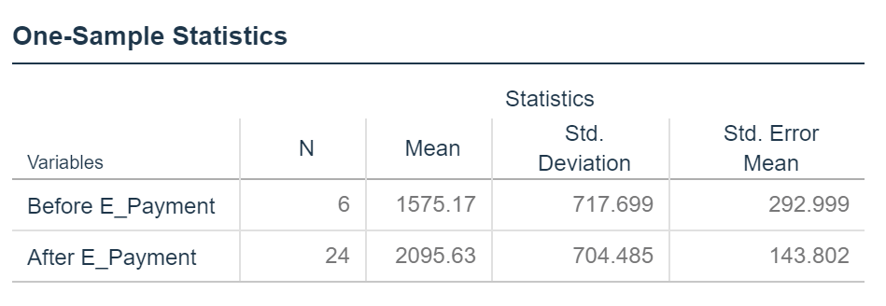

This table present the mean of OPEX under two group, one with the years yet to further develop electronic payment, and another had seen high development in electronic payment. The mean for no E-Payment is 1,575.17 (million) and the mean after E-Payment is 2,095.63 (million).

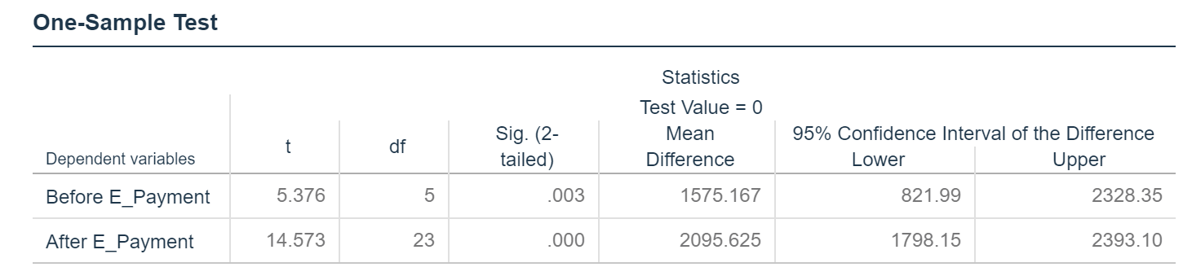

This table show the t statistic between the variables OPEX before and after the development of electronic payment method, the t value before E-Payment is 5.376 and after E-Payment is 14.573, and the p value of less than 0.001 confirm that there is significant relationship between operating expenses and the implementation of electronic payment method.

## T Test: Operating Expenses (Non-Interest Income)

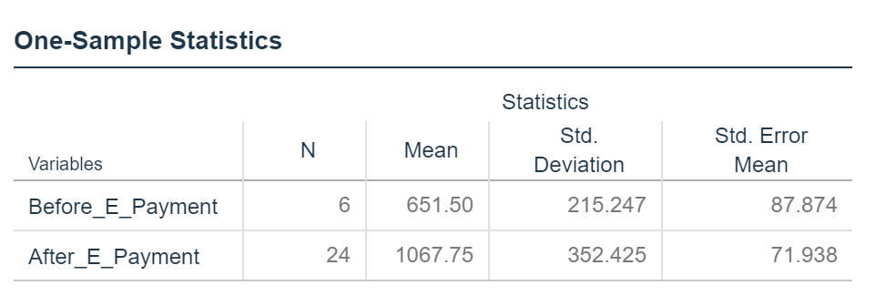

This table present the mean of non-interest income generated from the banks and separated into two group, one with the years yet to further develop electronic payment, and another had seen high development in electronic payment. The mean for no E-Payment is 651.50 (million) and the mean after E-Payment is 1,067.75 (million).

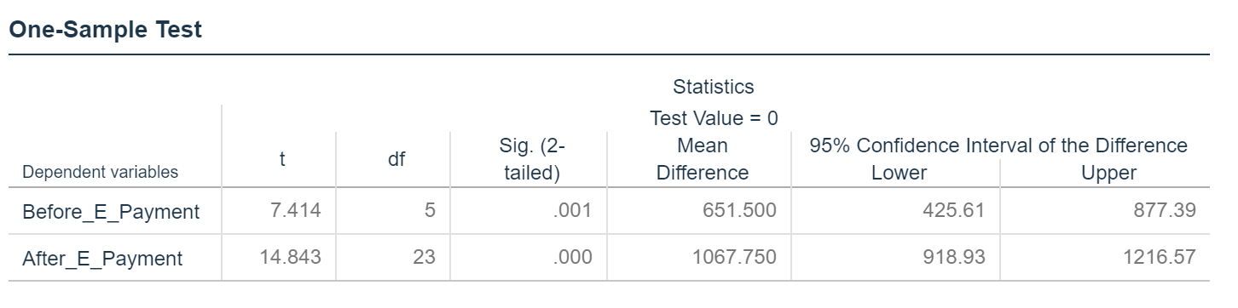

This table show the t statistic between the variables non-interest income before and after the development of electronic payment method, the t value before E-Payment is 7.414 and after E-Payment is 14.843, and the p value of less than 0.001 confirm that there is significant relationship between non-interest income and the implementation of electronic payment method.

## T Test: Operating Expenses (Non-Interest Income)

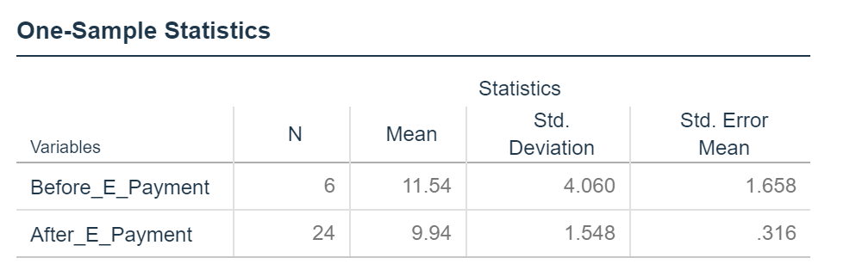

This table present the mean of return on equity (ROE) of the banks generated and separated into two group, one with the years yet to further develop electronic payment, and another had seen high development in electronic payment. The mean for no E-Payment is 11.54% and the mean after E-Payment is 9.94%.

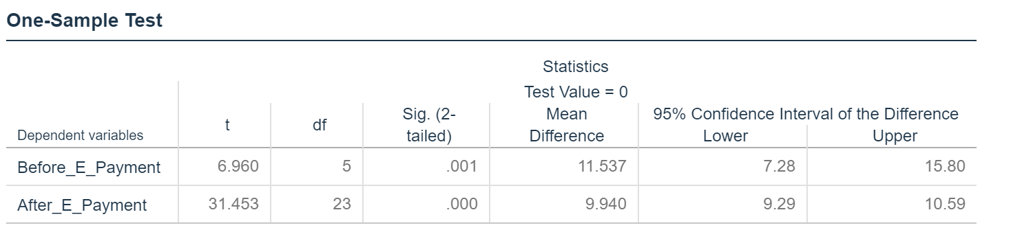

This table show the t statistic between the variables return on equity before and after the development of electronic payment method, the t value before E-Payment is 6.96 and after E-Payment is 31.453, and the p value of less than 0.001 confirm that there is significant relationship between the return on equity (ROE) and the implementation of electronic payment method.

## Paired Samples Statistics

|  |  |  |  |  |  |
| --- | --- | --- | --- | --- | --- |
| **Paired Samples Statistics** | | | | | |
|  | | Mean | N | Std. Deviation | Std. Error Mean |
| Pair 1 | All_ROE | 10.5745 | 10 | 2.94515 | .93134 |
| RHB_ROE | 12.0393 | 10 | 3.58598 | 1.13399 |

In the Paired Sample Statistics Box, the mean for the Return on Equity for all Banks is 10.5745. The mean for RHB Banks Return on Equity is 12.0393. The standard deviation for all Banks is 2.94515 and for RHB is 3.58598. The number of participants in each condition (N) is 10.

|  |  |  |  |  |
| --- | --- | --- | --- | --- |
| **Paired Samples Correlations** | | | | |
|  | | N | Correlation | Sig. |
| Pair 1 | All_ROE & RHB_ROE | 10 | .585 | .076 |

The correlation of paired sample shows that there are 10 number of observations with 0.585 correlation. Its p-value is more than 0.05 which indicates that there is negative relationship between both variables.

|  |  |  |  |  |  |  |  |  |  |
| --- | --- | --- | --- | --- | --- | --- | --- | --- | --- |
| **Paired Samples Test** | | | | | | | | | |
|  | | Paired Differences | | | | | t | df | Sig. (2-tailed) |
| Mean | Std. Deviation | Std. Error Mean | 95% Confidence Interval of the Difference | |
| Lower | Upper |
| Pair 1 | All_ROE – RHB_ROE | -1.46474 | 3.02954 | .95803 | -3.63194 | .70247 | -1.529 | 9 | .161 |

This value is less than 0.5. Because of this, we can conclude that there is a statistically significant difference between Banks that implement E-Payment and Banks that do not (RHB). Since our Paired Sample Statistics box revealed that the Mean number of RHB Banks ROE is greater than the Mean for all Banks ROE, we can conclude that by implementing electronic payment method, the banks do not have higher return on equity as compare to the bank (RHB) that do not implement electronic payment method.

# Chapter 5- Research finding, Conclusion & Recommendation:

## Research finding

From the data analysis we can conclude that by implementing electronic payment method, the bank had increase it operating expenses, possibly to increase spending on the data protection and several technological issues revolving providing more electronic payment method and channels. However, the data analysis also shown that the bank has actually generate more income from the non-interest income section, which statistically shown significant relationship with the implementation of electronic payment method, hence it is safe to conclude that, while increase spending on providing electronic payment method, the banks actually generate income from providing such services as well. This is further support by the banks return on equity (ROE), which have significant relationship between before and after of implementing electronic payment method.

From the above analysis, we have concluded that overall Banking sector have to invest in the Electronic Payment system advancements because it will affect the financial performance significantly. Furthermore, there is a positive impact of additional expenses incurred on the electronic payment system of the Banks on the return on equity. The expenses on mobile payment, retail merchants, online clearing house, online payment system etc. are not just cost consuming but also these expenses are increasing the profit line of the Banks in Singapore as well as in the whole world.

## Conclusion:

At end of the thesis paper, it is concluded that overall Banking sector must incur expenses for the betterment of electronic payment system, which will ultimately have a positive impact on the financial performance of the Banks. The users of electronic payment in the Banking procedures are the certain beneficiaries of the technology. From the research done on the use of electronic payment method in Singapore, it is proved that the electronic payment system has positive impact on the return on equity.

## Recommendation:

Our recommendations include that Banking sector around the globe must adopt change which is necessary for the performance of industry. Banking sector must invest in the advancement of electronic payment systems for the efficient performance of the Banks and to get the desired outputs. The effect of expenditures on the electronic payments ultimately improve the Financial statements of the Banks and it will guarantee shareholders wealth maximization by improving the return on equity.

# References

Chatterjee, S. and Hadi, A. (2015). *Regression analysis by example*. Somerset: Wiley.

Draper, N. and Smith, H. (2014). *Applied Regression Analysis*. Somerset: Wiley.

Massaron, L. and Boschetti, A. (n.d.). *Regression analysis with Python*.

Mendenhall, W. and Sincich, T. (2014). *A second course in statistics*. Upper Saddle River, NJ: Pearson Education International.

Schroeder, L., Sjoquist, D. and Stephan, P. (2017). *Understanding regression analysis*. Los Angeles: Sage.

Yan, X. and Su, X. (2009). *Linear regression analysis*. Singapore: World Scientific Pub. Co.

Blumberg, B., Cooper, D.R., Schindler, P.S, (2011) Business Research Methods. 3rd edn. McGraw-Hill Higher Education

Bryman, A., Bell, E (2015), ‘Business Research Methods’ 4th edn. Oxford: Oxford University Press

Mackenzie, N. & Knipe, S. (2006), Research dilemmas: Paradigms, methods and methodology, Issues in Educational Research, 16(2), 193-205 available at: http://www.iier.org.au/iier16/mackenzie.html

Mason, J. (2002). Qualitative Researching (2nd edn.). London: Sage, available at: https://us.sagepub.com/sites/default/files/upm-binaries/28285_02_Boeije_Ch_02.pdf

Patton, M.Q. (2002) Qualitative Research and Evaluation Methods, 3rd edition, Thousand Oaks, CA: Sage, available at: https://mthoyibi.files.wordpress.com/2011/10/qualitative-research-practice_a-guide-for-social-science-students-and-researchers_jane-ritchie-and-jane-lewis-eds_20031.pdf

Saunders, M., Lewis, P., Thornhill, A. (2012) Research Methods for Business Students. 6th edn. Essex: Pearson Education Limited

Engaging Financial Services Customers in an Omni-channel world (2014), Adobe Online, available at: http://wwwimages.adobe.com/content/dam/Adobe/en/solutions/financial-services/pdfs/overview-fsi-omni-channel.pdf [Accessed 11 Aug. 2016].

Newenham, Pamela (2014) Irish founded payments start-up Stripe now valued at $3.5 billion, 3rd December Irish Times Online, Available at: http://www.irishtimes.com/business/technology/irish-founded-payments-start-up-stripe-now-valued-at-3-5-billion-1.2023112 [Accessed 11 Aug. 2016].

Retail Banking 2020 Evolution or Revolution? (2015), PWC Report online, available at: http://www.pwc.com/et_EE/EE/publications/assets/pub/pwc-retail-Banking-2020-evolution-or-revolution.pdf [Accessed 11 Aug. 2016].

Burns,N and Grove,S. (2003). The Practice of Nursing Research Conduct, Critique and Utilization (4th ed). W.B.Saunders: Philadelphia, Pennsylvania. USA.

Kader, Parahoo. (1997). Nursing Research: Principles, Process and Issues. Basingstoke: Macmillan.

Denzin, N. and Lincoln, Y. (2005). The SAGE handbook of qualitative research. Thousand Oaks: Sage Publications.

Saunders, M., Lewis, P. and Thornhill, A. (2012). Research methods for business students. Harlow, England: Financial Times/Prentice Hall.

Mason, J. (2002). Qualitative researching. London: Sage.

Miles, M. and Huberman, A. (1994). Qualitative data analysis. Thousand Oaks: Sage Publications.

Field, A. (2005). Discovering statistics using SPSS. London: Sage Publications.

Bogdan, R. and Taylor, S. (1975). Introduction to qualitative research methods. New York: Wiley.

Aduda, J., & Kingoo, N. (2012). The relationship between electronic Banking and financial performance among commercial Banks in Kenya. Journal of Finance and Investment analysis, 1(3), 99-118.

Agboola, A. (1970). Electronic payment systems and tele-Banking services in Nigeria. The Journal of Internet Banking and Commerce, 11(3), 1-7.

Bucur, L. E. (2015). CHARACTERISTICS OF ONLINE BANKING PRODUCTS AND SERVICES. Revista Economica, 67(5).

Durgun, Ö., & Timur, M. C. (2015). The Effects of Electronic Payments on Monetary Policies and Central Banks. Procedia-Social and Behavioral Sciences, 195, 680-685.

Fadoju, O. S., Evbuomwan, G., Olokoyo, F., Oyedele, O., Ogunwale, O., & Kolawole, O. O. (2018). Dataset for electronic payment performance in Nigerian Banking system: A trend analysis from 2012 to 2017. Data in brief, 20, 85-89.

Humphrey, D. B., Pulley, L. B., & Vesala, J. M. (1996). Cash, paper, and electronic payments: a cross-country analysis. Journal of Money, Credit and Banking, 28(4), 914-939.

Joshua, A., & Koshy, M. P. (1970). Usage patterns of electronic Banking services by urban educated customers: Glimpses from India. The Journal of Internet Banking and Commerce, 16(1), 1-12.

Masoud, E., & AbuTaqa, H. (2017). Factors Affecting Customers' Adoption of E-Banking Services in Jordan. Information Resources Management Journal (IRMJ), 30(2), 44-60.

Mittal, S., Pant, A., & Bhadauria, S. S. (2017). An Empirical Study on Customer Preference towards Payment Banks over Universal Banks in Delhi NCR. Procedia computer science, 122, 463-470.

Hasan, I., Maccario, A. and Zazzara, C. (2002), “Do Internet Activities Add Value? The Italian Bank Experience”, Working Paper, Berkley Research Center, New York University.

Adewoye, J. O. (2013). Impact of mobile banking on service delivery in the Nigerian commercial banks. International Review of Management and Business Research, 2 (1): 333 – 344.

Husni, A. K., & Noor, M. A. S. (2011). The impact of e-banking on bank profitability: empirical evidence from Jordan. Middle Eastern Finance and Economics, 13: 142 – 158.

Kashif, M.K.; Mohammad, E.J.L. Impact of cashless banking on profitability: A Case study of banking industry of Pakistan. Res. J. Commer. Econ. Soc. Sci. 2016, 10, 82–93.

Onay, C., Ozsoz, E., & Helvacioglu, A. D. (2008). The impact of internet banking on bank profitability: The case of Turkey. Oxford Business and Economics Conference Program, 22 – 24 June, Oxford, UK.

Statista. (2018). Digital Payments - Singapore | Statista Market Forecast. [online] Available at: https://www.statista.com/outlook/296/124/digital-payments/singapore [Accessed 15 Dec. 2018].

Furst, K., Lang, W. and Nolle, D. (2000). Internet Banking: Developments and Prospects. SSRN Electronic Journal.

Electronic Payment Methods and Profitability of Banking Firms in Nigeria: A Panel Data Analysis. (2018). *International Journal of Finance and Accounting*, 2017, 6(3): 67-74.

E-Payment Technology Effect on Bank Performance in Emerging Economies–Evidence from Nigeria. (2018). *J. Open Innov. Technol. Mark. Complex.*, 2018, 4(4), 43.

Adoption of Internet Banking: An Empirical Investigation of Indian Banking Sector. (2018). *Journal of Internet Banking and Commerce*, 9(2) · July 2004.