**Blended learning Adoption in Higher Education Institutions (HEI’s) in Islamabad, Pakistan.**

Muhammad Soman Khan

ID: I17014023

ETHICS NUMBER: cBUS/PGT/CP/03806

SUPERVISED BY: DR. Abidah Binti Saad

FINAL WORD COUNT: 12184

MASTER OF BUSINESS ADMINISTRATION

FACULTY OF BUSINESS, COMMUNICATION & LAW

INTI INTERNATIONAL UNIVERSITY

2018

DECLARATION

I I hereby declare that: I understand the meaning of “Plagiarism” and “Intellectual Property Rights” and Ethics Related to the Principles of Academic Works. This dissertation is hereby acknowledged as my own work and I have duly acknowledged use of published and unpublished works of other people from the print, electronic and other media.

Name : Muhammad Soman Khan

Student ID : I17014023

Signature :

Date : 15th December 2018

Acknowledgements

This MBA Project is the result of a long journey which consisted of long efforts, patience and motivations. This thesis requires good writing, skills, complemented by sound information and communication insight, to produce a factual but readable research literature.

This research paper would have not been possible without the support of those who play important role in the outcome. Most specially, Dr. Abidah Binti Saad, my supervisor who advised and inspired me throughout the whole process which contributed positively to the success of this study, Dr. Sukjeet Kaur for his individual support in the provision of extensive knowledge on this topic.

Next, I would like to have special thanks to the participants who took part in filling up questionnaire. I am highly indebted to the Pakistani HEIs students, the participants for extending their valuable time to provide me with the information needed for my research. I would also like to convey my special thanks to my family and friends for their unceasing encouragement, support and inspired me in different difficult moments of the journey of this project.

I would like to express gratitude to the faculty members of the Faculty of Business, Communication and Law at INTI International University for providing the necessary resources and support to conduct my research.

My thanks and appreciation also go to anyone who has directly, or indirectly helped me with their abilities in this venture.

*Muhammad Soman Khan,*

December 2018

Abstract

Although Blended Learning has already developed several years and became a successful method to improve the learning system of Higher Education Institutions (HEIs). The evolution of the information technology helps to improve the infrastructure of the HEIs and helps to connect with updated and new technologies around the world. Without any doubt, many educational institutions are adopting and implementing the Information and Communication Technologies (ICT) and Learning Management System (LMS) in their educational structure as they believe that it will add a value in their performance. Many universities are adopting blended learning but still some of the countries do not consider blended learning as an effective tool which means that blended learning has not been accepted fully by the educational institutions around the world. In the context of Pakistan, HEIs are still following the traditional way of the education system and they are not fully aware of the Blended Learning. The research gap between the researcher and the HEIs is really big.

In order to explore the level influence of LMS and ICT on student learning experience for blended learning adoption, the researcher chose to approach the quantitative case study to collect data.

Finally, conclusion and recommendation will be provided after findings of this study. Similarly, the study will also enrich the huge gap of the studies on Awareness of Blended Learning and provide the platform for further studies that will relate when the researchers will examine the Blended learning adoption in Pakistan.

Keywords:

Blended Learning; Higher Education Institutions; Disruptive Technology.

Table of Contents

ABSTRACT Error! Bookmark not defined.

Chapter 1 introduction 8

1.0 Chapter overview 8

1.1 Background of study 9

1.2 Problem statement 9

1.3 Research Objectives 10

1.4 Research Questions 11

1.5 Significance of Research 11

1.5.1 Significance of Academy 11

1.5.2 Significance of Industry 11

1.5.3 Significance of Government 12

1.6 Scope of Research 12

1.7 Operational definition 12

1.7.1 Blended learning 12

1.7.2 Learning Management System (LMS) 12

1.7.3 Information and Communication Technology (ICT) 13

1.7.4 Higher Education Institutions (HEIs) 13

1.7.5 Blackboard 13

1.8 Organization of chapters 13

Chapter One- Introduction 14

Chapter Two- Literature Review 15

Chapter Three- Research Methodology 15

Chapter Four- Data Analysis and Findings 15

Chapter Five- Conclusion and Recommendation 15

1.9 Conclusion 15

Chapter 2 16

2.0 Chapter Overview 16

2.1 Introduction 16

2.2 Blended learning 16

2.2.1 Global Perspective 19

2.2.2 Blended learning in Pakistan 21

2.3 Blended learning adoption 23

2.4 Blended learning Adoption Framework 24

2.4.1 Strategy 25

2.4.2 Structure 25

2.4.3 Support 26

2.4.4 Learning management system (LMS) 27

2.5 Grounded Theory 29

2.6 Gaps in literature 31

2.7 Conceptual Framework 31

2.8 Hypothesis 32

2.9 Conclusion 32

Chapter 3: Research Methodology 34

3.0 Overview 34

3.1 Research Design 34

3.1.1 Nature of Research 35

3.1.2 Types of Investigation 35

3.1.3 Research Environment 36

3.1.4 Extent of Researcher Interference 36

3.2 Unit of Analysis 36

3.3 Sampling Plan 37

3.3.1 Sampling Population 37

3.3.2 Sampling Method 38

3.3.3 Sampling Size 38

3.4.1 Descriptive Information 39

3.4.2 Pilot Test: Reliability Test 40

3.4.3 Preliminary Tests 40

3.4.4 Measurement Model Assessment 40

3.4.4.1 Internal Consistency (Component Reliability) 40

3.4.4.2 Indicator reliability 41

3.4.4.3 Convergent Validity 42

3.4.4.4 Discriminant validity 43

Chapter 4 Data Analysis and Findings 46

4.0 Overview 46

4.1 Pilot test 46

4.2 Descriptive Information 46

4.3 Internal Consistency (Component Reliability) 47

4.3.1 Indicator reliability 48

4.3.2 Convergent Validity 49

4.3.3 Discriminant validity 50

4.4 Hypothesis Testing 51

4.5 Conclusion 52

Chapter 5 Conclusion and Recommendations 53

5.0 Overview 53

5.1 Summary of Findings 53

5.2 Contribution 54

5.2.1 Contribution to Academe 54

5.2.2 Contribution to Industry 54

5.3 Recommendations 55

5.4 Limitations of Study 55

5.5 Chapter Conclusion 56

Reference 57

Appendix 67

Blended learning adoption in higher education institutions (HEIs) in Islamabad, Pakistan

# Chapter 1 introduction

In today’s world, information and communication technology (ICT) plays an important role and has also provided the chances to the students from all over the world to adopt these technologies to enhance the industry of higher education. The research will emphasis on the adoption of blended learning in the education industry in Pakistan. In Pakistan, institutions focus on theory, instructors come up with the notebook in hand which has been preceding by the prior lecturers and follow the traditional style of learning and instructors are guided by the readymade technique of teaching concept (Oosman, 2014). The main reason of this study is to find out the level of awareness as well as challenges of adopting blended learning in higher education institutions in Pakistan. Pakistan's HEI’s are additionally trying different things with new models of blended learning, but out of 183 million population only 5.1% students of age group between 17-23 are enrolled in HEI, however government is planning to provide free WIFI facility to all 161 government universities with in the time span of four years (Suresh, 2015). Not much but few of the private universities adopted blended learning to enrich the style of knowledge and to provide the best platform for learning not only for the Pakistani students and teachers as well as international students and that institutions are National University of Modern Languages (NUML) and Agha Khan University (AKU) (Naseem, 2013). Pakistan is focusing on ease of access to education to increase the ratio of enrolment from 5.1% to 15% by 2020 and is seeking the help of private sector as well (Suresh, 2015).

# 1.0 Chapter overview

Chapter one features the general understanding of the research. It mainly centres around the basic and statistics that is especially identified with the examination point. This chapter provides a problem statement which define the issues and context of the research, followed by the relevant Research Objectives and Research Questions. Moreover, chapter one will include the Scope of Study and the Significance of the Research as well as limitation of study.

# 1.1 Background of study

From the last two eras, technologies dominantly affect all parts of the person's life and society (Gisbert and Johnson, 2015). It really helped alt in building new projects, especially in education, media and health sector (Martin, Diaz, Sancristobal, Gil, Castro and Peire, 2011). Today, technology assume a part to upgrade students taking in encounter where students gained from genuine and coordinate experience whereby the instructors will go about as facilitators in giving direction to the students (Alshathri, 2016). Inside the most recent couple of years, the fast changes in the system of Higher Education and the adjustments in nature of innovation had impacted the rise of blended learning (Alebaikan, 2012).

The progression of innovation has energized a ton of new pathway and devices for instructing and learning, and because of the converging of different advancements with specific teaching method has promoted blended learning (Dzakiria, Don and Rahman, 2012). These days numerous universities are taking points of interest of the disruptive technology and one of the advancements that have been generally utilized as a part of the university is the digital technology whereby the digital technology has brought the various chances to expand the educating and learning style, for example, online coordinated effort, web conferencing, dialog boards and social communities (Lichy, Khvatova and Pon, 2014). In correlation with tradition one on one conveyance mode, blended learning which is thought to be a more adaptable conveyance technique has enhanced learning results in HEIs and there is a constructive change in student results (Wong and Fong, 2014).

# 1.2 Problem statement

The traditional view of instructing and learning has dependably been aligned with the physical presence of schools, reading material, instructors, classrooms, and examinations (Alias, Jain and Luaran, 2014). However, the general utilization of information and communication advancements in our everyday lives change the way we live as well as change the development, dispersion and reproduction of knowledge (Lim and Wang, 2017). With the quick development in technology, the utilization of blended learning approaches is anticipated to rise significantly (Alebaikan, 2012). Several universities have adopted ICT and set up a creative programme that conferred to ICT and make a significant position in the industry of education (Fu, 2013). On the other hand, there are only 2 universities that have been adopted blended learning in Pakistan and really, there are just a couple of journals that wrote about Information and Communication Technology (ICT) and blended learning with regards to Pakistan.

The motivation behind this study is accordingly to explore the level that how much people are aware and also the apparent difficulties of adoption of blended learning for the administration and academics of Higher Education Institutions (HEIs) in Pakistan which will centre around the comparative analysis of the institution which has quite recently been adopted blended learning with the universities that are not following the new patterns of the technologies in the education industry of Pakistan. As Pakistan is still following the traditional style of learning that is why the system of education of Pakistan is weakest among the world but for now it is in critical stage (Janjua, 2011). As per 2018 the literacy rate of Pakistan is 58% regardless of all the facts and lack of immediate actions needed to be taken to driven Pakistan in education section on international level (Sultana, 2012). Execution of ICT gives another method for learning and influence the learning process more adaptable and time saving (Flynn, 2013). On the other hand, Pineteh (2011) mentioned that adoption of ICT in education helps students in a more effective way but with the rapid change in the technology it becomes more challenging for learners as well as instructors.

# 1.3 Research Objectives

A decent study ought to have clear and cantered research objectives that ought to pass on the clear understanding of the study. At the end of the day, it is for the most part centred around the reasons why this research has been done (Farrugia et al., 2010). The primary purpose of study is defined under research objective followed by the hypothesis of study (Bhandar, et al., 2010). The objectives of research are:

RO1: To find out whether LMS technology in blended learning has a significant influence on students learning experience in HEI’s in Pakistan?

RO2: To find out whether ICT in blended learning has a significant influence on students learning experience in HEI’s in Pakistan?

# 1.4 Research Questions

Research question provide the clear direction that from where the data has been collected and analysed to achieve the objective of research and should be in accordance with the objectives of research (Farrugia et al., 2010). By using theoretical question research question help to show a clear direction and scope of research (Walliman, 2011).

RQ1: Does LMS technology in blended learning has a significant influence on students learning experience in HEI’s in Pakistan?

RQ2: Does ICT in blended learning has a significant influence on students learning experience in HEI’s in Pakistan?

# 1.5 Significance of Research

In the modern world of technology, it is very important to understand technology for government entities as well as individuals (Gluck, 2012). Technology isn't just constrained to a couple fields, it helps in a ton of zones, technology covers the entire world like in the medicinal business, hospital industry, education industry, media, advertising etc (Gisbert and Johnson, 2015). With the increase in use of technology in education industry research on adoption of blended learning is important to find whether the combination in web-based learning and traditional style of learning are beneficial for the learning of learners (Wong and Fong, 2014). The following aspects will be value added from the research:

## 1.5.1 Significance of Academy

From the Academic perspective, the examination result will assist analysts with understanding on the adoption of blended learning for students. This research will give a reasonable picture on the determinants that are impacting the adequacy of the adoption of blended learning in HEI's in Pakistan. The outcomes from this research will help to understand the factors that has an influence on blended learning adoption in respect of disruptive technology in Pakistan. Finally result will tell how to adopt the new technology to bring change in education system in Pakistan.

## 1.5.2 Significance of Industry

From the Industry perspective, this research could contribute in giving feedback and remarks on the handiness of blended learning for students who are simply moved on from colleges, where the greater part of them are as yet adjusting with the traditional style of teaching which has its own pros and cons. blended learning will enhance the learning system and retain the advantages of the traditional method as well (Pape, 2016).

## 1.5.3 Significance of Government

The contribution of this study in the Government point of view, this study conveys more valuable data to the government of the Pakistan as they don't know about the E-learning, blended learning and LMS. From the results of this research, the government can look at the significance of disruptive technologies in the HEIs and plans the pertinent strategies to put more in the foundation of the universities of Pakistan.

# 1.6 Scope of Research

The purpose of this study is to find out the influence of blended learning adoption on student learning in higher education institutions in Islamabad Pakistan. As the target population is university students, the researcher will be focusing on different government as well as private universities. For data collection purpose, questionnaire is being used by the researchers. Since the study use participants from Pakistan, the recent approach of learning will also be asked.

# 1.7 Operational definition

## 1.7.1 Blended learning

A delivery method of teaching that combines face to face as well as web-based learning allowing a student-centric learning experience (Vassiliou and Aleese, 2014). To create a learning environment, higher education institutions must adopt blended learning as it is an effective way to deliver learning material (Gyamfi and Gyaase,2015)

## 1.7.2 Learning Management System (LMS)

Learning Management System is a tool that serves to upgrade, enhance and support the procedure of learning of student and furthermore gives the stage to the students to speak with the lecturers and the administration identified with the LMS issues (Chou and Chou, 2011).

## 1.7.3 Information and Communication Technology (ICT)

With regards to education, ICT is alluded to computerized innovation which has been consolidated into the education field, for example, PCs and cell phones (Vassiliou and Aleese, 2014). It refers to electronic system of delivery that are extensively used now a day like projectors, television etc (Fu, 2013).

## 1.7.4 Higher Education Institutions (HEIs)

Higher education refers to the institution that provide education post-secondary level such as universities, academies that are recognised by government officials for higher studies (Walsh, 2012).

## 1.7.5 Blackboard

Walker and Rehfeldt (2012), said that black board is where students can draw in with the class work exercises through the chat room, coordinated effort, exchange and furthermore associate with the everyday updates like announcements and assignment deadlines etc.

# 1.8 Organization of chapters

In order to structure this research in an organised manner this research is classified into five following chapters



*Figure 1: Flowchart of Study*

## Chapter One- Introduction

Chapter one is the presentation of the context of the research which incorporates the background of research, the problem statement, objectives of research, look into questions, and the importance of the research. The degree and constraints of the research is additionally given under this section to furnish readers with a superior comprehension on the primary objectives and the fundamental knowledge of the issue being researched.

## Chapter Two- Literature Review

This chapter is developed by utilizing the secondary data to support the research. This section gives distinctive theories, thoughts and models from past researches by different researchers. The data and literature are accumulated from EBSCO, Google Scholar, Science Direct and Emerald.

## Chapter Three- Research Methodology

Chapter Three which is the Research Methodology will centre around the procedures, instruments and techniques in collecting information all through the study. This section likewise incorporates the research outline and strategy, sampling techniques, ways of data collection and additionally the interpretation of data that is utilized to test in this research.

## Chapter Four- Data Analysis and Findings

This chapter contains the graphical portrayal of the research. All the data gathered from the surveys is dissected by means of software (Smart Pls) and the result is exhibited as diagrams and charts. Furthermore, discussion and interpretation of the data will be given to support the statistical data.

## Chapter Five- Conclusion and Recommendation

Chapter five is the last section of the research and it consist of detailed discussion on the general findings and results acquired from the research. In the section, suggestions and future research bearing will likewise be given for different researchers to extend the research later on.

# 1.9 Conclusion

This chapter mainly focused in detail on the background of study, importance of that study, objectives of research and research questions. Moreover, this chapter also highlighted the significance as well as the scope of study provided by the operational definition and summary of chapter to provide overview on plan of study at the end of this chapter.

# Chapter 2

# 2.0 Chapter Overview

The purpose of this literature review is to provide a general knowledge about blended learning in both local context as well as in Pakistan context. In addition to that, it provides reasonable comprehension of the significance of blended learning and level of awareness that can be executed by Higher Education Institution (HEIs) in Pakistan. In addition, this section additionally gives the framework that makes the study accomplish.

# 2.1 Introduction

Higher education Institutions alludes to the way toward learning and instructing, where students and instructors rehearse their learning abilities (Poon, 2013). More particularly, the organizations encourage students to procure and improve the set of learning aptitudes. All the while, as a fast development of innovations, institutions are additionally promoting their utilization of Information and Communication Technologies (ICT) for the students (Fu, 2013). Likewise, this part will give a clarification on the breach in literature, the elements under the examination, the hypothetical scheme and theory. Consequently, this examination may give bits of knowledge with respect to the handiness of blended learning in HEIs particularly for undergraduate studies.

# 2.2 Blended learning

Nowadays, in order to fulfil the demands of globalized atmosphere, HEIs tends to prepare students by engaging them in a kind of learning practice which is a blend of knowledge and technology (Graham, et al., 2013). blended learning is the hybrid style of learning process which let student to gain meaningful knowledge and allow corporate employees to manage their work and study together without physically been present in the class (Levy, et al., Feb 2012). Aynur (2013) describes blended learning as a stretchy approach that include IT to give education specifically online and in head-on environment.

On the other hand, Kaur (2013) construed blended learning as the proper and reasonable mix of different models of educating, models of conveyance, and styles of discovering that must be trailed by intelligently learning condition. So also, Training based on computer, Distance Learning, Electronic Learning, Tele-mentoring and Web-Based Training all are the case of blended learning (Aynur, 2013). Renner et al (2015) added that blended learning is the term that describe combination of traditional mode of learning and online learning which in most of the cases are reinforced by information technology (IT), along these lines compelling and proficient outline of learning substance were required with a specific end goal to ensure the learning achievement of students.

As shown in figure 1 blended learning can be characterized as a blend of various conveyance modes, including classroom communication and online-based materials in a learning circumstance (Ali, et al., 2014). blended learning can likewise allude as the consolidated of customary learning and online strategies, an e-learning condition which is joined with various devices and media, together with the blend of a few educational methodologies (Rahman, et al., 2012). Under this approach, students and teachers or educators don't standard face-to face meeting, there will be a fitting mix of online components and eye to eye class, students will do both on the web and disconnected exercises at their own particular pace (Grace, 2017).

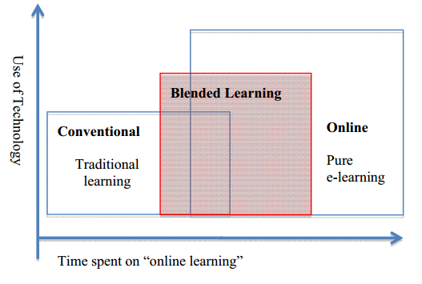

Figure: 2.0 *Conception of blended learning*

Source: Procter and Heinze (2003)

Research demonstrates that numerous e-learning activities neglect to offer students with important mixed learning encounters inside the e-learning setting and thus don't yield promising outcomes of course (Embi and Hamat, 2014).

Accordingly, there is a need to see how powerful mixed learning in connection to the learning knowledge of pre-college students in Malaysia is. As of late, instructing and learning through the online mode in Malaysia has turned out to be more plausible with the quick improvement and high use of electronic innovation. As the coordination of innovation into examines is consider as a need for a large portion of the advanced education foundations, a successful and easy to use web-based learning stage will position advanced education organizations at a more focused level particularly when it is all around acknowledged by the scholarly staff and under graduate studies (Embi, Nordin and Wahab, 2012). The plan of blended learning can defeat two difficulties: in the first place, where the physical size of a specific nations makes it troublesome for students to movement to institute grounds and besides, when there is a constrained space or ability to carter for all students who are qualified for proceed with their investigations in advanced education HEI’s (Alshathri, 2016). Besides, the rise of innovation has empowered the advanced education foundations to give an assortment of techniques in the learning condition to meet distinctive person's learning style and needs (Singh and Kaur, 2017).

blended learning can be a viable apparatus in setting up learning associations that students and teachers’ team up to construct information and enabling HEIs to end up more adaptable and responsive in a financially savvy way (Grace, 2017). The capacity of a student to be successfully received and profit by the mixed learning is greatly influenced by the foundations and qualities of the individual student, and in addition the plan of devices to be utilized as a part of the blended learning process (Kagambe, et al., 2017).

Grace (2017) additionally expressed that powerful blended learning is impossible by simply embedding innovation into the current courses content, yet there is a need of a few changes in instructional method and the connections between the students and the teachers. An examination has demonstrated that students who got both on the web and classroom sessions were more fruitful in exchanging and applying their insight to errands as contrasted and students who are having up in class one to one (Demirer and Sahin, 2013).

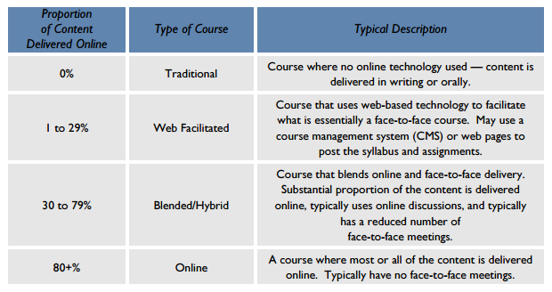

Figure:2.1 Prototypical Course Classifications

Source: Allen, Garrett and Seaman (2007)

## 2.2.1 Global Perspective

HEIs are confronting a developing need to scan for savvy methods to attract and holding students who may not search for conventional instruction and HEIs must guarantee the employability of graduates in this quickly changing and rising industry (Grace, 2017). blended learning presently turns out to be more than in vogue, blended learning itself is leverage for the students who are far away or topographically segregated and can't go to the classes physically, with the instructive access it turns out to be more adaptable that give even-handed information as same are putting forth in the classrooms (Gyamfi and Gyaase, 2015).

Universities in kingdom of Saudi Arabia adopted blended learning after ensuring that they have required number of services to provide support to growing number of graduates and to engage those students who have some issues in attended university campuses (Alshathri, 2016). blended learning isn't valuable for the working individuals or part timers, it likewise helps the full-time students who didn't go to the class because of the medicinal issues or other things which empower them to even now occupied with the on-grounds class exercises (Ibrahim and Mehmet, 2014).

As indicated by O'Connor, Mortimer and Bond (2012), blended learning is the linkage between the students, educators and the classroom that has been situated in the diverse states, areas, territories and the landmasses and furthermore give a chance to examine the thoughts, bring up issues and verbal confrontation through the offbeat discussion. blended learning is not only useful for the working people or part-time students, it also helps the existing or full-time student who didn’t attend the class due to the medical issues or other things which enable them to still engage in the on-campus class activities (Ibrahim and Mehmet, 2014).

Vitošević et al (2014) featured the four qualities of blended learning results that are: Flexibility, bring down disappointment or dropout rate when contrasted with the full-time courses, successful and helpful assets and helping materials and students' fulfilments. Moreover, Poon (2013) announced that, blended learning advances a learning into the profound comprehension, which can be reasonable by; taking new information, utilizing and getting acquainted with the new and high innovations and furthermore checking on the assets and taking beneficial choice on the best fits with the current learning and the structure of blended learning. blended learning could prompt be accomplishing the student’s fulfilment and inspiration.

As a technology giant, leaders of the universities in east china shanghai presumes that most of the students are from the era of technology, so they are well known with electronic devices and internet, so they adopted the new way based of eLearning platform (Gu, 2017). With the execution of mixed learning, HEIs get the chances to achieve the learning results which is adjusted to the requests of a globalized and innovation drive world (Lim and Wang, 2017). Furthermore Poon (2013) reported that, blended learning endorses in depth learning which one can understand by, gaining new knowledge, getting yourself aware with new technology and take creative decisions with the provided knowledge and framework of blended learning.

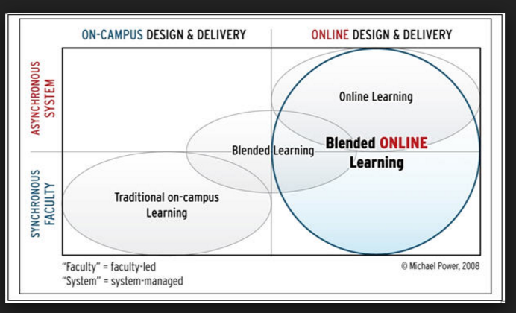However, to be profited from the usage of mixed learning and expand its adequacy, one of the greatest difficulties is how academicians can guarantee members' dedication when managing distinctive individual student attributes (Kagambe, et al., 2017). Along these lines, giving the outline of blended learning and its advantages, there is a need to get the fitting comprehension and information of blended learning in the Higher Education Institutions (HEIs) inside a context of Pakistan. Correspondingly, this investigation centres around the responsiveness level of the blended learning of Pakistan which also prompts increment the execution in the academic zone Poon (2013).

### 

Figure 2.2: The comparative position of Mixed Online Learning.

Source: Power (2009)

## 2.2.2 Blended learning in Pakistan

Pakistan's HEI’s are additionally trying different things with new models of blended learning, but out of 183 million population only 5.1% students of age group between 17-23 are enrolled in HEI, however government is planning to provide free WIFI facility to all 161 government universities with in the time span of four years (Suresh, 2015). As indicated by Paturusi et al (2015), Pakistan is one of the creating nation that began to actualize ICT into instruction industry with a specific end goal to engage and improve their training level whereupon Pakistan trusted that the combination of Internet into Higher training establishments will empower undergraduate studies to be more included effectively in self-coordinated learning. Not much but few of the private universities adopted blended learning to enrich the style of knowledge and to provide the best platform for learning not only for the Pakistani students and teachers as well as international students and that institutions are National University of Modern Languages (NUML) and Agha Khan University (AKU) (Naseem, 2013).

Aslam (2013) reported that in comparison with the traditional style of learning, adoption of blended learning is more effective, and study also reveals that students who were trained through blended learning tends to score good grades as compare to the students that were taught in traditional style. Qureshi, Ilyas, Yasmin and Whitty (2012) stated that it is not easy to implement ICT in Pakistan, as for now Pakistan is not allocating that much budget for education as well as supporting staff, software’s and IT is expensive in Pakistan. In addition, Pradnyawati (2014) included that blended learning system was reasonable for visual learning styles because of the way that the techniques for blended learning were suitable and upheld students in Indonesia that tend to have visual learning styles.

Pakistan is focusing on ease of access to education to increase the ratio of enrolment from 5.1% to 15% by 2020 and is seeking the help of private sector as well (Suresh, 2015). Moreover, Oosman (2014) quoted that Pakistan is following traditional style of education till now, and most of the instructors comes up with the notebook in hand directed by the predefined scientific way of instructing. The ratio of adoption of blended learning in Pakistan is not that much good, but gradually things are changing and becoming real now, and we are focusing on eliminating the shortage of resources, said by the chairman of Higher Education Commission (HEC) Dr Mukhtar Ahmed (Suresh, 2015).

Universities haven’t adopted blended learning till now and focusing on the traditional style of learning, as the administration and the government are not focusing on enhancing the quality of education Oosman (2014). Furthermore, students and instructors in the institutions also use to of traditional style of learning and teaching so that is also another hurdle in the way of blended learning adoption as the technology is new and they might not get the desired results (Suresh, 2015). Moreover, government is not allocating that much budget and not giving free hands to the institutions to adopt the new technology to enhance the quality of education and compete on the international level but still, students getting education from these institutions are competing on the international level, that is why they think that they do not need to adopt blended learning as the traditional style is good enough for them Naseem (2013).

Qureshi et al (2012) stated that it does not matter that how much effective technology is, few of the countries can’t get benefit through it because of the less knowledge and deprived strategy, and Pakistan is among that countries having restricted knowledge and funds. On the other hand, Naseem (2013) supported him and said that good quality of knowledge and new means of technology will help Pakistan a lot to change their education system and provide good learning experience to the students of Pakistani universities.

# 2.3 Blended learning adoption

By adopting blended learning over traditional style of teaching one can convey the instruction to the students anyplace whenever, as it isn't following the conventional method for realizing where students need to report in the classrooms and labs (Missildine, et al 2013). Numerous higher institutions in Malaysia have adopted blended learning because of its viability as a learning approach, be that as it may, contemplates have demonstrated that academicians are fearful about educating in blended learning and confused whether to adopt the blended learning technology or not (AbdRahmanb, 2012).

blended learning in institutions help to identify the goal that institutions intend to achieve and the three main purpose of adopting the blended learning, as well as by adopting blended learning students are being motivated and providing better results in comparison to traditional approach of learning (Porter et al., 2014).

Higher education institutions in Malaysia are adopting blended learning but study reflects that till now only 13 percent of the institutions have adopted blended learning till now, however he factors which affected the adoption of blended learning are seen convenience of the framework, learning objectives, and instructive innovation inclination, knowledge on the state of mind towards the adoption of mixed learning (Missildine, et al 2013). It is down to earth commitment incorporates information which can be fused into the e-learning modules to address the issue of low adoption of mixed learning (AbdRahmanb, 2012).

As per Tahar et al (2013), students' fulfilment towards blended learning was chiefly influenced by three most imperative components which were data quality, framework quality, and administration quality thusly if these three elements were successfully executed henceforth it will lead students to develop the aim of adopting blended learning. Meanwhile, Roslina et al (2013) found that there were three critical factors that affect student satisfaction towards blended learning which were: a) How students perceive blended learning adoption in terms of the future prospects of blended learning b) Difficulties in adopting blended learning and c) Advantages in adopting blended learning, it was discovered that students weren’t too satisfied with blended learning methods hence students even recommended that blended learning is more suitable for adult learners although it held great prospect in the future of education industry. Research led by Naajet et al (2012) considered students fulfilment as a critical factor in estimating the nature of mixed learning.

# 2.4 Blended learning Adoption Framework

The study is prepared into three main classes in adopting blended learning:

Table 2.0: blended learning Adoption Framework

|  |  |
| --- | --- |
| Categories | Description |
| Strategy | Features the issues identified with the adoption of blended learning configuration like motivation behind blended learning, level of usage and types of promotion |
| Structure | Features issues identified with the specialized and regulatory system of blended learning including assessment, administration and planning structures. |
| Support | Spotlight on the execution and upkeep of blended learning outline, specialized help and personnel motivating forces |

## 2.4.1 Strategy

Purpose of adopting blended learning

blended learning adoption in foundations help to distinguish the objective that organizations mean to accomplish and the three-fundamental reason for adopting the mixed learning; (1) upgrade information, (2) Increased adaptability and openness, and (3) lessen cost that enhance viability and proficiency in the establishments work (Porter et al., 2014). Williams (2012), contributes that the adoption of new learning techniques will assist the students with increasing their insight aptitudes and decline the reliance on the addresses of the colleges as by having every one of the materials online can get to effectively and get the asset from on the web. Besides, blended learning offers a stage where students and instructors improved geological adaptability, permitting them the time and the online section happen. While the cost of blended learning is relying upon the model of blended structure and dictated by the general students use to adoption of blended learning are fundamentally lower than the normal cost for customary learning materials or as such the cost of adoption of blended learning will be costly on the first run through yet will be advantage later as the students and the instructors will natural to the arrangement of the blended learning (Moskal, Dziuban and Hartman, 2013).

Institutional support

Any fruitful undertaking or procedure require a help of admiration and resources in gatherings of institutional work force (Porter et al., 2014). Taylor and Newton (2013) certified that backing by the admirations shares a dream of blended learning adoption, upgraded information, expanding the correspondence and subsidizing and dealing with the assets of the organizations. support by the faculty members, student’s promotion, participation of organization would facilities be able to the adoption of blended learning system and furthermore works together with outside exchange, conferences, and accomplices of the blended learning model (Poon, 2013).

## 2.4.2 Structure

Infrastructure is the principle body of the blended learning structure and it's somewhat basic to comprehend and execute in the institutions as its requires imperative choices identified with spending plan, vital advancements, and usage of new software’s (Poon, 2013). Institutions who are looking to adopt blended learning must need mechanical foundation that suits a powerful course management framework (CMS) and furthermore is agreeable clients for the students and the resources (Blomeyer, Renk, and Clair, 2012). Moreover Gruba, et al (2016) mentioned that despite the fact that interest in foundation may include the critical cost yet the turnover is higher than the cost related. Accordingly, the cost of innovation in the instructive asset will keep on decreasing after some time.

Governance

Adoption of blended learning will likewise save the licensed innovation rights that have been affirmed by the governing bodies to run the blended learning under the name of institutions keeping in mind that noticed that institutions basically adjust the current approaches to address blended learning adoption (Porter et al., 2014).

Evaluation

After the adoption of blended learning, the next main step is to evaluate it which incorporates the criticism from the clients and the upkeep on the issues or inquiries (Taylor and Newton, 2013). Organized and information gathering is imperative for viable assessment (Gruba et al., 2016). Be that as it may, numerous organizations neglect to recoup the blunder in the framework or neglects to meet the quarries of the students and furthermore the excellence of the blended learning execution must be various information sources that enable the students and the heads to deal with the multi-task in the meantime (Moskal et al., 2013). Regardless of the significance of the evaluation most of the institutions fear to fail in maintaining evaluation resulting in not adopting the blended learning in universities (Blomeyer et al., 2012).

## 2.4.3 Support

Technical support

The adoption of blended learning in the education area may profit by the specialized help as they fused blended learning and the arrangements and guideline are under considerations (Taylor and Newton, 2013). In addition to this, user require some specialized help to redress the missteps and the mistakes if there is any and support on the regular routine of the framework (Naseem, 2013). Institution should procure the specialized skill as they are not notable about the blended learning usage and support can be ideally settled either messages, phones and by means of texts (Walker and Rehfeldt, 2012).

# 2.4.4 Learning management system (LMS)

Learning Management System is an instrument that serves to upgrade, enhance and bolster the procedure of students learning and furthermore gives the stage to the students to speak with the instructors and the organization identified with the LMS issues (Chou and Chou, 2011). LMS alludes to a rich, continuous communitarian learning condition for academicians in sharing showing materials and gathering students' learning-related information by means of learning examination apparatuses in the framework (Wang and Lim, 2017). With regards to mixed learning training, learning management system (LMS) alludes to the combination of intelligent learning exercises directed by the academician to the students, and it requires the dedication from all partners so as to be executed adequately (Diniz and Dias, 2014).

LMS are utilized as an electronic safe particularly for those Institutions that are putting forth remoteness training and joined with the LMS to convey up close and personal aptitudes keeping in mind the end goal to associate with the students who are opposite geological fringes (Kurniali, 2014). As per Mtebe (2015), he said that LMS is a gainful instrument to expand the proficiency and viability of learning and instruction style in the Higher Education Institutions (HEIs) and that additionally got by the expressly (students) and verifiably (educators). Lestari and Hendradjaya (2014) specified that Learning Management System (LMS) is known as an execution of online action in mixed learning which is utilizing e-learning models, which helps students as well.

Mahnegar (2012) additionally focused on that Learning Management System (LMS) was a helpful device to convey, track, and oversee training, and LMS gave few advantages to numerous parties, for example, empowering educators and heads to track students’ performance, participation, time on assignment, and LMS likewise enables guardians to track students' evaluations whereby students could use it also to submit homework or to get to lessons and syllabus as illustrated in figure.

Then again, Conde, et al (2012) detailed some drawback of the LMS, where LMS concentrate more on the institutional and the course materials rather core around the students which transformed into that framework isn't completely fulfilling the last partner students. Besides, the concealed cost related, restriction and interoperability are the confinements of the LMS and with a specific end goal to actualize the scheme in the institute, directors should be exceptionally cautious about the need of the system in the institute (Cavus, 2013).

Asiri et al (2012) discovered comparable outcome whereby it was found that giving employees an adequate innovative foundation did not ensured the usage of LMS could be ideal. Dias et al (2015) clarified that Learning Management System (LMS) under mixed learning could give Online Learning Improvement (OLEs) at Higher Education Institutions (HEIs) with a more productive and compelling method for realizing which eventually could support students' execution altogether.

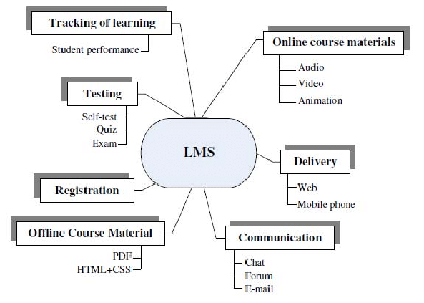

Figure 2.3: Structure of LMS

Source: Dias and Diniz (2014)

Therefore, based on the literature review conducted, the factors influencing the adoption of blended learning such as LMS, ICT Will be included into the current study in order to ascertain whether these factors will influence the extent of blended learning adoption in HEIs in Pakistan.

# 2.5 Grounded Theory

Technological Acceptance Model (TAM) has been widely used to explain the acceptance of an information system and numerous literature reviews are available in this area (Surendran, 2012). Many researchers Adams, Nelson and Todd (1992), Chin and Todd (1995), Mathieson, Peacock and Chin (2001) and Moon and Kim (2001) of information system have confirmed that the TAM has two main concepts; perceived usefulness and the perceived ease of use in estimating the acceptance of information system by the individuals. In this framework of TAM, system quality, and the quality information are two main aspects that affect the use and the user’s satisfaction (Roca, Chiu, and Martínez, 2006). Kettinger and Lee (1994) re-examined the model and mentioned that one more important aspect is defined in this model is quality service to user’s satisfaction.

According to Yousafzai, Foxall and Pallister (2010), the theory of Reasoned Action was the foundation of TAM theory by (Fishbein and Aizen, 1975) that helped Davis (1989) to come up with the TAM model. TAM focus on the external factors that affect the actual use and the intention through moderated effect on the perceived ease of use and the perceived usefulness (Park, 2009).

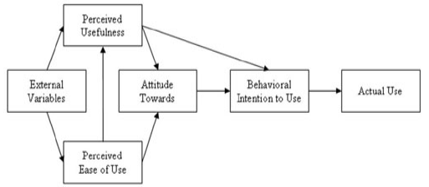

Figure 1: Theoretical framework of Technological Acceptance Model (TAM)

Source: Park (2009)

Surendran (2012) explain the TAM as a model of adoption and the use of e-learning. Moreover, Selim (2003) stated that there is a need to investigate again the TAM model with the web-based learning and he contributes his idea by enhancing the TAM model as a Course Website Acceptance Model (CWAM); where he tested the relationship among the perceived usefulness, the perceived ease of use and the intention to use with the university students. Similarly, TAM2 contributes some additional social influence (subjective norms, images and voluntariness) factors and cognitive instrumental process (output quality, job relevance and result demonstrability) and experience and the new model was tested through both mandatory and voluntary settings (Wu, Chou, Weng and Huang, 2011). Venkatesh and Davis (2000) confirmed that their TAM2 model adopted by the 60%

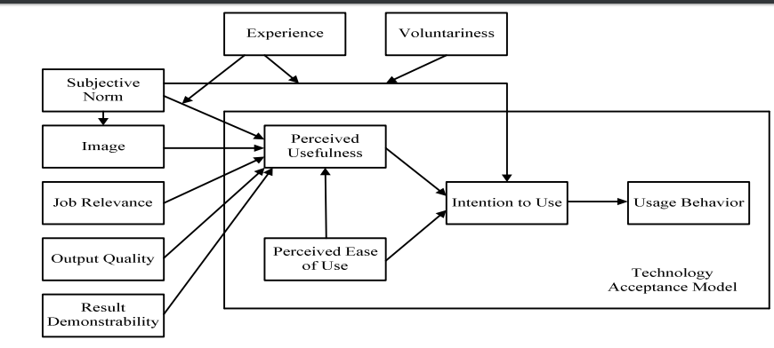

Figure 2: A theoretical extension of the Technological Acceptance Model.

Source: Venkatesh and Davis (2000)

Conversely, TAM3 contributes the new theoretical relationship among the moderating effect of experience, perceived ease of use, perceived usefulness, perceived ease of use and behavioural intention and computer anxiety (Venkatesh and Bala, 2008). However, there are several papers and articles published on the theory of TAM in an educational context such as Cakır and Solak (2015); Escobar-Rodriguez and Monge-Lozano (2012) and Tabak and Nguyen (2013). TAM is a framework that considered as an appropriate model in the context of BL to adopted and implement it in the education industry and the TAM will become the foundation for this study.

# 2.6 Gaps in literature

There are researches either in learning design or influence on students as well as on issue in adopting blended learning. But a very few numbers of researches in Pakistan have been done on blended learning adoption in higher education institution in Pakistan (Ali, 2015). blended learning has officially settled well in most recent couple of years and wound up one of the vital devices in the education business, yet the researcher analysts about blended learning isn't sufficient. As a matter of fact, the circumstance is that only 2 private institutions have adopted the blended learning in Pakistan and few articles marginally contacted the Information and Communication Technologies (ICT) and blended learning with regards to Pakistan (Naseem, 2013).

The gap in research and higher education institutions (HEI’s) is really very high. An earlier study (Ali, 2016) using a qualitative method had found that the level of blended learning in Pakistan is still very low, hence, although two (2) years have lapse, it will be of value to study from a quantitative perspective whether the level of blended learning adoption in Pakistan had improved. Thus, this study is carried out to further understand the phenomenon. There are many barriers associated with learning in the context of technology, the main purpose of this study is to check whether the adoption of blended learning necessarily has an influence on students of higher education institutions (Naseem, 2013).

# 2.7 Conceptual Framework

Based on literature review and grounded theories, this research will measure the effect of blended learning adoption in higher education institutions in Pakistan. A conceptual framework is formulated and consist of one independent variable which is blended learning and one dependent variable which is adoption in higher education institution in Pakistan, as illustrated in figure 2.7 below:

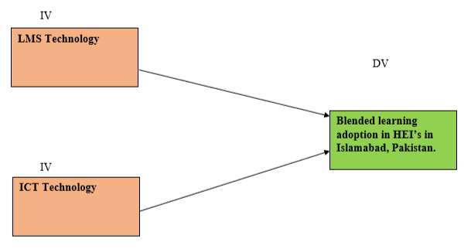

Figure: 2.7

Conceptual Framework

# 2.8 Hypothesis

Hypothesis is a frame of statement from which we made sensible suppositions (Walliman, 2011). The sort of research plan for the examination will be impacted by the research theories, and the exploration hypothesis ought to be upheld by the research questions (Farrugia, et al., 2010). According to figure 2.5, we can reach on the following hypothesis:

H1: ICT factors have a significant influence on student learning experience for blended learning adoption in higher education institutions (HEI’s) in Pakistan.

H2: LMS platform has a significant influence on student learning experience blended learning adoption in higher education institutions (HEIs) in Pakistan.

# 2.9 Conclusion

After the conduction of literature review, it can be inferred that apparent handiness, perceived convenience and behavioural goal to utilize the e-learning stage would impact the viability of mixed learning on students. The whole chapter two has talked about on the setting of mixed learning and how TAM can be utilized to quantify the students' adoption to the e-learning frameworks which will along these lines prompt the viability and adoption of blended learning. Since blended learning is new in the HEIs in Pakistan. This part gives the detail information about the mixed learning and the leads of the mixed learning. This part called attention to the significance of mixed learning adoption, history and the usage respects with the unsettling technology

# 

# Chapter 3: Research Methodology

# 3.0 Overview

In this chapter, we will focus on the methodology of research used in this section. Right off the bat, this section will clarify about the research outline with reference of the framework gave in chapter 2. Likewise, this section will also examine about the nature of the research, which incorporates the type of research, research condition, degree of research interference, and the unit of analysis. Other than that, the sampling outline and design of questionnaire will be reviewed into in this part also. To upgrade the suitability of the research data of this examination, the validity test and reliability will be conducted keeping in mind the end goal to guarantee that the collected data is important for the analysis.

# 3.1 Research Design

Looi (2014) expressed that, while outlining a research, the researcher should settle on the sort samples, select a fitting measurement for the factors under the research and pick the research procedure to be applied. The design of research can be differentiated into different types relying upon the kind of the research project, and the nature of the research problem (Walliman, 2011). A research design outlines the planning, course of strategy and technique of the research, which must summarize what the researcher will do (Mukherjee, 2017). Following table 3 will illustrate the methodology of research that is been applied in this research.

Table 3: Research Structure

|  |  |
| --- | --- |
| Items Methods | Methods |
| Nature of Research | Descriptive |
| Type of Investigation | Correlations |
| Sample selection | Non-probability and purposive sampling |
| Data collection | Questionnaire Survey |
| Data analysis | Smart PLS |

The research problem of this research is to identify the influence of blended learning adoption on students in HEI’s in Pakistan. For that purpose, the method used is quantitative that will also assist in developing a co relation in the given variables and outcomes (Looi, 2014). A quantitative research will utilize different sorts of quantitative analysis of techniques to give a straightforward description of the factors, and the build up a statistical relation between the variables (Hilman, Khalid, and Kumar, 2012). The nature of the research design fluctuates on the capacities and the abilities of the researcher to understand the strength and the weakness of the data obtained (Harwell, 2011).

## 3.1.1 Nature of Research

In a research, descriptive study will be utilized to find out and describe the characteristic for the distinguished variable under the context of research (Sekaran and Bougie, 2016). An illustrative study will depend on observation as a method for gathering data and attempts to examine situations to create what is the norm under a similar situation (Walliman, 2011). On alternate words, the variables can be portrayed in terms as numerical frame by utilizing the descriptive research (Lewis, et al., 2012). As per Sekaran and Bougie (2016), the point of purpose of descriptive study is to give a profile to the researcher or to depict the related parts of the phenomenon under examination from alternate perspective.

## 3.1.2 Types of Investigation

Keeping in mind the end goal to quantify the relation between the dependent and independent variables, the most fitting design for the sort of investigation will be co-relationship design (Kumar, 2011). The dependent variables will change because of the progressions of independent variables, and the quality of this relationship can be measured statically by utilizing co-relation technique (Lewis, et al., 2012). Sekaran and Bougie (2016) additionally expressed that the co-relation is resulting by assessing the variations in a single variable as another variable likewise changes.

## 3.1.3 Research Environment

Another name of co-relation research is ex post facto research where by it looks at the factors in their natural environment and do exclude researcher-imposed treatments (Simon and Goes, 2011). Natural environment is connected with human-collaborations and is basic in demonstrating the development of comprehensive theories (Ulrich, 1983).

## 3.1.4 Extent of Researcher Interference

The degree of researcher interference alludes to the degree of which the variables can be controlled and will accordingly affect the dependent variables of the study (Sekaran and Bougie, 2016). When choosing the kind of investigation for the research, the researcher should think about of the level of researcher's interference as one of the impacting factors (Bryman and Bell, 2011). This research will embrace the co-relation study and will be led with the minimum interference under the regular environment by the researcher by utilizing the ordinary stream of work (Sekaran and Bougie, 2016). Babin et al. (2013) additionally expressed that the perfect setting of co-relation research is there will be a minor or even no impedance from the researchers because of getting a more exact reflection of the correlation among the factors being examined. Directing research in such condition is vital as it will boost the precision of the data gathered from the co-relation research (Babin, et al., 2013).

# 3.2 Unit of Analysis

Unit of analysis is an imperative thought in a research study as it alludes to the real object that you are analysing, which will furnish you with the significant data for your research (Mcnabb, 2013). The unit of analysis in this research is the Higher Education Institutions (HEIs), though the focus is on institutions and their opinions about blended learning adoption so, questionnaire will be floated among students as well as different departments of HEI’s in Islamabad, Pakistan. Babin et al. (2013) additionally expressed that the unit of analysis of a research alludes to the common subject being explored in a research which can be regarding individual or association which is chosen by the various context of a research. As the motivation behind this investigation is to distinguish the influence of blended learning adoption, therefore the students who are studying in HEI's will be the unit of examination in this research (Lewis, et al., 2012). For this situation, the unit of examination can be considered as individual. The population of study alludes to the subject that is proposed to be explored by the researcher (Sekaran and Bougie, 2016). Study population can likewise be alluded as the subjects where by the researcher can got the required information to answer the research questions (Kumar, 2011). For this situation, the research population of this study will be the students studying in HEI's in Islamabad, Pakistan.

# 3.3 Sampling Plan

## 3.3.1 Sampling Population

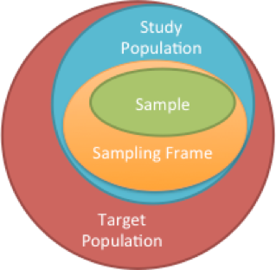The participants which is chosen for this research will be the students of age 18 or above who are currently studying in HEI's in Islamabad Pakistan. These students can likewise be considered as the sampling frame for this research because of their different demographic attributes and the program they selected for their degree. As blended learning methodology will have diverse effect for different students considering the student learning needs, the point of this research is to distinguish the key factors that will have influence on blended learning adoption in HEI's in Pakistan. For this research, questionnaire will be distributed for data accumulation purposes. Figure underneath demonstrates sampling frame in context to population and sample.

Figure 3: Sampling Frame in Relation to Population and Sample

Source: Walliman (2011)

## 3.3.2 Sampling Method

Measurement of characteristic from a population in order to select sample unit is known as sampling (Rahi, 2017). There are two techniques of sampling, which is the non-probability sampling and probability sampling (Bala and Etikan, 2017). Because of time requirement and cost effectiveness, non-probability sampling is considered as the most appropriate technique of sampling to be applied on (Alvi, 2016). If the elements of population in unidentifiable individually, one can use non-probability sampling (Kumar, 2011).

Sampling method under non-probability sampling is purposive sampling (Showkat and Parveen, 2017). Under purposive sampling, the attributes of the sample to be incorporated into the research is predefined (Alvi, 2016). By executing the purposive sampling method, the researcher ought to apply the best judgment in choosing the participants or respondents to get significant data to accomplish the objectives of research (Kumar, 2011). Purposive sampling method will be applied on this research as the participants intended to take part in this research are the students who are currently studying in HEI’s in Pakistan and related to the institute which mainly focus on traditional way of learning and teaching.

## 3.3.3 Sampling Size

Selected sample has to be the representative of the target population, that is how the number of participants can be determined properly (Patino and Ferreira, 2016). The estimated number of students studying in HEI’s In Pakistan is 9.33 million (Suresh, 2015). Because of time limitation and in addition 95% of confident level and 0.7 margin of error, the sample size would be 150 for this population (Cohen’s, 1992). Table below illustrates the decided sample size from the given population:

Table 4: Table of determining sample size from a given population

A screenshot of a cell phone

Description generated with very high confidence



*Source*: Cohen, J. A power primer. *Psychological Bulletin*, 112, 155-519

3.4 Pilot test

Pilot testing is characterized or alluded to as a little report to play out an examination to the survey made and to help and limit the difficulties that the participant may confront while answering question and gathering information issue together with the reliability of the data collected (Zikmund et al., 2012). Running on 10% of the sample size is the thing that done in pilot test and it will associate with 25-32 for this research study (Hazzi and Maldaon, 2015). In conducting this pilot test an aggregate 30 respondent was chosen and data was gathered and tested to check the reliability of the data.

## 3.4.1 Descriptive Information

Statistical information in regard to the characteristic of a population is characterized as demographic profile (Sekaran and Bougie, 2016). The data assembled will give the required information about the respondents of the research (Alvi, 2014). With the end goal of generalization, the demographic data is required to decide if the member of the examination are the genuine representatives of the objective population (Rahi, 2017). In this research, the demographic information that will be gathered would be the age, gender and level of education of respondents as upheld by Sekaran and Bougie (2016).

## 3.4.2 Pilot Test: Reliability Test

Table 5: Reliability Test

|  |  |
| --- | --- |
| Items | Significance Value |
| Cronbach Alpha | >0.7 |

The following test would be the reliability test where it is used to decide the reliability and legitimacy of the information gathered for the dimension of impact of LMS and ICT on blended learning adoption which likewise to complete an assessment on the stability and internal consistency of the measure (Sekaran and Bougie, 2017). The value of Cronbach alpha esteem must be more than 0.7 and being a pilot test the outcome is permitted to be marginally skewed (Hazzi and Maldaon, 2015). Be that as it may, if the value of Cronbach alpha dips under 0.7, the question should have been erased or changed (Hilman et al., 2012).

## 3.4.3 Preliminary Tests

Information gathered will be tested by preliminary test to check out the integrity of the data utilizing the Smart-PLS system (Mukherjee, 2017).

## 3.4.4 Measurement Model Assessment

The information that is gathered for pilot study is run through the SMART-PLS utilizing an orderly Evaluation. This system has four segments that exist which are Internal Consistency (Component Reliability), Indicator Reliabilty, Convergent Validity (Average Variance Extracted) and Dicriminant Validity (Hair and Sarstedt,2014).

### 3.4.4.1 Internal Consistency (Component Reliability)

The information that is gathered for pilot study is gone through the SMART-PLS utilizing a systematic Evaluation. this system has four parts that exist which are Internal Consistency (Component Reliability), Indicator Reliability, Convergent Validity (Average Variance Extracted) and Discriminant Validity (Hair and Sarstedt,2014). Measuring distinctive things on a similar test dependent on the correlation is normally known as internal consistency. The reason for internal consistency is to propose or to verify that the few independent variables that are being measured can create similar outcome with the dependent variable. The composite reliability value ought to be more than 0.70 and any value underneath 0.6 is considered as absence of internal consistency. Moreover, value in between 0.6 to 0.7 are viewed as adequate in exploratory research and values in between 0.7 to 0.9 is a satisfactory value while values above 0.9 verifies that all the indicators are estimating a similar phenomenon (Hair et.al., 2014). Pilot test has been conducted by researcher and the Component Reliability test is acquired and is in following table

Table 5: Composite Reliability

|  |  |
| --- | --- |
| Variable | Composite Reliability |
| LMS | 0.855 |
| ICT | 0.914 |
| Blended Learning | 0.913 |

### 3.4.4.2 Indicator reliability

Indicator reliability test is done to see whether every one of the indicator or variables are reliable and is there requirement for any question removal. It is appeared by the higher outer loadings that is available in a similar gathering of convergent validity (Hair et.al., 2014). The rule of thumb is that the value of outer loading must be above 0.708 to be acknowledged. Values between of 0.4 to 0.7, the researcher should consider evacuating it and while expelling the indicator leads, the composite reliability has an expansion in value. In the meantime, any value underneath of 0.4 ought to be expelled (Hair, Ringle, and Sartedt, 2015).

Table 6: Indicator Reliability

|  |  |  |  |
| --- | --- | --- | --- |
| Indicator Reliability | | | |
|  | LMS Technology | ICT Technology | Blended Learning |
| Q4_LMS | 0.905 |  |  |
| Q5_LMS | 0.855 |  |  |
| Q6_LMS | 0.734 |  |  |
| Q7_ICT |  | 0.802 |  |
| Q8_ICT |  | 0.901 |  |
| Q9_ICT |  | 0.788 |  |
| Q10_ICT |  | 0.774 |  |
| Q11_ICT |  | 0.855 |  |
| Q12_BLA |  |  | 0.808 |
| Q13_BLA |  |  | 0.830 |
| Q14_BLA |  |  | 0.764 |
| Q15_BLA |  |  | 0.734 |
| Q16_BLA |  |  | 0.752 |
| Q17_BLA |  |  | 0.922 |

After running PLS algorithm the values of outer loading are greater than 0.708, and some of the variables whose value was less than 0.708 were removed.

### 3.4.4.3 Convergent Validity

Convergent validity measures the degree to which it relates emphatically with alternate measures inside a similar construct (Hair and Hult, 2017). Convergent validity items share high extent of variance. With the end goal to establish the convergent validity, the researcher needs to consider two things which are:

1. Indicator reliability also known as outer loading of indicator must be high.
2. Average variance extracted (AVE) must be considered by the researcher.

Average variance extracted (AVE)

The AVE is characterizing as a grand mean estimation of the squared loading's and is proportionate to the commonality of the construct. The estimation of the AVE ought to be more than 0.5 and if the value is beneath 0.5 that implies the presence of error in the item with the fluctuation explained by the construct (Hair and Hult, 2017).

Table 7 : Convergent Validity

|  |  |
| --- | --- |
| Convergent Validity | |
|  | Average Variance Extracted (AVE) |
| LMS | 0.696 |
| ICT | 0.681 |
| Blended Learning | 0.647 |

### 3.4.4.4 Discriminant validity

This test shows to what degree the build really distinct itself from the other construct by utilizing experimental measures and the method for evaluation by doing examination to the outer loading. The standard guideline for this test would be that the outer loading value ought to be higher than the majority of its construct loading. The Fornell Larcker model is utilized the square root of the AVE ought to be more than variable correlation latent. To get the test outcome the method which is used is Heterotrait Monotrait Ratio (HTMT).

Table 8 : Fornell Larcker Criterion

|  |  |  |  |
| --- | --- | --- | --- |
| Fornell Larcker | | | |
|  | LMS | ICT | Blended Learning |
| LMS | 0.835 |  |  |
| ICT | 0.673 | 0.825 |  |
| Blended Learning | 0.678 | 0.727 | 0.804 |

Table 9 : Cross Loading

|  |  |  |  |
| --- | --- | --- | --- |
| Cross Loading | | | |
|  | LMS | ICT | Blended Learning |
| Q4_LMS | 0.312 | 0.526 | 0.808 |
| Q5_LMS | 0.751 | 0.594 | 0.830 |
| Q6_LMS | 0.303 | 0.614 | 0.764 |
| Q7_ICT | 0.905 | 0.549 | 0.740 |
| Q8_ICT | 0.581 | 0.802 | 0.416 |
| Q9_ICT | 0.855 | 0.605 | 0.464 |
| Q10_ICT | 0.535 | 0.901 | 0.595 |
| Q11_ICT | 0.600 | 0.550 | 0.734 |
| Q12_BLA | 0.552 | 0.788 | 0.538 |
| Q13_BLA | 0.734 | 0.572 | 0.399 |
| Q14_BLA | 0.513 | 0.774 | 0.757 |
| Q15_BLA | 0.565 | 0.528 | 0.752 |
| Q16_BLA | 0.611 | 0.855 | 0.581 |
| Q17_BLA | 0.621 | 0.679 | 0.922 |

Both tables show that data is valid for the discriminant validity and the rule of thumb is adhered accordingly.

Table 10: Result Summary

|  |  |  |  |  |  |
| --- | --- | --- | --- | --- | --- |
| Result Summary for Reflective Measurement Models | | | | | |
| Latent Variable | Indicators | Loading | Indicator Reliability | Composite Reliability | Ave |
| LMS | Q4_LMS | 0.905 | 0.905 | 0.855 | 0.696 |
| Q5_LMS | 0.855 | 0.855 |
| Q6_LMS | 0.734 | 0.734 |
| ICT | Q7_ICT | 0.802 | 0.802 | 0.914 | 0.681 |
| Q8_ICT | 0.901 | 0.901 |
| Q9_ICT | 0.788 | 0.788 |
| Q10_ICT | 0.774 | 0.774 |
| Q11_ICT | 0.855 | 0.855 |
| Blended Learning | Q12_BLA | 0.808 | 0.808 | 0.913 | 0.647 |
| Q13_BLA | 0.830 | 0.830 |
| Q14_BLA | 0.764 | 0.764 |
| Q15_BLA | 0.734 | 0.734 |
| Q16_BLA | 0.752 | 0.752 |
| Q17_BLA | 0.922 | 0.922 |

Chapter 4 Data Analysis and Findings

# 4.0 Overview

Ensuing from the dialog in Chapter 3, the analysis of data is directed dependent on the methodology. Chapter 4 will concentrate on the analysis of data gathered from the questionnaire and the result of the investigation will be interpreted. Analysis will be done using smart pls software.

# 4.1 Pilot test

Pilot testing is characterized or alluded to as a little report to play out an examination to the survey made and to help and limit the difficulties that the participant may confront while answering question and gathering information issue together with the reliability of the data collected (Zikmund et al., 2012). In conducting this pilot test an aggregate 157 respondent was chosen and data was gathered and tested to check the reliability of the data.

# 4.2 Descriptive Information

Statistical information regarding the characteristic of a population is characterized as demographic profile (Sekaran and Bougie, 2016). The data assembled will give the required information about the respondents of the research (Alvi, 2014). With the end goal of generalization, the demographic data is required to decide if the member of the examination are the genuine representatives of the objective population (Rahi, 2017). In this research, the demographic information that will be gathered would be the age, gender and level of education of respondents as upheld by Sekaran and Bougie (2016).

Table 11: Descriptive Analysis

|  |  |  |
| --- | --- | --- |
| Demographic Information | Frequency | Percentage (%) |
| Age |  |  |
| 18-20 | 25 | 15.9 |
| 21-24 | 60 | 38.2 |
| 25-28 | 55 | 35 |
| Above 28 | 17 | 10.8 |
| Gender |  |  |
| Male | 76 | 48.4 |
| Female | 78 | 49.7 |
| Prefer Not to Say | 3 | 1.9 |
| Total | 157 | 100% |
| Level of Education |  |  |
| Diploma | 8 | 5.1 |
| Bachelor’s | 66 | 42 |
| Postgraduate | 67 | 42.7 |
| Doctorate | 16 | 10.2 |

As indicated by the descriptive analysis that the number of participants is 157 out of which 48.4% are male and 49.7% are female. Majority of the students are from the age group of 21-24, and 25-25, and are the students of bachelors and postgraduate studies respectively.

# 4.3 Internal Consistency (Component Reliability)

The information that is gathered for pilot study is gone through the SMART-PLS utilizing a systematic Evaluation. this system has four parts that exist which are Internal Consistency (Component Reliability), Indicator Reliability, Convergent Validity (Average Variance Extracted) and Discriminant Validity (Hair and Sarstedt,2014). Moreover, value in between 0.6 to 0.7 are viewed as adequate in exploratory research and values in between 0.7 to 0.9 is a satisfactory value while values above 0.9 verifies that all the indicators are estimating a similar phenomenon (Hair et.al., 2014).

Table 12: Composite Reliability

|  |  |
| --- | --- |
| Variable | Composite Reliability |
| LMS | 0.903 |
| ICT | 0.948 |
| Blended learning | 0.934 |
|  | |

## 

## 4.3.1 Indicator reliability

|  |  |  |  |
| --- | --- | --- | --- |
| Indicator Reliability | | | |
|  | LMS Technology | ICT Technology | Blended Learning |
| Q4_LMS | 0.837 |  |  |
| Q5_LMS | 0.883 |  |  |
| Q6_LMS | 0.887 |  |  |
| Q7_ICT |  | 0.878 |  |
| Q8_ICT |  | 0.863 |  |
|  |  |  |  |
| Q9_ICT |  | 0.830 |  |
| Q10_ICT |  | 0.773 |  |
| Q11_ICT |  | 0.803 |  |
| Q12_ICT |  | 0.793 |  |
| Q13-ICT |  | 0.855 |  |
| Q14_ICT |  | 0.832 |  |
| Q15_ICT |  | 0.731 |  |
| Q16_BLA |  |  | 0.780 |
| Q17_BLA |  |  | 0.781 |
| Q18_BLA |  |  | 0.786 |
| Q19_BLA |  |  | 0.797 |
| Q20_BLA |  |  | 0.854 |
| Q21_BLA |  |  | 0.761 |
| Q22_BLA |  |  | 0.717 |
| Q23_BLA |  |  | 0.760 |
| Q24_BLA |  |  | 0.795 |

Indicator reliability test is done to see whether every one of the indicator or variables are reliable and is there requirement for any question removal. It is appeared by the higher outer loadings that is available in a similar gathering of convergent validity (Hair et.al., 2014). The rule of thumb is that the value of outer loading must be above 0.708 to be acknowledged.

The questions whose values were below 0.708 were removed as per the rule of thumb and remaining are only the questions whose values are 0.708 or above.

## 4.3.2 Convergent Validity

Convergent validity measures the degree to which it relates emphatically with alternate measures inside a similar construct (Hair and Hult, 2017). To establish convergent validity, researcher keep in mind two things, one is indicator reliability whose value must be high, and the other thing is average variance extracted.

Average variance extracted (AVE)

The value of grand mean of squared loadings is known as AVE. The estimation of the AVE ought to be more than 0.5 and if the value is beneath 0.5 that implies the presence of error in the item with the fluctuation explained by the construct (Hair and Hult, 2017).

Table 13: Convergent Validity

|  |  |
| --- | --- |
| Convergent Validity | |
|  | Average Variance Extracted (AVE) |
| LMS | 0.756 |
| ICT | 0.670 |
| Blended Learning | 0.611 |

## 4.3.3 Discriminant validity

This test shows to what degree the build really distinct itself from the other construct by utilizing experimental measures and the method for evaluation by doing examination to the outer loading. The Fornell Larcker model is used and the square root of the AVE ought to be more than variable correlation latent. In order to get results the method which is used is Heterotrait Monotrait Ratio (HTMT).

Table 14 : Fornell Larcker Criterion

|  |  |  |  |
| --- | --- | --- | --- |
| Fornell Larcker | | | |
|  | LMS | ICT | Blended Learning |
| LMS | 0.869 |  |  |
| ICT | 0.673 | 0.819 |  |
| Blended Learning | 0.543 | 0.682 | 0.782 |

|  |  |  |  |
| --- | --- | --- | --- |
| Cross Loading | | | |
|  | LMS | ICT | Blended Learning |
| Q4_LMS | 0.883 | 0.346 | 0.436 |
| Q5_LMS | 0.887 | 0.407 | 0.513 |
| Q6_LMS | 0.837 | 0.482 | 0.461 |
| Q7_ICT | 0.483 | 0.803 | 0.531 |
| Q8_ICT | 0.389 | 0.863 | 0.558 |
| Q9_ICT | 0.422 | 0.773 | 0.473 |
| Q10_ICT | 0.382 | 0.830 | 0.593 |
| Q11_ICT | 0.431 | 0.731 | 0.451 |
| Q12_ICT | 0.358 | 0.878 | 0.573 |
| Q13_ICT | 0.406 | 0.832 | 0.573 |
| Q14_ICT | 0.307 | 0.793 | 0.584 |
| Q15_ICT | 0.357 | 0.855 | 0.651 |
| Q16_BLA | 0.490 | 0.567 | 0.780 |
| Q17_BLA | 0.525 | 0.514 | 0.795 |
| Q18_BLA | 0.365 | 0.540 | 0.781 |
| Q19_BLA | 0.364 | 0.481 | 0.761 |
| Q20_BLA | 0.311 | 0.471 | 0.717 |
| Q21_BLA | 0.368 | 0.533 | 0.760 |
| Q22_BLA | 0.412 | 0.553 | 0.797 |
| Q23_BLA | 0.450 | 0.308 | 0.854 |
| Q24_BLA | 0.499 | 0.518 | 0.786 |

|  |  |  |  |
| --- | --- | --- | --- |
|  | LMS | ICT | Blended Learning |
| LMS |  |  |  |
| ICT | 0.540 |  |  |
| Blended learning | 0.610 | 0.727 |  |

# 4.4 Hypothesis Testing

Table 15: P value

|  |  |  |  |  |  |
| --- | --- | --- | --- | --- | --- |
|  | Original Sample (O) | Sample Mean (M) | Standard Deviation (STDEV) | T Statistics (|O/STDEV|) | P Values |
| LMS -> Blended Learning Adoption | 0.283 | 0.273 | 0.153 | 1.845 | 0.065 |
| ICT -> Blended Learning Adoption | 0.548 | 0.563 | 0.176 | 3.115 | 0.002 |

In order for the acceptance of hypothesis the P value must be less than 0.05. as the table indicates that the p value of variable 1(LMS) is above 0.05 which means that the hypothesis is rejected, while on the other hand the p value for variable 2 (ICT) is below 0.05 which means that the hypothesis is accepted. The reason of rejection of hypothesis 1 is that the software’s used in learning management system might be important but they do not affect the learning experience of student. While the ICT has a significant influence on student learning for blended learning adoption and the hypothesis is also been accepted.

The (R-squared) , (additionally called the coefficient of determination), which is the extent of variance (%) in the dependent variable that can be clarified by the independent variable. Consequently, as a standard guideline for interpreting the quality of a relationship based on the value of R-squared (Moore, Notz and Fligner, 2013).

* When the R-square value is less than 0.3 its effect size is considered as weak or none.
* When the R-square value is greater than 0.3 but less than 0.5 the effect size is considered as low or weak.
* When R-square value is greater than 0.5 but less than 0.7 the effect size is considered as moderate.
* When the R-square value is greater than 0.7 the effect size is considered as strong effect size.

Table 16: R-square

|  |  |  |
| --- | --- | --- |
|  | R Square | R Square Adjusted |
| Latent Variable 3 | 0.528 | 0.521 |

The table indicates that the R square value has a moderate effect size.

# 4.5 Conclusion

The purpose of this study is to decide the key components which will has an influence on students learning experience for adoption of blended learning. As appeared in the results of the research, the factors demonstrated in the structure have a positive critical relationship with the adoption of blended learning. This demonstrates that the students who are attempting to engage with blended learning are expecting to get higher grades in their academic career as compare to traditional style of learning.

# Chapter 5 Conclusion and Recommendations

# 5.0 Overview

This section will give the key findings on the outcomes got from the data examination, and an outline of the research as conclusion. Appropriate suggestions will be given situated in the result of the analysis of this research. Furthermore, the process of future research and personal reflection on the general research process and experience will be given in this chapter too.

# 5.1 Summary of Findings

The purpose of this research is to study the influence of LMS and ICT technology on learning experience of students for adoption of blended learning in HEI’s in Pakistan. Hypothesis 1 stated that LMS technology has an influence on student learning experience for blended learning adoption. Based on the results in chapter 4, the first hypothesis is rejected as the table in chapter 4 indicates that the p value of hypothesis 1 is greater than 0.05. which means that LMS technology ( software’s use for learning purposes e.g. Blackboard) does not influence students learning in HEI’s. Which means that the software’s might be important for administration purposes, of lecture delivery or engage students in lectures but it does not have a prominent effect on learning experience of students. It does not help students to enhance there skills or level of confidence, or does not either help to increase there grades as showing in chapter 4 analysis and the results of p- value that LMS does not influence the learning experience of students.

For the hypothesis 2, the researcher wants to test whether ICT will influence the learning experience of students for blended learning adoption as according to Sultana (2012), Qureshi, Ilyas, Yasmin and Whitty (2012) and Suresh (2015), the literacy rate recorded in 2015 is 58% in Pakistan and its because not the use of updated technologies. Hypothesis 2 is whereby proven accepted in chapter 4 as the p value of hypothesis 2 which was that the ICT technology has an influence on student learning experience in HEI’s is below 0.05. which means that the ICT technology( projectors, availability of Wi-Fi, gadgets) influence the learning experience of students and according to students they think that these factors will positively influence their studies and not only help them to interact with each other in a better way but also help them to score good grades as compared to traditional face to face learning style.

# 5.2 Contribution

## 5.2.1 Contribution to Academe

As researcher mentioned in chapter 1, there are insufficient articles on the blended learning or blended learning adoption in Pakistan, just a single article somewhat contacted the upcoming pattern of technologies in Pakistan, so this study should be the first one to explore the factors influencing blended learning adoption in HEI’s in Pakistan.

For this study, researcher uses quantitative approach to find out the influence of LMS and ICT technology on learning experience of students for blended learning adoption in HEIs in Islamabad, Pakistan. Besides, the hypothesis testing also clarify some common and interesting issues like lack of technology, lack on infrastructure which gives the clear understanding why blended learning is not considering as an effective tool in Islamabad Pakistan.

With the high-quality data collection, the appropriate framework and the detailed analysis, this quantitative research has the contribution to fill up the gap in literature. This study will help and would offer the platform for the further future research to discuss when researcher study blended learning adoption in the context of Pakistan.

## 5.2.2 Contribution to Industry

This study contributes in giving basic perspectives on the adoption of blended learning for students in HEI’s in Pakistan. According to Mozelius & Hettiarachchi (2017), acceptance of students and use of ICT are the main factor of the success of blended learning in HEI’s besides the acceptance of teacher. Since there is no systematic information on the blended learning adoption in the context of Pakistan. This quantitative study did focus on the exploring the factors influencing blended learning adoption in HEIs in Islamabad Pakistan.

This research gives the value to the blended learning in education industry of Pakistan. The outcomes that found in this research will help the Education Industry to go further and the recommendations, key findings, and analysis will help the industry of education, administration of universities and the academic of the HEI's while adopting the blended learning.

# 5.3 Recommendations

The quality and outcome of teaching and learning could be improved by enhancing the interaction in the learning environment (Khodabandelou, Jalil & Ali et al., 2015). Blended learning adoption will help students to build their confidence and make them independent in learning. The e-learning platform will act as a tool for information sharing between students and the teacher will moderate the process of sharing. Students are persuaded to consider abroad because of profession opportunities. Researcher want to suggest that Pakistani Education Industry should adopt the blended learning since it will give the work chances to the alumni and also the new graduates as institutions will require staff for the software’s as well as to provide training for the current staff to be efficient with blended learning. Moreover, it will also help students to coupe up with the pace of the world and compete with rest of the world as blended learning is being adopted by the leading world institutions.

Researcher recommends reducing the “negligence” factors which affects the implementation of blended learning in Islamabad, Pakistan. The top-level management should take action on the adoption of blended learning, that will help to enhance the quality of education as well as improve the online literacy skills of the users. So, it will indirectly reduce the factor of negligence and spur Pakistan universities to adopt blended learning in the future. Beside focusing on the challenges of blended learning, HEIs should focus on the benefits of the blended learning as well as to collaborate to provide a sounding platform for the government of Pakistan in general, and Islamabad specifically to encourage the improvement of the existing IT infrastructure throughout the country.

# 5.4 Limitations of Study

As the students in higher education institutions in Islamabad, Pakistan are not that much aware of blended learning, even though the definitions had been provided in questionnaire, but they do not have deep know how about blended learning, LMS and ICT technology in blended learning.

Time constraint is another limitation for this research. As this research paper considering as an MBA final project, it required researcher to complete the research within 8 months under the module of Business Research Method (BRM) and MBA Project. However, researcher was also enrolled with the other modules which lead to the limited time for this study.

Similarly, the sample size of this research is small which might have an influence on the outcomes of research but overall It is a good approach as this research has successfully gained some valuable research information to ignite future research (Sekaran and Bougie, 2011).

# 5.5 Chapter Conclusion

This last chapter is to conclude the overall research. Researcher highlighted the outcomes of the hypothesis testing and findings. The researcher additionally gives some suggestion, contribution of both academe and industry. In conclusion, researcher give future research suggestions and personal reflection.

# Reference

Alebaikan, R. A., 2012. The Future of blended learning. International Journal of Social, Behavioral, Educational, Economic, Business and Industrial Engineering, 6(3), pp. 321-325.

Ali, W. Z. W., Ayub, A. F. M., Ismail, N. & Yunus, A. S. M., 2014. The Effects of blended learning Methods on Educational Achievement and the Development of Online Material in a Curriculum Information Document Online System (CIDOS) for Computer Application Courses. Malaysian Journal of Distance Education, 16(2), pp. 59-82.

Alias, N. A., Jain, J. & Luaran, J. E., 2014. blended learning: Examining Concepts and Practices. In: M. A. Embi, ed. blended & Flipped Learning: Case Studies in Malaysian HEIs. Bangi: Centre for Teaching & Learning Technologies, Universiti Kebangsaan Malaysia, pp. 19-33.

Alshahrani, Saeed, Ward, and Rupert, (2014). Shifting from traditional approaches of teaching to a blended learning approach; challenges and possible solutions.

Alshathri, S., 2016. The challenges of developing blended learning in the first electronic university in the Arab world (Saudi Electronic University). Educational Futures, 7(3), pp. 86-98

Alshathri, S., 2016. The challenges of developing blended learning in the first electronic university in the Arab world (Saudi Electronic University). Educational Futures, 7(3), pp. 86-98

Alvi, M., 2016. A Manual for Selecting Sampling Techniques in Research. [Online] Available at: https://mpra.ub.uni-muenchen.de/70218/1/MPRA_paper_70218.pdf [Accessed 18 Jul 2018].

Asiri, M., Mahmud, R., Abu Bakar, K. and Mohd Ayub, A. (2012). Factors Influencing the Use of Learning Management System in Saudi Arabian Higher Education: A Theoretical Framework. *Higher Education Studies*, 2(2).

Aslam, S. (2013). A Comparative Study of blended learning versus Traditional Teaching.

Babin, B. J., Carr, J. C., Griffin, M. & Zikmund, W. G., 2013. Business Research Methods. 9th ed. USA: Cengage Learning.

Bala, K. & Etikan, I., 2017. Sampling and Sampling Methods. Biometrics & Biostatistics International Journal, 5(6), pp. 1-3.

Bhandar, M. et al., 2010. Research questions, hypotheses and objectives. Canadian Journal of Surgery, 53(4), pp. 278-281

Blomeyer, R., Renk, S. And Clair, C. (2012). blended Course and Higher Ed: On mission or Off course? *26th Annual Conference on Distance Teaching and Learning*.

Bryman, A. & Bell, E., 2011. Business Research Methods. 3rd ed. New York: Oxford University Press Inc.

Bryman, A. & Bell, E., 2011. Business Research Methods. 3rd ed. New York: Oxford University Press Inc.

Cavus, N. (2013). Selecting a learning management system (LMS) in developing countries: instructors' evaluation. *Interactive Learning Environments*, 21(5), pp.419-437.

Chou, A. And Chou, D. (2011). Course Management Systems and blended learning: An Innovative Learning Approach. *Decision Sciences Journal of Innovative Education*, 9(3), pp.463-484.

Chou, A. And Chou, D. (2011). Course Management Systems and blended learning: An Innovative Learning Approach. *Decision Sciences Journal of Innovative Education*, 9(3), pp.463-484.

Conde, M., García-Peñalvo, F., Rodríguez-Conde, M., Alier, M., Casany, M. And Piguillem, J. (2012). An evolving Learning Management System for new educational environments using 2.0 tools. *Interactive Learning Environments*, 22(2), pp.188-204.

Demirer, V. & Sahin, I., 2013. Effect of blended learning environment on transfer of learning: an experimental study. Journal of Computer Assisted Learning, 29(6), pp. 518-529.

Dias, S. B. & Diniz, J. A., 2014. Towards an Enhanced Learning Management System for blended learning in Higher Education Incorporating Distinct Learners’ Profiles. Educational Technology & Society, 17(x), p. 307–319.

Dikko, M., 2016. Establishing Construct Validity and Reliability: Pilot Testing of a Qualitative Interview for Research in Takaful (Islamic Insurance). The Qualitative Report, 21(3), pp. 521-528.

Dzakiria, H., Don, M. S. & Rahman, H. D. A., 2012. blended learning (BL) as Pedagogical Alternative to Teach Business Communication Course: Case Study of UUM Executive Diploma Program. Turkish Online Journal of Distance Education, 13(3), pp. 297-315.

Dzakiria, H., Don, M. S. & Rahman, H. D. A., 2012. blended learning (BL) as Pedagogical Alternative to Teach Business Communication Course: Case Study of UUM Executive Diploma Program. Turkish Online Journal of Distance Education, 13(3), pp. 297-315.

Farrugia, P., Bhandari, M., Petrisor, B. And Farrokhyar, F. (2010). Research questions, hypotheses and objectives. *Canadian Journal of Surgery*, [online] 53(4), p.278. Available at: http://www.ncbi.nlm.nih.gov/pmc/articles/PMC2912019/ [Accessed 18 Jul 2018].

Flynn, J. (2013). Moocs: disruptive innovation and the future of higher education. *Christian education journal*, 10(1), p.149.

Fu, J. (2013). ICT in Education: A Critical Literature Review and Its Implications. *International Journal of Education and Development using Information and Communication Technology*, 9(1), pp.112-125.

Fu, J.S., 2013. ICT in education: A critical literature review and its implications. *International Journal of Education and Development using Information and Communication Technology*, *9*(1), p.112.

Gisbert, M. And Johnson, L. (2015). Education and technology: new learning environments from a transformative perspective. *RUSC. Univ. And Know. Soc.*, 12(2), p.1.

Gluck, M. (2012). *The role of Technology in Today’s World and in the Future*. [online] Eoi.es. Available at: http://www.eoi.es/blogs/marieglueck/2012/06/30/the-role-of-technology-in-today%E2%80%99s-world-and-in-the-future/ [Accessed 18 Jul 2018].

Gogus, A., & Nistor, N. (2012, October). Educational technology acceptance across cultures: A validation of the Unified Theory of Acceptance and Use of Technology in the context of turkish national culture. Turkish Online Journal of Educational Technology - TOJET, 11, 394-408.

Grace, O., 2017. From Diffusion to Explosion: Accelerating blended learning at the University of Western Australia. In: C. P. Lim & L. Wang, eds. blended learning for Quality Higher Education: Selected Case Studies on Implementation from Asia-Pacific. Paris: United Nations Educational, Scientific and Cultural Organization, pp. 66-102

Graham, C.R., Woodfield, W. and Harrison, J.B., 2013. A framework for institutional adoption and implementation of blended learning in higher education. *The internet and higher education*, *18*, pp.4-14.

Gruba, P., Cárdenas-Claros, M., Suvorov, R. And Rick, K. (2016). *blended language program evaluation*.

Gu, X., 2017. blended learning at East China Normal University: Promising Practices and Challenges. In: C. P. Lim & L. Wang, eds. blended learning for Quality Higher Education: Selected Case Studies on Implementation from Asia-Pacific. Paris: United Nations Educational, Scientific and Cultural Organization, pp. 39-64.

Gyamfi, S. And Gyaase, P. (2015). Students' perception of blended learning environment: A case study of the University of Education, Winneba, Kumasi-Campus, Ghana. *International journal of education and development using information and communication technology*, 11(1), p.80.

Gyamfi, S. And Gyaase, P. (2015). Students' perception of blended learning environment: A case study of the University of Education, Winneba, Kumasi-Campus, Ghana. *International journal of education and development using information and communication technology*, 11(1), p.80.

Hair, J. F., Black, W. C., Babin, B. J. & Anderson, R. E., 2010. Multivariate Data Analysis. 7th ed. s.l.: Pearson

Harwell, M. R. (2011) ‘Research design in qualitative/quantitative/mixed methods*.*’ *The Sage handbook for research in education*. 2nd edn. Los Angeles, CA: Sage.

Hazzi, O. A. & Maldaon, I. S., 2015. A Pilot Study: Vital Methodological Issues. Business: Theory and Practice, 16(1), pp. 53-62.

Hilman, H., Khalid, K. & D. K., 2012. Get Along with Quantitative Research Process. International Journal of Research in Management, 2(2), pp. 15-29.

Hilman, H., Khalid, K. & D. K., 2012. Get Along with Quantitative Research Process. International Journal of Research in Management, 2(2), pp. 15-29

Ibrahim, Y. and Mehmet, D. (2014). Effect of blended learning environment model on high school students' academic achievement. *TOJET the Turkish online journal of educational technology*, 13(1), pp.78-87.

Im, I., Hong, S., & Kang, M. S. (2012). An international comparison of technology adoption: Testing the UTAUT model. Information & management,48(1), 1-8.

Janjua, M. (2011). *Futurechallenges » How Technology Enables Education in Pakistan*. [online] Futurechallenges.org. Available at: https://futurechallenges.org/local/how-technology-enables-education-in-pakistan/ [Accessed 18 Jul 2018].

Kagambe, E., Kintu, M. J. & Zhu, C., 2017. blended learning effectiveness: the relationship between student characteristics, design features and outcomes. International Journal of Educational Technology in Higher Education, 14(7), pp. 1-20.

Kagambe, E., Kintu, M. J. & Zhu, C., 2017. blended learning effectiveness: the relationship between student characteristics, design features and outcomes. International Journal of Educational Technology in Higher Education, 14(7), pp. 1-20.

Kaur, M., 2013. blended learning-its challenges and future. *Procedia-Social and Behavioral Sciences*, *93*, pp.612-617.

Kimberlin, C. L. & Winterstein, A. G., 2012. Validity and reliability of measurement instruments used in research. Am J Health-Syst Pharm, Volume 65, pp. 2276-2284.

Krejcie, R. V. & Morgan, D. W., 1970. Determining Sample Size for Research Activities. Educational and Psychological Measurement, Volume 30, pp. 607-610.

Kumar, R., 2011. Research Methodology: A step-by-step guide for beginners. 3rd ed. s.l.: SAGE Publications Ltd.

Kurniali, S. (2014). An approach to online learning using learning management system in higher education institution. *Journal of Computer Science*, 10(8), pp.1517-1521.

Lewis, P., Saunders, M. & Thornhill, A., 2012. Research methods for business students. 6th ed. London: Pearson Education Limited

Lewis, P., Saunders, M. & Thornhill, A., 2012. Research methods for business students. 6th ed. London: Pearson Education Limited.

Lichy, J., Khvatova, T. And Pon, K. (2014). Engaging in digital technology: one size fits all? *Journal of Mgmt Development*, 33(7), pp.638-661.

Lim, C. P. & Wang, T., 2017. A Framework and Self-Assessment Tool for Building the Capacity of Higher Education Institutions for blended learning. In: C. P. Lim & L. Wang, eds. blended learning for Quality Higher Education: Selected Case Studies on Implementation from Asia-Pacific. Paris: United Nations Educational, Scientific and Cultural Organization, pp. 1-38.

Looi, T. C., 2014. The Strengths and Weaknesses of Research Methodology: Comparison and Complimentary between Qualitative and Quantitative Approaches. Journal of Humanities and Social Science, 19(4), pp. 99-104.

Mahnegar, F. (2012). Learning Management System. *International Journal of Business and Social Science*, 3(12).

Martin, S., Diaz, G., Sancristobal, E., Gil, R., Castro, M. And Peire, J. (2011). New technology trends in education: Seven years of forecasts and convergence. *Computers & Education*, 57(3), pp.1893-1906.

Mcnabb, D. E., 2013. Research method in public administration and non-profit management: quantitative and qualitative approaches. 3rd ed. New York: M. E. Sharpe.

Missildine, K., Fountain, R., Summers, L. And Gosselin, K. (2013). Flipping the Classroom to Improve Student Performance and Satisfaction. *Journal of Nursing Education*, 52(10), pp.597-599

Moore, D., Notz, W. and Fligner, M. (2013). *The basic practice of statistics*. 7th ed. New York: W.H. Freeman and Co., c2004, 2003 printing., p.138.

Moskal, P., Dziuban, C. And Hartman, J. (2013). blended learning: A dangerous idea?. *The Internet and Higher Education*, 18, pp.15-23.

Mtebe, J. (2015). Learning Management System success: Increasing Learning Management System usage in higher education in sub-Saharan Africa. *International journal of education and development using information and communication technology*, 11(2), p.51.

Mukherjee, M., 2017. A Review of Research Design. International Journal of Advanced Engineering and Management, 2(3), pp. 56-59.

Naseem, A. (2013). Discussion paper on the network of blended and digital learning at aku. *Network of blended and Digital Learning*.

O'Connor, C., Mortimer, D. And Bond, S. (2012). blended learning: ISSUES, BENEFITS AND CHALLENGES. *International journal of employment studies*, 9(2), pp.63-83.

Oosman, A. (2014). *blended learning comes to Pakistan!* [online] The Islamabad. Available at: http://theIslamabadite.com/features/blended-learning-comes-to-pakistan.html [Accessed 18 Jul. 2018].

Pape, L. (2016). blended teaching and learning. *The Education digest*, 76(2), p.22.

Patino, C. M. & Ferreira, J. C., 2016. What is the importance of calculating sample size? Journal of Bras Pneumol, 42(2), p. 162

Paturusi, S., Chisaki, Y. and Usagawa, T. (2015). Assessing Lecturers and Student’s Readiness for E-Learning: A preliminary study at National University in North Sulawesi Indonesia. *JEd*, 2(2).

Pineteh, E. (2011). Using virtual interactions to enhance the teaching of communication skills to information technology students. *British Journal of Educational Technology*, 43(1), pp.85-96.

Poon, J., 2013. blended learning: An institutional approach for enhancing students' learning experiences. *Journal of online learning and teaching*, *9*(2), p.271.

Porter, W., Graham, C., Spring, K. And Welch, K. (2014). blended learning in higher education: Institutional adoption and implementation. *Computers & Education*, 75, pp.185-195.

Pradynyawati, L. and Suparta, I. (2014). Pengaruh strategy blended learning dalam pembelajaran kooperatif terhadap motivasi belajar matematika ditinjau dari gaya belajar siswa di SMP K 2 harapan. *Jurnal Pengajaran Matematika dan Ilmu Pengetahuan Alam*.

Quinlan, C., 2011. Business Research Methods. 1st ed. Hampshire: Cengage Learning EMEA.

Rahi, S., 2017. Research Design and Methods: A Systematic Review of Research Paradigms, Sampling Issues and Instruments Development. International Journal of Economics & Management Sciences, 6(2), pp. 1-5.

Renner, D., Laumer, S. and Weitzel, T. (2015). blended learning Success: Cultural and Learning Style Impacts. *Wirtschaftinformatik Proceedings 2015*, 92.

Sekaran, U. & Bougie, R., 2016. Research Methods for Business: A Skill Building Approach. 7th ed. New York: John Wiley & Sons

Showkat, N. & Parveen, H., 2017. Non-Probability and Probability Sampling. [Online] Available at: https://www.researchgate.net/publication/319066480_NonProbability_and_Probability_Sampling [Accessed 18 Jul 2018].

Simon M. K. & Goes, J., 2011. Correlational Research. Dissertation and Scholarly Research: Recipes for Success, pp. 1-15.

Simon M. K. & Goes, J., 2011. Correlational Research. Dissertation and Scholarly Research: Recipes for Success, pp. 1-15.

Sultana, N. (2012). *Making the Case for Quality Education for All in Pakistan*. [online] Open Society Foundations. Available at: https://www.opensocietyfoundations.org/voices/making-case-quality-education-all-pakistan [Accessed 18 Jul 2016].

Suresh, T. (2015). Connecting universities: Future models of higher education Analysing innovative models for Afghanistan, Bangladesh, India, Nepal, Pakistan and Sri Lanka. *An Economist Intelligence Unit report produced for the British Council*.

Taylor, J. And Newton, D. (2013). Beyond blended learning: A case study of institutional change at an Australian regional university. *The Internet and Higher Education*, 18, pp.54-60.

Thomas, T. D., Singh, L. & Gaffar, K., 2013. The utility of the UTAUT model in explaining mobile learning adoption in higher education in Guyana. International Journal of Education and Development using Information and Communication Technology (IJEDICT), 9(3), pp. 71 - 85.

Ulrich, R. S., 1983. Aesthetic and Affective Response to Natural Environment. Human Behavior and Environment, Volume 6, pp. 85-125.

Vassiliou, A. & Aleese, M. M., 2014. Report to the European Commission on New modes of learning and teaching in higher education. 1st ed. Luxembourg: Publications Office of the European Union.

Venkatesh, V., Thong, J. Y. L. & Xu, X., 2016. Unified Theory of Acceptance and Use of Technology: A Synthesis and the Road Ahead. Journal of the Association for Information System, 17(5), pp. 328 - 376.

Vitošević, B., Janković, A. and Vitošević, Z. (2014). Piloting of blended learning: Implementation and benefits. *The new educational review*, 36(2), pp.104-117.

Walker, B. And Rehfeldt, R. (2012). An evaluation of the stimulus equivalence paradigm to teach single-subject design to distance education students via blackboard. *J Appl Behav Anal*, 45(2), pp.329-344

Walker, B. and Rehfeldt, R. (2012). An evaluation of the stimulus equivalence paradigm to teach single-subject design to distance education students via blackboard. *J Appl Behav Anal*, 45(2), pp.329-344.

Walliman, N., 2011. Research Methods: The Basics. 1st ed. New York: Routledge.

Walsh, C. (2012). *What’s the difference between higher education and further education? »*. [online] Lcp.org.uk. Available at: http://lcp.org.uk/index.php/2012/03/whats-difference-between-higher-education-further-education/ [Accessed 17 Jul 2018].

Williams van Rooij, S. (2012). Open-source learning management systems: a predictive model for higher education. *Journal of Computer Assisted Learning*, 28(2), pp.114-125.

Wong, L. & Fong, M., 2014. Student Attitudes to Traditional and Online Methods of Delivery. Journal of Information Technology Education: Research, 13(1), pp. 1-13.

# 

Appendix

UNIVERSITY OF HERTFORDSHIRE

ETHICS COMMITTEE FOR STUDIES INVOLVING THE USE OF HUMAN PARTICIPANTS

(‘ETHICS COMMITTEE’)

FORM EC6: PARTICIPANT INFORMATION SHEET

1 Title of study

*Blended Learning Adoption in Higher Education Institutions in Islamabad, Pakistan.*

2 Introduction

You are being invited to take part in a study. Before you decide whether to do so, it is important that you understand the study that is being undertaken and what your involvement will include. Please take the time to read the following information carefully and discuss it with others if you wish. Do not hesitate to ask us anything that is not clear or for any further information you would like to help you make your decision. Please do take your time to decide whether or not you wish to take part. The University’s regulations governing the conduct of studies involving human participants can be accessed via this link:

<http://sitem.herts.ac.uk/secreg/upr/RE01.htm>

Thank you for reading this.

3 What is the purpose of this study?

The aim of study is to talk about the traditional way of study and to check the influence of blending learning adoption in institution in Pakistan. As the adoption of blended learning relates with the students undergoing studies in institution in Pakistan.

4 Do I have to take part?

It is completely up to you whether you decide to take part in this study. If you do decide to take part, you will be given this information sheet to keep and be asked to sign a consent form. Agreeing to join the study does not mean that you must complete it. You are free to withdraw at any stage without giving a reason. A decision to withdraw at any time, or a decision not to take part at all, will not affect any treatment/care that you may receive (should this be relevant).

5 Are there any age or other restrictions that may prevent me from participating?

*Students studying in higher education institutions in Pakistan and of age of 18 years and above.*

6 How long will my part in the study take?

If you decide to take part in this study, you will be involved in it for 10 minutes.

7 What will happen to me if I take part?

*You will be asked to fill in an online questionnaire about your experience and knowledge of blended learning in Islamabad, Pakistan. This should take approximately 10 minutes.*

8 What are the possible disadvantages, risks or side effects of taking part?

*The only disadvantage is the time you will take to fill up the questionnaire.*

9 What are the possible benefits of taking part?

*They are helping us in the success of research.*

10 How will my taking part in this study be kept confidential?

*Their personal data will not be given to anybody else and their identity will remain anonymous. The data will only be used for study.*

11 Audio-visual material

*N/A*

12 What will happen to the data collected within this study?

12.1 The data collected will be stored electronically, in a password-protected environment, for 3 months, after which time it will be destroyed under secure conditions;

12.2 The data will be anonymized prior to storage.

13 Will the data be required for use in further studies?

*No*

13.1 The data will not be used in any further studies;

14 Who has reviewed this study?

This study has been reviewed by:

14.2 The University of Hertfordshire Social Sciences, Arts and Humanities Ethics Committee with Delegated Authority

The UH protocol number is <*enter>*

15 Factors that might put others at risk

Please note that if, during the study, any medical conditions or non-medical circumstances such as unlawful activity become apparent that might or had put others at risk, the University may refer the matter to the appropriate authorities.

16 Who can I contact if I have any questions?

If you would like further information or would like to discuss any details personally, please get in touch with me, in writing, by phone or by email: *+6011 51495749, email id: I17014023@student.newinti.edu.my*

Although we hope it is not the case, if you have any complaints or concerns about any aspect of the way you have been approached or treated during the course of this study, please write to the University’s Secretary and Registrar at the following address:

Secretary and Registrar

University of Hertfordshire

College Lane

Hatfield

Herts

AL10 9AB UK

Thank you very much for reading this information and giving consideration to taking part in this study.

UNIVERSITY OF HERTFORDSHIRE

FORM EC1A: APPLICATION FOR ETHICS APPROVAL OF A STUDY INVOLVING HUMAN PARTICIPANTS

(Individual or Group Applications)

Please complete this form if you wish to undertake a study involving human participants.

Applicants are advised to refer to the Ethics Approval StudyNet Site and read the Guidance Notes (GN) before completing this form.

<http://www.studynet2.herts.ac.uk/ptl/common/ethics.nsf/Homepage?ReadForm>

Use of this form is mandatory [see UPR RE01, ‘Studies Involving Human Participants’, SS 7.1-7.3]

Approval must be sought and granted before any investigation involving human participants begins [UPR RE01, S 4.4 (iii)]

If you require any further guidance, please contact either [hsetecda@herts.ac.uk](mailto:hsetecda@herts.ac.uk) or [ssahecda@herts.ac.uk](mailto:ssahecda@herts.ac.uk)

Abbreviations: GN = Guidance Notes UPR = University Policies and Regulations

THE STUDY

Q1 Please give the title of the proposed study

Blended Learning Adoption in Higher Education Institutions in Islamabad Pakistan.

THE APPLICANT

Q2 Name of applicant/(principal) investigator (person undertaking this study)

Muhammad Soman Khan

Student registration number/Staff number

I17014023

Email address

I17014023@student.newinti.edu.my

Status:

|  |  |
| --- | --- |
| Undergraduate (Foundation) | Undergraduate (BSc, BA) |
| Postgraduate (taught) | Postgraduate (research) |
| Staff  If other, please provide details here:  Click here to enter text. | Other |

School/Department:

Faculty of Business Communication and Law (FOBCAL)

If application is from a student NOT based at University of Hertfordshire, please give the name of the partner institution: Inti International University, Malaysia

Name of Programme (eg BSc (Hons) Computer Science): MBADI Master of Business Administration

Module name and module code: MGT 7999 MBA Project

Name of Supervisor: Dr. ABIDAH Supervisor’s email: Abidah.saad@newinti.edu.my

Name of Module Leader if applicant is undertaking a taught programme/module:

Dr. Abidah Binti Saad

Names and student/staff numbers for any additional investigators involved in this study

N/A

Is this study being conducted in collaboration with another university or institution and/or does it involve working with colleagues from another institution?

Yes No

If yes, provide details here:

Click here to enter text.

DETAILS OF THE PROPOSED STUDY

Q3 Please give a short synopsis of your proposed study, stating its aims and highlighting where these aims relate to the use of human participants (See GN 2.2.3)

The aim of study is to talk about the traditional way of study and to check the influence of blending learning adoption in institution in Pakistan. As the adoption of blended learning relates with the students undergoing studies in institution in Pakistan.

Q4 Please give a brief explanation of the design of the study and the methods and procedures used. You should clearly state the nature of the involvement the human participants will have in your proposed study and the extent of their commitment. Ensure you provide sufficient detail for the Committee to, particularly in relation to the human participants. Refer to any Standard Operating Procedures SOPs under which you are operating here. (See GN 2.2.4).

The design of study is quantitative co relation design and methods are non-contrived with cross sectional time horizon, the sampling procedure is convenience sampling and the procedure of data collection is online questionnaire with sample size of 384.

Q5 Does the study involve the administration of substances?

Yes No

PLEASE NOTE: If you have answered yes to this question you must ensure that the study would not be considered a clinical trial of an investigational medical product. To help you, please refer to the link below from the Medicines and Healthcare Products Regulatory Agency:

https://[www.gov.uk/government/uploads/system/uploads/attachment_data/file/317952/Algothrim.pdf](http://www.gov.uk/government/uploads/system/uploads/attachment_data/file/317952/Algothrim.pdf)

To help you determine whether NHS REC approval is required, you may wish to consult the Health Research Authority (HRA) decision tool: <http://www.hra-decisiontools.org.uk/ethics/>

If your study is considered a clinical trial and it is decided that ethical approval will be sought from the HRA, please stop completing this form and use Form EC1D, 'NHS Protocol Registration Request'; you should also seek guidance from Research Sponsorship.

I confirm that I have referred to the Medicines and Healthcare Products Regulatory Agency information and confirm that that my study is not considered a clinical trial of a medicinal product.

Please type your name here: Click here to enter text.

Date: Click here to enter a date.

Q6.1 Please give the starting date for your recruitment and data collection: 01/November/2018

Q6.2 Please give the finishing date for you data collection: 15/November/2018

(For meaning of ‘starting date’ and ‘finishing date’, see GN 2.2.6)

Q7 Where will the study take place?

Islamabad, Pakistan

Please refer to the Guidance Notes (GN 2.2.7) which set out clearly what permissions are required;

Please tick all the statements below which apply to this study

|  |  |
| --- | --- |
|  | I confirm that I have obtained permission to access my intended group of participants and that the agreement is attached to this application |
|  | I confirm that I have obtained permission to carry out my study on University premises in areas outside the Schools and that the agreement is attached to this application |
|  | I confirm that I have obtained permission to carry out my study at an off-campus location and that the agreement is attached to this application |
|  | I have yet to obtain permission but I understand that this will be necessary before I commence my study and that the original copies of the permission letters must be verified by my supervisor before data collection commences |
|  | This study involves working with minors/vulnerable participants. I/we have obtained permission from the organisation (including UH/UH Partner Institutions when appropriate) in which the study is to take place and which is responsible for the minors/vulnerable participants. The permission states the DBS requirements of the organisation for this study and confirms I/we have satisfied their DBS requirements where necessary.  NB If your study involves minors/vulnerable participants, please refer to Q18 to ensure you  comply with the University's requirement regarding Disclosure and Barring Service clearance. |
|  | Permission is not required for my study as:  Click here to enter text. |

HARMS, HAZARDS AND RISKS

Q8.1 It might be appropriate to conduct a risk assessment (in respect of the hazards/risks affecting both the participants and/or investigators). Please use Risk Assessment Form EC5 if the answer to any of the questions below is 'yes'.

If you are required to complete and submit a School specific risk assessment in addition to Form EC5, please append it to your completed Form EC5.

Will this study involve any of the following?

Invasive Procedures/administration of any substance/s? YES NO

Are there potential hazards to participant/investigator(s) YES NO

from the proposed study? (Physical/Emotional)

Will or could aftercare and/or support be needed by participants? YES NO

IF 'YES' TO THE ABOVE PLEASE COMPLETE EC1 APPENDIX 1 AND INCLUDE IT WITH YOUR APPLICATION

Q8.2 Is the study being conducted off-campus (i.e. not at UH/UH Partner?) YES NO

It might be appropriate to conduct a risk assessment of the proposed location for your study (in respect of the hazards/risks affecting both the participants and/or investigators) (this might be relevant for on-campus locations as well). Please use Form EC5 and, if required, a School-specific risk assessment (See GN 2.2.8 of the Guidance Notes).

If you do not consider it necessary to submit a risk assessment, please give your reasons:

It’s not necessary to submit a risk assessment because I will send online questionnaire and the interference is minimal and the research will not harm anybody. Research is done on volunteer basis and participants are not forced or bound to fulfil the questionnaire.

ABOUT YOUR PARTICIPANTS

Q9 Please give a brief description of the kind of people you hope/intend to have as participants, for instance, a sample of the general population, University students, people affected by a particular medical condition, children within a given age group, employees of a particular firm, people who support a particular political party, and state whether there are any upper or lower age restrictions.

University Students studying in Universities of Islamabad, Pakistan.

Q10 Please state here the maximum number of participants you hope will participate in your study. Please indicate the maximum numbers of participants for *each* method of data collection.

390

Q11 By completing this form, you are indicating that you are reasonably sure that you will be successful in obtaining the number of participants which you hope/intend to recruit. Please outline here your recruitment (sampling) method and how you will advertise your study. (See GN 2.2.9).

The questionnaire will be sent to the participants and upon receiving their consent to take part in the survey, each individual will be informed and thoroughly explained the purpose of the research and how to take part in the survey. Non-Probability (Convenient sampling) will be used for sampling method. After consent each individual will take part in the survey, the language of the questionnaire will be English which will make it easier to understand for the respondents. The respondents will be contacted through networks of friends and family who are eligible to take part in the survey (studying in higher education institution and are above or equals to 18 year of age). Since it is convenient sampling, they can further ask their colleagues to take part in the survey in order to achieve the desired target participants.

CONFIDENTIALITY AND CONSENT

(For guidance on issues relating to consent, see GN 2.2.10, GN 3.1 and UPR RE01, SS 2.3 and 2.4 and the Ethics Approval StudyNet Site FAQs)

Q12 How will you obtain consent from the participants? Please explain the consent process for each method of data collection identified in Q4

Informed consent using EC3 and EC6 (equivalent)

Implied consent (e.g. via participant information at the start of the questionnaire/survey etc)

Consent by proxy (for example, given by parent/guardian)

Use this space to describe how consent is to be obtained and recorded for each method of data collection. The information you give must be sufficient to enable the Committee to understand exactly what it is that prospective participants are being asked to agree to.

I will indicate in the start of questionnaire that the identity of the participants will remain anonymous and I will not share the data with anyone else except the supervisor.

If you do not intend to obtain consent from participants please explain why it is considered unnecessary or impossible or otherwise inappropriate to seek consent.

N/A

Q13 If the participant is a minor (under 18 years of age) or is unable for any reason to give full consent on their own, state here whose consent will be obtained and how? (See especially GN 3.6 and 3.7)

N/A as I am focusing on the students studying in higher education institutions.

Q14.1 Will anyone other than yourself and the participants be present with you when conducting this study? (See GN 2.2.10)

YES NO

If YES, please state the relationship between anyone else who is present other than the applicant and/or participants (eg health professional, parent/guardian of the participant).

N/A

Q14.2 Will the proposed study be conducted in private?

YES NO

If 'No', what steps will be taken to ensure confidentiality of the participants’ information. (See GN 2.2.10):

Confidentiality will be maintained by not revealing their identity.

Q15 Are personal data of any sort (such as name, age, gender, occupation, contact details or images) to be obtained from or in respect of any participant? (See GN 2.2.11) (You will be required to adhere to the arrangements declared in this application concerning confidentiality of data and its storage. The Participant Information Sheet (Form EC6 or equivalent) must explain the arrangements clearly.)

YES NO

If YES, give details of personal data to be gathered and indicate how it will be stored.

Age gender and level of education, and the data is stored Online as the questionnaire use for data collection is google docs. The data will be gathered using a self-administered questionnaire whereby personal information such as age, gender and education level will be gathered. These personal information question will be utilised only if it is relevant to the study and for the purpose of this study only. The respondents’ personal information will be treated with utmost confidentiality by the researcher and no information obtained from this study shall be disclosed in any manner. It will not be revealed to any other parties or used for any purpose other than this study..

Will you be making audio-visual recordings?

YES NO

If YES, give details of the types recording to be made and indicate how they will be stored.

N/A

State what steps will be taken to prevent or regulate access to personal data/audio-visual recordings beyond the immediate investigative team, as indicated in the Participant Information Sheet.

Indicate what assurances will be given to participants about the security of, and access to, personal data/audio-visual recordings, as indicated in the Participant Information Sheet.

The data collected will be saved in SPSS software for analysis and the resulting files will be encrypted by the researcher. No one else will have any kind of access to it.

State as far as you are able to do so how long personal data/audio-visual recordings collected/made during the study will be retained and what arrangements have been made for its/their secure storage, as indicated in the Participant Information Sheet.

The data collected will be retained for a period of approximately for 3 months period in an password protected environment because examiners may request proof of the data to confirm that the data is accurate and not of self-filled results. As stated above, document files will save with passwords and encrypted to ensure the information remains secure.

Will data be anonymised prior to storage? YES NO

Q16 Is it intended (or possible) that data might be used beyond the present study? (See GN 2.2.10) YES NO

If YES, please indicate the kind of further use that is intended (or which may be possible).

N/A

If NO, will the data be kept for a set period and then destroyed under secure conditions? YES NO

If NO, please explain why not:

N/A

Q17 Consent Forms: what arrangements have been made for the storage of Consent Forms and for how long?

Data will be stored online in password secure environment in google docs for the time period of 3 months.

Q18 If the activity/activities involve work with children and/or vulnerable adults satisfactory Disclosure and Barring Service (DBS) clearance may be required by investigators. You are required to check with the organisation (including UH/UH Partners where appropriate) responsible for the minors/vulnerable participants whether or not they require DBS clearance.

Any permission from the organisation confirming their approval for you to undertake the activities

with the children/vulnerable group for which they are responsible should make specific reference to any DBS requirements they impose and their permission letter/email must be included with your application.

More information is available via the DBS website -

[https://www.gov.uk/government/organisations/disclosure-a](http://www.gov.uk/government/organisations/disclosure-and-barring-service)nd[-barring-service](http://www.gov.uk/government/organisations/disclosure-and-barring-service)

REWARDS

Q19.1 Are you receiving any financial or other reward connected with this study? (See GN 2.2.14 and UPR RE01, S 2.3)

YES NO

If YES, give details here:

N/A

Q19.2 Are participants going to receive any financial or other reward connected with the study? (Please note that the University does not allow participants to be given a financial inducement.) (See UPR RE01,

S 2.3)

YES NO

If YES, provide details here:

N/A

Q19.3 Will anybody else (including any other members of the investigative team) receive any financial or other reward connected with this study?

YES NO

If YES, provide details here:

N/A

OTHER RELEVANT MATTERS

Q20 Enter here anything else you want to say in support of your application, or which you believe may assist the Committee in reaching its decision.

The result of this study will benefit the education industry and will explain the process of blended learning adoption and influence of blended learning adoption in institutions in Pakistan.

DOCUMENTS TO BE ATTACHED

Please indicate below which documents are attached to this application:

|  |
| --- |
| Permission to access groups of participants from student body |
| Permission to use University premises beyond areas of School |
| Schools Permission from off-campus location(s) to be used to conduct this study |
| Risk Assessment(s) in respect of hazards/risks affecting participants/investigator(s) |
| Copy of Consent Form (See Form EC3/EC4) Copy of Form EC6 (Participant Info Sheet)  Copy of Form EC6 (Participant Info Sheet) |
| A copy of the proposed questionnaire and/or interview schedule (if appropriate for this study). For unstructured methods, please provide details of the subject areas that will be covered and any boundaries that have been agreed with your Supervisor |
| Any other relevant documents, such as a debrief, meeting report. Please provide details here:  Click here to enter text. |

DECLARATIONS

1 DECLARATION BY APPLICANT

I undertake, to the best of my ability, to abide by UPR RE01, ‘Studies Involving the Use of Human Participants’, in carrying out the study.

I undertake to explain the nature of the study and all possible risks to potential participants,

Data relating to participants will be handled with great care. No data relating to named or identifiable participants will be passed on to others without the written consent of the participants concerned, unless they have already consented to such sharing of data when they agreed to take part in the study.

All participants will be informed (a) that they are not obliged to take part in the study, and (b) that they may withdraw at any time without disadvantage or having to give a reason.

(NOTE: Where the participant is a minor or is otherwise unable, for any reason, to give full consent on their own, references here to participants being given an explanation or information, or being asked to give their consent, are to be understood as referring to the person giving consent on their behalf. (See Q 12; also GN Pt. 3, and especially 3.6 & 3.7))

Enter your name here: Muhammad Soman Khan Date 27/09/2018

GROUP APPLICATION

(If you are making this application on behalf of a group of students/staff, please complete this section as well)

I confirm that I have agreement of the other members of the group to sign this declaration on their behalf

Enter your name here: Click here to enter text. Date Click here to enter a date.

DECLARATION BY SUPERVISOR (see GN 2.1.6)

I confirm that the proposed study has been appropriately vetted within the School in respect of its aims and methods; that I have discussed this application for Ethics Committee approval with the applicant and approve its submission; that I accept responsibility for guiding the applicant so as to ensure compliance with the terms of the protocol and with any applicable ethical code(s); and that if there are conditions of the approval, they have been met.

Enter your name here: Dr. Abidah Binti Saad Date 28/09/2018

APPENDIX E: QUESTIONNAIRE

|  |  |
| --- | --- |
| LMS1 I Believe eLearning system is easy to use | 0.883 |
| LMS2 I believe eLearning would improve my learning experience | 0.887 |
| LMS3 Ecorse provides ways to test knowledge through self-assessment | 0.837 |
| LMS4 I can regularly receive feedback about my work from course teacher | Removed |
| LMS5 in eLearning It will be easy to work together with other students involved in a group project | Removed |
| ICT6 I have Internet access throughout the campus | Removed |
| ICT7 I believe that ICT enhances the quality of education | 0.803 |
| ICT8 Ecorse provides mandatory and optional study material in digital form | Removed |
| ICT9 ICT helps you to excess online study material | 0.863 |
| ICT10 I believe ICT provide new ways of interaction between students | 0.773 |
| ICT11 ICT help to access online lecture related material during face to face learning class | 0.830 |
| ICT12 With the help of devices mobile phone and laptop Online learning material can be accessed more effectively and rapidly than only sitting in class | 0.731 |
| ICT13 Having access to text books online through ICT will make it easier to obtain information | 0.878 |
| ICT14 Through ICT I would be able to read the narrative part of the lecture presentation online | 0.832 |
| ICT15 More types of interaction in learning such as face to face learning with online videos and in general with online teaching materials increase motivation. | 0.793 |
| ICT16 The impact of ICT on student achievement is more positive when linked to blended learning | 0.855 |
| BLA17 Blended learning adoption will affect the understanding of students as compare to traditional style of teaching. | 0.780 |
| BLA18 The use of blended learning technology in institutions encourages students to learn independently. | 0.795 |
| BLA19 Blended learning adoption will help me to score good grades. | 0.781 |
| BLA20 Compared to face to face course settings I believe blended learning would be a better experience. | 0.761 |
| BLA21 There are more opportunities to collaborate with other students in a blended course. | Removed |
| BLA22 I assume that Blended learning helps me better understand course material. | 0.717 |
| BLA23 I assume that blended learning courses are more engaging. | 0.760 |
| BLA24 Blended learning will provide the flexibility of accessing the class content anytime. | 0.797 |
| BLA25 Combination of an online class delivery and traditional in class delivery is most effective than using one-way delivery of information. | 0.854 |
| BLA26 Blended learning enables a student to become more involved in the learning process. | 0.786 |

APPENDIX F: MASTER PROPOSAL DEFENSE

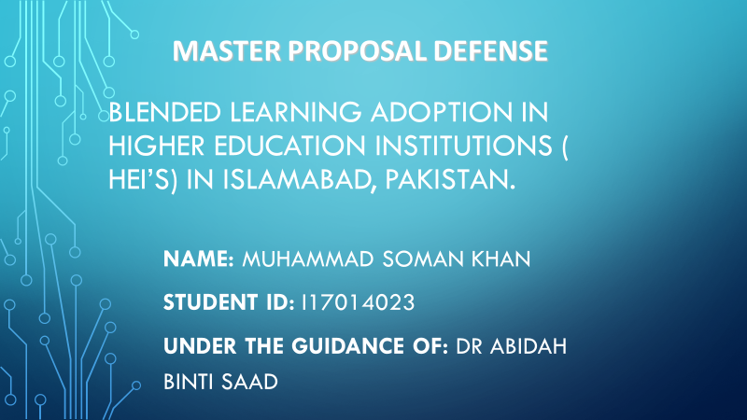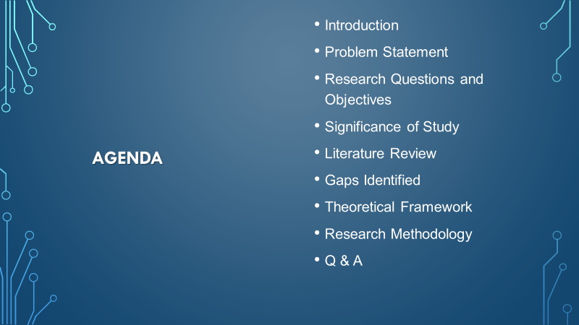

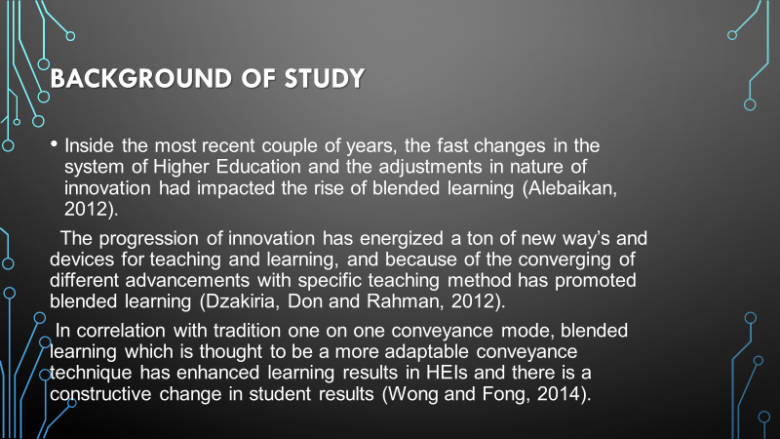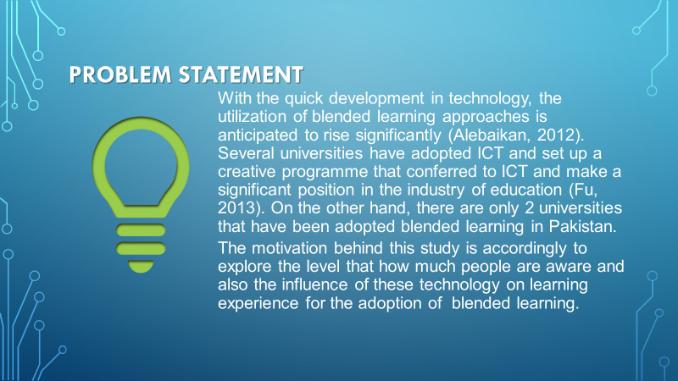

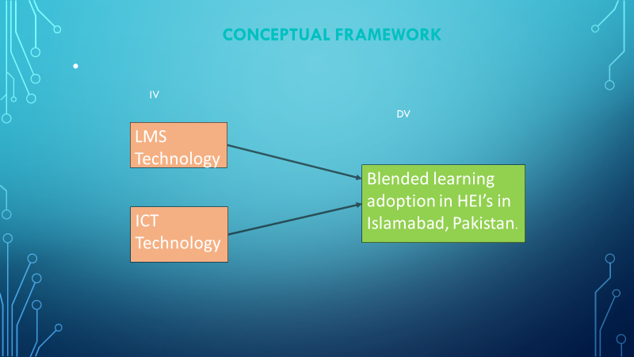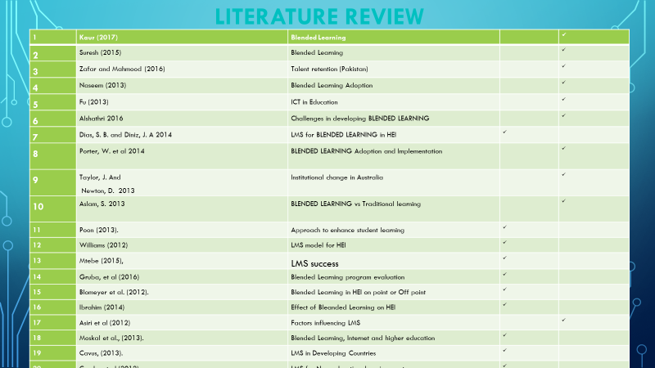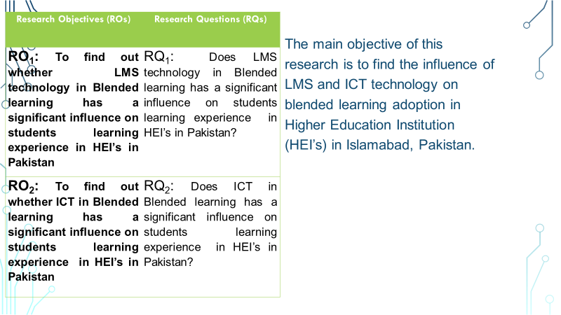

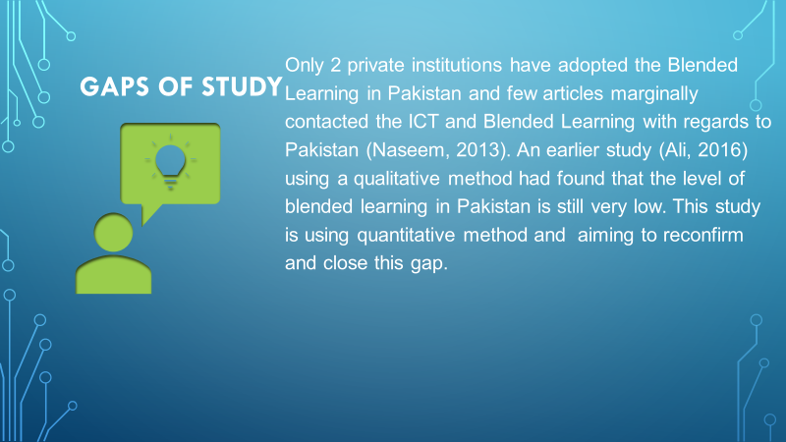

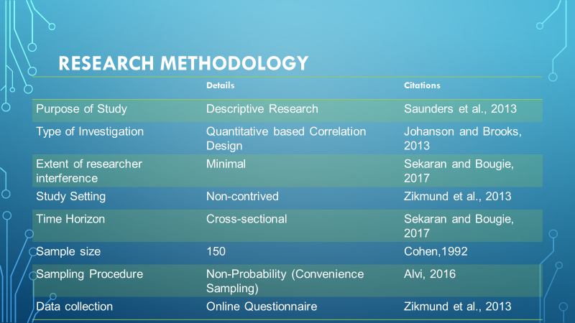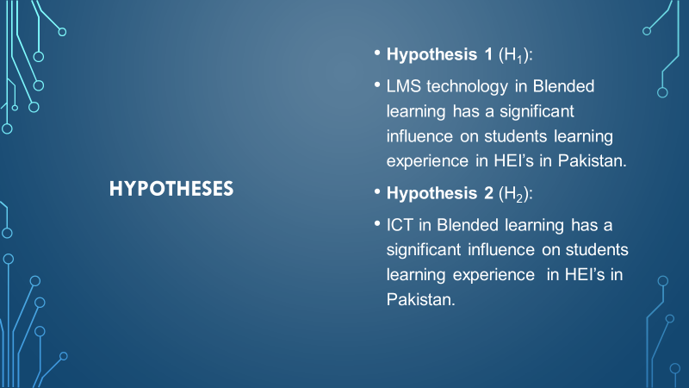

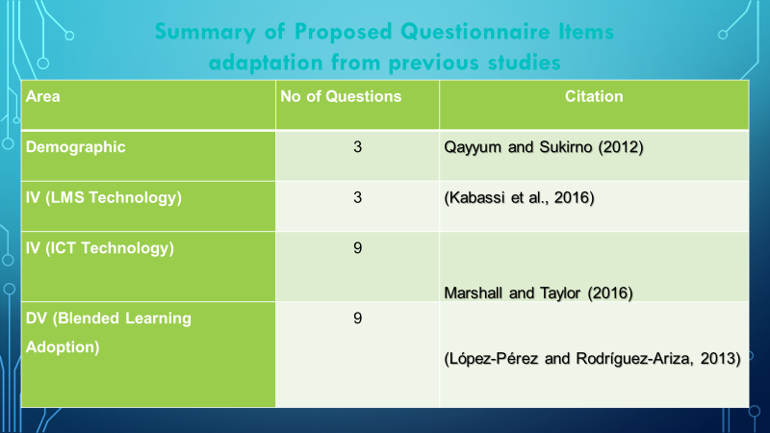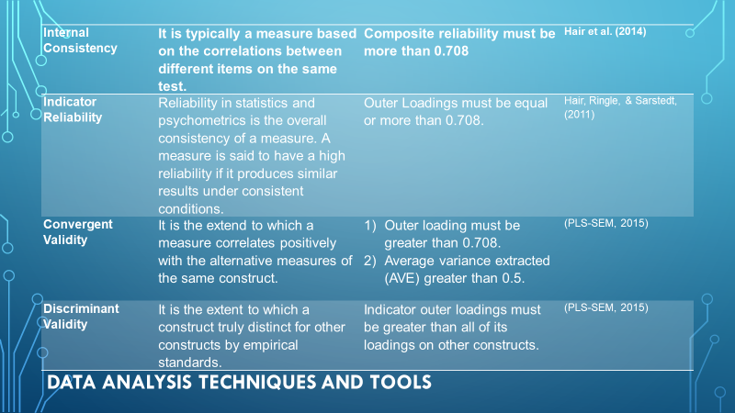

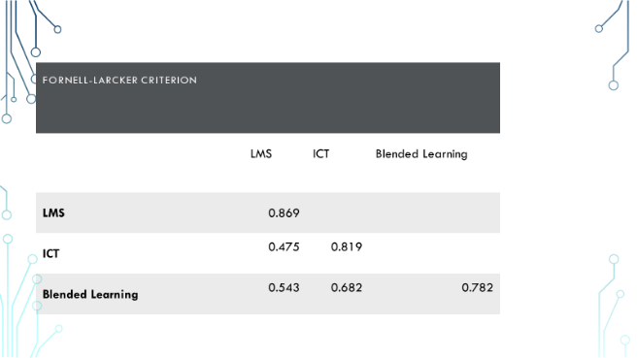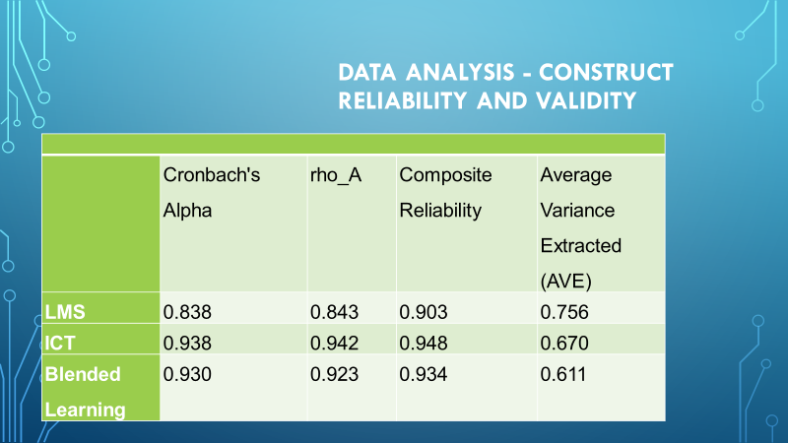

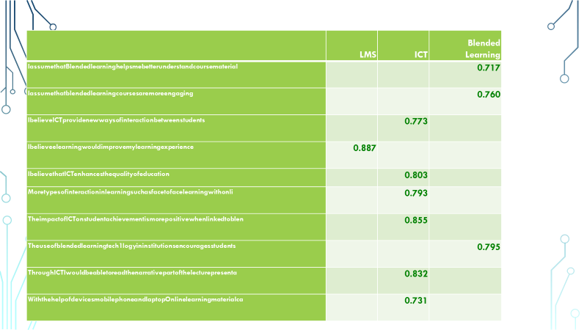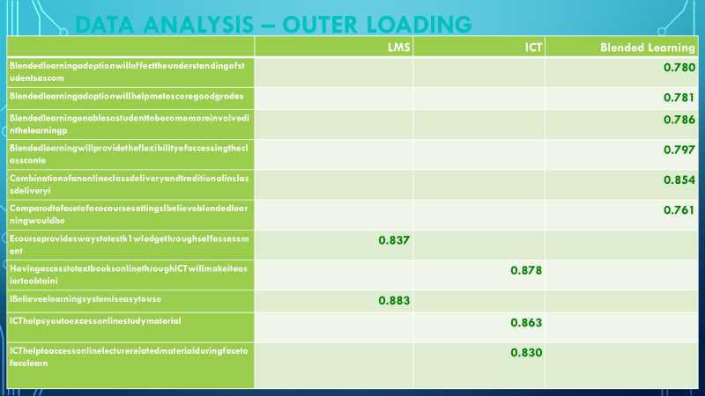

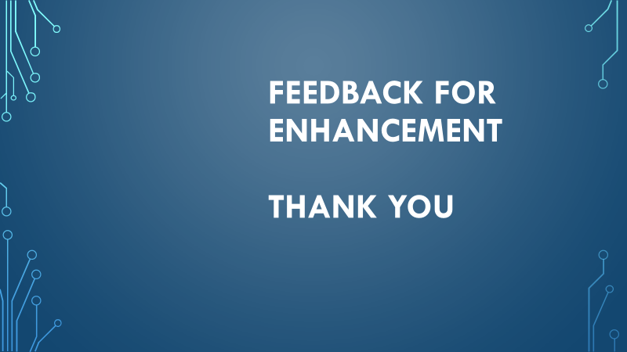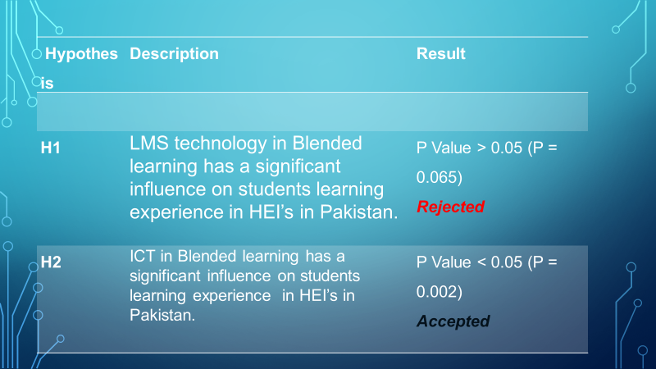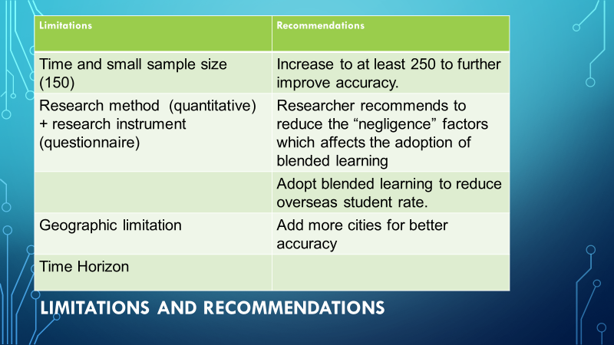

*APPENDIX G*

PROJECT PAPER LOG

This is an important document, which is to be handed in with your dissertation. This log will be taken into consideration when awarding the final mark for the dissertation.

|  |  |
| --- | --- |
| Student Name: | Muhammad Soman Khan |
| Supervisor Name: | Dr. Abidah Binti Saad |
| Dissertation Topic: Blended Learning Adoption in Higher Education Institution in Islamabad, Pakistan. | |

# SECTION A. MONITORING STUDENT DISSERTATION PROCESS

The plan below is to be agreed between the student & supervisor and will be monitored against progress made at each session.

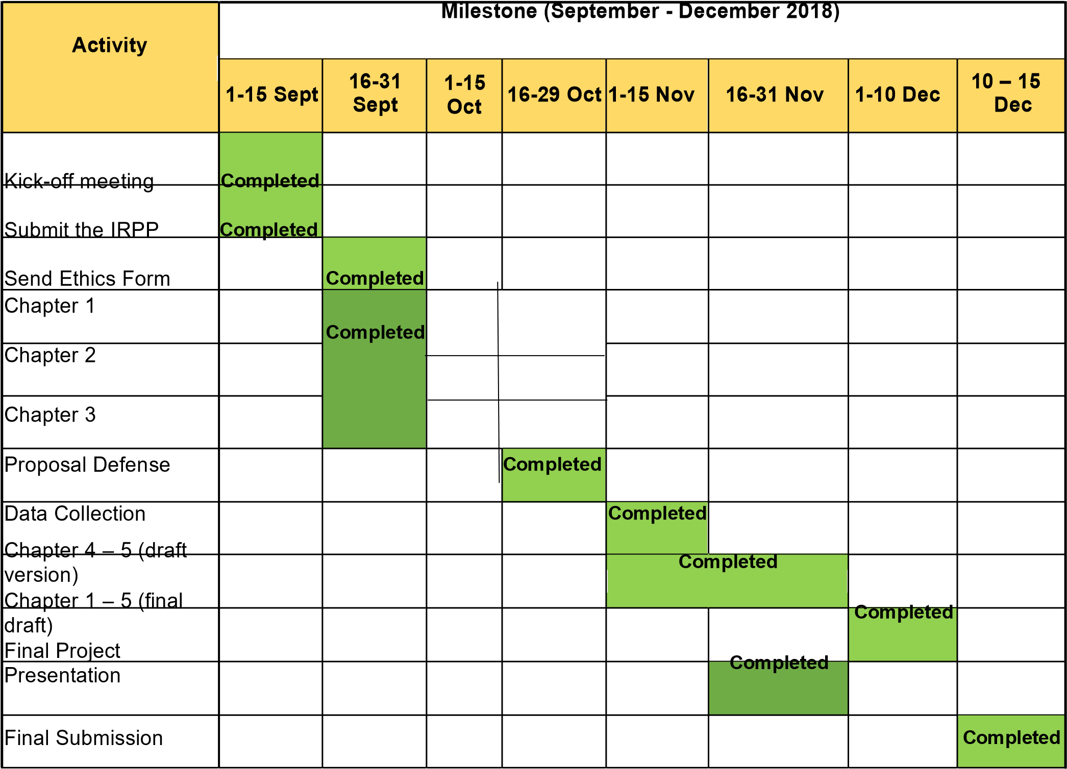

SECTION B. ETHICS

Ethics form protocol number: cBUS/PGT/CP/03806

# SECTION C. RECORD OF MEETINGS

The expectation is that students will meet their supervisors up to seven times and these meetings should be recorded.

# Meeting 1

|  |  |
| --- | --- |
| Date of Meeting | 12/09/2018 |
| Progress Made | Discuss the thesis title and meeting schedule |
| Agreed Action | Topic finalization |
| Student Signature | Muhammad Soman Khan |
| Supervisor’s Signature |  |

# Meeting 2

|  |  |
| --- | --- |
| Date of Meeting | 19/09/2018 |
| Progress Made | Confirm the dissertation title and Research objectives |
| Agreed Action | Minor changes in chapter two and theory used |
| Student Signature | Muhammad Soman Khan |
| Supervisor’s Signature |  |

# Meeting 3

|  |  |
| --- | --- |
| Date of Meeting | 28/09/2018 |
| Progress Made | Discuss content of chapter 3 and also discuss how to fill ethics form |
| Agreed Action | Minor tweaks and amendments in chapter 3, change of data analysis |
| Student Signature | Muhammad Soman Khan |
| Supervisor’s Signature |  |

# Meeting 4

|  |  |
| --- | --- |
| Date of Meeting | 08/10/2018 |
| Progress Made | Discussed the changes made and discussed about smart pls |
| Agreed Action | Verified the changes and Learn how to use smart pls and minor change in ethics form for resubmission |
| Student Signature | Muhammad Soman Khan |
| Supervisor’s Signature |  |

# Meeting 5

|  |  |
| --- | --- |
| Date of Meeting | 17/10/2018 |
| Progress Made | Discussed the questionnaire and proposal defense slides |
| Agreed Action | Finalize the questionnaire and Minor tweaks for proposal defense slides |
| Student Signature | Muhammad Soman Khan |
| Supervisor’s Signature |  |

# Meeting 6

|  |  |
| --- | --- |
| Date of Meeting | 29/10/2018 |
| Progress Made | Discussed sample pilot test |
| Agreed Action | Verified data of sample pilot test and adding up some questions in questionnaire |
| Student Signature | Muhammad Soman Khan |
| Supervisor’s Signature |  |

# Meeting 7

|  |  |
| --- | --- |
| Date of Meeting | 10/11/2018 |
| Progress Made | Discussed about proposal defense and questionnaire |
| Agreed Action | Questionnaire sent for data collection and analysis using smart pls |
| Student Signature | Muhammad Soman Khan |
| Supervisor’s Signature |  |

# Meeting 8

|  |  |
| --- | --- |
| Date of Meeting | 27/11/2018 |
| Progress Made | Discussed final results of data collected and EC7 form |
| Agreed Action | Verified the results of data collected and submission of EC7 form |
| Student Signature | Muhammad Soman Khan |
| Supervisor’s Signature |  |

|  |  |
| --- | --- |
|  |  |
| Progress Made |  |
| Agreed Action |  |
| Student Signature |  |
| Supervisor’s Signature |  |

# Meeting 9

Meeting 10

|  |  |
| --- | --- |
| Date of Meeting |  |
| Progress Made |  |
| Agreed Action |  |
| Student Signature |  |
| Supervisor’s Signature |  |

Section D. Comments on Management of Project

(to be completed at the end of the dissertation process)

Student Comments

It’s been a very great and challenging experience. I would like to thank my supervisor to guide me and to be there every time when I need her guidance.

Supervisor Comments

Student have already go through proposal defense and viva process. Thesis is ready for submission after amendment as recommended by examiner.

|  |  |
| --- | --- |
| Signature of Muhammad Soman Khan Student | Date 13/12/2017 |
| Signature of Dr. Abidah Binti Saad Supervisor | Date 13/12/2017 |
| Ethics 01/11/18  Confirmed | Date Valid till 15/11/18 |

APENDEX H: TURNITIN Report