SHAO XINRU  MASTER OF BUSINESS ADMINISTRATION  201  888 | CONSUMER PURCHASING INTENTION OF PET SUPPLIES IN MALAYSIA  SHAO XINRU  MASTER OF BUSINESS ADMINISTRATION  FACULTY OF BUSINESS, COMMUNICATION & LAW  INTI INTERNATIONAL UNIVERSITY  2018

MASTER OF BUSINESS ADMINISTRATION

CONSUMER PURCHASING INTENTION OF PET SUPPLIES IN MALAYSIA

AUTHOR: SHAO XINRU
ID NUMBER: E93980204
STUDENT ID: I17013429
PROGRAM: MASTER OF BUSINESS ADMINISTRATION
SUBJECT: MGT7998 MBA PROJECT
SUPERVISOR: DR. PHUAH KIT TENG
SUBMITTION DATE: 10/12/2018
FINAL WORD COUNT: 14891
STUDENT’S DECLARATION

I hereby declare that this thesis is my own work and effort and that it has not been submitted anywhere for any award. Where other sources of information have been used, they have been duly acknowledged.

Name : SHAO XINRU

Student ID : I17013429
Signature :

Date : 10/12/2018

ACKNOLEDGEMENT
First and foremost I would like to thank Dr. Phuah Kit Teng for being my supervisor, advising and guiding me throughout this dissertation process. Secondly I would like to thank everyone who voluntarily participated with the survey questionnaire. Last but not least I would like to thank my family for their endless motivational support throughout the duration of my Master of Business Administration programme.

ABSTRACT
In today's society, due to the change of people's thinking and the urbanized lifestyle, more and more people choose to keep pets as their own spiritual support, and Malaysia is no exception. The rapid growth of the pet population has affected the development of the pet supplies market, and more and more scholars and marketers are beginning to realize the importance of this field. In 2010, Malaysia became the second largest pet care market in South East Asia, however, most of the research on the pet supplies market is concentrated in European countries, the United States and China, and there are few academic studies to study the pet market in Malaysia. This study will bridge the gap by analyzing consumer purchase intention in the Malaysian context pet supplies. Attitude, Subjective norms and Perceived behavioral control (PBC) are selected as the independent variables of consumer purchase intention in this research. In addition, in order to determine this relationship, the study reviewed relevant literature and appropriate measurement models which are suitable to all variables in this research. The relevant research design is adopted as the research method, and the questionnaire is distributed to the target population, and the collected data is scientifically analyzed. Besides, in order to determine the validity and accuracy of the study, the study will distribute about 30 questionnaires online for pilot testing.

Keywords: Consumer purchase intention, Attitude, Subjective norms, Perceived behavioral control (PBC), Theory of Planned Behavioral (TPB), Pet food, Malaysia

Table of Contents
Acknowledgement 1
Abstract 2
Chapter 1: Introduction 6
1.1 World Production/Supply and Consumption of Pet Foods 6
1.1.1 World Top 4 Pet Food Manufacturer 9
1.1.2 Categories of Pet Foods 10
1.2 Malaysia Pet Food Market 14
1.2.1 Special Type of Pet Foods in Malaysia 16
1.2.2 Government Policy 17
1.3 Problem Statement 18
1.4 Research Objectives 18
1.5 Research Questions 19
1.6 Significant of the Study 19
1.7 Organization of the Study 20
Chapter 2: Literature Review 22
2.1 Pet Food Consumer 22
2.2 Opportunities and Challenges of Pet Food/Supplies in Malaysia 22
2.3 Consumers’ Buying Behavior towards Pet Food 23
2.3.1 Attitude 23
2.3.2 Subjective Norms 23
2.3.3 Perceived Behavioral Control 24
2.4 Theory of Planned Behavior 24
Chapter 3: Research Methodology 26
3.1 Conceptual Framework 26
3.2 Sources of Data 27
3.3 Data Collection 28
3.3.1 Questionnaire Development 28
3.3.2 Sampling Frame and Techniques 28
3.4 Pilot Test 30
3.5 Data Processing and Methodology 30
3.5.1 Reliability Test 30
3.5.2 Descriptive Analysis 30
3.5.3 Exploratory Factor Analysis 31
3.5.4 Multiple Regression Analysis 32
3.6 Summary 32
Chapter 4: Research Finding 33
4.1 Descriptive Analysis 33
4.1.1 Socio-demographic Profile 33
4.1.2 Consumer Awareness, Knowledge and Habits towards Pet Food 34
4.2 Results of Hypothesis Testing 36
4.2.1 Measure of Sampling Adequacy 36
4.2.2 Reliability Test 39
4.2.3 Multiple Regression Analysis 39
4.3 Summary 41
Chapter 5: Conclusion and Recommendation 42
5.1 Recommendation 42
5.2 Limitation of Study 43
5.3 Recommendation of Future Research 43
5.4 Conclusion 44
5.5 Personal Reflection 44
Reference 46
Appendix A: Initial Research Paper Proposal 51
Appendix B: Questionnaire 62
Appendix C: MBA Project Log 67
Appendix D: Turntin Research 72
Appendix E: SPSS Output 78
Factor Analysis 78
Reliability Test 82
Multiple Regression 84
Descriptive Analysis 85

CHAPTER 1: INTRODUCTION
Pet food is a food specially provided for pets. It is a high-grade animal food between human food and traditional livestock as well as poultry feed. Basically pet foods are made up of proteins, fats, carbohydrates, vitamins and minerals, to provide pets with the most basic survival guarantee (Buff, Carter & Bauer et al., 2014).
According to Kelly (2012), for example, in the United States, where pet food is the fastest growing, commodity pet food has risen rapidly over the past century, as people’s ideas gradually changed, these domestic animals from “pets” to “family members”, they realized that it is not enough to feed a pet with "table scraps." At the same time with the improvement of the socio-economic conditions, purchase commercially processed pet food becomes much easier to accept.
With the rapid development of the pet food industry, increase pet food brands on the market has also caused difficulties in consumer selection and quality of the food itself. In 2010, Malaysia became the second largest pet care market in South East Asia, however the researches for consumer purchasing intention for pet supplies in Malaysia are limited. Most of the research was basically concentrated in the United States or in the European developed countries, which led to uncertainty regarding the purchase intention of Malaysian consumers for pet supplies (Lee & Wee, 2010). Hence, the purpose of this project is to investigate factors that influence Malaysian consumers' purchasing intention of pet food.

  - World Production/Supply and Consumption of Pet Foods
In today's society, due to the change of people's thinking and the urbanized lifestyle, more and more people choose to keep pets as their own spiritual support. The rapid growth of the pet population has affected the development of the pet supplies market. Developed regions in North America account for the largest market share in pet food industry, which is 38% of the global market
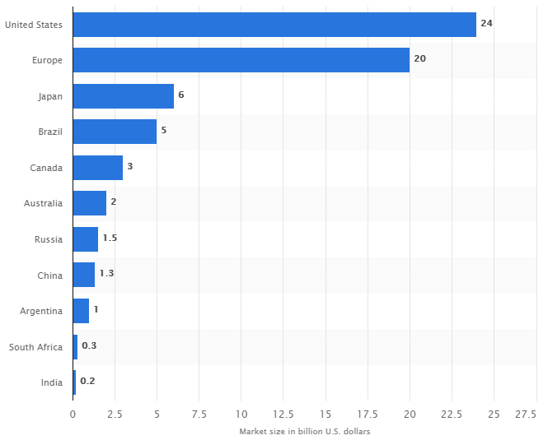
Figure 1.0 Pet food market size worldwide in 2015, by country (in billion U.S. dollars) (Statista., 2016)

According to Figure 1.0, in 2015, the global pet food market size, which was divided by country, the top three was the US, Europe and Japan. Overall, European and American countries account for a relatively high proportion.
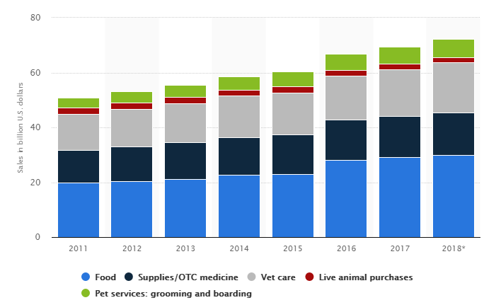
Figure 2.0 Pet market sales in the United States from 2011 to 2018, by category (in billion U.S. dollars) (Statista., 2018)
In 2018, pet food accounted for the highest sales in the US pet market, with sales of $29.88 billion.
In 2018, the European pet food market revenue reached 21.847 billion US dollars. It is also expected that the compound annual growth rate of the market in 2018-2021 will increase by 4.1% per year (Statista., 2018).

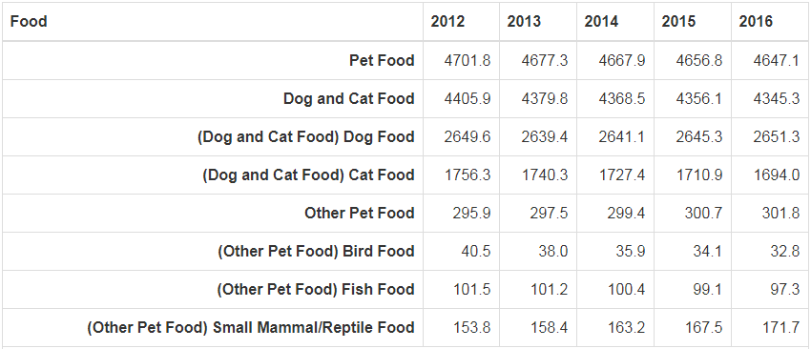
Table 1.0 Pet Food Market Sizes in Japan (in million U.S. dollars)
In 2016, the Japanese pet food market generated approximately 13.94 billion US dollars.

    - World Top 4 pet food manufacturer
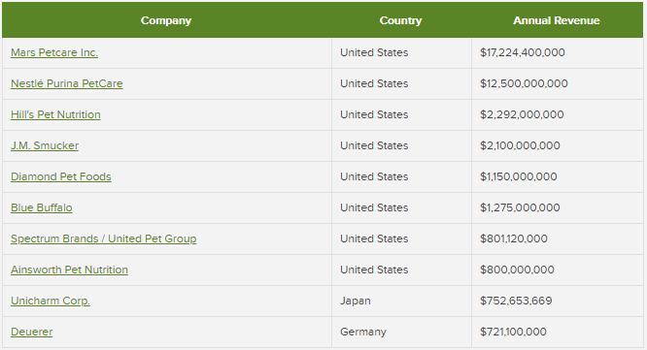
Table 2.0 The World’s Top 10 Pet Food Companies (Petfoodindustry.com., 2018)
According to Table 2.0, the world’s top 4 pet food companies which are based on net sales, are all from America. The global pet food market is highly concentrated in the top ten companies including Mars Inc., Nestlé and Colgate Palmolive, accounting for more than 50% of the market. As the largest center-of-store grocery category, pet food and pet snacks are a $32 billion industry in the US and are still growing.

The top 1 is Mars. Mars' main business includes the pet business, and the sales of related products rank first in the world. Mars Petcare Inc. has 41 pet food brands, among the world's top five pet food brands, Mars accounted for three, which are Pedigree, Whiskas and Royal Canin, each one worth 5 billion US dollars. One-third of the world's pets eat Mars's Pedigree dog food and Whiskas cat food every day. Its 2017 net sales reached 17.224 billion US dollar (Petfoodindustry.com., 2018).

The top 2 is Nestlé Purina Petcare. Nestlé Purina Petcare has 8 pet food brands, such as Friskies, Felix and Pro Plan; the brand NeuroCare is the first and only diet that uses canine epilepsy as a nutrition management of dog. Its net sales in 2017 was 12.5 billion CHF, accounting for 13.9% of total industry revenue of Nestle. In terms of dog snacks, Nestlé Purina has expanded Dentalife worldwide successfully in 2017; Merrick launched its first complete pet food series, which called Castor & Pollux Pristine; its cat food production has also expanded, with capacity investments in Poland, Russia, Hungary, Brazil, Mexico and the United States (Nestlé Annual Review 2017, 2018).

The top 3 is Hill’s Pet Nutrition, it is a subsidiary of Colgate-Palmolive, and its 2017 sales accounted for 15% of Colgate-Palmolive’s net sales. Net sales of Hill’s Pet Nutrition for 2017 were 2.292 billion US dollar, an increase of 1.0% over 2016 (Colgate-Palmolive Company, 2017).

The top 4 is J.M. Smucker. It acquired Big Heart Pet Brands three years ago, and this strategy has consolidated its position in the field，and it will acquire Ainsworth Pet Nutrition in FY 2019 (the maker of Rachael Ray Nutrish and DAD’S™ brands)，which will further strengthen its position in the pet food field. As well as, its brands, RachaelRay and Nutrish are high-growth quality brands. Its net sales have declined in fiscal year 2017 compared to 2016, with net sales of 2.1 billion US dollar. Due to its investment in Nature's Recipe, Rachael Ray Nutrish and innovation in dog snacks will drive sales growth, which is expected to reach 2.2 billion US dollar by 2018 (The J.M. Smuckers Company, 2018).

    - Categories of Pet food
The categories of pet food can be roughly divided into dry food, wet food and treats.
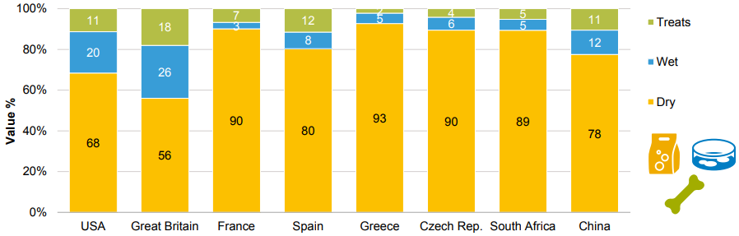
Figure 3.0 Pet food type share of sales by country (Lange, 2016)
Type | Definition
Dry Food | Dry food is the most popular and most common pet food available on the market today. According to figure 3.0, dry food sales account for at least 50% in each country
Wet Food | Canned food is the most common type of wet food on the market today. According to figure 3.0, wet food is more popular in USA and Great Britain.
Treats | This is a general term for pet medicines on the market, which includes injections, topical drugs and internal medicines.
Table 3.0 Definition for pet food
Nowadays, due to the continuous growth of the "pet-raising" industry and the change of people's life concept, most pet foods on the market are developed for specific market segments, such as for different age groups, for specific diseases (urinary system, bones), for food intolerance, as well as special effects (skin and fur, tartar) and pets of different descent.

On April 19, 2016, Maria Lange, Director of Gfk Business Group, delivered a speech at the Petfood Forum 2016, she said that in the pet specialty market, three types of pet food should be closely watched in the future: grain-free pet food, freeze-dried pet food and dehydrated pet food. Can also be called premiumization of pet food (Conway, 2016).
Picture 1.0 Symbol of Grain-free Pet Food
For the most common cats and dogs in the pet category, grain-free pet foods are more in line with their original nutritional needs, because most of the protein contained in grain-free pet food comes from meat materials. Therefore, grain-free pet food is a relatively popular category among emerging premium pet foods. According to market research, one-third of all pet food which were sold in the United States, is grain-free，and of all the new products launched in 2015, nearly 45% of the products are in the grain-free category, increase nearly 25% year-on-year.
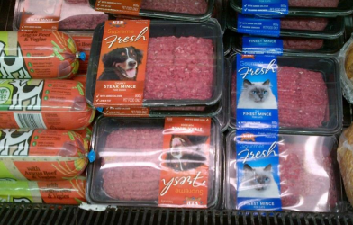
Picture 2.0 Refrigerated Pet Food
Refrigerated/Raw-Frozen pet food increased by 63% in 2015. Compared with 2014, the number of freeze-dried new products which were launched in 2015 has doubled. Net sales of freeze-dried pet food increased from $120.1 million in 2014 to $195.4 million in 2015. The production process is to directly freeze the raw materials, so high quality raw materials are required. Although this process retains the nutrients in the raw materials to the greatest extent, it has a short shelf life and needs to be stored in a low temperature environment, which leads to extreme deterioration in transportation and consumption, resulting in adverse reactions in pets. It is for this reason that most of the pet food recalls that occurred in the United States in 2015 were related to this kind of pet food. Therefore, despite the current good development of raw-frozen pet food, the future growth of US raw-frozen pet food may continue to slow down unless manufacturers can regain consumer confidence. (Lange, 2016)。
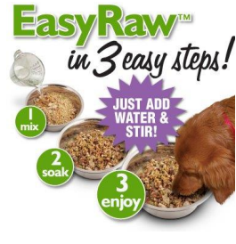
Picture 3.0 Dehydrated Pet Food
In the pet specialty, dehydrated/air-dried pet food grew the fastest in 2015, growing by 72%. This category jumped from $15.2 million in 2014 to $26 million in 2015. Compare with raw-frozen pet food, dehydrated pet food is easier to store, and the nutrients are basically the same. And because of its dehydration and drying treatment, it reduces the production of microorganisms or bacteria.
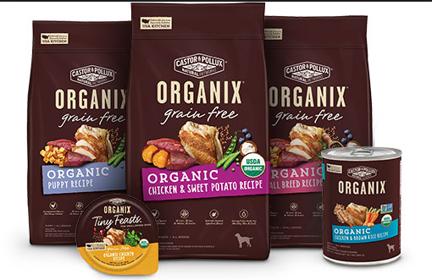
Picture 4.0 Organic pet food
Besides that, because health consciousness is increasing in globalizes international consumers, “Organic” pet food becomes the primary choice for some of the owners, with pet foods which are claiming “no genetically modified ingredients (GMOs)” overwhelmingly defeating other health claims (The Nielsen Company, 2016).

  - Malaysia Pet Food Market
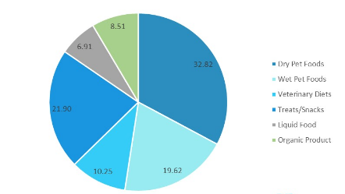
Figure 4.0 Categorise of pet food in Malaysia (Anon., 2018)

Type | Definition
Veterinary Diets | Refers to the food specified by the veterinarian to treat a particular aspect of the pet's disease, which is usually marked on the outer packaging.
Liquid Food | Can refer to liquid medicines, or an emerging pet food such as catnip drink.
Organic Product | This refers to the way in which ingredients are grown, harvested and processed. Pet foods that meet human standards may display organic seals.
Table 4.0 Definition of pet food in Malaysia
Due to the popularity of the pet industry, in 2017, the Asian pet food industry increased by 5.54% compared with 2016. And because of the economic rebound in 2017, pet owners are more willing to pay for premium pet food for their pets (Anon., 2018). At the same time, due to de rise of the Asian pet food market, Malaysia became the second largest pet care market in Southeast Asia in 2010 (Lee & Wee, 2010). In addition, as pet owners are willing to provide more nutritious, healthy and organic foods for pets, this has led to more and more companies in Malaysia seize the opportunity to start developing their own brands.

According to Figure 4.0, dry pet food accounts for the highest market share, at 32.82%; and the lowest is the liquid food, at 6.91%.
Because of the health awareness of pet owners, organic pet food is the fastest growing segment. In terms of market value, cat food is an important market segment in Malaysia, although the increase in the number of pet dogs in Malaysia will drive the development of the dog food market in the next 5 years.

International companies such as Mars Inc., Nestle Purina and Hills Pet Nutrition dominate the Malaysia's pet food market and gain advantage through the widespread distribution of hypermarkets, supermarkets, pet stores and pet supermarkets. Although more than 80% of Malaysia's pet food market relies on global leading companies, Malaysians are now ready to give priority to high quality local branded products (Anon, 2018).

    - Special Type of Pet food in Malaysia
Picture 5.0 Halal pet food
Like the global market, pet foods in Malaysia currently can be roughly divided into: dry food, wet food and treats. However, Malaysia is a multi-ethnic Muslim country. Its special point is to use "halal food" as a selling point, but most of the world's available pet foods are non-halal foods, most of pet foods contain pig material and blood meal residues, which the Muslim community considers unhealthy and unclean.
Pet food can come into contact with people, such as when cleaning the feeding utensils under the same wash basin and dishwasher. And in many cases, pet foods come into contact with human food storage facilities (such as refrigerators), and if they are not halal foods, they may affect the human food chain to some extent.

The term “halal food” indicates that the raw material of the food comes from a clean source and contains no contaminants. Products that use dead, dying, diseased and disabled animals, and products that contain drug residues (Pentobarbital sodium for euthanizing companion animals) is not allowed to enter the food chain (Amir, Razauden & Harisun et al., 2014).

    - Government Policy (Pet food labelling)
Because more than 80% of Malaysia's pet food market relies on global leading companies, this means that it is necessary to comply with the regulations for importing pet food into Malaysia.

Only pet foods with a valid import license issued by the MAQIS will be allowed to enter the Malaysian pet food market. And each batch of pet food should be accompanied by an English veterinary certificate, dated within 14 days of export, signed and approved by the US Department of Agriculture (USDA). It also needs to provide detailed information on the goods (such as the name and address of the shipper, the consignee and the manufacturing plant, the quantity, type and source of raw materials).
At the same time, the raw material or ingredient list and nutritional data should be clearly recorded on the package and marked as pet food.

Since Malaysia is a Muslim country，when the product contains pork, pork derivatives or lard, the pet food should be clearly marked: "contains [national pork, pork derivatives or lard]" (Regulations for the Importation of Pet Food to Malaysia., 2018).

  - Problem Statement
Due to the rapid development of the pet food market, there will inevitably be negative situations. The most serious problem is food safety, which will directly affect consumers' intention to purchase the brands involved.

In the Midwest and Western states of the United States in 2018, Salmonella has been found in dog food testing, and since the beginning of February, 6 animals and 2 people have been sick or dead. After the incident, Natural and ZooLogics pet food produced by Arrow Reliance was recalled after testing (Green, 2018).

Basically pet foods are made up of proteins, fats, carbohydrates, vitamins and minerals. Most of components of protein are made by animal, poultry or fish (Amir et al., 2014). However, some manufacturers have replaced these ingredients with ' inferior material' in the human food chain, such as chicken feet, animal lymphs or sick animals.

Most consumers think that they can avoid these problems by paying high prices to buy pet foods which have famous brand, but even worse, they waste money but didn't bring healthy food to their pets. A lawsuit between Blue Buffalo and Nestlé Purina exposed this problem.

In May 2014, Nestlé Purina sued Blue Buffalo, accusing Blue Buffalo of false advertising, using crude ingredients such as “animal by-products” to deceive consumers (Carter, 2015).

  - Research Objectives
The specific research objectives are shown as follow:
RO1: To determine whether Attitude influence consumer purchasing intention of pet supplies in Malaysia;
RO2: To determine whether Subjective Norm influence consumer purchasing intention of pet supplies in Malaysia;
RO3: To determine whether Perceived Behavioral Control influence consumer purchasing intention of pet supplies in Malaysia.

  - Research Questions
Based on the research objectives, the research questions are as stated below:
RQ1: Will Attitude influence consumer purchasing intention for pet supplies in Malaysia?
RQ2: Will Subjective Norm influence consumer purchasing intention for pet supplies in Malaysia?
RQ3: Will Perceived Behavioral Control influence consumer purchasing intention for pet supplies in Malaysia?

  - Significant of the Study
As mentioned above, in recent years, with the rise of the pet market, the pet supplies market has also developed rapidly. Although academics and marketers are aware of the importance of understanding consumer purchasing intention for the pet supply market, few people establish frameworks for this particular area and use research methods to study it, which is an area that is still relatively uncertain.

Therefore, this study focuses on whether there is a correlation between consumer purchasing intention and attitude, subjective norms, perceived behaviour control in this particular market—the pet supply market. This study can provide more information and evidence for researchers who will work on this research area.

First, the study will provide pet supplies manufacturers with new perspectives on consumer purchase intentions in specific markets, such as Malaysia. Based on research goals and related literature reviews, the study will be narrowed down to specific business areas, and the purchase intention of specific customers in the pet supply market will be measured through appropriate measurements.

Then, to ensure the accuracy of this study, the study will apply the most commonly used models and questionnaires based on the industry's characteristics and existing researches.

In the end, as described in the research objectives of this study，the study will provide manufacturers with a thorough understanding of the correlation between consumer purchasing intentions and Attitude, Subjective Norm, Perceived Behavioral Control in the pet supplies market in Malaysia in order to interact with target consumers

  - Organization of the Study
This project is divided into five chapters. The first chapter gives a general introduction to the definition and background of pet food, and analyses the development of the pet food industry from the perspective of the global and Malaysia, and then discusses the background of the research and the formation of the problem. The second chapter is a literature review that describes the consumer of pet food and points out the opportunities and challenges faced by the pet food industry and the consumer's purchase intention of pet food. The third chapter explains the research methodology and tools of this study, theoretically explains each variable and determinant, and discusses the sample process and data collection process. The fourth chapter discusses the analysis and findings of the research. After analysing the collected data, the data is analysed and the research findings are critically analysed. This chapter is the key to the whole research. Finally, Chapter 5 explains the results of this study. This chapter also includes recommendations, limitations, and conclusions.

CHAPTER 2: LITERATURE REVIEW
This chapter is a literature review that describes the consumer of pet food and points out the opportunities and challenges facing the pet food industry and the consumer's purchase intention of pet food.

2.1 Pet Food consumer
The main target customer of pet food, of course, is the person or group (such as Pet-themed café and Pet breeding agencies) who already owned or wants to raise one or more than one pets, because the user of pet food is the pet.
As global fertility declines, more and more families choose to keep pets instead of having a baby. Coriolis (2014) shows that one-third of the world's households have at least one domestic animal.

In this study, consumers of pet foods will be classified according to the type of pets they are keeping. It can be roughly divided into pet dog owners, pet cat owners and other pet owners (such as fish, rabbits or birds).

At the same time, it has been found that the population of pet owners is mostly concentrated in high-income people and the elderly (Surie, 2014). This is also why countries with a high number of pet ownership are concentrated in developed countries.

2.2 Opportunities and Challenges of pet food/supplies in Malaysia
The increase in the number of pets worldwide is the main reason that affects the rapid development of the pet food market (Surie, 2014). Secondly, due to the strengthening of the concept of “humanization”, more and more pet owners think that their pets are part of the family, which means they are willing to spend more money to buy better and healthier pet food for their pets (The Nielsen Company, 2016).

However, the rapid development of the pet food market presents opportunities as well as some challenges. Food safety issues should be the most serious challenge. Same as human food, the most important function of pet food is to keep the pet's basic consumption and health. There are a variety of pet foods on the market. In fact, most pet owners don't know the specific nutritional needs of their pets, which makes some manufacturers take advantage of this, such as making false advertisements or using some bad raw materials (Green, 2018).

2.3 Consumers’ buying behavior towards pet food
Although the consumer of pet food is human, it is designed to be used by pets, which means that pet owners do not consume these products directly. Therefore, consumers can only experience pet food through other means, such as attitude, subjective norms and perceived behaviour control, which are the independent variables of this study that will affect consumers' purchasing intentions of pet food.

2.3.1 Attitude
Pet food is a commercial food which has a common characteristic of commercial food: they use the brand to attract the attention of potential customers of the product (Surie, 2014). According to the above, the top 5 pet food brands in the world are all from the United States, which will affect consumers' attitude towards pet food, that is, consumers will think that brands from the United States will have better quality and more healthy than pet foods from other countries, this cognition will affect their intention to buy pet foods.
H1: Attitude has a significant positive influence on pet food purchasing.
2.3.2 Subjective norms
With regard to subjective norms, most of the time consumers' perceptions of a particular product are influenced by people around them, such as family, friends or colleagues. This also explains why the pet owner will go online to check the evaluation of such pet food before they want to but it. Another important point is that the pet’s preference for a pet food will largely affect the pet owner’s intention to purchase the pet food, simply put, consumers are not willing to choose a pet food that pets don't like. (Di Donfrancesco, Koppel & Chambers, 2012; Huang, 2014).
H2: Subjective norm has a significant positive influence on pet food purchasing.

2.3.3 Perceived behavioural control
Another very intuitive factor is the price of pet food, or whether the pet food the consumers purchased is worth the money. This is a factor of perceived behavioural control in TPB. Coriolis (2014) suggests that the more common pet food consumers are higher-income groups and older groups. In this view, the income of the owner determines their intention to buy pet food, because consumers will not choose to buy products that exceed their payment level
H3: Perceived behavioural control will have negative effect on consumer intention towards pet food purchasing.
2.4 Theory of Planned Behavior
Theory of Planned Behavior (TPB) is the development of Theory of Reasoned Action (TRA) (Ajzen, 1991).

The formation of the theory of planned behaviour was that in 1988, Azjen added a new factor to the Theory of Reasoned Action by Martin Fishbein and Icek Azjen, which is Perceptual Behaviour Control. Since then, the three factors: Attitude, subjective normative and perceived behaviour control constitute the theory of planned behaviour (Utami, 2017)。

This study will use the TPB (Ajzen, 1985, 1989) as a model to determine the intent to lead to consumer behaviour. The theory of planned behaviour developed by TRA is considered to be superior in determining behaviour. In addition, TPB also emphasizes analysis that determines how these attitudes, subjective norms, and perceived behavioural control affect similar or different behavioural intent.

CHAPTER 3: RESEARCH METHODOLOGY
3.1 Conceptual Framework
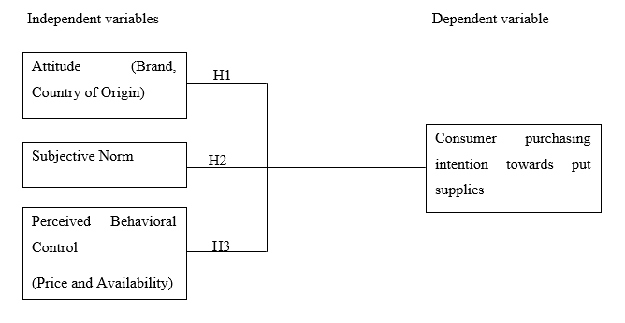
Figure 5.0 Conceptual Framework
The theory of planned behaviour constructs a conceptual research framework in this study, which is shown in figure 5.0. This model presents the independent variables which are Attitude, subjective norms and perceived behavioural control. As well as the dependent variable is consumer purchasing intention towards pet supplies.

An attitude defined as the position of a person in a bipolar evaluation or emotional dimension of an object, behaviour or event; and differences in attitudes between different groups of people can be assessed using attitudes (Hill, Fishbein & Ajzen, 1977). It can be understood in this study that once the consumer has collected enough information and their learning and understanding of the pet food has increased to the desired level, the consumer's intention to purchase the pet food will form a positive or negative attitude.

Subjective norms are called community pressures, and they are also called people’s personal opinions about a certain thing or person, such as friends, colleagues or family members (Ajzen, 1991). For example, pet owners may be more willing to buy pet foods that are positively evaluated by people around them. Subjective norms are used to measure how social pressures motivate consumers to purchase pet food.

The main purpose of the perceived behaviour control (PBC) is to capture the involuntary view of behaviour. The actions performed are strongly based on behavioural patterns rather than under personal control. Although PBC can be replaced by determining the actual control of the consumer, it depends on the accuracy of the consumer's insights (Utami, 2017). In short, for example, in this study, once the consumer's favorite pet food has negative information, whether he or she is still willing to purchase the pet food. There are many control factors that may promote or inhibit consumer intention to purchase pet food, such as information provided on the website, price impact, perceived quality, and the convenience of purchase.

3.2 Sources of Data
The study used primary data, which was collected directly from face-to-face interviews with respondents by using self-administered questionnaires and online questionnaires. About 400 respondents interviewed based on their perceptions, attitudes and intentions about purchasing pet food.

The secondary data in this study came from a variety of sources, such as the INTI University Library and the Internet. Statistics come from government departments such as the Statistics Bureau. Review other relevant information about concepts and pet food purchases from journals, seminars, conferences, observations, magazines, articles and publications.

3.3 Data Collection
3.3.1 Questionnaire Development
In order to achieve the objectives of this study, a questionnaire was used. In this study, the questionnaire was divided into:

- Part A：Contains personal information about the respondent (gender, income, age, and race). In this section, question 5 confirms whether the respondent meets the requirements of this study, that is, whether the respondent is keeping a pet.
- Part B：It includes questions about consumer’s awareness, knowledge and habits about purchasing pet food.
- Part C：Part C is divided into 4 sections.

Section 1 (Attitude) - Questions about respondents' perceptions and attitudes about pet food-related attributes, such as product brand and product origin. It contains 7 questions.
Section 2 (Subjective norms) - Questions about subjective norms such as the network, friends, people around and suppliers.
Section 3 (PBC) - Questions about the perceived control information of respondents.
Section 4 (Intention) - Questions about the intent of the respondent to purchase pet food.

3.3.2 Sampling Frame and Techniques
When researchers want to collect and analyze data for a research problem, because there is not enough time and resources to analyze the entire population, sampling techniques will be used to reduce the number of cases (Sekaran & Bougie, 2016).

The target population of this research is individual consumers currently living in Malaysia who own pets and often buy pet supplies. In Malaysia, pet owners are already a very large group, as of 2016, just for pet dogs, there are 260,963 dogs have been registered with the FCI, not to mention the sum of the types of pets (Fci.be, 2018).
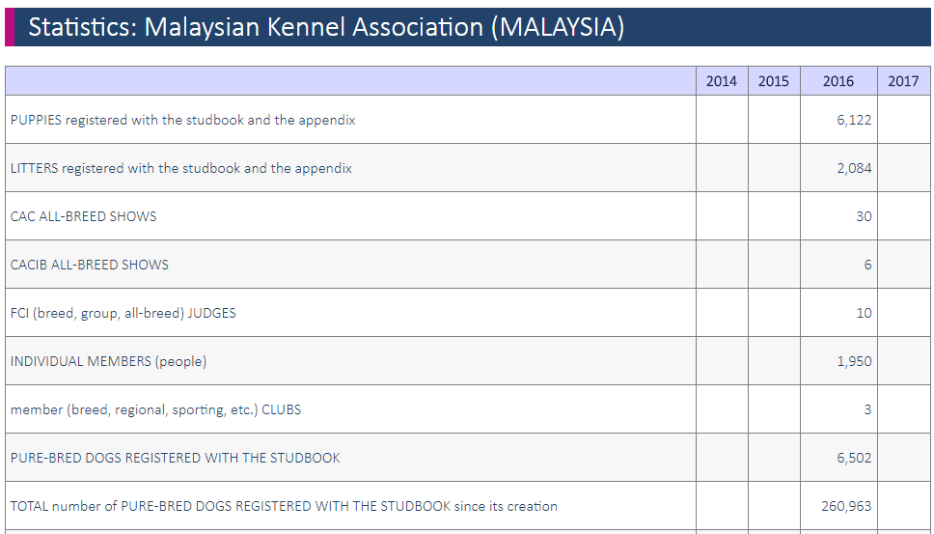
Table 5.0 Amount of Pet dogs in Malaysia (Fci.be, 2018)

The sample size for this study was determined according to the formula of Krejcie & Morgan (1970), which states that if the given population more than or equal to 100,000, the required sample size must be 384. According to the above, the population of this study is at least 260,963, when the Confidence level is 95% and Confidence interval is 5%, the sample size of this study should be 384.
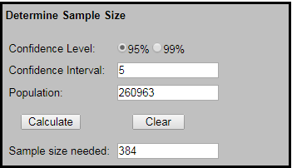
Figure 6.0 Sample size (Krejcie & Morgan, 1970)
3.4 Pilot Study
Pilot test is an important part of data analysis, it is used to determine the shortcomings of design and instrumentation to predict the appropriateness of the research (Matthews & Ross，2014). The size of the pilot test in this study was probably 10% of the entire sample size, which is around 30.
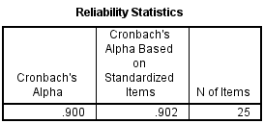
Table 6.0 Pilot test
The Cronbach's Alpha is 0.9, which is close 1 that means the respondents can understand the questions very well, so that the questionnaire can be distributed.
3.5 Data Processing and Methodology
3.5.1 Reliability Test
In order to conduct better statistical research, it is important to ensure the reliability of the data collected back. Reliability test is a tool that measures the internal consistency of variables under a single factor, this test also ensures the quality of the data collected and whether the research tool is useful and reliable for the analysis (Bryman & Bell, 2015).

The Cronbach alpha value is a measure of reliability. In the study, the alpha value of Cronbach must be greater than 0.5 because the alpha value is positively correlated with reliability, the higher the alpha value, the higher the reliability. If a question’s alpha value is less than 0.5, this question needs to be delayed.

3.5.2 Descriptive Analysis
Descriptive analysis is used to quantitatively analyze data collection. Then use the frequency distribution to summarize the values of each variable. Therefore, frequency analysis is used in SPSS to analyse the demographic attributes of respondents. By calculating the mean, median, and standard deviation of all respondents, the researchers can determine the average income, marital status, education, age, and percentage of male or female respondents. In this research, this part includes respondents’ personal characteristics and their awareness, knowledge and habits towards pet food.

3.5.3 Exploratory Factor Analysis
Factor analysis is a technique for understanding and interpreting the relationships and patterns between some of the complex factors in research. Factor analysis is designed to summarize data by removing research variables to reduce unobservable potential variables of shared common variance. This means that factor analysis can help researchers reduce similar variables and thus focus more on key factors, so factor analysis can help researchers conduct research more effectively (Yong & Pearce, 2013).

Kaiser-Meyer-Olkin (KMO) Barlett’s test is the most widely used technology in factor analysis. In this research, when researcher runs KMO, both of independent variables and dependent variable’s KMO value must more than 0.5. If dependent variables’ KMO value is less than 0.5, the researcher needs to add questions to the dependent variables part of the questionnaire; if independent variables’ KMO value is less than 0.5, this independent variable is not satisfy for factor analysis (Zohrabi, 2013).

Factor loading represents the relationship between each variable and the underlying factor. In most fields, the factor loading of all variables is greater than 0.6 to be considered have a strong correlation with factor analysis. In this research, all questions need to more than 0.6, if a question’s factor loading value is between 0.6 and 0.5, no need to remove this question, because the size of pilot test is just 10% of entire sample size, the impact on the overall results is little. If the question is less than 0.5, this question needs to be removed (Bryman & Bell, 2015).

The eigenvalues are calculated and used to determine how many factors are extracted in the overall factor analysis. When the eigenvalue is 1 or higher, the factor is selected for factor analysis. According to Cooper & Schindler (2014) that the eigenvalues must equal to the number of independent variables that the research has. For this research there are three independent variables, which are Attitude, Subjective norm and Perceived Behavioral Control, so the eigenvalues of these three independent variables all must be greater than 1.

3.5.4 Multiple Regression Analysis
Multiple regression is a combination of multiple independent variables that are used to determine if there is a relationship between a dependent variable and an independent variable (Cooper & Schindler, 2014). In the multiple regression model, the $R^{2}$is used to evaluate the goodness of fit of the model, which can indicate the ability of the independent variable to interpret the dependent variable in the model. When $R^{2}$ is greater than 0.5, this means that the independent variable has the ability to interpret the dependent variable. In contrast, if $R^{2}$ is less than 0.5, that means the model and conceptual framework does not fit, and there is no relevant between independent variables and dependent variables.

3.6 Summary
This section explains the research methodology and tools of this study. Each variable and determinant are explained theoretically, and the sample process and data collection process are discussed. According to the result of the pilot test, the questionnaire can be distributed.
CHAPTER 4: RESEARCH FINDING

4.1 Descriptive Analysis
About this study, the respondents are focus on the pet owners in Malaysia, there has one question to confirm whether the respondent is fit with the requirement of the research that is “Have you own a pet” which the result need to be “Yes”. Table 7.0 shows that all respondents is effective.
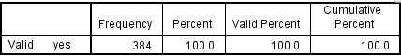
Table 7.0 Frequency Statistics of “Have you own a pet”
(Source: IBM SPSS Statistics 23, 2018)

4.1.1 Socio-demographic Profile
The demographic profile mainly includes gender, income statement, age, and nationality. The results are indicated in table 8.0.
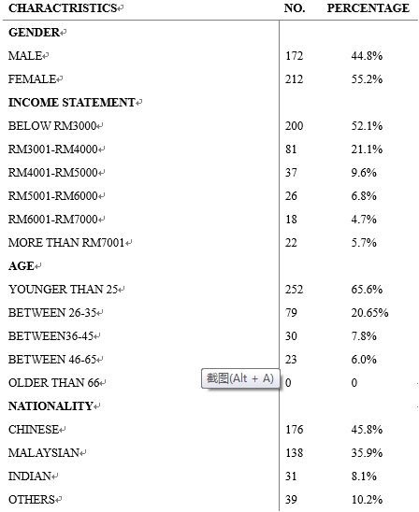
Table 8.0 Socio-demographic profile of respondents (n=384)
(IBM SPSS Statistics 23, 2018)
Table 8.0 visually shown the result of socio-demographic profile of respondents. Out of the 384 respondents, 44.8% (172) is male and 55.2% (212) is female. About income statement, the largest proportion is below RM3,000, which is account for 52.1% (200), and the smallest one is RM6,001-RM7,000, which is 4.7% (18). Most of the respondents’ age is younger than 25, that is 252 (65.6%) and older than 66 is the smallest proportion, is 0. The majority respondents are Chinese 45.8% (176), and Indian is 8.1% (31), which is the smallest proportion.

4.1.2 Consumer Awareness, Knowledge and Habits towards pet food
This section is to determine the consumer awareness, knowledge and habit towards pet food. There also use descriptive analysis to describe the consumer awareness, knowledge and habit. Table 9.0 shows some questions which are asking for information about respondents’ awareness, knowledge and habits, in it also shows the result of these questions.
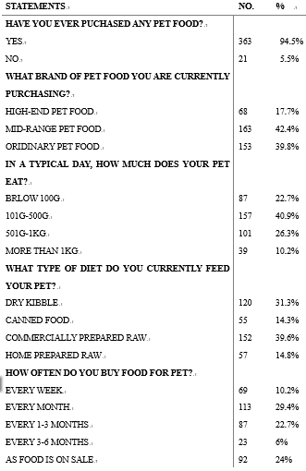
Table 9.0 Consumer awareness, knowledge and habits towards pet food (IBM SPSS Statistics 23, 2018)
Table 9.0 illustrate that most of the respondents have experiences to purchase pet food that is 363 (94.5%). And 42.4% (163) of respondents choose to purchase mid-range pet food. The food intake is based on the type of pet or the quantity of the pets the respondent owned, which is below 100g 87 (22.7%), 101g-500g 157 (40.9%), 501g-1kg 101 (26.3%) and more than 1kg 39 (10.2%). Commercially prepare raw is the most popular type of diet, which account for 39.6% (152), following by dry kibble 120 (31.3%), home prepared raw 57 (14.8%) and canned food 55 (14.3%). Most of the respondents prefer to purchase pet food every month, account for 29.4% (113), every 3-6 months is the smallest proportion 6% (23).

4.2 Results of Hypothesis Testing
The number of constructs and the structure between the variables in the analysis can be determined by performing an explanatory factor analysis (EFA). In this study, EFA was used to reveal the underlying factors of consumers' intention to purchase pet food. Respondents faced 25 questions in the 5-point Likert scale which are Involved in their attitudes, subjective norms, perceived behavioural control and intentions for pet food purchasing.

4.2.1 Measure of Sampling Adequacy
In this study, the Keiser-Meyer-Olkin (KMO) sampling sufficiency test and Bartlett's spherical test were used to measure sampling adequacy and correlation between all variables. Kaiser-Meyer-Olkin (KMO) Barlett’s test is the most widely used technology in factor analysis, about the range of KMO measurement sampling, the following is an explanation: values between 0.5 and 0.7 are mediocre, values between 0.7 and 0.8 are good, values between 0.8 and 0.9 are great and value above 0.9 are marvellous (Hutcheson & Sofroniou, 1999). KMO can be used to identify which variables should be removed from the factor analysis due to the lack of multicollinearity.
In addition, the statistically significant Bartlett test for sphericity should be less than 0.05, indicating that there is sufficient correlation between the variables. Kaiser-Meyer-Olkin (KMO) Sampling Adequacy Test and Barlett's Spherical Test are first performed in all statements to confirm the appropriateness of the factor analysis (Tabachnick and Fidell, 2001)。
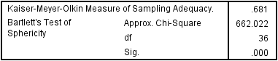
Table 10.0 KMO and Barlett’s Test
(IBM SPSS Statistics 23, 2018)
According to table 10.0, the result of KMO test is reached 0.681, this value is between 0.5 and 0.7, which means is satisfy for factor analysis so that the factor analysis and sampling adequacy can be run.
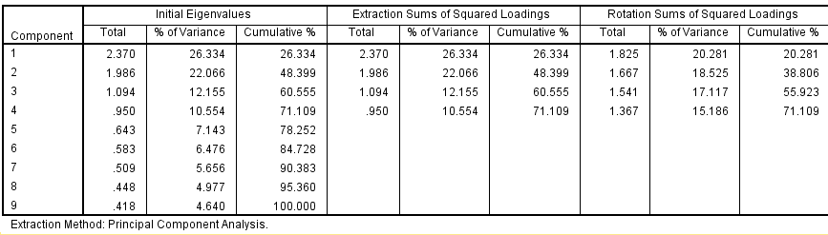
Table 11.0 Total variance table
(IBM SPSS Statistics 23, 2018)
About the total variance, the initial eigenvalue need to greater than 1 or close to 1, according to this, in table 11.0 there are the top 4 components is satisfy for the requirement, so that means 71.109% of consumer purchase intention can be define by these factors and the other 28.891% is because of other factors.
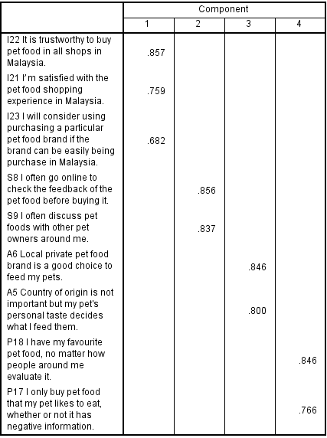
Table 12.0 Rotated component matrix
(IBM SPSS Statistics 23, 2018)
The rotated component matrix is in order to group the factors which have similar goals, table 12.0 illustrate that this 9 items are perfectly divided into 4 factors, which are satisfy for the independent variables, and dependent variable.

4.2.2 Reliability Test
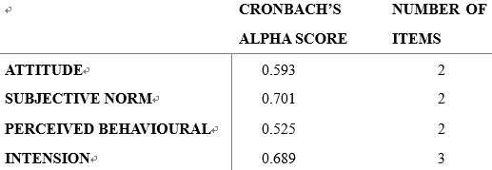
Table 13.0 Reliability Statistics
(IBM SPSS Statistics 23, 2018)
In this study, in order to ensure validity, the reliability test was used for research and testing to determine internal consistency. Cronbach’s Alpha is used to measure the reliability of 9 items in 5 point Likert scales that measure consumer behaviour in purchasing pet food. According to table 13.0, there are reliability consistency within these four potential factors. Therefore, there is consistency between multiple factors in factor analysis. By testing these four potential factors, the theory of planned behaviour is relatively consistent. It provides clear theoretical insights into consumer purchasing intention and attitudes. It also provides clear information for the pet food industry and pet food marketers.

4.2.3 Multiple Regression analysis
In this study, multiple regression analysis was used to determine the relationship between factors and consumers' intention to purchase pet food.
Table 14.0 shows the estimated parameters and the level of statistical significance when the researchers performed multiple regression analysis to examine the relationship between factors and consumers' intention to purchase pet food. At the same time, the following data generated by multiple regression models are also very important：$R^{2}=0.121$, F=17.431, p=0.000, p-value$<$0.05. Since the F test is significant, which means that the model is acceptable for this research.
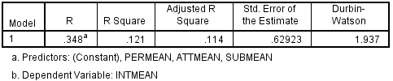
Table 14.0 Model summary (IBM SPSS Statistics 23, 2018)
According to table 14.0, the value of Adjusted R Square is 0.114, which means 11.4% of the variability on the intension of consumer to purchase pet food is explained by attitude, subjective norm and perceived behavioural control, and another 88.6% is explained by other factors. The residual are not correlated because the Durbin Watson statistic is 1.937, which is at the acceptance range of 1.5 to 2.5. Tolerance and variance inflation factor (VIF) are used to test collinearity, and according to table 10.0, the results show that all independent variables’ tolerance are more than 0.1, and the values of VIF are less than 10. Therefore, there was no collinearity within the data.

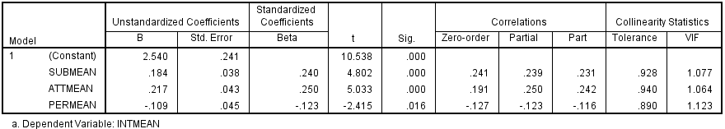
Table 15.0 Consumer intention to purchase pet food
(IBM SPSS Statistics 23, 2018)
According to table 15.0, the equation for the regression line is:
Y=2.540 + 0.184 (Subjective norm) + 0.217 (Attitude) - 0.109 (Perceived behavioural control)

Table 15.0 also indicate that in this research, all independent variables show significant relationship with consumer intention to purchase pet food, because the p-value of these three independent variables are all less than 0.05. Therefore, Subjective norm, Attitude and Perceived behavioural control are contributing to the multiple regression model. In other words, table 15.0 shows the results of hypothesis testing of the differences between attitude, subject norm and consumer intentions to purchase pet food, below shows the hypothesis:
H1: Attitude has a significant positive influence on pet food purchasing;
H2: Subjective norm has a significant positive influence on pet food purchasing.

About perceived behavioural control had significant negative regression weights (p=0.016; β= -0.109), according to the questions of this independent variable, this indicate that most consumers will choose to buy a particular pet food which is rated higher by people around or online rather than according to their own intentions or pet preferences.

4.3 Summary
Hypothesis | Hypothesis statement | Result
H1 | Attitude has a significant positive influence on pet food purchasing | Fail to reject
H2 | Subjective norm has a significant positive influence on pet food purchasing | Fail to reject
H3 | Perceived behavioural control will have negative effect on consumer intention towards pet food purchasing | Fail to reject

CHAPTER 5: CONCLUSION AND RECOMMENDATION

5.1 Recommendation
Consumers are more inclined to purchase pet foods that are able to keep their pets healthy and have a targeted effect. Therefore, manufacturers can develop and produce such pet foods more. This can reference Royal Canin. In fact Royal Canin is just a mid-range pet food, but compare with those high-end pet food such as Ziwi Peak and Naturea, perhaps Royal Canin is more famous, and its price is also more expensive than other mid-range pet food. This is because Royal Canin is one of the leader which has subdivided their pet food into many series. It is not just classified according to flavour, Royal Canin classifies the pet food according to pet’s age, pedigree and breed, as well as the pet food which has targeted efficacy, such as for sensitive gastrointestinal, good for skin and hair or make bones stronger. This meticulous classification makes it easy for consumers to choose pet food and make Royal Canin successful.

By understanding consumer intent, pet food manufacturers and marketers can survive and compete in the competitive pet food industry. It also helps survivors and newcomers in the competition find strategies for success in this area and learn from past mistakes.

In order to facilitate communication between the pet owners, the Federation Cynologique International (FCI) in Malaysia or the Cat Fanciers’ Association, this kind of Institution can create a website or application software, so that pet owners can discuss their opinions or exchange some information or experience of pet food. And the creator can also publish some information about good or inferior pet foods on this website or application software regularly. This can help the pet owners keep abreast of the information related to pet food, so as to reduce the damage to pets and prevent the inferior pet food from circulating in the market to a certain extent.

And for pet owners those cannot use computers or smart phones very well, the organizations also can organize some pet food promotion and exchange activities in real world to raise consumers' awareness and knowledge of pet food.

5.2 Limitation of study
As with other studies, this research is also limited by many factors. The first limitation of this research is time, the researcher just has 14 weeks to complete this project which including 5 weeks to collect the primary data from respondents. The second limitation is budget. Due to the budget constraint, this research has to use the primary data which were collected from respondents in Sembilan. And because of the geographical limitations of the study, taking into consideration of the social and cultural aspects of the particular region. The third limitation is the scope of data, the results may be limited or biased. The sampling size of this research is 384, and the data obtained depends on the honesty and cooperation of the respondents, so that the results are limited by their bias.

5.3 Recommendation for future research
The suggestion for further research is to expand the scope of the study and increase the number of research samples, which will help future research to obtain more accurate information and thus better plan the future of the Malaysian pet food industry.

The second point is using a qualitative research method so that can go for a depth discussion and find more information and knowledge about pet food industry in Malaysia. The proposed research method is to conduct interviews and focus groups.

5.4 Conclusion
According to the above survey results, most Malaysian pet owners have the knowledge and experience of purchasing pet food. In the market, mid-range pet foods become the most popular pet food because of their better quality than ordinary pet foods and more acceptable price to consumers than high-end pet foods.

Three independent variables attitudes, subjective norms and perceived behavioural control can influence consumers' purchasing intentions of pet food purchasing. Research has observed that consumers are more willing to buy products that they think are better, whether this cognitive is came from the Internet, the people around them or their own perceptions.

As a conclusion of this study, the application of planned behavioural theory models helps to understand consumers' intentions for pet food purchases and ultimately predicts the possible behaviour of Malaysian pet food consumers.

5.5 Personal Reflection
Researchers have done a lot of research in writing literature reviews and have found many journals to gain a deeper understanding of the pet food industry and gain some knowledge. And after completing the project, the researchers have a better and deeper understanding of the theory of planned behaviour. The biggest benefit of this research for researchers is that the researchers learned how to use SPSS to analyse data and run the results in the project. The subject is of great interest for researchers, and for a master who is about to enter the society, this helps researchers determine the direction of her future career. And under the direction of Dr. Phuah Kit Teng, the researchers learned how to work effectively to complete high-quality projects in a short period of time.

In general, under the professional guidance of Dr. Phuah, the researchers believe that the entire learning and research process is a valuable and enjoyable experience, and is fortunate to be able to successfully collect 384 valid questionnaires in a limited time, and complete the project on time in the most satisfactory way.

Reference
1 Amir H.M.S., Razauden Z., Harisun Y., Ida I.M. & Mona Z., (2014). Halal Cat Food for the World Market. International Journal on Advanced Science, Engineering and Information Technology, 4(4), pp.230.
- Anon. (2018). Malaysia Pet Food Market - Growth, Trends and Forecast (2018 - 2023). Mordor Intelligence. [online] Available at: https://www.mordorintelligence.com/industry-reports/malaysia-pet-food-market [Accessed 2018].
- Bryman, A. & Bell, E. (2015). Business Research methods. Oxford: Oxford University Press, pp.1-220.
- Buff, P., Carter, R., Bauer, J. & Kersey, J. (2014). Natural pet food: A review of natural diets and their impact on canine and feline physiology. Journal of Animal Science, 92(9), pp.3781-3791.
- Carter, Z. (2015). Looking For The Safest, Healthiest Pet Food? Good Luck With That.. [online] HuffPost UK. Available at: https://www.huffingtonpost.com/entry/pet-food-safety_us_55b67875e4b0a13f9d1976e7 [Accessed Oct. 2018].
- Colgate-Palmolive Company (2017). 2017 Annual Report. Investing For Global Growth Winning With Focus. [online] p.5. Available at: http://investor.colgatepalmolive.com/static-files/0f093899-7f24-448f-93b2-c236a3c93d99 [Accessed 2018].
- Conway, A. (2016). 3 pet food types to watch in the pet specialty market. [online] Petfoodindustry.com. Available at: https://www.petfoodindustry.com/articles/5768-pet-food-types-to-watch-in-the-pet-specialty-market [Accessed Oct. 2018].
- Cooper, D. R. & Schindler, P. S. (2014) Business Research Methods. 12th Edition. New York: McGraw-Hill.
- Coriolis. (2014). Opportunities in the New Zealand petfood industry: New Zealand Trade and Enterprise. Retrieved August 2014, from New Zealand Trade and Enterprise: www.nzte.govt.nz.
- Di Donfrancesco, B., Koppel, K., Chambers, E., IV (2012). An initial lexicon for sensory properties of dry dog food. Journal of Sensory Studies, 27, 498–510.
- Fci.be. (2018). Statistics: Malaysian Kennel Association (MALAYSIA). [online] Available at: http://www.fci.be/en/statistics/ByNco.aspx?iso=MY [Accessed 14 Jul. 2018].
- Green, D. (2018). Four pet food brands have been recalled after dogs and cats fell ill and died. [online] Business Insider Malaysia. Available at: https://www.businessinsider.my/pet-food-brands-recalled-after-dogs-and-cats-died-2018-2/?r=US&IR=T [Accessed Oct. 2018].
- Hill, R., Fishbein, M. & Ajzen, I. (1977). Belief, Attitude, Intention and Behavior: An Introduction to Theory and Research. Contemporary Sociology, 6(2), p.244.
- Huang, Y.X. (2014). Impact of Product Information on Consumers´ Choice for Dog Food. Norwegian University of life Sciences, pp.8-45.
- Kelly, R.E. (2012). FEEDING THE MODERN DOG: AN EXAMINATION OF THE HISTORY OF THE COMMERCIAL DOG FOOD INDUSTRY AND POPULAR PERCEPTIONS OF CANINE DIETARY PATTERNS, pp.1-33.
- Krejcie, R. & Morgan, D. (1970). Determining Sample Size for Research Activities. Educational and Psychological Measurement, 30(3), pp.607-610.
- Lange, M. (2016). Pet food trends shaping the world. Tucson, AZ: Gfk, pp.3-45.
- Lee, S.W. & Wee, W. (2010). Pet Industry, pp.1-87.
- Nestlé Annual Review 2017. (2018). [ebook] pp.1-35. Available at: https://www.nestle.com/asset-library/documents/library/documents/annual_reports/2017-annual-review-en.pdf [Accessed Oct. 2018].
- Pet market sales in the United States from 2011 to 2018, c. (2018). Pet market sales in the U.S. by category, 2011-2018 | Statistic. [online] Statista. Available at: https://www.statista.com/statistics/253983/pet-market-sales-in-the-us-by-category/ [Accessed 30 Sep. 2018].
- Petfoodindustry.com. (2018). Mars Petcare Inc.. [online] Available at: https://www.petfoodindustry.com/directories/211-top-pet-food-companies-current-data/listing/2838-mars-petcare-inc [Accessed Oct. 2018].
- Petfoodindustry.com. (2018). Top Pet Food Companies Current Data. [online] Available at: https://www.petfoodindustry.com/directories/211-top-pet-food-companies-current-data [Accessed 2018].
- Regulations for the Importation of Pet Food to Malaysia. (2018). [ebook] pp.1-2. Available at: https://www.aphis.usda.gov/regulations/vs/iregs/products/downloads/my-pf.pdf [Accessed Oct. 2018].
- Sekaran, U. & Bougie, R. (2016) Research Method for Business. 7th edition. Italy: Printer Trento Sri.
- Statista. (2016). Pet food market size worldwide country 2015 | Statistic. [online] Available at: https://www.statista.com/statistics/526435/pet-food-market-size-worldwide-by-country/ [Accessed 2018].
- Statista. (2018). Pet market sales in the U.S. by category, 2011-2018 | Statistic. [online] Available at: https://www.statista.com/statistics/253983/pet-market-sales-in-the-us-by-category/ [Accessed 2018].
- Surie, M.L. (2014). An Exploratory Study on the Pet Food Purchasing Behaviour of New Zealand Consumers. Lincoln University Digital Dissertation, pp.3-70.
- The J.M. Smuckers Company (2018). 2018 ANNUAL REPORT. [online] pp.2-25. Available at: http://www.jmsmucker.com/investor-relations/smuckers-annual-report [Accessed Oct. 2018].
- The Nielsen Company (2016). THE HUMANIZATION OF PET FOOD. AN UNCOMMON SENSE OF THE CONSUMER, pp.1-16. [Accessed 30 Sep. 2018].
- Utami, C.W. (2017). Attitude, Subjective Norms, Perceived Behavior, Entrepreneurship Education and Self-efficacy toward Entrepreneurial Intention University Student in Indonesia. European Research Studies Journal, XX(2A), pp.475-495.
- Wrye, J. (2012). Nutritionism and the Making of Modern Pet Food. Ottawa, Ontario: Carleton University, pp.1-41.
- Yong, A. & Pearce, S. (2013). A Beginner’s Guide to Factor Analysis: Focusing on Exploratory Factor Analysis. Tutorials in Quantitative Methods for Psychology, 9(2), pp.79-94.
- Yong, A. & Pearce, S. (2013). A Beginner’s Guide to Factor Analysis: Focusing on Exploratory Factor Analysis. Tutorials in Quantitative Methods for Psychology, 9(2), pp.79-94.
- Zohrabi, M. (2013). Mixed Method Research: Instruments, Validity, Reliability and Reporting Findings. Theory and Practice in Language Studies, 3(2), pp.1-9.

List of Figures and Tables
Figure 1.0 Pet Food Market Size Worldwide in 2015, by Country 7
Figure 2.0 Pet Market Sales in the United Stated 2011-2018 8
Figure 3.0 Pet Food Type Share of Sales by Country 11
Figure 4.0 Categories of Pet Food in Malaysia 14
Figure 5.0 Conceptual Framework 26
Figure 6.0 Sample Size 29
Table 1.0 Pet Food Market Sizes in Japan 8
Table 2.0 The World’s Top 10 Pet Food Companies 9
Table 3.0 Definition for Pet Food 11
Table 4.0 Definition for Pet Food in Malaysia 15
Table 5.0 Amount of Pet Dogs in Malaysia 29
Table 6.0 Pilot Test 30
Table 7.0 Frequency Statistics of “Have you own a pet” 33
Table 8.0 Socio-demographic Profile of Respondents 34
Table 9.0 Consumer Awareness, Knowledge and Habits towards Pet Food 35
Table 10.0 KMO and Barlett’s Test 37
Table 11.0 Total Variance Table 37
Table 12.0 Rotated Component Matrix 38
Table 13.0 Reliability Statistic 39
Table 14.0 Model Summary 40
Table 15.0 Consumer Intention to Purchase Pet Food 40

Appendix A: Initial Research Paper Proposal
MASTER OF BUSINESS ADMINISTRATION
MGT 7998 MBA PROJECT
STUDENT NAME & ID NO. & STUDENT ID | SHAO XINRU  (E93980204/ I17013429)
BROAD AREA | MARKETING (CONSUMER PURCHASE INTENTION)
TITLE | Consumer Purchasing Intention for Pet Supplies in Malaysia
PROBLEM DEFINITION | Although there are many studies on consumers’ intentions to purchase various products, most of the studies are on the factors influencing daily products, such as food, cosmetics or electronic products, the research on pet supplies is very small proportion. In addition, in this small proportion of studies, most of the research was basically concentrated in the United States or in the European developed countries, which led to uncertainty regarding the purchase intention of Malaysian consumers for pet supplies
RESEARCH OBJECTIVES | RO1: To determine whether Attitude influence consumer purchasing intention of pet supplies in Malaysia;  RO2: To determine whether Subjective Norm influence consumer purchasing intention of pet supplies in Malaysia;  RO3: To determine whether Perceived Behavioral Control influence consumer purchasing intention of pet supplies in Malaysia.
RESEARCH QUESTIONS | RQ1: Will Attitude influence consumer purchasing intention for pet supplies in Malaysia?  RQ2: Will Subjective Norm influence consumer purchasing intention for pet supplies in Malaysia?  RQ3: Will Perceived Behavioral Control influence consumer purchasing intention for pet supplies in Malaysia?
SCOPE OF STUDY | The scope of this study is only focus on pet supplies industry in Malaysia
SIGNIFICANCE OF THE RESEARCH | This study focuses on whether there is a correlation between consumer purchasing intention and COO, brand, quality in this particular market—the pet supply market. This study can provide more information and evidence for researchers who will work on this research area.
LITERATURE REVIEW | Definition of consumer purchasing intention  Customer purchasing intension is a complex process that is often associated with consumer behavior, perceptions, and attitudes; it is also a key factor that influences consumers' decision-making on product purchases (Bhakar et al., 2015). In this study, the purchase intention is defined as "the willingness of consumers to purchase pet supplies”.  Definition of country of origin (COO)  The country of origin (COO) of the product refers to the country where the product was originally produced (Younus et al., 2015), consumers’ perceptions and evaluations of this country will influence the consumers’ purchase intention.  Definition of brand  Brand is the name and symbol of a product, it is a very important tool for companies to create a positive image among customers (Mirabi et al., 2015), when other factors are the same, consumers will choose to buy the product which brand has a positive influence.  Definition of quality  Consumers judge the quality of a product by assessing how well the product meets their expectations (Rafi, Ali & Saqib et al., 2012). Quality is an important factor in predicting consumers’ willingness to purchase a particular product (Haque et al., 2015).  Influencing factors linkage with Consumer purchasing intention  - Global perspective  The image of the country of origin will directly influence the purchase intention of consumers, the intention of consumers to purchase products is consistent with their impression of the country of origin of the product, when consumers have a good view of the country of origin of the product, customers will appreciate products from that particular country, and vice versa (Haque et al., 2015). It can be seen that there is a positive correlation between the image of the country of origin and consumer purchase intention (Josiassen＆Assaf，2010).  Brand is the name and it is also a symbol of a product, it is a very important tool for companies to create a positive image among customers (Mirabi et al., 2015). There is a positive correlation between brand awareness and consumer purchasing intentions, that is, consumers are more willing to buy a product with a brand that know well (Fakharmanesh & Miyandehi, 2013).  Brand image is the overall impression of a particular brand in the consumer's mind, the positive brand image improves the company's reputation and brand value, and enhances the customer's purchase intention, so there is a positive correlation between them (Hawkins & Mothersbaugh, 2010).  Besides, the core brand image of a product includes both brand knowledge and brand preference, both of these factors influence the consumer’s purchase intention and are positively correlated, that is, the more detailed the consumer knows about the brand's information or the more consumers prefer this brand, then will be more willing to buy this brand’s product (Shah et al., 2012).  There is also a positive correlation between brand awareness and consumer purchase intention (Rafi et al., 2012). When a consumer only focuses on the brand itself and no other factors, such as price or quality, so when the consumers pay more attention to the brand, the stronger the influence of the brand on the consumer's purchase intention (Yi & Wan, 2017).  Consumers judge the quality of a product by assessing how well the product achieves their expectations, product quality is positively correlated with consumer purchase intention, that is, consumers are more willing to buy good quality products, especially when customers buy foreign products, product quality is one of the factors that consumers in developing countries like Pakistan highly consider (Rafi et al., 2012).  Similarly, the quality of service provided to customers will also have a significant influence on consumers’ purchase intentions, compared with product quality, service quality is basically a consumer's emotional experience, and there is no doubt that there is a positive correlation between service quality and consumer purchase intention (Tan, 2016).  In general, these independent variables are all having a positive correlation with consumer purchasing intention from a global perspective.  - Malaysia perspective  Due to dissatisfaction with U.S. political measures in Afghanistan, Iran, and other Islamic countries, some Malaysian consumers are disgusted and even hated the United States, which has led them to reduce their purchase of products made in the United States (Ahmed et al., 2013). This phenomenon indicates that there is a positive correlation between the image of the country of origin of the product and the consumer purchase intention, that is, the intention of consumers to purchase products is consistent with impression of the country of origin of the product (Haque et al., 2015).  When Malaysian consumers purchase products, product selection will focus on the level of development of the country of origin of the product (Garten, 2012). In short, Malaysian consumers think that the quality of foreign products from developed countries such as the United States and Japan is higher than local products because these countries of origin are economically better than Malaysia; however, when local products are compared with products from less developed countries, Malaysian consumers will think that the quality of local products is higher (Lew ＆ Sulaiman, 2014). In general, the level of economic development in the country of origin is positively related to consumer purchasing intention (Haque et al., 2015).  Malaysia is a multicultural country, In Malaysia, brands: Alagapa, Lee Kum Kee and Adabi represent Indian, Chinese and Malay communities respectively (Ahmed et al., 2013). This can increase the sense of identity of different consumers for the brand, thereby attracting consumers, so there is a positive correlation between brand identity and consumer purchase intention (Shah et al., 2012).  Malaysian consumers value quality more than price, so quality is considered as one of the important determinants of Malaysian consumers’ purchasing intention (Rahman & Haque, 2011). There is no doubt that customers prefer to consider buying high-quality products (Mirabi et al., 2015). Therefore, there is a positive correlation between product quality and consumer purchase intention (Younus et al., 2015).  Consequently for the purpose of this study, there is a need to further adopt the 3 factors as reviewed above to ascertain whether it will also influence the consumer purchase intention when the product is not related to humans, but the animals.
RESEARCH METHODOLOGY | Research design  In order to measure the relationship between dependent variables and independent variables, the most suitable design is the correlation design (Kumar, Talib & Ramayah, 2012), which will also be used in this study.  Pilot test  Pilot test is an important part of data analysis, it is used to determine the shortcomings of design and instrumentation to predict the appropriateness of the research (Matthews & Ross，2014). Since the questionnaire is used as a data collection method, in order to improve the questionnaire, the study must use a pilot test to ensure that the respondent can answer the question more accurately (Cooper & Schindler, 2014). The size of the pilot test in this study was 10% of the entire sample size, which is around 39.  Reliability test  In order to conduct better statistical research, it is important to ensure the reliability of the data collected back (Zohrabi, 2013). Reliability test is a tool that measures the internal consistency of variables under a single factor, this test also ensures the quality of the data collected and whether the research tool is useful and reliable for the analysis (Bryman & Bell, 2015).  The Cronbach alpha value is a measure of reliability (Zohrabi, 2013). In the study, the alpha value of Cronbach must be greater than 0.7 because the alpha value is positively correlated with reliability, the higher the alpha value, the higher the reliability (Horodnic, Ursachi & Zait, 2013).  Sampling size  The sample size for this study was determined according to the formula of Krejcie & Morgan (1970), which states that if the given population more than or equal to 100,000, the required sample size must be 384. According to the above, the population of this study is at least 260,963, when the Confidence level is 95% and Confidence interval is 5%, the sample size of this study should be 384.  Data collection instrument  Zikmund et al. (2013) pointed out that the questionnaire can be defined as a set of written questions which are designed to conduct a survey research or statistical research. Questionnaire design is a process of designing the format and questions in research tools which is used to collect data from respondents in the research. It is considered to be very useful and convenient for collecting data from respondents.  Statistical analysis  All the statistical analysis will be conducted using Statistical Package for the Social Sciences (SPSS) version 23. Data analysis is conducted using a four step approach which is descriptive analysis, exploratory factor analysis, reliability test and multiple regression analysis.  Descriptive analysis  Demographics profile can help researchers’ better understanding the target population (Cooper & Schindler, 2014). The data that is related to the respondent’s personal information, including population, religion, education, income, and many other factors are all demographic profile.  Exploratory Factor analysis  Factor analysis is a technique for understanding and interpreting the relationships and patterns between some of the complex factors in research (Yong & Pearce, 2013). Factor analysis is designed to summarize data by removing research variables to reduce unobservable potential variables of shared common variance.  Kaiser-Meyer-Olkin (KMO) Barlett’s test is the most widely used technology in factor analysis (Zohrabi, 2013). In this research, when researcher runs KMO, both of independent variables and dependent variable’s KMO value must more than 0.6.  The eigenvalues are calculated and used to determine how many factors are extracted in the overall factor analysis. When the eigenvalue is 1 or higher, the factor is selected for factor analysis.  Multiple regression analysis  Multiple regression is a combination of multiple independent variables that are used to determine if there is a relationship between a dependent variable and an independent variable (Cooper & Schindler, 2014). In the multiple regression model, the $R^{2}$ is used to evaluate the goodness of fit of the model, which can indicate the ability of the independent variable to interpret the dependent variable in the model (Hittner, 2016). When $R^{2}$ is greater than 0.5, this means that the independent variable has the ability to interpret the dependent variable.

Appendix B: Questionnaire
This questionnaire is designed to study the Pet Food buyers in Malaysia. The questionnaire is available in both Chinese and English. This survey only take a few minutes to complete, and hope that you would answer the all questions frankly and honestly. Your response will only be used for survey purpose, and your privacy would be retained and no information obtained from this study shall be disclosed in any manner that would identify you.
All in all, thank you very much for your help!
---------------------------------Survey Questionnaire----------------------------------------
Section A: Personal Characteristics Questionnaire
1. Please indicate your gender （性别）: □Male（男） □Female（女）
2. Please indicate your income statement （收入）:
□Below RM3000
□RM3001-RM4000
□RM4001-RM5001
□RM5001-RM6000
□RM6001-RM7000
□More than RM7001
3. How old are you（年龄）?
□Younger than 25
□Between 26 and 35
□Between 36 and 45
□Between 46 and 65
□Older than 66
4. What is your nationality（国籍）?
□Chinese
□Malaysian
□Indian
□Others
5. Have you own a pet?（您饲养宠物吗）
□Yes □No
6. How many pets have you own?（您饲养了几只宠物）
□Only 1 □2 pets □Others___________
7. What type of pet have you own? (Multiple choice)（您饲养了什么类型的宠物-多选）
□Dog（狗） □Cat（猫） □Bird（鸟）
□Fish（鱼） □Hamster（仓鼠） □Others__________

Section B: Awareness and Knowledge towards Pet Food
1. Have you ever purchased any pet food?（您有购买过任何宠物食品吗）
□Yes □No
2. What brand of pet food you are currently purchasing? （您现在购买的宠物食品是什么品牌的）
□High-end pet food (eg. Ziwi Peak, Orijen and Naturea)
□Mid-range pet food (eg. Royal Canin, Blue Buffalo and ACANA)
□Ordinary pet food (eg. Bridge, Pedigree and Whiskas)
3. In a typical day, how much does your pet eat? （您的宠物每天的进食量是多少）
□Below 100g
□101g-500g
□501g-1kg
□More than 1kg
4. What type of diet do you currently feed your pet?（您的宠物目前食用什么种类的宠物食品）
□Dry Kibble（干粮）
□Canned Food（罐头食品）
□Commercially prepared raw（商品粮）
□Home prepared raw（自制粮）
5. How often do you buy food for your pet?（您多久购买一次宠物食品）
□Every week（每周）
□Every month（每个月）
□Every one to three months（每隔一到三个月）
□Every three to six months（每三到六个月）
□As food is on sale（随时）

Section C: Measurement Questionnaire
Using the scale below, please choose the item that describes your opinion best.
(Strongly Disagree=1, Disagree=2, Neutral=3, Agree=4, Strongly Agree=5)
Part 1: Attitude
No | Statement | Score
Brand（品牌）
1 | My pet's food is the most important factor in its health and wellbeing, not related with brand.（我的宠物食品是其健康和福祉的最重要因素，与品牌无关。）
2 | Brand Name usually attract me to purchase.（品牌名称通常会吸引我购买。）
3 | Brand Name is selected regardless of price.（无论价格如何，都会选择品牌。）
4 | I will be loyal to the brand that can solve my pets’ problem such as fur issues.（我将忠于可以解决我的宠物问题的品牌，如毛皮问题。）
Country of Origin（原产地）
5 | Country of origin is not important but my pet's personal taste decides what I feed them.（原产地并不重要，但我宠物的偏好决定了我喂它们的宠物食品。）
6 | Local private pet food brand is a good choice to feed my pets.（当地私人宠物食品品牌是喂养宠物的好选择。）
7 | Imported pet foods is more appealing and attractive.（进口宠物食品更具吸引力。）
Part 2: Subjective norm
8 | I often go online to check the feedback of the pet food before buying it.（在购买宠物食品之前，我经常上网查看宠物食品的反馈。）
9 | I often discuss pet foods with other pet owners around me.（我经常与周围的其他宠物主人讨论宠物食品。）
10 | The pets’ owner I met in the pets fair influence me to change pet food brand.（我在宠物展上遇到的宠物主人影响我改变宠物食品品牌。）
11 | Campaign from pet supplier encourage me to purchase their pet foods.（来自宠物供应商的活动鼓励我购买他们的宠物食品。）
12 | I will purchase the same brand of pet foods if the brand is widely used by people in my community.（如果该品牌被我所在社区的人们广泛使用，我将购买相同品牌的宠物食品。）
Part 3: Perceived Behavioural Control
13 | I prefer to buy the pet food which is cheap.（我比较偏向于购买便宜的宠物食品。）
14 | I think the more expensive pet food, the better its quality.（我认为越贵的宠物食品质量越好。）
15 | I'm not concerned about the price of pet food.（我不关注宠物食品的价格。）
16 | When buying the pet food, I look for the more discount product available.（当我购买宠物食品时，我会购买折扣更大的。）
17 | I only buy pet food that my pet likes to eat, whether or not it has negative information.（我只会购买自己宠物爱吃的宠物食品，不管这种宠物食品有没有负面的信息。）
18 | I have my favourite pet food, no matter how people around me evaluate it.（我有我喜爱购买的宠物食品，不管周围人如何评价它。）
19 | I will purchase the pet foods if it is as available everywhere.（我喜欢购买那些任何地方都能买到的宠物食品。）
20 | I will purchase the pet foods if its available online.（我喜欢购买网上能买到的宠物食品。）
Part 4: Intention
No | Statement | Score
21 | I’m satisfied with the pet food shopping experience in Malaysia.（我很满意在马来西亚购买宠物食品的经历。）
22 | It is trustworthy to buy pet food in all shops in Malaysia.（在马来西亚的所有商店购买的宠物食品是值得信赖的。）
23 | I will consider using purchasing a particular pet food brand if the brand can be easily being purchase in Malaysia.（如果一个特定品牌的宠物食品在马来西亚十分容易购买，我会考虑购买它。）
24 | Whenever possible, I intend to purchase pet food that my pet like to consume.（只要有可能，我会购买我的宠物爱吃的宠物食品。）
25 | Although I want to buy pet food but the high price of pet foods stop me from purchasing them.（虽然我想要购买宠物食品，但宠物食品的高价格阻止了我购买它们。）

THANK YOU FOR YOUR CO-OPERATION!

Appendix C: MBA Project Log
INTI INTERNATIONAL UNIVERSITY
FACULTY OF BUSINESS, COMMUNICATIONS AND LAW
This is an important document, which is to be handed in with your dissertation. This log will be taken into consideration when awarding the final mark for the dissertation.
Student Name: | Shao Xinru
Supervisor’s Name: | Dr. Phuah Kit Teng
Dissertation Topic:
Consumer Purchasing Intention of Pet Supplies in Malaysia
SECTION A. MONITORING STUDENT DISSERTATION PROCESS
The plan below is to be agreed between the student & supervisor and will be monitored against progress made at each session.
Activity | Milestone/Deliverable Date
 | 18 Sep | 25 Sep | 8 Oct | 18 Oct | 23 Oct | 13 Nov | 16 Nov | 23 Nov | 29 Nov
1st Meeting | √
2nd Meeting |  | √
3rd Meeting |  |  | √
4th Meeting |  |  |  | √
5th Meeting |  |  |  |  | √
6th Meeting |  |  |  |  |  | √
7th Meeting |  |  |  |  |  |  | √
8th Meeting |  |  |  |  |  |  |  | √
9th Meeting |  |  |  |  |  |  |  |  | √
SECTION B. RECORD OF MEETINGS
The expectation is that students will meet their supervisors up to seven times and these meetings should be recorded.

Meeting 1
Date of Meeting | Sep. 18th, 2018
Progress Made | Discussed about the topic for dissertation
Agreed Action | Modified the dissertation title as “Customer Purchasing Intention of Pet Supplies in Malaysia ”
Student Signature
Supervisor’s Signature

Meeting 2
Date of Meeting | Sep. 25th, 2018
Progress Made | Made changes over Project Introduction (Chapter 1), Literature Review (Chapter 2) and Methodology (Chapter 3)
Agreed Action | Proceed with Chapter 1, 2, 3 and submit the modified Chapter 1 to Supervisor before Oct. 8th, 2018 for check.
Student Signature
Supervisor’s Signature

Meeting 3
Date of Meeting | Oct. 8th, 2018
Progress Made | Further improvement on the modified Chapter 1 according to Supervisor’s feedback.
Agreed Action | Further improve Chapter 1. Proceed Chapter 2 & 3 and submit the modified Chapter 2 & 3 to Supervisor before Oct. 18th, 2018 for check.
Student Signature
Supervisor’s Signature

Meeting 4
Date of Meeting | Oct. 18th, 2018
Progress Made | Do further improvement on modified Chapter 2 & 3 and discuss about the first presentation held on Oct. 29th, 2018
Agreed Action | Accomplish Chapter 2 & 3 according to Supervisor’s comment. Proceed with the PPT for first presentation on Oct. 29th, 2018
Student Signature
Supervisor’s Signature

Meeting 5
Date of Meeting | Oct. 23rd, 2018
Progress Made | Discuss about PPT for first Presentation
Agreed Action | Proceed and enhance the PPT according to Supervisor’s advice
Student Signature
Supervisor’s Signature

Meeting 6
Date of Meeting | Nov. 13rd, 2018
Progress Made | Discuss about the development of Chapter 4
Agreed Action | Proceed with the questionnaire distribution and preparation for data analysis.
Student Signature
Supervisor’s Signature

Meeting 7
Date of Meeting | Nov. 16th, 2018
Progress Made | Discuss about the presentation on Nov. 26th, 2018 and development of Chapter 5
Agreed Action | Modify Chapter 4 and proceed with Chapter 5. Submit PPT for second presentation to Supervisor before Nov. 23rd for check
Student Signature
Supervisor’s Signature

Meeting 8
Date of Meeting | Nov. 23rd, 2018
Progress Made | Discuss about PPT for second Presentation and Chapter 5
Agreed Action | Enhance the PPT and preparation for presentation. Modify the Chapter 5 according to Supervisor’s advice
Student Signature
Supervisor’s Signature

Meeting 9
Date of Meeting | Nov. 29th, 2018
Progress Made | Discuss about the whole Project and final Project submission
Agreed Action | Proceed the format for final submission according to the requirement; meanwhile, check and rectify the small mistakes made in the whole Project
Student Signature
Supervisor’s Signature

Appendix D: Turntin Result
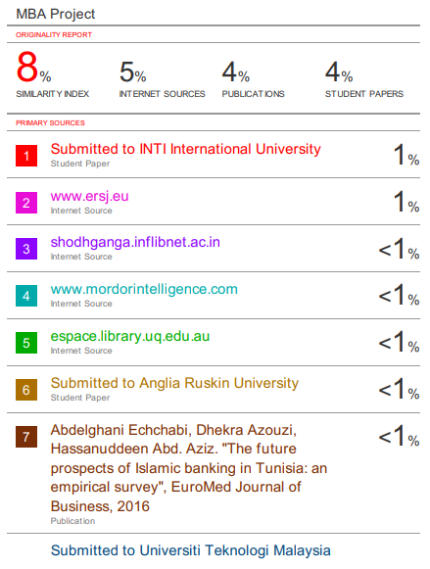
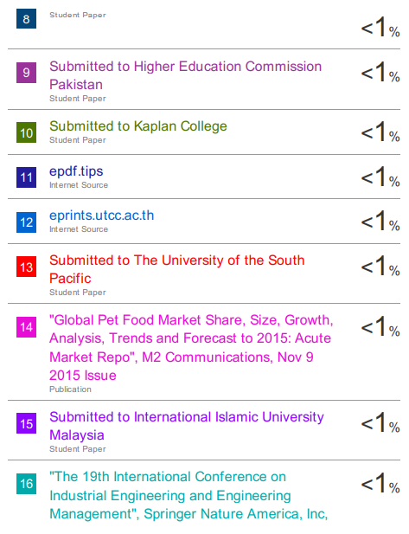

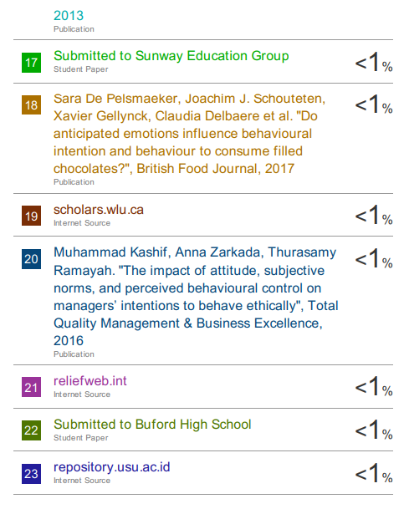

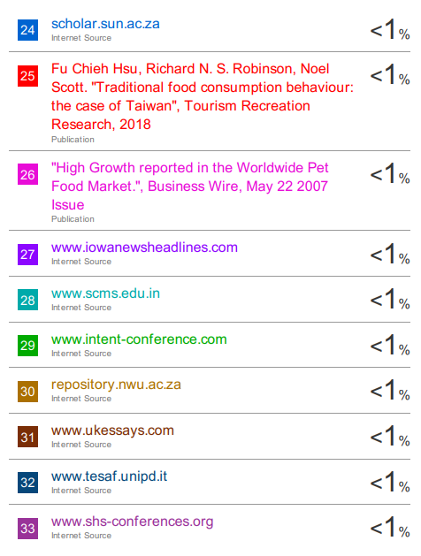
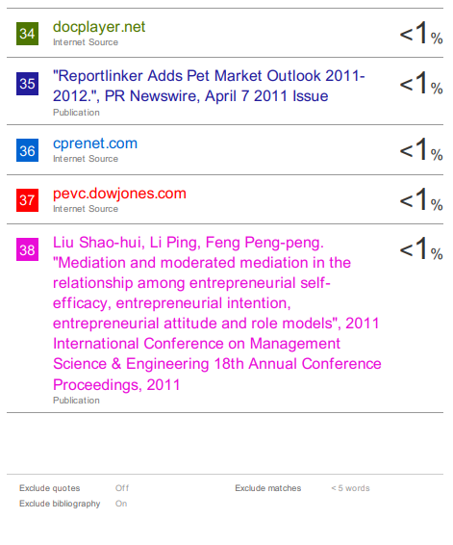

Appendix E: SPSS Output

FACTOR
/VARIABLES A5 A6 S8 S9 P17 P18 I21 I22 I23
/MISSING LISTWISE
/ANALYSIS A5 A6 S8 S9 P17 P18 I21 I22 I23
/PRINT INITIAL KMO EXTRACTION ROTATION
/FORMAT SORT BLANK(0.5)
/CRITERIA FACTORS(4) ITERATE(25)
/EXTRACTION PC
/CRITERIA ITERATE(25)
/ROTATION VARIMAX
/SAVE BART(ALL)
/METHOD=CORRELATION.

Factor Analysis

KMO and Bartlett's Test
Kaiser-Meyer-Olkin Measure of Sampling Adequacy. |  | .681
Bartlett's Test of Sphericity | Approx. Chi-Square | 662.022
 | df | 36
 | Sig. | .000

Communalities
 | Initial | Extraction
A5 Country of origin is not important but my pet's personal taste decides what I feed them. | 1.000 | .677
A6 Local private pet food brand is a good choice to feed my pets. | 1.000 | .744
S8 I often go online to check the feedback of the pet food before buying it. | 1.000 | .753
S9 I often discuss pet foods with other pet owners around me. | 1.000 | .745
P17 I only buy pet food that my pet likes to eat, whether or not it has negative information. | 1.000 | .647
P18 I have my favourite pet food, no matter how people around me evaluate it. | 1.000 | .726
I21 I’m satisfied with the pet food shopping experience in Malaysia. | 1.000 | .697
I22 It is trustworthy to buy pet food in all shops in Malaysia. | 1.000 | .752
I23 I will consider using purchasing a particular pet food brand if the brand can be easily being purchase in Malaysia. | 1.000 | .657
Extraction Method: Principal Component Analysis.

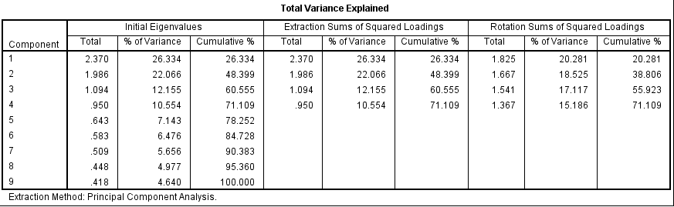

Component Matrixª
 | Component
 | 1 | 2 | 3 | 4
I21 I’m satisfied with the pet food shopping experience in Malaysia. | .733
S9 I often discuss pet foods with other pet owners around me. | .700
S8 I often go online to check the feedback of the pet food before buying it. | .644 |  | .522
I22 It is trustworthy to buy pet food in all shops in Malaysia. | .620
P17 I only buy pet food that my pet likes to eat, whether or not it has negative information. | -.501
I23 I will consider using purchasing a particular pet food brand if the brand can be easily being purchase in Malaysia. |  | .697
A6 Local private pet food brand is a good choice to feed my pets. |  | .697
A5 Country of origin is not important but my pet's personal taste decides what I feed them. |  | .677
P18 I have my favourite pet food, no matter how people around me evaluate it. |  |  | .518
Extraction Method: Principal Component Analysis.
a. 4 components extracted.

Rotated Component Matrixª
 | Component
 | 1 | 2 | 3 | 4
I22 It is trustworthy to buy pet food in all shops in Malaysia. | .857
I21 I’m satisfied with the pet food shopping experience in Malaysia. | .759
I23 I will consider using purchasing a particular pet food brand if the brand can be easily being purchase in Malaysia. | .682
S8 I often go online to check the feedback of the pet food before buying it. |  | .856
S9 I often discuss pet foods with other pet owners around me. |  | .837
A6 Local private pet food brand is a good choice to feed my pets. |  |  | .846
A5 Country of origin is not important but my pet's personal taste decides what I feed them. |  |  | .800
P18 I have my favourite pet food, no matter how people around me evaluate it. |  |  |  | .846
P17 I only buy pet food that my pet likes to eat, whether or not it has negative information. |  |  |  | .766
Extraction Method: Principal Component Analysis.
Rotation Method: Varimax with Kaiser Normalization.ª
a. Rotation converged in 5 iterations.

Component Transformation Matrix
Component | 1 | 2 | 3 | 4
1 | .618 | .652 | -.104 | -.426
2 | .553 | -.192 | .742 | .327
3 | -.333 | .722 | .180 | .579
4 | .449 | -.126 | -.637 | .614
Extraction Method: Principal Component Analysis.
Rotation Method: Varimax with Kaiser Normalization.

RELIABILITY
/VARIABLES=I21 I22 I23
/SCALE('ALL VARIABLES') ALL
/MODEL=ALPHA.

Reliability

Scale: ALL VARIABLES

Case Processing Summary
 |  | N | %
Cases | Valid | 384 | 100.0
 | Excludedª | 0 | .0
 | Total | 384 | 100.0
a. Listwise deletion based on all variables in the procedure.

Reliability Statistics
Cronbach's Alpha | N of Items
.701 | 2

RELIABILITY
/VARIABLES=A5 A6
/SCALE('ALL VARIABLES') ALL
/MODEL=ALPHA.

Scale: ALL VARIABLES

Case Processing Summary
 |  | N | %
Cases | Valid | 384 | 100.0
 | Excludedª | 0 | .0
 | Total | 384 | 100.0
a. Listwise deletion based on all variables in the procedure.

Reliability Statistics
Cronbach's Alpha | N of Items
.593 | 2

RELIABILITY
/VARIABLES=P17 P18
/SCALE('ALL VARIABLES') ALL
/MODEL=ALPHA.

Scale: ALL VARIABLES

Case Processing Summary
 |  | N | %
Cases | Valid | 384 | 100.0
 | Excludedª | 0 | .0
 | Total | 384 | 100.0
a. Listwise deletion based on all variables in the procedure.

Reliability Statistics
Cronbach's Alpha | N of Items
.525 | 2

COMPUTE SUBMEAN=MEAN(S8,S9).
EXECUTE.
COMPUTE ATTMEAN=MEAN(A5,A6).
EXECUTE.
COMPUTE PERMEAN=MEAN(P17,P18).
EXECUTE.
REGRESSION
/MISSING LISTWISE
/STATISTICS COEFF OUTS R ANOVA COLLIN TOL ZPP
/CRITERIA=PIN(.05) POUT(.10)
/NOORIGIN
/DEPENDENT INTMEAN
/METHOD=ENTER SUBMEAN ATTMEAN PERMEAN
/RESIDUALS DURBIN.

Regression

Variables Entered/Removedª
Model | Variables Entered | Variables Removed | Method
1 | PERMEAN, ATTMEAN, SUBMEAN^{b} | . | Enter
a. Dependent Variable: INTMEAN
b. All requested variables entered.

Model Summary^{b}
Model | R | R Square | Adjusted R Square | Std. Error of the Estimate | Durbin-Watson
1 | .348ª | .121 | .114 | .62923 | 1.937
a. Predictors: (Constant), PERMEAN, ATTMEAN, SUBMEAN
b. Dependent Variable: INTMEAN

ANOVAª
Model |  | Sum of Squares | df | Mean Square | F | Sig.
1 | Regression | 20.705 | 3 | 6.902 | 17.431 | .000^{b}
 | Residual | 150.453 | 380 | .396
 | Total | 171.157 | 383
a. Dependent Variable: INTMEAN
b. Predictors: (Constant), PERMEAN, ATTMEAN, SUBMEAN

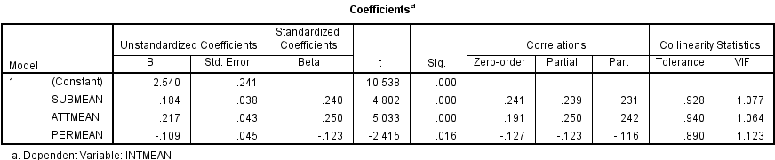

Collinearity Diagnosticsª
Model | Dimension | Eigenvalue | Condition Index | Variance Proportions
 |  |  |  | (Constant) | SUBMEAN | ATTMEAN | PERMEAN
1 | 1 | 3.855 | 1.000 | .00 | .00 | .00 | .00
 | 2 | .084 | 6.761 | .00 | .25 | .01 | .43
 | 3 | .048 | 8.987 | .00 | .09 | .76 | .34
 | 4 | .013 | 17.323 | .99 | .66 | .22 | .23
a. Dependent Variable: INTMEAN

Residuals Statisticsª
 | Minimum | Maximum | Mean | Std. Deviation | N
Predicted Value | 2.6141 | 4.2192 | 3.6536 | .23251 | 384
Residual | -2.70882 | 1.61913 | .00000 | .62676 | 384
Std. Predicted Value | -4.471 | 2.432 | .000 | 1.000 | 384
Std. Residual | -4.305 | 2.573 | .000 | .996 | 384
a. Dependent Variable: INTMEAN

DATASET ACTIVATE DataSet1.

SAVE OUTFILE='C:\Users\Administrator\Desktop\Pet Food questionnaire.sav'
/COMPRESSED.
DESCRIPTIVES VARIABLES=Gender Income Age Nationality Ownership Quantity Type Purchased Brand Intake
Diet Often
/STATISTICS=SUM STDDEV MIN MAX.

Descriptives

FREQUENCIES VARIABLES=Gender Income Age Nationality Ownership Quantity Type Purchased Brand Intake
Diet Often
/ORDER=ANALYSIS.

Frequencies

Gender
 |  | Frequency | Percent | Valid Percent | Cumulative Percent
Valid | male | 172 | 44.8 | 44.8 | 44.8
 | female | 212 | 55.2 | 55.2 | 100.0
 | Total | 384 | 100.0 | 100.0

Income statement
 |  | Frequency | Percent | Valid Percent | Cumulative Percent
Valid | Below RM3000 | 200 | 52.1 | 52.1 | 52.1
 | RM3001-RM4000 | 81 | 21.1 | 21.1 | 73.2
 | RM4001-RM5000 | 37 | 9.6 | 9.6 | 82.8
 | RM5001-RM6000 | 26 | 6.8 | 6.8 | 89.6
 | RM6001-RM7000 | 18 | 4.7 | 4.7 | 94.3
 | More than RM7001 | 22 | 5.7 | 5.7 | 100.0
 | Total | 384 | 100.0 | 100.0

Age
 |  | Frequency | Percent | Valid Percent | Cumulative Percent
Valid | younger than 25 | 252 | 65.6 | 65.6 | 65.6
 | 26-35 | 79 | 20.6 | 20.6 | 86.2
 | 36-45 | 30 | 7.8 | 7.8 | 94.0
 | 46-65 | 23 | 6.0 | 6.0 | 100.0
 | Total | 384 | 100.0 | 100.0

Nationality
 |  | Frequency | Percent | Valid Percent | Cumulative Percent
Valid | Chinese | 175 | 45.6 | 45.6 | 45.6
 | Malaysian | 138 | 35.9 | 35.9 | 81.5
 | Indian | 31 | 8.1 | 8.1 | 89.6
 | Others | 39 | 10.2 | 10.2 | 99.7
 | 11 | 1 | .3 | .3 | 100.0
 | Total | 384 | 100.0 | 100.0

Have you own a pet?
 |  | Frequency | Percent | Valid Percent | Cumulative Percent
Valid | yes | 384 | 100.0 | 100.0 | 100.0

How many pets have you own
 |  | Frequency | Percent | Valid Percent | Cumulative Percent
Valid | Only 1 | 234 | 60.9 | 60.9 | 60.9
 | 2 pets | 97 | 25.3 | 25.3 | 86.2
 | Others | 53 | 13.8 | 13.8 | 100.0
 | Total | 384 | 100.0 | 100.0

Have you ever purchased any pet food
 |  | Frequency | Percent | Valid Percent | Cumulative Percent
Valid | yes | 363 | 94.5 | 94.5 | 94.5
 | no | 21 | 5.5 | 5.5 | 100.0
 | Total | 384 | 100.0 | 100.0

What brand of pet food you are currently purchasing
 |  | Frequency | Percent | Valid Percent | Cumulative Percent
Valid | Royal Canin | 68 | 17.7 | 17.7 | 17.7
 | Acana | 163 | 42.4 | 42.4 | 60.2
 | Orijen | 153 | 39.8 | 39.8 | 100.0
 | Total | 384 | 100.0 | 100.0

In a typical day, how much does your pet eat
 |  | Frequency | Percent | Valid Percent | Cumulative Percent
Valid | Below 100g | 87 | 22.7 | 22.7 | 22.7
 | 101g-500g | 157 | 40.9 | 40.9 | 63.5
 | 501g-1kg | 101 | 26.3 | 26.3 | 89.8
 | More than 1kg | 39 | 10.2 | 10.2 | 100.0
 | Total | 384 | 100.0 | 100.0

What type of diet do you currently feed your pet
 |  | Frequency | Percent | Valid Percent | Cumulative Percent
Valid | dry kibble | 120 | 31.3 | 31.3 | 31.3
 | canned food | 55 | 14.3 | 14.3 | 45.6
 | commercially prepared raw | 152 | 39.6 | 39.6 | 85.2
 | home prepared raw | 57 | 14.8 | 14.8 | 100.0
 | Total | 384 | 100.0 | 100.0

How often do you buy food for your pet
 |  | Frequency | Percent | Valid Percent | Cumulative Percent
Valid | every week | 69 | 18.0 | 18.0 | 18.0
 | every month | 113 | 29.4 | 29.4 | 47.4
 | every one to three months | 87 | 22.7 | 22.7 | 70.1
 | every three to six months | 23 | 6.0 | 6.0 | 76.0
 | as food is on sale | 92 | 24.0 | 24.0 | 100.0
 | Total | 384 | 100.0 | 100.0

