

THE INFLUENCE OF WESTERN CORPORATE CULTURE ON THE EDUCATION INDUSTRY IN CHINA

RUAN HANWEI
DUAL-AWARD
I17013744

FACILITATOR: ASSOC.PROF. DR. LEE KAR LING

2018

Acknowledgement
This dissertation consummates my Master of Business Administration degree in INTI International University joint program with University of Hertfordshire. This would not be possible without the advice, assistance, cooperation and encouragement from a number of people. I would like to express my gratitude to all those who gave me help and support Firstly, I am deeply gratitude to my supervisor Assoc Prof Dr Lee Kar Ling, my wise, able, brilliant supervisor, who has been unselfish with her time unvarnished, yet always thoughtful in her critiques, passionate about the dissertation and demonstrated assertiveness in urging me to move forward in this undertaking. Secondly, I would like to that thanks to my second examiner Dr Francis Wong who has provided moderate suggestions to this study. Thirdly, my sincere appreciation to fellow scholars, who has contributed to ensure that this dissertation is fulfilled on the right note. The scholars have always been there to brainstorm and share ideas. Lastly, gratitude to INTI International University, Faculty of Business and Law for allowing me to have the opportunity to conduct the research which has provided me a better understanding on the area of my research.

Ruan Hanwei
7/Dec/2018

ABSTRACT
Corporate culture, or organizational culture, is an organization's unique cultural image composed of its values, beliefs, rituals, symbols and ways of doing things.
Education Institutions training industry development history founded in China is not in a long period time, the longest institutions are founded less than 30 years, the vast majority of less than 10 years development history, the stationing of public institutions in addition to a few cities across the country, most belong to small and medium-sized institutions, in the recruitment of students, teaching and management and is still exist many problems, many of the survival and development of institutions are still in the middle of the market and the policy of cracks. Talking about the enterprise culture construction, is not very interested in the topic for the principals of institutions. However, we often find themselves in such a situation: education training is a marginalized industry and rarely becomes the focus and focus of local mainstream social consciousness. Once it becomes the focus of media and public opinion, most of it is negative news. Because the industry wasn’t established relative specification, clear goals and the development of the industry service standards, many institutions which didn't realize the development in school should take corporate social responsibility. The society need to have a more clear and correct understanding in terms of a relatively positive social position of these education institutions. However, in this respect, it is very closely related to the construction of corporate culture.

Keywords: Corporate culture; organizational culture; education Institutions; China.

TABLE OF CONTENTS
CHAPTER 1. INTRODUCTION 5
1.0 Overview 5
1.1 Background of the study 5
1.2 Problem Statement 6
1.3 Research objectives 7
1.4 Research questions 7
1.5 Significance of study 8
1.5.1 significance to academia 8
1.5.2 significance to industry 8
1.6 Scope & limitation of study 8
1.7 Operational definitions 9
1.8 Organisation of chapters 11
CHAPTER 2. LITERATURE REVIEW 13
2.0 Overview 13
2.1 The performance of education industry in China..........................................................................................13
2.1.1 Global perspective 14
2.1.2 Local perspective 15
2.2 Independent variables for performance.........................................................................................................17
2.2.1 Deal & Kennedy corporate culture dimensions 17
2.2.2 Trompenaars cultural dimensions 20
2.3 Linkage between western corporate culture and the performance of education industry in China..............24
2.3.1 Linkage: A global view 24
2.3.2 Linkage: A local view 25
2.4 Grounded theory............................................................................................................................................28
2.5 Gaps in the literature.....................................................................................................................................29
2.6 Theoretical Framework.................................................................................................................................29
2.7 Hypotheses....................................................................................................................................................30
2.8 Conclusion.....................................................................................................................................................30
CHAPTER 3. RESEARCH METHODOLOGY 31
3.0 Overview 31
3.1 Research design 32
3.2 Unit of analysis & Time horizon 34
3.3 Sampling design 35
3.3.1 Sampling plan 35
3.3.2 Sample size 36
3.4 Questionnaire Design 36
3.5 Pilot test 38
3.5.1 Pilot test: Factor analysis 38
3.5.2 Pilot test: Reliability test 39
3.5.3 Pilot test: Correlation matrix 40
3.6 Measurements 40
3.6.1 Descriptive Information 41

3.6.2 Preliminary tests 41
3.6.3 Hypothesis testing 42
3.7 Ethical consideration 44
3.8 Conclusion 44
CHAPTER 4. RESEARCH FINDINGS 46
4.0 Overview 46
4.1 Pilot test 46
4.1.1 Factor Analysis 47
4.1.2 Reliability Test 51
4.1.3 Correlation Matrix 53
4.1.4 Conclusion for Pilot Test 55
4.2 Full Scale Data Collection 55
4.3 Demographic Profile 56
4.4 Preliminary Test 57
4.4.1 Factor Analysis 58
4.4.2 Reliability Analysis 61
4.4.3 Correlation Matrix 63
4.5 Hypotheses Analysis 65
4.5.1 Multiple regression 65
4.5.2 Beta coefficient 67
4.5.3 VIF/ multicollinearity 68
4.5.4 Hypothesis testing and Outcome 68
4.6 Summary of Findings 69
4.7 Conclusion 72
CHAPTER 5. CONCLUSION AND RECOMMENDATIONS 73
5.0 Overview 73
5.1 Discussion of findings 73
5.2 Recommendations 75
5.3 Contribution 77
5.3.1 Contribution to Academia 77
5.3.2 Contribution to Industry 78
5.4 Future research direction 78
5.5 Personal reflection 79
5.6 conclusion 80
REFERENCES 81
APPENDIX 95

CHAPTER 1. INTRODUCTION

1.0 Overview
This chapter provides the overview with regards to western corporate culture influences on education industry in China. Following by problem statement, research questions and research objectives, to determine the research’s intentions. Next, significance of study, scope and limitation of the research will be discussed further in this section. Operational definitions and organization of chapters will then be the last topics to be addressed accordingly.

Background of the study
The education industry in China has been enjoyed a long period development, its overall size has been ranked in the world, and it has a good reputation over the world (Finch, Hillenbrand and Rubin, 2015). China's education industry is ushering into its "golden age" with expansion in terms of both industry size and market activity (Xu, 2015). In 2015, the overall size of China's education industry was RMB1.6 trillion (Baensch, 2017). This figure is expected to grow to nearly RMB3 trillion in 2020 with a Compound Annual Growth Rate (CAGR) of 12.7 percent (Genuchten and Hatton, 2012). Educational training including early childhood education, K12 training, and vocational training will become the major growth point in the future. Early childhood education is driven by the implementation of two-child policy which brings sufficient demand and the government's policies to encourage preschool education (Dreyfus and Heurgué-Hamard, 2010). Meanwhile, desire for further education and international education also drives the demand for tutoring education and language education; personal training grows because of better economic capability and higher willingness to improve competitiveness (Morgan, 2016).
Chinese academic representations of corporate culture on the whole provide further justification for the official views: that corporate culture is beneficial for educational firms’ performance; that it is closely tied up with political and ideological work within corporations though some academics object to this tendency; and that corporate culture must somehow base itself on or promote “Chinese” culture and values, while simultaneously embracing socialism and accepting the best aspects of foreign cultures and management methods (Weerts, Vermeulen and Witjes, 2018).

Problem Statement
China has further opened its market to education training, especially the rapid and rapid development of vocational training (Shan, Liu and Li, 2015). The market competition is further intensified, and the market space of small institutions is getting smaller and smaller due to the shortage of teachers, the lack of market development funds and the difficulty of brand formation in the short term (Holm and Lundström, 2011). And because of the education and training industry is to charge first, after service profit pattern, so compared with other industries with distinctive characteristics, students learn in order to reduce the risk and tend to be concentrated choose brand has the advantage of the education training institutions, to form the strong stronger and the dominance of benign situation (Khan, 2011). Education's huge market and huge profits have also prompted western countries to step up their entry into China's education training market (Tyutereva, 2013). These foreign companies have begun to enter China's education training market, and under the situation of evolution, the diversification of education training market pattern, training market admittance threshold low, many operators to the law of education and training the lack of scientific understanding, on the quality of teaching, teaching content, faculty of serious shortage of R & D, cannot guarantee the teaching effect, lead to disregard the quality of teaching (Zeng, Zuo and Wang, 2014). The end of result is that the smaller it is, the worse its quality is, the worse its reputation is, and it is eliminated from the market (Fan, 2017).
Although there is strong significance need for this research, nevertheless, there are many problems for this study. Firstly, there were abundant literature on western corporate culture influences on specific industries, however rarely linked with education industry in China. Secondly, many of the studies that researcher has reviewed were done many years ago, they are rarely recent, especially in 2018. Hence, the source of the data and literature needed to be analyzed and verified again.

Research objectives
The broad objective of this study is to ascertain the relationship between western corporate culture and the performance of education industry in China.
RO1: To see whether Deal & kennedy’s corporate culture dimensions has influence on the performance of education industry in China.
RO2: To find out whether Trompenaars cultural dimensions has influence on the performance of education industry in China.

Research questions
Broad RQ: Whether western corporate culture influence on he performance of education industry in China?
RQ1: Will Deal & kennedy’s corporate culture dimensions has influence on the performance of education industry in China？
RQ2: Will Trompenaars cultural dimensions has influence on the performance of education industry in China？

1.5 Significance of study

1.5.1 significance to academia
This study is expected to give better analysis on the potential growth opportunities, influential, better performance of China’s education industry. Thus, education institutions is the main research area. The result of this research can provide a better understanding and knowledge for the academia on the western corporate culture that will influence the performance of China’s education industry. This research will benefit researches and academicians who are interested to do this research in the relevant field. It is able for people in academic to boost up their knowledge about the significant relationship between the variables.

1.5.2 significance to industry
This paper focus on the major influences of western corporate culture, to explore the factors affect the performance of education industry in China, the finding can make the managers of education institution to know how to combine both Chinese and western culture in order to make their organization develop better.

1.6 Scope & limitation of study
Each research will have inherent limitations as each research study has specific research questions and scope to determine a specific phenomenon (Zikmund, 2010). About this research, firstly, this study can only focus on general question not face to only one enterprise to research that the result cannot direct to fit a company because of different enterprise have different feature. Secondly, the study only has three months to research and the education industry is a very large scale in China. Lastly, This paper is study on western corporate culture influences on education industry in China, Although there are many study conducted on education industry and corporate culture, But there are not much related to the relationship and influence of them, to a certain extent, the source of the data is limited. And the academic level of the researcher is limited and can only be studied in a limited academic context.

1.7 Operational definitions
Table 1 below shows the primary goal of this section which is to provide the key terms and definitions to the terms stated.
Table 1.1: Operational definitions
Key Term | Definition
Education industry | Education industry is commonly divided formally into such stages as preschool or kindergarten, primary school, secondary school and then college, university, or apprenticeship (Blaug, Lauwerys and Scanlon, 2006).
Education institution | An educational institution is a place where people of different ages gain an education. Examples of some institutions are preschools, primary schools, secondary schools, and further and higher education. They provide a large variety of learning environments and learning spaces (Shapiro, Latham and Ross, 2006).
Organizational performance | Organizational performance involves analyzing a company’s performance against its objectives and goals. In other words, organizational performance comprises real results or outputs compared with intended outputs. The analysis focuses on three main outcomes, first, shareholder value performance; second, financial performance; and third, market performance (Shen and Chanda, 2009).
Deal & Kennedy corporate culture dimensions | In their classic 1982 book, Terrence Deal and Allan Kennedy proposed one of the first models of organizational culture, the notion of corporate culture is now widely accepted to be as important a business concept as financial control and employee satisfaction.  In their work on the subject of culture, they suggested that the basis of corporate culture was an interlocking set of those cultural elements (Deal and Kennedy, 2008):  - Business environment  - Values  - Heroes  - rites and rituals  - Cultural network
Trompenaars cultural dimensions | According to Fons Trompenaars, cultural differences will create a better understanding of reality. They developed a cultural model, that distinguishes seven cultural dimensions. The name of this management and communication model is the Trompenaars Cultural Dimensions (Trompenaars and Hampden-Turner, 2015).  These are the seven cultural dimensions:  - Universalism versus Particularism  - Individualism versus Communitarianism  - Neutral versus Emotional  - Specific versus Diffuse  - Achievement versus Ascription  - Sequential versus Synchronous time  - Internal direction versus External direction

1.8 Organisation of chapters
In order to keep the research simple and clear it is essential for the researcher to structure the research in a proper manner. Therefore, this research is designed in 5 chapters and sub chapters. The brief information regarding each chapter is given below:

Chapter 1: Introduction
Chapter one is the first chapter of research with include the basic knowledge and initial research information finding of researcher based on the research topic.This chapter included research background, aims and objectives, research question and research limitation that was presented as upper of the report, therefore viewer can easily to know the core objective about this research.

Chapter 2: Literature Review
Chapter two consists of a combination of literature review on the performance of Chinese education institutions, fundamental theories, theoretical framework, and hypotheses development. This chapter reviews the theoretical framework.

Chapter 3: Research Methodology
Chapter three is the chapter that provide explanations on research methodology, research design, approaches, tools and techniques used to collect data. Furthermore, this chapter also explains in detailed on research instrument, populations, sampling methods, as well as sample size.

Chapter 4: Analysis and Findings
Chapter four will provide further analysis and investigations on the data which is relevant to the questions and hypotheses discussed. Obtained data will be presented in tables and figure format for better interpretations.

Chapter 5: Conclusion
Chapter five is the final chapter that summarize all the findings in this research and to discuss about some recommendations and suggestions for future research. Besides that, this chapter also further discuss on limitation and implications of this research

CHAPTER 2. LITERATURE REVIEW

2.0 Overview
Chapter two reviews the recent researches and literature on western corporate culture and establishes the theoretical basis. This chapter will outline the previous literature on the main points of this study, such as western corporate culture, the performance of education industry in China, Deal & Kennedy’s corporate culture dimensions (Deal and Kennedy, 2000) and the Trompenaars Cultural Dimensions (Trompenaars and Hampden, 2015). At last, according to the literature review, the research framework of current project and research hypothesis is put forward.

2.1 The performance of education industry in China
China education is one of the largest education system in the world. On June 2017, there were 9.4 million students taking the National Higher Education Entrance Examination (Gao Kao) in China (Wu and Ping, 2014). Investment in education accounts for about 4% of total GDP in China. In 1986, the Chinese government passed a compulsory education law, making nine years of education mandatory for all Chinese children (Xie and Huang, 2012). Today, the Ministry of Education estimates that above 99 percent of the school-age children have received universal nine-year basic education (Wang and Lewin, 2016).
On March 2018, Ministry of Education of the People's Republic of China announced a total of 489,200 international students were studying in China in 2017, International students have enrolled in over 935 higher education institutions in China (Hu, Yang and Tang, 2018). China has a long history of providing education to international students studying in high schools and universities in China. Over the past few years, the number of international students who study abroad in China has significantly increased every year (Shabanifar and Konyalioglu, 2013).
The higher education sector has growth as well, China has increased the proportion of its college-age population in higher education to over 20 percent now from 1.4 percent in 1978 (Jian, 2013). At the same time, China is improving the quality of education through a major effort at school curriculum reform (Zheng, 2014).

2.1.1 Global perspective
Currently, the internationalization of Chinese education faces extremely unbalanced import and export (Normile, 2017). Restricted by weak educational resources of domestic education institutions, although the "export" of international education is highly potential, it is still in the beginning stage (Chan, 2014).
Enterprises' overseas presence and policy support will drive the export of Chinese education industry in the future (John, 2015). For enterprises, overseas presence not only helps them build their international images and prove the quality of their education content, to get more recognition domestically, but helps expand overseas markets in advance and identify new profit growth point. In addition, national policies also actively encourage local education to "go global" (Naka, 2016). For example, B & R(The Belt and Road) initiative proposed by the central government will "increase the number of overseas students studying in China and Chinese students studying in countries along B & R, and cooperate in running schools" , to provide opportunities for education export (Li, 2018). However, different to "import" , currently the degree of internationalized "export" in various education sectors are different, form high to low are K12 training, preschool education, higher education and vocational education (Jia, 2015).

2.1.2 Local perspective
Currently, the education market in China is highly fragmented (SU, 2017). The private education industry is characterized by stable cash flows and generous profits, able to attract investments from both domestic and international investors (Jain, 2012). The private education industry, after a phase of very rapid growth is now in a phase of consolidated development. However, since the beginning of 2014, two major trends have emerged in China’s private education sector with the power to greatly transform the industry (Lin, 2015). The second is the continuous growth of the online education sector since 2013 (Zuo, 2018). Investors strongly believe in an expansion of this field, especially if we consider that online educational services are characterized by a lack of boundaries and are subject to loose regulation (Zuo, 2018). The experts expect that in the next years a wave of IPOs will take place in the online education industry: this is a clear sign of a market that is consistently maturing (Gao, 2014).
The main segments that compose the education system in China will be analyzed one by one, concentrating on the aspects with the highest impact on the overall education industry. All these segments compose and influence the performance of China’s education industry.
As a first step, it makes sense to start directly at early childhood education. Pre-school education takes a relevant piece of the pie of the education industry (Kilic, 2013). The government’s approach with respect to the one-child policy has recently changed. In fact, China relaxed the one-child policy between 2013 and 2014, which could lead to a sharp increase in the number of Chinese children in the future (Tsao, 2015). Since 2012 the Kindergarten market has registered average growth of 9%, a clear sign of expansion. Beyond that, it has to be stressed how a gradual shrinking of public pre-schools has been offset by the development of private structures mainly targeting wealthy families (Tsao, 2017).
Going up the educational progression, besides the public institutions responsible for providing primary and secondary education, there is a relevant market for extracurricular tutoring (Li, 2012). In 1977 the national entrance examination required to access to the university system was reintroduced (Haifeng, 2015). Thus, students are required to achieve high scores if they want to enter top-ranked universities. However, it is fragmented and many actors hold a small piece of the pie. One of the Chinese government’s priorities is the internationalization of the education system (Wang, 2014). International primary and secondary schools are developing rapidly, from 2002 to 2012, this market registered a CAGR of about 25% (Gong, 2014). International schools prepare students for further studies at foreign universities, satisfying Chinese parents’ need for a diversified education (Shih, 2015). The international schools are now in their growth phase. There is still room to grow, especially if we consider the huge territories will be accessed in the future (Chang, 2010).
The major trends that are impacting the education market in China is the expansion of the vocational education market (Agrawal and Agrawal, 2017). Vocational education is provided at secondary and higher levels, and endows students with skills related to specific fields, it embeds several careers and industries for which it is possible to be trained (Schmidtke and Chen, 2012). Management and IT training are still the most relevant among the specialization fields, with an expected CAGR of 7% over the next three years (Gremaud, 2017). Recently, computer graphics and online marketing training have grown due to the broad expansion of Internet applications and a huge demand for skilled workers (Boshchenko and Fokina, 2013). Regarding manufacturing companies, China has made great strides towards sophistication and process improvements (Xia, 2012).

2.2 Independent variables for performance

2.2.1 Deal & Kennedy corporate culture dimensions
2.2.1.1 A global perspective
Corporate culture has been defined in many ways by various authors and researchers and many would agree that corporate culture can be referred to as a set of values, beliefs, and behavior patterns that form the core identity of organisations, and help in shaping the employees’ behavior (Deal and Kennedy, 2008). Corporate culture also acts as a cognitive map that influences the way in which the context is defined, for it provides the selection mechanisms or norms and values which people enact
events (Hickman and Silva, 2018). It is also a pattern of beliefs, symbols, rituals, myths, and practices that have evolved over time in an organisation (Pheysey, 1993). Corporate culture is also the dominant values espoused by an organisation or a set of values and assumptions that underlie the statement: “this is how we do things around here” (Deal and Kennedy, 2008).
Schein (2002) defined organisational culture as a pattern of basic assumptions invented, discovered or developed by a given group as it learns to cope with its problem of external adaptation and internal integration. These values are then taught to new members in the organisation as the correct way to think and feel in relation to those problems. For Schein (2002), culture is the sum that total of all the shared, taken for granted assumptions that a group has learned throughout its history. Also, culture is determined to be the residue of success. Culture is also the structure and control system to generate behavioral standards (Guiso, Sapienza and Zingales, 2013).
According to Hickman and Silva (2018), corporate culture has to be kept strictly apart from similar looking concepts like the corporate identity, organizational climate or the national culture. Corporate culture is the implicit, invisible, intrinsic, and informal consciousness of the organization which guides the behavior of the individuals and which shapes itself out of the behavior (Eccles, Ioannou and Serafeim, 2012).
Grenville (2009) examined the relationship between corporate culture and performance. In that study, corporate culture was based on the perceptions of organizational practices and conditions, to characterize the organizational culture. He found that the organization with participative culture performed better than other cultural types.
Corporate culture is also related to organizational strategy (Mullins, 2011). Anghel (2012) found a strong relationship between corporate strategy and culture. He found that firms pursuing the prospectors’ strategy tends to have developmental culture, and those with defensive strategy tend to have hierarchical culture. Rashid and Anantharaman (2002) also found that there was an association between organizational strategy and culture which is consistent with the findings by Anghel (2012).
From the above literature, it appears that corporate culture played an important role in promoting company success, and this could only be achieved by assuring an appropriate culture being developed or shaped in the organization that matches the managers values, attitudes and behavior. (Hickman and Silva, 2018)

2.2.1.2 A local perspective
The origin of culture as an independent variable affecting an employee’s attitudes and behaviour can be traced back more than 50 years ago to the notion of institutionalization (Hammonds, 2000). Culture is an important force determining managerial attitudes and practices, and does influence the practice of management (Brothers, 2007). Cultural differences may often affect management expectations and styles, coping with other cultures and trying to understand why and how culture influences behaviour is one of the most crucial issues facing management (Miller, 2010). The impact of culture in organizations is becoming increasingly important. Organizations are driven by their own kind of culture known as ‘corporate culture’, which has significant influence on member’s attitude and behavior (Hickman and Silva, 2018). Bateman and Snell (1999) observed that a company’s culture provides a framework that organizes and directs people’s behavior on the job. Corporate culture impact individual behavior on what it takes to be in good standing and directs the appropriate behavior for each circumstance. Culture is an essential quality of excellent organizations (Amah, 2016). Culture is viewed as the organization’s DNA – invisible to the naked eye yet powerful template that shapes what happens in the workplace (Davenport 2011). Corporate culture has been defined as “the way things get done around here” (Deal and Kennedy, 2008). This implies that the culture of one organization can differ from another even in the same industry. Schein (2000) defined corporate culture as the pattern of basic assumptions that a given group has invented, discovered or developed in learning to cope with its problems of external adaptation and integration that have worked well enough to be considered valid, and therefore to be taught to new members as the correct way to perceive, think and feel in relation to those problems (Miller, 2011) .
Culture helps guide daily activities of workers to meet certain goals, it enables organizations respond rapidly to customers’ need or the moves of a competitor. Nickels (2010) further defined corporate culture as widely shared values within an organization that provide coherence and cooperation to achieve goals. This means that corporate culture glues employees together and also enable them cooperate towards the achievement of organizational goals. Corporate culture has also been defined as “ the set of values, guiding beliefs, understandings, and ways of thinking that is shared by members of an organization and is taught to new members as correct” (Duncan, 2013). This implies that culture is learned and not genetically inherited. The learning process tends to go on unconsciously making culture pass from one generation to another unnoticed (McShane and Von-Glinow, 2016). It suggests that culture can be changed if the dynamics of learning process are known. The underlying values may include ethical behavior, commitment to employees, efficiency or customer service. Hills and Jones (2013) defined corporate culture as the “specific collection of values and norms that are shared by people and groups in an organization and that control the way they interact with each other and with stakeholders outside the organization”.
Culture seems to determine things like loyalty and commitment, how employees work and how far they are prepared to take risks. It is also the organizationally induced collective ‘mental programming which all members of the organization share (Ahiauzu, 2018). McShane and Von Glinow (2016) described corporate culture as an automatic pilot that directs employees in ways that are consistent with organizational expectations. Corporate culture therefore tends to enhance management in coordinating and integrating people with diverse personal and cultural value systems in the workplace (Duncan, 2013).

2.2.2 Trompenaars cultural dimensions
2.2.2.1 A global perspective
Trompenaars (1993) presents a seven-dimensional model of national culture differences which he argues is particularly relevant to the conduct of internal national business. Data read, from his book were treated using correlation and factor analysis at the country level. Results indicate that only two dimensions can be clearly confirmed statistically. Both are correlated with Hofstede’s Individualism dimension. The re-analysis raised concerns about Trompenaars’ conclusions and about his methodology. It is argued that the theory in the book is not supported by the database. Suggestions are made on how the database could be validly studied. However, the evident lack of content validity of the instrument used will remain a major concern (Trompenaars, 2015).
In Riding the Waves of Culture (London: The Economist Books, 1993), Dutch management consultant Fons Trompenaars proposes a model of seven fundamental dimensions of (national) culture for understanding cultural diversity in business. The first five factors describe relationships with other people. They are: universalism versus particularism, individualism versus collectivism, neutral versus emotional, specific versus diffuse, and achievement versus ascription. The remaining two dimensions are orientation in time and attitudes towards the environment.
In three opening chapters, Riding the Waves of Culture introduces the culture concept, and relates differences in national culture to differences in ways of organizing (Trompenaars, 2015).
In the book, Trompenaars illustrates his arguments with his own questionnaire data. His database covers about 15,000 respondents. Some were participants in the author’s cross-cultural training programs; others were employees in 30 companies in 50 different countries. Of the respondents, 75% belong to management, while the remainder are general administrative staff, mainly female. The book does not mention whether the questionnaire was translated or administered in English.
The questionnaire was originally designed for the author’s doctoral dissertation (Trompenaars, 1985). The dissertation used data obtained from a 79-item survey across 653 respondents, divided over nine countries, two industries (oil and hosiery), and seven job categories (from unskilled labor to managers of managers).
The survey questionnaire used in the dissertation research already consisted of seven subscales, corresponding to the seven. dimensions of Trompenaars’ later work, plus demographics. In Trompenaars’ dissertation the seven categories were all correlated with his Left Right Brain typology, also suggesting substantial intercorrelations. With the extended database, this still appears to be the case (Trompenaars and Wooliams, 2003)

2.2.2.2 A local perspective
Organized in 7 Cultural Dimensions, Trompenaars and Hampden-Turner structured their findings into a guideline that can be used as a management support system (Trompenaars, 1985). Trompenaars’s research has been based on a vast pool of participants with different nationalities and cultures. In over 25 years of studying the behaviour of managers in academic and field research, input from over 1,500 cross-cultural training programs in more than 25 countries, and contributions from many well-established global players which span their branches through over 60 countries have been analyzed and studied in depth. The research was designed so results would be applicable to Trompenaars’ target audience that mainly consists of managers. As such, 75 % of the included participants originated from management positions in sales, marketing, operations, etcetera, while the remaining 25% belonged to the supporting positions. Nowadays their database extends over 80,000 participants and continues to grow thanks to the internet and the new opportunities in research design. This allows a constant updating and extension of the database (Trompenaars and Hampden-Turner, 2010).
Trompenaars theories have been recognized multiple times. Thinkers 50 which an independent yet world-renowned organization that selects 50 great business minds every two years, has picked Trompenaars on its lists multiple times, 2011 being the latest he made the list. The renowned HR Magazine has also selected Trompenaars on its "Most Influential International Thinkers" list (Trompenaars and Hampden-Turner, 2015).
Trompenaars is best known for his cultural dimension theories, presented in his best-selling book Riding the Waves of Culture, Understanding Cultural Diversity in Business. The book has been translated to nine languages, and has sold over 120 000 copies worldwide. The Seven Dimensions of Culture is the most recognized cultural theory model co-created by Trompenaars and Hampden-Turner. The theory was first published in the aforementioned book in 1997. The theory was created to help understanding and managing cultural differences. The Seven Dimensions model was created after 10 years of active worldwide research. As part of the research, Trompenaars and Hampden-Turner for example sent questionnaires to over 46 000 managers in 40 different countries. The research shed light on cultural behavior patterns. Trompenaars and Hampden-Turner found out that people from different cultures are not just randomly different, but that they differ in very specific, sometimes even in very predictable ways. According to Trompenaars & Hampden-Turner, this is due to the fact that each culture has its own values, beliefs and ways of thinking as well as its different preferences placed on a variety of different factors. (Trompenaars, 2003)
Trompenaar’s model may be used to understand people from different cultural backgrounds better by helping prevent misunderstandings. This is especially useful for doing business with a diverse group of people or global interactions. However, the model is limited in that it cannot measure individuals’ preferences on each dimension; for best usage, the model should be used as a general guide. (Trompenaars and Hampden-Turner, 2015).

2.3 Linkage between western corporate culture and the performance of education industry in China

2.3.1 Linkage: A global view
Two reasons are usually given for this emphasis on Chinese culture (Zhang, 2012). The first is practical necessity, Chinese values are different from “foreign” values, therefore employees will not be properly motivated and the corporation will not operate successfully unless the corporate values are expressed in a way that Chinese employees can naturally relate and respond 41 The second is the superiority of Chinese values (Ma, 2012). The historical development of Western, especially American, multinational corporations has shown that individualistic and selfish short-term strategies will not produce lasting success (Stealey, 2016). The most successful multinationals have started to embrace a socially responsible corporate citizenship model, where employees are encouraged to develop their talents to the full for the good of the whole corporate group and its surrounding community (Mizruchi, 2013). These new corporate values are very similar to traditional Chinese cultural ideals, and therefore Chinese corporations should not make the mistake of abandoning their own Chinese values in favor of a short-term Western approach that has already proven to be defective (Ma, 2012).
Two interesting features recur in these academic accounts of corporate culture and Chinese values (Sun, 2011). First, they tend to present socialism not as a repudiation of traditional Chinese belief systems such as Confucianism, but as a natural development of them, so that ancient Confucian sayings are cited alongside Marxist and Maoist revolutionary texts as if they are merely differently-worded expressions of the same basic values (Iribarne, 2012). Secondly, they reinterpret American corporate culture texts as if they are simply a way of applying Chinese values whether Confucian or Maoist to contemporary problems of corporate management (Herrmann-Pillath, 2016). The result of these various juxtapositions of ancient and modern, Eastern and Western, capitalist and socialist is a curiously contradictory vision of the ideal Chinese corporate philosophy (Ko, 2016).
China’s outstanding traditional culture is a treasure trove from which we should seek inspiration and nourishment in building corporate culture (Yue, 2016). But we should also reject and discard the damaging aspects of traditional culture (Pan and Wei, 2015). Besides emphasizing traditional Chinese values as the bedrock of Chinese corporate culture, many of these academic texts also echo the official view that corporations should encourage their employees to organize and participate in various artistic, cultural and sporting activities (Hawes, 2015). This is because such activities bring employees together in a harmonious way, encourage them to become more creative which may inspire innovation in their work build team spirit, and generally raise their “quality”, “cultural level” and “aesthetic sense” (Argenti, 2013).
To sum up, Chinese academic representations of corporate culture on the whole provide further justification for the official views: that corporate culture is beneficial for firms’ performance; that it is closely tied up with political and ideological work within corporations though some academics object to this tendency; and that corporate culture must somehow base itself on or promote “Chinese” culture and values, while simultaneously embracing socialism and accepting the best aspects of foreign cultures and management methods (Hawes, 2015).

2.3.2 Linkage: A local view
As with English-language studies of corporate culture, there is now a vast amount of published Chinese material on this topic (Andersen and Bech, 2013). Among the dozen or so Chinese works on corporate culture reviewed for this study, there is a high degree of overlap in both style and content (Yang and Webber, 2014). This does not mean that the views of Chinese corporate culture experts are uniform, however, and some scholars in particular express diametrically opposing views on the appropriate relationship between corporate culture and political and ideological work within corporations (Rosenmann, 2015).
Obviously, one major difference between the academic and official representations of corporate culture is in the level of detail provided. Whereas the SASAC Guiding Opinion gives only vague suggestions on implementing corporate culture change strategies, academic texts provide step-by-step accounts of the various kinds of core values, corporate philosophies, rituals, employee incentives, and other techniques that they claim will result in a stronger and more positive corporate culture (Wang, Guthrie and Xiao, 2012). The vast majority of these techniques are clearly drawn from the American literature on corporate culture, although Chinese firms that have successfully applied similar methods are also often used as case studies (Guiso, Sapienza and Zingales, 2015). Possibly because they have a vested interest in promoting their own field of study and its associated consultancy opportunities, all these academic authors agree that there are clear benefits for firms when they improve their corporate culture, and like their American models, they tend to ignore the counterarguments raised by subsequent English-language studies that cast doubt on the positive nexus between corporate culture transformation and corporate performance (Jonnas, 2016). Yet despite their reliance on imported ideas, all these academic authors take pains to emphasize that Chinese corporations must develop their own distinctive culture that suits the broader Chinese social, political and cultural context (Yang and Webber, 2014). Here emerges further discussion of the two uniquely Chinese aspects of corporate culture that we identified in the official representation above: the relationship between corporate culture and political/ideological work, and the promotion of “Chinese culture” within corporations (Li, 2017).
In China, especially in state-controlled corporations, besides economic activities there are also political and cultural activities (Sauvant and Strauss, 2012). Party organizations, Youth League organizations, Women’s Federations and Workers’ Unions play a significant role within corporations, and they have enormous impact and influence (Prysby, 2018). They are a powerful resource that should not be overlooked when building corporate culture. If the capabilities of each of these organizations can be fully utilized, then the building of corporate culture will receive widespread support among employees, and this will provide a firm foundation to ensure the success of the corporate-culture-building effort (Manzoni, 2012).
Strengthening corporate-culture-building can help to synthesize political and ideological work with corporate management work like a body inhabiting a single skin rather than two separate skins (Witzany, Zigler and Kroftová, 2016).
One of the major tendencies of Chinese corporate culture is to confuse corporate culture work with political and ideological work (Argenti, 2013). Even though we now have a policy of separating government from enterprise management, and in most state-controlled corporations today, the person in charge is not the Party Secretary but the corporate CEO, still due to historical reasons corporate culture work has naturally been made the responsibility of Party organizations (Ellinas and Lamprianou, 2016).
Although argument strongly criticizes the “confusion” of corporate culture with political indoctrination, or even the suggestion that they are linked in any way whatsoever, the very fact that he has to make such an argument indicates that this “synthesis” is common among Chinese corporate managers (Manning, 2012).
Another distinctive feature of Chinese corporate culture as it appears in the academic literature is the central place awarded to Chinese cultural values and various refined cultural activities designed to cultivate employees (Choi, 2015). 40 These texts broaden the term “corporate culture” to include other aspects of culture, such as national culture and elite culture (Stanley, 2012).

2.4 Grounded theory
Deal and Kennedy (1982), in their seminal book on corporate culture, introduce five basic elements that are essential to an organization’s culture: business environment; values; heroes; rites and rituals; cultural network. Deal and Kennedy (1982) incited the interest of researchers and consultants to the concept of corporate culture, and how these values and philosophy guide the employees’ behavior in the organization towards greater success.
Organizations all over the world work are dealing with a wide variety of cultures. According to Fons Trompenaars (1998), cultural differences will create a better understanding of reality. For an insight into the biggest differences and how organizations are affected by these differences, Fons Trompenaars and Charles Hampden-Turner (2003) developed a cultural model, that distinguishes seven cultural dimensions. The name of this management and communication model is the Trompenaars Cultural Dimensions. These are the seven cultural dimensions in Trompenaars research: Universalism versus Particularism; Individualism versus Communitarianism; Neutral versus Emotional; Specific versus Diffuse; Achievement versus Ascription; Sequential versus Synchronous time; Internal direction versus External direction.
Corporate culture is very important to the success of a business. The social side of work requires as much attention as the financial side: The long-term economic performance will suffer if the cultural influences is neglected. By using Deal & Kennedy’s theory can help this research to understand the internal factors from western corporate culture bring to China’s education industry, through the study of Deal & Kennedy’s theory, the result will show that how is relationship between western corporate culture and the education industry in China. Secondly, the Trompenaars Cultural Dimensions will help the study to analyze the cultural factors that may affect the industry, the theories will support the study to analyze how is the relationship can be influenced by these factors.

2.5 Gaps in the literature
Although there is strong significance need for this research, nevertheless, there are several gaps for this study. Firstly, there were abundant literature on western corporate culture influences on specific industries, however rarely linked with education industry in China. Thus the source of the data need to be analyzed and verified. Secondly, the academic level of the researcher is limited and he can only be studied in a limited academic context. Lastly, the study will take only several weeks, which was not enough for the veracity of study.

2.6 Theoretical Framework
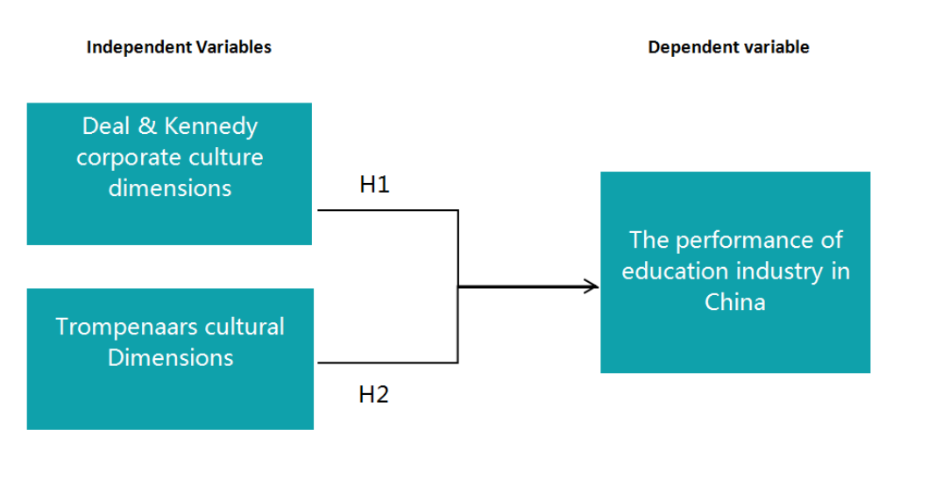
Figure1: Research Framework of the study
Source: Self Built(2018)
One of the objectives of this study would be to determine the types of corporate culture which would affect the performance of education industry in China. There could be many factors which could play a role in these influences, however for this research, by using Deal & Kennedy’s corporate culture dimensions and Trompenaars cultural dimensions to measure western corporate culture.
Hence for the Independent variables (IV) which will be Deal & Kennedy’s corporate culture dimensions and Trompenaars cultural dimensions, and the relationship it has with the dependent variable (DV), which would be the performance of education industry in China and to understand the relationship, hypotheses was developed to be tested.

2.7 Hypotheses
H1: Deal & Kennedy’s corporate culture dimensions has a significant influence on the performance of education industry in China.
H2: Trompenaars cultural dimensions has a significant influence on the performance of education industry in China.

2.8 Conclusion
The chapter included several main contents as the western corporate culture influences on the performance of education industry in China. To understand the factor in more depth, this research look into Deal & Kennedy’s and Trompenaar’s theories in detail, in order to find the answer on how strong are those cultural factors influencing on the education industry in China.

CHAPTER 3. RESEARCH METHODOLOGY

3.0 Overview
This chapter will provide an overview of the research design and research methodology that are going to be executed in this study. First of all, research design will cover the purpose of the study, types of investigation, extent of research interference and the study setting. Next, this section will look into unit of analysis, sampling plan, as well as time horizon. Data collection method will be the next where questionnaire design and items will be further explained. Measurements will be the last part of this section, to discuss about pilot test, preliminary analyses, factor analysis, reliability test, and hypothesis testing.

3.1 Research design
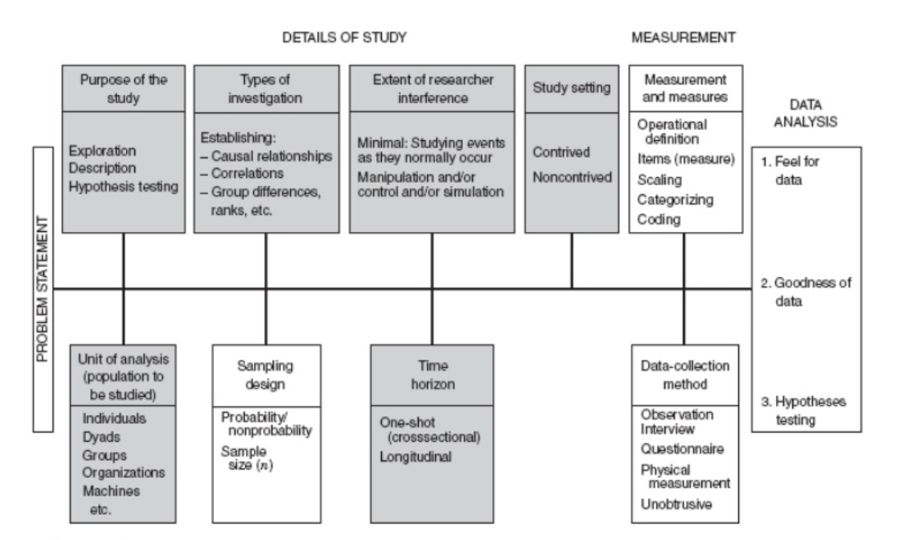
Figure 2: Research Design
Source: adapted from Bougie and Sekaran (2016)
Kothari (2013) defines research design as a method used to determine the causes and types of information which relate to the research issues, and it also specify which approaches to be used for data gathering and analyzing. The figure shows the overview of the research methodology structure. Each part of the structure in research design carries multiple critical points of choices which researchers need to take into consideration throughout the research process (Bougie and Sekaran, 2016).
Organization studies generally employ quantitative research methods as these are considered as objective in comparison to qualitative research methods, which are subjective and therefore, less reliable (Boodhoo and Purmessur, 2009). According to the research design, this research should use qualitative case study, case study simply refer to the documented history of a particular person, group organization, or event, typically, a case study may describe the events of a specific company as it faces an important decision or situation,such as introducing a new product or dealing with some management crisis (Harwell, 2011). The cross-sectional studies involves observations of a sample,or cross section,or a population phenomenon that are made at one point in time, exploratory and descriptive studies are often cross sectional, Many explanatory studies are also cross-sectional (Mansson, 2001). The explanatory cross-sectional studies have an inherent problem (Earl, 2009). According to Baxter and Jack (2008), the case study approach is to explore a phenomenon within its context using various data sources.
When a research is establishing relationship of same variables in two populations, or between two or more variables in a single population, this type of investigation is known as correlational research (Leedy and Ormrod, 2010). This research contains two variables which are the two construct of dimensions of corporate culture. The study is to determine the relationship established between these two variables with the performance of education industry in China. Based on all these, this study is said to be focusing on correlational type of research.
The extend of researcher interference of this study is minimal, in fact near zero, because it is studying events as they normally occur and it is just obtaining perceptions of respondents. According to Rahi (2017), when a researcher influence becomes minimum, it is categorized under non-contrived type of research setting. Furthermore, this research is done in an organization where work proceeds normally and since it is not manipulating any variables or factors, hence, this research is said to be a non-contrive field of study. Bougie and Sekaran (2016) found that the external validity of a research tends to be higher, given that if the research is using non-contrived environment because the research must be under no manipulation circumstance. Also, the extent of interference from researcher is minimum because it will be no interfered with the normal activities of the study.

3.2 Unit of analysis & Time horizon
According to Morse and Niehaus (2009), a good sampling methods can help to maximize the efficiency and the validity of the study. Thus, essentially, choosing a suitable sampling method is critical to the aim of the study. This study will focus on many types of educational organizations or institutions, such as the public and private schools an universities, tutoring institutions, etc. Because the study is focused on the performance of education industry in China, therefore, the unit of analysis is deemed to be organization. The time scale for this study will be cross sectional as the questionnaires of the target population and data collection will be conducted at a single moment in time, that is at the moment the interview is recorded and the moment the questionnaires are collected (Levin, 2006).
This research is applying cross-sectional studies, which also known as one-shot (Sahai and Khurshid, 1996). Cross-sectional studies refer to a situation where the data are gathered just once, maybe get over a period of days or weeks or months, for participants to answer the research questions (Bougie and Sekaran, 2016). According to Fox, Hunn and Mathers (2007), this design normally uses a descriptive or exploratory form which easily sets out to illustrate behavior or attitudes. As data for the questionnaires in this research will only be collected once, therefore, it is said to be cross-sectional studies.

3.3 Sampling design

3.3.1 Sampling plan
Sampling is the process of selecting a sufficient number of the right elements from the population (Sekaran and Bougie, 2013). There are two major types of sampling design which are probability and nonprobability (Cooper and Schindler, 2011). A non-probability sampling technique is used in selecting participants in this study. Non-probability sampling method is used because this research uses a non-randomized method to draw the sample, and the selected participants in this study are easy to access (Parveen and Showkat, 2017). According to Bougie and Sekaran (2016), non-probability technique is a tool used in a research when the member of the target population is unknown.
Convenience sampling used in design of nonprobability sampling because the data collection from respondents of the population who are conveniently available to provide it (Cooper and Schindler, 2011). Ponte et al. (2015) used convenience sampling in research of online purchase through online survey. Convenience sampling was chosen because it is the best way for data collection due to it was the fastest and efficient way due to very limited time of the project (Sekaran and Bougie, 2013).
In this research, the target organization is a number of the Chinese education institutions which were purposely chose by researcher. Those are well-known educational organizations and have good public awareness. Most importantly, they have strong association with western corporate culture. Thus the researcher chose those institutions as convenience sampling.

3.3.2 Sample size
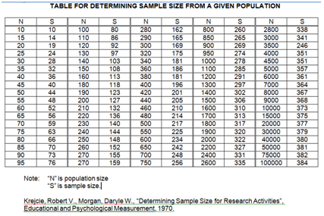
Figure 3 : The Krejcie and Morgan’s Table
Source: Google images

In this research study, the Krejcie and Morgan’s table will be used to determine the sample size. According to former research, China already has more than 100,000 education institutions in 2013. Therefore, in this research, the sample size is 384 which represent over 100 000 population size and around 400 questionnaires will be distributed in this research.

3.4 Questionnaire Design
The method of data collection is commonly used questionnaire to distribute target respondents according to Cooper and Schindler (2011). Questionnaire are practical and the results usually be quickly and easily quantified through software package. The responses are collected in a consistent way. In short, it is relatively quick to collect information using a questionnaire.
The table below provides a better illustration on how the questions are designed in the questionnaires, and citations of where the questions are referred to.
Table 3.1: Questionnaire Design

Section | Items | No. of Item | Source & References
1 | Demographic | 3 | Adopt  Malebana (2013); Rengiah (2013)
2 | The performance of education institutions in China | 5 | Adapt  (Murtuzaliev, 2002)  (Wang and Wang, 2011)
3 | Western culture influence- Deal & Kennedy corporate culture dimensions | 5 | Adapt  (Deal and Kennedy, 2000)
3 | Western culture influence- Trompenaars cultural dimensions | 5 | Adapt  (Trompenaars and Hampden-Turner, 2015)

3.5 Pilot test
Pilot test is said to be a trial test executed before a full-scale study can be conducted (Hundley and Teijlingen, 2001). This study is a quantitative research and has chosen questionnaires as data collection method, therefore, according to Watson, Atkinson and Rose (2007), pilot test is a fundamental test to help research in determining possible flaws. Zikmund et.al (2014) argues that pilot study Is an important test used in maintaining the validity, reliability and consistency of the surveys. According to Baker (1994), 10-20% out of the sample size for the actual research is a reasonable number of participants in order to conduct the pilot test. According to De Vaus (1993) pilot test could help to minimize the risk and to warn the researcher on specific area where the research might fail.

3.5.1 Pilot test: Factor analysis
Factor test is one of the most widely used techniques for determination of the common method variance (Sekaran and Bougie, 2013). All items from all of the constructs in each relationship structure were included in a factor analysis (Wu, 2013).
Kumar (2010) mentioned that factor analysis that involve the KMO Bartlett’s test of Sphericity will be used to analyze and determine all the data that have been collected and to check whether the items within the constructs are connected and suitable for further analyses. The value of factor loading is more than 0.6 in order to be significant, means the factor could have an influence on the variable (Hair et al., 2009). Eigenvalues are the total of the variance of the factor, which mentions the exceptional set of scalars that are connected with a linear system of equations (Bryman & Bell, 2015). According to Yong & Pearce (2013), it sustained that the eigenvalues is often more significant that help researchers to determine how plenty of factors to retain in the research, when researchers likewise could carry the scree and revolved eigenvalues out plot to decide the figure of meaning factors.

3.5.2 Pilot test: Reliability test
Reliability is the key measurement indicator to ensure consistency and repeatability of the data, which is a measurement to ensure the goodness of a data (Sekaran and Bougie, 2013). Reliability have to free from error to show the result is reliable and it is measured by weight Coefficient alpha (a) is the most common measurement method applied of multiple-item reliability to ensure consistency (Cooper and Schindler, 2011). Therefore, Cronbach’s alpha is a measurement value to identify the level of consistency of a data for all variables from this test (Zikmund, 2012). The minimum acceptance requirement of reliability test at alpha 0.6, data are consider acceptable (alpha=>0.7) and good (alpha=>0.8), therefore there is no need to take any remedial action (Sekaran and Bougie, 2013).
A data with high internal consistency when the Cronbach’s alpha value is higher than 0.7, which is the minimum acceptance requirement and for the purpose of checking reliability; However, the typical scale has poor reliability when the coefficient alpha is less than 0.6 (Zikmund, 2012). As the requirement from this test, any items or questions that was insignificant (alpha<0.7) will be deleted and items of privacy was reverse coded (because negative statement) in order to fulfill the highest reliability of the measurement (Yulihasri et al., 2011). The statistical software such as SPSS and PLS able to compute Cronbach’s alpha value (Zikmund, 2012).
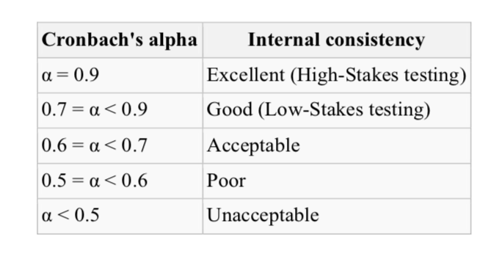
Figure 4: Acceptance Range in Cronbach’s Alpha
Source: adapted from Sunmeet and Vijaya (2015)

3.5.3 Pilot test: Correlation matrix
The correlation matrix will be concluded for all possible predictor variables and the dependent variables (Cooper & Schindler 2011). Correlation test was conducted in order to see whether all items have relation with each other or not. With the calculation of the Pearson’s correlation result, which ranging from +1 to -1 to indicate the relationship between the variables while the prefix of “+” and “-” indicate the positive and negative relationship of two variables (Saunders et al. 2009). Generally P value is required to be smaller than 0.05, which is a<0.05, means the research is at 5% significant level and can be accepted (Sekaran & Bougie 2011).
In this research, there are two constructs of independent variables, those two constructs cannot correlate with each other. Within the constructs, each dimensions must correlate with each other.

3.6 Measurements
Zikmund et al (2010) adhered that measurement instruments are tools that is used by practitioners and researchers to help them in order to evaluate patients, subjects, or clients.
Quantitive study requirements for statistical significance, the main purpose of this study is to identify western corporate culture factors influencing education industry in China. In this study, different way of test and measurements are done to analyze the data that has been obtained through questionnaire. For the survey part, IBM SPSS 22.0 will be used to to analysis the data. Descriptive Analysis is a good choice in summarizing the data as expressed by Saunders, Lewis and Thornhill (2012), a descriptive analysis will be adopted by using SPSS where it supports to evaluate the data skills.

3.6.1 Descriptive Information
Descriptive statistics can be explained as the creative outcome generated from the raw data, which come from the process of research(Yockey,2010). Descriptive statistics is often represented with descriptive contents combining those key factors together in a situation and establishing demographic profile (Green,2010). Frequently, under such condition, the description contents will be turned from raw data and relevance to the research topic (Noru, 2012). In this study, SPSS 20.0 Version latest version will be used.

3.6.2 Preliminary tests
Factor analysis is required to be conducted to determine whether the items in the questionnaires are valid or should be removed (Zikmund et.al, 2013). This technique is appropriate in this research as it does not require any pre-existing functional relationship and it is well known for data reduction, in which a large number of variables are reduced into few of the core factors (Jalaliyoon, Sahibuddin and Taherdoost, 2014).
The Kaiser-Meyer-Olkin (KMO) and Bartlett’s test of sphericity is applied in this study to measure the sampling adequacy which is known as MSA (Yusoff, 2010). The sampling is interpreted as adequate if the obtained value from the Statistical Product and Service Solutions (SPSS) tool in KMO test is greater than 0.5, otherwise the item is suggested to be removed (Field, 2000). SPSS software will be used in this research to perform the factor analysis. By using SPSS, the pattern of correlations within a set of variables can be shown through the underlying factors identified (Chen and Xiao, 2012).
On the other hand, the value for Bartlett test of Sphericity should less than 0.05 to indicate that the data is acceptable for further testing (Abdullah, Hani and Ilham, 2016). Whereas, eigenvalues is Kaiser criterion technique used to decide the number of constructs to be remained for rotation, and the value shall be greater than 1 (Jalaliyoon el.at., 2014). According to Pearce and Yong (2013), factor loading is used to measure how much the variables contribute to the factor and items with value greater than 0.4 should be retained.
According to Brown (2002), Cronbach’s alpha is one of the most frequently used technique to calculate the internal consistency. Hence, this research will apply Cronbach’s alpha to determine the level of reliability of the data collected. The result is expressed in number that falls in the range between 0 and 1, and the acceptable values of alpha are in the range from 0.70 to 0.95 (Dennick and Tavakol, 2011).

3.6.3 Hypothesis testing
Hypothesis testing is needed to determine the probability of whether a statement is true and at what possibility that the statement is accepted to be true (Massey and Miller, 2006). There are three types of hypothesis testing need to be conducted in this research, which are Simple Multiple Regression, One-Way ANOVA; and Beta coefficient.
Multiple regression analysis is employed to develop a self-weighting estimating equation that predicts values for a dependent variable from the values of independent variables (Cooper and Schindler, 2008). Path coefficient, β, symbolizes the estimate of strength of linear association and its direction between interval and ratio variables (Zikmund et al., 2013). The coefficient is ranging from +1 to -1 and the prefix of “+” and “-” indicates the direction of the relationship whereas the number indicates the strength of the relationship in which higher number of coefficient indicates stronger relationship (Saunders et al., 2009). The significance of p<0.05 is the generally accepted conventional level in research (Sekaran and Bougie, 2010).
One-way ANOVA is an extension test of T-Test which is used to find the differences between class means, of two or more groups (Ostertag and Ostertagová, 2013). According to Sow (2014), if the means result of one-way ANOVA are equal, the null hypothesis will be accepted, otherwise null hypothesis will be rejected while alternative hypothesis will be accepted, in which it can be concluded that the null hypothesis will be rejected if at least one of the means is different. In statistical testing, for hypothesis testing more than two populations, ANOVA method will need to be applied (Ostertag and Ostertagová, 2013). Hence, one-way ANOVA will be employed to determine whether there is significant differences between the two independent variables in this research.
Besides that, the coefficient of determinant, R2, provides information about the goodness of fit of the regression model and it shows the percentage of variance in the dependent variable is explained by the variation in the independent variable (Saunders et al., 2009). If R2 is near to 1, most of the variation in the dependent variable can be explained by the regression model; however, if R2 is near to 0, most of the data variation cannot be explained by the regression model (Sekaran and Bougie, 2010).

3.7 Ethical consideration
Banyard and Flanagan (2005) suggested that researchers must collect the data in an ethical manner which eventually will help to maintain research quality and integrity. The researcher collected the data in an ethical way and participants were allowed to state their opinions without being forced and they were voluntarily filled the questionnaires. The participants were convinced by the researcher that their opinions will not be exploited and will be kept safely without any intention to share it publicly. According to DiCicco-Bloom and Crabtree (2006), the researcher should have assured that the personal information of the participants will be kept highly confidential and the data from the participant will not be discussed or explore in the future. In addition, the researcher also provided participants with a briefing sheet in order to assist and gives participants a chance to know and understand the research topic and reason why the research is conducted.
The researcher gathered the data from the literature review which were obtained from previous authentic sources. To make sure that participants understand the question, simple language was used to build the questionnaire and it was based on the research hypotheses. As the questionnaire was adopted from past researches, it helped to improve internal validity and as the data was collected from the natural work environment, the external validity is also catered for ethically.

3.8 Conclusion
As conclusion of the chapter, the research methodology adopted in the research which is included the research design, unit of analysis, sampling plan along with data collection methodology to ensure the correct and appreciate research methodology. Meanwhile, this chapter will expends the measurement tools to use and ethical consideration including related justification. The findings and analysis of the data will be discussed in the next chapter.

CHAPTER 4. RESEARCH FINDINGS

4.0 Overview
In this chapter, the statistical data analysis is carried out in accordance to the methodology explained in the previous chapter using the SPPS software and the findings are explained based on the results obtained. However, the pilot test is initially conducted before the full data collection to ensure that the proposed questionnaire for the survey is appropriate and accurate for the study. The description analysis, preliminary tests and hypotheses testing are sequentially performed to further support the relevance of this study.

4.1 Pilot test
A pilot test is performed on a small scale with selected number of respondents prior to the full scale data collection to investigate the feasibility of the approach used to conduct this study in a larger basis (Leon et al., 2011). During the survey, 40 respondents were selected for the pilot test data collection and the factor analysis, reliability test, and Correlation Matrix were conducted to ascertain the face and content validity as well as the appropriateness of the data collected at the initial stage. The 40 respondents for the pilot test are conveniently selected for education institutions in China, but they are still reflect the population being studied. The selection of the 40 respondents for the pilot test was based on Creswell (2013) that mentioned that the pilot test can number can be based on about 10% of the expected sample size.

4.1.1 Factor Analysis
In order to determine if the constructs of this study are relevant, the factor analysis and multi-colinearity tests are carried out to measure if all independent variables items are correlated (Bougie and Sekaran, 2011). The factor analysis provides insights into whether specific items or construct is to be removed from the subsequent data collection in order to strengthen the validity and appropriateness of the constructs if the factor loading for a specific factor is found to be lower than the required cut-off (Creswell, 2013). The multi-collinearity test is carried out to ensure there are no constructs in a regression model that are correlated to each other which can subsequently affect the accuracy of regression analysis (Bougie and Sekaran, 2011). Below are the relevant tables showing the results of the factor analysis test conducted during the pilot run.

Table 4.1: KMO and Bartlett’s Table - DV & IVs

KMO and Bartlett's Test - DV
Kaiser-Meyer-Olkin Measure of Sampling Adequacy. |  | .820
Bartlett's Test of Sphericity | Approx. Chi-Square | 136.526
Bartlett's Test of Sphericity | df | 10
Bartlett's Test of Sphericity | Sig. | .000

KMO and Bartlett's Test - IVs constructs
Kaiser-Meyer-Olkin Measure of Sampling Adequacy. |  | .800
Bartlett's Test of Sphericity | Approx. Chi-Square | 340.242
Bartlett's Test of Sphericity | df | 45
Bartlett's Test of Sphericity | Sig. | .000

Table 4.2: Communalities Table - DV & IVs
Communalities - DV
 | Initial | Extraction
P1 | 1.000 | .782
P2 | 1.000 | .609
P3 | 1.000 | .789
P4 | 1.000 | .778
P5 | 1.000 | .750
Extraction Method: Principal Component Analysis.

Communalities - Ivs
 | Initial | Extraction
DK1 | 1.000 | .626
DK2 | 1.000 | .717
DK3 | 1.000 | .782
DK4 | 1.000 | .872
DK5 | 1.000 | .682
TP1 | 1.000 | .829
TP2 | 1.000 | .799
TP3 | 1.000 | .879
TP4 | 1.000 | .836
TP5 | 1.000 | .839
Extraction Method: Principal Component Analysis.

Table 4.2.2 : Eigenvalues table - DV & IVs
Total Variance Explained - DV
Component | Initial Eigenvalues |  |  | Extraction Sums of Squared Loadings
Component | Total | % of Variance | Cumulative % | Total | % of Variance | Cumulative %
1 | 3.707 | 74.150 | 74.150 | 3.707 | 74.150 | 74.150
2 | .607 | 12.140 | 86.290
3 | .275 | 5.500 | 91.790
4 | .267 | 5.332 | 97.122
5 | .144 | 2.878 | 100.000
Extraction Method: Principal Component Analysis.

Total Variance Explained -IVs
Component | Initial Eigenvalues |  |  | Extraction Sums of Squared Loadings
Component | Total | % of Variance | Cumulative % | Total | % of Variance | Cumulative %
1 | 4.328 | 43.283 | 43.283 | 4.328 | 43.283 | 43.283
2 | 3.534 | 35.338 | 78.621 | 3.534 | 35.338 | 78.621
3 | .576 | 5.757 | 84.378
4 | .542 | 5.420 | 89.798
5 | .327 | 3.266 | 93.064
6 | .197 | 1.969 | 95.033
7 | .174 | 1.739 | 96.773
8 | .157 | 1.565 | 98.338
9 | .091 | .905 | 99.243
10 | .076 | .757 | 100.000
Extraction Method: Principal Component Analysis.

According to Hair et al. (2013), KMO Bartlett’s Test of Sphericity is a measure of sampling adequacy that is recommended to check the case to variable ratio for the analysis being conducted. Normally, the value of KMO ranges from 0 to 1, and the minimal acceptable KMO sampling adequacy is over 0.6 but values that are closer to 1 are preferred. Bartlett's Test of Sphericity checks the correlational matrix to the identity matrix; verifying if there are equal variances across variables tested as in order for factor analysis to operate; relationships between the variables tested should exist to avoid zero correlation coefficients (Bougie and Sekaran, 2011; Andy, 2005). The Barlett’s Test of Sphericity should be significant and thus a value less than 0.05 is required to show the validity and suitability of the responses collected for the purpose of the study or the phenomenon that is being addressed in this study. The KMO is reported to be more than 0.6 shows adequacy of sampling and the result of Bartlett’s Test of Sphericity is less than 5% which means the items adapted from previous studies for this research is relevant and appropriate for subsequent analysis.
According to Cooper & Schindler (2013), when the factor loading which is defined as the correlation between a variable and a factor which has been extracted from the data; is larger than 0.6 the factors are deemed to be relevant and appropriate for further analysis. Based on the table above, all of the extraction values exhibit loadings higher than 0.6, with many of the items having a factor loading of more than 0.7 thus these results indicate that the factors are considered to be appropriate for the study. However, there is one factor which reports a loading slightly lower than 0.6 which is the item related to the “location of each section within the store”. Although the factor loading is lower than 0.6; it is still higher than 0.5 which is acceptable according to Hair, Anderson, Black and Latham (2013) who state that loadings above 0.5 could still be included in the study. As a result, this item will be retained during the final data collection. All other factor loadings are considered to be within the range of moderate to high ranging from 0.6 to above 0.9.
The value of 3 set tables above for both 2 constructs (IVs) and dependent variables in the research has been presented. The above data are all in line with KMO tests’ minimum requirements, the factor loading test for each factor is greater than 0.6 and eigenvalue is above for both IVs and DV is bigger than 1. All these data results indicate it is accepted for further analyses in this study.

4.1.2 Reliability Test
The reliability test was conducted with consists of all the variables (dependent variable and independent variables) in the research. The Table 4.3 presented the result of Reliability Test that the Cronbach Alpha is 0.878, which is above 0.80 and almost close to 1.0. Hence, all items in each of the constructs in the research have a high internal consistency reliability and also the result disclosed the pilot test respondents are understand the questionnaire items clearly (Zikmund, 2012). The details of reliability test if any of the specified items were deleted are listed in the Table 4.4. This table clearly demonstrated that all the items of the constructs in the study will relatively having high internal consistencies and the internal consistency will not be affect or decrease from the current Cronbach’s Alpha value (0.878) even if any of specific item is deleted from the study (Dennick and Tavakol, 2011).

Table 4.3: Reliability Test

Reliability Statistics
Cronbach's Alpha | Cronbach's Alpha Based on Standardized Items | N of Items
.878 | .879 | 15

Table 4.4: Cronbach Alpha if Specific Items are Deleted
Item-Total Statistics
 | Scale Mean if Item Deleted | Scale Variance if Item Deleted | Cronbach Alpha for Item | Squared Multiple Correlation  (DELETE – no data) | Cronbach's Alpha if Item Deleted
DV1 | 15.25 | 11.885 | .813 | - | .882
DV2 | 15.25 | 11.628 | .672 | - | .913
DV3 | 14.58 | 11.379 | .819 | - | .879
DV4 | 15.03 | 11.461 | .800 | - | .883
DV5 | 14.90 | 11.836 | .773 | - | .889
IV1-1 | 35.93 | 37.712 | .655 | - | .832
IV1-2 | 36.10 | 37.785 | .622 | - | .841
IV1-3 | 36.33 | 36.533 | .749 | - | .831
IV1-4 | 36.30 | 37.446 | .613 | - | .842
IV1-5 | 36.50 | 37.744 | .625 | - | .852
IV2-1 | 36.40 | 31.221 | .779 | - | .805
IV2-2 | 36.25 | 34.090 | .610 | - | .824
IV2-3 | 36.25 | 34.449 | .613 | - | .824
IV2-4 | 36.10 | 34.554 | .612 | - | .824
IV2-5 | 36.10 | 34.554 | .677 | - | .828

4.1.3 Correlation Matrix
Table 4.5: Correlation table
Correlations
 |  | DK1 | DK2 | DK3 | DK4 | DK5 | TP1 | TP2 | TP3 | TP4 | TP5
DK1 | Pearson Correlation | 1 | .631** | .553** | .646** | .496** | .318* | .190 | .232 | .236 | .098
DK1 | Sig. (2-tailed) |  | .000 | .000 | .000 | .001 | .046 | .240 | .151 | .143 | .549
DK1 | N | 40 | 40 | 40 | 40 | 40 | 40 | 40 | 40 | 40 | 40
DK2 | Pearson Correlation | .631** | 1 | .726** | .697** | .518** | .282 | .078 | -.054 | -.052 | -.050
DK2 | Sig. (2-tailed) | .000 |  | .000 | .000 | .001 | .077 | .634 | .740 | .750 | .761
DK2 | N | 40 | 40 | 40 | 40 | 40 | 40 | 40 | 40 | 40 | 40
DK3 | Pearson Correlation | .553** | .726** | 1 | .778** | .648** | .371* | .104 | .027 | .095 | .117
DK3 | Sig. (2-tailed) | .000 | .000 |  | .000 | .000 | .018 | .523 | .868 | .561 | .473
DK3 | N | 40 | 40 | 40 | 40 | 40 | 40 | 40 | 40 | 40 | 40
DK4 | Pearson Correlation | .646** | .697** | .778** | 1 | .804** | .148 | -.048 | -.101 | -.043 | -.090
DK4 | Sig. (2-tailed) | .000 | .000 | .000 |  | .000 | .362 | .768 | .537 | .791 | .581
DK4 | N | 40 | 40 | 40 | 40 | 40 | 40 | 40 | 40 | 40 | 40
DK5 | Pearson Correlation | .496** | .518** | .648** | .804** | 1 | .128 | -.086 | -.045 | -.056 | -.119
DK5 | Sig. (2-tailed) | .001 | .001 | .000 | .000 |  | .433 | .599 | .784 | .729 | .465
DK5 | N | 40 | 40 | 40 | 40 | 40 | 40 | 40 | 40 | 40 | 40
TP1 | Pearson Correlation | .318* | .282 | .371* | .148 | .128 | 1 | .821** | .738** | .683** | .769**
TP1 | Sig. (2-tailed) | .046 | .077 | .018 | .362 | .433 |  | .000 | .000 | .000 | .000
TP1 | N | 40 | 40 | 40 | 40 | 40 | 40 | 40 | 40 | 40 | 40
TP2 | Pearson Correlation | .190 | .078 | .104 | -.048 | -.086 | .821** | 1 | .783** | .726** | .736**
TP2 | Sig. (2-tailed) | .240 | .634 | .523 | .768 | .599 | .000 |  | .000 | .000 | .000
TP2 | N | 40 | 40 | 40 | 40 | 40 | 40 | 40 | 40 | 40 | 40
TP3 | Pearson Correlation | .232 | -.054 | .027 | -.101 | -.045 | .738** | .783** | 1 | .896** | .813**
TP3 | Sig. (2-tailed) | .151 | .740 | .868 | .537 | .784 | .000 | .000 |  | .000 | .000
TP3 | N | 40 | 40 | 40 | 40 | 40 | 40 | 40 | 40 | 40 | 40
TP4 | Pearson Correlation | .236 | -.052 | .095 | -.043 | -.056 | .683** | .726** | .896** | 1 | .823**
TP4 | Sig. (2-tailed) | .143 | .750 | .561 | .791 | .729 | .000 | .000 | .000 |  | .000
TP4 | N | 40 | 40 | 40 | 40 | 40 | 40 | 40 | 40 | 40 | 40
TP5 | Pearson Correlation | .098 | -.050 | .117 | -.090 | -.119 | .769** | .736** | .813** | .823** | 1
TP5 | Sig. (2-tailed) | .549 | .761 | .473 | .581 | .465 | .000 | .000 | .000 | .000
TP5 | N | 40 | 40 | 40 | 40 | 40 | 40 | 40 | 40 | 40 | 40
**. Correlation is significant at the 0.01 level (2-tailed).
*. Correlation is significant at the 0.05 level (2-tailed).

The correlation matrix test is performed to check the multicolinearity of the data to ascertain if there is a high correlation among independent variables. The correlation value of 1.00 means two variables are correlated, the correlation value of 0.00 means there is absolutely no correlation (Pyrczak, 2006). Table 4.5 shows that 2 constructs (IVs) of values for the different constructs or independent variables are much smaller than 1.00 which means that these independent variables are not correlated with one another.

4.1.4 Conclusion for Pilot Test
The pilot test conducted with the data received from the selected first 40 responses to test the accurateness and significance of the data. Based on the results of Factor Analysis and Reliability Test and Correlation Matrix above shows all the items of the constructs in the questionnaire have more realistic loading values in both tests and it clearly proved that all the items of the constructs in the study were suitable and applicable for further analysis.

4.2 Full Scale Data Collection
After the pilot tests completed, a collection of full-scale data has been conducted in this research with the same distribution technique and channels as executed in the pilot test. As discoursed earlier in the Chapter 3, 384 sample size was required for this study based on the number of target population stated by Krejcie & Morgan (1970). Overall 400 questionnaires were distributed to the people from education institutions in China. The following Table 4.6 listed the summary of research questionnaire response rate from the respondents. Thus, a total of 280 usable questionnaires are deemed for further analysis in this research.

Table 4.6: Summary of Research Questionnaire Response Rate
Total Questionnaire Distributed | 400 questionnaires
Total Questionnaire Received | 305 questionnaires
Total Response Rate | 76.25%
Total Questionnaire Non-usable | 25 questionnaires (missing, incomplete, spoilt)
Total Questionnaire Usable | 280 questionnaires

4.3 Demographic Profile
Table 4.7: Demographic Profile Information

Demographic Categories |  | Frequency | Percent
Gender | Male | 119 | 42.50%
Gender | Female | 161 | 57.50%
Age | 20 - 30 | 196 | 70.00%
Age | - 40 | 56 | 20.00%
Age | 40 - 50 | 14 | 5.00%
Age | Above 50 | 14 | 5.00%
Working Years | 1 year and below | 49 | 17.50%
Working Years | 1-3 years | 77 | 27.50%
Working Years | 3-5 years | 70 | 25.00%
Working Years | 5-10 years | 42 | 15.00%
Working Years | Above 10 years | 42 | 15.00%

The Table 4.7 above shows the distribution of male to female ratio, women in this survey significantly more than men. Based on the usable questionnaires, almost 70.00% of people who is among 20-30 has participated this survey. And most of the participants have worked within 1-5 years in this industry.

4.4 Preliminary Test
The SPSS software was involved to analyse in the following study, examine and interpret result of the questionnaires data collected from education industry in China. The Factor Analysis and Reliability Test are part of the preliminary data analysis of this study.

4.4.1 Factor Analysis
Table 4.8 : Full Scale of Data – KMO and Bartlett’s Test - DV & IVs

KMO and Bartlett's Test - DV
Kaiser-Meyer-Olkin Measure of Sampling Adequacy. |  | .820
Bartlett's Test of Sphericity | Approx. Chi-Square | 1034.235
Bartlett's Test of Sphericity | df | 10
Bartlett's Test of Sphericity | Sig. | .000

KMO and Bartlett's Test - IVs
Kaiser-Meyer-Olkin Measure of Sampling Adequacy. |  | .800
Bartlett's Test of Sphericity | Approx. Chi-Square | 2684.490
Bartlett's Test of Sphericity | df | 45
Bartlett's Test of Sphericity | Sig. | .000

Table 4.9 : Full Scale of Data - Communalities Table - DV& IVs
Communalities - DV
 | Initial | Extraction
P1 | 1.000 | .782
P2 | 1.000 | .609
P3 | 1.000 | .789
P4 | 1.000 | .778
P5 | 1.000 | .750
Extraction Method: Principal Component Analysis.

Communalities - IVs
 | Initial | Extraction
DK1 | 1.000 | .626
DK2 | 1.000 | .717
DK3 | 1.000 | .782
DK4 | 1.000 | .872
DK5 | 1.000 | .682
TP1 | 1.000 | .829
TP2 | 1.000 | .799
TP3 | 1.000 | .879
TP4 | 1.000 | .836
TP5 | 1.000 | .839
Extraction Method: Principal Component Analysis.

Table 4.10 : Full Scale of Data - Total Variance Table - DV& IVs
Total Variance Explained - DV
Component | Initial Eigenvalues |  |  | Extraction Sums of Squared Loadings
Component | Total | % of Variance | Cumulative % | Total | % of Variance | Cumulative %
1 | 3.707 | 74.150 | 74.150 | 3.707 | 74.150 | 74.150
2 | .607 | 12.140 | 86.290
3 | .275 | 5.500 | 91.790
4 | .267 | 5.332 | 97.122
5 | .144 | 2.878 | 100.000
Extraction Method: Principal Component Analysis.

Total Variance Explained - IVs
Component | Initial Eigenvalues |  |  | Extraction Sums of Squared Loadings
Component | Total | % of Variance | Cumulative % | Total | % of Variance | Cumulative %
1 | 4.328 | 43.283 | 43.283 | 4.328 | 43.283 | 43.283
2 | 3.534 | 35.338 | 78.621 | 3.534 | 35.338 | 78.621
3 | .576 | 5.757 | 84.378
4 | .542 | 5.420 | 89.798
5 | .327 | 3.266 | 93.064
6 | .197 | 1.969 | 95.033
7 | .174 | 1.739 | 96.773
8 | .157 | 1.565 | 98.338
9 | .091 | .905 | 99.243
10 | .076 | .757 | 100.000
Extraction Method: Principal Component Analysis.

The above both tables displayed the result of KMO value is 0.82 and 0.80, which are above 0.70 and the result of communalities table and total variance table that indicated all the items are exceeded the principle, which means 2 constructs in the study are considered as applicable and suitable. Eigenvalue has been observed as well through factor analysis. Eigenvalue should have value more than 1 for each construct in this research therefore the table below showed the Eigenvalues for all construct and based on the requirement which is value > 1 thus it fulfilled the requirement.

4.4.2 Reliability Analysis

Table 4.11 : Full Scale of Data – Reliability Test
Reliability Statistics
Cronbach's Alpha | Cronbach's Alpha Based on Standardized Items | N of Items
.845 | .846 | 15

Table 4.12 : Full Scale of Data - Cronbach Alpha if Specific Items were Deleted

Item-Total Statistics
 | Scale Mean if Item Deleted | Scale Variance if Item Deleted | Corrected Item-Total Correlation  (follow the pilot test) | Squared Multiple Correlation (DELETE – as per pilot) | Cronbach's Alpha if Item Deleted
DV1 | 15.25 | 11.629 | .813 | - | .882
DV2 | 11.629 | 11.378 | .672 | - | .913
DV3 | .813 | 11.134 | .819 | - | .879
DV4 | 15.25 | 11.214 | .800 | - | .883
DV5 | 11.378 | 11.581 | .773 | - | .889
IV1-1 | 35.93 | 36.901 | .655 | - | .832
IV1-2 | 36.10 | 36.972 | .622 | - | .841
IV1-3 | 36.33 | 35.747 | .649 | - | .831
IV1-4 | 36.30 | 36.641 | .613 | - | .842
IV1-5 | 36.50 | 36.932 | .625 | - | .852
IV2-1 | 36.40 | 30.549 | .779 | - | .805
IV2-2 | 36.25 | 33.357 | .710 | - | .824
IV2-3 | 36.25 | 33.708 | .713 | - | .824
IV2-4 | 36.10 | 33.811 | .612 | - | .824
IV2-5 | 36.10 | 33.811 | .677 | - | .828

As mentioned previously, the reliability test is to gauge the respondents’ understanding of the survey questions or items asked to provide further support on the feasibility of instrument used in the research (Pallant, 2011).
Based on Table 4.11 and 4.12, the Cronbach’s alpha are all more than 0.7, which means a high level of internal consistency for the scale. The social cues variable reports the highest value of reliability at 0.913. Bland and Altman (1997) mentioned that Cronbach’s Alpha of 0.70 and above would show high internal consistency, and thus all the items are now considered to be relevant and appropriate for subsequent analysis.

4.4.3 Correlation Matrix

Table 4.13 : Full Scale of Data - Correlation table
Correlations
 |  | DK1 | DK2 | DK3 | DK4 | DK5 | TP1 | TP2 | TP3 | TP4 | TP5
DK1 | Pearson Correlation | 1 | .631** | .553** | .646** | .496** | .318** | .190** | .232** | .236** | .098
DK1 | Sig. (2-tailed) |  | .000 | .000 | .000 | .000 | .000 | .001 | .000 | .000 | .103
DK1 | N | 280 | 280 | 280 | 280 | 280 | 280 | 280 | 280 | 280 | 280
DK2 | Pearson Correlation | .631** | 1 | .726** | .697** | .518** | .282** | .078 | -.054 | -.052 | -.050
DK2 | Sig. (2-tailed) | .000 |  | .000 | .000 | .000 | .000 | .195 | .367 | .387 | .408
DK2 | N | 280 | 280 | 280 | 280 | 280 | 280 | 280 | 280 | 280 | 280
DK3 | Pearson Correlation | .553** | .726** | 1 | .778** | .648** | .371** | .104 | .027 | .095 | .117
DK3 | Sig. (2-tailed) | .000 | .000 |  | .000 | .000 | .000 | .082 | .651 | .114 | .051
DK3 | N | 280 | 280 | 280 | 280 | 280 | 280 | 280 | 280 | 280 | 280
DK4 | Pearson Correlation | .646** | .697** | .778** | 1 | .804** | .148* | -.048 | -.101 | -.043 | -.090
DK4 | Sig. (2-tailed) | .000 | .000 | .000 |  | .000 | .013 | .422 | .093 | .471 | .133
DK4 | N | 280 | 280 | 280 | 280 | 280 | 280 | 280 | 280 | 280 | 280
DK5 | Pearson Correlation | .496** | .518** | .648** | .804** | 1 | .128* | -.086 | -.045 | -.056 | -.119*
DK5 | Sig. (2-tailed) | .000 | .000 | .000 | .000 |  | .033 | .153 | .456 | .347 | .047
DK5 | N | 280 | 280 | 280 | 280 | 280 | 280 | 280 | 280 | 280 | 280
TP1 | Pearson Correlation | .318** | .282** | .371** | .148* | .128* | 1 | .821** | .738** | .683** | .769**
TP1 | Sig. (2-tailed) | .000 | .000 | .000 | .013 | .033 |  | .000 | .000 | .000 | .000
TP1 | N | 280 | 280 | 280 | 280 | 280 | 280 | 280 | 280 | 280 | 280
TP2 | Pearson Correlation | .190** | .078 | .104 | -.048 | -.086 | .821** | 1 | .783** | .726** | .736**
TP2 | Sig. (2-tailed) | .001 | .195 | .082 | .422 | .153 | .000 |  | .000 | .000 | .000
TP2 | N | 280 | 280 | 280 | 280 | 280 | 280 | 280 | 280 | 280 | 280
TP3 | Pearson Correlation | .232** | -.054 | .027 | -.101 | -.045 | .738** | .783** | 1 | .896** | .813**
TP3 | Sig. (2-tailed) | .000 | .367 | .651 | .093 | .456 | .000 | .000 |  | .000 | .000
TP3 | N | 280 | 280 | 280 | 280 | 280 | 280 | 280 | 280 | 280 | 280
TP4 | Pearson Correlation | .236** | -.052 | .095 | -.043 | -.056 | .683** | .726** | .896** | 1 | .823**
TP4 | Sig. (2-tailed) | .000 | .387 | .114 | .471 | .347 | .000 | .000 | .000 |  | .000
TP4 | N | 280 | 280 | 280 | 280 | 280 | 280 | 280 | 280 | 280 | 280
TP5 | Pearson Correlation | .098 | -.050 | .117 | -.090 | -.119* | .769** | .736** | .813** | .823** | 1
TP5 | Sig. (2-tailed) | .103 | .408 | .051 | .133 | .047 | .000 | .000 | .000 | .000
TP5 | N | 280 | 280 | 280 | 280 | 280 | 280 | 280 | 280 | 280 | 280
**. Correlation is significant at the 0.01 level (2-tailed).
*. Correlation is significant at the 0.05 level (2-tailed).

Table 4.13 shows that 2 constructs (IVs) of values for the different constructs or independent variables are much smaller than 1.00 which means that these independent variables are not correlated with one another. The results are consistent with previous pilot tests.

4.5 Hypotheses Analysis
In this section, the Multiple Regression, ANOVA analysis and Correlation Coefficient are involved to ascertain the relationships between independent variables and dependent variable. The following Table 4.14 listed the Hypotheses in the research to examine.

Item | Hypothesis
H1 | Deal & Kennedy’s corporate culture dimensions has a significant influence on the performance of education industry in China.
H2 | Trompenaars cultural dimensions has a significant influence on the performance of education industry in China.
Table 4.14 : List of Hypotheses in the Research

4.5.1 Multiple regression
SPSS was used in order to conduct multiple regressions test that intended to check whether the hypotheses that have been discussed in previous chapter were supported or not. Furthermore, researcher used regression method in SPSS to calculate multiple regressions. Table 4.15 and table 4.16 showed the result of multiple regression method that indicate whether the hypotheses were supported or not.

Table 4.15 : Multiple regression model summary
Model Summary
Model | R | R Square | Adjusted R Square | Std. Error of the Estimate
1 | .642ª | .591 | .592 | .49228
a. Predictors: (Constant), mean_TP, mean_DK
Table 4-16 : Multiple regression ANOVA
ANOVAª
Model |  | Sum of Squares | df | Mean Square | F | Sig.
1 | Regression | 11.414 | 2 | 5.707 | 8.649 | .000^{b}
1 | Residual | 182.766 | 277 | .660
1 | Total | 194.180 | 279
a. Dependent Variable: mean_P
b. Predictors: (Constant), mean_TP, mean_DK

Based on the table 4.17 and 4.18, the p-value of ANOVA test is less than 0.05. This shows that the theoretical framework with all its independent variables has obtain a model fit and so, can be considered as an establishment of a significant relationship between the independent variables and the dependent variables. The R-Square of the current model is equal to 0.59 (R² = 0.59). It means that 59% of people who work in education industry in China can be explained by the current two independent variables. The tables also indicates the main results of the structural relationships among the dependent and the independent variables. The results obtained show that two hypotheses (H1, H2) are all significant.

4.5.2 Beta coefficient
Table 4.17 : Beta coefficient
Coefficientsª
Model |  | Unstandardized Coefficients |  | Standardized Coefficients | t | Sig. | Collinearity Statistics
 |  | B | Std. Error | Beta | t | Sig. | Tolerance | VIF
1 | (Constant) | 3.327 | .315 |  | 10.570 | .000
1 | mean_DK | .226 | .064 | .207 | 3.546 | .000 | .994 | 1.006
1 | mean_TP | -.120 | .049 | -.143 | -2.445 | .015 | .994 | 1.006
a. Dependent Variable: mean_P

In evaluating the contributions of each independent variable, these are noted to have positive β coefficients, indicating a positive relationship between the independent and dependent variables. The T-value can be used to evaluate the strength of the relationship between each independent variable and the dependent variable (Hair et al., 2013).
The result from table 4.17 shows that the p-value of the regression test is less than .05, therefore it can be concluded that there is a significant relationship between Deal & Kennedy’s corporate culture dimensions and Trompenaars cultural dimensions (β DK= .0207, β TP= -.143, p-value< .05)

4.5.3 VIF/ multicollinearity
As part of collinearity diagnostics, the Tolerance and VIF (Variance inflation factor) values are also examined. As table 4.17 shows, all values of VIF are less than 10, showing that there is no multicollinearity among the dependent and independent variables. All the predictor variables exhibit Tolerance values of more than 0.10 and VIF values below 10; hence multicollinearity is ruled out (Field, 2009).
The lack of inter-correlation between the independent variables was also highlighted from the correlation matrix shown earlier in this chapter.

4.5.4 Hypothesis testing and Outcome
Table 4.18 : Conclusion of hypothesis testing based on Multiple Regression Analysis
Hypothesis | Statistical results | Strength of statistical  relationship | Decision
H1：Deal & Kennedy’s corporate culture dimensions has a significant influence on the performance of education industry in China. | Standardised β = 0.207, Sig. = 0.00, p > 0.05 | Positive relationship; significant | Accepted
H2：Trompenaars cultural dimensions has a significant influence on the performance of education industry in China. | Standardised β = -0.143, Sig. = 0.015, p < 0.05 | Negative relationship; Significant | Partially Accepted

4.6 Summary of Findings
In this section, all the complete findings from the essential tests conducted above to examine the relationship between independent variables towards the performance of education industry in China will be summarised and listed out in the following Table 4.19 to present the results in efficient way to ensure it is clear to read. Overall, the results were showed the relationship between constructs and focused phenomenon of this study are significantly positive and all the hypotheses are accepted based on the results provided.

Table 4.19 : Summary of Findings
Test | Sample size | Type of Tests | Output | Finding/ Decision
Pilot Test | 40 | Factor Analysis | KMO > 0.70 | Fit to the research
Pilot Test | 40 | Factor Analysis | Factor Loading > 0.60 | Fit to the research
Pilot Test | 40 | Factor Analysis | Eigenvalues > 1 | Fit to the research
Pilot Test | 40 | Factor Analysis | Varimax Rotated Component Matrix > 0.60 | Fit to the research as all the items meets the communalities cut of line value.
Pilot Test | 40 | Reliability Test | Cronbach’s Alpha > 0.60 | Fit to the research  The Cronbach’s Alpha value will be remained above 0.80 even any of the item is deleted.
Preliminary Test | 280 | Factor Analysis | KMO > 0.70 | Fit to the research
Preliminary Test | 280 | Factor Analysis | Factor Loading > 0.60 | Fit to the research
Preliminary Test | 280 | Factor Analysis | Eigenvalues > 1 | Fit to the research
Preliminary Test | 280 | Factor Analysis | Varimax Rotated Component Matrix > 0.60 | Fit to the research as all the items meets the communalities cut of line value.
Preliminary Test | 280 | Reliability Test | Cronbach’s Alpha > 0.60 | Fit to the research  The Cronbach’s Alpha value will be remained above 0.80 even any of the item is deleted.
Hypotheses Testing | 280 | Multiple Regression | Model Summary  Model 1 (DV, IVs):  R value = 0.642  R² value = 0.591 | Model 1 is fit to the research. It means the IVs and DV has a significant positive relationship
Hypotheses Testing | 280 | Multiple Regression | Beta Coefficient (Model 1)  β-value of IV1= 0.207  β-value of IV2= --0.143 | The highest influences on the DV is the IV1  IV2 has negative influences to the DV
Hypotheses Testing | 280 | Multiple Regression | VIF/ Multicollinearity (Model 1) – VIF < 10  VIF-value of IV1= 1.006  VIF-value of IV2= 1.006 | The values of VIF in the model 1 are less than 10 which is there was no multicollinearity between variables
Hypotheses Testing | 280 | Multiple Regression | Hypotheses result  H1 p-value = 0.000  H2 p-value = 0.015 | H1, H2 are accepted significantly and the constructs is fit to the research

4.7 Conclusion
The data analysis for this study has been completed with the relevant findings obtained. A pilot test was first performed through 40 selected respondents to check the instrument suitability for the study and ascertain whether the appropriate statistical analysis could be carried for the purpose of this research. After a period of data collection, the descriptive analysis was performed to understand the demographic profile of the sample as well as observe if it could be a representative of the actual overall population of study. Several preliminary tests as well as multiple regression was performed to initiate hypothesis testing in order to ascertain if the framework adopted for this study was a fit with the variables and constructs. Chapter 5 will further explore the discussion of the findings in order to evaluate the viability and relevance of the findings obtain to compare with the research objectives, research questions, as well as to provide recommendations for the industry.

CHAPTER 5. CONCLUSION AND RECOMMENDATIONS

5.0 Overview
This chapter will look into the concluding of the study conducted. The findings of this study will be compared and contrasted with previous researches to gain an overall understanding of the study as well as look into newer gaps that could be addressed by future researchers as well as managerial implications and suggestions deemed useful for the education industry in China.

5.1 Discussion of findings
According to what have been discussed in chapter 2 on literature review and the data analysis that has been conducted in chapter 4, it was discovered that the first objective of this research has been fulfilled which is to determine whether there is a relationship between western corporate culture (Deal & Kennedy’s corporate culture dimensions and Trompenaars cultural dimensions) with the performance of education industry in China and positive outcomes that lead to the result whereby it was found that these two construts of corporate culture with the performance of education industry has a relationship with positive outcomes.
The second objective of this research has been achieved also after conducting the multiple regression analysis. Based from these tests included that have been conducted which are multiple regression analysis, it was discovered that both Deal & Kennedy’s corporate culture dimensions and Trompenaars cultural dimensions is actually has influence towards the performance of education industry in China and the relationship between has positive outcomes.

For H1, the results of this study showed that there is significant relationship between Deal & Kennedy’s corporate culture dimensions and the performance of education industry in China because the p-value for this hypothesis was smaller than 0.05. This result has proved that the influence of western corporate culture has on China’ education industry in valid. This result is aligned with some of the previous studies done by the other researchers which also found out that there was relationship between Deal & Kennedy’s corporate culture dimensions and education fields in China (Choi, 2015; Hickman and Silva, 2016; Ma, 2012).
For H2, the results of this study showed that there is a significant relationship between Trompenaars cultural dimensions and the performance of education industry in China because the p-value for this hypothesis was less than 0.05. But the result of beta coefficients is negative number( -0.143) which means the Trompenaars cultural dimensions has negative influence to the DV.
The third Research Objective of this study is to model the contributors towards the performance in education industry in China. In order to achieve the third research objective, R² was used to analyse the goodness of fit for the model (Sekaran and Bougie, 2010). R² for the dependent variable of both Deal & Kennedy’s corporate culture dimensions and Trompenaars cultural dimensions was 0.591 and this shows that there is a moderate goodness of fit for this model (Lee and Chen, 2013). This indicates that 59.1% of the workers from China’s education industry can be explained by the two independent variables. The higher the R², the better the model fits the data. This shows that the model moderately fits the data and hence, the results confirm that the model for this study is relevant and appropriate.

5.2 Recommendations
In the 21st century, corporate management has become more important than ever before in every distinct industries, traditional management methods are kind of outdated. In 20th century 80s a new concept of corporate culture was come up and it has become an important element in management. Many enterprises now have their unique and outstanding corporate culture which benefit them. However in China, there are lots of enterprises whose corporate culture are poor which leads to various of problems and issues. Thus the author has analyzed the corporate culture in education industry in China in order to give a reasonable suggestion on how to improve the quality of corporate culture in the Chinese education industry.
First of all, relationship is one of the most important thing between employees and managers and also within employees themselves. It is the basic of building corporate culture. From the studies the author find out that Trompenaars cultural dimensions might have negative influence but still significant. One of the factor from it is cooperation and teamwork (Individualism versus Communitarianism). Teamwork makes people united and could make the work more efficient, thus to improve the connection between employees could help to build a better atmosphere. Considering the situation of Chinese custom the author tend to think dining together once every two months could be a good way to enhance teamwork. The dining doesn’t have to be compulsory but once people try to take part in and most of them might fall in love with it cause everyone is eager to be involved in an organization. Setting restrooms and restaurants for employees can not only help them get to know each other better but also improve their satisfaction.
Second, an enterprise should have clear core value and vision. According to the Deal & Kennedy corporate culture dimensions the core value is always remind them of their mission and how they should act. It has a positive influence on the performance of staffs. The core value of certain company is to change their own fate with their hands. The vision and mission are clear so that the staffs have the passion to work and the core value is shared to everyone, most of employees come from countrysides and offers them the opportunity to live and settle down in big cities. So the suggestion is that every manager should have clear awareness of the importance of core value and core value, furthermore the deeds should follow the words to make a good example for staffs.
Third, excitation is necessary within an enterprise, most education institutions in China have mature award and punishment system, many companies in China only set award for attendance per month but if someone is late then he or she will lose it which will absolutely depress them. These are not excitation but constraint, Big institution like Hujiang give out some of the share as welfare to their employees and they select one people as the best employee every month. Awards should contain target incentive and honor incentive and be more abundant so that the employees are eager to work for you. The proper competition can help to enhance the atmosphere in an enterprise as well. Treatment is also a part of it. Hilton has resting room and restaurants for staffs and Xindongfang offers them accommodations, moreover they are helping staffs get involved in big cities and they have guarantee if they leave. These factors make them feel safe and moved.
Fourth, currently there are many elements which might have negative impact on the quality of corporate and it is necessary to make changes, for example, some employees are not well educated in terms of a non-teaching position in their organization, a lot of companies may just ignore them as long as they are making profit for them. In order to be responsible for the majority of learners, systematic education should be provided by the firms before everyone enters especially in the education institutions, the etiquette and the manner should be learned by each employee. And the promotion within an enterprise doesn’t always depend on the performance of an employee but the relationship between workers and their boss, this phenomenon should be rubbished by setting specific rules and system. The promotion that relies on the relationship will reduce the enthusiasm of employees directly.

5.3 Contribution

5.3.1 Contribution to Academia
This research contributes to academia because the result provides other researchers with better understanding in-depth regarding corporate culture. Researchers will be able to obtain useful information if they are going to conduct any other research that has similar topic with this research. It also provided them with broader view on how corporate culture dimensions responded on the education industry in China. With the result of this research, researcher will be able to conduct a follow up research for example on how the corporate culture influence education industry in China and which factors need to be focused therefore this research will be able to provide them with information and as well as help them to reduce their workload in obtaining data which will lead to more efficiency in both effort and time.
Another thing that this research contribute to academia is based on the period that researcher conducted this research, it is still relatively new therefore the accuracy of the findings will reflect on the latest condition in education industry in China therefore if other researchers followed and used the data given, it will give them more accuracy on data collection (Choi, 2015; Hickman and Silva, 2016; Ma, 2012). In a nutshell, the result of this study highlighted the point regarding the Deal & Kennedy’s corporate culture dimensions and Trompenaars cultural dimensions towards the performance of education institutions in China and clarify how will the influence affect education institutions’ performance. In, brief, these findings will provide other researchers with more critical views.

5.3.2 Contribution to Industry
In addition, the result of this research determines that the Deal & Kennedy’s corporate culture dimensions actually has positive influence with positive outcomes on the education industry in China which means that in order to help education institutions to perform better, institutions should properly enhance their organizations’ corporate culture to achieve high performance level of their staff and organization. In additions, it will also benefit large number of learners in China who enrolled in these institutions. This research provided a useful and genuine feedback for the industry to contribute in building a sustainable corporate culture system which intended to create a positive perception especially for education institutions that eventually could lead to achieve higher performance. This study also provided suggestions to highlight the importance of enhance corporate culture to the organization and details in the benefits by implementing enhance corporate culture dimensions which will be more attractive and helpful for the employees and managers who work in education industry in China.

5.4 Future research direction
To understand more on the influence of western corporate culture has on the education industry in China, future research can be carried out on bigger scale and respondents could be taken from other private and public institutions from different cities in China so that a more accurate data could be obtained. Another thing is that future research could be conducted for public educational institutions that are owned by government so there will be a clear comparison on the level of the outcome performance for those who are working in private institutions and public institutions.
Moreover, future research could explore more different variables which have an impact on the performance of education industry in China.
In addition, future research could concentrate on the participants who are working for the education institutions, they can be categorized and differentiated among the operator level, middle and top managers.
Finally, future researcher might consider conducting quantitative and qualitative research together when they collect data. Combining quantitative and qualitative techniques researcher could utilize various instruments such as questionnaires, and even focusing groups if possible, so that they are able to collect rich information about employee job satisfaction for further and profound study.

5.5 Personal reflection
Upon completion of this MBA project, I feel grateful that the challenges faced in this process would enhance my knowledge and perception on how corporate culture could influence the education industry in China. This study has taught me many things and helped me enhance my understanding towards statistical analysis, business research methodologies as well as look into past literature and compare with the present world. Some of the key findings of previous literature are still widely applicable; but some are no longer applicable which shows that in a business environment the influence of corporate culture keep changing over time.
In addition, as an international student who work and study concurrently, meeting up with the deadline is challenging. Time management as well as stress management are essential to make sure that there is no delay in work and study. Nevertheless, this project could not be completed so smoothly without the guidance of Assoc. Prof. Dr. Lee Kar Ling. I appreciate the patient and guidance provided from Prof. Lee in all aspect. And the fellow MBA students has also provided tremendous help to me in this whole learning journey which I highly appreciated. Lastly, I would like to conclude that, overall it is a very good experience and I believed that the knowledge I gained will enhance my expertise in my career.

5.6 conclusion
This is the last chapter of this research. The chapter discussed about the key findings that have been discussed in previous chapter, the contributions and also the recommendations based on the result from the analysis. Lastly, this chapter was concluded with a personal reflection behind conducting this research study in the MBA program.

REFERENCES
Andersen, G. and Bech, K. (2013). English corpus linguistics. Amsterdam: Rodopi.
Anghel, G. (2012). Doomed to internationalization and modernization of corporate culture. Wiesbaden: Gabler Verlag.
Argenti, P. (2013). Corporate communication. Boston: McGraw-Hill Irwin.
Agrawal, T. and Agrawal, A. (2017). Vocational education and training in India: a labour market perspective. Journal of Vocational Education & Training, 69(2), pp.246-265.
Brothers, L. (2007). Organization-level human resource policies, culture, and managerial practices.
Baker, T.L. (1994). Doing Social Research (2nd Edn.), New York: McGraw-Hill Inc.
Baxter, P., & Jack, S. (2008). Qualitative Case Study Methodology: Study Design and Implementation for Novice Researchers . The Qualitative Report, 13(4), 544-559.
Brown, J. D. (2002). Statistics Corner. Questions and answers about language testing statistics: Can we use the Spearman-Brown prophecy formula to defend low reliability? Shiken: JALT Testing & Evaluation SIG Newsletter, 4 (3), 7-9.
Baensch, R. (2017). The Publishing Industry in China. Milton: Taylor and Francis.
Boshchenko, T. and Fokina, N. (2013). Searching for effective methodical system of student training in computer graphics. Геометрия и графика, 1(1), pp.68-69.
Chan, S. (2014). Recruiting Students from China. Chinese Education & Society, 47(1), pp.65-82.
Choi Won Oh. (2015). The Cultural‐Historical Contributions andHumanistic Values of 'Orality'. Journal of Korean Literature in Classical Chinese, null(57), pp.65-101.
Chen X, Chen M, Ning K. (2006). Bnarray: an package for constructing gene regulatory networks from microarray data by using bayesian network. Bioinformatics 22: 2952.
Creswell, J. W. (2013). Qualitative Inquiry & Research Design: Choosing among Five Approaches (3rd ed.). Thousand Oaks, CA: SAGE.
Cooper, D. and Schindler, P. (2011). Business research methods. New York: McGraw-Hill/Irwin.
De Vaus, D.A. (1993), Surveys in Social Research (3rd edn.), London: UCL Press.
DiCicco-Bloom B. (2013). The racialised and gendered experiences of immigrant nurses from Kerala, India. J Transcultural Nurs 2006;15(1):26–33.
Deal, T. and Kennedy, A. (2000). Corporate cultures. Cambridge, Mass.: Basic.
Deal, T. and Kennedy, A. (2008). The New Corporate Cultures. Reading, MA: Basic Books.
Dreyfus, M. and Heurgué-Hamard, V. (2010). Termination troubles in Escherichia coli K12. Molecular Microbiology, 79(2), pp.288-291.
Ellinas, A. and Lamprianou, I. (2016). How far right local party organizations develop. Party Politics, 23(6), pp.804-820.
Eccles, R., Ioannou, I. and Serafeim, G. (2012). The impact of a corporate culture of sustainability on corporate behavior and performance. Cambridge, Mass.: National Bureau of Economic Research.
Fan, F. (2017). Teaching laboratory management and quality assurance/quality improvement skills in a cytopathology fellowship program. Cancer Cytopathology, 125(9), pp.667-668.
Fox, N, Hunn, A, & Mathers, N. (2007). Sampling and sample size calculation. The NIHR RDS for the east Midlands/Yorkshire & the Humber 2007.
Field, A. (2000). Discovering Statistics using SPSS for Windows. London – Thousand Oaks – New Delhi: Sage publications.
Finch, D., Hillenbrand, C. and Rubin, H. (2015). Proximity, Strategic Groups and Reputation: An Exploratory Study of Reputation in Higher Education. Corporate Reputation Review, 18(3), pp.174-194.
Gao, P. (2014). Using Personalized Education to Take the Place of Standardized Education. Journal of Education and Training Studies, 2(2).
Gong, P. (2014). Applied Modes and Current Problems of e-Learning in the Primary and Secondary Schools of China. International Journal of e-Education, e-Business, e-Management and e-Learning, 4(3).
Gremaud, T. (2017). Vocational education in Canada. Journal of Vocational Education & Training, 69(2), pp.282-285.
Guiso, L., Sapienza, P. and Zingales, L. (2013). The Value of Corporate Culture. Cambridge, Mass.: National Bureau of Economic Research.
Guiso, L., Sapienza, P. and Zingales, L. (2015). Corporate Culture, Societal Culture, and Institutions. American Economic Review, 105(5), pp.336-339.
Haifeng, L. (2015). The College Entrance Examination in China. International Higher Education, (68), p.23.
Hu, G., Yang, Y. and Tang, L. (2018). Retraction and Research Integrity Education in China. Science and Engineering Ethics.
Hair, Joseph F., et al. Multivariate Data Analysis: A Global Perspective. 7th ed. Upper Saddle River: Prentice Hall, 2009. Print.
Hickman, C. and Silva, M. (2018). Creating Excellence. Milton: Routledge.
Hickman, C. and Silva, M. (2018). Creating Excellence. Milton: Routledge.
Howard-Grenville, J. (2009). Corporate culture and environmental practice. Cheltenham: Edward Elgar.
Hawes, C. (2015). Chinese transformation of corporate culture. Routledge.
Herrmann-Pillath, C. (2016). China's Economic Culture. Florence: Taylor and Francis.
Holm, A. and Lundström, U. (2011). “Living with Market Forces”Principals’ Perceptions of Market Competition in Swedish Upper Secondary School Education. Education Inquiry, 2(4), pp.601-617.
Iribarne, P. (2012). Managing corporate values in diverse national cultures. Abingdon, Oxon: Routledge.
Jain, S. (2012). Compendium Alternative Investments Education Series. SSRN Electronic Journal.
Jia, J. (2015). Route Choice: Higher Vocational Education to Further Development in China. Education Journal, 4(6), p.352.
Jian, S. (2013). Age Distribution of a Zero-Growth Population: Implications for China. Chinese Studies, 02(02), pp.77-83.
John, R. (2015). Projecting Power Overseas: U.S. Postal Policy and International Standard-Setting at the 1863 Paris Postal Conference. Journal of Policy History, 27(03), pp.416-438.
Kilic, C. (2013). Parents’ opinions of the pre-school education concerning pre-school education institutions. International Journal of Academic Research, 5(6), pp.37-40.
Khan, D. (2011). Fostering Sustainable Development and Environmental Education Programmes: Role of Teacher Training Institutions and Colleges of Teacher Education. Indian Journal of Applied Research, 3(5), pp.194-200.
Kothari, S. and Rajagopal, R. (2013). Clinical profile of patients with peripheral ulcerative keratitis. Saarbrücken: Scholars' Press.
Ko, H. (2016). The Making of the Modern Chinese State. Singapore: Springer Singapore.
Loyola Tyutereva, D. (2013). International Market for Higher Education and a Higher Education Policy: The Case of France and China. International Journal for Cross-Disciplinary Subjects in Education, 4(3), pp.1256-1262.
Li, A. (2018). “One Belt One Road” and Central Asia: A New Trend in Internationalization of Higher Education?. International Higher Education, (92), p.14.
Li, T. (2012). Remedial Education with Incentivized Peer-Tutoring: Evidence from Migrant Children Schools in China. The Developing Economies, 50(4), pp.334-350.
Lin, J. (2015). China: Private Trends. International Higher Education, (36).
Li, L. (2017). Chinese Activities and Chinese Culture Within Community Arts in Melbourne. International Journal of Literature and Arts, 5(4), p.40.
Leon, A. C., Davis, L. L., & Kraemer, H. C. (2011). The role and interpretation of pilot studies in clinical research. Journal of psychiatric research, 45(5), 626- 629.
Leedy, P. and Ormrod, J. (2010). Practical research. Upper Saddle River, NJ: Merrill.
Rahi S (2017) Research Design and Methods: A Systematic Review of Research Paradigms, Sampling Issues and Instruments Development. Int J Econ Manag Sci 6: 403.
Morgan, G. (2016). Allied healthcare undergraduate education: international students at the clinical interface. Journal of Further and Higher Education, 41(3), pp.286-300.
Miller, I. (2011). Weight management for triathletes. Aachen: Meyer & Meyer Sport.
Mullins, L. (2011). Essentials of organisational behaviour. Harlow, England: Financial Times Prentice Hall/Pearson.
Ma, H. (2012). The Images of Science through Cultural Lenses. Rotterdam: SensePublishers.
Manning, E. (2012). Up the Corporate Ladder. Cape Town: Penguin Random House South Africa.
Manzoni, J. (2012). Building and Nurturing a High Performance - High Integrity Corporate Culture. SSRN Electronic Journal.
Mizruchi, M. (2013). The fracturing of the American corporate elite. Cambridge, Massachusetts: Harvard University Press.
Mazzanti, E. (2011). Harwell. Gale Ecco, U S Supreme C.
Morse, J. and Niehaus, L. (2009). Mixed method design. Walnut Creek, Calif.: Left Coast.
Naka, T. (2016). Encountering Others in Overseas Study Tours: An Examination of Educational Potentials. International Journal of Social Science and Humanity, 6(9), pp.714-718.
Niu Xia (2012). Financial early warning of listed companies based on time serials data: Evidence from manufacturing listed companies in China. African Journal of Business Management, 6(4).
Normile, D. (2017). One in three Chinese children faces an education apocalypse. An ambitious experiment hopes to save them. Science.
Ostertagová, E. (2013). Applied Statistic (in Slovak), Elfa, Košice.
- Banyard and C. Flanagan (2005). Ethical issues and Guidelines in Psychology. London: Routledge
Pheysey, D. (1993). Organizational cultures. London: Routledge.
Pan, J. and Wei, H. (2015). Annual Report on Urban Development of China 2013. Berlin, Heidelberg: Springer Berlin Heidelberg.
Prysby, C. (2018). Book review: Local Party Organizations in the Twenty-First Century Roscoe, Douglas Shannon, Local Party Organizations in the Twenty-First Century, Albany, NY: State University of New York Press.
Rosenmann, A. (2015). Mapping Lay Perceptions of Contemporary Global Culture and Its Ideological and Political Correlates. Political Psychology, 38(2), pp.351-369.
Sauvant, K. and Strauss, J. (2012). State-Controlled Entities Are Important Outward Direct Investors. Transnational Corporations Review, 4(3), pp.1-9.
Stanley, J. (2012). Women’s absence from news photos: the role of tabloid strategies at elite and non-elite newspapers. Media, Culture & Society, 34(8), pp.979-998.
Stealey, J. (2016). The Antebellum Kanawha salt business and western markets.
Sun, T. (2012). Inside the Chinese business mind. Santa Barbara, Calif.: Praeger.
Schein, E. (2010). Psicología de la organización. Pearson Prentice Hall.
Schein, E. (2012). Process consultation.
Shan, H., Liu, Z. and Li, L. (2015). Vocational training for Liushou women in rural China: development by design. Journal of Vocational Education & Training, 67(1), pp.11-25.
Shapiro, H., Latham, K. and Ross, S. (2006). The institution of education. Boston: Pearson Custom.
Saunders, M., Lewis, P. & Thornhill, A. (2009). Research methods for business students, 5th ed., Harlow, Pearson Education.
Saunders, M. N. K., Lewis, P., & Thornhill, A. (2012). Research methods for business students (6th ended.) Harlow, England: Pearson Education.
Shen, J. and Chanda, A. (2009). HRM Strategic Integration and Organizational Performance. New Delhi: SAGE India.
Månsson, J. (2001). Essays on applications of cross sectional efficiency analysis. Lund, Sweden: Distributed by the Dept. of Economics, Lund University.
Sekaran, U. and Bougie, R. (2016). Research Methods For Business: A Skill Building Approach Seventh Edition. John Wiley & Sons.
Sahai, H. and Khurshid, A. (1996). Statistics in epidemiology. Boca Raton: CRC Press.
Schmidtke, C. and Chen, P. (2012). Philosophy of Vocational Education in China: A Historical Overview. Journal of Philosophy of Education, 46(3), pp.432-448.
Shabanifar, S. and Konyalioglu, A. (2013). Mathematics teachers’ approaches to students’ possible mistakes in exponential and square root number. International Journal of Academic Research, 5(6), pp.213-219.
Shi-Chang, X. (2004). Creating health-promoting schools in China with a focus on nutrition. Health Promotion International, 19(4), pp.409-418.
Shih, C. (2015). CHINA rise syndromes: Drafting national schools of international relations in Asia. Comparative Politics (Russia), 5(3(17), p.128.
SU, L. (2017). The Problem and Countermeasures of Market Entity in Poverty Alleviation in China. DEStech Transactions on Social Science, Education and Human Science, (hsmet).
Trompenaars, A. and Hampden-Turner, C. (2010). Riding the waves of innovation. New York: McGraw-Hill.
Trompenaars, A. and Hampden-Turner, C. (2015). Riding the waves of culture. London: Nicholas Brealey Publishing.
Trompenaars, F. and Wooliams, P. (2003). Business across cultures. Oxford: Capstone.
Trompenaars, A. and Hampden-Turner, C. (2015). Riding the waves of culture. London: Nicholas Brealey Publishing.
Taherdoost H, Sahibuddin S, and Jalaliyoon N. (2014). Perceived Barriers and Benefits of Web Based Services. in International Conference on Computational Science and Computational Intelligence.
Tavakol, M., & Dennick, R. (2011). Making Sense of Cronbach’s Alpha. International Journal of Medical Education, 2, 53-55.
The Present English Curriculum. (2016). International Journal on Studies in English Language and Literature, 4(10).
Trompenaars, A. and Hampden-Turner, C. (1998). Riding the waves of culture. New York: McGraw Hill.
Van Genuchten, M. and Hatton, L. (2012). Compound Annual Growth Rate for Software. IEEE Software, 29(4), pp.19-21.
Van Teijlingen, E., Hundley, V. (2001). The importance of pilot studies. Social Research Update, 35.
Wang, L. (2014). Internationalization with Chinese Characteristics. Chinese Education & Society, 47(1), pp.7-26.
Wang, L. and Lewin, K. (2016). Two Decades of Basic Education in Rural China. Singapore: Springer Singapore.
Wu, Y. and Ping, X. (2014). Gaokao in China.
Wang, J., Guthrie, D. and Xiao, Z. (2012). The Rise of SASAC: Asset Management, Ownership Concentration, and Firm Performance in China's Capital Markets. Management and Organization Review, 8(02), pp.253-281.
Witzany, J., Zigler, R. and Kroftová, K. (2016). Strengthening of compressed brick masonry walls with carbon composites. Construction and Building Materials, 112, pp.1066-1079.
Weerts, K., Vermeulen, W. and Witjes, S. (2018). On Corporate Sustainability Integration: Analysing Corporate Leaders’ Experiences and Academic Learnings from an Organisational Culture Perspective. Journal of Cleaner Production.
Watson, R., Atkinson, I., & Rose, K. (2007). Pilot studies: To publish or not [Editorial]. Journal of Clinical Nursing, 16, 619–620.
Wu, M.C., & Chen, Y.H. (2014). A factor analysis on teamwork performance - an empirical study of inter-instituted collaboration. Eurasian Journal of Educational.
Xie, A. and Huang, X. (2012). Advances in computer science and education. Heidelberg: Springer.
Xu, H. (2015). The development of teacher autonomy in collaborative lesson preparation: A multiple-case study of EFL teachers in China. System, 52, pp.139-148.
Yea-Ling Tsao. (2015). Mathematics Perceptions of Pre-service Elementary School Teachers. US-China Education Review B, 5(5).
Yea-Ling Tsao. (2017). Pre-Service Elementary School Teachers’ Attitude Towards Geometry. US-China Education Review B, 7(1).
Yulihasri et al., (2011). Yulihasri, Ku Amir, K.D., Md. Aminul, I. (2011, February). Factors that influence Customers’ Buying Intention on Shopping Online. International Journal of Marketing Studies, 3(1), 128-139.
Yockey, R. D. (2010). SPSS demystified: A step-by-step guide to successful data analysis (2nd ed). NY: Prentice- Hall.
Yusoff, M.S.B., A.F. Abdul Rahim and M.J. Yaacob, (2010). The development and validity of the Medical Student Stressor Questionnaire (MSSQ). ASEAN J. Psychiatry, 11: 231-235.
Yong, A. G., & Pearce, S. (2013). A beginner’s guide to factor analysis: Focusing on exploratory factor analysis. Tutorials in Quantitative Methods for Psychology, 9(2), 79–94
Yang, J. and Webber, J. (2014). Empowering Corporate Social Responsibility in Chinese Nongovernmental Organizations. Journal of Psychological Issues in Organizational Culture, 5(1), pp.16-39.
Yue, D. (2016). China and the West at the Crossroads. Singapore: Springer Singapore.
Zikmund, W. (2010). Marketing research. South Melbourne, Vic.: Cangage Learning.
Blaug, M., Lauwerys, J. and Scanlon, D. (2006). Education within industry. London: Routledge.
Zikmund, W. G., Babin, B. J., Carr, J. C., & Griffin, M. (2010). Business research methods (8th ed.). Mason, HO: Cengage Learning.
Zigmund, W. G., Babin, B. J., Carr, J. C., and Griffin, M. (2013), Business Research Methods, South Western Cengage Learning, Mason.
Zikmund, W. G., Babin, B. J., Carr, J. C., & Griffin, M. (2010). Business research methods (8th ed.). Mason, HO: Cengage Learning.
Zeng, J., Zuo, C. and Wang, Y. (2014). A Controlled Trial to Compare the Teaching Quality of Clinical-Skills Training Faculty: The Clinician-Educator Career Path in China. Teaching and Learning in Medicine, 26(2), pp.146-152.
Zheng, X. (2014). School curriculum leadership within the context of curriculum reform. Frontiers of Education in China, 9(4), pp.626-629.
Zuo, Y. (2018). Online English Education for Teenagers in China. DEStech Transactions on Social Science, Education and Human Science.
Zhang, X. (2011). The transformation of political communication in China. Singapore: World Scientific.

APPENDIX A. LITERATURE REVIEW
NO. | Author/Year | Key Findings | DV | IV1 | IV2
1 | Su, 2017 | Definition of DV | ✔
2 | Rosenmann, 2015 | Definition of DV | ✔
3 | Anghel, 2012 | Education institutions in China | ✔
4 | Ma, 2012 | Education institutions in China | ✔
5 | Hickman and Silva, 2016 | The performance of education industry in China | ✔
6 | Choi，2015 | The performance of education industry in China | ✔
7 | Deal and Kennedy， 2008 | Definition and Origin of D & K ‘s corporate culture dimensions |  | ✔
8 | Ellinas and Lamprianou, 2016 | Deal & Kennedy corporate culture dimensions- Business environment |  | ✔
9 | Herrmann-Pillath, 2016 | Deal & Kennedy corporate culture dimensions- Values |  | ✔
10 | Manning, 2012 | Deal & Kennedy corporate culture dimensions- Heroes |  | ✔
11 | Iribarne, 2012 | Deal & Kennedy corporate culture dimensions- Rites and rituals |  | ✔
12 | Guiso, Sapienza, and Zingales, 2015 | Deal & Kennedy corporate culture dimensions- Cultural network |  | ✔
13 | Trompenaars， 2015 | Definition and Origin of Trompenaars’s corporate culture dimensions |  |  | ✔
14 | Argenti, 2013 | Trompenaars’s corporate culture dimensions- Universalism versus Particularism |  |  | ✔
15 | Manzoni, 2013 | Trompenaars’s corporate culture dimensions- Individualism versus Communitarianism |  |  | ✔
16 | Sauvant and Strauss, 2012 | Trompenaars’s corporate culture dimensions- Neutral versus Emotional |  |  | ✔
17 | Wang, Guthrie and Xiao, 2012 | Trompenaars’s corporate culture dimensions- Achievement versus Ascription |  |  | ✔
18 | Schmidtke and Chen, 2015 | Trompenaars’s corporate culture dimensions- Internal direction versus External direction |  |  | ✔
19 | Sun, 2012 | Education system and corporate culture | ✔ | ✔
20 | Zuo, 2018 | Education system and corporate culture |  | ✔ | ✔

APPENDIX B. PROJECT PAPER LOG
This is an important document, which is to be handed in with your dissertation. This log will be taken into consideration when awarding the final mark for the dissertation.
Student Name: | RUAN HANWEI
Supervisor’s Name: | ASSOC.PROF. DR. LEE KAR LING
Dissertation Topic:

THE INFLUENCE OF WESTERN CORPORATE CULTURE ON THE EDUCATION INDUSTRY IN CHINA

SECTION A. MONITORING STUDENT DISSERTATION PROCESS
The plan below is to be agreed between the student & supervisor and will be monitored against progress made at each session.
Activity | Milestone/Deliverable Date
Activity | Week1 | Week2 | Week3 | Week4 | Week 5&6 | Week 7&8 | Week 9&10 | Week 11&12
Discussion of the research topic | √
Discussion of the problem |  | √ | √
IRPP presentation |  |  | √
Discussion for chapter1-2 |  |  |  | √
Draft out chapter3 |  |  |  | √
Finishing the Chapter1-3 |  |  |  |  | √
Data collection |  |  |  |  | √ | √
Data analysis |  |  |  |  |  | √ | √
Finishing chapter4-5 |  |  |  |  |  |  | √
Combing the whole thesis |  |  |  |  |  |  | √ | √
Prepare for MBA symposium |  |  |  |  |  |  | √ | √

SECTION B. ETHICS FORM
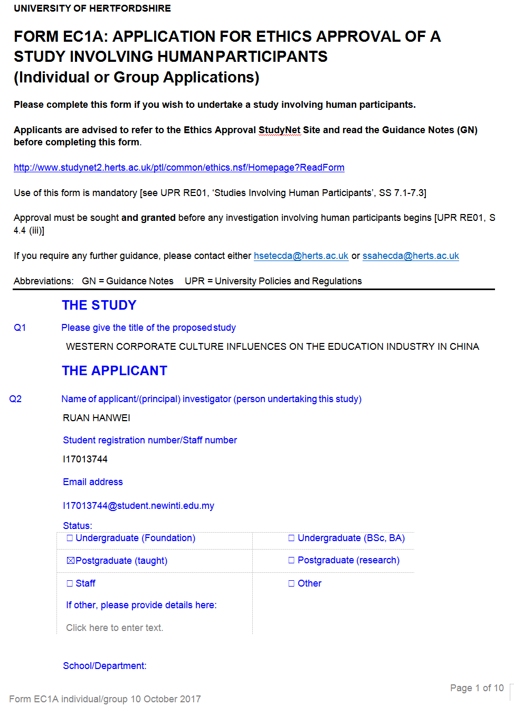
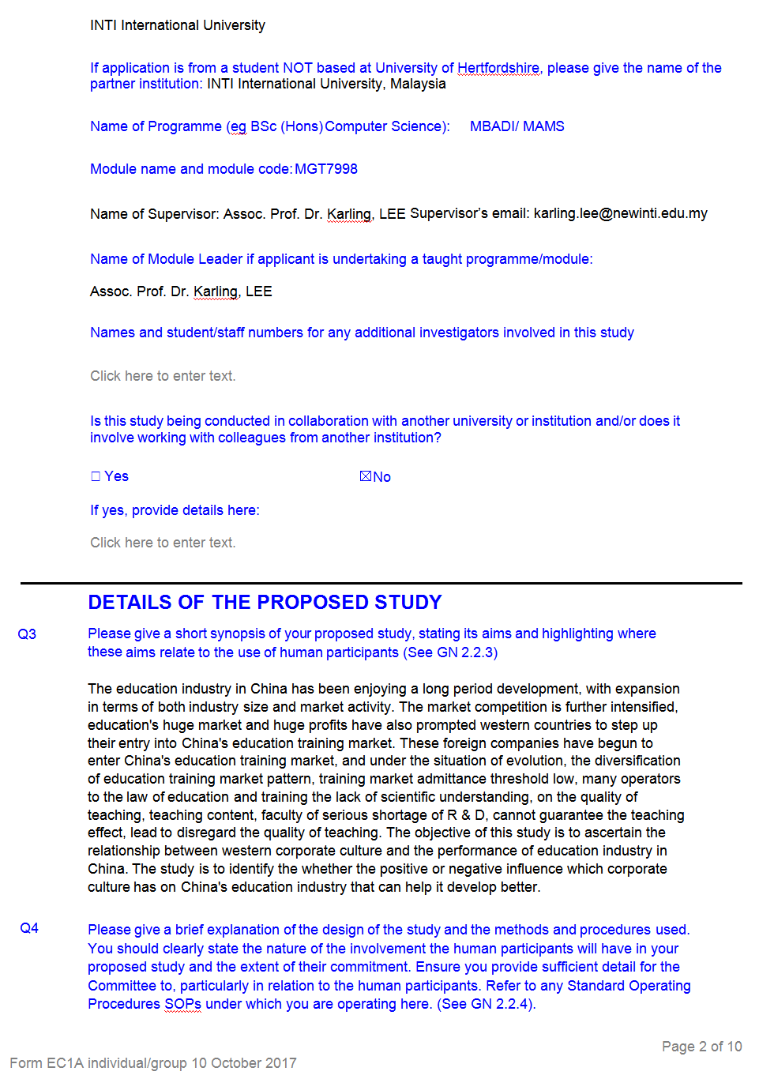


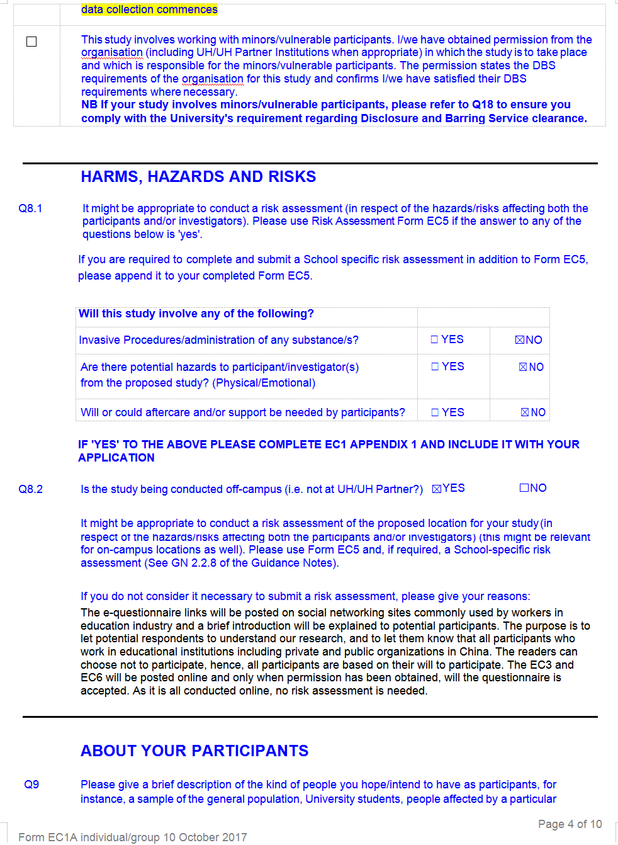
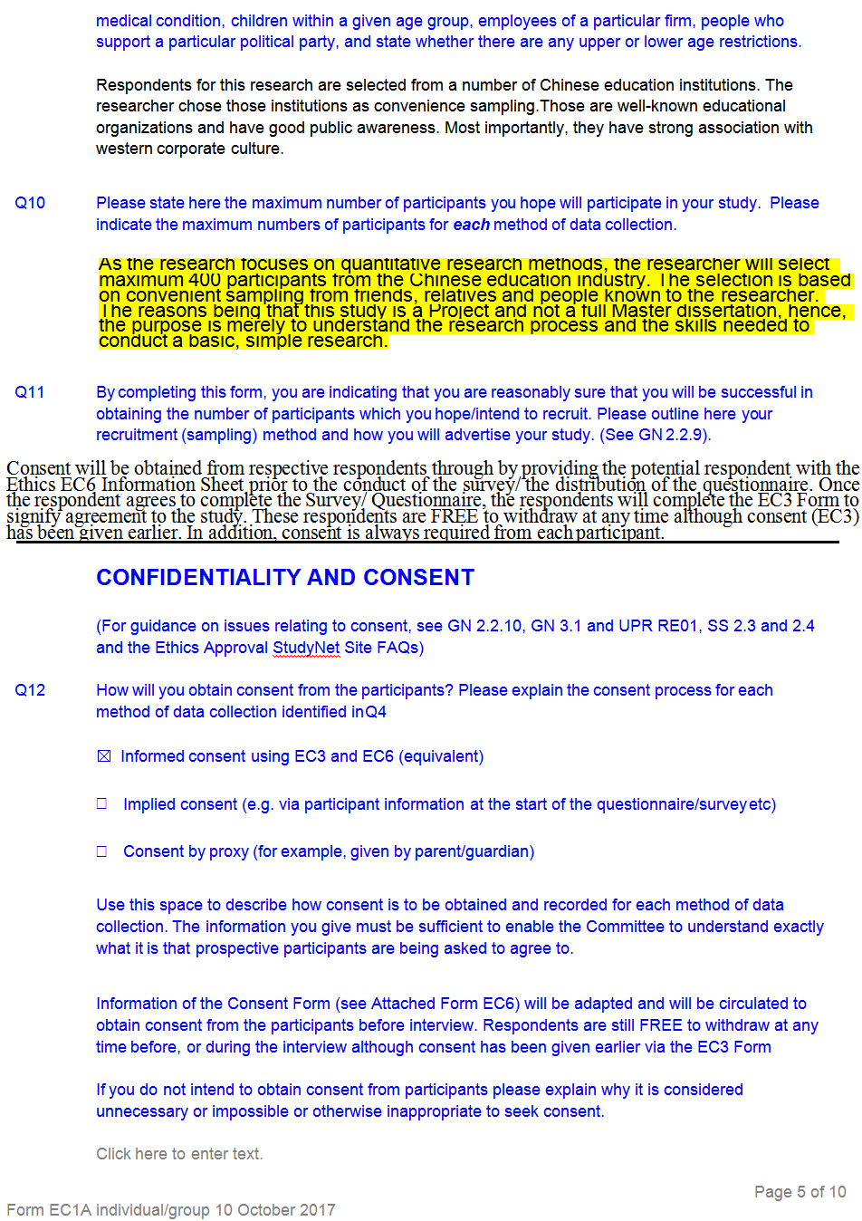

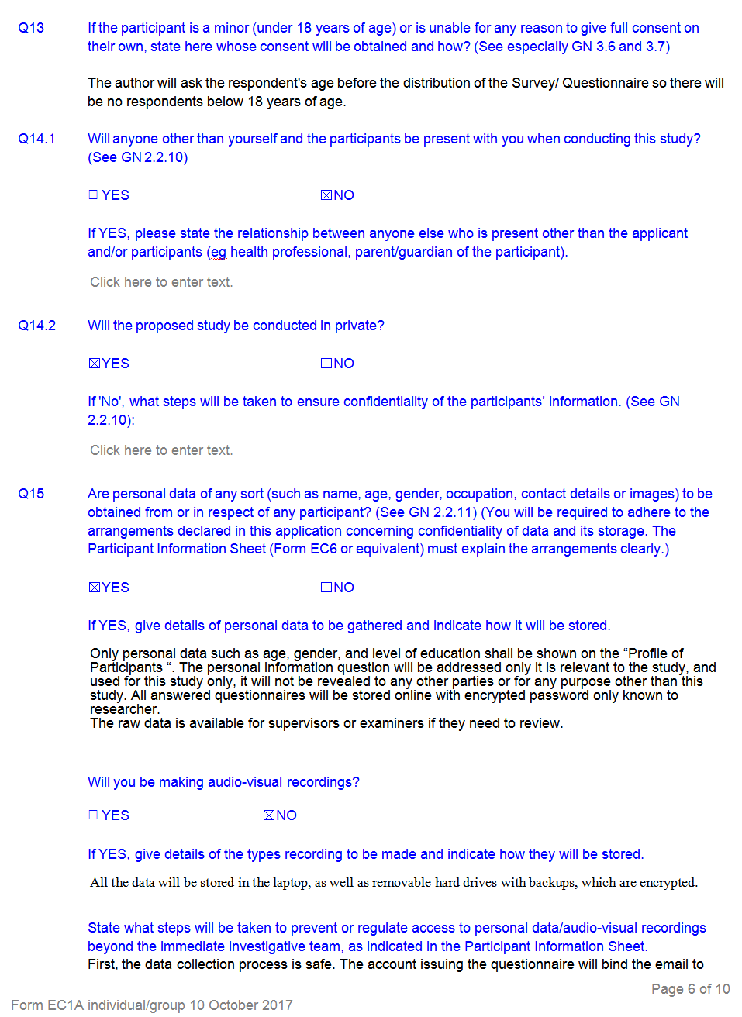

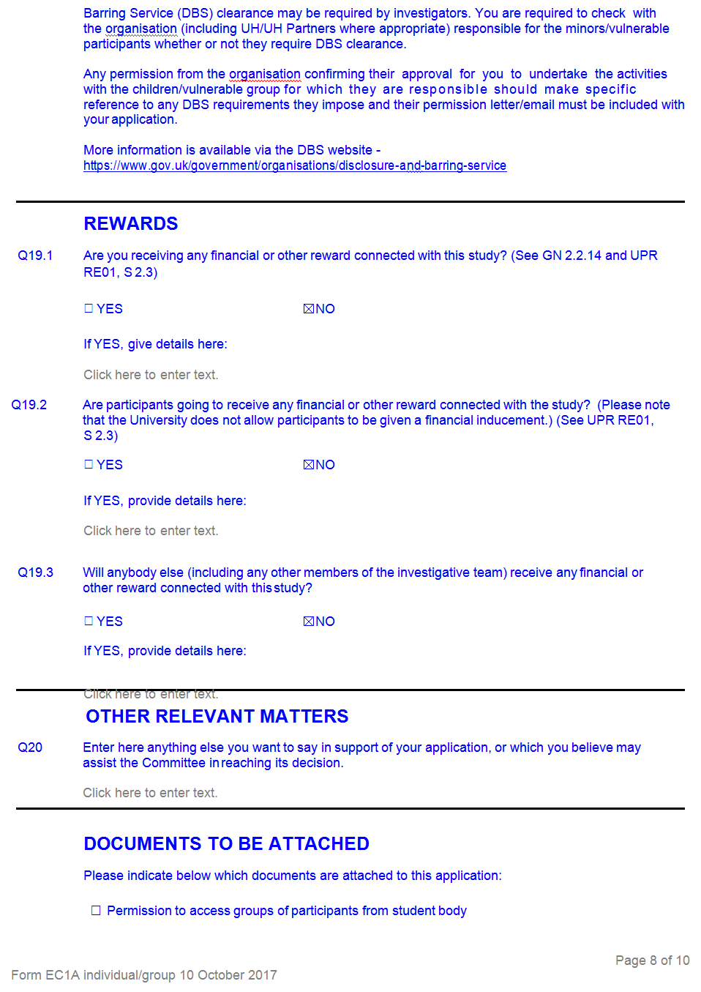



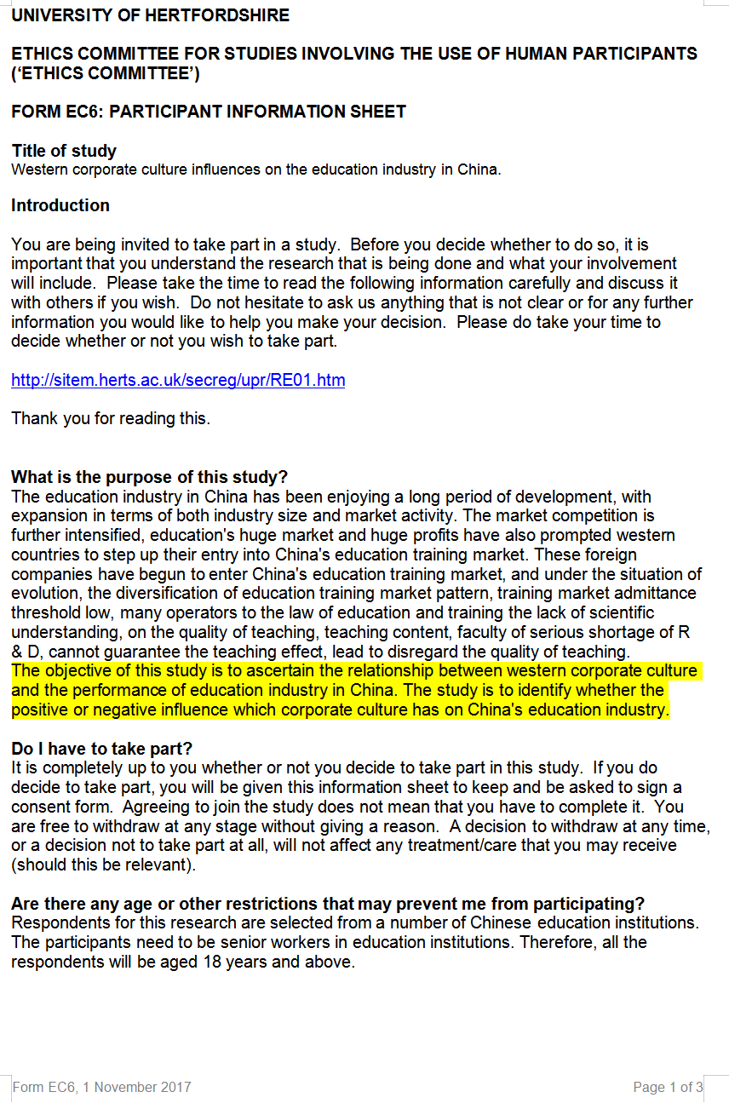
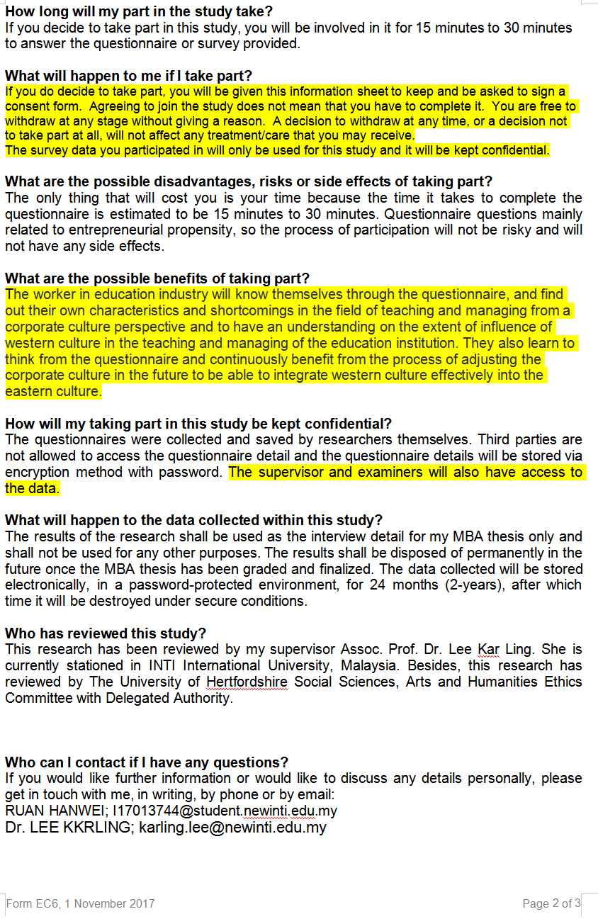

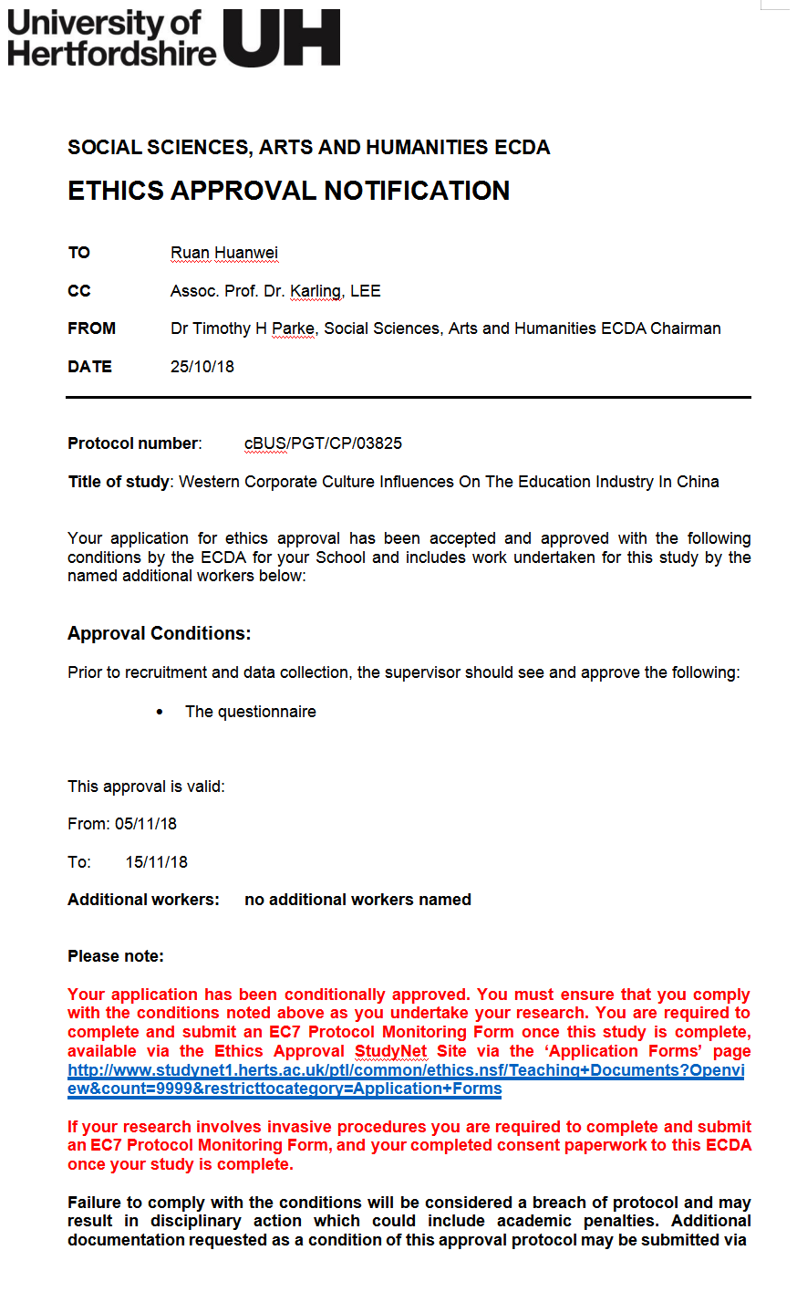
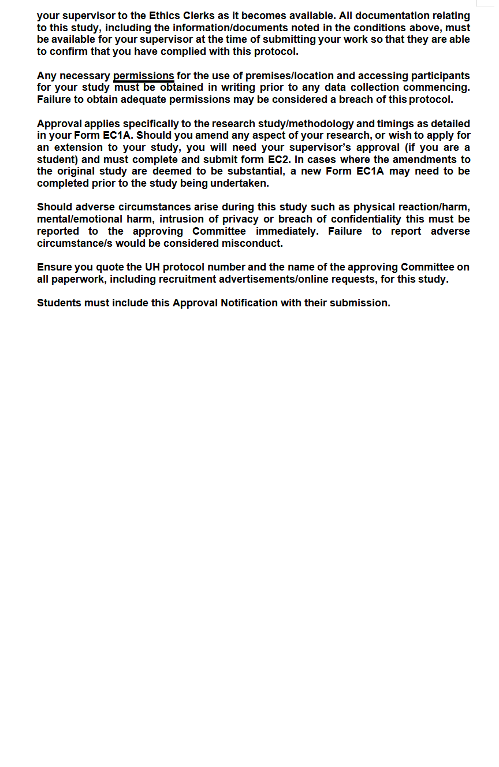
SECTION C. RECORD OF MEETINGS
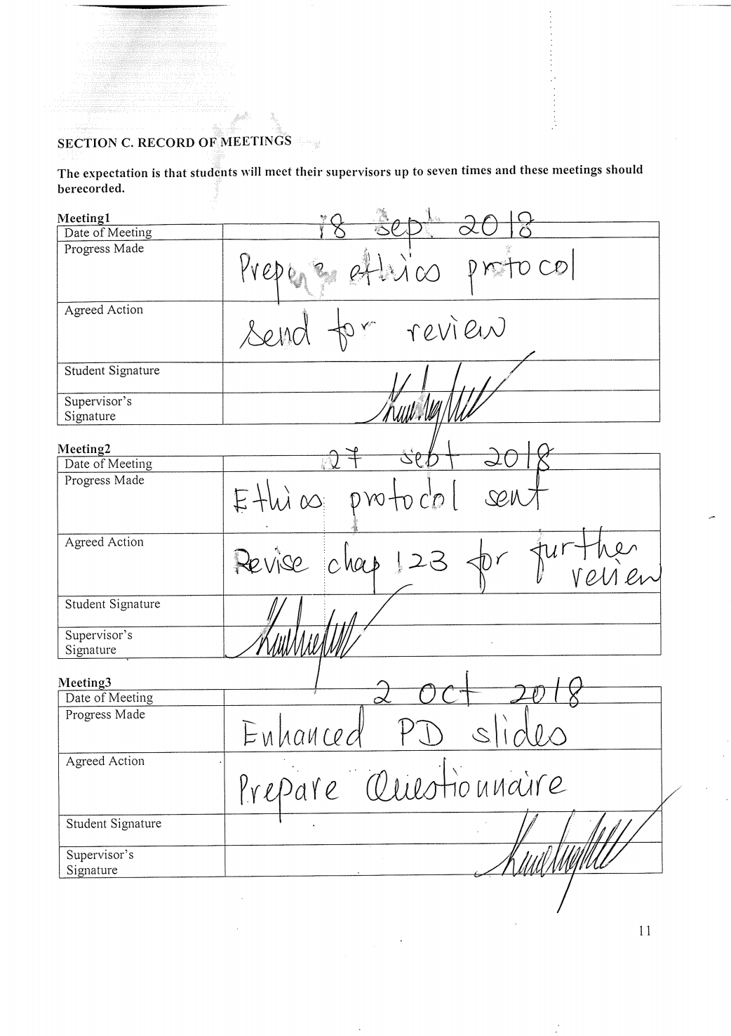




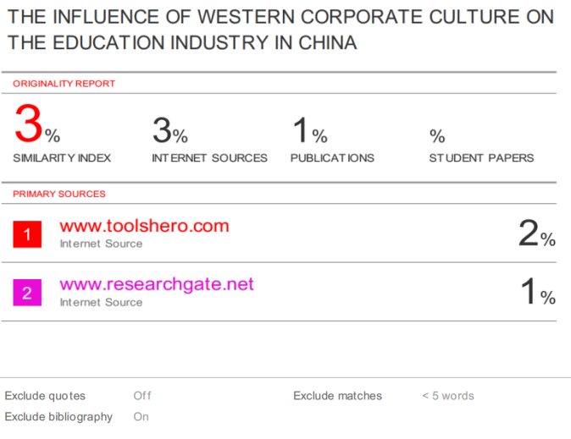

APPENDIX 2

Declaration

I hereby declare that this thesis is my own work and effort and that it has not been submitted anywhere for any award. Where other sources of information have been used, they have been duly acknowledged.

Name : Ruan Hanwei
Student ID : I17013744
Signature : Ruan Hanwei
Date : 2018/12/5
APPENDIX 2
Title Page
INTI INTERNATIONAL UNIVERSITY
MASTER OF BUSINESS ADMINISTRATION

THE INFLUENCE OF WESTERN CORPORATE CULTURE ON THE EDUCATION INDUSTRY IN CHINA

Author；RUAN HANWEI
Student No: I17013744
Supervisor: ASSOC.PROF. DR. LEE KAR LING
Submission Date: 2018/12/7
Ethics Number: cBUS/PGT/CP/03825
Final Word Count: 16829

