ADOPTION OF MOBILE APPLICATIONS IN EAST MALAYSIA BY GENERATION Y

NANTENI THANABALAN

MASTER OF BUSINESS ADMINISTRATION
FACULTY OF BUSINESS, COMMUNICATION & LAW
INTI INTERNATIONAL UNIVERSITY

2018

INTI INTERNATIONAL UNIVERSITY

MASTER OF BUSINESS ADMINISTRATION
ADOPTION OF MOBILE APPLICATIONS IN EAST MALAYSIA BY GENERATION Y
Author | : Nanteni Thanabalan
Student No | : I17012253
Supervisor | : Assoc. Prof. Dr. Lee Kar Ling
Submission Date | : December 2018
Ethics Number | :
Final Word Count | : 24774 words

Student’s Declaration
I hereby declare that: I understand the meaning of “Plagiarism” and “Intellectual Property Rights” and Ethics Related to the Principles of Academic Works.

This dissertation is hereby acknowledged as my own work and I have duly acknowledged use of published and unpublished works of other people from the print, electronic and other media.

NANTENI THANABALAN/ I17012253

[Signature]  [Date] 14th December 2018

Acknowledgment
Firstly, I would like to take this opportunity to show my truthful gratitude to my MBA project supervisor, Assoc. Prof. Dr. Lee Kar Ling, an excellent mentor who has taught, coached, and guided me throughout a journey of completing this research. Thanks lot to her direction has assisted me to absorb the wisdom knowledge of the research methodology efficiently within my MBA project journey. In addition, I would like to express my gratitude to Dr. Sukjeet for her a clear as crystal feedbacks and recommendations during my Proposal Defence (PD) and VIVA presentation. Furthermore, I’m very grateful and appreciate the persistent and selfless supports together guidance from my family especially my fiancé Mr. Vickneswaran Porch Seliyan who was never ever failed to motivate me to complete this MBA project as well as all the respondents that participated in this research survey.

Abstract
The growth of Internet and Mobile Commerce have become more and more established and produced many opportunities as competitive advantages and an enhanced platform for create a new business to develop the businesses market. The Electronic Commerce (E-Commerce) and Mobile Commerce (M-Commerce) are the parts of mobile applications which the information and communication has risen, and principals that increase intensively. The coverage of M-Commerce has occupied the consumers weighted down with the several transactions and information consequently, it carries improbability for current and existing internet users including the old-style of business in adopting to M-Commerce. Generation Y (Gen Y) is the main sample population of this study has been selected which recognised as the innovator or pioneer that spent their whole lives in the digitalised environment and information technology for daily usage in their entire life and work. In this research, the Technology Acceptance Model (TAM) has been chosen as fundamental theory by the researcher to support and examine the relationship between the independent variables (perceived ease of use and perceived usefulness) towards the adoption of mobile applications by Gen Y. Questionnaire has been employed as a data collection method which will be circulated within East Malaysia and this research is based on a quantitative correlation study. Therefore, this research is focusing on determining the adoption of mobile applications within East Malaysia by Generation Y and the outcomes will support the existing or new business to understand and enhance the M-Commerce for potential mobile users’ especially for young generation. As well, the result of this research has concluded that both perceived ease of use and perceived usefulness has influenced most of the Generation Y users in East Malaysia to adopt in mobile applications. Furthermore, the Gen Y users in East Malaysia are more desired to download various types of mobile application when it provided as free instead of paid mobile application therefore, the cost of mobile application especially free apps played a significant positive relationship towards adoption of mobile applications.

Keywords: Mobile Applications; Generation Y; Technology Acceptance Model (TAM)

List of Abbreviations

GEN Y | Generation Young
TAM | Technology Acceptance Model
APPS | Application (Refer to Mobile Applications)
OS | Operating System
E-Commerce | Electronic Commerce
M-Commerce | Mobile Commerce
IT | Information Technology
IS | Information System
PEOU | Perceived Ease of Use
PU | Perceived Usefulness
IV | Independent Variable
MV | Moderate Variable
DV | Dependent Variable
RO | Research Objectives
RQ | Research Questions

Turnitin Result
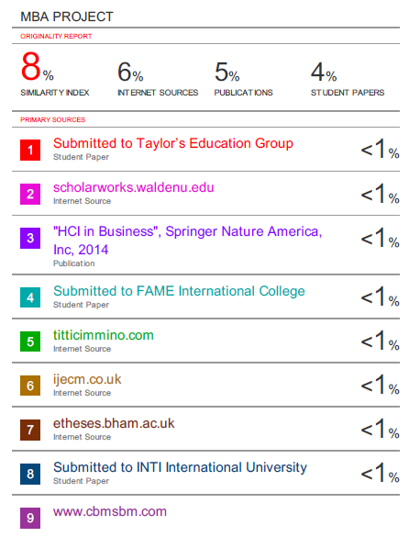

Table of Content
Student’s Declaration i
Acknowledgment ii
Abstract iii
List of Abbreviations iv
Turnitin Result v
Table of Content vi
List of Tables ix
List of Figures x
Chapter 1: Introduction 1
1.0 Overview 1
1.1 Background of Study 2
1.2 Problem Statement 8
1.3 Research Objectives (ROs) 9
1.4 Research Questions (RQs) 10
1.5 Significant of Study 11
1.5.1 Significance to Academia 11
1.5.2 Significance to Industry 11
1.6 Scope of the Research 12
1.7 Limitation of Research 12
1.8 Operational Definitions 13
1.9 Organisation of Chapters 14
Chapter 2: Literature Review 16
2.0 Overview 16
2.1 Mobile Application (Mobile Apps) 17
2.1.1 Adoption of Mobile Application (Global and Local Perspective) 18
2.1.2 Adoption of Mobile Apps by Gen Y (Global and Local Perspective) 21
2.1.3 Evolution of Mobile Internet and Mobile Commerce 25
2.2 Factors Influencing the Adoption of Mobile Application 26
2.3 Influencers (IVs) & Relationship amid Factors with Adoption of Mobile Apps 28
2.3.1 Perceived Ease of Use 28
2.3.2 Perceived Usefulness 29
2.4 Moderator Variable (MV) 32
2.4.1 Cost of the Mobile Apps 32
2.5 Fundamental Theories: Technology Acceptance Model 33
2.6 Gaps in the Literature 34
2.7 Conceptual Framework 34
2.8 Hypotheses 35
2.9 Conclusion 35
Chapter 3: Research Methodology 36
3.0 Overview 36
3.1 Research Design 37
3.2 Unit of Analysis & Time Horizon 40
3.3 Sampling Design 41
3.3.1 Sampling Plan 41
3.3.2 Sample Size 42
3.4 Questionnaire Design 44
3.5 Pilot Test 45
3.5.1 Factor Analysis 45
3.5.2 Reliability Test 47
3.5.3 Correlation Matrix 47
3.6 Measurements 48
3.6.1 Preliminary Analyses 49
3.6.2 Descriptive Information 51
3.6.3 Hypothesis Testing 52
3.7 Ethical Consideration 55
3.8 Conclusion 56
Chapter 4: Research Findings 57
4.0 Overview 57
4.1 Pilot Test 58
4.1.1 Pilot Test: Factor Analysis 58
4.1.2 Pilot Test: Reliability Test 60
4.1.3 Correlation Matrix 61
4.1.4 Conclusion for Pilot Test 62
4.2 Full Scale Data Collection 63
4.3 Demographic Profile of Respondents 64
4.4 Preliminary Test 66
4.4.1 Factor Analysis 66
4.4.2 Reliability Analysis 67
4.5 Hypotheses Analysis 69
4.5.1 Pearson Correlation Coefficient 69
4.5.2 Multiple Linear Regressions and Hierarchical Testing 70
4.6 Summary of Findings 74
4.7 Conclusion 77
Chapter 5: Conclusion and Recommendation 78
5.0 Overview 78
5.1 Discussion of Findings 79
5.2 Recommendations 83
5.3 Research Limitation 84
5.4 Contribution 85
5.4.1 Contribution to Industry 85
5.4.2 Contribution to Academy 85
5.5 Future Research Direction 86
5.6 Personal Reflection 87
5.7 Conclusion 88
References 89
Appendixes 104
Appendix A: Initial Research Proposal 104
Appendix B: UH Ethics Approval Forms 168
Appendix C: Questionnaire 182
Appendix D: SPSS Statistical Analyses 186
Appendix E: Project Log 190

List of Tables
Table 1: Operational definition of key terms. 13
Table 2: Summary of the Questionnaire Design 44
Table 3: KMO and Bartlett’s Table 59
Table 4: Communalities Table 59
Table 5: Varimax Rotated Component Matrix 60
Table 6: Reliability Test 60
Table 7: Cronbach Alpha if Specific Items are Deleted 60
Table 8: Result of Correlation Matrix Analysis 61
Table 9: Summary of Research Questionnaire Response Rate 63
Table 10: Demographic Profile Information 64
Table 11: Most Used Mobile Apps 64
Table 12: Summary of the Dependent Variable (DV), Independent Variables (IVs) and Moderating Variable (MV) 66
Table 13: Full Scale of Data – KMO and Bartlett’s Test 66
Table 14: Full Scale of Data - Varimax Rotated Component Matrix 66
Table 15: Full Scale of Data – Reliability Test 67
Table 16: Full Scale of Data - Cronbach Alpha if Specific Items were Deleted 67
Table 17: List of Hypotheses in the Research 69
Table 18: Result of Pearson Correlation Coefficient 69
Table 19: Model Summary 70
Table 20: Multiple Regression ANOVA 71
Table 21: Detailed of Multiple Regression 72
Table 22: Summary of Findings 74
Table 23: Summary for Acceptance of Hypotheses in the Research 76

List of Figures
Figure 1: Share of mobile app time spent by US mobile users. 3
Figure 2: US top smartphone apps for third-quarter 2016. 4
Figure 3: The top social platforms, China. 5
Figure 4: The statistics of smartphone owner market share by age in US. 6
Figure 5: Number of mobile application users globally. 18
Figure 6: Mobile applications downloaded on mobile devices by Asia Pacific users. 19
Figure 7: Technology Acceptance Model (TAM). 31
Figure 8: The Conceptual Framework 34
Figure 9: Structure of Research Design. 37
Figure 10: A table for determining the sample size for a given population. 43
Figure 11: Guidelines for the Kaiser-Meyer-Olin (KMO) Test value. 49

Chapter 1: Introduction

1.0 Overview
This chapter 1 is an introductory chapter which focuses on the adoption of mobile applications in East Malaysia by Generation Y. The following section will discuss the background of the research and justifies the rationale of the study while, describes the gaps in this research. Additionally, this section will cover the problem statement of the study, and then continue to discuss the research objectives and research questions. This section also highlights the scope of study and discourse the limitations of the research. The operational definition which involve in this research paper is counted in and the organisation of chapters are listed in last section of this chapter.

1.1 Background of Study
Currently, the growths of technology have improved the source of information for consumers that available in the Internet via various methods of media such as broadcast, electronic and print stated by Lim, Omar & Thurasamy (2015). According to research conducted by Lee (2015), have indicated that explosion of Internet has powerfully impacted the environment of global business and it also offering the capability to grow any local companies’ business globally thru Electronic Commerce (E-Commerce) and Mobile Commerce (M-Commerce).

In addition, there are few characteristics of the Internet such as familiar, cooperating, flexible and open that has made to become more useful tool for dispersing the data to the consumers affirmed by Lim et al. (2015). A lot of consumers and users are accomplished to gain more n more information with the presence of the Internet from anywhere and anytime such as accessing to important sites; education, social media, and entertainment (Turban, Outland & King et al., 2018).

Based on Muñoz-Leiva, Climent-Climent & Liébana-Cabanillas (2017) studies, the growth of Internet has established the ability of consumers to make any payment of placement easily in term of buying goods and services at lower charge. Therefore, the owners of organization have obtained more benefit in their services and goods to reach to their customers thru Internet by advertising and communicating (Lim et al., 2015).

Moreover, the E-Commerce and M-Commerce has disclosed a massive load of transactions by consumers that brings uncertainty likes advantages, expenditures, risks, encounter challenges for new and skilled users of the Internet including the traditional business owners that adopting to E-Commerce and M-Commerce that considered it as upcoming channels of marketplace such as offline and online channels mentioned by Kim, Kim & Choi et al. (2017). It mostly happened due to consumers that have few substitute options to shop thru online or mobile applications channels (Lim et al., 2015) as form of software programs have different versions and features to support based on mode of device like mobile-based and web-based as acknowledged by Hur, Lee & Choo (2017).
Past studies (Lee, 2015; Yu & Buahom, 2013) has revealed the disclosing of M-Commerce has become widespread and rapidly growing the mobile applications globally as well as this platform is one of medium tools for users to participate, cooperate and retain the real-time relationship anytime from anywhere. Although the condition of economic and geographic locations is unfortunate, the network size of mobile is rapidly growing with lower charges rather than E-Commerce as it has allowed more companies to have access to advertising the information relevant to latest services that make available for customers persistently compared to traditional way (Moorthy, Chan & Chan et al., 2014).

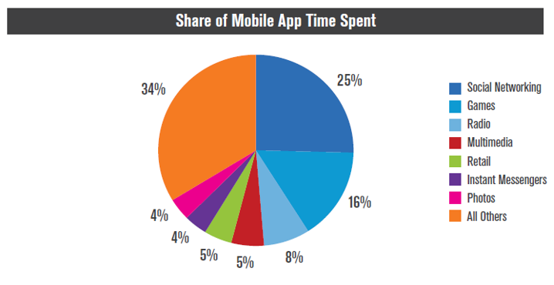
Figure 1: Share of mobile app time spent by US mobile users.
Source: Perez (2014).

According to previous survey directed by Perez (2014) also mentioned that US mobile users spent their time by consuming in the digital media applications strongly almost 52%; 60% of mobile users are spending their time by using both mobile and web, while the rest of users are consuming with desktop digital media therefore, this survey clearly indicated that maximum usage of mobile apps by users are social networking, games and radio actions which shown in Figure 1 above. Another research conducted by Olmstead & Atkinson (2015) has declared that roughly 68% of American mobile users owned a smartphone compared to 43% in 2010 and approximately 77% of United States (US) smartphone users have downloaded various of apps in their smartphone which has increased from 22% in 2009, thus presented the speed of mobile apps usage is growing by smartphone users.

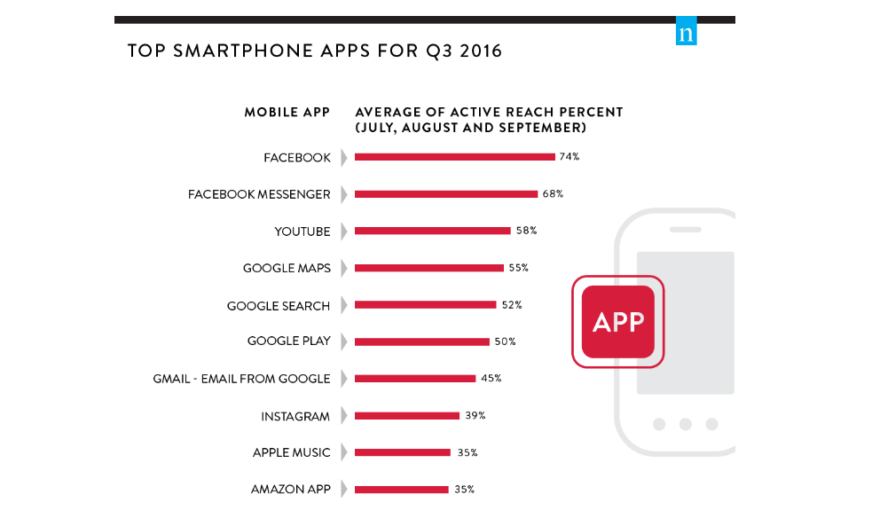
Figure 2: US top smartphone apps for third-quarter 2016.
Source: Nielsen (2016).

Additionally, Nielsen (2016) presented that there are approximately 88% of the population in US owned smartphones which reveled within third-quarter of 2016 and the most three mobile apps that have been downloaded by the mobile users are Facebook, Facebook Messenger and YouTube from social media category which shown clearly in Figure 2 above.

Recently, WeAreSocial (cited in ICEF Monitor, 2016) have conducted a survey in China that exposed there are almost 668 million of mobile internet users which is half of China’s population and it also represents twice of US population however, around only 659 million mobile internet users are actively using the social medias with average of 4 hours spending on tablet or desktop devices daily in mobile platforms such as QQ, QZone, WeChat and Weixin. Zhu, He & Xiang et al. (2014) also have revealed the growth of mobile devices that continuously increase to the fortune of mobile applications; 1.4 million of mobile users has downloaded various apps from Play Store while, 1.2 million users downloaded mobile apps from Apple Store.
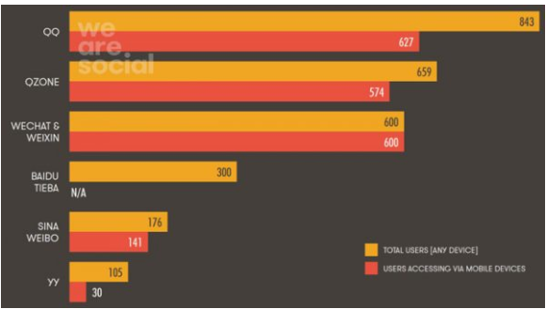
Figure 3: The top social platforms, China.
Source: WeAreSocial (ICEF Monitor, 2016).

Based on the data provided by WeAreSocial (ICEF Monitor, 2016) in Figure 3 above, it shows that mobile users in China has increased and mobile internet also provided massive advantages for businesses in globally as well as business in small-scale developing country such as Malaysia hence, this has supported the attention of this study to determine the level of mobile applications adoption by generation Y of mobile internet users.

The young generation (Gen Y) is acknowledged as individuals that born after Gen X around 1980 onwards and Gen Y mentioned as pioneer or inventor of information technology adopter stated by Lim et al. (2015). Moorthy et al. (2014) also considered the Gen Y is one of vital for market division since it is a big size of segment and it have a strong future in spending and purchasing power. The statistics provided from the survey conducted by Nielsen (2016) have explained the massive number of US mobile device users are the millennials knows as Gen Y aged from 24 to 34 shown in following Figure 4, which that age group of millennials has been classified as the population of generation Y declared by Lee (2011). Another research Varsha & Vijay (2015) commented that India has huge number of Gen Y that representation as sign of world of applications when this age group of Gen Y get the attention of markets.

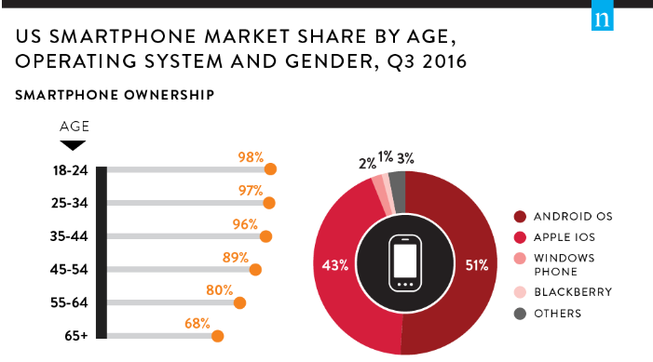
Figure 4: The statistics of smartphone owner market share by age in US.
Source: Nielsen (2016).

Besides, the generation Y holding a main characteristic as ‘digital-savvy’, specifically this group of people are running through equally with the development of technology since born stated by Price (2017). This was supported by another research directed by Bolton, Parasuraman & Hoefnagels et al. (2013), the generation Y is the first generation that has applied entire life by using the technology and lives in digital environment, therefore the daily routine of Gen Y has been significantly affected by technologies. The purpose of using smartphone by Gen Y is to attach with family members, friends, navigations, entertainment thru mobile applications mentioned by Bhave, Jain & Roy (2013).

With the massive explosion of technology, the Gen Y able to change widely as digital savvy, advance learners, capable in multi-tasking, open-minded which all of these make the Gen Y simpler to adopt with upcoming information technology to accomplish the good results (Bolton et al., 2013). This was affirmed by Bhave et al. (2013), the Gen Y optimism more entertainment and information from upcoming technologies and media therefore, various mobile apps have been downloaded by generation Y in their owned smartphones.

In United States, the adoption of young adults and the usage of mobile applications are extremely high, and it was influenced by the participations of closest partners with Gen Y indicated by Taylor, Voelker & Pentina (2011). Also, Hur et al. (2017) admitted that few of factors of mobile apps such as perceived ease of use, perceived usefulness and perceived playfulness have influencing a significant relationship towards the adoption of mobile application by young consumer’s in South Korea.

From local perspective, Wei, Marthandan & Chong et al. (2009) declared the highest level of mobile applications adoption in Malaysia which is almost 65.8% users are aged between 21-25 years, thus representing the Gen Y smartphone users are main adopters compared to other group of age. Lim et al. (2015) also agreed with the above statement as the growth of internet usage locally (Malaysia) has increased. However, Shanmugam, Savarimuthu & Teoh (2014) argued that Gen Y are more concern about the security during any transactions such as shopping, virtual banking thru mobile applications in smartphone therefore, it is very vital to determine the factors that influencing the adoption of mobile application by Gen Y are more voluntarily compared to other age group of users.

In Malaysia, the growth of mobile usage by Internet users is rapidly increasing which clearly highlights from the background of this study. The concentration of this research is to study the factors that influencing towards adoption of mobile applications especially by generation Y focusing on East Malaysia. There are similar studies has been conducted by Lee (2015) and Tee (2018) at different locations such as Penang and Selangor which both researchers are focused in West, Malaysia only. However, the researcher of this study still focuses on the factors that influencing towards adoption of mobile apps in East, Malaysia by Gen Y.

1.2 Problem Statement
Nowadays, the smartphone usage is beyond than personal communication and it has carried massive opportunities for the all the businesses including small and medium business to widen their current business thru mobile application (Taylor et al., 2011). According to Lim et al. (2015), the first generation adopted to new technology with the Internet is young generation (Gen Y) and it has enhanced the both part of Mobile Applications market growth which are Electronic Commerce (E-Commerce) and Mobile Commerce (M-Commerce). There are few vital elements to influencing the adoption of M-Commerce by Gen Y which are perceived risk, complexity, observability, trustworthiness, compatibility, and advantage of relative acknowledged by Chung & Holdsworth (2012).

Additionally, perceived ease of use and perceived usefulness are the main factors that adopt to Information Technology (IT) indicated by Davis (1989). Past studies (Carter & Yeo, 2017; Kang, Ha & Hambrick, 2015; Lai, 2017; Lee, Park & Chung et al., 2012) have been explored the adoption of mobile application on specific purpose or business such as mobile education, mobile tourism, mobile game, mobile shopping, and mobile finance. However, there are limited studies on the adoption of mobile applications by Gen Y in general and especially in East Malaysia.

Lee (2015) has conducted a research on the adoption of mobile apps amongst Gen Y users in Penang, Malaysia with consist of perceived ease of use, perceived usefulness, perceived trust, risk or security, and electronic word-of-mouth (E-WOM) that influencing the Gen Y to adopt mobile application. Tee (2018) has also looked at Gen Y perception on intention of mobile application adoption in Selangor, Malaysia as well as other articles have focused on mobile applications adoption (Jain & Viswanathan, 2015; Price, 2017; Yang, 2013). However, there is still mobile applications have become more and more common and it is important to further study about mobile apps. Therefore, there is a need to still conduct a study on adoption of mobile applications especially by generation Y focusing on East Malaysia as East Malaysia is less developed by West Malaysia thus, it is important to find out whether in less developed part of Malaysia the influence of the factors would be the same on adoption of mobile applications.

1.3 Research Objectives (ROs)
The research objectives describe that more precise on the aim of the research which directly linked to research questions (Doody & Bailey, 2016). It also aimed to investigate the related data which focus on the topic of interest (Sekaran & Bougie, 2016). It was agreed by Kothari (2013) that research objectives help to discover the solution to the questions by applying the scientific techniques to obtain the understanding on focusing space of a phenomenon. Past studies have stated that research objectives can achieve the expected result of the research study (Hunt, Pollock & Campbell et al., 2018; Tabachnick & Fidell, 2013). The focus of this study is to find out the factors that influence on the adoption of mobile application in East Malaysia by Generation Y. The research objectives are to achieve formulated as below:

RO1: To determine whether the perceived ease of use factor have influence on the adoption of mobile application in East Malaysia by Generation Y.

RO2: To determine whether the perceived usefulness factor have influence on the adoption of mobile application in East Malaysia by Generation Y.

RO3: To determine whether the cost of mobile apps especially free app have moderating influence on the adoption of mobile application in East Malaysia by Generation Y.

1.4 Research Questions (RQs)
The research question is form of questions that the research prepared to answer as a theory of expected results (Al-Shukaili & Al-Maniri, 2017). Sekaran & Bougie (2016) stated that both research questions and research objectives are tremendously interrelated therefore, it is very vital which both research questions and objectives have been explained to relate with the literature reviews. The research objectives and research questions will direct the research to achieve the suitable outcomes mentioned by Alvesson & Sandberg (2013). This study will answer the research questions that identified below:

RQ1: Does the perceived ease of use factor have influences on the adoption of mobile application in East Malaysia by Generation Y?

RQ2: Does the perceived usefulness factor have influences on the adoption of mobile application in East Malaysia by Generation Y?

RQ3: Does the cost of mobile apps especially free app has moderating influences on the adoption of mobile application in East Malaysia by Generation Y?

1.5 Significant of Study

1.5.1 Significance to Academia
There are number of reasons behind of choosing the adoption of mobile applications in East Malaysia by Generation Y as a focus of this study. According to Tan & Balachandran (2015) have identified that the mobile devices and smartphones are the most useful to interact among each other’s and also it is main communication tool that has become more common to use in Malaysia society. The highest mobile applications users are Gen Y in Malaysia as declared in the background of study earlier section, therefore this study will close the knowledge gaps that related to adoption of mobile applications. Moreover, this study will provide some vital elements to help the upcoming researcher to fill in the gap of the lack of studies related to adoption of mobile application in Malaysia generally by determining the factors that influencing the adoption of mobile applications among Gen Y.

1.5.2 Significance to Industry
Lee (2015) stated the market of mobile applications has an enormous potential therefore, it is vital to distinguish the features that inspires the users of mobile devices and smartphone to adopt on the mobile application in Malaysia specifically younger generation (Gen Y) that adopting to the information technology and also willing to be pioneers or inventors (Price, 2017) for operating the organisation business in locally (Malaysia) as well as globally as a nature of mobile applications. This study will find out the factors that influencing the adoption of mobile application in East Malaysia by Gen Y.

1.6 Scope of the Research
This section will be indicating the scope of this study which focus on the factors that influencing the adoption of mobile applications by Gen Y. This study will focus on the Gen Y in East Malaysia only. Also, this study just focusing on how the perceived ease of use and perceived usefulness as independent variables influencing the adoption of mobile applications in East Malaysia by Gen Y. Furthermore, this study also discovers the cost of mobile apps whether have moderating influence between the independent variables and the adoption of mobile application in East Malaysia by Generation Y.

1.7 Limitation of Research
Based on the review, the focused area of this study which is East Malaysia is one of the limitations of the study. Therefore, it is not possible to provide further comparative exploration of dissimilarity in Generation Y by conducting in various zones in this nation. Additionally, there are few other factors that influencing the adoption of mobile applications by Gen Y are stay untouched due to constrained in selecting the factors that should be involved in this study. This could make the research weaken in term of investigation level and also there is barrier to understand the other factors which may have influence the mobile applications adoption in Malaysia.

In this study, the method that will be adopted to use in the data collecting is survey since this is a correlation study. Nevertheless, there is a restriction of this method as it only capable to deliver the data that used to investigate whether there are relationships mid of independent variable, moderate variable, and dependent variables rather than the causality of attributes are not linked (Bacon-Shone, 2013; Johnson & Christensen, 2017).

1.8 Operational Definitions
The main principal of this section is to present the definition of key terms used in this study with the related concepts to improve the understanding. In any situation, an appropriate information with respect to the concern of factors has been listed in the following Table 1.

Table 1: Operational definition of key terms.
Key Terms | Definitions
Generation Y | Generation Y (Gen Y or Young Generation) known as Millennial and Gen Y are born between 1978 and 1994 in general definition (Kotler & Armstrong, 2010). However, Gen Y in Malaysia as born around 1984-1998 stated by Lee (2011).
Mobile Application | The mobile applications known as mobile apps which are installed on the mobile device as programs for mobile users to perform several of tasks such as gaming, payments of bank, browse information and location as stated by Taylor et al. (2011) and it has included with two parts which are Mobile commerce (M-Commerce) and Electronic commerce (E-Commerce).
Perceived Ease of Use | Carter & Yeo (2017) has defined the perceived ease of use is a feel of an individual to learn easily by using a specific information technology.
Perceived Usefulness | The perceived usefulness is a level of mobile device users that believe on his or her performance can improve by using specific technology defined by Davis & Venkatesh (2000).
Cost of Mobile Apps | The cost of mobile applications (Apps) is a fee of mobile apps that stated in the apps store either download for free or pay and download with some amount (Lee, 2015).
Technology Adoption | The Technology Acceptance Model (TAM) used to evaluate influences on the actual system usage by involved of the four internal factors; perceived usefulness, perceived ease of use, attitude towards use, and intention to use from the original TAM model stated by Davis (1989).

1.9 Organisation of Chapters
This is a fundamental section for the researcher to organise the research chapters into proper alignment to keep the examination smooth and strong with a clear way. There are five chapters that exhibited in the research which directing for different purpose to achieve the objectives of research that described as follows:

Chapter One – Introduction
This is main chapter of research to introduce the background of research and the expansion of internet development thru Electronic Commerce (E-Commerce) and Mobile Commerce (M-Commerce). Next, discuss the vital parts of research which are research objectives and research questions followed by, the significant of study towards academic and industry to make the readers understand the main goal of this research.

Chapter Two – Literature Review
This chapter fully established based on the secondary data which included the existing literatures that relevant to independent variables, dependent variables, moderate variable, models and the framework. The literature review discussed in this section is gathered with the support of several journals from different scholars. The gap of research also finds to determine the objective of research are addresses in this chapter, to improve the research value form of academic and managerial.

Chapter Three – Research Methodology
This chapter is involved of the research methodologies that relevant to this study. There are few sub-sections are discussed in this chapter which are design of research, categories of investigations, plan and method of sampling, collection of data, and methods of measurement that related to measure the research and maintained the strength and consistency of this study.

Chapter Four – Data Analysis and Findings
The main focus of this chapter four is to point out the main research thru the findings from gathered data with support of software. Also, the tested hypotheses result will be explained in which the interpretation of results will make the readers more understand the actual information fluently. It will determine whether the objectives of research and questions of research are mentioned in first chapter have been responded.

Chapter Five - Conclusion
This is the last chapter of this study to close the doors of the research findings, any other discussion, explanations on its influences of factors, and also the limitation of the research in term of academic and managerial. At last, the recommendation and future research will be discussed for helping the growing of upcoming study that related to this topic.

Chapter 2: Literature Review

2.0 Overview
In this chapter, the reviewed literature in the study is discussed. The use of independent variables in this study are also defined which are perceived ease of use, and perceived usefulness. As the moderating variable, mobile applications cost will be used for the purpose of this study. Firstly, the mobile internet and mobile commerce evolution will be discussed as part of mobile applications and then, the adoption of mobile application. Moving on with the factors that influencing the adoption of mobile applications in term of global and local (Malaysia) perspective will be briefly discussed. Lastly, the gaps found in the literature which linked to the objective of research are addresses in this chapter, to improve the research value form of academic and managerial.

2.1 Mobile Application (Mobile Apps)
The mobile applications known as mobile apps which are installed on the mobile device as programs for mobile users to perform several of tasks such as gaming, payments of bank, browse information and location as stated by Taylor et al. (2011). According Tan, Lee & Lin et al. (2017), the phenomenon of mobile apps is increasing since the mobility platform has attract the companies’ attentions to attach with their customers by promote the connections and services plus it is an advanced level of software application that allows the user to perform variety of tasks whenever required.

Besides, there are limited characteristics of mobile application such as majority of designs for personal use, Free of Charge (FOC) or minimum cost of mobile apps and download the mobile apps from a centralized platform that providing the other mobile users’ rating and feedbacks mentioned by Liu, Au & Choi (2014).

In the fashioned area, the smartphones are known as extremely advanced level of mobile device compared to normal mobile phone in term of using Operation System (OS) such as Android (Google), iOS (Apple), and Symbian (Nokia) which embedded with high range of resolutions on touch screen interface and allows to run the mobile apps observed by Pindeh, Suki & Suki (2016). Also, Jain & Pant (2012) found the individuals use smartphones usually to explore several of contents or browse information and to fit with their convenience by downloading different type of mobile apps.

Additionally, more young adults are using mobile apps because of low cost, opportunities of networking, trust, usefulness, and compatibility as advantage of mobile apps added by Jain & Viswanathan (2015). Also, the characteristics of mobile devices made the smartphones as powerful communication tool stated by Pindeh et al. (2016). The mobile applications have flexibility to execute the daily tasks of users to search information related to restaurants, resorts or locations, and the user also gain information of the product and price of service (Tan et al., 2017). Not only that, it was supported with statistical report presented by Statista (2018a), which shown in Figure 5 below that 3.3 billion users were active on the mobile application especially on social media and the most active internet users almost 4 billion as of April 2018.
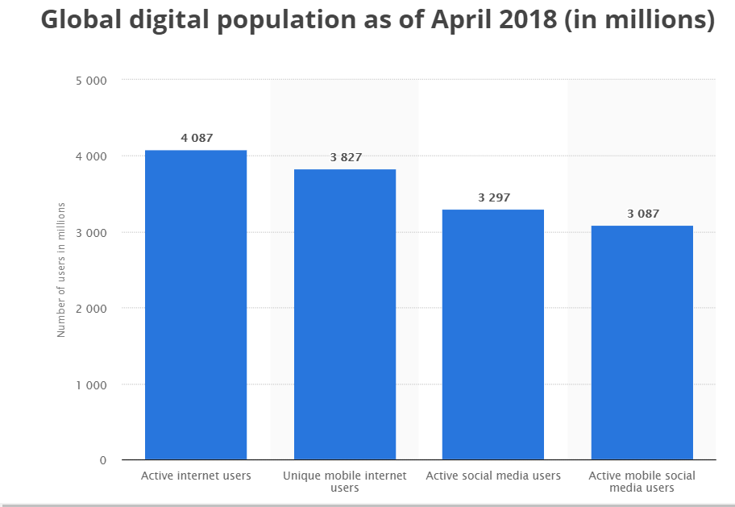
Figure 5: Number of mobile application users globally.
Source: Statista (2018a)

2.1.1 Adoption of Mobile Application (Global and Local Perspective)
The mobile application market is massively growing these years, the centralised platform of iOS (Apple Store) has dominates over 350 thousand of apps for iPhone, however, the rapid growing of Android (Play Store) apps has exceeded the record in year 2012 mentioned by Taylor et al. (2017). According to Liu et al. (2014), the mobile operating system of Android apps is gaining the highest market share almost 50.3% while, 43.1% market share of Apple iOS and Window Phone’s market share almost 4.7% respectively in November 2013. With the latest statistical report updated by GlobalStat (2018b) shows clearly there is up and down on the market share of mobile operating system as of June 2018, as usual Android apps operating system still rapidly growing to almost 76.99%, while rest of the market share is declining as Apple iOS (18.91%) and Windows (0.47%). Based on the outcomes given by GlobalStat (2018b) and Liu et al. (2014) has visibly shown the changes happened on market share of mobile operating system and it is indirectly giving a wide picture that most of the mobile phone users are downloading Android apps.
In United Kingdom, the highest market share of mobile operating system led by Android almost 63.3%, followed by iOS around 34.7% as of May 2017 published by Statista (2018b). In United States, approximately 82.2 million of peoples are having their own smartphones as well as almost 40.6% are mobile subscriber downloaded the apps in 2011 thus, shown the wider usage of mobile applications discovered by Yang (2013). Also, Nielsen (2011) revealed almost 76% of mobile subscribers owned smartphones and around 63% only downloaded few apps on their smartphones in United States. In United States, majority of users are adopted to the mobile applications due to several purposes such as playing games, mobile e-learning, navigating route, and social networking (Yang, 2013).

Not only that, the massive number of Americans approximately 95% owned smartphone in 2015 than 77% in 2011 as a main access to online from home stated by Smith (2015). For the first time, the usage of Internet thru mobile and tablet devices almost 55.3% than desktop (44.6%) worldwide in April 2018 (GlobalStats, 2018a) which shows the mobile apps downloaded by American to perform their daily task. Based on the report provided by Internet Society (2016), most of countries in Asia Pacific has changed the Internet access primary mode to mobile broadband from fixed broadband and peoples in Asia Pacific nearly 90% are access the Internet via their smartphone daily while, almost 72% of subscribers aged between 15 to 24 are mainly used the Internet for social media, browse information and messaging as shown in following Figure 6.

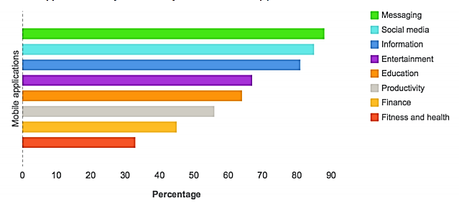
Figure 6: Mobile applications downloaded on mobile devices by Asia Pacific users.
Source: Internet Society (2016).
The usage of mobile apps by consumers is significantly increasing in China which is the world’s largest 2nd economy stated by Fong, Lam, & Law (2017). The mobile has played a key role in the society of Chinese because the number of users used mobile internet grew almost 12% which is approximately 7 million of mobile internet users while, the duration of spent per day increased nearly 30% compared to last year in China (ICEF Monitor, 2016). The users in China used to download the mobile application for both social media and messaging while, this is challenging for those users download the mobile application for browse information, news and functions of gaming in Japan (Kakihara, 2016).

In Korea, most of the residents are seriously reliant on the smartphone around 44.7 million of mobile users out of a total population 48.7 million, it means majority of people using mobile communication as vital tool based on the research performed by Lee et al. (2012). The most of millennial users in Korea desire for both enjoyments and entertainment value by using mobile application mentioned by Hur et al. (2017). Therefore, currently the residents of Korea quickly adopting them into mobile apps for daily usage and personal needs (Tan et al., 2012).

As well, Indonesia is another well performing of mobile market Southeast Asia which has over 250 million of population, but it exploded past two years and now actively have nearly 87 million of internet users for the past twelve months (Balea, 2016). Based on the same report also, it shown almost 40% of the respondents spent nearly 3 hours daily by browsing web thru smartphones and downloaded the main mobile apps which used for social networking and messaging such as WhatsApp, Facebook, Twitter, Google and Line.

The research conducted by Kemp (2017) determined the Southeast Asia penetration of mobile social remains to rise rapidly around all the regions, as the top highest is Brunei (76%), followed by Singapore (70%) and Malaysia (65%) in 2017 as well as this research discovered the landscape of mobile apps with a mere of Malaysia population around 29 million, that reached almost 140% mobile penetration, it means nearly 47% of Malaysia residents owned more than 1 smartphones, after Vietnam and Singapore having highest mobile penetration compared to Malaysia. Additionally, the majority of downloaded mobile applications were social networking, purchase movie ticket, airlines ticket, reservation of tour and resort are the most top transactions of Malaysia to purchase on tablets declared by Nielsen (2014).

In Malaysia, almost 80% of smartphone users agreed that the purpose of using the smartphone is to attach with friends, colleagues and family members, 71% of the users are fixed with smartphone as a vital portion of their social life while, the last 71% of users feels they cannot live without their smartphones based on the report presented by Malaysia Digital Association and CARAT Media Network in Digital Integration & Business Transformation Asia Conference (Malaysia Digital Association, 2016). According to Kemp (2017), Malaysian are very heavy mobile users which regularly downloaded various of mobile apps such as social networking, games and messaging while, the rest 9% of mobile users downloaded the shopping mobile applications and the main purpose of them is to perform online transactions thru internet website.

2.1.2 Adoption of Mobile Apps by Gen Y (Global and Local Perspective)
According to Bolton et al. (2013), the Generation Y (Gen Y) is recognised as the innovator or pioneer that spent their whole lives in the digitalised environment and information technology for daily usage in their entire life and work. Past studies (Jain & Viswanathan, 2015; Price, 2017; Yang, 2013) have indicated the Gen Y is the main users of mobile application.

Although there are differences on the range of Gen Y age, few past studies agreed that Gen Y are born between 1978 and 1994 (Kotler & Armstrong, 2010; Lim et al., 2015) while, it is not exactly matching for Gen Y in Malaysia as born around 1984 -1998 stated by Lee (2011). In this section, the adoption of mobile apps by young generation (Gen Y) for several purposes in term of global and local (Malaysia) perspective will be discussed.

2.1.2.1 Global Perspective
Mobile Application – Shopping and Marketing
The mobile apps are well utilised by Gen Y as primary tool to browse information therefore, it has played a very important role in pleasing to the eye of shopping experience to users in this computerised era stated by Jain & Viswanathan (2015). In United States, there are almost 20% of smartphone users using shopping mobile apps last month as declared by Taylor et al. (2011). Moreover, the smartphone users roughly 21% are using the concept of ‘today deal’ sites like Groupon and Living Social, whereas the rest of smartphone users are youngsters which regularly using their mobile device for shopping and it shows there is more chances for Mobile Commerce revealed by Nielsen (2011).

The companies use the mobile apps to perform an effective marketing activity which will influence a positive attitude and loyalty of the brand by consumers (Jain & Viswanathan, 2015). At the same time, Kumar & Mukherjee (2013) indicated the mobile applications can do beyond than incentives, coupons, and other deals which provides more information about the product to help consumer to make comparison and deliver personalised results. The mobile apps are vital to allow consumers to interact with product brands and it has successfully increased the level of engagement of users by providing more information about relevant products (Jain & Viswanathan, 2015).

Mobile Application – Communication and Social
In Taiwan, the most downloaded mobile application is social media apps between the youngsters which are Instagram, WhatsApp and WeChat revealed by Hsiao, Chang & Tang (2016). According to Kim & Hahn (2012), one of the core factors is the individuals with high-end technology contribution will influence the adoption of mobile apps by youngster for communication and social purposes.

Hsiao et al. (2016) discovered that FireChat is an unspecified and offline social mobile apps that become most popular as messaging in a private and intelligent tool which able to make connection with peers over wireless networking such as Wi-Fi or Bluetooth. In Hong Kong, the offline social mobile apps have been downloaded by 500 thousand of mobile users during a political assembly mentioned by Meinecke (2015).

Mobile Application - Gaming
The gaming mobile apps such as Pokemon Go, Mobile Legend, Clash of Clan, and CSR 2 Racing are getting widespread between teenagers and the download rates of those gaming apps are higher compared to other mobile apps such as ticketing, education, navigation, banking and other purchasing apps for the smartphone declared by Price (2017). Also, Bhave et al. (2013) agreed that the youngsters always willing to spend their time by downloading free gaming apps since it is always available as free of charge than premium version of gaming mobile apps that need to pay some charges.

In South Africa, the main factors that influencing the Gen Y to mobile gaming are perceived attractiveness, social influence, and perceived enjoyment as concluded from the survey that investigate the behavior of Gen Y to mobile gaming by using 600 full-time generation Y students as sample which conducted by Price (2017).

2.1.2.2 Malaysia’s Scenario
Mobile Application – Mobile Commerce
According to the research conducted by Moorthy et al. (2014) revealed the factors that influencing the adoption of mobile commerce among the Gen Y in Malaysia are perceived enjoyment, perceived ease of use, perceived trust, perceived usefulness, social influence, and compatibility has a significant correlation to adopt the mobile commerce by Gen Y.

The adoption of mobile commerce by smartphone owners has increased the loyalty towards the application’s brand for long term as concluded in another research conducted by Hew, Lee & Ooi et al. (2015). The adoption of mobile commerce still has gaps to be filled for enhancement on the communication and entertainment purposes rather than monetary operation purposes since the Gen Y carries most of the mobile activities stated by Moorthy et al. (2014).

Mobile Application – Language and Learning
The mobile language has the factors influencing the Gen Y to adopt in learning mobile apps attached with Kadazandusun language and it shows a great outcome that those users used the mobile learning application has achieved better result in study compared to those continued with traditional method of study investigated by Pindeh et al. (2016).

A research that has been conducted by Ganapathy, Shuib & Azizan (2016) on the perceptions of undergraduates to use the mobile application in Malaysia for grammar test resulted increase in the number of study approach in gaining knowledge to obtain process and also learning resources and information usage therefore, the process of teaching and learning thru mobile devices has more interactivity between the lecturers and students. One of vital elements that influencing the adopting of mobile learning application by the user is perceived usability which moves the experiences and effectiveness of mobile learning by users stated by Hujainah, Dahlan & Basheer (2013).

Mobile Application – Other Services
In Malaysia, the practitioners and students of medical and pharmacy used mobile applications as most common tools therefore, various of reliable apps can be choose between thousands of medical applications which are available on the application stores is one of key factor that confirming the efficiency of these tools stated by Elnaem & Jamshed (2017). Another research conducted by Mihanyar, Rahman & Aminudin (2016) on mobile application of National Park which emphasized the rise of social media that led massive number of mobile applications formed by and shared between young travellers; the young travellers used the apps to make a good decision about the trip during their vacations and other trip purposes. There was another study have been conducted by Tan et al. (2017) on mobile application of tourism indicated the adopting of travellers using tourism mobile apps as a main tool to purchase or reservation tour ticket or booking hotel in Malaysia are increased.

2.1.3 Evolution of Mobile Internet and Mobile Commerce
The Electronic Commerce (E-Commerce) and Mobile Commerce (M-Commerce) are the parts of mobile applications which the information and communication has risen, and principals that increase intensively since 1985 stated by Lee et al. (2012). Lee, Cheng & Cheng (2007) defined the M-Commerce is performing the information investigation and corporate transactions by using mobile devices thru wireless communications. According to Gitau & Nzuki (2014) observed the companies directing their business easily by using the powerful and accessible tools as advantaged of M-Commerce and it has widespread than E-Commerce.

Moreover, the M-Commerce devices (mobile and tablet) purchased are almost $627 billion (2018) which is increased up to quadruple of $133 billion (2013), while the E-Commerce sales are 11% included online and in stores purchases in USA highlighted by Sluis (2014). The mobile applications having opportunities for both advertising and branding as the channel of M-Commerce still available in market potentially (Taylor et al., 2011). Yang (2013) found the mobile apps will help and useful for all type of businesses such as small and medium size business by developing mobile applications to get more potential new customers, engage a better relationship with existing customers, geographically target the customers, and also can reorganise the business model by using mobile application broadly for next 3 to 5 years.

Even though the M-Commerce is continuously growing however, the adoption of M-Commerce in Malaysia still low compared to the rest of countries stated by Moorthy et al. (2014). The Chief Officer of Industry of Malaysia Communications and Multimedia Commission (MCMC) agreed with lack of knowledge about the mobile in the marketplace therefore, Malaysia still immature in the developing of mobile apps published by The Star (2013).

The acceptance rate of mobile application developed locally in Malaysia will be too low since due to lack of knowledge mentioned by Hew et al. (2015). Hence, the factors that influencing the generation Y as the main group of mobile users in Malaysia aim to adoption of mobile apps which will offer more opportunities to local business and dealers in evolving a new mobile application will investigate in this research.

2.2 Factors Influencing the Adoption of Mobile Application
In the technology era, there are enormous number of challenges that made to comprehend the ins and outs of people become complex with developing technologies highlighted by Kang et al. (2015). A few conceptual models have created to make clear about the adoption of new Information Technology (IT) and Information System (IS) past twenty-five years ago and there are some models are mostly focused like “Theory of Planned Behaviour (TPB)”, “Structural Equal Modelling (SEM)”, “Technology Acceptance Model (TAM)”, “Theory of Reason Action (TRA)”, “Diffusion of Innovation (DOI)”, and “Unified Theory of Acceptance and Use of Technology (UTAUT)” stated by Lai (2017) and Tan et al. (2017).

Past studies (Carter & Yeo, 2017; Gitau & Nzuki, 2014; Tan et al. 2017) have investigated several factors in adoption of IT and IS which are perceived usefulness and perceived ease of use as the most popular factors that has been chosen by researchers. Moreover, applications which are available for free downloads for Android phones and use of mobile applications for purchases and banking transactions defined as the special features of the application has been brought to spotlight and few improvised models and keys to identify the adoption of the mobile application end-users has been brought forward in few recent researches (Lee et al., 2012; Muñoz-Leiva et al., 2017; Ooi & Tan, 2016; Price, 2017).

An integrated TAM model has been used by Lee et al. (2012) to research the key cause that dominating the willing to use financial services mobile application in South Korea. Personal innovativeness and absorptive capacity are the two additional key roles that have added in the research. Besides, Hew et al. (2015) mentioned that personal preferences is the most obvious key player of the adoption of mobile application while paid applications and social value have in-direct relationship with the end-users adoption on the mobile applications. Additionally, the researchers in this study reflects that personal innovativeness is the user’s ability to embrace latest information technology that will inspire the user to adopt the mobile applications or enhanced information system and the earlier information to use a specific information technology that will inspire the mobile users to adopt pioneering technology positively (Tan et al., 2017).
In contrast, the previous research on mobile banking and mobile shopping applications claimed the apparent trust and risk are one of the prominent features in persuading the smartphone users in adopting the latest information technology which is financial related (Muñoz-Leiva et al., 2017; Ooi & Tan, 2016). These studies also mentioned that as long as the bank or monetary organizations are trustworthy and accountable for any integrity or privacy issues, consumers are prone to use the mobile applications for transactions.

In Malaysia, the user adoption on Kadazandusun Language mobile applications has been studied by Pindeh et al. (2016). The perceived playfulness has been comprised as one of the factors that definite the essential feeling that encourage the mobile users to apply this technology due to its playfulness and exciting factors in this research. According to Hujainah et al. (2013), the perceived usability inspire user in adopting the mobile applications as it marks user’s learning practices and efficiency.

The perceived enjoyment and subjective norms have been exposed by an investigation done by Price (2017) on the mobile games drives adoption with SEM model by generation Y that have the impact towards generation Y in adopting a mobile application which define a smartphone user more prone to adopt the technology if he/she enjoys when implementing an innovative technology. Furthermore, generation Y also expects the feedbacks from their friends and family members which connect personally with them during adopting with enhanced technology stated by Jiang, Peng & Liu (2015).

As discussed above, there are few factors that influencing the adoption of IT and IS from past researches (Muñoz-Leiva et al., 2017; Ooi & Tan, 2016; Price, 2017; Tan et al., 2017). With the attention of discussed factors above, the following section will discuss about the factors that have been brought forward as the independent variables in this research consist of perceived ease of use, and perceived usefulness, plus with a moderate variable (cost of mobile applications) between Generation Y in East Malaysia for adoption of mobile apps.

2.3 Influencers (IVs) & Relationship amid Factors with Adoption of Mobile Apps

2.3.1 Perceived Ease of Use
The perceived ease of use is one of the major factors that influencing the Technology Acceptance Model 2 (TAM2) stated by Davis & Venkatesh (2000). Carter & Yeo (2017) has defined the perceived ease of use is a feel of an individual to learn easily by using a specific information technology. Also, it is consistent with the definition stated by Davis (1989) thus, would highly influence the adoption of mobile application. Therefore, the acceptance of the technology would be positive if, the consumer able to adopt with the technology easily mentioned by Carter & Yeo (2017).

According to research conducted by Gitau & Nzuki (2014) indicated the chosen perceived ease of use factor has positive relationship with mobile applications to adopt by online users in Kenya. Also, it is one of the main factors to use for mobile financial transactions application in India declared by Sharma & Govindaluri (2014). Hanafizadeh, Behboudi & Abedini et al. (2014) has verified a significant positive relationship between perceived ease of use factor with the adoption of mobile banking application by behavior of bank customers in Iranian.

Additionally, a study conducted by Wu & Yen (2014) determined the higher influence of factor is perceived ease of use which performed to affecting the acceptance of mobile financial services applications by consumers in Taiwan. Moreover, a research on the adoption of mobile financial transactions application by using Structural Equation Modeling (SEM) approach in India has noted that perceived ease of use of mobile financial transactions application affected the mobile application adoption in urban India (Sharma & Govindaluri, 2014). This statement has supported by previous researches in the mobile financial transaction services (Hanafizadeh et al., 2014; Lee et al., 2012; Roy, 2017).

However, there are few studies have concluded the perceived ease of use has no significant relationship to adoption of mobile applications stated by Agha & Saeed (2015). Also, previous studies (Davis, 1989; Davis & Venkatesh, 2000; Shanmugam et al., 2014) on Technology Acceptance Model have revealed there is less influence of the perceived ease of use on the technology acceptance than the perceived usefulness on the information technology.
For local perspective, the perceived ease of use is no significant influence on the adoption of M-Commerce in Malaysia, although the perceived ease of use has confirmed as one of major factors that will influencing the users to the adoption of technologies in both form of TAM original and extended claimed by Wei et al. (2009).

On top of that, Shanmugam et al. (2014) also stated the perceived ease of use has not significantly influencing the users in adopting of mobile financial transaction applications. While, the research conducted by Wei et al. (2009) also exposed a surprise outcome that might be due to the maximum total number of smartphone users are fall into youngsters’ category and aged between 20 to 30 in Malaysia, which the youngsters can learn M-Commerce without any difficulty, therefore, there is no significant positive relationship between perceived ease of use and the adoption of M-Commerce. In contrast, perceived ease of use in the mobile applications feature has been paying attention of more smartphone users to adopt in tourism apps in Malaysia stated by Tan et al. (2017).

In Zimbabwe, one of limited factor that influenced the M-Commerce adoption is perceived ease of use claimed by Chitungo & Munongo (2013). Also, it was agreed by two researchers (Carter & Yeo, 2017; Pindeh et al., 2016) have argued there is a significant positive relationship between perceived ease of use with the adoption of mobile application in local (Malaysia) perspective. Therefore, the perceived ease of use involved since it is relevant to this study as a factor to discover whether the adoption of mobile applications highly preferred by Generation Y smartphone users when having a perceived ease of use.

2.3.2 Perceived Usefulness
The perceived usefulness is a level of mobile device users that believe on his or her performance can improve by using specific technology defined by Davis & Venkatesh (2000). According to research directed by Aboelmaged & Gebba (2013), the perceived usefulness has been used in the wide-ranging of Information Technology (IT) to measure the advanced level of performance for daily routine in term of life, study and jobs. Gitau & Nzuki (2014) indicated the perceived usefulness engage a vital part in influencing the adoption of users in technology as the mobile users will adopt to the mobile apps after finding it usefulness whereby the mobile device users can gain more information instantly or able to make any transaction from anywhere and anytime.

Another study conducted by Yang (2013) identified the mobile application by perceived usefulness to the smartphone users will influence the adoption of mobile apps. In German, the perceived usefulness of mobile applications is vital since it influence the adoption of mobile application for public transport by public which stipulated from the study directed by Schmitz, Bartsch & Meyer (2016). In addition, Wei et al. (2009) also declared that high level of downloads in Malaysia context has been led by the perceived usefulness of the mobile applications. Based on the research conducted by Schmitz et al. (2016) have revealed the outcome of influencing the consumers’ perceptions of perceived usefulness in mobile application which are convenience, saving, and accurate information as the three main themes.

Besides, the perceived usefulness has influenced a significant relationship between perceived usefulness with the adoption of mobile library application by undergraduates to allow the users use the apps at academic libraries in South Korea stated by Yoon (2016). It was also supported with recent research conducted by Tan et al. (2017) in South Korea, which indicated the perceived usefulness of the applications has significantly influenced the users to adopt the mobile apps of finance services for financial transactions. Hur et al. (2017) also agreed that exploring the usage of innovative mobile application service by analyzing the consumers’ perception among Millennial and Mature in South Korea and it concluded the most of consumers are Millennials that deliberated the perceived usefulness of the mobile apps as extremely vital compare to the rest of factors such as perceived ease of use and perceived playfulness when the users are adopting into new technology devices.

In contrast, the perceived usefulness insignificantly establishes as to build an important relationship in consumers decision to adopt the mobile applications argued by Hsiao et al. (2016). While, this outcome is not consistent with the previous researches in adoption of mobile applications (Hanafizadeh et al., 2014; Sharma & Govindaluri, 2014; Lee et al., 2007; Wu & Yen, 2014; Zhou, 2014), which have competed the perceived usefulness is most vital factors in influencing the adoption of mobile apps by consumers decisions.
Additionally, Jeong & Yoon (2013) has found the perceived usefulness in an empirical investigation of mobile commerce on adoption of mobile apps from the research directed in Singapore as well, Wei et al. (2009) also found that perceived usefulness is most vital factor which have significant influence towards consumers’ perceptions with adoption of mobile apps in Malaysia. Therefore, the perceived usefulness involved since it is relevant to this study as a factor to discover whether the adoption of mobile applications highly preferred by Generation Y smartphone users when having a perceived usefulness.

Moreover, Ooi & Tan (2016) stated that perceived usefulness and perceived ease of use in the Technology Acceptance Model (TAM) has a relation with the characteristics of system and the level of system usage or adoption, this element are vital to be involved for the research like adoption of Information System (IS). It indirectly means the Information System (IS) usefulness, for instance M-Commerce is exists in the middle of both elements, perceived ease of use and perceived usefulness which will be added as the main factors to influence the purpose of users to use by usage of actual behavior mentioned by Lee (2015).

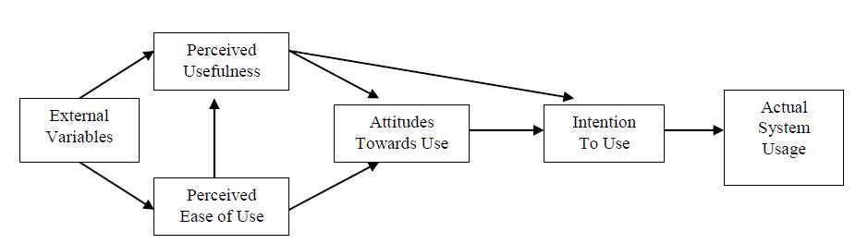
Figure 7: Technology Acceptance Model (TAM).
Source: Davis (1989).

The diagram of TAM shown in above Figure 7 exposed the attention on the both perceived ease of use and perceived usefulness as vital factors for the adoption of Information System (IS), in this study the purpose and objective focusing on the adoption of mobile applications.

2.4 Moderator Variable (MV)

2.4.1 Cost of the Mobile Apps
According to Abrahão, Moriguchi & Andrade (2016), found that perceived cost not significantly revealed in the adoption of mobile applications. On the other hand, the statement denying by the previous researches (Hanafizadeh et al., 2014; Leong, Ooi & Chong et al., 2013; Wu & Yen 2014; Yadav, Sharma & Tarhini, 2016) that concluded the perceived cost has a significant positive relationship to influence the consumers on the adoption of M-Commerce.

Another research conducted by Chen, Hsu, & Wu (2012) on evaluating the smartphone apps as a main promoting tools for hotels or resorts, it revealed the mobile phone users only spending some amount to access the Internet as well as for any other purchases products and service when, there is no any charges for download the apps which it indirectly boosts more potential consumers to reserve any booking thru mobile apps.

In this study, the cost of the mobile application also included as a moderator variable to explore its preferred to influence on the independent and dependent variables since, there is lack of study on the status of the mobile application payment like applications in the Android are free for those users using this operating system while, the users of iOS need to pay the charge of most applications (Lee, 2015).

2.5 Fundamental Theories: Technology Acceptance Model
The Technology Acceptance Model (TAM) is a model that developed by Davis (1989) to evaluate influences on the actual system usage by involved of the four internal factors; perceived usefulness, perceived ease of use, attitude towards use, and intention to use from the original TAM model. Past studies (Aboelmaged & Gebba, 2013; Wei et al., 2009; Schmitz et al., 2016; Boonsiritomachai & Pitchayadejanant, 2017; Chitungo & Munongo, 2013; Fraqih & Jaradat, 2015; Islam, Low & Hasan, 2013; Jeong & Yoon, 2013) have engaged with the TAM to evaluate the adoption of smartphone by users for mobile services such as shopping, gaming, navigation, and chatting.

According to the previous studies (Carter & Yeo, 2017; Muñoz-Leiva et al., 2017; Sharma & Govindaluri, 2014; Kang et al., 2015; Lai, 2017; Lee, 2015; Magotra, Sharma & Sharma, 2018; Pindeh et al., 2016; Roy, 2017) have covered that TAM is one of the powerful, dominant, and strongest model to be used in several of Information Technology (IT) perspective as predictive model. In addition, the previous researches on the adoption of M-Commerce have been derived from the TAM model as it is one of common model for adoption of technology which interconnected to M-Commerce or E-Commerce (Wei et al., 2009; Boonsiritomachai & Pitchayadejanant, 2017; Chitungo & Munongo, 2013; Fraqih & Jaradat, 2015; Gitau & Nzuki, 2014; Kim & Hahn, 2012; Lee, 2015). The major internal factors in TAM are perceived ease of use and perceived usefulness which used for presumption of the attitudes towards using of any technology stated by Ooi & Tan (2016). This was supported by Yang (2013) and Yoon (2016), the both internal factors are the key of TAM to predict the behavior and attitudes of user towards mobile applications adoption.

As the purpose of this study, TAM will be included as a supporting theory to discover the level of mobile application adoption in East Malaysia by Generation Y smartphone users as literature (Hanafizadeh et al., 2014; Lee, 2015; Price, 2017; Wei et al., 2009) have indicated both perceived ease of use and perceived usefulness will influence on the adoption of mobile applications.

2.6 Gaps in the Literature
Based on the literature that has been discussed the relevant factors above, it found the previous researchers (Hanafizadeh et al., 2014; Price, 2017; Wu & Yen 2014) has conducted studies on the behavior of mobile applications which specifically aim on the various type of mobile applications such as gaming, travel, finance, education, and social media rather than adoption of common mobile app. On the other hand, there are few studies has been covered on the similar topic but the focused area of past researchers (Lee, 2015; Tee, 2018) at different location such as West Malaysia and the factors that has been used to discover the relationship is less significant to reuse in the current research of the focused phenomenon without sufficient support from previous studies. However, there are lack of previous studies on the adoption of mobile application specifically for the Generation Y (Gen Y) in East Malaysia. Therefore, there is a study gap that has driven the researcher to close the gap by constructing the study in this specific field of research.

2.7 Conceptual Framework
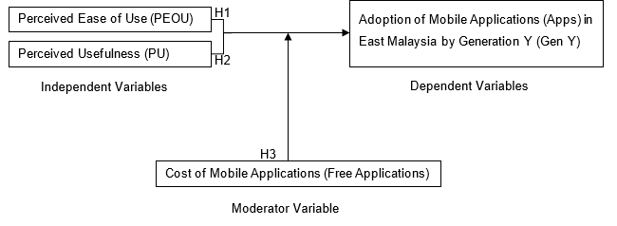
Figure 8: The Conceptual Framework

The conceptual framework in above Figure 8, has been formed to specify the relationship between the factors (Independent variables) such as perceived ease of use (PEOU) and perceived usefulness (PU) with adoption of mobile applications in East Malaysia by Generation Y.

2.8 Hypotheses
H1: The Perceived Ease of Use (PEOU) has a significant positive relationship with adoption of mobile applications in East Malaysia by Generation Y.

H2: The Perceived Usefulness (PU) has a significant positive relationship with adoption of mobile applications in East Malaysia by Generation Y.

H3: The cost of mobile apps especially free app has moderating influences on the adoption of mobile applications in East Malaysia by Generation Y.

2.9 Conclusion
This chapter emphasized on the reviewing the literature in the study. There are few factors discussed which are perceived usefulness, perceived enjoyment, perceived ease of use and perceived trust, risk, or security that influencing the adoption of mobile applications. The Technology Acceptance Model (TAM) is a robust model to be use in this study as fundamental theory. In a nutshell, the perceived ease of use and perceived usefulness are involved as independent variable while, the cost of the mobile applications assigned as moderating variable in this study which was decided by the researcher.

Chapter 3: Research Methodology

3.0 Overview
In this chapter, the overview of research design and research methodology will be providing clearly on which have been performed for this research. To determine whether there are any significant relationships between variables (independent variables, moderating variable and dependent variable) under the study which tested by applying the correlation study. Also, the section is moved on with sampling technique and analysis methodology to be used in the study in order to make sure the relevance and appropriateness of the proposed survey and type of analysis tools. Moreover, the study has adopted non-probability sampling and it is also known as convenience sampling techniques which used by the researcher during distribution the proposed questionnaire. While, the unit of analysis for the study is an individual which is Gen Y in East Malaysia. Last but not least, the factor analysis and reliability test as well as other tests will be involved, so the expected finding for the study can be accomplished.

3.1 Research Design
According to Kothari (2013) the research design known as a key approach that stated the root causes and several information which interrelated to the type of research problem and it is also vital to specifying the approached plan that can used for collecting and examining the data. This study is relayed based on a quantitative approach to ascertaining the correlation design relationship between 2 independent variables which are perceived ease of use and perceived usefulness and a moderating variable with adoption of mobile applications by Generation Y in East Malaysia. The overview of research design structure is shown in following Figure 9. The structure of research design clearly shows how important of every element that provides some critical selections which need to give attention during directing a research analysis stated by Sekaran & Bougie (2016).

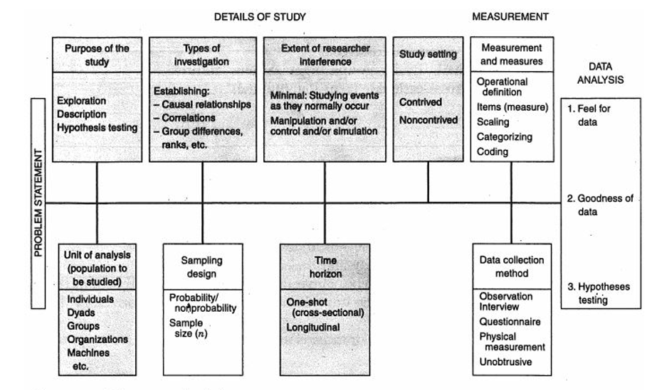
Figure 9: Structure of Research Design.
Source: Sekaran & Bougie (2016).

Besides, there are 2 exclusive type of research design; exploratory and descriptive studies that targets to deliver a well understanding on the essential objectives of the research executed (Zikmund, Babin & Carr et al., 2013). The exploratory study is commenced when there are very less researches presented on the same field that have been solved, therefore, the broad opening of the field will be started to work to accomplish in order to understand the root causes of the problems and advance the knowledge with the specific phenomenon in the surroundings indicated by Sekaran & Bougie (2016). It also supported by Saunders, Lewis & Thornhill (2016), that those researchers who wanted to discover the untouched spaces will consent the exploratory research. In contrast, Sekaran & Bougie (2016) mentioned that descriptive study is used to determine the features of the independent variables in a context; it is effective to establish the significant characteristics of the interested phenomenon from different perspectives such as individual, organization or others. It also supported by Zikmund et al. (2013) that descriptive study is highlighting the additional discovering information on a specific area which help to close the research gaps and strengthening the knowledge on the specific research problem.

Additionally, there are another 2 types of investigation; casual and correlation investigation that can be performed in a research. The causal investigation is to evaluate the cause-effect of the relationship between the factors and study the independent variables on how it affects the changes in the dependent variable said by Veal (2017). Kothari (2013) stated it has deliberated comparatively vital for experimental researches, when the scholars more interest in causal effect among variables. The researchers will be more challenged to completely isolate all the factors used in the research that influence the casual relationship which indirectly affect the accuracy of the result of casual research revealed by Zikmund et al. (2013). On the other hand, Kothari (2013) stated that correlation investigation study has the join variation of independent variables for ascertaining the extent of correlation between independent variables and concentrations on ascertaining whether the proposed variables are interrelated. It also affirmed by Quinlan (2015) that correlation investigation not support to study any relationship related to causal, and it useful for those researchers conducting correlation analysis to determine whether there is a linear relationship between predicted independent variables and dependent variables of the research. There are 3 end-status of correlation analysis; positive correlation, negative correlation and no correlation in the research specified by Veal (2017). Furthermore, Sekaran & Bougie (2016) has indicated the coefficient of correlation is varies from -1 to +1 represents the relation of variables respectively from weak to strong correlation. The researchers able to make decision on future predictions based on the outcomes by gaining the knowledge of relationship that influence the variables which can be add as advantages for future studies in both academic and industry declared by Cooper & Schindler (2014).

Therefore, the core purpose of this research is to investigate the relationship of Gen Y adoption on the mobile applications in East Malaysia by descriptive study and correlation investigation used to ascertain the correlation relationship between 2 independent variables - perceived ease of use and perceived usefulness towards the focused phenomenon. Also, the correlation investigation support to study whether there is any correlation relationship between moderate variable (cost of mobile application) towards the adoption of mobile applications by Gen Y in East Malaysia. On top, questionnaire has been chosen as main data collection method of this research since the quantitative approach suitable based on the past researches’ outcomes hence, to verify the relationship between factors with adoption of mobile applications by Generation Y especially focus on East Malaysia since few researchers have presented the similar research at different location (Lee, 2011; Tee, 2018).

The setting of study has 2 categories which used for different purpose of research; contrived and non-contrived settings stated by Veal (2017). The contrived setting is regularly used in investigation of causal that to determine the causal-effect relationship between the factors in the research remarked by Cooper & Schindler (2014). On the other hand, Bryman & Bell (2015) found the non-contrived setting refers to nature environment that researcher is allows to conduct study or continue normal routine without any interference of researcher. Normally, the correlation studies have 2 forms such as field studies used non-contrived setting in the research while, field experiment studies will complete the research by establishing contrived setting for investigate the cause-effect relationship (Sekaran & Bougie, 2016). In this research, the most concentrations on the areas that proposed phenomenon which maximumly appeared to collect the data in a natural environment which does not manipulated the environment, compared to non-natural environment like an artificial lab environment for researcher to manipulate the data generally. Moreover, the correlation relationship is the focused of this study for examining instead of cause-effect relationship therefore, this study adopted with non-contrived setting.

The interference of research will lead by researcher on the flow of task that have important influence on discovering the category of investigation that suitable for the research, it normally happens in casual investigation since there are level of interferences are desired to be completed by the scholars declared by Bryman & Bell (2015). According to Sekaran & Bougie (2016) specified the researchers still can interfere and continue add study about the manipulation effect which can impact the research’s dependent variables and it can lead to interruption of normal flow even changing some variables. Alternatively, Zikmund et al. (2013) stated the correlation investigation needs a minimal interference from the study’s researcher. In this study, the correlation relationship is focused on the adoption of mobile applications as the purpose of the study by distributing the questionnaire to the potential respondents to answer in the proposed phenomenon naturally, therefore there will be minimum interruption. In this research, the interference is minimal by researcher thus, the result will be accurate from correlation investigation.

3.2 Unit of Analysis & Time Horizon
In view of Sekaran & Bougie (2016), the population will indicate group of individual or events that plan to study and investigate by researcher while, the unit of analysis is a main unit of researcher to use in research analysis. In this research, the individual is the unit of analysis as the investigation is focus on Generation Y in East Malaysia. The most important enlightenment behind of selecting the people as the unit of analysis is on the surroundings that led the study depends on the independent variables which influencing the adoption of mobile applications therefore, the individuals are vital focus of this research.

On top of that, the data gathered from an individual respondent once only by distributed the questionnaire and it is unrepeatable tested on the same respondent as this research is reflected with cross sectional study. In another word, the cross-sectional study is used to collect the data only at a point in time stated by Sekaran & Bougie (2016).

3.3 Sampling Design
According to Bhagvandas (2014), sampling design can be defining the clear method to procure samples from specified population. It is a complete method to select matters before any survey or information acquired (Kothari & Garg, 2014). Also, it is vital to know that sample designing progression necessitates in choosing some sampling units evidently because it is tightly unified and applicable to all area of research which interfere the specified population (Bhagvandas, 2014). Therefore, the researcher of this study focused on the small part of population instead of entire population in East Malaysia.

To study the adoption of mobile applications by the population in East Malaysia specifically focused on the Generation Y. Despite the fact, East Malaysia is less developed than the West Malaysia, the researcher discovering to find out whether the Gen Y in East Malaysia have the same behaviour on the adoption of mobile applications as West Malaysia that has been conducted by previous researchers (Lee, 2011; Tee, 2018).

3.3.1 Sampling Plan
According to Sekaran & Bougie (2016), sampling plan is used to decide how to get the sample and also to draw out a required sample of target population to carry out the research for correlation design studies that adopted to ascertain the existing of relationships. Taking into consideration of information given by Malaysia Digest (2016) before looking forward on the sampling, that around 67% of population are actively using Internet thru mobile connections which is almost more than half of entire Malaysia population (30.54 million) in 2016. The youngsters in Malaysia are massively growing by purchasing more Internet connections to use for several purposes published by The Star (2017). East Malaysia is less developed areas compared to West Malaysia however, East Malaysia has a huge population around 6.74 million as of December 2017 declared by Department of Statistic Malaysia (2018).

As the population of East Malaysia is slightly massive, the distribution of survey to every individual within the focused phenomenon is impossible therefore, the sampling is chosen. The process of gathering data will be easier and efficiency thru sampling stated by Sekaran & Bougie (2016). There are two types of sampling methods which usually used by the researchers; probability sampling and non-probability sampling specified by Kothari (2013). Sekaran & Bougie (2016) declared that probability sampling is also known as simple random sampling that refers to an individual or a person in the population have an equal probability to be selected while, non-probability sampling is known as convenience sampling which some of parts will be selected intentionally by the researcher.

As recommended by Kothari (2013), the simple random sampling is considered as an effective technique that pay attention on every single individual in the population has an equal chance to be chosen in the study. On the other hand, Alkassim, Etikan & Musa (2016) identified the convenience sampling is usually observed as ‘accidental samples’ which the individuals are chosen simply that close to the researcher to perform the data collection.

In this study, non-probability sampling will be involved as the potential respondents are the existing users that have knowledge about mobile apps by using snowball sampling method (Johnson, 2014). Also, it is convenient to distribute the questionnaires to the potential respondents (friends, friends of friends and relatives) via online (Email, Facebook, WhatsApp, Twitter).

3.3.2 Sample Size
The sample size defines as one of the components in the research design that researchers need to deliberate as plan of the study to compute the needed sample size accurately for conduct the research (Burmeister & Aitken, 2012). In addition, Krejcie & Morgan (1970) also presented a table as shown in following Figure 10 that helps to determine the sample size as a sign for researcher on how many sample sizes is needed to conduct a research which statistically significant and to strengthen the validity of the study.

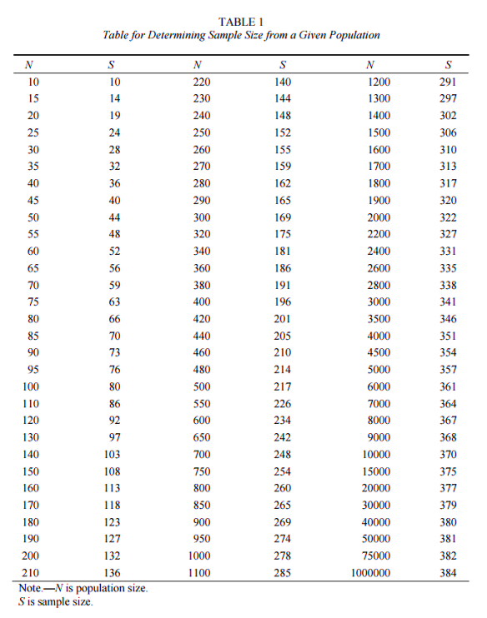
Figure 10: A table for determining the sample size for a given population.
Source: Krejcie & Morgan (1970).

For the purpose of this study, the population size of focused phenomenon is more than 1 million therefore, according to Krejcie & Morgan (1970) table in the Figure 10 above, the sample size should be 384. The aim of this research is Gen Y individuals that using mobile internet and currently residing in East Malaysia and around 400 questionnaires distributed thru online (Email, Facebook, WhatsApp, Twitter) however, a total of 384 respondents are assessed to take as consideration in this study.

3.4 Questionnaire Design
According to Rowley (2014), the questionnaire design is an approach of designing the questions format in the survey that used to gather data from the focused phenomenon, which helps to decrease the huge amount of measurement errors in a questionnaire and it generally used in conducting a quantitative study. In this study, the questionnaire is designed into 4 segments: Demographics questions are listed in Section A, the independent variables of mobile application questions are itemised in Section B, Section C covered the dependent variable of consumer behaviour in using technology questions and the moderate variable of consumer intention on cost of mobile application questions are counted in Section D. The questions in Section A, B, C and D were adapted from past researches (Lee, 2015; Muñoz-Leiva et al., 2017; Tee, 2018; Yang, 2013), measured by employing the Five-Point Likert Scale (“1: Strongly Disagree” to “5: Strongly Agree”) acknowledged by Olsen (1993). The Five-Point Likert Scale method is easy to adopt in the research as it is not taking more time to create, and the outcome is more consistent when the potential respondents have to response every statement involved in the survey stated by Kothari (2013). The following Table 2 provides a clear illustration the summary of questionnaire design.

Table 2: Summary of the Questionnaire Design
Section | Questions/ Items | No. of Questions | Reference
A | Demographic | 4 | Tee (2018)
B | Perceived ease of use | 4 | Lee (2015); Muñoz-Leiva et al. (2017); Tee (2018)
 | Perceived usefulness | 4 | Lee (2015); Muñoz-Leiva et al. (2017); Tee (2018)
C | Adoption of mobile applications | 5 | Lee (2015); Tee (2018)
D | Cost of mobile applications | 2 | Tee (2018); Yang (2013)

3.5 Pilot Test
According to Kothari (2013), the pilot test is one of the important tests should be conducted in the research to recognise the items of survey in term of weaknesses and techniques and the purpose of doing pilot test is to make sure that the questionnaire considered to be relevant and appropriate for the researcher to conduct the study. Also, Teijlingen & Hundley (2002) declared that pilot test is a vital part to prepare a good research design as it helps to give awareness to researcher on the main aspects of the project that might not meet the objectives or protocols in advance in order to make sure questionnaire to be consider and appropriate for the study.

Therefore, the pilot testing will be included in this study to explore the appropriateness in term of comprehensibility and viability of the questionnaire used to conduct the survey and it will help the researcher to find out whether the respondents can understand the questions clearly which indirectly helps to reduce the chances of misunderstanding of questions happen during distribution of the questionnaire. Kothari (2013) affirmed that questionnaire must be pragmatically organized to collect the appropriate information effectively which can support to accomplish the testing thus, the researcher of this study adapted the questions from previous studies (Lee, 2015; Muñoz-Leiva et al., 2017; Tee, 2018; Yang, 2013) to prepare the questionnaire as well reduce the errors during pilot testing. Approximately 44 Gen Y mobile phone users from East Malaysia will participate in this pilot testing as respondents to discover whether the questions were well-understood thus, increase the strengthening of viability of construct in the research. The researcher will use Statistical Package for Social Science (SPSS) as a tool to analyses the validity and reliability of the collected data from the pilot test. However, a new pilot test will be executed until achieve the desired results if, the designed questionnaire is not appropriate to consider in the research when the outcomes is not positive as required.

3.5.1 Factor Analysis
In the research, the first test that usually will perform under pilot test is factor analysis to reduce the complication in the set of data for make sure the data is appropriate as relevant for the study and it consist of three different analyses; KMO Bartlett’s Test of Sphericity, Factor Loading, and Eigenvalues (Zikmund et al., 2013).
KMO Bartlett’s Test of Sphericity
The main purpose behind of the KMO Bartlett’s Test is to determine whether the factors that used in study is consider to be an educate sample and the value of factor in KMO test should be more than 0.6 (>0.6) which will clearly indicates that is a correct factor while, the most important is the independent variables (IVs) and dependent variable (DV) must run separately and achieve the value of factors more than 0.6 (e.g. IV > 0.6 and DV > 0.6) in order to determine the factors used in the study are correct (Bryman & Bell, 2015). Also, Tabachnick & Fidell (2013) specified the value of KMO should not be less than 0.6 as it is not satisfactory for further any examination however, the factors that not meet the criteria should be ejected from the further investigation.

Factor Loading
Next, the factor loading is helps to reduce or change inappropriate questions for the research and the test for IVs and DV must split which cannot run together (Cooper & Schindler, 2014). All the questions must run with one factor loading like questions in IVs must run with one factor loading cannot mixed with DV questions or in SPSS software, the factor loading called as communalities (Zikmund et al., 2013). All the questions must have factor loading of more than 0.6 (Sekaran & Bougie, 2016). Assuming that during pilot test the factor loading for particular question or item is more than 0.5 however it is less than 0.6, according to Bryman & Bell (2015) the questions can be retained however, if the same scenario occurred in the preliminary analyses, the questions must be removed. In case if the factor loading for specific question is less than 0.5, the particular question must be removed and change the question without conduct any further test in pilot test (Zikmund et al., 2013).

Eigenvalues
Last but not least, the value of eigenvalues must be more than 1 in order to be valid which assists to indicate the correct IVs in the proposed research clearly however, the number of eigenvalues that is more than 1 and must equate to number of IVs in the research (Cooper & Schindler, 2014). In the case of have 3 IVs, the eigenvalues must be more than 1 and must equals to 3 in order to be valid if, one of eigenvalue is less than 1 it means one of the IV is not a correct and need to remove that particular IV (Zikmund et al., 2013). In the different case that have 3 IVs has come out 4 eigenvalues which evidently indicating might have multicollinearity in the IV, in this kind of situation, the correlation matrix needs to run again to check which of the IVs intercorrelated then remove the questions as stated by Bryman & Bell (2015).

3.5.2 Reliability Test
There are many listed structures or untiring quality exits, all of these can affect the instruments quality and also the information collected generally, therefore, this reliability test is conducted to measure the internal consistency and stability of the data gathered from the proposed study mentioned by Sekaran & Bougie (2016). In reliability test, the IVs and DV must test differently in order to get an accurate Cronbach’s Alpha (Cooper & Schindler, 2014). In this research, the Cronbach’s Alpha will be employed to compute and measure the reliability of collected data. Hair, Black & Babin et al. (2014) acknowledged the acceptable value of Cronbach’s Alpha is between 0.70 to 0.95 which indicating the highest value of Cronbach’s Alpha, will influence the measurable outcomes to be more solid and according to Kumar (2014), the Cronbach’s Alpha is a reliability coefficient and when the value of Cronbach’s Alpha nearer to 1, that data of the research have a highest internal consistency which indicates how the items are interconnected to another positively. Assuming that during pilot test the Cronbach’s Alpha value for specific question is less than 0.7, the particular questions should be change or remove in order to avoid errors in further examinations (Tavakol & Dennick, 2011).

3.5.3 Correlation Matrix
According to Hair et al., (2014), the correlation matrix is to measure whether a construct correlates within other measures (indicators) of the same construct positively. Sekaran & Bougie (2016) stated that both IVs and DV cannot be test together which will affect the outcomes of IVs and DV as in this research, all the proposed IVs and all the questions under IVs cannot correlated since the IVs has a separated construct while, all the questions in the DV construct must correlated with the DV that to determine the adoption of mobile applications in East Malaysia by Gen Y.

The Pearson Correlation Coefficient analysis is conducted on the variables in the research, to ascertain the strength and stabilize the direction of the linear relationship between independent variables and dependent variable (Kothari, 2013). As indicated by Hair et al. (2014), the range of r value should be from -1.00 to 1.00; r = 0 it means there is no significant relationship, however, r = 1 it clearly indicates there is a strong correlation while, r = -1 also indicates there is a strong negative correlation. Every level of correlation value has different interpretations which are; less than 0.30 (negligible correlation); 0.30 to 0.50 (low correlation); 0.50 to 0.70 (moderate correlation); 0.70 to 0.90 (high correlation) and 0.90 to 1.00 (very high correlation) declared by Sekaran & Bougie (2016). However, the multicollinearity problem will be resulted, when there is a strong high correlation value between the independent variables (Kothari, 2013; Witte & Witte, 2015), therefore, the Pearson Correlation Coefficient is included in this research to measure the correlates of a construct within the same construct of other measures which is indicators positively.

3.6 Measurements
This is one of an essential part of the study to measure the conceptual framework variables as it is the main aspects of the research design for the researchers to be able to perform hypotheses testing and determine the answer to complicated matters by determining the variables in the research (Sekaran & Bougie, 2016). According to Health Science Library (2018), the measurement tools also can be utilised to collect the information on the multiple factors which running from physical working to psychosocial prosperity, and there are few sorts of standard measurement tools available; reviews, casual perceptions, scales, and interviews.

In this research, the tests, measurements and data analysis methods are included by following the requirements of scientific research that consists of Preliminary Test, Hypotheses Test as well as supporting with remaining tests and confirmatory testing (Sekaran & Bougie, 2016). Also, to be included is the internal and external validity tests in this research as it is vital to validate the precision of this research (Kumar, Aksoy & Donkers et al., 2010). It was supported by Sekaran & Bougie (2016), that validity test is to measure the construction of research and to measure with the correct concept model.

3.6.1 Preliminary Analyses
The preliminary tests such as factor analysis and reliability test, directed in the previous test (pilot test), to validate the collected data are appropriate, applicable and adequately reliable for ensuing hypotheses testing (Fidell & Tabachnick, 2013). Under preliminary analyses has 2 different tests; Factor analysis included with KMO Bartlett’s Test of Sphericity, Factor Loading, and Eigenvalues and Reliability test to measure the collected data to be valid and appropriate for the study (Kothari, 2013).

Factor Analysis
According to previous scholars (Hair et al., 2014; Sekaran & Bougie, 2016; Zikmund et al., 2013), the factor analysis is to decide whether the factors used in the study is the correct factor which fit for the study and it also helps to remove one of the factor if there are many factors in the study plus, it can also see whether to change or remove the questions in the study therefore, the factor analysis is adopt in the research for measure the factor appropriateness and relevance as well as factor reductions.

KMO Bartlett’s Test of Sphericity (KMO)
The following guideline of Measure of Sampling Adequacy (MSA) in Figure 11 below is presented by Beavers, Lounsbury & Richards et al. (2013), to measure the MSA value of collected data consider to be appropriate for the study and the guideline of MSA is adopted in this study. The ranging of MSA value is from 0 to 1 and each of level has different interpretations (Sekaran & Bougie, 2016). The most important is the rule of thumb for KMO is should be more than 0.6 stated by Zikmund et al. (2013) as indicates the data is more appropriate and relevant for the further analysis.

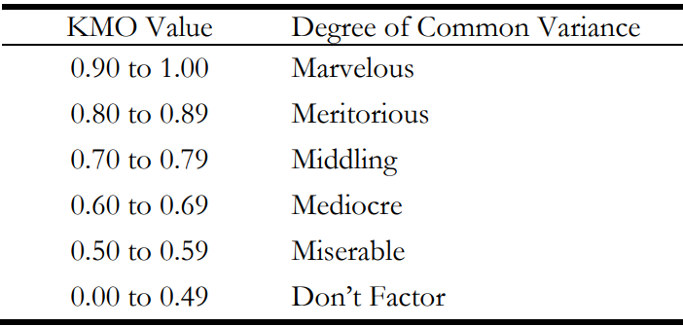
Figure 11: Guidelines for the Kaiser-Meyer-Olin (KMO) Test value.
Source: Beavers et al. (2013).
Assuming that one of the questions has the KMO value is less than 0.6, according to Fidell & Tabachnick (2013) that particular question is disqualify for further examination therefore, that particular question should be remove in the preliminary test. In this study, the guidelines of value from analyses are strictly followed by the researcher to make sure the accurateness of data.

Factor Loading
One of test in the factor analysis is factor loading to determine the collected data is a correct and fit for the study by performing the test and get the value of loading for check the level of data and the most important is the rule of thumb for loading is should be more than 0.6 according to Bryman & Bell (2015), which the value of data should meet this rule of thumb else, that particular items or factors must be removed to perform further analyses declared by Zikmund et al. (2013). There are differences in pilot test and preliminary test which is one of the questions is more than 0.5 and less than 0.6, in the preliminary test the specific question must be removed however, that specific question still can be retained (Sekaran & Bougie, 2016). Although, the value of question is less than 0.5, the question still needs to remove from the proposed study in order to make the outcomes of the research more appropriate and effective mentioned by Bryman & Bell (2015).

Eigenvalues
The last test as usual conduct under preliminary test is eigenvalues, to measure the validity of the constructs to make sure the IVs are strong and to indicate that is correct IVs for the research (Hair et al., 2014). Assuming that, if there is 5 IVs and the result should come out 5 eigenvalues with value of more than 1 and equal to 5 as per eigenvalues rule of thumb that the value of eigenvalues must be more than 1 and equate to number of IVs in the study however, if the eigenvalues does not meet the rule of thumb, the IVs should be removed from the study which stated by Cooper & Schindler (2014).

Reliability Test
In light view of statement stated by Kumar et al. (2010), the factor analysis and reliability test are known as the fundamental testing which should be run before proceeding with the execution of hypotheses to make sure whether the collected information or data is appropriate for further examination in the study. According to Sekaran & Bougie (2016), the technique of examining the vitality and reliability of the collected data from the focused phenomenon of the study as well as to determine the internal consistency of the information collected in the social studies is referred as reliability test. Moreover, reliability test is the initial stage after gathering the concern main information as it will assist in studying on whether the gathered information is reliable and proficient on using more for producing linked conclusions which indicated by Crowder & Lane (2014). Therefore, the current study needs to perform the reliability test to confirm the reliability of the gathered information because if the gathered answers are highly opposing, it means that participants have unsuccessful understandings on the statement or did not fill up the survey vigilantly. Besides, the other primary cause of following the reliability test is to quantify the steadiness in the concerned matter built on the gathered information. In addition, the Cronbach’s Alpha value used to measure reliability of the stated variables in the study, to assess the internal consistency as well as steadiness of the measurements and the possible measurement error in which Cronbach's Alpha is utilised to assess the reliability of items or factors mentioned by Peterson and Kim (2013). As the rule of thumb for reliability test is Cronbach’s Alpha value should be from 0.70 and 0.90 where the reliability of each scale shows a good reliability and within a generally accepted range (Hair et al., 2014).

3.6.2 Descriptive Information
In the research, the descriptive information is referred to study whether the information is appropriate and important to the focused topic which the information gathered from the focused phenomenon; demographics (Zikmund et al., 2014). The analysis of demographics supports the researcher to analysing the required items or questions by gathering the data from the respondents in this research such as gender used to analyse the ratio of male and female that participated in the survey and age is one of the demographic profile included in the current study as the study is focusing on Gen Y and Gen Y according to Lee (2015) is aged from 20 to 34 therefore, gender and age is required to be included in the demographic profile to ensure that a correct population of the respondents data is collected. As mentioned by Hair et al. (2014), the demographic analysis can be directed through the SPSS software and the collected data from a total of 44 respondents are gathered anonymously in the study and the data would not be revealed in public in order to keep up with the ethics. Moreover, the methods of question design such as multiple-choice question and Five Point Likert Scale question has been used in this study while designing the important statement to be covered the main objectives of the research.

3.6.3 Hypothesis Testing
The technique to be followed for investigating the relationship between the proposed independent variables and dependent variable is referred as hypothesis testing and it also helps in examining the strength of relationship between the proposed variables therefore, the researcher of this study adopted the hypothesis test to make sure the outcomes of variable is considered to be significant (Crowder & Lane, 2014). In addition, the SPSS software will be fully utilised in this research to analyse the gathered data from the survey and the features of SPSS software such as design and function is user-friendly which is able to perform many statistical techniques or analyses in order to accomplish the proposed objectives of research (Sekaran & Bougie, 2016). Furthermore, the multiple regression analysis, beta coefficient and ANOVA tests are involved to test the hypothesis in the study.

Multiple Regression
The multiple regression test is carried out from a simple regression and it is also able to estimate the value of focused dependent variable based on the value of proposed independent variables in the research (Kumar, 2014; Veal, 2017). According to Witte & Witte (2015), the multiple regression has many predictor variables in the same equation however, the simple regression will end up with a single predictor variable. Zikmund et al. (2013) has specified the symbol of estimating the strength and the direction of linear association between interval and ratio variables is referred as Path Coefficient (β). The ranging of multiple regression is from -1 to +1 means negative and positive sign of Path Coefficient value that shows the direction of linear association while, the most important is the value of Path Coefficient should be higher which indicates the stronger the relationship is in the study (Saunders et al., 2016). The significance of p-value less than 0.05 (p<0.5), it considered there is a significant relationship between independent variables and dependent variable in the study as stated by Sekaran & Bougie (2016). Besides that, according to Saunders et al. (2016) the Coefficient of Determinant (R²) is the determinant of the information to check the goodness of fit of the proposed regression model and it is able to show the percentage of variances behaviour in the dependent variable which can be explained by the variation in the independent variables. When the value of R² near to 1, the variation of the dependent variable can be explained by the proposed regression model which means the framework is fit, however, if the R² value is near to 0, according to Sekaran & Bougie (2016) the framework considered not fit which entire variation in the data cannot be explained by the proposed regression model. The researcher will be reviewing the results or finding once completed the tests against the objectives of research and hypotheses to discover the existence and level of influence between the independent variables and dependent variable in the research.

Hierarchical Analysis
The hierarchical analysis is a step by step to show the relationship between manipulated variables and fixed constant variable (Garson, 2013). According to Gelman & Hill (2017) has defined the hierarchical analysis of the variables naturally enhances the understanding of the researcher on the focused phenomenon of the study since the researcher need considerate inputs on indicating the right flow of IVs and MV entries, therefore, the hierarchical analysis will be employed in this research to study the relationship between moderating variable (MV) and dependent variable (DV). The rule of thumb for hierarchical analysis is the value of R-squared (R²) should be always between 0% and 100%, the R-squared value should be increase when moving from one model to another model during the analysis, it indicates there is a significant relationship among the variables as declared by Witte & Witte (2015). Assuming that one of the models out of 3 models, the R-squared value is less than previous model’s R-squared value, according to Tabachnick & Fidell (2013) that particular variable involved in that model should be removed which indicating the model is not fit for the study. Moreover, this hierarchical analysis test used to evaluate the effects of a moderating variable (MV) in the SPSS software which specified and supported by previous studies (Lee, 2015; Makhubela & Debusho, 2013; Prado, Korelo & Silva, 2014; Tee, 2018).

Beta Coefficient
The beta coefficient is known as standardized coefficient or beta weight to determine which of the construct within the research has the highest same influences and same power on the phenomenon under the study which is the proposed DV of the study stated by Bryman & Bell (2015). Zikmund et al. (2013) acknowledged the rule of thumb for beta coefficient is the value should be nearer to 1, which indicates the highest influence of phenomenon under the study however, if the value is 0, it clearly shows no significant influence of the DV in the research. The SPSS software has several techniques which will help to perform the beta coefficient and provide the outputs with indication that the standardized coefficient labelled as ‘Beta’ and unstandardized coefficient labelled as ‘B’ (Saunders et al., 2016).

ANOVA
Instead of Multivariate Analysis of Variance (MANOVA), Analysis of Variance (ANOVA) is adopted as the hypotheses testing in this research. The variances between the mean of more than two groups on a single dependent variable is tested by ANOVA unlike MANOVA whereby variances between mean among the group across numerous dependent variables verified concurrently as stated by Sekaran & Bougie (2016). The simple regression will be adopted in this study as there is only one item in the dependent variable which is the willingness to download the mobile application. As stated by Bryman & Bell (2015), the value of F in ANOVA test will help to determine whether there is a significant different between more than two groups on a single dependent variable and it also decides the P value which is the probability of a result that actually required by the researcher to conclude whether the null hypothesis is true or false in order to reject or accept the null hypothesis. Assuming that if the p-value of the specific hypothesis is less than 0.05, it shows a very strong evidence which against the null hypothesis, so the null hypothesis will be rejected however, if the P-value is more than 0.05, according to Witte & Witte (2015) the researcher should reject that particular null hypothesis since evidence against the null hypothesis is extremely weak.

3.7 Ethical Consideration
Ethics is referred as a process, manner or procedure for defining how to act and for assessing the complex of matters and complications mentioned by Resnik (2015). According to Sekaran & Bougie (2016), it is a vital to be straightforward and truthful when conducting a research, therefore, the permission letter to perform the survey will be obtained as prove to be ethical. A briefing sheet is prepared to make the participants understand the purpose of this research as well as the research topic before distributing the prepared questionnaire and also to make sure there is not asked any information from the participants which is not related to the research topic (Bryman & Bell, 2015). Moreover, the researcher should do the survey under the anonymity condition which need to assure the privacy of the collected data from participants’ and keep it confidentially which the collected data should not be exploited in the future without any authorisation (Eze, Tan & Yeo, 2012). The researcher should remember not to manipulate, alter, or twist the outcomes of findings which is unethical revealed by Resnik (2015), in order to make sure the accurateness and consistency of the findings. Since the questionnaire were used in this research were adapted from previous researchers (Lee, 2015; Tee, 2018), it supported to increase both internal and external validity is also satisfied for ethically agreed by Eze et al. (2012). Besides that, the researcher included the secondary data in the literature review are from authentic sources such as books, journals and many more and the Harvard Referencing Method is taken into consideration by the researcher to reference those sources properly in the study in order to make sure the entire data is not plagiarised (Kothari, 2013).

3.8 Conclusion
In summary, this chapter highlights the adopted research methods on this study for go through the proposed objectives of research which had discoursed in Chapter 1. A standalone online questionnaire that prepared by the researcher of the study will be circulated within East Malaysia via online (Email, Facebook, WhatsApp, Twitter). Before directing a full scale of the survey for the study, a pilot test will be executed to make sure the items in the questionnaire under the study are reliable, applicable and comprehensible. There are quite few of data analysis measurements will be engaged during performing the preliminary test and hypotheses testing in order to ensuring the entire proposed items in the questionnaire are valid and appropriate for the study.

Chapter 4: Research Findings

4.0 Overview
In this chapter, all the analyses, tests and tabulation of the data will be discoursed. Additionally, the SPSS software used to analysed the result in term of scientific research standards. As mentioned earlier in the Chapter 3, a pilot test will be directed before proceeding to collect the full data in order to ensure the survey of this research is reliable and appropriate. Also, the hypotheses will be tested in this chapter to evaluate the existence and level of relationships between the factors of this research and to determine whether the objectives of research were significantly achieved.

4.1 Pilot Test
In this research, the pilot test is conducted to examine the suitability of the questionnaire items as the examination pilot test will strongly help this research to check whether there are any weaknesses among the research protocols, or unsuitable methods is proposed in the research stated by Hundley & Teijlingen (2002). According to Kothari (2013), the pilot test result will give a caution to the researcher in advance if any aspect of the research might be led to failure before proceeding to conduct a collection of full data. The pilot test was directed before proceeding to a full scale of distribution (Hundley & Teijlingen, 2002).

The questionnaire of this research is designed by using Google Forms that is more convenience and sustainable to distribute the questionnaire to the respondents (Gen Y) in the East Malaysia thru online by sending a generated Uniform Resource Identifier (URL) link of the questionnaire. The data used to conduct the pilot test are from the first 44 responses and conduct the Factor Analysis, Reliability test and Correlation Matrix to ensure the results of the adapted items in the questionnaire to be appropriate, applicable and consistent for this study. The Compute Variable used in this research to group the number of question items of the same variable into 1 which can present a clear and better result to the readers of this study.

The tests of preliminary test are conducted in the pilot testing to certify the collected data are suitable, applicable and consistent to begin the collection of a full data and following with hypotheses testing (Zikmund et al., 2013). Based on the Measure of Sampling Adequacy (MSA) of factor analysis, the result should be more than 0.60 as a satisfactory to proceed further examination in the research which highlighted by Tabachnick & Fidell (2013). While, the acceptable Cronbach’s Alpha value of the reliability test is above 0.70, which indicating the outcome is solid. The following sub-sections are specifying the results of factor analysis and reliability test for the pilot test.

4.1.1 Pilot Test: Factor Analysis
The factor analysis is conducted to check whether the questionnaire’s variables or constructs are appropriate and related to the study stated by Sekaran & Bougie (2016). It is also very helpful to provide insights of any items or construct need to be removed from the following data collection to ensure the strong of validity and suitability of the items or constructs in the research (Hundley & Teijlingen, 2002).

Table 3: KMO and Bartlett’s Table
KMO and Bartlett's Test
Kaiser-Meyer-Olkin Measure of Sampling Adequacy. |  | .787
Bartlett's Test of Sphericity | Approx. Chi-Square | 767.504
 | df | 78
 | Sig. | .000

Table 4: Communalities Table
Communalities
 | Initial | Extraction
Dependent Variable | 1.000 | .792
Perceived Ease of Use | 1.000 | .894
Perceived Usefulness | 1.000 | .814
Extraction Method: Principal Component Analysis.

The value of KMO Bartlett’s test of Sphericity for 2 constructs (IVs) in the research has been presented in the Table 3. The KMO value is more than 0.7 as expected and it is acceptable significantly for further analysis. According to Hair et al. (2014), the factor loading for the research’s variable and construct should be more than 0.6, which will indicate it is accepted for further analyses in this study.

The Table 4 above provided the detailed factor loading of each item in the research. The constructs of this study had factor loading above 0.6 as expected, which is all the items in the proposed constructs are applicable and suitable for conduct further examines in this research.

Additionally, a Principal Component Analysis with Varimax Rotation test was directed in this research in order to maximize the variances of each of factors (squared loadings) although the factor loading already meets the criteria which stated by Maskey, Fei & Nguyen (2018). It also supported by Sondoh & Tanakinjal (2017) that Varimax Rotation test used in the research to minimise the number of variables that having higher loadings on the each of factors.
Table 5: Varimax Rotated Component Matrix
Rotated Component Matrixª
 | Component
 | 1 | 2 | 3
Average | .834
Average |  | .953
Average |  |  | .899
Extraction Method: Principal Component Analysis.
Rotation Method: Varimax with Kaiser Normalization.
a. Rotation converged in 3 iterations.

The results of Varimax – Kaiser Normalization rotated component matrix shown in the Table 5 above, the value of each component of the research (construct) including dependent variable and 2 independent variables are higher than 0.6. It clearly shows all the items of the constructs are appropriate, relevant and suitable for this research therefore, no any items in the constructs will be removed from the final questionnaire as all the items in the research are achieved the communalities cut off line values.

4.1.2 Pilot Test: Reliability Test
A Reliability Test was conducted after the Factor Analysis to certify the collected data for pilot test are internal consistency (Hair et al., 2014). The important of conducting this test to ensure the participant can able to understand the proposed questions in the questionnaire clearly in order to collect an appropriate data for conduct the analyses and interpretation the result which mentioned by Sekaran & Bougie (2016).

Table 6: Reliability Test
Reliability Statistics
Cronbach's Alpha | Cronbach's Alpha Based on Standardized Items | N of Items
.962 | .964 | 13

Table 7: Cronbach Alpha if Specific Items are Deleted
 | Scale Mean if Item Deleted | Scale Variance if Item Deleted | Corrected Alpha for Item | Cronbach's Alpha if Item Deleted
Dependent Variable Q1 | 44.30 | 97.329 | .809 | .959
Dependent Variable Q2 | 43.68 | 97.199 | .793 | .959
Dependent Variable Q3 | 44.18 | 96.943 | .818 | .959
Dependent Variable Q4 | 44.66 | 97.951 | .727 | .961
Dependent Variable Q5 | 44.75 | 98.238 | .616 | .965
Perceived Ease of Use Q1 | 43.68 | 97.710 | .832 | .958
Perceived Ease of Use Q2 | 43.64 | 96.981 | .858 | .958
Perceived Ease of Use Q3 | 43.93 | 97.600 | .779 | .959
Perceived Ease of Use Q4 | 43.77 | 96.924 | .869 | .957
Perceived Usefulness Q1 | 44.27 | 97.831 | .854 | .958
Perceived Usefulness Q2 | 44.43 | 97.600 | .800 | .959
Perceived Usefulness Q3 | 44.00 | 97.163 | .847 | .958
Perceived Usefulness Q4 | 44.52 | 95.883 | .824 | .958

The reliability test was conducted with consists of all the variables (dependent variable and independent variables) in the research. The Table 6 above presented the result of Reliability Test that the Cronbach Alpha is 0.96, which is above 0.80 and almost close to 1.0. According to Hair et al. (2015) have declared that Cronbach’s Alpha value between 0.60 to 0.70 are still acceptable in the research. Hence, all items in each of the constructs in the research have a high internal consistency reliability and also the result disclosed the pilot test respondents are able to understand the questionnaire items clearly including Dependent Variable Q5 (0.616). The details of reliability test if any of the specified items were deleted are listed in the Table 7 above. The Table 7 above clearly demonstrated that all the items of the constructs in the study will relatively having high internal consistencies and the internal consistency will not be affect or decrease from the current Cronbach’s Alpha value (0.96) even if any of specific item is deleted from the study.

4.1.3 Correlation Matrix
Table 8: Result of Correlation Matrix Analysis
Correlation Matrix
 | Q5.1 PEOU1 | Q5.2 PEOU2 | Q5.3 PEOU3 | Q5.4 PEOU4 | Q6.1 PU1 | Q6.2 PU2 | Q6.3 PU3 | Q6.4  PU4
Q5.1 PEOU1 | 1 | .975** | .848** | .845** | .686** | .637** | .821** | .602**
Q5.2 PEOU2 | .975** | 1 | .838** | .880** | .699** | .656** | .816** | .648**
Q5.3 PEOU3 | .848** | .838** | 1 | .878** | .668** | .505** | .818** | .480**
Q5.4 PEOU4 | .845** | .880** | .878** | 1 | .795** | .644** | .794** | .648**
Q6.1 PU1 | .686** | .699** | .668** | .795** | 1 | .791** | .719** | .786**
Q6.2 PU2 | .637** | .656** | .505** | .644** | .791** | 1 | .686** | .824**
Q6.3 PU3 | .821** | .816** | .818** | .794** | .719** | .686** | 1 | .665**
Q6.4 PU4 | .602** | .648** | .480** | .648** | .786** | .824** | .665** | 1
**. Correlation is significant at the 0.01 level (2-tailed).

The Correlation Matrix test was conducted in this pilot test with 44 respondents’ data to check the multicollinearity and correlations among the independent variables in the research stated by Hair et al., (2014). Based on the Correlation Matrix results generated in the Table 8 disclosed that value of Correlation among the independent variables are less than 1.00, even in the same row of variables. Therefore, there is no correlation between independent variables (PEOU and PU) in this research are observed.

4.1.4 Conclusion for Pilot Test
The pilot tests are conducted by selected first 44 responses to test the accurateness and significance of the collected data. Based on the Factor Analysis and Reliability Test results above showed all the items of the constructs in the questionnaire have more realistic loading values in both tests and it clearly proved that all the items of the constructs in the study were suitable and applicable for further analysis as well as to proceed collect a full scale of data.

4.2 Full Scale Data Collection
After the pilot tests completed, a collection of full-scale data has been conducted in this research with the same distribution technique and channels as executed in the pilot test. As discoursed earlier in the Chapter 3, 384 sample size was required for this study based on the number of target population in the East Malaysia stated by Krejcie & Morgan (1970). Overall 400 questionnaires were distributed to the Gen Y users in the East Malaysia who possessed owned mobile devices and downloaded many different types of mobile applications (app). The questionnaires were distributed to the target population in East Malaysia via online by using the Google Forms. The following Table 9 itemised the summary of research questionnaire response rate from the respondents as well as the number of questionnaires can be usable for further analysis.

Table 9: Summary of Research Questionnaire Response Rate
Total Questionnaire Distributed | 400 questionnaires
Total Questionnaire Received | 301 questionnaires
Total Response Rate | 75.25%
Total Questionnaire Non-usable | 35 questionnaires (missing, incomplete, spoilt)
Total Questionnaire Usable | 266 questionnaires

Based on the Table 9, the researcher only managed to collect this much of questionnaires as there are few constraints in collecting a required data such as the researcher unable to travel East Malaysia to collect more data due to time limitation and also the researcher rely on the responses from friends, friends of friends and relatives in East Malaysia since this is convenient sampling. Thus, a total of 266 usable questionnaires are deemed for further analysis in this research.

4.3 Demographic Profile of Respondents
The overview of demographic is able to broadcast the general information of the targeted population and distribution of the research. The following Table 10 disclosed the demographic profile gained from the 266 usable questionnaires received from respondents. The respondents profile specified that balance of both male (58.60%) and female (41.40%) was pretty good. Besides that, the Table 10 also confirmed that 86% of Gen Y in East Malaysia aged between 20 to 30 are prospectively use the mobile apps and 86.50% of the Gen Y in East Malaysia using the mobile apps more than 10 times a day in the mobile device. Whereas, the rest of respondents (13.50%) only using the mobile apps between 2 to 9 times a day and nobody use the mobile apps at least once a day or a few times in a week. The majority respondents from East Malaysia are frequent users of the mobile apps within a day which proven by the results in the Table 10.

Table 10: Demographic Profile Information
Demographic Categories |  | Frequency | Percent
Gender | Male | 156 | 58.60%
 | Female | 110 | 41.40%
Age | 20 - 25 | 48 | 18.00%
 | 26 - 30 | 180 | 67.70%
 | 31 - 35 | 38 | 14.30%
Frequency of Using Mobile Apps in Smartphone | More than 10 times a day | 230 | 86.50%
 | Between 2-9 times a day | 36 | 13.50%
 | At least once a day | 0 | 0.00%
 | A few times in a week | 0 | 0.00%

Table 11: Most Used Mobile Apps
Demographic Categories |  | Frequency | Percent
Most Used Mobile Apps (may choose more than 1) | Social Media | 242 | 91.00%
 | Mobile Messaging | 254 | 95.50%
 | Games | 60 | 22.60%
 | Mobile Banking/Payment Service | 168 | 63.20%
 | Mobile Shopping | 122 | 45.90%
 | Learning and Language | 74 | 27.80%
 | Others | 0 | 0.00%

The most used mobile apps by the respondents in East Malaysia has been highlighted in the Table 11 above. Based on the usable questionnaires, almost 95.50% of the Gen Y respondents are using the mobile messaging apps such as WhatsApp, WeChat, Viber, Facebook Messenger regularly, followed by 91% of respondents using social media apps such as Facebook, YouTube, Instagram, Twitter and continue with mobile banking and payment services apps (63.20%) plus mobile shopping apps (45.90%). The results exposed that majority of Gen Y respondents in East Malaysia are frequently using mobile apps for communication and social networking purpose.

4.4 Preliminary Test
In this study, the SPSS software was involved to analyse, examine and interpret result of the questionnaires data collected from East Malaysia. The Factor Analysis and Reliability Test are part of the preliminary data analysis of this study. Table 12 below provided a summary of the variables (DV, IVs and MV) involved in the research as well as used to examines the constructs in the following tests.

Table 12: Summary of the Dependent Variable (DV), Independent Variables (IVs) and Moderating Variable (MV)
Dependent Variable (DV) | Independent Variables (IV) | Moderating Variable (MV)
Adoption of Mobile Applications in East Malaysia by Generation Y. | Perceived Ease of Use (PEOU) | Cost of Mobile Apps (Free App)
 | Perceived Usefulness (PU)

4.4.1 Factor Analysis
The following both tables below displayed the result of KMO value is 0.786, which is above 0.70 and the result of varimax rotated component matrix that indicated all the items are exceeded the principle, which means 2 constructs in the study are considered as applicable and suitable. Since the result of factor analysis is acceptable, the author may now proceed to examine the reliability test whether the collected data are consistent and applicable for following hypotheses testing in the research.

Table 13: Full Scale of Data – KMO and Bartlett’s Test
KMO and Bartlett's Test
Kaiser-Meyer-Olkin Measure of Sampling Adequacy. |  | .786
Bartlett's Test of Sphericity | Approx. Chi-Square | 5265.435
 | df | 78
 | Sig. | .000

Table 14: Full Scale of Data - Varimax Rotated Component Matrix
Rotated Component Matrixª
 | Component
 | 1 | 2
PEOU2 | .970
PEOU1 | .963
PEOU4 | .945
PEOU3 | .934
PU2 |  | .920
PU1 |  | .917
PU4 |  | .913
PU3 |  | .849
Extraction Method: Principal Component Analysis.
Rotation Method: Varimax with Kaiser Normalization.
a. Rotation converged in 3 iterations.

4.4.2 Reliability Analysis
Table 15: Full Scale of Data – Reliability Test
Reliability Statistics
Cronbach's Alpha | Cronbach's Alpha Based on Standardized Items | N of Items
.962 | .963 | 13

Table 16: Full Scale of Data - Cronbach Alpha if Specific Items were Deleted
 | Scale Mean if Item Deleted | Scale Variance if Item Deleted | Cronbach Alpha for Item | Cronbach's Alpha if Item Deleted
Dependent Variable Q1 | 44.26 | 94.968 | .810 | .959
Dependent Variable Q2 | 43.64 | 94.873 | .793 | .959
Dependent Variable Q3 | 44.14 | 94.583 | .818 | .958
Dependent Variable Q4 | 44.62 | 95.603 | .726 | .961
Dependent Variable Q5 | 44.71 | 95.891 | .615 | .964
Perceived Ease of Use Q1 | 43.64 | 95.371 | .832 | .958
Perceived Ease of Use Q2 | 43.59 | 94.657 | .857 | .957
Perceived Ease of Use Q3 | 43.89 | 95.285 | .777 | .959
Perceived Ease of Use Q4 | 43.73 | 94.613 | .868 | .957
Perceived Usefulness Q1 | 44.23 | 95.455 | .855 | .958
Perceived Usefulness Q2 | 44.40 | 95.169 | .798 | .959
Perceived Usefulness Q3 | 43.96 | 94.783 | .847 | .958
Perceived Usefulness Q4 | 44.49 | 93.504 | .823 | .958

The result of Cronbach’s Alpha test of this study displayed in the Table 15 above. The result presented the value of Cronbach’s Alpha is quite same (0.962) as pilot test result. Besides that, Table 16 above provided the results of Cronbach’s Alpha value if any of the item was removed or deleted, it was clearly showed that the values were might be reduced as each of the items were correlated along with the construct. According to Hair et al. (2015) have acknowledged that Cronbach’s Alpha value between 0.60 to 0.70 are still acceptable in the research. Hence, the results are confirmed all the items in the constructs are internally consistent which are more suitable and applicable for further analysis.

4.5 Hypotheses Analysis
The researcher can continue to execute the hypotheses testing once collected all the data from online questionnaires which need to be proved as applicable, suitable and related to the research. In this section, the Pearson Correlation Coefficient, ANOVA analysis and Multiple Regression (Hierarchical Regression, Beta Coefficient, VIF/Multicollinearity) are involved to ascertain the relationships between independent variables (Perceived Ease of Use and Perceived Usefulness) and dependent variable (Adoption of Mobile Apps). Also, the Hierarchical Analysis will be included in the study to ascertain the relationship between moderating variable (Cost of Mobile Apps – Free) and dependent variable (Garson, 2013; Lee, 2015; Makhubela & Debusho, 2013; Prado et al., 2014; Tee, 2018). The following Table 17 listed the Hypotheses in the research to examine.

Table 17: List of Hypotheses in the Research
Item | Hypothesis
H1 | The Perceived Ease of Use (PEOU) has a significant positive relationship with adoption of mobile applications in East Malaysia by Generation Y.
H2 | The Perceived Ease of Use (PEOU) has a significant positive relationship with adoption of mobile applications in East Malaysia by Generation Y.
H3 | The cost of mobile apps especially free app has moderating influences on the adoption of mobile applications in East Malaysia by Generation Y.

4.5.1 Pearson Correlation Coefficient
According to Kothari (2013), the Pearson Correlation Coefficient analysis is conducted to examine the linear relationship strength and direction between dependent variable and independent variables. Based on Sekaran & Bougie (2016), the correlation (r) value range is from -1.00 to 1.00, if the value of (r) is 0, it means there is no relationship between variables.

Table 18: Result of Pearson Correlation Coefficient
Correlations
 |  | CADV | CAPEOU | CAPU
CADV | Pearson Correlation | 1 | .757** | .889**
 | Sig. (2-tailed) |  | .000 | .000
 | N |  | 266 | 266
CAPEOU | Pearson Correlation |  | 1 | .788**
 | Sig. (2-tailed) |  |  | .000
 | N |  |  | 266
CAPU | Pearson Correlation |  |  | 1
 | Sig. (2-tailed)
 | N
**. Correlation is significant at the 0.01 level (2-tailed).

The result of Pearson Correlation Analysis presented in the Table 18 above by using SPSS software. The result showed that the Pearson Correlation values of (r) between all the independent variables were not exceeded 0.90, therefore the problem of multicollinearity does not exist. Based on the results in the Table 18, Perceived Usefulness (PU) and Adoption of Mobile Apps (DV) has a very strong positive relationship (r=0.889) at value of p= 0, compared to Perceived Ease of Use with r= 0.757. Overall, the independent variables in the research have a significant relationship towards Adoption of Mobile Apps as the r value of all the independent variables are more than 0.7 at value of p is 0.

4.5.2 Multiple Linear Regressions and Hierarchical Testing
Table 19: Model Summary
Model Summary
Model | R | R Square | Adjusted R Square | Std. Error of the Estimate | Durbin-Watson
1 | .894ª | .798 | .797 | .38204
2 | .902^{b} | .814 | .812 | .36809 | 1.987
a. Predictors: (Constant), PU, PEOU
b. Predictors: (Constant), PU, PEOU, Cost of Mobile Apps (Free Apps)
c. Dependent Variable: Adoption of Mobile Apps

According to previous studies (Garson, 2013; Makhubela & Debusho, 2013; Prado et al., 2014; Tee, 2018) have specified that moderating variable can be included in the hierarchical testing to evaluate the relationship towards the focused phenomenon of this study by using SPSS software. As construed from the Table 19 above, the correlation coefficient of model 1 which included of 2 independent variables and dependent variable showed 0.894. However, the correlation coefficient of model 2 is increased (0.902) after included the moderating variable (Cost of Mobile Apps – Free Apps) together with independent variables and dependent variable.

Besides that, the R² values in Table 19 above disclosed how strength of the relationship between dependent variable, independent variables and moderating variable. The model 2 in Table 19 above represented the final value of R² that 81.4% of variance in Adoption of Mobile Apps is significantly clarified by the independent variables (PU, PEOU) and moderating variable (Cost of Mobile Apps – Free Apps). While, the remaining 18.6% are unclarified as other variables or items of the constructs that were not involved in the study.

Additionally, the value of Durbin-Watson (d= 1.987) showed in Table 19 is a value between the two critical values of 1.5 < d < 2.5, therefore, it indicated there is non-autocorrelation in the conducted multiple linear regression test above.

Table 20: Multiple Regression ANOVA
ANOVA
Model |  | Sum of Squares | df | Mean Square | F | Sig.
1 | Regression | 152.112 | 2 | 76.056 | 521.091 | .000^{b}
 | Residual | 38.386 | 263 | .146
 | Total | 190.499 | 265
2 | Regression | 155.001 | 3 | 51.667 | 381.336 | .000^{c}
 | Residual | 35.498 | 262 | .135
 | Total | 190.499 | 265
a. Dependent Variable: Adoption of Mobile Apps
b. Predictors: (Constant), PU, PEOU
c. Predictors: (Constant), PU, PEOU, Cost of Mobile Apps (Free Apps)

The Table 20 above provided the result of Multiple Regression ANOVA test which indicated the proposed model was positively significant at value of p= 0.00, Therefore, the proposed model of this study is fit and relevant. In addition, the value of F test (381.336) displayed that entire regression is positively significant.

Table 21: Detailed of Multiple Regression
Coefficients
Model |  | Unstandardized Coefficients |  | Standardized Coefficients | t | Sig. | Collinearity Statistics |  | Result
 |  | B | Std. Error | Beta |  |  | Tolerance | VIF
 | CAPEOU (H1) | .190 | .042 | .201 | 4.484 | .000 | .355 | 2.820 | Accept
 | CAPU (H2) | .707 | .044 | .719 | 16.042 | .000 | .354 | 2.824 | Accept
 | CAMV (H3) | -.518 | .112 | -.128 | -4.617 | .000 | .928 | 1.077 | Accept
a. Dependent Variable: CADV

The detailed of Multiple Regression presented in the Table 21 above, that clearly showed the relationship between dependent variable and independent variables. According to Sekaran & Bougie (2016) stated the P-value can used to evaluate the relationship among variables (IVs, DV and MV). Also, the Beta Coefficient showed that value of PU – Perceived Usefulness is nearer to 1, which means it has the highest influences towards the dependent variable compared to PEOU – Perceived Ease of Use and moderate variable (Cost of Mobile Apps – Free Apps).

While, the moderate variable (Cost of Mobile Apps – Free Apps) has a negative Beta Coefficients, which means the level of influences towards the dependent variable is low compared to independent variables (PEOU and PU). However, all the Beta Coefficient are statistically significant when the p-value is less than 0.05 according to the rule of thumb specified by Bryman & Bell (2015) and Zikmund et al. (2013).

In addition, the value of VIF in the Table 21 showed are less than 10 which is clearly indicated there was no multicollinearity between the independent variables and dependent variable to lead to skewness in the research. As interpreted from Table 21, both independent variables (Perceived Ease of Use and Perceived Usefulness) have significant positive relationship towards dependent variable (Adoption of Mobile Apps); therefore, all the hypotheses (H1, H2 and H3) listed in the Table 17 above are accepted significantly. The following is a detailed of hypotheses test finding:

Hypothesis 1: The Perceived Ease of Use (PEOU) has a significant positive relationship with adoption of mobile application in East Malaysia by Generation Y.

Based on the result in Table 20 above, the PEOU was significantly has a positive relationship towards the adoption of Mobile Apps as the value of p is 0.000 and β-value is 0.190. It means the adoption of Mobile Apps will increase 0.190 units when a unit of PEOU is increased. Therefore, H1 is accepted.

Hypothesis 2: The Perceived Usefulness (PU) has a significant positive relationship with adoption of mobile applications in East Malaysia by Generation Y.

The result in the Table 20 above presented that the PU was significantly has a positive relationship towards the adoption of Mobile Apps as the value of p is 0.000 and β-value is 0.707. It means the adoption of Mobile Apps will increase 0.707 units when a unit of PU is increased. Thus, H2 is accepted.

Hypothesis 3: The cost of mobile apps especially free app has moderating influences on the adoption of mobile applications in East Malaysia by Generation Y.

There are few previous studies has been conducted by Lee (2015) and Tee (2018) on adopted this variable for the investigating as moderate variable towards the adoption of mobile apps in West Malaysia. As per result in the Table 20 above, it indicated that the free Mobile Apps has a significant positive relationship towards adoption of mobile apps as the value of p is 0.000 even the β-value is -0.518. It means the adoption of Mobile Apps will decrease 0.518 units when a unit of Free App is increase. Hence, H3 is accepted.

As a conclusion, the results presented above of this research was not as projected as the significance levels of specific constructs were not strongly significant when compared to West Malaysia (Lee, 2015; Price, 2017; Tee. 2018).

4.6 Summary of Findings
In this section, all the complete findings from the essential tests conducted above to examine the relationship between independent variables (PEOU and PU) towards adoption of mobile apps in East Malaysia by Gen Y will be summarised and listed out in the following Table 22 to present the results in efficient way to ensure it is clear to read. The research was further proceeding to analysed once the two tests in the Pilot Test have met the requirements by using 44 respondents’ data. A total of 266 respondents were being analysed for this research to conduct the rest of tests. The characteristics of 266 respondents were examined by looking the frequency, and percentage. Besides that, all the results of preliminary tests and hypotheses testing are presented in the Table 22 below. Overall, the results were showed the relationship between constructs and focused phenomenon of this study are significantly positive and all the hypotheses are accepted based on the results provided in the Table 21 above and the summary for acceptance of hypothesis are provided in the following Table 23.

Table 22: Summary of Findings
Test | Sample size | Type of Tests | Output | Finding/ Decision
Pilot Test | 44 | Factor Analysis | KMO > 0.70 | Fit to the research
 |  |  | Factor Loading > 0.60 | Fit to the research
 |  |  | Eigenvalues > 1 | Fit to the research
 |  |  | Varimax Rotated Component Matrix > 0.60 | Fit to the research as all the items meets the communalities cut of line value.
 |  | Reliability Test | Cronbach’s Alpha > 0.90 and nearer to 1 | Fit to the research as internal consistently of all the items in the constructs has a very high reliability.  The Cronbach’s Alpha value will be remained above 0.90 even any of the item is deleted.
 |  | Pearson Correlation Coefficients | Correlation Matrix r > 0.70 at p-value 0. | Fit to the research as the r value of all the independent variables are more than 0.70 and it is not exceeded 0.90 therefore, there is no multicollinearity problem exists in the pilot test based on the 44 respondents.
Preliminary Test | 266 | Factor Analysis | KMO > 0.70 | Fit to the research
 |  |  | Factor Loading > 0.60 | Fit to the research
 |  |  | Eigenvalues > 1 | Fit to the research
 |  |  | Varimax Rotated Component Matrix > 0.60 | Fit to the research as all the items meets the communalities cut of line value.
 |  | Reliability Test | Cronbach’s Alpha > 0.90 and nearer to 1 | Fit to the research as internal consistently of all the items in the constructs has a very high reliability.  The Cronbach’s Alpha value will be remained above 0.90 even any of the item is deleted.
Hypotheses Analysis |  | Pearson Correlation Coefficients | Pearson Correlation Coefficient r > 0.70 at p-value 0. | Fit to the research as the r value of all the independent variables are more than 0.70 and it is not exceeded 0.90 therefore, there is no multicollinearity problem exists.
 |  | Multiples Linear Regression and Hierarchical Testing | Model Summary  Model 1 (DV, IVs):  R value = 0.894  R² value = 0.798  Model 2 (DV, IVs, MV):  R value = 0.902  R² value = 0.814  Durbin-Watson  d value = 1.987 | Model 2 is fit to the research as the value of r and R² are increased after included the MV, it means the IVs and MV has a significant positive relationship towards the adoption of mobile apps.  The value of d showed that there is no autocorrelation in this test for the research as the value is between two critical values of 1.5 < d < 2.5.
 |  |  | ANOVA (Model 2)  p-value = 0.000 | The proposed model 2 is fit to research as the significant value is p=0.000.
 |  |  | Beta Coefficient (Model 2)  β-value of PEOU= 0.190  β-value of PU= 0.707  β-value of MV= -0.518 | The highest influences on the DV is the PU factor which has β-value above 0.70 and nearer to 1.
 |  |  | VIF/ Multicollinearity (Model 2) – VIF < 10  VIF-value of PEOU= 2.820  VIF-value of PU= 2.824  VIF-value of MV= 1.077 | The values of VIF in the model 2 are less than 10 which is there was no multicollinearity between variables.
 |  |  | Hypotheses result  H1 p-value = 0.000  H2 p-value = 0.000  H3 p-value = 0.000 | H1, H2, and H3 are accepted significantly and the constructs is fit to the research.

Table 23: Summary for Acceptance of Hypotheses in the Research
Hypothesis | Summary for Acceptance
H1 | The PEOU was significantly has a positive relationship towards the adoption of Mobile Apps as the value of p is 0.000 and β-value is 0.190. It means the adoption of Mobile Apps will increase 0.190 units when a unit of PEOU is increased.
H2 | The PU was significantly has a positive relationship towards the adoption of Mobile Apps as the value of p is 0.000 and β-value is 0.707. It means the adoption of Mobile Apps will increase 0.707 units when a unit of PU is increased.
H3 | The free Mobile Apps has a significant positive relationship towards adoption of mobile apps as the value of p is 0.000 even the β-value is -0.518. It means the adoption of Mobile Apps will decrease 0.518 units when a unit of Free App is increase

4.7 Conclusion
In this chapter, the first test was directed is pilot test to check the reliability and appropriateness of the data before proceeding to distribute a full scale of questionnaires. The factor analysis and reliability tests in the preliminary analysis were executed once collected a full data to ensure the all the items that adapted are applicable and suitable for this research. Besides, the Pearson Correlation Coefficient, ANOVA and Multiple Regression Analysis were performed in order to examine the hypotheses and conclude whether the relationship between independent variables and dependent variable is significantly positive. Additionally, Hierarchical testing was directed to investigate whether the relationship between moderating variable and dependent variable is significantly positive. The result of hypotheses testing concluded that both independent variables (PEOU and PU) has significant positive relationship towards the adoption of Mobile Apps in East Malaysia by Gen Y while, the cost of mobile – Free mobile apps has moderating effect on adoption of Mobile Apps. The following chapter (Chapter 5) will discuss further about the findings listed in this chapter and provide recommendations in managerial level as well as the suggestions to support the findings that obtained from the various tests in this chapter.

Chapter 5: Conclusion and Recommendation

5.0 Overview
In the final chapter of this study will summarised and dive to deep the findings of research and associated all the research findings with previous studies in order to validate whether there are any possible significant deviations could be occurred. Additionally, recommendations are included in this chapter based on the hypotheses test results which conducted in previous chapter (Chapter 4). The followed by limitation of research, contribution discussion, suggestions of direction for future research as well as personal reflection.

5.1 Discussion of Findings
This study is focused to examine whether there are relationships among proposed factors and adoption of mobile applications in East Malaysia especially Generation Y. There are 2 proposed factors in this research such as Perceived Ease of Use (PEOU) and Perceived Usefulness (PU) as independent variables (IVs) for determining the adoption of mobile applications by Generation Y’s in East Malaysia. In addition, there is a moderator variable employed in this research which is cost of mobile applications – free apps for determining whether it have a moderating effect towards the adoption of mobile applications by Generation Y in East Malaysia.

As per exhibited in the Chapter 2, there are 3 hypotheses aligned to answer the research questions in order to obtain the research objectives in this study. Followed by methods of research methodology were discoursed in the Chapter 3. The data were collected for pilot and preliminary tests has been analysed and results of hypotheses were conversed in the previous Chapter 4. The researcher will provide a complete critical discussion towards all the 3 hypotheses as well as supported the points with previous literatures and studies.

Hypothesis 1: The Perceived Ease of Use (PEOU) has a significant positive relationship with adoption of mobile application in East Malaysia by Generation Y.

Hypothesis 1 (H1) emphases on examining whether PEOU have a significant positive relationship with adoption of mobile application in East Malaysia by Generation Y. Based on the statistical result displayed in Table 21 above, this hypothesis 1 has a full support and the relationship between two variables is positively significant as the β value is 0.190. It also was supported by result of Pearson Correlation Coefficient test executed in the Table 18 above, the value of r is 0.757. As well, the loading factors of each items in the PEOU construct (please refer to Appendix D for the table), Q1 has the very high loading factor (0.910) compared to the rest of items within a same construct and the Q1 stated ‘It is easy for me to learn and use the mobile apps”. It means almost all the Generation Y users were agreed to Q1 statement which is easy to learn and use the mobile apps including new or existing mobile applications daily. This result has been established by previous studies (Gitau & Nzuki, 2014; Hanafizadeh et al., 2014; Sharma & Govindaluri, 2014; Tee, 2018).

Besides that, there are number of arguments stated the PEOU has no significant relationship towards adoption of mobile applications in the past studies (Agha & Saeed, 2015; Shanmugam et al., 2014; Wei et al., 2009). Also, previous studies (Davis, 1989; Davis & Venkatesh, 2000; Shanmugam et al., 2014) on Technology Acceptance Model have revealed there is less influence of the perceived ease of use on the technology acceptance than the perceived usefulness on the information technology. It also concluded by Lee (2015) that PEOU has only moderately influence towards the adoption of mobile applications as the characteristics of Generation Y are very differ from the earlier generations such as Baby Boomers and Generation X.

Nevertheless, Gitau & Nzuki (2014) and Hanafizadeh et al. (2014) determined the PEOU has a significant influence towards the adoption mobile application by the users and the PEOU has shown a positive relationship to the user’s behaviour to adopt a mobile application. It also supported by previous researchers (Carter & Yeo, 2017; Pindeh et al., 2015; Tee, 2018) have mentioned that PEOU does have a strong significant relationship towards the adoption of mobile applications in the Malaysia context. As well, the Generation Y from East Malaysia in this study has agreed that ease of use features like process of learning and effortless interaction with mobile apps are the main purpose that will make to download or use a mobile app.

Hypothesis 2: The Perceived Usefulness (PU) has a significant positive relationship with adoption of mobile applications in East Malaysia by Generation Y.

This hypothesis 2 is started to discover the relationship among PU and adoption of mobile application in East Malaysia by Gen Y. As demonstrated the results in the Table 18 and Table 21 above, this hypothesis 2 has a full support and the relationship between two variables is positively significant as the β value is 0.707 and r value is 0.889. PU has very high positive correlation compared to PEOU according to Pearson Correlation Coefficient result stipulated in the Table 18. Based on the loading factors of each items in the PU construct (please refer to Appendix D for the table), Q4 has the very high loading factor (0.846) compared to the rest of items within a same construct and the Q4 stated ‘Mobile apps ensure that I stay productive”. It means almost all the Generation Y users were agreed to Q4 statement that mobile applications are ensuring to stay productively every time. According to Table 11 above showed that almost all the Generation Y users using mobile applications for communicating thru social media and mobile messaging, playing various games, and followed by make payments, mobile shopping. Hence, mobile applications are ensuring the Gen Y users to stay productively by performing their daily tasks to save time. This result has been established by previous researchers (Hur et al., 2017; Schmitz et al., 2016; Tee, 2018; Yoon, 2016).

However, the perceived usefulness insignificantly establishes as to build an important relationship in consumers decision to adopt the mobile applications argued by Hsiao et al. (2016). It was also supported by Lee (2015) stated the PU has only moderately influence towards the adoption of mobile applications by Gen Y in Penang, Malaysia due to Gen Y user’s characteristics that born with technology savvy in adopting many kinds of mobile devices or any other related technologies.

Despite the fact, there are previous researches (Hanafizadeh et al., 2014; Sharma & Govindaluri, 2014; Lee et al., 2007; Wu & Yen, 2014; Zhou, 2014) are argued that perceived usefulness is most vital factors in influencing the adoption of mobile apps by consumers decisions. This was supported by both researchers Jeong & Yoon (2013) and Wei et al. (2009) that perceived usefulness is most vital factor which have significant influence towards consumers’ perceptions with adoption of mobile apps in Malaysia. In this study, the PU has the very high positive correlations towards the adoption of mobile applications in East Malaysia by Generation Y. Since there are unlimited number of mobile apps in the market for different purposes, therefore, it is vital that Gen Y user should compare the usefulness and features of every mobile applications wisely before proceeding to download a mobile application into the mobile device.

Hypothesis 3: The cost of mobile apps especially free app has moderating influences on the adoption of mobile applications in East Malaysia by Generation Y.

For hypothesis 3, it examined whether there was a moderating influence of cost of mobile app especially free apps towards adoption of mobile applications in East Malaysia by Gen Y users. According to the results presented in Table 21 above, there was a significant positive relationship among the free mobile applications and adoption of mobile applications at p-value 0.000 even β-value is -0.518. The results of this research indicated that most of Generation Y users are more likely to adopt a mobile application when the mobile application is provided for free instead of paid apps. It means the adoption of Mobile Apps will decrease 0.518 units when a unit of Free App is increase. The result of this hypothesis was supported by previous studies Hanafizadeh et al., 2014; Leong et al., 2013; Wu & Yen 2014; Yadav et al., 2016) that perceived cost of mobile apps has a strong significant influence towards intention of mobile commerce by consumers.

Additionally, Lee (2015) have conducted a research that concluded the Free mobile applications has a moderating influence on the intention of download a mobile application and the total number of downloaded mobile applications. Therefore, the result of this hypothesis 3 still aligned with previous studies that almost every Gen Y are willing to download a mobile application when it is provided for free. Since there are unlimited number of mobile apps in the market, Generation Y user have an opportunity to compare and select any free mobile applications with the same or similar criteria.

5.2 Recommendations
By considerate of all the relationship between independent variables and moderating variable towards the adoption of mobile application, it is very decisive for any M-Commerce providers to initiate engage with all the factors that influencing the Generation Y in adoption of a mobile application and form an own competitive advantages and approach to sustain in current trend of business world which is Volatility, Uncertainty, Complexity and Ambiguity (VUCA). The Chapter 4 has included all the findings of this research which could offer more than a few recommendations to the M-Commerce providers in the East, Malaysia as it will be more benefit for whom need better understanding on how to prepare a well design for a new mobile application for different purposes in order to cover the target population in East Malaysia.

The author has discussed in the previous section, the Perceived Usefulness (PU) had highest positive significant relationship towards adoption of mobile applications. Therefore, Mobile Commerce providers should go deep to evaluate further on this particular construct compared to the rest of constructs in the study. The TAM model also very interrelated with the PU as Generation Y users always expected to be influenced instead of PEOU mentioned by Lee (2015). According to results stipulated in this research, the Generation Y users are keen to adopt a mobile application if the mobile application expands the growth to increase the productivity by saving time and provides information appropriately. When the mobile applications function and feature are aligned with the specified PU qualities, it will increase the download rate of mobile applications rapidly on the focused phenomenon.

Additionally, the Mobile Commerce providers should distinguish there are many Generation Y users in the East Malaysia are eagerly waiting to download a mobile application that is offered for free as found from the stipulated results in this research. As a same result directed by Lee (2015) and Tee (2018), it concluded the free mobile applications has moderating influence towards adoption of mobile applications in Penang, Malaysia context. This study showed that free mobile applications gives more attractive to the Gen Y users in East Malaysia. Therefore, the M-Commerce providers should understand about the cost of mobile applications before produce a new mobile application in order to increase the rate of download and application usage by Generation Y especially in East Malaysia.

5.3 Research Limitation
There are numerous research limitations in this study. The first limitation is about the distribution of questionnaire. All the items in the questionnaires were adapted from past researches (Muñoz-Leiva et al., 2017; Tee, 2018; Yang, 2013) and the questionnaires were circulated to existing mobile users (Gen Y) in East Malaysia using non-probability convenient sampling method. The author relies for the responses from friends, friends of friends and relatives in the East Malaysia since the author unable to travel to the destination as well as time constraint. Therefore, it might intersect the result of full-scale questionnaires.

In this study, the method that will be adopted to use in the data collecting is survey since this is a correlation study. Nevertheless, there is a restriction of this method as it only capable to deliver the data that used to investigate whether there are relationships mid of independent variable, moderate variable, and dependent variables rather than the causality of attributes are not linked (Bacon-Shone, 2013; Johnson & Christensen, 2017).

Moreover, the target population size of focused phenomenon is more than 1 million therefore, 384 sample size is determined for this study. The relation of a small sample size is definitely not enough to represent the entire population in East Malaysia and this is the reason of the β value of moderate variable (free app) is negative, which not enough evidence to support the variable.

5.4 Contribution

5.4.1 Contribution to Industry
This research has provided many better analyses on the impact of the factors towards the adoption of mobile application in East Malaysia by Generation Y. According to the findings, the PEOU and PU were demonstrated a significant positive relationship to rise the intention of downloading mobile applications. The findings in this research will help and guide the Mobile Commerce providers to boost their productivity by creating extra mobile products and services with efficiency to reach out in the market to the targeted consumers in a high impact. Also, this study concluded that most of Generation Y users are willing to download and adopt to a mobile app which is free instead of paid app. It clearly provided insight to the Mobile Commerce providers to enhance the mobile applications that can linked to organisation’s services by giving a free download to encourage the Gen Y to download more mobile apps therefore, the rate of download will be increased rapidly.

5.4.2 Contribution to Academy
According to the findings in the research, the results will help and guide an academician to get more facts about the positive significant relationship among the variables in the adoption of mobile application topic. Also, this study will be more useful for other researchers’ intent to perform related studies in future and this research will assist as a frame of reference. There are many researchers are focusing on the constructs of TAM such as Perceived Ease of Use (PEOU) and Perceived Usefulness (PU). Therefore, this research would be a good example to give a better understanding on the other constructs such as cost of mobile applications (free app). While, the result of moderator variable will provide insights to the future researchers to deliberate this free app construct as one of independent variable in the future researches.

5.5 Future Research Direction
The target population of this study only covered East Malaysia. The future study could be conducted at a larger target population by extending the geographical area that can represent the entire Malaysia, instead of focusing only a part of Malaysia. Additionally, the future scholar may take a consideration to add more variables to accompaniment the selected areas which are not covered in this study.

Based on the previous study conducted by Tee (2018), the hypothesis of moderator variable ‘Free app’ should executed with a highest beta coefficient value in this research however, the finding of this research has concluded that free app is a significant with a low influence towards the focused phenomenon. The future researchers could take this construct into consideration to deep dive to get more knowledge and facts in their future studies.

Moreover, the future researchers are advised to be sensible to explore very deeper with each of items which related to perceived ease of use and perceived usefulness in order to provide perception as a suggestion for these factors towards adoption of mobile application by several users. This is mostly occurred when each of these factors may increase different insights from various mobile device users and it might result in the skewed of data collected if the detailed analyses were not directed (Lee, 2015).

5.6 Personal Reflection
In this section, the author will discuss the personal experience and feeling towards the journey of completing this MBA final project. The expectations and requirement were given to the project is high and the timeframe of completing this project is only a quarter. The researcher was spent most of time to go through various types of journals, articles as well as the Harvard referencing format after chosen a right topic for the research. The researcher was very passion during preparing this final project because the author had few difficulties that effect the progression of research however, the author moves forward to achieve the journey of completing this project. Therefore, multiple discussion sessions were held with an experienced supervisor to guide the researcher throughout completing this project.

The guidance is very important in the project from a supervisor at every stage in order the researcher to be in a right path to complete the project and also to overcome any technical challenges. The research methodology was slightly hard to circulate the questionnaires to respondents on the focused phenomenon of this study. Besides that, the researcher keeps getting more guidance from a supervisor and friends to execute the various types of tests in the SPSS software. The tests should execute in a correct way in order to get an accurate result therefore, the researcher added more knowledge about the statistical tests and learnt very fast within an intense project timeframe.

As mentioned, the research would not be accomplished without an appropriate guidance. A powerful academic research world was explored by the researcher in order to complete the MBA project. Thus, the researcher appreciation on the multiple discussion session, clear as crystal feedbacks and beneficial guides provided along the journey.

5.7 Conclusion
In a nutshell, the aim of this research was to study the relationship between the constructs (PEOU, PU and Cost of Mobile Apps - Free Apps) and adoption of mobile applications in East Malaysia by Generation Y. All the 3 proposed hypotheses were fully supported after analysed and interpreted the data collected from 266 self-administrated online questionnaires that was circulated to the Generation Y in East Malaysia.

The findings of this research discovered the Perceived Usefulness (PU) that seemed to be the highest significant influencer in encouraging the Generation Y in East Malaysia to adopt any specific mobile application as it has a very high loading factor. As well, Generation Y found a valuable and well-organized mobile application that will help them to stay productive by performing any tasks, thus, increase the adoption of mobile apps. In addition, this study confirmed that PEOU and Free apps had a significant positive relationship towards the adoption of mobile applications.

Therefore, Mobile Commerce provider should grab an opportunity by taking into consideration all the findings presented in this research when creating or designing a new or existing mobile application for Generation Y users in East Malaysia. M-Commerce providers also could take more advantage from this study by understanding the requirement of mobile applications downloaded which exhibited in Chapter 4.

Lastly, this study will contribute to the future academicians with all the information gathered and statistical evidences executed on this research topic. It will encourage and stimulate the future researchers who would like to investigate further research that related to this topic, this research will become a frame of reference to support their future researches.

References
Aboelmaged, M. & Gebba, T. (2013). Mobile Banking Adoption: An Examination of Technology Acceptance Model and Theory of Planned Behavior. International Journal of Business Research and Development, 2(1), pp.15-70.

Abrahão, R., Moriguchi, S. & Andrade, D. (2016). Intention of adoption of mobile payment: An analysis in the light of the Unified Theory of Acceptance and Use of Technology (UTAUT). RAI Revista de Administração e Inovação, 13(3), pp.221-230.

Agha, S. & Saeed, M. (2015). Factors Influencing Customer Acceptance of Online Banking in Pakistan and the Moderating Effect of Technophobia. Journal of Marketing and Consumer Research, 2, pp.55-66.

Al-Shukaili, A. & Al-Maniri, A. (2017). Writing a Research Proposal to The Research Council of Oman. Oman Medical Journal, 32(3), pp.180-188.

Alvesson, M. & Sandberg, J. (2013). The Context of Constructing and Formulating Research Questions. Constructing Research Questions: Doing Interesting Research, pp.10-23.

Bacon-Shone, J. (2013). Introduction to quantitative research methods. Hong Kong: Graduate School, The University of Hong Kong, pp.2-200.

Balachandran, D. & Tan, G. (2015). Regression modelling of predicting NFC mobile payment adoption in Malaysia. International Journal of Modelling in Operations Management, 5(2), pp.100-116.

Balea, J. (2016). Tech in Asia - Connecting Asia's startup ecosystem. [online] Techinasia.com. Available at: https://www.techinasia.com/indonesia-web-mobile-statistics-we-are-social [Accessed: 2 June, 2018].

Beavers, A., Lounsbury, J., Richards, J., Huck, S., Skolits, G. and Esquivel, S. (2013). Practical Considerations for Using Exploratory Factor Analysis in Educational Research. Practical Assessment, Research & Evaluation, 18(6), pp.1-13.

Bhagvandas, B. (2014). A Study of Awareness, Opportunities and Problems For Retail Investors With Reference To Mutual Funds In Gujarat State. Shodhganga, pp.190-200.

Bhave, K., Jain, V. & Roy, S. (2013). Understanding the Orientation of Gen Y toward Mobile Applications and In-App Adverting In India. International Journal of Mobile Marketing, 8(1), pp.62-74.

Bolton, R., Parasuraman, A., Hoefnagels, A., Migchels, N., Kabadayi, S., Gruber, T., Komarova Loureiro, Y. & Solnet, D. (2013). Understanding Generation Y and their use of social media: a review and research agenda. Journal of Service Management, 24(3), pp.245-267.

Boonsiritomachai, W. & Pitchayadejanant, K. (2017). Determinants affecting mobile banking adoption by generation Y based on the Unified Theory of Acceptance and Use of Technology Model modified by the Technology Acceptance Model concept. Kasetsart Journal of Social Sciences.

Bryman, A. and Bell, E. (2015). Business research methods. 4th ed. UK: Oxford University Press.

Burmeister, E. and Aitken, L. (2012). Sample size: How many is enough?. Australian Critical Care, 25(4), pp.271-274.

Carter, S. & Yeo, A. (2017). From Hedonism and Utilitarianism to Anticipated Actual Behavior: Do UK and Malaysian Postgraduate Students Behave Differently to Mobile Apps?. Economics, Management, and Financial Markets, 12(2), p.11.

Chen, K., Hsu, Y. & Wu, C. (2012). Mobile Phone Applications as Innovative Marketing Tools for Hotels. International Journal of Organizational Innovation, 5(2), pp.116-140.
Chitungo, S. & Munongo, S. (2013). Extending the Technology Acceptance Model to Mobile Banking Adoption in Rural Zimbabwe. Journal of Business Administration and Education, 3(1), pp.51-79.

Cooper, D. and Schindler, P. (2014). Business research methods. 12th ed. Boston: McGraw-Hill/Irwin.

Crowder, S. and Lane, J. (2014). The Use of Degradation Measures to Design Reliability Test Plans. International Journal of Mathematical and Computational Sciences, 8(2), pp.347-353.

Davis, F.D., & Venkatesh, V. (2000). A theoretical extension of the technology acceptance model: four longitudinal field studies. Management Science, 46(3), pp. 186-204.

Davis, F. D. (1989). Perceived usefulness, perceived ease of use, and user acceptance of information technology. MIS Quarterly, 13(3), pp. 319–340.

Department of Statistics Malaysia (2018). Department of Statistics Malaysia Official Portal. [online] Dosm.gov.my. Available at: https://www.dosm.gov.my/v1/index.php?r=column/cone&menu_id=clJnWTlTbWFHdmUwbmtSTE1EQStFZz09 [Accessed: 13 July, 2018].

Doody, O. & Bailey, M. (2016). Setting a research question, aim and objective. Nurse Researcher, 23(4), pp.19-23.

Elnaem, M. & Jamshed, S. (2017). Mobile applications in clinical practice: What is needed in the pharmacy scenario?. Archives of Pharmacy Practice, 8(1), p.3.

Eze, U., Tan, C. and Yeo, A. (2012). Purchasing Cosmetic Products: A Preliminary Perspective of Gen-Y. Contemporary Management Research, 8(1).

Fong, L., Lam, L. & Law, R. (2017). How locus of control shapes intention to reuse mobile apps for making hotel reservations: Evidence from Chinese consumers. Tourism Management, 61, pp.331-342.

Faqih, K. & Jaradat, M. (2015). Assessing the moderating effect of gender differences and individualism-collectivism at individual-level on the adoption of mobile commerce technology: TAM3 perspective. Journal of Retailing and Consumer Services, 22, pp.37-52.

Ganapathy, M., Shuib, M. & Azizan, S. (2016). Malaysian ESL Students’ Perceptions on the Usability of a Mobile Application for Grammar Test: A Case Study of ESL Undergraduates in Universiti Sains Malaysia. 3L The Southeast Asian Journal of English Language Studies, 22(1), pp.127-140.

Garson, G. (2013). Hierarchical linear modeling. Los Angeles: SAGE.

Gelman, A. and Hill, J. (2017). Data analysis using regression and multilevel/hierarchical models. Cambridge: Cambridge University Press.

Gesis (2018). Survey Guidelines: Socio-Demographic Variables. [online] Gesis.org. Available at: https://www.gesis.org/en/gesis-survey-guidelines/instruments/survey-instruments/socio-demographic-variables/ [Accessed: 20 November 2018].

Gidengil, C., Parker, A. and Zikmund-Fisher, B. (2012). Trends in Risk Perceptions and Vaccination Intentions: A Longitudinal Study of the First Year of the H1N1 Pandemic. American Journal of Public Health, 102(4), pp.672-679.

Gitau, L., & Nzuki, D. (2014). Analysis of Determinants of M-Commerce Adoption by Online Consumers. International Journal of Business, Humanities and Technology, 4(3), pp. 84-94.

GlobalStats (2018a). Desktop vs Mobile vs Tablet Market Share Worldwide | StatCounter Global Stats. [online] StatCounter Global Stats. Available at: http://gs.statcounter.com/platform-market-share/desktop-mobile-tablet [Accessed: 29 May, 2018].

GlobalStats (2018b). Mobile Operating System Market Share Worldwide | StatCounter Global Stats. [online] StatCounter Global Stats. Available at: http://gs.statcounter.com/os-market-share/mobile/worldwide [Accessed 13 July, 2018].

Hair, J., Black, W., Babin, B. and Anderson, R. (2014). Multivariate data analysis. Upper Saddle River, NJ: Prentice Hall.

Hanafizadeh, P., Behboudi, M., Abedini Koshksaray, A. & Jalilvand Shirkhani Tabar, M. (2014). Mobile-banking adoption by Iranian bank clients. Telematics and Informatics, 31(1), pp.62-78.

Health Sciences Library (2018). Library Guides: Social Work: Research Tools. [online] Guides.lib.uw.edu. Available at: http://guides.lib.uw.edu/c.php?g=99079&p=642469 [Accessed: 24 July, 2018].

Hew, J., Lee, V., Ooi, K. & Lin, B. (2016). Mobile social commerce: The booster for brand loyalty?. Computers in Human Behavior, 59, pp.142-154.

Hsiao, C., Chang, J. & Tang, K. (2016). Exploring the influential factors in continuance usage of mobile social Apps: Satisfaction, habit, and customer value perspectives. Telematics and Informatics, 33(2), pp.342-355.

Hujainah, F., Dahlan, H. & Basheer, A. (2013). Usability Guidelines of Mobile Learning Application. Journal of Information Systems Research and Innovation, 5(2), pp.70-77.

Hunt, H., Pollock, A., Campbell, P., Estcourt, L. & Brunton, G. (2018). An introduction to overviews of reviews: planning a relevant research question and objective for an overview. Systematic Reviews, 7(1).

Hur, H., Lee, H. & Choo, H. (2017). Understanding usage intention in innovative mobile app service: Comparison between millennial and mature consumers. Computers in Human Behavior, 73, pp.353-361.

ICEF Monitor (2016). Social channels a major factor in Chinese research for study abroad. [online] ICEF Monitor - Market intelligence for international student recruitment. Available at: http://monitor.icef.com/2016/06/social-channels-major-factor-chinese-research-study-abroad/ [Accessed: 28 May, 2018].

Internet Society (2016). Mobile Internet Usage Trends in Asia-Pacific. [pdf] Singapore, pp.1-11. Available at: https://cdn.prod.internetsociety.org/wpcontent/uploads/2017/08 /Mobile20Internet20Usage20Trends20in20Asia-Pacific.pdf [Accessed: 1 June, 2018].

Islam, Z., Low, P. & Hasan, I. (2013). Intention to use advanced mobile phone services (AMPS). Management Decision, 51(4), pp.824-838.

Jain, V., & Pant, S. (2012). Navigating Generation Y for effective mobile marketing in India: A conceptual framework. International Journal of Mobile Marketing, 7(3), pp. 56-65.

Jain, V. & Viswanathan, V. (2015). Choosing and using mobile apps: A conceptual framework for Generation Y. Journal of Customer Behaviour, 14(4), pp.295-309.

Jeong, B. & Yoon, T. (2013). An Empirical Investigation on Consumer Acceptance of Mobile Banking Services. Business and Management Research, 2(1).

Jiang, G., Peng, L. & Liu, R. (2015). Mobile Game Adoption in China: The Role of TAM and Perceived Entertainment, Cost, Similarity and Brand Trust. International Journal of Hybrid Information Technology, 8(4), pp.213-232.

Johnson, B. & Christensen, L. (2017). Educational Research: Quantitative, Qualitative, and Mixed Approaches. 6th ed. pp.1-774.

Johnson, T. (2014). Snowball Sampling: Introduction. Wiley StatsRef: Statistics Reference Online, pp.1-100.

Kakihara, M. (2016). Mobile Apps in APAC: 2016 Report - Think with Google. [online] Think with Google. Available at: http://apac.thinkwithgoogle.com/articles/mobile-apps-in-apac-2016-report.html [Accessed: 1 June, 2018].

Kang, S., Ha, J. & Hambrick, M. (2015). A Mixed-Method Approach to Exploring the Motives of Sport-Related Mobile Applications among College Students. Journal of Sport Management, 29(3), pp.272-290.

Kemp, S. (2017). Tech in Asia - Connecting Asia's startup ecosystem. [online] Techinasia.com. Available at: https://www.techinasia.com/talk/full-guide-southeast-asia-digital-landscape-2017 [Accessed: 1 June, 2018].

Kim, J. & Hahn, K. (2012). Effects of Personal Traits on Generation Y Consumers' Attitudes toward the Use of Mobile Devices for Communication and Commerce. Human Technology an Interdisciplinary Journal on Humans in ICT Environments, 8(2), pp.133-156.

Kim, M., Kim, J., Choi, J. & Trivedi, M. (2017). Mobile Shopping Through Applications: Understanding Application Possession and Mobile Purchase. Journal of Interactive Marketing, 39, pp.55-68.

Kothari C.R. (2013). Research Methodology: Methods and Techniques. New Delhi: New Age International (P) Limited.

Kothari, C. and Garg, G. (2014). Research methodology Methods and Techniques. 3rd ed. New Delhi: New Age International (P) Limited, Publishers.

Kotler, P. & Armstrong, G. (2010). Principles of marketing. 13th ed. London: Pearson, Prentice Hall.

Krejcie, R. and Morgan, D. (1970). Determining Sample Size for Research Activities. Educational and Psychological Measurement, 30(3), pp.607-610.

Kumar, A., & Mukherjee, A. (2013). Shop While You Talk: Determinants of Purchase Intentions through a Mobile Device. International Journal of Mobile Marketing, 8(1), pp. 23-37.

Kumar, R. (2014). Research methodology. 4th ed. Los Angeles, California: Sage Publications.

Kumar, V., Aksoy, L., Donkers, B., Venkatesan, R., Wiesel, T. and Tillmanns, S. (2010). Undervalued or Overvalued Customers: Capturing Total Customer Engagement Value. Journal of Service Research, 13(3), pp.297-310.

Lai, P. (2017). The Literature Review of Technology Adoption Models and Theories for the Novelty Technology. Journal of Information Systems and Technology Management, 14(1).

Lee, K. (2011). Cross Generation Management: The New Diversity. Academy of Taiwan Information Systems Research, 8(1).

Lee, K. (2015). Mobile Applications Adoption amongst Generation Y Users in Penang, Malaysia. Journal of International Economic Research, 1(1), pp.43-60.

Lee, C., Cheng, H. & Cheng, H. (2007). An empirical study of mobile commerce in insurance industry: Task–technology fit and individual differences. Decision Support Systems, 43(1), pp.95-110.

Lee, Y., Park, J., Chung, N. & Blakeney, A. (2012). A unified perspective on the factors influencing usage intention toward mobile financial services. Journal of Business Research, 65(11), pp.1590-1599.

Leong, L., Ooi, K., Chong, A. & Lin, B. (2013). Modelling the stimulators of the behavioral intention to use mobile entertainment: Does gender really matter?. Computers in Human Behavior, 29(5), pp.2109-2121.

Lim, Y., Omar, A. & Thurasamy, R. (2015). Online Purchase: A Study of Generation Y in Malaysia. International Journal of Business and Management, 10(6), pp.1-7.

Liu, C., Au, Y. & Choi, H. (2014). Effects of Freemium Strategy in the Mobile App Market: An Empirical Study of Google Play. Journal of Management Information Systems, 31(3), pp.326-354.

Magotra, I., Sharma, J. & Sharma, S. (2018). Investigating linkage between customer value and technology adoption behavior: A study of banking sector in India. European Research on Management and Business Economics, 24(1), pp.17-26.

Makhubela, M. and Debusho, L. (2013). MODERATOR EFFECTS OF GENDER AND AGE ON THE RELATIONSHIP BETWEEN EXPOSURE TO DOMESTIC VIOLENCE AND IDENTITY DEVELOPMENT. International Journal of Research In Social Sciences, 3(2), pp.14-20.

Malaysia Digital Association (2016). 2016 Malaysia Digital Landscape. [online] Malaysia Digital Association. Available at: http://www.malaysiandigitalassociation .org.my/event/2016-malaysia-digital-landscape [Accessed: 1 June, 2018].

Malaysian Digest (2016). Increase Internet Speed Before Getting More M'sians To Own Smartphones, Says IT Expert. [online] Malaysian Digest. Available at: http://malaysiandigest.com/features/643206-increase-internet-speed-before-getting-more-m-sians-to-own-smartphones-says-it-expert.html [Accessed: 13 July, 2018].

Maskey, R., Fei, J. and Nguyen, H. (2018). Use of exploratory factor analysis in maritime research. The Asian Journal of Shipping and Logistics, 34(2), pp.91-111.

Meinecke, S. (2015). FireChat: How to Chat Without Wifi or a Signal. [online] MakeUseOf. Available at: http://www.makeuseof.com/tag/firechat-chat-without-wifi-signal/ [Accessed: 2 June, 2018].

Mihanyar, P., Rahman, S. & Aminudin, N. (2016). The Effect of National Park Mobile Apps on National Park Behavioral Intention: Taman Negara National Park. Procedia Economics and Finance, 37, pp.324-330.

Moorthy, M., Chan, W., Chan, Y., Tee, P., Wan, K. & Yip, Y. (2014). Adoption of Mobile Commerce in Malaysia: A Generation Y Perception. International Journal of Research, 1(8), pp.825-845.

Muñoz-Leiva, F., Climent-Climent, S. & Liébana-Cabanillas, F. (2017). Determinants of intention to use the mobile banking apps: An extension of the classic TAM model. Spanish Journal of Marketing - ESIC, 21(1), pp.25-38.

Nielsen (2011). State of the Media: Mobile Media Report Q3 2011. [online] Nielsen.com. Available at: http://www.nielsen.com/us/en/insights/reports/2011/state-of-the-media--mobile-media-report-q3-2011.html [Accessed: 1 June, 2018].

Nielsen (2016). Millennials Are Top Smartphone Users. [online] nielsen. Available at: http://www.nielsen.com/us/en/insights/news/2016/millennials-are-top-smartphone-users.html [Accessed: 19 June, 2018].

Olmstead, K. & Atkinson, M. (2015). Chapter 1: The Majority of Smartphone Owners Download Apps. [online] Pew Research Center: Internet, Science & Tech. Available at: http://www.pewinternetorg/2015/11/10/the-majority-of-smartphone-owners-download-apps/ [Accessed: 18 June, 2018].

Olsen, B. (1993). Brand Loyalty and Lineage: Exploring New Dimensions for Research. Advances in Consumer Research, 20(1), pp.575-579.

Ooi, K. & Tan, G. (2016). Mobile technology acceptance model: An investigation using mobile users to explore smartphone credit card. Expert Systems with Applications, 59, pp.33-46.

Perez, S. (2014). Majority Of Digital Media Consumption Now Takes Place In Mobile Apps. [online] TechCrunch. Available at: https://techcrunch.com/2014/08/21/majority-of-digital-media-consumption-now-takes-place-in-mobile-apps/ [Accessed: 19 June, 2018].

Peterson, R. and Kim, Y. (2013). On the relationship between coefficient alpha and composite reliability. Journal of Applied Psychology, 98(1), pp.194-198.

Pindeh, N., Suki, N. & Suki, N. (2016). User Acceptance on Mobile Apps as an Effective Medium to Learn Kadazandusun Language. Procedia Economics and Finance, 37, pp.372-378.

Prado, P., Korelo, J. and Silva, D. (2014). Mediation, Moderation and Conditional Process Analysis. Revista Brasileira de Marketing, 13(04), pp.04-24.

Price, D. (2017). Drivers of Mobile Game Adoption amongst Generation Y Students. [ebook] North-West University, pp.1-176. Available at: http://dspace.nwu.ac.za/ bitstream /handle/10394/24930/Price_DG.pdf? sequence=1&isAllowed=y [Accessed: 2 June, 2018].

Quinlan, C. (2015). Business research methods. 2nd ed. Andover: Cengage Learning EMEA.

Resnik, D. (2015). What is Ethics in Research & Why is it Important?. [online] National Institute of Environmental Health Sciences. Available at: https://www.niehs.nih.gov /research/resources/bioethics/whatis/ [Accessed: 23 July, 2018].

Roy, S. (2017). App Adoption and Switching Behavior: Applying the Extended Tam in Smartphone App Usage. Journal of Information Systems and Technology Management, 14(2), pp.239-261.
Rowley, J. (2014). Designing and using research questionnaires. Management Research Review, 37(3), pp.308-330.

Saunders, M., Lewis, P. and Thornhill, A. (2016). Research methods for business students. 7th ed. England: Pearson Education Limited.

Schmitz, C., Bartsch, S. & Meyer, A. (2016). Mobile App Usage and its Implications for Service Management – Empirical Findings from German Public Transport. Procedia - Social and Behavioral Sciences, 224, pp.230-237.

Sekaran, U. and Bougie, R. (2016). Research Methods for Business: A Skill Building Approach. 7th ed. John Wiley & Sons.

Shanmugam, A., Savarimuthu, M. & Teoh, C. (2014). Factors Affecting Malaysian Behavioral Intention to Use Mobile Banking With Mediating Effects of Attitude. Academic Research International, 5(2), pp.236-253.

Sharma, S. & Govindaluri, S. (2014). Internet banking adoption in India Structural equation modeling approach. Journal of Indian Business Research, 6(2), pp.155-169.

Sluis, S. (2014). Mobile Sales to Represent Half of E-Commerce by 2018. [online] CRM Magazine. Available at: https://www.destinationcrm.com/Articles/Columns-Departments/Insight/Mobile-Sales-to-Represent-Half-of-E-Commerce-by-201896405 .aspx [Accessed: 30 May, 2018].

Smith, A. (2015). U.S. Smartphone Use in 2015. [online] Pew Research Center: Internet, Science & Tech. Available at: http://www.pewinternetorg/2015/04/01/us-smartphone-use-in-2015/ [Accessed: 1 June, 2018].

Sondoh, J. and Tanakinjal, G. (2017). BASIC AND ADVANCED QUANTITATIVE DATA ANALYSIS USING SPSS. [online] Ums.edu.my. Available at: https://www.ums.edu.my/pascav2/files/kursusmethodlogyDataAnalysis2017.pdf [Accessed: 20 November 2018].

Statista (2018a). Global digital population 2018 | Statistic. [online] Statista. Available at: https://www.statista.com/statistics/617136/digital-population-worldwide/ [Accessed: 13 July, 2018].

Statista (2018b). Monthly smartphone OS market share in Great Britain | 2013-2017. [online] Statista. Available at: https://www.statista.com/statistics/274119/market-share-held-by-smartphone-os-in-great-britain/ [Accessed: 1 June, 2018].

Tabachnick, B. & Fidell, L. (2013). Using multivariate statistics. 6th ed. Pearson.

Tan, G., Lee, V., Lin, B. & Ooi, K. (2017). Mobile applications in tourism: the future of the tourism industry?. Industrial Management & Data Systems, 117(3), pp.560-581.

Tavakol, M. and Dennick, R. (2011). Making sense of Cronbach's alpha. International Journal of Medical Education, 2, pp.53-55.

Taylor, D. G., Voelker, T.A., & Pentina, I. (2011). Mobile Application Adoption by Young Adults: A Social Network Perspective. International Journal of Mobile Marketing, pp. 60-70.

Tee, H. (2018). Gen Y Perception on Adoption Intention of Mobile Application in Selangor, Malaysia. Inti International University, pp.1-173.

Teijlingen, E. and Hundley, V. (2002). The importance of pilot studies. Nursing Standard, 16(40), pp.33-36.

The Star (2017). Malaysia’s Internet connection is Asia-Pacific’s 10th fastest - Business News | The Star Online. [online] Thestar.com.my. Available at: https://www.thestar.com.my/business/business-news/2017/06/01/malaysias-internet-connection-is-asia-pacifics-10th-fastest/ [Accessed: 13 July, 2018].

The Star (2013). Malaysian app developers still lack market knowledge - Nation | The Star Online. [online] Thestar.com.my. Available at: http://www.thestar.com.my/news/nation/2013/10/27/msian-app-developers-still-lack-market-knowledge/ [Accessed: 1 June, 2018].

Turban, E., Outland, J., King, D., Lee, J., Liang, T. and Turban, D. (2018). Electronic commerce 2018. Cham: Springer, pp.3-201.

Veal, A. (2017). Research Methods for Leisure and Tourism. 5th ed. London: Pearson Prentice Hall.

Wei, T., Marthandan, G., Chong, A., Ooi, K. & Arumugam, S. (2009). What drives Malaysian m-commerce adoption? An empirical analysis. Industrial Management & Data Systems, 109(3), pp.370-388.

Witte, R. and Witte, J. (2015). Statistics. 11th ed. Hoboken: Wiley.

Wu, F. & Yen, Y. (2014). Factors Influencing the Use of Mobile Financial Services: Evidence from Taiwan. Modern Economy, 05(13), pp.1221-1228.

Yadav, R., Sharma, S. & Tarhini, A. (2016). A multi-analytical approach to understand and predict the mobile commerce adoption. Journal of Enterprise Information Management, 29(2), pp.222-237.

Yang, H. (2013). Bon Appétit for Apps: Young American Consumers' Acceptance of Mobile Applications. Journal of Computer Information Systems, 53(3), pp.85-96.

Yoon, H. (2016). User Acceptance of Mobile Library Applications in Academic Libraries: An Application of the Technology Acceptance Model. The Journal of Academic Librarianship, 42(6), pp.687-693.

Yu, Y., & Buahom, K. (2013). Exploring Factors Influencing Consumer Adoption on Mobile Commerce Services. The Business Review, 21(1), pp. 258- 265.

Zhou, T. (2014). Examining continuance usage of mobile Internet services from the perspective of resistance to change. Information Development, 30(1), pp.22-31.

Zhu, K., He, X., Xiang, B., Zhang, L. and Pattavina, A. (2016). How Dangerous Are Your Smartphones? App Usage Recommendation with Privacy Preserving. Mobile Information Systems, pp.1-10.

Zikmund, W., Babin, B., Carr, J. and Griffin, M. (2013). Business research methods. 9th ed. Mason, OH: South-Western.

Appendixes

Appendix A: Initial Research Proposal
Research Proposal Title:
Adoption of Mobile Applications in East Malaysia by Generation Y.

Abstract:
The growth of Internet and Mobile Commerce have become more and more established and produced many opportunities as competitive advantages and an enhanced platform for create a new business to develop the businesses market. The Electronic Commerce (E-Commerce) and Mobile Commerce (M-Commerce) are the parts of mobile applications which the information and communication has risen, and principals that increase intensively. The coverage of M-Commerce has occupied the consumers weighted down with the several transactions and information consequently, it carries improbability for current and existing internet users including the old-style of business in adopting to M-Commerce. Therefore, this research is focusing on determine the adoption of mobile applications within East Malaysia by Generation Y. This will support the existing or new business to understand and enhance the M-Commerce for potential mobile users’ especially for young generation.
Generation Y (Gen Y) is recognised as the innovator or pioneer that spent their whole lives in the digitalised environment and information technology for daily usage in their entire life and work therefore, the Gen Y has been selected in the study as sample population. Herewith, it will be included in the literature to have a wide perceptive or scenarios within Malaysia, which will help to deliver more considerations to the local businesses as well as marketers that in-processing to develop any new Mobile Commerce Applications (Mobile Apps). In this research, the fundamental theory that has been chosen by the researcher is Technology Acceptance Model (TAM) to examine the relationship between the independent variables (perceived ease of use and perceived usefulness) towards the adoption of mobile applications by Gen Y. Questionnaire has been employed as a data collection method which will be circulated within East Malaysia and this research is based on a quantitative correlation study.

Keywords: Electronic Commerce; Mobile Commerce; Mobile Applications; Generation Y; Quantitative Method, Technology Acceptance Model (TAM)

Chapter 1: Introduction
1.0 Overview
This chapter 1 is an introductory chapter which focuses on the adoption of mobile applications in East Malaysia by Generation Y. The following section will discuss the background of the research and justifies the rationale of the study while, describes the gaps in this research. Additionally, this section will cover the problem statement of the study, and then continue to discuss the research objectives and research questions. This section also highlights the scope of study and discourse the limitations of the research. The operational definition which involve in this research paper is counted in and the organisation of chapters are listed in last section of this chapter.

1.1 Background of Study
Currently, the growths of technology has improved the source of information for consumers that available in the Internet via various methods of media such as broadcast, electronic and print stated by Lim, Omar & Thurasamy (2015). According to research conducted by Lee (2015), have indicated that explosion of Internet has powerfully impacted the environment of global business and it also offering the capability to grow any local companies’ business globally thru Electronic Commerce (E-Commerce) and Mobile Commerce (M-Commerce). In addition, there are few characteristics of the Internet such as familiar, cooperating, flexible and open that has made to become more useful tool for dispersing the data to the consumers affirmed by Lim et al. (2015). A lot of consumers and users are accomplished to gain more n more information with the presence of the Internet from anywhere and anytime such as accessing to important sites; education, social media, and entertainment (Turban, Outland & King et al., 2018).

Based on Muñoz-Leiva, Climent-Climent & Liébana-Cabanillas (2017) studies, the growth of Internet has established the ability of consumers to make any payment of placement easily in term of buying goods and services at lower charge. Therefore, the owners of organization have obtained more benefit in their services and goods to reach to their customers thru Internet by advertising and communicating (Lim et al., 2015). Moreover, the E-Commerce and M-Commerce has disclosed a massive load of transactions by consumers that brings uncertainty likes advantages, expenditures, risks, encounter challenges for new and skilled users of the Internet including the traditional business owners that adopting to E-Commerce and M-Commerce that considered it as upcoming channels of marketplace such as offline and online channels mentioned by Kim, Kim & Choi et al. (2017). It mostly happened due to consumers that have few substitute options to shop thru online or mobile applications channels (Lim et al., 2015) as form of software programs have different versions and features to support based on mode of device like mobile-based and web-based as acknowledged by Hur, Lee & Choo (2017). Past studies (Lee, 2015; Yu & Buahom, 2013) has revealed the disclosing of M-Commerce has become widespread and rapidly growing the mobile applications globally as well as this platform is one of medium tools for users to participate, cooperate and retain the real-time relationship anytime from anywhere. Although the condition of economic and geographic locations is unfortunate, the network size of mobile is rapidly growing with lower charges rather than E-Commerce as it has allowed more companies to have access to advertising the information relevant to latest services that make available for customers persistently compared to traditional way (Moorthy, Chan & Chan et al., 2014).
Figure 1: Share of mobile app time spent by US mobile users.
Source: Perez (2014).
According to previous survey directed by Perez (2014) also mentioned that US mobile users spent their time by consuming in the digital media applications strongly almost 52%; 60% of mobile users are spending their time by using both mobile and web, while the rest of users are consuming with desktop digital media therefore, this survey clearly indicated that maximum usage of mobile apps by users are social networking, games and radio actions which shown in Figure 1 above. Another research conducted by Olmstead & Atkinson (2015) has declared that roughly 68% of American mobile users owned a smartphone compared to 43% in 2010 and approximately 77% of United States (US) smartphone users have downloaded various of apps in their smartphone which has increased from 22% in 2009, thus presented the speed of mobile apps usage is growing by smartphone users.

Figure 2: US top smartphone apps for third-quarter 2016.
Source: Nielsen (2016).

Additionally, Nielsen (2016) presented that there are approximately 88% of the population in US owned smartphones which reveled within third-quarter of 2016 and the most three mobile apps that have been downloaded by the mobile users are Facebook, Facebook Messenger and YouTube from social media category which shown clearly in Figure 2 above.

Recently, WeAreSocial (cited in ICEF Monitor, 2016) have conducted a survey in China that exposed there are almost 668 million of mobile internet users which is half of China’s population and it also represents twice of US population however, around 659 mobile internet users only are actively using the social medias with average of 4 hours spending on tablet or desktop devices daily in mobile platforms such as QQ, QZone, WeChat and Weixin. Zhu, He & Xiang et al. (2014) also have revealed the growth of mobile devices that continuously increase to the fortune of mobile applications; 1.4 million of mobile users has downloaded various apps from Play Store while, 1.2 million users downloaded mobile apps from Apple Store.

Figure 3: The top social platforms, China.
Source: WeAreSocial (ICEF Monitor, 2016).

Based on the data provided by WeAreSocial (ICEF Monitor, 2016) in Figure 3 above, shown that mobile users in China has increased and mobile internet also provided massive advantages for businesses in globally as well as business in small-scale developing country such as Malaysia hence, this has supported the attention of this study to determine the level of mobile applications adoption by generation Y of mobile internet users. The young generation (Gen Y) is acknowledged as individuals that born after Gen X around 1980 onwards and Gen Y mentioned as pioneer or inventor of information technology adopter stated by Lim et al. (2015). Moorthy et al. (2014) also considered the Gen Y is one of vital for market division since it is a big size of segment and it have a strong future in spending and purchasing power. The statistics provided from the survey conducted by Nielsen (2016) have explained the massive number of US mobile device users are the millennials knows as Gen Y aged from 24 to 34 shown in following Figure 4, which that age group of millennials has been classified as the population of generation Y declared by Lee (2011). Another research Varsha & Vijay (2015) commented that India has huge number of Gen Y that representation as sign of world of applications when this age group of Gen Y get the attention of markets.

Figure 4: The statistics of smartphone owner market share by age in US.
Source: Nielsen (2016).

Besides, the generation Y holding a main characteristic as ‘digital-savvy’, specifically this group of people are running through equally with the development of technology since born stated by Price (2017). This was supported by another research directed by Bolton, Parasuraman & Hoefnagels et al. (2013), the generation Y is the first generation that has applied entire life by using the technology and lives in digital environment, therefore the daily routine of Gen Y has been significantly affected by technologies. The purpose of using smartphone by Gen Y is to attach with family members, friends, navigations, entertainment thru mobile applications mentioned by Bhave, Jain & Roy (2013). With the massive explosion of technology, the Gen Y able to change widely as digital savvy, advance learners, capable in multi-tasking, open-minded which all of these make the Gen Y more simple to adopt with upcoming information technology to accomplish the good results (Bolton et al., 2013). This was affirmed by Bhave et al. (2013), the Gen Y optimism more entertainment and information from upcoming technologies and media therefore, various mobile apps have been downloaded by generation Y in their owned smartphones. In United States, the adoption of young adults and the usage of mobile applications are extremely high, and it was influenced by the participations of closest partners with Gen Y indicated by Taylor, Voelker & Pentina (2011). Also, Hur et al. (2017) admitted that few of factors of mobile apps such as perceived ease of use, perceived usefulness and perceived playfulness have influencing a significant relationship towards the adoption of mobile application by young consumer’s in South Korea.

From local perspective, Wei, Marthandan & Chong et al. (2009) declared the highest level of mobile applications adoption in Malaysia which is almost 65.8% users are aged between 21-25 years, thus representing the Gen Y smartphone users are main adopters compared to other group of age. Lim et al. (2015) also agreed with the above statement as the growth of internet usage locally (Malaysia) has increased. However, Shanmugam, Savarimuthu & Teoh (2014) argued that Gen Y are more concern about the security during any transactions such as shopping, virtual banking thru mobile applications in smartphone therefore, it is very vital to determine the factors that influencing the adoption of mobile application by Gen Y are more voluntarily compared to other age group of users. In Malaysia, the growth of mobile usage by Internet users is rapidly increasing which clearly highlights from the background of this study. The concentration of this research is to study the factors that influencing towards adoption of mobile applications especially by generation Y focusing on East Malaysia. There are similar studies has been conducted by Lee (2015) and Tee (2018) at different locations such as Penang and Selangor which both researchers are focused in West, Malaysia only. However, the researcher of this study still focuses on the factors that influencing towards adoption of mobile apps in East, Malaysia by Gen Y.

1.2 Problem Statement
Nowadays, the smartphone usage is beyond than personal communication and it has carried massive opportunities for the all the businesses including small and medium business to widen their current business thru mobile application (Taylor et al., 2011). According to Lim et al. (2015), the first generation adopted to new technology with the Internet is young generation (Gen Y) and it has enhanced the both part of Mobile Applications market growth which are Electronic Commerce (E-Commerce) and Mobile Commerce (M-Commerce). There are few vital elements to influencing the adoption of M-Commerce by Gen Y which are perceived risk, complexity, observability, trustworthiness, compatibility, and advantage of relative acknowledged by Chung & Holdsworth (2012).

Additionally, perceived ease of use and perceived usefulness are the main factors that adopt to Information Technology (IT) indicated by Davis (1989). Past studies (Carter & Yeo, 2017; Kang, Ha & Hambrick, 2015; Lai, 2017; Lee, Park & Chung et al., 2012) have been explored the adoption of mobile application on specific purpose or business such as mobile education, mobile tourism, mobile game, mobile shopping, and mobile finance. However, there are limited studies on the adoption of mobile applications by Gen Y in general and especially in East Malaysia.

Lee (2015) has conducted a research on the adoption of mobile apps amongst Gen Y users in Penang, Malaysia with consist of perceived ease of use, perceived usefulness, perceived trust, risk or security, and electronic word-of-mouth (E-WOM) that influencing the Gen Y to adopt mobile application. Tee (2018) has also looked at Gen Y perception on intention of mobile application adoption in Selangor, Malaysia as well as other articles have focused on mobile applications adoption (Jain & Viswanathan, 2015; Price, 2017; Yang, 2013). However, there is still mobile applications have become more and more common and it is important to further study about mobile apps. Therefore, there is a need to still conduct a study on adoption of mobile applications especially by generation Y focusing on East Malaysia as East Malaysia is less developed by West Malaysia thus, it is important to find out whether in less developed part of Malaysia the influence of the factors would be the same on adoption of mobile applications.

1.3 Research Objectives (ROs)
The research objectives describe that more precise on the aim of the research which directly linked to research questions (Doody & Bailey, 2016). It also aimed to investigate the related data which focus on the topic of interest (Sekaran & Bougie, 2016). It was agreed by Kothari (2013) that research objectives help to discover the solution to the questions by applying the scientific techniques to obtain the understanding on focusing space of a phenomenon. Past studies have stated that research objectives can achieve the expected result of the research study (Hunt, Pollock & Campbell et al., 2018; Tabachnick & Fidell, 2013). The focus of this study is to find out the factors that influence on the adoption of mobile application in East Malaysia by Generation Y. The research objectives are to achieve formulated as below:

RO1: To determine the perceived ease of use factor have influence on the adoption of mobile application in East Malaysia by Generation Y.

RO2: To determine the perceived usefulness factor have influence on the adoption of mobile application in East Malaysia by Generation Y.

RO3: To find out the cost of mobile apps have moderating influence on the adoption of mobile application in East Malaysia by Generation Y.

1.4 Research Questions (RQs)
The research question is form of questions that the research prepared to answer as a theory of expected results (Al-Shukaili & Al-Maniri, 2017). Sekaran & Bougie (2016) stated that both research questions and research objectives are tremendously interrelated therefore, it is very vital which both research questions and objectives have been explained to relate with the literature reviews. The research objectives and research questions will direct the research to achieve the suitable outcomes mentioned by Alvesson & Sandberg (2013). This study will answer the research questions that identified below:

RQ1: Does the perceived ease of use factor have influences on the adoption of mobile application in East Malaysia by Generation Y?

RQ2: Does the perceived usefulness factor have influences on the adoption of mobile application in East Malaysia by Generation Y?

RQ3: Does the cost of mobile apps has moderating influences on the adoption of mobile application in East Malaysia by Generation Y?

1.5 Significant of Study
1.5.1 Significance to Academia
There are number of reasons behind of choosing the adoption of mobile applications in East Malaysia by Generation Y as a focus of this study. According to Tan & Balachandran (2015) have identified that the mobile devices and smartphones are the most useful to interact among each other’s and also it is main communication tool that has become more common to use in Malaysia society. The highest mobile applications users are Gen Y in Malaysia as declared in the background of study earlier section, therefore this study will close the knowledge gaps that related to adoption of mobile applications. Moreover, this study will provide some vital elements to help the upcoming researcher to fill in the gap of the lack of studies related to adoption of mobile application in Malaysia generally by determining the factors that influencing the adoption of mobile applications among Gen Y.

1.5.2 Significance to Industry
Lee (2015) stated the market of mobile applications has an enormous potential therefore, it is vital to distinguish the features that inspires the users of mobile devices and smartphone to adopt on the mobile application in Malaysia specifically younger generation (Gen Y) that adopting to the information technology and also willing to be pioneers or inventors (Price, 2017) for operating the organisation business in locally (Malaysia) as well as globally as a nature of mobile applications. This study will find out the factors that influencing the adoption of mobile application in East Malaysia by Gen Y.

1.6 Scope of the Research
This section will be indicating the scope of this study which focus on the factors that influencing the adoption of mobile applications by Gen Y. This study will focus on the Gen Y in East Malaysia only. Also, this study just focusing on how the perceived ease of use and perceived usefulness as independent variables influencing the adoption of mobile applications in East Malaysia by Gen Y. Furthermore, this study also discovers the cost of mobile apps whether have moderating influence between the independent variables and the adoption of mobile application in East Malaysia by Generation Y.

1.7 Limitation of Research
Based on the review, the focusing area of this study which is East Malaysia is one of the limitation of this study. Therefore, it is not possible to provide further comparative exploration of dissimilarity in Generation Y by conducting in various zones in this nation. Additionally, there are few other factors that influencing the adoption of mobile applications by Gen Y are stay untouched due to constrained in selecting the factors that should be involved in this study. This could make the research weaken in term of investigation level and also there is barrier to understand the other factors which may have influence the mobile applications adoption in Malaysia.

In this study, the method that will be adopted to use in the data collecting is survey since this is a correlation study. Nevertheless, there is a restriction of this method as it only capable to deliver the data that used to investigate whether there are relationships mid of independent variable, moderate variable, and dependent variables rather than the causality of attributes are not linked (Bacon-Shone, 2013; Johnson & Christensen, 2017).

1.8 Operational Definitions
The main principal of this section is to present the definition of key terms used in this study with the related concepts to improve the understanding. In any situation, an appropriate information with respect to the concern of factors has been listed in the following Table 1.

Key Terms | Definitions
Generation Y | Generation Y (Gen Y or Young Generation) known as Millennial and Gen Y are born between 1978 and 1994 in general definition (Kotler & Armstrong, 2010). However, Gen Y in Malaysia as born around 1984-1998 stated by Lee (2011).
Mobile Application | The mobile applications known as mobile apps which are installed on the mobile device as programs for mobile users to perform several of tasks such as gaming, payments of bank, browse information and location as stated by Taylor et al. (2011) and it has included with two parts which are Mobile commerce (M-Commerce) and Electronic commerce (E-Commerce).
Perceived Ease of Use | Carter & Yeo (2017) has defined the perceived ease of use is a feel of an individual to learn easily by using a specific information technology.
Perceived Usefulness | The perceived usefulness is a level of mobile device users that believe on his or her performance can improve by using specific technology defined by Davis & Venkatesh (2000).
Cost of Mobile Apps | The cost of mobile applications (Apps) is a fee of mobile apps that stated in the apps store either download for free or pay and download with some amount (Lee, 2015).
Table 1: Operational definition of key terms.

1.9 Organisation of Chapters
This is a fundamental section for the researcher to organise the research chapters into proper alignment to keep the examination smooth and strong with a clear way. There are five chapters that exhibited in the research which directing for different purpose to achieve the objectives of research that described as follows:
Chapter One – Introduction
This is main chapter of research to introduce the background of research and the expansion of internet development thru Electronic Commerce (E-Commerce) and Mobile Commerce (M-Commerce). Next, discuss the vital parts of research which are research objectives and research questions followed by, the significant of study towards academic and industry to make the readers understand the main goal of this research.
Chapter Two – Literature Review
This chapter fully established based on the secondary data which included the existing literatures that relevant to independent variables, dependent variables, moderate variable, models and the framework. The literature review discussed in this section is gathered with the support of several journals from different scholars. The gap of research also find to determine the objective of research are addresses in this chapter, to improve the research value form of academic and managerial.
Chapter Three – Research Methodology
This chapter is involved of the research methodologies that relevant to this study. There are few sub-sections are discussed in this chapter which are design of research, categories of investigations, plan and method of sampling, collection of data, and methods of measurement that related to measure the research and maintained the strength and consistency of this study.
Chapter Four – Data Analysis and Findings
The main focus of this chapter four is to point out the main research thru the findings from gathered data with support of software. Also, the tested hypotheses result will be explained in which the interpretation of results will make the readers more understand the actual information fluently. It will determine whether the objectives of research and questions of research are mentioned in first chapter have been responded.
Chapter Five - Conclusion
This is the last chapter of this study to close the doors of the research findings, any other discussion, explanations on its influences of factors, and also the limitation of the research in term of academic and managerial. At last, the recommendation and future research will be discussed for helping the growing of upcoming study that related to this topic.

Chapter 2: Literature Review
2.0 Overview
In this chapter, the reviewed literature in the study is discussed. The use of independent variables in this study are also defined which are perceived ease of use, and perceived usefulness. As the moderating variable, mobile applications cost will be used for the purpose of this study. Firstly, the mobile internet and mobile commerce evolution will be discussed as part of mobile applications and then, the adoption of mobile application. Moving on with the factors that influencing the adoption of mobile applications in term of global and local (Malaysia) perspective will be briefly discussed. Lastly, the gaps found in the literature which linked to the objective of research are addresses in this chapter, to improve the research value form of academic and managerial.

2.1 Mobile Application (Mobile Apps)
The mobile applications known as mobile apps which are installed on the mobile device as programs for mobile users to perform several of tasks such as gaming, payments of bank, browse information and location as stated by Taylor et al. (2011). According Tan, Lee & Lin et al. (2017), the phenomenon of mobile apps is increasing since the mobility platform has attract the companies’ attentions to attach with their customers by promote the connections and services plus it is an advanced level of software application that allows the user to perform variety of tasks whenever required. Besides, there are limited characteristics of mobile application such as majority of designs for personal use, Free of Charge (FOC) or minimum cost of mobile apps and download the mobile apps from a centralized platform that providing the other mobile users’ rating and feedbacks mentioned by Liu, Au & Choi (2014).

In the fashioned area, the smartphones are known as extremely advanced level of mobile device compared to normal mobile phone in term of using Operation System (OS) such as Android (Google), iOS (Apple), and Symbian (Nokia) which embedded with high range of resolutions on touch screen interface and allows to run the mobile apps observed by Pindeh, Suki & Suki (2016). Also, Jain & Pant (2012) found the individuals use smartphones usually to explore several of contents or browse information and to fit with their convenience by downloading different type of mobile apps.

Additionally, more young adults are using mobile apps because of low cost, opportunities of networking, trust, usefulness, and compatibility as advantage of mobile apps added by Jain & Viswanathan (2015). Also, the characteristics of mobile devices made the smartphones as powerful communication tool stated by Pindeh et al. (2016). The mobile applications have flexibility to execute the daily tasks of users to search information related to restaurants, resorts or locations, and the user also gain information of the product and price of service (Tan et al., 2017). Not only that, it was supported with statistical report presented by Statista (2018a), which shown in Figure 5 below that 3.3 billion users were active on the mobile application especially on social media and the most active internet users almost 4 billion as of April 2018.
Figure 5: Number of mobile application users globally
Source: Statista (2018a)

2.1.1 Adoption of Mobile Application (Global and Local Perspective)
The mobile application market is massively growing these years, the centralised platform of iOS (Apple Store) has dominates over 350 thousand of apps for iPhone, however, the rapid growing of Android (Play Store) apps has exceeded the record in year 2012 mentioned by Taylor et al. (2017). According to Liu et al. (2014), the mobile operating system of Android apps is gaining the highest market share almost 50.3% while, 43.1% market share of Apple iOS and Window Phone’s market share almost 4.7% respectively in November 2013. With the latest statistical report updated by GlobalStat (2018b) shows clearly there is up and down on the market share of mobile operating system as of June 2018, as usual Android apps operating system still rapidly growing to almost 76.99%, while rest of the market share is declining as Apple iOS (18.91%) and Windows (0.47%). Based on the outcomes given by GlobalStat (2018b) and Liu et al. (2014) has visibly shown the changes happened on market share of mobile operating system and it is indirectly giving a wide picture that most of the mobile phone users are downloading Android apps. In United Kingdom, the highest market share of mobile operating system led by Android almost 63.3%, followed by iOS around 34.7% as of May 2017 published by Statista (2018b). In United States, approximately 82.2 million of peoples are having their own smartphones as well as almost 40.6% are mobile subscriber downloaded the apps in 2011 thus, shown the wider usage of mobile applications discovered by Yang (2013). Also, Nielsen (2011) revealed almost 76% of mobile subscribers owned smartphones and around 63% only downloaded few apps on their smartphones in United States. In United States, majority of users are adopted to the mobile applications due to several purposes such as playing games, mobile e-learning, navigating route, and social networking (Yang, 2013).

Not only that, the massive number of Americans approximately 95% owned smartphone in 2015 than 77% in 2011 as a main access to online from home stated by Smith (2015). For the first time, the usage of Internet thru mobile and tablet devices almost 55.3% than desktop (44.6%) worldwide in April 2018 (GlobalStats, 2018a) which shows the mobile apps downloaded by American to perform their daily task. Based on the report provided by Internet Society (2016), most of countries in Asia Pacific has changed the Internet access primary mode to mobile broadband from fixed broadband and peoples in Asia Pacific nearly 90% are access the Internet via their smartphone daily while, almost 72% of subscribers aged between 15 to 24 are mainly used the Internet for social media, browse information and messaging as shown in following Figure 6.

Figure 6: Mobile applications downloaded on mobile devices by Asia Pacific users.
Source: Internet Society (2016).
The usage of mobile apps by consumers is significantly increasing in China which is the world’s largest 2nd economy stated by Fong, Lam, & Law (2017). The mobile has plays a key role in the society of Chinese because the number of users used mobile internet grew almost 12% which is approximately 7 million of mobile internet users while, the duration of spent per day increased nearly 30% compared to last year in China (ICEF Monitor, 2016). The users in China used to download the mobile application for both social media and messaging while, this is challenging for those users download the mobile application for browse information, news and functions of gaming in Japan (Kakihara, 2016).

In Korea, most of the residents are seriously reliant on the smartphone around 44.7 million of mobile users out of a total population 48.7 million, it means majority of people using mobile communication as vital tool based on the research performed by Lee et al. (2012). The most of millennial users in Korea desire for both enjoyments and entertainment value by using mobile application mentioned by Hur et al. (2017). Therefore, currently the residents of Korea quickly adopting them into mobile apps for daily usage and personal needs (Tan et al., 2012).

As well, Indonesia is another well performing of mobile market Southeast Asia which has over 250 million of population, but it exploded past two years and now actively have nearly 87 million of internet users for the past twelve months (Balea, 2016). Based on the same report also, it shown almost 40% of the respondents spent nearly 3 hours daily by browsing web thru smartphones and downloaded the main mobile apps which used for social networking and messaging such as Whatsapp, Facebook, Twitter, Google and Line.

The research conducted by Kemp (2017) determined the Southeast Asia penetration of mobile social remains to rise rapidly around all the regions, as the top highest is Brunei (76%), followed by Singapore (70%) and Malaysia (65%) in 2017 as well as this research discovered the landscape of mobile apps with a mere of Malaysia population around 29 million, that reached almost 140% mobile penetration, it means nearly 47% of Malaysia residents owned more than 1 smartphones, after Vietnam and Singapore having highest mobile penetration compared to Malaysia. Additionally, the majority of downloaded mobile applications were social networking, purchase movie ticket, airlines ticket, reservation of tour and resort are the most top transactions of Malaysia to purchase on tablets declared by Nielsen (2014).

In Malaysia, almost 80% of smartphone users agreed that the purpose of using the smartphone is to attach with friends, colleagues and family members, 71% of the users are fixed with smartphone as a vital portion of their social life while, the last 71% of users feels they cannot live without their smartphones based on the report presented by Malaysia Digital Association and CARAT Media Network in Digital Integration & Business Transformation Asia Conference (Malaysia Digital Association, 2016). According to Kemp (2017), Malaysian are very heavy mobile users which regularly downloaded various of mobile apps such as social networking, games and messaging while, the rest 9% of mobile users downloaded the shopping mobile applications and the main purpose of them is to perform online transactions thru internet website.

2.1.2 Adoption of Mobile Apps by Generation Y (Global and Local Perspective)
According to Bolton et al. (2013), the Generation Y (Gen Y) is recognised as the innovator or pioneer that spent their whole lives in the digitalised environment and information technology for daily usage in their entire life and work. Past studies (Jain & Viswanathan, 2015; Price, 2017; Yang, 2013) have indicated the Gen Y is the main users of mobile application.

Although there are differences on the range of Gen Y age, few past studies agreed that Gen Y are born between 1978 and 1994 (Kotler & Armstrong, 2010; Lim et al., 2015) while, it is not exactly matching for Gen Y in Malaysia as born around 1984 -1998 stated by Lee (2011). In this section, the adoption of mobile apps by young generation (Gen Y) for several purposes in term of global and local (Malaysia) perspective will be discussed.

2.1.2.1 Global Perspective
Mobile Application – Shopping and Marketing
The mobile apps are well utilised by Gen Y as primary tool to browse information therefore, it has played a very important role in pleasing to the eye of shopping experience to users in this computerised era stated by Jain & Viswanathan (2015). In United States, there are almost 20% of smartphone users using shopping mobile apps last month as declared by Taylor et al. (2011). Moreover, the smartphone users roughly 21% are using the concept of ‘today deal’ sites like Groupon and Living Social, whereas the rest of smartphone users are youngsters which regularly using their mobile device for shopping and it shows there is more chances for Mobile Commerce revealed by Nielsen (2011). The companies use the mobile apps to perform an effective marketing activity which will influence a positive attitude and loyalty of the brand by consumers (Jain & Viswanathan, 2015). At the same time, Kumar & Mukherjee (2013) indicated the mobile applications can do beyond than incentives, coupons, and other deals which provides more information about the product to help consumer to make comparison and deliver personalised results. The mobile apps are vital to allow consumers to interact with product brands and it has successfully increase the level of engagement of users by providing more information about relevant products (Jain & Viswanathan, 2015).

Mobile Application – Communication and Social
In Taiwan, the most downloaded mobile application is social media apps between the youngsters which are Instagram, WhatsApp and WeChat revealed by Hsiao, Chang & Tang (2016). According to Kim & Hahn (2012), one of the core factor is the individuals with high-end technology contribution will influence the adoption of mobile apps by youngster for communication and social purposes. Hsiao et al. (2016) discovered that FireChat is an unspecified and offline social mobile apps that become most popular as messaging in a private and intelligent tool which able to make connection with peers over wireless networking such as Wi-Fi or Bluetooth. In Hong Kong, the offline social mobile apps have been downloaded by 500 thousand of mobile users during a political assembly mentioned by Meinecke (2015).

Mobile Application - Gaming
The gaming mobile apps such as Pokemon Go, Mobile Legend, Clash of Clan, and CSR 2 Racing are getting widespread between teenagers and the download rates of those gaming apps are higher compared to other mobile apps such as ticketing, education, navigation, banking and other purchasing apps for the smartphone declared by Price (2017). Also, Bhave et al. (2013) agreed that the youngsters always willing to spend their time by downloading free gaming apps since it is always available as free of charge than premium version of gaming mobile apps that need to pay some charges. In South Africa, the main factors that influencing the Gen Y to mobile gaming are perceived attractiveness, social influence, and perceived enjoyment as concluded from the survey that investigate the behavior of Gen Y to mobile gaming by using 600 full-time generation Y students as sample which conducted by Price (2017).

2.1.2.2 Malaysia’s Scenario
Mobile Application – Mobile Commerce
According to the research conducted by Moorthy et al. (2014) revealed the factors that influencing the adoption of mobile commerce among the Gen Y in Malaysia are perceived enjoyment, perceived ease of use, perceived trust, perceived usefulness, social influence, and compatibility has a significant correlation to adopt the mobile commerce by Gen Y. The adoption of mobile commerce by smartphone owners has increased the loyalty towards the application’s brand for long term as concluded in another research conducted by Hew, Lee & Ooi et al. (2015). The adoption of mobile commerce still has gaps to be filled for enhancement on the communication and entertainment purposes rather than monetary operation purposes since the Gen Y carries most of the mobile activities stated by Moorthy et al. (2014).

Mobile Application – Language and Learning
The mobile language has the factors influencing the Gen Y to adopt in learning mobile apps attached with Kadazandusun language and it shows a great outcome that those users used the mobile learning application has achieved better result in study compared to those continued with traditional method of study investigated by Pindeh et al. (2016). A research that has been conducted by Ganapathy, Shuib & Azizan (2016) on the perceptions of undergraduates to use the mobile application in Malaysia for grammar test resulted increase in the number of study approach in gaining knowledge to obtain process and also learning resources and information usage therefore, the process of teaching and learning thru mobile devices has more interactivity between the lecturers and students. One of vital elements that influencing the adopting of mobile learning application by the user is perceived usability which moves the experiences and effectiveness of mobile learning by users stated by Hujainah, Dahlan & Basheer (2013).

Mobile Application – Other Services
In Malaysia, the practitioners and students of medical and pharmacy used mobile applications as most common tools therefore, various of reliable apps can be choose between thousands of medical applications which are available on the application stores is one of key factor that confirming the efficiency of these tools stated by Elnaem & Jamshed (2017). Another research conducted by Mihanyar, Rahman & Aminudin (2016) on mobile application of National Park which emphasized the rise of social media that led massive number of mobile applications formed by and shared between young travellers; the young travellers used the apps to make a good decision about the trip during their vacations and other trip purposes. There was another study have been conducted by Tan et al. (2017) on mobile application of tourism indicated the adopting of travellers using tourism mobile apps as a main tool to purchase or reservation tour ticket or booking hotel in Malaysia are increased.

2.1.3 Evolution of Mobile Internet and Mobile Commerce
The Electronic Commerce (E-Commerce) and Mobile Commerce (M-Commerce) are the parts of mobile applications which the information and communication has risen, and principals that increase intensively since 1985 stated by Lee et al. (2012). Lee, Cheng & Cheng (2007) defined the M-Commerce is performing the information investigation and corporate transactions by using mobile devices thru wireless communications. According to Gitau & Nzuki (2014) observed the companies directing their business easily by using the powerful and accessible tools as advantaged of M-Commerce and it has widespread than E-Commerce.

Moreover, the M-Commerce devices (mobile and tablet) purchased are almost $627 billion (2018) which is increased up to quadruple of $133 billion (2013), while the E-Commerce sales are 11% included online and in stores purchases in USA highlighted by Sluis (2014). The mobile applications having opportunities for both advertising and branding as the channel of M-Commerce still available in market potentially (Taylor et al., 2011). Yang (2013) found the mobile apps will help and useful for all type of businesses such as small and medium size business by developing mobile applications to get more potential new customers, engage a better relationship with existing customers, geographically target the customers, and also can reorganise the business model by using mobile application broadly for next 3 to 5 years.

Even though the M-Commerce is continuously growing however, the adoption of M-Commerce in Malaysia still low compared to the rest of countries stated by Moorthy et al. (2014). The Chief Officer of Industry of Malaysia Communications and Multimedia Commission (MCMC) agreed with lack of knowledge about the mobile in the marketplace therefore, Malaysia still immature in the developing of mobile apps published by The Star (2013).

The acceptance rate of mobile application developed locally in Malaysia will be too low since due to lack of knowledge mentioned by Hew et al. (2015). Hence, the factors that influencing the generation Y as the main group of mobile users in Malaysia aim to adoption of mobile apps which will offer more opportunities to local business and dealers in evolving a new mobile application will investigate in this research.

2.2 Factors Influencing the Adoption of Mobile Application
In the technology era, there are enormous number of challenges that made to comprehend the ins and outs of people become complex with developing technologies highlighted by Kang et al. (2015). A few conceptual models have created to make clear about the adoption of new Information Technology (IT) and Information System (IS) past twenty-five years ago and there are some models are mostly focused like “Theory of Planned Behaviour (TPB)”, “Structural Equal Modelling (SEM)”, “Technology Acceptance Model (TAM)”, “Theory of Reason Action (TRA)”, “Diffusion of Innovation (DOI)”, and “Unified Theory of Acceptance and Use of Technology (UTAUT)” stated by Lai (2017) and Tan et al. (2017).

Past studies (Carter & Yeo, 2017; Gitau & Nzuki, 2014; Tan et al. 2017) have investigated several factors in adoption of IT and IS which are perceived usefulness and perceived ease of use as the most popular factors that has been chosen by researchers. Moreover, applications which are available for free downloads for Android phones and use of mobile applications for purchases and banking transactions defined as the special features of the application has been brought to spotlight and few improvised models and keys to identify the adoption of the mobile application end-users has been brought forward in few recent researches (Lee et al., 2012; Muñoz-Leiva et al., 2017; Ooi & Tan, 2016; Price, 2017).

An integrated TAM model has been used by Lee et al. (2012) to research the key cause that dominating the willing to use financial services mobile application in South Korea. Personal innovativeness and absorptive capacity are the two additional key roles that have added in the research. Besides, Hew et al. (2015) mentioned that personal preferences is the most obvious key player of the adoption of mobile application while paid applications and social value have in-direct relationship with the end-users adoption on the mobile applications. Additionally, the researchers in this study reflects that personal innovativeness is the user’s ability to embrace latest information technology that will inspire the user to adopt the mobile applications or enhanced information system and the earlier information to use a specific information technology that will inspire the mobile users to adopt pioneering technology positively (Tan et al., 2017).

In contrast, the previous research on mobile banking and mobile shopping applications claimed the apparent trust and risk are one of the prominent features in persuading the smartphone users in adopting the latest information technology which is financial related (Muñoz-Leiva et al., 2017; Ooi & Tan, 2016). These studies also mentioned that as long as the bank or monetary organizations are trustworthy and accountable for any integrity or privacy issues, consumers are prone to use the mobile applications for transactions.

In Malaysia, the user adoption on Kadazandusun Language mobile applications has been studied by Pindeh et al. (2016). The perceived playfulness has been comprised as one of the factors that definite the essential feeling that encourage the mobile users to apply this technology due to its playfulness and exciting factors in this research. According to Hujainah et al. (2013), the perceived usability inspire user in adopting the mobile applications as it marks user’s learning practices and efficiency.

The perceived enjoyment and subjective norms has been exposed by an investigation done by Price (2017) on the mobile games drives adoption with SEM model by generation Y that have the impact towards generation Y in adopting a mobile application which define a smartphone user more prone to adopt the technology if he/she enjoys when implementing an innovative technology. Furthermore, generation Y also expects the feedbacks from their friends and family members which connect personally with them during adopting with enhanced technology stated by Jiang, Peng & Liu (2015).

As discussed above, there are few factors that influencing the adoption of IT and IS from past researches (Muñoz-Leiva et al., 2017; Ooi & Tan, 2016; Price, 2017; Tan et al., 2017). With the attention of discussed factors above, the following section will discuss about the factors that have been brought forward as the independent variables in this research consist of perceived ease of use, and perceived usefulness, plus with a moderate variable (cost of mobile applications) between Generation Y in East Malaysia for adoption of mobile apps.

2.3 Influencers (IVs) & Relationship amid Factors with Adoption of Mobile Apps
2.3.1 Perceived Ease of Use
The perceived ease of use is one of the major factors that influencing the Technology Acceptance Model 2 (TAM2) stated by Davis & Venkatesh (2000). Carter & Yeo (2017) has defined the perceived ease of use is a feel of an individual to learn easily by using a specific information technology. Also, it is consistent with the definition stated by Davis (1989) thus, would highly influence the adoption of mobile application. Therefore, the acceptance of the technology would be positive if, the consumer able to adopt with the technology easily mentioned by Carter & Yeo (2017).

According to research conducted by Gitau & Nzuki (2014) indicated the chosen perceived ease of use factor has positive relationship with mobile applications to adopt by online users in Kenya. Also, it is one of the main factor to use for mobile financial transactions application in India declared by Sharma & Govindaluri (2014). Hanafizadeh, Behboudi & Abedini et al. (2014) has verified a significant positive relationship between perceived ease of use factor with the adoption of mobile banking application by behavior of bank customers in Iranian.

Additionally, a study conducted by Wu & Yen (2014) determined the higher influence of factor is perceived ease of use which performed to affecting the acceptance of mobile financial services applications by consumers in Taiwan. Moreover, a research on the adoption of mobile financial transactions application by using Structural Equation Modeling (SEM) approach in India has noted that perceived ease of use of mobile financial transactions application affected the mobile application adoption in urban India (Sharma & Govindaluri, 2014). This statement has supported by previous researches in the mobile financial transaction services (Hanafizadeh et al., 2014; Lee et al., 2012; Roy, 2017).

However, there are few studies have concluded the perceived ease of use has no significant relationship to adoption of mobile applications stated by Agha & Saeed (2015). Also, previous studies (Davis, 1989; Davis & Venkatesh, 2000; Shanmugam et al., 2014) on Technology Acceptance Model have revealed there is less influence of the perceived ease of use on the technology acceptance than the perceived usefulness on the information technology.

For local perspective, the perceived ease of use is no significant influence on the adoption of M-Commerce in Malaysia, although the perceived ease of use has confirmed as one of major factors that will influencing the users to the adoption of technologies in both form of TAM original and extended claimed by Wei et al. (2009).

On top of that, Shanmugam et al. (2014) also stated the perceived ease of use has not significantly influencing the users in adopting of mobile financial transaction applications. While, the research conducted by Wei et al. (2009) also exposed a surprise outcome that might be due to the maximum total number of smartphone users are fall into youngsters’ category and aged between 20 to 30 in Malaysia, which the youngsters can learn M-Commerce without any difficulty, therefore, there is no significant positive relationship between perceived ease of use and the adoption of M-Commerce. In contrast, perceived ease of use in the mobile applications feature has been paying attention of more smartphone users to adopt in tourism apps in Malaysia stated by Tan et al. (2017).

In Zimbabwe, one of limited factor that influenced the M-Commerce adoption is perceived ease of use claimed by Chitungo & Munongo (2013). Also, it was agreed by two researchers (Carter & Yeo, 2017; Pindeh et al., 2016) have argued there is a significant positive relationship between perceived ease of use with the adoption of mobile application in local (Malaysia) perspective. Therefore, the perceived ease of use involved since it is relevant to this study as a factor to discover whether the adoption of mobile applications highly preferred by Generation Y smartphone users when having a perceived ease of use.

2.3.2 Perceived Usefulness
The perceived usefulness is a level of mobile device users that believe on his or her performance can improve by using specific technology defined by Davis & Venkatesh (2000). According to research directed by Aboelmaged & Gebba (2013), the perceived usefulness has been used in the wide-ranging of Information Technology (IT) to measure the advanced level of performance for daily routine in term of life, study and jobs. Gitau & Nzuki (2014) indicated the perceived usefulness engage a vital part in influencing the adoption of users in technology as the mobile users will adopt to the mobile apps after finding it usefulness whereby the mobile device users can gain more information instantly or able to make any transaction from anywhere and anytime.

Another study conducted by Yang (2013) identified the mobile application by perceived usefulness to the smartphone users will influence the adoption of mobile apps. In German, the perceived usefulness of mobile applications is vital since it influence the adoption of mobile application for public transport by public which stipulated from the study directed by Schmitz, Bartsch & Meyer (2016). In addition, Wei et al. (2009) also declared that high level of downloads in Malaysia context has been led by the perceived usefulness of the mobile applications. Based on the research conducted by Schmitz et al. (2016) have revealed the outcome of influencing the consumers’ perceptions of perceived usefulness in mobile application which are convenience, saving, and accurate information as the three main themes.

Besides, the perceived usefulness has influenced a significant relationship between perceived usefulness with the adoption of mobile library application by undergraduates to allow the users use the apps at academic libraries in South Korea stated by Yoon (2016). It was also supported with recent research conducted by Tan et al. (2017) in South Korea, which indicated the perceived usefulness of the applications has significantly influenced the users to adopt the mobile apps of finance services for financial transactions. Hur et al. (2017) also agreed that exploring the usage of innovative mobile application service by analyzing the consumers’ perception among Millennial and Mature in South Korea and it concluded the most of consumers are Millennials that deliberated the perceived usefulness of the mobile apps as extremely vital compare to the rest of factors such as perceived ease of use and perceived playfulness when the users are adopting into new technology devices.

In contrast, the perceived usefulness insignificantly establishes as to build an important relationship in consumers decision to adopt the mobile applications argued by Hsiao et al. (2016). While, this outcome is not consistent with the previous researches in adoption of mobile applications (Hanafizadeh et al., 2014; Sharma & Govindaluri, 2014; Lee et al., 2007; Wu & Yen, 2014; Zhou, 2014), which have competed the perceived usefulness is most vital factors in influencing the adoption of mobile apps by consumers decisions.
Additionally, Jeong & Yoon (2013) has found the perceived usefulness in an empirical investigation of mobile commerce on adoption of mobile apps from the research directed in Singapore as well, Wei et al. (2009) also found that perceived usefulness is most vital factor which have significant influence towards consumers’ perceptions with adoption of mobile apps in Malaysia. Therefore, the perceived usefulness involved since it is relevant to this study as a factor to discover whether the adoption of mobile applications highly preferred by Generation Y smartphone users when having a perceived usefulness.

Moreover, Ooi & Tan (2016) stated that perceived usefulness and perceived ease of use in the Technology Acceptance Model (TAM) has a relation with the characteristics of system and the level of system usage or adoption, this element are vital to be involved for the research like adoption of Information System (IS). It indirectly means the Information System (IS) usefulness, for instance M-Commerce is exists in the middle of both elements, perceived ease of use and perceived usefulness which will be added as the main factors to influence the purpose of users to use by usage of actual behavior mentioned by Lee (2015).

Figure 7: Technology Acceptance Model (TAM)
Source: Davis (1989)

The diagram of TAM shown in above Figure 7 exposed the attention on the both perceived ease of use and perceived usefulness as vital factors for the adoption of Information System (IS), in this study the purpose and objective focusing on the adoption of mobile applications.

2.4 Moderator Variable (MV)
2.4.1 Cost of the Mobile Apps

According to Abrahão, Moriguchi & Andrade (2016), found that perceived cost not significantly revealed in the adoption of mobile applications. On the other hand, the statement denying by the previous researches (Hanafizadeh et al., 2014; Leong, Ooi & Chong et al., 2013; Wu & Yen 2014; Yadav, Sharma & Tarhini, 2016) that concluded the perceived cost has a significant positive relationship to influence the consumers on the adoption of M-Commerce.

Another research conducted by Chen, Hsu, & Wu (2012) on evaluating the smartphone apps as a main promoting tools for hotels or resorts, it revealed the mobile phone users only spending some amount to access the Internet as well as for any other purchases products and service when, there is no any charges for download the apps which it indirectly boosts more potential consumers to reserve any booking thru mobile apps.

In this study, the cost of the mobile application also included as a moderator variable to explore its preferred to influence on the independent and dependent variables since, there is lack of study on the status of the mobile application payment like applications in the Android are free for those users using this operating system while, the users of iOS need to pay the charge of most applications (Lee, 2015).

2.5 Fundamental Theories: Technology Acceptance Model

The Technology Acceptance Model (TAM) is a model that developed by Davis (1989) to evaluate influences on the actual system usage by involved of the four internal factors; perceived usefulness, perceived ease of use, attitude towards use, and intention to use from the original TAM model. Past studies (Aboelmaged & Gebba, 2013; Wei et al., 2009; Schmitz et al., 2016; Boonsiritomachai & Pitchayadejanant, 2017; Chitungo & Munongo, 2013; Fraqih & Jaradat, 2015; Islam, Low & Hasan, 2013; Jeong & Yoon, 2013) have engaged with the TAM to evaluate the adoption of smartphone by users for mobile services such as shopping, gaming, navigation, and chatting.

According to the previous studies (Carter & Yeo, 2017; Muñoz-Leiva et al., 2017; Sharma & Govindaluri, 2014; Kang et al., 2015; Lai, 2017; Lee, 2015; Magotra, Sharma & Sharma, 2018; Pindeh et al., 2016; Roy, 2017) have covered that TAM is one of the powerful, dominant, and strongest model to be used in several of Information Technology (IT) perspective as predictive model. In addition, the previous researches on the adoption of M-Commerce have been derived from the TAM model as it is one of common model for adoption of technology which interconnected to M-Commerce or E-Commerce (Wei et al., 2009; Boonsiritomachai & Pitchayadejanant, 2017; Chitungo & Munongo, 2013; Fraqih & Jaradat, 2015; Gitau & Nzuki, 2014; Kim & Hahn, 2012; Lee, 2015). The major internal factors in TAM are perceived ease of use and perceived usefulness which used for presumption of the attitudes towards using of any technology stated by Ooi & Tan (2016). This was supported by Yang (2013) and Yoon (2016), the both internal factors are the key of TAM to predict the behavior and attitudes of user towards mobile applications adoption. As the purpose of this study, TAM will be included as a supporting theory to discover the level of mobile application adoption in East Malaysia by Generation Y smartphone users as literature (Hanafizadeh et al., 2014; Lee, 2015; Price, 2017; Wei et al., 2009) have indicated both perceived ease of use and perceived usefulness will influence on the adoption of mobile applications.

2.6 Gaps in the Literature
Based on the literature that has been discussed the relevant factors above, it found the previous researchers (Hanafizadeh et al., 2014; Price, 2017; Wu & Yen 2014) has conducted studies on the behavior of mobile applications which specifically aim on the various type of mobile applications such as gaming, travel, finance, education, and social media rather than adoption of common mobile app. On the other hand, there are few studies has been covered on the similar topic but the focused area of past researchers (Lee, 2015; Tee, 2018) at different location such as West Malaysia and the factors that has been used to discover the relationship is less significant to reuse in the current research of the focused phenomenon without sufficient support from previous studies. However, there are lack of previous studies on the adoption of mobile application specifically for the Generation Y (Gen Y) in East Malaysia. Therefore, there is a study gap that has driven the researcher to close the gap by constructing the study in this specific field of research.

2.7 Conceptual Framework

Figure 8: The Conceptual Framework

The conceptual framework in above Figure 8, has been formed to specify the relationship between the factors (Independent variables) such as perceived ease of use (PEOU) and perceived usefulness (PU) with adoption of mobile applications in East Malaysia by Generation Y.
2.8 Hypotheses
H1: The Perceived Ease of Use (PEOU) has a significant positive relationship with adoption of Mobile Apps.

H2: The Perceived Usefulness (PU) has a significant positive relationship with adoption of Mobile Apps.

H3: Free Mobile Apps influences a higher chance of Gen Y users to adopt the specific mobile Apps.

2.9 Conclusion
This chapter emphasized on the reviewing the literature in the study. There are few factors discussed which are perceived usefulness, perceived enjoyment, perceived ease of use and perceived trust, risk, or security that influencing the adoption of mobile applications. The Technology Acceptance Model (TAM) is a robust model to be use in this study as fundamental theory. In a nutshell, the perceived ease of use and perceived usefulness are involved as independent variable while, the cost of the mobile applications assigned as moderating variable in this study which was decided by the researcher.

Chapter 3: Research Methodology
3.0 Overview
In this chapter, the overview of research design and research methodology will be providing clearly on which have been performed for this research. To determine whether there are any significant relationships between variables (independent variables, moderating variable and dependent variable) under the study which tested by applying the correlation study. Also, the section is moved on with sampling technique and analysis methodology to be used in the study in order to make sure the relevance and appropriateness of the proposed survey and type of analysis tools. Moreover, the study has adopted non-probability sampling and it is also known as convenience sampling techniques which used by the researcher during distribution the proposed questionnaire. While, the unit of analysis for the study is an individual which is Gen Y in East Malaysia. Last but not least, the factor analysis and reliability test as well as other tests will be involved, so the expected finding for the study can be accomplished.

3.1 Research Design
According to Kothari (2013) the research design known as a key approach that stated the root causes and several information which interrelated to the type of research problem and it is also vital to specifying the approached plan that can used for collecting and examining the data. This study is relayed based on a quantitative approach to ascertaining the correlation design relationship between 2 independent variables which are perceived ease of use and perceived usefulness and a moderating variable with adoption of mobile applications by Generation Y in East Malaysia. The overview of research design structure is shown in following Figure 9. The structure of research design clearly shows how important of every elements that provides some critical selections which need to give attention during directing a research analysis stated by Sekaran & Bougie (2016).
Figure 9: Structure of Research Design.
Source: Sekaran & Bougie (2016).
Besides, there are 2 exclusive type of research design; exploratory and descriptive studies that targets to deliver a well understanding on the essential objectives of the research executed (Zikmund, Babin & Carr et al., 2013). The exploratory study is commenced when there are very less researches presented on the same field that have been solved, therefore, the broad opening of the field will be started to work to accomplish in order to understand the root causes of the problems and advance the knowledge with the specific phenomenon in the surroundings indicated by Sekaran & Bougie (2016). It also supported by Saunders, Lewis & Thornhill (2016), that those researchers who wanted to discover the untouched spaces will consent the exploratory research. In contrast, Sekaran & Bougie (2016) mentioned that descriptive study is used to determine the features of the independent variables in a context; it is effective to establish the significant characteristics of the interested phenomenon from different perspectives such as individual, organization or others. It also supported by Zikmund et al. (2013) that descriptive study is highlighting the additional discovering information on a specific area which help to close the research gaps and strengthening the knowledge on the specific research problem.

Additionally, there are another 2 types of investigation; casual and correlation investigation that can be performed in a research. The causal investigation is to evaluate the cause-effect of the relationship between the factors and study the independent variables on how it affects the changes in the dependent variable said by Veal (2017). Kothari (2013) stated it has deliberated comparatively vital for experimental researches, when the scholars more interest in causal effect among variables. The researchers will be more challenged to completely isolate all the factors used in the research that influence the casual relationship which indirectly affect the accuracy of the result of casual research revealed by Zikmund et al. (2013). On the other hand, Kothari (2013) stated that correlation investigation study has the join variation of independent variables for ascertaining the extent of correlation between independent variables and concentrations on ascertaining whether the proposed variables are interrelated. It also affirmed by Quinlan (2015) that correlation investigation not support to study any relationship related to causal, and it useful for those researchers conducting correlation analysis to determine whether there is a linear relationship between predicted independent variables and dependent variables of the research. There are 3 end-status of correlation analysis; positive correlation, negative correlation and no correlation in the research specified by Veal (2017). Furthermore, Sekaran & Bougie (2016) has indicated the coefficient of correlation is varies from -1 to +1 represents the relation of variables respectively from weak to strong correlation. The researchers able to make decision on future predictions based on the outcomes by gaining the knowledge of relationship that influence the variables which can be add as advantages for future studies in both academic and industry declared by Cooper & Schindler (2014).

Therefore, the core purpose of this research is to investigate the relationship of Gen Y adoption on the mobile applications in East Malaysia by descriptive study and correlation investigation used to ascertain the correlation relationship between 2 independent variables - perceived ease of use and perceived usefulness towards the focused phenomenon. Also, the correlation investigation support to study whether there is any correlation relationship between moderate variable (cost of mobile application) towards the adoption of mobile applications by Gen Y in East Malaysia. On top, questionnaire has been chosen as main data collection method of this research since the quantitative approach suitable based on the past researches outcomes hence, to verify the relationship between factors with adoption of mobile applications by Generation Y especially focus on East Malaysia since few researchers have presented the similar research at different location (Lee, 2011; Tee, 2018).

The setting of study has 2 categories which used for different purpose of research; contrived and non-contrived settings stated by Veal (2017). The contrived setting is regularly used in investigation of causal that to determine the causal-effect relationship between the factors in the research remarked by Cooper & Schindler (2014). On the other hand, Bryman & Bell (2015) found the non-contrived setting refers to nature environment that researcher is allows to conduct study or continue normal routine without any interference of researcher. Normally, the correlation studies have 2 forms such as field studies used non-contrived setting in the research while, field experiment studies will complete the research by establishing contrived setting for investigate the cause-effect relationship (Sekaran & Bougie, 2016). In this research, the most concentrations on the areas that proposed phenomenon which maximumly appeared to collect the data in a natural environment which does not manipulated the environment, compared to non-natural environment like an artificial lab environment for researcher to manipulate the data generally. Moreover, the correlation relationship is the focused of this study for examining instead of cause-effect relationship therefore, this study adopted with non-contrived setting.

The interference of research will lead by researcher on the flow of task that have important influence on discovering the category of investigation that suitable for the research, it normally happens in casual investigation since there are level of interferences are desired to be completed by the scholars declared by Bryman & Bell (2015). According to Sekaran & Bougie (2016) specified the researchers still can interfere and continue add study about the manipulation effect which can impact the research’s dependent variables and it can led to interruption of normal flow even changing some variables. Alternatively, Zikmund et al. (2013) stated the correlation investigation needs a minimal interference from the study’s researcher. In this study, the correlation relationship is focused on the adoption of mobile applications as the purpose of the study by distributing the questionnaire to the potential respondents to answer in the proposed phenomenon naturally, therefore there will be minimum interruption. In this research, the interference is minimal by researcher thus, the result will be accurate from correlation investigation.

3.2 Unit of Analysis & Time Horizon
In view of Sekaran & Bougie (2016), the population will indicate group of individual or events that plan to study and investigate by researcher while, the unit of analysis is a main unit of researcher to use in research analysis. In this research, the individual is the unit of analysis as the investigation is focus on Generation Y in East Malaysia. The most important enlightenment behind of selecting the people as the unit of analysis is on the surroundings that led the study depends on the independent variables which influencing the adoption of mobile applications therefore, the individuals are vital focus of this research.

On top of that, the data gathered from an individual respondent once only by distributed the questionnaire and it is unrepeatable tested on the same respondent as this research is reflected with cross sectional study. In another word, the cross-sectional study is used to collect the data only at a point in time stated by Sekaran & Bougie (2016).

3.3 Sampling Design
According to Bhagvandas (2014), sampling design can be defining the clear method to procure samples from specified population. It is a complete method to select matters before any survey or information acquired (Kothari & Garg, 2014). Also, it is vital to know that sample designing progression necessitates in choosing some sampling units evidently because it is tightly unified and applicable to all area of research which interfere the specified population (Bhagvandas, 2014). Therefore, the researcher of this study focused on the small part of population instead of entire population in East Malaysia. To study the adoption of mobile applications by the population in East Malaysia specifically focused on the Generation Y. Despite the fact, East Malaysia is less developed than the West Malaysia, the researcher discovering to find out whether the Gen Y in East Malaysia have the same behaviour on the adoption of mobile applications as West Malaysia that has been conducted by previous researchers (Lee, 2011; Tee, 2018).

3.3.1 Sampling Plan
According to Sekaran & Bougie (2016), sampling plan is used to decide how to get the sample and also to draw out a required sample of target population to carry out the research for correlation design studies that adopted to ascertain the existing of relationships. Taking into consideration of information given by Malaysia Digest (2016) before looking forward on the sampling, that around 67% of population are actively using Internet thru mobile connections which is almost more than half of entire Malaysia population (30.54 million) in 2016. The youngsters in Malaysia are massively growing by purchasing more Internet connections to use for several purposes published by The Star (2017). East Malaysia is less developed areas compared to West Malaysia however, East Malaysia has a huge population around 6.74 million as of December 2017 declared by Department of Statistic Malaysia (2018).

As the population of East Malaysia is slightly massive, the distribution of survey to every individuals within the focused phenomenon is impossible therefore, the sampling is chosen. The process of gathering data will be easier and efficiency thru sampling stated by Sekaran & Bougie (2016). There are two types of sampling methods which usually used by the researchers; probability sampling and non-probability sampling specified by Kothari (2013). Sekaran & Bougie (2016) declared that probability sampling is also known as simple random sampling that refers to an individual or a person in the population have an equal probability to be selected while, non-probability sampling is known as convenience sampling which some of parts will be selected intentionally by the researcher.

As recommended by Kothari (2013), the simple random sampling is considered as an effective technique that pay attention on every single individual in the population has an equal chance to be chosen in the study. On the other hand, Alkassim, Etikan & Musa (2016) identified the convenience sampling is usually observed as ‘accidental samples’ which the individuals are chosen simply that close to the researcher to perform the data collection. In this study, non-probability sampling will be involved as the potential respondents are the existing users that have knowledge about mobile apps by using snowball sampling method (Johnson, 2014). Also, it is convenient to distribute the questionnaires to the potential respondents (friends, friends of friends and relatives) via online (Email, Facebook, WhatsApp, Twitter).

3.3.2 Sample Size
The sample size defines as one of the component in the research design that researchers need to deliberate as plan of the study to compute the needed sample size accurately for conduct the research (Burmeister & Aitken, 2012). In addition, Krejcie & Morgan (1970) also presented a table as shown in following Figure 10 that helps to determine the sample size as a sign for researcher on how many sample size is needed to conduct a research which statistically significant and to strengthen the validity of the study.
Figure 10: Table for determining the sample size for a given population.
Source: Krejcie & Morgan (1970).

For the purpose of this study, the population size of focused phenomenon is more than 1 million therefore, according to Krejcie & Morgan (1970) table above, the sample size should be 384. The aim of this research is Gen Y individuals that using mobile internet and currently residing in East Malaysia and around 400 questionnaires distributed thru online (Email, Facebook, WhatsApp, Twitter) however, a total of 384 respondents are assessed to take as consideration in this study.

3.4 Questionnaire Design
According to Rowley (2014), the questionnaire design is an approach of designing the questions format in the survey that used to gather data from the focused phenomenon, which helps to decrease the huge amount of measurement errors in a questionnaire and it generally used in conducting a quantitative study. In this study, the questionnaire is designed into 4 segments: Demographics questions are listed in Section A, the independent variables of mobile application questions are itemised in Section B, Section C covered the dependent variable of consumer behaviour in using technology questions and the moderate variable of consumer intention on cost of mobile application questions are counted in Section D. The questions in Section A, B, C and D were adapted from past researches (Lee, 2015; Muñoz-Leiva et al., 2017; Tee, 2018; Yang, 2013), measured by employing the Five-Point Likert Scale (“1: Strongly Disagree” to “5: Strongly Agree”) acknowledged by Olsen (1993). The Five-Point Likert Scale method is easy to adopt in the research as it is not takes more time to create and the outcome is more consistent when the potential respondents have to response every statement involved in the survey stated by Kothari (2013). The following Table 2 provides a clear illustration of the questionnaire design.

Section | Questions/ Items | No. of Questions | Reference
A | Demographic | 4 | Tee (2018)
B | Perceived ease of use | 4 | Lee (2015); Muñoz-Leiva et al. (2017); Tee (2018)
 | Perceived usefulness | 4 | Lee (2015); Muñoz-Leiva et al. (2017); Tee (2018)
C | Adoption of mobile applications | 5 | Lee (2015); Tee (2018)
D | Cost of mobile applications | 3 | Tee (2018); Yang (2013)
Table 2: The questionnaire design.

3.5 Pilot Test
According to Kothari (2013), the pilot test is one of the important test should be conducted in the research to recognise the items of survey in term of weaknesses and techniques and the purpose of doing pilot test is to make sure that the questionnaire considered to be relevant and appropriate for the researcher to conduct the study. Also, Teijlingen & Hundley (2002) declared that pilot test is a vital part to prepare a good research design as it helps to give awareness to researcher on the main aspects of the project that might not meet the objectives or protocols in advance in order to make sure questionnaire to be consider and appropriate for the study.

Therefore, the pilot testing will be included in this study to explore the appropriateness in term of comprehensibility and viability of the questionnaire used to conduct the survey and it will help the researcher to find out whether the respondents can understand the questions clearly which indirectly helps to reduce the chances of misunderstanding of questions happen during distribution of the questionnaire. Kothari (2013) affirmed that questionnaire must be pragmatically organized to collect the appropriate information effectively which can support to accomplish the testing thus, the researcher of this study adapted the questions from previous studies (Lee, 2015; Muñoz-Leiva et al., 2017; Tee, 2018; Yang, 2013) to prepare the questionnaire as well reduce the errors during pilot testing. Approximately 40 Gen Y mobile phone users from East Malaysia will participate in this pilot testing as respondents to discover whether the questions were well-understood thus, increase the strengthening of viability of construct in the research. The researcher will use Statistical Package for Social Science (SPSS) as a tool to analyses the validity and reliability of the collected data from the pilot test. However, a new pilot test will be executed until achieve the desired results if, the designed questionnaire is not appropriate to consider in the research when the outcomes is not positive as required.

3.5.1 Factor Analysis
In the research, the first test that usually will perform under pilot test is factor analysis to reduce the complication in the set of data for make sure the data is appropriate as relevant for the study and it consist of three different analyses; KMO Bartlett’s Test of Sphericity, Factor Loading, and Eigenvalues (Zikmund et al., 2013).

KMO Bartlett’s Test of Sphericity
The main purpose behind of the KMO Bartlett’s Test is to determine whether the factors that used in study is consider to be an educate sample and the value of factor in KMO test should be more than 0.6 (>0.6) which will clearly indicates that is a correct factor while, the most important is the independent variables (IVs) and dependent variable (DV) must run separately and achieve the value of factors more than 0.6 (e.g. IV > 0.6 and DV > 0.6) in order to determine the factors used in the study are correct (Bryman & Bell, 2015). Also, Tabachnick & Fidell (2013) specified the value of KMO should not be less than 0.6 as it is not satisfactory for further any examination however, the factors that not meet the criteria should be ejected from the further investigation.

Factor Loading
Next, the factor loading is helps to reduce or change inappropriate questions for the research and the test for IVs and DV must split which cannot run together (Cooper & Schindler, 2014). All the questions must run with one factor loading like questions in IVs must run with one factor loading cannot mixed with DV questions or in SPSS software, the factor loading called as communalities (Zikmund et al., 2013). All the questions must have factor loading of more than 0.6 (Sekaran & Bougie, 2016). Assuming that during pilot test the factor loading for particular question or item is more than 0.5 however it is less than 0.6, according to Bryman & Bell (2015) the questions can be retained however, if the same scenario occurred in the preliminary analyses, the questions must be removed. In case if the factor loading for specific question is less than 0.5, the particular question must be removed and change the question without conduct any further test in pilot test (Zikmund et al., 2013).

Eigenvalues
Last but not least, the value of eigenvalues must be more than 1 in order to be valid which assists to indicate the correct IVs in the proposed research clearly however, the number of eigenvalues that is more than 1 and must equate to number of IVs in the research (Cooper & Schindler, 2014). In the case of have 3 IVs, the eigenvalues must be more than 1 and must equals to 3 in order to be valid if, one of eigenvalue is less than 1 it means one of the IV is not a correct and need to remove that particular IV (Zikmund et al., 2013). In the different case that have 3 IVs has come out 4 eigenvalues which evidently indicating might have multicollinearity in the IV, in this kind of situation, the correlation matrix need to run again to check which of the IVs intercorrelated then remove the questions as stated by Bryman & Bell (2015).

3.5.2 Reliability Test
There are many listed structures or untiring quality exits, all of these can affect the instruments quality and also the information collected generally, therefore, this reliability test is conducted to measure the internal consistency and stability of the data gathered from the proposed study mentioned by Sekaran & Bougie (2016). In reliability test, the IVs and DV must test differently in order to get an accurate Cronbach’s Alpha (Cooper & Schindler, 2014). In this research, the Cronbach’s Alpha will be employed to compute and measure the reliability of collected data. Hair, Black & Babin et al. (2014) acknowledged the acceptable value of Cronbach’s Alpha is between 0.70 to 0.95 which indicating the highest value of Cronbach’s Alpha, will influence the measurable outcomes to be more solid and according to Kumar (2014), the Cronbach’s Alpha is a reliability coefficient and when the value of Cronbach’s Alpha nearer to 1, that data of the research have a highest internal consistency which indicates how the items are interconnected to another positively. Assuming that during pilot test the Cronbach’s Alpha value for specific question is less than 0.7, the particular questions should be change or remove in order to avoid errors in further examinations (Tavakol & Dennick, 2011).

3.5.3 Correlation Matrix
According to Hair et al. (2014), the correlation matrix is to measure whether a construct correlates within other measures (indicators) of the same construct positively. Sekaran & Bougie (2016) stated that both IVs and DV cannot be test together which will affect the outcomes of IVs and DV as in this research, all the proposed IVs and all the questions under IVs cannot correlated since the IVs has a separated construct while, all the questions in the DV construct must correlated with the DV that to determine the adoption of mobile applications in East Malaysia by Gen Y. The Pearson Correlation Coefficient analysis is conducted on the variables in the research, to ascertain the strength and stabilize the direction of the linear relationship between independent variables and dependent variable (Kothari, 2013). As indicated by Hair et al. (2014), the range of r value should be from -1.00 to 1.00; r = 0 it means there is no significant relationship, however, r = 1 it clearly indicates there is a strong correlation while, r = -1 also indicates there is a strong negative correlation. Every level of correlation value has different interpretations which are; less than 0.30 (negligible correlation); 0.30 to 0.50 (low correlation); 0.50 to 0.70 (moderate correlation); 0.70 to 0.90 (high correlation) and 0.90 to 1.00 (very high correlation) declared by Sekaran & Bougie (2016). However, the multicollinearity problem will be resulted, when there is a strong high correlation value between the independent variables (Kothari, 2013; Witte & Witte, 2015), therefore, the Pearson Correlation Coefficient is included in this research to measure the correlates of a construct within the same construct of other measures which is indicators positively.

3.6 Measurements
This is one of an essential part of the study to measure the conceptual framework variables as it is the main aspects of the research design for the researchers to be able to perform hypotheses testing and determine the answer to complicated matters by determining the variables in the research (Sekaran & Bougie, 2016). According to Health Science Library (2018), the measurement tools also can be utilised to collect the information on the multiple factors which running from physical working to psychosocial prosperity, and there are few sorts of standard measurement tools available; reviews, casual perceptions, scales, and interviews. In this research, the tests, measurements and data analysis methods are included by following the requirements of scientific research that consists of Preliminary Test, Hypotheses Test as well as supporting with remaining tests and confirmatory testing (Sekaran & Bougie, 2016). Also, to be included is the internal and external validity tests in this research as it is vital to validate the precision of this research (Kumar, Aksoy & Donkers et al., 2010). It was supported by Sekaran & Bougie (2016), that validity test is to measure the construction of research and to measure with the correct concept model.

3.6.1 Preliminary Analyses
The preliminary tests such as factor analysis and reliability test, directed in the previous test (pilot test), to validate the collected data are appropriate, applicable and adequately reliable for ensuing hypotheses testing (Fidell & Tabachnick, 2013). Under preliminary analyses has 2 different tests; Factor analysis included with KMO Bartlett’s Test of Sphericity, Factor Loading, and Eigenvalues and Reliability test to measure the collected data to be valid and appropriate for the study (Kothari, 2013).

Factor Analysis
According to previous scholars (Hair et al., 2014; Sekaran & Bougie, 2016; Zikmund et al., 2013), the factor analysis is to decide whether the factors used in the study is the correct factor which fit for the study and it also helps to remove one of the factor if there are many factors in the study plus, it can also see whether to change or remove the questions in the study therefore, the factor analysis is adopt in the research for measure the factor appropriateness and relevance as well as factor reductions.

KMO Bartlett’s Test of Sphericity (KMO)
The following guideline of Measure of Sampling Adequacy (MSA) in Figure 11 below is presented by Beavers, Lounsbury & Richards et al. (2013), to measure the MSA value of collected data consider to be appropriate for the study and the guideline of MSA is adopted in this study. The ranging of MSA value is from 0 to 1 and each of level has different interpretations (Sekaran & Bougie, 2016). The most important is the rule of thumb for KMO is should be more than 0.6 stated by Zikmund et al. (2013) as indicates the data is more appropriate and relevant for the further analysis.

Figure 11: Guidelines for the Kaiser-Meyer-Olin (KMO) Test value.
Source: Beavers et al. (2013).
Assuming that one of the question has the KMO value is less than 0.6, according to Fidell & Tabachnick (2013) that particular question is disqualify for further examination therefore, that particular question should be remove in the preliminary test. In this study, the guidelines of value from analyses are strictly followed by the researcher to make sure the accurateness of data.

Factor Loading
One of test in the factor analysis is factor loading to determine the collected data is a correct and fit for the study by performing the test and get the value of loading for check the level of data and the most important is the rule of thumb for loading is should be more than 0.6 according to Bryman & Bell (2015), which the value of data should meet this rule of thumb else, that particular items or factors must be removed to perform further analyses declared by Zikmund et al. (2013). There are differences in pilot test and preliminary test which is one of the question is more than 0.5 and less than 0.6, in the preliminary test the specific question must be removed however, that specific question still can be retained (Sekaran & Bougie, 2016). Although, the value of question is less than 0.5, the question still need to remove from the proposed study in order to make the outcomes of the research more appropriate and effective mentioned by Bryman & Bell (2015).

Eigenvalues
The last test as usual conduct under preliminary test is eigenvalues, to measure the validity of the constructs to make sure the IVs are strong and to indicate that is correct IVs for the research (Hair et al., 2014). Assuming that, if there is 5 IVs and the result should come out 5 eigenvalues with value of more than 1 and equal to 5 as per eigenvalues rule of thumb that the value of eigenvalues must be more than 1 and equate to number of IVs in the study however, if the eigenvalues does not meet the rule of thumb, the IVs should be removed from the study which stated by Cooper & Schindler (2014).

Reliability Test
In light view of statement stated by Kumar et al. (2010), the factor analysis and reliability test are known as the fundamental testing which should be run before proceeding with the execution of hypotheses to make sure whether the collected information or data is appropriate for further examination in the study. According to Sekaran & Bougie (2016), the technique of examining the vitality and reliability of the collected data from the focused phenomenon of the study as well as to determine the internal consistency of the information collected in the social studies is referred as reliability test. Moreover, reliability test is the initial stage after gathering the concern main information as it will assist in studying on whether the gathered information is reliable and proficient on using more for producing linked conclusions which indicated by Crowder & Lane (2014). Therefore, the current study need to perform the reliability test to confirm the reliability of the gathered information because if the gathered answers are highly opposing, it means that participants have unsuccessful understandings on the statement or did not fill up the survey vigilantly. Besides, the other primary cause of following the reliability test is to quantify the steadiness in the concerned matter built on the gathered information. In addition, the Cronbach’s Alpha value used to measure reliability of the stated variables in the study, to assess the internal consistency as well as steadiness of the measurements and the possible measurement error in which Cronbach's Alpha is utilised to assess the reliability of items or factors mentioned by Peterson and Kim (2013). As the rule of thumb for reliability test is Cronbach’s Alpha value should be from 0.70 and 0.90 where the reliability of each scale shows a good reliability and within a generally accepted range (Hair et al., 2014).

3.6.2 Descriptive Information
In the research, the descriptive information is referred to study whether the information is appropriate and important to the focused topic which the information gathered from the focused phenomenon; demographics (Zikmund et al., 2014). The analysis of demographics supports the researcher to analysing the required items or questions by gathering the data from the respondents in this research such as gender used to analyse the ratio of male and female that participated in the survey and age is one of the demographic profile included in the current study as the study is focusing on Gen Y and Gen Y according to Lee (2015) is aged from 20 to 34 therefore, gender and age is required to be included in the demographic profile to ensure that a correct population of the respondents data is collected. As mentioned by Hair et al. (2014), the demographic analysis can be directed through the SPSS software and the collected data from a total of 40 respondents are gathered anonymously in the study and the data would not be revealed in public in order to keep up with the ethics. Moreover, the methods of question design such as multiple-choice question and Five Point Likert Scale question has been used in this study while designing the important statement to be covered the main objectives of the research.

3.6.3 Hypothesis Testing
The technique to be followed for investigating the relationship between the proposed independent variables and dependent variable is referred as hypothesis testing and it also helps in examining the strength of relationship between the proposed variables therefore, the researcher of this study adopted the hypothesis test to make sure the outcomes of variable is considered to be significant (Crowder & Lane, 2014). In addition, the SPSS software will be fully utilised in this research to analyse the gathered data from the survey and the features of SPSS software such as design and function is user-friendly which is able to perform many statistical techniques or analyses in order to accomplish the proposed objectives of research (Sekaran & Bougie, 2016). Furthermore, the multiple regression analysis, beta coefficient and one-way ANOVA tests are involved to test the hypothesis in the study.

Multiple Regression
The multiple regression test is carried out from a simple regression and it is also able to estimate the value of focused dependent variable based on the value of proposed independent variables in the research (Kumar, 2014; Veal, 2017). According to Witte & Witte (2015), the multiple regression has many predictor variables in the same equation however, the simple regression will end up with a single predictor variable. Zikmund et al. (2013) has specified the symbol of estimating the strength and the direction of linear association between interval and ratio variables is referred as Path Coefficient (β). The ranging of multiple regression is from -1 to +1 means negative and positive sign of Path Coefficient value that shows the direction of linear association while, the most important is the value of Path Coefficient should be higher which indicates the stronger the relationship is in the study (Saunders et al., 2016). The significance of p-value less than 0.05 (p<0.5), it considered there is a significant relationship between independent variables and dependent variable in the study as stated by Sekaran & Bougie (2016). Besides that, according to Saunders et al. (2016) the Coefficient of Determinant (R²) is the determinant of the information to check the goodness of fit of the proposed regression model and it is able to show the percentage of variances behaviour in the dependent variable which can be explained by the variation in the independent variables. When the value of R² near to 1, the variation of the dependent variable can be explained by the proposed regression model which means the framework is fit, however, if the R² value is near to 0, according to Sekaran & Bougie (2016) the framework considered not fit which entire variation in the data cannot be explained by the proposed regression model. The researcher will be review the results or finding once completed the tests against the objectives of research and hypotheses to discover the existence and level of influence between the independent variables and dependent variable in the research.

Hierarchical Analysis
The hierarchical analysis is a step by step to show the relationship between manipulated variables and fixed constant variable (Garson, 2013). According to Gelman & Hill (2017) has defined the hierarchical analysis of the variables naturally enhances the understanding of the researcher on the focused phenomenon of the study since the researcher need considerate inputs on indicating the right flow of IVs and MV entries, therefore, the hierarchical analysis will be employed in this research to study the relationship between moderating variable (MV) and dependent variable (DV). The rule of thumb for hierarchical analysis is the value of R-squared (R²) should be always between 0% and 100%, the R-squared value should be increase when moving from one model to another model during the analysis, it indicates there is a significant relationship among the variables as declared by Witte & Witte (2015). Assuming that one of the model out of 3 models, the R-squared value is less than previous model’s R-squared value, according to Tabachnick & Fidell (2013) that particular variable involved in that model should be removed which indicating the model is not fit for the study.

Beta Coefficient
The beta coefficient is known as standardized coefficient or beta weight to determine which of the construct within the research has the highest same influences and same power on the phenomenon under the study which is the proposed DV of the study stated by Bryman & Bell (2015). Zikmund et al. (2013) acknowledged the rule of thumb for beta coefficient is the value should be nearer to 1, which indicates the highest influence of phenomenon under the study however, if the value is 0, it clearly shows no significant influence of the DV in the research. The SPSS software has several techniques which will help to perform the beta coefficient and provide the outputs with indication that the standardized coefficient labelled as ‘Beta’ and unstandardized coefficient labelled as ‘B’ (Saunders et al., 2016).

One-way ANOVA
Instead of Multivariate Analysis of Variance (MANOVA), Analysis of Variance (ANOVA) is adopted as the hypotheses testing in this research. The variances between the mean of more than two groups on a single dependent variable is tested by ANOVA unlike MANOVA whereby variances between mean among the group across numerous dependent variables verified concurrently as stated by Sekaran & Bougie (2016). The simple regression will be adopted in this study as there is only one item in the dependent variable which is the willingness to download the mobile application. As stated by Bryman & Bell (2015), the value of F in one-way ANOVA test will help to determine whether there is a significant different between more than two groups on a single dependent variable and it also decides the P value which is the probability of a result that actually required by the researcher to conclude whether the null hypothesis is true or false in order to reject or accept the null hypothesis. Assuming that if the p-value of the specific hypothesis is less than 0.05, it shows a very strong evidence which against the null hypothesis, so the null hypothesis will be rejected however, if the P-value is more than 0.05, according to Witte & Witte (2015) the researcher should reject that particular null hypothesis since evidence against the null hypothesis is extremely weak. In addition, the Tukey test will be employed in this study to avoid the outliers of gathered data and to examine the homogeneity of variance or equality of means on the variables (IVs, DV and Demographics) as well as the Tukey test also known as Tukey’s Honest Significant Difference test which is a post-hoc test that derive from studentized range distribution (Gelman & Hill, 2017). Also, the Kruskal-Wallis test included in this study for examine there is a statistically significant difference on the categorical data which is moderate variable of the study and it also helps to test the non-parametric which compare more than two groups (Garson, 2013).

3.7 Ethical Consideration
Ethics is referred as a process, manner or procedure for defining how to act and for assessing the complex of matters and complications mentioned by Resnik (2015). According to Sekaran & Bougie (2016), it is a vital to be straightforward and truthful when conducting a research, therefore, the permission letter to perform the survey will be obtained as prove to be ethical. A briefing sheet is prepared to make the participants understand the purpose of this research as well as the research topic before distributing the prepared questionnaire and also to make sure there is not asked any information from the participants which is not related to the research topic (Bryman & Bell, 2015). Moreover, the researcher should do the survey under the anonymity condition which need to assure the privacy of the collected data from participants’ and keep it confidentially which the collected data should not be exploited in the future without any authorisation (Eze, Tan & Yeo, 2012). The researcher should remember not to manipulate, alter, or twist the outcomes of findings which is unethical revealed by Resnik (2015), in order to make sure the accurateness and consistency of the findings. Since the questionnaire were used in this research were adapted from previous researchers (Lee, 2015; Tee, 2018), it supported to increase both internal and external validity is also satisfied for ethically agreed by Eze et al. (2012). Besides that, the researcher included the secondary data in the literature review are from authentic sources such as books, journals and many more and the Harvard Referencing Method is taken into consideration by the researcher to reference those sources properly in the study in order to make sure the entire data is not plagiarised (Kothari, 2013).

3.8 Conclusion
In summary, this chapter highlights the adopted research methods on this study for go through the proposed objectives of research which had discoursed in Chapter 1. A standalone online questionnaire that prepared by the researcher of the study will be circulated within East Malaysia via online (Email, Facebook, WhatsApp, Twitter). Before directing a full scale of the survey for the study, a pilot test will be executed to make sure the items in the questionnaire under the study are reliable, applicable and comprehensible. There are quite few of data analysis measurements will be engaged during performing the preliminary test and hypotheses testing in order to ensuring the entire proposed items in the questionnaire are valid and appropriate for the study.

References
Aboelmaged, M. & Gebba, T. (2013). Mobile Banking Adoption: An Examination of Technology Acceptance Model and Theory of Planned Behavior. International Journal of Business Research and Development, 2(1), pp.15-70.

Abrahão, R., Moriguchi, S. & Andrade, D. (2016). Intention of adoption of mobile payment: An analysis in the light of the Unified Theory of Acceptance and Use of Technology (UTAUT). RAI Revista de Administração e Inovação, 13(3), pp.221-230.

Agha, S. & Saeed, M. (2015). Factors Influencing Customer Acceptance of Online Banking in Pakistan and the Moderating Effect of Technophobia. Journal of Marketing and Consumer Research, 2, pp.55-66.

Al-Shukaili, A. & Al-Maniri, A. (2017). Writing a Research Proposal to The Research Council of Oman. Oman Medical Journal, 32(3), pp.180-188.

Alvesson, M. & Sandberg, J. (2013). The Context of Constructing and Formulating Research Questions. Constructing Research Questions: Doing Interesting Research, pp.10-23.

Bacon-Shone, J. (2013). Introduction to quantitative research methods. Hong Kong: Graduate School, The University of Hong Kong, pp.2-200.

Balachandran, D. & Tan, G. (2015). Regression modelling of predicting NFC mobile payment adoption in Malaysia. International Journal of Modelling in Operations Management, 5(2), pp.100-116.

Balea, J. (2016). Tech in Asia - Connecting Asia's startup ecosystem. [online] Techinasia.com. Available at: https://www.techinasia.com/indonesia-web-mobile-statistics-we-are-social [Accessed: 2 June, 2018].

Beavers, A., Lounsbury, J., Richards, J., Huck, S., Skolits, G. and Esquivel, S. (2013). Practical Considerations for Using Exploratory Factor Analysis in Educational Research. Practical Assessment, Research & Evaluation, 18(6), pp.1-13.

Bhagvandas, B. (2014). A Study of Awareness, Opportunities and Problems For Retail Investors With Reference To Mutual Funds In Gujarat State. Shodhganga, pp.190-200.

Bhave, K., Jain, V. & Roy, S. (2013). Understanding the Orientation of Gen Y toward Mobile Applications and In-App Adverting In India. International Journal of Mobile Marketing, 8(1), pp.62-74.

Bolton, R., Parasuraman, A., Hoefnagels, A., Migchels, N., Kabadayi, S., Gruber, T., Komarova Loureiro, Y. & Solnet, D. (2013). Understanding Generation Y and their use of social media: a review and research agenda. Journal of Service Management, 24(3), pp.245-267.

Boonsiritomachai, W. & Pitchayadejanant, K. (2017). Determinants affecting mobile banking adoption by generation Y based on the Unified Theory of Acceptance and Use of Technology Model modified by the Technology Acceptance Model concept. Kasetsart Journal of Social Sciences.

Bryman, A. and Bell, E. (2015). Business research methods. 4th ed. UK: Oxford University Press.

Burmeister, E. and Aitken, L. (2012). Sample size: How many is enough?. Australian Critical Care, 25(4), pp.271-274.

Carter, S. & Yeo, A. (2017). From Hedonism and Utilitarianism to Anticipated Actual Behavior: Do UK and Malaysian Postgraduate Students Behave Differently to Mobile Apps?. Economics, Management, and Financial Markets, 12(2), p.11.

Chen, K., Hsu, Y. & Wu, C. (2012). Mobile Phone Applications as Innovative Marketing Tools for Hotels. International Journal of Organizational Innovation, 5(2), pp.116-140.

Chitungo, S. & Munongo, S. (2013). Extending the Technology Acceptance Model to Mobile Banking Adoption in Rural Zimbabwe. Journal of Business Administration and Education, 3(1), pp.51-79.

Cooper, D. and Schindler, P. (2014). Business research methods. 12th ed. Boston: McGraw-Hill/Irwin.

Crowder, S. and Lane, J. (2014). The Use of Degradation Measures to Design Reliability Test Plans. International Journal of Mathematical and Computational Sciences, 8(2), pp.347-353.

Davis, F.D., & Venkatesh, V. (2000). A theoretical extension of the technology acceptance model: four longitudinal field studies. Management Science, 46(3), pp. 186-204.

Davis, F. D. (1989). Perceived usefulness, perceived ease of use, and user acceptance of information technology. MIS Quarterly, 13(3), pp. 319–340.

Department of Statistics Malaysia (2018). Department of Statistics Malaysia Official Portal. [online] Dosm.gov.my. Available at: https://www.dosm.gov.my/v1/index.php?r=column/cone&menu_id=clJnWTlTbWFHdmUwbmtSTE1EQStFZz09 [Accessed: 13 July, 2018].

Doody, O. & Bailey, M. (2016). Setting a research question, aim and objective. Nurse Researcher, 23(4), pp.19-23.

Elnaem, M. & Jamshed, S. (2017). Mobile applications in clinical practice: What is needed in the pharmacy scenario?. Archives of Pharmacy Practice, 8(1), p.3.

Eze, U., Tan, C. and Yeo, A. (2012). Purchasing Cosmetic Products: A Preliminary Perspective of Gen-Y. Contemporary Management Research, 8(1).

Fong, L., Lam, L. & Law, R. (2017). How locus of control shapes intention to reuse mobile apps for making hotel reservations: Evidence from Chinese consumers. Tourism Management, 61, pp.331-342.

Faqih, K. & Jaradat, M. (2015). Assessing the moderating effect of gender differences and individualism-collectivism at individual-level on the adoption of mobile commerce technology: TAM3 perspective. Journal of Retailing and Consumer Services, 22, pp.37-52.

Ganapathy, M., Shuib, M. & Azizan, S. (2016). Malaysian ESL Students’ Perceptions on the Usability of a Mobile Application for Grammar Test: A Case Study of ESL Undergraduates in Universiti Sains Malaysia. 3L The Southeast Asian Journal of English Language Studies, 22(1), pp.127-140.

Garson, G. (2013). Hierarchical linear modeling. Los Angeles: SAGE.

Gelman, A. and Hill, J. (2017). Data analysis using regression and multilevel/hierarchical models. Cambridge: Cambridge University Press.

Gidengil, C., Parker, A. and Zikmund-Fisher, B. (2012). Trends in Risk Perceptions and Vaccination Intentions: A Longitudinal Study of the First Year of the H1N1 Pandemic. American Journal of Public Health, 102(4), pp.672-679.

Gitau, L., & Nzuki, D. (2014). Analysis of Determinants of M-Commerce Adoption by Online Consumers. International Journal of Business, Humanities and Technology, 4(3), pp. 84-94.

GlobalStats (2018a). Desktop vs Mobile vs Tablet Market Share Worldwide | StatCounter Global Stats. [online] StatCounter Global Stats. Available at: http://gs.statcounter.com/platform-market-share/desktop-mobile-tablet [Accessed: 29 May, 2018].

GlobalStats (2018b). Mobile Operating System Market Share Worldwide | StatCounter Global Stats. [online] StatCounter Global Stats. Available at: http://gs.statcounter.com/os-market-share/mobile/worldwide [Accessed 13 July, 2018].

Hair, J., Black, W., Babin, B. and Anderson, R. (2014). Multivariate data analysis. Upper Saddle River, NJ: Prentice Hall.

Hanafizadeh, P., Behboudi, M., Abedini Koshksaray, A. & Jalilvand Shirkhani Tabar, M. (2014). Mobile-banking adoption by Iranian bank clients. Telematics and Informatics, 31(1), pp.62-78.

Health Sciences Library (2018). Library Guides: Social Work: Research Tools. [online] Guides.lib.uw.edu. Available at: http://guides.lib.uw.edu/c.php?g=99079&p=642469 [Accessed: 24 July, 2018].

Hew, J., Lee, V., Ooi, K. & Lin, B. (2016). Mobile social commerce: The booster for brand loyalty?. Computers in Human Behavior, 59, pp.142-154.

Hsiao, C., Chang, J. & Tang, K. (2016). Exploring the influential factors in continuance usage of mobile social Apps: Satisfaction, habit, and customer value perspectives. Telematics and Informatics, 33(2), pp.342-355.

Hujainah, F., Dahlan, H. & Basheer, A. (2013). Usability Guidelines of Mobile Learning Application. Journal of Information Systems Research and Innovation, 5(2), pp.70-77.

Hunt, H., Pollock, A., Campbell, P., Estcourt, L. & Brunton, G. (2018). An introduction to overviews of reviews: planning a relevant research question and objective for an overview. Systematic Reviews, 7(1).

Hur, H., Lee, H. & Choo, H. (2017). Understanding usage intention in innovative mobile app service: Comparison between millennial and mature consumers. Computers in Human Behavior, 73, pp.353-361.

ICEF Monitor (2016). Social channels a major factor in Chinese research for study abroad. [online] ICEF Monitor - Market intelligence for international student recruitment. Available at: http://monitor.icef.com/2016/06/social-channels-major-factor-chinese-research-study-abroad/ [Accessed: 28 May, 2018].

Internet Society (2016). Mobile Internet Usage Trends in Asia-Pacific. [pdf] Singapore, pp.1-11. Available at: https://cdn.prod.internetsociety.org/wpcontent/uploads/2017/08 /Mobile20Internet20Usage20Trends20in20Asia-Pacific.pdf [Accessed: 1 June, 2018].

Islam, Z., Low, P. & Hasan, I. (2013). Intention to use advanced mobile phone services (AMPS). Management Decision, 51(4), pp.824-838.

Jain, V., & Pant, S. (2012). Navigating Generation Y for effective mobile marketing in India: A conceptual framework. International Journal of Mobile Marketing, 7(3), pp. 56-65.

Jain, V. & Viswanathan, V. (2015). Choosing and using mobile apps: A conceptual framework for Generation Y. Journal of Customer Behaviour, 14(4), pp.295-309.

Jeong, B. & Yoon, T. (2013). An Empirical Investigation on Consumer Acceptance of Mobile Banking Services. Business and Management Research, 2(1).

Jiang, G., Peng, L. & Liu, R. (2015). Mobile Game Adoption in China: The Role of TAM and Perceived Entertainment, Cost, Similarity and Brand Trust. International Journal of Hybrid Information Technology, 8(4), pp.213-232.

Johnson, B. & Christensen, L. (2017). Educational Research: Quantitative, Qualitative, and Mixed Approaches. 6th ed. pp.1-774.

Johnson, T. (2014). Snowball Sampling: Introduction. Wiley StatsRef: Statistics Reference Online, pp.1-100.

Kakihara, M. (2016). Mobile Apps in APAC: 2016 Report - Think with Google. [online] Think with Google. Available at: http://apac.thinkwithgoogle.com/articles/mobile-apps-in-apac-2016-report.html [Accessed: 1 June, 2018].

Kang, S., Ha, J. & Hambrick, M. (2015). A Mixed-Method Approach to Exploring the Motives of Sport-Related Mobile Applications among College Students. Journal of Sport Management, 29(3), pp.272-290.

Kemp, S. (2017). Tech in Asia - Connecting Asia's startup ecosystem. [online] Techinasia.com. Available at: https://www.techinasia.com/talk/full-guide-southeast-asia-digital-landscape-2017 [Accessed: 1 June, 2018].

Kim, J. & Hahn, K. (2012). Effects of Personal Traits on Generation Y Consumers' Attitudes toward the Use of Mobile Devices for Communication and Commerce. Human Technology an Interdisciplinary Journal on Humans in ICT Environments, 8(2), pp.133-156.

Kim, M., Kim, J., Choi, J. & Trivedi, M. (2017). Mobile Shopping Through Applications: Understanding Application Possession and Mobile Purchase. Journal of Interactive Marketing, 39, pp.55-68.

Kothari C.R. (2013). Research Methodology: Methods and Techniques. New Delhi: New Age International (P) Limited.

Kothari, C. and Garg, G. (2014). Research methodology Methods and Techniques. 3rd ed. New Delhi: New Age International (P) Limited, Publishers.

Kotler, P. & Armstrong, G. (2010). Principles of marketing. 13th ed. London: Pearson, Prentice Hall.

Krejcie, R. and Morgan, D. (1970). Determining Sample Size for Research Activities. Educational and Psychological Measurement, 30(3), pp.607-610.

Kumar, A., & Mukherjee, A. (2013). Shop While You Talk: Determinants of Purchase Intentions through a Mobile Device. International Journal of Mobile Marketing, 8(1), pp. 23-37.

Kumar, R. (2014). Research methodology. 4th ed. Los Angeles, California: Sage Publications.

Kumar, V., Aksoy, L., Donkers, B., Venkatesan, R., Wiesel, T. and Tillmanns, S. (2010). Undervalued or Overvalued Customers: Capturing Total Customer Engagement Value. Journal of Service Research, 13(3), pp.297-310.

Lai, P. (2017). The Literature Review of Technology Adoption Models and Theories for the Novelty Technology. Journal of Information Systems and Technology Management, 14(1).

Lee, K. (2011). Cross Generation Management: The New Diversity. Academy of Taiwan Information Systems Research, 8(1).

Lee, K. (2015). Mobile Applications Adoption amongst Generation Y Users in Penang, Malaysia. Journal of International Economic Research, 1(1), pp.43-60.

Lee, C., Cheng, H. & Cheng, H. (2007). An empirical study of mobile commerce in insurance industry: Task–technology fit and individual differences. Decision Support Systems, 43(1), pp.95-110.

Lee, Y., Park, J., Chung, N. & Blakeney, A. (2012). A unified perspective on the factors influencing usage intention toward mobile financial services. Journal of Business Research, 65(11), pp.1590-1599.

Leong, L., Ooi, K., Chong, A. & Lin, B. (2013). Modelling the stimulators of the behavioral intention to use mobile entertainment: Does gender really matter?. Computers in Human Behavior, 29(5), pp.2109-2121.

Lim, Y., Omar, A. & Thurasamy, R. (2015). Online Purchase: A Study of Generation Y in Malaysia. International Journal of Business and Management, 10(6), pp.1-7.

Liu, C., Au, Y. & Choi, H. (2014). Effects of Freemium Strategy in the Mobile App Market: An Empirical Study of Google Play. Journal of Management Information Systems, 31(3), pp.326-354.

Magotra, I., Sharma, J. & Sharma, S. (2018). Investigating linkage between customer value and technology adoption behavior: A study of banking sector in India. European Research on Management and Business Economics, 24(1), pp.17-26.

Malaysia Digital Association (2016). 2016 Malaysia Digital Landscape. [online] Malaysia Digital Association. Available at: http://www.malaysiandigitalassociation .org.my/event/2016-malaysia-digital-landscape [Accessed: 1 June, 2018].

Malaysian Digest (2016). Increase Internet Speed Before Getting More M'sians To Own Smartphones, Says IT Expert. [online] Malaysian Digest. Available at: http://malaysiandigest.com/features/643206-increase-internet-speed-before-getting-more-m-sians-to-own-smartphones-says-it-expert.html [Accessed: 13 July, 2018].

Meinecke, S. (2015). FireChat: How to Chat Without Wifi or a Signal. [online] MakeUseOf. Available at: http://www.makeuseof.com/tag/firechat-chat-without-wifi-signal/ [Accessed: 2 June, 2018].

Mihanyar, P., Rahman, S. & Aminudin, N. (2016). The Effect of National Park Mobile Apps on National Park Behavioral Intention: Taman Negara National Park. Procedia Economics and Finance, 37, pp.324-330.

Moorthy, M., Chan, W., Chan, Y., Tee, P., Wan, K. & Yip, Y. (2014). Adoption of Mobile Commerce in Malaysia: A Generation Y Perception. International Journal of Research, 1(8), pp.825-845.

Muñoz-Leiva, F., Climent-Climent, S. & Liébana-Cabanillas, F. (2017). Determinants of intention to use the mobile banking apps: An extension of the classic TAM model. Spanish Journal of Marketing - ESIC, 21(1), pp.25-38.

Nielsen (2011). State of the Media: Mobile Media Report Q3 2011. [online] Nielsen.com. Available at: http://www.nielsen.com/us/en/insights/reports/2011/state-of-the-media--mobile-media-report-q3-2011.html [Accessed: 1 June, 2018].

Nielsen (2016). Millennials Are Top Smartphone Users. [online] nielsen. Available at: http://www.nielsen.com/us/en/insights/news/2016/millennials-are-top-smartphone-users.html [Accessed: 19 June, 2018].

Olmstead, K. & Atkinson, M. (2015). Chapter 1: The Majority of Smartphone Owners Download Apps. [online] Pew Research Center: Internet, Science & Tech. Available at: http://www.pewinternetorg/2015/11/10/the-majority-of-smartphone-owners-download-apps/ [Accessed: 18 June, 2018].

Olsen, B. (1993). Brand Loyalty and Lineage: Exploring New Dimensions for Research. Advances in Consumer Research, 20(1), pp.575-579.

Ooi, K. & Tan, G. (2016). Mobile technology acceptance model: An investigation using mobile users to explore smartphone credit card. Expert Systems with Applications, 59, pp.33-46.

Perez, S. (2014). Majority Of Digital Media Consumption Now Takes Place In Mobile Apps. [online] TechCrunch. Available at: https://techcrunch.com/2014/08/21/majority-of-digital-media-consumption-now-takes-place-in-mobile-apps/ [Accessed: 19 June, 2018].

Peterson, R. and Kim, Y. (2013). On the relationship between coefficient alpha and composite reliability. Journal of Applied Psychology, 98(1), pp.194-198.

Pindeh, N., Suki, N. & Suki, N. (2016). User Acceptance on Mobile Apps as an Effective Medium to Learn Kadazandusun Language. Procedia Economics and Finance, 37, pp.372-378.

Price, D. (2017). Drivers of Mobile Game Adoption amongst Generation Y Students. [ebook] North-West University, pp.1-176. Available at: http://dspace.nwu.ac.za/ bitstream /handle/10394/24930/Price_DG.pdf? sequence=1&isAllowed=y [Accessed: 2 June, 2018].

Quinlan, C. (2015). Business research methods. 2nd ed. Andover: Cengage Learning EMEA.

Resnik, D. (2015). What is Ethics in Research & Why is it Important?. [online] National Institute of Environmental Health Sciences. Available at: https://www.niehs.nih.gov /research/resources/bioethics/whatis/ [Accessed: 23 July, 2018].

Roy, S. (2017). App Adoption and Switching Behavior: Applying the Extended Tam in Smartphone App Usage. Journal of Information Systems and Technology Management, 14(2), pp.239-261.

Rowley, J. (2014). Designing and using research questionnaires. Management Research Review, 37(3), pp.308-330.

Saunders, M., Lewis, P. and Thornhill, A. (2016). Research methods for business students. 7th ed. England: Pearson Education Limited.

Schmitz, C., Bartsch, S. & Meyer, A. (2016). Mobile App Usage and its Implications for Service Management – Empirical Findings from German Public Transport. Procedia - Social and Behavioral Sciences, 224, pp.230-237.

Sekaran, U. and Bougie, R. (2016). Research Methods for Business: A Skill Building Approach. 7th ed. John Wiley & Sons.

Shanmugam, A., Savarimuthu, M. & Teoh, C. (2014). Factors Affecting Malaysian Behavioral Intention to Use Mobile Banking With Mediating Effects of Attitude. Academic Research International, 5(2), pp.236-253.

Sharma, S. & Govindaluri, S. (2014). Internet banking adoption in India Structural equation modeling approach. Journal of Indian Business Research, 6(2), pp.155-169.

Sluis, S. (2014). Mobile Sales to Represent Half of E-Commerce by 2018. [online] CRM Magazine. Available at: https://www.destinationcrm.com/Articles/Columns-Departments/Insight/Mobile-Sales-to-Represent-Half-of-E-Commerce-by-201896405 .aspx [Accessed: 30 May, 2018].

Smith, A. (2015). U.S. Smartphone Use in 2015. [online] Pew Research Center: Internet, Science & Tech. Available at: http://www.pewinternetorg/2015/04/01/us-smartphone-use-in-2015/ [Accessed: 1 June, 2018].

Statista (2018a). Global digital population 2018 | Statistic. [online] Statista. Available at: https://www.statista.com/statistics/617136/digital-population-worldwide/ [Accessed: 13 July, 2018].

Statista (2018b). Monthly smartphone OS market share in Great Britain | 2013-2017. [online] Statista. Available at: https://www.statista.com/statistics/274119/market-share-held-by-smartphone-os-in-great-britain/ [Accessed: 1 June, 2018].

Tabachnick, B. & Fidell, L. (2013). Using multivariate statistics. 6th ed. Pearson.

Tan, G., Lee, V., Lin, B. & Ooi, K. (2017). Mobile applications in tourism: the future of the tourism industry?. Industrial Management & Data Systems, 117(3), pp.560-581.

Tavakol, M. and Dennick, R. (2011). Making sense of Cronbach's alpha. International Journal of Medical Education, 2, pp.53-55.

Taylor, D. G., Voelker, T.A., & Pentina, I. (2011). Mobile Application Adoption by Young Adults: A Social Network Perspective. International Journal of Mobile Marketing, pp. 60-70.

Tee, H. (2018). Gen Y Perception on Adoption Intention of Mobile Application in Selangor, Malaysia. Inti International University, pp.1-173.

Teijlingen, E. and Hundley, V. (2002). The importance of pilot studies. Nursing Standard, 16(40), pp.33-36.

The Star (2017). Malaysia’s Internet connection is Asia-Pacific’s 10th fastest - Business News | The Star Online. [online] Thestar.com.my. Available at: https://www.thestar.com.my/business/business-news/2017/06/01/malaysias-internet-connection-is-asia-pacifics-10th-fastest/ [Accessed: 13 July, 2018].

The Star (2013). Malaysian app developers still lack market knowledge - Nation | The Star Online. [online] Thestar.com.my. Available at: http://www.thestar.com.my/news/nation/2013/10/27/msian-app-developers-still-lack-market-knowledge/ [Accessed: 1 June, 2018].

Turban, E., Outland, J., King, D., Lee, J., Liang, T. and Turban, D. (2018). Electronic commerce 2018. Cham: Springer, pp.3-201.

Veal, A. (2017). Research Methods for Leisure and Tourism. 5th ed. London: Pearson Prentice Hall.

Wei, T., Marthandan, G., Chong, A., Ooi, K. & Arumugam, S. (2009). What drives Malaysian m-commerce adoption? An empirical analysis. Industrial Management & Data Systems, 109(3), pp.370-388.

Witte, R. and Witte, J. (2015). Statistics. 11th ed. Hoboken: Wiley.

Wu, F. & Yen, Y. (2014). Factors Influencing the Use of Mobile Financial Services: Evidence from Taiwan. Modern Economy, 05(13), pp.1221-1228.

Yadav, R., Sharma, S. & Tarhini, A. (2016). A multi-analytical approach to understand and predict the mobile commerce adoption. Journal of Enterprise Information Management, 29(2), pp.222-237.

Yang, H. (2013). Bon Appétit for Apps: Young American Consumers' Acceptance of Mobile Applications. Journal of Computer Information Systems, 53(3), pp.85-96.

Yoon, H. (2016). User Acceptance of Mobile Library Applications in Academic Libraries: An Application of the Technology Acceptance Model. The Journal of Academic Librarianship, 42(6), pp.687-693.

Yu, Y., & Buahom, K. (2013). Exploring Factors Influencing Consumer Adoption on Mobile Commerce Services. The Business Review, 21(1), pp. 258- 265.

Zhou, T. (2014). Examining continuance usage of mobile Internet services from the perspective of resistance to change. Information Development, 30(1), pp.22-31.

Zhu, K., He, X., Xiang, B., Zhang, L. and Pattavina, A. (2016). How Dangerous Are Your Smartphones? App Usage Recommendation with Privacy Preserving. Mobile Information Systems, pp.1-10.

Zikmund, W., Babin, B., Carr, J. and Griffin, M. (2013). Business research methods. 9th ed. Mason, OH: South-Western.

Appendix 1: Turnitin Result
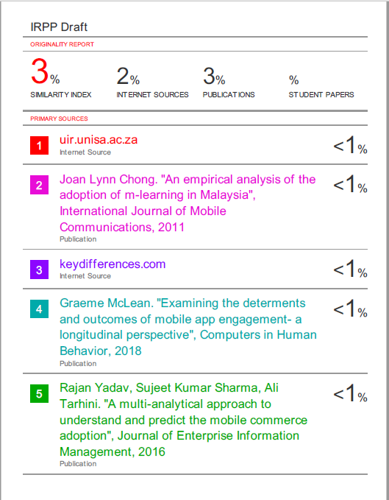
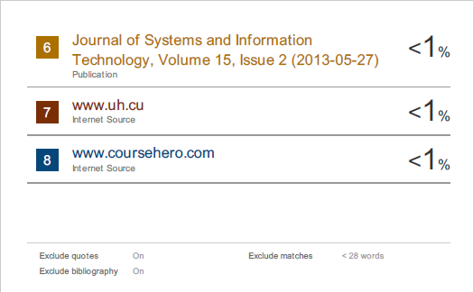

Appendix B: UH Ethics Approval Forms
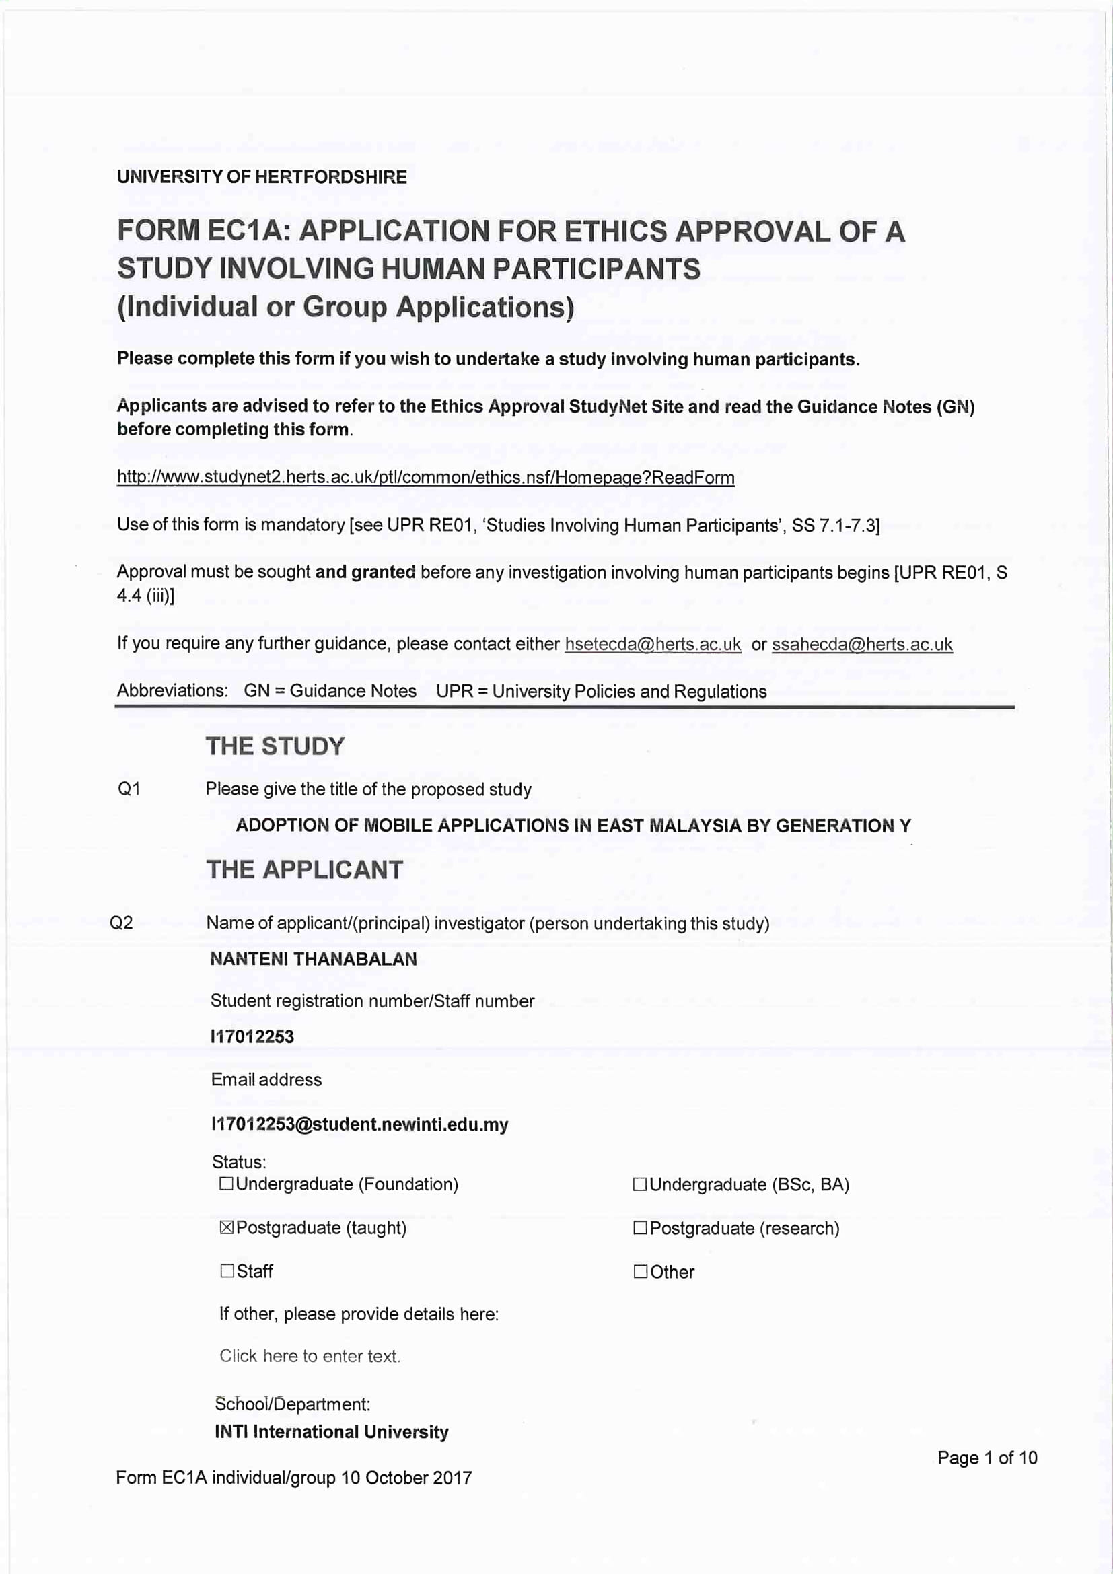

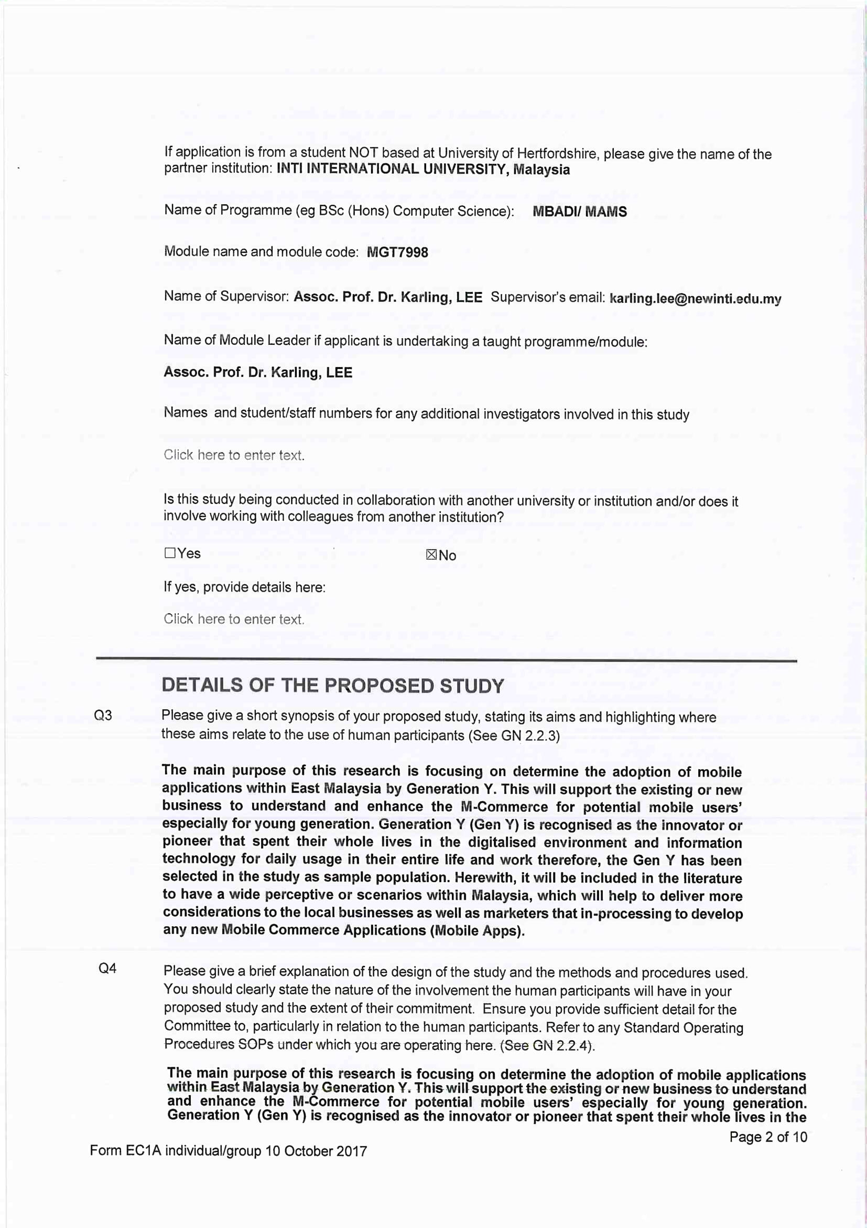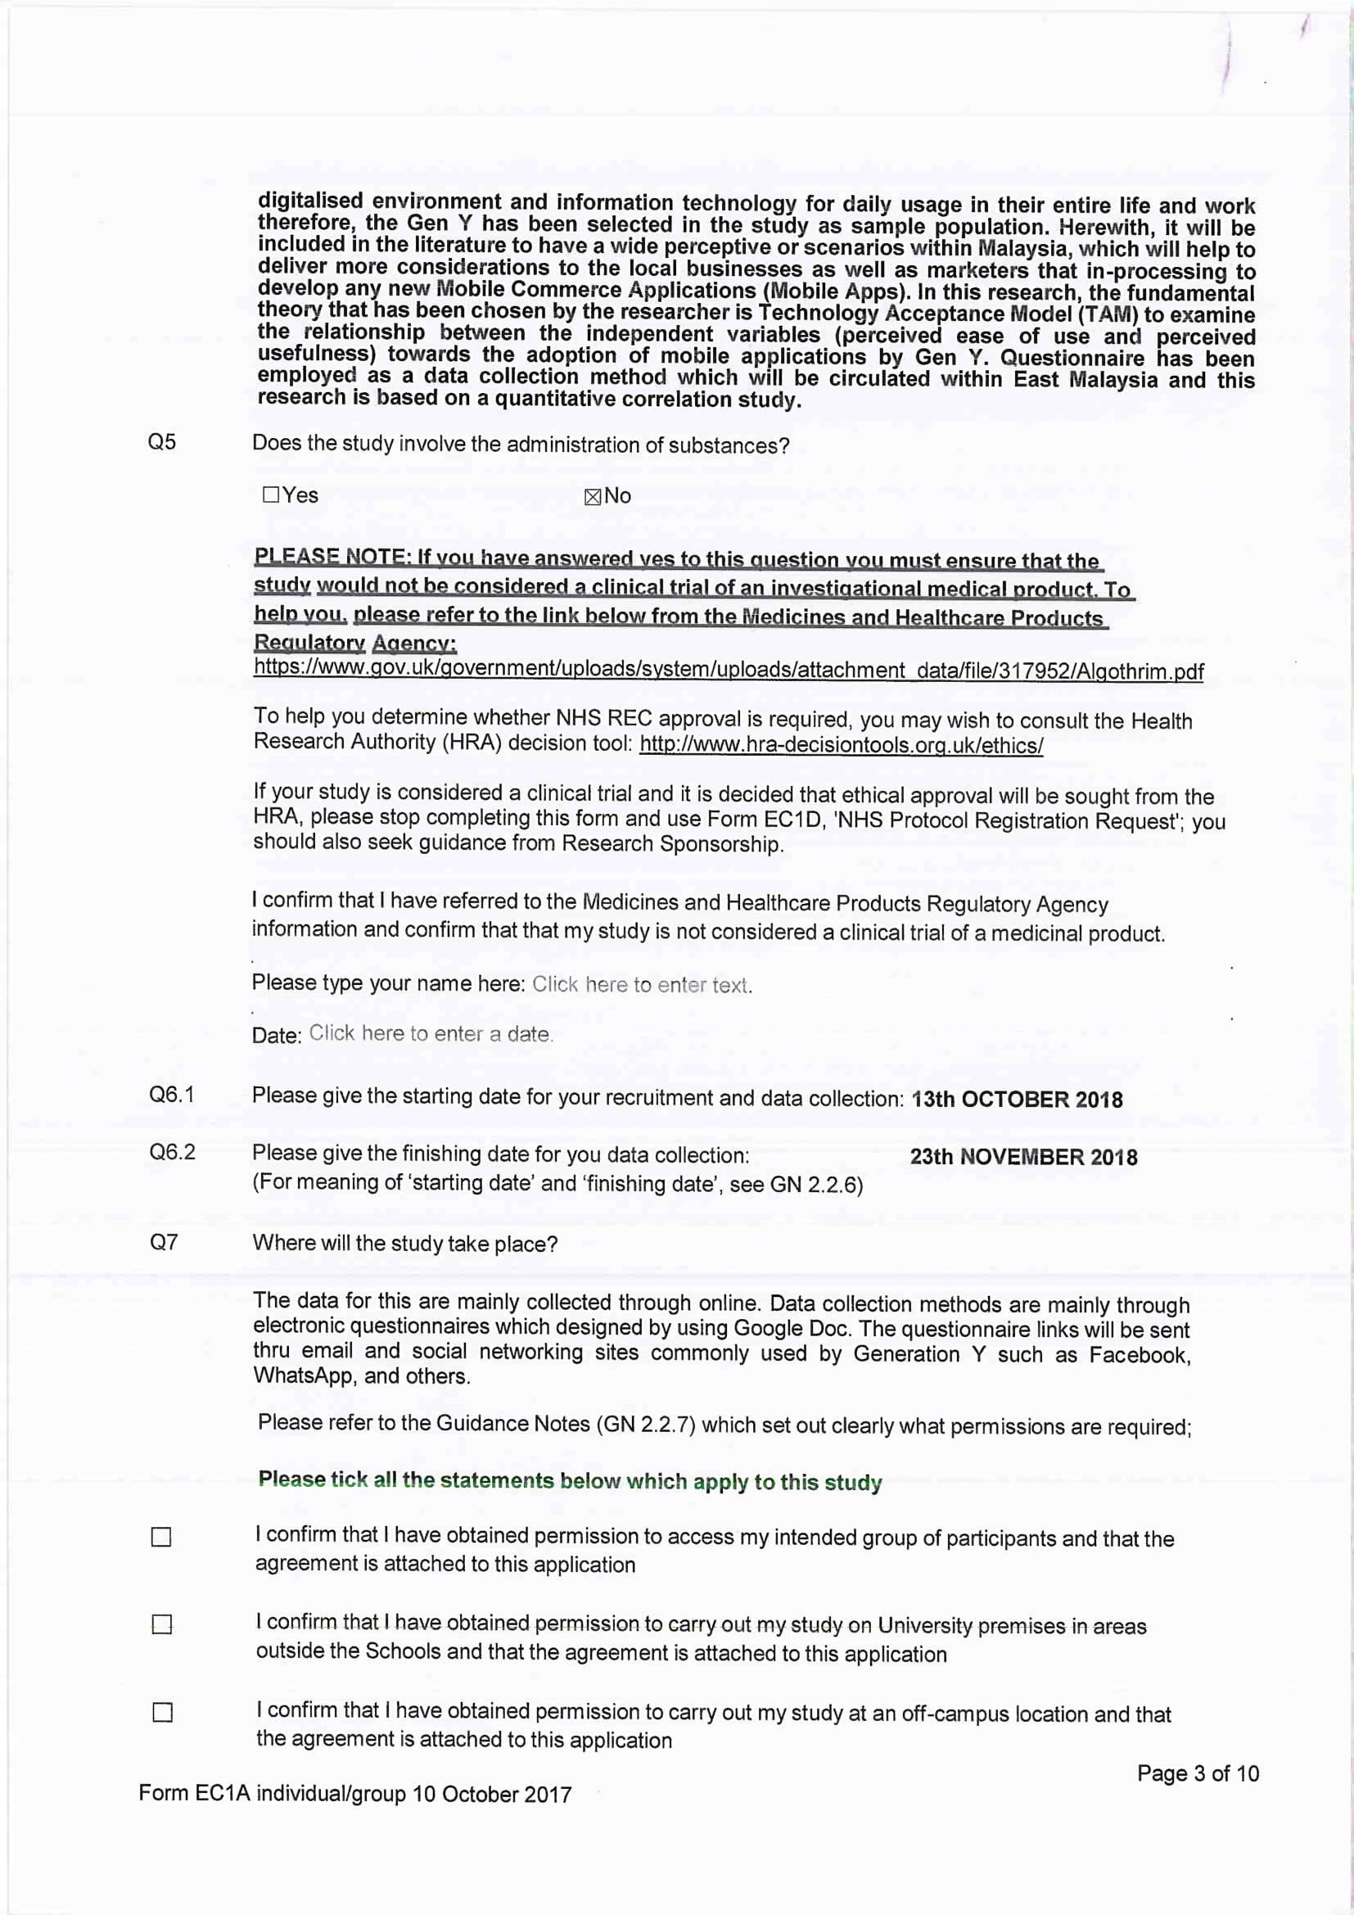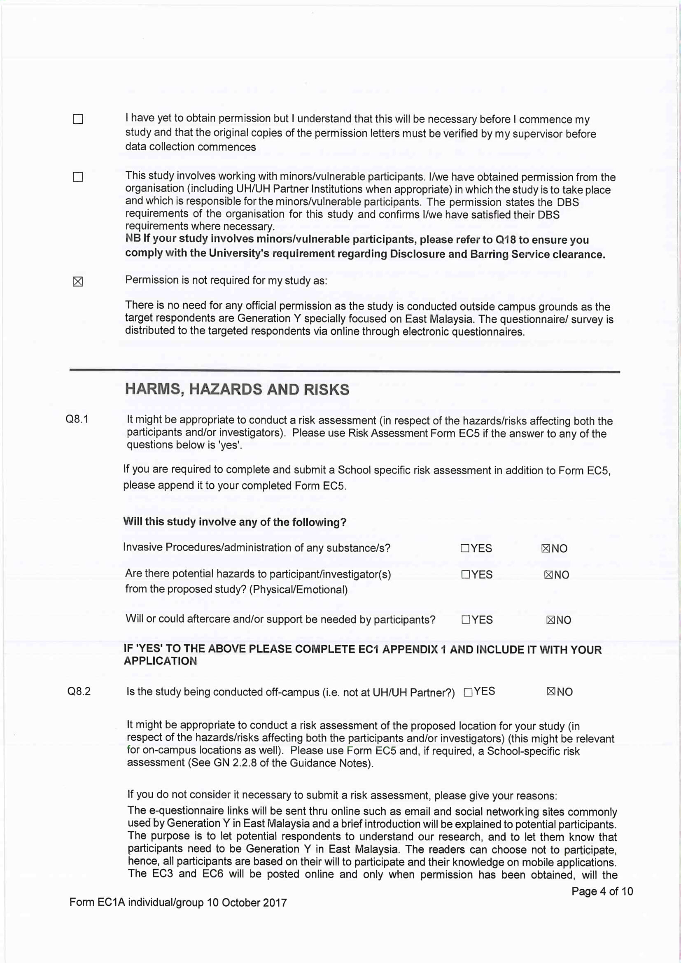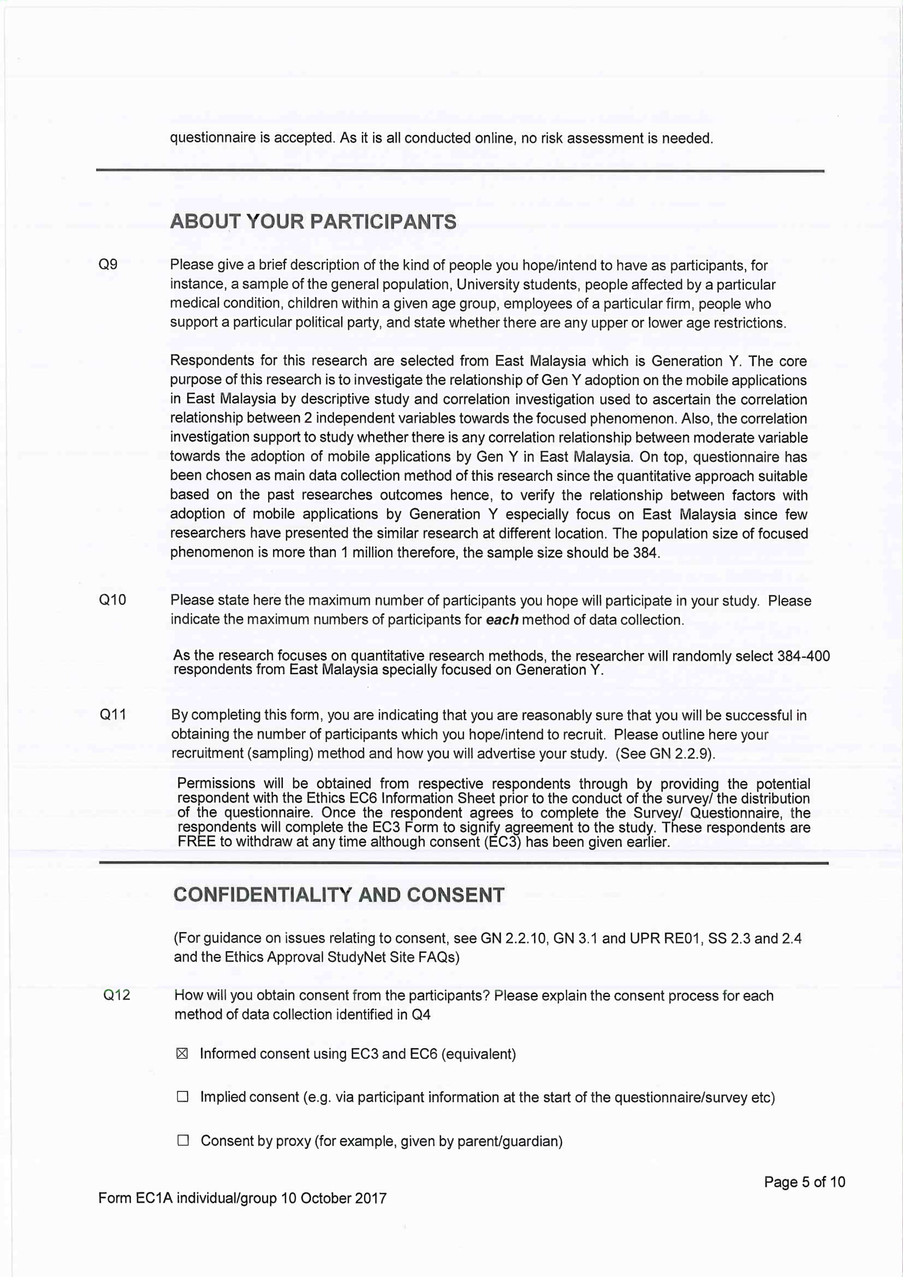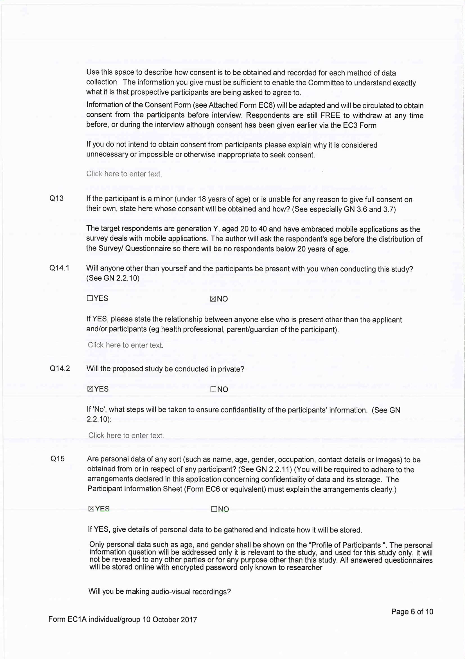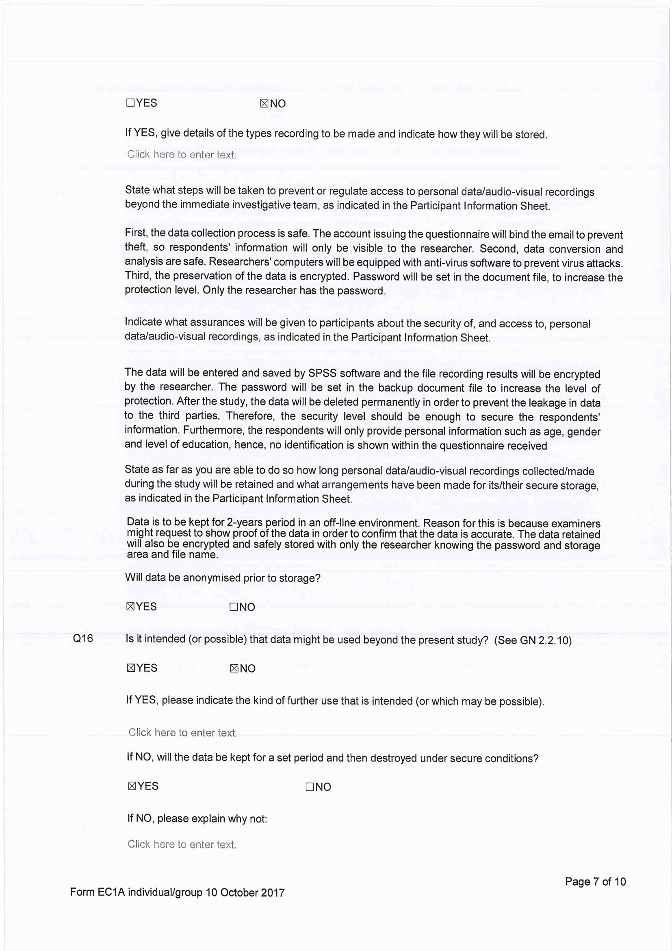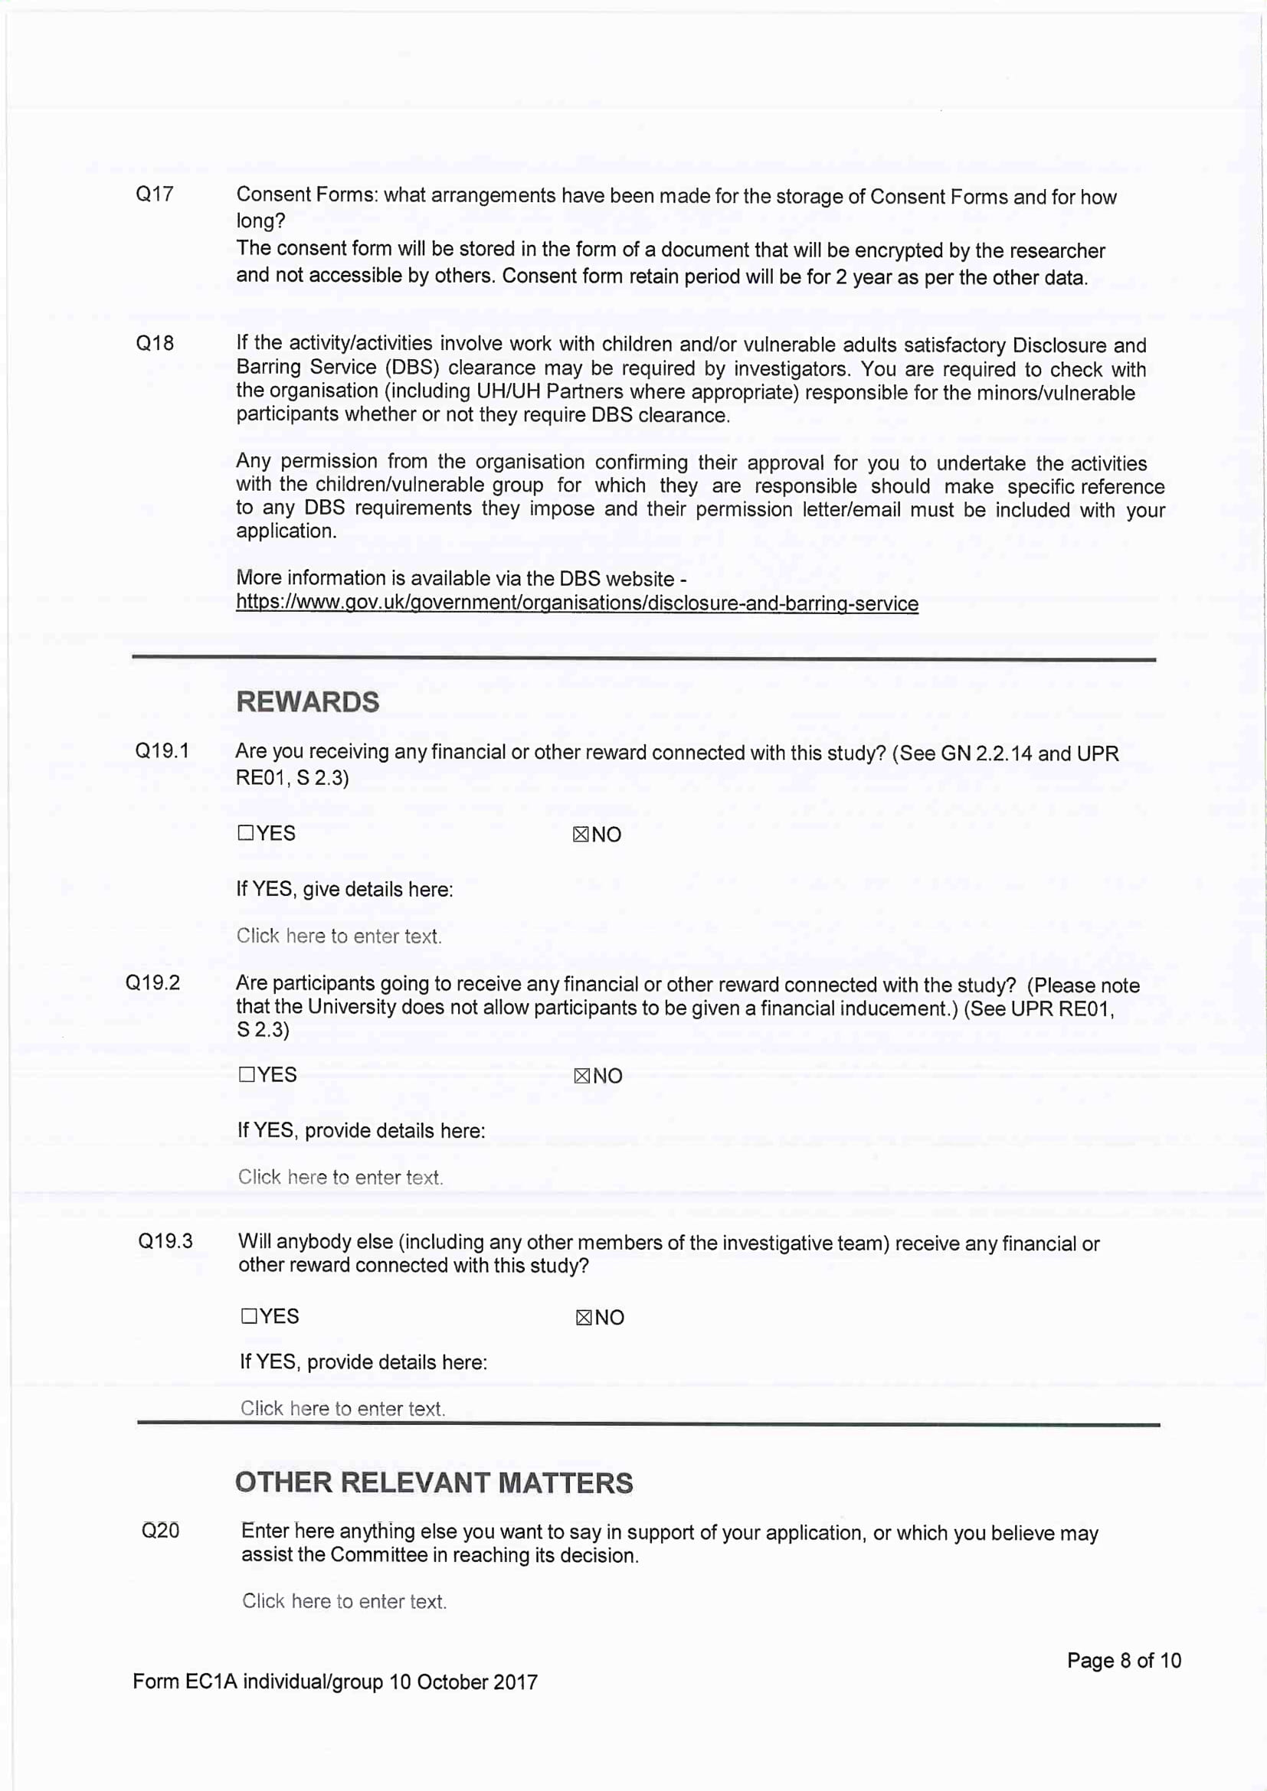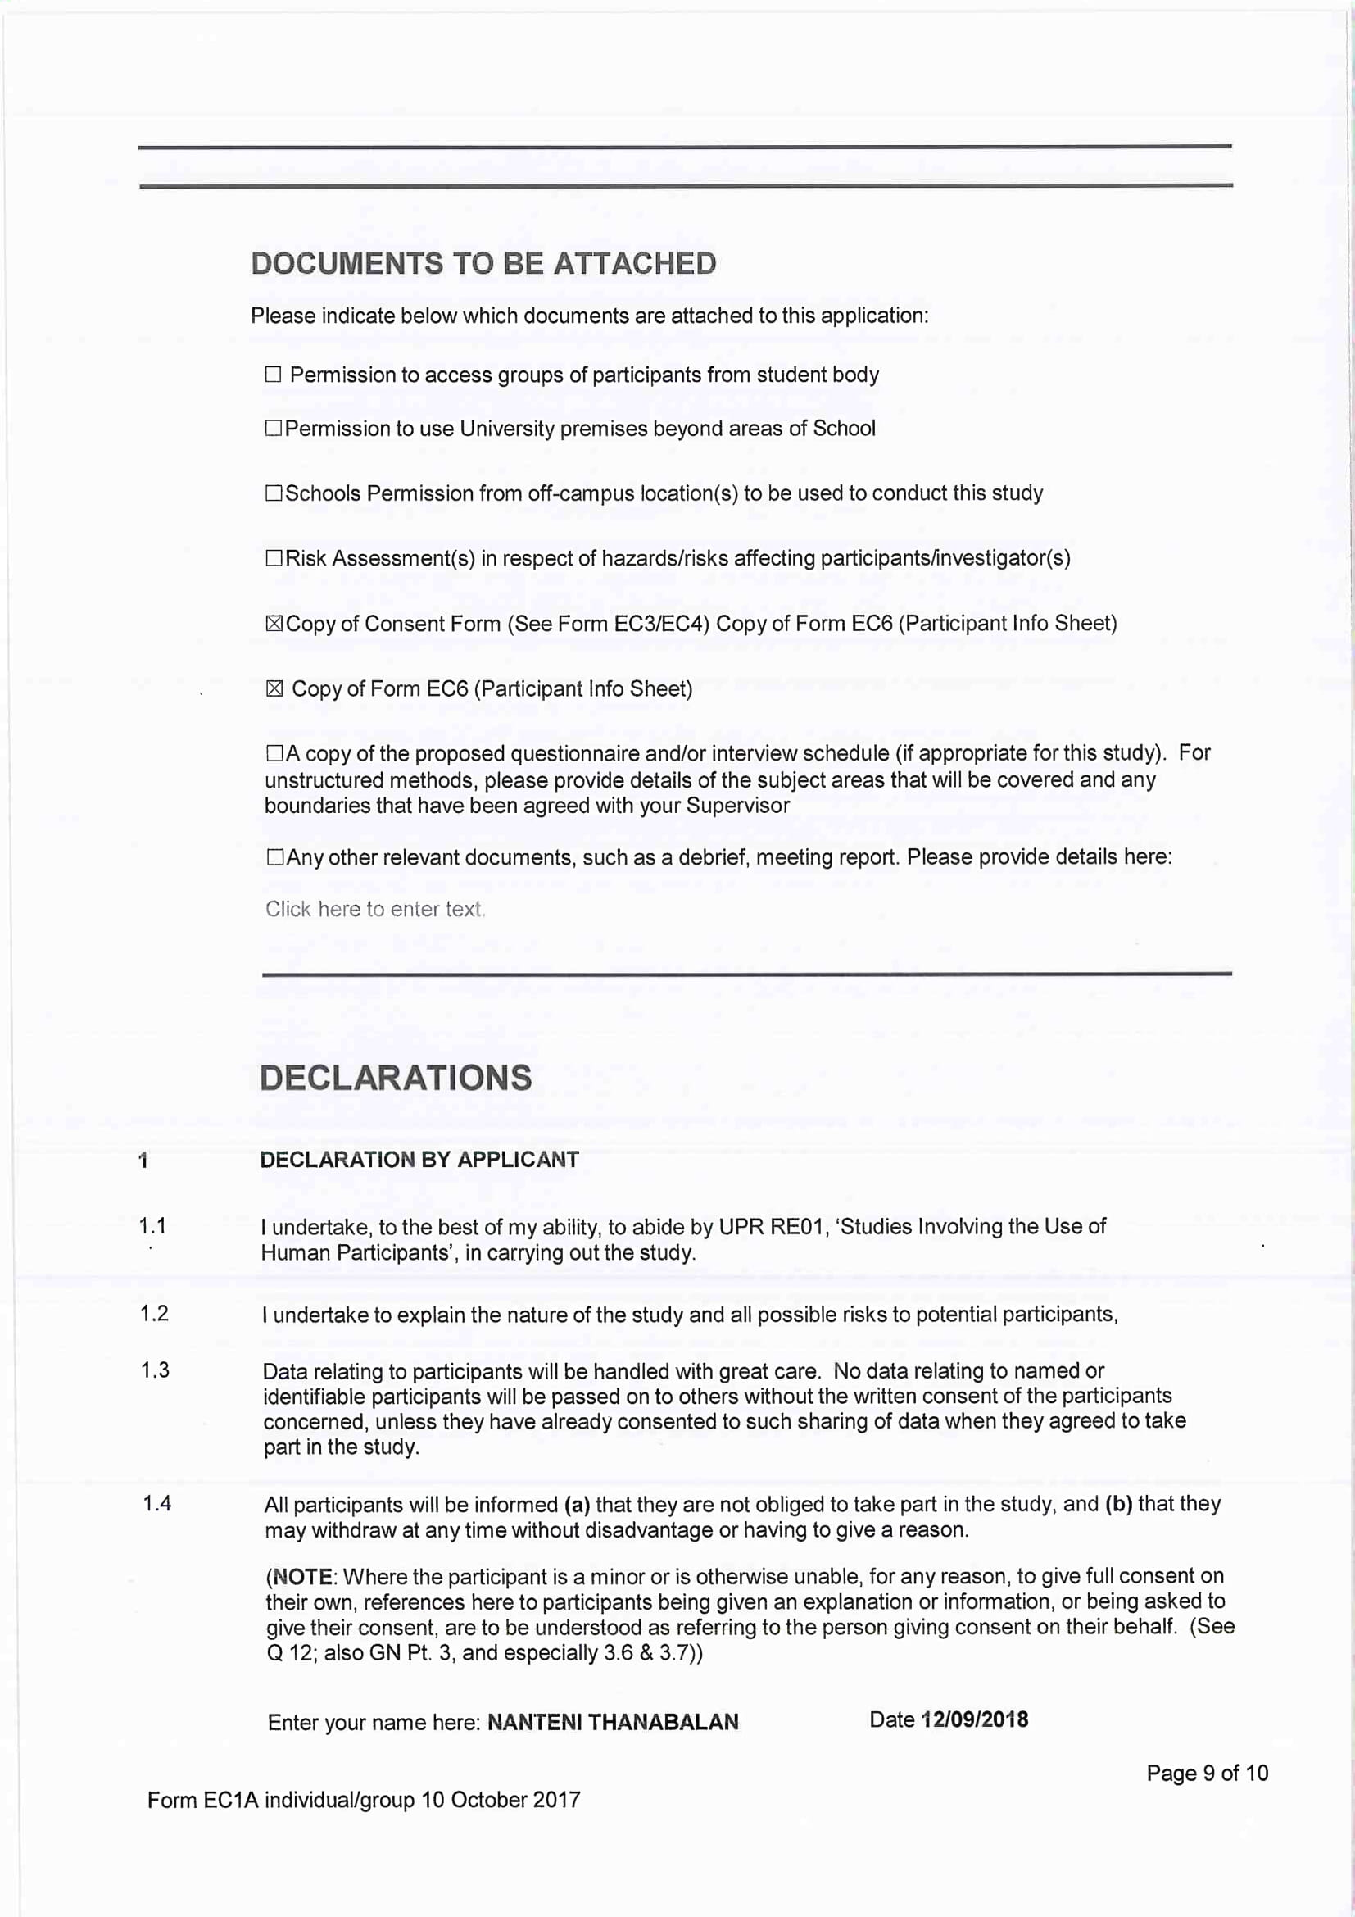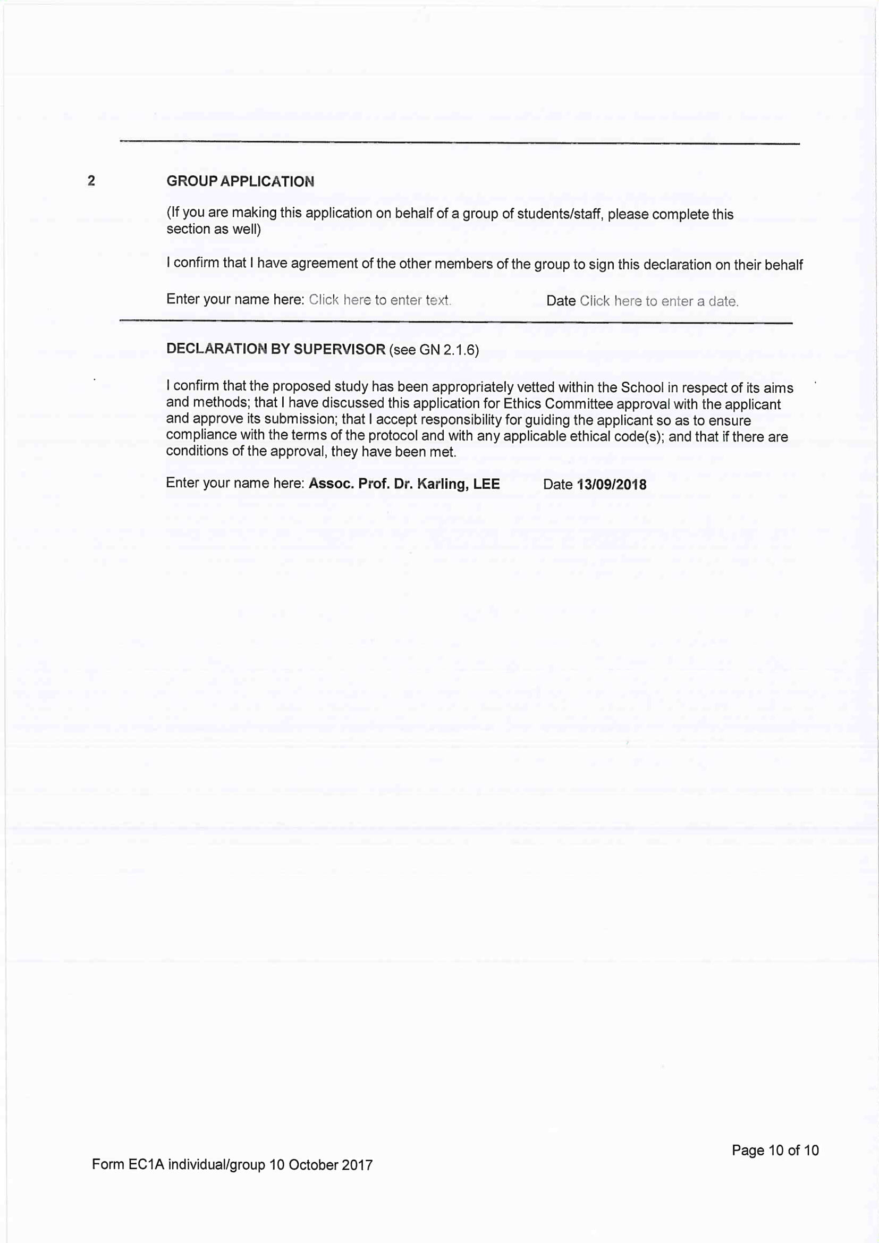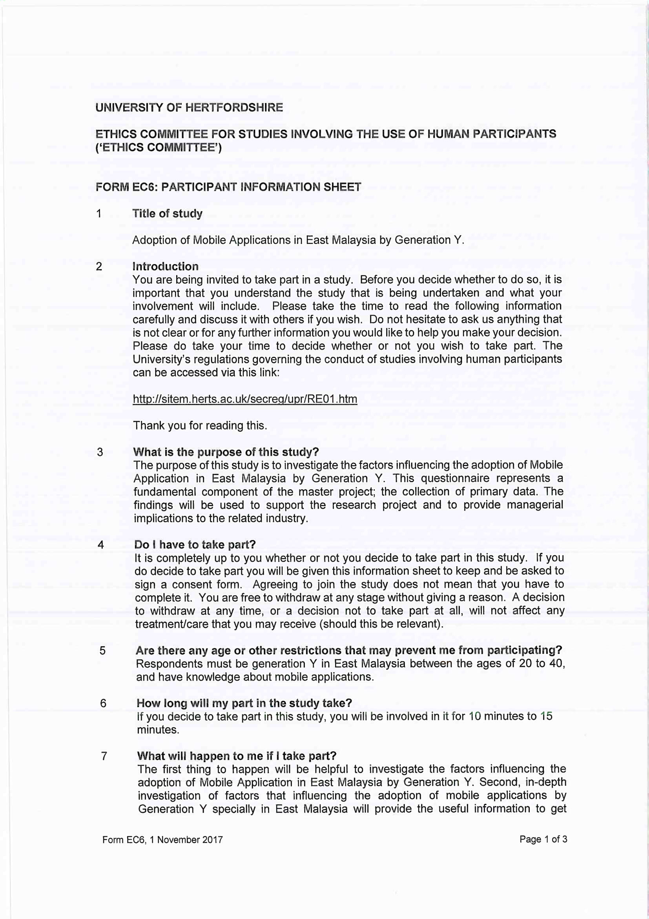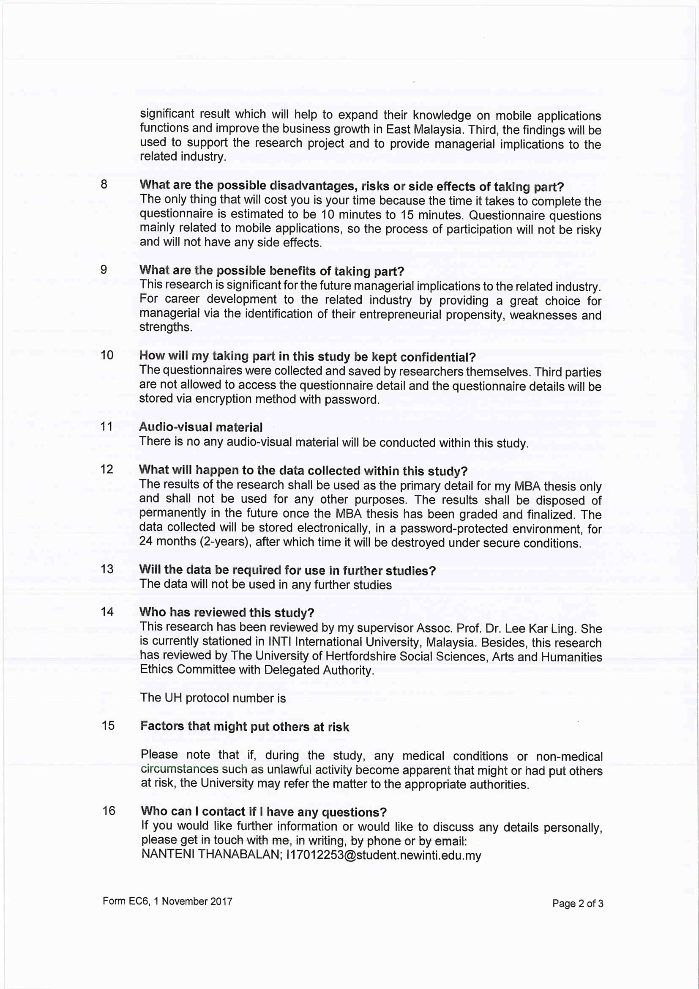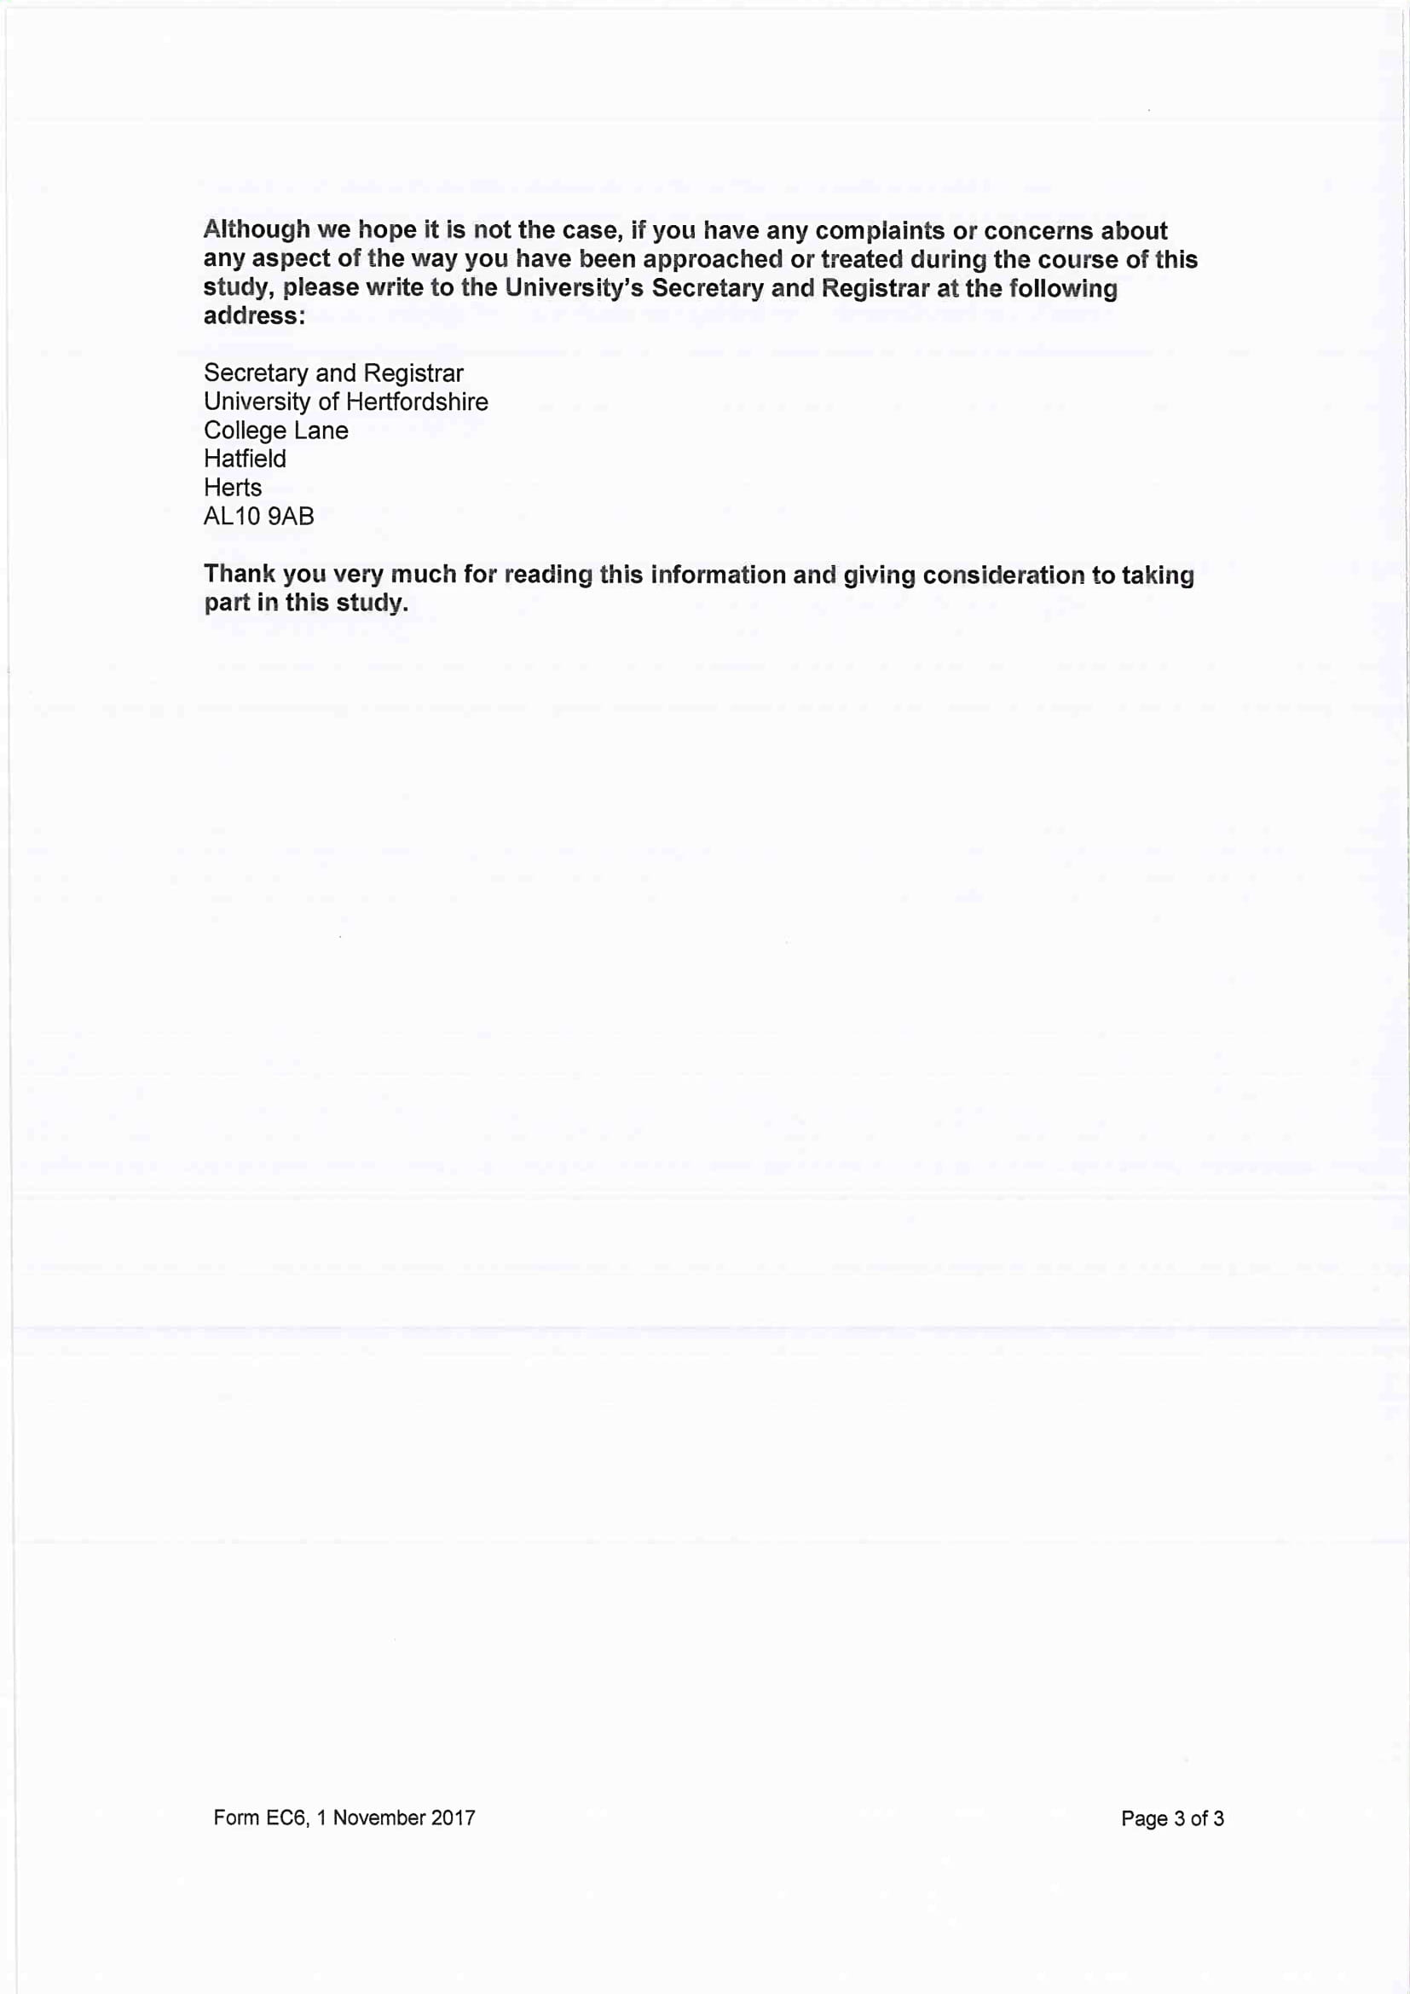

Appendix C: Questionnaire

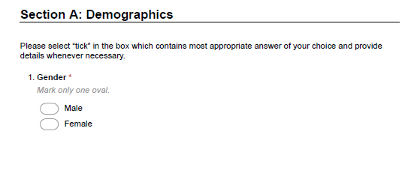

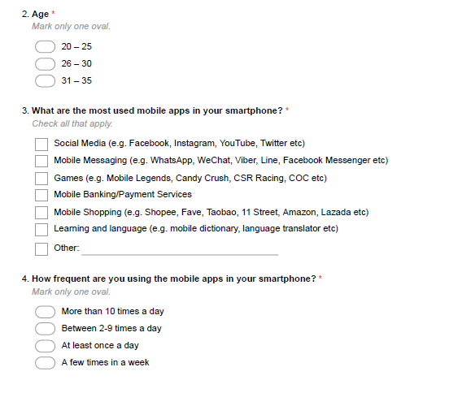
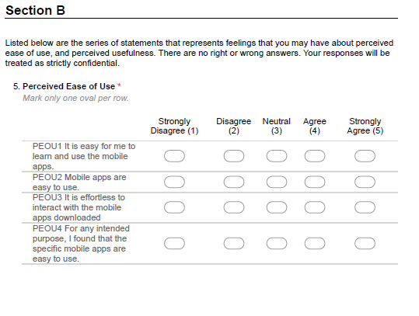
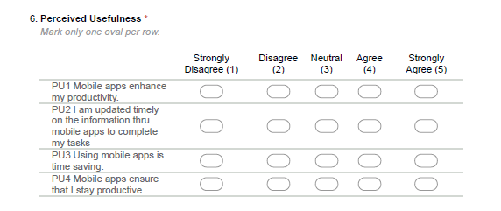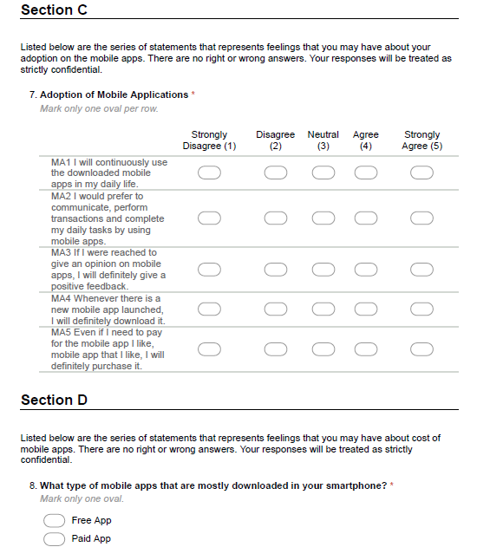
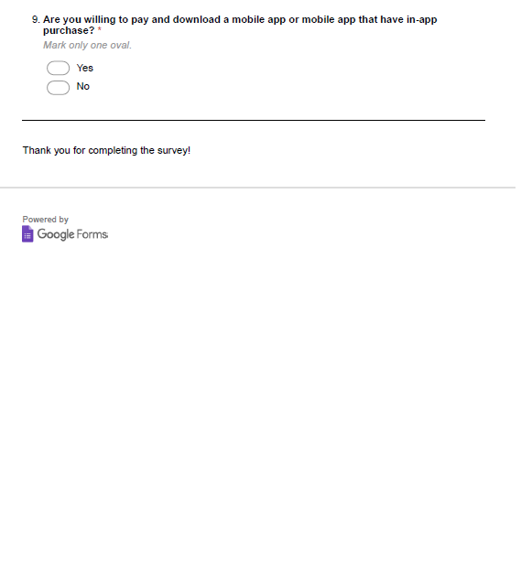

Appendix D: SPSS Statistical Analyses

1. Pilot Test

Frequency Table – Demographic Profiles

Q1. Gender
 |  | Frequency | Percent | Valid Percent | Cumulative Percent
Valid | Male | 26 | 59.1 | 59.1 | 59.1
 | Female | 18 | 40.9 | 40.9 | 100.0
 | Total | 44 | 100.0 | 100.0

Q2. Age
 |  | Frequency | Percent | Valid Percent | Cumulative Percent
Valid | 20 – 25 | 8 | 18.2 | 18.2 | 18.2
 | 26 – 30 | 30 | 68.2 | 68.2 | 86.4
 | 31 - 35 | 6 | 13.6 | 13.6 | 100.0
 | Total | 44 | 100.0 | 100.0

Q4. How frequent are you using the mobile apps in your smartphone?
 |  | Frequency | Percent | Valid Percent | Cumulative Percent
Valid | More than 10 times a day | 38 | 86.4 | 86.4 | 86.4
 | Between 2 - 9 times a day | 6 | 13.6 | 13.6 | 100.0
 | Total | 44 | 100.0 | 100.0

Factor Analysis: Communalities – In Detail

Communalities
 | Initial | Extraction
Q7.1 MA1 | 1.000 | .722
Q7.2 MA2 | 1.000 | .778
Q7.3 MA3 | 1.000 | .734
Q7.4 MA4 | 1.000 | .914
Q7.5 MA5 | 1.000 | .811
Q5.1 PEOU1 | 1.000 | .910
Q5.2 PEOU2 | 1.000 | .902
Q5.3 PEOU3 | 1.000 | .892
Q5.4 PEOU4 | 1.000 | .870
Q6.1 PU1 | 1.000 | .797
Q6.2 PU2 | 1.000 | .781
Q6.3 PU3 | 1.000 | .830
Q6.4 PU4 | 1.000 | .846
Extraction Method: Principal Component Analysis.

2. Final Data – Full Scale

Frequency Table – Demographic Profiles

Frequency Table
Q1. Gender
 |  | Frequency | Percent | Valid Percent | Cumulative Percent
Valid | Male | 156 | 58.6 | 58.6 | 58.6
 | Female | 110 | 41.4 | 41.4 | 100.0
 | Total | 266 | 100.0 | 100.0

Q2. Age
 |  | Frequency | Percent | Valid Percent | Cumulative Percent
Valid | 20 – 25 | 48 | 18.0 | 18.0 | 18.0
 | 26 – 30 | 180 | 67.7 | 67.7 | 85.7
 | 31 - 35 | 38 | 14.3 | 14.3 | 100.0
 | Total | 266 | 100.0 | 100.0

Q4. How frequent are you using the mobile apps in your smartphone?
 |  | Frequency | Percent | Valid Percent | Cumulative Percent
Valid | More than 10 times a day | 230 | 86.5 | 86.5 | 86.5
 | Between 2 - 9 times a day | 36 | 13.5 | 13.5 | 100.0
 | Total | 266 | 100.0 | 100.0

Factor Analysis: Communalities – In Detail

Communalities
 | Initial | Extraction
Q7.1 MA1 | 1.000 | .723
Q7.2 MA2 | 1.000 | .778
Q7.3 MA3 | 1.000 | .735
Q7.4 MA4 | 1.000 | .912
Q7.5 MA5 | 1.000 | .808
Q5.1 PEOU1 | 1.000 | .910
Q5.2 PEOU2 | 1.000 | .902
Q5.3 PEOU3 | 1.000 | .891
Q5.4 PEOU4 | 1.000 | .869
Q6.1 PU1 | 1.000 | .797
Q6.2 PU2 | 1.000 | .779
Q6.3 PU3 | 1.000 | .828
Q6.4 PU4 | 1.000 | .845
Extraction Method: Principal Component Analysis.

Total Variance Explained
Component | Initial Eigenvalues |  |  | Extraction Sums of Squared Loadings |  |  | Rotation Sums of Squared Loadings
 | Total | % of Variance | Cumulative % | Total | % of Variance | Cumulative % | Total | % of Variance | Cumulative %
1 | 9.087 | 69.899 | 69.899 | 9.087 | 69.899 | 69.899 | 6.207 | 47.747 | 47.747
2 | 1.691 | 13.009 | 82.909 | 1.691 | 13.009 | 82.909 | 4.571 | 35.161 | 82.909
3 | .594 | 4.567 | 87.475
4 | .440 | 3.387 | 90.862
5 | .306 | 2.356 | 93.217
6 | .214 | 1.643 | 94.860
7 | .203 | 1.561 | 96.421
8 | .151 | 1.163 | 97.584
9 | .109 | .836 | 98.420
10 | .095 | .729 | 99.149
11 | .056 | .432 | 99.581
12 | .047 | .364 | 99.945
13 | .007 | .055 | 100.000
Extraction Method: Principal Component Analysis.

Appendix E: Project Log

