The impact of media advertising on passenger car buying behavior in Shanghai, China

Student Name: QI LUYI
Identification Number: I18014405
Program: MBADI/ MAMS
Subject: MGT 7999 MBADI Project
Supervisor: Assoc. Prof. Dr. Lee Kar Ling

Content
Chapter 1: Introduction 4
1.0 Overview 4
1.1 Background 4
1.2 Problem statement 9
1.3 Research objectives 10
1.4 Research questions 10
1.5 Scope of the study 11
1.6 Significance of the study 11
1.7 Limitation of the study 11
1.8 Operational definition 12
1.9 Organization of chapters 13
Chapter 2 Literature review 15
2.1 The customer buying behavior for automobile in Shanghai, China 15
2.1.1 Research on the global advertising market 15
2.1.2 China's advertising market 16
2.2 Influencers 16
2.2.1 Print media 16
2.2.2 Electronic advertisement 17
2.2.3 Digital advertisement 17
2.3 Theses 3 IV linking to DV 18
2.3.1 Linking print media to the customer buying behavior for automobile in Shanghai, China 18
2.3.2 Linking TV and radio advertisement to the customer buying behavior for automobile in Shanghai, China 18
2.3.3 Linking digital advertisement to the customer buying behavior for automobile in Shanghai, China 19
2.4 The influences of income level, gender and age 19
2.5.3 Influence of advertisement on consumer buying behavior 23
2.6 Framework 24
2.7 Research gap 24
2.8 Research hypothesis 24
2.9 Chapter summary 24
Section 3: Research Methodology 26
3.0 Introduction 26
3.1 Research plan 26
3.1.1 Plan description 26
3.1.2 Research approach 27
3.1.3 Research theory 27
3.1.4 Research technique 28
3.1.5 Unit of Analysis 28
3.2 Sampling Design 29
3.2.1 Target populace 29
3.2.2 Sampling Techniques 29
3.2.3 Sample measure 30
3.3 Questionnaire design 30
3.4 Measurement strategy 31
3.4.1 Analyses apparatuses 31
3.4.2 Pilot testing 31
3.4.3 Descriptive study 31
3.4.4 Internal and outer legitimacy 32
3.4.5 Preliminary Test 32
3.4.6 Hypotheses testing 34
3.4.7 Data accumulation and investigation 34
3.5 Chapter summary 35
Research Methodology 35
Data Analysis Techniques and Tools 36
Summary of Proposed Questionnaire Items adaptation from previous studies 37
Literature Rubric 38
Chapter 4: Research Findings 45
4.0 Overview 45
4.1 Pilot Test 45
4.1.1 Factor Analysis 45
4.1.2 Reliability Test 46
4.2 Descriptive Statistics/ Demographic of Respondents 48
4.3 Preliminary Data Analysis 54
4.3.1 Factor Analysis and Reliability Test 54
4.4 Hypotheses Testing 56
4.4.1 Multiple Regression Test 55
4.4.2 Hypotheses Test 57
4.5 Chapter Summary 58
Chapter 5: Conclusion and Recommendation 59
5.1 Discussion of Findings 59
5.2 Contributions 60
5.2.1 Contribution to Academia 60
5.2.2 Recommendation to Industry 60
5.3 Limitations of Study 61
5.4 Future Study Recommendation 62
5.5 Personal Reflection 63
5.6 Conclusion 63
Reference 65

Chapter 1: Introduction

1.0 Overview
This study's purpose is on demographic influencers and advertisement in automobile purchases within Shanghai, China. The first chapter fundamentally discussed the background of the related variables that has helped in formulating the problem statement. Besides, this chapter also discussed the presented research along with its significance. Moreover, the limitation and scope of the research have also been highlighted in the research. This chapter, however, has justified the need for conducting the research on the concern topic while the objectives and main aims helped in conducting the overall research.

1.1 Background
According to Zeng and Bathelt (2014), advertising industry of China is mainly dependent on its creativity. It is further continued that the advertising agencies in the country have focused on creativity's value addition mainly as one of the country's leading advertising practitioners has stated that no creativity means no life. (Zeng, 2014) Andrews and Shimp (2012) further continued that advertising within Shanghai of China has been the important concern for the reason that it has been analyzed that it has direct relationship with the recent economic as well as social liberalization. Zeng and Bathelt (2014) also found that the Chinese advertisement industry has established an image of regional economic powerhouse mainly due its effectiveness and low-cost production of the advertisement that has resulted in increased number of the consumer base, whereby it has also been discussed that these recognition and achievements of the Chinese advertisement industry has also attracted international companies to Shanghai, China. Hence, it is relevant to study advertisement's influence on automobiles' purchase decision in Shanghai, China.

Besides, Kloss (2012) discussed that advertisement is one of the fastest and internationally recognized service industries within China's Shanghai. Furthermore, the four major international players in the Chinese advertising industry includes Ogilvy, Mather and J Walter Thompson, and Saatchi and Saatchi, and these companies all have branches in Shanghai, China. On the other hand, the other domestically operated companies have absorbed the ideas from these that operate companies internationally and develop the awareness regarding their operations and the transnational players. (Ogilvy, 2012) Furthermore, the international companies have helped in training the Chinese advertising practitioners' young generation. In argument, Escribano (2013) said that this 4A international companies program have caused the issues regarding the nationalism that is one of the main element in developing the brand equity has for the reason that less prominent due to the emerging bottom line issues including the value and services.

Wang (2015) continued that current state of Chinese advertisement industry can be analyzed through reviewing it from the origin that is the 20th century where the main focus has been the economies of the USSR and China. It is further continued that in the 20th century, advertisement is not considered a major concern but China's operating brands as it was in other western countries instead they considered advertisement a measure that was taken by the companies for addressing their over obsolescence and production related problems. In continuation, Coatsworth, Cole, Hanagan, Perdue, Tilly and Tarily (2015) discussed that the iron's fall curtain the year 1980 in has increased Chinese advertising industry's importance. Furthermore, this change in the pattern has contributed to the growth of media's commercial forms largely as before this change, the concerned industry has been operated through monopolies. (Perdue, 2015) In the initial no such initiatives taken by the existing companies towards the advertisements. With the openness that be experienced in China's economy today, advertisements have become the norm in Shanghai, China, including for the automobile industry. This study therefore is relevant to understand the influencing relationship with purchase decision of consumers.

Helveston, Liu, Feit, Fuchs, Michalek and Klampfl (2015) continued that China has developed a consumer automotive market through uninterrupted changes in the profound social, economic and cultural concern from past 20 years. Furthermore, Carley, Krause, Graham and Lane (2013) continued that China is one of the top automobile manufacturing company as well as the number one car buying the country. The author has elaborated that even though the country's exceptional annual growth rate is not maintained in the coming year, the car industry of the spending and the country will stay same. Besides, Gibson and Li (2014) continued that China's economies have been raised in the last few years which has affected their preference and interests as well. It is further continued that China's automobile industry has been largely affected by the company's increasing economy as the spending and affordability of the concern people has been increased in the automobile industry. The advertisement has therefore become the main concern as people are more attracted towards highly recognized and reputed brands.

Additionally, Esherick (2013) discussed that in the initial years of communist control of China from 1947 to 1966, Mao Zedong the China's founder has tried to change the existing longstanding advertisement practice of the country that is Chinese newspaper's influence. It is further continued that these newspapers have been considered to be the capitalist infringement from the socialist perspective. In continuation, Wang (2010) talked about that drastic change in the advertisement industry of China has been analyzed when in entered in the World Trade Organization in 2002. The Chinese advertising market is not only recognized as fastest growing sector of world, but is also considered to be focal point of the country, especially digital advertisement as China has the largest pool of people using the internet. The major changes in the China's existing advertisement industry has been mainly due to the shift in the cultural values, increasing brand's influence name, the use English language for especially attracting others the young generation, the rapid growth of the new emerging media including internet and technology and the on-line shopping trend in the country. (Wang, 2010)

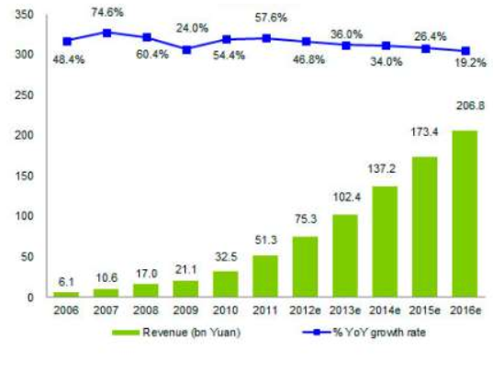

Figure 1: China Online Advertising Revenue
(Source: Reagan, 2016)

The figure 1 above is illustrating the overall revenues that are generated by the China till 2011 while it has been expected that it will grow in future. Kumar and Svensson (2015) continued by stating the number of Chinese internet users, however, has been 564 million in 2012. Furthermore, it is discussed that the on-line videos are the most popular internet service in the country. It is also mentioned that the number of video website within China's Shanghai has also been increased up to 7.7% in the year 2012 due to the increasing demand in the country. In continuation, Subramanian and Lardy (2012) discussed that the on-line advertisement revenues expectation China's Shanghai has been met as the growth in the industry in the following years after 2012 has been experienced. It is further discussed that between the year 2010 and 2015, China's advertising industry has been increased by 1.6 times while the average growth rate has been reached up to 21%. (Subramanian, 2012)

Besides, advertisement is important in China's every concern industry including automobile industry as well. However, automobile industry is one of China's dominant industry as Van der Kuijp, Huang, and Cherry (2013) discussed that China's automobile industry is one of the fastest growing industry with 21 million passenger car's production record. The author further continued that China has been ranked the first country with the largest production of the passenger cars in 2015. The China, however, is one of cars' major exporters as the countries including Iran, Russia, Algeria, Egypt and other developing countries are Chinese passenger cars' main buyers. In continuation, Gosens and Lu (2014) discussed that China has not claimed the rise in the market share of domestically produced passenger car even when the volume of production has been ranked on the top.

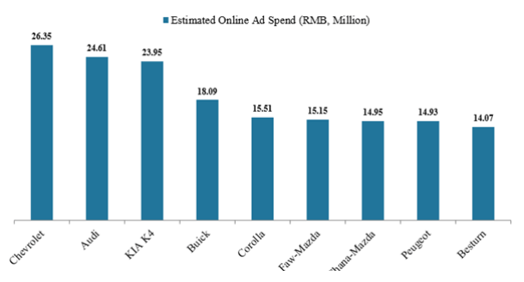

Figure 2: China Top 10 Automobile Brands by Online Ad Spend in September 2014
(Source: Cecilia, 2014)

Advertisement in China's automobile industry is one of the major concern as the figure above is illustrating the top ten automobile brands of their overall spending and China in the on-line ad in the year 2014. From the above figure, it can be illustrated that Chevrolet has paid the highest amount of $26.35 million in its on-line advertisement while Audi is the second largest car manufacturer company with $24.61 million's total spending. In addition Gan (2003) discussed that the increasing competition in the Chinese automobile industry is one main reason that has increased advertisement's need. It is further discussed that on-line marketing is China's most preferable medium Shanghai due to its high preference by the concern consumers. (Gan, 2003)

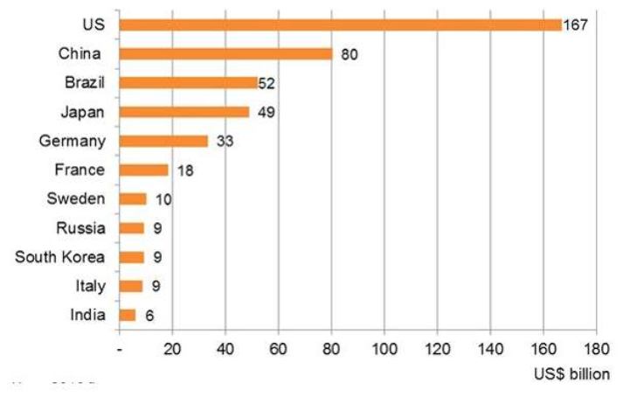

Table 1: Major countries with Advertising industry
(Source: HK TDC, 2016)

The above chart above is illustrating the advertising industry revenue of the major nations, where China is the second largest country able to generate almost $80 billio. Furthermore, the major contribution in Chinese advertisement market that has increased the sales is the real estate spending and automobile. As Hktdc (2016) talked about that 38% of the advertising spending in the automobile while 44% in the real estate has been recorded in the year 2013. Pappas and Bregoli (2016), however, argued that the internet is the main reason that has increased the internet's influence in the Chinese market. The increasing number of internet users and the preference of seeing on-line videos have made the advertising industry dependent on the internet. (Pappas, 2016) Such evident is also found within Shanghai, China, hence the need to conduct this study to determine the extent of the relationship between the resultant purchase decision and advertisement for automobile purchases.

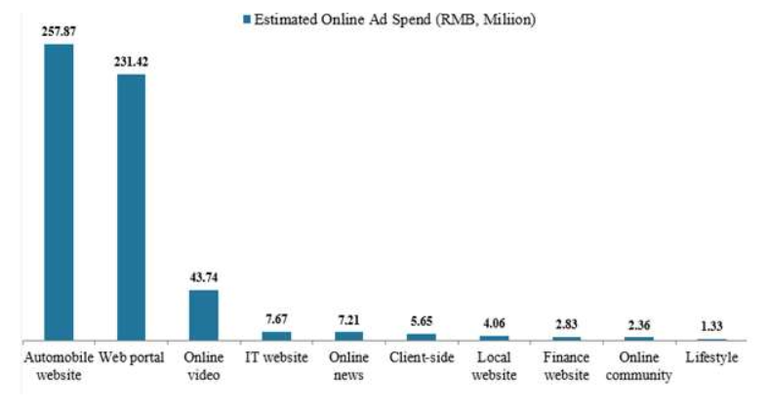

Figure 3: Chian Top 10 Online Advertising Channels for Automobile Brands in September 2014 (Source: Cecilia, 2014)

Besides, West, Prendergast, and Shi (2015) discussed that online advertising China's Shanghai helps in developing high brand awareness and reaching the maximizing number of people. There, however, are different channels within the online advertising marketing in order to maximize the reach to the concern audience, and as seen in the figure above, where it is illustrating that there are top 10 on-line advertising channels that are used in China's automobile industry. It can be illustrated from the figure above that most of the automobile companies in China's Shanghai invest in their website mainly for advertising their developed brand awareness and manufactured products. (Prendergast, 2015) Furthermore, as it can be seen from the above figure that web portals are the second preferred on-line advertisement channels by the automobile industry as almost $231.42 million has been spent in the year 2014. (Shi, 2015) The other major online advertising channels that are used in China's automobile industry includes on-line video, IT website, On-line news, Client-side, Local website, Finance On-line community, lifestyle and website. (Prendergast, 2015)

1.2 Problem statement
The presented research's main concern is to discuss the concern variables including advertisement and customer buying behavior in China's automobile industry in order to analyze the existing relationship between them. Furthermore, as it has been analyzed in this study's background, that the market trends and practices are evolving, it has therefore raised the concern regarding the influence of the existing companies' advertisement in the automobile industry over the Chinese customer's buying behavior. Moreover, the presented research has involved the concern of exploring different types of their influence and advertisements over customers' buying behavior in automobile industry. The presented research's problem statement, however, has been structured as follows.

What is the impact of media advertising on passenger car buying behavior in Shanghai China?

Since, there are a large number of automobile products and car models offered by China's Cherry Shanghai, thus, it is adequate to focus on one product. The reason is that we need to know what the different impacts the 3 types of media (electronic meida, print media and digital media) can product? For that purpose, the advertisements that were made by Cherry for "Arrizo 7" will be studied in this research.

Why study passenger car? Why study media advertisement? Why the 3 media?

1.3 Research objectives
The presented research's main aim is to study the relevant variables including the advertisement and generate measurable justification on its relationship with the buying behavior of the automobile industry's Chinese customers in Shanghai, China. The aim of the presented research has been to achieve the following discussed objectives.

• To study the impact of electronic media advertisement on passenger can buying behavior in ShangHai, China

• To study the impact of print advertisement on passenger can buying behavior in ShangHai, China

• To study the impact of digital media advertisement on passenger can buying behavior in ShangHai, China

1.4 Research questions
The aim of the presented research has been to justify the following questions that have emerged from the discussion on the relevant variables' background. The research questions derive from the research objectives that are as provided above and are deemed to be aligned in order to facilitate the study.

• What is the extent of influence of different types of advertisement including electronic, digital and print media, and digital advertisement over consumer buying behavior in Shanghai, China?

• Will the demographic variable of income, age and gender have the moderating influence on the relationship between advertisement and automobile purchase in Shanghai China?

1.5 Scope of the study
The presented research's scope has been more inclined towards the customer that buys behavior in China's automobile industry. Furthermore, the presented research's scope is towards advertisement's role in influencing the Chinese customer's buying behavior in the automobile industry. However, due to the lack of conducted research in the specifically Shanghai and concerned area, of China, therefore, it can be stated that the presented research's scope is limited to China's automobile industry while the generated recommendations are focusing on the consumer that buys China's behavior primarily, specifically for Shanghai, China, and hence, may not be generalizable to other parts of China. Moreover, the presented research is also applicable in China's other existing industries because the generated findings regarding the influence of the advertisement over the buying behavior which could bear some significant for companies in other industries to serve as reference.

1.6 Significance of the study
The presented research is significant for the automobile companies that operate within China's Shanghai because it will help them in analyzing the influence and role of the different types of advertisement over the concern customers' buying decision. Furthermore, relevant recommendations that can help China's existing automobile companies in analyzing and managing the concern customers' buying behavior have been provided by the presented research. The presented research is also significant for the other automobile companies that operate around the world because the recommendations and generated findings have provided them with relevant information regarding advertisement's role over customer that buys behavior, although the contextual application may be limited due to differences in culture and consumer buying behaviors of different countries. Moreover, as this research has helped in fulfilling the identified research gap, it therefore is significant for the future researchers as upcoming researchers can use the information in the subsequent research work while the generated information is also significant for the students as well.

1.7 Limitation of the study
The presented research is primarily focusing on the advertisement's relationship and buying behavior of the customer Shanghai of automobile industry of China, it can be therefore stated that the research is limited to a specific industry of China. However, this limitation does not have any influence over the study's results instead it has limited the research's applicability. However, while conducting the study including the collection, analyzation, and interpretation of the data, the following limitation has been faced.

The limited time has restricted the researcher from embracing all the available data on the concern variables. Enough information required for attaining the objectives and desired aim, however, has been included by the research.

The required resources' unavailability has been the research's major limitation. The researcher, however, has managed to gather the information from two related sources including the on-line forums and the library.

The time constraint has made it hard for the researcher to embrace the larger number of sample from the concern population. The number of samples that are participated in the research, however, are capable of representing the concern population's views.

1.8 Operational definition
The main aim of this section of the presented research is to discuss the related concepts and the key terms in order to develop the understanding. The relevant information regarding the concern variables, however, has been listed in the table below.¬ The limited time has restricted the researcher from embracing all the available data on the concern variables. Enough information required for attaining the objectives and desired aim, however, has been included by the research. The required resources' unavailability has been the research's major limitation. The researcher, however, has managed to gather the information from two related sources including the on-line forums and the library.

Key Terms | Definitions
Advertisement | Advertisement can be referred as the tool that is used by the organization for communicating their goods with the concerned market.
Print Advertisement | Use of newspapers, magazines, and billboards for communicating the message regarding the goods is the print advertisement.
Electronic Advertisement | Use of television, radio and relevant electronic device for communicating the message regarding the goods is the print advertisement.
Digital Advertisement | Use of internet including the web portals and social media platforms for communicating the message regarding the product is the print advertisement.
20 Consumer Buying Behaviour | The consumer that buys behaviour is referred to the total sum of the perception, preference, affordability and the decision-making capabilities of an individual towards a product.

1.9 Organization of chapters

Chapter 1: Introduction | This chapter presents an overview of the research topics, describes the background of this chapter, explains job selection. The next sections describe RO and RQ. The significance and scope of the research are also mentioned. Finally, the limitations of the study and the interpretation of the relevant definitions are explained. Through this chapter, readers can understand the overview of this study and the reasons for the study.
Chapter 2: Literature review | This chapter illustrates the phenomenon studied, the definition of independent variables and the theory supporting independent variables. This chapter also discusses the relationship between IVs and DV, then proposes hypotheses based on previous research.
Chapter 3: Methodology | This chapter aims to introduce the principles of research methods, design questionnaires for data collection and analyze the results. Its purpose is to ensure the validity and reliability of the research data.
Chapter 4: Research Findings and  Discussion | The discussion is included by the research's fourth chapter on the number of key research findings from the collected data. Furthermore, Hypotheses testing's results are also presented and discussed in order to analyze that whether they are accepted or rejected. Furthermore, this chapter assists in discussing the overall findings of the research that has been gathered through collected data. However. The reliability and correlation between the concerned variable are also analyzed in this chapter.
Chapter 5: Conclusions | This chapter summarizes the entire article and makes recommendations on the formulation of targeted recruitment strategies. At the same time, this chapter also discusses the practical significance of the future.

Chapter 2 Literature review
2.0 Overview
In chapter two mainly describe the important focusing topics of this course is based on related literature. Three independent variables (I V) are also explained, including print media, digital media, radio and TV media. Then the relevant between 3 independent variables and the DV(the customer buying behavior for automobile in Shanghai, China) is discussed. Otherwise , the character of MV, anticipate, in the DV is presented. Followed by the review of Theory of Reasoned Action(TRA) theory, to facilitate the use of related theories of analysis and research. In chapter 2, the research framework is build and the hypotheses is established on the basis of the subject. At end of this chapter is concluded .Finally, made a summed of this chapter.

2.1 The customer buying behavior for automobile in Shanghai, China
According to Walton, Retana, Chen and Scudder (2016), an advertisement is referred to the activity carried by an organization for communicating with its concern users effectively about the services and offered product. The author has further elaborated that advertisements are the messages for which the enterprise pays in order to deliver it to the right customers. The main reason for investing in the advertisements is to influence the concern people's opinions by enhancing the benefits that are associated with the offered product. Besides, Ward, Hancock, and Macrae (2014) discussed that advertisement utilizes every available medium preferred by the concern customers in order to aware them about their services and offered product. The author has further continued by stating that the advertisement's main advantage is that it helps in providing the concern information regarding the product to the potential customers. Besides, Virender (2010) discussed that there are four main objectives of advertisement including trial, continuity, brand switch and switching backward, where it was also discussed that the first objective of advertisement is the trial including the companies that have been introduced their product and service in the market and recently invest in the advertisement for analyzing in the response of the concern audience. Advertisement's other main objective is the continuity referring to keep the product at the top of the existing customers' mind. (Virender, 2010)
2.1.1 Research on the global advertising market
Virender (2010) stated that most of the companies in global introducing new products usually invest high on their advertisement because without having the awareness regarding the product, the buying decision would not be developed by the customers. On the other hand, Eldering, Flickinger and Hamilton (2016) argued that the returns on these investments on the advertisement budgets supply returns in the long term while they are also not guaranteed. Furthermore, the author further elaborated that it is highly risky for the new companies to invest high on the advertisement while the negative response from the audience can cause great loss to the company.
2.1.2 China's advertising market
Most of the enterprises in China invest in their advertisement in order to expand the market size by making their product prominent in the existing markets. Back referred to attract the previous customers that have switched the brand due to any reason is being switched by Advertisement's last main objective. (Virender, 2010) In contrast, Futa, Yamaguchi, Ohmori, Matsuzaki, Kozuka and Yamamoto (2013) stated that the advertisement's primary objective is to develop the awareness about the product's existence in the concerned market. The author has further elaborated that advertisement has become the existing companies' main concern because it helps in converting the product into a brand. For the purpose of this study, advertisement is consequently adopted as the independent variable to determine its relationship with consumer purchase decision for automobile in Shanghai, China.
2.2 Influencers
Katz (2014) has noted that advertisement uses different mediums including TV, Radio, Billboards, the internet and social media platforms for maximizing the message's reach to the concern potential customers. Every media has different influences. Each medium that was used for advertisement, however, has been elaborated in detail below:

2.2.1 Print media
In the view of Doddaraju, Megharaj, and Reddy (2016), the print media are utilized by print media advertisement mainly including the magazines, pamphlet, newspapers and other related media. The author has further stated that billboards and banners are also categorized as print media advertisement but due to the technological advancement it has become digital marketing. In continuation, Shaw, Howell, and Genskow (2014) discussed that the digital marketing's increasing influence has caused the decline in the print media advertisement because of the shift in the concern customers' preference from newspapers and printed magazines towards digital gadgets. However, McAfee, Davis, Alexander, Bunnell and Pechacek (2013) discussed that different newspapers including regional, local, and nationally published are used for advertising the services and related product. It is further continued that newspaper is used as the medium usually for the advertisement when the local market is the organization's main concern. In argument, John, Rajamohan, and Felix (2012) stated that digital gadgets' increasing trend has replaced newspaper's need because they timely provide more updated news in cost effective method. Furthermore, the author argued that the print media marketing is limited in the domestic market only while another advertisement medium provides the advantage of reaching worldwide customers.
2.2.2 Electronic advertisement
In the view of Fatemeh, Mehrdad and Sohrab (2014), television advertisement is one of the most preferred types of marketing technique used widely by the marketers. It is further continued that the organizations use the commercials for communicating the benefits associated with the product in a representable way. Morillo, Alvarez-Garci, Ramirez and Gonzalez-Abril (2016) continued that TV advertisement's main advantage is its reach to the large audience. That TV advertisement helps were further elaborated by the author in reaching the relatively large audience than print media because the use and videos of music in the TV commercials helps in grabbing the concern audience's attention. (Gonzalez-Abril, 2016) Furthermore, the TV audience is divided into much larger segments therefore, it provides music, motion and attractive sight for the benefit of conveying the message and reaching the concern audience. (Morillo, 2016) On the other hand, Spiller and Baier (2010) argued that the TV advertisement's major disadvantage is high cost's requirement even though the airtime is limited. Furthermore, there is no station loyalty meaning that the concern viewers have no such loyalty due to multiple alternatives' availability. (Ramirez, 2016)

2.2.3 Digital advertisement
According to Chaffey and Ellis-Chadwick (2012), the digital advertisement is the emerging advertisement medium also referred as the internet advertisement. The digital marketing is also referred as the high and modern technology that is based marketing strategy that has helped in reducing the geographical barrier while communicating. (Chaffey, 2012) Besides, Aguirre, Mahr, Grewal, Wetzels and de Ruyter (2015 ) discussed that that on-line advertisement is further categorized into different channels including the social media platforms and web portals. The author has also mentioned that the digital advertisement's extensive coverage is one of the major benefits helping fulfilling the emerging need in of globally recognition and presence of the brand that has emerged due to globalization. (Grewal, 2012) Khraim (2015) supported by stating that on-line advertising helps the organizations in communicating their product in the global network furthering leads in high brand awareness' development in the global market. Moreover, the companies have been helped by this advertisement medium in expanding in the international market by analyzing its potential through the response that was received through the advertisement. (Mahr, 2012)

2.3 Theses 3 IV linking to DV

2.3.1 Linking print media to the customer buying behavior for automobile in Shanghai, China
Nelson, Shroff, Best and Lindauer (2015) discussed that in Shanghai, China, the billboards are one of the most preferred advertisement media when the organization's main aim is to communicate the product to the local customers. Furthermore, it is talked about that billboard advertisement provides the opportunity to the companies for reminding the product at the time of purchase and reaching the concern customers on every move. Edegoh, Okpanachi and Asemah (2013) further continued that the main billboard advertisement's advantage is that it helps the product in becoming noticeable for the concern customers. It is further continued with that billboard also provides the ease of customization as whenever and wherever there is a need of advertising the product, billboards can be placed. On the other hand, Kohanim, Jefson and Young (2013) argued that as people are usually in the rush while driving or walking in the street, the whole message is not therefore read by them regarding the product. Billboards advertisement's other main disadvantage is relatively high investment's requirement while its reach is limited to the local market. For the purpose of this study, print media is therefore included as one of the commonly adopted media in advertisement to gauge influence's extent on the purchase decision for automobile in Shanghai, China.

2.3.2 Linking TV and radio advertisement to the customer buying behavior for automobile in Shanghai, China
Ayimey, Awunyo-Vitor, and Gadawusu (2013) talked about that that in Shanghai, China, the radio advertisement has not been considered one of the most preferred advertisement media. It is further elaborated that the main reason for the downfall in the radio advertisement is due to emerge the social media platforms' trend. (Ayimey, 2016) However, even it has been not highly preferred by the people around the world but still it is considered one of the organizations' most important media strategies. Besides, that radio advertisement helps were discussed by Janks (2014) in targeting the specific audience as there are different radio programs preferred by the specific audience. Furthermore, radio advertisement is cost effective and can be developed very quickly as compared to television commercials. (Janks, 2014) Tv advertisements and radio will be consequently included in the study to ascertain its influence's extent on purchase decision of the consumers for automobile in Shanghai, China.

2.3.3 Linking digital advertisement to the customer buying behavior for automobile in Shanghai, China
Keller and Batra (2016) stated that the other advertisement medium including TV, radio, newspapers and billboards provides one-way communication's facility while the on-line advertisement has provided two-way communication's benefit between the customer and the product easy and reliable without any geographical barrier. Furthermore, the direct interaction with the customers helps in resolving their queries and deliver the right information about the product. (Batra, 2016) Additionally, Long and Wall (2014) discussed that on-line advertisement involves large capacity of information therefore, companies are allowed to communicate their history and detailed information with their concern customers. It is further continued that internet marketing also provides the benefit of updating in no time due to the accessibility and control over the medium and making relevant changes. (Long, 2014) Mclaughlin and Rosenfeld (2015), however, argued that due to high disturbance and noise of these on-line ads, most of the people filter them. Furthermore, the on-line advertisement has made the companies answerable for their every action directly to the customers while if the company fails to satisfy the concerned customer than these social media platforms can damage the brand's existing reputation. (Mclaughlin, 2015) In consequence, the digital media as a mode of advertisement is also included in the current study to determine the influence on consumers' purchase decision of automobile in Shanghai, China.
2.4 The influences of income level, gender and age
According to Solomon (2014), consumer that buys behavior is one of the organization's important concern because it is referred to the sum of the attitude, preference intention, affordability and decision of the customer towards the particular company. Furthermore, the overall performance and sustainability of an organization that be dependent on the customer buying behavior, it has therefore been the organizations' major concern. (Solomon, 2014) The major factors having the direct influence on customers' buying behavior, however, are being illustrated by the figure below. In support, Oliver (2014) discussed there are four different categories of the factor also involving sub-variables influencing an individual's buying behavior. Besides, the author also said that cultural and social are the external factors while personal and psychological are the internal factors that affected by the external environment. Additionally, Solomon, Previte and Russell-Bennett (2012) elaborated that the existing culture, subculture, and the social class are the primary key factors developing a customer's buying behavior. The author further continued that cultural factors develop the product's need while plays an important role in developing the product's acceptance in the concerned market. On the other hand, Schiffman, O'Cass Paladino and Carlson (2013) stated the social factor includes the group, family, role and status developing the preference and affordability of the customer while making the purchase decision. The personal and psychological factors are highly influenced by the external environment because customer prefers the products that are acceptable and well reputed in their concern environment. (O'Cass, 2013)

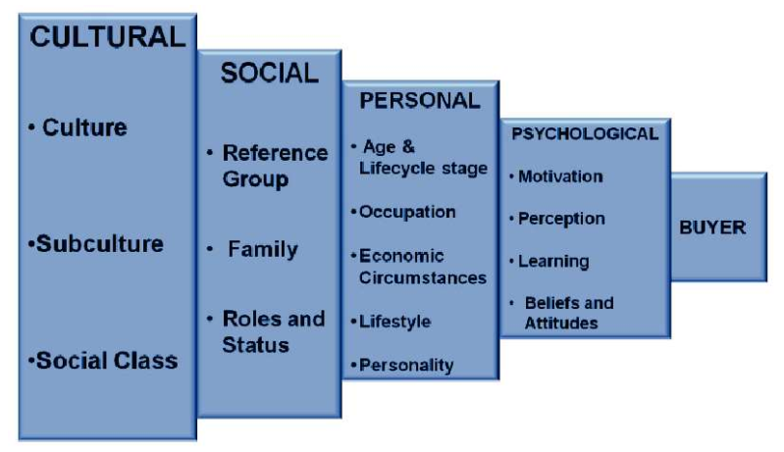
Figure 4: Factors affecting the buying behavior of customers
(Source: Carlymjones, 2016)

Besides, Boztepe (2016) discussed that the standard model of consumer that buys behavior representing the stages involves in the development of the actual buying behavior. The steps that are involved in the consumer buying decision model, however, are being illustrated by the figure below graphically. It can be seen from the figure below that the first stage is problem recognition as Nes, Yelkur and Silkoset (2014) elaborated this stage by stating that during this step the concern customers realizes the emerging need required to be fulfilled. This moves the customer to the second stage that is the information search stage where people gather the relevant information regarding the identified need in order to solve the emerging problem. In continuation, the third step in the model is the evaluation where the customer evaluates each available option after gather the multiple solutions. Parmar and Deliya (2012) further continued that at evaluation's stage customer compare the benefits usually and other characteristic associated with the offered service or the product. After evaluating the available option, the purchase is made by the customer finally in order to fulfill the identified need. (Deliya, 2012) The model's last stage is the post purchase evaluation where the perception regarding the quality and effectiveness of the purchased product is developed. (Parmar, 2012)

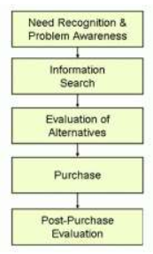
Figure 5: Stages of consumer buying behavior
(Source: Izotron, 2015)
Consumer that buys behaviour is thus adopted as the dependent variable for this study's purpose to provide clarity and guidance to ascertain the influence of the different types of advertisement media or mode on consumers' purchase decision with relations to automobile purchases in Shanghai, China.
2.5 Fundamental theory
2.5.1 The Theory of Reasoned Action (TRA)
Kasprzyk and Montano (2015) discussed that the reason action theory states that an individual's decision-making process involves high unpredictability therefore, it does not involve specificity. It is further continued that in consumer behavior's context, this theory states that the action of a customer towards a product is dependent on the expectations of the specific result they will receive by purchasing that particular product. (Kasprzyk, 2015) Furthermore, due to the expectation the customer decides to act when the certain action is completed. The ability of change the customers' perception continue to be same while they make the decisions on the different course of action. Besides, Bagozzi, Wong, Bergami and Abe (2014) discussed that this theory suggests the marketers the offered product should associate the purchase with a positive result in order to influence the concern customers' buying decision. Fisher, Kohut, Salvadori and Salisbury (2013) continued that this theory is based on the intention as it states that stronger intentions, the more efforts will be made to perform the certain behavior. The Theory of Reasoned Action is being illustrated by the figure below graphically. This theory, however, will help in positioning and justifying the concern customers' actions towards a particular brand developed through their advertisement.

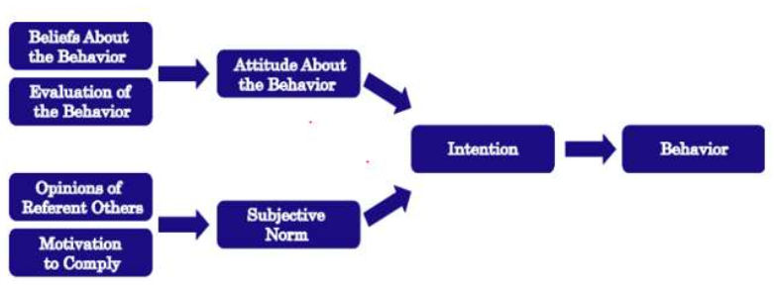
Figure 6: Theory of Reasoned Action
(Source: Iastate, 2016)

The fundamental grounding is thus provided by Theory of Reasoned Action to support this study's purpose as it is based on the assumption that humans will make purchase decisions in a rational and reasonable manner after considering various options (Bagozzi et. al., 2014). Moreover, advertisement could serve as a form of opinion from others, whereby according to Iastate (2016), will influence the purchase intention that will then lead to the subsequent purchase decision that was made by the consumer as shown in Figure 6. Hence, this is an appropriate supporting theory for this study.
2.5.2 The classical model of decision-making
Zimmermann (2012) discussed that decision's classical model making is considered to be the traditional approach that has been followed by an individual while making any related decision. It is further continued that the decision's classical view making involves an individual's rational thinking within decision's whole process making. Besides, Rodríguez, Martınez, and Herrera (2013) discussed that this model suggests that the decision makers are objective because they have complete information regarding the concern utilized while developing the perceptions and final decisions. Furthermore, the author has argued that this approach of decision making is ineffective in this modern era due to high unauthentic information's availability. Perez, Cabrerizo, Alonso and Herrera-Viedma (2014) continued by stating that from the consumer behavior perspective, this theory states customer make for the rational decision while making any purchase that is dependent on the available information regarding the concerned product.

The classical decision making model also relates to the fact that customers will make when making purchases, dependent on available information (Perez et for rational decision. al., 2014), hence, this theory is also aligned with the Theory of Reasoned Action that will be useful as support for this study focussing on establishing the relationship between advertisement as a form of opinion and information on purchase decision of the consumers for automobile in Shanghai, China.
2.5.3 Influence of advertisement on consumer buying behavior
In the view of Tseng, Kuo and Chen (2014), the advertisement's main purpose is relevant information and communication high regarding the product to the concern customers. The author has further stated that advertisement involves the main information regarding the characteristic and benefits of the offered product usually in order to inform the concern audience. On the other hand, Prabhakar, Maeda, Jain, Sevick-Muraca, Zamboni, Farokhzad and Blakey (2013) discussed the consumer that buys behavior is highly affected by the available information regarding the product as it mainly helps in identifying the existing need while the communicated information has direct influence over their buying decision. In contrast, Halinen (2012) argued that advertising of the services and concern product develops the customers' emotional reaction by using sound and effective pictures. Furthermore, the author has further argued that these advertisements could also lead towards the negative perception's development and image of the product in the concerned market. It is further elaborated that the exaggeration of the benefits of the offered product and services in the advertisement develops high expectations from the product, it could therefore have a reverse impact.

2.6 Framework
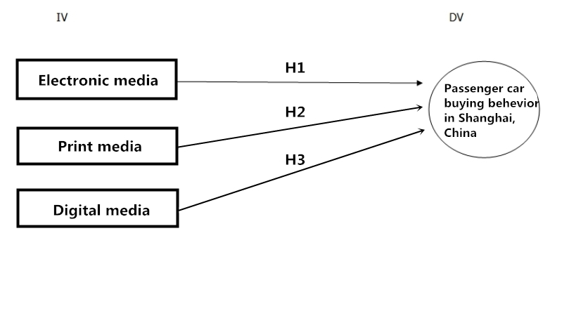
Figure 7: Conceptual framework

The above framework has been designed to measure the relation between the advertisements of Arrizo 7 with the buying behavior of customers in Shanghai, of China. Cherry automobile Ltd promotes its products with high class advertisements and tends to create awareness in the consumers' minds.
2.7 Research gap
From the above discussion on the relevant variables' literature it has been analyzed that though the consumer behavior and advertisement have already been discussed by a lot of past researchers but the information on the related variables in the automobile China's industry is still limited, especially within Shanghai, China, where such a study has yet to be undertaken. It has been identified that there is a study gap that has motivated the researcher to fulfill the gap by conducting the study in this field of study.
2.8 Research hypothesis
Research hypotheses are discussed as follows:
H1: There is a significant relationship between print media advertisement and passenger can buying behavior in Shanghai of China.
H2: There is a significant relationship between digital media advertisement and passenger can buying behavior in Shanghai of China.
H3: There is a significant relationship between electronic media advertisement and passenger can buying behavior in Shanghai of China.

2.9 Chapter summary
The discussion on the literature of the concern variables including the consumer buying behaviour and the advertisement has helped in analyzing the research gap that has been used to develop the concern hypothesis. It, however, has been identified that the concern variables have already been discussed and reviewed by researchers but there are no such studies that are conducted in China's automobile industry regarding advertisement's influence in the consumer that buys behaviour.

Section 3: Research Methodology

3.0 Introduction
The exploration philosophy is connection which is a quantitative review to think about the relationship among the IV and DV. The non-likelihood accommodation that examines strategy will be utilized amid the polls' appropriation. The socioeconomics and notice of purchasers is relied upon to be the influencers impacting the client that purchases conduct inside the car business in Shanghai, China.

In this study, this exploration has a place with the class of cross sectional, relationship ponder, which alludes to information's gathering in brief day, age and a solitary as it were. Moreover, investigation's unit is person. In the interim, this investigation would use elucidating and inferential measurements to translate the outcomes. Other than these, an overview would be led through on-line survey dissemination as this is the speediest method to acquire input from the focused on respondents. Amid the overview time, NOT can in any case be picked by the respondents to answer the poll since this is their willful to react or not. Any that drives of noting poll won't be directed.

3.1 Research plan

3.1.1 Plan description
The exploration configuration is the general technique that has been fused by the specialist for efficiently connecting the study's worry segment that can legitimize the created goals. Logical, exploratory and depiction investigate configuration are the three concern kinds of the study outline typically embraced by the exploration Lewis (2015). Nonetheless, the displayed explore has taken after the logical research plan in light of the fact that the primary motivation behind the exploration is to break the connection down between the promotion and the shopper purchasing conduct in China's car business. Besides, the principle reason of following this study configuration is on account of there is no such vulnerability apart from if the conclusions are obviously characterized. Besides, as the introduced's key research articulation examine are the created speculation while as the exploration has included the basic leadership's later phases, in this way, logical research has been taken after.

As exploratory research configuration includes the unstructured research approach while the exhibited look into has engaged with the very organized research approach hence, logical research approach. (Lewis, 2015) What's more, as the exploration's theme unmistakably expresses its motivation of testing the end results connection and circumstances between the worry needy and free factor that can be accomplished by following the illustrative research. (Hunter, 2012) Distinguishing the autonomous variable while clear research configuration includes the reason for concentrate the worry variable as the exploratory research is relevant in the investigations including the motivation behind profoundly because of absence of writing accessible. Besides, the other primary reason of following the illustrative research configuration is to recognize the connection's idea between the reliant factors and the autonomous factors to find out whether the outcomes can be unsurprising. This study along these lines is thought to be a clear, logical, quantitative based relationship consider (Case and Hunter, 2012).

3.1.2 Research approach
Research approach can be alluded as the strategy that has been joined by the scientist in organizing the study. As there are two principle approaches that are trailed by the analyst including inductive and deductive (Friend and Jessop, 2013). In any case, the introduced explore has conveyed forward the deductive research approach over the inductive research approach. The deductive research approach is predominantly worry with the testing of the speculation or hypothesis while inductive research approach includes the point of creating hypothesis and new data from the information. It can be expressed that as the exhibited's principle point investigate is to test the created theory so as to finish up the exploration in this manner, deductive research has been conveyed forward. Besides, as the displayed look's primary accentuation into is to build the degree and presence of connection up between the DV and the IVs, in this way, deductive approach has been connected. Unsurprising conclusions' benefit is given by the deductive research approach as the study's results is required to give consistency as far as the accessibility and degree of connection between the factors (Lewis, 2015).

3.1.3 Research theory
Research theory is the scientist's conviction with respect to the way trailed by gathering, dissecting and translating the concerned information about a wonder. Interpretivism, authenticity and Positivism are the three principle rationalities consolidated by the scientist (Nichols and Knobe, 2013). Be that as it may, the exhibited inquire about has taken after the positivism investigate reasoning in light of the fact that the exploration's worry factors are as of now examined by the past researchers subsequently, enough writing on the worry factors is accessible. Besides, as the exploration has expected to examine and foresee while the study's eyewitness is free that is the fundamental reason of following the positivism investigate logic. The pertinent factors' clarifications have been shown causality to and isn't worry of expanding the circumstance's general comprehension in authenticity and this manner interpretivism inquire about has not been taken after. One of the other fundamental reason of following the positivism examine logic is on account of the study has embraced the deductive approach and expected to test the created speculation. Furthermore, the worry investigation has been decreased to the most straightforward terms while likelihood has been taken after for speculation the worry discoveries. Authenticity and interpretivism limits the scientist from including vast number of test units while the displayed look into has expected to incorporate substantial example's suppositions in this manner, positivism has been taken after. (Knobe, 2013)

3.1.4 Research technique
Research technique is the strategy that has been taken after for watching and gathering the worry information of the exploration that can legitimize its objectives and principle points. (Nobe, 2013) Review, perceptions, test, contextual investigation are few noteworthy research technique trailed by the analysts for gathering the worry information that relies upon the exploration's idea (Ohlin, Wilson and Farrington, 2012). Be that as it may, as the displayed look into has planned to incorporate countless units and to produce quantifiable and quantifiable information chiefly, consequently, review explore procedure has been conveyed forward. One of the fundamental the review's advantages inquire about procedure is the cost viability on the grounds that overviews are moderately more affordable than other study techniques. (Wilson, 2012) Also, innovation has made it simple to access to the worry test through on-line stages and versatile which has decreased the requirement for the exploration's physical nearness for gathering the worry essential information from the example units. (Ohlin, 2012) These on-line studies have lessened printing's cost additionally while made it simple to include a high number of potential reactions with no topographical boundary. (Farrington, 2012) Besides, the most important reason of following the study technique is it provides the upside of depicting the attributes of the extensive populace that is generally troublesome because of the restraint of time for finishing the exploration. (Wilson, 2012) The wide limit gave by the review procedure is one of its upper hand that guarantees the precision of the gathered information that is additionally used in closing the exploration and settle on applicable choices. (Farrington, 2012)

3.1.5 Unit of Analysis
Investigation's unit is considered as one of the real element in an exploration that is being broke down. It can additionally be expounded that the study ponders and legitimize who and what worries with a specific end target to finish up the exploration (Case and Hunter, 2012). In any case, in the displayed examine, study's concerned unit are the people especially the customers of the vehicle business that have been concentrated to test the created speculation and legitimize the exploration's worry question. In any case, people are considered to be the most complexed and run of the mill units yet help in creating logical discoveries that are more profitable and generalizable. (Case, 2012) The study's worry test units can speak to the perspectives of the entire populace that has expanded the relevance and generalizability of the exploration. (Hunter, 2012) The introduced look's general discoveries into are reliant on its example units since they are key components that have been examined in the exhibited inquire about. The fundamental purpose behind choosing people as the unit of investigation is on account of the introduced inquire about depends because of the ad in the clients' purchasing conduct, in this manner, they have been the essential focal point of the exploration.

3.2 Sampling Design
This exploration center around who needs to purchase or as of now owning autos inside Shanghai, China, particularly, the Cherry brand, and to decide the sorts of notice impacting their whether the statistic factors will likewise have impact and purchasing. There will be 500 polls that were appropriated on the web, a greatest of 500 members are assessed to take an interest the study. It must be no less than 384 legitimate polls that are gathered, ( Morgan and krejcie, 1970) and as per Hair et. al. (2013), as information surpasses 250 information focuses, it will be factually substantial and essentially clear as long.

3.2.1 Target populace
The objective populace is alluded the portion or general population of individuals having similar qualities required for taking part the exploration. Be that as it may, the objective populace generally is relatively huge. Along these lines, it is unfeasible for the analyst to incorporate all the worry members (Acquet, Stephenson, Collins, Patel, Trussler, Al‐Bedaery and Ilic, 2013). Notwithstanding, the exhibited's objective populace inquire about is the car's purchasers China's business. The shoppers in the worry business are generally gigantic in volume, as Wang, Fan, Zhang, Gao and Wang (2014) talked about that China is considered one of the most elevated populace country in this manner. In this way, the specialist will approach Cherry vehicle Ltd Shanghai's customers, of China with respect to their purchasing conduct that may have been impacted by the commercials of Arrizo 7.

3.2.2 Sampling Techniques
The study has taken after the comfort non-likelihood that inspects strategy as the exploration's worry populace is generally huge along these lines, to choose the required example units. (Gibson, 2013) Shot, Gibson, and Eisenhardt (2013) talked about that comfort non-likelihood that examines procedures are a standout amongst the most widely recognized techniques where the choice of the worry test from the focused on populace is simply in light of the scientist's availability simplicity. It is further proceeded with that through evaluate have contended that this technique includes the predispositions of the specialist having an immediate impact over the finish and discoveries of the study. (Eisenhardt, 2013) In any case, to keep the exploration from inclinations the scientist has incorporated the example that was effectively accessible and have every one of the qualities required to take an interest paying little mind to any inclination and individual intrigue. (Gibson, 2013) Besides, the scientist has been helped by this technique in producing more that was summed up discoveries that have incorporated the entire concern populace's perspectives. (Shot, 2013)

3.2.3 Sample measure
This exploration is concentrating on the connection amongst ad and the socioeconomics of the car and purchasers buys Shanghai China in. In China, there are 1.368 billion populaces. Be that as it may, the focal point of the study populace is on Shanghai just as because of the time oblige (under 3 months to finish the whole task), it is inconceivable to direct the exploration for the entire of China. In this way, there is a need to get an example, rather than taking the whole populace because of time confinement for this undertaking, which is just 3-months that takes all things together. As per Krejcie and Morgan (1970), for populace surpassing 1 million, the base example measure is 384. Thus, in view of the figure, around 80% of the respondents is expected to drew nearer will answer the study, and henceforth, a sum of 500 polls are circulated to the potential respondents. Once approximately 250 studies can be gathered back, information investigations can be guided as there will be more elevated amount of mensurable noteworthiness (Hair et. al., 2013).

3.3 Questionnaire design
There are different structure follows in developing the concern questionnaire that depends on the aim and nature of the research. Furthermore, it is continued that questionnaire can be utilized in generating both qualitative and quantitative data (Schuldt, Roh, and Schwarz, 2015). However, as the aim of the presented research has been to generate the quantitative data, the structured methodology and close-ended has been therefore followed while designing the concern questionnaire. Furthermore, the question has restricted the respondent to respond in the given five streams including strongly agree, agree, neutral, disagree and strongly disagree. Moreover, there is two section in the developed questionnaire including the demographics and descriptive. The demographic involved the respondents' personal information including their gender and age.

3.4 Measurement strategy

3.4.1 Analyses apparatuses
Study apparatuses that are alluded to the systems that have been taken after for breaking the gathered essential or optional information that keeps in mind the end goal to continue further and use the information in future choices down. Be that as it may, as the displayed explore has cumulated the quantitative information, in this way, the related investigation programming known as the Statistical Package for Social Science (SPSS) has been chosen from examining the worry that was assembled information. Besides, the product has likewise been used in breaking the created survey's unwavering quality down through the connection and pilot testing between the recognized factors. SPSS has been realized as the most widely recognized and effectively utilized information investigation instrument by specialists for quantitative information study chiefly in light of the fact that it is time proficient and give exceptionally exact results.

3.4.2 Pilot testing
The pilot testing is alluded to the created poll's testing including its adequacy and understandability in social event the worry information that is required to legitimize the targets and related points of the study. It is additionally examined that pilot testing is utilized to uncover the deficiency and current blunders in the information gathering instrument's outline and moreover helps in checking its unwavering quality and legitimacy before leading the full test on the extensive scale (Verma, 2012). Notwithstanding, the pilot testing in the exhibited examine has included 10 to 30 test units from the focused on populace with a specific end goal to break down the handiness of the created survey.

3.4.3 Descriptive study
If the data applicable to the worry theme, this exploration's enlightening investigation is alluded to the study. Anyhow, there are two kinds of data generally assembled from the worry test including the socioeconomics and expressive. (Verma, 2012). The socioeconomics study helps in dissecting the proportion of male and female and the age section that have partaken in the exploration so as to break the directed investigation's generalisability down. Again, clear study is then alluded to the gathered reactions' general dialog on the worry articulation with respect to the exploration's fundamental issue. (Verma, 2012). Both clear study and the statistic are directed through SPSS programming. Besides, the members' gathered individual data is cumulated namelessly in the exploration and would not be revealed freely keeping in mind the end goal to keep the morals up. Besides, the different decision question strategy has been utilized while planning the worry proclamation with respect to the exploration's principle issue.

3.4.4 Internal and outer legitimacy
There are two kind of legitimacy in the exploration including the inward legitimacy and the outside legitimacy. Likewise, Blackman, Zoellner, Berrey, Alexander, Fanning, Estabrooks and Hill (2013) examined that an study's inside legitimacy is related with conviction's level in regards to the impact's conceivable results between the worry reliant and autonomous variable. Besides, the study's inner legitimacy has been expanded through high control over the variable to enhance the connection's evaluation between the factors and keeping in mind that surveying the causes to the factors identified with the investigation's worry wonder. (Blackman, 2013)

Then once again, the other concern legitimacy of the study that is the outside legitimacy that can be alluded to the level of which the worry assembled information and the investigated inquire about discoveries can be applied in reality. (Alexander, 2013) Besides, the outer legitimacy requires the materialness of the finding without including the exploration's controlled setting rather is requiring the discoveries' generalizability. (Fanning, 2013) Besides, the expansion in the inner legitimacy of the study the outer legitimacy can be decreased on the grounds that such investigations having high inward legitimacy are directed in a way that isn't proper in reality as Datler, Jagodzinski and Schmidt (2013) talked about that. The creator assist proceeded with that the outer legitimacy can be expanded by gathering the information in the non-devised status. Be that as it may, the introduced inquire about has taken after a similar technique additionally for expanding its outer legitimacy.

3.4.5 Preliminary Test
There are three concern regions incorporated into the primer test including the factor study and the unwavering quality test. They are additionally expounded underneath.

3.4.5.1 Factor Analysis
Factor study can be alluded as the procedure directed before testing the significance and suitability of the pertinent factors that investigation that whether there are components or things engaged with the study that ought to be expelled because of its insignificance before additionally continuing towards tests. (Bi, 2013) Be that as it may, for breaking the worry factors the exhibited's gathered information investigate down has included the KMO Bartlett's trial of sphericity. As Bi and Dang (2013) talked about that the KMO Bartlett's trial of sphericity helps in distinguishing the data which is the gathered information with respect to the worry factors are applicable and proper for additionally studys while their commitment in accomplishing the targets and coveted points is likewise dissected. Besides, the Measure of Sampling Adequacy (MSA) has been directed to break the factor down as Ayeh additionally, Law and Au (2013) expressed that MSA is one of the primary factor study measures that has constrained the range from 0 to 1. It is additionally explained that this measure expresses that if the estimation of the variables in higher that 1 the elements are then more fitting. Again, Soukup, Hughes, and Heffernan (2014) then contended that the part network ought to be connected with a specific end goal to investigate the factors' legitimacy as the outcome ought to be no less than 0.6 or more. Nonetheless, if the produced aftereffects of the segment lattice don't meet the worry prerequisite then the gathered information and the worry factors should be expelled from before continuing further. (Bi, 2013)

3.4.5.2 Reliability Test
Unwavering quality test in the social studys is alluded to the strategy for dissecting the dependability and significance of the cumulated data in reality and also to find out the information's inside consistency gathered. (Lane, 2014) The same, unwavering quality test is the initial step in the wake of gathering the anxiety essential information since it helps in investigating that whether the accumulated information is dependable and is equipped for utilizing further to generate related conclusions (Crowder and Lane, 2014). In this manner, the introduced investigate has likewise directed the dependability test to guarantee the gathered information's unwavering quality in light of the fact that if the gathered answers are high conflicting that implies that whether members have neglected to comprehend the announcement of have not rounded the survey out with complete consideration. Furthermore, the other fundamental reason of following the unwavering quality test is to gauge the consistency in the worry point in light of the accumulated information. (Crowder, 2014)

Moreover, Peterson and Kim (2013) talked about that unwavering quality of the worry factors is examined through Cronbach's Alpha esteem. The creator has examined that additionally the qualities inside the scope of 0.7 and 0.85 of the Cronbach's esteem are worthy while the information is viewed as dependable. In any case, the esteem surpasses the esteem 0.95 or the esteem under 0.75 means that the gathered information isn't dependable, in this way, it ought not continue encourage for finishing up the exploration. (Kim, 2013) The figure underneath is representing the satisfactory reaches and the level of unwavering quality.

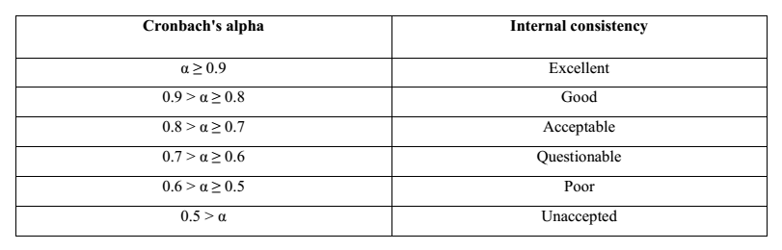
Table 2: Cronbach's value
(Source: Author’s own)

3.4.6 Hypotheses testing
Speculations testing is alluded to the method after for examining the connection between the worry autonomous and needy variable, took. (Lily, 2014) Besides, the speculation testing helps in breaking the connection's quality down between the factors in this way, they are normally shaped in the investigations intending to examine the end results connection and circumstances between the worry factors fundamentally. In continuation, the speculation is tried through relapse investigation. (Lousia, 2013) The introduced inquire about has led the relapse study through SPSS programming to break down and legitimize that whether the proposed speculation is acknowledged or dismissed.

The relapse study through SPSS programming includes β alluded to the way coefficient that is utilized as a part of building the relapse articulation up. Verma (2012) proceeded with that way that coefficient speaks to the worry factors' quality alongside the direct affiliation's bearing. Besides, if the relapse investigation is required to be under 0.05 with a specific end goal to meet the general acknowledgment traditional level. Furthermore, the relapse display includes the estimation of R2 speaking to the level of the needy variable's difference conduct by the variety in the autonomous variable. (Kelry, 2016) The discoveries or outcomes will be evaluated against the speculations and exploration targets to decide the degree and presence of impact between the DV, once the tests had been finished and the IVs.

3.4.7 Data accumulation and investigation
Information accumulation technique for the specialist is subject to the study's, as indicated by Goodman, Cryder, and Cheema (2013) idea. Besides, there are the distinctive skill accessible for gathering the worry essential information as surveys are utilized when the exploration intends to create the quantitative information. Then again, if the study expects to gather the quantitative information at that point ideally meetings and reviews are attempted by the analyst. (Goodman, 2013) Nonetheless, the exhibited examine has intended to make the quantitative information for the gather, in this way, relative measures that are the poll's utilization for gathering the worry essential information has been joined.

Ott and Longnecker (2015) talked about that the information that was gathered through the instrument that was required further investigation to change over into valuable data that can be used in defending the destinations and created point of the study. The creator has facilitate proceeded with that SPSS programming is the most ordinarily utilized information study device generally utilized by the specialists around the globe. The displayed inquire about has likewise utilized the SPSS programming for dissecting the worry essential information so as to produce the exploration's applicable discoveries.

3.5 Chapter summary
The introduced investigate has taken after the deductive approach because of the theory that tests while, because of the point of gathering the quantitative information the exploration has taken after the logical research plan. Besides, overview and positivism research investigate methodology have been consolidated into the study. Organized surveys and close-finished have been also created for gathering the concerned research from 300 clients of China's vehicle business. Furthermore, the created survey's adequacy has been examined through pilot testing while the gathered information has been broke down through SPSS programming. Be that as it may, before applying the accumulated information for finishing up the study, its unwavering quality has been dissected by using factor investigation. The study has additionally guaranteed that the morals including the classification, namelessness, and self-rule are followed in seeking after the exploration.

Research Methodology
 | Details | Citations
Purpose of Study | Descriptive research | Ploetzet al.(2005)
Type of Investigation | Quantitative based correlations | Babin et al. (2012)
Extent of researcher interference | Minimal | Umamaheswariet al.(2009)
Study Setting | Non-contrived | Umamaheswariet al.(2009)
Time Horizon | Cross-sectional | Kimberlin &Winterstein (2008)
Target Population | 8 million Mobil car customers in China yearly | The world bank, (2011)
Sample size | 384 | Krejcie and Morgan (1970)
Sampling Procedure | Non probability convenience sampling | Mann (2005)
Data collection | Online Questionnaire | Iii (2014)

Data Analysis Techniques and Tools
Tests | Function | Rule of thumb | Citations
Factor Analysis  (Pilot & Preliminary after full data collection) | To identify a reduced number of factors from a larger number of measured variables (Hair et al, 2014) | Loadings>0.6 (Hair et al, 2014)  KMO > 0.6 (Hooper, 2012)  Bartlett’s test of spheicity p< 0.05 (Rusuli et al., 2013) | Paille (2012), Dhar (2015), George (2015)
Reliability Test  (Pilot & Preliminary after full data collection)  Hypotheses testing | To evaluate the internal consistency and stability of the measurement (Sekaran and Bougie, 2011).  Simple multiple regression + One-way ANOVA (ANOVA) is a collection of statistical models and their associated estimation procedures used to analyze the differences among group means in a sample.  Hierarchical regression (if have MV/ IVV) | Cronbach alpha between 0.70 and 0.90 (Hair et al, 2010)  P=<0.05 (95% confidence level)  R & R2 + Beta Coefficient | Nawab and Bhatti (2011)

Summary of Proposed Questionnaire Items adaptation from previous studies
Section | Variable | Item | Source
A | Demographic profile | 3 | (Kalia,2016)(Sin,2011) (Akman,2010)  (Awa,2015) (Clarke,2015)
B (Dependent variable) | Customers buying behavior | 5 | (Zipser,2016) (Zhang,2014) (Thomas,2014)  (Diao, 2015) (Chen,2014)
C (Independent variables) | Print media | 5 | (Yang, 2017) (khan,2017) (Nakhumwa,2013)  (Suwunniponth,2015)(Nakhumwa, 2013)  (Jarollahi,2013)
C (Independent variables) | Digital media | 5 | (Wang,2014) (Najjar,2016) (Li,2011)  (Radziszewska,2013) (Apăvăloaie,2015)
C (Independent variables) | Radio and TV media | 5 | (Morganti,2014) (Mensah,2014) (Nurdani,2016) (Kim,2016) (Xu,2013)

Literature Rubric
Number | Author | Year | Journal | Result of study | DV |  | IVs
 |  |  |  |  | Customers buying behavior |  | Print media |  | Digital media |  | Radio and TV media
 |  |  |  |  | Thesis | Anti-Thesis | T | A | T | A | T | A
1 | Tholen, Gerbrand | 2012 | British Educational Research Journal | It means schools only guide students when they are selecting jobs. | *
2 | Velasco, Manuel Salas | 2012 | Journal of Business Economics and Management | The employee who was selected a great job, but, the candidate bypassed is like the road not taken. | *
3 | Orser, Barbara ; Riding, Allan ; Stanley, Joanne | 2012 | Entrepreneurship & Regional Development | Management is a significant approach to promote employees to boost work efficiency |  |  |  |  |  |  | *
4 | Gutierrez, Antonio P. ; Candela, Lori L. ; Carver, Lara | 2012 | Journal of Advanced Nursing | Questions about welfare and salary history can easily transition into a discussion of your salary expectations. |  |  | *
5 | Mirvis, Philip | 2012 | California Management Review | In this post, we'll explore whether or not higher salaries make for more satisfied employees, and if not, what factors contribute to overall employee satisfaction. |  |  | *
6 | Bogart, Dan ; Chaudhary, Latika | 2012 | AMERICAN ECONOMIC JOURNAL: ECONOMIC POLICY | Mandatory training will be carried out for Chairs and Panel members involved in interview panels in the job recruitment and selection. | * |  |  |  | *
7 | Nguyen, Nguyen ThiDuc ;Takanashi, Chikako ; Aoyama, Atsushi | 2012 | International Journal of Business and Management | Studies show that feeling a sense of belonging in the workplace leads to more than just good vibes and salaries. |  |  | *
8 | Garavan, Thomas N. ;Carbery , Ronan ; Rock, Andrew | 2012 | European Journal of Training and Development | In fact, this opportunity for employees to grow and develop through training is one of the most important factors inemployee motivation |  |  |  |  | *
9 | Lips, Hilary M. | 2013 | Sex Roles | One of the factors that influence the selection process for the job department is the geographical location of the job selection. | * |  | *
10 | Klaauw, Bas Van der ; Ours, Jan C. Van | 2013 | Journal of Applied Econometrics | Only to discover that you'll be leaving behind benefits at your current employer that are actually worth more than that new salary |  |  | *
11 | Chen, Shengnan ; Cheng, Alice ; Mehta, Khanjan | 2013 | Telemedicine and e-Health | The decision to promote employees or not differs for lower level employees to management level employees. |  |  |  |  |  |  | *
12 | Malik, Muhammad Ehsa; Naeem, Basharat | 2013 | World Applied Sciences Journal | Promoting in-house is a smart way to grow your business and invest in your staff towards leadership development. |  |  |  |  |  |  | *
13 | Geddie, Kate | 2013 | Population, Space and Place | The importance of selecting a career with which we are satisfied cannot be overemphasized. | *
14 | Dhevabanchachai, Nate-tra; Muangasame, Kaewta | 2013 | International Education Studies | This argument will be proven that a harmonious workplace and love of work are the leading factors in choosing a job. | *
15 | Gereffi, Gary | 2014 | Review of International Political Economy | Industrial development has had an important role in the economic growth of countries like China
16 | Yadav, Preeti; Singh, Jeet. | 2014 | Sumedha Journal of Management | The role of training and its impact on company performance is studied in different types of enterprises in a transitional economy. |  |  |  |  | *
17 | Seligman, Martin E. P. ; Csikszentmihalyi, Mihaly | 2014 | Flow and the Foundations of Positive Psychology | This may sound obvious, but many people neglect considering this important side of selecting a career. | *
18 | Nijs, Sanne; Gallardo, EvaGallardo; Dries, Nicky; Sels, Luc | 2014 | Journal of World Business | The job selection and standard selection of the portfolio must embody the participation of learner. | *
19 | Wararkar, Pravin ;Wararkar, Kishor | 2015 | International Journal on Textile Engineering and Processes | Employee compensation can include base salary, wages, incentives and/or commission. |  |  | *
20 | Barnes, Sally-Anne ; Green, Anne ; Hoyos, Maria de | 2015 | New Technology, Work and Employment | In the contemporary climate, fully engaging with the techniques of job analysis, job description and person specification is considered to be 'a good business investment because it can be used to support most HR functions: recruitment, selection, orientation, training, work plans, compensation, performance reviews | * |  |  |  | *
21 | Sun, Hongyi; Ni, Wenbin; Lam, Rocky | 2015 | Computers in Industry | It is essential to be aware of the legal requirements that underpin the recruitment and job selection | *
22 | Hammer, Michael | 2015 | Handbook on Business Process Management | Small and medium-sized businesses really need to understand the importance ofpromotional and marketing strategies. |  |  |  |  |  |  | *
23 | Hornstein, Henry A. | 2015 | International Journal of Project Management | Once that is done there can be a more realistic assessment of the probable success of job training. |  |  |  |  | *
24 | Swamy, Devappa Renuka; Nanjundeswaraswamy, T. S.; Rashmi, Srinivas | 2015 | International Journal of Caring Sciences | Various compensation systems have  developed to determine the job selection. | *
25 | Chan, David ; Ye, Tian ; Xu, Honggang | 2016 | Journal of China Tourism Research | However, most people find that their financial situation strongly influences their job decision making. | *
26 | Latukha, Marina | 2016 | Talent Management in Emerging Market Firms | All of these forms of compensation contribute to a more comfortable lifestyle, which makes promotions appealing motivational goals for a wide range of workers. |  |  |  |  |  |  | *
27 | Wojciechowska, Maja | 2016 | Intangible Organizational Resources | Finally, unions typically resist merit pay plans and they strongly rely on collective bargaining to determine salary increases. |  |  | *
28 | Kartikasari, Dwi ;Merianti, Marisa | 2016 | International Journal of Economics and Financial Issues | A high base salary may attract a top job candidate that is 20-something and single, while a job candidate with a family may consider a flexible work。 |  |  | *
29 | Sarkar, Mahbub ; Overton, Tina ; Thompson, Christopher ; Rayner, Gerry | 2016 | International Journal of Innovation in Science and Mathematics Education | But you can also let employees choose their work and managers, select their own professional development opportunities, or provide incentive-based compensation for particularly good performance on key projects. | *
30 | Chang, Xiaoyan ; Jiang, Xiaohua ; Qu, Xiuyan | 2018 | Business Adminstration and Management | For a long time the promotion system in Chinese SOEs has been based on the seniority of workers and staff rather than on performance. |  |  |  |  |  |  | *

Chapter 4: Research Findings

4.0 Overview
In previous chapter the research methodology is introduced. This chapter will present the key results of the analysis of the data collected from 14th Nov 2017 to 20th Nov 2018. The chapter will begin with the discussion of pilot test result and descriptive analysis. Descriptive analysis is conducted to analyze the attributes of the respondents. Then, the data from the items of the questionnaire are further analyzed in factor analysis and reliability test to ensure the appropriateness of the study. Hypotheses testing with simple multiple regression test, anova test and hierarchical regression for the moderating variables are run to observe the relationship between dependent variables and independent variable. These data are analyzed with SPSS version 22.

4.1 Pilot Test
Johnson and Brooks (2010) stated that appropriate sample size for pilot study will ranged within 10 to 30. Therefore, before the questionnaires are distributed, pilot test is run among 30 people to assure the understanding of the respondents towards the questionnaires wordings and expression. Besides, the consistency of the data results will be proved and further ready for conducting preliminary test.

4.1.1 Factor Analysis
Factor analysis was done with SPSS to observe the communalities values and the values must be greater than or slightly lower than 0.7 to ensure that the items are eligible and relevant for further analysis (Field, 2005). The Kaiser-Meyer-Olkin (KMO) measure and Bartlett’s Test of Sphericity used to measure the sampling adequacy (MSA) and factorability of correlation matrix will be statistically significant with p<0.05 and MSA value larger than 0.5. (Che-Rusulu et al., 2013).

Table 3: Factor Analysis results
Variables | Items | Factor Loading | KMO | P-value
Print Media | Q6 | .863 | .823 | .000
 | Q7 | .818
 | Q8 | .803
 | Q9 | .728
Radio & TV | Q10 | .660 | .677 | .000
 | Q11 | .599
 | Q12 | .687
Digital Media | Q13 | .829 | .500 | .000
 | Q14 | .829
Automobile Purchase | Q15 | .791 | .722 | .000
 | Q16 | .793
 | Q17 | .730
According to the table, the entire communalities level are greater than 0.6. Therefore, the results are adequate and eligible for further research use. Besides, the KMO value are larger than 0.6, and all the p-values are lower than 0.05. The items are apparently valid and appropriate for the purpose of study.
4.1.2 Reliability Test
Table 4: Reliability Test results.
Variables | Items | Cronbach’s Alpha | N  (Number of items)
Print Media | Q6 | .918 | 4
 | Q7
 | Q8
 | Q9
Radio & TV | Q10 | .727 | 3
 | Q11
 | Q12
Digital Media | Q13 | .792 | 2
 | Q14
Automobile Purchase | Q15 | .833 | 3
 | Q16
 | Q17
The Cronbach’s Alpha must be greater than 0.7 to prove that the items are reliable and the respondents have sufficient understanding to the questions (Hair et al., 2010). The closer the Cronbach’s alpha is to 1, the higher the internal consistency reliability. According to table 4.2, the Cronbach’s alpha for the variables are 0.711, 0.760, 0.877 and 0.706 respectively. Hence, the items are assumed reliable and the questionnaire distribution may proceed for data collection.

Correlations
 |  | VAR00008 | VAR00009 | VAR00010 | VAR00011 | VAR00012 | VAR00013 | VAR00014 | VAR00015 | VAR00016
VAR00008 | Pearson Correlation | 1 | .776** | .775** | .771** | .159 | .181 | .071 | -.330* | -.377*
VAR00008 | Sig. (2-tailed) |  | .000 | .000 | .000 | .328 | .263 | .665 | .037 | .017
VAR00008 | N | 40 | 40 | 40 | 40 | 40 | 40 | 40 | 40 | 40
VAR00009 | Pearson Correlation | .776** | 1 | .795** | .664** | -.061 | -.092 | -.073 | -.390* | -.385*
VAR00009 | Sig. (2-tailed) | .000 |  | .000 | .000 | .710 | .574 | .652 | .013 | .014
VAR00009 | N | 40 | 40 | 40 | 40 | 40 | 40 | 40 | 40 | 40
VAR00010 | Pearson Correlation | .775** | .795** | 1 | .636** | .092 | .142 | .219 | -.222 | -.252
VAR00010 | Sig. (2-tailed) | .000 | .000 |  | .000 | .572 | .381 | .174 | .168 | .117
VAR00010 | N | 40 | 40 | 40 | 40 | 40 | 40 | 40 | 40 | 40
VAR00011 | Pearson Correlation | .771** | .664** | .636** | 1 | .217 | .092 | .123 | -.267 | -.230
VAR00011 | Sig. (2-tailed) | .000 | .000 | .000 |  | .179 | .571 | .448 | .096 | .154
VAR00011 | N | 40 | 40 | 40 | 40 | 40 | 40 | 40 | 40 | 40
VAR00012 | Pearson Correlation | .159 | -.061 | .092 | .217 | 1 | .431** | .526** | -.049 | -.065
VAR00012 | Sig. (2-tailed) | .328 | .710 | .572 | .179 |  | .006 | .000 | .763 | .689
VAR00012 | N | 40 | 40 | 40 | 40 | 40 | 40 | 40 | 40 | 40
VAR00013 | Pearson Correlation | .181 | -.092 | .142 | .092 | .431** | 1 | .462** | .105 | .148
VAR00013 | Sig. (2-tailed) | .263 | .574 | .381 | .571 | .006 |  | .003 | .518 | .361
VAR00013 | N | 40 | 40 | 40 | 40 | 40 | 40 | 40 | 40 | 40
VAR00014 | Pearson Correlation | .071 | -.073 | .219 | .123 | .526** | .462** | 1 | .032 | .060
VAR00014 | Sig. (2-tailed) | .665 | .652 | .174 | .448 | .000 | .003 |  | .842 | .711
VAR00014 | N | 40 | 40 | 40 | 40 | 40 | 40 | 40 | 40 | 40
VAR00015 | Pearson Correlation | -.330* | -.390* | -.222 | -.267 | -.049 | .105 | .032 | 1 | .658**
VAR00015 | Sig. (2-tailed) | .037 | .013 | .168 | .096 | .763 | .518 | .842 |  | .000
VAR00015 | N | 40 | 40 | 40 | 40 | 40 | 40 | 40 | 40 | 40
VAR00016 | Pearson Correlation | -.377* | -.385* | -.252 | -.230 | -.065 | .148 | .060 | .658** | 1
VAR00016 | Sig. (2-tailed) | .017 | .014 | .117 | .154 | .689 | .361 | .711 | .000
VAR00016 | N | 40 | 40 | 40 | 40 | 40 | 40 | 40 | 40 | 40
**. Correlation is significant at the 0.01 level (2-tailed).
*. Correlation is significant at the 0.05 level (2-tailed).

Correlations
 |  | VAR00017 | VAR00018 | VAR00019
VAR00017 | Pearson Correlation | 1 | .672** | .644**
VAR00017 | Sig. (2-tailed) |  | .000 | .000
VAR00017 | N | 40 | 40 | 40
VAR00018 | Pearson Correlation | .672** | 1 | .595**
VAR00018 | Sig. (2-tailed) | .000 |  | .000
VAR00018 | N | 40 | 40 | 40
VAR00019 | Pearson Correlation | .644** | .595** | 1
VAR00019 | Sig. (2-tailed) | .000 | .000
VAR00019 | N | 40 | 40 | 40
**. Correlation is significant at the 0.01 level (2-tailed).

Table 5: Correlation Test results.
The Correlation test is to test the extent of correlation between the items of independent variables while the correlation table is shown to ascertain whether the items within the dependent variable itself has the strength of linear association. Khalid et al. (2012) states that the value of r always lies among -1 and +1 inclusive, when r lies near to -1, it shows a strong negative correlation and vice versa. From the table, the variables are consider correlated since all the data are -1 and +1 inclusive.

4.2 Descriptive Statistics/ Demographic of Respondents
Figure 8: Gender
In accordance to the figure 4.1, majority of the respondents are male, composing 58.88% of the respondents while male respondents consist of 41.12% only.
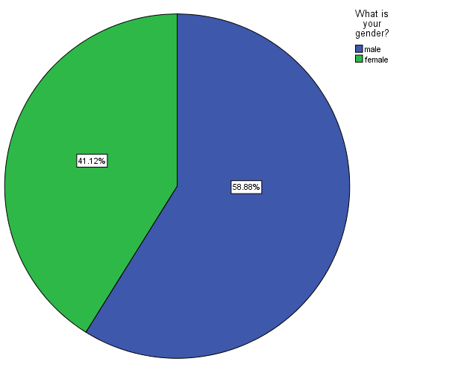

Figure 9: Educational Level
From the figure 4.2, the educational level of major respondents is degree (44.86%) and the least percentage is 7.477% which is the master educational level group.

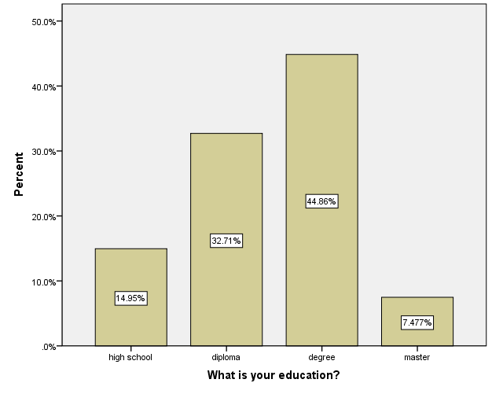

Figure 10: Occupation
60.75% of the respondents are services while the second large occupation group are from retired (16.82%). The percentage of private, self employed both made up 11.21% respectively.
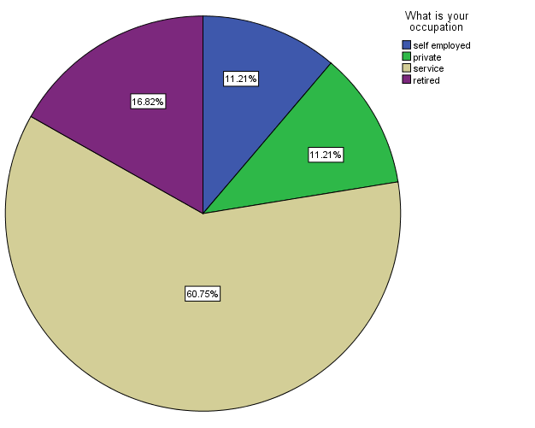

Figure 11: Monthly Income
Majority of the respondents have earnings of 4001-6000RMB (51.4%). The respondents with income under 2000RMB and 2001-4000RMB made up 3.738% and 24.3% respectively. While the minority respondents have income exceeding 6000RMB

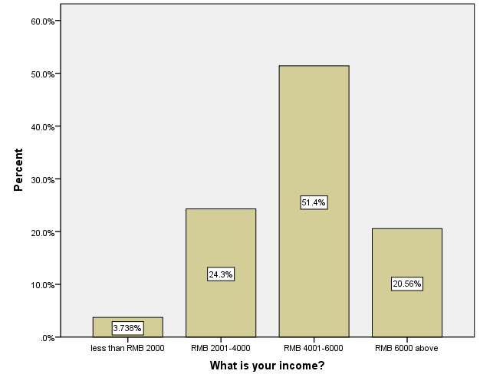

Figure 12: Age
18-25 years old are the minority age group of the respondents (18.69%). The major group 26-33 and 40 above years old both consist of 29.91% of the respondents. While the34-40 group consist of 21.50% of the respondents respectively

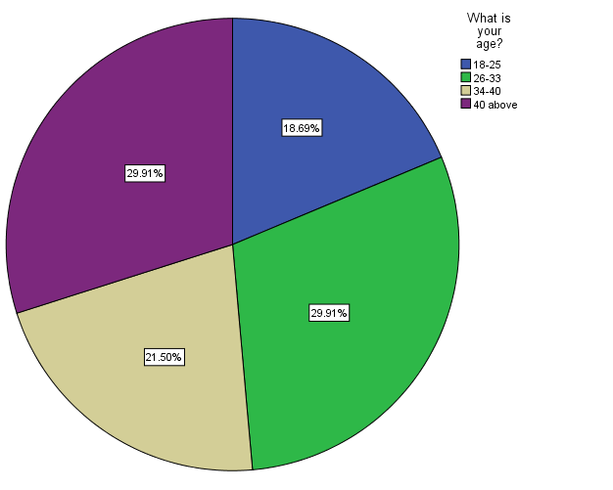

What is your age?
 |  | Frequency | Percent | Valid Percent | Cumulative Percent
Valid | 18-25 | 60 | 18.7 | 18.7 | 18.7
Valid | 26-33 | 96 | 29.9 | 29.9 | 48.6
Valid | 34-40 | 69 | 21.5 | 21.5 | 70.1
Valid | 40 above | 96 | 29.9 | 29.9 | 100.0
Valid | Total | 321 | 100.0 | 100.0

What is your gender?
 |  | Frequency | Percent | Valid Percent | Cumulative Percent
Valid | male | 189 | 58.9 | 58.9 | 58.9
Valid | female | 132 | 41.1 | 41.1 | 100.0
Valid | Total | 321 | 100.0 | 100.0

What is your income?
 |  | Frequency | Percent | Valid Percent | Cumulative Percent
Valid | ess?than RMB 2000 | 12 | 3.7 | 3.7 | 3.7
Valid | MB 2001-4000 | 78 | 24.3 | 24.3 | 28.0
Valid | MB 4001-6000 | 165 | 51.4 | 51.4 | 79.4
Valid | MB 6000 above | 66 | 20.6 | 20.6 | 100.0
Valid | Total | 321 | 100.0 | 100.0

What is your occupation
 |  | Frequency | Percent | Valid Percent | Cumulative Percent
Valid | self employed | 36 | 11.2 | 11.2 | 11.2
Valid | private | 36 | 11.2 | 11.2 | 22.4
Valid | service | 195 | 60.7 | 60.7 | 83.2
Valid | retired | 54 | 16.8 | 16.8 | 100.0
Valid | Total | 321 | 100.0 | 100.0

What is your education?
 |  | Frequency | Percent | Valid Percent | Cumulative Percent
Valid | high school | 48 | 15.0 | 15.0 | 15.0
Valid | diploma | 105 | 32.7 | 32.7 | 47.7
Valid | degree | 144 | 44.9 | 44.9 | 92.5
Valid | master | 24 | 7.5 | 7.5 | 100.0
Valid | Total | 321 | 100.0 | 100.0

Table 6: Demographic Profile
The questionnaires were distributed to nearly 350 people, 330 are collected back and excluding the invalid questionnaires, 321 valid questionnaires are analysed. The demographic session of the questionnaire includes Gender, Age, Occupation, Monthly Income and Occupation (Table 4.4).

4.3 Preliminary Data Analysis
In order to ensure the items for 301 respondents are eligible for hypotheses testing, the preliminary data analysis is conducted by utilizing also the SPSS software version 22. The analysis undergoes Factor Analysis and Reliability Test again to observe the Cronbach’s alpha, Kaiser-Meyer-Olkin (KMO), and the p-value of Bartlett’s Test of Sphericity

4.3.1 Factor Analysis and Reliability Test

No. | Questions | Factor Loading | Cronbach’s  Alpha
Q6. | News paper advertisement has an impact on passenger car buying behavior | 0.843 | 0.911
Q7. | Magazine advertisement has an impact on passenger car buying behavior | 0.824
Q8. | Product handout has an impact on passenger car buying behavior | 0.782
Q9. | Product catalouge has an impact on passenger car buying behavior | 0.748
KMO: 0.699 Bartlett’s Test of Sphericity – p-value < 0.05
Table 7: Validity and Reliability for the Print Media.
According to table 4.5, the KMO is 0.699 and the p-value of Bartlett’s Test of Sphericity is under 0.05. Hence, the result is valid. The factor loading for all items are greater than 0.6, which means they are highly influential to the variable. Meanwhile, the Cronbach’s alpha is 0.782, higher than 0.7 and hence assumed to be reliable for this variable.
No. | Questions | Factor Loading | Cronbach’s  Alpha
Q11. | Social media advertisement has an impact on passenger car buying behavior | 0.738 | 0.813
Q12. | Mobile phone advertisement has an impact on passenger car buying behavior | 0.754
Q13. | Internet advertisement has an impact on passenger car buying behavior | 0.724
KMO: 0.699 Bartlett’s Test of Sphericity – p-value < 0.05
Table 8: Validity and Reliability for the Digital media.
By referring to table 4.6, the KMO of Radio and TV variable is 0.660 while the p-value of Bartlett’s Test of Sphericity is under 0.05. Hence, the variable’s validity is valid. Besides, the entire factor loading of the items are more than 0.5, proving it is highly affecting the variables. The Cronbach’s Alpha exceeding 0.7 means that the variable is adequately reliable.

No. | Questions | Factor Loading | Cronbach’s  Alpha
Q14. | Radio advertisement has an impact on passenger car buying behavior | 0.706 | 0.757
Q16. | TV advertisement has an impact on passenger car buying behavior | 0.678
KMO: 0.699 Bartlett’s Test of Sphericity – p-value < 0.05
Table 9: Validity and Reliability for the Electronic media.
From the table 4.7, the factor loading for all items are more than 0.5, they are significantly affecting the variables. The KMO is 0.699 with p-value for Bartlett’s Test of Sphericity lower than 0.05. Hence, the variable is sufficiently valid. The reliability of the variable is also acceptable since the Cronbach’s alpha is 0.782.

No. | Questions | Factor Loading | Cronbach’s  Alpha
Q17. | I prefer advertisement over word of mouth when it come to car purchases | 0.747 | 0.794
Q18. | I will promote the car brand I own to others | 0.781
Q19. | I am satisfied with the advertisement exposure through different media | 0.602
KMO: 0.675 Bartlett’s Test of Sphericity – p-value < 0.05
Table 10: Validity and Reliability for the Automobile’s Purchasing Decision.
Since the p-value of Bartlett’s Test of Sphericity for the independent variable is less than 0.05 and the KMO is 0.675, the variable’s validity is apparently satisfactory. In addition, the entire value of factor loading is more than 0.4; therefore, they are highly influential to the variable. The value of Cronbach’s Alpha is 0.794, concluding that it is reliable since the figure is larger than 0.7. Consequently, based on the above preliminary tests which are deemed necessary for all descriptive, quantitative based correlation studies (Lewis, 2015), the results indicated that the data is considered to be relevant and appropriate and sufficiently reliable for further data analyses such as hypotheses testing.
4.4 Hypotheses Testing
4.4.1 Multiple Regression Test
Table 11: Model Summary
Model Summary^{b}
Model | R | R Square | Adjusted R Square | Std. Error of the Estimate | Durbin-Watson
1 | .206ª | .424 | .333 | .86680 | 1.976
a. Predictors: (Constant), IV3, IV2, IV1
b. Dependent Variable: DV

The adjusted R square for the proposed model is 0.424. Therefore, the proposed model will represent nearly 42% of the factors that influence the automobile purchasing decision in Shanghai, China. However, around 58% of the factors remained unknown in this proposed mode. Hence, it can be assumed that there are other influencing variables that are not included in this proposed model.

ANOVAª
Model |  | Sum of Squares | df | Mean Square | F | Sig.
1 | Regression | 210.548 | 3 | 3.516 | 4.680 | .003^{b}
1 | Residual | 238.175 | 317 | .751
1 | Total | 248.723 | 320
a. Dependent Variable: DV
b. Predictors: (Constant), IV3, IV2, IV1

Coefficientsª
Model |  | Unstandardized Coefficients |  | Standardized Coefficients | t | Sig.
 |  | B | Std. Error | Beta | t | Sig.
1 | (Constant) | 1.721 | .205 |  | 8.386 | .000
1 | Print Media | .156 | .043 | .203 | 3.665 | .000
1 | Digital Media | .039 | .052 | .042 | .762 | .447
1 | Electronic Media | .015 | .054 | .015 | .273 | .785
a. Dependent Variable: DV

4.4.2 Hypotheses Test
H1: There is a significant relationship between print media advertisement and passenger car buying behavior in Shanghai of China.
From the table, there is a significant relationship between print media advertisement and consumer buying behaviour on passenger car in Shanghai, China. This is because p-value is less than 0.05 (β=0.156, p-value=0.000). The figure illustrates that for each unit increment of Print Media, there is a slight increase of 0.203 units in automobile purchasing behaviour. Hence, H1 is accepted.
H2: There is a significant relationship between digital media advertisement and passenger car buying behavior in Shanghai of China.
There is no significant influence of digital media advertisement on passenger car buying behavior in Shanghai, China. Because the p-value is higher than 0.05. (β=.039 and p-value=0.447). The data demonstrates that the unit of customer buying behavior in Shanghai, China will only increase slightly by 0.042 units for each unit increase of digital media advertisement. Therefore, H2 is rejected.
H3: There is a significant relationship between electronic media advertisement and passenger car buying behavior in Shanghai of China.
There is no significant influence of electronic media advertisement on passenger car buying behavior in Shanghai, China. Because the p-value is higher than 0.05. (β=.015 and p-value=0.785). The data demonstrates that the unit of customer loyalty towards coffee brands in Beijing, China will only increase slightly by 0.015 units for each unit increase of electronic media advertisement. Therefore, H3 is rejected.

4.5 Chapter Summary
This chapter demonstrated the result of the data analysis tested with SPSS Version 22 Software. The software is utilized to run factor analysis, reliability test and hypotheses testing. The item’s validity and reliability are examined through the tests in order for the data to undergo further analysis. From the result illustrated, only print media advertisement have influence towards on passenger car buying behavior in Shanghai, China. The relationship between these dependent variables, moderating variables and independent variable are examined via multiple regression test and hierarchical regression test.

Chapter 5: Conclusion and Recommendation
5.0 Chapter Overview
In this chapter, the findings and analysis from previous chapter will be concluded and discussed thoroughly. The contribution to the academia and industry, limitations of the study and further study recommendations will be brought to discuss subsequently. The conclusion will be given in the end after the researcher’s personal reflection.

5.1 Discussion of Findings
The main aim of the presented research is to study the concern variables including the advertisement and justify its relationship with the buying behavior of the Chinese customers of the automobile industry. In accordance to that, three research objectives are generated:
• To study the extent of influence of different types of advertisement including print media, digital media and electronic media advertisement on passenger car buying behavior in Shanghai, China
• To explore the relationship between print media, digital media and electronic media advertisement in automobile industry and passenger car buying behavior in Shanghai, China
• To provide relevant recommendations to passenger car company for Shanghai, China. The conceptual framework illustrated in chapter 2 has identify the moderating variable (income level, gender and age) in the middle of the dependent variable which is the automobile purchase behavior and independent variables which includes print media, digital media and electronic media advertisement. These objectives can be discussed and examined through the data analysis of a questionnaire which are distributed to nearly 500 Chinese of Shanghai, China.
i. Does print media advertisement have influence on consumer buying behavior on passenger car buying behavior in Shanghai, China?
From the result analysis in chapter 4, print media advertisement is apparently influencing the consumer’s passenger car buying behavior in Shanghai, China. The relationship between these two variables can be observed since p-value is less than 0.05 with β=0.156. Different newspaper including regional, local, and nationally published are used for advertising the related product and services. It is further continued that newspaper is usually used as the medium for the advertisement when the local market is the main concern of the organization. (McAfee, Davis, Alexander, Pechacek and Bunnell, 2013). Besides, billboards are also one of the most preferred advertisement media when the main aim of the organization is to communicate the product to local customers (Nelson, Shroff, Best and Lindauer, 2015). It is discussed that billboard advertisement provides the opportunity to the companies for reaching the concern customers on every move and reminding the product at the time of purchase. Edegoh, Asemah and Okpanachi (2013) further continued that the main advantage of billboard advertisement is that it helps the product in becoming noticeable for the concern customers. It is further continued that billboard also provides the ease of customization as whenever and wherever there is a need of advertising the product, billboards can be placed.

However, Shaw, Howell, and Genskow (2014) discussed that the increasing influence of the digital marketing has caused the decline in the print media advertisement because of the shift in the preference of the concern customers from printed magazines and newspapers towards digital gadgets. John, Rajamohan, and Felix (2012) stated that the increasing trend of digital gadgets has replaced the need of newspaper because they provide more updated news timely in cost effective method. In this case, printed media is still influential because automobile products are still advertised via print media nowadays. It has become a habit to the local consumers to check car sales or advertisement through printed media.
ii. Does digital media advertisement have influence on passenger car buying behavior in Shanghai, China?
Television and radio advertisement do not have significant relation with consumer buying behavior of Cherry automobile in Inner Mongolia of China in accordance to the results from previous chapter. The insignificance is proved as the p-value is more than 0.05 and β=0.039. Although in the view of Fatemeh, Mehrdad and Sohrab (2014), television advertisement is one of the most preferred types of marketing technique that is used widely by the marketers. Automobile products sales require more information that can hardly be fully understood through radio and television advertisement that are advertised for a short few minutes. The purchase of automobile requires information regarding down payment, loans, warranty, functionality of the automobile and etc. Hence, television and radio are considered as eye-catcher tool to attract the interest of consumers in buying automobile. Morillo, Alvarez-Garci, Gonzalez-Abril and Ramirez (2016) stated that the main advantage of TV advertisement is its reach to the large audience. The author further elaborated that TV advertisement helps in reaching the relatively large audience than print media because the videos and use of music in the TV commercials helps in grabbing the attention of the concern audience.

Meanwhile, past literature also argued that major disadvantage of the TV advertisement is the requirement of high cost even the airtime is limited. Moreover, there is no station loyalty which means that the concern viewers have no such loyalty due to the availability of multiple alternatives. (Baier,2010). Radio advertisement has not been considered as one of the most preferred advertisement media. It is further elaborated that the main cause for the downfall in the radio advertisement is due to the emerge trend of the social media platform (Ayimey, Awunyo-Vitor, and Gadawusu, 2013).
iii. Does electronic media advertisement have influence on passenger car buying behavior in Shanghai, China?
Electronic media advertisement has do not have significant relation with passenger car buying behavior in Shanghai, China in accordance to the results from previous chapter. The insignificance is proved as the p-value is more than 0.05 and β=0.015. The electronic advertisement is the emerging advertisement medium that is also referred as the internet advertisement (Chaffey and EllisChadwick, 2012). The electronic marketing is a high technology-based marketing strategy that reduces the geographical barrier while communicating with consumers. Electronic advertisements are time and cost effective. Khraim (2015) supported by stating that online advertising helps the organizations in communicating their product in the global network that further leads in the development of high brand awareness in the global market. Furthermore, this advertisement medium has helped the companies in expanding in the international market by analyzing its potential through the response received through the advertisement.

As mentioned earlier, automobile advertisement consists of a huge capacity of information. Online advertisement meets the requirement as it advertises massive capacity of information. (Chaffey and EllisChadwick, 2012). Therefore, companies are allowed to communicate detailed information and their history with their concern customers (Long and Wall, 2014). It is further continued that marketing also provides the benefit of making relevant changes and updating in no time due to the accessibility and control over the medium. Other advertisement medium including TV, radio, billboards and newspapers provide the facility of one-way communications while the online advertisement has provided the benefit of two-way communication between the product and the customer easily and reliable without any geographical barrier. Furthermore, the direct interaction with the customers helps in resolving their queries and deliver the right information about the product (Batra and keller, 2016).
5.2 Contributions
5.2.1 Contribution to Academia
In accordance to the findings gained from the study, the results will assist the academicians to have more understanding on the significance of relationship between these variables. The study aims to shorten the literature gap and support the future researchers on listing the factors that influence customer’s automobile buying behavior in Shanghai, China. By referring to the results, TV and radio advertisement will not be the advertising factors that influence customer’s automobile buying behavior. Whereas, digital media and print media advertisement has significant influence on customer’s buying behavior. These findings will provide the researchers a basic idea or knowledge about the significance between these variables. Furthermore, it also serves as an opportunity for the researchers as reference, expanding it to other regions or sectors or replicate it within a different context.
5.2.2 Recommendation to Industry
This study helps to improve the analysis of factors such as print media advertisement, TV and radio advertisement, and digital media advertisement that influence customer’s automobile buying behavior. The results will aid the companies of automobile industries to figure out the most efficient and effective way to advertise their automobile products for better sales. Since the TV and radio advertisements are slowly out of the world’s current trend, the industry should concentrate on digital and print media advertising, especially the digital media. Digital media has higher capability of advertising massive information regarding the automobile products. It provides the benefit of making relevant changes and updates in no time due to the accessibility and control over the medium. Hence, the industry can pay more concentration on creating innovative online advertisements and social media advertising that will catch the eye of the consumers and willing to spend their time understanding the information. Besides, the two-way communication with the consumers has no geographical barrier. This is an opportunity for the industries to further expand their market into a global scale. The industry should invest more resources and time on constructing a reliable digital marketing team. Other than that, the practice of advertising through print media should continue but with greater innovation. The illustrations of information in print media must be on trend to make sure even the young generations will also notice them. The collaborations between print media and digital media should be encouraged in order to make sure the advertisements penetrate into every single corner of the consumer’s lives, encouraging their buying power and confidence to understand more. Lastly, since the Cherry automobile brand is a local China brand, the governmental sectors could collaborate with private digital sectors for example Weibo and Wechat to influence their civilians’ buying behavior or further create awareness of the car with affordable price.
5.3 Limitations of Study
Throughout the study, there are a few limitations or constraints that should be discussed. Firstly, due to the time constraints, the study was limited in terms of sample size and geographical focus. The questionnaires can only be distributed and studied among 301 respondents of Shanghai, China. And hence, the inequalities of the respondents’ gender arise as there are 62% of female and 38% of male respondents. Therefore, the accuracy and reliability of study on the customer’s behavior is reduced. Besides, this study is conducted with online distribution of close-end questionnaire. The validity of the results is fully depending on the concentration or concern given by the respondents. The design of the questionnaire might not be considerate enough and fail to understand the buying behavior in a deeper context.
In addition, there are merely six variables regarding the factors that influence customer buying behavior that are discussed throughout the study. There may be many other extra factors that influence customer buying behavior such as the brand image, marketing strategies, automobile’s quality and its price. Therefore, the study is insufficient to represent the buying behavior of the entire market.
5.4 Future Study Recommendation
Firstly, the questionnaires should be equally distributed to the respondents according to their characteristics. This is to make sure the idea and response of the respondents will be improved in terms of validity and reliability. The questionnaires should be distributed to a larger sample size of population in other regions of China or sectors to achieve the results with higher accuracy. The research period should be prolonged to achieve more respondents and results with stronger relevance and reliability. In addition, the design of the questionnaire can be further improved. The questions should be asked in the form of the level of agreement to clarify the thoughts and ideas of the respondents. The questionnaires will perhaps interview the corporate management level to understand their thoughts while purchasing automobile for official usage. There are solely six variables influencing customer buying behavior in this study. Future researchers may enhance the study by remodeling the variables and include more variables such as brand image, brand satisfaction and marketing strategies into the study. This could improve the representativeness of the study.
5.5 Personal Reflection
It is a worthy experience to complete this study which begins from the topic selection until the finalization. Throughout the study, I have improved myself in terms of writing skills, presentation skills, time management and communication skills. I have learnt to summarize the contents and data in order to acquire a fitting result for the study of customer’s behavior in automobile purchasing. Customer’s behavior has always been the common topic of discussion among me and my friends. It is interesting to understand which media has become the trend of advertisement in the current era through the studies. I will like to deliver my gratitude to my supervisor, which guides me with patience throughout the research. Through the guidance, I have learnt to apply the theories in the study. I have learnt to plot a timetable for myself in order to meet up the supervisor for suggestions and advice. My supervisor makes sure that all my data analyses and findings are linked back to the research objectives. I learnt that the progress of study is vital in order to have a better understanding towards the relation between the variables and the data. I will also thank my friends and family, for assisting me in the distribution of questionnaire to their surroundings. Through the collection of data, I have learnt to deliver a short, but clear and informative communication skill. It is vital to deliver the questionnaires in the right time and a polite manner. Without the assistance from my friends and family, it will be a difficult task for me to complete.
5.6 Conclusion
In conclusion, the findings and discussions from the study of customer’s buying behavior of automobile aims to develop a deeper interpretation of the industry towards the advertising trend of the current market. The average leavers of the consumers are exceptionally high in China due to the diversity of products and advertisements in the market. This study explores the major factors that played their roles in advertising the automobile products and the significance of each factors are practically researched and analyzed to observe their relations. Therefore, the automobile industry should verify the relevant advertising factors that influence the market’s consuming behavior and in the meantime be innovative and creative in advertising through the media. In this case, digital media should be vastly highlighted. The vital role of digital media in advertising can be seen through the immense usage of internet. Online purchasing had become part of their civilization and urbanization, influencing every small thing in their lives. Utilizing the sharing features of the digital media will ensure a constant concentration from the consumers especially in this era of when digital media and technologies are the main concern of the young generations.

Reference
Aguirre, E., Mahr, D., Grewal, D., de Ruyter, K., and Wetzels, M. (2015). Unraveling the personalization paradox: the effect of information collection and trust-building strategies on online advertisement effectiveness. Journal of Retailing, 91(1), 34-49.

Ayeh, J. K., Au, N., and Law, R. (2013). “Do we believe in TripAdvisor?” Examining credibility perceptions and online travelers’ attitude toward using user-generated content. Journal of Travel Research, 0047287512475217.
Ayimey, E. K., Awunyo-Vitor, D., and Gadawusu, J. K. (2013). Does radio advertisement influence sale of herbal products in Ghana? Evidence from Ho Municipality. Modern Economy, 4(10), 652.
Bagozzi, R. P., Wong, N., Abe, S., and Bergami, M. (2014). Cultural and situational contingencies and the theory of reasoned action: Application to fast food restaurant consumption. Journal of Consumer Psychology, 9(2), 97-106.
Bathelt, H., and Zeng, G. (2014). The development of trade fair ecologies Shanghai, of China: case studies from Chengdu and Shanghai. Environment and Planning A, 46(3), 511- 530.
Batra, R., and Keller, K. L. (2016). Integrating Marketing Communications: New Findings, New Lessons, and New Ideas. Journal of Marketing, 80(6), 122-145.
Blackman, K. C., Zoellner, J., Berrey, L. M., Alexander, R., Fanning, J., Hill, J. L., and Estabrooks, P. A. (2013). Assessing the internal and external validity of mobile health physical activity promotion interventions: a systematic literature review using the RE-AIM framework. Journal of medical Internet research, 15(10), e224.
Boztepe, A. (2016). Green marketing and its impact on consumer buying behavior. European Journal of Economic and Political Studies, 5(1), 5-21.
Carley, S., Krause, R. M., Lane, B. W., and Graham, J. D. (2013). Intent to purchase a plug-in electric vehicle: A survey of early impressions in large US cites. Transportation Research Part D: Transport and Environment, 18, 39-45.
Carlymjones. (2016). What Impacts Consumer Buying Behavior. [Online] Available at <https://carlymjones.wordpress.com/reflection-essays/buying-behavior//> [Accessed on 2nd Nov 2016]
Case, A. D., and Hunter, C. D. (2012). Counterspaces: A unit of analysis for understanding the role of settings in marginalized individuals’ adaptive responses to oppression. American Journal of Community Psychology, 50(1-2), 257-270.
Cecilia. (2014). Top 10 China Automobile Advertisers in Sep 2014. [Online] Available at < https://www.chinainternetwatch.com/10521/top-10-automobile-advertisers-sep-2014/ [Accessed on 2nd Nov 2016]
Chaffey, D., and Ellis-Chadwick, F. (2012). Digital marketing. Pearson Higher Ed.

Chance, B., Gibson, Q. H., and Eisenhardt, R. H. (Eds.). (2013). Rapid mixing and sampling techniques in biochemistry. Elsevier.
Coatsworth, J., Cole, J., Hanagan, M. P., Perdue, P. C., Tilly, C., and Tilly, L. (2015). Global Connections: Volume 2, Since 1500: Politics, Exchange, and Social Life in World History. Cambridge University Press.
Crowder, S. V., and Lane, J. W. (2014). The Use of Degradation Measures to Design Reliability Test Plans. World Academy of Science, Engineering and Technology, International Journal of Mathematical, Computational, Physical, Electrical and Computer Engineering, 8(2), 347-353.
Dang, Y. Y., and Bi, X. (2013). Factor Analysis and Clustering-Based Empirical Study on Regional Construction Industry Development Shanghai,of China. In Proceedings of 20th International Conference on Industrial Engineering and Engineering Management (pp. 451-460). Springer Berlin Heidelberg.
Datler, G., Jagodzinski, W., and Schmidt, P. (2013). Two theories on the test bench: Internal and external validity of the theories of Ronald Inglehart and Shalom Schwartz. Social Science Research, 42(3), 906-925.
Deliya, M. M., and Parmar, M. B. J. (2012). Role of packaging on consumer buying behavior– patan district. Global Journal of Management and Business Research, 12(10). 83
Doddaraju, M. E., Megharaj, B. R., and Reddy, T. N. (2016). Role of Advertisement on Educational Loans of Public and Private Sector Banks. MERC Global’s International Journal of Social Science and Management, 3(1), 17-25.
Edegoh, L. O., Asemah, E. S., and Okpanachi, R. (2013). Guinness Stout Billboard Advertisement and Gender Representation: Views of Media Practitioners in Anambra State, Nigeria. Journal of New Media and Mass Communication, 18, 55-64.
Eisinga, R., Grotenhuis, M. T., and Pelzer, B. (2013). The reliability of a two-item scale: Pearson, Cronbach, or Spearman-Brown?. International journal of public health, 1-6.
Eldering, C. A., Flickinger, G. C., and Hamilton, J. S. (2016). U.S. Patent Application No. 15/137,744.
Escribano, G. (2013). Ecuador's energy policy mix: Development versus conservation and nationalism with Chinese loans. Energy Policy, 57, 152-159.
Esherick, J. W. (2013). War and revolution: Chinese society during the 1940s. Twentieth-Century China.
Farrington, D. P., Ohlin, L. E., and Wilson, J. Q. (2012). Understanding and controlling crime: Toward a new research strategy. Springer Science and Business Media.
Fatemeh, E. K., Mehrdad, M., and Sohrab, G. (2014). The role of advertisement factors in development of sport tourism industry of Fars province. Physical education of students, 3.
Fisher, W. A., Kohut, T., Salisbury, C., and Salvadori, M. I. (2013). Understanding human papillomavirus vaccination intentions: Comparative utility of the theory of reasoned action and the theory of planned behavior in vaccine target age women and men. The journal of sexual medicine, 10(10), 2455-2464.
Friend, J., and Jessop, N. (2013). Local Government and Strategic Choice (Routledge Revivals): An Operational Research Approach to the Processes of Public Planning. Routledge.
Futa, Y., Yamaguchi, T., Ohmori, M., Matsuzaki, N., Kozuka, M., and Yamamoto, M. (2013). U.S. Patent Application No. 14/407,102.
Gan, L. (2003). Globalization of the automobile industry Shanghai,of China: dynamics and barriers in greening of the road transportation. Energy policy, 31(6), 537-551.
Goodman, J. K., Cryder, C. E., and Cheema, A. (2013). Data collection in a flat world: The strengths and weaknesses of Mechanical Turk samples. Journal of Behavioral Decision Making, 26(3), 213-224.
Gosens, J., and Lu, Y. (2014). Prospects for global market expansion of China’s wind turbine manufacturing industry. Energy Policy, 67, 301-318.
Halinen, A. (2012). Relationship marketing in professional services: a study of agency-client dynamics in the advertising sector. Routledge.

Harriss, D. J., and Atkinson, G. (2013). Ethical standards in sport and exercise science research: 2014 update·. International journal of sports medicine, 34(12), 1025-1028.
Helveston, J. P., Liu, Y., Feit, E. M., Fuchs, E., Klampfl, E., and Michalek, J. J. (2015). Will subsidies drive electric vehicle adoption? Measuring consumer preferences in the US and China. Transportation Research Part A: Policy and Practice, 73, 96-112.
Hktdc. (2016). Capitalising on China’s New Advertising Media (1): New Media to Stimulate Market Demand. [Online] Available at <http://china-trade-research.hktdc.com/businessnews/article/Research-Articles/Capitalising-on-China-s-New-Advertising-Media-1-NewMedia-to-Stimulate-Market-Demand/rp/en/1/1X3CO7NS/1X0A5VYH.htm > [Accessed on 2nd Nov 2016]
Holman, C. D. A. J. (2012). Anonymity and Research: Health Data and Biospecimen Law in Australia. Uniprint, UWA.
Iastate. (2016). The Theory of Reasoned Action. . [Online] Available at
<http://www.soc.iastate.edu/sapp/soc401FAM.html> [Accessed on 2nd Nov 2016]
Izotron. (2015). Consumers Standard Behavioral Model Of Buying Electronics Online. [Online] Available at <http://www.izotron.com/consumers-standard-behavioral-model-of-buyingelectronics-online/> [Accessed on 2nd Nov 2016]
Jacquet, L., Stephenson, E., Collins, R., Patel, H., Trussler, J., Al‐Bedaery, R., ... and Ilic, D.
(2013). Strategy for the creation of clinical grade hESC line banks that HLA‐match a target population. EMBO molecular medicine, 5(1), 10-17.
Janks, H. (2014). Critical literacy's ongoing importance for education. Journal of Adolescent and Adult Literacy, 57(5), 349-356.
John, A. J., Rajamohan, A., and Felix, J. W. (2012). APPEAL, POSITIONING AND ATTITUDE TOWARDS ADVERTISEMENT FOR TWO WHEELERS IN PRINT MEDIA. International Journal on Information Sciences and Computing, 6(2).
Katz, H. (2014). The media handbook: A complete guide to advertising media selection, planning, research, and buying. Routledge.
Khraim, H. S. (2015). The Effect of Using Pay Per Click Advertisement on Online Advertisement Effectiveness and Attracting Customers in E-marketing Companies in Jordan. International Journal of Marketing Studies, 7(1), 180.
Kloss, I. (Ed.). (2012). More advertising worldwide. Springer Science and Business Media. Knobe, J., and Nichols, S. (Eds.). (2013). Experimental philosophy (Vol. 2). Oxford University Press.
Kohanim, G. A., Jefson, C. A., and Young, G. C. (2013). U.S. Patent No. 8,548,846. Washington, DC: U.S. Patent and Trademark Office.
Kumar, V., and Svensson, J. (Eds.). (2015). Promoting Social Change and Democracy Through Information Technology. IGI Global.
Lardy, N. R., and Subramanian, A. (2012). Sustaining China's economic growth after the global financial crisis. Peterson Institute.

Lewis, S. (2015). Qualitative inquiry and research design: Choosing among five
approaches. Health promotion practice, 1524839915580941.
Li, C., and Gibson, J. (2014). Urbanization Economies Shanghai,of China: Nature, Location and Effects.

Long, P., and Wall, T. (2014). Media studies: texts, production, context. Routledge.
McAfee, T., Davis, K. C., Alexander, R. L., Pechacek, T. F., and Bunnell, R. (2013).

Effect of the first federally funded US antismoking national media campaign. The Lancet, 382(9909), 2003-2011.
Mclaughlin, M., and Rosenfeld, R. K. (2015). U.S. Patent No. 20,150,278,852. Washington, DC: U.S. Patent and Trademark Office.
Montano, D. E., and Kasprzyk, D. (2015). Theory of reasoned action, theory of planned behavior, and the integrated behavioral model. Health behavior: Theory, research and practice
Morillo, L. M. S., Alvarez-Garcia, J. A., Gonzalez-Abril, L., and Ramírez, J. A. O. (2016). Discrete classification technique applied to TV advertisements liking recognition system based on low-cost EEG headsets. BioMedical Engineering OnLine, 15(1), 75.
Nelson, K. L., Shroff, B., Best, A. M., and Lindauer, S. J. (2015). Orthodontic marketing through social media networks: The patient and practitioner's perspective. The Angle Orthodontist, 85(6), 1035-1041.
Nes, E. B., Yelkur, R., and Silkoset, R. (2014). Consumer affinity for foreign countries: Construct development, buying behavior consequences and animosity contrasts. International Business Review, 23(4), 774-784.
Oliver, R. L. (2014). Satisfaction: A behavioral perspective on the consumer. Routledge. Ott, R. L., and Longnecker, M. T. (2015). An introduction to statistical methods and data analysis. Nelson Education.
Pappas, N., and Bregoli, I. (Eds.). (2016). Global dynamics in travel, tourism, and hospitality. IGI global.
Perez, I. J., Cabrerizo, F. J., Alonso, S., and Herrera-Viedma, E. (2014). A new consensus model for group decision making problems with non-homogeneous experts. IEEE Transactions on Systems, Man, and Cybernetics: Systems, 44(4), 494-498.
Peterson, R. A., and Kim, Y. (2013). On the relationship between coefficient alpha and composite reliability. Journal of Applied Psychology, 98(1), 194.
Prabhakar, U., Maeda, H., Jain, R. K., Sevick-Muraca, E. M., Zamboni, W., Farokhzad, O. C., ... and Blakey, D. C. (2013). Challenges and key considerations of the enhanced permeability and retention effect for nanomedicine drug delivery in oncology. Cancer research, 73(8), 2412-2417.

Reagan, R. (2016). Chinese Online Advertising Market Grows 46.8% In 2012; Market Now Worth Over 75 Billion Yuan. [Online] Available at <https://www.exchangewire.com/blog/2013/02/07/china-online-advertising-marketgrows-46-8-in-2012-market-now-worth-over-75-billion-yuan/> [Accessed on 2nd Nov 2016]
RodríGuez, R. M., MartıNez, L., and Herrera, F. (2013). A group decision making model dealing with comparative linguistic expressions based on hesitant fuzzy linguistic term sets. Information Sciences, 241, 28-42.
Schiffman, L., O'Cass, A., Paladino, A., and Carlson, J. (2013). Consumer behaviour. Pearson Higher Education AU.
Schuldt, J. P., Roh, S., and Schwarz, N. (2015). Questionnaire design effects in climate change surveys implications for the partisan divide. The ANNALS of the American Academy of Political and Social Science, 658(1), 67-85.
Shaw, B. R., Howell, A., and Genskow, K. (2014). Evaluation of a movie theater advertisement campaign to promote behaviors that prevent spread of aquatic invasive species. Society and Natural Resources, 27(7), 768-776.
Shimp, T. A., and Andrews, J. C. (2012). Advertising promotion and other aspects of integrated marketing communications. Cengage Learning.

Solomon, M. R. (2014). Consumer behavior: Buying, having, and being. Engelwood Cliffs, NJ: prentice Hall.

Solomon, M., Russell-Bennett, R., and Previte, J. (2012). Consumer behaviour. Pearson Higher Education AU.
Soukup, M. J., Hughes, G., and Heffernan, M. (2014). U.S. Patent No. 8,706,806. Washington, DC: U.S. Patent and Trademark Office.
Spiller, L. D., and Baier, M. (2010). Contemporary direct and interactive marketing.
Tseng, C. H., Kuo, H. C., and Chen, J. M. (2014). Do Types of Virtual Community Matter for the Effects of online Advertisement and Electronic Words of Mouth?. Xing Xiao Ping Lun, 11(1), 28.
Van der Kuijp, T. J., Huang, L., and Cherry, C. R. (2013). Health hazards of China’s lead-acid battery industry: a review of its market drivers, production processes, and health impacts. Environmental Health, 12(1), 1.
Verma, J. P. (2012). Data analysis in management with SPSS software. Springer Science and Business Media.
Virender, S. (2010). Advertising Management. Gyan Publishing House.
Walton, D., Retana, A., Chen, E., and Scudder, J. (2016). Advertisement of multiple paths in BGP (No. RFC 7911).
Wang, F. S., Fan, J. G., Zhang, Z., Gao, B., and Wang, H. Y. (2014). The global burden of liver disease: the major impact of China. Hepatology, 60(6), 2099-2108.
Wang, J. (2010). Brand New China. Harvard University Press.
Wang, X. S. (2015). The Chinese economy in crisis: state capacity and tax reform. Routledge. Ward III, T. E., Hancock, K., and Macrae, D. B. (2014). U.S. Patent No. 8,635,649. Washington, DC: U.S. Patent and Trademark Office.
West, D., Prendergast, G., and Shi, Y. Z. (2015). Advertising Budgeting Methods and Processes Shanghai,of China. In Assessing the Different Roles of Marketing Theory and Practice in the Jaws of Economic Uncertainty (pp. 288-294). Springer International Publishing.
Willison, J., Sabir, F., and Thomas, J. (2016). Shifting dimensions of autonomy in students’ research and employment. Higher Education Research and Development, 1-14.
Zimmermann, H. J. (2012). Fuzzy sets, decision making, and expert systems (Vol. 10). Springer Science and Business Media.

