LI XUEFEI MASTER OF BUSINESS ADMINISTRATION 2018 | THE FACTORS AFFECTING THE CHOICE OF BORROWING METHODS FOR SMES IN HEBEI, CHINA  LI XUEFEI  MASTER OF BUSINESS ADMINISTRATION FACULTY OF BUSINESS, COMMUNICATION & LAW INTI INTERNATIONAL UNIVERSITY  2018

THE FACTORS AFFECTING THE CHOICE OF BORROWING METHODS FOR SMES IN HEBEI, CHINA

LI XUEFEI

MASTER OF BUSINESS ADMINISTRATION
FACULTY OF BUSINESS, COMMUNICATIONS & LAW

INTI INTERNATIONAL UNIVERSITY
2018

INTI INTERNATIONAL UNIVERSITY

MASTER OF BUSINESS ADMINISTRATION

The Factors Affecting the Choice of Borrowing Methods for SMEs in Hebei, China

Author : Li Xuefei

Student No : I17013766

Supervisor : Dr. Lee Chin Chong

Submission Date : 10th December 2018

Ethics Number : cBUS/PGT/CP/03819

Final Word Count : 12011

FACULTY OF BUSINESS, COMMUNICATIONS AND LAW

STUDENT’S DECLARATION
I hereby declare that: I understand the meaning of “Plagiarism” and “Intellectual Property Rights” and Ethics Related to the Principles of Academic Works.
This dissertation is hereby acknowledged as my own work and I have duly acknowledged use of published and unpublished works of other people from the print, electronic and other media.

[Name/Identification Number] Li Xuefei/ I17013766
[Signature] 

[Date] ________2018/12/07_____________

Acknowledgments
During this study, there are many persons needed to be appreciated. First of all, I am deeply grateful for my supervisor, Dr. Ken Lee. He is an extraordinary excellent supervisor, lecture, and guide, he inspires me an abundant of effective knowledge and understanding about how to develop a perfect study, how to explore the emerging areas, how to work out the valuable findings with the raw materials. It is an honor to be thought by her by the reason of her wisdom and intelligence broaden my mind and guide me on the way of a logical and profound thinking of this project, moreover, he provided plenty of practical and valuable feedbacks to assist me to finish my dissertation.
Second, I feel like to express a great of appreciation to Sati Nurbayah, her generosity, goodness, and patience helped me when I stuck in my project.
Third, I need to thank for all the staffs of INTI who created a great campus to let me enjoy myself here. Also with the Google Scholar since it selflessly supported me for hunting the useful journal articles. And I gratefully acknowledge to all the respondents who took part in this project survey and gave the necessary data to make progress this project research.
Finally, I gratitude to my whole family and friends I met in Malaysia, without their support and understanding, I cannot finish it efficiently.

Abstract
In contemporary society, with the sustainable economic development and the fierce competition among the SMEs, it was imperative to help small and medium-sized enterprises to relieved the problem of borrowing issues. This study focuses on re-verify the factors that influences of the choice of borrowing methods for SMEs. Also in this research the researcher identify the influencing factor in order to provide SME with a clear basis for borrowing methods. The research use the quantitative method, which approached of 120 questionnaires were distributed to respondents of the SME’s in China. The respondents are employees of small and medium enterprise. The returned answered of the questionnaires distributed were using SPSS software. Factor analysis and reliability testing were conducted to test the reliability of the reliability of the question before proceeding in analyzing the data. In order to reverify the relationship between the dependent variables and the independent variables, regression analysis was used.
Based on the outcomes of this research, borrowing maturity, borrowing cost and borrowing risk was found to be significant and all of them has positive influence on the SME’s borrowing methods. The author concluded the research with recommendation based on the hypothesis.
Key Words: Small and medium enterprises, borrowing methods, borrowing risk, borrowing risk, borrowing maturity

Table of Content
STUDENT’S DECLARATION 4
Acknowledgments 5
Abstract 6
List of Figure 15
List of Table 15
List of Abbreviations 16
Chapter 1 Introduction 17
Overview 17
1.1 Research Background 18
1.2 Problem Statement 19
1.3 Research Objectives 20
1.4 Research Questions 21
1.5 Significance of Study 21
1.5.1 Significance to Academic 21
1.6 Scope and Limitation of Study 22
1.7 Operational Definition 23
1.8 Organization of Chapter 24
Chapter 2 Literature Review 26
Overview 26
2.1 Borrowing Methods 27
2.1.1 Borrowing Method in the World 27
2.1.2 Borrowing Methods in China 28
2.2 Factors Influencing borrowing methods 30
2.2.1 Borrowing Maturity 30
2.2.2 Borrowing Cost 31
2.2.3 Borrowing Risk 32
2.3 Fundamental Theory 33
2.4 Gaps in the Literature 34
2.5 Conceptual Framework 35
2.6 Hypotheses 36
2.7 Conclusion 36
Chapter 3 Research Methodology 38
Overview 38
3.1 Research Design 39
3.2 Unit of Analysis and Horizons 40
3.3 Sample Design 41
3.3.1 Sampling Plan 41
3.3.2 Sampling Size 42
3.4 Questionnaire Design 44
3.5 Pilot Test 44
3.5.1 Pilot Test: Factor Analysis 45
3.6 Measurement 47
3.6.1 Descriptive Information 47
3.6.2 Preliminary Test 48
3.6.3 Hypothesis Test 50
3.7 Ethical Consideration 51
3.8 Conclusion 52
Chapter 4 Research Findings 53
overview 53
4.1 Pilot Test 54
4.1.1 Factor Analysis 54
4.1.2 Reliability Analysis 56
4.2 Demographic Profile of Respondents 56
4.3 Preliminary Data Analysis 60
4.3.1 Factor Analysis 61
4.3.2 Reliability Test 64
4.4 Hypothesis Analysis 65
4.4.1. Hypothesis Testing 66
4.5 Summary of Result 68
4.6 Conclusion 69
Chapter 5 Conclusion and Recommendation 70
Overview 70
5.1 Conclusion 71
5.2 Recommendations 71
5.3 Study Limitations 73
Reference 74
Appendix 80
Appendix 1: MBA Project Log 80
Appendix 2 Example of Spine and Cover of the Thesis 86
Appendix 3 Declaration 87
Appendix 4 Title Page 88
Appendix 5 Initial Research Paper Proposal 89
Appendix 6 Turnitin Results 94
Appendix 7 Questionnaire 98
Appendix 8 Tables 103
Appendix 9 Ethics Approval 110
Appendix 10 Documents 112
Appendix 11 Presentation Slides 126

List of Figure
Figure 2.5 Conceptual Framework 32
Figure 3 Krejcie Morgan Table 35
Figure 4.2.1 Established Time of SMEs 54
Figure 4.2.2 Industry Category of SMEs 55

List of Table
Table 3.4 Questionnaire Design 51
Table 4.1 Communities for Pilot Test 51
Table 4.2 KMO and Bartlett’s Test for Pilot Test 52
Table 4.3 Summary of Results of Reliability Analysis 53
Table 4.5 Demographic Profile of Respondents 53
Table 4.6 Frequency of Established Time 53
Table 4.7 Frequency of Industry Category 55
Table 4.8 Dependent Variables and Independent Variables 56
Table 4.9 KMO and Bartlett’s Test for Borrowing Maturity 57
Table 4.10 Total Variance Explained for Borrowing Maturity 58
Table 4.11 Total Variance Explained for Borrowing Risk 58
Table 4.12 KMO and Bartlett’s Test for Borrowing Cost 59
Table 4.13 Total Variance Explained for Borrowing Cost 59
Table 4.14 Summary Result of Reliability Test 60
Table 4.15 Summary of Hypothesis 61
Table 4.16 Model Summary of Multiple Regression 62
Table 4.17 ANOVA of Multiple Regression 62
Table 4.18 Coefficients of Multiple Regression 63
Table 4.19 Result of Hypothesis Testing ………………………………………….64

List of Abbreviations

SMEs | Small and Medium Enterprises
SPSS | Statistical Package for Social Science
KMO | Kaiser-Meyer-Olkin
EFA | Exploratory FACTOR Analysis
CFA | Confirmatory Factor Analysis
VIF | Variance Inflation Factor

Chapter 1 Introduction

Overview
This chapter mainly introduces relevant methods, first discusses the development background for SMEs, and then analyzes the borrowing problems of small and medium-sized enterprises.
Finally, the significance and limitations of this study are briefly introduced, and the specific concepts are defined.

1.1 Research Background
Since the reform and opening up, small and medium-sized enterprises began to develop gradually, From the perspective of China's economic development, small and medium-sized enterprises occupy a very important position. Although in the national economy, the status of small and medium-sized enterprises is rising, SME borrowing is a global problem, and many countries are troubled by SME borrowing problems (Chong, 2009). The scale of SMEs is generally small, the operation risks are large, the stability is poor, the defense risk is weak, the credit rating is not high, and there is no credit record or credit, repayment is not guaranteed. At the same time, lack of sufficient mortgage assets, it is very difficult to seek guarantees, and it is unable to withstand excessive borrowing costs. These characteristics of SMEs themselves determine that it is difficult to meet bank loan conditions. Therefore, in the operation and development of SMEs, borrowing difficulties have always been a key factor plaguing the growth of small and medium-sized enterprises. Almost all SMEs are faced with borrowing difficulties in the development process of small and medium-sized enterprises. China's current policy support for SMEs lies in the form, financial support is not in place, and borrowing difficulties for SMEs has become a very common problem (Xu, Ding & Bao, 2016)
This study tries to understand what factors influence the choice of borrowing methods for SMEs in China. This study can help SMEs make better choice, this is why study about the factors affecting the borrowing the choice of borrowing methods for SMEs in China.

1.2 Problem Statement
According to statistics, China's SMEs account for 94.15% of the total number of enterprises, and the final product and service value created is equivalent to 60% of the total GDP. Taxation accounts for half of the total state, and 65% of invention patents and 80% or more new product development are completed. At present, China is carrying out the economic path. The SMEs played a pivotal role in the development of the economy. The problem of borrowing difficulties has become a global and macro issue for China (Xu & Li, 2009).
China is a country with many small and medium-sized enterprises. By the end of 2006, there were about 42 million small and medium-sized enterprises, including individual businesses. The number of small and medium-sized enterprises exceeded 90 percent of the total number in China. At the same time the value created by the final product and service accounted for domestic value added 58%, providing employment opportunities accounted for 75%. However, the financial resources acquired by SMEs are not commensurate with their status in national economic and social development (Xu & Li, 2009).
According to the survey, among the total loan balances of domestic commercial banks in China, SMEs only account for 22.5%. After the implementation of tight monetary policy, this proportion has dropped to 15%. Because the capital market is underdeveloped, SMEs directly borrow only 2%. Nearly 50% of the regular investment operations and investments required by SMEs rely on internal fundraising, friends or relatives borrow money to raise funds. And exceeding 80% of SMEs believed that if the liquidity loans within one year cannot meet the needs. In China, about 30% of SMEs fail every year, and more than 60% of SMEs are caused by unresolved lending problems.

1.3 Research Objectives
Research objective is defined as what the researcher seeks at the end of the research process, which is what the researcher can achieve at the end of the study (Lakstutienė, 2008). The goal of a research project summarizes the purpose of this study. The goal should be closely related to the statement of the problem (Patidar, 2018), and is required to guide an academic research. The Research Objective is very important as Konradsen (2018) stated that, research objectives are usually expressed in a non-professional way and have the same guidance for both clients and researchers. Research objectives may be associated with an assumption or as a purpose of a hypothetical study (Cooper & Schindler, 2003).
The purpose of the study is to find out how borrowing maturity, borrowing cost and borrowing risk affect the choice of borrowing methods for SMEs in Hebei, China.
The specific objectives are:
RO1: To find out whether borrowing maturity influence on the choice of borrowing methods for SMEs
RO2: To examine whether borrowing cost influence on the choice of borrowing methods for SMEs
RO3: To determine whether borrowing risk influence on the choice of borrowing methods for SMEs

1.4 Research Questions
Designating a research question is one of the first method steps, a researcher must take when conducting a research. Research questions must be accurate and clear (Konradsen, 2018). Research questions are the fundamental core of a research project, research, or literature review. It focuses on research, identifies methods, and guides all phases of investigation, analysis, and reporting (Cooper and Schindler, 2003).
A research question best illustrates the goals of business research and it may be also a specific issue which need to be answered (Cooper and Schindler, 2003).
RQ1: Will borrowing maturity influence on the choice of borrowing methods for SMEs
RQ2: Will borrowing cost influence on the choice of borrowing methods for SMEs
RQ3: Will borrowing risk influence on the choice of borrowing methods for SMEs

1.5 Significance of Study

1.5.1 Significance to Academic
In this study, there are many contributions to academics. Most researchers are concerned with external factors of SMEs to understand how to promote the development of SME companies. In this study, the intrinsic factors of SMEs will be used. In addition, most of the research focused only on one element of the SME microfinance framework, but in this study, the microfinance framework uses borrowing risk, borrowing period and borrowing cost as the dependent variable. This research will help narrow the gaps in the literature and provide some new knowledge.
Nowadays, with the development of small and medium-sized enterprises, the problems of SMEs begin to receive attention.
This study describes the characteristics of small and medium-sized enterprises in Hebei province, China. At the same, describes how these factors affect their choice of borrowing and lending

1.6 Scope and Limitation of Study
This paper studies the factors affecting the choice of SMEs' lending methods. Specifically, it focuses on the characteristics of SME lending options, including lending term, borrowing risk and borrowing cost, and discusses which factors are related to SME borrowing options.
Although this research has certain significance for academic researchers or practitioners. And the study aims to choose the gap in the context of borrowing. But this is just a project. It is not a dissertation. It is not enough time. It only takes ten weeks to complete the work. At the same time, the focus of this paper is on the factors influencing the choice of SME lending methods, but the influencing factors involved are few. Therefore, future research may examine more factors and make the research more complete and comprehensive.

1.7 Operational Definition
Borrowing Methods
Almost all trading companies, in the course of their operation, stand in need of money over and above their paid-up capital. They satisfy their financial needs by borrowing from various sources. Such borrowings may be either for a temporary purpose or for more or less permanent requirements.
Borrowing Maturity
The maturity date of the loan is the date on which the debt is due. The term of the loan is also called the debt maturity date. In business and borrowing, the term is simply the agreed date on which the full amount of the loan or bond must be repaid to the lender. In other words, if everything goes according to the terms of the loan, this is the date of the final repayment (Zhang, 2002).
Borrowing Cost
When an enterprise borrows money, the interest or other costs it incurs can be called borrowing costs. When small and medium-sized enterprises borrow money, their lack of credit will undoubtedly increase the difficulty of borrowing money. Some borrowing behaviors require early investment, which is the cost problem when they borrow money.

Borrowing Risk
Borrowing risk is the risk of default caused by the borrower's failure to repay debts on time due to uncertain factors. Whether it is a borrower or a lender, there are risks. For small and medium-sized enterprises, what they are faced with is that the company cannot run stably and repay debts

1.8 Organization of Chapter
Chapter 1 - Introduction
The first chapter introduces the information of relevant variables. This chapter not only introduces the relevant problems, but also introduces the research objectives. At the same time, this paper defines the research scope and explains the significance of the research. In addition, the definition of each variable is given, and the limitations of this paper are listed
Chapter 2 - Literature Review
This chapter introduces relevant references, provides the research direction and guidance for this research through a large number of references.
Chapter 3 - Research Methodology
This chapter, the analysis method is introduced, which introduces the design of the sample size to the design of the questionnaire, and then the specific analysis of the analysis tool to prove the rationality of the collected data and the credibility of the research results.
Chapter 4 - Data Analysis and Discovery
In this chapter, the SPSS analysis of the collected data and the hypothesis testing are discussed based on the obtained analysis results. Finally, the results are obtained to discuss which independent variables can be accepted and which independent variables are rejected.
Chapter 5 - Conclusion
As the last chapter, the results obtained are summarized, the research limitations of this research are proposed, and some suggestions for future research and the development of SMEs are provided.

Chapter 2 Literature Review

Overview
This section will provide a comprehensive literature review of SME borrowing methods and describe the current rapid development of SMEs in Hebei, China. This chapter will also compare the literature review of the factors affecting the choices of borrowing methods for SME from two different perspectives, and explain how these factors affect SMEs' choice of borrowing methods. Finally, this chapter will propose a research framework based on the relevant theories of borrowing to influence the SMEs and make assumptions based on this.

2.1 Borrowing Methods
There are many different ways of borrowing methods. Some methods can directly benefit from simple eligibility criteria, but usually involve higher interest rates. Other methods provide more flexibility and convenience, but may be difficult to meet requirements (Habib, 2015). Most trading companies need more than paid-in capital in their operations. They meet their financial needs by borrowing from various sources. This type of borrowing can be temporary or more or less long-term. At the same time, the company can adopt a variety of methods to meet its long-term and short-term financial needs (Cohen and Roussel, 2013).
SMEs loans refers to a method of borrowing money according to stipulated interest rates and contracts through Banks or other channels. SMEs loans can be mainly used to expand the company's construction, innovate technology and seek development for the company (Vosoughi, Nasserabadi and Babaei, 2017).

2.1.1 Borrowing Method in the World
International research on the way borrowing methods for SMEs began in the 1980s. Stiglitz and Weiss (1981) argue that the problem of imbalance in credit rationing caused by information asymmetry has led to moral hazard problems in financial markets. The reason for this phenomenon is that banks are not well supervised by borrowers, the interests of the lenders and borrowers are in conflict and the information is asymmetrical. The purpose of financial institutions’ operations is to obtain the maximum benefit with the least risk, so they are more willing to adopt credit rationing.
Peek and Rosengren (1996) analyzed data on the merger of the New England banking industry in 1993-1995. After the merger of banks, the loans that SMEs can obtain did not increase significantly, but they are still decreasing.
Almost all trading companies, in the course of their operation, stand in need of money over and above their paid-up capital. They satisfy their financial needs by borrowing from various sources. Such borrowings may be either for a temporary purpose or for more or less permanent requirements.
Autio and Lumme (1996) studied the impact of systemic factors on SME borrowing. An empirical study of Finnish 392 technology-based SMEs considers that market-oriented reforms are more efficient for SMEs that are only going to securities borrowing, while systemic reforms are more efficient for SMEs that go to equity borrowing.
According to Stiglitz and Grahamn (1996) research, the tax-saving operation of debt increases the value of enterprises with the increase of leverage ratio. Enterprises prefer debt financing, but this will increase the bankruptcy cost of enterprises, so it will have an impact on corporate debt financing.

2.1.2 Borrowing Methods in China
With the rapid development of China's market economy, SMEs occupy an increasingly important position in China's national economy. It plays an important role in promoting China's economic development, relieving employment pressure, and revitalizing the local economy. However, the issue of borrowing has become one of the difficulties that restrict the development of SMEs. Solving the problem of borrowing by SMEs has become an important and urgent reality. Under this circumstance, the choice of the best borrowing method for enterprises is not only related to the successful financing of enterprises, but also to whether SMEs can grow and develop so that China's national economy can develop better and faster.
Bond (2003) pointed out that the availability of endogenous funds and exogenous funds is an important factor affecting corporate investment, operations and R&D. In essence, information asymmetry leads to financing difficulties for SMEs and causes market failures in financial transactions. (Zhang, 2002).
Among the SMEs' debt funds, bank loans occupy a very important position. It is generally believed that financial industry policy distortions, lack of professional expertise in banks, information asymmetry, and SMEs' own operational risks are the main reasons for financing difficulties. In order to prevent the credit risk of small enterprises, domestic commercial banks often choose small-enterprise credit technology based on mortgage-backed loans. The shortcomings of this credit technology have caused the credit gap of small enterprises to be unsatisfied to a certain extent, which directly restricts the growth of small enterprises (Chong, et al., 2009)
In addition to bank loans, private borrowing is also an important external financing channel for SMEs. Private borrowing has the characteristics of low threshold, flexible time limit and quick aspect. It can meet the capital needs of individual industrial and commercial households and small and medium-sized enterprises, realize the effective allocation of social resources, and play a certain role in supplementing bank credit (Zhou, 2006).

2.2 Factors Influencing borrowing methods
Independent variable is a variable that can be changed or defined in a range in order to study the degree to which the variable affects the dependent variable in a study (Tord, 2018).
That means that the independent variable is independent, it doesn't change because of the other independent variables (Iricanin, Smarda and Stevic, 2017).

2.2.1 Borrowing Maturity
The borrowing maturity refers to the period in which the enterprise has the right to use the funds. It is an important factors when the SME do the choice of borrowing methods.
The term of loan is from the date of signing the loan contract to the time when the principal and interest of the loan are fully paid off. The length of the term of a loan shall be determined separately according to the type of loan (Zhou, 2006).
The scale of bank loans is limited, and it is impossible to raise a large amount of funds at one time. Enterprises are often in a passive position in borrowing transactions and have no financial initiative. Long-term borrowings and principals must be long-term, and the more companies borrow, the greater the financial risk, and the greater the SMEs with limited operating and profitability. The bond financing is mainly based on medium and long-term funds, which to some extent compensates for the shortfall in the term structure of bank loans and provides a way for long-term loans of SMEs. (Xu & Li, 2009).
The borrowing of SMEs mainly meets the demand for liquidity, the demand for loans is more urgent, the frequency is high, and the demand for funds is less than one-time. The complexity of borrowing makes the cost higher and the management cost higher. Although short-term loans can also meet the needs of SMEs, the Small Business Administration encourages long-term loans to help SMEs develop and reduce repayment pressures (Zhang, 2002).

2.2.2 Borrowing Cost
The borrowing cost refers to the price paid by the enterprise for raising and using the funds. The essence is the compensation paid by the fund user to the fund owner, including the financing fee and the usage fee. Borrowing expenses are various expenses incurred by enterprises in the process of fund raising. The cost of use is expressed as the compensation paid by the company to the fund provider due to the use of funds (Divid Durand, 1952).
The economic meaning of capital cost refers to the opportunity cost of funds invested in a project. This part of the funds may come from within the company or may be raised from outside investors. But no matter where the company's capital comes from, the company has to pay for the use of funds. This price is not the actual price paid by the company, but the expected price to be paid. It is the investor who wants to get the funds, and expected rate of return from the project (Jahani, Mohammadi and Mashreghi, 2018).
The borrowing cost refers to the financing cost (or cost) actually undertaken by the enterprise, which includes two parts: financing expenses and usage fees. Financing expenses are various expenses incurred by enterprises in the process of fund raising, such as payment of intermediary fees to intermediaries; usage fees refer to the remuneration paid by enterprises to their providers due to the use of funds, such as dividends and dividends paid by shareholders to stock financing , the issuance of bonds and the interest paid by the borrower to the creditor (Zhang, 2002). The sources of financing are different, and the composition of financing costs is different. In general, due to the lack of hardware and software (professional statistical software and professional financial personnel) of SMEs, they tend to pay more attention to the financing cost, which is more operative than the cost of capital (Xu & Li, 2009).

2.2.3 Borrowing Risk
SMEs implement borrowing, and enterprises that are due must repay the debts in full, and the enterprises bear the loss of funds. Enterprises face financial risks, which may not be able to pay the full amount of credit to the creditors due to the insufficient ability to pay, and the risk of debt financing may also bring benefits to shareholders (Zhang, 2002). When the return on corporate assets falls below the debt ratio, debt financing will bring net losses to the company and reduce shareholder returns. Supply chain financing has a certain time limit. Generally, when the transaction is completed, the principal is returned and a certain interest expense is paid. If it fails to repay at maturity, the company will face the risk of losing the market and losing credit, leaving the company with bad records and even being prosecuted and liquidated. Therefore, companies will be seriously affected when they go to other financial institutions to finance or seek other financing cooperation (Xu & Li, 2009).
Borrowing costs are rigid, and interest rates will become a major burden for companies in business difficulties. In financing products based on bank loan interest rates, if the interest rate is reduced after the contract is signed, the company will lose the opportunity to raise funds at a lower interest rate. The purpose of enterprise supply chain financing is to make it difficult to achieve a complete match between the two cash flows, which will lead to insufficient cash flow or even financial crisis, low utilization of funds and serious waste (Zhou, 2006)
In borrowing methods, liquidity pressure makes the company's current liabilities risk greater than long-term liabilities, because banks' supply chain financing products for SMEs are mostly short-term loans within one year. Companies with higher profitability have lower borrowing risks, while companies with lower profitability generally have higher borrowing risks. The company's ability to resist risks is relatively strong, and the probability of bankruptcy is low. On the other hand, the size of the company often represents the strength of the company, the status of the industry and the potential for development. Therefore, the risk of borrowing of large companies is generally low (Zhu, Xie, Sun, Wang and Yan).
However, in essence, this model realizes a risk transfer that increases the risk of core companies. However, once there is a problem in one link, the degree of impact will also spread with the borrowing methods. Therefore, SMEs must consider the financing risks arising from the adoption of the corresponding financing products when choosing the supply chain financing method.

2.3 Fundamental Theory
The capital structure of an enterprise reflects the combination of various sources of funds raised by the company. For SMEs, the financing process is the process of capital structure adjustment and optimization. The healthy development of enterprises not only needs reasonable capital structure, but also have a greater impact on the financing costs, financial and operational risks, governance structure and resource allocation of enterprises. Through the analysis of the capital structure, we can find out the regularity of the choice of corporate financing parties. Therefore, before analyzing and researching the central thesis that affects the financing methods of SMEs, it is necessary to systematically describe the theory of corporate financing choices and other related theories.
Net Income Theory
The net income theory which is an extremely for the early capital structure theory. The theory holds that the liability interest and equity capital cost are fixed regardless of the debt, and the risk and cost of the debt are generally lower than the equity capital, and the debt financing ratio is increased, When the enterprise value is high, it means that the weighted cost of total capital is low.
In other words, when the cost of debt is less than that of equity capital and the enterprise borrows more, the value of the enterprise will be higher and the weighted cost will be lower (Zhang, 2002).
When the business is completely in debt, the value of the enterprise is the largest. However, this round did not consider the increase in corporate capital and financing costs as a result of the increase in debt capital, the positive effect of exaggerated financial leverage, ignoring the impact of financial risks, so there is a big gap between theory and reality (Firescu and Bondoc, 2016).

2.4 Gaps in the Literature
At present, foreign research literature on corporate borrowing methods is extremely rich, and many models have been developed to measure the risk of borrowing methods. However, many listed companies are the research objects, but there are not many researches on the factors affecting the borrowing methods of SMEs. There are fewer factors influencing the borrowing methods based on borrowing. Most of China's research on borrowing methods for SMEs is qualitative research. There are not many quantitative analysis of the factors affecting the choice of SME borrowing methods. The analysis of the influencing factors based on borrowing methods is rare.

2.5 Conceptual Framework
Research frameworks can help researchers perform better subject analysis. This study mainly reverify the relationship between the factors affecting the choice of the borrowing for SMEs. This study focuses on the impact of three independent variables on SMEs' choice of borrowing methods. The first independent variable is the borrowing maturity, which is related to SMEs choosing borrowing methods. Therefore, the borrowing maturity is a very important factor for SMEs to choose borrowing methods. The second independent variable is the borrowing cost, which is an independent variable that can influence SMEs to choose borrowing methods. The third independent variable is borrowing risk. The main reason for SMEs to choose borrowing methods is because SMEs lack of funds to develop. Based on the analysis of Hebei SMEs, this research analyzes the influence of the above independent variables on the dependent variables and gives suggestions.

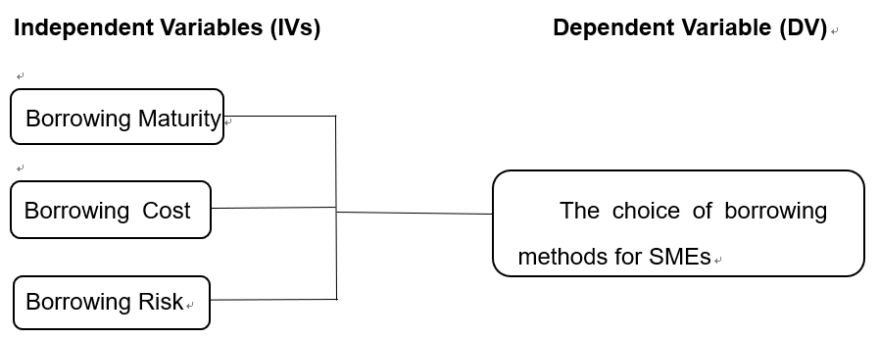Figure 2.5 Conceptual Framework

2.6 Hypotheses
According to the research objectives and relevant literature, the hypotheses proposed in this study are as follows
H1: There is significant relationship between borrowing maturity and the choice of borrowing methods for SMEs
H2: There is significant relationship between borrowing cost and the choice of borrowing methods for SMEs
H3: There is significant relationship between borrowing risk and the choice of borrowing methods for SMEs

2.7 Conclusion
The chapter 2 is a review of the literature on the choice of borrowing methods for SMEs. For many years, most studies have followed evidence of the impact of various factors such as borrowing methods and borrowing deadlines, borrowing costs and borrowing risks. The second chapter is a review of the literature on borrowing method for SMEs. For many years, most studies have followed evidence of the impact of various factors such as SME borrowing methods and borrowing deadlines, borrowing costs and borrowing risks.

Chapter 3 Research Methodology

Overview
This chapter introduces the relevant research and analysis methods. Through the research design, questionnaire design and sample size control, this paper introduces the methods and steps for the data analysis in the next chapter.

3.1 Research Design
A research design define by Bryman and Bell (2011), it can provide direction for this research and help with data collection and analysis. Research design is a logical, systematic plan prepared for a study, and its goal is obtaining answers to the questions of the research, the plan can be the whole plan or the study’s plan (Krishnaswami and Satyaprasad, 2010). This is important for research, which expresses accidental connections between variables and generalizes them into larger communities of individuals rather than that actually make up this survey (Koivisto, Hannula, and Boje et.al.2018).
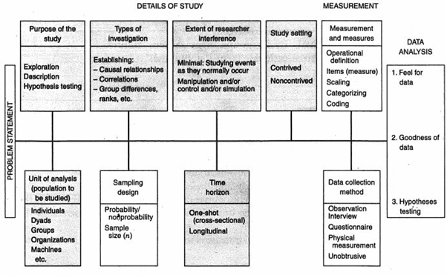
Figure 3.1 The research design
Source: Sekaran and Bougie (2016)
Descriptive research can be used as a simple research method to describe and explain existing phenomena and theories to understand verify the relationship between borrowing maturity, borrowing cost and borrowing risks. The purpose is establishing relationship among borrowing maturity, borrowing cost, borrowing risks and the choice of borrowing methods for SMEs or to re-verify as well as well as reconfirm previous theories. So as to establish the relationship between the independent variables and dependent variables in this research, this research belongs to correlation design (Krishnaswami and Satyaprasad, 2010).
The level of interference in this study was the lowest because the study used questionnaires and based on a common relationship study of the workplace's natural environment, the researchers had less intervention in the workflow (Zikmund, 2013).
The study setting in non-contrived as the research is studying the phenomenon as it naturally occurs, and it is not manipulation, the study setting is evident (Wiley, 2000).

3.2 Unit of Analysis and Horizons
The unit of analysis defined by Wiley (2000), It represents the aggregation of the data analysis phase in the next chapter. In this study, the focus is on the performance of small and medium enterprises in Hebei, so the individuals of Chinese should selected by the data collection. As the result, the unit of analysis is organization (Zikmund, 2013). The unit of analysis is the individual of the choice of borrowing method for SMEs in Hebei, China, because the respondents are different background, therefore the results of questionnaire maybe different.
For the research, in terms of time horizon, it collected data from the interested populations and use at the single moment in time, in other words, it means collected data only once from the respondents, it is cross-sectional (Zhou, Zhang and Luo, 2017).

3.3 Sample Design
The sample design method usually aims to the technique used to select the sample unit for measuring, for example, selecting an individual from a population or location and sampling within a study area (Wiley, 2000). Its purpose is to help investigators estimate uncertain demographic characteristics (Zikmund, 2013). The important reason for sampling design is that it directs the researchers to extract samples from the research objectives, while the correct samples ensure that data collection and analysis are effective for the results (Wiley, 2000).
For this research, the populations are small and medium enterprises which is in Hebei, China. With the development of small and medium enterprises are increasing in recent years in Hebei, China, it is important use the small and medium enterprises as the population, it can easy find the relationship between the choice of borrowing methods and small and medium enterprises.

3.3.1 Sampling Plan
Probabilistic and non-probability sampling are the main types of sampling plans. In non-probability sampling, parts of the population have no predetermined opportunity to be selected as the sample subject (Sekaran and Bougie, 2016). Sometimes non-probability sampling is the only way to collect data before discussing (Wiley, 2000). Non-probability sampling designs are suitable for a wide range of convenient sampling and sample surveys (Krishnaswami & Satyaprasad, 2010).
The simplest form of probability sampling includes the unrestricted, sample random sample (Cooper & Schindler, 2013). Since all probability sample must be provided the opportunity to choose a known non-zero elements of each group, so a simple random sample is regarded as a special case, and each group has a known element of choice and equal opportunity (Weathington, Cunningham and Pittenger, 2012).
The main features of arbitrary and subjective non-probabilistic sampling are that no member will include a known nonzero chance and allow researchers to randomly select sample factors are not random sampling ( Bryman and Bell, 2011).
The research used nonprobability sampling procedures is it can meet the sampling aims and the previous research choose this method to analysis for SMES, Cooper and Schindler (2003) claimed that the random sample can provide a true cross section in this data, but it cannot as the aims of this research.

3.3.2 Sampling Size
The number of samples used in research to define the number of samples in the market is called the sample size (Weathington, Cunningham and Pittenger, 2012). Sample size was also defined by Bryman and Bell (2011), measures the number or observation of a single sample measured in a survey or experiment. The sampling scale of the statistical survey is also directly related to the error range of the survey (Cooper and Schindler, 2003). As Krejcie & Morgan (1970) pointed out, the sample size should be 381 and above, when there are about 50000 SMEs, as shown below.
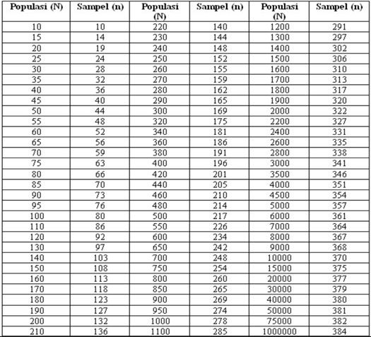
Figure 3 Krejcie Morgan Table
According to figure 3, when the population exceeds 50000, so in this study 381 can be the sample size. Based on the sample of the population selection is the employees of SMEs in Hebei, in contemporary, the number of Hebei’s small and medium enterprise is approximately 50000, according to the above form of Kreicie Morgan (1970), sample size of small and medium enterprises should be 381, in order to ensure that the participants' response rates can be efficiency, so the sample size should distribute to 160 questionnaires for this study.

3.4 Questionnaire Design
The questionnaire is a set of pre-written written questions, which questions are answered, and the respondents will record the answers, usually within a fairly clear choice (Saunders, Lewis and Thornhill, 2004).
Questionnaire can be used as an effective way to collect data so as to know how to effectively measure the relationship between variables (Wiley, 2000). The questionnaire can be managed in person or by mail to the respondent or electronically. However, for most organizational studies, the questionnaire is a convenient data collection mechanism after the study variables have been identified and after the measures discovered or developed. The online questionnaire include 3 sections, first section is about demographic information, second section is about the independent variables, third section is ask some information about dependent variables, which have correlation with SMEs.
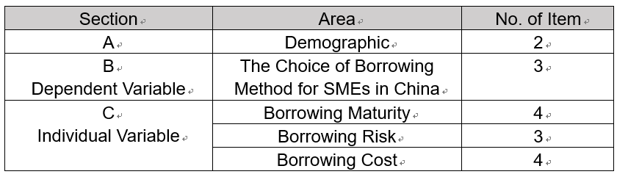 Table 3.4 Questionnaire Design

3.5 Pilot Test
A pilot test was conducted to explore the defects of this study, it can provide the selecting probabilistic samples(Cooper and Schindler, 2013). Therefore, it should extract topics from the target population and simulate the processes and protocols specified for data collection (Wiley, 2000). The pilot test is to extract a small number of people to observe its information to determine whether it can play its role in big data (Bryman and Bell, 2011). The purpose of the pilot test is to ensure that everyone in the sample not only understands the issues in the questionnaire, but also understands the problem in the same way and understands how long it takes to complete the survey in real time (Bryman and Bell, 2011).

3.5.1 Pilot Test: Factor Analysis
In order to effectively study the relationship between variables in complex concepts, factor analysis can be used (Gorsuch, 2014). It allows researchers to investigate concepts that are not easily measured directly by converting large numbers of variables into several interpretable potential factors (Kim and Mueller, 1978). It can be used to identify potential variables or constructs, and it is important that it can reduce many individual items to less the dimensions. It means it can simplify data (Duggan, McDevitt and Whitehurst et. al, 2018). For the pilot test, the sample size should be 10% of the whole sample size of this research, according to the sample size of this research is 381, so the pilot test size is 38, which means it need distributed online questionnaire for the 38 employee of SMEs in Hebei, China (Zikmund, 2013). At the same time, it is necessary to take the factor analysis, reliability test and correlation matrix, then, it can verify the data, which is collected by the online questionnaire, is useful for this research (Wiley, 2000).
KMO Bartlett’s Test of Sphericity
Bartlett's sphericity test is a test of the null hypothesis, that is, the correlation matrix has a unit matrix (Reinoso and Türegün, 2016). And the values range of KMO, which is from 0 to 1, high value, which is close to 1and greater than 0.6, it means factor analysis useful with the data, and there exists a strong correlation (Stott, Sobral and Swinbank et. al., 2014). In the contrast, if the value is less than 0.6, the results of the factor analysis probably will not be very useful for the data, it means the correlation is weak (Sobral, Swinbank and Stott et. al., 2013).
Factor Loading
The relationship between each variable and potential factor is represented by the so-called factor load, and the factor load can be explained by the normalized regression coefficient. (Armstrong, Banerjee and Corona et. al., 2013). If the factor loading’s value is more than 0.6, which means it has a strong relationship between variable and potential factor (Zhang, O'Neill and Sánchez, 2016). If the value is between 0.5 and 0.6, in the pilot test, the value can be kept, the reason is the sample size only account for the whole samples for 10%, which mean it maybe has bias (Bryman and Bell, 2011).
Eigenvalues
Eigenvalue, which is a scalar, is associated with a linear transformation that belongs to the vector space (Ma, Xu and Long, 2018). The eigenvalue needs to be > 1, and the number of eigenvalues can be equal to the number of independent variables. If the eigenvalue is less than one, or small, it can be seen the factor can only explain a small number of variables, which is not conducive to reducing the number of variables, and cannot prove the correlation between them well (Aliyari and Ghasemi, 2018).
3.5.2 Pilot Test: Reliability Test
Reliability refers to the consistency or reliability of an instrument, including stability, internal consistency, and equivalence and the reliability of the metrics indicates how unbiased it is, ensuring consistent metrics across time and across multiple projects (Wiley, 2000). Cronbach's Alpha test is the homogeneity of the test instrument project and reflects the same underlying structure. Cronbach's alpha is the most common internal consistency measure (Diedenhofen and Musch, 2016). Reliability below 0.6 is considered to be very poor, 0.7 is considered acceptable, and over 0.8 shows very good those below 0.6. Then consider removing the form to improve the consistency of the project (Sekaran and Bougie, 2016).

3.6 Measurement
Measurements occurs when an established ruler verifies the height, weight, or other characteristics of a physical object in everyday usage (Cooper and Schindler, 2013). Measurements in the study include numbers assigned to empirical events based on a set of rules (Wiley, 2000). And it is the process when collected as part of a research, which provide and record the observed value. Quantitative measurements were quantitatively relates the measured values described event or feature (Diedenhofen and Musch, 2016).

3.6.1 Descriptive Information
Description information may be viewed as an index, by accessing the associated aids, can efficiently access relevant information packet (Gorsuch, 2014). An effective method of collecting comprehensive demographic data is the omnipotent medicine of research. Knowing the number of respondents' company employees, the company's business hours, and the background of the leaders are all powerful insights into how best to study (GfK, 2016). For this research is based on SMEs choose supply chain financing in Hebei of China, then, about the demographic profile is about the background of the enterprises, which choose the supply chain financing and years of the enterprise (Mitchison, Hay and Mond, 2014). The purpose of demographics profile is to verify whether influence the supply chain financing options of SMEs.

3.6.2 Preliminary Test
After a pilot test, it need to do the preliminary tests, which is further testing for researching, development and testing different areas of the process, in order to promote the implementation of the test (Saunders, Lewis and Thornhill, 2004). For this research, 16 questionnaires were distributed by the pilot test, it means 160 questionnaires are required in the preliminary test (Byman and Bell, 2011).
3.6.2.1 Factor Analysis
For the preliminary test, it required when the pilot test was finished, it means in this part, the factor analysis should be according to the preliminary test, which can provide the data for the research, which can make the correlation has a decline in this analysis (Byman and Bell, 2011).
KMO Bartlett’s Test of Sphericity
KMO, Bartlett's sphericity test is a method for measuring the adequacy of the sampling, analysis recommended making changes than checking cases (Reinoso and Türegün, 2016). In previous academic and commercial research, KMO & Bartlett test plays an important role in the acceptance of the adequacy of the sample (Gorsuch, 2014). Although KMO ranges is 0 - 1, the world-recognized index greater than 0.6 (Wiley, 2000). Meanwhile, Bartlett's sphericity test and significance of relevant, thus demonstrating the effectiveness and suitability of solving problems through research (Byman and Bell, 2011). Suitable recommended for factor analysis, Bartlett sphericity test must be less than 0.05 (Stott, Sobral and Swinbank et. al., 2014).
Factor Loading
In the factor analysis, compared the pilot test, the sample size of preliminary test more comprehensive (Gorsuch, 2014). If the factor loading’s value is more than 0.6, which means it has a strong relationship between variable and potential factor (Zhang, O'Neill and Sánchez, 2016). If the value is between 0.5 and 0.6, in the pilot test, the value can be kept, the reason is the sample size only account for the whole samples for 10%, which mean it maybe has bias (Bryman and Bell, 2011).
Eigenvalues
For this research, there are two independent variables, which means the number of independent variables equal to the eigenvalue’s quality, at the same time, the value should be more than 1(Byman and Bell, 2011). In other word, there has 2 eigenvalue and more than 1. If the eigenvalue is less than one, or lower, it can be seen that the factor can only explain a less number of variables, which are not conducive to reducing the number of variables, and cannot prove the correlation between them well (Aliyari and Ghasemi, 2018).

3.6.2.2 Reliability Test
Reliability is synonymous with repeatability and consistency. It is defined as the degree of reliability of the test scores no measurement error (Byman and Bell, 2011). There are many structural qualities or the same, all of which will affect the overall quality of the instrument and the information collected, the reliability test was used to measure the consistency of the proposed research model of the data collected (Stott, Sobral and Swinbank et. al., 2014). Factor analysis and reliability testing test are basic, and then continue assumptions, to ensure that the data collected for further examination (Sekaran and Bougie, 2016)

3.6.3 Hypothesis Test
According to statistical theory, the hypothesis is an unproven proposition or hypothesis that temporarily explains certain facts or phenomena (Sekaran, 1992).
A hypothesis is a statement about the nature of the world, a hypothesis. In the simplest form, the assumption is a guess. Hypothesis testing is used to explain the variance of the dependent variable or to predict tissue outcomes (Wiley, 2000). Importantly, it can be speculated that define the logical relationship between the variables represented by the test to be more in the form of a statement or more (Sekaran, 1992). These relationships are based on the network of connections established in the theoretical framework developed for research (Sekaran, 2012).
Multiple Regressions
Multiple regressions is an extension of simple regression, it is possible to rely on the values in the predicted values of the independent variables (Sekaran, 2012). Multiple regressions there is more than one predictor compared with only a simple regression predictor variables in the equation (Sekaran and Bougie, 2016). More specifically, the path coefficients from -1 - +1, and the prefix "+" or "-" indicates the direction of the linear correlation, when the path coefficient was higher, the relationship also stronger. (Stott, Sobral and Swinbank et. al., 2014).
Beta Coefficient
The beta coefficient is the result of regression analysis and the estimation result is standardized, so the variance of the dependent and independent variables is 1 (Sekaran and Bougie, 2016). Therefore, the beta coefficient means how many standard deviations a dependent variable will change, based on the standard deviation of the predictor variable (Larry, David and Sjoquist et.al., 1986).

3.7 Ethical Consideration
To ensure the integrity and quality of research, researchers must take an ethical approach to collecting information and data (Sekaran and Bougie, 2016). The information and data used in this research were collected through ethical methods, and participants were able to share opinions and participate in voluntary research (Armstrong, Banerjee and Corona, 2013). At the same time, researchers can commit to participants to ensure that participants’ data and personal information are not used and disclosed (Hall, 2014). By committing confidentiality to the participants, the participants’ trust can be obtained, making the data obtained more realistic and effective (Ma, Xu and Long, 2018). Before issuing the questionnaire, provide participants with a simple research description to help participants better understand the reasons and goals of the study. The questionnaire survey questions in this research were used in the literature of previous researchers (Alam & Mohammad, 2012; Aziri, 2012; Lu & Alon, 2014), which can improve the reliability of the research. When the data comes from the natural working environment, it can improve the internal validity while achieving catered for ethically in external validity.

3.8 Conclusion
This chapter is about the research method which used in the research, it includes populations, sample size, questionnaire and measurements. This research is aim to re-verify the relationship, which use the methodology, among borrowing maturity, borrowing risk and borrowing cost and the choice of borrowing method for SMEs in Hebei, China.

Chapter 4 Research Findings

overview
This chapter will analyze the results and analysis of 151 available data collected from Chinese SME employees and test and analyze the data using SPSS software. Prior to the analysis of all data, a small sample test was conducted and factor analysis was supported to ensure that the adjusted questionnaire was suitable for the study. Then preliminary tests were carried out, and hypothesis tests were carried out on the feasibility of the samples, at the same time, the relationship between financing maturity, financing costs and financing risk and the choice of borrowing methods can be studied.

4.1 Pilot Test
Because this questionnaire was adapted from previous studies, the pilot test was first conducted to ensure that the questions were appropriate for the questionnaire. The appropriate sample size for the pilot study was between 10-30 (Isaac and Michael, 1995). Therefore, this test selected 16 employees working in SMEs in Hebei Province, China, to participate in the questionnaire survey and obtain data. A pilot test was conducted through factor analysis and reliability testing. According to Thabane et al. (2010) preliminary testing is the best way to assess the feasibility of a comprehensive study, which is also essential. This will help to increase the probability of success in the study, and it can also avoid failure to some extent.

4.1.1 Factor Analysis
According to the table below, all the values are greater than 0.6, which means that the problem of the respondent's participation is effective. Williams (2012) pointed out that it must be loaded more than 0.6 to be considered acceptable and effective. Since these indicators are all shown to be greater than 0.6, this can be done in part.
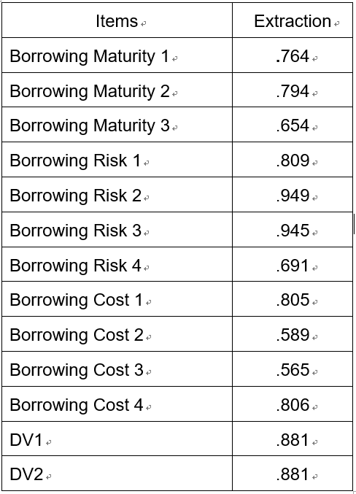
Table 4.1 Communities for Pilot Test
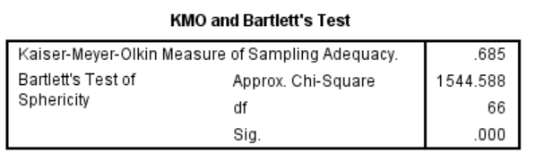
Table 4.2 KMO and Bartlett’s Test for Pilot Test
According to the table 4.2, the factor analysis result of the pilot test is 0.685, which is more than 0.6, which is acceptable. Therefore, the results of the questionnaire can be further analyzed. And Bartlett tests, its significance level is 0.000(Sig).<0.05), the total sample size is sufficient for continuous factor analysis, and the overall structure validity is also very good. Therefore, factor analysis is found to be an appropriate technique for constructing validity.

4.1.2 Reliability Analysis
The closer the value of Cronbach's Alpha is approximately to 1, the internal consistency reliability was more higher (Sekaran & Bougie, 2016). Whether it is an independent iv or all variables, it is greater than 0.7. So this questionnaire is acceptable.
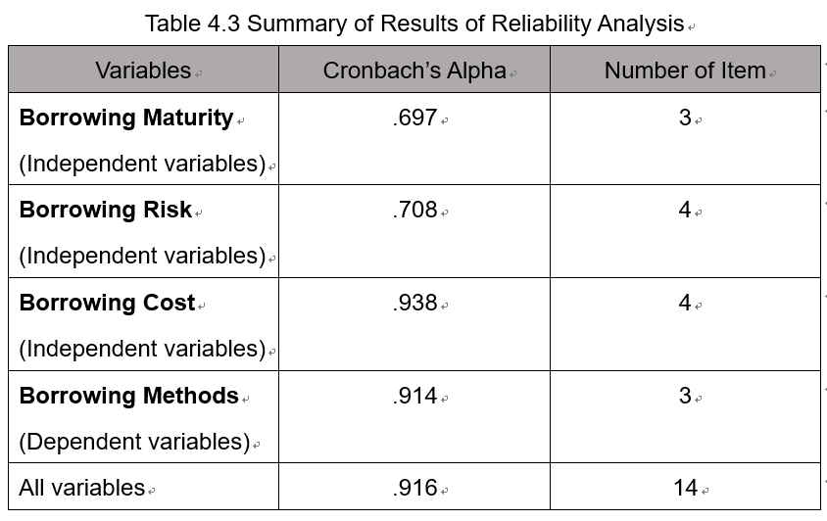
Table 4.3 Summary of Results of Reliability Analysis

4.2 Demographic Profile of Respondents
Descriptive feature analysis includes the basic situation of the small and medium-sized enterprises in which the interviewees are located.
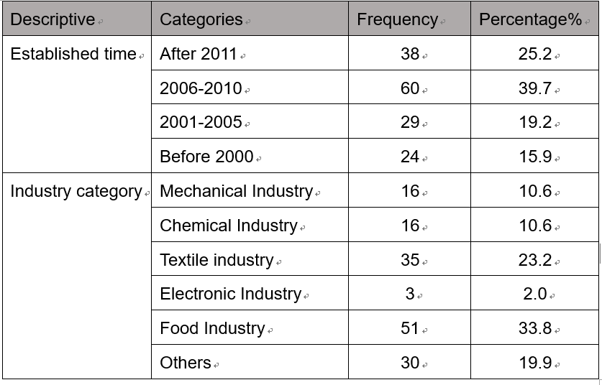
Table 4.4 Demographic Profile of Respondents
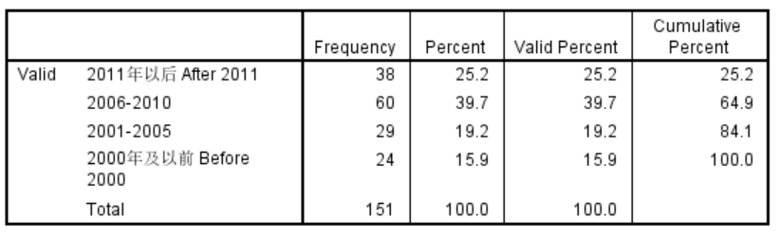
Table 4.5 Frequency of Established Time

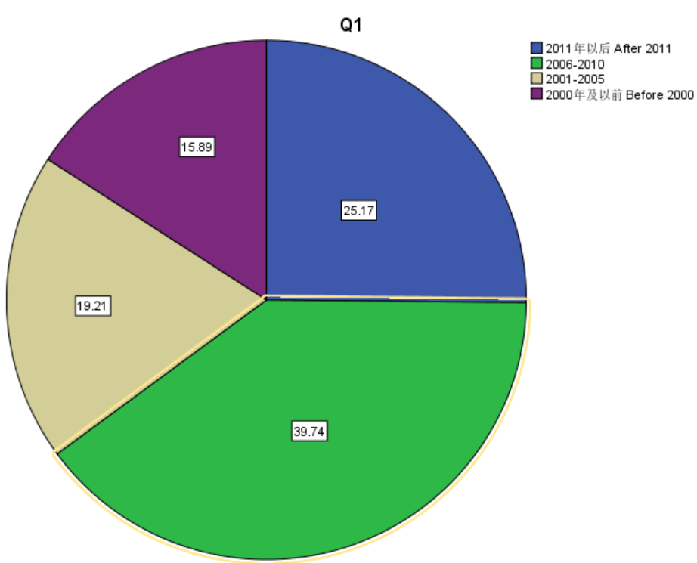
Figure 4.2.1 Established Time of SMEs
According to Table 4.6 and Figure 4.1, 151 respondents participated in the survey of SMEs, 25.17% of their companies were established after 2011, and the largest proportion established between 2006 and 2010 was 39.74. Small and medium-sized enterprises established before 2000 was account for 15.89%, and SMEs established in 2001-2005 accounted for 19.21%. It can be seen that more SMEs were established between 2006 and 2010.
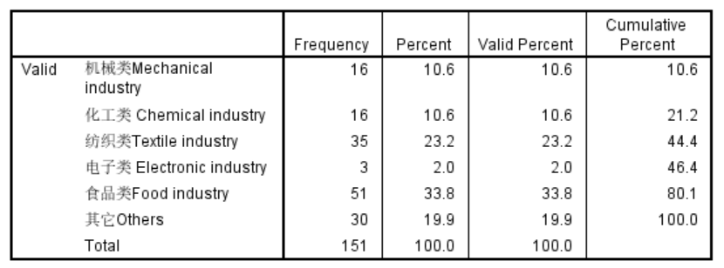
Table 4.6 Frequency of Industry Category
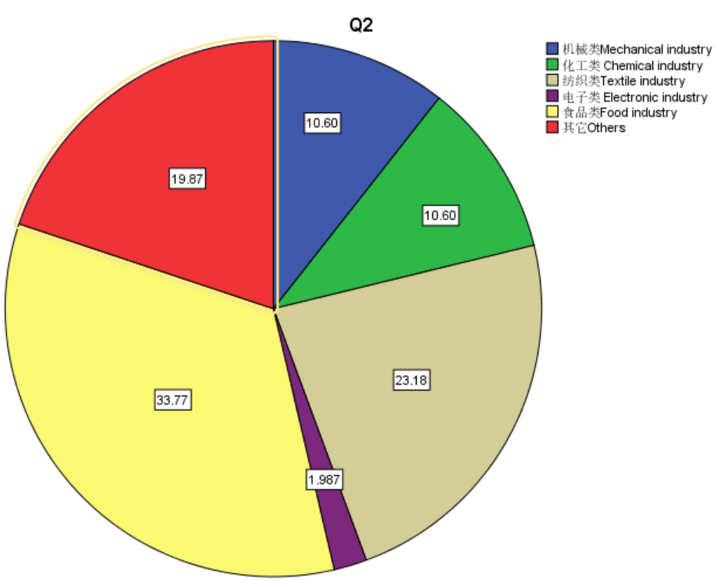 Figure 4.2.2 Industry Category of SMEs
According to Table 4.7 and Figure 4.2, it can be seen that the minimum number of electronic SMEs is only 1.987%, the chemical and mechanical categories account for the same ratio of 10.6%, and the other categories are 19.87%. Among them, the food category is the most, 33.77%.

4.3 Preliminary Data Analysis
This study conducted a preliminary analysis of factor analysis and reliability analysis.
The purpose of factor analysis is to determine if there are factors or items that need to be removed before further testing (Bryman & Bell, 2011). The data collected by the questionnaire was tested using KMO Bartlett's sphericity test, which determines the level of correlation and suitability of the data collected and the items in the questionnaire (ie, KMO values greater than 0.6) (Schepker & Oh, 2013). If all of these items have a common value greater than 0.6 after extraction, then the quality of the proposed model measurements is appropriate and relevant, otherwise it should be removed before further analysis (Scherer, Baumann-Pauly, & Schneider, 2013).
The eigenvalues are then determined to identify significant variables with a cumulative percentage of variance of at least 60%.
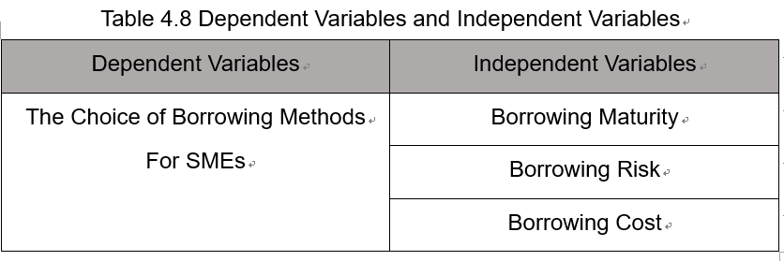
Table 4.7 Dependent Variables and Independent Variables

4.3.1 Factor Analysis
So as to verify the validity of these structures, some tests were conducted. The Kaiser-Meyer-Olkin (KMO) and Bartlett tests are used to measure the relationship between the filling of the study data and the confirmed structure, respectively (Pallant, 2011). Acceptable individual sample adequacy (MSA) should be more than 0.5, while overall KMO should be more than 0.6 (Kaiser, 1974 cited in Pallant, 2011). The saliency and component matrices are also examined, which helps to confirm the validity of the research structure.
Therefore, the commonality of the component matrix correlations should be greater than 0.5 and 0.4.
- Factors Analysis of Borrowing Maturity

Table 4.8 KMO and Bartlett’s Test for Borrowing Maturity
According to table 4.9 and table 4.10, all the samples about the borrowing maturity are higher than 0.5. Bartlett test results show that P<0.001, and the overall KMO calculation is 0.707, which is actually closer to the minimum requirements. In addition to that, the communities and component matrices also exceed the minimum requirements of 0.5 and 0.4, respectively. Therefore, when the overall MSA value is 0.733, From these four aspects, it can be considered that it is effective to measure the influence of borrowing risk on the choice of borrowing methods for SME in Hebei, China.
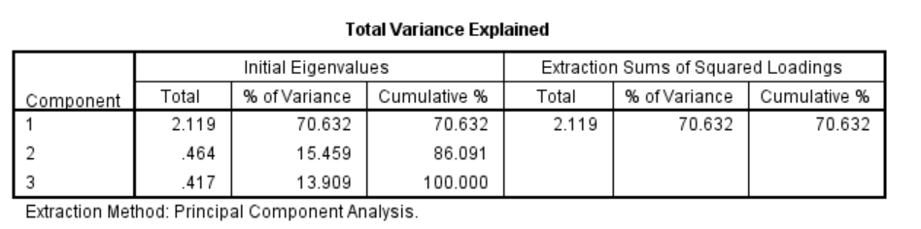
Table 4.9 Total Variance Explained for Borrowing Maturity
In this study, the first factor whose eigenvalue is greater than the cutoff standard 1 explains the total variance of the loan term structure (70.632%). Pallant (2011) pointed out that the construction body whose eigenvalue is greater than 1 is regarded as the most relevant part. Therefore, according to the test results, this study can be considered to be sufficient
- Factors Analysis of Borrowing Risk
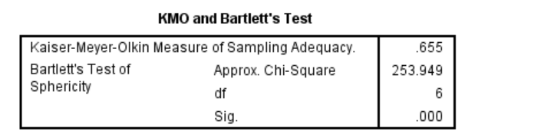
Table 4.10 KMO and Bartlett’s Test for Borrowing Risk
According to table 4.10 and table 4.11, all the samples about the borrowing risk are higher than 0.5. Bartlett test results show that P<0.001, and the overall KMO calculation is 0.655, which is actually closer to the minimum requirements. In addition to that, the communities and component matrices also exceed the minimum requirements of 0.5 and 0.4, respectively. Therefore, when the overall MSA value is 0.655, From these three aspects, it can be considered that it is effective to measure the influence of borrowing risk on the choice of borrowing methods for SME in Hebei, China.
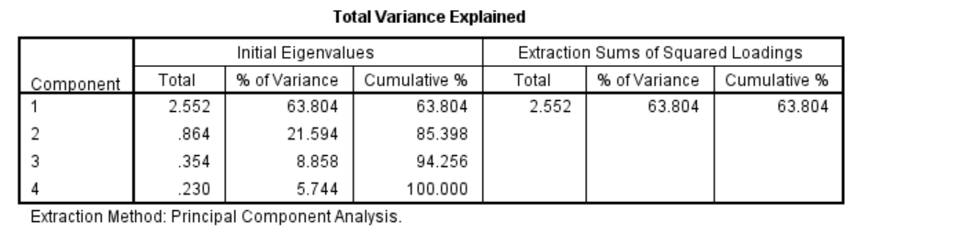
Table 4.11 Total Variance Explained for Borrowing Risk
In this study, the first factor whose eigenvalue is greater than the cutoff standard 1 explains the total variance of the loan term structure (63.804%). Pallant (2011) pointed out that the construction body whose eigenvalue is greater than 1 is regarded as the most relevant part. Therefore, according to the test results, this study can be considered to be sufficient.
- Factors Analysis for Borrowing Cost
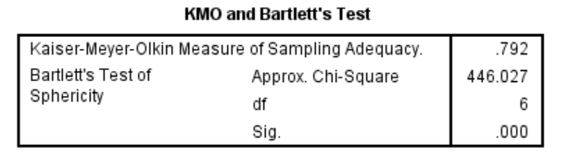
Table 4.12 KMO and Bartlett’s Test for Borrowing Cost
According to table 4.12 and table 4.13, all the samples about the borrowing risk are higher than 0.5. Bartlett test results show that P<0.001, and the overall KMO calculation is 0.792, which is actually closer to the minimum requirements. In addition to that, the communities and component matrices also exceed the minimum requirements of 0.5 and 0.4, respectively. Therefore, when the overall MSA value is 0,792 From these four aspects, it can be considered that it is effective to measure the influence of borrowing risk on the choice of borrowing cost for SME in Hebei, China.
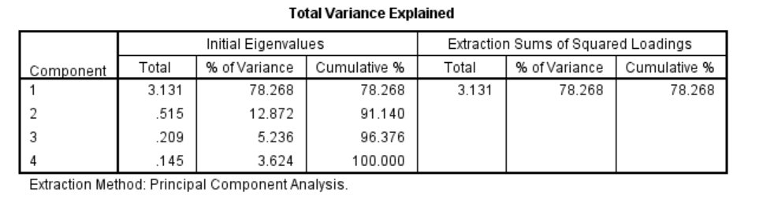
Table 4.13 Total Variance Explained for Borrowing Cost
In this study, the first factor whose eigenvalue is greater than the cutoff standard 1 explains the total variance of the loan term structure (78.268%). Pallant (2011) pointed out that the construction body whose eigenvalue is greater than 1 is regarded as the most relevant part. Therefore, according to the test results, this study can be considered to be sufficient.

4.3.2 Reliability Test
Reliability refers to the degree if the measurement is repeated multiple times, scales produce consistent results. Reliability analysis is the reliability analysis (Armor, 1974). The proportion of system changes can determined the reliability test in the scale, and the proportion of system changes can be determined by determining the association between the scores of the different management departments of the scale. Therefore, if the correlation in the reliability analysis is high, the scale will have consistent results (Raykov, 1998).
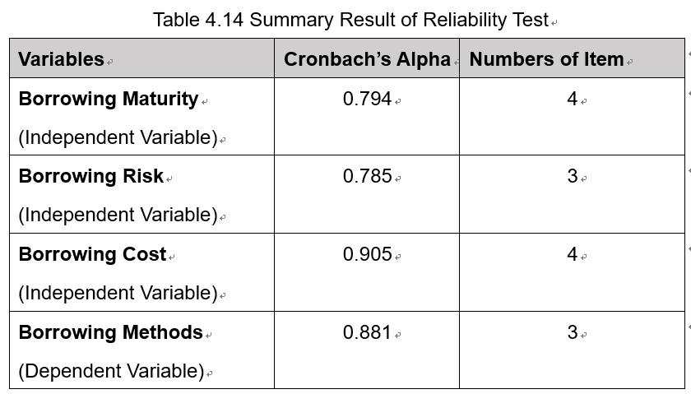
Table 4.14 Summary Result of Reliability Test
Hence, the reliability test show a good result that the independent variables and dependent variable are appropriate for further analysis.

4.4 Hypothesis Analysis
According to table 4.15, it shows the three hypothesis. All of them use the multiple regression.
H1 | Borrowing maturity has a significance on the choice of borrowing methods for SMEs
H2 | Borrowing risk has a significance on the choice of borrowing methods for SMEs
H3 | Borrowing cost has a significance on the choice of borrowing methods for SMEs
Table 4.15 Summary of Hypothesis

4.4.1. Hypothesis Testing
Multiple regressions were performed for this study, as shown in Table 4.16, which yielded 0.589 with a correlation of 0.767. This means that approximately 58.90% of the differences in SME borrowing methods have been explained by borrowing maturity, borrowing cost, and borrowing risk in this study. According to the previous study, the remaining 41.10% is determined by other factors not the three considered in this study (Pallant, 2011).
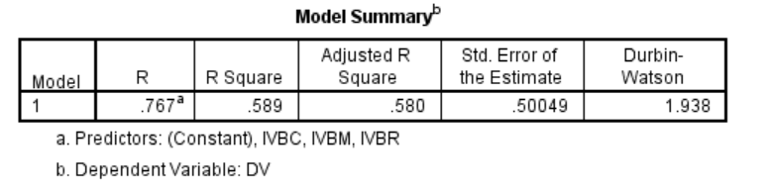
Table 4.16 Model Summary of Multiple Regression
Thus, according to the known data, it can be found that there is a certain relationship between the three independent variables and the dependent variables in this study, which is between the choice of SME borrowing methods and the three independent variables used. In addition, the Durbin-Watson value also demonstrates that the variables are independent, since 1.938 is between 1.5 and 2.5 (Alam, Saeed, Sahabuddin and Akter, 2013), and the multicollinearity assumption of the variables is also achieved.
According to Table 4.17, it demonstrates that the regression model is significant at 0.001 (P = 0.000).
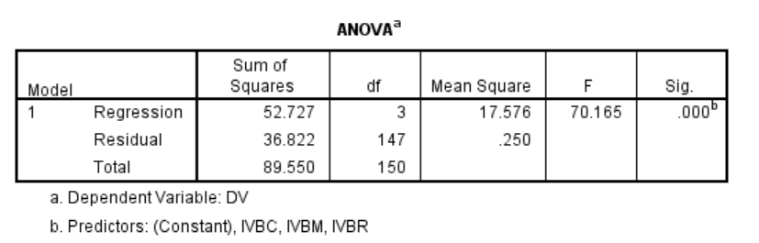
Table 4.17 ANOVA of Multiple Regression
Since the multiple regression hypothesis has been achieved, the next observation of the regression results is shown in Table 4.18. Through the evaluation of the table, it was found that the risk of borrowing (P = 0.000, significant at the 0.001 level) and the borrowing maturity (P = 0.013, significant at the 0.05 level) are predictors of SME borrowing methods. In addition, the highest standard factor is 0.811, and the risk of borrowing is often the most important predictor of SME borrowing methods. In the small and medium-sized enterprises in Hebei Province of China, the borrowing maturity coefficient is 0.219, indicating that the borrowing maturity has a certain positive impact on the choice of SME borrowing methods.
In addition, borrowing costs were not significantly related to SME borrowing methods (P = 0.618 > 0.05), and therefore there was no multi-collinearity with borrowing cost (Pallant, 2011).
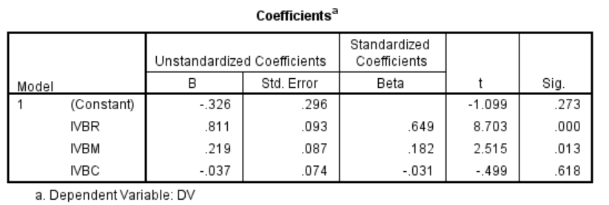
Table 4.18 Coefficients of Multiple Regression
Therefore, the borrowing maturity and the borrowing risk are supported by these three assumptions, and are positively related to the choice of SME borrowing methods. However, the cost of borrowing is not positively related to the choice of SME borrowing methods.

4.5 Summary of Result
HI (Borrowing Maturity) | Accept
H2 (Borrowing Risk) | Accept
H3 (Borrowing Cost) | Rejected
Table 4.19 Result of Hypothesis Testing
Based on the results of the study, Table 4.19 illustrates a summary of the hypothetical results, indicating that the other two hypotheses are accepted except that Hypothesis 3 is rejected. In other words, the borrowing maturity (hypothesis 1) and the borrowing risk (hypothesis 2) are positively related to the choice of SME borrowing methods in Hebei Province, China. There is only one factor, borrowing cost (Hypothesis 3), which has no significant impact on the choice of SME borrowing methods in Hebei Province, China.

4.6 Conclusion
This chapter focuses on the analysis of results based on data analysis. SPSS statistical software version 2.0 is mainly used to measure hypothesis testing. The results show that among the three factors (borrowing maturity, borrowing risk and borrowing cost), except for the borrowing cost, the other two factors have a positive impact, and the borrowing risk has the greatest impact on the choice of borrowing methods for SMEs in Hebei, China.

Chapter 5 Conclusion and Recommendation

Overview
Based on the data analysis in the previous chapter, this chapter has conducted in-depth and detailed research on the research results. Subsequently, the recommendations and future research were discussed. Before the end of this chapter, the researchers conducted a personal reflection.

5.1 Conclusion
China's economy is developing step by step, SMEs are beginning to become more and more important in economic development. However, due to the current difficulties in financing for SMEs, the choice of borrowing methods is particularly important for SMEs, which can promote the development of SMEs and enhance market competitiveness. Considering that many factors may affect the choice of SMEs for borrowing, it is important to investigate SMEs and understand the factors that influence SME borrowing options.
Based on the previous literature, this study proposes a framework and conducts a questionnaire survey to study the relationship between borrowing maturity, borrowing risk and borrowing cost on SME borrowing methods.
The results show that the choice of borrowing methods for SMEs is related to the risk of borrowing, and the borrowing maturity is positively correlated. The impact of borrowing costs is not reflected.

5.2 Recommendations
SMEs generally have a small scale of production, but the overall number is large. SMEs have flexible management methods and can adjust business strategies at any time according to changes in the market conditions. This is mainly due to the ease of management of SME personnel, the reduction of decision-making implementation and the improvement of work efficiency. It is also because of the working environment that employees can develop their talents and contribute to the company. At the same time, SMEs have insufficient anti-risk ability, and insufficient internal capital reserves will cause difficulties in capital turnover. Therefore, SMEs should gradually improve their credit rating in financial institutions.
SMEs borrowing mainly relies on traditional financing structures, especially bank funds, which are difficult to obtain, and the borrowing methods are relatively less. It is very difficult for SMEs to borrow from banks. Though the statistics, Less than 2% of small and medium-sized enterprises have access to credit. Total credit is less than 10%, and the loan interest rates have been mostly between 5% and 8%. For short-term loans with a term of 6-12 months, the loan cost is high, which is not conducive to the development of long-term projects with large returns and benefits.
Strengthening financial credit support for SMEs, commercial banks should be encouraged to increase credit support for SMEs, and build up the credit structure, encourage commercial banks to participate in the reform of borrowing interest rate marketization, and allow state-owned commercial banks to borrow interest rates to SMEs based on the free floating of capital supply and demand. Adjust the credit policy, revise the enterprise credit rating standard, break the enterprise's scale and nature as support conditions, support the reasonable capital needs of SMEs, and follow the principles of fairness, justice and integrity, and gradually increase the proportion of credit investment to SMEs. Commercial banks have made innovations in organizational systems. Now, there are commercial banks in various countries. In addition to the establishment of the SME credit department, the first-tier banks and the secondary banking industry have set up SME credit institutions to formulate and implement financial service strategies for SMEs in the region.

5.3 Study Limitations
There are some sample and research limitations in this study. There are not only many factors that influence the choice of SMEs' borrowing methods, but also many changes. In addition to the three influencing factors in this study, it is possible to explore other variables for SME borrowing. In addition, sample sizes can be increased in future studies and more information on how SMEs lend can be collected. Although the samples in this study appear to be identical in many respects, more demographics can be collected to distinguish them. The key of this study is data collection. In the design of questionnaires, the problems are few and not comprehensive, which may lead to data deviation and thus affect the research results.
However, this study provides recommendations for future research directions, and future research suggests expanding the scope of research in the region, as well as other influencing factors. Therefore, the current study is limited to China's Hebei Province, so it is recommended that this study be extended to other provinces to comprehensively explore factors that influence the choice of SMEs borrowing methods.

Reference
Ahmed AW, Wang Zr and Asaad (2018) ‘Overcoming SMEs Financing and Supply Chain Obstacles by Introducing Supply Chain Finance’, Holistica, Vol 9, Iss 1, Pp 7-22 (2018), (1), p. 7. doi: 10.1515/hjbpa-2018-0001
Alam, M. M. & Mohammad, J. F., 2012. Level of job satisfaction and intent to leave among Malaysian nurses. Business Intelligence Journal, 3(1), p. 123-137.
Aliyari, M, & Ghasemi Kamalvand, M 2018, 'A Method of Indefinite Krylov Subspace for Eigenvalue Problem', Mathematical Problems In Engineering, pp. 1-5, Academic Search Complete, EBSCOhost, viewed 18 July 2018.
Andaleeb, S. Anwar, F.(2008). Factors Influencing Customer Trust in Salespersons in a Developing Country [J]. Journal of International Marketing.
Arezoo Jahani, Parastoo Mohammadi and Hamid Mashreghi (2018) ‘Studying Risk Effect in Evaluating the Financing Methods of New Technology-Based Firms’, International Journal of Industrial Engineering and Production Research, Vol 29, Iss 2, Pp 133-146 (2018), (2), p. 133. Available at: https://ezproxy.inti.edu.my/login?qurl=http%3a%2f%2fsearch.ebscohost.com%2flogin.aspx%3fdirect%3dtrue%26db%3dedsdoj%26AN%3dedsdoj.83841f81906c4e2c9005394567f2d6c1%26site%3deds-live (Accessed: 25 October 2018).
Armstrong, C, Banerjee, S, & Corona, C 2013, 'Factor-Loading Uncertainty and Expected Returns', Review Of Financial Studies, 26, 1, pp. 158-207, Business Source Complete, EBSCOhost, viewed 17 July 2018.
Barnes, R (London), Duncan, D (Atlanta, G & Arne, P (Atlanta, G 2007, ‘Supply Chain Financing Systems and Methods’, viewed 25 October 2018, <https://ezproxy.inti.edu.my/login?qurl=http%3a%2f%2fsearch.ebscohost.com%2flogin.aspx%3fdirect%3dtrue%26db%3dedspap%26AN%3dedspap.20070156584%26site%3deds-live>.
Barnes, R. (London), Duncan, D. (Atlanta, G. and Juliano, D. (Gibsonia, P. (2007) ‘Supply Chain Financing and Credit Memo Systems and Methods’. Available at: https://ezproxy.inti.edu.my/login?qurl=http%3a%2f%2fsearch.ebscohost.com%2flogin.aspx%3fdirect%3dtrue%26db%3dedspap%26AN%3dedspap.20070282744%26site%3deds-live (Accessed: 25 October 2018).
Bond, S, D. and Van (2003). Investment, R&D and Financial Constraints in Britain and Germany, Working Paper, 2003, 1-53
Bryman, A. and Bell, E. (2011). Business research methods. 3rd ed. United States: Oxford University Press Inc.
Caniato, F., Gelsomino, L.M., Perego, A. & Ronchi, S. 2016, "Does finance solve the supply chain financing problem?", Supply Chain Management: An International Journal, vol. 21, no. 5, pp. 534-549
CELIK, N, SENOGLU, B, & ARSLAN, O 2015, 'Estimation and Testing in One-Way ANOVA when the Errors are Skew-Normal', Revista Colombiana De Estadistica, 38, 1, pp. 75-91, Academic Search Complete, EBSCOhost, viewed 16 July 2018.
Chong, A. Y. L. et al. (2009) Influence of interorganizational relationships on SMEs’ e-business adoption. Emerald Group Publishing Limited. Available at: https://ezproxy.inti.edu.my/login?qurl=http%3a%2f%2fsearch.ebscohost.com%2flogin.aspx%3fdirect%3dtrue%26db%3dir01193a%26AN%3dintiir.206%26site%3deds-live (Accessed: 25 October 2018).
Cohen, S. & Roussel, J. 2013, Strategic supply chain management, Second edn, McGraw-Hill, New York.
Diedenhofen, B, & Musch, J 2016, 'cocron: A Web Interface and R Package for the Statistical Comparison of Cronbach's Alpha Coefficients', International Journal Of Internet Science, 11, 1, pp. 51-60, Academic Search Complete, EBSCOhost, viewed 18 July 2018.
Divid Durand. 1952. Cost of Debt and Equity Funds for Business: Trends and Problems of Measurement in Nation Bureau of Economic Research. Conference on Research on of Business Finance, New York
Duggan, K, McDevitt, E, Whitehurst, L, & Mednick, S 2018, 'To Nap, Perchance to DREAM: A Factor Analysis of College Students' Self-Reported Reasons for Napping', Behavioral Sleep Medicine, 16, 2, pp. 135-153, MEDLINE, EBSCOhost, viewed 17 July 2018.
Firescu and Bondoc. (2016). ‘The Relevance of Comprehensive Income Compared to Net Income for the Measurement and Presentation of Company Performance’, Annals of the University of Craiova: Economic Sciences Series, Vol 1, Iss 44, Pp 71-82 (2016), (44), p. 71.
GfK. (2016). Tech Trends 2016: Understanding the driving forces behind the connected consumer. Retrieved from
Gorsuch, R.L. 2014, Factor Analysis, Taylor and Francis.
Habib, M. (2015) Supply Chain Management : Practices, Applications and Challenges. Hauppauge, New York: Nova Science Publishers, Inc (Business Economics in a Rapidly-changing World).
Hall, Shane.2014. "What is the Purpose of Factor Analysis?" Sciencing, http://sciencing.com/what-is-the-purpose-of-factor-analysis-12225143.html. 29 September 2017.
Hofmann, E. 2005. Supply Chain Finance: Some Conceptual Insights [J]. Logistik Management- Innovative Logistikonzept, (S): 203-214.
http://www.cite.com/website.html?id=5be285a656eacacc5e8b4567
Jin, W. and Luo, J. (2017) ‘Optimal inventory and insurance decisions for a supply chain financing system with downside risk control’, Applied Stochastic Models in Business & Industry, 33(1), pp. 63–80. doi: 10.1002/asmb.2219
Kim, J. & Mueller, C.W. 1978, Factor analysis: statistical methods and practical issues,Sage Publications, Beverley Hills
Koivisto, J, Hannula, L, Boje, R, Prescott, S, Bland, A, Rekola, L, & Haho, P 2018, 'Design-based research in designing the model for educating simulation facilitators', Nurse Education In Practice, 29, pp. 206-211, MEDLINE, EBSCOhost, viewed 10 July 2018
Krejcie, R.V. & Morgan, D.W. (1970). Determining Sample Size for Research Activities. Educational and Psychological Measurement. Vol. 30, No. 3, pp. 604-610.
Krishnaswami, O.R. & Satyaprasad, B.G. 2010, Business Research Methods, Himalaya Publishing House, New Delhi.
Larry D. Schroeder, David L. Sjoquist, Paula E. Stephan. (1986) Understanding regression analysis, Sage Publications. ISBN 0-8039-2758-4, p. 31-32
Li, XF. (2009). Research on financing problems of small and medium-sized enterprises. [online] Available at: http://www.docin.com/p-296321388.html [Accessed 7 Nov. 2018].
Lu, C. Q. & Ling, W. Q., 2014. The relationship between management self-efficacy and management attitude and efficiency. Journal of Peking University, 42 (2), p. 267-280.
Ma, R, Xu, M, & Long, Y 2018, 'Principal Eigenvalues of a Second-Order Difference Operator with Sign-Changing Weight and Its Applications', Discrete Dynamics In Nature & Society, pp. 1-8, Academic Search Complete, EBSCOhost, viewed 18 July 2018.
Mengis, N, Keller, D, & Oschlies, A 2018, 'Systematic Correlation Matrix Evaluation (SCoMaE) - a bottom-up, science-led approach to identifying indicators', Earth System Dynamics, 9, 1, pp. 15-31, Academic Search Complete, EBSCOhost, viewed 16 July 2018.
Mitchison, D., Hay, P., Slewa-Younan, S. & Mond, J. 2014, "The changing demographic profile of eating disorder behaviors in the community", BMC Public Health, vol. 14, no. 1, pp. 943-943.
Mollah, M.M.H., Jamal, R., Mokhtar, N.M., Harun, R. & Mollah, M.N.H. 2015, "A hybrid one-way ANOVA approach for the robust and efficient estimation of differential gene expression with multiple patterns", PLoS ONE, vol. 10, no. 9, pp. e0138810.
Mu, W. & Wang, X. 2014, "Inference for one-way ANOVA with equicorrelation error structure",TheScientificWorldJournal, vol. 2014, pp. 341617.
Printz, T, Pedersen, E, Juhl, P, Nielsen, T, Grøntved, Å, & Godballe, C 2017, 'Reproducibility of Dual-Microphone Voice Range Profile Equipment', Journal Of Speech, Language & Hearing Research, 60, 12, pp. 3369-3377, Engineering Source, EBSCOhost, viewed 16 July 2018.
Pu, J. (2011). Research on Supply Chain Performance Management Indicator System of Manufacturing Enterprises. Gold Card Engineering: Economics and Law, 15(005), 279-280.
Reinoso, H. & Türegün, M. 2016, "Examining the factor structure of MUIS-C scale among baby boomers with hepatitis C", Applied Nursing Research, vol. 32, pp. 111-116.
Saunders, M., Lewis, P. and Thornhill, A. (n.d.), 2004. Research methods for business students.
Sekaran, U. & Bougie, R. (2016). Research Methods For Business: A Skill Building Approach. New Jersey: Wiley Publications.
Sekaran, U. (1992). Instructor's resource guide with test questions and transparency masters to accompany Research methods for business. New York, N.Y.: John Wiley & Sons.
Sekaran. (2012). Research methods for business - a skill building approach 5e set. [Place of publication not identified]: John Wiley & Sons Inc.
Sobral, D., Swinbank, A.M., Stott, J.P., Matthee, J., Bower, R.G., Smail, I., Best, P., Geach, J.E. & Sharples, R.M. 2013, "The dynamics of z = 0.8 Hα-selected star-forming galaxies from KMOS/CF-HiZELS", Astrophysical Journal, vol. 779, no. 2.
Stott, J.P., Sobral, D., Swinbank, A.M., Smail, I., Bower, R., Best, P.N., Sharples, R.M., Geach, J.E. & Matthee, J. 2014, "A relationship between specific star formation rate and metallicity gradient within z ~ 1 galaxies from KMOS-HiZELS", Monthly Notices of the Royal Astronomical Society, .
Vosoughi, H. D. Nasserabadi and A. Babaei (2017) ‘Investigating Appropriate Financing Methods in Collaborative Projects of Water and Wastewater with AHP Approach’, Engineering, Technology & Applied Science Research, Vol 7, Iss 5, Pp 2089-2093 (2017), (5), p. 2089. Available at: https://ezproxy.inti.edu.my/login?qurl=http%3a%2f%2fsearch.ebscohost.com%2flogin.aspx%3fdirect%3dtrue%26db%3dedsdoj%26AN%3dedsdoj.5f330502d95b457eb9a8e37ed6fdda7b%26site%3deds-live (Accessed: 25 October 2018)
Weathington, B., Cunningham, C. and Pittenger, D. (2012). Understanding business research. Hoboken, N.J.: John Wiley & Sons.
Wiley, J. (2000). Research Methods for Business. 3rd ed. New York: United Stated of America.
Xiong, X. Ma, J. Zhao, WJ. (2009). Risk Management in Supply Chain Finance Mode.
Xu XP and Li XJ, 2009. Small business credit gap, credit technical defects and government intervention -- based on the survey of small business in Shanghai regional economic park in 2008, journal of Shanghai university of finance and economics, no.4, 2009, 65-72.
Xu, K., Ding, H. and Bao, X. (2016) ‘SMEs credit evaluation in the e-commerce supply chain financing model’, RISTI (Revista Iberica de Sistemas e Tecnologias de Informacao), (E7), p. 35. Available at: https://ezproxy.inti.edu.my/login?qurl=http%3a%2f%2fsearch.ebscohost.com%2flogin.aspx%3fdirect%3dtrue%26db%3dedsgao%26AN%3dedsgcl.473923914%26site%3deds-live (Accessed: 25 October 2018).
Zhang J, 2002. Relational lending and bank organizational structure of small and medium-sized enterprises, economic research, no.6, 2002, 32-37.
Zhang, Z, O'Neill, M, & Sánchez, B 2016, 'Using a latent variable model with non-constant factor loadings to examine PM2.5 constituents related to secondary inorganic aerosols', Statistical Modelling: An International Journal, 16, 2, pp. 91-113, Business Source Complete, EBSCOhost, viewed 17 July 2018.
Zhou LN, 2006. Influence of private credit on small business credit of Banks and Suggestions on further regulation, hainan finance, 11th issue, 2006, 31-33.
Zhou, H, Zhang, L, Luo, X, Wu, L, Zou, X, Xia, K, Wang, Y, Xu, X, Ge, X, Jiang, Y, Fombonne, E, Yan, W, & Wang, Y 2017, 'Modifying the Autism Spectrum Rating Scale (6-18 years) to a Chinese Context: An Exploratory Factor Analysis', Neuroscience Bulletin, 33, 2, pp. 175-182, MEDLINE, EBSCOhost, viewed 16 July 2018.
Zhu, Y, Xie, C, Sun, B, Wang GJ, and Yan XG. “Predicting China’s SME Credit Risk in Supply Chain Financing by Logistic Regression, Artificial Neural Network and Hybrid Models.” Sustainability, Vol 8, Iss 5, p 433 (2016), no. 5 (2016): 433. doi:10.3390/su8050433.
Zikmund, W. (2013). Business Research Methods. 5th ed. United States of America: Harcourt Brace College.

Appendix

Appendix 1: MBA Project Log
PROJECT PAPER LOG
Student Name: | Li Xuefei
Supervisor’s Name: | Dr. Ken Lee
Dissertation Topic: The Factors Affecting the Choice of Borrowing Methods for SMEs in Hebei, China

SECTION A. MONITORING STUDENT DISSERTATION PROCESS
The plan below is to be agreed between the student & supervisor and will be monitored against progress made at each session.
Activity | Milestone/Deliverable Date
Review Chapter 1-3 & confirm the conceptual framework | 9/8
Modify Chapter 1-3 |  | 11/9
Done Chapter 1-3 |  | 20/9
Review presentation slides for proposal |  | 8/10
Proposal presentation |  | 12/11
Draft questionnaire |  | 3/11
Modify the questionnaire |  | 7/11
Showing data & start Chapter 4-5 |  |  | 15/11
Done Chapter 4-5 |  |  | 25/11
Final Viva & modify Chapter 1-5 |  |  |  | 1/12

SECTION B. RECORD OF MEETINGS
The expectation is that students will meet their supervisors up to seven times and these meetings should be recorded.



Appendix 2 Example of Spine and Cover of the Thesis
Example of Spine and Cover of the Thesis
LIXUEFEI MASTER OF BUSINESS ADMINISTRATION 2018
THE FACTORS AFFECTING THE CHOICE OF BORROWING METHODS OF BORROWING METHODS
LI XUEFEI
MASTER OF BUSINESS ADMINISTRATION FACULTY OF BUSINESS, COMMUNICATION & LAW
INTI INTERNATIONAL UNIVERSITY
2018

Appendix 3 Declaration
Declaration
I hereby declare that this thesis is my own work and effort and that it has not been submitted anywhere for any award. Where other sources of information have been used, they have been duly acknowledged.
Name: Li Xuefei
Student ID: I17013766
Signature:
Date: 7/12/2018

Appendix 4 Title Page
Title Page
INTI INTERNATIONAL UNIVERSITY
MASTER OF BUSINESS ADMINISTRATION
The Factors Affecting the Choice of Borrowing Methods for SMEs in Hebei, China
Author: Li Xuefei
Student No: I17013766
Supervisor: DR. Lee Chin Chong
Submission Date: 14/12/2018
Final Word Count: 12011
Ethic Number: 03819

Appendix 5 Initial Research Paper Proposal
INTI International University
Master of Business Administration MGT7999
Initial Research Paper Proposal
STUDENT NAME & ID NO | Li Xuefei I17013766
BROAD AREA | Finance
Concise Title | The Factors Affecting the Choice of Borrowing Methods for SMEs in Hebei, China
Problem Definition | China is a country with many small and medium-sized enterprises. By the end of 2006, there were about 42 million small and medium-sized enterprises, including individual businesses. The number of small and medium-sized enterprises exceeded 90 percent of the total number in China. At the same time the value created by the final product and service accounted for domestic value added 58%, providing employment opportunities accounted for 75%. However, the financial resources acquired by SMEs are not commensurate with their status in national economic and social development (Xu & Li, 2009).
Research Objectives and Research Questions | The purpose of the study is to find out how borrowing maturity, borrowing cost and borrowing risk affect the choice of borrowing methods for SMEs in Hebei, China.  The specific objectives are:  RO1: To find out whether borrowing maturity influence on the choice of borrowing methods for SMEs  RO2: To examine whether borrowing cost influence on the choice of borrowing methods for SMEs  RO3: To determine whether borrowing risk influence on the choice of borrowing methods for SMEs  The research questions are behind to the research objectives. In order to achieve the above research objectives, this research establishes the following research questions.  RQ1: Will borrowing maturity influence the choice of borrowing methods for SMEs in Hebei, China?  RQ2: Will borrowing risk influence the choice of borrowing methods for SMEs in Hebei, China?  RQ3: Will borrowing cost influence the choice of borrowing methods for SMEs in Hebei, China?
Scope of study | This paper studies the factors affecting the choice of SMEs' lending methods. Specifically, it focuses on the characteristics of SME lending options, including lending term, borrowing risk and borrowing cost, and discusses which factors are related to SME lending options.
Significance of the Research | Significance to Academia  In this study, there are many contributions to academics. Most researchers are concerned with external factors of SMEs to understand how to promote the development of SME companies. In this study, the intrinsic factors of SMEs will be used. In addition, most of the research focused only on one element of the SME microfinance framework, but in this study, the microfinance framework uses borrowing risk, borrowing period and borrowing cost as the dependent variable. This research will help narrow the gaps in the literature and provide some new knowledge.  Significance to Industry  If SMEs can understand the factors that influence the choice of borrowing methods, then companies can choose to appropriate methods to solve the financing issues, it will be very helpful to the enterprise. So, the results of this research can help SMEs to understand the choice of borrowing methods widely.
Literature Review | Borrowing Methods: There are many different ways of borrowing methods. Some methods can directly benefit from simple eligibility criteria, but usually involve higher interest rates. Other methods provide more flexibility and convenience, but may be difficult to meet requirements (Habib, 2015). Most trading companies need more than paid-in capital in their operations. They meet their financial needs by borrowing from various sources. This type of borrowing can be temporary or more or less long-term. At the same time, the company can adopt a variety of methods to meet its long-term and short-term financial needs (Cohen and Roussel, 2013).  Borrowing Maturity: The borrowing maturity refers to the period in which the enterprise has the right to use the funds. It is an important factors when the SME do the choice of borrowing methods. The term of loan is from the date of signing the loan contract to the time when the principal and interest of the loan are fully paid off. The length of the term of a loan shall be determined separately according to the type of loan (Zhou, 2006).  Borrowing Risk: SMEs implement borrowing, and enterprises that are due must repay the debts in full, and the enterprises bear the loss of funds. Enterprises face financial risks, which may not be able to pay the full amount of credit to the creditors due to the insufficient ability to pay, and the risk of debt financing may also bring benefits to shareholders (Zhang, 2002). When the return on corporate assets falls below the debt ratio, debt financing will bring net losses to the company and reduce shareholder returns. Supply chain financing has a certain time limit. Generally, when the transaction is completed, the principal is returned and a certain interest expense is paid. If it fails to repay at maturity, the company will face the risk of losing the market and losing credit, leaving the company with bad records and even being prosecuted and liquidated. Therefore, companies will be seriously affected when they go to other financial institutions to finance or seek other financing cooperation (Xu & Li, 2009).  Borrowing Cost: The borrowing cost refers to the price paid by the enterprise for raising and using the funds. The essence is the compensation paid by the fund user to the fund owner, including the financing fee and the usage fee. Borrowing expenses are various expenses incurred by enterprises in the process of fund raising. The cost of use is expressed as the compensation paid by the company to the fund provider due to the use of funds (Divid Durand, 1952).
Research Methodology | Research Design: This research is a cross- sectional study Methodology using quantitative methods based on descriptive research.  Unit of Analysis: Individual of the choice of borrowing methods among Chinese in Hebei SMEs.  Sample Size: 381 employees of SMEs in Hebei, China  Sampling Procedure: Non-probability sampling (convenience sampling)  Data Collection Method: Online Questionnaire.  Questionnaire Design: The data collection technique of the questionnaire system consists of a number of questions and requires participants to answer the listed questions to determine the participants’ attitudes and the problem setting is the questionnaire design (Lavrakas, 2015). The researchers divided the online questionnaire into three parts: A, B and C. Part A is the demographic profile. Part B use the Likert scale format of five-point to represent the measurement concept. The “strong disagree” is 1, “Strongly agree” is 5. In Section B, respondents were asked to answer questions about independent variables: borrowing maturity, borrowing risk and borrowing cost. In Section C, respondents were asked to answer the question of dependent variables, which is the choice of borrowing methods for SMEs in Hebei, China.

Appendix 6 Turnitin Results
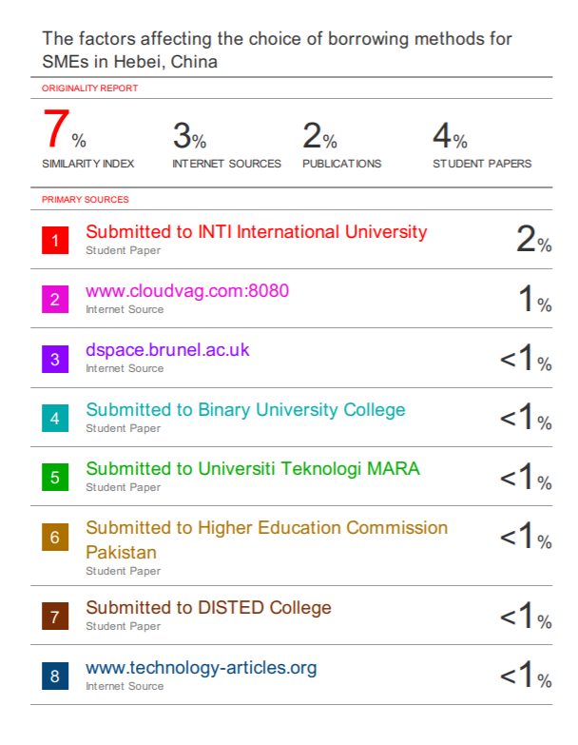
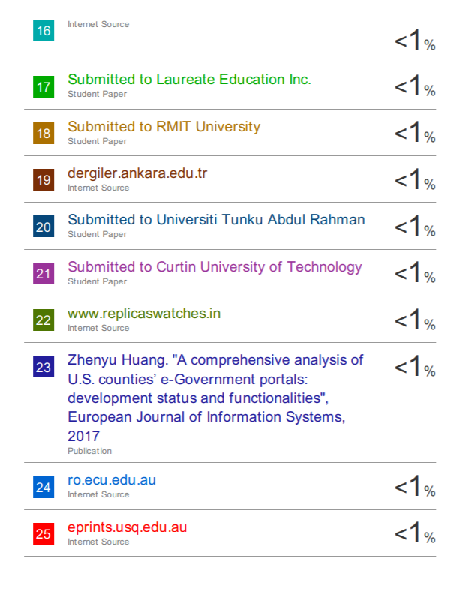
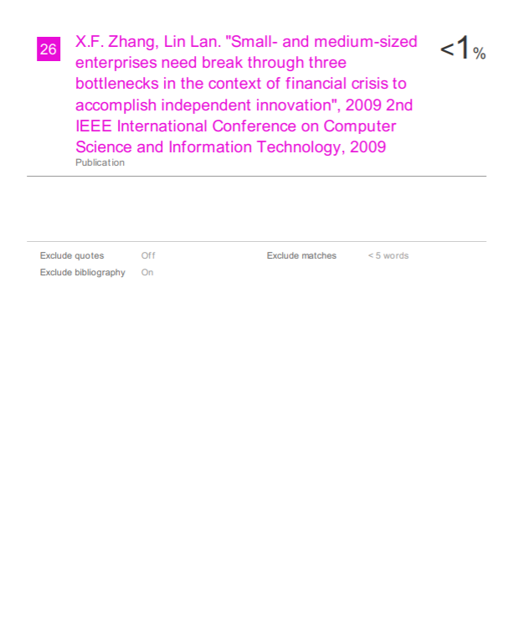

Appendix 7 Questionnaire
亲爱的先生/女士,
感谢您抽出宝贵时间回答问题。非常感谢您的反馈。我目前正在撰写一篇关于中国河北中小企业借贷选择的硕士论文，这份问卷是我在英迪国际大学攻读MBA的最后一个项目的重要组成部分。目的是了解中小企业融资现状，探讨影响中小企业借款方式选择的因素。
感谢您的支持和帮助。
本研究结果仅供学术用途，我们将严格保密您提供的信息。
李雪菲（ID：I17013766）
Dear Sir/Madam,
Thank you for taking the time to answer my questions. Your feedback is highly appreciated. I am currently working on a master’s thesis on borrowing options of SMEs in Hebei, China and this questionnaire is an important part of my final program of MBA in INTI International University. The purpose is to understand the current situation of SMEs financing, to explore the factors affecting the choice of borrowing methods for SMEs.
Thanks for your support and assistance. The results of this research are only for academic purposes and we will strictly keep the information provided by you confidential.
Your sincerely,
Li Xuefei (ID: 17013766)

SECTION A- Demographic Profiles
Instruction: please tick (✓) at the appropriate box.
- 您的公司是什么时候成立的？ When was your company founded ()？
- 2011年以后 After 2011
- B. 2006-2010
- C. 2001-2005
- D. 2000年及以前 Before 2000
- 您的公司属于什么行业？What industry does your company belong to?
A. 机械类Mechanical industry
B. 化工类 Chemical industry
C. 纺织类Textile industry
D. 电子类 Electronic industry
E. 食品类Food industry
F. 其它Others

Section B - Factors influencing Job hopping
Please tick “√” the following.
Rate each statement using 5-point Likert Scale 1=Strongly Disagree, 2= Disagree, 3=Neutral, 4=Agree, 5=Strongly Agree
Borrowing Maturity
NO. | Questions | 1 | 2 | 3 | 4 | 5
1 | 你认为你们公司了解相关借贷风险吗？ Do you think your company is aware of the relevant borrowing maturity?
2 | 你认为在长期借款融资和短期借款融资之间，您的公司一般更倾向于长期借款融资方式吗？ Between long-term borrowing and short-term borrowing, is your company generally more inclined to long-term borrowing financing?
3 | 你认为在选择借贷方式时，借贷期限是最重要考虑的因素吗？ When choosing a borrowing method, is the loan term the most important factor to consider?  .
4 | 您认为借贷方式(例如：银行借贷，民间借贷，商业借贷等)的选择会受到融资期限的影响吗？ What is your choice of borrowing methods (e.g. bank lending, private lending, commercial lending, etc.) Will be affected by the borrowing maturity？
Borrowing Risk
NO. | Questions | 1 | 2 | 3 | 4 | 5
1 | 你认为公司拖欠工资会成为借贷方式考虑的风险因素吗？Do you think that the company’s arrears in salaries will become a risk factor for borrowing?
2 | 你认为你们公司了解相关借贷风险吗？Do you think your company is aware of the relevant borrowing risks?
3 | 您认为借贷方式(例如：银行借贷，民间借贷，商业借贷等)的选择会受到融资风险的影响吗？what is your choice of lending methods (e.g. bank lending, private lending, commercial lending, etc.) Will be affected by the borrowing risk?

Borrowing Cost
NO. | Questions | 1 | 2 | 3 | 4 | 5
1 | 在选择长期融资或短期融资时，会考虑成本因素吗？Cost will be considered when choosing long-term financing or short-term financing?
2 | 在借贷融资成本过高时，是否会放弃借贷？Will the loan be abandoned when the cost of borrowing financing is too high
3 | 如果借贷成本高，你会担心这些问题吗？资金链断裂，工资拖欠，公司破产等问题吗？If borrowing costs are high, will you concern all of the problem?
4 | 您认为借贷方式(例如：银行借贷，民间借贷，商业借贷等)的选择会受到融资成本的影响吗？what is your choice of borrowing methods (e.g. bank lending, private lending, commercial lending, etc.) Will be affected by the borrowing cost？

Section C- Job hopping
Please tick “√” the following.
Rate each statement using 5-point Likert Scale 1=Strongly Disagree, 2= Disagree, 3=Neutral, 4=Agree, 5=Strongly Agree
The Choice of Borrowing Mthods
NO. | Questions | 1 | 2 | 3 | 4 | 5
1 | 你认为你们公司对借贷方式了解吗？ Do you think your company knows about various borrowing methods?
2 | 你认为你们公司资金短缺时会有借款融资行为吗？Does your company use borrowing?
Thank you very much for reading this information and considering taking part in this study.
Researcher: Li Xuefei
Phone: +601139761136
Email: i17013766@student.newinti.edu.my

Appendix 8 Tables
Factor Analysis of Pilot Test
Table 4.1 Communities for Pilot Test

Table 4.2 KMO and Bartlett’s Test for Pilot Test
Reliability Analysis
Table 4.3 Summary of Results of Reliability Analysis
Demographic Profile
Descriptive | Categories | Frequency | Percentage%
Established time | After 2011 | 38 | 25.2
Established time | 2006-2010 | 60 | 39.7
Established time | 2001-2005 | 29 | 19.2
Established time | Before 2000 | 24 | 15.9
Industry category | Mechanical Industry | 16 | 10.6
Industry category | Chemical Industry | 16 | 10.6
Industry category | Textile industry | 35 | 23.2
Industry category | Electronic Industry | 3 | 2.0
Industry category | Food Industry | 51 | 33.8
Industry category | Others | 30 | 19.9
Table 4.5 Demographic Profile of Respondents
Table 4.6 Frequency of Established Time

Table 4.7 Frequency of Industry Category
Preliminary Data Analysis
Table 4.8 Dependent Variables and Independent Variables

Factor Analysis
Table 4.9 KMO and Bartlett’s Test for Borrowing Maturity
Table 4.10 Total Variance Explained for Borrowing Maturity
Table 4.11 KMO and Bartlett’s Test for Borrowing Risk
Table 4.12 Total Variance Explained for Borrowing Risk
Table 4.13 KMO and Bartlett’s Test for Borrowing Cost
Table 4.14 Total Variance Explained for Borrowing Cost
Reliability Test
Table 4.15 Summary Result of Reliability Test
H1 | Borrowing maturity has a significance on the choice of borrowing methods for SMEs
H2 | Borrowing risk has a significance on the choice of borrowing methods for SMEs
H3 | Borrowing cost has a significance on the choice of borrowing methods for SMEs
Table 4.16 Summary of Hypothesis
Hypothesis Testing
Table 4.17 Model Summary of Multiple Regression
Table 4.18 ANOVA of Multiple Regression
Table 4.19 Coefficients of Multiple Regression
Summary of Result
HI (Borrowing Maturity) | Accept
H2 (Borrowing Risk) | Accept
H3 (Borrowing Cost) | Rejected
Table 4.20 Result of Hypothesis Testing

Appendix 9 Ethics Approval




Appendix 10 Documents

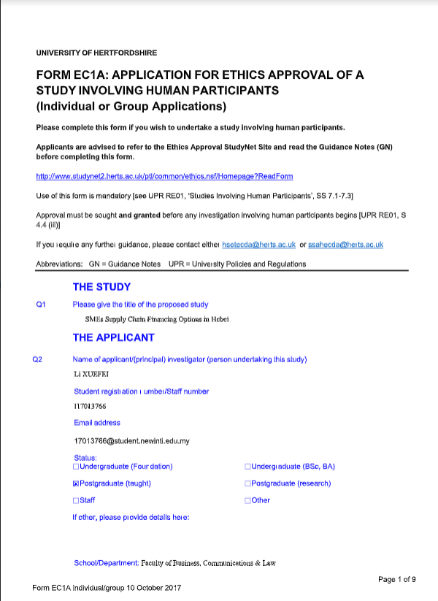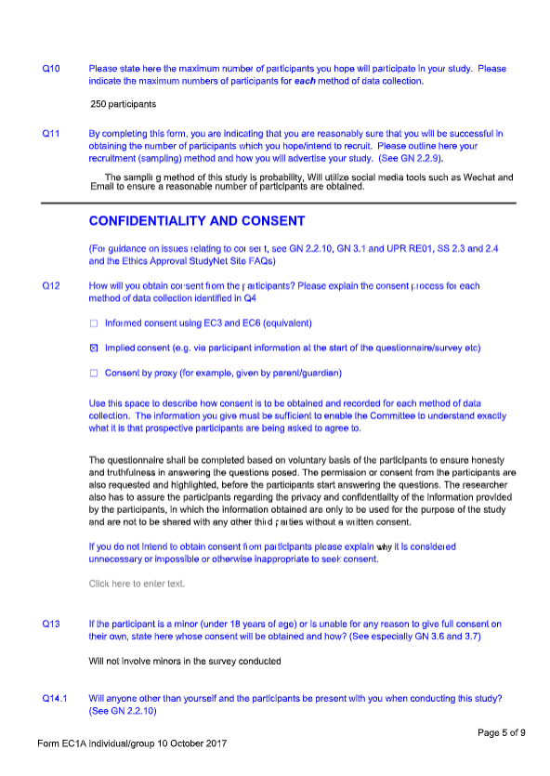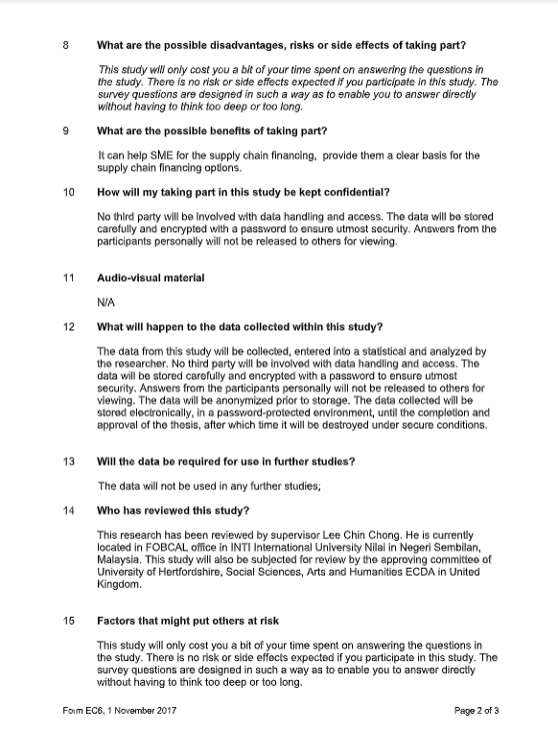

Appendix 11 Presentation Slides
