SALAAR FAROOQ MASTER OF BUSINESS ADMINISTRATION 2018 | FINANCIAL RATIO ANALYSIS AND PERFORMANCE OF AUTOMOBILE MANUFACTURING INDUSTRY OF LISTED COMPANY IN SHENZHEN  LI JIADI  MASTER OF BUSINESS ADMINISTRATION FACULTY OF BUSINESS, COMMUNICATION & LAW INTI INTERNATIONAL UNIVERSITY  2018



MASTERS OF BUSINESS ADMINSTRATION (MBADI)
MGT7999: MBA PROJECT

FINANCIAL RATIO ANALYSES AND PERFORMANCE OF AUTOMOBILE MANUFACTURING INDUSTRY OF LISTED COMPANY IN SHENZHEN

Author: LI JIADI
Student No: I13004554
Supervisor: Ms. Annie Wang
Submission Date: 14 December 2018
Final Word Count: 36,534

FACULTY OF BUSINESS, COMMUNICATION AND LAW (FOBCAL) INTI INTERNATIONAL UNIVERS

DECLARATION
I there under declare that:
I understand clearly the mean of the Plagiarism and Intellectual Property Right and Ethics related to the principles of academic work. I hereby declare that this paper is entirely my own work and effort. Moreover, it has not been submitted anyway for any award. Where other sources of information have been used, they have been duly and sincerely acknowledged. I am in possession of a copy of this document, which can reproduce immediately for whatever reason: if the original copy is lost or damaged.

Name : LI JIADI
Student ID: I13004554
Signature: 
Date : 14 December 2018

ACKNOWLEDGEMENTS
The research work of this MBA the project is completed under the careful guidance of my supervisor Ms. Annie Wang. From the topic selection of the project, the collection of materials, the formulation and revision of the research plan, the selection of technical routes to the development of the system, and the writing of the project. From the first draft to repeated revisions, all aspects are inseparable from the enthusiastic and patient help and guidance of my supervisor Ms. Annie Wang. This semester's study and research work not only brought my knowledge structure and scientific research capabilities to a new level, but more importantly, the quality of all aspects has been improved. All of this is due to the deep teaching and enthusiasm of my supervisor Ms. Annie Wang. During this semester of the master's research period, Ms. Annie Wang is easygoing, serious work attitude, honest and generous, and has made me an indelible impression. It has also set an excellent example for my future work. On the occasion of the successful completion of this thesis, I would first express my deep respect and unspeakable gratitude to my distinguished teacher Ms. Annie Wang.
At the same time, I am also very grateful to my second supervisor Ms. Rebecca Yew, for her valuable comments and suggestions during the opening of the project, the first draft, and the pre-answer. Thanks to Ms. Rebecca Yew for taking the time to discuss the results of Smart-PLS with me and give me ideas and guidance. Ms. Rebecca Yew have made important contributions to my MBA project and helped me successfully complete the MBA project.
I also would like to thanks AP Dr. Karling for her guidance and help during BRM. AP Dr. Karling's flexible approach to problem solving, rigorous problem-solving attitude, solid professional knowledge and serious research attitude have left a deep impression on me, and I admire it. In addition, thanks to D.r Syarifah for taking the time to give me a detailed explanation of the operation of Smart-PLS and the solutions and suggestions I gave when I encountered problems.
Thanks to my classmates Bi Yanfei, Dongqi, Yueying, Guochenxi, etc., and they spent a lot of sunshine and happy time in the library, at the dinner table, on the sports field, thanks for their selfless help in my study. Thanks to my friends Sun Lushuai, Zhang Yanan, Wang Shanshan, Jing Chunqi, etc. Thanks for them provide the learning resources, and help me successfully solved the difficulties encountered in the paper.
Thanks to Dr. Syriac for his supervision and meticulous care. In addition, during the research, I would also like to thank Ms. Farah for the reference materials. Thanks to the FOBCAL office and the library every staff for help and care for me.
Finally, I am deeply grateful to the parents who have raised me. Whenever I encounter difficulties, my parents are always the first to give me encouragement. Looking back on the roads that have been going on for more than 20 years, every footprint is filled with their selfless care and teaching. Thanks to their spiritual and material selfless support, they have strengthened my belief in the pursuit of life's ideals. Looking forward to the future brilliant career, parents are proud of it. I also believe that I can achieve my goals.
Once again, I would like to express my deep gratitude to all the teachers, relatives and friends who care about me. The road is still long, only diligently moving forward.

ABSTRACT
In recent years, China's economy and science and technology have made great development and progress, and the development of the automobile manufacturing industry is constantly expanding. However, due to the influence of relevant national policies, market factors -- oil price, material price, competitors and other aspects, the development of automobile industry is facing great pressure. The automobile industry is the pillar industry in China's economic structure. The core of the automobile industry is the whole vehicle manufacturing, and the foundation is the automobile parts manufacturing. The upstream extends to the related industries of the parts, and the downstream extends to the service trade and financial industry related to the automobile. The sustainable development and innovation capability of enterprises are of great significance to financial performance evaluation, enhancing the profitability of the auto industry enterprises, in order to keep sustainable development in our country's economic health. On the basis of the original financial evaluation indicators, the related indicators of enterprise innovation input are added.
Based on TOPSIS method and DuPont Analysis, an improved cross-annual evaluation model of factor analysis is constructed. This model overcomes the limitation that factor analysis can only evaluate cross-sectional data at a single time point, applies it to the financially sustainable development evaluation of manufacturing enterprises, and makes cluster analysis of manufacturing enterprises based on the above evaluation results.
In this study, the sample of 30 A-share listed companies in the automobile manufacturing industry of listed company in Shenzhen was taken as a sample, and the financial data of them from 2013 to 2017 were intercepted. The empirical test on the relationship between financial ratio analysis and business performance was carried out, and the evaluation model was used to test their long-term development ability. The results show that the evaluation results are consistent with the actual trend of the sample enterprises, indicating that the evaluation system can objectively evaluate the financial performance and sustainable development ability of the enterprises.
At the same time, according to the evaluation results, the paper puts forward targeted policies and Suggestions to improve the financial performance of manufacturing listed companies. This evaluation model provides a new idea for the research of financially sustainable development of manufacturing enterprises and the comprehensive analysis of dynamic influence at different time points of panel data. Based on this conclusion, the countermeasures and Suggestions to improve the operation, management and production performance of automobile manufacturing listed companies are put forward.
Key words: Automobile Manufacturing Industry, Company performance, DuPont Analysis

TABLE OF CONTENT

DECLARATION I
ACKNOWLEDGEMENTS II
ABSTRACT IV
TABLE OF CONTENT VI
LIST OF FIGURES X
LIST OF TABLES XI
LIST OF ABBREVIATIONS XII
CHAPTER I 1
INTRODUCTION 1
1.0 Overview 1
1.1 Background 1
1.2 Problem statement 4
1.3 Research objectives 8
1.4 Research Questions 8
1.5 Significance of study 9
1.5 Scope of Study 10
1.6 Limitation of Study 11
1.7 Operational definitions 12
1.8 Organization of chapters 16
1.9 Conclusion 17
CHAPTER II 18
LITERATURE REVIEW 18
2.0 Overview 18
2.1 Company Performance 20
2.1.1 The impartment of main analysis methods for company performance in international 21
2.1.2 The Impartment of main analysis methods for Company Performance of automobile manufacturing industry of listed in Shenzhen 24
2.2 Financial ratio analyses 26
2.2.1 Profitability Ratios 27
2.2.2 Liquidity Ratios 32
2.3 Linkage between Financial Ratios and Company Performance 36
2.3.1 Multidimensional Financial Ratios and Company Performance of Manufacturing Industry in Global 36
2.3.2 The Relevance of Financial Ratios to Company Performance of Automobile Manufacturing Industry of listed in Shenzhen 37
2.4 Grounded Theory 39
2.5 Gaps in the Literature 41
2.6 Theoretical Framework 42
2.7 Hypotheses 42
2.8 Conclusion 43
CHAPTER III 44
RESEARCH METHODOLOGY 44
3.0 Overview 44
3.1Rsearch Design 44
3.2 Unit of Analysis and Time Horizon 46
3.3 Sampling design 47
3.3.1 Sapling Plan 48
3.3.2 Sample size 49
3.4 Formula Used 50
3.5 Measurements 54
3.5.1 Reliability Test 54
3.5.2 Convergent Validity 55
3.5.3 Discriminant Validity 56
3.5.4 Regression model 57
3.5.5 Multicollinearity Regression 58
3.6 Data Analysis Tools 59
3.6.1 Model definition 60
3.7 Ethical consideration 62
3.8 Chapter Conclusion 63
CHAPTER IV 64
DATA ANALYSIS AND FINDINGS 64
4.0 Introduction 64
4.1 PLS Model Data Analysis 65
4.2Measurement Model Analysis 66
4.2.1 Outer loading of indicators reliability 67
4.2.2 Composite Reliability 68
4.2.3 Convergent Validity 69
4.2.4Discriminate Validity 70
4.3 Structural Model Analysis 72
4.3.1 Multicollinearity Regression -Collinearity Statistics (VIF) 73
4.3.2Path Coefficient 74
4.3.3 Determination coefficient (R² value) 75
4.3.4 Prediction of correlation Q2 76
4.4 Hypothesis Testing 77
4.5 Hypothesis Discussion 78
4.6 Summary of Findings 81
4.7 Conclusion 83
CONCLUSION AND RECOMMENDATION 84
5.1 Research conclusions 84
5.2 Limitation 85
5.3 Suggestions for improvement 87
5.3.1 Increase the specification and scope of external information disclosure on the balance sheet 87
5.3.2 Design and use of non-financial evaluation indicators to further improve the evaluation system 88
5.3.3 Comprehensively analyze and evaluate the business performance of the enterprise and the development prospect of the industry 88
5.3.4 Suggestions on the Research Topic 89
REFERENCE 90
Appendix I Project Paper Log 117
Appendix II Initial Research Paper Proposal 118
Appendix III Gant Chart of Timeline 123
Appendix IV Record of Meeting 124
Appendix V Secondary Data collection 128
Appendix VI Results of Smart-PLS Analysis 129
Exhibit 1 PLS Algorithm calculation Result 129
Exhibit 2 Path Coefficients 129
Exhibit 3 Outer Loadings 130
Exhibit 4 R-Square 130
Exhibit 5 Construct Reliability and Validity 131
Exhibit 6 Discriminant Validity- Fornell-Larcker Criterion 131
Exhibit 7 Discriminant Validity- Gross Loadings 132
Exhibit 8 Discriminant Validity- Heterotrait-Monotrait Ratio (HTMT) 132
Exhibit 9 Collinearity Statistics (VIF) 133
Exhibit 10 Path Coefficients 133
Exhibit 11 Bootstrapping Results 134
Exhibit 12 Mean, STDEV, T-Values, P-Values 134
Exhibit 13 Construct Crossvalidated Redundancy 135
Appendix VII Plagiarism Report 136
Appendix VIII Viva Slides 138

LIST OF FIGURES

Figure 1: DuPont Analysis 19
Figure 2: Liquidity Ratios 32
Figure 3: Theoretical Frameworks 42
Figure 4: Research Design Framework 45
Figure 5: Table for determining sample size of a known population 50
Figure 6: The formula 1 for the reflective measurement model xi= 1 xi=λiη+εi 61
Figure 7: Formative measurement model Equation 2 η=γ1x1+γ2x2+... +γixi+ ζ 61
Figure 8: PLS Path Model after PLS Algorithm calculation 67
Figure 9: Chart of Composite Reliability of reflective constructs 69
Figure 10: Chart of Average variance extracted (AVE) values of reflective constructs 70
Figure 11: Result of after calculation Bootstrapping 73

LIST OF TABLES

Table 1: Summary Table of Formula Used 51
Table 2: Factor loadings (bolded) and cross loadings 67
Table 3: Composite Reliability of reflective constructs 69
Table 4: Average variance extracted (AVE) values of reflective constructs 69
Table 5: Discriminant validity (intercorrelations) of variable constructus 70
Table 6: Discriminant Validity –Heterotrait-Monotrait Ration (HTMT) 71
Table 7: Results of the collinearity Statistics of structural model (Inner VIFs) 74
Table 8: Results of Structural Model Relevance and Significance of Path Coefficients 75
Table 9: Results of Structural Model Coefficient of Determination (R2) 76
Table 10: Results of the Construct Crossvalidated Redundancy 77
Table 11: Result of hypothesis Test for H1 to H4 77
Table 12: Finding and conclusion of hypothesis result 82

LIST OF ABBREVIATIONS
IVs: Independent Variables
DV: Dependent Variable
GPM: Gross Profit Margin
NPM: Net Profit Margin
CR: Current Ratio
QR: Quick Ratio
et. al.: et alias (and others)
etc.: Et cetera (and so on)
H: Hypothesis
i.e.: id Est (that is)
IVs: Independent Variables
PV: Perceived Value
RO: Research Objective
RQ: Research Question
Sig.: Significance
Smart-PLS: Partial Least Squares Structural Equation Modeling (PLS-SEM)

CHAPTER I

INTRODUCTION

1.0 Overview
This chapter first introduces the background of the research and discusses the basic problems of the research. Then, the problem statement is further elaborated, and the research objective and subsequent development of the problem are explained in detail.
Then, in this chapter, the significance and limitations of the study, as well as the scope of the study are clarified. Finally, the operational significance, definition, organization structure and summary of the study are discussed in this chapter, and the corresponding solutions are obtained in the following chapters.

1.1 Background
China's manufacturing industry has become the largest in the world. The proportion of manufacturing industry in China's GDP has been over 40% for a long time (Zhao, 2016). The steady and steady development of our economy owes much to the manufacturing industry (Zhang, 2015). China is the world's second largest automobile consumer, third largest automobile producer and largest potential market (Shaheen and Cohen, 2013). China's automobile industry is the pillar of the national economy, and the rapid development of automobile industry drives the development of the automobile industry (Sultan, 2014). The automobile is a necessity for ordinary people, and demand is still rising, and investors and companies focus on the future development prospects of the automobile industry (Brandt, Van and Zhang, 2016). Regulators, operators, investors, and making correct investment decisions and performance evaluation play an important role in the further development of China's automobile industry (Donnelly, 2008).
However, in recent years, China's manufacturing industry has begun to fall into a depressed state, and both the investment in manufacturing industry and the added value of manufacturing industry have decreased (Si, 2015). When China's economy entered the new normal, the manufacturing industry faced greater pressure, difficulties and challenges (Ye, 2015). In view of this, China issued "made in China 2025" in 2015 and took as a programmatic document (Huang, 2012). The development focus of China's manufacturing industry in the next decade to complete the strategic task of "made in China 2025"(Chao, 2018).
Company performance refers to the operating performance in the operation and management of the company, namely the ratio between input and output and high efficiency means high output with less input (Dele, Kuzey and Uyar, 2013). The performance of the company is mainly reflected in sales revenue, profit indicators, profitability, asset management level, solvency and the ability to develop in the future (Tan, 2013). According to the research results of Varghese and Menacere (2012), the performance of managers is the achievement and contribution of managers to the company's operation, management and development. In addition, according to the study of Mert (2013), corporate performance is an important parameter for assessing and executing corporate finance, shareholder performance and market valuation.
The research results by Delen, Kuzey and Uyar (2013) shows that the long-term sustainability, profit growth and future development of the company are determined by excellent corporate performance and good decisions, which depend on the overall evaluation within the company. According to the research results of Ongore and Kusa (2013), the management team, consultants or investors as stakeholders of an enterprise or company evaluate the performance of the company through critical evaluation. In addition, research conducted by Hui (2012) indicates that in order to maintain long-term prosperous operation of the company, the company should obtain accurate and reliable data through financial analysis to make business decisions. In the operation of the company and in some cases, because of lack of information or related managers in the decision-making process of the basic knowledge and is not suitable for company's operating strategy choices and decisions, and cause the company's performance is low (Bayrak and Kahraman, 2012).
The financial ratio is a kind of financial analysis and comparison, which is used to measure the performance of the company and use the data in the balance sheet and income statement to generate values that are easy to explain financial significance (Kat and En, 2013). Financial ratios play an important role in assessing the performance and financial status of an entity (Bold and Pu, 2014). By referring to the research results of Water (2010), the essence of financial analysis is to collect various financial information related to decision making and analyze and interpret it. Based on Leopold (2010) study suggests that the process of financial analysis is a kind of judgment, is current or past evaluation enterprise financial position and operating results, mainly for the future of the enterprise condition and operating performance is the best prediction.
The financial ratio is an indispensable part of enterprise performance analysis because the ratio gives quantitative industry profitability, liquidity and long-term solvency, asset utilization, turnover, and the ability to manage financial resources (David and Samuel, 2012). The liquidity ratio is mainly to evaluate the company's ability to pay short-term debts, while the long-term solvency ratio is to investigate the risk degree of the company's investment to creditors (Obi, 2012). According to the Sultan's (2014) research results, profitability ratio is determined according to the sales income, the use of equity and assets can verify the company's profitability, asset utilization or turnover is measured through the use of assets, accounts receivable and sell for inventory to create income amount of success.
According to the research results of Delen (2013), financial ratio analysis is a powerful tool for investors, public finance managers, creditors and other decision makers to assess a company's performance and to help stakeholders analysis the financial situation, provide support, and analyze the success, failure and development the business of company (Baird, Geylani and Roberts, 2012). For example, the company of BYD was through calculation of various ratios and comparing with the previous period of numerical conditions to assess the company's performance, and look for that may indicate a financial situation changed much difference (Lei, 2015). According to the research results of Damjibhai (2016), these financial ratios can be used to compare the efficiency within the industry, industry or company.
According to Xia (2013) studies have shown that in Shanghai securities investors and securities analysts can be the company's financial ratios and the ratio of industry standard or similar organization value comparison, to determine their relative advantages and disadvantages, and find out the differences may indicate a weakness or opportunities for improvement, make policymakers to take appropriate financing and investment decisions. According to Bose and Chen (2015) in the financial distress prediction of listed companies in China is put forward, ratio analysis is an important early warning indicator for the company to provide, the company can solve business problems before the business was damaged. Financial ratios of key importance is that the current ratio, speed ratio, net profit margin, asset turnover, gross profit margin, debt ratio, debt and equity, equity multiplier ratio, payment cycle, inventory turnover, the inventory cycle, and these variables are of great importance in the target manufacturing company (Sultana, 2013).
1.2 Problem statement
With the rise of China in the global manufacturing industry, a large number of investors have attracted attention (Tan, 2013). Since the 1990s, the average growth rate of China's manufacturing industry has been the fastest in the world (Morrison, 2013). From 2000 to 2016, the annual growth rate of the automobile manufacturing industry remained at 10.5%, leading the pace of China's automobile manufacturing industry (Guan, 2012). With the development of the economy and which is increasingly important to master the business status of enterprises through financial analysis (Lee, 2015). At present, the financial analysis indicators and the relevant evaluation method with increasingly complex than corporate financial information, operating conditions, also is in a state of relatively backward, especially in the manufacturing industry (Su, Heshmati and Geng, 2013).
It has become a social consensus to study the current financial indicator system, improve financial analysis methods and improve analysis efficiency (Revelli and Viviani, 2015). The research of Chinese scholars mainly focuses on the following three aspects: first, the limitation of financial ratio analysis method; the second is the emphasis on cash flow. The third is to pay attention to opportunity cost, but the ratio analysis of automobile manufacturing enterprises' statements is still insufficient to make a comprehensive evaluation of the overall financial status of enterprises (Dahmen and Rodriguez, 2014).
Academia and industry analysts to speculation that China's manufacturing strategy other surrounding the manufacturing enterprises will enter the Chinese market, or the threat of establishing the order of manufacturing at the expense of the company by increasing share of the market (Parnell, Lester and Long, 2012). With the implementation of One Belt And One Road policy, the implementation of the manufacturing enterprises in China and the western enterprise cooperation opportunities rising, in the vigorous development of domestic manufacturing industry, automobile enterprises can flexible ways to use financial ratios assess the performance of the company in order to get more opportunities (Tan,2013). Flexible use of financial ratio analysis is the foundation of enterprise survival and driving force for the development of the enterprise direction, enterprise (Donnelly, 2011).
Although the past few years and centuries, many companies are in a similar way to develop the company's strategic objectives and decision making, and to measure the company's performance in some way, but in today's social performance management is still discussing the company or as a important measure (Varghese and Mena, 2012). According to Zhang (2012) in the listed company financial statement analysis, the results show that the performance of the company management situation and development trend of the converted into investment decision basis which is an important way to understand company surface situation is the outlook for business conditions and results of an evaluation.
Based on Ade and Wu (2015), the results show that the company is the first condition of successful implementation of strategic development is the need to decision makers for the company's performance assessment, assessment of the company's operating scale and financial resources, and potential opportunities, market conditions and other related factors. According to the company's strategy of each industry is different, and the required performance measure is also varied from company, but if the measure of corporate performance each are not identical, the decision makers to compare the performance of different companies is produced when controversy (Shaik and Abdul, 2012). According to the research results of Enekwe, Agu and Nnagbogu (2014) financial analysis have long been used to analyze the company's financial statements and credit status, which is one of the most useful and important methods.
Based on the research of Sledge (2015), the data of financial information integration is retired from the financial statement, but the digital display is not absolute, which does not mean that the information is completely reliable, and the data can only be used as a reference. Although, in the past few decades a large number of financial and accounting model are innovation and development, however, the role of these new models and methods or as a measure of the performance of the other supporting analysis, but the basic classic analysis ability of financial ratio analysis remains the same (Higgins, 2012). According to Pavelin (2012), the ability of financial ratio analysis is demonstrated in the company's financial decision-making and overall planning analysis, which is based on financial statements to provide an estimate of value and cost. However, due to different accounting practices and financial reports, there is no accurate comparability between different companies, and there is still significant subjectivity (Christensen, Glover and Wood, 2012).
In short, in past studies, a single indicator was selected to measure the company's performance, which cannot fully reflect the company's operating conditions (Wand and Xia, 2015). China's enterprise performance evaluation has the following problems:
- Too much emphasis on financial evaluation
Most of the indicators used in the existing enterprise performance evaluation methods of automobile manufacturing industry are financial indicators, while only a few are non-financial indicators, making it difficult for the evaluation system to reflect enterprise performance comprehensively and truly (Ittner and Larcker, 2003). Excessive use of financial indicators will inevitably lead to the following disadvantages:
(1) The simple financial index system makes enterprises blindly pursue high financial indicators, pay more attention to immediate interests while ignoring long-term interests, and it is easy for enterprises to conduct short-term operations (Heinberg, 2011).
(2) Financial indicators are largely affected by accounting policy choices, making it difficult to fully reflect the objective reality in the evaluation of enterprise performance (Healy and Palepu, 2001).
2) The set non-financial indicators are not perfect
In the current performance evaluation methods, non-financial indicators are all evaluation indicators, no measurement method is given, and the subjective randomness is strong (Wong, Tan and Wong, 2015). In addition, the existing non-financial indicators are not comprehensive enough, such as not assessing the credibility of the enterprise, fail to fully reflect the relationship between the enterprise and customers (Gunasekaran, Patel and McGaughey, 2004).
3) The traditional fixed weighting method is still used in the weight design of the evaluation system
Performance evaluation subjects should include state management agencies, asset owners, major stakeholders and enterprises themselves and the relative importance of various indicators of different interest subjects is inconsistent, and the use of fixed weight cannot meet the actual needs of all interest subjects (Djankov and Murrell, 2002). In the design of fixed weights, the industry differences of enterprises are not considered. Since different industries pay different attention to different indicators, the use of fixed weights of different industries cannot meet the actual needs of performance evaluation (Bontis, 2001).
In this research, based on automobile manufacturing listed companies from 2016 to 2017 financial data as the research sample, this study will focus on the financial ratio analysis four dimensions and the relationship between the corporate performance to a certain extent, avoids using the defects of a single index, makes the research conclusion is more influence ( Lee, 2015).

1.3 Research objectives
According to the research results of Atieh (2014), the financial ratio can evaluate the company performance to a certain extent. According to the needs of different users in the measure of enterprise performance, the different financial ratio analysis can meet different purpose (Paradi and Zhu, 2013). Therefore, according to the literature review, the broad objectives of this study will take place by means of quantitative methods, focus on the independent variable of liquidity and profitability of the two most commonly used financial ratio indicators, select the ratio analysis, the data of listed companies to measure the performance of the dependent variable manufacturing companies, provide empirical basis for influence performance evaluation (Eckbo, 2013). The main purpose of this study is to ascertain the relationship between financial ratios and company performance of the automobile manufacturing industry company listed in Shenzhen. The specific objectives are as follows:
- To determine whether gross profit margin has influence performance of automobile manufacturing companies listed in Shenzhen.
- To determine whether net profit margin has influence performance of automobile manufacturing companies listed in Shenzhen.
- To determine whether current ratio has influence performance of automobile manufacturing companies listed in Shenzhen.
- To determine whether quick ratio has influence performance of automobile manufacturing companies listed in Shenzhen.

1.4 Research Questions
According to Gupta's research (2016), the research problem is the core of the whole research work. Reference Varghese and Menacere (2012) the results of the study, in the study should be an accurate statement of the research question, as far as possible to help answer and clear the goals and direction of the entire study, to discover the importance of this phenomenon (Antonio, Lima and Junior, 2015).
Broad Research Questions: Will financial analysis ratios and dimensions influence company performance in the automobile manufacturing industry company listed in Shenzhen?
Specific Research Questions:
- Will gross profit margin influence performance of automobile manufacturing companies listed in Shenzhen?
- Will net profit margin influence performance of automobile manufacturing companies listed in Shenzhen?
- Will current ratio influence performance of automobile manufacturing companies listed in Shenzhen?
- Will quick ratio influence performance of automobile manufacturing companies listed in Shenzhen?

1.5 Significance of study
The focus of this study is the financial ratio analysis, is used to describe the balance sheet and loss account and income, budget control system or accounting organization in any other part shows the important relationship between the Numbers (Miller and Power, 2013). The importance of using financial analysis methods in some companies is to provide accurate and appropriate information to understand the cause of the deviation and then to evaluate the company's performance (Huo, 2012). Financial management and influence planning is a key to the success of the company's financial, ratio analysis to company decision makers understand financial statements, determine the long-term trend and is critical to the overall financial position and performance evaluation of enterprise (Soudani, 2012).
In addition, in today's rapid development, potential investors and lenders can make loan and investment decisions for companies through ratio analysis, which is a key quantitative analysis tool (Bruton et al., 2015). One of the most important functions of ratio analysis is to be able to detect backward indicators to determine negative financial trends and positive trends (Adu, Marbuah and Mensah, 2013). The information provided by trend analysis enables managers to develop and implement ongoing financial plans and to revise short-term financial plans as necessary (Ates et al., 2013). In addition, by studying the influence of ratio analysis on corporate performance, managers can compare the financial status of enterprises with that of other enterprises or other industries in the industry (Robb and Watson, 2012).
The topic selected for undertaking this research is focused mainly on the practices of financial ratios analysis, so the outcomes of this research would be useful for:
- The results of this study can provide academic factors influencing the performance of Shenzhen listed automobile manufacturing enterprises, and further expand the index system and factors of financial performance analysis of Chinese automobile manufacturing enterprises (Deng, 2012).
- This study can provide an in-depth understanding of the factors affecting corporate performance for automobile manufacturing companies and through these references, the automobile manufacturing industry can establish a more standardized and accurate performance indicator, thus becoming the focus area of the manufacturing industry to maintain competitive advantage (Peng, Chen and Qian, 2012).
- To arouse the interest of future investors and analysts and improve the feasibility of accounting coordination and the development of the automobile industry for standard-setters and regulators in the automotive industry (Tan, 2013).

1.5 Scope of Study
The purpose of this research is to identify the influence of financial ratio analysis on automobile manufacturing industry of listed companies in Shenzhen and the importance of their relationships, regardless of the size (Newman, Gunessee and Hilton, 2012). This study adopts the method of quantitative study and adopts the method of the literature review on the research of scholars at China and abroad and chromatography, for sample adopt targeted sampling technology (Singh and Masuku, 2014). Analysis the unit of 30 listed automobile manufacturing industry of listed companies in Shenzhen, and use 5 years company annual report as evidence from 2013 to 2017 (Wu, 2012; Krejcie and Morgan, 1970). Finally, by using the statistical software Smart-PLS scientific analysis of data collected by survey respondents, and gets the answer whether the detection problem, in order to obtain the results concluded that to help achieve the goal of this research (Zikmund et al., 2013).

1.6 Limitation of Study
At the end of each study, researchers will encounter many limitations in collecting necessary information on relevant research topics: As is the general enterprise widely used ratio analysis method, financial ratios are also many deficiencies and limitations, such as ratio analysis method limited factors, control of subjective factors, factors such as imperfect corporate financial statements data, these factors influence the accuracy of financial ratio analysis and guidance quality (Deng, 2012).
First of all, the analysis of this study is based on the company's historical data, which is the lack of dynamics (Tan, 2013). To operating and financial conditions of enterprise financial ratio analysis, the use of most of the data from the financial statements, so the scope of the standard, the establishment of financial statements, staff role, as a result, the data will have an influence on the result of contrast ratio analysis. Secondly, the analysis is simple and easy to be manipulated (Huo, 2012).
Ratio analysis is based on the report data according to a certain formula to the quantitative comparative analysis in order to come to the conclusion of a kind of method, but because of financial statement have problem, when the actual ratio analysis, the report covered by some data outside of the enterprise information is not taken into consideration, the results of the analysis may lead to contrast with the enterprise actual situation (Morrison, 2013). Finally, lack integrity ratio structure system, correct use of financial ratio analysis, related to scientific nature of the ratios, current widespread use of financial ratios, the lack of systematic research, there are some limitations (Morrison, 2013).
In addition, among the listed automobile manufacturing companies in Shenzhen, there are only a few English studies in this field which lack English literature suitable for the influence of corporate performance. Secondly, difficult to reach most automobile manufacturing companies and the sample of automobile manufacturing companies in this study cannot represent the whole (Higgins, 2012).
Then, the existing literature can provide a lot of financial ratio analysis methods to influence the company's performance, but in this study mainly focuses on two aspects: liquidity, profitability (Robb and Watson, 2012). Last restrictions are time constraints, this study is in the past 10 weeks of short time to complete the paper, because in the short term is not allowed the researchers to further explore and discover other qualitative aspects, especially when the researchers found inconsistent with the existing literature review expected results (Ryan and Irvine, 2012).

1.7 Operational definitions
The following are formal operational definitions of various concepts and variables used in this study. These variables have been used by different researchers in earlier studies and have been defined differently by different authors (Bouazza, Ardjouman and Abada, 2015). In this study, logical and suitable definitions were found through different literature reviews (Unwin, 2013).
Corporate performance: in economic research, the concept of evaluation results is a priority, especially on some indexes of exploration and discovery, as much as possible in order to accurately reflect the economic entity of the subtleties of (Pinches and Soldofsky, 2014).
The main purpose of this study is to highlight the influence of financial analysis on the performance of automobile manufacturing companies. Performance is a concept, which can accurately or best report performance at the company level and raise questions (Kwon, Lee and Shin, 2014). According to the research of Unwin (2013), performance measurement methods are contradictory, and companies are more inclined to resort to financial indicators, playing a more important role in manufacturing companies.
Performance has always been a controversial and evolving concept, and the concept of performance can be reduced by almost unlimited definitions, including many definitions (Ryan and Irvine, 2012). At the level of an entity difficult to reach a consensus on the definition of performance, because the types of activities undertaken by an entity and the different benefits involved must be taken into account (Wang, 2017).
According to Dong (2011) study shows that the entity's goals are often vague, changing, controversial, sometimes even contradictory, in this case, the performance is a kind of subjective, various phenomena. For what an economic entity is concerned about, many shares may affect or be affected by the activities provided by each entity (Horta et al., 2012). According to Porter's research (2013), corporate performance depends on the ability to create value for customers. Buirguignon (2012) believes that performance reflects the realization of organizational goals.
According to the research results of Eli (2014), performance is related to efficiency, and the results obtained by the company are compared with the resources used. Base on the study by Philip (2010) performance represents a contribution to optimizing the cost of value, not just a cost reduction or value increase. Performance is a competitive state achieved by an economic entity through efficiency and productivity, thus ensuring sustainability in the market (Niculescu, 2015). Performance concept must have efficient, performance indicators have special diversity, corporate performance means, directly or indirectly to reassess competition, competitive advantage, the concept of efficiency and influence (Brbulescu, 2015).
Financial ratios: financial ratios or choose from enterprise financial accounting ratio in the statement of two values, often used in accounting knowledge, financial companies of different industries use many different professionals to evaluate standard rate (Dao, 2016). According to the research results of Almant, Edward and Beaver (2013), the significance of financial ratio analysis is to test the relationship between corporate bankruptcy, bond rating and individual financial ratio and industry average level. The common analysis tool used to validate a company's performance is ratio analysis (Kwon, Lee and Shin, 2014).
Although the ratio is very easy to calculate, has broad appeal, but when the ratio of two or more offer conflicting signals, can lead to explain a problem, therefore, ratio analysis is often criticized as is subjective (Eeroz, Raab and Haag, 2012). According to the multivariate procedures adopted by the estimate, Industrial enterprise financial ratios of the factor model for: return on investment, capital, inventory, financial leverage, accounts receivable, short-term liquidity and cash position (Thomas, 2016). In this study financial ratios were divided into liquidity, profitability, solvency, and activity categories, these groups will be supported in the framework of this study, and through the definition and use of the formula (Stephen and Ross, 2012).
In these categories, these financial ratios constitute the basic list of this study, detailed in the methods of each ratio formula:
Profitability ratios: profitability is a kind of used to assess the company's ability to generate income, and in a specific period of time compared with competitors, or the ratio of the former period, a high ratio means the company do well (Marti, 2014), though for the enterprise or the company, profitability is one of the difficult to conceptualize and measure, the absolute profit levels may show the scale of the enterprise (Trejo Pech and Noguera, 2015).
Return on assets (ROA): a measure of a company's profitability relative to total assets, ROA guides managers on how to use the company's assets to generate revenue (Soudani, 2012).
ROA is calculated by dividing a company's annual revenue by total assets, and ROA is expressed as a percentage, the higher ROA is the less money the company makes (Kabajeh, Nuaimat and Dahmash, 2012).
Return on equity (ROE): return on equity is the ratio of return on equity to equity, the shareholders of a company are told by the return on equity how much profit can make from their investments to assess the profitability of the company (Kabajeh et al., 2012).
Liquidity Ratio: The short-term liquidity ratio is measure the ability to pay the current financial debts of the company and companies can avoid the risk of financial crisis if have enough cash flow (Olagunju, David and Samuel, 2012). Accounting liquidity is a measure of company's short-term solvency with the net working capital, the difference between current assets and current liabilities, current ratio is the most widely used accounting liquidity index and speed ratio (Ballings et al., 2015).
Current Ratio (CR): the ratio of a company's current assets to current liabilities, which measures the company's ability to repay short-term debts at maturity (Olagunju et al., 2012). Liquidity ratio shows that if the company ran into trouble, will delay paying account payable or to seek new loans (Ryan and Irvine, 2012). Current liabilities will increase faster than the growth of the current assets, the company's current ratio will fall (Alam, Haq and Kader, 2015).
Quick Ratio (QR): the sum of cash, marketable securities and accounts receivable divided by current liabilities (Robb and Watson, 2012). As a result, higher ratios mean better liquidity for companies (Koyuncugil and Ozgulbas, 2012)
Manufacturing industry: refers to the industry that transforms manufacturing resources (materials, energy, equipment, tools, capital, technology, information and manpower, etc.) into large tools, industrial products and life consumption products that can be used and utilized by people through manufacturing process according to market requirements (Baines and Lightfoot, 2013) . Manufacturing refers to the process of becoming a new product after physical or chemical changes, whether it is mechanical manufacturing or manual production, whether the products are sold wholesale or retail, are regarded as manufacturing (Hi, 2017).
Manufacturing is the most important material guarantee of the national economy. The manufacturing industry is the pillar industry of a country and the operation and development of economy, politics and culture of the whole country cannot be separated from manufacturing industry (Coe and Ye, 2015). The manufacturing industry is very important to the country's economic development and people's production and living and the extension of the industrial chain of the manufacturing industry is the tertiary industry (Noble, 2017). For example, after the manufacturing of mobile phones, a series of after-sales services are needed to create a lot of jobs and play a connecting role in industrial restructuring and development, in 2013, the growth rate of China's manufacturing reached 12.9%, which is the main driving force of China's economic growth (Li, 2018). Meanwhile, manufacturing accounts for more than 80 percent of China's total exports and provides more than 80 million jobs (Yang, Luo and Li, 2013).
The manufacturing industry is an important manifestation of a country's international competitiveness and comprehensive strength, and the development degree of a country's manufacturing industry plays a decisive role in the country's international economic status and is the foundation and carrier of a country's economic development (Visser and Tolhurst, 2017). In developed countries, the added value of the manufacturing industry accounts for more than 20% of the gross national product and fiscal revenue, 70% of the wealth comes from the manufacturing industry, and 80% of the top 100 international multinational companies are in the manufacturing industry (Wang and Wei, 2014). The manufacturing industry is the practical carrier of advanced science and technology (Galbraith, 2015). The invention of the computer brought people into the information age, promoted the third industrial revolution, and formed a related industry with the computer as the main body (Morris, 2013).

1.8 Organization of chapters
This study investigated the relationship between financial ratio analysis and corporate performance, including five dimensions of three independent variables and the stakeholder theory (Kwon, Lee and Shin, 2014). In this chapter will briefly introduce the outline of all chapters and this study consists of the following five chapters to provide a structured and clear way to transmit information and information across (Ryan, and Irvine, 2012).
Chapter 1 is the introduction, a brief overview of the research background, through the review of the literature, this paper discusses the financial ratio analysis between corporate performance and manufacturing problems, and presented the research limitations of the study objectives, scope, and allows the reader to further understanding of the significance of this study and results.
Chapter 2 is a literature review. In this chapter, provides detailed and extensive literature, describes the various before research related to financial ratio and corporate performance and outstanding and discussed the research related to this research model, the theoretical framework, related research discovery and gap. The research hypothesis of this study was further developed by the guidance of the literature review. These data mainly come from secondary data, mainly Emerald, EBSCO host, Google Scholar, Science Direct and Jstor.
Chapter 3 is the research methodology. This chapter introduces the research adopts the research method of Outlines the further details about the research design, sampling objects, and technology, the choice of sample size and analysis, and adopted to achieve the research goal of measuring instrument and software. Accurately explain how, when, where, and with whom all variables are measured at the specified time interval. Sample size, unit analysis, and research design are also defined together with data statistical analysis methods and their respective roles. In addition, this chapter also summarizes the process and ethics of data collection.

1.9 Conclusion
This chapter elaborates the background of this research and the basic theory of promoting this research and puts forward the research question of the target. Then, the significance and scope of the study are stated and the relevant limitations are pointed out. Then, the keywords used in the study were defined and the research was summarized. Finally, this chapter also introduces the outline of this study, and in the following chapters, other aspects of this study will be developed accordingly.

CHAPTER II

LITERATURE REVIEW

2.0 Overview
In the manufacturing industry, the relationship between financial ratio and company performance have a critical influence on the company. The purpose of chapter 2 is to review the existing relevant literature and establish the theoretical framework. This chapter reviews the relevant literature to in-depth understand the theories about financial ratio analysis and company performance. The research field included resource-based view management areas. For this report, the main academic sources are the Wiley Online Library, Elsevier, Emerald, and EBSCO host to obtain sources reliable journals for research in this report.
This chapter focuses on the influence of global financial ratios and financial ratios on the company's financial position. There are have 9 sub-sections, section 2.1 and 2.2 discuss the financial ratio analysis and company performance respectively in global and local background perspective. Section2.2.1-2.2.3 mainly use DuPont analyzes the financial status of a company by introducing two different financial ratios. The main contents include the different influences of liquidity ratio and profitability ratio on corporate performance. Section 2.3 which is explained the linkage between the individual and dependence variables. Section 2.4 used the stakeholder theory management framework to support these different perspectives. At the end of this chapter, based on the literature review, the theoretical framework and hypotheses of the research are developed.
The analysis of an enterprise's debt-paying ability, operating ability and profitability reflects the enterprise's operating status and operating results from different aspects, but must carry on the general appraisal to the enterprise, also needs to carry on the synthesis analysis to the enterprise financial condition (Haberberg and Rieple, 2008).
The main methods of financial comprehensive analysis are DuPont analysis and wall specific gravity score, and this study mainly use DuPont analysis to analyze the factors affecting the profitability of the company (Tate, Ellram and Kirchoff, 2010). DuPont Analysis is an Analysis method that comprehensively analyzes the financial status of an enterprise by using the relationship between several main financial ratios, to be specific, it is a classic method to evaluate corporate performance from the financial perspective, which is used to evaluate corporate profitability and return on shareholders' equity (Amaya and Memba, 2015). The basic idea is to decompose the return on equity of an enterprise into the product of multiple financial ratios step by step, which is conducive to in-depth analysis and comparison of the business performance of an enterprise (Abor, 2005).
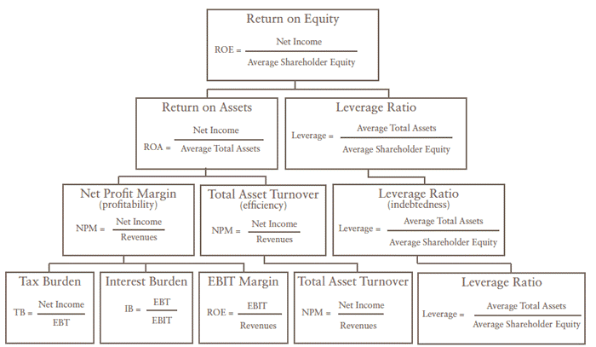Figure 1: DuPont Analysis
Source: Abor, J., 2005. The effect of capital structure on profitability: an empirical analysis of listed firms in Ghana. The journal of risk finance, 6(5), pp.438-445.
The DuPont Analysis system includes the following main index relations:
(1) Return on equity is the starting point and core of the whole analysis system.
The level of this index reflects the strength of the net assets of investors to profit. Return on equity is determined by sales compensation rate, total asset turnover rate and equity multiplier (Bontis, 2001).
(2) Equity coefficient indicates the debt level of the enterprise.
The larger the index is, the higher the debt level of the enterprise is. It is the reciprocal of the ratio of assets to equity (Capozza and Seguin, 2000).
(3) The return on total assets is the product of the sales profit margin and the turnover rate of total assets, and it is a comprehensive reflection of the enterprise's sales results and asset operation.
To improve the return rate of total assets, enterprises must increase sales revenue and reduce capital occupation (Dehning, Richardson and Zmud, 2007).
(4) The total asset turnover rate reflects the comprehensive ability of an enterprise's assets to achieve sales revenue. Analysts must analyze whether the enterprise's asset structure is reasonable based on the comprehensive sales revenue in the analysis, that is, the structural ratio relationship between current assets and long-term assets (Lee and Lee, 2009).
At the same time, it is necessary to analyze the turnover rate of current assets, inventory turnover rate, accounts receivable turnover rate and other related asset utilization efficiency indicators, and find out the exact reason for the change of the total asset turnover rate (Gunasekaran, Patel and Tirtiroglu, 2001).
This study will analyze the gross profit margin and net profit margin in the profitability ratios and the current ratio quick ratio in liquidity Ratios based on DuPont Analysis to avoid the shortcomings of the single analysis in the traditional DuPont Analysis method (Grant and Fabozzi, 2011).

2.1 Company Performance
A company is a group of legal entities composed of individuals, engaged in an operating enterprise which is an organization that makes a profit or a profit through the business which is a company with common capital, a share of the shares offered by members, to make a profit in some businesses (Zhang, 2015). Under the corporate law of the jurisdiction, companies may organize their tax and financial responsibilities in various ways (Huang, 2017). The company needs to make various forward-looking financial decisions to achieve the best financial performance (Wang, 2013). The various financial ratios in the decisions made by the company will have an influence on the financial performance of the company and using different financial ratios, companies can determine the degree of successful or unsuccessful of their activities (Ding, 2015). Company performance has defined the performance of a company utilizing all the resources of the company under the influence of business activities (Tan, 2012). In other words, corporate performance depends on the sum of some project performance (He, 2017).
Company performance has two aspects: first, the ratio of efficiency with input and output, and high efficiency means higher output with less input; another one is efficiency which is the extent to the company's goals are achieved (Chen and Lieberman, 2015). Performance is an important concept formed with the rapid change of the global economic environment and fierce competition (Huang and Chiu, 2014). Performance is a multifaceted phenomenon, which involves various stakeholders and is an important measure for the company to control and implement the long-term strategy (Deng and Smyth, 2013).

2.1.1 The impartment of main analysis methods for company performance in international
In a global perspective, company performance has attracted the interest of scholars and managers around the world, because of the company performance is measure and evaluate the operational capability of the enterprise (Ameer and Othman, 2012). All the enterprises do not want a low level of company performance due to lead to negative influence to the company, such as go bankrupt or be in debt (Wibowo, Astana and Rusdi, 2015). Therefore, understanding how to realize company performance, letting the company keep the business healthy was very important (Ward, 2016).
Padachi (2006) studied the relationship between capital structure and profitability, and concluded that the total debt leverage ratio was negatively correlated with the net profit margin, positively correlated with the turnover rate of total assets and the growth rate of total assets, and that the long-term debt ratio was significantly positively correlated with the gross profit rate. Sibilkov (2011) studied the correlation between the liquidity of assets and the return on equity, adopted the method of empirical analysis, studied the relationship between the liquidity of assets and the return on equity from the two aspects of the relationship between liquidity and secured debt and unsecured debt, and concluded that the liquidity of assets and the return on equity were positively correlated.
According to the research results of Hansen and Wernerfelt (2012) proposed a research report on performance analysis, which included two profit models of enterprises, one is the use of economic factors and another one is the use of organizational factors. The basis of the economic factor model is the traditional economy which expresses the significance of external market determinants to the development of the company (Sunley and Martin, 2017). Furthermore, the conclusion on research by Sunley et al., (2017) showed that organizational factors often reflect changes in profitability more than economic ones. In this study, the researchers will limit the influence of microeconomic factors on corporate performance (Barney and Mackey, 2016).
According to the research results of Bromiley and Hendrickx (2013) study showed that companies and industries can influence the profitability of enterprises, but companies have greater influence but the microeconomic factors may have a greater influence on corporate performance than industry (Dunning, 2013). However, the influence of this area will be tested with EVA indicators, and the researchers will determine the capital of each area as a different result, other authors through judge the factors to measure the market value or book value and analyzes the determinants of the performance (Coffey, 2013).
Economic added value measures the difference between capital cost and return on capital of the company, accurately reflects the value created by the company for shareholders and overcomes the defects of traditional indicators (Sharma and Kumar, 2012). After the introduction of EVA index in the United States has been rapidly popularized and has been evaluated in many enterprises such as Coca-Cola, IBM, American express, general motors, Siemens, SONY, dell, Wal-mart and other nearly 300 companies in the use of EVA management system (McLaughlin, 2012).
Enqvist, Graham and Nikkinen (2014) did research in 2013 that showed the literature on total return on assets, financial return, capital investment and return on assets analyze the influence of profitability in different business cycles in Finland. The result showed that the financial ratio of working capital is an independent variable influencing the analysis of enterprise profitability (Makori and Jagongo, 2013).
Muritala (2018) researched in 2012 in Nigeria for analysis of annual data from 10 companies over a five-year period examined the optimal level of capital structure to improve financial performance and the research results show that there is a negative and significant relationship between asset tangibility and ROE, which serves as a measurement standard for model performance.
Z - Score model (Z - Score model) is by the United States of New York University professor Edward Altman (1968), this is one of the common models of credit risk, which is main financial indicators analysis and simulation, to predict the possibility of bankruptcy and to predict the credit risk of the enterprise( Lepetit and Strobel, 2013). Z - Score model influence of several ratios on the "corporate performance" bankruptcy model and the ratios influence each other in this model (Martínez, 2014).
In this study, the researchers focused on the sustainability of the company (Gallego，2015). Select manufacturing listed companies as research samples, considering the three factors to evaluate the profitability of these companies, and use of ROA, ROE, and ROS in the traditional financial performance evaluation system and on the basis of introducing the innovation index, based on the sustainable development needs, TOPSIS method and factor analysis model, build a set of new financial comprehensive evaluation model of the maximal enterprise (Barney, 2012).

2.1.2 The Impartment of main analysis methods for Company Performance of automobile manufacturing industry of listed in Shenzhen
Our country basic research on enterprise performance with the development of the western context, but due to the research in China started late, in quite a long period of time is to introduce and absorb foreign advanced methods, industrial development to serve the government, improve the efficiency of production and operation of an enterprise and the evaluation system of the performance appraisal of enterprises, the research process in our country along with the development of the national economy and the change of economic system and gradual (Yuan, 2016).
Domestic research on capital structure started late, but also very rich. Wang and Lin (2011) selected 158 listed companies in Jiangsu province and found a significant negative correlation between liquidity ratio and return on equity. Liu (2011) studied the relationship between industry characteristics, gross margin, and profitability of iron and steel enterprises, and used the VAR model for empirical study. The results showed that the optimization of gross margin affected the return on equity of enterprises. Yang and Bing (2012), in Hunan province during 2000-2009, we made empirical analysis of a total of 367 samples, the study found that for the profitability of listed companies in Hunan province, either with asset-liability ratio and equity ratio of the capital structure of the representative, or on behalf of the assets structure of monetary capital ratio has significant correlation, but with the ratio of current assets, fixed assets ratio, intangible assets ratio of no significant linear relationship. Wang, Zhang et al., (2015) analyzed the relationship between the capital structure of listed companies in the real estate industry and their profitability. The analysis results confirmed that the asset-liability ratio of listed companies in the real estate industry was negatively correlated with their profitability, while the equity-to-liability ratio was positively correlated with their profitability (Xu and Zhang, 2009).
The 8 indicators of enterprise performance: profitability, competitive advantage, debt-paying ability, operation ability, industry adaptability, innovation ability, dynamic development ability and social contribution ability (Degravel, 2012). Based on the analysis of the company performance evaluation index system; based on the significance, from financial, customer, internal business process, learning, growing, other stakeholders and six dimensions of sustainable development, manufacturing, for example to build the index system of enterprise performance evaluation ( Zhang , 2015).
Based on the Wang and Liu (2014) reviewed the historical evolution of performance evaluation, from the early performance evaluation and financial evaluation to the current EVA and BSC analysis (Wu, 2016). For them on the basis of general performance score three patterns, namely financial mode, value mode and balance mode, and put forward Chinese enterprises is more suitable for use by comparing the balance mode, select the major reason to consider four factors: strategic goals, organizational structure, comprehensive budget management and incentive mechanism (Chua et al., 2012).
In addition, some scholars also Yang (2006), on the basis of advantages and disadvantages in the evaluation of EVA and BSC, integrate, both on the carrier of BSC, EAV oriented, the role of the BSC in enterprise long-term strategy and guiding role of EVA evaluation system, build a new system of BSC. According to the research results of Jiang (2016) argue that EVA and BSC two methods reflect the performance of the two aspects: shareholders of the performance evaluation of agent and the agent enterprise performance evaluation of the overall problem, and analyzes the relationship of the two methods, think both can influence integration (Zhang, 2015).
According to the research results of EVA and BSC integration advantage that overcomes the BSC dispersion and EAV goals too simple faults to improve the enterprise value by goal is more cleared, and can find out the key to influence enterprise performance driving factors, better realize the goal of enterprise (Zhang, 2014). However, when the performance evaluation of BSC and EVA methods is conducted jointly, that is necessary to take into account the characteristics of the industry and enterprise and the goals achieved by the company (Gable and Wolf, 2012). The “Additional Economic Value” rules to introduce the basic concepts and principles of EVA to experts and scholars in 1993, but after the later used, many experts and scholars of the theory have query of the EVA (Liu, 2012).

From the owner of the initial focus on revenue and profit targets to rise to the enterprise value and maximize stakeholder value, many scholars gradually introducing the operational research and mathematical statistics method to conduct the thorough research to the enterprise performance evaluation, and try to make more scientific and reasonable (Sun, 2015). Therefore, with the continuous expansion of extension and deepening of connotation, enterprise performance evaluation is no longer limited to management discipline (Collier, 2015).

From the summary of performance evaluation literature, there is a big gap between the domestic research results and those of foreign countries (Wang, 2013). On the one hand, most of the relevant domestic literature introduce and comment on some major foreign research results, and lack of innovation in their own research on enterprise performance evaluation (Li, 2013). However, there is a large number of discussions on the selection of company performance evaluation indicators and evaluation methods in the domestic research literature, and there is a lack of some empirical and case studies (Costa, Cool and Dierickx, 2013).

2.2 Financial ratio analyses
Financial ratio analysis is a tool which largely used in company financial analysis, (Brigham and Houston, 2012). Brigham and Houston (2012) study showed that the different ratios play different roles for stakeholders, due to the investors, bankers, creditors, debtors, shareholders, governments and others are the users of the ratios because above stakeholders cannot draw conclusions from available financial statements. Based on the research by Teece (2014), an excellent enterprise must be an enterprise with excellent management and management. According to the research by Brigham and Houston (2012) as one of the important means of financial management, financial analysis can provide the necessary basis for all financial activities, operations and management decisions of enterprises.
In the actual business operations is to help companies to analyze the financial status of a company consists of four components: profitability ratio, liquidity ratios, solvency ratio, and Leverage and coverage ratios (Delen, Kuzey and Uyar, 2013). According to the research Linares, Coenders and Vives, (2017), based on the analysis of financial statements of the company which often using factor analysis, comparative analysis and ratios analysis three kinds of methods, one of the most commonly used and most important method is the financial ratio analysis.

2.2.1 Profitability Ratios
Profitability ratios refer to the ratio which describes the company capability to obtain the profits through the use of overall forces and sources like selling, cash, capital, number of employees, number of branches, etc. Harahap and Sofyan (2011) research show that profitability ratio is beneficial to assess company capability in gaining profits. Profitability ratio consists of four categories, namely Net profit margin (NPM), Gross profit margin (GPM), Return on Equity (ROE). NPM refers to the ratio of net profit after taxes and total selling. GPM is defined as the ratio of profit before taxes and the number of assets. ROE resembles the ratio of net profits after taxes and capital (Febyansyah and Andar 2013).
Profitability ration is a very useful tool for understanding the efficiency and inefficiency of an enterprise and the purpose is to help managers and owners take corrective actions (Linares, Coenders and Vives, 2017). The management of the company is to measure the operating efficiency of the company and Investors invest the money into the company wants to get a reasonable expected return (Epstein and Buhovac, 2014). The profitability of a company is the ability to generate revenue for the company which is an important factor for the survival of the company (Komala and Nugroho, 2013).
With the help of profitability, stakeholders can understand and judge the lending ability of enterprises and profitability ratio enables managers to manage enterprises with the help of profits and determines the management ability of senior managers (Adams, 2017). Profitability is the substitution of financial performance which is one of the main objectives of organizational management (Drury, 2013). In today's globalization, profitability ratio is the prerequisite to improve the competitive advantage of enterprises (Barney and Mackey, 2016). Profitability ratio through goodwill to improve the level of customer confidence and improves solvency and attracts investors and lenders (Binh and Thomas, 2014).
- Gross profit margin (GPM)
Gross Profit Margin (GPM) is a ratio showing the relationship between sales- cost of goods sold to net sales which is a measure of a company's profitability that is expressed as a percentage of gross profit (Darsono and Ashari, 2005). The gross margin is not an exact estimate of the company's pricing strategy but it does give a good indication of financial health which often used to compare the competitiveness of a company's products in the same industry, showing the company's pricing ability, manufacturing cost control ability and market share (Collier, 2015). Gross profit margin can also be used to compare the industrial trend of different industries. GPM shows gross returns on net sales, so a GPM increase will show the greater gross profit the firm receives on its net sales. Such performance results can increase the attractiveness of investors to invest in the company, so that the revenue obtained by the company will increase (Kurniasih, 2013). Without an adequate gross margin, a company will be unable to pay its operating and other expenses and build for the future (Sari, 2013). Wibowo and Pujiati (2011) show that GPM has a significant positive effect on profit growth in the next one year.
- Net profit margin (NPM)
Net profit margin is profit margins return the firm’s ability to produce a product or service at a low cost or a high price and the profit margins are not direct measures of profitability because they are based on total operating revenue, not on the investment made in assets by the firm or the equity investors (Heikal, Khaddafi and Ummah, 2014).
- Return on Equity Ratio (ROE)
The return on equity (ROE) ratio is calculated by dividing net income by share capital (Hanafi and Halim, 2014). ROE is the calculation of accounting method which is similar with return on investment and which is used to evaluate the profitability of a company that can compare the profitability of different enterprises in the same industry (Rinati, 2012). The profitability of a company is measured by showing the return on investment of the company and fund shareholders (Kabajeh, Al Nu’aimat and Dahmash, 2012). The profitability of a company's shareholders in invest in the company is measured by ROE (Khaddafi and Umma, 2014). In other words, ROE is the dollar to dollar report of the average shareholder's equity (Heikal, Khaddafi and Ummah, 2014). Therefore, the ratio of 1 in ROE expresses that the net income of 1 dollar corresponds to the common shareholders' equity of 1 dollar (Rinati, 2012). Potential investors are interested in which company's fund can generate more net income and ROE can be good measure of the company profitability to help make investment judgments (Heikal et al., 2014). Khalaf Taani (2011) conclude ROE have a significant influence in predicting earnings change.

2.2.1.1 Factor of Profitability ratios in global perspective
According to the research results of Dave (2012) defined profitability as the ability to profit from all business activities of an organization or enterprise that shows how management can influence use all the resources in the market to make a profit. Profitability is also the ability of a particular investment to earn a return on the use. However, the term "profitability" is an indicator of efficiency and efficiency management guidelines (Dalkir, 2013). Although profitability is an important measure of efficiency, appropriate efficiency can be accompanied by a loss of profit (Degravel, 2012). Net profit figures only show a satisfactory balance between the value received and the value given (Doğan, 2013). The change in operating efficiency is one of the main factors that influence the profitability of enterprises. Besides, there are many other factors besides efficiency that influence profitability (Rinati, 2012).
The corporate budget compares the cost and benefits of an enterprise to the average over a period of time (Drury, 2013). A typical general concept of cost, price, yield and feed conversion rate is presented, because that is based on a fixed price and output of the average valve, this can only be used to analyze the overall prospects of the enterprise (Muller, 2012). This is not a good way to measure the short-term profitability of a particular business, in order to analyze the short-term profitability of enterprises the appropriate financial statement is the income statement (Gable and Wolf, 2012). Unlike the corporate budget, the income the statement usually prepares the business for a specific year, for this reason, called the income statement (Giuliani and Meloni, 2015). According to the research results of Novinson (2008) pointing out that the profitability ratio indicates how much money the company earns compared to the money invested by shareholders, the money the company borrows from the bank.
Price-to-earnings ratio refers to the price of a company's stock divided by earnings per share, which indicates whether the stock is overvalued or undervalued compared with other companies (Grant, 2016). According to the research results of Emekekwue (2008) believed that the profitability of the company depends on several factors, such as government policies, political activities, the competitive position of the industry companies, joint actions on wages. The point here is that as long as management uses the resources influence, which has no consequences whether makes a profit or not (Hanna, 2013). A company has several goals, but "maximizing profits" is said to be the most important (Damilola, 2007). Since "profit maximization" as a concept is subject to some inherent limitations would rather be replaced by wealth maximization (Kang and Kim, 2012). However, profit is indeed an influence resource allocation tool, because which is the most appropriate indicator to measure enterprise performance under competitive market conditions (Robert, 2012). Conceptually, profit can refer to the income generated by a company during an accounting period that exceeds related costs. Operationally, the word profit is imprecise because there are many variations (Khan, 2013). Profit may refer to profit tax, after-tax profit, gross profit, net profit, per-share profit, return on assets and other variables of return on equity (Egbidi 2009). Such inaccuracies often present a decisive challenge for researchers, who must choose an appropriate variable to replace profitability (Hanna, 2013).
However, the most commonly used variables to measure profitability include gross profit (GOP), net operating profit (NOP), and return on equity (ROE) (Tervel and Solano, 2006). The conclusion of the study is that the profitability ratio is seen as another variable used to identify and measure financial ratios (Pee and Kankanhalli, 2016). Hanna (2013) believes that profitability is an important indicator to make sure the financial status of the company. When company's profitability declines or profitability is weaker than that of other companies in the industry and considered to in poor financial condition (Potter and Lawson, 2013). The researchers decided to use return on equity (ROE) as a measure of corporate profitability (Raheman and Nasr, 2007).

2.2.1.2 Factor of Profitability Rations in China perspective
In the seminal paper on total profitability and according to the research results of Robert (2012) by emphasizing the company's total profits are more important than total assets, rather than the profit is more important than the book value, further improved the hypothesis. Spurred by Robert (2012) the total profitability was a good predictor of strong future earnings over the period he studied. The literature in this field proposed different results of the so-called "scale influence". According to the research results of Pervan (2012) found that there was a negative correlation between enterprise size and financial profitability. Companies can charge higher prices for their products and services in the market because of strong market forces (Deloof, 2003).
In addition, the high-profit rate of the company may be the result of good negotiation ability between the company and suppliers and economies of scale (Rau, 2014). In addition, many scholars have studied the relationship between firm size and the resulting financial returns, for example, Vijayakumar and Tamizhselvan (2012) of the empirical study proved a significantly positive correlation between company size and financial performance. The study focuses on the financial performance of profitability and found that large commercial companies have long-term profit resource and ability, and the short and medium term small company profitability is relatively strong (Potter and Lawson, 2013). Spurred by Potter (2013) conducted quantitative results and analysis studies on 3,035 Greek manufacturing enterprises, which indicated that the scale category of commercial enterprises was positively correlated and proportional to the profitability of enterprises.
Spurred by Lee (2014) also studied the source of corporate profitability analysis shows that the strategic source of corporate profitability is the size of the enterprises, and the open cash inflows and performance have a positive influence and play an important role. Most of these studies were conducted in manufacturing, but there are similarities between manufacturing companies and services (Reddy and Rao, 2014). A study in the service industry tested the relationship between Amato and Burson's (20014) scale profitability and found that any company can achieve profitability.

2.2.2 Liquidity Ratios
The liquidity ratio is the ability to measure a company's ability which is to pay company’s debt and safety margin by calculating such indicators as current ratio and quick ratio (Mele and Della, 2013). The main purpose of the liquidity ratio is to measure the amount of liquidity that a company must repay debts, that is, the amount of cash and easily convertible assets, and to provide a broad overview of the company's financial position (Deegan, 2013). Liquidity ratio is mainly used to assess the company's continuing operation. Liquidity measurement ratios show that the positioning of the cash flow and the current assets of the company are sufficient to fulfill the obligations upon the expiry of the company (Chaston, 2015). There are two ratios used to determine the liquidity capability, namely the current ratio and quick ratio. Current ratio relates to ration between current assets and current debt, meanwhile, quick ratio resembles ratio between current assets minus current debt (Horne, James and John, 2012).
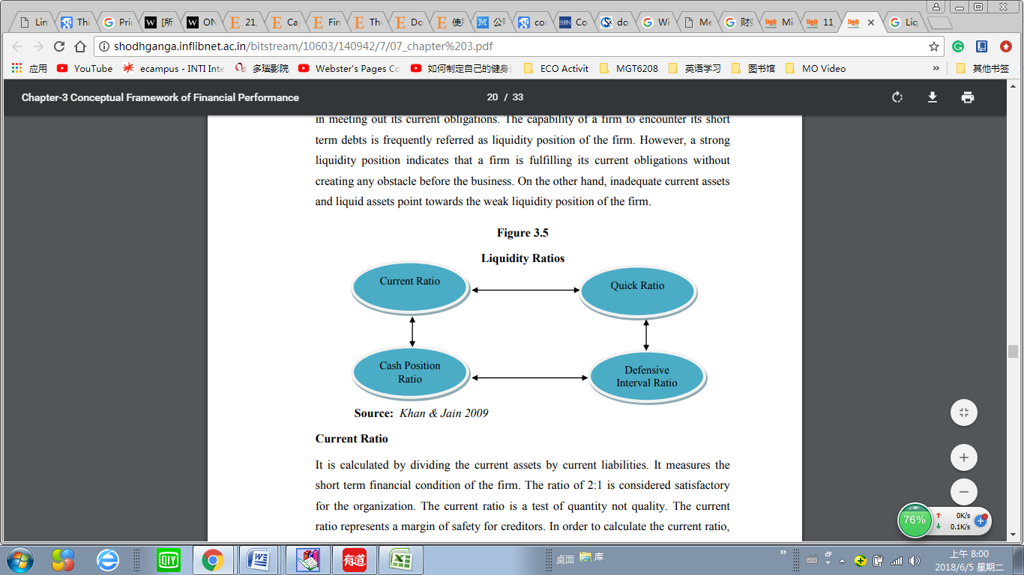
Figure 2: Liquidity Ratios
Source: Khan and Jain (2013)
- Current Ratios (CR)
Current Ratio (CR) is the ratio between current assets with current liabilities (Mamduh and Halim, 2014). CR or current ratio is a true indicator of corporate liquidity since the calculation considers the relative relationship between current assets and current liabilities for each company (Syamsudin, Wibowo and Pujiati, 2011). CR reflects the coverage of current assets to current liabilities which is measures a company ability to repay short-term debt with existing assets which are the key to company success and low liquidity rate is often favour (Rehman and Takumi, 2012). A very common rule of thumb is that a 2:1 liquidity ratio is appropriate for most companies, allowing up to a 50% reduction in current assets while still covering all current liabilities (Juchau, 2015). CR high can provide good information to potential investors. This will have an effect on investor interest in investing, resulting in increased current assets. The higher the current ratio shows the higher profit change (Kuswadi 2005). Wibowo and Pujiati (2011) concluded that the current ratio partially positively affects earnings changes.
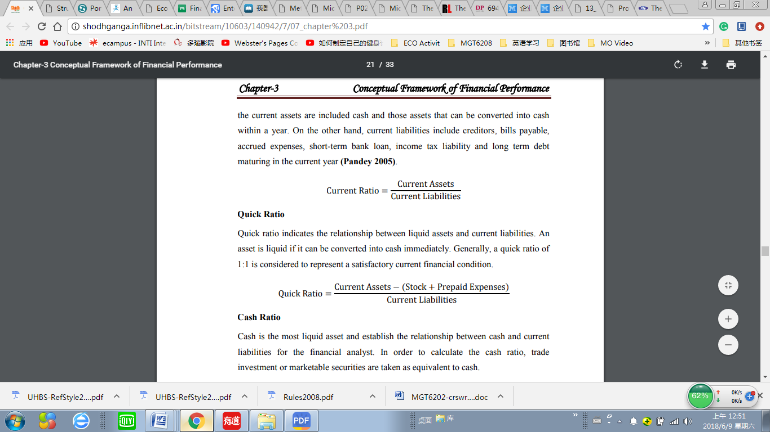
- Quick Ratios (QR)
Quick ratio is the relationship between current assets and current liabilities. An asset is liquid if the asset can be immediately converted into cash. In general, the quick ratio in 1:1 is a considered satisfactory of current financial situation (Ashraf et al., 2017)
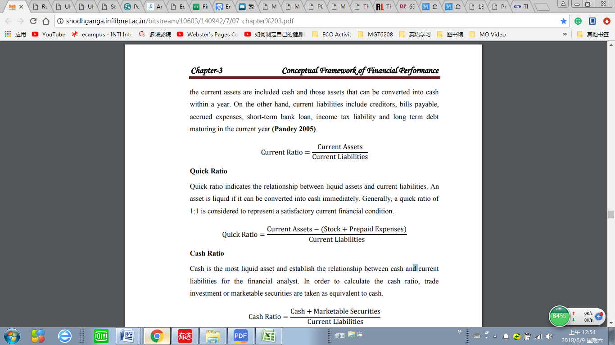

2.2.2.1 Liquidity Ratios Theory in Global
According to the research of James Clausen (2009) showed in his research that investors often use the ratio of financial statements to determine the profitability and liquidity of the company. If the company's ratio is not performing well, investors may be reluctant to invest (Kang, and Kim, 2012). Therefore, the current ratio or working capital ratio measures current assets and current liabilities (Dalkir, 2013). According to the research of Higgins (2012), the liquidity ratio is a measure of the company's ability to repay short-term debts with existing assets. James Clausen (2009) research believes that higher ratio indicates that companies have better ability to repay short-term debts with current assets (Dalkir, 2013). Therefore, the Quick ratio measures fast assets and current liabilities and fast assets are regarded as assets that can be quickly converted into cash, generally speaking, current assets minus inventory (Alvarez and Barney, 2017).

2.2.2.2 Liquidity Ratios Theory in China
In the study of stock liquidity, the early literature mainly focused on liquidity and asset pricing (Amihud and Mendelson, 2011). Liquidity influences the company's capital structure and liquidity influences corporate governance (Kang and Liu, 2011). Gradually appeared in recent years how liquidity influences the real economy, such as liquidity influence enterprise capital allocation behavior and efficiency and the field is being more and more researchers' attention (Xiao and Su, 2014). According to the research of Baxter (2012), the study found that the stock liquidity will help ease the inadequate investment and curb excessive investment and the influence mechanism is liquidity can improve the stock information content and reduce agency cost, from the perspective of the relationship and shine.
According to the research of Elwin (2015), China's A-share listed companies in 2003-2012 panel data, the study found that in stock size and corporate investment is significantly related to the level of influence on the performance of the high way is stock flow to promote company issue stock financing to promote investment. But to explore the specific influence mechanism, cannot completely copy the liquidity influence company investment mechanism, the reason is that the company fixed asset investment and other investment and innovation between there may be alternative to each other (Yang, Xun and He, 2015).
Therefore, when the liquidity increases, the influence on the total investment amount of the company due to the reduction of agency cost and the improvement of information content on the innovation investment of the company may be completely opposite(Wu and Chen, 2014). In fact, many scholars have questioned the innovation spirit of capitalism, believing that the inhibition of innovation spirit comes from good corporate governance, reducing the cost of agency and information asymmetry (Chiristensen, 2014).
According to the research of Rafferty (2012), the relationship between corporate governance and corporate innovation is sensitive to some non-observation influence and instrumental variable shows the relationship between corporate governance and corporate innovation is not sure. If the stock liquidity by enhancing corporate governance level way to judge influence on firm innovation, and help us to explain some actual phenomenon about the company's innovation (Hirshleife and Teoh, 2017).
In theory, liquidity can influence innovation in many ways, liquidity can influence innovation investment and innovation output of companies by reducing agency cost and improving stock price information content (Yasser, Entebang and Mansor, 2015). Liquidity will influence the entry and exit of institutional investors, but there is no consensus on whether institutional investors promote or inhibit innovation (Lei et al., 2012). Liquidity inhibits innovation investment by influencing the occurrence of hostile events (Shleifer and Summers, 1988). Liquidity influences executives' equity-based pay attitudes and hence innovation. The theoretical analysis based on these influencing approaches has not produced a definite analysis framework, which is not clear how liquidity influences corporate innovation (Verbeke and Tung, 2013). In terms of empirical, difficult to get data from the innovation, according to the research of Fang (2014) study, liquidity and corporate innovation research, provides empirical evidence from the capital market.
The empirical research on Chinese this is almost a blank, only individual literature from the perspective of the development of capital market, using the macro data to a preliminary probe into the correlation between the liquidity and innovation of (Lynne, 2012). Therefore, that is necessary to study the relationship between liquidity and corporate innovation and influencing mechanism for China's highly liquid stock market (Wu and Chen, 2014). In the clear after the stock liquidity and innovation, the relationship between the company and the government and securities regulators can be controlled by changing the financial market and the securities laws and regulations to influence stock liquidity, thus influence the company innovation behavior (Fang, 2014).

2.3 Linkage between Financial Ratios and Company Performance

2.3.1 Multidimensional Financial Ratios and Company Performance of Manufacturing Industry in Global
Many scholars at home and abroad have studied the financial performance evaluation of manufacturing enterprises (Coffey, 2013). Different scholars start from different perspectives, and there are also differences in the components and evaluation models of the established financial evaluation system of enterprises (Gombola and Edward, 2012). According to Frederick Winslow Taylor (2009), proposed scientific management theory and began to pay attention to enterprise performance evaluation and management methods. Subsequently, American accountant Harry (2012) proposed the standard cost system and the difference analysis system on this basis, forming the prototype of performance evaluation.
Tend to be diversified as the enterprise management, financial performance evaluation has changed from the original cost control to management performance evaluation, Dupont Company first proposed to use the key to evaluate the Company's financial management and budget project level (Donald, 2012). Brown created with ROE as the core of Dupont financial analysis system, provides an important basis for the financial situation for the enterprise (Sunley and Martin, 2009). Subsequently, based on the research of Alexander Wole (2012), the result shows that established a scoring system to comprehensively evaluate the financial situation, which is significant progress in using financial indicators to evaluate corporate performance and later used EVA to describe a company's profitability.
In the 21st century, based on the research of Gombola and Edward (2012), found that the research on corporate financial performance is not limited to the indicators related to profitability, but gradually pays attention to the problems related to capital utilization and value addition. In the study of Pan (2013), 17 financial indicators were used to evaluate the development status of Pan pharmaceutical manufacturing enterprises. However, based on the research of Shaverdi (2014), constructed a financial stratified evaluation system of 5 sub-goals and 17 sub-indicators from the aspects of liquidity, financial leverage ratio, operating ratio, profit ratio and growth ratio.

2.3.2 The Relevance of Financial Ratios to Company Performance of Automobile Manufacturing Industry of listed in Shenzhen
Despite China’s development and progress and establishment of modern enterprise system, the construction of the financial evaluation system has begun to receive attention (Dwi, 2012). The enterprise research center of THU University selected more than 1,100 enterprises as sample objects from three perspectives of profitability, debt service, and growth status to rank their comprehensive performance (Lin and Wu, 2014). This is the first large-scale empirical analysis of financial performance model for listed companies (Zhang and Wang, 2013). According to the research by Li (2013), asset management capability was added to the above three aspects of research, thus establishing the financial evaluation system of aviation manufacturing enterprises.
According to the research of Chen (2014), the analysis of the company's sustainable growth should include five aspects: profitability, distribution ability, growth ability, leverage ability and operation ability. Therefore, the fuzzy evaluation model is used for evaluation. However, according to the research of Su (2014), the dynamic cumulative influence model was built on the premise of time-series three-dimensional data space, and the sustainable development ability of enterprises was studied from six aspects of capital structure and profitability, operation, debt paying, growth, and long-term development capacity.
Based the research of Zhang (2015), results show that the rationality of integrating technological innovation elements into the enterprise performance evaluation system is demonstrated from a theoretical perspective and the framework of constructing a new enterprise performance evaluation system from the perspective of scientific and technological innovation and sustainable development are proposed. Therefore, according to the research of Li and Liu (2014), nine sub-indicators related to science and technology innovation ability were introduced in the evaluation indicator design, and the comprehensive development ability of the automobile manufacturing industry was evaluated from an empirical perspective.
In addition, according to the financial performance evaluation standard of enterprises (2013), 12 financial evaluation indicators were designed from the aspects of profitability, debt-paying ability, asset operation status and development ability (Hanna,2013). The financial performance of automobile manufacturing listed companies was evaluated by taking region as an example (Dan, 2015). On the basis of the above financial indicators, a comparative analysis was conducted on the corporate performance of listed companies in the household appliance automobile manufacturing industry for three years by considering relevant non-financial factors to select evaluation indicators (Wang and Tang, 2016). Subsequently, on the basis of a single year, the panel data of China's high-tech manufacturing enterprises from 2008 to 2012 were taken as the research object, and the financial performance of listed companies was evaluated through improved factor analysis (Jiang and Liu, 2016).
Based on the research situation at home and abroad, the financial performance evaluation of enterprises is constantly improved, but there are also many problems (Albers, 2017). Although some studies have established a relatively comprehensive financial performance evaluation system, most of them only study from the perspective of a single financial indicator (Dalkir, 2013). On the basis of the original evaluation indicators, the comprehensive evaluation model was used to study the sustainable development of enterprise finance. However, most of them only evaluated the cross-section data of one year (Muller, 2012). Some scholars considered the dynamic development at different time points, but the model was too complicated and complicated (Lin, 2014).
Some scholars used the innovation ability to evaluate the comprehensive development of the automobile manufacturing industry, which reflects that began to attach importance to the evaluation of innovation related indicators (Dong, 2013). However, most of the previous literature only selected the data of a certain year for empirical analysis or did not consider the evaluation requirements of corporate financial performance in the context of sustainable financial development and innovation-driven development (Potter and Lawson, 2013). This study tries to integrate the original financial evaluation indicators, add the innovation ability evaluation indicators, establish the financial evaluation model of cross-annual sustainable development, and study the sustainable development ability and long-term financial performance of manufacturing enterprises (Sharma and Kumar, 2012).

2.4 Grounded Theory
The definition of stakeholder refers to anything that can affect or affected by the company's key objectives of individuals and groups (Freeman, Nasi and Savage, 2010). This broad definition means that managers need to pay attention to the external groups, direct stakeholders affect the performance of the long-term support, if cannot get the support of these groups, the company will face failure (Parmar et al., 2010). For an enterprise, stakeholders can be divided into three categories: capital market stakeholders, namely shareholders and the main suppliers of corporate capital; Product market stakeholders are the company's main customers, suppliers, local associations and trade unions. The stakeholders in the organization are all employees of the company, including managers and general employees (Gedajlovic and Sur, 2011). Every stakeholder group hopes that the organization can give priority to them when making strategic decisions in order to achieve their goals, the company has to make a balance according to the degree of dependence on stakeholders (Yasser, et al., 2015).
According to Harrison and Freeman's research (2016), the stakeholder theory as a strategic approach aims to make the company prosper and survive in difficult times by paying more attention to the voters who may play an important role in the success of the company. Therefore, in context of the stakeholder theory, the global social role of enterprises determines their status (Arora and Dharwadkar, 2011).
According to Horisch and Freeman's research (2014), the future of human beings depends on the development of sustainable enterprises and economic entities, connecting business, society and the environment. Therefore, the primary goal of the company is to create and accumulate wealth or value for key partners and stakeholders by converting shares into services and commodities as to maintain the sustainable development of the company (Freeman et al., 2015). According to the research of Fassin (2012), in this field corporate governance and operation is the function of coordinating various activities in the context of negotiation and compromise with stakeholders.
Based on research by Verhoef (2013), shows that corresponding to the shareholder center model is based on the financial index evaluation method, and stakeholders model clearly evaluates the requirements from the perspective of a broader, including not only the financial performance indicators. For shareholders, include social responsibility index, in combination with the evaluation method and from static to dynamic, from short-term to long-term, by quantitative or qualitative to quantitative, from subjective or objective to the subjective and objective combination (Bosse and Phillips, 2016).
Based on the research results of Freeman (2010), as a natural part of enterprise strategy and management, the stakeholder theory is attracting more and more attention, and enterprises will rethink and review their sustainable development strategy from the perspective of social responsibility. Research based on research of Michelon and Parbonetti (2013), shows that this concept links the interest balance of stakeholders with the awareness of improving the measurement of enterprise performance: financial performance, company size, social and environmental measurement.
According to the research results of Pande and Ansari (2015), stakeholder theory is incompatible with business, while the balance of interests of unlimited stakeholders is almost impossible. Stakeholder theory does not provide a basis for determining the balance, and enterprise organizations will not adopt these principles (Tullberg, 2012). The research based on Tricker (2016), indicates that the company has no common objective and standard to measure the performance of the company's agents through the disclosure of responsibility to owners, and there are no boundaries.

2.5 Gaps in the Literature
In this chapter, there are has a lot of the previous domestic and foreign researchers have carried out various studies on financial analysis and company performance (Barkham, Gudgin and Hart, 2012). Financial analysis and company performance has defined and have been explained and discussed the three factors in chapter 2 section. Although, the researcher reviewed various studies on financial performance analysis which revealed that enormous work has been done in the area of financial performance analysis in the past. However, there are still limitations in the study of financial performance in the automobile manufacturing industry, especially in academic and journals by using financial ratio analysis of the Listed Company in Shenzhen (Zhuo, 2010).
Although has many scholars carried out to the studies with the company performance (Mathuva, 2015). But there are still limited in the manufacturing industry, only fewer scholars using advance performance to measures, there have some study gaps in the automobile manufacturing industry for this research (Sharma and Kumar, 2012). Based on research of Wibowo (2015), scholars focused on analysis company performance in China. According to the research of Chiaramonte and Casu (2017), the result shows that the small number scholars concentrate on the performance automobile manufacturing industry of listed company.
There are has some limited studies about the company performance in automobile manufacturing industry use the scientific methods to influence the company performance listed in China which means in the follow-up studies to need more relevant research to provide and guide academic to study (Wu and Chen, 2014). According to the research by Kang and Kim (2012), with the gradual development of today, scientific research on the performance of automobile manufacturing industry is undoubtedly to maximize the resource benefits of automobile manufacturing industry.
On the basis of the original financial evaluation index, this study will add the related indicators of enterprise innovation investment (Lepetit and Strobel, 2013). In this study, Profitability Ratios and the Liquidity Ratios are used to study the performance of automobile manufacturing in Shenzhen (Heine and Rind, 2013).

2.6 Theoretical Framework
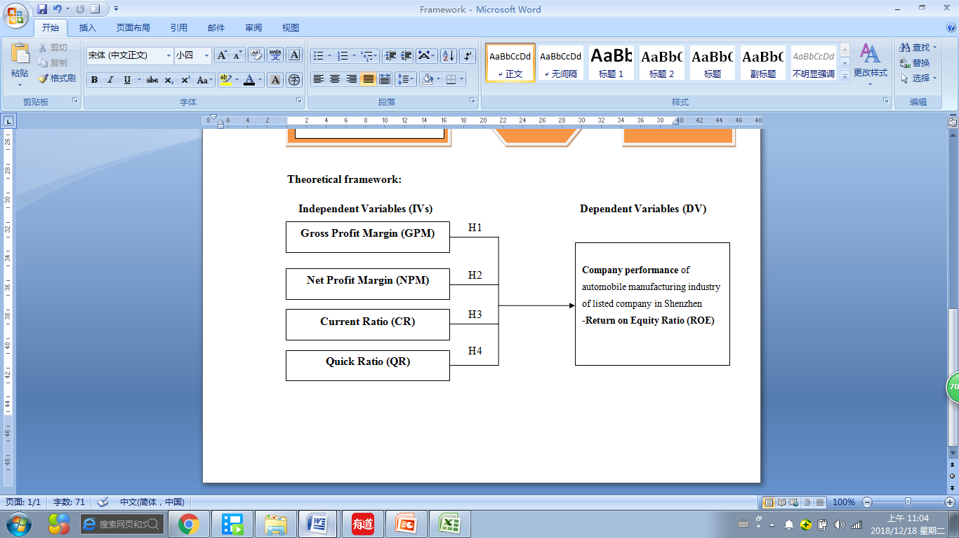
Figure 3: Theoretical Frameworks

2.7 Hypotheses
Based on the background of the problem, the objectives to be achieved in this research are: To know the Gross profit margin, Net profit margin, Current Ratio, Quick ratio to influence the company performance in automobile manufacturing industry of listed companies in Shenzhen stock exchange and the following are the hypotheses of the studies:
- H1: Gross profit margin has a significant influence on performance of automobile manufacturing companies listed in Shenzhen.
- H2: Net profit margin has a significant influence on performance of automobile manufacturing companies listed in Shenzhen.
- H3: Current ratio has a significant influence on performance of automobile manufacturing companies listed in Shenzhen.
- H4: Quick ratio has a significant influence on performance of automobile manufacturing companies listed in Shenzhen.

2.8 Conclusion
Finally, in this chapter, the foreign and domestic literature reviews provided verily usefully support for framework and hypotheses. The theories between financial ratio and company performance are supported by many studies. With the development of technology, managers, decision makers, and investors pay more and more attention to the company's financial situation. The continuous monitoring of the financial situation of the market increases the chances of the company's survival under the increasingly fierce market competition. With the development of science and technology, various financial analysis methods have been invented and widely used in performance analysis and evaluation of enterprises. The financial ratio is one of the important tools for corporate performance analysis which can directly and influence analyze the performance of the company, and which is used to compare the same industry and management status and operation efficiency between different industries. In this study, two kinds of common and important financial ratios are mainly discussed which play an important role in decision-making and analysis in the financial performance analysis of a company.

CHAPTER III

RESEARCH METHODOLOGY

3.0 Overview
The main purpose of this chapter is to explore the research methods applied in this study. First of all, the parameters of research design and the definition of sampling population and sampling technology are highlighted. Second, this study uses the data analysis method, sampling technique, sampling methods, and data sources were summarized, the methods and strategies to ensure that these apply to this study, and using the correlation analysis and secondary data to achieve this goal. In addition, this research design also discusses the instrument, test and analysis methods of data collected in this research.

3.1Rsearch Design
According to the research of Cooper, Schindler and Sun (2012), design is the task of preparing for a research project to identify problems related to research, which is a detailed outline and total plan, specify the collection and analysis, the methods and steps of the information needed for how researchers achieve research provides an overview and framework of the system. Based on the research by Kerlinger (2013), the result shows that research design is a plan, structure and research strategy designed to obtain the answers to research questions and control variance. The research design mainly includes how to collect data, how to use instruments, how to use instruments and how to analyze the collected data expected means, as shown in figure 3.1 the research design for this study (Sekaran and Bougie, 2017).
According to the research of Lewis (2015), on the basis of the study need to be considered before the design to ensure that the study is influence solved and the purpose of the research design is important for the reliability of the results obtained by influence. Because provides a solid foundation for the research and planning, to collect, analyze and explain the researchers think that can provide answers to the questions as the research data and explains how to realize the goal (Mathuva, 2015). According to the research of Maxwell's (2012), the plan at various stages of completion can guide the researchers and helps to systematically study problems to achieve maximum efficiency and reliability, eliminating deviation and margin of error. Based on the research by Fowler(2013), indicated that the research design is conducive to the collection of research data and the reliability of research, providing the maximum information with as little effort, capital and time as possible and as to guide the correctness of the research direction. The research design is important because complete design tends to yield important and correct conclusions and systematically observe research problems (Marczyk, DeMatteo and Festinger, 2017).
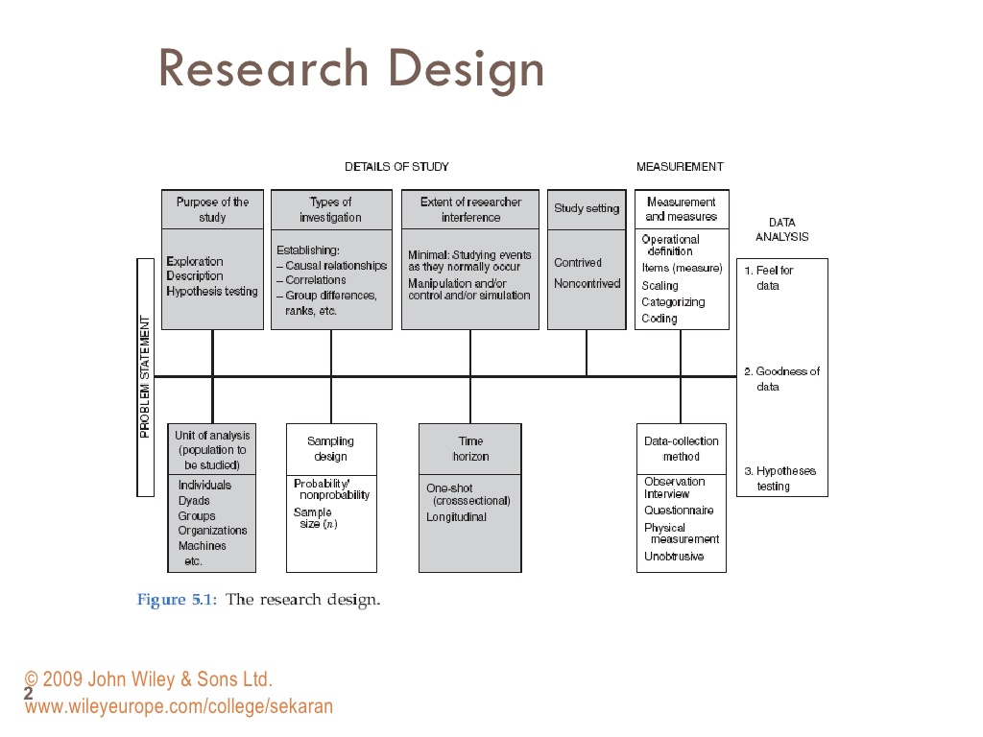
Figure 4: Research Design Framework
Source: Sekaran and Bougie (2017).
Descriptive research design help answer and specific research questions, to clarify and explain the internal relations and the properties (Marczyk et al., 2017). The descriptive research defines problems, investigation and data collection before the analysis method of descriptive research is used to get information about the current state of the phenomenon, and describe the existence of the condition of variable or condition (Saunders, 2012). This study uses quantitative research methods, in the quantitative approach emphasizes the objective measurement and through public opinion polls, questionnaire and survey data collected by statistics, quantitative research is focused on collecting digital data and promote to the crowd or explain a particular phenomenon (Sekaran and Bougie, 2013).
This study used quantitative descriptive correlation design research design to identify and describe the specific case is the study of the characteristics of the variable, and the collected data statistics and quantitative analysis, allowing researchers to detailed study the characteristic of the research object and content (Lambert and Lambert, 2012). Therefore, through descriptive research design, the researchers focused on establishing the relationship between financial ratios analysis and company performance of the automobile manufacturing industry listed in Shenzhen China (Wang, 2014). In addition, this study is classified as a longitudinal study because the collection and statistical analysis of research data come from the same subject for more than one point of time (Ameer and Othman, 2012).
According to the research of Khalid, Abdullah and Kumar (2012), the result shows in the natural environment, the researchers had the least interference with normal processes or work. The extent of interference in this research is no interference as the data is from a secondary source there is no human to touch (Barney, 2012). The research setting environment for this study is non-contrived because the research is studying the phenomenon as naturally occurs and no manipulation of the study setting in evident (Barney and Mackey, 2016). According to the research of Rahi (2017), if organizational research is done in a natural environment where work proceeds normally and the research is in non-contrived settings.

3.2 Unit of Analysis and Time Horizon
One of the first decisions of any research is to analyze the research and the unit of analysis refers to the individual, group or object of the investigation and the analysis unit mainly includes individuals, groups, organizations, countries, technologies (Bhatt, 2012).
For example, if the study is people's shopping behavior or attitudes toward new technologies then the unit of analysis is the individual; if the study teamwork in organization then unit of analysis is a group; if the goal of the study is to know the company profitability or make good decisions then the unit of analysis is the company; if the purpose of the study is to understand the differences between national cultures then the unit of analysis is the country (Bryman, 2016). Therefore, the analysis unit determines the type of data collected and the source of data collected (Barney, 2012).
According to the objective of this study, the relationship between the financial ratio and the company performance of automobile manufacturing companies is understood and the object of analysis is the company, therefore, the analysis unit of this study is the organization (Scott and Garner, 2013). Therefore, the study should measure the variables of organizational levels, such as organizational size, income, absorptive capacity and the data collected from various sources, such as financial records or the chief executive's investigation (Bryman and Bell, 2015).
According to the research by Bryman and Bell (2015), the time range of the study determines whether the study is a cross-sectional study or a longitudinal study. In longitudinal studies, the data were collected repeatedly twice or more over a long period of time means repeating the measurement on the same variable and fixed sample; however, the cross-sectional studies, data are collected only once in a period of time (Bryman,2016). In this reach, collected the data over three times in the same data, therefore, the time horizon in this study is a longitudinal study (Baxter, 2012).

3.3 Sampling design
In the research analysis, the sample design is a framework, and the sampling method is used to extract samples from interested objects or people, in studies, researchers usually get certain types of information by investigating people or organizations of interest (Lewis, 2015).
The common sampling methods include simple random sampling, which is usually selected completely from the population included Systematic sampling, which is the sequencing and periodic selection of the population; stratified sampling, which divides the population into different categories and randomly selects from each category; matching random sampling, which divides groups into pairs according to criteria, and then randomly assigns them to groups; this is the same test that was applied at random time to randomly selected groups of people (Converse, 2017). One of the most commonly used methods in the study was the Krejcie and Morgan sampling methods (Bryman and Bell, 2015).
According to the research by Sayer (2015), under the background of extensive research, observation and study of each unit is impractical behavior and the sample cost is too expensive. Therefore, an appropriate sampling method to eliminate or avoid deviation is very important in the selection process, at the same time can also reduce the cost and effort the researchers collected samples, produce more accurate results (Coles, Lemmon and Meschke, 2012). Therefore, according to the study by Hussein et al. (2015), an appropriate sampling method can improve the efficiency and credibility of the research and play a key role in the research objectives.
In this study, the population under study is companies in the automobile manufacturing industry listed in Shenzhen China because at present there are relatively few cases of financial ratio analysis on listed companies in automobile manufacturing industry listed in Shenzhen China (Fang, 2016). Qualitative analysis of financial ratios for the current situation used for the company's performance and select multiple indicators and related inspection of the company's performance of the companies (Costa, 2012). In manufacturing companies, the financial ratio is a vital indicator to measure the performance of the company, and the determination of reasonable financial ratio analysis is conducive to the stable operation of the manufacturing industry and the protection of the interests of creditors (Hodge, 2018).

3.3.1 Sapling Plan
Sampling planning is a technical term used in research and provides a detailed overview of researchers (Light, 2014). These summaries guide the researcher to investigate which types of samples, the size of samples, and how to select the investigated objects from a population or organization (Fumitaka, 2015). The design of an influence sampling plan should allow the resulting data to contain representative samples of the parameters of interest to the researcher and be able to answer the relevant questions mentioned in the target (Sargeant, 2012)
The sampling plan helps the researcher to select the sample of the population and the methods of sampling have two types include the probability and non-probability sampling methods (Fumitaka, 2016). Probability sampling refers to the probability that people or things can be accurately understood as part of the study sample but non-probability cannot accurately know the probability that a particular research object is sampled (Trotter, 2012). The non-probability sampling method is adopted in this study because the sample data of this study come from secondary data, therefore, the convenient sampling method is more suitable for this study (Baker et al., 2013).
Based on the research of Sekaran and Bougie (2017), convenient sampling is a kind of non-probability sampling which can collect data from a large number of population or objects conveniently. According to Saunders (2013) research results, in order to enable researchers to collect information efficiently and quickly, the convenient sampling method is the best choice when the study has restrictions on time and place.

3.3.2 Sample size
The sample size is the number of completed responses or observations received by the researcher through a survey of views or behavior related to the study (Aslam et al., 2013).
In this study to determine a suitable size of the sample is very important because the sample size can affect the feasibility of the study, samples of the correct calculation have a significant influence on the influence liveness of the results (Meysamie et al., 2014). The sample is too small will lead to unreliable results, but too much of a sample researchers need to spend a lot of time and resources (Hooper, 2016). In order to simplify the process and determine the overall sample size limited Coben (2014), proposed the use of finite population sample size figure 3.2 to determine the size of the sample, to help the researchers to determine the size of the sample.
By the end of January 2018, there 30 automobile manufacturing companies listed in Shenzhen had disclosed their 5years annual reports from 2013- 2017. According to the sample measurement figure 3.2 of Coben (2014), therefore, the sample size of this study is 4*30*5 equal to 600 samples and these second data collected from the Shenzhen exchange.

Figure 5: Table for determining sample size of a known population
Source: Coben, J. A power primer. Psychological Bulletin, 112, 155-519 (2014)

3.4 Formula Used
As mentioned in the second chapter, there are 2 independent variables and 1 dependent variable in this study. The following Figure 3.3 illustrates the measurement formulas and purpose of different variables and their sources. As mentioned Krejcie and Morgan (1970) above, the purpose of this study is mainly to analyze the performance of listed companies of China's automobile manufacturing industry and used in the study of samples collected in 5 and the data will be collected from 2016 to 2017 two years and a total of 8 observation records. The second data were collected and analyzed based on the measurement formula shown in Table 3.1 below. The data collected mainly comes from the annual report of Shenzhen stock exchange from 2016 to 2017 official website of the company and the corporate governance analysis.

Table 1: Summary Table of Formula Used
NO. | Factors | Formula | Purpose
IV | Profitability Ratios | - Gross Profit margin  $$\left(GPM\right)= \frac{Gross profit}{Sales }$$ | The gross profit margin expresses a company’s gross profit as a percentage of its sales revenue (Alan, 2014).
 |  | - Net Profit margin  $$\left(NPM\right)= \frac{Profit }{Sales }$$ | The net profit margin expresses a company’s profit as a percentage of its sales revenue (Alan, 2014).
 | Liquidity Ratios | $$a) Current Ratio= \frac{Current Assets }{Current Liabilities}$$ | The liquidity ratio is the extent to which the company's current assets cover current liabilities at the point of analysis and mainly reflects the company's ability to repay short-term debt with existing assets (Heikal nd Ummah, 2014).
 |  | $$b) Quick Ratio= \frac{Current assets – Inventories}{Current Liabilities}$$ | The quick ratio is the ratio of the company's quick assets to current liabilities, which reflects the extent to which the company's assets with strong liquidity cover current liabilities（Delen, Kuzey and Uyar, 2013）.
DV | Profitability Ratios | $$a) Return on Equity Ratio$$  $$\left(ROE\right)= \frac{Net Income}{Total Equity }$$ | ROE reflects a company's ability to generate return on investment for shareholders. The higher the return rate of shareholders' equity, the more investment returns the company creates for shareholder (Heikal and Ummah, 2014）.

- Profitability Ratios
Financial performance usually refers to the profitability of an enterprise. Profit is the precondition for the survival and development of an enterprise (Delen, Kuzey and Uyar, 2013). From a market perspective, a long-term loss-making enterprise always exits the market when runs out of all resources (Asma et al., 2011). Investors, creditors, managers and even government officials are increasingly concerned about the profitability of companies (Ni and Van, 2015). Financial indicators related to the business performance of enterprises are also used as the preferred indicators for the establishment of the company's financial performance model (Ferrouhi, 2014).
a) Gross Profit margin (GPM)
Gross Profit margin is the comparison value between the Gross operating Profit and the net operating income of an enterprise, which is usually one year (Kabajeh et al., 2012). Dividing the gross operating Profit of a company by the net operating income, expressed as a percentage, is the basis of the research on the net profit (Delen, Kuzey and Uyar, 2013). GPM used to compare the competitiveness of the products of a company in the same industry, showing the pricing ability of the company's products, the control ability of manufacturing costs and the market share, and to compare the industrial trend changes among different industries (Saleem and Rehman, 2011). The profit of an enterprise is derived from the turnover minus the operation cost, and the gross profit rate can directly reflect the ability of the enterprise to operate (Norsworthy and Oliver, 2001). If the gross profit rate is high, the enterprise's profit is high; if the gross profit rate is low, the enterprise's profit is low; if the gross profit rate is negative, the enterprise is in a state of loss (Kabajeh, 2012).
b) Net Profit margin (NPM)
Net profit margin is the ratio between net profit and operating income that is the ratio of profit to income (Heikal, Khaddafi and Ummah, 2014). Usually one year, the company's net after-tax profit divided by net revenue, usually expressed as a percentage, represents the company's final profitability (Fairfield and Yohn, 2001). The higher proportion of net operating interest rate, the stronger the profitability of the enterprise, but the formation of profit is not generated by operating income, but also by investment income, non-operating income and other factors. Generally, the after-tax net interest rate of the company should be stable, and there will not be too much change in the short term. If there is too much change, it means that the product structure, price policy, industrial environment, cost control ability, tax burden or business cycle of the company has changed.
- Return On Equity Ratio(ROE)
ROE refers to the ratio between net profit and average net assets of an enterprise in certain period of time, which fully reflects the ability of investors to obtain net income from their own capital invested in the enterprise and the most comprehensive and representative indicator to evaluate the level of enterprise's own capital and accumulated and earned returns (Heikal et al., 2014). This index has strong universality, wide adaptability and is not limited by the industry (Kabajeh, 2012).
- Liquidity Ratios
In order to expand the business scale or meet the needs of operating turnover, almost every enterprise is in debt operation, but the debt ratio is different (Heikal et al., 2014). High debt ratio is usually called risk management, while low debt ratio may enter conservative management (Ayanda et al., 2013). No matter how high or low the debt and which is the basic premise of the normal operation of the enterprise to repay the debt at maturity (Ferrouhi, 2014). If a company is unable to repay maturing debt, may be taken over by creditors or declared bankrupt by the court. Therefore, financial indicators related to debt paying ability are often used to examine important indicators of short-term financial crisis of enterprises (Said, 2014).
- Current Ratio (CR)
The CR is the ratio between current assets and current liabilities of an enterprise in a certain period of time, this index measures the size of the enterprise's capital liquidity, fully considering the relationship between the size of current assets and the size of current liabilities, and judging the ability of enterprises to convert short-term debts into cash for repayment of current liabilities before maturity (Said and Tumin, 2011).
- Quick Ratio(QR)
The QR is the ratio between quick assets and current liabilities (Elsiefy, 2013). There are various calculation methods for the corresponding quick ratio. In this study, a more traditional one is adopted: current assets minus inventory divided by current liabilities (Said, 2014).

3.5 Measurements
As mentioned above, this study uses the annual report of the secondary data company as the data of measurement. The research of Creswell (2013) shows that the advantages and disadvantages of the use of second data. Firstly, the data required by the research can be easily obtained through the company's year-end report, saving time and cost for the research (Blay and Geiger, 2013). On the other hand, the secondary data obtained by the researchers may be too old or processed, leading to unreliable research results (Cervellon, Carey and Harms, 2012).
Studies based on Sekaran and Bougie (2012) show that preliminary tests, hypothesis tests and other support can measure the validity of data. In order to ensure the correctness of the data analysis results and the social science statistics software version 2.20 will be used to test and analyze the research model before conducting the test of research hypothesis, namely the test of the substantial relationship between variables (Henwood, 2014).

3.5.1 Reliability Test
Reliability analysis is the first step of questionnaire or secondary data analysis which is also one of the criteria to test whether the questionnaire or data are qualified (Hämmerer et al., 2013). Therefore, in the preliminary test, some independent variables and dependent variables in this study need to first conduct factor analysis and reliability test to ensure that the collected questionnaires or data are meaningful (Bernhardsson and Larsson, 2013). Reliability is the degree of consistency to which the same results are obtained when the same measurement tool is used to repeatedly measure the same thing (Postmes, Haslam and Jans, 2013). Based on the research of Amini and Islam (2014), the result shows that a good measuring tool, measuring the same thing over and over again, should always keep the results the same. The scores are very reliable and accurate and are consistent from one test point to another (Zhou et al., 2012). This means that if the test process is repeated with a group of test participants, substantially the same results can be obtained; therefore, well-designed questionnaire or data collection should have reliability and stability (Baick et al., 2017).
In the measurement results, the reliability coefficient should be between 0 and 1 (Eisinga, Te Grotenhuis and Pelzer, 2013). If the reliability coefficient of the scale is above 0.9, the reliability of the scale is good. If the reliability coefficient of the scale is between 0.8 and 0.9, the reliability of the scale is acceptable; if the reliability coefficient of the scale is between 0.7 and 0.8, which means that some items of the scale need to be revised; if the reliability coefficient of the scale is below 0.6 which means that some items of the scale need to be abandoned; then, the adjusted independent and dependent variables are determined and used to analyze the model (Green and Yang, 2015).

3.5.2 Convergent Validity
Based on the research of Campbell and Fiske (1959) developed multi-feature, multi-method matrix to evaluate the structural validity of a set of measurement data. This method emphasizes the importance of using both discriminant and convergent verification technology in the evaluation of new tests (Tran and Gastin, 2015). Convergent validity mainly uses different measurement methods to test whether multiple questions that are exhibited as a variable will converge to a factor (Carlson and Herdman, 2012). In the study, confirmatory factor analysis was used to test whether all variables had good convergence validity (John and Benet, 2009).
Due to the measurement model of this study include the measurement item is more, relatively sample size is limited, can't put all the items in the same measurement model to estimate the way to test sword validity (Halkitis et al., 2013). Therefore, this study based on Sethi and Carraher (2003), suggested limited information analysis method, the research model according to the theory of segmentation for the independent variable and dependent variable measuring model of a number of smaller, respectively, to ensure that the results of the analysis with sufficient stability factors. In other words, in order to establish structural validity, this study must prove convergence and discrimination (Kim, Park and Kang, 2013).

3.5.3 Discriminant Validity
Discriminant analysis is a kind of statistical identification and analysis technology and can be a certain number of cases of a group and the corresponding other multivariate variables of known information, determine the number of grouped with other multivariate relationship, establish discriminant function (Kan et al.,2016). Then use the quantitative relation to known multivariate information, but the case of unknown packet types belong to the discriminant analysis (Henseler et al., 2015). Determining whether the validity test believes the irrelevant structure is actually irrelevant (Voorhees et al., 2016).
Generally speaking, discriminant analysis includes two stages: the first stage is to analyze and explain the differences between the indicators of each group, and establish discriminant functions (Brereton and Lloyd, 2014).
The case used to establish the discriminant function must have mutually exclusive grouping attribute, that is, the probability that the case must have grouping at the same time may be greatly increased (Napper et al., 2008). Therefore, the value of financial ratio and the probability of financial crisis may be non-linear. Moreover, the prediction of corporate financial crisis belongs to two types of qualitative analysis, which is either normal or possible (Paap and Sawi, 2014). In order to serve the multivariate nonlinear analysis of qualitative dependent variables, the multivariate linear regression is constantly modified and developed according to the needs of practical research, leading to a new analytical method (Renno and Wood, 2013).

3.5.4 Regression model
In order to select the panel data regression model that is most suitable for this study, F test is needed to decide whether to choose the mixed model or the fixed influence model (Bates et al., 2014). According to the research of Breusch and Pagan (2010), the multiplier test can determine the relationship between mixed OLS model and fixed influence model. If the null hypothesis is not rejected which indicates that the model tends to mixed OLS model (Belloumi, 2014). Then, the Hausman test was used to determine whether the random influence model or fixed influence model should be established; if the null hypothesis is not rejected which indicates that the stochastic influence model is more suitable for this study (Ahn and Moon, 2014). Therefore, in chapter 4, the panel regression model suitable for this study will be determined based on hypothesis and data analysis.
From the four aspects of profitability, debt paying ability and development ability, 10 performance evaluation indicators were selected, and factor analysis was carried out with Smart-PLS 3.0 (Yong and Pearce, 2013). The comprehensive evaluation indicators of enterprise performance were obtained by factor score, as the dependent variable of the study (Bagozzi and Yi, 2012). Taking asset-liability ratio and short-term capital-debt ratio as independent variables, and considering the two control variables of the company's size (represented by the logarithm of total assets), a linear regression model was constructed, and Smart-PLS 3.0 was used for analysis and test (Henseler et al., 2016).
According to the research hypothesis, the regression model is constructed:
Y1=a+b×DAR+c×SIZE+d×ε1
Y2=e+f×SDAR+g×SIZE+h×ε2
Among them, Y1 and Y2 represent enterprise performance.DAR stands for asset-liability ratio; SDAR represents the short-term capital debt ratio. Size represents the size of the company (logarithm of total assets); ε1andε2 are random variable (Vural, Sökmen and Çetenak, 2012).

3.5.5 Multicollinearity Regression
In the regression model, multicollinearity is a condition that occurs when some predicted variables in the model are associated with other predicted variables (Kraha, et al., 2012). Serious multicollinearity will lead to problems, because it increases the variance of regression coefficient and makes it unstable (Kroll and Song, 2013).
The following are some consequences of the instability coefficient:
- Even if there is a significant relationship between the predictive variable and the response, the coefficients may not seem significant.
- The coefficients of highly correlated predictive variables vary greatly from sample to sample.
- The removal of any highly correlated term from the model will greatly affect the estimated coefficients of other highly correlated terms.
- The coefficients of highly correlated terms may even contain wrong symbols.
In the study, to measure multicollinearity, the correlation structure of the predicted variables can be checked, and the researchers can look at the variance expansion factor (VIF) (García et al., 2015). VIF is used to measure the increase in variance of estimated regression coefficient when predicting variable correlation. If all VIF are 1, there is no multicollinearity, but if some VIF is greater than 1, the predicted variable is correlated; when VIF is greater than 5, the estimated result of the regression coefficient of this term is not ideal (Shu et al., 2014). Coefficient (linear discriminant function) cannot be translated reliably, but the value of fit (classification) will not be affected (Katoh and Standley, 2013).

3.6 Data Analysis Tools
In order to measure the reliability of the potential constructs proposed in this study and verify the model of this study, Partial Least Squares Structural Equation Modeling (PLS-SEM) was used for data analysis in this study. Computer analysis software was used to analyze the sample data with Smart-PLS3.0 maintained by Dr. King who is a professor at the University of Houston (Ageev et al., 2014).
PLS is a kind of detection or construct predictive model analysis technology, especially for the potential variables between the causal model analysis, compared with LISREL (Linear Structural base model), PLS for processing is more suitable for small sample data , is better than that of Linear Structural relations general (Sambamurthy and Chin, 1999).PLS has the following advantages:
(1) Can handle multiple dependent variables and multiple independent variables;
(2) Can overcome the problem of multi-variable collinearity;
(3) Robust land could process disturbance data and lost values;
(4) Input response variables have a strong ability to predict potential variables;
(5) Can handle reflective at the same time indicator and formative indicator;
(6) Applicable to small samples;
(7) PLS is not restricted by data distribution (Pirouz, 2006).
In addition, PLS used different resample programs for the estimation and whether the path coefficient was significantly tested, such as Bootstrapping, Blindfolding, Jackknifing and other methods (Chin, 1998a). In this study, PLS Algorithm, Bootstrapping and Blindfolding methods were used for analysis.
Due to the small number of samples in this study, PLS can be used regardless of the variable assignment type and sample size, and has good predictive and explanatory power.Therefore, this study adopted SmartPLS software developed by Ringle, Wende & Will (2005) for PLS analysis.Due to the small sample size, 5,000 samples were repeatedly extracted by Bootstrap resampling method as parameter estimation and inference (Eckbo, 2013).

3.6.1 Model definition
When developing constructs, researchers must consider which type of measurement specification to use: reflective measurement model or formative measurement model (Aras, 2015). First of all, the traditional measurement model reflective model can be expressed by the following formula: xi = λiη + εi, i represents the i-th index; λi represents the load of the i-th index on the latent variable η; εi represents the measurement of the i-th index Errors, measurement errors are independent of each other, and measurement errors and latent variables are also independent (Diamantopoulos, Riefler and Roth, 2008). The above formula is consistent with the assumption of X=T+E Lord& Novick (1968) of the common factor model (Thurstone, 1947), and classical measurement theory (CCT), that is the relationship between the indicator and the potential variable is a linear function, and the change of the potential variable will lead to the change of the indicator. Many concepts in the field of psychology and social sciences can be used to construct corresponding measurement tools according to the model (Bollen, 2002). Potential index and construct in the traditional measurement mode as shown in figure 3.3, the relationship between latent variables by measuring indicators, is the significance of the Model by potential is the significance of construct point to measure a one-way arrows to said that this model is called Reflective Measurement Model (RM), the corresponding Indicator as reflective indicator, the corresponding common factor on the statistical model (Kock, 2011).
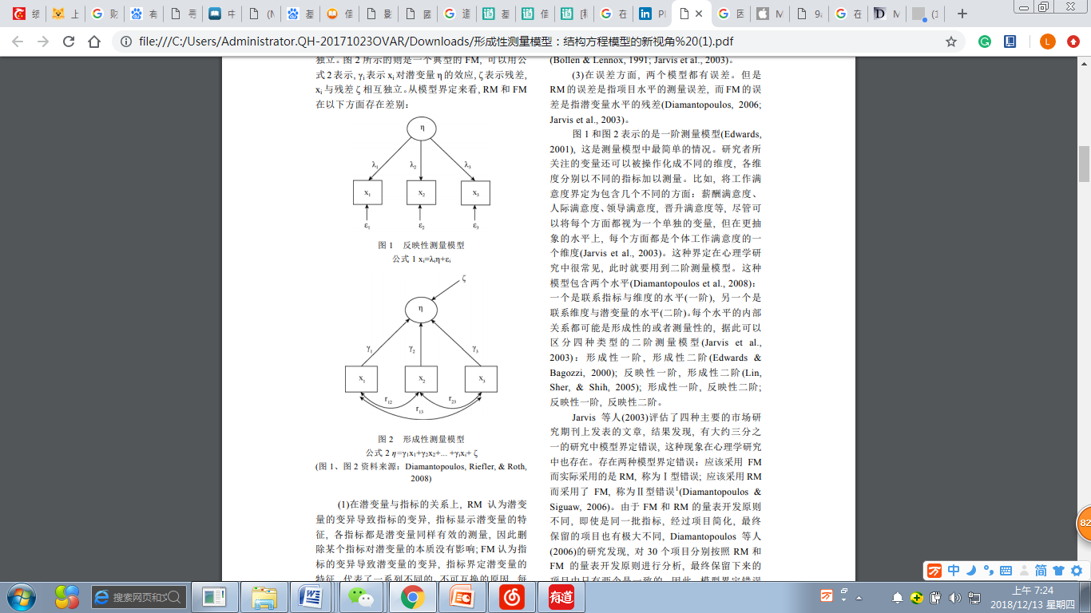
Figure 6: The formula 1 for the reflective measurement model xi= 1 xi=λiη+εi
Source: Diamantopoulos, Riefler, & Roth, 2008)
In many cases, the reflective measurement model is appropriate, but in some cases the measurement does not always reflect the potential construction, but instead, as shown in Figure 3.4 below, the formula η = γ1x1 + γ2x2+... + γixi + ζ can be used It is shown that γi represents the effect of xi on the latent variable η, ζ represents the residual, and xi is independent of the residual ζ (Diamantopoulos et al., 2008). In this case, the meaning of the latent variable is defined by the measurement index, that is by the observation indicator a potentially constructed one-way arrow indicates that such a measurement model is called a Formative Measurement Model (FM), and the indicator is called a Formative Indicator, also called a Causal Indicator, which statistically corresponds to the principal component model (Franke, Preacher and Rigdon, 2008).
Figure 7: Formative measurement model Equation 2 η=γ1x1+γ2x2+... +γixi+ ζ
Source: Diamantopoulos, Riefler, & Roth, 2008)
From the above model definition, RM and FM are different in the following aspects:
(1) In terms of the relationship between latent variables and indicators, RM believes that the variation of latent variables leads to the variation of indicators, and indicators show the characteristics of latent variables, all indicators are equally effective measurements of latent variables therefore the deletion of an indicator has no effect on the essence of latent variables (Hair, Ringle and Sarstedt, 2011). FM believes that the variation of index leads to the variation of latent variables, and the indicator defines the characteristics of latent variables, which represents a series of different and non-interchangeable reasons (Bollen and Lennox, 1999). Each indicator represents a specific aspect of the variable, and deleting an indicator will change the essence of the variable (Jarvis et al., 2003).
(2) In terms of the relationship between various indexes, all indexes in RM must have positive correlation (internal consistency), while in FM, correlation between indexes is not a necessary condition, and there is no specific requirement for correlation mode and degree, which can be positive correlation, negative correlation or no correlation (Bollen and Lennox, 1999).
(3) In terms of errors both models have errors (Diamantopoulos, 2006). However, RM error refers to the measurement error of project level, and FM error refers to the residual of latent variable level (Jarvis et al., 2003).

3.7 Ethical consideration
According to the research report of Belmont (2013), the three ethical principles of respect, kindness and justice are related to this study. Therefore, all the companies, personal information and results collected in this study are anonymous and confidential, not disclosed, and are only used for education purposes. In this study, only secondary data of Shenzhen stock exchange market were collected and paid attention to (Roberts, 2014). According to the research of Leikas and Kulju (2017), in academic publishing ethics, respecting the originality of data is to promote research objectives, avoid mistakes, and pursue knowledge and truth. In order to maintain the original copyright, the secondary data or other people's research results that this study borrowed and quoted in the literature review are all marked with the source of the data, and appropriate reference, so as to avoid potential plagiarism (Hart, 2018).

3.8 Chapter Conclusion
A clear explanation was demonstrated in this chapter on every aspects of the research methodology. The data analysis approach is also clearly defined and explained thoroughly.

CHAPTER IV

DATA ANALYSIS AND FINDINGS

4.0 Introduction
In order to obtain the relationship between the accurate financial ratio and the value of the automobile manufacturing industry, this chapter mainly uses Smart-PLS software to analyze the second-hand data collected and verify the research results related to the research hypothesis discussed in the first chapter. The calculation results in this study are shown in figure 8 including independent variables, dependent variables, relationships between variables and all indicators of variables, as well as external load values of indicators constructed by reflection. In this research the gross profit margin, net profit margin, the current ratio and quick ratio four construct is measured by Reflective index, therefore, this research is suitable for use Reflective Measurement Model to measure. According to Anderson and Gerbing (1988), scholars suggest that when PLS is used to analyze the research mode there are more rigorous to carry out the following two stages in sequence: Measurement Model Analysis Outer Model and Structural Model Analysis Inner Model.
According to the research results of Anderson and Gerbing (1988), the focus of Measurement Model Analysis Outer Model is to verify whether all Measurement variables in the theory can accurately measure their potential variables, and whether there is a load of replication Measurement variables in different potential variables, namely, verification reliability, convergence validity and discriminant validity. Convergent validity and discriminant validity are important construction validity. Convergent validity is based on the discriminant construct, which is based on the discriminant construct, which is based on the discriminant construct. At the same time, Diamantopoulos and Winklhofer (2001) also pointed out that reliability and validity are two important indicators in evaluating the measurement model, and the traditional method is suitable for researchers to test reliability and validity. Finally, the results of the study are analyzed and illustrated, and a conclusion is drawn.

4.1 PLS Model Data Analysis
PLS model analysis and interpretation has two steps: the first step is to verify the reliability and validity of the measurement model; the second step is to detect the significance and predictive ability of the path coefficient of the structural model. Firstly, for the measurement model:
(1) Items loading must be greater than 0.5;
(2) Composite reliability and Cronbach's Alpha must be greater than 0.7 to ensure the degree of internal consistency;
(3) AVE of Average variance extracted (AVE) must be greater than 0.5;
(4) The square root of AVE of each dimension must be greater than the correlation coefficient with other dimensions;
(5) The factor load must be greater than that of other factors, that is, own-loadings is greater than cross-loadings, which means that the convergent validity and discriminant validity of the measurement are good.
Secondly, regarding the structural model depends on:
(1) Standardized Path coefficient achieves statistical significance;
(2) R2 was used to judge the explanatory ability of the model (Fornell & Larcker, 1981; Hair et al., 1998; Hulland, 1999; Medina and Chaparro, 2008; Pavlou and Fygenson, 2006).
In this study, PLS method was used for the analysis of two models. Firstly, PLS model one used path analysis to verify the hypothesis H1,H2 ,H3 and H4 of this study, while PLS model two explored the effect of the four hypotheses to verify the hypothesis of this study.

4.2Measurement Model Analysis
The evaluation of reflection measurement model mainly includes the following tests:
1. Firstly, comprehensive reliability test of internal consistency should be carried out for the measurement model.
2. The second is to test the external load, which is a composite reliability index of each index.
3. Convergent validity: AVE was used to evaluate.
4. Discriminant validity: Fornell-Larcker criterion and cross - loading are used to evaluate discriminant validity.
In the measurement model in figure 8, the factor loads are all greater than 0.5 and reach the statistically significant level (see figure 8 for details).Composite reliability of the four dimensions is 0.934, 0.964, 0.966 and 0.933, respectively (see table 3 for details).AVE is 0.827, 0.842, 0.895 and 0.739 (see table 4 for details).The load of each factor is also greater than that of other factors, and the square root of AVE is greater than the correlation coefficient with other dimensions (see table 5 for details), indicating that the reliability and validity of the model are acceptable.

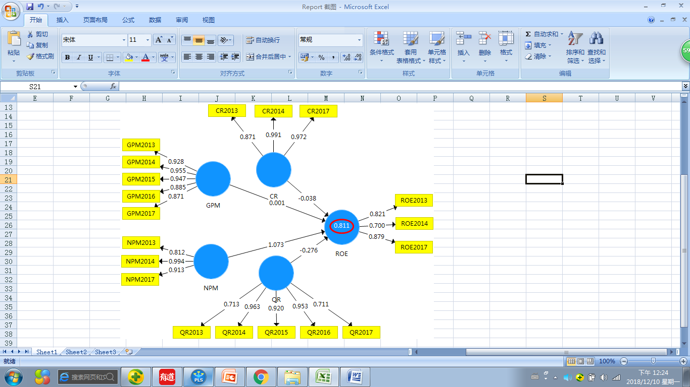
Figure 8: PLS Path Model after PLS Algorithm calculation

4.2.1 Outer loading of indicators reliability
In order to verify the validity and reliability of the analysis, the reliability and validity were tested again. In PLS measurement model analysis, PLS can generate weight and loadings at the same time. Generally speaking, weight is more suitable to interpret formative index, while loadings are more suitable to interpret reflective index (Chin, 1998a). However, this study only deals with the reflective construct, so the reliability is checked from loading. In this measurement model, the direct relationship between Current Ratio, Gross Profit Margin, Net Profit Margin, and Quick Ratio on Company performance (ROE) is discussed. It can be seen from table 4.1 that factor loading values are higher than the recommended threshold value of 0.7 and reach the statistically significant level (Carmines and Zeller, 2000).

Table 2: Factor loadings (bolded) and cross loadings

 | Current Ratio | Gross Profit Margin | Net Profit Margin | Quick Ratio | Company Performance
CR2013 | 0.871 | 0.661 | 0.735 | 0.378 | 0.624
CR2014 | 0.991 | 0.723 | 0.870 | 0.274 | 0.829
CR2017 | 0.972 | 0.698 | 0.849 | 0.225 | 0.828
GPM2013 | 0.537 | 0.928 | 0.737 | 0.579 | 0.589
GPM2014 | 0.722 | 0.955 | 0.827 | 0.455 | 0.722
GPM2015 | 0．566 | 0.947 | 0.782 | 0.608 | 0.689
GPM2016 | 0.617 | 0.885 | 0.779 | 0.528 | 0.683
GPM2017 | 0.862 | 0.871 | 0.871 | 0.344 | 0.793
NPM2013 | 0.476 | 0.787 | 0.812 | 0.829 | 0.580
NPM2014 | 0.860 | 0.859 | 0.994 | 0.601 | 0.885
NPM2017 | 0.948 | 0.765 | 0.913 | 0.319 | 0.872
QR2013 | 0.263 | 0.453 | 0.419 | 0.713 | 0.187
QR2014 | 0.327 | 0.553 | 0.590 | 0.963 | 0.339
QR2015 | 0.236 | 0.522 | 0.523 | 0.920 | 0.278
QR2016 | 0.216 | 0.508 | 0.530 | 0.953 | 0.273
QR2017 | 0.232 | 0.310 | 0.475 | 0.711 | 0.381
ROE2013 | 0.492 | 0.615 | 0.662 | 0.378 | 0.821
ROE2014 | 0.409 | 0.437 | 0.522 | 0.295 | 0.700
ROE2017 | 0.934 | 0.740 | 0.863 | 0.229 | 0.879

4.2.2 Composite Reliability
Reliability results are given in Table 3 shows that the composition reliability of each construct, In general, the composite reliabilities of the different measures range from 0.76 to 0.95, which exceed the recommended threshold value of 0.70 (Nunnally, 1987). The following table 3 and figure 9 are the results of composite reliability of reflection structures. The results of the following chart show that the composite reliability of all reflection structures all above 0.7 and reaches the statistically significant level (Carmines and Zeller, 2000). This proves that the four reflection structures in this study have a high level of internal consistency and reliability.
Table 3: Composite Reliability of reflective constructs
Latent | Composite reliability
Variable | (CR)
Net Profit Margin | 0.934
Gross Profit Margin | 0.964
Current Ratio | 0.966
Quick Ratio | 0.933
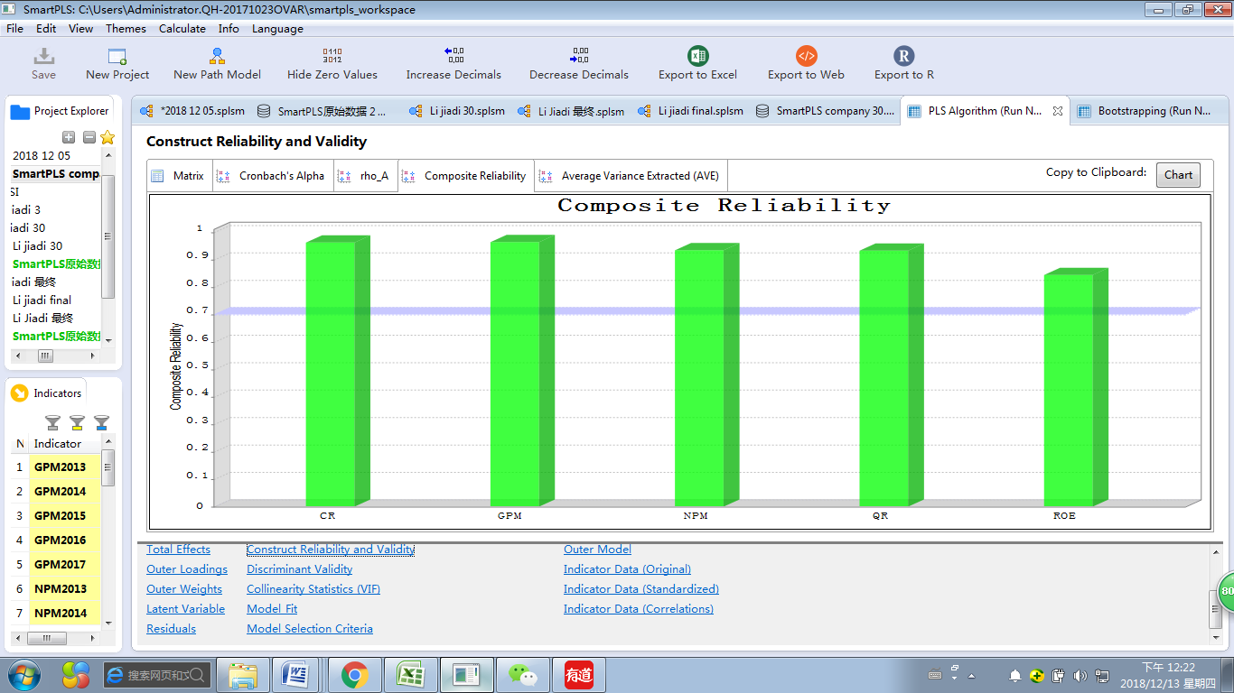
Figure 9: Chart of Composite Reliability of reflective constructs

4.2.3 Convergent Validity
In addition, the threshold value of Average Variance Extracted (AVE) is 0.5 (Fornell and Larcker, 1981), which indicates that this indicator can explain 50% or more changes. In this study, the AVE test results are shown in table 4 and figure 10, the AVE values of all reflection constructs shown in the following figure are all greater than 0.5, so it indicates that the measures of all reflection constructs have a high convergence validity.

Table 4: Average variance extracted (AVE) values of reflective constructs
Latent | Average variance extracted
Variable | (AVE)
Net Profit Margin | 0.827
Gross Profit Margin | 0.842
Current Ratio | 0.895
Quick Ratio | 0.739
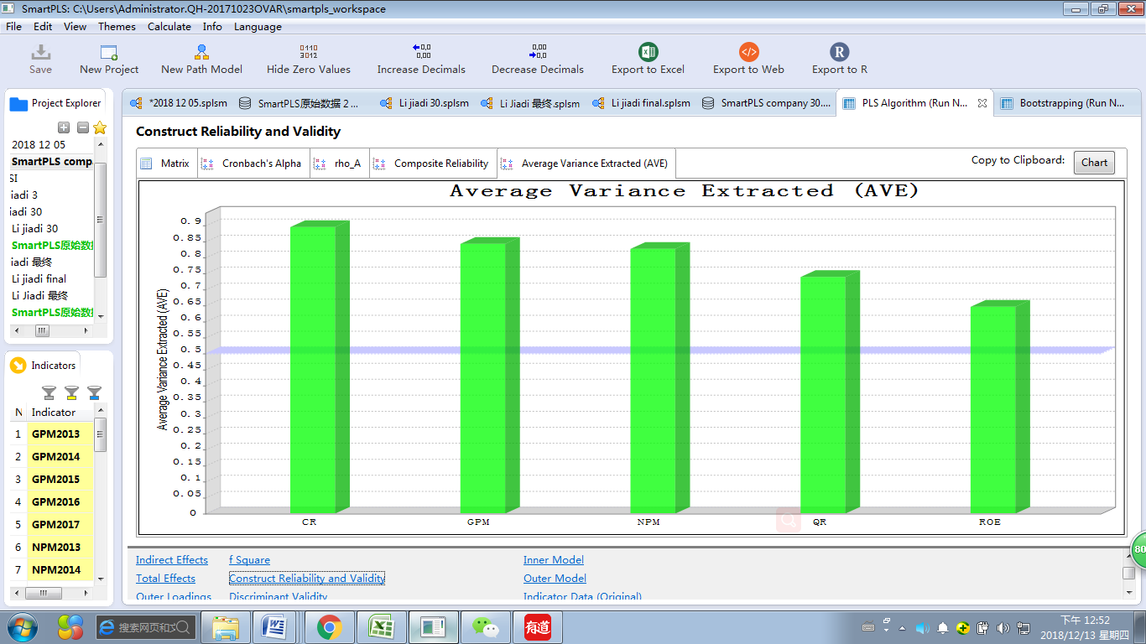
Figure 10: Chart of Average variance extracted (AVE) values of reflective constructs

4.2.4Discriminate Validity
In this study, Fornell-Larcker criterion and cross load were used to test the discriminant validity. According to Fornell-Larcker's criterion, the square root of AVE for each construct should be greater than the highest correlation between that construct and any other construct in the model, as the Table 5 below shows that.
Table 5: Discriminant validity (intercorrelations) of variable constructus
Latent constructs | Current Ratio | Gross Profit Margin | Net Profit Margin | Quick Ratio | Company Performance
Current Ratio | 0.946
Gross Profit Margin | 0.733 | 0.918
Net Profit Margin | 0.868 | 0.877 | 0.909
Quick Ratio | 0.299 | 0.541 | 0.601 | 0.860
Company Performance | 0.812 | 0.766 | 0.876 | 0.358 | 0.804
* The diagonals are the square root of the AVE the latent variables and indicate the highest in any column or row in order to obtain sufficient discriminant validity.
According to the analysis results in the Table 5, the correlation coefficient between each variable is less than the square root value of its AVE, for example, the AVE square root value of company performance (CP) is 0.95, which is greater than the correlation coefficient between company performance (CP) and current ratio (CR) of 0.839. The AVE square root value of average extraction variance of Current ratio (CR) is 0.946, which is greater than the correlation coefficient between Current ratio (CR) and Gross profit margin (GPM) of 0.733. Therefore, the square root of AVE of each construct is higher than the highest correlation between AVE and other constructs in the model which shown that the variables of this model are indeed different from each other and have sufficient discriminant validity.
Table 6: Discriminant Validity –Heterotrait-Monotrait Ration (HTMT)
 | Current Ratio | Gross Profit Margin | Net Profit Margin | Quick Ratio | Company Performance
Current Ratio
Gross Profit Margin | 0.763
Net Profit Margin | 0.912 | 0.953
Quick Ratio | 0.335 | 0.597 | 0.704
Company Performance | 0.906 | 0.880 | 1.029 | 0.436
*Kline,R.B.(2011) Principles and practice of structural equation modeling. New York: Guilford Press
*Gold, A.H.,Malhotra,A. and Segars, A.H.(2001). Knowledge management: an organizational capabilities perspective. Journal of Management information Systems, 18(1),185-214.
From the HTMT results, the values in bold in Table 6 indicated discriminant validity problems according to the HTMT0.85 criterions (Henseler, Ringle and Sarstedt, 2015). This implied that the HTMT criterion detect the collinearity problems among the latent constructs (Multicollinearity). The constructs of company performance - current ratio; company performance - net profit margin; current ratio - net profit margin and gross profit margin- net profit margin are having problems. Probably most of the items of constructs are measuring the same thing. In other words which means contains the overlapping items from the data in the affected constructs.

4.3 Structural Model Analysis
Structural Model is mainly evaluated from the following aspects:
1. The first is to evaluate the collinearity of structural model r
2. Secondly, the significance and relevance of structural model relationships
3. The level of R²
4. Predict the influence of correlation Q²
According to the calculation of Bootstrapping, the path coefficient provided by Smart-PLS is shown in Figure 11, namely, the relationship between the structure model structures. The standardized path coefficient judged the model's understanding ability and the strength of the analysis hypothesis relationship by R² value. The value of R² path coefficient was between +1 and -1, the larger the value was, the better the explanatory power was. R² > 0.67 is the real value; R² = 0.33 represents moderate explanatory ability; R² = 0.19 indicates weak explanatory ability; the path coefficient value close to 0 indicates a weak correlation, and the independent variable is completely independent of the dependent variable.
In terms of structural models, according to the research results shown in figure 11, R2 value of 0.811 indicates that the four potential variables proposed by this model, gross profit margin, net profit margin, current ratio and quick ratio, can explain the results of 81% of corporate performance, and the explanatory power is more than 50%, indicating that it has certain influence. In addition, the significance of the path coefficient is determined by the T value in figure 11, where NPM reaches the significant level of Alpha=0.001, while other gross profit margin, current ratio and quick ratio do not reach the significant level, indicating that in this model, corporate performance is influenced by NPM.
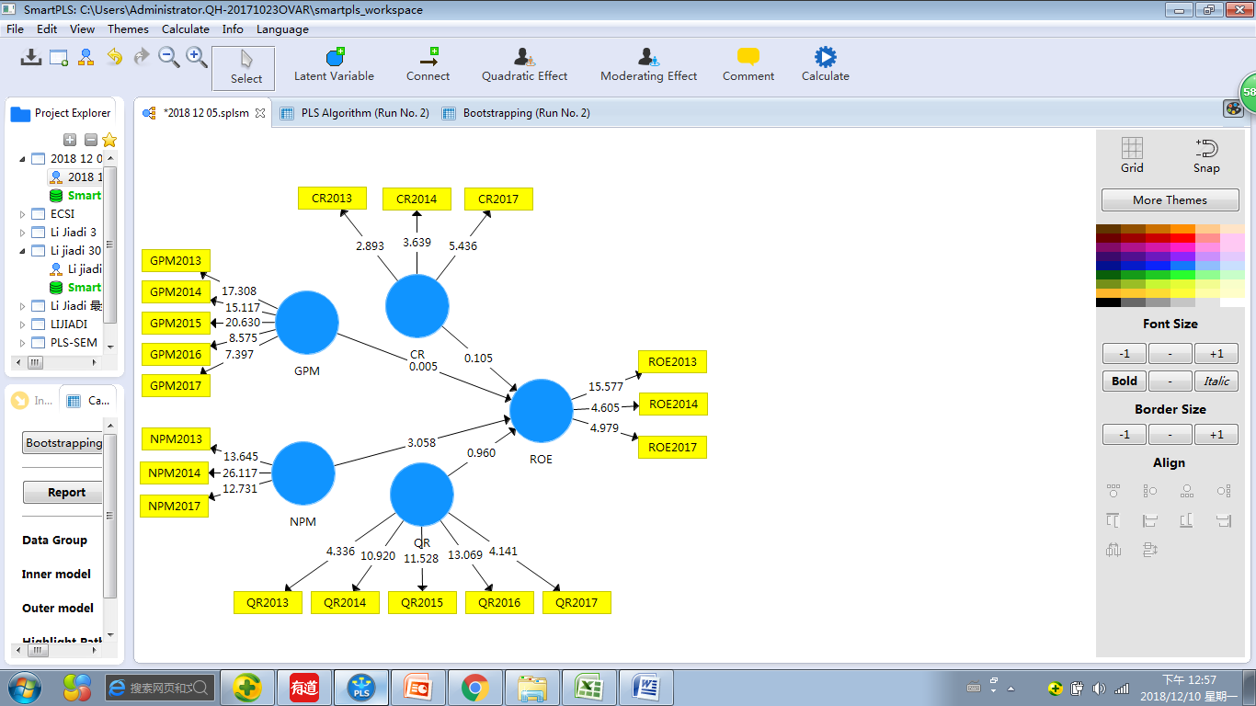
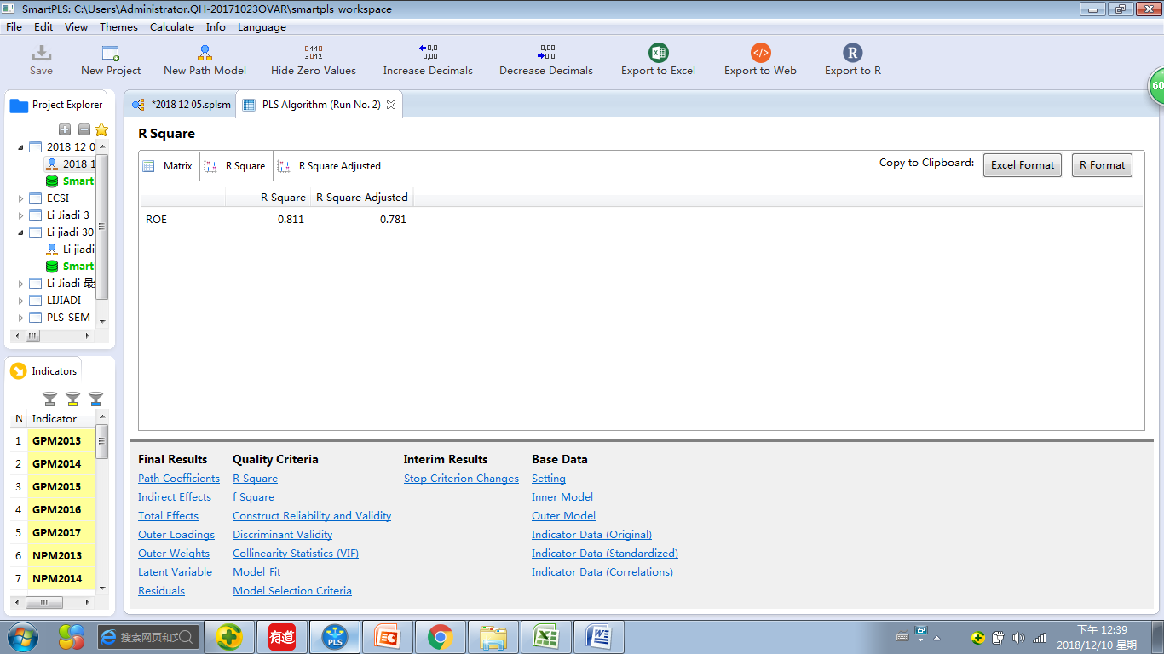

Figure 11: Result of after calculation Bootstrapping
Bootstrapping is an important test to reflect the path coefficient value. It provides an empirical T statistic (the value of the path coefficient divided by the standard error) and a "P value" (the probability of incorrectly rejecting the null hypothesis).Compare the empirical T value with the critical value to see if it is greater than the expected critical value. When T value > is 2.57, it means that the significance level is 1%, that is, P<0.01, it is very significant; When T value > is 1.96, it means that the significance level is 5%, that is, P<0.05, which is a common standard, usually T value requires >1.96 to be significant; When T value > is 1.65, it means that the significance level is 10%, that is, P <0.1, which is the most relaxed standard (Hair,et al. 2013).According to the bootstrapping calculation report, the importance of the path coefficient to the research model is shown in below Table 8.

4.3.1 Multicollinearity Regression -Collinearity Statistics (VIF)
The collinear problem of the structural model mainly evaluates the collinear problem of the construct by verifying the VIF value, which should be less than 5.VIFs of the structure of this study shown in Table 7. The results show the constructs of gross margin and corporate performance; VIF value of the constructs of quick ratio and corporate performance is <5, indicating that there is no collinearity problem in these two constructs. However, the VIF values of the constructs of liquidity ratio and corporate performance, net profit and corporate performance are > and 5, so the results show that there is a collinearity problem between the two constructs.
Table 7: Results of the collinearity Statistics of structural model (Inner VIFs)
Latent Constructs | Current Ratio | Gross Profit Margin | Net Profit Margin | Quick Ratio | Company Performance
Current Ratio |  |  |  |  | 6.019
Gross Profit Margin |  |  |  |  | 4.416
Net Profit Margin |  |  |  |  | 13.040
Quick Ratio |  |  |  |  | 2.292
Company Performance

4.3.2Path Coefficient
Path Coefficient analysis was used to test the hypothesis which aimed at knowing the effect of independent variables toward dependent variables individually. From the Table 8 results shows below, the first hypothesis testing related to variable of current ratio got negative significant values namely negative 0.038. Error possibility is determined 0.05. The result shows significant values 0.458 > alpha 0.05, which means that H1 is rejected. The implication is that current ratio does not influence significantly to the company performance to gain profit in automobile manufacturing industry company.
The second hypothesis is aimed at knowing the influence of gross profit margin toward the company performance in gaining their net income. The result shows significant values, namely 0.001. The error margin is 0.05. The result shows significant values 0.498 >alpha 0.05, which means that H2 is rejected. The implication is that gross profit margin not influence significantly to the company performance to gain profit in automobile manufacturing industry company.
The third hypothesis testing related to variable of net profit margin got significant values namely 1.073. Error possibility is determined 0.05. The result shows significant values 0.001 < alpha 0.05, which means that H3 is accepted. The implication is that net profit margin has significantly to the company performance to gain profit in automobile manufacturing industry company.
The fourth hypothesis testing related to variable of quick ratio got negative significant values namely negative 0.276. Error possibility is determined 0.05. The result shows significant values 0.170 > alpha 0.05, which means that H4 is rejected. The implication is that quick ratio has negative influence to the company performance to gain profit in automobile manufacturing industry company.

Table 8: Results of Structural Model Relevance and Significance of Path Coefficients
 | Paths | Path | T | Significant | P
 |  | Coefficient | Values | Levels | Value
H1 | Current Ratio ->Company Performance | -0.038 | 0.106 | NS | 0.458
H2 | Gross Profit Margin->Company Performance | 0.001 | 0.005 | NS | 0.498
H3 | Net Profit Margin->Company Performance | 1.073 | 3.127 | *** | 0.001
H4 | Quick Ratio ->Company Performance | -0.276 | 0.955 | NS | 0.170
Note: NS=Not Significant; *P<0.10; **P<0.05;***P<0.01.

4.3.3 Determination coefficient (R² value)
Determination Coefficient Analysis is aimed at knowing the ability of independent variable in giving the contribution in affecting dependent variables determined through percentage. The determination coefficient (R² value) describes the prediction accuracy of the structural model and calculates the square correlation between the actual value of a specific endogenous structure and the predicted value (Hair et al., 2014). R² gives the comprehensive influence of independent variables on dependent variables, that is, it represents the variance quantity of endogenous constructs explained by all exogenous constructs related to it (Hair et al., 2014). R² values range from 0 to 1 and the larger the value, the higher the explanatory power and prediction accuracy.
Table 9: Results of Structural Model Coefficient of Determination (R2)
Path Coefficient, T values, P-Values | Path Coeff. | T Value | P Value
Company Performance | 0.811 | 0.106 | 0.458
Net Profit Margin | 1.073 | 3.127 | 0.001
According to the test results shown in Table 9, the R² value of the dependent variable corporate performance in this study is 0.811, the result shows that variables of gross profit margin, net profit margin, current ration and quick ratio are able to influence company performance, indicating that the comprehensive effect of all independent variables can lead to 81.1% of the change of the dependent variable intention. The R² of the independent variable net profit margin is 107.3%, which means the net profit margin is able to influence company performance (ROE). The acceptable R² value depends on the complexity of the model and the research discipline (Hair et al., 2014).

4.3.4 Prediction of correlation Q2
R² value refers to the prediction accuracy and independent variable interpretation depending on the ability and degree of variables, while prediction correlation Q² refers to the prediction correlation of the model, which is called "stone-geisser's Q² value" (Stone,1975). For a certain endogenous potential variable of reflection, Q² value > indicates the predictive correlation of path model to this structure (Hair et al., 2014).When blindfolding was run in PLS, the results in Table 10 were obtained, Q² =0.316> 0 was obtained, indicating that the prediction correlation of the path model in this study was relatively high.

Table 10: Results of the Construct Crossvalidated Redundancy
 | SSO | SSE | Q (=1-SSE/SSO)
Current Ratio | 90 | 90
Gross Profit Margin | 150 | 150
Net Profit Margin | 90 | 90
Quick Ratio | 150 | 150
Company Performance | 90 | 61.562 | 0.316

4.4 Hypothesis Testing
In this research model, four hypotheses were proposed to predict the willingness of dependent variables, namely gross profit margin, net profit margin, current ratio and quick ratio, which had a positive correlation with the company's performance. Bootstrapping was performed by running PLS algorithm and Smart-PLS software to calculate the path coefficient of these relationships and the P value indicating the strength of these relationships, so as to verify whether these relationships are statistically significant, the result are as followed:
Table 11: Result of hypothesis Test for H1 to H4
Hypotheses | Path | P | T
 | Coefficient | Value | Value
H1: Gross profit margin has a significant influence on company performance of automobile manufacturing companies listed in Shenzhen. | 0.001 | 0.498 | 0.005
H2: Net profit margin has a significant influence on company performance of automobile manufacturing companies listed in Shenzhen. | 1.073 | 0.001 | 3.127
H3: Current ratio has a significant influence on company performance of automobile manufacturing companies listed in Shenzhen. | -0.038 | 0.458 | 0.106
H4: Quick ratio has a significant influence on company performance of automobile manufacturing companies listed in Shenzhen. | -0.276 | 0.170 | 0.955

4.5 Hypothesis Discussion
H1: Gross profit margin (GPM) has a significant influence on company performance of automobile manufacturing companies listed in Shenzhen.
According to the results in Table 11, the significant level of gross margin was 0.001 and the significant level of P value 0.498 > α (0.05).If significance level > α = 0.05 and T value 0.005<1.96, which means the first hypothesis is not established, indicating that gross margin has no significant impact on the performance of auto manufacturing companies of Shenzhen stock exchange. This shows that the company has some difficulties in making up for administrative costs, depreciation costs, debts and tax interest expenses, thus reducing the income to be obtained by the company, which means reducing profits (Gitman and Lawrence, 2006). The results of this study show that GPM variable has a weak and significant impact on the growth of corporate performance. This shows that the automobile manufacturing enterprises generate lower gross profit, which makes the company unable to bear the costs, thus making the business activities difficult, making the income earned smaller, and reducing the growth of the company's profits (Gunawan, 2013).
Gross margin is the profit brought by the company's main business, which is used to measure the most fundamental profitability of the enterprise and to a certain extent can reflect the sustainable competitive advantage of the enterprise (Kasmir, 2008). If an enterprise has a sustained competitive advantage, its gross profit rate will be at a high level, and the enterprise can price its products or services freely, making the price much higher than the cost of its products or services (Khaldun, 2014). If an enterprise lacks sustainable competitive advantages, its gross profit rate will be at a low level, and the enterprise can only make pricing according to the cost of products or services and earn a small profit (Jack, 2013). This study supports the research results of Wibowo and Pujiati (2011), indicating that GPM has a weak impact on the profit growth of the automobile manufacturing industry.
Gross profit margin and corporate performance return on equity (ROE) between growth without significant influence, because the gross margin is only on behalf of the company's main business interest rates, in this study, because car manufacturing and traditional manufacturing retail supply chain is different, there are too many factors affecting the income of car manufacturing, on the one hand is the profit pattern of them is very diverse, so the income and cost structure and single provide goods enterprise completely different; On the other hand, science and technology, research and development, personnel and funds have a decisive impact on income, but cannot be counted as cost (Sutrisno,2009). The results of the study and scholars Yan (2017) investigate the results of consistent, gross profit margin on the performance of the car manufacturing company return on equity (ROE) the influence of growth, no significant meaning, but companies or investors need to consider the enterprise market influence, influence uncontrollable factors such as industry, these factors are more or less will have an impact on enterprise's gross margin.
H2: Net profit margin (NPM) has a significant influence on company performance of automobile manufacturing companies listed in Shenzhen.
According to the results in table 4.10, the significant level of the net profit margin was 1.073, and the P value was 0.001< the significant level α (0.05). As the results shows that the significance level < α = 0.05 and T value 3.127>1.96, which means the second hypothesis is established, indicating that the net profit margin has a significant impact on the performance of auto manufacturing companies of Shenzhen stock exchange. The positive impact between net profit margin and the growth of corporate performance return on equity (ROE) is that the company can obtain high profits from each sales of the company, thus increasing the continuous growth of corporate performance return on equity (ROE).
The results of this study are consistent with previous studies conducted by Irawan (2011); Cahyanigrum (2010); Hapsarai (2007); Appriliani (2011), which concluded that net profit margin has a positive impact on a company's performance return on equity (ROE).This is because the ratio of companies with high net profit margins (NPM) tends to lead to higher corporate performance due to increased sales. The results of this study support the theory of Harahap (2007). Higher net profit margins (NPM) indicate that sales increased the company's net profit. These results are also consistent with the research results conducted by Cahyaningrum (2011), which shows that the increase in NPM ratio caused by sales growth is greater than the increase in cost of future revenue increase. Then Irawan (2011) found that a high ratio of the company's net profit margin (NPM) often leads to higher profit growth, and vice versa. The higher the return on equity, the higher the efficiency of capital invested by shareholders for profit growth, therefore, investors will pay attention to the impact of NPM on ROE and ROE. In addition, Purnomo (1997); Mais (2005); Sparta and Februaty (2005) also believed that roe was positively correlated with stock price (Martani, Khairurizka and Khairurizka, 2009).
H3: Current ratio（CR） has a significant influence on company performance of automobile manufacturing companies listed in Shenzhen.
According to the results in Table 11, the significant level obtained by the current ratio (CR) was -0.038 and the P value 0.458> significant level α (0.05).The significance level of the research results is > α = 0.05 and the T value is 0.106<1.96, which means the third hypothesis is not valid, indicating the meaning of the current ratio and the negative significant influence on the performance return on equity (ROE) of automobile manufacturing companies in Shenzhen stock exchange. Current ratio (CR) return on equity ratio and corporate performance between negative impact, because of the current assets are listed in raw materials and in inventory ready to sell your product yet, so the composition to increase the number of current ratio (CR), but it did not bring to the company profit, because the company must pay for product handling to inventory processing into a finished product ready to sell.
The results of this study are consistent with previous studies conducted by Wang (2010). The results of this study support Wang (2010)'s opinion that current ratio (CR) indicates that a company is not a good agent in determining its future revenue growth. On the other hand, Ang (2001) pointed out that for investors, the high CR value of the company will reduce the uncertainty of investors, because it indicates that the company has idle funds that will reduce the level of corporate profits. The influence of CR on corporate performance in this study is consistent with the results of Wibowo and Pujiati (2011), which show no significant impact. The results of this study were supported by Ade and Sri (2013), Esa and Yu (2014), Khalidazia (2014). High liquidity ratio information will be positively evaluated by investors, because it shows the solvency of the company and makes investors believe that the company can pay dividends. However, it is not necessarily the condition of the company is good, which may happen, because the cash is not used likely (Kasmir, 2008).
H4: Quick ratio (QR) has a significant influence on company performance of automobile manufacturing companies listed in Shenzhen.
According to the results in Table 11, the significance level between the quick ratio variable and the return on equity (ROE) of company performance was -0.276, and the significance level alpha of 0.170> α (0.05) was the P value. If the significant level of > α = 0.05 and the T value 0.955<1.96, the hypothesis is not valid, indicating that the quick ratio is negatively correlated with the performance of auto manufacturing companies in Shenzhen stock exchange. In addition, the correlation between independent and dependent variables of the quick ratio used in the study was not statistically significant. Therefore, the null hypothesis is accepted and the research hypothesis is rejected. In other words, there is no significant relationship between liquidity and profitability among automobile manufacturers listed on Shenzhen stock exchange. Manufacturers must maintain sufficient liquidity to meet production needs and ensure that production is not interrupted. As sales grow, companies need to invest more in inventories and debtors. As sales continue to grow, these needs become very frequent and rapid. Therefore, financial managers should be aware of these needs and provide funds quickly.

4.6 Summary of Findings
According to the Table 11 above hypothesis test results which a conclusion supporting H2 can be drawn, indicating that the net profit margin ratio does affect the company's performance to some extent. However, according to the above hypothesis test results, H1 is weakly correlated, indicating that gross profit margin has little influence on the performance of enterprises. However, H3 and H4 are rejected, and the current ratio and quick ratio will not have a significant impact on the company's performance. The following Table 12 summarizes the results of the above hypothesis test.
Table 12: Finding and conclusion of hypothesis result
Hypotheses | Finding | Supported | conclusion
H1: Gross profit margin has a significant influence on performance of automobile manufacturing companies listed in Shenzhen. | T value= 0.005  P value= 0.498  Positive | Rejected | H1: Gross profit margin does not significant influence on company performance of automobile manufacturing companies listed in Shenzhen.
H2: Net profit margin has a significant influence on performance of automobile manufacturing companies listed in Shenzhen. | T value= 3.127  P value= 0.001  Positive | Supported | H2: Net profit margin have significant influence on performance of automobile manufacturing companies listed in Shenzhen.
H3: Current ratio has a significant influence on performance of automobile manufacturing companies listed in Shenzhen. | T value= 0.106  P value= 0.458  Negative | Rejected | H3: Current ratio does not have significant influence on performance of automobile manufacturing companies listed in Shenzhen.
H4: Quick ratio has a significant influence on performance of automobile manufacturing companies listed in Shenzhen. | T value= 0.955  P value= 0.170  Negative | Rejected | H4: Quick ratio does not significant influence on performance of automobile manufacturing companies listed in Shenzhen.

4.7 Conclusion
This chapter mainly analyzes relevant data, validates the hypothesis of this study with SmartPLS3.0, and obtains the relationship between variables by using PLS analysis results. Through the above empirical studies, it is found that CR and QR, independent variables, have a negative impact on the growth of ROE of the dependent variables.NPM has a significant positive impact on the growth of ROE of the dependent variable company. The variable with no significant influence is GPM. This work examines how ratio analysis can be used to measure an organization's performance. Based on the discussion and findings in this study, the following conclusions are drawn:
Ratio analysis is a tool of financial analysis and can be used as a forecasting tool to measure enterprise performance; Ratio analysis can be used to show the strengths and weaknesses of a company. Ratio analysis is needed for the purposes of management control decision, investment decision and credit control. A ratio analysis is needed to determine whether the company's financial position is improving or deteriorating over time. Ratio analysis can be used to determine whether a company has met the required standards in the industry. Profitability ratio is useful for the management of a company. They are used to determine a company's profitability and the efficiency with which its resources are used.

CHPTER V

CONCLUSION AND RECOMMENDATION

5.1 Research conclusions
This study of China's automobile manufacturing industry listed in Shenzhen 30 companies, 2013-2017 annual report data for five consecutive years as the research sample, using Smart - PLS software of automobile manufacturing industry listed companies of Shenzhen financial ratios and the performance of the company in a multiple linear regression analysis and inspection, to set before the four hypotheses to confirm financial ratio indicators affect the performance of automobile manufacturing industry listed companies in Shenzhen, and puts forward the corresponding countermeasures and measures, the conclusion of this research are as follows:
1) The results of Multicollinearity analysis show that the impact of financial ratio analysis on corporate performance is related to the industry in which it is located. The financial ratios of listed companies in different industries are different, which leads to different evaluation standards. In addition, users from different perspectives also have different research results which lead to poor performance in the selection of financial ratio index combination. The selection of financial ratio index combination is very important, and it will directly affect the relevance and accuracy of research results.
2) Although the financial ratio has been featured in the industry of listed companies in China's automobile manufacturing industry, the study found that the linear relationship between the financial ratio of listed companies in Shenzhen and the company's performance was similar. In this study, the independent variable Net profit margin (NPM) is positively correlated with the company's performance. The correlation between Gross profit margin (GPM) and corporate performance is weak and not obvious. The influence of Current ratio (CR) and quick ratio (QR) on corporate performance is negatively correlated. The results of this study are consistent with Wang's (2010) point of view in the empirical study of agency theory. However, this research result is contrary to the conclusion drawn by Masulis (1988) in his empirical research on the trade-off theory.
3) The Gross profit margin of the Shenzhen listed companies in the automobile manufacturing industry is not obvious to the performance of the company in the automobile manufacturing industry, which does not fully explain the profitability of the company. It can only be said that the profit of the Shenzhen listed companies in the automobile manufacturing industry in their main business is not obvious. In addition which reflects the diversification of the profit model of automobile manufacturing companies, which is different before cost and income.

5.2 Limitation
This research is only limited to the automobile manufacturing companies listed in Shenzhen, China. The research data, results and conclusions are completed with the help of secondary data of Shenzhen stock exchange. Therefore, there may be differences in the research results, and the conclusions are not completely accurate. In addition, only 30 companies were selected as samples in this study, represented by the data of the five-year period. The research structure of this study has a reference role for the financial managers of the manufacturing industry to formulate and manage the policies of enterprise liquidity and profitability. In addition, there are also the following limitations in the financial analysis of enterprises:
- Insufficient use of information such as human capital and intangible assets
With the social progress and economic development, in modern enterprises, due to the increasingly strong penetration of information technology, human capital and intangible assets are the direction of enterprise investment. In the rapid development of the economic era, talent, technology and innovation ability is the main characteristics of enterprise competition. With the progress of information technology, the tangible assets of enterprises will be replaced by talents, knowledge and technology, and become the core and development motivation of enterprises in terms of management. In terms of intangible assets and human capital, there are still defects in the system, measurement and disclosure of financial reports in China.
2) Current accounting economic activities are confirmed and measured in the form of money, thus limiting the scope of analysis of quantitative information in the form of money.
At present, quantitative data is a common factor used for financial analysis indicators, rarely considering non-monetary measurement factors. With the development of economy, competition in various industries becomes increasingly fierce, and enterprises need to face various uncertainties and risks. Therefore, business expansion, technological improvement, government policies and market demand changes as well as competitors are all crucial to the operation of enterprises. In addition, the internal organizational structure, human resource management, changes in corporate culture, and non-monetary information related to management value and capability are not fully reflected in the current financial statements. In addition, at present, financial analysis and evaluation are mainly based on manufacturing enterprises, and are limited to the analysis and evaluation of tangible assets of enterprises, and are limited to the evaluation with quantitative indicators measured in monetary terms, which cannot completely accurately reflect the real operating conditions of enterprises under technical and economic conditions.
3) The sustainable development of enterprises is neglected in the calculation and analysis of financial indicators.
The current financial statement information ignores the enterprise's "mobile" activities and only reflects the "quiet" economic activities, but "dynamic" is the progress and development of things. In general, dynamic information can provide investors and enterprises with a better reference. One of the most active factors in an enterprise is human capital. In the current financial analysis and evaluations, the analysis is limited to the static content of the enterprise. Under the continuous development and competition of the enterprise, it is not enough to evaluate the profitability and solvency of the enterprise. For example quick ratio and current ratio are two indicators that mainly reflect the solvency of an enterprise. However, these indicators are only based on the liquidation level of the company and only focus on the book value of the assets of the enterprise, while ignoring the ability of the enterprise to increase cash flow due to continuous operation in the future. In addition, the company's good reputation will lead customers to be completely loyal to their products, and the company's brand can increase the company's financing ability. High-tech companies, for example, will not bring to the company at an early stage in the development of good performance, but may also spend a lot of research and development spending, but in the process of the future development of the R&D team to create unlimited company performance, but the information are not fully reflected in the existing financial reporting system, the financial analysis also has not been fully utilized.

5.3 Suggestions for improvement

5.3.1 Increase the specification and scope of external information disclosure on the balance sheet
1. Disclosure of external environment information of the enterprise:
(a) the disclosure of industry information, mainly including the prospect of the industry and the average rate of return of the product; The competitiveness and competitive advantages of major competitors; The industry lifecycle and the speed at which core technologies are updated.
(b) The disclosure of product information of enterprises mainly includes market share, production interest rate, core income level rate and marketing network of products.
(c) Disclosure of enterprise customer information, mainly including customer satisfaction with products and after-sales services, customer loyalty and customer recognition of enterprise reputation and brand.
(d) The disclosure of corporate social image information mainly includes the annual profits and taxes of the company, the social responsibilities and environmental protection performed by the company, and employment opportunities.
2. Disclosure of internal resource information: it mainly includes human resource information, intangible asset information, innovation information and competitiveness of the company.

5.3.2 Design and use of non-financial evaluation indicators to further improve the evaluation system
In the information disclosed in the financial report, in addition to disclosing the performance of the business and the financial status of the enterprise, the business background and future prediction should also be disclosed to provide investors with more references. For the constant changes of enterprises, the following non-financial evaluation indicators can be used as a reference and supplement for the financial evaluation indicators: first, the customer's satisfaction with the quality of products and services. The second is the strategic goal of the enterprise, such as the company's ability to restructure and manage the transition. In addition, it is the potential development force of the enterprise in the future, such as the satisfaction and retention rate of employees, learning and training opportunities of employees in the company, and the cooperation and management efficiency of various departments and teams. In addition, it is the innovation ability of the enterprise, such as the investment and achievement of the enterprise in research and development, and the ability of the company to develop and innovation new products. Finally, it is the core technology of enterprise development, market share and the responsibility of enterprise to the society and environmental protection.

5.3.3 Comprehensively analyze and evaluate the business performance of the enterprise and the development prospect of the industry
In the analysis and evaluation of the financial situation, business performance and future development potential of enterprises, in order to avoid the uncertainty of the evaluation results, the financial indicators and non-financial indicators of enterprises should be combined in the evaluation of enterprise performance (Gunasekaran and Kobu, 2007). The evaluation of dynamic indicators and static indicators, as well as the neglected evaluation of tangible assets and knowledge assets of enterprises, make the evaluation performance of enterprises more complete and clear. This is conducive to external investors and enterprises to make the right decision and management (Cricelli and Grimaldi, 2008).

5.3.4 Suggestions on the Research Topic
Corporate performance is the core of an enterprise. Obviously, there is still a lot of room for research in this study in the future.
Therefore, I suggest to further study the following points:
1）The research results show that there is no significant relationship between liquidity and profitability. This shows that the changes in liquidity status of manufacturing companies have no significant impact on profitability. There are the following possible reasons, such as the decrease in demand caused by seasonal changes, the substitution of products caused by technological changes, the size of the company and the manufacturing cycle of the products produced, which may have an impact on the profitability of the manufacturing enterprise. Therefore, this field can be studied as a range by future researchers.
2）Currently, there are 187 companies listed under 20 sectors in the Shenzhen stock exchange. The study only looked at 30 listed companies in the auto industry. Therefore, the future research needs to further study the balance between liquidity and profitability of companies in different sectors.
3) Traditional financial evaluation methods, such as DuPont analysis method, only involve the analysis of the company's financial indicators. For modern enterprises, they are not comprehensive enough to effectively measure and evaluate non-financial analysis factors. How to include qualitative indicators into the evaluation of the impact of financial indicators on the performance of the company and how to effectively and comprehensively evaluate the company is a very important research topic in the future.

REFERENCE
Abor, J., 2005. The effect of capital structure on profitability: an empirical analysis of listed firms in Ghana. The journal of risk finance, 6(5), pp.438-445.
Adams, C., 2017. Understanding integrated reporting: The concise guide to integrated thinking and the future of corporate reporting. Routledge.
Adu, G., Marbuah, G. and Mensah, J.T., 2013. Financial development and economic growth in Ghana: Does the measure of financial development matter. Review of Development finance, 3(4), pp.192-203.
Ageev, R.V., Mogilevich, L.I., Popov, V.S., Popova, A.A. and Kondratov, D.V., 2014. Mathematical model of pulsating viscous liquid layer movement in a flat channel with elastically fixed wall. Applied Mathematical Sciences, 8(157-160), pp.7899-7908.
Ahn, S.C. and Moon, H.R., 2014. Large-N and large-T properties of panel data estimators and the Hausman test. In Festschrift in Honor of Peter Schmidt (pp. 219-258). Springer, New York, NY.
Alam, S., Haq, M.M. and Kader, A., 2015. Non-Performing Loan and Banking Sustainability Bangladesh Perspective. International Journal of Advance Research, 8, pp.1197-1210.
Albers, S., 2017. Competition dynamics of alliance networks. Managing Alliance Portfolios and Networks, p.91.
Alegre, J., Sengupta, K. and Lapiedra, R., 2013. Knowledge management and innovation performance in a high-tech SMEs industry. International Small Business Journal, 31(4), pp.454-470.
Almajali, A.Y., Alamro, S.A. and Al-Soub, Y.Z., 2012. Factors affecting the financial performance of Jordanian insurance companies listed at Amman Stock Exchange. Journal of Management Research, 4(2), p.266.
Altman, E., Iwanicz-Drozdowska, M., Laitinen, E. and Suvas, A., 2014. Distressed Firm and Bankruptcy Prediction in an International Context: A Review and Empirical Analysis of Altman's Z-Score Model.
Alvarez, S.A. and Barney, J.B., 2017. Resource‐based theory and the entrepreneurial firm. Strategic entrepreneurship: Creating a new mindset, pp.87-105.
Amaya, P.A. and Memba, F., 2015. Influence of risk management practices on financial performance of life assurance firms in Kenya: A survey study of Kisii County. International journal of Economics, Commerce and Management, 3(5).
Ameer, R. and Othman, R., 2012. Sustainability practices and corporate financial performance: A study based on the top global corporations. Journal of Business Ethics, 108(1), pp.61-79.
Amini, M.H. and Islam, A., 2014, February. Allocation of electric vehicles' parking lots in distribution network. In Innovative Smart Grid Technologies Conference (ISGT), 2014 IEEE PES (pp. 1-5). IEEE.
Ashraf, D., Felixson, K., Khawaja, M. and Hussain, S.M., 2017. Do constraints on financial and operating leverage affect the performance of Islamic equity portfolios? Pacific-Basin Finance Journal, 42, pp.171-182.
Ates, A., Garengo, P., Cocca, P. and Bititci, U., 2013. The development of SME managerial practice for effective performance management. Journal of Small Business and Enterprise Development, 20(1), pp.28-54.
Bagozzi, R.P. and Yi, Y., 2012. Specification, evaluation, and interpretation of structural equation models. Journal of the academy of marketing science, 40(1), pp.8-34.
Baines, T. and Lightfoot, H., 2013. Made to serve: How manufacturers can compete through servitization and product service systems. John Wiley & Sons.
Baird, P.L., Geylani, P.C. and Roberts, J.A., 2012. Corporate social and financial performance re-examined: Industry effects in a linear mixed model analysis. Journal of business ethics, 109(3), pp.367-388.
Baker, R., Brick, J.M., Bates, N.A., Battaglia, M., Couper, M.P., Dever, J.A., Gile, K.J. and Tourangeau, R., 2013. Summary report of the AAPOR task force on non-probability sampling. Journal of Survey Statistics and Methodology, 1(2), pp.90-143.
Ballings, M., Van den Poel, D., Hespeels, N. and Gryp, R., 2015. Evaluating multiple classifiers for stock price direction prediction. Expert Systems with Applications, 42(20), pp.7046-7056.
Baños-Caballero, S., García-Teruel, P.J. and Martínez-Solano, P., 2014. Working capital management, corporate performance, and financial constraints. Journal of Business Research, 67(3), pp.332-338.
Barkham, R., Gudgin, G. and Hart, M., 2012. The Determinants of Small Firm Growth: an inter-regional study in the United Kingdom 1986-90. Routledge.
Barney, J.B. and Mackey, A., 2016. Text and metatext in the resource‐based view. Human Resource Management Journal, 26(4), pp.369-378.
Barney, J.B., 2012. Purchasing, supply chain management and sustained competitive advantage: The relevance of resource‐based theory. Journal of supply chain management, 48(2), pp.3-6.
Bartelsman, E., Haltiwanger, J. and Scarpetta, S., 2013. Cross-country differences in productivity: The role of allocation and selection. American Economic Review, 103(1), pp.305-34.
Bates, D., Maechler, M., Bolker, B. and Walker, S., 2014. lme4: Linear mixed-effects models using Eigen and S4. R package version, 1(7), pp.1-23.
Baxter, R., 2012. How can business buyers attract sellers' resources? Empirical evidence for preferred customer treatment from suppliers. Industrial Marketing Management, 41(8), pp.1249-1258.
Bell, A. and Jones, K., 2015. Explaining fixed effects: Random effects modeling of time-series cross-sectional and panel data. Political Science Research and Methods, 3(1), pp.133-153.
Belloumi, M., 2014. The relationship between trade, FDI and economic growth in Tunisia: An application of the autoregressive distributed lag model. Economic systems, 38(2), pp.269-287.
Bernhardsson, S. and Larsson, M.E., 2013. Measuring evidence-based practice in physical therapy: translation, adaptation, further development, validation, and reliability test of a questionnaire. Physical therapy, 93(6), pp.819-832.
Blay, A.D. and Geiger, M.A., 2013. Auditor fees and auditor independence: Evidence from going concern reporting decisions. Contemporary Accounting Research, 30(2), pp.579-606.
Bontis, N., 2001. Assessing knowledge assets: a review of the models used to measure intellectual capital. International journal of management reviews, 3(1), pp.41-60.
Bontis, N., 2001. Assessing knowledge assets: a review of the models used to measure intellectual capital. International journal of management reviews, 3(1), pp.41-60.
Bouazza, A.B., Ardjouman, D. and Abada, O., 2015. Establishing the factors affecting the growth of small and medium-sized enterprises in Algeria. American International journal of Social science, 4(2), pp.101-115.
Brereton, R.G. and Lloyd, G.R., 2014. Partial least squares discriminant analysis: taking the magic away. Journal of Chemometrics, 28(4), pp.213-225.
Bromiley, P. and Rau, D., 2016. Operations management and the resource based view: Another view. Journal of Operations Management, 41, pp.95-106.
Brunswicker, S. and Vanhaverbeke, W., 2015. Open innovation in small and medium‐sized enterprises (SMEs): External knowledge sourcing strategies and internal organizational facilitators. Journal of Small Business Management, 53(4), pp.1241-1263.
Bruton, G., Khavul, S., Siegel, D. and Wright, M., 2015. New financial alternatives in seeding entrepreneurship: Microfinance, crowdfunding, and peer‐to‐peer innovations. Entrepreneurship Theory and Practice, 39(1), pp.9-26.
Campbell, B.A., Coff, R. and Kryscynski, D., 2012. Rethinking sustained competitive advantage from human capital. Academy of Management Review, 37(3), pp.376-395.
Capozza, D.R. and Seguin, P.J., 2000. Debt, agency, and management contracts in REITs: the external advisor puzzle. The Journal of Real Estate Finance and Economics, 20(2), pp.91-116.
Carlson, K.D. and Herdman, A.O., 2012. Understanding the impact of convergent validity on research results. Organizational Research Methods, 15(1), pp.17-32.
Cervellon, M.C., Carey, L. and Harms, T., 2012. Something old, something used: Determinants of women's purchase of vintage fashion vs secondary fashion. International Journal of Retail and Distribution Management, 40(12), pp.956-974.
Chen, C.M., Delmas, M.A. and Lieberman, M.B., 2015. Production frontier methodologies and efficiency as a performance measure in strategic management research. Strategic Management Journal, 36(1), pp.19-36.
Chen, R.R., Chidambaran, N.K., Imerman, M.B. and Sopranzetti, B.J., 2014. Liquidity, leverage, and Lehman: A structural analysis of financial institutions in crisis. Journal of Banking and Finance, 45, pp.117-139.
Chen, R.R., Yang, T.H. and Yeh, S.K., 2017. The liquidity impact on firm values: The evidence of Taiwan's banking industry. Journal of Banking and Finance, 82, pp.191-202.
Chiaramonte, L. and Casu, B., 2017. Capital and liquidity ratios and financial distress. Evidence from the European banking industry. The British Accounting Review, 49(2), pp.138-161.
Christensen, B.E., Glover, S.M. and Wood, D.A., 2012. Extreme estimation uncertainty in fair value estimates: Implications for audit assurance. Auditing: A Journal of Practice and Theory, 31(1), pp.127-146.
Chua, J.H., Chrisman, J.J., Steier, L.P. and Rau, S.B., 2012. Sources of heterogeneity in family firms: An introduction.
Coe, N.M. and Yeung, H.W.C., 2015. Global production networks: Theorizing economic development in an interconnected world. Oxford University Press.
Coffey, E., 2013. Pain tolerance: Economic voting in the Czech Republic. Electoral Studies, 32(3), pp.432-437.
Coleman, S., Cotei, C. and Farhat, J., 2013. A resource-based view of new firm survival: new perspectives on the role of industry and exit route. Journal of Developmental Entrepreneurship, 18(01), p.1350002.
Coles, J.L., Lemmon, M.L. and Meschke, J.F., 2012. Structural models and endogeneity in corporate finance: The link between managerial ownership and corporate performance. Journal of Financial Economics, 103(1), pp.149-168.
Costa, L.A., Cool, K. and Dierickx, I., 2013. The competitive implications of the deployment of unique resources. Strategic management journal, 34(4), pp.445-463.
Cricelli, L. and Grimaldi, M., 2008. A dynamic view of knowledge and information: a stock and flow based methodology. International Journal of Management and Decision Making, 9(6), pp.686-698.
Dahmash, F.N., 2015. Size effect on company profitability: Evidence from Jordan. International Journal of Business and Management, 10(2), p.58.
Dahmen, P. and Rodríguez, E., 2014. Financial literacy and the success of small businesses: An observation from a small business development center. Numeracy, 7(1), p.3.
Data, N.T. and Hoab, T.D., 2017. Factors Affecting Financial Performance of Firms in Context of The Fourth Industrial Revolution: Evidence from Information and Communication Technology Companies Listed in The Vietnamese Stock Market. For young researchers in economics and business, 2017, p.303.
Degravel, D., 2012. Strategy-as-practice to reconcile small businesses' strategies and RBV? Journal of Management Policy and Practice, 13(1), p.46.
Dehning, B., Richardson, V.J. and Zmud, R.W., 2007. The financial performance effects of IT-based supply chain management systems in manufacturing firms. Journal of Operations Management, 25(4), pp.806-824.
Delen, D., Kuzey, C. and Uyar, A. (2013). Measuring firm performance using financial ratios: A decision tree approach. Expert Systems with Applications, 40(10), pp.3970-3983.
Deng, F. and Smyth, H., 2013. Contingency-based approach to firm performance in construction: Critical review of empirical research. Journal of Construction Engineering and Management, 139(10), p.04013004.
Deng, P., 2012. The internationalization of Chinese firms: A critical review and future research. International Journal of Management Reviews, 14(4), pp.408-427.
Dezsö, C.L. and Ross, D.G., 2012. Does female representation in top management improve firm performance? A panel data investigation. Strategic Management Journal, 33(9), pp.1072-1089.
Dimitrova, D.V., Shehata, A., Strömbäck, J. and Nord, L.W., 2014. The effects of digital media on political knowledge and participation in election campaigns: Evidence from panel data. Communication Research, 41(1), pp.95-118.
Distelhorst, G., Locke, R.M., Pal, T. and Samel, H., 2015. Production goes global, compliance stays local: Private regulation in the global electronics industry. Regulation & Governance, 9(3), pp.224-242.
Djankov, S. and Murrell, P., 2002. Enterprise restructuring in transition: A quantitative survey. Journal of economic literature, 40(3), pp.739-792.
Doğan, M., 2013. Does firm size affect the firm profitability? Evidence from Turkey. Research Journal of Finance and Accounting, 4(4), pp.53-59.
Dong, M.C., Tian, S. and Chen, C.W., 2018. Predicting failure risk using financial ratios: Quantile hazard model approach. The North American Journal of Economics and Finance, 44, pp.204-220.
Duanmu, J.L., 2012. Firm heterogeneity and location choice of Chinese multinational enterprises (MNEs). Journal of World Business, 47(1), pp.64-72.
Eisinga, R., Te Grotenhuis, M. and Pelzer, B., 2013. The reliability of a two-item scale: Pearson, Cronbach, or Spearman-Brown. International journal of public health, 58(4), pp.637-642.
Elhorst, J.P., 2014. Spatial panel data models. In Spatial econometrics (pp. 37-93). Springer, Berlin, Heidelberg.
Enqvist, J., Graham, M. and Nikkinen, J. (2014). The impact of working capital management on firm profitability in different business cycles: Evidence from Finland. Research in International Business and Finance, 32, pp.36-49.
Erdogan, E.O., Erdogan, M. and Ömürbek, V., 2015. Evaluating the effects of various financial ratios on company financial performance: Application in Borsa Istanbul. Business and Economics Research Journal, 6(1), p.35.
Exchange. International Journal of Academic Research in Business and Social Sciences, 4(12), p.101.
Fairfield, P.M. and Yohn, T.L., 2001. Using asset turnover and profit margin to forecast changes in profitability. Review of Accounting Studies, 6(4), pp.371-385.
Ferlie, E., Crilly, T., Jashapara, A. and Peckham, A., 2012. Knowledge mobilisation in healthcare: a critical review of health sector and generic management literature. Social science and medicine, 74(8), pp.1297-1304.
Gable, R.K. and Wolf, M.B., 2012. Instrument development in the affective domain: Measuring attitudes and values in corporate and school settings (Vol. 36). Springer Science and Business Media.
Galbraith, J.K., 2015. The new industrial state. Princeton University Press.
Gallego-Álvarez, I., Segura, L. and Martínez-Ferrero, J., 2015. Carbon emission reduction: the impact on the financial and operational performance of international companies. Journal of Cleaner Production, 103, pp.149-159.
García, C.B., García, J., López Martín, M.M. and Salmerón, R., 2015. Collinearity: Revisiting the variance inflation factor in ridge regression. Journal of Applied Statistics, 42(3), pp.648-661.
Geng, R., Bose, I. and Chen, X., 2015. Prediction of financial distress: An empirical study of listed Chinese companies using data mining. European Journal of Operational Research, 241(1), pp.236-247.
Giuliani, S. and Meloni, C., 2015. Connections Among Optimization Models with Uncertainties, ABC and RBV. In Uncertainty Management in Simulation-Optimization of Complex Systems (pp. 123-149). Springer, Boston, MA.
Grant, J.L. and Fabozzi, F.J., 2011. Equity Analysis Using Traditional and Value-Based Metrics. Equity Valuation and Portfolio Management, Hoboken, pp.25-70.
Grant, R.M., 2016. Contemporary strategy analysis: Text and cases edition. John Wiley & Sons.
Greco, M., Cricelli, L. and Grimaldi, M., 2013. A strategic management framework of tangible and intangible assets. European Management Journal, 31(1), pp.55-66.
Green, S.B. and Yang, Y., 2015. Evaluation of dimensionality in the assessment of internal consistency reliability: Coefficient alpha and omega coefficients. Educational Measurement: Issues and Practice, 34(4), pp.14-20.
Gunasekaran, A. and Kobu, B., 2007. Performance measures and metrics in logistics and supply chain management: a review of recent literature (1995–2004) for research and applications. International journal of production research, 45(12), pp.2819-2840.
Gunasekaran, A., Patel, C. and McGaughey, R.E., 2004. A framework for supply chain performance measurement. International journal of production economics, 87(3), pp.333-347.
Gunasekaran, A., Patel, C. and Tirtiroglu, E., 2001. Performance measures and metrics in a supply chain environment. International journal of operations & production Management, 21(1/2), pp.71-87.
Haberberg, A. and Rieple, A., 2008. Strategic management: Theory and application. Oxford University Press.
Hair, J.F., Ringle, C.M. and Sarstedt, M., 2011. PLS-SEM: Indeed a silver bullet. Journal of Marketing theory and Practice, 19(2), pp.139-152.
Halkitis, P.N., Moeller, R.W., Siconolfi, D.E., Storholm, E.D., Solomon, T.M. and Bub, K.L., 2013. Measurement model exploring a syndemic in emerging adult gay and bisexual men. AIDS and Behavior, 17(2), pp.662-673.
Halme, M. and Korpela, M., 2014. Responsible innovation toward sustainable development in small and medium‐sized enterprises: a resource perspective. Business Strategy and the Environment, 23(8), pp.547-566.
Hämmerer, D., Li, S.C., Völkle, M., Müller, V. and Lindenberger, U., 2013. A lifespan comparison of the reliability, test‐retest stability, and signal‐to‐noise ratio of event‐related potentials assessed during performance monitoring. Psychophysiology, 50(1), pp.111-123.
Hanna, A., 2013. Computer-aided content analysis of digitally enabled movements. Mobilization: An International Quarterly, 18(4), pp.367-388.
Healy, P.M. and Palepu, K.G., 2001. Information asymmetry, corporate disclosure, and the capital markets: A review of the empirical disclosure literature. Journal of accounting and economics, 31(1-3), pp.405-440.
Heikal, M., Khaddafi, M. and Ummah, A., 2014. Influence analysis of return on assets (ROA), return on equity (ROE), net profit margin (NPM), debt to equity ratio (DER), and current ratio (CR), against corporate profit growth in automotive in Indonesia Stock Exchange. International Journal of Academic Research in Business and Social Sciences, 4(12), p.101.
Heinberg, R., 2011. The end of growth: Adapting to our new economic reality. New Society Publishers.
Heine, K. and Rindfleisch, H., 2013. Organizational decline: A synthesis of insights from organizational ecology, path dependence and the resource-based view. Journal of Organizational Change Management, 26(1), pp.8-28.
Henseler, J., Hubona, G. and Ray, P.A., 2016. Using PLS path modeling in new technology research: updated guidelines. Industrial management and data systems, 116(1), pp.2-20.
Henseler, J., Ringle, C.M. and Sarstedt, M., 2015. A new criterion for assessing discriminant validity in variance-based structural equation modeling. Journal of the academy of marketing science, 43(1), pp.115-135.
Henseler, J., Ringle, C.M. and Sarstedt, M., 2015. A new criterion for assessing discriminant validity in variance-based structural equation modeling. Journal of the academy of marketing science, 43(1), pp.115-135.
Henwood, K., 2014. Qualitative research. Encyclopedia of Critical Psychology, pp.1611-1614.
Hitomi, K., 2017. Manufacturing Systems Engineering: A Unified Approach to Manufacturing Technology, Production Management and Industrial Economics. Routledge.
Horta, I.M., Camanho, A.S. and Da Costa, J.M., 2012. Performance assessment of construction companies: A study of factors promoting financial soundness and innovation in the industry. International Journal of Production Economics, 137(1), pp.84-93.
Hoskisson, R.E., Wright, M., Filatotchev, I. and Peng, M.W., 2013. Emerging multinationals from mid‐range economies: The influence of institutions and factor markets. Journal of Management Studies, 50(7), pp.1295-1321.
Huang, C.W., Ho, F.N. and Chiu, Y.H., 2014. Measurement of tourist hotels׳ productive efficiency, occupancy, and catering service effectiveness using a modified two-stage DEA model in Taiwan. Omega, 48, pp.49-59.
Hunt, S.D. and Davis, D.F., 2012. Grounding supply chain management in resource‐advantage theory: in defense of a resource‐based view of the firm. Journal of Supply Chain Management, 48(2), pp.14-20.
Huo, B., 2012. The impact of supply chain integration on company performance: an organizational capability perspective. Supply Chain Management: An International Journal, 17(6), pp.596-610.
Ittner, C.D. and Larcker, D.F., 2003. Coming up short on nonfinancial performance measurement. Harvard business review, 81(11), pp.88-95.
Jang, S.H., 2013. The offensive framework of resource based view (RBV): Inhibiting others from pursuing their own values. Journal of Management and Strategy, 4(1), p.62.
Jha, S. and Hui, X., 2012. A comparison of financial performance of commercial banks: A case study of Nepal. African Journal of Business Management, 6(25), pp.7601-7611.
John, O.P., and Benet-Martinez, V. (2000). Measurement: Reliability, Construct Validation, and Scale Construction. In Reis, H.T., and Judd, C.M. (Eds.). Handbook of Research Methods in Social and Personality Psychology, pp 339-370.
Journal of Academic Research in Business and Social Sciences, 4(12), p.101.
Kabajeh, M.A.M., Al Nu’aimat, S.M.A. and Dahmash, F.N., 2012. The relationship between the ROA, ROE and ROI ratios with Jordanian insurance public companies market share prices. International Journal of Humanities and Social Science, 2(11), pp.115-120.
Kan, M., Shan, S., Zhang, H., Lao, S. and Chen, X., 2016. Multi-view discriminant analysis. IEEE transactions on pattern analysis and machine intelligence, 38(1), pp.188-194.
Kang, Y.S. and Kim, B.Y., 2012. Ownership structure and firm performance: Evidence from the Chinese corporate reform. China Economic Review, 23(2), pp.471-481.
Katchova, A.L. and Enlow, S.J., 2013. Financial performance of publicly-traded agribusinesses. Agricultural Finance Review, 73(1), pp.58-73.
Katoh, K. and Standley, D.M., 2013. MAFFT multiple sequence alignment software version 7: improvements in performance and usability. Molecular biology and evolution, 30(4), pp.772-780.
Kerstens, K. and Van de Woestyne, I., 2014. Comparing Malmquist and Hicks–Moorsteen productivity indices: Exploring the impact of unbalanced vs. balanced panel data. European Journal of Operational Research, 233(3), pp.749-758.
Kim, Y., Park, I. and Kang, M., 2013. Convergent validity of the international physical activity questionnaire (IPAQ): meta-analysis. Public health nutrition, 16(3), pp.440-452.
Kock, N., 2011. Using WarpPLS in e-collaboration studies: Mediating effects, control and second order variables, and algorithm choices. International Journal of e-Collaboration (IJeC), 7(3), pp.1-13.
Komala, L.A.P. and Nugroho, P.I., 2013. The Effects of Profitability Ratio, Liquidity, and Debt towards Investment Return. Journal of Business and Economics, 4(11), pp.1176-1186.
Koopman, R., Wang, Z. and Wei, S.J., 2014. Tracing value-added and double counting in gross exports. American Economic Review, 104(2), pp.459-94.
Koufteros, X., Vickery, S.K. and Dröge, C., 2012. The effects of strategic supplier selection on buyer competitive performance in matched domains: does supplier integration mediate the relationships. Journal of Supply Chain Management, 48(2), pp.93-115.
Koyuncugil, A.S. and Ozgulbas, N., 2012. Financial early warning system model and data mining application for risk detection. Expert Systems with Applications, 39(6), pp.6238-6253.
Kraakman, R. and Hansmann, H., 2017. The end of history for corporate law. In Corporate Governance (pp. 49-78). Gower.
Kraha, A., Turner, H., Nimon, K., Zientek, L. and Henson, R., 2012. Tools to support interpreting multiple regression in the face of multicollinearity. Frontiers in psychology, 3, p.44.
Kroll, C.N. and Song, P., 2013. Impact of multicollinearity on small sample hydrologic regression models. Water Resources Research, 49(6), pp.3756-3769.
Kumaraswamy, A., Mudambi, R., Saranga, H. and Tripathy, A., 2012. Catch-up strategies in the Indian auto components industry: Domestic firms’ responses to market liberalization. Journal of International Business Studies, 43(4), pp.368-395.
Kwon, O., Lee, N. and Shin, B., 2014. Data quality management, data usage experience and acquisition intention of big data analytics. International Journal of Information Management, 34(3), pp.387-394.
Lambert, V.A. and Lambert, C.E., 2012. Qualitative descriptive research: An acceptable design. Pacific Rim International Journal of Nursing Research, 16(4), pp.255-256.
Lankau, M. J., and Scandura, T. A. (2002). An investigation of personal learning in mentoring relationships: Content, antecedents, and consequences. Academy of Management Journal, 45, 779-790.
Lee, A.C., Lee, J.C. and Lee, C.F., 2009. Financial analysis, planning & forecasting: Theory and application.
Lee, I. and Lee, K., 2015. The Internet of Things (IoT): Applications, investments, and challenges for enterprises. Business Horizons, 58(4), pp.431-440.
Lepetit, L. and Strobel, F., 2013. Bank insolvency risk and time-varying Z-score measures. Journal of International Financial Markets, Institutions and Money, 25, pp.73-87.
Leslie, S.J., Cimpian, A., Meyer, M. and Freeland, E., 2015. Expectations of brilliance underlie gender distributions across academic disciplines. Science, 347(6219), pp.262-265.
Lewis, S., 2015. Qualitative inquiry and research design: Choosing among five approaches. Health promotion practice, 16(4), pp.473-475.
Li, D.Y. and Liu, J., 2014. Dynamic capabilities, environmental dynamism, and competitive advantage: Evidence from China. Journal of Business Research, 67(1), pp.2793-2799.
Li, L., 2018. China's manufacturing locus in 2025: With a comparison of “Made-in-China 2025” and “Industry 4.0”. Technological Forecasting and Social Change, 135, pp.66-74.
Lin, Y. and Wu, L.Y., 2014. Exploring the role of dynamic capabilities in firm performance under the resource-based view framework. Journal of business research, 67(3), pp.407-413.
Lind, L., Pirttilä, M., Viskari, S., Schupp, F. and Kärri, T., 2012. Working capital management in the automotive industry: Financial value chain analysis. Journal of purchasing and supply management, 18(2), pp.92-100.
Liu, H., Jiang, X., Zhang, J. and Zhao, X., 2013. Strategic flexibility and international venturing by emerging market firms: the moderating effects of institutional and relational factors. Journal of International Marketing, 21(2), pp.79-98.
Martani, D., Khairurizka, R. and Khairurizka, R., 2009. The effect of financial ratios, firm size, and cash flow from operating activities in the interim report to the stock return. Chinese Business Review, 8(6), pp.44-55.
Miller, P. and Power, M., 2013. Accounting, organizing, and economizing: Connecting accounting research and organization theory. The Academy of Management Annals, 7(1), pp.557-605.
Morris, A.E.J., 2013. History of urban form before the industrial revolution. Routledge.
Napper, L., Wood, M., Jaffe, A., Fisher, D., Reynolds, G. and Klahn, J. (2008). Convergent and discriminant validity of three measures of stage of change. Psychology of Addictive Behaviors, 22(3), pp.362-371.
Neves, L.W.D.A., Hamacher, S. and Scavarda, L Neves, L.W.D.A., Hamacher, S. and Scavarda.F., 2014. Outsourcing from the perspectives of TCE and RBV: A multiple case study. Production, 24(3), pp.687-699.
Newman, A., Gunessee, S. and Hilton, B., 2012. Applicability of financial theories of capital structure to the Chinese cultural context: A study of privately owned SMEs. International Small Business Journal, 30(1), pp.65-83.
Ni, A. and Van Wart, M., 2015. Corporate Social Responsibility: Doing Well and Doing Good. In Building Business-Government Relations (pp. 175-196).
Nickell, E.B. and Roberts, R.W., 2014. Organizational legitimacy, conflict, and hypocrisy: An alternative view of the role of internal auditing. Critical Perspectives on Accounting, 25(3), pp.217-221.
Nieves, J. and Haller, S., 2014. Building dynamic capabilities through knowledge resources. Tourism Management, 40, pp.224-232.
Niresh, J.A., 2012. Trade-off between liquidity & profitability: A study of selected manufacturing firms in Sri Lanka. Researchers World, 3(4), p.34.
Noble, D., 2017. Forces of production: A social history of industrial automation. Routledge.
Norsworthy, J.K. and Oliver, L.R., 2001. Effect of seeding rate of drilled glyphosate-resistant soybean (Glycine max) on seed yield and gross profit margin. Weed Technology, 15(2), pp.284-292.
Oikonomou, I., Brooks, C. and Pavelin, S., 2012. The impact of corporate social performance on financial risk and utility: A longitudinal analysis. Financial Management, 41(2), pp.483-515.
Olagunju, A., David, A.O. and Samuel, O.O., 2012. Liquidity management and commercial banks' profitability in Nigeria. Research Journal of Finance and Accounting, 2(7-8), pp.24-38.
Ongore, V.O. and Kusa, G.B., 2013. Determinants of financial performance of commercial banks in Kenya. International Journal of Economics and Financial Issues, 3(1), pp.237-252.
Owolabi, S.A. and Obida, S.S., 2012. Liquidity management and corporate profitability: Case study of selected manufacturing companies listed on the Nigerian stock exchange. Business Management Dynamics, 2(2), pp.10-25.
Paap, K.R. and Sawi, O., 2014. Bilingual advantages in executive functioning: problems in convergent validity, discriminant validity, and the identification of the theoretical constructs. Frontiers in psychology, 5, p.962.
Padachi, K., 2006. Trends in working capital management and its impact on firms’ performance: an analysis of Mauritian small manufacturing firms. International Review of business research papers, 2(2), pp.45-58.
Paladino, A., Widing, R. and Whitwell, G., 2015. Internal and external organisational orientations: Comparing the resource based view and market orientation. In Global perspectives in marketing for the 21st century (pp. 338-338). Springer, Cham.
Paradi, J.C. and Zhu, H., 2013. A survey on bank branch efficiency and performance research with data envelopment analysis. Omega, 41(1), pp.61-79.
Parnell, J.A., Lester, D.L., Long, Z. and Köseoglu, M.A., 2012. How environmental uncertainty affects the link between business strategy and performance in SMEs: Evidence from China, Turkey, and the USA. Management Decision, 50(4), pp.546-568.
Pee, L.G. and Kankanhalli, A., 2016. Interactions among factors influencing knowledge management in public-sector organizations: A resource-based view. Government Information Quarterly, 33(1), pp.188-199.
Peng Xu, P., Chan, E.H. and Qian, Q.K., 2012. Key performance indicators (KPI) for the sustainability of building energy efficiency retrofit (BEER) in hotel buildings in China. Facilities, 30(9/10), pp.432-448.
Popa, A.E. and Ciobanu, R., 2014. The financial factors that influence the profitability of SMEs. International Journal of Academic Research in Economics and Management Sciences, 3(4), p.177.
Postmes, T., Haslam, S.A. and Jans, L., 2013. A single‐item measure of social identification: Reliability, validity, and utility. British journal of social psychology, 52(4), pp.597-617.
Potter, A. and Lawson, B., 2013. Help or hindrance? Causal ambiguity and supplier involvement in new product development teams. Journal of Product Innovation Management, 30(4), pp.794-808.
Rahi, S., 2017. Research design and methods: A systematic review of research paradigms, sampling issues and instruments development. International Journal of Economics and Management Sciences, 6(2), pp.1-5.
Rau, S., 2014. Resource-based view of family firms. The sage handbook of family business, pp.321-340.
Reddy, M.R.S. and Rao, V.G., 2014. Application of the resource-based view: A case of an Indian pharma multinational. IUP Journal of Business Strategy, 11(1), p.54.
Rehman, A. and Takumi, H., 2012. Determinants of dividend payout ratio: Evidence from Karachi Stock Exchange (KSE). Journal of Contemporary Issues in Business Research, 1(1), pp.20-27.
Renno, P. and Wood, J.J., 2013. Discriminant and convergent validity of the anxiety construct in children with autism spectrum disorders. Journal of Autism and Developmental Disorders, 43(9), pp.2135-2146.
Revelli, C. and Viviani, J.L., 2015. Financial performance of socially responsible investing (SRI): what have we learned? A meta‐analysis. Business Ethics: A European Review, 24(2), pp.158-185.
Robb, A.M. and Watson, J., 2012. Gender differences in firm performance: Evidence from new ventures in the United States. Journal of Business Venturing, 27(5), pp.544-558.
Ryan, C. and Irvine, H., 2012. Accountability Beyond the Headlines: Why Not‐for‐profit Organisations Need to Communicate Their Own Expenditure Stories. Australian Accounting Review, 22(4), pp.353-370.
Saad M, A. and Zhengge, T. (2015). The Impact of Organizational Factors on Financial Performance: Building a Theoretical Model. International Journal of Management Science and Business Administration, 2(7), pp.51-57.
Saleem, Q. and Rehman, R.U., 2011. Impacts of liquidity ratios on profitability. Interdisciplinary Journal of Research in Business, 1(7), pp.95-98.
Saleem, Q., Rahman, R.U. and Sultana, N., 2013. Leverage (Financial and Operating) Impact on profitability of oil and gas sector of SAARC Countries. American Based Research Journal, 1, p.3.
Santos-Vijande, M.L., López-Sánchez, J.Á. and Trespalacios, J.A., 2012. How organizational learning affects a firm's flexibility, competitive strategy, and performance. Journal of Business Research, 65(8), pp.1079-1089.
Schoeni, R.F., Stafford, F., McGonagle, K.A. and Andreski, P., 2013. Response rates in national panel surveys. The Annals of the American Academy of Political and Social Science, 645(1), pp.60-87.
Scott, G. and Garner, R., 2013. Doing qualitative research: designs, methods, and techniques.
Setiadharma, S. and Machali, M., 2017. The Effect of Asset Structure and Firm Size on Firm Value with Capital Structure as Intervening Variable. Journal of Business and Financial Affairs, 6(4), pp.298-303.
Shaik, M. and Abdul-Kader, W., 2012. Performance measurement of reverse logistics enterprise: a comprehensive and integrated approach. Measuring Business Excellence, 16(2), pp.23-34.
Sharma, A.K. and Kumar, S., 2012. EVA Versus Convenational Performance Measures-Empirical Evidence from India. ASBBS Proceedings, 19(1), p.804.
Shaverdi, M., Heshmati, M.R. and Ramezani, I., 2014. Application of fuzzy AHP approach for financial performance evaluation of Iranian petrochemical sector. Procedia Computer Science, 31, pp.995-1004.
Shu, B., Zhang, H., Li, Y., Qu, Y. and Chen, L., 2014. Spatiotemporal variation analysis of driving forces of urban land spatial expansion using logistic regression: A case study of port towns in Taicang City, China. Habitat International, 43, pp.181-190.
Singh, A.S. and Masuku, M.B., 2014. Sampling techniques and determination of sample size in applied statistics research: An overview. International Journal of Economics, Commerce and Management, 2(11), pp.1-22.
Soininen, J., Martikainen, M., Puumalainen, K. and Kyläheiko, K., 2012. Entrepreneurial orientation: Growth and profitability of Finnish small-and medium-sized enterprises. International Journal of Production Economics, 140(2), pp.614-621.
Soudani, S.N., 2012. The usefulness of an accounting information system for effective organizational performance. International Journal of Economics and Finance, 4(5), p.136.
Stahl, F., Heitmann, M., Lehmann, D.R. and Neslin, S.A., 2012. The impact of brand equity on customer acquisition, retention, and profit margin. Journal of Marketing, 76(4), pp.44-63.
Su, B., Heshmati, A., Geng, Y. and Yu, X., 2013. A review of the circular economy in China: moving from rhetoric to implementation. Journal of Cleaner Production, 42, pp.215-227.
Sultan, A.S., 2014. Financial Statements Analysis-Measurement of Performance and Profitability: Applied Study of Baghdad Soft-Drink Industry. Research Journal of Finance and Accounting, 5(4), pp.49-56.
Sunley, P. and Martin, R., 2017. Paul Krugman’s geographical economics and its implications for regional development theory: a critical assessment. In Economy (pp. 25-58). Routledge.
Takeh, A. and Navaprabha, J., 2015. Capital structure and its impact on financial performance of Indian steel industry. International Journal, 6(6).
Tan, X., 2013. China's overseas investment in the energy/resources sector: Its scale, drivers, challenges and implications. Energy Economics, 36, pp.750-758.
Tate, W.L., Ellram, L.M. and Kirchoff, J.F., 2010. Corporate social responsibility reports: a thematic analysis related to supply chain management. Journal of supply chain management, 46(1), pp.19-44.
Teece, D.J., 2014. The foundations of enterprise performance: Dynamic and ordinary capabilities in an (economic) theory of firms. The Academy of Management Perspectives, 28(4), pp.328-352.
Turner, R., Ledwith, A. and Kelly, J., 2012. Project management in small to medium-sized enterprises: Tailoring the practices to the size of company. Management Decision, 50(5), pp.942-957.
Unwin, A., 2013. Discovering Statistics Using R by Andy Field, Jeremy Miles, Zoë Field. International Statistical Review, 81(1), pp.169-170.
Vaara, E., Sarala, R., Stahl, G.K. and Björkman, I., 2012. The impact of organizational and national cultural differences on social conflict and knowledge transfer in international acquisitions. Journal of Management Studies, 49(1), pp.1-27.
Vanderstraeten, J. and Matthyssens, P., 2012. Service-based differentiation strategies for business incubators: Exploring external and internal alignment. Technovation, 32(12), pp.656-670.
Verbeke, A. and Tung, V., 2013. The future of stakeholder management theory: A temporal perspective. Journal of Business Ethics, 112(3), pp.529-543.
Vintila, G. and Gherghina, S.C., 2012. An empirical investigation of the relationship between corporate governance mechanisms, CEO characteristics and listed companies’ performance. International Business Research, 5(10), p.175.
Visser, W. and Tolhurst, N., 2017. The world guide to CSR: A country-by-country analysis of corporate sustainability and responsibility. Routledge.
Voorhees, C.M., Brady, M.K., Calantone, R. and Ramirez, E., 2016. Discriminant validity testing in marketing: an analysis, causes for concern, and proposed remedies. Journal of the Academy of Marketing Science, 44(1), pp.119-134.
Vural, G., Sökmen, A.G. and Çetenak, E.H., 2012. Affects of working capital management on firm’s performance: evidence from Turkey. International Journal of Economics and Financial Issues, 2(4), pp.488-495.
Wang, Z.J. and Deng, X.L., 2006. Corporate governance and financial distress: Evidence from Chinese listed companies. Chinese Economy, 39(5), pp.5-27.
Wibowo, M.A., Astana, I.N.Y. and Rusdi, H.A., 2015. An Analysis of bidding strategy, project performance and company performance relationship in construction. Procedia Engineering, 125, pp.95-102.
Wong, K.Y., Tan, L.P., Lee, C.S. and Wong, W.P., 2015. Knowledge management performance measurement: measures, approaches, trends and future directions. Information Development, 31(3), pp.239-257.
Wu, I.L. and Chen, J.L., 2014. Knowledge management driven firm performance: The roles of business process capabilities and organizational learning. Journal of Knowledge Management, 18(6), pp.1141-1164.
Xu, M. and Zhang, C., 2009. Bankruptcy prediction: the case of Japanese listed companies. Review of accounting studies, 14(4), pp.534-558.
Yalcin, N., Bayrakdaroglu, A. and Kahraman, C., 2012. Application of fuzzy multi-criteria decision-making methods for financial performance evaluation of Turkish manufacturing industries. Expert Systems with Applications, 39(1), pp.350-364.
Yandianti, W., 2017. The Influence Of Profitability On Financial Distress: A Research On Agricultural Companies Listed In Indonesia Stock Exchange. International Journal Of Scientific & Technology Research Volume, 6(11), pp.233-237.
Yang, T., Xun, J. and He, X., 2015. British SMEs’e-commerce technological investments and firm performance: an RBV perspective. Technology Analysis and Strategic Management, 27(5), pp.586-603.
Yang, Y., Song, J., Huang, Z., Ma, Z., Sebe, N. and Hauptmann, A.G., 2013. Multi-feature fusion via hierarchical regression for multimedia analysis. IEEE Transactions on Multimedia, 15(3), pp.572-581.
NO. | Author(s) | Key findings | IV | DV
1 | Erdogan, Erdogan and Ömürbek (2013) | Evaluating the Effects of Various Financial Ratios on Company Financial Performance: Application in Borsa Đstanbul. |  | √
2 | Kraakman and Hansmann (2012) | The End of History for Corporate Law |  | √
3 | Vives (2001) | Financial performance and distress profiles. From classification according to financial ratios to compositional classification |  | √
4 | Wibowo, Astana and  Rusdi (2009) | An Analysis of Bidding Strategy, Project Performance and Company Performance Relationship in Construction |  | √
5 | Ashraf, Felixson and Khawaja (2011) | Do constraints on financial and operating leverage affect the performance of Islamic equity portfolios? | √
6 | Chiaramonte and Casu (2011) | Capital and liquidity ratios and financial distress. Evidence from the European banking industry | √
7. | Chen,Yang and Yeh (2013) | The liquidity impact on firm values: The evidence of Taiwan's banking industry | √
8 | Dong, Tian and Chen (2013) | Predicting failure risk using financial ratios: Quantile hazard model approach | √
9 | Chen, Chidambaran and Imerman (2014) | Liquidity, leverage, and Lehman: A structural analysis of financial institutions in crisis | √
10 | Gitman, Juchau and Flanagan (2008) | Principles of managerial finance | √
11 | Rehman and Takumi (2010 | Determinants of dividend payout ratio: Evidence from karachi stock exchange | √
12 | Chaston (2010) | Resource‐based view (RBV) of the firm is a concept which proposes that in increasingly competitive markets where all firms understand customer needs, differentiation can only be achieved by the organizations focusing on and exploiting some form of superior internal organizational capabilities (or “competences”). |  | √
13 | Jang (2006) | when they retain the superiority of resources. Resource heterogeneity has shown to play a critical role in understanding the variance of competitive advantage among firms (Barney, 1991; Peteraf, 1993; Wright, McMahan, and McWilliams, 1994). As scholars like Barney (1991) proposed, it is for sure that firms with valuable, scarce, nontransferable, and inimitable resources are more likely to beat competitors. The question lies in how and why firms outrun the competition from the resource perspectives. |  | √
14 | Vintila and Nenu (2007) | Performance is a key concept in today’s economic environment, shaped by rapid changes, fierce competition and globalization. Organisational performance is a multi-faceted phenomenon that involves all categories of stakeholders and represents an essential initiative to control and implement long-term strategies. |  | √
15 | Shaverdi, Heshmati and Ramezani (2009) | 1) The defi nition of EVA and why it is a superior measure of shareholder value; 2) Which types of companies can benefi t most from EVA; and 3) How EVA can be the centerpiece of an effective management compensation policy.
16 | Chen andYang (2012) | The liquidity impact on firm values | √
17 | Dong, Tian and Chen (2012) | Predicting failure risk using financial ratios | √
18 | Chen, Chidambaran and Imerman (2014) | Liquidity, leverage, and Lehman | √
17 | Gitman, Juchau and Flanagan (2013) | Principles of managerial finance.
18 | Rehman and Takumi (2011) | Determinants of dividend payout ratio | √
19 | Deegan (2014) | Financial accounting theory
20 | Chaston (2010) | Resource‐Based View (RBV)
21 | Jang (2003) | The offensive framework of resource based view (RBV)
22 | Vintila (2001) | An Analysis of determinants of corporate financial performance |  | √
23 | Paladino, Widing and Whitwell (2012) | Internal and external organisational orientations
24 | Lin and Wu (2009) | dynamic capabilities in firm performance under the resource-based view framework |  | √
25 | Bartelsman, Haltiwanger and Scarpetta (2004) | American Economic Review | √
26 | Scheer (2013) | reference models for industrial enterprises
27 | Chua, Chrisman and Steier (2011) | Sources of heterogeneity in family firms
28 | Campbell, Coff and Kryscynski (2011) | Rethinking sustained competitive advantage from human capital | √
29 | Verbeke andTung (2012) | The future of stakeholder management theory
30 | Neves, Hamacher and Scavarda (2013) | Outsourcing from the perspectives of TCE and RBV | √
31 | Giuliani and Meloni (2011) | Connections Among Optimization Models with Uncertainties, ABC and RBV. | √
32 | Li and Liu (2014) | Dynamic capabilities, environmental dynamism, and competitive advantage | √
33 | Muller (2011) | nnovation interactions between knowledge-intensive business services and small and medium-sized enterprises
34 | Brunswicker and Vanhaverbeke (2012) | Open innovation in small and medium‐sized enterprises
35 | Nickell and Roberts (2013) | Organizational legitimacy, conflict, and hypocrisy |  | √
36 | Vaara, Sarala and Stahl (2014) | The impact of organizational and national cultural differences on social conflict and knowledge transfer in international acquisitions | √
37 | Vanderstraeten and Matthyssens (2012) | Service-based differentiation strategies for business incubators |  | √
38 | Wang (205) | Theories for competitive advantage |  | √
39 | Coleman, Cotei and Farhat (2013) | A resource-based view of new firm survival
40 | Alvarez and Barney (2014) | Resource‐based theory and the entrepreneurial firm
41 | Hunt and Avis (2012) | Grounding supply chain management in resource‐advantage theory | √
42 | Bromiley and Rau (2014) | Operations management and the resource based view |  | √
43 | Cardeal and Antonio (2016) | Valuable, rare, inimitable resources and organization (VRIO) resources or valuable, rare, inimitable resources (VRI) capabilities | √
44 | Costa and Dierickx (2013) | The competitive implications of the deployment of unique resources | √
45 | Khan (2015) | Micro-foundation of the resource-based view | √
46 | Degravel (2012) | Strategy-as-practice to reconcile small businesses' strategies and RBV
47 | Irungu and Ndegwa (2011) | Effects of Firm Resources on the Internationalization of Medium Sized Firms
48 | Heine and Rindfleisch (2014) | Organizational decline
49 | Rau | Resource-based view of family firms
50 | Koufteros, Vickery and Dröge (2012) | The effects of strategic supplier selection on buyer competitive performance in matched domains: does supplier integration mediate the relationships | √
51 | Mele and Della (2012) | Resource-based view and Service-dominant logic | √
52 | Barney and Mackey (2015) | text and metatext in the resource‐based view | √
53 | Reddy and Rao (2014) | Application of the resource-based view | √
54 | Alvarez and Barney (2013) | based theory and the entrepreneurial firm | √
55 | Halme and Korpela (2011) | Responsible innovation toward sustainable development in small and medium‐sized enterprises
56 | Wu and Chen (2013) | Knowledge management driven firm performance |  | √
57 | Ferlie, Crilly and Jashapara (2013) | nowledge mobilisation in healthcare |  | √
58 | López (2009) | How organizational learning affects a firm's flexibility, competitive strategy, and performance |  | √
59 | Alegre, Sengupta and Lapiedra (2012) | Knowledge management and innovation performance in a high-tech SMEs industry |  | √
60 | Pee (2011) | Interactions among factors influencing knowledge management in public-sector organizations |  | √
61 | Nieves and Haller (2013) | Building dynamic capabilities through knowledge resources |  | √
62 | Dalkir (2009) | Knowledge management in theory and practice |  | √
63 | Albers (2011) | Competition dynamics of alliance networks
64 | Yang, Xun and He (2012) | British SMEs’e-commerce technological investments and firm performance - an RBV perspective |  | √
65 | Ameer and Othman (2012) | Sustainability practices and corporate financial performance |  | √
66 | Higgins (2011) | Analysis for financial management
67 | Shaverdi, Heshmati, and Ramezani, | approach for financial performance evaluation of Iranian petrochemical sector. |  | √
68 | Sharma and Kumar (2013) | EVA Versus Convenational Performance Measures-Empirical Evidence from India |  | √
69 | Sunley and Martin (2014) | Paul Krugman’s geographical economics and its implications for regional development theory |  | √
70 | Popa (2013) | The financial factors that influence the profitability of SMEs |  | √
71 | Dunning (2014) | International Production and the Multinational Enterprise |  | √
72 | Coffey (2014) | Economic voting in the Czech Republic. Electoral Studies |  | √
73 | Enqvist, Graham and Nikkinen (2012) | The impact of working capital management on firm profitability in different business cycles | √
74 | Makori and Jagongo (2011) | Working Capital Management and Firm Profitability: Empirical | √
75 | Muritala (2012) | An empirical analysis of capital structure on firms’ performance in Nigeria | √
76 | Gallego and Segura (2013) | Carbon emission reduction: the impact on the financial and operational performance of international companies |  | √
77 | Altman, Laitinen and Suvas (2010) | Distressed Firm and Bankruptcy Prediction in an International Context |  | √
78 | Lepetit and Strobel (2013) | Bank insolvency risk and time-varying Z-score measures | √
79 | Caballero, Teruel and Solano (2012) | Working capital management, corporate performance, and financial constraints |  | √
80 | Brigham and Houston (2011) | Fundamentals of financial management. Cengage Learning | √
82 | Ongore and Kusa (2013) | Determinants of financial performance of commercial banks in Kenya |  | √
83 | Higgins (2014) | Analysis for financial management | √
84 | Delen, Kuzey and Uyar (2014) | Measuring firm performance using financial ratios | √
85 | Coles, Lemmon and Meschke (2013) | Structural models and endogeneity in corporate finance: The link between managerial ownership and corporate performance |  | √
86 | Yasser, Entebang and Mansor (2014) | Corporate governance and firm performance in Pakistan |  | √
87 | Kang and Kim (2015) | Ownership structure and firm performance: Evidence from the Chinese corporate reform. |  | √
88 | Vintila and Gherghina (2013) | An empirical investigation of the relationship between corporate governance mechanisms, CEO characteristics and listed companies’ performance |  | √
89 | Kang and Kim (2012) | Ownership structure and firm performance: Evidence from the Chinese corporate reform |  | √
90 | Kumaraswamy, Mudambi and Saranga (2012) | Catch-up strategies in the Indian auto components industry: Domestic firms’ responses to market liberalization | √
91 | Teece (2014) | The foundations of enterprise performance |  | √
92 | Kerzner and Kerzner (2013) | Project management: a systems approach to planning, scheduling, and controlling |  | √
93 | Brigham and Houston (2013) | Fundamentals of financial management | √
94 | Ward (2014) | Keeping the family business healthy
95 | Barkham, Gudgin and Hart (2013) | The Determinants of Small Firm Growth
96 | Doğan (2014) | Does firm size affect the firm profitability |  | √
97 | Almajali and Alamro (2013) | Factors affecting the financial performance of Jordanian insurance companies listed at Amman Stock Exchange |  | √
98 | Dahmash (2014) | Size effect on company profitability |  | √
99 | Mathuva (2012) | The Influence of working capital management components on corporate profitability |  | √
100 | Barkham and Gudgin (2011) | The Determinants of Small Firm Growth
101 | Turner, Ledwith and Kelly (2013) | Project management in small to medium-sized enterprises
102 | Grant (2014) | Contemporary strategy analysis |  | √
103 | Data and Hoab (2015) | Factors Affecting Financial Performance of Firms in Context of The Fourth Industrial Revolution |  | √
104 | Soininen, Martikainen and Puumalainen (2012) | Entrepreneurial orientation: Growth and profitability of Finnish small-and medium-sized enterprises
105 | Komala, and Nugroho (2010) | The Effects of Profitability Ratio, Liquidity, and Debt towards Investment Return. Journal of Business and Economics | √
106 | Binh and Thomas (2013) | Capital Adequacy and Banking Risk–An empirical study on Vietnamese Banks | √
107 | Kurniasih (2013) | Pengaruh Return on Assets, Leverage, Corporate Governance | √
108 | Heikal, Khaddafi and Ummah (2014) | Influence analysis of return on assets (ROA), return on equity (ROE), net profit margin (NPM), debt to equity ratio (DER), and current ratio (CR), against corporate profit growth in automotive in Indonesia Stock Exchange | √
109 | Rinati (2012) | return on assets (ROA) dan return on equity (ROE) | √
110 | Heikal, Khaddafi and Ummah (2013) | Influence analysis of return on assets (ROA), return on equity (ROE) | √
111 | Kabajeh and Dahmash (2013) | relationship between the ROA, ROE and ROI ratios | √

Appendix I Project Paper Log
This is an important document, which is to be handed in with your dissertation. This log will be taken into consideration when awarding the final mark for the dissertation.
Student Name: | LI JIADI
Supervisor’s Name: | Ms. Annie Wang
Dissertation Topic:

Financial Ratio Analysis and Performance of Automobile Manufacturing Industry of Listed Company in Shenzhen

Appendix II Initial Research Paper Proposal

STUDENT NAME and  ID NO. | LI JIADI  I13004554
BROAD AREA | FINANCE
Concise Title | Financial Ratio Analysis and Performance of Automobile Manufacturing Industry of Listed Company in Shenzhen
Problem Definition | The research of Chinese mainly focuses on the following three aspects: the limitation of financial ratio analysis method; the second is to emphasize cash flow; the third is to pay attention to opportunity cost, but the proportional analysis of the statements of automobile manufacturing enterprises is still insufficient to comprehensively evaluate the overall financial situation of enterprises. In the past studies, a single indicator was selected to measure the company's performance, which cannot fully reflect the company's operating conditions (Varghese and Mena, 2012).  With the rapid development of social economy, automobile consumption has changed from luxury goods to daily necessities. The market demand continues to expand, and the development prospect of China's automobile industry is still broad. Under this background, relevant stocks of automobile industry are more and more favored by investors. Under the background of market economy, both for the market regulator, or auto enterprise managers, operators, or the general investors is especially important for the healthy and stable development of the automotive industry, so for the automobile manufacturing industry to establish a scientific performance evaluation system to grasp market trends, to make the right business decision is particularly important, also for the balanced development of the auto industry, the coordinated development also appears very important (Hu, Reardon and Wang, H., 2004).  Automobile manufacturing industry listed companies as the industry leader, the pros and cons of its operating performance is related to the healthy development of the whole automobile industry in our country, and for the study of the operating performance of listed companies, car manufacturing for the development of the auto industry has a certain reference value, and at present, the research on industry's performance in the academic field is relatively small, and the use of factor analysis to performance evaluation research is less, in view of this selection of automobile manufacturing industry listed companies operating performance evaluation research (Porter and Kramer, 2006).  In this study, The DuPont System will be used to comprehensively evaluate and analyze the financial situation of an enterprise by utilizing the internal relations among the major financial ratios and explains the reasons and trends of index changes and points out the direction for enterprises to take measures (Leopold, 2010).
Research Questions  and Objectives | The main purpose of this study is to determine the relationship between financial ratios and performance of automobile manufacturing companies listed in Shenzhen.  RO1: To determine whether gross profit margin has influence performance of automobile manufacturing companies listed in Shenzhen.  RO2: To determine whether net profit margin has influence performance of automobile manufacturing companies listed in Shenzhen.  RO3: To determine whether current ratio has influence performance of automobile manufacturing companies listed in Shenzhen.  RO4: To determine whether quick ratio has influence performance of automobile manufacturing companies listed in Shenzhen.  RQ1: Will gross profit margin influence performance of automobile manufacturing companies listed in Shenzhen?  RQ2: Will net profit margin influence performance of automobile manufacturing companies listed in Shenzhen?  RQ3: Will current ratio influence performance of automobile manufacturing companies listed in Shenzhen?  RQ4: Will quick ratio influence performance of automobile manufacturing companies listed in Shenzhen?
Scope of study | The purpose of this research is to identify the influence of financial ratio analysis on automobile manufacturing industry of listed companies in Shenzhen and the importance of their relationships, regardless of the size (Newman, Gunessee and Hilton, 2012). This study adopts the method of quantitative study and adopt the method of literature review on the research of scholars at China and abroad and chromatography, for sample adopt targeted sampling technology (Singh and Masuku, 2014). Analysis the unit of 30 listed automobile manufacturing industry of listed companies in Shenzhen, and use 5 years company annual report as the evidence from 2013 to 2017 (Wu, 2012; Krejcie and Morgan, 1970). Finally, by using the statistical software Smart-PLS scientific analysis of data collected by survey respondents, and gets the answer whether the detection problem, in order to obtain the results concluded that to help achieve the goal of this research (Zikmund et al., 2013).
Significance of the Research | The subject chosen for this study mainly focuses on the practice of financial ratio analysis, so the results of this study will be helpful to:  1)The results of this study can provide academic factors influencing the performance of Shenzhen listed automobile manufacturing enterprises, and further expand the index system and factors of financial performance analysis of Chinese automobile manufacturing enterprises (Deng, 2012).  2)This study can provide an in-depth understanding of the factors affecting corporate performance for automobile manufacturing companies and through these references, the automobile manufacturing industry can establish a more standardized and accurate performance indicator (Peng, Chen and Qian, 2012).  3)To arouse the interest of future investors and analysts and improve the feasibility of accounting coordination and the development of the automobile industry for standard-setters and regulators in the automotive industry (Tan, 2013).
Literature Review | The literature review of this study will review the previous domestic and foreign scholars' literature on factors affecting the performance of listed companies in the automobile manufacturing industry. This study also elaborated the research status of previous scholars on the factors influencing the corporate performance of listed automobile manufacturing companies, and explained the impact of Gross profit margin, Net profit margin, Current ratio and Quick ratio on the performance of listed automobile manufacturing companies in Shenzhen. Through extensive literature review, previous research results have laid a theoretical foundation for this paper.
Research Methodology | The research method will introduce the research method applied in the research. This paper is to study the corporate performance of Shenzhen listed automobile manufacturing companies and find out the factors influencing the corporate performance of listed automobile manufacturing companies. Firstly, the parameters of the research design, the definition of the sampling population and the sampling technique are mainly introduced. Secondly, this study adopts data analysis method to summarize the sampling technology, sampling method and data source, ensure that these methods and strategies are applicable to this study, and use correlation analysis and auxiliary data to achieve this goal. In addition, this research design also discusses the instrument, test and analysis methods of the data collected in this study. In fact, methodology determines research results, so choosing the right and effective method is the key to solve research problems and achieve good goals.  Purpose of Study Descriptive research  Type of Investigation Quantitative based Correlation Design  Extent of researcher interference No Interference as the Secondary Data  Study Setting Non-contrived  Time Horizon Longitudinal as the Secondary Data collected (Secondary Data 5years)  Target Population 30 companies in the automobile manufacturing companies listed in Shenzhen  Sample size 30*4*5=600  Sampling Procedure Non-probability convenience sampling  Data collection Secondary Data from the company 2013-2017 annual report
Conceptual
Framework

Appendix III Gant Chart of Timeline
Activity | Milestone (Week)
 | 1 | 2 | 3 | 4 | 5 | 6 | 7 | 8 | 9 | 10 | 11 | 12 | 13 | 14
Research Title Confirmation
Initial Research Proposal
Draft Chapter I
Draft Chapter II
Draft Chapter III
Meeting with the Supervisor
Proposal Defense
Conduct Pilot Study
Secondary Data Collection
Compiling Data
Data Analysis
Draft Chapter IV
Draft Chapter V
VIVA
Feedback
Final Draft
Final Submission

Appendix IV Record of Meeting





Appendix V Secondary Data collection
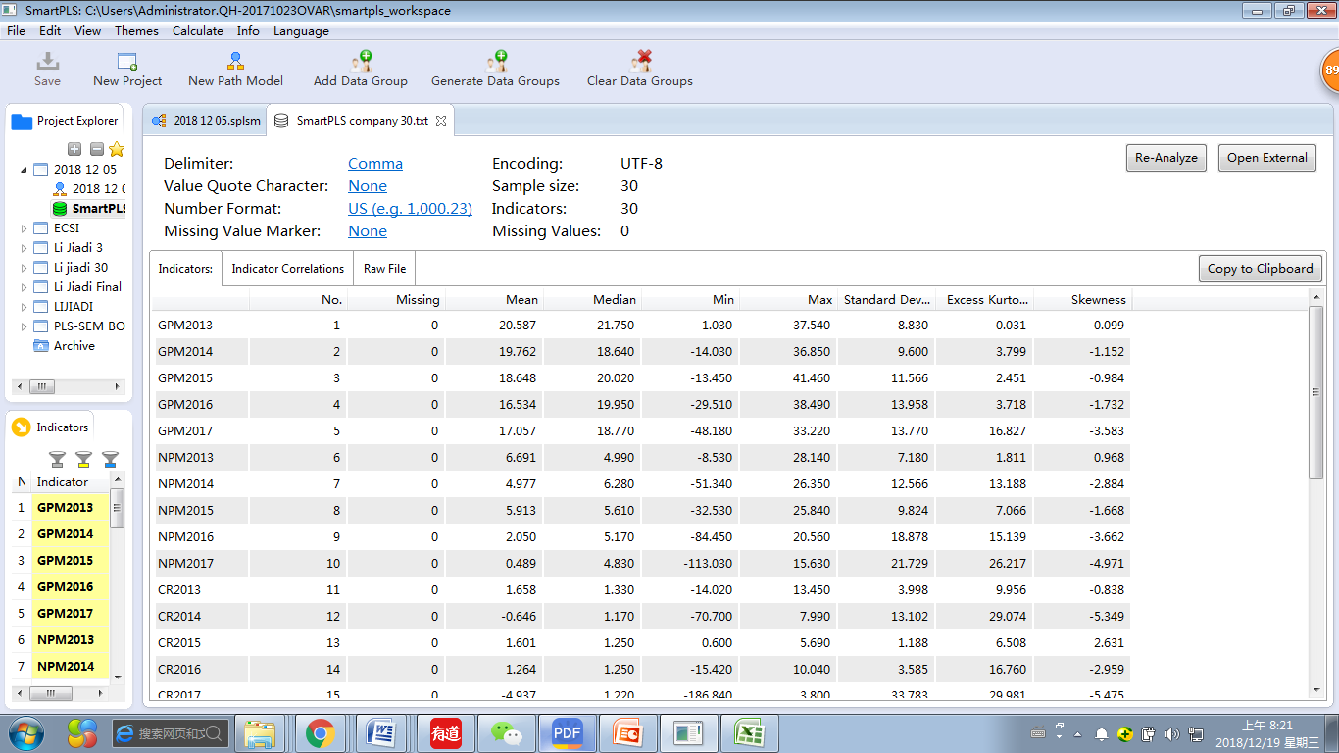
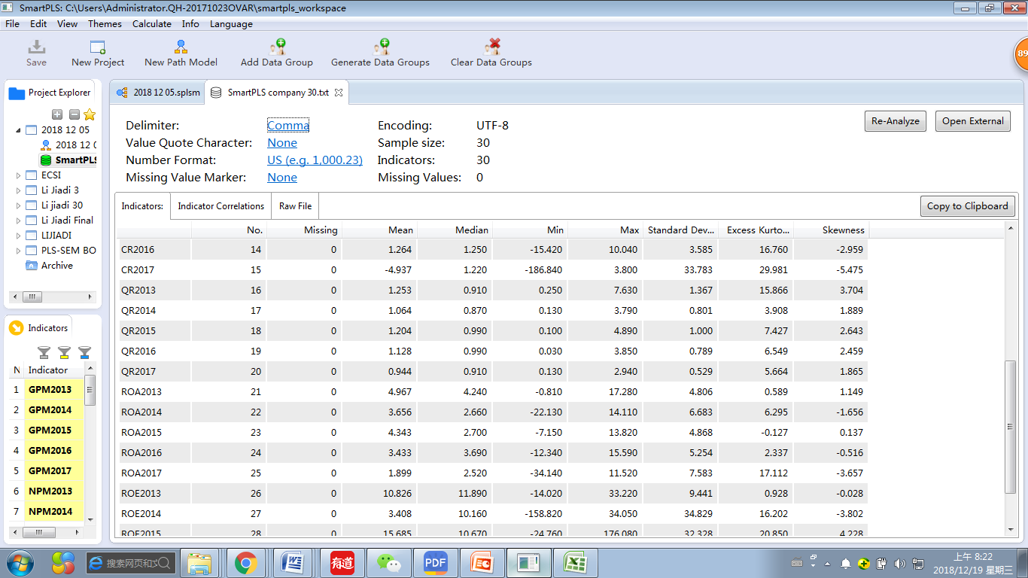
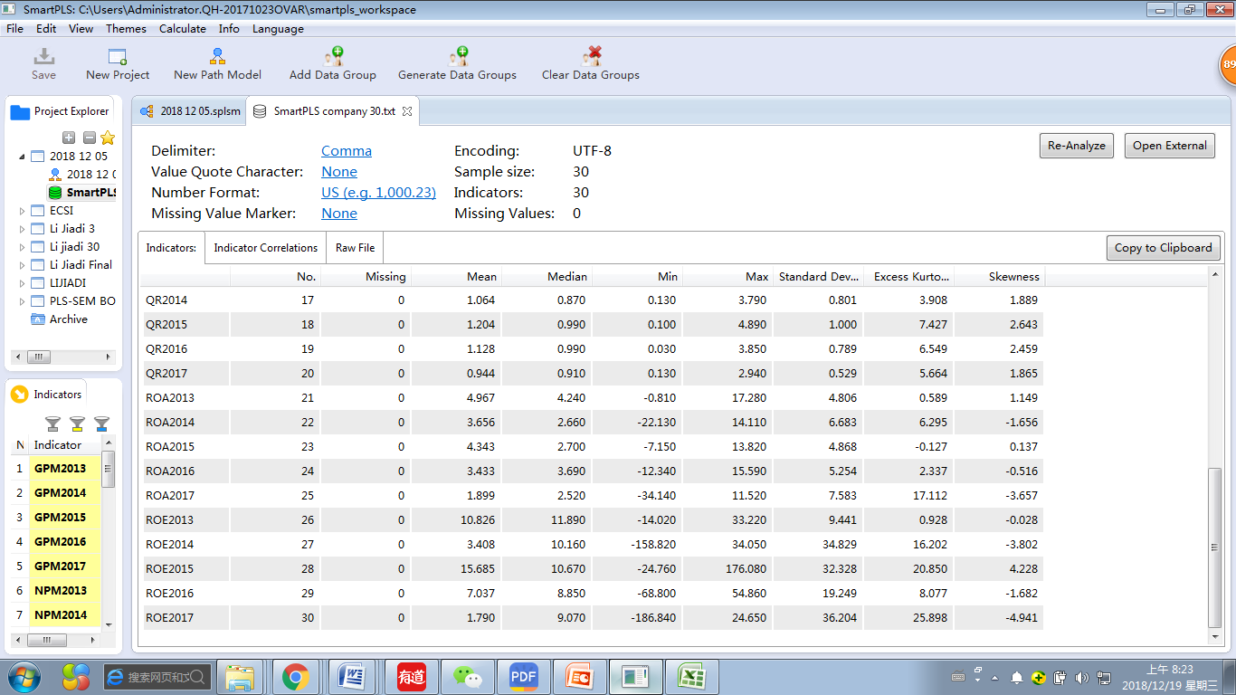

Appendix VI Results of Smart-PLS Analysis

Exhibit 1 PLS Algorithm calculation Result

Exhibit 2 Path Coefficients
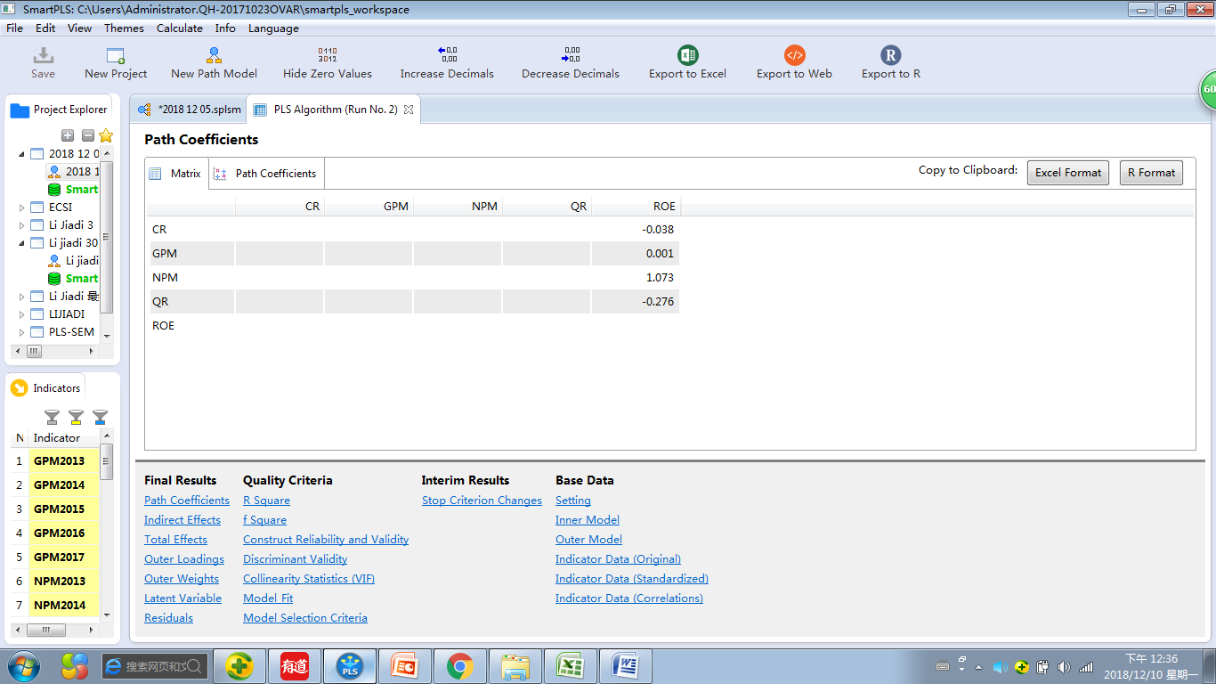

Exhibit 3 Outer Loadings


Exhibit 4 R-Square

Exhibit 5 Construct Reliability and Validity
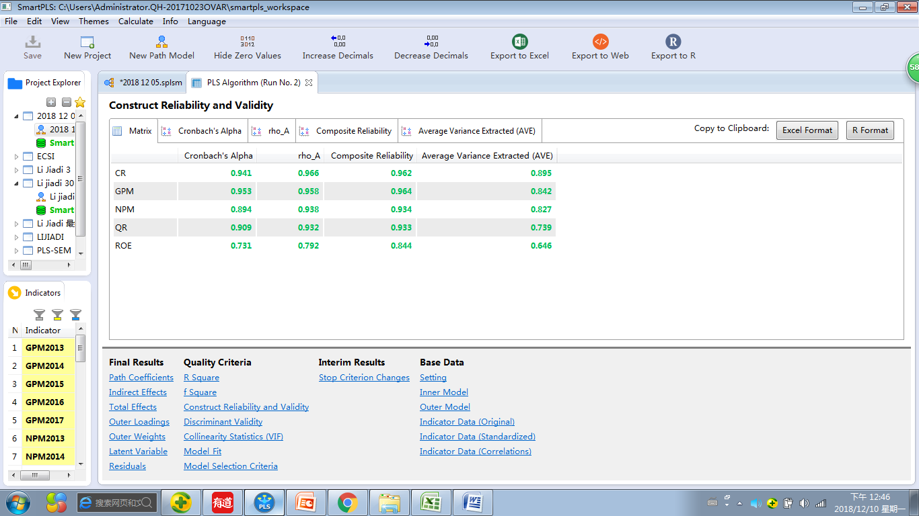

Exhibit 6 Discriminant Validity- Fornell-Larcker Criterion
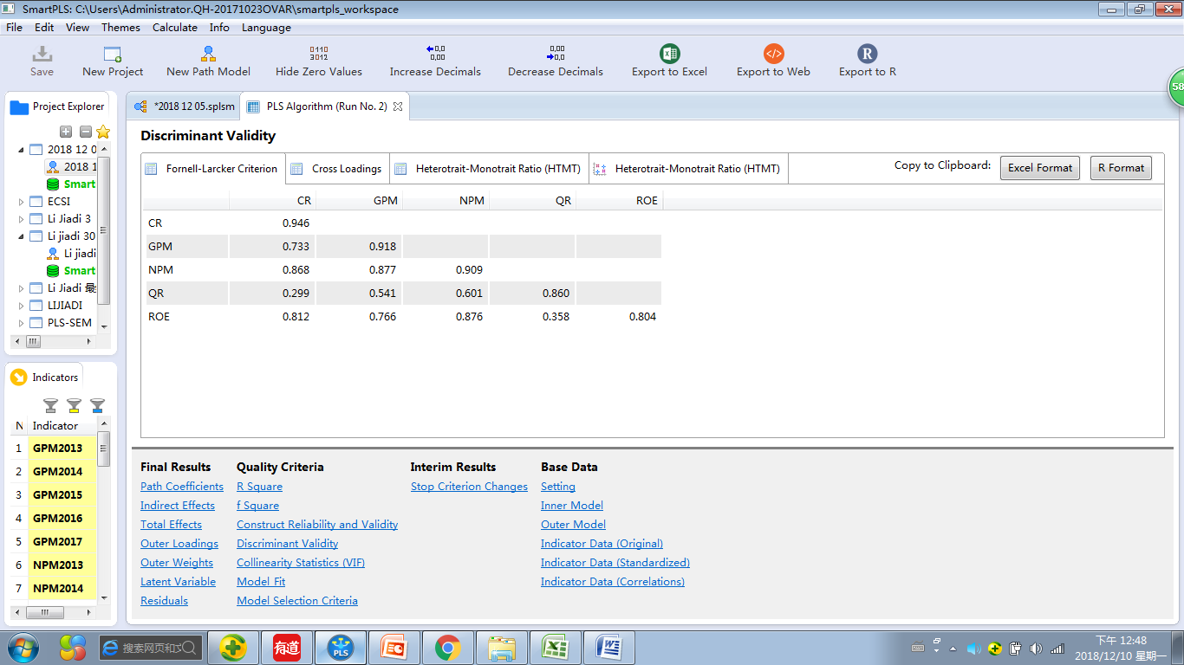

Exhibit 7 Discriminant Validity- Gross Loadings
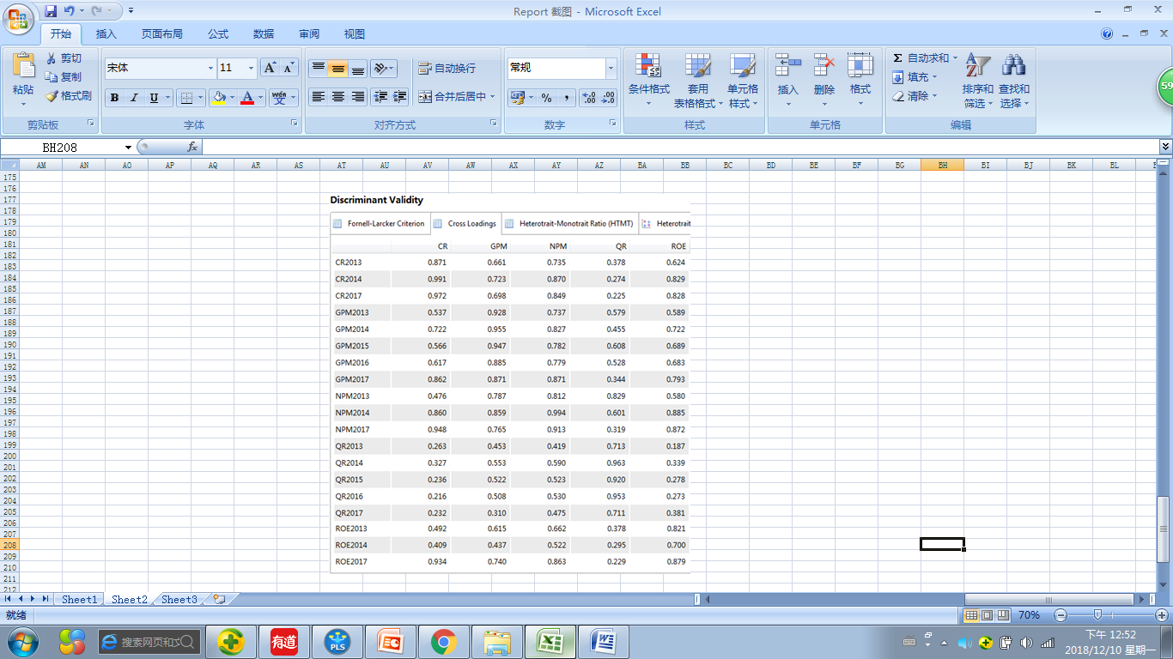

Exhibit 8 Discriminant Validity- Heterotrait-Monotrait Ratio (HTMT)
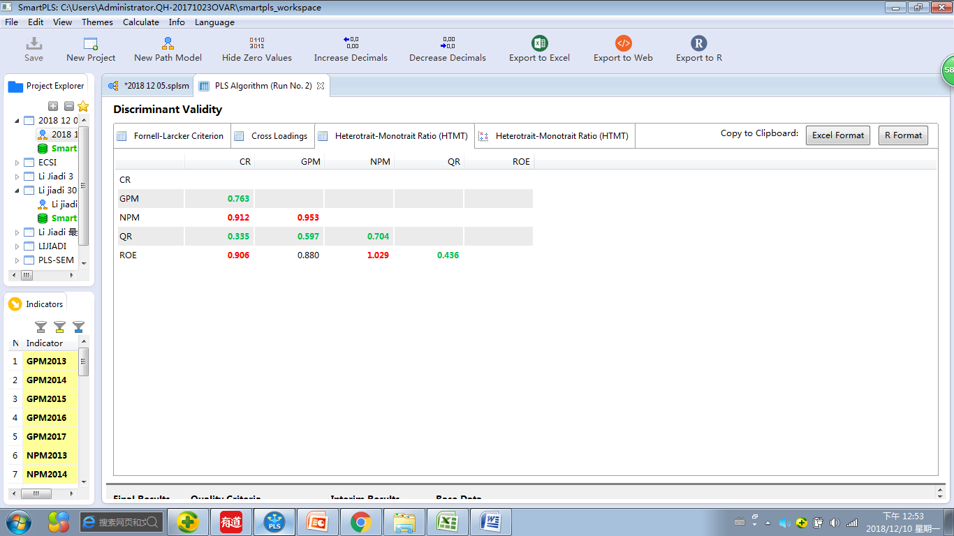

Exhibit 9 Collinearity Statistics (VIF)
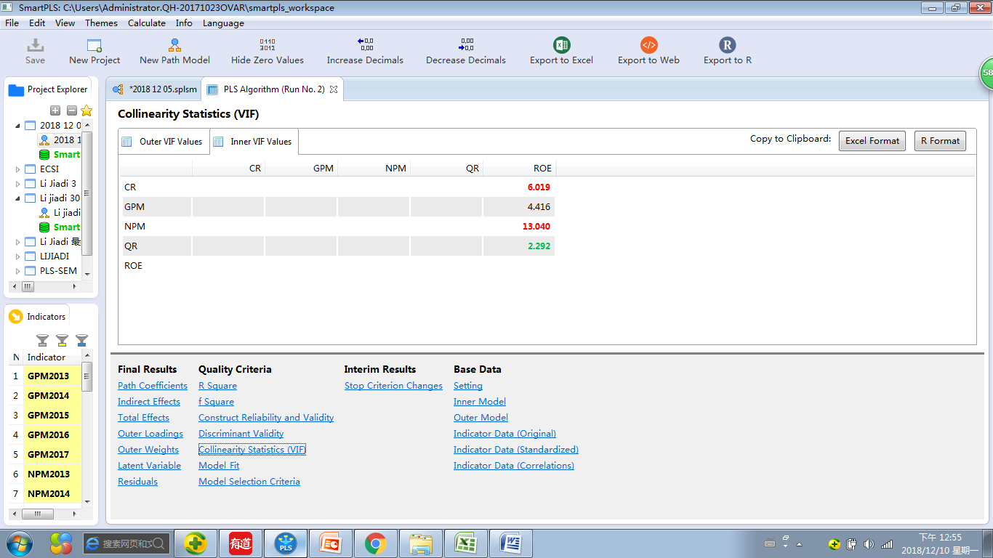

Exhibit 10 Path Coefficients
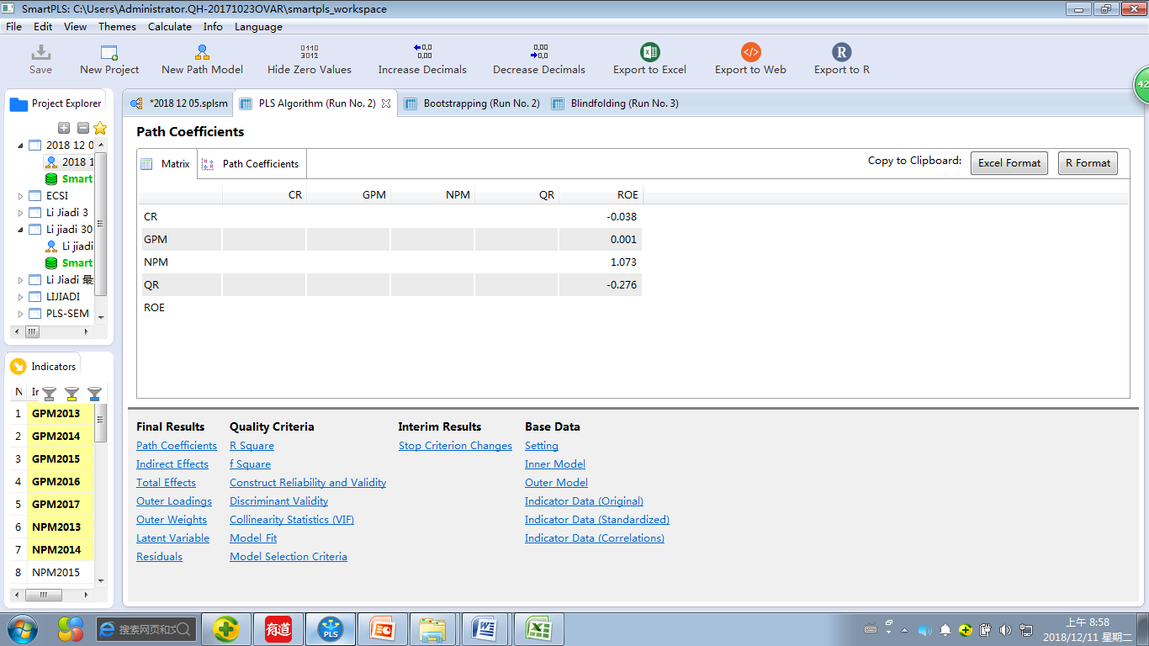

Exhibit 11 Bootstrapping Results

Exhibit 12 Mean, STDEV, T-Values, P-Values
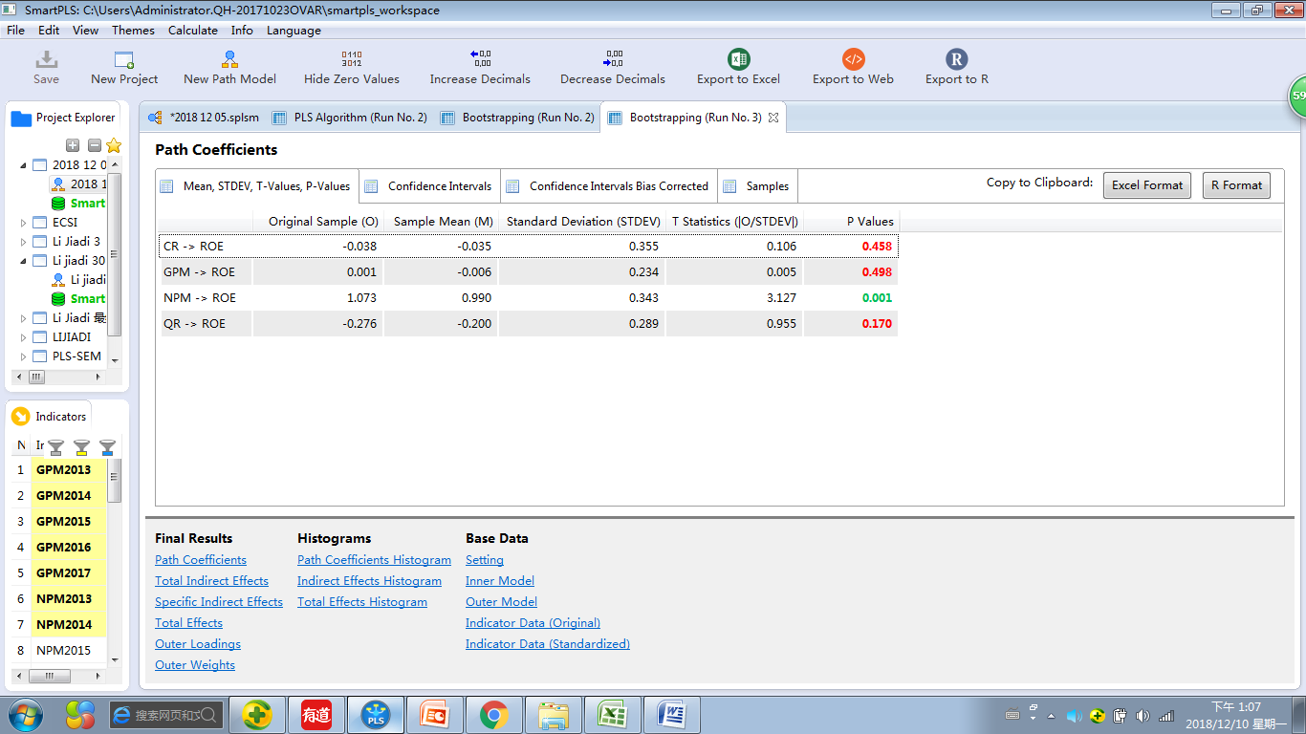

Exhibit 13 Construct Crossvalidated Redundancy
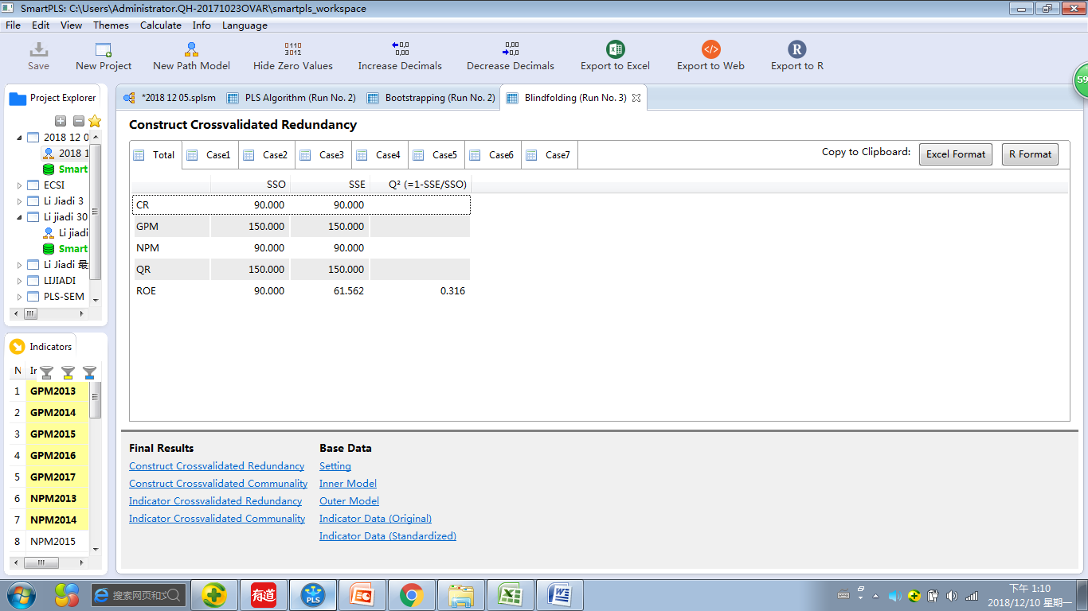

Appendix VII Plagiarism Report



Appendix VIII Viva Slides

