Factors Influencing Blended Learning Effectiveness among University students in Hyderabad, India.

Hussein Fathy Hussein Salim
ID: I18014447
ETHICS NUMBER: cBUS/PGT/CP/03810
SUPERVISED BY: Mr. Francis Wong

MASTER OF BUSINESS ADMINISTRATION
FACULTY OF BUSINESS, COMMUNICATION & LAW
INTI INTERNATIONAL UNIVERSITY
2018

DECLARATION
I I hereby declare that: I understand the meaning of “Plagiarism” and “Intellectual Property Rights” and Ethics Related to the Principles of Academic Works. This dissertation is hereby acknowledged as my own work and I have duly acknowledged use of published and unpublished works of other people from the print, electronic and other media.

Name : Hussein Fathy Hussein Salim
Student ID : I18014447
Signature : Hussein Fathy Hussein Salim
Date : 17th December 2018

Acknowledgements
This MBA Project is the result of a long journey which consisted of long efforts, patience and motivations. This thesis requires good writing, skills, complemented by sound information and communication insight, to produce a factual but readable research literature.
This research paper would have not been possible without the support of those who play important role in the outcome. Most specially, Mr. Francis Wong, my supervisor who advised and inspired me throughout the whole process which contributed positively to the success of this study, Dr. Alex N.G for his individual support in the provision of extensive knowledge on this topic.
Next, I would like to have special thanks to the participants who took part in filling up questionnaire. I am highly indebted to the University students in Hyderabad, the participants for extending their valuable time to provide me with the information needed for my research. I would also like to convey my special thanks to my family and friends for their unceasing encouragement, support and inspired me in different difficult moments of the journey of this project.
I would like to express gratitude to the faculty members of the Faculty of Business, Communication and Law at INTI International University for providing the necessary resources and support to conduct my research.
My thanks and appreciation also go to anyone who has directly, or indirectly helped me with their abilities in this venture.

Hussein Fathy Hussein Salim

December 2018

Contents
Acknowledgements 3
ABSTRACT 7
Chapter One 8
1.0 Chapter Overview 8
1.1 Background of the study 8
1.2 Problem statement 9
1.3 Research Objectives 11
1.4 Research Questions 11
1.5 Significance of Study 11
1.5.1 Significance to Academe 12
1.5.2 Significance to Industry 12
1.6 Scope and Limitations of the Research 12
1.7 Operational definitions 13
1.7.1 Blended Learning 13
1.7.2 Learning Management System (LMS) 13
1.7.3 Content Management System (CMS) 13
1.8 Organization of chapters 13
Chapter One- Introduction 14
Chapter Two- Literature Review 15
Chapter Three- Research Methodology 15
Chapter Four- Data Analysis and Findings 15
Chapter Five- Conclusion and Recommendations 15
Chapter 2: LITERATURE REVIEW 16
2.0 Chapter overview 16
2.1 Introduction 16
2.2 Blended Learning 16
Table 2.2 Classical Course Classification 17
2.2.1 Global Perspective 18
2.2.2 India’s Perspective 20
2.3 Factors Influencing Blended Learning 22
2.3.1 Learning Management System in Technology: 22
2.3.2 Learning Management System (LMS) 22
Figure 1.3 Learning Management System illustration 25
2.3.3 Teaching 25
2.3.4 Student’s perception towards Blended Learning 27
2.3.5 Content Management System (CMS) 27
2.4 Linkage between Blended learning and effectiveness in universities 28
2.4.1 LMS in Technology and effectiveness in universities 28
2.4.2 Teaching effectiveness of blended learning in universities 28
2.4.3 Students perception of blended learning and its effectiveness 29
2.5 Fundamental theory 29
2.5.1 Unified Theory of Acceptance and Use of Technology 29
Figure 1.4 Fundamental theory of UTAUT model 30
2.6 Gaps in Literature 31
2.7 Conceptual Framework 31
2.8 Hypothesis 33
2.9 Conclusion 33
Chapter 3: RESEARCH METHODOLOGY 34
3.0 Overview 34
3.1 Research Design 34
3.1.1 Nature of Research 35
3.1.2 Type of Investigation 35
3.1.3 Research Environment 35
3.1.4 Extent of Research Interference 36
3.2 Unit of Analysis and Study Population 36
3.3 Sampling Plan 37
3.3.1 Sampling Population 37
3.3.2 Sampling method 37
3.3.3 Sampling Size 38
3.4 Pilot Test 39
3.4.1 Validity test 39
3.4.2 Preliminary test 40
Source: Hair et al. (2007) 40
3.4.3 Hypothesis Testing 41
3.5 Questionnaire design 41
3.6 Ethical Consideration 42
3,7 Conclusion 43
3.8 GANTT CHART 43
4.0 Overview 44
4.1 Pilot Test 44
4.1.1 Factor analysis 44
I. KMO Bartlett’s test of Sphericity 44
II. Factor Loading/ Extraction/ Communalities 45
III. Eigenvalue Table 48
4.1.2 Reliability test – Cronbach Alpha 49
4.2 Demographic Profile of Respondents 50
4.3 Preliminary Analysis 51
4.3.1 Factor Analysis 52
i) KMO Bartlett’s test of Sphericity 52
ii) Factor Loading/ Extraction/ Communalities 52
iii) Eigenvalue Table 53
4.3.2 Reliability test – Cronbach Alpha 53
4.4 Hypotheses Testing 54
Multiple Regression & One-way ANOVA table 54
4.5 Summary of Findings 56
4.6 Chapter conclusion 56
CHAPTER 5: CONCLUSION AND RECOMMENDATIONS 57
5.0 Overview 57
5.1 Summary of findings 57
5.2 Implementation of Management theory 57
5.2.1 The Blended Learning Curriculum (BLC) model 57
5.3 Contribution 60
5.3.1 Contribution to Academe 60
5.3 Limitations 60
5.3.1 Participation 60
5.3.2 Survey period 60
5.4 Conclusion and Recommendations 60
5.5 Personal Reflection 61
Appendix: 73

ABSTRACT
Although Blended Learning has already developed several years and became a successful method to improve the learning system of Higher Education Institutions (HEIs). many educational institutions are adopting and implementing the Information and Communication Technologies (ICT) in their educational structure as they believe that it will add a value in their performance. In the context of India, HEIs are still following the traditional way of the education system and they are not fully aware of the Blended Learning. The research gap between the researcher and the HEIs is quite big.
To explore the level influence of LMS and Intention of blended learning effectiveness together with analysing the relationship between satisfaction with blended learning, the researcher chose to approach the quantitative case study to collect data.
Finally, conclusion and recommendation will be provided after findings of this study. Similarly, the study will also enrich the huge gap of the studies on influence of LMS technology and intention to use Blended Learning effectiveness and provide the platform for further studies that will relate when the researchers will examine the Blended learning in India.

Chapter One

1.0 Chapter Overview
This chapter sets an emphasis on the overall phenomena of the research. This part gives an issue explanation which portray the issues and setting of the exploration and take after by the pertinent Research Objectives and Research Questions. In addition, part one will examine on the Scope of Study and the Significance of the Research. This quantitative research will focus on Universities as focus on the research and investigate the experience of blended learning of learners in universities undertaking modules by means conducting a review or a survey. The point of this examination is to investigate the level of effectiveness of blended learning for university students which considers the students' viewpoint on Blended Learning, the difficulties looked by the students and the students' receptiveness to and inspiration for utilizing Blended Learning.

1.1 Background of the study
Today, innovations assume a part to improve students taking in encounter where they gain from authentic and coordinate experience whereby the instructors will go about as facilitators in giving direction to the students (Alshathri, 2016). Inside the most recent couple of years, the fast changes in the Higher Education frameworks and the adjustments in nature of innovation had affected the development of blended learning (Alebaikan, 2012). The headway of innovation has empowered a great deal of new pathway and instruments for instructing and learning, and because of the converging of different advances with specific instructional method has promoted blended learning (Dzakiria, Don and Rahman, 2012). In this innovation driven condition, students are relied upon to be very skilled, outfitted with the capacities to handle complex issues with imaginative arrangements and cooperate viably with different students from various foundations (Lim and Wang, 2017). With the extension of innovation together with the blend of up close and personal collaboration, students can be profited from a more valuable, autonomous and economical learning knowledge (Ali, Ayub and Ismail, 2014). In correlation with the conventional up close and personal conveyance mode, mixed realizing which is thought to be a more adaptable conveyance technique has enhanced learning results in Universities and there is a constructive change in student rankings (Fong and Wong, 2014).

1.2 Problem statement
The customary view of instructing and learning has dependably been aligned with the physical nearness of schools, course readings, teachers, classrooms, and examinations (Alias, Jain and Luaran, 2014). In any case, the all-inclusive utilization of data and correspondence advancements in our everyday lives change the way we live as well as change the development, conveyance and remaking of information (Lim and Wang, 2017). With the quick development in innovation, the use of blended learning approaches is anticipated to rise significantly (Alebaikan, 2012). Concerning the globalized electronic taking in, the Ninth Shift of Indian Education Blueprint as appeared in Figure 1.11 underneath, has accentuated on the abilities of the scholarly network to convey internet learning, and has set up a national e-learning stage to co-ordinate and lead the development of substance (Kaurt and Singh, 2017).

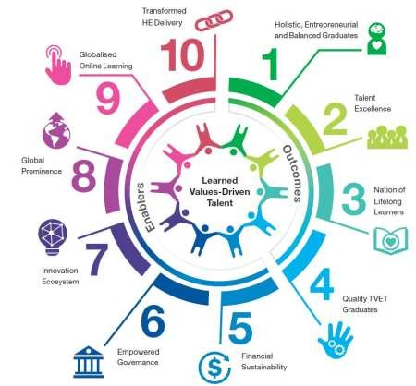

Figure 1.1: India Education Blueprint 2015-2025 (Higher Education)
Source: Ministry of Higher Education (MoHE), 2015

The ninth move which centres around the globalized Online Learning plans to accomplish India's objective regarding access, quality and productivity of Higher Education (Umar, 2017). By having the blended approach, India will have the likelihood to change from a large-scale manufacturing conveyance model to a model in which innovation empowered developments and give more customized learning condition to all students (Kaurt and Singh, 2017).
In India, blended learning is not just being utilized as a part of colleges, yet in addition out in the open and private association in preparing to improve learning and enhance delicate aptitudes among laborers (Dzakiria, et al., 2012). Even though India are new with the blended approach, our training procedure has been adjusted and incorporated by the expanding utilization of innovation (Alias, 2014). Blended learning offers students and instructors a significant blend of computerized advances and up close and personal cooperation, bringing about a socially bolstered and valuable learning knowledge and additionally increment the nature of learning and educating (Ali, 2014). Research demonstrates that numerous e-learning activities neglect to offer students with important blended learning encounters inside the e-learning setting and consequently don't yield promising outcomes not surprisingly (Embi and Hamat, 2014). In this manner, there is a need to see how compelling blended learning in connection to the learning background of university students in Hyderabad is, India. The point of this examination is to contemplate on the adequacy of blended learning among university students in Hyderabad, India. Besides, it is planned to discover the key factors that are affecting students' acknowledgment of blended learning through this investigation. Moreover, this examination will talk about on how blended learning can benefit the students which are experiencing their universities selection. It is profitable to comprehend the level of adequacy of mixed realizing which will assist the academicians with catering and outline their conveyance mode for students in universities.

1.3 Research Objectives
A good study should have clear and focused research objectives that should convey the explicit understanding of the study. In other words, it is mainly focused on the reasons why this study has been done (Farrugia, Bhandari, Petrisor and Farrokhyar, 2010). This study has also research objectives which are as follows:
RO1: To determine whether there is a relationship between customer satisfaction with blended learning effectiveness among University student in Hyderabad, India.
RO2: To determine whether LMS technology in blended learning has a significant influence on university students in Hyderabad, India.
RO3: To determine whether the intention to use the blended learning platform has a significant influence on the university students in Hyderabad, India.

1.4 Research Questions
Research question helps to indicates a clear directions and scope for a research project by using a theoretical question (Walliman, 2011). The research question should be formulated after the research objectives and should be inter-related and aligned with the research objectives (Bhandar, et al., 2010). The research questions for this study are as following:
RQ₁: Is there a relationship between customer satisfaction with blended learning effectiveness among University students in Hyderabad India?
RQ₂: Does LMS technology in Blended learning has a significant influence on university students in Hyderabad, India?
RQ₃: Does the intention to use blended learning platform has a significant influence on the university students in institutions in Hyderabad, India?

1.5 Significance of Study
In an increasingly globalized world, the quality of learning experience in University can no longer be addressed by traditional teaching method (Alebaikan, 2012). With the increase use of online teaching methods, research into the effectiveness of blended learning teaching mode is important to determine whether the combination of web-based learning and traditional delivery method will be beneficial to the learners’ learning (Wong & Fong, 2014). The following three aspects will be value-added from this research study:

1.5.1 Significance to Academe
From the Academic perspective, the examination result will assist analysts with understanding on the acknowledgment of blended learning university students. This examination will give a reasonable picture on the determinants that are affecting the effectiveness of the usage of blended learning in tertiary establishments. The discoveries will address on the difficulties looked by university students in adopting blended learning the during their university study life.

1.5.2 Significance to Industry
From the Industry point of view, this research could contribute in providing feedback and comments on the usefulness of blended learning for students who are in university and to those who are looking to join, where most of them are still adapting the traditional teaching method. In addition, this research will provide an understanding on how information technologies can integrate with the higher education curriculum. When new technologies have a huge potential to effect change, offering a combination of face-to-face and web-based learning will allow a more flexible learning environment (Aleese and Vassiliou, 2014).

1.6 Scope and Limitations of the Research
The purpose of this study is to analyse the effectiveness of blended learning on University students and the factors that has influence the acceptance of blended learning. This research target population is the University students where the researcher will use questionnaire as a medium of data collection and the initial sample is expected to be approximately 150.
The limitation of this study is the selected sample size. Due to limited resources and time constraint, whereby the research for this MBA project has less than 4 months, the questionnaires were only being distributed in Osmania university, India. Hence, the collected data may be biased, and the data analysed may be skewed due to the above said limitations. However, the results will still be valuable for University students in understanding the key factors that influenced the effectiveness of blended learning.

1.7 Operational definitions

1.7.1 Blended Learning
According to Gyamfi and Gyaase (2015), blended learning is an effective way to deliver the learning material and resources of teaching that must follow by the Higher Education Institutions (HEIs) to create an interactively learning environment.

1.7.2 Learning Management System (LMS)
Dias and Diniz (2012) added that Learning Management System (LMS) is a potential solution to integrate between interactive learning activities and collaborative learning whereby LMS is expected to increase the effectiveness and efficiency of learning which is received by the users, teachers (implicitly) and learners (explicitly).

1.7.3 Content Management System (CMS)
Lust, el al, 2011 stated that Content Management System (CMSs) were an arrangement of frameworks that blend and coordinate both subject administration and instructive apparatuses with a specific end goal to give approaches to configuration, assemble, and convey virtual or web-based learning situations.

1.7.4 Customer Satisfaction
In this report the customers are the students. This research will guide us to determine whether the customers who are students are satisfied with blended learning and how effective it is (Graham, C.R., 2013).

1.8 Organization of chapters
To be organized and structured appropriately. The research is categorized into 5 chapters:

Figure 1.2 Flowchart of the Research

Chapter One- Introduction
In this chapter, Introduction is the context of the research which includes the background of the study, problem statement, research objectives, research questions and the importance or significance of the research. The scope and limitations of the research is also stated in this chapter to provide the readers with better understanding on the main objectives of the research.

Chapter Two- Literature Review
Literature Review is constructed by using the secondary data to support the study. In this chapter, literature review provides different ideas, models and theories from previous research by different researchers. The information and literature review is collected from Google Scholar, EBSCO and Emerald.

Chapter Three- Research Methodology
Research Methodology focuses on the techniques, procedures and tools in collecting information throughout the research. It also includes the research design. Strategy, data collection method, sampling techniques and the interpretation of data that is used to test this research.

Chapter Four- Data Analysis and Findings
In the fourth chapter, which is data analysis and findings, contains the graphical representation of the research. The all data collected from the survey is analysed via software and the outcome is presented in the form of graphs and charts. In addition, appropriate discussion and interpretation of the data will be provided to support the statistical data.

Chapter Five- Conclusion and Recommendations
Chapter five is the final chapter of the research and it contains a detailed discussion on the overall findings and results obtained from the research. In the chapter, recommendations and future research direction will also be given for other researchers to expand the research in the future.

Chapter 2: LITERATURE REVIEW

2.0 Chapter overview
The purpose of this literature review is to furnish the one going through it with a general outline on Blended Learning from both worldwide viewpoint and India's viewpoint. Literature review is to plot the present state and flow condition of learning in the zone of research through every single accessible source and help with recognizing the gap for extra research (Walliman, 2011). This section will convey a comprehension on the viability of blended learning in HEIs from the worldwide point of view and India viewpoint. Moreover, this section will give a clarification on the gaps in literature, the elements under the investigation, the theoretical framework and the hypothesis.

2.1 Introduction
Researchers, addresses, scholastics, program, foundation and course materials comprise of advanced education establishment. HEIs intend to offer scholarly information, bits of knowledge, qualities and convictions to both local and worldwide learners (Poon, 2013). The way toward instructing, investigating and administration has coordinated both intercultural and worldwide measurement to develop learners' worldwide point of view, social and moral affectability that assist learners create global learning and relational abilities. For the learners programs, down to earth information later on and reasonable educational cost expense are two critical components to consider (Punie, 2016).An effective marketing strategy is being utilised by higher education institution to interest more learners (Kuba and Kohli ,2014). In addition to make the service of education of greater value, a division of market is included. Blended learning is consistent with the values of traditional higher education institutions and has the proven potential to enhance both the effectiveness and efficiency of meaningful learning experiences (Graham, 2013).

2.2 Blended Learning
Blended learning can be characterized as a blend of various conveyance modes, including classroom communication and online-based materials in a learning circumstance (Ali, et al., 2014). Mixed learning can likewise allude as the joined of conventional learning and online techniques, an e-learning condition which is joined with various devices and media, together with the mix of a few academic methodologies (Dzakiria, 2012). Under this approach, learners and tutors do not normally face-to face meet (Grace, 2017). There will be a proper mix of online components and vis-à-vis class, students will do both on the web and disconnected exercises at their own pace (Bocconi and Trentin, 2014).
Blended Learning is considered as an eminent substitute for conveying the instruction to the learners anyplace whenever, as it does not follow the customary method for realizing where learners need to report in the classrooms and labs (Missildine, 2013). Also, Computer-Based Training, Distance Learning, Distributed Learning, E-Learning, Tele-mentoring and Web-Based Training all are the case of Blended Learning. In addition, Kaur (2013), said that blended learning is a powerful and fitting mix of different paragons of lessons, learning styles and the materials conveyance models that must be trailed by Institutions while portraying and enhancing the Blended Learning.
Although the outline of the blended learning and how it is being executed, it is accepted to have a positive effect in the educating and learning process as learners' cooperation and connection in their examinations has expanded (Embi and Ma'arop, 2016). This is illustrated below:

Table 2.2 Classical Course Classification
Proportion of Content Delivered online | Type of Course | Description
0% | Traditional | Content delivered orally or in writing form
1 to 29% | Web Facilitated | Face to face course transmitted through the web by use of Course Management system.
30 to 79% | Blended | Face to face delivery and blending online course. Online discussions are being used.
80+% | Online | No face to face meetings. All courses are online based.

Source: Allen, Garret and Seamen (2007)

2.2.1 Global Perspective
Blended Learning is the linkage between the learners, tutors and the lecture theatre that has been situated in the diverse states, areas, territories and the mainland and furthermore give a chance to talk about the thoughts, bring up issues and civil argument through the offbeat discussion, as indicated by Bond, Moritmer and O'Connor (2011). Moreover, it was revealed that, Blended Learning advances a learning into the profound comprehension, which can be justifiable by; taking new information, utilizing and getting comfortable with the new and high advances and furthermore assessing the assets and taking profitable choice on the best fits with the current information and the system of Blended Learning (Poon, 2013).
Ibrahim and Mehmet (2014) reported that, blended learning is not only valuable for the working individuals but also helps the current or full-time learners who did not go to the class because of the medicinal issues or other things which empower them to in any case occupied with the on-grounds class exercises. Mixed learning could prompt be accomplishing the learners’ fulfilment and inspiration (Missildine, 2013).
Blended Learning presently turns out to be more than elegant, Blended Learning itself is preference for the learners who are far away and cannot go to the classes physically, with the instructive access it turns out to be more adaptable that give even-handed learning as same are putting forth in the classrooms (Gyamfi and Gyaase, 2015).
In Sri Lanka, the execution of online separation training at Yellow Fields University incorporated the utilization of blended learning, where the approach activity to acquaint online components with remove instruction was guided by the desire for cost decrease and the usage was financed under the Distance Education Modernization Project (Adams, 2014). University leaders of East China, Normal University, believe that many of the learners are familiar with technology and internet hence they can be tempted to shift to e-learning platform (Gu, 2017).
In the case of Russia, blended learning is considered as a unique style that aims to solve a chain of responsibilities linked with the need of hovering education quality (Krasnova, 2015). Likewise, in Poland, Cracow University students embraced the blended learning system by highlighting the benefits of e-classes which proved to be not difficult (Grabinsk, 2015). In addition, Saudi Kingdom universities, embraces blended learning so as to ease the travel of their citizens in travelling abroad to other universities and also to ensure that there are enough facilities for the secondary school graduates who are increasing at a high rate (Alishathri, 2016).
Over the past 50 years, globalization has profoundly affected higher education (Grabinsk, et al, 2015). The twin powers of mass advanced education and the worldwide information economy have driven an extraordinary change where these changes have pulled in inverse ways, one pushes for more extensive access and going with difficulties of value, the other towards limited access (Altbatch, 2016). Below the figure illustrates the concept of blended learning:

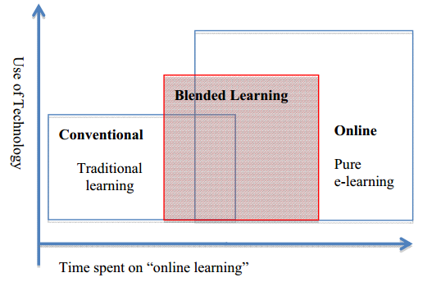
Figure 1.1 Concept of Blended Learning
Source: Heinze and Procter (2003)

2.2.2 India’s Perspective
Blended Learning is one way which Indira Gandhi National University along with Dental Council of India prefer using for continuing professional programs for postgraduate certificate for dentists (Kuba and Kohli 2014). In addition to this, Gaikwad, and Tankhiwale (2014), stated that universities in India are taking on the new methodology if Blended Learning format where the Medical council if India Vision 2015 has emphasised on the use of blended learning in the universities. Students in the modern world are the ones who benefit the most in online education initiatives, however some feel that online classroom will replace the physical classrooms especially in the developing regions (Cutrell, et al, 2015).
Exploiting blended learning in medical education can result in better educational chances for learners while concurrently improving faculty efficiency and effectiveness, conversely, institutional readiness in human and infrastructural resources is assumed in the blended learning potentiality (Frehywot, et al, 2013). As the maturity of Blended Learning grows, many voices come into place to embrace it (Halverson, et al, 2012). In India, Portable innovations have a colossal potential to change instruction gave these advances are outlined and executed such that they are pertinent to the social and social setting of learning (Bhargava, et al, 2014).
The government of India, broadcasted an online learning portal to act as an education regulator to universities or institutions to pave way for the online courses since the quality of education has been gaining momentum as of the budget 2017 (Nitish,et al, 2018). Nevertheless, India has a custom of having face to face learning where the tutor is considered as a guru and he or she cannot be replaced because of the technological innovation, however the gap between what the learners are taught and what the outside world demands is growing at a fast rate (Bhilwar and Jain, 2014). On that note India is embracing blended learning since it attempts to form a stability between inflexible learning and learning according to one’s ability (Snodin, 2013).
Technology is set up to upset education and for people to embrace it they need to change their mind-sets on the shift towards blended learning (Phatak. 2015) In addition to this, Nizar, 2015, elaborated that today’s world education should be a continuous process so as to get solutions to problems.

Several tech experts in Hyderabad are interested in online courses to still be in business, where blended learning courses assist them to study online and have access to teachers’ who are there to clear doubts and easy understanding of theories which are difficult through the normal way of teaching in classroom (Radhamani, 2018).
To support this motion of blended learning in Hyderabad, UNICEF has partnered up with the University of Hyderabad to introduce C4D (blended learning course consisting of online component, written assignment and face to face workshop) learning programme which aims to build and support a minimum amount of advancement experts in the association who are outfitted with pertinent information, abilities and instruments to address socio-social determinants of UNICEF projects and helpful activities (Agora.unicef.org, 2018). Libraries in Hyderabad, are reshaping from the traditional ways to the digital world of online following the change in some of the universities like Osmania University and Boya Kumar University who embraced the E-learning culture (Das, et al, 2014).
It is of no surprise that nowadays the Web is the most successful educational tool that exists since facilitators and institutions at all levels prefer using the Web as a medium of delivering information, Blended learning helps in the facilitation of this web learning mode (Mehdipour, et al, 2013).
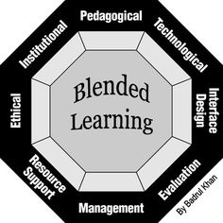

Figure 1.2 Blended Learning Framework
Source: Badrul (2013)

2.3 Factors Influencing Blended Learning
The following Factors should be taken into consideration when assessing the effectiveness of blended learning;

2.3.1 Learning Management System in Technology:
Blended learning in the internet act as an instrument to supplement conventional types of guideline, in the conviction that the joining of new data and correspondence advancements may prompt more proficient and compelling training (Anon, 2018)
The term Technology-enhanced learning (TEL) is utilized to portray the use of data and correspondence advances to educating and learning where it express articulations about what the term is comprehended to mean are uncommon and it is not obvious that a mutual comprehension has been produced in advanced education of what constitutes an upgrade of the understudy learning background (Kirkwood and Price, 2014). A meta-analysis is devoted in developing a better understanding of the effectiveness of blended learning in higher education where a sub collection of comparative studies of blended learning and classroom instructions integrates a larger systematic review of technology (Schimd et al, 2014). This was supported by Tamim, 2011, where he mentioned that meta-analysis has an overall positive impact on learning.

2.3.2 Learning Management System (LMS)
LMS is a product application for the organization, documentation, following, announcing and conveyance of instructive courses or preparing programs (Dabagh and Kitsantas, 2012).Technology has a positive influence on blended learning effect on universities in Hyderabad, India, where the significance of innovation for education is expanding year by year at all instructive levels and especially for Universities (Garrido-Moreno, et al, 2013). LMS is stable, reliable and adaptable where Blended Learning utilizes innovation to consolidate in-class and out-of-class picking up, expanding the instructive effect for understudies subsequently (Drysdale, et al, 2013). Beetham and Sharpe, 2013, added that often in universities more education is done on devices in doing assessments and in collaboration among students and also among students and lecturers.
Lestari and Hendradjaya ,2014 said that Learning Management System (LMS) was known as a usage of online movement in mixed realizing which was utilizing e-learning models. Not just it will encourage students, Learning Management System (LMS), for example, Modular Object-Oriented Dynamic Learning Environment (Moodle) inside an Online Learning Environment (OLE) will have the capacity to give instructors a space for them to put their online materials and in addition assignments (Musbahtiti and Muhammad, 2013). Mahnegar (2012) additionally focused on that Learning Management System (LMS) was a helpful device to convey, track, and oversee preparing or instruction, and LMS gave few advantages to numerous gatherings, for example, empowering educators and executives to track understudy advance, participation, time on undertaking, and LMS likewise enables guardians to track student’s evaluations whereby students could use it too to submit homework or to get to lessons and syllabus. Learning Management System (LMS) was a basic establishment of instructional experience and learning execution in advanced education (Chung et al, 2013) which was simultaneously bolstered by other discoveries of Asiri (2012), whereby it was discovered that the quick development of Information and Technology (ICT) and e-learning devices were essential and valuable to help instructive procedures.
In any case, Cavus (2010), discovered that Learning Management System (LMS) has a few downsides, for example, indistinct client conditions, contain shrouded cost, impediments as to coordination, transfer speed prerequisites, interoperability, and limitation in this manner cautious assessment is vital to choose the most suitable LMS to be actualized inside the associations. Asiri (2012), discovered comparable outcome whereby it was found that furnishing employees with an adequate innovative framework did not ensured the usage of LMS could be ideal in this way another finding was directed whereupon Gautreau (2011), discovered that inspiration factors, for example, pay, accomplishment, obligation, organization strategy, progression, acknowledgment, and the work itself assumed real parts in the achievement of LMS's execution inside the association. Moreover, Dias (2015), clarified that Learning Management System (LMS) under mixed learning could give Online Learning Improvement (OLEs) at Higher Education Institutions (HEIs) with a more productive and successful method for realizing which at last could help understudies' execution altogether.
There has been fast development in blended learning usage and research concentrated on course-level issues, for example, enhanced learning results, however exceptionally restricted research concentrated on institutional strategy and selection issues (Graham, 2013). Additional institutional-level blended learning research is expected to control establishments of advanced education in deliberately embracing and executing mixed learning on campus (Harrison, 2013). Generally, U.S. schools and colleges have a LMS for scholarly exercises, including posting syllabuses, evaluating and conveying declarations. Be that as it may, the level of use shifts relying upon the school and the educator (University Business Magazine, 2018).
In the substance of serious workforce deficiencies in asset obliged nations, therapeutic schools look to e-learning for enhanced access to restorative instruction (Mikhail et al, 2013). However, Blended Learning approaches are more common and can facilitate better in India (Talib, 2013). According to Pandey (2014), Institutions in India are aiming ahead in the study of general practices and management of higher education.
Mobile technologies have a colossal potential to change education provided these innovations are outlined and actualized such that they are significant to the social and social setting of learning (Bhargava, 2014). Unmistakably, the application, execution, and plan of portable innovation in the worldwide instructive setting posture mechanical and socio-cultural difficulties. In particular, innovation apparatuses and applications that are well-known in created countries may posture remarkable difficulties in developing countries such as India (Keengwe, 2014).
According to Bora and Ahmed (2013), technologies can make a big difference in education especially at young ages by use of cloud computing in e-learning where it is growing rapidly. There are numerous instructive establishments that can't manage the cost of such speculations, and distributed computing is the best arrangement, particularly in the colleges where the utilization of PCs is more serious and what should be possible to expand the advantages of basic applications for understudies and educators (Utpal, 2013). E-learning is additionally ending up exceptionally well known and intense pattern, which is likewise expansive. E-learning frameworks typically require numerous equipment and programming assets (Majidul, 2013).
Moreover, Repetto and Trentin (2013), supported the Mobile technology by using it along with network to bridge formal and informal learning because a big gap exists between how learners and universities use communication technology. Virtual education technologies have been widely spread and is now being accepted in today’s world where the usage of verbal labs enhanced autonomous and guided educational methods (Radhamani, 2014).
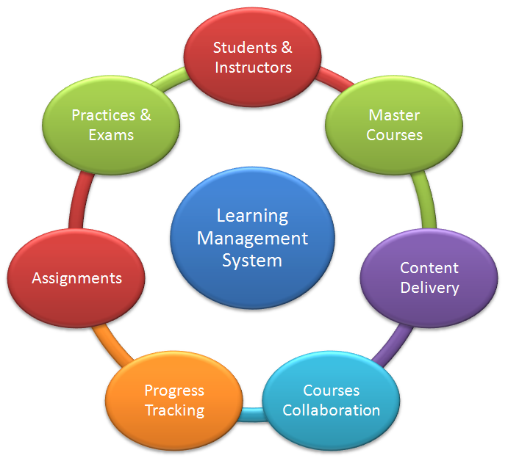

Figure 1.3 Learning Management System illustration
Source: Moore (2013)

2.3.3 Teaching
According to Makhdoom,2013, blended learning is a technological way of teaching where studies in medical education assess the effectiveness of it in clinical medical science ot family medicine. Khoshal,2013, supported blended learning by highlighting that it is better than traditional learning in all aspects. However, Algaidi (2013) noted that blended learning is better in all areas except social perception since learners especially in universities are flexible to adapt new methods of learning. In addition to this Heissam and Zolaly (2013), indicated that blended learning can be an effective method in clinical medical sciences.
Implementation of blended learning and research on the level of course is rapidly growing in terms of blended learning which improves learning results but limits research on institutional policy and issues on adoption (Drysdale. 2013). Graham (2013), added that more research on blended learning at an institutional level is needed to guide the universities in advantageously adopting and implementing blended learning within the institution.
As highlighted by Cigdem (2015), Self-regulation is one of the vital abilities for a learner to achieve in blended learning courses since the skill has achieved to be noticed in blended learning surrounding where it is in relation with self-efficacy, the level of interaction and satisfaction of the blended learning system.
There has been an ongoing debate on the definition of the concept of blended learning as indicated by Alammary (2014). Because of this, teachers are developing different understandings and design approaches regarding blended learning especially in the higher institutions (Sheard, 2014). Moreover, for the teachers who are new to the idea of blended learning, the selection of the most effective approach of blended learning is a challenge to many in higher educational institutions especially in designing the approaches about the impact it will make (Carbone, 2014).
According to Scott (2013), online learning has improved over the past years with the integration of LMS, however the development in rising innovations such as Social networking sites (SNS) has made teaching difficult since many teachers select educational technologies based on their beliefs hence changing this belief would be difficult which will in turn affect teachers taking up the online learning.
Notwithstanding teacher protection from the utilization of innovation in instruction, blended learning has expanded quickly, determined by proof of its points of interest over either on the web or classroom instructing alone (Jeffery, 2014).
Be that as it may, blended learning courses still neglect to expand the advantages this organization offers where classroom segments are observed to be more exceedingly esteemed by instructors than those on the web, a demeanour to a great extent driven by the teacher's recognitions that particular learning capacities were most appropriate to specific arrangements (Milne, 2014). Most educators utilized all around created commitment methodologies in their classroom instructing, contrasted with an insignificant utilization of procedures on the web (Suddaby, 2014). Blended learning will not satisfy its guarantee of better learning unless instructors can be urged to revaluate and update courses that bear the cost of students more, and diverse learning encounters than those offered by either on the web or classroom alone (Higgins, 2014).

2.3.4 Student’s perception towards Blended Learning
As expressed by Ooi, Siew and Wee (2016), user’s encounters of utilizing the framework frequently disregarded amid the framework implementation. When executing or acquainting another framework with the learners who adjusted to traditional showing mode, learners will shape attitudes and aims which is need in confidence toward endeavouring to take in the new innovation before starting endeavours at utilizing it (Chokri, 2012). Students' conduct aims to utilize the blended learning stage can be influenced by the PC self-adequacy and execution desires (Chao, Cheng and Ma, 2013).

2.3.5 Content Management System (CMS)
Lust (2011), stipulated that Content Management System (CMSs) were an arrangement of frameworks that blend and coordinate both subject administration and educational instruments with a specific end goal to give approaches to configuration, fabricate, and convey virtual or internet learning conditions. Chou and Choud (2011), portrayed Content Management System (CMS) as an Information and Technology (ICT) device that were helpful to both adjust and encourage correspondence divert in mixed learning condition. In addition to this, Laleci (2013), included that Content Management System (CMSs) were considered as programming applications that were expected to make, distribute, alter, and deal with the virtual substance.
Content Management System (CMS) was additionally not just utilized as a part of instruction establishments, as specified by Haug (2011), Content Management System (CMS) was likewise appropriate in big business element whereby they called it Enterprise Management System (EMS) whereby it spoke to an innovation that tended to and concentrated on administration errand, including the need of reconciliation of chaotic data with sorted out data. Besides, Altun (2014) found that Content Management System (CMS) might have the capacity to help sorting out understudy work in the most suitable path by keeping up high volume of information and showing data as per what the client needs.
Kietzmann (2013) said that YouTube was a decent case of a superb usage of Content Management System whereby content proprietors of the recordings were given CMS that empower them to recognize and deal with their substance on YouTube.

2.4 Linkage between Blended learning and effectiveness in universities

2.4.1 LMS in Technology and effectiveness in universities
LMS technology has a positive influence on blended learning effectiveness in universities where it re-assesses the technological framework and biological system to guarantee that they bolster the blended learning approach (Demers, 2015). Moreover, the mix of instructive advancements into the classroom raises worries about the effect on educating and learning if the needed assets and help are not accessible, in that capacity a critical thought must go into the uptime, accessibility and support of the framework (Kamen, 2015). Universities must settle on decisions about needs inside their own settings.
At the most essential level, where teachers have low levels of computer proficiency, a learning Management System (LMS) is alluring (Altobel, 2015). Two open-source stages, Moodle and Sakai, are being utilized by South African colleges for which no permit charges are paid. Where the business stage, Blackboard, which requires yearly permit expenses, is utilized by most of universities in South Africa (Gray, 2015).
Technology provide improvement as a key component in the accomplishment of blended learning activities hence Staff individuals should be prepared in the utilization of learning with educational technologies in a mixed domain (Tracey et al, 2015). Composing for the screen is another imperative ability where it incorporates the utilization of screen-accommodating text styles, visit outlines and void area (Merwe et al, 2015).
The Information and Communication Technology (ICT) has influenced the libraries to the colossal degree. Libraries utilize ICT to keep up housekeeping activities, administrations, consistency and expansion of library offices (Tiwari, 2013). University libraries of Rajasthan (India) are utilizing PC and related innovation for library exercises (Sahoo, 2013).

2.4.2 Teaching effectiveness of blended learning in universities
Educating should centre on blended learning outline that means to decide how the mix will function; which parts will be conveyed face to face and which on the web (Braff, 2013(. The learning configuration should begin with the educational modules results, and helpful arrangement ought to be made with exercises, substance and evaluation to guarantee interior intelligibility, consistency and straightforwardness (Fisher, 2013). A standout amongst the most essential elements obviously configuration is to decide a route structure that guarantees that the understudy can explore the course effortlessly (McEwen, 2013).
Educating makes social nearness and commitment unequivocally through visuals, voice and content-based association. Learners' commitment and agency are imperative for inspiration (Smith, 2013). Developmental appraisal in the online educational programs supports individual progress where facilitators ought to create arrangements around compensation for online help, which could lengthen teaching hours past what a few scholastics might not find it reasonable (Moore, 2013). Moreover, facilitators ought to pick learning innovations that are fit for reason where decisions ought to mirror the esteem included through the conveyance mode (Merwe, et al, 2013).

2.4.3 Students perception of blended learning and its effectiveness
To actualize a powerful and blended learning framework, teachers or instructors should assess the students' expectation to utilize the online-based framework (Khalid, 2014). The dynamic interest of all partners is fundamental in making the mixed approach productive (Lee, et al., 2014). Students' aim to utilize and embrace the e-learning innovation as a major aspect of the educating and learning apparatuses is much rely upon the plan of the mixed learning process received by the educators (Chokri, 2012). Learning development and understudies' preparation to utilize mixed learning should be advanced by clear and predictable correspondence from the instructors to assist understudies with appreciating the procedure of mixed learning (Embi, et al., 2014).
Therefore, from the literature reviewed, the factor of technology (including the type and nature of LMS or CMS adopted) and student perception of blended learning and its effectiveness will be including in this study to measure the level of effectiveness of blended learning.

2.5 Fundamental theory

2.5.1 Unified Theory of Acceptance and Use of Technology
UTAUT aims to assess the attitudes of users in the direction of accepting ICT solution irrespective of the availability of infrastructure and support from administration where a concern is raised over the readiness of teachers or facilitators to incorporate technology into effective lessons to the students (Chokri, 2012).
According to Venkatesh (2016), the UTAUT model is made up of eight innovation acknowledgment models which incorporates the Technology Acceptance Model (TAM), the Theory of Reasoned Action (TRA), the Theory of Planned Behaviour (TPB), the Motivation Model, the bound together of TAM and TPB, the model of Personal Computer Utilization, the Social Cognitive Theory and the Innovation Diffusion Theory.
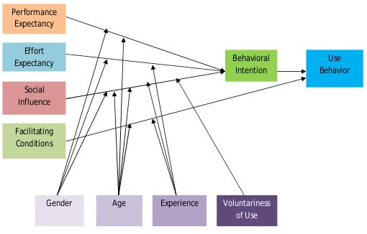

Figure 1.4 Fundamental theory of UTAUT model
Source: Venkattesh (2013)
The UTAUT model involves four main theories (i.e. performance expectancy, effort expectancy, social impact, and Facilitating condition), and four mediators (i.e. Gender, age, involvement and intentionality of utilization) towards user's aim in using innovation (Nurkhin, et al., 2017). It has been estimated that performance expectancy, effort expectancy and social impact were found to influence the conduct aim to utilize the innovation, while both facilitating condition and social expectation to utilize will decide the utilization conduct of innovation (Venkatesh, et al., 2016). Despite the fact that state of mind is an essential part in the TRA and TAM however it doesn't give sufficient interesting data when contrasted with the data gave mutually by exertion anticipation and execution hope, subsequently it isn't expressly fused in the UTAUT display (Thomas, et al., 2013).

2.6 Gaps in Literature
Blended learning has proven to be one of the key aspect in education. The mix of traditional and online modes of teaching has established to be effective over the past year. However, there is no enough articles from scholars on blended learning.
From the literature review above researchers have found that India is one of the best technological hub, however there are limited studies in terms of blended learning in Hyderabad. From a Global perspective, blended learning is effective in developing countries where the online learning methodology is being used especially for learners who are working and are not able to visit the campus on a day to day basis. Blended Learning has made it possible for them to get materials, collaborate with the lecturers and students through online portal i.e., blackboard (Naseem, 2013).
The scholarly advancement of learners experiencing the progress into advanced education is basic to their future achievement, and the reception of blended learning practices could give a potential road through which compelling scholastic improvement may be sought after (Ali,2016). Since there are obstructions related to learning with innovation, the justification of this investigation is to look at whether blended learning will fundamentally prompt successful learning for university students.

2.7 Conceptual Framework
Blended Learning has a significant influence on university student in Hyderabad, India. Learning Management System (LMS) has a positive influence on blended learning effect on universities in Hyderabad. In addition to this blended learning also influence the teaching process positively where universities are adopting to changes towards the blend of transmitting information to students.
Moreover, students themselves are adopting to the shift of traditional learning to blended learning. Using technology students can access information and collaborate with other students and lecturers without having a face to face interaction with them.

The figure below shows the conceptual framework of blended learning effectiveness

IV
LMS Technology

DV
Effectiveness of blended learning on University students in Hyderabad, India
IV
Intention of using Blended Learning

Relationship between Customer satisfaction with Blended Learning Effectiveness

Figure 1.5: Conceptual Framework of Blended Learning Effectiveness

2.8 Hypothesis
Hypothesis is a form of statement which we made sensible suppositions (Walliman, 2011). The kind of research outline for the investigation will be impacted by the exploration theories, and the examination speculations ought to be bolstered by the exploration questions (Farrugia, et al., 2010).
According to Wallman (2012), Hypothesis is a kind of statement which are make sensible suppositions. Farrugia, et al, (2013) added that it is the kind of research which outlines the investigation which will be impacted by the exploration theories and the examination speculations ought to be bolstered by the exploration questions.
H1: Relationship between customer satisfaction with Blended Learning effectiveness has a significant influence on university students in Hyderabad, India.
H2: LMS technology has a positive influence on Blended Learning effectiveness on university students in Hyderabad, India.
H3: Intention to use Blended learning platform has significant influence on the effectiveness of blended learning of university students in Hyderabad, India.

2.9 Conclusion
After conducting the literature review, it can be concluded that LMS technology, Teaching, and Students perception would be influencing the effectiveness of blended learning on students in universities. The entire chapter two has discussed on the context of blended learning and how UTAUT can be used to measure the students’ effectiveness to blended learning systems which will later lead to the effectiveness of blended learning. The hypothesis provided are based on the conceptual framework. The following chapter will be discussing on the research methodology used for this research.

Chapter 3: RESEARCH METHODOLOGY

3.0 Overview
The research methodology utilized as a part of this study will be engaged in this section. Primarily, this part will clarify about the research design with reference of the structure provided in section 2. Furthermore, this section will also examine about the idea of the research, which incorporates the kind of examination, research environment, extent of research interference, and the unit of investigation. Moreover, the sampling design and questionnaire design will be reviewed in this chapter also. To improve the relevance of the research data of this study, the test of validity and reliability will be collected to guarantee that the information gathered is significant for the accompanying examination.

3.1 Research Design
Looi (2014) stated that, while designing a research, the researcher should decide on the type of samples, select a suitable measurement for the variables under the study and select the research technique to be applied. Research design can be separated into different sorts relying upon the kind of research project, and the idea of the study problem (Walliman, 2011). A research design outlined the preparation, course of action and methodology of the research, which outlined what the researcher will do (Mukherjee, 2017). Table 2 demonstrates the research methodology applied in this study.

Items |  | Methods
 | Nature of Research | Descriptive
 | Type of Investigation | Correlations
 | Sample selection | Non-probability and purposive sampling
 | Data collection | Questionnaire Survey
 | Data analysis | SPSS Software

The study issue of this examination is to recognize the effectiveness of blended learning of university students in Hyderabad, India. Therefore, a quantitative strategy will be adopted which will help with setting up relationships between given factors and results (Looi, 2014). A quantitative research will utilize different sorts of quantitative investigation methods to give a basic unmistakable of the factors, and the build up a measurable connection between the factors (Hilman, Khalid, and Kumar, 2012).

3.1.1 Nature of Research
In a study, descriptive investigation will be utilized to find out about and define the characteristics of the recognized factors under the setting of research (Sekaran and Bougie, 2016). An engaging report or a descriptive study will depend on perceptions as a method for gathering information and endeavours to review circumstances to create what is the standard under a similar circumstance (Walliman, 2011). Furthermore, the factors can be described in terms of numerical form by using the descriptive research (Lewis, et al., 2012). As indicated by Sekaran and Bougie (2016), the point of clear investigation is to give a profile to the analyst or to define the related aspects of the phenomena under examination from alternate point of view.

3.1.2 Type of Investigation
To quantify the connection between the independent variables and dependent variables, the most proper plan for the sort of study will be correlation design (Kumar, 2011). The dependent variables will change considering the progressions of independent variables, and the quality of this relationship can be measured statistically by using correlation technique (Lewis, et al., 2012). Sekaran and Bougie (2016) additionally expressed that the relationship is coming about by assessing the varieties in a single variable as another variable likewise changes.

3.1.3 Research Environment
Correlation research is also referred as ex post facto research where by it inspects the variables in their natural environments and excludes researcher-imposed treatments (Simon and Goes, 2011). Natural environments relate to human-associations and is fundamental in demonstrating the improvement of complete theories (Ulrich, 1983).

3.1.4 Extent of Research Interference
The degree of researcher interference alludes to the degree of which the variables or factors can be controlled and will in this manner affect the dependent variables of the study (Sekaran and Bougie, 2016). When choosing the kind of investigation for the study, the analyst should take into consideration of the level of researcher’s interference as one of the impacting factor (Bryman and Bell, 2011). This research will embrace the correlation study and will be conducted with the minimum interference under natural surrounding by the researcher or analyst by utilizing the ordinary stream of work (Sekaran and Bougie, 2016). Babin et al. (2013) additionally expressed that the perfect setting of correlation research is that there will be a minor or even no interference from the researchers because of acquiring a more exact impression of the relationship among the variables being examined. Conducting research in such situation is critical as it will maximize the accuracy of the data gathered from the correlation research (Babin, et al., 2013).

3.2 Unit of Analysis and Study Population
Unit of analysis is a vital thought in research study as it refers to the significant object that you are analysing, which will provide you with the applicable information for your study (Mcnabb, 2013). Babin et al. (2013) likewise expressed that the unit of examination of a study refers to the basic subject being explored in a study which can be as far as individual or association which is chosen by the diverse context of a research. The purpose of this study is to recognize the effectiveness of blended learning, therefore the university students will the unit of analysis in this research. In this case the unit of analysis can be considered as individual.
The study population refers to the subject that is planned to be explored by the researcher (Sekaran and Bougie, 2016). Study population can likewise be referred as the subjects where by the researcher can obtain the expected data to answer the research questions (Kumar, 2011). For this situation, the examination population of this investigation will be the university students of Hyderabad, India.

3.3 Sampling Plan

3.3.1 Sampling Population
The participants which is selected for this research will be university students in Hyderabad, India. These students will also be considered as the sampling frame for this study due to their various demographic characteristics and the effectiveness of blended learning method as a delivery mode in facilitation of their courses. Blended learning approach will have different impact to different students based on student learning capacity, the purpose or goal of this research is to identify the key factors that will have impact on the effectiveness of blended learning for university students. For this study, questionnaire will be distributed for data collection process. The figure below illustrates the sampling frame with regards to population and sample:
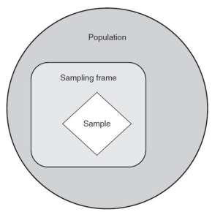

3.3.2 Sampling method
Sampling is a procedure to choose a sample of units from a populace to gauge the trademark (Rahi, 2017). There are two sampling methods, which is the nonprobability sampling and probability sampling (Bala and Etikan, 2017). Because of time limitation and the point of practical, non-probability sampling is considered as the most reasonable sampling technique to be applied (Alvi, 2016). Non-probability sampling is utilized when the quantities of components in a population is obscure or cannot be recognized independently (Kumar, 2011).

Purposive sampling is a sampling technique under non-probability sampling (Showkat and Parveen, 2017). Under purposive sampling, the qualities of the example to be incorporated into the research is predefined (Alvi, 2016). By executing the purposive testing technique, the researcher ought to apply the best judgment in choosing the members or respondents keeping in mind the end goal to get important data to accomplish the research objectives (Kumar, 2011). This study is applying purposive testing as the proposed respondents are the university students.

3.3.3 Sampling Size
The number of respondents ought to be resolved suitably as the chosen test must be illustrative of the objective population (Patino and Ferreira, 2016). The estimated population of students in university in India is approximately 315,000,000 students (citation) Because of time limitation and additionally 95% of sure level and 0.7 margin of error, the sample size would be 384 for this population (Krejcie and Morgan, 1970). Table below demonstrates the determine size sample from a given population.
Table 2: Table determining sample size from a given population
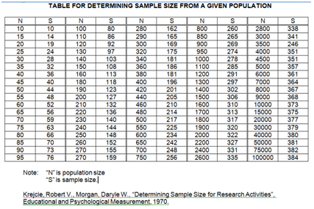

3.4 Pilot Test
Keeping in mind the end goal to evaluate the phenomena under study, the researcher will allocate numbers to observations which is called as "measurement" (Kimberlin and Winterstein, 2008). The levels of measurements used to get information assume an imperative part in choosing which sort of measurement that is suitable (Walliman, 2011). As per Babin et al. (2013) researchers use measurement instruments to aid the appraisal or assessment of clients, subjects or patients. This research will adopt different test and measurement, for instant the pilot test, validity test, preliminary test and hypothesis test, to examine the information assembled from the questionnaire distributed.
Pilot test will be done as a pre-trial of the questionnaire on few cases to access the systems and quality of responses by distributing questionnaire (Walliman, 2011). The point of conducting a pilot test is to enhance or upgrade the polls to ensure that the respondents will not confront any issue in answering the questions as well as in recording the information (Lewis, Saunders, and Thornhill, 2012).
Pilot test can likewise be referred as a function to help distinguish the possible defects in the measurement instrument (Dikko, 2016). Hazzi and Maldaon (2015) It is not appropriate to have a formal sample size calculation for pilot test, however, 10% - 20% will be the perfect example size to lead a pilot test.

3.4.1 Validity test
Validity represent the extent of truthfulness of the data (Hilman, et al., 2012). As per Dikko (2016), the purpose of validity is to ensure that the measurement instrument is lined up with the idea set out in the research. Validity test incorporates faulty samplings of test resources, the adjustment in nature of materials during test, the interference of unseen aspects and poor description of the research process (Walliman, 2011). It is likewise a test of the degree of the suitability of an instrument that is produced to gauge the idea under the study (Babin, et al., 2013). The internal validity and external validity are the two sorts of validity which adds to the general validity of a research (Kumar, 2011). Interior validity refers to the level of confidence that a researcher set in the circumstances and end results relationship (Babin, et al., 2013). Concerning external validity, it is impacted by level of significance of the research findings in contrast with this present reality, which is destined to be identified with the issue of generalizability and is outside the ability to control setting of the research (Sekaran and Bougie, 2016).

3.4.2 Preliminary test
Factor analysis refers to the merging of variables which is reasonably or exceedingly related with each other keeping in mind the end goal to decrease an extensive number of variables to a couple of elements (Simon and Goes, 2011).
Factor analysis is frequently used by researcher who direct a review in the research, to group a progression of long questions into shorter sets, in which every one of them represent an aspect of phenomena under study (Babin, et al., 2013). The measure of factor analysis ought to embrace the Measure of Sampling Adequacy (MSA) with the range from 0 to 1, whereby a high estimation of MSA will demonstrate that the item is appropriate for subsequent measure (Hair, Anderson, and Black et al, 2007).
Factor analysis ought to be conducted prior to the reliability test with a specific end goal to look at whether a specific factor ought to be remained or not before conducting further test (Babin, et al., 2013). The table below illustrates the rule of MSA which can be followed by component matrix
Table 3: Guideline of MSA

Source: Hair et al. (2007)
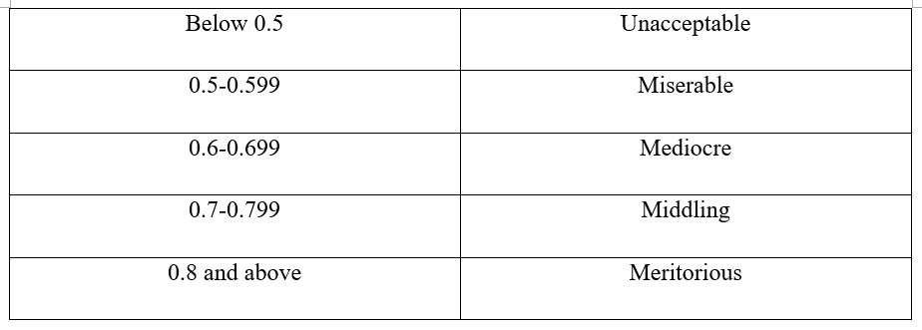

Sekaran and Bougie (2011) expressed that reliability comprises of numerous structures and every one of them affect the general unwavering quality with respect to the instrument in this manner it is necessary to gather information, yet it is conceivable to have a solid measure that is not legitimate. Kumar (2011) trusted that every one of the information that have been gathered still need to finish through the reliability test to guarantee its inner consistency.
Cronbach's Alpha ought to be adopted while inspecting the reliability of every factor under the questionnaire and to decide if the constructs are reasonable for further analysis, a composite reliability will be conducted (Quinlan, 2011). Cronbach's Alpha is considered as the most prominent test to be utilized for reliability test for correlation research (Sekaran and Bougie, 2016). As indicated by Babin et. al. (2013), 0.7 would be the cut off point for Cronbach's Alpha. Hair et al. (2010) likewise expressed that any elements which is below 0.7 ought to be disregarded as it shows poor reliability. It is supported by Quinlan (2011), the reliability test needs to demonstrate composite reliability and an indicator in between of 0.7 to 0.9 so as for an item to be accepted.
Eigenvalues will also be experimented for factor analysis which must be more than 1 for each item in the study. Eigenvalues show the measure of variance of a variable a factor contains. It was expressed by Diedenhofen and Musch, (2016) that factor analysis should be directed sooner than reliability tests to guarantee that the things picked are set up for further investigation or not – the things which neglect to meet prerequisites will be wiped out in factor analysis and not used for further tests.

3.4.3 Hypothesis Testing
Both factor analysis and reliability test are crucial as they are inter-related with the implementation of hypothesis testing which expects to decide the appropriateness of data gathered concerning further analysis (Babin, et al., 2013). In the wake of experiencing the factor analysis and reliability test on all the data acquired from questionnaire, the information is prepared for consequent analysis (Quinlan, 2011). The hypothesis testing will be conducted using the SPSS software. Multiple regression will be conducted to examine and understand the simultaneous effect of free factors on a needy variable (Sekaran and Bougie, 2016).

3.5 Questionnaire design
Looi (2014) expressed that quantitative research strategy regularly refers to the distribution of standardized questionnaire to people or households. A questionnaire is used when the study is analysing the information considering quantitative technique and the sample being analysed is for the entire population (Mukherjee, 2017). Questionnaire can be considered as an extremely adaptable tool for information gathering which is simple and helpful for participants, cost-effective and simple to administer a large number of respondents covering large geographical area (Walliman, 2011).
The questionnaire is separated into two areas, Section A and Section B. A will contain questions regarding demographic and characteristics while Section B will centre around the key factors that impact the effectiveness of blended learning. All questions in Section B will be addressed considering the 5-point Likert scale, with a scale from 1 which designates "Strongly Disagree" to a size of 5 which specifies "Strongly Agree".

The table below illustrates the overview design of the questionnaire:

Table 4: Questionnaire design
Area | No of Questions | Citation
Demographic | 3 | Qayyum and Sukirno (2012)
IV (LMS Technology) | 3 | Zareen, Razzaq, Mujtaba (2015)
IV (Intention of using blended learning) | 3 | Graves, Sarkis and Zhu (2013)
DV (Blended Learning Effectiveness) | 5 | Anwar and Ahmad

3.6 Ethical Consideration
Ethical Consideration is an important part of any research. In the view of questionnaire, it is a critical part. The respondents of the overview survey were asked for to round out the agreement frame which demonstrated that they think about the research being driven and their support is totally unruly. Therefore, the respondents were permitted to take an interest on the off chance that they need to at their own specific extra time. It is similarly fundamental that the individuals are totally mindful of the examination they are taking an intrigue and that their own information will be kept private and not be uncovered. As far as social event information, suitable inspecting size was picked with a true objective to ease any mistakes in the consequences of study. Through utilizing surveys from conspicuous considers, the legitimacy is upgraded while, unwavering quality is in like manner measurably checked in this research.

3,7 Conclusion
This section focuses on the research technique embraced by the researcher to look at the impact of blended learning on university students. 384 surveys are distributed to students to gather the required data for investigation. This chapter additionally clarifies on the plan of questionnaire, the significance of pilot test, validity test, factor investigation and reliability test. The following part which is the section 4 will centre around dissecting the information acquired from the poll by utilizing the SPSS software.

3.8 GANTT CHART
GANTT CHART OF RESEARCH
Milestone | Week 1 | Week 2 | Week 3 | Week 4 | Week 5 | Week 6 | Week 7 | Week 8 | Week 9 | Week 10 | Week 11 | Week 12
Research Topic Approval
Chapter 2
Draft of Chapter 2
Submission of Chapter 2
Chapter 1
Chapter 3
Final Submission (Chapter 1, 2 and 3)

Chapter 4 Data Analysis and Findings

4.0 Overview
Subsequent from the discussion in Chapter 3, the data analysis is conducted based on the methodology. Chapter 4 will focus on the analysis of data collected from the questionnaires and the outcome of the analysis will be interpreted. The analysis will be done using the SPSS software.

4.1 Pilot Test
Pilot test will be done as a pre-trial of the questionnaire on few cases to access the systems and quality of responses by distributing questionnaire (Walliman, 2011). The point of conducting a pilot test is to enhance or upgrade the polls to ensure that the respondents will not confront any issue in answering the questions as well as in recording the information (Lewis, Saunders, and Thornhill, 2012).
Pilot test can likewise be referred as a function to help distinguish the possible defects in the measurement instrument (Dikko, 2016). The target population consists of 384 respondents where 30 respondents’ data was collected from a total of 223 sample for the pilot test to examine on the feasibility approach.

4.1.1 Factor analysis
Factor analysis is being used to confirm the dimension of the concept that have been operationally defined, as well as indicate the appropriateness of each dimension (Sekaran & Bougie, 2016). It also helps to reduce a vast number of variables to a more meaningful and manageable set of factors (Kumar, 2011).

KMO Bartlett’s test of Sphericity

Kaiser-Meyer-Olkin Measure of Sampling Adequacy. |  | 0.945
Bartlett's Test of Sphericity | Approx. Chi-Square | 6160.433
Bartlett's Test of Sphericity | df | 351
Bartlett's Test of Sphericity | Sig. | 0.000

KMO Bartlett’s test of sphericity provides the Kaiser-Meyer-Olkin measure of sampling adequacy whereby the value of KMO should be greater than 0.6 if the sample is adequate (Field, 2005). As shown in Table 4.1, the KMO is 0.678 which indicates that the sample is adequate, and the researcher may proceed with factor analysis.

Factor Loading/ Extraction/ Communalities

Communalities
 | Initial | Extraction
I find blended learning system easy to use | 1.000 | .529
I believe blended learning would improve my learning experience | 1.000 | .715
I believe blended learning facilitates the study of the course content easier | 1.000 | .734
I have internet access throughout the campus | 1.000 | .598
I intend to check announcements on e-learning portal | 1.000 | .748
I intend to participate on online activities to enhance my learning experience | 1.000 | .743
I intend to interact with my peers using the e-learning portal to increase academic productivity | 1.000 | .519
I believe that LMS enhances the quality of education | 1.000 | .599
More types of interaction in learning such as face to face learning with online videos, increases motivation | 1.000 | .730
Blended learning provides better understanding to students compared to traditional style of teaching | 1.000 | .703
Learning how to use the features of e-learning is easy for me | 1.000 | .756
It is easy for me to search course content I need on e-learning platform | 1.000 | .698
I am comfortable with the stability of e-learning system | 1.000 | .571
I find it easy to communicate with the lecturer/ assistant in the e-learning portal | 1.000 | .626
E-learning provides ways to test knowledge through self-assessment. | 1.000 | .689
I believe the idea of the existence of video lectures is attractive and improve learning | 1.000 | .760
I can regularly receive feedback about my work from the e-learning portal after reviewed by the lecturer. | 1.000 | .673
In e-learning it is easy to work together with other students involved in a group assignment | 1.000 | .682
With the help of devices such as mobile phones and laptops, online learning material can be accessed more effectively and fast than sitting in class | 1.000 | .620
Having access to textbooks online through ICT makes it easier to obtain information | 1.000 | .718
Blended learning helps the students understand the comparison between traditional style of teaching with the online style of teaching | 1.000 | .781
The use of blended learning technology in institutions encourages students to learn independently | 1.000 | .752
Blended learning helps me score good grades | 1.000 | .839
Blended learning is a better experience compared to face to face | 1.000 | .704
If I had the opportunity to take a course via the internet I would gladly do so | 1.000 | .716
Blended learning provides flexibility of accessing the class content anytime | 1.000 | .750
Combination of an online class and traditional in-class delivery is effective than using a one-way mode of delivering information | 1.000 | .590
Extraction Method: Principal Component Analysis.
Table x shows the factor loading after the various factors have been extracted from the items. As shown from the results in the table of communalities, the extraction values of extraction values are more than 0.6, with most of the items are more than 0.7. According to Asnawi, Gravell & Wills (2012), for a factor to be deemed to be suitable for further analysis, the factor loading should be greater than 0.6. The outcome for the pilot test indicates that the factors are appropriate for subsequent analysis as the extraction value are more than 0.6 for all items in the proposed questionnaire.

Eigenvalue Table

Total Variance Explained
Component | Initial Eigenvalues |  |  | Extraction Sums of Squared Loadings |  |  | Rotation Sums of Squared Loadings
Component | Total | % of Variance | Cumulative % | Total | % of Variance | Cumulative % | Total | % of Variance | Cumulative %
1 | 17.168 | 63.587 | 63.587 | 17.168 | 63.587 | 63.587 | 10.287 | 38.100 | 38.100
2 | 1.374 | 5.089 | 68.676 | 1.374 | 5.089 | 68.676 | 8.255 | 30.576 | 68.676
3 | .994 | 3.683 | 72.359
4 | .827 | 3.063 | 75.421
5 | .753 | 2.789 | 78.211
6 | .609 | 2.256 | 80.466
7 | .540 | 2.000 | 82.466
8 | .486 | 1.799 | 84.265
9 | .463 | 1.713 | 85.979
10 | .415 | 1.538 | 87.517
11 | .374 | 1.383 | 88.900
12 | .370 | 1.369 | 90.269
13 | .345 | 1.277 | 91.546
14 | .302 | 1.120 | 92.666
15 | .263 | .974 | 93.640
16 | .247 | .914 | 94.554
17 | .233 | .862 | 95.415
18 | .212 | .787 | 96.202
19 | .178 | .658 | 96.860
20 | .162 | .600 | 97.460
21 | .132 | .488 | 97.948
22 | .123 | .456 | 98.403
23 | .099 | .368 | 98.772
24 | .097 | .361 | 99.133
25 | .092 | .340 | 99.473
26 | .078 | .291 | 99.763
27 | .064 | .237 | 100.000
Extraction Method: Principal Component Analysis.

Eigenvalues or Kaiser’s criterion will extract and retain the factors that have eigenvalues which are greater than 1 for further analysis (Asnawi, et al., 2012).

4.1.2 Reliability test – Cronbach Alpha
Reliability test is essential to ensure the design of research is auditable whereby the method is clear enough to instil confidence in the reader that the outcomes were not falsified in any way (Greener, 2008). The reliability test for this research has been done on the 27 respondents data collected for pilot test to measure the internal consistency reliability.

Reliability Statistics
Cronbach's Alpha | Cronbach's Alpha Based on Standardized Items | N of Items
.977 | .978 | 27
According to Tavakol & Dennick (2011), the ideal value of Cronbach Alpha should be above 0.7 as a low value of alpha may be due to poor correlation between items where some of the questions should be revised or discarded. Cronbach's Alpha of LMS technology, Perceived ease of use and intention of using blended learning is 0.977. This is the overall Cronbach's Alpha of the questionnaire, which is greater than 0.7, indicating that the scale designed by the questionnaire has excellent reliability.

4.2 Demographic Profile of Respondents
The questionnaires were distributed after the researcher has conducted the pilot test. A total of 384 questionnaires being distributed and 223 questionnaires were collected back within 12 days. All data collected were usable as the researcher was using online questionnaire (Google docs) by distributing the questionnaires to the students studying under university programme. Table x below shows the summary of the questionnaires:
Summary of questionnaire table
Items | Quantity
Questionnaires Distributed | 384
Questionnaires Collected | 223
Questionnaires Used for Analysis | 223

Before conducting the preliminary analysis, a descriptive analysis has been run to provide descriptive statistics on the data of the respondents. Table x below indicates the demographic data of the respondents:
Table x: Descriptive analysis of Demographic
 |  | frequency | Percentage
Gender | Female | 81 | 36.3
Gender | Prefer not to Say | 32 | 14.3
Gender | Male | 110 | 49.3
Age | 18-20 years | 31 | 13.9
Age | 21-24 years | 80 | 35.9
Age | 25-28 years | 84 | 37.7
Age | Above 28 years | 28 | 12.6
Level of Education | Diploma | 51 | 22.8
Level of Education | Bachelors | 98 | 43.9
Level of Education | Postgraduate | 54 | 24.2
Level of Education | Doctorate | 20 | 9.0

- 49.3% of the participants in the research were male.
- Majority of participants in this research at the age of 25-28 years old
- Majority of the participants are from the bachelor’s department.
The target population of this research required 384 respondents. Unfortunately, I could only manage to get 223 respondents till this moment

4.3 Preliminary Analysis
Preliminary analysis is conducted after the pilot test. The objectives of preliminary data analysis are to prepare the data for further analysis, describe the key factors of the data, and summarize the results (Blischke, et al., 2011). The items being tested in the pilot test are categorized as below:

4.3.1 Factor Analysis

i) KMO Bartlett’s test of Sphericity
Kaiser-Meyer-Olkin Measure of Sampling Adequacy. |  | 0.747
Bartlett's Test of Sphericity | Approx. Chi-Square | 634.561
Bartlett's Test of Sphericity | df | 3
Bartlett's Test of Sphericity | Sig. | 0.000

The KMO measures the sampling adequacy whereby it determines if the responses given with the sample are adequate or not, which should be close to 0.6 for a satisfactory factor analysis to proceed (Asnawi, et al., 2012). Table X shows that the KMO is 0.694 which is more than 0.6. This indicates that the sample is adequate, and the researcher may proceed with factor analysis.

ii) Factor Loading/ Extraction/ Communalities
 | Initial | Extraction
Intention | 1.000 | .883
Ease of Use | 1.000 | .932
Effectiveness | 1.000 | .882
Extraction Method: Principal Component Analysis.
The table of communalities shows how much of the variance, where the communality value should be more than 0.6 to be considered for further analysis, else these variables are to be removed from further steps of the factor analysis (Asnawi, et al., 2012). As shown in the table x over 90% variance in Ease of use is accounted for, whereas 88% of the variance is in Intention and Effectiveness of using Blended Learning.

iii) Eigenvalue Table
Component | Initial Eigenvalues |  |  | Extraction Sums of Squared Loadings
Component | Total | % of  Variance | Cumulative % | Total | % of  Variance | Cumulative %
1 | 2.696 | 88.877 | 89.877 | 2.696 | 89.877 | 89.877
2 | .200 | 6.655 | 98.531
3 | .104 | 3.469 | 100.00

Eigenvalue reflects the number of extracted factors whose sum should be equal to number of items which are subjected to factor analysis (Blischke, et al., 2011). In Table X The first component is accounted for 90% of the total variance. As more data are collected, the 3 independent variables have merged as a single factor that is able to explain 90% of the variances occurring within the data.

4.3.2 Reliability test – Cronbach Alpha

Cronbach's Alpha |  | Cronbach's Alpha Based on Standardized Items | N of Items
 | .977 | .978 |  | 27

Cronbach’s alpha is a measure used to assess the reliability or internal consistency of a set of test items (Goforth, 2015). As per Table x, the Cronbach’s alpha coefficient for the three variables is 0.977 which indicates a high internal consistency.

4.4 Hypotheses Testing

Multiple Regression & One-way ANOVA table
Coefficients
Model |  |  | Unstandardized Coefficients |  | Standardized Coefficients | t |  | Sig. |  | 95.0% Confidence Interval for B |  |  | Collinearity Statistics
 |  | B |  | Std. Error | Beta |  |  |  |  |  | Lower Bound | Upper Bound |  | Tolerance | VIF
1 | (Constant) | 2.193 |  | .247 |  |  | 8.888 |  | .000 |  | 1.707 | 2.679
1 | Intention | .142 |  | .170 | .117 |  | .835 |  | .405 |  | -.194 | .478 |  | .232 | 4.314
1 | Ease of Use | -.040 |  | .221 | -.031 |  | -.181 |  | .857 |  | -.476 | .396 |  | .156 | 6.416
1 | LMS technology | -.124 |  | .176 | -.098 |  | -.703 |  | .483 |  | -.471 | .223 |  | .235 | 4.260
a. Dependent Variable: effectiveness of blended learning

Table X shows the coefficient for independent variables to dependent variable. The unstandardized beta represents the slope of the line between the predictor variable and the dependent variable.
Standard error is similar to the standard deviation for a mean. The larger the number, the more spread out the points are from the regression line. The more spread out the number are, the less likely that significance will be found. The standardized Beta will range from 0 to 1 or 0 to -1, depending on the direction of the relationship. The closer to 1 or -1, the stronger the relationship. This enable the researcher to compare the variables to see which had the strongest relationship with the dependent variable. In this case,

Model Summary
Model | R | R Square | Adjusted R Square | Std. Error of the Estimate | Durbin-Watson
1 | .070ª | .005 | .009 | .922 | 1.840
a. Predictors: (Constant), LMS technology, Intention, Ease of Use
b. Dependent Variable: Blended Learning Effectiveness

Anova
Model | Sum of Squares | df | Mean Square | F | Sig.
1 Regression | .113 | 1 | .113 | .214 | .644^{b}
Residual | 116.687 | 221 | .528
Total | 116.801 | 222

Table x shows that the three independent variables are able to explain 92.2% of the variances influencing the dependent variable, which is very strong, thereby indicating a strong model fit for this research. The ANOVA table shows the p-value is above 0.05, therefore there is no statistically significant result on the effectiveness of blended learning.

4.5 Summary of Findings
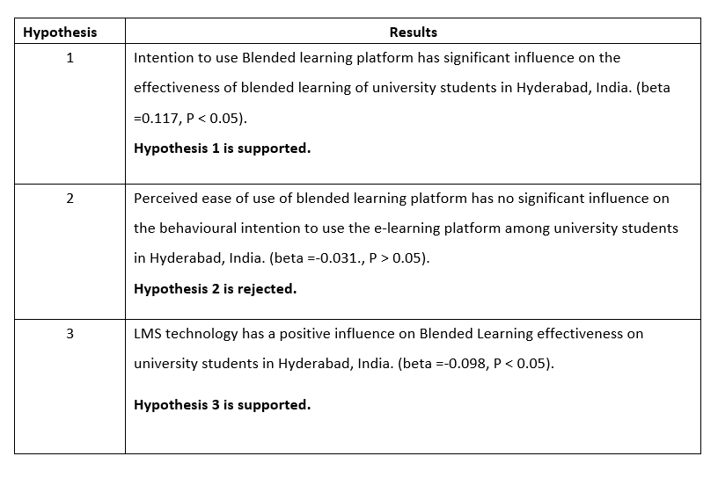

4.6 Chapter conclusion
The aim of this study is to determine the factors influencing Blended Learning effectiveness among university students in Hyderabad, India. As revealed in the results of the analysis, the variables indicated in the framework have a positive significant influence with the effectiveness of blended learning except the perceived ease of use variable. This indicates that the Intention of using Blended Learning and LMS technology has a positive impact to the students. Students who perceived that the Blended Learning platform is useful and easy to be used will have the motivation to use the e-learning platform as a learning tool and subsequently have a positive impact on their studies.

CHAPTER 5: CONCLUSION AND RECOMMENDATIONS

5.0 Overview
This chapter will be providing the main findings on the results obtained from the analysis of data. A summary of the analysis, recommendations and future research direction will be provided in this chapter. It will also include my personal reflection on the overall research and experience.

5.1 Summary of findings
The purpose of this research is to study on the factors that influence Blended learning effectiveness among University students in Hyderabad, India. Hypothesis 1 specified that Intention to use Blended Learning platform has a significant influence on the effectiveness of Blended Learning among University students in Hyderabad India. Based on the results in chapter 4 above, the hypothesis was supported.
Hypothesis 2 specified that Perceived Ease of Use of Blended Learning platform has no significant influence on the effectiveness of Blended Learning among university students in Hyderabad, India. According to the analysis in chapter 4, the p-value is greater than 0.05 which signifies that the hypothesis is rejected.
Hypothesis 3 specified that LMS Technology has a positive influence on the effectiveness of Blended Learning among University students in Hyderabad, India. The p=value is less than 0.05 which signifies that the hypothesis is accepted.
From the research, Blended Learning is effective on the male students in Hyderabad, India. The age is 25 to 28 years old, where Blended Learning is most effective on the bachelor’s department.

5.2 Implementation of Management theory

5.2.1 The Blended Learning Curriculum (BLC) model
Blended learning is currently advanced in educational circles around the world. It is universal in both corporate and academic settings. In any case, how to structure such an educational program stays precarious claiming there are few models that can be connected to the direction of such educational modules plan. The accompanying model portrays the plan methodology that can be pursued when structuring a blended learning educational programs. The objective of this model is for instructional implementation.
The strategies are comprised of three principle segments:
a. Pre-examination;
b. Movement and asset plan; and
c. Instructional evaluation.
Pre-analysis. To discover whether Blended Learning could be utilized, a few perceptions and examinations should be directed. These examinations mostly are made out of three elements: investigation of student attributes, as far as customary appraisal of students' earlier information, learning styles, learning inclinations, and so on.; examination of learning objects (learning scientific classification), regarding characterizing what ought to be shown dependent on information scientific categorization; and examination of mixed learning situations, as far as discovering the natural highlights. The motivation behind this part is to distinguish students' capability level and spell out learning undertakings to establish a sound framework for association of learning exercises.
The result of this pre-investigation is represented by an examination report, which is an outline of the beginning stage of guidance dependent on these examinations.
Structure of Activities and Resources. This segment comprises of three subcomponents, that is, overall design of Blended Learning, unit structure, and assets plan and development. The general plan of Blended Learning predetermines the other two subcomponents as far as the way that it sets the tone for what should be possible in the other two structures by spreading out the general targets and making suitable game plans for explicit exercises. The result of this general structure is an itemized plan report, which can be viewed as a guide for the other two plans. It is the essential archive for mixed learning and centers instructors' instructional techniques for arranging course occasions and exercises and the fundamental standards for educational programs appraisal. The most imperative component of the structure that varies from the standard instructional plan is that it centers around which exercises and assets fit in the learning setting and which fit in the run of the mill classroom guidance setting.
Instructional Assessment Design. The evaluation configuration relies upon the action targets, execution definition, and the general condition of Blended Learning. It basically utilizes the evaluation of the learning procedure (for instance, utilizing e-portfolios), the examination of educational modules information (for instance, online tests), and the association of learning exercises.
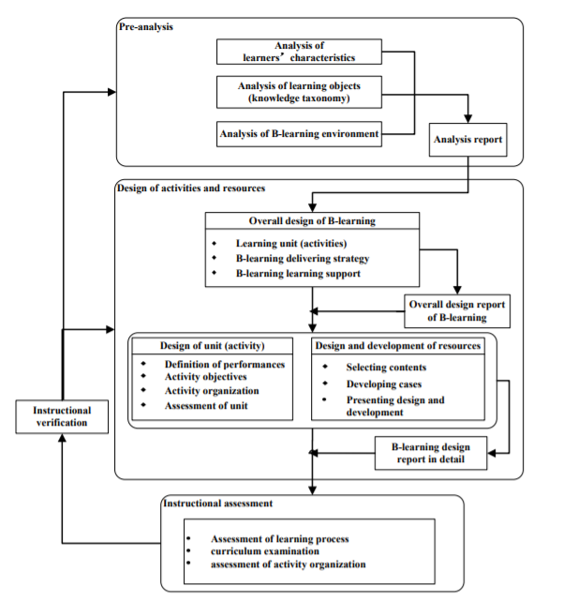
The BLC model

5.3 Contribution

5.3.1 Contribution to Academe
This study contributes to academe as the results obtained from the research provides a clearer picture on how Blended Learning platform can be used as a learning and teaching tool by integrating with the face-to-café lecture. Blended learning is a permanent trend and academicians should have the awareness in designing their teaching for both traditional and online method (Alebaikan, 2012). With the outcome of this research, researcher will be able to conduct further studies on how to improve the design of Blended Learning platform based on the respective determinants. In addition, the research outcome also helps researchers to understand on the acceptance of blended learning among the University students. By understanding the factors which would influence the effectiveness of blended learning platform which can be designed in a better way to maximize the benefits brought to the students. As such, researchers would be able to develop a better system which would engage the learners by increasing their perception on the usefulness and ease of use of Blended Learning platform.

5.3 Limitations

5.3.1 Participation
The target sample size of this research was 384. Not all students participated in the survey but 223 of them responded to the survey.

5.3.2 Survey period
The research time frame to collect data was limited. Therefore, the survey period was a factor in terms of collecting data.

5.4 Conclusion and Recommendations
The purpose of this research is to study on the effectiveness of blended learning among university students in Hyderabad India.
Increase students perceived usefulness of Blended Learning platform: Facilitators are recommended to provide interactive blended learning where students are able to study before the face-to-face class and share what information they have gain during the independence learning.
Since Hyderabad is still developing in terms of Blended Learning, Facilitators should create awareness of online learning so as the students will find it easy for them to use the e-learning platform.
Increase students Intention of using blended learning platform: Facilitators should ensure that the materials and activities in the e-learning platform are useful to support university students’ learning in order to strengthen their intention to use the Blended Learning platform as Learning Management System.

5.5 Personal Reflection
Upon completion of this MBA project, I feel grateful that the challenges faced in this process would enhance my knowledge and perception on how Blended Learning could influence the effectiveness of e-learning in universities. As blended learning is believed to be the trend in higher education system, this research enables me to understand more on the factors which lead to the acceptance of a system.
By going through various researches done previously, I could see that academicians are keen to know whether the implementation of Blended Learning in India would be able to bring out a positive outcome to the students. Based on my observation, Blended Learning platform is mostly used in private institutions. Since India is known for its Technological hub, facilitators should try and implement Blended Learning in public institutions as well as help in creating awareness of the platform so as more students are introduced to this.
Lastly, the experience of working on a project is helpful and knowledgeable. Under the guidance of Mr. Francis Wong, the project went smoothly and much appreciation to him on his guidance.

REFERENCES
Alebaikan, R. A., 2012. The Future of Blended Learning. International Journal of Social, Behavioral, Educational, Economic, Business and Industrial Engineering, 6(3), pp. 321-325.
Alias, N. A., Jain, J. & Luaran, J. E., 2014. Blended Learning: Examining Concepts and Practices. In: M. A. Embi, ed. Blended & Flipped Learning: Case Studies in Malaysian HEIs. Bangi: Centre for Teaching & Learning Technologies, Universiti Kebangsaan Malaysia, pp. 19-33.
Ali, W. Z. W., Ayub, A. F. M., Ismail, N. & Yunus, A. S. M., 2014. The Effects of Blended Learning Methods on Educational Achievement and the Development of Online Material in a Curriculum Information Document Online System (CIDOS) for Computer Application Courses. Malaysian Journal of Distance Education, 16(2), pp. 59-82.
Alvi, M., 2016. A Manual for Selecting Sampling Techniques in Research. [Online] Available at: https://mpra.ub.uni-muenchen.de/70218/1/MPRA_paper_70218.pdf [Accessed 1 December 2017].
Bhandar, M. et al., 2010. Research questions, hypotheses and objectives. Canadian Journal of Surgery, 53(4), pp. 278-281.
Dias, S. B. & Diniz, J. A., 2014. Towards an Enhanced Learning Management System for Blended Learning in Higher Education Incorporating Distinct Learners’ Profiles. Educational Technology & Society, 17(x), p. 307–319.
Dzakiria, H., Don, M. S. & Rahman, H. D. A., 2012. Blended Learning (BL) as Pedagogical Alternative to Teach Business Communication Course: Case Study of UUM Executive Diploma Program. Turkish Online Journal of Distance Education, 13(3), pp. 297-315.
Embi, M. A. & Hamat, A., 2014. Meaningful Blended Learning via iFolio @ UKM. In: M. A. Embi, ed. Blended & Flipped Learning: Case Studies in Malaysian HEIs. Bangi: Centre for Teaching & Learning Technologies, Universiti Kebangsaan Malaysia, pp. 59-80.
Gyamfi, S. And Gyaase,, P. (2015). Students' perception of blended learning environment: A case study of the University of Education, Winneba, Kumasi-Campus, Ghana. International journal of education and development using information and communication technology, 11(1), p.80.

Lim, C. P. & Wang, T., 2017. A Framework and Self-Assessment Tool for Building the Capacity of Higher
Education Institutions for Blended Learning. In: C. P. Lim & L. Wang, eds. Blended Learning for Quality Higher Education: Selected Case Studies on Implementation from Asia-Pacific. Paris: United Nations Educational, Scientific and Cultural Organization, pp. 1-38.
Lust, G., Juarez Collazo, N., Elen, J. and Clarebout, G. (2012). Content Management Systems: Enriched learning opportunities for all?. Computers in Human Behavior, 28(3), pp.795-808.
Singh, R. & Kaurt, T., 2017. Blended Learning - Policies in Place at Universiti Sains Malaysia. In: C. P. Lim & L. Wang, eds. Blended Learning for Quality Higher Education: Selected Case Studies on Implementation from Asia-Pacific. Paris: United Nations Educational, Scientific and Cultural Organization , pp. 103-124.

Umar, I. N., 2017. Feasibility Study: Malaysia Experience. Penang, University Sains Malaysia.

Walliman, N., 2011. Research Methods: The Basics. 1st ed. New York: Routledge.

Wong, L. & Fong, M., 2014. Student Attitudes to Traditional and Online Methods of Delivery. Journal of Information Technology Education: Research , 13(1), pp. 1-13.
Agora.unicef.otg. (2018). C4D Learning Programme 2018. [online] Available at: https://agora.unicef.org/course/info.php?id=1196 [Accessed 5 Jun. 2018].
Alammary, A., Sheard, J. and Carbone, A., 2014. Blended learning in higher education: Three different design approaches. Australasian Journal of Educational Technology, 30(4).
Al-Busaidi, K.A. and Al-Shihi, H., 2012. Key factors to instructors’ satisfaction of learning management systems in blended learning. Journal of Computing in Higher Education, 24(1), pp.18-39.
Ali, W. Z. W., Ayub, A. F. M., Ismail, N. & Yunus, A. S. M., 2014. The Effects of Blended Learning Methods on Educational Achievement and the Development of Online Material in a Curriculum Information Document Online System (CIDOS) for Computer Application Courses. Malaysian Journal of Distance Education, 16(2), pp. 59-82.
Altbach, P.G., 2016. Global perspectives on higher education. JHU Press.
Anon, (2018) Available at: https://www. Reaserchgate.net
Beetham, H. and Sharpe, R. eds., 2013. Rethinking pedagogy for a digital age: Designing for 21st century learning. routledge.
Bernard, R.M., Borokhovski, E., Schmid, R.F., Tamim, R.M. and Abrami, P.C., 2014. A meta-analysis of blended learning and technology use in higher education: from the general to the applied. Journal of Computing in Higher Education, 26(1), pp.87-122.
Bhilwar, A. and Jain, S., 2014, December. Multi-tenant enabled eLearning platform: Blended with workflow technologies. In e-Learning, e-Management and e-Services (IC3e), 2014 IEEE Conference on (pp. 88-92). IEEE.
Bocconi, S. & Trentin, G., 2014. Modelling blended solutions for higher education: Teaching, learning, and assessment in the network and mobile technology era. Educational Research and Evaluation, 20(78), pp. 516-535.
Bruff, D.O., Fisher, D.H., McEwen, K.E. and Smith, B.E., 2013. Wrapping a MOOC: Student perceptions of an experiment in blended learning. Journal of Online Learning and Teaching, 9(2), p.187.
Chao, C.-M., Cheng, B.-W. & Ma, C.-M., 2013. Integrating Technology Acceptance Model and TaskTechnology Fit into Blended E-Learning System. Journal of Applied Sciences, 13(5), pp. 736-742
Chokri, B., 2012. Factors Influencing the Adoption of the E-Learning Technology in Teaching and Learning by Students of a University Class. European Scientific Journal, 8(28), pp. 165-190.
Chou, A. and Chou, D. (2011). Course Management Systems and Blended Learning: An Innovative Learning Approach. Decision Sciences Journal of Innovative Education, 9(3), pp.463-484.
Cigdem, H., 2015. How Does Self-Regulation Affect Computer-Programming Achievement in a Blended Context?. Contemporary Educational Technology, 6(1), pp.19-37.
Cutrell, E., O'Neill, J., Bala, S., Nitish, B., Cross, A., Gupta, N., Kumar, V. and Thies, W., 2015, March. Blended learning in Indian colleges with massively empowered classroom. In Proceedings of the Second (2015) ACM Conference on Learning@ Scale (pp. 47-56). ACM.
Cutrell, E., O'Neill, J., Bala, S., Nitish, B., Cross, A., Gupta, N., Kumar, V. and Thies, W., 2015, March. Blended learning in Indian colleges with massively empowered classroom. In Proceedings of the Second (2015) ACM Conference on Learning@ Scale (pp. 47-56). ACM.
Dabbagh, N. and Kitsantas, A., 2012. Personal Learning Environments, social media, and self-regulated learning: A natural formula for connecting formal and informal learning. The Internet and higher education, 15(1), pp.3-8.
Das, R.K., Mohanty, R. and Mohanty, S., 2014. Centre-Cum-Reading Rooms in Tribal Areas of Odisha in Digital Era: A Study. DIGITAL LIBRARIES: Reshaping Traditional Libraries into Next Generation Libraries, 1, p.100.
Drysdale, J.S., Graham, C.R., Spring, K.J. and Halverson, L.R., 2013. An analysis of research trends in dissertations and theses studying blended learning. The Internet and Higher Education, 17, pp.90-100.
Drysdale, J.S., Graham, C.R., Spring, K.J. and Halverson, L.R., 2013. An analysis of research trends in dissertations and theses studying blended learning. The Internet and Higher Education, 17, pp.90-100.
Dzakiria, H., Don, M. S. & Rahman, H. D. A., 2012. Blended Learning (BL) as Pedagogical Alternative to Teach Business Communication Course: Case Study of UUM Executive Diploma Program. Turkish Online Journal of Distance Education, 13(3), pp. 297-315.
Frehywot, S., Vovides, Y., Talib, Z., Mikhail, N., Ross, H., Wohltjen, H., Bedada, S., Korhumel, K., Koumare, A.K. and Scott, J., 2013. E-learning in medical education in resource constrained low-and middle-income countries. Human resources for health, 11(1), p.4.
Frehywot, S., Vovides, Y., Talib, Z., Mikhail, N., Ross, H., Wohltjen, H., Bedada, S., Korhumel, K., Koumare, A.K. and Scott, J., 2013. E-learning in medical education in resource constrained low-and middle-income countries. Human resources for health, 11(1), p.4.
Gaikwad, N. and Tankhiwale, S., 2014. Interactive E-learning module in pharmacology: a pilot project at a rural medical college in India. Perspectives on medical education, 3(1), pp.15-30.
Grabinsk, K., Kedzior, M. and Krasodomska, J., 2015. Blended learning in tertiary accounting education in the CEE region-A Polish perspective. Accounting and Management Information Systems, 14(2), p.378.
Grace, O., 2017. From Diffusion to Explosion: Accelerating Blended Learning at the University of Western Australia. In: C. P. Lim & L. Wang, eds. Blended Learning for Quality Higher Education: Selected Case Studies on Implementation from Asia-Pacific. Paris: United Nations Educational, Scientific and Cultural Organization, pp. 66-102.
Graham, C.R., Woodfield, W. and Harrison, J.B., 2013. A framework for institutional adoption and implementation of blended learning in higher education. The internet and higher education, 18, pp.4-14.
Gu, X., 2017. Blended Learning at East China Normal University: Promising Practices and Challenges. In: C. P. Lim & L. Wang, eds. Blended Learning for Quality Higher Education: Selected Case Studies on Implementation from Asia-Pacific. Paris: United Nations Educational, Scientific and Cultural Organization, pp. 39-64
Gyamfi, S. And Gyaase,, P. (2015). Students' perception of blended learning environment: A case study of the University of Education, Winneba, Kumasi-Campus, Ghana. International journal of education and development using information and communication technology, 11(1), p.80.
Halverson, L.R., Graham, C.R., Spring, K.J. and Drysdale, J.S., 2012. An analysis of high impact scholarship and publication trends in blended learning. Distance Education, 33(3), pp.381-413.
Haug, A. (2012). The implementation of enterprise content management systems in SMEs. Journal of Ent Info Management, 25(4), pp.349-372.
Ibrahim, Y. And Mehmet, D. (2014). Effect of blended learning environment model on high school students' academic achievement. TOJET the Turkish online journal of educational technology, 13(1), pp.78-87.
Jeffrey, L.M., Milne, J., Suddaby, G. and Higgins, A., 2014. Blended learning: How teachers balance the blend of online and classroom components. Journal of Information Technology Education, 13.
Kamen, D., Demers, J.A., Altobelli, D.E., Gray, L.B., Perry, N.C., Tracey, B., Dale, J.D., Van der Merwe, D.A. and Owens, K., Deka Products LP, 2015. Heat exchange systems, devices and methods. U.S. Patent 8,968,232..
Kaur, M. (2013). Blended Learning - Its Challenges and Future. Procedia - Social and Behavioral Sciences, 93, pp.612-617
Keengwe, J. and Bhargava, M., 2014. Mobile learning and integration of mobile technologies in education. Education and Information Technologies, 19(4), pp.737-746.
Khechine, H., Lakhal, S., Pascot, D. and Bytha, A., 2014. UTAUT model for blended learning: The role of gender and age in the intention to use webinars. Interdisciplinary Journal of E-Learning and Learning Objects, 10(1), pp.33-52.
Kietzmann, J., Hermkens, K., McCarthy, I. and Silvestre, B. (2011). Social media? Get serious! Understanding the functional building blocks of social media. Business Horizons, 54(3), pp.241-251.
Kirkwood, A. and Price, L., 2014. Technology-enhanced learning and teaching in higher education: what is ‘enhanced’and how do we know? A critical literature review. Learning, media and technology, 39(1), pp.6-36.
Krasnova, T., 2015. A paradigm shift: blended learning integration in Russian higher education. Procedia-Social and Behavioral Sciences, 166, pp.399-403.
Kuba, R. and Kohli, A., 2014. Continuing professional development of dentists through distant learning: An Indira Gandhi National Open University-Dental Council of India experiment a report. Indian Journal of Dental Research, 25(6), p.821.
Laleci, G., Aluc, G., Dogac, A., Sinaci, A., Kilic, O. and Tuncer, F. (2010). A semantic backend for content management systems. Knowledge-Based Systems, 23(8), pp.832-843.
Liyanagunawardena, T, Adams, A, Rassool, N, & Williams, S 2014, 'Blended learning in distance education: Sri Lankan perspective', International Journal Of Education & Development Using Information & Communication Technology, 10, 1, pp. 55-69, Education Research Complete, EBSCOhost, viewed 31 May 2018.
Lust, G., Juarez Collazo, N., Elen, J. and Clarebout, G. (2012). Content Management Systems: Enriched learning opportunities for all?. Computers in Human Behavior, 28(3), pp.795-808.
Mahnegar, F. (2012). Learning Management System. International Journal of Business and Social Science, 3(12).
Makhdoom, N., Khoshhal, K.I., Algaidi, S., Heissam, K. and Zolaly, M.A., 2013. ‘Blended learning’as an effective teaching and learning strategy in clinical medicine: a comparative cross-sectional university-based study. Journal of taibah university medical sciences, 8(1), pp.12-17.
Means, B., Toyama, Y., Murphy, R. and Baki, M., 2013. The effectiveness of online and blended learning: A meta-analysis of the empirical literature. Teachers College Record, 115(3), pp.1-47.
Mehdipour, Y. and Zerehkafi, H., 2013. Mobile learning for education: Benefits and challenges. International Journal of Computational Engineering Research, 3(6), pp.93-101.
Missildine, K., Fountain, R., Summers, L. And Gosselin, K. (2013). Flipping the Classroom to Improve Student Performance and Satisfaction. Journal of Nursing Education, 52(10), pp.597-599
Mondal, A. and Mete, J., 2012. ICT in higher education: opportunities and challenges. Institutions, 21(60), p.4.
O'Connor, C., Mortimer, D. And Bond, S. (2011). BLENDED LEARNING: ISSUES, BENEFITS AND CHALLENGES. International journal of employment studies, 9(2), pp.63-83.
Ooi, S. H., Siew, P. H. & Wee, K. P., 2016. An Investigation of University Students' Acceptance Towards a Learning Management System Using Technology Acceptance Model. Journal of Education and Social Sciences, 5(2), pp. 1-12.
Padilla-MeléNdez, A., Del Aguila-Obra, A.R. and Garrido-Moreno, A., 2013. Perceived playfulness, gender differences and technology acceptance model in a blended learning scenario. Computers & Education, 63, pp.306-317.
Pandey, A., 2014. A study of general practices and management of higher education institutions in India: Aiming ahead. South Asian Journal of Marketing & Management Research, 4(3), pp.32-47.
Phatak, D.B., 2015. Adopting MOOCs for quality engineering education in India. In Proceedings of the International Conference on Transformations in Engineering Education (pp. 11-23). Springer, New Delhi.
Poon, J. (2013). Blended Learning: An Institutional Approach for Enhancing Students' Learning Experiences. MERLOT Journal of Online Learning and Teaching, [online] 9(2), p.271. Available at: http://jolt.merlot.org/vol9no2/poon_0613.htm [Accessed 19 Jun. 2016].
Punie, Y., dos Santos, A.I., Mitic, M. and Morais, R., 2016. How are Higher Education Institutions Dealing with Openness? A Survey of Practices, Beliefs, and Strategies in Five European Countries (No. JRC99959). Joint Research Centre (Seville site).
Sasidharakurup, H., Radhamani, R., Kumar, D., Nizar, N., Achuthan, K. and Diwakar, S., 2015. Using Virtual Laboratories as Interactive Textbooks&58; Studies on Blended Learning in Biotechnology Classrooms. EAI Endorsed Transactions on e-Learning, 2(6), pp.1-13.
Sasidharakurup, H., Radhamani, R., Kumar, D., Nizar, N., Achuthan, K. and Diwakar, S., 2015. Using Virtual Laboratories as Interactive Textbooks&58; Studies on Blended Learning in Biotechnology Classrooms. EAI Endorsed Transactions on e-Learning, 2(6), pp.1-13.
Scott, K.M., 2013. Does a university teacher need to change e‐learning beliefs and practices when using a social networking site? A longitudinal case study. British Journal of Educational Technology, 44(4), pp.571-580.
Tiwari, B.K. and Sahoo, K.C., 2013. Infrastructure and use of ICT in university libraries of Rajasthan (India).
Trentin, G. and Repetto, M. eds., 2013. Using network and mobile technology to bridge formal and informal learning. Elsevier.
University Business Magazine. (2018). Colleges unleash LMS [online] Available at https://www.universitybusiness.com/article/unleash-your-lms [Accessed 5 Jun. 2018]
Vitošević, B., Janković, A. And Vitošević, Z. (2014). Piloting of blended learning: Implementation and benefits. The new educational review, 36(2), pp.104-117.
Walliman, N., 2015. Social research methods: The essentials. Sage. (Ref)
Alvi, M., 2016. A Manual for Selecting Sampling Techniques in Research. [Online] Available at: https://mpra.ub.uni-muenchen.de/70218/1/MPRA_paper_70218.pdf [Accessed 1 December 2017].
Hair, J. F., Black, W. C., Babin, B. J. & Anderson, R. E., 2010. Multivariate Data Analysis. 7th ed. s.l.:Pearson.
Babin, B. J., Carr, J. C., Griffin, M. & Zikmund, W. G., 2013. Business Research Methods. 9th ed. USA: Cengage Learning.
Bala, K. & Etikan, I., 2017. Sampling and Sampling Methods. Biometrics & Biostatistics International Journal, 5(6), pp. 1-3.
Bryman, A. & Bell, E., 2011. Business Research Methods. 3rd ed. New York: Oxford University Press Inc
Dikko, M., 2016. Establishing Construct Validity and Reliability: Pilot Testing of a Qualitative Interview for Research in Takaful (Islamic Insurance). The Qualitative Report, 21(3), pp. 521-528.
Hazzi, O. A. & Maldaon, I. S., 2015. A Pilot Study: VItal Methodological Issues. Business: Theory and Practice , 16(1), pp. 53-62.
Hilman, H., Khalid, K. & D. K., 2012. Get Along With Quantitative Research Process. International Journal of Research in Management , 2(2), pp. 15-29.
Kimberlin, C. L. & Winterstein, A. G., 2008. Validity and reliability of measurement instruments used in research. Am J Health-Syst Pharm, Volume 65, pp. 2276-2284.
Krejcie, R. V. & Morgan, D. W., 1970. Determining Sample Size for Research Activities. Educational and Psychological Measurement, Volume 30, pp. 607-610.
mar, R., 2011. Research Methodology: A step-by-step guide for beginners. 3rd ed. s.l.:SAGE Publications Ltd.
Lewis, P., Saunders, M. & Thornhill, A., 2012. Research methods for business students. 6th ed. London: Pearson Education Limited.
Looi, T. C., 2014. The Strengths and Weaknesses of Research Methodology: Comparison and Complimentary between Qualitative and Quantitative Approaches. Journal Of Humanities And Social Science, 19(4), pp. 99-104.
Looi, T. C., 2014. The Strengths and Weaknesses of Research Methodology: Comparison and Complimentary between Qualitative and Quantitative Approaches. Journal Of Humanities And Social Science, 19(4), pp. 99-104.
Mukherjee, M., 2017. A Review of Research Design. International Journal of Advanced Engineering and Management, 2(3), pp. 56-59.
Quinlan, C., 2011. Business Research Methods. 1st ed. Hampshire: Cengage Learning EMEA.
Rahi, S., 2017. Research Design and Methods: A Systematic Review of Research Paradigms, Sampling Issues and Instruments Development. International Journal of Economics & Management Sciences, 6(2), pp. 1-5.
Sekaran, U. & Bougie, R., 2016. Research Methods For Business: A Skill Building Approach. 7th ed. New York: John Wiley & Sons.
Showkat, N. & Parveen, H., 2017. Non-Probability and Probability Sampling. [Online]

Simon, M. K. & Goes, J., 2011. Correlational Research. Dissertation and Scholarly Research: Recipes for Success, pp. 1-15.

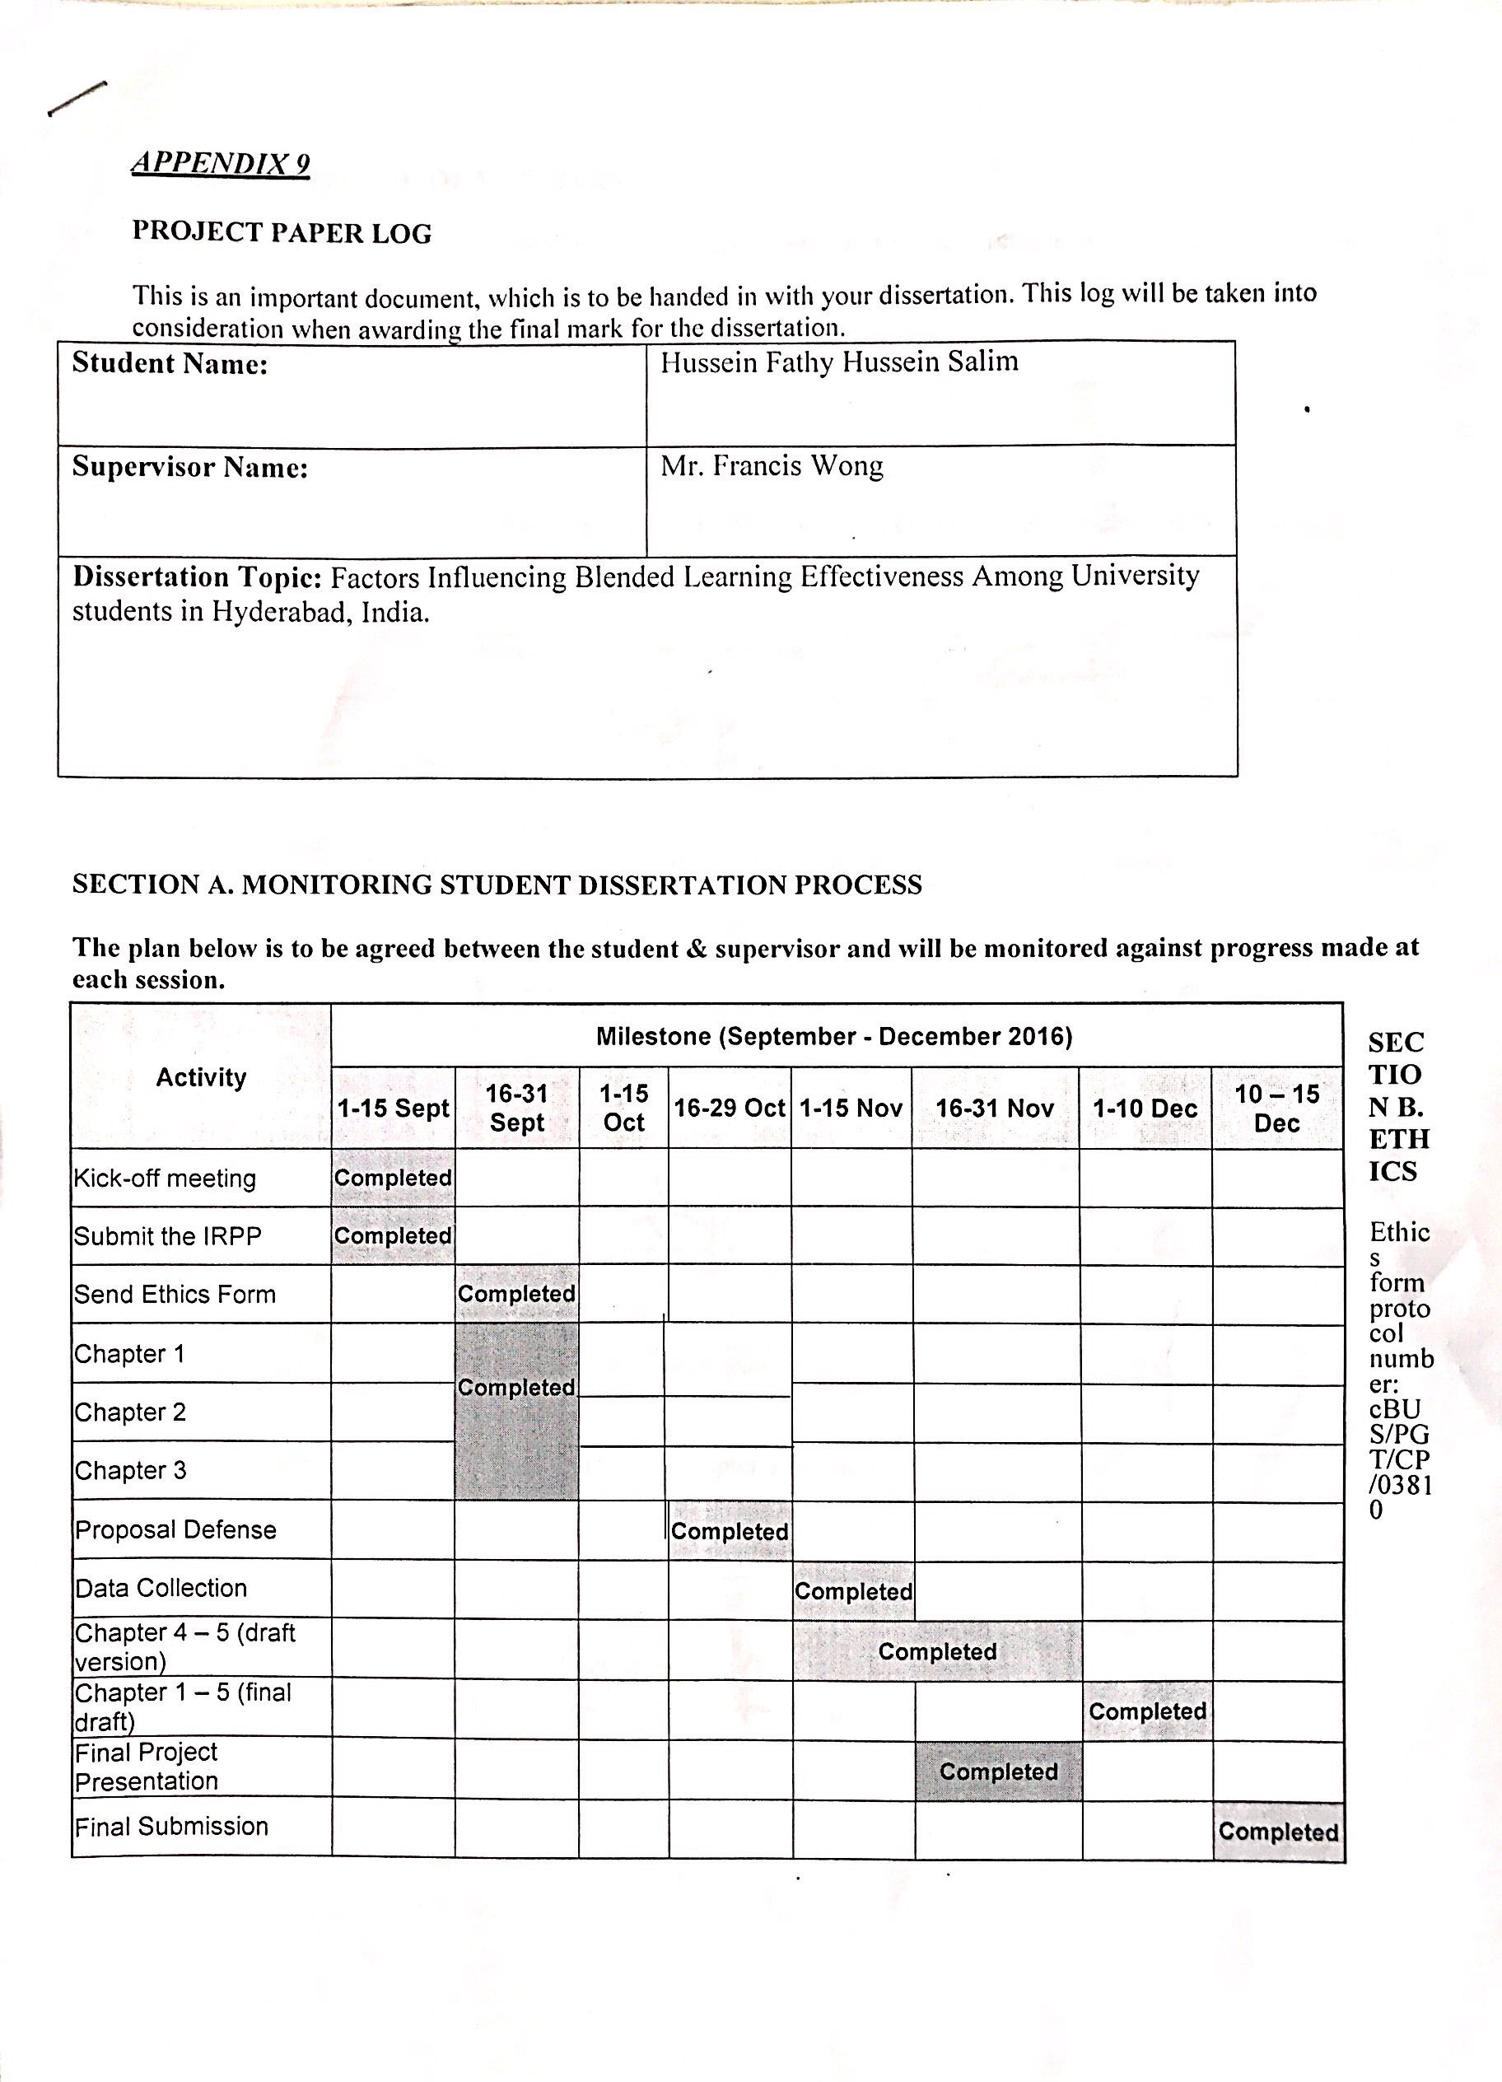
Appendix:
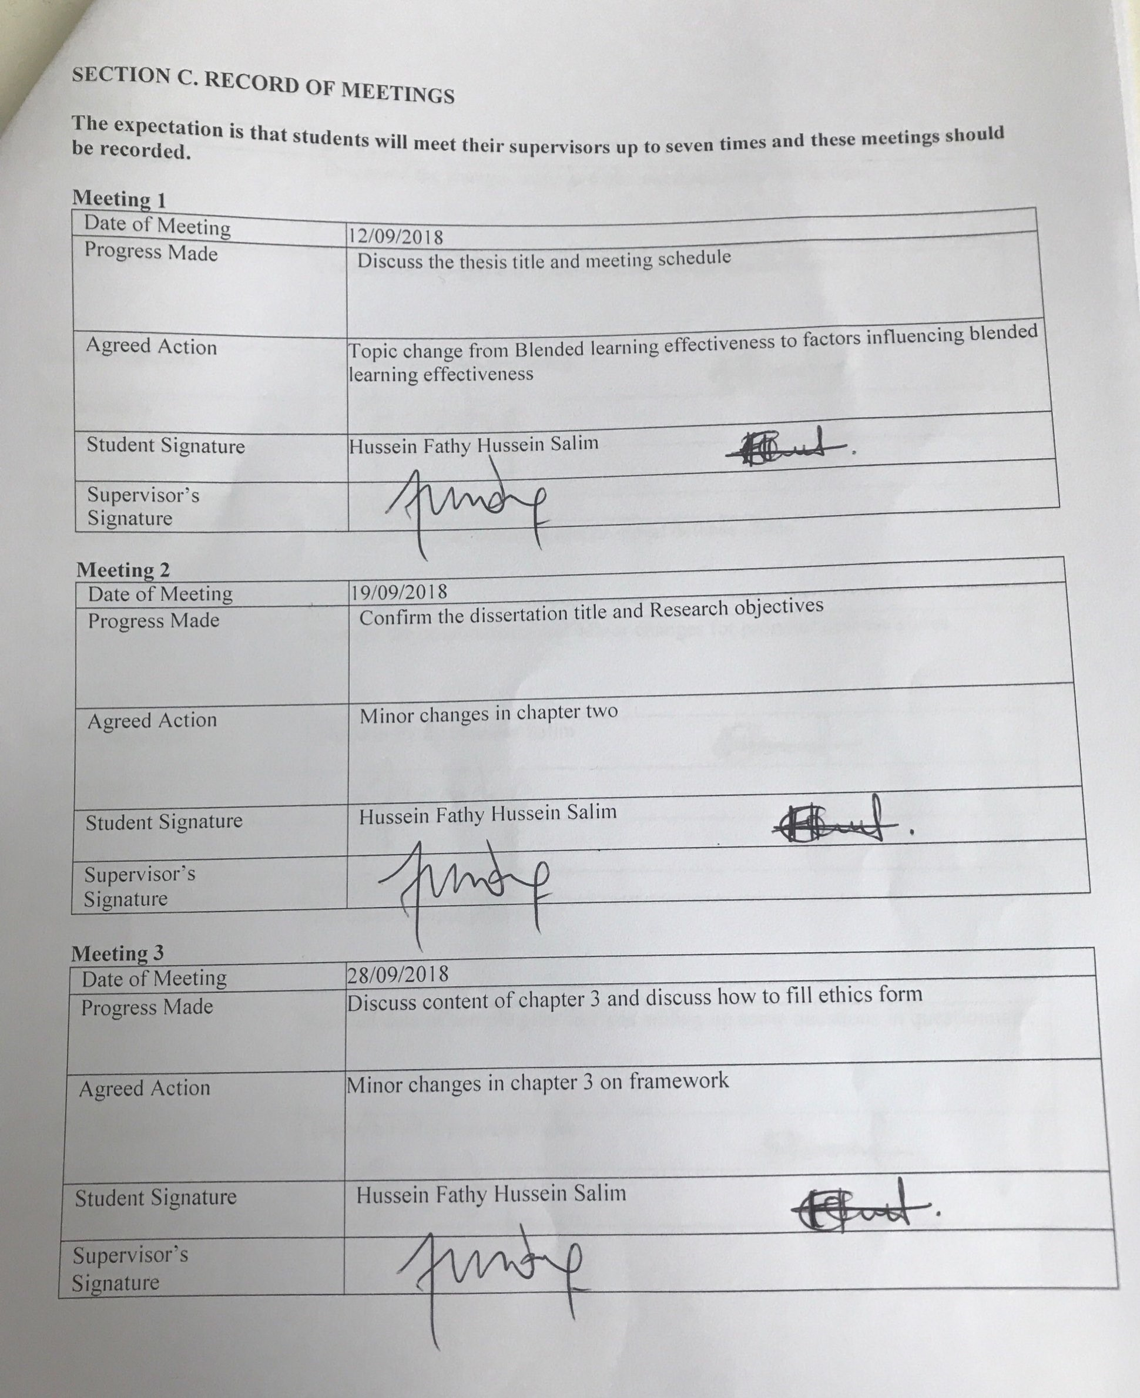
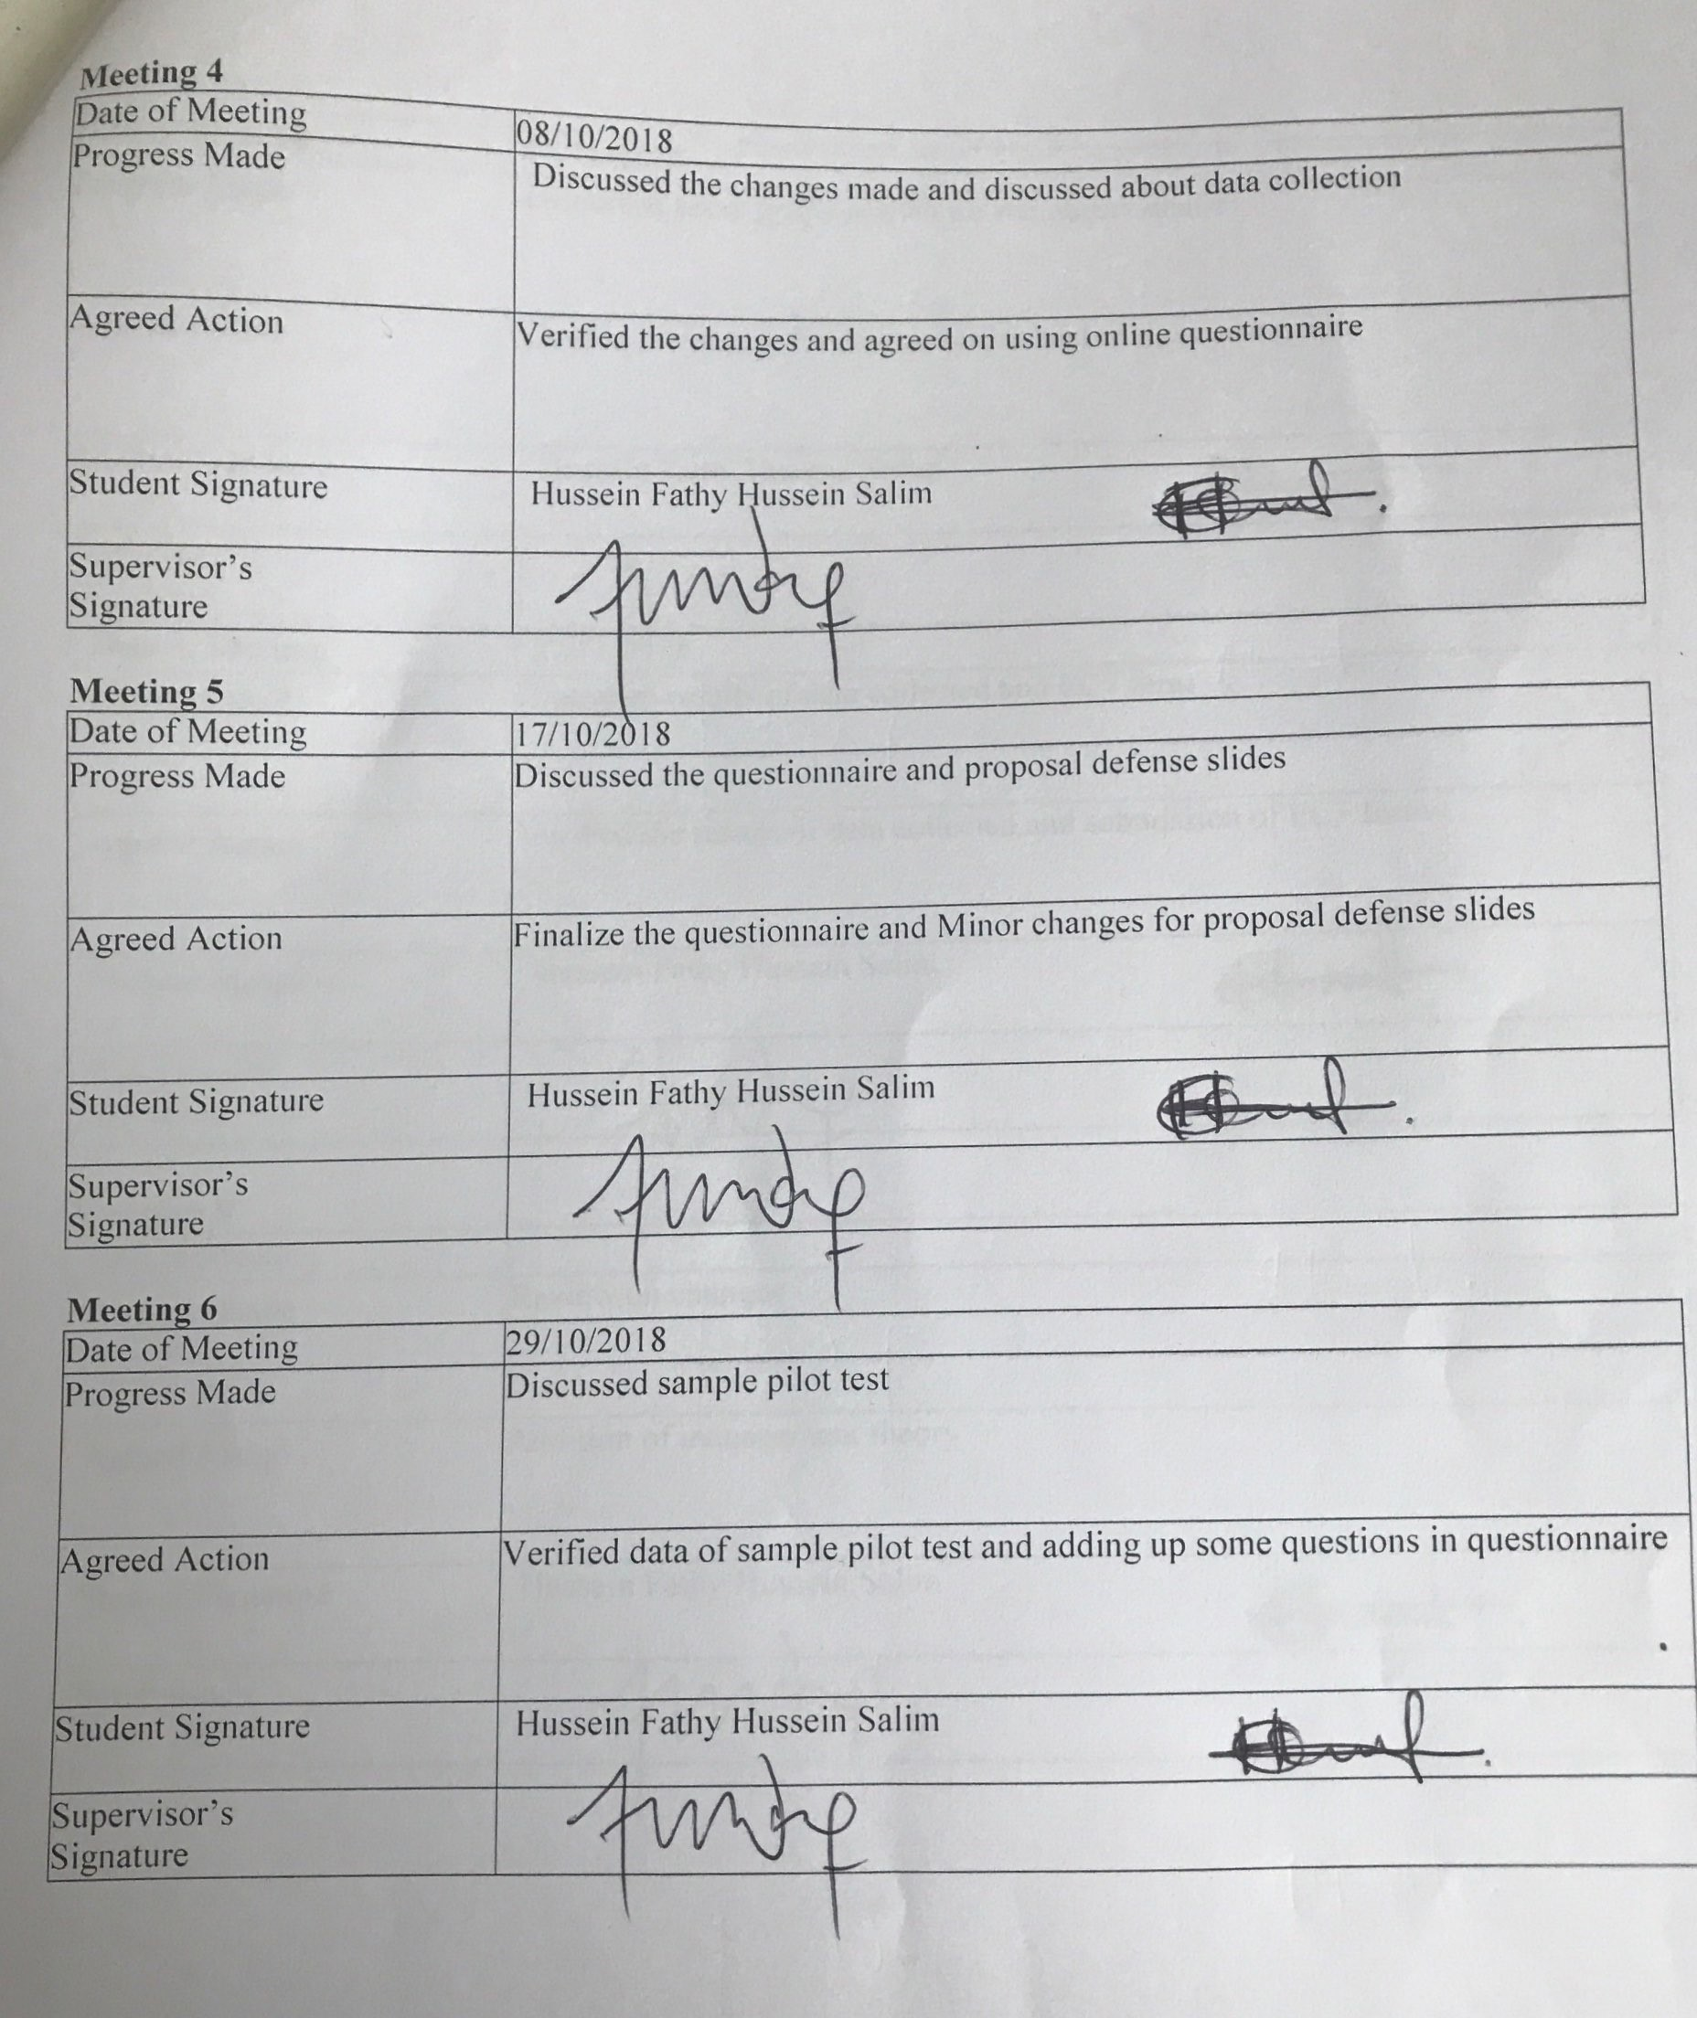
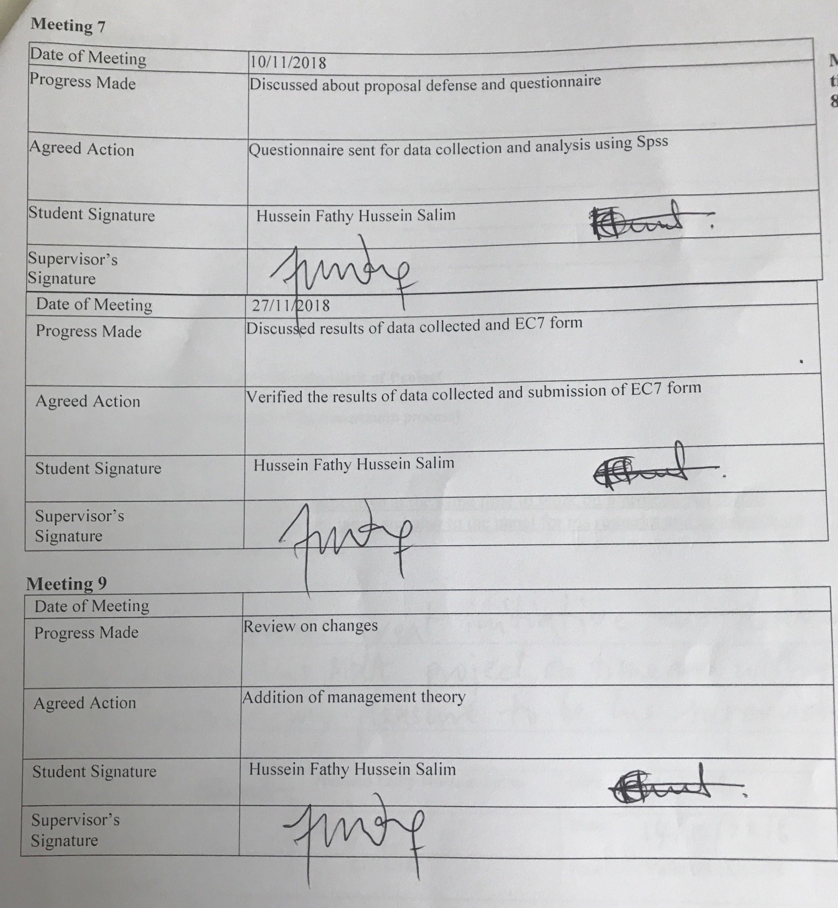

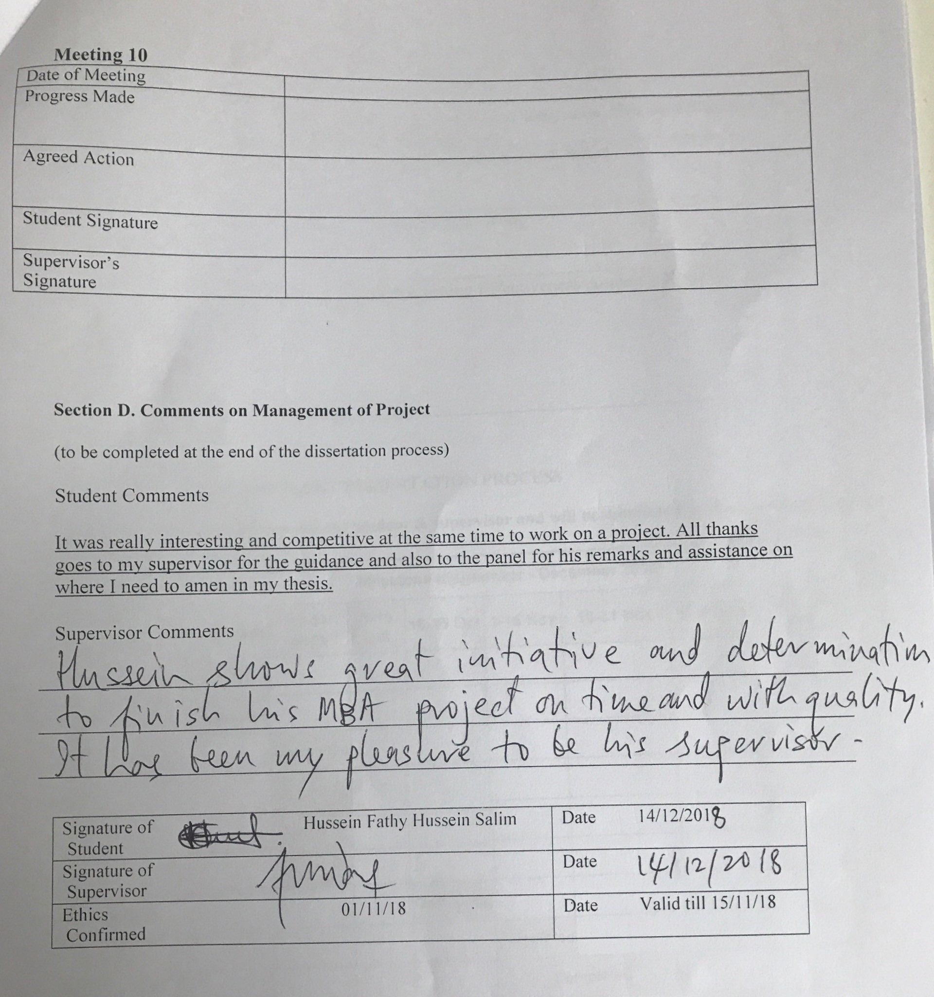

TurnitIn Report:
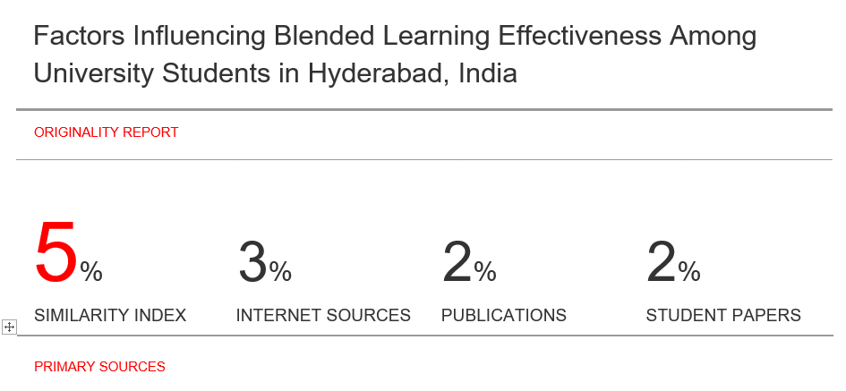

UNIVERSITY OF HERTFORDSHIRE

FORM EC7 – PROTOCOL MONITORING FORM

Ethics Committee with Delegated Authority (ECDA) ………………………………………..

Name of Principal Investigator
(or name of class protocol holder) Hussein Fathy Hussein Salim

Student/Staff ID I18014447

Programme of Study or Module Name MBA

Title of study
(or name of class protocol) Factors Influencing Blended Learning Effectiveness among University students in Hyderabad, India.

UH Protocol Approval Number cBUS/PGT/CP/03810

Date 17th October 2017

Has data collection for this project been completed? YES
If NO, please explain why:

If an extension is required, a Form EC2 will need to be completed and submitted.

Have any of the participants within the study experienced or reported any of the following: (if you answer YES to any of these, you must provide the details)

Physical reaction/harm NO
Mental/emotional harm NO
Intrusion of privacy NO
Breach of confidentiality NO

If the UH Protocol Approval you were originally sent included any conditions (for example supervisor to approve interview schedule prior to data collection), were all conditions complied with? YES

If NO please include any documents and/or information with this form"

DECLARATION (overleaf)
hsetecda@herts.ac.uk ) when you submit your project/dissertation. Failure to submit this Form may result in a breach of the University’s regulations (UPR RE01, ‘Studies Involving Human Participants’, refers)

DECLARATION

Staff applicants

Declaration by staff applicants:
I confirm that I have followed the approved Protocol for this study and, where appropriate, the relevant code(s) and/or practice(s) that apply

Signed (staff) ………………………………………….………..
Date ………………………………………………………………

……………………………………………………………………………………………………………………………….

Student applicants

Declaration by student applicants:
I confirm that I have followed the approved Protocol for this study and, where appropriate, the relevant code(s) and/or practice(s) that apply

Signed (student) …………Hussein Fathy Hussein Salim…………………………………….
Date …28th November 2018……………………………………………………………

Declaration by supervisor:
As far as I can ascertain, the above student has followed the approved Protocol for this study and, where appropriate, the relevant code(s) and/or practice(s) that apply

Signed (Supervisor) …Francis Wong…………………………………………

Please print name: ……28th November 2018…………………………………….….
Date ………………………………………………………………This completed form, together with any relevant documents (where applicable) must be returned to the relevant ECDA (ssahecda@herts.ac.uk
UNIVERSITY OF HERTFORDSHIRE

ETHICS COMMITTEE FOR STUDIES INVOLVING THE USE OF HUMAN PARTICIPANTS
(‘ETHICS COMMITTEE’)

FORM EC6: PARTICIPANT INFORMATION SHEET

1 Title of study

Factors Influencing Blended Learning Effectiveness among university students in Hyderabad, India.

2 Introduction

You are being invited to take part in a study. Before you decide whether to do so, it is important that you understand the study that is being undertaken and what your involvement will include. Please take the time to read the following information carefully and discuss it with others if you wish. Do not hesitate to ask us anything that is not clear or for any further information you would like to help you make your decision. Please do take your time to decide whether or not you wish to take part. The University’s regulations governing the conduct of studies involving human participants can be accessed via this link:

http://sitem.herts.ac.uk/secreg/upr/RE01.htm

Thank you for reading this.

3 What is the purpose of this study?

The aim of this study is to know how effective blended learning is on university students in Hyderabad India.

4 Do I have to take part?

It is completely up to you whether or not you decide to take part in this study. If you do decide to take part you will be given this information sheet to keep and be asked to sign a consent form. Agreeing to join the study does not mean that you have to complete it. You are free to withdraw at any stage without giving a reason. A decision to withdraw at any time, or a decision not to take part at all, will not affect any treatment/care that you may receive (should this be relevant).

5 Are there any age or other restrictions that may prevent me from participating?

Only university students are required to take part in this study and it will involve students in Hyderabad India only.

6 How long will my part in the study take?

15-20 minutes

7 What will happen to me if I take part?

Answer the questions in the questionnaire.

8 What are the possible disadvantages, risks or side effects of taking part?

The time taken to fill the questionnaire and responsiveness from the participants may differ.

9 What are the possible benefits of taking part?

The success of the research of the study.

10 How will my taking part in this study be kept confidential?

Personal data and confidentiality of the applicant taking part will be stored well as online questionnaires will be saved online in form of google documents.

11 Audio-visual material

N/A

12 What will happen to the data collected within this study?

At the end of the study the data will be deleted under secure conditions

<please delete statements below that do not apply>

12.1 The data collected will be stored electronically, in a password-protected environment, for 3 months, after which time it will be destroyed under secure conditions;

13 Will the data be required for use in further studies?

13.1 The data will not be used in any further studies;

14 Who has reviewed this study?

This study has been reviewed by:
<Please delete whichever does not apply:>

14.2 The University of Hertfordshire Social Sciences, Arts and Humanities Ethics Committee with Delegated Authority

The UH protocol number is <enter>

15 Factors that might put others at risk

Please note that if, during the study, any medical conditions or non-medical circumstances such as unlawful activity become apparent that might or had put others at risk, the University may refer the matter to the appropriate authorities.

16 Who can I contact if I have any questions?

+601121319515
I18014447@student.newinti.edu.my

Although we hope it is not the case, if you have any complaints or concerns about any aspect of the way you have been approached or treated during the course of this study, please write to the University’s Secretary and Registrar at the following address:

Secretary and Registrar
University of Hertfordshire
College Lane
Hatfield
Herts
AL10 9AB

Thank you very much for reading this information and giving consideration to taking part in this study.

