
MASTER OF BUSINESS ADMINISTRATION
Job-Hopping Behavior in the Retail Industry of Shanghai, China

Student Name: Hao Bin
Identification Number: I17013849
Program: MBADI
Subject: MGT 7998 MBADI Project
Supervisor: Umi Kalsom
(Final Word Count: 17671)

Faculty of Business, Communication and Law

STUDENT’S DECLARATION
I hereby declare that: I understand the meaning of “Plagiarism” and “Intellectual Property Rights” and Ethics Related to the Principles of Academic Works.
This dissertation is hereby acknowledged as my own work and I have duly acknowledged use of published and unpublished works of other people from the print, electronic and other media.

[Name/Identification Number] Hao Bin/ I17013849

[Signature]
[Date] ________2018/12/02_____________

Acknowledgements
First of all, I would like to thank my professional and kindly supervisor, Umi Kalsom, who has guided me throughout the whole journey. She is always very careful to explain the problem to me, no matter how busy she is. Under her guidance, I not only have a deeper understanding of academics, but also have clear goals for my future career planning. What I want to say is that that am for fortunate that she can become My supervisor.
Secondly, I would like to thank my college, who provided a lot of learning materials to help me to finish my thesis. Meanwhile, I can get a book I want to see in the library and learn a variety of knowledge. The most important thing Is to thank the college for giving me the opportunity to study so that I can become a postgraduate student.
They have me support and confidence in the process of learning. Their encouragement and support have allowed me to persist until now. The spirit of never giving up is one of my original gains. I believe that in the future, I will be successful.

Abstract
Because of the high turnover rate every year, the job-hopping behavior of employees in retail industry in Shanghai, China is worthy of attention. The three factors involved in this research are income level, job satisfaction and working environment with relationship to the job-hopping behavior. The geographic focus of this research is in retail industry in Shanghai, China and the units analyzing is the employees working retail industry in Shanghai. The purpose of this research is to determine the influence of income levels, job satisfaction, and working environment on employee job-hopping behavior in retail industry in Shanghai. Questionnaire surveys were conducted on 400 retail employees using the online questionnaire method, and the study used non-probability sampling. The design of the questionnaire was designed with reference to previous studies.
Key Words: Employee job-hopping behavior, working environment, job satisfaction, income level, retail industry.
Table of Content
STUDENT’S DECLARATION 2
Acknowledgements 3
Abstract 4
List of Figures 8
List of Tables 8
Chapter 1: INTRODUCTION 10
1.0 Overview 10
1.1 Research Background 10
1.2 Problem Statement 12
1.3 Research Objectives 13
1.4 Research Questions 14
1.5 Significance of Study 15
1.5.1 Significance to Academia 15
1.5.2 Significance to Industry 15
1.6 Scope and Limitation of Study 16
1.6.1 Scope of Study 16
1.6.2 Limitation of Study 16
1.7 Operational Definitions 17
1.7.1 Job-hopping Behavior (Dependent Variable) 17
1.7.2 Income Level (Independent Variable) 17
1.7.3 Job Satisfaction (Independent Variable) 17
1.7.4 Working Environment (Independent Variable) 18
1.7.5 Social Exchange Theory (Theory) 18
1.8 Organization of Chapters 19
Chapter 2: LITERATURE REVIEW 20
2.0 Overview 20
2.1 Job-hopping Behavior in Retail Industry of Shanghai, China 21
2.1.1 Job-hopping Behavior in Global Perspectives 21
2.1.2 Job-hopping Behavior in China 23
2.2 Independent Variables for Job-hopping Behavior 26
2.2.1 Income Level 26
2.2.2 Job Satisfaction 31
2.2.3 Work Environment 35
2.3 Income Level, Job Satisfaction and Work Environment with Relationship for Job-Hopping 39
2.3.1 Income Level with Job-hopping 39
2.3.2 Job Satisfaction with Job-hopping 41
2.3.3 Work Environment with Job-hopping 42
2.4 Grounded Theory 45
2.4.1 Social Exchange Theory 45
2.5 Gaps in the Literature 47
2.6 Conceptual Framework 48
2.7 Hypotheses 49
2.8 Conclusion 50
Chapter 3: RESEARCH METHODOLOGY 51
3.0 Overview 51
3.1 Research Design 51
3.2 Unit of Analysis and Time Horizon 53
3.3 Sampling Design 54
3.3.1 Sampling Plan 54
3.3.2 Sample Size 55
3.4 Questionnaire Design 56
3.5 Pilot Test 57
3.5.1 Pilot Test: Factor Analysis 58
3.5.2 Pilot Test: Reliability Test 60
3.5.3 Pilot Test: Correlation Matrix 60
3.6 Measurements 61
3.6.1 Descriptive Information 61
3.6.2 Preliminary Test 62
3.6.3 Hypotheses Test 64
3.7 Conclusion 66
Chapter 4: RESEARCH FINDINGS 67
4.0 Overview 67
4.1 Pilot Test 67
4.1.1 Factor Analysis in Pilot Test 67
4.1.2 Reliability Test in Pilot Test 72
4.1.3 Correlation Matrix Analysis 73
4.2 Demographic Characteristics Description 74
4.3 Preliminary Data Analysis 77
4.3.1 Factor Analysis 77
4.3.2 Reliability Test 81
4.4 Normality test 82
4.4.1 Normal Q-Q Plot 82
4.4.2 Homoscedasticity 84
4.5 Hypotheses Testing 86
4.5.1 Simple Multiple Regression 86
4.6 Summary of Findings 88
Chapter 5: CONCLUSION AND RECOMMENDATION 90
5.0 Overview 90
5.1 The Discussion Between Social Exchange Theory and Research Findings 90
5.2 Contributions 92
5.2.1 Contribution to Industry 92
5.2.2 Contribution to Academia 93
5.3 Limitations of Study 94
5.3.1 Scope Limitation 94
5.3.2 Time Limitation 94
5.4 Future Direction of Research 95
5.5 Conclusion 95
5.6 Recommendation 96
5.7 Personal Reflection 97
Reference 99
Appendix 117
Appendix 1: MBA Project Log 117
Appendix 2 Example of Spine and Cover of the Thesis 123
Appendix 3 Declaration 124
Appendix 4 Title Page 125
Appendix 5 Initial Research Paper Proposal 126
Appendix 6 Turnitin results 132
Appendix 7 Questionnaire 141
Appendix 7 Tables 145

List of Figures
Figure 2.6 Conceptual Framework 51
Figure 3.1 Research Design Framework 55

List of Tables
Table 3.3.2 Table for Determining Sample Size for a Finite Population 59
Table 3.4 Summary Table of Questionnaire 60
Table 4.1.1.1 KMO and Bartlett’s Test (Dependent Variable) 70
Table 4.1.1.2 Communalities of Dependent Variable 71
Table 4.1.1.3 Total Variance Explained of Dependent Variable 71
Table 4.1.1.4 KMO and Bartlett’s Test (Total Independent Variables) 72
Table 4.1.1.5 Communalities of Total Independent Variables 74
Table 4.1.1.6 Total Variance Explained of Total Independent Variables 74
Table 4.1.2 Summary of Reliability Test 75
Table 4.1.3.1 Summary of Correlations (Independent Variables) 76
Table 4.1.3.2 Summary of Correlations (Dependent Variable) 77
Table 4.2.1 Gender 78
Table 4.2.2 Age 78
Table 4.2.3 Education Background 79
Table 4.2.4 Occupation 80
Table 4.3.1.1 KMO and Bartlett’s Test (Dependent Variable) 80
Table 4.3.1.2 Communalities of Dependent Variable 81
Table 4.3.1.3 Total Variance Explained of Dependent Variable 81
Table 4.3.1.4 KMO and Bartlett’s Test (Total Independent Variable) 82
Table 4.3.1.5 Summary of Communalities (Total Independent Variable) 83
Table 4.3.1.6 Total Variance Explained 84
Table 4.3.2 Summary of Reliability 84
Table 4.4.1 Summary of Normal Q-Q Plot 86
Table 4.4.2.1 Normal P-P Plot of Regression Standardized Residual 87
Table 4.4.2.2 Scatterplot 88
Table 4.5.1.1 Model Summary 89
Table 4.5.1.2 ANOVA 89
Table 4.5.1.3 Coefficients 90
Table 4.6 Hypotheses Summary 91

Chapter 1: INTRODUCTION

1.0 Overview
This chapter is an overview of research topics, first explaining the background of Shanghai retail industry in China, and then the problem statement of the research. This is followed by a presentation of research objectives and research questions. This chapter also describes the significance and scope of the research, as well as its limitations. Finally, this chapter describes the operational definitions and the organization of chapters.

1.1 Research Background
In China, each major company provides approximately 10 million jobs each year, but at the same time there are still employee job-hopping and changing jobs happen in the workplace (Pradhan, 2015). According to the Shanghai Statistics Network, 30 percent of employees said had experienced to job-hopping, and an average job-hopping occurred every two years (Salleh, Nair & Harun, 2015). In the current process of globalization and economic integration, companies are increasingly competitive, and employees as a core part of the enterprise are important to enterprises, especially in the retail industry (Vaiman, 2015).
As the core and most important resource in the retail industry, the company's progress and development benefit from the existence of employees, so it is a top priority for enterprises to clarify the reasons for employee job-hopping and prevent it happen (Yang, Wan & Fu, 2016). In China, department stores, supermarkets, large-scale integrated markets, convenience stores, warehouse-style shopping malls, specialty stores, and shopping centers all belong to the retail industry (Xie, 2016). With the continuous improvement of China's reform and opening up, the Western human resource management model has gradually been used by Chinese enterprises, and the employees’ thinking has also changed because of the reasons for reform and opening up (Wong, Osman, Jamaluddin & Chan, 2016). Therefore, the managers of the human resources department should clearly understand the changes in the ideology of the employees at the current stage and the requirements for the positions. (Vaiman, 2015)
The current values of Chinese people are different from traditional values, so it is very important to understand the values of Chinese employees, for example, Chinese employees are more concerned with the company's environment and job satisfaction (Zhao, 2016). Income is still the focus of employees' attention and it is the basis of daily life that employees must consider and higher income will affect the employee's career choices, resulting in job-hopping (Li, 2015). In China, the turnover rate of retail industry is very high, and the reasons why most employees choose job-hopping can be roughly summarized as three types: income, job satisfaction and working environment (Chen, 2016).
Therefore, the purpose of this research is to determine the influence of income levels, job satisfaction, and working environment on employee job-hopping behavior in retail industry of Shanghai in China as the values of Chinese employees may be different from other countries, hence, a verification is needed from this study.

1.2 Problem Statement
With the rapid development of the market economy, China's retail industry has grown rapidly but compared with developed countries, China's retail industry started late, and there are still some deficiencies in management, especially in human resources management (Xie, 2016). There is an excessive loss of employees in China's retail industry and the rapid flow of human resources has become one of the serious problems faced by retail companies in China, at the same time, the current talent job-hopping rate of local retailers in Beijing, Shanghai, and Tianjin is close to 35% (Wang, 2015).
The emergence of job-hopping has already had an influence on Shanghai retail industry and enterprises are worried that the shortage of talent or so-called scarcity of talent (Chen, 2016). With the increasingly fierce competition among enterprises, many high-quality talents will job-hopping to the competition which can meet the requirements, so remedy the problem of the enterprise itself can retain talents (Zhao, 2016). At the same time, the job-hopping rate of grassroots employees is relatively high and according to statistics, the job-hopping rate of grassroots employees in China's chain retailing industry is 20 percent to 30 percent (Liao, 2015).
Higher employee job-hopping rate is a major problem faced by enterprises and managers should seriously consider the strategy of preventing employees’ job-hopping, because cultivating an employee requires the company to spend a lot of resources and no one can accept such losses (Xie, 2016). Despite there have the research on employee job-hopping behavior in other industries but the research on retail industry of Shanghai in China is limited. Therefore, this research can explore the influence of factors on employee choice of whether to job-hop in the retail industry of Shanghai in China.

1.3 Research Objectives
The research objective is an important manifestation of the research direction and the purpose of setting up research objectives is to prove that the current knowledge is reliable while discovering problems in the research field and then making meaningful suggestions (Boiko, 2015). Identifying research objectives can help researchers accurately capture research emphasis and analyze research objectives then make recommendations and comments (Delery & Roumpi, 2017).
The focus of this study is to investigate the influence of income levels, job satisfaction, and working environment on employee job-hopping behavior in retail industry of Shanghai in China.
The specific objectives are:
RO1: To determine whether the income level influence the job-hopping behavior in the retail industry of Shanghai, China.
RO2: To determine whether the job satisfaction influence the job-hopping behavior in the retail industry of Shanghai, China.
RO3: To determine whether the work environment influence the job-hopping behavior in the retail industry of Shanghai, China.

1.4 Research Questions
The setting of research questions is the beginning of a real research, which allows researchers to clearly know which tasks must be completed in the research (George, 2015). Research is a process that is carried out step by step in accordance with order, and research questions determine these orders for researchers (Daher, 2015). Research questions are important because research questions can help researchers reduce the extra steps involved in the research process (Doody & Bailey, 2016).
The research questions are proposed and derived according to the research objectives and are proof of the research objectives (George, 2015), so the research questions are behind to the research objectives. In order to achieve the above research objectives, this research establishes the following research questions.
RQ1: Will the income level influence the job-hopping behavior in the retail industry of Shanghai, China?
RQ2: Will the job satisfaction influence the job-hopping behavior in the retail industry of Shanghai, China?
RQ3: Will the work environment influence the job-hopping behavior in the retail industry of Shanghai, China?

1.5 Significance of Study

1.5.1 Significance to Academia
The results and findings of this study can help enterprise managers improve the ability and effectiveness in managing human resources, and better selection strategies to prevent employees choose job-hopping, Khalid and Kenneth (2015) was also gave considerable support in the study. At the same time, according to the research of Chee Xie (2016), the study also provides factors that influence employee job-hopping, such as income level, job satisfaction and working environment, and the relationship between employee job-hopping in retail companies.
Ahmid, Yazam and ALDamoe (2015) also confirmed the importance of factors influencing employee job-hopping, so it is also reflected in this study and this research can help employers find the solutions to prevent employee job-hopping and achieve academic satisfaction. This research not only deepens the understanding of the factors influencing employee job-hopping, but also supplements Shanghai lack of English-related research in the retail industry, providing a reference for future research.

1.5.2 Significance to Industry
If retail companies can understand the factors that influence employee job-hopping behavior, then companies can choose to propose appropriate strategies and methods to solve the employee job-hopping behavior, which will be very helpful to the enterprise. So, the results of this research can help managers to understand employee job-hopping behavior more widely.

1.6 Scope and Limitation of Study

1.6.1 Scope of Study
The scope of this study is the behavior research of employee job-hopping in the retail industry of Shanghai (Kong, 2015). By proposing appropriate recommendations and solutions, companies can effectively reduce the chances of employee turnover in the retail industry (Wang, 2015). Research in a specific field can propose targeted solutions, so on this basis, this research will do the situation of the retail industry in Shanghai (Chen, 2016). In addition, this study also focused on the discovery of key factors leading to employee job-hopping, which often appear in the mass media and are known by many scholars (Liao, 2015).

1.6.2 Limitation of Study
In the process of completing the research, researchers will face a variety of obstacles when collecting relevant information. First of all, there are only a limited number of English studies in this field, so there are few good English literature available in research of retail industry in Shanghai. This is followed by a scope of limitations. The study focused on the whole of retail industry in Shanghai and did not analyze the local culture and consumption levels of other regions of China. Because the diversity of local culture and consumption levels influences employee job-hopping more or less, but these are not the emphasis of this study. Then, there are limitations in data collection. The target sample is a limited number of 400 Shanghai retail employees from different backgrounds, so it is impossible to fully sense all employees in the Shanghai retail industry. Finally, is time limitation and the time to complete the study is limited, so the researchers must reasonably arrange the time to complete the various parts of the study.

1.7 Operational Definitions

1.7.1 Job-hopping Behavior (Dependent Variable)
The job-hopping behavior is that the company’s employees are not satisfied with the current work situation and turn to another better position (Ganco, Ziedonis & Agarwal, 2015). After the appearance of job-hopping behavior, employees generally do not change the nature and type of work, but only change the company and the environment (Idris, 2015). Retail industry is the individual or company that engages in product marketing activities from producer to consumer who buy goods from wholesalers and manufacturers and sell them to consumers (Wang, 2015).

1.7.2 Income Level (Independent Variable)
Income is the reward that laborers receive by paying the brain power or physical strength while different countries have different standards of income and income can motivate employees to work hard, and monthly bonus can be regarded as income level (Lu & Alon, 2015).

1.7.3 Job Satisfaction (Independent Variable)
The feelings of the work environment, work status, work style, work stress and the challenges faced by employees in the enterprise are collectively referred to as job satisfaction and job satisfaction will have an influence on the development and career of the employees (Walker, 2015).

1.7.4 Working Environment (Independent Variable)
The work environment can be divided into hardware and software which the hardware includes material compensation and labor environment, that can ensure the safety of employees while the software includes corporate culture and working atmosphere to improve employee cohesion (Spence, 2015).

1.7.5 Social Exchange Theory (Theory)
The theory of social exchange belongs to the concept of psychology which insists that human beings can make social decisions on the basis of self-perception, and the gain or benefit can be obtained through action (Gray, 2015). Social exchange theory allows people to judge whether something of current value is suitable for exchange (Bhattacharyya, 2015).

1.8 Organization of Chapters
This study mainly includes the following five chapters:
Chapter 1 Introduction: This chapter outlines the basics of research, including research backgrounds, problem statements, research objectives, research questions, scope of study, limitations, and operational definitions.
Chapter 2 Literature Review: This chapter focuses on a literature review of other scholars and related theories, focusing on the analysis of previous scholars' employee job-hopping and influencing factors. Theoretical support, frameworks and assumptions are also provided.
Chapter 3 Research Methodology: This chapter describes research design, sampling plan, and methods for collecting data. At the same time, this section also introduces the measurement tools used in this study.
Chapter 4 Research Findings: In this chapter, the collected data is analyzed and the results are obtained, and the results are linked to the objectives to obtain research findings.
Chapter 5 Conclusion and Limitation: This chapter summarizes the conclusions and limitations of this study, gives personal reflection, and records the future research directions in this field.

Chapter 2: LITERATURE REVIEW

2.0 Overview
The performance of employees will influence the operation of the organization. Employees in the retail industry are the core of the organization’s operation, so the employee job-hopping will influence the organization’s performance and financial results. This project focuses on the factors that lead to job-hopping. This chapter mainly reviews the job-hopping behavior in retail industry of Shanghai, China and expatiates on the global and local perspectives. At the same time, this chapter also provides a literature review of income level, job satisfaction and work environment. Finally, this chapter uses the theory of planned behavior and social exchange theory, presented conceptual framework, gap in the literature and hypothesis.

2.1 Job-hopping Behavior in Retail Industry of Shanghai, China
Job-hopping is an important event for every person’s career development plan, in general, it is often related to financial income and previous study have shown that an average of 10 percent of wage growth is obtained from work, accounting for about one-third of wage growth (Topeland & Ward, 2015). Different countries have different definitions on job-hopping and the common definition of job-hopping is that employees are dissatisfied with the current situation and move on to a better position (Ganco, Ziedonis & Agarwal, 2015). Idris (2015) pointed out that job-hopping means that employees do not change the nature of work, but often change the company. Most people change jobs because want to get paid, welfare and bonus more than the current company can provide (Yusoff, Queiri, Zakaria & Hisham, 2015). Therefore, job-hopping is inter-organizational shift because after the job-hopping is over, the employee's work nature and organization type may be the same and is an internal shift of the same type of organization, (Idris, 2015).

2.1.1 Job-hopping Behavior in Global Perspectives
In recent years, job-hopping has been hot topic to talk about over the past decade, the world appears a phenomenon that is the company’s employees will move from one position to another position (Vittee & Makhubele, 2016). Although job-hopping is happening more and more frequently in modern workplaces, it can be accepted by companies and job seekers by default (Tambe & Hitt, 2015).
According to Workopolis, one Canadian job-solving website shows that between 2002 and 2012, the proportion of employees who stayed in a position for less than two years rose from 17 percent to 34 percent, and in 2015 it increased to more than 50 percent (Vittee & Makhubele, 2016). It is worth noting that while job-hopping is a global phenomenon, but the general view of this phenomenon will exist two, one is positive the other one is negative and in different countries this kind of situation is unique (Zopiatis, Constanti & Theocharous, 2015). Below, from a variety of countries and regions to understand the global perspectives of job-hopping.
A professional recruitment company in the UK--Robert Half UK, has conducted an investigation as an independent research company and the survey found that employers in the UK still hold negative opinions on job-hopping (Bock, Kankanhalli & Sharma, 2015). From interviews with more than 200 CFOs across the UK, the vast majority of respondents believe that if the interviewee is a job hopper, then the person will not be considered for hiring (TANOVA & Holtom, 2016). Comparing the size of a company, 93 percent of small companies choose to ignore whether employees are job hoppers, followed by 84 percent of large companies and 82 percent of medium-sized ones (Bock et. al. 2015). According to DegreeQuery, a British higher education consultancy shows 90 percent of Millennials who work in the UK will only stay in current positions for three years (TANOVA & Holtom, 2016). This agency believes that the main factors for millennials choosing to job hop in the UK are location, reasonable benefits, good work culture, free work schedules and career opportunities (Vittee & Makhubele, 2016).
According to the US Bureau of Labor Statistics, the average American workers stay in current job for 4.6 years, while younger workers stay in the job for 2.3 years (Tziner & Birati, 2016). At the end of 2015, one employment website called CareerBuilde released a survey of the United States that showed one in five workers decided to job-hopping in the next year (Seibert, Kraimer & Liden, 2016). A survey of 3,300 employees in the United States showed that nearly 21 percent of respondents got a new job in 2016 by job-hopping. That increases 5 percent from last year's survey (Tziner & Birati, 2016). The entrepreneurs in the United States are most concerned with retaining top talent and ensuring that the production efficiency can maintain a stable state and reduce replacement costs, it’s reflected the high job-hopping rate of US employees (Mossholder, Settoon & Henagan, 2016). The Centre for American Progress once released a research report in 2012 and the report estimates that the cost of employee job-hopping accounted for about 21 percent of the employer's income which does not include the cost of recruiting new employees and production losses (Hadlock, 2015).
A company named Kelly conducted a survey of South African companies and the survey results showed that 47 percent of South African employees said that employees are currently working for less than one year (Vittee & Makhubele, 2016). Most of the participants stated that already had two or three jobs since started work, and even 29 percent of respondents indicated that already had changed four or six jobs since started working (Graham, Li & Qiu, 2016). Kelly’s survey on job-hopping found that nearly half of South African respondents considered being job hopper, and that job-hopping is a global phenomenon rather than being concentrated in a specific country or region (Vittee & Makhubele, 2016).

2.1.2 Job-hopping Behavior in China
Remuneration is viewed by young Chinese employees as the most important factor in the emergence of a job-hopping trend (Zhao, 2016). A recruitment agency named Hudson published a report in 2015, according to a report that 75 percent of the 1,262 employees and employers who participated in the survey in China were among those aged 20 to 35 believed that increase income was a priority in job-hopping (Sun, 2016). According to a global salary report released by recruiting expert Robert Walters in 2015, after the Chinese employees switch jobs to new employers, job-hopping people have greater opportunities to increase revenue (Ren, 2016).
According to a survey, between November 2013 to November 2014, white-collar workers with aspirations to job-hopping in China accounted for 50 percent, and white-collar workers who had already job-hopping were nearly 75 percent (Wan, 2015). In 2012, a survey was conducted on students who had already participated in work or had work experience found that 57 percent of people who had graduated from college had a job-hopping in less than three years (Zhao, 2016). Another survey and study by a Chinese website found that 90 percent of workers have considered job-hopping, with 70 percent of the workers surveyed being male and 30 percent female (Zhang, 2015). Furthermore, Highpin-- a Chinese online recruitment website, released a new database in February 2013 and the proportion of users who job-hopping in the data was 42 percent, and by March this figure had raised to 57 percent (Wan, 2015).
In recent years, China’s corporate employee job-hopping rate has gradually increased, with the general employee job-hopping rate nearly 70 percent while the rate of low-level managers job-hopping is 27.7 percent (Huang & Zhang, 2016). The age range of employees who job-hopping is mainly between the ages of 25 and 35, accounting for 56.6percent of the total, followed by employees under the age of 25 accounting for 34.98 percent, it can be seen that Job-hopping is becoming more widespread and younger (Zhang, 2015).
There are three kinds of job-hopping trends in China at present (Shao, 2015). The first is that employees of domestic enterprises change jobs to foreign enterprises (Zhao, 2016). Because China has adopted a series of preferential measures after the reform and development, it has introduced many foreign enterprises, most of which are large transnational enterprises (Qu & Gao, 2015). These foreign enterprises set up various forms of company in China, makes the human resources competition intensifying, especially the competition for talented people reached the white-hot degree, many Chinese workers job-hopping to foreign companies (Shao, 2015).
The second trend is that workers job-hopping from underdeveloped areas to economically developed areas, specifically from the middle and western regions of China to the relatively developed Yangtze River Delta region, the Pearl River Delta region, and from rural areas to major cities (Zhao, 2016). It can be seen from this that enterprises in more developed areas are able to attract more excellent employees, while those in less developed areas are hard to attract excellent employees (Shao, 2015).
The third trend is the collective job-hopping and in many small or medium-sized enterprises, once one or more influential employees have taken the lead in job-hopping then several or a dozen employees will collectively job-hopping (Qu & Gao, 2015). This kind of collective job-hopping will cause job vacancies, which will seriously make the company’s key positions vacant or even produce stagnant and it is more likely that the team leaders will job-hopping with the backbone team and make the original company paralyzed (Zhao, 2016).

2.2 Independent Variables for Job-hopping Behavior
Income in different countries has different standards and scales, and income can be seen as the most influential factor in motivating employees to make the employees work harder, and each month’s financial and reward amounts can be defined as income levels (Lu & Alon, 2015).
Job satisfaction is the psychological state and feeling reflected in the work environment, work status, work style, work pressure, and challenges of the employees during the work of the company and the job satisfaction also influences the personal career of the employees and the development of the company (Walker, 2015).
The working environment includes hardware and software, among which hardware refers to material remuneration and labor environment, which can guarantee the physical safety of employees and software refers to the corporate culture and working atmosphere, which can improve the cohesion of employees (Spence, 2015).

2.2.1 Income Level

2.2.1.1 Global Perspectives
In the United States, part of the company employee’s income including basic salary, bonus, stock option and stock, but the basic salary incentive function is very limited, because it can only satisfy the employee’s basic life safeguard (Pudelko, 2015). Bonuses as part of the employee’s income are mainly determined by the company’s performance and personal performance and it can combine the benefits of both parties, which can both improve the company’s effectiveness and prevent employee’s job-hopping (Hausknecht, Hiller & Vance, 2015). Stock options allow employees to purchase company stocks at a specified price while stock incentives to sell a certain number of stocks to employees at low prices, in this way can increase employee income and reduce company cash expenses (Pudelko, 2015). According to statistics, basic salary of employees in the United States accounted for 32 percent of total income, dividends accounted for 17 percent, and stock options accounted for 51 percent, thereby increasing employee income (Bergkvist & Rossiter, 2016).
In Japan, the income of employees is different, and the incomes of Japanese employees are composed of annual salary series and bonuses (Heckhausen, Schulz & Wrosch, 2015). The system of annual salary series means that employees receive income in the form of salary and bonuses thus contribution of employees to the company determines the amount of bonuses (Campbell, Ikegami & Gibson, 2015). At the same time, Japanese enterprises encourage the long-term development of employees in the company, and the income of employees depends on the length of time employees stay in the company and the size of the contribution to the company (Heckhausen et. al., 2015).
In a German company, the employee’s income generally includes the basic annual salary, annual bonuses and allowances, as well as stock options, but stock options only account for a small portion of the total income (Geraedts, Heller & Harrington, 2015). For example, Deutsche Bank employees can purchase stocks with a certain price for the corresponding option as long as employees have worked in the company for a year and these options can later purchase the same amount of stocks (Campbell et. al., 2015). In addition, employees can not only get annual salary, bonus and other income, but also get a series of good welfare treatment, especially enterprise pension fund (Heinicke & Thomsen, 2015).
In the Western countries, there have study on income from the perspective of economics, the most important is to focus on the determinants of salary, such as the theory of minimum salary, survival salary theory, Adam Smith’s salary differential theory (Kaasa, 2015). From the perspective of management, research on the income system began in the United States and because income has an incentive effect, it analyzes how to effectively play the incentive role of money (Pudelko, 2015). The study of income theory from the perspective of psychology and behavior is mainly focused on motivation, that is, from the perspective of psychology to explore people’s satisfaction with things (Hausknecht et. al., 2015).
The income payment plan is designed to pay employees in a fair and impartial way and its basic function is to provide enterprises with an income structure that attracts and retains effective employees, therefore, its purpose can be achieved through various means (Hsing, Tsao & Devesa, 2015). Kaasa (2015) many of the basic income systems are based on the relative value of positions in an organization being determined for a specific position and the most essential for a perfect basic income is to determine different salary ranges for various positions within the organization.

2.2.1.2 China Perspectives
In today’s economic globalization, the competition of human resources in enterprises also requires a compensation mechanism to ensure that employees’ income can guide and motivate employees to bring benefits and development to the enterprise (Han, 2015). In general, China’s corporate employee income model has followed a foreign framework, and the income of Chinese corporate employees mainly includes basic wages, bonuses, dividends, allowances and benefits (Zhang, 2014).
Luo (2015) proposed that the company’s employee income management is the process of determine and adjust to the elements of wages, bonuses, benefits, and profits. Employee's income refers to the labor remuneration that employees receive through physical or mental labor in the enterprise and reasonable income management can motivate employees and increase employee’s enthusiasm (Li, 2015).
The income of employees should be organically integrated with the goals of the organization, and the existing income distribution system should be improved and a job performance pay system based on job income should be designed (Zheng, 2016). At the same time, the complete transparency of the income of employees and managers is an inevitable trend, because the confidential income obscures the link between income and performance, resulting in unfair (Ji & Wu, 2015).
The problem of employee income is one of the most important issues faced by the leaders of any company or organization and the ideal employee income can be satisfied with both the organization and the employees, so that can achieve better corporate strategic goals (Han, 2015). The core concept of the company's employee income design and management is company formulation scientific employee income strategy and the design of a reasonable income system are all inseparable from the core concepts of “change”, “fairness” and “integrity” (Zheng, 2016). The five principles of employee income design are: fairness, competition, incentives, economy and legality (Li, 2015).
The three fulcrums in China to ensure the reasonableness of employees’ income are fairness, competitiveness, and incentives, and these three main symbols are important guarantees of rationality and key factors influencing employees’ income (Zhang, 2016). Targeting income through income surveys is the basis for guaranteeing revenue competition, and rating the income through job evaluation is the key to ensuring income fairness (Luo, 2015).
At present, there are problems in the income of employees in China, which have brought great negative effects on enterprises and employees (Han, 2015). The first is that the income of employees is inconsistent with the company's business strategy, because at present most Chinese companies implement a unified employee income strategy, which is largely separated from the company's business strategy (Wang & Zeng, 2015). The second is that the design of employee income is not scientific, the scope of employee income survey is narrow, and the lack of reliability of the survey data makes the determination of the employee’s income level unscientific (Liu, 2015). Some companies use a simple sorting method to rank employees and managers, classify position in the same category as the same level, and give employees the same income according to level, reflecting the inherent inequity of employee income (Wang & Zeng, 2015). The third is the lack of transparency in the payment of employees' income, like companies pay wages to employees by using secret payment methods, which leads to a fuzzy income system (Liu, 2015).
The decision and management of the employee’s income have a great influence on the construction of the company’s workforce, its management and maintenance of its competitive advantage (Ji & Wu, 2015). According to the company’s production and operation goals at different times, the company designs a scientific employee income system and adjusts internal labor relations to stimulate employees’ initiative (Zhang, 2014).

2.2.2 Job Satisfaction

2.2.2.1 Global Perspectives
Job satisfaction is the emotional expression and behavioral expression of work and this feeling is influenced by some work-related factors such as income, benefits, recognition, and relationships with colleagues and supervisors (Yilmazel, 2015). Job satisfaction as one of the most important factors of organizational function is easily influenced by the corporate culture and leadership of the company (Girma, 2016). Yaseen (2015) used Maslow’s hierarchy of needs theory and Hertzberg’s two-factor motivation theory to analyze and study job satisfaction.
Employees can positively or negatively evaluate the work through the level of personal goals and the evaluation can indicate the expectations of the work’s contribution and the results (Rosin & Korabik, 2015). In the retail industry, employees leave or job-hopping not only because of job satisfaction, but also include other factors (Mehrad & Mohammad, 2017). The employees’ disappointment in the work and the disillusionment of the career prospects make it less likely to find new jobs or job-hopping (Vitell, Ramos & Nishihara, 2015). The result of employee job-hopping or abandonment of work can be analyzed as to whether the employee is satisfied with the work of the retail industry and whether this work is important and whether can grow and develop at work (Salleh et. al., 2015).
According to a survey, compared with employees whose career development is unsatisfactory, employees with higher job satisfaction have higher loyalty to the company and a lower job-hopping rate (Yilmazel, 2015). There is a positive correlation between employee performance and job satisfaction and employee loyalty to the organization (Alam & Mohammmad，2015). But the job satisfaction does not have a large influence on the company’s turnover, accounting for only 15 percent (Yaseen, 2015).
The survey found that job satisfaction will cause employees to change jobs or job- hopping, so job satisfaction will have a significant influence on employee job-hopping and job change (Moorthy, 2015). Because of the diversity of employee job-hopping behaviors, it is necessary to further understand the intention of employee job-hopping, since only studying job satisfaction will lead to the limitation of employee job-hopping (Rosin & Korabik, 2015).
From a certain level, employee job satisfaction is actually an emotional response of employees to the work attitude (Roos & Eeden, 2015). Many complex and varied factors can influence emotions and form an emotional foundation, like employees feel successful, valued, and happy at work, and employees cannot job-hop (Yilmazel, 2015). If an employee feels unhappy and dissatisfied at work, the situation can be expressed as that the employee has an unsatisfactory job or the employee's job satisfaction is extremely low (Vitell et. al., 2015).
Sometimes employees’ job satisfaction degree are likely to come from the income situation, when income level to achieve the ideal state then employees will feel very satisfied, otherwise will feel dissatisfied with to work (Rosin & Korabik, 2015). The company’s new employees need training and expenses after entering the company, so new employees will have many problems in the process of reaching future job expectations and need more preparation to adapt to the work (Yilmazel, 2015). In addition, the attitude of other colleagues and superiors at work will also have an influence on employees, which will also have an influence on the job satisfaction (Girma, 2016).

2.2.2.2 China Perspectives
The related research on job satisfaction can be divided into two major aspects: job satisfaction influence variables and outcome variables (Nan, 2015). The research conclusion of the influencing factors of employees' job satisfaction is same, and basic factors influencing employees’ job satisfaction can be concluded (Lu, Shi & Yang, 2015).
Work ability, salary, management style, corporate training and colleagues’ relations have an influence on employees’ job satisfaction and there is a certain relationship between employee satisfaction and job performance (Xu & Li, 2015). The evaluation structure of job satisfaction is composed of corporate image, leadership, job return, work cooperation and job (Zhang, Zhu & Chen, 2014). Among them, corporate image includes enterprise system and product management, while leadership including management and recognition of employees’ work and job rewards are benefits and employee development, and work collaboration is mutual respect between employees (Liu & Zhang, 2015).
Employees’ job satisfaction is divided into 5 aspects and contains a total of 16 influencing factors and the five aspects are work, rewards, working background of satisfaction, work relationships and enterprise overall satisfaction (Nan & Xiong, 2015). The age of the employee and the employee’s working time are the two individual factors that influence the employee’s satisfaction (Wu & Yao, 2015). Employee age and working time is one of the largest two individual factors influence employee satisfaction and job stress, employees’ professional ability, the challenge for the employee, the employee’s job autonomy will all influence the job satisfaction (Ding & Han, 2015).
Employee job satisfaction in addition to working environment factors influenced will also be influenced by individual factors, so the influencing factors of job satisfaction can also be divided into two categories, environmental factors and individual factors (Huang, 2015). However, the empirical study on individual factors influencing employee job satisfaction is small, and the conclusion drawn is also very different so organizational behavior scholars and managers tend to start researching from the working environment (Cheng, 2014).
Job satisfaction can also be viewed as a work attitude variable because it influences many outcome variables and in reality, there are more abundant researches on job satisfaction, job performance and employee job-hopping intention (Lu, 2015). There is a positive relationship between employees’ job satisfaction and organizational limitations, and there is also a close relationship between employee job satisfaction and customer satisfaction (Zhang et. al., 2014).
Chinese scholar also has a method of using Grey relational analysis to analyze company employee satisfaction and express employee job satisfaction through quantitative evaluation and combine the Grey system theory with employee job satisfaction (Xu & Li, 2015). Starting from metrics that measure employee job satisfaction, the principal component analysis and cluster analysis methods are used to quantitatively analyze employees’ job satisfaction and this empirical study is simple and effective (Lu et. al., 2015).
By analyzing the factors that influence employee satisfaction, and then integrating the four aspects: work, management structure, performance, and corporate culture then obtained 4P theory of employee job satisfaction that is namely as product, channel, price, and promotion (Liu & Zhang, 2015). The four aspects complement each other, interact with each other, and increase the employee’s job satisfaction from the actual needs of employees (Wu & Yao, 2015).

2.2.3 Work Environment

2.2.3.1 Global Perspectives
The working environment and the surrounding environment will have an influence on employees’ job-hopping intention, so company environments are one of the factors preventing employees from job-hopping (Demet, 2015). There is a positive correlation between the work environment and employees’ job-hopping intentions (Dixit & Bhati, 2015). When employees want to job-hopping, it will cause the company’s productivity to decline and its turnover to decrease (Falola, Ibidunni & Olokundun, 2015). At the same time, when employees have already started to job hopping, it will have a negative influence on the current working environment (Jain & Kaur, 2015).
At the company, all employees work in the same work environment and most of the time employees stay together, so the work environment is important to every employee (Mclaggan, Bezuidenhout & Botha, 2015). In general, if employees are dissatisfied with the current work environment, employees will have the intention to job-hopping to different types of work environment to change the current status and feel the new working environment (Mustapha, 2015).
The working environment is conceptualized, then simplest form of work environment is the environment, circumstances, and situations in which employees work (Umoh, Amah & Wokocha, 2015). Further elaboration of the working environment will find that the working environment covers the physical environment, the working characteristics, the extensive organizational characteristics, and the external organizational background (Yusuf & Metiboba, 2015). In other words, the working environment which is the sum total of the relationship between employees and the superiors, as well as the technical, human and organizational environment in which employees work (Taiwo, 2015).
The work environment consists of three major sub-environments, including the technological environment, the human environment, and the organizational environment (Nakpodia, 2015). The technological environment is the internal tools, infrastructure, equipment, physical factors and technical elements of an enterprise while the human environment includes colleagues, superior leaders, working teams and stakeholders (Demet, 2015). Human environment can also be expressed as the communication between staff activities and social networks, these activities can be formal or informal and in the organizational framework, it is expressed as a superior-subordinate relationship (Yusuf & Metiboba, 2015).
The third sub-environment of the work environment is the organizational environment including the company's culture, values, procedures, operating modes and practices (Mustapha, 2015). Organizational environment is the goal of organizations and output of enterprises to the society, so in this environment, enterprises provide products and services to the society through input, processing and output (Dixit & Bhati, 2015). In the organizational environment, the output process will be influenced by many factors such as customers, social-economic, political, legal, cultural, and stakeholders and these factors will also have an influence on the employees’ spiritual level (Jain & Kaur, 2015).
The work environment can have a profound influence on employees to change the characteristics of employees and the change is not static but with the development of work experience in the organizational environment (Umoh et. al., 2015). The working environment can also be divided into two types, the beneficial environment and the harmful environment (Falola et. al., 2015). The beneficial work environment can bring employees a pleasant experience and help employees achieve the goals, while the harmful work environment will make employees feel disappointed and reduce the work enthusiasm (Mustapha, 2015). The beneficial work environment can also change those irresponsible employees, and make these employees become serious and responsible for the work, gradually in line with the work environment (Taiwo, 2015).

2.2.3.2 China Perspectives
The working environment includes hardware and software, which meet the needs of employees and the goals of enterprises from different levels (Guo, 2015). Hardware includes material rewards and labor environment, in which material rewards can motivate employees, and labor environment can improve work efficiency while ensuring employees’ physical safety (Xing, Zhang & Yin, 2016). Software includes corporate culture and working atmosphere, in which a good corporate culture and working atmosphere can improve the cohesion of employees and promote the development of enterprises (Yao, 2015).
The core connotation of labor environment is labor safety and labor hygiene (Du, 2015). Labor safety management refers to all kinds of protection measures that the state requires enterprises to take in order to improve working conditions and protect the safety and health of workers in the process of labor (Yao, 2016).
The core principle of labor safety is safety first, and prevention is the main one (Lu, Ling & Fang, 2015). The safety first is that the company puts the safety of its employees first in the production process (Sun & Jiao, 2015). Prevention is to take effective measures to prevent the occurrence of hidden danger and casualties (Yan & Chen, 2016). Labor hygiene includes lighting and color, noise, greening, temperature and other aspects (Zhou & Guo, 2016).
After people meet the basic physiological and security needs, there is a higher level of social, respected and self-fulfilling needs (Xing et. al., 2016). Therefore, the harmonious interpersonal relationship within the organization is crucial to the growth and development of the organization and its employees (Yao, 2015).
Good interpersonal relationship at work will make employees physically and mentally healthy and happy, which will lead to a smooth work and life (Guo, 2015). On the contrary, tension in interpersonal relationship will definitely make employees feel irritable and depressed, and serious mental imbalance will lead to mental illness (Du, 2015).
In certain circumstances, the employee’s individual behavior will be influenced by the influence of crowd behavior and different interpersonal situation will lead to different emotional experience (Lu et. al., 2015). Employees treat each other with sincerity, solidarity and friendship, the cohesion of the organization will continue to increase, and the benefits of the company will continue to rise (Sun & Jiao, 2015). Good interpersonal relationship can fully stimulate the enthusiasm, initiative and creativity of employees, improve the work efficiency of employees, and enable the efficient and rapid development of enterprises (Zhou & Guo, 2016).
The working environment is the basis for employees to engage in work activities and 90 percent of the organizational performance comes from the organizational environment and only 10 percent depends on the personal quality of employees (Yao, 2016). The work environment as the core content of the organizational environment is closely related to employee self-efficacy and performance (Guo, 2015).
Different factors in the working environment will influence employees, and the communication between employees and senior management will also influence employees’ performance and corporate performance (Xing et. al., 2016). It can be found that in the organization, most employees and supervisors have contradictions, which is not conducive to the long-term development of individuals and organizations in this work environment (Sun & Jiao, 2015).

2.3 Income Level, Job Satisfaction and Work Environment with Relationship for Job-Hopping

2.3.1 Income Level with Job-hopping

2.3.1.1 Global Perspectives
The employee’s income level will cause the employee to make job-hopping intent and even if the job position can make the employee happy but the employee is not satisfied with the income, the employees also want to job-hopping (Heinicke & Thomsen, 2015). If the employees of the company think that the current job can get a high income, then the job-hopping behavior of employees will be very low (Bergkvist & Rossiter, 2016). This also shows that the reasons for employee job-hopping include limited salaries and inadequate benefits and employees will complain about the current working environment, and even work and organization (Huang & Zhang, 2016).
At the same time, when employees appear to be making a career change, the company can change employees’ ideas by paying more than the current salary, and employees will choose to stay in the company to serve the company (Hadlock, 2015). After employees move to other organizations, employee will talk with new colleagues about salary issues for new jobs, and then work hard in new positions to obtain higher income and meet economic needs (Hsing et. al., 2015).

2.3.1.2 China Perspectives
Working relationship between mobility and income is very important in theory, but in fact are often ignored, young employee’s job-hopping can make income increase, but the salary increase will reduce with the increase of age (Han, 2015). Most employees will have a one-third increase in income after job-hopping and the income of job-hopping people will usually be higher than others (Luo, 2015). The change of income caused by job-hopping can be divided into short-term income changes and long-term income changes, and high-frequency job-hopping in exchange for income improvement is achievable (Zheng, 2016).
Both the long-term and short-term income of the job-hopping people are positively changing, which means that as long as employees change jobs, the income will increase (Wang & Zeng, 2015). In order to obtain high incomes, the benefits gained by employees through job-hopping are far greater than those employees stick to the original positions, and career development is further improved (Liu, 2015). Internal and external job-hopping is the path of career development, and both of these approaches will increase income, among that the internal work transfer having the greatest influence and employee income will increase as the number of transfers increases (Li, 2015).

2.3.2 Job Satisfaction with Job-hopping

2.3.2.1 Global Perspectives
When the employee’s job satisfaction is combined with various factors of job, the employee will become extremely sensitive to the satisfaction requirement (Mehrad & Mohammad, 2017). The employee's job satisfaction standard and work obligations are influenced by income opportunity, employee attendance rate and employee punctuality (Salleh et. al., 2015). In addition, Trevor investigated and studied whether there is a positive correlation between employee job satisfaction and job commitment (Vitell et. al., 2015).
When the employee’s evaluation of job satisfaction is low, the employee will have negative emotions and not serious at work, and finally there will be job-hopping behavior (Roos & Eeden, 2015). The organization’s incentive method will also influence the employee’s job satisfaction, this match with Maslow's demand theory and the highest level of demand is self-realization, so employees with high job satisfaction do not choose to change jobs in order to achieve self (Moorthy, 2015).

2.3.2.2 China Perspectives
Once employees are not satisfied with the jobs, it will directly lead to the idea of job-hopping or changing jobs, which is the intention of job-hopping (Liu & Zhang, 2015). Job satisfaction has always been an important factor in the study of employee job-hopping and in the framework of employee stability job satisfaction is an important variable that determines the stability of the entire system (Zhang et. al., 2014). The study of employee job satisfaction and job-hopping is the result of the continuous evolution of the management level of contemporary enterprises (Xu & Li, 2015).
According to the current research results, there is a significant negative correlation between job satisfaction and job-hopping, and the higher the job satisfaction, the lower the chance of job-hopping (Nan, 2015). Because of the different nature of the company, the employee’s job satisfaction and job-hopping intention will be different (Wu & Yao, 2015). For example, the connection between the employee’s job-hopping intention and job satisfaction in the foreign-funded enterprise will be closer (Huang, 2015).

2.3.3 Work Environment with Job-hopping

2.3.3.1 Global Perspectives
The working environment includes various work-related factors, such as the size of the workplace, the comfort of the workplace, the ambient temperature, humidity and brightness, which will influence the employees' physical and mental health (Jain & Kaur, 2015). It is worth noting that unhealthy and unsafe working environments can cause mental or physical harm to employees, and some damages may be irreparable (Mclaggan et. al., 2015). In this fiercely competitive era, organizations with excellent work environments are more likely to be recognized by employees and if the current work environment cannot meet the requirements, employees will choose to job-hopping (Mustapha, 2015).
Employees want to be able to work in a safe and comfortable atmosphere and this environment can improve the efficiency of the employees (Yusuf & Metiboba, 2015). The best working environment is to fit the entire organization's employees, adjust the lighting, temperature, and humidity in the work environment to the right conditions to meet employee requirements (Taiwo, 2015).

2.3.3.2 China Perspectives
Well-run companies will provide employees with the most satisfactory working environment as possible to ensure the safety of the employees and enable employees to work stably, which can reduce employees’ intention to job-hopping (Yao, 2016). Good relationship between the superior and colleagues in the work can greatly improve labor productivity, and it also can better acquire and retain capable employees to continue to serve the organization (Sun & Jiao, 2015).
Satisfactory work environment enables employees to have a sense of belonging in the work, fundamentally eliminate the intention of employees to change jobs and a good working environment enables employees to actively cope with the pressure of work (Lu et. al., 2015). The strong sense of responsibility of employees will allow employees to cherish the own work environment and job opportunities, greatly reducing the chances of employee job-hopping (Zhou & Guo, 2016). Therefore, paying attention to income level, job satisfaction and work environment is very important to the influence of employee job-hopping and only by understanding these factors can companies solve employee job-hopping.

2.4 Grounded Theory
In this project, used the theory of social exchange to support this research

2.4.1 Social Exchange Theory
Social exchange theory is a psychological concept, which holds that human beings make social decisions on the basis of self-cognition that can obtain value and benefits through action or inaction (Gray, 2014). The theory emphasizes the establishment of human relationships through subjective costs, benefit analysis, and comparison of multiple choices (Daher, 2015). The main characteristics of social exchange theory are interdependence and self – interest and people use this theory to decide whether valuable things in the hands can be exchanged (Bhattacharyya, 2015).
In social exchange theory, when individuals perform a series of activities, such as when an employer takes employees seriously, a sense of responsibility arises in the process of exchange, and employees perform the responsibilities in an effective manner (Cropanzano & Mitchell, 2015). Social exchange theory has been successfully applied to explain the job-hopping behavior of employees in organizations, which proves the process of making correlations and maintain (Fu & Deshpande, 2015).
When employees’ income level, job satisfaction and working environment cannot meet the social exchange theory or based on the theory of social exchange (Bhattacharyya, 2015), employees believe that other companies or organizations can better meet the exchange ideas than the current company, then employees will choose to job-hopping to find a better situation, so used this theory to study the job-hopping of Shanghai retail employees (Cropanzano & Mitchell, 2015).

2.5 Gaps in the Literature
Research on employee job-hopping has existed and proved the influence of employee job-hopping behavior (Nair & Salleh, 2015). However, most of the scholars’ research on job-hopping is still concentrated in other industries such as banking, hotels, and nursing industries (Fu & Deshpande, 2015; Kashmoola, Ahmad & Yeoh, 2017; Yean & Yahya, 2015). Few scholars have analyzed job-hopping factors from the perspective of the retail industry (Yusoff et. al., 2015), especially in the context of Shanghai.
There are many studies on employee job-hopping behavior in other industries in China (Fu & Deshpande, 2015; Huang,2015; Jing, 2015), but there are limited studies on employee job-hopping in Shanghai retail industry, so there is still an academic gap in this area. This research can understand the influence of income levels, job satisfaction, and working environment on employee job-hopping behavior in retail industry of Shanghai and help enterprises prevent employee job-hopping.

2.6 Conceptual Framework
The figure 2.6 is a conceptual framework which designed according to the research that influence employee job-hopping in Shanghai retail industry, among which the independent variables include employee income level, employee job satisfaction and employee work environment.
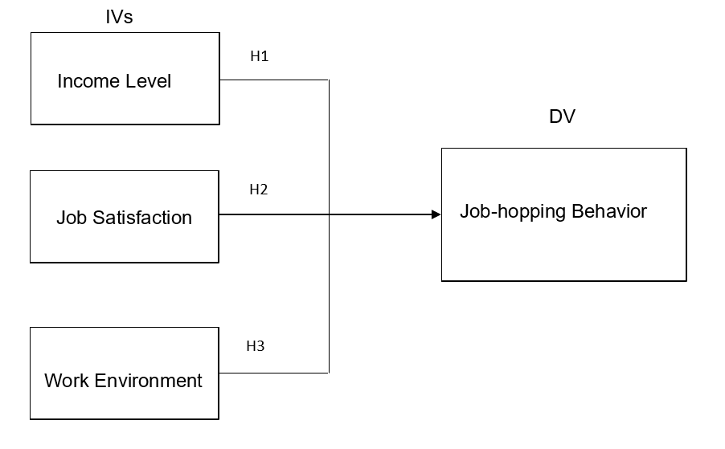
Figure 2.6 Conceptual Framework

2.7 Hypotheses
Based on the research objectives and the literature materials, the research hypotheses are as follows:
H1: Income level has a significant influence on the job-hopping behavior in the retail industry of Shanghai, China.
H2: Job satisfaction has a significant influence on the job-hopping behavior in the retail industry of Shanghai, China.
H3: Work environment has a significant influence on the job-hopping behavior in the retail industry of Shanghai, China.

2.8 Conclusion
The significance of employees to the organization is very important. Any organization that leaves the employees cannot operate normally. The employee’s job-hopping will have many negative influences on the organization. Therefore, it is necessary to study the employee’s job-hopping behavior. This chapter is based on a study of the independent variables that influence employee job-hopping, such as employee income levels, employee job satisfaction, and employee work environment. All of the literature in this chapter supports employee income levels, employee job satisfaction, and employee work environment influence on job-hopping.

Chapter 3: RESEARCH METHODOLOGY

3.0 Overview
This chapter explaining the research methodology used in this research. The research design is reviewed first and linked back to the framework in chapter two, and then is the analysis unit and time horizon, followed by the sampling design and the questionnaire design. Beside discuss the measurement instruments selected in this research, data collection and generalization. Finally, a discussion of effectiveness, reliability and conclusions.

3.1 Research Design
After setting up the variables and frameworks, the relevant information and data are collected through research design, and the collected data and information are used to analyze and study the determined independent variables and dependent variables (Ridder, 2017). Research design is the guiding blueprint for research that maximizes the control of factors that may interfere with the validity of the research findings (Jennifer, 2017). Parahoo (2015) defines research design as a plan to describe how, when, and where to collect and analyze data.
Research design is important for a research and research design has an extremely important influence on the reliability of the results obtained by the research, so the research design provides a solid foundation for the whole research (Saunders, Lewis & Thornhill, 2015). Research design allows many research operations to go smoothly, ensuring that research is as effective as possible, while maximizing information with less effort, money and time (Jolles & Martinez, 2017). Figure 3.1 shows the research design used in this research.
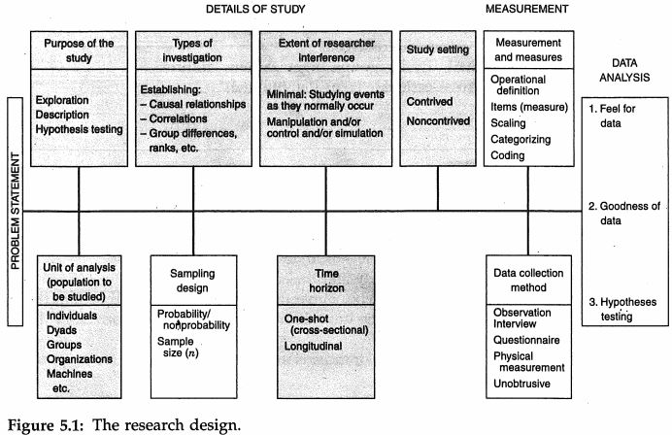
Figure 3.1 Research Design Framework
Source: Sekaran & Bougie (2017)
This research is quantitative descriptive correlation design. Quantitative research produced numerical data for this study and quantitative methods are generally called deductive methods, in a manner, it is an inference of population characteristics (Saunders, et al., 2015). The purpose of quantitative research is to use quantitative information to express, estimate and test theory (Cooper & Schindler, 2015). This study is a descriptive research because it examines the relationship between income levels, job satisfaction, and work environment with job-hopping behavior (Mertler & Reinhart, 2016). This research is also a correlation design in order to establish the relationship between independent variables and dependent variables in the research (Kumar, 2014). According to the correlation research the purpose of this research is to determine the influence of income levels, job satisfaction, and working environment on employee job-hopping behavior in retail industry of Shanghai in China.
The extent of interference in this research is minimum, because the study used the form of a questionnaire and was based on a co-relationship study of the workplace’s natural environment, the researchers had less interference in the workflow (Shan, 2015). The environment of this research is non-contrived, because correlation research has always been performed in a non-designed environment, and causal studies are the most rigorous and are carried out in man-made laboratories (Hwang, 2017).

3.2 Unit of Analysis and Time Horizon
The analysis unit is regarded as the main content of the research and the data can be analyzed in the subsequent data analysis stage, so the individuals of Chinese can be selected for data collection (Chen, 2016). Therefore, the unit of analysis is the individual of job-hopping behavior among Chinese in Shanghai retail industry and due to different participants, the expected results of the questionnaire will be different, because these employees are employed by different retail companies in Shanghai (Wang, 2015).
The time horizon is important to the results of the study, and specific research objectives will influence the duration of the study (Gounaris & Boukis, 2015). The time scale used in this research is a cross sectional study, which is to collect data from interested populations at the single moment in time, that is to say, collected questionnaire at the end of the answer and once only from the respondents (Zikmund, Babin, Carr et.al., 2015).

3.3 Sampling Design
The sample design is usually chosen to measure the unit of the sample, and the sampling technique can be divided into two types, one is probability sampling and the other is non-probability sampling (Saunders, et al., 2015). Researchers look for the right population, individuals and regions to conduct the sampling process (Park & Park, 2016). Sampling design is important because it guides researchers in extracting samples from research objectives, and the right samples ensure that data collection and analysis are valid for the results (Reams, Nicholls, Hair & Baker, 2017).
In this research, the population is individual. Because in retail industry employees are very important for the companies, employees are the core of the companies, so use employees in the retail industry as the population can find reasons why the employees choose to job-hopping and help companies avoid employees job-hopping behavior happened.

3.3.1 Sampling Plan
The formulation and design of the sample plan is based on quality requirements and mathematical statistical theory (Tomohiroa, Arizonoa & Tak, 2016). The sample plan is a detailed outline of when, what materials, what methods and who will make the measurements, and the sample plan produces data that includes representative samples of the parameters of interest (Aslam, 2017). The sampling method has probability sampling and non-probability sampling, wherein probability sampling gives equal opportunities to each unit of the population and is randomly selected for research (Saunders, et al., 2015). Non-probability sampling is a method for researchers to select samples according to the convenience or subjective judgment of the research (Yang, Xing & Wang, 2017). So, in this research, the researchers selected convenience sampling in non-probability sampling to measure the sample units, because the respondents of this research are the retail employees in Shanghai, the questionnaire is sent to this group of people instead of anyone.
Through the understanding of the above two sampling methods, this research used the method of convenience sampling in non-probability sampling. Because in the convenience sampling, the sample is limited to a part of the population that is easy to extract (Saunders, et al., 2015), convenient sampling is the simplest method of non-probability sampling, saving time and money, because the time for doing research is only a few months. Therefore, convenience sampling in non-probability sampling can meet the requirements of this research.

3.3.2 Sample Size
The sample size measures the number of individual samples or the results of the experiment and it is the number of individual samples or observations that must be set in each statistic, and the choice of sample size is the key determinant of the study (Ridder, 2017). Krejcie and Morgan (1970) created a table to clarify the sample size and to select the correct sample size.
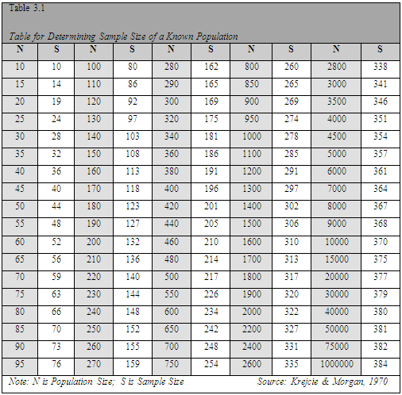
Table 3.3.2 Table for Determining Sample Size for a Finite Population
Source: Krejcie and Morgan (1970)
According to the Shanghai Municipal Statistics Bureau in 2017, Shanghai has 4 million employees in the retail industry and is expected to reach 4.2 million in 2019 (Shanghai Municipal Statistics Bureau, 2017). As can be seen from the tables of Krejcie and Morgan (1970), the population size of 1,000,000 needs to set a sample size of 384. Therefore, it is expected that 400 online questionnaires will be distributed within two weeks to conduct a questionnaire survey of 400 Shanghai retail employees. Assuming 63% of the responses to the questionnaire are valid, then the number of valid online questionnaires is 250, which is have enough power to statistical significance.

3.4 Questionnaire Design
The data collection technique of the questionnaire system consists of a number of questions and requires participants to answer the listed questions to determine the participants’ attitudes and the problem setting is the questionnaire design (Lavrakas, 2015). The researchers divided the online questionnaire into three parts: A, B, and C. Part A is the demographic profile. Part B and C use the Likert scale format of five-point to represent the measurement concept. The “strong disagree” is 1, “Strongly agree” is 5. In Section B, respondents were asked to answer questions about independent variables: income level, job satisfaction, and work environment. In Section C, respondents were asked to answer the question of dependent variables, which is job-hopping behavior in retail industry of Shanghai, China.
Section | Variable | Items | Source
A | Demographic | 4 | Hooi (2007); Milman (2003)
A | Profile | 4 | Hooi (2007); Milman (2003)
B (Independent  Variables) | Income level | 5
B (Independent  Variables) | Income level | 5 | Heinicke & Thomsen (2015);
B (Independent  Variables) | Income level | 5 | Lu & Alon (2015)
B (Independent  Variables) | Job Satisfaction | 5 | Alam & Mohammad (2015);  Mehrad& Mohammad (2017)
B (Independent  Variables) | Work Environment | 5 | Mclaggan, Bezuidenhout & Botha (2015);
B (Independent  Variables) | Work Environment | 5 | Spence (2015)
C (Dependent | Job Hopping | 5 | Ganco, Ziedonis & Agarwal (2015);
Variable) | Behavior | 5 | Nouri & Parker (2015)
 |  | 5 | Robinson (2015)
Table 3.4 Summary Table of Questionnaire

3.5 Pilot Test
Before starting formal quantitative studies, a small sample size must be tested, and this test is called a pilot test (Hwang, 2017). In general, in an experimental study of a large sample size, pilot testing can provide meaningful reference value (Copper & Bramwell, 1992). In the pilot test, the sample size used was 10% of the total sample size of the study (Barnham, 2015). The total sample size of this study is 384, so according to the above situation, the sample size of the pilot test is 40, which is distributed online questionnaire for the pilot test of 40 employees working in Shanghai retail industry. These 40 sample size data are then used to perform factor analysis, reliability test, and correlation matrix to determine if the data is sufficient for the research (Boari & Ruscone, 2015).

3.5.1 Pilot Test: Factor Analysis
Factor analysis is a method which often used in statistics to observe and describe the variability between dependent variables and independent variables (Çokluk & Koçak, 2016). It is called a factor because there may be some variables that are not observed in the variable (Dodou, 2015). In factor analysis, the researchers reduced the number of variables to be analyzed by increasing the high correlation of variables by reducing dimensions (Jolles & Martinez, 2017).
KMO Bartlett’s Test of Sphericity
Factor analysis of the collected data involves KMO Bartlett's spherical test, which determines whether the data collected and the items in the structure are relevant and can be analyzed in the next step (Kumar, 2014). The range of KMO values is from 0 to 1, so when the value of KMO is greater than 0.6, there is a strong correlation between variables, and the original variables are suitable for factor analysis (Zheng, Wei, Zhang & Yang, 2016). Conversely, when the value of KMO is less than 0.6, it indicates that the correlation between variables is weak, and the original variable is not suitable for testing in factor analysis (Hitczenko, 2015). In the Bartlett's spherical test, the independent variable and the dependent variable are run separately and if the value of the independent variable is less than 0.6, it indicates that the independent variables are wrong and needs change independent variables (Mertler & Reinhart, 2016). If the value of the dependent variable is less than 0.6, the number of questions with the dependent variable are insufficient, and the number of questions needs to be increased (Zikmund, et al., 2015).
Factor Loading
The factor load is part of the results of the factor analysis, which can be a reduction in data (Otten & Riet, 2018). The role of the factor loading is to rank the factors that influence the questionnaire items by importance (Stochi, Jones, and Perez, 2016). If the value of the factor loading is greater than 0.6, it indicates that the factor has a strong influence on the variable (Dodou, 2015). If the value of the factor loading is less than 0.6, then the questions in the variable needs to be changed but if the value of the factor loading is greater than 0.5 and less than 0.6, the retention questions can be selected, because the sample size of the pilot test is 10% of the total sample size, it will be some deviation (Cooper & Schindler, 2015).
Eigenvalues
The eigenvalue is an important component of the variance, and each factor has an eigenvalue when doing factor analysis (Çokluk & Koçak, 2016). The eigenvalues represent how many variances the factor can interpret in all variables, and the eigenvalues must be greater than 1, and the number of eigenvalues is equal to the number of independent variables (Kumar, 2014). If the eigenvalue is too small, it means that this factor can only explain a very small number of variables, which is not helpful to reduce the number of variables (Zheng, et al., 2016).

3.5.2 Pilot Test: Reliability Test
Reliability test is the use of relevant programs to calculate the reliability measurements of commonly used scale and showing information between each item in the relevant scale (Boari & Ruscone, 2015). Internal consistency testing is the assessment of test items that measure the same structure to ensure that all test items are measuring the concepts items should measure (Barnham, 2015). Cronbach Alpha is also able to measure the reliability of the study, and the accepted value of Cronbach Alpha is between 0.7 and 0.95, if the value is higher that mean the data is more reliable (Goertzen, 2017). If the value of Cronbach Alpha is greater than 0.6 and less than 0.7, then the question needs to be rejected; if the value is less than 0.6, the original question needs to be deleted and change (Boari & Ruscone, 2015).

3.5.3 Pilot Test: Correlation Matrix
The correlation matrix is usually a table that provides all the associations between the variables used in the analysis, that is, provides correlation coefficients and the correlation between variables are based on a P-value of less than 0.05 (Yang, et al., 2017). The correlation matrix is a symmetric table, where the intersection of a given row and a given column is the correlation coefficient between the two variables, and the correlation of the main diagonal is 1, because the two are the same variable, so the table is usually only show half (Stochi, et al., 2016). There can be no correlation between different independent variables, because if different independent variables are correlated, then the two independent variables are the same variable (Zikmund, et al., 2015). Each dimensions of the same independent variable can be correlated or no correlated but each item in the dependent variable must have correlated (Barman & Bell, 2015).

3.6 Measurements
Measurement is the process of recording and discussing observations and is part of the collection in research work (Hwang, 2017). The basic concepts of measurement must be understood when measuring, such as the meaning of the measurement level and the reliability of the research measurement (Stochi, et al., 2016). Measurements are descriptions of values and features that enable researchers to compare events and features (Goertzen, 2017). Quantitative research has the ability to make predictions based on statistics, and researchers can use statistical tests to generate descriptive quantities and make predictions (Saunders, et al., 2015).

3.6.1 Descriptive Information
Demographic profile data is a socially conceptual nature of statistics and represents a specific location with time and related environment (Barnham, 2015). Demographic profile can help researchers identify factors that may influence respondents to choose an answer and to determine that the answers collected are of research significance (Goertzen, 2017). This research is based on employees from the China’s retail industry and employee job-hopping behavior, so the three aspects of demographic profile are age, years in the company, and position (Liao, 2015). The purpose of demographics profile is to be able to discover the influence of employee job-hopping in that particular industry (Wang, 2015).

3.6.2 Preliminary Test
Preliminary test was conducted according to pilot test, which was a further test of the research to develop different aspects of the test procedure to facilitate the implementation of the test (Goertzen, 2017). The purpose of the preliminary test is to improve intervention and assess acceptability (Barnham, 2015). In the pilot test of this research, 40 questionnaires were distributed, so according to the total sample size of the research, 400 questionnaires were distributed in the preliminary test (Cooper & Schindler, 2015). Preliminary test still requires factor analysis and reliability test (Aslam, 2017).

3.6.2.1 Factor Analysis
The preliminary test must be performed after the pilot test, so the factor analysis must be based on the preliminary test (Nasution, Afiyanti & Milanti, 2018). Implementing factor analysis can help researchers assess the importance of different factors (Mazurek & Perzina, 2017). Through factor analysis, researchers can reduce the high correlation and quantity of variables (Jolles & Martinez, 2017).
KMO Bartlett’s Test of Sphericity
KMO Bartlett’s Sphericity test is extremely important to the research because the results of this test can assess whether each factor is appropriate for the research (Yang, et al., 2017). The applicability of the factor in the research can be judged based on the value of KMO Bartlett’s Sphericity test, and if the value of test is greater than 0.6 then this factor is suitable for this research (Zheng, et al., 2016). If the value of KMO Bartlett’s Sphericity is less than 0.6, then it is proved that there is a weak correlation between the variables and the variable is not suitable for factor analysis (Hitczenko, 2015). When the value of the dependent variable is less than 0.6, it is necessary to check whether the questions of the dependent variable are qualified; when the value of the independent variable is less than 0.6, it is necessary to carefully consider whether the independent variables are inappropriate (Mertler & Reinhart, 2016).
Factor loading
In the factor analysis results of SPSS, the factor loading of the preliminary test will appear, which can promote the interpretation of the factor (Hossain, 2017). From the results of the factor loading, it can be seen which factors or data need to be retained or deleted, because a factor loading of less than 0.6 represents a lower level relationship between the problem and the data (Onen, 2016). Therefore, in the preliminary test, the value of all the questions must be greater than 0.6, in order to ensure that the question and the variable have a higher relationship (Dodou, 2015).
Eigenvalues
The number of eigenvalues is the same as the number of independent variables and the value is greater than 1, so this research has 3 independent variables which mean eigenvalues must be 3 and values greater than 1 (Kumar, 2014). If the eigenvalue is less than 1, it means that the factor is not enough to explain the variable, and it cannot provide the basis for reducing the variable (Zheng, et al., 2016). If it appears in the pilot test that there are three eigenvalues and are greater than 1 but there are four eigenvalues in the preliminary test and are greater than 1, check whether the dependent variable is added when running the test (Çokluk & Koçak, 2016). Or the researcher can re-run the correlation matrix to find out which questions are correlated and combine the correlated questions (Saunders, et al., 2015).

3.6.2.2 Reliability Test
The value of Cronbach Alpha can test the reliability of the questionnaire items, so the reliability of the questionnaire item is the main purpose of the reliability test (Bener & Alsulaiman, 2017). The Cronbach Alpha value of the questionnaire items are greater than 0.7, indicating that the questionnaire items are available and has high reliability (Çokluk & Koçak, 2016). Reliability testing must be performed after factor analysis to ensure that all factors in the factor analysis are reliable and suitable (Park & Park, 2016). If there is a situation where the Cronbach Alpha value is less than 0.7, the researcher needs to remove the question (Saunders, et al., 2015).

3.6.3 Hypotheses Test
Hypotheses test is a method of testing surveys or experimental results to ensure that the results of the research are meaningful (Barnham, 2015). Hypothesis testing is the procedure by which a researcher accepts or rejects this hypothesis, or the process of selecting hypotheses for a particular probability distribution based on observed data (Lavrakas, 2015).

Multiple Regression
Multivariate regression analysis is a method of establishing statistical analysis by treating one variable as an independent variable and one or more other variables as dependent variables (Kumagai & Hayashi, 2015). The coefficients range from -1 to +1, where the numbers represent the strength of the relationship, and "-" and "+" represent the direction of the relationship, so if the coefficient is close to 1, the regression model can fully explain the variation in the variable (Barnham, 2015). The significance of P less than 0.05 was accepted in the research (Barman & Bell, 2015). $R^{2}$demonstrates the adaptability of the regression model and changes in the independent variables can account for the percent variance of the dependent variable (Sprenger, 2015). If $R^{2}$ is close to 1, the regression model can account for the variation of the dependent variable; if $R^{2}$ is close to 0, the regression model cannot explain the variation of the data, so the $R^{2}$ must greater than 0.5 (Sekaran & Bougie, 2017).
Beta coefficient
The beta coefficient, also called the normalized beta coefficient, is used to compare the intensity of the influence of each independent variable on the dependent variable and the higher the absolute value of the beta coefficient, the stronger the influence (Bener & Alsulaiman, 2017). The beta coefficient takes the standard deviation as a unit so that the variables can be easily compared (Sprenger, 2015). Different scales and units can be used for comparison in regression analysis, so the beta coefficient indicates that researchers can compare the relative importance of each coefficient in the regression model (Celik, et al., 2015). When the beta coefficient is closer to 1, it means that the independent variable has more influence on the dependent variable (Barman & Bell, 2015).

3.7 Conclusion
This chapter explains and explains the research methods used in the research, in addition to identifying populations, sample sizes, questionnaire formats and measurements. The purpose of the research methodology and measurements used in this chapter is to identify the relationship between income levels, job satisfaction, work environment and employee job-hopping in the retail industry in Shanghai, China.

Chapter 4: RESEARCH FINDINGS

4.0 Overview
In this chapter, a series of data analysis were performed on 299 questionnaires collected using SPSS. The first step is to perform a pilot test to identify problems that may arise in the study, then is a description of the demographic characteristics and the information in the table. The main tests in the pilot test included factor analysis, reliability testing and correlation testing. In addition, in order to understand the relationship and the measure the hypotheses between the independent variables and dependent variables, linear regression testing was used.

4.1 Pilot Test
The sample size selected in the pilot test was 10% of the total sample size, and the total sample size in this study was 384, so the sample size for the pilot test was 40 (Barnham, 2015). The main purpose of pilot testing is to measure the feasibility and existing problems of the factors before the preliminary test to improve the reliability of the information (Boari & Ruscone, 2015).

4.1.1 Factor Analysis in Pilot Test
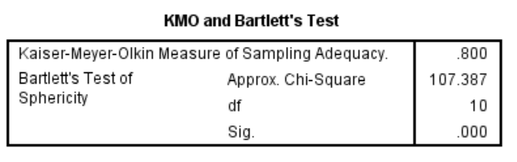
Table 4.1.1.1 KMO and Bartlett’s Test (Dependent Variable)
Job-hopping Behavior
Items | Factor Loading
I often think about quitting my job. | 0.617
I am likely to look for different organization to work in in the short term. | 0.726
I feel disjointed and not engaged in this organization. | 0.824
I do intend to quit my job within the next year/short term. | 0.684
I do not hope to have a long future with this company. | 0.553
Variance (percent of explained) | 68.084
Table 4.1.1.2 Communalities of Dependent Variable

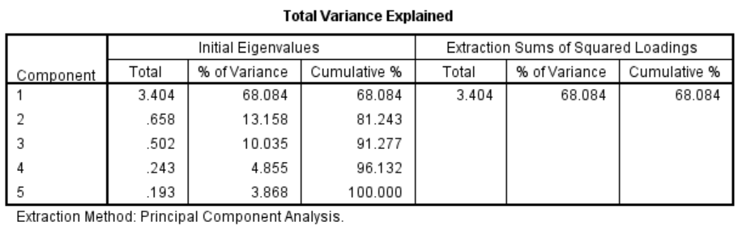
Table 4.1.1.3 Total Variance Explained of Dependent Variable
Table 4.1.1.1 shows the results of the KMO Bartlett’s test of Sphericity, from which KMO>0.6 is shown, so the dependent variable of the study is acceptable. Therefore, according to the test results, the factors of employee job-hopping behavior are applicable to the experimental assessment of this research. The p-value of the above KMO Bartlett’s test of Sphericity is 0.00 and less than 0.05. In addition, in the Communalities, the first four items of the dependent variable are greater than 0.6, and the last item value is 0.553, according to Cooper and Schindler (2015) if the value of the factor loading is greater than 0.5 and less than 0.6, the retention questions can be selected, because it can be seen from the previous research that the item is very important and makes sense for the research. According to the eigenvalues in Table 4.1.1.3, 68.084% of the variations within the items in the construct can be explained, so the dependent variable can be used for subsequent research analysis. Therefore, all requirements of the factor analysis for the dependent variable in the pilot test are accepted.
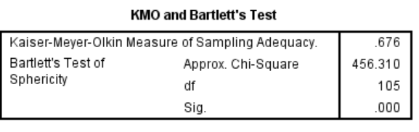
Table 4.1.1.4 KMO and Bartlett’s Test (Total Independent Variables)
Income Level
Items | Factor Loading
I am satisfied with my current salary. | 0.636
I think my current wage/ salary is comparable to the standard income in this industry. | 0.671
I think that my hard work is proportional to my income. | 0.544
I believe that my income is appropriate to my position and qualification. | 0.632
I think that the annual salary increment is acceptable when compared to other companies in the industry | 0.642
Job Satisfaction
Items | Factor Loading
I am contented with this type of work. | 0.816
I am enjoying this job. | 0.818
I can learn much and grow fast by doing this job. | 0.874
I feel I am important when I do this work. | 0.812
I think my job is very interesting and satisfying | 0.883

Work Environment
Items | Factor Loading
The physical working condition of my firm are very good. | 0.654
The method of work measurement is reasonable in my firm. | 0.643
I am satisfied with my working time and privileges offered | 0.836
My company is always moving toward to improve ways of doing things. | 0.553
My organization is always utilizing new technologies to work. | 0.759
Table 4.1.1.5 Communalities of Total Independent Variables
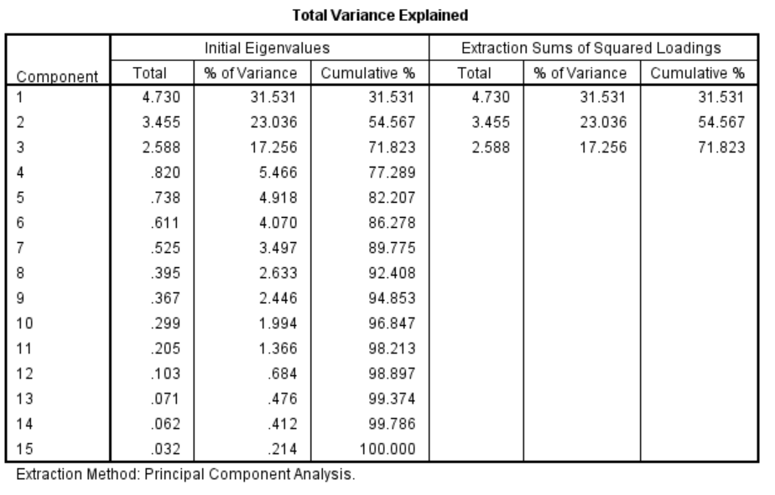
Table 4.1.1.6 Total Variance Explained of Total Independent Variables
The result of KMO Bartlett’s test of Sphericity is shown in Table 4.1.1.4, where the value of KMO is 0.676, greater than 0.6. In the communalities, the third item of income level and the fourth item of job satisfaction have factor loading of 0.544 and 0.553, respectively. According to Kumar (2014), in the pilot test, when the factor loading is less than 0.6 but greater than 0.5, this factor is acceptable and analyzed in the preliminary test, because these items are important to research and have reference value, these two should be retain. For the eigenvalue table provided by the total independent variable, it can be concluded that the number of eigenvalues is the same as the number of independent variables and these 3 eigenvalues are greater than 1. It can be seen that the three factors of this study are relevant and appropriate for subsequent analysis and statistical tests.

4.1.2 Reliability Test in Pilot Test
 | Cronbach’s Alpha | Number of Items
Income Level | 0.814 | 5
Job Satisfaction | 0.948 | 5
Work Environment | 0.879 | 5
Job-hopping Behavior | 0.882 | 5
Table 4.1.2 Summary of Reliability Test
The main purpose of reliability testing is to verify the reliability of data through internal consistency. According to Kumar (2014), if the value of Cronbach’s Alpha is between 0.7 and 0.8, the data is reliable. If the value of Cronbach’s Alpha is greater than 0.8, the data is excellent. From the table 4.1.2.1, it can be found that the Cronbach’s Alpha value of each variable is greater than 0.8, so all the data in the questionnaire is reliable, which means that the questionnaire has research value.

4.1.3 Correlation Matrix Analysis
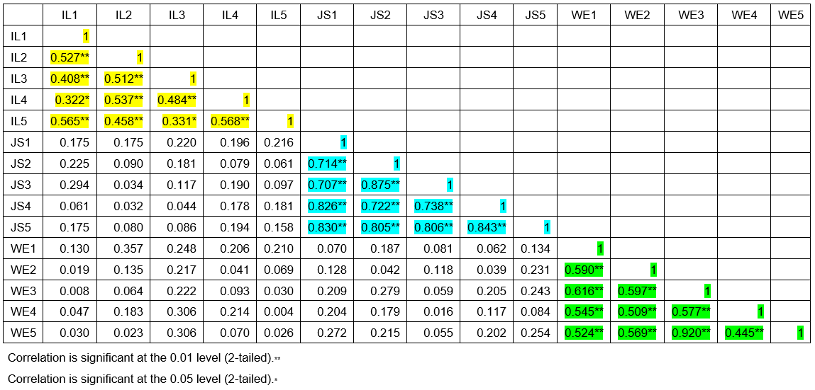
Table 4.1.3.1 Summary of Correlations (Independent Variables)
The purpose of running correlation matrix analysis is to measure whether there is an internal correlation between variables. It can be seen from the correlation matrix of Table 4.1.3.1 that all different independent variables are irrelevant, while the items under the same independent variable are related. So, all the above items are acceptable and can be used for the next analysis.
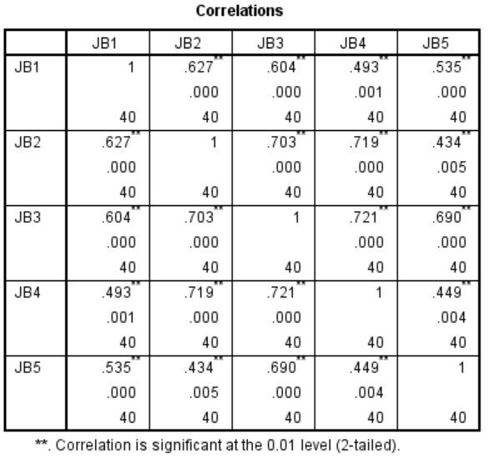
Table 4.1.3.2 Summary of Correlations (Dependent Variable)
Table 4.1.3.2 is a correlation matrix of dependent variable. It can be seen from the table that all items of the dependent variable are related and therefore acceptable and applicable.

4.2 Demographic Characteristics Description
The questionnaire for this study was distributed through the Internet, mainly through WeChat and web links. And the target respondents are employees of the Shanghai retail industry. At present, there are 4 million retail employees in Shanghai (Shanghai Municipal Statistics Bureau, 2017), according to Krejcie and Morgan (1970), the total sample size selected in this study was 384, so 400 questionnaires were distributed to the respondents, and 309 questionnaires were received. Of these, 10 questionnaires were not available, so there were 299 questionnaires available and used for preliminary testing.
 | Frequency | Percentage
Male | 80 | 26.8
Female | 219 | 73.2
Total | 299 | 100.0
Table 4.2.1 Gender
As can be seen from Table 4.2.1, 80 of the 299 respondents were male, accounting for 26.8% of the total, and 219 were female, accounting for 73.2%. So, the survey respondents were mostly women.
 | Frequency | Percentage
Below 21 years old | 49 | 16.4
21-30 | 111 | 37.1
31-40 | 80 | 26.8
41-50 | 34 | 11.4
More than 50 | 25 | 8.4
Total | 299 | 100.0
Table 4.2.2 Age
Table 4.2.2 shows the age distribution of respondents. Of the 299 respondents, 111 were 21-30 years old, accounting for 37.1%. The second largest number was respondents aged 31-40, with a total of 80, accounting for 26.8% of the total respondents. The lowest number of respondents were those over the age of 50, only 25, accounting for 8.4% of the total.
 | Frequency | Percentage
High school/ Diploma | 73 | 24.4
Bachelor degree | 143 | 47.8
Master | 53 | 17.7
PhD | 17 | 5.7
Others | 13 | 4.3
Total | 299 | 100.0
Table 4.2.3 Education Background
Table 4.2.3 shows the educational background of the respondents, of which 143 were bachelor degrees, accounting for 47.8% of the total. Therefore, the educational background of bachelor degree is very important. Next are high school and master, with 73 (24.4%) and 53 (17.7) respectively. The educational background of 13 respondents was not within the above range, accounting for only 4.3% of the total.

 | Frequency | Percentage
Store sales | 139 | 46.5
Store manager | 90 | 30.1
Store supervisor | 49 | 16.4
Store owner | 21 | 7.0
Total | 299 | 100.0
Table 4.2.4 Occupation
Table 4.2.4 shows the occupation of the respondents. Of those, 139 were store sales and accounting for 46.5% of the total. Store manager and store supervisor ranked second and third, with 90 (30.1%) and 49 (16.4%), respectively. Therefore, it can be seen that the information of store sales is very important for this study.

4.3 Preliminary Data Analysis

4.3.1 Factor Analysis
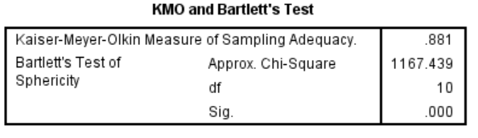
Table 4.3.1.1 KMO and Bartlett’s Test (Dependent Variable)

Job-hopping Behavior
Items | Factor Loading
I often think about quitting my job. | 0.731
I am likely to look for different organization to work in in the short term. | 0.708
I feel disjointed and not engaged in this organization. | 0.870
I do intend to quit my job within the next year/short term. | 0.795
I do not hope to have a long future with this company. | 0.766
Variance (percent of explained) | 77.396
Table 4.3.1.2 Communalities of Dependent Variable
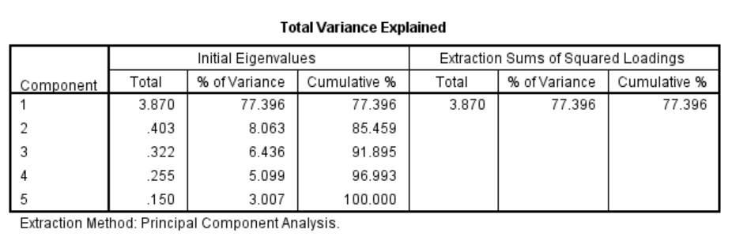
Table 4.3.1.3 Total Variance Explained of Dependent Variable
As can be seen from Table 4.3.1.1, the value of KMO is 0.881, which is already greater than 0.6, so this dependent variable can be used. At the same time, from Tables 4.3.1.2 and 4.3.1.3, it can be found that the factor loading of each items of the dependent variable is greater than 0.6, and the eigenvalue is greater than 60%, so the result of the analysis can prove that the job-hopping behavior can be used as the dependent variable.
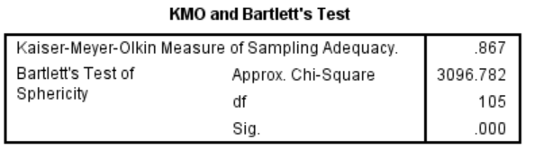
Table 4.3.1.4 KMO and Bartlett’s Test (Total Independent Variable)
Items | Factor Loading
Income Level
I am satisfied with my current salary.  I think my current wage/ salary is comparable to the standard income in this industry. | 0.616  0.703
I think that my hard work is proportional to my income. | 0.675
I believe that my income is appropriate to my position and qualification. | 0.651
I think that the annual salary increment is acceptable when compared to other companies in the industry | 0.617
Job Satisfaction  I am contented with this type of work.  I am enjoying this job.  I can learn much and grow fast by doing this job.  I feel I am important when I do this work.  I think my job is very interesting and satisfying.  Work Environment  The physical working condition of my firm are very good.  The method of work measurement is reasonable in my firm.  I am satisfied with my working time and privileges offered.  My company is always moving toward to improve ways of doing things.  My organization is always utilizing new technologies to work. | 0.788  0.863  0.703  0.816  0.669  0.749  0.602  0.618  0.777  0.831
Table 4.3.1.5 Summary of Communalities (Total Independent Variable)
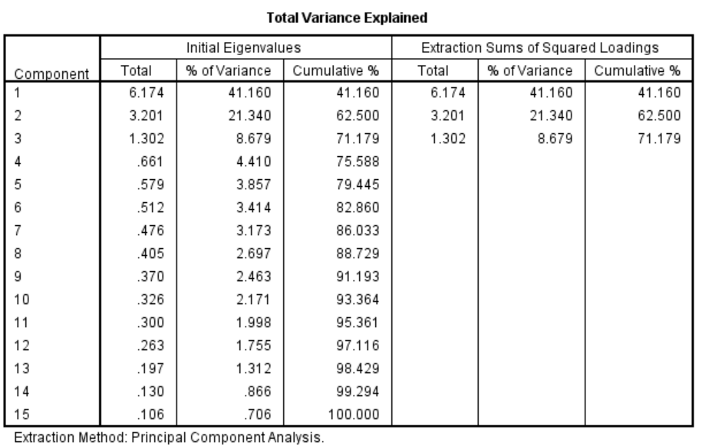
Table 4.3.1.6 Total Variance Explained
The factor loading in the preliminary test is must greater than 0.6 (Sekaran & Bougie, 2017). Therefore, Table 4.3.1.5 is the result of the factor loading for all independent variables and the factor loading of each item is greater than 0.6. Beside the value of KMO is 0.867 which is greater than 0.6. There are 3 eigenvalues and greater than 1, so the study in the above case is reasonable.

4.3.2 Reliability Test
 | Cronbach’s Alpha | Number of Items
Income Level | 0.863 | 5
Job Satisfaction | 0.920 | 5
Work Environment | 0.890 | 5
Job-hopping Behavior | 0.927 | 5
Table 4.3.2 Summary of Reliability
Table 4.3.2 shows the reliability test summary for 3 independent variables and 1 dependent variable. It can be seen from the table that the Cronbach’s Alpha values of all variables are greater than 0.7, so the information in the questionnaire is valid, and all variables are in good confidence intervals.

4.4 Normality test
In the study, the normality of the data collected needs to be evaluated, and for many statistical processes, the normality of the data must be evaluated because it is an important hypotheses in parametric testing and if the normal hypotheses is invalid, the test results will not be reliable (Das & Imon, 2016).

4.4.1 Normal Q-Q Plot
Q-Q plot is short for the quantile-quantile plot, a graphical technique used to determine if two data sets have a common distribution (Ghasemi & Zahediasl, 2012). A 45-degree reference line is drawn in the graph and if the two sets come from a population with the same distribution, then the points should be roughly along this reference line, if the further away from this line, the two data sets come from differently distributed people (Park, 2015).
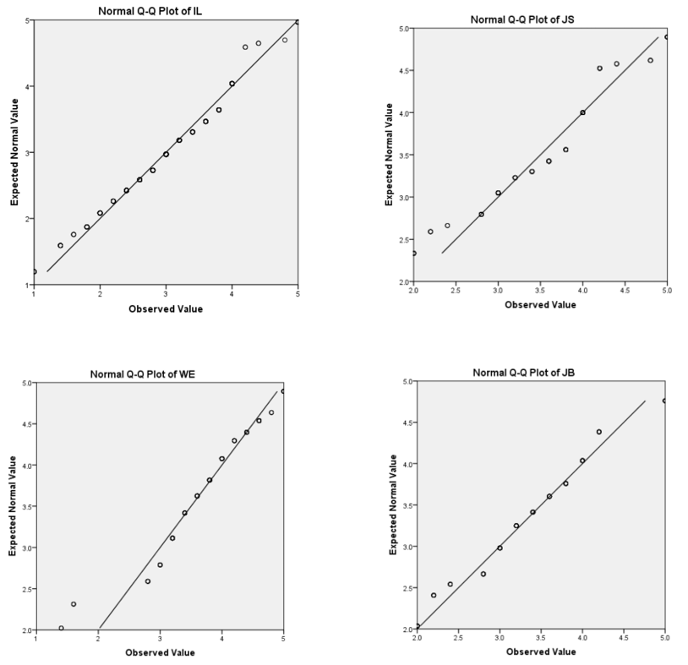
Table 4.4.1 Summary of Normal Q-Q Plot
Table 4.4.1 shows the normal Q-Q plot of the four variables. As can be seen from the table, most of the points of each variable are arranged along the 45-degree reference line, which means that the data comes from the same distribution group. That is, it conforms to the normal distribution. Therefore, the data meets the requirements.

4.4.2 Homoscedasticity
Homoscedasticity refers to the condition that the variance of the residual or error term is constant in the regression model, that is, as the value of the predictor changes, the error term does not change much (Yang & Mathew, 2018). If the variation of error variance near the regression line is obvious, the regression model may not be clearly defined, and the lack of homoscedasticity may mean that the regression model may need to include additional predictors to explain the performance of dependent variables (Raafat & Tolba, 2015).
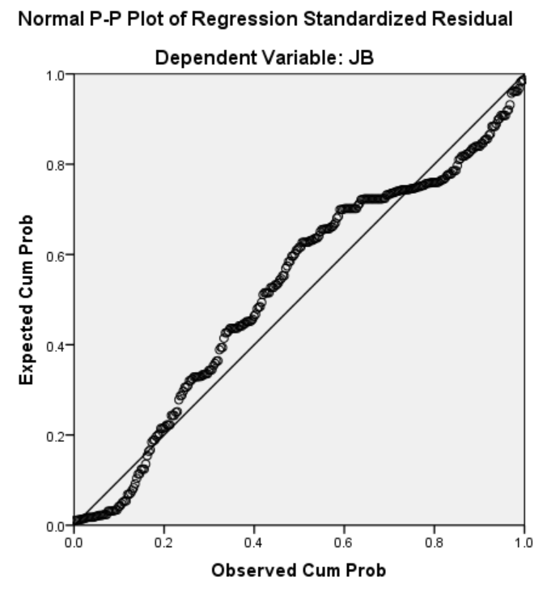
Table 4.4.2.1 Normal P-P Plot of Regression Standardized Residual
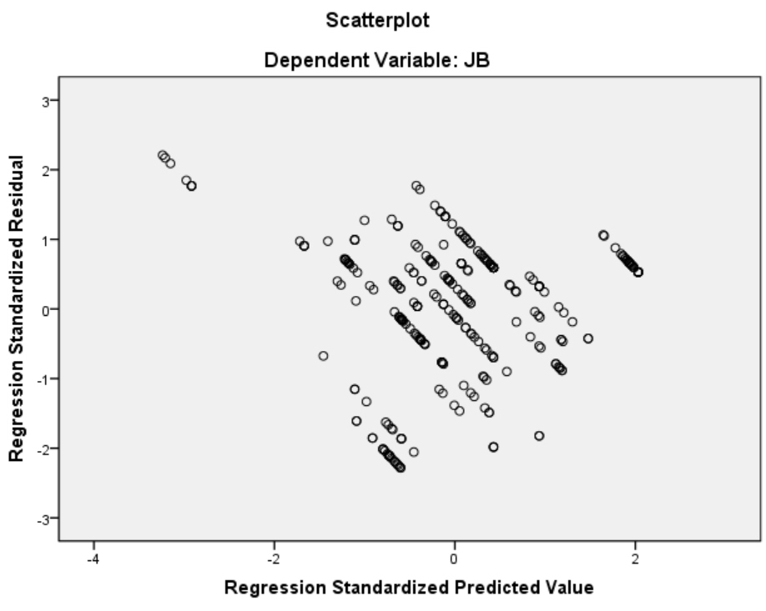
Table 4.4.2.2 Scatterplot
Table 4.4.2.1 shows the normal P-P plot of regression standardized residual. It can be seen from the table that the residuals are roughly distributed in the vicinity of the reference line and are normally distributed, indicating that there are no normality hypotheses that violates the regression model, so it can be reasonable. The sample was observed to be from a normal distribution. Table 4.4.2.2 is a scatterplot. It can be seen from the table that the scatter plot shows that there is no general pattern. All the points scattered around the zero mean have no systematic positive and negative trends and are randomly distributed. This means that the residuals have a common variance and therefore do not violate the assumption of homoscedasticity.

4.5 Hypotheses Testing
The above data analysis proves that the questionnaire information collected on the Internet is reliable, so the hypotheses test will be carried out on these data to verify the relationship between the independent variables and the dependent variable (Kumar, 2014).

4.5.1 Simple Multiple Regression
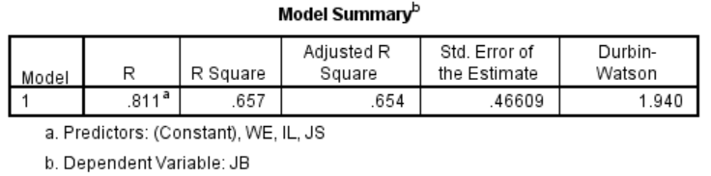
Table 4.5.1.1 Model Summary
Table 4.5.1.1 is a model summary. It can be seen that the value of R-squared is 0.657, which means that 65.7% of the job-hopping behavior can be explained by the independent variables: income level, job satisfaction and work environment. In addition, the value of Durbin-Watson is greater than 1.5 and very close to 2, which indicates that there is no obvious correlation between residuals, that is, residuals are independent.
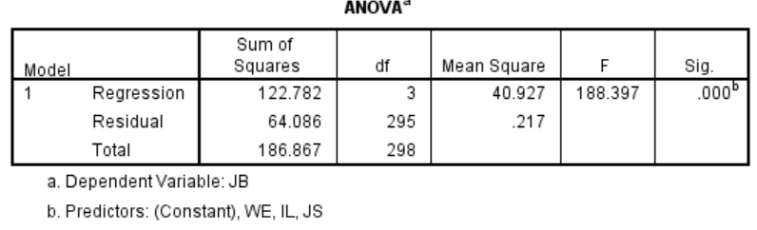
Table 4.5.1.2 ANOVA
As can be seen in Table 4.5.1.2, the p-value is 0.00 and less than 0.05, the requirements are met. Therefore, the regression model is statistically significant, meaning that the independent variables can be used to test job-hopping behavior.
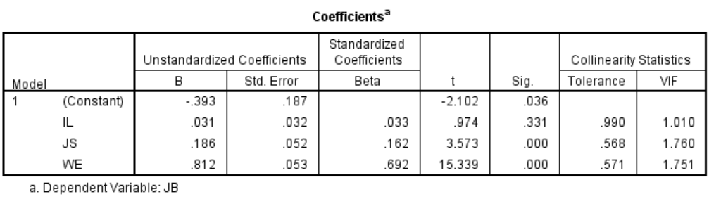
Table 4.5.1.3 Coefficients
Check the variable inflation factor (VIF) to make sure there are no multicollinearity problems. When the correlation between the indexes of the same structure is too high, multicollinearity problem will occur and according to Sekaran and Bougie (2017), the VIF value is less than 5 to ensure that the items does not overlap within the same constructs. As can be seen in Table 4.5.1.3, the VIF is less than 5, this shows that there is no multicollinearity.
As can be seen from the above table, the beta coefficient of the income level is 0.033 and the p-value is 0.331 greater than 0.05, so this independent variable has no significance. In other words, H1: Income level has a significant influence on the job-hopping behavior in the retail industry of Shanghai, China should be rejected.
For job satisfaction, the beta coefficient of this independent variable is 0.162 and the p-value is less than 0.05, it has significance. Therefore, the H2: Job satisfaction has a significant influence on the job-hopping behavior in the retail industry of Shanghai, China is supported.
For the work environment, the beta coefficient is 0.692 and the p-value is 0.00, less than 0.05, so this independent variable has a significance influence on the dependent variable, so H3 Work environment has a significant influence on the job-hopping behavior in the industry of Shanghai, China is supported.

4.6 Summary of Findings
According to the results of the above hypothesis test, H2 and H3 are accepted, that is, job satisfaction and work environment influence the job-hopping behavior. At the same time, the above hypotheses test results indicate that H1 is rejected, which means that income level cannot be a predictor of job-hopping behavior. The following table is a summary of the hypotheses testing findings.
Hypotheses | Finding | conclusion
H1: Income level has a significant influence on the job-hopping behavior in the retail industry of Shanghai, China. | P-value=0.331  No significant | Rejected
H2: Job satisfaction has a significant influence on the job-hopping behavior in the retail industry of Shanghai, China. | P-value= 0.000  Significant | Supported
H3: Work environment has a significant influence on the job-hopping behavior in the industry of Shanghai, China. | P-value= 0.000  Significant | Supported
Table 4.6 Hypotheses Summary

4.7 Conclusion
In summary, this chapter factor analysis, reliability testing, and correlation matrix are used in the pilot test to analyze the data. Each factor in the pilot test meets the requirements. In the preliminary test, the data of 299 respondents were analyzed, and it was found that each items of the factor loading are meet the requirements. Descriptive analysis was also used to examine the demographics of respondents. Finally, the hypotheses of the study were verified and the conclusion was given in the preliminary test.

Chapter 5: CONCLUSION AND RECOMMENDATION

5.0 Overview
This chapter mainly discusses the social exchange theory and research findings, and concludes the contribution to industry and academia. In addition, the limitations of the research and the future research focus are discussed in order to further improve the research. At last, it gives a summary, advice and personal reflection.

5.1 The Discussion Between Social Exchange Theory and Research Findings
According to the hypotheses of Chapter 4, Hypotheses 2 and Hypotheses 3 are accepted, which means that job satisfaction and work environment have a significant influence on job-hopping behavior of Shanghai, China (Liao, 2015). In addition, Hypotheses 1 is rejected, which means that income levels are not a significant predictor of job-hopping behavior of Shanghai, China (Li, 2015). This chapter will further validate the hypotheses results by combining social exchange theory with research findings (Daher, 2015).
Social exchange theory holds that interpersonal relationship is a value exchange, following the principle of reciprocity and both sides contribute the values and satisfy the needs, but this contribution and acquisition are not absolute and measurable (Bhattacharyya, 2015). China is a country with a large population and there are job-hopping phenomena in all walks of life, but the job-hopping phenomenon in retail industry is the most significant (Zhao, 2016). Based on the current situation of Shanghai retail industry and the theory of social exchange theory, it can be found that Shanghai retail employees pay more attention to the location and environment of work, because it is related to the vital interests and circumstances of employees (Ren, 2016). Employees' satisfaction with job can increase employee loyalty and sense of belonging to the company, thus creating value for the company (Chen, 2016).
Similarly, for the relationship between work environment and job-hopping behavior, the quality of the work environment can influence the employee's intention and the excellent work environment can not only reduce the employee's job-hopping behavior, but also attract more people to join the company (Liao, 2015). Because no employees want the work environment to be unhealthy and bad, when such a work environment occurs, employees will only think about leaving faster (Demet, 2015). Social exchange theory insists that the exchange between people is mutually beneficial (Kelley & Thibaut, 1978). Generally speaking, the work environment is the place where the employees are located, influencing the spirit and body of the employees and when the company provides a good working environment for the employees, the employees can feel the attitude of the company, so employees will work with a serious and responsible attitude (Jain & Kaur, 2015). A good work environment does not let employees have the idea of job-hopping, so the work environment has a significant influence on job-hopping behavior (Demet, 2015).
On the other hand, although the income level will influence the employee's job-hopping behavior, for the retail industry, income level cannot be a factor that influence employee job-hopping behavior (Zheng, 2016). Because in Shanghai and even in all China's retail industry, the income level of employees in each region is basically the same according to the regional economic situation, there will not be a company that provides high wages (Luo, 2015). Employees' income is more dependent on the efforts and if employees can sell more products or create more value for the company, then employees can get extra income beyond the salary, so the amount of extra income is related to the employees themselves rather than being job-hopping to other companies (Huang & Zhang, 2016). Therefore, the income level of employees does not meet the social exchange theory, and the income level cannot be an important factor in the job-hopping behavior of employees in Shanghai retail industry (Wang & Zeng, 2015).

5.2 Contributions

5.2.1 Contribution to Industry
According to the research results, it is found that job satisfaction and work environment have a significant influence on the job-hopping behavior of Shanghai retail employees in China. Therefore, based on these two factors, this study makes recommendations on the job-hopping behavior of Shanghai retail companies in China. It is recommended that job satisfaction is important, so in order to reduce employee turnover, efforts should be made to improve employee job satisfaction (Xu & Li, 2015). In addition, employees are also very focused on the company's work environment, so companies can improve the hardware facilities and software facilities. A comfortable working environment not only enhances the enthusiasm of employees, but also increases employee dependence and good evaluation of the company (Lu et. al., 2015). Therefore, if the enterprise refers to these two factors in solving the problem that the employee turnover rate is too high, the employee's job-hopping behavior can be further reduced, thereby reducing the company's loss and increasing the profit rate. By doing so, the research has contributed to the industry by showing companies the focus on reducing employee job-hopping.
In addition, according to the research results, the income level is not an important factor influencing the employee job-hopping of Shanghai retail industry. Therefore, this study provides a new perspective for Shanghai retail enterprises to reduce employee job-hopping. Because the income levels in the industry are almost equal, in this case, employees will pay more attention to the company's working environment and job satisfaction then employees are more willing to work in the same industry with a more comfortable working environment and high job satisfaction (Wang, 2015).
Therefore, the contribution will be that the retail enterprises in Shanghai need to pay less attention to the income level and should focus the resources on improving the company's working environment and employee job satisfaction. This is the contribution of this research to the industry.

5.2.2 Contribution to Academia
According to the previous literature, there is a large amount of literature on Chinese employees' job-hopping (Fu & Deshpande, 2015; Huang,2015; Jing, 2015). Most of the industries studied are banks, hotels and other industries, but the literature on job-hopping behavior of Shanghai and retail employees is limited. Moreover, this study, as an English study, can try to make up for the English literature on the behavior of employees in the retail industry. The objective of the research proposed in Chapter 1 is to investigate the influence of income levels, job satisfaction and work environment on job-hopping behavior. Through research and analysis, it is found that the income level has no significant influence on the behavior of employees in Shanghai retail industry. Therefore, it provides a literature that has different views from pervious literature which prove the income level has an influence on job-hopping behavior.

5.3 Limitations of Study

5.3.1 Scope Limitation
The study did not study other parts of China, but only studied Shanghai. However, there is no research on the influence of regional cultural differences and other factors on employee job-hopping behavior. Compared with big cities like Shanghai, the job-hopping rate of small and medium-sized cities may be reduced, because small and medium-sized cities do not have the pressure of life in big cities (Chen, 2016). So, the results of this study are not applicable to the retail industry in other cities in China.

5.3.2 Time Limitation
The researcher must conduct the investigation and complete the study within the specified time, because the time given in this study is 3 months, and there will be some flaws in the researcher completing the five chapters in a limited time. In addition, due to the limited time, the sample size of this study is very small. At last, only 299 employees of Shanghai retail industry are analyzed. Obviously, such sample size cannot fully represent employees of Shanghai retail industry.

5.4 Future Direction of Research
As for the potential research of this subject, the current research only analysis the income level, job satisfaction and work environment that influence the job-hopping behavior of employees in the retail industry in Shanghai, so it is suggested that the future research can be extended to other industries and fields (Liu, 2015). In addition, future studies may find other variables that influence employee job-hopping behavior. Besides the above factors, job-hopping behaviors can be influenced by other factors and dimensions, encouraging future researchers to add variables for research (Sun, 2016). This research did not study the moderating influence of gender and age on employee job-hopping behavior, and future potential studies can study the moderating influence of gender, age and other factors on employee job-hopping behavior (Liao, 2015).

5.5 Conclusion
The study consists of five chapters, which are introduction, literature review, research methodology, research findings, conclusions and recommendations. The objective of the study was to investigate the influence of income levels, job satisfaction and work environment on the job-hopping behavior of Shanghai retail employees. Analysis of these factors can help managers understand employee job-hopping behavior to improve or avoid job hopping. This study used a convenient sampling method to conduct an online questionnaire survey of the target population, and then used SPSS statistical software to analyze the data and test the hypotheses. According to the research results, it is found that job satisfaction and work environment have a significance influence on the job-hopping behavior of Shanghai retail employees.

5.6 Recommendation
The study has identified a number of factors that influence employee job-hopping behavior. Through the research, it is found that among the three factors, besides the income level, the other two factors which including job satisfaction and work environment have a significant influence on job-hopping behavior and work environment has the greatest influence on the job-hopping behavior of Shanghai retail employees in China. Therefore, companies should retain employees based on these factors, especially the work environment. Here are some suggestions to reduce the emergence of employee job-hopping behavior in Shanghai retail industry.
First of all, in terms of job satisfaction, according to the opinion of most interviewees, in addition to exit interview, every organization must have an on-job interview policy (Nan, 2015). This is because, through interviews, managers can know employees' problems, expectations and wishes so as to work better with employees. Through the interview, the company can ask employees for meaningful ideas and listen to the feedback when employees are on the job, instead of managers thinking about whether the company has problems after employee’s job-hopping (Ding & Han, 2015). At the same time, the company should education and remind employees not to expect 100% satisfaction and 0% dissatisfaction, and should weigh the overall job satisfaction, because there are often situations where the best work leads to dissatisfaction, therefore, employees need self-guidance (Roos & Eeden, 2015). In addition, clearly tell employees the type of work and working conditions employees are engaged in, such as corporate culture, working hours, relationships and so on (Salleh et. al., 2015). Because if employees are not satisfied with the jobs, job-hopping will occur.
Then there is the influence of the work environment on employee job-hopping. If the company provides a more comfortable and welcoming work environment than other organizations, then employees will be more inclined to stay rather than job-hopping (Zhang, 2015). So, the company can create an excellent work environment, such as providing employee-friendly facilities, gyms, health foods and beverages. In addition, encouraging friendly employee relationships, colleagues and managers like a family, giving friendly relationships, communication, and even intimate emotions is essential (Liu & Zhang, 2015). In the company, employees can talk comfortably and make other plans that do not hinder the work.
In short, it is important to reduce the company's employee job-hopping behavior in the current retail industry in Shanghai. Because employees can not only improve the company's profits and markets, but also help the company achieve organizational goals.

5.7 Personal Reflection
The personal reflection part is to show my experience in completing the MBA project. In the process of completing the project, I improved my ability to find information through the websites. I learned that I must input the right keywords to get the information I want, so as to find the information suitable for this research. In addition, I understand how to use the E-library to search for my auxiliary information to ensure the reliability and relevance of the information. I gain a lot of knowledge and understand employees' job-hopping behavior by doing this research study and referencing so many journals.
I also learned to understand and apply all the information collected in journals to my research and then present it in a concise form. I understand that only information related to the research can be displayed, and only important information can be written in the project, so that readers of the project can feel that the project is informational. At first, I found it difficult to sort the information, because there was too much related information. Gradually, I learned to properly organize my project through guidance before starting the project, so that my project would look very logical. I also realized that hierarchical structures and formats can be of interest to readers.
In addition, I have understood the importance of managing time and arranging time in advance to ensure the timely completion of the project. Because time management is very important in doing this project, as long as it can produce high-quality projects. Only by completing the project ahead of time and discussing with my supervisor can I improve my project better. Therefore, I will make a schedule to arrange the tasks to be completed every day.
Finally, I learned to use SPSS to analysis data to achieve the research objectives of this study. The correct interpretation of data is very important, only in this way can this study provide a better reference for future studies. The analysis must be useful for research and must be tested purposefully. Therefore, I must understand the capabilities of analysis, then interpret the data correctly and present findings.

Reference
Alam, M. M. & Mohammad, J. F., 2015. Level of job satisfaction and intent to leave among Malaysian nurses. Business Intelligence Journal, 3(1), p. 123-137.
Ahmid, D. K. B., Yazam, D. M. & ALDamoe, F. M. A., 2015. The Mediating Effect of HRM Outcomes (employee retention) on the Relationship between HRM Practices and Organizational Performance. International Journal of Human Resource Studies, 1(2), p. 75-88.
Aslam, M., 2017. Group SkSP-R sampling plan for accelerated life tests. Sadhana, 42(10), p. 10.
Bergkvist, L., & Rossiter, J. R., 2016. The predictive validity of multiple-item versus single-item measures of the same constructs. Journal of Marketing Research, 44(3), p. 175–184.
Bhattacharyya, D. K., 2015. Talent Development Process of CPSEs. Journal of Institute of Public Enterprise, 37(3), p. 10.
Bock, G. W., Kankanhalli, A. & Sharma, S., 2015. Are Norms Enough? The Role of Collaborative Norms in Promoting Organi- zational Knowledge Seeking. European Journal of Information Systems, 15(4), p. 357-367.
Barman, A. & Bell, E., 2015. Business Research Methods. 4 ed. New York: Oxford University Press Inc..
Barnham, C., 2015. Quantitative and qualitative research. International Journal of Market Research, 57(6), p. 19.
Bener, A. & Alsulaiman, R., 2017. An assessment of reliability and validity of the European Organization for Research and Treatment of Cancer Quality of Life Questionnaire C30 among breast cancer patients in Qatar. Journal of Family Medicine & Primary Care, p. 9-11.
Boari, G. & Ruscone, M. N., 2015. A procedure simulating Likert scale item responses. Electronic Journal of Applied Statistical Analysis, 8(3), p. 11.
Boiko, I., 2015. INSTRUMENTS OF IMPLEMENTING. RECENT ISSUES IN ECONOMIC DEVELOPMENT, 6(2), p. 9.
Campbell, J.C., Ikegami, N. & Gibson, M.J., 2015. Lessons from public long-term care insurance in Germany and Japan. Health Affairs, 29(5), p.87–95.
Cropanzano, R. & Mitchell M. S., 2015 Social exchange theory: An interdis- ciplinary review. J Manage, 31(6), p. 874–900.
Celik, N., Senoglu, B. & Arslan, O., 2015. Estimation and Testing in One-Way ANOVA when the Errors are Skew-Normal. Revista Colombiana de Estadistica, 38(1), p. 18.
Chen, B. J., 2016. Study on factors influencing the intention of employee turnover in enterprises. Management science, 5(3), p. 12-18.
Çokluk, Ö. & Koçak, D., 2016. Using Horn’s Parallel Analysis Method in Exploratory Factor Analysis for Determining the Number of Factors.. Educational Sciences: Theory & Practice, p. 16.
Cooper, D. & Schindler, P., 2013. Business research methods. 11 ed. New York: McGraw-Hill/Irwin.
Copper, C. L. & Bramwell, R. S., 1992. Predictive validity of the strain components of the Occupational Stress Indicator. Stress Medicine, 4(2), p. 57-60.
Daher, N., 2015. EMOTIONAL AND CULTURAL INTELLIGENCES AS AN ASSESSMENT TOOL FOR RECRUITING, SELECTING AND TRAINING INDIVIDUAL CANDIDATES. International Journal of Business and Public Administration (IJBPA), 12(1), p. 15.
Das, K. R. & Imon, A. H. M. R., 2016. A brief review of tests for normalit. American Journal of Theoretical and Applied Statistics, 5(1), pp. 5-12.
Demet, L., 2015. Impact of workplace quality on employee’s productivity: case study of a bank inTurkey. Journal of Business, Economics & Finance 1(1), p 12-15.
Ding, Y. L. & Han, L., 2015. An analysis of the effectiveness of paid annual leave -- An Empirical Study on employee satisfaction based on organizational support theory. Journal of Shaanxi Normal University, 24 (2), p. 93-104.
Dixit, V. & Bhati, M., 2015. A study about employee commitment and its impact on sustained productivity in Indian Auto-Component Industry. European Journal of Business and Social Sciences, 1(6), p. 34 – 51.
Du, Q., 2015. Discussion on enterprise environmental management. Fujian BBS: humanities and social sciences edition, 5(11), p. 33-34.
Delery, J. E. & Roumpi, D., 2017. Strategic human resource management, human. Human Resource Management Journal, 27(1), p. 22.
Dodou, W., 2015. Factor recovery by principal axis factoring and maximum likelihood factor analysis as a function of factor pattern and sample size. Journal of Applied Statistics, 39(4), p. 17.
Doody, O. & Bailey, M. E., 2016. Setting a research question. Nurse Researcher, 23(4), p. 5.
Falola, H. O., Ibidunni,A. S. & Olokundun, M., 2015. Incentives packages and employees’ attitudes to work: a study of selected government parastatals in Ogun State South-West, Nigeria. International Journal of Research in Business and Social Science 3(1), p. 18-26.
Fu, W. & Deshpande, S. P., 2015. The impact of caring climate, job satisfaction, and organizational commitment on job performance of employees in a China’s insurance company. Journal of Business Ethics, 124(2), p.339-349.
Ganco, M., Ziedonis, R. & Agarwal, R., 2015. More stars stay, but the brightest ones still leave: job hopping in the shadow of patent enforcement. Strategic Management Journal, 36(5), p.659-685.
Geraedts, M., Heller, G. V., Harrington, C. A., 2015. Germany's long-term-care insurance: putting a social insurance model into practice. Milbank Quarterly, 78(3), p. 375–401.
Ghasemi, A. & Zahediasl, S., 2012. Normality tests for statistical analysis: a guide for non-statisticians. International journal of endocrinology and metabolism, 10(2), p. 486.
Girma, S., 2016. The relationship between leadership style, job satisfaction and culture of the organization. International Journal of Applied Research, 2(4), p.35-45.
Graham, J., Li, S. & Qiu, J., 2016. Managerial attributes and executive compensation. Review of Financial Studies, 25(3), p. 144–186.
Gray, D., 2015. Succession Planning 101. Professional Safety, p. 2.
Guo, J. S., 2015. On the realistic relationship between university aesthetic culture and mass aesthetic culture. Theory monthly, 12(7), p. 26-30.
George, E., 2015. 5 Steps to Planning for Internal Successors in a Small Business Environment. Journal of Financial Planning, 20(2), p. 4.
Goertzen, M. J., 2017. Introduction to Quantitative Research and Data. Library Technology Reports, p. 8.
Gounaris, S. & Boukis, A., 2015. The role of employee job satisfaction in strengthening customer repurchase intentions. Journal of Services Marketing, 27(4), p. 322-333.
Hadlock, C., 2015. Management turnover across the corporate hierarchy. Journal of Accounting and Economics 37(2), p. 3–38.
Han, L. Y., 2015. Problems and Countermeasures in salary management of small and medium sized enterprises. China business, 21(6), p. 51-52.
Hausknecht, J. P., Hiller, N. J., & Vance, R. J., 2015. Work-unit absenteeism: Effects of satisfaction, commitment, labor market conditions, and time. Academy of Management Journal, 51(4), p. 1223–1245.
Heckhausen, J., Schulz, R., & Wrosch, C., 2015. A motivational theory of life-span development. Psychological Review, 117(11), p. 32–60.
Heinicke, K. & Thomsen, S. L., 2015. The Social Long-term Care Insurance in Germany: Origin, Situation, Threats, and Perspectives. Center for European Economic Research, Mannheim, Germany. 15(9), p. 69-76.
Hsing, A. W., Tsao, L. & Devesa S. S., 2015. International trends and patterns of prostate cancer incidence and mortality. Int J Cancer. 85(4), p. 60–67.
Huang, G., 2015. An empirical study on Influencing Factors of employee satisfaction. School of management, Zhongshan University, 17(3), p. 15-18.
Huang, P. & Zhang, Z., 2016. Participation in Open Knowledge Communities and Job- Hopping: Evidence from Enterprise Software. MIS Quarterly, 40(3), p.785-806.
Hahn, S. & Salmaso, L., 2017. A comparison of different synchronized permutation approaches to testing effects in two-level two-factor unbalanced ANOVA designs. Statistical Papers, 6(12), p. 25.
Hitczenko, M., 2015. Modeling Anchoring Effects in Sequential Likert Scale Questions. Research Review, 13(15), p. 4.
Hooi, L. W., 2007. Human capital development policies: enhancing employees' satisfaction. JOURNAL OF EUROPEAN INDUSTRIAL TRAINING, 31(4), p. 297-322.
Hossain, D. M., 2017. Discourse Analysis: An Emerging Trend in Corporate Narrative Research. Middle East Journal of Business, 12(4), p. 8.
Hwang, H., 2017. Image-based quantitative analysis of tear flm lipid layer thickness for meibomian. BioMedical Engineering OnLine, p. 16.
Idris, A., 2015. Flexible Working as an Employee Retention Strategy in Developing Countries: Malaysian Bank Managers Speak. Journal of Management Research, 14(2), p. 71.
Jain, R. & Kaur, S., 2015. Impact of work environment on job satisfaction. International Journal of Scientific and Research Publications, 4(1), p. 22-26.
Ji, Q. & Wu, X. J., 2015. Application of benchmarking in salary management of small and medium sized enterprises. Economic problems, 15(2), p. 124-126.
Jing, T., 2015. The psychological analysis and countermeasures of job-hopping employees. Journal of human resource development, 13(6), p. 24-26.
Jennifer, R. G., 2017. Burns and Grove's The Practice of Nursing Research. 8 ed. Lousiana:Elisevier.
Jolles, M. P. & Martinez, M., 2017. Involving Latina/o parents in patient-centered outcomes research: Contributions to research study design, implementation and outcomes. Health Expectations, 3(5), p. 10.
Kaasa, A., 2015. Work values in European countries: Empirical evidence and explanations. Review of International Comparative Management, 12(5), p. 852–862.
Kashmoola, B., Ahmad, F. & Yeoh, K., 2017. Job Satisfaction and Intention to Leave in SME Construction Companies of United Arab Emirates. Business Management Dynamics, 7(3), p.1-9.
Kelley, H. H. & Thibaut, J. W., 1978. Interpersonal Relations: A Theory of Interdependence. 2 ed. New York: John Wiley & Sons.
Khalid, A. & Kenneth, A. K., 2015. Employee Retention Strategies: the case of a patent firm in Australia. School of Management, 2(1), p. 186-265.
Kong, F. H., 2015. Problems and Countermeasures of human resource cost control in enterprises at present. Modern commerce, 12(2), p. 24-30.
Krejcie, R. & Morgan, D., 1970. Determining sample size for research activities. Educational and psychological measurement, 30(3), p. 607-610.
Kumagai, W. & Hayashi, M., 2015. Quantum Hypothesis Testing for Gaussian States: Quantum Analogues of χ2, t-, and F-Tests. Communications in Mathematical Physics, p. 41.
Kumar, R., 2014. Research Methodology: A Step-by-Step Guide for Beginners. 3 ed. Chennai: SAGE Publications.
Li, J. M., 2015. Analysis and exploration of the current situation of salary management in small and medium enterprises. China's foreign capital,17(3), p. 90-93.
Liu, X. H., 2015. Problems and Countermeasures of salary positioning for small and medium sized enterprises in China. Enterprise economy, 44(2), p. 83-86.
Liu, Y. & Zhang, D. W., 2015. Based on the 4P concept, employee satisfaction is increased. Human resources, 337 (9), p. 60-62.
Lu, C. Q. & Ling, W. Q., 2015. The relationship between management self-efficacy and management attitude and efficiency. Journal of Peking University, 42 (2), p. 267-280.
Lu, J., Shi, K. & Yang, J. F., 2015. Evaluation structure and method of job satisfaction. China human resource development, 19(1), p. 15-16.
Lu, L. & Alon, I., 2015. Analysis of the changing trends in attitudes and values of the Chinese: the case of Shanghai's young & educated. Journal of International and Area Studies, 30(5), p.67-88.
Lu, Y., 2015. Research on Influencing Factors of job satisfaction. China human resource development, 38(12), p. 30-36.
Luo, Y., 2015. Analysis and suggestion on the salary management of small and medium enterprises. Enterprise guide, 16(8), p. 207-208.
Lavrakas, P. J., 2015. Encyclopedia of Survey Research Methods. 2 ed. California: SAGE Publications.
Liao, Q. C., 2015. A brief discussion on the strategy of human resource development in China's retail enterprises. Trade in China, 10(4), p. 12-13.
Li, Y. Q., 2015. On income distribution and equity. The northern economic and trade, 6(2), p. 32-36.
Lu, L., Ling, W. & Fang, C., 2015. On employee satisfaction and enterprise development. Beijing Petroleum Management College, 2 (14), p.11-14.
Mazurek, J. & Perzina, R., 2017. ON THE INCONSISTENCY OF PAIRWISE COMPARISONS: AN EXPERIMENTAL STUDY. Scientific Papers of the University of Pardubice. Series D, Faculty of Economics & Administration, p. 9.
Mehrad, A. & Mohammad, H. T. Z., 2017. Different levels of job satisfaction by educational organization motivators. Open Science Journal, 2(2), pp. 26-35.
Mclaggan, E., Bezuidenhout, A., & Botha, C. T., 2015. Leadership style and organizational commitment in the mining industry in Mpumalanga. SAJournal of Human Resource Management, 11 (1), p. 36-45.
Moorthy, R., 2015. An empirical study of leadership theory preferences among Gen Y in Malaysia. Review of Integrative Business and Economics Research, 3(2), p. 398.
Mossholder, K. W., Settoon, R. P., & Henagan, S. C., 2016. “A Relational Perspective on Turnover: Examining Structural, Attitudinal, and Behavioral Predictors.” Academy of Management Journal, 48(4), p. 607-618.
Mofcom, 2016. Statistics of China's ministry of commerce. [Online] Available at: http://www.mofcom.gov.cn/article/tongjiziliao/ [Accessed 10 7 2018].
Mustapha, N., 2015. Measuring job satisfaction from the perspective of interpersonal relationship and faculty workload among academic staff at public universities in Kelantan, Malaysia. International Journal of Business and Social Science, 4(15), p.19-26.
Mertler, C. A. & Reinhart, R. V., 2016. Advanced and multivariate statistical methods: Practical application and interpretation. 6 ed. New York:Routledge.
Milman, A., 2003. Hourly employee retention in small and medium attractions: The Central Florida example. International Journal of Hospitality Management, 22(3), p. 17-35.
Nair, M. S., Salleh, R. & Nair, S.K., 2015. Employee Turnover in the Malaysian Retail Industry. Global Business and Management Research, 6(4), p.283.
Nakpodia, E. D., 2015. Work environment and productivity among primary school teachers in Nigeria. International Multidisciplinary Journal, Ethiopia, 5(5), p. 367-381.
Nan, J. F. & Xiong, Z. J., 2015. Employee satisfaction index ESI evaluation model research. Chinese enterprise operations research, 18(6), p. 95-98.
Nan, J. F., 2015. Research on employee satisfaction model. World standardization and quality management,19(3), p. 13-19.
Nasution, C. L., Afiyanti, Y. & Milanti, A., 2018. The relationship of the preexisting anxiety problem with the demographic profile of cervical cancer patients. Enfermería Clínica, 28(1), p. 199-202.
Nouri, H. & Parker, R., 2015. Career growth opportunities and employee turnover intentions in public accounting firms. The British Accounting Review, 45(3), p. 138-148.
Onen, D., 2016. Appropriate Conceptualisation: The Foundation of Any Solid Quantitative Research. Electronic Journal of Business Research Methods, p. 12.
Otten, R. H. J. & Riet, T. G., 2018. Determinants of selective reporting: A taxonomy based on content analysis of a random selection of the literature. PLoS ONE, p. 16.
Pudelko, M., 2015. A comparison of HRM systems in the USA, Japan and Germany in their socio-economic context. Human Resource Management Journal, 16(9), p. 123–153.
Parahoo, K., 2015. Nursing research : principles, process and issues. 2 ed. Hampshire: Palgrave Macmillan.
Park, J. & Park, M., 2016. Qualitative versus Quantitative Research Methods: Discovery or Justification. Journal of Marketing Thought, 6(3), p. 8.
Pradhan, S., 2015. Retailing Management 2E. Tata McGraw-Hill Education, 5(2), p. 20-24.
Qu B. C. & Gao, K., 2015. How do the best employers retain core employees. Human resources, 13 (6), p. 27-28.
Raafat, H. M. & Tolba, A. S., 2015. Homoscedasticity for defect detection in homogeneous flat surface products. Textile Research Journal, 85(8), pp. 850-866.
Ren, H. L., 2016. The correct view of enterprise employee’s job-hopping. Science and technology and business, 6(3), p. 17-19.
Roos, W. & Eeden, R. V., 2015. The relationship between employee motivation, job satisfaction and corporate culture. SA Journal of Industrial Psychology, 34(1), p. 54-63.
Rosin, H. M. & Korabik, K., 2015. Workplace variables, affective responses, and intention to leave among women managers. Journal of Occupational and Organizational Psychology 64(4), p. 317-330.
Reams, R. S., Nicholls, J., Hair, J. F. & Baker, T. L., 2017. Online Social Presence: Scale Development and Validation. Society for Marketing Advances Proceedings, 8(2), p. 4.
Ridder, H. G., 2017. The theory contribution of case study research designs. Business Research, 10(13), p. 26.
Robinson, W., 2015. Surviving The New Job Search. 2 ed. Morrisville: LuLu Inc..
Salleh, R., Nair, M. S. & Harun, H., 2015. Job satisfaction, organizational commitment, and turnover intention: A case study on employees of a retail company in Malaysia. World Academy of Science, Engineering and Technology, 72(12), p.316- 323.
Shanghai Municipal Statistics Bureau, 2017. The main data bulletin for the third economic census of Shanghai (Number two). [Online] Available at: http://www.stats-sh.gov.cn/index.html [Accessed 20 7 2018].
Seibert, S. E., Kraimer, M. L., & Liden, R. C., 2016. “A Social Capital Theory of Career Success.” Academy of Management Journal, 44(2), p. 219-237.
Shao, W. Y., 2015. Organizational factors and countermeasures affecting employee turnover in enterprises. Human Resources, 10(2). p. 197-198.
Spence, M., 2015 “Job market signaling”. The Quarterly Journal of Economics, 87(3), p. 355-374.
Sun, B., 2016. What do you think employees job-hopping. Chinese and foreign enterprise culture, 7(9), p. 71-75.
Sun, J. M. & Jiao, C. Q., 2015. An exploratory study on the performance structure of managers. Ergonomics, 8(3), p. 1-10.
Saunders, M., Lewis, P. & Thornhill, A., 2015. Research Methods for Business Student. 6 ed. Edinburg Gate: Financial Times Prentice Hall.
Sekaran, U. & Bougie, R., 2017. Research Methods for Business A Skill-Building Approach. 7 ed. New York: Wiley.
Shan, S., 2015. Constructing minimum interference connected dominating set for multi–channel multi–radio multi– hop wireless network. International Journal of Sensor Networks, 11(2), p. 100-108.
Sprenger, J., 2015. Testing a Precise Null Hypothesis: The Case of Lindley’s Paradox. Philosophy of Science, p. 13.
Stochi, J., Jones, P. & Perez, J., 2016. Effects of ignoring clustered data structure in confirmatory factor analysis of ordered polytomous items: a simulation study based on PANSS. International Journal of Methods in Psychiatric Research, 5(7), p. 15-18.
Taiwo, A. S., 2015. The influence or work environment on workers’ productivity: a case of selected oil and gas industry in Lagos, Nigeria. African Journal of Business Management, 4(3), p. 299-307.
Tambe, P. & Hitt, L. M., 2015. Job hopping, information technology spillovers, and productivity growth. Management Science, 60(2), p. 338-355.
Tanova, C. & Holtom, B. C., 2016. Using job embeddedness factors to explain voluntary turnover in four European countries. International Journal of Human Resource Management, 19(9), p. 1553-1568.
Topeland, R. H. & Ward, M. P., 2015. Job Mobility and the Careers of Young Men. The Quarterly Journal of Economics, 2(107), p.439-479.
Tziner, A. & Birati, A., 2016. “Assessing employee turnover costs: a revised approach”. Human Resource Management Review, 6(2), p. 113-122.
Tomohiroa, R., Arizonoa, I. & Tak, Y., 2016. Proposal of variable sequential sampling plan having desired operating characteristics indexed by quality loss. International Journal of Production Research, 54(19), p. 20.
Umoh, G. I., Amah, E. & Wokocha, I. H., 2015. Employee Benefits and Continuance Commitment in the Nigerian Manufacturing Industry. IOSR Journal of Business and Management, 16(2), p. 69-74.
Vitell, S. J., Ramos, E. & Nishihara, C. M., 2015. The role of ethics and social responsibility in organizational success: A Spanish perspective. Journal of Business Ethics 91(4), p. 467-483.
Vittee, K. & Makhubele, K., 2016. A KELLY REPORT ON JOB-HOPPING: SOUTH AFRICAN & GLOBAL PERSPECTIVES OF THE NEW ‘NORMAL’ IN THE MODERN WORKPLACE. LABOUR & INDUSTRY, 4(10), p. 20-34.
Vaiman, V., 2015. Retention management as a means of protecting tacit knowledge in an organisation: a conceptual framework for professional services firms. International Journal of Learning and Intellectual Capital, 5(2), p. 172.
Walker, D., 2015. Evolving executive equity compensation and the limits of optimal contracting. Vanderbilt Law Review 64(8), p. 611–674.
Wan, X., 2015. Analysis of the causes of fleeing. Journal of new capital, 24(2), p. 90-95.
Wang, H. & Zeng, P. H., 2015. Problems and countermeasures of compensation management in small and medium-sized enterprises. Technology and market,13(2), p. 78-79.
Wu, W. K & Yao, D., 2015. The relationship between service leadership and employee satisfaction. Journal of management, 6 (3), p. 338-341.
Wang, X. L., 2015. An empirical analysis of the efficiency of China's retail industry. Full text database of Chinese excellent master's degree thesis, 11(3), p. 1-92.
Wong, Y., Osman, S., Jamaluddin, A. & Chan, Y. F., 2016. Shopping motives, store attributes and shopping enjoyment among Malaysian youth. Journal of retailing and Consumer Services, 19(2), p. 240-248.
Xing, P. F., Zhang, C. Y. & Yin, S. F., 2016. The influence of mass culture on contemporary college students' aesthetic cognition. China science and technology information, 3(1), p.23-27.
Xu, L. & Li, X. P., 2015. Evaluation of employee satisfaction based on grey relational analysis. Chinese management science, 18(10), p.68-72.
Xie, T. J., 2016. Human resources management in China's retail industry: a case study of H supermarket chain. Market Forum, 11(11), p. 58-60.
Yan, W. & Chen, Y., 2016. An empirical study on the relationship between management self-efficacy and management performance and organizational commitment. Human resource management, 13(8), p. 45-51.
Yao, K., 2016. Self-efficacy review - new trends in organizational behavior. Journal of management, 13(3), p.463-468.
Yao, W. F., 2015. Reproduction of mass aesthetic culture. Tianjin social science, 15(2), p. 31-36.
Yaseen, A., 2015. Effect of Compensation Factors on Employee Satisfaction-A Study of Doctor's Dissatisfaction in Punjab. International Journal of Human Resource Studies, 3(1), p.142.
Yean, T. F. & Yahya, K. K., 2015. The Influence of Malaysian Insurance Agents" Career Planning on Their Career Strategies. International Journal of e-Education, e- Business, e-Management and e-Learning, 3(1), p.24.
Yılmazel, G., 2015. Mobbing, job satisfaction and affecting factors in the nurse. Turkiye Clinics Journal of Nursing Science, 5(2), p. 55-63.
Yusoff, W. W., Queiri, A., Zakaria, S. & Hisham, R., 2015. Generation-Y turnover intention in business process outsourcing sector. Kota Kinabalu, ICMEF.
Yusuf, N. & Metiboba, S., 2015. Work environment and job attitude among employees in a Nigerian work organization. Journal of Sustainable Society, 1(2), p. 36-43.
Yang, J. T., Wan, C. S. & Fu, Y. J., 2016. Qualitative examination of employee turnover and retention strategies in international tourist hotels in Taiwan. International Journal of Hospitality Management, 3(31), p. 837-848.
Yang, Q. F., Xing, R. R. & Wang, S. X., 2017. Quantitative Analysis of Urban Regional Traffic Status. Mathematical Problems in Engineering, 8(13), p. 13.
Zhang, D. Y., 2015. Career planning and management. Fujian: Xiamen university press, 5(4), p. 45-49
Zhang, S. M., 2016. On the present situation of enterprise salary management and the countermeasures of optimizing management system. Modern economic information, 13(5), p.128-129.
Zhang, X. Y., Zhu, M. L. & Chen, S. D., 2014. Research on employee satisfaction based on cluster analysis. Coastal enterprises and technology, 73 (6), p. 215-219.
Zhang, X., 2014. Salary management of small and medium enterprises. Technology and market,18(11), p.99-100.
Zheng, Y. X., 2016. A brief discussion on the salary incentive of small and medium sized enterprises in private enterprises. Knowledge economy, 20(8), p. 16-25.
Zhou, W. X. & Guo, G. P., 2016. Self-efficacy: concept, theory and application. Journal of renmin university of China, 23(1), p. 91-97.
Zopiatis, A., Constanti, P. & Theocharous, A. L., 2015. Job involvement, commitment, satisfaction and turnover: evidence from hotel employees in Cyprus. Tourism Management, 41(3), p. 129-140.
Zhao, W., 2016. China's state-owned enterprises pay scheme design. Management studies, 7(7), p. 32-36.
Zheng, N., Wei, Y., Zhang, Y. & Yang, J., 2016. Zheng, N., Wei, Y., Zhang, Y. & Yang, J., 2016. In search of strategic assets through cross-border merger and acquisitions: Evidence from Chinese multinational enterprises in developed economies. International Business Review, 25(1), p. 177-186.
Zikmund, W. G., Babin, B. J., Carr, J. C. & Griffin, M., 2015. Business research methods. 8 ed. Mason: HO: Cengage Learning.

Appendix

Appendix 1: MBA Project Log
PROJECT PAPER LOG
Student Name: | Hao Bin
Supervisor’s Name: | Umi Kalsom
Dissertation Topic: Job-Hopping Behavior in the Retail Industry of Shanghai, China

This is an important document, which is to be handed in with your dissertation. This log will be taken into consideration when awarding the final mark for the dissertation.

SECTION A. MONITORING STUDENT DISSERTATION PROCESS
The plan below is to be agreed between the student & supervisor and will be monitored against progress made at each session.
Activity | Milestone/Deliverable Date
Review Chapter 1-3 & confirm the conceptual framework | 9/8
Modify Chapter 1-3 |  | 11/9
Done Chapter 1-3 |  | 20/9
Review presentation slides for proposal |  | 8/10
Proposal presentation |  | 26/10
Draft questionnaire |  | 2/11
Modify the questionnaire |  | 9/11
Showing data & start Chapter 4-5 |  |  | 15/11
Done Chapter 4-5 |  |  | 25/11
Final Viva & modify Chapter 1-5 |  |  |  | 1/12

SECTION B. RECORD OF MEETINGS
The expectation is that students will meet their supervisors up to seven times and these meetings should be recorded.
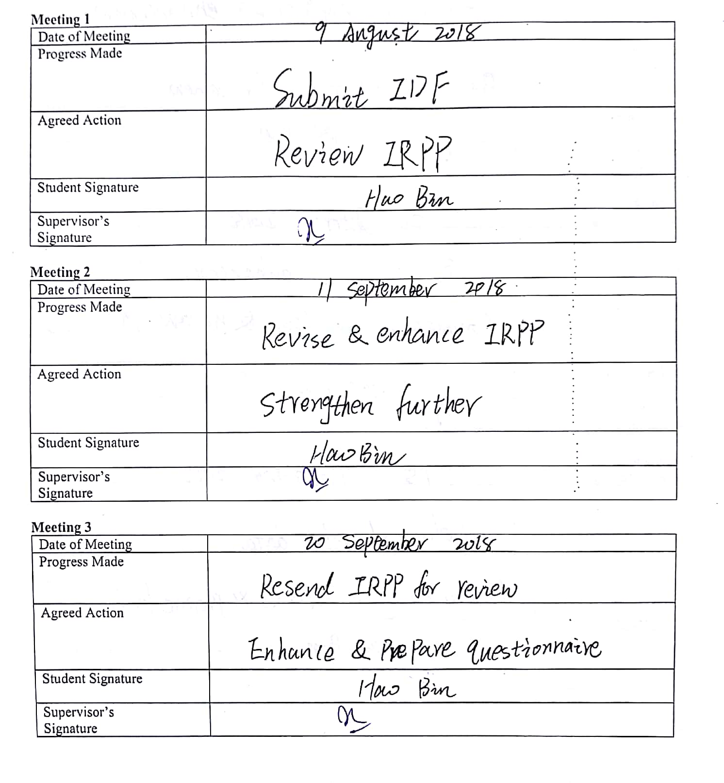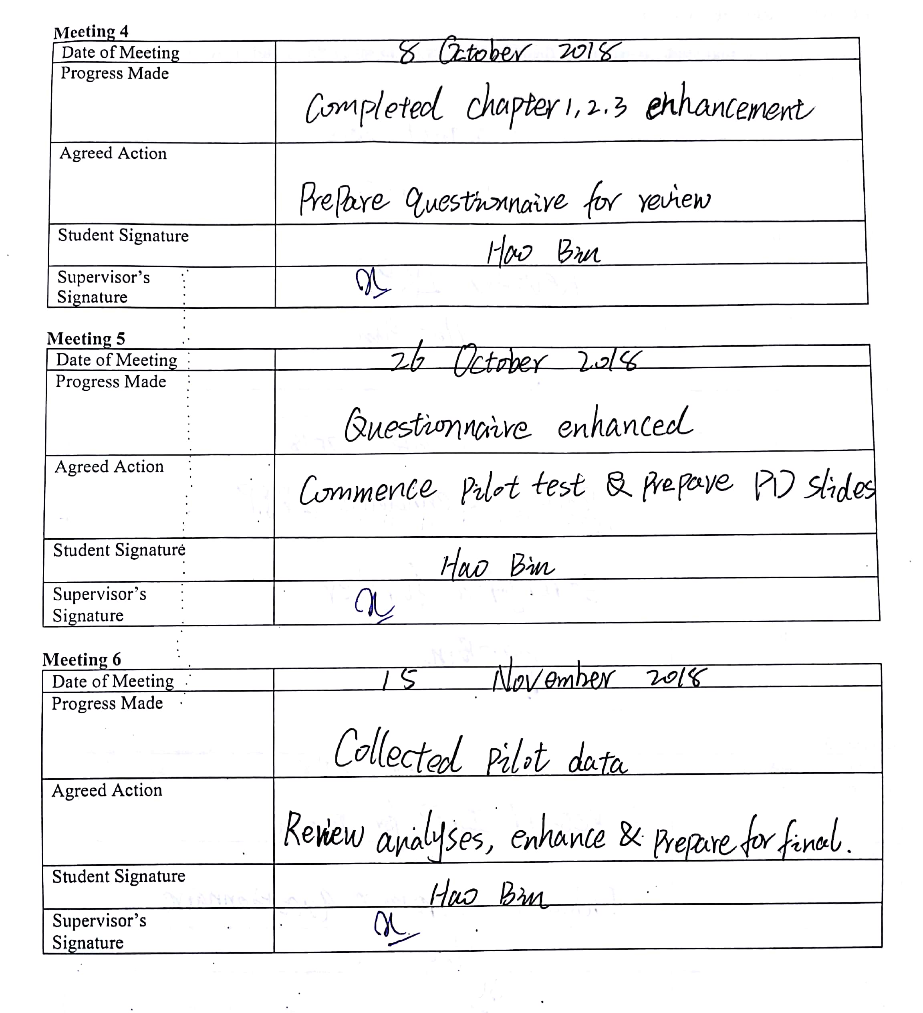
Section C. Comments on Management of Project
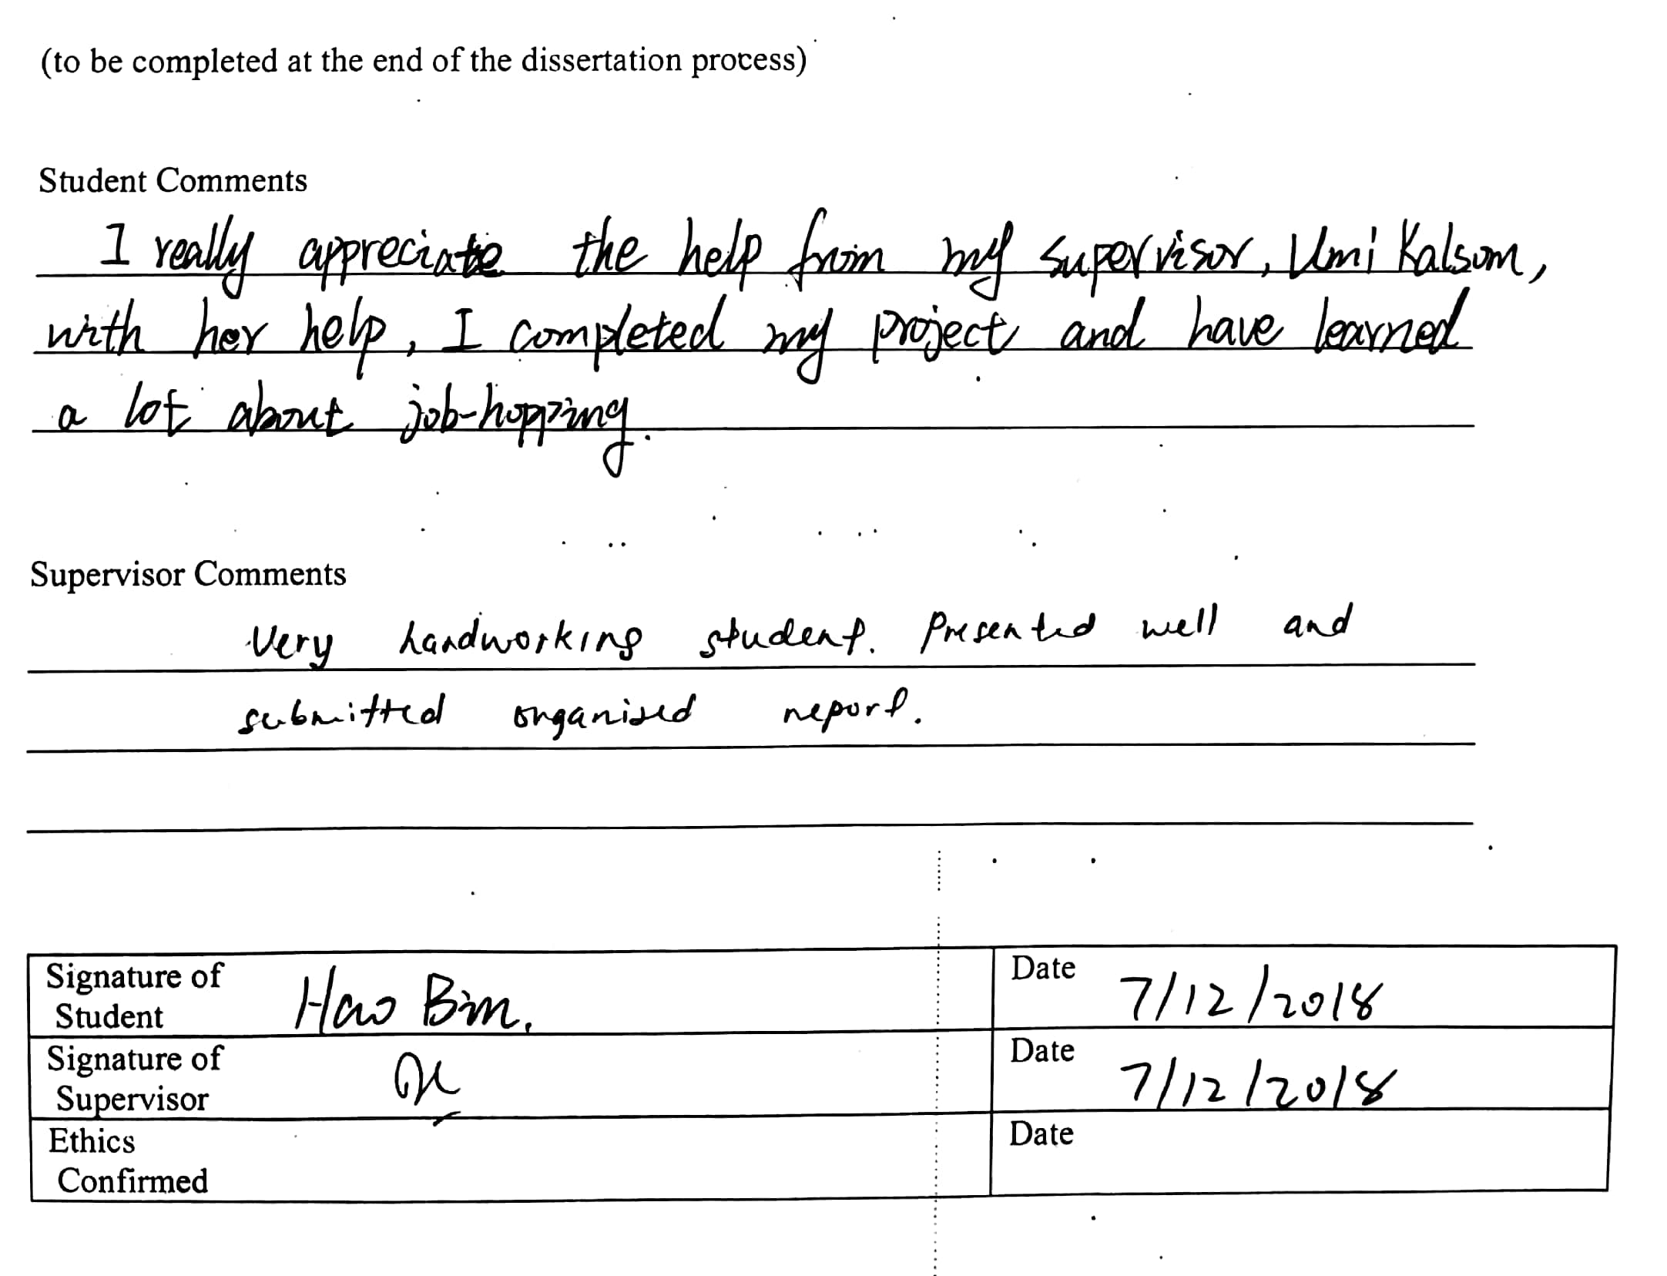

Appendix 2 Example of Spine and Cover of the Thesis
Example of Spine and Cover of the Thesis
HAO BIN MASTER OF BUSINESS ADMINISTRATION 2018
JOB-HOPPING BEHAVIOR IN THE RETAIL INDUSTRY OF SHANGHAI, CHINA
HAO BIN
MASTER OF BUSINESS ADMINISTRATION FACULTY OF BUSINESS, COMMUNICATION & LAW
INTI INTERNATIONAL UNIVERSITY
2018

Appendix 3 Declaration
Declaration
I hereby declare that this thesis is my own work and effort and that it has not been submitted anywhere for any award. Where other sources of information have been used, they have been duly acknowledged.
Name: Hao Bin
Student ID: I17013849

Signature:
Date: 7/12/2018

Appendix 4 Title Page
Title Page
INTI INTERNATIONAL UNIVERSITY
MASTER OF BUSINESS ADMINISTRATION
Job-Hopping Behavior in the Retail Industry of Shanghai, China

Author: Hao Bin
Student No: I17013849
Supervisor: Umi Kalsom
Submission Date: 14/12/2018
Final Word Count: 17671

Appendix 5 Initial Research Paper Proposal
INTI International University
Master of Business Administration MGT7999
Initial Research Paper Proposal
STUDENT NAME & ID NO | Hao Bin I17013849
BROAD AREA | Human Resource Management
Concise Title | Job-Hopping Behavior in the Retail Industry of Shanghai, China
Problem Definition | There is an excessive loss of employees in China's retail industry and the rapid flow of human resources has become one of the serious problems faced by retail companies in China, at the same time, the current talent job-hopping rate of local retailers in Beijing, Shanghai, and Tianjin is close to 35% (Wang, 2015).The emergence of job-hopping has already had an influence on Shanghai retail industry and enterprises are worried that the shortage of talent or so-called scarcity of talent (Chen, 2016). With the increasingly fierce competition among enterprises, many high-quality talents will job-hopping to the competition which can meet the requirements, so remedy the problem of the enterprise itself can retain talents (Zhao, 2016). At the same time, the job-hopping rate of grassroots employees is relatively high and according to statistics, the job-hopping rate of grassroots employees in China's chain retailing industry is 20 percent to 30 percent (Liao, 2015).  Higher employee job-hopping rate is a major problem faced by enterprises and managers should seriously consider the strategy of preventing employees’ job-hopping, because cultivating an employee requires the company to spend a lot of resources and no one can accept such losses (Xie, 2016)
Research Objectives and Research Questions | The focus of this study is to investigate the influence of income levels, job satisfaction, and working environment on employee job-hopping behavior in retail industry of Shanghai in China.  The specific objectives are:  RO1: To determine whether the income level influence the job-hopping behavior in the retail industry of Shanghai, China.  RO2: To determine whether the job satisfaction influence the job-hopping behavior in the retail industry of Shanghai, China.  RO3: To determine whether the work environment influence the job-hopping behavior in the retail industry of Shanghai, China.  The research questions are behind to the research objectives. In order to achieve the above research objectives, this research establishes the following research questions.  RQ1: Will the income level influence the job-hopping behavior in the retail industry of Shanghai, China?  RQ2: Will the job satisfaction influence the job-hopping behavior in the retail industry of Shanghai, China?  RQ3: Will the work environment influence the job-hopping behavior in the retail industry of Shanghai, China?
Scope of study | The scope of this study is the behavior research of employee job-hopping in the retail industry of Shanghai (Kong, 2015). By proposing appropriate recommendations and solutions, companies can effectively reduce the chances of employee turnover in the retail industry (Wang, 2015). Research in a specific field can propose targeted solutions, so on this basis, this research will do the situation of the retail industry in Shanghai (Chen, 2016). In addition, this study also focused on the discovery of key factors leading to employee job-hopping, which often appear in the mass media and are known by many scholars (Liao, 2015).
Significance of the Research | Significance to Academia  The results and findings of this study can help enterprise managers improve the ability and effectiveness in managing human resources, and better selection strategies to prevent employees choose job-hopping, Khalid and Kenneth (2015) was also gave considerable support in the study. At the same time, according to the research of Chee Xie (2016), the study also provides factors that influence employee job-hopping, such as income level, job satisfaction and working environment, and the relationship between employee job-hopping in retail companies.  Ahmid, Yazam and ALDamoe (2015) also confirmed the importance of factors influencing employee job-hopping, so it is also reflected in this study and this research can help employers find the solutions to prevent employee job-hopping and achieve academic satisfaction. This research not only deepens the understanding of the factors influencing employee job-hopping, but also supplements Shanghai lack of English-related research in the retail industry, providing a reference for future research.  Significance to Industry  If retail companies can understand the factors that influence employee job-hopping behavior, then companies can choose to propose appropriate strategies and methods to solve the employee job-hopping behavior, which will be very helpful to the enterprise. So, the results of this research can help managers to understand employee job-hopping behavior more widely.
Literature Review | Job-Hopping: Job-hopping is an important event for every person’s career development plan, in general, it is often related to financial income and previous study have shown that an average of 10 percent of wage growth is obtained from work, accounting for about one-third of wage growth (Topeland & Ward, 2015). Different countries have different definitions on job-hopping and the common definition of job-hopping is that employees are dissatisfied with the current situation and move on to a better position (Ganco, Ziedonis & Agarwal, 2015). Idris (2015) pointed out that job-hopping means that employees do not change the nature of work, but often change the company. Most people change jobs because want to get paid, welfare and bonus more than the current company can provide (Yusoff, Queiri, Zakaria & Hisham, 2015). Therefore, job-hopping is inter-organizational shift because after the job-hopping is over, the employee's work nature and organization type may be the same and is an internal shift of the same type of organization, (Idris, 2015).  Income Level: In today’s economic globalization, the competition of human resources in enterprises also requires a compensation mechanism to ensure that employees’ income can guide and motivate employees to bring benefits and development to the enterprise (Han, 2015). In general, China’s corporate employee income model has followed a foreign framework, and the income of Chinese corporate employees mainly includes basic wages, bonuses, dividends, allowances and benefits (Zhang, 2014).  Job Satisfaction: The related research on job satisfaction can be divided into two major aspects: job satisfaction influence variables and outcome variables (Nan, 2015). The research conclusion of the influencing factors of employees' job satisfaction is same, and basic factors influencing employees’ job satisfaction can be concluded (Lu, Shi & Yang, 2015).  Work ability, salary, management style, corporate training and colleagues’ relations have an influence on employees’ job satisfaction and there is a certain relationship between employee satisfaction and job performance (Xu & Li, 2015). The evaluation structure of job satisfaction is composed of corporate image, leadership, job return, work cooperation and job (Zhang, Zhu & Chen, 2014). Among them, corporate image includes enterprise system and product management, while leadership including management and recognition of employees’ work and job rewards are benefits and employee development, and work collaboration is mutual respect between employees (Liu & Zhang, 2015).  Work Environment: The working environment includes hardware and software, which meet the needs of employees and the goals of enterprises from different levels (Guo, 2015). Hardware includes material rewards and labor environment, in which material rewards can motivate employees, and labor environment can improve work efficiency while ensuring employees’ physical safety (Xing, Zhang & Yin, 2016). Software includes corporate culture and working atmosphere, in which a good corporate culture and working atmosphere can improve the cohesion of employees and promote the development of enterprises (Yao, 2015).
Research Methodology | Research Design: This research is a cross- sectional study Methodology using quantitative methods based on descriptive research.  Unit of Analysis: Individual of job-hopping behavior among Chinese in Shanghai retail industry.  Sample Size: 384 employees in retail industry of Shanghai, China.  Sampling Procedure: Non-probability sampling (convenience sampling)  Data Collection Method: Online Questionnaire.  Questionnaire Design: The data collection technique of the questionnaire system consists of a number of questions and requires participants to answer the listed questions to determine the participants’ attitudes and the problem setting is the questionnaire design (Lavrakas, 2015). The researchers divided the online questionnaire into three parts: A, B, and C. Part A is the demographic profile. Part B and C use the Likert scale format of five-point to represent the measurement concept. The “strong disagree” is 1, “Strongly agree” is 5. In Section B, respondents were asked to answer questions about independent variables: income level, job satisfaction, and work environment. In Section C, respondents were asked to answer the question of dependent variables, which is job-hopping behavior in retail industry of Shanghai, China.

Appendix 6 Turnitin results
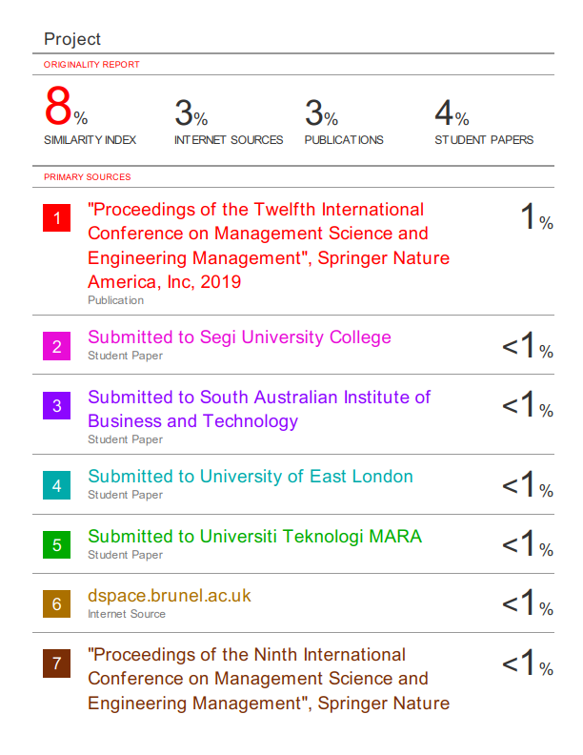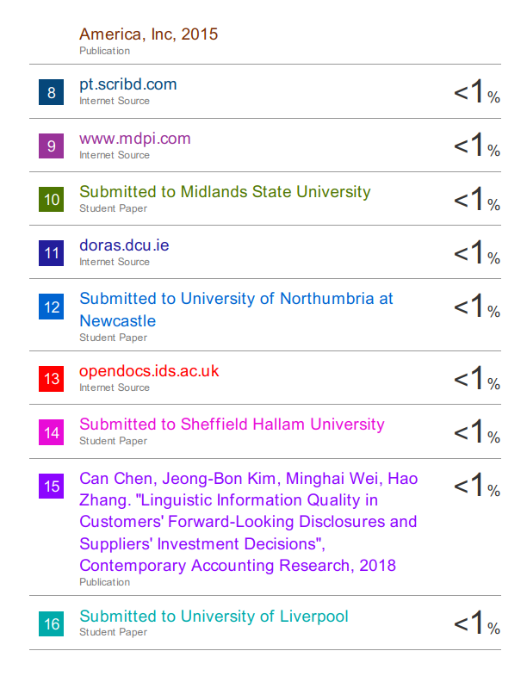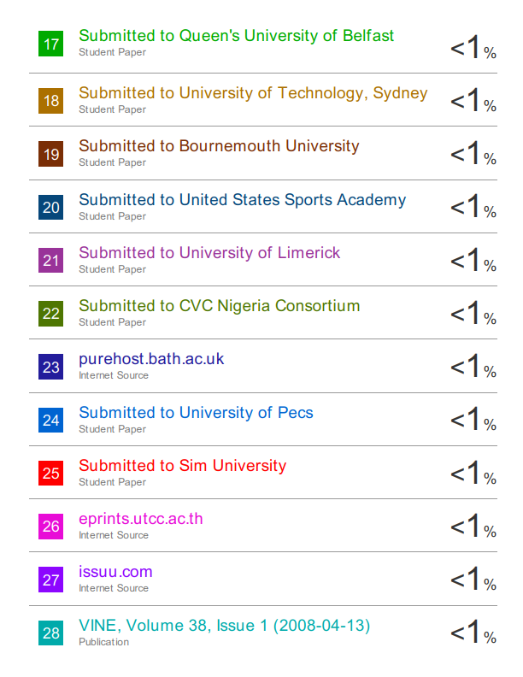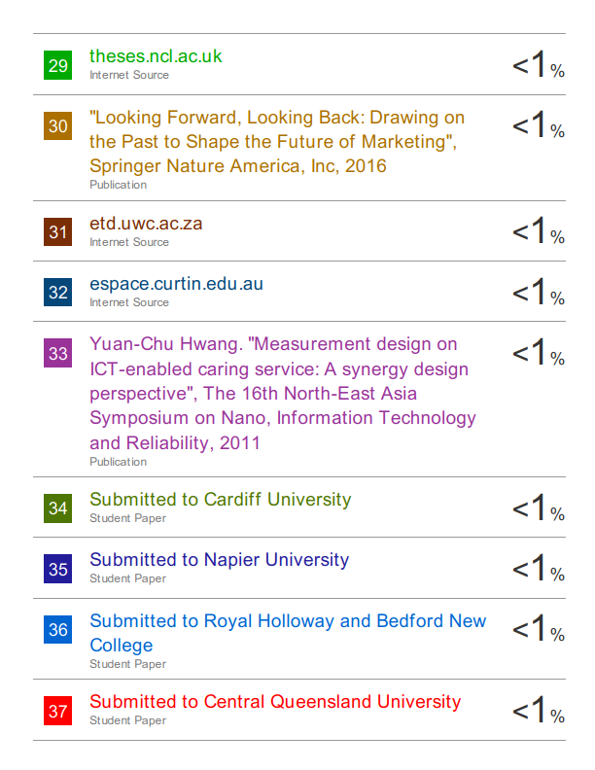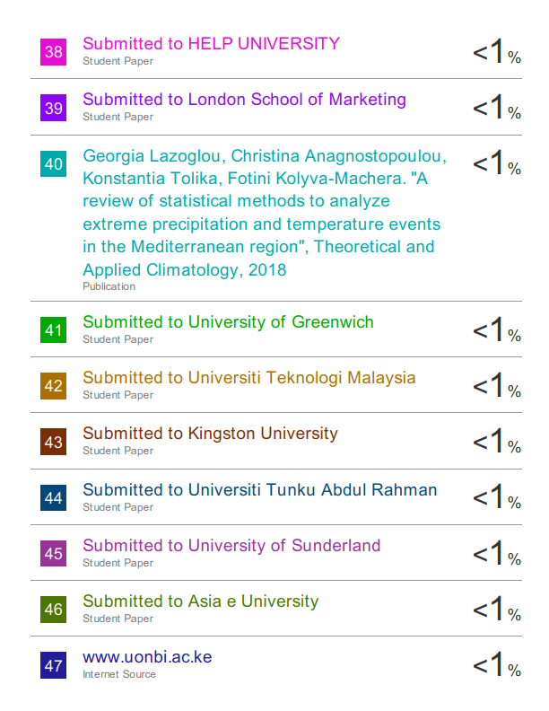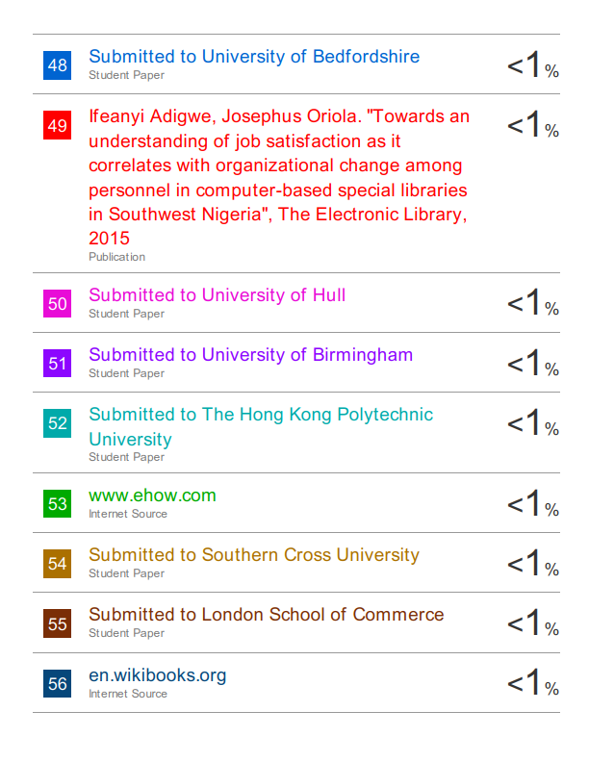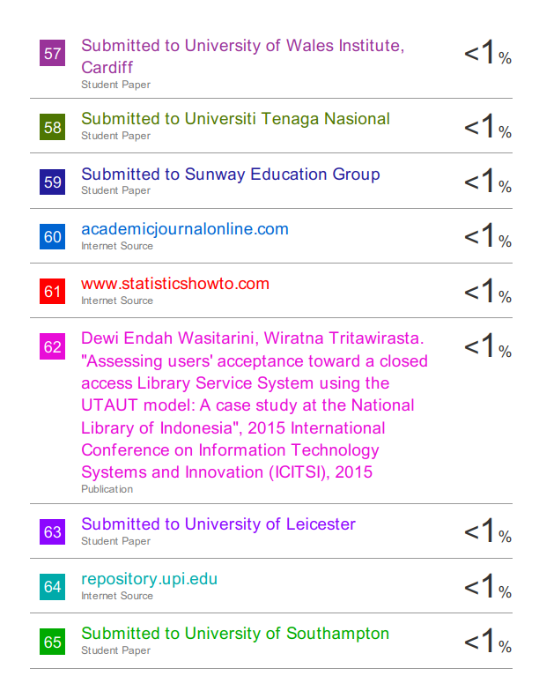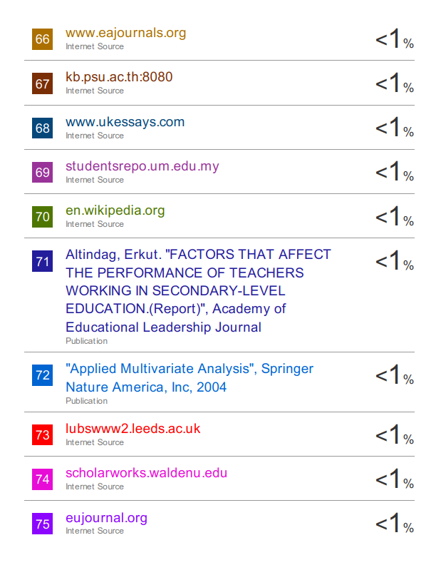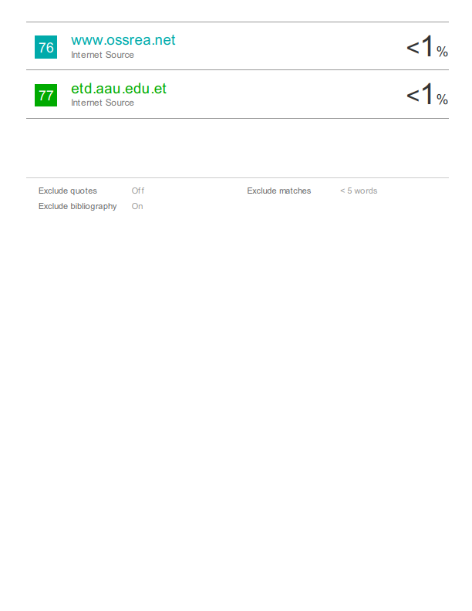

Appendix 7 Questionnaire
Dear Sir/Madam,
I am Hao Bin (ID: I17013849) and currently doing my postgraduate program in the Master of Business Administration at INTI International University, Malaysia. You are invited to take part in a research study. The aim of this study is to identify the factors that lead to employee job hopping, and to determine the factor that has the greatest influence on employee job hopping in the retail industry in Shanghai, China.
There will be no risk or side effects in taking part as the questionnaire is designed in a way that you could answer the questions directly. The data collection is done by the researcher personally. Third parties are not allowed to access the data and the answers will not be released to others for viewing, besides your name will not be recorded in order to preserve your anonymity.
Without your cooperation and support, this research cannot be accomplished. Please take your time to participate in this survey. Thank you in anticipation for your cooperation.
Yours faithfully,
Hao Bin

SECTION A- Demographic Profiles
Instruction: please tick (✓) at the appropriate box.
1. Gender
◻ Male ◻ Female

2. Age
◻ Below 21 years old ◻ 21 – 30 ◻ 31-40
◻ 41-50 ◻ More than 50

3. What is your highest education level?
  - High school/Diploma ◻ Bachelor degree ◻ Master
◻ PhD ◻ Others, please specify

4. Occupation:
◻ Store sales ◻ Store / branch manager ◻ Store supervisor
◻ Store owner ◻ Others

Section B - Factors influencing Job hopping
Please tick “√” the following.
Rate each statement using 5-point Likert Scale 1=Strongly Disagree, 2= Disagree, 3=Neutral, 4=Agree, 5=Strongly Agree

Income Level
NO. | Questions | 1 | 2 | 3 | 4 | 5
1 | I am satisfied with my current salary.
2 | I think my current wage/ salary is comparable to the standard income in this industry.
3 | I think that my hard work is proportional to my income.
4 | I believe that my income is appropriate to my position and qualification.
5 | I think that the annual salary increment is acceptable when compared to other companies in the industry
Job Satisfaction
NO. | Questions | 1 | 2 | 3 | 4 | 5
1 | I am contented with this type of work.
2 | I am enjoying this job.
3 | I can learn much and grow fast by doing this job.
4 | I feel I am important when I do this work.
5 | I think my job is very interesting and satisfying
Work Environment
NO. | Questions | 1 | 2 | 3 | 4 | 5
1 | The physical working condition of my firm are very good.
2 | The method of work measurement is reasonable in my firm.
3 | I am satisfied with my working time and privileges offered
4 | My company is always moving toward to improve ways of doing things.
5 | My organization is always utilizing new technologies to work.

Section C- Job hopping
Please tick “√” the following.
Rate each statement using 5-point Likert Scale 1=Strongly Disagree, 2= Disagree, 3=Neutral, 4=Agree, 5=Strongly Agree
NO. | Questions | 1 | 2 | 3 | 4 | 5
1 | I often think about quitting my job.
2 | I am likely to look for different organization to work in in the short term.
3 | I feel disjointed and not engaged in this organization.
4 | I do intend to quit my job within the next year/short term.
5 | I do not hope to have a long future with this company.

Thank you very much for reading this information and considering taking part in this study.
Researcher: Hao Bin
Phone: +60172184363
Email: i17013849@student.newinti.edu.my /375371657@qq.com

Appendix 7 Tables
Factor Analysis of Pilot Test

Table 4.1.1.1 KMO and Bartlett’s Test (Dependent Variable)

Job-hopping Behavior
Items | Factor Loading
I often think about quitting my job. | 0.617
I am likely to look for different organization to work in in the short term. | 0.726
I feel disjointed and not engaged in this organization. | 0.824
I do intend to quit my job within the next year/short term. | 0.684
I do not hope to have a long future with this company. | 0.553
Variance (percent of explained) | 68.084
Table 4.1.1.2 Communalities of Dependent Variable
Table 4.1.1.3 Total Variance Explained of Dependent Variable
Table 4.1.1.4 KMO and Bartlett’s Test (Total Independent Variables)
Income Level
Items | Factor Loading
I am satisfied with my current salary. | 0.636
I think my current wage/ salary is comparable to the standard income in this industry. | 0.671
I think that my hard work is proportional to my income. | 0.544
I believe that my income is appropriate to my position and qualification. | 0.632
I think that the annual salary increment is acceptable when compared to other companies in the industry | 0.642
Job Satisfaction
Items | Factor Loading
I am contented with this type of work. | 0.816
I am enjoying this job. | 0.818
I can learn much and grow fast by doing this job. | 0.874
I feel I am important when I do this work. | 0.812
I think my job is very interesting and satisfying | 0.883

Work Environment
Items | Factor Loading
The physical working condition of my firm are very good. | 0.654
The method of work measurement is reasonable in my firm. | 0.643
I am satisfied with my working time and privileges offered | 0.836
My company is always moving toward to improve ways of doing things. | 0.553
My organization is always utilizing new technologies to work. | 0.759
Table 4.1.1.5 Communalities of Total Independent Variables
Table 4.1.1.6 Total Variance Explained of Total Independent Variables
Reliability Test of Pilot Test

 | Cronbach’s Alpha | Number of Items
Income Level | 0.814 | 5
Job Satisfaction | 0.948 | 5
Work Environment | 0.879 | 5
Job-hopping Behavior | 0.882 | 5
Table 4.1.2 Summary of Reliability Test

Correlation Matrix Test

Table 4.1.3.1 Summary of Correlations (Independent Variables)
Table 4.1.3.2 Summary of Correlations (Dependent Variable)

Demographic Profile

 | Frequency | Percentage
Male | 80 | 26.8
Female | 219 | 73.2
Total | 299 | 100.0
Table 4.2.1 Gender

 | Frequency | Percentage
Below 21 years old | 49 | 16.4
21-30 | 111 | 37.1
31-40 | 80 | 26.8
41-50 | 34 | 11.4
More than 50 | 25 | 8.4
Total | 299 | 100.0
Table 4.2.2 Age

 | Frequency | Percentage
High school/ Diploma | 73 | 24.4
Bachelor degree | 143 | 47.8
Master | 53 | 17.7
PhD | 17 | 5.7
Others | 13 | 4.3
Total | 299 | 100.0
Table 4.2.3 Education Background

 | Frequency | Percentage
Store sales | 139 | 46.5
Store manager | 90 | 30.1
Store supervisor | 49 | 16.4
Store owner | 21 | 7.0
Total | 299 | 100.0
Table 4.2.4 Occupation

Factor Analysis of Preliminary Test

Table 4.3.1.1 KMO and Bartlett’s Test (Dependent Variable)
Job-hopping Behavior
Items | Factor Loading
I often think about quitting my job. | 0.731
I am likely to look for different organization to work in in the short term. | 0.708
I feel disjointed and not engaged in this organization. | 0.870
I do intend to quit my job within the next year/short term. | 0.795
I do not hope to have a long future with this company. | 0.766
Variance (percent of explained) | 77.396
Table 4.3.1.2 Communalities of Dependent Variable
Table 4.3.1.3 Total Variance Explained of Dependent Variable
Table 4.3.1.4 KMO and Bartlett’s Test (Total Independent Variable)
Items | Factor Loading
Income Level
I am satisfied with my current salary.  I think my current wage/ salary is comparable to the standard income in this industry. | 0.616  0.703
I think that my hard work is proportional to my income. | 0.675
I believe that my income is appropriate to my position and qualification. | 0.651
I think that the annual salary increment is acceptable when compared to other companies in the industry | 0.617
Job Satisfaction  I am contented with this type of work.  I am enjoying this job.  I can learn much and grow fast by doing this job.  I feel I am important when I do this work.  I think my job is very interesting and satisfying.  Work Environment  The physical working condition of my firm are very good.  The method of work measurement is reasonable in my firm.  I am satisfied with my working time and privileges offered.  My company is always moving toward to improve ways of doing things.  My organization is always utilizing new technologies to work. | 0.788  0.863  0.703  0.816  0.669  0.749  0.602  0.618  0.777  0.831
Table 4.3.1.5 Summary of Communalities (Total Independent Variable)
Table 4.3.1.6 Total Variance Explained
Reliability Test of Preliminary Test

 | Cronbach’s Alpha | Number of Items
Income Level | 0.863 | 5
Job Satisfaction | 0.920 | 5
Work Environment | 0.890 | 5
Job-hopping Behavior | 0.927 | 5
Table 4.3.2 Summary of Reliability

Normality Test

Table 4.4.1 Summary of Normal Q-Q Plot
Table 4.4.2.1 Normal P-P Plot of Regression Standardized Residual
Table 4.4.2.2 Scatterplot
Simple Multiple Regression

Table 4.5.1.1 Model Summary
Table 4.5.1.2 ANOVA
Table 4.5.1.3 Coefficients

