CHENG YUN EN MASTER OF BUSINESS ADMINISTRATION 2018 | CONSUMER PURCHASE INTENTION ON HEALTH FOOD IN TAIWAN  CHENG YUN EN  MASTER OF BUSINESS ADMINISTRATION  FACULTY OF BUSINESS, COMMUNICATION & LAW  INTI INTERNATIONAL UNIVERSITY  2018
INTI INTERNATIONAL UNIVERSITY

MASTER OF BUSINESS ADMINISTRATION

CONSUMER PURCHASE INTENTION ON HEALTH FOOD IN TAIWAN

Author: Cheng Yun En
Student No: I17013728
Supervisor: Dr. Alex Ng Hou Hong
Submission Date: 7 December 2018
Ethics Number: cBUS/PGT/CP/03805
Final Word Count: 16,647

Faculty of Business, Communication and Law

ABSTRACT
Nowadays, people are getting more health conscious and paying more attention on healthy diet than ever before. As a result, more healthy food products are now available in the market and it had driven the healthy food industry to grow at an exponential rate. This particular study aims to explore the factors that influence the consumers' purchase intention of healthy food. The fundamental underlying theory for consumer purchase intention with regards to the research topic would be Theory of Planned Behavior (TPB), which focuses on explaining how consumers’ purchase intention is influenced by external environmental factors. With that, it is identified that the independent variables (IVs) in this research would be Brand Awareness, Perceived Quality and Perceived Price and the dependent variable (DV) is Consumer Purchasing Intention. Apart from that, the research methodology of this study would be designed using correlation design and adopting the quantitative framework. In another word, the methodology involves data collection through a survey and analyzed by SPSS to measure the relationship between the variables of the research. Finally, this thesis concludes the research results and provides some reasonable suggestions to health food marketing in the last section of the research paper.

Keywords: Purchase Intention; Health Food; Brand Awareness; Perceived Quality; Perceived Price; SPSS

ACKNOWLEDGEMENT
Firstly, I would like to express my sincere gratitude to my supervisor Dr. Alex Ng Hou Hong for the continuous support of my research, for his patience, motivation, and immense knowledge. His guidance helped me in all the time of research and writing of this thesis.
Besides my supervisor, I would like to thank Dr. Syriac Nellikunnel for his insightful comments and encouragement, but also for the few questions which incented me to widen my research from various perspectives.
I would also like to thank the individual who were involved in the survey for this research. Without their passionate participation and input, the survey could not have been successfully conducted.
Finally, I must express my very profound gratitude to my family for providing me with unfailing support and continuous encouragement throughout my years of study and through the process of researching and writing this thesis. This accomplishment would not have been possible without them.

Cheng Yun En

DECLARATION
I hereby declare that this thesis is my own work and effort and that it has not been submitted anywhere for any award. Where other sources of information have been used, they have been duly acknowledged.

Name: Cheng Yun En
Student ID: I17013728
Signature: Cheng Yun En
Date: 10 December, 2018

:
Table of Contents
CHAPTER 1 INTRODUCTION 1
1.0 Overview 1
1.1 Background 1
1.2 Problem Statement 3
1.3 Research Objectives 4
1.4 Research Questions 5
1.5 Significance of Study 5
1.5.1 Significance to Academic 5
1.5.2 Significance to Industry 6
1.6 Scope of the study 6
1.7 Operational Definitions 7
1.8 Organization of Chapters 8
CHAPTER 2 LITERATURE REVIEW 11
2.0 Overview 11
2.1 Consumer Purchase Intention 11
2.1.1 Consumer Purchase Intention Globally 12
2.1.2 Consumer Purchase Intention in Taiwan 14
2.2 Factors Influencing Consumer Purchase Intention 16
2.2.1 Brand Awareness 17
2.2.2 Perceived Quality 22
2.2.3 Perceived Price 25
2.3 Influencing Factors linking with Consumer Purchase Intention 28
2.3.1 The Relationship between Brand Awareness and Consumer Purchase Intentions 28
2.3.2 The Relationship between Perceived Quality and Customer Purchase Intentions 30
2.3.3 The Relationship between Perceived Price and Customer Purchase Intention 31
2.4 Theory of Planned Behavior 32
2.5 Gaps in Literature 34
2.6 Conceptual Framework 34
2.7 Hypothesis 35
2.8 Conclusion 36
CHAPTER 3 RESEARCH DESIGN AND METHODOLOGY 37
3.0 Overview 37
3.1 Research Design 37
3.2 Unit of Analysis and Time Horizon 39
3.3 Sampling Design 40
3.3.1 Sampling Plan 40
3.3.2 Sample Size 41
3.4 Questionnaire Design 42
3.5 Pilot Test 44
3.5.1 Factor Analysis 44
3.5.2 Reliability Test 45
3.5.3 Correlation Matrix 46
3.6 Measurements 47
3.6.1 Descriptive Information 47
3.6.2 Preliminary Tests 47
3.6.3 Hypothesis Testing 49
3.7 Ethical Consideration 50
3.8 Conclusion 50
CHAPTER 4 RESEARCH FINDINGS 51
4.0 Overview 51
4.1 Pilot Test 51
4.1.1 Factor Analysis of Pilot Test 51
4.1.2 Reliability Test of Pilot Test 53
4.1.3 Correlation Analysis of Pilot Test 54
4.2 Descriptive Analysis / Demographic of Respondents 55
4.2.1 Response Rate 55
4.2.2 Demographic Profile of Respondents 56
4.3 Preliminary Data Analysis 60
4.3.1 Factor Analysis 60
4.3.2 Reliability Test 61
4.4 Hypothesis Analysis 62
4.5 Summary of Findings 65
4.6 Conclusion 66
CHAPTER 5 CONCLUSION 67
5.0 Overview 67
5.1 Discussion 67
5.2 Recommendation 71
5.3 Conclusion 72
5.4 Contribution to Academy 72
5.5 Contribution to Industry 73
5.6 Limitation 73
5.7 Future Study of Research 74
5.8 Personal Reflection 75
REFERENCE 76
APPENDICES 95
Appendix 1: Questionnaire 95
Appendix 2: SPSS Outputs for Pilot Test 97
Appendix 3: SPSS Outputs for Final Data Analysis 102
Appendix 4: Project Proposal 114
Appendix 5: Ethics Approval Form 116
Appendix 6: Project Log 132
Appendix 7: TURN-IT IN Report 139

List of Tables
Table 1.1 Operational Definitions 7
Table 3. 1 Framework of Resign Design………………………………………...42
Table 4. 1 The factor analysis result of pilot test………………………………..52
Table 4. 2 The reliability test of pilot test 54
Table 4. 3 Criterion of Pearson Correlation R Value 55
Table 4. 4 Demographic of Respondents 56
Table 4. 5 Factor Analysis Result in SPSS 61
Table 4. 6 Reliability test of preliminary data 62
Table 4. 7 Research Hypotheses 63
Table 4. 8 Multiple Regression Model Summary 63
Table 4. 9 Multiple Regression ANOVA 63
Table 4. 10 Results from Multiple Regression 64
Table 4. 11 Acceptance results for hypothesis testing 65
Table 5. 1 The Most and Least Significant Factor Summary………………….68

List of Figures
Figure 2. 1 The Framework of Purchase Intention in This Study 35
Figure 3. 1 Framework of Research Design……………………………..……..38
Figure 4. 1 Demographic Profile (Gender)………………………………………57
Figure 4. 2 Demographic Profile (Age) 58
Figure 4. 3 Demographic Profile (Education Level) 58
Figure 4. 4 Demographic Profile (Marital Status) 59
Figure 4. 5 Demographic Profile (Income Per Month) 59

CHAPTER 1 INTRODUCTION

1.0 Overview
Chapter one will first and foremost focus on the background of study which discusses the development of healthy food industry in Taiwan and then followed by the problem statement of this research, research objectives and as well as the research questions. In the final part of chapter one, the significance of the study, as well as the research limitation, will also be outlined. Finally, the end of this chapter will include the operational definitions and the organization of the chapters.

1.1 Background
According to market research done by Technavio (2017), the global healthy food industry is expected to grow at a rate of 14 percent from 2017 to 2021. In a similar context, Brennan et. al. (2013) reported that health consciousness among consumers is growing rapidly and is particularly obvious among the younger generation who are seriously concerned with their own weight, figure, and self-image. Not only that, but they have also discovered that businesses and consumers are putting more emphasis on healthy consumer food and often associated healthy food with quality, safety, and hygiene on a global scale (Ambali and Bakar, 2013). In addition, there is a research focusing on the purchase intention of health food industry a few years ago in the USA whereby the results show that the economic growth has a positive influence towards the growth of the health food industry, as the country becomes more civilized, their concern and demand for healthy food increases. (An, 2013). This is because as consumers are getting better educated and have higher purchasing power, they are more likely to spend more of their financial resources on health foods for their daily consumption. Furthermore, health-consciousness and personal appearance are also found to be the driving force behind the growing demand for the health food industry (Lopaciuk and Loboda, 2013).
And in terms of branding aspect of a company and products, Asaad and Serdar (2015) indicated that brand awareness is crucially important for a company as it directly represents the consumers understanding of the company's brand and their associated products. At the same time, integrated branding also represents what would be the company’s vision and mission, which helps in creating awareness about the products and its features for consumers that resonate with their vision. (Muhammad et. al., 2013)
Based on Golnaz et. al. (2012) there is a positive correlation between perceived quality and consumer willingness to purchase. Moreover, Haque et. al. (2015) have similarly stated that plans and strategies to control the product quality need to be implemented to ensure that the consumers have confidence in the quality of the health food products in the long run.
Furthermore, the ease of access of the internet has made it easier for consumers to make their decisions of companies selling similar products which are made available to them based on a wide variety of factors such as price, product quality, brand integrity, and et cetera. (Moreira et. al., 2015). Consequently, this highly competitive environment will bound to cause the consumers' price sensitivity increase, so the price and the brand of the product and the environment of the store will be particularly evaluated more carefully before the purchase decision is being made. (Lynch et. al, 2012).
As of recent, Taiwan’s national value would be to promote healthy living through healthy food. Therefore, Taiwanese consumers are more concerned with the nutritional value of the food they eat and do their best to pursue a healthy diet that reduces the obesity and as well as the risk of chronic diseases (Yang et. al., 2016). With that, when consumers make food-buying decisions, features of healthy food are important, such as their taste, sensory sensation and nutritional value (Li et. al., 2013). This observed consumer trend is expected to encourage the sales growth of healthy food, as healthy food is believed to have a higher nutritional content that promotes individual longevity than other conventional food. (Lee and Yun, 2015). With that in mind, this research will focus on studying the factors influence the relationship between customer purchase intention in the healthy food industry.

1.2 Problem Statement
Consumers’ desire for a healthy diet had observed to increase dramatically over the years according to the report done by Ronteltap et. al. (2012). There is, in fact, a growing increase in interest around the usage and consumption of healthy food (Teng and Wang, 2015). Healthy food is not purely intended to just satisfy hunger or to meet nutrition requirements, but they are food that has additional health-boosting ingredients, reduction in sugar and artificial ingredients as well as naturally processed (Jun et. al., 2014).
The number of elderly populations in Taiwan is increasing at an unprecedented rate (Lin and Huang, 2015). Due to changes in demographics in Taiwan of less working adults, the number of employees eating out and working pressure has increased due to their increased workload, and many diseases such as obesity, high blood pressure, and diabetes have also increased (Colbin, 2013). It is said that prevention is better than cure. Therefore, personal health awareness has increased, and consumers are paying more attention to the nutritional information of their food, therefore, the demand for the health food that helps maintain health is greatly increased (Sonnenberg et. al., 2013).
However, due to the variety of healthy foods, in the case of uneven quality, consumers can see the advertisements that exaggerate the effects of products everywhere, it is difficult for consumers to judge the authenticity of health foods, product efficacy, and reasonable prices (Barbera et. al, 2018). Not only that, if consumers buy a healthy food with poor quality, it will not bring health but will cause harm to the body. With that, this research aims to look the subject matter from a different perspective by studying the factors influencing the relationship between brand awareness, perceived quality and perceived price and customer purchase intention in healthy food industry and how the variation of these factors influences the customer purchase intention in the healthy food industry in Taiwan (Darmon and Drewnowski, 2015).

1.3 Research Objectives
The research objectives represent the core goals which will be studied by the researchers. Based on the research objectives, the questions provide the exact focus of the research attempts of the individual (Sekaran and Bujía, 2013). The research objectives are formulated as below:
RO₁: To determine whether brand awareness influence consumer purchase intention of health food in Taiwan.
RO₂: To determine whether perceived quality influence consumer purchase intention of health food in Taiwan.
RO₃: To determine whether perceived price influence consumer purchase intention of health food in Taiwan.

1.4 Research Questions
On the basis of Sekaran and Bougie (2013), the research questions must be formed after the formation of the research objectives in order to help the researcher to collect information related to research focus areas and achieve research objectives. Research questions are the focused version of the research objectives, from which they are derived. Hence, the research questions will use the objectives which have been set out in this study. Based on the above statements, the present study based on three questions:
RQ₁: Will brand awareness influences consumer purchase intention of health food in Taiwan.
RQ₂: Will perceived quality influences consumer purchase intention of health food in Taiwan.
RQ₃: Will perceived price influences consumer purchase intention of health food in Taiwan.

1.5 Significance of Study

1.5.1 Significance to Academic
The main contribution of this research from an academic perspective is that it adds to the literature which is present around decision making in the health food industry (Teng and Wang, 2015). As a matter of fact, this research offers statistical evidence and information to those researchers who wish to study topics in similar academic field.
Hence, this study researches the relationship between the factors of brand awareness, perceived quality, perceived price, and the customer purchase intention in the health food industry of Taiwan. At the same time, it also helps expand the literature to enhance topical understanding of health food marketing based on specific independent variables and other researchers may refer to this research when they are carrying out research on other industries (Teng et. al., 2014).

1.5.2 Significance to Industry
From the perspective of industry-wide implication, it can provide important guidance on how companies should orient their products within the health food industry. For example, the study will provide results on what features of health food are most important for consumers, and with that companies could align their products with this newly found knowledge in order to improve the offering for their customers (Khan et. al., 2013). Secondly, for the government, the result may help to adopt measures to reduce diseases due to obesity and to improve people’s health through the promotion of health food for its citizens (Swinburn et. al., 2015).

1.6 Scope of the study
This research will only focus on a specific business sector – Healthy Food, and the research location is set to be in Taiwan. Popular mainstream social media platforms will be chosen for distribution of the online questionnaires. Moreover, the research methodology mainly relies on the primary data extracted from the target respondents. The target population in this research are individual consumers who over the age of 21 years old that are proven to have a better experience on making regular purchase decisions whether via offline (physical shops) or online (e-commerce) portals. (Maichum et. al., 2016).

1.7 Operational Definitions
For most readers, some terms used in the research is highly technical, and are usually used by academic professionals for academic discussion purposes. Therefore, for the convenience and ease of understanding of the readers, the following table is accompanied by an explanatory list of these uncommon terms.
Table 1.1 Operational Definitions
Key Terms | Definitions
Consumer Purchase Intention | Consumer purchase intention had been defined by Hasan et. al. (2013) as the consumer willingness to purchase a product or the attitude and perception of a consumer towards a product in the sake of evaluating the probability for trying and buying that product as a way to seeking value or need.
Health Food | Healthy food refers to any food that is considered beneficial to the body, or that the food may have a slight health benefit which does not contain (or contains lower) nutrients such as fat, sugar, sodium, and cholesterol that are not beneficial to the body (Nestle, 2013).
Brand Awareness | Brand awareness refers to the two-way connection strength of information related to purchasing decisions such as brand elements and product categories in the consumer memory system. (Kotler and Keller, 2016).
Perceived Quality | Perceived quality is defined as an assessment of consumers towards an overall quality or brand performance, where intrinsic and extrinsic quality are examined including the brand and its performance (Hasan et al., 2013).
Perceived Price | Perceived price refers to the subjective cognition and judgment of the price of the product or service provided by the company. (Ponte et. al., 2015).

1.8 Organization of Chapters
This research consists of five (5) chapters each of which along with different aims that descripted in the following table:
Chapter | Aim of the Chapter
Chapter 1: Introduction | At the beginning of this report, the section first introduces the research background and current developments of health food globally. It outlines the development of the health food industry and then uses the unique advantages of the health food industry to elaborate problem statements, research questions, and research goals. Finally, this chapter describes the scope and significance of this study.
Chapter 2: Literature Review | This part aims to review relevant early literature on all the research variables regard to this research. Firstly, it introduces the relevant studies of behavioral intention including purchase intention. Secondly, it introduces the influence factors of purchase intention including brand awareness, perceived quality, and perceived price. Thirdly, it introduces the main models/ theories that referred in this research report such as the Theory of Planned Behavior (TPB). Finally, the gap in the literature and the conceptual framework will be presented to give context and structure for the overall research. Based on the relevant studies, the research hypotheses will also be formulated for statistical examination.
Chapter 3: Research Methodology | This chapter demonstrates the research design and methodology that are applicable to this research. Firstly, Research Design will be presented and linked to the framework of the proposal which was outlined in the earlier chapter. Then, based on the research design, Unit of Analysis and Sampling Design will ensure the research survey can reach the desired target group. Thirdly, Questionnaire Design and Measurement part will outline the data sourcing method, data analysis method, and how to measure the data to maintain the validity of the research results.
Chapter 4: Research Findings and Discussion | This chapter highlights key research findings of the collected data. The results of hypotheses testing will also be presented and discussed extensively. Besides, this chapter will refer to Chapter 1 to assess whether those research objectives and research questions had been achieved and answered.
Chapter 5: Conclusions | The final chapter of this research summarizes and concludes the research findings and discussions with comments on its implication both for academic research and the health food industry. In addition, this report would provide findings and some suggestions to help more health food industry enterprises to better develop marketing strategies and food quality.

CHAPTER 2 LITERATURE REVIEW

2.0 Overview
The purpose of chapter two is to review early academic literatures on all the research variables (independent and dependent variables) associated with this research. The literature review section will mainly talk about the customer purchase intentions of healthy foods in Taiwan. In order to better explain the main topic and other sub-topics, the chapter is segregated into different sections and subsections. By all means, this chapter focuses heavily on literature review, where the previous research findings by other researchers will be discussed, and these early findings are expected to provide the solid foundation for this main research.
Moreover, this chapter includes detail discussion on the research’s variables i.e., independent and dependent variables. These variables will be further studied to come to an effective conclusion on the topic. The framework will also be devised in this chapter to provide the solid base to the research being conducted, along with this, the gaps in literature will be discussed in order to provide information regarding any future research on this topic.

2.1 Consumer Purchase Intention
Fishbein and Ajzen (1980) first identified the importance of consumer purchase intention on the commercial transaction which took place. As a matter of fact, purchase intention was defined by Hasan et. al. (2013) as consumers that are willing to evaluate the product and with that decide whether they want to engage in the transaction or not. On the other hand, purchase intention is also the pattern of repeat purchase of specific products of a particular brand and avoid the usage of alternative branded products because consumers perceive the unique value provided by these brands (Haque et. al., 2015).
In particular, the purchase intention may change due to internal or external reasons during the purchase, under the influence of the perceived quality and the price received. (Gogoi, 2013). According to Kotler and Armstrong (2013), researchers proposed six steps before making a decision to purchase a product., namely interest, awareness, knowledge, like, purchase, and persuasion. And it is also important to note that customers are thinking that it is dangerous to purchase cheap and easy packaging and not very well branded products because the quality of these products is not guaranteed. (Gogoi, 2013).

2.1.1 Consumer Purchase Intention Globally
According to a study handled by Demir and Tansuhaj (2013), concluded that consumers in Turkey were more likely to consider buying global brands when it compared to the offering of local brands. However, there was also a tendency with some to choose local brands over global brands due to their nationalism spirit to support local business. In addition, in another exploratory study conducted by Aqeel (2012), he found that product quality is the most important factor affecting Saudi women’s willingness to purchase, the influence rate of other factors is merely 50%. Furthermore, Diallo (2012) believes that compared with other developed countries, Indian consumers have higher price sensitivity, and in their view high prices and untimely product acquisition are major obstacles for Indian consumers. In addition, Indian consumers believe that the supply of goods is an important aspect influencing their purchase behavior, which is available in grocery stores near them because most consumers take a less active approach to buying and are unwilling to search for other stores for the products (Hjelmar, 2013).
As for Malaysian consumers’, ethical value (such as company CSR and environmental policy) is an important consideration factor of Malaysian consumers' willingness to purchase products from the United States and other foreign regions. Looking from perspective of Russian consumers, Bruschi et. al. (2015) emphasized the attitudes and opinions of Russian consumers on purchase intention and the factors that promote or prevent them from purchasing products, the research showed that the consumption was mainly driven by personal welfare and was correspondingly reduced due to social or environmental issues which the brand or company exhibits.
Apart from price sensitivity and repeat buying patterns, there are also other subtler underlying factors that decide the product demand such as environmental conscious factor. For that, when the product that consumer buys that could potentially pollute and cause damage to the environment would then impact negatively on the purchase intention of the consumer (Hoffmann and Schlicht, 2013).
However, consumer habits can be reckoned as a powerful influence on repurchase intention for the same product over and over again, which means the connection between habits for low-risk trust and repeated purchase intention creates stronger consumer repurchase influence (Chiu et. al., 2012).
The customer's view of the brand influences their purchase intention, as brand trust make up as an important factor in shaping buying intentions (Limbu et. al., 2012). Yong et. al. (2017) indicated that purchase intention can also be divided into positive and negative intentions. When the consumers’ purchase intention is positive, the emotion and preferences of commodities offered will increase, thus will enhance the possibility of buying. Moreover, people who have a good attitude towards the product are more likely to show repeat purchase behavior. (Hartmann, and Apaolaza-Ibáñez, 2012).

2.1.2 Consumer Purchase Intention in Taiwan
Teng and Lu (2016) pointed out that when consumers have a strong motivation for the purchase of a product and believe product value offered is very valuable to them, consumers are then willing to make efforts to actively collect information, which means that highly concerned individuals can simply think that this product can meet their needs and eventually make the purchase decision. Therefore, regardless of whether there is negative publicity of the product, the buyer’s buying intention will trump the negative public sensation of the product at that moment of time. (Wu et. al., 2015).
In order to cultivate the desire of consumer buying intention, manufacturers have a duty to provide the product according to their customers’ preferences that are in different locations (Paul and Rana, 2012). Unlike the western products, when Taiwanese consumers recognize the product is made in Asian countries, consumers have a lower willingness to purchase, which is mainly caused by Taiwanese consumers' stereotyping of the overall lower quality of products produced in Asian countries especially in China, which might not be entirely true (Lin, 2015).
Wu et. al., (2016) found that consumer’s individual attitudes have the highest level of influence on their purchase intentions, which would subsequently cause them to buy or not to buy the product that was offered to them. (Prompongsatorn et. al., 2012). In addition, previous research has shown that the need for product personalization also largely sways the consumers’ purchase intention when it comes to these health-based products (Choi and Kim, 2016).
Zhang and Kim (2013) indicated that manufacturers seek to satisfy consumers' new tastes through consumer-driven strategies and innovative models in order to attract consumers' attention in terms of raising their acceptance and eventual purchase of goods. Additionally, consumption nationalism also has a strong indirect influence on consumer buying intentions of promoting the country alongside the marketed product. (Sadra, 2012). For instance, the traditional cultural orientation of Taiwanese consumers and their perception of foreign culture have a direct influence as the condition for influencing Taiwanese consumers' intention to purchase foreign manufactured goods (Javalgi et. al., 2013).
However, Teng and Lu (2016) pointed out that due to incomplete information and perceived product risk will have a negative influence on consumers' purchase intention, strong uncertainty will reduce the influence of purchase decisions. In other words, when the consumer feels doubtful, consumers are less inclined to settle on purchasing decisions since they lack the learning and data to exactly expect the cost-benefit of their purchase (Choi and Kim, 2016). In addition, according to Chen and Huang (2013), the increase in consumer uncertainty leads the consumer to follow their past purchasing pattern or products which would be a safer alternative than trying new products. After all, perceived uncertainty may lead to a decrease in purchase intention. Moreover, Tung et. al. (2012) conducted a consumer study in Taiwan and reported that due to too many certification bodies, Taiwanese consumers also face difficulties in recognizing the quality of the product, as the certification labels are sending mixed messages to the consumer. The biggest concern is that consumers in Taiwan are generally skeptical about the authenticity of all the different certification bodies and they have concerns regarding whether the high price which is being paid for the product match the benefits and features advertised or not.
Yang et. al. (2016) also show that usefulness, similarity, and visual appeal will increase the purchase intention of groups of potential and real users, although the three mentioned elements potentially increase purchase intention, they may not be equally significant influential for the purchase intention of all the consumers. According to Hsiao (2013), social values and quality/ performance values do not affect consumer intentions to buy a certain product, however, it does affect the accuracy of consumers in assessing of less well-known/ branded items.

2.2 Factors Influencing Consumer Purchase Intention
The independent variable is the variable which change is not influenced by some other independent variable in the investigation, it is also a factor or phenomenon that causes or influences another associated factor or phenomenon (Ary et. al., 2013). In other words, only the researcher can change the independent variable, otherwise, nothing else in the research can influence or changes it (Chatfield, 2013). Two great examples of basic independent variables are age and time, there is nothing else can do to accelerate or back off time or increase or lessening age of the individual. (Gravetter and Wallnau, 2016; Ary et. al., 2013).
The significance of the independent variables is to estimate the level of change in the result of the dependent variable (Gravetter and Wallnau, 2016). It is important to differentiate that the determination of the independent variable will always be different than that of the dependent variable and the two different types of variables should be operationally defined right at the start of the research. (Chatfield, 2013). In addition, it is necessary to ensure sufficient time for the operation of the independent variable, examine the role of each identified independent variable separately to ensure a more accurate and reliable final result (Mendenhall and Sincich, 2015). Therefore, the following literature review, the researcher has deduced that the chosen independent variables of this particular research would be Brand Awareness, Perceived Quality, and Perceived Price.

2.2.1 Brand Awareness
The main aim of the marketing function of a business organization would always be to figure out how to attract consumers to buy their product or services consistently and to do that they will need to organize activities which will create brand awareness and consequently profitability. (Arai et. al., 2014). It is generally known that consumer purchase intention is influenced by brand awareness; however, it also depends on other variables such as perceived price and the perceived quality, which have the significant influence on consumers' willingness to purchase (Saleem et. al., 2015). As identified by Malik et. al. (2013) that even though consumers are aware of the environmental problems and other factors associated with the product brand, their interest of purchasing is not obstructed by other external factors. Therefore, the influence of the mentioned variables on purchase intention is crucial and need to be integrated into the marketing plans that could better attract consumers and increase brand awareness in the process (Malik et. al, 2013).
Consumer purchase intentions significantly influenced by awareness about the brand, customers tend to lean more towards the brand which consumers recognize rather than those that are new or unknown to them (Sirgy, 2015). Therefore, when a consumer is given an option to choose a product from the same category; even if there are many options, he/she will always pick the well-known brand. Brand awareness is very important in terms of understanding consumer purchase intentions (Malik et. al., 2013). According to Lien et. al. (2015), in Taiwan, those brands which are daily seen by consumers also have a better chance of being picked because it is easily recognized among alternatives availability. Tih and Kean (2017) therefore indicated that in Taiwan, the concept of brand awareness is equally very important, there is a direct connection between brand awareness and purchase intention. Because retaining the brand’s information is vital in helping consumers to recognize it amongst different alternatives, that is why companies invest huge resources in improving brand awareness, mainly through advertising and other marketing mediums.
Branding is an important part of marketing and it held a great deal of importance in the current age of marketing, which allows companies to differentiate their products, globally from their competitors (Siahaan et. al., 2014). In every corner of the world, there is one common element that consumers seek for is whether consumers can trust the brand or not (Che et.al, 2017). According to Siahaan et. al. (2014), trust can be based on the various different scopes that the consumer is concerned with, for example, value for money or quality. If the company can convince customers that their brand is the most reliable brand and more often than not the customer will be true of the brand for a long time, this is the reason brand management needs to be perfect when it comes to branding (Che et.al, 2017).
Branding also allows consumers to be emotionally attached to the product through advertising campaigns that are thoughtful and emotionally connected with the audience (Rubio et.al., 2014). By all means, consumers often buy products are seemingly emotionally connected with the product which makes the consumers as a part of the brand. This strategy helps the product attract the consumers to stay with the brand for a long time and continue giving business to the company repeatedly (Djelassi and Decoopman, 2013).
It is through branding that companies can try to convince the consumer that the value proposition of the company is highly unique and hence cannot be easily copied by other competing companies (Rubio et.al., 2014). Additionally, the brand name is also important because the name must be catchy and easy to remember which will make the brand easier to recognize amongst all other available brands. According to Natarajan et. al., (2016), an attractive brand name can significantly improve chances of being chosen by the consumers because people tend to the good that they can remember the best and will increase the probability to buy the brand. (Yen et. al., 2014)
In the eyes of consumers, brand awareness is also seen as an integral part of product branding, which is the meaning that consumer defines for a particular brand (Sasmita and Mohd Suki, 2015). According to Khuong and Tram (2015), research has shown that there is at least an awareness in the minds of consumers for all the brands that consumers encountered in life. Therefore, the job of the company is to figure out a way to put the best possible awareness in the minds of consumers, and the association of the awareness with the brand is what helps the company in getting the attention that is needed (Che et.al, 2017).
To have strong brand awareness, marketers need to provide consumers with the details of the product which is easy to remember and, in a way, that it grabs their attention (Sasmita and Mohd Suki, 2015). For example, many brands have a unique logo or a unique slogan, that helps greatly in improving brand awareness and as soon as consumers see the logo or hear the slogan they can immediately recall all the information about the brand (Natarajan et. al., 2016). The information received helps to increase consumer understanding of specific products (Khuong and Tram, 2015). To support the earlier statement, an investigation of Siahaan et. al. (2014) additionally demonstrates that brand awareness is perceived by consumers as brand recognition, which is earned after some time and could be converted into higher deals volume and higher profit margin.
In Taiwan, Xu et. al. (2015) indicated that brand recognition may as a measurement for evaluating factor brand awareness. In simple terms, a brand should have the similar feature as the consumer, not only determined by the main content of the branded product but also include other aspects of the brand and the company (Lee, 2014). As for Hu (2013) identifies many problems when it comes to brand identification. In his study, he found out that the impressions and feelings for brands are created by direct and indirect experiences with the product over various situations (Lee, 2014).
Moreover, Dumasi et. al. (2014) defines the brand awareness as brand perception and combines various marketing experiences and sources such as customer experience, market information and word-of-mouth, including evaluation of information, benefits, and special opinions with regards to the brand and purchase situation, and verifies that a single brand attribute cannot alone constitute a significant brand awareness. Similarly, Chen and Tseng (2012) explained the brand awareness as something that exists in the minds of consumers, which means that product branding is essentially the sum of all the message that consumers receive for the brand so far, and the information getting from the experience, word-of-mouth, advertising, packaging, services, etc., and these messages will be prone to change due to selective perception, past beliefs, social standards, and forgetfulness over time.
With that, Wang (2015) found that brand awareness is, in fact, a combination of personal characteristics and attitudes of the consumer which then influenced the customer's view of the brand and the choices that they will make. When customers lack information for decision making, they will go back to the branding of the product as a safe way of determining their purchase satisfaction (Mirabi et.al., 2015). Lee (2014) defined the brand awareness as the brand concept held by a consumer for a certain brand, which is the perceptual interpretation of the brand by the consumer, it is not only caused by the product but also through marketing activities and as well as environmental factors. In addition, Lin et. al. (2013) believe that brand awareness is a collection of attributes and elements that consumers associate with trademarks. These are a combination of corporate image, product image, and user image (usually generated by the user, company or product). Therefore, brand awareness is considered to be a factor in this study.

2.2.2 Perceived Quality
The perceived quality is defined as the consumer's assessment of durability, shelf life, and the availability of a particular product (Hasan et. al., 2013). Similarly, Glonaz et. al. (2012) express the idea that the valuation of the brand/product quality is directly proportional to the height of the price, indirectly individual consumers will become more loyal to the brand due to their individual high perception of the product quality. As per statement of Haque et. al. (2015) indicated that the impression of high quality among the consumers towards a specific product or brand would influence them to increase their buying intention of that brand rather than the competing brands.
Moreover, as indicated by Rezai et. al. (2012) that there is a connection between the perceived quality among the customers and the consumer purchase intention. In addition, as indicated by Jeddi (2012) that for the perceived quality of a specific product, the branding, and product information are the main indicators in which the customers rely upon connection to the judgment or perception of product quality. Additionally, Mathew et. al. (2014) have expressed that the consumers are putting more consideration of their consumptions with the guarantee that the products are safe and pleasant to use in the long run.
Previous research analyzed the consumer's view of the significant worth of a product, which indicated that quality is a precursor of purchase intention (Chen and Chen, 2012). In addition, it has been said that perceived quality is a precedent of perceived value, high-quality administration influences consumer loyalty with a higher degree (Kim et. al., 2013). In a similar way, perceived quality is a fairly important factor that affects the personal fulfillment and purchase intention of the consumer (Lai and Chen, 2013). As for Marinkovic et. al. (2014) similarly proposed that perceived quality can be considered as a forerunner of personal fulfillment.
Perceived quality can often be described as a feature of products that meets or exceeds the specification requirements in accordance with the consumer's expectations (Ngoc and Uyen, 2015). In other words, when perceived quality has fully met on the consumer, they are willing to pay for the products (Ting et. al., 2017).
In addition, perceived quality is significantly identified with value conception, it has turned into a key factor in understanding business practices in the commercial market (Alex and Thomas, 2013). In the same way, perceived quality is characterized as the judgment or impression of the buyers on the advantage or disadvantage of an item, therefore, it has certain influences over consumers’ purchase intention (Hwang and Kandampully, 2015).
According to Wang (2013), there are different perspectives of perceived quality, firstly it could be considered as how much a product satisfies the desires of the customers and it may not be the actual quality of the product, but rather the individual’s idea or opinion of a specific brand or a product rather than actual product quality. Additionally, perceived quality is interpreted as the confidence in the product, branding, administration and other segments of the business (Garg, 2014). Moreover, Asshidin et. al. (2016) referred to that perceived quality is synonymous with customer expectations and represents consumer expectations of products or services
Taiwan scholar Chen and Chang (2013) believe that there are three main reasons why perceived quality is different from actual quality: firstly, the consumer's prior experience and initial impressions influence the judgment of quality; secondly, the definition of manufacturer’s and consumers’ on the product quality aspects is vastly different; thirdly, consumers are generally unable to make correct judgments due to erroneous information under asymmetric information that withheld by the manufacturer and not shared with them.
Moreover, the study of Wang (2013) outlines four quality aspects, this aspect provides a conceptual framework for the definition of perceived quality: firstly, perceived quality is a kind of personal preference or judgment, from the point of view of consumers on the quality and might differ from one consumer to another consumer; secondly, perceived quality is the resulting frequency of product interaction, thus for different consumers, the same product will have different perceived quality; thirdly, perceived quality is relative, comparative, and individual concepts, such as the comparison of competitors or the number of substitutes will affect the evaluation process; last but not least, perceived quality also take into account consumer experience, in addition to actual use, it also includes a sense of ownership and degree of appreciation of products by the consumer.
Wu (2013) stated that perceived quality is largely an abstract concept that is manifested within the minds of the consumers. With regards to Wang (2013) believed that perceived (subjective) quality is determined based on the user's personal opinion, and objective quality is based on the product or manufacturer's point of view, therefore, perceived quality is the consumer's perception or evaluation of a product's level of excellence. Therefore, it is concluded that perceived quality is considered to be one on the determinant factor that could influence the consumers’ purchase intention in Taiwan (Chen and Chang, 2013).

2.2.3 Perceived Price
Pantouvakis and Dimas (2013) divided prices into consumers' perceived price and objective prices. Perceived prices are when consumers associate product prices with cheap or expensive psychological feelings, while objective prices refer to the true price of a product or service, which is determined by the manufacturer and the market demand (Achyar and Setiawan, 2013). Similarly, Ito (2014) believes that the price of perception is the truly meaningful price that customers believe it should be worth. Yoon et. al. (2014) also stated that perceived price is the most direct psychological sensation of consumers and is an important basis for evaluation. It is also an important basis for making purchasing decisions based on the above factors. The perceived price includes all costs that the buyer must face at the time of purchase: purchase price, order processing, acquisition cost, repair and maintenance, transportation cost, installation cost, the risk of failure or low product performance (Achyar and Setiawan, 2013).
From a consumer's cognitive perspective, the price is an indicator of cost because consumers have to sacrifice or give up certain currency quality in the exchange of products and related interests (Achyar and Setiawan, 2013). The pricing of the product will also determine what will be the market demand for that product. It is expected that once the price rises beyond the point consumers will not be able to afford it which then leads to a decrease in demand (Pantouvakis and Dimas, 2013). Moreover, Afsar (2014) also emphasizes that price is an important factor in consumer satisfaction because whenever consumers assess the product, the price is usually the first and main consideration factor.
Perceived price can be clarified as the psychological expected pricing over the actual product pricing by comparing undifferentiated products offered by competing firms within a limited time (Afsar, 2014). It is noted that consumers are willing to pay more for the products by a firm who can exhibit their corporate identity to be socially responsible and determination to provide the best product for their consumers. In another word, consumers’ trust in a company’s less risk-taking behavior (such as using harmless but expensive manufacturing material), and in this way, consumers are willing to pay high prices for goods to expect lower danger for the products manufactured (Choi and Kim, 2013).
Since socially responsible firms are perceived to be less inclined to participate in unethical behavior, consumers will probably take part in doing business with them and pay a higher price for their products to help the firm maintain a strategic distance from risk (Ito, 2014). Additionally, as for firms that are perceived to be less socially responsible, consumers will require a higher financial or non-financial compensation for the potential risk that they might face, for instance requesting for lower product pricing compared to other similar products offered (Hamilton and Chernev, 2013).
According to Lin (2013), the perceived price is a consumer's impression of price, and it includes manufacturing cost, opportunity cost, and other associated costs. In addition, the price is essentially the real price of an item, while the perceived price is the price thought by consumers (Chang and Chuang, 2015). Consumers don't generally know or interested in the real prices of items or services, instead, the perceived price is when they would benchmark the current product price with the price they desire (Lin, 2013). Pantouvakis and Dimas (2013) stated that perceived price is more significant as perceived price have more influence on purchase intention than the actual price.
Beneke et. al. (2013) found that the influence of perceived price in Taiwan on purchase goal was observed to be less of a consideration factor for potential customers, perceived price influences purchase intentions only when customers are highly sure about the product quality as potential customers are not sure about quality due to lack of information, thereby causing the influence of perceived price on purchase intention to be inconsequential. Despite what might be expected, as existing customers are increasingly sure about the quality, the influence of perceived price on purchase intnetion is considered significant (Choi and Kim, 2013).
Chiu et. al. (2014) explored the idea that the impact on purchase intention when it comes to perceived price is more substantial for existing customers than it is for new potential customers. This would mean that customers are not impacted in the same way and companies will need to devise a different strategy in tackling the different group of consumers. Likewise, Jian (2014) found that perceived price fundamentally influences purchase intention when customers are highly knowledgeable of the product quality.

2.3 Influencing Factors linking with Consumer Purchase Intention

2.3.1 The Relationship between Brand Awareness and Consumer Purchase Intentions
As demonstrated by Das (2014) that regular consumers that are willing to purchase the product their purchase decision would be largely influenced by the overall branding maintenance. At whatever point a customer will purchase a product or service whereby the brand name that is positioned as the top five brands (high brand awareness) in the consumers’ minds would have the higher probability being purchased. As shown by Hutter et. al. (2013) higher ranking of measure of brand awareness can affect the purchase intention of the consumers. Same was shown by Das (2014), he stated that products with higher brand awareness will receive higher demand in the market and boost in their perceived quality. On the other hand, firms must also create brand loyalty among their customers, in which Kim and Lennon (2013) suggested that attracting new customers is more expensive than retaining existing ones because they do not understand the brands and products.
Jian (2014) uses Luxgen as an example to explain the survey results of that Taiwanese brand awareness is positively related to the purchase intention. Brand awareness is an important clue to evaluate product quality, especially in the evaluation of the empirical product, brand awareness and the recognition of product quality will, in turn, stimulate consumer purchasing intention. Beneke et. al. (2013) studied the research on the influence of brand awareness on the purchase intention of Starbucks, Taiwan and found that the positive influence of brand awareness on purchase intention, it was concluded that the reason why Taiwanese consumers were consistently selecting Starbucks is because it had a solid reputation in the market.
As before, consumers have a tendency to invest such a great amount of energy for choosing a product due to the difference in branding with comparatively similar products, in this manner, brand awareness is evaluated as a key part in the basic business selling (Moslehpour et. al., 2015). Likewise, the key achievement in the opposition between national brand and private names is quality, not price. Along these lines, it is smarter to centre around quality as opposed to low price to enhance attractiveness of the offers of items (Hautz et. al., 2013). It additionally exhibits that the high quality of products would push the higher purchase intention (Moslehpour et. al., 2015). Therefore, this study will explore the relationship between brand awareness and purchase intention.

2.3.2 The Relationship between Perceived Quality and Customer Purchase Intentions
According to Calvo-Porral and Lévy-Mangin (2017), go with perceived price and brand awareness, perceived quality is additionally observed as a key component that influences to purchase intention, additionally, referred to in the exploration that perceived quality was considered as a key pointer in clarifying purchase intention. In this way, it is reasonable to say that the Improve relevant perceived quality to expand consumer loyalty and purchase goals (Beneke et. al., 2013). In this regard, Das (2014) stated that consumers have a strong link between perceived quality, satisfaction, loyalty and willingness to buy health foods.
Moreover, perceived quality as considered a subjective reaction which influences product purchase (Lee and Yun ,2015). Tariq et. al. (2013) stated thatThe improvement in perceived quality is basically seen as a driver of customer purchases. In brief, perceived quality further provides customers with some advantages, providing customers with buying inspiration, and isolating the brand from the brand, and significantly affecting the purchase intention (Calvo-Porral and Lévy-Mangin, 2017).
Wu et. al. (2015) studied perceived quality and purchase intentions of originating countries and manufacturing countries in Taiwanese consumers, the results of the study found that perceived quality is positively correlated with purchase intentions, and consumers’ perceived quality is active, it does affect the consumer's purchase intention, and the influence of perceived quality on purchasing will vary in the different countries. Wu (2013) took Taipei W-Hotel as an example to discuss the perceived quality influences consumers' purchase intention. The perceived quality has a significant and positive impact on consumer purchase intention, the higher the consumers’ perceived quality, the higher the willingness to consume. In addition, Lee and Yun (2015) researched the relationship of consumer perceptions of product perceived quality and buying intention, the result showed that consumers have a significant positive influence on their purchase intentions when having a higher perceived quality when consumers feel good quality of perception will increase their willingness to buy.
However, Chiu et. al. (2014), which supports other ideas, the buyer usually needs less money for products which require the same quality as the high-priced product. All in all, the distinctive levels of consumer's quality recognition have a diverse influence on their purchase intention (Lee and Yun, 2015).

2.3.3 The Relationship between Perceived Price and Customer Purchase Intention
Perceived price is the result of the purchase. When a consumer decides to make a purchase decision, this is considered to be a reasonable and useful guide to consumption, and it is not the true price of the item. (Beneke et. al., 2013). In addition, consumers investigate the real price of an item, considers the item to be worth the price, and decides to buy it. (Iyer et. al., 2016). According to Lee and Kang (2013), the viewpoint of the purchase price is judged by the perceived price, consumers will pay a price that the user thinks is reasonable, and the trade-off between the price and the quality depends on whether the selected item satisfies its prerequisites. In addition, the perceived price of the object will directly affect the consumer's purchase intention. If the price of the item is considered unreasonable, the consumer's attention to the item and the purchase intention will be reduced. (Andreti et. al., 2013).
Moslehpour et. al. (2015) defined the price as the perceived price of the consumer and the objective price, which is the price that the consumer converts the price into a cheap or expensive psychological experience, conversely, the subjective price is the actual price of the product or service and is determined by the manufacturer. Similarly, Wang et. al. (2013) believed that the perceived price is the truly meaningful price that the customer believes. According to Lee and Kang (2013), Found that perceived price is an important cognitive process in which numbers are converted into meaningful characters which can then be used to decide whether the purchase should take place or not. The focus of this particular study was to explore the relationship with perceived price and purchase intention of the consumer.

2.4 Theory of Planned Behavior
The most important theoretical framework which can be used is the theory of planned behaviour which can then be used to understand the demand for health food in the consumer process related to the buying of those health foods. (Paul et. al., 2016).
Due to the limitations of theory of reasoned action (TRA), Ajzen (1985) reviewed on the basis of the theory of rational behavior and proposed a model with greater predictability, namely the theory of planned behavior. The theory is based on the idea of reasoned action which says that a new variable can influence behavioural intentions, which impacts the perceived behavioural control of the individual (Lu et. al., 2014). Perceived behavioral control refers to the individual's perceived behavior in their capacity, which not only influences the individual's behavioral intentions, but also directly influences the individual's behavior (Wibowoa and Ahmada, 2015). When an individual needs certain information, resources and opportunities in the decision-making process, the individual perceives that there are sufficient resources or adequate opportunities to achieve something that can be considered under control, there is a greater intention to act (Lu et. al., 2014). That is, perceived behavioral control is mainly influenced by the control of beliefs and perceptual convenience (Ajzen and Madden, 1986).
Since the theory of planned behavior (TPB) is advanced, it involves improving the theory of reasoned action (TRA) with a more obvious predictive influence (Yadav and Pathak, 2016). Previous research did not only use the theory of planned behavior to analyse the behavior of the consumer, but successfully apply this theory in many areas of practical applications, such as eating behavior, learning behavior, exercise behavior, behavior of drug addiction, etc. (Suntornpithug and Khamalah, 2012). San Martín and Herrero (2012) made an identification significant to the predictive ability of the theory of planned behavior and examined the purchase intention of consumers of online retail shops, by dissecting the experimental information, the researcher found theory of planned behavior have positive toward consumer purchase intention. Hsu et. al. (2013) additionally built the hypothetical model of consumer behavior under the theory of planned behavior, which is utilized to contemplate the behavior of consumers under the electronic trade.
According to Lee and Yun (2015) the theory demonstrates that the consumers purchase intentions are based on various factors such as the consumer's perceptions and attitude. Therefore, the theory is associated with the given independent variables discussed earlier which might have a significant relationship with the dependent variable.

2.5 Gaps in Literature
Based on a comprehensive review of the aforementioned literature and theory, it is clear that there are some gaps in the current knowledge of health food purchase intentions in Taiwan. In the past five years, there have been many papers in other countries about influencing consumers' intentions to buy healthy foods, including countries such as the United States, India, and Malaysia (Hwang and Kandampully, 2015). However, in Taiwan, the number of papers published in English about the intention of Taiwanese consumers to purchase healthy foods is limited, and most of the data is outdated, and this data hinders the smooth process of collecting information. Furthermore, information about Taiwan's perceived price is limited. This is a huge gap that needs to be fixed (Cheng, 2013). This research will help to provide a good foundation for future research on this topic.

2.6 Conceptual Framework
Concluded that most of the findings are from past data which is also helped set up the conceptual framework for the current study. The various variables have been combined together to create the theoretical framework. The main goal of current research is to find out the effect of perceived price, brand awareness and perceived quality on consumer purchase intention. This study proposes research framework, which is shown below which will help in understanding the relationship of the different independent variable with the dependent variable.
Figure 2. 1 The Framework of Purchase Intention in This Study
H₁
Consumer Purchase Intentions on Health Food in Taiwan
Brand Awareness

H₂
Perceived Quality

Perceived Price
H₃

2.7 Hypothesis
Following are the hypothesis for the research,
- Hypothesis 1 (H₁): Brand awareness has a significant influence on consumer purchase intention of health food in Taiwan.
- Hypothesis 2 (H₂): Perceived quality has a significant influence on consumer purchase intention of health food in Taiwan.
- Hypothesis 3 (H₃): Perceived price has a significant influence on consumer purchase intention of health food in Taiwan.

2.8 Conclusion
This chapter has looked into the literatures on the existing researches that were conducted previously. Through these literatures, the information gathering process was made easier and much smoother. Furthermore, all the independent and dependent variables were studied through literatures which allowed better understanding of the relationship between all variables. For Taiwan context, the literature was limited however, very useful. It allowed the researcher to properly understand how the different variables relate with each other within Taiwan’s context.

CHAPTER 3 RESEARCH DESIGN AND METHODOLOGY

3.0 Overview
In this chapter, it is explained the research design and methodology used in this study. Firstly, the research design will be presented and associated with the framework of the suggestion which was mentioned in Chapter 2. Then, Unit of Analysis and Sampling Design will confirm the research that can obtain the correct and efficient target group in accordance with the research design. Ultimately, Questionnaire Design, Pilot Test and Measurement sections will present the data source, data analysis method, and how to measure the data in order to keep the validity of the research.

3.1 Research Design
Sekaran and Bougie (2016) defined the research project as a research plan and provided an overall framework for data collection. Adams and Lawrence (2018) define it as a choice of the subject, research location, and data collection procedures to answer questions the research topic. Furthermore, Sekaran and Bougie (2016) stressed that the purpose of this survey is to provide results which are believed reliable. For Adams and Lawrence (2018), Research design is a framework concept that can help to explore the links between topics and problem discussions.
A research design is considered to be a main blueprint of a research that draws the procedures and the methods for collecting data and information that are needed for analysis (Zikmund et. al., 2013). According to Sekaran and Bougie (2016) the research design acts as a master plan for the data collection including measuring and analyzing the data of a research, whereby the descriptive study is to be used in a research in order to determine the characteristics of certain variables.
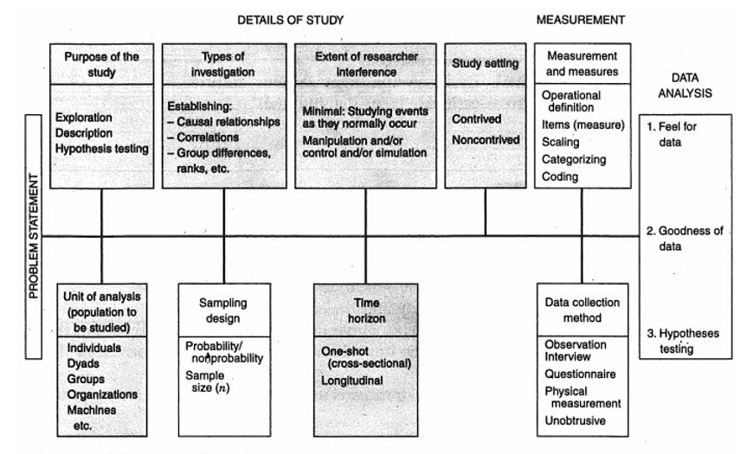
Figure 3. 1 Framework of Research Design
Source: (Sekaran and Bougie, 2016)
Chang et. al. (2014) have used quantitative methods in the study, where descriptive research design was used to analyze the data obtained from respondents whom are consumers in Taiwan in order to identify the characteristics of the respondents towards health food. Moreover, Teng (2016) have also applied descriptive research projects in their research show the factors that influence the willingness of Taiwanese consumers to buy healthy food.
As this is a correlational study on purchase intention on health food, it is done in a natural environment with minimal disruption to the participants' normal behavior.
Referring to Sekaran and Bougie (2016), people can usually conduct research in both natural and artificial environments. Sometimes, the natural environment is called a non-contrived setting, and its activities are usually carried out in its own environment (Zikmund et. al., 2013). Therefore, the setting of the study is non-contrived since the aim of this research is to get opinions and information from the respondents in a normal, natural and public environment.

3.2 Unit of Analysis and Time Horizon
According to Sekaran and Bougie (2016) the unit of analysis should be individual if the problem statement of a study is interested in individuals and aims to investigate the behaviors or certain characteristics within individuals. However, since this research is studying the factors that influence the purchase intention of consumers in Taiwan towards health food, therefore, the unit of analysis is individual.
The time horizon according to Saunders et. al. (2012) of a study can be conducted for the sake for collecting the needed data from respondents over a short period of time which can range from few days up to few months for the purpose of answering the research questions, in which can be called cross-sectional. Therefore, this research is a cross-sectional, where the data are collected only one time, in which one questionnaire is filled by one respondent only once.

3.3 Sampling Design
A purposive sampling of consumers who have experience in purchasing health foods based in Taiwan is targeted. Survey forms were distributed to networks of friends and acquaintances through online questionnaire. Furthermore, this research adopted Non-probability sampling method (Chang, 2017).

3.3.1 Sampling Plan
According to Bryman and Bell (2015), the significant sample sampling plans can be compiled into probability techniques and non-probability techniques. In probability sampling each component in the population has a known nonzero probability of determination and the straightforward random is the best-known probability sample, in which every individual from the population has an equivalent probability of being selected (Zikmund et. al., 2013). On the other hand, for non-probability sampling, the specific components of the selected population are more likely to be ambiguous, and the determination of the unit of distrust of the sample is free. Because researchers depend heavily on personal judgment (Bryman and Bell, 2015).
According to Palinkas et. al. (2015), purposive sampling method was defined as intentionally determining and choosing individual participants who have relative knowledge or experience for the research. Furthermore, Zikmund et. al. (2013) defined that the respondents were selected by using the quota sampling, a non-probability sampling that ensures various subgroups of a population is represented. Therefore, after identifying the sample frame, purposive sampling method will be utilized by this research, in other words, the non-probability sampling method will be employed since the time limitation and cost, for instance, the target population of this research will be the consumers who have purchased health food in Taiwan.

3.3.2 Sample Size
On the basis of Zikmund et al. (2013), the sample size equations cannot be correctly used for non-probabilistic samples, and the required sample size is usually done subjectively and intuitively by researchers based on previous studies or available resources. Moreover, Malhotra (2015) believes that the size of the sample influences the accuracy of the results, even the size of the sample has a direct impact on the adequacy of the statistical techniques chosen.
Based on the statistic of the Department of Household Registration, M. O. I. Taiwan (2018), there were overall approximately twenty-three million population in Taiwan. Hence, the sampling size of this research is confirmed as 384 in accordance with Krejcie and Morgan (1970), who stated that the necessary sampling size was 384, if the number of target population exceeded 1 million.

Table 3. 1 Framework of Resign Design
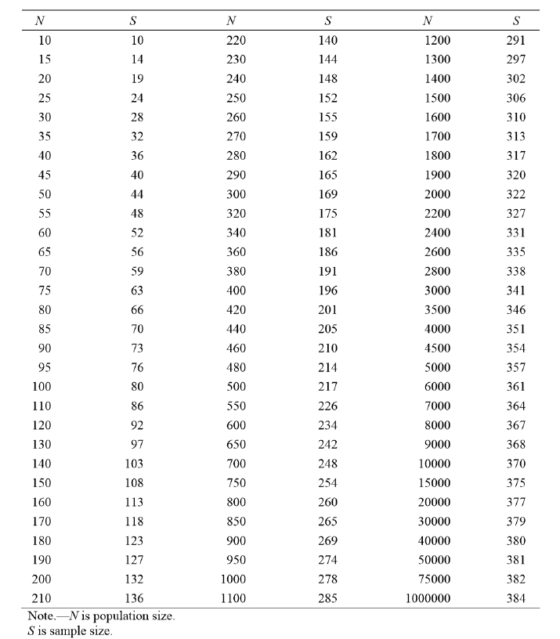

Source: (Krejcie and Morgan, 1970)

3.4 Questionnaire Design
The survey approach was considered as the most common data collection method that widely applied by most of the researchers (Chang et. al., 2014; Kamel, 2013; Qureshi et. al., 2013). Therefore, the primary data of this research will thus to be collected by conducting self-administered online survey. Survey and data accumulation will be done through organized questionnaires for this research. Section A of the survey planned to comprehend the demographic profile while the Section B requests reactions on the key builds for the conceptual framework. In this study, five-point Likert scale were used, 1= Strongly Disagree, 2 = Disagree, 3 = Neutral, 4 = Agree, and 5 = Strongly Agree to recognize the demeanor of respondents (Oliver, 2014). Likert scale is utilized to gauge how emphatically subjects agree and disagree explanations (Ewe et.al, 2012).
Since the topic deals with purchase intention of health food industry in Taiwan, online questionnaires were used. The questionnaire was first translated into Chinese and uploaded to Google. Secondly, creating a uniform resource identifier (URL) for the online questionnaire link. Most of the questionnaires which followed the requirements of Ethic Form were distributed and shared to respondents as URL by Line. Respondents can easily click on a link that links directly to the survey. However, respondents need this limited participation and decreased frequency response.
Online questionnaires will be used because respondents will be given time to respond in order to take part in questionnaires at their own convenience because of this reason, online questionnaire perfectly fit the required criteria.
Section | Items | No. of Questions | Reference
A | Demographic Profile | 6 | Ali and Mohammad (2013)
B (IVs) | Brand Awareness | 6 | Arai, Ko and Ross (2014)
B (IVs) | Perceived Quality | 6 | Glonaz et. al. (2012)
B (IVs) | Perceived Price | 8 | Pantouvakis and Dimas (2013)
C (DV) | Consumer Purchase Intention | 4 | Ali and Mohammad (2013)

3.5 Pilot Test
Pilot tests were carried out before the questionnaire was distributed to the respondents. The test was carried out by distributing the questionnaire to 40 people with experience in the purchase of health foods. According to Zikmund et. al. (2013), pilot tests were conducted in a directed manner to prepare for a real investigation. Taking one of the advantages of the pilot test, it can be pointed out by Sekaran and Bougie (2016) about previously agreed research weaknesses, and through pilot tests, it can help to minimize risks while informing researchers as early as possible in specific areas in which the investigation might fail. In the pilot test, factor analysis and reliability tests were performed, and reliable results were expected before the distribution of the questionnaire of 385 respondents was expected. The SPSS software will analyze and calculate all the collected survey data (Cooper and Schindler, 2014).

3.5.1 Factor Analysis
As per Sekaran and Bougie (2016), the factor analysis can help decrease the quantity of variables and structure the discovery. Under the factor analysis, the KMO and Barlet's Test of Sphericity will be utilized to search for inter-correlations between the variables (Creswell and Creswell, 2017). The measure of KMO changes in the vicinity of 0 and 1 and the qualities more like 1 are better, as a rule it alludes to the measure of sampling adequacy (MSA), which is more prominent than 0.6 will be worthy and the Barlett's Test of Sphericity must be under 0.05 to make reasonable factor analysis (Cooper and Schindler, 2014). In light of the Anti-Image Matrices from the factor analysis result, the variables with MSA under 0.6 may be expelled and keep on constructing test to guarantee the general KMO is greater 0.6 (Sekaran and Bougie, 2016).
In addition, the factor loading will also be used to verify the relation of each variable with the related factors. The value of the factor loading must be greater than 0.6, which indicates a close relationship with the underlying factors, if some items do not meet the requirements, which should be removed from further analysis (Cooper and Schindler, 2014).
In the factor analysis community this value must be greater than 0.6 and in order to properly analyze the collected data it is necessary to delete from the survey items whose public value is less than 0.6 (Johanson and Brooks, 2013). Furthermore, the study also observes the Eigenvalues for the factor analysis that must be greater than 1 for each research object. Eigenvalues indicate the amount of variance of a variable contained in a factor. Creswell and Creswell (2017) argued that factor analysis should be done before the reliability tests to ensure that the selected elements are ready for further analysis or not. Items that do not meet the requirements will be removed in the factor analysis and will not be used in subsequent analyzes (Zikmund et. al., 2013).

3.5.2 Reliability Test
Reliability test decides the capacity that whether a progression of inquiries can measure a similar develop or not, in other words, if the researchers need to test the internal consistency of every item in one independent variable, a reliability test should be directed (Zikmund et. al., 2013). It can be an estimation of stability and general execution for a framework and it is the same with the importance of consistency of a test (Cooper and Schindler, 2014).
For this current research's Reliability test, Cronbach's Alpha is figured and check against the criteria. As indicated by Bryman and Bell (2015), if the Cronbach's Alpha of every variable is under 0.7, which implies the data is not sufficiently solid, so if Cronbach's Alpha value falls under 0.7, the relevant questions from the study need to be deleted in order to increase the value above 0.7.

3.5.3 Correlation Matrix
As per Bishara and Hittner (2012), a Correlation Test is familiar with affirm the linear relationship between at least two by and large conveyed interval variables, otherwise, Correlation Test will be additionally direct amid the pilot test in the research. In light of Tabachnick and Fidell (2013) specified that, for measure of Pearson's test, a p-value with lower than .05 will demonstrate a critical relationship between the variables. Furthermore, the Pearson's Correlation r value could be separated into unique levels to state distinctive level of relationship between the variables (Bishara and Hittner, 2012).
Besides that, the Correlation Test method also will be used as mentioned by Cooper and Schindler (2014) the Correlation Test method is a method to find out the connection or the relationship between the independent variables and the dependent variables as in this research study. The independent variables are brand awareness, perceived quality and perceived price, according to Sekaran and Bougie (2016), the questions of independent variables cannot correlate with each other and for dependent variables, all the questions must be correlated.

3.6 Measurements
In this research, all tests and measurements of data analysis methods will strictly follow the needs of scientific research, which compose of preliminary tests, Hypotheses testing, and other tests (Sekaran and Bougie, 2016). Moreover, validity tests are crucial for confirming the accuracy of this research as well (Bishara and Hittner, 2012). Then, this research will employ the Statistical Package for Social Science (SPSS) as the analysis tool to complete the needful pilot test and analyze the data which collected from the final survey. Descriptive Analysis is a decent decision in outlining the data as communicated by Saunders et. al., (2012), a descriptive analysis will be received by utilizing SPSS where it backings to assess the data abilities. In addition, Factor test, Reliability test and Regression test will be directed in this research.

3.6.1 Descriptive Information
The Descriptive analysis of this research will emphases on that demographic information from the respondents. To be specifically, the questionnaire will consist of some simple items like age, education and annual income. As the consideration of ethics of this research, all personal information of the respondents will be collected anonymously and will not be disclosed. Furthermore, a multiple-choice question method will be applied for designing the relevant items.

3.6.2 Preliminary Tests
In order to verify the integrity of the information and reliability in the questionnaire, preliminary tests are discussed (Sekaran and Bougie, 2016). Usually, in a research study in order to reduce data, this technique is used to provide what is commonly due to the relationship in order to perform the first factor analysis (Zikmund et. al., 2013). Factor analysis in which the cause is identified statistically reduced by a large number of variables, the correlation of coefficients is the factor loading. (Cooper and Schindler, 2014). For factor loading, the general rule is greater than 0.7, meaning that loads less than 0.7 will not be taken into account for further analysis (Sekaran and Bougie, 2016). For a community in a factor analysis, this value must be greater than 0.6, and with a common value less than 0.6 must be removed from the study to continue the correct analysis of the collected data (Zikmund et. al., 2013).
KMO Bartlett’s Test is one of the most important elements of the factor analysis, which is used to verify the suitability of the sampling in relation to the variable coefficient analyzed by the study (Bryman and Bell, 2015). In most of the tests carried out, having an acceptable sample adequacy is fundamental for the KMO and Bartlett tests, to be accepted, the test rank of KMO and Bartlett must exceed 0.6, otherwise it will not be considered for further analysis (Bishara and Hittner, 2012). In addition, the test also allows the researcher to verify the reliability and adequacy of the data collected during the test, the reason for the factorial analysis performed before the reliability test is to ensure that elements that are outside the rule are excluded or removed from further analysis (Zikmund et. al., 2013).
Reliability tests will be applied to the data in the research because this test accurately measures the reliability of the information collected and confirms whether the collected data accurately measures the concepts, which is a measure of consistency of measurement when running the same data under the same conditions (Bishara and Hittner, 2012). In addition, internal consistency and measurement errors are also verified in reliability tests via Cronbach’s Alpha, in terms of the reliability test range, values between 0.7-0.9 are considered reliable and within the accepted range (Sekaran and Bougie, 2016).

3.6.3 Hypothesis Testing
As indicated by Bishara and Hittner (2012), the primary component of leading the hypothesis test is to get the testable articulation communicating a coherent hypothesis on the connection between at least two variables. In this study, the Multiple Regression investigation will be led in a hypothesis test, the connection between independent variables and dependent variables can be broken down utilizing this test (Saunders et. al., 2012). Along these lines, in this exploration ponder, relapse systems will be utilized to recognize every one of the variables that impact the buy goal of sound sustenance (Bishara and Hittner, 2012). One Way ANOVA likewise will be directed in this examination, this test shows noteworthy mean contrasts among a few gatherings as concurred by Cooper and Schindler (2014), One Way ANOVA is utilized to decide if there are huge contrasts between the methods at least two independent gatherings. Furthermore, Standardized beta coefficients are also used to compare variables to each other. The normalized beta factor analyzes the strength of each independent variable that affects the dependent variable. Beta values must be higher and more powerful effects are needed (Diedenhofen and Musch, 2016).

3.7 Ethical Consideration
Eathough (2007) states the significance to accumulate data in an ethical way keeping in mind the end goal to keep up respectability and nature of the research. This research gathers data ethically where participants of survey are allowed to pass on insights openly and deliberately. Participants of the survey are given a preparation sheet to comprehend the research theme and reason of leading the research before questionnaire were appropriated. Questionnaires were set up in basic English in light of the research structure. Questionnaires are inspected to guarantee no data other than the research theme is inquired. The researcher additionally guaranteed the protection and privacy of data gathered that it won't be shared freely and misused later on without assent. Certainty was given to the participants in view of the confirmation methodology mentioned. Since the questionnaires were received from past researches, it upgraded internal validity and the external validity is likewise provided ethically (Eze et. al, 2012). Other than that, this research properly referenced considering the Harvard Referencing Method.

3.8 Conclusion
This chapter emphasis on research method that will be applied to this research for studying the proposed research objectives. The questionnaires were distributed to the respondents who have the experience of purchasing health food in Taiwan through an online questionnaire. Various data analysis methods will be applied based on the academic research requirements and existed researches. The following chapter will statistically analyze the data collected and provide accurate and reliable evidence for supporting the research results.

CHAPTER 4 RESEARCH FINDINGS

4.0 Overview
The part presented the data collection methodology, analyzed the data of Taiwanese consumers' intention to purchase healthy food and examine the key research findings to affirm the examination hypotheses that was mentioned in Chapter 2. To accomplish this reason, the section started with the pilot test pursued by descriptive analysis which was finished by utilizing SPSS program. Next, a demographic structure appeared to describe the qualities of the respondents. Thirdly, the full data gathered by surveys were checked for the reliability, validity and hypotheses testing has been clarified separately.

4.1 Pilot Test
As mentioned in Chapter 3, a pilot test was directed before the full-scale distribution. The questionnaire was first converted into Chinese and transferred onto Google Forms. At that point, a Uniform Resource Locator (URL) of the questionnaire connect was produced which was helpful for online circulation. As per De Vaus (2001), the pilot test could limit the risk. Likewise, Van and Hundley (2002) discovered that the perfect number of sample size for the pilot test is 10-20% of the sample size for the real examination. Consequently, this study utilized 10%-20% of the sample size of 384 which is around 40 questionnaires for the pilot test.

4.1.1 Factor Analysis of Pilot Test
Based on below Table 4.1, it represents that each value in the factor loading is more than 0.6, which implies that questions that have been shown on the questionnaire are valid. As indicated by Kline (2014), the indicators must load more than 0.6 to be viewed as valid and acceptable, hence, since all indicators in this study demonstrate values more than 0.6, it is fitting to be utilized for further analysis.
Table 4. 1 The factor analysis result of pilot test
Variables | Items | Factor Loading | KMO | P-value
Brand Awareness | B1 | .647 | .708 | .000
 | B2 | .842 | .708 | .000
 | B3 | .765 | .708 | .000
 | B4 | .777 | .708 | .000
 | B5 | .719 | .708 | .000
 | B6 | .618 | .708 | .000
Perceived Quality | Q1 | .746 | .708 | .000
 | Q2 | .739 | .708 | .000
 | Q3 | .766 | .708 | .000
 | Q4  Q5  Q6 | .644  .650  .612 | .708 | .000
Perceived Price | P1 | .747 | .795 | .000
 | P2  P3  P4  P5  P6  P7  P8 | .722  .777  .733  .695  .676  .607  .616 | .795 | .000
Purchase Intention | I1 | .649 | .815 | .000
Purchase Intention | I2 | .843 | .815 | .000
Purchase Intention | I3 | .851 | .815 | .000
Purchase Intention | I4 | .898 | .815 | .000

In addition, the KMO value of all items are over the basis line of .6, which reached .7 or higher, can be considered as commendable as per the suggested range, and the Bartlett's Test p-value was .0 likewise under .05. Thus, as indicated by the result of the pilot test appeared, factors were viewed as applicable and relevant for the study.

4.1.2 Reliability Test of Pilot Test
According to Mokhtar (2010), the value of Cronbach's Alpha above 0.7 is acceptable, and the closer Cronbach's Alpha is to 1, the higher the reliability of internal consistency. However, in the pilot test, as described by Hair et. al. (2010), 0.6 is also considered acceptable. Therefore, the questionnaire is reliable.
According to Table 4.2, Cronbach’s Alpha values are all above 0.7, indicating that the internal consistency of the scale is high. Therefore, the pilot test shows a valid signal for further data collection. All data was collected for testing, meaning that this study expected all items to be suitable for further analysis.

Table 4. 2 The reliability test of pilot test
Variables | Items | Cronbach’s Alpha | N  (Number of items)
Brand Awareness | B1 | .817 | 6
 | B2 | .817 | 6
 | B3 | .817 | 6
 | B4  B5  B6 | .817 | 6
Perceived Quality | Q1 | .757 | 6
 | Q2 | .757 | 6
 | Q3 | .757 | 6
 | Q4  Q5  Q6 | .757 | 6
Perceived Price | P1 | .791 | 8
 | P2  P3  P4  P5  P6  P7  P8 | .791 | 8
Purchase Intention | I1 | .921 | 4
Purchase Intention | I2 | .921 | 4
Purchase Intention | I3 | .921 | 4
Purchase Intention | I4 | .921 | 4

4.1.3 Correlation Analysis of Pilot Test
The Correlation test is to see if all items are related to each other to determine that each item is related to the expected result and the data should between -1 to 1 (Lewis, et al., 2016). Based on Hair et. al. (2010) mentioned that, for criterion of Pearson’s test, a p-value with lower than .05 will indicate a significant relationship between the variables. In addition, the Pearson’s Correlation R value could be divided into distinct levels to state different level of relationship between the variables (Evans and Over, 2013). The following table 4.3 showed criterion of Pearson Correlation R Value.
Table 4. 3 Criterion of Pearson Correlation R Value
Range | Acceptance
0 ≤|R |< .20 | Very Weak
.20 ≤|R |< .40 | Weak
.40 ≤|R |< .60 | Moderate
.60 ≤|R |< .80 | Strong
.80 ≤|R |< 1.00 | Very Strong
Source: Evans and Over, 1996

4.2 Descriptive Analysis / Demographic of Respondents
In this section, the demographic characteristics of respondents will be presented. According to Dierckx (2013), demographic information provides an overview of the population and distribution of a study, as well as the proximity of the study sample to the overall population. In this case, the information involved includes the gender and age of the respondent.

4.2.1 Response Rate
The focus of this study is on individuals, and more specifically on those who buy healthy foods in Taiwan. Question 6 (Have you ever bought healthy food?) was established to distinguish the respondents. The questionnaire was first translated into Chinese and a Uniform Resource Locator (URL) for the questionnaire link was generated via Google Form, and the URL was distributed to the respondent via social software. In order to achieve the research objectives, a questionnaire was developed, and 385 questionnaires were sent, as a result, 302 valid coupons were received.

4.2.2 Demographic Profile of Respondents
Demographic information outlines the target population for the study and provides an overview of the respondents to understand how close the sample is to the target population. (Dierckx, 2013). However, in this chapter, a complete overview of the participants of the study is provided in the form of charts and tables.
Table 4. 4 Demographic of Respondents
Variables | Category | Frequency | Percent | Valid Percent
Gender | Female | 221 | 73.2 | 73.2
 | Male | 81 | 26.8 | 26.8
Age | 21-30 | 27 | 8.9 | 8.9
 | 31-40 | 59 | 19.5 | 19.5
 | 41-50 | 80 | 26.5 | 26.5
 | Above 51 | 136 | 45.0 | 45.0
Education Level | Bachelor Degree | 159 | 52.6 | 52.6
 | Master | 75 | 24.8 | 24.8
 | Others | 62 | 20.5 | 20.5
 | PhD | 6 | 2.0 | 2.0
Marital Status | Married | 222 | 73.5 | 73.5
 | Single | 80 | 26.5 | 26.5
Income Per Month | Below TWD25.000 | 38 | 12.6 | 12.6
 | TWD25,001 – 40,000 | 97 | 32.1 | 32.1
 | TWD40,001 – 60,000 | 85 | 28.1 | 28.1
 | TWD60,001 – 100,000 | 68 | 22.5 | 22.5
 | Above TWD100,001 | 15 | 4.6 | 4.6

Figure 4.1 shows nearly three-quarters of the respondents are female, accounting for 73.2%, and more about 46% than women (26.8%).
Figure 4. 1 Demographic Profile (Gender)
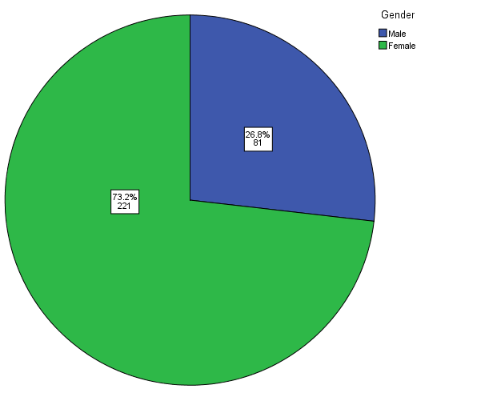

Figure 4.2 shows that most respondents came from the age group over 51 years old, accounting for 45%, followed by 41-50 years old group, accounting for 26.5%, and 31-40 years old group accounting for 19.5%. It is worth noting that young customers under the age of 30 account for only 8.9% of the total respondents.

Figure 4. 2 Demographic Profile (Age)
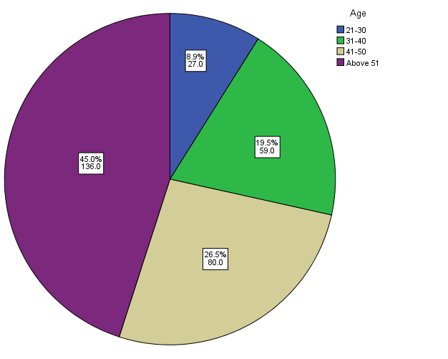
Figure 4.3 shows that 52.6% of the 302 participants' education level were Bachelor Degree, and 24.8% of the participants were having Masters, and 20.5% were having other qualifications PhD and only 2% of the participants were having PhD.
Figure 4. 3 Demographic Profile (Education Level)
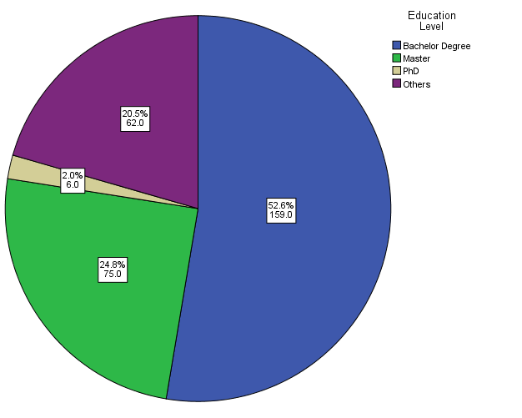
The below chart shows that 73.5% of the 302 participants were married, while 26.5% of the participants were single.
Figure 4. 4 Demographic Profile (Marital Status)
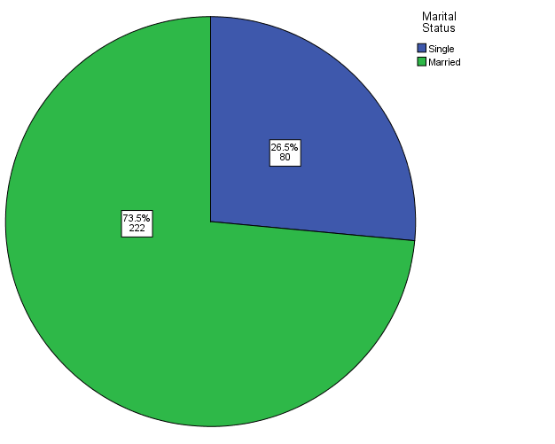
Figure 4.5 shows that the highest proportion of the income per month of 302 participants is TWD25,001-TWD40,000 (32.1%) and TWD40,001-60,000 (28.1%), while about 22.5% of the participant were at the range of TWD60,001-TWD100,001, and 12.6% at the range of below TWD25,000. It is worth noting that 4.6% of respondents have monthly incomes exceeding TWD100,001.
Figure 4. 5 Demographic Profile (Income Per Month)
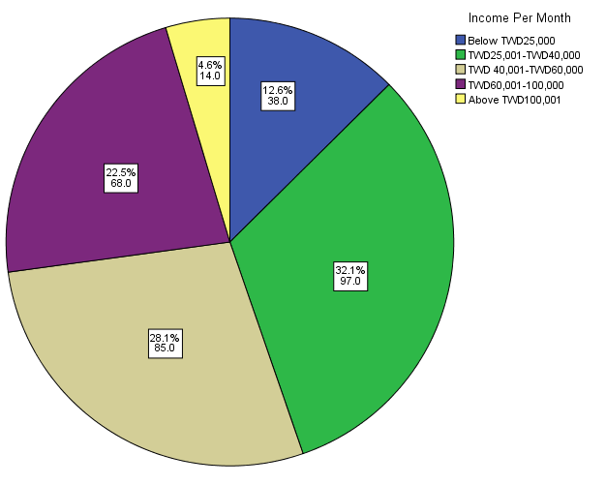

4.3 Preliminary Data Analysis
In this study, SPSS was used as a data analysis tool to interpret the results of survey data. In addition, according to the discussion in Chapter 3, the preliminary data analysis of the study consisting of factor analysis, reliability testing, KMO and Bartlett’s Test of Sphericity, and all statistical outcome produced by SPSS were demonstrated, discussed and compared.

4.3.1 Factor Analysis
As described in Chapter 3, there are several criteria for determining which item should be deleted. For example, the constructed KMO value should exceed 0.60, and Bartlett's Sphericity test should have a p-value of less than 0.05 (Tabachnick and Fidell, 2013), all Community values for a single item should be greater than 0.50 (Anastasiadou, 2011), the constructed Eigenvalue should be higher than 1.00 (Bryman and Cramer, 2005).
According to Table 4.5, the KMO values of all variables in this study ranged from .709 to .815, and all p-values of the Bartlett sphericity test met the significance criteria. Next, the community value, the eigenvalue and the total variance explained by brand awareness, perceived quality, perceived price and the willingness of consumers to purchase healthy foods exceeded the standard, which means that all the items in the three structures can be considered appropriate and related.

Table 4. 5 Factor Analysis Result in SPSS
Factors | KMO | Bartlett’s  Sphericity | Test | of | Communality after Extraction | Eigenvalue
Factors | KMO | Approx. Chi-Square | df | Sig. | Communality after Extraction | Eigenvalue
B1 | .713 | 823.693 | 15 | .000 | .658 | 3.267
B2 |  |  |  |  | .840
B3 |  |  |  |  | .766
B4 |  |  |  |  | .781
B5 |  |  |  |  | .731
B6 |  |  |  |  | .617
Q1 | .709 | 595.767 | 15 | .000 | .741 | 2.825
Q2 |  |  |  |  | .740
Q3 |  |  |  |  | .770
Q4 |  |  |  |  | .634
Q5 |  |  |  |  | .650
Q6 |  |  |  |  | .612
P1 | .786 | 687.837 | 28 | .000 | .749 | 3.281
P2 |  |  |  |  | .728
P3 |  |  |  |  | .776
P4 |  |  |  |  | .729
P5 |  |  |  |  | .701
P6 |  |  |  |  | .686
P7 |  |  |  |  | .592
P8 |  |  |  |  | .606
I1 | .815 | 1043.999 | 6 | .000 | .685 | 3.245
I2 |  |  |  |  | .841
I3 |  |  |  |  | .851
I4 |  |  |  |  | .897

4.3.2 Reliability Test
The reliability test measures the internal consistency of the data collected and is used to measure the proposed research model (Bryman and Bell, 2015). In SPSS, if Cronbach’s Alpha value of reliability test is greater than or equal to 0.7, then the items or construction can be considered reliable and suitable for further analysis.
Table 4. 6 Reliability test of preliminary data
 | Cronbach's Alpha | N of Items
Brand Awareness | .820 | 6
Perceived Quality | .759 | 6
Perceived Price | .771 | 8
Purchase Intention | .920 | 4

Overall, the reliability analysis performed showed good results, indicating that 24 items of independent and dependent variables were suitable for further analysis, correlation analysis. Therefore, a correlation analysis was performed.

4.4 Hypothesis Analysis
As shown in Table 4.7, a total of three hypotheses are proposed. Test all hypotheses using multiple regression. After completing all the above data analysis, the data collected from the online questionnaire in this study has been verified to be accurate and reliable and can be used for hypothesis testing. For the hypothesis provided by the test, a Multiple Regression test is performed to check if there is a relationship between the independent variable and the dependent variable. In the multiple regression test, there are three steps, including checking the model fit level by the ANOVA test, checking the R Square model summary test, and checking the beta of the model coefficients.

Table 4. 7 Research Hypotheses
Hypothesis 1 | Brand awareness has a significant influence on consumer purchase intention on health food in Taiwan.
Hypothesis 2 | Perceived quality has a significant influence on consumer purchase intention on health food in Taiwan.
Hypothesis 3 | Perceived price has a significant influence on consumer purchase intention on health food in Taiwan.

Table 4. 8 Multiple Regression Model Summary
Model Summary
Model | R | R Square | Adjusted R Square | Std. Error of the Estimate
1 | .580ª | .337 | .330 | 1.96250
a. Predictors: (Constant), P, B, Q

Table 4. 9 Multiple Regression ANOVA
ANOVAª
Model |  | Sum of Squares | df | Mean Square | F | Sig.
1 | Regression | 582.673 | 3 | 194.224 | 50.429 | .000^{b}
1 | Residual | 1147.723 | 298 | 3.851
1 | Total | 1730.396 | 301
a. Dependent Variable: I
b. Predictors: (Constant), P, B, Q
As shown in Table 4.8, multiple regression was performed to obtain 0.337 and R was 0.580. This means that the three independent variables used in this study have explained for approximately 33.70 percent of the variance of acceptance in the purchase intention of healthy foods. According to the study by Pallant (2013), the remaining 66.30 percent of the changes can be explained by other factors not considered in this study.
In addition, according to Table 4.9, the p-value of the multiple regression ANOVA test is .00, less than .05, so the fitted model is suitable.
Table 4. 10 Results from Multiple Regression
Coefficientsª
Model |  | Unstandardized Coefficients |  | Standardized Coefficients | t | Sig. | Collinearity Statistics
 |  | B | Std. Error | Beta | t | Sig. | Tolerance | VIF
1 | (Constant) | .505 | 1.040 |  | .486 | .628
H1 | B | -.022 | .043 | -.027 | -.503 | .615 | .757 | 1.320
H2 | Q | .377 | .045 | .441 | 8.318 | .000 | .793 | 1.262
H3 | P | .169 | .036 | .258 | 4.708 | .000 | .742 | 1.348
a. Dependent Variable: I

Lastly, each of the proposed three hypotheses was tested by examining the model coefficient table above (Table 4.10). The hypotheses that p-values are below .05, namely H2 and H3, is supported by statistical results. However, since the p-value of H1 is greater than .05, which means there is no a significant relationship between brand awareness and purchase intention, therefore, H1 is rejected. In other words, this study does not have enough statistical power to detect this relationship.
In addition, all beta values for each independent variable are also shown in the table. Beta is a measure of the regression standardized coefficient used to compare the effect of each independent variable on the dependent variable (Pallant, 2013). It is worth noting that H1 has a negative beta value (-.027) in this study. On average, negative beta values mean construct B (brand awareness) and dependent variable I (purchase intention) is a negative correlation.
The regression analysis also analyzed the collinearity between the independent variables. The above regression analysis table shows Collinear Statistics as a result of the Variance Inflation Factor (VIF) values are under 5. As per Hair et al. (2014), the edge of VIF is 5. Hence, it can be judged that there is no multicollinearity issue between the three independent variables.
Table 4. 11 Acceptance results for hypothesis testing
Hypothesis 1 | Not Supported / Rejected
Hypothesis 2 | Supported / Accepted
Hypothesis 3 | Supported / Accepted

4.5 Summary of Findings
Based on the research findings, which shows that except for hypotheses about brand awareness was rejected, all others were accepted. In other words, among the three variables of brand awareness, perceived quality and perceived price, except brand awareness, the other two variables have a positive influence towards consumer purchase intention of health food in Taiwan. Based on the result of the analysis, we can understand which factor contributes to the consumer's purchase decision and which factor is more important. Both perceived quality (Hypotheses 2) and perceived price (Hypotheses 3) have a positive influence towards purchase intention on health food of consumers, what is more, perceived quality (Hypotheses 2) has a more significant positive influence.

4.6 Conclusion
In summary, the pilot test of the study received 40 responses. The analysis is tested by factor loading and reliability testing to ensure that the question form is understandable and effective, so the questionnaire is driven for final data collection. After a period of data collection, the study received a total of 302 responses, and finally all data was input into SPSS to improve the accuracy of the study. Based on factor loading and reliability testing, all results of data analysis provide strong results to support the items and data is sufficient for the final hypothesis testing. In the end, all three hypotheses were tested by SPSS and the results supported two of the three hypotheses, except H1 (brand awareness). Chapter 5 will further explore the discussion of the finding of this chapter, followed by contributions and recommendations.

CHAPTER 5 CONCLUSION

5.0 Overview
As a final part of this study, the purpose of Chapter 5 is to summarize and discuss the findings in depth and to link all of these findings to previous studies to demonstrate whether there are significant differences that may occur. Next, recommendations will be provided according to the hypotheses test results. After that, the research limitations and contributions will be discussed in detail. In addition, recommendations for further academic research will be provided. Finally, the conclusions of this study and personal reflections are described in the last two parts.

5.1 Discussion
The focus of this study is on the three objectives described in Chapter 1. However, the first goal of the study was to “determine the factors that influence the purchase intention on healthy foods in Taiwan,” which was achieved by identifying the three factors discussed in the literature review in Chapter 2, and the data analysis in Chapter 4. The three factors of “independent variables” are considered to be factors influencing the purchase intention of health food in Taiwan. According to the data analysis shown in Table 4.10, only two variables, perceived quality and perceived price, were able to find a significant relationship with the dependent variable and to be consistent with what was discussed in the literature. On the other hand, another brand awareness variable failed to establish a significant relationship with the dependent variable, contradicting the literature review provided in Chapter 2.
The second purpose of the study was to “determine what is the most significant factor influencing the intention to purchase healthy food in Taiwan”. However, this purpose is achieved by data analysis of multiple regression coefficients. According to Table 5.1, the highest value of the Beta Coefficient of the factor is “perceived quality” (Beta=.441). Therefore, the perceived quality is the most significant factor influencing the intention to purchase healthy food in Taiwan.
The third purpose of the study is to “determine the least significant factor influencing the intention to purchase healthy food in Taiwan”. However, this purpose was achieved by data analysis of multiple regression coefficients. According to Table 5.1, the factor “perceived price” (Beta=.258) has the least Beta coefficient value. Therefore, perceived price is the least important factor influencing the intention to purchase healthy food in Taiwan.
Table 5. 1 The Most and Least Significant Factor Summary
Coefficientsª
Factor | Standardized Coefficients | Significance
Factor | Beta | Significance
Perceived Quality | .441 | Most
Perceived Price | .258 | Least

As discussed in Chapter 2, three hypotheses were developed to explain the research questions in this study. At the same time, the data analysis in Chapter 4 is discussed, including the hypothesis test results. Therefore, in this section, the researcher provides a detailed description of the outcomes of the study, as well as a detailed discussion of each developed hypotheses, including the contrast with the views provided in the existing literature.
H1: Brand awareness has a significant influence on consumer purchase intention on health food in Taiwan.
The first hypothesis aimed to focus on whether the brand awareness has a significant influence or not on the consumer purchase intention on health food in Taiwan. According to the statistical results shown in table 4.10, this hypothesis was not supported, in which its sig. (p-value) is .615. This result shows that the consumers in Taiwan are not influenced by the brand awareness in their intention to purchase health foods. However, this negative result reflects certain aspects of the health foods in terms of the brand awareness, which includes that the health foods have good reputation, reliability and good health appeal. This negative finding contradicts with the point of views of Jiang and Chen (2012); Arai et. al. (2014); Malik et. al. (2013) and Saleem et. al. (2015) who assumed that brand awareness is a factor that can influences the consumer purchase intention of health food. On the contrary, result is similar to the point of views of Hoyer and Brown (1990); Chen and Chang (2011) and Osman and Subhani (2010) who believed that brand awareness is not a key factor that can influence the purchase intention of health food.
H2: Perceived quality has a significant influence on consumer purchase intention on health food in Taiwan.
The second hypothesis is meant to focus on whether the perceived quality has a significant influence or not on the consumer purchase intention on health food in Taiwan. According to the statistical results shown in table 4.10, this hypothesis was supported, in which sig. (p-value) is .000. Successfully, this positive result shows that consumers in Taiwan are influenced by the perceived quality of their intention to purchase health foods. However, this positive result reflects certain aspects of the health foods in terms of the perceived quality, which include that buying health foods seemed to be more nutritional values, good quality ingredients and freshness. Moreover, this result is consistent with the point of views of Hasan et. al. (2013); Glonaz et. al. (2012); Rezai et. al. (2012) and Jeddi (2012) who believed that the perceived quality is an essential factor that can influence the purchase intention on health foods.
H3: Perceived price has a significant influence on consumer purchase intention on health food in Taiwan.
Finally, the third hypothesis intended to focus on whether the perceived price has a significant influence or not on the consumer purchase intention on health food in Taiwan. According to the statistical results shown in table 4.10, this hypothesis was supported, in which its sig. (p-value) is .000. Successfully, this positive outcome demonstrated that the consumers in Taiwan are influenced by perceived price in their intention to purchase health foods. However, this positive result reflects perceived price, which include that the health foods are worthwhile at this price and reasonable, as well as the consumers pay attention to the effect regardless of the price. Furthermore, this positive result is consistent with the point of views of Pantouvakis and Dimas (2013); Ito (2014); Setiawan and Achyar, 2013 and Yoon et. al (2014), who believed that the perceived price is an important factor that can influence the purchase intention on health food.

5.2 Recommendation
Understanding the relationship between influencing factors and customers purchase intention is critical to healthy food marketing. Based on the findings discussed in Chapter 4, this study provides recommendations for catering companies that want to develop healthy food marketing, benefiting from better products and services.
In the health food market, the price gap is large. For the same kind of food, the prices of different manufacturers and different brands may differ. From the perspective of profit, such a difference is enough to create a huge business opportunity. The success of the price setting will reflect the sales figures, and not the high-priced products will be favored by consumers. The price that makes consumers feel value for money is the most successful pricing method. Because the perceived price used in this study is based on the price inside the consumer as a standard. The more consistent with the consumer's perceived price, the greater the consumer's willingness to buy. Furthermore, this study suggests that in terms of social value, the company should continuously improve the interests of consumers to reduce the cost of consumers, so that consumers can obtain more benefits, and encourage consumers to have a strong willingness to purchase. In terms of functional value, through the word-of-mouth marketing of consumers, the generation of group behavior is promoted, thereby enhancing consumers' willingness to purchase and maximizing benefits.
Product quality has always been a key factor in the buyer's decision to make a purchase decision. Therefore, product quality as an important production criterion can naturally enhance the buyer's trust in the seller. In the proposal to maintain product quality, this study suggests that the buyer's perceived quality can be met through services and products. Whether it is manufacturing quality, functional quality or after-sales service quality, maintaining high-quality product and continuing to strive on product innovation capabilities to make distinctive products. The higher the overall perceived quality, the higher the consumer's willingness to purchase.

5.3 Conclusion
This research has been conducted in order to study the consumer purchase intention on health food in Taiwan. The sample size of this research was 384, where data collection took place in various cities and place in Taiwan. The data obtained were statistically analyzed by SPSS and the results showed that only two out of three independent variables were supported, which are the perceived quality and perceived price. Therefore, the three hypotheses in this study were discussed and compared with the existing literature to better understand the meaning behind each variable. Followed by the managerial implications, in which recommendations have been laid down based on the supported variables. Lastly, the limitations of the study were given including further research and personal reflection.

5.4 Contribution to Academy
The results of this study have increased understanding of the factors that influence Taiwan's willingness to purchase health foods. The study also provides sufficient information for future academic research. In fact, this study provides statistical evidence and information for researchers who wish to work on this topic, and this research will be the reference and basis for their citations.

5.5 Contribution to Industry
From an industry perspective, this study can provide the health food industry with comprehensive information and statistical evidence about customers purchase intention. Therefore, companies can apply this research to the health food industry to design and implement more effective targeted marketing strategies. For those catering companies that want to develop the health food market, this research will help them provide better products and services.

5.6 Limitation
The limitations of this study exist on the different sides that limits the universality of the results to the entire population of Taiwan. First, due to limited time and time constraints for researchers to collect data, about two weeks, in which restricts the researcher to go for the vast scale test sample. Thus, this has caused researchers to obtain a limited sample size, which is 302 respondents. Second, the sample of 302 respondents came from consumers who had experience in purchasing healthy foods, and the results were unlikely to represent the entire consumer in the country because people's experiences, perceptions and attitudes seemed to be different. Third, the variables involved in this study are three variables that may not be sufficient to study consumers purchase intention to purchase health foods. Therefore, there should be other factors that can influence the purchase intention, and these factors are not involved in this study.

5.7 Future Study of Research
This study tries to reach objective standards in research architecture, research design, data collection, statistical analysis and result evaluation, but it is still limited by time, manpower, and technical limitations, resulting in insufficient discussion of many issues. Therefore, the following suggestions are provided for further follow-up by researchers who are interested in this topic.
The study adopts a convenient sampling method, and the sampling object is not carried out by random sampling. Therefore, this study suggests that if the external conditions permit, the samplers can take random sampling and expand the consumption of more age groups for more extensive research.
The design of this study mainly describes the situation in a textual manner. Therefore, in future research, it may be possible to increase participants' reaction to research situations through different interview methods and even physical presentation. This study lists preliminary results on health foods that can be further analyzed, expanded and replicated in the future. Although this study has its limitations, it is hoped that it will provide the basis for future research on health foods.
In addition, since the value of Coefficients (R-Square) is low in the analysis of this study, the explanatory power of the representative variable is not very sufficient. In future research, it is recommended to extend the range of variables. Add other variables that may affect the willingness to purchase functional foods. For example, promotion methods, promotion scenarios and other factors.

5.8 Personal Reflection
Ultimately, this research is entering the last section. As the final project of the whole Master life, it has been given high expectations and I promise I already have tried my best to complete it. Candidates require to review a huge number of journals and researches from variable disciplines, as well as they should identify and select useful journals and information about purchase intention and on health food industry. This part is a challenge in the beginning stage, thus, an experienced supervisor is quite important for success. They could pass their experience in business research aspects and knowledge of research methodology on their candidates. Consequently, they provide clear justifications towards the proposed research ideas and topics, as well as suggestions for relevant literatures. It is so appreciated that have such excellent supervisor Dr. Alex Ng Hou Hong for guiding the whole research.
Next, research methodology design stage was a challenge in this research. Luckily, with the guidelines and suggestions from Dr. Alex Ng Hou Hong, data analysis finished opportunely. After doing this research, each candidate can grasp research methodology and SPSS who was not good at it before.
The throwback to the whole research, it has to mention again to appreciate the guidelines from the supervisor. Without the guidelines, this research could not complete in a limited time and resources. I have really learned a lot from this research, hope this research could contribute on others relative researches, and not only benefit myself.

REFERENCE
Achyar, A. and Setiawan, R. (2013). Effects of Perceived Trust and Perceived Price on Customers’ Intention to Buy in Online Store in Indonesia. ASEAN Marketing Journal, 4(1).
Adams, K. and Lawrence, E. (2018). Research methods, statistics, and applications. 2nd ed. SAGE Publications, Inc.
Afsar, B. (2014). Effect of perceived Price, Brand Image, perceived Quality and Trust on Consumer’s buying Preferences. Journal of Economics and Business Research, 20(1), pp.7-20.
Ajzen, I. (1985). From Intentions to Actions: A Theory of Planned Behavior. Action Control, pp.11-39.
Ajzen, I. and Madden, T. (1986). Prediction of goal-directed behavior: Attitudes, intentions, and perceived behavioral control. Journal of Experimental Social Psychology, 22(5), pp.453-474.
Alex, D. and Thomas, S. (2013). Impact of product quality, service quality and contextual experience on customer perceived value and future buying intentions. European Journal of Management and Business Economics, 3(3), pp.307-315.
Alvesson, M. and Sandberg, J. (2013). Constructing research questions: Doing interesting research. Sage.
Ambali, A.R. and Bakar, A.N. (2013). Halal food and products in Malaysia: people's awareness and policy implications. Intellectual Discourse, 21(1), p.7.
An, R. (2013). Effectiveness of subsidies in promoting health food purchases and consumption: a review of field experiments. Public health nutrition, 16(7), pp.1215-1228.
Anastasiadou, S. D. (2011). Reliability and Validity Testing of a New Scale for Measuring Attitudes toward Learning Statistics with Technology. Acta Didactica Napocensia, 4(1), 1-10.
Andreti, J., Zhafira, N.H., Akmal, S.S. and Kumar, S. (2013). The analysis of product, price, place, promotion and service quality on customers’ buying decision of Convenience Store: A survey of young adult in Bekasi, West Java, Indonesia. International Journal of Advances in Management and Economics, 2(6), pp.72-78.
Aqeel. A. (2012). Factors influencing Saudi women to purchase luxury fashion brand, International Conference on Management, Behavioral Sciences and Economics Issues (ICMBSE’2012) Penang, Malaysia
Arai, A., Ko, Y.J. and Ross, S. (2014). Branding athletes: Exploration and conceptualization of athlete brand image. Sport Management Review, 17(2), pp.97-106.
Ary, D., Jacobs, L.C., Irvine, C.K.S. and Walker, D. (2013). Introduction to research in education. Cengage Learning.
Asaad, A. K. and Serdar, S. (2015). An Analysis Study of Improving Brand Awareness and Its Impact on Consumer Behavior Via Media in North Cyprus (A Case Study of Fast Food Restaurants). International Journal of Business and Social Science, 6(1), pp.66-80.
Asshidin, N., Abidin, N. and Borhan, H. (2016). Perceived Quality and Emotional Value that Influence Consumer's Purchase Intention towards American and Local Products. Procedia Economics and Finance, 35, pp.639-643.
Barbera, F., Dagnes, J. and Di Monaco, R. (2018). Consumers’ Quality Conventions in Alternative, Conventional, and High-End Food Chains. In Alternative Food Networks (pp. 87-117). Palgrave Macmillan, Cham.
Beneke, J., Flynn, R., Greig, T. and Mukaiwa, M. (2013). The influence of perceived product quality, relative price and risk on customer value and willingness to buy: a study of private label merchandise. Journal of Product & Brand Management, 22(3), pp.218-228.
Bishara, A. J. and Hittner, J. B. (2012). Testing the significance of a correlation with non-normal data: Comparison of Pearson, Spearman, transformation, and resampling approaches. Psychological Methods, 17, pp. 399-417.
Brennan, M.A., Derbyshire, E., Tiwari, B.K. and Brennan, C.S. (2013). Ready‐to‐eat snack products: the role of extrusion technology in developing consumer acceptable and nutritious snacks. International Journal of Food Science & Technology, 48(5), pp.893-902.
Bruschi, V., Shershneva, K., Dolgopolova, I., Canavari, M. and Teuber, R. (2015). Consumer perception of organic food in emerging markets: evidence from Saint Petersburg, Russia. Agribusiness, 31(3), pp.414-432.
Bryman, A and Bell, E. (2015). Business Research Methods. 4 ed. Oxford University Press.
Bryman, A., & Cramer, D. (2005). Quantitative data analysis with SPSS 12 and 13: a guide for social scientists. Psychology Press.
Calvo-Porral, C. and Lévy-Mangin, J. (2017). Specialty food retailing: examining the role of products’ perceived quality. British Food Journal, 119(7), pp.1511-1524.
Chang, E. and Tseng, Y. (2013). Research note: E-store image, perceived value and perceived risk. Journal of Business Research, 66(7), pp.864-870.
Chang, R.C. (2017). The influence of attitudes towards health eating on food consumption when travelling. Current Issues in Tourism, 20(4), pp.369-390.
Chang, S.C., Chou, P.Y. and Lo, W.C. (2014). Evaluation of satisfaction and repurchase intention in online food group-buying, using Taiwan as an example. British Food Journal, 116(1), pp.44-61.
Chatfield, C. (2013). Introduction to multivariate analysis. Routledge.
Chen, C. and Chen, F. (2012). Experience quality, perceived value, satisfaction and behavioral intentions for heritage tourists. Tourism Management, 31(1), pp.29-35.
Chen, C. and Tseng, W. (2012). Exploring Customer-based Airline Brand Equity: Evidence from Taiwan. Transportation Journal, 49(1), pp. 24-34.
Chen, C.F. and Chang, Y.Y. (2016). Impact of brand awareness, perceived quality and customer loyalty on brand profitability and purchase intention: A resellers’ view.
Chen, M. and Huang, C., (2013). The impacts of the food traceability system and consumer involvement on consumers' purchase intentions toward fast foods. Food Control, 33(2), pp.313-319.
Chen, M.F. (2013). Attitude toward organic foods among Taiwanese as related to health consciousness, environmental attitudes, and the mediating effects of a health lifestyle. British Food Journal, 111(2), pp.165-178.
Chen, Y. and Chang, C. (2013). Towards green trust. Management Decision, 51(1), pp.63-82.
Chiu, C., Hsu, M., Lai, H. and Chang, C. (2012). Re-examining the influence of trust on online repeat purchase intention: The moderating role of habit and its antecedents. Decision Support Systems, 53(4), pp.835-845.
Chiu, C.M., Wang, E.T., Fang, Y.H. and Huang, H.Y. (2014). Understanding customers' repeat purchase intentions in B2C e‐commerce: the roles of utilitarian value, hedonic value and perceived risk. Information Systems Journal, 24(1), pp.85-114.
Choi, E.J. and Kim, S.H. (2013). The study of the impact of perceived quality and value of social enterprises on customer satisfaction and re-purchase intention. International Journal of Smart Home, 7(1), pp.239-252.
Choi, J. and Kim, S. (2016). Is the smartwatch an IT product or a fashion product? A study on factors affecting the intention to use smartwatches. Computers in Human Behavior, 63, pp.777-786.
Colbin, A., (2013). Food and Healing: How What You Eat Determines Your Health, Your Well-Being, and the Quality of Your Life. Ballantine Books.
Cooper, D. and Schindler, P. (2014). Business research methods. New York, NY: McGraw-Hill Education.
Creswell, J.W. and Creswell, J.D. (2017). Research design: Qualitative, quantitative, and mixed methods approaches. Sage publications.
Darmon, N. and Drewnowski, A. (2015). Contribution of food prices and diet cost to socioeconomic disparities in diet quality and health: a systematic review and analysis. Nutrition Reviews, 73(10), pp.643-660.
Das, G. (2014). Linkages of retailer personality, perceived quality and purchase intention with retailer loyalty: A study of Indian non-food retailing. Journal of Retailing and Consumer Services, 21(3), pp.407-414.
De Vaus, D. A., & de Vaus, D. (2001). Research design in social research. Sage.
Diallo, M. (2012). Effects of store image and store brand price-image on store brand purchase intention: Application to an emerging market. Journal of Retailing and Consumer Services, 19(3), pp.360-367.
Diedenhofen, B. and Musch, J. (2016). cocron: A Web Interface and R Package for the Statistical Comparison of Cronbach's Alpha Coefficients. International Journal of Internet Science, 11(1).
Dierckx, D. (2013). The importance of socio-demographics in online surveys. Retrieved August, 12, p.2013.
Djelassi, S. and Decoopman, I. (2013). Customers' participation in product development through crowdsourcing: Issues and implications. Industrial Marketing Management, 42(5), pp.683-692.
Demir, K. and Tansuhaj, P. (2013). Global vs local brand perceptions among Thais and Turks. Asia Pacific Journal of Marketing and Logistics, 23(5), pp.667-683.
Dumasi, T., Dhurup, M. and Mafini, C. (2014). The impact of packaging, price and brand awareness on brand loyalty: Evidence from the paint retailing industry. Professional Accountant, 14(1), pp.1-9.
Evans, J.S.B. and Over, D.E. (2013). Rationality and reasoning. Psychology Press.
Fishbein, M. and Ajzen, I. (1980). Belief, attitude, intention, and behavior. Reading, Mass.: Addison-Wesley.
Garg, S. (2014). Effect of Brand Name and Price on Customer Product Evaluations. International Research Journal of Management Science and Technology, 5(1), pp.73-103.
Gogoi, b. (2013), Study of antecedents of purchase intention and its effect on brand loyalty of private label brand of apparel, International Journal of Sales and Marketing, 3(2), pp.73-86
Golnaz, R., Mohamed, Z., Shamsudin, M., and Chiew. (2012). Non-Muslim consumers’ understanding of Halal principles in Malaysia. Journal of Islamic Marketing, 3(1), pp.35-46.
Gravetter, F. and Wallnau, L. (2016). Statistics for the behavioral sciences. Australia: Wadsworth/Thomson Learning.
Hair, J. et al. (2014). Multivariate data analysis. 7th ed. Upper Saddle River: Person Prentic Hall.
Hair, J. F., Black, W. C., Babin, B. J. & Anderson, R. R. (2010). Multivaria Data Analysis, 7th ed, New Jersey: Prentice Hall
Hamilton, R. and Chernev, A. (2013). Low Prices Are Just the Beginning: Price Image in Retail Management. Journal of Marketing, 77(6), pp.1-20.
Haque, A., Sarwar, A., Yasmin, F., Tarofder, A. and Hossain, M. (2015). Non-Muslim consumers’ perception toward purchasing halal food products in Malaysia. Journal of Islamic Marketing, 6(1), pp.133-147.
Hartmann, P. and Apaolaza-Ibáñez, V. (2012). Consumer attitude and purchase intention toward green energy brands: The roles of psychological benefits and environmental concern. Journal of Business Research, 65(9), pp.1254-1263.
Hasan, S., Ali, M. and Mohammad Javad, S. (2013). Iranian consumers’ purchase intention toward global brands. Interdisciplinary Journal of Contemporary Research in Business, 8, pp.361-371.
Hasnah Hassan, S. and Hamdan, H. (2013). Experience of Non-Muslim Consumers on Halal as Third Party Certification Mark in Malaysia. Asian Social Science, 9(15).
Hjelmar, U. (2013). Consumers’ purchase of organic food products. A matter of convenience and reflexive practices. Appetite, 56(2), pp.336-344.
Hoffmann, S. and Schlicht, J. (2013). The impact of different types of concernment on the consumption of organic food. International Journal of Consumer Studies, 37(6), pp.625-633.
Hoyer, W.D. and Brown, S.P. (1990). Effects of brand awareness on choice for a common, repeat-purchase product. Journal of consumer research, 17(2), pp.141-148.
Hsu, M., Chang, C. and Chuang, L. (2015). Understanding the determinants of online repeat purchase intention and moderating role of habit: The case of online group-buying in Taiwan. International Journal of Information Management, 35(1), pp.45-56.
Huang, Y.T. and Cheng, F.F. (2013). The Effect of Online Sales Promotion Strategies on Consumers' Perceived Quality and Purchase Intention: A Moderating Effect of Brand Awareness. In Service Science and Innovation (ICSSI), pp. 91-95
Hwang, J. and Kandampully, J. (2015). Embracing CSR in pro-social relationship marketing program: understanding driving forces of positive consumer responses. Journal of Services Marketing, 29(5), pp.344-353.
Ito, K. (2014). Do Consumers Respond to Marginal or Average Price? Evidence from Nonlinear Electricity Pricing. American Economic Review, 104(2), pp.537-563.
Iyer, P., Davari, A. and Paswan, A. (2016). Green products: Altruism, economics, price fairness and purchase intention. Social Business, 6(1), pp.39-64.
Javalgi, R., Park, J., Lee, O., Prasad, V. and Vernon, I. (2013). Antecedents of Taiwan Chinese Consumers’ Purchase Intentions Toward U.S.- and Japanese-Made Household Appliances. Journal of Global Marketing, 26(4), pp.203-223.
Jeddi, N. (2012). The Impact of Label Perception on the Consumers’ Purchase Intention: An application on food products. IBIMA Business Review, pp.1-14.
Jian Z. (2014). Research on the decisive factors influencing consumers to purchase Taiwan's own-brand cars - Taking Luxgen Automobile as an example. The successful master's degree in Advanced Management Management (EMBA) dissertation, pp. 1-84.
Jiang Y. & Chen S. (2012). The formation factors and influence effects of virtual brand community consciousness. Electronic Commerce Studies, 10(3), pp.297-323.
Johanson, G.A. and Brooks, G.P. (2013). Initial scale development: sample size for pilot studies. Educational and Psychological Measurement, 70(3), pp.394-400.
Jun, J., Kang, J. and Arendt, S.W. (2014). The effects of health value on healthful food selection intention at restaurants: Considering the role of attitudes toward taste and healthfulness of healthful foods. International Journal of Hospitality Management, 42, pp.85-91.
Khan, R.S., Grigor, J., Winger, R. and Win, A. (2013). Functional food product development–Opportunities and challenges for food manufacturers. Trends in food science and technology, 30(1), pp.27-37.
Khuong, M.N. and Tram, V.N.B. (2015). The Effects of Emotional Marketing on Consumer Product Perception, Brand Awareness and Purchase Decision (A Study in Ho Chi Minh City, Vietnam). Journal of Economics, Business and Management, 3(5), p.524.
Kim, J. and Lennon, S.J. (2013). Effects of reputation and website quality on online consumers' emotion, perceived risk and purchase intention: Based on the stimulus-organism-response model. Journal of Research in Interactive Marketing, 7(1), pp.33-56.
Kline, P. (2014). An easy guide to factor analysis. Routledge.
Kotler, P. and Armstrong, G. (2013). Principles of marketing.
Kotler, P. and Keller, K. (2016). Marketing management. Essex: Person Education.
Krejcie, R.V. and Morgan, D.W. (1970). Determining sample size for research activities. Educational and psychological measurement, 30(3), pp.607-610.
Lai, W. and Chen, C. (2013). Behavioral intentions of public transit passengers—The roles of service quality, perceived value, satisfaction and involvement. Transport Policy, 18(2), pp.318-325.
Lee, C.J. (2014). Effects of sport mega-events on city brand awareness and image: using the 2009 world games in Kaohsiung as an example. Quality & Quantity, 48(3), pp.1243-1256.
Lee, H.J. and Kang, M.S. (2013). The effect of brand personality on brand relationship, attitude and purchase intention with a focus on brand community. Academy of Marketing Studies Journal, 17(2), p.85.
Lee, H.J. and Yun, Z.S. (2015). Consumers’ perceptions of organic food attributes and cognitive and affective attitudes as determinants of their purchase intentions toward organic food. Food quality and preference, 39, pp.259-267.
Lewis, P., Saunders, M. & Thornhill, A. (2016). Research Method for Business Students. 7 th ed. Essex: Person Education Limited.
Li, J., Jaenicke, E. C. and Anekwe, T. D. (2013). Health-related product attributes and purchasing behavior in the ready-to-eat cereal market: An application with household-level, censored data. Agricultural and Applied Economics Association.
Lien, C., Wen, M., Huang, L. and Wu, K. (2015). Online hotel booking: The effects of brand image, price, trust and value on purchase intentions. Asia Pacific Management Review, 20(4), pp.210-218.
Limbu, Y., Wolf, M. and Lunsford, D. (2012). Perceived ethics of online retailers and consumer behavioral intentions. Journal of Research in Interactive Marketing, 6(2), pp.133-154.
Lin, C. (2015). Conceptualizing and measuring consumer perceptions of retailer innovativeness in Taiwan. Journal of Retailing and Consumer Services, 24, pp.33-41.
Lin, S.Y. (2013). The influence of relational selling behavior on relationship quality: The moderating effect of perceived price and customers’ relationship proneness. Journal of relationship marketing, 12(3), pp.204-222.
Lin, Y. and Huang, C. (2015). Aging in Taiwan: Building a Society for Active Aging and Aging in Place. The Gerontologist, 56(2), pp.176-183.
Lin, Y.C., Lee, Y.C., Lin, S.C. and Zheng, Y.X. (2013). The effect of impulsiveness and promotional types on purchase intentions in Taiwan: a study. IUP Journal of Marketing Management, 12(1), p.7.
Loboda, M. and Lopaciuk, A. (2013). Global Beauty Industry Trends in XXI Century. In Active Citizenship by Knowledge Management & Innovation: Proceedings of the Management, Knowledge and Learning International Conference 2013, pp. 1079-1087. ToKnowPress.
Lu, L.C., Chang, W.P. and Chang, H.H. (2014). Consumer attitudes toward blogger’s sponsored recommendations and purchase intention: The effect of sponsorship type, product type, and brand awareness. Computers in Human Behavior, 34, pp.258-266.
Lynch, E., Holmes, S., Keim, K. and Koneman, S. (2012). Concepts of Healthful Food among Low-Income African American Women. Journal of Nutrition Education and Behavior, 44(2), pp.154-159.
Maichum, K., Parichatnon, S. and Peng, K. (2016). Application of the Extended Theory of Planned Behavior Model to Investigate Purchase Intention of Green Products among Thai Consumers. Sustainability, 8(10), p.1077.
Malhotra N. K. (2015). Marketing Research: An Applied Orientation. 7th edition. New Delhi: Pearson Prentice Hall Inc.
Malik, M. E., Ghafoor, M. M., Iqbal, H. K., Ali, Q., Hunbal, H., Noman M. and Ahmad, B. (2013) Impact of brand image and advertisement on consumer buying behavior, World Applied Sciences Journal, 23(1), pp.117-122.
Marinkovic, V., Senic, V., Ivkov, D., Dimitrovski, D. and Bjelic, M. (2014). The antecedents of satisfaction and revisit intentions for full-service restaurants. Marketing Intelligence & Planning, 32(3), pp.311-327.
Mathew, V., Abdullah, A. and Ismail, S. (2014). Acceptance on Halal Food among Non-Muslim Consumers. Procedia - Social and Behavioral Sciences, 121, pp.262-271.
Mendenhall, W. and Sincich, T. (2015). Statistics for engineering and the sciences. Upper Saddle River, N.J.: Pearson Prentice-Hall.
Mirabi, V., Akbariyeh, H. and Tahmasebifard, H. (2015). A study of factors affecting on customers purchase intention. Journal of Multidisciplinary Engineering Science and Technology (JMEST), 2(1).
Moreira, C., Moreira, E. and Fiates, G. (2015). Perceived Purchase of Health Foods Is Associated With Regular Consumption of Fruits and Vegetables. Journal of Nutrition Education and Behavior, 47(3), pp.248-252.
Moslehpour, M., Aulia, C. K. and Masarie C. E. L. (2015). Bakery product perception and purchase of Indonesian consumers in Taiwan. International Journal of Business and Information,10(1), pp. 63-94.
Muhammad, E. M., Muhammad, M. G., Hafiz, K. I., Usman, R., Noor, H., Muhammad, M. and Saleh, S. (2013). Importance of Brand Awareness and Brand Loyalty in assessing Purchase Intentions of Consumer. International Journal of Business and Social Science, 4(5), pp.167-171.
Natarajan, T., Balasubramaniam, S. and Srinivasan, T. (2016). Relationship between Internal Branding, Employee Brand and Brand Endorsement. International Journal of Business and Management, 12(1), p.95.
Nestle, M. (2013). Food politics: How the food industry influences nutrition and health (Vol. 3). Univ of California Press.
Ngoc, K. and Uyen, T. (2015). Factors Affecting Guest Perceived Service Quality, Product Quality, and Satisfaction–A Study of Luxury Restaurants in Ho Chi Minh City, Vietnam. Journal of Advanced Management Science, pp.284-291.
Oliver, R.L. (2014). Satisfaction: A Behavioral Perspective on the Consumer: A Behavioral Perspective on the Consumer. Routledge.
Osman, A. and Subhani, M.I. (2010). A study on the association between brand awareness and consumer/brand loyalty for the packaged milk industry in Pakistan.
Palinkas, L.A., Horwitz, S.M., Green, C.A., Wisdom, J.P., Duan, N. and Hoagwood, K. (2015). Purposeful sampling for qualitative data collection and analysis in mixed method implementation research. Administration and Policy in Mental Health and Mental Health Services Research, 42(5), pp.533-544.
Pallant, J. (2013). SPSS survival manual. McGraw-Hill Education (UK).
Pantouvakis, A. and Dimas, A. (2013). The role of corporate agility and perceived price on the service quality - customer satisfaction link: some preliminary evidence from the port industry. International Journal of Shipping and Transport Logistics, 5(4/5), p.412.
Paul, J. and Rana, J. (2012). Consumer behavior and purchase intention for organic food. Journal of Consumer Marketing, 29(6), pp.412-422.
Paul, J., Modi, A. and Patel, J. (2016). Predicting green product consumption using theory of planned behavior and reasoned action. Journal of Retailing and Consumer Services, 29, pp.123-134.
Ponte, E.B., Carvajal-Trujillo, E. and Escobar-Rodríguez, T. (2015). Influence of trust and perceived value on the intention to purchase travel online: Integrating the effects of assurance on trust antecedents. Tourism Management, 47, pp.286-302.
Prompongsatorn, C., Sakthong, N., Chaipoopirutana, S. and Combs, H. (2012). The factors influencing consumer trust of internet shopping in Thailand. ASBBS Proceedings, 19(1), p.736.
Rezai, G., Mohamed, Z. and Nasir Shamsudin, M. (2012). Non‐Muslim consumers' understanding of Halal principles in Malaysia. Journal of Islamic Marketing, 3(1), pp.35-46.
Ris.gov.tw. (2018). Department of Household Registration, M.O.I. R.O.C. (Taiwan) - 戶政司. [online] Available at: https://www.ris.gov.tw/en/web/ris3-english/home [Accessed 10 Jul. 2018].
Ronteltap, A., Sijtsema, S.J., Dagevos, H. and de Winter, M.A. (2012). Construal levels of health eating. Exploring consumers’ interpretation of health in the food context. Appetite, 59(2), pp.333-340.
Rubio, N., Oubiña, J. and Villaseñor, N. (2014). Brand awareness–Brand quality inference and consumer’s risk perception in store brands of food products. Food quality and preference, 32, pp.289-298.
Sadra, T. (2012). The role of animosity, religiosity and ethnocentrism on consumer purchase intention: A study in Malaysia toward European brands. AFRICAN JOURNAL OF BUSINESS MANAGEMENT, 6(23).
Saleem, S., Rahman, S.U. and Umar, R.M. (2015). Measuring customer based beverage brand equity: Investigating the relationship between perceived quality, brand awareness, brand image, and brand loyalty. International Journal of Marketing Studies, 7(1), p.66.
San Martín, H. and Herrero, Á. (2012). Influence of the user’s psychological factors on the online purchase intention in rural tourism: Integrating innovativeness to the UTAUT framework. Tourism Management, 33(2), pp.341-350.
Sasmita, J. and Mohd Suki, N. (2015). Young consumers’ insights on brand equity. International Journal of Retail & Distribution Management, 43(3), pp.276-292.
Saunders, M., Lewis, P. and Thornhill, A. (2012). Research methods for business students. 6th edition. Harlow, England: Financial Times/Prentice Hall.
Sekaran, U. and Bougie, R. (2016). Research methods for business. 7th edition. Wiley.
Siahaan, M., C., Pangemanan, S., S., Pandowo, M. (2014). Price, Brand Equity, and Perceived Quality on Purchase Intention of Honda Scooter Motorcycle in Manado, Journal of EMBA, 2(1), pp.441-449.
Sirgy, M.J. (2015). The self-concept in relation to product preference and purchase intention. In Marketing Horizons pp.350-354.
Sonnenberg, L., Gelsomin, E., Levy, D.E., Riis, J., Barraclough, S. and Thorndike, A.N. (2013). A traffic light food labeling intervention increases consumer awareness of health and health choices at the point-of-purchase. Preventive medicine, 57(4), pp.253-257.
Suntornpithug, N., and Khamalah, J. (2012). Machine and person interactivity: thedriving forces behind influences on consumer’s willingness to purchase online. Journal of Electronic Commerce research, 11(4), pp.299-325.
Swinburn, B., Kraak, V., Rutter, H., Vandevijvere, S., Lobstein, T., Sacks, G., Gomes, F., Marsh, T. and Magnusson, R., (2015). Strengthening of accountability systems to create health food environments and reduce global obesity. The Lancet, 385(9986), pp.2534-2545.
Tabachnick, B. G.& Fidell, L. S. (2013) Using Multivariate Statistics, 6th ed. Boston: Pearson
Tariq, M.I., Nawaz, M.R., Nawaz, M.M. and Butt, H.A. (2013). Customer perceptions about branding and purchase intention: a study of FMCG in an emerging market. Journal of Basic and Applied Scientific Research, 3(2), pp.340-347.
Technavio (2017). Global Health and Wellness Food Market 2017-2021. Technavio (IRTNTR13228), pp.1-67.
Teng, C. and Lu, C. (2016). Organic food consumption in Taiwan: Motives, involvement, and purchase intention under the moderating role of uncertainty. Appetite, 105, pp.95-105.
Teng, C.C. and Wang, Y.M. (2015). Decisional factors driving organic food consumption: Generation of consumer purchase intentions. British Food Journal, 117(3), pp.1066-1081.
Teng, Y.M., Wu, K.S. and Huang, D.M. (2014). The influence of green restaurant decision formation using the VAB model: The effect of environmental concerns upon intent to visit. Sustainability, 6(12), pp.8736-8755.
Tih, S. and Kean, H.L. (2017). Perceptions and predictors of consumers’ purchase intentions for store brands: Evidence from Malaysia. Asian Journal of Business and Accounting, 6(2).
Ting, H., Lau, W., Cheah, J., Yacob, Y., Memon, M. and Lau, E. (2017). Perceived quality and intention to revisit coffee concept shops in Malaysia. British Food Journal, 120(5), pp.1106-1119.
Tung, S., Shih, C., Wei, S. and Chen, Y. (2012). Attitudinal inconsistency toward organic food in relation to purchasing intention and behavior. British Food Journal, 114(7), pp.997-1015.
Wang, E. (2013). The influence of visual packaging design on perceived food product quality, value, and brand preference. International Journal of Retail & Distribution Management, 41(10), pp.805-816.
Wang, E. (2015). Effect of food service-brand equity on consumer-perceived food value, physical risk, and brand preference. British Food Journal, 117(2), pp.553-564.
Wang, Y.S., Yeh, C.H. and Liao, Y.W. (2013). What drives purchase intention in the context of online content services? The moderating role of ethical self-efficacy for online piracy. International Journal of Information Management, 33(1), pp.199-208.
Wibowoa, M.W. and Ahmad, F. S. (2015). Non-Muslim Consumers’ Halal Food Product Acceptance Model. Procedia Economics and Finance. 37, pp.276-283.
Wu, H. (2013). An Empirical Study of the Effects of Service Quality, Perceived Value, Corporate Image, and Customer Satisfaction on Behavioral Intentions in the Taiwan Quick Service Restaurant Industry. Journal of Quality Assurance in Hospitality & Tourism, 14(4), pp.364-390.
Wu, J., Wu, C., Lee, C. and Lee, H. (2015). Green purchase intentions: An exploratory study of the Taiwanese electric motorcycle market. Journal of Business Research, 68(4), pp.829-833.
Wu, L., Wu, L. and Chang, S. (2016). Exploring consumers’ intention to accept smartwatch. Computers in Human Behavior, 64, pp.383-392.
Xu, F., Li, Y. and Zhou, J. (2015). Brand Awareness for Entrepreneurial Hotel Chains: Perceived Quality and Brand Loyalty. The Anthropologist, 19(3), pp.763-771.
Yadav, R. and Pathak, G.S. (2016). Intention to purchase organic food among young consumers: Evidences from a developing nation. Appetite, 96, pp.122-128.
Yang, H., Yu, J., Zo, H. and Choi, M. (2016). User acceptance of wearable devices: An extended perspective of perceived value. Telematics and Informatics, 33(2), pp.256-269.
Yang, S. H., Monteiro, D. S., Chan, M. Y. and Woods, T. A. (2016). Preferences for Meat Labeling in Taiwanese Traditional Markets: What do Consumers Want? Journal of Food Distribution Research, 47 (1), pp.50-56.
Yen, H., Lin, P. and Lin, R. (2014). Emotional Product Design and Perceived Brand Emotion. International Journal of Advances in Psychology, 3(2), p.59.
Yong, N. L., Ariffin, S. K., Goh, Y. N., and Wahid, N. A. (2017). A Study of Factors influencing Consumer’s Purchase Intention toward Green Vehicles: Evidence from Malaysia. Global Business and Management Research: An International Journal, 9(4), pp. 281-297.
Yoon, S., Oh, S., Song, S., Kim, K. and Kim, Y. (2014). Higher quality or lower price? How value-increasing promotions affect retailer reputation via perceived value. Journal of Business Research, 67(10), pp.2088-2096.
Zhang, B. and Kim, J.H. (2013). Luxury fashion consumption in China: Factors affecting attitude and purchase intent. Journal of Retailing and Consumer Services, 20(1), pp.68-79.
Zikmund, W. G., Babin, B. J., Carr, J. C. and Griffin, M. (2013). Business research methods. 9th edition. Ohio: South-Western.

APPENDICES

Appendix 1: Questionnaire


Questionnaire on consumer purchase intention on health food in Taiwan
Dear Participant,

I am a MBA student at INTI University. I am appreciated it if you could complete the following questionnaire. There are no right or wrong answers. Please answer the questions as honestly and thoroughly as possible. The questionnaire is anonymous, and the result of the questionnaire would be designed only for my research.

Section A: Demographic Questions
- Gender: □ Male □ Female
- Age: □ 21-30 □ 31-40 □ 41-50 □ 51 and above
- Education Level: □ Bachelor Degree □ Master □ PhD □ Others
- Marital Status: □ Single □ Married
- Income Per Month: □ Below TWD25,000 □ TWD25,001-TWD40,000
- TWD 40,001-TWD60,000 □ TWD60,001-100,000
□ Above TWD100,001
- Have you ever bought healthy food? □ Yes □ No

Section B:
The following questions will use 5-point Likert Scale, including with strongly disagree (1), disagree (2), neutral (3), agree (4), or strongly agree (5).
No. | Questions | 1 | 2 | 3 | 4 | 5
Brand Awareness
B1 | I only buy branded health foods.
B2 | I feel secure towards when the health food is branded.
B3 | The brand of health foods makes me feel that it is reliable.
B4 | The health food I buy is the leading brand.
B5 | The health food I buy has a good reputation.
B6 | The health food I buy has a good health appeal.
Perceived Quality
Q1 | I believe health foods are have good quality ingredients.
Q2 | I believe health foods have more nutritional values.
Q3 | I buy health foods because of a better quality.
Q4 | I believe that the quality of health foods is defined by its freshness.
Q5 | In my opinion, quality is a key criterion when I buy health foods.
Q6 | I believe that sometimes the health foods can also have low quality.
Perceived Price
P1 | I am a price sensitive consumer.
P2 | Will I stick to the same product (health foods) if the price is increased?
P3 | The price of the health foods I purchased is reasonable.
P4 | I think it is worthwhile to buy the price of food at this price.
P5 | I will continue to use the health food I have purchased.
P6 | The effect of the health food I bought is good.
P7 | The health food I bought is my favorite product.
P8 | When I buy health foods, I pay attention to the effect regardless of the price.

Section C:
The following questions will use 5-point Likert Scale, including with strongly disagree (1), disagree (2), neutral (3), agree (4), or strongly agree (5).
No. | Questions | 1 | 2 | 3 | 4 | 5
I1 | When I buy food, health food is my priority.
I2 | My willingness to buy health foods is high.
I3 | I am willing to buy health foods.
I4 | There is a big chance that I would purchase health foods again.

Thanks for your help and cooperation.

Appendix 2: SPSS Outputs for Pilot Test
Factor Analysis - Brand Awareness
KMO and Bartlett's Test
Kaiser-Meyer-Olkin Measure of Sampling Adequacy. |  | .708
Bartlett's Test of Sphericity | Approx. Chi-Square | 98.637
Bartlett's Test of Sphericity | df | 15
Bartlett's Test of Sphericity | Sig. | .000

Communalities
 | Initial | Extraction
B1 | 1.000 | .647
B2 | 1.000 | .842
B3 | 1.000 | .765
B4 | 1.000 | .777
B5 | 1.000 | .719
B6 | 1.000 | .618
Extraction Method: Principal Component Analysis.

Factor Analysis - Perceived Quality
KMO and Bartlett's Test
Kaiser-Meyer-Olkin Measure of Sampling Adequacy. |  | .708
Bartlett's Test of Sphericity | Approx. Chi-Square | 72.143
Bartlett's Test of Sphericity | df | 15
Bartlett's Test of Sphericity | Sig. | .000

Communalities
 | Initial | Extraction
Q1 | 1.000 | .746
Q2 | 1.000 | .739
Q3 | 1.000 | .766
Q4 | 1.000 | .644
Q5 | 1.000 | .650
Q6 | 1.000 | .612
Extraction Method: Principal Component Analysis.
Factor Analysis - Perceived Price
KMO and Bartlett's Test
Kaiser-Meyer-Olkin Measure of Sampling Adequacy. |  | .795
Bartlett's Test of Sphericity | Approx. Chi-Square | 82.748
Bartlett's Test of Sphericity | df | 28
Bartlett's Test of Sphericity | Sig. | .000

Communalities
 | Initial | Extraction
P1 | 1.000 | .747
P2 | 1.000 | .722
P3 | 1.000 | .777
P4 | 1.000 | .733
P5 | 1.000 | .695
P6 | 1.000 | .676
P7 | 1.000 | .607
P8 | 1.000 | .616
Extraction Method: Principal Component Analysis.

Factor Analysis - Purchase Intention
KMO and Bartlett's Test
Kaiser-Meyer-Olkin Measure of Sampling Adequacy. |  | .815
Bartlett's Test of Sphericity | Approx. Chi-Square | 128.672
Bartlett's Test of Sphericity | df | 6
Bartlett's Test of Sphericity | Sig. | .000

Communalities
 | Initial | Extraction
I1 | 1.000 | .649
I2 | 1.000 | .843
I3 | 1.000 | .851
I4 | 1.000 | .898
Extraction Method: Principal Component Analysis.

Reliability - Brand awareness
Reliability Statistics
Cronbach's Alpha | Cronbach's Alpha Based on Standardized Items | N of Items
.817 | .830 | 6

Reliability - Perceived Quality
Reliability Statistics
Cronbach's Alpha | Cronbach's Alpha Based on Standardized Items | N of Items
.757 | .763 | 6

Reliability - Perceived Price
Reliability Statistics
Cronbach's Alpha | Cronbach's Alpha Based on Standardized Items | N of Items
.776 | .791 | 8

Reliability - Purchase Intention
Reliability Statistics
Cronbach's Alpha | Cronbach's Alpha Based on Standardized Items | N of Items
.919 | .921 | 4

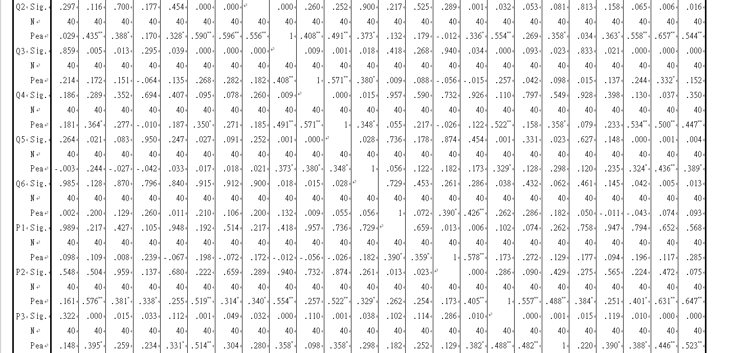
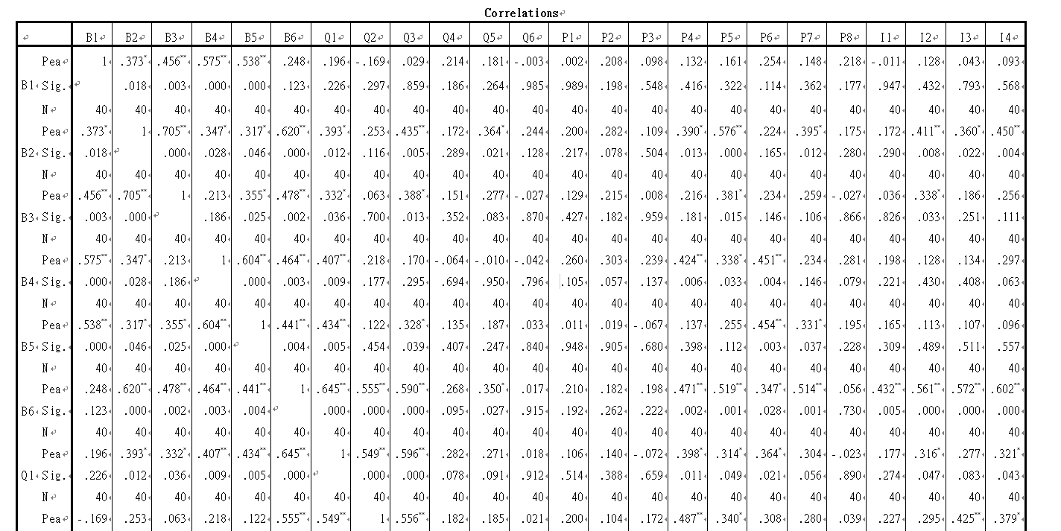
Correlations-All Items

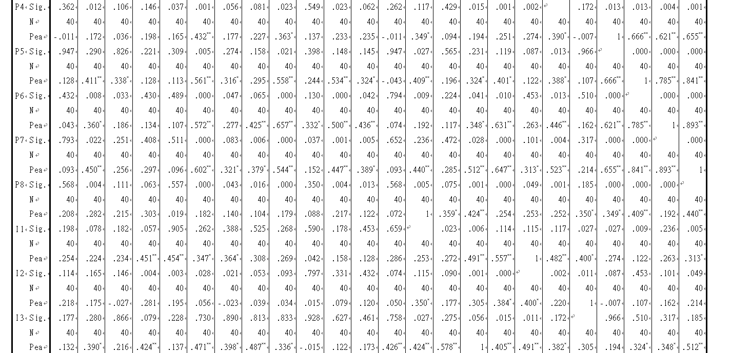

Appendix 3: SPSS Outputs for Final Data Analysis
Demographic Profile

Gender
 |  | Frequency | Percent | Valid Percent | Cumulative Percent
Valid | Male | 81 | 26.8 | 26.8 | 26.8
Valid | Female | 221 | 73.2 | 73.2 | 100.0
Valid | Total | 302 | 100.0 | 100.0

Age
 |  | Frequency | Percent | Valid Percent | Cumulative Percent
Valid | 21-30 | 27 | 8.9 | 8.9 | 8.9
Valid | 31-40 | 59 | 19.5 | 19.5 | 28.5
Valid | 41-50 | 80 | 26.5 | 26.5 | 55.0
Valid | Above 51 | 136 | 45.0 | 45.0 | 100.0
Valid | Total | 302 | 100.0 | 100.0

Education Level
 |  | Frequency | Percent | Valid Percent | Cumulative Percent
Valid | Bachelor Degree | 159 | 52.6 | 52.6 | 52.6
Valid | Master | 75 | 24.8 | 24.8 | 77.5
Valid | PhD | 6 | 2.0 | 2.0 | 79.5
Valid | Others | 62 | 20.5 | 20.5 | 100.0
Valid | Total | 302 | 100.0 | 100.0

Marital Status
 |  | Frequency | Percent | Valid Percent | Cumulative Percent
Valid | Single | 80 | 26.5 | 26.5 | 26.5
Valid | Married | 222 | 73.5 | 73.5 | 100.0
Valid | Total | 302 | 100.0 | 100.0

Income Per Month
 |  | Frequency | Percent | Valid Percent | Cumulative Percent
Valid | Below TWD25,000 | 38 | 12.6 | 12.6 | 12.6
Valid | TWD25,001-TWD40,000 | 97 | 32.1 | 32.1 | 44.7
Valid | TWD 40,001-TWD60,000 | 85 | 28.1 | 28.1 | 72.8
Valid | TWD60,001-100,000 | 68 | 22.5 | 22.5 | 95.4
Valid | Above TWD100,001 | 14 | 4.6 | 4.6 | 100.0
Valid | Total | 302 | 100.0 | 100.0

Factor Analysis - B Construct

KMO and Bartlett's Test
Kaiser-Meyer-Olkin Measure of Sampling Adequacy. |  | .713
Bartlett's Test of Sphericity | Approx. Chi-Square | 823.693
Bartlett's Test of Sphericity | df | 15
Bartlett's Test of Sphericity | Sig. | .000

Communalities
 | Initial | Extraction
B1 | 1.000 | .658
B2 | 1.000 | .840
B3 | 1.000 | .766
B4 | 1.000 | .781
B5 | 1.000 | .731
B6 | 1.000 | .617
Extraction Method: Principal Component Analysis.

Total Variance Explained
Component | Initial Eigenvalues |  |  | Extraction Sums of Squared Loadings |  |  | Rotation Sums of Squared Loadings
Component | Total | % of Variance | Cumulative % | Total | % of Variance | Cumulative % | Total | % of Variance | Cumulative %
1 | 3.267 | 54.443 | 54.443 | 3.267 | 54.443 | 54.443 | 2.204 | 36.733 | 36.733
2 | 1.126 | 18.771 | 73.214 | 1.126 | 18.771 | 73.214 | 2.189 | 36.481 | 73.214
3 | .701 | 11.685 | 84.899
4 | .420 | 6.992 | 91.891
5 | .272 | 4.536 | 96.428
6 | .214 | 3.572 | 100.000
Extraction Method: Principal Component Analysis.

Component Matrixª
 | Component
 | 1 | 2
B1 | .762 | -.509
B2 | .748 | .415
B3 | .741 | -.262
B4 | .728 | .501
B5 | .725 | .363
B6 | .723 | -.493
Extraction Method: Principal Component Analysis.
a. 2 components extracted.

Factor Analysis - Q Construct
KMO and Bartlett's Test
Kaiser-Meyer-Olkin Measure of Sampling Adequacy. |  | .709
Bartlett's Test of Sphericity | Approx. Chi-Square | 595.767
Bartlett's Test of Sphericity | df | 15
Bartlett's Test of Sphericity | Sig. | .000

Communalities
 | Initial | Extraction
Q1 | 1.000 | .741
Q2 | 1.000 | .740
Q3 | 1.000 | .770
Q4 | 1.000 | .634
Q5 | 1.000 | .650
Q6 | 1.000 | .612
Extraction Method: Principal Component Analysis.

Total Variance Explained
Component | Initial Eigenvalues |  |  | Extraction Sums of Squared Loadings |  |  | Rotation Sums of Squared Loadings
Component | Total | % of Variance | Cumulative % | Total | % of Variance | Cumulative % | Total | % of Variance | Cumulative %
1 | 2.825 | 47.084 | 47.084 | 2.825 | 47.084 | 47.084 | 2.119 | 35.317 | 35.317
2 | 1.323 | 22.050 | 69.135 | 1.323 | 22.050 | 69.135 | 2.029 | 33.818 | 69.135
3 | .697 | 11.611 | 80.746
4 | .456 | 7.595 | 88.342
5 | .440 | 7.326 | 95.667
6 | .260 | 4.333 | 100.000
Extraction Method: Principal Component Analysis.

Component Matrixª
 | Component
 | 1 | 2
Q1 | .866 | -.143
Q2 | .711 | .381
Q3 | .702 | -.498
Q4 | .684 | .408
Q5 | .625 | -.591
Q6 | .467 | .627
Extraction Method: Principal Component Analysis.
a. 2 components extracted.

Factor Analysis - P Construct

KMO and Bartlett's Test
Kaiser-Meyer-Olkin Measure of Sampling Adequacy. |  | .786
Bartlett's Test of Sphericity | Approx. Chi-Square | 687.837
Bartlett's Test of Sphericity | df | 28
Bartlett's Test of Sphericity | Sig. | .000

Communalities
 | Initial | Extraction
P1 | 1.000 | .749
P2 | 1.000 | .728
P3 | 1.000 | .776
P4 | 1.000 | .729
P5 | 1.000 | .701
P6 | 1.000 | .686
P7 | 1.000 | .592
P8 | 1.000 | .606
Extraction Method: Principal Component Analysis.

Total Variance Explained
Component | Initial Eigenvalues |  |  | Extraction Sums of Squared Loadings |  |  | Rotation Sums of Squared Loadings
Component | Total | % of Variance | Cumulative % | Total | % of Variance | Cumulative % | Total | % of Variance | Cumulative %
1 | 3.281 | 41.009 | 41.009 | 3.281 | 41.009 | 41.009 | 2.221 | 27.765 | 27.765
2 | 1.246 | 15.580 | 56.589 | 1.246 | 15.580 | 56.589 | 1.863 | 23.287 | 51.052
3 | 1.040 | 13.000 | 69.588 | 1.040 | 13.000 | 69.588 | 1.483 | 18.536 | 69.588
4 | .722 | 9.024 | 78.612
5 | .513 | 6.418 | 85.031
6 | .443 | 5.538 | 90.568
7 | .399 | 4.991 | 95.559
8 | .355 | 4.441 | 100.000
Extraction Method: Principal Component Analysis.

Component Matrixª
 | Component
 | 1 | 2 | 3
P1 | .792 | .316 | .034
P2 | .763 | -.250 | -.201
P3 | .704 | -.390 | -.232
P4 | .627 | -.350 | -.276
P5 | .553 | -.370 | .404
P6 | .577 | .633 | .208
P7 | .485 | .520 | -.493
P8 | .555 | .040 | .647
Extraction Method: Principal Component Analysis.
a. 3 components extracted.

Factor Analysis - I Construct

KMO and Bartlett's Test
Kaiser-Meyer-Olkin Measure of Sampling Adequacy. |  | .815
Bartlett's Test of Sphericity | Approx. Chi-Square | 1043.999
Bartlett's Test of Sphericity | df | 6
Bartlett's Test of Sphericity | Sig. | .000

Communalities
 | Initial | Extraction
I1 | 1.000 | .656
I2 | 1.000 | .841
I3 | 1.000 | .851
I4 | 1.000 | .897
Extraction Method: Principal Component Analysis.

Total Variance Explained
Component | Initial Eigenvalues |  |  | Extraction Sums of Squared Loadings
Component | Total | % of Variance | Cumulative % | Total | % of Variance | Cumulative %
1 | 3.245 | 81.126 | 81.126 | 3.245 | 81.126 | 81.126
2 | .438 | 10.956 | 92.082
3 | .219 | 5.482 | 97.563
4 | .097 | 2.437 | 100.000
Extraction Method: Principal Component Analysis.

Component Matrixª
 | Component
 | 1
I1 | .947
I2 | .922
I3 | .917
I4 | .810
Extraction Method: Principal Component Analysis.
a. 1 components extracted.

Reliability - Brand Awareness
Case Processing Summary
 |  | N | %
Cases | Valid | 302 | 100.0
Cases | Excludedª | 0 | .0
Cases | Total | 302 | 100.0
a. Listwise deletion based on all variables in the procedure.

Reliability Statistics
Cronbach's Alpha | Cronbach's Alpha Based on Standardized Items | N of Items
.820 | .833 | 6

Item Statistics
 | Mean | Std. Deviation | N
B1 | 3.84 | 1.068 | 302
B2 | 4.13 | .680 | 302
B3 | 3.92 | .640 | 302
B4 | 3.85 | .825 | 302
B5 | 4.04 | .678 | 302
B6 | 4.26 | .634 | 302

Item-Total Statistics
 | Scale Mean if Item Deleted | Scale Variance if Item Deleted | Corrected Item-Total Correlation | Squared Multiple Correlation | Cronbach's Alpha if Item Deleted
B1 | 20.21 | 6.735 | .603 | .521 | .802
B2 | 19.92 | 8.388 | .601 | .607 | .789
B3 | 20.12 | 8.657 | .571 | .589 | .796
B4 | 20.20 | 7.713 | .616 | .564 | .784
B5 | 20.00 | 8.259 | .641 | .487 | .782
B6 | 19.78 | 8.672 | .575 | .509 | .796

Reliability – Perceived Quality
Case Processing Summary
 |  | N | %
Cases | Valid | 302 | 100.0
Cases | Excludedª | 0 | .0
Cases | Total | 302 | 100.0
a. Listwise deletion based on all variables in the procedure.

Reliability Statistics
Cronbach's Alpha | Cronbach's Alpha Based on Standardized Items | N of Items
.759 | .765 | 6

Item Statistics
 | Mean | Std. Deviation | N
Q1 | 3.92 | .788 | 302
Q2 | 3.75 | .765 | 302
Q3 | 3.97 | .691 | 302
Q4 | 4.03 | .810 | 302
Q5 | 4.11 | .746 | 302
Q6 | 4.15 | .797 | 302

Item-Total Statistics
 | Scale Mean if Item Deleted | Scale Variance if Item Deleted | Corrected Item-Total Correlation | Squared Multiple Correlation | Cronbach's Alpha if Item Deleted
Q1 | 20.01 | 6.923 | .497 | .463 | .724
Q2 | 20.18 | 7.297 | .417 | .406 | .745
Q3 | 19.96 | 6.500 | .746 | .615 | .663
Q4 | 19.90 | 6.730 | .528 | .378 | .716
Q5 | 19.82 | 6.892 | .551 | .416 | .710
Q6 | 19.78 | 7.615 | .309 | .286 | .774

Reliability – Perceived Price
Case Processing Summary
 |  | N | %
Cases | Valid | 302 | 100.0
Cases | Excludedª | 0 | .0
Cases | Total | 302 | 100.0
a. Listwise deletion based on all variables in the procedure.

Reliability Statistics
Cronbach's Alpha | Cronbach's Alpha Based on Standardized Items | N of Items
.771 | .787 | 8

Item Statistics
 | Mean | Std. Deviation | N
P1 | 3.87 | 1.054 | 302
P2 | 3.26 | .866 | 302
P3 | 3.72 | .796 | 302
P4 | 3.68 | .715 | 302
P5 | 3.63 | .703 | 302
P6 | 3.51 | .737 | 302
P7 | 3.90 | .706 | 302
P8 | 3.81 | .844 | 302

Item-Total Statistics
 | Scale Mean if Item Deleted | Scale Variance if Item Deleted | Corrected Item-Total Correlation | Squared Multiple Correlation | Cronbach's Alpha if Item Deleted
P1 | 25.51 | 12.503 | .337 | .261 | .780
P2 | 26.12 | 12.860 | .405 | .280 | .758
P3 | 25.65 | 12.865 | .461 | .391 | .748
P4 | 25.70 | 12.186 | .688 | .525 | .713
P5 | 25.75 | 12.873 | .547 | .423 | .735
P6 | 25.86 | 12.412 | .611 | .468 | .724
P7 | 25.48 | 13.293 | .454 | .335 | .749
P8 | 25.56 | 13.031 | .392 | .270 | .760

Reliability – Purchase Intention
Case Processing Summary
 |  | N | %
Cases | Valid | 302 | 100.0
Cases | Excludedª | 0 | .0
Cases | Total | 302 | 100.0
a. Listwise deletion based on all variables in the procedure.

Reliability Statistics
Cronbach's Alpha | Cronbach's Alpha Based on Standardized Items | N of Items
.920 | .921 | 4

Item Statistics
 | Mean | Std. Deviation | N
I1 | 3.59 | .873 | 302
I2 | 3.73 | .830 | 302
I3 | 3.89 | .770 | 302
I4 | 3.89 | .861 | 302

Item-Total Statistics
 | Scale Mean if Item Deleted | Scale Variance if Item Deleted | Corrected Item-Total Correlation | Squared Multiple Correlation | Cronbach's Alpha if Item Deleted
I1. | 11.52 | 5.407 | .692 | .486 | .938
I2 | 11.37 | 5.118 | .844 | .730 | .885
I3 | 11.21 | 5.355 | .849 | .803 | .886
I4 | 11.21 | 4.859 | .889 | .850 | .869

Hypotheses Test-Multiple Regression
Variables Entered/Removedª
Model | Variables Entered | Variables Removed | Method
1 | P, B, Q^{b} | . | Enter
a. Dependent Variable: I
b. All requested variables entered.

Model Summary
Model | R | R Square | Adjusted R Square | Std. Error of the Estimate
1 | .580ª | .337 | .330 | 1.96250
a. Predictors: (Constant), PerceivedPrice, PerceivedQuality, BrandAwareness

ANOVAª
Model |  | Sum of Squares | df | Mean Square | F | Sig.
1 | Regression | 582.673 | 3 | 194.224 | 50.429 | .000^{b}
1 | Residual | 1147.723 | 298 | 3.851
1 | Total | 1730.396 | 301
a. Dependent Variable: PurchaseIntention
b. Predictors: (Constant), PerceivedPrice, PerceivedQuality, BrandAwareness

Coefficientsª
Model |  | Unstandardized Coefficients |  | Standardized Coefficients | t | Sig. | Collinearity Statistics
 |  | B | Std. Error | Beta | t | Sig. | Tolerance | VIF
1 | (Constant) | .505 | 1.040 |  | .486 | .628
1 | BrandAwareness | -.022 | .043 | -.027 | -.503 | .615 | .757 | 1.320
1 | PerceivedQuality | .377 | .045 | .441 | 8.318 | .000 | .793 | 1.262
1 | PerceivedPrice | .169 | .036 | .258 | 4.708 | .000 | .742 | 1.348
a. Dependent Variable: PurchaseIntention

Appendix 4: Project Proposal
STUDENT NAME &  ID NO. | Cheng Yun En  I17013728
Broad Area | Marketing
Concise Title | Consumer Purchase Intention on Health Food in Taiwan
Problem Definition | Due to changes in lifestyles, the number of people eating out and working pressure has increased. Therefore, many diseases such as obesity, high blood pressure, and diabetes have also increased (Colbin, 2013). Moreover, the food safety incidents that have occurred in Taiwan over the past few years have threatened the health of the people (Hsu et. al., 2015). However, due to uneven quality and advertisement that exaggerates product efficacy, it is difficult for consumers to judge the authenticity of health foods, product efficacy and reasonable prices.
Research Objective | RO1: To determine whether brand awareness influence consumer purchase intention on health food in Taiwan.  RO2: To determine whether perceived quality influence consumer purchase intention on health food in Taiwan.  RO3: To determine whether perceived price influence consumer purchase intention on health food in Taiwan.
Research Question | RQ1: Will brand awareness influence consumer purchase intention on health food in Taiwan.  RQ2: Will perceived quality influence consumer purchase intention on health food in Taiwan.  RQ3: Will perceived price influence consumer purchase intention on health food in Taiwan.
Scope of study | This research will only focus on a specific business sector – Healthy Food, and the research location is set to be in Taiwan.
Significance of the research | Significance to Academic  The main contribution of this research is that it adds to the literature which is present around decision making in the health food industry. As a matter of fact, it also helps expand the understanding of health food marketing based on specific independent variables such as brand awareness, perceived quality, perceived price, and other researchers may refer to this research when they are carrying out research on other industries.  Significance to Industry  From the perspective of industry-wide implication, it can provide important guidance on how companies should orient their products within the health food industry. Companies could align their products with this newly found knowledge in order to improve the offering for their customers.
Literature Review | 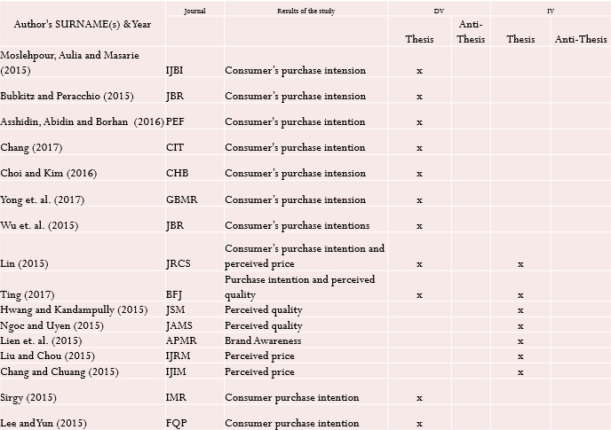
Research Methodology | Below is the brief proposed methodology:  - Purpose of Study: Descriptive research  - Type of Investigation: Quantitative Correlations Design  - Extent of researcher interference: Minimum  - Study Setting: Non-contrived  - Time Horizon: Cross-sectional  - Sample Size: 384  - Sampling Procedure: Non-probability convenient sampling  - Data Collection: Online questionnaire  - Data Analysis Method:  - Descriptive statistic will be used to descript the demographic of participants  - Validity and reliability test, ANOVA test and Multiple Regression Test will be conducted to test the hypothesis  - Data Analysis Software: IBM SPSS Statistic 22.0

Appendix 5: Ethics Approval Form
UNIVERSITY OF HERTFORDSHIRE
FORM EC1A: APPLICATION FOR ETHICS APPROVAL OF A STUDY INVOLVING HUMAN PARTICIPANTS
(Individual or Group Applications)

Please complete this form if you wish to undertake a study involving human participants.

Applicants are advised to refer to the Ethics Approval StudyNet Site and read the Guidance Notes (GN) before completing this form.
http://www.studynet2.herts.ac.uk/ptl/common/ethics.nsf/Homepage?ReadForm

Use of this form is mandatory [see UPR RE01, ‘Studies Involving Human Participants’, SS 7.1-7.3]
Approval must be sought and granted before any investigation involving human participants begins [UPR RE01, S 4.4 (iii)]

If you require any further guidance, please contact either hsetecda@herts.ac.uk or ssahecda@herts.ac.uk
Abbreviations: GN = Guidance Notes UPR = University Policies and Regulations
1. THE STUDY
Q1 Please give the title of the proposed study
CONSUMER PURCHASE INTENTION ON HEALTH FOOD IN TAIWAN
2. THE APPLICANT
Q2 Name of applicant/(principal) investigator (person undertaking this study)
CHENG YUN EN
Student registration number/Staff number: I17013728
Email address: I17013728@student.newinti.edu.my
Status: ☐Undergraduate (Foundation) ☐Undergraduate (BSc, BA)
☒Postgraduate (taught) ☐Postgraduate (research)
☐Staff ☐Other
School/Department: FACULTY OF BUSINESS, COMMUNICATIONS AND LAW
If application is from a student NOT based at University of Hertfordshire, please give the name of the partner institution: INTI INTERNATIONAL UNIVERSITY, MALAYSIA
Name of Programme: MBADI Master of Business Administration
Module name and module code: MGT7998
Name of Supervisor: DR. Alex Ng Hou Hong
Supervisor’s email: houhong.ng@newinti.edu.my
Name of Module Leader if applicant is undertaking a taught programme/module:
DR. Alex Ng Hou Hong
Names and student/staff numbers for any additional investigators involved in this study
Is this study being conducted in collaboration with another university or institution and/or does it involve working with colleagues from another institution?
☐Yes ☒No

3. DETAILS OF THE PROPOSED STUDY
Q3 Please give a short synopsis of your proposed study, stating its aims and highlighting where these aims relate to the use of human participants (See GN 2.2.3)
Today peoples are getting more health conscious and they are paying more attention on healthy diet than ever. In this context, more health food products are available in the market and it has driven the health food market to grow drastically. The study aims to explore the factors that influence the consumers' purchase intention on health food in Taiwan. At the end of this research, the following objectives should be achieved:
1. To determine the relationship between the brand awareness and purchase intention in the health food industry.
2. To determine the relationship between the perceived quality and purchase intention in the health food industry.
3. To determine the relationship between the perceived price and purchase intention in the health food industry.
Q4 Please give a brief explanation of the design of the study and the methods and procedures used. You should clearly state the nature of the involvement the human participants will have in your proposed study and the extent of their commitment. Ensure you provide sufficient detail for the Committee to, particularly in relation to the human participants. Refer to any Standard Operating Procedures SOPs under which you are operating here. (See GN 2.2.4).
The design of the study is quantitative research whereby the data gathered are all primary data. Questionnaire will be used in obtaining the feedback from the participants. The sampling frame is focus on individual basis. The total sample size required is 150 respondents who are aged 18 and above living in Taiwan. The distribution method used to distribute this questionnaire is using Google form. Measurement strategy used is using both description and inferential analysis the tools used to evaluate the data is using SPSS 20 in this research.
Q5 Does the study involve the administration of substances?
☐Yes ☒No
PLEASE NOTE: If you have answered yes to this question you must ensure that the study would not be considered a clinical trial of an investigational medical product. To help you, please refer to the link below from the Medicines and Healthcare Products Regulatory Agency:
https://www.gov.uk/government/uploads/system/uploads/attachment_data/file/317952/Algothrim.pdf
To help you determine whether NHS REC approval is required, you may wish to consult the Health Research Authority (HRA) decision tool: http://www.hra-decisiontools.org.uk/ethics/
If your study is considered a clinical trial and it is decided that ethical approval will be sought from the HRA, please stop completing this form and use Form EC1D, 'NHS Protocol Registration Request'; you should also seek guidance from Research Sponsorship.
I confirm that I have referred to the Medicines and Healthcare Products Regulatory Agency information and confirm that that my study is not considered a clinical trial of a medicinal product.
Q6.1 Please give the starting date for your recruitment and data collection: 29 Oct 2018
Q6.2 Please give the finishing date for you data collection: 16 November 2018
(For meaning of ‘starting date’ and ‘finishing date’, see GN 2.2.6)
Q7 Where will the study take place?
This research will be tale place in Taiwan. The questionnaire will be sent online.
Please refer to the Guidance Notes (GN 2.2.7) which set out clearly what permissions are required;
Please tick all the statements below which apply to this study
☐ I confirm that I have obtained permission to access my intended group of participants and that the agreement is attached to this application
☐ I confirm that I have obtained permission to carry out my study on University premises in areas outside the Schools and that the agreement is attached to this application.
☒ I have yet to obtain permission but I understand that this will be necessary before I commence my study and that the original copies of the permission letters must be verified by my supervisor before data collection commences
☐ This study involves working with minors/vulnerable participants. I/we have obtained permission from the organisation (including UH/UH Partner Institutions when appropriate) in which the study is to take place and which is responsible for the minors/vulnerable participants. The permission states the DBS requirements of the organisation for this study and confirms I/we have satisfied their DBS requirements where necessary.
NB If your study involves minors/vulnerable participants, please refer to Q18 to ensure you
comply with the University's requirement regarding Disclosure and Barring Service clearance.
☐ Permission is not required for my study as

4. HARMS, HAZARDS AND RISKS
Q8.1 It might be appropriate to conduct a risk assessment (in respect of the hazards/risks affecting both the participants and/or investigators). Please use Risk Assessment Form EC5 if the answer to any of the questions below is 'yes'.
If you are required to complete and submit a School specific risk assessment in addition to Form EC5, please append it to your completed Form EC5.
Will this study involve any of the following?
Invasive Procedures/administration of any substance/s? ☐YES ☒NO
Are there potential hazards to participant/investigator(s) from the proposed study? (Physical/Emotional) ☐YES ☒NO
Will or could aftercare and/or support be needed by participants? ☐YES ☒NO
IF 'YES' TO THE ABOVE PLEASE COMPLETE EC1 APPENDIX 1 AND INCLUDE IT WITH YOUR APPLICATION
Q8.2 Is the study being conducted off-campus (i.e. not at UH/UH Partner?)
☐YES ☐NO
It might be appropriate to conduct a risk assessment of the proposed location for your study (in respect of the hazards/risks affecting both the participants and/or investigators) (this might be relevant for on-campus locations as well). Please use Form EC5 and, if required, a School-specific risk assessment (See GN 2.2.8 of the Guidance Notes).
If you do not consider it necessary to submit a risk assessment, please give your reasons:
This research is conducted on a voluntary basis. Respondents are not forced to fill in the questionnaire. Therefore, risk assessment is not necessary for this research.

5. ABOUT YOUR PARTICIPANTS
Q9 Please give a brief description of the kind of people you hope/intend to have as participants, for instance, a sample of the general population, University students, people affected by a particular medical condition, children within a given age group, employees of a particular firm, people who support a particular political party, and state whether there are any upper or lower age restrictions.
This research mainly aims at participants who are living in Taiwan. The range of age is 21 and above.
Q10 Please state here the maximum number of participants you hope will participate in your study. Please indicate the maximum numbers of participants for each method of data collection.
The maximum number of participants required to make this research successful is approximately 180 respondents.
Q11 By completing this form, you are indicating that you are reasonably sure that you will be successful in obtaining the number of participants which you hope/intend to recruit. Please outline here your recruitment (sampling) method and how you will advertise your study. (See GN 2.2.9).
The participants will be approached and upon receiving their consent to take part in the survey, each individual will be informed and thoroughly explained the purpose of the research and how to take part in the survey. The language that shall be used in the questionnaire will be English that shall enable the respondent to clearly understand the questions. To achieve the target of 180 respondents, convenience will be applied.

- CONFIDENTIALITY AND CONSENT
(For guidance on issues relating to consent, see GN 2.2.10, GN 3.1 and UPR RE01, SS 2.3 and 2.4 and the Ethics Approval StudyNet Site FAQs)
Q12 How will you obtain consent from the participants? Please explain the consent process for each method of data collection identified in Q4
☒ Informed consent using EC3 and EC6 (equivalent)
☐ Implied consent (e.g. via participant information at the start of the questionnaire/survey etc)
☐ Consent by proxy (for example, given by parent/guardian)
Use this space to describe how consent is to be obtained and recorded for each method of data collection. The information you give must be sufficient to enable the Committee to understand exactly what it is that prospective participants are being asked to agree to.
A copy of the Consent Form (Form EC3) is attached at the end of this document. For every participant that agreed to participate in this study will need to sign at the end of the consent form indicating that they understand the content of the consent form. The content of the consent form basically indicates that the participant agrees on giving their information such as nationality and educational level in this study.
In addition, Participant Information sheet is also given to the participants explaining particulars of the study, including its aim(s), methods and design, the names and contact details of key people and, as appropriate, the risks and potential benefits, and any plans for follow-up studies that might involve further approaches to participants.
Besides, if in the event of any significant change to the aim(s) or design of the study, the participant will be informed and asked to renew their consent to participate in it. Participant will also be informed that their information will be kept confidential. Upon agreeing to all these, only then the participant will sign the consent form. After the participants finish the consent form, the data will be entered and stored in a computer and no one can access it and meanwhile the data file will be encrypted.
If you do not intend to obtain consent from participants please explain why it is considered unnecessary or impossible or otherwise inappropriate to seek consent.
Q13 If the participant is a minor (under 18 years of age) or is unable for any reason to give full consent on their own, state here whose consent will be obtained and how? (See especially GN 3.6 and 3.7)
The study focuses on Taiwan. All participants for this study will be selected from individuals above 21 years old.
Q14.1 Will anyone other than yourself and the participants be present with you when conducting this study? (See GN 2.2.10)
☐YES ☒NO
If YES, please state the relationship between anyone else who is present other than the applicant and/or participants (eg health professional, parent/guardian of the participant).
Q14.2 Will the proposed study be conducted in private?
☒YES ☐NO
If 'No', what steps will be taken to ensure confidentiality of the participants’ information. (See GN 2.2.10)
Q15 Are personal data of any sort (such as name, age, gender, occupation, contact details or images) to be obtained from or in respect of any participant? (See GN 2.2.11) (You will be required to adhere to the arrangements declared in this application concerning confidentiality of data and its storage. The Participant Information Sheet (Form EC6 or equivalent) must explain the arrangements clearly.)
☒YES ☐NO
If YES, give details of personal data to be gathered and indicate how it will be stored.
The data will be gathered using a self-administered questionnaire whereby personal information such as age, gender and education level will be gathered. These personal information question will be utilized only if it is relevant to the study and for the purpose of this study only. The respondents’ personal information will be treated with utmost confidentiality by the researcher and no information obtained from this study shall be disclosed in any manner. It will not be revealed to any other parties or used for any purpose other than this study.
Will you be making audio-visual recordings?
☐YES ☒NO
If YES, give details of the types recording to be made and indicate how they will be stored.
State what steps will be taken to prevent or regulate access to personal data/audio-visual recordings beyond the immediate investigative team, as indicated in the Participant Information Sheet.
Indicate what assurances will be given to participants about the security of, and access to, personal data/audio-visual recordings, as indicated in the Participant Information Sheet.
The data collected will be saved in SPSS software for analysis and the resulting files will be encrypted by the researcher. No one else will have any kind of access to it.
State as far as you are able to do so how long personal data/audio-visual recordings collected/made during the study will be retained and what arrangements have been made for its/their secure storage, as indicated in the Participant Information Sheet.
The data collected will be retained for a period of approximately for 1-year period in an offline environment because examiners may request proof of the data to confirm that the data is accurate and not of self-filled results. As stated above, document files will save with passwords and encrypted to ensure the information remains secure.
Will data be anonymized prior to storage? ☒YES ☐NO
Q16 Is it intended (or possible) that data might be used beyond the present study? (See GN 2.2.10) ☐YES ☒NO
If YES, please indicate the kind of further use that is intended (or which may be possible).
If NO, will the data be kept for a set period and then destroyed under secure conditions? ☒YES ☐NO
If NO, please explain why not:
Q17 Consent Forms: what arrangements have been made for the storage of Consent Forms and for how long?
Consent forms will also be stored for the same duration as the data, which is 1 year in an offline environment with password protection.
Q18 If the activity/activities involve work with children and/or vulnerable adults satisfactory Disclosure and Barring Service (DBS) clearance may be required by investigators. You are required to check with the organization (including UH/UH Partners where appropriate) responsible for the minors/vulnerable participants whether or not they require DBS clearance.
Any permission from the organization confirming their approval for you to undertake the activities
with the children/vulnerable group for which they are responsible should make specific reference to any DBS requirements they impose, and their permission letter/email must be included with your application.
More information is available via the DBS website -
https://www.gov.uk/government/organisations/disclosure-and-barring-service

- REWARDS
Q19.1 Are you receiving any financial or other reward connected with this study? (See GN 2.2.14 and UPR RE01, S 2.3) ☐YES ☒NO
If YES, give details here:
Q19.2 Are participants going to receive any financial or other reward connected with the study? (Please note that the University does not allow participants to be given a financial inducement.) (See UPR RE01,S 2.3) ☐YES ☒NO
If YES, provide details here:
Q19.3 Will anybody else (including any other members of the investigative team) receive any financial or other reward connected with this study? ☐YES ☒NO
If YES, provide details here

- OTHER RELEVANT MATTERS
Q20 Enter here anything else you want to say in support of your application, or which you believe may assist the Committee in reaching its decision.
Nowadays, business and consumers are getting more aware on the health food and they realize that the concept of health food is associated with quality, safety.
The aim of this study is to identify the factors influencing the consumer purchase intention in Taiwan. This study would be beneficial to academic, the health food industry and related business as they will have insights on the health food industry and to make accurate decisions.

- DOCUMENTS TO BE ATTACHED
Please indicate below which documents are attached to this application:
☐Permission to access groups of participants from student body
☐Permission to use University premises beyond areas of School
☐Schools Permission from off-campus location(s) to be used to conduct this study
☐Risk Assessment(s) in respect of hazards/risks affecting participants/investigator(s)
☒Copy of Consent Form (See Form EC3/EC4) Copy of Form EC6 (Participant Info Sheet)
☐ Copy of Form EC6 (Participant Info Sheet)
☐A copy of the proposed questionnaire and/or interview schedule (if appropriate for this study). For unstructured methods, please provide details of the subject areas that will be covered and any boundaries that have been agreed with your Supervisor
☐Any other relevant documents, such as a debrief, meeting report. Please provide details here:

- DECLARATIONS
1 DECLARATION BY APPLICANT
I undertake, to the best of my ability, to abide by UPR RE01, ‘Studies Involving the Use of Human Participants’, in carrying out the study.
I undertake to explain the nature of the study and all possible risks to potential participants,
Data relating to participants will be handled with great care. No data relating to named or identifiable participants will be passed on to others without the written consent of the participants concerned, unless they have already consented to such sharing of data when they agreed to take part in the study.
All participants will be informed (a) that they are not obliged to take part in the study, and (b) that they may withdraw at any time without disadvantage or having to give a reason.
(NOTE: Where the participant is a minor or is otherwise unable, for any reason, to give full consent on their own, references here to participants being given an explanation or information, or being asked to give their consent, are to be understood as referring to the person giving consent on their behalf. (See Q 12; also GN Pt. 3, and especially 3.6 & 3.7))

Enter your name here: CHENG YUN EN Date 27/09/2018

GROUP APPLICATION

(If you are making this application on behalf of a group of students/staff, please complete this section as well)
I confirm that I have agreement of the other members of the group to sign this declaration on their behalf
Enter your name here: Click here to enter text. Date Click here to enter a date.

DECLARATION BY SUPERVISOR (see GN 2.1.6)

I confirm that the proposed study has been appropriately vetted within the School in respect of its aims and methods; that I have discussed this application for Ethics Committee approval with the applicant and approve its submission; that I accept responsibility for guiding the applicant so as to ensure compliance with the terms of the protocol and with any applicable ethical code(s); and that if there are conditions of the approval, they have been met.

Enter your name here: DR. ALEX NG HOU HONG Date 27/09/2018

UNIVERSITY OF HERTFORDSHIRE
ETHICS COMMITTEE FOR STUDIES INVOLVING THE USE OF HUMAN PARTICIPANTS
(‘ETHICS COMMITTEE’)

FORM EC3
CONSENT FORM FOR STUDIES INVOLVING HUMAN PARTICIPANTS

I, the undersigned [please give your name here, in BLOCK CAPITALS]
…………………………………………………………………………………………….…
of [please give contact details here, sufficient to enable the investigator to get in touch with you, such as a postal or email address]
…..…………………………..………………………………………………………………
hereby freely agree to take part in the study entitled [insert name of study here]
………Consumer Purchase Intention on Health Food in Taiwan……………..
(UH Protocol number …………………………………………)

1 I confirm that I have been given a Participant Information Sheet (a copy of which is attached to this form) giving particulars of the study, including its aim(s), methods and design, the names and contact details of key people and, as appropriate, the risks and potential benefits, how the information collected will be stored and for how long, and any plans for follow-up studies that might involve further approaches to participants. I have also been informed of how my personal information on this form will be stored and for how long. I have been given details of my involvement in the study. I have been told that in the event of any significant change to the aim(s) or design of the study I will be informed, and asked to renew my consent to participate in it.
2 I have been assured that I may withdraw from the study at any time without disadvantage or having to give a reason.
3 In giving my consent to participate in this study, I understand that voice, video or photo-recording will take place and I have been informed of how/whether this recording will be transmitted/displayed.
4 I have been given information about the risks of my suffering harm or adverse effects. I have been told about the aftercare and support that will be offered to me in the event of this happening, and I have been assured that all such aftercare or support would be provided at no cost to myself. In signing this consent form I accept that medical attention might be sought for me, should circumstances require this.
5 I have been told how information relating to me (data obtained in the course of the study, and data provided by me about myself) will be handled: how it will be kept secure, who will have access to it, and how it will or may be used.
6 I understand that my participation in this study may reveal findings that could indicate that I might require medical advice. In that event, I will be informed and advised to consult my GP. If, during the study, evidence comes to light that I may have a pre-existing medical condition that may put others at risk, I understand that the University will refer me to the appropriate authorities and that I will not be allowed to take any further part in the study.
7 I understand that if there is any revelation of unlawful activity or any indication of non-medical circumstances that would or has put others at risk, the University may refer the matter to the appropriate authorities.
8 I have been told that I may at some time in the future be contacted again in connection with this or another study.
Signature of participant……………………………………..…Date…………………………
Signature of (principal) investigator………………………………………………………Date…………………………
Name of (principal) investigator ………..CHENG YUN EN ………………………………

UNIVERSITY OF HERTFORDSHIRE
ETHICS COMMITTEE FOR STUDIES INVOLVING THE USE OF HUMAN PARTICIPANTS
(‘ETHICS COMMITTEE’)
FORM EC6: PARTICIPANT INFORMATION SHEET

1 Title of study: A STUDY ON CONSUMER PURCHASE INTNETION ON HEALTH FOOD IN TAIWAN
2 Introduction
You are being invited to take part in a study. Before you decide whether to do so, it is important that you understand the study that is being undertaken and what your involvement will include. Please take the time to read the following information carefully and discuss it with others if you wish. Do not hesitate to ask us anything that is not clear or for any further information you would like to help you make your decision. Please do take your time to decide whether or not you wish to take part. The University’s regulations governing the conduct of studies involving human participants can be accessed via this link: http://sitem.herts.ac.uk/secreg/upr/RE01.htm
- What is the purpose of this study?
Today peoples are getting more health conscious and they are paying more attention on healthy diet than ever. In this context, more health food products are available in the market and it has driven the health food market to grow drastically. The study aims to explore the factors that influence the consumers' purchase intention on health food in Taiwan. At the end of this research, the following objectives should be achieved:
- To determine the relationship between the brand awareness and purchase intention in the health food industry.
- To determine the relationship between the perceived quality and purchase intention in the health food industry.
- To determine the relationship between the perceived price and purchase intention in the health food industry.
4 Do I have to take part?
It is completely up to you whether or not you decide to take part in this study. If you do decide to take part you will be given this information sheet to keep and be asked to sign a consent form. Agreeing to join the study does not mean that you have to complete it. You are free to withdraw at any stage without giving a reason. A decision to withdraw at any time, or a decision not to take part at all, will not affect any treatment/care that you may receive (should this be relevant).
5 Are there any age or other restrictions that may prevent me from participating?
Respondents must be residents of Taiwan over the age of 20.

6 How long will my part in the study take?
If you decide to take part in this study, you will be involved in it for 15 minutes to 30 minutes.
7 What will happen to me if I take part?
The first thing to happen will be you will see three part of questions, respectively are demographic profile (personal information), dependent variable (consumer purchase intention), independent variable (influencing factors). Your contribution will bring significant to health food industry that would also like to understand how the influencing factors (brand awareness, perceived quality and perceive price) impact on consumer purchase intention of health food industry in Taiwan.
8 What are the possible disadvantages, risks or side effects of taking part?
The only thing that will cost you is your time because the time it takes to complete the questionnaire is estimated to be 15 minutes to 30 minutes. Questionnaire questions mainly related to purchase intention, so the process of participation will not be risky and will not have any side effects.
9 What are the possible benefits of taking part?
This research is significant for the policymaker. The policy maker will be able to improve the existing recycling program and modify the applied strategy to current practices for future generation.
10 How will my taking part in this study be kept confidential?
The questionnaires were collected and saved by the researcher. Third parties are not allowed to access the questionnaire detail and the questionnaire details will be stored via encryption method with the password.
11 Audio-visual material
The questionnaire was the main data collection tool for this study, so there was no audio-visual material
12 What will happen to the data collected within this study?
The results of the research shall be used in the interview detail for my MBA thesis only and shall not be used for any other purposes. The results shall be disposed of permanently in the future once the MBA thesis has been graded and finalized. The data collected will be stored electronically, in a password-protected environment, for 12 months (1-years), after which time it will be destroyed under secure conditions.
13 Will the data be required for use in further studies?
The data will not be used in any further studies
14 Who has reviewed this study?
This study has been reviewed by my supervisor Dr. Alex Ng Hou Hong. He is currently stationed in INTI International University, Malaysia. Besides, this research has reviewed by The University of Hertfordshire Social Sciences, Arts and Humanities Ethics Committee with Delegated Authority.
The UH protocol number is <enter>
15 Factors that might put others at risk
Please note that if, during the study, any medical conditions or non-medical circumstances such as unlawful activity become apparent that might or had put others at risk, the University may refer the matter to the appropriate authorities.
16 Who can I contact if I have any questions?
If you would like further information or would like to discuss any details personally, please get in touch with me, in writing, by phone or by email: Cheng Yun En; +600167076342; I17013728@student.newinti.edu.my
Although we hope it is not the case, if you have any complaints or concerns about any aspect of the way you have been approached or treated during the course of this study, please write to the University’s Secretary and Registrar at the following address:

Secretary and Registrar
University of Hertfordshire
College Lane
Hatfield
Herts
AL10 9AB

Thank you very much for reading this information and giving consideration to taking part in this study.

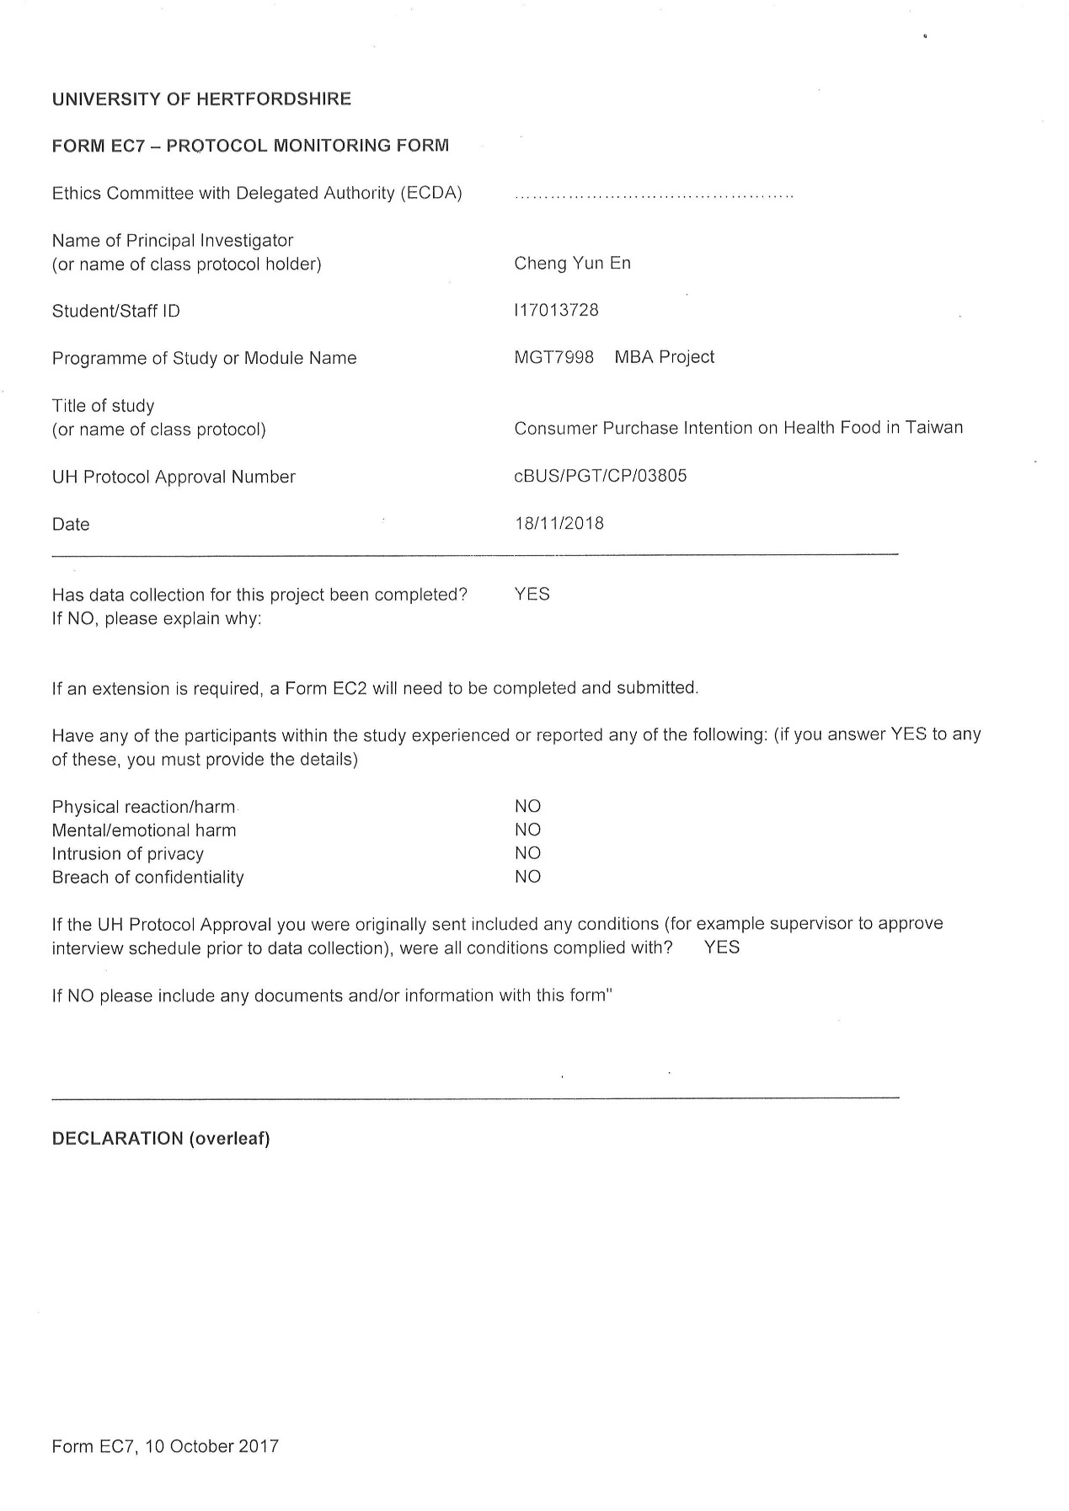

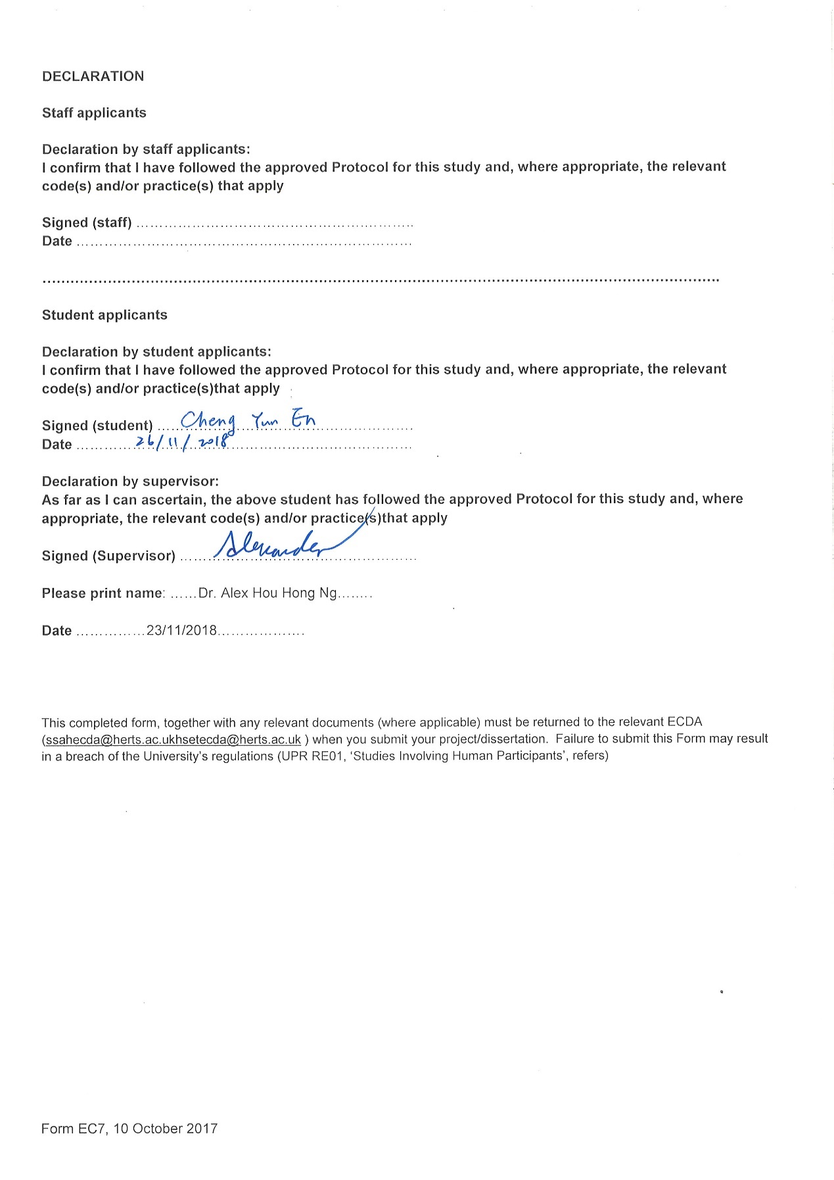

Appendix 6: Project Log

PROJECT PAPER LOG
This is an important document, which is to be handed in with your dissertation. This log will be taken into consideration when awarding the final mark for the dissertation.

Student Name: | Cheng Yun En
Supervisor’s Name: | Dr. Alex Ng Hou Hong
Dissertation Topic:
Consumer Purchase Intention on Health Food in Taiwan

SECTION A. MONITORING STUDENT DISSERTATION PROCESS

The plan below is to be agreed between the student & supervisor and will be monitored against progress made at each session.

Activity | Milestone/Deliverable Date
Enhance Chapter 1-3 | 06/9
Enhance Chapter 1-3 | 14/9
UH Ethics Forms | 27/9
Review Chapter 1-3 & Draft Questionnaire |  | 11/10
Done Review Chapter 1-3 & Prepare slides |  | 22/10
Review presentation slides for Proposal Defense |  | 29/10
Proposal Defense |  |  | 02/11
Enhance items of questionnaire |  |  | 05/11
Distribute questionnaire |  |  | 07/11
Complete Chapter 4-5 |  |  | 20/11
Prepare for defense |  |  | 23/11
Proposal Defense |  |  | 28/11
Sent full report for review |  |  |  | 10/12

SECTION B. ETHICS
Ethics form protocol number: cBUS/PGT/CP/03805

SECTION C. RECORD OF MEETINGS
The expectation is that students will meet their supervisors up to seven times and these meetings should be recorded.







Section D. Comments on Management of Project
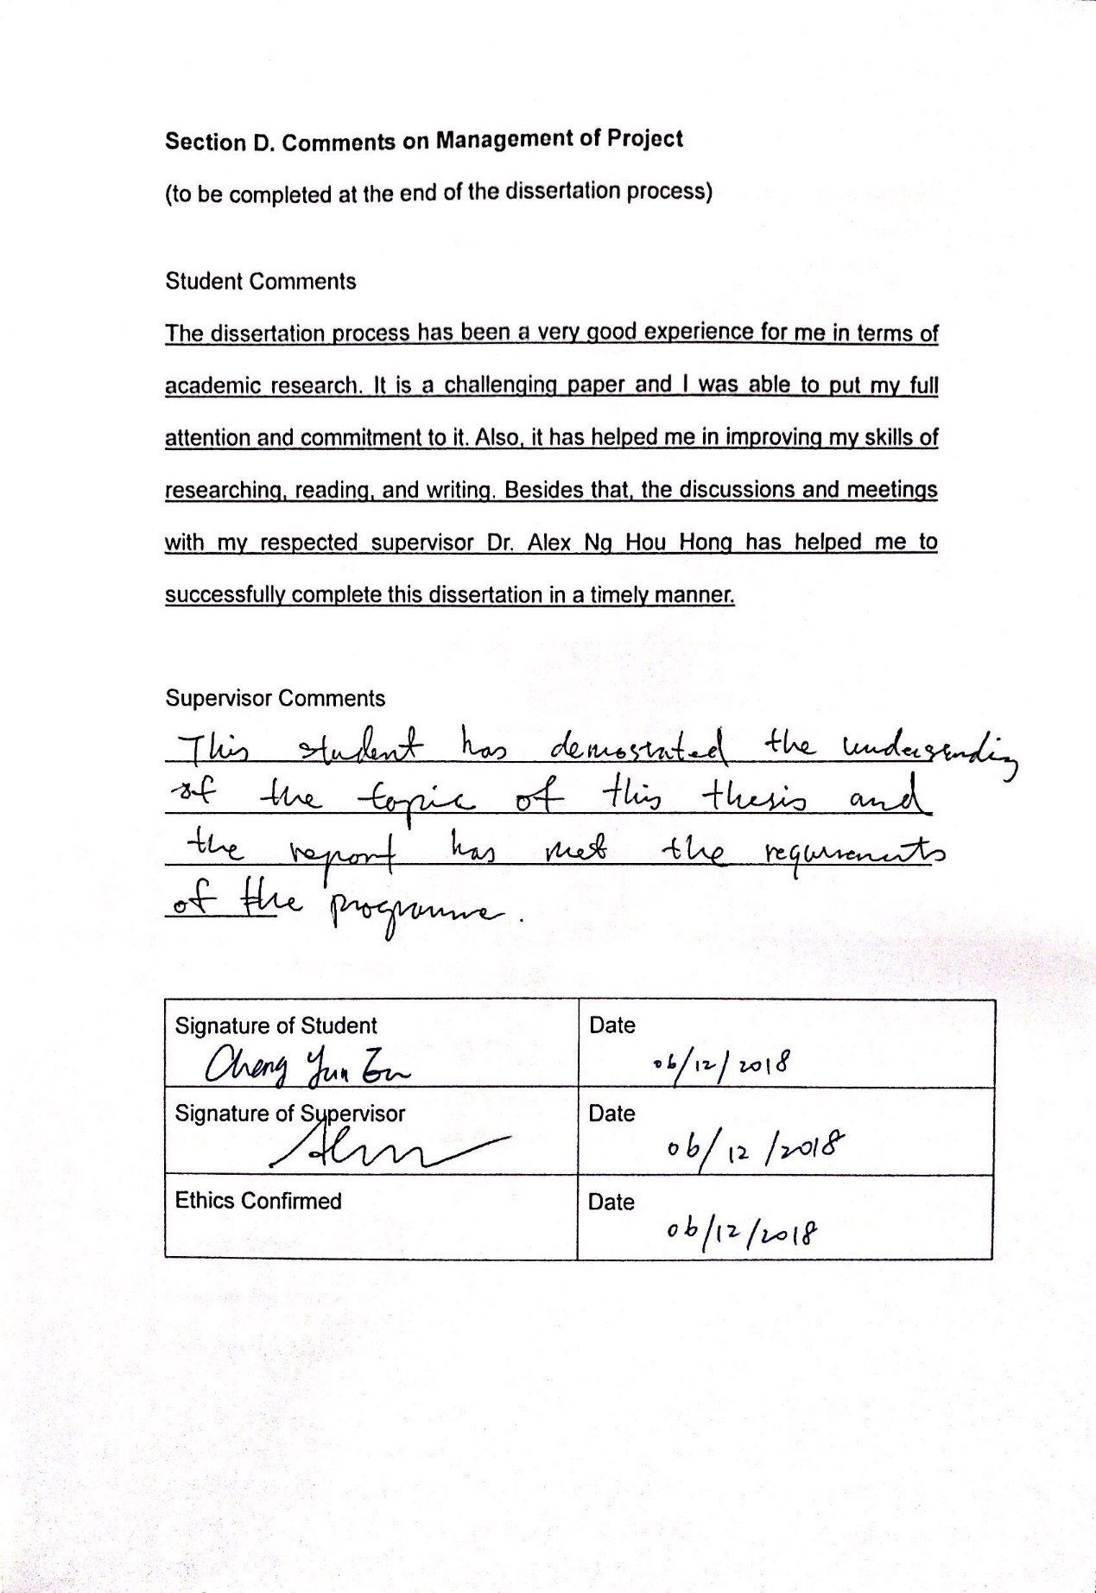

Appendix 7: TURN-IT IN Report
