**VALUE INVESTING USING PRICE TO EARNINGS RATIO FOR SMALL CAPS IN MALAYSIA.**

**CASMIR GINDOL**

**MASTER OF BUSINESS ADMINSTRATION**

**FACULTY OF BUSINESS, COMMUNICATION & LAW**

**INTI INTERNATIONAL UNIVERSITY**

**2018**

**DECLARATION**

I hereby declare that this thesis is my own work and effort and that it has not been submitted anywhere for any award. Where other sources of information have been used, they have been duly acknowledged.

Name : Casmir Gindol

Student ID : I16011885

Signature :

Date :

**ABSTRACT**

The research aimed to explore the relationship between independent variable of price to earnings ratio (PER) and the dependent variable of investment returns. The targets of this research were constituents of Malaysia Small Cap Index (MSCI) small-caps firms listed on the Bursa Malaysia for period 2007-2017.

**Keywords:** value investing, price to earnings ratio (PER), margin of safety, efficient market hypothesis (EMH), herd behavior, Malaysia Small Cap Index (MSCI), Bursa Malaysia.

**TABLE OF CONTENTS**

Abbreviations……………………………………………………………………………..….6

List of Tables……………………………………………….………………………….…..…7

Acknowledgements…………………………………………………………………….……8

1. Introduction ………………………………………………………………………………9
   1. Background of research……………………………………………………………..9
   2. Problem statement…………………………………………………………………13
   3. Research objectives ……………………………………………………………….15
   4. Research questions………………………………………………………………..16
   5. Hypothesis………………………………………………………………………….16
2. Literature Review ……………………………………………………………………...17
   1. Concept of value investing ………………………………………………………..17
   2. Capital Assets Pricing Models…………………………………………………….20
   3. Margin of safety…………………………………………………………………….22
   4. Efficient Market Hypothesis……………………………………………………….23
   5. Herd behavior……………………………………………………………………….25
   6. Value investing using price to earnings ratio (PER)……….……………………26
   7. The other dimensions of value investing….……………………………………..29
3. Research Methodology………………………………………………………………..32
   1. Data…………………………………….……………………………………………32
   2. Analysis method……………………………………………………………………32
   3. Determination of price to earnings ratio (PER) …………………………………34
   4. Market capitalization…………………………… …………………………………34
   5. The Sharpe ratio……………………………………………………………………35
   6. The Jensen’s alpha…..………………………………………………………….…35
   7. Statistically significant.…………………………………………………………..…36
   8. Regression analysis...…………………………………………………………..…36
   9. Exclusion…………………………………………………………………………....36
4. Findings………………………………………………………………………………....37
   1. PER and stock returns………………………………………………………….....37
   2. Market capitalization and stock returns……………………………………….....40
5. Conclusions…………………………………………………………………………….44
6. Recommendations….………………………………………………………………….45
7. Personal Reflections.………………………………………………………………….46
8. Reference……………………………………………………………………………….47
9. Appendix…………………………………………………………………...…………...54

**ABBREVIATIONS**

|  |  |
| --- | --- |
| PER  PBV  EPS  DY  ROA  ROI  ROE  EMH  CAPM | Price to earnings ratio  Price to book value  Earnings per Share  Dividend yield  Return on Assets  Return on Investment  Return on equity  Efficient Market Hypothesis  Capital Assets Pricing Model |

**LIST OF TABLES**

Table 1: Low PER (Value Portfolio) and stock returns

Table 2: High PER (Growth Portfolio) and stock returns

Table 3: Paired sample t-test of Low PER and High PER

Table 4: Linear regression between PER and stock returns

Table 5: Smaller market capitalization and stock returns

Table 6: Bigger market capitalization and stock returns

Table 7: Paired sample t-test of Smaller MCap and Bigger MCap

Table 8: Linear regression between MCap and stock returns

**ACKNOWLEDGMENTS**

First and foremost, I want to thank my supervisor, Ms. Annie Wang for all the help, advices, and patience in guiding me through this MBA project.

Secondly, I would also like to express my gratitude to my 2nd Panel member, Ms. Siti Nurbayah for her assistance and contribution towards this study.

I also want to thank to my family whose love, support and encouragement made this work possible, may God bless you all.

**1.0 INTRODUCTION**

**1.1 Background of research**

Value received by shareholder from any investment is the value in the form of dividends, capital gains or interest produced by the underlying assets during the period of ownership (Mo and Qiao, 2015). Therefore, a firm earning power can be used to estimate its current and future valuation. The idea of value investing assumes that the movement of stock price is not random, it is representation of expected future cash flow from the underlying assets. Over a period, the true value of these assets will be revealed. The mispricing occurred due to misunderstanding or undisclosed information to the investing public. It is also possible that investing public ignored a firm due to certain reason such as size of market capitalization and bad publicity which may create a stock traded much lower than its fair value. This difference will slowly become smaller when more value investor realizes the opportunity.

Price to earnings ratios or PER used by investor and stock analyst to decide whether a stock is priced reasonably and to can help estimate future direction of market index (Shen, 2000). PER approach is very popular due to its simplicity and usefulness to determine if the stock is cheap or too expensive. This view argued that stock prices likely to increase after a low PER period and stock prices growth likely to decline after high PER period. PER of a stock is equivalent to the market price of a stock divided by per share earnings of the stock. The price in a PER is normally the latest price provided by the market but the definition of earning probably based on past realized earning or forecasted earnings in the future. Based on historical past trend, no perpetual increase or decrease of PER observed which bring argument that PER above or below historical average eventually will return to the mean. A drop in the PER could be explained by drop in stock prices or increasing earnings.

Although stock price can be provided precisely by the stock exchange, determining intrinsic value of any stock at best on roughly estimation. According to Chhaya and Nigam (2015) two most fundamental calculation on intrinsic value of a stock are based on book value and earning. Therefore, to measure current valuation of stock, price-to-book ratio (PBR) and PER often used although calculating the intrinsic value is difficult to do since there is no generally accepted method for quantifying. Value investor method is to decipher a stock’s fundamentals to know approximately the intrinsic value and become a bargain hunter looking for stocks undervalued by most market participants due to investor tendency to overreact to latest information causing stock price at optimistic or pessimistic extremities.

According to Singh and Kaur (2014) another way to calculate intrinsic value is through the tangible book value of a firm. It is considered as value stock if stock price is less than two-third of the net tangible book value per share. Net tangible value calculated by adding all tangible assets and deducting all liabilities. Investor should buy stock when it is selling less than two-third of their book value. The difference between buying price and market price is a margin of safety which can help the investor during sudden price drop due to market downturn.

Value investing which generally involves buying cheap securities by fundamental analysis standard was introduced in 1934 by Graham and Dodd and has evolved tremendously since its inception (Yan and Zhao, 2010). Value investing strategy is about buying stock at price cheaper than its intrinsic value which is defined by price to earnings, book value, dividends, and other value dimension. Market assume value stocks to have low growth potential and as out of favor. In contrary to value stock, growth stocks are assumed to have higher growth potential and often accompanied by high price to earnings. Many researches have constantly discovered that value stock perform better than growth stock and the whole market.

According to Truong (2009), some investor using value investing strategy and become very successful. In his research in the New Zealand market, he found that investing in the low price-to-earnings stock consistently result in higher return which cannot be explained by normal risk measurement. The mispricing phenomenon perhaps can be explained by wrong investors’ estimation of past data, and the stock market correction happen when new information announced. By screening other factors such as the level of debt and debt repayment capability, investor can avoid firms with debt issue to construct a low PE ratio portfolio with low risk. Another factor is expected growth rates of the firm by projecting past growth rates. Highly undiversified low PER from a single industry can increase risk. Depending on which market and average PER, definition of low PER must be decided.

Cheung and Yin (2012) argued that the prices of stock largely owned by corporate investor likely to return to intrinsic value than stock with smaller corporate ownership due to corporate investor likely to remain as long-term shareholder to receive corresponding return so they willing to spend more resources on surveillance and gathering information on the intrinsic value of the firm. Investor collects information about the intrinsic value of a stock and adjust their portfolio accordingly to avoid short term trading for quick gain. In addition, larger corporate investor ownership linked to more effective organization, efficient operation, and better stock returns.

Many researches on the performance of value investing based on past data back testing were focused on developed country such as US and less studies are conducted on developing countries (Chhaya and Nigam, 2015). Their research examines the performance of low price-to-earnings ratio over high price-to-earnings in the Indian stock market. As a result, they found that low PER stocks outperformed high price-to-earnings stocks on absolute as well as risk adjusted basis. One of the possible reasons of outperformance was the overreaction of market participants to latest news which based on behavioral psychology explanation. In addition, usually investors influenced by many other factors during their investment decision such as short-term gain, filtering constraint, and career issues. Stock price return to the true value after the investors’ expectation not realized. Although some argued that higher return is a reward for the higher risk associated with low PER stocks, but value investing supporter argued that value investing is all about exploitation of stock market participant behavior.

Since 2010, many companies offer online trading services at competitive rates which enables individual investors to trade stock in small quantity without worrying about expensive transaction costs (Baumann and Trautmann, 2013). Unlike institutional investor, the small investors face difficulties in term of transaction cost, stock diversification, and portion of each stock due to limitation of resources due to most literature are generally made for corporate investor. The screening model for stock portfolio optimization must consider factors such as transaction cost, dividend, mix of stocks, and diversification which are constraints that may affect investment returns especially to individual investors.

Cai and Cen (2015) argued that although securities analyst’ recommendations provide some economic value, but investors probably cannot make profit consistently by following blindly the buy or sell recommendations especially in a declining market sentiment. Security analyst propose their analysis result and recommendation on individual stock or industry in the equity market which can be divided into buy, sell, or hold to investors. During bullish market sentiment, investor could be rewarded with handsome profit by following security analyst recommendation especially on hot industries since a security analyst likely to focus on specific sector and could produce a precise valuation predominantly.

According to Dash and Mahakud (2013) many literature supported correlation between stock returns and investors’ sentiment due to undervaluation or overvaluation on stock that vulnerable to subjective valuations. Beside fundamental risk elements, other probable factors such as market sentiment considered by economist and investor to influence stock market return. Bullish sentiment will result in over valuation on the securities and subsequently lowering its return in the future. Meanwhile, bearish sentiment will result in undervaluation and subsequently increasing future return. Investors inability to separate between information and opinion, importance of information causing unexpected rise and fall in the stock price although the fundamental soundness is intact.

Some research finds that no significant relationship between stock return and PER (Fun and Basana, 2012). Generally investing in low PER is perceived to generate higher return in the future. However, their findings show that no significant difference between the return of low PER and high PER if the holding periods is more than one year. Stock with low PER is riskier and have higher rate of return required. Low PER does not mean that it is undervalued, therefore probably it will not produce higher return in the future. Instead of deciding stock based on simple PER, investor need to investigate the factors that influencing the difference PER among firms.

The purpose of this research is to explore the performance of value investing strategy using low PER on the Malaysia stock market. As a developing country, Malaysia stock market has low correlation with the rest of the world and more volatile compare to developed country (Ong et al., 2010). Due to time restrictions, this study focusses only on the small caps firm in Malaysia equity market. It is expected that this study will be beneficial for the investors interested to invest in Malaysia stock market and to extend their knowledge on value investing.

**1.2** **Problem Statement**

Many literatures from around the world gives empirical evidence about the effectiveness of value investing in general and PER in particular. According to Athanassakos (2011) many researches around the globe found that value stock using PER consistently outperform growth stock. He found value stock in Canada selected using mechanical screening on average produces higher returns than growth stock for the period 1985-1999 and 1999- 2007. However, by classifying stock into value and growth criteria is the first step in the stock selection. Low PER screening is done to identify possibility of undervalued stocks before individual evaluation on each stock by considering other factor. Most academics tend to only look on the PER screening process. As consequences, stocks with low PE ratio called value stock, and stock with high PER called growth stock. PER screening is a very simple and purely mechanical process which can be run by anybody. Value investor adding value by running the next screening step which is based on ‘margin of safety concept’ to determine a truly undervalued stock. However, applying screening methodology to limit the number of stocks involve personal perception which is usually inevitable.

Singh and Kaur (2014) found that value investing using price criterion of less than two-third of tangible book value, for stocks listed on the Bombay Stock Exchange for a period of 15 years from 1996 to 2010 providing better returns over the long term. In addition, the portfolio volatility is lower than the volatility of the stock market which suggest value investing can be used as a tool to minimize risk for the whole portfolio, reducing uncertainty due to price volatility, and for taxation benefits. Therefore, value investing based on tangible book value can support investors to outperform the market in the long run.

Investors and researchers were use financial ratios such as PER, earning per share (EPS), dividend per share (DPS), current ratio to analyze, compare, and interpret the financial conditions of companies (Haghiri and Haghiri, 2012). Each of these ratios capable to illuminates the firm’s financial strength or weakness and have high correlation with stock returns. The research found that, the effect of financial ratios is different for different industry and markets. Return on asset (ROA) and return on equity (ROE) found to be strongly linked to stock return performance, but debt level has no influence on the performance of stock returns.

Cho et al. (2012) using two-dimensional value investment strategy that using both financial statement’s data and value investment strategy to test the Korean stock market for the period from January 1981 to June 2011 and found that it can earn additional return which show value investment strategy not only working for developed market such as US, but also working for emerging market such as Korea. In addition, they also found that two-dimensional value investment strategy using value ratio and financial data produce higher return than one-dimension value investment strategy does. A value stock with stronger financial position found to generate much higher return than growth stock with weak financial position. Better return during a bear market indicates the defensive element of value investing. Therefore, value investing strategy can be used for various purpose depending on stock market situations.

Many researchers found that market sensitivity is not constant and this affecting stock prices (Andrei, 2013). Higher market sensitivity causing more stock purchase and sharp price movement, whereas low market sensitivity produces weak response to new information. Due to insufficient investors’ attention, latest news reflected gradually by the stock price and result in minimum stock price volatility. When investor become more attentive, news reflected by the stock price immediately and result in higher stock price volatility. Higher risk premium is required for more volatile return and conversely lower risk premium required for low volatility. Market uncertainty and investors’ sensitivity to the latest development influence the risk premium and stock market volatility.

According to Ahsan (2013), investor like to emphasize latest performance result in forecasting and judging. Investors can make portfolio using closely monitored financial ratio such as PER, PBV, price to sales, and return on equity (ROE) which may produce excess investment return without involving extensive analysis. The idea of screening using simple financial ratio to construct portfolio could be very efficient especially in the developing markets where details of financial report is not accessible easily. However, these indicators especially ROE is not immune to legally allowed manipulation on earnings reported through change in accounting policy. In addition, more debt will increase ROE although the firm’s financial strength become weaker and systematic risk to increase.

Investors need to investigate thoroughly the fundamental elements of certain stocks that may affect PER since usually low PER stock is riskier and associated with higher required rate of return (Fun and Basana, 2012). Research on investing based on low PER for Indonesian stock market during period of 2005-2010 found that there is no links between PER and stock return. Investor cannot expect to gain systematically more than the average return provided by the stock market by simply buying low PER since PER is useless for future stock returns estimation. Low PER cannot be concluded as indication of cheaper stock price or undervalue or indication of higher stock return in the future. Instead of simply focusing on PER, investor need to decompose PER, so the other fundamental elements can be examined to get insight on the component of mispricing.

Small caps stocks listed in the Bursa Malaysia usually are those with market capitalization less than RM2 billion (MIDF Research, 2016). Market capitalization of a firm must be sufficiently large to enable corporate investor to invest. Normally, corporate investors do not prefer investing in small caps stock due to constraint such as corporate governance, track records, and limited access to the management. The top 100 largest stock listed in the Bursa Malaysia normally have market capitalization above RM2 billion. There are about 670 firms with market capitalization less than RM 2 billion which can be categorized into different industry such as industrial, services, consumer, construction, finance, property, technology, and mining.

Investors are expecting returns as result obtained from an investment (Sorongan, 2016). Studying the value investing using PER focusing on small-cap in Malaysia market is very important since there are not much similar studies has been done before. Business students and investor know that value investing often has positive impact on investment returns. Therefore, it is interesting to explore on how low PER strategy will perform if applied on the small-cap firm in Malaysia stock market.

**1.3 Research objective**

The objective of this study is to explore the relationship between PER and investment returns of small caps firm in the Malaysia stock market during the 2007 – 2017 period.

* 1. **Research questions**

The main question of this research is:

* Do value investing strategy using price to earnings ratio (PER) perform better than growth stocks for small caps frim in the Malaysia equity market?

This research also wants to answer these questions:

* Is there a value premium on the Malaysia equity market?
* Do stock with smaller capitalization perform better than large capitalization
* What is the relationship between independent variable PER and the dependent variable of investment returns for small-caps firms listed on the Bursa Malaysia for period 2007 to 2017?
  1. **Hypothesis**

The research hypothesis can be expressed as below;

H1= There is relationship between PER and investment returns for small-caps firm listed on the Bursa Malaysia for period 2007-2017.

H2= There is relationship between market capitalization size and investment returns for small-caps firm listed on the Bursa Malaysia for period 2007-2017.

Below are the conceptual frameworks (Figure 1) for hypothesis above.



**2.0** **LITERATURE REVIEW**

**2.1 Concept of value investing**

Value investing strategies are often credited to Benjamin Graham and David Dodd and can be traced back to 1920 (Asness et al., 2015). In the beginning value investing involving purchase of successful but undervalued securities. The concept of value investing is very simple; the purchase price of a stock should be much lower than the liquidation value of the company. However, there is so many confusing information about value investment strategy persisted. Generally, most investors assume value investing cannot go along with momentum investing. Opposition of value investing often use this confusion to ridicule this strategy. Value investing strategy works best when combined with other criteria, rather than solely based on PE or PBV ratios. Higher return produced by value investment strategy is not a compensation for higher risk taken. Value investing continuously successful in efficient stock market, inefficient stock market, an in between.

Basically, PER calculation done by dividing stock market price per share with earning per share as shown below (Fun and Basana, 2012).



Based on the formula for PER above, dividend payout ratio, future dividend growth, and required rate of return are affecting PER. Future dividend growth rate and dividend payout ratio is have positive link with PER while stock required rate of return is negatively corelated with PER. Therefore, it can be concluded that higher dividend payout ratio and higher future dividend growth will cause PER to raise.

Basu (1977) argued that investment in low PER stocks performed significantly better and generated better absolute return by about 7% for the investors. Additional study in US stock market found that low price to book value outperform the market (Stattman, 1980). In addition a links between cash flow to price ratio and higher stock returns discovered by Chan et al. (1991). Fama and French (1996) extend the findings on the US markets by using different method and providing reasonable proofs on the existence of value premium. However, Black (1993), argued that the previous findings as inaccurate, wrongly interpreted and involve manipulation of data which unable to guarantee the findings by considering fluctuating premium risk and error of estimation.

As more and more people are aware of this value investing strategy, competition is increasing, and this leads to lesser buying opportunities (Calandro, 2014). The original concept of value investing was focused on buying assets at costs below their liquidation prices which assumed as current assets minus total liabilities. This investment will provide opportunity to make profit at minimum risk since purchase cost was much lower than liquidation value. Therefore, to increase investment opportunities, value investing tries to look at earnings on income statement. By estimating on future earning based on past performance, value investor can compare relative valuation between stocks. Soon or later stock prices will reconcile with earning power and net asset of the firm. Value investing with safety margin opportunity arises when stock prices fall below than the value of earning power or book value.

The mood of stock market is unstable and always moving between depression and mania (Cheung, 2010). The Efficient Market Hypothesis (EMH) supported strongly by both by empirical evidence and strong theory foundations prior the end of 1970s. After 1980s, EMH was challenged by behavioral finance school of thought which united psychology and finance. Behavioral finance focused more on human emotion impact on investors’ actual behavior in the stock markets. During the bull market, stock prices are rising as many buyers are seeking immediate profit from price increases regardless of the company's fundamental performance. During the bear market, prices fell because many sellers than buyers because of fear of further loss due to falling prices. Value investors will usually look for opportunities to create profits by buying stocks with low PB ratio, low PER, and high dividend yield (DY). However, normal argument on stock market is whether it is irrational or rational. Since the psychology of mass can reverse suddenly and wildly, investor shouldn’t ignore the impact of market psychology.

Hens et al. (2010) argue additional returns from value stocks is a contradicting to Capital Asset Pricing Models (CAPM) since the betas of value stocks is lower compare to growth stocks. The excess return has been verified by many researches in different countries and periods. Although stock markets valuation on certain assets is fluctuating, in the long term it will converge to their true value. The tendency to converge making more accurate estimation on stock return based on fundamental value such as earnings. Their study found that stock prices will be affected by the amount of dividend payments over the long term which mean market value of a firm will be influenced by the expected future dividend payments. Therefore, by holdings stock proportionally to their expected future dividends will ensure survival and prosperity in the long term.

Many academic papers have demonstrated that value investing strategy based on low PER or PBV ratio tend to produce better return than growth stocks (Athanassakos, 2011). The filtering process is simple and can be done by anyone. Value investor added value by their next step for stock picking which is individual evaluation of each stock based on margin of safety quantification. This is the reason it is difficult to predict eventually which stock will be selected by the investor. Further filtering for stock selection may involve personal judgment on the competitiveness of the firm represented by the stock and cannot duplicated by another investor easily.

Lamponi (2014) argued that correlation among stock returns has increased lately and causing stock picking and diversification become more difficult. The increase in correlation between investment return blamed on latest development in investment practice such as increasing popularity of ETFs, futures, and options and rapid trading. Classical stock investment strategy such as value investing sometimes trapped in a correlation tend to face decreasing risk adjusted return. In the long term, the value investment strategy may still satisfactory, but investor must aware that based on past data, it may produce low or even negative returns in certain periods.

McMillan and Wohar (2012) argued that although there is relationship between output and stock prices but failure to separate fundamental and bubble element within assets prices may lead to false investment return expectation. The bubble element can influence the value growth in the future, but naturally stock prices and output will adjust and eventually re-integrate. While policy makers more interested on how stock market condition such as bubble will impact output in the future, investors and market participant want to know how stock market returns will be affected by macroeconomic factors.

Although value investing using low PER produced better performance confirmed by many researches, the reason of low PER outperformance is keenly debated (Cheh et al., 2008). It was argued that low PER stocks are fundamentally riskier and outperforming stock returns are reward for the higher risk taken. Another possibility is lower return from growth stock caused by their excessive focus on short-term returns. Since growth stocks with high PER are valued based on the projection of future earnings, longer time horizon required before it is realized and reflected on the market share prices. Higher rebalancing frequency increase the returns of low PER strategy but decrease the returns of high PER strategy. It is also suggested that rotation between low PER and high PER strategy according to stock market sentiment and cycle of business would give better return than buy and hold investment approach.

Although the basic tenets value investing which is buying assets at price lower than its intrinsic value, value investing has diversified into more steps and methods through combination with other investment ideas (Davyclov et al., 2016). Stock market participant misjudges the underlying value of stock causing it to trade below intrinsic value. Many studies argued that the undervalued stock price likely to increase again in the future and this creates good investment opportunity. Other financial ratio such as price to cash flow, dividend yield, and earnings before income and tax (EBIT/EV) used to verify the existence of value premium in various stock market in the world.

**2.2 Capital Asset Pricing Model**

The capital asset pricing model (CAPM) enable security analyst, researcher, and investor to elegantly measure value of assets, the level of investment risk, and the form of relationship between risk and investment returns. Since 1960s, CAPM used as a formula to decide the required rate of return for an asset and eventually become the standard for assets pricing (Fama and French, 2004). Perold (2004) argued that although stocks trading existed for more than three centuries, there is no commonly utilized model to calculate asset price or properly relate the links between risk and stock returns. By 50s the study on risk requirement, modern portfolio theory, and investment decision secure the foundation for CAPM future progress. The advancement of more powerful computing processing capability and larger memory storage after 1960s helps the development of CAPM model to handle big set of stock trading data.

Before CAPM become a standard model in investment community, in order to predict future returns, investor choice is quite limited to method such as dividend growth models, weighted cost of capital (WACC), and projection of past data into the future (Perold, 2004). Compare to these old methods, CAPM allow investor to relate the links between risk and return. Although the dividend growth models, weighted cost of capital (WACC), and projection of past data still in use today but the CAPM became a standard model and more extensively practiced. However, Fama and French (2004) argued that CAPM model is neither practical nor theoretically sound since it is failed to produce a trustworthy investment returns forecast and also oversimplify inference. Nonetheless, due to its simple operation and the elemental rationale CAPM persist to be practiced extensively.

Capital Asset pricing Model (CAPM) argued that future additional return on stocks will be proportional to the beta which is coefficient of systematic risk (Au and Shapiro, 2010). According to CAPM, return of any stock is the sum of risk-free return and expected extra market return times by stock’s beta. Securities with higher beta usually more volatile and tend to underperform or outperform during bearish and bullish market sentiment, respectively. Basically, according to CAPM, investment returns of a stock is in proportion to the beta which is systematic risk. Value premium is linked to risk and value stock likely to perform better during bearish market sentiment. On the other hand, growth stocks perform better during bullish market sentiment. Therefore, value investing strategy is riskier than growth investing strategy during market recession but less risky when the market sentiment is good.

Many researches focused on the exchange between risk and return of stock investment. According to Kane et al. (1996), CAPM assumed market volatility would be in proportion to risk premium but other capital markets models proposed inverse relation between return and risk. Investors may change investment from high risk asset to risk-free assets due to increase in risk and it may cause risk-free rate to drop which in turn may cause drops in the expected investment return.

Ozdagli (2012) argued that value stocks with higher price to book value can earn better return compare to growth stocks with lower price to book value. However, since growth stock associated with higher risk and derive value from its growth, it should have better return than value stock. The standard capital asset pricing model show that stocks with different value characteristic have similar risk.

**2.3 Margin of safety**

The concept of margin of safety says value investor should buys stocks whose market price is much lower than intrinsic value (Singh and Kaur, 2014). The difference between market price and intrinsic value is called margin of safety. If the calculation of intrinsic value is not accurate, the margin of safety can protect investors from losses. Margin of safety indirectly says value investor should avoid excessive trading. This is because value investors make some assumptions when investing. The first assumption is that the market price is below the intrinsic value and the second is that in the future market value will converge with intrinsic value. Therefore, excessive trading should be avoided because we do not know exactly when market value will converge with intrinsic value. The concept of margin of safety is also used to assess the ability of a company to pay interest on a loan. For example, the margin of safety can be calculated as a surplus of income that remains after the interest payment. This helps investors assess the financial strength of a company.

It is rational for investors seeking for margin of safety for each investment (Yee, 2008). Estimating the value regardless to accuracy is very important because without estimation the investor is unable to evaluate required margin of safety. Beside volatility of market price, there is three kind of risks to the investor. First, interim information risk which can negatively impact the valuation done by the investor before profit is realized. Second risk is the accuracy of value estimation by the investor might be uncertain. Third risk is the timing of stock price to return to the value estimated by the investor. In value investing, the process of value estimation is very important to identify prices deviation and margin of safety assessment. Before committing to investment, investor must demand substantial margin of safety.

Mo and Qiao (2015) stated that business valuation involves multiple levels of quantification to maintain a margin of safety. The risk of investment controlled by proper size allocation and in details comprehensions of the characteristic of business. Value investors can ensure that they always have a margin of safety by constantly buying stocks at a considerable discount over underlying business value and preferring tangible assets rather than intangible. This is because nobody knows when the intrinsic value will fall or increase. Therefore, the value investor should consider the worst-case scenario assuming the intrinsic value may fall.

Margin of safety as one of the main ideas of value investing applied in various study is consistent universally used to safeguard investment towards drawback possibility (Athanasskos, 2011). By following a two-step process, value investor can find stocks below intrinsic value. The first step is stock screening using dimension such as PE ratio and PVB ratio. The following step is filtering the stocks selected using the margin of safety concept to decide which stocks are truly below their intrinsic value. The difference between purchase price and intrinsic value is the margin of safety which is very important for capital preservation and at the same time enhancing the possibility of higher stock returns.

**2.4 Efficient Market Hypothesis**

In an efficient stock market all available information will be reflected by the current price of a stock (Hammami, 2011). EMH exists in three situations: weak form, semi-strong form and strong form. In a weak form, the stock price is based on all relevant market information. The semi-strong form assumes stock prices will change according to the latest stock market information. Strong form assumes stock prices are based on known information as well as insider information. This definition is agreed by financial economists but whether the stock markets are really efficient is controversial and fiercely disputed. However, the difference over the stock returns are not supported by the betas of markets. Other literature proposed this abnormality happen due to investor behave irrationally.

According to Ovtchinnikov and McConnel (2009) investment decision by institutional investors are more sensitive to stock price changes in inefficient capital markets. Weaker stock prices will cause firms with higher leverage or weak cashflow more exposure to expensive financial difficulties. Stock prices increase will affect the net present value (NPV) of projects available and therefore encourage financially strong firm to allocate capital into the project. As for value investing perspective, the intrinsic value of all stocks is linked closely to the underlying economic elements. All related variable must be examined to decide the intrinsic value of a stock and if it is much higher than its current market prices, the investor will buy the stocks. Many researched evidences on the links between PER and stock returns suggesting that it is possible for investor to use PER to estimate stock return in the future which contradicting to semi strong EMH.

Some research on efficient capital markets found that the capitals are indeed efficient but other studies confirmed that the market does not change immediately to latest news (Ong et al., 2010). The contradicting evidence on efficient capital markets affecting the analysis of fundamental of value investing since stock price assumed to change quickly to their fair value when new information become available to the public. The efficient market hypothesis (EMH) can be divided in weak form EMH, semi strong EMH, and strong EMH. According to the weak form of EMH there is no links between stock market data and returns in the future since all market information already incorporated in the current stock prices. Semi strong form of EMH argued that both market and non-market news such as quarterly earnings and general elections are already incorporated in the stock prices and therefore investors wouldn’t be able to generate return higher than average rate. Finally, strong form of EMH implies that both private and public information are fully reflected in the stock prices and therefore no investors earn risk adjusted returns higher than the market consistently.

In efficient market it is impossible to get more returns than market returns as the stock market is efficient and all information are reflected by the latest market prices. If returns exceed market returns it is depending solely luck and has nothing to do with investor using certain investment methods (Malkiel, 2003). Hence according to the EMH, the low P/E ratio does not bring any meaning to the investors and attempts to obtain higher returns from market returns by using technical analysis or value investment without being exposed to excessive risk are impossible.

However, studies by Rosenberg, Reid, and Lanstein (1985) denied EMH based on a study on 1400 stocks from NYSE, ASE, and NASDAQ indicating the stock market was not efficient at certain condition. For instance, small caps are less followed by large investment institutions due to its small size and prospects. In addition, inefficient company management can also cause inefficiency, for example, low stock prices may cause the company to be bought by other companies. New owners may change inefficient management and sometimes these changes will improve the performance.

In contrast to efficient market theory, higher return produced from inefficient market and multiple investment strategies by manipulating this situation have been constantly established. Low PER stocks produce higher return than high PER stocks in New Zealand firms during period from January 1997 to December 2007 (Truong, 2009). To build a truly low risk portfolio, investor should consider avoiding firm with excessive debt. Low PER ratio combined with high growth rate can increase the possibility of pleasant surprise in the future.

The investors using strategy based on financial report available to public can generate high investment returns (Skogsvik and Skogsvik, 2010). The financial accounting provides necessary data for investment decision to the investor. Through analysis of the financial report, valuation based on accounting can identify stock mispricing. Accounting data available to public can be exploited to predict future earnings trend and after that use these predictions to construct investment portfolio.

**2.5 Herd behavior**

In the investment world, herd behavior or mentality is something that needs to be avoided. Value investors cannot allow investment decisions to be influenced by colleagues, families, or public opinion. Herd instinct occurs when the decision is not based on individual thinking, but instead does what the other person does. Banerjee (1992) says there are many social and economic conditions in which our decisions are based on what others are doing. In daily activities such as choosing a restaurant for lunch we are exposed to herd behavior. Voters who are exposed to opinion polls are also vulnerable to herd behavior. Students also tend to choose hot academic topics. Keynes (1936) also proposed a herd behavior to describe investors in the stock market.

According to Bikhchandani and Sharma (2000) the cause of herd behavior may be due to several reasons. Information based herding can occur when all investors take the same actions on certain information. Reputation based herding is due to certain investment decisions by influential investors such as Warren Buffet and George Soros. Compensation based herding occurs when an investor's or portfolio manager's remuneration is based on his or her performance compared to another investor or other manager. Herding behavior can cause underprice or overprice which is an opportunity for the value investor.

Debondt and Thaler (1985) argued that the source of value premium is based on the overreaction of the investor to latest news. Investor likely to react excessively on the latest news resulting in extreme sock price movement from pessimistic to optimistic. After overreaction found to be baseless, stock price will return to average which producing return anomalies. According to Anderson and Brooks (2006), value premium will increase further if PER calculation is based on average for multiple years instead of a single year. Many researches confirmed existence of return anomalies in different stock markets and more investor starting using value investing strategy in their approach.

Herd behavior influenced by stock market seasonality causing investment return to be highest in January (Rozeff and Kinney, 1976). In an efficient market situation, reasonable market participants will detect the irregularity and taking advantage to generate quick profits from the phenomenon which over time will cause the irregularity to disappear. French (1980) and Gibbon and Hess (1981) found equivalent oddity of ‘Monday effect’ in the equity market during period 1962-1978. Compare to other day, clearly average stock return on Monday is significantly below than average which began showing decreasing trend from 1970 to 1978. Obviously the market participant failed to detect and take advantage of this strange pattern. Ariel (1990) found irregularity in the vicinity of festivals, while Lakonishok and Smidt (1988) argued that there strong evidence for certain repeatedly similar pattern on stocks price movement every end of month. Although stock market irregularity is not directly related to the topic of this research, understanding of these irregularities and herd behavior is a supporting argument that stock market participants evidently irrational sometime in their investment decision.

**2.6 Value investing using price to earnings ratio (PER)**

Athanassakos (2011) found strong evidence on the existence of value premium in Canada during 1985-1999 and 1999-2007. On average, value portfolio defined as low PER perform better than growth portfolio. His research also found that further stock valuation based on the concept of margin safety produces even higher return than selecting stocks solely based on low PER may be used as a second screener to seek higher investment returns. The second screener is based on the idea that intrinsic value of a stock is between the net asset value and earning power. Stocks are considered to meet "margin of safety" criteria if the price is less than two-third of intrinsic value. By applying the second screener for more detailed stock selections, it was found to provide a higher return than selecting solely based on low PER.

Price to earnings ratio (PER) is probably the most widely used measurement method of the expensiveness or cheapness of stock and total market valuation (Kane et al., 1996). PER multiples above past average considered as expensive and below past average as cheap. Too high PER multiples considered as warning of incoming stock market corrections. The market volatility is highly related to market multiple and therefore its impact on PER equilibrium must be not ignored.

Basu (1977) examined the value investing strategy using PER to challenge efficient market hypothesis and to determine empirically the stock returns is related to PER. He found that the returns of portfolio with low PER are higher than portfolio with high PER for 15 years from September 1956 until August 1971. Using Sharpe ratio, which is one of the methods used by the finance industry to calculate a risk-adjusted return on investment for certain assets, the low PER portfolio gets higher returns than portfolio with high PER. As a conclusion, the efficient market hypothesis unable to explain completely the behavior of stock prices during the period of study. It seems to be gap between the information available to public and stock price action which may give opportunity to the investor to find value opportunity.

Low PER anomaly researched by Jaffe et al. (1989) by including effect of market capitalization and negative earnings. The research conducted for period 1951-1986 which was longer than previous study conducted. Six portfolios were formed and all stocks with negative earnings placed together into a separate portfolio. The stocks with positive earnings were ranked and placed into respective portfolios according to their ranks. After that, these stocks were categorized according to their capitalization size into their respective portfolio. This research found that portfolio with the lowest PER produced the highest return and evidence of links between the size of market capitalization and stock return through the observation period.

According to Truong (2009), value investing in low PER perform very well for stock market in New Zealand for the period 1997-2007. Investing in low PE may result highly focused investment on stocks from similar industry. Mispricing causing low PER stocks to outperform high PER stocks in New Zealand which cannot be explained by usual measurement of risk. It is possible that mispricing caused by investors’ wrong expectation on the market. Wrong expectation corrected by the market after latest information available. It is necessary to add other factor consideration beside low PER screening, such as the strength of financial position the firm and recent development in the industry to minimize risk.

Research on value strategy using low PER in the Indian market from October 2000 to September 2013 by Chhaya and Nigam (2015) found proof of statistically significant value premium on both absolute and risk adjusted performance measures such as Sharpe’s ratio, Treynor’s ratio, Fama’s net selectivity, and Jensen’s alpha. Value portfolio outperform the benchmark for most part of the study for all buy and hold period. In this study, sampling errors such as survivorship bias, window dressing, and year-end corporate result avoided by conducting study on large samples, long period of research, including economic phase in different cycles. It is concluded that risk cannot explain the consistent value premium which was validated statistically using ANOVA. The PER of a stock may go very low under special circumstances such as bankruptcy, market demand deterioration, regulatory threat, oversupply on industry capacity, and geopolitical sudden changes. Under this situation, usually value investor will include these factors in their investment decision.

Although most studies found that low PER perform better than high PER, according to Cheh et al. (2008) some researchers found high PER provide higher return than low PER for longer buy and hold period during bullish market. Therefore, it is suggested that the links between investment returns and PER affected by buy and hold period and timing of the market. Their study found that regardless to rebalancing frequency, during bullish market high PER stocks provide higher return than low PER for the overall sampling period. Also, based on risk adjusted basis, low PER performance can be linked to frequency of portfolio rebalancing. Higher portfolio rebalancing frequency increase the returns from low PER stocks but reduce the returns from high PER stocks. Therefore, trading frequency and condition of markets can affect the performance of low PER and high PER portfolios which imply that by trading more frequently investors can get better returns from low PER strategy. In addition, it is concluded that investor swinging from low PER strategy to high PER strategy according to the cycle of business and condition of market can realized higher returns.

**2.7 The other dimension of value investing**

Screening stock using return on invested capital (ROIC) and enterprise value to earnings before interest and taxes (EV/EBIT) also known as ‘magic formula’ is another investment strategy based on value approach (Davyclov et al., 2016). The magic formula found to produce extra investment in return in Finnish stock market between 1991 and 2013. Improved version of magic formula which uses cash-flow-to-price as extra screener for stock selection are compared to the usual value investing approach which use earnings, book value, and earning before interest and tax. Study result found that both original magic formula and improved magic formula outperform the benchmark index on absolute and risk adjusted basis. The improved magic formula found to be outperformed the other value strategy and show better performance especially during bullish market sentiment.

Many academic empirical evidences demonstrate the potential of value investing (Asness et al., 2015). However, many investors assume value investing cannot be combined with momentum investing because it is a contradictory idea and value investing effect for large caps stocks was rather weak. In addition, the definition of value investing strategy is varied among academics and investors adding confusion on value investing. Therefore, it is suggested that that value investing based on the PER alone should not be justified but should be combined with other financial criteria such as profitability, balance sheet strength, and sales growth.

Leivo and Patari (2011) combined price momentum with various value-added strategies for the Finnish stock market for the period from 1993 to 2008 and found that price momentum helped to improve the performance of investment returns compare to just using traditional value strategies. Momentum strategy known to perform better for short duration and value strategy work best for long term investment purpose. By adding price momentum into stock picking criteria, the average annual returns increased and at the same time average volatility decreases. Combination of dividend to price, book to price, and EBITDA/EV screening factors produced the highest risk adjusted return during a 15 years simulation.

Cho et al. (2012) uses a two-dimensional strategy that combines value investing strategy and financial statement analysis against the Korean stock market and found that it had a higher return than using traditional value investment strategy solely. Additional screener such as book to market ratio, sales growth, earning to price ratio, equity share turnover, cashflow to price ratio, and composite value were used for financial statement analysis. The result suggests that investors slow to react to the news or announcement related to the financial situation. This strategy is tested during bull and bear market, and based on higher returns during the bull market, they concluded that value investing has a protection feature during economic slowdown which is in line with the concept of margin of safety.

According to Singh and Kaur (2014), basically value investing is to purchase securities less than their intrinsic value so the gap between purchase price and market price will become margin of safety during market downturn. A study to explore the effectiveness of purchasing a stock below than two-third of its net tangible book value in India equity market for 15 years period from 1996-2010 revealed that this strategy capable to produce significantly risk adjusted higher returns. In addition, the volatility of the portfolio is less than the market which indicates this selection criteria can help investor to perform better than the market and less exposure to risk.

Value investing strategy at country level is possible by modifying value investment approach (Yan and Zhao, 2010). A country’s GDP ratio to its market capitalization can be compared to other country using index funds of countries. Total market capitalization may change due to investor sentiment, monetary policies, inflation, and market noises. Therefore, total market capitalization fluctuate from the intrinsic value and investor can make profit by purchasing when the country index fund is cheap and selling when it is expensive.

Study result on firms listed in the Tehran Stock Exchange found strong links between investment returns and return on equity (ROE) and return on assets (ROA) which suggest capability of ROE and ROA as a predictor of stock returns (Haghiri and Haghiri, 2012). ROE and ROA as a financial ratio has elements of asset, profit, equity, and debt can be used by investor for comparison, trend analysis, and to asses financial health of a company.

Momentum strategies researched extensively since their proposal in 1993. Some study try to combine momentum and value strategies although many researcher assume these contradicting idea. According to Bird and Casavecchia (2007), issue related to value stocks and growth stocks definition can be solved by using momentum and sentiment indices using the data of European wide data for period 1989-2004. In his literature review, the relationship between momentum and contrarian trading discussed and summarized by Galariotis (2014).

Brown et al. (2008) studied combination strategies for Asian markets combination by comparing returns between portfolio on bottom and top based on average ranking of price to book value and dividend yield during period 1993-2005. The study found similarly weighted portfolio's profits being marginally better in Hong Kong and Korea though performance did not prevailed. These result confirmed earlier researches done in Japan during period 1982-2001 (Guerard, 2006) and stock market in Asia for period 1975 – 1997 (Ding et al., 2005).

1. **RESEARCH METHODLOGY**

This research aims to explore the relationship between PER and stock returns for small-caps firm listed in the Malaysian stock market. It tries to replicate previous research methodology applied in different stock markets.

**3.1 Data.**

Stocks which are listed in the Bursa Malaysia in the period January to December 2007 are ranked based on their PER calculation result. The period January to December 2007 is selected since this research will try to explore various holding period portfolio return from, 1 year, 2 years, 3 years, 5 years, and 10 years (Fun and Basana, 2012). Since the focus of this research is to compare value stock against growth stocks, stocks with moderate PER are not included. Stock return calculated based on buy and hold assumption during holding periods which means investors hold the stock for certain duration which is 1 year, 2 years, 3 years, 5 years, and 10 years without any selling and re-purchase. To calculate investment returns, it is assumed that equivalent amount of fund invested on each stock.

To examine the excess returns is due to excessive risk taken or not the capital asset pricing model (CAPM) will be used to determine since it is a fast way for measuring stock returns compare to market returns. The 10 year Malaysia bond will be used as a proxy of risk free rate for the calculation of required rate of returns of stock portfolio. Annual average will be obtained from the Bank Negara website. Although CAPM model has been extensively practiced by investment world, according to Fama and French (2004) CAPM model likely to generate excess return which is a limitation.

**3.2 Analysis method**

Stocks listed in Bursa Malaysia will be selected randomly for the purpose of this research. PER calculated by year end market price for stock with earning per share over the last 4 quarters. The earning per share (EPS) is based on audited financial report.



In this research, the dependent variable is stock return and independent variable is PER.



P1= Stock price in the beginning of holding period

P2= Stock price in the end of holding period

The PER of each stock selected randomly calculated and sorted according to their PER from the lowest to the highest. Then based on methodology by Levis and Liodakis (1999) the 33% with the lowest PER categorized as ‘value portfolio’, while the 33% with the highest PER as ‘growth portfolio’.

Descriptive statistic and ANOVA executed to investigate whether the return of stock in value portfolio is significantly different with return of stocks in growth portfolio (Fun and Basana, 2012). For each holding period (1 year, 2 years, 3 years, 5 years, and 10 years), paired sample t-test will be carried out to measure mean difference between the return of value portfolio and growth portfolio.

To test the mean of difference, the null hypothesis and alternative hypothesis are as below.

H0= µx - µy = D0

H1=µx - µy ≠ D0

The study will use α=0.05.

To examine the relationship between PER and stock return for each holding duration, linear regression will be carried out. The model of linear regression is as below;

Y = B0 + B1X + E

Y = stock return

B0 = intercept regression line

B1 = Coefficient of regression line

X = PER

E = error term

To estimate the slope and intercept of PER for each holding duration, Ordinary Least Squared (OL) regression will be used. OLS assume that errors have zero mean, homoscedastic, is normally distributed and not related to each other.

**3.3 Determination of price to earnings ratio (PER)**

The dividend yield, interest rate, and earnings growth are related closely to PER. According Gordon (1962), investor only can rely to dividend from stock as way to determine the reasonable price of a stock. The stock price valuation formula can be shown as below;

$$P0=\frac{D1}{(k-g)}$$

Current price, P0 is the present value of expected dividend payment in the future and D1 is the subsequent term dividend. The required rate of return for the investor is k and it is assumed that dividend will grow at fix rate of g. In other words, future dividends discounted to today together with the required rate of return and deducting the assumed dividend growth rate. To relate the dividend growth model with PER, both side need to divide by earning per share (EPS), which is E1 and become the following equation.

$$\frac{P0}{E1}=\frac{D1}{E1}*\frac{1}{(k-g)}$$

Base on the equation, it is clear that PER is affected by future dividend yield, growth rate, and stock’s required rate of return.

**3.4 Market capitalization**

Based on study on NYSE stock historical performance during period 1936-1976, Banz (1981) argued that small cap firm average return is consistently higher than larger firm. Although the small cap firm likely to be more risky, but based on CAPM risk adjusted, the excess returns of small cap firms remained.

**3.5 The Sharpe ratio**

Stock returns performance can be evaluated using Sharpe ratio and Jensen alpha. The Sharpe ratio usually used for portfolio performance evaluation after considering return and risk (Berk and DeMarzo, 2011). The aims for investment are to get the maximum returns that produce the steepest line with risk free returns and can be expressed as below.



Rp= Portfolio return

Rf= Risk free return

σ: Standard deviation of portfolio returns

Sharpe ratio introduced as a performance indicator for portfolio returns. Portfolio with high Sharpe ratio indicating good performance.

**3.6 The Jensen’s Alpha**

Jensen’s Alpha introduced by Jensen 91967) to assess the performance of protolio on stock relatively to the predicted returns assumed by security market line and Capital Asset Pricing Model.

Jensen’s alpha, α= ri -rf -β(rm – rf)

Ri= portfolio returns

Rf= risk free return

Rm= market return

Β= beta of the portfolio

Jensen’s alpha is a risk adjusted measurement of stock returns.

**3.7 Statistically significant**

Jobson Korkie test and Student’s t-test can be used to examine to the statistical significant of difference between two portfolio’s Sharpe ratios. Z-test developed by Jobson and Korkie (1980) to measure statistical significant between two Sharpe ratio needs minimum, 36 findings to function properly.

To measure whether the Jensen’s alpha significantly difference with returns calculated based on CAPM and beta.

**3.8 Regression analysis**

Regression analysis try to explain the changes in a dependent variable by linking it to one or more another variable to shed a light on the relationship among different variables. Usually, dependent variable (DV) shown as Y, while the independent variable (IV) shown as X. It is assumed that Y as randomly distributed and therefore have a probability distribution. While X is in contrast to Y, considered as non-stochastic and repetitive samples with constant value (Brooks, 2004). During regression analysis, R2 which is goodness of fit statistic determine the strength of explanatory power of X to relate with the dependent variable, Y. In short, R2 is way to assess whether the model is capable or not. The residuals distribution whether normal or not is assessed by the standard deviation.

**3.9 Exclusion**

In this study, stock with negative earnings are excluded since it may cause the growth portfolio's returns to be negatively affected which indirectly support the hypothesis.

1. **FINDINGS**

**4.1 PER and stock returns**

51 stocks with small capitalization (less than RM2 billion) and positive PER which are listed in the Bursa Malaysia in the period January to December 2007 are selected randomly and arranged according to their ranks of PER. The starting period of January to August 2007 chosen because this research tries to explore stock returns of short term holdings period of one and two years and long term holding period for three, five, and ten years. After PER calculation and sorting according to their rank, the 33% with the lowest PER categorized as ‘value portfolio’ (Table 1), while the 33% with the highest PER as ‘growth portfolio’ (Table 2). As a results, there are 17 stocks low PER portfolio and 17 stocks in high PER portfolio. Since the purpose of this study is to compare value portfolio (low PER) and growth portfolio (high PER), 17 stocks in between with moderate PER are excluded.

Table 1: Low PER (Value Portfolio) and stock returns

|  |  |  |  |  |  |  |
| --- | --- | --- | --- | --- | --- | --- |
| STOCK | PER | Stock returns | | | | |
| 1y | 2y | 3y | 5y | 10y |
| VITROX | 3.9 | 0.31 | 0.50 | 2.50 | 2.13 | 52.10 |
| HARISON | 4.7 | -0.08 | 0.63 | 1.33 | 1.79 | 3.19 |
| MYEG | 4.8 | 7.15 | 6.45 | 12.63 | 12.99 | 226.19 |
| WTHORSE | 5.8 | -0.04 | 0.34 | 1.00 | 0.76 | 1.46 |
| NHFATT | 5.9 | -0.07 | 0.37 | 0.46 | 0.63 | 1.53 |
| PERSTIM | 6.0 | -0.25 | 0.17 | 0.89 | 0.45 | 1.31 |
| SKPRES | 6.0 | -0.37 | 0.06 | 0.49 | 3.15 | 23.60 |
| PMETAL | 6.0 | -0.57 | -0.22 | 0.65 | 0.23 | 18.20 |
| KHIND | 6.2 | 0.12 | 0.54 | 1.48 | 1.62 | 3.14 |
| MFLOUR | 6.4 | -0.02 | 0.28 | 0.79 | 1.37 | 2.79 |
| WEIDA | 6.9 | -0.33 | 0.03 | 0.35 | 1.09 | 1.88 |
| PHARMA | 6.9 | 0.15 | 0.49 | 0.92 | 2.18 | 3.71 |
| YSPSAH | 7.0 | -0.19 | 0.04 | 0.15 | 0.23 | 2.09 |
| PTARAS | 7.4 | -0.37 | -0.18 | 0.21 | 1.04 | 4.37 |
| OFI | 7.4 | -0.24 | 0.47 | 0.76 | 0.95 | 5.20 |
| JTIASA | 7.6 | -0.50 | -0.30 | 0.25 | 0.71 | 0.00 |
| MNRB | 7.9 | -0.36 | -0.30 | -0.38 | -0.33 | -0.09 |
| Average | 6.3 | 0.26 | 0.55 | 1.44 | 1.82 | 20.63 |
| Min | 3.9 | -0.57 | -0.30 | -0.38 | -0.33 | -0.09 |
| Max | 7.9 | 7.15 | 6.45 | 12.63 | 12.99 | 226.19 |

Sources: Dynaquest, 2018

Table 1 shows stock returns of low PER or value portfolio for period 1,2,3,5, and 10 years and average returns of each periods. The average PER for value portfolio is 6.3 and average stock returns for 1 year is 26%, 2 years is 55%, 3 years is 144%, 5 years is 182%, and 10 years is 2063%. The range of stock returns of value portfolio is extremely wide which is -57% to 22619%, and the average stock returns tend to increase when holding period is longer.

Table 2: High PER (Growth Portfolio) and stock returns

|  |  |  |  |  |  |  |
| --- | --- | --- | --- | --- | --- | --- |
| STOCK | PER | Stock returns | | | | |
| 1y | 2y | 3y | 5y | 10y |
| HAPSENG | 13.0 | 0.26 | 0.30 | 0.23 | 2.00 | 16.13 |
| PADINI | 14.0 | -0.23 | 0.20 | 0.75 | 2.04 | 7.94 |
| CRESNDO | 14.0 | -0.38 | -0.12 | 0.17 | 0.62 | 0.68 |
| AZRB | 14.7 | -0.73 | -0.47 | -0.35 | -0.57 | -0.17 |
| BONIA | 14.7 | -0.44 | -0.48 | -0.12 | 0.15 | 0.17 |
| PANAMY | 15.3 | -0.04 | 0.21 | 0.80 | 1.13 | 3.24 |
| MAGNI | 16.3 | -0.18 | 0.03 | 0.29 | 0.75 | 8.97 |
| DLADY | 17.2 | -0.26 | 0.00 | 0.52 | 3.06 | 5.23 |
| CHINWEL | 17.5 | -0.39 | -0.09 | 0.09 | 0.17 | 0.97 |
| AEON | 17.8 | -0.20 | -0.04 | 0.19 | 1.75 | 0.59 |
| NSOP | 17.8 | -0.18 | 0.11 | 0.42 | 0.64 | 0.31 |
| KIANJOO | 17.9 | -0.26 | -0.23 | 0.12 | 0.59 | 1.19 |
| CBIP | 18.1 | -0.70 | -0.49 | -0.32 | 0.14 | 0.68 |
| ANALABS | 18.4 | -0.18 | 0.24 | 0.65 | 0.64 | 1.31 |
| FPI | 19.7 | 0.89 | 1.52 | 2.36 | 2.13 | 6.36 |
| LIIHEN | 25.3 | -0.48 | 0.61 | 1.06 | 1.56 | 19.00 |
| GDEX | 80.0 | 0.26 | -0.24 | -0.22 | 1.57 | 14.60 |
| Average | 20.7 | -0.19 | 0.06 | 0.39 | 1.08 | 5.13 |
| Min | 13.0 | -0.73 | -0.49 | -0.35 | -0.57 | -0.17 |
| Max | 80.0 | 0.89 | 1.52 | 2.36 | 3.06 | 19.00 |

Sources: Dynaquest, 2018

Table 2 shows stock returns of high PER or growth portfolio for period 1,2,3,5, and 10 years and average returns of each periods. The average PER for growth portfolio is 20.7 and average stock returns for 1 year is -19%, 2 years is 6%, 3 years is 39%, 5 years is 108%, and 10 years is 513%. The range of stock returns for growth portfolio is quite wide which is -73% to 1900%, and similarly to value portfolio stock, the average stock returns tend to increase when the holding period is longer.

During portfolio monitoring period, buy and hold method is used and any dividend received included in stock returns calculation for different holding period of 1, 2, 3, 5, and 10 years. If there is capital changes during observation period, the values of earning per share, dividend per share and year-end prices adjusted to reflect the latest changes in capitalization structure to avoid calculation mistake in PER and stock returns. It is assumed that equal amount of fund invested in each stock in the portfolio.

Table 3: Paired sample t-test of Low PER and High PER

|  |  |  |  |
| --- | --- | --- | --- |
| Holding Periods | Average Returns | | p-value paired sample t-test |
| Low PER Portfolio  (Value Portfolio) | High PER Portfolio  (Growth Portfolio) |
| 1 year | 0.2553 | -0.1882 | 0.353 |
| 2 years | 0.5512 | 0.0624 | 0.243 |
| 3 years | 1.4400 | 0.3906 | 0.178 |
| 5 years | 1.8229 | 1.0806 | 0.363 |
| 10 years | 20.6276 | 5.1294 | 0.266 |

Sources: Output of SPSS

Based on the average stocks returns shown by Table 1 and Table 2, it is appearing that investing in low PER produce better performance than high PER for all holding periods. Nonetheless, as shown by Table 3 there is no statistically significance mean difference between low PER and high PER portfolio returns at each holding period after tested using paired sample t-test with α=0.05. Based on this finding, it is safe to say that investing in low PER stocks is not necessarily will lead better investment returns.

Then the linear regression between independent variable, PER and dependent variable, stock returns for buy and hold period of 1, 2, 3, 5, and 10 years are performed to explore the links of these variables. Ordinary Least Squared (OLS) regression is used to evaluate the slope and interception of PER for each portfolio holding period return that diminish sum squared error to decide in case future stock returns for both short and long term is influenced by PER factor.

Table 4: Linear regression of between PER and stock returns

|  |  |  |  |  |
| --- | --- | --- | --- | --- |
| Low PER | | | | |
| Period | Constant | Coefficient | p-value | R-square |
| 1y | 4.524 | -0.680 | 0.101 | 0.169 |
| 2y | 4.579 | -0.641 | 0.068 | 0.205 |
| 3y | 10.087 | -1.376 | 0.037 | 0.260 |
| 5y | 9.703 | -1.254 | 0.065 | 0.209 |
| 10y | 172.348 | -24.150 | 0.049 | 0.234 |
|  |  |  |  |  |
|  |  |  |  |  |
| High PER | | | | |
| Period | Constant | Coefficient | p-value | R-square |
| 1y | -0.351 | 0.008 | 0.226 | 0.096 |
| 2y | 0.115 | -0.003 | 0.752 | 0.007 |
| 3y | 0.530 | -0.007 | 0.535 | 0.026 |
| 5y | 0.885 | 0.005 | 0.546 | 0.025 |
| 10y | 1.509 | 0.175 | 0.078 | 0.193 |

Sources: Output of SPSS

As a results regression between PER and stock returns, it is revealed that PER parameter is significant only at holding period 3 and 10 years for low PER portfolio, and not significant at each holding period for high PER portfolio. Furthermore, the coefficient of determination and the R-square is too small and cannot explain the variety of stock returns. There is other parameters beside PER that influence stock price performance

**4.2 Market capitalization and stock returns**

51 stocks listed in the Bursa Malaysia in the period January to December 2007 with market capitalization less than RM2 billion are selected randomly and arranged according to their ranks of market capitalization. This study wants to explore the links between size of market capitalization and stock returns for small caps firm defined as less than RM2 billion, therefore the stock returns of the bottom 33% with the smaller market capitalization and top 33% with bigger market capitalization will be compared. The 17 stocks in between with moderate market capitalization size are excluded.

Table 5: Smaller market capitalization and stock returns

|  |  |  |  |  |  |  |
| --- | --- | --- | --- | --- | --- | --- |
| STOCK | Mcap (RM'm) | Stock returns | | | | |
| 1y | 2y | 3y | 5y | 10y |
| KHIND | 26.4 | 0.12 | 0.54 | 1.48 | 1.62 | 3.14 |
| MYEG | 35.5 | 7.15 | 6.45 | 12.63 | 12.99 | 4.63 |
| LIIHEN | 39.6 | -0.48 | 0.61 | 1.06 | 1.56 | 19.04 |
| VITROX | 56.5 | 0.31 | 0.50 | 2.50 | 2.13 | 52.12 |
| OFI | 62.4 | -0.24 | 0.47 | 0.76 | 0.95 | 5.22 |
| FPI | 76.7 | 0.89 | 1.52 | 2.36 | 2.13 | 6.36 |
| HARISON | 93.1 | -0.08 | 0.63 | 1.33 | 1.79 | 3.19 |
| WEIDA | 97.7 | -0.33 | 0.03 | 0.35 | 1.09 | 1.88 |
| IMASPRO | 104.0 | -0.21 | -0.30 | -0.23 | -0.21 | 0.69 |
| TGUAN | 106.2 | -0.20 | -0.17 | 0.07 | 0.56 | 5.07 |
| MAGNI | 109.0 | -0.18 | 0.03 | 0.29 | 0.75 | 8.97 |
| ANALABS | 114.5 | -0.18 | 0.24 | 0.65 | 0.64 | 1.31 |
| ATRIUM | 121.8 | -0.31 | 0.07 | 0.30 | 0.70 | 0.91 |
| SKPRES | 125.0 | -0.37 | 0.06 | 0.49 | 3.15 | 23.57 |
| OIB | 130.1 | -0.30 | 0.11 | 0.06 | 0.22 | 2.47 |
| AJI | 134.4 | 0.10 | 0.58 | 0.93 | 1.11 | 9.46 |
| NHFATT | 135.6 | -0.07 | 0.37 | 0.46 | 0.63 | 1.53 |
| Average | 92.3 | 0.33 | 0.69 | 1.50 | 1.87 | 8.80 |
| Min | 26.4 | -0.48 | -0.30 | -0.23 | -0.21 | 0.69 |
| Max | 135.6 | 7.15 | 6.45 | 12.63 | 12.99 | 52.12 |

Sources: Dynaquest

Table 5 shows stock returns of smaller market capitalization for period 1,2,3,5, and 10 years and average returns of each periods. The average market capitalization for Smaller MCap portfolio is RM92.3 million and average stock returns for 1 year is 33%, 2 years is 69%, 3 years is 150%, 5 years is 187%, and 10 years is 880%. The range of stock returns for this portfolio is quite wide which is -48% to 5212%, and the average stock returns tend to increase when the holding period is longer.

Table 6: Bigger market capitalization and stock returns

|  |  |  |  |  |  |  |
| --- | --- | --- | --- | --- | --- | --- |
| STOCK | Mcap (RM'm) | Stock returns | | | | |
| 1y | 2y | 3y | 5y | 10y |
| MFLOUR | 357.7 | -0.02 | 0.28 | 0.79 | 1.37 | 2.79 |
| CRESNDO | 374.4 | -0.38 | -0.12 | 0.17 | 0.62 | 0.68 |
| BONIA | 427.0 | -0.44 | -0.48 | -0.12 | 0.15 | 0.17 |
| PADINI | 440.8 | -0.23 | 0.20 | 0.75 | 2.04 | 7.94 |
| APM | 455.7 | -0.33 | 0.24 | 1.60 | 1.35 | 1.36 |
| CCMDBIO | 540.2 | -0.17 | -0.02 | 0.05 | 0.07 | 0.82 |
| AZRB | 705.1 | -0.73 | -0.47 | -0.35 | -0.57 | -0.17 |
| PANAMY | 710.7 | -0.04 | 0.21 | 0.80 | 1.13 | 3.24 |
| CBIP | 747.3 | -0.70 | -0.49 | -0.32 | 0.14 | 0.68 |
| KIANJOO | 755.1 | -0.26 | -0.23 | 0.12 | 0.59 | 1.19 |
| DLADY | 812.8 | -0.26 | 0.00 | 0.52 | 3.06 | 5.23 |
| AMWAY | 1,035.6 | 0.16 | 0.30 | 0.56 | 1.31 | 0.96 |
| PMETAL | 1,121.9 | -0.57 | -0.22 | 0.65 | 0.23 | 18.21 |
| JTIASA | 1,161.6 | -0.50 | -0.30 | 0.25 | 0.71 | 0.00 |
| HAPSENG | 1,493.8 | 0.26 | 0.30 | 0.23 | 2.00 | 16.13 |
| AEON | 1,867.3 | -0.20 | -0.04 | 0.19 | 1.75 | 0.59 |
| MNRB | 1,933.0 | -0.36 | -0.30 | -0.38 | -0.33 | -0.09 |
| Average | 878.8 | -0.28 | -0.07 | 0.32 | 0.92 | 3.51 |
| Min | 357.7 | -0.73 | -0.49 | -0.38 | -0.57 | -0.17 |
| Max | 1933.0 | 0.26 | 0.30 | 1.60 | 3.06 | 18.21 |

Sources: Output of SPSS

Table 6 shows stock returns of bigger market capitalization for period 1,2,3,5, and 10 years and average returns of each periods. The average market capitalization for Bigger MCap portfolio is RM878.8 million and average stock returns for 1 year is -28%, 2 years is -7%, 3 years is 32%, 5 years is 92%, and 10 years is 351%. The range of stock returns for this portfolio is quite wide which is -73% to 1821%, and the average stock returns tend to getting better when the holding period is longer.

During portfolio monitoring period, buy and hold method is used and any dividend received included in stock returns calculation for different holding period of 1, 2, 3, 5, and 10 years. For calculations purpose, assumption is equal amount of fund invested in each stock in the portfolio. Based on the average stocks returns shown by Table 5 and Table 6, it is appearing that investing in smaller market capitalization produce better performance than high market capitalization for all holding periods.

Table 7: Paired sample t-test of Smaller MCap and Bigger MCap

|  |  |  |  |
| --- | --- | --- | --- |
| Holding Periods | Average Returns | | p-value paired sample t-test |
| Smaller MCap Portfolio | Bigger MCap Portfolio |
| 1 year | 1.8229 | 1.0806 | 0.186 |
| 2 years | 0.3306 | -0.2806 | 0.064 |
| 3 years | 0.6906 | -0.6710 | 0.130 |
| 5 years | 1.8712 | 0.9188 | 0.241 |
| 10 years | 8.7976 | 3.5135 | 0.135 |

Sources: Output of SPSS

Nonetheless, as shown by Table 7 there is no significance mean difference between smaller market capitalization and bigger market capitalization portfolio returns at each holding period after tested using paired sample t-test with α=0.05. Therefore, it is safe to say that investing in smaller market capitalization stocks maybe will not lead to better investment returns.

Then the linear regression between independent variable, market capitalization and dependent variable, stock returns for buy and hold period of 1, 2, 3, 5, and 10 years are performed to explore the links of these variables. Ordinary Least Squared (OLS) regression is used to evaluate the slope and interception of market capitalization for each portfolio holding period return that diminish sum squared error to decide in case future stock returns for both short and long term is influenced by market capitalization size factor.

Table 8: Linear regression between MCap and stock returns

|  |  |  |  |  |
| --- | --- | --- | --- | --- |
| Smaller MCap | | | | |
| Period | Constant | Coefficient | p-value | R-square |
| 1y | 2.324 | -0.022 | 0.079 | 0.191 |
| 2y | 2.632 | -0.021 | 0.044 | 0.244 |
| 3y | 5.524 | -0.044 | 0.028 | 0.282 |
| 5y | 5.481 | -0.039 | 0.054 | 0.225 |
| 10y | 17.461 | -0.094 | 0.305 | 0.070 |
|  |  |  |  |  |
|  |  |  |  |  |
| Bigger MCap | | | | |
| Period | Constant | Coefficient | p-value | R-square |
| 1y | -0.348 | 0.000 | 0.594 | 0.019 |
| 2y | -0.028 | 0.000 | 0.770 | 0.006 |
| 3y | 0.614 | 0.000 | 0.210 | 0.103 |
| 5y | 0.895 | 0.000 | 0.957 | 0.000 |
| 10y | 1.800 | 0.002 | 0.505 | 0.030 |

Sources: Output of SPSS

As shown by Table 8, the results of regression between market capitalization size and stock returns revealed that market capitalization size is significant only at holding period 2 and 3 years for low PER portfolio, and not significant at each holding period for bigger market capitalization portfolio. Furthermore, the coefficient of determination and the R-square is too small and cannot explain the variety of stock returns. There is other parameters beside market capitalization that influence stock price performance.

1. **CONCLUSIONS**

Although many researchers such as Chhaya and Nigam (2015) and Truong (2009) found that investing in low PER stocks will result in better investment returns but the study on the small capitalization stocks listed in the Bursa Malaysia during period 2007 to 2017 found that there is no significant difference between low PER and high PER portfolio returns. Further examination on PER and market capitalization size influence on future stock market price using regression analysis found that PER is significant factor to estimate investment returns for middle term (3 years) and long term (10 years) for low PER portfolio.

This research found that simply investing in low PER or smaller market capitalization firms listed in Bursa Malaysia will not guarantee better investment returns since PER and market capitalization size is not a significant element for future stock price estimation. Stock price changes cannot be explained properly by PER and market capitalization size which show that there are many other elements that influence stock returns. Instead of simply looking into PER or market capitalization size of a stock which is publicly available, investors should inspect more into the elements that contributing to PER changes such as business fundamental and industry demand. Comparison of PER between similar firms should be done since stocks with low PER doesn’t necessarily means it is an undervalue opportunity.

1. **RECOMMENDATIONS**

Since the average stock returns tend to getting better when holding period is longer for both PER and market capitalization size portfolios, it is recommended that investors should aim for longer investment horizon and reduce investment portfolio turnover.

The range of stock returns for all portfolios is very wide and therefore investor should minimize risks by diversifying investment into many stocks instead of a few.

Since findings found that both PER and market capitalization size parameters is not a significant factor for stock returns performance, it is recommended that investors to look deeper into other factors such as the underlying business quality, current situation such as threat of bankruptcy, industrial capacity oversupply, regulatory and geographical threats, which may cause the low valuation or smaller market size capitalization Chhaya and Nigam (2015).

1. **PERSONAL REFLECTION**

As a personal reflection, I want to conclude that successful stock investing requires continuous efforts from the investors to look into the underlying business quality and current threats that may cause unsatisfactory investment returns.

**8.0 REFERENCE**

Ahsan, M. (2013) ‘Can ROE be Used to Predict Portfolio Performance?’. *Journal of Academic Research in Economics.* 5(1), p5-20.

Amoako-Adu, B., and Smith, B. (2002) ‘Analysis of P/E Ratios and Interest Rates’. *Managerial Finance,* vol 28, pp 48-59

Anderson, K., and Brooks, C. (2006). ‘The Long-Term Price Earnings Ratio’. *Journal of Business Finance and Accounting,* Vol 33, no 7-8, p1063-1086.

Andrei, D., and Hasler, M. (2014). ‘Investor Attention and Stock Market Volatility’. *The Review of Financial Studies*, 28(1), p33-72.

Ariel, R. (1990) ‘High stock returns before holidays: existence and evidence on possible causes’. *The Journal of Finance,* 1611-1626.

Asness, C., Frazzini, A., Israel, R., and Moskowitz, T. (2015) ‘Fact, Fiction, and Value Investing’. *The Journal of Portfolio Management,* Fall 2015, p34-52.

Athanassakos, G. (2011) ‘Do Value Investors Add Value?’. *The Journal of Investing,* Summer 2011, p86-100.

Au, A.S., and Shapiro, R. (2010) ‘The Changing Beta of Value and Momentum Stocks’. *The Journal of Investing,* Spring 2010, p25-31.

Banerjee, A.V. (1992) ‘A Simple Model of Herd Behavior’. *The Quarterly Journal of Economics,* Vol. CVII August 1992 Issue 3. p797-817.

Banz, R.W. (1981) ‘The Relationship between Return and Market Value of Common Stocks Investment’. *Journal of Finance,* vol 9, pp 3-18

Basu, S. (1977) ‘Investment Performance of Common Stocks in Relation to Their Price-Earnings Ratios: A Test of the Efficient Market Hypothesis’. *JowrHd/ of Finance,* 32 (1977), pp. 663—682.

Baumann, P., and Trautmann, N. (2013) ‘Portfolio-optimization models for small investors’. *Math Meth Oper Res,* 77, p345-356.

Black, F. (1993) ‘Beta and Return’. *The Journal of Portfolio Management, Vol 20,* no. 1, p.8-18.

Berk, J., and DeMarzo, P. (2011) *Corporate Finance 2nd ed.* Pearson.

Bikhchandani, S., and Sharma, S. (2000) ‘Herd Behaviour in Financial Markets: A Review’. *Staff* *Paper WP/00/48, IMF 2000*.

Bird, R., and Casavecchia, L. (2007) ‘Sentiment and Financial Health Indicators for Value and Growth Stocks: The European Experience’. *The European Journal of Finance,* XIII(8), p.769-793.

Bodie, Kane, Marcus, (2007) *Essentials of Investments,* McGraw-Hill

Brook, Chris (2004), *Introductory econometrics for finance,* Cambridge

Brown, S., Rhee, S. G., and Zhang, L. (2008) ‘The return to value in Asian stock markets’. *Emerging Markets Review,* Volume IX, p.194-205.

Cai, R.,and Cen, Z. (2015) ‘Can Investor Profit by Following Analysts’ Recommendations? An Investigation of Chinese Analysts’ Trading Recommendations on Industry’. *Economics, Management, and Financial Markets,* 10(3), p1842-3191.

Calandro, J.J. (2014) ‘Graham and Dodd: A Perspective on Its Past, Present, and Possible Future’. *The Journal of Investing,* Spring 2014, p7-16.

Chan, L. K., Hamao, Y., and Lakonishok, J. (1991) ‘Fundamentals and Stock Returns in Japan’ *The Journal of Finance,* p1739-1764.

Cheh, J.J., Kim, D., and Zheng, G. (2008) ‘Investing in Growth Stocks vs. Value Stocks: Does Trading Frequency Matter?’ *The Journal of Investing,* Summer 2008, p75-92.

Cheng, L.Y., and Lin, Y.E. (2012) ‘Institutional investment horizons and open-market stock repurchases: evidence from the Taiwan stock market’*. Applied Financial Economics,* 22, p611-623.

Cheung, J.H.B. (2010) ‘Does Mr. Market Suffer from Bipolar Disorder?’ *The Journal of Behavioral Finance,* 11, p224–238.

Chhaya, G., and Nigam, P. (2015) ‘Value Investing with Price-Earnings Ratio in India’. *The IUP Journal of Applied Finance,* Vol. 38 21, No. 2, p34-38.

Cho, S.S., Shin, J.S., and Byun, J. (2012) ‘The Value of a Two-Dimensional Value Investment Strategy: Evidence from the Korean Stock Market’. *Emerging Markets Finance & Trade,* July–August 2012, Vol. 48, Supplement 2, pp. 58–81.

Cooper, D., and Schindler, P. (2008). *Business research methods (10th ed.).* New York, McGraw-Hill/Irwin.

Dash, S.R., and Mahakud, J. (2013) ‘Impact of Investor Sentiment on Stock Return: Evidence from India’. *Journal of Management Research,* Vol 13, p131-144.

Davyclov, D., Tikkanen, J., and Äijö, J. (2016) ‘Magic Formula vs. Traditional Value Investment Strategies in the Finnish Stock Market’. *NJB Voi. 65,* Autumn/Winter 2016, No. 3 -4, p38-54.

Debondt, W., and Thaler, R. (1987) ‘Does the Sotck Market Overreact’. *Journal of Finance,* Vol. 40, No. 3, p557-581.

Ding, D.K., Chua, J.L., and Fetherson, T.A. (2005) ‘The performance of value and growth portfolios in East Asia before the Asian financial crisis’. *Pacific-Basin Finance Journal, Volume XIII,* p.185-199.

Fama, E.F. (1970) ‘Efficient capital markets: a review of theory and empirical work’. *Journal of Finance,* 25, p383–417.

Fama, E.F., and French, K.R. (1996) ‘Multifactor Explanations of Asset Pricing Anomalies’. *The Journal of Finance,* 55-84.

Fama, E.F., and French, K.R. (2004) ‘The Capital Asset Pricing Model: Theory and Evidence’. *Journal of Economic Perspectives,* 18(3), p25-46.

French, K. (1980) ‘Stock returns and the weekend effect’. *Journal of Financial Economics*, p.55-70.

Fun, L.P., and Basana, S.R. (2012) ‘Price Earnings Ratio and Stock Return Analysis (Evidence from Liquidity 45 Stocks Listed in Indonesia Stock Exchange)’. *Jurnal Manajemen Dan Kewirausahaan,* Vol 14, No 1, p7-12.

Galariotis, E.C. (2014) ‘Contrarian and momentum trading: a review’. *Review of Behavioral Finance*, VI(1), p.63-82.

Gibbons, M., and Hess, P. (1981) ‘Day of the week effects and asset returns’. *Journal of Business,* p.579-596.

Graham, B., and Dodd, D. (1934) *Security Analysis*. New York: McGraw-Hill.

Graham, B. (1973) *The Intelligent Investor.* 4th Edition. New York: Harper & Row.

Greenblatt,J. (2006) *The Little Book That Beats the Market.* Hoboken: John Wiley & Sons, Inc.

Gordon, M.J., and Shapiro, E. (1956) ‘Capital Equipment analysis: The Required rate of profit’. Management Science, III(1), pp. 10-110.

Guerard, J.B.J. (2006) ‘Quantitative Stock Selection in Japan and the United States: Some Past and Current Issues’. *Journal of Investing,* XV(1), p.43-49.

Haghiri, A., and Haghiri, S. (2012) ‘The Investigation of Effective Factors on Stock Return with Emphasis on ROA and ROE Ratios in Tehran stock exchange (TSE)’. *Journal of Basic and Applied Scientific Research,* 2(9), p9097-9103.

Hammami, Y. (2011) ‘Is the stock market efficient in bad times and inefficient in good times?’. *Applied Financial Economics,* No 21, p905-915

Hens, T., Lensberg, T., Schenk-Hoppé, R.K., and Wöhrmann, P. (2010) ‘An evolutionary explanation of the value premium puzzle’. *J Evol Econ,* 2011, 21, p803–815.

Jaffe, J., Keim, D.B., and Westerfield, R. (1989) ‘Earning Yields, Markets Values, and Stock Returns’. *Journal of Finance,* XLIV(1), p.135-148.

Jensen, M.C. (1967) ‘The Performance of Mutual Fund’. *Journal of Finance,* XXIII(2), p389-416.

Jobson, J., and Korkie, B.M. (1981) ‘Performance Hypothesis Testing with the Sharpe and Treynor Measure’. *Journal of Finance,* XXXV(4), P889-908.

Kane, A., Marcus, A.J., and Noh, J. (1996) ‘The P/E Multiple and Market Volatility’. *Financial Analyst Journal*, July/August, p16-23.

Klarman, S. (1991) *Margin of Safety: Risk-Averse Value Investing Strategies for the Thougthful Investor.* New York: HarperCollins.

Lakonishok, J., & Smidt, S. (1988) ‘Are Seasonal Anomalies Real? A Ninety-Year Perspective’. *The Review of Financial Studies,* 403-425.

Lamponi, D. (2014) ‘The Long-Term Performance of Equity Investment Strategies and the Correlation Trap’. *The Journal of Portfolio Management,* Summer 2014, p135-142.

Leivo, T.H., and Patari, E.J. (2011) ‘Enhancement of value portfolio performance using momentum and the long-short strategy: The Finnish evidence’. *Journal of Asset Management,* 11, p401–416.

Levis, M., and Liodakis, M. (1999) ‘The Profitability of Style Rotation Strategies in the United Kingdom’. *The Journal of Portfolio Management,* Fall 1999, p73-86.

Maio, P., and Santa-Clara, P. (2015) ‘Dividend Yields, Dividend Growth, and Return Predictability in the Cross Section of Stocks’. *Journal of Financial and Quantitative Analysis, Vol* 50, ½, p33-60.

Malkiel, B.G. (2003) ‘The Efficient Market Hypothesis and Its Critics’. *Journal of Economic Perspectives,* Volume 17, Number 1 Winter, p59-82.

McMillan, D.G., and Wohar M.E. (2012) ‘Output and stock prices: an examination of the relationship over 200 years’. *Applied Financial Economics,* 22, p1615-1629.

MIDF Research (2016) ‘The potential in small, mid-cap stocks’. *The Star Online,* [online] 26 November. Available at: <http://www.thestar.com.my/business/business-news/2016/11/26/the-potential-in-small-midcap-stocks/> [Accessed 6 June 2017]

Mo, J.P., and Qiao, X. (2015) ‘Value Investing Through the Lens of Campbell-Shiller’. *The Journal of Portfolio Management,* Spring 2015, p59-69.

Ong, T.S., Yichen, Y.N., and Teh, B.H. (2010) ‘Can High Price Earnings Ratio Act as an Indicator of the Coming bear Market in Malaysia?’. *International Journal of Business and Social Science,* Vol. 1, No 1. p194-213.

Ovtchinnikov, A.V., and McConnell, J.J. (2009) ‘Capital Market Imperfections and the Sensitivity of Investment to Stock Prices’. *Journal of Financial and Quantitative Analysis,* Vol 44, p551-578.

Ozdagli, A.K. (2012) ‘Financial Leverage, Corporate Investment, and Stock Returns’. *The Review of Financial Studies,* 25 (4), p1033-1069.

Perold, A.F. (2004) ‘The Capital Asset Pricing Model’. *Journal of Economic Perspectives,* 18(3), 3-24.

Rosenberg, B., Reid, K., and Lanstein, R. (1985) ‘Persuasive Evidence of Market Inefficiency’. *Journal of Portfolio Management,* Spring 1985, p9-16.

Rozeff, M.S., and Kinney, W.R. (1976) ‘Capital Market Seasonality: The Case of Stock Returns’. *Journal of Financial Economics,* 379-402.

Shen, P. (2000) ‘The P/E Ratio and Stock Market Performance’. *Economic Review*, Fourth Quarter 2000, p23-26.

Singh, J., and Kaur, K. (2014) ‘Examining the Profitability of Value Stocks in Indian Stock Market – An Empirical Analysis’. *The Journal of Institute of Public Enterprise,* Vol. 37, No. 3&4. p19-31.

Skogsvik, S., and Skogsvik, K. (2010) ‘Accounting-Based Probabilistic Prediction of ROE, the Residual Income Valuation Model and the Assessment of Mispricing in the Swedish Stock Market’. *Abacus,* 46 (4), p387-418.

Sorongan, F.A. (2016) ‘Factors Affecting the Return Stock Company in Indonesia Stock Exchange (IDX) LQ45 In Years 2012-2015’. *Journal the Winners,* Vol 17, p37-45.

Stattman, D. (1980) ‘Book Values and Stock Returns’. *Journal of Selected Papers,* p25-45.

Truong, C. (2009) ‘Value investing using price earnings ratio in New Zealand’. *University of Auckland Business Review,* Vol11 Iss 1, p1-7.

Yan, Z., and Zhao, Y. (2010) ‘New evidence on value investing in emerging equity markets’. *Applied Financial Economics,* 20, p1839–1849.

Yee, K.K. (2008) ‘Deep-Value Investing, Fundamental Risks, and the Margin of Safety’. *The Journal of Investing,* Fall 2008, p35-46.

**9.0 APPENDIX**

1. Paired Sample T-test

**T-Test**

|  |  |  |  |  |  |
| --- | --- | --- | --- | --- | --- |
| **Paired Samples Statistics** | | | | | |
|  | | Mean | N | Std. Deviation | Std. Error Mean |
| Pair 1 | low_per_1yr | .2529 | 17 | 1.80732 | .43834 |
| hi_per_1yr | -.1882 | 17 | .39351 | .09544 |
| Pair 2 | low_per_2yr | .5512 | 17 | 1.55049 | .37605 |
| hi_per_2yr | .0624 | 17 | .48005 | .11643 |
| Pair 3 | low_per_3yr | 1.4400 | 17 | 2.95366 | .71637 |
| hi_per_3yr | .3906 | 17 | .64632 | .15676 |
| Pair 4 | low_per_5yr | 1.8229 | 17 | 3.00242 | .72819 |
| hi_per_5yr | 1.0806 | 17 | .93407 | .22654 |
| Pair 5 | low_per_10yr | 20.6276 | 17 | 54.56238 | 13.23332 |
| hi_per_10yr | 5.1294 | 17 | 6.19655 | 1.50289 |
| Pair 6 | smallcap1y | .3306 | 17 | 1.78636 | .43326 |
| bigcap1y | -.2806 | 17 | .27250 | .06609 |
| Pair 7 | smallcap2y | .6906 | 17 | 1.54129 | .37382 |
| bigcap2y | -.0671 | 17 | .28644 | .06947 |
| Pair 8 | smallcap3y | 1.4994 | 17 | 2.96726 | .71967 |
| bigcap3y | .3241 | 17 | .51163 | .12409 |
| Pair 9 | smallcap5y | 1.8712 | 17 | 2.97977 | .72270 |
| bigcap5y | .9188 | 17 | .95846 | .23246 |
| Pair 10 | smallcap10y | 8.7976 | 17 | 12.84185 | 3.11461 |
| bigcap10y | 3.5135 | 17 | 5.57222 | 1.35146 |

|  |  |  |  |  |
| --- | --- | --- | --- | --- |
| **Paired Samples Correlations** | | | | |
|  | | N | Correlation | Sig. |
| Pair 1 | low_per_1yr & hi_per_1yr | 17 | -.135 | .607 |
| Pair 2 | low_per_2yr & hi_per_2yr | 17 | -.085 | .746 |
| Pair 3 | low_per_3yr & hi_per_3yr | 17 | -.075 | .775 |
| Pair 4 | low_per_5yr & hi_per_5yr | 17 | -.141 | .590 |
| Pair 5 | low_per_10yr & hi_per_10yr | 17 | -.078 | .767 |
| Pair 6 | smallcap1y & bigcap1y | 17 | -.064 | .808 |
| Pair 7 | smallcap2y & bigcap2y | 17 | -.016 | .952 |
| Pair 8 | smallcap3y & bigcap3y | 17 | -.046 | .861 |
| Pair 9 | smallcap5y & bigcap5y | 17 | -.103 | .693 |
| Pair 10 | smallcap10y & bigcap10y | 17 | .033 | .900 |

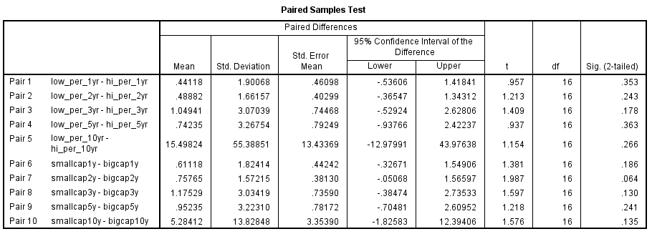

**B. Linear Regression (Low PER -1yr)**

|  |  |  |  |
| --- | --- | --- | --- |
| 1. **Descriptive Statistics** | | | |
|  | Mean | Std. Deviation | N |
| Returns | .2529 | 1.80732 | 17 |
| PER | 6.282 | 1.0939 | 17 |

|  |  |  |  |
| --- | --- | --- | --- |
| **Correlations** | | | |
|  | | Returns | PER |
| Pearson Correlation | Returns | 1.000 | -.411 |
| PER | -.411 | 1.000 |
| Sig. (1-tailed) | Returns | . | .050 |
| PER | .050 | . |
| N | Returns | 17 | 17 |
| PER | 17 | 17 |

|  |  |  |  |
| --- | --- | --- | --- |
| **Variables Entered/Removeda** | | | |
| Model | Variables Entered | Variables Removed | Method |
| 1 | PERb | . | Enter |
| a. Dependent Variable: Returns | | | |
| b. All requested variables entered. | | | |

|  |  |  |  |  |
| --- | --- | --- | --- | --- |
| **Model Summaryb** | | | | |
| Model | R | R Square | Adjusted R Square | Std. Error of the Estimate |
| 1 | .411a | .169 | .114 | 1.70129 |
| a. Predictors: (Constant), PER | | | | |
| b. Dependent Variable: Returns | | | | |

|  |  |  |  |  |  |  |
| --- | --- | --- | --- | --- | --- | --- |
| **ANOVAa** | | | | | | |
| Model | | Sum of Squares | df | Mean Square | F | Sig. |
| 1 | Regression | 8.847 | 1 | 8.847 | 3.057 | .101b |
| Residual | 43.416 | 15 | 2.894 |  |  |
| Total | 52.262 | 16 |  |  |  |
| a. Dependent Variable: Returns | | | | | | |
| b. Predictors: (Constant), PER | | | | | | |

|  |  |  |  |  |  |  |  |  |
| --- | --- | --- | --- | --- | --- | --- | --- | --- |
| **Coefficientsa** | | | | | | | | |
| Model | | Unstandardized Coefficients | | Standardized Coefficients | t | Sig. | 95.0% Confidence Interval for B | |
| B | Std. Error | Beta | Lower Bound | Upper Bound |
| 1 | (Constant) | 4.524 | 2.477 |  | 1.826 | .088 | -.757 | 9.804 |
| PER | -.680 | .389 | -.411 | -1.748 | .101 | -1.509 | .149 |
| a. Dependent Variable: Returns | | | | | | | | |

|  |  |  |  |  |  |
| --- | --- | --- | --- | --- | --- |
| **Residuals Statisticsa** | | | | | |
|  | Minimum | Maximum | Mean | Std. Deviation | N |
| Predicted Value | -.8467 | 1.8724 | .2529 | .74358 | 17 |
| Residual | -1.57241 | 5.93939 | .00000 | 1.64726 | 17 |
| Std. Predicted Value | -1.479 | 2.178 | .000 | 1.000 | 17 |
| Std. Residual | -.924 | 3.491 | .000 | .968 | 17 |
| a. Dependent Variable: Returns | | | | | |

**Charts**

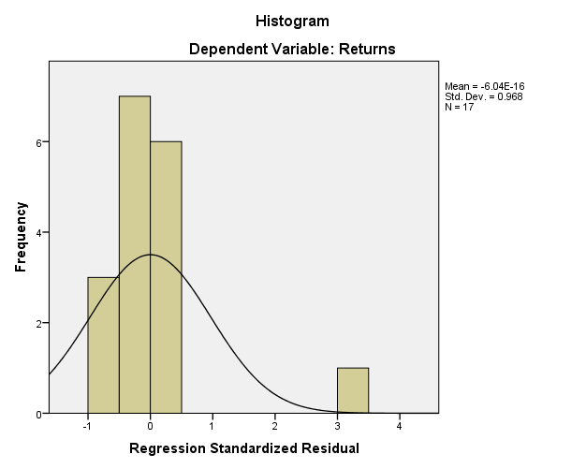

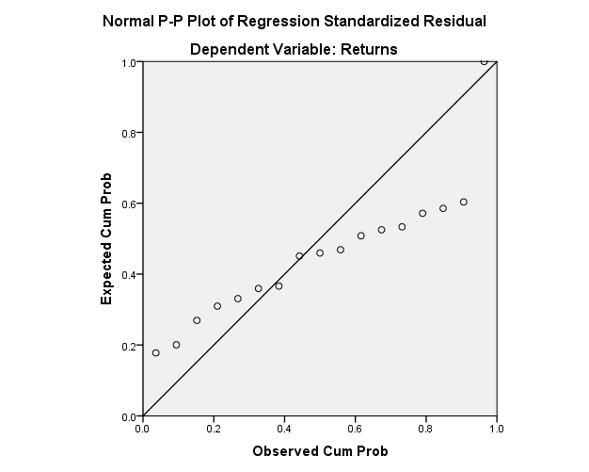

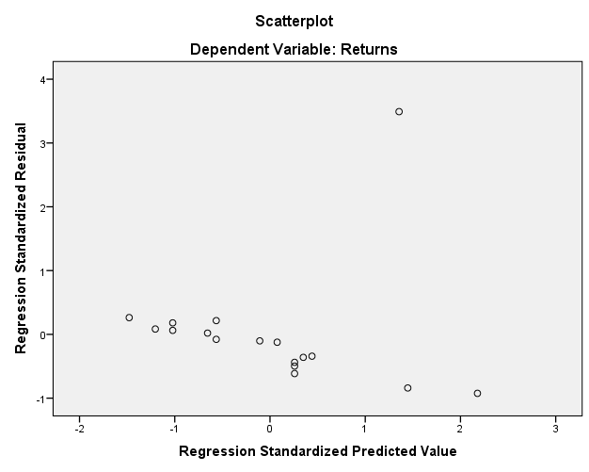

1. **Linear Regression (Low PER -2yr)**

|  |  |  |  |
| --- | --- | --- | --- |
| **Descriptive Statistics** | | | |
|  | Mean | Std. Deviation | N |
| Returns | .5512 | 1.55049 | 17 |
| PER | 6.282 | 1.0939 | 17 |

|  |  |  |  |
| --- | --- | --- | --- |
| **Correlations** | | | |
|  | | Returns | PER |
| Pearson Correlation | Returns | 1.000 | -.452 |
| PER | -.452 | 1.000 |
| Sig. (1-tailed) | Returns | . | .034 |
| PER | .034 | . |
| N | Returns | 17 | 17 |
| PER | 17 | 17 |

|  |  |  |  |
| --- | --- | --- | --- |
| **Variables Entered/Removeda** | | | |
| Model | Variables Entered | Variables Removed | Method |
| 1 | PERb | . | Enter |
| a. Dependent Variable: Returns | | | |
| b. All requested variables entered. | | | |

|  |  |  |  |  |
| --- | --- | --- | --- | --- |
| **Model Summaryb** | | | | |
| Model | R | R Square | Adjusted R Square | Std. Error of the Estimate |
| 1 | .452a | .205 | .152 | 1.42812 |
| a. Predictors: (Constant), PER | | | | |
| b. Dependent Variable: Returns | | | | |

|  |  |  |  |  |  |  |
| --- | --- | --- | --- | --- | --- | --- |
| **ANOVAa** | | | | | | |
| Model | | Sum of Squares | df | Mean Square | F | Sig. |
| 1 | Regression | 7.871 | 1 | 7.871 | 3.859 | .068b |
| Residual | 30.593 | 15 | 2.040 |  |  |
| Total | 38.464 | 16 |  |  |  |
| a. Dependent Variable: Returns | | | | | | |
| b. Predictors: (Constant), PER | | | | | | |

|  |  |  |  |  |  |  |  |  |
| --- | --- | --- | --- | --- | --- | --- | --- | --- |
| **Coefficientsa** | | | | | | | | |
| Model | | Unstandardized Coefficients | | Standardized Coefficients | t | Sig. | 95.0% Confidence Interval for B | |
| B | Std. Error | Beta | Lower Bound | Upper Bound |
| 1 | (Constant) | 4.579 | 2.080 |  | 2.202 | .044 | .147 | 9.012 |
| PER | -.641 | .326 | -.452 | -1.965 | .068 | -1.337 | .054 |
| a. Dependent Variable: Returns | | | | | | | | |

|  |  |  |  |  |  |
| --- | --- | --- | --- | --- | --- |
| **Residuals Statisticsa** | | | | | |
|  | Minimum | Maximum | Mean | Std. Deviation | N |
| Predicted Value | -.4861 | 2.0787 | .5512 | .70139 | 17 |
| Residual | -1.57875 | 4.94833 | .00000 | 1.38277 | 17 |
| Std. Predicted Value | -1.479 | 2.178 | .000 | 1.000 | 17 |
| Std. Residual | -1.105 | 3.465 | .000 | .968 | 17 |
| a. Dependent Variable: Returns | | | | | |

**Charts**

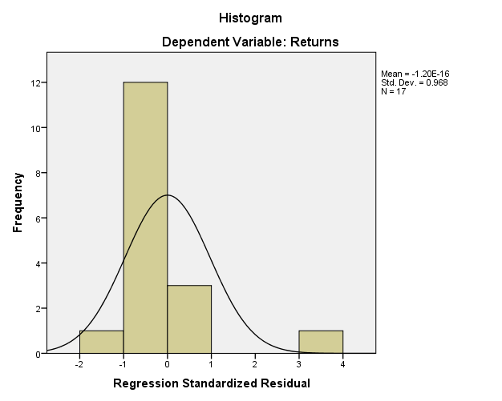

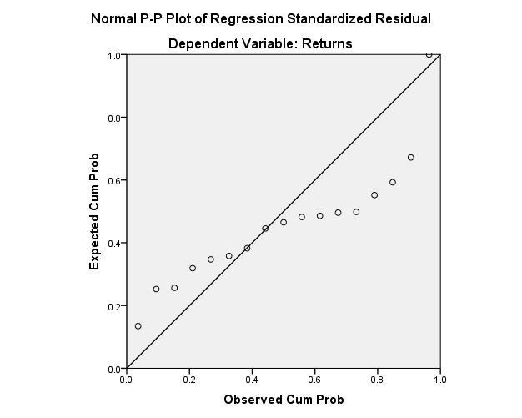

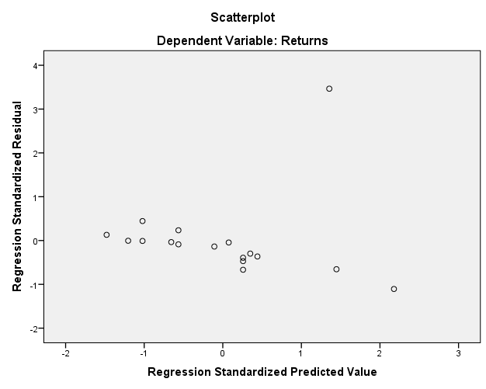

Low PER – 3yr

|  |  |  |  |
| --- | --- | --- | --- |
| **Descriptive Statistics** | | | |
|  | Mean | Std. Deviation | N |
| Returns | 1.4400 | 2.95366 | 17 |
| PER | 6.282 | 1.0939 | 17 |

|  |  |  |  |
| --- | --- | --- | --- |
| **Correlations** | | | |
|  | | Returns | PER |
| Pearson Correlation | Returns | 1.000 | -.510 |
| PER | -.510 | 1.000 |
| Sig. (1-tailed) | Returns | . | .018 |
| PER | .018 | . |
| N | Returns | 17 | 17 |
| PER | 17 | 17 |

|  |  |  |  |
| --- | --- | --- | --- |
| **Variables Entered/Removeda** | | | |
| Model | Variables Entered | Variables Removed | Method |
| 1 | PERb | . | Enter |
| a. Dependent Variable: Returns | | | |
| b. All requested variables entered. | | | |

|  |  |  |  |  |
| --- | --- | --- | --- | --- |
| **Model Summaryb** | | | | |
| Model | R | R Square | Adjusted R Square | Std. Error of the Estimate |
| 1 | .510a | .260 | .211 | 2.62441 |
| a. Predictors: (Constant), PER | | | | |
| b. Dependent Variable: Returns | | | | |

|  |  |  |  |  |  |  |
| --- | --- | --- | --- | --- | --- | --- |
| **ANOVAa** | | | | | | |
| Model | | Sum of Squares | df | Mean Square | F | Sig. |
| 1 | Regression | 36.273 | 1 | 36.273 | 5.266 | .037b |
| Residual | 103.313 | 15 | 6.888 |  |  |
| Total | 139.585 | 16 |  |  |  |
| a. Dependent Variable: Returns | | | | | | |
| b. Predictors: (Constant), PER | | | | | | |

|  |  |  |  |  |  |  |  |  |
| --- | --- | --- | --- | --- | --- | --- | --- | --- |
| **Coefficientsa** | | | | | | | | |
| Model | | Unstandardized Coefficients | | Standardized Coefficients | t | Sig. | 95.0% Confidence Interval for B | |
| B | Std. Error | Beta | Lower Bound | Upper Bound |
| 1 | (Constant) | 10.087 | 3.822 |  | 2.640 | .019 | 1.942 | 18.233 |
| PER | -1.376 | .600 | -.510 | -2.295 | .037 | -2.655 | -.098 |
| a. Dependent Variable: Returns | | | | | | | | |

|  |  |  |  |  |  |
| --- | --- | --- | --- | --- | --- |
| **Residuals Statisticsa** | | | | | |
|  | Minimum | Maximum | Mean | Std. Deviation | N |
| Predicted Value | -.7866 | 4.7192 | 1.4400 | 1.50567 | 17 |
| Residual | -2.28805 | 9.14959 | .00000 | 2.54107 | 17 |
| Std. Predicted Value | -1.479 | 2.178 | .000 | 1.000 | 17 |
| Std. Residual | -.872 | 3.486 | .000 | .968 | 17 |
| a. Dependent Variable: Returns | | | | | |

**Charts**

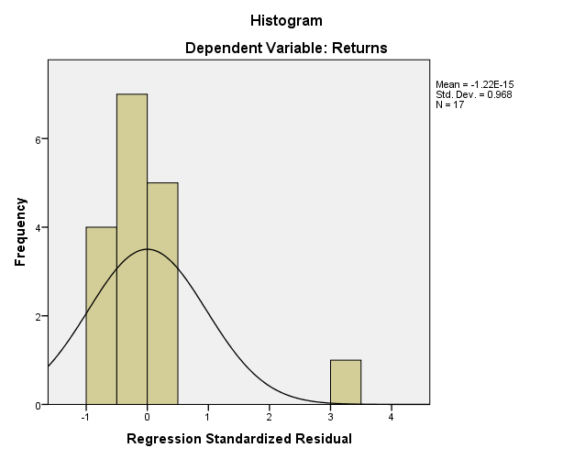

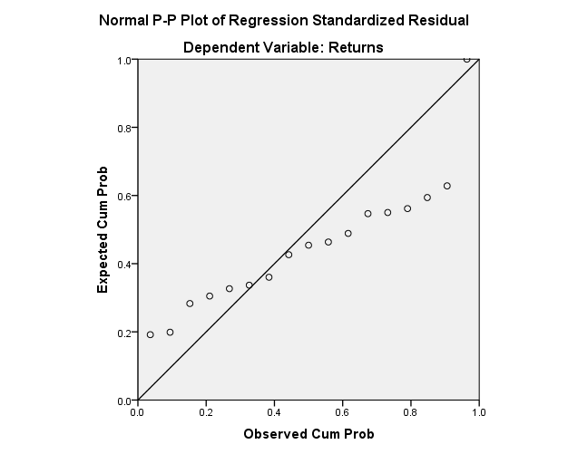

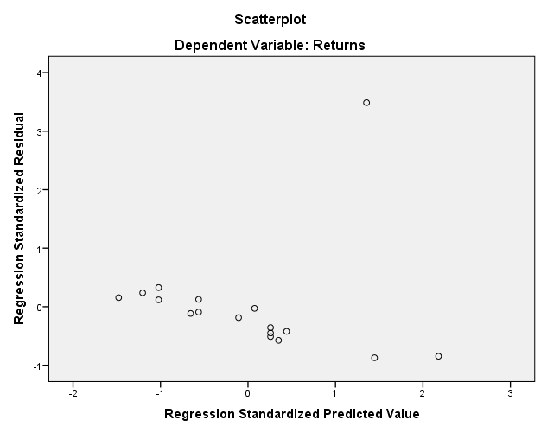

Low PER – return, 5yr

|  |  |  |  |
| --- | --- | --- | --- |
| **Descriptive Statistics** | | | |
|  | Mean | Std. Deviation | N |
| Returns | 1.8229 | 3.00242 | 17 |
| PER | 6.282 | 1.0939 | 17 |

|  |  |  |  |
| --- | --- | --- | --- |
| **Correlations** | | | |
|  | | Returns | PER |
| Pearson Correlation | Returns | 1.000 | -.457 |
| PER | -.457 | 1.000 |
| Sig. (1-tailed) | Returns | . | .033 |
| PER | .033 | . |
| N | Returns | 17 | 17 |
| PER | 17 | 17 |

|  |  |  |  |
| --- | --- | --- | --- |
| **Variables Entered/Removeda** | | | |
| Model | Variables Entered | Variables Removed | Method |
| 1 | PERb | . | Enter |
| a. Dependent Variable: Returns | | | |
| b. All requested variables entered. | | | |

|  |  |  |  |  |
| --- | --- | --- | --- | --- |
| **Model Summaryb** | | | | |
| Model | R | R Square | Adjusted R Square | Std. Error of the Estimate |
| 1 | .457a | .209 | .156 | 2.75817 |
| a. Predictors: (Constant), PER | | | | |
| b. Dependent Variable: Returns | | | | |

|  |  |  |  |  |  |  |
| --- | --- | --- | --- | --- | --- | --- |
| **ANOVAa** | | | | | | |
| Model | | Sum of Squares | df | Mean Square | F | Sig. |
| 1 | Regression | 30.120 | 1 | 30.120 | 3.959 | .065b |
| Residual | 114.113 | 15 | 7.608 |  |  |
| Total | 144.232 | 16 |  |  |  |
| a. Dependent Variable: Returns | | | | | | |
| b. Predictors: (Constant), PER | | | | | | |

|  |  |  |  |  |  |  |  |  |
| --- | --- | --- | --- | --- | --- | --- | --- | --- |
| **Coefficientsa** | | | | | | | | |
| Model | | Unstandardized Coefficients | | Standardized Coefficients | t | Sig. | 95.0% Confidence Interval for B | |
| B | Std. Error | Beta | Lower Bound | Upper Bound |
| 1 | (Constant) | 9.703 | 4.016 |  | 2.416 | .029 | 1.142 | 18.263 |
| PER | -1.254 | .630 | -.457 | -1.990 | .065 | -2.598 | .089 |
| a. Dependent Variable: Returns | | | | | | | | |

|  |  |  |  |  |  |
| --- | --- | --- | --- | --- | --- |
| **Residuals Statisticsa** | | | | | |
|  | Minimum | Maximum | Mean | Std. Deviation | N |
| Predicted Value | -.2061 | 4.8111 | 1.8229 | 1.37203 | 17 |
| Residual | -2.68112 | 9.30775 | .00000 | 2.67059 | 17 |
| Std. Predicted Value | -1.479 | 2.178 | .000 | 1.000 | 17 |
| Std. Residual | -.972 | 3.375 | .000 | .968 | 17 |
| a. Dependent Variable: Returns | | | | | |

**Charts**

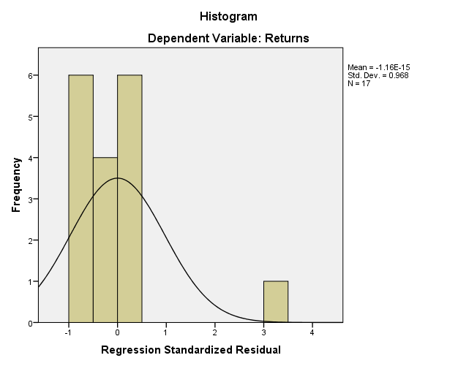

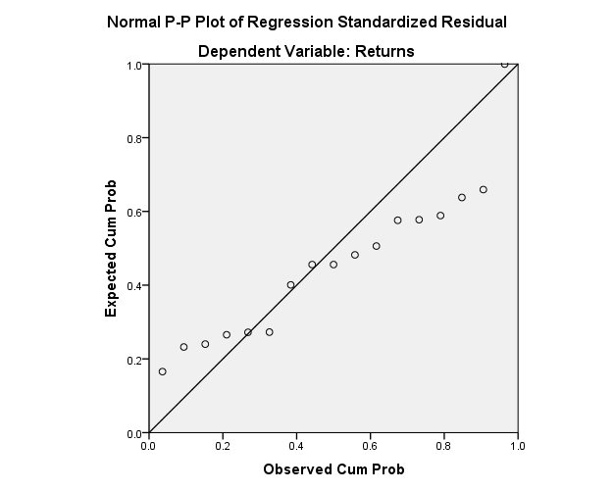

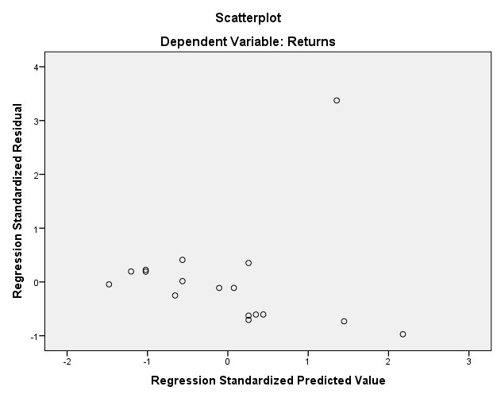

**Low PER, return, 10 yr**

|  |  |  |  |
| --- | --- | --- | --- |
| **Descriptive Statistics** | | | |
|  | Mean | Std. Deviation | N |
| Returns | 20.6276 | 54.56238 | 17 |
| PER | 6.282 | 1.0939 | 17 |

|  |  |  |  |
| --- | --- | --- | --- |
| **Correlations** | | | |
|  | | Returns | PER |
| Pearson Correlation | Returns | 1.000 | -.484 |
| PER | -.484 | 1.000 |
| Sig. (1-tailed) | Returns | . | .024 |
| PER | .024 | . |
| N | Returns | 17 | 17 |
| PER | 17 | 17 |

|  |  |  |  |
| --- | --- | --- | --- |
| **Variables Entered/Removeda** | | | |
| Model | Variables Entered | Variables Removed | Method |
| 1 | PERb | . | Enter |
| a. Dependent Variable: Returns | | | |
| b. All requested variables entered. | | | |

|  |  |  |  |  |
| --- | --- | --- | --- | --- |
| **Model Summaryb** | | | | |
| Model | R | R Square | Adjusted R Square | Std. Error of the Estimate |
| 1 | .484a | .234 | .183 | 49.30648 |
| a. Predictors: (Constant), PER | | | | |
| b. Dependent Variable: Returns | | | | |

|  |  |  |  |  |  |  |
| --- | --- | --- | --- | --- | --- | --- |
| **ANOVAa** | | | | | | |
| Model | | Sum of Squares | df | Mean Square | F | Sig. |
| 1 | Regression | 11165.916 | 1 | 11165.916 | 4.593 | .049b |
| Residual | 36466.933 | 15 | 2431.129 |  |  |
| Total | 47632.849 | 16 |  |  |  |
| a. Dependent Variable: Returns | | | | | | |
| b. Predictors: (Constant), PER | | | | | | |

|  |  |  |  |  |  |  |  |  |
| --- | --- | --- | --- | --- | --- | --- | --- | --- |
| **Coefficientsa** | | | | | | | | |
| Model | | Unstandardized Coefficients | | Standardized Coefficients | t | Sig. | 95.0% Confidence Interval for B | |
| B | Std. Error | Beta | Lower Bound | Upper Bound |
| 1 | (Constant) | 172.348 | 71.798 |  | 2.400 | .030 | 19.315 | 325.382 |
| PER | -24.150 | 11.269 | -.484 | -2.143 | .049 | -48.169 | -.131 |
| a. Dependent Variable: Returns | | | | | | | | |

|  |  |  |  |  |  |
| --- | --- | --- | --- | --- | --- |
| **Residuals Statisticsa** | | | | | |
|  | Minimum | Maximum | Mean | Std. Deviation | N |
| Predicted Value | -18.4390 | 78.1622 | 20.6276 | 26.41722 | 17 |
| Residual | -55.65197 | 169.76306 | .00000 | 47.74079 | 17 |
| Std. Predicted Value | -1.479 | 2.178 | .000 | 1.000 | 17 |
| Std. Residual | -1.129 | 3.443 | .000 | .968 | 17 |
| a. Dependent Variable: Returns | | | | | |

**Charts**

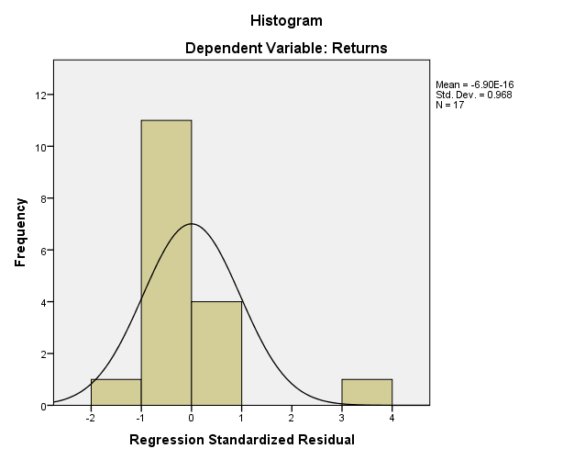

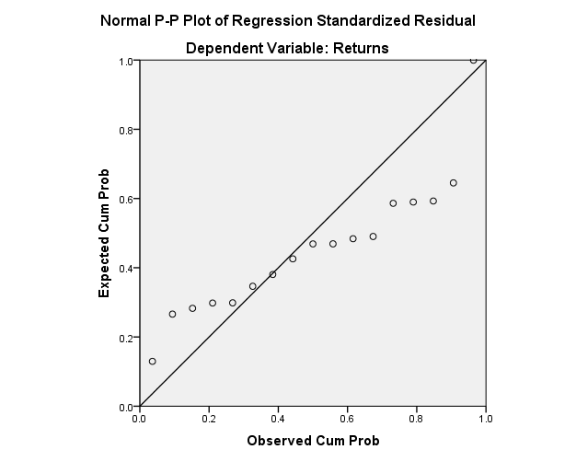

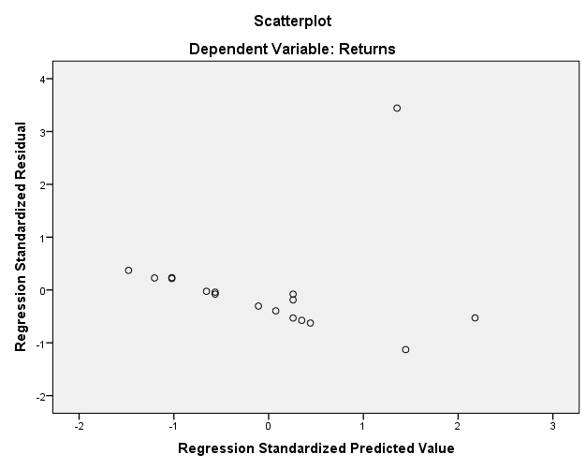

**High PER – return, 1yr**

**Regression**

|  |  |  |  |
| --- | --- | --- | --- |
| **Descriptive Statistics** | | | |
|  | Mean | Std. Deviation | N |
| Returns | -.1882 | .39351 | 17 |
| PER | 20.688 | 15.5472 | 17 |

|  |  |  |  |
| --- | --- | --- | --- |
| **Correlations** | | | |
|  | | Returns | PER |
| Pearson Correlation | Returns | 1.000 | .310 |
| PER | .310 | 1.000 |
| Sig. (1-tailed) | Returns | . | .113 |
| PER | .113 | . |
| N | Returns | 17 | 17 |
| PER | 17 | 17 |

|  |  |  |  |
| --- | --- | --- | --- |
| **Variables Entered/Removeda** | | | |
| Model | Variables Entered | Variables Removed | Method |
| 1 | PERb | . | Enter |
| a. Dependent Variable: Returns | | | |
| b. All requested variables entered. | | | |

|  |  |  |  |  |
| --- | --- | --- | --- | --- |
| **Model Summaryb** | | | | |
| Model | R | R Square | Adjusted R Square | Std. Error of the Estimate |
| 1 | .310a | .096 | .036 | .38639 |
| a. Predictors: (Constant), PER | | | | |
| b. Dependent Variable: Returns | | | | |

|  |  |  |  |  |  |  |
| --- | --- | --- | --- | --- | --- | --- |
| **ANOVAa** | | | | | | |
| Model | | Sum of Squares | df | Mean Square | F | Sig. |
| 1 | Regression | .238 | 1 | .238 | 1.596 | .226b |
| Residual | 2.239 | 15 | .149 |  |  |
| Total | 2.478 | 16 |  |  |  |
| a. Dependent Variable: Returns | | | | | | |
| b. Predictors: (Constant), PER | | | | | | |

|  |  |  |  |  |  |  |  |  |
| --- | --- | --- | --- | --- | --- | --- | --- | --- |
| **Coefficientsa** | | | | | | | | |
| Model | | Unstandardized Coefficients | | Standardized Coefficients | t | Sig. | 95.0% Confidence Interval for B | |
| B | Std. Error | Beta | Lower Bound | Upper Bound |
| 1 | (Constant) | -.351 | .159 |  | -2.204 | .044 | -.690 | -.012 |
| PER | .008 | .006 | .310 | 1.263 | .226 | -.005 | .021 |
| a. Dependent Variable: Returns | | | | | | | | |

|  |  |  |  |  |  |
| --- | --- | --- | --- | --- | --- |
| **Residuals Statisticsa** | | | | | |
|  | Minimum | Maximum | Mean | Std. Deviation | N |
| Predicted Value | -.2486 | .2773 | -.1882 | .12202 | 17 |
| Residual | -.49145 | 1.09599 | .00000 | .37412 | 17 |
| Std. Predicted Value | -.495 | 3.815 | .000 | 1.000 | 17 |
| Std. Residual | -1.272 | 2.837 | .000 | .968 | 17 |
| a. Dependent Variable: Returns | | | | | |

**Charts**

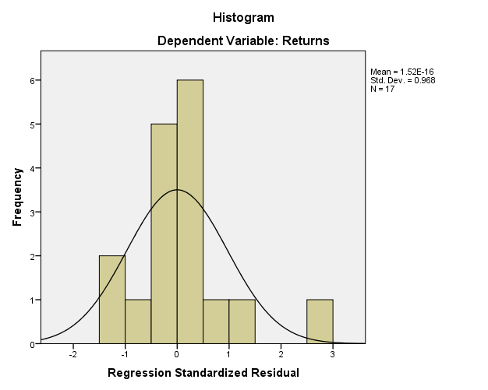

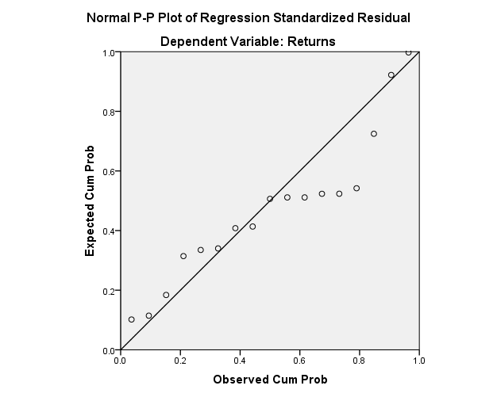

**High PER, 2yr**

**Regression**

|  |  |  |  |
| --- | --- | --- | --- |
| **Descriptive Statistics** | | | |
|  | Mean | Std. Deviation | N |
| Returns | .0624 | .48005 | 17 |
| PER | 20.688 | 15.5472 | 17 |

|  |  |  |  |
| --- | --- | --- | --- |
| **Correlations** | | | |
|  | | Returns | PER |
| Pearson Correlation | Returns | 1.000 | -.083 |
| PER | -.083 | 1.000 |
| Sig. (1-tailed) | Returns | . | .376 |
| PER | .376 | . |
| N | Returns | 17 | 17 |
| PER | 17 | 17 |

|  |  |  |  |
| --- | --- | --- | --- |
| **Variables Entered/Removeda** | | | |
| Model | Variables Entered | Variables Removed | Method |
| 1 | PERb | . | Enter |
| a. Dependent Variable: Returns | | | |
| b. All requested variables entered. | | | |

|  |  |  |  |  |
| --- | --- | --- | --- | --- |
| **Model Summaryb** | | | | |
| Model | R | R Square | Adjusted R Square | Std. Error of the Estimate |
| 1 | .083a | .007 | -.059 | .49408 |
| a. Predictors: (Constant), PER | | | | |
| b. Dependent Variable: Returns | | | | |

|  |  |  |  |  |  |  |
| --- | --- | --- | --- | --- | --- | --- |
| **ANOVAa** | | | | | | |
| Model | | Sum of Squares | df | Mean Square | F | Sig. |
| 1 | Regression | .025 | 1 | .025 | .104 | .752b |
| Residual | 3.662 | 15 | .244 |  |  |
| Total | 3.687 | 16 |  |  |  |
| a. Dependent Variable: Returns | | | | | | |
| b. Predictors: (Constant), PER | | | | | | |

|  |  |  |  |  |  |  |  |  |
| --- | --- | --- | --- | --- | --- | --- | --- | --- |
| **Coefficientsa** | | | | | | | | |
| Model | | Unstandardized Coefficients | | Standardized Coefficients | t | Sig. | 95.0% Confidence Interval for B | |
| B | Std. Error | Beta | Lower Bound | Upper Bound |
| 1 | (Constant) | .115 | .203 |  | .567 | .579 | -.318 | .549 |
| PER | -.003 | .008 | -.083 | -.322 | .752 | -.019 | .014 |
| a. Dependent Variable: Returns | | | | | | | | |

|  |  |  |  |  |  |
| --- | --- | --- | --- | --- | --- |
| **Residuals Statisticsa** | | | | | |
|  | Minimum | Maximum | Mean | Std. Deviation | N |
| Predicted Value | -.0894 | .0820 | .0624 | .03978 | 17 |
| Residual | -.55897 | 1.45512 | .00000 | .47840 | 17 |
| Std. Predicted Value | -3.815 | .495 | .000 | 1.000 | 17 |
| Std. Residual | -1.131 | 2.945 | .000 | .968 | 17 |
| a. Dependent Variable: Returns | | | | | |

**Charts**

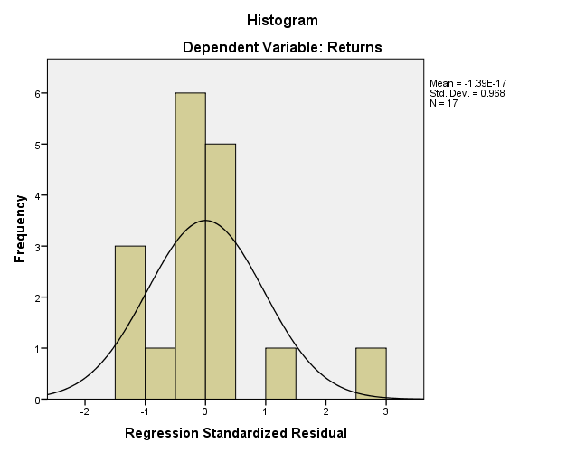

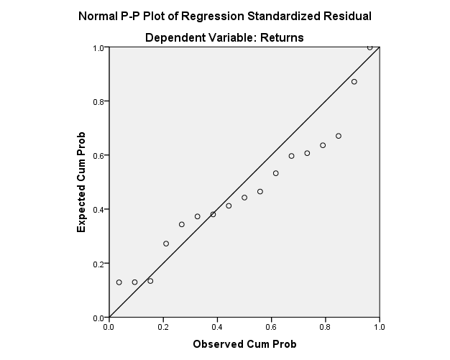

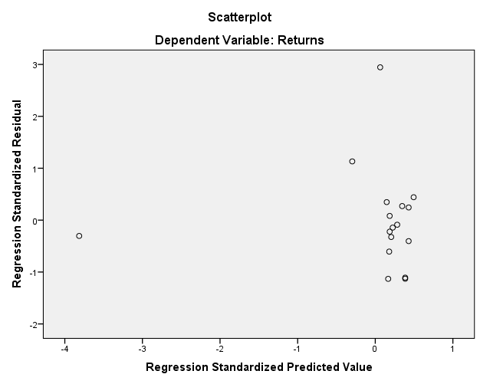

High PER, 3yr

**Regression**

|  |  |  |  |
| --- | --- | --- | --- |
| **Descriptive Statistics** | | | |
|  | Mean | Std. Deviation | N |
| Returns | .3906 | .64632 | 17 |
| PER | 20.688 | 15.5472 | 17 |

|  |  |  |  |
| --- | --- | --- | --- |
| **Correlations** | | | |
|  | | Returns | PER |
| Pearson Correlation | Returns | 1.000 | -.162 |
| PER | -.162 | 1.000 |
| Sig. (1-tailed) | Returns | . | .267 |
| PER | .267 | . |
| N | Returns | 17 | 17 |
| PER | 17 | 17 |

|  |  |  |  |
| --- | --- | --- | --- |
| **Variables Entered/Removeda** | | | |
| Model | Variables Entered | Variables Removed | Method |
| 1 | PERb | . | Enter |
| a. Dependent Variable: Returns | | | |
| b. All requested variables entered. | | | |

|  |  |  |  |  |
| --- | --- | --- | --- | --- |
| **Model Summaryb** | | | | |
| Model | R | R Square | Adjusted R Square | Std. Error of the Estimate |
| 1 | .162a | .026 | -.039 | .65870 |
| a. Predictors: (Constant), PER | | | | |
| b. Dependent Variable: Returns | | | | |

|  |  |  |  |  |  |  |
| --- | --- | --- | --- | --- | --- | --- |
| **ANOVAa** | | | | | | |
| Model | | Sum of Squares | df | Mean Square | F | Sig. |
| 1 | Regression | .175 | 1 | .175 | .404 | .535b |
| Residual | 6.508 | 15 | .434 |  |  |
| Total | 6.684 | 16 |  |  |  |
| a. Dependent Variable: Returns | | | | | | |
| b. Predictors: (Constant), PER | | | | | | |

|  |  |  |  |  |  |  |  |  |
| --- | --- | --- | --- | --- | --- | --- | --- | --- |
| **Coefficientsa** | | | | | | | | |
| Model | | Unstandardized Coefficients | | Standardized Coefficients | t | Sig. | 95.0% Confidence Interval for B | |
| B | Std. Error | Beta | Lower Bound | Upper Bound |
| 1 | (Constant) | .530 | .271 |  | 1.954 | .070 | -.048 | 1.108 |
| PER | -.007 | .011 | -.162 | -.636 | .535 | -.029 | .016 |
| a. Dependent Variable: Returns | | | | | | | | |

|  |  |  |  |  |  |
| --- | --- | --- | --- | --- | --- |
| **Residuals Statisticsa** | | | | | |
|  | Minimum | Maximum | Mean | Std. Deviation | N |
| Predicted Value | -.0087 | .4424 | .3906 | .10468 | 17 |
| Residual | -.78091 | 1.96276 | .00000 | .63779 | 17 |
| Std. Predicted Value | -3.815 | .495 | .000 | 1.000 | 17 |
| Std. Residual | -1.186 | 2.980 | .000 | .968 | 17 |
| a. Dependent Variable: Returns | | | | | |

**Charts**

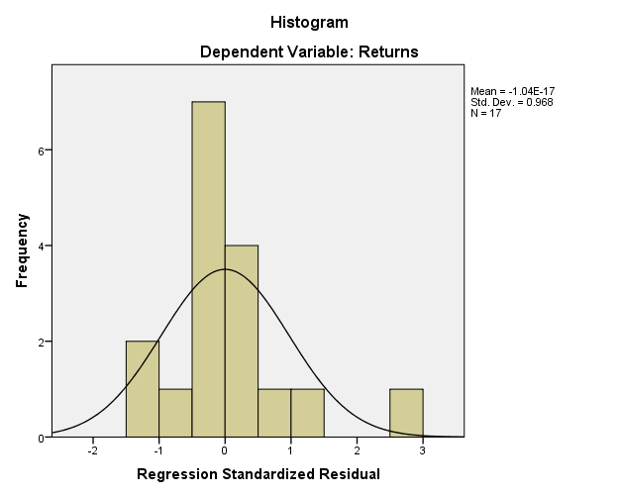

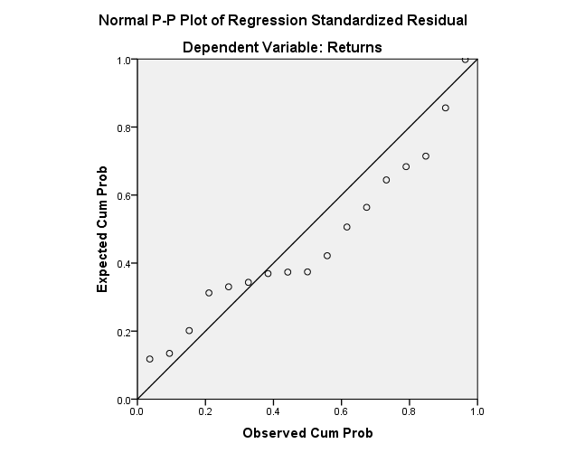

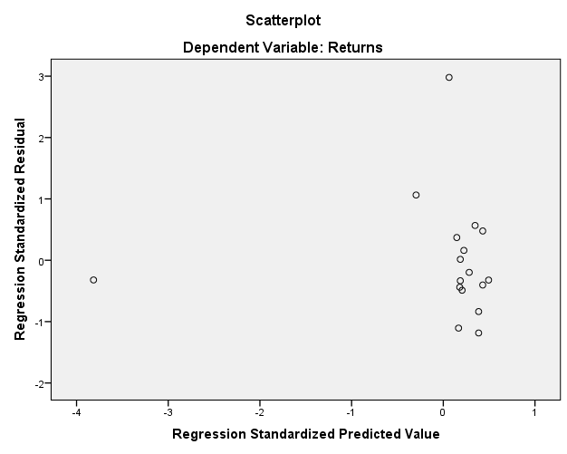

High PER, 5yr

|  |  |  |  |
| --- | --- | --- | --- |
| **Descriptive Statistics** | | | |
|  | Mean | Std. Deviation | N |
| Returns | 1.0806 | .93407 | 17 |
| PER | 20.688 | 15.5472 | 17 |

|  |  |  |  |
| --- | --- | --- | --- |
| **Correlations** | | | |
|  | | Returns | PER |
| Pearson Correlation | Returns | 1.000 | .157 |
| PER | .157 | 1.000 |
| Sig. (1-tailed) | Returns | . | .273 |
| PER | .273 | . |
| N | Returns | 17 | 17 |
| PER | 17 | 17 |

|  |  |  |  |
| --- | --- | --- | --- |
| **Variables Entered/Removeda** | | | |
| Model | Variables Entered | Variables Removed | Method |
| 1 | PERb | . | Enter |
| a. Dependent Variable: Returns | | | |
| b. All requested variables entered. | | | |

|  |  |  |  |  |
| --- | --- | --- | --- | --- |
| **Model Summaryb** | | | | |
| Model | R | R Square | Adjusted R Square | Std. Error of the Estimate |
| 1 | .157a | .025 | -.040 | .95267 |
| a. Predictors: (Constant), PER | | | | |
| b. Dependent Variable: Returns | | | | |

|  |  |  |  |  |  |  |
| --- | --- | --- | --- | --- | --- | --- |
| **ANOVAa** | | | | | | |
| Model | | Sum of Squares | df | Mean Square | F | Sig. |
| 1 | Regression | .346 | 1 | .346 | .381 | .546b |
| Residual | 13.614 | 15 | .908 |  |  |
| Total | 13.960 | 16 |  |  |  |
| a. Dependent Variable: Returns | | | | | | |
| b. Predictors: (Constant), PER | | | | | | |

|  |  |  |  |  |  |  |  |  |
| --- | --- | --- | --- | --- | --- | --- | --- | --- |
| **Coefficientsa** | | | | | | | | |
| Model | | Unstandardized Coefficients | | Standardized Coefficients | t | Sig. | 95.0% Confidence Interval for B | |
| B | Std. Error | Beta | Lower Bound | Upper Bound |
| 1 | (Constant) | .885 | .392 |  | 2.256 | .039 | .049 | 1.721 |
| PER | .009 | .015 | .157 | .618 | .546 | -.023 | .042 |
| a. Dependent Variable: Returns | | | | | | | | |

|  |  |  |  |  |  |
| --- | --- | --- | --- | --- | --- |
| **Residuals Statisticsa** | | | | | |
|  | Minimum | Maximum | Mean | Std. Deviation | N |
| Predicted Value | 1.0079 | 1.6417 | 1.0806 | .14708 | 17 |
| Residual | -1.59394 | 2.01241 | .00000 | .92241 | 17 |
| Std. Predicted Value | -.495 | 3.815 | .000 | 1.000 | 17 |
| Std. Residual | -1.673 | 2.112 | .000 | .968 | 17 |
| a. Dependent Variable: Returns | | | | | |

**Charts**

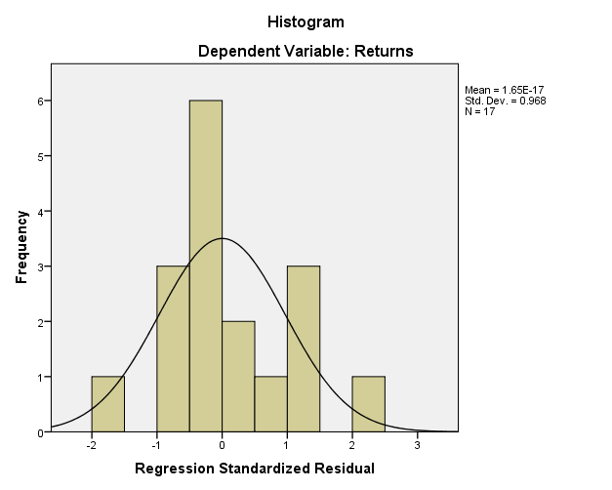

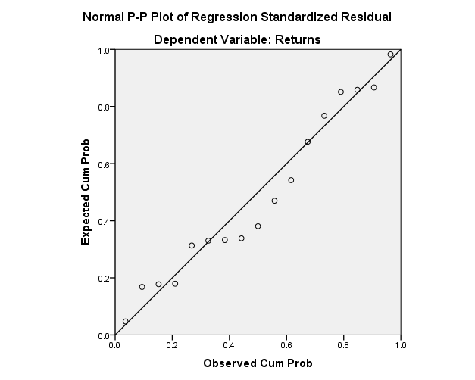

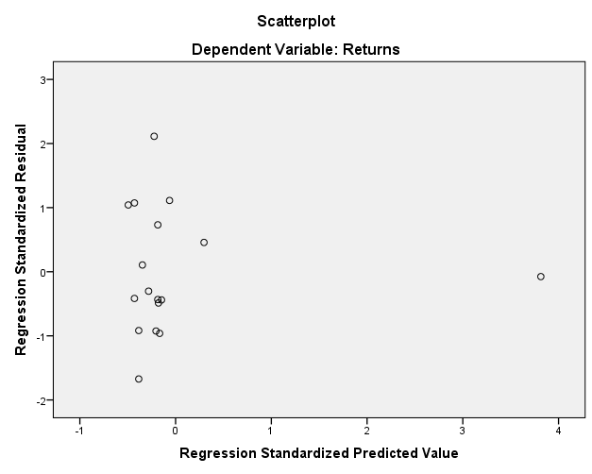

High PER, 10y

|  |  |  |  |
| --- | --- | --- | --- |
| **Descriptive Statistics** | | | |
|  | Mean | Std. Deviation | N |
| Returns | 5.1294 | 6.19655 | 17 |
| PER | 20.688 | 15.5472 | 17 |

|  |  |  |  |
| --- | --- | --- | --- |
| **Correlations** | | | |
|  | | Returns | PER |
| Pearson Correlation | Returns | 1.000 | .439 |
| PER | .439 | 1.000 |
| Sig. (1-tailed) | Returns | . | .039 |
| PER | .039 | . |
| N | Returns | 17 | 17 |
| PER | 17 | 17 |

|  |  |  |  |
| --- | --- | --- | --- |
| **Variables Entered/Removeda** | | | |
| Model | Variables Entered | Variables Removed | Method |
| 1 | PERb | . | Enter |
| a. Dependent Variable: Returns | | | |
| b. All requested variables entered. | | | |

|  |  |  |  |  |
| --- | --- | --- | --- | --- |
| **Model Summaryb** | | | | |
| Model | R | R Square | Adjusted R Square | Std. Error of the Estimate |
| 1 | .439a | .193 | .139 | 5.74989 |
| a. Predictors: (Constant), PER | | | | |
| b. Dependent Variable: Returns | | | | |

|  |  |  |  |  |  |  |
| --- | --- | --- | --- | --- | --- | --- |
| **ANOVAa** | | | | | | |
| Model | | Sum of Squares | df | Mean Square | F | Sig. |
| 1 | Regression | 118.438 | 1 | 118.438 | 3.582 | .078b |
| Residual | 495.919 | 15 | 33.061 |  |  |
| Total | 614.357 | 16 |  |  |  |
| a. Dependent Variable: Returns | | | | | | |
| b. Predictors: (Constant), PER | | | | | | |

|  |  |  |  |  |  |  |  |  |
| --- | --- | --- | --- | --- | --- | --- | --- | --- |
| **Coefficientsa** | | | | | | | | |
| Model | | Unstandardized Coefficients | | Standardized Coefficients | t | Sig. | 95.0% Confidence Interval for B | |
| B | Std. Error | Beta | Lower Bound | Upper Bound |
| 1 | (Constant) | 1.509 | 2.367 |  | .637 | .533 | -3.537 | 6.555 |
| PER | .175 | .092 | .439 | 1.893 | .078 | -.022 | .372 |
| a. Dependent Variable: Returns | | | | | | | | |

|  |  |  |  |  |  |
| --- | --- | --- | --- | --- | --- |
| **Residuals Statisticsa** | | | | | |
|  | Minimum | Maximum | Mean | Std. Deviation | N |
| Predicted Value | 3.7840 | 15.5089 | 5.1294 | 2.72073 | 17 |
| Residual | -4.31398 | 13.06354 | .00000 | 5.56731 | 17 |
| Std. Predicted Value | -.495 | 3.815 | .000 | 1.000 | 17 |
| Std. Residual | -.750 | 2.272 | .000 | .968 | 17 |
| a. Dependent Variable: Returns | | | | | |

**Charts**

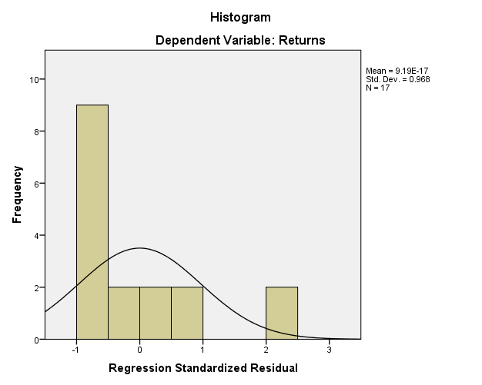

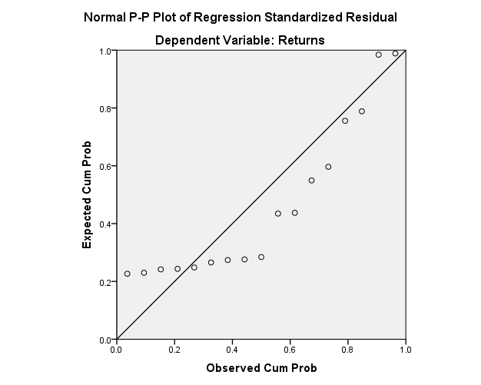

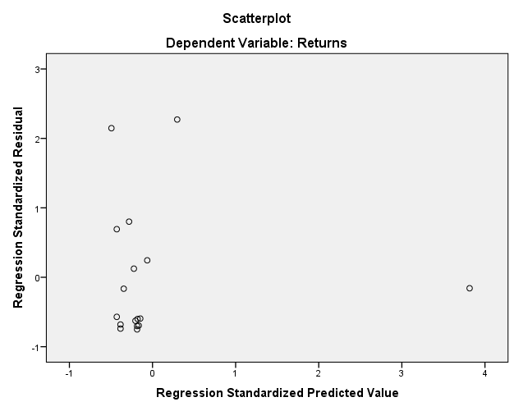

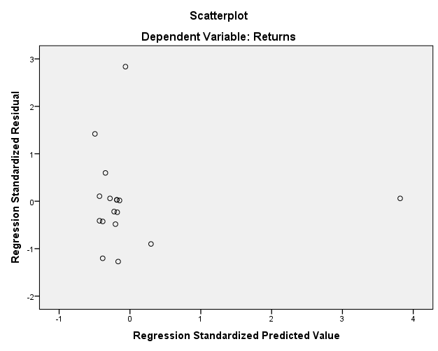

**Low MCap – returns, 1yr**

**Regression**

|  |  |  |  |
| --- | --- | --- | --- |
| **Descriptive Statistics** | | | |
|  | Mean | Std. Deviation | N |
| Returns | .3306 | 1.78636 | 17 |
| MCap | 92.265 | 36.1530 | 17 |

|  |  |  |  |
| --- | --- | --- | --- |
| **Correlations** | | | |
|  | | Returns | MCap |
| Pearson Correlation | Returns | 1.000 | -.437 |
| MCap | -.437 | 1.000 |
| Sig. (1-tailed) | Returns | . | .040 |
| MCap | .040 | . |
| N | Returns | 17 | 17 |
| MCap | 17 | 17 |

|  |  |  |  |
| --- | --- | --- | --- |
| **Variables Entered/Removeda** | | | |
| Model | Variables Entered | Variables Removed | Method |
| 1 | MCapb | . | Enter |
| a. Dependent Variable: Returns | | | |
| b. All requested variables entered. | | | |

|  |  |  |  |  |
| --- | --- | --- | --- | --- |
| **Model Summaryb** | | | | |
| Model | R | R Square | Adjusted R Square | Std. Error of the Estimate |
| 1 | .437a | .191 | .137 | 1.65922 |
| a. Predictors: (Constant), MCap | | | | |
| b. Dependent Variable: Returns | | | | |

|  |  |  |  |  |  |  |
| --- | --- | --- | --- | --- | --- | --- |
| **ANOVAa** | | | | | | |
| Model | | Sum of Squares | df | Mean Square | F | Sig. |
| 1 | Regression | 9.762 | 1 | 9.762 | 3.546 | .079b |
| Residual | 41.295 | 15 | 2.753 |  |  |
| Total | 51.057 | 16 |  |  |  |
| a. Dependent Variable: Returns | | | | | | |
| b. Predictors: (Constant), MCap | | | | | | |

|  |  |  |  |  |  |  |  |  |
| --- | --- | --- | --- | --- | --- | --- | --- | --- |
| **Coefficientsa** | | | | | | | | |
| Model | | Unstandardized Coefficients | | Standardized Coefficients | t | Sig. | 95.0% Confidence Interval for B | |
| B | Std. Error | Beta | Lower Bound | Upper Bound |
| 1 | (Constant) | 2.324 | 1.133 |  | 2.052 | .058 | -.090 | 4.738 |
| MCap | -.022 | .011 | -.437 | -1.883 | .079 | -.046 | .003 |
| a. Dependent Variable: Returns | | | | | | | | |

|  |  |  |  |  |  |
| --- | --- | --- | --- | --- | --- |
| **Residuals Statisticsa** | | | | | |
|  | Minimum | Maximum | Mean | Std. Deviation | N |
| Predicted Value | -.6057 | 1.7536 | .3306 | .78111 | 17 |
| Residual | -1.94844 | 5.59298 | .00000 | 1.60653 | 17 |
| Std. Predicted Value | -1.199 | 1.822 | .000 | 1.000 | 17 |
| Std. Residual | -1.174 | 3.371 | .000 | .968 | 17 |
| a. Dependent Variable: Returns | | | | | |

**Charts**

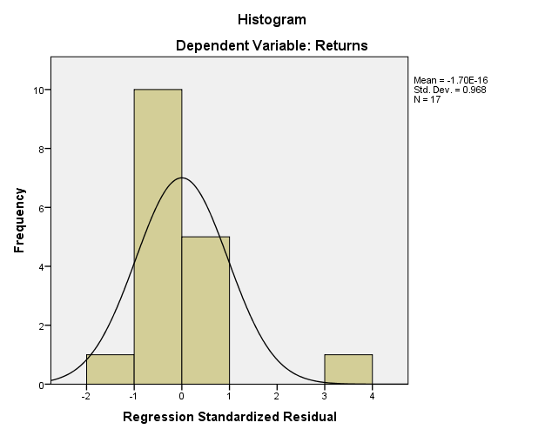

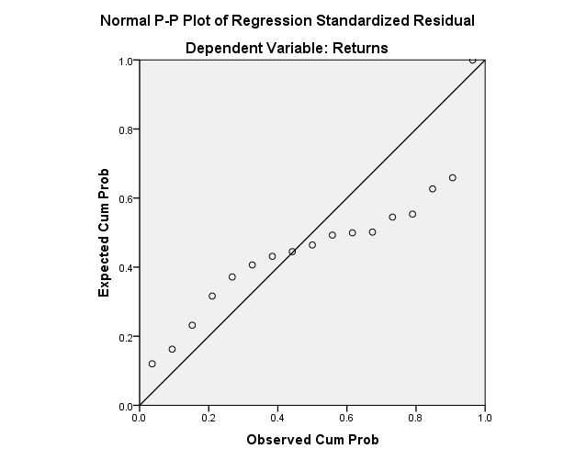

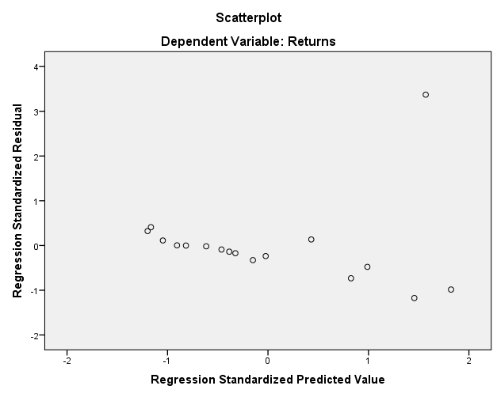

**Low-MCap, 2yr**

**Regression**

|  |  |  |  |
| --- | --- | --- | --- |
| **Descriptive Statistics** | | | |
|  | Mean | Std. Deviation | N |
| Returns | .6906 | 1.54129 | 17 |
| MCap | 92.265 | 36.1530 | 17 |

|  |  |  |  |
| --- | --- | --- | --- |
| **Correlations** | | | |
|  | | Returns | MCap |
| Pearson Correlation | Returns | 1.000 | -.494 |
| MCap | -.494 | 1.000 |
| Sig. (1-tailed) | Returns | . | .022 |
| MCap | .022 | . |
| N | Returns | 17 | 17 |
| MCap | 17 | 17 |

|  |  |  |  |
| --- | --- | --- | --- |
| **Variables Entered/Removeda** | | | |
| Model | Variables Entered | Variables Removed | Method |
| 1 | MCapb | . | Enter |
| a. Dependent Variable: Returns | | | |
| b. All requested variables entered. | | | |

|  |  |  |  |  |
| --- | --- | --- | --- | --- |
| **Model Summaryb** | | | | |
| Model | R | R Square | Adjusted R Square | Std. Error of the Estimate |
| 1 | .494a | .244 | .193 | 1.38438 |
| a. Predictors: (Constant), MCap | | | | |
| b. Dependent Variable: Returns | | | | |

|  |  |  |  |  |  |  |
| --- | --- | --- | --- | --- | --- | --- |
| **ANOVAa** | | | | | | |
| Model | | Sum of Squares | df | Mean Square | F | Sig. |
| 1 | Regression | 9.262 | 1 | 9.262 | 4.833 | .044b |
| Residual | 28.747 | 15 | 1.916 |  |  |
| Total | 38.009 | 16 |  |  |  |
| a. Dependent Variable: Returns | | | | | | |
| b. Predictors: (Constant), MCap | | | | | | |

|  |  |  |  |  |  |  |  |  |
| --- | --- | --- | --- | --- | --- | --- | --- | --- |
| **Coefficientsa** | | | | | | | | |
| Model | | Unstandardized Coefficients | | Standardized Coefficients | t | Sig. | 95.0% Confidence Interval for B | |
| B | Std. Error | Beta | Lower Bound | Upper Bound |
| 1 | (Constant) | 2.632 | .945 |  | 2.786 | .014 | .618 | 4.646 |
| MCap | -.021 | .010 | -.494 | -2.198 | .044 | -.041 | -.001 |
| a. Dependent Variable: Returns | | | | | | | | |

|  |  |  |  |  |  |
| --- | --- | --- | --- | --- | --- |
| **Residuals Statisticsa** | | | | | |
|  | Minimum | Maximum | Mean | Std. Deviation | N |
| Predicted Value | -.2214 | 2.0767 | .6906 | .76082 | 17 |
| Residual | -1.53668 | 4.56482 | .00000 | 1.34042 | 17 |
| Std. Predicted Value | -1.199 | 1.822 | .000 | 1.000 | 17 |
| Std. Residual | -1.110 | 3.297 | .000 | .968 | 17 |
| a. Dependent Variable: Returns | | | | | |

**Charts**

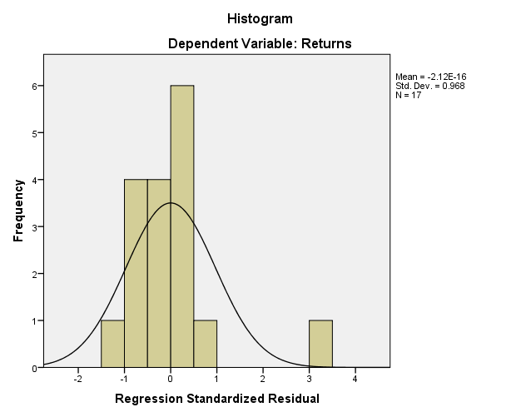

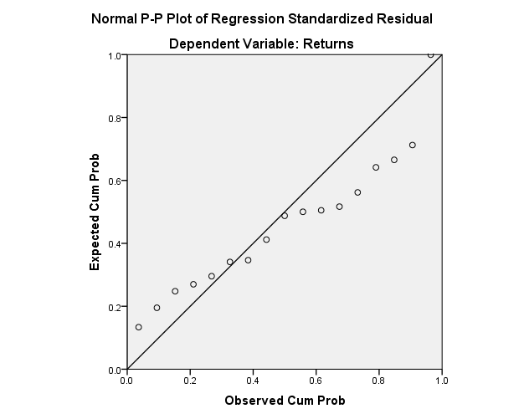

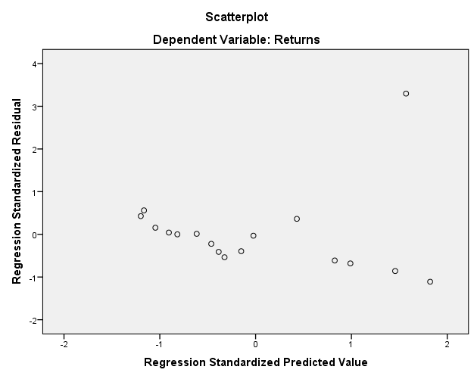

**Low-Mcap, 3yr**

|  |  |  |  |
| --- | --- | --- | --- |
| **Descriptive Statistics** | | | |
|  | Mean | Std. Deviation | N |
| Returns | 1.4994 | 2.96726 | 17 |
| MCap | 92.265 | 36.1530 | 17 |

|  |  |  |  |
| --- | --- | --- | --- |
| **Correlations** | | | |
|  | | Returns | MCap |
| Pearson Correlation | Returns | 1.000 | -.531 |
| MCap | -.531 | 1.000 |
| Sig. (1-tailed) | Returns | . | .014 |
| MCap | .014 | . |
| N | Returns | 17 | 17 |
| MCap | 17 | 17 |

|  |  |  |  |
| --- | --- | --- | --- |
| **Variables Entered/Removeda** | | | |
| Model | Variables Entered | Variables Removed | Method |
| 1 | MCapb | . | Enter |
| a. Dependent Variable: Returns | | | |
| b. All requested variables entered. | | | |

|  |  |  |  |  |
| --- | --- | --- | --- | --- |
| **Model Summaryb** | | | | |
| Model | R | R Square | Adjusted R Square | Std. Error of the Estimate |
| 1 | .531a | .282 | .235 | 2.59595 |
| a. Predictors: (Constant), MCap | | | | |
| b. Dependent Variable: Returns | | | | |

|  |  |  |  |  |  |  |
| --- | --- | --- | --- | --- | --- | --- |
| **ANOVAa** | | | | | | |
| Model | | Sum of Squares | df | Mean Square | F | Sig. |
| 1 | Regression | 39.790 | 1 | 39.790 | 5.904 | .028b |
| Residual | 101.085 | 15 | 6.739 |  |  |
| Total | 140.874 | 16 |  |  |  |
| a. Dependent Variable: Returns | | | | | | |
| b. Predictors: (Constant), MCap | | | | | | |

|  |  |  |  |  |  |  |  |  |
| --- | --- | --- | --- | --- | --- | --- | --- | --- |
| **Coefficientsa** | | | | | | | | |
| Model | | Unstandardized Coefficients | | Standardized Coefficients | t | Sig. | 95.0% Confidence Interval for B | |
| B | Std. Error | Beta | Lower Bound | Upper Bound |
| 1 | (Constant) | 5.524 | 1.772 |  | 3.118 | .007 | 1.747 | 9.301 |
| MCap | -.044 | .018 | -.531 | -2.430 | .028 | -.082 | -.005 |
| a. Dependent Variable: Returns | | | | | | | | |

|  |  |  |  |  |  |
| --- | --- | --- | --- | --- | --- |
| **Residuals Statisticsa** | | | | | |
|  | Minimum | Maximum | Mean | Std. Deviation | N |
| Predicted Value | -.3908 | 4.3724 | 1.4994 | 1.57697 | 17 |
| Residual | -2.89239 | 8.65454 | .00000 | 2.51352 | 17 |
| Std. Predicted Value | -1.199 | 1.822 | .000 | 1.000 | 17 |
| Std. Residual | -1.114 | 3.334 | .000 | .968 | 17 |
| a. Dependent Variable: Returns | | | | | |

**Charts**

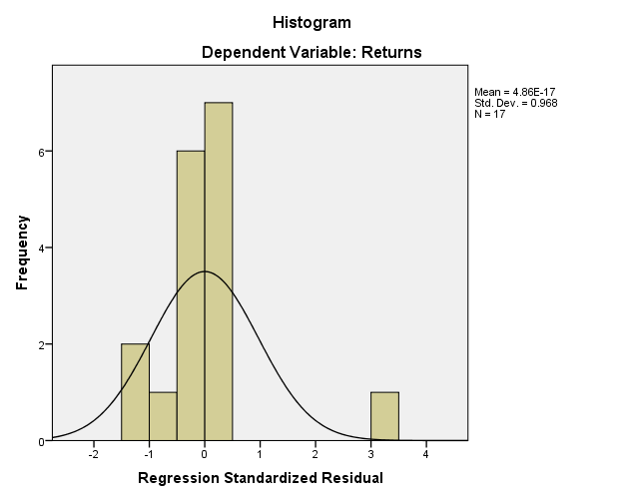

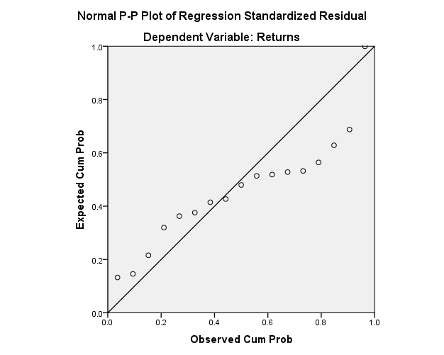

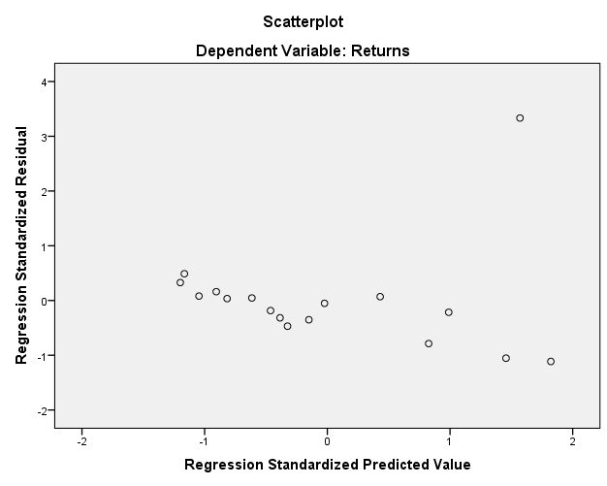

**Low-MCap, 5yr**

|  |  |  |  |
| --- | --- | --- | --- |
| **Descriptive Statistics** | | | |
|  | Mean | Std. Deviation | N |
| Returns | 1.8712 | 2.97977 | 17 |
| MCap | 92.265 | 36.1530 | 17 |

|  |  |  |  |
| --- | --- | --- | --- |
| **Correlations** | | | |
|  | | Returns | MCap |
| Pearson Correlation | Returns | 1.000 | -.475 |
| MCap | -.475 | 1.000 |
| Sig. (1-tailed) | Returns | . | .027 |
| MCap | .027 | . |
| N | Returns | 17 | 17 |
| MCap | 17 | 17 |

|  |  |  |  |
| --- | --- | --- | --- |
| **Variables Entered/Removeda** | | | |
| Model | Variables Entered | Variables Removed | Method |
| 1 | MCapb | . | Enter |
| a. Dependent Variable: Returns | | | |
| b. All requested variables entered. | | | |

|  |  |  |  |  |
| --- | --- | --- | --- | --- |
| **Model Summaryb** | | | | |
| Model | R | R Square | Adjusted R Square | Std. Error of the Estimate |
| 1 | .475a | .225 | .174 | 2.70865 |
| a. Predictors: (Constant), MCap | | | | |
| b. Dependent Variable: Returns | | | | |

|  |  |  |  |  |  |  |
| --- | --- | --- | --- | --- | --- | --- |
| **ANOVAa** | | | | | | |
| Model | | Sum of Squares | df | Mean Square | F | Sig. |
| 1 | Regression | 32.012 | 1 | 32.012 | 4.363 | .054b |
| Residual | 110.052 | 15 | 7.337 |  |  |
| Total | 142.064 | 16 |  |  |  |
| a. Dependent Variable: Returns | | | | | | |
| b. Predictors: (Constant), MCap | | | | | | |

|  |  |  |  |  |  |  |  |  |
| --- | --- | --- | --- | --- | --- | --- | --- | --- |
| **Coefficientsa** | | | | | | | | |
| Model | | Unstandardized Coefficients | | Standardized Coefficients | t | Sig. | 95.0% Confidence Interval for B | |
| B | Std. Error | Beta | Lower Bound | Upper Bound |
| 1 | (Constant) | 5.481 | 1.849 |  | 2.965 | .010 | 1.540 | 9.422 |
| MCap | -.039 | .019 | -.475 | -2.089 | .054 | -.079 | .001 |
| a. Dependent Variable: Returns | | | | | | | | |

|  |  |  |  |  |  |
| --- | --- | --- | --- | --- | --- |
| **Residuals Statisticsa** | | | | | |
|  | Minimum | Maximum | Mean | Std. Deviation | N |
| Predicted Value | .1757 | 4.4481 | 1.8712 | 1.41449 | 17 |
| Residual | -2.82813 | 8.89790 | .00000 | 2.62264 | 17 |
| Std. Predicted Value | -1.199 | 1.822 | .000 | 1.000 | 17 |
| Std. Residual | -1.044 | 3.285 | .000 | .968 | 17 |
| a. Dependent Variable: Returns | | | | | |

**Charts**

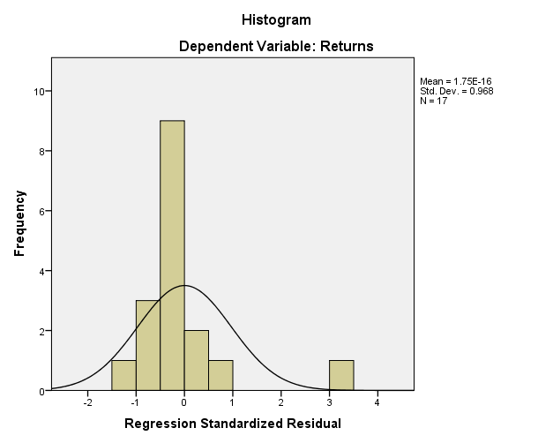

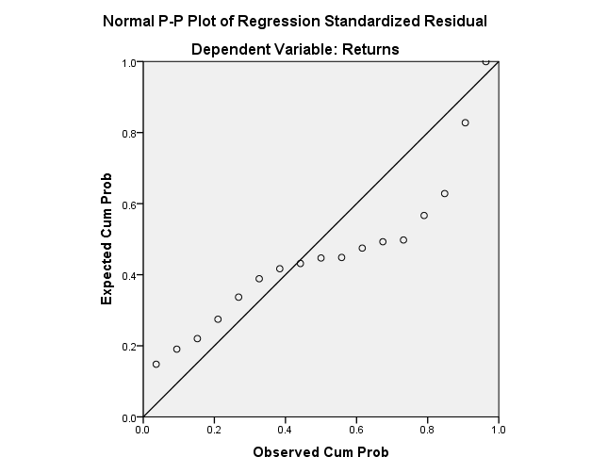

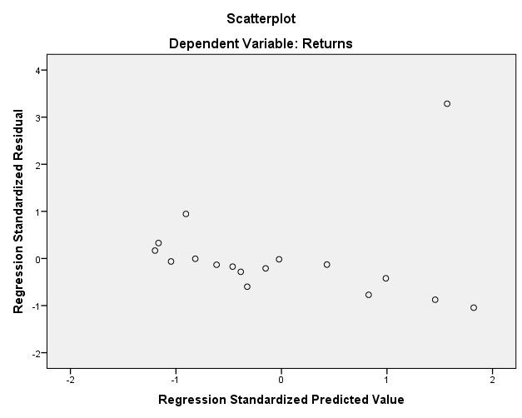

**Low MCap – return, 10 yr**

|  |  |  |  |
| --- | --- | --- | --- |
| **Descriptive Statistics** | | | |
|  | Mean | Std. Deviation | N |
| Returns | 8.7976 | 12.84185 | 17 |
| MCap | 92.265 | 36.1530 | 17 |

|  |  |  |  |
| --- | --- | --- | --- |
| **Correlations** | | | |
|  | | Returns | MCap |
| Pearson Correlation | Returns | 1.000 | -.264 |
| MCap | -.264 | 1.000 |
| Sig. (1-tailed) | Returns | . | .153 |
| MCap | .153 | . |
| N | Returns | 17 | 17 |
| MCap | 17 | 17 |

|  |  |  |  |
| --- | --- | --- | --- |
| **Variables Entered/Removeda** | | | |
| Model | Variables Entered | Variables Removed | Method |
| 1 | MCapb | . | Enter |
| a. Dependent Variable: Returns | | | |
| b. All requested variables entered. | | | |

|  |  |  |  |  |
| --- | --- | --- | --- | --- |
| **Model Summaryb** | | | | |
| Model | R | R Square | Adjusted R Square | Std. Error of the Estimate |
| 1 | .264a | .070 | .008 | 12.79122 |
| a. Predictors: (Constant), MCap | | | | |
| b. Dependent Variable: Returns | | | | |

|  |  |  |  |  |  |  |
| --- | --- | --- | --- | --- | --- | --- |
| **ANOVAa** | | | | | | |
| Model | | Sum of Squares | df | Mean Square | F | Sig. |
| 1 | Regression | 184.379 | 1 | 184.379 | 1.127 | .305b |
| Residual | 2454.230 | 15 | 163.615 |  |  |
| Total | 2638.609 | 16 |  |  |  |
| a. Dependent Variable: Returns | | | | | | |
| b. Predictors: (Constant), MCap | | | | | | |

|  |  |  |  |  |  |  |  |  |
| --- | --- | --- | --- | --- | --- | --- | --- | --- |
| **Coefficientsa** | | | | | | | | |
| Model | | Unstandardized Coefficients | | Standardized Coefficients | t | Sig. | 95.0% Confidence Interval for B | |
| B | Std. Error | Beta | Lower Bound | Upper Bound |
| 1 | (Constant) | 17.461 | 8.731 |  | 2.000 | .064 | -1.148 | 36.070 |
| MCap | -.094 | .088 | -.264 | -1.062 | .305 | -.282 | .095 |
| a. Dependent Variable: Returns | | | | | | | | |

|  |  |  |  |  |  |
| --- | --- | --- | --- | --- | --- |
| **Residuals Statisticsa** | | | | | |
|  | Minimum | Maximum | Mean | Std. Deviation | N |
| Predicted Value | 4.7286 | 14.9821 | 8.7976 | 3.39466 | 17 |
| Residual | -11.84214 | 39.96416 | .00000 | 12.38505 | 17 |
| Std. Predicted Value | -1.199 | 1.822 | .000 | 1.000 | 17 |
| Std. Residual | -.926 | 3.124 | .000 | .968 | 17 |
| a. Dependent Variable: Returns | | | | | |

**Charts**

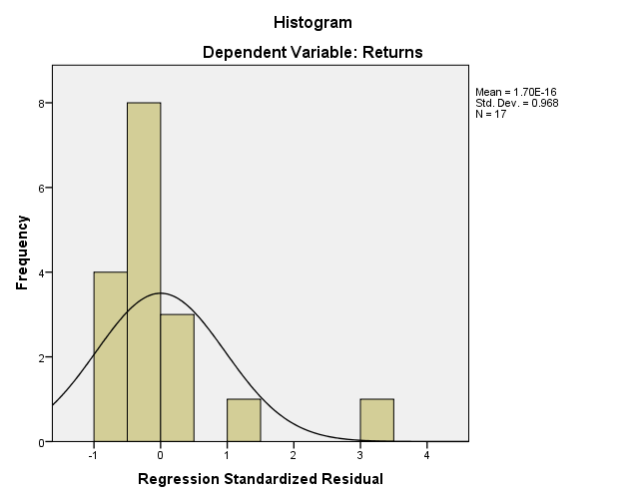

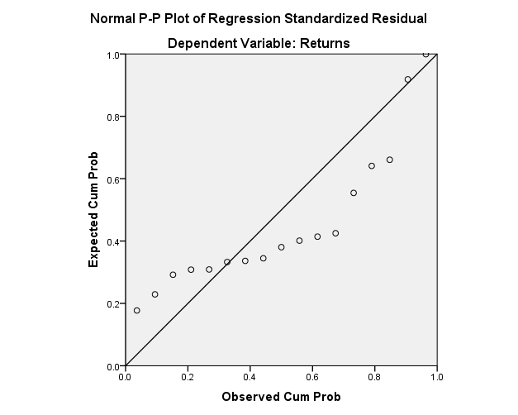

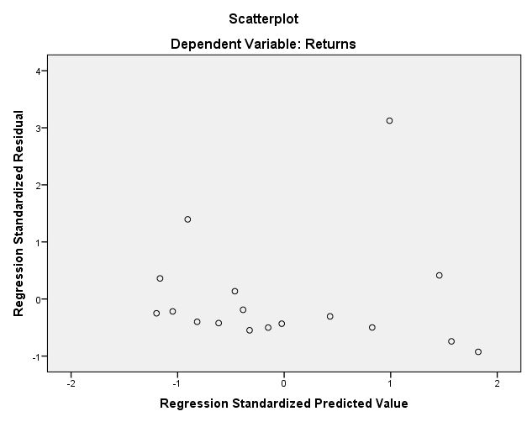

**High MCap, 1yr**

|  |  |  |  |
| --- | --- | --- | --- |
| **Descriptive Statistics** | | | |
|  | Mean | Std. Deviation | N |
| Returns | -.2806 | .27250 | 17 |
| MCap | 878.824 | 496.3195 | 17 |

|  |  |  |  |
| --- | --- | --- | --- |
| **Correlations** | | | |
|  | | Returns | MCap |
| Pearson Correlation | Returns | 1.000 | .139 |
| MCap | .139 | 1.000 |
| Sig. (1-tailed) | Returns | . | .297 |
| MCap | .297 | . |
| N | Returns | 17 | 17 |
| MCap | 17 | 17 |

|  |  |  |  |
| --- | --- | --- | --- |
| **Variables Entered/Removeda** | | | |
| Model | Variables Entered | Variables Removed | Method |
| 1 | MCapb | . | Enter |
| a. Dependent Variable: Returns | | | |
| b. All requested variables entered. | | | |

|  |  |  |  |  |
| --- | --- | --- | --- | --- |
| **Model Summaryb** | | | | |
| Model | R | R Square | Adjusted R Square | Std. Error of the Estimate |
| 1 | .139a | .019 | -.046 | .27869 |
| a. Predictors: (Constant), MCap | | | | |
| b. Dependent Variable: Returns | | | | |

|  |  |  |  |  |  |  |
| --- | --- | --- | --- | --- | --- | --- |
| **ANOVAa** | | | | | | |
| Model | | Sum of Squares | df | Mean Square | F | Sig. |
| 1 | Regression | .023 | 1 | .023 | .297 | .594b |
| Residual | 1.165 | 15 | .078 |  |  |
| Total | 1.188 | 16 |  |  |  |
| a. Dependent Variable: Returns | | | | | | |
| b. Predictors: (Constant), MCap | | | | | | |

|  |  |  |  |  |  |  |  |  |
| --- | --- | --- | --- | --- | --- | --- | --- | --- |
| **Coefficientsa** | | | | | | | | |
| Model | | Unstandardized Coefficients | | Standardized Coefficients | t | Sig. | 95.0% Confidence Interval for B | |
| B | Std. Error | Beta | Lower Bound | Upper Bound |
| 1 | (Constant) | -.348 | .141 |  | -2.473 | .026 | -.648 | -.048 |
| MCap | 7.653E-5 | .000 | .139 | .545 | .594 | .000 | .000 |
| a. Dependent Variable: Returns | | | | | | | | |

|  |  |  |  |  |  |
| --- | --- | --- | --- | --- | --- |
| **Residuals Statisticsa** | | | | | |
|  | Minimum | Maximum | Mean | Std. Deviation | N |
| Predicted Value | -.3205 | -.1999 | -.2806 | .03798 | 17 |
| Residual | -.43612 | .49352 | .00000 | .26984 | 17 |
| Std. Predicted Value | -1.050 | 2.124 | .000 | 1.000 | 17 |
| Std. Residual | -1.565 | 1.771 | .000 | .968 | 17 |
| a. Dependent Variable: Returns | | | | | |

**Charts**

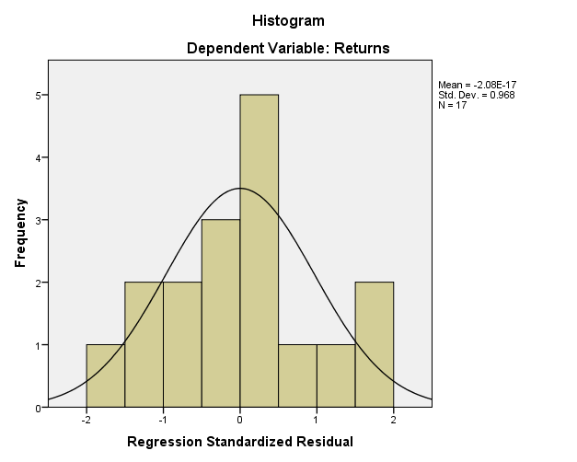

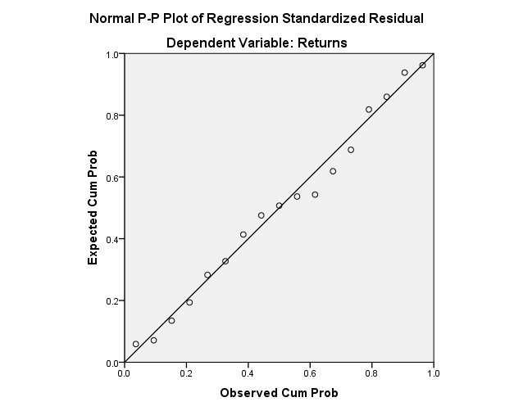

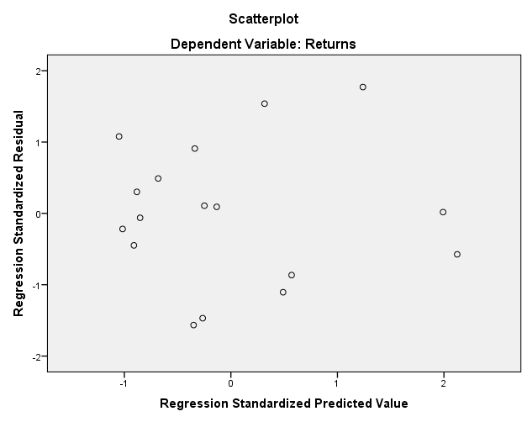

**High MCap, 2yr**

|  |  |  |  |
| --- | --- | --- | --- |
| **Descriptive Statistics** | | | |
|  | Mean | Std. Deviation | N |
| Returns | -.0671 | .28644 | 17 |
| MCap | 878.824 | 496.3195 | 17 |

|  |  |  |  |
| --- | --- | --- | --- |
| **Correlations** | | | |
|  | | Returns | MCap |
| Pearson Correlation | Returns | 1.000 | -.077 |
| MCap | -.077 | 1.000 |
| Sig. (1-tailed) | Returns | . | .385 |
| MCap | .385 | . |
| N | Returns | 17 | 17 |
| MCap | 17 | 17 |

|  |  |  |  |
| --- | --- | --- | --- |
| **Variables Entered/Removeda** | | | |
| Model | Variables Entered | Variables Removed | Method |
| 1 | MCapb | . | Enter |
| a. Dependent Variable: Returns | | | |
| b. All requested variables entered. | | | |

|  |  |  |  |  |
| --- | --- | --- | --- | --- |
| **Model Summaryb** | | | | |
| Model | R | R Square | Adjusted R Square | Std. Error of the Estimate |
| 1 | .077a | .006 | -.060 | .29496 |
| a. Predictors: (Constant), MCap | | | | |
| b. Dependent Variable: Returns | | | | |

|  |  |  |  |  |  |  |
| --- | --- | --- | --- | --- | --- | --- |
| **ANOVAa** | | | | | | |
| Model | | Sum of Squares | df | Mean Square | F | Sig. |
| 1 | Regression | .008 | 1 | .008 | .089 | .770b |
| Residual | 1.305 | 15 | .087 |  |  |
| Total | 1.313 | 16 |  |  |  |
| a. Dependent Variable: Returns | | | | | | |
| b. Predictors: (Constant), MCap | | | | | | |

|  |  |  |  |  |  |  |  |  |
| --- | --- | --- | --- | --- | --- | --- | --- | --- |
| **Coefficientsa** | | | | | | | | |
| Model | | Unstandardized Coefficients | | Standardized Coefficients | t | Sig. | 95.0% Confidence Interval for B | |
| B | Std. Error | Beta | Lower Bound | Upper Bound |
| 1 | (Constant) | -.028 | .149 |  | -.189 | .852 | -.346 | .289 |
| MCap | -4.420E-5 | .000 | -.077 | -.298 | .770 | .000 | .000 |
| a. Dependent Variable: Returns | | | | | | | | |

|  |  |  |  |  |  |
| --- | --- | --- | --- | --- | --- |
| **Residuals Statisticsa** | | | | | |
|  | Minimum | Maximum | Mean | Std. Deviation | N |
| Predicted Value | -.1137 | -.0440 | -.0671 | .02194 | 17 |
| Residual | -.43291 | .39424 | .00000 | .28560 | 17 |
| Std. Predicted Value | -2.124 | 1.050 | .000 | 1.000 | 17 |
| Std. Residual | -1.468 | 1.337 | .000 | .968 | 17 |
| a. Dependent Variable: Returns | | | | | |

**Charts**

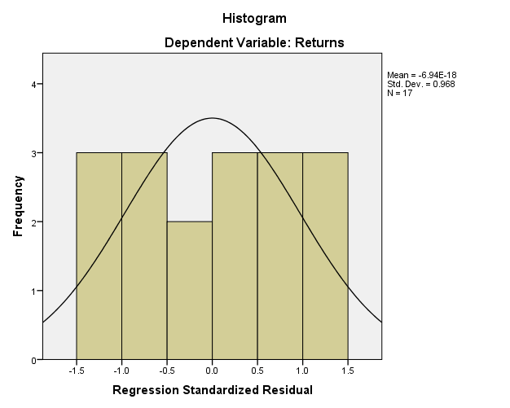

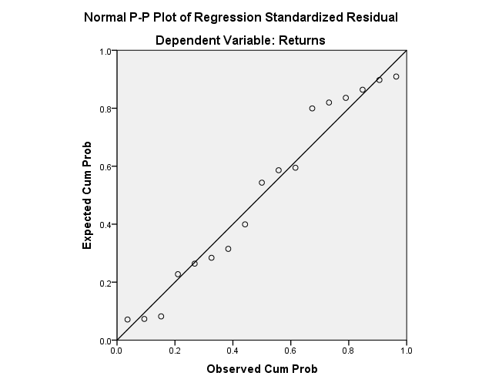

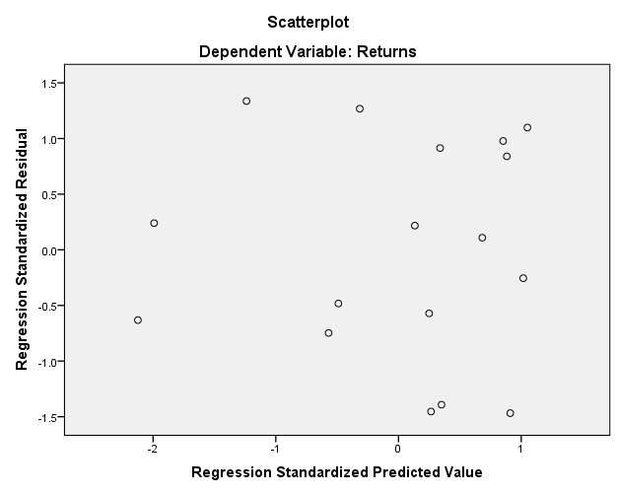

**High MCap, 3y**

|  |  |  |  |
| --- | --- | --- | --- |
| **Descriptive Statistics** | | | |
|  | Mean | Std. Deviation | N |
| Returns | .3241 | .51163 | 17 |
| MCap | 878.824 | 496.3195 | 17 |

|  |  |  |  |
| --- | --- | --- | --- |
| **Correlations** | | | |
|  | | Returns | MCap |
| Pearson Correlation | Returns | 1.000 | -.320 |
| MCap | -.320 | 1.000 |
| Sig. (1-tailed) | Returns | . | .105 |
| MCap | .105 | . |
| N | Returns | 17 | 17 |
| MCap | 17 | 17 |

|  |  |  |  |
| --- | --- | --- | --- |
| **Variables Entered/Removeda** | | | |
| Model | Variables Entered | Variables Removed | Method |
| 1 | MCapb | . | Enter |
| a. Dependent Variable: Returns | | | |
| b. All requested variables entered. | | | |

|  |  |  |  |  |
| --- | --- | --- | --- | --- |
| **Model Summaryb** | | | | |
| Model | R | R Square | Adjusted R Square | Std. Error of the Estimate |
| 1 | .320a | .103 | .043 | .50057 |
| a. Predictors: (Constant), MCap | | | | |
| b. Dependent Variable: Returns | | | | |

|  |  |  |  |  |  |  |
| --- | --- | --- | --- | --- | --- | --- |
| **ANOVAa** | | | | | | |
| Model | | Sum of Squares | df | Mean Square | F | Sig. |
| 1 | Regression | .430 | 1 | .430 | 1.715 | .210b |
| Residual | 3.759 | 15 | .251 |  |  |
| Total | 4.188 | 16 |  |  |  |
| a. Dependent Variable: Returns | | | | | | |
| b. Predictors: (Constant), MCap | | | | | | |

|  |  |  |  |  |  |  |  |  |
| --- | --- | --- | --- | --- | --- | --- | --- | --- |
| **Coefficientsa** | | | | | | | | |
| Model | | Unstandardized Coefficients | | Standardized Coefficients | t | Sig. | 95.0% Confidence Interval for B | |
| B | Std. Error | Beta | Lower Bound | Upper Bound |
| 1 | (Constant) | .614 | .253 |  | 2.431 | .028 | .076 | 1.153 |
| MCap | .000 | .000 | -.320 | -1.309 | .210 | -.001 | .000 |
| a. Dependent Variable: Returns | | | | | | | | |

|  |  |  |  |  |  |
| --- | --- | --- | --- | --- | --- |
| **Residuals Statisticsa** | | | | | |
|  | Minimum | Maximum | Mean | Std. Deviation | N |
| Predicted Value | -.0239 | .4962 | .3241 | .16387 | 17 |
| Residual | -.73148 | 1.13618 | .00000 | .48468 | 17 |
| Std. Predicted Value | -2.124 | 1.050 | .000 | 1.000 | 17 |
| Std. Residual | -1.461 | 2.270 | .000 | .968 | 17 |
| a. Dependent Variable: Returns | | | | | |

**Charts**

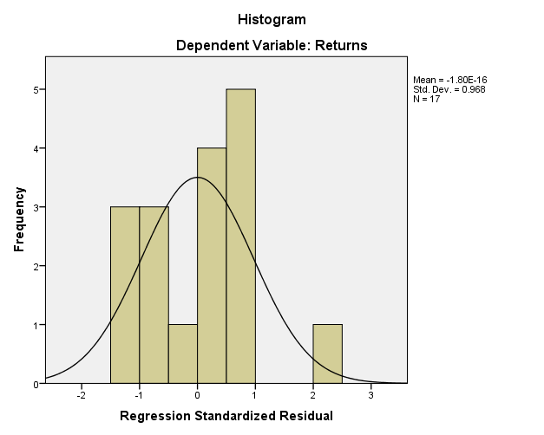

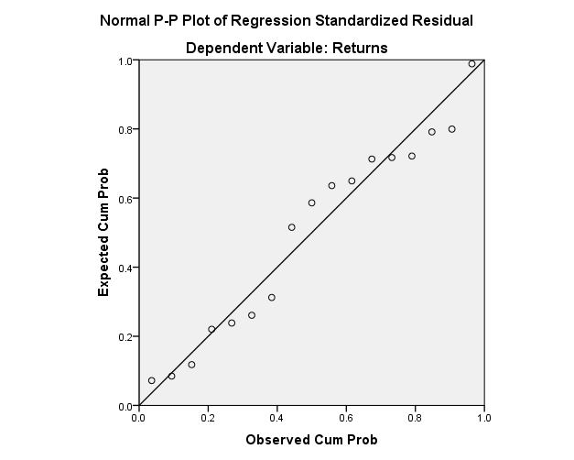

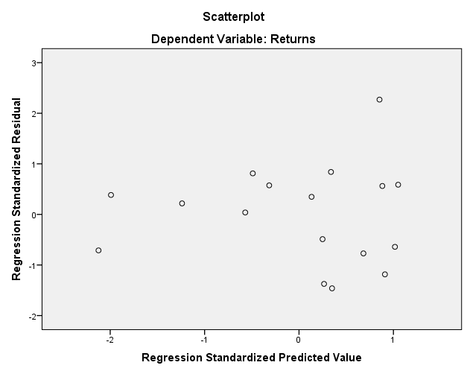

**High MCap, 5y**

|  |  |  |  |
| --- | --- | --- | --- |
| **Descriptive Statistics** | | | |
|  | Mean | Std. Deviation | N |
| Returns | .9188 | .95846 | 17 |
| MCap | 878.824 | 496.3195 | 17 |

|  |  |  |  |
| --- | --- | --- | --- |
| **Correlations** | | | |
|  | | Returns | MCap |
| Pearson Correlation | Returns | 1.000 | .014 |
| MCap | .014 | 1.000 |
| Sig. (1-tailed) | Returns | . | .479 |
| MCap | .479 | . |
| N | Returns | 17 | 17 |
| MCap | 17 | 17 |

|  |  |  |  |
| --- | --- | --- | --- |
| **Variables Entered/Removeda** | | | |
| Model | Variables Entered | Variables Removed | Method |
| 1 | MCapb | . | Enter |
| a. Dependent Variable: Returns | | | |
| b. All requested variables entered. | | | |

|  |  |  |  |  |
| --- | --- | --- | --- | --- |
| **Model Summaryb** | | | | |
| Model | R | R Square | Adjusted R Square | Std. Error of the Estimate |
| 1 | .014a | .000 | -.066 | .98980 |
| a. Predictors: (Constant), MCap | | | | |
| b. Dependent Variable: Returns | | | | |

|  |  |  |  |  |  |  |
| --- | --- | --- | --- | --- | --- | --- |
| **ANOVAa** | | | | | | |
| Model | | Sum of Squares | df | Mean Square | F | Sig. |
| 1 | Regression | .003 | 1 | .003 | .003 | .957b |
| Residual | 14.695 | 15 | .980 |  |  |
| Total | 14.698 | 16 |  |  |  |
| a. Dependent Variable: Returns | | | | | | |
| b. Predictors: (Constant), MCap | | | | | | |

|  |  |  |  |  |  |  |  |  |
| --- | --- | --- | --- | --- | --- | --- | --- | --- |
| **Coefficientsa** | | | | | | | | |
| Model | | Unstandardized Coefficients | | Standardized Coefficients | t | Sig. | 95.0% Confidence Interval for B | |
| B | Std. Error | Beta | Lower Bound | Upper Bound |
| 1 | (Constant) | .895 | .500 |  | 1.792 | .093 | -.170 | 1.960 |
| MCap | 2.705E-5 | .000 | .014 | .054 | .957 | -.001 | .001 |
| a. Dependent Variable: Returns | | | | | | | | |

|  |  |  |  |  |  |
| --- | --- | --- | --- | --- | --- |
| **Residuals Statisticsa** | | | | | |
|  | Minimum | Maximum | Mean | Std. Deviation | N |
| Predicted Value | .9047 | .9473 | .9188 | .01343 | 17 |
| Residual | -1.48412 | 2.14296 | .00000 | .95837 | 17 |
| Std. Predicted Value | -1.050 | 2.124 | .000 | 1.000 | 17 |
| Std. Residual | -1.499 | 2.165 | .000 | .968 | 17 |
| a. Dependent Variable: Returns | | | | | |

**Charts**

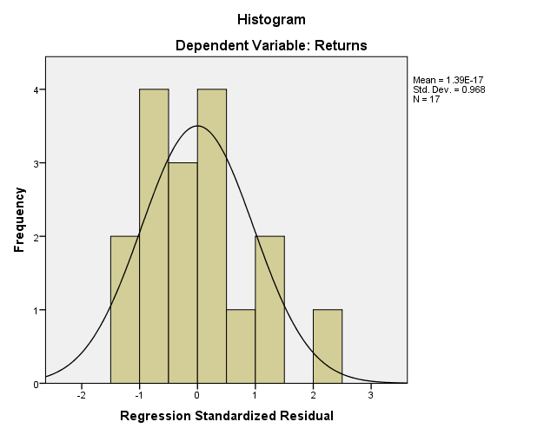

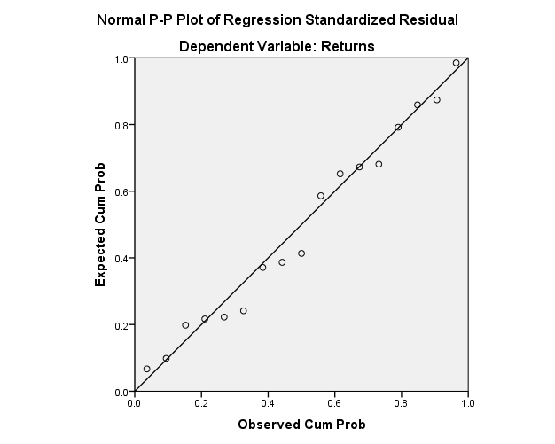

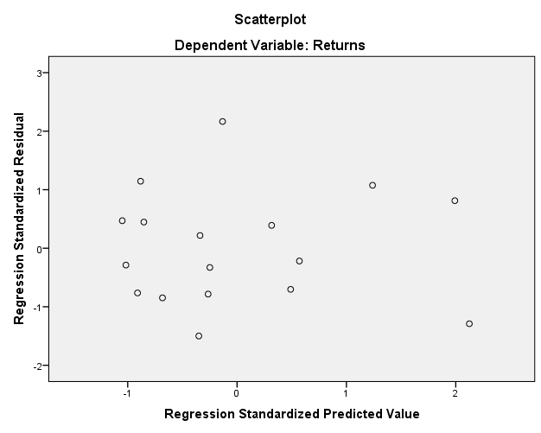

**High MCap, 10y**

|  |  |  |  |
| --- | --- | --- | --- |
| **Descriptive Statistics** | | | |
|  | Mean | Std. Deviation | N |
| Returns | 3.5135 | 5.57222 | 17 |
| MCap | 878.824 | 496.3195 | 17 |

|  |  |  |  |
| --- | --- | --- | --- |
| **Correlations** | | | |
|  | | Returns | MCap |
| Pearson Correlation | Returns | 1.000 | .174 |
| MCap | .174 | 1.000 |
| Sig. (1-tailed) | Returns | . | .253 |
| MCap | .253 | . |
| N | Returns | 17 | 17 |
| MCap | 17 | 17 |

|  |  |  |  |
| --- | --- | --- | --- |
| **Variables Entered/Removeda** | | | |
| Model | Variables Entered | Variables Removed | Method |
| 1 | MCapb | . | Enter |
| a. Dependent Variable: Returns | | | |
| b. All requested variables entered. | | | |

|  |  |  |  |  |
| --- | --- | --- | --- | --- |
| **Model Summaryb** | | | | |
| Model | R | R Square | Adjusted R Square | Std. Error of the Estimate |
| 1 | .174a | .030 | -.035 | 5.66756 |
| a. Predictors: (Constant), MCap | | | | |
| b. Dependent Variable: Returns | | | | |

|  |  |  |  |  |  |  |
| --- | --- | --- | --- | --- | --- | --- |
| **ANOVAa** | | | | | | |
| Model | | Sum of Squares | df | Mean Square | F | Sig. |
| 1 | Regression | 14.976 | 1 | 14.976 | .466 | .505b |
| Residual | 481.818 | 15 | 32.121 |  |  |
| Total | 496.795 | 16 |  |  |  |
| a. Dependent Variable: Returns | | | | | | |
| b. Predictors: (Constant), MCap | | | | | | |

|  |  |  |  |  |  |  |  |  |
| --- | --- | --- | --- | --- | --- | --- | --- | --- |
| **Coefficientsa** | | | | | | | | |
| Model | | Unstandardized Coefficients | | Standardized Coefficients | t | Sig. | 95.0% Confidence Interval for B | |
| B | Std. Error | Beta | Lower Bound | Upper Bound |
| 1 | (Constant) | 1.800 | 2.861 |  | .629 | .539 | -4.297 | 7.898 |
| MCap | .002 | .003 | .174 | .683 | .505 | -.004 | .008 |
| a. Dependent Variable: Returns | | | | | | | | |

|  |  |  |  |  |  |
| --- | --- | --- | --- | --- | --- |
| **Residuals Statisticsa** | | | | | |
|  | Minimum | Maximum | Mean | Std. Deviation | N |
| Predicted Value | 2.4977 | 5.5684 | 3.5135 | .96748 | 17 |
| Residual | -5.65845 | 14.22264 | .00000 | 5.48759 | 17 |
| Std. Predicted Value | -1.050 | 2.124 | .000 | 1.000 | 17 |
| Std. Residual | -.998 | 2.509 | .000 | .968 | 17 |
| a. Dependent Variable: Returns | | | | | |

**Charts**

