INTI INTERNATIONAL UNIVERSITY

MASTER OF BUSINESS ADMINISTRATION

EMPLOYEE SATISFACTION IN SME ORGANIZATION SELANGOR, MALAYSIA

Author: Veeshalan a/l Ravichandran

Student No: I11007348

Supervisor: Miss Umi Klasom

Submission Date: 14 AUGUST 2018

Ethics Number: cBUS / PGT/ CP/ 03681

Final Word Count: 20056

FACULTY OF BUSINESS COMMNUNICATION AND LAW

Acknowledgment
I would like to take this opportunity to thank the people who gave me advice, guidance and suggestion in helping me throughout this project.
Firstly, I wish to thank my supervisor, Miss Umi Klasom, for giving me unwavering support and guidance throughout this project. Her effort and knowledge given to me have helped me a lot in carrying out my research project. I also appreciate her patience in reviewing my work to improve the quality of my research project even though she was very busy with many things. Her insights and ideas were extremely precious and helpful to me. Furthermore, I would also like to thank all the participants who were willing to spend their precious time in helping me to fill out the questionnaires patiently. I would also like to thank the library staffs that have been helpful in obtaining articles and research method book for me through the duration of the project. Lastly, I would also like to express my gratitude to my family who have given me moral support throughout this project. Because without them, I would not be able to finish my research project successfully.

DECLARATION BY CANDIATE

I hereby declare that this thesis is my own work and effort and that it has not been submitted anywhere for any award. Where other sources of information have been used, they have been duly acknowledged.

Name : Veeshalan a/l Ravichandran
Student ID : I11007348
Signature : 
Date : 14 AUGUST 2018

Abstract
Employee Satisfaction among SME organization is an important aspect due to the high turnover rate every year. The three factors for this study are compensation, working environment, employee engagement relationship with employee satisfaction. The geographic focus of the study is in SME industry of Selangor Malaysia, and the unit analysis for this study is the employees in SME industry who are working in Selangor Malaysia. This research is a cross-sectional study using quantitative methods based on descriptive research. Questionnaires are distributed online to the respondents and there are 200 usable responses collected could be used. Convenience sampling is used in this study and the questionnaires are adapted from previous studies.
Based on the findings, the results showed that there were three variables being tested which were compensation, working environment, employee engagement while two were found to be significant variables which were compensation, working environment, and are thus supported, whereas employee engagement could not be supported.

Paper type: Research Paper

Key Words: Employee Satisfaction, compensation, worming environment, employee engagement.
Table of Content PAGE NUMBER
- Overview…………………………………………………………………………..........8
1.1 Background………………………………………………………………………..........9
1.2 Problem Statement……………………………………………………………….....10 & 11
1.3 Research Objectives……………………………………………………………..........12
1.4 Research Question……………………………………………………………………..13
1.5 Scope of Study…………………………………………………………………………..14
1.6 Significance………………………………………………………………………………15
1.7 Limitation………………………………………………………………………………….16
1.8 Operational Definition…………………………………………………………………….17
1.9 Organizational Chapter…………………………………………………………………...18
2.0 Chapter 2 Overview………………………………………………………………………..19
2.1 Phenomenon Understudy (DV)…………………………………………………………..20
2.1.1 EMPLOYEE SATISAFCTION ON GLOBAL………………………………… 21 & 22
2.1.2 EMPLOYEE SATISFACTION MALAYSIA…………………………………... 23 & 24
2.2 Influences (IV)………………………………………………………………………… 25
2.2.1 Job Satisfaction………………………………………………………………… 26 & 27
2.2.2 Working Environment……………………………………………………….. 28 & 29
2.2.3 Employee Engagement……………………………………………………….. 30 & 31
2.3 DV and IV Linkage………………………………………………………………. 32
2.3. Job Satisfaction & Employee Satisfaction Link……………………………. 33 & 34
2.3.2 Working environment & Employee satisfaction Link……………………. 35 & 36
2.3.3 Employee engagement & Employee satisfaction Link …………………. 37 & 38
2.4 Social Exchange theory ……………………………………………………… 39 & 40
2.5 Framework……………………………………………………………………….. 41
2.6 Hypothesis……………………………………………………………………… 42
2.7 Chapter Conclusion………………………………………………………………….. 43
3.0 Overview……………………………………………………………………….. 44
3.1 Research Design ………………………………………………… 45 & 46
3.2 Sampling Design………………………………………………………………. 46
- 3.2.1 Population Under Study……………………………………………………….46
- 3.2.2 Sampling Plan…………………………………………………………………..47
- 3.2.3 Sampling Size …………………………………………………………………..47
- 3.2.5 Unit Analysis……………………………………………………………………..47
3.3 Questionnaire design………………………………………………………………… 48
- 3.3.1 Data Collection for Correlation study………………………………………48
- 3.3.2 Questionnaire Design ……………………………………………………….49
- 3.3.3 Summary of Questionnaire Table…………………………………………..49
3.4 Measurement of Study…………………………………………………… 50 & 51 & 52
- 3.4.1 Pilot Test
- 3.4.1.1 KMO Test
- 3.4.1.2 Communalities
- 3.4.1.3 Eigenvalues Analysis
- 3.4.1.4 Reliability Test
- 3.4.2 Demographic Profile
- 3.4.3 Preliminary test
- 3.4.4 Hypothesis testing
- 3.4.4.1 Simple multiple regression
- 3.4.4.2 ANOVA
3.5 Ethical Consideration……………………………………………………………………53
3.6 Conclusion………………………………………………………………………………...53
4.0 Chapter 4 Overview……………………………………………………………………...54
4.1 Pilot Test……………………………………………………………………. 55 & 56
4.2 Demographic Analysis…………………………………………………….. 57 & 59
4.3 Preliminary Test…………………………………………………………… 60 & 64
4.4 Hypotheses Testing………………………………………………………. 64 & 67
4.5 Chapter Conclusion…………………………………………………………………….67
5.0 Overview…………………………………………………………………………………68
5.1 Recommendation……………………………………………………………… 69 & 70
5.2 Contribution to Academic…………………………………………………..................71
5.3 Contribution to industry…………………………………………………………………71
5.4 Limitation………………………………………………………………………………….72
5.5 Future Research………………………………………………………………………….72
5.6 Personnel Reflection……………………………………………………………………..73
5.7 Conclusion………………………………………………………………………………….74
References…………………………………………………………………………….... 75 & 79
Appendix
- Turnitin……………………………………………………………………………….80
- Sample Questionnaire………………………………………………………… 81 & 82
- Research Proposal……………………………………………………………. 83 & 88
- Project Log…………………………………………………………………….. 89 & 90
- Weekly log…………………………………………………………………….. 91 & 95
- EC1A……………………………………………………………………… 96 & 105
- EC3……………………………………………………………………….. 106 & 107
- EC6………………………………………………………………………. 108 & 111
- EC7……………………………………………………………………… 112 & 113

1.0 Overview
This chapter will be the introduction into my research paper and it will start with an overview of my topic of research. Here the focus will be on the research background where I will explain the motive and explanation behind this research. I will explain the introduction and the main fundamental problem linking it into my research statement. After doing this I will explain and elaborate my problem statement and explaining the objectives of this research. Moreover, I will also go in detail into the development of the research question and focusing on the scope of study and significance. I will also explain the limitation of this this research as well. Finally, this chapter concludes with operational definition and summary of the whole chapters.

1.1 Research Background
Ceylan & Aydin (2012) firm now days must utilize their employee to maximum of their productivity so that the organization can remain competitive in the market. This employee have the skills and abilities to contribute to the firm productivity and it closely associated with human resource management of the firm (Christina, 2013). This is supported by Obuobisa (2016) the concept of human resource management deals with the employee concept where the firm implement appropriate strategies so that employee can follow this strategies to help the organization reach the objectives.
The definition of employee satisfaction Ceylan & Aydin (2012) can be said has the reactional of different perceptions of person receive compared to what the person should receive. Moreover, firm must always ensure that appropriate measure is taken to satisfied employees (Saeed, Zehou, Hussain, et al., 2014). According to Sageer Rafat & Agarwal (2012) the employee emotional state may also impact the satisfaction and the firm must be able to create and sustain a good working environment in the organization.
Moreover Christina (2013) to help organization reach the objectives the key players are employees, so it is important that the firm motivate their employee so that employee is satisfied. According to Darko (2015) employee that are satisfied will be more loyal to the firm and will be more product
ve in their work. Moreover, employee that are satisfied especially will also have effect of customer satisfaction and the productivity of the organization (Obuobisa, 2016).
Moreover, the last few years new style of management working, and programs have been emerging so human resource now plays a very important role in this political, legal, technological and economic changes (Saeed et al., 2014). Moreover, the importance of human factor in the ever-changing environment is also becoming more important to the organization (Sageer et al., 2012). That why employee satisfaction is becoming very important to any business and organization out there because if the employee is happy the turnover rate is low thus the organization will be able to be more productive (Darko, 2015).
1.2 Problem Statement
According to Christina (2013) we are living in the era of Globalization and free trade between countries continue to change the business environment and competition have increase globally between firms. Firm who conduct business today Ceylan & Aydin (2012) to remain competitive must be able to cope with the changes that is happening around them to deliver satisfactory financial reward to the stakeholders. Furthermore, Malaysia is entering a phase of knowledge-based economy due to globalization and the challenges is forcing Malaysia towards the vital knowledge-based economy (Khalique, 2011).
It is important that Malaysia can shift the growth strategy from driven by input and towards the knowledge driven to achieve the 2020 vision of a developed nation but to do that it must also concentrate on the progress and development of firms around Malaysia (Haslinda, 2015). According to survey done by Job street (2018) currently 74% of Malaysia are not satisfied with their current job and there is various factor that are involved. Further supporting this The Star (2018) again almost 79% says that they are not satisfied with the job.
Haslinda (2015) the most important factor to employee satisfaction is the salary, working environment and employee engagement. This is further supported by Job street (2018) has the 74% respondent that are not satisfied now the main reason is salary followed by lack of engagement from employer. This shows that employee that are not satisfied will not be able to maximize their productivity fully has they are not satisfied.
Wei (2014) most employee that leave organization because they are not satisfied with the salary, training and development and engagement of employers. Khalique (2011) the area of employee satisfaction in Malaysia need to go broader has there are high number employee that are not satisfied. These factors Christina (2013) have greatly impact firm and employee that are not satisfied will never full reach their full potential and the organization will never be able to reach its full productivity.
Employee Satisfaction play a key role in any firm but more so in SME organization The Small and medium enterprises plays a very important role in basting in economy of Malaysia and can be considered as the main backbone of the development of the industrial in the country (Haslinda, 2015). According to Wei (2014) SME in Malaysia is slowly becoming one of the main contributors in the Malaysia economy has it is on track to contribute 41% worth of country GPD by 2020 compared to the 32% that it currently contributes and SME company now days are the core suppliers to MNC and GLC organization showing the world that SME can be penetrated the big market.
According to Khalique (2011) organization in Malaysia are facing major problem currently to the survival of the company has almost 50% percent of company been shut down within 5 years due to the competitive advantages from bigger organization. Moreover Wei (2014) losing skills workers is also reason why SME cannot remain competitive. Furthermore Haslinda (2015) almost 50% employee who leaves SME organization is due that they are not satisfied and most who choose to stay does not perform to their full productivity level.

1.3 Research Objectives
According to Nuessle (2013) research objectives are important has it set the primary area of the research and to gain a proper understanding of the environment that may affect the research and how to control the environment. My main purpose of this study is to examine compensation, working environment and employee engagement on employee satisfaction in SME organization in Selangor, Malaysia.
RO1: To examine the influence of compensation on employee satisfaction in SME organization in Selangor
RO2: To examine the influence of working environment on employee satisfaction in SME organization in Selangor
RO3: To examine the influence of employee engagement on employee satisfaction SME organization in Selangor

.

1.4 Research Question
According to Nuessle (2013) knowledge in this research will be able to generate a set of question and it is important that these questions must be answered during the research
RQ1: Does compensation influences employee satisfaction in SME organization in Selangor
RQ2: Does working environment influences employee satisfaction in SME organization in Selangor
RQ3: Does employee engagement influences employee satisfaction SME organization in Selangor

1.5 Scope of Study
This research will mainly focus on the factors that will influence employee satisfaction in SME organization in Selangor area. This will include all level of employees in the SME organization. This survey will only be conducted around Kajang and Puchong area due limited amount of time. Moreover, another reason for choosing this both area has I work in SME organization before in Puchong this will help me to distribute my questionnaire. Furthermore, for Kajang since I am resident in Kajang it will help me to distribute the questionnaire around that area. Most of this questionnaire will be handed out to SME organization in this 2-particular area.

1.6 Significance
This study is significance has is study the influence of employee satisfaction in SME organization in Selangor, Malaysia. Furthermore, at the end of this research SME will be able to fully understand the reason on why employee is not satisfied (Haslinda 2015). The main output for this research will help SME corporation to retain employees and ensure that they are satisfied (Khalique, 2011).
This researcher outcome enables SME organization human resource department to develop policy that will ensure employee are satisfied (Haslinda 2015). According to Saeed et.al (2014) employee that are satisfied will ensure that the firm is successful in the long run. Moreover if the SME organization wants to remain competitive it must be able retain talent and ensure that employees are satisfied (Khalique, 2011).

1.7 Limitation
This research paper had to be completed within the 3 months’ time frame so in this very short duration it was hard for me to cover all the relevant details about the employee satisfaction SME organization in Selangor and all the proper solutions behind it. Another problem would be the sample population itself as some respondents did not answer the questionnaire truthfully. So, it was hard as a researcher to reach out to most respondents. Finally, because this project had to be completed within 3 months’ time frame it was very hard for me to cover the whole of Selangor and the collection was only done around the Puchong area.

1.8 Operational definition
- Employee Satisfaction (Dependent Variable)
Employee satisfaction can be defined has the emotional state of a person that will result to the satisfaction level in an organization (Obuobisa, 2016). According Saeed et al., (2014) when it comes to the satisfaction level of the employee the various dimensions that need to be considered by the organization has it involves phycological factor
- Compensation (Independent Variable)
According to Gupta (2014) compensation can be considered has the output and the benefit that employees receives for working in the organization. This according to Adler & Ghiselli (2014) may include wages and some sort of rewards like exchanges in the monetary to increase the satisfaction of employees.
- Working Environment (Independent Variables)
Working environment refers to the surrounding and any other factor that affect employee from caring out their work efficiently (Kaur, 2014). According to Renah & Setyadi (2014) organization must provide good working environment is when all the essential facilities are there to help employee to maximize their output
- Employee Engagement (Independent Variables)
Employee Engagement is the strategic tools used by the organization to engage with employee (Bedarkar, Madhukar, Manainam et al., 2013). This tool is used has engine to ensure the communication process is there to ensure the effectiveness in the organization (Kaliannana & Narh Adjovu 2015).
- SME Organization (Context)
SME or small medium enterprise play a very important role in Malaysian economy and it is the backbone of development of industry (Haslinda, 2015). According to SME Malaysia it is slowing becoming one of the main contributor of Malaysia GDP.

1.9 Organizational Chapter
This research papers will be organized into 5 chapters which will include Introduction, literature review, methodology, finding, conclusion and recommendation. Each of this chapter will be connected to one and another so it will be structured systematically for a better understanding.
Following is the details
- Chapter 1: This chapter of research will be the introduction chapter which will begin background of this study and the research problems and research objectives will be explained. Furthermore, the scope, the limitation will also be explained for further understanding in the same chapter.
- Chapter 2: This chapter will contain the literature review and the appropriate argument on the area of the research. After that I will explain my dependent variable in a global and local perspective. Also, in this chapter I will explain my 3-independent variable based on the literature review after that explaining the model and finishing with the framework.
- Chapter 3: This chapter will introduce the methodology used in the paper outline. The research design and the framework are also highlighted in this chapter. Moreover, the sample size of the population will also be determined with sampling design and per unit explained. To conclude this chapter will be data collection and method used to analysis the data will discussed and explain at the end
- Chapter 4: The data analysis will be done by using the SPSS software. The result will then be generated wants the data is inserted the result will be presented in the table form. The first part will include demographic and hypothesis test. The second part will go into regression analysis that will be used to test the hypothesis statement.
- Chapter 5: The final chapter will conclude the result and recommendation and suggestion will be given before concluding this research.

2.0 Overview
The main objectives for this chapter is that I will review all the existing literature from year 2012 to 2017 this will include other researchers and theories that are included in my topic. I will then go into my Dependent Variable and explain in terms of Global and Local perceptive based on the literature review on theories and other researches. This will then lead to my DV and IV from global and local perspective here the first part will more to specific influences. The second part I will link both Dependent Variable and Independent variable together through literature in global and local perspective. After this I will link my Dependent Variable and my Independent variables together so that I can understand my grounded theory. Finally, after this is dome based on the literature review and the relevant finding that I have got will lead to the development of my framework.

2.1 Employee Satisfaction
According to Masood, Ain, Aslam et al., (2014) the definition of satisfaction is how the person feel about the job they are currently doing and some of this definition are the attitude in which the person satisfaction towards the job. This is supported Saeed et al., (2014) when it comes to the satisfaction level of the employee there are various dimensions that need to be considered. Employee Satisfaction can be the emotional state of a person resulting the appraisal of the satisfaction level of the employee in the organization (Obuobisa, 2016).
Furthermore Masood et al., (2014) the proposed satisfaction is the determination where part of it have discrepancies that result on the physiological process of the job appraisal. This employee appraisal will have based on the current job experience and how the standard compares to others out there (Obuobisa, 2016). The significant variables of the employee satisfaction will give a general estimation on employee thinking when it comes to the job and workplace (Nanjundeswaraswamy, 2014).

2.1.1 Global Perceptive on Employee Satisfaction
In the last few years Saeed et al., (2014) have highlighted working patters, new management working pattern have changed this is because of the political, technological and the changes in the economy. In the journal Sageer et al., (2012) from India stated that the main area for the Human Resource Management is to see the measurement of the employee satisfaction in the organization. According to Obuobisa (2016) the level of satisfaction can refer to a person fulfillment the needs and desire.
According to Sageer et al., (2012) this satisfaction level depends on the individual what it wants to get and what he gets in return. Employees satisfaction Darko (2015) say that it measures how happy is the worker with their job and the effectiveness of the organization that may affect the employee satisfaction. Organization that are effective ensure that employee is satisfied and happy by applying good culture (Saeed et al., 2014).
Sageer et al., (2012) happy employees ensure that allegiance and commitment to the organization this in turn will help improve the employee’s productivity and they will be less retention and absenteeism from work. This is further supported by Ariani (2012) employee is more productive because they are satisfied with working environment of the organization and employee work can improve the quality of productivity of the organization.
Some of the factors that can affect employee’s satisfaction are the leadership style according to Sageer et al., (2012). An effective leader can be defined as someone who is able to influence others to follow to achieve the desire goals and objectives according to Nanjundeswaraswamy (2014) that’s how the importance of leadership. It is further explained by Alkahtani (2016) leadership is a dynamic process that works with a group of people over a time and can influence other member to commit themselves to achieve a specific goals and objectives,
According to Sageer et al., (2012) democratic style leadership can greatly improve employee satisfaction has democratic leader promotes respect and have a warmth of relationship with among other employees of the organization in contrary to employees that are under dictatorial and authorial leaders. According to Obuobisa (2016) transformational leader can also have a positive effects of employee satisfaction has study shown here in the bank of Ghana show that this leadership style has a positive effect on employees.
Another factor on employee satisfaction can be related to management according Saeed et al., (2014) most of the top management people don’t really understand the needs and wants of the employee especially the supervisor whose roles is very important in determining the satisfaction of the employee itself. This furthers supported by Ariani (2012) has a good working relationship with the supervisor is essential at every level has supervisor can guide and employees a general understanding of their work.
Another factor is satisfaction with other employee to Saeed et al., (2014) the satisfaction level of employee can be greatly improved if there are understanding between the employee at work as the effects of close understanding and friendship is important in the employee satisfaction level. According to Obuobisa (2015) this social relationship with worker include working in group giving employee the opportunity to interact with the organization. This further supported by Sageer et.al (2012) has it is natural desire for people to interact with one and another has a team in the organization and if they are isolated this will mean that employees are not happy with the job they have will have a major influence in employee satisfaction.
Moreover, Saeed et al., (2014) another factor of employee satisfaction is the financial package that is given by the organization to the employees this can ensure the maximum satisfaction of the employees. Ariani (2012) says that salary and other benefits will ensure that employee enjoy their work as they are motivated to reach their objectives further improving employee satisfaction. Sageer et al., (2012) declared that the most important aspect in employee satisfaction are the benefit and compensation package, where employee must be satisfied with the salary package that is offered to them while comparing with other employees that are working in the same industry player as they will fell that the organization is fair to them. To conclude we can say that increase in employee satisfaction ensure that they are more productive, there are various factors such as working environment, pay, relationship with other employees will ensure successful organization (Saeed et al., 2014).
2.1.2 Employee Satisfaction in Malaysia
According to Munap, Izwan, & Rahman (2013) employee satisfaction is a remarkable area for discussion in the field of management which can be tied in with the organization behavior and human resource department and organization in Malaysia. Moreover, in Malaysia, organization must be able to take care of their employees from benefit and compensation packages to help boast employee motivation to work harder thus employee will be satisfied to work harder for the organization (Yusof, Misisran, & Harun 2014). Furthermore, in Malaysia according to Chin (2018) currently the employee turnover rate is very high because employee is not satisfied in the year 2014 it increases from 1.1. % to 14.2% and increased again the following year 2015 which was at 16.3% in the manufacturing sector in Malaysia and this business suffered as of this high turnover rate.
According to Yusof, Misisran, & Harun (2014) say that employee that are happy and satisfied will be able to maintain their productivity has they are able to perform to their fulfill the expectation of the organization This further supported by Munap et al., (2013) that says that fringe benefits like balance in work life, yearly bonus and health insurance are some of the benefit package provide by organization today, this shows that these benefit packages will encourage employee to worker harder and ensure that the organization target is met. The implementation of this system by the organization will be an incentive to the employee as they will feel that the organization is happy, and they are contributing their effort to the organization (Amalina & Teng 2017).
According to Munap et al., (2013) it is important that employee develop strategies that is appropriate to the employee job to increase their evaluation for larger distribution of salary within the organization. Moreover, in Malaysia Benrazavi & Silong (2013) says salary plays the most important factor in ensuring if the person is satisfied or not and willing to get extra effort in ensuring the success of the organization. Furthermore Chin (2018) says salary also plays a key role in Malaysia has employee take this into consideration if to stay or leave the organization and their satisfaction level can be measured precisely.
In the journal of Munap et al., (2013) on the study carried in Telekom Malaysia shows that employee that are working there will just walk out from the company if they are not satisfied with the payment given as they say it not equal. This is different from UNILEVER organization where the organization have implemented that a good reward system will create a positive relationship with satisfaction and motivation level of the employee thus benefiting the organization in the long run (Chin 2018). The implementation of a good reward system by the organization will be an incentive to the employees has they will feel that the organization is happy, and they are contributing skills and productivity to the organization (Amalina & Teng 2017).
This shows that in Malaysia salary plays a key role in satisfaction level of employee salary according to Chin (2018) has it is one of the key concerns to employee and employers today. This salary packages plays a key role has employee look at their salary to satisfy their need and wants (Munap et al., 2013). Furthermore, if the employee is not satisfied they will influence their behavior and attitudes toward the organization has Amalina & Teng (2017) note that salary is one of the most important variable when come to determining the employee satisfaction and play key role in determining the company success.
According to Munap et al., (2013) if the organization benefit and compensation package is not designed properly it will affect employee satisfaction and their motivation level will be low and this will create and unpleasant working environment that affects employee performance and their morale. This is further supported by Benrazavi & Silong (2013) that says a physiological factor of a person will affect and lower their productivity from completing a task set by the organization this is because employee that are not satisfied and low in morale will result to higher absentees from work.
According to Amalina & Teng (2017) there is a positive relationship between compensation package and employee satisfaction among the working adults here in Malaysia and it play key role in measuring the impact of the relationship. This is supported by Munap et al., (2013) that satisfaction of an employee can be measure by the compensation package that the organization provides.

2.2 Influencing Factors
According to Sageer et al., (2012) the key area of employee satisfaction is based on the compensation, working environment, and employee engagement. These factors are closely related to one and another has all the independent variables in some way affect the satisfaction level of an employee (Saeed et al., 2014). The first independent variable compensation closely related to employee satisfaction according to Munap et al., (2013) is by the salary and compensation packages provided by the organization. The second variable working condition according Renah & Setyadi (2014) if the organization can provide a proper working environment to employee they can properly executed their job well. Lastly will be employee engagement Kaliannana & Narh Adjovu (2015) employee engagement is the engine in the talent management process, where it drives the resilience from the effectiveness of environment factors from internally and externally of the organization. In conclusion of these influences will be discuss further for better understanding.

2.2.1 Compensation
This compensation area is the most complex and dynamic in the are human resource management (Gupta 2014). Therefore, according to Adler & Ghiselli (2014) if the organization wants to reach their objectives and goals they must be effective in managing every aspect of the human resource department in the organization. These compensation area is so huge and the aspect it is called compensation management process where the manager ability to reach the objectives and goals rest on the effective implementation of the process (Hameed 2014)
According to Gupta (2014) compensation can be considered has the output and the benefit that employees receives for working in the organization. This Adler & Ghiselli (2014) may include wages and some sort of rewards like exchanges in the monetary to increase the satisfaction of employees. Furthermore, these area in the transaction segment between the employees and the owner of the outcome of the employee contract (Andrew 2014).
According to Hameed (2014) the view of the compensation is very important to employees has the value the pay has their life necessity and the payment they receive is for their work done behalf of the organization. this shows for the employee view of point the cash flow is important to them has also by the organization (Mathew 2014). Therefore, there compensation is the equal of the cash flow of the companies and is the major are in attracting and motivation employee to improve their performance (Andrew 2014).
This is further supported by Adler & Ghiselli (2014) that most individual that are with higher qualification are not satisfied with their jobs currently. this can create a problem for the organization where employee that are not satisfied will create a high turnover and to overcome this problem they need to have a proper compensation package to attract and retain employee (Mathew 2014). Therefore Hameed (2014) says that the main objectives of a good compensation packages will be able attract and retain talent ensuring that talents will stay and accepted the responsibility given to them.

It is important for organization to implement a proper compensation packages to employees for them to retain and stabilizing the organization which will help in reducing turnover in the organization (Andrew 2014). According to Hameed (2014) this plays a very important role in the employee performance in the organization has happy employees will contribute more for the organization. Moreover Adler & Ghiselli (2014) says that the relationship between the employer and employee can be determine by the compensation package provided by the organization and it is essential that human resource department plays a role has well.
According to Andrew (2014) in theories incentive system is there to reward them with the expected increase in their productivity in the workplace. Furthermore, most organization now days also practice non-monetary rewards such has recognition from other employee promotion and many other that affect the satisfaction level of employees (Hameed 2014). These types of awards Sageer et al., (2012) can also be important has the monetary rewards has the rewards are based on the employee performance and they are happy that they are recognize in their workplace.

2.2.2 Working Environment
The second independent variable for this research is working environment. According to Raziq & Maulabash (2015) organization today are facing a lot of new challenges compared to organization those days and one of the key challenges employers face today is the need to satisfy their employee. According to Kaur (2014) the environment here refers to the surrounding and any other factors that affect a human being and in terms of business context working environment refers to environment that employee work to achieve the goals and objectives set by the organization. According to Renah & Setyadi (2014) to define a good working environment is when all the essential facilities are provided by the organization to their employee so that they can execute their work essentially.
These facilities may include the machine, furniture, air conditioning and many more to create a good working atmosphere (Suharno, 2015). Based on Raziq & Maulabash (2015) form a broader perspective the work environment can also be define has the location where employee perform their work. According to Kaur (2014) working environment can also be geographical location of the job in terms of close surroundings has this can generally be the equipment that are very important for employees to execute their task.
According to Raziq & Maulabash (2015) working environment is split into two dimension which are work and context. Moreover, Renah & Setyadi (2014) the dimension of working environment also includes the working conditions and the social working conditions within the organization and becomes essential that employee have this. Kaur (2014) today many organization ignore this creating a bad effect and employee are not able to perform to the level the organization wants them to.
According to Kaur (2014) the working environment gives employees negative or positive impact due to the outcome of the environment in their workplace. This is supported by Raziq & Maulabash (2015) that a good management system in place ensure that it will have a good working order and technically perfect and the management of the organization will be able to manage the productivity at a very high level. Renah & Setyadi (2014) also say that employee prefers safe and fun workplace and not a lot of stress as happy employees are willing to go extra mile to ensure that the organization is able to reach their objectives and ensuring that the organization is able to retain employees and not spend money with hiring new employees.
Furthermore, to help organization cope with the change they will have to increase effective’s by providing a good working condition so that employee can maximize their productivity (Suharno 2015). According to Renah & Setyadi (2014) human resource department plays a very important role has it can be recognized the determinants factors that can allow the organization to reach their goals and objectives. Kaur (2014) that to create a good working environment u need organizational culture and the life in organization must be inspired and construed by all employees.
It is also important that the working environment of the organization is up to the industry standard has a good working condition enables employees to perform them dally activities with minimum health safety and comfortably (Suharno 2015). This is further supported by Renah & Setyadi (2014) has the sustainability of the working environment must be a long period time and not a short period of time so having proper practices in place with proper infrastructure which will enable the employee to be happy with their job. Based on Raziq & Maulabash (2015) if the working environment of the organization is poor and not up to industry standard the demand for labor force will increase has more time is needed to work and the productivity will decrease has the working environment is not efficient enough.
Another benefit of good working environment is it help with the productivity and efficiency of the employee according Kaur (2014) has the work environment compasses on how the employee mind and body are reacted to the environment that they are working in the organization. Working environment can be categorized under physiological factors and the social interaction where employees are required to work together to improve effectiveness and productivity, so it is important to create and generate an environment that will guarantee maximum effort from employees (Raziq & Maulabash 2015). According to Suharno (2015) an organization is required to have this concept at the early stages has it less time consuming and consist series of activities that will ensure good practice are on place and ensure that employees feels comfortable and motivated to work.
2.2.3 Employee Engagement
According to Bedarkar, Madhukar, Manainam et al., (2013) employee engagement has become important to organization today has it is used to engaged employee and used has a strategic tool in the business. According to Kaliannana & Narh Adjovu (2015) employee engagement is the engine in the talent management process, where it drives the resilience from the effectiveness of environment factors from internally and externally of the organization. This shows that employee engagement involves strategic way has it will initiate support for the branding of the organization and build a very strong reputation among employee (Ashraf, Jaffri, Tariq, & Khan 2012).
Furthermore, in today environment employee engagement have become even more important has there are many drivers that have been identified which will have impact on the employee performance and how each employee is treated in the workplace (Bedarkar et al., 2013). Even more important is the fact that organization nowadays across the various industries must able to survive the competition among them and the physical and mental state of each employee will be the most important factor for Human Resource manager in the organization that why employee engagement be a powerful tool to gain a competitive advantage over the rival’s organization (Andrew 2012).
Moreover, Hanaysha (2016) says if the number of the engaged employee is higher, that means the organization will be able to retain and attract new talented people to the organization while employee that are not engaged with employer will have problems such as lower productivity and higher absent from work. According to Andrew & Sofian (2012) in the United States it has been estimated that half of their workforce are disengaged from the organization costing the country almost $300 billion annually due to loss of productivity and high turnover rate in most of the organization and to compared this with another country Australia only lost about $31 billion annually due to the same issue.
Furthermore, it is important that employee engagement is practice improving the organization productivity and performance as this could be strong factor in ensuring that it will not affect employee retention and their loyalty towards the organization will remain (Hanaysha, 2016). This is further supported by Andrew & Sofian (2012) says if employee is happy and engaged their productivity will increase and, in some cases, might link to customer satisfaction has happy employee means happy customer and the reputation of the organization will increase and the value of stakeholder will improve overall (Bedarkar et al., 2013).
When it comes to employee engagement communication play a very important role has it has been emphasized that employee need a clear line communication from the top management for the employees execute their role and responsibilities (Andrew & Sofian 2012). This is further supported by Hanaysha (2016) a clear communication line can relate employees to their roles in the organization, however if the communication it not that clear from the top management it can be a barrier to engagement as it really affects the internal communication practice within the organization. According to Mwangi & Thuku (2013) internal communication is very essential to any organization if it wants to be successful as conveys messages of the organizational practices to all the employees and the values of the organization how the organization intent to reach the goals and objectives.
That’s why internal communication plays a crucial role and need to be precise so that the organization will be able to have employee engagement successfully (Kaliannana & Narh Adjovu 2015). Moreover, it is important to know that organization and employee have a positive relationship and are dependent into one and another to reach the goals and objectives of the organization so it is important that employee engagement becomes a frequent thing in the organization and able to be integrated to the culture of the organization which will help the organization fulfill the expectation (Bedarkar et al., 2013).

2.3 Factors and Relationship of Employee Satisfaction
According to (Kaliannana & Narh Adjovu 2015) employee are not satisfied due to three factors which are compesation packages, working condition and engagement of employer. Employee satisfaction can be categorized into compesation packages has Usman et al., (2013) say there a positive realtionship between compesation packages and employee satisfaction. Moreover in Malaysia Chin (2018) says that compesation packages plays an important role in determining the satisfaction level of an employee. Therefore Usman et al., (2013) employee needs to maximize their skills and abilities to ensure that they can earn higher wages and the organization will be successful.
The second independent variables working environment have a positive relationship with employee satisfaction has, work includes all the characteristic of the job, how is the job carried out by employee and how the employee completes the jobs studies have shown there is a positive relationship between work environment and employee satisfaction (Raziq & Maulabash 2015). Furthermore, Suharno (2015) say that the mental aspect of the environment creates a condition for example fatigue of the employees and the social environment can affect the performance level of the employee thus it will create a dissatisfaction of that employee. Naharuddin & Sadegi (2013) that says working environment can give an immediate impact of the employee’s attitude in way of a positive or negative outcome affecting satisfaction level of the employee working for that organization
The third independent variable which is the employee engagement and employee satisfaction has employee engagement is the measurable outcome of employees positive or negative emotional value toward the organization (Ashraf et al., 2012). Futhermore work engagement bring positive impact to employee and employers in the organization ( Mwangi & Thuku 2013). Research has shown that they are positive relationship between employee engagement and employee satisfaction has employee are in the state of happiness (Bedarkar et al., 2013).

2.3.1 Relationship between Compensation and Employee Satisfaction
According to Saeed et al., (2014) employee satisfaction is a variable that is not supposed to measured only once a year but daily and employee satisfaction is built by day to day work activities in the organization has employees are taking part in a more advanced activity. This is further supported by Chin (2018) says that the diversity of today organization ensure it will benefit the stakeholders in the long run. Furthermore, employee uses their skills and abilities to ensure that they can earn higher wages by ensuring that the organization will be successful job (Usman et al., 2013).
It is important to know that compensation and employee satisfaction have a positive relationship has they related to each other by (Parvin, 2012). Compensation plays a great role for the employees and the employer of that organization (Malik et al., 2012). Therefore, organization today pay greater attention of the compensation packages that they offer employee has they know that it is key toward employee satisfaction and job satisfaction (Ibrar 2015).
The study done in pharmaceutical industry in the country of Bangladesh shows 68% of respondent agree that wages and promotion play an important role in influencing the level of employee satisfaction in an organization (Parvin 2012). This is further supported by Usman et al., (2013) has this study done in Pakistan where the respondent where school teachers again 87 respondents agreed that only salary has a significant impact on employee satisfaction. Moreover Munap et al., (2013) study done in Telekom Malaysia also shows say that organizational salary package greatly contributes to the employee satisfaction
It is important to know that Malaysians view money as an important factor in life so when the survey done with Telekom Malaysia did reveal that a good compensation package given to employees will make them happy and Telekom Malaysia have good implementation compensation packages to all employee as well (Munap et al., 2013).This is supported Chin (2018) who did his study in the manufacturing industry Malaysia that can affect employee satisfaction is the salary and the benefits is one of the key concerns to employee and employers because it the perspective of employee salary is essential to them in term of satisfying their daily need so it important that employee is satisfied as they will influence their behavior and attitudes toward the organization. Therefore, many employees are not satisfied with the job has compensation packages that the organization provide is not up to the standard that employee wants has they think they are contributing greatly to the organization success (Amalina & Teng 2017).
Therefore Sageer et al., (2012) that say employees must be satisfied with the compensation packages given by the organization as it must be up to the industry standard. Furthermore, employee will be satisfied that they are treated fairly by the organization and will able to increase their productivity (Munap et al., 2013). To conclude we can say that increase in employee satisfaction ensure that they are more productive, there are various factors such as working environment, pay, relationship with other employees will ensure successful organization (Saeed et al., 2014). This is further supported by Sageer et al., (2012) that says employee satisfaction will reflect their attitude and moral values of the organization to keep employees happy.

2.3.2 Relationship between working environment and employee satisfaction
The working environment can be divided into two-dimension work and context, work includes all the characteristic of the job, how is the job carried out by employee and how the employee completes the jobs studies have shown there is a positive relationship between work environment and employee satisfaction (Raziq & Maulabash 2015). According to Kaur (2014) there is positive relationship between working environment and employee satisfaction because the physical work environment that creates the physical working condition that can affect the health of the employees in a bad way. Most organization nowadays chooses to ignore the importance of working environment which result in high turnover for the organization due to this employee are dissatisfied with the organization effort to improve the working environment (Renah & Setyadi 2014).
Furthermore, Suharno (2015) say that the mental aspect of the environment creates a condition for example fatigue of the employees and the social environment can affect the performance level of the employee. This is further supported by Naharuddin & Sadegi (2013) that says working environment can give an immediate impact of the employee’s attitude in way of a positive or negative outcome affecting satisfaction level of the employee working for that organization. Furthermore, it has proven that over the last few years work environment factors had greatly changed because of the changes in the working progress in each organization so in these changes it can affect the level of employee satisfaction in an organization (Hanaysha, 2016)
Factors that affect working environment consists of several key areas that the organization needs to look at safety, job security, relationship to coworkers and proper recognition for work performed by employees (Raziq & Maulabakhsh 2014). It is essential that organization take this factors into consideration has if employees are happy then these areas of the working environment are taken care of they will be able to work properly thus they will be satisfied with the job and increasing the productivity for the organization (Renah & Setyadi 2014).Factors that affect working environment in an organization like noise and lack of communication will significantly affect employee morale and productivity at their workplace (Hamid & Hassan 2015).
Moreover, not proper workplace environment like workstation that is poorly designed, lacking in office equipment and relevant office measures that can contribute to health hazards and employee satisfaction is highly dependable in this area (Nahar, Uddin, & Sadegi 2013). Moreover, work environment another factor that plays a role in improving the outcomes in the organization it must be designed to fulfill employee satisfaction and ensure that they are clear line of communication between employees (Bojadjiev, Petkovska, Misoska et al., 2015)
Moreover, employee satisfaction comes from positive working environment in any organization where free flow of ideas are exchange between employees thus creating a channel where they can express their view will give employee happiness that the organization is willing to listen to them (Bojadjiev et al., 2015). Employees that are a happy and satisfied a study done in Malaysia by Hanaysha (2016) shows that employee that are satisfied will be motivated to work even harder to help the organization reach their goals and objectives as their productivity will be higher. Moreover, this shows that is a positive relationship between working environment and employee satisfaction when the work environment is designed properly it will motivate employees to work even more thus increasing their productivity level at the same time as their output and input has increase (Hamid & Hassan 2015).
According Hanaysha (2016) can say that workplace environment does impact the employee satisfaction and the study done shows good workplace environment provided by the organization will have positive effect on the employees has it will encourage them to work even more because of their positive behavior toward the work. In conclusion according to Raziq & Maulabash (2015) there is positive relationship between working environment and employee satisfaction as their competition is business world increased and changes due to the era of technology so is the dynamic employee wants to work in environment that is suitable to maximize their productivity it is also important for the organization to have proper working environment has it will have competitive advantage over their rivals. Working environment plays a very important factor connecting employee satisfaction and their productivity because if the organization creates a proper working environment employee will fell happy to do their daily jobs (Hanaysha 2016).
2.3.3 Relationship between employee engagement and employee satisfaction
According to Vorina, Simonic & Vlasova (2017) organization that are successful today because of employee that are happy and satisfied. Further supporting this according to Vokić & Hernaus (2017) satisfied employees are able maximize their effort and at the same time be creative that will be able to keep up with the standard set by the organization. Employee engagement plays a very important role in keeping employee satisfied as it is more to the workers engagement by the employer or the organization (Shweta, 2016).
Employee engagement is the measurable outcome of employees positive or negative emotional value toward the organization if it positive that the employee is satisfied with negative would mean the employee is not satisfied (Ashraf et al., 2012). It is important to know that work engagement bring positive impact to employee and employers in the organization ( Mwangi & Thuku 2013). Research has shown that they are positive relationship between employee engagement and employee satisfaction has employee are in the state of happiness (Bedarkar et al., 2013).
Relationship between the employer and employees in the workplace ensure employees are committed toward the organizational values and beliefs so if the employee understand it will positively affect employee satisfaction Kaliannana & Narh Adjovu (2015). In the contrast employee satisfaction is a term used interchange with employee engagement as it defines how that person feels on that job this include work environment pay which again related back to employee satisfaction has each of this factor play a key role (Andrew & Sofian 2012). Employee satisfaction is not the equal to Motivation or aptitude but is clearly linked to employee engagement as it his very complex and there are many factors in the engagement level in an organization (Vorina et al., 2017).
Moreover, there are many different pathways that organization can take to foster engagement between employees to satisfy them but the key to engagement in the flexibility in the approach will ensure that employees are happy (Kaur, 2014).There strong evidence to show that they are positive correlation between employee satisfaction and employee engagement because satisfied employee is likely to stay longer in organization and positively introduced the workplace to other people (Vokić & Hernaus). Moreover, employee that are dissatisfied will be a short-term job experience has their attitude is not to serve the organization thus decreasing the productivity level of the organization ( Suharno, 2015).
When it comes to employee engagement communication play a very important role has it has been emphasized that employee need a clear line communication from the top management for the employees execute their role and responsibilities (Andrew & Sofian 2012). This is further supported by Hanaysha (2016) a clear communication line can relate employees to their roles in the organization, however if the communication it not that clear from the top management it can be a barrier to engagement as it really affected as mostly it is the internal communication practice within the organization. According to Mwangi & Thuku (2013) internal communication is very essential to any organization if it wants to be successful as conveys messages of the organizational practices to all the employees and the values of the organization how the organization intent to reach the goals and objectives.
That’s why internal communication is crucial and need to precise so that their organization will be able to have employee engagement successfully (Kaliannana & Narh Adjovu 2015). In conclusion study done by Vorina et al., (2017) shows that there is positive relationship between employee engagement and employee satisfaction the value of satisfaction would increase and there no significant when it comes to gender has either male or female play any role in satisfaction level. Good employee engagement from the organization with ensure loyalty of the employee towards the organization has they are happy to work for the organization so there is a positive relationship between employee enjoyment and loyalty has loyalty itself show that the employee is a happy to work for the organization (Andrew & Sofian 2012).

2.4 Social Exchange Theory
According to Shahsavarani,Heyrati, Mohammadi et al., ( 2016) there are various type relationship in human life and the social aspect with other human kinds. This is important that the relationship and communications is from the society in mankind life in the society we live in (Lambe, Wittman & Spekman 2002). This kind diverse relationship with the societies and communities includes formal and informal communication of relationship this include business or family side of things (Cropanzano & Mitchell 2015). What all of this have in common are the social relationship and the interaction with one and another and form the very fundamental of the structure of social (Mitchell & Marie 2016).
Social exchange theory is the sociological perspective that can be explain from the change of social and the stability of the process that parties can negotiated (Shahsavarani et al., 2016). This theory shows all the human relationship that are formed in the subjective matter and the cost benefit analysis’s that the alternative can be compared (Cropanzano & Mitchell 2015). This theory has been used in the economics, sociology and posology way it is assume that these theory is a rational choice theory due to the structure (Lambe et al., 2002). This is further supported by (Majiros, 2013) that says this theory is the exchange view in the social behavior of person that can affect the economics and social outcomes of the surroundings.
When a person forms a new relationship and maintain the old ones the rewarding will be there as money could play a role in the economic reason but in terms of social interaction the reward would be satisfaction level would be high for that person (Cropanzano & Mitchell 2015). These values can be spiritual at times and can be shared humanitarian ideals are valued more as the social is given the respect it deserves from the people (Shahsavarani et al., 2016). There is difference between the economic and social exchange according to Lambe et al., (2002) as the social exchange will involve the connection between two persons and these exchanges involves trust and not any legal requirement as this type exchanges are flexible and rarely involve conflict between these two persons. Moreover Mitchell & Marie (2016) this type of social exchange can also be called interpersonal relationship as it is the interest for two parties relationship to get into the advance stage it could be the major push in the interpersonal relationship in the satisfaction of both people self-interest and they are happy with the economic exchanges between both parties.
In most culture around the world social relationship play a key role as it is classified as the amount of respect that people gives to the types of social exchanges has almost all culture provides with an in depth psychological concept in these exchanges (Shahsavarani et al. 2016). The major force in the interpersonal relationship the major force is both parties’ self-interest as this can be good or bad to improve relationship (Cropanzano & Mitchell 2015). These interpersonal exchanges can be connected to economic changes where both person are satisfied with what they get in return and this must also give benefit to expenditure (Majiros 2013). These benefits include monetary policy as the financial gain is the most important aspect as both the individual involve will have different expectation (Mitchell & Marie 2016).
The two-different dimension when it comes to the individual differences that may occur in the social exchange as one person may seek benefits in favor of the equity as they are willing to invest and at the same time maintain the relationship with the other person (Lambe et al. 2002). The other type of the person will be more vigilant in establishing the relationship always be firm in negotiation with other person is in case both have different personality traits has the attachment will not be has strong (Cropanzano & Mitchell 2015). In a workplace social exchange theory plays a key role in the form of interpersonal exchanges between employees, they can communicate with each other and their supervisor of the organization (Majiros 2013).
To conclude we can say that it interpersonal relationship is important as it combine the relation of two person and compress in the way of a transaction concepts and message between both person (Cropanzano & Mitchell 2015). This social relationship will be a process where it sends a strong bond to another person in the role of interpersonal relationship with the role itself has the bond each information can flow (Shahsavarani et al., 2016).

2.5 Research Framework

INDEPENDENT VARIABLES DEPENDANT VARIABLES
Compensation
H1
Employee Satisfaction in SME
Working Environment
H2
Employee Engagement
H3

Above is the framework that I will use for this research. My dependent variable will employee satisfaction while my independent variables will be compensation, working environment and employee engagement

2.6 Hypothesis
Hypothesis 1: There is a positive relationship between compensation and employee satisfaction in SME organization in Selangor
Hypothesis 2: There is a positive relationship between working environment and employee satisfaction in SME organization in Selangor
Hypothesis 3: There is a positive relationship between employee engagement and employee satisfaction in SME organization in Selangor

2.7 Chapter Conclusion
This chapter will explain in detail on the literature review and the appropriate argument on the area of the research. I have got the importance reading the journal and getting to know arguments on my dependent and independent variables. Furthermore, linking my independent variables to my dependent variable for my research area.

3.0 Overview
This chapter will focus on the research methodology followed by a detail explanation on the research design. Furthermore, I will also go in detail on the research design, followed by the definition of each sampling technique. Also, in this chapter we will focus on target population, sample size, questionnaire design and the appropriate data analysis used in these studies.

3.1 Research Design
According to Zikmund, Babin, Car et al., (2013) the design of the research will be the main structure of the scientific research had it will be determining systematic research dimensions and how diverse the research outline will be for the focal point of this research. This further supported by Sekaran & Bougie (2016) the outline of the research is not considered to the best in the world has the most important aspect is the configuration of the research must have the capacities to implement the procedures and the strategies gathered from the accumulation of information from this research. The main idea in the research is the planning that the researcher must do by planning the quantitative approach how to use the information gather to get the data analysis (Cooper & Schindler 2013)
This research will a formal study and descriptive in nature has it will be looking for the relationship between the variables in this study (Saunders, Lewis & Thornhill, 2012). According to Sekaran & Bougie (2016) descriptive study in this research will be to study the influences of job satisfaction, working environment and employee engagement toward employee satisfaction in SME organization in Selangor Malaysia. This research can also be considered has study of verification has there have been previous studies, but the context is different (Cooper & Schindler 2013).
The standard correlation design for this research is to establish the relationship between the variables and the researcher interference is at very minimum due to the main objective for the researcher is to study the phenomenon in the natural setting (Cooper & Schindler 2013). According to Zikmund et al., (2013) the main purpose of lack in interference is because it is non- contrived setting. According to Sekaran & Bougie (2016) the reason for the minimum interference has the researcher will not have time to manipulate the questionnaire data gathered for the respondent.
The co relational study is at the natural setting and the interference will be at very minimal so that that it will not affect the data analysis part (Saunders et al., 2012). Therefore Sekaran & Bougie (2016) the purpose of research design is to clearly be described the phenomena understudy and if there are relationship between the variables. Moreover, the primary data collection will be through questionnaire and the data will be collected only once for this research thus it can be defined has cross sectional study (Zikmund et al., 2013).
3.2 Sampling Design
3.2.1 Population Under Study
The main purpose for this research is to study the employee satisfaction in SME organization in Selangor, Malaysia so the population under study will be employee that are currently working in SME organization around Selangor Malaysia. The data research from SME (2018) shows that currently 700,000 employee working various SME organization around Malaysia.
3.2.2 Sampling Plan
According to Saunders et al., (2012) this type of sampling techniques is divided into two categories including the probability sampling and sampling without probability. Furthermore, in this research convenience sampling will be chosen as technique in the sampling which will be non-probability sampling. The other sampling called convenience sampling is the technique used to collect data from a population that can be easily accessible and convenient (Sekaran and Bougie, 2016). The purpose of using this sampling is to ensure the researcher can gather the information efficiently before deadline of this project (Zikmund et al., 2013).
3.2.3 Sampling Size
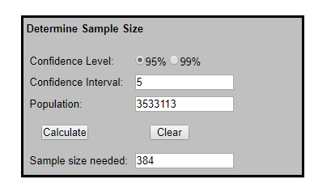
The above table from Krejcie and Morgan (1970) will indicate the correct sample size for this study and if the sample size is more 1 million people, the researcher must distribute the questionnaire to 384 respondents. According Anderson, Black & Lethem (2013) to achieve the statistical validity 400 questionnaire must be distributed and 250 questionnaires must be collected back from the respondent. Furthermore, this research survey will be carried out in one month where 400 employees from SME organization around Selangor Malaysia.
3.2.5 Unit Analysis
The unit of analysis is considered has one of the most important are in the research has it guide how to provide the appropriate research date for this research and the number of respondent needed is around 400, where the unit of analysis is considering has individual and the demographic factor plays a role (Zikmund et al., 2013). According Sekaran and Bougie (2016) individual plays a key role has they been commonly used in researches and this can have described the behavior of everyone.
Moreover, for this research 400 employee that are currently working in SME organization around Selangor Malaysia will be selected randomly and ask to fill up the questionnaire for the data collection process needed for this research. Therefore, the unit of analysis for this research will be employee satisfaction in SME organization Selangor Malaysia (Zikmund et al., 2013). Moreover, the questionnaire will be distributed to various employee working in SME organization and the result will be different has SME organization have different sizes (SME, 2018).

3.3 Questionnaire design
3.3.1 Data Collection for Correlation study
This research will be based on the quantitative method for the data collection method. This is where questionnaires will be distributed to respondent to get their feedback. According to Zikmund et al., 2013 questionnaires are designed to serve one purpose which is question related to the research topic will be included in the questionnaire. This questionnaire will include the demographic profile, independent variables and dependent variables of the research. Respondent who answer the questionnaire is required to read each question properly and it up to their own preference how they want to answer each question item in the questionnaire (Sekaran and Bougie 2016). The main advantages of using questionnaire method is because it is cheap and able to reach out to larger demographic profile in a shorter period (Cooper & Schindler 2013). Based on previous quantitative method questionnaire have 2 part which contains the demographic profile of employees before going in the factors that influences employee satisfaction (Saunders et al., 2012). There second stage of the questionnaire will consist influences factors toward employee satisfaction. This will include the independent variables and dependent variables so that these data can analysis through SPSS to get the reading ( (Anderson, 2013).
3.3.2 Questionnaire Design
The researcher will normally be divided the questionnaire into 3 different groups which are A, B and C. According to Rowley (2018) it is better for the fir the group A to contain the demographic profile of the respondent and information such as age, sex religion and so on where by this group should include the ordinal scale or the nominal scale. Therefore, for group in section B and C Adiguzel & Wedel (2013) it better to use likert scale to mesure the varibales inlvoed in the study as liker scale will have the range of strongly disagree (1) to strongly agree (5) which will be easier for data anaylsis later on. Therefore in this s group B will include independent variable which are job satsiafction, working enviroment and employee engagement so respondent will have to answer to give their wiews. Lastly group C will contain the dependendant varibale which is employee satisfaction.

3.3.3 Summary of Questionnaire Table
Section | Variables | Items | Source
A | Demographic | 3 | Hajdukova & Klementova (2014)
B (Independent Variables) | Job Satisfaction | 5 | Usman, Tahir, & Rahman (2013), Parvin (2012)
 | Working Environment | 5 | Raziq & Maulabash (2015) Kaur (2014) Renah & Setyadi (2014)
 | Employee Engagement | 5 | Bedarkar et.al. (2013) Andrew (2012)
C (Dependent Variable) | Employee Satisfaction | 5 | Munap et al. (2013) Amalina & Teng (2017) Sageer et al. (2012)

According to Sekaran & Bougie (2016) if the researcher can find a preexist questionnaire item it will help the researcher to measure the variables involved in the study. Zikmund et al., (2013) says there are two ways where the instrument can be used in the study and it is called adopting and adapting. The first way is adopting where the questionnaire item is not altered at all and the other way is adapting where the researcher makes significant changes to the questionnaire item (Saunders et al., 2012).
This research will be adopting the questionnaire because when the questionnaire item is adopted the reliability of the study previous may be applied to our study saving is time (Zikmund et al., 2013). Moreover Sekaran & Bougie (2016) if the researcher adapted the questionnaire item there will be changes in the reliability and validity and this cannot be applied in the study anymore. Saunders et al., (2012) adopting the questionnaire item is the best way has it will be same type of instrument used form previous studies thus saving time for the researches from making a lot of changes.
3.4 Measurement of Study
3.4.1 Pilot Test

The main reason for conducting this test is because since the questionnaire is adapted from the previous research this test is conducted to ensure the question item are suitable for this research Sekaran & Bougie 2016). Therefore, it can detect weakness in the question item thus gives data for a sample of probability (Saunders et al., 2012). Furthermore, according Zikmund et al., (2013) a small group of subjects are chosen from the target population to rehearse the step taken for data collection.
The small size in population in the pilot test enable improvements to be made and can be considered has a trial run, Cooper & Schindler (2013) says that the appropriate sample size will be around 30 respondents for the pilot study and it will analyze the factor analysis and reliability test. The 30 respondent that participated in this pilot test can be random person and not to the specific target population which in this case is employee.
3.4.1.1 KMO Test
This KMO or Kaiser-Meyer-Olkin the purpose is to measure if the data is suitable for the factor analysis or not (Zikmund et al., 2013). According Saunders et al., (2012) this test measure each of the variable and it is vital in this research has the proportion variance is measured in determining if there is a common variance. Therefore, the lower the proportion it will be better data for the researcher to perform data analysis later and all the value must be more that 0.6 if it is lower than that one variables must be eliminated by the researcher (Taherdoost, Sahibuddin & Jalalliyoon, 2014).
3.4.1.2 Communalities

This factor analysis is the techniques used where it will reduce the number of unnecessary factors that will be identified using statistical which measured each of the variables in the questionnaire (Zikmund et al., 2013). Therefore Sekaran & Bougie (2016) the variable portion will be all accounted for the common factors where high communality would mean unique loading factor. Moreover, these correlations can be called loadings and the main rule for the loading it must be more than 0.7 (Cooper & Schindler, 2013). Furthermore, many researchers used this factor analysis method when conducting their researchers (Taherdoost et al., 2014). These factor analysis test is done using SPSS software where each item in the questionnaire should be more than 0.6 and any item less than 0.6 should be removed before further continuing with the analysis (Zikmund et. al., 2013).
3.4.1.3 Eigenvalues Analysis
This analysis’s will represent the variables which will consider all the common factors that are measured by adding squared factors in the loadings (Zikmund et. al., 2013). According to Cooper & Schindler (2013) this will construct all the eigenvalues values which are greater for this research and the factors that small values, which will have indicated small existence between the common variance. According to Saunders et al., (2012) this small values in the factor should not be used for further analysis in this research. Therefore Sekaran & Bougie (2016) that the eigenvalues analysis is important must be checked during pilot test to enable the researcher to retain factor that only be helpful to them in the research.

3.4.1.4 Reliability Test

The main purpose for Reliability test is to evaluate the measurement stability and the internal consistency where it will underline the error in measurement so that the reliability can be evaluated in Cronbach’s alpha (Sekaran & Bougie 2016). Moreover, the satisfactory level must be around 0.70 and 0.90 to ensure the reliability in each scale have good and accepted reliability

3.4.2 Demographic Profile

According to Sekaran & Bougie (2016) this group will contain information such has gender, age, religion that has some relationship with the respondent. Therefore, Zikmund et. al., (2013) this information gives a very little value to the research has it does not affect any factors

3.4.3 Preliminary test

Zikmund et. al., (2013) the preliminary test must be conducted to ensure that the data analysis is correct and factor that are removed are further tested. According to Sekaran & Bougie (2016) pilot test is done first to prove the proof of concept.

3.4.4 Hypothesis testing

3.4.4.1 Simple multiple regression
Simple multiple regression analysis is used in the development of the equation in estimating the self-weighting which will show the values of the variables that are reliable and standalone variables (Cooper and Schindler 2013). This according Zikmund et. al., (2013) coefficient path β, means the estimation of the linear association strength between the ratio interval variables. Moreover, the coefficient will have the range of +1 to -1 so the prefix will be “+” and “-” which shows the relationship where the greater the number of coefficient the greater the link. (Sekaran & Bougie 2016)
Moreover, the coefficient will give detail information on the regression model is good to fit or not and provide precise percentages on the variables that are reliable and explained in the standalone variable (Saunders et al., 2012). Furthermore, if it close to 1 the regressions model will explain the changes if it close to 0 it will not explain most of the changes (Cooper and Schindler 2013).
3.4.4.2 ANOVA
There ANOVA method will be used to compare the mean difference to both group in this research. Moreover, the homogeneity of variance test will be done to see the variance equity in the assumption that the equal variance and not assumed if the p-value is less than 0.05 or the other way around (Zikmund et. al., 2013).

3.5 Ethical Consideration
Firstly, to conduct this research it requires the person to have honestly and integrity. This is because it is important for the person conducting the research to protect the anonymity and confidently of respondent that are involved in this research. It is essential of presenting and clarifying the data before distribution of questionnaire to respondents. Moreover, there must not be any data tampering in SPSS which affect the result of the study.
3.6 Conclusion
This chapter has clearly defined the research methodology that will be used during this research. Furthermore, it has outlined the quantitative analysis and the research design. Moreover, in this chapter we will also focus on the questionnaire design and the test needed to interpret the research. It also explains the analysis that need to be done to ensure that the data can be used in this study

4.0 Overview
This chapter will focus on the analysis and the finding from the data collected from SME employee around the Klang Valley area. The analysis of the overall result will be presented by using the SPSS where the respondent data are inserted in the SPSS program. They will also be charts and table presented in this chapter to better illustrate there result that was acquired from the respondent. This is important has these results will give a better explanation on the finding and for this project.

4.1 Pilot test
This analysis is done before I presented the full set of my questionnaire to my respondent, I randomly choose 40 employees that were working in SME to participate in this pilot test study. The main purpose for conducting this test is because since the questionnaire is adapted from the previous research this test is conducted to ensure the question item are suitable for this research (Sekaran & Bougie 2016).
4.1.1 Factor Analysis
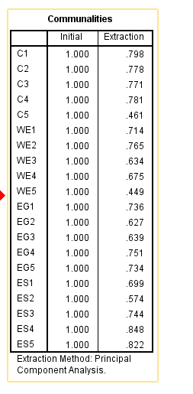
Table 4.0 Communalities for Pilot test
Bases on the above table 4.0 it shows that all the values which are not more than 0.6 will be removed and only items that are at 0.6 will be presented in the questionnaire for further analysis. This is to ensure in the communalities is more than 0.6 meaning the question that was presented to the respondent are valid. Therefore, question C5 and WE5 will be removed has it been lower at 0.6. According to Zikmund et. al., (2013) the load must be at 0.6 and more to be considered valid so that it is appropriate for further analysis.
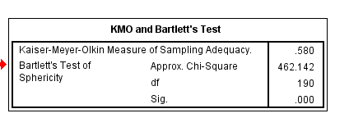
Table 4.1 KMO and Bartlett’s test
Furthermore, the above table 4.1 show the factor analysis result of pilot test at 0.580 which is above than 0.5 meaning the analysis is considered acceptable therefore all the question provided in the questionnaire can be accepted for further study.
4.1.2 Reliability Analysis
Variables | Cronbach Alpha | Number of items
Compensation (IV) | 0.834 | 4
Working Environment (IV) | 0.766 | 4
Employee Engagement (IV) | 0.696 | 5
Employee Satisfaction (DV) | 0.761 | 5

Table 4.2 Result Summary of Reliability test
According to Sekaran & Bougie (2016) the value of Cronbach Alpha must be at 0.7 has it is closer to 1 so that reliability will be consistent. However, for the table above 4.2 there is result at 0.6 this also can be accepted according to Cooper and Schindler (2013) has the sample size is small in the pilot test. Therefore, the questionnaire adopted is reliable for distribution.
4.2 Demographic Analysis
This analysis will provide information on the respondent gender, education level and salary. This frequency distribution will help the reader understand the descriptive information about the respondent that participate in the questionnaire. The analysis will include 200 SME employees working in Klang Valley area.
Gender
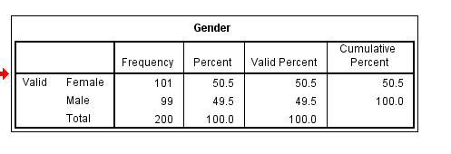
Table 4.3 Gender Frequency
According to the table above 4.3 the total number of respondent that took part was 200 and 101 was female which is 50.5% and the rest was male at 99 at 49.5%. This shows that male and female employee working in SME organization around Klang Valley is almost equal even though there are more female respondent here.

Level of Education
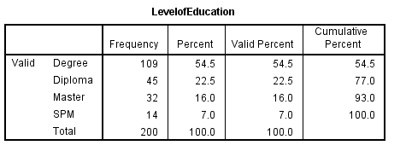
Table 4.4 Level of Education
According to the table 4.4 most of the respondent education level is at degree has 109 respondent answer this followed by diploma which is at 45, and then degree at 32 and finally SPM at 14. This shows that most respondent have a degree nowadays which is the minimum requirement of qualification in studies
Salary Range
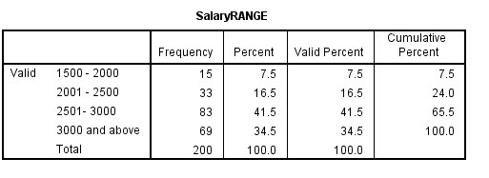
Table 4.5 Salary Range
According to the above table we can clearly see 83 respondents earn a salary range of 2501 to 3000 which is at 65.5%. This is expected has most respondent are degree holder and the minimum salary is at RM2500. The next salary range which is RM3000 and above there are 69 respondent this may due to their experience in working for the SME for a long time and have degree qualification in hand. The next salary range is between 2001-2500 and 33 respondents are in this category and lastly is 1500-200 salary range where 15 respondents are at this category.

Current Position
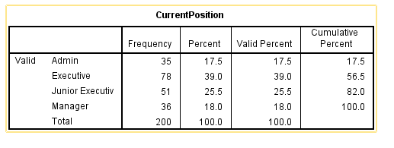
Table 4.6 Current Working Position
The above table shows the current working position of the respondent has currently 78 of them are executive followed by junior executive at 51 respondents and then manager at 35 respondents and lastly is admin at 35 respondents.

4.3 Preliminary Test
4.3.1 Factor Analysis (Independent Variables)
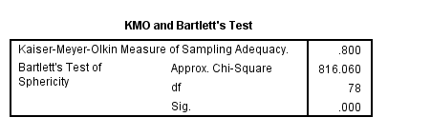
4.3.1.1 KMO and Bartlett’s Test

Communalities
 | Initial | Extraction
Compensation package offered by my organization is very attractive | 1.000 | .578
Compensation package offered by the organization motivates for better employee performance | 1.000 | .639
The company provides me with above average benefits (such as medical, dental, and insurance policies) | 1.000 | .528
I think that the annual salary increment is acceptable when compared to other companies in the industry | 1.000 | .490
The physical working surroundings of my companies are very good | 1.000 | .625
My workplace is very clean | 1.000 | .744
I am contented with my working time and privileges provided | 1.000 | .433
My company has been making efforts to improve methods of doing things | 1.000 | .426
I receive useful and constructive feedback from my manager | 1.000 | .440
Employee performance evaluations are fair and appropriate | 1.000 | .732
My supervisor gives me praise and recognition when I do a good job | 1.000 | .621
I receive the training I need to do my job well | 1.000 | .493
I am encouraged to learn from my mistakes | 1.000 | .504
Extraction Method: Principal Component Analysis.

4.3.1.2 Communalities
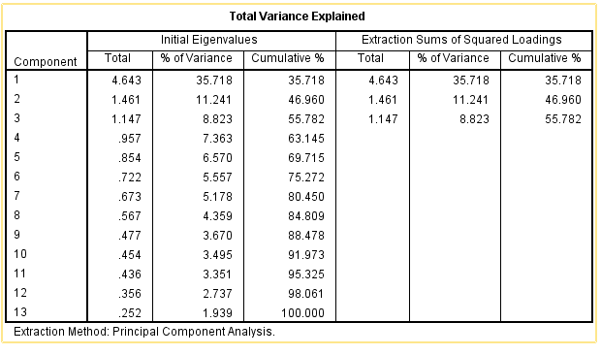
4.3.1.3 Total Variance Explained

According Anderson, Black & Lethem (2013) to achieve the statistical validity 400 questionnaire must be distributed and 250 questionnaires must be collected back from the respondent. In this case I manage to find 200 respondents and the area that distributed the questionnaire which was Puchong, Petaling Jaya and Klang was enough to cover employee working in SME. The table 4.3.1.1 shows the finding of the factor analysis on the independent variables that has been on this research. Therefore, based on the result which is at 0.800 the value of KMO is represented by compensation, working environment and employee engagement (independent variable). According to Zikmund et. al., (2013) the minimum value of KMO is at 0.60 but the value in this study is at 0.800 which is reasonably high. This KMO value proved that the independent variables of compensation, working environment and employee engagement can be used for the factor analysis experimental. Moreover, the Bartlett’s which has been test and the values shows at 0.000 which is less than 0.01 which is the significant level. Therefore, we can conclude that at 0.000 the correlation matrix is declining, and the hypothesis is null (Sekaran & Bougie 2016). In conclusion there is a valid relationship and correlation between compensation, working environment and employee engagement (Zikmund et. al., 2013). The table 4.3.1.2 shows the communalities all of them are above 0.5 so it will not affect the data analysis. Lastly table 4.3.1.3 shows the variance of the independent variables at 55.78% hence we can determine that all the independent variable correlated with each other

4.3.2 Factor Analysis (Dependent Variable)
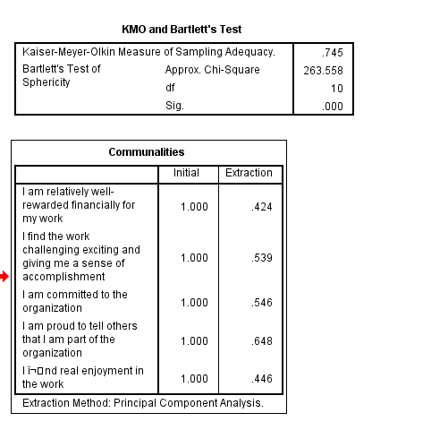
Table 4.3.2.1 KMO and Communalities
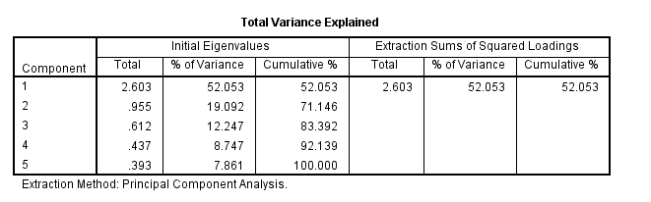
Table 4.3.2.2 Total Variance
The table above shows that finding of the factor analysis on the dependent variables that has been on this research. Therefore, based on the result which is at 0.745 the value of KMO for employee satisfaction. According to Zikmund et. al., (2013) the minimum value of KMO is at 0.60 but the value in this study is at 0.745 which is reasonably high, and the independent variables can be used for further research. In conclusion there is a valid relationship and correlation in employee satisfaction. The values of the total variance are at 52.03 % which is also moderate.
4.3.3 Reliability test

The main purpose for Reliability test is to evaluate the measurement stability and the internal consistency where it will underline the error in measurement so that the reliability can be evaluated in Cronbach’s alpha (Sekaran & Bougie 2016). Moreover, the satisfactory level must be around 0.70 and 0.90 to ensure the reliability in each scale have good and accepted reliability. Based on the table below all the Cronbach alpha is at 0.7 so it is reliable. Overall it is a good result

Variables | Cronbach Alpha | Number of items
Compensation (IV) | 0.712 | 4
Working Environment (IV) | 0.713 | 4
Employee Engagement (IV) | 0.755 | 5
Employee Satisfaction (DV) | 0.766 | 5

4.4 Hypothesis Analysis
Hypothesis 1 | Hypothesis 1: There is a positive relationship between compensation and employee satisfaction in SME organization in Selangor
Hypothesis 2: | Hypothesis 2: There is a positive relationship between working environment and employee satisfaction in SME organization in Selangor
Hypothesis 3 | Hypothesis 3: There is a positive relationship between employee engagement and employee satisfaction in SME organization in Selangor

The above table shows the three hypotheses that was proposed and tested using multiple regression.

4.4.1 Hypothesis testing

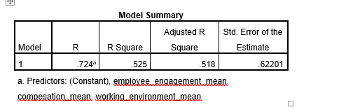

The multiple regression was conducted and achieved 0.525 with the R correlation is 0.724 this shows a strong standing.

4.4.2 ANOVA

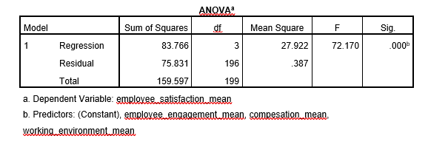

Therefore, based on the finding it can be assume that there is a positive relationship between employee satisfaction and the 3 independent variables that have been used. Moreover, the ANOVA table also proved that the regression model is significant has the significant level is at 0.001 (P=0.000).

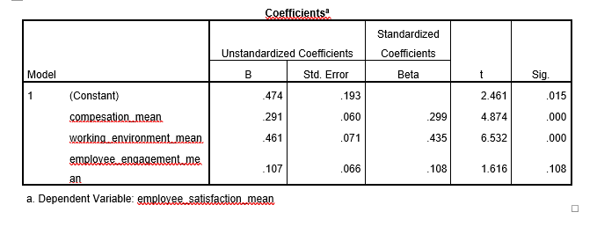

The next step is to check on the regression since the multiple regression assumption have been fulfill. The table above shows the variables has we can see that there is positive relationship in compensation and working environment has the significant is less than 0.05. However, for employee engagement there is no positive relationship has the significant value is above 0.05

Key summary findings
Hypothesis | Description | Results
Hypothesis 1 | Hypothesis 1: There is a positive relationship between compensation and employee satisfaction in SME organization in Selangor | Accept
Hypothesis 2: | Hypothesis 2: There is a positive relationship between working environment and employee satisfaction in SME organization in Selangor | Accept
Hypothesis 3 | Hypothesis 3: There is no positive relationship between employee engagement and employee satisfaction in SME organization in Selangor | Reject

The overall finding is summarized in the table where hypothesis 1 and 2 is accepted while 3 is rejected. In other words, we can say that compensation and working environment has a positive impact on employee satisfaction working in SME while hypothesis 3 which was employee engagement has no significant impact to employee satisfaction.

4.5 Conclusion

This chapter have highlighted finding based on the data analysis using SPPS software. This analysis was done using descriptive and testing of the hypothesis to analyze the key result of findings for this study. There final test was on the hypothesis testing which showed 2 hypotheses was accepted and 1 hypotheses rejected for this research.

5.0 Overview

This chapter will look at the findings based on the previous chapter has it will critically evaluate the results. Furthermore, they will be recommendation, contribution, limitation personnel reflection, before ending with chapter conclusion. This chapter will basically summarize the finding found form chapter 4 SPSS analysis.

5.1 Recommendation

The focus of this study is to see the insight of employee satisfaction working in SME organization in Selangor Malaysia. The first chapter at already focus on the contributing factors that affect employee satisfaction and the importance of it to the SME organization is to the economy of Malaysia. Based on the result of the hypothesis compensation has a significant impact on employee satisfaction. Therefore, I would suggest SME organization to pay a mix of salary and incentives. According to Volper (2018) successful organization like Amazon and Apple have high employee productivity and morale because they mix salary and incentives given to employees. Salary is wat employee get for performing their task they are required to do, and incentives will be able to motivate them to work even more. This will help SME has they are able to maximize their productivity and their output at the same time. The other recommendation would be to make the compensation package plan has simple it may be. This will ensure that the compensation package can be measured, and employees understand what the factors are involved in the compensation package. Furthermore, SME can also see what their competitors are paying for new talents in the market. This will ensure that SME will be able to attract and retain talent and keep them motivated at all time. lastly would be that compensation given is modify based on the geographic location of the SME. It is essential to know that SME based in Kelantan and Terengganu might give their employee lower pay compared to SME employee working in Selangor due to the location of the state. Therefore, employer must be reasonable when paying employee compensation based on these factors to ensure that they are happy always.

The second hypotheses are on the working environment which also have a significant positive relationship to employee satisfaction here one of the recommendation would be hiring great team member and letting the bad ones go. If the company can hire right people that itself will create a good working environment. Moreover, SME company needs to have team player rather arrogant individual. Where there are toxic workers working for the company it will make the office environment to become toxic thus creating unpleasant working environment. Also, SME company can improve on the physical working condition for employees and the office environment and giving employees flexible working hours. One of the example would be the company allow freedom to their employees to choose where they wish to work and provide them with comfy chairs and table to perform their work. According to Potts (2018) if the furniture is in bad condition it will cause an unpleasant environment for the employees thus they become less productive. This is because the current generation don’t like to work office hours instead they would like to come to work with their desired time. Furthermore, the company can also improve the lighting of the company has these plays important role in the productivity of the employees. If the company provides a natural light it will improve their energy and they will have a positive mood.

The third hypothesizes is employee engagement which from the hypotheses testing we found that there we no significant impact to employee satisfaction. However, I feel employee engagement is still important has according to study done by Vorina et al., (2017) shows that there is positive relationship between employee engagement and employee satisfaction the value of satisfaction would increase. This shows if I got more respondents maybe employee engagement would have been significant however I would recommendation some suggestion to SME ensure that there is a two-way communication between employee and employer. This two-way communication will ensure that employees know the expectation of the employer and they will be able to execute their job properly. I would like to conclude that these recommendations will help SME to be successful and help attract and retain employees.

5.2 Contribution to Academic

This study had some limitation however there are literature contribution for this purpose of the study. It is essential we know the mindset of the employee that are not satisfied in relation to compensation, working environment and employee engagement. There was a limitation in conducting these studies has I find out that most journal and literature have not included these variables in their study. This study will be able to reduce the gaps in literature and increase the knowledge on employee satisfaction in Malaysia. Furthermore, based on the factor compensation and working environment have a positive relationship to employee satisfaction and only employee engagement had no significant impact.

5.3 Contribution to Industry

The importance of SME plays to the economy of Malaysia is very important has they contribute greatly to the GDP of Malaysia. This SME cannot afford to have high turnover of employees has these will greatly affect the productivity of SME. Therefore, to able to be productive they must have proper human resource system in place to ensure that the employees are able to maximize their productivity for the SME. Furthermore, employee that are not satisfied will also not be able to provide talents and the quality of the job they produce may not be up to the standard of the organization. This study will help manages working in SME to fully understand and give them an insight of the importance of the human resource. Moreover, the manager will be able to make the employee satisfied has the factors that greatly contribute will be fix.

5.4 Limitation

The study was only focus on the state of Selangor of the Klang Valley area, so the result might have different if other states in Malaysia is also involved. It is important that we know employees working in big city have greater pressure that smaller cities. Employee working Kelantan and Terengganu SME their satisfaction might have other influences than compensation, working environment and employee engagement. Therefore, this study and variables may not be suitable to other states in Malaysia where SME exists. Secondly is the data collection was conducted through online question are which was published in Google docs. I also had to distribute this through other social media such Facebook and Twitter to enable employee to participate in this study. In some cases, I had to be more persuasive and send them the link more than 1 time for them to participate. Therefore, due to time limitation the sample size for the study is only at 200 instead of the required 250 respondents which further restrict information collected from these respondents.

5.5 Future Research

There future research can be studied using different variables than the one that was used for this study. There are number of other variables that can be mentioned for this study and future research are encouraged to use different variables from the one that was used for this research. Furthermore, moderating effect such has gender or age can also be use in future research where we can see if the moderating effect have significant impact on the variables and the relationship.

5.6 Personnel Reflection

This is where I will share all the good experience I had while I was doing this MBA project. This is a bitter sweet moment for me has when I completed this chapter I am finally one step closer to graduating this program. This project has help me in many ways in improving my skills that I have learned from the last 1 year of the program. Furthermore, I need to place a special thanks to my supervisor Miss Umi Kalsom who has been there since the beginning of this project. She has played a key role in the completion of my thesis by giving me valuable information. Also, when I was tense up with things she will calm me down and assure me everything is going to be fine. Therefore, looking back, I have learnt that time management is important when it comes to the project. This 1 years have really taught me that I always need to keep my feet in the ground. Lastly, I would like to thank everyone who help me for their support through this project and Master program.

5.7 Conclusion

This study has five chapter starting with introduction, review of literature, methodology and finding and ending with conclusion. The purpose was to analyze of the factor influencing employee satisfaction in SME organization in Malaysia. These factors will be able to help SME in the future to improve their operation and ensure employees are happy.

References
Alkahtani, A. H. (2016). The Influence of Leadership Styles on Organizational Commitment: The Moderating Effect of Emotional Intelligence . Business and Management Studies .
Anderson, B. &. (2013). Business Research Method. United States.
Andrew. (2014). Effect of Compensation Strategy on Corporate Performance: Evidence from Nigerian Firms . Research Journal of Finance and Accounting .
Andrew, O. C. (2012). Individual Factors and Work Outcomes of Employee Engagement . Procedia - Social and Behavioral Sciences .
Ariani, D. W. (2012). Employee Satisfaction and Service Quality: Is There Relations, 1.
Ashraf, Z. (2012). Increasing Employee Organizational Commitment by Correlating Goal Setting, Employee Engagement and Optimism at Workplace . European Journal of Business and Management .
Benrazavi, S. R. (2013). Employees’ Job Satisfaction and Its Influence on Willingness to Work in Teams . Journal of Management Policy and Practice.
Bojadjiev, M. (2015). PERCEIVED WORK ENVIRONMENT AND JOB SATISFACTION AMONG PUBLIC ADMINISTRATION EMPLOYEES. The European Journal.
Boonpattarakan, A. (2012). Model of Thai Small and Medium Sized Enterprises’ . Journal of Management Research .
Ceylan, B. A. (2012). A Research Analysis on Employee Satisfaction in terms . Internationa Journal of Business Management.
Chin, C. L. (2018). The Influence of Job Satisfaction on Employee Turnover Intention in the Manufacturing Industry of Malaysia . Journal of Arts & Social Sciences.
Christina. (2013). Employee Satisafaction and Customer Satisfaction. International Journal of Hospitality Management.
Cropanzano, R. (2015). Social Exchange Theory: An Interdisciplinary Review. Research Gate.
Eniola, A. A. (2015). SME Firm Performance-Financial Innovation and Challenges . Procedia - Social and Behavioral Sciences .
Evawati. (2015). The Effect of Organization Culture and Working Environment on Employee Performance at Pt. Asuransi Jiwa Sequislife Jakar. European Journal of Business and Management .
GABČANOVÁ, I. (2012). THE EMPLOYEES – THE MOST IMPORTANT ASSET. Human Resources Management & Ergonomics .
Ghiselli1, H. A. (2014). The Importance of Compensation and Benefits on University Students’ Perceptions of Organizations as Potential Employers . Journal of Management and Strategy .
Hajdukova, A. (2014). The job satisfaction as a regulator of the working behaviour. Procedia - Social and Behavioral Sciences .
HAMED TAHERDOOST, S. J. (2014). Exploratory Factor Analysis; Concepts and Theory. Advances in Applied and Pure Mathematics.
HAMID, N. Z. (2015). The Relationship Between Workplace Environment and Job Performance in Selected Government Offices in Shah Alam, Selangor . International Rewiew of Management and Bussiness Research .
Hanaysha. (2016). Work Environment and Organizational Learning as Key Drivers of Employee Productivity: Evidence from Higher Education Sector . International Journal of Human Resource Studies .
Hanaysha, J. (2016). Testing the Effects of Employee Engagement, Work Environment, and Organizational Learning on Organizational Commitment . Procedia - Social and Behavioral Sciences .
Hanaysha, J. (2016). Work Environment and Organizational Learning as Key Drivers of Employee Productivity. International Journal of Human Resource Studies.
HRM, E. C. (2014). Employee Compensation. The neglected area of HRM. Gupta.
Ibrar. (2015). The Influences of Employee Job Satisfaction an Organizational Commitment on Turnover Intention. Arabian Journal of Business and Management Review.
Job street. (2018, April 7). Retrieved from www.jobstreet.com: https://www.jobstreet.com.my/career-resources/malaysians-dissatisfied-work/#.WshvGIhubIU
Kabir, M. M. (2012). FACTORS AFFECTING EMPLOYEE JOB SATISFACTION OF PHARMACEUTICAL SECTOR . Australian Journal of Business and Management Research .
Kaur, S. (2014). IMPACT OF WORK ENVIRONMENT ON JOB SATISFACTION . International Journal of Scientific and Research Publications.
Khalique, *. (2011). CHALLENGES FACED BY THE SMALL AND MEDIUM ENTERPRISES (SMEs) IN MALAYSIA: AN INTELLECTUAL CAPITAL PERSPECTIVE . International Journal of Current Research .
Khan, M. W. (2014). An Overview of Small and Medium Enterprises in Malaysia and Pakistan: Past, Present and Future . Business and Management Horizons .
Koea, W.-L. (2014). Factors Influencing Propensity to Sustainable Entrepreneurship of SMEs in Malaysia . Procedia - Social and Behavioral Sciences .
Lambe, C. J. (2002). Social Exchange Theory and Research on Businessto-Business Relational Exchange. Journal of Business-to-Business Marketing.
Madhura Bedarkar, D. P. (2013). A study on the drivers of employee engagement impacting employee performance . Procedia - Social and Behavioral Sciences .
Majiros, C. (2013). Beyond Social Exchange Theory: A Theoretical Shift for Mentoring Relationships in the Federal Workplace . Advances in Social Work .
Malhotra, S. (2016). A STUDY OF RELATIONSHIP BETWEEN JOB SATISFACTION AND EMPLOYEE ENGAGEMENT . Procedia - Social and Behavioral Sciences .
Malik, M. E. (2012). The Impact of Pay and Promotion on Job Satisfaction: Evidence from Higher Education Institutes of Pakistan. American Journal of Economics .
Maniam Kaliannana, S. N. (2015). Effective employee engagement and organizational success: a case study . Procedia - Social and Behavioral Sciences .
Mark N.K Saunders, P. L. (2012). Research Methods for Business Students. United States: Financial Times/ Prentice Hall; 6 edition (19 April 2012).
Masood, A. (2014). Factors Affecting Employee Satisfaction of the Public and Private Sector Organizations of Pakistan . International Journal of Human Resource Studies.
Mathew. (2014). Compensation Management and Employees Performance in the Manufacturing Sector, A Case Study of a Reputable Organization in the Food and Beverage Industry . International Journal of Managerial Studies and Research.
Mitchell, M. S. (2016). Theory of Social exchange. Research Gate.
MORGAN, R. V. (1970). DETERMINING SAMPLE SIZE FOR RESEARCH. EDUCATIONAL AND PSYCHOLOGICAL MEASUREMENT .
Mr. Abdul Hameed, M. (2014). Impact of Compensation on Employee Performance (Empirical Evidence from Banking Sector of Pakistan) . International Journal of Business and Social Science .
Munap, R. (2013). Organizational Rewards System and Employees’ Satisfaction at Telekom Malaysia Berhad . Journal of Educational and Social Research.
Musa, H. (2015). Malaysian SMEs Development: Future and Challenges on Going Green . Procedia - Social and Behavioral Sciences .
Naharuddin, N. M. (2013). International Journal of Independent Research and Studies . Factors of Workplace Environment that Affect Employees Performance: A Case Study of Miyazu Malaysia .
Nanjundeswaraswamy. (2014). Leadership styles. Journal Research.
Nuessle, A. (2013). Research Objectives, Methods, and Mentalities. Productivity and Research .
Obuobisa, T. (2016). Leadership and Employee Satisfaction . 1.
Obuobisa-Darko, T. (2015). Leadership and Employee Satisfaction in the Ghanaian Banking Sector . European Journal of Business and Management , 1.
Parvin, M. M. (2012). FACTORS AFFECTING EMPLOYEE JOB SATISFACTION OF PHARMACEUTICAL SECTOR. Australian Journal of Business and Management Research.
Rajput, M. S. (2016). Job Satisfaction and Employee Loyalty. Asian J. Management.
Rashid, S. (2015). EMPLOYEE ENGAGEMENT: A QUALITATIVE RESEARCH ON CRITICAL FACTORS WITHIN MALAYSIA’S SME BUSINESSES . First Asia Pacific Conference on Contemporary Research .
Raziq, A. (2015). Impact of Working Environment on Job Satisfaction . Procedia Economics and Finance .
Renah, A. (2014). The Influence of Organizational Culture, Working Environment and Educational Training on Motivation and Performance of Government Employees at West Kutai Regency East Kalimanatan . European Journal of Business and Management .
Rohani Salleh. (2012). Job Satisfaction, Organizational Commitment, and Turnover Intention: A Case Study on Employees of a Retail Company in Malaysia. International Journal of Social, Behavioral, Educational, Economic, Business and Industrial Engineering .
Ron Volper. (2018, 8 7). cnbc. Retrieved from www.cnbc.com: https://www.cnbc.com/id/46045960
Rowley, J. (2018). Designing and using. Languages, Information and Communications,.
S, N. T. (2014). Leadership styles . 1.
Saeed, A. (2014). Customer Satisfaction and Shareholder’s Value: The Role of Employee Satisfaction . European Journal of Business and Management , 1.
Sageer, A. (2012). IOSR Journal of Business and Management . Identification of Variables Affecting Employee Satisfaction and Their Impact on the Organization , 1.
SaqibUsman. (2013). Effect of Salary and Stress on Job Satisfaction of Teachers in District Sialkot, Pakistan . IOSR Journal Of Humanities And Social Science.
Schindler, D. R. (2013). Business Research Methods, 12th Edition . United States: McGraw-Hill Education; 12th edition (March 5, 2013).
Shahsavarani, A. M. (2016). Social Exchange Theory and Attachment Theory: Combination of Sociological and Psychological approaches to form a biopsychosocial viewpoint to human social and interpersonal relationshi. INTERNATIONAL JOURNAL OF HUMANITIES AND CULTURAL STUDIES.
SME. (2018, 4 13). Retrieved from SME Corporation : http://www.smecorp.gov.my/index.php/en/policies/2015-12-21-09-09-49/sme-statistics
Teng, N. A. (2017). Job Satisfaction, Organizational Commitment, and Turnover Intention: A Case Study on Employees of a Retail Company in Malaysia. Journal of Economics, Business and Management, Vol. 5, No. 1, January 2017.
The Star. (2018, April 4). Retrieved from Thestar.com.my: https://www.thestar.com.my/business/business-news/2013/02/09/salary-vs-job-satisfaction/
Thuku, C. M. (2013). Human Resources Engagement as a Competitive Strategy for Performance in Small and Medium Enterprises in Kenya: A case Study of Jirani Engineering Services. European Journal of Business and Management .
Uma Sekaran, R. B. (2016). Research Methods For Business: A Skill Building Approach. United States: Wiley; 7 edition (June 27 , 2016).
Vokić, N. P. (2017). The triad of employee satisfaction, work engagement and employee loyalty – The interplay among the concepts . EFZG WORKING PAPER SERIES .
Vorina, A. (2017). AN ANALYSIS OF THE RELATIONSHIP BETWEEN EMPLOYEE SATISFACTION AND EMPLOYEE ENGAGEMENT . ECONOMIC THEMES .
Walliman, N. (2017). Research Methods: The Basics: 2nd edition. United states: Routledge; 2 edition (8 Sept. 2017).
Wedel, F. A. (2013). Split Questionnaire Design for Massive Surveys. Proceedings 59th ISI World Statistics Congress, 25-30 August 2013, Hong Kong (Session IPS033).
Yusof, Z. M. (2014). Job Satisfaction among Employees in a Manufacturing Company in North Malaysia. Asian Journal of Applied Sciences .
Zikmund, B. C. (2013). Businesss Research Method. Chicago: South-Western College Pub; 9 edition (March 12, 2012).

Appendix:
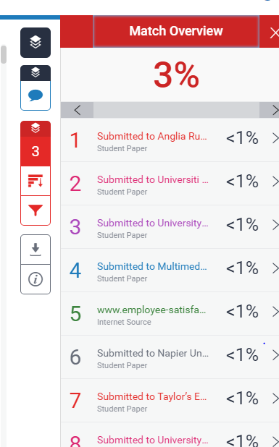

Sample Questionnaire
Independent Variables
- Compensation
Question | 1 | 2 | 3 | 4 | 5
Compensation package offered by my organization is very attractive.
Compensation package offered by the organization motivates for better employee performance
The company provides me with above average benefits (such as medical, dental, and insurance policies)

I think that the annual salary increment is acceptable when compared to other companies in the industry

- Working Environment
Question | 1 | 2 | 3 | 4 | 5
The physical working surroundings of my companies are very good
.
My workplace is very clean

I am contented with my working time and privileges provided

My company has been making efforts to improve methods of doing things

- Employee Engagement
Question | 1 | 2 | 3 | 4 | 5
I receive useful and constructive feedback from my manager
Employee performance evaluations are fair and appropriate

My supervisor gives me praise and recognition when I do a good job

I receive the training I need to do my job well

I am encouraged to learn from my mistakes

Dependent Variables (Employee Satisfaction)
Question | 1 | 2 | 3 | 4 | 5
I am relatively well-rewarded ﬁnancially for my work

I ﬁnd the work challenging exciting and giving me a sense of accomplishment

I am committed to the organization

I am proud to tell others that I am part of the organization

I ﬁnd real enjoyment in the work

Gender
- Female
- Male
Level of Education
- SPM
- Diploma
- Degree
- Master
Current Position
- Admin
- Junior Executive
- Executive
- Manager
Salary RANGE
- 1500 - 2000
- 2001 - 2500
- 2501- 3000
- 3000 and above

Appendix Research Proposal
STUDENT NAME & ID NO | Veeshalan a/l Ravichandran I11007348
BROAD AREA | Human Resource Management
Concise Title | Employee Satisfaction in SME organization Selangor, Malaysia
Problem Definition | According to Christina (2013) we are living in the era of Globalization and free trade between countries continue to change the business environment and competition have increase globally between firms. Firm who conduct business today Ceylan & Aydin (2012) to remain competitive must be able to cope with the changes that is happening around them to deliver satisfactory financial reward to the stakeholders. Furthermore, Malaysia is entering a phase of knowledge-based economy due to globalization and the challenges is forcing Malaysia towards the vital knowledge-based economy (Khalique, 2011).  It is important that Malaysia can shift the growth strategy from driven by input and towards the knowledge driven to achieve the 2020 vision of a developed nation but to do that it must also concentrate on the progress and development of firms around Malaysia (Haslinda, 2015). According to survey done by Job street (2018) currently 74% of Malaysia are not satisfied with their current job and there is various factor that are involved. Further supporting this The Star (2018) again almost 79% says that they are not satisfied with the job.
Research Questions OR Objectives | According to Nuessle (2013) research objectives are important has it set the primary area of the research and to gain a proper understanding of the environment that may affect the research and how to control the environment. My main purpose of this study is to examine compensation, working environment and employee engagement on employee satisfaction in SME organization in Selangor, Malaysia.  RO1: To examine the influence of compensation on employee satisfaction in SME organization in Selangor  RO2: To examine the influence of working environment on employee satisfaction in SME organization in Selangor  RO3: To examine the influence of employee engagement on employee satisfaction SME organization in Selangor
Scope of study | This research will mainly focus on the factors that will influence employee satisfaction in SME organization in Selangor area. This will include all level of employees in the SME organization. This survey will only be conducted around Kajang and Puchong area due limited amount of time. Moreover, another reason for choosing this both area has I work in SME organization before in Puchong this will help me to distribute my questionnaire. Furthermore, for Kajang since I am resident in Kajang it will help me to distribute the questionnaire around that area. Most of this questionnaire will be handed out to SME organization in this 2-particular area.
Significance of the Research | This study is significance has is study the influence of employee satisfaction in SME organization in Selangor, Malaysia. Furthermore, at the end of this research SME will be able to fully understand the reason on why employee is not satisfied (Haslinda 2015). The main output for this research will help SME corporation to retain employees and ensure that they are satisfied (Khalique, 2011).  This researcher outcome enables SME organization human resource department to develop policy that will ensure employee are satisfied (Haslinda 2015). According to Saeed et.al (2014) employee that are satisfied will ensure that the firm is successful in the long run. Moreover if the SME organization wants to remain competitive it must be able retain talent and ensure that employees are satisfied (Khalique, 2011).
Literature Review | Employee Satisfaction (Dependent Variable)  According to Masood, Ain, Aslam et al., (2014) the definition of satisfaction is how the person feel about the job they are currently doing and some of this definition are the attitude in which the person satisfaction towards the job. This is supported Saeed et al., (2014) when it comes to the satisfaction level of the employee there are various dimensions that need to be considered. Employee Satisfaction can be the emotional state of a person resulting the appraisal of the satisfaction level of the employee in the organization (Obuobisa, 2016).  Furthermore Masood et al., (2014) the proposed satisfaction is the determination where part of it have discrepancies that result on the physiological process of the job appraisal. This employee appraisal will have based on the current job experience and how the standard compares to others out there (Obuobisa, 2016). The significant variables of the employee satisfaction will give a general estimation on employee thinking when it comes to the job and workplace (Nanjundeswaraswamy, 2014).  Compensation (Independent Variable)  This compensation area is the most complex and dynamic in the are human resource management (Gupta 2014). Therefore, according to Adler & Ghiselli (2014) if the organization wants to reach their objectives and goals they must be effective in managing every aspect of the human resource department in the organization. These compensation area is so huge and the aspect it is called compensation management process where the manager ability to reach the objectives and goals rest on the effective implementation of the process (Hameed 2014)  According to Gupta (2014) compensation can be considered has the output and the benefit that employees receives for working in the organization. This Adler & Ghiselli (2014) may include wages and some sort of rewards like exchanges in the monetary to increase the satisfaction of employees. Furthermore, these area in the transaction segment between the employees and the owner of the outcome of the employee contract (Andrew 2014).  Working Environment  The second independent variable for this research is working environment. According to Raziq & Maulabash (2015) organization today are facing a lot of new challenges compared to organization those days and one of the key challenges employers face today is the need to satisfy their employee. According to Kaur (2014) the environment here refers to the surrounding and any other factors that affect a human being and in terms of business context working environment refers to environment that employee work to achieve the goals and objectives set by the organization. According to Renah & Setyadi (2014) to define a good working environment is when all the essential facilities are provided by the organization to their employee so that they can execute their work essentially.  These facilities may include the machine, furniture, air conditioning and many more to create a good working atmosphere (Suharno, 2015). Based on Raziq & Maulabash (2015) form a broader perspective the work environment can also be define has the location where employee perform their work. Kaur (2014) working environment can also be geographical location of the job in terms of close surroundings has this can generally be the equipment that are very important for employees to execute their task.  Employee Engagement  According to Bedarkar, Madhukar, Manainam et al., (2013) employee engagement has become important to organization today has it is used to engaged employee and used has a strategic tool in the business. According to Kaliannana & Narh Adjovu (2015) employee engagement is the engine in the talent management process, where it drives the resilience from the effectiveness of environment factors from internally and externally of the organization. This shows that employee engagement involves strategic way has it will initiate support for the branding of the organization and build a very strong reputation among employee (Ashraf, Jaffri, Tariq, & Khan 2012).  Furthermore, in today environment employee engagement have become even more important has there are many drivers that have been identified which will have impact on the employee performance and how each employee is treated in the workplace (Bedarkar et al., 2013). Even more important is the fact that organization nowadays across the various industries must able to survive the competition among them and the physical and mental state of each employee will be the most important factor for Human Resource manager in the organization that why employee engagement be a powerful tool to gain a competitive advantage over the rival’s organization (Andrew 2012).
Research Methodology | Research Method: Quantitative  Type of Research: Descriptive Research  Nature of Research: Correlations  Sample Size: 200

APPENDIX 1

PROJECT PAPER LOG

This is an important document, which is to be handed in with your dissertation. This log will be taken into consideration when awarding the final mark for the dissertation.

Student Name: | Veeshalan a/l Ravichandran
Supervisor’s Name: | Miss Umi Kalsom
Dissertation Topic:
Employee Satisfaction in SME Selangor Malaysia

SECTION A. MONITORING STUDENT DISSERTATION PROCESS

The plan below is to be agreed between the student & supervisor and will be monitored against progress made at each session.

Activity | Milestone/Deliverable Date
Activity | 11/5/2018 | 22/5/2018 | 9/6/2018 | 2/7/2018 | 27/8/2018 | 30/7/2018
Finalizes Chapter 1 to 3
Done Chapter 1 to 3
Review for Proposal defense
Start data collection
Start Chapter 4 and 5
Compile Chapter 1 to 5

Appendix Weekly Log
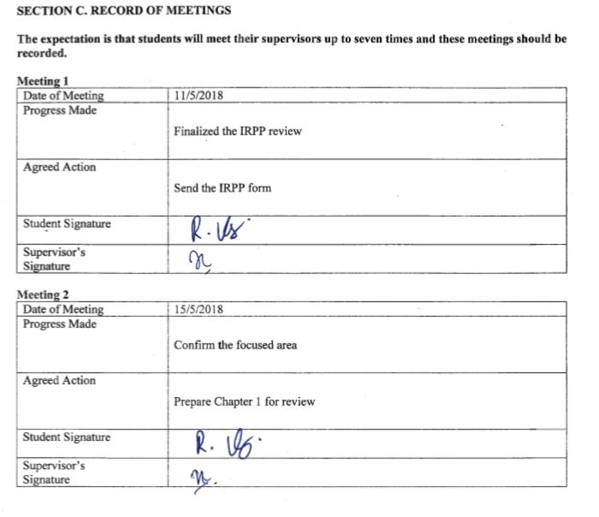

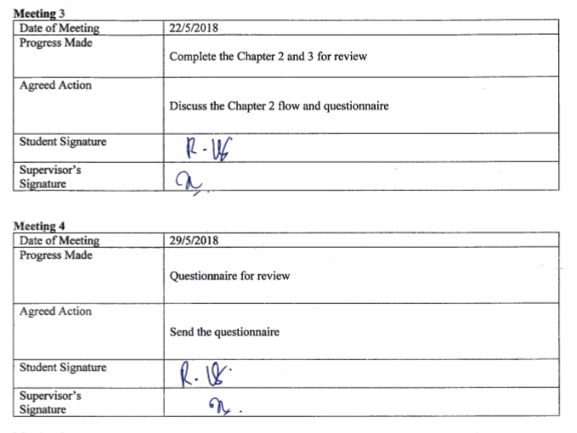


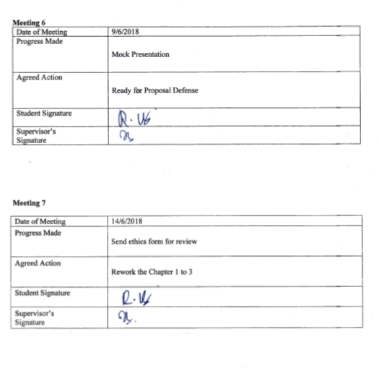



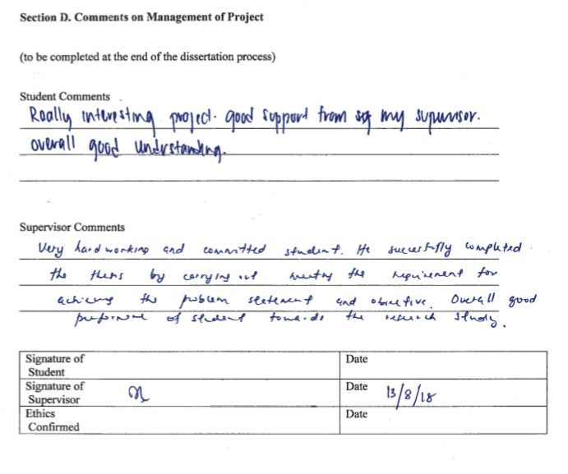

Appendix EC Forms
Form EC1A
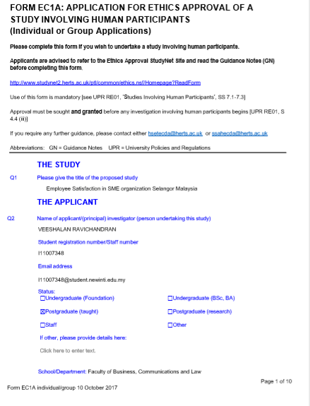

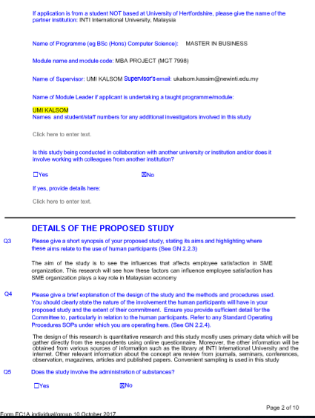



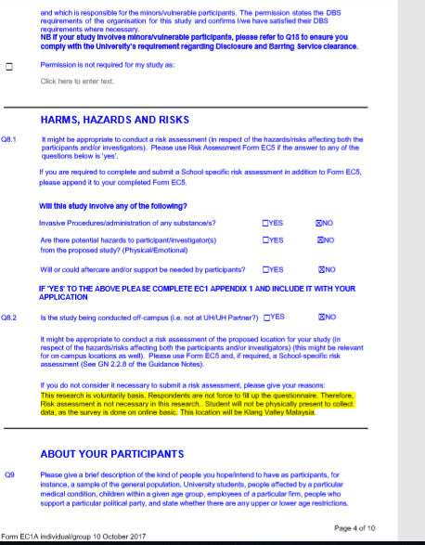
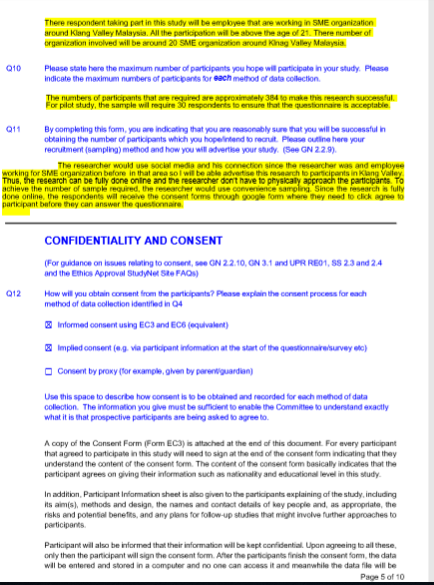

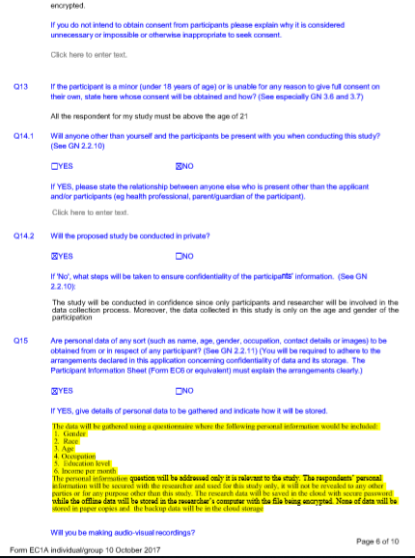
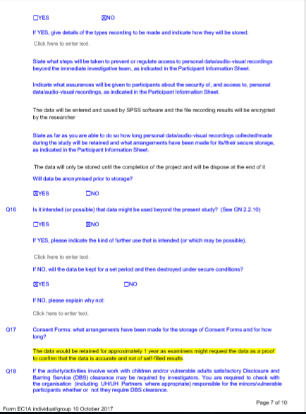
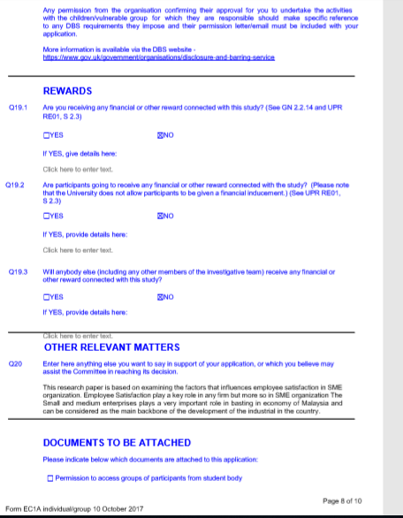
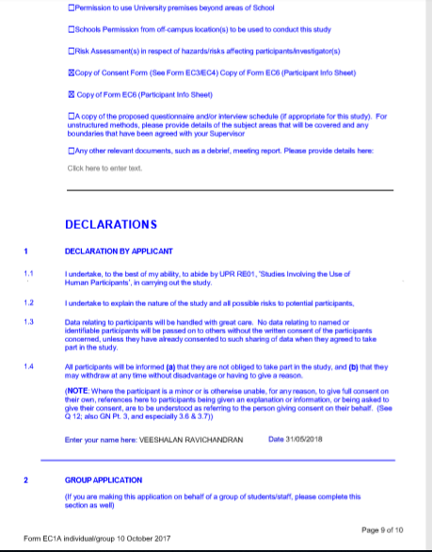


Form EC3
UNIVERSITY OF HERTFORDSHIRE
ETHICS COMMITTEE FOR STUDIES INVOLVING THE USE OF HUMAN PARTICIPANTS
(‘ETHICS COMMITTEE’)

FORM EC3
CONSENT FORM FOR STUDIES INVOLVING HUMAN PARTICIPANTS

I, the undersigned [please give your name here, in BLOCK CAPITALS]

…………………………………………………………………………………………………………….…
of [please give contact details here, sufficient to enable the investigator to get in touch with you, such as a postal or email address]
…..………………………………………………………………………………………………………………
hereby freely agree to take part in the study entitled [insert name of study here]

…………EMPLOYEE SATISFACTION IN SME ORGANIZATION SELANGOR MALAYSIA ………………………………………………………………………………………………………..

(UH Protocol number …………………………………………)

1 I confirm that I have been given a Participant Information Sheet (a copy of which is attached to this form) giving particulars of the study, including its aim(s), methods and design, the names and contact details of key people and, as appropriate, the risks and potential benefits, how the information collected will be stored and for how long, and any plans for follow-up studies that might involve further approaches to participants. I have also been informed of how my personal information on this form will be stored and for how long. I have been given details of my involvement in the study. I have been told that in the event of any significant change to the aim(s) or design of the study I will be informed, and asked to renew my consent to participate in it.

2 I have been assured that I may withdraw from the study at any time without disadvantage or having to give a reason.

5 I have been told how information relating to me (data obtained in the course of the study, and data provided by me about myself) will be handled: how it will be kept secure, who will have access to it, and how it will or may be used.

7 I understand that if there is any revelation of unlawful activity or any indication of non-medical circumstances that would or has put others at risk, the University may refer the matter to the appropriate authorities.

Signature of participant……………………………………..…Date…………………………

Signature of (principal) investigator………………VEESHALAN…………………………………Date……………31/5/2018……………

Name of (principal) investigator [in BLOCK CAPITALS please]
………………………VEESHALAN……………………………………………………………………………

Form EC6
UNIVERSITY OF HERTFORDSHIRE

ETHICS COMMITTEE FOR STUDIES INVOLVING THE USE OF HUMAN PARTICIPANTS
(‘ETHICS COMMITTEE’)

FORM EC6: PARTICIPANT INFORMATION SHEET

1 Title of study

Employee Satisfaction in SME organization Selangor Malaysia

2 Introduction

You are being invited to take part in a study. Before you decide whether to do so, it is important that you understand the study that is being undertaken and what your involvement will include. Please take the time to read the following information carefully and discuss it with others if you wish. Do not hesitate to ask us anything that is not clear or for any further information you would like to help you make your decision. Please do take your time to decide whether or not you wish to take part. The University’s regulations governing the conduct of studies involving human participants can be accessed via this link:

http://sitem.herts.ac.uk/secreg/upr/RE01.htm

Thank you for reading this.

3 What is the purpose of this study?

The aim of this research is to have a better understanding on the factor that affect employee satisfaction in SME organization. Organization now days rely on employees to reach the objectives and goals of the organization. So, it is important for employee to be satisfied in order to help the organization in the long run

4 Do I have to take part?

It is completely up to you whether or not you decide to take part in this study. If you do decide to take part you will be given this information sheet to keep and be asked to sign a consent form. Agreeing to join the study does not mean that you have to complete it. You are free to withdraw at any stage without giving a reason. A decision to withdraw at any time, or a decision not to take part at all, will not affect any treatment/care that you may receive (should this be relevant).

5 Are there any age or other restrictions that may prevent me from participating?

Respondents that are below the age of 18 will be not eligible to participate.

6 How long will my part in the study take?

The questionnaire will take 5-10 minutes only for the participant to answer the question

7 What will happen to me if I take part?

The first thing to happen will be <The respondent will be contributing their time into this important study that will help SME organization further understand their employees

8 What are the possible disadvantages, risks or side effects of taking part?

There is no side effect only will be time taken from the participant when filling up the questionnaire

9 What are the possible benefits of taking part?

This will help SME organization further understand their employees has SME plays a very important role in Malaysian economy.

10 How will my taking part in this study be kept confidential?

The data collection can only be viewed by the researcher and only age and gender information will be asked from the respondent.

12 What will happen to the data collected within this study?

12.1 The data collected will be stored electronically, in a password-protected environment, for a month, after which time it will be destroyed under secure conditions.

12.3 The data will be anonymized prior to storage.

13 Will the data be required for use in further studies?

13.1 The data will not be used in any further studies;

14 Who has reviewed this study?

This study has been reviewed by:
This study has been reviewed by:Umi Kalsom. She is currently in FOBCAL office in INTI International University, Malaysia. Besides, this study will also be reviewed by the approving committees of University of Hertfordshire, Social Sciences, Arts and Humanities ECDA.

14.2 The University of Hertfordshire Social Sciences, Arts and Humanities Ethics Committee with Delegated Authority

The UH protocol number is <enter>

16 Who can I contact if I have any questions?

If you would like further information or would like to discuss any details personally, please get in touch with me, in writing, by phone or by email: VEESHALAN RAVICHANDRAN 0164117377 I11007348@student.newinti.edu.my

Although we hope it is not the case, if you have any complaints or concerns about any aspect of the way you have been approached or treated during the course of this study, please write to the University’s Secretary and Registrar at the following address:

Secretary and Registrar
University of Hertfordshire
College Lane
Hatfield
Herts
AL10 9AB

Thank you very much for reading this information and giving consideration to taking part in this study.

Form EC7
