**INTI INTERNATIONAL UNIVERSITY**

**MASTER OF BUSINESS ADMINISTRATION**

Electronic word of mouth influence on consumer

buying behavior in China

Author: ZhengGuokun

Student NO: I19017910

Supervisor: Prof. Dr. Walton Wider

Submission Date: 18th December 2020

**Abstract**

Whether as a source of information for consumers or as a marketing tool for enterprises, word-of-mouth has been closely watched by scholars and entrepreneurs (Luo, 2019). With the continuous development of the Internet, social networks have not only become a platform for people to communicate with each other, but also the rapid development of Internet word-of-mouth. Social networking platforms have become an important channel for consumers to share experiences and obtain product information. When consumers receive word-of-mouth information about products or services on social platforms, they will influence their attitudes and future behavior. However, compared with face-to-face word-of-mouth information exchange, the dissemination of word-of-mouth information in a social network environment involves communicators. There are many factors of communication, such as the platform of communication and the form of information (Huang, 2016).

This research divides word-of-mouth into three categories: "E-WOM's professionalism, E-WOM's empiricism, E-WOM's reputation", and explores whether these three different types of E-WOM influence consumer buying behavior.

**Keywords:** Electronic-Word-ofMouth (E-WOM)，Social networking platform, Buying behavior, Reasoned action, Spread influence

**Acknowledgment**

First of all, here I would like to take this opportunity to show my deepest gratitude to Prof. Dr. Walton Wider, my dearest, respectable, responsible, and amiable supervisor, who has offered me with the great guidance and support continuously during my whole MBA project. Without his patience, advice and generous sharing of valuable knowledge and sources of academic researches, I could not accomplish this project. What is more valuable, the knowledge and experience I have obtained from this project and from my dear Prof. Has increased my understanding of marketing and will definitely benefit me in my future career.   
Secondly, I would like to thank to my family and those people who had help me to make this project possible, without their constant and selfless support, this project would never be accomplished as well.   
Lastly, I also wish to this opportunity to thank INTI International University, I got to learn numerous useful knowledge of MBA and relevant theories, concepts of different disciplines in Marketing, Management, Accounting, Finance, etc. Without the support and assistance of those selfless and amiable people that I mentioned above, I could not accomplish this project. Thanks to them all again and best wishes to all of them!

**Student’s Declaration**

I declare that:

I understand the meaning of ‘Plagiarism and Intellectual Property Right’ and Ethics Related to the Principles of Academic Works.

This assignment is hereby acknowledgment as my own work and I have duly acknowledged use of published and unpublished works of other people from the print, electronic and other media.

I am in possession of a copy of this document, which I can reproduce immediately if for whatever reasons, the original copy is lost or damaged.

[Name / Identification Number] ZhengGuokun

[Signature] ZhengGuokun

[Date] 18th December 2016

**Table of Contents**

**Chapter 1 1**

1.Research Background 1

2.Problem Statement 1

3.Research objective 2

4.The significance of research 2

4.1.Theoretical significance 2

4.2.Practical significance 2

5.Research question 2

6.Hypotheses 3

7.Definition of Terms 3

**Chapter 2 3**

1.Conceptual Framework 3

2.Theory of Reasoned Action 4

3.Word-of-mouth literature review 5

3.1.The concept of traditional word of mouth 5

3.2.The concept of Electronic word of mouth（E-WOM） 6

3.3.Characteristics of E-WOM 6

3.4.Characteristics of E-WOM Communicators 7

4.The concept of consumer behavior 8

5.Research on the Relationship between E-WOM and Consumer Behavior 8

5.1.The communication role of E-WOM 8

5.2.Research on Related Variables Affecting the Spread influence of E-WOM 9

5.2.1.Research on word-of-mouth types 9

5.3.Related research on other influencing factors 10

6.Theoretical model and hypothesis 11

6.1.Conceptual framework 11

6.2.Research hypothesis 12

6.2.1.The professionalism of E-WOM has a positive influence on consumers buying behavior in China 12

6.2.2.The empiricism of E-WOM has a positive influence on consumers buying behavior in China 13

6.2.3.The reputation of E-WOM has a positive influence on consumers buying behavior in China 13

**Chapter 3 13**

1.Overview 14

2.Research Design 14

3.Unit of Analysis 14

4.Sampling Design 14

5.Data Collection Methodology 15

6.Development of questionnaire 15

7.Measurement Instrument 17

7.1.Analysis Tools 17

7.2.Descriptive analysis 17

7.3.Pilot test 17

7.4.Data Analysis 18

**Chapter 4 18**

1.Chapter Overview 18

2.Pilot test 19

2.1.Pilot Test – Factor Analysis 19

2.2.Pilot Test – reliability test 20

3.Data analysis 21

3.1.Descriptive analysis 21

3.2.Data analysis - factor analysis 22

3.3.Data Analysis–reliability test 24

3.4.Multiple regression analysis 25

4. Test of Hypotheses 28

4.1. E-WOM's professionalism 28

4.2. E-WOM's empiricism 28

4.3. E-WOM's reputation 28

5. Conclusion 29

**Chapter 5 29**

1. Chapter view 29

2. Result Discussion 29

3. Research Limitation 30

4.Recommendation on research 30

5. Conclusion 31

6. Personal Reflection 31

**Chapter 6 32**

Appendix 1: Questionnaire 35

Appendix 2: SPSS outputs for Pilot Test 38

Appendix 3: SPSS outputs for Data Analysis 41

Appendix 4: Project Paper Log 47

**Chapter 1**

**Introduction**

**1.Research Background**

Since the term "Word of Mouth" was used in marketing, a large number of scholars have confirmed that word of mouth communication affects consumers' purchasing decisions (Hou, 2019). With the popularization and development of the Internet, consumers can publish and disseminate various forms of word-of-mouth information. There are many channels of information transmission and the speed of transmission has made word-of-mouth marketing continue to circulate on the Internet, and the spread and influence coverage has become wider and wider. Word-of-mouth communication has not only information attributes but also normative attributes (Peng, 2018). Compared with the advertisements issued by the merchants and the introduction of the promoters, consumers are more inclined to search for relevant product information from their friends or through online reviews. Compared with traditional word-of-mouth, online word-of-mouth has multiple presentation forms and is easier to obtain by many consumers. Therefore, this research is based on the Theory of Reasoned Action(TRA) to study the influence of three types of E-WOM on the buying behavior of a consumer in China．

**2.Problem Statement**

Word-of-mouth communication has not only information attributes but also normative attributes (Peng, 2018). For enterprises, the emergence, and development of Internet word-of-mouth provides new channels and opportunities for the dissemination of corporate brand and product-related beliefs, and companies have also discovered the impact of obtaining product information through the Internet on consumer psychology and behavior, especially the Internet impact of word of mouth and online reviews on consumer decision-making. Although many companies have begun to establish virtual brand communities to provide platforms for users to post-consumer experiences and ask questions, thereby stimulating viewers' desire to purchase, the large number of participants in virtual communities, openness and anonymity, and other characteristics have led to the release of Good and bad information is uneven, and some users or stakeholders make exaggerated or even false statements, which makes the authenticity and reliability of internet word of mouth lose its authenticity and reliability, increases consumer search costs, and greatly reduces the effectiveness of word-of-mouth communication (Dong, 2012).

Although many companies have begun to establish virtual brand communities to provide platforms for users to post-consumer experiences and ask questions, thereby stimulating viewers' desire to purchase, the large number of participants in virtual communities, openness and anonymity, and other characteristics have led to the release of Good and bad information is uneven, and some users or stakeholders make exaggerated or even false statements, which makes the E-WOM lose its authenticity and reliability, increases consumer search costs, and greatly reduces the effectiveness of word-of-mouth communication (Wu, 2018).

**3.Research objective**

RO1: To examine the EWOM has to influence on consumer buying behavior in China

RO1a: To examine the influence of E-WOM's professionalism on the consumer buying behavior in China

RO1b: To examine the influence of E-WOM's empiricism on the consumer buying behavior in China

RO1c: To examine the influence of E-WOM's reputation on consumer buying behavior in China

**4.The significance of research**

**4.1.Theoretical significance**

Most scholars in the past only studied the influence of the characteristics of word-of-mouth communicators on the recipients and ignored the characteristics of word-of-mouth itself. This research uses three different forms of word-of-mouth as independent variables to analyze the impact of online word-of-mouth information dissemination on consumer buying behavior more comprehensively and accurately.

**4.2.Practical significance**

On the one hand, Internet word-of-mouth, as a widely spread and low-cost marketing method, plays a very important role in the promotion of corporate brands and products. On the other hand, this research helps to understand what kind of word-of-mouth communication potential consumers tend to trust, to actively guide more suitable communicators to publish word-of-mouth information that is conducive to corporate publicity on the right social platforms. It is helpful for enterprises to cooperate with social network platforms, or to develop and maintain their network platforms, to better grasp the mechanism of online word-of-mouth communication, to help enterprises achieve precision marketing, and to reduce their investment in marketing and publicity.

**5.Research question**

RQ1: Does EWOM has an influence on consumer buying behavior in China?

RQ1a: Is there any influence of professionalism of E-WOM on the consumer buying behavior in China?

RQ1b: Is there any influence of empiricism of E-WOM on the consumer buying behavior in China?

RO1c: Is there any influence on the reputation of E-WOM on consumer buying behavior in China?

**6.Hypotheses**

H1: EWOM has a positive influence on consumer buying behavior in China

H1a: The professionalism of E-WOM has a positive influence on consumers' buying behavior in China.

H1b: The empiricism of E-WOM has a positive influence on consumers' buying behavior in China.

H1c: The reputation of E-WOM has a positive influence on consumers' buying behavior in China.

**7.Definition of Terms**

(1)Electronic word-of-mouth (E-WOM)

The definition of online word-of-mouth: With the advent of the Internet, customers can collect product information provided by other consumers by browsing the web, and customers can share their own experience, opinions, and related knowledge on specific products or services (Xu, 2016).

1. Behavioral Intentions

The behavior intention of consumers is the statement of consumers themselves and future behavior. Treats consumers' behavioral intentions after facing product recommendation information on the Internet, divided into the user's intention to adopt the recommended product information and the intention to purchase the product. (Greene, 2017)

**Chapter 2**

**literature review**

**1.Conceptual Framework**

According to consumer behavior, after consumers receive product or service information, they will make a comprehensive judgment on the information, and then decide whether to trust the information and generate behavior. Therefore, based on theoretical and practical significance, this research will study the impact of three different types of word-of-mouth on consumer purchasing behavior.

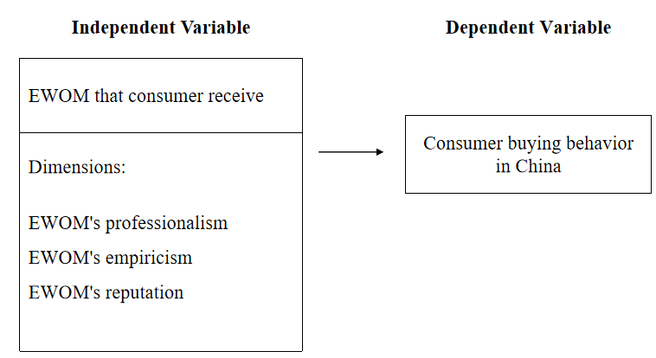

**2.Theory of Reasoned Action**

Theory of Reasoned Action (TRA) was proposed by American scholars Fishbein and Ajzen in 1975. It is an important theory used to analyze consumer behavior (Fishbein, 1975). This theory is mainly used to analyze how consumers' behavior and attitudes consciously affect their behavior. The rational behavior theory regards consumers as "rational people" and believes that consumers will comprehensively analyze various information to judge the meaning and consequences of their behavior before they act. The theoretical model is general. It proposes that any factor can directly affect individual behavior attitudes and subjective norms, and then affect their actual behaviors. The model variables include attitudes towards behaviors, consumer subjective norms, Behavior intention, and actual behavior.

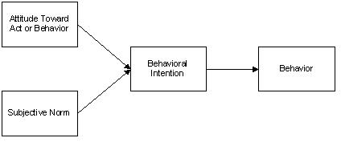

Since the theory of rational behavior was put forward, the theory has been widely used and developed in the field of research on consumer behavior, especially in the study of consumer individual subjective will behavior. The rational behavior theory believes that actual behaviors are usually made after rational thinking and can generally be controlled. When consumers will take action is difficult to track and measure, but people's intention to act can be measured. Measuring behavioral intentions can predict whether people will take this behavior; behavioral intentions are usually affected by two factors, consumers' behavioral attitudes, and their subjective norms. Behavioral attitude refers to the subjective factors of consumers. Attitude determines behavior. The actual behavior of consumers is the external manifestation of their attitude. (Guo.2003) Because it is difficult to track the actual behavior of consumers, scholars usually only consider the behavioral tendencies of the respondents in actual research, that is, adopt a simplified theoretical model of rational behavior, and a large number of studies have shown that consumers' behavioral intentions There is a strong positive relationship with its actual behavior, so a simplified model that does not examine the actual behavior of consumers is feasible.

**3.Word-of-mouth literature review**

**3.1.The concept of traditional word of mouth**

Word-of-mouth communication is an informal interpersonal communication, which is the exchange of information about products or services between non-profit consumers (Xu, 2016) Traditional word-of-mouth is a long-standing way of information dissemination, in which companies disseminate their product information or brand image through mutual exchanges between customers in the process of brand building. Word of mouth has always played an important role in the field of marketing. When informatization is underdeveloped and Internet technology is not perfect, most consumers will rely on face-to-face word-of-mouth communication to share or collect information. And for companies, word-of-mouth communication can not only increase the promotion of products and brands but word-of-mouth marketing, as a low-cost information dissemination tool, does not require more resources and capital investment from the company, saving a lot of advertising costs. Traditional word-of-mouth refers to the positive or negative reviews of goods or services released by consumers face-to-face, without resorting to media channels. Arndt (1967) studied traditional word-of-mouth earlier and defined word-of-mouth as the behavior of informal information communication between people without the purpose of corporate marketing. Information includes corporate products, brands, and services.

Westbrook (2016) defines word-of-mouth as: in the context of consumers buying products, consumer sharing includes ownership, usage, purchase experience, or specific goods, services, and seller characteristics informally for other consumers communication (Robert, 2017).

Through scholars' definitions of traditional word-of-mouth communication, it is not difficult to find that the two most important characteristics of traditional word-of-mouth communication are high credibility and informal communication. Under normal circumstances, word-of-mouth communication mostly occurs when relatives, friends, colleagues, etc. have close and long-term relationships. Before the interactive communication of word of mouth, word of mouth communicators and recipients have established a long-term and stable relationship between the communicating groups. Compared with pure commercial advertisements and information provided by promoters, the credibility of word of mouth Higher, and not restricted by the system and corporate rules in the process of word-of-mouth communication. These two characteristics are the core of word-of-mouth communication and are also the most concerned factors for companies to carry out word-of-mouth publicity. Instead of spending a lot of money and resources on commercial advertising, promotional activities, and public relations activities to stimulate potential consumers, attract their attention to generating "eyeball economy" "The effect is to expand the user market and increase the loyalty of consumers. It is better to achieve the purpose of the enterprise through this relatively simple but very influential "user tells the user" method.

**3.2.The concept of Electronic word of mouth（E-WOM）**

Traditional word-of-mouth is informal communication between consumers. Because companies are difficult to grasp and guide, traditional word-of-mouth plays a small role in the actual marketing practice of enterprises. However, with the popularization of mobile Internet, the cost of network usage has increased significantly. With the extensive development and application of social media, consumers can express their thoughts and feelings more conveniently. Not only can they obtain information about products or services they need through the Internet at any time, but they can also share themselves with other users more conveniently. Consumer experience or product expertise.

Stauss (2017), as the earliest scholar who defined E-WOM, believes that E-WOM is "communication among Internet consumers" and defines E-WOM as the information exchange conducted by consumers on the Internet to choose suitable products. The content of communication includes the product and its usage.

Shen Suxia (2018) believes that the Internet is an indispensable link in the development of enterprises. This link can eliminate the asymmetric information between enterprises and consumers, thereby helping enterprises formulate development strategies and carry out marketing plans in the e-commerce environment.

Haiqing Hou and Yajing Gong (2019) through literature review, define the internet word of mouth as consumers use the Internet to share information about companies, products, or services, to express their own emotions, and provide a reference for other consumers' purchase decisions and behaviors Information.

Based on the concepts put forward by various scholars, it can be seen that E-WOM mainly emphasizes two factors. First, it must rely on Internet platforms, not only shopping websites and platforms but also social platforms, virtual websites, etc.; second, The sharing and communication between consumers thus affect the process of consumers to a certain extent. Therefore, this research defines Internet word-of-mouth as an activity in which consumers use the Internet as a medium, take product and service experience as a content, and use text and images as information dissemination carriers to communicate and interact.

**3.3.Characteristics of E-WOM**

The influence of word-of-mouth on consumers As the Internet has expanded infinitely, the role of online word-of-mouth in consumer psychology and behavior is becoming more and more important. (Du.2016)Although both are informal communication between consumers on goods or services, due to the characteristics of the Internet as a medium, the way of spreading and consuming word-of-mouth information in the network environment has a significant impact Compared with traditional word-of-mouth, online word-of-mouth has its characteristics due to its role.

1. The spread of online reputation is wide.

Compared with the traditional word-of-mouth communication that mainly relies on face-to-face communication between relatives and friends, the influence of online word-of-mouth communication will be greatly enhanced due to the openness and popularity of the Internet. Using the Internet, especially the mobile Internet, consumers are in virtual communities, social platforms, etc. Various types of Internet platforms discuss and exchange corporate brand images, product features, and services provided by the company. Any user can browse the word-of-mouth information and participate in the discussion.

1. The observability of internet word of mouth content.

Online word-of-mouth content can be in various forms such as text, pictures, videos, etc., and online word-of-mouth information is not only published on platforms such as virtual communities or social networks, but can also be browsed, stored, and shared for further word-of-mouth communication. The form, content, and Features such as information sources can be permanently preserved, and the observability of word-of-mouth content also significantly affects the credibility of online word-of-mouth. (Guo.2017)

1. The anonymity of internet word of mouth.

Since the Internet is an open and relatively anonymous media, some businesses may manipulate online reviews to obtain high rewards to pursue profits, which may reduce the credibility of Internet word-of-mouth, and some bad business competition may also affect the Internet word-of-mouth Manipulate and hire network naval forces to release false information. As a special form of online word-of-mouth, online naval speech is sometimes difficult for consumers to distinguish between true and false, so it will have a great impact on consumers' purchasing decisions (Zheng, 2015).

**3.4.Characteristics of E-WOM Communicators**

Gilly (1998) and others found that the more professional the information source, the greater the impact on the information collector, that is, the information communicator with professional knowledge is more likely to gain the trust of others; and the research found that word-of-mouth communicators and information receivers The more similar they are, the greater the impact of word-of-mouth information on recipients. Gao Lin's (2015) research found that with curiosity as a moderating variable, in a social media environment, the reliability of word-of-mouth information sources affects consumers' purchase intentions. Xu Weiqing and Huang Xiaojun (2004) believe that the professionalism of word-of-mouth communicators refers to their ability to provide consumers with valuable information. The professionalism of word-of-mouth communicators is affected by the professional knowledge, experience, and social status of the communicator. Huang Jinglong (2008) found through research on product reviews that the credibility of product reviews has a great impact on consumer product attitudes. The higher the professionalism, usefulness, and similarity of product reviews, the more consumers see online product reviews. , The higher the credibility of its perceived product reviews. Wang Feng (2010) believes that when consumers are in an uncertain consumption situation or environment, word-of-mouth provided by trusted people such as experts has a greater influence on consumers. Wang Xiuqin (2011) confirmed through research that the higher the professional level of the online word-of-mouth information publisher, the higher the credibility of the word-of-mouth information for the word-of-mouth receiver. Tan Chunhui (2017) researched empirical research methods, and the results showed that the professionalism, homophobia, and relationship strength of information disseminators are positively correlated with the recipient's perception of Internet word-of-mouth trust.

**4.The concept of consumer behavior**

The American Marketing Association (AMA) defines consumer behavior as the dynamic interaction process of emotions, perceptions, behaviors, and environmental factors, which are the behavioral basis for humans to perform transaction functions in life. Engel, Kollat, and Blackwell (1993) believe that consumer behavior refers to the various actions taken by consumers to obtain, use, and dispose of consumer goods or services, and include decisions that occur before and after these activities. Schiffman and Kanuk (1991) defined consumer behavior as the behavior of consumers seeking products and services, purchasing, using, evaluating, and disposing to meet their needs. That is to say, this kind of research orientation defines consumer behavior as the consumer activities shown by consumers for products or services to meet their needs, and the decision-making behaviors that occur in the process. The consumer decision-making process consists of five stages: confirming needs, collecting information, evaluating the plan, purchasing behavior, and post-purchase results.

**5.Research on the Relationship between E-WOM and Consumer Behavior**

**5.1.The communication role of E-WOM**

In today's highly globalized living environment, the products that people are exposed to are very different from the past. The development of science and technology and the improvement of transportation networks have made it possible for people to enjoy products produced around the world. However, people's understanding of different products is always limited. Faced with an overly rich variety of products, how should consumers choose? How to optimize the complex product purchase link? How to ensure that the final consumption decision is the most effective? It has become a matter of great concern to consumers.

Well-known theories in the field of consumer behavior, such as the E.B.M model and Kotler model, all show that consumers will enter the corresponding information collection link after their needs are aroused, and form the final consumption decision through the processing of internal and external information. Internet word-of-mouth, as information created by consumers, contains the experiences, evaluations, and opinions of these consumers. As an independent product information channel, information from this user's perspective is often the information that manufacturers cannot or are unwilling to provide, Can better help potential consumers to make a purchase plan evaluation. Therefore, for potential consumers, the status of Internet Word of Mouth in consumer decision-making is becoming more and more important. A survey shows that online word-of-mouth is an important source of product information for consumers. 57% of consumers will browse other consumers' recommendation information through web pages, which is much higher than the influence of other sources on consumer buying behavior. Park et al. (2008) believe that Internet word-of-mouth plays the role of the information provider and recommender in information dissemination. As an information provider, IWOM provides information about product attributes and product performance from the user's perspective. As a recommender, it provides positive or negative signals to reflect the popularity of the product, allowing the information recipient to understand the emotional experience of related users. To eliminate the uncertainty in the purchase process, consumers need to know a lot of information from different perspectives. They will hope to get additional product attribute information and user suggestions at the same time. Therefore, Internet word-of-mouth with two roles at the same time meets people's needs for such information.

**5.2.Research on Related Variables Affecting the Spread influence of E-WOM**

Chatterjee (2001) believes that the effect of online word-of-mouth information depends on consumers' acceptance of word-of-mouth information. The stronger the consumer's feeling of confidence in accepting word-of-mouth information, the more likely such feelings are to dominate consumers' interpretation and use of word-of-mouth information. This in turn affects consumer attitudes and behaviors. Understanding what factors affect the spread of word-of-mouth has become an area of great concern to scholars.

**5.2.1.Research on word-of-mouth types**

From the perspective of the characteristics and content of word-of-mouth information, in previous related researches in the field of word-of-mouth marketing, most of the empirical studies have adopted measurement methods that do not limit word-of-mouth content, ignoring the influence of word-of-mouth information characteristics and content on the communication effect, only a few Scholars pay attention to the type of word-of-mouth information in their research. In traditional word-of-mouth research, Chan (2000) divided word-of-mouth into three types in the empirical study of consumer word-of-mouth acceptance, namely professional word-of-mouth, empirical word-of-mouth, and well-known word-of-mouth.

1. Professional word-of-mouth:

The expression of professional word-of-mouth communicators based on product attribute feature information (such as product composition, configuration, performance, etc.). Chan (2000) believes that product features are widely used in word-of-mouth communication for two main reasons. The first is that word-of-mouth recipients are interested in a certain attribute of the product, so they actively seek out attribute information. The second is because information recipients often think that professional reputation is more objective and reliable.

1. Empirical word of mouth

Empirical content is the expression of the experience of the word-of-mouth communicator buying and consuming products or services. Word-of-mouth communicators are more interested in sharing each other's experiences (such as what happened to them and how they felt) rather than just providing characteristic information (such as what the product was like). The research of Chan (2000) pointed out that when a person thinks about purchasing a certain product, he is more inclined to rely on real user experience as the basis for consumer decision-making.

1. Well-known word of mouth

Well-known word-of-mouth refers to product reviews that have received the most attention on social networking platforms or product reviews endorsed by celebrities. Consumers are susceptible to such word-of-mouth influences to determine the final purchase decision.

**5.3.Related research on other influencing factors**

(1) The professional level of the information recipient

The receiver's expertise includes its existing impression of the product and brand familiarity. To a certain extent, it is a sign of the recipient's confidence in the product or service and reflects the consumer's self-judgment level of the product or service attribute. Consumers are less affected by word-of-mouth on brands that have previously left an impression. On the contrary, consumers' attitudes towards brands that have no prior contact with and have not formed concepts are more likely to be affected by word-of-mouth (Herr et al., 1991). Gilly's (1998) research results show that the higher the receiver's professional knowledge, the less affected by word-of-mouth information. Voyer (1999) studied the impact of word-of-mouth on service purchase decisions, assuming that the higher the professional level of word-of-mouth receivers, the smaller the influence of word-of-mouth on purchase decisions, but the results of the study show that the relationship between the two is not significant. The research results also show that contrary to the research hypothesis, the professional level of the receiver has a positive relationship with word-of-mouth active search. Wang Zunzhi (2004) took e-mail as an example to study online word-of-mouth and found that the stronger the personal professional ability of word-of-mouth recipients, the greater the impact of word-of-mouth information (email content) on word-of-mouth recipients.

(2)Perceived risk

The concept of perceived risk was first proposed by Raymond Bauer (1960) of Harvard University. He believed that any consumer buying behavior has unexpected circumstances that may cause consumers to be unhappy, so consumer behavior is a risk-taking behavior. Professor Bauer proposed that the perceived risk includes two factors: ① the uncertainty of the outcome of the decision; ② the severity of the consequences of the wrong decision, that is, the importance of possible losses. Following Bauer, Dowling, and Staeli (1994) defined consumer perceived risk as to the possibility of uncertainty and adverse consequences that consumers perceive when purchasing products or services. When consumers face the uncertainty and consequences of purchasing decisions, if consumers pay more attention to the uncertainty or the consequences are higher, the perceived risks of consumers are relatively high. Arndt (1967) first proposed that word-of-mouth communication is the most important strategy to reduce perceived risk. He pointed out that high-risk perceivers tend to pass more product or service information to other consumers because this information is considered to have special value and therefore attracts them. Become an exchange member in social relations. Engle et al., (1995) put forward the consumer purchase behavior model (ie E.B.M model) also explained that one of the main purposes of external search is to reduce perceived risk. Scholars such as Engle believe that consumers' information search can be roughly divided into two aspects, namely, internal search, which relies solely on the experience stored in memory, and visits to stores, listens to the opinions of people around, and searches for advertising media information. Active external search (External search). Moreover, in most cases, internal information search often fails to meet the needs of consumers' shopping decisions, so they have to turn to external information search.

Through literature review, it can be seen that in the existing Internet word-of-mouth research, most scholars believe that Internet word-of-mouth has a stronger influence on purchasing decisions in high-risk scenarios, and consumers will be affected by perceived risks in the process of making purchasing decisions. And the higher the perceived risk, the more consumers will get more information from word of mouth. Park et al. (2008) pointed out in a study that consumers often have a conformity mentality when the perceived risk is high. At this time, consumers tend to buy products with more recommended groups, and consumers believe that they follow the public's purchases. Behavior helps reduce the chance of wrong decisions.

**6.Theoretical model and hypothesis**

**6.1.Conceptual framework**

According to the TRA, consumers make rational decisions based on the effective information they have obtained. The theory believes that consumers' actual behavior comes from the evaluation of information, and the evaluation of information affects consumers' purchasing behavior. Therefore, the impact of different types of word-of-mouth on consumer buying behavior is the focus of this research. The Conceptual framework is shown in the figure.

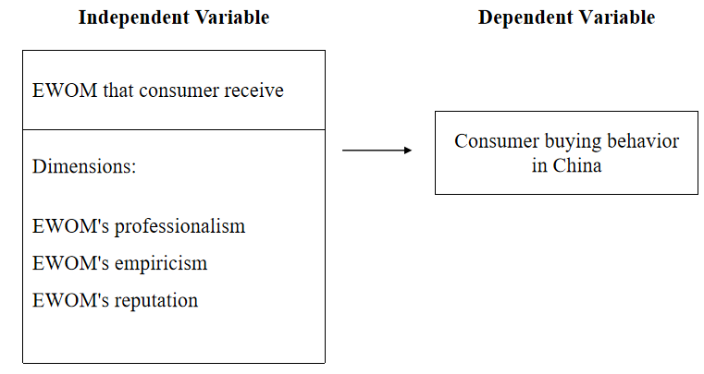

**6.2.Research hypothesis**

**6.2.1.The professionalism of E-WOM has a positive influence on consumers buying behavior in China**

This research believes that the professionalism of E-WOM has a positive influence on consumers' buying behavior in China. Arndt (1997) pointed out that word-of-mouth receivers generally believe that the word-of-mouth information released by opinion leaders is more influential, and the recipients believe that its credibility is higher. Word-of-mouth recipients tend to regard consumers with professional knowledge as experts in certain types of products or services, and even think that they can obtain difficult-to-obtain internal information, which makes information recipients more willing to adjust their attitudes by expert opinions. Word-of-mouth receivers on social networking platforms have a deeper understanding of the communicator and a certain level of understanding of the professional knowledge and skills of word-of-mouth communicators. Therefore, the initial trust of the recipient depends more on the professionalism and reliability of the communicator. Chen Xiaohong (2019) and others compared the word-of-mouth information on medical social platforms and common social platforms and found that although medical social platforms and common social platforms (such as Weibo and WeChat Moments) have a large amount of information and are interactive Strong characteristics. However, because users of medical social platforms have strong purpose and pertinence, that is, users have relevant medical experience or medical experts, so patients will think that it is compared with the reputation of ordinary social platforms Information, word-of-mouth information derived from medical social platforms is more credible, with strong authenticity and availability.

Therefore, this research proposes hypotheses: The professionalism of E-WOM has a positive influence on consumers' buying behavior in China.

**6.2.2.The empiricism of E-WOM has a positive influence on consumers buying behavior in China**

Fiske (1980) believes that the experience of word-of-mouth is more attractive to consumers, and consumers will give this information more weight, that is, consumers are more inclined to believe in more experienced word-of-mouth information. When consumers have clarified their needs, they will start searching for relevant information. A more comprehensive understanding of product information can help reduce the uncertainty of consumers' purchasing decisions, thereby enhancing consumers' confidence and purchasing intentions in this consumer decision. That is, when consumers have more comprehensive product information, the more they can reduce the perceived risk of consumption. Cohen (1983) believes that there are two ways for consumers to accept word of mouth. One is that when consumers face word-of-mouth information, they often choose to follow the opinions of the majority to obey the opinions of their group to maintain their status in the group. The second is because the word of mouth does provide accurate and credible information about product quality. Many studies in the field of psychology and marketing have shown that consumers tend to obey the social expectations of public standards. Therefore, consumers often observe or imitate the behavior of others as their decision-making basis. Perceived popularity reflects the popularity of related products that consumers perceive. According to the theory of social expectations tendency, consumers will have a positive perception and impression of the product, and their willingness to buy will be higher; on the contrary, when the product is perceived When unpopular, the willingness to buy will be reduced accordingly.

Therefore, this research proposes hypotheses: The empiricism of E-WOM has a positive influence on consumers' buying behavior in China.

**6.2.3.The reputation of E-WOM has a positive influence on consumers buying behavior in China**

When consumers buy products, consumers tend to directly search for the most popular and well-known word-of-mouth information. Consumers sometimes make purchase decisions based on the most well-known and most followed word-of-mouth information in all reviews. The process of searching for information and evaluating alternative brands will be omitted.

Therefore, this research proposes hypotheses: The reputation of E-WOM has a positive influence on consumers' buying behavior in China.

**Chapter 3**

**Research Design and Methodology**

**1.Overview**

This chapter provides an introduction of research design and methodology which had been applied for this research. Firstly, the research design will be presented and linked with the framework of the proposal which was shown in Chapter 2. Then, based on the research design, the Unit of Analysis and Sampling Method will both ensure the research can reach the right and effective target group. Thirdly, Data Collection and Measurement part will further introduce the data source, data analysis method, and how to measure the data so as to maintain the accuracy and relevancy of the research. In addition, this research will employ  SPSS for analyzing data collected from the survey.

**2.Research Design**

As the research objective stands, the purpose of this research is identifying the relationship between two research variables,Therefore, Quantitative Study approach is much suitable for this research for its deductive nature,which means general inferences about the characteristics of a population (Saunders et al, 2012).This research will follow the nature of Quantitative Study, to describe or predict, build and test hypothesized theory (Cooper&Schindler, 2008).

Furthermore, according to Kumar et al (2010),the Correlation Design, also known as Descriptive Research,is commonly applied for identifying and descripting relationships between independent and dependent variables in a research.

Ultimately, a cross-sectional questionnaire is distributed at one-shot (Cooper & Schindler,2008) to respondents to answer for data collection.

**3.Unit of Analysis**

The research of this study are individuals, more specifically, those Chinese consumers who often purchase goods on the Internet.

**4.Sampling Design**

Considering that it is impossible to get in touch with a large number of target consumers in various parts of China, this study will only focus on the consumers WeChat, Weibo and Qzone on the three largest social networking platforms in China. In order to determine the sampling frame of the target group, this study uses a random sampling method due to cost considerations and time constraints. Therefore, the sample size required for this study is the statement of 384 krejcie & morgan (1970), which states that for the target population more than 1 million, the sample size required is 384 (see the table below).

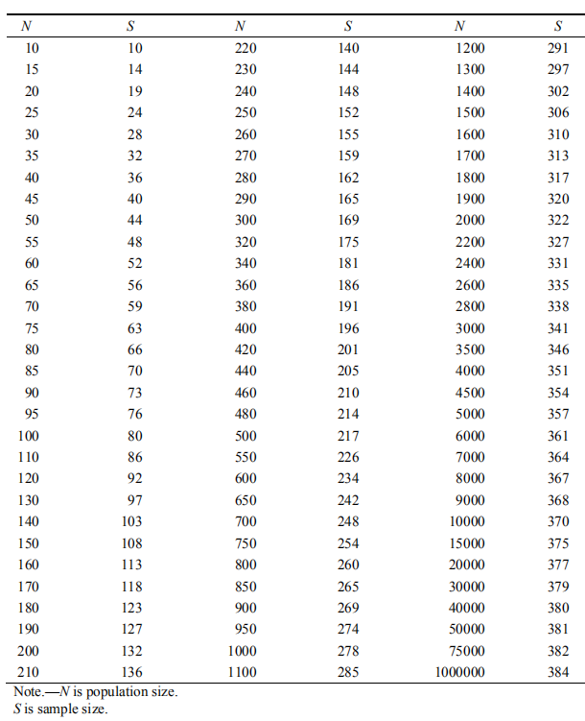

*Source: Krejcie & Morgan (1970)*

**5.Data Collection Methodology**

The survey approach is considered as the most common data collection method which is widely applied by most of the researchers (Kamel, 2013; Narayanan & Savarimuthu, 2015; Qureshi, et. al, 2013; Shujat, et. al, 2011). Therefore, the primary data of this research will thus to be collected by online survey.

In order to collect sufficient data for later analysis part, a total of 384 online survey will be conducted via online questionnaire，

The whole distribution of survey will take around three weeks.

**6.Development of questionnaire**

Questionnaire methodThe questionnaire is the method of obtaining data in this research. The questionnaire in this research is mainly divided into two parts. The first part is the various variables in the research on the influence of Internet word-of-mouth on consumer behavior intention in the social network environment. This part is the main part of the questionnaire. The second part is the investigation of the basic situation of the surveyed person, which mainly involves the basic personal situation of the surveyed person such as gender, age, and educational background. This questionnaire asks respondents to recall the most impressive and trusted word of mouth on social networking platforms, and then answer the questions in the questionnaire based on this.

Questions 1~5 are to determine the influence of professional word of mouth on consumers' purchasing behavior.

Questions 6~10 are to determine the influence of the experiential nature of word of mouth on the purchasing behavior of consumers.

Questions 11~15 are to determine the influence of the fame of word of mouth on the purchasing behavior of consumers.

Questions 16-20 are to determine whether word of mouth has an impact on consumers' buying behavior.

|  |  |  |
| --- | --- | --- |
| **Variable** | **Definition** | **Reference** |
| E-WOM's professionalism | Arndt (1997) pointed out that word-of-mouth receivers generally believe that the word-of-mouth information released by opinion leaders is more influential, and the recipients believe that its credibility is higher. Word-of-mouth recipients tend to regard consumers with professional knowledge as experts in certain types of products or services, and even think that they can obtain difficult-to-obtain internal information, which makes information recipients more willing to adjust their attitudes by expert opinions. | Gilly (1998)  Johnston (2010)  Arndt (1997) |
| E-WOM's empiricism | Fiske (1980) believes that the experience of word-of-mouth is more attractive to consumers, and consumers will give this information more weight, that is, consumers are more inclined to believe in more experienced word-of-mouth information | Fiske (1980)  . Cohen (1983) |
| E-WOM's reputation | When consumers buy products, consumers tend to directly search for the most popular and well-known word-of-mouth information. Consumers sometimes make purchase decisions based on the most well-known and most followed word-of-mouth information in all reviews. The process of searching for information and evaluating alternative brands will be omitted. | Park＆Lee (2009) |

7.Measurement Instrument

Data analysis methods, particularly, those tests and measurements of this research will follow the requirements of scientific research, which consist of Preliminary tests, Hypotheses testing, as well as other supporting or confirmatory tests (Sekaran & Bougie, 2011).

**7.1.Analysis Tools**

In this research, Statistical Package for Social Science (SPSS) will be employed to perform the required pilot test and analyze the data collected from the final survey.

SPSS is considered as the most commonly used data analysis tool in both social science and business circles for the reason of user-friendly (Daniel, 2014; Muijs, 2004). This research will employ SPSS for performing: Descriptive Analysis, Factor analysis，Reliability Test and Multiple Regression Test.

**7.2.Descriptive analysis**

The Descriptive analysis of this research will emphasize on demographic information from the respondents. Besides, data analysis will be performed by SPSS, because, SPSS is capable for demonstrating data in various format, table, chart, graph (IBM, 2012).

The demographic information of this research consists five simple items: Gender, Age, Income Level, Education Level and Years of working. As the consideration of ethics of this research, all personal information of the respondents will be collected anonymously and will not be disclosed.

**7.3.Pilot test**

*Factor Analysis in SPSS*

In this research, Factor Analysis is not only applied for testing the full data, it is also applied as a test method for the pilot test result.

According to Zikmund et. al. (2010), Factor Analysis is conducted before Reliability Test, which is initiated to ascertain whether there are factors or items that should be removed before further tests. Therefore, the data collected from the questionnaires will be test by the KMO Bartlett's test of Sphericity (Kumar et al., 2010), which could determine the level of relevance and appropriateness of data collected and items within the questionnaire. The results will directly affect whether the data can be taken to the next step tests.

*Reliability Test in SPSS*

Once Factor Analysis were completed, Reliability test should be done to measure the consistency of data collected for measuring the proposed research models (Bryman & Bell, 2011). Also, this test will be performed during pilot test.

It is vital to perform Reliability test, although at times, it may get an invalid but reliable measurement (Sekaran & Bougie, 2011). Yet, it is still necessary to perform such test so as to ensure the internal consistency of data collected (Kumar et al., 2010).

For this research's Reliability test, Cronbach's alpha is calculated and check against the criteria. According to Tavakol & Dennick (2011), the recommended rage for Cronbach's Alpha is between .70 and .95, and the higher the value is, the more reliable the data is.

**7.4.Data Analysis**

*Multiple Regression Analysis in SPSS*

Different from Simple Regress, Multiple regressions has more than one predictor variable in the equation (Hair et al, 2010). Multiple Regression analysis is applied for developing a self-weighting estimating equation that determines the predicted value of depend variable from the value of several independent variables (Cooper & Schindler, 2008). According to Zikmund et al. (2010), Path Coefficient, B are the symbol of strength and direction of the linear association between interval and ratio variables. Specifically, the Path Coefficient ranging from -1 to +1, whereas the or ‘-' of prefix shows the direction of the linear association, plus, the higher the Path Coefficient value is, the stronger the relationship is (Saunders et al., 2012). Again, if the p-value less than .05, it could be considered as significant as the general acceptance conventional level (Sekaran & Bougie, 2011).

Next, the coefficient of determinant, R2, is the determinant of the goodness of fit of the proposed model, plus, it provides how much percentage of the variance behavior of the dependent variable can be explained by the variation of the independent variable (Saunders et al., 2012).

**Chapter 4**

**Data Analysis and Results**

1.Chapter Overview

This chapter focused on the tabulation of all data, analyses, and tests as well as demonstrated and discussed all results based on the scientific research criteria. For this research, SPSS was employed to perform all stipulated data analyses. As per discussed in Chapter 3, before the full data collection, this research had conducted a pilot test and the results were examined to ensure that the proposed questionnaire was appropriate and accurate for this research. Next, a description of the demographic structure was shown to demonstrate the characteristics of respondents. Then, a series of preliminary tests were performed to analyze the full data and ensure the accuracy and validity of this research, thereby, the statistics results from SPSS was presented and discussed. Finally, all hypotheses proposed in this research were tested to ascertain whether the research objectives of this research was achieved.

**2.Pilot test**

As discussed in Chapter 3, a pilot test was conducted before the full scale distribution. Finally, 251 respondents were collected, which was beyond the general required number for statistical tests to be conducted (Baker, 1994). The data was then tested by Factor Analysis, Reliability Test and Correlation Test so as to ensure

the adapted items are appropriate and relevant for this research.

**2.1.Pilot Test – Factor Analysis**

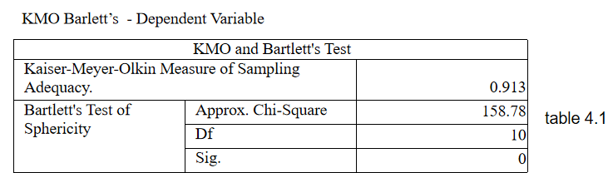

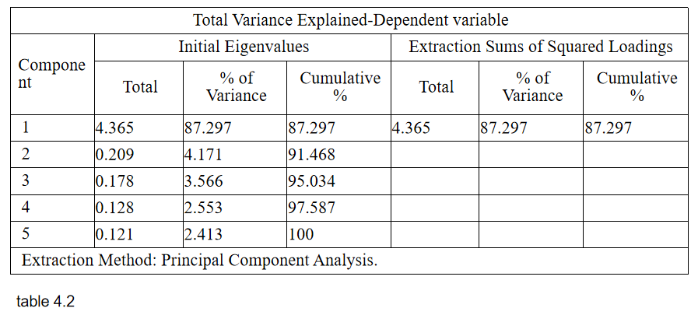

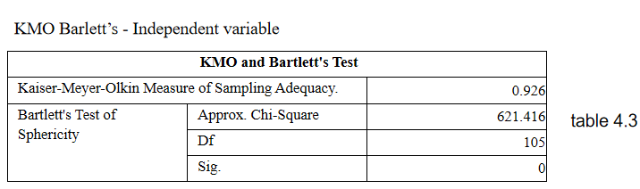

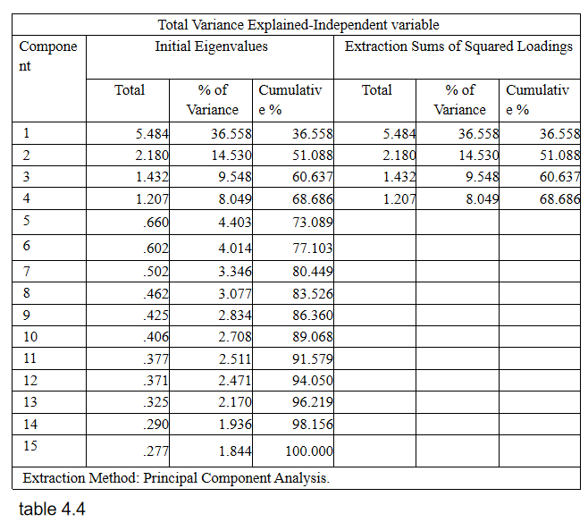

As table 4.1 and 4.3, KMO and Bartlett's Test for Dependent variable and Independent variable interpreted, the KMO of sampling adequacy are 0.913 and 0.926, which are acceptable and are above-recommended value. While Bartlett's Test of Sphericity for Dependent variable and Independent variable shows the p-value where the sig. show value of 0.000 which is less than 0.05. it means the factor is valid.

Based on table 4.2 and 4.4, Total Variance Explained for Dependent variable and Independent variable, the principal component analysis shows all the Initial eigenvalue are more than 1. Therefore, the scale used for the Dependent variable and Independent variable is appropriate and suitable for this research to continue.

**2.2.Pilot Test – reliability test**

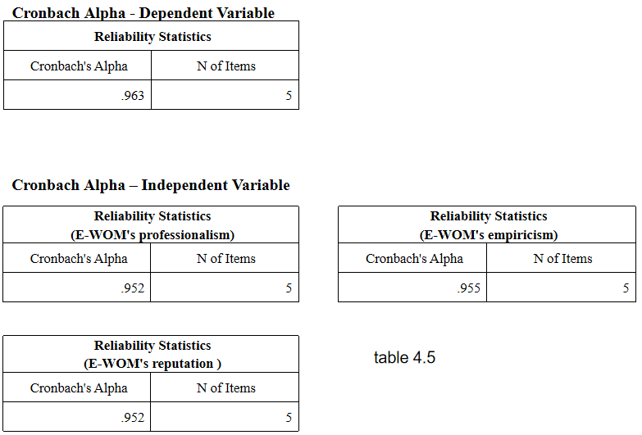

Cronbach's alpha is used to test the reliability of the instruments used in this research. Twenty items in the questionnaire were used in Cronbach's alpha test to measure the reliability of the four variables used in this research. The results of the reliability test show that Cronbach's alpha results of all variables are above 0.9. as shown in table 4.5. The results are acceptable and good.

**3.Data analysis**

**3.1.Descriptive analysis**

The questionnaire is divided into three parts. The first part is about 15 questions about independent variables, the second part is about 5 questions about dependent variables, and the third part is about the demographic profile of the respondent. The census is divided according to gender, age, monthly income, education level, and working years. Table 4.6 is the demographic information provided by the respondents in the questionnaire. About 250 respondents participated in the survey. According to the descriptive analysis of demographic information in Table 4.6, employees aged 19-29 account for the majority. Therefore, the results of this research will be more reflected in the 19-29-year-old population.

It can be seen from Table 4.6 that undergraduates and junior college students account for about 75% of the total, and graduate students account for 12.7% of the total. Therefore, we can conclude that the majority of respondents have bachelor's and college degrees.

|  |  |  |
| --- | --- | --- |
| Profile | Frequency | Percentage |
| Gender   * Male * Female | * 133 * 118 | * 53 % * 47 % |
| Age group   * Under 18 * 19~29 * 30~39 * 40~49 * Over 50 | * 3 * 162 * 44 * 32 * 10 | * 1.3 % * 64.5 % * 17.5 % * 12.7 % * 4 % |
| Level of education   * Higher school education * Junior college student * Bachelor Degree * Master Degree | * 33 * 88 * 98 * 32 | * 13.1 % * 35.2 % * 39 % * 12.7 % |
| Monthly income   * RM1000-2000 * RM3000-4000 * RM5000-6000 | * 99 * 44 * 108 | * 39.4 % * 17.6 % * 43 % |
| Year of work experience   * No * Above 5 years | * 131 * 120 | * 52.2 % * 47.8 % |

Table 4.6 The demographic profile of respondents (N=251)

**3.2.Data analysis - factor analysis**

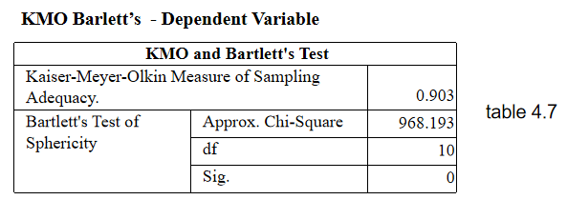

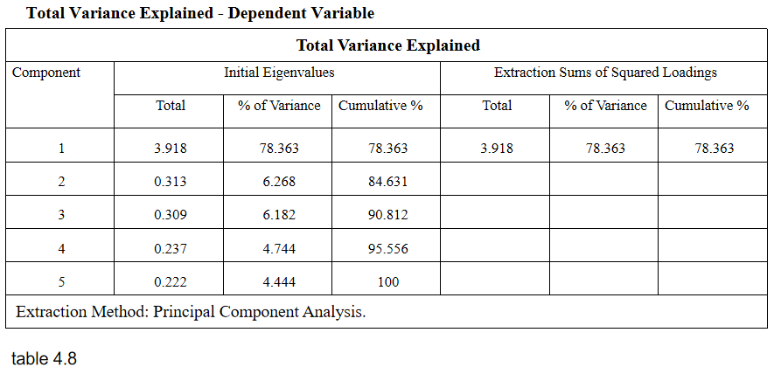

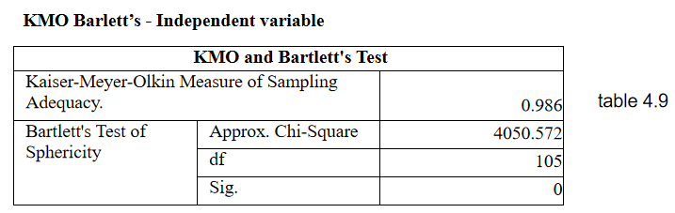

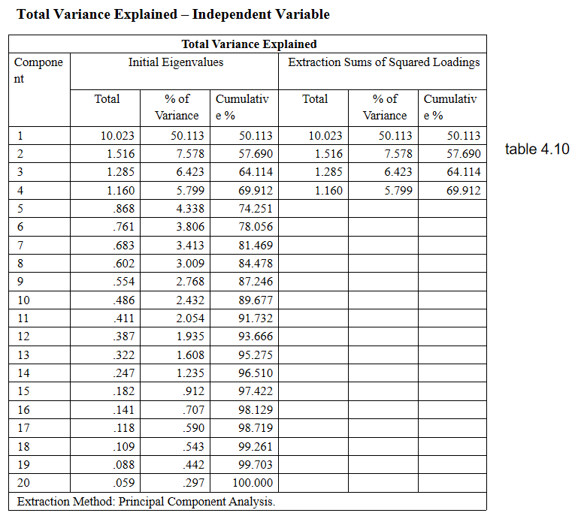

As table 4.7 and 4.9, KMO and Bartlett's Test for Dependent variable and Independent variable interpreted, the KMO of sampling adequacy are 0.903 and 0.986, which are acceptable and are above-recommended value. While Bartlett's Test of Sphericity for Dependent variable and Independent variable shows the p-value where the sig. show value of 0.000 which is less than 0.05. it means the factor is valid.

Based on table 4.8 and 4.10, Total Variance Explained for Dependent variable and Independent variable, the principal component analysis shows all the Initial eigenvalue are more than 1. Therefore, the scale used for the Dependent variable and Independent variable is appropriate and suitable for this research to continue.

**3.3.Data Analysis–reliability test**

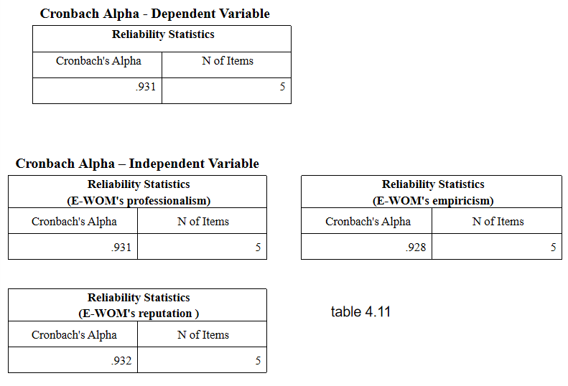

Cronbach's alpha is used to test the reliability of the instruments used in this research. Twenty items in the questionnaire were used in Cronbach's alpha test to measure the reliability of the four variables used in this research. The results of the reliability test show that Cronbach's alpha results of all variables are above 0.9. as shown in table 4.11. The results are acceptable and good.

**3.4.Multiple regression analysis**

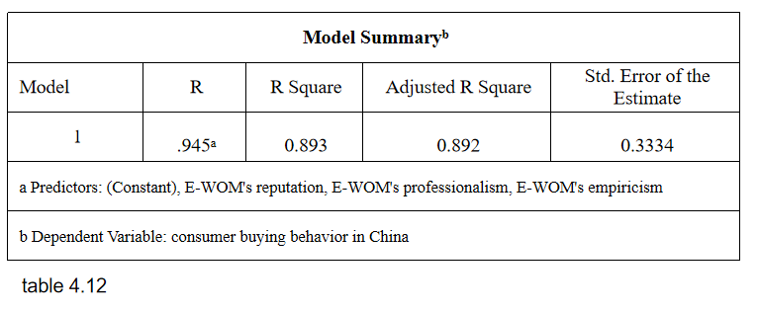.

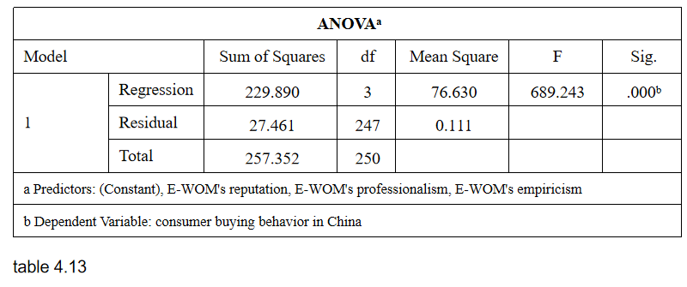

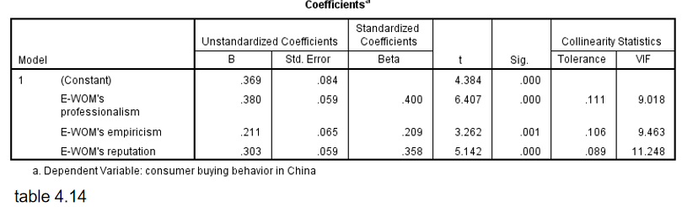

Multiple regression analysis is used to determine the relationship between a dependent variable and one or more independent variables. The relationship between the dependent variables and the independent variables is measured by the purchase behavior of Chinese consumers. According to Sekaran and Bougie (2016), for the model to fit, the R square must be more than 0.5. According to Table 4.12, the value of R Square is 0.893, greater than 0.5, which fits the standard.

Table 4.13 shows the results of P-value is 0.000, which is less than 0.05 (David, 2009). Therefore means the statistical significance of the correlation between Independent variables and dependent variables.

To perform multiple linear regression analysis, first, check whether there are multiple collinearities between the independent variables. According to the VIF value in table 4.14 is greater than 10, it can be considered that there is a collinearity problem between variables. The variable with strong collinearity is "EWOM's reputation" (VIF>10).

Collinearity exists between independent variables, indicating that the information provided by independent variables is overlapped, and the independent variables with strong collinearity can be deleted to reduce repeated information (Meng, 2017).

Therefore, remove the independent variable EWOM's reputation, and do multiple regression analysis again.

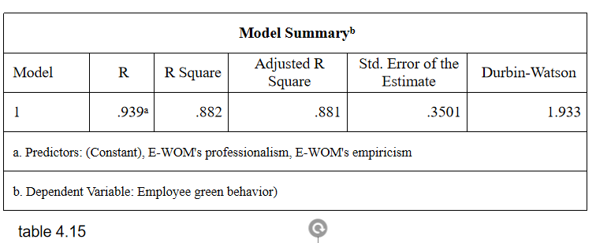

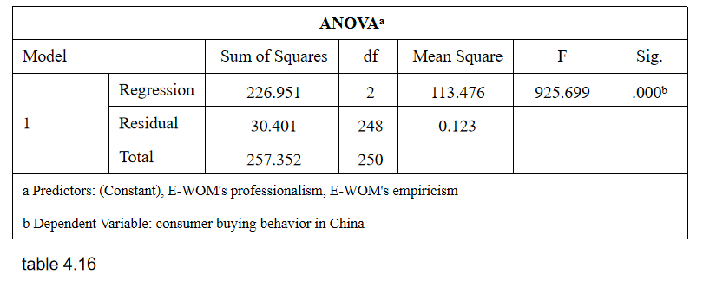

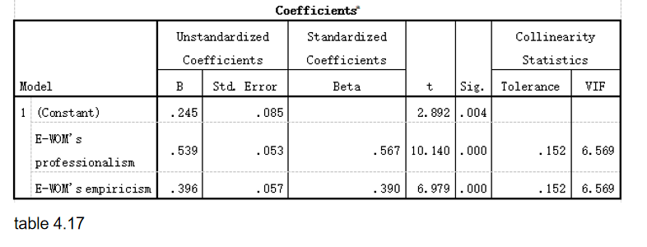

In the regression analysis, the degree of fit needs to be investigated, which is represented by the R square. The closer the R square is to 1, the better the fit; the closer to 0, the poorer the fit. It can be seen from the fitness test of the above table 4.15 that the R-square is 0.882, which means that the part of the dependent variable that can be explained by the regression equation is 88.2%, and the model fits well.

According to the VIF value in the table is less than 10, it can be considered that the effect of collinearity among variables on the model is weak. The significance of the independent variable's t-test is less than 0.05, and the regression coefficient is greater than 0, indicating a significant positive effect on the dependent variable. By comparing the standard value of the beta coefficient, it can be seen that the absolute value of the standard value of the beta coefficient of professionalism is larger, indicating a greater degree of influence.

It is often necessary to avoid autocorrelation between variables in regression models, so this research uses the Durbin-Watson test (DW). When DW is close to and equal to 2, it means that there is no autocorrelation relationship between variables. When it is close to 4 When there is a negative correlation. The DW value in this table is 1.933 close to 2, which means that the model does not have serious autocorrelation.

In summary, H1a, H1b are accepted.

**4. Test of Hypotheses**

The hypotheses on the relationship between independent various (E-WOM's professionalism, E-WOM's empiricism, E-WOM's reputation) and dependent various (consumer buying behavior) were tested.

**4.1. E-WOM's professionalism**

H1a: The professionalism of E-WOM has a positive influence on consumers' buying behavior in China.

Based on table 4.17, E-WOM's professionalism has a significant influence on the dependent variable (p-value < 0.05). The significance of the independent variable's t-test is less than 0.05, and the regression coefficient is greater than 0, indicating a significant positive effect on the dependent variable.

H1a is accepted.

**4.2. E-WOM's empiricism**

H1b: The empiricism of E-WOM has a positive influence on consumers' buying behavior in China.

Based on table 4.17, E-WOM's empiricism has a significant influence on the dependent variable (p-value < 0.05). The significance of the independent variable's t-test is less than 0.05, and the regression coefficient is greater than 0, indicating a significant positive effect on the dependent variable.

H1b is accepted.

**4.3. E-WOM's reputation**

H1c: The reputation of E-WOM has a positive influence on consumers' buying behavior in China.

Because there is collinearity between the independent variables, indicating that the information provided by the independent variables overlaps, the independent variables with strong collinearity are deleted to reduce duplicate information (Meng, 2017).

H1c is rejected.

**5. Conclusion**

In this chapter, before performing formal data analysis, do a Pilot test to affirm the appropriateness of the questionnaire before the distribution of questionnaires for final data collection (Foong, S'ng, Lim, et. al.; 2015). The reliability analysis, factor analysis, and descriptive analysis were carried out to determine the validity of the measurement used in this research. Among the three hypotheses in this research, H1a and H1b are accepted, H1c was rejected because collinearity too strong. The following chapter provides a detailed discussion on the statistical analysis, implication, limitations of this research, and future recommendation of this research.

**Chapter 5**

**Discussion and Conclusion**

**1. Chapter view**

This chapter will provide a summary of the main findings based on the statistical analysis by the research questions of this study. The findings will then be discussed in detail according to the objectives of this research. The discussion will clearly state the correlation between the literature review and the findings of the research to fulfill the objectives of this research. Lastly, a conclusion and recommendations will be provided.

**2.** Result Discussion

The research questions generated in this research are used to understand the influence of e-WOM professionalism, e-WOM empiricism, and e-WOM reputation on Chinese consumers' purchasing behavior. The main purpose of this research is to answer the following questions:

Is there any influence of the professionalism of E-WOM on consumer buying behavior in China?

Is there any influence of empiricism of E-WOM on the consumer buying behavior in China?

Is there any influence on the reputation of E-WOM on consumer buying behavior in China?

This research adopts a random sampling method and selects 384 survey subjects as samples. The data of all respondents was collected through online questionnaires and entered into spss 26.0.

In the questionnaire collection part of this research, we mainly collected young consumer groups with the age of 19-29 as the research samples. In this part of the group, most respondents are people with no work experience or with more than five years of work experience. Therefore, this research mainly reflects this part of the group.

This research found that EWOM's professionalism and EWOM's empiricism have a positive impact on the purchasing behavior of Chinese consumers, especially EWOM's professionalism. Consumers are easily influenced by this type of EWOM to purchase products, and even recommend related products to people around them. Therefore, this research suggests that online platforms or e-commerce companies should encourage consumers to leave more professional product reviews after purchasing products.

**3. Research Limitation**

This research was facing several limitations due to certain circumstances. These limitations are as follows:

Due to the nonprobabilistic convenience sampling, the time for data collection is limited, and the online questionnaire survey may not attract all participants equally. Therefore, these reactions may not be statistically representative of the entire population. Due to time constraints, only 258 respondents were selected as the target group, so the number of respondents was relatively small. This is because this research is only for the interviewees. Due to time and cost constraints, this is the most strategic and convenient location for investigation. Although it will take 15 weeks to complete the research, it is clear that the time limit will arise after the completion of the response to the proposal, as the researchers need to change some parts of Chapter 1 to Chapter 3. Data collection (questionnaire) is also very troublesome because there are only two weeks to distribute and collect data. The third limitation is the researchers' knowledge of SPSS. Although researchers have studied SPSS before, the time has passed. Some knowledge can not be well remembered because it is not often used in daily work. Therefore, researchers have to take some time to correct.

**4.Recommendation on research**

We can study several aspects to get a comprehensive discovery in the future. First of all, this research mainly discusses three aspects of Chinese consumers' purchasing behavior, namely, e-WOM's professionalism, e-WOM's empiricism, and e-WOM's reputation. However, many other important factors are not analyzed in this report. Therefore, more variables were added to the research. These three variables may not be sufficient to support this research. This needs to find comprehensive factors through research. Secondly, it is suggested that the survey time should be extended and the questionnaire should be carefully assigned to specific groups to better count the whole population. Extending the study period to 15 weeks is very short. If there is more time for future research, the research area may cover the whole of China. It will be a huge job, but it has its value. Thirdly, this research uses a quantitative research method to test the influence of E-WOM’s professionalism, E-WOM’s empiricism, and E-WOM’s reputation on consumers' purchase behavior. Future research should be based on the information collected from qualitative research, using more quantitative research methods. The research combined with research methods will provide more subjective and in-depth data, which will help future researchers understand the nature and impact of purchase behavior. Also, due to time and cost-effectiveness, only 384 respondents were used in this research. Future research should focus on a larger population to collect larger data on this topic, which can be used to present tourism in general and generalize the subject.

**5. Conclusion**

E-WOM's professionalism and E-WOM's empiricism have a huge impact on improving the buying behavior of Chinese consumers. As a result, there are initiatives around the world to investigate consumer buying behavior. According to the research conducted, E-WOM's empiricism and E-WOM's professionalism have a positive impact on improving the purchasing behavior of Chinese consumers. Therefore, E-WOM's empiricism and E-WOM's professionalism are important factors affecting consumer behavior.

**6.** Personal Reflection

This research helped me familiarize myself with and understand the whole research process from initial steps to interpretation and submission. The challenge begins with finding the right topic and gradually editing and correcting it with the help of professionals and respected mentors. This gives me a deep insight into how to narrow the scope of research on specific problems to achieve results. But it could still be discovered. This new experience inspired me to maintain a focused attitude during the research, carefully write down every word, the research should have appropriate literature to prove its effectiveness. On the other hand, reading many journals and articles improves my ability to read research papers.

Identifying problems and finding solutions has been a constant problem for me, which has made it difficult for me to concentrate and continue my hard work, especially in determining problem statements, research objectives, and literature reviews of key theories, dependent variables, and independent variables. Research methods, measurements, and statistical analysis are some of the valuable lessons I learned from this research. In this study, I will find out the factors that affect the consumption behavior, which can help me understand the consumption behavior of consumers in future studies, and what factors will affect the consumer behavior of Chinese consumers, especially in the tourism industry. However, I was particularly surprised by the results of this study. E-wom's professionalism, e-WOM's empiricism, and e-WOM's reputation will all be important factors influencing Chinese consumer behavior and have positive relationships, which will help me understand Chinese consumer behavior. Degree of influence on consumer behavior. Finally, I would like to express my deep appreciation for the valuable learning experience provided by this study.

**Chapter 6**

**Reference**

[1]Peng, L., 2018. Research on the Impact of Electronic Word of Mouth on Consumers' Purchase Intention Based on Fine Possibility Model. Soft science, 32(06), 140-144.

[2]Guo, G., 2003. China Renmin University Press General Theory of Marketing. 2nd ed. Beijing: China Renmin University Press.

[3]Xu, W., 2016. Basic research orientation of word-of-mouth communication. Journal of Zhejiang University, 1, 1-2.

[4]J, A., 2017. Word of Mouth Advertising. Journal of Marketing Research, 6(1), 3-4.

[5]Robert, A., 2017. Product/Consumption-Based Affective Responses and Post-purchase Processes. Journal of Marketing Research, 24(3), 24-25.

[6]Stauss, B., 2017. Global word of mouth，Service Bashing on the Internet is a Thorny Issue. Marketing Management, 6(3), 23-30.

[7]Shen, S., 2017. Multi-dimensional comparison of B2C enterprise network marketing between China and the United States. Journal of Commercial Economics, (01), 110-112.

[8]Hou, H., 2019. A Review of Researches on the Influence of Internet Word of Mouth on Consumers' Purchase Intention. Journal of Xi'an Shiyou University, (03), 52-57.

[9]Du, X., 2016. Research on the Influence of Online Reviews on Consumers' Purchase Intention. Management reviews, 28(03), 173-183.

[10]Guo, D., 2017. Summary of Research on Internet Word of Mouth. Operation and management, (03), 140-144.

[11]Zheng, C., 2015. How online speech influences your purchase intention. Nankai Business Review, (01), 89-97.

[12]Gilly, M., 1998. dyadic study of interpersonal information search. Journal of the Academy of Marketing Science, 26(2), 3-10.

[13]Lim, Y., 2015. Evaluating the wisdom of strangers：The perceived credibility of online consumer reviews on yelp. Journal of Computer-Mediated Communication, 20(1), 67-82.

[14]Luo, Y., 2019. A Summary of Domestic and Foreign Research on Social Network Context. Journal of Information, （08）, 179-187.

[15]Arndt, J., 1967. Word of Mouth Advertising. Journal of Marketing Research, 6(1), 3-11.

[16]Chen, X., 2019. Influence of Types and Sources of Internet Word of Mouth on Patients' Behavior of Seeking Doctors. Hospital Management Forum, (09), 31-33.

[17]Wanta, W., and Hu, Y., 1994. The effects of credibility，reliance，and exposure on media agenda-setting：A path analysis model. Journalism & Mass Communication Quarterly, 71(1), 90-98.

[18]Xu, L., 2016. An Empirical Study on the Factors Influencing the Credibility of Internet Word of Mouth. Finance and Trade Research, (05), 113-117.

[19]Wu, S., 2018. The impact of electronic word-of-mouth platforms on perceived credibility and purchase intention. Transaction of Beijing Institute of Technology, 20(05), 72-81.

[20]Fishbein, M., and Ajzen, B., 1975. attitude ， intention ， and behavior: An introduction to theory and research. *Reading Mass:Addison-Wesley*, 6, 301-325.

[21]Meng, Q., 2017. Treatment of multicollinearity in multiple regression analysis. *Chinese Journal of Health Statistics*, (01), 51-52.

[22]Johnston, A. and Warkentin, M., 2010. The Influence of Perceived Source Credibility on End User Attitudesand Intentions to Comply with Recommended IT Actions. *Journal of Organizational and End User Computing*, 22（3）, 1-21.

[23]Greene, M., 2018. networks and consumer behavior:NEURAL models ， logistic regression ， and the behavioral perspective model. *Behavior Analyst*, 40(5), 1-26.

[24]Mc Knight, D., Cummings, L. and Chervany, N., 2018. Initial Trust Formation in New Organizational Relationships. *Academy of Management Review*, 23（2）, 473-490.

[25]Mcknight, D., 2014. Shifting Factors and the Ineffectiveness of Third Party Assurance Seals ： A Two-Stage Model of Initial Trust in a Web Business. *Electronic Markets*, 4(14), 252-266.

[26]Rousseau, D., 2018. Introduction to Special Topic Forum ： Not so Different after All ： A Cross-Discipline View of Trust. *Academy of Management Review*, 23(3), 393-404.

[27]Park, D., Lee, J. and Han, I., 2017. The Effect of On-line Consumer Reviews on Consumer Purchasing Intention ： The Moderating Role of Involvement. *International Journal of Electronic Commerce*, 11(4), 125-148.

[28]Blckart, B. and Schindler, M., 2020. Internet Forums as Influential Sources of Consumer Information. *Journal of Interactive Marketing*, 15(2), 31-40.

[29]Huang, J., Boh, W. and Goh, K., 2017. A Temporal Study of the Effects of Online Opinions Information Sources Matter. *Journal of Management Information Systems*, 34(4), 1169-1202.

[30]Brown, J., Broderick, A. and Lee, N., 2017. Word of mouth communication within online communities ： Conceptualizing the online social network. *Journal of interactive marketing*, 25(7), 25-47.

[31]Bollen, J., Mao, H. and Zeng, X., 2012. Twitter mood predicts the stock market. *Journal of Computational Science*, 2(1）, 1-8.

[32]Lim, Y. and Van Der Heide, B., 2015. Evaluating the wisdom of strangers ： The perceived credibility of online consumer reviews on yelp. *Journal of Computer-Mediated Communication*, 20(1）, 67-82.

[33]Satya, M. and Barbara, K., 2020. Crosscategory effects of induced arousal and pleasure on the Internet shopping experience. *Journal of Retailing*, 7(8), 31-40.

[34]Sharma, P. and Sivakumaran, B., 2015. Exploring impulse buying and variety seeking by retail shoppers: towards a common conceptual framework. *Journal of Marketing Management*, 26(6), 473-494.

[35]Leonard-Barton, D., 2015. Experts as negative option leaders in the diffusion of a technological innovation. *Journal of Consumer Research*, 11（9）, 914-927.

[36]Litvin, S., 2017. Goldsmith: Electronic word-of-mouth in hospitality and tourism management. *Journal of Marketing*, 29（3）, 458.

[37]Motyka, S., Grewal, D. and Aguirre, E., 2018. The emotional review–reward effect: how do reviews increase impulsivity. *Journal of the Academy of Marketing Science*, 26(4), 178-185.

[38]Parboteeah, D., Valacich, J. and Wells, J., 2019. The influence of website characteristics on a consumer's urge to buy impulsively. *Information Systems Research*, 20(1), 60-78.

[39]Preacher, K. and Hayes, A., 2004. SPSS and SAS procedures for estimating indirect effects in simple mediation models. *Behavior Research Methods, Instruments, & Computers*, 717-731, 36(4).

[40]Rook, D., 2017. The buying impulse. *Journal of Consumer Research*, 14(2）, 189-199.

**Appendix 1: Questionnaire**

Questionnaire on consumer buying behavior influenced by Electronic-Word-of Mouth

Dear participant,

Greetings ! I am a MBA candidate from INTI International University (Malaysia) and the following questionnaire is a part of my master research project which focusing on the Electronic word of mouth influence on consumer buying behavior in China

The whole questionnaire includes THREE parts and will take you less than 10 minutes to complete, and all those answers and personal information that you had provided will be used for this research only.

In case you have any questions regarding to this questionnaire, please contact ZhengGuokun at 011281419701 or I19017910@student.newinti.edu.my

Thank you for your participating

Kind Regards,

ZhengGuokun

This questionnaire is carried out on a voluntary basis.

Please tick the following and proceed with questionnaire if you agree to take part in this survey. I I I Agree

**Questionnaire**

|  |  |  |  |  |  |  |  |  |  |  |  |  |  |  |  |  |  |  |  |
| --- | --- | --- | --- | --- | --- | --- | --- | --- | --- | --- | --- | --- | --- | --- | --- | --- | --- | --- | --- |
| NO. | Item | | | | | | | | Strongly disagree | | disagree | | | | general | | agree | | Strongly agree |
| 1 | Before purchasing a product, I would like to check the product reviews with high professional level | | | | | | | |  | |  | | | |  | |  | |  |
| 2 | I believe in professional word of mouth | | | | | | | |  | |  | | | |  | |  | |  |
| 3 | I will buy related products according to professional word of mouth | | | | | | | |  | |  | | | |  | |  | |  |
| 4 | Professional word of mouth helps me when I don't know which product to buy | | | | | | | |  | |  | | | |  | |  | |  |
| 5 | I will buy additional products based on professional word of mouth advice | | | | | | | |  | |  | | | |  | |  | |  |
| 6 | Before purchasing a product, I am willing to check the product reviews with high experience | | | | | | | |  | |  | | | |  | |  | |  |
| 7 | I believe in empirical word of mouth | | | | | | | |  | |  | | | |  | |  | |  |
| 8 | I will buy related products based on empirical word of mouth | | | | | | | |  | |  | | | |  | |  | |  |
| 9 | Empirical word of mouth helps me when I don't know which item to buy | | | | | | | |  | |  | | | |  | |  | |  |
| 10 | I would buy additional products based on empirical word of mouth advice | | | | | | | |  | |  | | | |  | |  | |  |
| 11 | Before buying a product, I would like to check more well-known and more concerned product reviews | | | | | | | |  | |  | | | |  | |  | |  |
| 12 | I believe in high reputation word of mouth | | | | | | | |  | |  | | | |  | |  | |  |
| 13 | I will buy related products based on high reputation word of mouth | | | | | | | |  | |  | | | |  | |  | |  |
| 14 | High reputation word of mouth helps when I don't know which item to buy | | | | | | | |  | |  | | | |  | |  | |  |
| 15 | I would buy additional products based on high reputation word of mouth advice | | | | | | | |  | |  | | | |  | |  | |  |
| 16 | Professional word of mouth will influence my buying decision | | | | | | | |  | |  | | | |  | |  | |  |
| 17 | Empirical word of mouth will influence my buying decisions | | | | | | | |  | |  | | | |  | |  | |  |
| 18 | High reputation word of mouth will influence my buying decision | | | | | | | |  | |  | | | |  | |  | |  |
| 19 | I still hesitate after seeing the word of mouth | | | | | | | |  | |  | | | |  | |  | |  |
| 20 | I will leave word of mouth after purchase for others' reference | | | | | | | |  | |  | | | |  | |  | |  |
| Gender | | | | | A.male | | | | | | | | B.female | | | | | | |
| Age | | A.Less than 18 | | B.19-29 | | | | C..30-39 | | | | D.40-49 | | | | | | E.Over 50 | |
| Education | | | A.Higher school education | | | B.Junior college student | | | | C.Bachelor Degree | | | | | | D.Mater Degree | | | |
| Income | | | A.1000-2000 | | | | B.3000-4000 | | | | | | | C.5000-6000 | | | | | |
| Years of working | | | A.No | | | B.1-3 years | | | | C.3-5 years | | | | | | D.Over 5 years | | | |

**Appendix 2: SPSS outputs for Pilot Test**

**Factor Analysis - Dependent Variable**

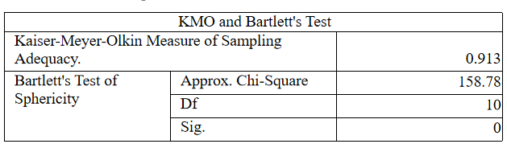

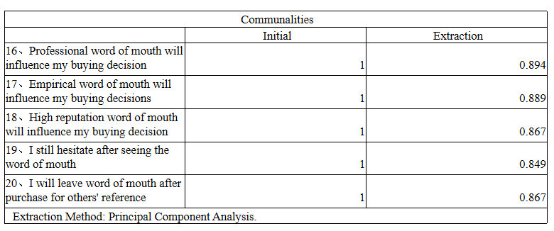

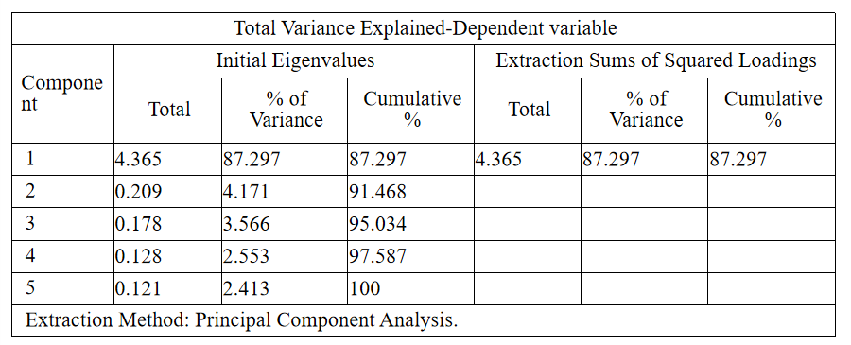

**Factor Analysis - Independent Variable**

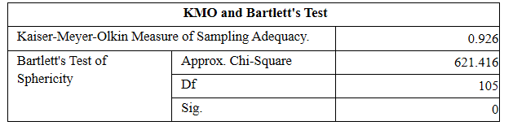

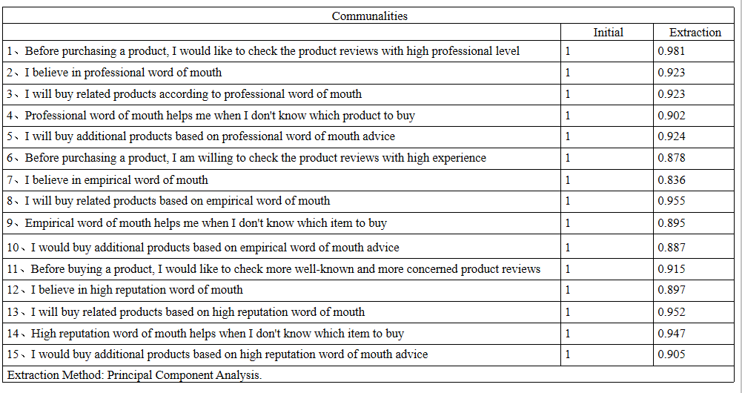

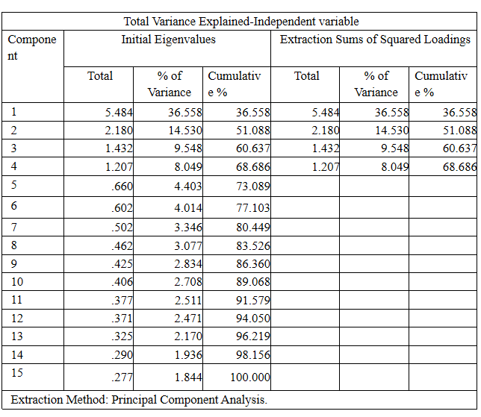

**Reliability Test**

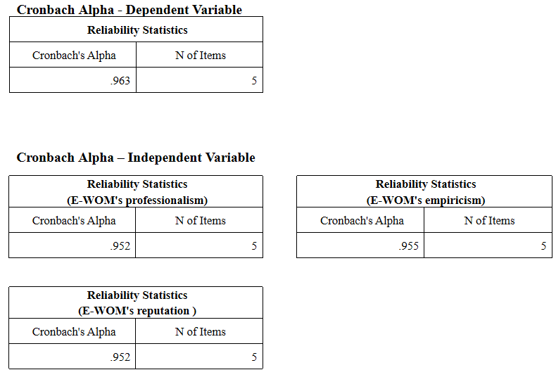

**Appendix 3: SPSS outputs for Data Analysis**

**Demographic Data of Participants**

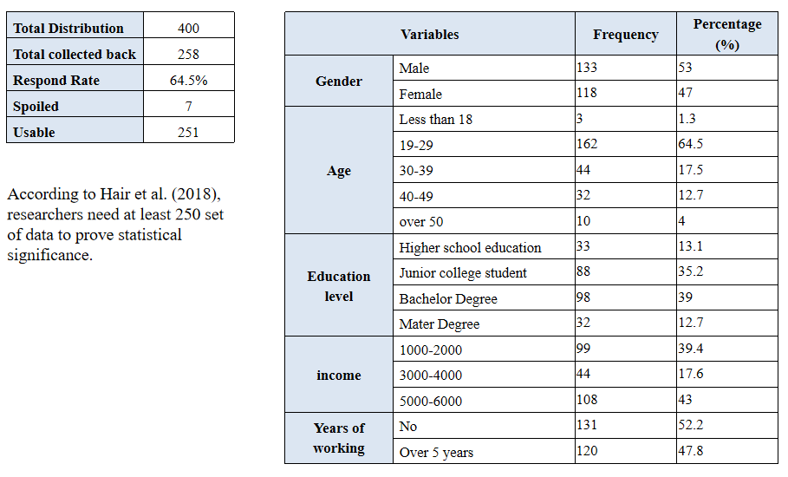

**Factor Analysis - Dependent Variable**

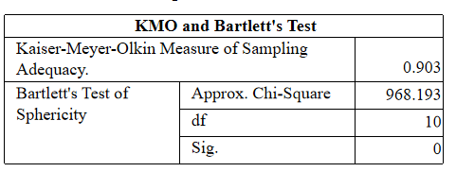

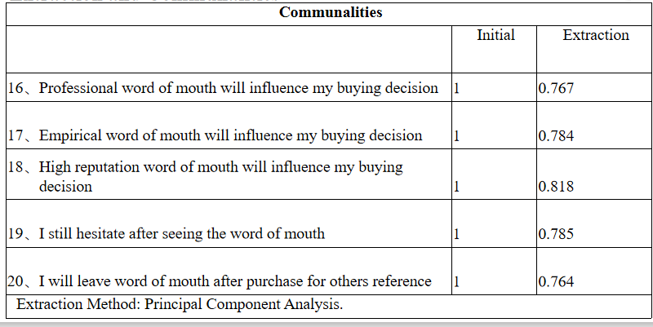

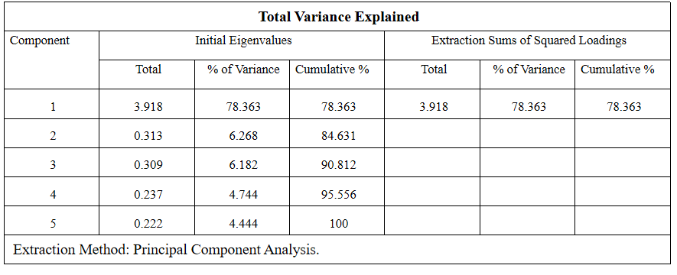

**Factor Analysis - Independent Variable**

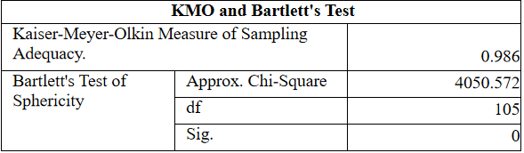

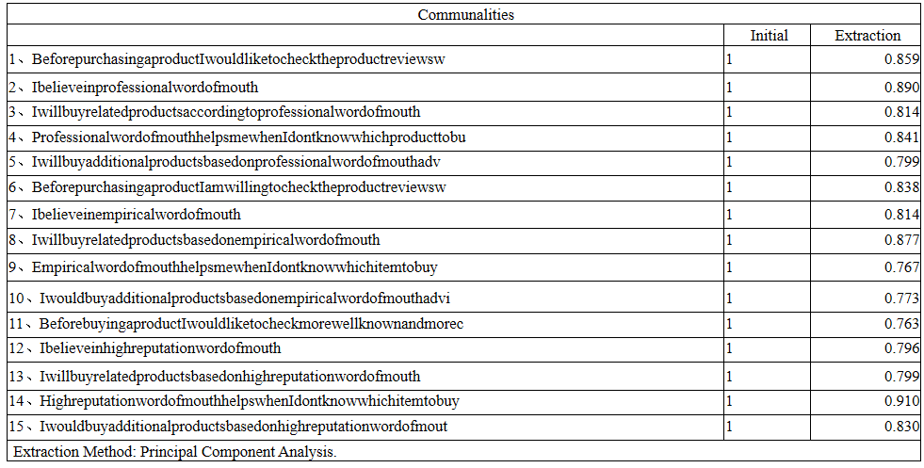

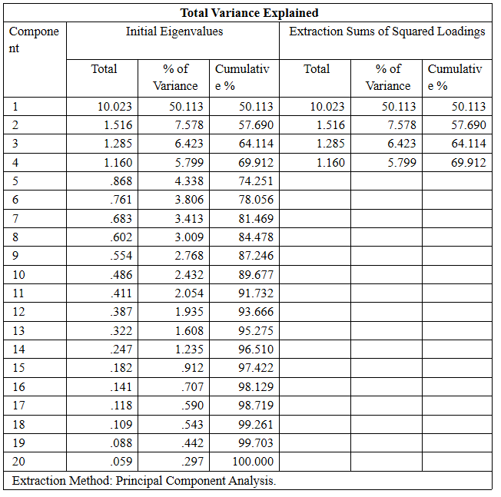

**Reliability Test**

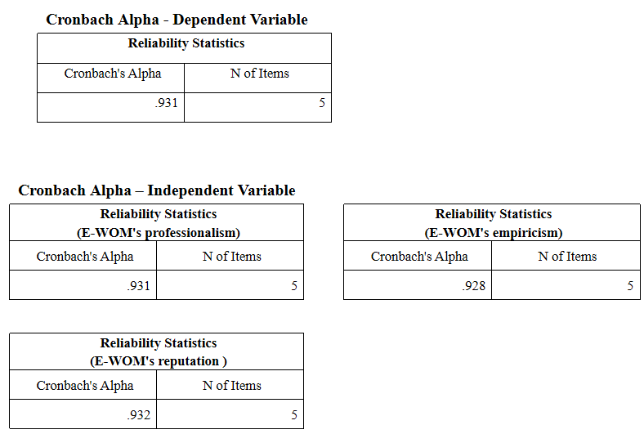

**Multiple regression analysis**

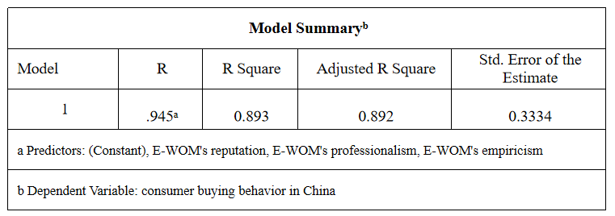

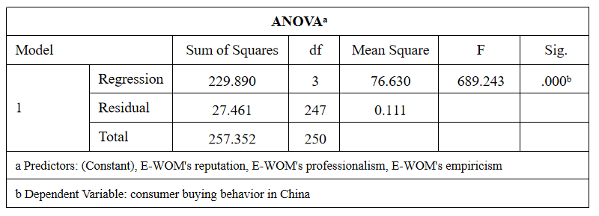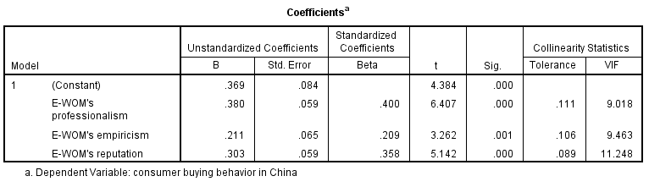

Since the collinearity between the variables is too strong, remove the variables with strong collinearity, re-do multiple regression analysis, and do D-W test for the remaining two variables.

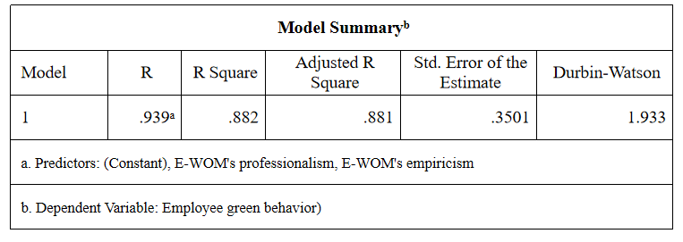

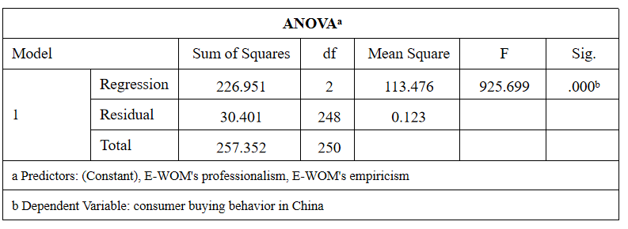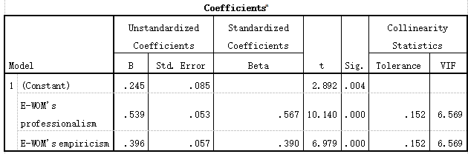

**Appendix 4: Project Paper Log**

PROJECT PAPER LOG

This is an important document, which is to be handed in with your dissertation. This log will be taken into consideration when awarding the final mark for the dissertation.

|  |  |
| --- | --- |
| **Student Name:** | **ZhengGuokun** |
| **Supervisor’s Name:** | **Prof. Dr. Walton Wider** |
| **Dissertation Topic:**  Electronic word of mouth influence on consumer buying behavior in China | |

SECTION A. MONITORING STUDENT DISSERTATION PROCESS

The plan below is to be agreed between the student & supervisor and will be monitored against progress made at each session.

|  |  |  |  |  |  |  |  |  |  |
| --- | --- | --- | --- | --- | --- | --- | --- | --- | --- |
| **Activity** | **Milestone/Deliverable Date** | | | | | | | | |
| 5/10 -  30/10 | 31/10 | 2/11 | 3/11 -  7/11 | 9/11 -  27/11 | | 28/11 -  29/11 | 30/11 - 4/12 | 7/12 - 18/12 |
| Writing of Chapter 1, 2, 3 | √ |  |  |  |  | |  |  |  |
| Obtain UH approval for Ethics Protocol |  | √ |  |  |  | |  |  |  |
| Prepare interview question (draft) |  |  | √ |  |  | |  |  |  |
| Prepare for proposal defense (PD) and complete PD |  |  |  | √ |  | |  |  |  |
| Data collection  - conducting interview |  |  |  |  | √ | |  |  |  |
| Analyzing of data |  |  |  |  | √ | |  |  |  |
| Review of document |  |  |  |  |  | | √ |  |  |
| Preparation of viva and completion of viva |  |  |  |  |  | |  | √ |  |
| Submit complete thesis draft for review |  |  |  |  | |  |  |  | √ |
| Final submission of thesis |  |  |  |  | |  |  |  | √ |

SECTION B. RECORD OF MEETINGS

The expectation is that students will meet their supervisors up to seven times and these meetings should be recorded.

Meeting 1

|  |  |
| --- | --- |
| Date of Meeting | 15 October 2020 |
| Progress Made | Sent chapter 1, 2 and 3 to supervisor for first review. |
| Agreed Action | Make enhancement base on supervisor’s feedback.  - Sample thesis given by lecturer for reference. |
| Student Signature | ZhengGuokun |
| Supervisor’s Signature |  |

Meeting 2

|  |  |
| --- | --- |
| Date of Meeting | 21 October 2020 |
| Progress Made | Sent enhanced chapter 1, 2 and 3 base on previous feedback (draft 1). |
| Agreed Action | Need further enhancement.  - Strengthening of research objectives and research questions. |
| Student Signature | ZhengGuokun |
| Supervisor’s Signature |  |

**Meeting 3**

|  |  |
| --- | --- |
| Date of Meeting | 28 October 2020 |
| Progress Made | Sent enhanced chapter 1, 2 and 3 base on previous feedback (draft 2). |
| Agreed Action | To make further enhancement on the content to align with the qualitative research requirements since during BRM, qualitative research was not  taught |
| Student Signature | ZhengGuokun |
| Supervisor’s Signature |  |

**Meeting 4**

|  |  |
| --- | --- |
| Date of Meeting | 4 November 2020 |
| Progress Made | Online session with supervisor.  Detailed discussion on content enhancement. |
| Agreed Action | To align further on qualitative research format |
| Student Signature | ZhengGuokun |
| Supervisor’s Signature |  |

**Meeting 5**

|  |  |
| --- | --- |
| Date of Meeting | 11 November 2020 |
| Progress Made | Data collection |
| Agreed Action | Work on data collection |
| Student Signature | ZhengGuokun |
| Supervisor’s Signature |  |

**Meeting 6**

|  |  |
| --- | --- |
| Date of Meeting | 18 November 2020 |
| Progress Made | Data Analysis |
| Agreed Action | Work on data Analysis  Preparation of proposed interview question |
| Student Signature | ZhengGuokun |
| Supervisor’s Signature |  |

**Meeting 7**

|  |  |
| --- | --- |
| Date of Meeting | 25 November 2020 |
| Progress Made | Data Analysis and Review of document |
| Agreed Action | Work on data Analysis and review of document  Preparation of proposed interview question  To prepare on viva slides |
| Student Signature | ZhengGuokun |
| Supervisor’s Signature |  |

**Meeting 8**

|  |  |
| --- | --- |
| Date of Meeting | 2 December 2020 |
| Progress Made | Enhanced viva slides under supervisor’s guidance |
| Agreed Action | To make some minor enhancement on the viva slides  To work on write up for Chapter 4 and Chapter 5 and send for review. |
| Student Signature | ZhengGuokun |
| Supervisor’s Signature |  |

**Meeting 9**

|  |  |
| --- | --- |
| Date of Meeting | 13 December 2020 |
| Progress Made | Enhanced thesis under supervisor’s guidance |
| Agreed Action | To make some minor enhancement on thesis  To submit complete thesis for review |
| Student Signature | ZhengGuokun |
| Supervisor’s Signature |  |

**Section C. Comments on Management of Project**

(to be completed at the end of the dissertation process)

Student Comments

Great time management and schedule set by supervisor. I like how supervisor always plan ahead of time, so that even if the process sidetrack a little, it is still manageable. I am also very thankful for the guidance and supervision from my supervisor in completing the project as she guided me step by step

Supervisor Comments

|  |  |
| --- | --- |
| Signature of ZhengGuokun  Student | Date 18 December 2020 |
| Signature of  Supervisor | Date 18 December 2020 |
| Ethics Confirmed | Date 18 December 2020 |