

MGT7998
MBA Project

Research on Problems and Countermeasures of Internet Marketing of Small and Medium-sized Foreign Trade Enterprises, China

Name : YU XIN
Student ID : I19017720
Programme : MBA
Supervisor :Ms Ah Huai

Table of content
Chapter 1 : Introduction - 1 -
1.0 Overview - 1 -
1.1 Background of the Study - 1 -
1.2 Problem Statement - 3 -
1.3 Research Objective - 3 -
1.4 Research Questions - 4 -
1.5 Significance of the Research - 4 -
1.5.1 Significance to Industry - 5 -
1.5.2 Significance to Academia - 5 -
1.6 Scope of Study - 5 -
1.6.1 Limitations of study - 5 -
1.6.2 Ethical Considerations - 6 -
1.7 Operational Definitions - 6 -
1.8 Organization Chapter - 8 -
Chapter 2: Literature Review - 9 -
2.0 The Concept of Internet Marketing - 9 -
2.1 The importance of internet marketing - 10 -
2.2 The status quo of enterprise network marketing - 12 -
2.3 Internet marketing methods and characteristics - 13 -
2.3.1 Search Engine Marketing - 13 -
2.3.2 Comprehensive B2B e-commerce platform - 15 -
2.3.3 E-commerce platform - 16 -
2.3.4 Internet Yellow Pages - 17 -
2.3.5 Licensed E-mail Marketing - 18 -
2.4 Influencing factors of enterprise network marketing - 19 -
2.4.1 Ignore corporate website design - 19 -
2.4.2 Over-reliance on B2B platforms - 19 -
2.4.3 Only use search engines for promotion - 19 -
2.4.4 Lack of Internet Marketing talents - 20 -
2.5 Gaps in the Literature - 21 -
2.6 Fundamental Theory - 21 -
2.6.1 4C Theory - 21 -
2.7 Conceptual Framework - 22 -
2.8 Hypothesis - 22 -
2.9 Conclusion - 23 -
Chapter 3: Methodology - 23 -
3.0 Overview - 23 -
3.1 Research Design - 23 -
3.1.1 Exploratory, Descriptive and Explanatory Research - 24 -
3.1.2 Deductive and Inductive Approach - 25 -
3.2 Unit of Analysis - 25 -
3.3 Sampling and Population - 26 -
3.4 Research Methods - 26 -
3.4.1 Questionnaire Design - 26 -
3.5 Data Collection Method - 27 -
3.5.1 Questionnaire - 29 -
3.6 Conclusion - 30 -
Chapter 4.0 Measurement and Measure - 30 -
4.0 Overview - 30 -
4.1 Pilot Test - 30 -
4.1.1 Factor Analysis - 31 -
4.1.2 Kiser-Meyer-Olkin (KMO) - 31 -
4.1.3 Communality - 32 -
4.1.4 Eigenvalues - 33 -
4.1.5 Factor Loading - 35 -
4.2.6 Reliability Test - 35 -
4.2 Data Analysis - 37 -
4.2.1 Descriptive statistics - 37 -
4.2.2 Reliability and validity analysis - 38 -
4.2.3 One Way Analysis of Variance (ANOVA) - 40 -
4.2.4 Correspondence analysis - 43 -
4.3 Hypothesis Testing - 45 -
4.4 Multiple Regression Analysis - 47 -
4.5 Conclusion - 50 -
Chapter 5.0 Countermeasure analysis - 51 -
5.0 Overview - 51 -
5.1 Improve website design - 51 -
5.2 Reasonable choice of e-commerce platform - 52 -
5.3 Enriched promotion methods - 52 -
5.4 Training of Internet Marketing talents - 53 -
5.5 Conclusion - 53 -
References - 54 -

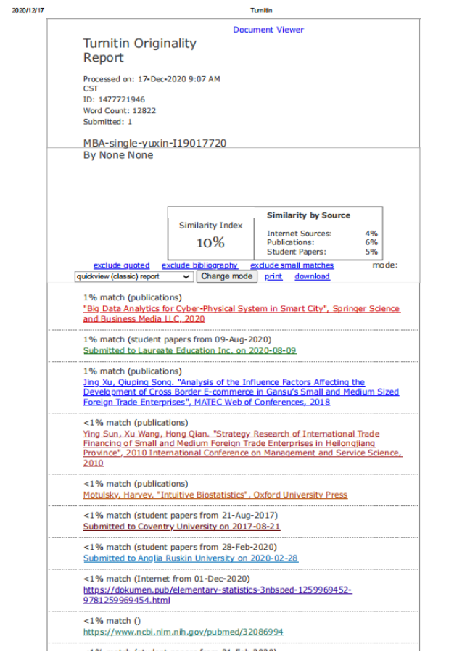

Research Title
Research on Problems and Countermeasures of Internet Marketing of Small and Medium-sized Foreign Trade Enterprises, China
Abstract
Under the current economic situation, China's foreign trade exports have suffered a huge impact due to unfavorable factors such as accelerated appreciation of the renminbi, rising labor costs, weakening of demand in major markets such as Europe and the United States, and foreign new crown virus epidemics.Chinese small and medium-sized foreign trade companies have paid more attention and practise to the modern marketing model and marketing system of Internet Marketing in the current economic situation, in order to reach the international market.(Li and Chen, 2006).[] This research first analyzes the role and significance of Internet Marketing of small and medium foreign trade companies, and then focuses on the current status of internet marketing of small and medium foreign trade companies, mainly analyzing the problems of small and medium foreign trade companies’ international Internet Marketing, and proposes practical and feasible measures for small and medium trading companies. Internet Marketing strategy to enhance the international competitiveness of small and medium foreign trade enterprises.
The 4C theory is used as the fundamental theory to describe the Internet marketing challenges of small and medium-sized international trade companies, based on previous studies on small and medium-sized Internet marketing.
Researchers also found that to test hypotheses based on research and literature reviews, to identify and verify factors that may affect the Internet marketing of Chinese small and medium-sized trading companies by distributing questionnaires to 350 interviewees.
The results of this research will help China's small and medium-sized foreign trade companies to formulate appropriate marketing strategies and methods, and influence the international competitiveness of small and medium-sized foreign trade companies.
Keywords: Small and Medium Trading Enterprises, Internet Marketing ,Problems and Strategies

Chapter 1 : Introduction

1.0 Overview
Chapter 1 describes the development and necessity of Internet Marketing for small and medium-sized foreign trade enterprises in China. This chapter starts with an overview of the importance to small and medium-sized multinational companies of the application of internet marketing. Secondly, there will be a response to a statement of concerns, research priorities, and research questions.The importance of the analysis, the nature and limitations of the study, and organisational concepts are also included in this chapter in order to decide which keywords will be included in this study.

  - Background of the Study
With the development of global information technology, the marketing of small and medium foreign trade enterprises has entered the era of international internet marketing. Many small and medium foreign trade companies still have many shortcomings on how to develop Internet Marketing. In the Internet + era, the marketing of small and medium-sized foreign trade companies will pay more attention to the practice of Internet Marketing, enhance value creation, and enhance the customer experience. The marketing of small and medium foreign trade companies requires more innovation in concepts, theories, markets, technologies, methods, strategies, organizations, and rules. This also means that small and medium foreign trade companies are also facing more challenges (Shanjun, 2019).[] Small and medium-sized foreign trade companies must keep pace with the times, persist in innovation, discover problems in their own development, and formulate marketing strategies suitable for their own development. The company hopes to expand its assets and market size by increasing sales.
Internet marketing is a business behavior that takes network technology as the means, commodity sales as the core, and brand formation and promotion as the pursuit. Generally speaking, it is the act of finding ways to buy products online, maximizing product sales, and ultimately obtaining net profits. In 2015, the well-known third-party trading platform Tmall, the "Double 11" transaction volume reached 91.217 billion yuan, of which the transaction volume of using mobile Taobao APP or mobile webpage to directly log in to the website to buy things reached 62.6 billion yuan, accounting for 68.67%, and logistics orders The volume is 467 million, covering 232 countries and regions. In 2016, Tmall’s “Double 11” shopping carnival totaled 120.749 billion yuan in total transactions throughout the day, far exceeding 91.217 billion yuan in 2015. Among them, the transaction value of using mobile Taobao APP or mobile webpage to directly log in to the website to buy things Accounted for 82%, it covered 235 countries and regions, and once again refreshed the "Double 11" record.The increase in transaction volume shows that online shopping has gradually become the choice of millions of households, and it is bound to be further developed in the future, and the profit-seeking activity of businesses is bound to increase online sales to respond to the online shopping growth trend. (He, 2018).[]
A significant proportion of China's economic and social growth is accounted for by China's small and medium-sized foreign trade enterprises and have played an active role in absorbing jobs and sustaining social stability.However, in the traditional sales field, funds, technology, talents, and distribution channels cannot Compete with large state-owned and private enterprises, so in order to survive and develop, small and medium trading companies must switch to the Internet to occupy a place in this huge virtual space. Therefore, In order to make small and medium foreign trade companies grow better and faster, doing a good job in Internet Marketing has therefore become not only a topic for the growth of small and medium-sized trading companies, but also an issue that needs to be studied in China's economic and social development.
In summary, Small and medium-sized foreign trade firms, including Asia-Pacific countries, are increasing internationally, using Internet marketing to explore global markets. This is a limited research, however, focusing on the factors affecting the application of Internet Marketing by small and medium-sized trading companies, especially in the Chinese market. Therefore it is important to conduct a study to understand the problems of small and medium-sized foreign trade companies in China with regard to Internet Marketing.

1.2 Problem Statement
Globally, the number of websites has increased from 17 million in 2000, and there are now more than 1.5 billion websites.[]In 2014, global business-to-consumer e-commerce grew by 20.1% to reach US$1,500 trillion. Payment methods have been simplified, and major global brands have been introduced into new international markets.[]
The aim of this case study is to examine the challenges and countermeasures of SMEs in the implementation of Internet marketing, given the importance of Internet marketing to the survival of small and medium-sized foreign trade enterprises. Other survey findings suggest that, owing to their environmental limitations, small and medium-sized international trading firms have to adjust to technological change, resulting in a competitive disadvantage relative to large corporations.
Thus this study's problem statement can be structured as below:
What factors will affect the application of Internet Marketing by small and medium foreign trade companies, China?

1.3 Research Objective
Doody and Bailey (2016) describe research goals, which are closely linked to the research issues, should be split into the main purpose and relevant goals. []
The main aim of this study is to understand the usage of Internet marketing in small and medium-sized international trade firms. To achieve this the following basic objectives can also be considered:
RO1:To determine whether the website design has significant influence on the Internet Marketing effect of small and medium foreign trade enterprises.
RO2:To determine whether the E-commerce platform has significant influence on theInternet Marketing effect of small and medium foreign trade enterprises.
RO3:To determine whether the promotion method has significant influence on the Internet Marketing effect of small and medium foreign trade enterprises.
RO4:To determine whether marketing talents has significant influence on the Internet Marketing effect of small and medium foreign trade companies.

1.4 Research Questions
Doody and Bailey (2016) identified the research question as an important phase in a study because it tapers the research goal to particular research areas and serves as a guide for the methodology of research.
RQ1: Does website design has significant influence on the Internet Marketing effect of small and medium foreign trade enterprises?
RQ2: Does E-commerce platform has significant influence on the Internet Marketing effect of small and medium foreign trade companies?
RQ3: Does promotion method has significant influence on the Internet Marketing effect of small and medium foreign trade enterprises?
RQ4:Does marketing talents has significant influence on the Internet Marketing effect of small and medium foreign trade companies?

1.5 Significance of the Research
Compared with traditional media, Internet marketing is more cost-effective, and most companies are shifting their marketing budgets to Internet marketing (Rollins, Nickell, and Ennis, 2014).[] It is important to understand how this factor affects the application of Internet Marketing by small and medium foreign trade companies. By understanding the Internet marketing problems of small and medium-sized foreign trade companies, help small and medium-sized foreign trade companies learn how to develop successful Internet marketing strategies to improve operational efficiency, expand the business scope, and attract new customers. It is very meaningful for the small foreign trade enterprise Internet Marketing industry and academia.

1.5.1 Significance to Industry
Internet Marketing not only breaks into the field of product sales for small and medium-sized international trade companies, but also recognises the potential for growth that Internet Marketing will sell their goods internationally.Understand what factors are affecting the application of Internet Marketing by small and medium foreign trade companies. This discovery will help them plan their marketing strategies, which should be practiced by marketers so that small and medium-sized foreign trade companies can quickly increase brand awareness and product awareness through Internet Marketing, so as to quickly stand out from the pressure of industry market competition. It is also possible to let small and medium-sized foreign trade companies quickly emerge from the industry through Internet Marketing.

1.5.2 Significance to Academia
The finding of this study will provide them with some information that might be necessary for their research, and this study might address some of their questions, which would be helpful to the future researcher.

1.6 Scope of Study
The scope of this research will focus on the specific factors that influence the application of Internet Marketing by small and medium foreign trade companies. This research will only focus on the Internet Marketing of China's small and medium foreign trade companies. In addition, this research will only focus on how the four independent variables of website design, E-commerce platform, promotion methods, and marketing talents will affect the Internet Marketing of China's small and medium foreign trade companies.

1.6.1 Limitations of study
Limitations reflect my research's possible flaws. The first limitation of this analysis is the geographical position of the small and medium-sized foreign trade companies in China.
Secondly, this analysis focuses only on four independent variables (website design,E-commerce platform , promotion methods, and marketing talents), while other independent variables will not be studied. Third, we presume that all genders, races, and age groups are the same in this analysis. The key factor that forces researchers to make the above assumptions is that the time taken by data collection and data analysis to complete the study is not adequate.
Therefore, researchers do not have ample time to extensively analyse more precise parameters and limit their studies to a narrower research scope.

1.6.2 Ethical Considerations
I follow ethics and standards when gathering data from participants. Knowledge and information of the business analysed will be kept confidential and approved by the top management of the company, and data collected from participants will be covered.I provided a review of the survey results to the owners of small and medium-sized trading companies after the study was completed. This approach helps to guarantee my comprehension and raise the morale of my research participants. The reference material of any author will be quoted.

1.7 Definitions for Operations
The purpose of this section is to define the reader's main words and related concepts.
Key terms | Definition
Internet marketing | Internet marketing, also known as Internet Marketing, is the process of promoting a brand or company and its products or services to customers through digital channels such as search engines, emails, websites, and social media.(Grubor and Jakša, 2018). []
The effect of Internet Marketing of small and medium foreign trade enterprises | The company conducts import and export commodity transactions, companies with less than 500 employees, and uses Internet marketing to attract overseas customers to produce marketing effects.  (Li, 2019).[]
Website design | By transmitting a series of designs such as text, pictures and information on the Internet, users will eventually browse it in the form of a website. In other words, the purpose of web design is to create a website.(Koren,et al,2019)[]
E-commerce platform | E-commerce platform is a software application that allows online businesses to manage their website, marketing, sales, and operations. Examples are eBay, TaoBao, Amazon , and Lazada .B2B platform (eg Alibaba,Amazon);B2C platform (eg Taobao,)(Rosson and Ford, 2016)[]
promotion method | Online advertising promotion methods, information network publishing promotion methods, search engine promotion methods, email promotion, pay-per-click advertising, blog marketing, B2B platform promotion, news soft article marketing, Weibo marketing, online brand marketing, video marketing resource cooperative promotion methods, Quick URL promotion, and other methods.(Huang et al,2017)[]
Marketing talent | Applied talents who are familiar with foreign trade knowledge, master enterprise management knowledge, and marketing technology, and have strong practical ability(Jin, etal.,2020) []

1.8 Organization Chapter
In order to ensure that the analysis stays in a systematic flow, this research paper will be structured in the flow below.
Chapter 1:Introduction
This chapter will introduce the current situation and background of Internet Marketing of small and medium foreign trade enterprises.The problem statement, study priorities, and study questions are discussed. In addition, it will also discuss how this research can benefit the small and medium-sized trade business community, academia, research scope, and research limitations. In the definition of service, the definition of the keywords that will be used throughout the analysis will be written.
Chapter 2:Literature Review
This section summarises data from papers, documents, textbooks, and verification reports from credible industry leaders.Some of the key words and phrases I used in my search include small and medium-sized enterprises, marketing, internet marketing, e-marketing, internet marketing, digital marketing, advertisement, and small and medium-sized foreign trade enterprises while studying the Internet marketing-related literature of small and medium foreign trade companies.To suit current study, all of these will be compiled, measured and evaluated. This knowledge is useful for filling in the research history and the current information required to address the research objectives and challenges in the next stage of research.
Chapter 3:Methodology
The methods used in this study to obtain sufficient data and results are described in this chapter.The methods, tools, and techniques used are also reasonable with support to ensure that the results can answer the research questions and goals.
Chapter 4:Research Findings
Based on the data gathered from the questionnaire, this chapter will present and explain the main findings of the study. The collected data will be analysed by various methods in order to verify the relationship between the independent variable and the dependent variable.
Chapter 5:Conclusion
This chapter summarizes the results of this research. This chapter will discuss the suggestions, limitations, and research directions of future researchers if the researchers want to get a deeper understanding of similar topics.

Chapter 2: Literature Review

2.0 The Concept of Internet Marketing
According to a research report written by Kiet and Kim（2008）, it is understood that in some cases, the concept of healthy and legal Internet marketing is used as a concept equivalent to "direct marketing". In this method, producers sell their goods through the people and customers themselves, rather than through distribution agents with high commission percentages. Therefore, a customer network that is willing to help producers complete sales tasks while benefiting themselves is responsible for goods marketing and sales tasks through contracts. In some cases in the literature, Internet Marketing is also called "multi-layer marketing."[]
Internet Marketing is described by British scholar Dave Chaffee and others as the use of the Internet and related digital technology to achieve marketing goals and promote modern marketing principles. The Internet and other digital media, such as cellular cell phones, television, and satellite media, are part of these innovations.（ P.N., 2020）.[]

2.1 The importance of internet marketing
Small and medium-sized foreign trade firms are an important economic backbone of every country (whether developed or developing). There is ample evidence that small and medium-sized foreign trade firms play an enormous role in any country's growth. Kuan and Chau (2001) pointed out that major contributions to the gross national product (GDP) have been made by US SMEs, generating new markets and cutting-edge technologies.Carayannis, Popescu, Sipp, and Stewart (2006) estimated that 99.8% of European companies constitute two-thirds of the workforce and are small and medium-sized enterprises. Moreover, in each nation, small and medium-sized enterprises account for a large proportion of the labour force and have made major contributions to fostering economic growth and generating job opportunities. In the social structure, it also stresses their status.
(Alrousan & Jones, 2016).[]
Research by Dalberg (2011) shows that while small and medium-sized foreign trade firms tend to be dominant in high-income economies, small and medium-sized foreign trade firms are socio-economically important to low- and middle-income countries as well, contributing significantly to their gross domestic product and employment. Contributorship. Furthermore through collaboration with larger agencies, small and medium-sized international trade companies contribute to the most creative work.
The role of small and medium foreign trade firms in the production of human capital is equally important, according to (Abor & Quartey, 2010; Ayyagari, Demirguc-Kunt & Maksimovic, 2011; Quartey, Turkson, Abor & Iddrisu, 2017). More than 95 percent of global businesses are small and medium-sized businesses, according to the survey, and small and medium-sized foreign trade businesses account for about 70 percent of GDP, especially in Asia.
(1) Internet marketing strengthens collaboration opportunities between small and medium-sized foreign trade firms
Because Internet Marketing connects trading companies, enterprises, economic groups, and other organizations all over the world, there is no time, geographical restrictions, no hierarchy, regardless of scale, foreign trade companies only need to establish their own websites and homepages to provide good products and online services, You can start Internet Marketing. This is especially important for China, which has many small and medium-sized foreign trade businesses. Internet marketing offers opportunities for small and medium-sized foreign trade companies to engage in international market competition on an equal basis with multinational companies, which is conducive to the effective integration of Chinese small and medium foreign trade companies into international economic cooperation and international trade (Qu, 2017)[]
(2) Internet marketing increases the business success of small and medium-sized international exchange firms
It can be understood, according to research by Rezvani, Ghahramani and Haddadi (2017), that China's foreign trade goods have the benefits of cheaper raw materials and lower labour costs, and their retail prices in the international market are higher than those in developed countries.[] The goods are several times cheaper. However it is difficult to find foreign importers since many small and medium-sized companies do not have their own direct export networks, most of them rely on domestic or foreign intermediaries and lose most of their profits. Through Internet Marketing, small and medium foreign trade enterprises can realize direct communication with customers, reduce intermediate links, and improve the efficiency of international trade operations.
(3) Internet marketing reduces the expense of small and medium international trade companies' operating costs
Based on ZHANG(2018) research and writing, it is known that since small and medium foreign trade businesses often interact across borders, the traditional international telephone, fax, and other international trade costs are relatively high. The network communication fees that companies need to pay for Internet Marketing are much lower. If countries implement EDI (Electronic Data Interchange) technology in Internet Marketing, not only can the loss caused by man-made document errors and delays be reduced, but the world can also save paper processing fees and human resource investment.At the same time, it is conducive to the authentication by companies of trade details and decreases the damages incurred by the forging of documents by criminals in conventional trade. []

2.2 The status quo of enterprise network marketing
According to You (2018) in China, only a small number of small and medium foreign trade companies expand their business through Internet Marketing.[] Generally speaking, the traditional ways to expand foreign trade channels include exhibitions, friend introductions, industry association recommendations, print media advertisements, etc. Due to many years of business habits, purchasers can also go directly to suppliers through friend introductions or after meeting at the exhibition. For factory visits, the rate of orders placed on the overall situation of the factory is also relatively high.However, as a small and medium-sized foreign trade corporation, the common foreign trade channels listed above are after all, relatively costly and are limited in time and space, making it difficult to take the initiative to strike. small and medium-sized international exchange firms responsible for more than half of the total number of firms involved, have developed so rapidly in the information age and have not resorted to Internet Marketing to expand their business?
According to research and research by Yu and Bell (2007), it can be seen that the growth of Chinese foreign trade companies has shifted from state-controlled foreign trade to local foreign trade activities after the 1980s in the past 30 years of reform and opening up;Small and medium-sized businesses have expanded quickly with the liberalisation of international trade management rights.Especially in recent years, their role in the annual export of Chinese products has become increasingly obvious. In China, there were only more than 8,000 companies of different types with international trade management rights. Towards the end of 1996, China’s foreign trade enterprises had reached 12,000. By the end of 2000, the number of enterprises with import and export business qualifications had reached 193,000. Among them, More than 70% of the total number of companies in the country accounted for the number of small and medium-sized businesses. Small and medium-sized foreign trade businesses play a crucial role in foreign trade and have become a new force in the export and export-oriented economic development of my country. How to alleviate the existing problems and how to make small and medium foreign trade businesses. In my country, 94 percent of foreign trade enterprises are represented by small and medium foreign trade enterprises. There are approximately 12 million small and micro enterprises in China and 44 million individual industrial and commercial households, according to relevant statistics. For the growth of my country's foreign trade, small and medium foreign trade enterprises are very important. However, large state-owned companies have monopolised much of China's import and export market.
According to Kim (2020), with the rapid development and maturity of Internet infrastructure and application conditions, Internet marketing methods, tools, and suppliers have also matured, and Internet marketing channels have broken the constraints of time and space. The cost is low, and a small Canton Fair booth fee, which can cost more than 100,000 yuan, can match the membership fee of top Chinese e-commerce websites such as Alibaba and Make in China for 2 to 3 years. Therefore, as small and medium-sized foreign trade companies that do not have a strong financial and human base, they can use Internet Marketing channels to open up new ways for the expansion of foreign trade business.[]

2.3 Internet marketing methods and characteristics

2.3.1 Search Engine Marketing
According to the research report of Nyagadza, B.R.I.G.H.T.O.N(2020), the survey results of Cyber Atlas, the world's largest online survey company, and IMT Strategies, an authoritative consulting company in the United States, respectively, show that 75% and 85% of website visits come from search engine recommendations. Search engines are encyclopedias and navigators on the Internet, and an important channel for international buyers to find suppliers. A search engine is a type of site on the Internet. Its main job is to automatically search for information on the website, classify and index the information, and store the indexed content in the database of the search engine.[]
Generally speaking, when foreign buyers want to purchase goods, they will use two methods: one is to search through keywords in well-known foreign search engines such as Google, Yahoo, AOL, etc.; the other is to search through large B2B business websites (Alibaba, Global Sources, Made-in-China) to search. This was further demonstrated by Wang, T. (2016) that these websites are actually large databases, and foreign buyers search for keywords through the large data of these websites to find the products and suppliers they need(Wang et al, 2016).[]
- Internet marketing based on professional search engines
According to the Survey Report on the Quantity of Internet Information Resources, 51.5% of corporate websites have less than 50 page views per day, and this proportion is still expanding. In other words, more than half of corporate websites are in a state of sleep. The reason why there are many enterprise websites that are not visited, it can be seen that many small and medium-sized foreign trade companies have not done a good job in website construction, such as "fancy", "lack of interaction", "monotonous information" and other reasons. This also shows that many small and medium foreign trade companies It is not a correct understanding of the relationship between a corporate website and Internet Marketing. For small and medium-sized foreign trade companies, building a website is equivalent to using the Internet to carry out various marketing activities. The development of these activities first requires an Internet Marketing platform. After the platform is built, effective publicity and promotion should be used to let interested people know about the platform and the products and services provided by the company.
In addition, according to Iredale and Heinz (2016)[] researched search engine websites, we can know that foreign customers should see the company's website, through platform information display and interactive services, and finally establish contact with the company and become the target customer , And even to reach a deal, require various search engine websites.In fact, among these websites, there are only 10 search engines that are really suitable for overseas promotion. The most famous ones are Google, Yahoo, AOL, AltaVista, etc.
(2) Marketing of search engine based on the B2B business platform
According to Vieira, VA, et al. (2019), the definition of B2B refers to the process of completing business transactions through the use of Internet technology or various business network platforms, and both the supply and demand sides of e-commerce transactions are merchants (or enterprises, companies). In a narrow sense, B2B refers to companies publishing and searching for products and information about buyers and sellers through B2B e-commerce trading platforms, such as Alibaba and Global Sources.[]
The further support of Cenfetelli, R. and Benbasat, I., (2020) found that keywords are very important on B2B business platforms, because most foreign customers log in to world-renowned B2B such as Alibaba and Global Sources On business websites, search for products you are interested in through keyword searches. The role of search engines on B2B business websites is like a shopping guide. On most B2B online platforms, more than 70% of customers find customers by telling shopping guide keywords. So how to improve the ranking on these B2B sites, spending money is definitely indispensable. For Alibaba sites, the more money is spent, the higher the ranking.[]

2.3.2 Comprehensive B2B e-commerce platform
According to Jiang (2017),the research report written shows that B2B websites can increase the success rate of buyers and sellers in reaching transactions through the Internet, and it is a very effective promotion method. Many B2B websites have attracted the attention of a large number of buyers with their high-quality information.
According to Jiang (2017),the research report written shows that B2B websites can increase the success rate of buyers and sellers in reaching transactions through the Internet, and it is a very effective promotion method. Many B2B websites have attracted the attention of a large number of buyers with their high-quality information.
Now the export companies in China have been overly dependent on the B2B platform. Some companies have invested more than 500,000 yuan on a B2B platform. All their promotion expenses and hopes are placed on this platform, hoping to pass B2B. It is really unwise for websites to open their own overseas sales channels. Because many of the B2B platform products are not classified in detail and their professionalism is not obvious.
Has our export company analyzed who would look for products on B2B platforms like Alibaba, and what kind of products? It can be said with certainty that individual consumers generally do not go to B2B platforms like Alibaba to find products, so the customers who visit Alibaba are all corporate customers. However, large companies should not come, because they have a relatively fixed supplier system, and it is very difficult for ordinary small and medium-sized enterprises to enter their supplier list.
Therefore, most of the buyers who come to B2B websites to find products are foreign small and medium-sized buyers. So what kind of products do these small and medium-sized buyers hope to find? Obviously, because they are at a disadvantage in the competition, these small and medium-sized buyers come to B2B platforms such as Alibaba. The purpose is to find low-priced products provided by small and medium-sized enterprises, and get them to compete with other companies in China, which can bypass imports. Merchants or agents to sell products at low prices.

2.3.3 E-commerce platform
Under the strength of comprehensive B2B such as Alibaba, Made-in-China, Global Sources, etc., those who can survive and have room for development at present have a share of the remaining market share, and only industry-based B2B. For example, China Chemical Network, most of the markets are actually foreign trade, and the current industry B2B is also striving to innovate, looking for its own characteristics and highlights, using new misaligned business models, using the advantages of industry-specific B2B to find comprehensive Where B2B can’t do it, strive to attract comprehensive B2B customers under the current market share, and gain part of the comprehensive B2B market share.
According to the research and writing of Yuying, Ying and Xinyue (2019), industry vertical websites in 2019 can be divided into 20 categories. Among them, China Chemical Network, My Steel Network, China Cement Network, China Clothing Network, China Food Industry Network, Global Textile Network, and other e-commerce companies have gradually become e-commerce platforms leading the industry in various industries and fields.[]
Furthermore, Liu (2017) studied these websites. The annual net profit of industry vertical B2B websites such as China Chemical Network and My Steel Network can reach tens of millions of RMB. He found that this is second only to The figures of Alibaba and Global Sources.com far surpass other comprehensive B2B websites (most of the other comprehensive B2B lose money).[]
This result was further supported by He and Xu (2018). It also claims that the industry platform is a very effective promotion method. The industry platform only focuses on a certain professional field or a certain industry. It is more ideal than the general comprehensive platform regardless of the professional level and the group of users. The number of global professional industry platforms is not very large, and not all industries have professional platforms.[]

2.3.4 Internet Yellow Pages
According to a survey conducted by the Yellow Pages Association and the market research company COM Score, it is found that although more and more consumers are turning to local search engines to find local service providers from yellow pages, consumers who use yellow pages to find businesses are better than those who use local search Of users are easier to convert into customers, and the value of this conversion is higher.
According to the research report written by Payne, W.B. and O’Sullivan, D. (2020), it can be seen that Internet Yellow Pages are of great help in developing regional markets because regional Yellow Pages are a platform frequently visited by buyers in target countries. Electronic maps were also launched on the area yellow pages, which increased the appeal of online yellow pages. The use of yellow pages is much less common than B2B e-commerce websites in the domestic internet marketing industry, and the characteristics of yellow pages and the importance of website promotion have not been reflected yet.[] People more often compare yellow pages with general B2B platforms. Up. However, in Europe and America, the frequency and popularity of Internet Yellow Pages are much higher than that of trade platforms. The yellow pages can arbitrarily define the scope according to the size of the area.
Other than that,the Qu, Y., (2017) study pointed out that for small and medium-sized export companies, online yellow page promotion includes two ways: to join the national and world-level yellow pages for the global market and to do in the yellow pages of the target market. advertising. []It is generally free to join the yellow pages directory. You can search for the Chinese Yellow Pages, Asia Yellow Pages, and World Yellow Pages in English through search engines, and register your company on these websites.However, there are few direct visits resulting from this form of catalogue registration and the main function is to increase the number of external links to the website. Advertising on well-known yellow pages in target countries that are accustomed to using yellow pages, such as supergages in the United States and europages in Europe, is the most powerful online yellow page promotion.

2.3.5 Licensed E-mail Marketing
According to Breckova (2018), it is an Internet marketing tool that with the prior permission of the user, provides useful information to target users via email. E-mail marketing has three fundamental factors: it is useful to users based on user consent, sending information via e-mail, and data. Efficient e-mail marketing should not be called the absence of one of the three variables..[]
Hudák, Kianičková and Madleňák, et al. (2017) further define that E-mail marketing in the true sense is also licensed E-mail marketing. Permission marketing has strong advantages over conventional marketing tactics or unlicensed e-mail marketing, such as reducing the nuisance of user ads and increasing the possible accuracy of customer placement, improving customer relationships, improving brand loyalty, etc. Licensed e-mail marketing is a relatively separate form of system of Internet marketing methods that can be mixed or implemented separately with other methods of Internet marketin.[]

2.4 Influencing factors of enterprise network marketing
This section will mainly discuss the four main factors that affect the Internet Marketing of small and medium foreign trade companies, including website construction, marketing channels, promotion methods, and marketing talents.

2.4.1 Ignore corporate website design
According to the analysis of the Qu (2017) research report, it can be seen that the corporate website is the basis of Internet Marketing. The purpose of purchasing search keywords and entering the third-party e-commerce platform is to promote the corporate website. However, many companies ignore the construction and promotion of their own websites, and simply and mechanically publish product and service information on third-party e-commerce platforms, causing their websites to not play a fundamental role.

2.4.2 Over-reliance on B2B platforms
In the Internet Marketing process of small and medium foreign trade companies, an in-depth exploration of potential customers is a very important link. Generally, potential customers have various ways to find information. If small and medium foreign trade companies use only one marketing channel when they conduct Internet Marketing, It will eventually pose problems in targeting a significant number of overseas clients. Small and medium-sized foreign trade companies are currently affected by numerous factors, such as energy allocation, budget restrictions, and the insufficient awareness of marketers using other platforms in the internet marketing process, according to Shao and Yan (2017).As a result, websites for international trade also rely on a single e-commerce platform from third parties. This dependency is expressed primarily in two ways. It uses the B2B business network, on the one hand, to publish information about supply and demand. The B2B business platform or other international trade business platforms, on the other hand, pay high rates, waiting for buyers to come to their door. []

2.4.3 Only use search engines for promotion
Search engines are encyclopedias and navigators on the Internet. They are important channels for international buyers to find suppliers.Search engines that are globally known include www.yahoo.com, www.google.com, www.asiannet.com, and other websites. Many small and medium-sized foreign trade companies still have a certain misunderstanding of search engine bidding rankings at this point in my region , believing that as long as they pay a certain fee for search engines and get a good ranking, they will definitely be able to achieve good performance or immediately generate benefits. In essence, the main role of search engines is to display corporate images. Search engines can only help to pay companies to enhance their corporate image and products. They cannot guarantee that companies that pay for search engines will be able to produce good Performance. Although paid promotion will have a certain effect, the effect of this kind of bidding ranking must be reflected over a period of time. (Thenmozhi and Gomathi, 2018)[]

2.4.4 Lack of Internet Marketing talents
The real Internet Marketing is to participate in the operation of professional network sales talents, but the current small and medium foreign trade companies have not formed a management atmosphere for training Internet Marketing talents. Most of the small and medium foreign trade companies’ Internet Marketing work is done by the company’s market Individuals in the department work part-time, and some of them are led by corporate managers, lacking professionalism and systematicity. The biggest obstacle for small and medium foreign trade companies to use Internet Marketing is the lack of talent. (Lu and Zhang, 2017)[]

2.5 Gaps in the Literature
While several forms of literature have been discovered and studied, the related variables of Internet Marketing for small and medium-sized international trade companies have been studied. Few literature, however, focuses on the drawbacks of SME Internet Marketing in China's small and medium foreign trade firms. Via studies in this field of study, it has been decided that there is a research hole, and researchers are encouraged to fill this gap.

2.6 Fundamental Theory

2.6.1 4C Theory
The cornerstone and principle of Internet Marketing is the 4C theory. Instead of rushing to devise product strategies, it stresses the need to research customer desires and needs as the middle, and provide goods that customers want to purchase, providing products that businesses can or want to produce and manufacture; it is important to study the cost that consumers are willing to pay to meet their needs,Instead of considering the pricing strategy first: consider how to offer customers the ease of purchasing products, and the channel strategy is the second place first; improve customer communication; and then consider the marketing strategy.(Pepaj, 2018) []
More focus needs to be paid to consumer needs when applying 4C in the marketing of small and medium international trade enterprises.At this stage, market demand is the prerequisite for marketing. Good at grasping the specific needs of customers, rather than what products and services the company can provide, and recombining the products and services of the company according to the needs of customers, turning potential customers into actual needs, the rise of B2B e-commerce is now The concrete manifestation of this marketing concept. Effectively grasp the needs of consumers, deliver goods at the fastest speed, and meet the specific needs of consumers.

2.7 Conceptual Framework
Website design
Marketing talent
Promotion method
E-commerce platform

The effect of Internet Marketing of small and medium foreign trade enterprises
IV
DV
Figure 1: Conceptual Framework
The above conceptual framework aims to determine the relationship between website design, E-commerce platform, promotion methods, and marketing talents (independent variables) and The effect of Internet Marketing of small and medium foreign trade enterprises(dependent variables).

2.8 Hypothesis
H1: Website design positively influences the Internet Marketing effects of Chinese small and medium foreign trade companies.
H2: E-commerce platform positively influences the Internet Marketing effect of Chinese small and medium foreign trade companies.
H3: Promotion method positively influences the Internet Marketing effect of small and medium-sized foreign trade companies in China.
H4: Marketing talents positively influences the Internet Marketing effects of Chinese small and medium foreign trade companies.

2.9 Conclusion
The second chapter deals primarily with the online marketing literature analysis of small and medium-sized international trade enterprises. A lot of research has been done on the factors shaping small and medium international trade enterprises' internet marketing. At the same time, this study agreed to take on the impact of website design, e-commerce network, marketing strategies, and marketing skills on Chinese small and medium foreign trade enterprises' internet marketing.

Chapter 3: Methodology

3.0 Overview
The third chapter will present the research design and research methods of this research paper. This chapter begins with the research design which includes the purpose of the research, related design, expansion of research intervention, research environment, time frame, unit of analysis, sampling design, method of data collection, data analysis, and calculation.
In order to determine the source of adaptation or adoption of the dependent variable (DV) and the independent variable (IV), the data collection method will be further defined in the questionnaire design. In Table 3 Questionnaire Design, it will be answered.

3.1 Research Design
Research design is the structure, framework, and organization created by researchers looking for answers to research questions, and clearly identify research questions and justify their choices.In particular, those connected to any successful alternative designs that might have been used. Design of Study A very critical decision in the process is to select a method of research.Research design A very important decision in the process is to choose a research method.A good research design can optimise the reliability of the collected and reviewed data and reduce bias.Because it determines how to obtain the relevant information of the research, the choice of research method will make the analysis easier, the result safer, and draw more trustworthy conclusions from the research, laying the foundation for the successful research (Geoffrey, Marczgk. et al. 2019).[]
Research design can allow researchers to determine the causal relationship between different dependent variables and independent variables effectively.This will involve how respondents choose (including dependent and independent variables), how to use these variables, how to collect and analyze data, and how to control irrelevant variables in the research to deal with the overall research question (Babariya and Gohel, 2017).[]
Quantitative research is characterised as systematic research that quantifies and analyses data and conducts statistics using data collection. The researchers seek to evaluate the relationship between the independent variable and the dependent variable or outcome variable in quantitative research.and use sampling methods, questionnaire surveys, or online surveys, etc. The focus is on collecting numerical data among the population. Generalize or explain specific phenomena in time (Klein and Müller, 2019).[]
This study includes research objective, type of survey, researcher interference extension, and research environment. The goal of this research is to recognise the problems of Internet marketing for Chinese small and medium-sized foreign trade companies. Focus on identifying the phenomenon.

3.1.1 Study in Exploratory, Descriptive and Explanatory
The main aim of descriptive research is to identify the population, situation or phenomenon in an accurate and systematic manner and at the same time, to provide more information on the Internet marketing of small and medium-sized international trade companies and to explain the current Internet marketing problems through the data collection process.so that they can compare Describe the situation more completely when not using this method. In short, the three main purposes of descriptive research can be interpreted as describing, interpreting, and verifying research results (Fox and Bayat, 2008).[]
Therefore, this research is a descriptive study, focusing on describing how website construction, marketing channels, promotion methods.In order to fill the holes in the literature review, Internet marketing by Chinese small and medium-sized international trade firms is influenced by marketing talents.
3.1.2 Deductive and inductive methodology
The deductive approach is analysis designed by the researcher to test the hypothesis by gathering the respondent's new data and evaluating the data through different statistical tests, whereas the inductive method involves creating a new theory from the data obtained (Rahi, 2017).
The deductive research method is that researchers make a series of predictions based on known conclusions or phenomena, and verify the correctness of the theory by collecting experience, facts, and evidence (Snieder, R. and Larner, K., 2009).[] The inductive research method is to observe phenomena, ask questions, think through second-level thinking, and draw conclusions; in other words, it is to transfer from data to theory, or from specific to general (Pellissier, R., 2008).[]
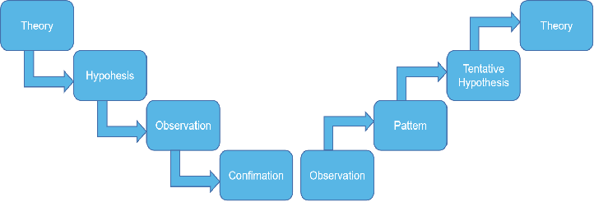
Figure 2:Induction Approach and Deduction Approach

3.2 Analysis Unit
The unit analysis of the study specifies what or who provides the data, and at what level the data is collected. The unit analysis of this research is individuals, and the research object is the Internet Marketing of small and medium enterprises.

3.3 Population and Sampling
Sampling refers to a method used for statistical analysis in which the broader population obtains a fixed number of observations. The method of sampling from a larger population depends on the type of analysis performed.Two types of sampling methods, probability sampling methods, and non-probability sampling methods are available. (Semiz, 2016).[]
Probability sampling means that there is a possibility for any member of the population to be chosen. It is used for quantitative analysis primarily. You need to use probability sampling methods if you want to achieve results that reflect the entire population. Individuals are chosen according to non-random criteria in a non-probability survey, and not every individual has a chance to be included. This type of sample is simpler and cheaper to collect, but it has a higher chance of sampling bias. For exploratory and qualitative analysis, non-probability sampling techniques are typically appropriate. The goal is not to test hypotheses about a large population in these types of study, but to shape a preliminary understanding of a small or under-researched population. (Sharma, 2017).[]
This research uses methods of non-probability sampling since respondents may respond at any time to the distributed questionnaire and are willing to share data.
The population doesn't necessarily apply to individuals in study. It can mean a collection of components containing everything you want to analyse, such as objects, activities, organisations, nations, animals, organisms, etc.(Semiz, 2016).
The number of domestic enterprises with foreign trade management rights in my country has risen from more than 6,000 in 1989 to over 400,000 now according to data from the National Bureau of Statistics of China, and most of them are small and medium foreign trade enterprises. With a confidence level of 96% and a margin of error of 4, the sample size used in this study will be 350 respondents.

3.4 Research Methods

3.4.1 Questionnaire Design
In order to gather data from respondents, a questionnaire is a research tool consisting of a series of questions. Questionnaire surveys offer a relatively inexpensive, simple, and productive way for a large number of people to collect a lot of information.. In order to obtain useful information from the respondents, each step needs to pay attention to details. Careful attention must be paid to the design of the questionnaire, and the process planning is shown in Figure 3 and the carefully designed questionnaire must be passed (Krosnick, 2018).[]
An effective, accurate, simple, succinct, and interesting questionnaire should be a good one. Based on the conceptual framework, it is important to design the questionnaire, carefully check the significance and clarity of each question and consider the final analysis to be carried out, which can be descriptive or explanatory. The descriptive questionnaire is Find opinions or characteristics without studying causality, or provide explanations from a range of populations; explanatory questionnaires involve more analytical opinions to investigate the relationship between variables (Ragab and Arisha, 2018).[]
The open-ended questionnaire enables respondents to freely answer questions in words, but since further analysis is required, they are not recommended to perform quantitative research(Roopa and Rani, 2012). The closed questioning method is used in the design of the questionnaire. This method allows the interviewee to give quick and accurate answers to achieve the required research purpose. (Ragab and Arisha, 2018).

3.5 Data Collection Method
Throughout the marketing analysis of small and medium international trade firms, this section addresses the types of data we collect. It is split into two data: it is divided as follows into two, secondary and primary data:
A large number of secondary data, which can be used as a benchmark for researchers to create research designs, are accessible to the public on the Internet. In this study, we used the collection of secondary data relevant to our learning topics to access university databases, Google Scholar and other academic journals. The value of secondary data collection is that it can re-analyze the data collected from secondary sources and provide comparative data with the primary data collected.Therefore in marketing, small business marketing, internet marketing, customer retention and satisfaction, we collected data previously collected by researchers. We reanalyze them and perform research on this basis in order to limit their reach to our research aims.
The data collection method of this study will be based on an internet marketing questionnaire survey of all small and medium-sized multinational trading firms.The questionnaire uses Google Forms, an electronic framework that will be distributed through digital platforms such as WhatApps, Facebook Messenger, and email. For further data analysis, researchers plan to obtain 350 full sets of questionnaires from respondents.
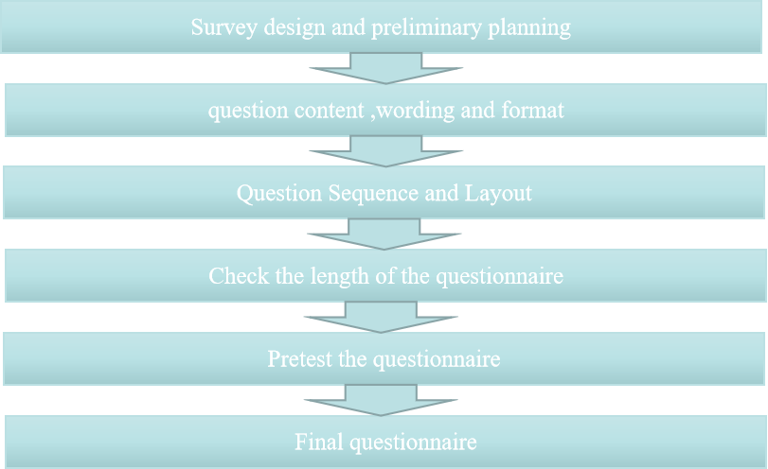
Figure 3 : Planning Questionnaire Phases
In questionnaires, Likert-type is usually used to allow individuals to express their degree of agreement or disagreement with a particular statement. The 5-Point Likert Scale, for instance, usually defines the degree of agreement with the argument in five aspects: (1) strongly disagree; (2) disagree; (3) neither agree nor disagree; (4) agree; (5) I strongly agree that the 5-point Likerbert scale should be used to obtain quantitative data,, which means that the data can be analyzed relatively easily. Improve their response rate and quality by reducing the frustration level of the respondent, which will allow the respondent to respond to their views in a better way.
A closed questionnaire design will be adopted in this analysis, and the 5-point Likert scale will serve as the basis of the measurement scale, except for some nominal data relating to the profile and demography of the surveyed individual.

3.5.1 Questionnaire
This research is intended to gather quantitative data so that, as seen in Table 4, a closed and standardised approach was adopted and modified in the questionnaire design.
Section | Question/Item | No | Adapt/Adopt | Sources
Part A | Demographic Information  (Gender, Age Group and Income Level) | 7 | Adopt | Hazeltine, 2020.
Part B  (Dependent Variable) | The effect of Internet Marketing of small and medium foreign trade enterprises | 5 | Adapt | Qu, 2017
Part C  (Independent Variable) | Website design | 4 | Adapt | Yu and Bell, 2007
Part C  (Independent Variable) | E-commerce platform | 4 | Adapt | Shao and Yan 2017
Part C  (Independent Variable) | promotion method | 4 | Adapt | Thenmozhi and Gomathi, 2018
Part C  (Independent Variable) | Marketing talent | 4 | Adapt | Lu and Zhang， 2017
Table 4 : Questionnaire Design

3.6 Conclusion
.In preparation for the data analysis in the next chapter, this chapter primarily addresses the research process of the project, including research design, analysis unit, data collection method and questionnaire design.

Chapter 4.0 Measurement and Measure

4.0 Overview
Chapter 4 is mainly about this research will use SPSS statistical tools to analyze the data collected by the questionnaire. The data analysis method will be discussed in Table 4.1-Table 5.7. The ultimate goal of these data analysis methods is to correctly test hypotheses and draw conclusions.

4.1 Pilot Test
Before using the questionnaire to collect data, it is important to test it. Pre-testing and piloting can help researchers identify questions that are not meant for participants or questionnaire questions that may lead to biased answers. Generally, researchers should pre-test all surveys and forms with at least 5 people. By doing so, you can know what needs to be improved. At the same time it is possible to test the correctness of the instructions to be calculated by whether the instructions can be followed by all respondents in the pilot study. Better information helps researchers determine whether the type of survey is effective for the purpose of the research. All in all, this test helps to determine the validity and reliability of conducting large-scale investigations (Radhakrishna, 2007).[]
Table 4.1----Case Processing Summary
 |  | N | %
Cases | Valid | 50 | 100.0
Cases | Excludedª | 0 | .0
Cases | Total | 50 | 100.0
a. Listwise deletion based on all variables in the procedure.

As shown in Table 4.1 above, in this study, 14% of the sampled population was collected and 50 questionnaires were collected for pilot testing.In the pilot test, roughly 10% to 20% of the population sampled is chosen as a pilot test. It focuses primarily on the consistency, definition, and arrangement of the issues, and will consider improving the questionnaire.

4.1.1 Factor Analysis
Factor analysis requires the classification into dimensions of related variables. This method is a processing method of dimensionality reduction based on multiple observation results.Its main purpose is to explore a certain structure hidden behind a large amount of observational data, to find a common factor for a set of variable changes, and to classify variables of the same nature into one element, which can decrease the number of variables and evaluate the relationship hypothesis between variables. To explain the omission of questions to shorten the questionnaire, factor analysis may be used. (Liew and Idris, 2017).[]

4.1.2 Kiser-Meyer-Olkin (KMO)
The KMO test method tests whether the questionnaire is valid. The validity value is usually between 0-1.The closer to 1, the higher the questionnaire's validity and the more relevant it is for factor analysis. The KMO metric that is widely used is above 0.8 means very suitable; above 0.7 means suitable; Over 0.6 means barely acceptable; below 0.5 means not appropriate. The KMO test therefore helps researchers to ensure that the information they have is sufficient for factor analysis to decide whether they have decided what to calculate. (Dodge, 2008).[]
Table 4.2---KMO and Bartlett's Test
Kaiser-Meyer-Olkin Measure of Sampling Adequacy. |  | .882
Bartlett's Test of Sphericity | Approx. Chi-Square | 431.027
Bartlett's Test of Sphericity | df | 120
Bartlett's Test of Sphericity | Sig. | .000
The Kaiser-Meyer-Olkin test of sampling adequacy in this analysis is shown in Table 4.2 above.A KMO value of 0.882 or greater is very suitable.The KMO index is similar to 1, meaning that the higher the questionnaire validity, the more appropriate for factor analysis; the Bartlett sphere test can be used for factor analysis as long as it is less than 0.05. The sig value of the last row of data is less than 0.05, which meets the standard.The hypothesis that each variable is independent is dismissed, and a clear correlation is assumed to exist between the variables.
In this analysis, SPSS outputs the KMO test outcomes of each component as follows:
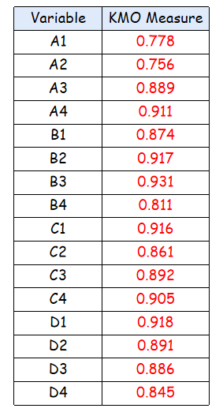
Table 4.3--KMO Measure
As shown in Table 4.3 above, we can see the introduction of the overall coefficient of KMO test. The results of the KMO test study for gap variables are split between 0 and 1. If the coefficient is greater than 0.5, the variable is considered to satisfy the criteria; if the coefficient is greater than 0.8, the variable's outcome is considered to be good.

4.1.3 Communality
As shown in Table 4.4, how many variables will be output in the study. If there are 16 variables in this study, 16 components will be generated accordingly.
The 'Original' column in Table 4.4 above shows that when all components are used, the degree of understanding of each variable's shift is 1.You can extract the changes in the data at this stage without removing any information. The "Extraction" column indicates the degree of extraction of the variable if only the selected components are kept.
Extracting factor analysis from each variable in the table, all variables are greater than 0.5, indicating that the information extraction effect is relatively good, and there will be no great loss to the collected original data.
The SPSS output commonality results are as follows:
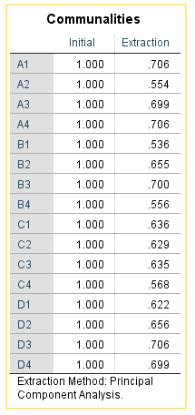
Table 4.4--Commonality
Extracting factor analysis from each variable in the table 4.4, all variables are greater than 0.5, indicating that the information extraction effect is relatively good, and there will be no great loss to the collected original data.

4.1.4 Eigenvalues
The eigenvalue is used to decide how many variables to maintain in the analysis . It also describes the variables that need close attention because more or less variables needed will lead to serious mistakes that will impact the outcome of the study. The element is known to be important with eigenvalues greater than one. In science, the number of eigenvalues (>1) must be the same as the number of variables(Denton, and Zhang 2019). []
Variance contribution of a common factor: It is the sum of squares of a common factor to all original variable loads. It reflects the ability of the common factor to explain all the original total variation, and is equal to the sum of squares of a column of load in the factor loading matrix. The greater the variance contribution of a factor, the more important the factor.
Extract the principal components
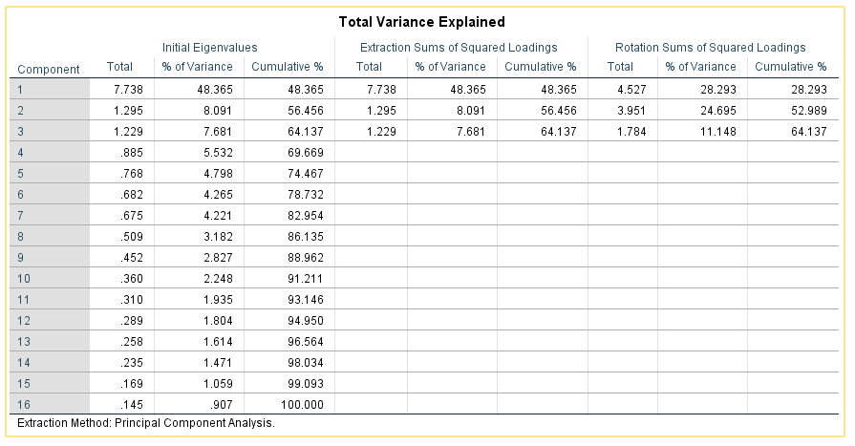
Table 4.5--Total Variance Explained
It can be seen from Table 4.5 above that three common factors are mainly extracted. The variance percentages are 28.293%, 24.695%, 11.148%, and the cumulative variance is 64.137%>50%.
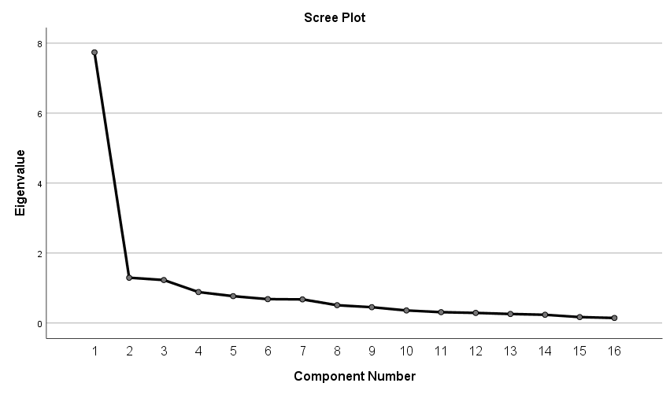
Figure 4.0--Scree plot
From the perspective of the Figure 4.0--Scree plot, this picture more intuitively shows the number of factors and eigenvalues.The number of junctions from steep to gentle is more fitting, generally speaking. The present judgement is that 3 variables are more suitable.

4.1.5 Factor Loading
The correlation coefficient between a certain factor and a certain original variable mainly reflects the contribution of the common factor to the corresponding original variable.
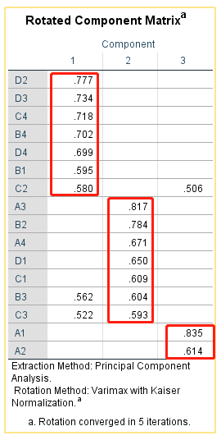
Table4.6--rotated component Matrix
It can be seen from the table 4.6 rotated component Matrix that common factor 1 has a larger factor load from D2 to C2; common factor 2 has a larger factor load from A3 to C3; common factor 3 has a larger factor load from A1 to A3.

4.2.6 Reliability Test
Reliability usually refers to the stability and repeatability of a measurement, or the ability of a test to produce the same results under the same conditions. In order to ensure the high reliability and validity of the questionnaire, before the formal analysis or the formation of the formal questionnaire, we will test the reliability and validity of the measurement results to ensure the reliability and validity of results. Otherwise, the results may be perfect. There is a problem. Therefore, testing the reliability and validity of questionnaires or scales is an essential and important part of the research process(Bujang, and Baharum,2018).[]
Cronbach's alpha is used to obtain the reliability index to estimate the data's reliability. The better the alpha value, the greater the reliability. The validity of the content is defined in the questionnaire design by the inclusive operation of item collection and adjustment.
Cronbach's alpha reliability coefficient is usually between 0 and 1. The greater the internal accuracy of the objects (variables) on the scale, the closer the coefficient is to 1.0. As the number of items (variables) increases or the average inter-item correlation increases, the alpha coefficient of Cronbach increases that is, when the number of items remains constant.
Its value is also called Cronbach reliability coefficient (Cronbach alpha coefficient value). If the reliability factor is greater than 0.8, the reliability of the test or scale is very good. 0.7 or more is acceptable; if it is greater than 0.6, the scale should be modified, but its value will not be lostThe scale can be updated if it is greater than 0.6, but its value will not be lost; if it is less than 0.6, it will need to be revamped. In short, Cronbach's x-a coefficient is between 0 and 1. The higher the coefficient, the higher the reliability, and more than 0.9 means that the questionnaire's internal accuracy is greater.(Liew & Idris, 2017)

Table 4.7---Reliability Statistics
Cronbach's Alpha | N of Items
.926 | 16

It can be seen from Table 4.7 above that Cronbach's alpha value in this study is> 0.9 by SPSS analysis, so it can be considered to represent excellent internal consistency.

4.2 Data Analysis

4.2.1 Descriptive statistics
Descriptive statistics are used to clarify the basic features of data in research. They have a fast metric and sample description. They form the basis of, along with simple graphical analysis, practically all quantitative data analysis..(Mishra,and Amit,2019).[]
The purpose is to study the characteristics of the population. Descriptive statistical analysis is the basis of statistical analysis. It is a description of the concentration or dispersion of a set of data and the distribution status.
Measure | Items | Frequency | Percent
Gender | Female | 151 | 43.1
Gender | Male | 199 | 56.9
Age | 18-24 | 35 | 10
Age | 25-40 | 154 | 44
Age | 41-50 | 120 | 34.3
Age | >50 | 41 | 11.7
Income (RMB) | Below 2000 RMB | 18 | 5.1
Income (RMB) | 3000-5000 RMB | 72 | 20.6
Income (RMB) | 5000-8000 RMB | 150 | 42.9
Income (RMB) | 8000-10000 RMB | 88 | 25.1
Income (RMB) | Above 10000 RMB | 22 | 6.3
Education level | High school and below | 35 | 10
Education level | Postgraduate | 155 | 44.3
Education level | Undergraduate | 147 | 42
Education level | PhD | 13 | 3.7
work position | Senior management | 70 | 20
work position | Middle managers | 187 | 53.4
work position | Ordinary employees | 93 | 26.6

Table 4.8---Descriptive statistics
The detailed summary statistics for the corresponding questionnaire are shown in Table 4.9, including gender, age, salary, level of education and job status.
It can be seen from the descriptive study that the higher the level of education, the higher the salary and the higher the work status, and the younger and middle-aged small and medium-sized international trade firms make up the majority.

4.2.2 Reliability and validity analysis
Table 4.9--Reliability Statistics
Cronbach's Alpha | N of Items
.820 | 16
Cronbach's alpha reliability coefficient is 0.82. Also close to 1.0, the higher the internal consistency of the variables. So it can be considered that it reflects excellent internal consistency.
Table 5.0--KMO and Bartlett's Test
Kaiser-Meyer-Olkin Measure of Sampling Adequacy. |  | .882
Bartlett's Test of Sphericity | Approx. Chi-Square | 960.232
Bartlett's Test of Sphericity | df | 120
Bartlett's Test of Sphericity | Sig. | .000
The table above shows the Kaiser-Meyer-Olkin of 350 samples in this study. The KMO value is 0.882, which is close to 1, indicating that the higher the validity of the questionnaire, the more suitable for factor analysis;
Table 5.1--Communalities
 | Initial | Extraction
A1 | 1.000 | .678
A2 | 1.000 | .758
A3 | 1.000 | .802
A4 | 1.000 | .741
B1 | 1.000 | .743
B2 | 1.000 | .815
B3 | 1.000 | .837
B4 | 1.000 | .777
C1 | 1.000 | .838
C2 | 1.000 | .647
C3 | 1.000 | .888
C4 | 1.000 | .698
D1 | 1.000 | .713
D2 | 1.000 | .779
D3 | 1.000 | .792
D4 | 1.000 | .859
Extraction Method: Principal Component Analysis.
All variables are greater than 0.5 from the study of the extraction factors of 350 samples, suggesting that the impact of the extraction of information is relatively good and will not cause great loss to the original data obtained.
Table 5.2--Total Variance Explained
Component | Initial Eigenvalues |  |  | Extraction Sums of Squared Loadings
Component | Total | % of Variance | Cumulative % | Total | % of Variance | Cumulative %
1 | 4.376 | 27.349 | 27.349 | 4.376 | 27.349 | 27.349
2 | 1.156 | 7.227 | 34.576 | 1.156 | 7.227 | 34.576
3 | 1.032 | 6.452 | 41.028 | 1.032 | 6.452 | 41.028
4 | .948 | 5.927 | 46.954
5 | .934 | 5.839 | 52.793
6 | .877 | 5.484 | 58.277
7 | .868 | 5.426 | 63.704
8 | .841 | 5.258 | 68.962
9 | .743 | 4.647 | 73.609
10 | .722 | 4.513 | 78.122
11 | .655 | 4.095 | 82.217
12 | .630 | 3.939 | 86.156
13 | .623 | 3.892 | 90.048
14 | .578 | 3.616 | 93.663
15 | .528 | 3.300 | 96.963
16 | .486 | 3.037 | 100.000
Extraction Method: Principal Component Analysis.
The above table is a data analysis of 350 samples. It can be seen that three common factors are mainly extracted. The percentage of variance is 25.416%,13.210%, 12.402%, and the cumulative variance is 51.028%>50%.

4.2.3 One Way Analysis of Variance (ANOVA)
The object of the variance analysis is to decide if the mean population of two or more data sets is the same and to test if the mean difference between two or more data samples is statistically significant. The fundamental principle of the study of variance is to decompose the total variation of the experimental data into corresponding variations derived from various factors and to make quantitative estimates, to explain the significance of the total variation of each variation factor;The variance of deviation is decomposed into the variance of each variable, and the error variance is used as the norm for comparison with the variance of other variables to determine whether or not the variance induced by other variables is valid or not is a form of statistical analysis.
If the analysis of variance studies the influence and effect of a factor on the test results, it is called a one-way analysis of variance. The different options for factors are called the level of factors or treatment. The level of the factor is actually the value of the factor or the grouping of the factors. If the difference between the sample data is caused by the randomness of the sampling, it is called random error; if it is due to the difference of the factor level itself, it is called systematic error (Baarda and van Dijk, 2019 ).[]
The P-value is an indicator to measure the difference between the control group and the experimental group. If the P-value is less than 0.05, it means that there is a significant difference between the two groups and is statistically significant. If the p-value (>0.05), is not statistically significant, and the P-value is less than 0.01 means that the difference between the two groups is extremely significant, which can be counted by SPSS. The P-value indicates the degree to which the null hypothesis is not rejected. In short, P indicates that the assumption is more likely to be correct, and vice versa (Bartholomew, 2016).[]

Table5.3--ANOVA
Website Design
 | Sum of Squares | df | Mean Square | F | Sig.
Between Groups | 1.502 | 3 | .235 | 3.460 | .019
Within Groups | 174.566 | 346 | .068
Total | 176.069 | 349

ANOVA
E-commerce platform
 | Sum of Squares | df | Mean Square | F | Sig.
Between Groups | 2.822 | 3 | .264 | 3.885 | .011
Within Groups | 236.895 | 346 | .328
Total | 239.717 | 349

ANOVA
Promotion method
 | Sum of Squares | df | Mean Square | F | Sig.
Between Groups | 1.776 | 3 | .327 | 4.823 | .030
Within Groups | 200.398 | 346 | .189
Total | 202.174 | 349

ANOVA
Marketing talent
 | Sum of Squares | df | Mean Square | F | Sig.
Between Groups | 1.000 | 3 | .189 | 2.778 | .000
Within Groups | 163.858 | 346 | .374
Total | 164.857 | 349

According to Table 5.3 above the significance of the four variables is P<0.05 in the results of the variance analysis, implying that the influence of each factor is different, i.e. that there is a significant influence. It is statistically significant and can be evaluated in the next step, but you need to verify the results of the pairwise comparison for particular effects.
Table 5.4--Multiple Comparisons
Dependent Variable: The effect of Internet Marketing of small and medium foreign trade enterprises
LSD
 |  | Mean Difference (I-J) | Std. Error | Sig. | 95% Confidence Interval
 |  |  |  |  | Lower Bound | Upper Bound
Website Design | E-commerce platform | -.068 | .099 | .492 | -.26 | .13
Website Design | Promotion method | -.024 | .096 | .801 | -.21 | .16
Website Design | Marketing talent | -.221 | .132 | .006 | -.48 | .04
E-commerce platform | Website Design | .068 | .099 | .492 | -.13 | .26
E-commerce platform | Promotion method | .044 | .103 | .672 | -.16 | .25
E-commerce platform | Marketing talent | -.153 | .137 | .266 | -.42 | .12
Promotion method | Website Design | .024 | .096 | .801 | -.16 | .21
Promotion method | E-commerce platform | -.044 | .103 | .672 | -.25 | .16
Promotion method | Marketing talent | -.196 | .135 | .148 | -.46 | .07
Marketing talent | Website Design | .221 | .132 | .006 | -.04 | .48
Marketing talent | E-commerce platform | .153 | .137 | .266 | -.12 | .42
Marketing talent | Promotion method | .196 | .135 | .148 | -.07 | .46

Because of the major differences between each group of variables, according to table 5.4 above.There is a significant difference between the average effects of the first and fourth groups, P = 0.096 <0.05.

Table5.5 --Descriptives
Website Design
 | N | Mean | Std. Deviation | Std. Error | 95% Confidence Interval for Mean |  | Minimum | Maximum
 |  |  |  |  | Lower Bound | Upper Bound | Minimum | Maximum
Website Design | 121 | 4.31 | .717 | .065 | 4.18 | 4.43 | 1 | 5
E-commerce platform | 91 | 4.37 | .725 | .076 | 4.22 | 4.52 | 1 | 5
Promotion method | 100 | 4.33 | .697 | .070 | 4.19 | 4.47 | 2 | 5
Marketing talent | 38 | 4.53 | .687 | .111 | 4.30 | 4.75 | 3 | 5
Total | 350 | 4.35 | .710 | .038 | 4.28 | 4.43 | 1 | 5
According to the above table 5.5, the mean values of E-commerce platform and Marketing talent are 4.37 and 4.53, respectively. It can be known that E-commerce platform and Marketing talent are higher than Website Design and Promotion method.

4.2.4 Correspondence analysis
Correspondence analysis is a form of analysis of variable dimensionality reduction similar to principal component analysis. It is mainly used for the analysis of qualitative two-dimensional or multi-dimensional contingency table data. The difference from principal component analysis is that it is used for the analysis of qualitative and quantitative data respectively(Di Franco,2016).[]The principal components are based on variance decomposition and sharing, and correspondence analysis is based on the decomposition and contribution of chi-square statistics. Correspondence analysis can analyze the correlation between variables and the difference or similarity between categories of the same variable. You can use graphs to observe the corresponding relationship. "Contingency table analysis" can analyze the correlation between two qualitative variables. For further analysis of differences Sex and similarity are powerless.
Table 5.6--Summary
Dimension | Singular Value | Inertia | Chi Square | Sig. | Proportion of Inertia |  | Confidence Singular Value
 |  |  |  |  | Accounted for | Cumulative | Standard Deviation | Correlation
 |  |  |  |  |  |  |  | 2
1 | .128 | .016 |  |  | .586 | .586 | .049 | .024
2 | .101 | .010 |  |  | .369 | .955 | .036
3 | .035 | .001 |  |  | .045 | 1.000
Total |  | .028 | 9.712 | .000ª | 1.000 | 1.000
a. 12 degrees of freedom
Chi-square value=9.712, meaning Sig=0.000<0.01, according to the above overview table 5.6, suggesting that the two nominal variables are not entirely independent in this study, affecting influences and satisfaction, and there is a certain relationship.

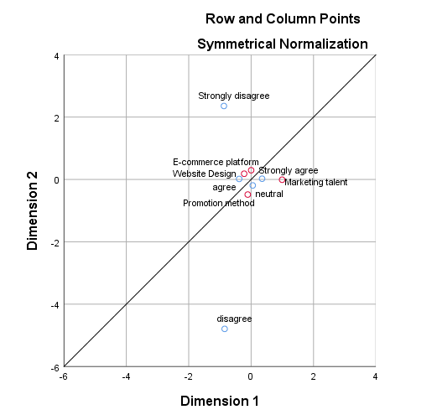
Figure 4.1：Correspondence analysis graph
When reading the graph, there are two principles: First, verify the differentiation of various variables between the horizontal axis and the vertical axis. If different categories of the same variable are closer in a certain direction, it means that there is no difference in this dimension between these categories; second, the positional relationship between the value categories of the various variables in each dimension is contrasted.
It can be seen from the map that the four variables in this questionnaire are the red dots, and the blue dots are the fulfilment of the variables. It can be shown clearly that the neutral approach supports promotion of sales. The agreement's attitude favours website design; the solid agreement's attitude favours marketing skills and cross-border channels.

4.3 Hypothesis Testing
On the premise that the null hypothesis is considered to be true, calculate the probability of the observation of the test statistic and record it as p. The probability p value is the probability of the sample value occurring under the premise of the null hypothesis. So it can be determined according to certain standards Whether the probability of occurrence is small.(Kafle, 2019).[]
If the null hypothesis is valid, the P-value is the likelihood of a sample observation outcome or more extreme result. If the value of P is small, it implies that the likelihood of this case is very small, and if it happens, we have justification to dismiss the original hypothesis according to the theory of small probability. Thus if the probability p value is below 0.01, H0 is rejected and the difference is very important; if the probability p value is below 0.01 and below 0.05, H0 is rejected, the difference is relevant. Therefore the lower the P value, the more we discount the null hypothesis for sufficient reasons. When the probability p value is greater than 0.05, the difference in accepting H0 is not important.
If the hypothesis test suggests that anything is unlikely to happen by chance, then the difference is statistically important between the sample statistics and the hypothetical value. To determine statistical significance, review the test's p-value. If the p-value is less than the alpha meaning amount defined (usually 0.10, 0.05, or 0.01), you should consider the difference to be statistically relevant and reject the test's null hypothesis.
Table 5.7--One-Sample Test
 | Test Value = 3
 | t | df | Sig. (2-tailed) | Mean Difference | 95% Confidence Interval of the Difference
 |  |  |  |  | Lower | Upper
Website Design | 35.671 | 349 | .000 | 1.354 | 1.28 | 1.43
E-commerce platform | 26.250 | 349 | .000 | 1.163 | 1.08 | 1.25
Promotion method | 29.285 | 349 | .000 | 1.191 | 1.11 | 1.27
Marketing talent | 34.220 | 349 | .000 | 1.257 | 1.18 | 1.33
A null hypothesis for the final outcome of the test is suggested according to the purpose of the test:
- The website design’s satisfaction with the Internet Marketing effect of small and medium-sized foreign trade companies is less than 3, so a null hypothesis can be made, H0: μ<3.
- The degree of satisfaction of the e-commerce network with the impact of small and medium international trade companies on Internet marketing is less than 3 and a null hypothesis can be made. H0: μ<3.
- The satisfaction degree of the promotion method to the Internet Marketing effect of small and medium foreign trade companies is less than 3, and a null hypothesis can be made, H0: μ<3
- Marketing talents’ satisfaction with the Internet Marketing effect of small and medium foreign trade companies is less than 3, which can be a null hypothesis, H0: μ<3
The average p value tested is 0.000, according to test results in Table 5.7 above. The p-value is less than 0.05 at the 5 percent significance stage, so the null hypothesis (H0) is denied.
Therefore, the four original hypotheses (H0): excessive reliance on B2B platforms, corporate website design, lack of talent, and single promotion methods are all invalid. The degree of satisfaction of Internet Marketing effects is ≥3, which is consistent with the assumptions of this questionnaire.

4.4 Multiple Regression Analysis
Regression analysis is a type of statistical analysis to investigate whether a dependent variable or several dependent variables and an independent variable have a linear or non-linear relationship. The regression analysis done at this time is a linear regression if there is a linear relationship between the independent variable and the dependent variable.Linear regression analysis is a mathematical method to analyse the quantitative relationship between dependent and independent variables. (Wathan, J et al. 2019).[]
It is subdivided into unary linear regression and multiple linear regression according to the number of independent variables. In linear regression analysis, this form of regression analysis is called unary linear regression analysis if only one independent variable and one dependent variable are included and the relationship between the two can be approximated by a straight line; If independent variables are used in two or more of them, the linear relationship between the dependent variable and the independent variable is called multiple analysis of linear regression.(Zambom and Kim, 2017).[]
The data collected in this study is the use of SPSS regression analysis software to evaluate and summarise the acceptance and rejection of the hypothesis proposed in Chapter 2. If the test is conducted, the researcher may analyse the results against the research goals and hypotheses in order to determine the type and scale of the impact of the independent variable on the dependent variable.
Table 5.8 --Coefficientsª
Model |  | Unstandardized Coefficients |  | Standardized Coefficients | t | Sig. | Collinearity Statistics
 |  | B | Std. Error | Beta | t | Sig. | Tolerance | VIF
1 | (Constant) | 2.183 | .500 |  | 4.367 | .000
1 | Website Design | .120 | .081 | .083 | 1.486 | .000 | .915 | 1.093
1 | E-commerce platform | .117 | .070 | .970 | 2.153 | .003 | .882 | 1.133
1 | Promotion method | .100 | .076 | .075 | 1.315 | .000 | .888 | 1.126
1 | Marketing talent | .019 | .083 | 1.129 | 2.232 | .000 | .928 | 1.078
a. Dependent Variable: The effect of Internet Marketing of small and medium foreign trade enterprises
Result analysis: Website design, e-commerce platform, promotion system and marketing talent with a p-value of less than 0.05 and beta is optimistic, according to Table 5.8 above, so the hypotheses H1, H2, H3, and H4 are acknowledged. E-commerce platform (0.970) and marketing talent (1.129) are the key factors affecting small and medium international trade companies' internet marketing.
In order to determine whether independent variables are independent of each other, tolerance and expansion factors are essential factors. Tolerance is called tolerance as well. The coefficient of expansion is the opposite of tolerance. The closer the coefficient of tolerance and expansion is to 1, the weaker the multicollinearity among the independent variables. The expansion factor <10 among them suggests that the independent variables are relatively independent. Factor for expansion >= 10,Indicating that the independent variables have a good multicollinearity.
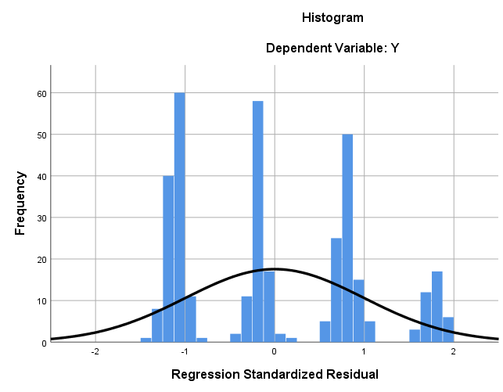
Figure 4.2:Histogram

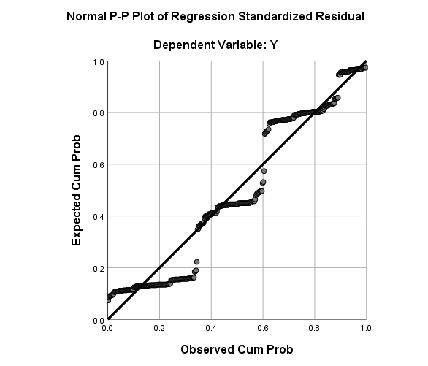
Figure 4.3:P-P Plot
Result analysis:According to Figure 4.3, the residual value is the difference between the observed value of the dependent variable and the estimated value of y obtained by the regression model, also known as the value of the error that is capable of estimating the size of the error that may occur in the regression model. It can be seen from the figure that the residuals are typically distributed in the histogram and approximate a straight line in the p-p map, so the hypothesis is correct.

Table 5.9--ANOVAª
Model |  | Sum of Squares | df | Mean Square | F | Sig.
1 | Regression | 3.838 | 4 | 1.959 | 17.604 | .003^{b}
1 | Residual | 360.519 | 345 | .910
1 | Total | 364.357 | 349
a. Dependent Variable: The effect of Internet Marketing of small and medium foreign trade enterprises
b. Predictors: (Constant), Marketing talent, E-commerce platform, Website Design , Promotion method
Result analysis:According to Table 5.9 above, the degree of significance indicates that website design, e-commerce network, method of promotion and marketing talent affect small and medium international trade companies' internet marketing (F=11.604). The p-value is 0.003 and thus meets the requirement of less than 0.05.
Table 6.0--Model Summary
Model | R | R Square | Adjusted R Square | Std. Error of the Estimate
1 | .503ª | .411 | .401 | 384.022
a. Predictors: (Constant), Marketing talent, E-commerce platform, Website Design , Promotion method

Result analysis:The R square is between 0 and 1. according to Table 5.9 above. Between 0 and 1., the R square is The closer the R square is to 1, the higher the model's fit and the more its internal adjustment reflects. The higher degree of suitable interpretation shows the R square above 0.6. The R square value is 0.411 this time, which means that the model has a relatively high level of understanding.

4.5 Conclusion
This chapter includes, in particular pre-test sampling before data analysis to ensure data quality, accuracy, reliability and validity testing to ensure that hypotheses can be properly tested and conclusions can be drawn. This chapter focuses on the data analysis process of the project.

Chapter 5.0 Countermeasure analysis

5.0 Overview
To check the validity of the hypothesis, Chapter 5 is based on the data in Chapter 4.It analyses the existing problems of internet marketing for Chinese small and medium-sized foreign trade companies. In reaction to the above problems, small and medium-sized foreign trade companies should take the following steps in their Internet Marketing Response Strategies.

5.1 Improve website design
First, the functionality of the website must be improved; the more products a company produces, the more difficult it will be for customers to browse the product catalog to obtain the target product. Therefore, it is necessary to design a concise product search function and refine the search function to ensure that customers can obtain the corresponding product information in a relatively short time. The email subscription function is also very important in order to obtain the buyer's email address; however, most customers resist and are unwilling to keep it, so you need to clearly inform the customer of the content of the subscription email.
Secondly, it effectively improves website browsing speed; if buyers need to wait a long time before they can open the webpage, most people will give up visiting. Therefore, scientifically designed websites, flash, dynamic databases, large websites, etc. should not be selected as much as possible. At the same time, organic selection of high-quality large-scale servers will promote the speed of website browsing.
Finally, we must design a multi-language version of the website; the international language is English, and the English version and Chinese version of the foreign trade website must be separated.In addition, small and medium international exchange companies focused on the characteristics of the target market should be sufficiently increased in the language edition of the website. The foreign trade website must have at least two versions, namely Chinese and English. If the target market also uses other languages, you need to add the design of the website in this language version.

5.2 Reasonable choice of e-commerce platform
In Internet Marketing, despite the widespread use of B2B platforms, some buyers do not use this channel to find product information. Many North American customers have strong hands-on skills and are more accustomed to using search engines, eBay and other platforms. If only the B2B e-commerce platform is adopted.This will impact the pace of growth of the market. Small and medium-sized foreign exchange firms can also market the company's goods on B2C platforms to more international clients in some activities, and can use comprehensive bidding,, auctions and other methods to find potential customers and promote the company’s culture and brand. . In the future development, it is necessary to organically combine physical stores and online stores according to actual conditions to establish a new direct sales model.

5.3 Enriched promotion methods
Currently, small and medium-sized foreign trading companies in China have begun to make extensive use of computer and Internet technologies. In the company's website design, it's important to pay full attention to search engines. They need to determine search engine rankings correctly for small and medium-sized international trading firms.In addition to choosing paid search engine ranking services, they also need to use other promotion methods, such as optimizing user experience, optimizing websites, optimizing search engines, etc., to increase website exposure and website ranking; they can also pay more attention to the use of social marketing, such as blogs Marketing, Facebook marketing, etc. Growing the use of advertising strategies would have a more positive effect on small and medium-sized international trade enterprises' online marketing.

5.4 Training of Internet Marketing talents
As we can see from the results of the questionnaire study, in China's current small and medium-sized foreign trade businesses, Internet marketing talents are still lacking, it is suggested that a talent training mechanism should be established to cultivate existing talents through recruitment, joint talents with universities, and independent training. Network technology also understands the compound talents of marketing and financial management. Understand the working methods of employees related to the company's Internet Marketing, and conduct targeted analysis, and provide them with professional training to improve work efficiency.

5.5 Conclusion
In short, the use of internet marketing has a very positive and important impact on the creation and growth of small and medium-sized foreign trade undertakings; it is particularly important in practise, to combine the undertaking's existing challenges and development needs and to take full account of the characteristics of the target market.Choose e-commerce platforms fairly, broaden promotion methods, rationally build websites, optimise rankings, and improve the application effects of Internet Marketing.

References

[] Li, J. and Chen, J., 2006. Development of Chinese small and medium‐sized enterprises. Journal of small business and enterprise development.
[] Shanjun, W., 2019. Analysis on the Role of Cross-border E-commerce in the Development of Small and Medium-sized Foreign Trade Enterprises.
[] He, X., 2018. Internet Marketing Strategy in China: Case company: Tmall.
[] Internet Live Stats: Total number of websites – 2017. http://www.internetlivestats.com/total-number-of-websites, accessed 3rd April 2017
[] eMarketer: Global B2C Ecommerce Sales to Hit $1.5 Trillion This Year Driven by Growth in Emerging Markets – 2014. https://www.emarketer.com/Article/Global-B2C-Ecommerce-Sales-Hit-15-Trillion-This-Year
[] Doody, O. and Bailey, M. E., (2016). Setting a research question, aim and objective. Nurse Researcher, 23(4), pp. 19-23.
[] Rollins, M., Nickell, D. and Ennis, J., 2014. The impact of economic downturns on marketing. Journal of Business Research, 67(1), pp.2727-2731.
[] Grubor, A. and Jakša, O., 2018. Internet marketing as a business necessity. Interdisciplinary Description of Complex Systems: INDECS, 16(2), pp.265-274.
[] Li, X., 2019, December. Financing Predicament of Small and Medium-Sized Foreign Trade Enterprises in China–Based on Big Data Analysis. In International conference on Big Data Analytics for Cyber-Physical-Systems (pp. 723-730). Springer, Singapore.
[] Koren, D., Shasha, E., Sadeh, E. and Rowland, R., Wixcom Ltd, 2019. System and method for the generation and editing of text content in website building systems. U.S. Patent Application 16/202,174.
[] Rosson, P.J. and Ford, I.D., 2016. Stake, conflict and performance in export marketing channels. In Proceedings of the 1979 Academy of Marketing Science (AMS) Annual Conference (pp. 66-69). Springer, Cham.
[] Huang, J., Lu, D., Mao, W., Ma, D., Wang, W., Zhu, W., Liu, X. and Tang, Y., Beijing Knet Eqxiu Technology Co Ltd, 2017. Promotion system and promotion method. U.S. Patent Application 15/149,057.
[] Jin, Y., Wang, Q., Wang, Y., Geng, K., Ren, Y. and Wei, Y., 2020. Talent Training Mode of Big Data Marketing Major in Higher Vocational Colleges Based on: Scientific Research Assistance, Competition Driven, Education and Training Combination. International Journal of Social Sciences in Universities, p.29.
[] Legara, E.F., Monterola, C., Juanico, D.E., Litong-Palima, M. and Saloma, C., 2008. Earning potential in multilevel marketing enterprises. Physica A: Statistical Mechanics and its Applications, 387(19-20), pp.4889-4895.
[] Liu, C.L.E., Zhang-Zhang, Y. and Ghauri, P.N., 2020. The influence of internet marketing capabilities on international market performance. International Marketing Review.
[] Abor, J. and Quartey, P., 2010. Issues in SME development in Ghana and South Africa. International research journal of finance and economics, 39(6), pp.215-228.
[] Qu, Y., 2017, May. Analysis on the Web Marketing of Foreign Trade Enterprise. In 2017 7th International Conference on Applied Science, Engineering and Technology (ICASET 2017). Atlantis Press.
[] Rezvani, M., Ghahramani, S. and Haddadi, R., 2017. Internet Marketing strategies in sale and marketing products based on advanced technology in micro-enterprises. International Journal of Trade, Economics and Finance, 8(1), pp.32-37.
[] ZHANG, Y.W., 2018. A Brief Analysis on Effect of Cross-border E-commerce for Small and Medium-sized Trade Enterprises Development in China. DEStech Transactions on Social Science, Education and Human Science, (icssm).
[] You, Y., 2018. A study on business model innovation of foreign trade service enterprises. Bus. Econ. Manag, 7, pp.67-71.
[] Kim, D., 2020. Internet and SMEs' internationalization: The role of platform and website. Journal of International Management, 26(1), p.100690.
[] Nyagadza, B.R.I.G.H.T.O.N., 2020. Search engine marketing and social media marketing predictive trends. Journal of Digital Media & Policy.
[] Wang, T., Wang, X. and Wang, T., Virginia Innovation Sciences Inc, 2016. Method and system for conducting business in a transnational e-Commerce network. U.S. Patent Application 13/230,657.
[] Iredale, S. and Heinze, A., 2016, September. Ethics and professional intimacy within the search engine optimisation (SEO) industry. In IFIP international conference on human choice and computers (pp. 106-115). Springer, Cham.
[] Vieira, V.A., de Almeida, M.I.S., Agnihotri, R. and Arunachalam, S., 2019. In pursuit of an effective B2B digital marketing strategy in an emerging market. Journal of the Academy of Marketing Science, 47(6), pp.1085-1108.
[] Islam, A.N., Cenfetelli, R. and Benbasat, I., 2020. Organizational buyers’ assimilation of B2B platforms: Effects of IT-enabled service functionality. The Journal of Strategic Information Systems, 29(1), p.101597.
[] Yuying, C., Ying, Z. and Xinyue, W., 2019. Empirical Study on the Influence Mechanism of B2b e-Commerce Transaction Growth in China.
[] Liu, B., 2017, June. Strategic Research on B2B E-commerce based on the Vertical Industry. In 2017 2nd International Conference on Education, Sports, Arts and Management Engineering (ICESAME 2017). Atlantis Press.
[] He, W. and Xu, Y., 2018. Cross-Border Electronic Commerce Development Present Situation and the Innovation Research in China. American Journal of Industrial and Business Management, 8(08), p.1825.
[] Payne, W.B. and O’Sullivan, D., 2020. Exploding the Phone Book: Spatial Data Arbitrage in the 1990s Internet Boom. Annals of the American Association of Geographers, 110(2), pp.391-398.
[] Qu, Y., 2017, May. Analysis on the Web Marketing of Foreign Trade Enterprise. In 2017 7th International Conference on Applied Science, Engineering and Technology (ICASET 2017). Atlantis Press.
[] Breckova, P., 2018. Export patterns of small and medium sized enterprises.
[] Hudák, M., Kianičková, E. and Madleňák, R., 2017. The importance of e-mail marketing in e-commerce. Procedia engineering, 192, pp.342-347.
[] Shao, B. and Yan, G., 2017. How Do China’s Small and Medium-sized Enterprises (SMEs) Go Out Under the New Normal?—Based on the Case of Alibaba B2B Platform. China-USA Business Review, p.318.
[] Thenmozhi, G. and Gomathi, P., 2018. Use of Internet Search Engines among B. Ed. Students: A Study. Journal of Advances in Library and Information Science, 7(1), pp.77-80.
[]Lu, X. and Zhang, S., 2017, June. Analysis on the Strategy of Cross-border E-commerce Talents-Based on the analysis of policy content. In 2017 International Conference on Management Science and Management Innovation (MSMI 2017). Atlantis Press.
[] ]Pepaj, D., 2018. Profitability Strategies for Small and Medium Entrepreneurs in Michigan.
[] Geoffrey, Marczgk. "Essential of Research design and methodology." (2019). Babariya, N.A. and Gohel, A.V., 2017. Research Methodology: Design, Method, and Techniques. In Scholarly Communication and the Publish or Perish Pressures of Academia (pp. 45-73). IGI Global.
[] Goertzen, M.J., 2017. Introduction to quantitative research and data. Library Technology Reports, 53(4), pp.12-18.
[] Klein, G. and Müller, R., 2019. Quantitative Research Submissions to Project Management Journal®.
[] Fox, W. and Bayat, M.S., 2008. A guide to managing research. Juta and company Ltd.
[] Snieder, R. and Larner, K., 2009. The art of being a scientist: A guide for graduate students and their mentors. Cambridge University Press.
[] Pellissier, R., 2008. Business research made easy. Juta and Company Ltd.
[] Semiz, B.B., 2016. Comparison of stratified sampling and quota sampling in terms of population mean. Proceedings of The 7th MAC 2016, pp.97-103.
[] Sharma, G., 2017. Pros and cons of different sampling techniques. International journal of applied research, 3(7), pp.749-752.
[] Krosnick, J.A., 2018. Questionnaire design. In The Palgrave handbook of survey research (pp. 439-455). Palgrave Macmillan, Cham.
[] Ragab, M. A. and Arisha, A. (2018). Research Methodology in Business: A Starter’s Guide. Management and Organisational Studies, 5(1), pp. 1-23.
[]Radhakrishna, R.B., 2007. Tips for developing and testing questionnaires/instruments. Journal of extension, 45(1), pp.1-4.
[] Liew, L. C. and Idris, N. (2017). Validity and Reliability of The Instrument Using Exploratory Factor Analysis and Cronbach’s alpha. International Journal of Academic Research in Business and Social Sciences, 7(10), pp. 400-410.
[] Dodge, Y., 2008. The concise encyclopedia of statistics. Springer Science & Business Media.
[] Denton, P.B., Parke, S.J., Tao, T. and Zhang, X., 2019. Eigenvectors from Eigenvalues. arXiv preprint arXiv:1908.03795.
[] Bujang, M.A., Omar, E.D. and Baharum, N.A., 2018. A review on sample size determination for Cronbach’s alpha test: a simple guide for researchers. The Malaysian journal of medical sciences: MJMS, 25(6), p.85.
[] Mishra, Prabhaker, Chandra M. Pandey, Uttam Singh, Anshul Gupta, Chinmoy Sahu, and Amit Keshri. "Descriptive statistics and normality tests for statistical data." Annals of cardiac anaesthesia 22, no. 1 (2019): 67.
[] Baarda, B. and van Dijkum, C., 2019. Introduction to Statistics with SPSS. Routledge.
[] Bartholomew, D.C., 2016. A Simple Two-way Multiple Analysis of Variance–SPSS. Research & Reviews: Journal of statistics & mathematical sciences.
[] Di Franco, G., 2016. Multiple correspondence analysis: one only or several techniques?. Quality & Quantity, 50(3), pp.1299-1315.
[] Kafle, S.C., 2019. Correlation and Regression Analysis Using SPSS. Management, Technology & Social Sciences, p.126.
[] Wathan, J., Higgins, V., Elliot, M., Browne, W., Carlton, C., Morales Gomez, A. and Buckley, J., 2019. Multiple Regression in SPSS worksheet (Quiz and Practical).
[] Zambom, A.Z. and Kim, S., 2017. A nonparametric hypothesis test for heteroscedasticity in multiple regression. Canadian Journal of Statistics, 45(4), pp.425-441.

