

**MASTER OF BUSINESS ADMINISTRATION**

**MGT7998 PROJECT**

**TITLE:**

**Research on the decline of P2P lending in China**

**Author: Yan Fu**

**Student No: I19017814**

**Supervisor: Dr Rashedul Hasan**

**Dr Chew Har Loke**

**2020**

**Table of Contents**

ABSTRACT 5

CHAPTER 1: INTRODUCTION 7

1.1 Background 7

1.2 Specific problem statement 10

1.3 Research objective and research question 11

1.3.1 Research Objective 12

1.3.2 Research Questions 12

1.4 Significance of study 12

1.4.1 Theoretical significance 12

1.5 Limitation of the study 13

1.6 Research category 13

1.7 Ethical Consideration 13

2.1 Review of literature 13

2.1.1 Regulatory Issues of P2P 14

2.1.2 Credit system of P2P 15

2.1.3 Inadequate personal credit system 16

2.1.4 Credit risk 16

2.1.4.1 Operational risks 17

2.1.4.2 Competition of P2P 17

2.2 Key concepts or theories 18

2.2.1 Information asymmetry theory 18

2.2.2 Risk management theory 18

CHAPTER 3 : RESEARCH METHODOLOGY 20

3.1 Research design 20

3.2 Measuring instrument 20

3.3 Validity and reliability test and analysis 21

3.4 Sample selection 21

3.5 Data collection research analysis 21

3.5.1 Specific data collection 21

3.5.2 Interpretation of variables 21

CHAPTER 4 : ANALYSIS AND DISCUSSION 23

4.1 Interpret survey data accurately with clear frequency distribution 23

4.1.1 The demographic-related situation of the people who had transacted on p2p 23

4.1.2 Surveyed the people who had transacted on p2p on factors related to the development trend of p2p lending industry 31

4.2 The relationship between p2p investment behavior and related factors is explained by descriptive analysis 42

4.3 Inferential analysis 43

4.3.1 Pearson Correlation Test Analysis 44

4.3.2 Multiple Regression Analysis 46

CHAPTER 5：CONCLUSION 48

5.1 Recommendations 49

5.2 Future outlook 49

BIBLIOGRAPHY 49

APPENDIX A: 53

APPENDIX B: 56

Anti-plagiarism Report 80

**List of tables**

Table 1: 5-point Likert Scale specific table 22

Table 2: Number of questions for each relevant and specific factor 22

Table 3: Frequency distribution about gender 23

Table 4: Frequency distribution about age 24

Table 5: Frequency distribution about education level 26

Table 6: Frequency distribution about marital status 27

Table 7: Frequency distribution about monthly income (CNY) 28

Table 8: Frequency distribution about background 29

Table 9: Frequency distribution about job category 30

Table 10: Frequency distribution about response regarding the P2P investment behavior 32

Table 11: Frequency distribution about response regarding the inadequate regulations 34

Table 12: Frequency distribution about response regarding the credit system 37

Table 13: Frequency distribution about response regarding the competition 39

Table 14: Descriptive analysis 42

Table 15: Coefficient size 43

Table 16: Correlation between P2P investment behavior and regulations 44

Table 17: Correlation between P2P investment behavior and credit system 45

Table 18: Correlation between P2P investment behavior and competition 45

Table 19: Model Summary Analysis 46

Table 20: ANOVA Analysis 47

Table 21: Multiple Regression Coefficient 48

Note: Frequency distribution of surveyed people who had transacted on P2P including Table 3-12.

# List of Figures

Figure 1,2: China P2P lending operating platform transaction scale and loan balance scale and Trend in the number of P2P lending platform in China 10

Figure 3: The structure of research 20

Figure 4: The percentage of surveyed about gender 24

Figure 5: The percentage of surveyed about age 25

Figure 6: The percentage of surveyed about education level 26

Figure 7: The percentage of surveyed about marital status 27

Figure 8: The percentage of surveyed about monthly income (CNY) 28

Figure 9: The percentage of surveyed about background 29

Figure 10: The percentage of surveyed about job category 31

Figure 11: Mean rating 42

Note: Pie chart illustrates the percentage of surveyed the people had transacted on P2P in several aspects including Figure 4-10

# ABSTRACT

99% of enterprises in China are SMEs.P2P lending is one of the main means of financing for SMEs, and the development of this industry in China has been declining in recent years, which seriously damages the development of financial market and economy. This paper carries on the deep level research to this, carries on the deep analysis to its influence factor. Therefore, this study conducted a questionnaire analysis of this phenomenon, and the research results are of some significance for analyzing the existing problems in China's P2P industry and building China's P2P industry in the future. The most relevant influencing factors that influence P2P which are regulation and credit system. While for competition is not a concern for the development of P2P lending industry.

**Keywords:** Development of P2P lending industry, P2P investment behavior, regulation, credit system, competition

**Research on the decline of P2P lending in China**

# CHAPTER 1: INTRODUCTION

## 1.1 Background

P2P is a financial product that has attracted the attention of many people in the lending industry. P2P is a way of borrowing and lending between individuals through the company as an intermediary. In this way, the connection between the borrower and the lender can be realized to meet the borrowing needs of each other. As a high-guarantee and high-yield platform, Win-Win Club is a typical P2P software. Borrowers are divided into secured loans or unsecured loans, and intermediary companies make profits by charging fees from both parties or unilaterally, which is a new type of financial management model. P2P wealth management companies have many products with different risks and rates of return. Investors choose wealth management products rationally and carefully according to their own risk preferences to maximize returns. At the same time, it can also bear the uncertain risks that it brings (Li Xin, 2019).

The model of foreign online lending platforms was introduced to China in 2007. As a result, China's domestic P2P online lending platforms have formed a certain scale and quickly become a popular way for many people to manage money or borrow money (Jin Li and Ke Jin, 2017). Its development in China can be roughly divided into four stages. Next is a detailed introduction to the P2P industry stage:

**The first stage time:** 2007-2012, in the initial stage of development, it is mainly credit loan

My country's first domestic P2P lending platform was put into operation in Shanghai in 2007 and was quickly accepted and recognized by investors. Some entrepreneurial investors have developed a P2P online lending platform. In the first stage, China's online lending platforms were developed to about 20, and there were not many quite active platforms. Fewer than 10 platforms remained active, and there were about 5 transactions at the end of 2011. 100 million, about 10,000 are effective investors (Hu et.al, 2019).

With the help of P2P network technology, it needs the support of network technology in the initial stage. Most of the entrepreneurs who enter the P2P industry have a certain level of technology, but they are not experienced in financial trading and private lending. They draw lessons from the original pat loan mode, borrow through credit, and inspect the personal data provided by the borrower on the P2P platform. The platform gives a certain credit line by observing the borrower's credit status, and the borrower borrows according to his own credit status. In the first stage, China's credit system is not complete, and the inspection of borrowers is not perfect. Many people who have no repayment ability take advantage of the opportunity to take advantage of the opportunity, and the problem of one borrower borrowing money from multiple platforms at the same time will destroy the operation of the software. The borrower becomes a black house, and the platform also becomes a bad debt, which will affect the reputation of the software and the trust of depositors.

**The second stage:** from 2012 to 2013, in this stage, the rapid expansion was mainly through regional borrowing

In this stage of development, the direction of P2P network lending platform has changed. Some pioneers who can seize the network opportunity start to develop the platform mode by using the private offline lending experience. Some specialized software development companies have seen the needs of entrepreneurs and have launched relatively mature network platform templates. The price of each set of templates is also relatively cheap, about 30000 to 80000, which provides technical support for entrepreneurs and makes up for the lack of technology of entrepreneurs. The final cost of the platform built by entrepreneurs is about 200000. Due to the low cost, the internal network lending platforms built by entrepreneurs have grown rapidly from about 25 to 245. By the end of 2012 year, the monthly transaction amount more than 3 billion yuan on this P2P online loan platform, and the number of effective investors who received the effect was between 24000 and 41000 (Li Xin, 2019).

Compared with the previous stage, in addition to technology, platform builders in this stage also have private lending experience to understand the problems and risks that users will encounter. By learning from the difficulties in the early stage, they adopted the mode of online financing and offline lending, and conducted a detailed investigation and investigation on all aspects of the borrowers, and effectively controlled the credit problems of the borrowers (Jin Li and Ke Jin, 2017). However, due to the excessive pursuit of wealth, lack of risk control and extensive management in operation, the platform managers are not conducive to the long-term development of the platform, and ultimately fail to end.

**The third stage:** from 2013 to 2014, this stage experienced the risk outbreak period of self financing and high interest rate

In this stage of development, the development template cost of network lending system is very low, and the technology has been quite mature. On the market, major domestic banks began to shrink their loans in 2013. Enterprises or speculators who can't get loans from banks or many speculators exploit the business opportunities of P2P network lending platform, buy the system template at low cost, and then they can make money. At this stage, the number of P2P online lending tools in China has rapidly increased from 230 to more than 600. About 11 billion yuan has been traded, and the number of effective investors is between 90000 and 130000 (Yang et.al, 2018).

**The fourth stage:** from 2014 to now, the order of standardizing the whole platform is gradually moving towards the mature stage

In this mature stage, the state has publicly indicated that it encourages Internet financial innovation development and gives very strongly support to the P2P lending platform in terms of relevant policy support, which makes financial tycoons and entrepreneurs who are afraid of policy risks enter the platform. Since 2014, P2P platforms have been launched in a centralized way. During this period, the volume of transactions has greatly increased, reaching 16 billion or so. By the end of this year, it can reach maybe 30 billion. About 1300 platforms compete with each other, and the number of effective investors is about 500000 (Xia. and Li, 2016).

After so many years of exploration, practice and improvement, this platform has completed the original accumulation of technology, flow, capital, brand and talent. In the deeper development process, the platform can better grasp the opportunity, adapt to the new environment of the outside world and its own, and obtain long-term development.

## 

## 1.2 **Specific problem statement**

## 

## *Figure 1and Figure 2 China P2P lending operating platform transaction scale and loan balance scale and Trend in the number of P2P lending platform in China（Source:www.qianzhan.com）*

In recent years, China has gradually recognized and improved the regulation and other issues of P2P, however, has yet to see results. By referring to relevant statistics and reports, we can see that both the size of the P2P online lending platform, as well as the volume of P2P transactions and loan amounts are declining year after year. After 2014 to the Covid-19 period, China's P2P online lending has gone from a hot start into a sustained downturn. In addition,affected by the epidemic, the debt evasion situation will certainly worsen, the platform will also increase the pressure of repayment, so the current Chinese P2P market is not optimistic (Ren zeping, 2018).

## *The annual volume of P2P lending reached 179.4801 billion CNY in 2018, a decrease of 36.01% compared to the annual volume of online lending in 2017. (280.4849 billion CNY). The annual volume of online lending in 2019 reached 964.511 billion CNY, a decrease of 46.26% compared to the annual volume of online lending in 2018 (179.4801 billion CNY). From the data, it can be found that the annual volume of transactions in 2019 hit a new low of nearly 5 years. With the gradual decline in the volume of transactions, the loan balances in the online lending industry are also lower at the same time (Zheng pengcheng and Chen jia, 2018).*

## *From 2011 to 2019, the number of normally operating platforms for P2P lending in China showed a trend of first rising and then declining. As of the end of January 2019, the number of P2P lending platforms was 1,031, falling to 343 at the end of December, down by 678 compared with the end of* *2018.Overall, The data shows that the development trend of P2P industry in China is not optimistic (*Zhou meiling and Wang li, 2019)*. The main problem of this research is to discover the reasons for the depressed trend of P2P in China through relevant literature, reports, and questionnaires collected by the author, and to give constructive comments.*

With the rapid advancement of Internet technology, Internet finance, represented by P2P lending, has quickly become one of the important channels of financing by virtue of its efficient and convenient advantages. In addition, the development of China's P2P lending industry follows a law different from that of the European and American markets. In terms of its development history, it has roughly gone through four stages: the embryonic stage, the stage of rapid development, the outbreak of risk and the period of policy adjustment. With the rapid development of the P2P lending industry, many P2P lending platforms that do not have operational qualifications have begun to flood into the market, and the market's expectations for the P2P lending industry have also begun to return to rationality, which will lead to mergers, restructuring and alliances of platforms (Du lianjun, 2019).

In developed countries, P2P lending platform has entered a mature stage of steady growth. Foreign credit system has been formed earlier than China. In this regard, China needs to learn from foreign experience to improve itself. And developed countries advocate borrowing consumption, which makes the P2P system in developed countries more perfect and sounder (Zheng pengcheng and Chen jia, 2018).

## 1.3 Research objective and research question

The key objective of this analysis is to analyse and evaluate the related factors affecting the conduct of P2P investment, and to present important and useful policy recommendations and overview to improve the dynamics of P2P investment in China.

1. What are the latest regulatory changes for P2P investment in China?

2. What are the factors that influence P2P investment behavior in China?

3. What policy recommendations are needed to improve P2P investment in China?

### 1.3.1 Research Objective

1.To determine relationship between inadequate regulations and P2P investment behavior

2.To determine relationship between domestic credit system and P2P investment behavior

3.To determine relationship between competition from other lending instruments and P2P investment behavior

### 1.3.2 Research Questions

1. What is the relationship between inadequate regulations and P2P investment behavior？

2.What is the relationship between domestic credit system and P2P investment behavior?

3.What is the relationship between competition from other lending instruments on P2P investment behavior?

## 1.4 Significance of study

### 1.4.1 Theoretical significance

This paper provides a comprehensive and in-depth analysis of the factors involved in the development of China's P2P industry through a questionnaire, which will help Chinese investors to grasp the regulatory defects, risk characteristics and development trends of P2P lending on the whole, and the development evaluation index system and quantitative analysis model constructed in the paper can serve as a reference for comprehensive investment evaluation and risk prevention in the P2P industry. It has certain theoretical value in promoting financial innovation and improving P2P management.

**1.4.2 Practical significance**

China should follow the development trend of information technology to support and regulate the growth of third-party payments, crowdfunding, microfinance, and P2P Internet finance. Under the guidance of this policy, it is imperative to study the issues related to the development of P2P online lending, and to guide and regulate the healthy development of the P2P industry. The research results in this paper will provide a reference basis for scientific risk control and management in the P2P industry and provide a policy reference for the regulatory authorities to establish an efficient regulatory system, so as to realize the standardized, healthy and orderly growth of China's P2P industry.

## 1.5 Limitation of the study

Due to the latest several years data limitation of P2P lending platform on the Chinese network, I can only draw on some of the latest P2P industry reports and analysis of personal questionnaires for my research.

## 1.6 Research category

This study is to investigate the factors influencing the P2P investment dynamics in China. Questionnaires and interview questionnaires collect data from target respondents, and then conduct research through quantitative methods and tools. The defined variable size is suitable for the sample size of this study. The research and discussion in this article are to use SPSS tools that can be quantitatively analyzed, so that more accurate and relevant data can be obtained for analysis and research, and the specific conditions and status of frequency distribution are summarized by formulating clear pie charts, bar charts and tables. These operations are used to explain the population of the interviewee. Survey data on statistical characteristics and related factors. Using SPSS data analysis tools that can be quantitatively analyzed to analyze the relationship between P2P investment dynamics in China and related factor variables.

## 1.7 Ethical Consideration

The privacy of those who take the questionnaire will be preserved. Any information obtained from this study will not be disclosed in any way to any other person or organization. All the information obtained will be kept strictly confidential and the data obtained will be analyzed statistically as a group.

**CHAPTER 2: LITERATURE REVIEW**

## 2.1 Review of literature

At present, there are a lot of research literature on P2P at home and abroad, especially in qualitative research, mostly focusing on the current development status of P2P lending, operation mechanism, typical models, credit risk, lending interest rates and the factors influencing the success rate of lending. This paper provides an overview of the existing research literature on the regulatory issues, lending risks of P2P networks based on the extensive literature.

## 2.1.1 Regulatory Issues of P2P

Ren zeping (2018) argues that the lack of an effective external regulatory system, an imperfect credit system and the absence of a standardized system for market access and exit are the main reasons for the frequent occurrence of P2P risks in China. From the perspective of systems science theory, Zhou meiling and Wang li (2019) point out that the lack of legal standards for the industry, the inability of platforms to self-regulate, and the imperfection of credit collection mechanisms and guarantee institutions make the P2P industry a high-risk industry；Du lianjun (2019) argues that the absence of the legal framework used to define the legal status of P2P in China, as well as the absence of relevant management approaches, is the root cause of induced legal and policy risks, attributing the generation of operational risks to the lack of experience in P2P development, the lack of interface with central bank data and the lack of efficient management and business systems, while the main reason for the generation of liquidity risks is the lack of experience and poor management of P2P platforms in terms of amount and maturity mismatches; Zheng pengcheng and Chen jia (2018) point out that the diversification of operating models of P2P platforms in China has increased the risk exposure and also increased the difficulty of supervision, which, together with the lack of regulatory subjects and social credit system, makes the cost of default very low and fails to produce sufficient deterrent effect;Ding (2018) argues that P2P risk arises not only from internal causes such as imperfect platform management systems and inadequate organizational structures, but also from external causes such as unclear legal status of P2P platforms and lack of industry regulation.

Throughout the financial industry, P2P, as the representative of inclusive finance, is at the bottom of the entire financial industry. P2P investment, as a kind of "over-the-counter trading", is also a new thing, and the government's regulatory means and policy system are relatively lagging, or even exist in many "regulatory blind spots", in terms of market entry threshold. This kind of filing and registration does not have a substantive review, so it does not evaluate and identify the business and management capabilities, risk management capabilities, creditworthiness and information technology support of P2P network lending platforms, and the low threshold for P2P entry. Platforms are of mixed standards.

In terms of exit mechanisms, P2P platforms are not the same as traditional financial institutions, because the cost of exit is exceptionally low, so when exiting the market will often be detrimental to the rights and interests of investors, many problematic platforms closed down or collapsed, such as the "e rental treasure" incident, many investors lost their money, the road to protecting their rights is very distant.

There is also a lack of regulation in daily operations. “The Interim Measures for the Administration of Business Activities of Network Lending Information Intermediaries” clearly define network lending as direct lending between individuals and individuals through the Internet platform, so P2P platforms play the role of an information intermediary from a regulatory point of view, providing information collection, information publication, credit matching, information interaction, credit assessment and other related services on the platform. . Therefore, even if there are overdue and bad debts, they cannot be managed with reference to traditional financial institutions.

## 2.1.2 Credit system of P2P

By analyzing borrower behavior on the U.S. Prosper platform, Li Yan et al. (2019)discovered the inevitability of information asymmetries that may induce borrowers to engage in adverse selection and pointing out that observing borrowers' social network profiles is one of the most effective means for investors to identify potential risks of a borrower; Dai juehui et al. (2019) point out that many investors lack knowledge and experience in the P2P field and that there is information asymmetry in the P2P market, which increases the credit risk and default risk faced by P2P;Wu Jiazhe (2016) found that due to the existence of information asymmetry, investors tend to select borrowers by people, a crowd behavior that results in inefficiencies and low returns in P2P financing;Zhaoyang Xie, Jiao Wang (2015) point out that investors can only identify the credit level range of borrowers on P2P sites, but it is difficult to accurately measure the magnitude of credit risk for borrowers with different capital needs, and that borrowers in the same credit level range may engage in adverse selection behavior as a result, leading to moral hazard;

Liu zhi et al. (2018) analyzed data from typical P2P platforms in China and pointed out that information such as the age, gender, and photo of those who need funds have an important influence on investors' investment decisions, and that middle-aged mature men will be more likely to obtain loans, so borrowers tend to create and publish their own information based on this psychology to obtain the funds they need, increasing the credit risk of P2P platforms.

Wang zhigang (2020) uses lending data on Prosper as a sample to empirically study borrowing success rates and finds that a borrower's social network ties play an important role in determining whether or not he or she gets a loan；Zhang shijun and Wang chengzhang (2019) empirically studied the lending behavior of members of P2P platforms as well as community groups, and the results show that combining individual reputation with the reputation of the group they are in and establishing a mutual monitoring mechanism within members can effectively alleviate the problem of information asymmetry, effectively reduce the probability of adverse selection behavior, and thus control moral hazard.

In addition to regulatory and legal deficiencies, the risk factors of P2P investment in China mainly include the following four aspects: unsound personal credit system; credit risk; operational risk; and liquidity risk.

## 2.1.3 Inadequate personal credit system

At present, traditional financial institutions in China mainly obtain personal credit information through the personal credit information system of the People's Bank of China (PBOC). However, the PBOC's personal credit information still has some shortcomings, as the collection of information is not comprehensive enough, personal credit information is not open to non-banking institutions, and P2P platforms cannot share the personal credit information of the PBOC's credit information center. Status. Although on 4 January 2015, the People's Bank of China issued an approval for eight institutions to start personal credit business. Third-party credit bureaus are beginning to emerge, and although these third-party credit bureaus cooperate with some P2P platforms, information on third-party credit bureaus is not shared, and there is a lack of information sharing between P2P platforms.

## 2.1.4 Credit risk

Credit problems are also the risk of default in financial activities, which refers to the debtor's failure to repay the principal or pay interest properly in accordance with the pre-determined time frame. In reality, because P2P platforms have very low thresholds for borrowers, some of them are not creditworthy enough to borrow money through traditional banking channels and are thus prone to credit risk. In addition, because the data of various platforms are not interconnected, it is highly likely that the same borrower may borrow from multiple P2P lending platforms at the same time, borrowing from company X to repay company Y. This behavior may easily lead to a break in the financial chain, thus causing credit problems. The information collected by China's central bank's credit reference center does not include information on loans and accounts in P2P lending platforms, so a borrower's default will not be recorded by the central bank's personal credit data, so the cost of default for a debtor in a P2P lending platform is exceedingly small, which increases the likelihood of bad debts.

### 2.1.4.1 Operational risks

Operational risk refers to internal procedural irregularities, lack of professional technical staff, gaps in the platform system or external events such as the investor's.

The risk of financial loss due to illegal acts, etc., of the P2P lending platform. In terms of fund storage and management, the "Business Guideline on the Storage and Management of Funds for Network Lending" requires P2P lending platforms to open dedicated accounts for the storage and management of funds for network lending and their own funds in commercial banks, and to ensure that customers' funds are stored in a separate account by implementing separate fund management. The security of transaction settlement funds. However, in actual operation, many P2P platforms have not implemented the regulatory requirements for fund deposit and control, and some platforms have misappropriated funds and used the money raised to invest in real estate, or even for personal squandering. In terms of information disclosure, as the information disclosure standards of China's P2P lending industry are industry self-regulation norms, there is currently no dedicated regulatory body to monitor the information disclosure of P2P platforms, and Net Loans Home, as the first authoritative P2P2 online lending investment and finance industry account in China, only mentions that the information disclosure of the P2P platform is not a matter of public concern. For real-time online lending platform data and information for investors' reference, the authenticity of each platform's information is not discerned. The information disclosed by many P2P platforms is incomplete, for example, some platforms fail to fully disclose all the information about the borrowers on the asset side and the true whereabouts of the borrowed funds.

### 2.1.4.2 Competition of P2P

Currently, domestic P2P companies have high leverage, high interest rates, and some platforms come with guarantees. P2P platform industry interest rates are usually above 9%, which in the context of falling interest rates, the lack of investment channels for citizens, attracting a lot of profit-seeking investors, so that online lending platforms have gathered a huge pool of assets. Online lending platforms are usually used as intermediary accounts, so platform operators can control the huge amount of stranded funds in a certain period of time, and invest in funds, stocks and other high-risk capital markets, once the economy faces adjustment or downfall, the whole market investment demand decline, the capital chain break, will cause online lending platform operating pressure, increase the bad debt rate, triggering a large-scale liquidity crisis, making investors' interest. Even the principal has been lost.

## 2.2 Key concepts or theories

### 2.2.1 Information asymmetry theory

The theory of information asymmetry, as an important and key theory of modern information economics, refers to the fact that in the process of market economy transaction activities, there is a certain degree of difference between the information possessed by the two parties to the transaction, and the party with more information tends to have the upper hand in the transaction activities, while the other party with less information tends to have the lower hand in the transaction activities. The existence of this phenomenon makes it highly likely to lead to adverse selection behavior before trading, and highly likely to induce moral hazard problems after trading. The adverse selection behavior refers to the existence of asymmetric information phenomenon, the counterparty with less information is misled or unfamiliar with the other party to form inappropriate decisions, resulting in the misallocation of market resources in trading activities, resulting in the economic phenomenon of inferior quality expelling good quality. Moral hazard refers to the fact that in economic transactions, one party to a transaction, in order to maximize its own interests and to enhance its own utility while making actions that are detrimental to the interests of the other party, usually refers to the high-risk decision-making behavior that may cause losses to the other party in an information disadvantaged position after the transaction is completed, when the party with the information advantage makes a decision that may cause losses to the other party in an information disadvantaged position.

Both pre-transaction adverse selection behavior and post-transaction moral hazard problems can affect the efficiency with which markets allocate resources, increase transaction costs, and potentially lead to market failures. Therefore, it is crucial that information asymmetries be effectively addressed, and it is worth considering how to address them.

### 2.2.2 Risk management theory

American researchers Williams and Hans (1964) first proposed the concept of risk management, it refers to the identification, measurement, and evaluation of risk, to minimize the scope of risk-induced losses with minimal cost of management. The more accepted concept in China's theoretical circles is that risk management is a discipline that mainly explores the rules of risk formation and the means of risk prevention, and that after identifying, measuring and evaluating risks, companies and relevant departments combine various risk management tools to achieve complementary advantages, so as to keep risks under control and properly handle the losses caused by risks, in order to achieve the goal of minimizing losses at the lowest cost. The goal of obtaining maximum security.

Specific to P2P platforms, there are three main steps: firstly, risk identification should be carried out, pointing out all the risks that the platform may encounter; secondly, risk measurement and judgment, building a P2P risk evaluation index system, using key indicators to estimate the various risks faced; finally, risk evaluation, and put forward effective risk prevention countermeasures, in order to achieve a standardized, orderly and healthy development of the P2P industry, to minimize all controllable risk losses.

**CONCEPTUAL FRAMEWORK AND HYPOTHESIS**

**Conceptual Framework**

Dependent variable

Independent variable

Inadequate regulations

P2P

Credit system

Competition

**Hypothesis**

1.There is a significant relationship between Inadequate regulations and P2P.

2.There is a significant relationship between Credit system and P2P.

3.There is a significant relationship between Competition factor and P2P.

# CHAPTER 3 : RESEARCH METHODOLOGY

## 3.1 Research design

This study is a quantitative research. The hypotheses and validation methods are supported by the Chinese and international P2P literature and are based on the research topic and research questions. In the confirmatory study, the questionnaire data were processed, and the hypotheses were verified by the spss software. The following is the structural design of this study.

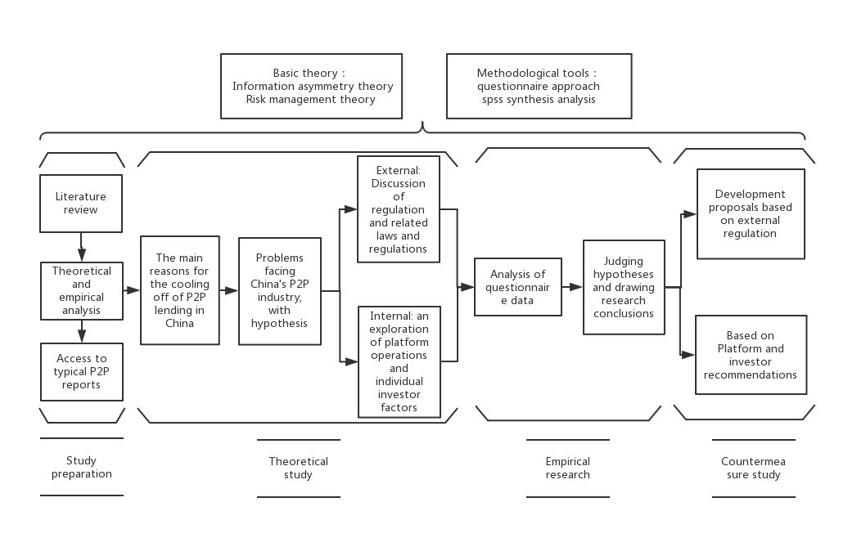

**Figure 3： The structure of research**

## 3.2 Measuring instrument

Use the data analysis function in SPSS to analyze and summarize the data collection in the questionnaire, and summarize it into forms such as tables, pie charts and bar charts. This article uses data related to frequency distribution, frequency percentage and cumulative percentage to explain the data survey and demographic analysis of the employees surveyed. Data analysis functions in Microsoft SPSS (such as descriptive statistical data tools, Pearson correlation analysis and multiple regression analysis) are used to analyze the factors that affect investment dynamics (Inadequate regulations, Credit system，competition from other lending instruments ) and P2P Relationship.

## 3.3 Validity and reliability test and analysis

This research needs to analyse the reliability of the variables in the pre-investigation. If the reliability coefficient Cronbach α of each variable is greater than 0.7, it indicates that the research has high reliability.

|  |  |
| --- | --- |
| **Reliability Statistics** | |
| Cronbach's Alpha | N |
| .993 | 15 |

Cronbach's Alpha 0.993>0.7, this shows that the data collection is validity and reliability.

## 3.4 Sample selection

This study is aimed at Chinese investors and the p2p lending industry in China. In addition, respondents are mainly concentrated in finance-related institutions and office locations in China, and valid questionnaire data matching the background are selected for analysis. Through accurate sampling techniques, the specific questionnaires of 50 office workers with a college degree or above were distributed. In order to select the correct sample size, the allowable confidence level for this study is 95% with a standard deviation of 0.5 and a confidence interval of (-5%, +5%).

## 3.5 Data collection research analysis

### 3.5.1 Specific data collection

This research uses quantitative research methods to obtain research data in the form of questionnaires, because it can simply and directly display the numerical data envisaged by the research, which is convenient for management and analysis. In this study, a questionnaire will be designed to investigate the issue of indifference trend in the P2P industry in China. This study will explore the factors that affect the development of the P2P industry in China. For the reliability of the data, the respondents of this paper are selected from those office workers who have college degree or above.

### 3.5.2 Interpretation of variables

The format of the questionnaire is not only traditional Section A but also uses Section B to facilitate the generation of data on respondents' responses. The number 1 Strongly indicates disagreement, 2 indicates disagreement, 3 indicates neutrality, 4 indicates agreement, and 5 indicates total agreement. By combining and analyzing the questionnaire data of different question numbers, the reasons for the trend of coldness in China's P2P industry, and the results of each hypothesis are derived, and constructive comments are given.

|  |  |
| --- | --- |
| Choices | Score |
| Strongly Agree | 5 |
| Agree | 4 |
| Neutral | 3 |
| Disagree | 2 |
| Strongly Disagree | 1 |

**Table 1: 5-point Likert Scale specific table**

Section A: Background of the Surveyed employee

Part A requires the surveyed employees to fill out their relevant demographic data and personal specific details. The specific issues in this part include gender, age, education level, marital status, monthly income, the number of years worked, and the specific type of work. After obtaining these specific data, use frequency distribution and percentage to carry out specific analysis and data model operation.

Section B: Factors contributing to the P2P investment behaviors

This section involves the measurement of the effect of inadequate regulations, domestic credit system, competition from other lending instruments towards the P2P investment behavior. There are 15 specific questions in this section. Table 1 lists the number of specific questions for each P2P investment behaviors influencing factor.

|  |  |
| --- | --- |
| Factors contributing to the P2P investment behaviors | Number of Questions |
| Inadequate regulations | 5 |
| Domestic credit system | 5 |
| Competition from other lending instruments | 5 |
|  |  |
| Total | 15 |
|  |  |

**Table 2: Number of questions for each relevant and specific factor**

# CHAPTER 4 : ANALYSIS AND DISCUSSION

## 4.1 Interpret survey data accurately with clear frequency distribution

A questionnaire survey was conducted among the people who had transacted on P2P. This study takes 50 P2P users as samples. The following chapters use various charts to analyze and investigate the relevant data.

### 4.1.1 The demographic-related situation of the people who had transacted on p2p

This section mainly introduces the demographic data of the people who had transacted on P2P. The frequency distribution and percentage tables and pie charts clearly show seven related demographic variables, such as gender, age, education level degree, marital status, monthly income amount, the number of years worked, and the work specific type .

**Gender**

Under the item category of gender, there are two clear options for respondents to choose, namely, male option and female option. Among the 50 P2P users surveyed, the proportion of men is higher than that of women. Among them, 56% of the respondents were female and 44% were male. Interviewer. Table 3 clearly shows the gender proportion of people who trade on P2P platforms. Figure 4 provides a very intuitive summary of the percentage of people surveyed by gender who trade on the platform.

|  |  |  |  |  |  |
| --- | --- | --- | --- | --- | --- |
| **Gender** | | | | | |
|  | | Frequency | Percent | Valid Percent | Cumulative Percent |
| Valid | 1.Male | 28 | 56.0 | 56.0 | 56.0 |
| 2.Female | 22 | 44.0 | 44.0 | 100.0 |
| Total | 50 | 100.0 | 100.0 |  |

**Table 3: Frequency distribution of surveyed people who had transacted on P2P about gender**

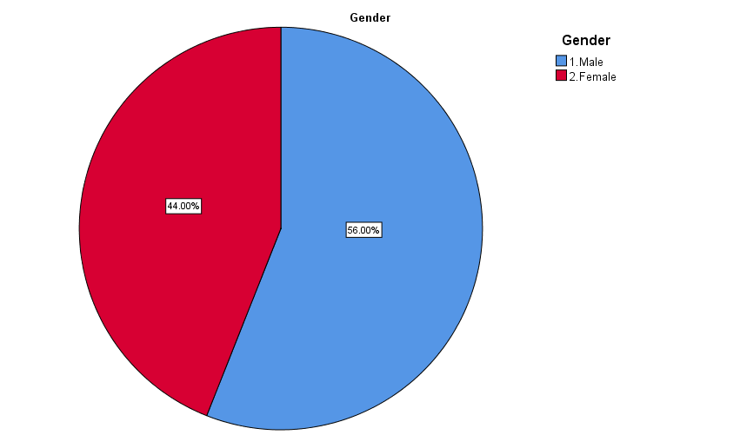

**Figure 4: Pie chart illustrates the percentage of surveyed people who had transacted on P2P based on gender**

**Age**

Under the specific project classification of age, there are three effective and specific options for the participants who trade on P2P platform, including 18-25 years old, 26-30 and 31-40 years old. Among the 50 respondents, 26-30 years old accounted for the highest proportion, accounting for about 58%; followed by 31-40 years old, accounting for 24%, 18-25 years old accounting for 18%, and other age groups accounted for 0%. Table 4 clearly shows the age proportion of people who trade on P2P platforms. Figure 5 provides a very intuitive summary of the percentage of people surveyed by age who trade on the platform.

|  |  |  |  |  |  |
| --- | --- | --- | --- | --- | --- |
| **Age** | | | | | |
|  | | Frequency | Percent | Valid Percent | Cumulative Percent |
| Valid | 1. 18 - 25 years | 9 | 18.0 | 18.0 | 18.0 |
| 2. 26 - 30 years | 29 | 58.0 | 58.0 | 76.0 |
| 3. 31 - 40 years | 12 | 24.0 | 24.0 | 100.0 |
| Total amount | 50 | 100.0 | 100.0 |  |

**Table 4: Frequency distribution of surveyed the people who had transacted on P2P about age**

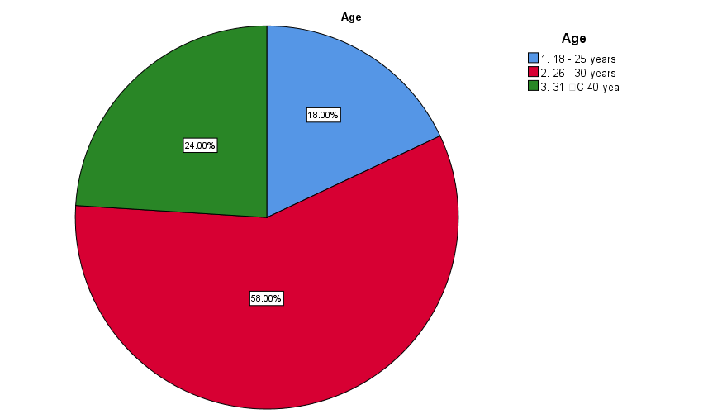

**Figure 5: Pie chart illustrates the percentage of surveyed the people who had transacted on P2P about age**

**Education level**

Under the education program, there are six options for respondents to choose from, namely, illiterate, senior high school, intermediate, bachelor, master, and doctor. Among the 50 respondents, 6% had high school education, 14% had intermediate education, 64% had bachelor's degree, 16% had postgraduate degree, and 0% had illiteracy and doctoral degree. Table 5 clearly shows the education level proportion of people who trade on P2P platforms. Figure 6 provides a very intuitive summary of the percentage of people surveyed by education level who trade on the platform.

|  |  |  |  |  |  |
| --- | --- | --- | --- | --- | --- |
| **Education** | | | | | |
|  | | Frequency | Percent | Valid Percent | Cumulative Percent |
| Valid | 2. High school | 3 | 6.0 | 6.0 | 6.0 |
| 3. Intermediate | 7 | 14.0 | 14.0 | 20.0 |
| 4. Degree | 32 | 64.0 | 64.0 | 84.0 |
| 5. Master’s Degree | 8 | 16.0 | 16.0 | 100.0 |
| Total amount | 50 | 100.0 | 100.0 |  |

**Table 5: Frequency distribution of surveyed the people who had transacted on P2P about education level**

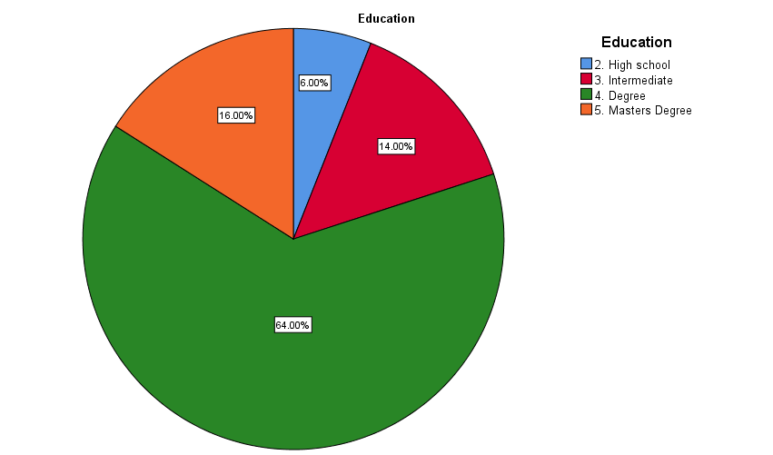

**Figure 6: Pie chart illustrates the percentage of surveyed the people who had transacted on P2P about education level**

**Marital Status**

The following figure is an introduction to marital status. This article divides marital status into four categories: married, unmarried, divorced, and widowed. Widows accounted for 0%, married people accounted for 22%, unmarried people accounted for the highest proportion, accounting for 74%, and divorced people accounted for 4%. Table 6 clearly shows the martial status proportion of people who trade on P2P platforms. Figure 7 provides a very intuitive summary of the percentage of people surveyed by marital status who trade on the platform.

|  |  |  |  |  |  |
| --- | --- | --- | --- | --- | --- |
| **MaritalStatus** | | | | | |
|  | | Frequency | Percent | Valid Percent | Cumulative Percent |
| Valid | 1. Married | 11 | 22.0 | 22.0 | 22.0 |
| 2. Single | 37 | 74.0 | 74.0 | 96.0 |
| 4. Divorced | 2 | 4.0 | 4.0 | 100.0 |
| Total amount | 50 | 100.0 | 100.0 |  |

**Table 6: Frequency distribution of surveyed the people who had transacted on P2P about marital status**

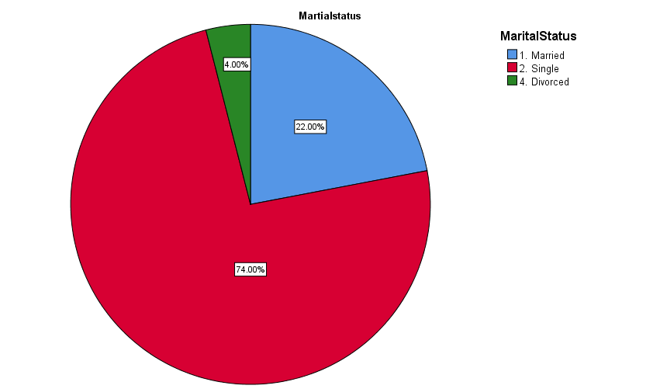

**Figure 7: Pie chart illustrates the percentage of surveyed the people who had transacted on P2P about marital status**

**Monthly income**

There are four options for monthly income (CNY): below 3000-yuan, 3001-7000 yuan, 7001-12000 yuan and above 12001 yuan. Among the 50 respondents who use P2P platform, 46% of them have a monthly income of 3001-7000 yuan; 4% of them have a monthly income of less than 3000 yuan; 34% of them have a monthly income of 7001-12000 yuan; and 16% of them have a monthly income of more than 12001 yuan. Table 7 clearly shows the monthly income proportion of people who trade on P2P platforms. Figure 8 shows a noticeably clear summary of the percentage of people surveyed by monthly income who trade on the platform.

|  |  |  |  |  |  |
| --- | --- | --- | --- | --- | --- |
| **Monthly Income** | | | | | |
|  | | Frequency | Percent | Valid Percent | Cumulative Percent |
| Valid | 1. below CNY3000 | 2 | 4.0 | 4.0 | 4.0 |
| 2. CNY 3001 - CNY7000 | 23 | 46.0 | 46.0 | 50.0 |
| 3. CNY 7001- CNY12000 | 17 | 34.0 | 34.0 | 84.0 |
| 4. more than CNY12001 | 8 | 16.0 | 16.0 | 100.0 |
| Total amount | 50 | 100.0 | 100.0 |  |

**Table 7: Frequency distribution of surveyed the people who had transacted on P2P about monthly income (CNY)**

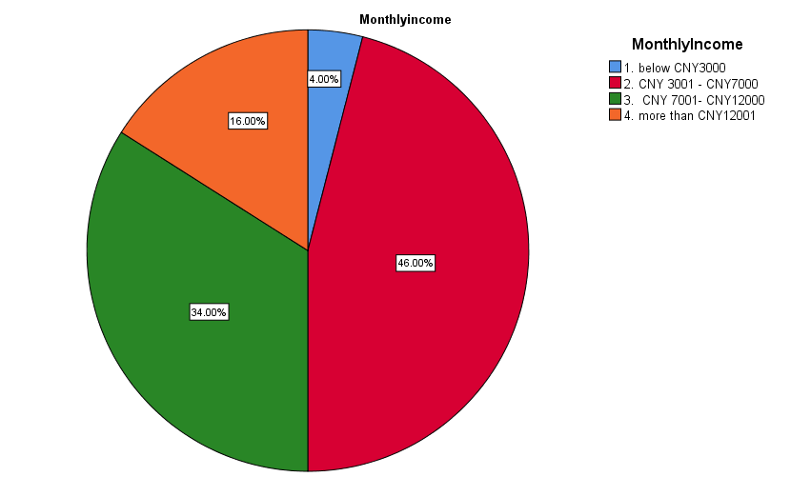

**Figure 8: Pie chart illustrates the percentage of surveyed the people who had transacted on P2P about monthly income (CNY)**

**Background**

The subjects of the questionnaire are divided into three categories: financial context, P2P platform transaction, can not understand P2P finance knowledge. For this paper, all the questionnaires collected are valid. The 50 questionnaires in this paper are all users who have done transactions on P2P platform. Table 8 clearly shows the background proportion of people who trade on P2P platforms. Figure 9 shows a very intuitive summary of the relevant percentage of people surveyed by background who trade on the platform.

|  |  |  |  |  |  |
| --- | --- | --- | --- | --- | --- |
| **Background** | | | | | |
|  | | Frequency | Percent | Valid Percent | Cumulative Percent |
| Valid | 2.Transacted on a P2P platform | 50 | 100.0 | 100.0 | 100.0 |

**Table 8: Frequency distribution of surveyed the people who had transacted on P2P about background**

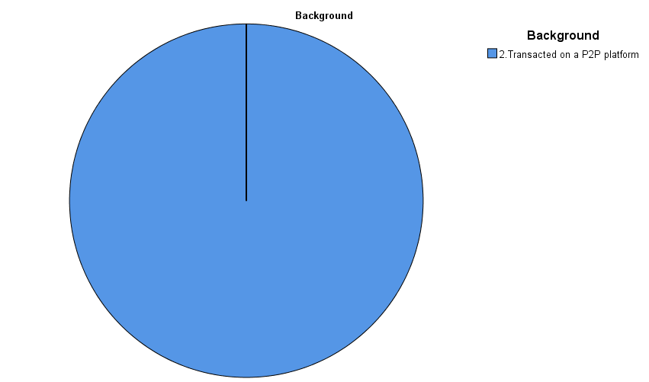

**Figure 9: Pie chart illustrates the percentage of surveyed the people who had transacted on P2P about background**

**Job Category**

There are eight options available under this job category ，including State-owned enterprises employees, civil service level，free investor，financial professionals，private enterprises employees，a self-employed individual，students, and other people. Among the 50 respondents, 16% of respondents are employees of State-owned enterprises, 10.00% are civil service, 10.00% and 12.00% respectively are free investor，financial professionals’ people. 22% is private enterprises employees，14% is self-employed individual，4.00% is students，Table 9 specifically lists the frequency distribution of the surveyed respondents about job categories. Figure 10 Pie chart illustrates the percentage of surveyed the people who had transacted on P2P about job category

|  |  |  |  |  |  |
| --- | --- | --- | --- | --- | --- |
| **JobCategory** | | | | | |
|  | | Frequency | Percent | Valid Percent | Cumulative Percent |
| Valid | 1.Employees of State-owned enterprises | 8 | 16.0 | 16.0 | 16.0 |
| 2.Civil service | 5 | 10.0 | 10.0 | 26.0 |
| 3.Free investor | 5 | 10.0 | 10.0 | 36.0 |
| 4.Financial professionals | 6 | 12.0 | 12.0 | 48.0 |
| 5.Employees of private enterprises | 11 | 22.0 | 22.0 | 70.0 |
| 6.A self-employed individual | 7 | 14.0 | 14.0 | 84.0 |
| 7.Students | 2 | 4.0 | 4.0 | 88.0 |
| 8.Other | 6 | 12.0 | 12.0 | 100.0 |
| Total total | 50 | 100.0 | 100.0 |  |

**Table 9: Frequency distribution of surveyed the people who had transacted on P2P about job category**

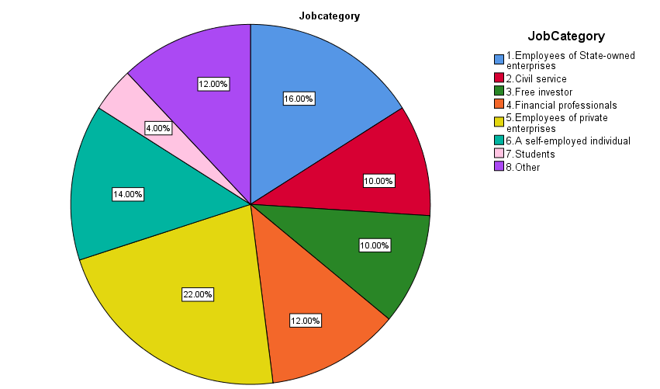

**Figure 10: Pie chart illustrates the percentage of surveyed the people who had transacted on P2P about job category**

### 4.1.2 Surveyed the people who had transacted on p2p on factors related to the development trend of p2p lending industry

In this part, through the detailed investigation of the respondents, this part deeply discusses the influencing factors of the development trend of P2P lending industry. The correlation between P2P investment behavior and related influencing factors was analyzed by SPSS. In order to understand the investment behavior of the investigated P2P platform users, it is necessary to discuss and evaluate 15 related research questions and classify the specific research questions from very disagree to strongly agree, so as to reflect the three main factors related to the investment behavior of P2P users. These factors include inadequate regulations, credit system and competition. The questionnaire data and statistics are expressed in percentage and frequency distribution.

**Factor 1: Status of development of P2P**

Five relevant statements have been drawn up in the questionnaire, to obtain relevant opinions of the surveyed respondents on the P2P investment behavior. Table 10 clearly lists the related frequency distribution of the P2P investment behavior.

|  |  |  |  |  |  |  |
| --- | --- | --- | --- | --- | --- | --- |
| **Statements related to the status of development of P2P** | **Frequency** | **Response** | | | | |
| **Strongly disagree** | **Disagree** | **Neutral** | **Agree** | **Strongly Agree** |
| The profitability of P2P is not stable | Number of  respondents | 0 | 1 | 12 | 32 | 5 |
| Percentage (%) | 0.00 | 2.00 | 24.00 | 64.00 | 10.00 |
| Cumulative  Percentage | 0.00 | 2.00 | 26.00 | 90.00 | 100.00 |
| Low company reputation | Number of  response | 0 | 2 | 10 | 31 | 7 |
| Percentage (%) | 0.00 | 4.00 | 20.00 | 62.00 | 14.00 |
| Cumulative Percentage | 0.00 | 4.00 | 24.00 | 86.00 | 100.00 |
| Low user loyalty | Number of respondents | 0 | 1 | 12 | 33 | 4 |
| Percentage (%) | 0.00 | 2.00 | 24.00 | 66.00 | 8.00 |
| Cumulative Percentage | 0.00 | 2.00 | 26.00 | 86.70 | 100.00 |
| The follow-up service was not very good | Number of respondents | 0 | 1 | 12 | 29 | 8 |
| Percentage (%) | 0.00 | 2.00 | 24.00 | 58.00 | 16.00 |
| Cumulative Percentage | 0.00 | 2.00 | 26.00 | 84.00 | 100.00 |
| Low development capacity | Number of respondents | 0 | 3 | 10 | 33 | 4 |
| Percentage (%) | 0.00 | 6.00 | 20.00 | 66.00 | 8.00 |
| Cumulative Percentage | 0.00 | 6.00 | 26.00 | 92.00 | 100.00 |

**Table 10: Frequency distribution of the surveyed the people who had transacted on P2P response regarding the P2P investment behavior**

Statement 1: The profitability of P2P is not stable

64.00% and 0% of the surveyed respondents agreed and strongly disagreed to consider the company's profitability. However, 2.00% disagree and 10.00% strongly agree while 24.00% of them are neutral.

Statement 2: Low company reputation

62% and 0% of respondents agree and strongly disagree they focus on low company reputation. However, 4.00% and 14.00% of respondents have disagree and strongly agree attitude while 20.00% of them are neutral attitude about low company reputation.

Statement 3: Low user loyalty

66.00% and 0% of respondents agree and strongly disagree about low user loyalty. However, 2.00% and 8.00% of the surveyed respondents respectively expressed disagreement and strong agreement, while 24.00% of the surveyed respondents held a neutral attitude towards low user loyalty.

Statement 4: The follow-up service was not very good

58.00% and 0% of respondents agree and strongly disagree about the follow-up service was not particularly good. However, 2.00% and 24.00% of respondents disagree and strongly agree attitude while 16.00% of them are neutral attitude about the follow-up service was not very good.

Statement 5: Low development capacity

66.00% and 0% of respondents agree and strongly disagree about low development capacity. However, 6.00% and 8.00% of respondents disagree and strongly agree attitude while 20.00% of them are neutral attitude regarding the low development capacity.

Summary and findings about factor 1: P2P investment behavior

Among the 50 respondents, majority of them are often think about the company in profitability of P2P is not stable and low company reputation in the P2P investment behavior. Besides, low user loyalty also plays a key and important role in the decline of P2P investment behavior. However, the follow-up service was not particularly good and low development capacity in P2P investment behavior.

**Factor 2: Inadequate regulations**

Five relevant statements have been clearly formulated in the questionnaire to solicit the surveyed respondents' suggestions on related inadequate regulations of P2P investment behavior. Table 11 specifically lists the specific frequency distribution of the inadequate regulations by the surveyed respondents in the P2P investment behavior.

|  |  |  |  |  |  |  |
| --- | --- | --- | --- | --- | --- | --- |
| **Statements related to inadequate regulations** | **Frequency** | **Response** | | | | |
| **Strongly disagree** | **Disagree** | **Neutral** | **Agree** | **Strongly Agree** |
| In recent years, supervision has been strengthened, and the filing requirements are also standardized, it is inevitable that the number of P2P lending platforms will shrink significantly | Number of respondents | 0 | 0 | 8 | 32 | 10 |
| Percentage (%) | 0.00 | 0.00 | 16.00 | 64.00 | 20.00 |
| Cumulative Percentage | 0.00 | 0.00 | 16.00 | 80.00 | 100.00 |
| Frequent laws and regulations have stabilized the lender's favor to some extent, but have limited the platform's scale and momentum | Number of responses | 0 | 0 | 8 | 34 | 8 |
| Percentage (%) | 0.00 | 0.00 | 16.00 | 68.00 | 16.00 |
| Cumulative Percentage | 0.00 | 0.00 | 16.00 | 84.00 | 100.00 |
| China's regulatory policies aim to stabilize society, with P2P industry in second place | Number of respondents | 0 | 0 | 6 | 32 | 12 |
| Percentage (%) | 0.00 | 0.00 | 12.00 | 64.00 | 24.00 |
| Cumulative Percentage | 0.00 | 0.00 | 12.00 | 76.00 | 100.00 |
| Compared with other countries, P2P laws and regulations are not perfect enough, there is still a considerable number of problematic platforms | Number of Surveyed employees | 0 | 1 | 12 | 28 | 9 |
| Percentage (%) | 0 | 2.00 | 24.00 | 56.00 | 18.00 |
| Cumulative Percentage | 0 | 2.00 | 26.00 | 82.00 | 100.00 |
| China's P2P regulation is in limbo for retrieval and handling of investment funds after investment problems | Number of respondents | 0 | 1 | 7 | 32 | 10 |
| Percentage (%) | 0.00 | 2.00 | 14.00 | 64.00 | 20.00 |
| Cumulative Percentage | 0.00 | 2.00 | 16.00 | 80.00 | 100.00 |

**Table 11: Frequency distribution of the surveyed the people who had transacted on P2P response regarding the inadequate regulations**

Statement 6: In recent years, supervision has been strengthened, and the filing requirements are also standardized, it is inevitable that the number of P2P lending platforms will shrink significantly

64.00% and 0% of the respondents respectively have agree and strongly disagree attitude that supervision has been strengthened, and the filing requirements are also standardized, it is the general trend that the number of users of P2P lending platform is shrinking. However, 0.00% disagree and 20.00% strongly agree while 16.00% of them are neutral regarding supervision has been strengthened, and the filing requirements are also standardized, it is the general trend that the number of users of P2P lending platform is shrinking.

Statement 7: Laws and regulations have been introduced frequently, and the lenders are confident in the stability of the platform, but the promulgation of laws and regulations has a great impact on the development of the platform.

16.00% and 0% of the surveyed respondents agreed and strongly disagreed. The work plan or process formulated by P2P investment behavior. However, 0.00% and 68.00% of respondents disagree and strongly agree attitude while 16.00% of them are neutral about laws and regulations have been introduced frequently, and the lenders are confident in the stability of the platform, but the promulgation of laws and regulations has a great impact on the development of the platform.

Statement 8: The purpose of China's regulatory policies is to maintain social stability and prosperity, and the operation of P2P industry must be carried out based on compliance with various regulatory policies.

64.00 and 0% of the surveyed respondents agreed and strongly disagreed that the purpose of China's regulatory policies is to maintain social stability and prosperity, and the operation of P2P industry must be carried out based on compliance with various regulatory policies. However, 0.00% and 24.00% of the surveyed respondents expressed disagreement and strongly agreed opinion status, respectively, while 12.00% of the surveyed respondents expressed a neutral opinion that the purpose of China's regulatory policies is to maintain social stability and prosperity, and the operation of P2P industry must be carried out based on compliance with various regulatory policies.

Statement 9: The degree of perfection and construction of P2P laws and regulations in China is not perfect enough, and there are still many loopholes and problems in the platform.

56.00% and 0% of the surveyed respondents agreed and strongly disagreed that the degree of perfection and construction of P2P laws and regulations in China is not perfect enough, and there are still many loopholes and problems in the platform. However, 2.00% and 18.00% of the surveyed respondents expressed disagreement and strong agreement respectively, while 24.00% of the surveyed respondents the degree of perfection and construction of P2P laws and regulations in China is not perfect enough, and there are still many loopholes and problems in the platform.

Statement 10: Due to the poor supervision of P2P in China, there are many problems in the process of investment, so it is not particularly good to face the future development trend and prospect

64.00% and 0% of the surveyed respondents expressed their agreement and strong disagreement respectively that due to the poor supervision of P2P in China, there are many problems in the process of investment, so it is not very good to face the future development trend and prospect . However, 2.00% and 20.00% of respondents disagree and strongly agree while 14.00% of them are neutral regarding due to the poor supervision of P2P in China, there are many problems in the process of investment, so it is not very good to face the future development trend and prospect.

Summary and findings about factor 2: Inadequate regulations

Among the 50 respondents surveyed, supervision has been strengthened, and the filing requirements are also standardized, it is the general trend that the number of users of P2P lending platform is shrinking, it has a negative impact on P2P investment behavior. In addition, laws and regulations have been introduced frequently, and the lenders are confident in the stability of the platform, but the promulgation of laws and regulations has a great impact on the development of the platform, the purpose of China's regulatory policies is to maintain social stability and prosperity, and the operation of P2P industry must be carried out on the basis of compliance with various regulatory policies, the degree of perfection and construction of P2P laws and regulations in China is not perfect enough, and there are still many loopholes and problems in the platform, due to the poor supervision of P2P in China, there are many problems in the process of investment, so it is not very good to face the future development trend and prospect,these factors lead to inadequate regulations.

**Factor 3: Credit system**

Five specific statements have been drawn up in the questionnaire to solicit respondents' specific opinions on related credit system of P2P investment behavior. Table 12 clearly lists the respondent's response to credit system in terms of frequency distribution.

|  |  |  |  |  |  |  |
| --- | --- | --- | --- | --- | --- | --- |
| **Statements related to credit system** | **Frequency** | **Response** | | | | |
| **Strongly disagree** | **Disagree** | **Neutral** | **Agree** | **Strongly Agree** |
| Unsound regulatory regime does not protect investors well | Number of respondents | 0 | 0 | 8 | 32 | 10 |
| Percentage (%) | 0.00 | 0.00 | 16.00 | 64.00 | 20.00 |
| Cumulative Percentage (%) | 0.00 | 0.00 | 16.00 | 80.00 | 100.00 |
| Reports and information show a variety of negative P2P lending events, reducing investor investment enthusiasm | Number of responsedents | 0 | 0 | 8 | 34 | 8 |
| Percentage (%) | 0.00 | 0.00 | 16.00 | 68.00 | 16.00 |
| Cumulative Percentage (%) | 0.00 | 0.00 | 16.00 | 84.00 | 100.00 |
| Investors cannot identify investment risks from borrower information provided by the platform | Number of Surveyed employee | 0 | 0 | 6 | 32 | 12 |
| Percentage (%) | 0.00 | 0.00 | 12.00 | 64.00 | 24.00 |
| Cumulative Percentage (%) | 0.00 | 0.00 | 12.00 | 76.00 | 100.00 |
| Lower yields are acceptable when returns can be guaranteed | Number of Surveyed employee | 0 | 1 | 12 | 28 | 9 |
| Percentage (%) | 0.00 | 2.00 | 24.00 | 56.00 | 18.00 |
| Cumulative Percentage | 0.00 | 2.00 | 26.00 | 82.00 | 100.00 |
| Inadequate disclosure of the borrower's historical loan information | Number of surveyed employee | 0 | 1 | 7 | 32 | 10 |
| Percentage (%) | 0.00 | 2.00 | 14.00 | 64.00 | 20.00 |
| Cumulative Percentage | 0.00 | 2.00 | 16.00 | 80.00 | 100.00 |

**Table 12: Frequency distribution of the surveyed the people who had transacted on P2P response regarding the credit system**

Statement 11: Unsound regulatory regime does not protect investors well

64.00% and 0% of the respondents respectively agree and strongly disagree that unsound regulatory regime does not protect investors well. Meanwhile, 0.00% and 20.00% of the respondents disagree and strongly agree whereas 16.00% of them are neutral that without a fairly sound regulatory system, investors cannot be well protected.

Statement 12: According to the relevant information and documents, the negative events of

P2P lending events lead to the decrease of investors' enthusiasm for this platform.

68.00% of the surveyed respondents agreed with their opinions and expressed that according to the relevant information and documents, the negative events of P2P lending events lead to the decrease of investors' enthusiasm for this platform. Meanwhile, only 0.00% and of the respondents disagree and whereas 16.00% of them are neutral that according to the relevant information and documents, the negative events of P2P lending events lead to the decrease of investors' enthusiasm for this platform.

Statement 13:The information of borrowers is fuzzy, and investors can't really identify the investment risk

64.00% and 24.00% of the respondents respectively agree and strongly agree that the information of borrowers is fuzzy, and investors can't really identify the investment risk. At the same time, respondents who were not surveyed expressed strong objections, and 12.00% of the people of P2P surveyed held neutral attitudes and opinions.

Statement 14: Lower yields are acceptable when returns can be guaranteed

56.00% and 18.00% of the surveyed respondents have agreed and strongly agreed attitude that lower yields are acceptable when returns can be guaranteed. However, 2.00% and 0% of the surveyed respondents respectively expressed disagreement and very disagreement, and 24.00% of the surveyed respondents hold neutral opinions and attitude----Lower yields are based on reliable returns.

Statement 15: The loan information of relevant borrowers is not fully disclosed

64.00% and 20.00% of respondents agree and strongly agree that the loan information of relevant borrowers is not fully disclosed. However, 2.00% and 0.00% of the surveyed respondents expressed opposing and strongly opposed opinions and attitudes respectively, while 14.00% of the surveyed employees expressed a neutral attitude that the loan information of relevant borrowers is not fully disclosed

Summary and findings about factor 3: Credit system

Majority of the respondents claim that unsound regulatory regime does not protect investors well. In addition, according to the relevant information and documents, the negative events of P2P lending events lead to the decrease of investors' enthusiasm for this platform, the information of borrowers is fuzzy, and investors can't really identify the investment risk, lower yields are acceptable when returns can be guarantee,the loan information of relevant borrowers is not fully disclosed.

**Factor 4: Competition**

Five related research questions have been formulated in the questionnaire to ask the surveyed people related credit system of P2P investment behavior. Table 13 clearly and specifically lists the P2P user responses to the credit system.

|  |  |  |  |  |  |  |
| --- | --- | --- | --- | --- | --- | --- |
| **Statements related to technology and training factor** | **Frequency** | **Response** | | | | |
| **Strongly disagree** | **Disagree** | **Neutral** | **Agree** | **Strongly Agree** |
| There are other better ways to invest such as the stock market, funds, etc. | Number of respondents | 0 | 0 | 16 | 28 | 6 |
| Percentage | 0.00 | 0.00 | 32.00 | 56.00 | 12.00 |
| Cumulative Percentage (%) | 0.00 | 0.00 | 32.00 | 88.00 | 100.00 |
| The interest rate of other investment means is high | Number of response | 0 | 9 | 13 | 22 | 6 |
| Percentage (%) | 0.00 | 18.00 | 26.00 | 44.00 | 12.00 |
| Cumulative Percentage | 0.00 | 18.00 | 44.00 | 88.00 | 100.00 |
| The information of other investment means is more transparent and symmetrical | Number of respondents | 0 | 3 | 21 | 22 | 4 |
| Percentage (%) | 0.00 | 6.00 | 42.00 | 44.00 | 8.00 |
| Cumulative Percentage | 0.00 | 6.00 | 48.00 | 92.00 | 100.00 |
| Other means of investment borrower disclosure issues | Number of respondents | 0 | 5 | 24 | 20 | 1 |
| Percentage (%) | 0 | 10.00 | 48.00 | 40.00 | 2.00 |
| Cumulative Percentage | 0 | 10.00 | 58.00 | 98.00 | 100.00 |
| Other means of investment borrower's basic personal information is very helpful in identifying investment risk | Number of respondents | 0 | 12 | 23 | 14 | 1 |
| Percentage (%) | 0.00 | 24.00 | 46.00 | 28.00 | 2.00 |
| Cumulative Percentage | 0.00 | 24.00 | 70.00 | 98.00 | 100.00 |

**Table 13:Frequency distribution of the surveyed the people who had transacted on P2P response regarding the competition**

Statement 16: The existence of other investment methods will also affect the prospects and development of P2P, such as funds, stock market and so on

56.00% and 0.00% of respondents respectively agree and strongly disagree that the existence of other investment methods will also affect the prospects and development of P2P, such as funds, stock market and so on. However, 0.00% and 12.00% of respondents respectively disagree and strongly agree while there is 32.00% respondent are neutral.

Statement 17: The interest rate of other investment means is high

44.00% and 0% of respondents agree and strongly disagree the interest rate of other investment means is high. However, 18.00% and 12.00% of respondents disagree and strongly agree attitude while 26.00% of them are neutral attitude about the interest rate of other investment means is high.

Statement 18: The information of other investment means is more transparent and symmetrical

44.00% and 0% of the employees surveyed agreed and strongly disagreed the information of other investment means is more transparent and symmetrical. However, 6.00% and 8.00% of the employees surveyed expressed disagreement and strong agreement with opinions and attitudes, and 42.00% of the company employees held neutral opinions and attitudes in this regard.

Statement 19: Other means of investment borrower disclosure issues

40.00% and 0% of respondents agree and strongly disagree that other means of investment borrower disclosure issues. Nevertheless, 10.00% and 2.00% of respondents disagree and strongly agree while 48.00% of them are neutral about new technologies and processes are constantly being improved.

Statement 20: Other means of investment basic information about the borrower helps to identify the relevant investment risks

28.00% and 0% of the employees surveyed agreed and strongly disagreed about other means of investment basic information about the borrower helps to identify the relevant investment risks. However, 24.00% and 2.00% of the employees surveyed expressed disagreement and strongly agreed attitudes and opinions, while 46.00% of the employees surveyed held a neutral attitude and opinion on this issue.

Summary and findings about factor 4: Competition

Many surveyed people who had transacted on P2P who conducted the questionnaire survey had relatively positive responses and feedback to the P2P investment behavior. According to the majority of P2P users, the existence of other investment methods will also affect the prospects and development of P2P, such as funds, stock market and so on, and the interest rate of other investment means is high. In addition, a considerable number of P2P users surveyed showed that The information of other investment means is more transparent and symmetrical, other means of investment borrower disclosure issues and Other means of investment Basic information about the borrower helps to identify the relevant investment risks.

## 4.2 The relationship between p2p investment behavior and related factors is explained by descriptive analysis

This section deals with the relationship between P2P investment behavior and various factors. In the quantitative analysis tool SPSS, the average, median, standard deviation, kurtosis value, skewness value and other related values are accurately calculated. Table 14 clearly shows the analysis of related factors affecting P2P investment behavior. The bar chart in Figure 7 clearly shows the average status of related factors. These data are analyzed and researched and developed through the 5-point Likert scale.

**Figure11: Mean rating**

According to Figure 11, it is specifically indicated that the average score on the regulation and regulation are the highest (average = 4.016); followed by competition (mean=3.452) .

|  |  |  |  |  |  |
| --- | --- | --- | --- | --- | --- |
|  | Mean | SD | Kurtosis | Skewness |  |
| *Regulation* | 4.016 | 0.6262 | -0.1474 | 0.2034 |  |
| *Credit system* | 4.016 | 0.6262 | -0.1474 | 0.2034 |  |
| *Competition* | 3.452 | 0.754 | -0.0134 | -0.512 |  |

**Table 14: Descriptive analysis**

According to the specific descriptive analysis results in Table 14, the average grade and median score of competition are the lowest (average = 3.452), while the average score and median score of the regulations and credit system are relatively high (average = 4.016). The kurtosis and skewness values of regulations calculated are -0.1474 and 0.2034; Credit system is -0.1474 and 0.2034 respectively and for competition is-0.0134 and -0.512 respectively. The three distribution shapes of P2P investment behavior,regulations, credit system and competition are clearly normal distribution. The kurtosis values are accurately between 3 and -3, and the skewness values are clearly between 1 and -1.

## 4.3 Inferential analysis

To provide the general conclusion of the study, inferential analysis is used. And the relationship between the independent variable and the dependent variable is often clarified by inferential analysis.

In this study, using Pearson Correlation Coefficient and Multiple Regression Analysis, there will be 4 theories that will be evaluated. The findings of model description, ANOVA and coefficient will be seen in both studies.

The correlation coefficient used by Pearson shows the course, intensity and importance of the bivariate relationship between all variables calculated at an interval or ratio level (Hair et al., 2007). The formula indicates, as seen in Table 15 below the related rules of thumb with respect to the range of coefficients and the strength of association.

|  |  |
| --- | --- |
| Coefficient specific range | Strength |
| ±0.91 to ±1.00 | Very strong |
| ±0.71 to ±0.90 | High |
| ±0.41 to ±0.70 | Moderate |
| ±0.21 to ±0.40 | Small but definite relationship |
| ±0.01 to ±0.20 | Slight, almost negligible |

**Table 15: Coefficient size**

**(Source: Hair et.al, 2007)**

### 4.3.1 Pearson Correlation Test Analysis

#### 4.3.1.1 Hypothesis 1

|  |  |  |  |
| --- | --- | --- | --- |
| **Correlations** | | | |
|  | | Statusofdevelopmentof | Regulations |
| Statusofdevelopmentof | Pearson Correlation | 1 | .637** |
| Sig. (2-tailed) |  | .000 |
| N | 50 | 50 |
| Regulations | Pearson Correlation | .637** | 1 |
| Sig. (2-tailed) | .000 |  |
| N | 50 | 50 |
| **. Correlation is significant at the 0.01 level (2-tailed). | | | |

**Table 16 Correlation between P2P investment behavior and regulations**

H0: There is no significant relationship between P2P investment behavior and regulations

H1: There is significant relationship between P2P investment behavior and regulations

Based on the Pearson correlation test in table 14 the correlation value is 0.637 which is positive relationship between P2P investment behavior and regulations. Thus, when regulations is inadequate, P2P investment behavior is declined. This also proves that both of the variables have the high relationship of each other. The correlation value data obtained through the analysis and research tool is 0.637, which belongs to the category of ±0.41 to ±0.70. Thus, there is moderate relationship between P2P investment behavior and regulations. The correlation value P value accurately calculated by the analysis tool = 0.000, which is no doubt less than 0.05. So it is concluded that H0 is rejected and H1 is accepted.

#### 4.3.1.2 Hypothesis 2

|  |  |  |  |
| --- | --- | --- | --- |
| **Correlations** | | | |
|  | | Statusofdevelopmentof | Creditsystem |
| Statusofdevelopmentof | Pearson Correlation | 1 | .637** |
| Sig. (2-tailed) |  | .000 |
| N | 50 | 50 |
| Creditsystem | Pearson Correlation | .637** | 1 |
| Sig. (2-tailed) | .000 |  |
| N | 50 | 50 |
| **. Correlation is significant at the 0.01 level (2-tailed). | | | |

**Table 17 ：Correlation between P2P investment behavior and credit system**

H0: There is no significant relationship between P2P investment behavior and credit system

H1: There is significant relationship between P2P investment behavior and credit system

Based on the Pearson correlation test in table 15 the correlation value is 0.637 which is positive relationship between P2P investment behavior and credit system. Thus, when credit system is good, P2P investment behavior is good. This also proves that both of the variables have the moderate relationship of each other. The correlation value is 0.637 which is falls in the range ±0.41 to ±0.70. Thus, there is very strong relationship between P2P investment behavior and credit system. The correlation value P value accurately calculated by the analysis tool = 0.000, which is no doubt less than 0.05. So it is concluded that H0 is rejected and H1 is accepted.

#### 4.3.1.3 Hypothesis 3

|  |  |  |  |
| --- | --- | --- | --- |
| **Correlations** | | | |
|  | | Statusofdevelopmentof | Competition |
| Statusofdevelopmentof | Pearson Correlation | 1 | .330* |
| Sig. (2-tailed) |  | .019 |
| N | 50 | 50 |
| Competition | Pearson Correlation | .330* | 1 |
| Sig. (2-tailed) | .019 |  |
| N | 50 | 50 |
| *. Correlation is significant at the 0.05 level (2-tailed). | | | |

**Table 18： Correlation between P2P investment behavior and competition**

H0: There is no significant relationship between P2P investment behavior and competition

H1: There is significant relationship between P2P investment behavior and competition

According to the specific Pearson correlation test in Table 16, the correlation value is 0.330, which indicates that there is a positive correlation between P2P investment behavior and competition. Thus, when competition is good, the P2P investment behavior is bad. This also proves that both of the variables have the very small but definite relationship of each other. The correlation value is 0.997 which is falls in the range ±0.21 to ±0.40. Thus, there is small but definite relationship between P2P investment behavior and competition. The correlation value P value accurately calculated by the analysis tool = 0.019, which is no doubt less than 0.05. So it is concluded that H0 is rejected and H1 is accepted.

### 4.3.2 Multiple Regression Analysis

The multiple regression analysis model is clearly used to measure the relationship between influencing factors and P2P investment behavior. The specific analysis is shown below.

#### 4.3.2.1 Model summary

|  |  |  |  |  |  |  |  |  |  |  |
| --- | --- | --- | --- | --- | --- | --- | --- | --- | --- | --- |
| **Model Summaryb** | | | | | | | | | | |
| Model | R | R Square | Adjusted R Square | Std. Error of the Estimate | Change Statistics | | | | | Durbin-Watson |
| R Square Change | F Change | df1 | df2 | Sig. F Change |
| 1 | .640a | .410 | .385 | .40158 | .410 | 16.345 | 2 | 47 | .000 | 1.658 |
| a. Predictors: (Constant), Competition, Creditsystem | | | | | | | | | | |
| b. Dependent Variable: Statusofdevelopmentof | | | | | | | | | | |

**Table 19： Model Summary Analysis**

According to the specific display in Table 17, R-squared value = 0.640, which is 64.00%. This meant that 64 percent of the dependent variable of performance can be explained by the three independent variables (Regulation，credit system，competition). On the other hand, it is stated that the above conclusions are drawn from the chart, and 0.36% of the related dependent variables are determined and explained by other potential related factors that are not considered in the research and discussion of this article.

#### 4.3.3.2 ANOVA

|  |  |  |  |  |  |  |
| --- | --- | --- | --- | --- | --- | --- |
| **ANOVAa** | | | | | | |
| Model | | Sum of Squares | df | Mean Square | F | Sig. |
| 1 | Regression | 5.272 | 2 | 2.636 | 16.345 | .000b |
| Residual | 7.579 | 47 | .161 |  |  |
| Total | 12.851 | 49 |  |  |  |
| a. Dependent Variable: Statusofdevelopmentof | | | | | | |
| b. Predictors: (Constant), Competition, Creditsystem | | | | | | |

**Table 20 ANOVA Analysis**

According to Table 18, the data P value = 0.000, which is undoubtedly less than 0.05, and the precise value of the F statistic is 16.345. As a result, the model for this study is adequate descriptor of the relation between the predictor variables and dependent variable. Thus, the independent variable is significant in explained the variance of the performance.

#### 4.3.2.3 Multiple Regression Analysis

|  |  |  |  |  |  |  |  |  |  |  |
| --- | --- | --- | --- | --- | --- | --- | --- | --- | --- | --- |
|  | | | | | | | | | | |
| Model | |  | |  | T | Sig. |  | |  | |
| B | Std. Error | Beta | Lower Bound | Upper Bound | Tolerance | VIF |
| 1 | (Constant) | -.005 | .679 |  | -.008 | .994 | -1.372 | 1.361 |  |  |
| Regulation | .879 | .179 | .604 | 4.898 | .000 | .518 | 1.240 | .825 | 1.212 |
| Creditsystem | .879 | .179 | .604 | 4.898 | .000 | .518 | 1.240 | .825 | 1.212 |
| Competition | .087 | .137 | .078 | .632 | .530 | -.189 | .363 | .825 | 1.212 |

**Table 21 Multiple Regression Coefficient**

According to Table 19, we can clearly show the following specific regression equation:

Performance= -0.005 + 0.879(Regulation) +0.879(Credit system) – 0.087(Competition)

Based on the P-value in the table, regulation and credit system are significantly influence P2P investment behavior whereas competition is not showing it significance.

# CHAPTER 5：CONCLUSION

The case studies in this paper are devoted to investigating these factors influencing P2P investment behavior. Through these detailed related questionnaire surveys, we can specifically quantify and analyze the existing 50 randomly selected P2P users. There are 3 independent variable being used in this research such as regulation, credit system, competition. According to the references previously referred to and mentioned, there is a certain degree of positive or negative correlation between the P2P investment behavior and the related factors that affect the development of P2P lending industry. From the result, among these factors, using references to identify the most relevant influencing factors that influence P2P which are regulation and credit system. While for competition is not a concern for the development of P2P lending industry.

Overall, this study concludes that the main factors that links to P2P investment behavior are regulation and credit system. Hence, recommending P2P platform to improve regulation supervision and credit system. According to relevant recommendations, the regulation of P2P platform should carry out serious supervision according to the specific conditions of the development of P2P, continuously improve the workload and ability of the P2P lending industry. In addition ,competition should be appropriately rewarded.

## 5.1 Recommendations

P2P investment behavior may have a great impact and impact on the business level of society. According to this quantitative analysis and research, the relevant regulation,credit system,competition are interrelated and have produced a domino chain effect, which has a positive impact on the P2P investment behavior , Which is consistent with the previous literature. However, factor like competition found not significantly affect the P2P investment behavior. The findings in this study have discrepancy to the literature review on this factor.

In this related research survey, this paper only investigated the factors that may affect the P2P investment behavior. This article can further explore this specific research by investigating other variables that may be influential. In addition, the relevant scientific researchers in the future can conduct close interviews with the surveyed respondents. Through open questionnaires, it may be possible to obtain more explanations and accurate data to make the data more reliable and based. In future studies on similar topics, researchers can refer to this article to make the necessary trade-offs for the factor of competition.

## 5.2 Future outlook

There are many different ideas about the future development of P2P, and the most important future development direction also depends on the government's policy. It is believed that there will be a lot of opportunities and prospects for the development of the whole P2P platform. Users will benefit more from this platform, which is conducive to the long-term development of the platform and social economy.

# BIBLIOGRAPHY

Aberer, K., Cudré-Mauroux, P., Datta, A., Despotovic, Z., Hauswirth, M., Punceva, M., & Schmidt, R. (2003). P-Grid: a self-organizing structured P2P system. ACM SiGMOD Record, 32(3), 29-33.

Aggarwal, V., Feldmann, A., & Scheideler, C. (2007). Can ISPs and P2P users cooperate for improved performance?. ACM SIGCOMM Computer Communication Review, 37(3), 29-40.

Balakrishnan, H., Kaashoek, M. F., Karger, D., Morris, R., & Stoica, I. (2003). Looking up data in P2P systems. Communications of the ACM, 46(2), 43-48.

Chawathe, Y., Ratnasamy, S., Breslau, L., Lanham, N., & Shenker, S. (2003, August). Making gnutella-like p2p systems scalable. In Proceedings of the 2003 conference on Applications, technologies, architectures, and protocols for computer communications (pp. 407-418).

Crespo, A., & Garcia-Molina, H. (2004, July). Semantic overlay networks for p2p systems. In International Workshop on Agents and P2P Computing (pp. 1-13). Springer, Berlin, Heidelberg.

Ding guofeng, 2018. Legal regulation of alienated operations on online lending platforms.[online] Available at: <https://qks.sufe.edu.cn/mv_html/j00003/201704/d9d2fcc8-9791-414f-8f49-9d9c533db2b2_WEB.html> [Accessed 29 July 2020].

Dai julie, Liu yixin, Sun yuanyuan, 2019. Situation and Risk Management of P2P Default Risk Based on Stakeholder Theory.[online] Available at: <https://m.hanspub.org/journal/paper/30159> [Accessed 30 July 2020].

Du lianjun, 2019. Online loan platform regulatory policy combing and criminal risk perspective.[online] Available at: <https://s3.amazonaws.com/documents.lexology.com/d0bba186-fff1-4d79-99fa-2307025826f2.pdf?AWSAccessKeyId=AKIAVYILUYJ754JTDY6T&Expires=1596850817&Signature=294dnps4v9CC6B9RNQrDA7bhIVQ%3DP2P> [Accessed 28 July 2020].

Hu, R., Liu, M., He, P. and Ma, Y., 2019. Can Investors on P2P Lending Platforms Identify Default Risk?. International Journal of Electronic Commerce, 23(1), pp.63-84.

Hei, X., Liang, C., Liang, J., Liu, Y., & Ross, K. W. (2007). A measurement study of a large-scale P2P IPTV system. IEEE transactions on multimedia, 9(8), 1672-1687.

Huang, Y., Fu, T. Z., Chiu, D. M., Lui, J. C., & Huang, C. (2008). Challenges, design and analysis of a large-scale p2p-vod system. ACM SIGCOMM computer communication review, 38(4), 375-388.

Jin Li and Ke Jin, 2017. 'Financial consumer protection in the regulation of China's P2P lending industry’,Available at <https://search-ebscohost-com.eresources.newinti.edu.my/login.aspx?direct=true&db=edskci&AN=edskci.ARTI.1919856&site=eds-live.>

Karagiannis, T., Broido, A., Faloutsos, M., & Claffy, K. C. (2004, October). Transport layer identification of P2P traffic. In Proceedings of the 4th ACM SIGCOMM conference on Internet measurement (pp. 121-134).

Kamvar, S. D., Schlosser, M. T., & Garcia-Molina, H. (2003, May). The eigentrust algorithm for reputation management in p2p networks. In Proceedings of the 12th international conference on World Wide Web (pp. 640-651).

Karagiannis, T., Broido, A., Brownlee, N., Claffy, K. C., & Faloutsos, M. (2004, November). Is p2p dying or just hiding?[p2p traffic measurement]. In IEEE Global Telecommunications Conference, 2004. GLOBECOM'04. (Vol. 3, pp. 1532-1538). IEEE.

Li Xin, 2019. Borrowers’ Reputation and Risk Identification Based on P2P Network Lending’, Journal of Financial Development Research, (6), p. 3. doi: 10.19647/j.cnki.37-1462/f.2019.06.001.

Liu Yi, Zhao Xuan, Luo Chunrong, 2018. P2P Lending Research. [online] Available at: <https://www.xzbu.com/3/view-7098816.htm > [Accessed 1 Aug 2020].

Li Yan, Zhang Yingxin, Wang Lin, 2018. Information Content of Reputation - Evidence from P2P Lending.[online]Available at:<file:///D:/software/%E5%A3%B0%E8%AA%89%E7%9A%84%E4%BF%A1%E6%81%AF%E5%90%AB%E9%87%8F&mdash_&mdash_%E6%9D%A5%E8%87%AAP2P%E7%BD%91%E7%BB%9C%E5%80%9F%E8%B4%B7%E7%9A%84%E8%AF%81%E6%8D%AE.pdf> [Accessed 29 July 2020].

Montresor, A., & Jelasity, M. (2009, September). PeerSim: A scalable P2P simulator. In 2009 IEEE Ninth International Conference on Peer-to-Peer Computing (pp. 99-100). IEEE.

Ng, W. S., Ooi, B. C., Tan, K. L., & Zhou, A. (2003, March). PeerDB: A P2P-based system for distributed data sharing. In Proceedings 19th International Conference on Data Engineering (Cat. No. 03CH37405) (pp. 633-644). IEEE.

Pouwelse, J., Garbacki, P., Epema, D., & Sips, H. (2005, February). The bittorrent p2p file-sharing system: Measurements and analysis. In International Workshop on Peer-to-Peer Systems (pp. 205-216). Springer, Berlin, Heidelberg.

Ren zeping, 2018. P2P rectification path is unclear, still facing five contradictions. [online] Available at: <http://finance.sina.com.cn/zl/china/2018-09-03/zl-ihiqtcan0825469.shtml> [Accessed 27 July 2020].

Sen, S., Spatscheck, O., & Wang, D. (2004, May). Accurate, scalable in-network identification of p2p traffic using application signatures. In Proceedings of the 13th international conference on World Wide Web (pp. 512-521).

Wang, J., Shen, Y. and Huang, Y., 2016. Evaluating the regulatory scheme for internet finance in China: the case of peer-to-peer lending. China Economic Journal, 9(3), pp.272-287.

Wu Jiazhe, 2016. A study of the p2p network lending model based on the herd effect[online] Available at: <https://wenku.baidu.com/view/038267810722192e4436f639.html> [Accessed 30 July 2020].

Wang zhigang ,2018. The Effect of borrowing and Ivesting Experience on the Success of funding in Oinline Lending.[online] Available at: <http://www.doc88.com/p-54387013332517.html> [Accessed 1 Aug 2020].

Xia, L. and Li, J.F., 2016. Analysis on credit risk assessment of P2P. In Proceedings of the 22nd International Conference on Industrial Engineering and Engineering Management 2015 (pp. 907-914). Atlantis Press, Paris.

Yang, D., Chen, P., Shi, F. and Wen, C., 2018. Internet finance: Its uncertain legal foundations and the role of big data in its development. Emerging Markets Finance and Trade, 54(4), pp.721-732.

Yoon, Y, Li, Y & Feng, Y 2019, ‘Factors affecting platform default risk in online peer-to-peer (P2P) lending business: an empirical study using Chinese online P2P platform data’, Electronic Commerce Research, vol. 19, no. 1, pp. 131–158

Zhou meiling and Wang li, 2019. Network lending operating model and its risk analysis.[online] Available at: <http://www.shxsj.com/uploadfile/kanwu/160314.pdf> [Accessed 27 July 2020].

Zheng pengcheng and Chen jia, 2018. The regulatory path of China's P2P online.[online] Available at: <https://www.sinoss.net/uploadfile/2015/0514/20150514012754363.pdf> [Accessed 29 July 2020].

Zhaoyang Xie, Jiao Wang, 2015. Research on Credit Risk of P2P Network Lending Platform [online] Available at: <https://image.hanspub.org/Html/1-1140136_14684.htm> [Accessed 1 Aug 2020].

Zhang shijun and Wang chengzhang, 2019. Information asymmetry in P2P lending disrupts lending relationships, causing lenders to lose money.[online] Available at: <https://finance.sina.com.cn/money/bank/bank_hydt/2019-01-07/doc-ihqhqcis3979676.shtml> [Accessed 1 Aug 2020].

# APPENDIX A:

Questionnaires to be filled by 50 workers with a college degree or above were distributed

**Dear Participants:**

This study is a requirement for the partial fulfilment of Master of Business management program (MBA) at the INTI International University. The purpose of this study is aimed at Chinese investors and the p2p lending industry in China. This questionnaire takes only a few moments of your time to complete. Please respond by ticking the appropriate box or filling in your answers in the blank spaces provided. This is an academic exercise and all information collected from respondents will be treated with strict confidentiality. Thank you very much for your cooperation.

**SECTION A: DEMOGRAPHIC PROFILE OF THE RESPONDENTS**

Please circle the letter of your choice for questions 1 to 7 which are related to your background information:

1. Gender : A. Male B. Female

2. Age : A. 18 - 25 years B. 26 - 30 years C. 31 – 40 years D. 41 – 50 years E. 51 – 60 years F. Above 60 years

3. Education: A. Illiterate B. High school C. Intermediate D. Degree E. Masters Degree F. Doctor Degree

4. Marital Status: A. Married B. Single C. Widowed D. Divorced

5. Monthly Income : A. below CNY3000 B. CNY 3001 - CNY7000

C. CNY 7001- CNY12000 D. more than CNY12001

6. Background： A.Financial context B.Transacted on a P2P platform

C.Don't understand finance and P2P

7. Job Category: A.Employees of State-owned enterprises B.Civil service C.Free investor D.Financial professionals E.Employees of private enterprises F.A self-employed individual G.Students H.Other

**SECTION B: FACTORS AFFECTING THE STATUS OF DEVELOPMENT OF p2p lending industry in China**

Please tick [√] the box in this section to rate your agreement or disagreement level on each statement. The statements below involve three factors which contributing to the status of development of p2p lending industry in China.

Rating Scale:

1 = Strongly disagree 2 = Disagree 3 = Neutral

4 = Agree 5 = Strongly agree

**Factor 1: Status of development of P2P**

|  |  |  |  |  |  |  |
| --- | --- | --- | --- | --- | --- | --- |
| **No.** | **Status of development of P2P** | **Scale** | | | | |
| **1** | **2** | **3** | **4** | **5** |
| 1 | The profitability of P2P is not stable |  |  |  |  |  |
| 2 | Low company reputation |  |  |  |  |  |
| 3 | Low user loyalty |  |  |  |  |  |
| 4 | The follow-up service was not very good |  |  |  |  |  |
| 5 | Low development capacity |  |  |  |  |  |

**Factor 2: Regulatory issues**

|  |  |  |  |  |  |  |
| --- | --- | --- | --- | --- | --- | --- |
| **No.** | **Regulatory issues** | **Scale** | | | | |
| **1** | **2** | **3** | **4** | **5** |
| 1 | With the rise in regulatory intensity and filing requirements, it is inevitable that the number of P2P lending platforms will shrink significantly |  |  |  |  |  |
| 2 | Frequent laws and regulations have stabilized the lender's favor to some extent, but have limited the platform's scale and momentum |  |  |  |  |  |
| 3 | China's regulatory policies aim to stabilize society, with P2P industry in second place |  |  |  |  |  |
| 4 | China's P2P legal and regulatory construction is still not sound enough, there is still a considerable number of problematic platforms |  |  |  |  |  |
| 5 | China's P2P regulation is in limbo for retrieval and handling of investment funds after investment problems |  |  |  |  |  |

**Factor 3: Credit system**

|  |  |  |  |  |  |  |
| --- | --- | --- | --- | --- | --- | --- |
| **No.** | **Credit system** | **Scale** | | | | |
| **1** | **2** | **3** | **4** | **5** |
| 1 | Unsound regulatory regime does not protect investors well |  |  |  |  |  |
| 2 | Reports and information show a variety of negative P2P lending events, reducing investor investment enthusiasm |  |  |  |  |  |
| 3 | Investors cannot identify investment risks from borrower information provided by the platform |  |  |  |  |  |
| 4 | Lower yields are acceptable when returns can be guaranteed |  |  |  |  |  |
| 5 | Inadequate disclosure of the borrower's historical loan information |  |  |  |  |  |

**Factor 4: Competition**

|  |  |  |  |  |  |  |
| --- | --- | --- | --- | --- | --- | --- |
| **No.** | **Competition** | **Scale** | | | | |
| 1 | 2 | 3 | 4 | 5 |
| 1 | There are other better ways to invest such as the stock market, funds, etc. |  |  |  |  |  |
| 2 | The interest rate of other investment means is high |  |  |  |  |  |
| 3 | The information of other investment means is more transparent and symmetrical |  |  |  |  |  |
| 4 | Other means of investment borrower disclosure issues |  |  |  |  |  |
| 5 | Other means of investment borrower's basic personal information is very helpful in identifying investment risk |  |  |  |  |  |

The questionnaire’s questions in used in the study adapted and adopted from different researches, included Mobley, Horner and Hollingsworth, (1978) Chen, Hui and Sego, (1998) – Turnover intention; Hooi (2007) - Training and development opportunities; Demo, Neiva, Nunes, & Rozzett (2012) - Working Environment; Rowden & Ahmad (1999) - Staff Benefit. Table shows the question contributors for the questionnaire that used in this study:

|  |  |  |
| --- | --- | --- |
| Section A | | |
| Information | Item | Source |
| Demographic Profile | 7 | Self-developed |
| Section B | | |
| Questions | Item | Source |
| Group management | 5 | Mobley, Horner and  Hollingsworth, (1978)  Chen, Hui and Sego, (1998) |
| Relevant policies | 5 | Rowden & Ahmad (1999) |
| Technology and Training | 5 | Demo, Neiva, Nunes, & Rozzett (2012) |
| Total | 22 |  |

# APPENDIX B:

|  |  |  |  |  |  |
| --- | --- | --- | --- | --- | --- |
| **Gender** | | | | | |
|  | | Frequency | Percent | Valid Percent | Cumulative Percent |
| Valid | 1.Male | 28 | 56.0 | 56.0 | 56.0 |
| 2.Female | 22 | 44.0 | 44.0 | 100.0 |
| Total | 50 | 100.0 | 100.0 |  |



|  |  |  |  |  |  |
| --- | --- | --- | --- | --- | --- |
| **Age** | | | | | |
|  | | Frequency | Percent | Valid Percent | Cumulative Percent |
| Valid | 1. 18 - 25 years | 9 | 18.0 | 18.0 | 18.0 |
| 2. 26 - 30 years | 29 | 58.0 | 58.0 | 76.0 |
| 3. 31 - 40 years | 12 | 24.0 | 24.0 | 100.0 |
| Total | 50 | 100.0 | 100.0 |  |



|  |  |  |  |  |  |
| --- | --- | --- | --- | --- | --- |
| **Education** | | | | | |
|  | | Frequency | Percent | Valid Percent | Cumulative Percent |
| Valid | 2. High school | 3 | 6.0 | 6.0 | 6.0 |
| 3. Intermediate | 7 | 14.0 | 14.0 | 20.0 |
| 4. Degree | 32 | 64.0 | 64.0 | 84.0 |
| 5. Masters Degree | 8 | 16.0 | 16.0 | 100.0 |
| Total | 50 | 100.0 | 100.0 |  |



|  |  |  |  |  |  |
| --- | --- | --- | --- | --- | --- |
| **MaritalStatus** | | | | | |
|  | | Frequency | Percent | Valid Percent | Cumulative Percent |
| Valid | 1. Married | 11 | 22.0 | 22.0 | 22.0 |
| 2. Single | 37 | 74.0 | 74.0 | 96.0 |
| 4. Divorced | 2 | 4.0 | 4.0 | 100.0 |
| Total | 50 | 100.0 | 100.0 |  |



|  |  |  |  |  |  |
| --- | --- | --- | --- | --- | --- |
| **MonthlyIncome** | | | | | |
|  | | Frequency | Percent | Valid Percent | Cumulative Percent |
| Valid | 1. below CNY3000 | 2 | 4.0 | 4.0 | 4.0 |
| 2. CNY 3001 - CNY7000 | 23 | 46.0 | 46.0 | 50.0 |
| 3. CNY 7001- CNY12000 | 17 | 34.0 | 34.0 | 84.0 |
| 4. more than CNY12001 | 8 | 16.0 | 16.0 | 100.0 |
| Total | 50 | 100.0 | 100.0 |  |



|  |  |  |  |  |  |
| --- | --- | --- | --- | --- | --- |
| **Background** | | | | | |
|  | | Frequency | Percent | Valid Percent | Cumulative Percent |
| Valid | 2.Transacted on a P2P platform | 50 | 100.0 | 100.0 | 100.0 |



|  |  |  |  |  |  |
| --- | --- | --- | --- | --- | --- |
| **JobCategory** | | | | | |
|  | | Frequency | Percent | Valid Percent | Cumulative Percent |
| Valid | 1.Employees of State-owned enterprises | 8 | 16.0 | 16.0 | 16.0 |
| 2.Civil service | 5 | 10.0 | 10.0 | 26.0 |
| 3.Free investor | 5 | 10.0 | 10.0 | 36.0 |
| 4.Financial professionals | 6 | 12.0 | 12.0 | 48.0 |
| 5.Employees of private enterprises | 11 | 22.0 | 22.0 | 70.0 |
| 6.A self-employed individual | 7 | 14.0 | 14.0 | 84.0 |
| 7.Students | 2 | 4.0 | 4.0 | 88.0 |
| 8.Other | 6 | 12.0 | 12.0 | 100.0 |
| Total | 50 | 100.0 | 100.0 |  |



|  |  |  |
| --- | --- | --- |
| **Reliability Statistics** | | |
| Cronbach's Alpha | Cronbach's Alpha Based on Standardized Items | N of Items |
| .847 | .852 | 20 |

Cronbach's Alpha>0.7

**Frequency Table**

|  |  |  |  |  |  |
| --- | --- | --- | --- | --- | --- |
| **TheprofitabilityofP2Pisnotstable** | | | | | |
|  | | Frequency | Percent | Valid Percent | Cumulative Percent |
| Valid | 2 | 1 | 2.0 | 2.0 | 2.0 |
| 3 | 12 | 24.0 | 24.0 | 26.0 |
| 4 | 32 | 64.0 | 64.0 | 90.0 |
| 5 | 5 | 10.0 | 10.0 | 100.0 |
| Total | 50 | 100.0 | 100.0 |  |

|  |  |  |  |  |  |
| --- | --- | --- | --- | --- | --- |
| **Lowcompanyreputation** | | | | | |
|  | | Frequency | Percent | Valid Percent | Cumulative Percent |
| Valid | 2 | 2 | 4.0 | 4.0 | 4.0 |
| 3 | 10 | 20.0 | 20.0 | 24.0 |
| 4 | 31 | 62.0 | 62.0 | 86.0 |
| 5 | 7 | 14.0 | 14.0 | 100.0 |
| Total | 50 | 100.0 | 100.0 |  |

|  |  |  |  |  |  |
| --- | --- | --- | --- | --- | --- |
| **Lowuserloyalty** | | | | | |
|  | | Frequency | Percent | Valid Percent | Cumulative Percent |
| Valid | 2 | 1 | 2.0 | 2.0 | 2.0 |
| 3 | 12 | 24.0 | 24.0 | 26.0 |
| 4 | 33 | 66.0 | 66.0 | 92.0 |
| 5 | 4 | 8.0 | 8.0 | 100.0 |
| Total | 50 | 100.0 | 100.0 |  |

|  |  |  |  |  |  |
| --- | --- | --- | --- | --- | --- |
| **Thefollowupservicewasnotverygood** | | | | | |
|  | | Frequency | Percent | Valid Percent | Cumulative Percent |
| Valid | 2 | 1 | 2.0 | 2.0 | 2.0 |
| 3 | 12 | 24.0 | 24.0 | 26.0 |
| 4 | 29 | 58.0 | 58.0 | 84.0 |
| 5 | 8 | 16.0 | 16.0 | 100.0 |
| Total | 50 | 100.0 | 100.0 |  |

|  |  |  |  |  |  |
| --- | --- | --- | --- | --- | --- |
| **Lowdevelopmentcapacity** | | | | | |
|  | | Frequency | Percent | Valid Percent | Cumulative Percent |
| Valid | 2 | 3 | 6.0 | 6.0 | 6.0 |
| 3 | 10 | 20.0 | 20.0 | 26.0 |
| 4 | 33 | 66.0 | 66.0 | 92.0 |
| 5 | 4 | 8.0 | 8.0 | 100.0 |
| Total | 50 | 100.0 | 100.0 |  |

**Frequency Table**

|  |  |  |  |  |  |
| --- | --- | --- | --- | --- | --- |
| **Withtheriseinregulatoryintensityandfilingrequirementsi** | | | | | |
|  | | Frequency | Percent | Valid Percent | Cumulative Percent |
| Valid | 3 | 8 | 16.0 | 16.0 | 16.0 |
| 4 | 32 | 64.0 | 64.0 | 80.0 |
| 5 | 10 | 20.0 | 20.0 | 100.0 |
| Total | 50 | 100.0 | 100.0 |  |

|  |  |  |  |  |  |
| --- | --- | --- | --- | --- | --- |
| **Frequentlawsandregulationshavestabilizedthelendersfavor** | | | | | |
|  | | Frequency | Percent | Valid Percent | Cumulative Percent |
| Valid | 3 | 8 | 16.0 | 16.0 | 16.0 |
| 4 | 34 | 68.0 | 68.0 | 84.0 |
| 5 | 8 | 16.0 | 16.0 | 100.0 |
| Total | 50 | 100.0 | 100.0 |  |

|  |  |  |  |  |  |
| --- | --- | --- | --- | --- | --- |
| **ChinasregulatorypoliciesaimtostabilizesocietywithP2Pi** | | | | | |
|  | | Frequency | Percent | Valid Percent | Cumulative Percent |
| Valid | 3 | 6 | 12.0 | 12.0 | 12.0 |
| 4 | 32 | 64.0 | 64.0 | 76.0 |
| 5 | 12 | 24.0 | 24.0 | 100.0 |
| Total | 50 | 100.0 | 100.0 |  |

|  |  |  |  |  |  |
| --- | --- | --- | --- | --- | --- |
| **ChinasP2Plegalandregulatoryconstructionisstillnotsound** | | | | | |
|  | | Frequency | Percent | Valid Percent | Cumulative Percent |
| Valid | 2 | 1 | 2.0 | 2.0 | 2.0 |
| 3 | 12 | 24.0 | 24.0 | 26.0 |
| 4 | 28 | 56.0 | 56.0 | 82.0 |
| 5 | 9 | 18.0 | 18.0 | 100.0 |
| Total | 50 | 100.0 | 100.0 |  |

|  |  |  |  |  |  |
| --- | --- | --- | --- | --- | --- |
| **ChinasP2Pregulationisinlimboforretrievalandhandlingof** | | | | | |
|  | | Frequency | Percent | Valid Percent | Cumulative Percent |
| Valid | 2 | 1 | 2.0 | 2.0 | 2.0 |
| 3 | 7 | 14.0 | 14.0 | 16.0 |
| 4 | 32 | 64.0 | 64.0 | 80.0 |
| 5 | 10 | 20.0 | 20.0 | 100.0 |
| Total | 50 | 100.0 | 100.0 |  |

|  |  |  |  |  |  |
| --- | --- | --- | --- | --- | --- |
| **Unsoundregulatoryregimedoesnotprotectinvestorswell** | | | | | |
|  | | Frequency | Percent | Valid Percent | Cumulative Percent |
| Valid | 3.00 | 8 | 16.0 | 16.0 | 16.0 |
| 4.00 | 32 | 64.0 | 64.0 | 80.0 |
| 5.00 | 10 | 20.0 | 20.0 | 100.0 |
| Total | 50 | 100.0 | 100.0 |  |

|  |  |  |  |  |  |
| --- | --- | --- | --- | --- | --- |
| **Reportsandinformationshowavarietyofnegative** | | | | | |
|  | | Frequency | Percent | Valid Percent | Cumulative Percent |
| Valid | 3.00 | 8 | 16.0 | 16.0 | 16.0 |
| 4.00 | 34 | 68.0 | 68.0 | 84.0 |
| 5.00 | 8 | 16.0 | 16.0 | 100.0 |
| Total | 50 | 100.0 | 100.0 |  |

|  |  |  |  |  |  |
| --- | --- | --- | --- | --- | --- |
| **Investorscannotidentityinvestmentrisksfromborrowerinformation** | | | | | |
|  | | Frequency | Percent | Valid Percent | Cumulative Percent |
| Valid | 3.00 | 6 | 12.0 | 12.0 | 12.0 |
| 4.00 | 32 | 64.0 | 64.0 | 76.0 |
| 5.00 | 12 | 24.0 | 24.0 | 100.0 |
| Total | 50 | 100.0 | 100.0 |  |

|  |  |  |  |  |  |
| --- | --- | --- | --- | --- | --- |
| **Loweryieldsareacceptablewhenreturnscanbeguaranted** | | | | | |
|  | | Frequency | Percent | Valid Percent | Cumulative Percent |
| Valid | 2.00 | 1 | 2.0 | 2.0 | 2.0 |
| 3.00 | 12 | 24.0 | 24.0 | 26.0 |
| 4.00 | 28 | 56.0 | 56.0 | 82.0 |
| 5.00 | 9 | 18.0 | 18.0 | 100.0 |
| Total | 50 | 100.0 | 100.0 |  |

|  |  |  |  |  |  |
| --- | --- | --- | --- | --- | --- |
| **Inadequatedisclosureoftheborrowershistoricalloaninformation** | | | | | |
|  | | Frequency | Percent | Valid Percent | Cumulative Percent |
| Valid | 2.00 | 1 | 2.0 | 2.0 | 2.0 |
| 3.00 | 7 | 14.0 | 14.0 | 16.0 |
| 4.00 | 32 | 64.0 | 64.0 | 80.0 |
| 5.00 | 10 | 20.0 | 20.0 | 100.0 |
| Total | 50 | 100.0 | 100.0 |  |

|  |  |  |  |  |  |
| --- | --- | --- | --- | --- | --- |
| **Thereareotherbetterwaystoinvestsuchasthestockmarket** | | | | | |
|  | | Frequency | Percent | Valid Percent | Cumulative Percent |
| Valid | 3 | 16 | 32.0 | 32.0 | 32.0 |
| 4 | 28 | 56.0 | 56.0 | 88.0 |
| 5 | 6 | 12.0 | 12.0 | 100.0 |
| Total | 50 | 100.0 | 100.0 |  |
| **Theinterestrateofotherinvestmentmeansishigh** | | | | | |
|  | | Frequency | Percent | Valid Percent | Cumulative Percent |
| Valid | 2 | 9 | 18.0 | 18.0 | 18.0 |
| 3 | 13 | 26.0 | 26.0 | 44.0 |
| 4 | 22 | 44.0 | 44.0 | 88.0 |
| 5 | 6 | 12.0 | 12.0 | 100.0 |
| Total | 50 | 100.0 | 100.0 |  |

|  |  |  |  |  |  |
| --- | --- | --- | --- | --- | --- |
| **Theinformationofotherinvestmentmeansismoretransparentan** | | | | | |
|  | | Frequency | Percent | Valid Percent | Cumulative Percent |
| Valid | 2 | 3 | 6.0 | 6.0 | 6.0 |
| 3 | 21 | 42.0 | 42.0 | 48.0 |
| 4 | 22 | 44.0 | 44.0 | 92.0 |
| 5 | 4 | 8.0 | 8.0 | 100.0 |
| Total | 50 | 100.0 | 100.0 |  |

|  |  |  |  |  |  |
| --- | --- | --- | --- | --- | --- |
| **Disclosureproblemsforborrowersinotherformsofinvestmenta** | | | | | |
|  | | Frequency | Percent | Valid Percent | Cumulative Percent |
| Valid | 2 | 5 | 10.0 | 10.0 | 10.0 |
| 3 | 24 | 48.0 | 48.0 | 58.0 |
| 4 | 20 | 40.0 | 40.0 | 98.0 |
| 5 | 1 | 2.0 | 2.0 | 100.0 |
| Total | 50 | 100.0 | 100.0 |  |

|  |  |  |  |  |  |
| --- | --- | --- | --- | --- | --- |
| **Othermeansofinvestmentborrowersbasicpersonalinformation** | | | | | |
|  | | Frequency | Percent | Valid Percent | Cumulative Percent |
| Valid | 2 | 12 | 24.0 | 24.0 | 24.0 |
| 3 | 23 | 46.0 | 46.0 | 70.0 |
| 4 | 14 | 28.0 | 28.0 | 98.0 |
| 5 | 1 | 2.0 | 2.0 | 100.0 |
| Total | 50 | 100.0 | 100.0 |  |

**Status of development of P2P**

|  |  |  |  |  |  |
| --- | --- | --- | --- | --- | --- |
| **Descriptive Statistics** | | | | | |
|  | N | Minimum | Maximum | Mean | Std. Deviation |
| TheprofitabilityofP2Pisnotstable | 50 | 2 | 5 | 3.82 | .629 |
| Lowcompanyreputation | 50 | 2 | 5 | 3.86 | .700 |
| Lowuserloyalty | 50 | 2 | 5 | 3.80 | .606 |
| Thefollowupservicewasnotverygood | 50 | 2 | 5 | 3.88 | .689 |
| Lowdevelopmentcapacity | 50 | 2 | 5 | 3.76 | .687 |
| Valid N (listwise) | 50 |  |  | 3.824 |  |

**Regulations**

|  |  |  |  |  |  |
| --- | --- | --- | --- | --- | --- |
| **Descriptive Statistics** | | | | | |
|  | N | Minimum | Maximum | Mean | Std. Deviation |
| Withtheriseinregulatoryintensityandfilingrequirementsi | 50 | 3 | 5 | 4.04 | .605 |
| Frequentlawsandregulationshavestabilizedthelendersfavor | 50 | 3 | 5 | 4.00 | .571 |
| ChinasregulatorypoliciesaimtostabilizesocietywithP2Pi | 50 | 3 | 5 | 4.12 | .594 |
| ChinasP2Plegalandregulatoryconstructionisstillnotsound | 50 | 2 | 5 | 3.90 | .707 |
| ChinasP2Pregulationisinlimboforretrievalandhandlingof | 50 | 2 | 5 | 4.02 | .654 |
| Valid N (listwise) | 50 |  |  | 4.016 |  |

**Credit system**

|  |  |  |  |  |  |
| --- | --- | --- | --- | --- | --- |
| **Descriptive Statistics** | | | | | |
|  | N | Minimum | Maximum | Mean | Std. Deviation |
| Unsoundregulatoryregimedoesnotprotectinvestorswell | 50 | 3.00 | 5.00 | 4.0400 | .60474 |
| Reportsandinformationshowavarietyofnegative | 50 | 3.00 | 5.00 | 4.0000 | .57143 |
| Investorscannotidentityinvestmentrisksfromborrowerinformation | 50 | 3.00 | 5.00 | 4.1200 | .59385 |
| Loweryieldsareacceptablewhenreturnscanbeguaranted | 50 | 2.00 | 5.00 | 3.9000 | .70711 |
| Inadequatedisclosureoftheborrowershistoricalloaninformation | 50 | 2.00 | 5.00 | 4.0200 | .65434 |
| Valid N (listwise) | 50 |  |  | 4.016 |  |

**Competition**

|  |  |  |  |  |  |
| --- | --- | --- | --- | --- | --- |
| **Descriptive Statistics** | | | | | |
|  | N | Minimum | Maximum | Mean | Std. Deviation |
| Thereareotherbetterwaystoinvestsuchasthestockmarket | 50 | 3 | 5 | 3.80 | .639 |
| Theinterestrateofotherinvestmentmeansishigh | 50 | 2 | 5 | 3.50 | .931 |
| Theinformationofotherinvestmentmeansismoretransparentan | 50 | 2 | 5 | 3.54 | .734 |
| Disclosureproblemsforborrowersinotherformsofinvestmenta | 50 | 2 | 5 | 3.34 | .688 |
| Othermeansofinvestmentborrowersbasicpersonalinformation | 50 | 2 | 5 | 3.08 | .778 |
| Valid N (listwise) | 50 |  |  | 3.452 |  |

|  |  |  |  |  |  |  |  |  |  |
| --- | --- | --- | --- | --- | --- | --- | --- | --- | --- |
| **Descriptive Statistics** | | | | | | | | | |
|  | N | Minimum | Maximum | Mean | Std. Deviation | Skewness | | Kurtosis | |
| Statistic | Statistic | Statistic | Statistic | Statistic | Statistic | Std. Error | Statistic | Std. Error |
| TheprofitabilityofP2Pisnotstable | 50 | 2 | 5 | 3.82 | .629 | -.363 | .337 | .660 | .662 |
| Lowcompanyreputation | 50 | 2 | 5 | 3.86 | .700 | -.543 | .337 | .766 | .662 |
| Lowuserloyalty | 50 | 2 | 5 | 3.80 | .606 | -.458 | .337 | .869 | .662 |
| Thefollowupservicewasnotverygood | 50 | 2 | 5 | 3.88 | .689 | -.229 | .337 | .106 | .662 |
| Lowdevelopmentcapacity | 50 | 2 | 5 | 3.76 | .687 | -.831 | .337 | 1.127 | .662 |
| Valid N (listwise) | 50 |  |  |  | 0.6622 |  |  |  |  |

|  |  |  |  |  |  |  |  |  |  |
| --- | --- | --- | --- | --- | --- | --- | --- | --- | --- |
| **Descriptive Statistics** | | | | | | | | | |
|  | N | Minimum | Maximum | Mean | Std. Deviation | Skewness | | Kurtosis | |
| Statistic | Statistic | Statistic | Statistic | Statistic | Statistic | Std. Error | Statistic | Std. Error |
| Withtheriseinregulatoryintensityandfilingrequirementsi | 50 | 3 | 5 | 4.04 | .605 | -.015 | .337 | -.114 | .662 |
| Frequentlawsandregulationshavestabilizedthelendersfavor | 50 | 3 | 5 | 4.00 | .571 | .000 | .337 | .269 | .662 |
| ChinasregulatorypoliciesaimtostabilizesocietywithP2Pi | 50 | 3 | 5 | 4.12 | .594 | -.031 | .337 | -.106 | .662 |
| ChinasP2Plegalandregulatoryconstructionisstillnotsound | 50 | 2 | 5 | 3.90 | .707 | -.216 | .337 | -.048 | .662 |
| ChinasP2Pregulationisinlimboforretrievalandhandlingof | 50 | 2 | 5 | 4.02 | .654 | -.475 | .337 | 1.016 | .662 |
| Valid N (listwise) | 50 |  |  |  | 0.6262 |  |  |  |  |

|  |  |  |  |  |  |  |  |  |  |
| --- | --- | --- | --- | --- | --- | --- | --- | --- | --- |
| **Descriptive Statistics** | | | | | | | | | |
|  | N | Minimum | Maximum | Mean | Std. Deviation | Skewness | | Kurtosis | |
| Statistic | Statistic | Statistic | Statistic | Statistic | Statistic | Std. Error | Statistic | Std. Error |
| Unsoundregulatoryregimedoesnotprotectinvestorswell | 50 | 3.00 | 5.00 | 4.0400 | .60474 | -.015 | .337 | -.114 | .662 |
| Reportsandinformationshowavarietyofnegative | 50 | 3.00 | 5.00 | 4.0000 | .57143 | .000 | .337 | .269 | .662 |
| Investorscannotidentityinvestmentrisksfromborrowerinformation | 50 | 3.00 | 5.00 | 4.1200 | .59385 | -.031 | .337 | -.106 | .662 |
| Loweryieldsareacceptablewhenreturnscanbeguaranted | 50 | 2.00 | 5.00 | 3.9000 | .70711 | -.216 | .337 | -.048 | .662 |
| Inadequatedisclosureoftheborrowershistoricalloaninformation | 50 | 2.00 | 5.00 | 4.0200 | .65434 | -.475 | .337 | 1.016 | .662 |
| Valid N (listwise) | 50 |  |  |  | 0.626292 |  |  |  |  |

|  |  |  |  |  |  |  |  |  |  |
| --- | --- | --- | --- | --- | --- | --- | --- | --- | --- |
| **Descriptive Statistics** | | | | | | | | | |
|  | N | Minimum | Maximum | Mean | Std. Deviation | Skewness | | Kurtosis | |
| Statistic | Statistic | Statistic | Statistic | Statistic | Statistic | Std. Error | Statistic | Std. Error |
| Thereareotherbetterwaystoinvestsuchasthestockmarket | 50 | 3 | 5 | 3.80 | .639 | .196 | .337 | -.556 | .662 |
| Theinterestrateofotherinvestmentmeansishigh | 50 | 2 | 5 | 3.50 | .931 | -.237 | .337 | -.797 | .662 |
| Theinformationofotherinvestmentmeansismoretransparentan | 50 | 2 | 5 | 3.54 | .734 | .018 | .337 | -.192 | .662 |
| Disclosureproblemsforborrowersinotherformsofinvestmenta | 50 | 2 | 5 | 3.34 | .688 | -.173 | .337 | -.334 | .662 |
| Othermeansofinvestmentborrowersbasicpersonalinformation | 50 | 2 | 5 | 3.08 | .778 | .129 | .337 | -.681 | .662 |
| Valid N (listwise) | 50 |  |  |  | 0.754 |  |  |  |  |

**Pearson Correlation Test**

|  |  |  |  |
| --- | --- | --- | --- |
| **Correlations** | | | |
|  | | Statusofdevelopmentof | Regulations |
| Statusofdevelopmentof | Pearson Correlation | 1 | .637** |
| Sig. (2-tailed) |  | .000 |
| N | 50 | 50 |
| Regulations | Pearson Correlation | .637** | 1 |
| Sig. (2-tailed) | .000 |  |
| N | 50 | 50 |
| **. Correlation is significant at the 0.01 level (2-tailed). | | | |

|  |  |  |  |
| --- | --- | --- | --- |
| **Correlations** | | | |
|  | | Statusofdevelopmentof | Creditsystem |
| Statusofdevelopmentof | Pearson Correlation | 1 | .637** |
| Sig. (2-tailed) |  | .000 |
| N | 50 | 50 |
| Creditsystem | Pearson Correlation | .637** | 1 |
| Sig. (2-tailed) | .000 |  |
| N | 50 | 50 |
| **. Correlation is significant at the 0.01 level (2-tailed). | | | |

|  |  |  |  |
| --- | --- | --- | --- |
| **Correlations** | | | |
|  | | Statusofdevelopmentof | Competition |
| Statusofdevelopmentof | Pearson Correlation | 1 | .330* |
| Sig. (2-tailed) |  | .019 |
| N | 50 | 50 |
| Competition | Pearson Correlation | .330* | 1 |
| Sig. (2-tailed) | .019 |  |
| N | 50 | 50 |
| *. Correlation is significant at the 0.05 level (2-tailed). | | | |

**Multiple Regression**

|  |  |  |  |
| --- | --- | --- | --- |
| **Variables Entered/Removeda** | | | |
| Model | Variables Entered | Variables Removed | Method |
| 1 | Competition, Creditsystemb | . | Enter |
| a. Dependent Variable: Statusofdevelopmentof | | | |
| b. Tolerance = .000 limit reached. | | | |

|  |  |  |  |  |  |  |  |  |  |  |
| --- | --- | --- | --- | --- | --- | --- | --- | --- | --- | --- |
| **Model Summaryb** | | | | | | | | | | |
| Model | R | R Square | Adjusted R Square | Std. Error of the Estimate | Change Statistics | | | | | Durbin-Watson |
| R Square Change | F Change | df1 | df2 | Sig. F Change |
| 1 | .640a | .410 | .385 | .40158 | .410 | 16.345 | 2 | 47 | .000 | 1.658 |
| a. Predictors: (Constant), Competition, Creditsystem | | | | | | | | | | |
| b. Dependent Variable: Statusofdevelopmentof | | | | | | | | | | |

|  |  |  |  |  |  |  |
| --- | --- | --- | --- | --- | --- | --- |
| **ANOVAa** | | | | | | |
| Model | | Sum of Squares | df | Mean Square | F | Sig. |
| 1 | Regression | 5.272 | 2 | 2.636 | 16.345 | .000b |
| Residual | 7.579 | 47 | .161 |  |  |
| Total | 12.851 | 49 |  |  |  |
| a. Dependent Variable: Statusofdevelopmentof | | | | | | |
| b. Predictors: (Constant), Competition, Creditsystem | | | | | | |

|  |  |  |  |  |  |  |  |  |  |  |
| --- | --- | --- | --- | --- | --- | --- | --- | --- | --- | --- |
|  | | | | | | | | | | |
| Model | |  | |  | T | Sig. |  | |  | |
| B | Std. Error | Beta | Lower Bound | Upper Bound | Tolerance | VIF |
| 1 | (Constant) | -.005 | .679 |  | -.008 | .994 | -1.372 | 1.361 |  |  |
| Regulation | .879 | .179 | .604 | 4.898 | .000 | .518 | 1.240 | .825 | 1.212 |
| Creditsystem | .879 | .179 | .604 | 4.898 | .000 | .518 | 1.240 | .825 | 1.212 |
| Competition | .087 | .137 | .078 | .632 | .530 | -.189 | .363 | .825 | 1.212 |

# Anti-plagiarism Report

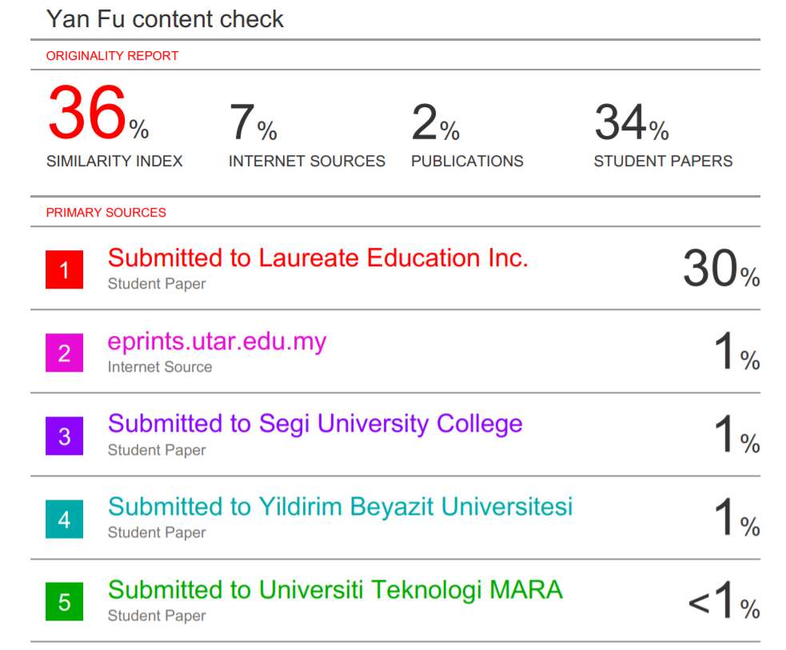

Note：The 30% portion of the assignment was a duplicate of the BRM (Business Research Method) assignment I uploaded last semester. Please cover or ignore it.