

MGT7998
MBA Project

FACTORS INFLUENCING E-LOYALTY AMONG ONLINE CUSTOMERS IN THE E-COMMERCE PLATFORM, KLANG VALLEY MALAYSIA

Name : WANG YAO
Student ID : I20018565
Programme : MBA
Supervisor :Ow Yong

Table of content

CHAPTER ONE 5
1.0 INTRODUCTION 5
1.1 Research Background 5
1.2 Problem Statement 7
1.3 Research Questions 8
1.3.1 General Question 8
1.3.2 Specific Questions 8
1.4 Research Objectives 8
1.4.1 General Objective 8
1.4.2 Specific Objectives 8
1.5 Significant of Study 9
1.5.1 In the context of the Industry: 9
1.5.2 In the context of Academia: 9
1.6 Scope of Study 10
1.7 Proposed Chapters 11
CHAPTER TWO 12
2.0 LITERATURE REVIEW 12
2.1 Introduction 12
2.2 Defining Topic 13
2.2.1 platform Design 13
2.2.2 Security 13
2.2.3 Choice 14
2.2.4 E-Loyalty 15
2.3 Critical Literature Review of Variables 16
2.3.1 Influences between Platform Design and E-Loyalty 16
2.3.2 Influences between Security and E-Loyalty 17
2.3.3 Influences between Choice and E-Loyalty 18
2.4 Underpinning Theories/Model 19
2.4.1 Theory of Reasoned Action 19
2.4.2 Expectation Confirmation Theory 19
2.5 Research Framework 20
2.6 Summary 21
CHAPTER THREE 21
3.0 RESEARCH METHODOLOGY 21
3.1 Introduction 21
3.2 Research Hypotheses 22
3.3 Research Instrument 22
3.3.1 Quantitative Research Method 22
3.4 Pilot Study 23
3.5 Data Collection 24
3.5.1 Population 24
3.5.2 Target Population 24
3.5.3 Sampling Technique 24
3.5.4 Sample Size 26
3.6 Data collection method 26
3.7 Data Analysis 26
3.7.1 Reliability Test 26
3.7.2 Descriptive Analysis 26
3.7.3 Correlation Analysis 27
3.7.4 Multiple Regression Analysis 27
3.8 Conclusion 27
CHAPTER FOUR 28
4.0 DATA ANALYSIS AND DISCUSSION OF FINDINGS 28
4.1 Introduction 28
4.2 Pilot Test 28
4.3 Data Analysis 29
4.3.1 Reliability Test 29
4.3.2 Descriptive Analysis 30
4.3.2.1 Demographic Profile 30
4.3.2.2 Gender 31
4.3.2.4 Age 33
4.3.2.5 Education Level 34
4.3.2.6 Status 35
4.3.2.7 Income Level (per month) 37
4.3.2.8 Frequency of Doing Online Shopping 38
4.3.3 Linearity Test 40
4.3.3.1 Linearity Test for Platform Design 40
4.3.3.2 Linearity Test for Security 41
4.3.3.3 Linearity Test for Choice 42
4.3.4 Pearson Correlation Analysis 43
4.3.4.1 Correlation between Platform design and E-Loyalty 44
4.3.4.2 Correlation between Security and E-Loyalty 44
4.3.4.3 Correlation between Choice and E-Loyalty 45
4.3.5 Multiple Regression Analysis 45
4.3.5.1 Variable Entered/Removed 45
4.3.5.2 Model Summary 45
4.3.5.3 ANOVA Model 46
4.3.5.4 Multiple Regression Analysis on Coefficients 47
4.3.5.5Multiple Regression Equation 48
4.4 Hypothesis Results 49
4.5 Summary 49
CHAPTER FIVE 50
5.0 CONCLUSION AND RECOMMENDATION 50
5.1 Introduction 50
5.2 Overall Findings based on Research Objectives 50
5.3 Implication of the Study 52
5.4 Limitation of the Study 53
5.5 Recommendation for Future Research 54
5.6 Conclusion 56
References 58
Appendix 67

CHAPTER ONE

1.0 INTRODUCTION

1.1 Research Background
Malaysia makes a show of 16.53 million e-commerce customers represent 50% of the population and 62% of e-commerce platform users use their devices to make purchases online. Throughout the previous decades, there is undoubtedly to recognize internet has grown quickly and made a tremendous change in the part of society, economy, and innovative framework. Internet is an incredible worldwide PC network system that contributes well to Information Communication Technologies (ICT) because of the various positive effects on internet users around the world. As indicated by the International Telecommunication Union (2018) and the United States Census Bureau (2019), the world's internet users reached 51.2% of the world population 7.6 billion people are using the Internet. As for the Malaysian internet, the number of users had reached about 26.3 million (Statista Research Department, 2019).
The first and second Internet Service Provider (ISP) had introduced in Malaysia at JARRING in 1990 and TMNET in 1996 (Adeline, Harn, Khatibi, & Ismail, 2006). Hence, it gives Malaysian a chance to start up their business and shop online. As an outcome of Malaysia's internet and mobile connectively, Malaysia has a high pace of e-commerce utilization with the encouragement of the public sector.
Online customers are used by product range, price advantages, and the availability of reviews. Moreover, they also urge to have convenient, free shipping, and exclusive deals provided by online stores (International Trade Administration [ITA], 2019).
These days, the internet has been extensively used as a noteworthy deal and advancing gadgets which serves as a platform for individuals to produce trade, share and control global information or news as well as performs business exchange without geographical hindrance. The rising of the internet encourages businesses to convey significant advantages to organizations in developing nations through online platforms, for instance, Amazon, eBay, Alibaba, Lazada, and so forth. The proliferate of the Internet boosts e-commerce trends by giving convenience enables customers to access products and services in anyplace and anytime. Thus, e-commerce has become a gigantic potential market that helps developing countries in the difference in retail vista (Lim, Osman, Salahudin, Romle, & Abdullah, 2016).
The convenience of the internet has increased the number of e-commerce in Malaysia. According to Statista 2019, it shows the e-commerce market in Malaysia has generated US$3681 million in 2019 and the amount is expected to grow steadily from years to years. In this manner, numerous organizations in Malaysia have shifted their business model from brick-and-mortar to online store due to the cost efficiency and operational effectiveness. Currently, the impact of e-commerce gains advantages of the country's economy, therefore, the performance of e-commerce platform is relatively important. Hence, it is necessary to understand the customer's online buying pattern in achieving the success of e-business and leads to customer e-loyalty.
There is a statement defined customer loyalty as “a profoundly held responsibility to rebuy or re-purchase a favored product or service consistently in the future, along these lines causing monotonous same-brand or same brand-set buying, despite the situational impacts and marketing efforts that having the capacity to cause exchanging product", said by Oliver (1997). This definition has been utilized broadly concerning the research on e-loyalty too. Anderson and Srinivasan (2003) recognized e-loyalty as a customer’s good disposition toward e-commerce bringing about continuous purchasing behavior, while Shankar, Smith, and Rangaswamy (2003) recognizes it as a customer’s duty to the specific e-commerce platform. In light of the above definition, the present investigation depicts e-loyalty as the perceived loyalty of a consumer towards an e-commerce platform and their expectations to visit the same e-commerce platform to rehash buy (Grace & Sun, 2009).
These efforts become progressively troublesome and serious in the online business to buyer condition since online organizations like e-store or e-commerce platform are confronting rivalry from not only other comparable store but also the offline organization that offers comparative products and services (Cristobal, Flavian, &Guinaliu, 2007; Yun & Good, 2007).
It has particularly happened in developing nations where online shopping continuously becomes ordinary, however, do not have a complete set of regulations to protect customer benefit yet. Furthermore, internet fraud is a major consideration coming into the customer's mind to stop them from online shopping. In this way, it is imperative to research to provide an insight into the ways to acquire customer e-loyalty using different perspectives. Hence, this study is going to determine the factors that bring impacts on e-loyalty among online customers in Malaysia which include platform design, security, choice.

1.2 Problem Statement
What factors of e-commerce platforms will affect e-loyalty? It is a big challenge for e-commerce platform operators to obtain e-loyalty from customers.
According to the research done by Akram (2018), he said that many customers are refused to buy things online because of the worry of privacy and security of their online transactions.
Limited studies are being found on the topic of the factors affecting customer e-loyalty in the aspect of the e-commerce platform environment, especially in the Malaysian context (Liew & Falahat, 2015).
Every business has to put great effort to create customer loyalty that can help the organization to sustain itself in a long way (Dowling & Uncles, 1997).
The objective to do this research topic is to measure the factors influencing e-loyalty among online customers in the Malaysian context. According to the past studies, there are numerous researchers had researched the e-commerce factors that gives an impact on customer loyalty specifically in Pakistan and Indonesia (Baubonienė&Gulevičiūtė, 2015; Nasimi, Nasimi&Basit, 2018; Pratminingsih, Lipuringtyas&Rimenta, 2013). Although the price may be the key factor for a customer to decide whether loyal to the company, however, other factors play important roles in performing customers’ e-loyalty (Wantara & Tambrin, 2019).
Meanwhile, limited studies are being found on the topic of the factors affecting customer e-loyalty in the aspect of the online shopping environment, especially in the Malaysian context (Liew & Falahat, 2015). Thus, it is necessary to explore more on e-loyalty among online customers in Malaysia because the researches done by other countries might not suitable to apply in Malaysia as it is different in the multi-culture and norms consisting of many ethnic groups.
Therefore, this study can be a reference for the individual to understand customer's online purchasing behavior in Malaysia which supports the development of e-commerce and enables the e-commerce platform to build long-term relationships with the customers (Lim, Abdullah, Shahrul, Abdul, & Safizal, 2016). It will measure on factors of platform design, security, choice, and its influences on e-loyalty among online customers in Malaysia which is important to measure to expand the body knowledge of customer e-loyalty in Malaysia.

1.3 Research Questions

1.3.1 General Question

Do these factors influence e-loyalty among online customers in Malaysia?

1.3.2 Specific Questions
- Does platform design influence e-loyalty among online customers in Malaysia?
- Does security influence e-loyalty among online customers in Malaysia?
- Does choice influence e-loyalty among online customers in Malaysia?

1.4 Research Objectives

1.4.1 General Objective

The research objective is to measure the factors influencing e-loyalty among online customers in Malaysia.

1.4.2 Specific Objectives
- To measure the influence of platform design on e-loyalty among online customers in Malaysia.
- To measure the influence of security on e-loyalty among online customers in Malaysia.
- To measure the influence of choice on e-loyalty among online customers in Malaysia.

1.5 Significant of Study

1.5.1 In the context of the Industry:
This research can improve the efficiency of the e-commerce platform to develop a new plan to serve online buyers. This study helps workers to deal with problems faster for the research.
This research will become an added value to the organization while organizes the online strategic plan to attract customers and makes the decision to retain loyal customers. There are three factors proposed to measure the issues which might affect customer e-loyalty in online retailer based in Malaysia context. The factors involved in this study are platform design, security, and choice. Furthermore, this research can improve the effectiveness and efficiency of the marketer to develop a new plan to serve online buyers when there is data listed to assist in progress without wasting time. Moreover, this study helps workers deal with problems faster and avoid challenges and obstacles that may increase the possibility of dissatisfaction among the customers. So, this could be the benchmark to implement or improve their business processes as insights and information of gaining customer e-loyalty will be done (Liew & Falahat, 2015).

1.5.2 In the context of Academia:
This study of the research will provide references for future scholars to continue to study the e-loyalty among online customers in Malaysia.
According to the SKMM (2018), the percentage of internet users was 87.4% in 2018 with approximately 28.7 million internet users which are higher than the previous year with 24.6 million in 2016. Through this survey, it showed that respondents spent 6.6 hours online in a day on average. The majority of internet users spent almost 1 to 4 hours daily (39.2%), 5 to 8 hours daily (23.9%), and 8.1% of internet users recognized to use more than three-quarters of the time daily connected to the internet. This survey also found that the involvement of e-commerce activities of the consumers has increased from 48.8% to 53.3% in 2018 compared with the data in 2016. The fundamental obstruction for e-commerce selection was the consumer’s inclination to go the physical stores, the absence of certainty and abilities, as well as the security and protection concern. Therefore, this study will help to add value to the body knowledge in the dimension of e-loyalty among online customers in Malaysia concerning the customers’ online purchasing behavior and provide references for future scholars to continue to study the e-loyalty among online customers in Malaysia.

1.6 Scope of Study

The scope of my research is limited to an only e-commerce platform. The E-commerce platform is just the platform of online shopping by electronic means such as by mobile applications and the Internet. Ecommerce platform refers to online shopping. Ecommerce has hugely increased in popularity over the last decades, and in ways, it's replacing traditional brick and mortar stores. Examples of e-commerce platform include- Lazada, Taobao.

The target area of respondent: Respondents in Klang Valley, Malaysia.

Limited factor affecting e-loyalty: Platform design, Security, Choice.
In recent years, the number of online shoppers increases significantly due to the advanced technology and the modern lifestyle that pursue by individuals to make life easy. Looking at the global stage, many individuals are purchasing products and services online as it brings them convenient services and saves a lot of times (Rahman, Islam, Esha, Sultana, & Chakravorty, 2018). When it comes to the Asia stage, many individuals love to do online purchasing for food, especially in China. This country is famous to take food orders online and get to send the food right to their home without even step one step to the outside of the house. It shows that how people rely on the internet to help them build a convenient and modern lifestyle as to differentiate from the oldest way to visit the physical stores in person to eat at the places (Patrick, Li, Abubakar, Antwi, & Akomeah, 2016). Due to the previous studies related to the internet users in different countries, it gives an idea to do research specifically in Klang Valley, Malaysia by identifying the tendency of internet users to buy things online with emphasizing which factors as well as their buying behavior while the purchasing process goes beyond brick and mortar. Most importantly, this study will help to increase the body context regarding the concerns of individuals to do online shopping, as well it can be a model for new start-up e-commerce platform company to evaluate whether their coming products and services will meet customer's expectation or not. It can probably decrease the spending of unnecessary time of the companies to find out what are the products and services that like or dislike by the customers. The factors that influence e-loyalty among online customers while doing online purchasing that discussed in this study would give a big hand for those who don't have the budget to do research and development for better creating the marketing strategy of the business (Bucko, Kakalejčíka, & Ferencová, 2018).
To complete this research, the target respondents will focus on online customers who used to do online purchases to analyze how frequently they make purchases online and what is the main reason for them to make online transactions with a certain e-commerce platform. This, in turn, would affect the degree of e-loyalty practice among customers in Malaysia (Mobarakabadia, Karamib, Farb, & Yarkaramic, 2013). Moreover, the focusing geographical areas will concentrate in Klang Valley, Malaysia includes both males and female that involves several age ranges. Research on measuring the factors of platform design, security, the choice will be applied to understand the individuals’ buying behavior and how would they loyal to one e-commerce platform leverage all these factors.

1.7 Proposed Chapters
Chapter one begins with the research background of the factors that influence e-loyalty among online customers in Malaysia. It then comes with the problem statement to derive the research objective and research questions. After that, the significance of the study has indicated to know who is going to be benefited from this research and the scope of the study will be listed too. Before ending, there will be the proposed chapters written to see what the following contents are.
Chapter two starts with an introduction to defining the topic of independent variables and dependent variables. A critical literature review will be done here to understand well every variable. Then, two related theories or models will be identified to better understand the research. Before the summary is written, there will be a valid research framework derive from this study.
Chapter three comes with an introduction followed by research hypotheses, operational definition and research instrument. A pilot study will create to test the reaction of respondents as the quantitative research method will be chosen to complete the data collection and data analysis. Thus, the research equation will be used to indicate and calculate the data in a systematic way. So, the last part will be the conclusion of this study.
Chapter four is started with the introduction followed by the pilot study of the research to expand with more information. Furthermore, data analysis will be carried out to understand the result of the study which later transforms it into the hypothesis result to assist in further research.
Chapter five derives the introduction besides with the discussion of the findings based on the research objective. Then, it also includes the implication of the study as well as the limitation of the study to better understand on the topic. Lastly, it comes with the recommendations for future research to leave a space for more individuals to discuss the same topic with deeper research.

CHAPTER TWO

2.0 LITERATURE REVIEW

2.1 Introduction
A review of the critical literature is led in this section tending to the theoretical foundation of platform design, security and choice intersect with e-loyalty. The utilization of outlines and illustrations all through this part is to underscore certain focuses and to clear up specific implications of the writing.

2.2 Defining Topic

2.2.1 platform Design
"Platform design" in this research means the design of function provided by the platform that enables buyers to search and purchase the product via the platform. This includes The layout of the e-commerce platform, The design of the function provided by the platform, for example, checkout process or product search process or process to checkout.
platform design assumes a vital job in e-retailing, as it influences customer legitimately amid the purchase procedure (Hila Ludin & Cheng, 2014). The characteristic of an e-commerce platform can be the main reason for customers to decide whether to continue searching or turn down and quit. Customer perception is relatively important especially to first time users in building the e-commerce platform's reliability mindset among them (Guo, Ling, & Liu, 2012). Besides that, Luo, Ba &Zhang (2012) describe platform design has a crucial job in helping the customers in finding data. A good-designed e-commerce platform will probably reduce the time of searching for information as well as avoid the possibility of mismatch the data search. Luo et al. (2012) likewise bring up a brilliant platform design can enhance customer's involvement which in turn build customer loyalty.

2.2.2 Security
"Security" in this research means the ability of the e-commerce platform to project a sense of security to its users. The sense of security may include; security of customer's personal information, the ability to deter hacking attempts, and security to transact via the platform.
Security is characterized as the capacity of the e-commerce platform to shield customer's data from any unapproved utilization of data revelation amid the electronic transaction (Guo et al., 2012). Maintain the security reflects recognition in regards to the reliability of the transaction method used and the instruments of information transmission and storage. The absence of security as seen by consumers speaks to risks and challenges to the development of online business. Therefore, raising the security of e-commerce platform can increase the trust of consumers and decrease the perceived environmental risk (Eid, 2011).

2.2.3 Choice
"Choice" in this research means e-commerce platform the product and services selection size being offered in the platform. The choice is not limited only to product or services which a user want or interested to buy, but also include those that user has no or little intention to buy.
E-commerce is one of the most exciting areas of rapid development. E-commerce has changed the concept of customers, customers' shopping experience and online services provided by e-commerce platform (Winnie, 2014). When it comes to e-commerce platforms, the online services provided meet the needs of customers related to usability and ease of use, and enjoy the choice of services or product they need in a short time (LIM, Yap, & Lau, 2010). Therefore, compared with a traditional physical store, an e-commerce platform is considered to be better than a traditional physical store.
The choice is an important factor affecting the whole process of online shopping. It represents a service provided online or on an e-commerce platform. The quality of online shopping is affected by this factor, as it can retain a limited number of services on the e-commerce platform. According to Cyr et al. 2010, the arrangement of choices offered online is very important, so customers have been looking for specific services or products that can make their transactions go smoothly. As a result, most e-commerce platforms adhere to this and arrange the services and products in a way that meets the needs of customers. As a result, this will keep customers satisfied and visit the e-commerce platform constantly. Proper selection or service arrangement helps customers save time and energy and find what they want (Hern á ndez et al. 2009). On the other hand, when it comes to the low-quality services by the e-commerce platform, customers will feel dissatisfied (Yee & faziharudean, 2010). Therefore, the choice of services to be provided should depend on the quality of other services and the suitability of their needs. E-commerce providers are constantly increasing or improving their online platform services, making their e-commerce platform a better choice for potential customers, and retaining existing customers. Therefore, product or service selection is an important factor affecting the e-loyalty of the e-commerce platform. However, due to the accuracy of product or service selection, it can not only meet the needs of customers but also meet the quality requirements of customers. As many studies have revealed, this choice is one of the main determinants of E-loyalty (Yee & faziharudean, 2010). As described by casa lo et al. (2008), it is used to measure customers' evaluation of e-commerce platform reputation and determine their choices.

2.2.4 E-Loyalty
"E-loyalty" in this research means the degree of customer trust and satisfaction toward an e-commerce platform.
E-loyalty which is known as online loyalty becomes like the concept of loyalty towards an organization through the internet portal, in a way that generates buying behavior and regular visits to the online store (Al-dweeri, Obeidat, Al-dwiry, Alshurideh & Alhorani, 2017). Loyal customers have a high intention of browsing the same online platform in purchasing the same products over some time (Winnie, 2014). The behavioral buying process of a customer's loyalty is also affected by the psychological process (Anderson & Srinivasan, 2003). However, using the behavioral measurement method to describe e-loyalty is insufficient, because it is hard to identify loyal customers between true customer loyalty and spuriously loyal customer (Jeon & Jeong, 2017). True customer loyalty already exists good experience and confidence in the e-commerce platform and has the behavior in consuming its products continuously (Al-dweeri, Obeidat, Al-dwiry, Alshurideh & Alhorani, 2017). A spuriously loyal customer that buying the same products from a similar e-commerce platform consistently, considering that there is a possibility of lack of alternatives (GHANE, FITHIAN & GHOLAMIAN3, 2011).
Through intensive study, Baldinger and Rubinson (1996) have verified that consumers are more willing to remain loyal to an e-commerce platform when they have a good impression of the brand. For instance, there is a higher possibility for loyal customers in converting their willingness to buy into the immediate purchase of the product (Durmuş, Ulusu & Erdem, 2013). The intention of future purchase is affected by the previous purchase satisfaction, and this will directly change the loyalty of the customer towards the e-commerce platform (Winnie, 2014).

2.3 Critical Literature Review of Variables

2.3.1 Influences between Platform Design and E-Loyalty
According to the research done by Al-dweeri, Moreno, Montes, Obeidat, and Al-dwairi (2019), the Platform design was having a positive influence on Jordanian student's e-loyalty. As shown in the study, platform design is considered an important factor that needs to well-organized and well-structured. It is because customers perceived platform design can help them find the information they need more easily. Most significant, the structure of the platform and usability diminish customer’s costs for looking and data handling and decline the time spent on the purchase. Quick navigation encourages customers to make fast online transactions by giving structured data. Similarly, Parra-Lopez, Martínez-gonzálezm, and Chinea-Martin (2018) suggested that platform design and e-loyalty have a positive significant correlation in the tourism industry within the youth segment at the University of the La Laguna in Spain. They indicate that the platform is a useful tool to link customers and the tourism goods and services that offered by the company. The more creative the platform design portray, the more likely the customers would purchase with the company that increases the possibility to the customers to revisit the e-commerce platform once customers have good experience with the company in the past. Hence, this can be evidence to link platform design and e-loyalty in achieving a positive result among students in Jordan and Spain.
Then, it consists of a similar report completed by Faraoni, Rialti, Zollo, and Pellicelli (2019) said that platform design has a positive influence on e-loyalty from Italian online grocery platforms. The simplicity of navigation creates a delightful purchasing experience. The effectiveness and efficiency of the e-commerce platform enable customers to place orders quickly were resulting in high fulfillment levels that easily convert into loyal customers. The same applies to the study finished by Chou, Chen, and Lin (2015), the finding outcome indicates that commerce platform quality also has a positive impact on e-loyalty on female online clothing shopper in Taiwan. The e-commerce platform design includes The layout of the e-commerce platform, The design of function provided by the platform. It can increase the awareness of customers and it is a key factor for building long term relationship like e-loyalty with the customers. As well, a good platform design can help customers browse easily and save their time in searching for what they need. Therefore, better platform design has proven to make the positive relationship between e-loyalty in the clothing and grocery industry.
H1: There is a significant positive relationship between platform design and e-loyalty among online customers in Malaysia.

2.3.2 Influences between Security and E-Loyalty
According to the research finished by Xiao, Guo, D'Ambra, and Fu (2016), there is a significant relationship between security and e-loyalty among online customers in Chinese markets. Numerous customers are hesitant to release payment card information or individual personal data to e-commerce platform because of the risk of fraud and maltreatment of personal data. So, if the customers can discover security features includes in the platform, they are bound to accept the e-commerce platform and further become loyal customers due to the high trust possessed to the e-commerce platform (Xiao, Guo, D’Ambra, & Fu, 2016). A similar result can be seen through the research done by Al-dweeri et al. (2019), they found that security and e-loyalty receive a positive significant relationship in online retailing in Jordan. They said that insecurity and lack of confidence will make customers refuse to make an online transaction. Thus, it is compulsory for developing a trustworthy platform through deployed the customer privacy policy to shield customers from the danger of fraud and financial loss. In summary, although this research had done in different countries, the outcomes are the same as security has a positive relationship to e-loyalty in doing online business.
Other than that, security and e-loyalty possess a positive relationship in the dimension of female online clothing shopper in Taiwan has been derived from the study done by Chou et al. (2015). They concluded that web security vulnerability keeps existing although the improvement of online security systems keeps developing. The security problem is always the main concern for female online shoppers while doing online purchases. E-commerce platforms must take responsibility to prevent their E-commerce platform from purposefully attacked and harmed as it will decrease the trust in online shoppers and reduce e-loyalty (Chou, Chen, & Lin, 2015). Again, this result is supported by Faraoni et al. (2019) which told that security can positively influence e-loyalty from Italian online grocery platforms. This study stated that the increase of security level that meets customers' expectations would make them more willing to give their data and information to continue the online purchase (Faraoni, Rialti, Zollo, & Pellicelli, 2019). Therefore, security has become one of the important elements that affect customer's e-loyalty due to customers will only do business with a trustworthy e-commerce platform that can protect their data and prevent them from fraud and deception.
H2: There is a significant positive relationship between security and e-loyalty among online customers in Malaysia.

2.3.3 Influences between Choice and E-Loyalty

Compared with traditional stores, the E-commerce platform is usually able to offer a wider range of product categories and more types of products in any given category. Stores in shopping malls are limited by availability and floor space costs, while their online stores are not. An E-commerce platform can also form alliances with other virtual suppliers to provide customers with more choices. For example, an e-commerce platform may keep only a limited classification of a given product category in its inventory but can form alliances with other suppliers and manufacturers who can deliver products from their own broader inventory to e-commerce platform customers. In contrast, increasing the number of available alternatives products can significantly reduce the opportunity cost of time, as well as the unrelated and actual cost of searching for virtual stores. An E-commerce platform with more choices can become an ideal place for one-stop shopping, thus generating e-loyalty.
H4: There is a significant positive relationship between choice and e-loyalty among online customers in Malaysia.

2.4 Underpinning Theories/Model

2.4.1 Theory of Reasoned Action
The theory of reasoned action (TRA) clarifies the connection between belief, attitude, aims, and practices. The TRA model display that individuals settle on sound choices dependent on the data accessible to them and the best prompt determinant of an individual's conduct is a purpose which is the intellectual portrayal of preparation to play out given conduct (Fishbein & Ajzen, 1975).
Moreover, TRA has added the third predictor of intention which known as perceived behavioral control. It is about the perceived effortlessness when the individual performs one behavior. If an individual has the will to control over an action, the stronger intention they made to perform a behavior, then they will probably perform a proposed behavior (Williams, He, & Conners, 2018).
As needs be, data quality given by the B2C online business platform contents can extraordinarily influence the expectation to buy. Likewise, if the data given by the platform is dependable and precise, at that point this will increase customer satisfaction and trust in turn lead to customer loyalty. Hence, TRA theory can be applied in this study to determine the factors influencing customer e-loyalty among online customers in Malaysia and understand the purchase behavior of the e-commerce platform.

2.4.2 Expectation Confirmation Theory
Expectation-Confirmation Theory (ECT) was proposed to think about customer fulfillment and repurchase behavior (Oliver, 1980). The ECT theory expresses that online shoppers will structure an underlying desire preceding to buy, and after that construct observation about the execution of the expended product or service after a time of introductory utilization.
Next, purchasers will settle on their dimension of fulfillment dependent on the degree to which their desire is affirmed through contrasting the real execution of the product or service against their underlying desire for the execution. Therefore, fulfilled purchasers will frame repurchasing goals. In other words, this is about the expectation of an individual to feel satisfied if the expectation is met positively, in contrast, an individual will feel dissatisfied if the expectation is met negatively. This indicates ECT as a powerful explanatory tool (Jiang & Klein, 2009).
Additionally, customer expectations differ from an online shipping environment and the physical market. It depends on the e-commerce platform design, security, and choice that are going to examine in this research. These factors bring effects on the individual's desire to decide whether to become a loyal customer. Usually, customers intend to investigate the company's performance to enhance the possibility to make a purchase (Biswas, Nusari, & Ghosh, 2019).
So, when consumers have affirmed their desire that an e-commerce platform is dependable, they will be increasingly roused to repurchase from the same e-commerce platform. It is because only satisfied customers will proceed to the second purchase of products or services in the same e-commerce platform. Therefore, it can be used in this study to see the expectations and perceived values of the customer while they are planning to do an online purchase.

2.5 Research Framework
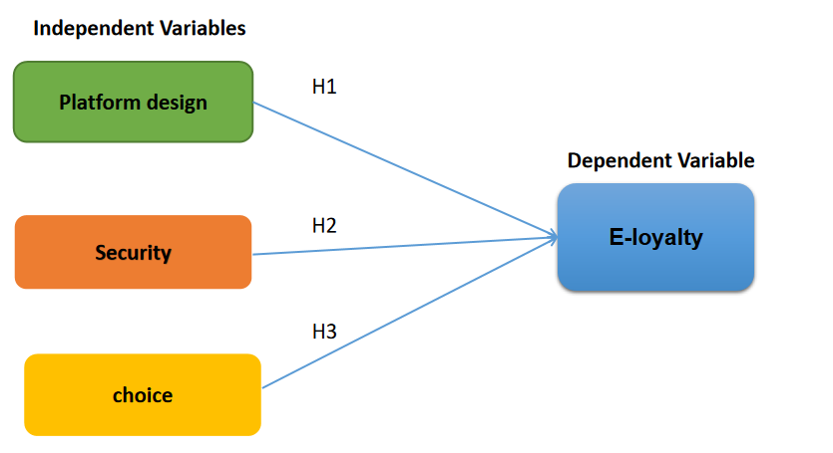
Figure 2.1 Research Framework

Above is the research framework of this study to find out whether platform design, security, and choice that represents independent variables have a significant effect on customer e-loyalty that represents the dependent variable.

2.6 Summary
The data found in this chapter furnishes a concise examination concerning the assessment and mindful of this investigation. The dependent variables partner with independent variable is expressed in the hypotheses structure. In the following part, the whole hypotheses will be evaluated depending on the respondent with appropriate research methods.

CHAPTER THREE

3.0 RESEARCH METHODOLOGY

3.1 Introduction
In this chapter, it will identify research hypotheses to know the possibility and relationship between factors influencing e-loyalty among online customers in Malaysia. Then, a pilot study will be prepared for future collecting the data from relative groups of people in analysis, recording, calculating, and classifying the receivable data using the SPSS method. Moreover, there are meanings given to each data analysis to understand the function of it.

3.2 Research Hypotheses

Based on the previous studies, there are many factors influencing e-loyalty among online customers in Malaysia. The research hypotheses are proposed below:

H1: There is a significant positive relationship between platform design and e-loyalty among online customers in Malaysia.

H2: There is a significant positive relationship between security and e-loyalty among online customers in Malaysia.

H3: There is a significant positive relationship between choice and e-loyalty among online customers in Malaysia.

3.3 Research Instrument
The research instrument can use the quantitative research method, the ways of collecting data helps in assessing the dependability of the data (Zohrabi, 2013).

3.3.1 Quantitative Research Method
Quantitative research is characterized as research including the organization of a lot of organized inquiries with foreordained reaction choices to a substantial number of respondents. It’s occasionally alluded to as “survey research”. Moreover, it includes a sizable delegate test of the population and a formalized methodology for collecting the information. It can be achieved through a questionnaire, printouts, mobile devices, PCs, and so on(Burns et al., 2017). Researchers will choose quantitative research whenever there is headcount needed, comparison overviews, and behavior (Hague, 2006). Besides, the data must accumulate follow an orderly procedure that is a great extent numerical in nature. Most significantly, all the items of the questionnaires or surveys are predominantly created dependent on the research questions and research objectives (Zohrabi, 2013).
To complete the research, a quantitative method is chosen in which a questionnaire research method will be conducted to collect useful information from the audience in calculating the result. The reason for utilizing this technique is to decide the accurate and precise information on this investigation. It can distribute to multiple target respondents at the same time with little time consuming than doing an interview. Also, through distributing questionnaire can support the larger sample size which is dependable as this research need 385 respondents to finish the analysis of the topic on how platform design, security, and choice bring effect on customer e-loyalty. Additionally, this technique helps to collect data for the user to know the practice regarding purchasing behavior and the desire to make a repeat purchase of the online buyers. So, the answers get from the respondents can be interpreted and analyzed easily and objectively in this research.

3.4 Pilot Study
A pilot study refers to the survey to utilize a limited number of respondents and regularly utilize less rigorous sampling techniques than are employed in huge and quantitative studies (Burns et al., 2017). Followed by Junyong (2017), he said that the pilot test is significant for the improvement of the quality and efficiency of the study. Moreover, it is conducted to evaluate the feasibility of the study protocol, inspect the randomization and blinding procedure, increase the researchers' involvement in the investigation techniques, select the most appropriate primary outcome, and give an appraisal for sample size calculation.
However, it is often misused, mistreated, and misrepresented to the respondents. A well-directed pilot study normally comes with clear points and targets within a formal framework. It can lead to high-quality research and scientifically valid work that brings benefits to the publicity. Therefore, a researcher has to build up his or her skills, pick the correct strategies, and cautiously plan for all parts of the procedure. Also, the questionnaire should be tested and get an opinion from the respondents before placing it into the SPSS system to determine the reliability of the questionnaire (Doody & Doody, 2015).
Before fully distribute the questionnaire, there is a pre-test questionnaire had distributed to 32 respondents who live in Klang Valley, Malaysia to understand the problems existing in the questionnaire as well as to ensure the reliability of the question included. The collected data has tested on the latest version of SPSS by employing Cronbach's Alpha test to know the reliability of the pilot test. The feedback getting from the first 32 respondents has given some clue to modify the question to a clearer and direct point which can easily understand by others.

3.5 Data Collection

3.5.1 Population
A population is defined as the entire group under study as specified by the objectives of the research project. It is usually the largest and most encompassing entity (Saunders, M.N.K., Lewis, P., Thornhill, A., 2015). As of April 2, 2019, based on the latest United National estimates, the present population of Malaysia is 32,350,893. It is equivalent to 0.42% of the whole world population which ranked at number 45 in the rundown of nations (Malaysia population, 2019). Then, this statement will be used in determining the target population identified with the research topic and research questions.

3.5.2 Target Population
It refers to a collection of elements identified with the examination study which aim to analyze and understand the reaction of the respondents on the components affecting customer's e-loyalty towards web-based shopping condition in Malaysia (Liew & Falahat, 2015). Accordingly, this investigation will center on the people living in Klang Valley, Malaysia and the target respondents will be the internet users that have always been accessible to the web (SKMM, 2017).
Additionally, there are no restrictions regarding the customer's age, gender, race, status, income level, and education level. Through the Department of Statistics Malaysia (2018), it stated that the population in Klang Valley was about 6.47 million in 2018 as estimation with having 3.36 million male and 3.11 million female. In this context, online customers are the target respondent to answer the survey as they are the one who reflects in the factors that can bring impact on customer e-loyalty. This can refer back to the SKMM (2018) analysis that Malaysia consists of 28.7 million internet users equivalent to 87.4%.

3.5.3 Sampling Technique
The major alternative sampling method can be gathered into probability sampling and non-probability sampling methods. It is used to make derivation about a population or to make speculation in connection to existing hypotheses. Fundamentally, this relies upon the decision made for the sampling technique used (Taherdoost, 2016).
Firstly, probability sampling methods refer to each component of the population has a known, nonzero possibility of choices. It can be categorized into four types which include simple random sampling, stratified random sampling, cluster sampling, and systematic sampling. Simple random sampling is the best known and most generally utilized probability sampling method. At the point when this method is pursued carefully, the laws of probability hold, enabling computation of the degree to which a sample value can be hope to vary from a population value. This distinction is mention as a sampling error.
In contrast, non-probability samples are those in which explicit components structure the population have been chosen in a nonrandom manner. Non-randomness results when population components are chosen based on convenience because they are simple or inexpensive to reach. There are two types of a non-probability sample which includes quota sampling and convenience sampling. Normally, these methods are mostly used for qualitative research due to the focus on small samples and are proposed to inspect a real life phenomenon instead of making a statistical inference in connection to the wider population. A sample of participants shouldn't be delegate or irregular, yet a reasonable method of reasoning is required for the consideration of certain cases or people as opposed to other people (Bryman & Bell, 2015).
Hence, a simple random method will be applied to analyze this research on the topic to know which factors influence more customer e-loyalty among internet users in Malaysia. The choice of using this method is because it enables us to obtain accurate and credible information with any deviation. Also, after consideration made to deal with a large population, simple random sampling allows every individual to have an equal possibility to be participated as a respondent to answer the survey questionnaire.

3.5.4 Sample Size
There are 385 respondents who will be sampled to enhance the reliability and validity of the data. All the respondents will be chosen from the online customers who live in Klang Valley, Malaysia.

3.6 Data collection method
Data collection is collected through online questionnaires. Online surveys are the preferred way to collect this research data. By generating Google Form and sending it to friends via WhatsApp, friends then send it to respondents via social media or Facebook or WhatsApp.

3.7 Data Analysis
Data analysis is a crucial part of any research as it summarizes all the data with interpretation and evaluation using systematic and consistent thinking to determine a relationship, patterns, or trends. There are assortments of specific data analysis techniques that utilize different measurement scales like ordinal, nominal, and interval scale to assist the success of the researchers to explain the gathered data (Lutabingwa & Auriacombe, 2007).

3.7.1 Reliability Test
Reliability is how much measures are free from random error and, therefore, provide consistent data. The less error there is, the more dependable the observation is. Thus, a measurement that is free of error is considered as a correct measure (McDaniel & Gates, 2013). In this study, Cronbach’s Alpha technique will be used to estimate the mean reliability coefficient. There is a rule of thumb for interpreting alpha of 0.7 and above is good, 0.8 and above is better, and 0.9 and above is the best (Tavakol & Dennick, 2011).

3.7.2 Descriptive Analysis
Certain estimates of the mean, mode, standard deviation, and range are types of descriptive analysis. It is utilized by researchers to describe the sample database to depict the "typical" respondent and to uncover the general pattern of responses. Ordinarily, it is used early in the investigation procedure and becomes an establishment for subsequent analysis (Saunders et al., 2015).

3.7.3 Correlation Analysis
Correlation analysis is the extent to which changes in a single variable (the dependent variable) are related to changes in another. When two variables exist, Pearson-moment correlation may be used to deal with metric data. The correlation value is in the scope of -1.0 (perfect negative correlation) and +1.0 (perfect positive correlation), besides, 0.0 indicates no relationship between two variables (Saunders et al., 2015). Therefore, the bivariate correlation method has been implemented to determine the relationship between the dependent variable and independent variables in the research.

3.7.4 Multiple Regression Analysis
Regression analysis can be defined as a predictive analysis technique in which one or more variables are used to predict the level of another by use of the straight-line formula. Sometimes, researchers refer this to as simple regression as there are analyzing only two variables. However, multiple regression analysis will be used to assess the significant relationship between more than two variables as per in this study (Burns et al., 2013).

3.8 Conclusion
The research framework and research methodology covered a target population of internet users who lives in Klang Valley, Malaysia. They are chosen randomly to answer a set of questionnaires that is prepared to identify the mistake and modify the question to make it clear and precise. Nonetheless, this study has concluded with the knowledge of how to prepare a project or proposal and find the right target population to collect data review in benefiting a certain range of e-commerce platforms. There are few analyses such as reliability analysis, descriptive analysis, correlation analysis, and multiple linear regression analysis to be found to engage in this research.

CHAPTER FOUR

4.0 DATA ANALYSIS AND DISCUSSION OF FINDINGS

4.1 Introduction
This chapter will analyze the result of data collection from the respondents obtain through the distribution of the questionnaire. The IBM software SPSS will be used to carry the result of the pilot study and data analysis includes reliability test, linearity test, correlation analysis, and multiple regression analysis. All the results to be found will give impacts the hypotheses result of this study.

4.2 Pilot Test
A pilot test is conducted to examine the reliability of the questionnaire. Thus, there are 32 respondents have participated in the survey to see whether the questionnaire is reliable to answer, and yet without having any mistakes.
Reliability Statistics
Cronbach's Alpha | N of Items
.861 | 15
Table 4.1 Pilot Test for All Variables
The above table shows Cronbach’s Alpha of 0.861 and the number of Items set is 15. All the independent and dependent variables are reliable as it has passed the minimum required benchmark of 0.7. So, the questionnaire can be distributed to 385 target respondents and the full reliability test will be done once the data is ready.

Reliability Statistics
Variables | Independent Variables |  |  | Dependent Variable
Variables | Platform Design | Security | Choice | E-loyalty
Cronbach's Alpha | .760 | .792 | .909 | .847
N of Items | 4 | 3 | 4 | 4
Table 4.2 Pilot Test for Each Variable
Besides that, the table 4.2 showed the reliability test for every single variable. The result of Cronbach's Alpha for platform design is 0.760; security is 0.792; the choice is 0.909, and customer e-loyalty is 0.847. The acceptance and reliability of all variables make further analysis goes on.

4.3 Data Analysis

4.3.1 Reliability Test

Reliability Statistics
Cronbach's Alpha | N of Items
.819 | 15

Table 4.3Reliability Test for All Variables
The Cronbach's Alpha shows in table 4.3 indicate the reliability of the independent and dependent variables in this study which is the amount to 0.819 for 15 items. This result is calculated based on 247 respondents. Due to the value excess 0.7, therefore it correlates with the independent and dependent variables.

4.3.2 Descriptive Analysis

4.3.2.1 Demographic Profile
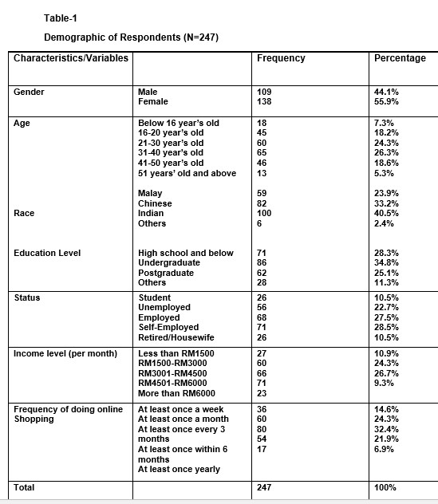
Table 4.4 Descriptive Statistic

The demographic profile of this research has included several elements of demographic information such as gender, race, age, education level, status, income level (per month), and the frequency of doing online shopping. Furthermore, the Klang Valley is the chosen focus area to distribute and collect the data. There are 385 sets of the questionnaire that had been distributed, it became 247 respondents in total to continue the further analyses until finish the study.

4.3.2.2 Gender
Gender
 |  | Frequency | Percent | Valid Percent | Cumulative Percent
Valid | Male | 109 | 44.1 | 44.1 | 44.1
Valid | Female | 138 | 55.9 | 55.9 | 100.0
Valid | Total | 247 | 100.0 | 100.0

Table 4.5 Gender
Table 4.5 Gender

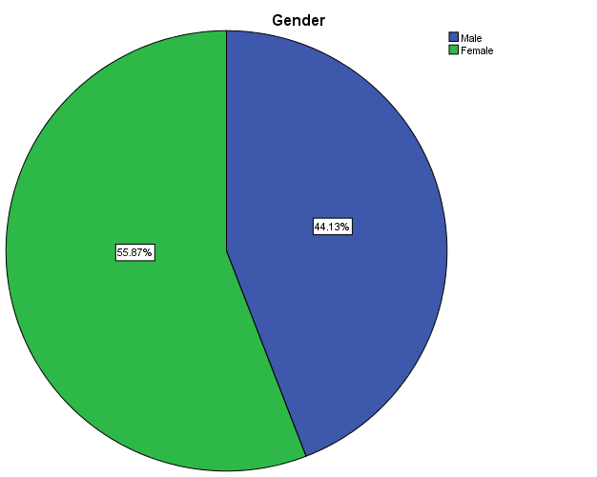

Figure 4.1Gender
The data based on gender has been divided into male and female and it can refer to the above table 4.5 and figure 4.1. The percentage of the male is accounted for 44.1%, whereas the percentage of the female is accounted for 55.9%. In the numeric data, there are 109 male and 138 female respondents who have participated in this research.
4.3.2.3 Race

Race
 |  | Frequency | Percent | Valid Percent | Cumulative Percent
Valid | Malay | 59 | 23.9 | 23.9 | 23.9
Valid | Chinese | 82 | 33.2 | 33.2 | 57.1
Valid | Indian | 100 | 40.5 | 40.5 | 97.6
Valid | Others | 6 | 2.4 | 2.4 | 100.0
Valid | Total | 247 | 100.0 | 100.0

Table 4.6 Race
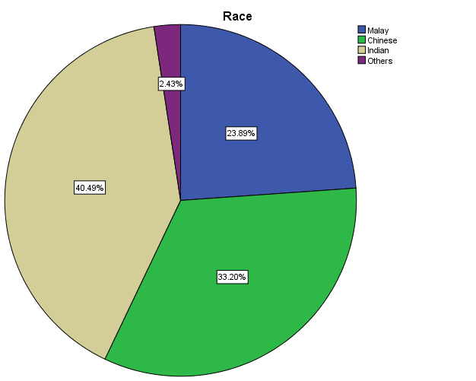
Figure 4.2 Race

The race is classified into four categories of Malay, Chinese, Indian, and others. Based on table 4.6 and figure 4.2, it shows that Indian is the largest group to deal with this study where it is accounted for 40.5% and 100 respondents. Then, it is followed by the Chinese respondents which account for 33.2% and 82 respondents. Malay is accounted for 23.9% and 59 respondents. The rest of 2.4% equal to 6 respondents has belonged to other races.

4.3.2.4 Age
Age
 |  | Frequency | Percent | Valid Percent | Cumulative Percent
Valid | Below 16 years old | 18 | 7.3 | 7.3 | 7.3
Valid | 16-20 years old | 45 | 18.2 | 18.2 | 25.5
Valid | 21-30 years old | 60 | 24.3 | 24.3 | 49.8
Valid | 31-40 years old | 65 | 26.3 | 26.3 | 76.1
Valid | 41-50 years old | 46 | 18.6 | 18.6 | 94.7
Valid | 51 years old and above | 13 | 5.3 | 5.3 | 100.0
Valid | Total | 247 | 100.0 | 100.0

Table 4.7Age
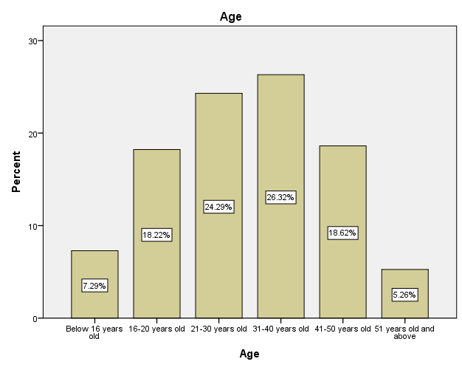
Figure 4.3 Age
Six different age groups have been divided. Refer to the data in table 4.7 and figure 4.3, the adult between 31-40 years old holds the largest amount which accounts for 26.3% in representing 65 respondents. There are 60 respondents (24.3%) belongs to the individual 21-30 years old. Moreover, there are 45 respondents(18.2%) belong to the individual 16-20 years old. Meanwhile, the individual who is aged between 41-50 years old obtains 18.6% in overall data collection as 46 respondents have participated. There are18 respondents (7.3%) belongs to the individual the Below 16 years old. The least respondents are coming from 51 and above years old which accounts for 5.3% equal to 13 respondents.

4.3.2.5 Education Level
Education Level
 |  | Frequency | Percent | Valid Percent | Cumulative Percent
Valid | High school and below | 71 | 28.7 | 28.7 | 28.7
Valid | Undergraduate | 86 | 34.8 | 34.8 | 63.6
Valid | Postgraduate | 62 | 25.1 | 25.1 | 88.7
Valid | Others | 28 | 11.3 | 11.3 | 100.0
Valid | Total | 247 | 100.0 | 100.0
Table 4.8 Education Level

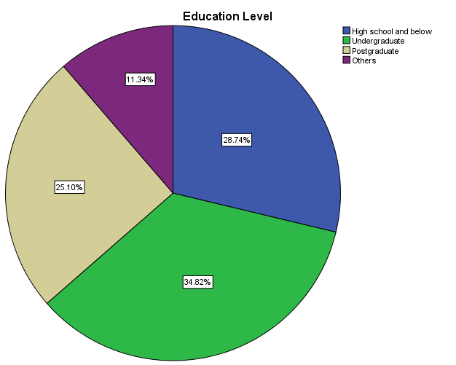
Figure 4.4 Education Level

The education level has been separated into four categories which have shown in table 4.8 and figure 4.4. The majority of respondents are falling into an undergraduate level which accounts for 86 respondents (34.8%). Then, it is followed by the respondents who come from high school and below the level that has 71 respondents (28.7%). The 62 respondents (25.1%) are contributed from the respondents who reach the postgraduate level. Other level accounts for 28 respondents (11.3%).

4.3.2.6 Status
Status
 |  | Frequency | Percent | Valid Percent | Cumulative Percent
Valid | Student | 26 | 10.5 | 10.5 | 10.5
Valid | Unemployed | 56 | 22.7 | 22.7 | 33.2
Valid | Employed | 68 | 27.5 | 27.5 | 60.7
Valid | Self-Employed | 71 | 28.7 | 28.7 | 89.5
Valid | Retired/Housewife | 26 | 10.5 | 10.5 | 100.0
Valid | Total | 247 | 100.0 | 100.0

Table 4.9 Status

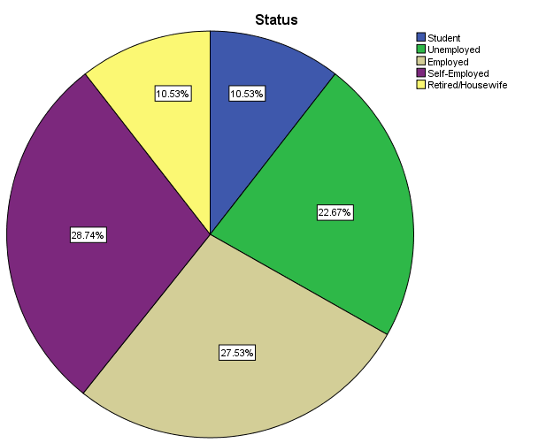

Figure 4.5 Status

Through the data of status showing in table 4.9 and figure 4.5, there are 26 respondents (10.5%) are student, 56 respondents (22.7%) are unemployed, 68 respondents (27.5%) are employed, 71 respondents (28.7%) are self-employed, and 26 respondents (10.5%) are retired or housewife. Hence, employed individuals and Self-Employee are the majority of respondents who have to participate in this survey.

4.3.2.7 Income Level (per month)
Income Level (Per month)
 |  | Frequency | Percent | Valid Percent | Cumulative Percent
Valid | Less than RM1500 | 27 | 10.9 | 10.9 | 10.9
Valid | RM1500-RM3000 | 60 | 24.3 | 24.3 | 35.2
Valid | RM3001-RM4500 | 66 | 26.7 | 26.7 | 61.9
Valid | RM4501-RM6000 | 71 | 28.7 | 28.7 | 90.7
Valid | More than RM6000 | 23 | 9.3 | 9.3 | 100.0
Valid | Total | 247 | 100.0 | 100.0
Table 4.10 Incom Level(per month)
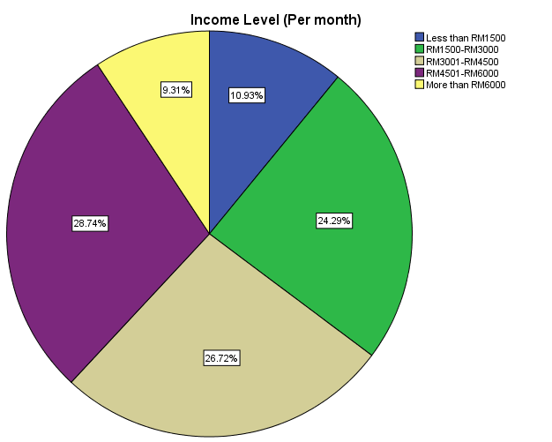
Figure 4.6 Income Level (per month)
Respondents are separated into different groups according to their income level (per month) which can refer in table 4.10 and figure 4.6. There are 71 respondents (28.7%) who earned RM4501-RM6000 per month and it belongs to the majority part of this survey. After that, there are 60 respondents (24.3%) who earn RM1500-RM3000 per month, whereby 66 respondents (26.7%) earn RM3001-RM4500 per month. Meanwhile, 27 out of 247 respondents have gained less than RM1500 monthly, which represents 10.9%. The rest of the 23 respondents (9.3%) are the one who earns more than RM6000 monthly.

4.3.2.8 Frequency of Doing Online Shopping
Frequency of doing online shopping
 |  | Frequency | Percent | Valid Percent | Cumulative Percent
Valid | At least once a week | 36 | 14.6 | 14.6 | 14.6
Valid | At least once a month | 60 | 24.3 | 24.3 | 38.9
Valid | At least once every 3 months | 80 | 32.4 | 32.4 | 71.3
Valid | At least once within 6 months | 54 | 21.9 | 21.9 | 93.1
Valid | At least once yearly | 17 | 6.9 | 6.9 | 100.0
Valid | Total | 247 | 100.0 | 100.0
Table 4.11 Frequency of Doing Online Shopping
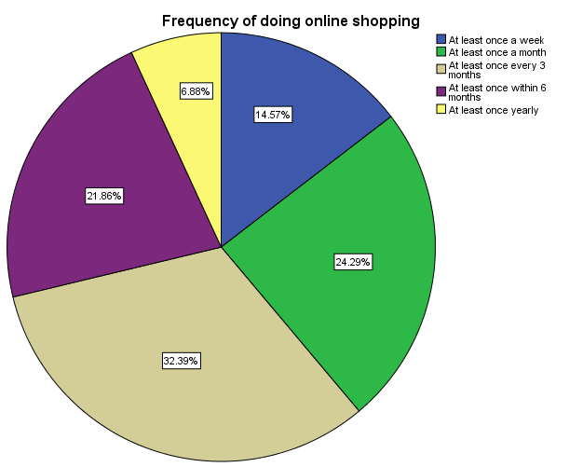

Figure 4.7 Frequency of Doing Online Shopping
In table 4.11 and figure 4.7 illustrates five divisions to know how frequently one individual will do online shopping. So, there are 36 respondents (14.6%) make an online Shopping at least once a week, 60 respondents (24.3%) make an online Shopping at least once a month, 80 respondents (32.4%) make an online Shopping at least once every 3 months, 54 respondents (21.9%) make an online Shopping at least once within 6 months, and 17 respondents (6.9%) make an online Shopping at least once yearly.

4.3.3 Linearity Test

4.3.3.1 Linearity Test for Platform Design
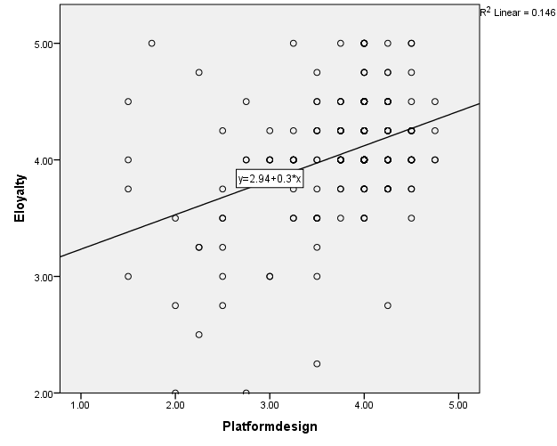

Figure 4.8 Linearity Test for Platform design
In figure 4.8, the R-square equal to 0.146 in which means that there is 14.6% of the variation happens between Platform design and customer e-loyalty. While the slope of this figure shows the number of 0.3 which represents it as per every 1 unit of Platform design increases, the customer e-loyalty will also increase for 0.3.

4.3.3.2 Linearity Test for Security
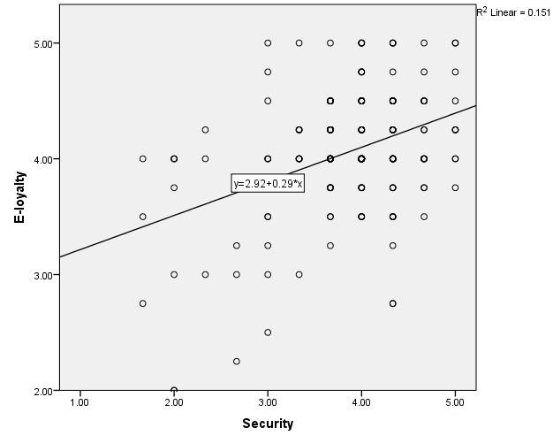
Figure 4.9 Linearity Test for Security
In figure 4.9, the R-square equal to 0.151 in which means that there is 15.1% of the variation happens between security and customer e-loyalty. While the slope of this figure shows the number of 0.29 which represents it as per every 1 unit of security increases, the customer e-loyalty will also increase for 0.29.

4.3.3.3 Linearity Test for Choice
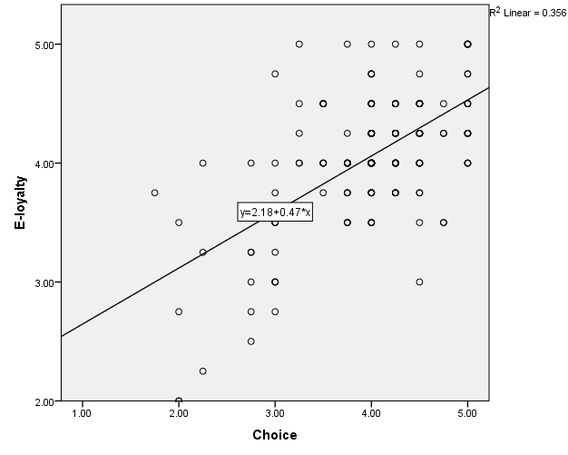
Figure 4.10 Linearity Test for Choice
In figure 4.10, the R-square equal to 0.356 in which means that there is 35.6% of the variation happens between choice and customer e-loyalty. While the slope of this figure shows the number of 0.47 which represents it as per every 1 unit of choice increases, the customer e-loyalty will also increase for 0.47.

4.3.4 Pearson Correlation Analysis
Correlations
 |  | Platform design | Security | Choice | E-Loyalty
Platform design | Pearson Correlation | 1 | .444** | .392** | .382**
Platform design | Sig. (2-tailed) |  | .000 | .000 | .000
Platform design | N | 247 | 247 | 247 | 247
Security | Pearson Correlation | .444** | 1 | .426** | .389**
Security | Sig. (2-tailed) | .000 |  | .000 | .000
Security | N | 247 | 247 | 247 | 247
Choice | Pearson Correlation | .392** | .426** | 1 | .596**
Choice | Sig. (2-tailed) | .000 | .000 |  | .000
Choice | N | 247 | 247 | 247 | 247
E-loyalty | Pearson Correlation | .382** | .389** | .596** | 1
E-loyalty | Sig. (2-tailed) | .000 | .000 | .000
E-loyalty | N | 247 | 247 | 247 | 247
**. Correlation is significant at the 0.01 level (2-tailed).
Table 4.12 Pearson Correlation Analysis
Correlation analysis helps in measuring the relationship between various variables. The significant value (2 tailed) needs to maintain at ≤0.05 or else it is non-significant if the value lies at ≥0.05 Moreover, it is common to fall in either -1 or 1 to determine the positive and negative relationship of the variables. Table 4.13 attached below can be used to determine the correlation level for every independent variable to the dependent variables that examine in this study.
The scale of Correlation Coefficient | Interpretation
0 ˂ r ≤ 0.19 | Very Low Correlation
0.2 ≤ r ≤ 0.39 | Low Correlation
0.4 ≤ r ≤ 0.59 | Moderate Correlation
0.6 ≤ r ≤ 0.79 | High Correlation
0.8 ≤ r ˂ 1.0 | Very High Correlation
Table 4.13 Correlation Coefficient Scale

4.3.4.1 Correlation between Platform design and E-Loyalty

Look at the Pearson correlation analysis in table 4.12, Platform design and customer e-loyalty has a significant value of 0.000 and correlates 0.382. This depicts the positive significant relationship between Platform design and customer e-loyalty. Hence, the hypothesis for Platform design and customer e-loyalty is accepted.

4.3.4.2 Correlation between Security and E-Loyalty

Refer to the Pearson correlation analysis in table 4.12, security and customer e-loyalty has a significant value of 0.000 and correlates 0.389. This depicts the positive significant relationship between security and customer e-loyalty. Hence, the hypothesis for security and customer e-loyalty is accepted.

4.3.4.3 Correlation between Choice and E-Loyalty

Based on the Pearson correlation analysis in table 4.12, choice and customer e-loyalty has a significant value of 0.000 and has a moderate correlation of 0.596. This depicts the positive significant relationship between choice and customer e-loyalty. Hence, the hypothesis for choice and customer e-loyalty is accepted.

4.3.5 Multiple Regression Analysis

4.3.5.1 Variable Entered/Removed
Variables Entered/Removed
Model | Variables Entered | Variables Removed | Method
1 | Choice, Platform design, Security |  | Enter
a. Dependent Variable: E-loyalty
b. All requested variables entered.
Table 4.14 Variable Entered/Removed
The table above indicates that all the variables are accepted and no need to delete them in this study. As a result, all the variables have proven to meet the expectation of statistical product and service solutions analysis.

4.3.5.2 Model Summary

Model Summary
Model | R | R Square | Adjusted R Square | Std. The error of the Estimate | Durbin-Watson
1 | .626ª | .392 | .384 | .37904 | 2.072
a. Predictors: (Constant), Choice, Platform design, Security
b. Dependent Variable: E-loyalty
Table 4.15 Model Summary
Based on the table, Durbin-Watson has chosen to find out the mistake or error in statistical analysis to obtain autocorrelation. In this study, the value of Durbin-Watson is 2.072 which lies between 1 to 3. So, there is no autocorrelation problem occur among the residuals or errors. Or else, it can be understood by there is no relationship in the independent error terms. And the standard error of the estimate is known as 0.37904.
Furthermore, the R-Square value is noticed to measure the relationship between the predictors and the outcomes of this research. The highest value of R-Square would reflect on the better of this model. As the result, the R-Square value can be seen as 0.392, whereby the R-value is known as 0.626. Hence, it means 39.2% of total variation towards the dependent variable of customer e-loyalty can be illustrated by the independent variable such as Platform design, security, and choice. So, the remaining 60.8% would have transferred to other variables that are not covered in this research.

4.3.5.3 ANOVA Model
ANOVA
Model |  | Sum of Squares | df | Mean Square | F | Sig.
1 | Regression | 22.491 | 3 | 7.497 | 52.181 | .000^{b}
1 | Residual | 34.912 | 243 | .144
1 | Total | 57.402 | 246
a. Dependent Variable: E-loyalty
b. Predictors: (Constant), Choice, Platform design, Security
Table 4.16 Analysis of Variance (ANOVA)
ANOVA model is also known as analysis of variance which is an examination device utilize to decide the impacts of independent variables on the dependent variable through means. In the ANOVA model, independent variables are notified as factors, while groups with each factor are mentioned as levels (Sawyer, 2009). The ideal significant value of the ANOVA model must control to not more than 0.05.
Refer to the table, the outcome of the significant value of ANOVA is 0.000, so it is acceptable. Also, the df value above displays that the three independent variables include Platform design, security, and choice in the regression result would influence the dependent variable named customer e-loyalty. However, the significant value of ANOVA doesn't evaluate each variable. Hence, it requires proceeding to the following coefficient analysis to measure the significant value of every single variable.

4.3.5.4 Multiple Regression Analysis on Coefficients
Coefficients
Model |  | Unstandardized Coefficients |  | Standardized Coefficients | t | Sig. | Collinearity Statistics
 |  | B | Std. Error | Beta | t | Sig. | Tolerance | VIF
1 | (Constant) | 1.755 | .195 |  | 9.017 | .000
1 | Platform design | .105 | .045 | .136 | 2.358 | .019 | .752 | 1.329
1 | Security | .090 | .044 | .118 | 2.017 | .045 | .728 | 1.374
1 | Choice | .389 | .045 | .493 | 8.629 | .000 | .767 | 1.303
a. Dependent Variable: E-loyalty
Table 4.17 Coefficients
To have an ideal coefficient significant value, each variable has to maintain the value lesser or equal to 0.05. Based on table 4.17, there are three independent variables are accepted. The accepted factors hold different significant values but have reached the benchmark. The hypothesis of Platform design is accepted with 0.019 of significant value. The hypothesis of security is accepted with 0.045 of significant value, whereby the hypothesis of choice is accepted too with 0.000 of significant value.

4.3.5.5Multiple Regression Equation

- loyalty=c+β platform design+βsecurity+βchoice+ε
Where
$c$ = Constant
$ε$ = Error Term

The new research equation can be derived and calculated as below:
E-loyalty=c+β platform design+βsecurity+βchoice+ε

E-loyalty=c(1.755) + β platform design(0.105) + βsecurity(0.090) + βchoice(0.389)+ε

4.4 Hypothesis Results

 | Hypothesis Statement | Significant Value | Gradient  Beta Value, $β$ | Result
H1 | There is a significant positive relationship between Platform design and e-loyalty among online customers in Malaysia. | 0.019 | 0.105 | Accepted
H2 | There is a significant positive relationship between security and e-loyalty among online customers in Malaysia. | 0.045 | 0.090 | Accepted
H3 | There is a significant positive relationship between choice and e-loyalty among online customers in Malaysia. | 0.000 | 0.389 | Accepted
Table 4.18 Hypothesis Results

4.5 Summary
The collection of 247 respondents’ data has been analyzed using IBM software SPSS to produce numerous findings of this research. There were several tests conducted to come out the results of the reliability test, and linearity test. Besides, analysis of correlation and multiple regression also being examined to verify the credibility of this research.

CHAPTER FIVE

5.0 CONCLUSION AND RECOMMENDATION

5.1 Introduction

This chapter will discuss the overall review of the research findings done by the distribution of questionnaires. Then, it will further explain the implication and limitation of this study. Meanwhile, there will be recommendations provided to enhance the research findings for future research purposes.

5.2 Overall Findings based on Research Objectives

This study has examined the factors of platform design, security, choice which influence e-loyalty among online customers in Malaysia. The context it has studies is based on the online customers who had the experience to do online shopping at least once in their life. In this research, it includes any age ranges of respondents from young to the old generation, because everyone's opinion is relatively important to finish this study as well as give an understanding of the e-commerce platform to know about the customers' preferences and the ways for improvement to achieve business growth.
Hypothesis Statement | Significant Value | Result
H1: There is a significant positive relationship between platform design and e-loyalty among online customers in Malaysia. | Sig: 0.019  B: 0.105 | Accepted
H2: There is a significant positive relationship between security and e-loyalty among online customers in Malaysia. | Sig: 0.045  B: 0.090 | Rejected
H3: There is a significant positive relationship between choice and e-loyalty among online customers in Malaysia. | Sig: 0.000  B: 0.389 | Accepted
Table 5.1 Overall Hypotheses Result
In table 5.1 above has shown the acceptances of hypotheses in platform design, security, choice.
H1: There is a significant positive relationship between platform design and e-loyalty among online customers in Malaysia.
Based on table 5.1, the hypothesis result shows a positive relationship between platform design and e-loyalty among online customers in Malaysia. It can be seen from the value of Pearson correlations of 0.019 and the beta value of 0.105. It proves that there is a positive relationship between platform design and e-loyalty among online customers in Malaysia as well as it has a correlation found between these two variables. This outcome is similar to Butt et al. (2018) as they said that platform design is a significant source to make a great first impression in the consumer's mind which attracts them to trade with the e-retailer and become loyal customers in the future.

H2: There is a significant positive relationship between security and e-loyalty among online customers in Malaysia.
According to table 5.1, the hypothesis result shows a positive relationship to be found between security and e-loyalty among online customers in Malaysia. The Pearson’s correlation value of a security with e-loyalty is 0.045 and the beta value is 0.090 which possesses a positive relationship. This factor is accepted due to its significant value is Less than 0.05. So, this is supported by Ponirin, Scott, and Heidt (2015) where they found that a perceived lack of security is the main reason for customers to leave the platform. A significant result has been obtained between security and e-loyalty.
H3: There is a significant positive relationship between choice and e-loyalty among online customers in Malaysia.
Table 5.1 demonstrates the relationship between choice and e-loyalty among online customers in Malaysia holds a positive correlation. The value of Pearson correlations is 0.000 and the beta value is 0.389 which belongs to correlation in the connection between choice and e-loyalty. There is a result shared by Al-dweeri, Obeidat, Al-dwiry, Alshurideh, & Alhorani (2017) with a similar outcome that has identified that choice has a positive and significant relationship to e-loyalty. due to customers pay high expectations to get better choices while they are doing online shopping. The e-commerce platform that gets to serves customers better will gain high repurchasing opportunities and convert more loyal customers.

5.3 Implication of the Study

This study is conducted to measure the factors influencing customer e-loyalty among online customers in Malaysia. All the data collected is based on the distribution of questionnaires in the Klang Valley area to identify the customer buying behavior and their expectation to purchase in the e-store. According to this research, the final result illustrated that the variables of platform design, security, and choice have a positive relationship with customer e-loyalty. Hence, this statement is useful for the e-commerce platform to make improvements of themselves to gain competitive advantages against its rivals.
Firstly, platform design is one of the factors that will affect customer e-loyalty. The data shown has made the e-retailer aware of this issue and strive to decorate and design their company's e-commerce platform with a beautiful surface as well as increase the searching and payment function. This would help the customers to decide whether want to stay in the e-commerce platform and make further research on the products and services the company has offered.
Next, the e-commerce platform that has many choices will gain customer e-loyalty. Currently, customers are willing to trade with an e-commerce platform that performs well in taking care of the customers’ needs and preferences. This helps the organization to build a long-run relationship with its existing customers. E-commerce platforms should put more concern with these factors and maybe, feedback can be collected to know the space for improvement that can make the company growing better. For example, giving good choice helps in retaining existing satisfied customer where it simultaneously can increase word-of-mouth.
Thirdly, the result of this research benefits those e-commerce platforms. This research has become a guideline for them to assess how to grow their business and maximize the profit of the company. Nevertheless, there is an advantage for future analysts who are interesting in researching a similar topic as is. Through referring to this study, future analysts will get the ideas and pieces of knowledge on the topic of factors influencing e-loyalty among online customers. While other readers will also get to know the pieces of knowledge of the current online market trend and customer buying behavior.

5.4 Limitation of the Study

While completing this research, there are certain limitations to be found out. The main limitation is related to the sample size being investigated. This would affect the research outcomes as the sample size being chosen is small which only includes the perceptions of individuals with 247 respondents' data. Additionally, a small sample size always leads to an increase in the margin of error and sampling bias. So, the result of this research may alter if the increases in sample size and target population will do. Furthermore, it is observed that the sample was collected based on the Malaysian context. Hence, the generalizability to other nations might be limited due to the differences in cultural behavioral and lifestyle behaviors. The behavioral thinking of individual in Malaysia may be different in other countries which are unable to generalize this study to fit all countries’ research. Therefore, it needs to take several investigations for the selection of choices before certain generalizing comments can be created. Future analysts must think of what research framework that they want to do to perform their ideal research outcomes that can benefit a certain group of people, society, economy, or even the country.
Besides that, in gathering the information, this study also escaped the possibility of respondents who might not have the experience as the factors have proposed in this study. As an example, there might have respondents who have never utilized or experienced online shopping.
Last but not least, the variables may be found too common or had been done by many researchers in the past. So, the assessment of the research can be broader which includes different factors that have never been used in this study. Innovation can be placed to extract the ideal factors which have relation to e-loyalty among online customers no matter in which countries. It is because the e-commerce trend often changes rapidly and hence continuous study should be done to prove the effectiveness of those factors to understand whether they still have a significant influence on e-loyalty.

5.5 Recommendation for Future Research

Considering the limitations mentioned in the earlier subsection, several recommendations ought to provide a beneficial guide to enhance the findings for future study. First and foremost, future researchers can increase the sample size to get a more sufficient and reliable data set. This is because the population in Malaysia is large and the sample size for 385 respondents doesn't provide accurate answers in this research topic. Hence, the sample size can be increased to acquire 500 respondents where the reliability of the study will also increase.
Moreover, an investigation should be made before some generalizing comments are created for further research on this topic. It is needed to study the factors in this research with additional population samples before generalization could be made, therefore, the validity and generalization level will increase. Other than that, the e-commerce platform has to give proper services to the customers to convert them into loyal customers and build a stronger bond. Therefore, e-commerce platforms need to update their insight or knowledge to provide what customers expected or needed. It can be attained by looking at the research publish online to make the performance of e-commerce platform better. It always has to make a continuous study on e-commerce because the trend moves rapidly and changes should make from an e-commerce platform to gain customer’s attraction and creditability by offering quality services.
Also, there are three independent variables are utilized to examine the factors influencing e-loyalty among online customers in Malaysia. In future studies, it is suggested to add more variables to this topic to find out more relevant factors that will influence customer e-loyalty. Many elements can be used to identify in further research, for example, SEQUAL (reliability, tangibles, assurance, responsiveness, empathy, services quality, availability, consistency, attitude) and WEBQUAL (design, ease of use, processing speed, tailored information, trust, response time, ease of understanding, innovativeness, on-line completeness). Also, increasing questions for each variable can be done to improve the result obtained. As well, it can increase the body knowledge on factors influencing customer e-loyalty among internet users in Malaysia.
Nevertheless, future analysts, E-commerce operators may look into the variables used in this study. Firstly, platform design should be concerned because customers will decide whether to stay or leave an e-commerce platform at first sight. So, it requires the e-commerce platform to invest in designing their company's website since it affects a lot of customer acquisition and customer retention.
Other than that, the e-commerce platform must concern the choice that provides to the customers. A good quality choice offered will be one of the reasons for the customers to make purchases in one e-commerce platform. Hence, the e-commerce platform should sustain in the marketplace by giving what other e-commerce platform doesn't provide. A good shopping experience can trigger the next purchase and satisfied customers will later become loyal customers to the company. And this would be the best situation where loyal customers as the biggest asset for one company to sustain in a long run.
In this study, the security factor is also important, but further research on this topic is needed to understand whether it has a direct or indirect impact on the e-loyalty of online customers in Malaysia. Recently, many e-commerce platform users pay attention to security and privacy when they want to make online purchases, because they may feel insecure if they need to fill in personal data. However, advanced technology and improved technology protect customers, because a more powerful firewall has been established to reduce the risk of cybercrime attacks. It allows customers to use online services freely without encountering many security issues. Therefore, due to the rapid development of e-commerce trends, as the results may change over time, more in-depth research on this factor is needed.

5.6 Conclusion

Platform design, security, and choice are the significant factors that will affect customer e-loyalty.
The checkout process and search function designed by the e-commerce platform will be convenient for customers to use and be loyal to this platform. If the e-commerce platform protects the security of customers’ personal information, customers will trust this e-commerce platform and be loyal to this platform. If this platform can choose many products and services, customers will be satisfied and be loyal to this e-commerce platform.
The overall outcomes and implications of this study are discussed throughout this chapter. It has proven to have deeper findings of this research topic due to its limitation that stated in between. Hence, recommendations for future research regarding this research topic are given to guide the research direction. In the end, it creates a better understanding of factors influencing e-loyalty among online customers in Malaysia which is an important topic to know by e-retailers that engage in online business.

Acknowledgment
Through this paper, first of all, thanks to Dr. Ow Yong for his advice. It made me very clear in the e-commerce field papers that I had misunderstood. Secondly, I learned to complete a master's degree thesis, structure, methods, and so on. Thirdly, the importance of communication. Timely communication with my supervisor will make me get twice the result with half the effort compared to my effort. I received great help and support from Dr. Ow Yong, who was very dedicated and professional in guiding my thesis. I am very grateful to Dr. Ow Yong and Dr. Ah Huai for their help, in the research of this article, through a lot of reading knowledge about e-loyalty. Let me gain more knowledge and insights into the e-commerce platform. It also made me more interested in this field. Whether I continue to engage in business activities or continue to engage in academic research in the future, this MBA project research will be very beneficial to me.

References
Abbaspou, B., & HazarinaHashim, N. (2015). International Journal of Science Commerce and Humanities, 3 (5), 6-17.
Achyar, A., & Brilliant, M. (2013). The impact of satisfaction and trust on the loyalty of e-commerce customers. Asian Marketing Journal, 5, 51-58.
Adeline, C., Harn, P., Khatibi, A., & Ismail, H. (2006). E-Commerce: A study on online shopping in Malaysia. Journal of Social Sciences, 13 (3), 231-242.
Akram, M. S. (2018). Drivers and barriers to online shopping in a newly digitalized society. TEM Journal, 7 (1), 118-127.
Al-dweeri, R. M., Moreno, A. R., Montes, F. J., Obeidat, Z. M., & Al-dwairi, K. M. (2019). The effect of choice on Jordanian student’s e-loyalty: An empirical study in online retailing. Industrial Management & Data Systems, 119 (4), 902-923.
Al-dweeri, R. M., Obeidat, Z., Al-dwiry, M. A., Alshurideh, D. M., & Alhorani, A. M. (2017). The impact of choice and e-loyalty on online shopping: Moderating effect of e-satisfaction and e-trust. International Journal of Marketing Studies, 9 (2), 92-103.
Al-Hawari, M. A. (2014). Does customer sociability matter? Differences in e-quality, e-satisfaction, and e-loyalty between introvert and extrovert online banking users. Journal of Services Marketing, 28 (7), 538-546.
Anderson, R. E., & Srinivasan, S. S. (2003). E‐satisfaction and e‐loyalty: A contingency framework. Psychology and Marketing, 20 (2), 123-138.
Armesh, H., Salarzehi, H., Yaghoobi, N. M., Heydari, A., & Nikbin, D. (2010). The effects of security and privacy information on trust & trustworthiness and loyalty in online marketing in Malaysia. International Journal of Marketing Studies, 2 (2), 223-234.
Asgari, N., Ahmadi, M. H., Shamlou, M., Farokhi, A. R., & Farzin, M. (2014). Studying the impact of choice on e-loyalty of customers. Journal of Management and Sustainability, 4 (2), 126-133.
Bao, Z., & Huang, T. (2018). Exploring stickiness intention of B2C online shopping malls: A perspective from platform design. International Journal of Web Information Systems, 14 (2), 177-192.
Baubonienė, Z., & Gulevičiūtė, G. (2015). E-Commerce factors influencing consumers’ online shopping decision. Social Technologies, 5 (1), 74-81.
Biswas, K. M., Nusari, M., & Ghosh, A. (2019). The influence of choice on customer satisfaction towards online shopping: The mediating role of confirmation of expectation. 5 (6), 7-14.
Brilliant, M. A., & Achyar, A. (2013). The impact of satisfaction and trust on the loyalty of e-commerce customers. ASEAN Marketing Journal (1), 51-58.
Bruin, J. (2006). Introduction to regression with SPSS lesson 2: SPSS regression diagnostics. Retrieved from UCLA: Statistical Consulting Group: https://stats.idre.ucla.edu/spss/seminars/introduction-to-regression-with-spss/introreg-lesson2/
Bryman, A., & Bell, E. (2015). Business research methods (4th Revised edition ed.). Oxford, United Kingdom: Oxford University Press.
Bucko, J., Kakalejčíka, L., & Ferencová, M. (2018). Online shopping: Factors that affect consumer purchasing behavior. Cogent Business & Management , 5 (1).
Burns, A. C., Veeck, A., & Bush, R. F. (2017). Marketing research (8th Edition ed.). England, United Stated: Pearson Education Limited.
Butt, M. M., Yu, Y., Mohd-Any, A. A., Mutum, D. S., Ting, H., & Wei, K. K. (2018). Antecedents of consumer-based electronic retail brand equity: An integrated model. Asian Academy of Management Journal, 23 (2), 66-99.
Chellappa, R. K. (2003, January). Consumers’ trust in electronic commerce transactions: The role of perceived privacy and perceived security. Emory University, 1-38.
Cherry, K. (2018, October 12). Cross-Sectional Research Method: How Does It Work? Retrieved November 1, 2018, from VeryWellMind: https://www.verywellmind.com/what-is-a-cross-sectional-study-2794978
Cheung, G. W., & Wang, C. (2017). Current Approaches for Assessing Convergent and Discriminant Validity with SEM: Issues and Solutions. Academy of Management Proceedings, Vol. 2017 (No. 1).
Chou, S., Chen, C.-W., & Lin, J.-Y. (2015). Female online shoppers: Examining the mediating roles of e-satisfaction and e-trust on e-loyalty development. Internet Research , 25 (4), 542-561.
Clifford, D., & Lang, M. (2012). What determines e-loyalty? An analysis of factors affecting online customer retention. IADIS International Conference, 203-210.
Cristobal, E., Flavian, C., & & Guinaliu, M. (2007). Perceived security: Measurement validation and effects on consumer satisfaction and e-commerce loyalty. Managing security, 17 (3), 317-340.
Cyr, D., Kindra, G. S., & Dash, S. B. (2008). platform design, trust, satisfaction, and e-loyalty: The Indian experience. Online Information Review, 32 (6), 773-790.
Del Águila-Obra, A. R., Padilla-Meléndez, A., & Al-dweeri, R. (2013). The influence of electronic security on loyalty in postal services: The mediating role of satisfaction. Total Quality Management and Business Excellence, 24 (9-10), 1111-1123.
Department of Statistics Malaysia. (2019, April 6). Selangor. Retrieved from The Source of Malaysia's Official Statistics: https://www.dosm.gov.my/v1/index.php?r=column/cone&menu_id=eGUyTm9RcEVZSllmYW45dmpnZHh4dz09
Doody, O., & Doody, C. M. (2015). Conducting a pilot study: a case study of a novice researcher. British Journal of Nursing, 24 (21), 1074-1078.
Dowling, G. R., & Uncles, M. D. (1997, July 1). Do customer loyalty programs work? 38 (4) , 71-82. Sloan Management Review.
Eid, M. I. (2011). Determinants of e-commerce customer satisfaction, trust, and loyalty in Saudi Arabia. Journal of Electronic Commerce Research, 12 (1), 78-93.
Ernst, A. F., & Albers, C. J. (2017). Regression assumptions in clinical psychology research practice—a systematic review of common misconceptions. PeerJ, 5.
Faraoni, M., Rialti, R., Zollo, L., & Pellicelli, A. C. (2019). Exploring e-Loyalty Antecedents in B2C e-Commerce: Empirical results from Italian grocery retailers. British Food Journal, 121 (2), 574-599.
Fishbein, M. A., & Ajzen, I. (1975). Belief, attitude, intention, and behavior: An introduction to theory and research. Reading, MA: Addison-Wesley.
Ghasemaghaei, M., & Hassanein, S. (2013, July 1). Consumers' satisfaction with online platform design: The moderating roles of consumer decision-making style, gender, and product involvement. ECIS 2013 Research in Progress, 1-7.
Ghasemi, A., & Zahediasl, S. (2012). Normality tests for statistical analysis: A guide for non-statisticians. International Journal of Endocrinology Metabolism, 10 (2), 486-489.
Grönroos, C. (1982). An applied service marketing theory. European Journal of Marketing, 16 (7), 30-41.
Grace, L. T., & Sun, C. C. (2009). Factors influencing satisfaction and loyalty in online shopping: An integrated model". Online Information Review , 33 (3), 458-475.
Guo, X., Ling, K. C., & Liu, M. (2012). Evaluating factors influencing consumer satisfaction towards online shopping in China. Asian Social Science , 8 (13), 40-50.
Hague, P. (2006). A practical guide to market research. British: Grosvenor House Publishing Ltd.
Hair, J. F., Black, W. C., Babin, B. J., & Anderson, R. E. (2010). Multivariate Data Analysis (Seventh ed.). Edinburgh Gate, Harlow: Pearson Education Limited.
Hila Ludin, I. H., & Cheng, B. L. (2014). Factors influencing customer satisfaction and e-loyalty: Online shopping environment among the young adults. Management Dynamics in the Knowledge Economy , 2 (3), 462-471.
International Telecommunication Union. (2018). Measuring the Information Society Report Volume 1. Switzerland: ITU Publications.
International Trade Administration [ITA]. (2019, August 19). Malaysia - eCommerce. Retrieved from export.gov: https://www.export.gov/article?id=Malaysia-E-Commerce
Jeon, M. M., & Jeong, M. (2017). Customers’ perceived choice and its effects on e-loyalty. International Journal of Contemporary Hospitality Management , 29 (1), 438-457.
Jiang, J. J., & Klein, G. (2009, January). Expectation-Confirmation theory: Capitalizing on descriptive power. Handbook of Research on Contemporary Theoretical Models in Information Systems , 384-401.
Junyong, I. (2017). Introduction of a pilot study. Korean J Anesthesiol , 70 (6), 601-605.
Khristianto, W., Suyadi, I., & Kertahadi. (2012). The influence of information, system quality, and choice on customer satisfaction and loyalty in online shopping. International Journal of Academic Research , 4 (2), 28-42.
Krejcie, R. V., & Morgan, D. W. (1970). Determining sample size for research activities. Educational and Psychological Measurement , 30, 607-610.
Liew, Y. S., & Falahat, M. (2015). Conceptualising consumers’ purchase intention towards online. Global Journal of Business and Social Science Review , 3 (1), 351-359.
Lim, Y. J., Abdullah, O., Shahrul, N. S., Abdul, R. R., & Safizal, A. (2016). Factors influencing online shopping behavior: the mediating role of purchase intention. Procedia Economics and Finance , 35, 401-410.
Lim, Y. J., Osman, A., Salahudin, S., Romle, A., & Abdullah, S. (2016). Factors influencing online shopping behavior: The mediating role of purchase intention. Procedia Economics and Finance , 35, 401-410.
Lin, Y., Luo, J., Cai, S. Q., Ma, S. H., & Rong, K. (2016). Exploring the choice in the e-commerce context: a triadic view. Industrial Management & Data , 116 (3), 388-415.
Lutabingwa, J., & Auriacombe, C. (2007). Data analysis in quantitative research. Journal of Public Administration , 42 (6), 528-548.
Malaysia population. (2019). Retrieved from Worldometers: http://www.worldometers.info/world-population/malaysia-population/
Manpreet, K. (2015). Influential factors of choice affecting e-loyalty in e-retailing. International Journal of Advance Research in Computer Science and Management Studies , 3 (12), 34-41.
McDaniel, C. J., & Gates, R. (2013). Marketing research (9th Edition ed.). United States: John Wiley& Sons Singapore Pre. Ltd.
Mobarakabadia, H., Karamib, M., Farb, S. M., & Yarkaramic, K. (2013). Influence of online shopping behavior factors on e-satisfaction of customer. Jurnal Teknologi , 64 (3), 1-7.
Nasimi, A. N., Nasimi, R. N., & Basit, R. A. (2018). Factors affecting e-commerce customer loyalty in Pakistan. Journal of Marketing and Consumer Research , 49, 17-30.
Oliver, R. L. (1980). A cognitive model of the antecedents and consequences of satisfaction decisions. Journal of Marketing Research , 17 (4), 460-469.
Oliver, R. L. (1997). Satisfaction: A behavior perspective on the consumer. New York, NY: McGraw-Hill.
Oliver, R. L. (1999). Whence consumer loyalty? Journal of Marketing , 33-44.
Ong, S. T., Md Ariff, M. S., Zakuan, N., Sulaiman, Z., & Mat Saman, M. Z. (2016). e-commerce platform, e-satisfaction and e-loyalty of online shoppers in business to consumer market; Evidence form Malaysia. IOP Conference Series: Materials Science and Engineering , 131, 1-10.
Pandey, S., & Chawla, D. (2018). Online customer experience (OCE) in clothing e-retail: Exploring OCE dimensions and their impact on satisfaction and loyalty – Does gender matter? International Journal of Retail & Distribution Management , 46 (3), 323-346.
Parra-Lopez, E., Martínez-gonzález, J. A., & Chinea-Martin, A. (2018). Drivers of the formation of e-loyalty towards tourism destinations. European Journal of Management and Business Economics , 27 (1), 66-82.
Patrick, A., Li, Z., Abubakar, R., Antwi, H. A., & Akomeah, M. O. (2016). Stimulants of online shopping behaviour among chinese millenials in China. International Journal of Academic Research in Business and Social Sciences , 6 (5), 331-349.
Ponirin, Scott, D., & Heidt, T. v. (2015, January). E-loyalty: Its antecedents, implications and differences between developed and developing countries. Cultural Perspectives in a Global Marketplace: Proceedings of the 2010 Cultural Perspectives in Marketing Conference , 77-82.
Pratminingsih, S. A., Lipuringtyas, C., & Rimenta, T. (2013). Factors influencing customer loyalty toward online shopping. International Journal of Trade, Economics and Finance , 4 (3), 104-110.
Rahman, M. A., Islam, M. A., Esha, B. H., Sultana, N., & Chakravorty, S. (2018). Consumer buying behavior towards online shopping: An empirical study on Dhaka city, Bangladesh. Cogent Business & Management , 5 (1), 1-22.
Rialti, R., Zollo, L., Pellegrini, M. M., & Ciappei, C. (2017). Exploring the antecedents of brand loyalty and electronic word of mouth in social-media-based brand communities: do gender differences matter? Journal of Global Marketing , 30 (3), 147-160.
Saunders, M., Lewis, P., & Thornhill, A. (2015). Research Methods for Business Students (7th New edition ed.). Harlow, United Kingdom: Pearson Education Limited.
Saunders, M.N.K. , Lewis, P., Thornhill, A. (2015). Research Methods for Business Students (7th New edition ed.). Harlow, United Kingdom: Pearson Education Limited.
Sawyer, S. (2009). Analysis of variance: The fundamental concepts. The Journal of manual & manipulative therapy , 17 (2).
Sekaran, U. &. (2016). Research methods for (Seventh ed.). New York: John Wiley & Sons Publisher.
Shanker, V., Smith, A., & Rangaswamy, A. (2003). Customer satisfaction and loyalty in online. International Journal of Research in Marketing , 20 (2), 153-175.
Sobihah, M., Mohamad, M., Ali, N. A., & Ismail, W. Z. (2015).Choice on customer satisfaction, belief and loyalty: A proposal. Mediterranean Journal of Social Sciences , 6 (2), 260-266.
Statista. (2019). eCommerce in Malaysia. Retrieved from Statista: https://www.statista.com/outlook/243/122/ecommerce/malaysia
Statista Research Department. (2019). Statista. Retrieved from Number of internet users in Malaysia from 2017 to 2023 (in millions): https://www.statista.com/statistics/553752/number-of-internet-users-in-malaysia/
Suruhanjaya Komunikasi dan Multimedia Malaysia [SKMM]. (2018). Internet users survey 2018. Cyberjaya, Selangor: Malaysian Communications and Multimedia Commission.
Taherdoost, H. (2016). Sampling methods in research methodology; how to choose a sampling technique for research. International Journal of Academic Research in Management , 5 (2), 18-27.
Tavakol, M., & Dennick, R. (2011). Making sense of Cronbach’s alpha. International Journal of Medical Education , 2, 53-55.
Tavakol, M., & Dennick, R. (2011). Making Sense of Cronbach's Alpha. International Journal of Medical Education (2), 53-55.
Thakur, R. (2018). The role of self-efficacy and customer satisfaction in driving loyalty to the mobile shopping application. International Journal of Retail & Distribution Management , 46 (3), 283-303.
The effects of security and privacy information on trust & trustworthiness and loyalty in online marketing in Malaysia. (n.d.). International Journal of Marketing Studies .
United Stated Census Bureau. (2019, July 1). World Population. Retrieved from United Stated Census Bureau: https://www.census.gov/newsroom/stories/2018/world-population.html
Wantara, P., & Tambrin, M. (2019). The effect of price and product quality towards customer satisfaction and customer loyalty on madura batik. International Tourism and Hospitality Journal , 2 (1), 1-9.
Williams, H., He, W., & Conners, S. E. (2018). Stakeholder loyalty in mergers: An application of theory of planned behavior. Journal of Academic Administration in Higher Education , 14 (1), 37-44.
Xiao, L., Guo, Z., D’Ambra, J., & Fu, B. (2016). Building loyalty in e-commerce: Towards a multidimensional trust-based framework for the case of China. Program: Electronic library and information systems , 50 (4), 431-461.
Yun, Z. S. (2007). Developing customer loyalty from e-tail store image attributes. Managing choice: An International Journal , 17 (1), 4-22.
Zohrabi, M. (2013). Mixed method research: instruments, validity,reliability and reporting findings. Theory and Practice in Language Studies , 3 (2), 254-262.

Appendix

INTI International University Master of Business Administration MGT7998 Initial Research Paper Proposal

 | STUDENT NAME & ID NO | WANG YAO I20018565
 | Concise Title | FACTORS INFLUENCING E-LOYALTY AMONG ONLINE CUSTOMERS IN THE E-COMMERCE PLATFORM, KLANG VALLEY MALAYSIA
 | Problem Statement | What factors of e-commerce platforms will affect e-loyalty? It is a big challenge for e-commerce platform operators to obtain e-loyalty from customers.
 | Research Questions OR Objectives | RQ1 - Does platform design influence e-loyalty among online customers in Malaysia?  RQ2 - Does security influence e-loyalty among online customers in Malaysia?  RQ3 - Does choice influence e-loyalty among online customers in Malaysia?
 | Scope of study | The scope of my research is limited to only the e-commerce platform.  The target area of respondent: Respondents in Klang Valley, Malaysia.  Limited factor affecting e-loyalty: Platform design, Security, Choice.
 | Significance of the Research | This research can improve the efficiency of the e-commerce platform to develop a new plan to serve online buyers. This study helps workers to deal with problems faster for the research.  This study of the research will provide references for future scholars to continue to study the e-loyalty among online customers in Malaysia.
 | Research Methodology | Primary data  Online Questionnaire collected from respondents.  Quantitative method  Reliability test  Descriptive analysis  Correlation Analysis  Multiple Linear Analysis
PROJECT PAPER LOG

This is an important document, which is to be handed in with your dissertation. This log will be taken into consideration when awarding the final mark for the dissertation.

Student Name: | Wang Yao
Supervisor’s Name: | Dr. Ow Yong
Dissertation Topic:

FACTORS INFLUENCING E-LOYALTY AMONG ONLINE CUSTOMERS IN THE E-COMMERCE PLATFORM, KLANG VALLEY MALAYSIA

SECTION A. MONITORING STUDENT DISSERTATION PROCESS
The plan below is to be agreed between the student & supervisor and will be monitored against progress made at each session
Activity | Milestone/Deliverable Date
Activity | September | October | November | December
The project topic determined | √
The related literature articles | √
The analysis method |  | √
Methodology |  | √
Study population |  | √
Data collection |  |  | √
Descriptive analysis |  |  | √
Correlation analysis |  |  | √
Recommendation |  |  | √
Limitation |  |  |  | √
Conclusion |  |  |  | √
The whole paper checking |  |  |  | √

SECTION B.
Ethics form protocol number:
SECTION C. RECORD OF MEETINGS
The expectation is that students will meet their supervisors up to ten times and these meetings should be recorded.
Meeting 1
Date of Meeting | 05/10 2020
Progress Made | This meeting mainly discussed the confirmation of the thesis title and the general content of the whole thesis with my supervisor. The main direction of the paper is e-commerce -----e-loyalty.
Agreed Action | Reached a consensus on the main content of the project.
Student Signature | Wang Yao
Supervisor’s  Signature | Ow Yong

Meeting 2
Date of Meeting | 12/10 2020
Progress Made | Discussed the determination of the final topic. And how to structure the paper. Continued to read independent variables and dependent variable.
Agreed Action | Agreed topic: Analysis of factors influencing e-loyalty in Malaysia. Continued to read a lot of articles related on e-loyalty.
Student Signature | Wang Yao
Supervisor’s  Signature | Ow Yong

Meeting 3
Date of Meeting | 19/10 2020
Progress Made | According to the suggestions given by Dr.Ow Yong, the contents of the Chapter 1to Chapter 3 are summarized. And continued to read a lot of literature about it.
Agreed Action | Continued to explain the definitions of independent and dependent variables
Student Signature | Wang Yao
Supervisor’s  Signature | Ow Yong

Meeting 4
Date of Meeting | 26/10 2020
Progress Made | This meeting was going to confirm Chapter 3-----Methodology. To discuss sample size and sampling method. And by using quantitative analysis method----Multiple Linear regression was used.
Agreed Action | The meeting agreed on the methodology to be used
Student Signature | Wang Yao
Supervisor’s  Signature | Ow Yong

Meeting 5
Date of Meeting | 02/11 2020
Progress Made | Present PPT
Agreed Action | Read a lot of relevant articles in the Literature Review Chapter. Improved the independent variables and dependent variables.
Student Signature | Wang Yao
Supervisor’s  Signature | Ow Yong

Meeting 6
Date of Meeting | 9/11 2020
Progress Made | This meeting mainly discussed the Conceptual Framework. Modify the independent and dependent variables.
Agreed Action | It is agreed the Modify the independent and dependent variables
Student Signature | Wang Yao
Supervisor’s  Signature | Ow Yong

Meeting 7
Date of Meeting | 16/11 2020
Progress Made | Modify the independent variable and determine the definition of the independent variable.
Agreed Action | The supervisor advised and agreed that Change of independent variable and design of the questionnaire.
Student Signature | Wang Yao
Supervisor’s  Signature | Ow Yong

Meeting 8
Date of Meeting | 23/11 2020
Progress Made | Distribute questionnaires and collect data
Agreed Action | Agreed to collect data
Student Signature | Wang Yao
Supervisor’s  Signature | Ow Yong

Meeting 9
Date of Meeting | 30/11 2020
Progress Made | Data reliability analysis, descriptive analysis, Pearson correlation analysis, multiple regression analysis
Agreed Action | Agree with the data analysis section
Student Signature | Wang Yao
Supervisor’s  Signature | Ow Yong

Meeting 10
Date of Meeting | 05/12 2020
Progress Made | Improve the PPT content of the second defense
Agreed Action | This meeting agree to the contents of the PPT in chapters 1 to 5
Student Signature | Wang Yao
Supervisor’s  Signature | Ow Yong

Section D. Comments on Management of Project

(to be completed at the end of the dissertation process)

Student Comments

Through this paper, first of all, thanks to Dr. Ow Yong for his advice. It made me very clear in the e-commerce field papers that I had misunderstood. Secondly, I learned to complete a master's degree thesis, structure, methods and so on. Thirdly, the importance of communication. Timely communication with my supervisor will make me get twice the result with half the effort compared to myself effort.

Supervisor Comments

Despite the challenging beginning, the student has managed to work to his best capacity and handle the project.

Signature of  Student Wang Yao | Date 18/12 2020
Signature of  Supervisor Ow Yong | Date 18/12 2020

