

**MGT7998**

**MBA Project**

**The influential factors of China cross border logistics on cross border e-commerce and countermeasures**

Name : CHEN PING

Student ID : I19017721

Programme : MBA

Supervisor : Heong Shya Lie

**Table of content**

Chapter 1 : Introduction 1

1.0 Overview 1

1.1 Background of the Study 1

1.2 Cross-border logistics problem statement 3

1.2.1 High cost of cross-border logistics 3

1.2.2 Imperfect logistics infrastructure 4

1.2.3 Logistics policy change 5

1.2.4 Lack of logistics talents 6

1.3 Research Objective 7

1.4 Research questions 8

1.5 Significance of the Research 9

1.5.1 Significance to Industry 9

1.5.2 Significance to Academia 9

1.6 Scope of Study 10

1.7 The key definition of cross-border logistics 10

1.8 Organization Chapter 11

Chapter 2: Literature Review 12

2.1 Key concepts 12

2.1.1 Cross border e-commerce 12

2.1.2 Overseas warehouses 13

2.2 Cross-border logistics model 13

2.2.1 Postal Parcel Mode 13

2.2.2 Dedicated line logistics model 13

2.2.3 Express logistics model 14

2.2.4 Overseas warehouse model 15

2.3 Influencing factors of cross-border logistics 16

2.3.1 Logistics costs 16

2.3.2 Logistics infrastructure 17

2.3.3 Logistics policy 18

2.3.4 Logistics talent 19

2.4 Gaps in the Literature 20

2.5 Hypotheses 20

2.6 Fundamental Theory 21

2.6.1 PEST analysis 21

2.7 Conceptual Framework 22

2.8 Conclusion 22

Chapter 3: Research Method 23

3.0 Overview 23

3.1 Research Design 23

3.1.1 Descriptive and explanatory research 23

3.1.2 Deduction and Induction 24

3.2 Methods of Research 24

3.2.1 Design Questionnaire 24

3.2.2 Questionnaire 25

3.3 Unit of Analysis 26

3.4 Sampling and Population 26

3.5 Methods and analysis for data collection 26

3.5.1 Data collection 27

3.5.2 Data Analysis 27

3.6 Ethical Considerations 28

3.7 Problems and Limitations 28

3.8 Conclusion 29

Chapter 4:Research Findings 29

4.0 Overview 29

4.1 Pilot Test 29

4.1.1 Reliability Test 29

4.1.2 Factor Analysis 30

4.1.3 Kiser-Meyer-Olkin (KMO) 31

4.1.4 Eigenvalues 32

4.1.5 Factor Loading 34

4.1.6 Communality analysis 34

4.2 Data Analysis 36

4.2.1 Reliability and validity analysis 36

4.2.2 Descriptive Analysis 39

4.2.3 Correspondence analysis 40

4.2.4 One-way analysis of variance 41

4.3 Hypothesis Testing 44

4.4 Multiple Regression Analysis 47

4.5 Conclusion 50

Chapter 5: Countermeasures and Conclusion 51

5.0 Overview 51

5.1 Countermeasures 51

5.1.1 Countermeasures for logistics costs 51

5.1.2 Countermeasures for logistics infrastructure 52

5.1.3 Countermeasures of logistics policy 53

5.1.4 Countermeasures to solve logistics talents 54

5.2 Conclusion 55

References 56

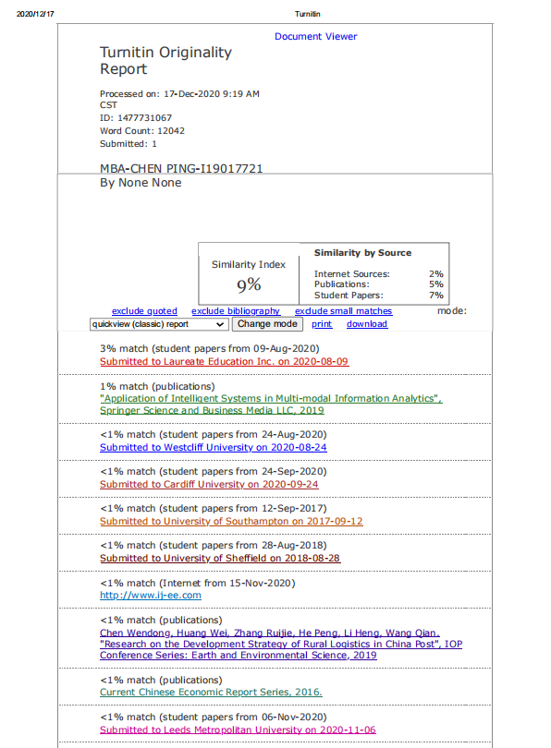

**Research Title**

The influential factors of cross border logistics on cross border e-commerce and countermeasures

**Abstract**

The business and market share of cross-border e-commerce is increasing every year . As for the growth trend of cross-border e-commerce logistics, researchers intend to use cross-border logistics to influence cross-border e-commerce, and find out the factors and countermeasures that affect the development of cross-border logistics.

On the basis of the previous research on cross-border logistics, PEST theory will be used as the basic theory to illustrate how cross-border logistics affects cross-border e-commerce in the development process of cross-border e-commerce.

The idea of this research is to distribute the questionnaire to workers engaged in cross-border logistics through the Internet to collect a sample size of about 350 to test and verify the hypothesis, so as to find and test the factors that may affect the development of cross-border e-commerce. The literature review leads to hypotheses.

The results of the study formulate appropriate strategies and methods for cross-border e-commerce development, so as to understand which cross-border logistics factors are the most fundamental issues.

**Keywords: Cross-border logistics, Cross-border e-commerce, Logistics cost, Logistics infrastructure, Logistics policy，Logistics talent**

**Chapter 1 : Introduction**

**1.0 Overview**

The first chapter outlines the cross-border logistics factors that will affect e-commerce across borders. This section is based on research on the impact of cross-border logistics factors on e-commerce across borders. Secondly, based on cross-border logistics influencing factors, problem statements, research goals and research questions are put forward. In addition, the significance of the research, the scope and limitations of the research, and the definition of cross-border logistics are also included. Which will define the key terms used in cross-border logistics.

**1.1 Background of the Study**

With the growing popularity of the globalization of the world economy and the support of emerging technologies, e-commerce is developing rapidly on a global scale. Therefore, cross-border logistics has become one of the most common problems faced by e-commerce across borders.E-commerce transactions between different countries are very frequent worldwide and cross-border logistics have become the basis and assurance of cross-border e-commerce. E-commerce provides global trade with powerful platforms and channels, promotes the circulation of global commodities, and enriches the diversity of shopping for people.

E-commerce Cross-border is an international business activity in which, through cross-border logistics, both parties to transactions in various countries complete transactions, make payments and settlements through Internet channels, and deliver goods and complete transactions.Liu Zhifu (2019) confirmed that the role of independent variable (cross-border logistics) is primarily to help dependent variable improve operational efficiency. For example, increase platform sales and shorten the delivery time of goods.Cross-border logistics is an important factor in consumers' overall evaluation of purchased goods. Cross-border e-commerce companies can also expand their overseas market share through cross-border logistics(Liu , 2019).[[1]]

The cross-border business model of e-commerce is still dominated by B2B,but the proportion of B2C orders is constantly increasing, from 2.5% in 2011 to 11.3% in 2016. Cross-border electricity supplier turnover growth of more than 21% average annual rate. the total number of worldwide B2C e-commerce consumers get 943 million.The cross-border logistics industry's market size is growing year by year.

Logistics infrastructure is relatively lagging in comparison with developed countries, and the proportion of modern facilities is low.Unable to meet the requirements of modern logistics development.A logistics park system has not yet been established with a reasonable layout and complete functions, and the logistics infrastructure has not been matched and it is difficult to connect effectively.At the same time, the logistics are not systematic and comprehensive, the transportation structure is irrational, and the degree of network and organization is low.

Logistics companies in China lack motivation for innovation, low investment in R&D, and lag behind innovation in the business model, organisational innovation, technological innovation, and innovation in management.International logistics companies in China are small in scale, not only lacking scale benefits, it is difficult to undertake large-scale business projects, their scope of business is single.The establishment of a complete logistics chain is very difficult.The operations of many domestic logistics companies are not standardised, service awareness is weak, legal awareness is weak, and there is no credit system.The standardised and orderly logistics market is far from forming a unified, open, fair competition(Li et al, 2019)[[2]].

China's logistics cost has been hovering around 18%, twice that of developed countries and 6.5 percentage points are higher than the global average.And it's also higher compared to BRIC countries with basically the same level of economic development,Such as 13 percent of India and 11.6 percent of Brazil .This data shows that there are many problems in my country's logistics market. The most important reason is the shortage of talents. If companies lack talents, problems will arise in their internal structure. If things go on like this for many companies.The development of the entire social logistics sector will definitely be affected.

In short, the cross-border logistics industry is a rapidly growing industry on a global scale. This article focuses on which factors in cross-border logistics have an impact on dependent variable. Due to differences in logistics costs, logistics infrastructure, logistics policies and logistics talent in each country, there are certain restrictions on the dependent variable. To understand the impact of cross-border logistics factors on e-commerce across borders. It is therefore necessary to study.

**1.2 Cross-border logistics problem statement**

The development and upgrading of cross-border logistics has driven the rapid development of cross-border e-commerce. A broad space for the development of cross-border logistics has been provided by cross-border e-commerce.The development of cross-border logistics has been strongly promoted by cross-border e-commerce development.The expansion of cross-border e-commerce has come with a strong potential market.However in view of the cross-border logistics of cross-border e-commerce, this is a new sector. There is still a lack of control over the entire process, and many problems remain to be addressed.

**1.2.1 High cost of cross-border logistics**

Costs for transportation, customs duties and overseas logistics costs do not include cross-border logistics costs. There should be cost control in cross-border e-commerce. They are caused by various factors such as tariffs, foreign transshipment, and foreign storage. Logistics costs cannot be effectively controlled, and logistics channels will change accordingly according to the policies of different countries and regions(Giuffrida, Mangiaracina and Tumino, 2019).[[3]]In customer return and exchange disputes, cross-border e-commerce is mainly aimed at overseas customers, so international logistics costs are very high, including time costs and financial costs(Wang , Xie and Fan , 2020).[[4]]

For many reasons, the high ratio of China's total cost of social logistics to GDP is not only related to the economic development stage, but also closely related to the level of development of logistics.China’s industrial structure and industrial layout determine that the tertiary industry accounts for less than 50%, while the tertiary industry in developed countries such as the United States accounts for more than 70%. China consumes large quantities of low-value raw materials such as coal and ore in conjunction with industrial design reasons. The distance from transport is far, leading to the large scale of the logistics and high transport costs of my country. Although labour costs are high in the United States, the average level of logistics charges is about twice that of my country.

Internationally, the logistics expense rate indicator, another important indicator of the level of logistics development of the industry, i.e. the proportion of enterprise logistics costs in product sales, is mainly obtained through surveys of manufacturing and trading enterprises.According to a survey conducted by the Japan Logistics System Association, in 2018, logistics costs accounted for 4.7 percent of sales in multiple industries in Japan; according to a survey by the US Supply Chain Management Consulting Company, this indicator in the US was 7.9 percent in 2018. China's indicator is 8.6 percent, of which the logistics expense ratio of industrial companies is 9.2 percent, and wholesale and retail companies are 7.8 percent, according to a survey conducted by the China Federation of Logistics and Purchasing. This demonstrates that a very important task is cost control.

**1.2.2 Imperfect logistics infrastructure**

Cross-border e-rapid commerce's growth has provided significant historical opportunities for the growth of the express delivery industry, which not only expanded the logistics demand, but also stimulated the structural adjustment of the logistics industry.The coordinated development of cross-border e-commerce and logistics has also exposed a number of immature and immature ones,imperfect logistics system, irrational structure, and insufficient infrastructure development for e-commerce services.Logistics resources are subdivided, such as transport, warehousing, distribution and express delivery, and service capabilities are weak (Fedorenko, 2020).[[5]] In the face of e-commerce needs of different scales, forms and regions, as well as fast-changing business models, logistics is difficult to meet in terms of quantity and quality.

The Internet is the primary battlefield of dependent variable. Faced with the explosive growth in recent years of online sales.In most countries, the construction of logistics infrastructure has not yet been able to make docking and integration of logistics logistics with the destination country possible.An imperfect logistics foundation may cause the package to be lost or damaged during transportation. It is therefore difficult to compensate for the increased losses incurred by cross-border e-commerce e-commerce and cross-border operating costs（Kampan and Tanielian, 2017）.[[6]]

**1.2.3 Logistics policy change**

There is a large area for warehousing facilities, transshipment centres and logistics parks and other logistics infrastructure.A large capital investment, and a long period of payback.The management of land resources is not in place, and there is no reasonable layout of the distribution of logistics infrastructure. There are a large number of industrial enterprises’ old factories that have not been used rationally; for the transfer or lease of land use rights, the procedures for the paid use of land are complicated and complicated(Wang and Li, 2020)[[7]].

Coordinate and improve relevant tax support policies according to the industry characteristics of the logistics industry and the integration, socialisation, networking and large-scale development requirements of logistics companies. Business tax rate between warehousing, distribution, freight and transportation is inconsistent.

Logistics is mainly engaged in the transportation industry, and generally does not receive goods or deliver goods to your door. The fees collected should be invoiced for the transportation industry.However, a small number of logistics companies have not implemented the current tax policies, deliberately treating transportation expenses as logistics auxiliary service fees, and declared and paid the value-added tax for logistics auxiliary services at a tax rate of 6%, and failed to declare and pay the value-added tax for the transportation industry at the applicable tax rate.

Generally speaking, the main business of express companies are sorting and packaging, inter-city transportation, and intra-city express delivery. If there is intercity transportation, the freight should account for most of the company's business.However, when most courier companies report the postage they charge, they usually declare more receipts and delivery income and less transportation income. In addition, the customers are mostly individuals, so there is no need to deduct tax, even for merchants that need to deduct. Because of the weak voice, the freight item invoice could not be obtained, or the logistics auxiliary invoice amount requested was much larger than the freight invoice amount.

**1.2.4 Lack of logistics talents**

The accelerated logistics industry's growth will inevitably increase the demand from companies and society for talent. The rapid evolution of the logistics industry has also led to an increase in the demand for logistics personnel in the industry.At present, there are not enough logistics talents in the industry, and the lack of logistics talents has caused problems in the logistics industry and cannot be solved.The education and training of logistics talents have not kept up with the needs of economic development, Which in a short period of time is hard to solve.Today, the construction of logistics majors in higher education is relatively slow due to the significant pressure of the contradiction between the supply and demand of logistics talent. The development and certification of logistics industry-related standards needs to be vigorously promoted so that employees engaged in logistics work or planning to participate in logistics can master professional skills through on-the-job training.Logistics knowledge and skills(Cui, 2018)[[8]].

The absence of logistics talents is mainly reflected in two aspects, procurement talents and supply chain management talents, in the face of the current shortage of talents in China's logistics industry..Purchasing talents: With the growing importance of purchasing behaviour in corporate strategy, one of the important indicators for measuring team spirit is mutual cooperation.The practice has proved that procurement talents under the supply chain system must save costs to the greatest extent in the implementation of procurement. Not only must the price factor be considered, but also the operation of each link of the supply chain must be understood, and the different characteristics, functions and functions of procurement in each link must be clarified. significance.Nowadays, procurement is diversified, cross-country, and cross-regional procurement. Therefore, procurement talents under the supply chain system must have good foreign language communication skills and always pay attention to events in the supply chain such as raw material price fluctuations and climate fluctuations. And so on, have a keen sense of the influencing factors, and be able to take early warning and preventive measures in time.

Supply chain management talents: Competition between businesses and companies is between the supply chain and the supply chain,and even the currency capital required for the competition between the country and the country, in the final analysis, is created and obtained by human knowledge and wisdom.Many companies have realized that supply chain management is a key link in building an excellent company. Traditional logistics managers, however only face a single corporate link and are unable to satisfy the requirements of an integrated supply chain.Inside and outside the company, the supply chain integrates information, so supply chain managers must have practical experience in sales forecasting, procurement, planning, material distribution, import and export, and other links. In supply chain management, what these talents do is plan, coordinate, operate, control, and optimise the whole supply chain system of the company.

**1.3 Research Objective**

Analyze the current status and current influencing factors of cross-border e-commerce logistics and propose future development strategies, hoping to contribute to dependent variable.

The main purpose of this research is to understand the cross-border logistics factors that impact e-commerce across borders. To this end, the following specific objectives will be considered as well:

RO1: Determine whether logistics costs affect cross-border e-commerce.

RO2: Determine whether the logistics infrastructure affects cross-border e-commerce.

RO3: Determine whether logistics policies affect cross-border e-commerce.

RO4:Determine whether logistics talents affect cross-border e-commerce.

**1.4 Research questions**

The four influencing factors of cross-border logistics are the focus of this research. My research aims to explore the impact of cross-border logistics on the development of cross-border e-commerce in the implementation process, in order to understand the factors that may contribute to its success and failure.

The following questions are included in the research:

R01: Does the cost of cross-border logistics have a positive impact on cross-border e-commerce?

RO2: Does the logistics infrastructure have a positive impact on cross-border e-commerce?

RO3: Does the change in logistics policy have a positive impact on cross-border e-commerce?

RO4:Do logistics talents have a positive impact on cross-border e-commerce?

**1.5 Significance of the Research**

It is hoped that the results of the research will help various countries to develop dependent variable steadily and rapidly while clearly aware of the drawbacks that still exist in cross-border logistics. Cross-border logistics, including the incorporation of logistics transportation, logistics warehousing, and logistics information industries, is a multi-field service industry.It also provides a large number of jobs and important role is played by the national economy's development. The logistics and e-commerce industries are interdependent, and a clear understanding of the drawbacks can help the logistics industry develop and optimise and upgrade its needs, as well as adding protection to influence the dependent variable.

**1.5.1 Significance to Industry**

This means that the logistics industry needs to pay more attention to logistics efficiency. The existence of the logistics industry also helps users solve the problem of difficult business information collection, because in the logistics industry every day. In the circulation and logistics sector, there are a large number of goods,and a large amount of commercial information can be grasped for the first time to grasp the business dynamics, grasp the needs of the market, and formulate long-term targeted production and operation plans based on this information.

**1.5.2 Significance to Academia**

The research in this article will help people who study logistics in the future, because the research in this article will provide some more detailed research details, and the research results of this article can be cited to solve problems related to cross-border logistics.

**1.6 Scope of Study**

The four factors affecting logistics and e-commerce development will be the focus of the scope of this article. This research focuses only on the impact on cross-border logistics of the four factors involved in cross-border logistics.In addition, this research focuses on four independent variables, namely logistics costs, logistics infrastructure, logistics policies and how logistics talents will influence the dependent variable.

The study's first limitation is occupation, that is, participants involved in work related to cross-border logistics. Secondly, this research only focuses on four independent variables (logistics cost, logistics infrastructure, logistics policy changes, logistics talents), and other independent variables will not be studied. Because there is not enough time to complete data collection and data analysis research. Therefore, researchers do not have enough time to study more precise parameters in-depth, thus restricting the research to a smaller scope.

**1.7 The key definition of cross-border logistics**

The aim of this section is to define the reader's key terms and related concepts.

|  |  |
| --- | --- |
| **Key Terms** | **Definition** |
| **Logistics costs** | Logistics costs account for most of the costs in a company's supply chain and also cover a significant share of the company's overall cost structure (Muha, 2019).[[9]] |
| **Logistics infrastructure** | A transport logistics infrastructure is defined as a complex of interconnected elements ensuringmaterial flows (Bychkov, Kazakov, Lempert, Bukharov and Stolbov, 2016).[[10]] |
| **Logistics policy** | Public policies and interventions formulated to realize the efficient operation and healthy development of logistics in the whole society( Nguyena, 2020).[[11]] |
| **Logistics talent** | The definition of logistics talent refers to graduates of logistics majors or related majors from universities that will work in the logistics industry after graduation（Wen, Wu and Wang, 2016）.[[12]] |
| **Cross-border e-commerce** | International business activities in which transaction entities complete transactions through platforms at various customs borders, conduct electronic payment settlements and deliver goods via cross-border e-commerce logistics and remote warehousin（Van Asch, Dewulf, Kupfer, Cárdenas, and Van , 2020）.[[13]] |
| **Cross-border logistics** | Under the cross-border e-commerce operation model, logistics management covers all supply chain management links of procurement, warehousing, and transportation. |

**1.8 Organization Chapter**

To ensure that the research stays systematic, this research paper will be organised according to the following process.

Chapter 1:

In the sense of the rapid growth of e-commerce cross-border, this chapter will introduce those cross-border logistics factors which will have an impact on dependent variable.The problem statement, research goals and research questions will be discussed. The benefits of such research to the cross-border logistics industry, academia, research scope, and limitations will also be discussed. Finally, the key professional terms related to cross-border logistics are defined.

Chapter 2:

Chapter 2 summarizes information from journals, papers and related reports in the logistics industry. This relevant information is analyzed and evaluated to verify the current research. It is helpful to improve the research background and carry out the next research and solve the research goals and problems.

Chapter 3:

The methods used in this study to obtain appropriate relevant data and results are outlined in this chapter. To ensure that the results can verify the issues and objectives of this research, the instruments and techniques used will be explained and explained.

Chapter 4:

Based on the data gathered from the questionnaire, this part will introduce and explain the main findings of the research. Using different methods, the collected data will be tested to verify the relationship between the independent variable and the dependent variable.

Chapter 5:

The outcome of this research is summarised in this chapter. Suggestions, limitations and research directions for future researchers will be discussed in this chapter if they want to further study similar subjects.

**Chapter 2: Literature Review**

**2.1 Key concepts**

**2.1.1 Cross border e-commerce**

Also known as cross-border e-commerce trade, it is an application model for e-commerce in which both parties make transactions and conduct transactions through the Internet and related information platforms in transactions between different countries or regions.The subjects of the border e-commerce transaction are located at different national borders and the trading platform is an Internet network requiring goods to be transported through cross-border logistics. It is a form of business activity internationally(Kawa, 2017). [[14]]Chinese cross-border e-commerce refers to the subject matter of a transaction with e-commerce companies located in China and engaged in cross-border trading activities.

**2.1.2 Overseas warehouses**

It is also referred to as overseas warehousing, refers to overseas pre-built or leased warehouses, and delivers the goods to the warehouse by air, sea, land or international multimodal transport, and then receives customer orders from the local warehouse via the Internet(Yan, 2017).[[15]] Cross-border Chinese e-commerce, logistics and third-party warehousing companies have set foot in the overseas warehouse business. Through self-built or leased overseas warehouses, overseas storage, small packages, special lines, international express delivery, order management, and logistics services such as pre-sales and after-sales are provided.

**2.2 Cross-border logistics model**

**2.2.1 Postal Parcel Mode**

As the postal network spreads all around the globe, the logistics channels are relatively mature. Therefore, postal parcels are the principal method of cross-border e-commerce export business logistics.In China, about 70% of packages for cross-border e-commerce export companies are delivered through the postal system, of which China Post accounts for about 50%.For cross-border e-commerce vendors. Its advantage is that the postal network basically covers the world, which is wider than any other logistics channels. Because postal services are generally operated in the country, they have strong customs clearance capabilities and low prices. Its disadvantage is that it usually leaves the country in private parcels, which has obvious size restrictions, Which is not suitable for customs statistics and is unable to benefit from normal export tax rebates.It is suitable for light-weight and small-sized goods, with slower speed and high packet loss rate.

**2.2.2 Dedicated line logistics model**

In the destination nation/region, cross-border dedicated line logistics is a dedicated line delivery method. It is usually shipped abroad through aircraft leasing, and then national logistics distribution is carried out through the cooperative company of the destination country.The function of receiving products is cross-border dedicated line logistics. Its main advantage lies in the ability to concentrate a large number of goods in specific countries or regions and to effectively reduce the cost of cross-border e-commerce logistics through the scale of logistics, transport and warehousing effects.

American Special Lines, European Special Lines, Australian Special Lines and Russian Special Lines are currently the most commonly used logistics lines in the industry.In the Middle East and South America, several logistics companies have also launched special lines. The benefit can concentrate large quantities of goods to the destination and reduce costs through economies of scale.Consequently, the price is lower than that of commercial express, faster than that of postal parcels, and the rate of loss of packages is relatively low. The main disadvantage is that the freight cost is still much higher compared to postal parcels, and the scope of domestic collection is relatively limited, and there is a need to expand the coverage area.

**2.2.3 Express logistics model**

International express logistics and domestic express logistics are primarily included express logistics model in cross-border e-commerce. The four big international express giants, including UPS, FedEx, DHL and TNT, are among them, mainly refer to international express logistics. They account for almost 80 percent of the existing market. International Business Express. Global express companies use strong IT systems and localised services globally through a self-built global network to overseas users who purchase Chinese products online, bring outstanding logistics experience.

Advantage:

1. Fast speed, good service, low rate of packet loss, especially convenient for shipping to developed European and American countries.
2. Use UPS to send a package from China to the United States, and it can arrive within 48 hours at the earliest, and DHL can arrive in Europe within 3 working days.

Disadvantages:

1. The price is expensive, in addition to freight, there are other surcharges such as fuel and remote fees, and the tariffs vary greatly;

2. Compared with postal channels, customs clearance capabilities are poor. Generally, it will be used only when timeliness is strongly required by the client, and additional shipping will be charged.

**2.2.4 Overseas warehouse model**

Overseas warehouses refer to the one-stop control and management services provided by foreign trade platforms and logistics service providers for sellers at the sales target for goods warehousing, sorting, packaging and delivery. In the local warehouse, the seller stores the goods, and when the buyer has a demand, he immediately responds, sorting, packaging and delivering the goods.Consider adopting the overseas warehouse model as a cross-border e-commerce logistics model. In order to achieve the same logistics services as cross-border e-commerce and domestic e-commerce transactions, and to address the long-term reception and poor user experience of cross-border e-commerce transactions as a logistics bottleneck.

Advantage:

1. It is equivalent to the sales occurring in the local area, which can provide flexible and reliable return and exchange programs, which improves the purchasing confidence of overseas customers;

2. The delivery cycle is shortened and the delivery speed is accelerated, which can reduce the rate of cross-border logistics defect transactions;

3. Avoid arranging and bursting warehouses during the peak season of direct mail.

Disadvantages:

1. The requirements for product selection are high, and it is particularly difficult to deal with slow sales;

2. Inventory storage costs are high, storage costs are incurred from the moment the goods arrive in overseas warehouses, and the capital return cycle is long;

3. The controllability of the goods overseas is poor, and the operation ability of the warehouse service provider is high. Once the goods are checked and detained, the seller will have a huge impact;

4. Sellers have higher requirements in supply chain management, inventory control, and dynamic sales management.

The logistics model of the overseas warehouse is mainly manifested in the fact that before obtaining the order, the seller pre-stores the goods in the overseas warehouse. When overseas buyers have demand, as shown in the figure, sellers can perform rapid order processing, delivery preparation and timely product classification, packaging and distribution.

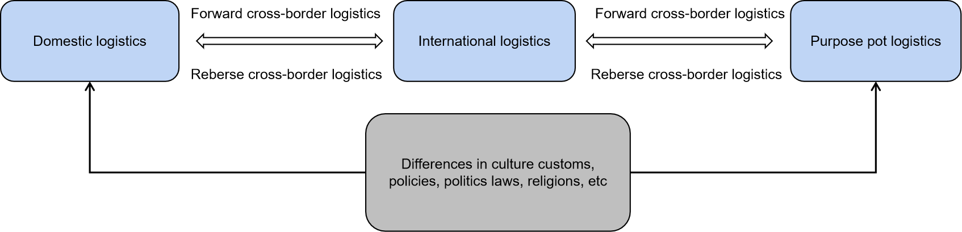

Figure 2.1: Flow chart of overseas warehouse logistics model

**2.3 Influencing factors of cross-border logistics**

This section will mainly discuss the four factors that affect consumer purchasing behavior, logistics costs, logistics infrastructure, logistics policies and logistics talents.

**2.3.1 Logistics costs**

Logistics costs are described as equivalent to the cost of using labor and third-party services to consume accumulated resources (Stock, Noel, Kasarda, 2000, Micherda, 2013). [[16]] Muha further supports this definition, and logistics cost is a key element related to the distribution of goods and warehouses(Muha, 2019).[[17]]

Cost control has always been a significant shortcoming in the growth and growth of logistics companies (Yan, 2019).[[18]] The purpose of logistics cost control is to reinforce logistics management and to promote logistics rationalisation. It relies on two things, one being the level of customer service quality and the other being the level of logistics costs.If we only pay attention to the reduction of logistics costs, the quality of customer service may be affected. A contradictory relationship exists between improving the quality of service and reducing the cost of logistics(Zhang , 2019).[[19]] In other words, the level of logistics service quality may decline if you want to reduce logistics costs. On the contrary, the logistics level may rise if you improve the level of service quality. Therefore in combining service quality control and logistics cost control, we must do a good job when carrying out logistics cost control.The relationship between cost reduction and quality improvement needs to be properly managed and the best combination of the two seeks to improve logistics efficiency.

**2.3.2 Logistics infrastructure**

Create conditions for logistics organizations through logistics infrastructure. These facilities are mainly logistics parks (hubs, bases), logistics centers, and distribution centers. Through this organization, the effect of agglomerating cargo flows is created, making the facilities a regional cargo distribution center. So as to seize the commanding heights of logistics development and cultivate new economic growth points.Therefore, logistics infrastructure is no longer a concept of logistics activity venues or organizations in the general sense, but has the function logistics organization, logistics development, and the function of driving economic development through logistics(Bogoviz et al, 2016).[[20]]

Cargo flow center and logistics center are two different concepts. The construction of logistics facilities is intended solely to meet the needs of industrial and commercial enterprises for the centralised organisation and management of supply chain management, supply chain management and related logistics activities,although it can produce the phenomenon of centralized logistics in the logistics organization , Does not mean being able to seize the position of the cargo flow center (Wang, Chu and Kim, 2020).[[21]] It is impossible for a single logistics infrastructure, in the entire supply chain process, to complete different functions or to provide these functions economically. Logistics can help the cargo logistics center achieve the corresponding position to consolidate and improve the service goals, but the logistics infrastructure itself It is difficult to have the goal of a cargo flow center.

**2.3.3 Logistics policy**

The logistics industry has gradually become an important national economic lifeline of each nation with the rapid development of the global economy.All countries throughout the world attach great importance to the development of the logistics industry. Many countries in the world have begun to introduce major logistics policies, laws and regulations.

2.3.3.1 Land policy

Open up new logistics cooperation methods and improve service efficiency.Logistics companies need to improve their inefficient management methods and seize the opportunity through government preferential land policies.Formulate a logistics park development plan, improve the level of intensive land use, and provide the main guarantee for the planned logistics parkland.Actively support the use of old factory buildings, warehouses and stock land resources of industrial enterprises to construct logistics facilities or provide logistics services. If the transfer or lease of the originally allocated land use rights is involved, procedures for paid use of the land shall be handled in accordance with regulations(Wang, 2020)[[22]].

2.3.3.2 Integrate logistics facilities resources  
Support large-scale superior logistics companies through mergers and reorganisations, etc to integrate scattered logistics facilities resources.Strengthen the cooperation of small and medium logistics companies.Open up new logistics cooperation methods and improve service efficiency.We must actively create conditions to open up to society and develop socialized logistics services. Support the development of joint distribution by commercial and circulation enterprises, reduce distribution costs, and improve distribution efficiency.Support logistics companies to reinforce cooperation with manufacturing companies,fully participate in the supply chain management of manufacturing enterprises, or jointly establish third-party logistics enterprises with manufacturing enterprises.

2.4.3.3 Logistics management system

Strengthen administration according to law, improve government supervision, and strengthen industry self-discipline. In combination with the formulation of appropriate laws and administrative regulations, the administrative licensing and approval conditions for the qualifications of logistics enterprises shall be appropriately relaxed under the premise of standardized management, and the qualification approval management methods shall be improved.It is necessary to break through regional blockades and system and mechanism obstacles, actively provide convenience for logistics enterprises to establish legal and unincorporated branches and encourage logistics enterprises to carry out cross-regional network operations. Further standardize the approval procedures for transportation, public security, environmental protection, quality inspection, fire protection, etc., shorten the approval time and improve approval efficiency( Zhu and Zheng, 2018)[[23]].

**2.3.4 Logistics talent**

At present, the human resource management system of a large number of logistics enterprises is extremely irregular. For example, employees have not signed labor contracts for employment, and various welfare systems that should be enjoyed are lacking. Logistics companies do not make human resource planning and do not pay attention to talent reserve. The hired employees are not targeted because of the lack of comprehensive planning, do not meet the job position requirements, and the recruitment effect is not ideal.

Due to the influence of traditional thinking, many logistics personnel generally have low academic qualifications and low overall quality. Some key positions, especially management positions, are not well qualified, resulting in lower work efficiency and service efficiency.In addition, companies cannot make the best use of their talents and employ their strengths, and mistaken assignments occur in the professional division of employees, allowing new employees with professional knowledge and higher quality to do hard work such as loading and unloading and handling. This kind of irrational allocation of talents makes talents lose the environment of fair competition and cannot do their best to contribute to the enterprise. As a result, a lot of logistics professional and technical talents are seriously drained.

Due to the rapid development of China's logistics industry, demand for logistics talent in the market is increasing day by day. Enterprises are eager for outstanding logistics management personnel and professional technical personnel. However, a large number of logistics graduates trained by schools and modern logistics companies are often out of touch with market demand.College students majoring in logistics often only have theoretical knowledge and lack practical and operational abilities. This has become the biggest bottleneck restricting the development of the logistics industry. The professional application skills and perspectives mastered by graduates still have a large gap between them and the company's needs, and the practical ability does not meet the requirements of the enterprise. This makes increasingly serious the contradiction between the supply and demand of logistics management talents.

**2.4 Gaps in the Literature**

Based on the research on the issue, we found some literature on the effect of cross-border logistics in cross-border e-commerce factors.However the impact of a certain factor on cross-border e-commerce will be specifically studied in a few documents. In determining the existence of four research gaps in cross-border logistics costs, logistics infrastructure, logistics policy and logistics tanlent, and through research reforms to promote research and fill the gaps.

**2.5 Hypotheses**

Research purposes: Research objective: The influential factors of China cross border logistics on cross border e-commerce and countermeasures

Hypothesis:

H1: Low logistics costs have a positive impact on cross-border e-commerce.

H2: Improving logistics infrastructure have a positive impact on cross-border e-commerce.

H3: Changes in logistics policies have a positive impact on cross-border e-commerce.

H4: Training logistics talents has a positive impact on cross-border e-commerce.

**2.6 Fundamental Theory**

**2.6.1 PEST analysis**

**2.6.1.1 Political Factors**

Political environment involves social system of a country,government guidelines, policies, legislation, etc.The purpose of this study is mainly directed against the country's cross-border impact of policy changes on the logistics of cross-border e-commerce.

**2.6.1.2 Economic Factors**

Two aspects are mainly included in the economic environment: macro and micro. In this study, through the microeconomic environment, the revenue level and job satisfaction of the sample can be reflected. Eliminate these factors to determine the development and status quo of the cross-border logistics industry.

**2.6.1.3 Sociocultural factors**

The social and cultural environment includes the level of education and culture of the inhabitants of a country or region, religious beliefs, customs, aesthetic opinions, values, etc. The sample's cultural level can be used to reflect whether it influences the logistics industry.

**2.6.1.4 Technical factors**

The technological environment should also be understood in a timely manner. In addition to technological changes and the development of means of investigation directly related to business activities, there are also locations.The cross-border logistics industry has the problem of technology and facilities mismatch. It is necessary to update the logistics industry's infrastructure and learn new technologies in the logistics industry.

PEST analysis

Politics factor

Economy factor

Technology factor

Society factor

Figure 2.2: PEST analysis

**2.7 Conceptual Framework**

Figure 2.3: Conceptual Framework

**Impact on cross-border e-commerce**

**Logistics costs**

**Logistics infrastructure**

**Logistics policy**

**IV**

**DV**

H1

H2

H3

**Logistics talent**

H4

The above conceptual framework aims to determine the relationship between logistics costs, logistics infrastructure, logistics policies and logistics talents (independent variables) and cross-border e-commerce (dependent variables).

**2.8 Conclusion**

The second chapter focuses on the literature review of cross-border logistics. Many studies have been conducted on the factors affecting cross-border e-commerce. In short, this study determines how logistics costs, logistics infrastructure, logistics policies, and logistics talent will affect the development of cross-border logistics.

**Chapter 3: Research Method**

1. **Overview**

The research design and research methodology that will be applicable to this research paper will be introduced in Chapter 3. This chapter will begin with a research design that includes the purpose of the study, the design of correlations, the extent of research interference, the setting of the study, the time horizon, the analysis unit, the design of samples, the method of data collection, data analysis and measurement and measurement.

To determine the source dependent variable (DV) and the adapted or argument.The methods of data collection in the design of the questionnaire (IV) will be further developed. In addition, SPSS statistical tool will be used in this research paper to analyse the data collected via the questionnaire.

**3.1 Research Design**

The purpose of this study is to collect, through satisfaction surveys, samples of cross-border logistics data.Determining which factors affect cross-border e-commerce through cross-border logistics data.For research, the setting of the research design is very important because it influences the research results (Miller and Salkind, 2002). [[24]] It also determines how interviewees are selected.How to collect and analyse data, including the dependent and independent variables, and how to use them.To deal with the whole research issue, how to control irrelevant variables in the study..Obtain the most practical results through investigation and collection, and then conduct collation and statistical research.

Descriptive research is defined as an attempt to discover and clarify while providing more cross-border e-commerce information, in which research tries to describe in more detail what is going on and fill in the missing parts and expand the understanding of the researcher (Lau and Kuziemsky, 2016 ).[[25]]

**3.1.1 Descriptive and explanatory research**

Descriptive research is the focus of describing research methods used as accurately as possible to describe existing phenomena. The main purpose of the research is consistent with a descriptive study describing the existence of the phenomenon. This study is therefore a descriptive study aimed at describing how logistics costs, logistics infrastructure and logistics policies will impact the development of cross-border e-commerce in order to fill the gaps in the review of the literature.

**3.1.2 Deduction and Induction**

The deductive method is a study designed by scientists to test theories by gathering new data from the above and analysing the data through different statistical tests, while the inductive method involves generating new theories from the data collected（Rahi，2017）.

In this research, it is a deductive approach because the characteristic of the deductive approach begins with the literature review information to shape the hypothesis and test the collected data.

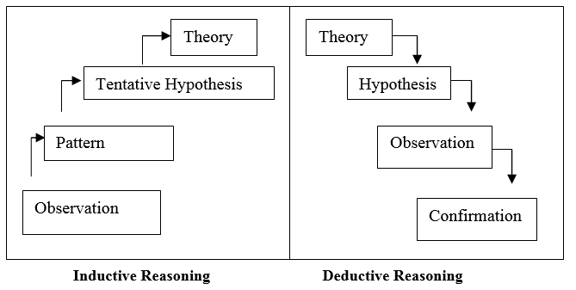

Figure 3.1: Approach to induction and deduction

**3.2 Methods of Research**

**3.2.1 Design Questionnaire**

Special attention must be given to the design of the questionnaire in order to obtain helpful information from the interviewees. A properly designed questionnaire must be planned and formulated through the following steps in Figure 3.2.

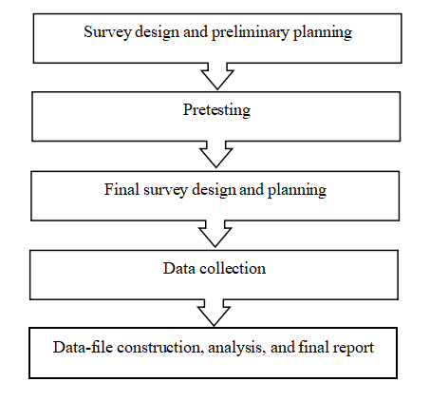

Figure 3.2: Stages of Planning Questionnaire

The purpose of using questionnaires can be descriptive or explanatory, while the purpose of descriptive questionnaires is to find out opinions or characteristics without studying causality; explanatory questionnaires involve more analytical perspectives to study the relationship between variables Relationship. The open questionnaire enables respondents to freely answer questions in words, but because it requires more analysis, it is not recommended for quantitative research.In this study, a closed questionnaire was used to restrict the respondents from choosing a fixed set of answers from the questions.

In questionnaires, the Likert scale is often used to measure observations and attitudes by checking their degree of approval or disapproval of carefully constructed statements, ranging from a very positive attitude towards something to a very negative attitude. Rahi (2017) suggested using the Likert scale to decrease the level of frustration of the interviewees to improve the interviewees' response rate, enabling interviewees to respond better to their opinions.

**3.2.2 Questionnaire**

This research seeks to gather quantitative data. In the questionnaire design, as shown in Figure 3.3, the closed structured method was adopted and adjusted.

|  |  |  |  |
| --- | --- | --- | --- |
| **Section** | **Question/Item** | **Number of statements** | **Source** |
| Part A | Demographic Information  (Gender, Age Group and Education level) | 6 | Adopted from Patten （2016） |
| Part B  (Dependent Variable) | The impact of cross-border e-commerce | 5 | Adapted from Geuens and De Pelsmacker（2017） |
| Part C  (Independent Variable) | Logistics costs | 4 | Adapted from Subiyanto and Rini（2020） |
| Logistics infrastructure | 4 | Adapted from Qi, Shi, Lin, Yuen and Xiao（2020） |
| Logistics policy | 4 | Adapted from Chang and Lai（2017） |
| Logistics talent | 4 | Wen, Wu and Wang, (2016） |

Table 3.3.1: Questionnaire Design

**3.3 Unit of Analysis**

The most fundamental element of a scientific research project is the analysis unit.In other words, the analyst can generalize it to the subject of the study.The unit analysis of this study is personal and the research subject is involved in work related to cross-border logistics.

**3.4 Sampling and Population**

Sampling is mainly to help researchers obtain data related to research topics, and questionnaires are one of the methods to quickly collect data. Generally speaking, questionnaire surveys can collect data in a very short time and with a limited budget.

**3.5 Methods and analysis for data collection**

**3.5.1 Data collection**

In order to support research, data collection is a powerful method of collecting detailed information and data. There are two types of data available, namely primary data, data collected directly from respondents, and secondary data collected from published journals, business reports, reports from conferences, etc.

In this study, data collection methods will be based on a Chinese logistics company staff questionnaire survey.The surveyed areas are mainly coastal cities in China, such as Shanghai and Guangzhou.The researchers' companies are mainly SF Logistics, Post Logistics, YTO Logistics, Shentong Logistics, Zhongtong Logistics and Yunda Logistics.The researchers' companies are mainly SF Logistics, Post Logistics, YTO Logistics, Shentong Logistics, Zhongtong Logistics and Yunda Logistics. Each logistics company distributed 80 questionnaires.The questionnaire uses an electronic system-Google Form, and will be distributed through social software. Researchers hope to collect about 350 complete questionnaires from respondents for further data analysis.

The benefit of online questionnaires is that the network covers a wide variety, can cover a large number of visitors, and has lower cost of research and time benefits. Google Forms is an efficient and effective method of collecting data because it is freely accessible and can automatically record participant responses in electronic forms, making it easier to collect data and simplifying data analysis.

**3.5.2 Data Analysis**

SPSS will be used to analyse the collected data, based on the data gathered by the questionnaire.The four logistics factors for logistics costs, logistics infrastructure, logistics policy and logistics talent have an impact on cross-border e-commerce. First, a pilot test of 70 samples was developed to verify the reliability and validity of the 70-point sample to ensure that the questionnaire can continue.

SPSS software is used to perform validity and reliability analysis, descriptive analysis, correspondence analysis, one-way analysis of variance and multiple recurrence regression analysis of the sample. To explore the impact of logistics costs, logistics infrastructure, logistics policies and logistics talents on cross-border e-commerce.

**3.6 Ethical Considerations**

There are many organizations dedicated to promoting scientific research ethics. These organizations agree that ethics is not an afterthought of research. Therefore, all interviewees will know the purpose of this online questionnaire. Respondents will not feel any slope to participate in the study, and participants can refuse to fill out the questionnaire at any time. At the same time, the assessment process will not harm respondents in any way.No one can obtain or access any identifying information. Confidentiality also makes sure that any reports or published documents exclude such identifying information. In addition, the names of participants will not appear in the research analysis.

**3.7 Problems and Limitations**

This study has certain limitations. The collection of samples has certain deviations and limitations. Therefore, they are subject to a certain degree of bias that may cause certain deviations in the research results. The main limitations of this study are sample selection, cultural bias, and time limitations.

Sample selection: 350 pieces of data need to be collected for this research sample, mainly to publish an online questionnaire for the purpose of this research through Google Forms. The geographical area covered by the online questionnaire may not be broad enough. Participants in this study also have occupational restrictions, and the work the samples are engaged in is related to cross-border logistics.

Cultural bias: Due to their cultural background and personal opinions on specific phenomena, participants may be biassed, and this bias may affect the research's rationality.

Time limitation: The occupational restrictions of the participants in this study lead to a relatively long time to collect data, Data collection takes a certain amount of time.

**3.8 Conclusion**

The research methodology of this project is mainly discussed in this chapter, where the research design, analysis unit and method of data collection are used. To ensure the accuracy of the data, the test of correctness, reliability and validity is carried out to ensure that the hypothesis can be accurately tested and concluded.

**Chapter 4:Research Findings**

**4.0 Overview**

The research methodology for the project is the focus of this chapter and the study design, data collection methods and analysis unit are used. We conducted correctness, reliability and validity tests to ensure the accuracy of the data in order to ensure proper inspection and drawing assumptions.

**4.1 Pilot Test**

Pilot test can help reveal errors in the design before researchers conduct comprehensive data collection. The pilot test refers to selecting a part of the data for testing before the full study. Collect information to analyse the reliability and validity of the questionnaire through pilot tests. It is not possible to casually design a questionnaire and it must have good reliability and validity. Therefore, through a pilot test, data is collected for analysis. The questionnaire also needs to be revised further if reliability and validity are low. In addition, whether there are some ambiguities in the questionnaire design, for example, the pilot test found that the understanding of the question is different from the original intention of the question design, so the questionnaire needs to be revised or further defined.

**4.1.1 Reliability Test**

Scales are commonly used in questionnaires in the study of questionnaire surveys, the purpose of which is to gather abstract concepts such as the research objects' psychological traits/abilities/attitudes.At this time, in addition to introducing the content of the scale and scoring rules regarding the introduction of reliability and validity, when introducing research tools, Cronbach's α coefficient should be the most commonly used reliability indicator in this article, and it can even be said to be reliable Sex. Indicates the degree.Its primary objective is to measure the consistency between variables, so it is also referred to as the coefficient of internal consistency, which is used directly to compare the homogeneity between variables.

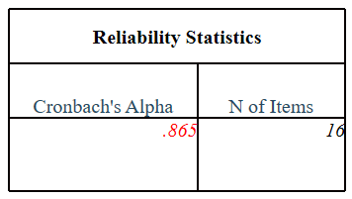

Table 4.1.2：Reliability

Alpha value criterion is between 1 and 0. The higher the alpha value in the reliability test, the higher the reliability it represents.When conducting reliability analysis, pay more attention to the overall reliability coefficient value. First, we need to get the alpha coefficient of the pre-test. If the value is > 0.8, the reliability is high.If the reliability is between 0.7-0.8, the questionnaire survey can continue; if the reliability is between 0.6-0.7, the questionnaire survey needs to be modified.If the reliability is less than 0.6, the reliability is not good.It can be seen from Table 3.2 that Cronbach's Alpha=0.865, indicating that the reliability of the questionnaire in this pilot trial is very good, and the following research can be continued.

**4.1.2 Factor Analysis**

Factor analysis starts with analyzing the correlation between multiple original indicators and finds a limited number of unobservable latent variables that dominate this correlation.Since these indicators reflect the unpredictable phenomenon of lucid consciousness to varying degrees, the correlation between these indicators is mainly dominated by the unpredictable phenomenon that they reflect together(Kass and Tinsley, 2018)[[26]].

The generalisation of primary component analysis is factor analysis. Factor analysis is a method of analyzing multiple variables to get statistical data. By simplifying the complex variable relationships in the matrix into several factors, the purpose of detection is achieved.

Therefore, before doing factor analysis, test whether there is a correlation between the variables. When independent variables are correlated, the data can be factored. The data collected in the questionnaire survey is sufficient for factor analysis, and the KMO test is generally adopted.

**4.1.3 Kiser-Meyer-Olkin (KMO)**

The main extraction situation of the KMO test collection data.Generally speaking, between 0 and 1. the KMO test coefficient is distributed.When the coefficient is greater than 0.6, the questionnaire survey can continue. When the coefficient value of the KMO test > 0.7, better practicability is achieved as a result of the principal component analysis(To, S.H., 2017).[[27]]

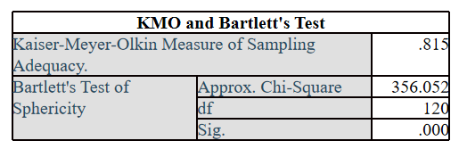

Table 4.1.3：KMO Test

From the above, it can be seen that the KMO statistic is 0.815. Generally, factor analysis can be performed above 0.6. If it is less than 0.5, consider giving up; Bartlett’s sphere test can be used as long as it is less than 0.05.P-value of less than 0.05 standard. The data are distributed in a spherical shape, which denies the assumption that each variable is independent and considers that the variables have a strong correlation.

The KMO test results of each SPSS output variable are as follows:

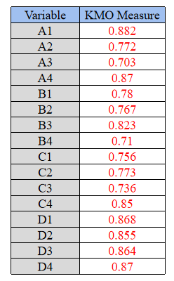

Table 4.1.4：KMO test for a single variable

The analysis results of the KMO test are also distributed between 0 and 1. Similar to the above introduction to the overall KMO test coefficient, for a single variable. If the coefficient is greater than 0.5, the requirements are considered to be met by the single variable; if the coefficient is greater than 0.8, the outcome of the single variable is considered to be very high.

**4.1.4 Eigenvalues**

The eigenvalue is used primarily to confirm how many common variables are derived from the research variables. More or less of the required variables can lead to serious mistakes that affect the study outcomes.When the characteristic value>1, the variable can be extracted as a common factor(Denton et al, 2019).[[28]]

**Extract the principal components**

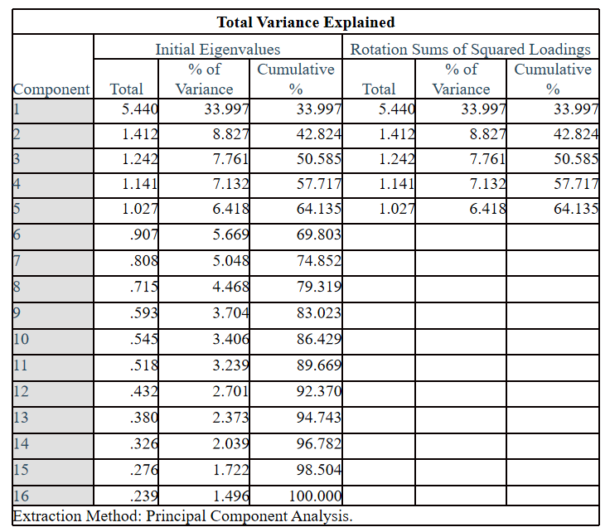

Table 4.1.6: Explained total variance

Table shows that the characteristic value of the fifth primary component is 1.027.Which is greater than 1, which means that five common factors have been extracted. The variance percentages are 33.99%, 8.827%, 7.761%, 7.132%, 6.418%, and the cumulative variance is 64.135%>0.5.

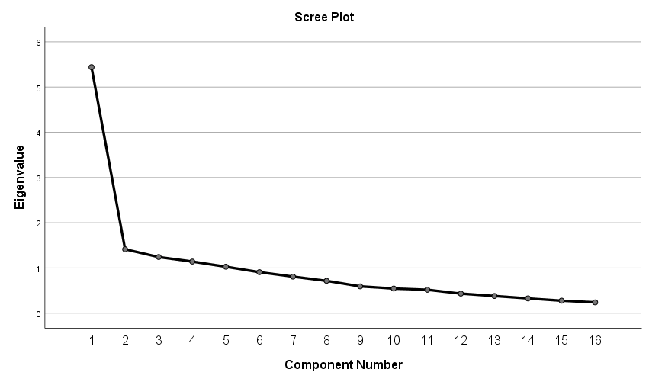

Figure 4.1: Scree plot

Combined with the Scree Plot, the number of junctions from steep to gentle is more appropriate. It can be seen that there are 5 factors greater than the characteristic value 1 that are more appropriate(Nelson, 2016).[[29]]

**4.1.5 Factor Loading**

The loading factor is defined as the relation between the basic factor and each variable. The bigger the loading factor, it gives researchers an idea that a factor has been assigned to a variable.If the loading factor value is assessed to be greater than 0.6, it means that the variable has sufficient variance extracted from the factor, and if it is less than 0.5, it means that it is not possible to generate a unique and reliable factor(Lewbel, 2020).[[30]]

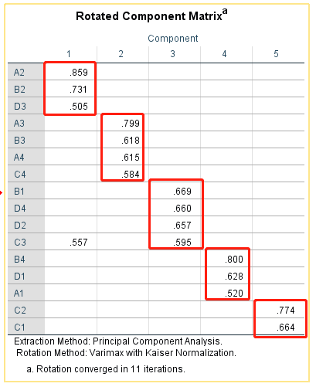

Table 4.1.7: Rotated Component Matrix

Using 16 questions to investigate the factors of 70 logistics-related employees. A linear relationship exists between the four studied variables, and the coefficient of correlation is greater than 0.5 between each group of variables.The common factor has a larger factor load on A2 to D3; the common factor 2 has a larger factor load on A3 to C4; the common factor 3 has a larger factor load on B1 to C5; Common factor 4 has a larger factor loading on B4 to A1; common factor 5 has a larger factor loading on C1 to C2.

**4.1.6 Communality analysis**

The SPSS output commonality results are as follows:

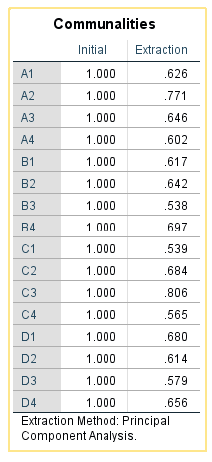

Table 4.1.8: Commonality

In the table above the 'Initial' column indicates that the degree of clarification of the variation of each variable is 1. when all the components are included. At this stage, without removing any information, the variation in the data can be extracted(Kass and Tinsley 2018)[[31]].The "Extraction" column indicates the degree of variable extraction when we only keep the selected components. It can be seen from the table that the extraction effect of all variables is relatively good, the variables are greater than 0.5, the extraction effect is relatively good, and the loss of information is relatively small.

**4.2 Data Analysis**

**4.2.1 Reliability and validity analysis**

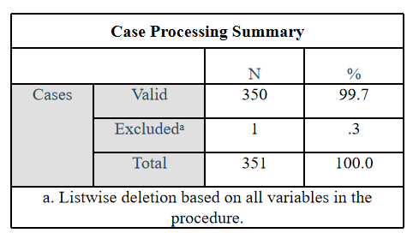

Table 4.2.1 ：Case Processing Summary

The number of samples collected in this study was 351, of which 350 samples were valid and 1 sample was excluded.

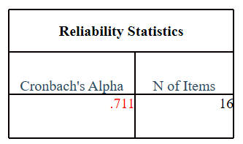

Table 4.2.2 :Reliability analysis

Alpha value = 0.711 can be seen from Table 4.2.2, indicating that the pilot questionnaire's reliability is relatively good, and that the following research can be continued.

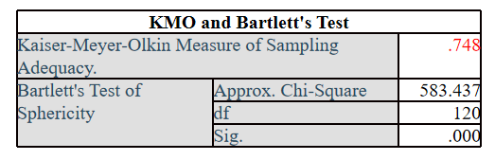

Table 4.2.3:KMO and Bartlett's Test

As can be seen from the above, the KMO statistic for the 350 sample is also 0.815. The KMO is typically greater than 0.7, which ensures that the sample can be calculated.

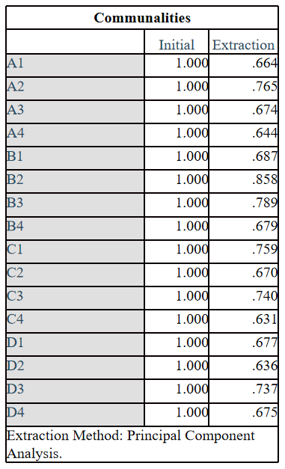

Table 4.2.4:**Communalities**

The extraction effect of all problems with strain settings is greater than 0.6, that variables are higher than 0.5, that the extraction effect is relatively good, and that the information loss is relatively small.

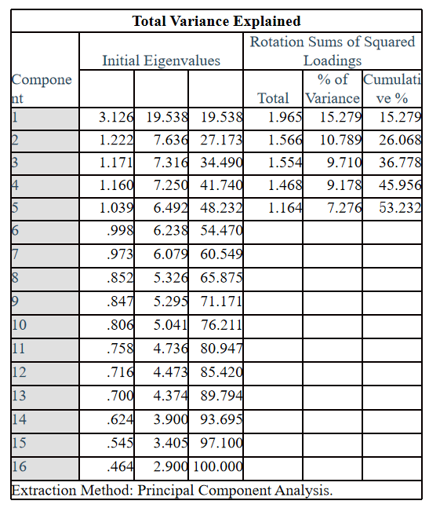

Table 4.2.5 :**Total Variance Explained**

It can be seen from Table 4.1.6 that 1,027, which is greater than 1, is the characteristic value of the fifth principal component. Which means that five common factors have been extracted. The variance percentages are 15.279%, 10.789%, 9.710%, 9.178%, 7.267%, and the cumulative variance is 53.23%>0.5.

**4.2.2 Descriptive Analysis**

The following table mainly collects basic data about logistics workers.After the data collected by the questionnaire, researchers need to perform statistical analysis, such as frequency analysis, normal analysis, scatter plot analysis, and so on.

|  |  |  |  |
| --- | --- | --- | --- |
| Measure | Items | Frequency | Percent |
| Gender | Female | 148 | 42.3 |
| Male | 202 | 57.7 |
| Age | 18-24 | 37 | 10.6 |
| 25-40 | 205 | 58.6 |
| 41-50 | 84 | 24 |
| >50 | 24 | 6.9 |
| Income (RMB) | Under 2000 RMB | 15 | 4.3 |
| 3000-5000 RMB | 92 | 26.3 |
| 5000-8000 RMB | 170 | 48.6 |
| 8000-10000 RMB | 46 | 13.1 |
| Above 10000 RMB | 27 | 7.7 |
| Education level | High school and below | 38 | 10.9 |
| Undergraduate | 224 | 64 |
| Master graduate | 66 | 18.9 |
| PhD | 22 | 6.3 |
| Department | Customer Service Department | 51 | 14.6 |
| Finance Department | 36 | 10.3 |
| IT system department | 45 | 12.9 |
| Operation Management Department | 74 | 21.1 |
| Sales Department | 58 | 16.6 |
| Transportation Department | 86 | 24.6 |

Table 4.2.6: Basic sample information

Table 4.2.6 shows the detailed description statistics of the corresponding questionnaire, which are gender, age, income, education level and department.

**4.2.3 Correspondence analysis**

Analysis of correspondence is a technique developed on the basis of factor analysis.By using an appropriate scaling method for the original data, and two results are obtained at the same time. Correspondence analysis is a method of dimensionality reduction. In particular, variables and samples can be represented on the same factor plane, thereby intuitively revealing the internal connection between the variables under study and the samples(Greenacre, 2017)[[32]].

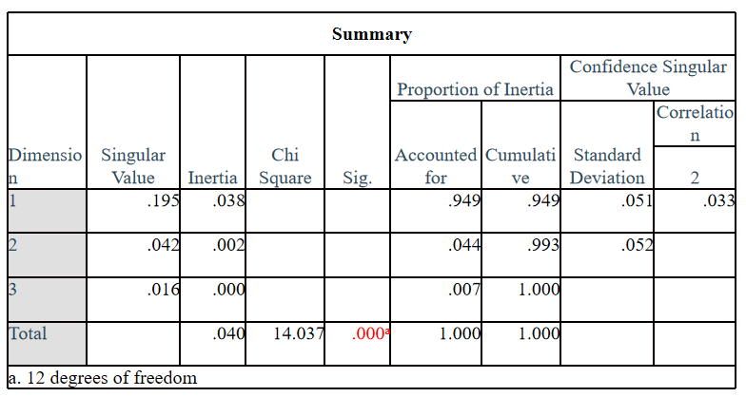Table 4.2.7 :**Summary**

According to the above summary table 4.2.7, Chi-square value=14.037, Sig<0.01 significance, indicating that in this analysis, the two nominal variables, influencing factors and satisfaction are not completely independent, and there is a certain relationship.

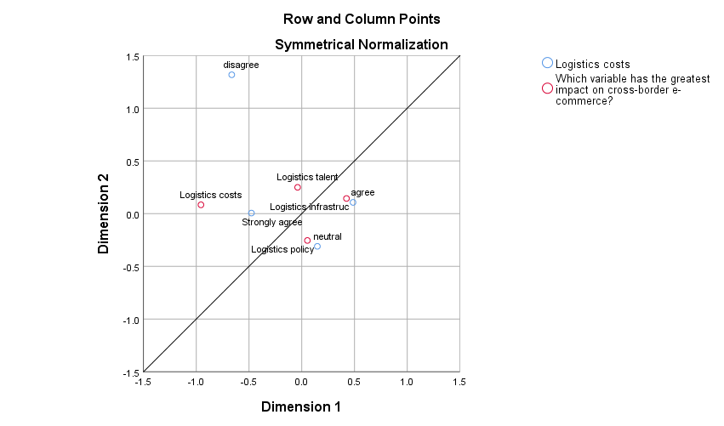

**Figure 4.1：Correspondence analysis graph**

There are two principles when interpreting the graph: First, check the distinction between the horizontal axis and the vertical axis by different variables. If different categories of the same variable are closer in a certain direction, it means that these categories are in There is little difference in this dimension; second, compare the positional relationship between the value categories of different variables in each dimension.

It can be seen from the chart that the red dots are the four variables in this questionnaire, and the blue dots are the variables’ satisfaction. It can be clearly seen that the neutral attitude favors logistics policies. A consistent attitude is conducive to logistics infrastructure and logistics talents. The strongly agreed attitude favors logistics costs.

**4.2.4 One-way analysis of variance**

Among the multiple sample groups for the winning factor, the function of ANOVA is to prove whether there is a difference in X change.A multi-factor analysis of variance corresponds to it. It is necessary to explain that for independent variables, single factor and multi-factor are. There can only be one independent variable, and multiple dependent variables(Kap. and Lamberson, 2017)[[33]].

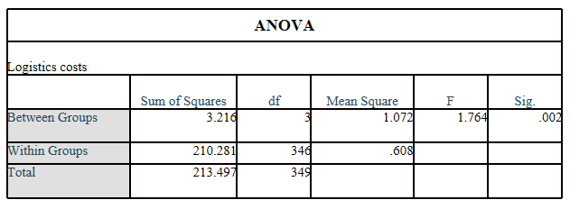

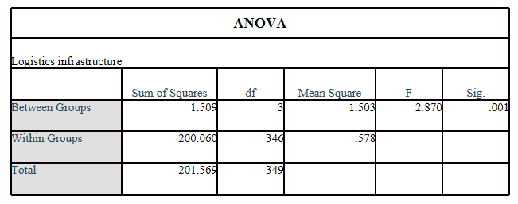

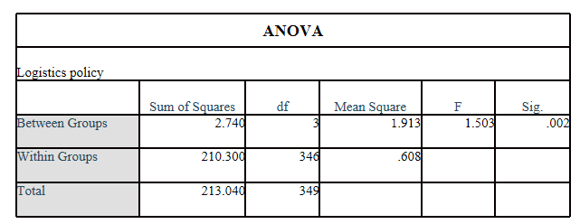

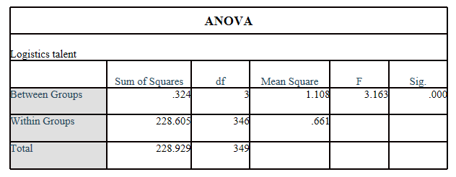

Table 4.2.8：**ANOVA**

According to Table 4.2.8 above the significance of the four variables is P<0.05 in the results of the variance analysis, indicating that the influence of each factor is different, that is, there is a significant influence. It is statistically significant and can be analyzed in the next step, but for specific effects, you need to check the results of the pairwise comparison.

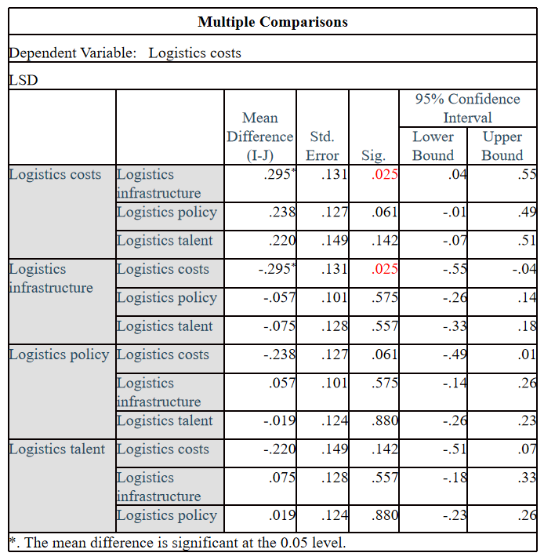Table 4.2.9 :Multiple comparisons

According to the above table 4.2.9, due to the significant differences between each group of factors. With P values of 0.025 and less than 0.05, there are significant differences between the logistics cost group and the logistics infrastructure group(Chen et al 2017)[[34]].

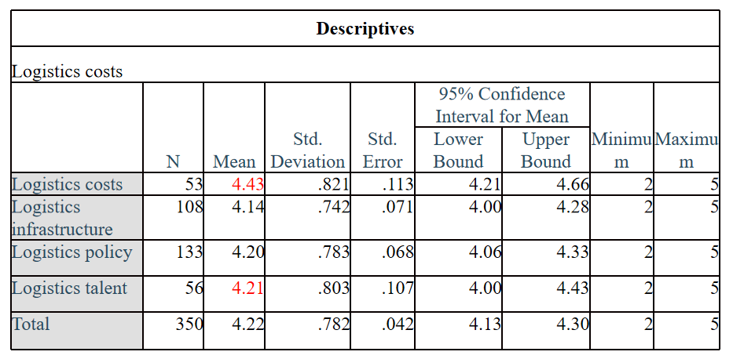

Table4.2.10: Descriptives

The average values of the logistics cost group and the logistics talent group are 4.43 and 4.21, respectively. It can be seen that the impact of the processing level of the logistics cost group is higher than the impact of the logistics infrastructure group and the logistics policy group.

**4.3 Hypothesis Testing**

A null hypothesis for the overall parameters was first put forward, and then the sample data was used to verify whether the previously proposed hypothesis was true. In small probability events, the sample data cannot prove the null hypothesis,the null hypothesis is rejected; conversely, if the sample data can not fully deny the null hypothesis, the null hypothesis can not be rejected.Relying on inference principle of statistical analysis, it is almost impossible for a low probability event to occur in a specific sample. It is reasonable to eliminate the null hypothesis if there is a small probability event(Donnarumma et al ,2017)[[35]].

The general steps of hypothesis testing:

1. Propose the null assumption (H0)

According to the goal of the test, a null hypothesis is proposed for the final result that needs to be tested. As to whether the low cost of logistics adversely affects cross-border e-commerce,whether the satisfaction degree is less than 3, a null hypothesis can be made, H0: μ<3.

2.Calculate the probability of occurrence of observations of test statistics

Calculate the probability of observing the test statistics under the premise that the null hypothesis is established and record it as p. The probability of the p value is the probability of the sample value taking place under the assumption that the null hypothesis is established.This can be determined according to certain standards. Whether the probability of occurrence is small.

3.Make judgments about the significance level

The null hypothesis is true, the Sig value is the likelihood of a sample observation outcome or more extreme result.If the value of P<0.05, then the likelihood of this situation is very low, and if it occurs, we have reason to reject the original hypothesis according to the principle of small probability.The smaller the P-value, the more we dismiss the null hypothesis for sufficient reasons.Therefore if the probability p-value is below 0.01, H0 is rejected and the difference is extremely important; if the probability p-value is below 0.01 and below 0.05, H0 is rejected, the difference is significant. The difference in accepting H0 is not significant when the probability p-value >0.05.

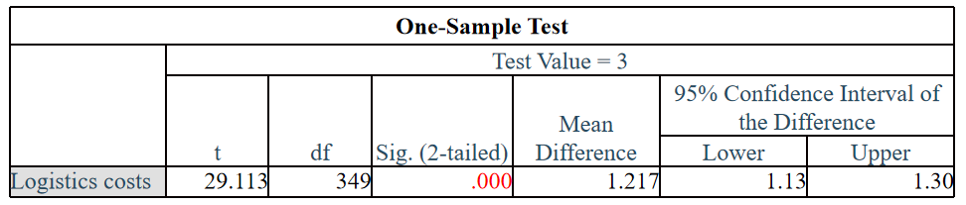Table 4.3.1:Logistics cost single factor T-test

According to the test results, the p value of the mean test is 0.000. The Sig value satisfies the standard under the 5% significance level, P<0.05. Therefore, the original hypothesis is rejected, and logistics costs have a negative impact on e-commerce across borders.

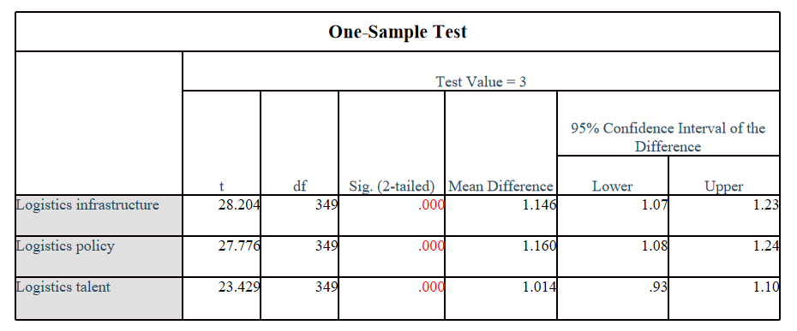Table 4.3.2: One-Sample Test

According to the same steps above, make null hypotheses for the remaining three variables:

With regard to whether the logistics infrastructure has a negative impact on e-commerce across borders, whether the satisfaction degree is less than 3, a null hypothesis can be made, H0: μ<3.

With regard to whether the logistics policy has a negative impact on e-commerce across borders,whether the satisfaction degree is less than 3, a null hypothesis can be made, H0: μ<3.

Regarding whether logistics talents have a negative impact,whether the satisfaction degree is less than 3, a null hypothesis can be made, H0: μ<3.

Through the single factor T-test, It can be seen that the P values are all less than 0.05 for the remaining three variables. So the original hypothesis of the three variables of logistics infrastructure, logistics policy and logistics talents is invalid, that is, logistics infrastructure. In line with the assumptions of this questionnaire, logistics policies and logistics talent have a positive impact on cross-border e-commerce.

**4.4 Multiple Regression Analysis**

A very powerful tool is linear regression analysis. Infer the value of the unknown variable through the value of the known variable. If X and Y are two related variables, then the analysis of linear regression will assist us in predicting the value of y given x, and vice versa（Aggarwal and Ranganathan, 2017）.[[36]]

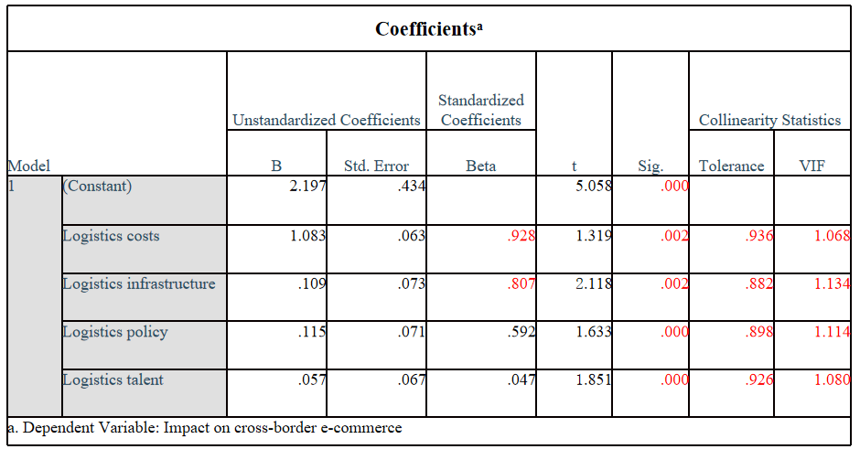Table 4.4.1:Coefficientsa

Result analysis: According to the above table 4.4.1, the Sig value of logistics cost, logistics infrastructure, logistics policy and logistics talents meet the standard.The four hypotheses presented above are all true.Logistics costs(0.928) and logistics infrastructure(0.807) are the main factors Impact on cross-border e-commerce.

Tolerance and expansion factor are important factors for judging whether independent variables are independent of each other. Tolerance is also called tolerance. The expansion coefficient is the inverse of tolerance. The closer the tolerance and expansion coefficient is to 1, the weaker the multicollinearity between the independent variables. Among them, the expansion factor <10 indicates that the independent variables are relatively independent. Expansion factor >= 10, indicating that there is strong multicollinearity between the independent variables.

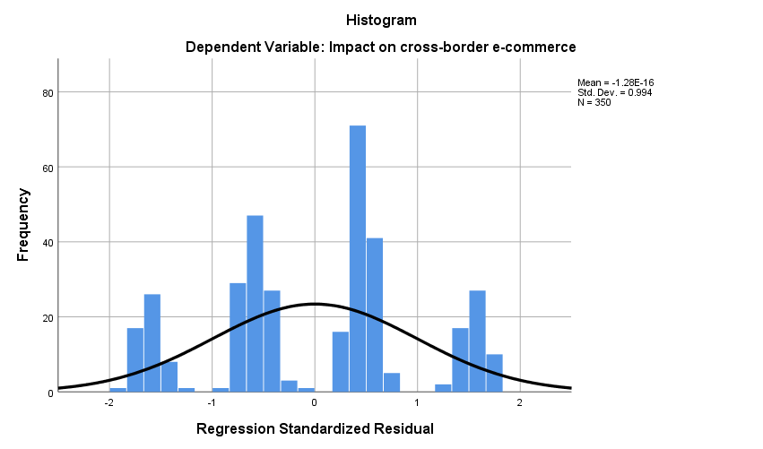

Figure 4.2:Histogram

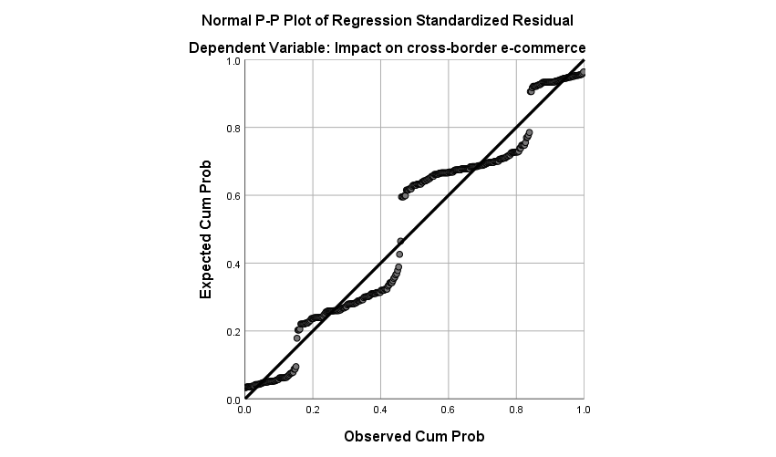

Figure 4.3:P-P Plot

Result analysis: The residual value of the dependent variable regression model obtained is the difference between the predicted and observed values of y,, also known as the error value, which can predict the size of the error that the regression model may produce. It can be seen from the figure that the residuals are normally distributed in the histogram.

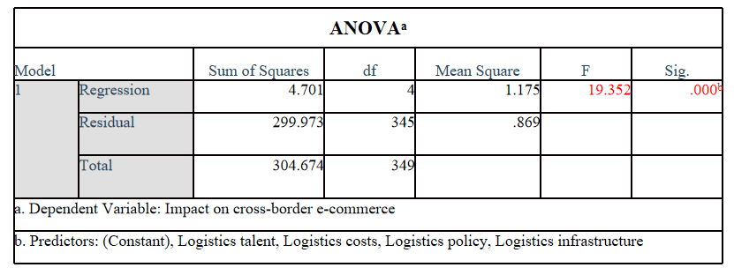Table 4.4.2:ANOVAa

Result analysis:According to Table 4.4.2 above,the level of significance shows that Website Design,E-commerce platform,Promotion method and Marketing talent influence network marketing of small and medium foreign trade enterprises (F=19.352).The p-value is 0.000, and therefore meets the requirements of less than 0.05.

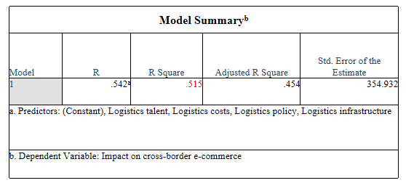

Table 4.4.3 :Model Summaryb

Result analysis:R-squared range is 0-1. The higher the R-squared, the more representative its internal changes.The R square above 0.6 shows a higher degree of fitting interpretation. This time the R square value is 0.515. The results of eradication demonstrate that there is a high degree of interpretation of the model.

**4.5 Conclusion**

The aim of this study was to investigate the factors affecting cross-border e-commerce development.First, a preliminary test was conducted on the pilot test, which is mainly divided into two aspects: reliability and validity. From the results, Cronbach's Alpha = 0.865, indicating that the reliability of the questionnaire is very good. KMO = 0.815, indicating that the sample can be decomposed well.

Then the reliability and validity of the 351 samples were analyzed again, Cronbach's Alpha = 0.711, KMO = 0.748, indicating that the reliability and validity of the questionnaire are good. The description of demographic information of all participants in the questionnaire is also analyzed. It is possible to better understand the selection of factors that affect cross-border e-commerce by people engaged in logistics work.

According to the results of the summary table in the correspondence analysis, the chi-square value = 14.03, and the P value less than 0.05 indicates that the two variables in the analysis, the influencing factors and satisfaction are not completely independent, and there is a certain relationship. The results of the table that P values of the four variables were all <0.05, indicating that each factor is significant.

In addition, first establish the null hypothesis through hypothesis testing. Through the significance results of one-way T test on these four variables, the null hypothesis of all four variables can be rejected. Therefore, the four variables in this questionnaire have a positive impact on cross-border e-commerce.

Next, perform multiple recurrence regression. From the analysis results, the multicollinearity between the independent variables is relatively weak. The R-squared value this time is 0.515, Indicating that there is a high degree of interpretation of the model. For the four variables, the P values are all less than 0.05,and the BETA coefficients are all greater than 0, indicates that these four variables have positive effects.

**Chapter 5: Countermeasures and Conclusion**

**5.0 Overview**

On the basis of the data in Chapter 4, Chapter 5 verifies the correctness of the hypothesis. It analyzes the current issues facing cross-border e-commerce. It can take the following steps in its development in response to the above problems.

**5.1 Countermeasures**

**5.1.1 Countermeasures for logistics costs**

Use overseas warehousing model

Overseas warehouse model means that the model of cross-border e-commerce companies to establish overseas export warehouse through the main target countries / regions,transport goods to overseas warehouses in advance, and retrieve goods in overseas warehouses according to orders and organize delivery(Hou et al .2019)[[37]].

With the help of the preferential policies enjoyed by the bonded area, and according to consumers' expectations of the types and quantities of goods, the overseas commodities are first shipped to China in batches, bonded and stored in the bonded area. After receiving the consumer's order, the goods will be delivered by express delivery, sent out and delivered to the consumer, improving logistics and transportation efficiency, and reducing consumers' online waiting time.In addition, because the goods enter the country through bulk transportation, logistics costs can be greatly reduced. Cross-border e-commerce in the export sector, because of the significantly reduced delivery time for logistics.The domestic enterprises to improve competitiveness abroad and increase customer satisfaction. To achieve sales growth.

By establishing overseas warehouses, overseas goods will be shipped to overseas warehouses in batches for storage. When orders are generated, they will be shipped directly from overseas warehouses. Because they are shipped in the home country, the order response time is shortened and logistics distribution is greatly improved speed.Due to the sufficient inventory of goods, the platform can provide consumers with convenient return and exchange services, completely solve the problem of "contacting with the merchant" when returning goods, and ensure the quality of after-sales service. But we also need to pay attention to the overseas warehousing model, which needs to be accurate Forecast the market, otherwise the backlog of goods will be overseas, and logistics costs will not decline, but will increase.

**5.1.2 Countermeasures for logistics infrastructure**

The standardised, rationally designed and deployed logistics infrastructure provides a solid basis for promoting cross-border e-commerce development.Quality logistics infrastructure will directly affect the efficiency of logistics.The development direction and trend of the modern logistics industry are the modernization and intelligentization of logistics infrastructure, which should attract enough attention.

First of all, the logistics infrastructure needs to be rationally arranged. The larger the scale of the logistics infrastructure is the best, not the smaller the scale. It must be arranged scientifically, focusing on China's core cities, transportation hubs, and industrial clusters.Not every city has to build a large-scale logistics park. In some cities, the industrial concentration is not enough, and the construction of logistics infrastructure is likely to cause overcapacity.Therefore, it is recommended to consider factors such as local industry scale, population size, freight volume, production output value.

Second, speed up an important part of cross-border e-commerce development is to improve the level and use of information and communication infrastructure, logistics industry data.It is recommended to promote openness and cooperation among logistics enterprises.Encourage the development of information platforms for logistics, and provide e-commerce merchants with a full range of information deployment services such as warehousing, delivery, and door-to-door pickup through the intensive use of third-party express, warehousing and other information, and promote efficient coordination of social resources , To improve the quality of services for social logistics.Finally, supporting the development of logistics and warehousing infrastructure is recommended. First, we must increase the speed of cross-border logistics, and second, we must improve the consumer experience.It is recommended that logistics and warehousing be divided into warehouses. At the same time, it can also reduce logistics costs and reduce carbon emissions.

**5.1.3 Countermeasures of logistics policy**

* Logistics Industry Policy

On the basis of existing logistics policies, various local protections that do not conform to the principles of fair market competition should be forcibly banned, and regional blockades and industry monopolies should be broken. The main purpose of the logistics policy is to establish a unified development, fair competition, and orderly logistics market system. Standardize the logistics industry's market behavior, set quality standards for logistics services and industry standards.

* Land Policy

The government can open preferential land policies, rational distribution of logistics facilities, and optimize logistics industrial parks, logistics centers, and distribution sites.Encourage logistics areas to settle in logistics industrial parks, coordinate and unify, and facilitate the government's regulatory role. Furthermore, avoiding the repeated construction of land resources and improving the logistics industry's resource utilisation rate.

* Tax policy

Logistics industry for a wide range of services and business, usually manifested in the following aspects: transportation, warehousing, forwarding, logistics and logistics information query processing. Developing a reasonable tax on the basis of the type of business service and facilitating the sustainable development of the logistics sector.

The purpose of the development policy is to provide logistics companies with a more powerful platform, including:

* Encourage key logistics companies to become bigger and stronger

The government can support the development of better logistics enterprises, such as fiscal loan policies, land preferential policies, tax reduction and exemption policies, etc. Help and encourage logistics enterprises to optimize the existing logistics industry structure and become modern logistics enterprises.

* The policy of introducing foreign first-class logistics companies

It can actively introduce and learn the laws and regulations of foreign modern logistics companies to create a fair and just market competition environment for Chinese logistics companies.

**5.1.4 Countermeasures to solve logistics talents**

* Strengthen the training of logistics talents

Many universities in my country tend to transfer the theoretical knowledge of logistics, and the teaching content lacks practicality. The training of students' practical skills seems to be very weak, leading to conflicts between learning and practical application(Wei and Wang, 2019)[[38]]. Therefore, school education must improve the teaching model, optimize the training model of logistics professionals and improve teaching methods.Before the curriculum is set up, it is necessary to have a deep understanding of the latest development trend of logistics enterprises and the demand for talents, and in-depth investigations of the specific requirements of the enterprises on the professional skills and practical ability of logistics talents, so as to provide for the school's professional curriculum setting and teaching plan formulation Realistic basis to enhance the pertinence and practicality of talent training.

* Strengthen the management of logistics human resources

Staff training is the basic method to improve staff ability, dedication and innovation ability. This is also the most significant evolution of human resources. Investment in human capital is more significant than investment in physical capital. Through employee training, employees can quickly adapt to work and reduce the flow of talent.In training, both pre-job training and post-job training should be emphasized. The training of management personnel and professional and technical staff must be of importance, and the education and training of front-line workers.As the talent structure of logistics enterprises is relatively complex and has many levels, the methods of organizing employee training should also be diversified.

**5.2 Conclusion**

Cross-border logistics has had a positive impact on the development of cross-border e-commerce through the understanding and analysis of the four factors of cross-border logistics, from the results of data analysis.Logistics companies should formulate relevant strategies to solve these problems from the four factors of this study, which is beneficial to the development of the company and the development of cross-border e-commerce.Reasonably control logistics costs, complete logistics infrastructure, changes in logistics policies, and train cross-border logistics talents.

**References**

1. [] Liu Zhifu, 2019. Research on logistics service problems and countermeasures facing China's cross-border e-commerce (Master's thesis, Tianjin University of Commerce).
2. [] Li, X., Lee, S.J., Liu, B.L. and Wang, L. eds., 2019. Contemporary Logistics in China: Interconnective Channels and Collaborative Sharing. Springer.
3. [] Giuffrida, M., Mangiaracina, R., Perego, A. and Tumino, A., 2019. Cross-border B2C e-commerce to China. International Journal of Physical Distribution & Logistics Management.
4. [] Wang, X., Xie, J. and Fan, Z.P., 2020. B2C cross-border E-commerce logistics mode selection considering product returns. International Journal of Production Research, pp.1-20.
5. [] Fedorenko, R.V., 2020. Problems of developing the customs and logistics infrastructure of the East-West International Transport Corridor. RUDN Journal of Economics, 28(3), pp.491-504.
6. [] Kampan, P. and Tanielian, A.R., 2017. Strategic development of ASEAN logistics infrastructure. The Open Transportation Journal, 11(3).
7. [] Wang, H. and Li, M., 2020. Improved gravity model under policy control in regional logistics. Measurement and Control, p.0020294020919849.
8. [] Cui, W., 2018, April. Study on Problems and Countermeasures of Smart Logistics Development in China. In Proceedings of the 2018 International Conference on Internet and e-Business (pp. 303-307).
9. [] Muha, R., 2019. An Overview of the Problematic Issues in Logistics Cost Management. Pomorstvo, 33(1), pp.102-109.
10. [] Bychkov, I.V., Kazakov, A.L., Lempert, A.A., Bukharov, D.S. and Stolbov, A.B., 2016. An intelligent management system for the development of a regional transport logistics infrastructure. Automation and Remote Control, 77(2), pp.332-343.
11. [] Nguyena, H.P., 2020. Human resource management of logistics in Vietnam: Status and policy solutions. Human Resource Management, 11(3).
12. [] Wen, H., Wu, H. and Wang, X., 2016, July. Matching the supply of and demand for logistics talent: an investigation in northeast of China. In 2016 International Conference on Logistics, Informatics and Service Sciences (LISS) (pp. 1-6). IEEE.
13. [] Van Asch, T., Dewulf, W., Kupfer, F., Cárdenas, I. and Van de Voorde, E., 2020. Cross-border e-commerce logistics–Strategic success factors for airports. Research in Transportation Economics, 79, p.100761.
14. [] Kawa, A., 2017, April. Supply chains of cross border e-commerce. In Asian Conference on Intelligent Information and Database Systems (pp. 173-183). Springer, Cham.
15. [] Yan, W.A.N.G., 2017. Analysis of Export cross border Electricity Supplier Overseas Warehouse. Journal of Beijing College of Finance and Commerce, (3), p.6.
16. [] Stock, G. N., Noel P. G., Kasarda J. D. (2000) , Enterprise logistics and supply chain structure: the role of fit. Journal of operations management No18.5.
17. [] Muha, R., 2019. An Overview of the Problematic Issues in Logistics Cost Management. Pomorstvo, 33(1), pp.102-109.
18. [] Yan, G., 2019, July. Discussion on the method of logistics cost control in foreign trade enterprises. In 4th International Conference on Humanities Science, Management and Education Technology (HSMET 2019) (pp. 649-652). Atlantis Press.
19. [] ZHANG, C. and ZHANG, T., 2019. A Review of Logistics Cost Control in Enterprises: Progress, Evaluation and Suggestions. Finance Research, (2), p.9.
20. [] Bogoviz, A.V., Ragulina, Y.V., Lobova, S.V., Zhukov, B.M. and Stepanova, O.M., 2016. Services infrastructure forming in the process of transport logistics stock movement. International Review of Management and Marketing, 6(6S).
21. [] Wang, C., Chu, W. and Kim, C.Y., 2020. The Impact of Logistics Infrastructure Development in China on the Promotion of Sino-Korea Trade: The Case of Inland Port under the Belt and Road Initiative. Journal of Korea Trade, 24(2), pp.68-82.
22. [] Wang, L., 2020. Development of China’s Logistics Industry During 40 Years of Reform and Opening-Up: Achievements, Thrusts, and Outlook. In Contemporary Logistics in China (pp. 1-23). Springer, Singapore.
23. [] Zhu, Y.R. and Zheng, R., Zipcodexpress Inc, 2018. Locker-based logistics management system. U.S. Patent 10,043,151.
24. [] Miller, D. C. and Salkind, N. J. (2002). Handbook Of Research Design & Social Management. 6th ed. London: Sage Publication.
25. [] Lau, F. and Kuziemsky (2016). Handbook of eHealth Evaluation: An Evidence-based Approach. Victoria: University of Victoria.
26. [] Kass, R.A. and Tinsley, H.E., 2018. Factor analysis. Journal of Leisure Research.
27. [] To, S.H., 2017. Kaiser-Meyer-Olkin (KMO) Test for Sampling Adequacy.
28. [] Denton, P.B., Parke, S.J., Tao, T. and Zhang, X., 2019. Eigenvectors from Eigenvalues. arXiv preprint arXiv:1908.03795.
29. [] Nelson, L.R., 2016. Some observations on the scree test, and on coefficient alpha. Research Methodology and Cognitive Science, 3(1), pp.1-17.
30. [] Lewbel, A., 2020. Kotlarski with a Factor Loading (No. 1001). Boston College Department of Economics.
31. [] Kass, R.A. and Tinsley, H.E., 2018. Factor analysis. Journal of Leisure Research.
32. [] Greenacre, M., 2017. Correspondence analysis in practice. CRC press.
33. [] Kaps, M. and Lamberson, W.R., 2017. Fixed effects one-way analysis of variance. Biostatistics for animal science, (Ed. 3), pp.246-287.
34. [] Chen, S.Y., Feng, Z. and Yi, X., 2017. A general introduction to adjustment for multiple comparisons. Journal of thoracic disease, 9(6), p.1725.
35. [] Donnarumma, F., Costantini, M., Ambrosini, E., Friston, K. and Pezzulo, G., 2017. Action perception as hypothesis testing. Cortex, 89, pp.45-60.
36. [] Aggarwal, R. and Ranganathan, P., 2017. Common pitfalls in statistical analysis: Linear regression analysis. Perspectives in clinical research, 8(2), p.100.
37. [] Hou, S., Wang, X., Xiao, J., Zhang, Y., Cheng, F., Visvizi, A., Lytras, M.D., Alhalabi, W. and Zhang, X., 2019. Cluster Analysis and Overseas Warehouse Assignment of Chinese Smartphones under “The Belt and Road” Initiative. In The New Silk Road Leads through the Arab Peninsula: Mastering Global Business and Innovation. Emerald Publishing Limited.
38. [] Wei, C. and Wang, S., 2019. Coordinated Training Model of Cold Chain Logistics Talents under Shared Education System. Ekoloji, 28(108), pp.2027-2031.