
MASTER OF BUSINESS ADMINISTRATION (MBA)

Module Name | MBA Project | Module Code |  | MGT 7998
Module Leader | Dr. DR Ah Huai |  | MBADI SINGLE AWARD
Title | Investigation on the Factors to Sustainable Competitive Advantage among Multi-Level Marketing (MLM) Firms in Malaysia
Students Names | Bao Wei | Student ID |  | I19017219
Student’s Declaration | I certify that this assignment is my own work and where materials have been used from published sources, they have been properly acknowledged. I understand I will receive a mark of 0% for this assignment and may receive further penalties if the content is found to be plagiarised.    Signed:  Date: 6/12/2020

Table of Contents

Chapter 1: Introduction 4
1.0 Overview 4
1.1 Background 4
1.2 Problem Statement 5
1.3 Research Objectives 9
1.4 Research Questions 10
1.5 Significance of the Study 11
1.6 Limitation of the Research 11
1.7 Scope of the Study 12
1.8 Ethical Consideration 12
1.9 Operational Definitions 13
Chapter 2: Literature Review 17
2.1 Definition of Sustainable Competitive Advantage 17
2.2 Definition of Some Independent Variables 22
2.2.1 Company Image 22
2.2.2 Product Innovation 26
2.2.3 Leadership 29
2.2.4 Distributors’ Reward System 33
2.2.5 Distributors Training System 36
2.3 Gaps in the Literature 38
2.4 Critical Review of Key Models and Theories 38
2.4.1 SWOT Analysis Theories 38
2.4.2 Porter's Five Forces Theories 39
2.4.3 Barney’s VRIN Theories 40
2.5 Conceptual Framework 42
2.6 Hypothesis 43
2.7 Conclusion 43
Chapter 3: Research Methodology 44
3.1 Overview 44
3.2 Research Design 44
3.3 Research Instrument 44
3.3.1 Qualitative Research Method 44
3.3.2 Mixed Research Method 45
3.3.3 Questionnaire 46
3.4 Pilot Study 47
3.5 Data Collection 48
3.5.1 Population 48
3.5.2 Target Population 48
3.5.3 Sampling Technique 48
3.5.4 Sample Size 49
3.6 Data Analysis 50
3.6.1 Reliability Test 50
3.6.2 Preliminary Testing 50
3.6.3 Correlation Analysis 51
3.6.4 Diagnostic Test 51
3.6.5 Multiple Regression Analysis 52
Chapter 4: Research Findings 53
4.1 Overview 53
4.2 Pilot Test 53
4.2.1 Factor Analysis 53
4.2.2 Reliability Test 55
4.3 Preliminary Test 55
4.3.1 Demographic of Respondents/ Descriptive Analysis 55
4.3.2 Preliminary Data Analysis 58
4.3.3 Factor Analysis 59
4.3.4 Reliability Test 60
4.4 Hypothesis Testing 61
4.5 Key Findings 64
4.6 Conclusion 65
Chapter 5: Conclusion 66
5.1 Overview 66
5.2 Discussion of Findings & Recommendation 66
5.2.1 Company Image 66
5.2.2 Product Innovation 67
5.2.3 Leadership 68
5.2.4 Distribution Reward System 69
5.2.5 Distribution Training System 70
5.3 Conclusion 71
5.4 Contributions 73
5.4.1 Contribution to Industry 73
5.4.2 Contribution to Academia 74
5.5 Limitation 74
5.6 Future Study of Research 74
5.7 Personal Reflection 75
6.0 Reference 77
7.0 Appendix 89

List of Figures
Figure 1: Competitive advantages and competition strategy by Porter
Figure 2: Definitions of corporate image
Figure 3: The relationship between traditional SWOT analysis
Figure 4: Porter Five Force
Figure 5: Barney’s VRIN and Competitive Advantage
Figure 6: Barney’s VRIN
Figure 7: Conceptual Framework
Figure 8: Questionnaire Design
Figure 9: Ethnicity Information
Figure 10: Income level distribution of respondents
Figure 11: Occupation of respondents

List of Tables
Table 1: The factor analysis result of the pilot test
Table 2: Reliability Test result for the pilot test
Table 3: Gender information of respondents
Table 4: Age Information
Table 5: Factor Analysis Result for the preliminary test
Table 6: Reliability Test for Preliminary Test
Table 7: Model Summary
Table 8: ANOVA result
Table 9: The Coefficient of the variables
Table 10: Acceptance results for hypothesis testing

List of Abbreviations
MLM: Multi-level marketing
SSM: Commission of Malaysia
IV: Independent variable
DV: Dependent variable
SCA: Sustainable Competitive Advantage
CI: Company Image
PI: Product Innovation
L: Leadership
DRS: Distribution Reward System
DTS: Distribution Training System
SPSS: Statistical Product and Service Solutions
KPDNKK: Kementerian Perdagangan Dalam Negeri, Koperasi danKepengunaan

Investigation on the Factors to Sustainable Competitive Advantage among Multi-Level Marketing (MLM) Firms in Malaysia

Bao Wei
INTI International University

Abstract
Multi-level marketing (MLM) business and market share are emerging growth throughout the year on year in Malaysia. the researcher intends to find out is to investigate the factors contributing to sustainable competitive advantage for MLM firms in Malaysia. The selected variables in this study are company image, product innovation, leadership, distributor rewards system and distributor training system.

The researcher has in mind to figure out and verifies the factors that could potentially influence the sustainable competitive advantage in Malaysia via distributing the questionnaires to the sample size of 466 respondents to test the hypothesis assumed based on research and literature review.

Based on the findings of this research, it is found that company image, leadership, distribution reward system and distribution training system are significant influence the sustainable competitive advantage in Malaysia.

Keywords: Sustainable Competitive Advantage, Company Image, Product Innovation, Leadership, Distributor Rewards System and Distributor Training System

Chapter 1: Introduction

1.0 Overview
Chapter 1 provides an overview of the multi-level marketing (MLM) firms in Malaysia. This chapter starts with the background of study regarding the background of multi-level marketing (MLM) firms in Malaysia. Secondly, it will present the problem statement, research objectives and research questions. This chapter also included the significance of the study, scope and limitation of the study and operation definition to define the key term which will be used in this research.

1.1 Background

Multi-level marketing (MLM) companies are also known as direct sales companies. Since this new model was founded in the United States in 1945 (Angela, 2019), it has developed rapidly in various markets because it has improved for various groups of people who be able to obtain varies income (Walrave, 2018).

In any economic system, trade is considered its heart and therefore, how it is accomplished is of significant importance (Neatu & Imbrisca, 2016). Direct selling is one of the oldest and most established methods of selling and distributing goods, in existence almost in tandem with the development of civilisations.

Direct selling is considered one of the most important retailing channels in most countries in the 21 Century. Direct selling provides opportunities for work including in production, supply chain management, and retailing channels, offering consumers a better understanding multi-level marketing business (MLM).To be successful in this business, the abilities of the MLM distributor are essential because the survival of these companies depends on the ability of the distributors and their teams to make sales (Hossan, Ahammad & Ferdous, 2012).Those abilities are closely associated with the competencies of the MLM distributors.

The Multilevel Marketing (MLM) industry is a significant contributor to the Malaysian economy. In Malaysia, the direct selling industry is expected to contribute RM20 billion to the growth of the Malaysian economy by 2020, says the former Minister of Domestic Trade and Consumer Affairs (MDTCA), Datuk Seri Saifuddin Nasution Ismail. He also added during the 25th Malaysian Direct Distribution Association (MDDA) annual dinner in 2018, Malaysia is listed in the top 10 of global direct selling industry and fourth rank in Asia with China on top, followed by South Korea and Japan. Furthermore, according to Bernama (2018), in 2017 the industry contributed more than RM13 billion sales revenue where the involvement from over 4 million of Malaysians from different society and status.

As a growing and strong industry, direct selling in Malaysia is a competitive force providing people with many choices not only to buy products and services but also as agents, dealers, or distributors for the direct selling company. In Malaysia, direct selling, network marketing or multi-level marketing companies such as Amway, Nu Skin, Tupperware, Sunrider, Elken, CNI Enterprise, Cosway, Avon (Ng, 2004)

1.2 Problem Statement
The Status of Malaysia's Direct Selling Market
In the background and it is mentioned that in the MLM industry market in Malaysia, in recent decades, many foreign-funded MLM companies have chosen Malaysia. As a result, there has been huge competition among local direct selling companies and an increasing influence. The direct selling industry is playing an increasingly important role in Malaysia’s economy. In 2017, the sales reached 1.4 billion Ringgit (data.gov.my). Malaysia's direct selling market has also been in the top ten, accounting for 3% of global sales in the global market (WFDSA, 2018). After decades of development, direct selling companies have been well developed in Malaysia, it is not only occupying an increasingly important role in the Malaysian local market, but also contributing a lot in the global market, and the number of companies engaged in this industry the scale has also been greatly developed, and it has also had a slight impact on the multi-level marketing and the diversified culture of Malaysia. Therefore, MLM companies have a force that cannot be ignored in Malaysia's economic development.

But Most Local MLM Companies Are Dormant
Compared with foreign-funded companies produced in Malaysia and long-term verification, they have more powerful resources and capabilities to local companies. Obviously, self-production and self-sale are in some aspects, especially the foreign investment and reputation behind the image, product development and technology, management and professionalism. Since the 1990s, the Ministry of Domestic Trade and Consumer Affairs has issued 1,700 direct selling licenses (data.gov.my) (Kementerian Perdagangan Dalam Negeri, Koperasi danKepengunaan, KPDNKK), but many have expired and are dormant, the remaining effective number is only 300 in 2018. From a numerical point of view, with the economic development of the MLM industry in Malaysia, more and more local companies are officially registered. Most of the companies want to get a share in this emerging market, but in terms of results Many companies have a very short survival cycle. So far, the remaining local companies account for less than 20%, which means that most local companies have only survived for less than 5 years. The harshness of competition in this industry and the lack of competition among local companies do not have any advantages.

MLM Companies of Malaysia Lacking Competitive Advantage
In the subdivided into 300 companies in Multilevel single-level marketing or mail order sales (data.gov.my) due to the lack of sustainable competitive advantage and technical direct marketing management knowledge. Direct selling is a highly capital-intensive business model that requires extensive knowledge and practical experience, competitive advantages and a foothold in the market (KPDNKK, 2017). In this case, many local direct selling companies such as Usana Health Sciences, MonaVie, Vemma Business, LeRoy International, Neways Worldwide, Zhuulian Marketing, DXN and so on hope to gain wealth in this industry. Unfortunately, many local companies cease operations in extreme circumstances. In this state of affair, many entrepreneurs had ventured into the pool together with those novices who wish to gain fortune in this industry. Unfortunately, many home-grown companies in extremes and ceased operation in view of the predicaments and the realistic situation were not what they perceived and reckon on.

Difficulties in Operating Local MLM Companies
According to statistics from the Commission of Malaysia (SSM), 40 foreign-owned companies account for more than 70% of their revenue. Foreign MLM companies are the main players in this kind of Malaysia market. But local companies are in a difficult situation and almost are not good as well as those foreign corporations. Currently, local MLM companies are facing threats from their stakeholders. the local MLM companies in Malaysia have a very short survival period without any competitive advantage. There are many reasons, but the results are mainly reflected in the worrying financial situation. Many local companies went bankrupt and even owed a lot of debts. The main creditors appeared credit. The crisis, because of the many problems that have appeared in the daily operation of the enterprise, has caused a loss.

Maintain the Sustainable Competitiveness of Local MLM Companies
Therefore, how to maintain the comparable advantages of local MLM companies (Oppenheim, Bonini, Bielak, Kehm and Lacy,2007) become more and more important. In order to achieve this goal, local MLM companies need to determine relevant sustainability factors to achieve sustainable operations, so this research will enhance the factors that influence the sustainable competitiveness of local MLM companies. And trying to understand and find out the specific internal factors of the company's sustainable competition, so that it can give in the follow-up suggestions how local companies can pay attention to and continue to improve the factors derived from the survey, so as to complement local companies The shortcomings of the company and the enhancement of the company’s operating capabilities and the improvement of the company’s core competitiveness, so as to achieve rapid development in the local market.

Thus, the problem statement of this research can be structured as below:

Investigation on the Factors to Sustainable Competitive Advantage among Multi-Level Marketing (MLM) Firms in Malaysia

1.3 Research Objectives

Doody and Bailey (2015) define research objectives should be divided into the main objective and some specific objectives, it is closely related to the research questions.

The main purpose of this research is to determine the factors that affect the sustainability of the direct selling business of companies in Malaysia and examine these factors and their contribution.

RO1: To examine the relationship between company image and sustainable competitive advantage of MLM companies in Malaysia.

RO2: To examine the relationship between product innovation and sustainable competitive advantage of MLM companies in Malaysia

RO3: To examine the relationship between leadership and sustainable competitive advantage of MLM companies in Malaysia

RO4: To examine the relationship between distributor reward system and business sustainable competitive advantage of MLM companies in Malaysia

RO5: To examine the relationship between distributor training system and sustainable competitive advantage of MLM companies in Malaysia

1.4 Research Questions

Doody and Bailey (2015) defined that the research question is an essential step in a study because it tapers down the research objective to specific areas of the research and acts as guidance for the research methodology.

RQ1: What is the impact of company image on sustainable competitive advantage of MLM companies in Malaysia?

RQ2: What is the impact of product innovation on sustainable competitive advantage of MLM companies in Malaysia？

RQ3: What is the impact of leadership on sustainable competitive advantage of MLM companies in Malaysia?

RQ4: What is the impact of distributor reward system on business sustainable competitive advantage of MLM companies in Malaysia?

RQ5: What is the impact of distributor training system on sustainable competitive advantage of MLM companies in Malaysia?

1.5 Significance of the Study
This research could give further insights on how foreign/home-grown companies’ distributors perceived on the sustainable advantage issue of MLM in Malaysia, we can understand the reason why local MLM are not stronger and how to apply those theories and conclusions to solve the current issues about MLM in Malaysia.

Furthermore, how local companies in the Malaysian MLM industry should understand sustainable core competitiveness in competition, and how to develop and improve sustainable development competitive advantage in their own local enterprises, so as to achieve excellence in market competition score from which aspects such as Corporation leadership、image、distributor rewarding and training of corporation. Therefor, we can focus on those field and further analysis to improvement operation management in local MLM Malaysia companies in future. It is a big significant for MLM corporations of Malaysia.

1.6 Limitation of the Research
The limitations of the research sample diversity, collecting more data from companies of different sizes, such as the large, medium and small MLM companies need to collect data reasonably, and also for the characteristics of this type of company and ignore the cultural Differences, such as the existence of different cultures in Malaysia, each company falls within the scope of its specific culture, and with it comes the various limitations of research, the methodology faced by researchers, It is inevitable that there will be restrictions in a series of links in the research such as the implementation of information collection methods and the selection of appropriate sample sizes.

1.7 Scope of the Study
This research has broad implications for companies in the local MLM industry in Malaysia. What are the differences between local companies and well-known foreign companies, not only imitating the models and structures of famous companies on the surface, but also going deep into the company’s cultural and institutional level for analysis and guidance, so as not to just imitate the external , It must learn its inherent advantages, so as to learn how to maintain and develop sustainable competitive advantages according to the local enterprises' own situation. This scope hopes to have reference value for similar enterprises in other Southeast Asian countries such as Vietnam, Indonesia, India and China.

1.8 Ethical Consideration
- The principle of confidentiality, the information of the investigation subject and the investigator shall be kept confidential
- The principle of honesty, the investigation subject and the investigator need to be honest to ensure that the content of the investigation and the content of the response are true and reliable
- The right to know, the content of the investigation is informed and agreed by the investigator
- Protect the right to privacy, the information obtained from the investigation should ensure protection, prohibit leakage, and protect the personal and security privacy of each relevant subject
- The principle of voluntary non-coercion ensures that the investigator is voluntary and free from coercion and threats
- Objective principle, the subject and evaluator of the investigation should keep the data authentic and reliable, and the planning process and results should remain objective and not subject to any emotion
Others similar to business ethics and laws are required by all relevant parties.

1.9 Operational Definitions
This section aims to define the key terms and related concept to the reader.

Key Terms | Definition
Multi-level marketing | “Multi-level marketing, also known as network marketing, refers to the practice of distributing, selling or supplying products or services through various levels of independent agents (contractors, distributors, etc.). These agents are paid commissions, bonuses, discounts, dividends or other forms of consideration in return for  selling products or services and/or for recruiting other agents.” (Koehn, 2001, p. 153)
Distributor | “Under the MLM model, each “distributor” can potentially create his/her own business by recruiting new distributors, who also recruit new distributors, creating  a “downline” of all direct and indirect recruits, purchasing products and potentially available for selling products and recruiting. Training can now be developed and sold by one distributor to another” (Keep & Vander Nat, 2014, p. 192)
Direct selling | “Direct selling is face-to-face selling away from a fixed retail location” (Peterson & Wotruba, 1996, p. 2).
Upline | “The party who recruits another participant is the “upline” of the recruit.”(Koehn, 2001, p. 153)
Downline | “The recruited party is the “downline” of the recruiter.” (Koehn, 2001. P.153)

Key Terms | Definition
Sustainable Competitive Advantage | Sustainability can be defined as "the organization maintains continuous business development"(Kurucz, Colbert, Lüdeke-Freund, Upward and Willard, 2016)  The sustainability advantage exists when the cost is lower (cost advantage) or the product profit is higher than the competitor (Kabeyi,2018).
Company Image | The company has been recognized by the public and society with a reputation (Feldman, Bahamonde and Velasquez Bellido, 2014).
Product Innovation | Innovation can also be defined as application new ideas into products, process or other aspects in an activity company (Wuryanti Kuncoro*, Wa Ode Suriani, 2018).
Leadership | leadership is about gaining access to key resources such as alliances with partner firms “social capital” and the ability to build great teams “human capital” as the most important firm resources (Omar Rabeea Mahdia*, Mahmoud Khalid Almsafirb ,2013).
Distributors’ Reward System | Distributor reward system is an enticement that motivates distributors and is an ability to sustain repeat sales of products/services (YH Hsieh, 2014).
Distributors’ Train System | Distributors are required to be competent in selling and sponsoring skills to captivate potential member (N IVASHKOVA, 2016)

Organization Chapter
This research paper will be organized in the below flow to make sure the research keeps in a systematic flow.

Chapter 1: Introduction
This chapter will be introducing the foundation and background of the MLM business and in Malaysia. Problem statement, research objective and research questions will be discussed. Besides that, how this research would be beneficial to the industry, scope of the study and limitation of the study will be discussed too. The definition of the keyword that will be used throughout the study will be written in the operation definitions.

Chapter 2: Literature Review
This chapter outline the information from the journal, thesis, textbook and verified reports from the honourable industry leader. All of these will be assemble, evaluate, and analyze to fit with the current research. These information helps to filling the research background and existing information needed to conduct the next step of the study to address the research objectives and questions.

Chapter 3: Methodology
This chapter sketch the methods will be used in this research to get the appropriated data and results. The approach, tools and technique used are also justified with support to make sure that the result can answer the research questions and objective.

Chapter 4: Research Findings
This chapter will present and explained the key findings of the research based on the data collected from the questionnaires. The collected data will go through hypothesis testing using various method to verify the relationship between independent variables with the dependent variable.

Chapter 5: Conclusion
This chapter outline the result of this research. Recommendation, limitation and research direction for the future researcher will be discussed in this chapter if they would like to go further on the similar topic.

Chapter 2: Literature Review

2.1 Definition of Sustainable Competitive Advantage
The word or term ‘sustainable’ contributes the necessary time component to the concept of competitive advantage. Adding the word ‘sustainable’ in front of competitive advantage is a way to describe a firm’s lasting success in the market (Kandampully & Duddy, 1999) However, the link between the terms‘sustainable’ and ‘competitive advantage’ seems to be rather complex. Due to the world’s highly dynamic global marketplace, ‘sustainable competitive advantage’ is somewhat of an oxymoron. Some of this confusion occurs with the definition of the word ‘sustainable’. The term ‘sustainable’ can literally assume a wide spectrum of meanings depending from which angle the issue is looked at. Just to give few examples, the term sustainable can mean defensible, endurable, supportable, passable,
penetrable, and so forth. In a world and industry where the only constant is change, sustainable is used to add an idea of something that is consistent amongst all the change. Some business thinkers regard sustainable competitive advantage with the famous idiom that it’s a journey not a destination (Chaharbaghi & Lynch, 1999)

The term ‘sustainable’ considers the protection of such attributes and resources have to offer over some usually undefined period of time into the future for the organization to maintain its competitiveness” (Chaharbaghi & Lynch, 1999, p. 45)

Sustainability can be defined as "the organization maintains continuous business development" it is focus on future-oriented (Kurucz, Colbert, Lüdeke-Freund, Upward and Willard, 2016).

The essence of strategic management is achieving and maintaining competitive advantage compared to competitors. A company is considered auspicious in achieving competitive advantage if the company can obtain profits above the average industry profits (Walker & Madsen, 2016).

Wiggins & Ruefli (2002) also agree, namely profits above the average industry profits, adding that these benefits achieved for at least ten years. On the other hand, there are also opinions which state that competitive advantage is if the company succeeds in obtaining above-normal profit levels called rent or profit above the breakeven level (Peteraf, 1993).

The primary objective of the strategy is to achieve a sustained competitive advantage, which in turn will result in superior profitability and profit growth (Hill, Jones, & Galvin, 2004).

Porter (1990) defines competitive advantage as a basic matter deciding the success or failure of an enterprise. Competition strategy is the competition seeking for the favorable competition conditions in the industry. Competition strategy has been applied to create a favorable and stable competition condition.

In strategic management research, competitive advantage has been traditionally defined as superior economic performance (Teece, Pisano, & Shuen, 2008). Other studies define competitive advantage as the ability of organizations to create higher economic value than competitors (J. B. Barney & Arikan, 2006).

Competitive advantage was also defined as an attribute and resource of an organization that makes it possible to outperform others in the product industry or market (Chaharbaghi & Lynch, 1999).

The basic foundation to ensure the operation of each enterprise in the long-term is the stable competitive advantage. There are two types of competitive advantages that the enterprise should have or own: low cost and the differentiation. The strengths and weaknesses of each enterprise relate to these two things (Porter,1985).

There exists a competitive advantage only when the firm is able to deliver the benefits which are the same as its competitors but at a lower cost (cost advantage), or deliver benefits that exceed those of competing products (differentiation advantage). Therefore, a competitive advantage will enable the company to create a superior value for its customers and superior profits for itself. According to Porter (1985), there are two kinds of basic competitive advantage which a firm can own. They are low-cost advantage and differentiation advantage. Low-cost advantage means the firm supplies customers with the same qualified goods as its competitors but the low cost for producing these goods. For this reason, it cannot be denied that the firm can set the selling price at the lower of same price to attract customers to the firms. Differentiation advantage can be understood when a firm introduces a product to the market with more attractive feature than its rivals. With this, customers are still satisfied with the firm’s products for its differentiation from the normal competitors in
the markets. Thus, as the low-cost advantage, the firm still maximizes its profits at the normal or even higher level.

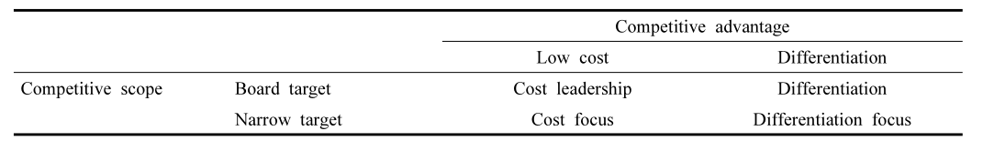
Figure 1：Competitive advantages and competition strategy by Porter
Source: Porter (1985)

Porter (1985) also argued that both competitive advantage and comparative advantage are comparison based on the productivity and are limited by the scarcity of natural resources; are affected by knowledge, creativeness, technology and economic scale. For this reason, no country across the world has both competitive advantage and comparative advantage for all industries.

Comparative advantage belongs to the economic field whereas competitive advantage belongs to the management field (David and Kerry, 1990). For the international scale, the comparative advantage is the relative difference of productivity among different
industries of a nation in comparison with another nation in the world. This is determined by natural factors such as labor forces, natural resources or financial sources. In contrast, competitive advantage is the complete difference of productivity of all enterprises in the same industry or among different industries in the same country.

Porter (1985) mentions that competitive advantage explains the root or the origin of wealth in which wealth helps a nation to be create an effective business environment and make full use of it. However, both competitive advantage and comparative advantage are closely related each other. In other words, comparative advantage can be a factor leading to competitive advantage. Moreover, it is difficult for an industry to form or maintain sustainably its international competitive advantage without having comparative advantage.

It is also considered to maintain core competition (Zhang and George, 2020), Nashiruddin (2019) research shows that sustainable competitive advantage is the company’s long-term development and commercial success.

Hamel and Prahalad (1991), explained that combining complex streams of technology and work activity creates core competence for the company and these core competencies yield long-term benefit to the company and gives birth to sustainable competitive advantage. Competitive strategies can come in the form of high-quality products, superior customer services and achieving lower costs.

Competitive strategy can only be identified when the company constantly researched into and predicts the changing or market conditions and customer's needs. The market dynamism and technologies has often been critical of the sustainability of competitive advantage. Wernerfelt (1984) had proposeda model which was improved by Barney, Wright, and Ketchen (2001). This model helps to solve issues related to elements in order to achieve competitive advantage. This model as Resource Based View, explains
that "resources" and "capabilities" are required by an organization to create sustainable high performances. Ray, Barney, and Muhanna (2004) and Barney (1991), supported that resources and capabilities are needed to form the competitive entry barrier. However, they further explained that it is very difficult to determine the precise amounts of resources and capabilities needed to provide sustainable position and performance. Hafeez, Zhang, and Malak (2002) stated that the answers are often rooted deep in the organisation.

From Kabeyi (2018) the company can provide compared with competitors, a sustainability advantage exists when the cost is lower (cost advantage) or the product profit is higher than the competitor (differentiated advantage). This is a combination of the company’s internal and external environment and the concept of using Porter’s five forces Factors, According to Srivastava, Franklin and Martinette (2013) have analyzed the specific factors that affect the Sustainable Competitive Advantage, they are the company’s philosophy, culture and organizational form, which are related to the various functions of the company departments and business links are fully connected, such as from the company's superstructure, such as the company's management advantages, team advantages, cultural advantages, human resources advantages, business advantages, etc., when all links reach the optimal state, the enterprise naturally It has maintained its core competitiveness.

2.2 Definition of Some Independent Variables

2.2.1 Company Image
The history of corporate image definition also reveals convergence on a gestalt meaning, but one that omits corporate attributes and focuses exclusively on perceiver images. This was not the emphasis in the first definition, for Martineau (1958) proposed that corporate image be defined two-dimensionally on the basis of functional attributes and emotional meanings. Functional ones included tangible assets such as quality, reliability, service, price, and so forth and emotional ones included the receptor’s subjective feelings. However, functional research on the firm as the image-sender gave way to reception research on image in perceivers’ minds, with emphasis on different stakeholders’ impressions or perceptions of a firm (Johnson and Zinkhan, 1990).

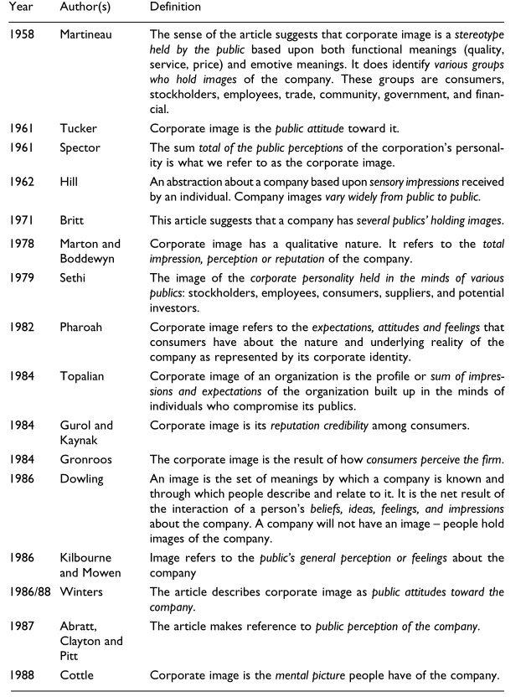
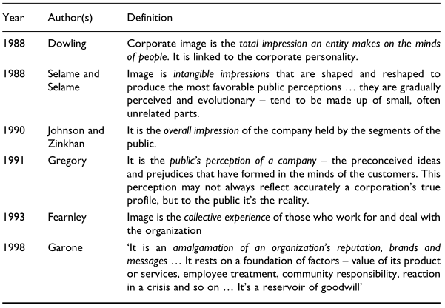
Figure 2:Definitions of corporate image
Source: Adapted (in part) from Johnson and Zinkhan (1990)

In Ind’s words (Ind, 1990),‘corporate image is in the eyes of the receiver,’ analogous to a portrait viewed through the viewer’s filter of feelings, beliefs, and interpretations.
As emphasis shifted from the corporation itself to the stakeholders’ impressions of it, the segmentation of perceivers became the major research task. The rationale is that each segment’s perception of corporate image flows from its particular relationship to the firm and must be measured in terms of different evaluative variables. The segment’s image is multidimensional, reflecting not only the specific group’s interests, values, and frame of reference, but also its access to available information. The latter includes a corporation’s controllable signals (advertising, annual reports, public relations) and those beyond its control (rumors, investigative reports, whistle-blowers’ statements). Negative as well as positive information influences stakeholders, for it is factored into the overall impression based on a segment’s prior experience, beliefs, and values.

Stakeholder perceptions are also influenced by haloing effects and inference making. Haloing (Reynolds and Whitlack, 1995) occurs when people ascribe impressions about attributes with which they are familiar to those with which they are not. Simple inferencing occurs when individuals assume that certain attributes such as size and power or high profits and soullessness ‘go together’ (Marchand, 1998).

More complex inferencing (Fombrun and Shanley, 1990) occurs when stakeholders make comparative evaluations of a firm by ranking it vis-a-vis others in the field. One consequence of different groups/different hierarchies/different variables is that contradictory images are likely to be constructed. For example, whereas investors may perceive a positive image based on profitability, consumers may perceive a negative one based on poor customer service.

The positive image of an organization is of great significance to MLM, which one is an invisible reputation (Nguyen, 2018).

Only the company has been recognized by the public and society, with a good reputation and reputation (Feldman, Bahamonde and Velasquez Bellido, 2014) is MLM’s sustainable competitiveness, the image of a company is a complex which it built on many levels of the company. It is an intangible asset that combines with the company’s brand impression, corporate reputation and corporate social image and the impression left by the company on consumers in society. Similar to the concept of each individual human being in society, if the corporate image is positive and positive, the majority of consumers will like him and trust him, otherwise the corporate image is not good and consumers hate it How can such an enterprise achieve corresponding success? this is the most direct and potentially influential enterprise sustainable competitive advantage.

2.2.2 Product Innovation

Product innovation means introducing the new products/services or brining significant
improvement in the existing products/services (Polder et al, 2010). For product innovation, the product must either be a new product or significantly improved with respect to its features, intended use, software, user-friendly or components and material. The first digital camera and microprocessors are the examples of the product innovation. Change in design that brings significant change in the intended use or characteristics of the product is also considered as product innovation (OECD, 2005).

The product innovation has many dimensions. First, from the perspective of the customer, product is new to the customers. Second, from the perspective of the firm, the product is new to the firm. Third, product modification means brining product variation in the existing products of the firm (Atuahene-Gima 1996). Firms bring product innovation to bring efficiency in the business (Polder et al. 2010).

In highly competitive environment of today, firms have to develop new products according to customer’s needs (Olson et al.1995). The aim of product innovation is to attract new customers. Firms introduce new products or modify the existing products according to needs of the customers (Adner &Levinthal, 2001). Shorter product life cycle of the products forces the firms to bring innovation in the products (Duranton & Puga, 2001). In the competitive environment firms bring product innovation to compete in the market. The product innovation face the low competition at the time of introduction and that is why it earns high profit (Roberts, 1999).

Ettlie & Reza (1992) stated that firms bring product innovation to compete with other firms in the markets. Firms bring product innovation to satisfy their customers.

Product innovation is reflected by the functional performance (Olson et al. 1995). Product innovation is one of the key factors that contribute to success of an organization. New product development and product innovation is an important strategy for increasing the market share and performance of the business. The studies showed that new product development has positive impact on the performance of the firm (Ettlie & Reza 1992)

The theoretical connection between the innovation's nature and sustainable competitive advantage, found in the literature taken into account, can be summarised in four factors. Firstly, innovations that are harder to imitate are more likely to lead to sustainable competitive advantage (Clark 1987; Porter, 1985). In simpler words, the harder the strategy is to imitate, the longer the advantage is (Porter,1985). Second, innovations that reflect more accurately than others market realities, are likely to lead to sustainable competitive advantage (Deming, 1983; Porter, 1985). Innovation of this kind are often based on “applying modifications of existing technologies in new ways for new markets” (Lengnik-Hall, 1992, p. 4). A classic example of this type of innovation in business literature is Miller's (1990) example of Federal express introduction of night service; a new application of an existing technology or process into a new market. Third, innovations that facilitate the timing characteristics of a firm in its relevant industry can bring sustainable competitive advantage (Betz, 1987; Kanter, 1983). also Teece (1987) argues that good timing can introduce a strong source of uniqueness and therefore advantage over the competition.

And last but not least, innovations based on technologies and resources that are easily
accessible by the company, are also considered to be beneficial to sustainable competitive advantage (Ansoff, 1988; Miller, 1990). As a matter of fact, for a company willing to obtain sustainable competitive advantage, “effective management
of resource allocations is an essential prerequisite” (Lengnik-Hall, 1992, p.6).

Overseas MLM companies have strong technological and product advantages. Because these superior products attract customers for continuous and repeated purchases and they gain competitiveness (Kuncoro, Wuryanti and Wa, 2018). Many well-known overseas MLM companies such as Amway and Herbalife use technology innovation to develop new markets and new businesses and take advantage of the differentiation of branch-level products to bring more profits (Brem, Maier and Wimschneider, 2016). Definitely, the new products and new technologies become more and more key roles in global or international companies, so the company innovation is also an important factor and hypothesis suggestion.

2.2.3 Leadership

Leadership is paramount to the success of organizations (Stamm, 2009; Burns, 2008). Leadership is a broad and complex topic, difficult to define and is awash in a multitude of theories in the academic and business worlds.

Paul Burns (2008) describes leadership in terms of strategy, communication, motivation and the setting a direction. This definition and perspective take on leadership is congruent with the theory of ‘transformational leadership’. It can be further defined as a leadership style that “influences the fundamental attitudes and assumptions of an organization’s members creating a common mentality to attain the firm’s goals” (Victor, 2008, p. 299).

In fact, understanding leadership involves spotlighting what effective top leaders actually do in order to produce a strategy-focused organization (Rumsey, 2013). Furthermore, strategic leaders need to be able to focus on critical resources which are most likely to make a difference in the assurance of sustained future success.

Hitt and Ireland (2002) who recommend that leadership is about gaining access to key resources such as alliances with partner firms “social capital” and the ability to build great teams “human capital” as the most important firm resources.

The strategic literature review emphasized that effective strategic leadership capabilities are needed in the new competitive landscape expected for the 21 st century (Ireland & Hitt, 2005). The strategic leadership capabilities focus on developing human capital and social capital. In addition, McCallum and O’Connell (2009) recognized that human capital and social capital are not fully independent of one another.

The essence of strategic leadership is managing human and social capital (Hitt & Ireland, 2002). Perhaps the most important task for strategic leaders is effectively managing the organization’s portfolio of resources. Strategic leaders manage the organization’s portfolio of resources by organizing them into capabilities, structuring the organization to use the capabilities, and developing and implementing a strategy to leverage those resources to achieve a competitive advantage (Sirmon, Hitt, & Ireland, 2007).

For the requirements of the study will focus on effectively managing of organization’s human and social capital as a essence of strategic leadership according to (Hitt & Ireland, 2002). Human capital refers to the knowledge and skills of a firm’s entire workforce (Hitt, Ireland, et al., 2010, p. 388). Emphasizing human capital as a part of intellectual capital, it is the primary component of intellectual capital (Bontis, 1998).
Furthermore, Au, Altman and Roussel (2008) described human capital within an organization, by the knowledge mastered by individuals. Conventionally, they distinguish three kinds of human capital in different categories according to Gibbons and Waldman (2004), Hatch and Dyer (2004) are generic (general) human capital, organization-specific human capital, task-specific human capital. Social capital is a component of intellectual capital as like human capital, also inevitably contributes on human capital development (Birasnav, Rangnekar, & Dalpati, 2011).

Balkundi and Kilduff (2006) define social capital that is inherent in the acuteness of individuals’ social perceptions and the structure of their social relationships. On the other hand, social capital includes relationships inside and outside the organization that assists the organization achieves tasks and creates value for customers and shareholders (Adler &Kwon, 2002; Hitt & Ireland, 2002; Prusak & Cohen, 2001). Strategic leaders must be conceded with social capital within that units and organization as well as with social capital residing outside their organization in other settings.

Thomas and Thomas (2011) put perspectives on leadership seeks to advocate examining strategic leadership processes through the exploration of interactions between such multiple constituencies as the dean, faculty, university councils and advisory boards. They found noted that strong leadership is necessary to form a strategy going forward and to implement the required changes.

Furthermore, those who are part of the university/academy and management education sectors would probably agree that it is necessary to strengthen and professionalize university/academy leadership and re- examine the dean’s roles so that they can respond swiftly and effectively to the challenges of the post- crisis world (Rosser, Johnsrud, & Heck, 2003). This has led some deans to argue that they can be likened to partners in professional service firms in that they are promoted on the basis of expertise, knowledge and intellectual capital to deanships (Goodall, 2009). While there is a clear requirement to evaluate competition and competitive markets, it is also essential that deans understand the specific organizational traits involving people, systems, business processes and cultural aspects in order to be effective in their strategic execution. This broad view of deans’ leadership implies a thorough awareness of both the internal context and the external context in their academic environments in order to frame their strategic positioning and specific strategies (Fragueiro & Thomas, 2011).

Leadership is undoubtedly crucial to the company’s success (Yamin, 2020). Leaders are typically in the most influential position in the company, A capable leader achieves the mission of the enterprise through his or his influence Törnblom, Oskar, Kristian Stålne and Sofia Kjellström (2018), a strong leader is the company's most core competitiveness advantages (Shao, 2019) in any time because a leader can affect the company culture and organization. an enterprise’s leadership style and direct leader’s style play a vital role in the development of an enterprise. A good leader can give the enterprise a new rebirth, and vice versa, it will lead to the destruction of the enterprise. Especially in start-up companies, they are particularly important factors. The founder's belief and mind, knowledge and other capabilities directly determine the success or failure of new companies. Because most local MLM companies in Malaysia are emerging companies and start-ups, this is also an important factor in the core competitiveness of corporate sustainable development.

2.2.4 Distributors’ Reward System

Rewards were viewed primarily as the pay checks employees collected every week or month. Today, that definition has expanded greatly. Bush (2003) defined the total rewards as cash compensation, benefits, other non-cash forms, and work experience. By this definition, A reward systems is everything employees perceive to be of value resulting from their employment relationship.

Gross and Friedman (2004) mentioned that rewards now encompass the overall value
proposition that the employer offers to the employee. This total package includes compensation (including base pay, short-term and long-term incentives), benefits (including health and insurance, retirement, work/life and other benefits) and careers (including training, development, and career opportunities).

A good reward system drives performance by motivating workers to achieve new levels of performance, and attracts, retains, and motivates employees to do their best and stay with the organization (Bowen, 2004). A suitable reward system is essential to ensuring that an organization’s investment in its employees is managed effectively. A reward system also provides a powerful means of implementing an organization’s competitive strategy. When properly designed and executed, a total reward system can be a powerful driver of business success (Gross &Friedman 2004).

Howard and Dougherty (2004) have labeled some reward systems, including individual output, group output, human capital, position, and market. Different reward alternatives are likely to have different effects on organizational outcomes as follows: 1. An individual output reward alternative will improve productivity. 2. A group output reward alternative encourages cooperation and collaboration among workers, and fosters commitment to a higher level of goals. 3. A human capital reward alternative encourages people to develop their human capital and entices them to use
it. This leads to increased skill scope and level as well as effort. Skill-based pay is often also used to develop flexibility in work scheduling because workers become generally more qualified. 4. A position reward alternative encourages workers to assume responsibility for greater job depth. The strategic consequence of a position reward alternative is greater technical competence within each specialized role in a worker’s job description. 5. A market reward alternative that pays these individuals at or above the market rate can prove to be a wise investment, especially if their replacement would be particularly expensive or disruptive. This approach ensures that the firm’s pay levels are at least competitive with the labor market.

In MLM system, distributors do not receive a salary, but they received commissions on the sales of the products they sold as well as sold by their downline members whom they recruit. The amounts of commissions depend on their group performance. Wang and Chang (1998) demonstrated that Lucrative compensation plan of a firm is the key factor that motivates the distributors to work in an enthusiastic manner.

The effective compensation policy of MLM business provides the distributor an opportunity to earn extra money and it also gives the financial satisfaction to distributors (Keun, 2004; Palmatier et al., 2007; Parvi & Kabir, 2011). Kiewand and Run (2007) reported that financial rewards and product quality allured people to join and stay on in MLM business. Consumers want instantly and convincing solutions to their problems and desire innovative, nutritious and suitable products for consumption.

Chaubey and Subramanian (2013) illustrated, the product feel, demonstration, opportunity to test and verify product claims are variables that satisfy the customers. Product quality is considered a prime embolden for repurchasing the products (Devi & Kalaiselvi, 2014).

The MLM system affects its direct customer’s willingness to pay through relationship marketing, therefore customers prefer to buy products from acquaintances, relatives, etc. rather than strangers. Oksanes (1999) inferred, distributors tend to create co-operative relationship with other distributors in order to accomplish their goals. This helps in building healthy relationship with co-workers and supervisor that lasts for long term (Parvin & Kabir, 2011). Hence, the social network as a factor plays an important role in success of business (Marsh, 2004; Palmatier et al., 2007).

The most fundamental feature of companies in the MLM industry is that they have adopted a unique incentive mechanism as a weapon to expand sales in market competition and job promotion. the specific performance is that the greater the sales of the channel, the greater the rebate and the faster the promotion of the distributor, the greater the discount (Grade and Gonçalo, 2019), which is also an attraction for talent one way (Rowland & Hall, 2014), such as Amway has unique titles and privileges at many status levels (Pasaribu and Ika, 2018). This is the most basic principle of incentives, rewards and punishments for MLM companies, but this system often brings a huge negative impact. For example, many companies only focus on sales, not specific products and services, it is not only focus on the final achievement data and it is not the meaning behind the data. Many companies will have a lot on unethical behaviors this system. such as in order to expand and improve sales performance, they often occurred deceive phenomena and behaviors. Many companies only focus on attracting people and improving performance. They do not pay attention to actual products, but some companies only focus on specific performance in order to achieve performance, there has even been a phenomenon of defrauding relatives which has brought great destructive power to the MLM industry and left a great negative impression on consumers. Therefore, the quality of the system of the channel business directly affects the company’s survival is a crucial factor.

2.2.5 Distributors Training System

Distributors must have sales and training skills to attract potential members and expand the service system, which is one of the factors for success in a highly competitive market (Ivashkova, Sidorchuk and Skorobogatykh, 2018), especially in the MLM industry, with the speed of entry of new customers and new channel providers is changing rapidly. the participation of new customers and new partners is completely provided by distributors to provide services and training. the requires distributors to maintain contact with the headquarters for new customers and new channels. How to keep the same policies and services require distributors to have higher sales training skills, and these trainings directly reflect the competitiveness of an MLM. The quality of the training directly reflects the company’s image and reputation, which also reflects business operations. The most important core competitiveness in China.

Recruiting in a regular corporate firm is characterized by devoting much time, money and effort to find the very best person for a certain position. Multi-level organizations in contrast have no recruitment criteria at all. In the corporate world, bad employees are considered non-valuable and expensive, yet many new distributors of MLM firms have none or minimal sales experience. Anyone can be considered a potential new distributor for a direct selling firm (Biggart, 1989)
Sponsors or uplines who are more active with training, information giving and communication create downlines who are more cooperative to the network (Sparks & Schenk, 2006). Lan (2002) explained that because distributors often are criticized by non-members, distributors depend on each other to validate their beliefs of success and moral meaning of the business model

The triangular model by Ferrell et al. (2010) illustrates a typical direct selling structure and explain the interactions between the actors in such a firm. One of the ways they mentioned that distributors interact with the direct sales company is training. However, the respondents only expressed training in the sense that they were trained by their uplines, and not by the MLM firms. Although, new distributors or their uplines may be provided with some material from the MLM firms. Therefore, an interpretation is that the activities that are described to occur between the firm and the distributors could just as well be activities between the distributor and the consumer in the model (Ferrell et al., 2010), This interpretation is also more similar to the point of view on training by Sparks and Shenk (2001 and 2006).

Due to the fact that distributors are considered independent contractors and each upline is responsible for training new recruits (Sparks & Schenk, 2001), new distributors are introduced to their new role as a distributor in different ways.
The different approaches of training used by uplines can be explained by that the distributors themselves are in control of deciding what to focus on, whether it is to sell or to recruit (Sparks & Schenk, 2001).

Sparks and Schenk (2006) described how uplines who are more active with training, information sharing and communication will create downlines more cooperative towards the network, meaning they will follow the guidelines set by their respective upline or senior uplines. This is partly explaining why some distributors agreed to certain practices despite not fully agreeing with them

2.3 Gaps in the Literature
Although many kinds of literature were found and study in Sustainable Competitive Advantage and relevant factors that influence it. However, there is limited literature that concentrates in MLM companies in Malaysia., It has been determined that there is a research gap and facilitated the researcher to fulfil the gap by researching this field of study.

2.4 Critical Review of Key Models and Theories

2.4.1 SWOT Analysis Theories
The source of the theoretical framework for the company’s sustainable competitive advantage comes from Porter (1985) and Rumelt (1984). Since the 1960s, a single organizational framework has been used. According to this framework, SWOT internal and external enterprise factor analysis: This model is suitable for all companies to objectively analyze their own internal and external advantages and disadvantages (Phadermrod and Gary, 2019).

In addition to the company's determination of internal and external factors and the company's competitiveness, the model also assesses the current status of the company and industry in terms of strengths, weaknesses, opportunities, and threats (Lamb, 1984).

Among these attributes, the advantages contribute to the company’s development. In order to enhance the competitive advantage, the disadvantages are the characteristics of the company that weakens the competitive advantage, the opportunity is that the external environmental conditions are conducive to enhancing the company’s competitive position, and the threat is the adverse external environmental conditions. As a result, we have a clear understanding of the objective situation of the enterprise, which has played a good role in formulating and how to exert our own advantages (Barney, 1986).

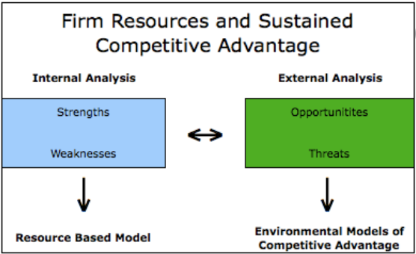
Figure 3: The relationship between traditional "strengths-weaknesses-opportunities-threat”
Source: JAY BARNEY (1991)

2.4.2 Porter's Five Forces Theories
Porter's Five Forces is based on SWOT to analyze the competition level of enterprises in specific industries and assist in the development of business strategies (Kabeyi, 2018). Below figure which it includes five factors: In order to maintain a competitive advantage and shield competitors, companies use the Porter Five Forces Principle to analyze the industry and corporate competition strategy. In currently this concept has become a more popular and recognized center of advanced market competition theory in the market. From this theory discussed the competitive advantage from five aspects. If you look at it at a specific level, it can be seen from the core advantage of the enterprise, which is irreplaceable, and the strategic cooperation relationship and soft power for partners in the market such as customers and suppliers. Such as corporate culture, management system, technology, leadership and execution of competitive strategic advantages, many aspects of this theory can be summarized in the factors of how companies maintain sustainable competitiveness.
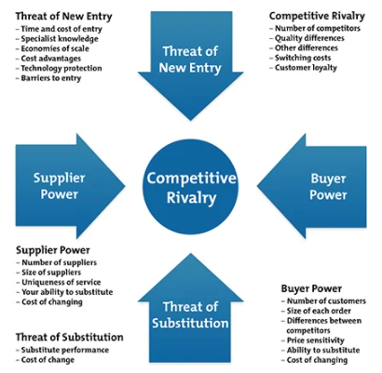
Figure 4: Porter Five Force
Source：author

2.4.3 Barney’s VRIN Theories
Barney (1991) stated that VRIN framework about relationship between company sustained competition advantages and company resources.
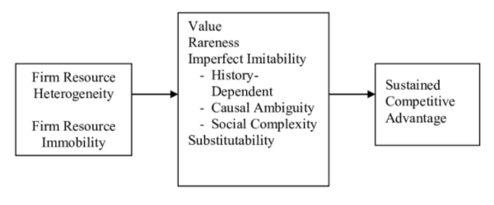
Figure 5: Barney’s VRIN and Competitive Advantage
Source: JAY BARNEY (1991)

The relationship between resource heterogeneity and immobility; value, rareness, imitability, and substitutability; and sustained competitive advantage is summarized in Figure 5. This framework can be applied in analyzing the potential of a broad range of firm resources to be sources of sustained competitive advantage. These analyses not only specify the theoretical conditions under which sustained competitive advantage might exist, they also suggest specific empirical questions that need to be addressed before the relationship between a particular firm resource and sustained competitive advantage can be understood.

From the de Oliveira, Ana Claudia, et al. (2018) and Barney’s VRIN the company’s specific sustainable competitive advantages from four aspects. These four aspects are valuable、rare、inimitable、on-substitutable.

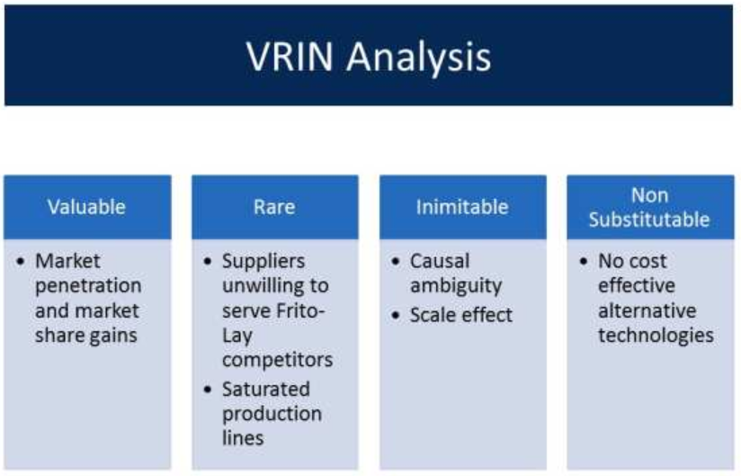
Figure 6: Barney’s VRIN
Source：http://www.sourcing-plus.com/dba.php

From these specific aspects, we can easily analyze the company's core competition Advantages, such as irreplaceability, it can range from corporate culture construction, corporate brand reputation, corporate leadership, and specific to outstanding products at the product level, and irreplaceable products with huge core technologies, such as those of foreign MLM companies core products and unique corporate values. According to this kinds of model we can confirm those major factors might to affect the business of MLM companies Sustainability and sustainable competitive advantage are company distributor reward system、leadership、image、product innovation and dealer training system.

2.5 Conceptual Framework

DV
IVs

Company Image
Leadership
Product Innovation
Sustainable Competitive Advantage
Distributors’ Reward System

Distributors Training System

Figure 7：Conceptual Framework
Source：author

2.6 Hypothesis

H1: The company image has a relationship with sustainable competitive advantage of MLM companies in Malaysia

H2: Product Innovation has a relationship with sustainable competitive advantage of MLM companies in Malaysia

H3: Leadership has a relationship with sustainable competitive advantage of MLM companies in Malaysia

H4: Distribution reward system has a relationship with sustainable competitive advantage of MLM companies in Malaysia

H5: Distribution training system has a relationship with sustainable competitive advantage of MLM companies in Malaysia

2.7 Conclusion
Chapter 2 mainly focuses on the literature review regarding every variables and key concept theories. There were many studies conducted on the factors that would influence sustainable competitive advantage. In a nutshell, this research decided to adopt company image, company innovation, leadership, distribution reward system and distribution training system will influence the sustainable competitive advantage firms in Malaysia.

Chapter 3: Research Methodology

3.1 Overview
In this chapter, it will identify research hypotheses to know the possibility and relationship between factors influencing five IVs among DV in Malaysia. Then, a pilot study will be prepared for future collecting the data from relative groups of people in analysis, recording, calculating, and classifying the receivable data using SPSS 23 method. Moreover, there are meanings given to each data analysis to understand the function of it.

3.2 Research Design
Research design is a logical approach to effectively solve research problems (Kumar and Gupta, 2016). It mainly stipulates the various procedures of the entire research, and any steps are based on theoretical basis and sources, so as to ensure that the entire research is effective and reliable

3.3 Research Instrument
The research instrument can be categorized. These different ways of collecting data helps in assessing the validity and dependability of the data (Zohrabi, 2013).

3.3.1 Qualitative Research Method
Qualitative research includes gathering, examining, and translating unstructured information by seeing what individuals do and say (Burns, Veeck, & Bush, 2017). Perception and explanation are free form or non-standardized on ground that question and perception are open ended. Qualitative data can be sorted, but such data are not generally qualified (McDaniel & Gates, 2013). For example, it can obtain through interviews, and classroom observation.

Quantitative research is characterized as research including the organization of a lot of organized inquiries with foreordained reaction choices to a substantial number of respondents. It’s occasionally alluded to as “survey research”. Moreover, it includes a sizable delegate test of the population and a formalized methodology for collecting the information. It can be achieved through questionnaire, printouts, mobile devices, PCs and so on (Burns et al., 2017). Basically, researchers will choose quantitative research whenever there is head count needed, comparison over views and behavior (Hague, 2006). In addition, the data must accumulate follow an orderly procedure that is great extent numerical in nature. Most significantly, all the items of the questionnaires or surveys are predominantly created dependent on the research questions and research objectives (Zohrabi, 2013).

3.3.2 Mixed Research Method
Mixed research method is the mix of qualitative and quantitative research technique with the reason to attain the benefits of both. Usually said that qualitative data give the “why”, and the quantitative data give the “what”. Mixed methods research can take an assortment of structures. The qualitative phase can fill in as an establishment for the quantitative phase of the research project since it gives the researcher with firsthand knowledge of the research problem. Armed with this information, the researcher’s structure and execution of the quantitative phase are perpetually better than what they may have been without the qualitative phase (Burns et al., 2017). For instance, it includes all the open-ended questionnaire, close-ended questionnaire, classroom observation, and interviews (Zohrabi, 2013).

To complete the research, quantitative method is chosen in which a questionnaire research method will be conducted to collect useful information from the audience in calculating the end result. The reason for utilizing this technique is to decide the accurate and precise information of this investigation. It is able to distribute to multiple target respondents at the same time with little time consuming than doing an interview. Also, through distributing questionnaire can support the larger sample size which is dependable as this research need respondents to finish the analysis of the topic. Additionally, this technique helps to collect data for the usage to know the practice regarding purchasing behavior and the desire to make repeat purchase of the online buyers. So, the answers get from the respondents can be interpreted and analyzed easily and objectively in this research.

3.3.3 Questionnaire
This research is to collect quantitative data, therefore closed-ended and structured methodology has been adopted and adapted in the questionnaire design as in figure
Section | Question/Item | No | Adapt/Adopt | Sources
Part A | Demographic Information  (Gender, Age Group and Income Level) | 4 | Adopt | Ahuja (2015)
Part B  (Dependent Variable) | Sustainable Competitive Advantage | 6 | Adapt | (Chen,2012)  (Nidumolu & Knotts, 1998)
Part C  (Independent Variable) | Company Image | 6 | Adapt | (Feldman, Percy, Rolando and Isabelle,2014)
Part C  (Independent Variable) | Leadership | 5 | Adapt | Yukl (2009)
Part C  (Independent Variable) | Product Innovation | 5 | Adapt | (Shaukat, Sadia, Muhammad and Saman,2013)
Part C  (Independent Variable) | Distribution Reward System | 5 | Adapt | (AS Abbasi,2012)
Part C  (Independent Variable) | Distribution Training | 5 | Adapt | (Loi, 2015)

Figure 8: Questionnaire Design

3.4 Pilot Study
Pilot study refers to the survey utilize a limited number of respondents and regularly utilize less rigorous sampling techniques than are employed in huge and quantitative studies (Burns et al., 2017). followed by Junyong (2017), he said that pilot test is significant for improvement of the quality and efficiency of the study. Moreover, it is conducted to evaluate the feasibility of the study protocol, inspect the randomization and blinding procedure, increase the researchers’ involvement in the investigation techniques, select the most appropriate primary outcome, and give appraisal for sample size calculation.

However, it is often misused, mistreated and misrepresented to the respondents. A well-directed pilot study normally comes with clear points and targets within a formal framework. It can lead to high quality research and scientifically valid work that brings benefits to the publicity. Therefore, a researcher has to build up his or her skills, pick the correct strategies and cautiously plan for all parts of the procedure. Also, the questionnaire should be tested and get opinion from the respondents before placing it into SPSS system to determine the reliability of the questionnaire (Doody & Doody, 2015).

Before fully distribute the questionnaire, there is a pre-test questionnaire had distributed to 82 respondents in order to understand the problems existing in the questionnaire as well as to ensure the validity and reliability of the question included. The collected data has tested on the latest version of SPSS by employing Cronbach’s Alpha test in order to know the reliability and validity of the pilot test. The feedback getting from the first 82 respondents have given some clue to modify the question to a clearer and direct point which can easily understand by others.

3.5 Data Collection

3.5.1 Population
According to WFDSA (2018) annual report, there is approximately 4.25 million direct selling (single level and multi-level) distributors in Malaysia. Hence, target population
group will be selected based on the position of manager level or above and distributors of MLM companies in Malaysia who is Malaysian with age of 18 years old and above (Stated by Direct Sales Act 1993 as legal age to join) regardless of gender, race, part-time or full-time. This target population group is the correct group as they understand and comprehend about the nature and structure of MLM business and its environment. For the sample size in this research, the rule-of-five technique for sample selection is adopted (36 items multiply with 5) that is minimum of 180 samples which fit as sampling population.

3.5.2 Target Population
It refers to a collection of elements identified with the examination study which aim to analyze and understand the reaction of the respondents (Liew & Falahat, 2015). This target population group is the correct group as they understand and comprehend about the nature and structure of MLM business and its environment. For the sample size in this research, the rule-of-five technique for sample selection is adopted (36 items multiply with 5) that is minimum of 180 samples which fit as sampling population.

3.5.3 Sampling Technique
The major alternative sampling method can be gathered into probability sampling and non-probability sampling methods. It is basically use to make derivation about a population or to make speculation in connection to existing hypothesis. Fundamentally, this relies upon the decision made for sampling technique used (Taherdoost, 2016).

Firstly, probability sampling methods refers to each component of the population has a known, nonzero likelihood of choices. It can be categorized in to four types which include simple random sampling, stratified random sampling, cluster sampling, and systematic sampling. Basically, simple random sampling is the best known and most generally utilized probability sampling method. At the point when this method is pursued carefully, the laws of probability hold, enabling computation of the degree to which a sample value can be hope to vary from a population value. This distinction is alluded to as sampling error.

In contrast, non-probability sample are those in which explicit components structure the population have been chosen in a nonrandom manner. Non-randomness results when population components are chosen on the basis of convenient because they are simple or inexpensive to reach. There are two types of non-probability sample which includes quota sampling and convenience sampling. Normally, these methods are mostly used for qualitative research due to the focusing on small samples and are proposed to inspect a real-life phenomenon instead of making statistical inference in connection to the wider population. A sample of participants shouldn’t be delegate or irregular, yet a reasonable method of reasoning is required for the consideration of certain cases or people as opposed to other people (Bryman & Bell, 2015).

Hence, simple random method will be applied to analyze this research on the topic the choice of using this method is because it enables to obtain accurate and credible information with any deviation. Also, after consideration made to deal with large population, simple random sampling allows every individual to have an equal possibility to be participated as a respondent to answer the survey questionnaire.

3.5.4 Sample Size
Sample size refers to the identified and selected population subset for the survey, chosen because it represents the entire groups. It would affect the effectiveness and flexibility of the research if the researchers unable to determine right sample size (Bryman & Bell, 2015). Followed by Hair, Black, Babin, and Anderson (2010), they suggest that the minimum sample size is 100 as estimated the research contains 5 variables in total. This ranges between 100-400 sample size are ideal in which it can ensure the stability of maximum

Thus, the sampling method utilized in this examination is the simple random sampling which is categorized in probability sampling method. A probability sampling characterizes as one in which each unit in the population gets an opportunity (0<1) of being chosen in the sample which can be precisely decided. A determination based on Hair et al. sample size calculation will be applied to complete this study. So, the research needs 180 (5 variables x 36 question = 180 questionnaire) sample size. However, there are 460 respondents will be sampled to enhance the reliability and validity of the data.

3.6 Data Analysis

3.6.1 Reliability Test
Data analysis is the crucial part of any research as it summarizes all the data with interpretation and evaluation using systematic and consistent thinking to determine relationship, patterns, or trends. In this study, Cronbach’s Alpha technique will be used to estimate the mean reliability coefficient. There is a rule of thumb for interpreting alpha of 0.7 and above is good, 0.8 and above is better, and 0.9 and above is the best (Tavakol & Dennick, 2011).

In the pilot test, there are about 10% to 20% of the sampling population is selected for the pilot test. It is mainly focused on the quality of the questions, outline and arrangement which will consider refining the questionnaire. In this study, there are 20 questionnaires need to be collected for the pilot test.

3.6.2 Preliminary Testing
Certain estimates of the mean, mode, standard deviation, and range are types of descriptive analysis. It is utilized by researchers to describe the sample database so as to depict the “typical” respondent and to uncover the general pattern of responses. Ordinarily, it is used early in the investigation procedure and become establishment for subsequent analysis (Saunders et al., 2015).

3.6.3 Correlation Analysis
Correlation analysis is the extent to Data analysis is the crucial part of any research as it summarizes all the data with interpretation and evaluation using systematic and consistent thinking to determine relationship, patterns, or trends. Data analysis is the crucial part of any research as it summarizes all the data with interpretation and evaluation using systematic and consistent thinking to determine relationship, patterns, or trends. Therefore, bivariate correlation method has implemented to determine the relationship between dependent variable and independent variables in the research.

3.6.4 Diagnostic Test
Firstly, normality test describes all the mistakes ought to be typically disseminated. The normality test is vital for the b-coefficient tests to be valid particularly for small samples, estimation of the coefficients just necessitates that the mistakes be indistinguishably and autonomously dispersed. Not as large of a deal whenever disregarded (Ernst & Albers, 2017).

Among the test of normality, Kolmogorov-Smirnov is the most frequent used test to inspect the hypothetical distribution function of the test distribution. However, Kolmogorov-Smirnov has a limitation where it consists of high affectability to the outrageous values. So, the p-value must greater than 0.05 to indicate that the data is normally distributed. Also, the absence of balance (skewness) and pointless (kurtosis) are the main reasons to deviate from normal distribution. These can be solved to convert the p-value to a z-score (Ghasemi & Zahediasl, 2012).

Next, linearity shows the connection between the indicators and the result variable ought to be linear or direct. Major ordeal whenever damaged. Lastly, multicollinearity portrays the indicators that are profoundly identified with one another and both prescient of your result can cause issues in evaluating the relapse coefficients (Bruin, 2006).

3.6.5 Multiple Regression Analysis
Among the test of normality, Kolmogorov-Smirnov is the most frequent used test to inspect the hypothetical distribution function of the test distribution. However, Kolmogorov-Smirnov has a limitation where it consists of high affectability to the outrageous values. So, the p-value must lower than 0.05 to indicate that the data is normally distributed. Also, the absence of balance (skewness) and pointless (kurtosis) are the main reasons to deviate from normal distribution. These can be solved to convert the p-value to a z-score (Ghasemi & Zahediasl, 2012).

Chapter 4: Research Findings

4.1 Overview
This chapter will research and explain the data collected from October 2020 to November 2020. Use the procedures and test methods in the previous chapters to make a full analysis, the purpose is to test all the independent variables of company image, product innovation, leadership, distribution reward system and distribution training system and the relationship between the dependent variable sustainable competitive advantage.

4.2 Pilot Test
Pilot testing is the procedure and the first step of testing the validity and reliability of the data in the research. This step is particularly important. Any test must be tested by this test to guide whether subsequent tests can continue. In this test, you need to select 10% to 20% of the total sample. The total number of samples in our test is 466, so the test is run using 82 questionnaires and the data results are used for preliminary test analysis.

4.2.1 Factor Analysis

Variables | Items | Factor Loading | KMO | P-Value | EV
Sustainable Competitive Advantage | SCA1  SCA2  SCA3  SCA4  SCA5  SCA6 | 0.818  0.833  0.636  0.875  0.746  0.754 | 0.833 | 0.000 | 3.611
Company Image | CI1  CI2  CI3  CI4  CI5  CI6 | 0.885  0.826  0.867  0.805  0.869  0.793 | 0.886 | 0.000 | 3.973
Product Innovation | PI1  PI2  PI3  PI4  PI5 | 0.805  0.827  0.796  0.659  0.752 | 0.804 | 0.000 | 2.966
Leadership | L1  L2  L3  L4  L5 | 0.762  0.814  0.712  0.829  0.812 | 0.789 | 0.000 | 3.097
Distribution Reward System | DRS1  DRS2  DRS3  DRS4  DRS5 | 0.780  0.766  0.709  0.801  0.704 | 0.701 | 0.000 | 2.755
Distribution Training System | DTS1  DTS2  DTS3  DTS4  DTS5 | 0.821  0.801  0.751  0.795  0.710 | 0.702 | 0.000 | 2.608
Table 1：The factor analysis result of the pilot test

Based on Table 1 above, factor loadings are above 0.6, which shows that the factor extracts enough variance from the variable (Zulkepli, Sipan and Jibril, 2017). Besides that, the KMO value is more than 0.6, which follow the rules of thumb of the KMO (Liew and Idris, 2017).

4.2.2 Reliability Test
Variable | Cronbach’s Alpha | N of Items
Sustainable Competitive Advantage  Company Image  Product Innovation  Leadership  Distribution Reward System  Distribution Training System | 0.866  0.895  0.826  0.844  0.794  0.767 | 6  6  5  5  5  5
Table 2：Reliability Test result for the pilot test

Reliability test measures the consistency, precision, repeatability and trustworthy of the research. Cronbach's alpha is used to get the reliability index, and it varies from 0 to 1, the higher the index, the higher the internal consistency (Haradhan, 2017). Based on Table 2 above, Cronbach's alpha shows that more than 0.7, which considered as acceptable.

4.3 Preliminary Test

4.3.1 Demographic of Respondents/ Descriptive Analysis
This study collected a total of 502 questionnaires through Google Forms and WhatsApp and other social media, of which 466 valid questionnaires, and the effective rate reached 92%. This questionnaire also designed 5 demographic information about the interviewee, such as gender, occupation, age, income and race. The purpose of setting up this census information is to have an overall picture of the interviewee, which is also helpful to find out some relationships that affect various factors from this basic information, which also plays an important role in analyzing other factors
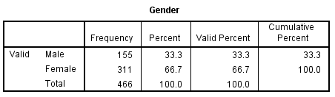
Table 3：Gender information of respondents

According to the above table, in the overall sample, the gender distribution is still very significant. Among them, male respondents accounted for 33.3%, female respondents (66.7%), and female respondents were approximately twice more than males, this shows that women in the MLM industry are more willing to engage in this industry, and at the same time women are more conducive to display their characteristics, and can better survive in this industry

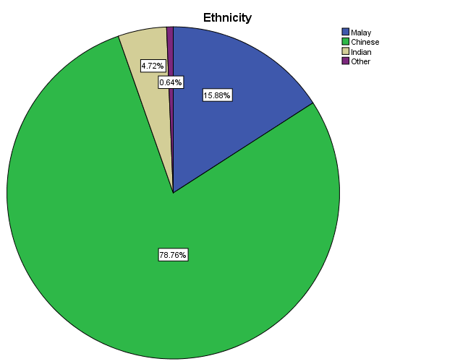
Figure 9：Ethnicity Information

As can be seen from the above table, in the MLM industry, Chinese accounted for 78.76% of the total number of respondents, while the remaining 15.88% Malays, 4720% Indians and 0.64% belong to “others”, which shows that this industry It’s understandable that each group likes to work in a company with its own group characteristics. This is also conducive to good communication and establishing good relationships. The development of this industry

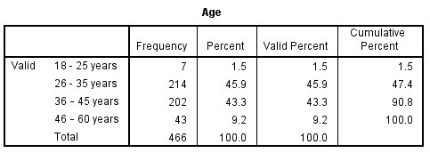
Table 4: Age Information

Based on the Table 4, A dominant percentage of 45.5 % are from the age group of 26-35 years old as well as the age group of 36-45 years old have contributed 43.3%,
The group of 46-60 years old fellow them and take up 9.2%.

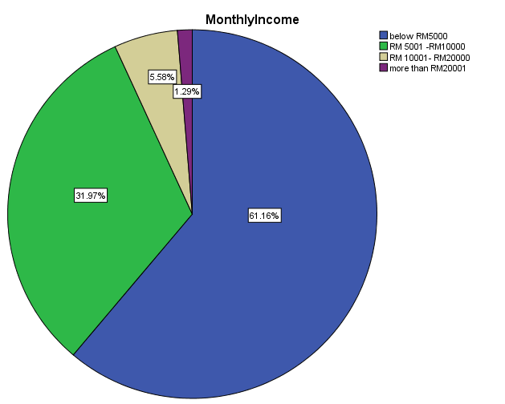
Figure 10: Income level distribution of respondents

Based on the figure, there are 61.6% who works in MLM firms in Malaysia obtain MYR 5,000 or below. And some of them 31.9% earns in between MYR 5,000 to MYR 10,000. Only 5.58% earnings of MYR 10,001 to MYR 20,000 shows with 1.29% gets a staggering income of above MYR 20,000.
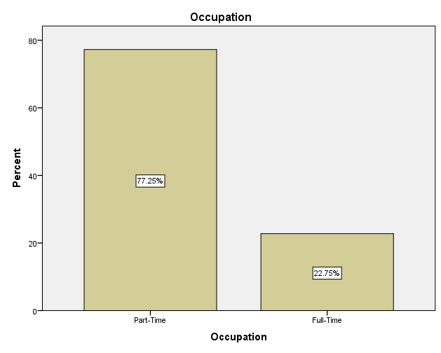
Figure 51: Occupation of respondents

According to the above figure shows that part-time employee takes up a majority total percentage of 77.25% of the total respondents whereas the remaining 22.75% full-time. part-time employee more than the full-time almost triple.

4.3.2 Preliminary Data Analysis
There are 466 collected data will go through factor analysis (factor loading, KMO and Barlett’s Test of Spherity) and reliability test to confirm that data are valid for the hypothesis testing. All the data was analyzed through SPSS version 23.

4.3.3 Factor Analysis

Variables | Items | Factor Loading | KMO | P-Value | EV
Sustainable Competitive Advantage | SCA1  SCA2  SCA3  SCA4  SCA5  SCA6 | 0.694  0.646  0.648  0.703  0.665  0.681 | 0.730 | 0.000 | 2.719
Company Image | CI1  CI2  CI3  CI4  CI5  CI6 | 0.705  0.708  0.709  0.743  0.787  0.758 | 0.720 | 0.000 | 2.714
Product Innovation | PI1  PI2  PI3  PI4  PI5 | 0.733  0.859  0.840  0.759  0.761 | 0.710 | 0.000 | 2.474
Leadership | L1  L2  L3  L4  L5 | 0.762  0.775  0.742  0.754  0.758 | 0.740 | 0.000 | 2.611
Distribution Reward System | DRS1  DRS2  DRS3  DRS4  DRS5 | 0.710  0.760  0.765  0.770  0.811 | 0.768 | 0.000 | 2.209
Distribution Training System | DTS1  DTS2  DTS3  DTS4  DTS5 | 0.689  0.780  0.764  0.798  0.702 | 0.729 | 0.000 | 2.386
Table 5：Factor Analysis Result for the preliminary test

Based on the result from the factor analysis, the factor loadings are 0.646 and above. It is fulfilled the rules of thumb of the factor loading which is 0.6 and above (Zulkepli et al. 2017). The general index for the KMO value should more than 0.6 considered as acceptable. According to the table 3, the value of KMO are 0.710 and above. Results for the Barlett’s Test of Sphericity are significant because the p-value is less than 0.05 which follow the rules of thumb (Liew and Idris, 2017). Reliability test will be carried out.

4.3.4 Reliability Test

Variable | Cronbach’s Alpha | N of Items
Sustainable Competitive Advantage  Company Image  Product Innovation  Leadership  Distribution Reward System  Distribution Training System | 0.758  0.754  0.734  0.768  0.717  0.723 | 6  6  5  5  5  5
Table 6：Reliability Test for Preliminary Test

Based on the result from Table 4, the Cronbach's Alpha is 0.717 and above, which follow the rules of thumb. The value 0.7 and above considered a reliable test (Haradhan, 2017).

4.4 Hypothesis Testing

Model Summary^{b}
Model | R | R Square | Adjusted R Square | Std. Error of the Estimate | Change Statistics |  |  |  |  | Durbin-Watson
 |  |  |  |  | R Square Change | F Change | df1 | df2 | Sig. F Change | Durbin-Watson
1 | .770ª | .592 | .588 | .34751 | .592 | 133.567 | 5 | 460 | .000 | 1.729
a. Predictors: (Constant), DTS, DRS, PI, L, CI
b. Dependent Variable: SCA
Table 7: Model Summary

This step in this study is to fit a linear model. The purpose of this step is to judge the fit of the factor to the data based on the coefficient of the data R2. This is a measure of the dependent variable's sustainable competitive advantage) by the independent variable company image, product innovation, leadership, distribution reward system and distribution training system caused by the percentage of the total change. If R2 should be greater than 0.5, the result of this step is acceptable. From the structure, it can be seen that the adjusted R2 is 0.588. This means that 59.2% of the sustainable competitive advantage of Malaysian MLM companies is affected by the company's image, product innovation, leadership, distribution reward system and distribution training system. At the same time, according to the results of the analysis of variance, the p value is less than 0.5 (p = 0.000), which indicates that the model is statistically significant.

ANOVAª
Model |  | Sum of Squares | df | Mean Square | F | Sig.
1 | Regression | 80.650 | 5 | 16.130 | 133.567 | .000^{b}
1 | Residual | 55.551 | 460 | .121
1 | Total | 136.201 | 465
a. Dependent Variable: SCA
b. Predictors: (Constant), DTS, DRS, PI, L, CI
Table 8: ANOVA result
Based on the ANOVA result, the p-value is less 0.5 (p=0.000), which shows that this model is statistically significant.

Coefficientsª
Model |  | Unstandardized Coefficients |  | Standardized Coefficients | t | Sig. | Collinearity Statistics
 |  | B | Std. Error | Beta | t | Sig. | Tolerance | VIF
1 | (Constant) | .033 | .175 |  | .190 | .849
1 | CI | .297 | .042 | .292 | 7.034 | .000 | .514 | 1.945
1 | PI | -.017 | .037 | -.018 | -.460 | .645 | .590 | 1.694
1 | L | .174 | .036 | .198 | 4.864 | .000 | .537 | 1.863
1 | DRS | .198 | .037 | .165 | 5.275 | .000 | .909 | 1.100
1 | DTS | .349 | .037 | .362 | 9.565 | .000 | .618 | 1.617
a. Dependent Variable: SCA
Table 9: The Coefficient of the variables

In addition, price, company image, leadership, distribution reward system and distribution training system have important influence on sustainable competitive advantage, because p<0.05. On the other hand, p = 0.645> 0.05 for product innovation, indicating that product innovation has no significant impact on sustainable competitive advantage.

From the above results, it can be seen that the distribution training system has the greatest impact on sustainable competitive advantage (β=0.362), followed by company image (β=0.292) and leadership (β=0.198). The distribution reward system has the least impact on sustainable competitive advantage, where β = 0.165.

According to Table 9, the VIF value is between 1 <VIF <5, which indicates that it is moderately correlated.

After the hypothesis testing, the result can show as below:
Hypothesis | T-Value | P-Value | Accepted  /Rejected
H1: The company image has a relationship with sustainable competitive advantage of MLM companies in Malaysia. | 7.034 | 0.000<0.05 | Accepted
H2: Product Innovation has a relationship with sustainable competitive advantage of MLM companies in Malaysia | -.460 | 0.645>0.05 | Not  Accepted
H3: Leadership has a relationship with sustainable competitive advantage of MLM companies in Malaysia | 4.864 | 0.000<0.05 | Accepted
H4: Distribution reward system has a relationship with sustainable competitive advantage of MLM companies in Malaysia | 5.275 | 0.000<0.05 | Accepted
H5: Distribution training system has a relationship with sustainable competitive advantage of MLM companies in Malaysia | 9.565 | 0.000<0.05 | Accepted
Table 10：Acceptance results for hypothesis testing

H1: The company image has a relationship with sustainable competitive advantage of MLM companies in Malaysia.
The Company Image has a significant influence towards the Sustainable Competitive Advantage of MLM companies in Malaysia. With the p-value of 0.000 and β=0.292 so that H1 is accepted.

H2: Product Innovation has a relationship with sustainable competitive advantage of MLM companies in Malaysia.
Product Innovation has no significant influence towards the Sustainable Competitive Advantage of MLM companies in Malaysia. with p=0.6450.645>0.05 Therefore, H2 is Not accepted (Rejected).

H3: Leadership has a relationship with sustainable competitive advantage of MLM companies in Malaysia.
Leadership has a significant influence towards the Sustainable Competitive Advantage of MLM companies in Malaysia with the p=0.000 and β=0.198. Hence, H3 is accepted.

H4: Distribution reward system has a relationship with sustainable competitive advantage of MLM companies in Malaysia
Distribution Reward System has a significant influence towards the Sustainable Competitive Advantage of MLM companies in Malaysia with p=0.000 and β=0.165. As a result, H4 is accepted.

H5: Distribution training system has a relationship with sustainable competitive advantage of MLM companies in Malaysia
Distribution Training System has a significant influence towards the Sustainable Competitive Advantage of MLM companies in Malaysia with p=0.000 and β=0.362.
This shows that Distribution Training System has the most potent influence power compare to other independent variables. As a result, H4 is accepted.

4.5 Key Findings
In the initial sample size test, 82 samples were tested, and each factor was in line with the expected requirements. According to the pilot test results, the Bartlett sphericity test p<0.05 is satisfactory, and all factor loads are higher than 0.6 KMO is higher than 0.6. In addition, the Cronbach alpha in the reliability test is greater than 0.7, which indicates that the early reliability and stability of this experiment can be satisfied

In the overall sample of 466, the results obtained are the same as the aforementioned experimental conclusions, which are in line with the target data, so this also shows that the internal consistency between the projects is very good. Results and conclusions can be guaranteed

Therefore, a hypothesis test is run to check whether there is any relationship between the independent variable and the dependent variable. According to hypothesis testing, H1, H3, H4 and H5 have a significant impact on the sustainable competitive advantage of Malaysian MLM companies. On the other hand, the H2 hypothesis test was rejected. It shows that H2 has no significant impact on the sustainable competitive advantage of Malaysian MLM companies.

4.6 Conclusion
According to the detailed analysis of the data and the strict inspection and execution in accordance with the established procedures, firstly, the reliability test was carried out in the early stage, and 82 questionnaires were tested. The conclusion is that each factor is fully consistent with the reliability verification. Can ensure that the data is fully protected

Next, we conducted a formal analysis of all 466 data, made a formal reliability, each factor analysis, conducted a factor fitting analysis and finally confirmed the influence of each factor hypothesis analysis and other tests, from the test results See, the conclusions of various experiments can meet the conditions, and the conclusions drawn can be guaranteed

Finally, H1, H3, H4 and H5 have a significant impact on the sustainable competitive advantage of Malaysian MLM companies. On the other hand, the H2 hypothesis test was rejected. It shows that H2 has a significant impact on the sustainable competitive advantage of MLM companies in Malaysia.

Chapter 5: Conclusion

5.1 Overview

In chapter 5, we will discuss and conclude the findings we get from the previous chapter. Furthermore, we will discuss how this result does will beneficial to the optical industry and the future researcher. Besides that, we will identify the limitation regard on this study and recommendation is given to the future researcher if they would like to further the similar research. Lastly, this chapter will end with my reflection of what I have learned during the project journey.

5.2 Discussion of Findings & Recommendation

In this study, we focused on determining any relationship between the Company Image, Product Innovation, Leadership, Distribution Reward System and Distribution Training System contact the Sustainable Competitive Advantage of MLM companies in Malaysia. Researcher has formed four research objectives and four hypotheses to test the parameter prior to the data collection.

5.2.1 Company Image

H1 stated that there is a relationship with Sustainable Competitive Advantage of MLM companies in Malaysia. Initially, the researcher would like to denial this hypothesis but from the finding showed that Company Image is significant to influence the Sustainable Competitive Advantage.

Based on the finding, it showed that Company Image is high significant influence the Sustainable Competitive Advantage with β=0.292 compared to the other variables.

Judging from the results of the research, Company Image has become the second largest influencing factor that affects Sustainable Competitive Advantage only in Distribution Training System. This is a reasonable situation, because from the analysis of the age group of people engaged in this MLM industry, there are about 90 % of people are between 36-56 years old. These practitioners have considerable life and industry experience, so as to understand the advantages and disadvantages of the industry, and at the same time, it is concluded that the reputation of this industry is essential for the sustainable development of local companies. It is very important. This is a good understanding. Why foreign companies have a higher corporate reputation than local companies. This also attracts various technical and talent advantages, which can drive the sustainability of the company. development of Proceeding from this result, local companies regard improving the reputation of local companies as the top priority, and carry out all-round construction of the company to improve the reputation of local companies, their impressions in the outside world and their status in the industry, and they must also actively participate Environmental protection construction, improve the corporate social responsibility ethics level, thereby establishing the sustainable development of local enterprises

5.2.2 Product Innovation
H2 stated that Company Image there is no relationship with Sustainable Competitive Advantage of MLM companies in Malaysia because of p=0.6450.645>0.05 Therefore, H2 is Not accepted (Rejected).

From the results of the research, product innovation is not a factor that affects Sustainable Competitive Advantage. This is really beyond the author’s expectation, because the R&D strength and product types of local MLM companies are indeed comparable to those of foreign companies. Products, such as nutritional products and cosmetics, are more suitable for the local market. As a result, product innovation is not an influencing factor affecting the sustainable development of enterprises in this industry but in MLM. This is closely related to the nature of the MLM industry, because Most of the participants in the MLM industry rely on distributors’ online and offline and commissions to obtain motivation and income. From the group’s income, there are 61.6% who works in MLM firms in Malaysia obtain MYR 5,000 or below. And some of them 31.9% earns in between MYR 5,000 to MYR 10,000. Only 5.58% earnings of MYR 10,001 to MYR 20,000 shows with 1.29% gets a staggering income of above MYR 20,000. Most of the income is not high, which also reflects to some extent Reduced the impact of new products and new technologies

Proceeding from this result, most of the local enterprises have invested heavily in new technologies and new products, and even regard this work as the top priority for improving the survival of local enterprises. This is very difficult in reality, especially for According to the analysis of Porter’s Five Forces for powerful foreign companies, local MLM companies lack a stable and high-quality supply chain, and the products they provide can’t keep up with technological development. However, this factor can be useful for MLM companies. Sustained development has no impact, so local companies can focus on important factors such as training and improving reputation that can improve the sustainable development of local companies.

5.2.3 Leadership

Based on the finding, H3 it showed that Leadership is a significant influence the Sustainable Competitive Advantage with β=0.198.

From the results of the research, Leadership is a factor that affects Sustainable Competitive Advantage. This is well understood, because in the MLM industry, all links are completed through distributors, that is to say, all purchases and sales need to go through independent distribution. This is also the uniqueness and charm of the MLM industry. This is why the MLM industry is a paradise for entrepreneurs, because every independent distributor is the boss. The business can be calculated by itself, and you can fully control how It can be seen from the statistics of the occupations of people engaged in the MLM career that part-time practitioners account for about two-thirds, which is three times that of full-time practitioners. This determines the importance of leadership. On the one hand It is through selling products to consumers or buying products at the price of distributors for self-consumption. On the other hand, distributors attach great importance to expecting a stable and bright future for the company through its strategy and visionary leaders. Leaders are usually in the company and lead to company success.

Proceeding from this result, local companies need to strengthen leadership improvement and construction, because this positively affects the sustainable development of local MLM companies. This type of leader needs to possess transformative leadership characteristics and true leadership, which not only requires continuous improvement in professionalism, but also includes improving ethical behavior and enhancing ethical responsibility. This is also the most important thing facing local MLM companies. According to the statistics of KPDNKK, many deception incidents have occurred in this industry. This is completely related to the leadership of the company or the quality of the leaders. This is also reflected from another side. As a result, local MLM companies have a bad impression on the public and their reputation has not been high. The follow-up needs to be improved in terms of leadership.

5.2.4 Distribution Reward System

H4 it showed that Distribution Reward System is a significant influence the Sustainable Competitive Advantage with β=0.165.

From the results of the research, the Distribution Reward System is a factor that affects Sustainable Competitive Advantage. This is well understood. Because in the MLM industry, all links are completed through distributors. In the MLM industry, it is called on-line and off-line. It is said that the company’s profit and motivation are the MLM’s reward system and compensation plan are the source of motivation, and the main source of income for employees is also these, and the channel for promotion is also one of the key factors of this incentive. Can ensure and ensure that distributors can strive to achieve sales targets. This is also unique to the MLM industry.

Proceeding from this result, local enterprises need to strengthen the construction of reward system, because this positively affects the sustainable development of local MLM companies. This Reward System needs to be truly implemented to the end. It not only requires continuous improvement in legality, but also includes improving fairness and real incentives to practitioners. It is not possible to cheat for the pure pursuit of performance and use high amounts of money. The commission rebate system is used as a bait to attract customers or distributors, but the truly fair, legal and incentive Reward System has not been implemented and fulfilled

5.2.5 Distribution Training System

H5 stated that there is a relationship with Sustainable Competitive Advantage of MLM companies in Malaysia. and from the finding showed that Company Image is a higher significant with β=0.363 compared to the other variables to influence the Sustainable Competitive Advantage.

From the results of the research, the Distribution Training System is an important factor affecting Sustainable Competitive Advantage. This is also well understood. According to the uniqueness of the MLM industry, all links are completed through independent distributors, and independent distributors are an independent distributor. The company, the company's profit and performance sources are also independent, and the source of income is their own subordinates, independent distributors sell products to consumers or purchase products at the distributor's price for their own consumption. Therefore, the Training System is so important in the MLM industry, because independent distribution requires relevant training and meetings to increase product sales and attract sales offline.

Proceeding from this result, local companies need to strengthen the construction of the Training System, and this is currently an important work for local MLM companies to improve sustainable development. Distributors must have sales capabilities, incentive capabilities and service skills to discover potential customers and distributors. It remains in the group in their network. It is not only required to establish professional product knowledge, but also to conduct professional training in confidence, to enhance the confidence of the current MLM local companies, not only to conduct professional training in leadership quality, but also to conduct professional training in specific professional processes. This is currently the most important task for local MLM companies.

5.3 Conclusion

Looking back at the research objectives:
- To examine the relationship between company image and sustainable competitive advantage of MLM companies in Malaysia
- To examine the relationship between product innovation and sustainable competitive advantage of MLM companies in Malaysia
- To examine the relationship between leadership and sustainable competitive advantage of MLM companies in Malaysia
- To examine the relationship between distributor reward system and business sustainable competitive advantage of MLM companies in Malaysia
- To examine the relationship between distributor training system and sustainable competitive advantage of MLM companies in Malaysia

Based on the research objective, the research questions are formed as below:
- What is the impact of company image on sustainable competitive advantage of MLM companies in Malaysia?
- What is the impact of product innovation on sustainable competitive advantage of MLM companies in Malaysia？
- What is the impact of leadership on sustainable competitive advantage of MLM companies in Malaysia?
- What is the impact of distributor reward system on business sustainable competitive advantage of MLM companies in Malaysia?
- What is the impact of distributor training system on sustainable competitive advantage of MLM companies in Malaysia?

According to the findings of this research, some of the independent variables Company Image, Leadership, Distribution Reward System and Distribution Training System are significant influence the contact the Sustainable Competitive Advantage of MLM companies in Malaysia.

Product Innovation is no significant influence the contact the Sustainable Competitive Advantage of MLM companies in Malaysia.

Moreover, the Distribution Training System (β=0.363) play the most significant relationship with Sustainable Competitive Advantage of MLM companies in Malaysia compare with the Company Image (β=0.292), Leadership (β=0.198) and Distribution Reward System (β=0.165).

Therefore, Sustainable Competitive Advantage of MLM companies in Malaysia should continue to recommend an excellent contact Distribution Training System. Meanwhile, the Company Image should strategies their contact based on results to influence the Sustainable Competitive Advantage of MLM companies in Malaysia.
However, we cannot neglect the Leadership and Distribution Reward System because they will be influencing the Sustainable Competitive Advantage of MLM companies in Malaysia as well as.

5.4 Contributions

5.4.1 Contribution to Industry
Since there limited research regarding Sustainable Competitive Advantage of MLM companies in Malaysia. By having this finding, it gives an overview and guideline for this kind of companies that Company Image, Leadership, Distribution Reward System and Distribution Training System are significant influence the contact the Sustainable Competitive Advantage of MLM companies in Malaysia.

As a MLM home-grown firms, they can increase use the product performance like this contact lens would provide long lasting comfort until end of days, provide clear and sharp vision or provide more oxygen supply to have a healthier eye as a marketing strategy. Besides that, the marketer could relate the contact lens product performance and product quality with their respective brand to create branding awareness, brand loyalty and brand association.

MLM local companies should improve their corporate image, which is an important factor in establishing the sustainable development of local companies. A positive reputation can help organizations gain social trust and credibility, while product innovation will not have an impact on the establishment of sustainable competitiveness. Power has a positive impact, and leadership quality needs to be improved. At the same time, if local companies want to build a sustainable competitive advantage need to establish a distributor reward system, and have the ability to maintain repeated sales of products/services. The training system is also a major factor, requiring distributors to have sales skills to attract potential members. It is one of the factors leading to success in the competition market.

5.4.2 Contribution to Academia
This result would be beneficial for the future researcher by providing such details on how the Company Image, Leadership, Distribution Reward System and Distribution Training System are significant influence the contact the Sustainable Competitive Advantage of MLM companies in Malaysia. By getting the findings and results of this research, the future researcher can be enhancing their research by more focus on how each respective variable influence the Sustainable Competitive Advantage of MLM companies in Malaysia to fill in the gap of the study. Moreover, the researcher can study on how the income level, gender, occupation or social status will influence the variables.

5.5 Limitation
As a result of time limitation, the study is limited to small sample size 466 respondents and not distribute proportion according to the local MLM firms. Even though there are respondents from majority of Malaysia.

5.6 Future Study of Research

It is recommended that whether the company’s culture is a factor that affects the sustainable development of local MLM companies, such as special analysis for companies of different cultural types, such as in-depth research on company culture that can be divided into Chinese, Malay and Indian.

Secondly, separate research on the difference between foreign-funded companies and local companies, such as comparing and analyzing the specific data of the two, so that specific factors affecting the sustainable development of local companies can be found

Thirdly, conduct differentiated research on local companies, classify them according to industry status, revenue scale, number of employees, etc., and find specific data for comparative analysis, so that specific factors affecting the sustainable development of different types of local companies can be found.

5.7 Personal Reflection

In the journey of the project, the experience is mix with stress and happiness. This journey has enlightened my study and working life. It allows me to understand Sustainable Competitive Advantage, Company Image, Product Innovation Leadership, Distribution Reward System and Distribution Training System by reading the past researcher literature review. It helps me to identify which steps in part to influence the Sustainable Competitive Advantage Factors.

In this research, I learned from some documents and materials, including local MLM institutions in Malaysia, the development situation, scale, status of enterprises, local operating conditions and problems encountered in the MLM industry in Malaysia. The industry is currently in Malaysia. Has a good prospect, has always been in a leading position in Asia, and even in the top ten in the world. I also understand that this industry is facing severe challenges in Malaysia, one of which is the image of the company and the company image is negative and I have learned from local companies how companies should improve the company’s image, leadership the improvement of the distributor reward system, and require distributors to have sales skills to attract potential members and others knowledge

In the technical side, I learned a lot on how to use SPSS and Microsoft Excel to analyze the data. I also learned how to present the data in a more natural and understanding ways for the readers. This skill has facilitated me in the future.

Thirdly, I have learned a lot in the time management skill. As a working adult, we must arrange our time properly to make sure that our task was complete promptly. Communication skill also crucial while doing this project like communicate with the supervisor, second panel and respondents.

Lastly, I want to take this opportunity to said thousands of THANK YOU to my supervisor, Dr. Ah Huai A. Ah Chan from INTI International University who give me guidance throughout the project journey. She guides me on how to form a persuasive problem statement, research question, hypothesis and presents the findings in the project.

6.0 Reference

Ali, Z. and Bhaskar, S. B. (2016). Basic Statistic Tools in Research and Data Analysis. Indian Journal of Anaesthesia, 60(9), pp. 662-669.
Angela, Nnamocha Obiageli. "The Consumer in a Globalizing World: Insights from a Multi-Level Marketing Firm." Archives of Business Research 7.3.2 (2019): 57-65.

Atmowardoyo, H. (2018). Research Methods in TEFL Studies: Descriptive Research, Case Study, Error Analysis, and R & D. Journal of Language Teaching and Research, 9(1), pp. 197-204.

Ansoff, H.I., “The new corporate strategy”, New York: Wiley. Baldridge, J.V., 1988. http://findarticles.com/p/articles/mi_m4256/is_n2_v18/ai_12720969/

Academy of Marketing Science, April, pp. 346–50. New Orleans, LA: Academy of
Marketing Science

Atuahene-Gima, K. (1996). Market orientation and innovation. Journal of Business Research, 35(2), 93-103.

Ar, I. M., & Baki, B. (2011). Antecedents and performance impacts of product versus process innovation: Empirical evidence from SMEs located in Turkish science and technology parks. European Journal of Innovation Management, 14(2), 172-206

Barker, R. and Hanekom, J. (2015). Online Consumer Behaviour: New Criteria For Web-Based Communication Exposure and Internal Psychological Behavioural Approached. World Academy of Researchers, Educators, and Scholars in Business, Social Sciences, Humanities and Education (In association with the Academy of World Finance, Banking, Management and IT) Congress Proceedings, 1(1), pp. 226-243.

Biggart, N.W. (1989). Charismatic Capitalism: Direct Selling Organizations in
America. Chicago, United States: University of Chicago Press
Bush, T.J. (2003). Leverage employee rewards to drive performance. Hoosier Banker , 87(4), 26-29.

Bowen, R.B. (2004). Today’s workforce requires new age currency. HR Magazine , 49(3) 101-106

Brem, A., Maier, M., & Wimschneider, C. (2016). Competitive advantage through innovation: the case of Nespresso. European Journal of Innovation Management. 19(1), 133-148. https://doi.org/10.1108/EJIM-05-2014-0055

Betz, F. 1987. Managing technology: Competing through new ventures, innovation, and corporate research. Englewood Cliffs, NJ: Prentice, 1987.Hall.http://findarticles.com/p/articles/mi_m4256/is_n2_v18/ai_12720969/.

Bryman, A. (2012). Social Research Methods. 4th edition, New York, United States: Oxford University Press Inc.

Barney, J. B., & Arikan, A. M. (2006). The Resource-based View : Origins and Implications. In The Blackwell Handbook of Strategic Management (First Edit, pp. 123–182). Blackwell Publishing Ltd. https://doi.org/10.1111/b.9780631218616.2006.00006.x

Brilliant, M. A., & Achyar, A. (2013). The impact of satisfaction and trust on loyalty of e-commerce customers. ASEAN Marketing Journal (1), 51-58.
Burns, A. C., Veeck, A., & Bush, R. F. (2017). Marketing research (8th Edition ed.). England, United Stated: Pearson Education Limited.
Bryman, A., & Bell, E. (2015). Business research methods (4th Revised edition ed.). Oxford, United Kingdom: Oxford University Press.

Chaharbaghi, K., & Lynch, R. (1999). Sustainable Competitive Advantage : Towards a Dynamic Resource-Based Sustainable competitive advantage : towards a dynamic resource-based strategy. Management Decision, 37(1), 45–50. https://doi.org/10.1108/00251749910252012

Chaharbaghi, K., Lynch, R. (1999) Sustainable competitive advantage: towards a
dynamic resource-based strategy, East London Business School, MCB University
Press
Clark, K. 1987. Investment in new technology and competitive advantage. In D.J.
Teece (Ed.), The competitive challenge: 59-82. Grand Rapids, MI: Harper & Row
Teece, D.J. 1987, The competitive challenge: Strategies for industrial innovation and renewal. Cambridge, MA: Ballinger.

Choudhary, R. (2013). MLM for socio-economic development.International Journal of Review, Surveys and Research, 2(1), 45-55.

Durmaz, Y. (2014). The impact of psychological factors on consumer buying behaviour and an empirical application in Turkey. Asian Social Science,10(6), 45-60

De Oliveira, Ana Claudia, et al. "Competencies for sustainability: A proposed method for the analysis of their interrelationships." Sustainable Production and Consumption 14 (2018): 82-94.

Damanpour, F., & Gopalakrishnan, S. (2001). The dynamics of the adoption of product and process innovations in organizations. Journal of Management Studies, 38(1), 45-65.

Doody, O., & Doody, C. M. (2015). Conducting a pilot study: case study of a novice researcher. British Journal of Nursing, 24 (21), 1074-1078.

Ettlie, J. E., & Reza, E. M. (1992). Organizational integration and process innovation. Academy of Management Journal, 35(4), 795-827

Ernst, A. F., & Albers, C. J. (2017). Regression assumptions in clinical psychology research practice—a systematic review of common misconceptions. PeerJ, 5.

Ferrell, L., Gonzalez-Padron, T. L. & Ferrell, O. C. (2010). An Assessment of the Use of Technology in the Direct Selling Industry. Journal of Personal Selling & Sales Management, 30(2), pp. 157–165. doi: 10.2753/PSS0885-3134300206.

Fombrun, C. and Shanley, M. (1990) ‘What’s in a Name? Reputation Building and
Corporate Strategy’, Academy of Management Journal 33: 233–58

Feldman, P. M., Bahamonde, R. A., & Velasquez Bellido, I. (2014). A new approach for measuring corporate reputation. Revista de Administração de Empresas, 54(1) 53-66. https://doi.org/10.1590/S0034-759020140102

Grade, Gonçalo Filipe Monteiro. Multi-level marketing and the impact on distributors’ loyalty of (un) success factors: an approach to measure loyalty. Diss. 2019.

Ghasemi, A., & Zahediasl, S. (2012). Normality tests for statistical analysis: A guide for non-statisticians. International Journal of Endocrinology Metabolism, 10 (2), 486-489.

Gross, S.E., & Friedman, H.M. (2004). Creating an effective total reward strategy: holistic approach better support. Benefits Quarterly, 20(3), 7-12

Hancock, G. R., Stapleton, L. M. and Mueller, R. O. (2018). The Reviewer's Guide to Quantitative Methods in the Social Sciences. 2 ed. s.l.:Routledge.

Howard, L.W., & Dougherty, T.W. (2004). Alternative reward strategies and employee reactions. Compensation and Benefits Review, Jan/Feb, 41-50.

Haradhan, M. (2017). Two Criteria for Good Measurement in Research: Validity and Reliability. International Journal of Selection and Assessment, Volume 25, pp. 213-222.

Haradhan, M. (2017). Two Criteria for Good Measurement in Research: Validity and Reliability. International Journal of Selection and Assessment, Volume 25, pp. 213-222.

Hossan, F., Ahammad, I., & Ferdous, L. (2012). A comceptual evaluation of traditional and multi-level marketing. World Jounal of Social Sciences, 2(4), 34-43.

Hill, C., Jones, G., & Galvin, P. (2004). Strategic Management: An Integrated Approach. Strategic Management: An Integrated Approach (11th Editi). Stamford, CT: Cengage Learning. https://doi.org/10.2218/ijdc.v5i1.148

Hamilton, D., Ghert, M. and Simpson, A. H. R. W. (2015). Interpreting Regression Models in Clinical Outcome Studies. Bone and Joint Research, 4(9), pp. 152-153.
Hague, P. (2006). A practical guide to market research. British: Grosvenor House Publishing Ltd.
Hair, J. F., Black, W. C., Babin, B. J., & Anderson, R. E. (2010). Multivariate Data Analysis (Seventh ed.). Edinburgh Gate, Harlow: Pearson Education Limited.
Ind, N. (1990) The Corporate Image: Strategies for effective Identity Programmes. London: Kogan Page.

Ismail, Nashwa and Kinchin et al. (2018). Pilot study, Does it really matter?. International Journal of Social Science Research, 6(1), pp. 1-17.

Ivashkova, N., R. Sidorchuk, and I. Skorobogatykh. "Studying distributor-consultants’ involvement into MLM business in the russian perfume and cosmetics market." Revista ESPACIOS 39.33 (2018).

Junyong, I. (2017). Introduction of a pilot study. Korean J Anesthesiol , 70 (6), 601-605.
Johnson, M. and Zinkhan, George. M. (1990) ‘Defining and Measuring Company
Image’, in B.J. Dunlap (ed.) Proceedings of the Thirteenth Annual Conference of the

Keun, N. G. (2004). Participation in network marketing companies, the motivational factors that influence the part time distributors in kuching Sarawak. Faculty of Economics and Business, University of Malaysia, Sarawak.
Kim, J. H. (2019). Multicollinearity and Misleading Statistical Results. Korean Journal of Anaesthesiology, 72(6), pp. 558-569.

Kabeyi, Moses Jeremiah Barasa. "Michael porter’s five competitive forces and generetic strategies, market segmentation strategy and case study of competition in global smartphone manufacturing industry." IJAR 4.10 (2018): 39-45.

Kurucz, E. C., Colbert, B. A., Lüdeke-Freund, F., Upward, A., & Willard, B. (2016). Relational leadership for strategic sustainability: Practices and capabilities to advance the design and assessment of sustainable business models. Journal of Cleaner Production, (Special Issue: Systematic Leadership Towards Sustainability), doi:10.1016/j.jclepro.2016.03.087

Kuncoro, Wuryanti, and Wa Ode Suriani. "Achieving sustainable competitive advantage through product innovation and market driving." Asia Pacific Management Review 23.3 (2018): 186-192.

Kumar, V. and Gupta, S., 2016. Conceptualizing the evolution and future of advertising. Journal of Advertising. 45(3). pp.302-317

Lee, C. Y., Tsao, C. H. and Chang, W. C., 2015. The relationship between attitude toward using and customer satisfaction with mobile application services: an empirical study from the life insurance industry. Journal of Enterprise Information Management. 28(5). pp.680-697.

Lan, P. C. (2002). Networking capitalism: Network construction and control effects in direct selling. The Sociological Quarterly, 43(2), pp. 165–184. doi: 10.1111/j.1533-8525.2002.tb00045.x

Lau, F. and Kuziemsky (2016). Handbook of eHealth Evaluation: An Evidence-based Approach. Victoria: University of Victoria.

Liew, L. C. and Idris, N. (2017). Validity and Reliability of The Instrument Using Exploratory Factor Analysis and Cronbach’s alpha. International Journal of Academic Research in Business and Social Sciences, 7(10), pp. 400-410.
Liew, Y. S., & Falahat, M. (2015). Conceptualising consumers’ purchase intention towards online. Global Journal of Business and Social Science Review , 3 (1), 351-359.
Marchand, Roland (1998) Creating the Corporate Soul: The Rise of Public Relations and Corporate Imagery in American Big Business. Berkeley: The University of California Press.

McDaniel, C. J., & Gates, R. (2013). Marketing research (9th Edition ed.). United States: John Wiley& Sons Singapore Pre. Ltd.

Marsh, J. (2004). Technology of persuasion in mlm or network marketing companies. Available at: http://www.energygrid.com/money/2004/03jm-mlm.html
Martineau, P. (1958) ‘Sharper Focus for Corporate Image’, Harvard Business Review 36:49–58

Miller, D. C. and Salkind, N. J. (2002). Handbook Of Research Design & Social Management. 6th ed. London: Sage Publication.

Mourougan, S. and Sethuraman, K. (2017). Hypothesis Development and Testing. IOSR Journal of Business and Management, 19(5), pp. 34-40.

Nayak, M. S. D. P. and Narayan, K. (2019). Strengths and Weakness of Online Surveys. IOSR Journal Of Humanities And Social Science, 24(5), pp. 31-38.

Ng, G. K. (2004). Participation in network marketing companies: the motivational factors that influence the part-time distributors ini Kuching, Sarawak, Project Paper, Bachelor of Economics and Business Honours, Universiti Malaysia Sarawak

Nashiruddin, Muhammad Imam. "Creating Competitive Advantage in the Turbulent Business Environment: Lesson Learned from Indonesia Telecommunication Industry [Menciptakan Keunggulan Bersaing dalam Lingkungan Bisnis yang Bergejolak: Pelajaran dari Industri Telekomunikasi Indonesia]." Buletin Pos dan Telekomunikasi 17.1 (2019): 31-46.

Nguyen, Bang, et al. "An investigation of the corporate identity construct in China: Managerial evidence from the high technology industry." Journal of Marketing Communications 24.8 (2018): 779-800.

Oksanes, E. (1999). Structure and characterstics of network marketing business. Helsinki School of Economics and Business Administration, Helsinki.

OECD (2005). Oslo Manual: Proposed Guidelines for Collecting and Interpreting Technological Innovation Data. Paris.

Olson, E. M., Walker Jr, O. C., & Ruekert, R. W. (1995). Organizing for effective new product development: The moderating role of product innovativeness. The Journal of Marketing, 59(1), 48-62

Olson, E. M., Walker Jr, O. C., & Ruekert, R. W. (1995). Organizing for effective new product development: The moderating role of product innovativeness. The Journal of Marketing, 59(1), 48-62

Optician, 2013. The Business of Contact Lenses.

Phadermrod, Boonyarat, Richard M. Crowder, and Gary B. Wills. "Importance-performance analysis based SWOT analysis." International Journal of Information Management 44 (2019): 194-203.

Pasaribu, Ika Mary. "Multilevel Marketing Strategy in PT. Oriflame Medan as a Basic Steps for Students of Business Studies." KnE Social Sciences (2018).

Palmatier, R.W., Scheer, L., Houston, M.B., Evans, K.P. &Gopalkrishna, S. (2007). Use of relationship marketing programs in building customer-salesperson and customer firm relationships: differential influence on financial outcomes. International Journal of Research in Marketing, 24(3), 210-233.

Parvin,M.M., &Kabir, M.M. (2011). Factors affecting employees job satisfaction on pharmaceutical sector. Australian Journal of Business and Management Research, 1(9), 113-123.

Peteraf, M. A. (1993). The Cornerstones of Competitive Advantage: A Resource-Based View. Strategic Management Journal, 14(3), 179–191.

Porter, M. E. (1980). Competitive Strategy: Techniques for Analyzing-Industries and Competitorsf. The Free Pers (First Edit). New York: The Free Pers.

Porter, M. E. (1985). Competitive Advantage: Creating and Sustaining-Superior Performance. New York: The Free Press
Polder, M., Leeuwen, G.V., Mohnen, P., & Raymond, W. (2010). Product, process and organizational innovation: drivers, complementarity and productivity effects: UNU- MERIT, Maastricht Economic and Social Research and Training Centre on Innovation and Technology.

Rowland, C., & Hall, R. (2014). Management learning, performance and reward: Theory and practice revisited. Journal of Management Development, 33(4), 342-356. https://doi.org/10.1108/JMD-08-2012-0110

Reynolds, T.J. and Whitlack, D.B. (1995) ‘Applying Laddering data to Communications Strategy and Advertising Practice’, Journal of Advertising Research (July/August):
9–17.

Roberts, P. W. (1999). Product innovation, product-market competition and persistent profitability in the US pharmaceutical industry. Strategic Management Journal, 20(7), 655-670.

Rahi, S. (2017). Research Design and Methods: A Systematic Review of Research Paradigms, Sampling Issues and Instruments Development. International Journal of Economics & Management Sciences, 6(2).

Roopa, S. and Rani, M. (2012). Questionnaire Designing for a Survey. The Journal of Indian Orthodontic Society, 46(4), pp. 273-277.

Ragab, M. A. and Arisha, A. (2018). Research Methodology in Business: A Starter’s Guide. Management and Organisational Studies, 5(1), pp. 1-23.

Shao, Zhen. "Interaction effect of strategic leadership behaviors and organizational culture on IS-Business strategic alignment and Enterprise Systems assimilation." International Journal of Information Management 44 (2019): 96-108.

Srivastava, M., Franklin, A., & Martinette, L. (2013). Building a sustainable competitive advantage. Journal of Technology Management and Innovation, 8(2), 47-60. https://doi.org/10.4067/S0718-27242013000200004

Stamm, B. (2009) ‘Leadership for innovation: what you can do to create a culture
conducive to innovation’ Strategic Direction, vol. 25, no. 6:13-15

Sparks J.R. & Schenk, J.A. (2006). Socialization Communication, Organizational
Citizenship Behaviors, and Sales in a Multilevel Marketing Organization. The Journal of Personal Selling and Sales Management, 26(2), pp. 161-180. doi: 10.2753/PSS0885-3134260204

Sparks, J.R. & Schenk, J.A. (2001). Explaining the Effects of Transformational
Leadership: An Investigation of the Effects of Higher-Order Motives in Multilevel Marketing Organizations. Journal of Organizational Behavior, 22(8), pp. 849-869. doi:10.1002/job.116

Sawyer, S. F. (2009). Analysis of Variance: The Fundamental Concepts. The Journal of Manual and Manupulative Therapy, 17(2), pp. 27-38.

Sarstedt, M. and Mooi, E. (2014). Regression Analysis. In: A Concise Guide to Market Research: The Process, Data, and Method Using IBM SPSS Statistic. Berlin, Germany: Springer, pp. 103-226.
Saunders, L. J., Russell, R. A. and Crabb, D. P. (2012). The Coefficient of Determination: What Determines a Useful R2 Statistic?. Investigate Opthalmology & Visual Science, 53(11).
Sobihah, M., Mohamad, M., Ali, N. A., & Ismail, W. Z. (2015). E-commerce service quality on customer satisfaction, belief and loyalty: A proposal. Mediterranean Journal of Social Sciences, 6 (2), 260-266.
Tavakol, M., & Dennick, R. (2011). Making sense of Cronbach’s alpha. International Journal of Medical Education, 2, 53-55.
Taherdoost, H. (2016). Sampling methods in research methodology; how to choose a sampling technique for research. International Journal of Academic Research in Management, 5 (2), 18-27.

Teece, D. J., Pisano, G., & Shuen, A. (2008). Dynamic capabilities and strategic management. Strategic Management Journal, 18(March), 509–533. https://doi.org/10.1142/9789812834478_0002

Törnblom, Oskar, Kristian Stålne, and Sofia Kjellström. "Analyzing roles and leadership in organizations from cognitive complexity and meaning-making perspectives." Behavioral Development 23.1 (2018): 63.

Uyanık, G. K. and Güler, N. (2013). A Study on Multiple Linear Regression Analysis. Procedia - Social and Behavioral Sciences, Volume 106, pp. 234-240.

Victor J García-Morales, Francisco Javier Lloréns-Montes, Antonio J Verdú-Jover. (2008). The Effects of Transformational Leadership on Organizational Performance through Knowledge and Innovation. British Journal of Management, 19(4), 299. Retrieved May 17, 2009, from ABI/INFORM Global database

William, C. (2007). Research Methods. Journal of Business & Economic Research, 5(3), pp. 65-72.

Walrave, Bob, et al. "A multi-level perspective on innovation ecosystems for path-breaking innovation." Technological Forecasting and Social Change 136 (2018): 103-113.

Wang, S. & Cheng, S.T. (1998). Success factors for direct selling business. International Journal of Research in Marketing,15, 401-426.

Walker, G., & Madsen, T. L. (2016). Modern Competitive Strategy. McGraw-Hill Education (4th Editio). McGraw-Hill Education.

Wiggins, R. R., & Ruefli, T. W. (2002). Sustained Competitive Advantage : Temporal Dynamics and the Incidence and Persistence of Superior Economic Performance. Organization Science, 13(1), 81–105.

Wyse, D., Selwyn, N., Smith, E. and Suter, L. E. (2016). The BERA/SAGE Handbook of Educational Research. London: SAGE Publication Ltd.

Yong, A. G. and Pearce, S., (2013). A Beginner;s Guide to Factor Analysis; Focusing on Explaratory Analysis. Tutorials in Quatitative for Psychology, 9(2), pp. 79-94.
Yamin, M. "Examining the role of transformational leadership and entrepreneurial orientation on employee retention with moderating role of competitive advantage." Management Science Letters 10.2 (2020): 313-326.

Zikmund, W. G., Babin, B. J., Carr, J. C. and Griffin, M. (2013). Business Research Methods. 9th ed.

Zulkepli, M., Sipan, I. and Jibril, J. D. (2017). An Exploratory Factor Analysis and Reliability Analysis for Green Affordable Housing Criteria Intrument. International Journal of Real Estate Studies, 11(4), pp. 1-13.

Zhang, Jonathan Z., and George F. Watson IV. "Marketing ecosystem: An outside-in view for sustainable advantage." Industrial Marketing Management (2020).

Zohrabi, M. (2013). Mixed method research: instruments, validity,reliability and reporting findings. Theory and Practice in Language Studies, 3 (2), 254-262.

7.0 Appendix
Appendix A: Questionnaire
https://docs.google.com/forms/d/1h5HaERDfSf2AYRwp6I52NPBNrNYOzQoiWilnSsDlRw4/prefill

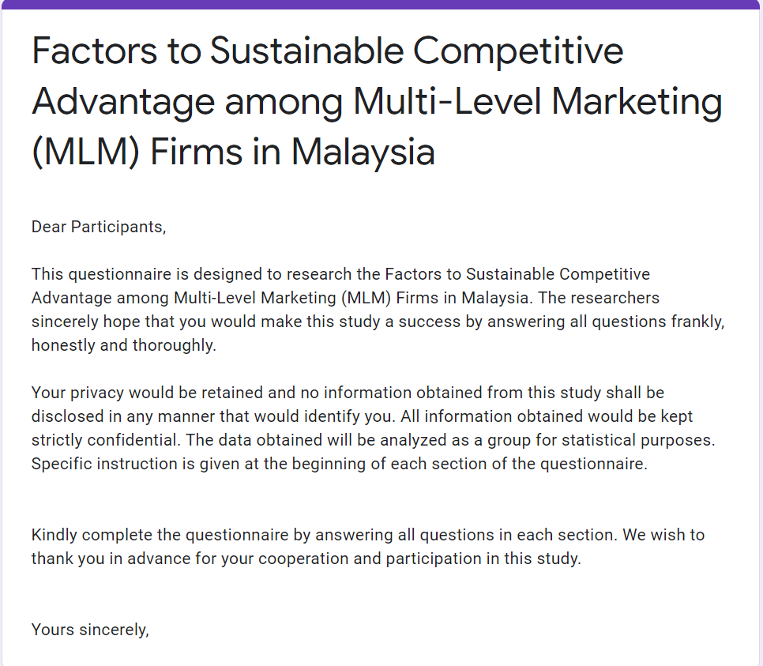


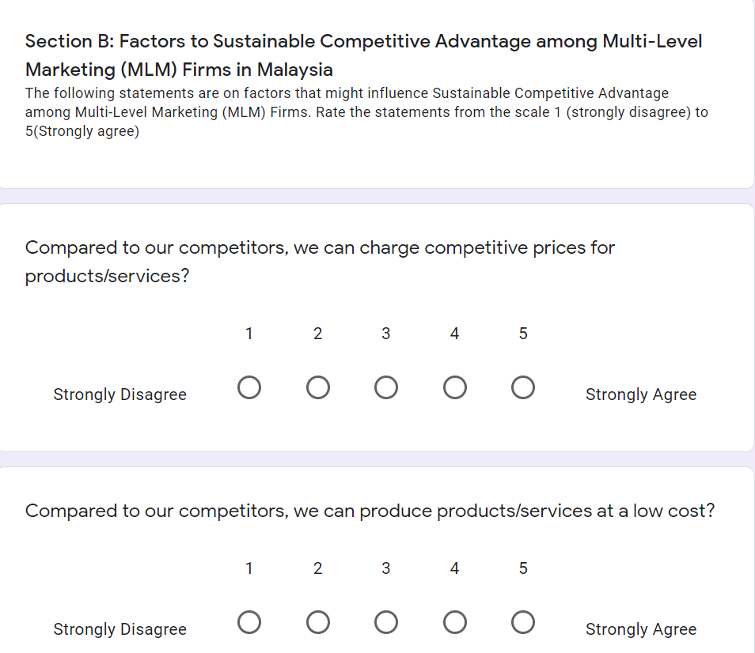

Dear Participants,

This questionnaire is designed to research the Factors to Sustainable Competitive Advantage among Multi-Level Marketing (MLM) Firms in Malaysia. The researchers sincerely hope that you would make this study a success by answering all questions frankly, honestly and thoroughly.

Your privacy would be retained and no information obtained from this study shall be disclosed in any manner that would identify you. All information obtained would be kept strictly confidential. The data obtained will be analyzed as a group for statistical purposes.
Specific instruction is given at the beginning of each section of the questionnaire.

Kindly complete the questionnaire by answering all questions in each section. We wish to thank you in advance for your cooperation and participation in this study.

Yours sincerely,

Please put a (/) mark to indicate your preference.
Demographics Information
1. Ethnicity: A. Malay B. Chinese C. Indian D. Others (Specify) ______
2. Gender: A. Male B. Female
3. Age: A. 18 - 25 years B. 26 - 30 years B. 31 – 40 years
C. 41 – 50 years D. 51 – 60 years E. Above 60 years
4. Occupation: A. Part-Time B. Full-Time
5. Monthly Income: A. below RM5000 B. RM 5001 -RM10000
C. RM 10001- RM20000 D. more than RM20001

The following statements are on factors that might influence Sustainable Competitive Advantage among Multi-Level Marketing (MLM) Firms. Rate the statements from the scale 1 (strongly disagree) to 5(Strongly agree)

Section B: Factors to Sustainable Competitive Advantage among Multi-Level Marketing (MLM) Firms in Malaysia

 | Strongly Disagree | Disagree | Neutral | Agree | Strongly Agree
Sustainable Competitive Advantage
(Chen,2012) (Nidumolu & Knotts, 1998)
Compared to our competitors, we can produce products/services at a low cost?
Compared to our competitors, we can charge competitive prices for products/services?
Compared to our competitors, we have higher efficiency in producing products/services?
Compared to our competitors, we can respond quickly to new customer needs?
Compared to our competitors, we can quickly enter new products/ services?
Compared to our competitors, we have a better rate of introduction of new products/services?
Company Image
(Feldman,Percy,Rolando and Isabelle ,(2014) P 53-66)
I think the company contributes actively and voluntarily to the social improvement, economic and the environmental of society
I think the company stands behind its products and services with good price and good quality that meet consumer
I think the company treats customers courteously, communicates with them and takes care of their safety and health
I think the company generates respect, admiration esteem and confidence
I think the company is recognized, has excellent leadership, is innovative, and seeks constant overcoming
I think the company looks like a good company to work, already be by its infrastructure such as its working environment, benefits and good treats with its employees
Product Innovation
(Shaukat, Sadia, Muhammad and Saman, (2013) P243-262.)
The company developing new products with components and materials totally differing from current ones
The company developing new products with technical specifications and functionalities totally differing from the current ones.
The company developing newness for current products leading to improved ease of use for customers and to improved customer satisfaction
The company decreasing manufacturing cost in components and materials of current products
The company increasing manufacturing quality in components and materials of current products
Leadership
Yukl (2009)
The leader shows a strong concern for ethical and moral values.
The leader sets an example of ethical behavior in his/her decisions and actions
The leader is fair and unbiased when assigning tasks to members.
The leader regards honesty and integrity as important personal values.
The leader is fair and objective when evaluating member performance and providing rewards.
Distribution Reward System
(AS Abbasi,2012)
I feel that the individual output reward enhances productivity in company
I think the the group output reward encourages team work and cooperation thus helps organization to achieve their goals effectively and efficiently in company
I think human capital reward encourages management to develop their human capital and utilize them for goal attainment, skill ased pay structure development for healthy competition within organization and polish the skills of employees in company
I fell that a position reward system helps employees to understand their responsibilities at workplace and perform job in a better way in company
In my opinion, the reward system reinforces and strengthens behavior of employees in company
Distribution Training System
(Loi, 2015)
I feel that I have received the necessary amount of training in company
I think the training has helped me to achieve success as a distributor in company
I think the training addressed the important issues related to my job as a distributor in company
I was very well motivated during the training session
In my opinion, the existing rules and procedures of company make the distributor job easier.
Thank you for your cooperation.

Appendix B: SPSS Analysis Result
Pilot Test Result
Factor Analysis
Dependent Variable: Sustainable Competitive Advantage

KMO and Bartlett's Test
Kaiser-Meyer-Olkin Measure of Sampling Adequacy. |  | .833
Bartlett's Test of Sphericity | Approx. Chi-Square | 232.086
Bartlett's Test of Sphericity | df | 15
Bartlett's Test of Sphericity | Sig. | .000

Component Matrixª
 | Component
 | 1
SCA1 | .818
SCA2 | .833
SCA3 | .636
SCA4 | .875
SCA5 | .746
SCA6 | .754
Extraction Method: Principal Component Analysis.
a. 1 components extracted.

Total Variance Explained
Component | Initial Eigenvalues |  |  | Extraction Sums of Squared Loadings
Component | Total | % of Variance | Cumulative % | Total | % of Variance | Cumulative %
1 | 3.661 | 61.009 | 61.009 | 3.661 | 61.009 | 61.009
2 | .752 | 12.538 | 73.547
3 | .627 | 10.447 | 83.993
4 | .436 | 7.266 | 91.260
5 | .285 | 4.750 | 96.009
6 | .239 | 3.991 | 100.000
Extraction Method: Principal Component Analysis.

Independent Variable: Company Image

KMO and Bartlett's Test
Kaiser-Meyer-Olkin Measure of Sampling Adequacy. |  | .886
Bartlett's Test of Sphericity | Approx. Chi-Square | 287.232
Bartlett's Test of Sphericity | df | 15
Bartlett's Test of Sphericity | Sig. | .000

Component Matrixª
 | Component
 | 1
CI1 | .885
CI2 | .826
CI3 | .867
CI4 | .805
CI5 | .869
CI6 | .793
Extraction Method: Principal Component Analysis.
a. 1 components extracted.

Total Variance Explained
Component | Initial Eigenvalues |  |  | Extraction Sums of Squared Loadings
Component | Total | % of Variance | Cumulative % | Total | % of Variance | Cumulative %
1 | 3.973 | 66.208 | 66.208 | 3.973 | 66.208 | 66.208
2 | .758 | 12.630 | 78.838
3 | .433 | 7.212 | 86.050
4 | .359 | 5.989 | 92.040
5 | .292 | 4.871 | 96.911
6 | .185 | 3.089 | 100.000
Extraction Method: Principal Component Analysis.

Independent Variable: Product Innovation

KMO and Bartlett's Test
Kaiser-Meyer-Olkin Measure of Sampling Adequacy. |  | .804
Bartlett's Test of Sphericity | Approx. Chi-Square | 143.155
Bartlett's Test of Sphericity | df | 10
Bartlett's Test of Sphericity | Sig. | .000

Component Matrixª
 | Component
 | 1
PI1 | .805
PI2 | .827
PI3 | .796
PI4 | .659
PI5 | .752
Extraction Method: Principal Component Analysis.
a. 1 components extracted.

Total Variance Explained
Component | Initial Eigenvalues |  |  | Extraction Sums of Squared Loadings
Component | Total | % of Variance | Cumulative % | Total | % of Variance | Cumulative %
1 | 2.966 | 59.329 | 59.329 | 2.966 | 59.329 | 59.329
2 | .736 | 14.719 | 74.048
3 | .576 | 11.529 | 85.577
4 | .402 | 8.043 | 93.621
5 | .319 | 6.379 | 100.000
Extraction Method: Principal Component Analysis.

Independent Variable: Leadership

KMO and Bartlett's Test
Kaiser-Meyer-Olkin Measure of Sampling Adequacy. |  | .789
Bartlett's Test of Sphericity | Approx. Chi-Square | 165.977
Bartlett's Test of Sphericity | df | 10
Bartlett's Test of Sphericity | Sig. | .000

Component Matrixª
 | Component
 | 1
L1 | .762
L2 | .814
L3 | .712
L4 | .829
L5 | .812
Extraction Method: Principal Component Analysis.
a. 1 components extracted.

Total Variance Explained
Component | Initial Eigenvalues |  |  | Extraction Sums of Squared Loadings
Component | Total | % of Variance | Cumulative % | Total | % of Variance | Cumulative %
1 | 3.097 | 61.937 | 61.937 | 3.097 | 61.937 | 61.937
2 | .703 | 14.056 | 75.994
3 | .564 | 11.286 | 87.279
4 | .371 | 7.428 | 94.708
5 | .265 | 5.292 | 100.000
Extraction Method: Principal Component Analysis.

Independent Variable: Distribution Reward System

KMO and Bartlett's Test
Kaiser-Meyer-Olkin Measure of Sampling Adequacy. |  | .701
Bartlett's Test of Sphericity | Approx. Chi-Square | 143.412
Bartlett's Test of Sphericity | df | 10
Bartlett's Test of Sphericity | Sig. | .000

Component Matrixª
 | Component
 | 1
DRS1 | .780
DRS2 | .766
DRS3 | .709
DRS4 | .801
DRS5 | .740
Extraction Method: Principal Component Analysis.
a. 1 components extracted.

Total Variance Explained
Component | Initial Eigenvalues |  |  | Extraction Sums of Squared Loadings
Component | Total | % of Variance | Cumulative % | Total | % of Variance | Cumulative %
1 | 2.755 | 55.100 | 55.100 | 2.755 | 55.100 | 55.100
2 | 1.015 | 20.301 | 75.402
3 | .561 | 11.214 | 86.615
4 | .431 | 8.626 | 95.241
5 | .238 | 4.759 | 100.000
Extraction Method: Principal Component Analysis.

Independent Variable: Distribution Training System

KMO and Bartlett's Test
Kaiser-Meyer-Olkin Measure of Sampling Adequacy. |  | .702
Bartlett's Test of Sphericity | Approx. Chi-Square | 121.519
Bartlett's Test of Sphericity | df | 10
Bartlett's Test of Sphericity | Sig. | .000

Component Matrixª
 | Component
 | 1
DTS1 | .821
DTS2 | .801
DTS3 | .751
DTS4 | .795
DTS5 | .710
Extraction Method: Principal Component Analysis.
a. 1 components extracted.

Total Variance Explained
Component | Initial Eigenvalues |  |  | Extraction Sums of Squared Loadings
Component | Total | % of Variance | Cumulative % | Total | % of Variance | Cumulative %
1 | 2.608 | 52.156 | 52.156 | 2.608 | 52.156 | 52.156
2 | 1.084 | 21.673 | 73.829
3 | .595 | 11.892 | 85.721
4 | .386 | 7.726 | 93.448
5 | .328 | 6.552 | 100.000
Extraction Method: Principal Component Analysis.

Test: Reliability Test
Reliability

Scale: Sustainable Competitive Advantage

Case Processing Summary
 |  | N | %
Cases | Valid | 82 | 100.0
Cases | Excludedª | 0 | .0
Cases | Total | 82 | 100.0
a. Listwise deletion based on all variables in the procedure.

Reliability Statistics
Cronbach's Alpha | N of Items
.866 | 6

Scale: Company Image

Case Processing Summary
 |  | N | %
Cases | Valid | 82 | 100.0
Cases | Excludedª | 0 | .0
Cases | Total | 82 | 100.0
a. Listwise deletion based on all variables in the procedure.

Reliability Statistics
Cronbach's Alpha | N of Items
.895 | 6

Scale: Product Innovation

Case Processing Summary
 |  | N | %
Cases | Valid | 82 | 100.0
Cases | Excludedª | 0 | .0
Cases | Total | 82 | 100.0
a. Listwise deletion based on all variables in the procedure.

Reliability Statistics
Cronbach's Alpha | N of Items
.826 | 5

Scale: Leadership

Case Processing Summary
 |  | N | %
Cases | Valid | 82 | 100.0
Cases | Excludedª | 0 | .0
Cases | Total | 82 | 100.0
a. Listwise deletion based on all variables in the procedure.

Reliability Statistics
Cronbach's Alpha | N of Items
.844 | 5

Scale: Distribution Reward System

Case Processing Summary
 |  | N | %
Cases | Valid | 82 | 100.0
Cases | Excludedª | 0 | .0
Cases | Total | 82 | 100.0
a. Listwise deletion based on all variables in the procedure.

Reliability Statistics
Cronbach's Alpha | N of Items
.794 | 5

Scale: Distribution Training System

Case Processing Summary
 |  | N | %
Cases | Valid | 82 | 100.0
Cases | Excludedª | 0 | .0
Cases | Total | 82 | 100.0
a. Listwise deletion based on all variables in the procedure.

Reliability Statistics
Cronbach's Alpha | N of Items
.767 | 5

Preliminary Test
Frequency Table
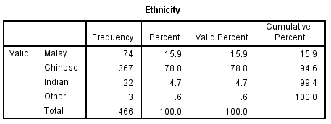
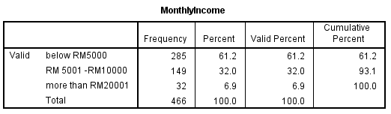
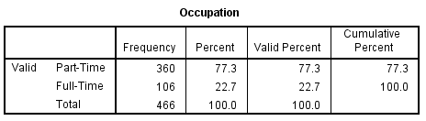

Factor Analysis
Dependent Variable: Sustainable Competitive Advantage

KMO and Bartlett's Test
Kaiser-Meyer-Olkin Measure of Sampling Adequacy. |  | .730
Bartlett's Test of Sphericity | Approx. Chi-Square | 734.585
Bartlett's Test of Sphericity | df | 15
Bartlett's Test of Sphericity | Sig. | .000

Component Matrixª
 | Component
 | 1
SCA1 | .694
SCA2 | .646
SCA3 | .648
SCA4 | .703
SCA5 | .665
SCA6 | .681
Extraction Method: Principal Component Analysis.
a. 1 components extracted.

Total Variance Explained
Component | Initial Eigenvalues |  |  | Extraction Sums of Squared Loadings
Component | Total | % of Variance | Cumulative % | Total | % of Variance | Cumulative %
1 | 2.719 | 45.323 | 45.323 | 2.719 | 45.323 | 45.323
2 | 1.256 | 20.926 | 66.249
3 | .635 | 10.582 | 76.830
4 | .578 | 9.635 | 86.466
5 | .451 | 7.521 | 93.987
6 | .361 | 6.013 | 100.000
Extraction Method: Principal Component Analysis.

Independent Variable: Company Image

KMO and Bartlett's Test
Kaiser-Meyer-Olkin Measure of Sampling Adequacy. |  | .720
Bartlett's Test of Sphericity | Approx. Chi-Square | 679.979
Bartlett's Test of Sphericity | df | 15
Bartlett's Test of Sphericity | Sig. | .000

Component Matrixª
 | Component
 | 1
CI1 | .705
CI2 | .708
CI3 | .709
CI4 | .743
CI5 | .787
CI6 | .758
Extraction Method: Principal Component Analysis.
a. 1 components extracted.

Total Variance Explained
Component | Initial Eigenvalues |  |  | Extraction Sums of Squared Loadings
Component | Total | % of Variance | Cumulative % | Total | % of Variance | Cumulative %
1 | 2.714 | 45.238 | 45.238 | 2.714 | 45.238 | 45.238
2 | .927 | 15.458 | 60.696
3 | .873 | 14.553 | 75.249
4 | .719 | 11.976 | 87.225
5 | .422 | 7.032 | 94.257
6 | .345 | 5.743 | 100.000
Extraction Method: Principal Component Analysis.

Independent Variable: Product Innovation

KMO and Bartlett's Test
Kaiser-Meyer-Olkin Measure of Sampling Adequacy. |  | .710
Bartlett's Test of Sphericity | Approx. Chi-Square | 590.471
Bartlett's Test of Sphericity | df | 10
Bartlett's Test of Sphericity | Sig. | .000

Component Matrixª
 | Component
 | 1
PI1 | .733
PI2 | .859
PI3 | .840
PI4 | .759
PI5 | .761
Extraction Method: Principal Component Analysis.
a. 1 components extracted.

Total Variance Explained
Component | Initial Eigenvalues |  |  | Extraction Sums of Squared Loadings
Component | Total | % of Variance | Cumulative % | Total | % of Variance | Cumulative %
1 | 2.474 | 49.485 | 49.485 | 2.474 | 49.485 | 49.485
2 | .913 | 18.253 | 67.738
3 | .752 | 15.032 | 82.770
4 | .579 | 11.588 | 94.358
5 | .282 | 5.642 | 100.000
Extraction Method: Principal Component Analysis.

Independent Variable: Leadership

KMO and Bartlett's Test
Kaiser-Meyer-Olkin Measure of Sampling Adequacy. |  | .740
Bartlett's Test of Sphericity | Approx. Chi-Square | 627.496
Bartlett's Test of Sphericity | df | 10
Bartlett's Test of Sphericity | Sig. | .000

Component Matrixª
 | Component
 | 1
L1 | .762
L2 | .775
L3 | .742
L4 | .754
L5 | .758
Extraction Method: Principal Component Analysis.
a. 1 components extracted.

Total Variance Explained
Component | Initial Eigenvalues |  |  | Extraction Sums of Squared Loadings
Component | Total | % of Variance | Cumulative % | Total | % of Variance | Cumulative %
1 | 2.611 | 52.227 | 52.227 | 2.611 | 52.227 | 52.227
2 | .851 | 17.011 | 69.237
3 | .748 | 14.963 | 84.201
4 | .427 | 8.549 | 92.749
5 | .363 | 7.251 | 100.000
Extraction Method: Principal Component Analysis.

Independent Variable: Distribution Reward System

KMO and Bartlett's Test
Kaiser-Meyer-Olkin Measure of Sampling Adequacy. |  | .768
Bartlett's Test of Sphericity | Approx. Chi-Square | 196.068
Bartlett's Test of Sphericity | df | 10
Bartlett's Test of Sphericity | Sig. | .000

Component Matrixª
 | Component
 | 1
DRS1 | .710
DRS2 | .760
DRS3 | .765
DRS4 | .770
DRS5 | .811
Extraction Method: Principal Component Analysis.
a. 1 components extracted.

Total Variance Explained
Component | Initial Eigenvalues |  |  | Extraction Sums of Squared Loadings
Component | Total | % of Variance | Cumulative % | Total | % of Variance | Cumulative %
1 | 2.029 | 40.573 | 40.573 | 2.029 | 40.573 | 40.573
2 | .999 | 19.985 | 60.558
3 | .892 | 17.845 | 78.403
4 | .546 | 10.919 | 89.321
5 | .534 | 10.679 | 100.000
Extraction Method: Principal Component Analysis.

Independent Variable: Distribution Training System

KMO and Bartlett's Test
Kaiser-Meyer-Olkin Measure of Sampling Adequacy. |  | .729
Bartlett's Test of Sphericity | Approx. Chi-Square | 476.107
Bartlett's Test of Sphericity | df | 10
Bartlett's Test of Sphericity | Sig. | .000

Component Matrixª
 | Component
 | 1
DTS1 | .689
DTS2 | .780
DTS3 | .764
DTS4 | .798
DTS5 | .702
Extraction Method: Principal Component Analysis.
a. 1 components extracted.

Total Variance Explained
Component | Initial Eigenvalues |  |  | Extraction Sums of Squared Loadings
Component | Total | % of Variance | Cumulative % | Total | % of Variance | Cumulative %
1 | 2.386 | 47.723 | 47.723 | 2.386 | 47.723 | 47.723
2 | .992 | 19.832 | 67.555
3 | .630 | 12.598 | 80.153
4 | .577 | 11.537 | 91.690
5 | .415 | 8.310 | 100.000
Extraction Method: Principal Component Analysis.

Reliability Test

Reliability

Scale: Sustainable Competitive Advantage

Case Processing Summary
 |  | N | %
Cases | Valid | 466 | 100.0
Cases | Excludedª | 0 | .0
Cases | Total | 466 | 100.0
a. Listwise deletion based on all variables in the procedure.

Reliability Statistics
Cronbach's Alpha | N of Items
.758 | 6

Scale: Company Image

Case Processing Summary
 |  | N | %
Cases | Valid | 466 | 100.0
Cases | Excludedª | 0 | .0
Cases | Total | 466 | 100.0
a. Listwise deletion based on all variables in the procedure.

Reliability Statistics
Cronbach's Alpha | N of Items
.754 | 6

Scale: Product Innovation

Case Processing Summary
 |  | N | %
Cases | Valid | 464 | 99.6
Cases | Excludedª | 2 | .4
Cases | Total | 466 | 100.0
a. Listwise deletion based on all variables in the procedure.

Reliability Statistics
Cronbach's Alpha | N of Items
.734 | 5

Scale: Leadership

Case Processing Summary
 |  | N | %
Cases | Valid | 466 | 100.0
Cases | Excludedª | 0 | .0
Cases | Total | 466 | 100.0
a. Listwise deletion based on all variables in the procedure.

Reliability Statistics
Cronbach's Alpha | N of Items
.768 | 5

Scale: Distribution Reward System

Case Processing Summary
 |  | N | %
Cases | Valid | 466 | 100.0
Cases | Excludedª | 0 | .0
Cases | Total | 466 | 100.0
a. Listwise deletion based on all variables in the procedure.

Reliability Statistics
Cronbach's Alpha | N of Items
.717 | 5

Scale: Distribution Training System

Case Processing Summary
 |  | N | %
Cases | Valid | 466 | 100.0
Cases | Excludedª | 0 | .0
Cases | Total | 466 | 100.0
a. Listwise deletion based on all variables in the procedure.

Reliability Statistics
Cronbach's Alpha | N of Items
.723 | 5

Hypothesis Testing

Regression

Variables Entered/Removedª
Model | Variables Entered | Variables Removed | Method
1 | DTS, DRS, PI, L, CI^{b} | . | Enter
a. Dependent Variable: SCA
b. All requested variables entered.

Model Summary^{b}
Model | R | R Square | Adjusted R Square | Std. Error of the Estimate | Change Statistics |  |  |  |  | Durbin-Watson
 |  |  |  |  | R Square Change | F Change | df1 | df2 | Sig. F Change | Durbin-Watson
1 | .770ª | .592 | .588 | .34751 | .592 | 133.567 | 5 | 460 | .000 | 1.729
a. Predictors: (Constant), DTS, DRS, PI, L, CI
b. Dependent Variable: SCA

ANOVAª
Model |  | Sum of Squares | df | Mean Square | F | Sig.
1 | Regression | 80.650 | 5 | 16.130 | 133.567 | .000^{b}
1 | Residual | 55.551 | 460 | .121
1 | Total | 136.201 | 465
a. Dependent Variable: SCA
b. Predictors: (Constant), DTS, DRS, PI, L, CI

Coefficientsª
Model |  | Unstandardized Coefficients |  | Standardized Coefficients | t | Sig. | Collinearity Statistics
 |  | B | Std. Error | Beta | t | Sig. | Tolerance | VIF
1 | (Constant) | .033 | .175 |  | .190 | .849
1 | CI | .297 | .042 | .292 | 7.034 | .000 | .514 | 1.945
1 | PI | -.017 | .037 | -.018 | -.460 | .645 | .590 | 1.694
1 | L | .174 | .036 | .198 | 4.864 | .000 | .537 | 1.863
1 | DRS | .198 | .037 | .165 | 5.275 | .000 | .909 | 1.100
1 | DTS | .349 | .037 | .362 | 9.565 | .000 | .618 | 1.617
a. Dependent Variable: SCA

Collinearity Diagnosticsª
Model | Dimension | Eigenvalue | Condition Index | Variance Proportions
 |  |  |  | (Constant) | CI | PI | L | DRS | DTS
1 | 1 | 5.946 | 1.000 | .00 | .00 | .00 | .00 | .00 | .00
1 | 2 | .019 | 17.639 | .07 | .01 | .08 | .15 | .30 | .01
1 | 3 | .012 | 22.171 | .01 | .00 | .42 | .01 | .01 | .56
1 | 4 | .009 | 25.398 | .00 | .26 | .09 | .79 | .05 | .09
1 | 5 | .008 | 27.752 | .14 | .63 | .21 | .05 | .09 | .25
1 | 6 | .006 | 31.992 | .78 | .10 | .20 | .01 | .55 | .10
a. Dependent Variable: SCA

APPENDIX C

PROJECT PAPER LOG

This is an important document, which is to be handed in with your dissertation. This log will be taken into consideration when awarding the final mark for the dissertation.

Student Name: | Bao Wei
Supervisor’s Name: | Dr. Ah Huai
Dissertation Topic:

Investigation on the Factors to Sustainable Competitive Advantage among Multi-Level Marketing (MLM) Firms in Malaysia

SECTION A. MONITORING STUDENT DISSERTATION PROCESS

The plan below is to be agreed between the student & supervisor and will be monitored against progress made at each session.

Activity | Milestone/Deliverable Date
Design Plan | Understand the Project and make the Plan 12/09/2020
Problem Statement | Confirm the MLM industry and research purpose 26/09/2020
Framework | Reading lots of articles and selected the conceptual framework 10/10/2020
First Three Chapters | Finished the first three chapters draft 24/10/2020
First Defense | Preparing and completed first defense 07/11/2020
Questionnaire | Make questionnaire and sent to targeting sample 08/11/2020
Collect Date | Collected questionnaires 28/11/2020
Analysis Date | Analysis date 30/11/2020
Second Defense | Preparing and completed second defense 03/12/2020
First Version | First version 05/12/2020
Final Version | Final version 12/12/2020

SECTION B. ETHICS

Ethics form protocol number:

SECTION C. RECORD OF MEETINGS

The expectation is that students will meet their supervisors up to seven times and these meetings should be recorded.

Meeting 1
Date of Meeting | 12/09/2020
Progress Made | Design Plan
Agreed Action | Understand that how is the MBA Project and How to make the Plan?
Student Signature | 
Supervisor’s  Signature | 

Meeting 2
Date of Meeting | 26/09/2020
Progress Made | Problem Statement
Agreed Action | Confirm the MLM industry and make the research purpose
Student Signature

Supervisor’s
Signature

Meeting 3
Date of Meeting | 10/10/2020
Progress Made | Framework
Agreed Action | Reading lots of articles and selected the conceptual framework
Student Signature

Supervisor’s
Signature

Meeting 4
Date of Meeting | 17/10/2020
Progress Made | Framework
Agreed Action | Reading lots of articles and understand the definition of every single variables, need to find out dimension and the specific measurable factors
Student Signature

Supervisor’s
Signature

Meeting 5
Date of Meeting | 24/10/2020
Progress Made | First Third Chapters
Agreed Action | Base on the conceptual framework, Finished the first third chapter draft and preparing the first defense
Student Signature

Supervisor’s
Signature

Meeting 6
Date of Meeting | 3/11/2020
Progress Made | First Defense Review
Agreed Action | Under second PD guidance, the problem statement should enhance some detail specific local MLM companies to illustrate the issues in present situation, meanwhile should sent surveys
Student Signature

Supervisor’s
Signature

Meeting 7

Date of Meeting | 7/11/2020
Progress Made | Confirm the first chapter organization
Agreed Action | Proceed that the completed first chapter and develop the details information about every chapter
Student Signature

Supervisor’s
Signature

Meeting 8
Date of Meeting | 28/11/2020
Progress Made | Confirm the first chapter version and preview the date
Agreed Action | Prepare to analysis the date and the second defense
Student Signature

Supervisor’s
Signature

Meeting 9
Date of Meeting | 03/12/2020
Progress Made | Completed the Second Defense
Agreed Action | Review about the second defense and the conclusion should link the research object and questions, preparing the last two chapter
Student Signature

Supervisor’s
Signature

Meeting 10
Date of Meeting | 05/12/2020
Progress Made | Completed the Final version
Agreed Action | preparing to submit the final version
Student Signature

Supervisor’s
Signature

Section D. Comments on Management of Project

(to be completed at the end of the dissertation process)

Student Comments

I want to take this opportunity to said thousands of THANK YOU to my supervisor, Dr. Ah Huai A. Ah Chan who give me guidance throughout the project journey. She guides me on how to form a persuasive problem statement, research question, hypothesis and presents the findings in the project.
She is very kindly and nice during the whole my MBA project period as well as, meanwhile I have got many valuable and precious advices from the professional Dr. Ah Huai.
_____________________________________________________________________

Supervisor Comments

This student is serious and can complete the set schedule on time according to the teacher’s requirements, he can actively look for the materials and tools needed by the research, which reflects the initiative and enthusiasm of learning.
_____________________________________________________________________________

Signature of  Student | Date: 06/12/2020
Signature of  Supervisor | Date: 06/12/2020
Ethics  Confirmed | Date

