

**MGT7998 PROJECT**

**TITLE:**

**Research on financing Efficiency of SEMsin the NEEQ market**

**SUBMITTED TO:**

***Supervisor***

***Dr. Rashedul Hasan***

**STUDENT NAME: Wang Yan Bo**

**STUDENT ID: I19017486**

**2020**

**Content**

Chapter 1 1

1.1Introduction 1

1.2 Problem Statement 2

1.3 Research Objective and Research Question and Research Hypothesis 2

1.3.1 Research Objective 3

1.3.2 Research Questions 3

1.4Selected topic significance 3

1.5 Conclusion 3

Chapter 2 4

2.1 Introduction 4

2.2 Definitions 4

2.2.1 The connotation of capital market 4

2.2.2 NEEQ market 5

2.2.3 Definition of SEMs 6

2.2.4 Definition of financing efficiency 7

2.3 Past studies on the main issues 8

2.3.1 The relationship between stock market and financing of SEMs 8

2.3.2 Research on financing issues 8

2.3.3 Research on enterprise financing efficiency 9

2.3.4 Research on financing efficiency of SEMs 10

2.4 Theoretical perspectives 10

2.4.1The MM theory 10

2.4.2 The Trade-off Theory 11

2.4.3 Information Cost Theory 11

2.4.4 Efficient market theory 12

2.4.5 Market micro structure theory 13

2.5 Conceptual framework and Article Overview 14

2.5.1 Conceptual framework 14

2.6 Overview of the financing status of SEMs on the NEEQ market 15

2.6.1 The number of SEMs listed on the NEEQ market 15

2.6.2 The industry distribution of NEEQ market listed enterprises 16

2.6.3 Share capital distribution of listed companies 17

2.6.4 Regional distribution of listed enterprises on the NEEQ market 18

2.6.5 Trading volume trend of listed companies on the NEEQ market 20

2.6.6 The scale of share issuance of listed companies on the NEEQ market 21

2.6.7 The relative valuation status of NEEQ market enterprises 23

2.7 conclusion 23

Chapter 3 24

3.1 Research Design 24

3.2 Research methods 24

3.3 Sample and index selection 24

3.3.1 A sample of descriptive analysis 24

3.3.3 Index selection 25

3.4 Measuring Instrument 25

3.5 Data Source 26

Chapter 4 Analysis results and findings 26

4.0 Introduction 26

4.1 Correlation test 27

4.2 Hypothesis Testing 29

4.2.1 Model Summary 29

4.2.2 ANOVA 30

4.3 Multiple linear regression 30

4.3.1 Build a model 30

4.3.2Coefficients 31

4.4 Findings of linear regression 31

4.5 Descriptive analysis 32

4.5.1 Comparison of average earnings per share（EPS）before and after listing 33

4.5.2 Comparison of net profit growth rate before and after listing 34

4.5.3 Comparison of equity multiplier before and after listing 35

4.5.4The times of private placement after listing 35

4.5.5 Comparison of ROE before and after listing 36

4.6The trend comparison of independent variables and dependent variables 37

4.6.1Trend comparison equity multiplier and ROE 37

4.6.2 Trend comparison between EPS and ROE 37

4.6.3 Trend comparison between net profit growth and ROE 38

4.6.4 Trend comparison times of private placement and ROE 38

4.7 Results of descriptive analysis 38

Chapter 5: CONCLUSION 39

5.1 Problems existing in market financing on the NEEQ market 39

5.1.1The liquidity of the NEEQ market is not optimistic 39

5.1.2 The market transfer mechanism of the NEEQ market is imperfect 39

5.1.3 The trading mode of the NEEQ market is imperfect 39

5.1.4 Problems of enterprises themselves in the NEEQ market . 39

5.2 Research Limitations & Suggestions for Future Research 40

6.0 Reference 40

7.0 Appendix 44

**Research on financing Efficiency of SEMsin the NEEQ market**

**Chapter 1**

**1.1Introduction**

According to a 2019 report by China's National Bureau of Statistics, SEMs play a pivotal role in the development of the national economy.And the vast majority of new and high technology industries in the form of SEMs, these enterprises has become a backbone(Li Y Y,2019), accelerate economic development in China's SEMs create value occupy China's gross domestic product by more than half, both to the Chinese tax increases, or provide for labor post plays a vital role.In 2019, 3.02,000 enterprises were newly registered in China, an increase of 21 percent over the same period last year, with a total registered capital of 12 trillion yuan, an increase of 25 percent over the same period last year.Chinese SEMs account for 99.2 percent of the total number of Chinese enterprises(Han.J,2020).The proportion of SEMs accounts for about 30% of China's GDP, the tax amount of SEMs accounts for about 52% of the total national tax revenue, and SEMs create 90% of the jobs in China( Kong X,2018).However, the development of SEMs is restricted by many conditions.The development of SEMs is faced with difficulties such as insufficient capital, excessive tax burden, low level of science and technology, lack of talents and insufficient market competitiveness.That is why China attaches great importance to the issue of SEMs.In order to further strengthen the support for small and micro enterprises and broaden the financing channels of SEMs in the capital market, the Chinese government has continuously reformed and improved the capital market in recent years.

The development of SEMs needs financial support, but in practice, from a global perspective, SEMs are usually limited in access to financial services. Solving the problem of "difficult financing and expensive financing" for SEMs is a challenge for the development of financial markets in all countries.

Under the background of financial inclusion and encouraging innovation to support economic development, the share transfer system of SEMs (new three broad, Referred to as NEEQ market ) is in full swing.By December 2019, more than 8,953 enterprises had been listed on the NEEQ market (NEEQ market .com.cn.,2020).The NEEQ market was established as early as 2006. However, no matter from the number of listed companies, market liquidity, and enterprise financing scale, the NEEQ market did not achieve good development before.In June 2013, the Chinese government expanded the pilot share transfer system for SEMs to China (NEEQ market .com.cn.,2020).Since then, the NEEQ market has developed rapidly.In September 2014, in order to promote the market liquidity of the NEEQ market , the market maker system was launched, which is committed to creating a favorable financial environment for financing SEMs(NEEQ market .com.cn.,2020).

The launch of the NEEQ market opens a new channel for some SEMs to solve their financing difficulties. Meanwhile, the development of the NEEQ market is also one of the important links for the establishment and improvement of China's capital market system.As a Chinese trading platform built for over-the-counter capital market, the system design and market management rules of the NEEQ market after the revision have basically taken shape.In the process, SEMs across China's provinces are rushing to list on the NEEQ market to secure the capital they need.

**1.2 Problem Statement**

SEMs often have limited access to financial services and solving the financing problem of SEMs is a challenge for the development of financial markets in various countries(Wan.L,2020).Due to the opacity of SEMs' financial information, non-standard corporate governance, unstable corporate operation, high risk, small asset scale and lack of corresponding physical guarantee, commercial Banks are usually unwilling to lend to SEMs to avoid risks.Even for SEMs, interest rates are much higher than for large enterprises.

Twenty years ago, China first developed a stock exchange for large enterprises, while ignoring the budding SEMs. SEMs with large enterprises have been developed and large there are essential differences between the differences in general are congenital, SEMs enterprise scale is limited, the uncertainty of continuing operations, as well as its high-risk characteristics(Han.J,2020), make the traditional financing channels can rarely be in SEMs need of funds in a timely manner to provide the corresponding funds.Developed countries with mature capital markets in the world first spontaneously formed the OTC market providing equity financing platforms for SEMs, and then gradually established the centralized trading market.

In developed countries, the proportion of SEMs through direct financing is very high, more than 50% in the United States.Most SEMs will raise capital through a wide range of platforms such as Nasdaq and over-the-counter trading.Yet in China, the proportion of SEMs in financing in this way, less than eighty percent of SEMs still rely on their own fiscal expansion ability, more than ninety percent of the initial capital in SEMs from the owner(Li Y Y,2019),partnership sponsors, and even family members, and seventy percent of them could not be reached the standard of loans rather than through loans to finance.

However, these experiences show that the mature capital market in the world, as well as the structure of the capital market structure and the real economy should match each other. Only in this way, the capital market with a reasonable structure can better serve the real economy.The emergence of "NEEQ market " in China's stock market has played an important role in improving the financing environment of SEMs.

**1.3 Research Objective and Research Question and Research Hypothesis**

The main purpose of this study is to study the financing effect of the NEEQ market listing of SEMs. Through the study of the NEEQ market in China's existing multi-level capital market, the deficiencies of the existing system and rules and potential risks are analyzed to understand the extent to which the establishment of the NEEQ market can improve the financing efficiency of SEMs.Finally, some improvement ideas are put forward aiming at the problems existing in the NEEQ market .

### 1.3.1 Research Objective

1 Explore the financing efficiency of SEMs in the NEEQ market.

2 Explore whether listing on the NEEQ market will actively promote SEMs financing.

3 Explore whether the financing effect of SEMs in the NEEQ market is positively correlated with their profitability.

4 Explore whether the NEEQ market as an important part of improving the level of China's capital market, can solve the long-term financing difficulties of SEMs

### 1.3.2 Research Questions

1 What is the financing efficiency of SEMs in the NEEQ market ?

2 Will the listing on the NEEQ market positively promote the financing of SEMs?

3 Is there a complementary relationship between the financing effect and profitability of SEMs in the NEEQ market?

4 Whether the NEEQ market can solve the long-term financing difficulties of SEMs?

**1.3.3 Research Hypothesis**

1 Hypothesis 1: The smaller the equity multiplier, the better the corporate financing efficiency（Return on equity (ROE)).

2 Hypothesis 2: The higher the earnings per share, the higher the corporate financing efficiency（Return on equity (ROE)).

3 Hypothesis 3: The higher the net profit growth rate, the better the financing efficiency（Return on equity (ROE)).

4 Hypothesis 4: The more times of private placement, the better the financing efficiency of enterprises（Return on equity (ROE)).

**1.4Selected topic significance**

Today, in the world, small and medium enterprises to create value and provide employment has played an important role, has a big enterprise hard to replace the status, they not only is the main body of technology innovation, carry out professional coordination of basic link and the main force to create jobs, and it is an important power of social economic development and the market mechanism perfect source.The number of SEMs in China ranks first in the world, which is of greater significance to China's economic development.

The growth and development of SEMs need to be financed through open capital markets.It is of great significance for SEMs to make up the financing gap by establishing a transparent and well-functioning capital market that adapts to their own characteristics.As a result, the Chinese government is increasingly concerned about how the capital market can better serve the financing of SEMs.

**1.5 Conclusion**

This chapter mainly introduces the importance of SEMs to the economic development of the whole country, then expounds the actual difficulties of SEMs in financing channels and financing costs, and finally puts forward the research purpose and research problems of this paper as well as the significance of studying the financing efficiency of SEMs

# Chapter 2

**2.1 Introduction**

This chapter includes the interpretation of relevant definitions, previous studies, relevant theories, the current situation of the NEEQ market , and the Conceptual Framework

**2.2 Definitions**

Accurately grasping the connotation and definition of the concept is the foundation and starting point of the research.To this end, this section systematically summarizes and defines the capital market, SEMs, SEMs financing, the NEEQ market and the efficiency of SEMs financing involved in this paper, in order to fundamentally grasp the scope of this study.

**2.2.1 The connotation of capital market**

The connotation of capital market has two kinds of interpretation in broad sense and narrow sense.Broadly speaking, the capital market is a place for issuing and trading financial instruments with a term of more than one year. These financial instruments are mainly divided into equity, creditor's rights and derivative products（JIANG.L, 2020).Among them, financing instruments such as equity and creditor's rights are issued by companies and government agencies.Derivative category tools are designed by market organizers or intermediaries.Capital market The issuance market of financial instruments, also known as the primary market, has public offering and private placement(Maghrebi, N, 2020).After the issuance of financial instruments in the capital market, if the holders transfer and trade with each other, a secondary market will be formed, that is, the secondary market provides liquidity for financial assets.From the history of the development of capital markets in mature markets in Europe and The United States, the capital market originates from the over-the-counter market(Maghrebi, N, 2020).

The otc market and the exchange promote and integrate each other, gradually forming a complex capital market structure, that is, a market system consisting of multiple trading venues for the issuance and trading of various financial instruments in the capital market(Mishra, V, 2020.).The IMF considers the stock market, the bond market, the foreign exchange market, the derivatives market and the long-term bank loan market as capital markets(Giannellis,2019).At present, domestic and foreign research literature USES different meanings according to different research purposes, and most Chinese researchers equate the capital market with the stock market.The research object of this paper is limited to the narrow sense of capital market, that is, the stock market, the debt market and the derivative market are not within the scope of this paper(Giannellis,2019).

According to the division of China's capital market, the capital market is usually equated with the stock market, such as the main board, SEMsBoard, GEM board, NEEQ market and regional equity market.The research object of this paper is the multi-level stock and equity market, including the main board, gem board, the NEEQ market and the regional equity market, which includes the regional equity market, angel investment market, venture capital market and private equity market.This paper mainly studies the impact of the NEEQ market on the financing efficiency of SEMs.

**2.2.2 NEEQ market**

Zhong guan cun Science park Unlisted Co., LTD. 's trial transfer of the share system was the predecessor of the NEEQ market , which is now uniformly called the NEEQ market .In order to better solve the problems of equity transfer and financing difficulties for high-tech enterprises in the initial rising stage, in early 2009, with the approval of the State Council of China, securities Association of China launched the share quotation transfer system under the unified deployment of the SECURITIES Regulatory Commission(Chang,2019).The existence of the NEEQ market is mainly aimed at SEMs, so as to establish a more suitable financing platform for SEMs.Now the NEEQ market is no longer confined to the zhongguancun science park non-listed co., LTD., also no longer limited wuhan east lake, Shanghai zhangjiang and tianjin binhai these pilot private co., LTD., but for China, for China's regional private co., LTD., equity trading platform, and these private co., LTD., for SEMs(Chang,2019).In 2012, the regional equity transfer center was approved as China's SEMs Share transfer System.

The main body of the NEEQ market is composed of three parties, namely, the host securities trader, the investor and the financing party(Yuan, 2018).The term "sponsored securities firm" refers to the quoted securities firm that recommends the company to enter the agency system for the transfer of quoted prices and is responsible for guiding and urging the company to fulfill the obligation of information disclosure(Yuan, 2018).Investors in the NEEQ market are both investors, including institutional investors and natural person investors.The financing party refers to the non-listed company listed on the NEEQ market and carrying out share quotation transfer(Yuan, 2018).

Listing conditions.The listed object of NEEQ market has been from state-level high-tech park enterprises to China, and the specific requirements of listing are: first, the operation period should be over two years(Shen, 2017). Second, the main business of the enterprise should be prominent, and have a record of going concern;Finally, the corporate governance structure should be reasonable and standardized. If it is a limited liability company, it needs to be restructured before it can be listed(Shen, 2017).

Listing process.Non-listed companies applying for listings should sign a referral listing agreement with a broker that recommends hosting them(Shen, 2017).Recommend the broker to conduct a detailed investigation of the enterprise applying for listing, if agreed to recommend the listing, will issue a recommendation report, and will submit the recommended listing to the Securities Association of China filing documents(Shen, 2017).If the Securities Association of China has no objection to the recommended listing filing documents, it will issue a record confirmation to the recommended securities broker within 50 working days from the date of acceptance, so that the enterprise can be listed on the NEEQ market .

Mode of transaction.The transfer of listed companies on the NEEQ market is mainly by agreement transfer, and the market maker system was introduced in 2014 to improve the liquidity and guide value assessment of the NEEQ market through intermediary market making(Yuan, 2018).

**2.2.3 Definition of SEMs**

SEMs literally range from start-ups to mid-sized companies.At present, there is no unified definition of SEMs in domestic and foreign research literature and policy practice. Under normal circumstances, it is divided according to the indicators such as employees, business income and total assets of enterprises.According to the World Bank's 2017 report, SEMs are a meaningful classification of businesses that differs from other businesses in that they have special policies, institutions or market failures that benefit the economy or the poor in different ways(Wang, C,2019).Different countries or regions have different definitions of SEMs.Different countries or regions usually adopt diversified indicators or thresholds to define SEMs, among which the most commonly used indicator is the number of employees, and some other indicators, such as annual revenue, annual investment and the size of the balance sheet(Wang, C,2019).In the World Bank survey of 132 countries, one third (about 46 countries) identified businesses with fewer than 250 employees as SEMs.Even in the same country(Mishra,2020).different government departments or different categories of industries may define SEMs differently.According to the national monitoring indicators of SEMs released by the International Monetary Fund (IMF)(Mishra,2020) ,11 of the monitored countries have different definitions of SEMs in different departments.Different economies have different economic structures, cultures and political systems. A unified definition of SEMs is not the best choice, but a common definition of SEMs is conducive to the design of loans, investment and other programs, as well as statistics and research(Szyszka, A., 2020).

In July 2012, the National Bureau of Statistics, the National Development and Reform Commission, Ministry of Finance promulgated the SEMs the relevant provisions of the row type standard, SEMs can be divided into medium, small and micro three categories(Shi.J,2020), on the concrete method is mainly based on industry characteristics, respectively formulate corresponding to various industries of SEMs staff, operating income and assets quantity standard.

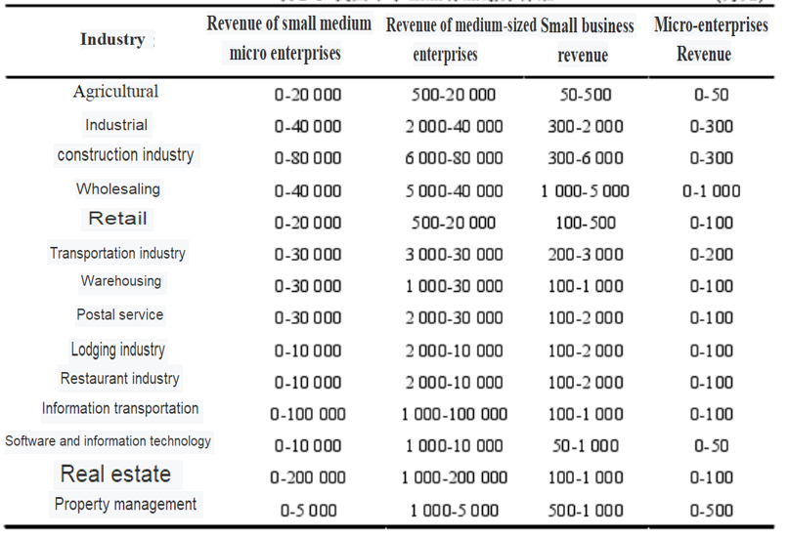

**CNY 10thousand**

Figure1：China's SEMs industry classification standards source:www.NEEQ market .com.cn

**2.2.4 Definition of financing efficiency**

In terms of financing, efficiency can be understood from many angles and can have many meanings depending on the object(Hongqi,2019).For the capital market, it can be divided into the efficiency of financing in the capital market and the efficiency of resource allocation in the capital market(Hongqi,2019).For enterprises, it can be divided into the efficiency of integrating capital and the efficiency of using capital.The capital market has two functions: price discovery and financing, which complement each other and constitute the basis for the capital market to exert its financing efficiency.

Some scholars believe that in economic research, "efficiency" refers to the relationship between cost and benefit. Financing efficiency includes two aspects, namely, the efficiency of both parties of investment and financing to reach a deal and the efficiency of capital resources allocation(Li, H,2019). If an enterprise can raise funds at the lowest cost and investors have access to investment, it will be reflected as transaction efficiency.If the enterprise with the best production capacity can obtain the required capital, it is reflected in allocation efficiency(Li, H,2019). Other scholars define corporate financing efficiency as the ability of the financial market to convert savings into investment through each financial instrument or financing system.(Li, H,2019) Some other scholars believe that corporate financing efficiency refers to the ability of a financial market or financing instrument to provide funds for an enterprise with the highest ratio of income to cost and the lowest risk(Li, H,2019).

By sorting out the concept of financing efficiency, it can be found that financing efficiency can be understood from four perspectives. First, it refers to the efficiency of an enterprise to integrate capital, which is reflected in the fact that an enterprise can raise more capital at the same cost or at a lower cost, and then it is efficient(Zhang,H,2019).Second, the efficiency of financing from the capital market is reflected in the capital market's ability to provide funds for enterprises. The capital market provides funds to more enterprises at a lower cost, the greater the amount of funds provided, and the qualified enterprises can timely finance the required funds, which is high efficiency(Zhang,H,2019).Third, the efficiency of the enterprise to integrate the use of funds, that is, the enterprise to make full use of funds, the greater the output per unit of capital, is efficient(Zhang,H,2019).Fourth, the efficiency of resource allocation in the capital market, that is, the capital supply and demand parties use the capital market platform to allocate capital factors to more effective places as far as possible in accordance with the principle of cost-effectiveness, so as to achieve the Pareto optimal allocation of capital factors(Zhang,H,2019).According to different subjects, financing efficiency can be divided into two categories: one is the financing efficiency of enterprises;Second, the financing efficiency of the capital market.According to different types, financing efficiency can be divided into capital integration efficiency and capital financing efficiency(Zhang,H,2019).

**2.3 Past studies on the main issues**

**2.3.1 The relationship between stock market and financing of SEMs**

A 2012 study by Harwood and Konidaris found that most SEMs stock exchanges mainly serve high-growth SEMs（Li Y Y，2019).According to the Research report of the World Bank in 2015, both the process of public offering of shares and the future trading in the stock market will incur certain costs(Li Y Y，2019）.Therefore, for some SEMs that are able to bear these costs, public offering of shares is the most appropriate way of financing.The Organization for Economic Cooperation and Development (OECD) pointed out in 2015 that equity financing is the most appropriate financing method for SEMs with strong growth prospects （Szyszka,2020),but SEMs must have sufficient capacity to disclose relevant information and corporate governance requirements when issuing shares publicly. According to the research of Nassr and Wehinger , many SEMs believe that the high cost of listing on the main board market of the exchange is to some extent an obstacle to listing financing（Jun Z,2019）.These costs include initial listing costs, maintaining listing costs, and indirect costs related to information disclosure requirements（Jun Z,2019.Therefore, countries around the world have tried to set up listed plates or exchanges specifically for SEMs, but the current research literature shows that whether these listed plates specifically for SEMs can really make up the financing gap of SEMs, the conclusion is not clear.

**2.3.2 Research on financing issues**

On the importance of SEMsfinancing.Although SEMs are of great significance to economic development, the financing problem of SEMs is prominent, which is one of the important factors restricting the development of SEMs.According to the research of THE International Monetary Fund, the most important problem restricting the development of SEMs in middle-income economies is capital（Giannellis,2020).In low-income economies, financing is the second biggest constraint to SEMsdevelopment, after electricity（Giannellis,2020）.Cook believes that access to financing is one of the important factors for the growth and development of SEMs.

As for the financing channels of SEMs, the research in developed countries mainly focuses on internal financing and external financing, equity financing and debt financing. OU and Haynes believe that internal financing (including internal equity, loans to business owners and retained profits) is an important source of financing for SEMs（Chen,2020).They suggest improving SEMs financing by increasing corporate savings and retained earnings, so as to promote the development of SEMs（Chen,2020）.Rocca et al. believe that as SEMs enter the growth stage, they begin to adjust their capital structure.In the growth stage, SEMs gradually have the operation ability and the ability to provide some collateral, which improves the credibility of enterprises and can attract outside investors to provide funds to enterprises（Cheng A，2019).Therefore, SEMs began to replace internal financing with external financing, including venture capital, bank loans and so on.After entering the growth stage, SEMs' information disclosure degree is further improved, and they may choose to issue bonds and go public for financing（Cheng A，2019）.Nassr and Wehinger believe that equity financing may be more appropriate than debt financing for SEMs that lack guarantees（ Li K,2019）,have negative cash flow or have high volatility, or need long-term capital investment（ Li K,2019）.According to Cassar and Holmes, the order in which enterprises choose financing channels is first internal equity, then debt issuance, and finally stock issuance（Si D K,2019).

Mura and Buleca studied the financing problems of SEMs industrial enterprises in Trenin Autonomous Region and found that the financing forms of enterprises mainly depended on the actual business needs（Si D K,2019）.Majan and Zing studied American enterprises from 1984 to 1986 and found that, different from other countries, American enterprises mostly adopted external debt financing（Pan,2019）.Titman selected some American enterprises from 1990 to 2010 as samples, studied their capital cost, freedom of financing, capital demand, etc., and concluded that the profitability of enterprises was negatively correlated with the debt ratio（Pan,2019）. Messrs Berger and Udell argue that Banks will be reluctant to lend to SEMs unless they are more confident of getting back the money they lent to them（Wan, 2020）.Raghuram and Luigi Zingale found through their empirical research on SEMs that enterprises that can make more and better use of external funds have better development.Fare Ross believes that production efficiency is affected by enterprise scale, namely, scale efficiency（Giannellis,2020）.

**2.3.3 Research on enterprise financing efficiency**

David B. Adudretsch believes that allocative efficiency and transaction efficiency constitute two aspects of financing efficiency.The transaction efficiency of enterprise financing refers to how much capital an enterprise can integrate with the lowest financing cost, and the allocation efficiency of enterprise financing refers to whether an enterprise can efficiently utilize the integrated capital（Mishra, 2019）.Gan Shengdao et al.used the input-output method, took WACC as the input variable（Filatova,2019）,ROI as the output variable of enterprise financing, and comprehensively considered the market risk, industry risk and enterprise financing risk of the industry where the enterprise is located, and other factors to analyze the financing efficiency of the enterprise（Filatova,2019）.Lu Fusai considered the financing efficiency of enterprises from two different perspectives: macro financing efficiency and micro financing efficiency（JIANG,2019）. Micro financing efficiency started from the perspective of enterprises themselves, including the ability of enterprises to integrate capital, operation level and the ability to use capital output（JIANG,2019）.Macro-efficiency refers to the external efficiency of enterprise financing from the perspective of the whole national economy( Vilela,2019). Zhu Bing, selected the Chinese SEMs in zhejiang province as sample, from the cost of financing, capital use efficiency, financing subject freedom, financing risk and the maturity of capital market, analysis of SEMs' financing efficiency and finally came to the conclusion that zhejiang province SEMs equity financing efficiency is lower than the bond financing efficiency is lower than the bank loan financing(Pan,2019).

**2.3.4 Research on financing efficiency of SEMs**

Gao Shan analyzed the financing efficiency of SEMs by sorting out the financial data of SEMs listed in Shenzhen and Hong Kong in 2007 and 2008 and applying the data enveloping analysis method(Cheng ,2019) .In 2012, Fang Fang and Zeng Hui evaluated the financing efficiency of equity and debt financing by considering the correlation among ROE,equity multiplier and equity multiplier(Lei Y,2019). Shen Youhua select listed on nasdaq in 2010, 400 home use of DEA efficiency evaluation model of financing for small businesses, selection of input indicators have total operating cost, total assets and liquidity ratio, the selection of output indicators have a total asset turnover, return on net assets, net income, the comprehensive analysis of scale efficiency, pure technical efficiency and technical efficiency from three aspects of SEMs financing efficiency(Brusova,2019) .Fang Mu Han selected 100 listed companies on the SEMs Board of Beijing as samples, took return on equity as the dependent variable,equity multiplier and equity multiplier as independent variables, and analyzed the financing efficiency of SEMs(Jun Z,2020).

**2.4 Theoretical perspectives**

When making financing decisions, both large and small enterprises need to choose financing methods and sequence: direct financing or indirect financing, which is to issue stocks or bonds for financing or external financing (commercial bank loans) for corporate financing.Each method of financing has its own advantages and disadvantages, and there are mainly the following theories about the choice of enterprise financing methods

**2.4.1The MM theory**

MM theory, as a classic theory of financing theory, was put forward by two American professors, Modigliani and Morton Miller in the late 1950s, and they were named by their initials.Expression of this theory is the value of an enterprise in the market with its own capital structure(Dhankar,2019), the relationship between the MM theory is that enterprise in the market value with its own there is no to corresponding relationship between capital structure and the cognition of course is in the information symmetry and does not include the enterprise income tax and related transaction costs under the premise of the MM theory in a few years later by other experts(Dhankar,2019), on the basis of the MM theory of enterprise income tax, the debt interest can to a certain extent, some equalled tax, joined the assumption ofIt is concluded that the cost of capital is related to the level of corporate debt, and the two are inversely proportional(Dierker,2019).

**2.4.2 The Trade-off Theory**

In 1973, Kraus and Litzenberger proposed the trade-off theory, which introduced the interest tax shield effect and financial distress cost brought by debt into a stable preference model(Nicodano, 2019).Capital structure tradeoff theory assumes that business managers attempt to achieve some form of optimal capital structure by balancing the benefits of the interest tax shield against the possible costs of financial distress(Nicodano, 2019).Financial distress costs can be divided into direct costs and indirect costs, of which direct costs include the management and legal expenses in the bankruptcy process of the enterprise, and indirect costs are caused by the decline in the market value of the enterprise due to the failure of the enterprise to fulfill its debt obligations（Haddad,2019）.According to the trade-off theory, the capital structure has a significant impact on the market value of enterprises. On the one hand, it comes from the present value of tax shield brought by the increase of financial leverage; on the other hand, it is the present value of enterprise bankruptcy cost. The point where the present value of tax shield minus the present value of bankruptcy cost reaches the maximum value is the optimal capital structure（Haddad,2019).

In addition, the tradeoff theory has four main conclusions: first, enterprises generally have a target debt ratio, and each enterprise has different goals.（Hirdinis,2019）Second, enterprises with relatively safe tangible assets are less likely to have financial difficulties and use more borrowed funds（Hirdinis,2019）.Enterprises with relatively more intangible assets are more likely to have financial difficulties and borrow less.Third, the higher the marginal tax rate, the higher the corporate leverage due to the debt interest deduction effect（Hirdinis,2019）.Mackie-mason proved that enterprises with a higher marginal tax rate have a higher debt ratio.Companies with lower marginal tax rates will raise money by issuing more shares.Fourth, enterprises with higher taxable income and relatively less non-debt tax shields (such as investment tax credits and depreciation) have a greater incentive to increase debt.Enterprises with a higher non-debt tax shield have a relatively small proportion of debt in their capital structure（Hirdinis,2019）.

Ozkan used the data of British enterprises to study the dynamic capital structure model and found that there was a significant negative correlation between the non-debt tax shield of enterprises and their leverage ratio（Dierker,2019）.Chakraborty,the empirical research to the opposite conclusion found non-debt tax shields its debt ratio or that there was a positive correlation between the positive correlations may be caused by the following reasons, namely high non-debt tax shields (such as depreciation) of enterprises, large Numbers of tangible assets, can support them get more debt（Dierker,2019）.

**2.4.3 Information Cost Theory**

According to information cost theory, there is usually information asymmetry between investors and enterprise management. This theory is divided into signal theory and financing order theory（Deng,2019).

Signal theory.Signal theory originates from the information asymmetry between management and shareholders（Deng,2019).Ross (1977) first proposed the signal theory, which assumed that enterprise management had inside information and their choice of enterprise capital structure conveyed signal information to the market（Deng,2019）.According to this theory, if the enterprise management believes that the enterprise value is undervalued, they will first choose to issue debt for financing, and then issue stock for financing.Conversely, if management believes the firm is overvalued（Celtekligil,2019),they will be the first to raise money by issuing shares.External investors usually regard the corporate leverage ratio as an important message. Since debt financing makes the management have the obligation to pay interest and repay principal in the future（Celtekligil,2019),the rising debt ratio conveys the management's confidence in the future earnings and cash flow of the company（Celtekligil,2019）.

Financing order theory. Financing order theory is a further development of signal theory.Myers and Majluf, the business operators, when choosing the timing issue stock usually tend to overestimate the prices in the market, investors issued shares is usually seen as negative information to the enterprise（Pomatto, 2018）,in order to avoid the signal effect of new issues, enterprises will be more willing to choose to issue debt rather than equity, this case management often think that their companies to the price of the stock is undervalued（Pomatto, 2018）.The financing order theory shows that, in accordance with the principle of least resistance, the management of an enterprise will prioritize the financing form with the lowest cost in the financing order(Zhao, 2018),so that the enterprise will choose to supplement funds with retained earnings, choose debt financing mode when retained earnings are exhausted, and finally choose to issue shares for financing.According to the financing order theory(Zhao, 2018), enterprises with relatively fewer investment opportunities and relatively more cash flow usually have a lower debt ratio, while enterprises with high growth and low cash flow usually have a higher debt ratio(Deng,2020).

**2.4.4 Efficient market theory**

Also known as the efficient markets hypothesis, it is one of the most important theories in the field of capital markets.Kendall (1953) found in his research that the stock price is unpredictable, and the stock price trend presents a state of random walk, and the price may rise or fall in the next moment.According to the random walk of stock prices(Fakhry,2016) ,Fama proposed the efficient market hypothesis, which believed that stock prices could reflect all known information of the market(Fakhry,2016), According to the different degrees of efficiency, Fama proposed three types of efficient markets, namely weak efficient market, semi-strong efficient market and strong efficient market(Fakhry,2016).

The weak efficient market hypothesis holds that the current stock price reflects all the historical price information of the stock, so investors cannot obtain excess return by analyzing the historical price, and technical analysis is completely useless at this time(Liu, 2020),The semi-strong efficient market hypothesis holds that the current stock price reflects all the historical price information and all the public information related to the stock(Causi,2017) ,and investors cannot obtain excess returns by analyzing the historical price, financial statements and other public information. (Causi,2017) In this case, neither technical analysis nor fundamental analysis is effective.The strong efficient market hypothesis holds that the current stock price reflects all the historical price information, all the public information and non-public information related to the stock, and investors cannot obtain excess returns by analyzing the historical price, financial statements and other public information and insider information(Causi,2017).

If the efficient market hypothesis, especially strong type of effective market hypothesis, the SEMs and large enterprises in the capital market of the same financing constraints(Eisenberg, 2018), can SEMs through the capital market into capital and stock prices are decided by the enterprise internal value, restricting the information asymmetry of SEM senterprise financing problems will disappear(Eisenberg, 2018).However, the efficient market hypothesis has also been questioned by many scholars. They believe that the premise of the efficient market hypothesis is that investors behave rationally, but the assumption of investor rationality does not conform to the reality(Eisenberg, 2018).The efficient market is only an ideal state, which does not exist in reality, and investors are usually irrational.

**2.4.5 Market micro structure theory**

Market micro structure is an important research object of the stock market. It refers to the process of stock price formation and discovery and its operating mechanism.The theory of market micro structure originated in the 1960s(Rothschild,2016). Demsetz first put forward the theory of market micro structure in his paper transaction Cost published in 1968(Rothschild,2016). The paper first analyzes the trading mechanism of the influence of price, bid-ask spread model is put forward, the model that if investors are willing to wait, may be a satisfactory deal each, if investors are not willing to wait, you will need to make concessions on the price to achieve real-time requirements for the deal, as a result, the market there will immediately to clinch a deal price and see the price of two kinds of equilibrium price (Rothschild,2016). After demsetz's paper was published, the research on market micro structure focused on the quotation behavior of market makers, and inventory model and information model emerged.The inventory model, also known as the complete information trading model, believes that inventory is the main factor determining the spread（Ryu, 2017),and market makers adjust the spread to reach the optimal inventory level.The information model divides investors into informed investors and uninformed investors, believing that the quotation of market makers is mainly affected by information imbalance, information is the main factor determining the price difference, and market makers adjust their own quotation according to the order flow information（Ryu, 2017）.

From the perspective of market micro structure theory, market micro structure mainly includes eight aspects :

1. market type.According to the transaction continuity, it can be divided into continuous transaction mode and discontinuous transaction mode.It can be divided into quotation-driven market and order-driven market according to whether an intermediary is involved（Ryu, 2017).
2. Price formation mechanism, such as the opening and closing system, the opening and closing price determination mechanism, and the bulk trading price formation mechanism（Ryu, 2017).
3. Order type, including limit order, market order, etc（Ryu, 2017).
4. Transaction discrete components, including the minimum offer table and the minimum trading unit（Ryu, 2017).
5. Price stability mechanism, including circuit breaker measures, fluctuation system, etc.（Ryu, 2017）.
6. Disclosure of transaction information, including disclosure before the transaction (namely disclosure of order and quotation information) and disclosure after the transaction (disclosure of transaction information).（Ryu, 2017).
7. Transaction and settlement period, such as "T+1" or "T+2" system（Ryu, 2017).
8. Transaction payment mechanism, including short selling and short selling system（Ryu, 2017）.

The above-mentioned micro elements of the market together form a specific form of capital market, and different elements will form different types of capital market（Cheung, 2018）.Here, market micro structure refers to the concept of market structure in a narrow sense, which only refers to the micro elements related to the formation process of stock price（Cheung, 2018).These micro elements have a significant impact on the fairness of stock price and pricing efficiency, determine the stock price to a certain extent, and thus indirectly affect the efficiency of SEMs to integrate capital(Wang, 2018).

**2.5 Conceptual framework and Article Overview**

**2.5.1 Conceptual framework**

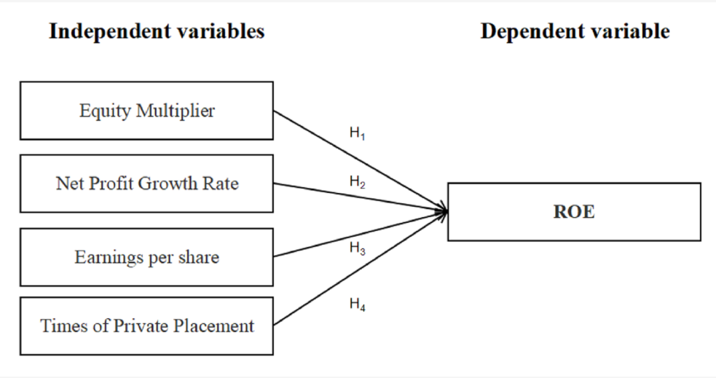

**Hypothesis:**

1 Hypothesis 1: The smaller the equity multiplier, the higher the ROE.

2 Hypothesis 2: The higher the earnings per share, the higher the ROE.

3 Hypothesis 3: The higher the net profit growth rate, the higher the ROE

4 Hypothesis 4: The higher the number of private placement, the higher the ROE.

**Dependent variable and Independent variable**

The index of corporate capital structure selected in this paper is return on equity (ROE).It is also the dependent variable of the model.As a comprehensive evaluation index of corporate profitability, return on equity can not only show the profitability of corporate net assets, but also reflect the change of corporate capital structure and financial status, and comprehensively reflect the utilization of assets and financing status of enterprises.Therefore, this index represents profitability to reflect the financing effect of SEMs.

Earnings per share (EPS) is selected as the independent variable of the model, which means that an enterprise has strong profitability with lower cost or higher profit with the same profit.

This paper selects the net profit growth rate as the independent variable of the model, the net profit growth rate is the index that measures the enterprise growth ability, the higher the net profit growth rate is, it indicates that the enterprise operates well, has stronger competitiveness in the market, and has a very strong growth potential

In this paper, the equity multiplier is selected as the independent variable of the model. The equity multiplier is an indicator to measure the solvency of an enterprise. The equity multiplier represents the amount of assets owned by a unit shareholder's equity.

In this paper, the times of private placement (PPS) is selected as the independent variable of the model.In the NEEQ market , enterprises usually conduct financing by means of directional capital increase. The number of directional capital increase shares can directly reflect the relationship between equity financing of enterprises and the NEEQ market at the present stage after capital increase.

**2.6 Overview of the financing status of SEMs on the NEEQ market**

The number of SEMs listed on the NEEQ market, the industry distribution, regional distribution, activity, the relative valuation of the NEEQ market, market liquidity, and the financing status of listed enterprises on the NEEQ market are analyzed

**2.6.1 The number of SEMs listed on the NEEQ market**

Before 2014, the number of listed companies in China's stock transfer system grew slowly, with an average of 17 newly listed companies each year.In 2014, the NEEQ market launched the market maker system, and the number of listed companies on the NEEQ market showed geometric growth. In 2014, the number of listed companies was 1,216, but in 2019, the number of listed companies reached 8,593.

From 2009 to 2013, the number of listed companies on the NEEQ market grew slowly, roughly maintaining between 10 and 20 companies per year. However, since 2014, the number of listed companies on the NEEQ market has grown rapidly, which is attributed to a series of favorable policies issued by the state that are conducive to the development of the NEEQ market .



Figure2:2009-2010 Number of listed companies on the NEEQ market source:www.NEEQ market .com.cn

**2.6.2 The industry distribution of NEEQ market listed enterprises**

SEMs listed on the NEEQ market are widely distributed in manufacturing, information transmission, software and information technology service industry, construction industry, scientific research and technology service industry and other industries, among which manufacturing, information transmission, software and information technology service industry has the most enterprises, as shown in Table.By the end of December 31, 2019, a total of 8,953 SEMs had been listed on the NEEQ market , of which 49.25% were high-end manufacturers, accounting for 4,409.Information transmission, software and information technology services accounted for 19.27%, reaching 1,725;Rental and business services amounted to 5.19%, 465;Scientific research and technology services accounted for 4.94 percent, reaching 442.Wholesale and retail sales reached 4.47%, reaching 400;Construction accounted for 3.4 percent, or 304, while culture, sports and entertainment industries accounted for 202, or 2.26 percent.200 enterprises engaged in agriculture, forestry, animal husbandry and fishery accounted for 2.23%, and 161 enterprises were engaged in water conservancy, environment and public facilities management.Transportation, warehousing and postal services 1.74 percent, 156;Finance 1.28%, 115;Production and supply of electricity, heat, gas and water were 111, accounting for 1.24%;Real estate 0.79%, 71;Education 0.78%, 70, mining 0.36%, 32 accommodation and catering 0.31%, 28.

It can be seen that the main financing subjects of the NEEQ market are high-end manufacturing and information transmission, leasing and business services. In addition, the tertiary industries, such as scientific research and technology services, wholesale and retail, construction, culture, sports and entertainment, also show a rapid rising trend.

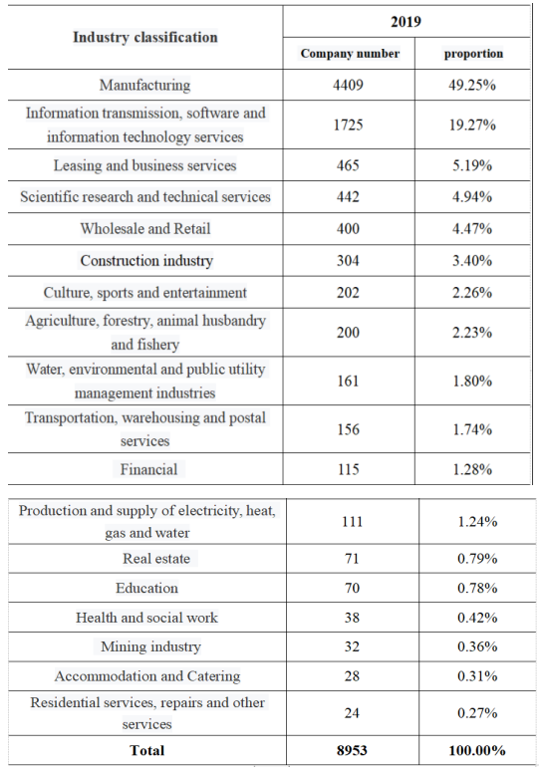

Figure3:Industry distribution of listed companies on the NEEQ market source:www.NEEQ market .com.cn

**2.6.3 Share capital distribution of listed companies**

Although the NEEQ market does not make clear provisions on the equity of listed SEMs, not all large-scale enterprises are suitable for listing and trading on the NEEQ market . The equity distribution of listed SEMs in 2019 is shown in the table below.As of December 31, 2019, a total of 8953 small enterprises listed on the NEEQ marketin the home, of which 1094 companies a total of more than 100 million shares, accounting for 12.22% of listed companies, 2203 small businesses in the home equity between 50 million shares and 100 million shares, 24.61% of the listed companies, 1956 small businesses in the home equity between 30 million and 50 million, 21.95% of the listed companies, 3051 small businesses in the home equity between 10 million and 30 million,Accounting for 34.08% of listed enterprises.

SEMs with a total capital of between 10 million and 30 million shares account for the largest proportion in the NEEQ market listing. The reason is that such enterprises are not large in scale, have their own advantages in main business, can continue to operate, and hope to support the further development of enterprises through listed financing.Large enterprises can obtain financial support by listing on the main board, SEMs board and GEM, while enterprises with too small scale are also not suitable for listing on the NEEQ market .

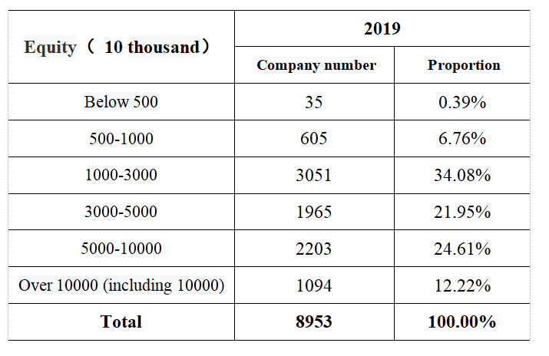

Figure4:Equity distribution of listed companies on the NEEQ market source:www.NEEQ market .com.cn

**2.6.4 Regional distribution of listed enterprises on the NEEQ market**

As of December 31, 2019, among the 8,953 SEMs listed on the NEEQ market , the top 10 provinces are Guangdong, Beijing, Jiangsu, Zhejiang, Shanghai, Shandong, Hubei, Fujian, Henan and Anhui.1319 enterprises in guangdong, accounted for 14.73%, 1190, Beijing enterprises accounted for 13.29%, jiangsu enterprises 1072, accounted for 11.97%, 786, zhejiang enterprises accounted for 8.78%, 715, Shanghai enterprises accounted for 7.99%, 547, shandong enterprises accounted for 6.11%, 314 hubei enterprises, accounted for 3.51%, fujian listed companies 310, accounted for 3.46%, 309, henan enterprises accounted for 3.45%, 308 anhui enterprises, respectively accounted for 3.44%,There were 272,216 enterprises in Sichuan and Hebei respectively, accounting for 3.04% and 2.41%.Liaoning, Hunan, Tianjin, Shaanxi, Jiangxi and Chongqing were listed as 183,179,162,143,125,122, accounting for 2.04%,2%,1.81%,1.60% and 1.40%.There are less than 100 enterprises in Shanxi, Yunnan, Heilongjiang, Xinjiang, Jilin and Guangxi, accounting for 0.93%,0.88%,0.86%,0.8%,0.78% and 0.74% respectively.

Thus it can be seen that in the NEEQ marketlisted companies in guangdong, Beijing, jiangsu, zhejiang, most listed companies and jilin, hainan, guangxi, shanxi, gansu, Inner Mongolia, qinghai provinces listed companies is less, this also conforms to the regional characteristics of China's economic development, more developed coastal regions, new and high technology enterprises, per capita income level, science and technology and education level were higher than the average level of the whole of China, therefore listed companies is more, the Midwest backward economy, high-tech enterprises, listed companies and the number is less.

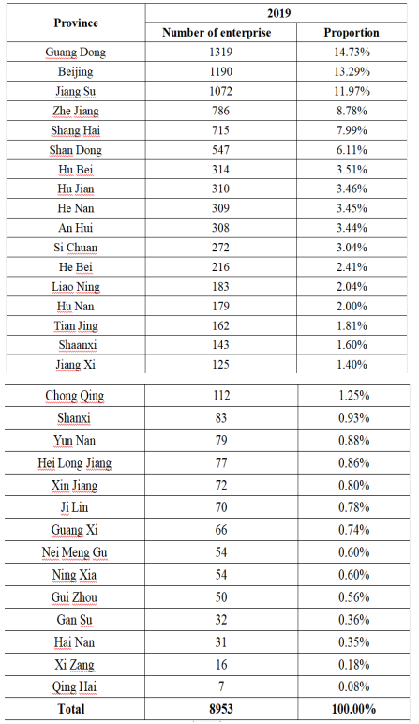

Figure5：Regional distribution of NEEQ market listed companies source:www.NEEQ market .com.cn

**2.6.5 Trading volume trend of listed companies on the NEEQ market**

Since the reform of the NEEQ market in 2013, the turnover of the NEEQ market has also shown a trend of increasing year by year, with 989 transactions in 2013, 92,700 in 2014, 2,821,300 in 2015, 3,088,100 in 2016, 282.99 in 2017, 150.84 in 2018, and 1,543,700 in 2019.

As can be seen from the following table, the expansion decision of the NEEQ market in 2013 transformed the regional OTC trading venue into the Chinese equity transfer system, and the number of market transactions also increased rapidly.The implementation of the market maker system in 2014 further increased the liquidity of NEEQ market and the number of transactions increased by leaps and bounds.

Before July 2014, the NEEQ market had been transacted by agreement, which had a certain negative impact on the liquidity of the NEEQ market .In August 2014, the market maker system was introduced into the NEEQ market . With the official implementation of the NEEQ market maker system, the development of NEEQ market has reached a milestone.In 2014, before the implementation of the market maker system, a total of 3 415 transactions were made, while after the implementation of the market maker system, 9 821 transactions were made in only one month in 2014.

As far as the current development is concerned, the market data proves this point: By December 31, 2019, the NEEQ market had completed 22.02 billion stock issues and raised 82.569 billion yuan, which were 109 times and 101 times of the full-year data in 2013 respectively.From 2013 to 2019, the NEEQ market turnover soared from 814 million to 13.036 billion yuan, clinch a deal amount, respectively, up from 202 million yuan to 22.02 billion yuan, clinch a deal the pen number respectively from only 989 jumped to 1.5084 million, seven years NEEQ marketlisted companies stock transfer scale rise year by year, among them 2014 NEEQ market stock transfer size is 1.6 times that of 2013, 2019 shares transfer size is about 2013 22 times.

|  |  |  |  |  |
| --- | --- | --- | --- | --- |
| **Year** | **Clinch a deal the quantity (100 million）** | **Clinch a deal amount (100 million）** | **Number of deals**  **(million)** | **Turnover rate (%）** |
| 2013 | 2.02 | 8.14 | 989 | 4.47 |
| 2014 | 22.82 | 130.36 | 0.0972 | 19.67 |
| 2015 | 278.91 | 1910.62 | 2.8213 | 53.88 |
| 2016 | 363.63 | 1912.29 | 3.0881 | 20.74 |
| 2017 | 433.22 | 2271.80 | 2.8299 | 13.47 |
| 2018 | 236.29 | 888.01 | 1.5084 | 5.31 |
| **2019** | **220.20** | **825.69** | **1.5437** | **6.00** |

Figure6：2013-2019 NEEQ market tock turnover statistics source:www.NEEQ market .com.cn

As far as the current development is concerned, the market data proves this point: By December 31, 2019, the NEEQ market had completed 22.02 billion stock issues and raised 82.569 billion yuan, which were 109 times and 101 times of the full-year data in 2013 respectively.From 2013 to 2019, the NEEQ market turnover soared from 814 million to 13.036 billion yuan, clinch a deal amount, respectively, up from 202 million yuan to 22.02 billion yuan, clinch a deal the pen number respectively from only 989 jumped to 1.5084 million, seven years NEEQ marketlisted companies stock transfer scale rise year by year, among them 2014 NEEQ market stock transfer size is 1.6 times that of 2013, 2019 shares transfer size is about 2013 22 times.

Can be seen from the chart, in 2019, the year's stock clinch a deal the quantity for the state of fluctuations, but the overall upward trend, shares rose from January 2.303 billion to December 2.569 billion, clinch a deal amount and clinch a deal the pen number also showed a trend of rise, clinch a deal amount rose from 7.575 billion yuan to 9.943 billion yuan, clinch a deal the pen number rose to 158900 from 124500.From January to December 2019, the turnover rate of SEMs listed on the NEEQ market showed an overall upward trend.The turnover rate showed a zigzag rise.

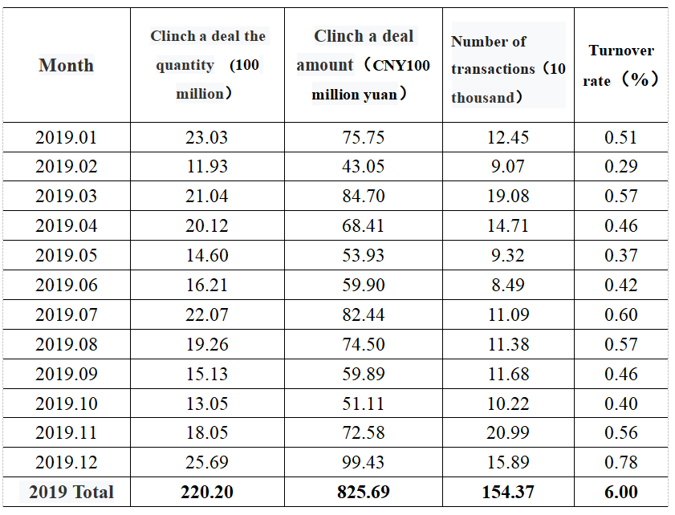

Figure7：2019 NEEQ market stock turnover monthly statistics source:www.NEEQ market .com.cn

**2.6.6 The scale of share issuance of listed companies on the NEEQ market**

From a number of stock issuance, stock issuance, stock issuance, investors account number four aspects from 2013 to 2019, seven years in a listing on the NEEQ marketSEMs (SEMs), 7 years can be found in the NEEQ marketlisting of small and medium enterprises listed on scale increases year by year, share issuance quantity increased year by year, stock transfer, the investors' account number increases year by year, 7 years shows that the NEEQ market activity.

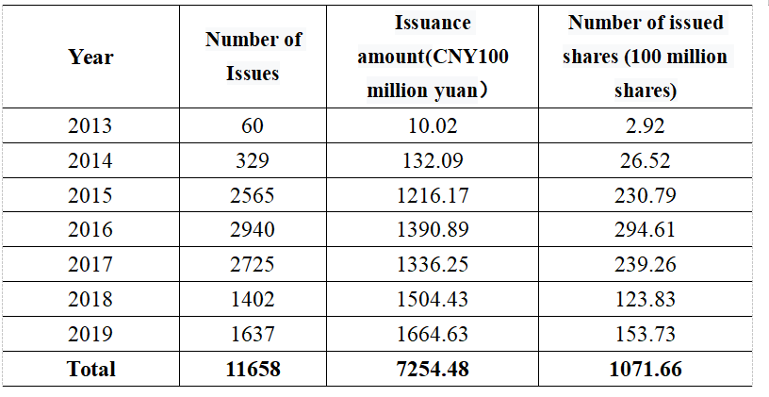

Figure8:Statistics of stock issuance on the NEEQ market from 2013 to 2019 source:www.NEEQ market .com.cn

From 2013 to 2019, the NEEQ market rise in number of listed companies from 356 to 8952, the NEEQ market enterprise issued a total of 1.002 billion shares jumped to 2013 from 2019 in 725.448 billion, the NEEQ market listed companies market capitalisation rose from 33.61 billion yuan to one hundred million yuan, 29399.60 by the above data analysis can get NEEQ market scale increased year by year, among them 2014 NEEQ market scale is the scale of 1.5 times in 2013,The market size of the NEEQ market in 2019 is about 25 times that of 2013, and the market growth rate is also accelerating.From 2013 to 2019, the number of shares issued by NEEQ market listed companies increased from just 60 to 1,637, and the number of shares issued increased from 292 million to 2.643 billion. The amount of financing in 2013 was 1.002 billion yuan, while the amount of financing in 2019 was 166.463 billion yuan. The size of the NEEQ market shares issued in 2014 was 5.4 times that of 2013, and that in 2019 was about 27 times that of 2013.From 2016 to 2019, the number of institutional investors in the NEEQ market was 38,500, 51,200, 56,300 and 58,900, respectively, and the number of individual investors was 295,700, 3574, 377,500 and 387,300, respectively. It can be seen from the data that the growth rate of the number of individual investors was significantly faster than that of institutional investors.

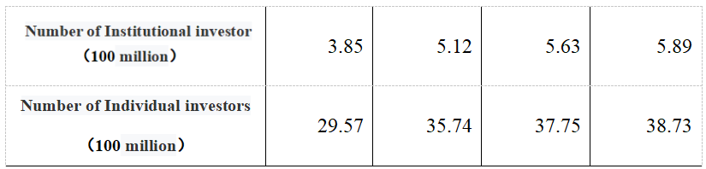

Figure9:Statistics of investors on the NEEQ market from 2016 to 2019 source:www.NEEQ market .com.cn

**2.6.7 The relative valuation status of NEEQ market enterprises**

In 2019, the general fluctuation of P/E ratio on the NEEQ market tends to be stable, which also indicates that investors have an objective understanding of the relative valuation of enterprises on the NEEQ market .December 1, 2019 NEEQ market weighted average p/e ratio were 20.68 times, 20.67 times, 20.95 times, 19.97 times,19.89 times, 19.73 times, 19.54 times, 19.06 times and 19.14 times, 19.12 times, 19.42 times, 19.74 times, analyze the above data shows that in 2019 the new three weighted average p/e ratio of the overall market volatility is not big, indication of the relative value of the NEEQ marketenterprise is stable.



Figure10：2019 NEEQ market monthly P/E ratio source:www.NEEQ market .com.cn

**2.7 conclusion**

This chapter is divided into four parts, namely, the introduction of relevant concepts, the introduction of relevant theories, previous scholars' research on SEMsfinancing, the current situation of the NEEQ market , and the Conceptual Framework.

Relevant concepts include the definition of the capital market, the definition of SEMs enterprises, the definition of financing efficiency, and the definition of the NEEQ market .Theories related to SEMs financing include MM theory, efficient market theory, tradeoff theory, information cost theory, and market microstructure theory.Previous researches on this issue mainly include the relationship between the stock market and SEMs enterprises, the evaluation method of financing efficiency of SEMs enterprises and the financing methods of SEMs.The number of SEMs listed on the NEEQ market, the industry distribution, regional distribution, activity, the relative valuation of the NEEQ market , market liquidity, and the financing status of listed enterprises on the NEEQ market.Finally, the Conceptual framework of this paper is introduced

**Chapter 3**

## 3.1 Research Design

The study was quantitative.The hypothesis and verification methods of this paper are supported by domestic and foreign literatures and theories on SEMs financing, and are based on the research topics and research problems.In the confirmatory study, In the confirmatory study, the collected data were processed, and SPSS software was used to analyze the dependent variables and independent variables to verify the hypothesis.Linear regression analysis was used to test the hypothesis, and descriptive analysis was used to compare the improvement of the financial situation of enterprises before and after the listing of the NEEQ market.Descriptive analysis was used to compare the variables before and after listing.Descriptive analysis is a supplement and explanation to the improvement of financing efficiency of SEMs (the problem studied in this paper) after their listing on the NEEQ market.

**3.2 Research methods**

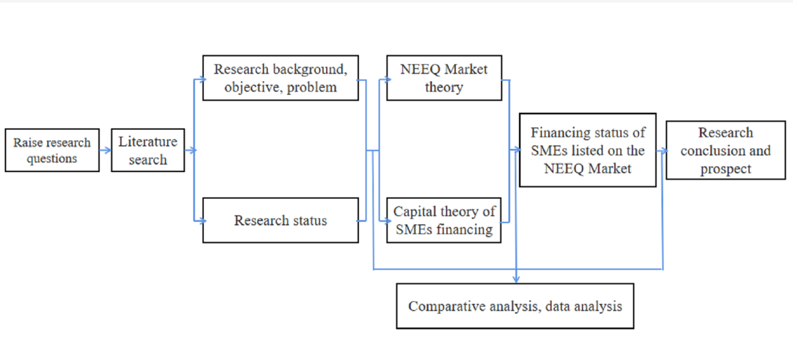

**3.3 Sample and index selection**

Sectional data of return on equity, number of private placements, earnings per share and net profit growth rate of 30 NEEQ market enterprises in 2019 are selected to analyze the linear relationship between these factors and ROE by means of multiple linear regression.

**3.3.1 A sample of descriptive analysis**

The return on equity, earnings per share, net profit growth rate and equity multiplier of 30 listed companies on the NEEQ market in 2019 are selected to carry out descriptive analysis, as a supplementary explanation to the research question of this paper.

Namely after the enterprises listed on the NEEQ market to improve the financing efficiency and increase the financing efficiency, It improves the profitability of enterprises and solves the long-term financing problem of SEMs to some extent.The financial index of 2 years before listing is selected as a measure of the financing efficiency of listed companies on the NEEQ market before listing, and the financial index of 2 years after listing is used as a measure of the financing efficiency of listed companies on the NEEQ market after listing.Therefore, this paper has four annual data, namely, 2 years before and 1 year after listing, 1 year after listing and 2 years after listing.

**3.3.3 Index selection**

In this paper, five indexes including return on equity, earnings per share, growth rate of operating income, times of private placement and growth rate of net profit are selected.

**3.4 Measuring Instrument**

|  |  |  |
| --- | --- | --- |
| Dependent variable | ROE | Net income / shareholders' equity |
| Independent variable | equity multiplier | Total assets / total shareholders' equity |
| net profit growth rate | （Current net profit-Last year's net profit / Last year's net profit)*100% |
| Earnings per share | (net income-preferred dividends) / common  Shares outstanding |
| Times of private placement | Private placement is a way of financing after a company goes public |

The data collected were analyzed and summarized by using the data analysis function of SPSS, and the data analysis function of Microsoft SPSS (descriptive statistical data tools and multiple regression analysis) was used to analyze the improvement of the financing efficiency of SEMs in the NEEQ market And the relationship between earnings per share, revenue growth rate, the number of private placement, net profit growth rate and ROE.

SPSS 26.0 was used for multiple linear regression analysis of return on equity, number of private placement, EPS, net profit growth rate and equity multiplier. Dependent variable:ROE. Independent variable: EPS 、net profit growth rate、 times of private placement (PPS) 、equity multiplier.

If the regression coefficient is positive, it indicates a positive correlation with return on equity; if the regression coefficient is negative, it indicates a negative correlation with return on equity

After listing on the NEEQ market , the increase of ROE of SEMs indicates that listing on the NEEQ market can positively promote their self-financing efficiency, that is, listing on the NEEQ market can improve the financing efficiency of SEMs.On the contrary, if the return on equity of an enterprise declines, listing on the NEEQ market will worsen the financing efficiency of SEMs on the NEEQ market .This paper also selects earnings per share and revenue growth rate to measure the profitability and growth capacity of SEMs as a supplement to the financing efficiency index of SEMs.By comparing the changes of earnings per share and revenue growth rate of SEMs before and after being listed on the NEEQ market , the influences of being listed on the NEEQ market on the financing efficiency of SEMs are judged.

**3.5 Data Source**

At present, There are five major financial websites in China, namely Oriental Fortune, Flush, Snowball.com, CICC Online and Wall Street Financial.This paper determines the data acquisition platform based on the following five indicators (as shown in the figure).Financial websites rank websites by category.

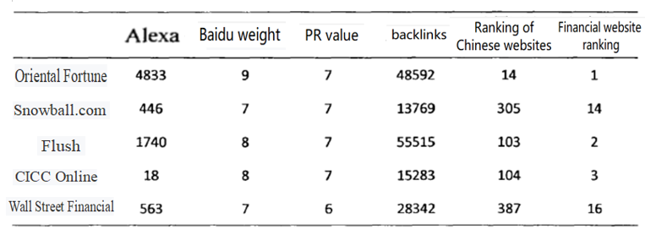

Figure11：Ranking of Financial websites source: www.baidu.com

It can be concluded from the figure that Oriental Wealth ranks first in all the five indicators, so it is chosen as the data source of this paper.

In this paper, sectional data of earnings per share, net profit growth rate, equity multiplier, times of private placement and return on equity of 30 SEMs listed on the NEEQ market in 2019 are selected as samples.Choose to cross section data rather than the time series data and panel data, because the NEEQ market set up a relatively short time.

The data year of 2019 is selected instead of the data year of 2020 because the global COVID-19 epidemic, namely the "black Swan" event, has brought economic crisis to all industries in 2020, so the data year of 2020 is not representative, so the data year of 2019 is selected.

**Chapter 4 Analysis results and findings**

## **4.0 Introduction**

Multiple linear regression was used to analyze the effects of earnings per share(EPS), net profit growth rate, equity multiplier and number of private placement on ROE.The return on equity of SEMs is mainly affected by macro and micro factors.Due to the large number of macro factors and variables, it is difficult to quantify, this paper only selects whether micro factors will affect the ROE of SEMs.Therefore, from the perspective of micro factors and enterprises, whether there is a significant correlation between the financing and profitability of SEMs in the NEEQ market.There should be a mutually promoting relationship between the financing effect of SEMs in the NEEQ market and their profitability.Therefore, this paper selects four variables reflecting profitability, operating ability, debt paying ability and growth ability, namely earnings per share, growth rate of net profit, equity multiplier and number of private placement, to study the impact of these factors on ROE of SEMs.

**4.1 Correlation test**

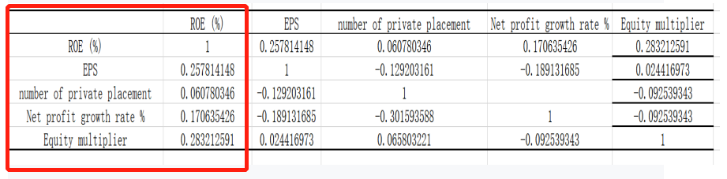

Figure12: The correlation coefficient between ROE and EPS, equity multiplier, times of private placement, and net profit growth rate

Multivariate linear regression analysis, according to the results of ROE and EPS of the correlation coefficient is 0.257, The correlation coefficient between ROE and the times of private placement is 0.0607, ROE and net profit growth rate of the correlation coefficient is 0.1706, ROE and the equity multiplier of correlation coefficient is 0.2832, through the test of the correlation coefficient of dependent variable and independent variable can be found, ROE and EPS, directional issuance number, net profit growth rate, present the positive correlation between equity multiplier, so the variable selection

**Hypothesis 1**

H0: There is no significant linear relationship between equity multiplier and ROE.

H1: There is a significant linear relationship between equity multiplier and ROE.

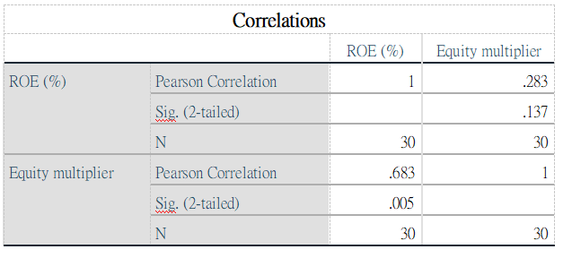

Figure13:Correlation analysis results of Equity Multiplier and ROE

According to the results, SIG=0.005(＜0.05). Therefore, the null hypothesis H0 is rejected, suggesting that there is a significant linear relationship between ROE and equity Multiplier, and Pearson Correlation is 0.683(＞0.3),So accept hypothesis H1, There is a significant linear relationship between equity Multiplier and ROE

**Hypothesis 2**

H0: Earnings per Share does not have a significant linear relationship with ROE.

H1: Earnings per Share has a significant linear relationship with ROE.

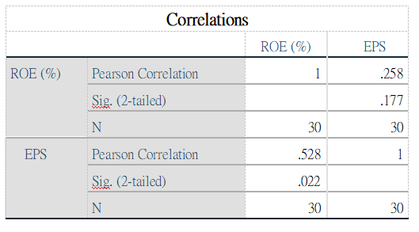

Figure14: Correlation analysis results of Earnings per Share and ROE

The results showed that SIG=0.022 (< 0.05).Therefore, rejecting the null hypothesis H0 indicates that there is a significant linear relationship between ROE and EPS, and Pearson correlation is 0.528 (＞0.3). Therefore, hypothesis H1 is accepted, there is a significant linear relationship between equity multiplier and EPS.

**Hypothesis 3**

H0: There is no significant linear relationship between net profit growth rate and ROE.

H1: There is a significant linear relationship between net profit growth rate and ROE.

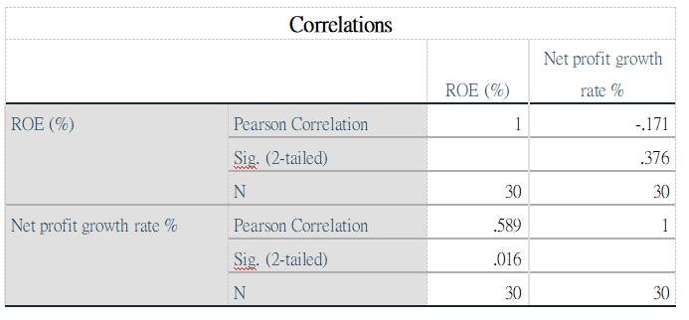

Figure15: Correlation analysis results of net profit growth rate and ROE

The results showed that SIG=0.016(< 0.05).Therefore, the null hypothesis H0 is rejected, indicating a significant linear relationship between ROE and net profit growth rate, and Pearson correlation is 0.589(＞0.3). Therefore, hypothesis H1 is accepted, that is, there is a significant linear relationship between equity multiplier and net profit growth rate.

**Hypothesis 4**

H0:There is no significant linear relationship between the number of private placement and ROE.

H1: There is a significant linear relationship between the number of private placement and ROE.

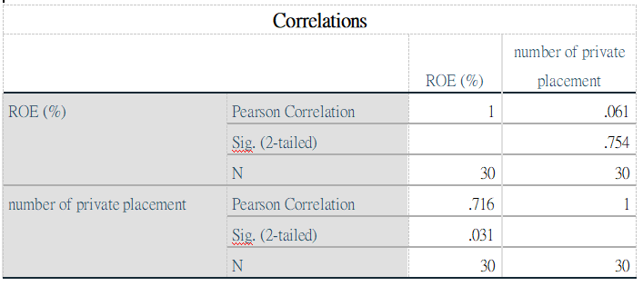

Figure16 : Correlation analysis results of number of private placement and ROE

The results showed that SIG=0.031(< 0.05).Therefore, rejecting the null hypothesis H0 indicates that there is a significant linear relationship between ROE and the number of private placement, and Pearson correlation is 0.716(＞0.3). Therefore, hypothesis H1 is accepted, that is, there is a significant linear relationship between equity multiplier and number of private Placement.

**4.2 Hypothesis Testing**

In this study, it is hypothesis that H1, H2, H3 and H4 are all measured by multiple linear regression analysis.

1 Hypothesis 1: There is a significant linear relationship between equity multiplier and ROE.

Namely The smaller the equity multiplier, the higher the ROE.

2 Hypothesis 2: There is a significant linear relationship between earnings per share and ROE.

Namely The higher the earnings per share, the higher the ROE.

3 Hypothesis 3: There is a significant linear relationship between the net profit growth rate and ROE.

Namely the higher the net profit growth rate, the higher the ROE

4 Hypothesis 4: There is a significant linear relationship between ROE in the number of private placement.

Namely the higher the number of private placement, the higher the ROE.

**4.2.1 Model Summary**

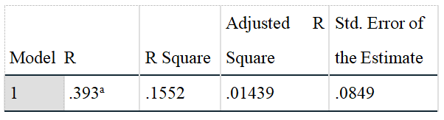

 Figure17: Finding Results of Multiple Regression Analysis-Model Summary

a.Dependent Variable: ROE

b.Dependent Variable: equity multiplier,earnings per share(EPS）， net profit growth rate, number of private placement.

R square value is 0.1552, indicating that the 15.52% variance of the dependent variable is caused by three independent variables.The variance of the remaining 84.48% of the dependent variable is caused by other factors.

**4.2.2 ANOVA**

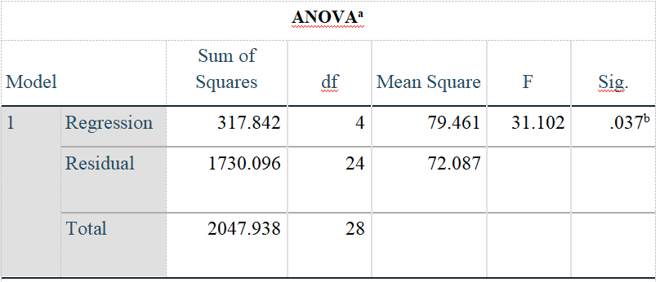

Figure18: Finding Results of Multiple Regression Analysis- ANOVA

a.Dependent Variable: ROE

b.Dependent Variable: equity multiplier,earnings per share(EPS）， net profit growth rate, number of private placement.

According to the results,P value = 0.037（＜0.05），precise value of the F statistic is 31.102.As a result, the model for this study is adequate descriptor of the relation between the predictor variables and dependent variable.

**4.3 Multiple linear regression**

**4.3.1 Build a model**

The multiple regression model analysis studies how dependent variables depend on multiple independent variables. The multiple regression model expression is as follows:

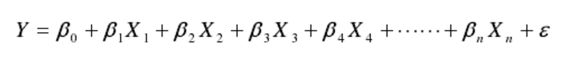

The multiple regression equation can be expressed as:



This paper attempts to establish a multiple regression model to explain the financing effect of SEMs in the NEEQ market . According to the formula, this paper establishes a regression model:

**ROE＝β0＋β1*EPS＋β2*npgr＋β3*pp＋β4*em**

Where β0is the regression coefficient, β1represents the impact of earnings per share on return on equity;β2represents the impact of net profit growth rate on ROE;β3 represents the influence of the number of private placement on ROE;β4represents the effect of the equity multiplier on ROE.

**4.3.2Coefficients**

According to formula , SPSS software was used for multiple linear regression analysis of the data, and the following regression results were obtained.

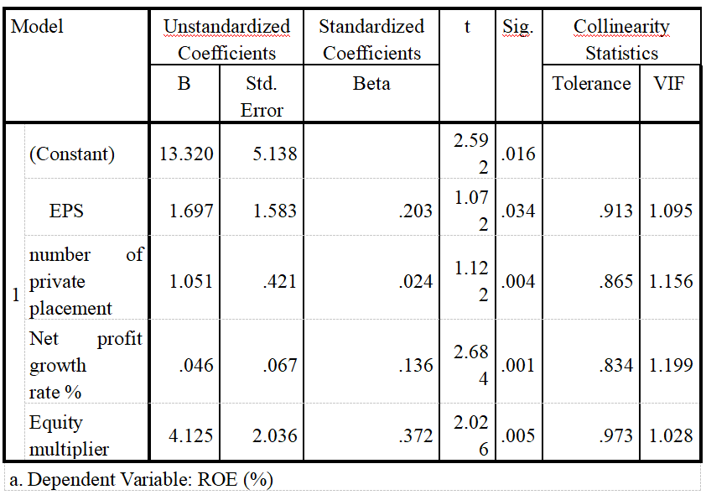

Figure19: coefficient of regression analysis.source:self-made

From the regression analysis coefficient table, it can be seen that the SIG values of the four indicators, namely the number of private placement, the growth rate of net profit, the earnings per share, and the equity multiplier, are all less than 0.05, which have passed the significance test.VIF is the reciprocal of tolerance, which can be accepted within 10. It can be seen from the table that VIF values hover around 1, which is acceptable.It can be seen from the table that the number of private placement, net profit growth rate, earnings per share, equity multiplier and return on equity are positively correlated.

The results show that the estimated global regression equation can be obtained as follows：

ROE=13.320+1.812*number of private placement+0.046*Net profit growth rate +1.697*EPS +4.125*Equity multiplier

**4.4 Findings of linear regression**

The conclusions of the regression model from the above analysis are as follows.

First, there is a significant positive correlation between the return on equity and the equity multiplier, and the statistical results verify that hypothesis 1 is correct.Second, there is a significant positive correlation between the return on net assets and earnings per share, which verifies the correctness of Hypothesis 2.Third, there is a significant positive correlation between the return on equity of an enterprise and the growth rate of its net profit. This result also shows that hypothesis 3 is correct.Fourthly, there is a significant integral correlation between the return on equity of an enterprise and its private placement, which also shows that hypothesis 4 is correct.

**4.5** **Descriptive analysis**

Descriptive statistics is used as a supplementary explanation to the research problem in this paper. The selected indicators are also earnings per share(EPS), net profit growth rate, equity multiplier, times of private placement and ROE. The correlation test of all variables shows that earnings per share(EPS), net profit growth rate, equity multiplier, Times of private placement are positively correlated with ROE(Figure12).Therefore, descriptive statistics were used to analyze the changes of earnings per share, net profit growth rate, equity multiplier and number of private placements before and after listing. It can reflect the impact of these four indicators on ROE to a certain extent

The financial indexes of 30 companies listed on the NEEQ market in 2019 for 2 years before listing are selected as the measurement indexes of the financing efficiency of companies listed on the NEEQ market before listing, and the financial indexes for 2 years after listing are used as the measurement of the financing efficiency after listing.Since private placement is a financing behavior only available after an enterprise goes public,Therefore, this index only takes the first year and the second year after listing Compare the changes of earnings per share (EPS), net profit growth rate, equity multiplier, private placement and ROE of these 30 companies before and after their listing on the NEEQ market.

The normal value range of equity multiplier is between 1 and 4. In this range, the smaller the value is, the higher the financing efficiency of enterprises is.If The equity multiplier of a company hovers around 1 after listing,it indicates that The NEEQ market improves The financing efficiency of The company, Because the equity multiplier is positively correlated with the return on equity,which indirectly proves that Hypothesis 1 is correct. Namely the smaller The equity Multiplier, The better The corporate financing efficiency (ROE).

If the earnings per share（EPS）of an enterprise after listing is higher than that before listing, Because earnings per share（EPS） and return on equity are positively correlated，it indicates that the NEEQ market has improved the financing efficiency of the company，which indirectly proves that Hypothesis 2 is correct.Namely the higher the earnings per share, the higher the corporate financing efficiency（ROE).

If the growth rate of the net profit of the enterprise after the listing is faster than before the listing of the enterprise, Because the growth rate of net profit is positively correlated with the return on equity,it indicates that The NEEQ market improves The financing efficiency of The company, which indirectly proves that Hypothesis 3 is correct.Namely the higher the net profit growth rate, the better the financing efficiency（ROE).

Private placement is the financing method used by enterprises after they go public. It is helpful for enterprises to obtain the funds they need and increase the return on equity of enterprises. Because the number of private placement is positively correlated with return on equity,The more times a company conducts private placement after going public, the higher its financing efficiency will be.which indirectly proves that Hypothesis 4 is correct. Namely the more times of private placement, the better the financing efficiency of enterprises（ROE）

**4.5.1 Comparison of average earnings per share（EPS）before and after listing**

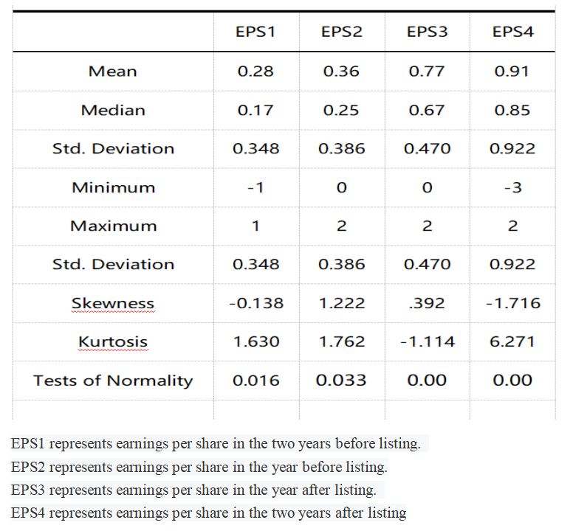

Figure20：Comparative Analysis of average earnings per share of SEMs on the NEEQ market before and after listing source:self-made.

By analyzing the earnings per share of SEMs listed on the NEEQ market from 2 years before listing to 2 years after listing, it can be found that the earnings per share of SEMs listed on the NEEQ market generally show an upward trend in 4 years, from 0.28 yuan in 2 years before listing to 0.91 yuan in 2 years after listing.It indicates that the listed profitability of SEMs has been improved year by year, as shown in the table

Two years before listed on the NEEQ market SEMs, listed before 1 year, 1 year after the listing, two years after the listing of average of earnings per share were 0.28 yuan and 0.36 yuan, 0.77 yuan and 0.91 yuan, a median of 0.17 yuan, 0.25 yuan and 0.67 yuan, 0.85 yuan, the maximum value of 1, 2, 2 yuan respectively, 2 yuan, the minimum value of 1 yuan, 0, 0 yuan, 3 yuan, and the standard deviation was 0.348, 0.386, 0.470, 0.922, respectively.Analysis of the above data shows that SEMs listed in the NEEQ market after the steady rise in earnings per share.

**4.5.2 Comparison of net profit growth rate before and after listing**

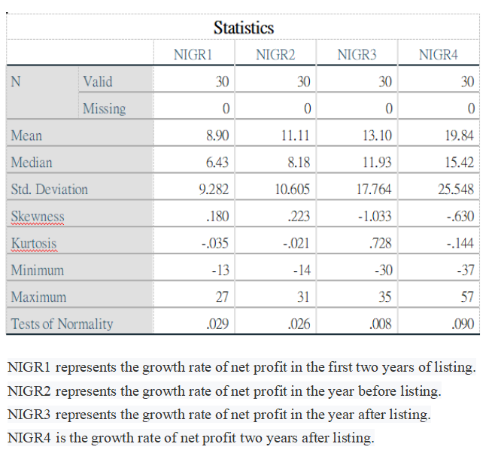

Figure 21:Comparative Analysis of net profit growth rate of SEMs on the NEEQ market before and after listing. source:self-made

Compared the net profit growth rate of the two years before and after listing, the net profit growth rate increased from 8.9% before listing to 19.84% after listing. From the perspective of the overall trend, the NEEQ market listed on the growth of SEMs own ability, promoted the growth of SEMs.

2 years before, 1 year before, 1 year after and 2 years after listing, the average values of SEMs on the NEEQ market are 8.9%, 11.11%, 13.10%, 19.84%, respectively. The median values are 6.43%, 8.18%, 11.93%, 15.42%, respectively. The maximum values are 30.96%, 33.58%, 86.40%, 56.9%.Before listing on the NEEQ market , the average growth rate of operating income of SEMs was about 10.005%, and after listing on the NEEQ market , the average growth rate of operating income of SEMs was about 16.47%. According to the average performance of SEMs in the NEEQ market ,SEMs have a positive role in promoting their own growth after being listed on the NEEQ market.

**4.5.3 Comparison of equity multiplier before and after listing**

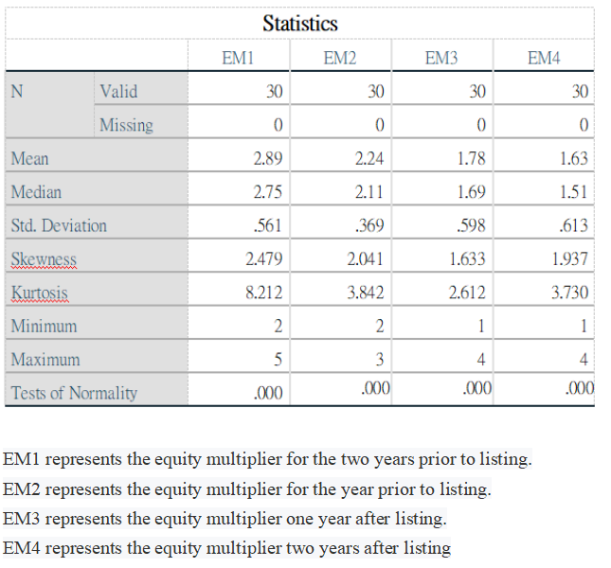

Figure 22：Comparative Analysis of equity multiplier of SEMs on the NEEQ market before and after listing source:self-made

2 years before, 1 year before, 1 year after and 2 years after listing, the mean of equity multiplier is 2.89, 2.24, 1.78 and 1.63, respectively.The median was 2.75, 2.11, 1.69 and 1.63, respectively.According to the average performance of SEMs in the NEEQ market, SEMs have effectively reduced their debt ratio after being listed on the NEEQ market.

**4.5.4The times of private placement after listing**

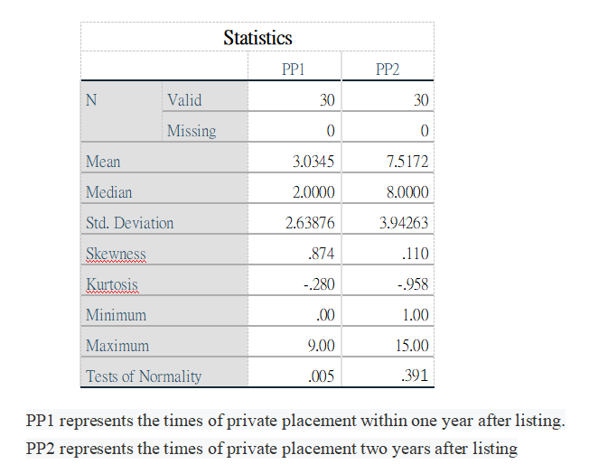

Figure23：Comparative Analysis of times of private placement of SEMs on the NEEQ market before and after listing source:self-made

From the statistical results, after listing on the New Third Board, the number of companies using private placement for financing increased significantly, from an average of two times to an average of eight times

**4.5.5 Comparison of ROE before and after listing**

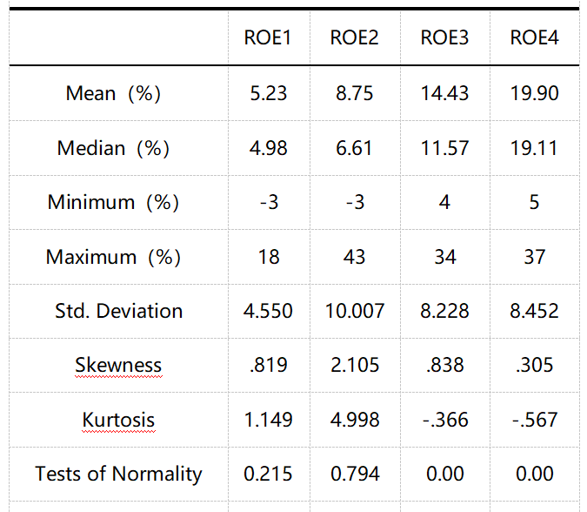

Figure24:Return on equity of SEMs on the NEEQ market before and after listing.source:self-made (ROE1 represents return on equity two years before listing.ROE2 represents return on equity one year before listing. ROE3 represents return on equity one year after listing.ROE4 represents return on equity two years after listing)

As the mean value of financial indexes of SEMs listed on the NEEQ market is lower or higher due to the abnormal performance of some enterprises, the median value of financial indexes of SEMs listed on the NEEQ market is selected to reflect their profitability.By analyzing the return on equity of 2 years before and after listing, it can be found that the return on equity of SEMs listed on the shows an overall rising trend in the 4 years from 2 years before listing to 2 years after listing, from 4.98% before listing to 19.11% after listing.This indicates that the listing of SEMs on the NEEQ market has indeed played a positive role in improving their profitability.

Two years before listed on the NEEQ market SEMs, listed before 1 year, 1 year after the listing, two years after the listing of average return on equity of 5.23%, 8.75%, 14.43% and 19.90% respectively, the median 4.98%, 6.61%, 11.57% and 19.11% respectively, the maximum 18%, 43%, 34% and 37% respectively, the minimum is respectively 3%, 3%, 4%, 5%, and the standard deviation of 4.55%, 10.007%, 8.228% and 8.452% respectively.

From the above data analysis, it can be seen that the ROE index of SEMs owed an average annual growth from 5.23% to about 19.90% 2 years before, 1 year after and 2 years after listing. Moreover, the standard deviation two years after listing was very small, both at about 8%.This indicates that the financing efficiency of SEMs listed on the NEEQ market generally develops smoothly in these years, and no special factors make their profitability increase or decrease rapidly.

From the above data analysis, it can be seen that the ROE index of small and medium sized enterprises showed an average annual growth From 5.23% to about 19.90% 2 years before,1 year after and 2 years after listing. Moreover, the standard deviation two years after listing was very small, both at about 8%.This indicates that the financing efficiency of SEMs listed on the NEEQ market generally develops smoothly in these years, and no special factors make their profitability increase or decrease rapidly.

**4.6The trend comparison of independent variables and dependent variables**

**4.6.1Trend comparison equity multiplier and ROE**

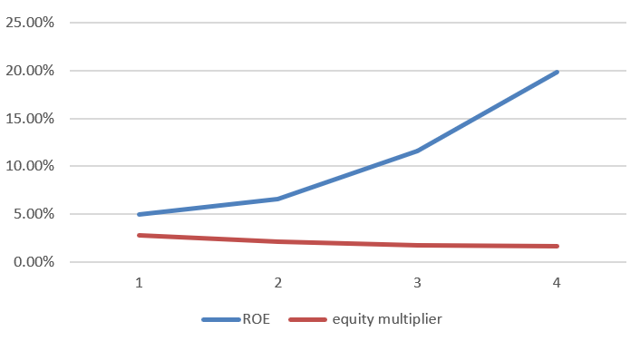

Figure25:Trend comparison equity multiplier and ROE

As equity multiplier is an indicator of liabilities, it can be seen from the trend comparison that the increase of ROE is consistent with the decline of equity multiplier, which also confirms that hypothesis 1 is correct, namely, the lower the equity multiplier, the higher the ROE

**4.6.2 Trend comparison between EPS and ROE**

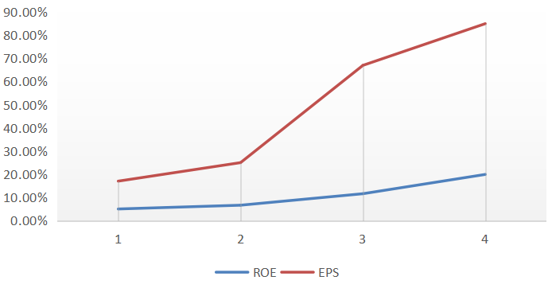

Figure26: Trend comparison between EPS and ROE

From the trend comparison, it can be seen that the trend of ROE and EPS is consistent, which also confirms that hypothesis 2 is correct, that is, the higher the earnings per share, the higher the ROE

**4.6.3 Trend comparison between net profit growth and ROE**

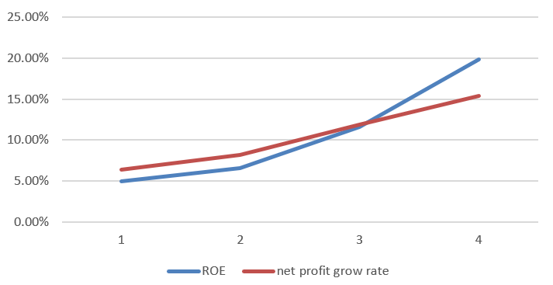

Figure27:Trend comparison between net profit growth and ROE

From the trend comparison, it can be seen that the trend of ROE is consistent with that of net profit growth rate, which also proves that hypothesis 3 is correct, that is, the higher the net profit growth rate, the higher the ROE

**4.6.4 Trend comparison times of private placement and ROE**

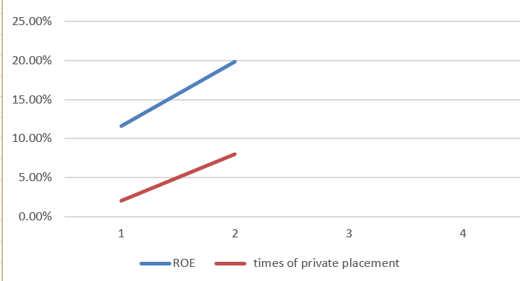

Figure28:Trend comparison times of private placement and ROE

It can be seen from the trend comparison that ROE and Times of private placement are consistent, which also confirms the correctness of Hypothesis 4, that is, the higher times of private placement, the higher the ROE.

**4.7 Results of descriptive analysis**

The descriptive statistical results of earnings per share(EPS), net profit growth rate, equity Multiplier and Times of private placement show that the four indicators of the enterprise have all been improved after the listing of the NEEQ market, thereby improving the ROE of the enterprise.This conclusion is consistent with the multiple linear regression analysis to get the conclusion, namely the way per share (EPS), net profit growth rate, equity Multiplier and Times of private placement is positive correlation with ROE, finally it is concluded that companies listed on the NEEQ market after improving its own financing efficiency and profitability, the NEEQ market to a certain extent, improve the financing problem in SEMs for a long time.

# Chapter 5: CONCLUSION

## **5.1 Problems existing in market financing on the NEEQ market**

### **5.1.1The liquidity of the NEEQ market is not optimistic**

In 2019, 5,613 companies were listed on the GEM, and 8,953 were listed on the NEEQ market . In terms of the number of listed companies, the NEEQ market is significantly more advantageous than the GEM.However, the total issued share capital of gem is 109.9 billion shares, while that of the NEEQ market is 66.255 billion shares, which is significantly lower than that of GEM.The turnover rate on the NEEQ market was 6 percent and on the Shanghai Stock Exchange was 11.55 percent.NEEQ market as an important part of the OTC market in China, although has attracted more than 13000 listed companies to enter the market, the overall volume is increasing, but the average volume is still in lower level, some indicators even less than some regional otc market, with foreign mature capital market also has the very big disparity in the same market.Sometimes SEMs do not need a particularly large scale in financing, but the financing efficiency is very important. The current liquidity of the NEEQ market and the market's allocation efficiency of funds are too low.

**5.1.2 The market transfer mechanism of the NEEQ market is imperfect**

Among the listed companies on the NEEQ market, many are qualified to transfer to the higher capital market due to their good development status. Although the NEEQ market has the transfer mechanism to the GEM board and the SEMs board, only 66 enterprises have successfully realized the transfer.Such a situation for those in the direct rush into the market or first listed and then seek opportunities to turn the board between the wavering SEMs, no doubt more difficult to choose and choose the cost.If the liquidity and financing efficiency of the NEEQ market cannot be improved for a long time, then the NEEQ market will lose its attractiveness to SEMs, which is not conducive to its further play the financing role of the newly emerging capital market level.

**5.1.3 The trading mode of the NEEQ market is imperfect**

At present, there are mainly two trading methods in the NEEQ market , namely agreement transfer and market-making transfer system.Compared with other otc markets, bidding transfer is not introduced in the NEEQ market .The main reason is that the NEEQ market is not mature enough at present, and there is not enough liquidity in the market to drive the operation of the centralized bidding transfer system.However, the lack of this system indirectly leads to the impossibility of implementing hierarchical management of the NEEQ market .

**5.1.4 Problems of enterprises themselves in the NEEQ market .**

Most SEMs technological enterprises are small in scale, with fewer levels of internal management and fewer share owners, and most of them are concentrated in the hands of investors. Therefore, the managers of enterprises are also investors, resulting in the lack of internal control system.In such an enterprise management structure, there is no scientific and reasonable mechanism to regulate the operation of the enterprise, most of which can only be the monopoly of the owner, and the development of the enterprise cannot be promoted by brainstorming. The allocation of human and financial resources is unreasonable, and the internal control mechanism is poor.After entering the market, such enterprises will not only restrict their own development, but also cause investors to lose confidence in enterprises in the market, making it more difficult for enterprises to obtain financing.

**5.2 Research Limitations & Suggestions for Future Research**

The establishment of the NEEQ market has a "positive incentive" effect on the financing of SMEs.Through this quantitative analysis and research, it can be seen that the financing efficiency (ROE) of SEMs is correlated with the enterprise's earnings per share, net profit growth rate, times of private placement, and equity multiplier.

In this study, there are three main deficiencies. First, the financial indicators selected in this paper are few, and the impact of all financial indicators on ROE is not fully considered.Secondly, this paper only considers the impact of micro factors on ROE, and does not consider the impact of macroeconomic indicators (such as GDP, CPI and money supply) on ROE.Finally, the sample size selected in this paper is small.

Therefore, future researchers can expand the size of the research sample, select a variety of different financial indicators, and comprehensively consider the impact of macroeconomic and microeconomic factors on the financing efficiency of SEMs.

**6.0 Reference**

1 XU, J. and JIANG, L., 2020. *Research On Chinars Financial Support For Scientific And Technological Innovation*.

2 Wang, C., Zhang, X., Vilela, A., Liu, C. and Stanley, H., 2020. *Industrial Structure Upgrading And The Impact Of The Capital Market From 1998 To 2018: A Spatial Econometric Analysis In Chinese Regions*.

3 Holmes, M. and Maghrebi, N., 2020. *Financial Market Impact On The Real Economy: An Assessment Of Asymmetries And Volatility Linkages Between The Stock Market And Unemployment Rate*.

4 Pan, L. and Mishra, V., 2020. *Stock Market Development And Economic Growth: Empirical Evidence From China*.

5 Wan, L., 2020. *Stock-Issue Registration System Reform: International Experience And China’S Choice*.

6 TENG, C., & YE, S. J. (2017). Impact of Internet Finance on China's Financial Structure. *Journal of Shenzhen University (Humanities & Social Sciences)*, (6), 17.

7 Sheng-zu HONG Qun-lian, G. U., & Xiang, Z. H. A. N. G. (2017). On the Construction of China's Multi-layer Capital Market for Innovation [J]. *China Soft Science*, *8*.

8 WANG, S. Q., & XU, Y. G. (2018). An Idea of Multilevel Capital Market [J]. *Taxation and Economy*, *4*.

9 Han, J., He, J., Pan, Z. and Shi, J., 2020. *Twenty Years Of Accounting And Finance Research On The Chinese Capital Market*.

10 Wu, J. (2018). The Development of Multi-level Capital Market-Promote the Development of Small and Medium Enterprises. In *2013 Sixth International Conference on Business Intelligence and Financial Engineering* (pp. 291-294). IEEE.

11 Hrmars.com. 2020. [online] Available at: <http://hrmars.com/hrmars_papers/The_Relationship_between_the_Capital_Market_and_the_Real_Economy_The_Case_of_the_European_Union.pdf> [Accessed 11 July 2020].

12 Liu, N., & Xu, W. (2017). Stock liquidity on China NEEQ exchange. *Eurasian Economic Review*, *7*(2), 255-275.

13 Giannellis, N. and Papadopoulos, A., 2020. *Intra-National And International Spillovers Between The Real Economy And The Stock Market: The Case Of China*.

14 Szyszka, A., 2020. *International Capital Markets And The Global Real Economy*.

15 Chen, Z., 2020. *Total Social Finance: Mutual Influences Between Financial Markets And Macro Economy*.

16 Si D K, Liu X H, Kong X. The comovement and causality between stock market cycle and business cycle in China: Evidence from a wavelet analysis[J]. Economic Modelling, 2019, 83: 17-30.

17 Cheng A W W, Chow N S C, Chui D K H, et al. The Three Musketeers Relationships between Hong Kong, Shanghai and Shenzhen Before and After Shanghai–Hong Kong Stock Connect[J]. Sustainability, 2019, 11(14): 3845.

18 Li K, Yan Q, Lei Y. The Effect of Stock Liquidity on Default Risk: An Empirical Study of China’s Capital Market[C]//International Conference on Management Science and Engineering Management. Springer, Cham, 2019: 93-104.

19 Li Y Y. Information transparency and corporate performance-Evidence from China's multi-tiered capital market system[J]. Journal of Statistics and Management Systems, 2019, 22(1): 73-96.

20 Jun Z, Kai G, Ming A, et al. Further Expanding the Opening Up of China’s Financial Industry[J]. The Jingshan Report: Opening China’s Financial Sector, 2020: 109.

21 Brusov, P., Filatova, T., Orehova, N., & Brusova, N. (2019). Weighted average cost of capital in the theory of Modigliani–Miller, modified for a finite lifetime company. *Applied Financial Economics*, *21*(11), 815-824.

22 Kim, E. H. (1978). A mean‐variance theory of optimal capital structure and corporate debt capacity. *The journal of Finance*, *33*(1), 45-63.

23 Dhankar, R. S. (2019). Cost of Capital, Capital Structure, Dividend Policy and Value of Firm. In *Capital Markets and Investment Decision Making* (pp. 187-196). Springer, New Delhi.

24 Dierker, M., Lee, I., & Seo, S. W. (2019). Risk changes and external financing activities: Tests of the dynamic trade-off theory of capital structure. *Journal of Empirical Finance*, *52*, 178-200.

25 Nicodano, G., & Regis, L. (2019). A trade-off theory of ownership and capital structure. *Journal of Financial Economics*, *131*(3), 715-735.

26 Haddad, K., & Lotfaliei, B. (2019). Trade-off theory and zero leverage. *Finance Research Letters*, *31*, 165-170.

27 Hirdinis, M. (2019). Capital structure and firm size on firm value moderated by profitability.

28 Deng, M., & Zhang, A. (2020). Effect of Transaction Rules on Enterprise Transaction Costs Based on Williamson Transaction Cost Theory in Nanhai, China. *Sustainability*, *12*(3), 1129.

29 Celtekligil, K. (2020). Transaction Cost Theory. In *Strategic Priorities in Competitive Environments* (pp. 141-154). Springer, Cham.

30 Pomatto, L., Strack, P., & Tamuz, O. (2018). The cost of information. *arXiv preprint arXiv:1812.04211*.

31 Zhao, Y. (2018). Research on Enterprises Vertical Merger Based on Transaction Cost Theory.

32 Eisenberg, P. (2018). Increasing board effectiveness with the balanced scorecard–theoretical assumptions and application in practice. *Discovery Economics*, *1*(1), 78-108.

33 Fakhry, B. (2016). A literature review of the efficient market hypothesis. *Turkish Economic Review*, *3*(3), 431-442.

34 Liu, X., Zhou, X., Zhu, B., & Wang, P. (2020). Measuring the efficiency of China’s carbon market: A comparison between efficient and fractal market hypotheses. *Journal of Cleaner Production*, *271*, 122885.

35 Causi, G. L. (2017). Theories of investor behaviour: From the Efficient Market Hypothesis to Behavioural Finance. *Tallinn University of Technology*.

36 Rothschild, D. M., & Sethi, R. (2016). Trading strategies and market microstructure: Evidence from a prediction market. *The Journal of Prediction Markets*, *10*(1), 1-29.

37 Ryu, D. (2017). Comprehensive market microstructure model: Considering the inventory holding costs. *Journal of Business Economics and Management*, *18*(2), 183-201.

38 Cheung, W., Fung, S., & Tam, L. (2018). Does market microstructure matter for corporate finance? Theory and evidence on seasoned equity offering decisions. *The Quarterly Review of Economics and Finance*, *60*, 149-161.

39 Wang, H., & Ge, X.（2018） Market Microstructure Analyses of Small Business Acquiring Microcredit.

40 Li, J., & Chang, C. (2019). Analysis on Current NEEQ market Development Situation and Systems. *Journal of World Economic Research*, *7*(6), 137-140.

41 Liu, N., & Xu, W. (2017). Stock liquidity on China NEEQ market exchange. *Eurasian Economic Review*, *7*(2), 255-275.

42 Shen, C., & Zhang, L. M. (2017). A research on financing efficiency of SEMs in NEEQ market : private placement based on three stage DEA model. *Journal of Audit and Economics*, *3*, 78-86.

43 Li, J. (2019). Research on the Application and Problems of Equity Incentives in China's NEEQ market Companies. *International Journal of Economics, Finance and Management Sciences*, *7*(1), 16.

44 Yuan, H., Kong, D., Zhang, C., & Chen, C. (2018). A comparative study of earnings quality of firms listed in the NEEQ market and the Growth Enterprise Market. *China Journal of Accounting Studies*, *6*(4), 474-497.

45 Hongqi, Y. (2019). Earnings Quality of Firms Listed in NEEQ market . *Accounting Research*, (5), 4.

46 Li, H., Ou, Q., Tan, W., & Zhang, H. (2018, May). Adjustment Effect of Voluntary Disclosure to Executive Intensity and Performance Volatility: Evidence from NEEQ market in China. In *Proceedings of the 2018 International Conference on Computers in Management and Business* (pp. 49-53).

**7.0 Appendix**

