Md. Nazmul Hossain MASTER OF BUSINESS ADMINISTRATION 2020 | TRANSITIONS IN INTEGRATED MARKETING COMMUNICATIONS  -FROM PHYSICAL TO DIGITAL  Md. Nazmul Hossain  MASTER OF BUSINESS ADMINISTRATION  FACULTY OF BUSINESS, COMMUNICATION & LAW  INTI INTERNATIONAL UNIVERSITY  2020

Contents
DECLARATION 6
ACKNOWLEDGEMENT 7
ABSRACT 8
1.0 Chapter 1: Introduction 9
1.1 Overview 9
1.2 Background 9
1.3 Problem Statement 10
1.4 Research Objectives 11
1.5 Research Questions 11
1.6 Significance of the Study 11
1.7 Scope of the Study 12
1.8 Organization of Chapters 13
1.9 Ethical Consideration 13
1.10 Conclusion 14
2.0 Chapter 2: Literature Review 15
2.1 Overview: 15
2.2 Integrated Marketing Communications 15
2.3 Effectiveness of Digital Marketing 15
2.4 Online Content 16
2.5 Knowledge and Awareness 16
2.6 Trust and Relationship Selling 17
2.7 “What Are the Most Important Factors for Successful Digital Marketing 18
2.8 “Physical and Digital Market Places – Where Marketing Meets Operations” 19
2.9 Fundamental Theory 20
2.9.1 Theory of Reasoned Action 20
2.9.2 The E-Business Model 21
2.10 Research Gap 21
2.11 Conceptual Framework 22
2.12 Research Hypothesis 22
2.13 Dependent variable and Independent variables 23
2.13.1 Effectiveness of Digital marketing communication 23
2.13.2 Information search 23
2.13.3 Online content 24
2.13.4 Purchase decision 24
2.13.5 Post-purchase satisfaction 25
2.14 Conclusion: 25
3.0 Chapter 3: Research Methodology 26
3.1 Overview 26
3.2 Research design 26
3.3 Measuring Instrument 27
3.4 Quantitative analyzing Method 27
3.5 Study population, unit of analysis, sample selection and sampling techniques 28
3.6 Data collection methods 29
3.7 Questionnaire Design 29
3.7.1 Qualitative & Quantitative Variables 29
3.7.2 Questionnaires: 30
3.8 Data analysis 31
3.8.1 Pilot Testing 31
3.8.2 Descriptive Analysis 31
3.8.3 Preliminary Testing 31
3.8.3.1 Factor analysis 31
3.8.3.2 Reliability test 32
3.9 Hypothesis Testing 33
3.10 Conclusion 34
4.0 Chapter 4: Research Findings 35
4.1 Overview 35
4.2 Pilot test 35
4.2.1 Factor Analysis Result: Pilot Test 36
4.2.2 Reliability Test: Pilot Test 36
4.3 Descriptive Analysis / Demographic of Respondents 37
4.4 Factor Analysis 43
4.4.1 Reliability Test 45
4.5 Hypothesis Testing 46
4.5.1 Multiple Regression Test 46
4.5.2 Correlations 50
4.6 Discussion on Findings 55
4.7 Summary of Hypothesis result 56
4.8 Conclusion 57
5.0 Chapter 5: Conclusions and Recommendations 58
5.1 Overview 58
5.2 Conclusion 58
5.2.1 Looking back at the research objectives 58
5.2.2 From the research objective, the research questions formed are 58
5.3 Discussion of Findings and Recommendations 60
5.4 Contributions 62
5.4.1 Contributions to Academia 62
5.4.2 Contributions to Industry 63
5.6 Recommendations for Future Research 63
5.7 Personal Reflection 64
References: 66
Plagiarism Report 69
Appendix: 1 Research Questionnaire 70
Appendix:2 MBA Project Log 75
SECTION A. MONITORING STUDENT DISSERTATION PROCESS 75
SECTION B. RECORD OF MEETINGS 76
Appendix: 3 Proposal Defense Presentation 81
Appendix: 4 VIVA Presentation 86

INTI INTERNATIONAL UNIVERSITY

MASTER OF BUSINESS ADMINISTRATION

TRANSITIONS IN INTEGRATED MARKETING COMMUNICATIONS
-FROM PHYSICAL TO DIGITAL

Author : Md. Nazmul Hossain

Student Number : I20018718

Supervisor : Dr. Alex Ng Hou Hong

Submission Date : 17th December, 2020

Final Word Count : 13,011 words

FACULTY OF BUSINESS, COMMUNICATION & LAW

DECLARATION

“I hereby declare that this thesis is my own work and effort and that it has not been submitted anywhere for any award. Where other sources of information have been used, they have been duly acknowledged”

Name : Md. Nazmul Hossain
Student ID Number: I20018718
Signature : 
Date :17th December, 2020

ACKNOWLEDGEMENT

At first, I want to thank to my honorable supervisor to Dr. Alex Ng Hou Hong for guided me from the beginning to end of this project. His dedication and patience helped me to complete this thesis, he provided me his much time and help me to understand the work process in a short time which was very important for me to work in right way and complete this thesis in time. And also special thanks to my 2nd panel Dr. Arasu A/L Raman for his valuable comments in the time of project defense presentation and final presentation which was helped me to prepare the more better thesis report.

And after I want to say thanks to honorable management of INTI International University, lecturers, staffs of the faculty of Business, Communication and law for their effectively support, guidance to the entire this period.

At last I want to say that I am very much thankful to my family and friends to help me very closely, provide me motivation, guidance to complete this thesis and help me to learn new things which was very much helpful for this thesis.

ABSRACT

The purpose of this research is to investigate the Transitions in Integrated Marketing Communications – From Physical to Digital. To achieve this purpose, a questionnaire was used as an instrument to gather primary data using non-probability convenience sampling. Total numbers of responses collected using online questionnaire from individuals were 390 from 150 million individuals residing in Bangladesh.

Analysis of the factors is used to suggest interrelationships of independent and dependent variables. The KMO value of variables indicated 0.948 in the meritorious category, and the results indicated an important relationship among search knowledge, web content, consumer acquisition choices, customer loyalty following the transaction by digital marketing effectiveness. Multiple regression analyses and correlations have shown that quest for results, web content and consumer purchasing decisions contribute to digital marketing performance positive, but customer loyalty has a negative significant connection on digital marketing effectiveness.

The p-value of 0.000 and the t-value of 8.569 suggest that the variant supply is approximately 85 per cent high by way of digital marketing efficacy. The purchasing choice of consumers is important. In addition, this report offers guidelines for future review.

Keywords: Information Search, Online content, Purchase decision of customers, Post-purchase satisfaction of customers.

1.0 Chapter 1: Introduction

1.1 Overview:
This paper deals with changes from physical to digital in advanced marketing communications. A context information is provided in the introductory chapter. This knowledge would then be used to describe the statement of issues and the analysis purpose and questions. The nature or limitations of this study are discussed in order to keep the analysis relevant. The first chapter ends with the description of the main word and organization of the chapter.

1.2 Background:
As time transfers marketers rely more on digital media than on conventional/physical media. In today's world, the Internet was the most suitable example, creating an interactive reality in our lives. Online renovates, enlarges and reinforces global networks focused on new technology. There is a clear link between physical and virtual life. Digital media is distinguished from traditional media because it involves all forms of networking. Everyday life easily replicates the modern world of life. In the modern digital age, people create groups and networks, based on their lifestyles, media attributes and other facets of behavior. Communication is easier, entertainment is better, education online is better, etc. Via convergence marketing relations, individuals from numerous cultures and regions will communicate face to face. Today people use internet for a variety of jobs to simplify their lives and save time, which is why people enjoy digital marketing, but this digital marketing system is not appropriate for everyone and the technique needs to be more developed.

In this research I will discuss the way of how to establish proper digital marketing to success in the business by some of effective digital marketing tools. Proper digital marketing can save the money and catch more customers by less money than physical marketing communications. By digital marketing communications advertising, promotions are very effective to the customers through create organizations own website, Face book, twitter, E-mail, You tube, Search Engine optimization (SEO) and Affiliate marketing etc. such as in current covid-19 situation digital marketing is boosting and it’s not for the strategy or systematic development of digital marketing, it’s actually for the fear of covid-19, people are not interested to buy anything to go to market physically to avoid the effected by Covid-19, that’s why they are ordering goods by online market and I know this all are online marketing system are need to develop, otherwise customer will not buy by online after covid-19, so my prime target is develop the digital marketing system and attract the customer for online market because now also huge customers are buying the product by physically go to the market, so after more development of digital market then current customer who is already purchasing products by online and who are going to market by physically they are maximum will come and stay to the online market, even after covid-19. In future this topic “Transitions in Integrated Marketing Communications – From Physical to Digital” will very much needs to be for further research because world market is going more online based so in future also need to develop the online market for the next level or advanced level when maximum customer will buy the product by online then that time digital market will need to be more useful for the customer and then researcher can look my research and can get the many ideas and it will help full for further research.

1.3 Problem Statement:
Digital marketing systems have from the beginning been plagued by overfill. On average, 21.55% of the world's population is digital according to some estimates, but this digital century is not a satisfactory feature of digital marketing. As a result of this a structure would be needed to develop a complex framework to affect these variables and to develop a detailed understanding of customer perceptions of Internet shopping.

Now day, businesses and businesspeople are moving out of physical marketing to digital marketing communications but they cannot focus on their clients and often struggle to develop large-scale digital marketing communications so that they can meet the full or target community of customers.

1.4 Research Objectives:

To improve conversation rate and decrease bounce rate, that communication can reduce the gap of organization and customers.

To Increasing sales percentage by the digital marketing.

To understand the importance of digital Marketing Communication.

To identify online marketing shortcomings as an IMC tool.

1.5 Research Questions:

How to establish digital marketing communications to maximum customers in a proper way?

How to increase sales by digital marketing?

How is digital marketing advantageous over physical marketing?

What are the proper digital marketing tools?

1.6 Significance of the Study:
This work is important and beneficial to the different stakeholders. The study mainly affects researchers who can use the knowledge to encourage more work in other areas, particularly social media outlets. The research provides baseline evidence that makes it possible to carry out related experiments of other businesses in the same market setting. This study allows online retailers to maximize their revenue leveraging their sales tools. The study also helps online retailers to adapt via social media to evolving customer tastes and demands to reduce big losses as the stocks accumulate. The study also seeks to provide prospective businesses advice about how social media channels should be used to reach the young market. The research results can allow young men to decide variables that affect their preferences based on different phases of digital marketing since the majority of young people are interested in social media in deciding to purchase their own alternative. Data reveals how buyers are willing to select luxury products according to their desires.

1.7 Scope of the Study:
Study from an organizational point of view will be a very logical strategy in terms of objectives. The study states that some surveys and studies allow advertisers to develop an understanding of ads in social media, but are not designed to help consumers identify the reasons that have changed social media choices. That the selling object is in short, a client's company perspective. It is focused. The study seeks to provide prospective readers (companies) with insights about how they can impact the decision-making process using social media channels. In Bangladesh, study is geared towards a geographical region where people share common interactions within a core network and are thus different across continents. The focus of the study is on end-user practices (organizations) such as clothes, food and drink, household electronics, etc. The study also explored the 5-stage buying model and the principle of retrieval of information in order to provide a more comprehensive perspective into the decision-making system. The first theory clarified the judgement stages, while the second appeared to be closely related to psychological causes. Social networking marketing is not a recent concept any more, but rather an important field of advancement and progress.

1.8 Organization of Chapters:
This research paper is organized in the order as below to keep the research in a systematic flow.

1) Chapter 1: Introduction:

Chapter 1 of this article provides the fundamental information and history of digital marketing. Problems, the purpose of the report, challenges and the meaning, existence and deficiency of analysis are addressed. The chapter also shared the context of a variety of key words and terms used in the text.

2) Chapter 2: Literature Review:

In this Portion, information from papers, daily reviews, manuscript ions, and research studies by well-established industry experts are compiled, validated and scientifically examined and applied to current sciences. These specifics lead to the provision of qualitative knowledge and experience required in order to achieve the next step of research.

3) Chapter 3: Methodology:

The methods used to gather the data and results sought in this analysis are discussed in Chapter 3. There is also proof that the acts taken influence and resolve analysis matters and goals. The methods, tools and analytical techniques used are justified.

1.9 Ethical Consideration:
When I began my thesis report, I was already working on my dissertation. However, when I started working, I found that research ethics is a core aspect of research and a foundation for research design. Once this analysis is completed, no harm can be in any possible manner caused to test participants, anonymity or cooperation is a priority. Prior to the study, relevant consent shall be obtained from participants/responses. The data safety of respondents would be ensured and the outcome of the analysis would remain confidential. The respondents would remain anonymous, not deceiving the author and not misrepresenting the study's results. By misleading or misinterpreting, main documents can be omitted. The findings of the other authors included in this analysis should be defined where appropriate in relation to and comparison of this report. Sampling is the first step in the design of analysis. Why you choose a particular group of participants must be explained. You will clarify why other persons or individuals are omitted. Furthermore, whether the study contains children or people with special needs, you might also have special requirements for handling parental leave.

1.10 Conclusion:

In the first chapter discussed the research objective, research questions which will be briefly discuss and solve the issues in the next chapters. In the current world digital marketing is a most acceptable for maximum people but its need to use proper way and need to use the proper tools and then it will be more efficient to the all. Now a days not only few countries it’s the matter of worldwide to go to the digital arena to develop the workforce and save the time because with online people can easily any work or shop from any places so, its need to develop more useful and more awareness to the people to go to the full form to the digital marketing communication. To take the right research methodology will be an effective way to solve the research questions and complete this research.

2.0 Chapter 2: Literature Review

2.1 Overview:
This thesis focuses on the changes from physical to digital in advanced marketing communications. Applicable conceptual information and analysis is provided by the introductory chapter, which is used for the determination of the problem statement, the development and revision of the solution.

2.2 Integrated Marketing Communications:
Most researchers and clinicians now accept that IMC is the most efficient multichannel method to be followed in the current complex, contemporary multichannel world (Shild, 2012; Keller, 2016) (Luxton, Reid, & Mavondo, 2015; Porcu, Del Barrio-Garcia, & Kitchen, 2017). IMC has recently been identified as mid-range (Kerr & Patti, 2015). Integrated brand communication was a crucial region for CMOs looking for a structural approach that desperately involves consumers. The study reveals that IMC complicates the monitoring, accountability and appraisal of CMO functions and even deals with different departments and networks. The common sense of IMC would also improve a stronger degree of collaboration and knowledge sharing. Ots and Nyilasy (2015) used the concept of mental models to find that multiple stakeholders had a diverse interpretation of IMC and how it can be implemented.

This research also collected the perspectives of experienced consumers and organizations, to offer some advice for these problems. The findings explain a difficulty in the market, since demands for flexibility and adaptability on the one hand are required as well as basic rules and procedures on the other.

2.3 Effectiveness of Digital Marketing:
A Jena (2017) survey found that most respondents were largely happy with their online shopping experience. The presences in an online shopping shop for buying both by study respondents and private-sector employees are claimed to be the most significant aspect of a wide variety of items and brands. From the marketer's perspective, a few facets of digital marketing are illustrated in the essay (Goel, 2016). These factors include the population target, channels, technology, entertainment, social media, talent and budget. For example, the first and foremost concern from the marketer's viewpoint is deciding the target market. The material should also shape an alliance with the preferences of the target consumer.

Emerging technology is emerging in the environment where brands communicate with their clients. New technologies provide new opportunities and ultimately create and improve new customers and competitors. For example, the introduction of online markets connecting consumers and suppliers have reduced the need for producers to involve certain providers in their supply chain and allow brand producers to negotiate directly with their customers. This direct access to consumers leads to previously unavailable usable information that can lead to higher quality and product quality.

2.4 Online Content:
Most people today use Google and other search engines to identify the responses, which is why online advertisement is central to digital marketing. Useful and humorous content makes the viewer the buyer, but the efficiency of selling content is not guaranteed. So, advertising, total description of product, live video for selling product, attractive online pattern for product is the online content which is very much helpful to catch the customers because customers are now a days maximum time check the online to the product and products verity and after they are attracted to the product to buy. The Pew Research Centre recorded that in 2015 92 percent of US teenagers go online every day, while 71 percent use at least two social networking sites (Lenhart, 2015). As new technology advances and becomes more important in the lives of adults and adolescents (Lenhart, 2015; Perrin, 2015; Perrin and Duggan, 2015)

2.5 Knowledge and Awareness:
A GMO review shows that the most critical element in the determination of acceptability and payment willingness (WTPs) of information is information (De Steur, et al., 2010). Studies by Tomás (2015) show that most Czech consumers are qualified in medical supplements and believe that medical supplements have a positive effect. Study by Annunziata & Vecchio in 2013 reveals that the decision to buy the item would be made by customers with constructive preventive arguments. In the background of the sales-related variables, researchers would then become conscious that MLM-labeled health supplements will seem to be a personal label and wording (ICA) (ITA, 2017).

2.6 Trust and Relationship Selling:

Private and public information were found with personal records. Businesses who capture customer data and assess market preferences and purchasing habits have a competitive edge in a complex world (Wheelen, Hunger, Hoffman, & Bamford, 2015).

The Trust Models section comprises the largest online e-commerce publication group (48.84 per cent). "Such a discovery hasn't been unexpected because the phenomenon of online trust is relatively recent and needs a strong theoretical base" (Benbasat, Gefen, & Pavlou, p.6). Trust is the very much important thing for the business this is not gain by one day or some time whole life is not enough to gain the trust so, only better service and concern about the commitment can create the trust to the customers mind and its need to retain for next business also this loyal customers will bring the new customers so its very important to take care of current customers also. By online customers are not trusting anybody too easily so its need to take some online live and proper online site to gain the customers trust.

Rouge Media. 2020.
2.7 “What Are the Most Important Factors for Successful Digital Marketing”

'Digital promotions' are complex in nature and many businesses nowadays have an independent, competent digital marketing operation. Successful use of original content and a built-in marketing platform contribute to the effectiveness of a digital marketing plan to a great deal. This covers all social media, links to Google, YouTube and even other search engines as well as e-mail. In the field of the tablet, computer, laptop and smartphone there is a rising number of devices like Alexa. In addition, a refrigerator will be connected to the Internet of Things for your business shortly. This is an event for you and for the digital marketing and design business.

Advertising also must be key to the digital marketing campaign by incorporating different kinds of advertising into the right platforms. Frequently, written material, such as forum postings, blogs, white papers and downloadable resources, along with info grams, slideshows, photos, GIFs and videos can be included. The success of every digital marketing initiative is influenced by the use of original content and a well-developed marketing plan. A good blog improves every website credibility, draws new visitors in and can attract huge quantities of traffic in the search engines. This content can also be found in other websites (syndication) to boost the reputation of your company and introduce new clients. Since most internet searches begin, it is a proven means of increasing income by using content to increase the number of times the site is searched on Google.

It provides all links to social networks and every other search engine and also of course, email. Social networking requires this. A cell phone, notebook, smartphone and a growing range of smartphone apps, including Alexa, are also present here. Therefore, a refrigerator links the business easily through the internet. For you and for the Digital Marketing and Technology Department it is an incentive. The contents of the pages are based on the wishes of tourists and can be addressed on the internet. On page optimization, the page is renamed. You have to understand the intention behind your visitor quest (through strong keyword analysis and testing). Another important part of the SEO process is the off-page optimization focused on links and social signals that allow search engines to determine the importance of other people to their content. Any automation must be handled cautiously because once it becomes robotic, it will have undesirable effects. However, in their digital marketing campaigns more and more organizations use automatic components. Some 70% of marketing leaders are projected to use some form of marketing automation, according to reports. In particular, these technologies automate and optimize the processes concerned, without which it would be impossible to coordinate all digital marketing operations.

Emerald.com. 2020.

2.8 “Physical and Digital Market Places – Where Marketing Meets Operations”
A special issue offers insights into current, physical and emergent industry trends in this report on The Importation of Digital Marketing Communication." This includes academic papers organised in 2018 at the Colloquium on European Research in Dissemination of Science by Surrey's Department of Advertisement and Retail Management. Deal and demand for the physical and streaming markets can be separated into two sectors, 11 contribution volumes overall. A brief description of the goals of the research, philosophy and practical implications, will be presented by the papers. Eriksson et al. concentrate on configuring internet fulfilment centers for retailers in their drive into the omni channel delivery. They will lead to optimizing stock levels online and offline through shop managers. The study by Rasch Tree indicates that retail aspects in various formats are of differing importance for consumers from different generations. The authors include digital media policies to increase customer adoption of emerging innovations. They show in this context four topics relevant to the contact experience management of consumers and their problems. The findings demonstrate the challenges in mobile marketing to QR codes. You also look at the shoppers in the food shopping world using interactive etiquette. The research was published in the online journal of the European Journal of Retail Management (ECM). This is based on a study of Jocevski et al. published by the European University of Retail Studies. Piris and Guibert explore consumer preferences and interpretations of digital product ranges. We offer new ideas about how to show a range on a website. If a designer needs to improve his appreciation of variety, he assures him that all products will be sold by a selection of labels. The association between empathy, reactivity and retail performance is explored by Murray et al. Empathy in a high service environment is known to be more critical than reaction. In the physical market places now a days people are not want go because they every people are so much busy now a days that’s why they need a service who can handle their personal shopping services, sometimes people take the house mate to do their shopping and others personal works but it’s not the proper solution so if people can get their product at home and they no need to go to market by directly then they will very much happy about that and its possible only in online market, people will select the product and get the product from home by online and it will be time saving and will create the happiness to the customers mind.

2.9 Fundamental Theory

2.9.1 Theory of Reasoned Action:
The TRA can be described as a behavior predictor based on voluntary habits (Colman, 2015). This hypothesis seeks to explain the intentional actions of a person under a certain situation and precedes the real activity itself. theory (Montano & Kaspersky, 2015). Consumers often prefer to choose items that advertise themselves with constructive focus (Bagozzi, et al., 2014). And the more likely the user is to acts, with clear correlation with the desire to conduct (Fisher, et al., 2013). The theories of reasoned action can be used to endorse the purpose of study by presupposing the fair and rational consideration and appraisal of brand preference in shopping trends (Bagozzi, et al., 2014).

2.9.2 The E-Business Model:

Different studies conducted throughout the recent decade indicate that one of the most significant business trends in the world has been the adoption of digitized marketing (DM) social network marketing strategies to maximize return on investment. This has led several academics to talk to and study on new digital industries. A mistake has taken place (Caffey, 2012). E-business model means a model which is can do the business by online or its call e-commerce. Online shopping is the big example for e-business model in this business can possible to serve the customers very efficiently and also its time saving for customers and sellers.

As O'Reilly (2005) suggested, one of the triggers which led to this period of transformation was Bubble Point Com, the growth of ICTs, creating a speculative economic trend among technology companies or newcomers and online companies (Cohen et al., 2000; Jardine and Karjaluoto, 2015).

2.10 Research Gap:

Many literatures promote digital marketing studies, but fundamentally, this research has a wide gap or fails. The study is focused on the sampling to explain the implications of the transition from physical to digital marketing contact. In this search there are some challenges, and the questionnaire will be obtained from Google via social media and e-mails. Any study must face some challenges. Therefore, this online survey is not the easiest way to speak about the people and it is often difficult for people to compile the survey for the people who do not know the questionnaire. Any people might also be uncertain about replying online to the questionnaire.

2.11 Conceptual Framework:

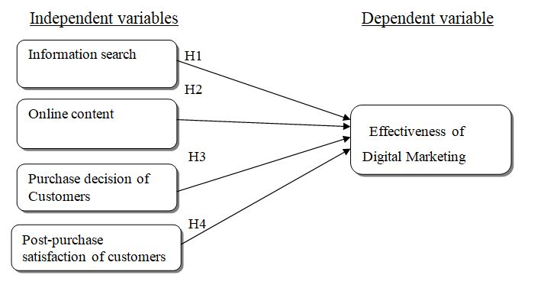

Figure: The Conceptual Framework

2.12 Research Hypothesis:
H1: Information search has a significant and positive relationship with effectiveness of digital marketing communication.
H2: online content has a significant and positive relationship with effectiveness of digital marketing communication.
H3: Purchase decision of customers has a significant and positive relationship with effectiveness of digital marketing communication.
H4: Post-purchase satisfaction of customers has a significant and positive relationship with effectiveness of digital marketing communication.

2.13 Dependent variable and Independent variables

2.13.1 Effectiveness of Digital marketing communication:
Digital marketing communication's efficiency is roughly similar to the traditional marketing mix. Offline marketing usually uses many contacts for public relations, advertising, sponsorship, personal transactions, direct marketing and promotion of revenue.

These tools geared to the demands of internet marketing will also be used in Digital Marketing Communications. Of note, new and innovative online outlets can also be included in the digital media mix. In a wide range of on-line and off-line promotions, internet options are known as digital media channels. In the digital marketing campaign, billboard ads, pay-for-visual advertising, search engine optimization and affiliate marketing will be used. This and other marketing teacher will explore and the importance of social media marketing must not be overlooked.

2.13.2 Information search:
Search Marketing is a method used by paying and free search engine techniques like Google, Bing and Yahoo to achieve website and traffic. View something on Google, Yahoo or Bing last time you looked for. The SERP or search engine results list is referred to as this page. The results of a web-based survey revealed that consumers of experienced products still use more internet content than those of search products. Online information sources from other users and unbiased sources were considered more valued and more commonly used by users of seasoned merchandise, while retail/manufacturer websites were considered more convenient for search items buyers. The perceived relevance, perceived ease of use of offline data sources, are also linked positively to online use.

2.13.3 Online content:
In this new era, online use continues to expand every year. In 2017, site use was expected to increase to 53.7 percent by 2021, by 46.8 percent of the general population.

Many people already have access to their responses through Google and other search engines, making online content an integral aspect of digital marketing. Hilful and equitable advertising, if you do, will make customers, but it will eventually contribute to commercial productivity. We know that a brand strategy is important, so why do certain companies have more content marketing success? Here, we discuss the main reasons for digital awareness creation in order to help the brand and boost the opportunities for action.

2.13.4 Purchase decision:
Technical growth enhances the internet and web 2.0 increases, improving user connections. Client behavior has been changed and consumer decision making has been impacted. The rise and involvement of users in the social network is triggering a dramatic change in human behavior. The organization carries out campaigns to change the actions of customers. The business must however be conscious of its customers' values, views and beliefs which impact the digital marketing strategy. Customers purchase decisions depend on the others customers after buying review because by online they don’t able to see product directly by online that’s why who bought the products before they can ensure and comments about the products that’s this product is good or bad and also by online customers are decide to purchase the product by the trust and the basis of the product need which is not available to the physical market.

2.13.5 Post-purchase satisfaction:

After buying satisfaction is the final stage of customer decision making where the buyer determines whether or not an order is completed. A customer can therefore control the purchasing choices of others, as he is likely to have to share his own opinions on the transaction.

Typically, after buying, customers perceive dissonance. They also argue about their acts. The publicity providers must also encourage consumers to be right, thanks to a variety of alternatives, a high production, etc. The seller may also refer to or highlight the principal qualities, attributes and benefits of the product in order to address and overcome their issues.

2.14 Conclusion:

All considerations presented in the literature review offered a context and encouragement for the researcher to properly grasp the nature of this analysis and motivating the researcher with well-based theories and established methodologies used by other researchers to improve the research methodology explored in the next part. In this chapter an analysis of four independent and one independent variable can be carried out using the right conceptual context and explored the most related theory with respect to digital marketing communication. Dependent variable is the efficacy of digital marketing in the digital arena digital marketing has to be successful, meaning that customers now use an internet channel for days but are not the common platform and it still has systemic issues. Independent variables include, Knowledge Quest which means that people can look for a product online from anywhere, the number two independent variable, online advertising which means that when the user finds the product online, the product has to be better explained, so advertisements will be viewed by consumers. Two more separate factors are consumer buying and customer loyalty after purchase. They reflect the consumers purchasing decision online and after they have ordered their product, how happy they are and how they are commenting on the product. Every customers has their own criteria to purchase the product sometimes many customers are saying that they will not purchase through online but one day they also started to purchase from the online and this is the success of the digital market.

3.0 Chapter 3: Research Methodology

3.1 Overview:
The analysis methods used in this paper was explained in this chapter. Determined by defined parameters are the study style, method of sampling, sample size, and target users. The authenticity, reliability and factor analysis data verification methods are then used to validate and question the study and to check the theory.

3.2 Research design:
It is usually believed to be an acceptable guide or guidance about the way the researchers are going to carry out the analysis. This study will be an elucidating study with a relationship framework, and thorough analysis is used to decipher a movement situation or to portray miracles as they happen. In comparison, this study uses the quantitative approach by using and drawing from a wide segment of respondents the basic information, from which the information is dissected and interpreted. Any theory would then decipher the finding to the extent it is accepted or denied. The explanation for selecting quantitative analysis is the potential to validate a theory concerning the phenomenon, to provide a closed answer questionnaire with quantifiable responses and to assess outcomes by descriptive language (Creswell, 2013). Moreover, depending on the size, schedules and services available, quantitative solution can also be quicker, simpler and easier to replicate (Davies & Hughes, 2014). Data from target population will be obtained from surveys and questionnaires with standardized questions (Fellows & Liu, 2015).

3.3 Measuring Instrument:

Important information collection is carried out by surveys for this study. When respondents understand this an interview will interest them, but it is crucial for the interviewer, especially when it is a source of essential information. The researchers will make sure the intended study for the respondents is anything but difficult to read. The findings of study are surveyed. However, the more complicated the survey is the more uncertain the respondents are the more difficult questions are to answer. This leads to tired and unreliable people. The analysis must also have a straightforward and timely respondent in obtaining replies. Another crucial aspect. Questions and responses that can be moved to an information field that can be explored to satisfy study needs can be included in the survey. The theory and forecast will include a search or a few relevant queries, and the searches will link the theories and variables to the reasoning.

3.4 Quantitative analyzing Method:
This guide contains a Google-style questionnaire prototype or accurate description of the collected data. The results can be evaluated by measuring the size of the sample using different SPSS approaches to track data quality.

The use of raw and logical reasoning will turn abstract statistics into concrete data in quantitative data analysis. Estimating the variables' concentration or disparity between variables requiring quantitative analysis. A quantitative methodology is generally connected to the gathering of data in order to validate or deny the theory during early stages of the research process. It is critical that the same figure be tested equally and sophisticated in many ways in the data set. For quantitative data analysis, from basic graphs to statistical interpretations by testing correlations among two or more items, a wide range of statistical technology is available. These methods include cluster-analysis, which is helpful for classifying ties between unclearly explained subject classes, and hypothesizing to decide whether any actual discrepancies exist in groups.

3.5 Study population, unit of analysis, sample selection and sampling techniques:

The choosing of a research set should be done by the public. The research will also analyses the number of applicants, so that Bangladeshi people are randomly chosen. The sample size is computed by the Rao soft website's population and usage (Raosoft.com, 2020). The research is carried out in full time by 385 random residents of Bangladesh.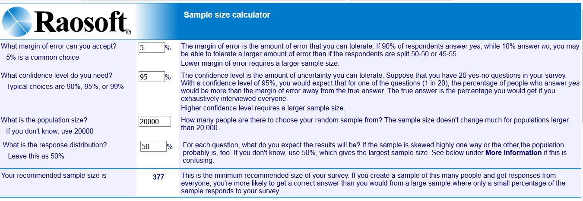 http://www.raosoft.com/samplesize.html

In the case of sampling methods, samples are not likely to be used with an important respondent without the same individual. Time and cost-effective impossible sampling are also used. There are ways of exceptional sampling; comfort samples are needed. For this study. The comfort of the survey population, whose investigations are focused on the clearest topics, is selected for study. This relates to the delivery of polls to individuals that are easier, less expensive, more effective and less confused.

Raosoft Survey Software is a flexible file storage and database services from 15 different utilities, accessed through Raosoft Online Survey Technology. It can accidentally erase data entry errors and correct database handling or configuration errors. For data sets, you can gather data to modify, sort, view, export and import information with great flexibility. Full data sets, with a particular field names or philtre out sub-sets, for different distribution and analysis. Multiple project files can be added easily. Survey Tools were created by both novices and professionals to manage their survey database files. The data gathered by Rao soft’s app authors, EZ Internet Survey, Interform and Survey Win survey services can easily be combined through various collection media.

3.6 Data collection methods:
In this report, the data collection approach will be based on survey questionnaires for all customers in health supplements. Surveying questionnaires are generated using Google-based electronic framework and circulated via email, Facebook, WhatsApp, social media platforms. At least 300 appropriate data sets are expected from the target population.

Case & Hunter (2012) found that raw statistics without analysis or checking are directly from the obtained source, typically using questionnaires, interviews, or observations to receive the correspondent's reliable and credible input.

The collecting of data provides an effective solution for obtaining the knowledge required to facilitate analysis, and two forms of data are gathered for the main data, raw data and secondary data that are analyzed (Sekaran & Bougie, 2013).

3.7 Questionnaire Design

3.7.1 Qualitative & Quantitative Variables:

Qualitative variables are variables categorizing data using just placeholder numbers (Zikmund, et al., 2012). Both forms of qualitative variables are minimal where there are no orders for each group, such as, 1 for women and 2 for men (Sekaran & Bougie, 2013). The alternative form of qualitative attribute is class A, B, C, or defining, pass, lose, etc. (Zikmund, et al., 2012).

The quantitative variables are intervals and fractions that do not have true zero in scores and data is gathered to evaluate mean and median and to quantify variables that have actual importance of zero, for example, age, height and weight. the ratio scale is the (Cooper & Schindler, 2011).

The interval–Likert scale is used as a measuring base in this study, with the exception of some nominal details relevant to the profile and demography of the respondent.

3.7.2 Questionnaires:
The purpose of this analysis is to collect quantitative data in order to follow a close and systematic approach to the design of the questionnaire. Two types of data obtained are trivial to divisions of the respondent's profile. The other factor is that it has seven answers: accept firmly, approve in part, agree, is neutral, opposes, disagrees in part and oppose strongly.

The questionnaires in the surveys were adapted from Gopal 2014's "Enquiry of Consumer Intentions for Special Reference to Pune Region" and Peters et al (2003)'s "Un examine des Factors qui influencing le consummation des complements Alimentarius." The questionnaires in this survey were adapted. The explanation for this is that the MLM health supplement is identical in nature where it normally costs more than more price and still the most selling versions and products on the market still exist (Chhimpa, et al., 2015).

3.8 Data analysis:

The survey process and data gathered was evaluated using the analytical tools of the Statistic Product and Service Solution (SPSS) by using questionnaires. The programmed will evaluate and interpret the relationship between the studied variables in secondary data the (Babin & Zikmund, 2015). In order to ensure the accuracy of this study the authenticity and the reliability of the results will also be measured.

3.8.1 Pilot Testing:
The pilot test is a process in which the researcher investigates whether the survey questions have been understandable and successful and gather evidence to support the relevant testing goals. The test will also expose design errors and serve as a validity and durability before researchers move on to a detailed set of results (Shenton, 2004). 30 samples have been identified due to the large population in this study (Hair, et al., 2014).

3.8.2 Descriptive Analysis:

The descriptive empirical analysis includes evaluating the gathered evidence, in order to explain variables capable of affecting the independent findings of this inquiry (Sekaran & Bougie, 2013).

3.8.3 Preliminary Testing
3.8.3.1 Factor analysis:
Factor analysis is a means of reducing more of the variables to less. This strategy eliminates the common variation and positions it for each variable in a common score. This ranking can be used as an index of all variables for further analysis. There are several assumptions that take this approach: a linear equation is created, there is no multiple collinearity, the necessary variables are evaluated and the genuine correlations are made. A lot of methods are available, but the key study of components is used often.

The assessment and extraction of non-essential elements was conducted in components before durability checks were performed (Kaiser Meyer Olkin (KMO) sampling test Appropriate in 2020). The factor-related analysis is carried out using the KMO (Keiser-Meyer-Olkin) and the sphericity management method of Bartlet. In KMO and Bartlett schemes the value is modified by the value of 0 to 1, where higher MSA values display increased sample efficiency. MSA (Sample Adequacy Measures) may be used. The extraction effect stacking factor values should be greater than 05 (or mutuality estimation). Complete interest will not exceed 0,5 and shared information for research and evaluation will not hit 0.5.

3.8.3.2 Reliability test:
Reliability refers to the degree to which a calculation is reliable when repeated on a number of times. The measurement of reliability is also a faith study. The reliability calculation is determined by measuring the proportion of systemic variation in one scale to assess the relationship between the values received by several jurisdictions. The findings of scale will then be reliable and precise if the reliability measurement connection is high. Subjects are assumed to be listed randomly during Split Half tests. Outcomes are to be kept apart from each other; variances are to be similarly accepted during Split Half tests. In the case of all the components, coding is the same.

In order to track the mysterious precision of the queries in Likert scales, the Cronbach's Alpha is starting to be accurate. Alpha is one of Cronbach's most common quality sensors. For any section of the details the Cronbach Alpha should be greater than 0,7 otherwise the unspeakable content is deemed incorrect and no result can be interpreted. On the basis of every test, the 4 IVs and the DV shall be tested for clear precision.

Cronbach's Alpha Scores Levels
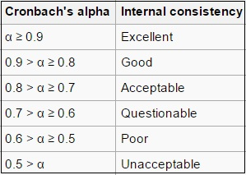
Source: https://www.statisticshowto.com/cronbachs-alpha-spss/

Over the long term, the value over 1 on its own will be considered for potential analysis while anything with a particular meaning below 1 was omitted.

Range and acceptance of The KMO and Bartlett method
Range | Acceptance
0.00 to 0.49 | Unacceptable
0.50 to 0.59 | Miserable
0.60 to 0.69 | Mediocre
0.70 to 0.79 | Middling
0.80 to 0.89 | Meritorious
0.90 to 1.00 | Marvelous

Source: https://www.statisticshowto.com/kaiser-meyer-olkin/

3.9 Hypothesis Testing:
The hypothesis testing involves evaluating data on trends, intensity and relation of the dependent to the independent variable (Zikmund, et al., 2012). Test analysis and regression analyses use SPSS to analyses data gathered and to infer that the original conclusion was confirmed or rejected by the researcher (Dodge, 2008).

The T test is used to assess if the population media or hypothesized importance vary substantially from the student test (Dodge, 2008). The regression test serves to test relationships in a single equation between two or more variables (Zikmund, et al., 2012). Regression analysis by means of the SPSS programmed consists of β relating to the path coffee used in the creation of the regression argument, and the path coefficient reflects the power of the concern variables along with the position of the linear assembly (Verma, 2012). Model of Regression Includes the R2 value which reflects the proportion by variation in the independent variable of the variance behavior. If the experiments are done, outcomes or results are analyzed in order to assess the presence and degree of effect among the dependent variables and the independent variables depending on the testing goals and hypotheses.

3.10 Conclusion:
In total, the research technique or solution to this study is discussed and discussed from the research architecture, assessment unit, sampling and data collection methods. The correctness, authenticity and durability of the data are often evaluated to ensure the hypothesis can be verified and accurately concluded. In this portion, the research approaches are mainly used and study design was addressed such as data collection processes, test surveys, factor analysis to identify the relevant outcomes of the research. In the next process of the work the respondents will be the sum of three hundred and ninety tests, but in the beginning the first forty respondents will be used for pilot testing to detect how profound the questionnaire could or might not be right for this questionnaire.

4.0 Chapter 4: Research Findings

4.1 Overview
Based on data collected between 18 November 2020 and 28 November 2020, this chapter will present and explain the main findings of these surveys. In order to ensure the feasibility and adequacy of the study, the pilot test shall be performed. The data is then subjected to hypothesis testing using different techniques to assess the association between dependent and independent variables. Both data are analyzed using the Microsoft Excel 2016 and SPSS versions 25 of SPSS. In this research will find out the relationship of all independent with the dependent variables, before it said that they all independent have the significant relationship with the dependent variable but now in the chapter it will be measure that this hypothesis is really have the positive and significant relationship has or not and after it will also discus the why they have positive or negative relationship with the effectiveness of digital marketing.

4.2 Pilot test:
The study should ensure the questionnaire design is correct and that the testing objective can be reached accurately before full-scale research is conducted. To confirm the status, the pilot test is carried out. For a well conducted pilot research sample 10 to 50. should be the appropriate scale (Zikmund, et al., 2012). Issues are spread electronically via the social network using Google Form as a data collection method. The pilot test was conducted and data findings were assessed with a sample size of 40, for the preliminary test. Pilot test is basically called a start up test that means when it done by 10 to 50 sample respondents for test then it can be said or can be take the decision that this research will further continue or not, if the KMO value will acceptable as per KMO value table then it can be run for next research and can collect the whole sample sizes respondents which will be used for next research in a broad way.

4.2.1 Factor Analysis Result: Pilot Test

KMO and Bartlett's Test
Kaiser-Meyer-Olkin Measure of Sampling Adequacy. |  | .727
Bartlett's Test of Sphericity | Approx. Chi-Square | 514.870
Bartlett's Test of Sphericity | df | 210
Bartlett's Test of Sphericity | Sig. | .000

KMO and Bartlett’s Test, Pilot Test

The value for Kaiser Mayer Olkin (KMO) for both dependent and independent variables is 0.727 which falls under the “middling” category based on MSA.

4.2.2 Reliability Test: Pilot Test

Reliability Statistics
Cronbach's Alpha | Cronbach's Alpha Based on Standardized Items | N of Items
.919 | .927 | 21

Cronbach’s Alpha, Pilot Test

Cronbach's Alpha has a value of 0.919 for the reliability test of five variables, including Efficacy of digital interactions, knowledge searching, content online, consumer purchasing decisions and Post sales delivery, and shows strong internal accuracy in its variables. The internal precision of the variables is high, and they are reliable, as Cronbach's alphabet is greater than 0.9 in all variables, the pilot test is passed and full data can be collected.

4.3 Descriptive Analysis / Demographic of Respondents:
A total of 390 answers have been obtained using Google Type online questionnaires. The target demographic of all of Bangladesh is 30 years of age or older. No invalid data are available and the cumulative valid data is 390.

Statistics
 |  | Gender | Age | Business better described | Monthly Income | Ethnic Group
N | Valid | 390 | 390 | 390 | 390 | 390
N | Missing | 0 | 0 | 0 | 0 | 0

Table: The descriptive analysis of respondents

According to the table of the respondents' descriptive research, there are 390 persons participated in this survey, who are demographic based on gender, age, sector, monthly sales and ethnic community.

1-Gender

Gender
 |  | Frequency | Percent | Valid Percent | Cumulative Percent
Valid | Female | 105 | 26.9 | 26.9 | 26.9
Valid | Male | 285 | 73.1 | 73.1 | 100.0
Valid | Total | 390 | 100.0 | 100.0

Table: The descriptive analysis and frequency of Gender

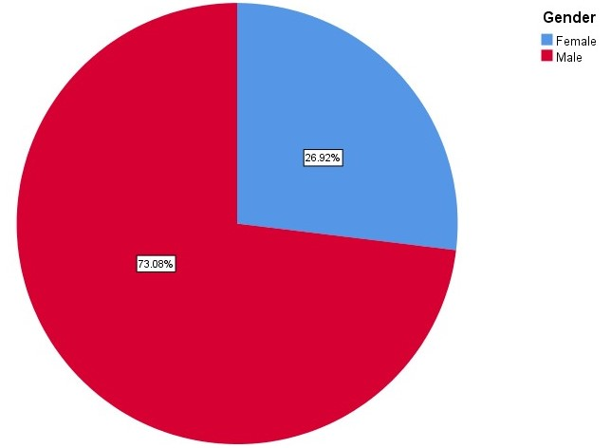
Figure: Respondent’s Gender

According to the table: the descriptive overview and the gender and figure frequency: the bulk of the participants are males, who account for 285 respondents with 73.08 percent and 105 female respondents, which is 26.92 percent.

2-Age
Age
 |  | Frequency | Percent | Valid Percent | Cumulative Percent
Valid | 18 to 24 | 4 | 1.0 | 1.0 | 1.0
Valid | 25 to 30 | 23 | 5.9 | 5.9 | 6.9
Valid | 30 to 40 | 233 | 59.7 | 59.7 | 66.7
Valid | above 40 | 130 | 33.3 | 33.3 | 100.0
Valid | Total | 390 | 100.0 | 100.0

Table: The descriptive analysis and frequency of Age

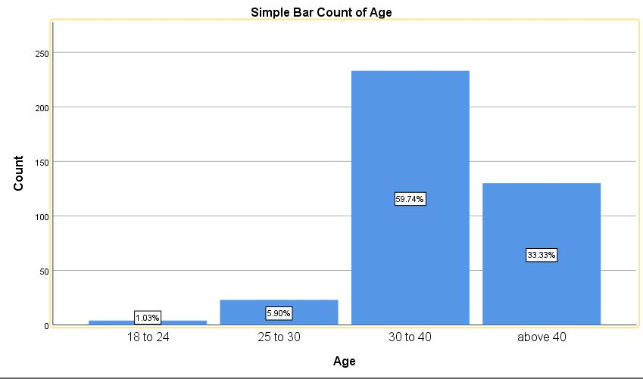
Figure: Respondent’s age

Table-driven: Informative analytics and age and figure frequency: the bulk of respondents were from 30 to 40; 59.74% of respondents are from 233 respondents and a median of 40 years in the second place is greater than 33.33% with 130 respondents. Based on table. This questionnaire also answers 18 to 24 years after 25 to 30 years.

3- Role in the business better described
Role in the business better described
 |  | Frequency | Percent | Valid Percent | Cumulative Percent
Valid | CEO/owner | 164 | 42.1 | 42.1 | 42.1
Valid | Marketing | 29 | 7.4 | 7.4 | 49.5
Valid | Other | 6 | 1.5 | 1.5 | 51.0
Valid | Partner | 170 | 43.6 | 43.6 | 94.6
Valid | Sales professional | 19 | 4.9 | 4.9 | 99.5
Valid | Technical/IT professional | 2 | 0.5 | 0.5 | 100.0
Valid | Total | 390 | 100.0 | 100.0
Table: The descriptive analysis and frequency of role in the Business better described

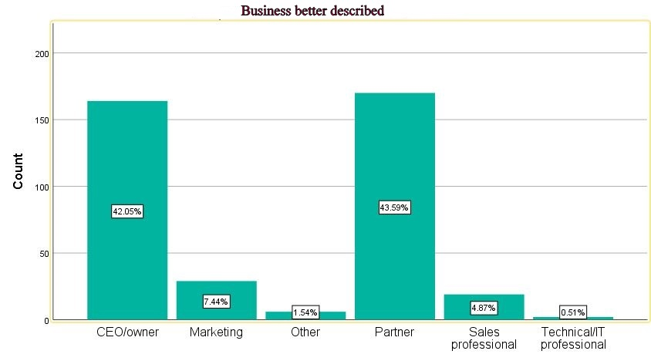
Figure: Respondents of role in the business better described

Table-driven: the descriptive overview and the position frequency of the company more specifically illustrated and Figure: The overall respondents to the role of the business are 170 business partners with a 43.59% and almost 1 person in second place, 164 respondents with a 42.05% representation, and they are all owners or CEOs of the business. Based on the table. This questionnaire is often addressed after marketing, distribution, technological experts and others.

4-Household monthly Income
Household Monthly Income
 |  | Frequency | Percent | Valid Percent | Cumulative Percent
Valid | 0$- 300$ | 3 | 0.8 | 0.8 | 0.8
Valid | 1001$-5000$ | 201 | 51.5 | 51.5 | 52.3
Valid | 301$-500$ | 20 | 5.1 | 5.1 | 57.4
Valid | 501$-1000$ | 97 | 24.9 | 24.9 | 82.3
Valid | Above 1001$ | 2 | 0.5 | 0.5 | 82.8
Valid | Above 5001$ | 67 | 17.2 | 17.2 | 100.0
Valid | Total | 390 | 100.0 | 100.0

Table: The descriptive analysis and frequency of House hold monthly Income

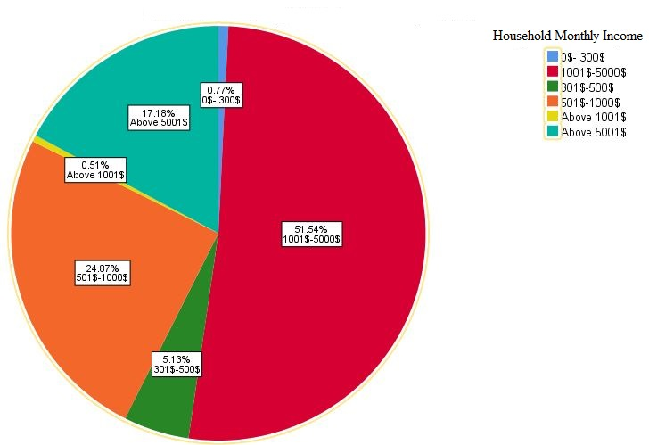
Figure: Respondent’s Household monthly Income

According to the table: The informative and the frequency of households are the highest respondents in this study and the following are 97 respondents, 24.87 percent and their level of income monthly is 51.54 percent, the level of incomes of 201 interviewees is between $1001 and $5000.

5-Ethnic group
Ethnic Group
 |  | Frequency | Percent | Valid Percent | Cumulative Percent
Valid | Bangladeshi | 289 | 74.1 | 74.1 | 74.1
Valid | Chinese | 38 | 9.7 | 9.7 | 83.8
Valid | Indian | 57 | 14.6 | 14.6 | 98.5
Valid | Malaysian | 6 | 1.5 | 1.5 | 100.0
Valid | Total | 390 | 100.0 | 100.0
Table: The descriptive analysis and frequency of Ethnic group

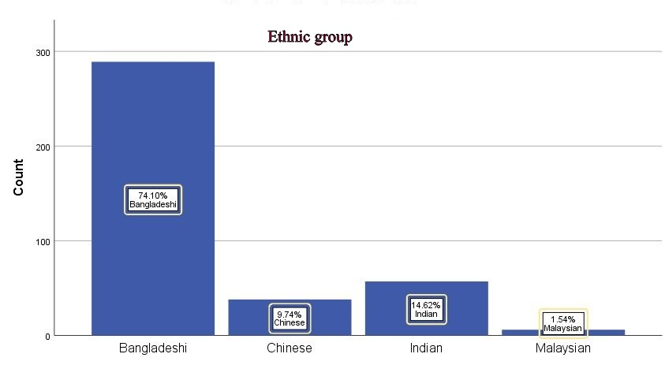
Figure: Respondents of Ethnic group

In the last demographic table survey: descriptive analyses and frequency of the ethnic group and Figure: Ethnic group respondents are 74.10% Bangladeshi, which is 289 nos. respondents and Indian responses 57 nos with 14.6% after Malaysians as well as Chinese answer in this questionnaire. Before I heard that there are a lot of countries citizen busing this questionnaire from Bangladesh and in Bangladesh, which is why I participate in my study.

4.4 Factor Analysis:
The component matrix corresponds to the load factor value in this analysis and the load factor value defines the variables' relationship. When the Kaiser Mayer Olkin (KMO) is over 0.6, a value would be indicated. The sphericity test for Bartlett should be found significant less than 0.05. The SPSS analysis of components of both dependent and different variables is seen in the table. Data collected from 390 respondents were tested for factor analysis, reliability checks, KMO and Sphericity Tests by Bartlett to ensure correct testing for future hypotheses. All research data is conducted with SPSS version 25.
KMO and Bartlett's Test
Kaiser-Meyer-Olkin Measure of Sampling Adequacy. |  | .948
Bartlett's Test of Sphericity | Approx. Chi-Square | 7924.263
Bartlett's Test of Sphericity | df | 210
Bartlett's Test of Sphericity | Sig. | .000

Table: KMO and Bartlett’s Test, Factor Analysis

Based on the Factor Analysis findings, the KMO value is 0.948 and is based on the MSA-driven value of the "Meritorious" type, which suggest that contingent and different variables are important for this research sample.

As seen in the table above the sphericity test of Bartlett has a meaningful value of 0,00, which is less than 0,05, which implies that variables are sufficiently correlated. The KMO value is 0.948 and even Bartlett's Sphericity test is important for this study. Factor analysis is done. For this research.
 | Communalities
 |  | Initial | Extraction
Dependent Variables | E1 | 1.000 | .577
Dependent Variables | E2 | 1.000 | .638
Dependent Variables | E3 | 1.000 | .739
Dependent Variables | E4 | 1.000 | .714
Dependent Variables | E5 | 1.000 | .573
Independent Variables | I1 | 1.000 | .591
Independent Variables | I2 | 1.000 | .639
Independent Variables | I3 | 1.000 | .737
Independent Variables | I4 | 1.000 | .778
Independent Variables | O1 | 1.000 | .721
Independent Variables | O2 | 1.000 | .773
Independent Variables | O3 | 1.000 | .628
Independent Variables | O4 | 1.000 | .615
Independent Variables | Pu1 | 1.000 | .609
Independent Variables | Pu2 | 1.000 | .770
Independent Variables | Pu3 | 1.000 | .746
Independent Variables | Pu4 | 1.000 | .688
Independent Variables | Po1 | 1.000 | .627
Independent Variables | Po2 | 1.000 | .735
Independent Variables | Po3 | 1.000 | .790
Independent Variables | Po4 | 1.000 | .780
Extraction Method: Principal Component Analysis.

Table: Extraction values of Dependent and Independent

According to communalities table the extraction value for each variable is 0.5 and Its shows in communalities table that extraction values ranges from .573 to .790 that indicates that all variables are accepted.

4.4.1 Reliability Test:
The Reliability test analysis must be calculated by reliability measures on the related dependent and independent component. The reliability test shall examine the internal coherence and related effects of measurements (Sekaran and Bougie, 2016). This analysis consists of 5 demographic variables and the alpha value of Cronbach is measured with 21 separate dependent and independent variables. This review reveals the position of the Cronbach Alpha in the graph.

Reliability Statistics
Cronbach's Alpha | Cronbach's Alpha Based on Standardized Items | N of Items
.967 | .969 | 21

Table: Cronbach's Alpha, Reliability Test

As seen in the above table, Cronbach Alpha value is 0.967 for all dependent and independent variables, Cronbach Alpha values are 0.967 and 21 elements are all accurate and appropriate in this search, since Cronbach Alpha value is 0.9 and 0.8. For each element, the following table displays the Cronbach Alpha value.

Factors | Cronbach's Alpha | Items in each variable
Effectiveness of digital marketing | .846 | 5
Information Search | .848 | 4
Online Content | .845 | 4
Purchase decision of customers | .848 | 4
Post Purchase satisfaction of customers | .851 | 4

Table: Reliability test of preliminary data

In order to improve the survey score and the reliability of an issue in the study, the Cronbach alpha inspectorate (Zikmund, et al., 2012). Cronbach Alpha in this analysis is above 0.7 (range 0.845 to 0.851) and the findings of this particular study are believed to display a high degree of internal precision (Lewis, et al., 2016). This means no change is possible when all data is sufficient.

4.5 Hypothesis Testing:
This thesis explores the relation of 2 or more dependent or independent variables and analyses the argument using the rational method Multiple Regression Analysis and Correlation (Yockey, 2011).

4.5.1 Multiple Regression Test:

The impact of independent variables such as knowledge search, content online, consumers' purchasing decision and consumer loyalty after purchase on the depending variable of efficacy of digital marketing are analyzed by multiple regressions.

Model Summary
Model | R | R Square | Adjusted R Square | Std. Error of the Estimate
1 | .875ª | .766 | .756 | .390
a. Predictors: (Constant), Information Search, Online Content, Purchase decision of customers, Post purchase satisfaction of customers
b. Dependent Variable: Effectiveness of digital marketing

Table: Model Summary of Independent Variables

The Summary Model table indicates values of R and R-square. The value of R is 0.875 which indicates the correlation value and the obtained R-square value of 0.766, that means 76.6% of Effectiveness of digital marketing were explained by the Information Search, Online Content, Purchase decision of customers, Post purchase satisfaction of customers.

ANOVAª
Model |  | Sum of Squares | df | Mean Square | F | Sig.
1 | Regression | 185.670 | 16 | 11.604 | 76.474 | .000^{b}
1 | Residual | 56.600 | 373 | .152
1 | Total | 242.269 | 389
a. Dependent Variable: Effectiveness of digital marketing
b. Predictors: (Constant), Information Search, Online Content, Purchase decision of customers, Post purchase satisfaction of customers
Table: ANOVA Table

Coefficientsª
Model |  | Unstandardized Coefficients |  | Standardized Coefficients | t | Sig.
 |  | B | Std. Error | Beta | t | Sig.
1 | (Constant) | -.404 | .156 |  | -2.591 | .000
1 | Information Search | .351 | .045 | .315 | 7.730 | .000
1 | Online Content | .146 | .045 | .142 | 3.276 | .000
1 | Purchase decision of customers | .385 | .045 | .373 | 8.569 | .000
1 | Post purchase satisfaction of customers | -.218 | .053 | -.199 | -4.123 | .000
a. Dependent Variable: Effectiveness of digital marketing
Table: Multiple Regression Analysis

Table of Multiple Regression Analysis indicates the statistical results of Coefficients of independent variables namely, Information Search, Online Content, Purchase decision of customers, Post purchase satisfaction of customers and the dependent variable of Effectiveness of digital marketing. Table of Multiple Regression Analysis contains statistics that analyze the significance of each independent variables in relation with dependent variable.

According to the statistical results, Information Search has statistically significant with a p- value of 0.000 and t-value of 7.730 which means the Information Search has approximately positive 77% strength. The standardized coefficients value Beta for Information Search is 0.315. Each single unit improvement of Information Search increases the Effectiveness digital marketing of the consumers by 0.315. Thus, Information Search has a significant positive relationship with Effectiveness digital marketing.

Based on the table, product preference is statistically significant with a p-value of 0.000 and t-value of 3.276 which indicates Online Content has approximately 32% strength. The standardized coefficients value Beta for product preference is 0.142. Each unit improvement of Effectiveness of digital marketing of the consumers by 0.142. Thus, Online Content has a significant positive relationship with Effectiveness of digital marketing.

As shown in the table, Purchase decision of customers is significant with a p-value of 0.000 and t-value of 8.569 which indicates that variety availability has an approximate strength of 85%. Standardized coefficients value for Beta of variety availability is 0.373which means each single unit improvement of Purchase decision of customers increases the effectiveness of digital marketing by 0.373. Therefore, Purchase decision of customers has a significant relationship with effectiveness of digital marketing.

Based on the table, Post purchase satisfaction of customers is statistically significant with a p-value of 0.000 and t- value of -4.123 which indicates Post purchase satisfaction of customers has approximately -41% week or negative. The standardized coefficients value Beta for Post purchase satisfaction of customers is -0.199. Each unit improvement of Post purchase satisfaction of customers decreases effectiveness of digital marketing by-0.199. Thus, Post purchase satisfaction of customers has a no significant positive relationship with effectiveness of digital marketing, this is negative relationship because it showing negative values.

To conclude, from all four there are three independent variables in this research are accepted with a significant positive relationship on dependent variable and one independent variable is rejected and its negative relationship with dependent variable. The summary of equation for all variables below:

Y= .351 I+.146 O+.385 Pu-218 Po- 404

Whereby,
Y=Effective digital marketing
I=Information search
O=Online content
Pu=Purchase decision of customers
Po=Post purchase satisfactions

4.5.2 Correlations:
The association describes the relationship between dependent and independent variables. Independent variables are connected to each other in a linear way. For identification of the association between variables, the Pearson correlation is a frequently used form of correlation. It is possible to approximate the relation between two quantitative variables. Following is the association between independent and dependent variables used for the analysis.

Scale | Interpretation
0 to 0.29 | Weak
0.30 to 0.49 | Moderate
More than 0.50 | Strong
Interpretation of correlation scale

H1: Information search has a significant and positive relationship with d effectiveness of digital marketing communication.

Correlations
 |  | Effectiveness of digital marketing | Information search
Effectiveness of digital marketing | Pearson Correlation | 1 | .683**
Effectiveness of digital marketing | Sig. (2-tailed) |  | .000
Effectiveness of digital marketing | N | 390 | 390
Information search | Pearson Correlation | .683** | 1
Information search | Sig. (2-tailed) | .000
Information search | N | 390 | 390
**. Correlation is significant at the 0.01 level (2-tailed).

Table: Correlation of Information search and Effectiveness of digital marketing

The result (Sig=0.000) in the above table is significant at 0.01%. This showed that there is a strong positive relationship between Information search and Effectiveness of digital marketing as the Pearson Correlation is more than 0.50. In this case where Information search is high in the Effectiveness of digital marketing increases and the pull to buy through online increases. Consumers are interested to purchase through online as they get influenced by Searching the Information by online.

H2: online content has a significant and positive relationship with effectiveness of digital marketing communication.

Correlations
 |  | Effectiveness of digital marketing | Online content
Effectiveness of digital marketing | Pearson Correlation | 1 | .611**
Effectiveness of digital marketing | Sig. (2-tailed) |  | .000
Effectiveness of digital marketing | N | 390 | 390
Online content | Pearson Correlation | .611** | 1
Online content | Sig. (2-tailed) | .000
Online content | N | 390 | 390
**. Correlation is significant at the 0.01 level (2-tailed).

Table: Correlation of Online content and Effectiveness of digital marketing

The result (Sig=0.000) in the above table is significant at 0.01%. This showed that there is a strong positive relationship between Online content and Effectiveness of digital marketing as the Pearson Correlation is more than 0.50. In this case where Online content is high in the Effectiveness of digital marketing which is increases and the pull to buy through digital marketing.

H3: Purchase decision of customers has a significant and positive relationship with effectiveness of digital marketing communication.

Correlations
 |  | Effectiveness of digital marketing | Purchase decision
Effectiveness of digital marketing | Pearson Correlation | 1 | .593**
Effectiveness of digital marketing | Sig. (2-tailed) |  | .000
Effectiveness of digital marketing | N | 390 | 390
Purchase decision | Pearson Correlation | .593** | 1
Purchase decision | Sig. (2-tailed) | .000
Purchase decision | N | 390 | 390
**. Correlation is significant at the 0.01 level (2-tailed).
Table: Correlation of Purchase decision and Effectiveness of digital marketing

The result (Sig=0.000) in the above table is significant at 0.01%. This showed that there is a strong positive relationship between Purchase decision and Effectiveness of digital marketing as the Pearson Correlation is more than 0.50. In this case where Purchase decision is high the Effectiveness of digital marketing increases and the pull to buy through digital marketing increases. Consumers are interested to purchase through online as they get easier to Purchase decision in online rather than traditional/Physical stores.

H4: Post-purchase satisfaction of customers has a significant and positive relationship with effectiveness of digital marketing communication.

Correlations
 |  | Effectiveness of digital marketing | Post-purchase satisfaction
Effectiveness of digital marketing | Pearson Correlation | 1 | .494**
Effectiveness of digital marketing | Sig. (2-tailed) |  | .000
Effectiveness of digital marketing | N | 390 | 390
Post-purchase satisfaction | Pearson Correlation | .494** | 1
Post-purchase satisfaction | Sig. (2-tailed) | .000
Post-purchase satisfaction | N | 390 | 390
**. Correlation is significant at the 0.01 level (2-tailed).

Table: Correlation of Post-purchase satisfaction and Effectiveness of digital marketing

The result (Sig=0.000) in the above table is significant at 0.01%. This showed that there is a week relationship between Post-purchase satisfaction and Effectiveness of digital marketing as the Pearson Correlation is lower than 0.50. which is 0.49 In this case where Post-purchase satisfaction is low in the Effectiveness of digital marketing. So, the hypothesis is not supported or accepted. In conclusion H4 is rejected.

4.6 Discussion on Findings:

According to the pilot test of this study performed on 40 answers, all 21 elements referred to four independent variables and one dependent variable fulfilled the criteria for factor analysis and reliability checking. The overall selection of responses has then continued. As 390 answers were obtained, factor analysis and reliability checks were carried out and a total of 21 items met the minimum criteria for hypotheses testing.

Information Search which is the strongest positive relationship with effectiveness of digital marketing contains that customers can easily search the product information from anywhere by online through social media, search engine, online database. play an important role on the tendency inclination towards online Purchasing. This indicates that Information Search is having a positive significant relationship with effectiveness of digital marketing.

Online content as indicated by multiple regression analysis tables has strong positive influence on effectiveness digital marketing. This variable includes the perception of consumers tend to choose the digital marketing portals due to increase the knowledge of product and knowing the full specification of product by advertisement, live video on social media and its inexpensive, safe, available for anyone in any industry, and beneficial in many different areas.

Purchase decisions of customers according to multiple regression analysis has a strong influence on effectiveness of digital marketing. In that way customers can make their purchase decision instantly by online which is not possible by physical shopping, family and friends can also influence to customers to make the purchase decision.

Post Purchase satisfaction of customers according to multiple regression analysis has a week influence on effectiveness in Effectiveness of digital marketing. In digital marketing after purchase the products customers are not very much available to inform their satisfaction level about the product, they are not commenting about products, that’s-how they are satisfied. Sometimes refund policy also not easy for customer.

4.7 Summary of Hypothesis result:

HYPOTHESIS | RESULTS
H1: Information search has a significant and positive relationship with effectiveness of digital marketing communication. | Supported /Accepted
H2: online content has a significant and positive relationship with effectiveness of digital marketing communication | Supported /Accepted
H3: Purchase decision of customers has a significant and positive relationship with effectiveness of digital marketing communication. | Supported /Accepted
H4: Post-purchase satisfaction of customers has no significant and positive relationship with effectiveness of digital marketing communication. | Not Supported/Rejected
The result has shown that the four independent variables were statistically significant according to multiple regression analysis and correlations. H1, H2, H3 are acceptable and H4 is Rejected.
Table: Hypothesis Testing Results

4.8 Conclusion:

This is the most important chapter where worked for findings by used SPSS Version 25 and Microsoft Excel Home 2016. At first taken 40 respondents for pilot test and this KMO and Bartlett’s test and Cronbach’s alpha test result was acceptable and after taken the all 390 respondents and completed the analysis process. There are many analysis done to get the appropriate result, such as factor analysis, KMO and Bartlett’s test, Cronbach’s alpha test, Hypothesis testing and after get the result that Hypothesis 1, Hypothesis 2, Hypothesis 3 is positive but Hypothesis 4 comes negative that means Post-purchase satisfaction of customers has no significant and positive relationship with effectiveness of digital marketing communication. Research findings is a very much important for any research because in this chapter mainly researcher get the research outcomes with various analysis and that’s why those analysis need to be very much perfect to get the actual result and next chapter also will be discuss about this chapter findings so if a researcher findings in this chapter will not correct then all chapter as well as whole research will be wrong and it will have no value. So, in this chapter research findings done very carefully and all analysis done step by step with more perfectly that’s why at last it can be said that, this research findings is absolutely right and can be possible to use another further research.

5.0 Chapter 5: Conclusions and Recommendations

5.1 Overview:
The contents of this chapter explained the findings of analysis and numerical analyses of the preceding chapter. In addition, this chapter contains analysis restriction, future studies suggestions and personal reflection.

5.2 Conclusion:

5.2.1 Looking back at the research objectives:

This research objective is to improve conversation rate and decrease bounce rate, that communication can reduce the gap of organization and customers, increasing sales percentage by the digital marketing, understand the importance of digital Marketing Communication and identify online marketing shortcomings as an IMC tool.

5.2.2 From the research objective, the research questions formed are:

1-How to establish digital marketing communications to maximum customers in a proper way?
2-How to increase sales by digital marketing?

3-How is digital marketing advantageous over physical marketing?
4-What are the proper digital marketing tools?

To answer research question 1, to establish digital marketing communication to maximum customers in a proper way its need to follow some digital marketing procedure which is availability product information to the online platform that customers can easily see the products information from anywhere. Now a day’s huge number of people purchase the products through social media so need to active in social media by open a business page and also need to take step to the search engine to show the products properly and quickly to the customers. In questionnaire of information search it done the analysis and this analysis will help to solve this question properly.

The research question 2, can be answered by looking at the set of data. The Beta in the coefficient shows us that online content beta of 0.142, and in this variable has four questionnaires related about sales increase by digital marketing such as, content marketing, up selling-cross selling by using online content, live video or receded video advertisement, proper online content of the product can attract the maximum customers.

The research question 3, can be answered by recommending purchase decision questionnaires where customers are respondents and analysis is done and, in this variable, has four question which beta is 0.373 which is highest ever from others variables. In this variable maximum respondent agreed with in online can take instant decision for purchase, advertisement can influence the customers to buy, family and friends also a big influencer for purchase and these all are advantageous over physical marketing because in physical shopping customers are can’t get the all of this advantages.

The research question 4 is about proper digital marketing tools, it can be answered by looking at the post purchase satisfaction. its need to established to get the customers proper view or comment after the purchase the product. in maximum time customers are not interested to provide the review of the product except they receive the bad condition product but it’s also need to established all time review system whatever it is bad or good product then business personals will understand their licking’s and they can develop those side. Such if customer can receive a message after purchase a product that if they will comment about those products the they will get the 20% discount for next deliver and another policy also can be apply, now a days lots of review means lots of customers view and its increase the sales percentage. Also return policy can be easy then it will be possible to retain the customers.

5.3 Discussion of Findings and Recommendations:

The purpose of this research is to identify and investigate the effectiveness of digital marketing because now a days world are going to digitalization and people want to maximum outcome with less effort, so Information search, online content, Purchase decision and post purchase satisfaction by digital marketing is very easy and better than physical marketing . Based on this purpose four research questions and research objectives were designed and after collecting responses from 390 individuals from across Bangladesh using an online questionnaire, the four hypotheses were tested. This section contains the discussion on findings and related literature that support these hypotheses.

Hypothesis 1 (H1): Information search has a significant and positive relationship with effectiveness of digital marketing.

Analysis has shown that the Information search for products has a positive relation on the effectiveness of digital marketing. Consumers prefer to select online purchase portals because consumers can quickly scan product details from anywhere online that has been revealed in previous low touch," study, such as computer apps, plane tickets, etc. In addition, it acts as part of the online shopping mode selection of consumers due to the alternate feedback provided by others on the items. In fact, this variable was chosen for this study because it was presumed that someplace, due to the reasons given in the previous studies, consumers might prefer the digital marketing mode for their shopping purposes.

Hypothesis 2 (H2): online content has a significant and positive relationship with effectiveness of digital marketing.

Analysis has found that the online content has a positive impact on effectiveness of digital marketing. The online content seekers are a large group of respondents, since most users are young people. This is why the aspect for the creation of questionnaire items can be considered. Many online shoppers have been undertaken on the basis of online content, as content marketing is cheap, secure, open to everyone in every sector and useful in many fields from the previous studies from different perspectives. Online customers may know the complete product specifications which improve the purchase intention.

Hypothesis 3 (H3): Purchase decision of customers has a significant and positive relationship with effectiveness of digital marketing.

Research has shown that purchase decision has a positive effect on the effectiveness of digital marketing. Purchase judgement metrics have been taken into account for analysis as online purchasers tend to be socially comparable and receptive to social interaction and have been an important criterion for determining the social acceptance of online purchases. This attribute is used as an important function of the analysis. In addition, other influences play a major role in market demand patterns in terms of the online purchasing effect, including friends, family, media recommendations, etc. and consumers may make their purchase choices immediately by online shopping that is not possible by physical shopping.

Hypothesis 4 (H4): Post-purchase satisfaction of customers has a significant and positive relationship with effectiveness of digital marketing.

Analysis have found that Post purchase satisfaction has a negative effect on effectiveness of digital marketing. From earlier studies have shown that online shoppers are probably happy and in recent times economic buyers have been dominant. This study aims to know the level of happiness of consumers after online buying of goods but has a negative connection to digital marketing as full consumer input would be given after purchasing the products. The repayment of goods is not so simple and full business people cannot do e-mail marketing.

5.4 Contributions:
Contributions from this research are academic contributions and industry contributions.

5.4.1 Contributions to Academia:

For search tools, a graphical description of the bid, payment treatment features, personalization, online distribution and privacy and safety requirements, tools for digital marketing success are important. Under the digital marketing strategy, we are now entirely able to carry out online operations including bargaining, pricing, bidding and clearing. You can also apply these solutions to online shopping. For customers who want personalized shopping, B2C portals take shape (especially in the region). Online Shopping Ports can be a quick scan, order, insurance and security service for customers to close shops through online shopping. This could be encouraging to researchers if the corporation intends a customized digital marketing website for local consumers to use online retail sites from the analyses above.

5.4.2 Contributions to Industry:

The results have administrative implications for Internet retailers, generally for online shopping services, in the architecture and maintenance of websites. Data reveals that for economic reasons, a given business running on the internet shopping network does not often use Internet systems effectively. Companies can approach external influences in a regional area with good competition and capital limits; prior to management, there are ways to pick the best choices, although this involves the employ of other international companies to set up and run sites and facilitate the customers' awareness of diverse priorities. The study includes all the ramifications and guidelines for the creation of personalized retail portals for creative use by online purchasing portal firms and online retail managers. To maximise their popularity, you need to follow the right digital marketing methods.

5.6 Recommendations for Future Research:

We may assume different studies in future research if a corresponding study can be conducted in the various web portal companies. This will provide the groundwork for a competitive study of firms and their reputation in order to meet market requirements. Second, while it can be seen from the findings that the consumer's belief that on-line purchasing portals are preferred on special occasions has an impact on variables such as customer favorite, ease and availability (whether product or brand), it is important to note that other considerations could be significant. Future studies may also concentrate on variables such as demographics, product content, costs, etc. In potential studies on multiple web sites, we may also take other in-house user values to increase comprehension of user behavior. So, this research is very much useful for all specially who will research in future about the digital market or online shopping then it will be very much help full to find another digital arena research finding.
5.7 Personal Reflection:

This analysis helped me to learn the steps taken in the project, from timely steps to analysis and presentation. It was with the assistance of experts and respected supervisors that the difficulties started to find the correct title, edit and repair the title steadily, and that I shone my visions on how to minimize the size of this research to a given problem in order to obtain the results while being open to the results. This new perspective has helped me to concentrate my mind and to carefully write every word for review and to research the required literature materials. In the other hand, reading these many journals and essays has strengthened my reading abilities. In specific, recognizing the challenges and seeking a solution motivated me to stay concentrated and work diligently to recognize the issues, research priorities and literature analyses of the primary hypotheses, variable dependency and independent variables. A valuables element of my learning from this research was the study of methodologies, equations and statistical analysis.

I've heard a lot from Dr. Alex Ng Hou Hong from INTI International University. All details, arguments or assertions from reputable sources such as journals, essays, newspapers, textbooks or authoritative news pages or research centers, must be cited in project research. Study can be based on research already conducted that has been confirmed or disproved. Academic reference is required to maintain reliability when formulating some theory or inference. In the meantime, I have learnt to analyze the findings in a crucial manner to ensure that they are holistic, all rounded and impartial.

I would like to take this opportunity to thank all my lecturers that have taught me in subjects in MBA-DI (2020) prior to the start of this MBA project. Each of them contributed a foundation needed this large research project. Particular thanks to Dr. Arasu A/L Raman guiding me throughout the basic of business research method and my supervisor, Dr. Alex Ng Hou Hong guiding me throughout the whole project to ensure I understand how the whole research process should go. The gratitude should also be delivered to all my family and friends in helping me sharing out the questionnaires for the data collection in time and my fellow classmates in helping me answers some of my doubts and subjects I do not understand.

At the end of the day, I am thankful and appreciative of this important learning opportunity that this study has given me and it will be very much helpful to my career.

References:
(Citation with Harvard referencing)

Emerald.com. 2020. Physical And Digital Market Places – Where Marketing Meets Operations | Emerald Insight. [online] Available at: <https://www.emerald.com/insight/content/doi/10.1108/IJRDM-12-2019-299/full/html> [Accessed 13 July 2020].

Career.guru99.com. 2020. Top 15 Digital Marketing Interview Questions & Answers. [online] Available at: <https://career.guru99.com/top-15-digital-marketing-interview-questions/> [Accessed 09 July 2020].

Login, S., Login, B., Login, S., Scheduling, P., Management, S., Care, C., Intelligence, D., Advocacy, E., Business, S., Stories, C., Blog, S., Center, R., Updates, P., Portal, L., Studies, C., Blog, A., Analytics, T., Listening, S., Tools, S., Campaigns, S., Login, S., Login, B., Login, S., Trial, S. and Barnhart, B., 2020. 41 Must-Have Digital Marketing Tools To Help You Grow. [online] Sprout Social. Available at: <https://sproutsocial.com/insights/digital-marketing-tools/> [Accessed 09 July 2020].

Zenmedia.com. 2020. 60 Most Commonly Asked Questions About Digital Marketing – Answered! | Zen Media. [online] Available at: <https://zenmedia.com/blog/60-common-questions-digital-marketing-answered/> [Accessed 09 July 2020].

Introduction to IMC – Elsevier Store [WWW Document], 2008. URL http://booksite.elsevier.com/samplechapters/9780750679800/9780750679800.pdf /> [Accessed 11 July 2020].

Friesner, T., n.d. Digital Marketing Communications. [WWW Document]. marketingteacher. URL http://www.marketingteacher.com/digital-marketing-communications/> [Accessed 11 July 2020].

Jthayer, 2016. Coca-Cola: A Marketing Journey – Social Media for Business Performance [WWW Document]. smbp.uwaterloo. URL http://smbp.uwaterloo.ca/2016/07/coca-cola-a-marketing-journey/> [Accessed 11 July 2020].

Marketing-Schools, 2012. Traditional Marketing | Explore the Strategy of Traditional Marketing [WWW Document]. URL http://www.marketing-schools.org/types-of-marketing/traditional-marketing.html /> [Accessed 11 July 2020].

Smart Insights (Marketing Intelligence) Ltd, n.d. Integrated marketing communications [WWW Document]. Smart Insights. URL https://www.smartinsights.com/traffic-building-strategy/integrated-marketing-communications/> [Accessed 11 July 2020].

Blog. 2020. What Is Digital Marketing: The Ultimate Online Marketing Guide. [online] Available at: <https://en.rockcontent.com/blog/what-is-digital-marketing/> [Accessed 11 July 2020].

Rouge Media. 2020. What Are The Most Important Factors For Successful Digital Marketing | Rouge Media. [online] Available at: <https://www.rouge-media.com/blog/what-are-the-most-important-factors-for-successful-digital-marketing/> [Accessed 11 July 2020].

Coursehero.com. 2020. Study-Of-The-Effectiveness-Of-Online-Marketing-On-Integrated-Marketing-Communication-Amruta-Pawar.Pd - STUDY OF THE EFFECTIVENESS OF ONLINE MARKETING ON | Course Hero. [online] Available at: <https://www.coursehero.com/file/23818386/Study-Of-The-Effectiveness-Of-Online-Marketing-On-Integrated-Marketing-Communication-Amruta-Pawarpd/> [Accessed 11 July 2020].

Emerald.com. 2020. Physical And Digital Market Places – Where Marketing Meets Operations | Emerald Insight. [online] Available at: <https://www.emerald.com/insight/content/doi/10.1108/IJRDM-12-2019-299/full/html> [Accessed 13 July 2020].

Bluleadz.com. 2020. 10 Digital Marketing Challenges That Are Hurting Small Businesses. [online] Available at: <https://www.bluleadz.com/blog/5-biggest-internet-marketing-challenges-for-small-businesses> [Accessed 11 July 2020].

ResearchGate. 2020. (PDF) A Critical Review Of Digital Marketing. [online] Available at:<https://www.researchgate.net/publication/328253026_A_Critical_Review_of_Digital_Marketing> [Accessed 11 July 2020].

Taylor & Francis. 2020. How To Achieve True Integration: The Impact Of Integrated Marketing Communication On The Client/Agency Relationship. [online] Available at: <https://www.tandfonline.com/doi/full/10.1080/0267257X.2019.1576755> [Accessed 8 November 2020].

Darshana Bhagowati et al., 2020. A Study On Literature Review For Identifying The Factors Impacting Digital Marketing. [online] Academia.edu. Available at: <https://www.academia.edu/37571282/A_STUDY_ON_LITERATURE_REVIEW_FOR_IDENTIFYING_THE_FACTORS_IMPACTING_DIGITAL_MARKETING> [Accessed 8 November 2020].

Taylor & Francis. 2020. How To Achieve True Integration: The Impact Of Integrated Marketing Communication On The Client/Agency Relationship. [online] Available at: <https://www.tandfonline.com/doi/full/10.1080/0267257X.2019.1576755> [Accessed 10 November 2020].

Vasic, N., Kilibarda, M. and Kaurin, T., 2020. The Influence Of Online Shopping Determinants On Customer Satisfaction In The Serbian Market.

Rouge Media. 2020. What Are The Most Important Factors For Successful Digital Marketing | Rouge Media. [online] Available at: <https://www.rouge-media.com/blog/what-are-the-most-important-factors-for-successful-digital-marketing/> [Accessed 10 November 2020].

Emerald.com. 2020. Physical And Digital Market Places – Where Marketing Meets Operations | Emerald Insight. [online] Available at: <https://www.emerald.com/insight/content/doi/10.1108/IJRDM-12-2019-299/full/html> [Accessed 10 November 2020].

Plagiarism Report:


Appendix: 1 Research Questionnaire

“Transitions in Integrated Marketing Communications – From Physical to Digital”

Dear respondent I am Md. Nazmul Hossain, MBA student of INTI International University, Malaysia. The purpose of this study is to search out the Transitions in Integrated Marketing Communications – From Physical to Digital. This questionnaire prepared for business personal & who are working in various organizations, especially for marketing department. Your response will be anonymous and it will never be liked to you personally. Your participation in this questionnaire is totally voluntary. Your participation is valued and appreciated.

With best regards
Md. Nazmul Hossain
MBA Student
INTI International University
Nilai, Malaysia.
--------------------------------------------------------------------------------------------------------------
Part A: Demographic Information
(This section consists of questions regarding your personal background. Kindly chose the appropriate options with relevant response.)
[
1-Your Gender
- Male
- Female

2-Your Age
- 18 to 24
- 25 to 30
- Above 30

3-How is your role in the business better described?

CEO/owner
Partner/senior executive
Marketing
Technical/IT professional
Sales professional
Other

4- Household Monthly Income?

0$- 300$
301$-500$
501$-1000$
151$-200$
Above 1001$

5-Ethnic Group
Malaysian
Chinese
Indian
Bangladeshi
Others

Part B. Please indicate how strongly you agree or disagree with each by using the following statements:
1=strongly disagree 2=disagree 3=neutral 4=agree 5=strongly agree
Dependent Variable Questions: Effectiveness of digital marketing
No | Questions | 1 | 2 | 3 | 4 | 5
6 | Online market available at all time that’s why customers can provide order any time.
7 | I buy products for my business by Online at least once a month
8 | Digital marketing uses all facets of internet advertising to generate response from the prospected customers.
9 | Search engine optimization (SEO) the process of improving a website in ways that help it rank in search results when users search for specific words and phrases.
10 | I have an own website of my business where I can receive order and can conversation with customers.

Part C: Please indicate how strongly you agree or disagree with each by using the following statements:
1=strongly disagree 2=disagree 3=neutral 4=agree 5=strongly agree
Independent variables Questions: Information Search
NO | Questions | 1 | 2 | 3 | 4 | 5
11 | Customers can easily search my product information from anywhere by online
12 | I have social media account for my business that customers can find out their desire products.
13 | Search engine can make easier for online business and its build a strong communication to maximum customers within short time.
14 | By Search engine & online data base I can search my new customers & can offer them for my products instantly, which quite hard by physically.

Online Content: please select one scale based on your opinion
NO | Questions | 1 | 2 | 3 | 4 | 5
15 | Content marketing is inexpensive, safe, available for anyone in any industry, and beneficial in many different areas.
16 | A business personal can do Up-selling and cross-selling to use online content marketing.
17 | I do live video through social media for sell my products, it helps me to increase my sales and increases the rate of conversation with customers.
18 | People feel interest about my product when they saw my products advertisements & description of my products through my online page.

Purchase decision of customers: please select one scale based on your opinion
NO | Questions | 1 | 2 | 3 | 4 | 5
19 | Customers can make their purchase decision instantly by online which is not possible by physical shopping.
20 | Advertising (TV, digital billboard, social media) can influence the customers to purchase the products.
21 | Family and friends can influence to customers to make the purchase decisions.
22 | Past customers positive review can make easier to new customers purchase decision.

Post Purchase satisfaction of customers: please select one scale based on your opinion
NO | Questions | 1 | 2 | 3 | 4 | 5
23 | After purchase the products customers are comments about my products, that’s-how they are satisfied.
24 | Do you agree that current customers feedback (comments, review, posts) on social media effects the others new customer?
25 | I e-mail the customers for greetings and provide loyalty reward, such as-discount, bonus point on purchase.
26 | In my business refunds and returns policy is quite transparent and time saving through online, that is build the trust with customer and its increase the post purchase satisfaction level.

THANK YOU VERY MUCH FOR YOUR COOPERATION
~The End~

Appendix:2 MBA Project Log

Student Name: | MD. NAZMUL HOSSAIN
Supervisor’s Name: | DR. ALEX NG HOU HONG
Dissertation Topic: “TRANSITIONS IN INTEGRATED MARKETING COMMUNICATIONS-FROM PHYSICAL TO DIGITAL”

SECTION A. MONITORING STUDENT DISSERTATION PROCESS
The plan below is to be agreed between the student & supervisor and will be monitored against progress made at each session.

Activity | Milestone/Deliverable Date
Discussing Research Topic | 18/09
Revision of Chapter 1 |  | 05/10
Research Framework |  |  | 12/10
Discussion of Chapter 2 |  |  |  | 19/10
Discussion of Research Methodology |  |  |  | 26/10
Review of Chapter 3 |  |  |  |  | 08/11
Adjusting paper based on feedback of proposal defense |  |  |  |  | 12/11
Discussion of Chapter 4 |  |  |  |  |  | 16/11
Discussion on Findings of the research |  |  |  |  |  |  | 23/11
Determining the content of Viva presentation |  |  |  |  |  |  | 28/11
Thesis adjustment and finalization |  |  |  |  |  |  |  | 01/12
Review of Chapter 5 |  |  |  |  |  |  |  | 03/12

SECTION B. RECORD OF MEETINGS

The expectation is that students will meet their supervisors up to seven times and these meetings should be recorded.

Meeting 1

Date of Meeting | 18/09/2020
Progress Made | Discussing Research Topic
Agreed Action | Further clarification of research topic
Student Signature
Supervisor’s Signature | Alexander

Meeting 2
Date of Meeting | 05/10/2020
Progress Made | Revision of Chapter 1
Agreed Action | Adjusting Problem Statement, Research Objectives and Research Questions
Student Signature
Supervisor’s Signature | Alexander

Meeting 3
Date of Meeting | 12/10/2020
Progress Made | Research Framework
Agreed Action | Literature on Framework, Independent and Dependent Variables
Student Signature
Supervisor’s Signature | Alexander

Meeting 4
Date of Meeting | 19/10/2020
Progress Made | Revision of Chapter 2
Agreed Action | Further enrichment of Literature Review
Student Signature
Supervisor’s Signature | Alexander

Meeting 5
Date of Meeting | 26/10/2020
Progress Made | Discussion of Research Methodology
Agreed Action | Adjusting and Editing Questionnaire
Student Signature
Supervisor’s Signature | Alexander

Meeting 6
Date of Meeting | 08/11/2020
Progress Made | Review of Chapter 3 and Preparing for Proposal Defense
Agreed Action | Adjusting Chapter 3 and determining content of slides
Student Signature
Supervisor’s Signature | Alexander

Meeting 7

Date of Meeting | 12/11/2020
Progress Made | Discussion on Feedback from Proposal Defense
Agreed Action | Adjusting Chapter 1 to 3 based on feedbacks
Student Signature
Supervisor’s Signature | Alexander

Meeting 8

Date of Meeting | 16/11/2020
Progress Made | Discussion of Chapter 4
Agreed Action | The results and findings of research
Student Signature
Supervisor’s Signature | Alexander

Meeting 9

Date of Meeting | 01/12/2020
Progress Made | Preparation for final defense (VIVA)
Agreed Action | Determining the content of the slides
Student Signature
Supervisor’s Signature | Alexander

Meeting 10

Date of Meeting | 03/12/2020
Progress Made | Review of Chapter 5
Agreed Action | Discussion on Recommendation and Conclusion
Student Signature
Supervisor’s Signature | Alexander

Appendix: 3 Proposal Defense Presentation

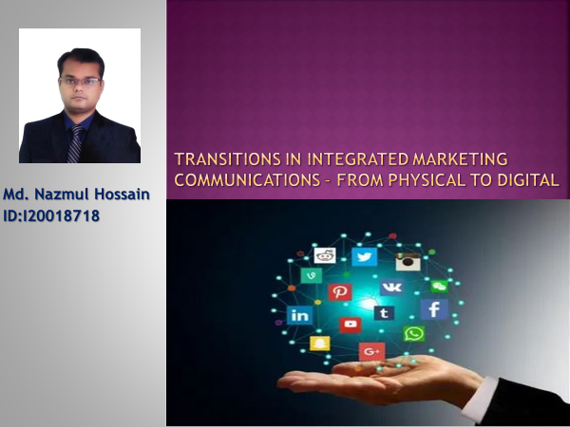

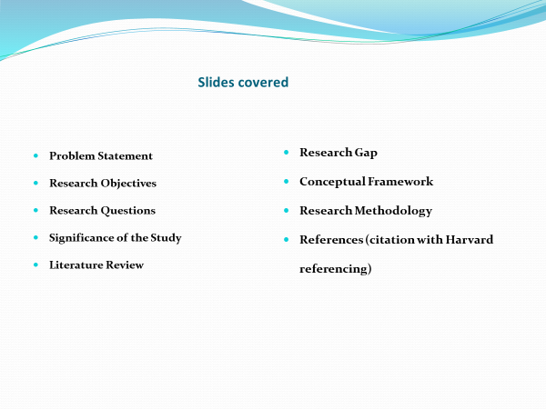

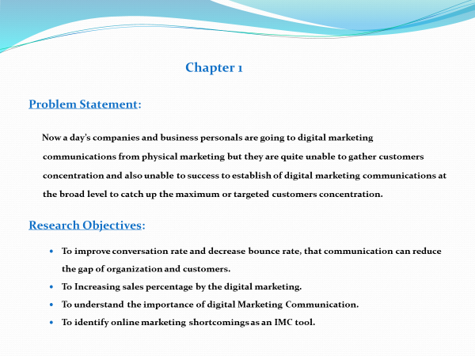

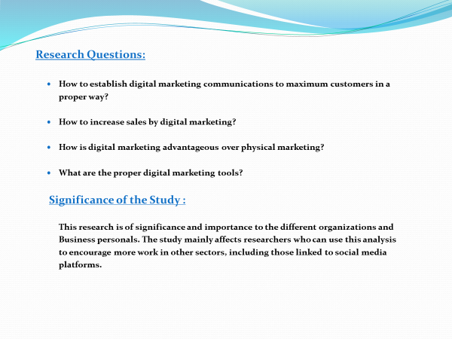

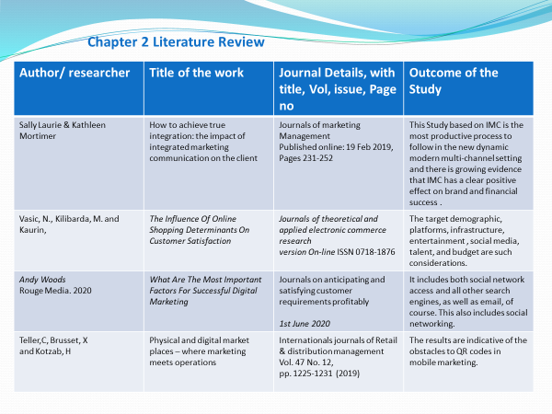

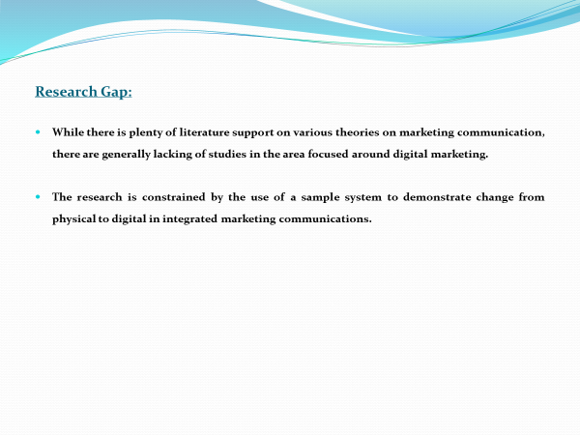

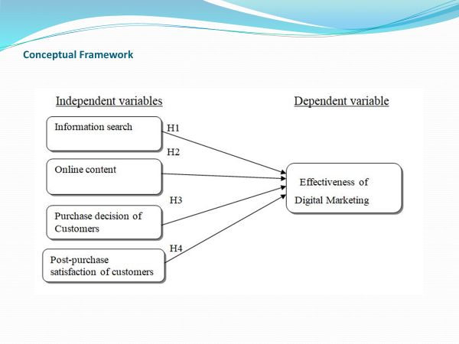

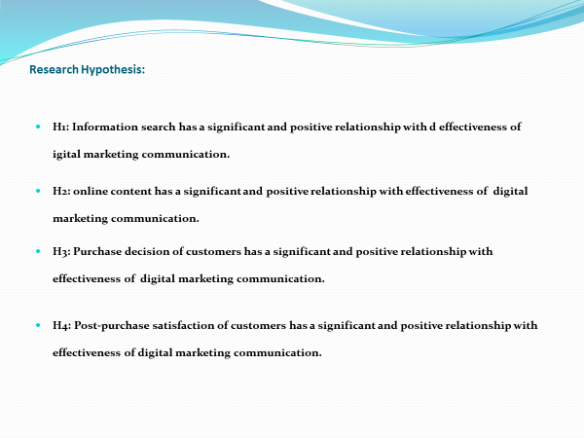

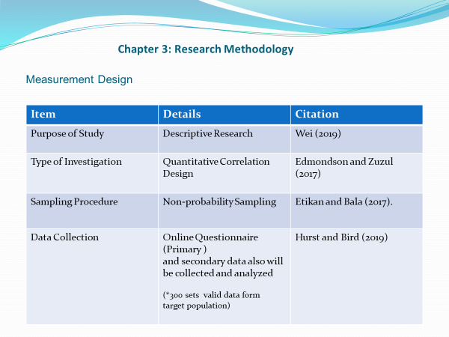
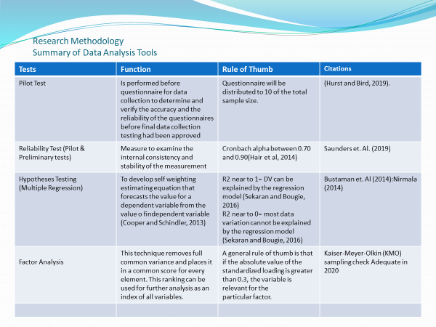

Appendix: 4 VIVA Presentation

