

**MASTER OF BUSINESS ADMINISTRATION (MBA)**

**MGT7998**

**MBA Project**

**FACTORS AFFECTING JOB PERFORMANCE OF GENERATION Z IN MALAYSIA**

Name : Ma Junkai

Student ID : I14007188

Programme : DMBA

Supervisor : Ms. Ah Huai

TABLE OF CONTENTS

CHAPTER 1 1

INTRODUCTION 1

1.1 BACKGROUND OF STUDY 1

1.2 PROBLEM STATEMENT 2

1.3 RESEARCH OBJECTIVE 2

1.4 Definition of Key Terms 3

1.5 Operational Definitions 3

1.6 SIGNIFICANCE OF THE RESEARCH 5

1.7 LIMITATION OF THE STUDY 6

1.8 SCOPE OF STUDY 6

1.9 ETHICAL CONSIDERATION 6

CHAPTER 2 8

LITERATURE REVIEW 8

2.1 OVERVIEW 8

2.2 JOB PERFORMANCE OF GENERATION Z 8

2.2.1 GLOBAL RESPECTIVE 8

2.2.2 MALAYSIA PERSPECTIVE 10

2.3 FACTORS AFFECTING JOB PERFORMANCE OF GENERATIONS Z IN MALAYSIA 12

2.3.1 Social Networking 12

2.3.2 REWARDS STRATEGY 13

2.3.3 WORKING ENVIRONMENT 14

2.4 THEORY OF REASONED ACTION 15

2.5 HYPOTHESIS 17

CHAPTER 3 19

RESEARCH METHODOLOGY 19

3.0 OVERVIEW 19

3.1 RESEARCH DESIGN 19

3.2 UNIT OF ANALYSIS 21

3.3 SAMPLING DESIGN 21

3.3.1 SAMPLING PLAN 22

3.3.2 SAMPLE SIZE 23

3.4 QUESTIONNAIRE DESIGN 24

3.5 PILOT TEST 25

3.5.1 RELIABILITY TEST 26

3.6 MEASUREMENT 26

3.6.1 DESCRIPTIVE ANALYSIS 27

3.6.2 Hypotheses Testing 27

3.6.3 MULTIPLE REGRESSION ANALYSIS 28

3.7 SUMMARY 29

CHAPTHER 4 30

RESEARCH FINDINGS 30

4.0 OVERVIEW 30

4.1 PILOT TEST 30

4.1.1 Reliability Analysis 30

4.2 DEMOGRAPHIC ANALYSIS 31

4.2.1 Response Rate 32

4.2.2 Demographic Profile of Respondents 32

4.3 FINAL DATA ANAYSIS 35

4.3.1 Reliability Test 35

4.4 HYPOTHESES TESTING 36

4.4.1 Multiple Regression Analysis 36

4.5 SUMMARY 39

CHAPTER 5 40

CONCLUSION AND RECOMMENDATIONS 40

5.0 OVERVIEW 40

5.1 DISCUSSION IN FINDINGS 40

5.3 CONTRIBUTIONS 43

5.3.1 Contribution to Academy 43

5.3.2 Contribution to Industry 43

5.4 FUTURE RESEARCH 44

5.5 CONCLUSION 44

5.6 PERSONAL REFLECTION 45

REFERENCE 46

APPENDIX I – Questionnaire 58

**LIST OF FIGURES**

Figure 1: Components of Reasoned Action Theory and Their Relations 24

Figure 2: Conceptual Framework 25

Figure 3: Research Design Framework 27

Figure 4: Determining the Sample Size from a Known Population 31

Table 5: Questionnaire Design 32

**LIST OF TABLES**

Table 1: Operational Definition 11

Table 2: Summary Results of Reliability Analysis (Pilot Test) 38

Table 3: Summary Results of Respond Rate 39

Table 4: Demographic Profile of Respondents 41

Table 5: Summary Results of Reliability Analysis (Final Data Analysis) 42

Table 6: Model Summary 44

Table 7: Result from Detailed of Multiple Regression for Independent Variables 44

Table 8: Summary of Hypotheses Testing Result 46

# CHAPTER 1

# INTRODUCTION

## 1.1 BACKGROUND OF STUDY

Generation Z was born in the time, which the world become connected and globally and they are gradually getting to the workplace with higher expectation, preference and unique perceptions for the jobs in the world (Zuzana and Jana, 2018). The same generation groups are presumed to have the similar mindset due to experience the common culture, politics and economics in the same time line (Parry and Urwin 2011; McCrindle 2014), which will be in form of different beliefs, behaviors, value and attitude in different generation (Xander et al 2012). These differences will directly affect the work style and working environment (Lyons and Kuron, 2014), thus the management has to try their best to understand the characteristics of the new generation which include understanding their motivation, attitudes and personality characteristics as it is important for the company to attract and retain the excellent workers when the new generation start to enter the labor market (Gelbart and Komninos 2012).

There are three generations are active in labor market which are Baby Boomers, Generation X, Generation Y (Tapscott, 2009), but the Generation Z also begin to enter both the higher level education and workplace. It is a big different between Generation Z and previous generations, which the number will get to about 5% to 10% workplace composition (Desjardins, 2019) and for sure they will cause a big change in the workplace in the upcoming years (Dool, 2019). Both research of Desjardins (2019) and Dool (2019) indicates that Generation Z change their jobs frequently in evolving digital environment where is behind the high demand for technical expertise in the market.

This study is to verify and explore the Generation Z’s perceptions according to the factors affecting the job performance of Generation Z. There are very limited research on this area as Generation Z just start to enter workplace.

## 1.2 PROBLEM STATEMENT

Grow and Yang stated that Intergenerational characteristics have been widely discussed in the organizational behavior literature (Grow & Yang, 2018). With the generation Z is ready to establish itself in the current labor market, existing management may face some generational issues. However, some companies are not ready to receive the new generation workers to the workplace (Acheampong, 2019). Facing these generational differences, it's important to understand how generation Z's view of the workplace has changed. From an academic perspective, research on Generation Z in the workplace is sporadic but growing. This is an appropriate time to consolidate the current research topic and suggest possible future research directions. This study attempts to ascertain the factors influencing job performance of Generation Z in Malaysia. The key theory relevant to this research is known as the Theory of Reasoned Action (Cislaghi and Herse, 2018).

## 1.3 RESEARCH OBJECTIVE

The research objective is to investigate whether social network, rewards strategy and working environment have a significant influence on job performance of Generation Z in Malaysia.

**Specific Objectives:**

1. To investigate whether social network has a significant influence on job performance of Generation Z in Malaysia.
2. To investigate whether rewards strategy has a significant influence on job performance of Generation Z in Malaysia.
3. To investigate whether working environment has a significant influence on job performance of Generation Z in Malaysia.

## Definition of Key Terms

The following terms are to enhance the understanding for the generation mentioned in this study:

• Generation - Acheampong (2019) states that a generation is “a group of people or cohorts who share birth year and experiences as they move through time together, influencing and being influenced by a variety of critical factors”.

• Generation Z – There are several different birth periods for the range of Generational Z in different research (Dimock, 2019). Most researches defined the birth period for generation Z was born in 1995 to 2009 or 2010, this study will use the birth period between 1995 and 2010 (Seemiller and Grace 2016; Koulopoulos and Keldsen 2016) as definition of Generation Z.

## 1.5 Operational Definitions

|  |  |  |
| --- | --- | --- |
| No. | Terminology | Operational Definition |
| 1 | Job performance | Job performance is defined as the total expected value to the organization of the discrete behavioral episodes that an individual carries out over a standard period of time (Motowidlo, Borman, & Schmit, 1997).  In this study, job performance is defined as how much the sets of behaviors (in the aggregate) which is Generation Z’s working preference are likely to contribute to or detract from organizational effectiveness such as using social network, good rewards system and beneficial working environment. |
| 2 | Social Network | A set of actors with some patterns of interaction or “ties” between them; represented by graphs or diagrams illustrating the dynamics of the various connections and relationships within the group (Katarzyna, 2013).  In this study, the social network refers to sum title of the platform the employees used to perform the work, which examine whether the social network will affect job performance of Generation Z employees. |
| 3 | Rewards Strategy | Rewards strategies are systems and policies that organizations use to motivate employees' positive work attitudes, such as job satisfaction and emotional commitment, which are necessary for improving employee performance and retaining employees (World at Work, 2015).  In this study, rewards strategy refers to monetary and non-monetary rewards to employees, which like certificate award, pay structure, reasonable salary increase, |
| 4 | Working Environment | Briner (2000) stated that working environment is as a very broad category that encompasses the physical setting (e.g. heat, equipments etc.), characteristics of the job itself (e.g. workload, task complexity), broader organizational features (e.g. culture, history) and even aspects of the extra organizational setting (e.g. local labour market conditions, industry sector, work-home relationships).  In this study, working environment refers to the company culture, employees relationship, career-oriented work and growth opportunities. |

Table 1: Operational Definition

## 1.6 SIGNIFICANCE OF THE RESEARCH

Gen Z (1995-2010) is just entering the labor market but they bring the new pattern of working behavior. Today's managers need to understand not only how best to manage young, inexperienced workers, but also the unique characteristics of the generation shaped by their experiences. Each generation is skeptical about the culture and social network of the younger generation. Understanding their behavior and their unique needs in the workplace will help them better integrate with new employees and succeed together. This study will provide valuable insight into the changing needs and expectations of most current staff members. It can help entrepreneurs, executives and even middle managers to understand and think about recruiting, managing and retaining Gen Z.

**Importance of the study to academia: S**upplement and fill in the research gap inherent in the area.

**Importance of the study to government:** Reviewing on the current factors affecting job performance of Generation Z is good for government to improve the education direction.

**Importance of the study to organization:** Develop a better understanding on the factors that influence job performance of Generation Z in Malaysia. It is significant for the organization to redesign the work value and reward preference to meet the present and future generations.

## 1.7 LIMITATION OF THE STUDY

Due to there is time limitation of this study, method of non-probability convenience sampling will be utilized where target respondents on the social media are easily to participant the survey. Besides that, this study just only emphasizes the environment of online social media which mean those impacts that caused on offline environment will not be considered. Other than that, the result of this study can’t be generalized since the scope of this research only on Gen Z in Malaysia, which the inherent limitation of convenience sampling and this study was carried out within Negeri Sembilan only which include Jelebu, Jempol, Kuala Pilah, Port Dickson, Rembau, Seremban and Tampin. Furthermore, this survey will be carried out only in Malaysia which mean the limitation of generalized to countries might be existed. Thus, the study outcome is recommended to utilize stratified sampling or meta-analysis to generalize for further studies.

## 1.8 SCOPE OF STUDY

Quantitative method will be adopted in this research. Unit of analysis will be Generation Z in Malaysia and the target participants for the questionnaire will generation Z who are going to work soon or has started with work in Malaysia.

## 1.9 ETHICAL CONSIDERATION

According to Connelly (2014), researcher of the study is essential to report on ethical consideration. Moreover, Bougie and Sekaran (2016) also stated that the research of ethical consideration is significant to stay truthful and faithful in the procedure of the research and the researcher is necessary to acquire the letter of permission before execute the survey. Other than that, the respondents must be participate voluntary and the questions are understandable are the responsibility of researchers to inform consent (Connelly, 2014). Referring to Elliott and Resnik (2016), social responsibility is also vital for researcher such as there is forbidden to manipulate during collecting data to assure that the findings of this study is accuracy and reliability.

# CHAPTER 2

# LITERATURE REVIEW

## 2.1 OVERVIEW

By 2020, there are more than 30% of labors are Generation Z who was born after 1995 (Ravikiran, D, Poonam, S, & Mehran, A, 2019). It is significant for the organization to understand who they are, and how do they think. The focus of this research will concentrate on the three factors which influencing on job performance of Generation Z in Malaysia based on their special characteristics. The three factors are social network, rewards strategy and working environment.

## 2.2 JOB PERFORMANCE OF GENERATION Z

### 2.2.1 GLOBAL RESPECTIVE

United States Census Bureau statistics that Generation Z will be in form of 20% of workforce in US in the next two years (Richard, 2018). The report of Zapier Editorial Team (2020) shows the large part in Generation Z’s daily work is social network and there are 16% respondents of Generation Z answers that they “have quit a job because their employer did not provide the proper social network for them to do their job” Moreover, 70% of Generation Z managers “say they encourage their direct reports to solve problems using social network” (Zapier Editorial Team, 2020). Generation Z prefer to find automation of jobs (Harris, 2020). 71% of Generation Z workers said ‘they are constantly on or checking their work communication tools outside of work” which the report regards it as one of the majority reason why the employees are experiencing “periods of decreased work productivity due to job burnout” (Zapier Editorial Team, 2020).

In addition, the level of Generation Z care about privacy and safety much more than older generation and is easily attracted by private social networking (Lanier 2017; Roblek et al. 2018).

Meret et al. (2018) conduct a research with a sample of high school students who are from Italy and some East European countries and the research indicates that the most vital factors for Generation Z to choose a job depending on the possibility of learning and development, trust and job security which is all behind the working environment. Furthermore, Lazanyi and Bilan (2017) did a research on the trust in the workplace in Hungary and the result shows that the job performance of employees of Generation Z is different with older generation, which supervisor is only able to earn the respect and trust from Generation Z by his or her professional excellence. Lorgulescu (2016) study on work preference of Generation Z in Romania and found that “most of the [study] respondents (47.7%) would like to work in a large team, in an open office space”. This result shows that Generation Z expect to work in a small size team independently (Acheampong, 2019).

Sidorcuka and Chesnovicka (2017) ´ s research on perception to attract and retain employees within existing methods in Latvia shows that Generation Z employees do not care about if they can keep the same job for long, concern about the specific value in workplace, preferred to get a job with flexible working hours and their personality can be applied, are attracted by a company's reputation, innovation, the pace of change, education and promotion platform, as well as special benefits. While the market is grappling with changing work and social values for Generation Z, trying to attract them with new strategy which concentrate on work-life balance, relaxation and benefits, the generation under them has entered into higher education and bring up a new challenge in a complex and constantly changing social market (Dwivedula, Singh & Azaran, 2019; Seemiller & Grace, 2017).

With regard to Generation Z, they expect the organization to increase virtualization, 24/7 connectivity, social media and more personal freedom, which can lead the organization to break away from traditional structures (Kirchmayer and Fratričová, 2017).

### 2.2.2 MALAYSIA PERSPECTIVE

Generation Z employees prefer and desire to have different aspirations in their workplace for guiding or instructing themselves in behavioral intentions and attitudes (Twenge & Campbell, 2008). According to the research, there are two variables discussed by Twenge (2010), namely the availability of work-life balance and perceived organizational cultural adaptability, from these two dimensions to emphasize some of the most important aspects in the working environment, which in turn can be the main reason for a turnover intention among Generation Z working at the organizational level. At the same time, based on the research review highlighted, it also shows that it has the potential to have a positive impact on employee development opportunities and employee rewards on employee job satisfaction levels, and it can even make up for the level of employee commitment that is considered popular among Generation Z (Yeewen, Rajendran and Aiping 2018).

Previous studies have also shown that when employees' work is recognized and rewarded, they will be more loyal and satisfied with their work or organization (William, 2010). The rewards strategy is designed to motivate employees to enjoy their work over a long period of time. There are a lot of previous research about the behavior of accounting to support the correlation between employee satisfaction and success of the company (Yeewen Rajendran and navigation, 2018), the plan is like a monetary reward and incentive has many purposes, which including reward employees work well done, motivate employees better or some tasks, improve their work efficiency, increase job satisfaction and performance (Erbasi & Arat, 2012).

In essence, Paine (2014) analyzed that the organization's reward and incentive system would not only affect Generation Z employees, but also affect the company's success and profitability. Generation Z employees are grateful to employers for rewarding them for all the effort they put into their jobs. In essence, Generation Z also like incentives because they take pride in the work they've commissioned and feel satisfied with the work they've successfully completed (Yeewen, Rajendran and Aiping 2018).

According to Smith (2010), Generation Z job candidates strongly agree that flexible work arrangements are important for long-term job satisfaction and it also shows Generation Z rated vacation time or flexible work hours as the most attractive work-life balance initiative. Generation Z are a challenge for employers or managers who need to encourage and trained the to make sure that their strengths become the profitability of the organization. Therefore, it is clear that managers have to pay more attention to work-life balance in the coming future in order to achieve career satisfaction and personal freedom (Yeewen, Rajendran and Aiping 2018).

Generation Z easily to be bored and, as a result, work well in environments that allow them to multitask and be flexible (Robbins & Judge, 2013). According to (Yeewen, Rajendran and Aiping, 2018), the reason is Generation Z grow up multitasking between school, work and other activities. Therefore, Generation Z prefer to multitask in their work as well because they would like to participate in a work culture with innovative communication and advanced social network (Ferri-Reed, 2010). Generation Z employees expect the working environment which is full of positive organizational culture, this will lead them to feel security and there are enough opportunities to enhance themselves. Moreover, Generation Z employees also report that they can work best when flexible work cultures and social networks are part of the work environment (Yeewen, Rajendran and Aiping, 2018).

The entry of Generation Z into the labor market accompanied by the retirement of Baby Boomers, may lead to a huge shift in working culture and working environment (Solnet et al., 2016). The environment and values in which each generation grows up shape its consumption behavior and basic social values. Unlike other generations, Generation Z come to the world and grow up with the Internet. Generation Z has been exposed to the Internet since they were born, so they rely on and are familiar with the use of social network (Ozkan and Solmaz, 2015). Ozkan and Solmaz(2015) found that this generation shows confidence, embraces team spirit, needs to guarantee the future, seeks happiness in the workplace, and desires independence rather than authority. Workplaces that encourage entrepreneurial skills, friendly work environments, and flexible work schedules are hallmarks of Gen Z's job search (Research Gate, 2019).

Schawbel (2016) points out that (1) while this generation likes corporate workplaces, they embrace flexibility in the workplace, (2) they support face-to-face communication technologies compared to others, but want companies to adapt to social media, (3) they plan to work in multiple countries during their careers and (4) they like regular feedback in annual performance appraisals. Deloitte (2017) also stated that Generation Z is prepared to work hard, but prefer to move careers up quickly.

## 2.3 FACTORS AFFECTING JOB PERFORMANCE OF GENERATIONS Z IN MALAYSIA

### 2.3.1 Social Networking

The report of Suslova and Holopainen (2019) shows that Generation Z has strong relationship with social network, which they study, communicate and do lots of things on the internet when they are looking for information. The generation Z can’t live in the world without social network such as smart phone, ipad, laptop and so on (Ravikiran, D, Poonam, S, & Mehran, A, 2019). Social network is indispensable part of their lives and they expect the organization to support and allow them to communicate, edit documents and work without limitation of geographies and time different (Harris, K, 2020).

Generation Z has the ability to form large communities and continuous circles of communication with people they have never met online and will never meet online; Paradoxically, this generation is collaborative, talkative and social online, but often less able to develop personal relationships in the real world (Sharil, Mahbob & Baharudin, 2018). Research (Criteo, 2018) indicates that Younger Gen Z members more prefer to using the social media like Snapchat an Instagram, but older Gen Z members prefer to use Facebook. Social media immersion is another defining aspect of this generation (Schroth, 2019). “Gen Z spend nearly nine hours a day listening to media, looking at a screen or on a device. Including time spent multitasking; they are exposed to over 13 hours of media a day on average” (Ipsos Mori, 2018). According to the research of Vitelar (2019), it caused a number of negative impact to Generation Z which is like shorter attention span and a constant need for entertainment. Ipsos Mori (2018) points out that social media has the risks for generation Z as it can be associated with anxiety, bullying, peer pressure, low self-esteem, but also accompany with positive outcomes.

### 2.3.2 REWARDS STRATEGY

Nowadays, the reward system is one of the most famous recruitment and retention mechanisms in the field of talent management. Rewards strategies are systems and policies that organizations use to motivate employees' positive work attitudes, such as job satisfaction and emotional commitment, which are necessary for improving employee performance and retaining employees (World at Work, 2015). According to Coccia and Benati (2018), individual motivation as well as obtaining job satisfaction and organizational commitment from employees constitute two key objectives of organization reward strategies.

Extrinsic rewards are tangible rewards that an organization provides to influence a particular outcome or achieve a particular goal. They usually include monetary factors (salary and benefits, bonuses and gifts) or non-monetary factors (positive work environment, good working conditions). On the other hand, Intrinsic rewards are intangible and psychological reward program, which is designed to obtain personal satisfaction from work and can example as recognition, career development (mentoring, etc.), job autonomy, meaningful and challenging work and so on (Acheampong, 2019). As the individual-centered or employee-centered nature of the reward strategy, both the intrinsic and extrinsic rewards are essential.

The literature essentially shows that the reward strategy is a powerful means to influence the organizational culture (Taufek, Zulkifle and Sharif, 2016) and increase employee motivation (Garbers and Konradt, 2013). The rewards strategy can be considered as one of the main ways to achieve control because it affects the existing behaviors and attitudes of employees (Darina, 2019).

More recently, De Waal and Jansen (2013) argue that the importance of the proponents of bonuses and monetary rewards improves productivity and performance within organizations. In an article by the Alzyoud (2018), it was suggested that organizations must reactivate the compensation and benefits offered to meet the needs and aspirations of each generation with its unique attitudes, values and perspectives on work.

### 2.3.3 WORKING ENVIRONMENT

Dr Hemlata Agarwal (2019) describes that generation Z as very worried along with environmental problems, there is a strong awareness of impending shortages and water shortages which shows they have a strong sense of responsibility for natural resources. The study of Research Gate (2019) indicates that Generation Z prefer face-to-face communication and expect managers to listen and value their ideas. This suggests that the workplace should think less about age and more about ideas and contributions. Furthermore, Harris (2020) mentioned in his report that Generation Z would like to work with an open-minded leader who will be honest and not withhold information from them due to their age or position. According to the study of Schroth (2019), they prefer working environments that foster mentoring relationships, learning and career development opportunities, because they think that their education does not equip them with the skills which can deal with real life problems.

Generation Z desire to have an office workplace which can be easier adjust within and focus on certainty and value arrangement in working environment rather than intricate planning layout (Research Gate, 2019). For success, the organization needs to pay more attention on modifying the working environment to motivate employees to engage in behaviors consistent with their goals (Osborne & Hammoud, 2017). Evidence shows that the right workplace culture is critical to attract and retain Generation Z talent. According to research by Pires (2017) and Arar and Yuksel (2017), the member of Generation Z prefers career-oriented work, growth opportunities and an inclusive management style within a well-defined organizational structure. Academic evidence also shows that Generation Z prefers meaningful working relationships (Tulgan, 2013) and flexible working hours (Singh and Dangmei, 2016; Asrar & Yuksel, 2017), personal development opportunities (Kirchmayer & Fratri, 2018) and independent work (Adecco, 2015).

## 2.4 THEORY OF REASONED ACTION

In the history of social psychology, the theory of Reasoned Action proposed by Ajzen and Fishbein(1980) is regarded as one of the top theoretical models to study individual decision-making behavior (Manstead, 2011). Specifically, the information processing method of attitude generation is the core of this theory. According to this theory, the behavior prediction of an individual in a specific situation can be explained by two kinds of self-determined intentions, which the first is the attitude to the behavior (positive or negative attitude), and the second is the subjective norm, namely the social need to perform or not perform the tested behavior (Mishra et. al, 2014).

In addition, the theory of Reasoned Action proposed by Ajzen and Fishbein(1980) was first put forward by Fishbein in 1967, with the purpose of explaining the relationship between attitude and behavior. It stems from the frustration caused by the use of traditional attitude measurement methods to predict repeated failure of behaviors (Terry et al., 1993). Moreover, the theory of Reasoned Action (Ajzen and Fishbein, 1980) assumes that it is reasonable for human beings to systematically utilize available information. Human beings consider the consequences of their actions before they act. The theory also elaborates the relationship between belief, attitude, intention and behavior. The primary determinant of behavior is behavioral intention, while the direct determinant of behavioral intention is attitude towards behavior performance (Al Shbail, 2018).

Reasoned Action theory (TRA) is a social psychological model to explain the causes of intentional behavior (Ajzen, 1985). This theory is widely used by many scholars in multidisciplinary fields to determine the intention of individual behavior. In this study, the theory of reasoned action focuses on the job performance within individual preferences. Influenced by positive attitudes and social norms, individuals' willingness to perform behaviors is the extent to which they perceive how others recognize their participation in specific behaviors (Bock, Zmud, Kim & Lee, 2005). This theory represents the influence of attitude and social norms on individuals' willingness to work. Attitude is defined as the tendency to react positively or negatively to oneself, others and the environment (Ajzen, 1985). On the other hand, Social norms is defined as the way one thinks and what one expects others to do. The figure 1 is the components of Reasoned Action Theory and their Relations (Yzer, 2013).

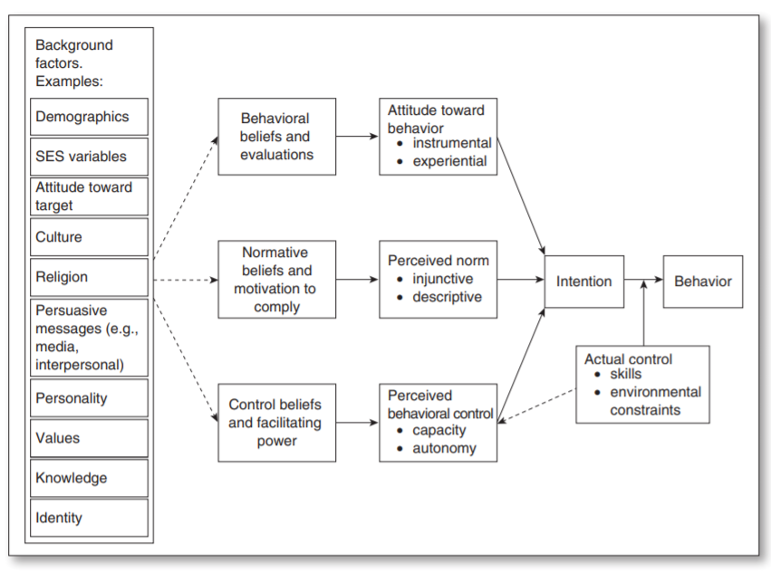

Figure 1: Components of Reasoned Action Theory and Their Relations (Yzer, 2013)

## 2.5 HYPOTHESIS

This research study was carried to find out the relationship of independent variables, which are social network, rewards strategy and working environment with the dependent variable, which is job performance of Generation Z in Malaysia. In this research, the hypotheses were defined as below:

H1: Social network has a significant relationship with job performance of Generation Z in Malaysia.

H2: Rewards strategy has a significant relationship with job performance of Generation Z in Malaysia.

H3: Working environment has a significant relationship with job performance of Generation Z in Malaysia.

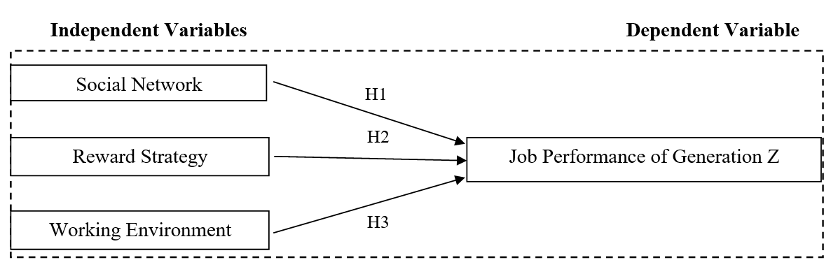 Figure 2: Conceptual Framework

# CHAPTER 3

# RESEARCH METHODOLOGY

## 3.0 OVERVIEW

Chapter 3 is discussed and explored about the research methodology of this study. Research methodology in this chapter will be briefly explained on the research design, questionnaire design and measurement and will be presented by tables or diagrams. Presented tables or diagrams in this chapter will also involve and briefly describe this study's sampling method, study of unit of analysis, data collection process, target population, sample size and more. Research design, questionnaire design and measurement in this study will be discussed further and detail during project.

## 3.1 RESEARCH DESIGN

Zikmund, Griffin, Babin and et. al. (2013) stated that business research method can give a clearly knowledge and information for organizations to identify the problems and challenges in business environment, which to make right decisions and strategies to settle the problem. The view is supported by Bell, Bryman and Harley (2018) who wrote that Data collection and analysis are the framework included in the research design, and the decision on the research design has priority in the research process that includes multiple dimensions.

Research design plays a crucial role in a study as research design provides the path and direction of research (Wahyuni, 2012). In addition, Hakim (2012) believes that research design can discover theoretical questions of research and carry out practical research to respond to research questions. Besides that, research design can present causal relationships between variables and understand the implications of action and action in a particular social context (Bell et. al., 2018). Maxwell (2012) mentioned that a good research design can improve the work efficiency and function of parts which reduces the failure rate.

This study utilizes descriptive study to determine whether social network, rewards strategy and working environment have influences on job performance of Generation Z in Malaysia. Approach of quantitative study is suitable for the deductive nature of this study, so hypotheses related to the focus of this study can be carried out through the research theory, and hypothesis testing can be carried out at the end (Grenner and Martelli, 2018). This study will follow the study of quantitative nature, to describe or estimate, establish and examine the theory of hypotheses.

Furthermore, correlation design also known as descriptive research, which helps to find the significant relationship between independents variables and dependent variables (Aksoy, Donkers and Kumar et, al., 2010). Therefore, this study will use the approach of correlation design to evaluate the existing relationship and the intensity.

In order to ensure the independence and accuracy of this study, all activities involved in this study will be carried out by the researchers with minimal interference (Billah and Khan, 2013). This means that the study does not change the environment because the data was collected in the natural environment (Bougie and Sekaran, 2016). Therefore, the research setting of this study is non-contrived. Figure 2 display the research design framework.

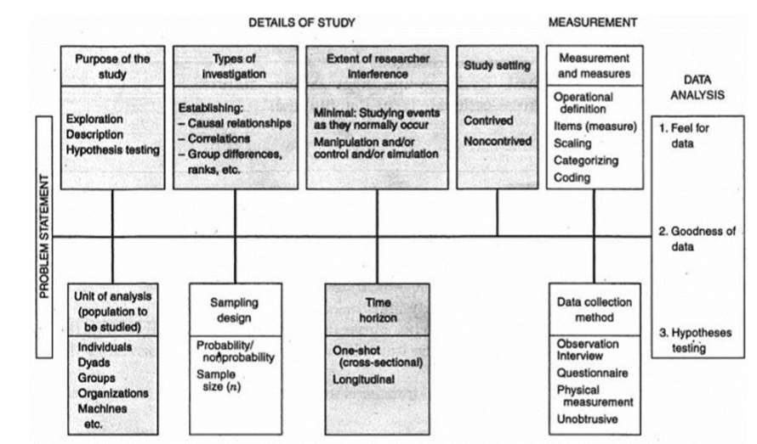

Figure 3: Research Design Framework (Bougie and Sekaran, 2011)

## 3.2 UNIT OF ANALYSIS

Massis and Kotlar (2014) defined the analysis unit as several types of phenomena occurring in bounded texts, and it is also considered as an important process when selecting research methods in research. Moreover, any research design needs to be clearly defined and focus on the population to be studied as the unit of analysis is to determine the target participants of the study (Bougie and Sekaran, 2011). In addition, Babbie (2013) also mentioned that determining unit of analysis is significant for the research design by testing the variables studied.

In a research design, there have many units of analysis are required to test the hypotheses, usually are from a large population sample, and data is usually collected from the unit of analysis which is lowest level (Bernard, 2012). This study is focus on Generation Z in Malaysia as target population. Since Malaysia Generation Z is classified as individual, so unit of analysis in this study is individual. All the data that gathered from every single of respondents will served as an individual data source which the scores had gained from the distributed questionnaires.

According to Bougie and Sekaran (2016), time horizon of research design can be classified into cross-sectional studies or longitudinal studies. Bell et. al. (2018) stated that studies of cross-sectional are collecting data from many respondents and each respondent data is just collected once to investigate the relationship of dependents variable and independent variables. Data which collected continually in a periodical interval from the individual to track the data over the time is the studies of longitudinal (Bougie and Sekaran, 2016). Data collection of this study is just collected once from the same respondent to find out the factors affecting the job performance of Gen Z in Malaysia. Therefore, the time horizon of this study is cross-sectional.

## 3.3 SAMPLING DESIGN

Sampling design is a procedure of identifying units from the population which is interested to further study on this particular unit with the objective of making summary regarding the larger population, thus data information that collected from a sample is applied to make the prediction of the particular unit of interested population (Peersman, 2014). Babin and Zikmund (2016) mentioned that sampling design lets researchers to acquire a data collection which are more accurate and economic as well as examine the finding research generalizability to larger population. Besides that, sampling will be a practical method which used to study on particular units more deeply and their attitudes, activities, relationship, thoughts and etc in the connection to business, and a group population will be represented as the sample of the study (Grenner and Martelli, 2018). In other words, the findings result can be generalized to the entire group of population.

However, when determining the outcomes of a policy or programme will confronted different types of sampling and different type of bias. According to Peersman (2014), the strengths and weaknesses of strategy of sampling which used in the research is important to define clearly and understand due to suitable sampling able help to reduce ‘selection bias’. For this study, target population will be those generation Z who has started working or are going to workplace soon in Malaysia. Moreover, this study is used to determine whether the factors that influence job performance of Generation Z have the same perception as pervious study.

### 3.3.1 SAMPLING PLAN

Sampling plan can be classified into 2 types: probability sampling and nonprobability sampling, and sampling plan is the process for collecting data (Bougie and Sekaran, 2016). Acharya, Nigam and Prakash et. al. (2013) defined as probability sampling is randomly collecting the data and the people who within the population has the equal opportunity to participant the study with no intention and emotion situation as well as become sample. In probability sampling, sample knowledge is able to use and apply the expectation and is intended to be utilized to gain an initial knowledge and better understanding on the targeted population (Uprichard, 2013).

On the other hands, non-probability sampling is the unit which used for the research is the probability of unknown or are known some of the probability to be zero (Steinmetz, Toepoel and Vehovar, 2016). Non-probability convenience sampling is the people who are intentional and conveniently available to participant in answering the questionnaires and those people are colleagues, friends and family to let the progress on data collection become easily and smoothly (Greener and Martelli, 2018). In addition, using non-probability in the study is not certainly to know additional information about the population through social media to collected sample, but is required to deepen the existing information of the sample itself (Uprichard, 2013). According to Greener and Martelli (2018), method of convenience sampling is utilized is because of the cause of limited of time frame and cost consideration.

The sampling design of this study is using non-probability convenience sampling method as data are collected from population who are intentional and conveniently available to participate such as colleagues, friends, sibling and more (Peersman, 2014). Convenience sampling method will be the ideal method for this study because the target population is too large and has limited time frame (Alkassim, Etikan and Musa, 2016). Another reason of choosing non-probability convenience sampling method is this study want to understand the factors which can influence Generation Z’s working behavior, so this method is more appropriate compared to probability sampling.

### 3.3.2 SAMPLE SIZE

Chow, Lokhnygina and Shao et. al. (2017) stated that sample size plays an important role in planning stage as used to guarantee that the respondents are able to give the evaluation which is accurate and reliable as well as with the assurance of some statistical. According to Ferreira and Patino (2016), the amount of target respondents should be identified adequately due to the sample which has been chosen will become the representative of target population. Based on POPULATION QUICK INFO (2019), there are around 11, 111, 200 Generation Z in Malaysia. The Generation Z in Malaysia who are going to work soon and has started working has gone to 6, 038, 700. This indirect statistic has the potential to become the target population in this study. Other than that, this study was carried out within Negeri Sembilan and total Generation Z who has qualification to answer the questionnaire in Negeri Sembilan 2019 is 217, 500 (POPULATION QUICK INFO, 2019). Thus, this study is having more than 1,000,000 populations as well as due to time constraint, confident level is 95% and error margin is 0.7, where the questionnaire will be distributed 384 copies as suggested by Krejcie and Morgen (1970). Figure 5 indicates the determining the sample size from a known population:

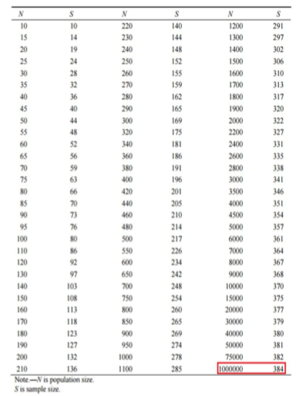

Figure 4: Determining the Sample Size from a Known Population (Krejcie and Morgan, 1970)

## 3.4 QUESTIONNAIRE DESIGN

The questionnaires that employ in this research is applying the method of adapted and involves the determinant-choice and multiple-grid questions to fulfil this study's objective. The questionnaires will be distributed by softcopies via social media to the related target respondents – Gen Z who is 15 to 25 years old to collect the data for this study. The questionnaire will be designed based on Figure 3 and the pilot test for this study will be executed by using 50 target respondents to enhance the questionnaire of this research. This study's survey is carried out in the design of factorial to find out the 4 types of relationship: independent variables on a single dependent variable, which examine the connection between social network and job performance of Generation Z; rewards strategy and job performance of Generation Z; and working environment and job performance of Generation Z.

Section A will be the 1st part of the survey questionnaire is asking respondent about the main constructs of the frameworks of conceptual. The survey questionnaire of this study is adapting the Likert scale of five-point by Berry, Parasuraman and Zeithalm (1988), where apply the format of Strongly Agree=5, Agree=4, Neutral=3, Disagree=2, Strongly Disagree=1 to differentiate the participant’s attitude. Eze, Tan, and Yeo (2012) mentioned that Likert scale is utilized to evaluate whether the respondents are agreed or disagreed with the series of statements. While the following part - Section B the final part of this survey questionnaire and is intended to know-well the respondent demographic profile.

|  |  |  |  |
| --- | --- | --- | --- |
| **Section** | **Description** | **No. of statements** | **Source** |
| **A** | **Demographic Profile** | **6** | **-** |
| **B (Dependent Variable)** | **Job performance of Generation Z** | **3** | **Jang, 2018** |
| **C  (Independent Variables)** | **Social Network** | **3** | **Islam, Muhd Yusuf, and Desa, 2011** |
| **Reward Strategy** | **3** | **MUNISAMY, 2013** |
| **Working Environment** | **3** | **MUNISAMY, 2013** |

Table 5: Questionnaire Design

## 3.5 PILOT TEST

According to Peersman (2014), pilot test is a study which is small scale and as an instrument to examine whether the data collected is reliability or non-reliability. Moreover, pilot test is also known as a small study to examine on the strategies of sample recruitment and research protocols (Hassan, Mazza and Schattner, 2006). Peersman (2014) stated that a pilot test has to conduct initially, and then enhance the instrument to more generally before utilized it to maximize the quality of data.

Saunders and Tosey (2015) mentioned that pilot test able to help researcher to make sure that the respondents are understand the survey questions and assurance that the questionnaire which had set is applicable. Creswell and Creswell (2018) had suggested that the sample size's total number which in pilot test is about 10% of the prospective sample size while 384 will be this study's sample size and thus 50 participants are required for the pilot test. The objective of carrying out a pilot test is to enhance the quality of questionnaire and ensure that there are not issue for respondents when answering the questions as well as no issue in data recording (Lewis, Saunders, and Thornhill, 2012).

### 3.5.1 RELIABILITY TEST

Reliability test is critical on data collection as utilize to figure out the reliability of pilot test data is consistency with the proposed research method (Greener and Martelli, 2018). The purpose of reliability test is to ensure both items and data collected are in consistent and lead to higher reliability (Bell et. al., 2018). Swanson (2014) mentioned that there has the possibility to obtain a reliable measure which is invalid, however reliability is a major prerequisite for validity. Furthermore, data which is collected is essential to run by reliability as to make sure that data is consistency to evaluate the recommended research model (Gidengil, Parker and Zikumund-Fisher, 2012). According to Anderson, Babin and Black, et. al. (2018), the result of reliability test must be more then 0.7. Babin et. al. (2013) stated that if the result is below 0.7, then the items need to be removed for future analysis due to represent a poor reliability. Reliability test is carried out after done the test of factor analysis and the data of preliminary test as well as full scale data collection will also be carried out in this study.

## 3.6 MEASUREMENT

According to Gidengil et. al. (2010), measurement is the instrument that frequently utilize in research to testing the subjects or phenomena in a certain setting of research. Mohajan (2018) also stated that measurement is a phenomenon of quantify that through allocated the numbers to observes, it contains the structure of variables and also quantify all the variables by the tool’s development and application. The questionnaire of this study will collect the data via online like social media and utilized SPSS (Statistical Package for the Social Sciences System) to go through the method of data analysis which includes hypothesis testing, preliminary tests, and additional test of confirmatory and supporting (Bougie and Sekaran, 2011). Moreover, the 384 of sample size will be collected from the questionnaire and also will utilize SPSS to analyze.

### 3.6.1 DESCRIPTIVE ANALYSIS

According to Davis (2014), descriptive information is through the demographic survey to recognize and know-well the respondents' characteristics. Moreover, Babin et. al. (2013) also mentioned that descriptive information is convert raw data and then interpret information for the researcher by the way of simple and easy to understand. Descriptive information contains education, gender, income level, age, education level, occupation and more (Aktürk, Aslan and Aylaz et. al., 2012). In this study, the demographic profile that will collect from respondents are involves age, gender, income level, education level, occupation and factors may affect their working behavior. Pang, Shakur and Siali et. al. (2016) stated that data collection for gender is male and female whereas the range of age is from 15 to 25.

Other than that, education level in this study questionnaire can be classifies as Under Bachelor Degree, Bachelor Degree, Master Degree and other whereas occupation can be categories as student, employee, professional and self-employed (Ahmad et. al., 2012). The objective of collect both information of respondent are to find out whether people who with different education level and occupation have different perception when it comes to working behavior. Another is What is the most important factors you will consider when you are looking for a job? (Social network, Incentives, working environment). The reason of collecting this information from respondent is due to able to investigate whether the respondent who check less and more often on phone will affect their working behavior.

Other than that, method of multiple-choice questions will be adopted for preparing the related questions. After completed the data collection, the demographic profile of respondents will be displayed by the standard of frequencies in Chapter 4 - Data Analysis.

### 3.6.2 Hypotheses Testing

Test of reliability and factor analysis are significant due to both of them are inter-related for the hypotheses test executing which adopts to identify whether the data that collected is suitability for the subsequent analysis (Babin et al., 2013). Referring to Quinlan (2011), data is getting ready for further analysis after all the data that acquired from the questionnaire is go through the test of reliability and factor analysis. Hypotheses testing is developing to figure out whether there is a positive or negative of relationship among variables to determine the data collected is appropriate for further analysis and utilize those measured variables to address the possible related factors (Weakliem, 2016). This testing is employing samples via a big population to examine a null hypothesis to compute a mean value for the variables and to figure out the relationship among dependent variable and independent variables (Gaston, 2014). Hypotheses testing in this study will be conducting by applying SPSS software.

Mourougan and Sethuraman (2017) had mentioned that researcher will draw up the research of hypotheses when the expectation is construct above the study results and hypotheses is the ultimate objective for every study thus this statement will be the center part of the study as well as is a necessary in all the real experimental design. Besides that, Krithikadatta and Valarmathi (2012) stated that statistical instruments are drawn up when the research is initiated by null hypothesis of assumption, after than attempting to deny due to null hypotheses always deny hypotheses instead of certify. Normally, the significance level of hypotheses testing will be employing at the standard of 0.05 (Ralla, 2014). If the significance level of this study is assuming at 5%, the null hypothesis will be denied when the outcome of sampling obtained the probability that below 0.05.

### 3.6.3 MULTIPLE REGRESSION ANALYSIS

Multiple regression will be carried on in this study to examine and find out the simultaneous influence of independent variables on dependent variable (Bougie and Sekaran, 2016). Multiple regression contains establishing an appraising equation of self-weighting which obtain estimated variable of a dependent variable out of diverse independent variables (Cooper and Schindler, 2013). Multiple regression also helps to ascertaining the entire fit of the correspond contribution of every independent variable to dependent variable (Krugman, Obstfeld and Melitz, 2012).

"R" will be represented the multiple correlation and estimate the forecasting’s quality on prevent the dependent variable while value of R2 is the coefficient's determination of variance ratio in the dependent variable and able to determine in the independent variables (Bougie and Sekaran, 2013). Cohen (1988) stated that if the value of R2 is 0.02 mean construct has weak influence on the phenomenon of the research; if the value of R2 is 0.13 mean construct has medium influence on the phenomenon of the research; if the value of R2 is 0.26 mean construct has substantial influence on the phenomenon of the research.

Furthermore, Cooper and Schindler (2008) indicated that p-value is the value of statistical significance and employed to measure every single independent variable, where the independent variable will be claimed as significant if the p-value is lower than 0.05 due to the standard of conventional is acknowledged. Beta coefficient is part of coefficient which will embody the influence of every predictor variable in the model of multiple regression, where the phenomenon is intensity influence the study if the value is more than 0.1 (Lohmöller, 2013).

## 3.7 SUMMARY

Chapter Three explained the research method of the study that employed to accomplish the proposed study objective. A convenient sampling of survey will be carried on by distributing online questionnaire via social media to the customers in Malaysia. A pilot test will gather 50 respondents will be conducted to enhance the questionnaire design and make sure that all items of this study are relevant, appropriate and easy to comprehend. Multiple methods of data analysis will be utilized based on the requirements of this academic study and existed studies. In additions, the outcome of measurement in this study will be discussed further in Chapter 5 – Data Analysis.

# CHAPTHER 4

# RESEARCH FINDINGS

## 4.0 OVERVIEW

According to methodology mentioned in chapter 3, data collection and analysis has been executed. The objective of Chapter 4 is to use collected data to get the result by analysis. SPSS will be utilized to verify the variables' loadings and relationship. For testing whether the questionnaire's item is feasibility or non-feasibility, the first step is to conduct pilot test which is before proceed to final data analysis. The final test mentioned in Chapter 3 will run to evaluate the level of relationship which existed between the variables in this study.

## 4.1 PILOT TEST

The mean objective of pilot test is to verify the feasibility of questionnaire, which make sure these data can be utilized in a larger scale for the research (Davis, Kraemer and Leon, 2011). There are 50 participants’ data will be selected for pilot test. Reliability test and correlation matrix will be covered to verify the suitability and validity of data at the primary stage.

### 4.1.1 Reliability Analysis

Bougie and Sekaran (2013) stated that the researcher must ensure that the questionnaire participants can understand the items in questionnaire of survey during the period of data collection, which will assist researcher to get the suitable data for analyses and interpretation. Conducting reliability test is to check the consistency of questionnaire respondents (Pallant, 2016). The feasibility of this study also can be sustained by the outcome of reliability analysis.

|  |  |  |  |  |
| --- | --- | --- | --- | --- |
| Variables | | Cronbach's Alpha | Number of Items | If reliable |
| Independent Variables | Social Network | 0.861 | 3 | Reliable |
| Rewards Strategy | 0.793 | 3 | Reliable |
| Working Environment | 0.890 | 3 | Reliable |
| Dependent Variable | Job performance | 0.702 | 3 | Reliable |
| All Variables | | 0.912 | 12 | Reliable |

Table 2: Summary Results of Reliability Analysis (Pilot Test)

According to statement of Bland and Altman (1997), Cronbach’s Alpha in reliability test is higher than 0.7 means the items are relevant and appropriate to continue the data collection, which cause Cronbach’s Alpha must fulfill the requirement of higher than 0.7 to make sure that the data contain internal consistency in the research. Internal consistency refers to a common comprehension of the survey questionnaire items from the respondents in pilot test. Table 2 - Summary Result of Reliability Analysis indicates that Cronbach’s alpha in this study is more than 0.7, which means there is internal consistency exist in respondents of this study.

In summary, internal consistency of this study exceed 0.7 in the pilot test, which shows that there is no difficulty for the questionnaire respondents to understand the questionnaire items in this survey and able to be utilized to collect the final data. In addition, obtaining the internal consistency between final data collection that contain larger sample size is expected keep in same level during pilot test.

## 4.2 DEMOGRAPHIC ANALYSIS

Liu and Mwanza (2014) stated that the basic information of the target population and allocation in a study can be provided by findings of demographic. Demographic section presents the outcome of this study respondents' demographic characteristics which include age, gender, income level, education level, ethnicity level, current working and the important factor when the respondent looks for job. SPSS will be used to analyzed all the data.

### 4.2.1 Response Rate

The respondent of this study are the Generation Z in Malaysia who have started to work in workplace. Below table (Table 3) is summary result of response rate of this study, where the number of total responds received and how many responds are effective among these responds. In fact, there are 392 responses received in total for this study by Google Forms and there is no unable respond, which means the response rate is 100%.

|  |  |  |
| --- | --- | --- |
| Total Responds Received | Total Unable Respond | Response Rate |
| 392 | 0 | 100% |

Table 3: Summary Results of Respond Rate

### 4.2.2 Demographic Profile of Respondents

Age, gender, income level, education level, ethnicity level, current working and the important factor when the respondent looks for job are included in the first section in questionnaire, which is the demographic background of respondents. Table 4- demographic profile of respondents shows result of the demographic analysis obtained by SPSS.

|  |  |  |  |
| --- | --- | --- | --- |
| Profile |  | Frequency | Percent (%) |
| Age | 15-18 | 47 | 12.0 |
| 19-22 | 126 | 32.2 |
| 23-25 | 218 | 55.8 |
| Gender | Female | 248 | 63.4 |
| Male | 134 | 36.6 |
| Income level | Below RM2500 | 72 | 18.4 |
| RM2501-RM4000 | 218 | 55.8 |
| RM4001-RM5500 | 73 | 18.7 |
| RM5501 and Above | 28 | 7.2 |
| Education Level | Under Bachelor Degree | 56 | 14.3 |
| Bachelor Degree | 216 | 55.2 |
| Master Degree | 109 | 27.9 |
| Others | 10 | 2.6 |
| Ethnicity | Malay | 63 | 16.1 |
| Indian | 78 | 19.9 |
| Chinese | 246 | 62.9 |
| Others | 4 | 1.0 |
| Current Working | Director | 36 | 9.2 |
| Manager/Executives | 142 | 36.3 |
| Officer | 148 | 37.9 |
| Worker | 65 | 16.6 |
| Important Factor when looking for a job | Social Network | 74 | 18.9 |
| Incentives | 175 | 44.8 |
| Working Environment | 142 | 36.3 |

Table 4: Demographic Profile of Respondents

In this study, more than half of respondents are Generation Z which are in the age of 23-25 years old and with total of 218 (55.8%) of respondents. Other respondents' age range is followed by 19 - 22 years old with 126 (32.2%) respondents and 15 - 17 years old with 47 (12%) respondents. Majority of respondents are female which are 248 (63.4%) and the rest are male with a total of 136 (36.6%) in the category of gender. Moreover, the income level of most respondents is fall in the level of RM2501- RM4000 (55.8%) and most of respondents are in bachelor degree which is 55.2%. 27.9 % of respondents are in master degree. There are 246 (62.9%)of respondents are Chinese and followed by 19.9% Indian and 16.1% Malay. Worth to take note that 148 (37.9%) and 142 (36.3%) of respondents are working as officer and managers/executives. Besides that, 9.2% of respondents are working as director and 16.6% are working as normal workers which are under bachelor degree (14.3%). Other than that, nearly half of the respondents indicated that the important factor when looking for a job is incentives, which is choose by 175(44.8%) of respondents. 142 (36.3%) of respondents think working environment is important factor when looking for a job and 74 (18.9%) of respondents prefer more on social network.

## 4.3 FINAL DATA ANAYSIS

Reliability test and hypotheses analysis will be done by using SPSS with 392 respondents to analyze the date in this section.

### 4.3.1 Reliability Test

As stated in section of pilot test (4.1.1 - Reliability Analysis), the research used reliability test to confirm and check if respondents can understand the questionnaire's items in survey and the feasibility of this study also can be sustained by outcome of this test (Pallant, 2016). Furthermore, the value of Cronbach’s Alpha is more than 0.7 and above means that internal consistency is high which to prove further that the items can be considered to be corresponding whose mentioned by Bland and Altman (1997). In this study, the reliability test analyzed in pilot test reflect the final data collection's result.

|  |  |  |  |  |
| --- | --- | --- | --- | --- |
| Variables | | Cronbach's Alpha | Number of Items | If reliable |
| Independent Variables | Social Network | 0.819 | 3 | Reliable |
| Rewards Strategy | 0.713 | 3 | Reliable |
| Working Environment | 0.873 | 3 | Reliable |
| Dependent Variable | Job performance | 0.798 | 3 | Reliable |
| All Variables | | 0.911 | 12 | Reliable |

Table 5: Summary Results of Reliability Analysis (Final Data Analysis)

Table 5 - Summary Results of Reliability Analysis (Final Data Analysis) indicates that all value of Cronbach’s Alphas are more then 0.7, which means the respondents in this study have internal consistency. Besides that, working environment which is the independent variable contribute highest value of Cronbach’s Alpha referring to 0.873 (number of items measure are 3). Another variable with the second highest value of Cronbach’s Alpha value is also the independent variable of the study – social network (number of items measure are 3), followed by dependent variable which is job performance contain 0.798 value of Cronbach Alpha (number of items measure are 3). The lowest Cronbach’s Alpha value in this study is rewards strategy (0.713), which is the independent variable (number of items measure are 3).

## 4.4 HYPOTHESES TESTING

In this section, the multiple regression analysis will be used by researcher to examine structure relationship of study between independent and dependent variables. There are three requirements have to be met to determine whether hypotheses in this study is supported or not supported where beta coefficient must be more than 0.1 (Lohmöller, 2013), t value should be higher than 1.96 (Anderson et, al., 2018) and p-value has to be less than 0.05 (Cooper and Schindler, 2008). Hypotheses for this study is indicated as below:

H1: Social Network has a significant relationship with job performance of Generation Z in Malaysia.

H2: Rewards strategy has a significant relationship with job performance of Generation Z in Malaysia.

H3: Working environment has a significant relationship with job performance of Generation Z in Malaysia.

### 4.4.1 Multiple Regression Analysis

The connection of dependent variable and independent variables in this study can be measured by multiple regression (Coakes, 2013). Cooper and Schindler (2014) stated that determine if framework and framework constructs in the research have or do not have a model fit can be conducted by multiple regression analysis, which to check whether the value of $R^{2}$ is more than 0.5. What if the result shows the value of $R^{2}$ is lower than 0.5, there is not enough predictive power in the constructs of this study and the phenomenon under this study might be affected by other factors which are not included in this study (Lewis et al., 2015). The three hypotheses mentioned in this study will be test and carry out with the result by multiple regression analysis. SPSS was utilized to run the data and get the result as showed in table 6 and table 7.

|  |  |  |  |  |  |
| --- | --- | --- | --- | --- | --- |
| **Model Summaryb** | | | | | |
| Model | R | R Square | Adjusted R Square | Std. Error of the Estimate | Durbin-Watson |
| 1 | .711a | .506 | .502 | 1.14204 | 1.777 |
| a. Predictors: (Constant), Working_Environment, Rewards_Strategy, Social_Network | | | | | |
| b. Dependent Variable: Job_Performance  Table 6: Model Summary | | | | | |

According to Table 6 - Model Summary, the value of $R^{2}$ is 0.506 with a correlation of R of 0.711, which means that 50.6% of variance in job performance of Generation Z in Malaysia can be predicted from the social network, rewards strategy and working environment. The moderate percentages show that the model to predict the job performance of Generation Z in Malaysia is acceptable. Therefore, there is a predictive fit of medium standard with the framework and hypotheses in this study when taking the entire. Other factors which is not included in this research can explain the remaining 49.4% of variance.

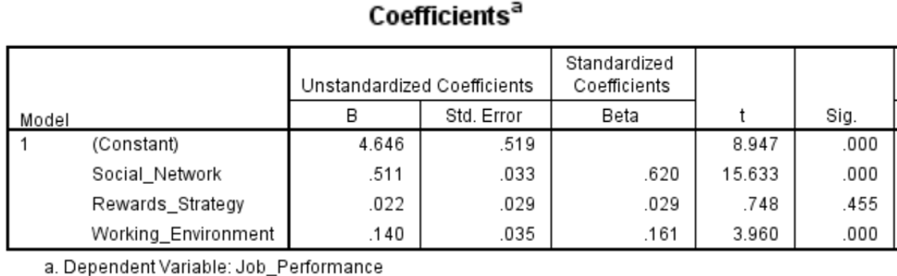Table 7: Result from Detailed of Multiple Regression for Independent Variables

The main outcome of the structural relationships between dependent variable (job performance ) and independent variables (social network, rewards strategy and working environment) is shown in Table 7 – Result from detailed of multiple regression for independent variables. The highest beta coefficient is social network of 0.620, which indicated that social network has strongest influence in job performance of Generation Z in Malaysia and followed by working environment and rewards strategy. As Anderson et, al. (2018) stated, the relationship between dependent variable and independent variable are able to be assessed by T-value. Referring to Table 7, the hypothesis H1 and H3 are supported and H2 is not supported as T-value is lower than 0.1. The test finding details in this study are shown as the following:

H1: Social Network has a significant relationship with job performance of Generation Z in Malaysia.

The relationship between social network and job performance of Generation Z in Malaysia was evaluated. Table 7 indicates that both of them has significant relationship where beta coefficient is 0.620, t value is 15.633 and p-value is 0.000. In fact, working environment is the strongest predictor of customer perception compared to other. Therefore, Hypothesis 1 is supported.

H2: Rewards strategy has a significant relationship with job performance of Generation Z in Malaysia.

The relationship between rewards strategy and job performance of Generation Z in Malaysia was evaluated. Table 7 indicates that both of them has no significant relationship where beta coefficient is 0.029, t value is 0.784 and p-value is 0.455. In fact, rewards strategy is the weakest predictor of job performance compared to other. Hence, Hypothesis 3 is not supported.

H3: Working environment has a significant relationship with job performance of Generation Z in Malaysia.

The relationship between working environment and job performance of Generation Z in Malaysia was evaluated. Table 7 indicates that both of them has significant relationship where beta coefficient is 0.161, t value is 3.960 and p-value is 0.000. Therefore, Hypothesis 3 is supported.

The summary of hypotheses testing result can be summarized as below table:

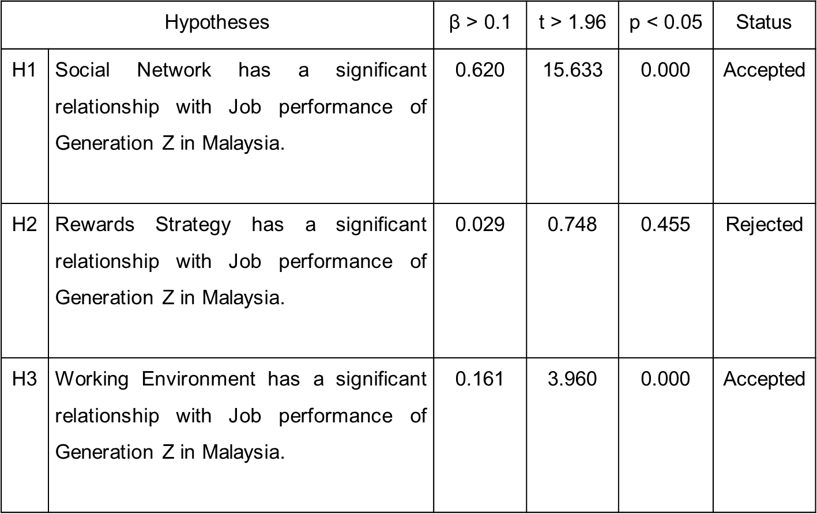

Table 8: Summary of Hypotheses Testing Result

### 4.5 SUMMARY

The reliability analysis was utilized in pilot test to examine the goodness of data in this chapter. Moreover, the characteristic of respondents was identified by demographic analysis. Besides that, the final data was utilized to analysis the reliability test, examine the relationship between independent variables with dependent variable and hypothesis. According to research findings, two hypotheses were accepted and one hypothesis was rejected after multiple regression analysis. Social network owns the most significant influence on job performance of Generation Z in Malaysia, followed by working environment and rewards strategy. Chapter five will summarize the results demonstrated by Chapter Four, discuss the key findings, future direction of research as well as recommendation for this study.

# CHAPTER 5

# CONCLUSION AND RECOMMENDATIONS

## 5.0 OVERVIEW

In this chapter, demographic analysis, reliability analysis and multiple regression analysis will be summarized by the data demonstrated in Chapter four. Hypotheses testing will answer the research questions in this study. Based on the context with present issues in Malaysia, the main findings will be discussed accordingly. In addition, the following section will present the contribution to the parties of academe and industry as well. Besides that, limitation of the research will also be mentioned where future direction of research is determined to resolve the restriction of the study. Lastly, a conclusion and researcher reflection will be the ending part of this study.

## 5.1 DISCUSSION IN FINDINGS

This study focuses on determining the factors which influencing job performance of Generation Z in Malaysia, where social network, working environment and rewards strategy were determined as constructs of independent for evaluating respondents' perception on job performance in Malaysia. Hypotheses was utilized to respond the questions of this study and acquire the objectives of this study which has mentioned in Chapter Two. Table 8 is the summary of hypotheses testing result of this study and the result will be presented in Chapter Four by using the methods of data analysis to presented which had discussed in Chapter Three. This section will provide discussion which is comprehensive and critical towards every research objective of this research and then answering the research questions with the current literature and researches' views.

RO1: To determine the relationship between social network and job performance of Generation Z in Malaysia

RQ1: What is the relationship between social network and job performance of Generation Z in Malaysia?

RO1 is proposed to determine whether social network and job performance of Generation Z in Malaysia has relationship. Referring to Table 8 - Summary of Hypotheses Testing Result, Hypothesis 1 was supported by the result of statistical in the research which mean there is a significant relationship between social network and job performance of Generation Z in Malaysia.

Barrick, Mount (1991) and Judge (2001) argued that social network will influence job performance which how well an employee performs his or her job. social network have enriched organizations and enabled a multitude of uses and capabilities from creating new business models and marketing techniques, to improving demand predictions, enabling new management practices and learning practices, and enhancing innovation, knowledge sharing, collaboration and communication ([Aral et al., 2013](https://www.sciencedirect.com/science/article/pii/S0963868715000190" \l "b0040), [Bughin and Chui, 2013](https://www.sciencedirect.com/science/article/pii/S0963868715000190" \l "b0110), [Urquhart and Vaast, 2012](https://www.sciencedirect.com/science/article/pii/S0963868715000190" \l "b0780)).

Therefore, there is a significant relationship between social network and job performance of Generation Z in Malaysia.

RO2: To assess the relationship between rewards strategy and job performance of Generation Z in Malaysia.

RQ2: What is the relationship between rewards strategy and job performance of Generation Z in Malaysia?

RO2 is proposed to estimate whether rewards strategy and job performance of Generation Z in Malaysia has relationship. Referring to Table 8 - Summary of Hypotheses Testing Result, Hypothesis 2 was not supported by the result of statistical in the research which mean there is no significant relationship between rewards strategy and job performance of Generation Z in Malaysia.

Employers have to offer attractive packages to entertain employee for their self-determination. It becomes trend to award employees with attractive packages for better performer (Sumita, 2004). It becomes trend to award employees with attractive packages for better performer (Sumita, 2004). Low level job satisfaction can lead to poor performance in organization. Inequality occurs when there is no proper distribution of reward system in this way the employee performance will be low.

Other researchers stated that there is relationship between rewards strategy and job performance, but the result of this study is there is no relationship between these two item. More works has to be done in future to estimate the reason why the relationship between job performance of generation Z and rewards strategy is not supported.

RO3: To estimate the relationship between working environment and job performance of Generation Z in Malaysia.

RQ3: What is the relationship between working environment and job performance of Generation Z in Malaysia?

RO3 is proposed to estimate whether working environment and job performance of Generation Z in Malaysia has relationship. Referring to Table 8 - Summary of Hypotheses Testing Result, Hypothesis 2 was supported by the result of statistical in the research which mean there is no significant relationship between working environment and job performance of Generation Z in Malaysia.

Different factors within the working environment such as wages, working hours, autonomy given to employees, organizational structure and communication between employees & management may affect job satisfaction (Lane, Esser, Holte, & Anne, 2010). Petterson (1998) argued that the interaction between employees within a business is crucial for accomplishing the organizational goals. Further he describes that the communication of information must be properly done in a timely manner so that the operations of the business are running smoothly. If there is a clash between co-workers then it is difficult to achieve the objectives of organization. Baah and Amoako (2011) described that the motivational factors (the nature of work, the sense of achievement from their work, the recognition, the responsibility that is granted to them, and opportunities for personal growth and advancement) in working environment helps employees to find their worth with respect to value given to them by organization.

Therefore, there is a significant relationship between working environment and job performance of Generation Z in Malaysia.

## 5.3 CONTRIBUTIONS

### 5.3.1 Contribution to Academy

This study is filling the literature gap where narrow down the gap into the context of Malaysia to evaluate factors of influence job performance of Generation Z in Malaysia. Some of the researchers ([Susana](https://www.sciencedirect.com/science/article/pii/S1877042815000385" \l "!), 2015 and Rana, 2019) had been done in Malaysia to discuss about the factors affecting job performance. However, this research is focused to studying on a specific context which is job performance of Generation Z in Malaysia.

According to the result of this study, the findings able to provide academicians to obtain the knowledge and information about significant relationship between independent variables and dependents variable where social network, working environment, and rewards strategy and job performance of Generation Z in Malaysia. Moreover, this study's result also useful and may serve as a reference frame to the academicians whom intend to research further and deeply about related studies. As recently many academicians are much focused in the area of general generation, thus this study will provide in-depth knowledge of understanding about job performance of Generation Z in Malaysia.

### 5.3.2 Contribution to Industry

This study aims to obtain an in-depth analysis regarding the job performance of Generation Z in Malaysia. Referring to the result of data analysis, working environment and social network indicates the relationship which is significant to influence job performance of Generation Z in Malaysia. This finding able to provide the organizations to know-well which factor is influencing employees who are Generation Z. Social network is the factor which influenced the most in this study, followed by working environment. Social network is indispensable part of their lives and they expect the organization to support and allow them to communicate, edit documents and work without limitation of geographies and time different (Harris, K, 2020). According to the study of Schroth (2019), they prefer working environments that foster mentoring relationships, learning and career development opportunities. Therefore, the organization can adjust their management style to increase employee performance effectiveness.

Moreover, managers or superiors of industry in Malaysia are able to gain a better and effective plan on enhancing the significance dimensions to obtain best result and return to base on the result of this study. This significant of study also helps the companies to be aware that working environment and social network are the major factors which influence job performance of Generation Z in Malaysia to strength the organization structure and culture for attracting more new generation talents to join.

## 5.4 FUTURE RESEARCH

A convenient sampling of survey will be carried out in this study by distributing online questionnaire via social media to the customers in Malaysia due to time restraint. This is one of the limitations of this study. Future research shall include interview survey due to qualitative survey able to have better understanding on target population perception as well as obtain higher accuracy of data when having communication with the respondents. Other than that, longitudinal study is recommended to include in future research due to data is obtained real-time which will be more accurate than cross sectional. This is because people are easy to make mistake and the structure of longitudinal study able to format restrict the mistake (Boxall and Steeneveld, 1999). Data of longitudinal study also able to utilize to execute essential changes that an action's course which may need to adopt in order to identify better result.

Moreover, this study is carried out in the area which within Negeri Sembilan which the findings and data of this study might not accurate and comprehensive to described, judged and represented the whole Malaysians' perception for branded sport shoes. According to Beckmann and Zenker (2013), a employees persecution may different from one another, even both people are come from same city and country under the same generation. Besides that, Therefore, future research shall cover more geographical area across Malaysia to have more balance of respondents which come from different background to determine whether general perceptions are consistent with the current study.

## 5.5 CONCLUSION

The purpose of this study is to find out the factors which has influence job performance of Generation Z in Malaysia such as social network, working environment and rewards strategy. The findings of this study indicated that factor of social network and working environment had significant relationship on influencing job performance of Generation Z in Malaysia. Social Network is discovered which own the strongest predictor of influence on job performance of Generation Z in Malaysia. In contrast, rewards strategy doesn’t have enough testimony to support has the significant relationship with job performance of Generation Z in Malaysia. From the contributions, understanding the factors which has influence job performance of Generation Z in Malaysia is important which bring a lot of advantages for academy and industry. The future research has been identified the limitation of this study which able researchers to carry out more in-depth research on similar topic in future. It is essential to keep on researching on the factor of influence on job performance of Generation Z in Malaysia due to the independent variables in this research is a general item which can be divided to more detail item like salary, job safety, promote opportunities and so on.

## 5.6 PERSONAL REFLECTION

This MBA project is a very good studying experience and this project also growing me up as well as enhancing my professional knowledge. In this fast-changing business environment, market research plays a significant role in future business development. Market research involving an overview which is detailed and comprehensive on current business environment and analyzes the possible environment of internal and external which able integrated with industry operation. Moreover, this study is collected primary data via online survey question where it is valuable and useful for academy as well as industry. Furthermore, this study is improved time management on self-discipline. This project was conduct in a time-frame which is short while as a part time student this is a challenge due to need to manage time properly between work and study. The meeting minutes and project schedule were assisting to completed each of the section on time and meet up with supervisor every week such as reminded what is the next step to complete this project and allowed us to keep on track what we had discussed before. Lastly, there is very thankful and appreciated to my supervisor who provide patient and supportive during guided and discussion session.

# REFERENCE

[Acheampong, N, A](https://search.proquest.com/indexinglinkhandler/sng/au/Acheampong,+Nana+Amma/$N). (2019). Recruiting and Retaining Generation Z into Public Sector Organizations: A Systematic Review - ProQuest. [online] Available at: https://search.proquest.com/openview/f7edd5a46dd27972f2f455684293ffd8/1?pq-origsite=gscholar&cbl=18750&diss=y [Accessed 7 Aug. 2020].

Adecco. (2015). Generation Z vs. millennials. Retrieved from <https://www.adeccousa.com/employers/resources/generation-z-vs-millennialsinfographic/>

Agarwal, H. and Vaghela, P. (2019). Work Values Of Gen Z:Bridging The Gap To The Next Generation. [online] ResearchGate. Available at: <https://www.researchgate.net/publication/334400459_WORK_VALUES_OF_GEN_ZBridging_the_Gap_to_the_Next_Generat> [Accessed 12 Jul. 2020].

Ajzen, I., 1985. From intentions to actions: A theory of planned behavior. In J. Kuhl & J. Beckmann (Eds.). Action control: From cognition to behavior. New York: Springer-Verlag.

Aksoy, L., Donkers, B., Kumar, V., Tillmans, S., Wiesel, T. and Venkatesan, R. (2010). ‘Undervalued or Overvalued Customers: Capturing Total Customer Engagement Value’. Journal of Service Research. 13(3), pp. 297-310

Al Shbail, M. O. (2018). The Associations of Internal Audit Quality with Job Burnout and Job Satisfaction Based on Theory of Reasoned Action. International Journal of Academic Research in Accounting, Finance and Management Sciences, 8(2), 208-217.

Alkassim, R.S., Etikan, I., and Musa, S.A. (2016). Comparison of Convenience Sampling and Purposive Sampling. American Journal of Theoretical and Applied Statistics, 5(1), pp.1-4.

Alzyoud, A. (2018). The Influence of Human Resource Management Practices on Employee Work Engagement. Foundations of Management, 10(1), pp.251-256.

Arar, T., & Yüksel, I. (2017). How to manage Generation Z in business life. Journal of Global Economics Management and Business Research, 4(4), 195-202. Retrieved from https://www.researchgate.net/publication/282506391_How_to_manage_Generation_Z_in _Business_Life

Babbie, E.R. (2013) The Basics of Social Research. South Melbourne: Cengage Learning.

Babin, B. J., Carr, J. C., Griffin, M. and Zikmund, W. G. (2013). Business Research Methods. 9th ed. New York: South-Western/Cengage Learning

Bell, E., Bryman, A. and Harley, B., (2018). Business Research Methods. Oxford University Press

Berge, Z. L., & Berge, m. B. (2019). The Economic ABCs of Educating and Training Generations X, Y, and Z. Performance Improvement,58(5),44–53.

Bernard, H. R. (2012). Social Research Methods: Qualitative and Quantitative Approaches. Sage.

Berry, L., Parasuraman, A. and Zeithalm, V. A. (1988). “SERVQUAL: A Multiple- item Scale for Measuring Consumer Perceptions of Service Quality”. Journal of Retailing, 64(1), pp. 12-16.

Billah, U. and Khan, M.M. (2013). ‘Product Life Cycle Strategies in Emerging Markets: A Case Study from Pakistan’. Kuwait Chapter of Arabian Journal of Business and Management Review, 2(11) pp.92-115.

Bock, G. W., Zmud, R. W., Kim, Y. G., and Lee, J. N., 2005. Behavioral intention formation in knowledge sharing: Roles of extrinsic motivators, social-psychological forces, and business climate”', MIS Quarterly, vol.29, no.1, pp. 87-112

Bougie, R. and Sekaran, U. (2016). Research Methods for Business: A Skill Building Approach. 7th ed. New York: John Wiley and Sons.

Bougie, R. and Sekaran, U. (2016). Research Methods for Business: A Skill Building Approach. 7th ed. New York: John Wiley and Sons.

Bovis, B., Cardoso, L., Wright, R., & Gott, J. (2017). ‘Gender matters for generation Y’. Retrieved November, 17 2017, from <http://www.atkearney.com/gbpc/issue-papers-andperspectives/article//asset_publisher/3iSOlX7wDpJG/content/gender-matters-forgeneration-y/10192>

Chow, S. C., Lokhnygina, Y., Shao, J. and Wang, H. (2017) Sample Size Calculations in Clinical Research. Chapman and Hall/CRC.

Cislaghi, B. and Herse, L. (2018) ‘Theory and practice of social norms interventions: eight

Coccia, M., & Benati, I. (2018). A new taxonomy of rewards in public administration for management implications. Working Paper CNR-IRCES, 4(2), 1-16. Retrieved from <https://ssrn.com/abstract=3133029>

common pitfalls’. Globalisation and Health. 14(1) pp.83.

Connelly, L.M. (2014) ‘Ethical Considerations in Research Studies’. Medsurg Nursing, 23(1) pp.5

Cooper, D.R. and Schindler, P.S. (2013) Business Research Methods. 12th Edition. New York: McGraw-Hill Education.

Criteo (2018). Gen Z Report Based on the Criteo Shopper Story. Criteo. Retrieved from <https://www.criteo.com/wp-content/uploads/2018/05/GenZ-Report.pdf>.

Darina, C. (2019). An Exploratory Study of Reward Management Systems; Millennial's vs Generation Z. A Qualitative Study. pp. 5-7.

De Waal, A. and Jansen, P. (2013). The bonus as hygiene factor: the role of reward systems in the high performance organization. Evidence-based HRM: a Global Forum for Empirical Scholarship, 1(1), pp. 41-59.

Desai, S. P., & Lele, V. (2019). Correlating Internet, Social Networks and Workplace - a Case of Generation Z Students.JournalofCommerce&ManagementThought,8(4),802–815.

Desjardins, F. (2019). Meet Generation Z: The newest member to the workforce. Visual Capitalist. Retrieved from <https://www.visualcapitalist.com/meet-generation-z-thenewest-member-to-the-workforce/>

Dimock, M. (2019). Defining generations: Where millennials end and Generation Z begins. Pew Research Center, 17, 1-7. Retrieved from <http://tonysilva.com/eslefl/miscstudent/downloadpagearticles/defgenerations-pew.pdf>

Dool, R. (2019). How Gen Z wants to be led (1st ed.). Columbia, SC: Richard Dool

Dwivedula, R., Singh, P., and Azaran, M. (2019). Gen Z: Where are we now, and future pathways. Journal of HUmAN RESOURCE mANAGEmENT, [online] XXII. Available at: https://www.jhrm.eu/wp-content/uploads/2019/12/HRM-02-2019-03-clanok.pdf [Accessed 7 Aug. 2020].

Elliott, K.C. and Resnik, D.B. (2016) The Ethical Challenges of Socially Responsible Science. Accountability in research, 23(1) pp. 31-46.

Erbasi, M. N. & Arat, B.A. (2012). ‘Modeling the enablers of organizational commitment’. Business Process Management Journal, 20 (1): 25-46.

Eze, U. C., Tan, C. and Yeo, A. L. (2012) ‘Purchasing Cosmetic Products: A Preliminary Perspective of Gen-Y’. Contemporary Management Research, 8(1), pp. 51-59.

Ferreira, J. C. and Patino, C. M. (2016) ‘What is The Importance of Calculating Sample Size?’. Journal of Bras Pneumol. 42(2), pp. 162.

Ferri-Reed, J. (2010). ‘The keys to engaging Millennials’. Journal for Quality & Participation, 33(1), 31-33.

Fishbein, M., & Ajzen, I. (1980). Belief, attitude, intention, and behavior: An introduction to theory and research.

Fister Gale, S. (2020). Forget millennials: Are you ready for Generation Z? Chief Learning Officer. Retrieved from https://scholar.google.com/scholar?hl=en&as_sdt=0%2C6&q=Forget+Millenials%3A+A re+you+ready+for+Generation+Z&btnG=

Garbers, Y. and Konradt, U. (2013). The effect of financial incentives on performance: A quantitative review of individual and team-based financial incentives. Journal of Occupational and Organizational Psychology, 87(1), pp.102-137

Gelbart N, Komninos J. (2012) Who? where? Y? Charter J, 84(7), pp. 20–23.

Gidengil, C. Parker, A. and Zikumund-Fisher, B. J. (2012) ‘Trends in Risk Perceptions and Vaccination Intentions: A Longitudinal Study of the First Year of the H1N1 Pandemic’. American Journal of Public Health 102(4), pp. 671-678.

Grow, J.m.,&Yang, S.(2018).Generation Z Enters the Advertising Workplace: Expectations Through a Gendered Lens. Journal of Advertising Education,22(1),7–22.

Hakim, C. (2012) Research Design: Succesful Designs for Social Economics Research. New York: Routledge.

Harris, K. (2020). ‘A New Generation of Workers: Preparing for Generation Z in the Workplace’, Senior Theses, pp. 1–32.

Harris, K. (2020). Scholar Commons Scholar Commons A New Generation of Workers: Preparing for Generation Z in the A New Generation of Workers: Preparing for Generation Z in the Workplace Workplace. [online] Available at: https://scholarcommons.sc.edu/cgi/viewcontent.cgi?article=1338&context=senior_theses [Accessed 7 Aug. 2020].

Hassan, Z. A., Mazza, D. and Schattner, P. (2006). ‘Doing a Pilot Study: Why is it Essential?” Malaysian Family Physician: The Official Journal of the Academy of Family Physicians of Malaysia. 1(2-3), pp. 70

Hee, O.C. and Rhung, L.X. (2019). Motivation and Employee Retention among Millennials in Malaysia. International Journal of Academic Research in Business and Social Sciences, 9(2).

https://www.researchgate.net/publication/323951724_Theory_and_Practice_of_Social_Norms Interventions_Eight_Common_Pitfalls [ Accessed: 11th July, 2020].

Iorgulescu, M. C. (2016). Generation Z and its perception of work. Cross-Cultural Management Journal, 18(1), pp. 47-54. Retrieved from <https://www.ceeol.com/search/article-detail?id=531928>

Ivanova, OE & Ryabinina, EV. (2019). ‘Assessing work values of Generation Z representatives and their impact on a person’s organizational behaviour’, Revista ESPACIOS, vol. 40, no. 18.

Jang, M., 2020. A Study Of The Effect On Organizational Factors On Job Satisfaction Of Geriatric Practitioners Between Millennials And Older Generations. [online] Digitalcommons.acu.edu. Available at: <https://digitalcommons.acu.edu/cgi/viewcontent.cgi?article=1109&context=etd> [Accessed 22 November 2020].

Kirchmayer, Z. and Fratričová, J. (2017). On the Verge of Generation Z: Career Expectations of Current University Students, Education Excellence and Innovation Management through Vision 2020, IBIMA, Vienna, 1575-1583.

Kotlar, J. and Massis, A. D. (2014) ‘The Case Study Method in Family Business Research: Guidelines for Qualitative Scholarship’. Journal of Family Business Strategy, 5(1), pp. 15-29

Krejcie, R.V. and Morgan, D.W., (1970). Determining Sample Size for Research Activities. Educational and Psychological measurement, 30(3), pp.607-610.

Krithikadatta, J. and Valarmathi, S. (2012) ‘Research Methodology in Dentistry: Part II—The Relevance of Statistics in Research’. Journal of Conservative Dentistry: JCD. 15(3), pp. 206.

Krugman, P. R., Obstfeld, M. and Melitz, M. J. (2012). International Economics: Theory and Policy. 9th edn. Harlow. Pearson.

Kupperschmidt, B. (2000). Multigenerational employees: Strategies for effective management. The Health Care Manager, 19(1), 65-76. doi:10.1097/00126450-200019010-00011

Lanier, K., (2017), ‘5 things HR professionals need to know about Generation Z’, Strategic HR Review, 16(6), pp. 288-290.

Lazanyi, K. and Bilan, Y. (2017), ‘Generation Z on the Labour Market – Do They Trust Others Within Their Workplace?’, Polish Journal of Management Studies, 16(1), pp. 78-93.

Lyons, S. and Kuron, L. (2014), ‘Generational differences in the workplace: A review of the veidence and directions for future research’, Journal of Organizational Behavior, 35(1), pp. 139-157.

Manstead, A. S. (2011). The benefits of a critical stance: A reflection on past papers on the theories of reasoned action and planned behaviour. British Journal of Social Psychology, 50(3), 366-373.

Maxwell, J. A., (2012) ‘Qualitative Research Design: An Interactive Approach’. Sage Publications. 41 [Online] Available at: https://books.google.com/books?hl=en&lr=&id=xAHCOmtAZd0C&oi=fnd&pg=PR 5&dq=Qualitative+Research+Design:+An+Interactive+Approach&ots=Y1DNvlxehZ& sig=13sxVsEWxrPyD9uHM3VtQetMfRc [Accessed: 1st Aug 2019].

McCrindle, M. (2014), The ABC of XYZ: Understanding the Global Generations, 3rd ed., McCrindle Research, Bella Vista.

Meret et. al. (2018). The Digital Employee Experience: Discovering Generation Z. Digital Social network and Organizational Change, pp.241-256

Michelle, D. (2019). Motivation and Learning for the Generation Z Learner in Higher Education - ProQuest. [online] Available at: https://search.proquest.com/openview/7180fa47db99667e710e228107f009cb/1?pq-origsite=gscholar&cbl=18750&diss=y [Accessed 7 Aug. 2020].

Mishra, D., Akman, I., & Mishra, A. (2014). Theory of reasoned action application for green information social network acceptance. Computers in human behavior, 36, 29-40.

Mohajan, H. (2018). Two Criteria for Good Measurements in Research: Validity and Reliability. Annals of Spiru Haret University. 17(3), pp. 58-82

Mourougan, S. and Sethuraman, K. (2017) ‘Hypothesis Development and Testing’. Journal of Business and Management. 19(5), pp. 34-40.

Norkaew, C., (2017). Positive Factors Affecting Satisfaction toward Sportswear Department Store A of Customers in Bangkok. Master of Business Administration dissertation, The Graduate School of Bangkok University

Osborne, S. and Hammoud, M. (2017). Effective Employee Engagement in the Workplace. International Journal of Applied Management and Social network, [online] 16(1), pp.50–67. Available at: <https://scholarworks.waldenu.edu/cgi/viewcontent.cgi?article=1239&context=ijamt>.

Ozkan, M., & Solma, B. (2015). **The changing face of the employees: generation Z and their perceptions of work (a study applied to university students).** pp. 476-483

Paine, H. (2014). ‘Measurement, design, and analysis: An integrated analysis’. Open University Press. 3rd Edition.

Pang, J.Y, Shakur, M.M.A., Siali, F. and Ya’kob, S.A., (2016). Relationship Between Brand Equity and Consumer Purchase Decision: A Case of An International Brand of Footwear. International Journal of Service Management and Sustainability, 1(1), pp. 58-75.

Parry, E., & Urwin, P. (2011), ‘Generational Differences in Work Values: A Review of Theory and Evidence’, International Journal of Management Reviews, 13(1), pp. 79–96.

Peersman, G. (2014). Overview: Data Collection and Analysis Methods in Impact Evaluation. Florence: UNICEF Office of Research.

Pires, C. (2017). Analysis of how companies should prepare to recruit and manage Generation Z (Unpublished Bachelor Thesis). Bryant University, Rhode Island. Retrieved from https://digitalcommons.bryant.edu/cgi/viewcontent.cgi?referer=https://scholar.google.co m/&httpsredir=1&article=1021&context=honors_management

Quinlan, C. (2011) Business Research Methods. 1st ed. Hampshire: Cengage Learning EMEA.

Ralla, M. (2014) ‘Testing of Hypothesis Parametric Test (T, Z, F) Chi-Square’. Scholarly Research Journal for Humanity Science and English Language, 1(5).

Ravikiran, D, Poonam, S, & Mehran, A. (2019). ‘Gen Z: Where are we now, and future pathways’, Journal of Human Resource Management, vol.XXII, no. 2453-7683.

ResearchGate. (2018). (PDF) The characteristics of Generation Z. [online] Available at: https://www.researchgate.net/publication/328564137_The_characteristics_of_Generation_Z [Accessed 12 Jul. 2020].

ResearchGate. (2019). (PDF) Understanding The Attitude Of Generation Z Towards Workplace. [online] Available at: <https://www.researchgate.net/publication/331346456_UNDERSTANDING_THE_ATTITUDE_OF_GENERATION_Z_TOWARDS_W>[Accessed 12 Jul. 2020].

ResearchGate. (2019). (PDF) UNDERSTANDING THE ATTITUDE OF GENERATION Z TOWARDS WORKPLACE. [online] Available at: <https://www.researchgate.net/publication/331346456_UNDERSTANDING_THE_ATTITUDE_OF_GENERATION_Z_TOWARDS_W>

Richard, F. (2018), “[Millennials Are the Largest Generation in the U.S. Labor Force](https://www.pewresearch.org/fact-tank/2018/04/11/millennials-largest-generation-us-labor-force/),” Pew Research Center Fact Tank.

Robbins, S.P. and Judge T.A (2013). ‘Organizational Behavior’. Pearson Education, Inc, Prentice Hall.

Roblek, V., Meško, M., Dimovski, V. and Peterlin, J., (2018), ‘Smart technologies as social innovation and complex social issues of the Z generation’.

Saunders, M.N.K. and Tosey, P. (2015). Handbook of Research Methods on Human Resource Management. Cheltenham: Edward Elgar.

Schroth, H. (2019). Are You Ready For Gen Z In The Workplace? California Management Review, 61(3), pp.5–18.

Seemiller, C. and Grace, M. (2017). Generation Z: Educating and Engaging the Next Generation of Students. About Campus, 22(3), pp.21–26.

Sharil, M, Mahbob, N & Baharudin, N. (2018). ‘Overview Of “Generation Z” Behavioural Characteristic And Its Effect Towards Hostel Facility’, International Journal of Real Estate Studies, vol. 11, p. 2017.

Sidorcuka, I. and Chesnovicka, A. (2017), ‘Methods of Attraction and Retention of Generation Z Staff’, CBU International Conference Proceedings, Prague, 5(2017), pp. 807-814.

Singh, A. P., & Dangmei, J. (2016). Understanding the Generation Z: The future workforce. South-Asian Journal of Multidisciplinary Studies (SAJMS), 3(3), 2349-7858. Retrieved from https://www.researchgate.net/publication/305280948_UNDERSTANDING_THE_GENE RATION_Z_THE_FUTURE_WORKFORCE

Smith, K. (2010). ‘Work-life balance perspectives of marketing professionals in generation Y’. Services Marketing Quarterly, 31 (4): 434-447.

Solnet,D., Baum, T., & Robinson, R. L. (2016). What about the workers? Roles and skills for employees in hotels of the future., 22 (3), pp. 212-226

Steinmetz, S., Toepoel, V. and Vehovar, V. (2016). Non-probability Sampling. The Sage Handbook of Survey Methods. pp. 329-345.

Suslova, A & Holopainen, L (2019). Job Satisfaction and Employee Motivation: Case Generation Z, Bachelor of Business Administration, pp. 30.

Tapscott, D. (2009). Grown up digital, how the Net Generation is changing your world. McGraw-Hill Professional, New York, NY.

Taufek, F., Zulkifle, Z. and Sharif, M. (2016). Sustainability in Employment: Reward System and Work Engagement. Procedia Economics and Finance, 35, pp.699-704.

Terry, D. J., Gallois, C., & McCamish, M. (1993). The theory of reasoned action: Its application to AIDS-preventive behavior: Psychology Press.

Tulgan, B. (2013). Meet Generation Z: The second generation within the giant “Millennial” Cohort [White paper]. New Haven: CT: Rainmaker Thinking. Retrieved from <https://grupespsichoterapija.lt/wp-content/uploads/2017/09/Gen-Z-Whitepaper.pdf>

Twenge, J. (2010). ‘A Review of the Empirical Evidence on Generational Differences in Work Attitudes’. J Bus Psychology, 25, 201-210. <http://dx.doi.org/10.1007/s10869-010-9165-6>.

Twenge, J., & Campbell, S. (2008). ‘Generational differences in psychological traits and their impact on the workplace’. Journal of Managerial Psychology, 23(8), 862-877. <http://dx.doi.org/10.1108/02683940810904367>

Uprichard, E. (2013). Sampling: Bridging Probability and Non-probability Designs. International Journal of Social Research Methodology, 16(1), pp. 1-11.

Vitelar, A. (2019). Like Me: Generation Z and the Use of Social Media for Personal Branding. Management Dynamics in the Knowledge Economy, 7(2), pp.257–268

Wahyuni, D. (2012). The Research Design Maze: Understanding Paradigms, Cases, Methods and Methodologies. Journal of Applied Management Accounting Research, 10(1), pp. 69-80.

Weakliem, D.L. (2016). Hypothesis Testing and Model Selection in the Social Sciences. 1st Edn. New York: Guilford Press

William, A.N. (2010). ‘Innovative reward systems for the changing work place’. McGraw-Hill, Inc.

World at Work. (2015). The worldatwork handbook of compensation, benefits and total rewards. Hoboken, N.J.: Wiley.

Xander, L., Nije Bijvank, M., Matthijs, B.P., Blomme, R. & Schalk, R. (2012), ‘Different or alike?’, International Journal of Contemporary Hospitality Management, 24(4), pp. 553-573.

Yeewen. T., Rajendran, M, & Aiping, T. (2018). Factors Influencing Job Satisfaction: A Perspective of Millennials in Malaysia Multinational (MNC) Companies. Global Business and Management Research: An International Journal.

Yzer, M. C. (2013). Reasoned action theory. The SAGE handbook of persuasion: Developments in theory and practice, 2, 120-136.

Zapier Editorial Team. (2020). Misunderstood generations: what Millennials and Gen Z actually think about work. Zapier. Retrieved from <https://zapier.com/blog/digital-natives-report/>

Zapier. (2020). Misunderstood generations: what Millennials and Gen Z actually think about work, Zapier.

Zikmund, W., Griffin, M., Babin, B., Carr, J. and Carr, B., 2013. *Business Research Method*. [online] Research Gate. Available at: <https://www.researchgate.net/publication/225083519_Business_Research_Method> [Accessed 8 November 2020].

Zuzana, K & Jana, F. (2018). (PDF) What Motivates Generation Z at Work? Insights into Motivation Drivers of Business Students in Slovakia. [online] Available at: https://www.researchgate.net/publication/324797364_What_Motivates_Generation_Z_at_Work_Insights_into_Motivation_Drivers_of_Business_Students_in_Slovakia [Accessed 8 Aug. 2020].

# APPENDIX I – Questionnaire

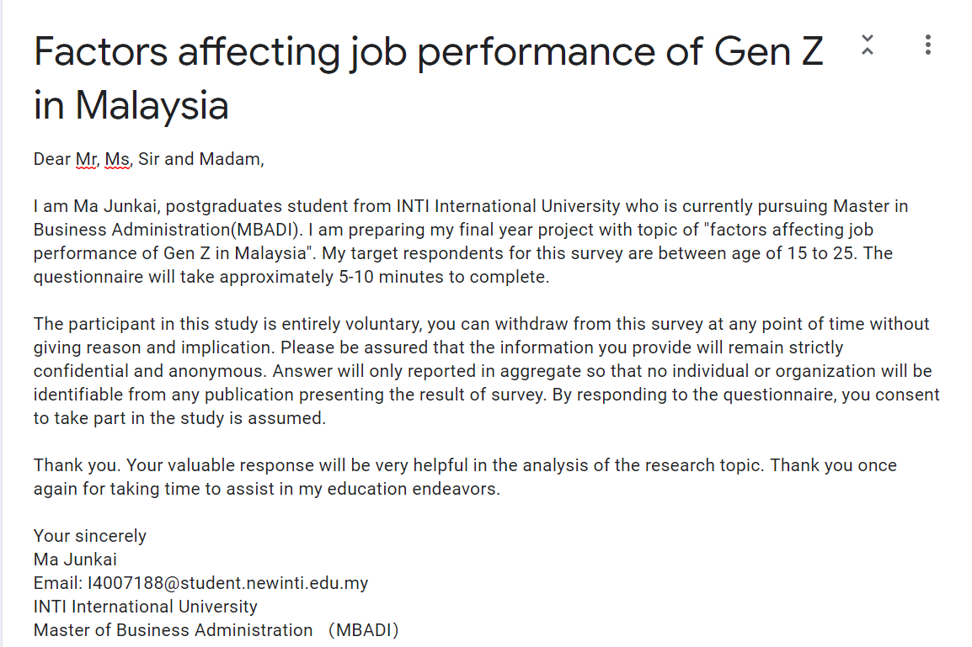

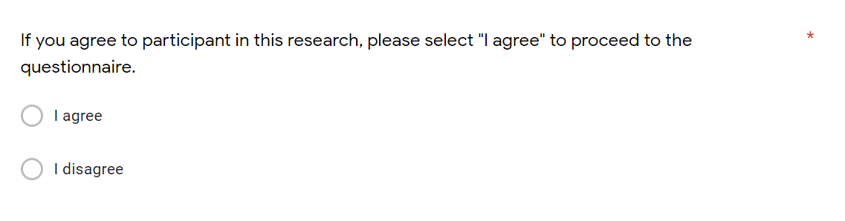

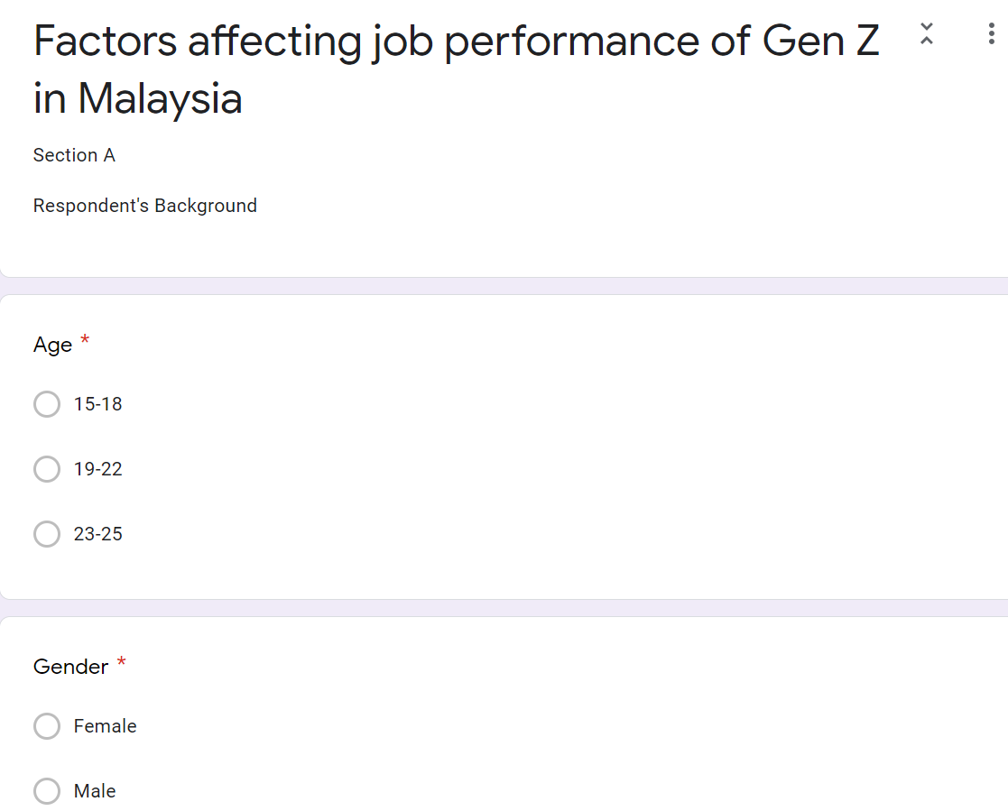





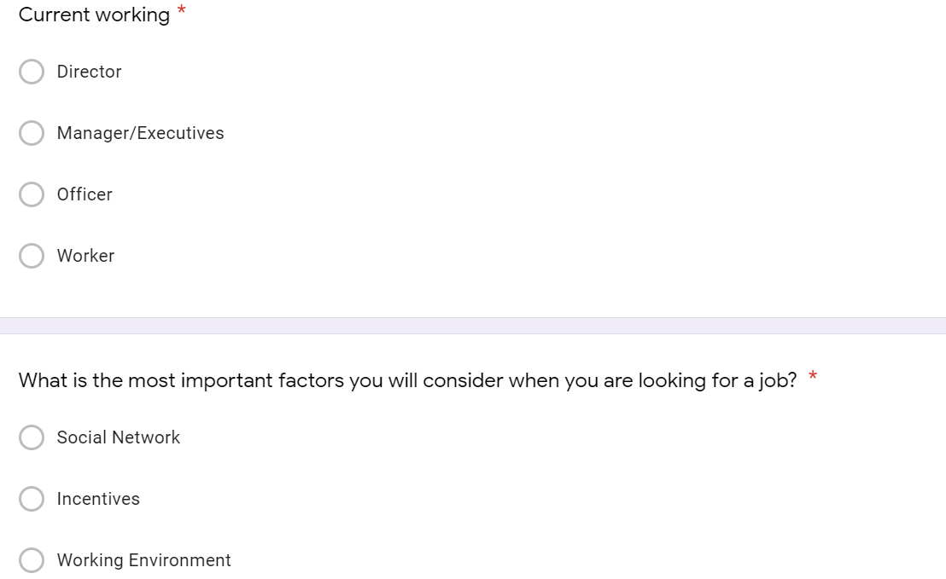

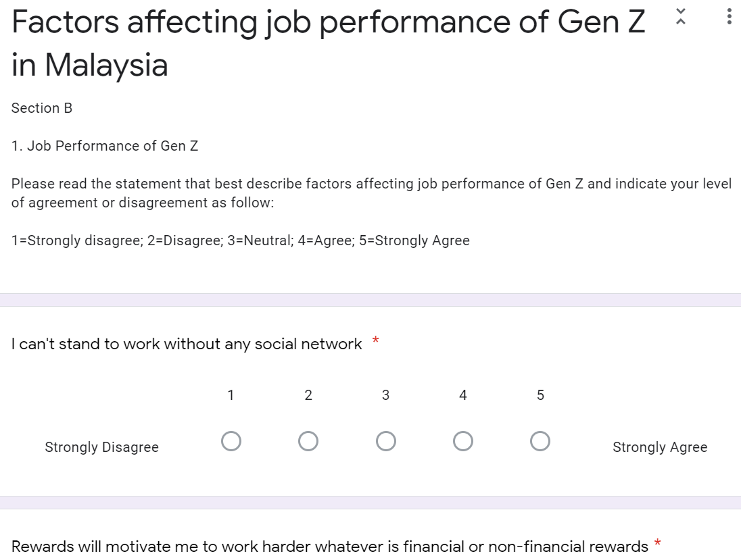

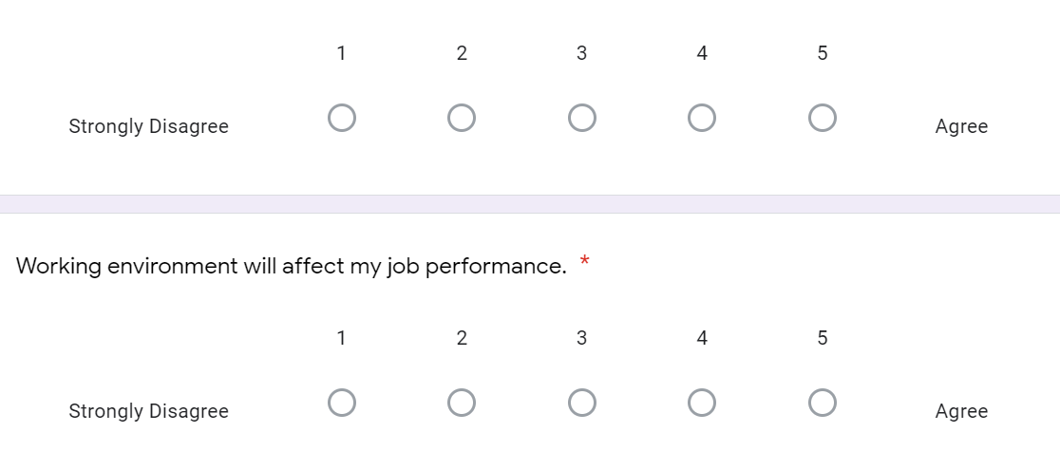

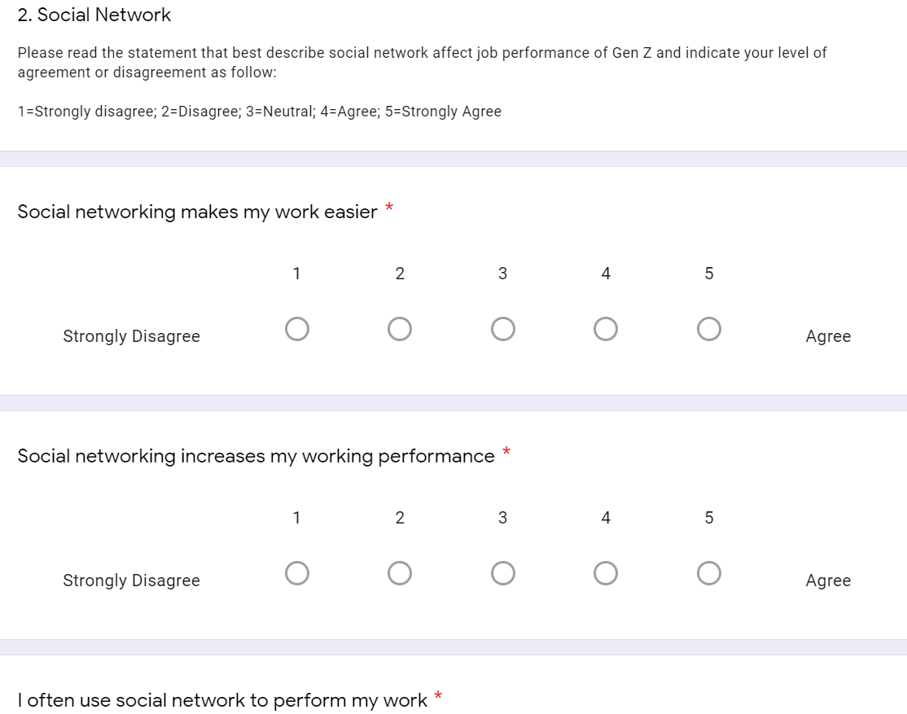



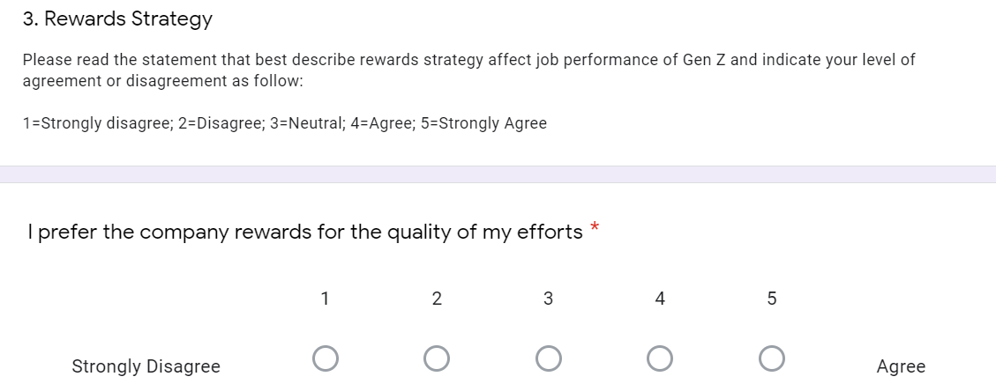

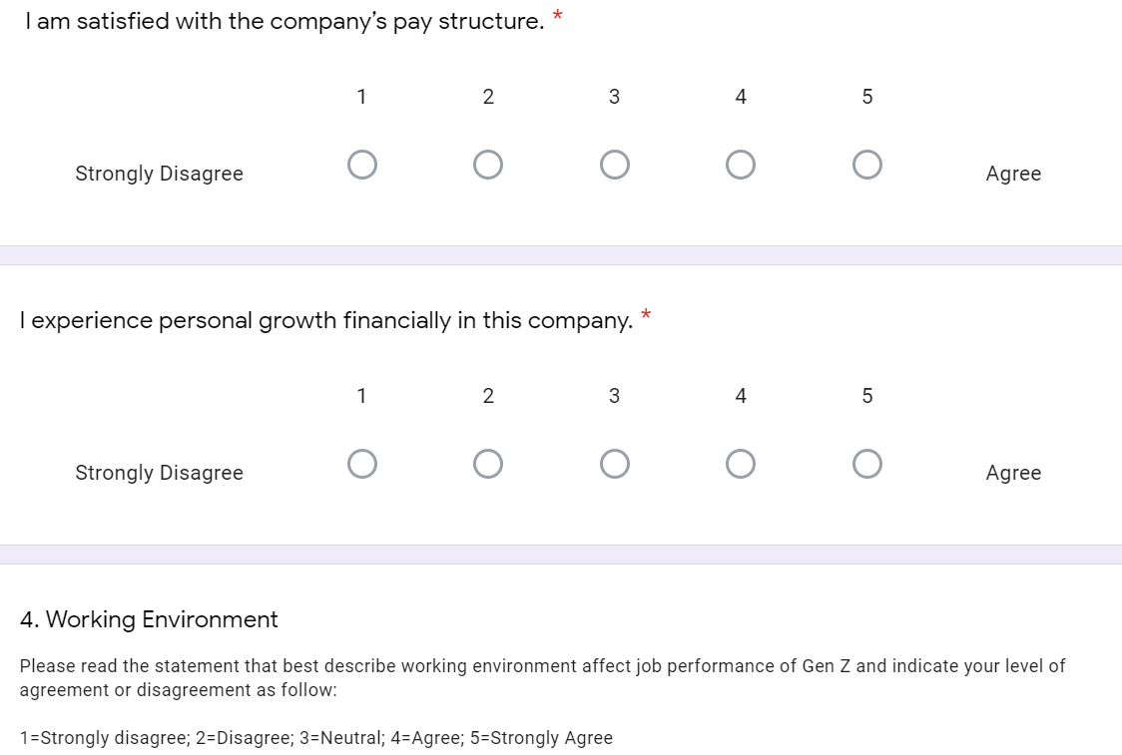

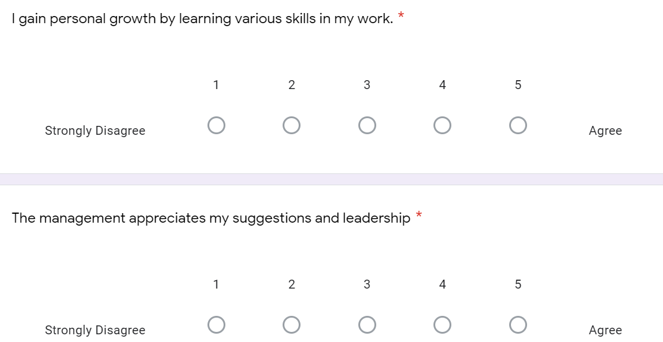



2.1 Age (0-15, 15-18, 19-22, 23-25)

2.2 Gender (Female, Male)

2.3 Income Level (Below-RM2500, 2501-4000, 4001-5500, 5501-above)

2.4 Education Level (Under Bachelor Degree, Bachelor Degree, Master Degree, Other)

2.5 Occupation (Student, Employee, Professional, Self Employed)

2.6 What is the most important factors you will consider when you are looking for a job? (Social network, Incentives, working environment)

**Section B (Dependent Variable – Working behavior)**

2.1 I can’t stand to work without any social networking.

2.2 Rewards can make me happy whatever is financial or non-financial rewards

2.3 I prefer more to work with flexible hours.

**Section C (Independent Variable – Social network)**

3.1 Social network has positive influence to your work

3.2 Social network has negative influence to your work

3.3 Social network does not have any influence to your work

**Section D (Independent Variable – Rewards strategy)**

4.1 Rewards will motivate you to work harder

4.2 I prefer more on working recognition rather than cash bonus

4.3 I don’t care about rewards

**Section E (Independent Variable – Working environment)**

5.1 I prefer to work with flexible working hours

5.2 I prefer to work in a security environment

5.3 I prefer to work in a company with opportunities for advancement