
Program: MBA-LS
MGT7998 MBA PROJECT
Research Topic: Factors Influencing the Acceptance of E-learning & teaching in Malaysian Higher Education Industry

Name: Ufra Khan
ID: I19018069
Intake: September 2020
Supervisor: Dr. Sam Toong Hai
Submission Date: 21st December 2020
Word Count: 22983

Acknowledgements

I would like to thank Dr. Sam Toong Hai for his guidance and time throughout this business project. He has provided helpful and constructive comments for me to complete my project on time. Furthermore, I want to thank my fellow MBA-LS scholars who are willing to share their knowledge, skills and experience in my research project. Lastly, I would want to thank all the respondents who’ve answered my questionnaire with total honesty in order for me to complete this project successfully.

Table of Contents
Abstract 7
Chapter I: Introduction 1
1.1 Background 1
1.2 Problem Statement 3
1.3 Research Objective 5
1.4 Research Questions 5
1.5 Significance of the study 6
1.6 Scope of the Study 6
1.7 Ethical consideration 7
Chapter II: Literature Review 10
2.0 Overview 10
2.1 E-learning and teaching 10
2.1.1 Definitions of E-Learning and teaching 10
2.1.2 Types of E-Learning 12
2.1.2.1 Fully Online learning 12
2.1.2.2 Hybrid learning 12
2.1.2.3 Web-assisted mode 13
2.1.3 Forms of E-Learning and its tools 13
2.1.3.1 Synchronous Learning and Its Tools 13
2.1.3.2 Asynchronous Learning and Its Tools 16
2.1.4 Challenges and Success of E-Learning 18
2.1.5 E-learning and teaching Market growth in Malaysia 19
2.1.5.1 Rising Government Education Programs 19
2.1.5.2 ICT enhancements 20
2.1.5.3 Increasing standards of universities 20
2.1.6 E-learning Readiness in Malaysia 20
2.1.7 Individual Factors influencing E-learning and teaching performance 21
2.1.7.1 Learning styles 21
2.1.7.2 Computer self-efficacy 22
2.1.7.3 Learning motivation 22
2.1.7.4 Previous experience 22
2.2 Factors Influencing acceptance of E-learning and teaching 23
2.2.1 Facilitating conditions 23
2.2.1.1 Definition of Facilitating Conditions 23
2.2.1.2 Importance of Facilitating Conditions to students 23
2.2.1.3 Importance of Facilitating Conditions to lecturers 24
2.2.1.4 Influence of Facilitating Conditions on E-learning and teaching 24
2.2.2 Effort expectancy 25
2.2.2.1 Definition of Effort expectancy 25
2.2.2.2 Influence of Effort expectancy on E-learning and teaching performance 25
2.2.2.2.1 Approach towards E-learning and teaching technology 25
2.2.2.2.2 E-learning and teaching applications experience 26
2.2.2.2.3 Output of e-learning and teaching system 26
2.2.3 Technology acceptance 26
2.2.3.1 Definition of Technology Acceptance 26
2.2.3.2 Importance of Technology Acceptance in E-learning and teaching 27
2.3 Significance of Academia 28
2.4 Significance of Education Industry 28
2.5 Gaps In literature 28
2.6 Unified Theory of Acceptance and Use of Technology (UTAUT) 29
2.7 Conceptual Framework 31
2.8 Hypothesis 31
2.9 Conclusion 32
Chapter III: Research Methodology 33
3.0 Overview 33
3.1 Research design 33
3.2 Unit of Analysis and Time Horizon 35
3.2.1 Unit of Analysis 35
3.2.2 Time Horizon 35
3.3 Sampling Design and Sampling Plan 35
3.3.1 Study Population and Sampling Technique 35
3.3.2 Sample Size 36
3.4 Data Collection Method 37
3.5 Questionnaire Design 38
3.6 Pilot test 39
3.6.1 Pilot Test: Factor Analysis 40
3.6.2 Pilot Test: Reliability Test 40
3.7 Data Analysis 41
3.7.1 Descriptive Data 41
3.7.2 Preliminary Test 41
3.7.2.1 Factor Analysis 42
3.7.2.2 Reliability Test 42
3.7.3 Hypothesis Testing 42
3.7.3.1 Multiple Regression Analysis 42
3.7.3.2 One-way ANOVA 43
3.7.3.3 Multi-Collinearity 43
3.7.3.4 Beta Coefficient 43
3.8 Conclusion 44
Chapter 4: Data Analysis and Interpretation 45
4.0 Overview 45
4.1 PILOT TEST 45
4.1.1 Factor Analysis Results 46
4.1.1.1 KMO and Bartlett’s Test for Sphericity 46
4.1.1.2 Factor Loadings 47
4.1.1.3 Eigen Values 49
4.1.1.4 Reliability Analysis Results 52
4.1.5 Conclusion of Pilot Test 53
4.2 Response rate 53
4.3 Demographic profile of respondents 54
4.3.1 Gender 54
4.3.2 Age 55
4.3.3 Profession 55
4.3.4 Type of university 56
4.3.5 Study Mode 56
4.3.6 Education Level 57
4.3.7 Domain of Study 57
4.4 Preliminary Testing 58
4.4.1 Factor Analysis (Dependent Variable) 58
4.4.2 Factor Analysis (Independent Variable) 61
4.4.3 Reliability Test 64
4.4.4 Hypothesis Testing 65
4.4.4.1 Multiple Regression Analysis 66
4.4.5 Multicollinearity 69
4.5 Summary of Findings 70
4.6 Conclusion 71
Chapter 5 Research Finding, Conclusion and Recommendation 72
5.0 Overview 72
5.1 Discussion 72
5.2 Recommendations 75
5.3 Contributions 77
5.3.1 Contribution to Academia 77
5.3.2 Contribution to Industry 78
5.4 Limitations of Research 78
5.5 Future Research Direction 79
5.6 Personal Reflection 79
5.7 Conclusion 80
References 82
APPENCIX A 93
FACTORS INFLUENCING ADOPTION OF E-LEARNING & TEACHING IN MALAYSIA HIGHER EDUCATION INDUSTRY 93
APPENDIX B 98
Plagiarism Report 98
APPENDIX C 99
PD Slides 99
APPENDIX D 109
Viva slides 109
Appendix E 125
MBA Project Log 125

Abstract
E-learning & teaching have become an integral part of Malaysian Higher Education Industry, for providing high quality education and to make universities competitive. This cross-sectional study will study Factors Influencing the Acceptance of E-learning & teaching in Malaysian Higher Education Industry. The factors Facilitating Conditions, Effort Expectancy and Technology Acceptance will be studied as the independent variables. Data is collected from 325 respondents through online questionnaire. The data is statistically analysed using SPSS software version 26. In this research, it is found that there are significant relationships between Acceptance of E-learning & teaching and Facilitating Conditions (p-value = 0.000), Effort Expectancy (p-value=0.000) and Technology Acceptance (p-value=0.000). Facilitating Conditions is the dominant factor influencing Acceptance of E-learning & teaching followed by Effort Expectancy and Technology Acceptance. This research can help Educational industry to further understand on factors influencing Acceptance of E-learning & teaching in Malaysian Higher Education Industry and accordingly implement strategies and design new online courses.
Keywords: E-learning & teaching, Facilitating Conditions, Effort Expectancy and Technology Acceptance.

Chapter I: Introduction
1.0 Overview
Chapter 1 consist of an explanation about the background of E-learning and teaching and factors influencing its acceptance in Malaysia Higher Education Industry. We will discuss the reasons for the selection of the research topic. Research objectives and research questions will be explicitly mentioned in this chapter. Definitions of E-learning and teaching, Facilitating Conditions, Effort Expectancy and Technology Acceptance are discussed at the end of Chapter 1.

1.1 Background
E-learning and teaching refers to online learning that focuses on technologically supported learning and training courses (Amado-Salvatierra et al., 2016). This style of education offers a virtual platform for students to engage in diverse events. This provides study and audio-visual engagement with a wide range of topics. In addition, e-learning presents students and teachers with the ability to connect. To recognize major improvements in e-learning policies, educational institutions and higher education must promote access to these digital e-learning courses (AL-RAHMI et al., 2018).
As modern technologies are an important part of our lives, our way of accessing information has changed profoundly. The development of ICTs has contributed to major reforms in all forms of education, from the nursery to the tertiary stage. In 1998 e-learning was developed in Malaysia and higher education institutions became the first ones to follow the idea of web-based teaching and learning. Due to the availability of ICT tools, resources and staff (Hwa, Hwei and Peck, 2016; Mohamad et al., 2005). Many of the universities (HEIs) are expanding in order to address the needs of students in this emerging online field, where educationists have brought ICT instruments into the education process by being increasingly IT-friendly into what is called a learning management framework (LMS) (Al-Busaidi and Al-Shihi, 2010).
Furthermore, 4,207,588,157 or 55.1% of Asian people were able to access internet on a regular basis during the last year as well as 62% of Asia-Pacific residents adapting to digitalization. Malaysian figures have indicated a large rise in e-learning users between the years 2004 and 2016 from 2,9 million to five million. With this high growth and rising trend in internet and network use, more industries use the internet as a part of their marketing (Low et al., 2020). In South East Asia, Malaysia contributes substantial sales to the smart learning and education sector. Taken by the major digital economy and the Fourth Industrial Revolution, the overall Malaysian online education industry is projected to rise at a growth rate of 16.4% by 2023. Over the forecast timeframe, the mobile e-learning sector could dominate the industry. The segment has an estimated 35 % market share by the end of 2023 as internet penetration is increased (FARID, 2020). Moreover, online video platforms have increased their profit hugely in 2020, like Zoom streaming video lecture programme had a profit growth of 78% and a survey from Google Meet shows that users' traffic grew 60%, with people spending 2 billion minutes meeting on-line daily (Junusi, 2020).
Higher education is an important economic field because it contributes to science and information. Digital education is now a must for higher education institutions. Malaysia has the highest Internet literacy rates and is very much part of this rising trend. With the interest of the MOHE (Ministry of Higher Ministry), it has put in place a number of online markets to encourage Malaysian higher education to draw more and more foreign students. Accordingly, 77% of the regular internet users in Malaysia are aged between 16 and 24 years old and 66.6% between 35 and 44 years of age. Hence, we can see that e-learning and teaching is in demand. Research reveals that 68.0% of the papers written on online education in the last 8 years demonstrated the advancement of digital marketing (Irfan et al., 2018). The incorporation of emerging technology and business processes in a digital environment is described as digital transformation (Sayabek, Suieubayeva and Utegenove, 2020). The implementation of digital transformation enhances teaching in both virtual and real-world classrooms with the enhancement of technology. Online learning in higher education include the renovation of college facilities and the refurbishment of higher education operational structures (Kuzu, 2019).
To recognize the acceptance of students and lecturers for an e-learning and teaching platform is a critical concern for enhancing the application and influence of e-learning. Therefore, this research aims to frame a Unified Theory on Acceptance and Use of Technology (UTAUT) to investigate how Facilitating Conditions, Effort expectancy and Technology Acceptance Influence the Acceptance of E-learning and teaching in Malaysia Higher Education industry (Hwa, Hwei and Peck, 2016).

1.2 Problem Statement
The COVID-19 pandemic declared by UNESCO of 26 March 2020 triggers 1.5 billion students from more than 165 states not to attend school. Malaysia is among 165 countries that have shut down schools because of the pandemic. School vacation in Malaysia was extended to 3 weeks in March after school holidays (Wan, 2020). As this pandemic outbreak of Covid-19 has brought a huge change to the lifestyle of the people, as its spread has put a halt to the physical movement of people. Moreover, it has directly hit the operations of the education Industry, as for the sake of following the precautions universities have banned face-to-face classes (Omar, Ishak and Jusoh, 2020). COVID-19 revealed a large gap between students and lecturer in online learning. A student needs facilities and information about digital platforms to learn online through such platforms. There are concerns in urban communities that children must share computers and that they cannot take full advantage of online learning because of poor internet or the lack of digital knowledge (Wan, 2020). However, digital transformation due to poor facilities is low in rural and remote areas including the villages of the Orang Asal on the Peninsular, Sabah and Sarawak (Yee, 2020).
Moreover, lack of digital preparedness in the education system. This problem impacts most countries worldwide that want to move learning from lessons to online. Most teachers are not technologically competent and have to adapt to e-learning. It is also necessary to explore the role of digital marketing to assist in coping with this "new normal" so that universities can respond to digitalization (Wan 2020). As any other business, the lack of Digital preparedness would throw colleges and universities under financial strain. There is alarming evidence of economic development in the higher education market. The Asia-Sentinel study conducted in early April 2020 by former Deputy Vice Chancellor Professor Geoffrey Williams of Tun Rasak University found that 55% of Malaysia's private high schools were losing business and about 44% were financially insolvent (Yee, 2020). It is clearly visible that universities in order to survive and be competent need to adapt technologically and understand the factors that influence the acceptance of e-learning technology (Hwa, Hwei and Peck, 2016).
Not only there are obstacles to the introduction and use of modern technologies but also in implementing it in education industry. The right voice on current channels in the social media and the ability to reply fast, consistently and in the right way can be a major factor for student recruitment activities. However, several universities do not know how to make effective use of these facilities and what the requisite checks are. This also results in unnecessarily complex social media permissions, disinclining researchers and staff with unusual or fascinating opinions (Obaid, Abdaljawad and Abumandil, 2020). Furthermore, according to Yee (2020) Admission of international students may also decrease as government regulation over foreign inflows to deter imports of COVID-19 events. The financial balance of the institutions is eventually being more squeezed. Non-important activities such as workshops, conferences and invites by foreign speakers are possibly cancelled. Owing to such problems Universities need to prepared with online learning and teaching platforms with appropriate facilities in order to attract students for online programs (Hwa, Hwei and Peck, 2016).
In response to the huge change towards technology, many universities create unique plans, but they do not have the imagination, capability or facilities to execute them successfully. This ensures that certain institutions then aggressively invest in IT programmers that do not produce the desired rewards and efficiency (Hwa, Hwei and Peck, 2016). These colleges do not realise that they don't need a digital strategy – just a digitalize education. An implementation strategy for the entire University, led by management with help from several departments, and not just IT, is important to remain vital throughout the digital period (Obaid, Abdaljawad and Abumandil, 2020). We need to analyse the factors affecting the acceptance of E-learning and teaching in Malaysian education Industry to help universities to be success full in their online programs (Buheji and Ahmed, 2020).

1.3 Research Objective
The main objective of this research is to understand the Factors Influencing the Acceptance of E-learning & teaching in Malaysian Higher Education Industry in order to allow universities to continue their programs and student to continue their studies we will determine. By developing and finding out the factors influencing E-learning and teaching in this industry this research will enables the institutions to understand the importance of digital platforms and the factors that can help education industry to understand how Facilitating Conditions, Effort Expectancy and Technology Acceptance Influencing the Acceptance of E-learning & teaching in Malaysian Higher Education Industry. Consequently, Universities can be more competitive and successful and enable them to faster adopt the e-learning & teaching to improve country economic as Education Industry contributes largely to Malaysia economy

RO1: To determine whether “Facilitating Conditions” has significant influence on the Acceptance of E-learning & teaching In Malaysian Higher Education Industry.
RO2: To determine whether “Effort Expectancy” has significant influence on the Acceptance of E-learning & teaching In Malaysian Higher Education Industry.
RO3: To determine whether “Technology acceptance” has significant influence on the Acceptance of E-learning & teaching In Malaysian Higher Education Industry.

1.4 Research Questions
RQ1: Does “Facilitating Conditions” has significant influence on the Acceptance of E-learning & teaching In Malaysian Higher Education Industry?

RQ2: Does “Effort Expectancy” has significant influence on the Acceptance of E-learning & teaching In Malaysian Higher Education Industry?

RQ3: Does “Technology acceptance” has significant influence on the Acceptance of E-learning & teaching In Malaysian Higher Education Industry?

1.5 Significance of the study
This research will be beneficial and significant to the education Industry. This research paper will help Universities to understand the Factors Influencing the Acceptance of E-learning & teaching in Malaysian Higher Education Industry and effectively device facilities for E-learning and teaching to provide quality learning to students. This paper will help them to understand what will be the influence of Facilitating conditions, Effort expectancy and Technology Acceptance on student and lecturer’s intention to accept E-learning and teaching. This paper can be effectively used by other researchers, they can use these Data analysis to interpret their results in the field of E-learning and teaching. This research will help any future research as benchmark in the related field. Further, this study will encourage the use of E-learning and teaching in the education industry by providing statistical evidence for its positive impact on quality learning. Which will further improve the Universities learning programs and help become competitive, which will help boost the economy of Malaysia. As the upcoming generation (Youth) is more into digitalization and prefer online activities, hence it will guide the universities on how to capture the new market. Universities will know the effectiveness of e-learning & teaching and the factors that that influencing the acceptance of E-learning & teaching that will allow them to design effect online programs that suits the needs and wants of the customers.

1.6 Scope of the Study

To achieve the objectives listed in the paper, strategically the research will be undertaken to look into the Factors Influencing the Acceptance of E-learning & teaching in Malaysian Higher Education Industry, from the universities point of view and its challenges and future scope of acceptance. From the available research paper present it can be seen that there are various studies conducted on E-learning and teaching benefits, but there is no such study undertaken which can help the universities to understand the Factors Influencing the Acceptance of E-learning & teaching as well as how to enhance their online learning programs. The main aim of the universities is to provide effective learning, for which digitalization plays the main role hence by collecting data from the lecturers and students about their intension and reason to accepts, fresh insights can be listed about the factors influencing the acceptance of e-learning and teaching. As well as the student’s acceptance of this technology, to have a better understanding of the stages of individual acceptance this study uses Unified Theory of Acceptance and Use of Technology (UTAUT) theory.

1.7 Ethical consideration

Personal information and details will be confidential that is the dissertation will be done with the findings and consent of participants will be obtained report would not deceive any participant. The data obtained from participants will be protected. Respect of people’s feelings and dignity will be maintained. Work of any writers will be acknowledged by references. Full responsibility will be taken that upon the completion of work there will be no harm to the respondents personally or professionally. Privacy protection of the respondent and the information they shared will be the first priority. Required & assured secrecy will be kept of the data provided by the participants while presenting the results of data analysis.

1.8 Operational Terms
Key Terms | Definitions
E-learning and teaching | Electronic Learning which is also known as e-learning or E-learning and teaching is defined in various ways by many studies. Such as- The use of computer networking technologies, particularly over the internet, to provide knowledge and guidance to individuals (Ong & Lai, 2006; Welsh et al., 2003). One more related concept is that e-learning is considered as a type of education which is supported by the internet and its technology and requires use of the World Wide Web (www) to encourage education and to provide material for courses (Masrom, 2007).
Facilitating Conditions | Facilitating conditions are defined as the extent to which a person believes that there are organizational Infrastructure and technological facilities are available for her/him to get guidance and help for system usage (Venkatesh et al., 2003; Venkatesh, Thong and Xu, 2016).
Effort Expectancy | Effort expectancy is the degree of ease associated with any system i.e., effort needed to use the system, whether it is simple or complicated (Venkatesh et al., 2003; Venkatesh, Thong and Xu, 2016).
Technology Acceptance | Intention of the user to use and continue the usage of certain technology. The acceptance of technology usually refers to the decision of a person to conduct a specific task using a technological method (Davis, 1989).
Table 1.1: Key terms

1.9 Organization of Chapters
This paper consists of five major chapters that illustrate this research paper's overall formation. Systematizing research is necessary to make research simple and transparent. Table 1.2 outlines the short overview of the 5 chapters.
Chapter | Aim of the Chapter
Chapter 1:  Introduction | This chapter addresses the background, problem statement, research objectives and research questions, scope and limitation of study and significance of this research. This chapter also comprises key terminology used in the study.
Chapter 2:  Literature Review | Chapter two starts with an overview of literature on the studied theory followed by a study of the independent variables in the literature. This chapter also reveals the UTAUT model basis of theory, Conceptual framework and Research Hypothesis.
Chapter 3:  Research Methodology | This chapter explores in depth how the researcher has used research methods, research design, methods, tools and techniques in data collection.
Chapter 4:  Research Findings | This chapter contains the analysis and interpretation of results. Results and observations of analysis are graphically portrayed to provide the readers with comprehension.
Chapter 5:  Conclusion and Recommendations | This chapter includes a description of the total study data analysis and the findings. Also discussed are key results and recommendations for further progress.
Table 1.2: Organization of Chapters

Chapter II: Literature Review

2.0 Overview

Chapter 2 will address dependent and independent variables. Acceptance of E-learning & teaching in Malaysia Higher education Industry is a dependent variable in this analysis. While the independent variable comprised of three Facilitating Conditions, Effort Expectancy and Technology acceptance. This section includes an extensive discussion on dependent and independent variables with the analysis of available secondary information. Data references are adapted from academic publications in the journal database, Google Scholars, and Research Gate. Unified Theory of Acceptance and Use of Technology (UTAUT) is applied in this research. After evaluating related scholarly papers and studies there are gaps in literature found for this study. The gaps found are the objective for the research as outlined in Chapter 2 which will be addressed in depth in Section 2.3. Conceptual framework is illustrated in section 2.5 to demonstrate the significance of Facilitating Conditions, Effort Expectancy and Technology acceptance have on Acceptance of E-learning & teaching in Malaysia Higher education Industry.

2.1 E-learning and teaching

2.1.1 Definitions of E-Learning and teaching
Electronic Learning which is also known as e-learning or E-learning and teaching is defined in various ways by many studies. Such as- The use of computer networking technologies, particularly over the internet, to provide knowledge and guidance to individuals (Mamattah, 2016; Ong & Lai, 2006; Welsh et al., 2003). One more related concept is that e-learning is considered as a type of education which is supported by the internet and its technology and requires use of the World Wide Web (www) to encourage education and to provide material for courses (Hung, Yu, Liou and Hsu, 2019).
The second sequence of definitions considers e-learning to be learning enabled and assisted by the use of ICT. E-learning can also be described as instruction given through the use of a computer to facilitate learning (Mamattah, 2016).
Thirdly, e-learning is described as the use of multimedia and internet technology to enhance learning quality of education by making resources available, facilities and virtual sharing and collaboration easier" (Latip et al., 2020).
It can be concluded that the definitions are centred on the method of implementation with which the scholars are aware of, for example, the authors who believe e-learning is achieved on the Internet their definitions focus in that area. Moreover, the author who believes that e-learning is provided through multimedia networks often represents this point of view – the first concept mentioned above centred on Internet learning (or online learning), the second on ICT-mediated or computer-mediated learning, and the third on multimedia and the Internet. From first sequence of researchers' views, it can be inferred that e-learning is a processing of education which is facilitated by the internet (online learning) (Hung, Yu, Liou and Hsu, 2019). According to the second series of definitions E-learning is demonstrated as education that can be accessed by ICT or computer. Simultaneously, the 3rd concept, contains both multimedia and the internet technology. Centred on these descriptions, it can be inferred that e-learning is an alternative to face-to-face/class learning. In addition, it can also be understood that e-Learning offers a way through different technologies – the internet, the multimedia technology and various other ICTs – to enhance the learning to gain education or facilitates for the establishment of education (Mamattah, 2016).
The definitions mentioned above are confined to the system and range of the teaching and learning used, so a wider definition is needed that is not confined to a specific system of distribution. Hence, E-learning is then defined as education access by different electronic media, including the internet, intranet sets, extranets and satellite TV, video/audio and/or CD-ROMs (Ünal, Alır and Soydal, 2014). Other concept is e-learning encourages five practises for teaching and learning with the use of ICTs (for example, internet, laptops, phones, radios, videos and others) (Masrom, 2007). It can be argued from these descriptions that e-learning is a generic or wide word used to characterize any method of learning, including internet as a platform for the advancement of education and training, with the use of one kind or another of electronic technology (Mamattah, 2016). Therefore, e-learning provides the ability to educate and learn, by resolving obstacles associated with the learner's time, space or geographical place. The concepts described above indicate that e-learning provides students and lecturers the ability to learn and teach from universities without being actually present in the same environment, in comparison with face-to-face learning, thereby allowing a greater number of people to be reached and trained (Zainab, Bhatti and Alshagawi, 2017).

2.1.2 Types of E-Learning
Electronic learning is classified in three distinct types: fully-online, mixed mode (also called hybrid or blended learning) and web-assisted (Mamattah, 2016).

2.1.2.1 Fully Online learning
Fully-online learning is where there are no direct interactions between the student and the lecturer in complete online instruction, it is done entirely on the Internet and its technology (Lateh and Raman, 2015). In the case with face- to-face learning that allows face-to-face contact between lecturers and students, this isn't the case with full-online. The teaching and learning resources as well as course requirements take such as assignment and exams are all completed online (Young, et al, 2008). In comparison, to face-to-face learning which is mostly guided by lecturers in their zone of proficiency, that is we can say its lecture-driven, in fully online the learning is self-directed and versatile in its design. Fully-online learning is also designed to fulfil students' desires, interests, learning preferences, talents and goals since it is self-directed (Buzzetto-More, 2015). Full online learning is asynchronous in nature, and asynchronous technologies are used to facilitate this form of education-which is further illustrated in detail the chapter.

2.1.2.2 Hybrid learning
Hybrid learning incorporates face-to-face communication as well as engagement with online learning, contrary to full-online learning (Tayebinik and Puteh, 2012). Any facets of studying can be done online during this kind of e-learning, although some sections are done face to face. For instance, during face-to-face sessions, instruction and evaluations are performed while tasks and presentations are made online. Hybrid learning is perhaps the trend of learning, which is expected to trigger a change in thinking in higher education in the coming years. It is also proposed that blended learning would include 80 to 90 % of all classes (Zawaideh, 2017). It is fair to argue that such education would improve face-to-face study and also encourage study courses to be thought by this method, involving realistic visibility (Mamattah, 2016).

2.1.2.3 Web-assisted mode
Final form of e-learning is web-assisted approach which uses synchronous tools, in which modules web sites and tools are used to improve education. Web-based instruction is almost the same as fully-online, except it involves online interactions and communication among students and lecturers. Online lectures and online communications among students and lecturers are carried out using synchronous tools, same as they are performed in the face-to-face, however these communications are not physical but are accessed online (Buzzetto-More, 2015). Key distinction between completely online and web-based education is that web-based support is synchronous and facilitates live interaction, whereas online learning is asynchronous type and does not authorise live interaction. Moreover, the contrast among hybrid and web-assisted learning is that while hybrid learning offers the potential for interaction between participants, there is a stronger benefit of physical communication, however there are no such physical encounters in Web-assisted applications (Mamattah, 2016).
Hybrid learning is considered a good strategy among e-learning styles (Tayebinik and Puteh, 2012), because it incorporates features of fully-online or web-based learning with standard classroom learning (Mamattah, 2016). In addition, participants can study some courses online during the Hybrid learning before the face-to-face meeting, which enables participants to have a good understanding of the subject to be addressed in class (Buzzetto-More, 2015). From the points mentioned above it can be inferred that, one thing is similar to all, regardless of the various interpretation and forms of e-learning – internet and technical resources are used for education with minimal or no face-to-face contact.

2.1.3 Forms of E-Learning and its tools
It is divided into two separate modes - synchronous and asynchronous, in addition to the types of e-learning accessible.

2.1.3.1 Synchronous Learning and Its Tools
This form of e-learning and teaching takes place in real time with a lecturer, who conducts live conversations and seminars in the education process with students. Indeed, students who attend class can be anywhere. Attendees join in at a given time and communicate directly with the teacher and the others (Kalpana, 2010). Electronic media that are able to reach individuals in various places at the same time help to promote this form of teaching and learning. Nevertheless, one of the key drawbacks of synchronous learning is that it requires same-time involvement, which accounts for interaction and presentation difficulties due to varying schedules and overlapping times zones (Obasa, 2010). In order to resolve the time variations problem, users need to identify the time zone variations and have an eye on the time variations to accommodate the timescales and enrol in the class. The electronic media which support synchronous learning and used by participants to build a total learning process are discussed below:
a) Audio conferencing: this is a communication between participants or between lecturers and students is in full detail. This medium helps you avoid wasting large sums for mobile calls. In order to make audio conferencing feasible, automated tool like Skype and other Voice over Web services can be used. This method allows voice conversation between learners and teachers, same as in the usual classroom (Obasa et. al., 2013).
b) Chat: It allows exchange of information in the form of text-and graphic. This allows students to ask questions during classes and gain real-time feedback. With the chat option, users need not wait for days to get guidance on any query they might ask via messages, but instead as in traditional classroom teaching, you can get an instant answer (Mamattah, 2016).
c) Instant messaging: These are brief messages transmitted by machine electronically. This platform enables to transfer instant messages and allows direct interaction among learners and teachers. Someone who is online when the message is delivered will have instant feedback option, but those who are not online can see the record and conversation of messages, when they log in next time and can provide feedback on the delivered messages later and add their comments (Obasa, 2010; Obasa et. al., 2013).
d) Video conferencing: Video conferencing facilitates real-time and traditional classroom collaboration among teachers and students. The students will experience their trainers live as in the traditional classroom through video conferencing. The chance to see the teacher in "video form" will build a sense of academia and connection (Kalpana, 2010; Mamattah, 2016).
e) Web conferencing: Instant transfer of presentations, documentation and programme tutorials is permitted in this system. Web-based conferencing systems enable students to present course assignments same like in standard classroom settings with fellow students and course professors (Efiloğlu-Kurt and Tingöy, 2017).
f) White boarding: As in the traditional classroom environment, white boarding resembles the method of writing or painting on a blackboard. The teachers can illustrate lessons and theories in written words with a mouse, or an electronic stylus with a phone. This tool enables participants in various places to get involved in constructive and cooperative conversations and suggestions in real time with the instructor. The teacher frequently advises and discusses challenges to the students with this method (Mamattah, 2016).
g) Application sharing: Participants from various places are able to work together on reports simultaneously. Students may collaborate on projects and presentations in teams with this service. Sharing an application happens where a web document like Google Doc operates in the same manner as Microsoft Word if formed and editing privileges are offered to all people interested in the learning process, allowing them to include suggestions in the file. As a result, students involved in the programme can modify and update the file provided (Lwoga and Komba, 2015). Application sharing helps students and other participants to bring forward their proposals and agree on the final result. The above-mentioned features enable teachers and students to achieve true life' experiences of the classroom such as having direct response on questions and collaboration in real time. By merging any of these apps –for instance, video conferencing, white boarding and chat, lecturers and students can experience traditional classroom events. The main distinction is that the participants do not have physical interaction (i.e., they do not share their learning space). But provided that synchronous learning requires no physical appearance, members came from all over the globe and at the same time more audiences can be approached (Efiloğlu-Kurt and Tingöy, 2017). Since these systems depend on technology, any breakdown in any aspect of the technical system may have a negative impact on the proper functioning of the module. A control measure is needed to make sure that technical problem disruptions are avoided in order to prevent such slowdowns. Attendees and program planners must brace themselves to resolve unpredictable issues and forecast obstacles in order to make the courses function successfully (Obasa et. al., 2013).

2.1.3.2 Asynchronous Learning and Its Tools
This way of learning requires independent or autonomous learning and provides more versatility than the synchronous way of learning. This versatility helps learners to train at their own space and at their own level (Hung, Yu, Liou and Hsu, 2019). Such way of learning connects learners to related resources rather than live, real-time teachers in comparison to synchronous learning (or traditional learning environments) (Kalpana, 2010). In order to have a more simple and effective learning process, asynchronous learning gives lecturers and students easy access to relevant tools and knowledge. The standard method used in this method of learning:
a) Databases: These are educational materials resources that are freely accessible to students and lecturers. This enables the continuous delivery by course instructors to be coordinated and managed by databases. This supports participants, who don't have time to review their work and who are not smart n several topics. A database enables the students to access freely accessible information for their research (Mamattah, 2016).
b) Document libraries: the work they've done at all time. Since asynchronous learning is an autonomous experience, students can theoretically have a really long gap during their research, but getting allowance to the document library facility ensures that they may 'stop' at a particular time and can resume their work later when they want. This versatility removes the necessity to go over what has been previously done (Obasa et. al., 2013).
c) E-books: Students and lecturers should use document libraries to enable the access to electronic books. which can be download and read them offline. E-books support various exercises of teaching and learning (El-Seoud et al., 2014). E-Books are similar as a physical book, but can be simply accessed everywhere and always and are freely downloaded online. This format reduces necessity at all times to hold many books. Sections of an e-book may be highlighted, labelled and outlined on pages with notes exactly like it is possible in physical book keep bookmarks (Hung, Yu, Liou and Hsu, 2019).
d) Forums: This encourages users to quickly interact and exchange ideas. This method also encourages students and lecturers to share issues and gain assistance and guidance from fellow students and lecturers (Salloum and Shaalan, 2018).
e) Messaging (e-mail): Allows course content to be shared by attendees. It gives a direct interaction among students and with lecturers. The only possible concern is that instant feedback is not guaranteed, as is the case with interacting and face-to-face teaching in the classroom (Mamattah, 2016).
f) Streaming audio: Audio streaming comes in the form of pre-recorded lessons, interview data or sound pictures that are important for the subject. Audio facilities are recorded and can be heard by students’ multiple times if necessary. One possible benefit of audio streaming is that the participant is able to repeat a recording various times until he/she understands the message/learning results (Hung, Yu, Liou and Hsu, 2019).
g) Streaming video: Like audio streaming, videos can be pre-recorded for participants as material that is significant to the study program (Obasa et. al., 2013). If approvals are right, the videos can be extracted and played repeatedly until the student knows the content in whole. This method also encourages teachers to explain their students' technological difficulties quickly (Hung, Yu, Liou and Hsu, 2019).
h) Web logs (Blogs): Web logs encourage suggestions and feedback to be circulated. Blogs are primarily used to convey information and announcements to students and lecturers in the same manner that a noticeboard would be used. The students can log in to their profiles and access the web logs in an asynchronous learning scenario in order to assess material updated (Lwoga and Komba, 2015).
I) Website links: This method provides a tool that guides visitors on external web sites for additional information. In this method students are most likely to be guided to links rather than uploading documents in the form of an e-book, video streaming or audio streaming in order to view the information that is put in to access them. The asynchronous learning resources mentioned above support people in various times zones. This is especially the case when learning is achieved at the optimal speed at your own time (Hrastinski, 2008). In comparison to synchronous practice – in which the participant must become active in accordance with the instructor's availability to lecture, students who are engaged in asynchronous practice learn on their own time schedule which is the main difference among these two learning forms (Lwoga and Komba, 2015).
With the aid of ICT and without physical presence of students/teachers in a same room, the usage of synchronous and asynchronous resources facilitates learning. In addition, students can determine which methods are better for themselves (Masa’deh et al., 2016). Students which are interested to communicate in real time with other students and teachers may wish to use synchronous learning better for themselves (Newland and Byles, 2014). whereas Students which are not willing to communicate in online with other students and teachers but only in gathering information may use asynchronous learning strategy that allows them to train at their own speed. Since various definitions, styles and even e-learning modes exist for students and lecturers, it is vital to study the factors that affect their acceptance to e-learning and teaching. In addition, except where specifically defined, e-learning is not used in this study to define any unique category or form, the word is used interchangeably to refer to all the e-learning styles and forms mentioned above (Efiloğlu-Kurt and Tingöy, 2017).

2.1.4 Challenges and Success of E-Learning
Unlike face-to-face learning, e-learning brings its own difficulties when education is provided through e-learning particularly when it is carried out independently of itself (full-line) involves a tremendous amount of intelligence and support in order to succeed (Ali and Magalhaes, 2008). This is because when students learn alone and at their own pace, they cannot be forced to work harder unlike a face-to-face education in which obligations are to be fulfilled (Di and Jaggars, 2014). As well as studying on its own creates – learning dissatisfaction, fear and uncertainty, particularly in full-line and Asynchronous learning (Schroeder, Minocha and Schneider, 2010). Hence it is important to study the factors that can influence the acceptance of e-learning and teaching and understand how can the challenges be resolved to provide successful learning and teaching process.
E-learning has several benefits firstly, providing the students with the freedom and ease to complete the lessons when they want them, ensuring that they can study from any part of the world without actually needing to be instructed and studied on the university campus (Sunkara and Kurra, 2017). Secondly, e-learning has educational benefits over conventional face-to-face learning because it makes it easier for students to incorporate ideas in practical ways using digital instruments in the course of learning activities. Third, e-learning allows graphics to be used to show principles and subjects that in conventional classrooms are difficult to convey, such that abstract theories and themes that could not be readily interpreted without such extra resources make teaching and learning simpler (Ali, Hossain and Ahmed, 2018). As can be seen above, e-learning can education in contrast to what can be done with only face-to-face learning.

2.1.5 E-learning and teaching Market growth in Malaysia
Malaysia is seen as one of the most competitive higher education markets in the world. Malaysia's government focuses on developing a system for education that strengthens the unique personality of students by offering specific education that students truly requires as well as is simple for online platform. Malaysia's Government works with the social and private universities to boost the readiness of students for higher education and the employment market (Ministry of Education Malaysia, 2018).
The Malaysian online learning markets due to the high government initiatives and growing smartphone and tablet users in the region are estimated to rise with 16.4% annual compound growth over the prevision period 2016-2023. Over the projected era, the sector of e-learning will dominate the market. By the end of 2023, the market is forecast at account 35% market share due to expanded internet penetration and rising domestic smartphone and tablet consumers (FARID, 2020).

2.1.5.1 Rising Government Education Programs
Malaysia's government spent extensively in education as RM 60 billion was budgeted for education segment. Initiatives such as 1BestariNet project, the MOOC project in Malaysia and The Frog Asia project (a project that links over 10,000 Malaysia schools through a central Internet to exchange E-learning content) show the Government is prepared to digitize, making E-learning available for all participants. Government ventures and tenders in the E-Learning and Education sector demonstrate that e-learning businesses in Malaysia have an optimistic tendency and will create strong competition from domestic and foreign universities (Ministry of Education Malaysia, 2018).

2.1.5.2 ICT enhancements

The Malaysian government has established 5 strategic guidelines, 12 sub-strategies and 30 ICT technology improvement projects for Malaysia, in its public sector ICT Strategic Plan 2016-2020. In addition, the technological services delivered by universities for e-learning will benefit from changes in ICT infrastructure, as access to LMS and streaming of e-learning material will increase and thus it is advantageous to more users to learn using e-learning resources (FARID, 2020).

2.1.5.3 Increasing standards of universities

The Malaysian special standardised higher education system gives you a chance to obtain an international degree at affordable rates, with over 30 years of experience in international education. Malaysia has over 100 universities including international branches from prestigious universities in the US the UK, Australia and Ireland. The above is offered in collaboration with a Malaysian university at their own campus overseas. You can select American, UK, Ireland or Australian, Malaysia-based, versatile and inexpensive academic qualifications (Malaysia Higher Education, 2020).

This rise influenced Malaysian e-learning as K-12; along with HEIs, this is a big source of growth for the material and resources of e-learning in Malaysia. As a marketing tactic, universities use e-learning to enrol and thus are willing to invest in e-learning technologies and materials (FARID, 2020).

2.1.6 E-learning Readiness in Malaysia
In the online education environment, quick utilization of mobile technologies is playing a crucial role in increasing the preparedness among students and lecturers. Students nowadays have better accessibility to the quality of their online education scheme, since they can devote more time during their learning journey, thereby further stimulating the readiness of the online education sector in Malaysia (Lateh and Raman, 2015). In order to improve the acceptance of new technology among younger generations and provide inexpensive and convenient education to resolve the lack of quality education, Malaysia's Government is taking various initiatives to encourage education through an online portal. Which are highly preparing participants to easily accept E-learning and teaching. Governments' strong policies are driving students to enter the higher education through online platform to promote the willingness among participants (Malaysia Higher Education, 2020).
New and successful regulations for the digitalization of schoolbooks and the promotion of an online learning portal are anticipated to increase the demand growth over the predicted timeframe by supplying the students of schools, colleges and universities with tablets and laptops. This initiative of providing facilities will highly prepare students and lecturers to get ready for E-Education (Tan, Goh and Chan, 2015). Online curriculum offers state-of-the-art graphics and emulation, making ideas simple to grasp. The growth of the online education industry in Malaysia is expected to further increase. However, there are still some challenges to be resolved such as the growing need for a highly developed IT infrastructure and shortage of academic personnel. Thus, we can say that Malaysian are still not fully ready to accept E-learning due to these challenges. Such factors can reduce the growth of the market during the forecast period (Zain et al., 2016).

Form the points stated above we can see that facilitating Conditions, Effort expectancy (easiness to use platform) a and technology acceptance are the main factors that the Malaysian government is working to improve the readiness and acceptance of online portals. Thus, it is important to explore the factors that can influence the acceptance of E-learning and teaching in Malaysia higher education Industry.

2.1.7 Individual Factors influencing E-learning and teaching performance
There are various factors that influence an individual’s E-learning and teaching performance directly. As these factors can act as a barrier for some people to accept E-learning and teaching while for some it can be an added advantage (Hung, Yu, Liou and Hsu, 2019). There are some factors discussed below:

2.1.7.1 Learning styles
Learning styles, derived from styles of thinking, were used to describe the role of the human thinking on initial stage learning outcomes (Hussein, 2018). Learning theory of learning and split the stage of learning into strong experience/random ideas, and consciously experimented/reflected and observed new, assimilating, converging and adapting learning models. That is, we can say each individual has it unique learning style and the extent to which an individual thinks E-learning and teaching is useful or interesting highly depends on his learning styles. Which ultimately affects his performance (Salloum and Shaalan, 2018).

2.1.7.2 Computer self-efficacy
Alqurashi, (2016) treated computer efficiency as the amount of confidence of people with computers. Computer self-efficacy has an impact on learning Exploring E-learning Effectiveness because E-learning and teaching is wholly based on technology as computers act a tool for this learning process. An individual who is more confident towards using computers have an added advantage in finding material online and accessing the E-platforms which in return improves their performance. On the other hand, people who lack confidence and are no self-efficient with computers find E-learning and teaching as a challenge (Chee, Ab-Jalil, Ma’rof, and Saad, 2020).

2.1.7.3 Learning motivation
Learning motivation is an internal mental construct that manages the activities of learners and also has a valuable impact on the results of learning. An individual who is motivated to learn and has goals for high standard of education will explore E-learning and teaching in order to add values to its education process. An individual who is highly motivated can explore this new technology and adapt to E-learning and teaching (Yoo, Han and Huang, 2012).

2.1.7.4 Previous experience
People prefer to balance new technology with their present experience or awareness. The level of expertise is determining the combination level, resulting in multiple activities, perceptions and intentions (Lateh and Raman, 2015). Therefore, the understanding of people on the use of information technology with or without prior experience and level of expertise influences E-learning and teaching performance. Furthermore, learning progress may be influenced by prior experience in E-learning and teaching system. In particular, if students have more experience, suitable learning techniques can be created. Consequently, for lecturers learning output is influenced by prior computer experience and web-based teaching experience (Punnoose, 2012).

2.2 Factors Influencing acceptance of E-learning and teaching

2.2.1 Facilitating conditions

2.2.1.1 Definition of Facilitating Conditions
Facilitating conditions are defined as the extent to which a person believes that there are organizational Infrastructure and technological facilities are available for her/him to get guidance and help for system usage (Venkatesh et al., 2003). In the context of this study, it referred to the extent to which a person sees that their university is providing technical resources and guidance to facilitate E-learning and teaching, which can influence the acceptance of E-learning and teaching. Venkatesh et al (2016) stated that there is a favourable connection between facilitating conditions and willingness to use and acceptance of technology. The association was therefore moderated with guidance and facilities which strengthened the acceptance of the E-platform. For this research if people are willing to use e-learning and teaching if they agree that the infrastructure, guidance and facilities are accessible to facilitate the use of the system (Catherine, Geofrey, Moya and Aballo, 2017).

2.2.1.2 Importance of Facilitating Conditions to students
Online learning materials built with guidance will have a positive effect on acceptance of online learning. For instance, Salloum and Shaalan, (2018) showed that the students strongly rate the importance of online education, though gaining a considerably support from the institution. As the environment and learning skills of online students are more complex, it is important to provide required facilities, support and guidance to help them benefit from this type of education system (Lateh and Raman, 2015).
Online students belong from different backgrounds, sometimes have difficulties with their learning environment, lack necessary skills and need encouragement to make use of the online platforms. This method of learning includes the use technologies such as computers and digital notebooks, apps, interactive whiteboards, digital cameras, mobiles, portable devices, electronic networking systems, like e-mail, message boards, virtual and video meeting rooms, virtual platforms for learning and control of learning environment. Hence it is important for the institutions to provide students with technical facilities and guidance to use the system to promote the seamless execution of the study Program and student’s acceptance toward e-education (Bakar, Zaidi and Abdul, 2014).

2.2.1.3 Importance of Facilitating Conditions to lecturers
E-learning and teaching platforms allow lecturers to connect domestically and internationally with students and to exchange information and create knowledge in a virtual world without physical meeting. In order to build improved and personal learning environment for learners they need adequate access to technology, facilities and services that facilitate their teaching needs. lecturers need ample of facilities for e-learning services to enable them to schedule, organise, exchange materials and communicate with the learners (Efiloğlu-Kurt and Tingöy, 2017).
Institution's technical assistance could help to increase E-learning and teaching use by lecturers and in turn, students e-learning potentials and a constructive approach to its use it. Having sufficient availability of adequate technical facilities for lecturers to access to e-Learning and teaching services can be a crucial factor in building confidence to use e-Learning and teaching (Ali, Hossain and Ahmed, 2018). If teachers are not relying or confident on their own abilities to use technologies, their implementation in their own classes or in university education in general would definitely be unable to help them. In turn increased use of e-learning by lecturers could lead to a greater use by learners (Yuen and Ma, 2008). Because lecturers have to attend huge number of students at a certain time as well as help them to use e-platforms for their course is it important to provide lecturers with appropriate facilities that can help to easily achieve the teaching objective. Moreover, adequate facilities and guidance for lecturers will help to improve the use of e-learning and teaching and to support the attainment of intermediate outcomes, such as learners understanding and independent study, especially because they require enough time to establish and integrate their use of e-learning in daily teaching practise (Bakar, Zaidi and Abdul, 2014).

2.2.1.4 Influence of Facilitating Conditions on E-learning and teaching
Facilitating conditions, addresses the idea that technology acceptance depends on the support provided to use technology when it is implemented and applied. That is, we can say that acceptance of E-learning and teaching by students and lecturers hugely depends on the facilities provided by universities (Sunkara and Kurra, 2017). The facilitating conditions is essential for the understanding of utility and the simplicity of user’s experience. Similarly, a favourable understanding of technologies is created with the support of institutions who are equipped to promote their application. These involve corporate and public institutions that are equipped to encourage the facilities of ICT and give educators and students opportunities to get acquainted with their different applications. Organizational assistance is a driving force for the use of E-learning and teaching (Bakar, Zaidi and Abdul, 2014).
The ability of students and lecturers to obtain and participate in e-learning and teaching at a university is determined, in turn, by support systems (facilitating conditions) such as adequate e-platforms, decent UCT facilities and sufficient instruction and transportation assistance (Ünal, Alır and Soydal, 2014).

2.2.2 Effort expectancy

2.2.2.1 Definition of Effort expectancy
Effort expectancy is the degree of ease associated with any system i.e., effort needed to use the system, whether it is simple or complicated (Venkatesh et al., (2003). Users can readily embrace and accept user-friendly technologies. Most users prefer technology which gives them versatility, flexibility and convenience. That is, we can say that acceptance of E-learning and teaching by students and lecturers hugely depends on the Effort needed to use the system. Effort expectancy is a critical factor in influencing the intention to use a system. In the current setting, Effort expectancy is referred to the extent students and lecturers that their e-learning platforms are simple and convenient to use (Catherine, Geofrey, Moya and Aballo, 2017). Venkatesh et al (2016) stated that there is a favourable connection between Effort expectancy and willingness to use and acceptance of technology. If the E-platform is Easy to use it will strengthen the acceptance of the E-learning and teaching. For this research if people are willing to use e-learning and teaching if they agree the E-platform provided by their university is easy to use (AL-RAHMI et al., 2018).

2.2.2.2 Influence of Effort expectancy on E-learning and teaching performance

2.2.2.2.1 Approach towards E-learning and teaching technology
Sunkara and Kurra, (2017) said that satisfaction with e-learning depends on students' and lecturers e-learning approach. And e-learning approach depends on how the students or lecturer feel about usage of E-platform. If the system is user-friendly it will influence more and more people and increase the willingness in them to accept the technology and have positive approach towards using e-learning and teaching. That is, we can say that Effort expectancy for a system highly influences its acceptance (Latip et al., 2020).

2.2.2.2.2 E-learning and teaching applications experience
In the sense of e-learning, students and lecturers may use e-platforms to access course resources and communicate among them. The desire or willingness of the learner to use the e-learning method is influenced by the perceived ease of use. Effort expectancy will influence the frequency and the efficacy and enjoyment of e-learning and teaching system. If users gain good experience from e-learning system it will in turn influence their intention of using it. As well as easy to use platform will enable them to explore the features of E-learning and teaching system and develop better understanding of concepts (Mamattah, 2016).

2.2.2.2.3 Output of e-learning and teaching system
Effort expectancy of e-learning and teaching platform plays a major role to assess learning output of the course. Effort expectancy of e-learning and teaching platform is to understand whether the learner acquires fundamental skills and understands essential problems of learning. If the users find it easy to use the system as well as his/her learning objectives are satisfied reflects that output of E-learning and teaching systems is achieved (AL-RAHMI et al., 2018).

2.2.3 Technology acceptance

2.2.3.1 Definition of Technology Acceptance
Intention of the user to use and continue the usage of certain technology. The acceptance of technology usually refers to the decision of a person to conduct a specific task using a technological method. Technology adoption in the sense of this study is a decision of a participant about his intention to use online education in everyday practises, including internet use, computers, web-based teaching and learning resources (Yuen and Ma, 2008). People who are extremely technologically acceptable will get a strong sense of e-learning and vice versa. One of the critical factors that impact e-learning and teaching success is the technology insecurity of the participants. Once they are dissatisfied, their intention to accept technology may personally be influenced by their interest in using this technology. Technology Acceptance has a positive connection and is critical for the intention of participants to use e-learning (Al-Rahmi et al., 2018). In relation to the intention for technology acceptance as a facilitator for the acceptance of e-learning by participants, there are lack or researches to study this relationship. The research is therefore critical to study the mediating impact of Technology acceptance on acceptance of e-learning and teaching (Latip et al., 2020).

2.2.3.2 Importance of Technology Acceptance in E-learning and teaching
The exponential development in technology/innovation focused on the Internet has contributed to a range of learning methods in diverse types of e-learning. Technology acceptance also complement or replace conventional approaches, which allow students to learn alongside or not via face-to-face distribution through various web technologies. E-learning is characterized by the Technology Acceptance of the participants and environments in which it operates (Asabere and Enguah, 2012). However, in this research, the use of e-learning technologies is used to provide students with knowledge through computer interfaces with interactions. The interest and approval of participants to accept technology is highly important for the successful or advanced programmes of E-learning and teaching; otherwise, acceptance of e-learning and teaching system will account to be very low. Many universities providing e-learning programmes have multiple obstacles in implementing efficient methods, including the acceptance and success of courses. This is particularly that participant is not wholly prepared to accept technology. In particular, the acceptance of e-learning technology by participants is considered the biggest step towards a stable e-learning environment (Zainab, Bhatti and Alshagawi, 2017).
Developers and administrators in universities must consider how students interpret and accept e-learning technologies and how a successful e-learning strategy can be employed in order to help improve the learning experience. In addition, analysis of the intentions of participants and analysis factors influencing the opinions of teachers regarding technology acceptance is important as it will help management build innovative approaches to draw more students and lecturers able to engage in e-learning programmes. Items that illustrate participants' approval, purpose and approach to accepting e-learning technology must be examined (Al- Adwan, Al- Adwan and Smedley, 2013).

2.3 Significance of Academia
Until today, limited study has been carried out on the Factors Influencing the Acceptance of E-learning & teaching in Malaysian Higher Education Industry. This research would allow UTAUT Theory to be applicable on factors that may affect the acceptance of E-learning and teaching. This research will then fill the identified gap and act as a reference point within the academia. It can also help future studies compare findings to this study`s finding.

2.4 Significance of Education Industry
This paper decides Acceptance of E-learning & teaching in Malaysian Higher Education Industry is affected by the independent variables like Facilitating conditions, Effort Expectancy and Technology Acceptance. The effect of independent variables will serve as a baseline for universities for future E-learning and teaching system enhancements. As technology is growing at an advance rate in education Industry this research will help universities to understand that Acceptance of E-learning & teaching would improve the Universities learning programs and help become competitive, which will help boost the economy of Malaysia. Universities will know the effectiveness of e-learning & teaching and the factors that that influencing the acceptance of E-learning & teaching that will allow them to design effect online programs that suits the needs and wants of the customers.

2.5 Gaps In literature
Various studies are been done by people all over the world on E-learning and its acceptance a or effects are studies under the effect of various variables.
Research by Latip et al. (2020) on Students’ Acceptance for eLearning and the Effects of Self-efficacy in Malaysia highlighted the effect of performance expectancy, social influence, and perceived enjoyment with self-efficiency as a mediating factor of students played a vital role in the acceptance of E-learning. The only considered students perspective and was not comprehensive enough to the factors influencing their acceptance. Zainab, Bhatti and Alshagawi (2017) conducted another study about Factors affecting e-training adoption under the influence of variables namely; perceived cost, computer self-efficacy in Nigerian civil service.
Furthermore, Al- Adwan, Al- Adwan and Smedley (2013) conducted a research Exploring students’ acceptance of e-learning in Jordanian universities under the influence of variables namely; perception and attitude. The study was limited to Jordanian universities as well as studied only from student’s perspective.
There are various researched done on E-learning to study students’ perception or acceptance, but the results cannot be generalized for universities so that they can understand the factors influencing the acceptance by both students and lecturers and help universities to come up with better implementation of e-learning and teaching.
The Research Gap has been Identified and this research aims to bridge a conceptual framework to fill this gap in literatures. The objective of this study is to focus on the influence of Facilitating conditions, Effort Expectancy and Technology Acceptance on the Acceptance of E-learning & teaching in Malaysian Higher Education Industry.

2.6 Unified Theory of Acceptance and Use of Technology (UTAUT)
Unified Theory of Acceptance and Use of Technology was framed by Venkatesh and others. UTAUT is technology acceptance model, this model studies the consumer acceptance for technology (Digital Marketing) (Williams, Rana and Dwivedi, 2015). This model aims to explain the user intention as well as usage behaviour for information technology. This model has four main concepts which form a base for its framework: 1) Performance Expectancy, 2) Effort Expectancy, 3) Social Influence, 4) Facilitating Conditions (Venkatesh, Thong and Xu, 2016). The first three concepts are used to study the usage intention and analyse the behaviour, whereas the fourth one is directly related to user behaviour (Williams, Rana and Dwivedi, 2015). The four key concepts are moderated using Gender, age, experience along with voluntariness of usage.
Unified Theory on Acceptance and Use of Technology (UTAUT), is a recently framed model to study the technology adoption of the user, this model is integrated from eight different theories of technology adoption, hence, it is used to provide an inclusive determination of factors which affect users’ adoption behaviour (Venkatesh, Thong and Xu, 2016).
E-learning and teaching is a technological platform to communicate among students and lecturers. The aim of all universities encourages students and lectures to accept E-learning and teaching. Using UTAUT model, we can explain the user acceptance behaviour that to what level a user is influenced by E-learning and teaching system.
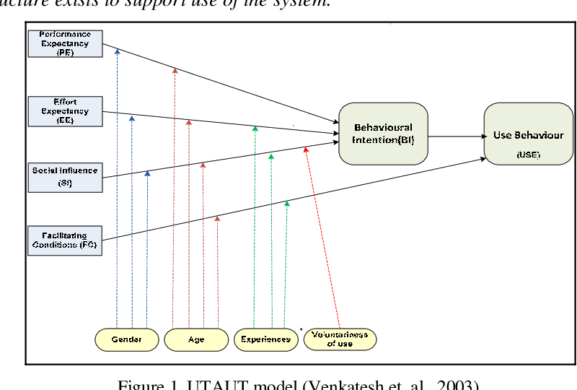
Figure 1. UTAUT model
Source: (Venkatesh et. al., 2003)
The unified theory of acceptance and use of technology (UTAUT) has established noteworthy attention in e-Learning and technology in education, which offers a credible framework to analyse the individual technical experience of education (Tan, 2013). (Venkatesh et. al., 2003). In previous research the UTAUT was used extensively used to research consumer acceptance of technology (Tagoe, 2012). This research is carried out using three factors: Facilitating conditions, Effort Expectancy and Technology Acceptance as independent variables.

2.7 Conceptual Framework
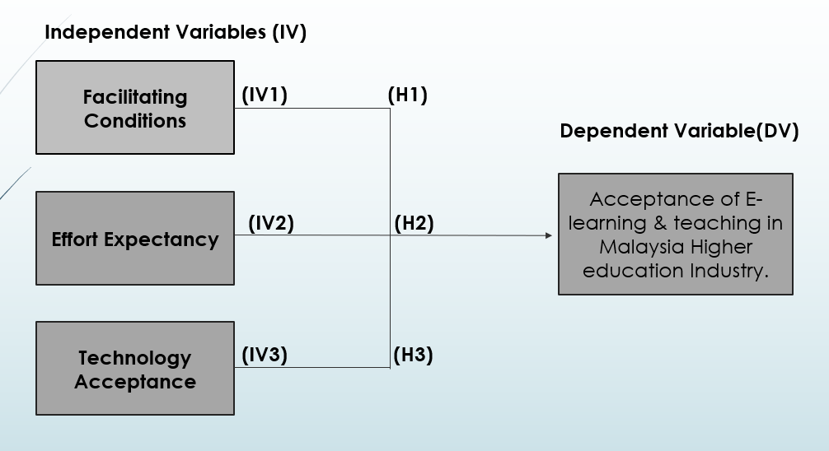
Figure 3: Conceptual Framework of research
The figure above demonstrates the conceptual framework which is created to explain the natural progression of the research which is to be conducted. It is used to link the Independent variables Facilitating conditions, Effort Expectancy and Technology Acceptance (connected to Hypothesis) to the Dependent variable Acceptance of E-learning & teaching in Malaysia Higher education Industry for this research. This will help to explain how the research problem will be explored and analyzed. This will help to establish statistical relationship between the main concepts of the study.

2.8 Hypothesis
This research is to determine the relationship between Facilitating conditions, Effort Expectancy and Technology Acceptance and Acceptance of E-learning & teaching in Malaysia Higher education Industry.
H1: Facilitating Conditions has a significant influence on the Acceptance of E-learning & teaching In Malaysian Higher Education Industry.
H2: Effort Expectancy has a significant influence on the Acceptance of E-learning & teaching In Malaysian Higher Education Industry.
H3: Technology acceptance has a significant influence on the Acceptance of E-learning & teaching In Malaysian Higher Education Industry.

2.9 Conclusion
Chapter 2 analysed literature related to the field of E-learning and teaching, types of E-learning and teaching, Forms of E-learning and teaching, E-learning and teaching tools, Malaysian Education Industry, E-leaning and teaching readiness among Malaysian and determinant factors including Facilitating conditions, Effort Expectancy and Technology Acceptance on Acceptance of E-learning & teaching in Malaysia Higher education Industry. In studying the Acceptance of E-learning & teaching in Malaysia Higher education Industry, a gap in literature is found. The study focuses in this chapter on the Unified Theory of Acceptance and the Use of Technology (UTAUT) as well as theoretical framework is derived based on UTAUT to further explain the acceptance of technology by universities and students and leacturers in the research. The relationship between the independent and dependent variables is illustrated using conceptual framework.

Chapter III: Research Methodology

3.0 Overview
Chapter 3 offers a simple diagram of the research design. The research design will include information on the objectives of the project, nature of research, level of intervention, the layout of the research study, time horizons, unit of analysis, design of samples, measurements and measures, method of data collection and analysis. Then further there’s a questionnaire designing, a table on research methodology and the data analysis. The object of each test and the thumb rule are clearly stated in the data analysis table.

3.1 Research design
Research design is an outline or the framework which consists of techniques and research method which will be used by the researcher to conduct his study (Saunders, Lewis and Thornhill, 2016). Figure 3.1 highlights the research design used in this research, this act as a guide line to take appropriate steps on required time as well as help to identify suitable research methods and successfully set up his study.
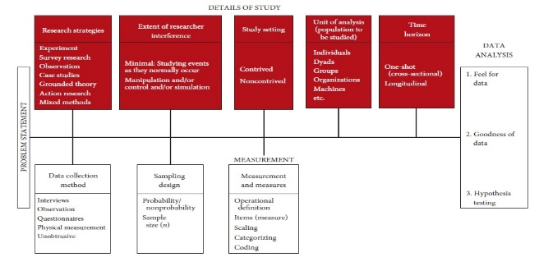

Figure 3.1 Research Design Framework
Adapted from: (Sekaran and Bougie, 2016)
According to Cooper and Schindler (2011), there can be of four types of Research design; Exploratory, Descriptive, Analytical & Predictive. As stated by (Bougie and Sekaran, 2019), objective of a descriptive research is to explain the studied phenomena and study design and research design is known as correlation research design when the aim is to establish relationship between variables. In this analysis, descriptive study will be done to relationships between independent variables and dependent variables hence it can be classified as a correlation study (Schindler, 2018). It focuses on the creation of the relationship between independent and dependent variables, the analysis is a correlation design (Kumar, 2014). This is confirmed further by Saunders et al. (2016), which suggested that correlation analysis should be done if the relationship between variables can be formed. Therefore, this analysis is a quantitative based descriptive correlations design to study the association of the independent variables which are Facilitating conditions, Effort Expectancy and Technology Acceptance with the dependent variable which is Factors Influencing the Acceptance of E-learning & teaching in Malaysian Higher Education Industry.
According to Bougie and Sekaran (2019) descriptive analysis focuses on the processing of data via distribution and analyses of the received data using quantitative methods me according to Zikmund et al. (2013). Data will be collected using online distribution of the questionnaire. Furthermore, statistical tests as well as analysis of the collected data will be done using SPSS. The pilot study will be conducted to validate the design methodology on a limited sample scale to assess how practical the analysis is before the final full test is conducted to ensure that the questionnaires that are circulated are transparent enough as not to be confused or vague, but to increase the content of questionnaires (Smith, Morrow and Ross, 2015). The data collection tool; questionnaire is to be distributed among Malaysian people to assess the correlation between the Factors Influencing the Acceptance of E-learning & teaching in Malaysian Higher Education Industry, Facilitating conditions, Effort Expectancy and Technology Acceptance. Both primary and secondary data will be used accordingly, the informative analysis will be conducted on different stages to evaluate the required results.
The pilot test will be carried out before the project will remind researchers that the experiment may pose a potential failure danger (Chiew, 2015). Further, in order for items to accurately account for a specific structure, the items suggested in the questionnaires will be evaluated statistically using factor analyses (Pallant, 2013). Moreover, simultaneously Cronbach Alpha will test the reliability of the items (Bryman, 2015). The relationship between independent variables and dependent variable in this research will be defined through regression analysis. Furthermore, the hypotheses based on the defined framework are tested by deductive method in this analysis (Saunders et al., 2012).
The setting of the analysis is non-contrived because the research is done in a natural and unfettered environment. Samples are minimally manipulated, managed and interfered. This analysis is performed with very minimal immersion from researchers.

3.2 Unit of Analysis and Time Horizon

3.2.1 Unit of Analysis
Unit of analysis is the key research and analysis body within a study and can be an organization or individual (Zikmund et al., 2013). In this research, the unit of Analysis are students and lecturers who are individuals because questionnaire will be circulated to respondents residing in Malaysia. The findings obtained from each respondent are, therefore, special because their demographic history is different.

3.2.2 Time Horizon
Data are obtained by respondents once in this study via the online questionnaire. This is thus a cross-sectional analysis in terms of the time horizon. Cross-sectional analysis is when collection of the data is performed at one moment (Saunders et al., 2012).

3.3 Sampling Design and Sampling Plan
Sampling is a method to assess the frequency of the situation that needs to be investigated by picking a handful from a wider community (Kumar, 2014).
The design of samples can also be regarded as the basis or structure for sample collection and will have a significant impact on many aspects of the research (Sekaran et al., 2016). A sampling frame that can represent the interested population must be selected in order to maximize the efficiency of study (Shan, 2012).

3.3.1 Study Population and Sampling Technique
The two different approaches of sampling are known as probability sampling and non-probability sampling. (Cooper and Schindler, 2011). Probability sampling means the array of data from particular segment of population where each respondent shares same probability, while non – probability sampling means array of random data where group of respondents share same selection opportunity (Sekaran and Bougies, 2016).
This study selects convenience sampling strategy under non-probability sampling technique through the online delivery of questionnaires for the purpose of restoring data collected through the cost-effective distribution of questionnaires within a given time frame to ensure that the response rate is sufficient (Saunders et al. 2016). The convenience sample strategy is a cost-effective strategy according to Saunders et al (2012) as it cuts the time needed to collect data and increases the reaction rate to overcome the time limits in that study. “The sampling design is non-probability convenience sampling” allows, thus to overcome the principal shortcomings of this research.
Target Population will be Students and Lecturers of the Universities which are using E-Learning & teaching. Specifically, the survey will be conducted with lecturers and Students who will act as the units for the Analysis.

3.3.2 Sample Size
The determination of the required sample size is important in all research because sample sizes can have a direct impact on research intensity and effectiveness and viability (Meysamie et.al., 2014).
Since there is no unique population size known to participate in E-learning & teaching, according to Raosoft, 20000 is therefore considered as the population size that will be randomly selected among members of the education industry engaged in E-learning & teaching platforms. Using Raosoft.com the sample size is obtained with 5 percent agreed margin error, 95 percent confidence level and 20000 as the population size is 377 (Raosoft.com, 2020).
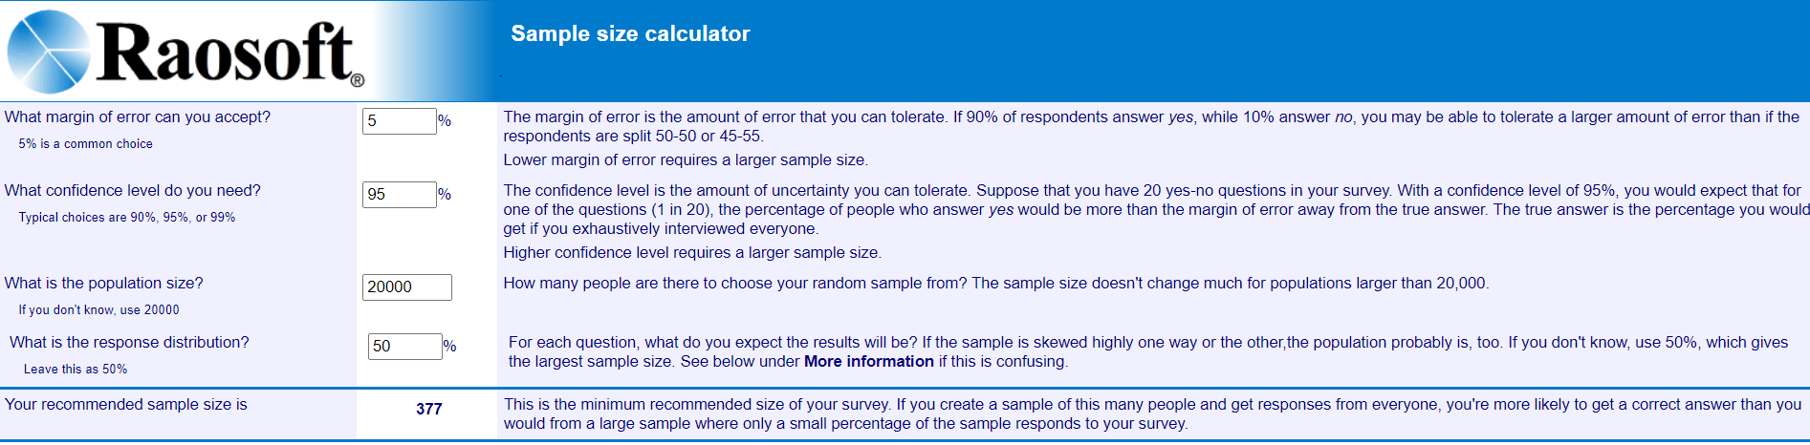Figure 2: Determining Sample size using Raosoft
Source: (Raosoft.com, 2020)

3.4 Data Collection Method
The survey methodology is the most popular way of gathering data and used by most of the researches (Kamel, 2013; Narayanan and Savarimuthu, 2015). The primary data of this study will be collected through an online self-administration survey.
As a self-administered questionnaire is used to gather data for this study, the self-administration questionnaire has benefits and drawbacks (Bougie and Sekaran, 2019). One benefit of self-administrator survey is that wide range of responses can be collected as well as data obtained can be statistically evaluated through the software (Ponto, 2015). As stated by Selm and Jankowski (2006) internet facilitated study eliminates the interviewer's biases, since the interviewer works remotely, thereby improving the authenticity and ensuring that those concerned will articulate themselves without hesitation. However, in order to understand the questions, the adverse aspect of a self-administered questionnaire is that no interviewer is present and the questions can be misinterpreted which results in invalid findings and cannot reflect the samples, as only those interested or trained groups of people can participate (Padayachee, 2016).
As calculated earlier 377 respondents are needed in order to have sufficient data for later analysis, but due to the risk of weak answers from respondents, 400 self-administered online survey will be done instead. Similar data collection approach was used by few researchers earlier for instance, Sunkara and Kurra, used this approach to study Learner Satisfaction and Needs on E-Learning Systems (Sunkara and Kurra, 2017), Ali, Hossain and Ahmed further used similar online survey method to study Effectiveness of E-learning for university students: evidence from Bangladesh (Ali, Hossain and Ahmed, 2018). As mentioned earlier non-probability convenience sampling will be used to collect data from target Population i.e. lecturers and Students who will act as the units for the Analysis.

3.5 Questionnaire Design

Section | Questions or Items | Number of Questions | References
A | Demographic Profile | 7 | Hung, Yu, Liou and Hsu, 2019;  Mamattah, 2016;  Sunkara and Kurra, 2017;
B (Dependent Variable) | Acceptance of E-learning & teaching in Malaysia Higher education Industry. | 8 | Golden, McCrone, Walker and Rudd, 2017;  Ünal, Alır and Soydal, 2014;  Mamattah, 2016;  Hung, Yu, Liou and Hsu, 2019.
C (Independent Variable) | Facilitating Conditions | 5 | Ünal, Alır and Soydal, 2014;  Golden, McCrone, Walker and Rudd, 2017;  Hung, Yu, Liou and Hsu, 2019.
C (Independent Variable) | Effort Expectancy | 5 | Mamattah, 2016;  Hung, Yu, Liou and Hsu, 2019;  Sunkara and Kurra, 2017.
C (Independent Variable) | Technology acceptance | 5 | Ünal, Alır and Soydal, 2014;  Mamattah, 2016.

Table 3.1: Table of Summary for Questionnaire Adoption
Questionnaire is an important instrument for the collection of data for the study and compared to interviews the information collected is effective and reliable (Sekaran and Bougie, 2016). The questionnaire developed in this study is merged and adapted from previous studies which supported the measurement models. The validity of information for this study is ensured by all these literatures.
The questionnaire consists of three sections: demographics, independent variable measurements and dependent variables measurements. Five-point Likert scale is constructed for each question. Respondents are expected to select one option based on their level of approval or disapproval with the five-point scale Likert statements. Options ae as follows
1 = “Strongly Disagree”, 2 = “Disagree”, 3 = “Neutral”, 4 = “Agree”, 5 = “Strongly Agree”.
The surveys would not be too time consuming to complete, but would be designed to ensure adequate data collection. Each section is described below in detail:

Part A: Demographics
Section A, measures the demographic data of respondents such as Gender, age, profession, education level, type of university, study mode and Domain of study will be collected. The options in this section are precise to make sure only target population is addressed. The respondents would be confidential, and the scale on which the respondent select for each question is dichotomous.
Part B: Measurement of Dependent Variables
In Section B, the Acceptance of e-Learning and teaching will be measured in Malaysian Higher education Industry users. For this E-learning and teaching is addressed in detail in order to see why people accept E-learning & teaching as well as questions measure reasons for acceptance of e-learning & teaching in depth.
Part C: Measurement of Independent Variables
Finally, section c analyses independent variables and their influence on Acceptance of e-Learning and teaching in Malaysian Higher education Industry. The elements used in the survey are adapted from prior surveys.

3.6 Pilot test
Before the completion of the study the pilot test is conducted as a trail variant of the test (Zikmund et al., 2013; Teijlingen and Hundley, 2002). The purpose of the test is to assess and check the validity and reliability of the items in the questionnaire, as well as to inform researchers of the potential risk of experimental failure (Chiew, 2015). The optimal sample size for conducting polit is 10-20% of the real sample size, says Baker (1994). The current sample size in this research is 377 and therefore a pilot test of around 37-40 Malaysian respondents will be performed.

3.6.1 Pilot Test: Factor Analysis
Through Factor analysis, multiple variables can be transformed into single form by reducing data for further analysis (Sekaran and Bougie, 2016). This is important for the study and decision-making on the retention or elimination of particular items of the collected data and items made in research. (Kumar, 2014 and Zikmund et al., 2013).
Factor analysis includes the Kaisser-Meyet Oikin (KMO) Bartlett’s test of sphericity to test for data suitability and accuracy (Pallant, 2011). Creswell (2014) states the value range is between 0 and 1 and that the acceptable value must be nearer to 1 and the minimum value is 0.6. The high value of KMO indicates the significant correlation and low KMO value indicates that the variable is unfit as representative factor, hence any object with communal values < 0.6 should be excluded (Chetty and Datt, 2015).
factor loading is to determine the variable and factor correlation coefficients (Zikmund et al., 2013). That is, the interaction of variables with the particular factor (Yong and Pearce, 2013). High loading (> 0.6) is desirable in testing, whereas low load (< 0.6) is less favored to provide a minimal load on any factor (Hair, 2018). In pilot tests, the factor loads of 0.5–0.6 according to Zikmund et al., (2013) is appropriate due to the limited sample size. Eigenvalue is the sum of difference between variables explained by the factor, according to Field (2009). Eigenvalue minimum 1 is known as "stable" and sufficient in order to consider as one of the factors (Kaiser, 1960). There are 3 IVs in this analysis and hence 3 of the variables have eigenvalue > 1 in order to be maintained.

3.6.2 Pilot Test: Reliability Test
Reliability test will assess the accuracy of the questionnaire results and the degree of the assessment reliability (Sekaran and Bougie, 2016). Cronbach's Alpha via SPSS is used to test the accuracy of the questionnaire in this cross-sectional analysis. Cronbach's Alpha is widely used, according to Rovai, Baker and Ponton (2014), for the calculation of the internal accuracy of the instruments and for deciding whether the questions combined in level are assessing the same concept. The alpha values vary between 0 and 1, as stated by Bryman (2015) chosen minimum Alpha value is 0.6. Values above 0.6 are deemed acceptable and satisfactory; values above 0.7 are deemed fine, and values above 0.8 are considered extremely coherent internally (Tavakol & Dennick, 2011). An alpha value of more than 0.6 is needed to guarantee reliability in this pilot study.

3.7 Data Analysis
Measurement is a quantification method for a phenomenon by number distribution (Mohajan, 2018). In addition, as stated by Pallant (2013), measurement is a projection method for certain features of the target population. Numerous applications and assessments for the study of the variables are used in this quantitative research. Data Analysis can be broken down into descriptive data, preliminary tests, hypotheses testing with other supporting analysis's (Kumar, 2014). In this research, statistical program known as Statistical Package for Statistic (SPSS) version 26.0 is used for pilot tests, preliminary test, hypotheses testing and other tests.

3.7.1 Descriptive Data
Descriptive Data is also called descriptive statistics, as part of measurement, it meaningfully describes, organizes and summarizes data together (Jaggi, 2012). It helps to present data innovatively through the pie chart, the bar chart and the table (Ahamad et al., 2014). In this study, SPSS is used to analyse the demographic profile of respondents, such as age, sex and nationality, provides a majority of descriptive information. Amangala (2016) states that the demographics of the sample population are statistical quantifications and can be used to classify quantifiable population sub-sets.

3.7.2 Preliminary Test
Preliminary testing serves as a method for statistical data to lead credible empirical outcomes which can further provide practical realistic conclusions for the research (Sutton and Austin, 2015). In the preliminary test to increase the quality of result, factor analysis and reliability test performed under pilot study is also carried out.

3.7.2.1 Factor Analysis
Zikmund et al. (2013) proposed that factor analyses should be carried out in order to ensure that elements or constructs which do not follow the thumb rules are excluded or modified for further analyses before the reliability checks are done.
Factor analysis is a technique of data reduction that decreases the number of variables (Zikmund et al., 2013). The sphericity test by KMO Bartlett is used to test and validate data suitability in the analysis, with a preferred value of a near to 1 with a minimum value of 0.6 (Krabbe, 2017). Factor loading is conducted under factor analysis to assess on correlation coefficients for variables and factors (Hair et al., 2014). A high factor loading means that the factor is greater than 0.6 and is adequate to variate from the variable (Zikmund et al., 2013). Moreover, for all the variables, the eigenvalues must surpass 1 (Field, 2009). Schindler (2018) states that the number of Eigenvalue values above 1 must be the same as the number of research variables.

3.7.2.2 Reliability Test
The internal consistency, reliability and stability of the questionnaire are measured by a reliability test (Heale and Twycross, 2015). To measure the inner accuracy Cronbach alpha is used and the alpha value above 0.7 shows that the questions together measure the same thing and implies strong reliability (Hair et al., 2014).

3.7.3 Hypothesis Testing
In order to evaluate these theories and establish the relationship between Acceptance of e-learning & teaching (dependent variable) and Facilitating conditions, Effort expectancy and technology acceptance (independent variables). Multiple Linear Regression, Analysis of Variance (ANOVA) multi- collinearity and beta-coefficient tests will be conducted.

3.7.3.1 Multiple Regression Analysis
The study of multiple regression tests is intended to assess the relation between several variables and dependent variables (Martin and Brigmon, 2012). This is further applied for the creation of equation in order to approximate the self-weight as it reflects the value of reliable variable from the value of independent variable (Cooper and Schindler, 2011). Path coefficient, β would reflect the approximate intensity and inclination of a linear relationship between ratio and interval variables. The Beta coefficient, β is the shift in the dependent variable that the dependent variable faces for each unit rise in Independent variable. (Zikmund et al., 2013). (Zikmund et al., 2013). The finding is considered statistically acceptable when the p-value is less than 0.05 and when p-value less than 0.01 is considered to be significantly significant (Bougie and Sekaran, 2019). The coefficient ranges from +1 to -1, where "+" and-" "represent the relationship direction, while the number shows the relationship's intensity (Sekaran and Bougie, 2016).
In addition to the determinant coefficient R², the association measure between the observed value and the expected value will show the association's overlap (Martin et al., 2012). When R² is near 1 most variable section can be described by the multiple regression model in accurate variables while when R² is near 0, most changes cannot be described by regression model (Sekaran et al., 2010).

3.7.3.2 One-way ANOVA
For this study, regression ANOVA is used to explore the link between the independent variables (Facilitating Conditions, Effort Expectancy and technology acceptance) and dependent variable, Acceptance of E-learning and teaching in Malaysian higher education Industry Malaysia (Bougie and Sekaran, 2019).
One-way ANOVA attempts to statistically analyse variations among three or more independent variables (Myers, Well and Lorch, 2010). If the p-value < .05 is significant, the mean differences can be accepted and the hypothesis is accepted, while p-value > .05 is mean difference is insignificant and the hypothesis must be dismissed.

3.7.3.3 Multi-Collinearity
The variation inflation factor (VIF) and tolerance are used to determine whether there is a multicollinearity between variables or not (Kumar, 2014). It is acceptable to infer that there is no multicollinearity among variables if VIF value is below 10, their tolerance value is below 0.1 (Saunders et al., 2016).

3.7.3.4 Beta Coefficient
The efficiency of each individual independent variable against dependent variables is evaluated using standardised beta coefficient (Myers et al., 2010). For analysis, the beta-coefficient should be as similar as possible to1, as higher beta-coefficient indicates a greater effect of an independent variable on the dependent variable (Sekaran and Bougie, 2016). In this research, beta coefficient is important to identify the factors Facilitating Conditions, Effort Expectancy and technology Acceptance influencing the Acceptance of E-learning & teaching in Malaysian Higher Education Industry.

3.8 Conclusion
In this chapter, research techniques used during the research have been discussed and the biographical details of the respondents have been quantitatively analysed. In addition, few essential processes such as research design preparation, questionnaire development and data collection management were covered in this portion. This chapter also discussed the manner in which the research and study were done. In the following part, the study results will be addressed.

Chapter 4: Data Analysis and Interpretation

4.0 Overview
The purpose of this chapter is to statistically analyse the data obtained from students and lecturers using E-learning & teaching. In order to interpret and explain the end report in the classification of data obtained from the 5-point Likert scale used in the questionnaire survey, SPSS Version 26 software will be used. Initially, pilot test will be conducted on a group of respondents to determine the reliability and validity of the variables before proceeding to full data collection and to verify the feasibility of the questionnaire. Tables are used to display the data obtained from the respondents. In order to support the validity of this report, preliminary test, hypothesis test, ANOVA, descriptive analysis will then follow this. Appropriate detail and more clarification of the results will be included in order to clarify and bring to a full understanding, the connection between the data collected and the study presented.

4.1 PILOT TEST
Pilot test is a significant step towards examining the feasibility of the questionnaire before complete data collection (Leon et al., 2011). Teijlingen and Hudley (2001), further states that pilot tests enable researchers to identify issues from inadequate research instruments and reduce the possibility of errors in large-scale respondents. Researchers use pilot tests to determine whether preliminary results favour a wider, more structured investigation (Lowe, 2019). A well-planned and performed pilot study would also allow researchers to identify potential confusing variables not previously known and determine the associations between major variables to attain good sample size (Sekaran and Bougie, 2016).
Pilot test is a trial of research project that helps to check the validity of research methodology with a small range of respondents before beginning the main research (Sekaran and Bougie, 2016). The main purpose of this pilot study is not to resolve research issues, but to discourage researchers from starting a large-scale study without appropriate understanding of the proposed methods; in fact, pilot test is conducted, in a study which is time taking and expensive in resources to prevent the occurrence of critical error (Kumar2014).
Under pilot test, factor analysis and reliability test are performed to assess the validity and adequacy of the items in the questionnaire obtained from small scale respondents. If these experimental findings do not agree with the thumb rules laid down by other scholars, then such questions will need to be changed or omitted from further study (Hair et.al.,2018; Sekaran and Bougie, 2019; Saunders et, al.,2019).
Creswell (2011) mentioned that 10% – 20% of the sample size is needed to run the pilot test. The validity and reliability of the question can be identified after the pilot test (Saunders et, al.,2019). Based on the sample size calculated using Raosoft.com (2020), required sample size for this research is 377, therefore respondents for pilot test can be between 37-75. Hence, 40 respondents were chosen for the pilot testing.

4.1.1 Factor Analysis Results

4.1.1.1 KMO and Bartlett’s Test for Sphericity
KMO Bartlett’s Test of Sphericity is to decide whether the correlation matrix includes an identity matrix and the relation between the variables should not be zero correlation coefficients for factor analysis (Sekaran and Bougie, 2016).
The sampling adequacy measure of the Kaiser-Meyer-Olkin test ranges from 0 to 1; preferred KMO values should be nearer to 1 and suggestion for minimum value is 0.6, any value less than 0.6 suggests a sample inadequacy (Hair et al, 2014; Bell, Bryman and Harley, 2018). Further analysis by the survey would not be carried out if the KMO value is less than 0.6, which is the thumb rule (Hussain et al., 2015).
KMO and Bartlett’s Test (Dependent Variables)
Kaiser-Meyer-Olkin Measure of Sampling Adequacy. |  | .870
Bartlett's Test of Sphericity | Approx. Chi-Square | 334.930
Bartlett's Test of Sphericity | df | 28
Bartlett's Test of Sphericity | Sig. | .000

KMO and Bartlett’s Test (Independent Variables)
Kaiser-Meyer-Olkin Measure of Sampling Adequacy. |  | .854
Bartlett's Test of Sphericity | Approx. Chi-Square | 454.652
Bartlett's Test of Sphericity | df | 105
Bartlett's Test of Sphericity | Sig. | .000

Table 4.1 KMO and Bartlett’s Test for dependent and independent variables

Table 4.1 reveals the value of KMO for both of dependent and independent variables in the pilot tests are 0.870 and 0.854 (above 0.6), thus we can say all the questions in the questionnaire are appropriate for further analysis and significance level of Bartlett's test of Sphericity for both dependent and independent variable is 0.000 (under 0.05), which demonstrates the adequacy of this study and overall shows validity of scale is appropriate and all correlations are significant.

4.1.1.2 Factor Loadings
As stated by Zikmund (2013), factor analysis is a method, for analysing that the gathered data and the articles constructed are appropriate and relevant for further analysis. The researcher may exclude elements from a project that are inadequate or have low factor loading than the minimum requirement by gaining insight from factor analysis (Creswell, 2013).
The factor loading is also called communalities, this demonstrates how much an element interacts with all other elements i.e. the degree to which the item is associated with other items (Sekaran and Bougie, 2016). Communalities determine the amount of variance in each variable. The initial communalities estimate the variance in each variable accounted for by all the elements or variables; the principal component derived is always equivalent to 1.0 for correlation analysis (Lohana, Rashid, Nasuredin, and Kumar 2019). As stated by Chetty and Datt (2015), the values of the communalities must be greater than 0.6 to show enough variance from the variable. If there are high communalities (i.e., more than 0.6), it means that the components extracted represent the variables appropriately, if the communalities are low i.e. the value is lower than the thumb rule, the variable does not load on any factor significantly (Bell et. Al., 2018).

Communalities (Dependent variable)
 | Initial | Extraction
I am able to use E-learning and teaching for my course | 1.000 | .725
There is an easy access to learning materials like reading documents and recorded videos via E-learning | 1.000 | .769
E-learning and teaching mode offers the flexibility to study when convenient for the user | 1.000 | .784
E-learning &amp; teaching enable people to study, regardless of their location | 1.000 | .762
E-learning &amp; teaching stimulates better understand of concepts and Learners are more effective as independent learners | 1.000 | .746
Students have sufficient knowledge about the usage of E-learning tools | 1.000 | .803
Lectures have sufficient knowledge about the usage of E-teaching tools | 1.000 | .823
E-learning system used by my University satisfied my learning objectives | 1.000 | .733
Extraction Method: Principal Component Analysis.

Communalities (Independent variable)
 | Initial | Extraction
There is an adequate platform to take tests and submit assignments in your university | 1.000 | .656
There is electronic platform available for interactive communication between instructor and student in your university | 1.000 | .798
There is a well-established ICT Infrastructure in your university | 1.000 | .705
There is sufficient knowledge and guidance provided to adapt to E learning &amp; teaching | 1.000 | .659
There is an unrestricted access and flexibility to navigate among online learning resources to control your individual learning speed | 1.000 | .811
I believe e learning platforms are user friendly | 1.000 | .826
It is easy for me to take exams and submit my work when using my e learning &amp; teaching platform | 1.000 | .803
I am easily able to access to study materials using the E learning &amp; teaching platforms | 1.000 | .694
It is easy for me to understand the features of the e learning &amp; teaching platform provided by my university | 1.000 | .653
The design and user interface of the e learning &amp; teaching system provided is attractive and customizable | 1.000 | .671
I prefer fully technology-based learning &amp; teaching to face to face because it is innovative and more productive | 1.000 | .776
Using technological tools for learning &amp; teaching is more cost effective than classroom learning | 1.000 | .798
I use technological tools and internet as a source of information | 1.000 | .821
I use emails and other technological tools as a main communication tool with my classmates and lecturers | 1.000 | .719
Usage of technological tools will increase my skills and make my study course more effective. | 1.000 | .725
Extraction Method: Principal Component Analysis.

Table 4.2 Communalities from Extraction Method: Principal Component Analysis
(for dependent and independent variables)

As seen in Table 4.2, in the extraction column, all the values of communalities are shown above 0.6, indicating that all the questions in the questionnaire are valid. Bell et. al. (2018) states that in order to be accurate and appropriate, the extraction must be 0.6 and higher in the complete sample setting. As the sample ranges from 0.653-0.826 it follows the thumb rule, items in the questionnaire survey need not be omitted. All items are then maintained for the collection of complete data.

4.1.1.3 Eigen Values
Eigen values are used for measuring variance in a correlation matrix and only variables with Eigenvalue above 1.0 are deemed to be significant for further understanding. The overall variance above 60% is considered to be sufficient (Tabachnick and Fidell2019). Usually, the first factor takes the majority of variances into account and thus has the highest Eigen-Value. The second factor consists of the remaining variance and the same goes on (Nyagilo and Njeru, 2020). Laerd further stated (2013) that component values should be above 1 and the number of Eigen value derived for the components should be equal to the number of variables.

Total Variance Explained (Dependent variable)
Component | Initial Eigenvalues |  |  | Extraction Sums of Squared Loadings
Component | Total | % of Variance | Cumulative % | Total | % of Variance | Cumulative %
1 | 6.145 | 76.810 | 76.810 | 6.145 | 76.810 | 76.810
2 | .693 | 8.663 | 85.473
3 | .378 | 4.722 | 90.195
4 | .293 | 3.668 | 93.864
5 | .193 | 2.414 | 96.277
6 | .137 | 1.711 | 97.988
7 | .089 | 1.113 | 99.101
8 | .072 | .899 | 100.000
Extraction Method: Principal Component Analysis.

Table 4.3: Extraction Method: Principal Component Analysis for Dependent Variable
Total Variance Explained (Independent variable)
Component | Initial Eigenvalues |  |  | Extraction Sums of Squared Loadings |  |  | Rotation Sums of Squared Loadings
Component | Total | % of Variance | Cumulative % | Total | % of Variance | Cumulative % | Total | % of Variance | Cumulative %
1 | 8.406 | 56.043 | 56.043 | 8.406 | 56.043 | 56.043 | 4.566 | 30.442 | 30.442
2 | 1.659 | 11.061 | 67.104 | 1.659 | 11.061 | 67.104 | 3.992 | 26.612 | 57.054
3 | 1.051 | 7.004 | 74.108 | 1.051 | 7.004 | 74.108 | 2.558 | 17.054 | 74.108
4 | .829 | 5.528 | 79.635
5 | .571 | 3.804 | 83.439
6 | .511 | 3.409 | 86.848
7 | .411 | 2.739 | 89.587
8 | .369 | 2.462 | 92.049
9 | .272 | 1.814 | 93.863
10 | .242 | 1.615 | 95.479
11 | .197 | 1.311 | 96.790
12 | .171 | 1.142 | 97.932
13 | .134 | .892 | 98.825
14 | .117 | .778 | 99.602
15 | .060 | .398 | 100.000
Extraction Method: Principal Component Analysis.

Table 4.4: Extraction Method: Principal Component Analysis for Independent Variables
As Kaiser (1960) has said, only those variables with a 1.0 or higher Eigenvalue are retained for analysis. Hinton and McMurray (2017) accept this fact that a Eigen value of 1 means that the variation in data can be clarified as much as a single initial element. In this research, principal components analysis in data extraction is conducted for dependent variables and independent variables which are with Eigen value of above 1. Table 4.3 extracts 1 eigen value equivalent to the number of dependent variable and Table 4.4 extracts 3 eigen values equivalent to the number of independent variables in the analysis. That meets Hussain et. al. (2018) standards because the number of Eigen value derived is equal to the number of dependent and independent variables. Hence, we do not need to change or check for variables which may be clustered based on the correlation matrix, because all components have a greater value than one which is aligned with the study variables.

The overall variation explained for acceptance of E-learning and teaching (DV) is 76.810 % and for facilitating conditions, effort expectation and technology acceptance (i.e. for all IV's) is 74.108 %. The findings in Table 4.3 showed that the derived variables explain a specific amount of variation, so it can be concluded that the questionnaire's content validity is ideal for further study. The findings meet the Nyagilo and Njeru (2020) criterion that the selected variables explain at least 70% to 80% of the variance.

Consequently, questions or objects will not be omitted from the existing sample survey. All factor analysis testing demonstrated that the pilot test results represent a degree of approval to carry out the entire data collection and further analysis.

4.1.1.4 Reliability Analysis Results
Reliability test is necessary to track consistency of the questionnaire in respondents and to support the feasibility of the research (Pallant, 2011). Cronbach's alpha approach is a reliable coefficient to demonstrate the correlations between the factors and the internal consistency of the data in this analysis (Bougie and Sekaran, 2019). In addition, Bayliss (2020) supported that the reliability of any given calculation corresponds to the degree to which a concept is consistent, whereas Cronbach's alpha is a measure of the strength of consistency. SPSS was used to evaluate the reliability test to ensure that the questions are sufficient to achieve a meaningful result.
Variables | Cronbach’s Alpha | Number of items
Acceptance of E-learning & teaching (Dependent Variable) | 0.868 | 8
Facilitating conditions (Independent Variable) | 0.901 | 5
Effort Expectancy (Independent Variable) | 0.850 | 5
Technology acceptance (Independent Variable) | 0.822 | 5
Overall | 0.860 | 23

Table 4.5: Reliability Test result for dependent and independent variables
For both independent and dependent variables, the Cronbach Alpha is more than 0.8, as seen in Table 4.5. Sekaran and Bougie (2016) states that reliability test with Cronbach's Alpha more than 0.8 suggests very high reliability. Consequently, all the items in the questionnaire are very reliable and ideal for complete data collection. Overall, when all the variables were combined in one item it was found that all 23 elements are accurate to further evaluation with high internal consistency (Cronbach’s Alpha=0,860).

4.1.5 Conclusion of Pilot Test
The reliability, Validity and significance of the data was tested by the pilot test on data obtained from 40 respondents. As the results of factor analyses and reliability checks demonstrated, each question for independent and dependent variable in the sample was adequate and significant for gathering full-scale data and further analyses.

4.2 Response rate
The response rate in the survey analyses is the number of persons who have completed the survey (after the unused responses have been removed) divided by the number of people in the sample size. Since survey quality is typically the response rate, higher response rates are better. The result achieved cannot be reliable and can also lead to higher levels of error with the low response rate. Therefore, higher response rates are good (Fincham, 2008).
Determined Sample Size  (Raosoft.com 2020) | Total Questionnaire Distributed | Total Questionnaire Received | Total  Usable  Questionnaire | Total  Unusable  Questionnaire | Response  Rate  Percentage
377 | 400 | 333 | 325 | 8 | 81.25%

Table 4.6. Response Rate of the Study
A total of 400 surveys were sent to students and teachers using e-learning and teaching in Malaysia through WhatsApp and Facebook. But only 333 responses have been received. In fact, 8 responses could not be used because the questions were inappropriately responded and some not finished.
The sample size calculated for a population according to raosoft.com (2020) is 377; however, we have 325 respondents after the elimination of the inadequate questionnaire, which is less than required. According to Bell (2018) equation N>50 + 8m (m reflects the number of independent variables that is 3 in this study), however at minimum 74 questionnaires have to be obtained to maintain sufficient sample size. Further supported by Fincham (2008), 60 % response rate is acceptable to explain and generalize results for the target population. Thus, it is appropriate and justifiable to accept the response rate of 81.25%.

4.3 Demographic profile of respondents
The study sends questionnaires to respondents from diverse backgrounds and states in Malaysia via various sites on the Internet. Convenient sampling procedure is chosen for this project to conform with time and resource limits. In total, this study includes 325 respondents. The demographic profiles of the respondents have been analysed and described using descriptive statistics as seen in the respective tables.

4.3.1 Gender
Gender
 |  | Frequency | Percent | Valid Percent | Cumulative Percent
Valid | Female | 192 | 59.1 | 59.1 | 59.1
Valid | Male | 133 | 40.9 | 40.9 | 100.0
Valid | Total | 325 | 100.0 | 100.0
Table 4.7 Gender of respondents
In this research, as seen in Table 4.7, 325 respondents participated, most of them were female 59.1% (N=192), followed by male 40.9%, (N=133).

4.3.2 Age
Age
 |  | Frequency | Percent | Valid Percent | Cumulative Percent
Valid | 18 and below | 42 | 12.9 | 12.9 | 12.9
Valid | 19-29 | 156 | 48.0 | 48.0 | 60.9
Valid | 30-39 | 65 | 20.0 | 20.0 | 80.9
Valid | 40-49 | 43 | 13.2 | 13.2 | 94.2
Valid | 50 and above | 19 | 5.8 | 5.8 | 100.0
Valid | Total | 325 | 100.0 | 100.0
Table 4.8 Age of respondents
Table 4.8 shows that the study's overall number of respondents is 325 and the majority of respondents between the ages of 19-25 48% (N=156), followed by respondents of the age between 30-39 (20%, N=65). Furthermore, there were 13.2% respondents between the ages of 40-49 (N=43), almost similar number of participants were from the ages of 18 and below (12.9%, N=42). Lastly, number of respondents from age group 50 and above is the lowest (5.8%, N=19). Low digital literacy in adults 50 years and older may be the potential answer to the massive gap.

4.3.3 Profession
Profession
 |  | Frequency | Percent | Valid Percent | Cumulative Percent
Valid | Student | 226 | 69.5 | 69.5 | 69.5
Valid | Lecturer | 99 | 30.5 | 30.5 | 100.0
Valid | Total | 325 | 100.0 | 100.0
Table 4.9 Profession of respondents
The majority of the respondents in Table 4.9 are students (69.5%, N=226) led by professors (30.5%, N=99). It his major gap is justifiable as there are more students in each university compared to lecturers.

4.3.4 Type of university
Type of university
 |  | Frequency | Percent | Valid Percent | Cumulative Percent
Valid | Public University | 158 | 48.6 | 48.6 | 48.6
Valid | Private University | 167 | 51.4 | 51.4 | 100.0
Valid | Total | 325 | 100.0 | 100.0
Table 4.10 university details of students of respondents
As seen in Table 4.10, respondents from the private universities were 51.4 % (N=167), while the participants from public universities accounted for 48.6 % (N=158).

4.3.5 Study Mode
Study Mode
 |  | Frequency | Percent | Valid Percent | Cumulative Percent
Valid | Part time | 116 | 35.7 | 35.7 | 35.7
Valid | Full time | 209 | 64.3 | 64.3 | 100.0
Valid | Total | 325 | 100.0 | 100.0
Table 4.11 Study mode of respondents
According to Table 4.11 we can see that the majority of respondents are studying in full-time study mode (64.3%), followed by respondents in part-time study mode (35.7%, n=116).

4.3.6 Education Level
Education Level
 |  | Frequency | Percent | Valid Percent | Cumulative Percent
Valid | Diploma | 52 | 16.0 | 16.0 | 16.0
Valid | Bachelor Degree | 142 | 43.7 | 43.7 | 59.7
Valid | Postgraduate (Master/PhD/Professor) | 131 | 40.3 | 40.3 | 100.0
Valid | Total | 325 | 100.0 | 100.0
Table 4.12 Education level of respondents
The overall number of research respondents is 325 as shown in table 4.12 and the majority of respondents have bachelor (43.7%, N=142) followed by postgraduate (Master/PhD/Professor) 40.3% (N=131), level of study. Only a small part of the respondents holds Diploma 16 % (N=52). Based on the standard of education, all the respondents are qualified and can understand the question in the questionnaire.

4.3.7 Domain of Study
Domain of Study
 |  | Frequency | Percent | Valid Percent | Cumulative Percent
Valid | Engineering | 69 | 21.2 | 21.2 | 21.2
Valid | Business | 110 | 33.8 | 33.8 | 55.1
Valid | Sciences | 76 | 23.4 | 23.4 | 78.5
Valid | Art & Design | 37 | 11.4 | 11.4 | 89.8
Valid | History & Languages | 33 | 10.2 | 10.2 | 100.0
Valid | Total | 325 | 100.0 | 100.0
Table 4.13 Domain of Study of respondents
The majority of respondents come from business background i.e., 33.8% (N=110), followed by 23.4% (N=76) respondents pursuing science. There are 21.2% (N=69) respondents taking Engineering. A total of 11.4% (N=37) participants are in Art & Design, and 10.2% (N= 33) in History and Language.

4.4 Preliminary Testing
Preliminary analysis is an important step before any test can be performed in a quantitative sample. There were two preliminary studies conducted, namely factor analysis and reliability analysis (Cooper and Schindler, 2018).

4.4.1 Factor Analysis (Dependent Variable)
KMO and Bartlett's Test
Kaiser-Meyer-Olkin Measure of Sampling Adequacy. |  | .937
Bartlett's Test of Sphericity | Approx. Chi-Square | 2447.706
Bartlett's Test of Sphericity | df | 28
Bartlett's Test of Sphericity | Sig. | .000
Table 4.14 KMO and Bartlett’s Test of Dependent Variables

Communalities of Dependent variable
 | Initial | Extraction
I am able to use E-learning and teaching for my course | 1.000 | .710
E-learning & teaching provides an easy access to learning materials like reading documents and recorded videos. | 1.000 | .797
E-learning and teaching mode offers the flexibility to study when convenient for the user | 1.000 | .784
E-learning &amp; teaching enable people to study, regardless of their location | 1.000 | .682
E-learning &amp; teaching stimulates better understand of concepts and Learners are more effective as independent learners | 1.000 | .740
Students have sufficient knowledge about the usage of E-learning tools | 1.000 | .804
Lectures have sufficient knowledge about the usage of E-teaching tools | 1.000 | .783
E-learning system used by my University satisfied my learning objectives | 1.000 | .833

Table 4.15 Factor loading (Dependent Variable)

Total Variance Explained for Dependent Variables
Component | Initial Eigenvalues |  |  | Extraction Sums of Squared Loadings
Component | Total | % of Variance | Cumulative % | Total | % of Variance | Cumulative %
1 | 6.033 | 75.410 | 75.410 | 6.033 | 75.410 | 75.410
2 | .506 | 6.323 | 81.733
3 | .379 | 4.739 | 86.472
4 | .298 | 3.720 | 90.192
5 | .232 | 2.895 | 93.087
6 | .211 | 2.634 | 95.721
7 | .196 | 2.445 | 98.166
8 | .147 | 1.834 | 100.000
Table 4.16: Eigenvalues of Preliminary Test (Dependent Variables)
In order to validate the reliability of the results in this report, factor analysis of the dependent and independent variables is carried out in preliminary research. As stated by Bell et. Al. (2018), usually used for reducing factors is factor analysis. This strategy takes the maximum common variation and sets it into a common score of all variables. Factor analysis include KMO and the Bartlett Sphericity Tests, communality value and Eigen values.
On the basis of Table 4.14, the measure of KMO and Bartlett of dependent variable is 0. 937which shows adequate sampling. The KMO and the Bartlett Test, which were performed, follow the thumb rule which is greater than 0.6 (Cooper and Schindler, 2018). Dependent variable is significant at 0.00, indicating that it aligns with the thumb rule p<0.05 (Bell et. al., 2018).
Table 4.15 highlights the factor loading of the dependent variable which is acceptance of E-learning & teaching. Values for factor loading range from 0.682 to 0.833 which fulfil the thumb rule as stated by Sekaran and Bougie (2016); the value of the communalities should surpass 0.6. Factor loading is substantially high for all items of dependent variable and therefore suited for analysis.
Items with eigen value greater than 1 are considered to be a significant component that is ideal for further statistical analysis (Pallant, 2011). In addition, as Bell et Al. (2018), stated the number of eigen value extracted should be equal to the number of research variables. The first component, based on Table 4.16, has eigen value greater than 1. Moreover, one component is extracted for dependent variable which is equal to the number of dependent variables i.e., 1 study has one DV. In addition, eigen value was derived at 75.41% for the dependent variable i.e., it provides explanation to 75.41% of total variance of acceptance of E-learning & teaching.
The scale for the approval of e-learning and teaching is appropriate for testing, since overall KMO Bartlett spherical test fulfils the minimum requirements.

4.4.2 Factor Analysis (Independent Variable)
KMO and Bartlett's Test for Independent variable
Kaiser-Meyer-Olkin Measure of Sampling Adequacy. |  | .936
Bartlett's Test of Sphericity | Approx. Chi-Square | 4103.878
Bartlett's Test of Sphericity | df | 105
Bartlett's Test of Sphericity | Sig. | .000
Table 4. 17 KMO and Bartlett’s Test (Independent Variables)
Communalities for Independent Variable
 | Initial | Extraction
There is an adequate platform to take tests and submit assignments in your university | 1.000 | .893
There is electronic platform available for interactive communication between instructor and student in your university | 1.000 | .892
There is a well-established ICT Infrastructure in your university | 1.000 | .897
There is sufficient knowledge and guidance provided to adapt to E-learning &amp; teaching | 1.000 | .618
There is an unrestricted access and flexibility to navigate among online learning resources to control your individual learning speed (e.g., online access to library) | 1.000 | .720
I believe e-learning platforms are user friendly | 1.000 | .746
It is easy for me to take exams and submit my work when using my e-learning &amp; teaching platform | 1.000 | .761
I am easily able to access to study materials using the E-learning &amp; teaching platforms | 1.000 | .712
It is easy for me to understand the features of the e-learning &amp; teaching platform provided by my university | 1.000 | .702
The design and user interface of the e-learning &amp; teaching system provided is attractive and customizable | 1.000 | .686
I prefer fully-technology based learning &amp; teaching to face-to-face because it is innovative and more productive | 1.000 | .655
Using technological tools for learning &amp; teaching is more cost effective than classroom learning | 1.000 | .741
I use technological tools and internet as a source of information | 1.000 | .810
I use emails and other technological tools as a main communication tool with my classmates and lecturers | 1.000 | .734
Usage of technological tools will increase my skills and make my study course more effective. | 1.000 | .674

Table 4.18 Factor loading (Independent Variable)
Total Variance Explained for Independent Variable
Component | Initial Eigenvalues |  |  | Extraction Sums of Squared Loadings |  |  | Rotation Sums of Squared Loadings
Component | Total | % of Variance | Cumulative % | Total | % of Variance | Cumulative % | Total | % of Variance | Cumulative %
1 | 8.641 | 57.609 | 57.609 | 8.641 | 57.609 | 57.609 | 4.419 | 29.458 | 29.458
2 | 1.575 | 10.502 | 68.111 | 1.575 | 10.502 | 68.111 | 3.683 | 24.553 | 54.011
3 | 1.024 | 6.827 | 74.938 | 1.024 | 6.827 | 74.938 | 3.139 | 20.927 | 74.938
4 | .719 | 4.793 | 79.731
5 | .506 | 3.373 | 83.104
6 | .437 | 2.916 | 86.020
7 | .360 | 2.403 | 88.423
8 | .340 | 2.268 | 90.691
9 | .282 | 1.879 | 92.570
10 | .248 | 1.653 | 94.223
11 | .224 | 1.496 | 95.718
12 | .221 | 1.476 | 97.194
13 | .173 | 1.156 | 98.350
14 | .128 | .855 | 99.205
15 | .119 | .795 | 100.000
Table 4.19 Eigenvalues of Preliminary Test (Independent Variables)
In order to determine the feasibility for research the factor analyses are carried out with independent variables which are Facilitating Conditions, Effort Expectancy and Technology Acceptance. As seen in Table 4.17, the KMO and Bartlett sphericity test for of Independent variable is 0.936, which is a strong value, since it is near to 1. This follows the thumb law, which is value should exceed 0.6 (Cooper and Schindler, 2018). For Independent Variable, the significant level is 0.000 and follows the thumb rule that is p<0.05 (Bell et. al., 2018).
In addition, factor loading of the independent variables display a value range from 0.618-0.893 indicating sufficient variation as shown in table 4.18. That satisfies the thumb rule set out by Sekaran and Bougie (2016), a value for the communalities should surpass 0.6.
As seen in Table 4.19, there are three elements that have Eigen values greater than 1 and there are three independent variables. In accordance with Pallant's (2011) thumb rule, Constructs with an Eigen value greater than 1 are regarded as relevant components which are appropriate for subsequent statistical analysis. Moreover, it also satisfies thumb rule stated by Bell et. al. (2018), the number of extractions should be equal to the number of testing variables. This factor analysis evaluation indicates that the components are adequate for research.

4.4.3 Reliability Test
Reliability analysis is technique used to assess the consistency of the questionnaire items, and to ensure variables are reliable (Sekaran and Bougie, 2016). While measuring Cronbach's Alpha the thumb rule is that its values must be 0.7 or above in order to have sufficient internal consistency (Bayliss, 2020). The value of the Cronbach alpha between 0.7 to 0.8 are acceptable, as stated by the Cooper and Schindler (2018) while the value greater than 0.8 but less than 0.9 is considered to have good reliability whereas a value above 0.9 is considered to be of excellent consistency.
Variables | Cronbach’s Alpha | Number of items
Acceptance of E-learning & teaching (Dependent Variable) | 0.947 | 8
Facilitating conditions (Independent Variable) | 0.903 | 5
Effort Expectancy (Independent Variable) | 0.900 | 5
Technology acceptance (Independent Variable) | 0.889 | 5
Overall | 0.910 | 23

Table 4.20 Reliability Test on the Items of Dependent Variables and Independent Variables in Construct
The Cronbach Alpha values range from 0.889-0.947 as illustrated in Table 4.20, which indicates excellent reliability for all items of dependent variable and independent variables. The items in the questionnaire therefore demonstrate excellent internal consistency and are considered suitable for research. Overall, when all variables were combined as one item, an excellent consistency was seen (Cronbach Alpha=0.910) showing that all 23 items confirm reliability of the data.

4.4.4 Hypothesis Testing
Table 4. 21 provides the summary of the variables for the research, the dependent variable is Acceptance of E-learning & teaching in Malaysia Higher education Industry and the independent variables are Facilitating Conditions, Effort Expectancy and Technology Acceptance.
Dependent Variable | Independent Variables
Acceptance of E-learning & teaching in Malaysia Higher education Industry. | Facilitating Conditions
 | Effort Expectancy
 | Technology Acceptance

Table 4. 21 Summary of the Dependent Variable and Independent Variables

Hypothesis testing is done to make a conclusion for a population by using data collected from the questionnaire. The relationship between independent and dependent variables is calculated by multiple regression analyses. The Hypothesis in the research is given below:
H1: Facilitating Conditions has a significant influence on the Acceptance of E-learning & teaching In Malaysian Higher Education Industry.
H2: Effort Expectancy has a significant influence on the Acceptance of E-learning & teaching In Malaysian Higher Education Industry.
H3: Technology acceptance has a significant influence on the Acceptance of E-learning & teaching In Malaysian Higher Education Industry.

4.4.4.1 Multiple Regression Analysis
Multiple Linear Regression is a statistical technique for predicting the result as well as it models the linear relationship between the explanatory variables (independent) and the responding variable (dependent). The multiple linear regression test is a critical part in the determination of conclusions (i.e., hypotheses are accepted or not) which is supported by the data (Bougies and Sekaran, 2019).

Model Summary^{b}
Model | R | R Square | Adjusted R Square | Std. Error of the Estimate | Durbin-Watson
1 | .849ª | .721 | .719 | 2.69883 | 2.077
a. Predictors: (Constant), Technology acceptance, Facilitating conditions, Effort expectancy
b. Dependent Variable: Acceptance of E-learning & teaching in Malaysia Higher education Industry.
Table 4.22: Multiple Regression Model Summary

The R square value in the model summary table reflects the influence of the dependent variable, Acceptance of E-learning & teaching in Malaysia Higher education Industry towards the independent variables, Technology acceptance, Facilitating conditions and Effort expectancy.
As seen in table 4.22, for the conceptual framework, the R square value is 0.721 which is above the minimal cut-off point 0.4. This suggests that the three independent variables analysed can explain 72.1 % of the Acceptance of E-learning & teaching in Malaysia Higher education Industry, while the remaining 27.9% is explained by the variations of other factors which are outside of the scope of this current study.
Moreover the 2.077 value of Durbin-Watson suggests that the variables are independent as the value is between 1.5-2.5. which is considered appropriate and not autocorrelated according to Alam, Saeed, Sahabuddin and Akter (2013).

ANOVAª
Model |  | Sum of Squares | df | Mean Square | F | Sig.
1 | Regression | 6054.746 | 3 | 2018.249 | 277.091 | .000^{b}
1 | Residual | 2338.067 | 321 | 7.284
1 | Total | 8392.812 | 324
a. Dependent Variable: Acceptance of E-learning & teaching in Malaysia Higher education Industry.
b. Predictors: (Constant), Technology acceptance, Facilitating conditions, Effort expectancy
Table 4.23: ANOVA of Multiple Regression

As demonstrated in the ANOVA analysis in Table 4.23 the significance level (p-value) of the F-test is .000, which satisfies the thumb rule of less than 0.05. which indicates model of regression is significant (Lockings, 2020). After evaluating the F-test and R-squared, it is essential to evaluate the regression beta coefficients (Konalingam, 2017).

Coefficientsª
Model |  | Unstandardized Coefficients |  | Standardized Coefficients | t | Sig.
 |  | B | Std. Error | Beta | t | Sig.
1 | (Constant) | 2.242 | 1.089 |  | 2.059 | .040
1 | Facilitating conditions | .588 | .080 | .360 | 7.388 | .000
1 | Effort expectancy | .477 | .078 | .307 | 6.115 | .000
1 | Technology acceptance | .408 | .074 | .263 | 5.482 | .000
a. Dependent Variable: Acceptance of E-learning & teaching in Malaysia Higher education Industry.

Table 4.24: Results of Beta Coefficients of Multiple Regression

There are two kinds of beta coefficients, namely standardized beta and non-standardized beta (Lockings, 2020). Standardized coefficient is calculated in standard deviation units; for example, a beta value of 0.25 means that a shift of one standard deviation in the independent variable results in 0.25 standard deviation increase in of the dependent variable (Nyagilo and Njeru, 2020). Unstandardized beta coefficients show the degree of dependent variable changes if the researcher changes a unit to the independent factor and while keeping another IV's constant (Saunders et. al., 2017; Ringle, Henseler and Sarstedt, 2015).
As stated by Saunders et. Al. (2017) the coefficient scale is from +1 to -1 where the sign '+' and '-' indicates the direction of a relationship, while the number is the strength of the connection whereby the connection is strong if the value of coefficients is high.
Table 4.24 indicates the three factors, facilitating conditions (p=0.000, <0.05), Effort expectancy (p=0.000, <0.05) and Technology Acceptance (p=0.000, <0.05) have p=values less than 0.05 which satisfy a thumb rule for a P-value lower than 0.05 as stated by Sekaran and Bougie (2016). Thus H1, H2 and H3 are all accepted, that is facilitating conditions, Effort expectancy and Technology Acceptance will influence Acceptance of E-learning & teaching in Malaysia Higher education Industry. Furthermore, Facilitation conditions has the highest influence on the Acceptance of E-learning & teaching in Malaysia Higher education Industry because it has the highest standard coefficient of 0.360 (i.e., a shift of one standard deviation in the Facilitating conditions results in 0.360 standard deviation increase in Acceptance of E-learning & teaching in Malaysia Higher education Industry) followed by Effort expectancy (0.307) and Technology Acceptance (0.263).
The equation of the regression model can be derived as below:
y = 2.242 + 0.588x₁ + 0.477x₂ + 0. .408x₃ + _{ᵋ,}
y= Acceptance of E-learning & teaching in Malaysia Higher education Industry
X₁ = Influence of Facilitating conditions
X₂ = Influence of Effort expectancy
X₃ = Influence of Technology Acceptance
_{ᵋ} = Error

4.4.5 Multicollinearity
In order to guarantee that there is no multicollinearity problem, a variation inflation factor (VIF) has been evaluated (Bayliss, 2020). The value of the VIF must be under 10, as stated by Cooper and Schindler (2018), in order to demonstrate that there is no multicollinearity between the variables.
Model |  | Collinearity Statistics
 |  | Tolerance | VIF
1 | Facilitating conditions (x₁) | .365 | 2.743
1 | Effort expectancy (x₂) | .344 | 2.909
1 | Technology acceptance (x₃) | .376 | 2.658

Table 4.25: Results of Collinearity of Multiple Regression

Furthermore, all research variables illustrated in table 4.25 display variance inflation factor (VIF) of less than 10. Thus, there is no multicollinearity in the variables in this regression model. The variables do not correlate too strongly to lead to skewness (Ong and Puteh, 2017). Further supported by Myers, Well and Lorch (2010), high multicollinearity value shows that the change in one variable influences the change in response of other variables. That is the lower the VIF value the better.
Tolerance is the quantity of variability in a single dependent variable, which is not expressed by the other independent variables (Daoud, 2017). Table 4.23 reveals that the tolerance for all variables is above 0.1

4.5 Summary of Findings
The summary of results is shown in Table 4.26 accepts all the hypotheses in this study. Therefore, it can be inferred that facilitating conditions, Effort expectancy, Technology Acceptance and Acceptance of E-learning & teaching in Malaysia Higher education Industry have a significant positive relationship. The Facilitating conditions has the greatest impact on the Acceptance of E-learning & teaching in Malaysia Higher education Industry.
Hypotheses | Statement | Results | Confirmation
H₁ | Facilitating Conditions has a significant influence on the Acceptance of E-learning & teaching In Malaysian Higher Education Industry. | p-value: 0.000  β: 0.360 | Accepted
H₂ | Effort Expectancy has a significant influence on the Acceptance of E-learning & teaching In Malaysian Higher Education Industry. | p-value: 0.000  β: 0.307 | Accepted
H₃ | Technology acceptance has a significant influence on the Acceptance of E-learning & teaching In Malaysian Higher Education Industry. | p-value: 0.000  β: 0.263 | Accepted

Table 4.26: Results from Multiple Linear Regression

4.6 Conclusion
Data interpretation on the data collected was carried out in this chapter. At the beginning, a preliminary evaluation of factor analysis and reliability test is conducted in the pilot test to assess the viability of the study framework. The large-scale data collection is conducted after the pilot testing criteria have been fulfilled. Preliminary tests including factor analysis and reliability tests was undertaken to validate the adequacy of the results for further analysis and multiple regression was conducted to test the hypotheses. The results of chapter 4 will be further explored in chapter 5 and recommendations and guidelines will be developed to support the study results.

Chapter 5 Research Finding, Conclusion and Recommendation

5.0 Overview
This chapter will address in depth the results found in the previous chapter. Then the significance of the research for academia and education Industry will be discussed. Further there are recommendations provided for universities as well as suggestion for future research are listed. The research then explains the personal reflection of the researcher in relation to this study. Finally, at the close of the study report, a final conclusion will be drawn.

5.1 Discussion
The prime aim of this study is to examine the factors that influence the acceptance of E-learning & teaching in Malaysian Education Industry. Three independent variables Facilitating Conditions, Effort Expectancy and Technology Acceptance are examined in this study to determine if they are related to the acceptance of E-learning & teaching in Malaysian Education Industry.
Three theories were established in Chapter 2, according to the variables to answer the research questions and research objectives. The findings of the hypotheses are seen in Table 4.17 and each hypothesis with supporting proof from current studies and literatures will be addressed in depth in the section.

H1: Facilitating Conditions has a significant influence on the Acceptance of E-learning & teaching In Malaysian Higher Education Industry.
H1 indicates p-value of 0.000 (p< 0.05) and beta to be 0.360 (which is positive). (which is positive). It can thus be inferred that in the Malaysian Higher Education Industry there is a significant positive relation between Acceptance of E-learning & teaching and Facilitating Conditions. Hypothesis 1 is thus accepted on the basis of the results. In fact, Facilitating Conditions has the dominant influence on the acceptance of E-learning and teaching as compared to the other two factors. This means that students and lecturers see Facilitating Condition as an important element in accepting e-learning and teaching.
This is in line with the study carried out by Catherine, Geofrey, Moya and Aballo (2017) which indicates that a significant positive relationship exists between the Facilitating Conditions for acceptance of fingerprint biometrics-based authentication for ATMS and the banks have been suggested in Uganda for providing relevant services, resources and continuous support. The study results also agree with the argument of Venkatesh et al. (2003) that there is a significant positive relationship between facilitating conditions and acceptance to use a certain system.
Studies by Salloum & Shaalan, (2018), Masa’deh, Tarhini, Bany Mohammed, & Maqableh (2016), Tarhini, Hone, Liu, & Tarhini (2016) and Latip et al., (2020) have further confirmed the results, which indicate that facilitating conditions have significant effects on acceptance of e-Learning & teaching. Theoretically, students who feel confident about the effectiveness of e-learning may have more plan to use it when equipped with the appropriate facilities.
Further, as stated by (Bakar, Zaidi & Abdul, 2014) and Lateh and Raman (2015), the success of an online course is largely based on the extent of support provided. In addition, supported by Hung, Yu, Liou and Hsu (2019), Mamattah (2016) and Yuen and Ma (2008) facilitating condition is a crucial deciding factor among students and lecturers for the continuation intention to use e-Learning and teaching among Malaysia higher education.
H2: Effort Expectancy has a significant influence on the Acceptance of E-learning & teaching In Malaysian Higher Education Industry.
Hypothesis 2 aims to determine if Effort Expectancy has a significant influence on the Acceptance of E-learning & teaching In Malaysian Higher Education Industry. H2 shows p-values to be 0.000 (p< 0.05) and beta values for Effort Expectancy is 0.307 (which is positive), Thus H2 is accepted. This indicates that there a significantly positive relationship between Acceptance of E-learning & teaching in Malaysian Higher Education Industry. Of the three variables, the second most influential factor is effort expectancy.
The influence of Effort Expectancy in acceptance of E-learning and teaching is in line with the findings of Hung, Yu, Liou and Hsu (2019) and Al-Gahtani (2016) which show that if students and lecturers find a system user-friendly then this will encourage their acceptance to use e-Learning and teaching and the universities are recommended to enhance system-friendliness, simplicity and comfort for the learners to appreciate the quality of the courses and increase their e-learning and teaching acceptability.
Effort Expectancy is seen important in forecasting an individual’s intention to use particular system. Further supported by Yuen and Ma (2008), Mamattah (2016) and Catherine, Geofrey, Moya and Aballo (2017) effort Expectancy has a significant direct positive effect on users’ intention to accept e-learning and teaching system. This can be further clarified logically as in any class there is a lecturer who communicates with a large number of students at a time and instruct them to use the E-platforms, so it is crucial that the system is simple to manage for lecturers as well as for the student to understand. Clodfelter (2010) further states that the degree to which the device is easily understood by a person has a big impact on the decision to use. Venkatesh et al., (2003), Giesing (2003) and Ho et al., (2003) also demonstrate a positive relationship between effort expectancy and acceptance of a system.
H3: Technology acceptance has a significant influence on the Acceptance of E-learning & teaching In Malaysian Higher Education Industry.
H3 reveals the p-value to be 0,000 (p<0.05) and beta value to be 0.263. Technology acceptance in the Malaysian higher education sector has shown a significantly positive influence on e-learning & teaching acceptance. Among the three factors, Technology acceptance has the least effect in influencing Acceptance of E-learning & teaching In Malaysian Higher Education Industry.
The results are in accordance, with previous study conducted by Al-Rahmi et al., (2018), Lwoga & Komba, (2015). In addition, the findings of Ünal, Alır and Soydal (2014) suggested that opinions on the technology acceptance would differ by grades of students. Based on the demographics, most of the respondents are bachelors or postgraduates, it could be viewed as standard for seniors to get used to technology and more willingly accept e-learning & teaching. Further supported by Al-Marshedi et al. (2017) and Lateh and Raman (2015), technology acceptability plays a significant role in maintaining successful online learning and teaching.
Technology acceptance is based on self-efficacy to use technology as described in chapter 2. Sun et al., (2008) and Latip et al., (2020) also conclude that people with a high degree of self-efficiency in technology will have a positive insight of e-learning and vice versa. High self-efficacy would further increase e-learning and teaching acceptance among users, backed by (Yuen and Ma, 2008).

5.2 Recommendations
This study identifies some variables that effect the acceptance of e-learning and teaching in Malaysian Higher education Industry and accordingly recommends universities to act on improving Facilitating Condition, Effort expectancy and technology acceptance.
Institutional Support
Universities should allow students and teachers to build the necessary competencies and access to ICT for electronic learning as possible and should provide them with their own user-friendly E-platform to enhance ICT capabilities among students and teachers (El-Seoud et al., 2014). So that Non-IT students can improve their level of technology and communication ability in order to benefit substantially from the e-learning opportunities. In the course of e-learning, students operate individually, and the lack of communication to lecturers and other students could make it very challenging for certain students to understand their content (Lateh and Raman, 2015). In such situations if universities have their own E-platforms they can easily maintain effective communication between the users.
The efficacy in e-learning and teaching is clearly dependent on the required support provided by the of Institution in the application of e-learning programmes (Latip et al., 2020). Hence it is very important for the universities to provide institutional support. Further stated by Yuen and Ma 2(008), Untrained staff can be a challenge in a fine-tuned learning environment and lead to difficulties in the use of applications and student expectations.
Technology Enhanced Learning Environments
University planning online learning should have a defined technology strategy to hold classes on the Internet. So that Users can have quality and safe learning experience. Electronic protection controls are used (Latip et al., 2020). To ensure that the unauthorized party does not disrupt the process of teaching and learning, a network security policy should be created. Several Internet Protocols are available, such as Secure Socket Layer (SSL), Secure Hypertext Transport Protocol (HTTP), Access Control and Authentications, Operating System Control and Firewalls. To ensure the consistency, credibility and authentication of information, all these security measures should be developed (Lateh and Raman, 2015). Which will ultimately provide users Technology Enhanced Learning Environments and encourage them to accept E-platforms.
Course Development
Firstly, while designing courses universities should use creative practices to promote the creation of new, online courses, and to encourage users to accept E-learning and teaching willingly. For instance, providing customised e-platform for users according to their courses. For this they can create the model design "look and feel" of online courses, and produce all the graphics, icons and banners needed for the course (Lateh and Raman, 2015).
Secondly, System friendliness should be enhanced to help students appreciate and understand the material of the courses and teaching assistance. The study has found that increased content satisfaction and quality development of course materials improves learning efficacy as well as acceptance of E-learning and teaching platforms (Pituch and Lee, 2006). This adds to the happiness of learners by utilising and maintaining their commitment to their learning platform (Limayem and Cheung 2008). Thirdly, Universities should improve user’s motivation-value and devote more time planning lessons and state clearly the main problems and have good contents organisation. They must be more careful in order to define the course material and allow the learner to grasp the content of the course and to increase teaching satisfaction and learning performance (Hung, Yu, Liou and Hsu, 2019).
Student & Lecturers support services
Many students are discouraged from registering online classes due to the lack of necessary guidance, involving a lot of reading and assignments. Moreover, website learners due to a lack of technological expertise about the use of popular Internet applications and web-based communication resources fear to accept e-learning and teaching (Lateh and Raman, 2015; Mamattah, 2016). Online students require practical knowledge and information to help them access electronic databases, interlibrary loans and news services. Hence universities should provide Hand-in-hand instruction to online learners prior to beginning the online courses. Hands-on teaching helps online users to access the training criteria and to be accustomed to online training technologies (Al-qurashi, 2016).
Whenever enrolled, each student must be given course brochures or instructions. University management should plan the system carefully to make it as simple, efficient and to give users instruction on how to use the system to improve the students' actions in using the system (Lateh and Raman, 2015). This research has offered an outline for higher education institutions of what should be done to make the system more efficient and appropriate to students as teachers and their institutions can affect them. It can also boost the happiness of students, which is essential to the survival of the university in today's competitive era. (Latip, May, Kadir, & Kwan, 2019).
Faculty Support
In the transition from classroom to online teaching, lecturers must be encouraged. As e-learning and training is new to lecturers who are teaching online services to feel the same way. Universities require to encourage lecturers to attend a distance learning course on the Internet before asking them to teach online (Yuen and Ma, 2008).
Moreover, faculty can provide the online students with a virtual library. Students can use the library at all hours, even being far from the main campus. The library will then be in the student's home or office with an online learning system. Many full-text books and interlibrary loans must be included. The most significant thing is that the reference should be available 24 hours a day, 7 days a week (Lateh and Raman, 2015).
For eg, Tun Abdul Razak University (UNITAR) has a central library to satisfy students' requirements, and has a larger electronic online catalogue than the physical type. Students can use the library from any machine wherever, anywhere. This enables a single source of Library content to be accessed by any enrolled student in any country.

5.3 Contributions

5.3.1 Contribution to Academia
The findings of this study will help other academics understand how the variables relate. In addition, this thesis will be a benchmark for future investigators involved in performing related research. In Malaysian higher education industry, several literature reviews focused mostly on e-learning & training and this study will further give them deeper insights of the factors influencing its acceptance. This thesis will also fill the void in Malaysia's literature. This could improve and enhance UTAUT model's reputation and explain numerous theory outcomes. Future studies may also correlate results with this research.

5.3.2 Contribution to Industry
In Malaysian Higher Education Industries as well as in the foreign countries, these studies will improve awareness of the factors that influence the acceptance of electronic learning. The industry will then re-examine its online services and create innovative and more workable e-programs on demand. Furthermore, universities can concentrate on the requirements for promoting e-learning and teaching.
The theoretical contribution of the research is that it offers critical literature on the influence of Technology Acceptance, effort expectancy, and facilitating conditions and the requirements for students and teachers to use E-learning and teaching. The study advises for universities on how to improve the acceptance of users in their online courses.
Finally, many educators, including policymakers, benefit from this analysis because the variables inside the study will help to forecast and measure the acceptance of the e-learning systems. And statistically prove to universities that acceptance of e-learning will strengthen and make them competitive, allowing Malaysia's economy to enhance learning programmes.

5.4 Limitations of Research
In the first case, time constraint is a restricting factor for this study, since timeframe given is only 10 weeks for this project to complete. There are some drawbacks due to the nature and the timing of this research. The data is obtained by means of an online questionnaire and only available in English thus data can only be taken from people who know English and ae digital literates. Thus, investigation would also not be inclusive of all Malaysian populations. In addition, 377 responses due to time limitations could not be collected for the study. In addition, some respondents may be hesitant to give truthful answers that restrict the understanding on factors influencing Acceptance of E-learning & teaching In Malaysian Higher Education Industry. To achieve a data sample representing the population, researchers should consider the languages of the questionnaire and the data collection process in future.
Moreover, most of the people surveyed were students, and thus the findings for lecturers cannot be completely interpreted. Besides, the highest respondents between the ages of 19 and 29, it is therefore difficult to interpret the results for all age group.

5.5 Future Research Direction
Additional studies in this area can be performed. In recent years, a mechanism for the artificial intelligence of e-learning was implemented (Gladun et al., 2009). I propose more study on technologies and artificial intelligence management in e-learning.
The present study offers various opportunities for further studies because facilitating conditions is the most influential factor upon students and lecturer acceptance of the E-learning and teaching system. Hence in future the relations between the effectiveness of E-learning and teaching and ICT infrastructure of the universities as requirements for facilitation can be studied. Future studies may also look into other considerations, such as the cost of Internet access, device availability, the history of users, GPA students, the social effects, the attitude of user and the user's intention or behaviour, which may influence the accepting of e-learning and teaching. Moreover, the effect of these factors on e-learning and education among users from various countries could also be examined in practical ways and insight, attitude and user intention could be compared.

5.6 Personal Reflection
This project helped to build my ability to search evidence on the internet. I noticed that to search for appropriate information, it was important to type the right keywords. I have now learnt to authenticate the accuracy and relevance of the information for the secondary information using the database. I've acquired a lot of experience by reading numerous articles, and I've realized that I understand E-learning and teaching deeper by reading journals. I have also learnt to sum up all the knowledge I have collected from journals in a concise way in my own study. As useful information can only be written in the project, I have learned to adjust the required data for my study. Initially, because there was a lot, I found it hard to arrange the details. However, before I began to write this project, I learned to plan my project correctly and to look smooth and structured. I also realize that it is necessary to draw readers' interest with the right format and ordered structure.
Completion of this thesis is part of the Business Management Master's Degree. This journey of study has been daunting for the me since the project is to be finished within 10 weeks. I learned to schedule my time better by making a routine in advance. I have found that time management is one of the main facets of the project to produce a high-quality project. In this short span of time, I learned to design a questionnaire and perform research online. In addition, I have a clearer understanding of statistical information through SPSS method. Moreover, in order to present the result in appropriate manner with detailed interpretation I considered the role of various studies which taught me how to conclude my findings. I have also learned to relate the research to all of the relevant theory for this investigation. In order to get a deeper understanding of the subject it is important to incorporate the theories into the study.
Given the tough mission, Dr. Sam Toong Hai, the researcher is in a position to finish off this project on time. He is an expert supervisor who also gives straightforward and construction guidance during the process. Moreover, considering its packed schedule, the researcher appreciates the supervisor's willingness to find time to take up questions. I am thankful to Dr Sam Toong Hai, who is always helping and encouraging me on this journey. Finally, I want to thank everyone who worked in this research directly and indirectly for their encouragement, support and commitment in finishing the last chapter of my Master's journey.

5.7 Conclusion
As the education industry has changed dramatically during Covid-19. In a couple of years, Malaysian education will be transformed by the modern distance learning model In Malaysia, online learning is seen as a positive opportunity to be carried out as it allows Malaysians to work together and to boost ethnic contact ((Latip et al., 2020). In future elementary and secondary schools in Malaysia may opt for E-learning an teaching as the Ministry for Education stresses that education, information, communication and Technology should be integrated into the teaching and learning process (Latip et al., 2020). The three variables explored help to grow Malaysians' online courses. Institutional support would maintain a high-quality online education environment, as well as initiatives that facilitate the advancement of teaching and learning online. The assistance for students includes admissions, financial support, academic preparation and internet support.
The study has identified positive links between effort expectancy, facilitating conditions, Technology acceptance and Acceptance of E-learning and teaching in Malaysia Higher education Industry. Due to the dominant effect of facilitating conditions on Acceptance of E-learning and teaching in Malaysian higher education Industry it is recommended that universities should have good ICT infrastructure to support effective learning. In addition, the effort expectancy also has a positive relationship towards accepting e-learning and teaching in Malaysian higher education. Therefore, the design of e-platform should be user friendly. Finally, technology acceptance will impact Acceptance of E-learning and teaching in Malaysian higher education Industry, so universities should take this opportunity into consideration provided innovative practices to encourage development of new online courses as well as provide customizable E-platform for users according to their courses.

References

Al-Gahtani, S. S. (2016). Empirical investigation of e-learning acceptance and assimilation: A structural equation model. Applied Computing and Informatics, 12(1), 27–50.
Ali, M., Hossain, S. and Ahmed, T., 2018. Effectiveness of E-learning for university students: evidence from Bangladesh. Asian Journal of Empirical Research, 8(10), pp.352-360.
Allam, S., Hassan, M., Mohideen, R., Ramlan, A. and Kamal, R., 2020. Online Distance Learning Readiness During Covid-19 Outbreak Among Undergraduate Students. International Journal of Academic Research in Business and Social Sciences, 10(5), pp.642-657.
AL-RAHMI, W., ALIAS, N., OTHMAN, M., ALZAHRANI, A., ALFARRAJ, O., SAGED, A. and RAHMAN, N., 2018. Use of E-Learning by University Students in Malaysian Higher Educational Institutions: A Case in Universiti Teknologi Malaysia. IEEEAccess, 6(1), pp.14268-14276.
Amado-Salvatierra, H., Hilera, J., Tortosa, S., Rizzardini, R. and Piedra, N., 2016. Towards a semantic definition of a framework to implement accessible e-learning projects. J. Univ. Comput. Sci, 22(7), pp.921-942.
Alqurashi, E. (2016). Self-efficacy in online learning environments: A literature review. Contemporary Issues in Education Research, 9(1), 45–52.
Al-Busaidi, K. A., & Al-Shihi, H. (2010). Instructors' acceptance of learning management systems: A theoretical framework. Communications of the IBIMA, Article ID 862128.
Ali, M., Hossain, S. and Ahmed, T., 2018. Effectiveness of E-learning for university students: evidence from Bangladesh. Asian Journal of Empirical Research, 8(10), pp.352-360.
AlMarshedi A., Wanick V., Wills G.B., Ranchhod A. (2017) Gamification and Behaviour. In: Stieglitz S., Lattemann C., Robra-Bissantz S., Zarnekow R., Brockmann T. (eds) Gamification. Progress in IS. Springer, Cham
Al- Adwan, A., Al- Adwan, A. and Smedley, J., 2013. Exploring students acceptance of e-learning using Technology Acceptance Model in Jordanian universities. International Journal of Education and Development using Information and Communication Technology, 9(2), pp.4-18.
Ali, G. E., & Magalhaes, R. (2008). Barriers to implementing e-learning: A Kuwaiti case study. International Journal of Training and Development, 12(1), 36–53
Bakar, A. A., Zaidi, F., & Abdul, B. (2014). The role of facilitating condition and social influence towards continuance intention to use e-learning. International Journal of Technical Research and Applications, 2(1), 12–14.
Bryman, A. (2015) Social Research Methods, 5th ed. Oxford University Press
Buheji, M. and Ahmed, D. (2020). Foresight of Coronavirus (COVID-19) Opportunities for a Better World. American Journal of Economics, 10(2), pp.97–108.

Buzzetto-More, N., 2015. Student attitudes towards the integration of youtube in online, hybrid, and web-assisted courses: An examination of the impact of course modality on perception. MERLOT Journal of Online Learning and Teaching Vol. 11, No. 1, March 39 2015.
Bougie, R. and Sekaran, U. (2019) Research Method for Business: A Skill Building Approach. Hichester: John Wiley & Sons Ltd.
Catherine, N., Geofrey, K., Moya, M. and Aballo, G., 2017. Effort Expectancy, Performance Expectancy, Social Influence and Facilitating Conditions as Predictors of Behavioural Intentions to use ATMS with Fingerprint Authentication in Ugandan Banks. Global Journal of Computer Science and Technology: E Network, Web & Security, 17(5).
Cooper, R.D. and Schindler, S.P. (2011) Business Research Methods. New York: McGraw-Hill Irwin.
Chee, L. L., Ab Jalil, H., Ma’rof, A. M., & Saad, W. Z. (2020). Self-regulated learning as a mediator in the relationship between peer learning and online learning satisfaction: A study of a private university in Malaysia. Malaysian Journal of Learning and Instruction, 17(1), 51–75
Davis, F., 1989. Perceived Usefulness, Perceived Ease of Use, and User Acceptance of Information Technology Author. MIS Quarterly, 13(3), pp.319-340.
Di, X., & Jaggars, S. S. (2014). Performance Gaps Between Online and Face-to-Face Courses: Differences Across Types of Students and Academic Subject Areas. Journal of Higher Education, 85(5), 633-659.
Efiloğlu-Kurt, Ö., & Tingöy, Ö. (2017). The acceptance and use of a virtual learning environment in higher education: An empirical study in Turkey, and the UK. International Journal of Educational Technology in Higher Education, 14(1). https://doi.org/10.1186/s41239-017- 0064-z
El-Seoud, M., Taj-Eddin, I., Seddiek, N., El-Khouly, M. and Nosseir, A., 2014. E-Learning and Students’ Motivation: A Research Study on the Effect of E-Learning on Higher Education. Faculty of Informatics and Computer Science, 9(4), pp.20-26.
Educationmalaysia.gov.my. 2020. Malaysia Higher Education In Brief | Education Malaysia Global Services. [online] Available at: <https://educationmalaysia.gov.my/malaysia-higher-education-in-brief/> [Accessed 21 December 2020].
FARID, M., 2020. ACCELERATED GROWTH CREATING DEMAND FOR DIGITAL EDUCATION IN MALAYSIA. [online] Team Finland. Available at: <https://www.marketopportunities.fi/home/2020/accelerated-growth-creating-demand-for-digital-education-in-malaysia/?type=business-opportunity#:~:text=Malaysia's%20overall%20online%20education%20market,2.000%20smart%20learning%20classrooms%20nationwide.> [Accessed 31 October 2020].
Field, A. (2009) Discovering Statistics Using SPSS: Introducing Statistical Method (3rd ed.). Thousand Oaks, CA: Sage Publications.

Giesing, I. (2003).“User Perceptions Related To Identification Through Biometrics Within Electronic Business”. Master’s Thesis. South Africa: University of Pretoria
Golden, S., McCrone, T., Walker, M. and Rudd, P., 2017. Impact of e-learning in Further Education: Survey of Scale and Breadth. National Foundation for Educational Research.
Ho, G., Stephens, G. and Jamieson, R. (2003) “Biometric Authentication Adoption issues”. Australasian Conference on Information Systems, pp. 1-12
Hrastinski, S., (2008). A study of asynchronous and synchronous e-learning methods discovered that each support different purposes.
Hussein, Z. (2018). Subjective norm and perceived enjoyment among students in e-learning. International Journal of Civil Engineering and Technology, 9(13), 852–858.
Hosseini, Z., Gharghani, Z.G., Mansoori, A., Aghamolaei, T. and Nasrabadi,
M.M. (2015) ‘Application of the theory of reasoned action to promoting breakfast consumption’. Medical Journal of the Islamic Republic of Iran. 29(289) pp.1-9.
Haele, R. and Twycross, A. (2015) ‘Validity and reliability in quantitative study’ Evid Based Nurs. 18(3) pp. 41-45.
Hair, J.F., Black, W.C. and Babin, B.J. (2018) Multivariate data analysis. 8th ed. Harlow, UK: Pearson Education Limited.
Hwa, S., Hwei, O. and Peck, W., 2016. AN INVESTIGATION OF UNIVERSITY STUDENTS' ACCEPTANCE TOWARDS A LEARNING MANAGEMENT SYSTEM USING TECHNOLOGY ACCEPTANCE MODEL. Journal of Education and Social Sciences, 5(2), pp.1-12.
Hung, S., Yu, W., Liou, K. and Hsu, S., 2019. Exploring E-learning Effectiveness Based on Activity Theory: An Example of Asynchronous Distance Learning. MIS Review, 15(1), pp.63-87.
Irfan, A., Rasli, A., Sulaiman, Z., Sami, A. and Qureshi, M., 2018. Use of Social Media Sites by Malaysian Universities and its Impact on University Ranking. International Journal of Engineering & Technology, 7(4.28), pp.67-71.
Jain, G., Rakesh, S. and Chaturvedi, K. R. (2018) ‘Online video advertisements’ effect on purchase intention: An exploratory study on youth’, International Journal of e-Business Research, 14(2), pp. 87–101.
Junusi, R., 2020. Digital Marketing During the Pandemic Period; A Study of Islamic Perspective. Journal of Digital Marketing and Halal Industry, 2(1), pp.15-28.
Kumar, R. (2014) Research methodology: a step-by-step guide for beginners. 4th ed. SAGE Publication Ltd.
Kalpana, V. (2010). Future Trends in E-Learning. IEEE 2010 4th International Conference on Distance Learning and Education (ICDLE).
Kuzu, Ö., 2019. Digital Transformation in Higher Education: A Case Study on Strategic Plans. Vysshee obrazovanie v Rossii = Higher Education in Russia, 29(3), pp.9-23.
Kaiser, H. F. (1960) ‘The application of electronic computers to factor analysis’. Educational and Psychological Measurement. 20 pp. 141–151.
Krabbe, PF. (2017) The measurement of health and health status: concepts, methods and applications from a multidisciplinary perspective. Sussex: Academic Press
Lwoga, E. T., & Komba, M. (2015). Antecedents of continued usage intentions of web-based learning management system in Tanzania. Education and Training, 57(7), 738–756.
Low, S., Ullah, F., Shirowzhan, S., Sepasgozar, S. and Lee, C., 2020. Smart Digital Marketing Capabilities for Sustainable Property Development: A Case of Malaysia. Department of Construction Management and Property, Faculty of Built Environment, University of New South Wales (UNSW), Kensington, Sydney NSW 2052, Australia;, 12(13), pp.2-40.
Limayem, M. and Cheung, Christy M.K. (2008) ‘Understanding information systems continuance: The case of Internet-based learning technologies’, Information and Management, Vol. 45, No. 4, pp. 227-232.
Latip, M. S. A., Noh, I., Tamrin, M., & Latip, S. N. N. A. (2020). Students’ Acceptance for eLearning and the Effects of Self-efficacy in Malaysia. International Journal of Academic Research in Business and Social Sciences, 10(5), 658–674.
Lateh, H. and Raman, A., 2015. Driving Factors for Successful Online Education in Malaysia. Universiti Sains Malaysia.
Latip, M. S. A., May, R. Y. Y., Kadir, M. A. A., & Kwan, T. C. (2019). Does program fees affect the relationship between lecturers’ competencies and student’ satisfaction in the digital era? A case of Malaysia higher education. International Journal of Academic Research in Business and Social Sciences, 9(7), 877–900.
Masa’deh, R., Tarhini, A., Bany Mohammed, A., & Maqableh, M. (2016). Modeling factors affecting student’s usage behaviour of e-learning systems in Lebanon. International Journal of Business and Management, 11(2), 299–312.
Mohamad, F.S., Abas, Z.W., & Samsudin, Z. (2005). E-learning in Malaysian universities: Three perspectives on faculty perceptions and readiness. In R. Nata (Ed.). Issues in higher education (pp. 167-194). New York: Nova Publishers.
Mamattah, R., 2016. Students’ Perceptions Of E-Learning. Department of Behavioural Sciences and Learning.
Mahmud, S. (2020). Impact of Corona Virus on the Global Economy. Department of Economics, Shahjalal University of Science & Technology, pp.2–3.

Ministry of Education Malaysia. (2018). Statistik pendidikan tinggi 2018. In Higher Education Statistic 2018: Ministry of Education Malaysia.
Masrom, M. (2007). Technology acceptance model and e-learning. In: 12th International Conference on Education, 21-24 May 2007, Sultan Hassanal Bolkiah Institute of Education, Universiti Brunei Darussalam
Masa’deh, R., Tarhini, A., Bany Mohammed, A., & Maqableh, M. (2016). Modeling factors affecting student’s usage behaviour of e-learning systems in Lebanon. International Journal of Business and Management, 11(2), 299–312.
Martin, WE. and Bridgmon, KD. (2016) Quantitative and statistical research methods. Suite: John Wiley & Sons.
Myers, JL., Well, AD. and Lorch, RF. (2010) Research design and statistical analysis. 3rd Edn. East Sussex: Routledge.
Meysamie, A., Taee, F., Mohammadi-Vajari, M., Yoosefi-Khanghah, S., Emamzadeh-Fard, S., and Abbassi, M. (2014) ‘Sample size calculation on web, can we rely on the results?’. Journal of Medical Statistics and Informatics. 2(1) pp.3.
Newland, B., & Byles, L. (2014). Changing academic teaching with Web 2.0 technologies. Innovations in Education and Teaching International, 51(3), 315–325.
Nunnally, J. (1978) Psychometric Theory, 2nd edition. New York: McGraw-Hill.
Narayanan, R.L. (2019). FUTURE OF DIGITAL MARKETING IN 2020. Department of Management, M. Kumarasamy college of Engineering, pp.2–9.

Omar, A.R.C., Ishak, S. and Jusoh, M.A. (2020). The impact of Covid-19 Movement Control Order on SMEs’ businesses and survival strategies. GEOGRAFIA OnlineTM Malaysian Journal of Society and Space, 16(2), pp.139–150.

Obasa, A. I. (2010). The development of an integrated virtual classroom. M. Tech thesis, Federal University of Technology, Akure, 42
Obasa, A. I., Eludire, A. A. & Ajao, T. A., (2013). A comparative study of synchronous and asynchronous E-learning resources. International Journal of Innovative Research in Science, Engineering and Technology (IJIRSET), 2(11)
Ong, C. S., & Lai, J. Y. (2006). Gender differences in perceptions and relationships among dominants of e-learning acceptance. Computers in Human Behavior, Vol. 22, pp.816– 829.
Obaid, T., Abdaljawad, R. and Abumandil, M., 2020. COVID-19 and the digital transformation of higher education: What insights Palestinian institutes can share?. International Journal of Applied Research 2020, 6(8), pp.109-114.
Punnoose, A. C. (2012). Determinants of intention to use eLearning based on the technology acceptance model. Journal of Information Technology Education: Research, 11(1), 301–337.
Pituch, K. and Lee, Y.-K. (2006) ‘The influence of system characteristics on e-learning use’, Computers and Education, Vol. 47, pp. 222-244
Ponto, J. (2015) Understanding and Evaluating Survey Research. Journal of the Advanced Practitioner in Oncology. 6(2) pp. 168–171.

Padayachee, K. (2016) ‘Internet Mediated Research: Challenges and Issues’. South African Computer Journal. 28(2) pp. 25–45.

Real-statistics.com. 2020. Validity Of Correlation Matrix And Sample Size. [online] Available at: <http://www.real-statistics.com/multivariate-statistics/factor-analysis/validity-of-correlation-matrix-and-sample-size/>
Raosoft.com. 2020. Sample Size Calculator By Raosoft, Inc.. [online] Available at: <http://www.raosoft.com/samplesize.html>
Sekaran, U. and Bougie, R. (2016). RESEARCH METHODS FOR BUSINESS. 7th ed. New York: Wiley.
Smith, P., Morrow, R. and Ross, D. (2015) ‘Preliminary studies and pilot testing’. Field Trials of Health Interventions: A Toolbox. 3rd edn. Oxford, UK: OUP Oxford.
Schindler, P. S. (2018) Business research methods. 12th ed. McGraw-Hill Education.
Shah, S., Aziz, A. and Raza, J.,(2012). The Impact of Brands on Consumer Buying Behavior. Asian Journal of Business Management, 4(2), pp. 105-110
Salloum, A. S., & Shaalan, K. (2018). Factors affecting students’ acceptance of e-learning system in higher education using UTAUT and structural equation modeling approaches. Proceedings of the International Conference on Advanced Intelligent Systems and Informatics 2018, 2018(845), 469–480.
Saunders, M., Lewis, P. and Thornhill, A. (2016) Research Methods for Business Students: Harlow, UK: Pearson Education Limited.
Selm, M. and Jankowski, N. (2006). Conducting online surveys. Quality and Quantity, 40, 435–456.

Sunkara, V. and Kurra, R., 2017. An Analysis of Learner Satisfaction and Needs on E-Learning Systems. International Journal of Computational Intelligence Research, 13(3), pp.433-444.
Sayabek, Z., Suieubayeva, S. and Utegenove, A., 2020. Digital Transformation in Business. pp.408-415.
Sunkara, V. and Kurra, R., 2017. An Analysis of Learner Satisfaction and Needs on E-Learning Systems. International Journal of Computational Intelligence Research, 13(3), pp.433-444.
Sun, P. C., Tsai, R. J., Finger, G., Chen, Y. Y., & Yeh, D. (2008). What drives a successful e-learning? An empirical investigation of the critical factors influencing learner satisfaction. Computers and Education, 50(4), 1183–1202.
Schroeder, A., Minocha, S., & Schneider, C. (2010). The strengths, weaknesses, opportunities and threats of using social software in higher and further education teaching and learning. Journal of Computer Assisted Learning, 26(3), 159–174.
Salloum, A. S., & Shaalan, K. (2018). Factors affecting students’ acceptance of e-learning system in higher education using UTAUT and structural equation modeling approaches. Proceedings of the International Conference on Advanced Intelligent Systems and Informatics 2018, 2018(845), 469–480.
Statista (2019). Retail e-commerce sales worldwide from 2014 to 2021 (in billion U.S.dollars), available on <https://www.statista.com/statistics/379046/worldwide-retail-e-commerce-sales>
Shahzad, A., Hassan, R., Aremu, A., Hussain, A. and Lodhi, R., 2020. Effects of COVID-19 in E-learning on higher education institution students: the group comparison between male and femaleArfan. Springer Nature B.V., pp.1-22.
Sunkara, V. and Kurra, R., 2017. An Analysis of Learner Satisfaction and Needs on E-Learning Systems. International Journal of Computational Intelligence Research, 13(3), pp.433-444.
Tarhini, A., Hone, K., Liu, X., & Tarhini, T. (2016). Examining the moderating effect of individual-level cultural values on users’ acceptance of E-learning in developing countries: a structural equation modeling of an extended technology acceptance model. Interactive Learning Environments, 25(3), 306–328.
Tayebinik, M., & Puteh, M. (2012). Blended Learning or E-learning? International Magazine on Advances in Computer Science and Telecommunications, 3(1), 103–110.
Tavakol, M. and Dennick, R., 2011. Making sense of Cronbach's alpha. International Journal of Medical Education, 2, pp.53-55.
Tan, C., Goh, Y. and Chan, H., 2015. The determinants of competitiveness in quality: a study among the Malaysian private higher education institutions. Problems and Perspectives in Management, 13(2), pp.243-389. (Tan, Goh and Chan, 2015)
Tabachnick, B. and Fidell, L. (2019) Using Multivariate Statistics 7th Edition. California. Pearson.
Lateh, H. and Raman, A., 2015. Driving Factors for Successful Online Education in Malaysia. Universiti Sains Malaysia, pp.1-13.
Teijlingen, E.R. van and Hundley, V. (2002). The importance of pilot studies. Nursing standard: official newspaper of the Royal College of Nursing, (35), pp.2–5.
Tagoe, M. (2012). Students’ perceptions on incorporating e-learning into teaching and learning at the University of Ghana. International Journal of Education and Development Using Information and Communication Technology, 8(1), 91–103
Tan, P. J. B. (2013). Applying the UTAUT to understand factors affecting the use of english e-learning websites in Taiwan. SAGE Open, 3(4), 1–12.
Ünal, Y., Alır, G. and Soydal, İ., 2014. Students Readiness for E-Learning: An Assessment on Hacettepe University Department of Information Management. Department of Information Management, Hacettepe University.
Venkatesh, V., Morris, M.G., Davis, G.B. & Davis, D.F. (2003). “User Acceptance of Information Technology: Toward a Unified View. MIS Quarterly, Vol. 27, No. 3, pp. 425-478.
Venkatesh, V., Thong, J.Y.L. and Xu, X. (2016). Unified Theory of Acceptance and Use of Technology: A Synthesis and the Road Ahead. Journal of the Association for Information Systems, 17(5), pp.328–376.

Venkatesh, Viswanath; Morris, Michael G.; Davis, Gordon B.; Davis, Fred D. (2003-01-01). "User Acceptance of Information Technology: Toward a Unified View". MIS Quarterly. 27 (3): 425–478.

Wan, Y., 2020. Education during COVID-19. Institute For Democracy And Economic Affairs, pp.1-10.
Williams, M.D., Rana, N.P. and Dwivedi, Y.K. (2015). The unified theory of acceptance and use of technology (UTAUT): a literature review. Journal of Enterprise Information Management, 28(3), pp.443–488.

Welsh, E., Wanberg, C., Brown, K. & Simmering, M. (2003). E-learning: emerging uses, empirical results and future directions. International Journal of Training and Development, Vol. 7, No. 4, pp.245–258.
Yee, C., 2020. Covid-19: Impact On The Tertiary Education Sector In Malaysia. [online] Penang Institute: making ideas work. Available at: <https://penanginstitute.org/publications/covid-19-crisis-assessments/covid-19-impact-on-the-tertiary-education-sector-in-malaysia/>
Yuen, A. and Ma, W., 2008. Exploring teacher acceptance of e-learning technology. Asia-Pacific Journal of Teacher Education, 36(3), pp.229-243.
Young, B., Hausler, J., & Sanders, J. (2008). Do online students exhibit different learning styles than onsite students? International Journal of Instructional Technology and Distance Education, 5(4). Retrieved November 10, 2015
Yoo, S. J., Han, S. H., & Huang, W. (2012). The roles of intrinsic motivators and extrinsic motivators in promoting e-learning in the workplace: A case from South Korea. Computers in Human Behavior, 28(3), 942–950.
Zainab, B., Bhatti, M. and Alshagawi, M., 2017. Factors affecting e-training adoption: an examination of perceived cost, computer self-efficacy and the technology acceptance model. BEHAVIOUR & INFORMATION TECHNOLOGY, pp.1-13.
Zain, N., Aspah, V., Mohmud, N., Abdullah, N. and Ebrahim, M., 2016. Challenges and Evolution of Higher Education in Malaysia. International Journal of Islamic and Civilizational Studies, 4(1), pp.78-87.

Zawaideh, F. H. (2017). Acceptance model for e-Learning services: A case study at Al-Madinah International University in Malaysia. Finance and Management Sciences, 7(2), 14–20.
Zikmund, W.G, Babin, B.J., Carr, J.C. and Griffin, M. (2013) Business research methods. 9th ed. Cengage Learning.

APPENCIX A

FACTORS INFLUENCING ADOPTION OF E-LEARNING & TEACHING IN MALAYSIA HIGHER EDUCATION INDUSTRY
My name is Ufra Khan, a master degree student in INTI INTERNATIONAL UNIVERSITY, Malaysia and I am doing a research project focusing on Factors Influencing the Acceptance of E-learning & teaching in Malaysian Higher Education Industry.
The research is purely academic its purpose to examine what are the factors that can influence acceptance of E-learning & teaching . The researcher sincerely hopes that you would make this study a success by answering all questions honestly and thoroughly.
Participation to this questionnaire is voluntary and respondents are guaranteed confidentiality, anonymity and the right to withdraw their involvement at any time. The data analysis will be conducted in an ethical manner; considering the interests of all parties involved. Data will not be disclosed or sold to third parties for commercial purposes.
Thank you in advance for your involvement, cooperation and kind participation in this study. Specific instructions are given at the beginning of each section of the questionnaire. Kindly complete the questionnaire by answering all questions in each section. This survey form will take around 3 minutes to complete.
Yours Sincerely,
Ufra Khan

Section A: Demographics Information
1. Select your gender:
Male
Female

2. Select your age group:
18 and below
19-29
30-39
40-49
50 and above

3. Select your Profession:
student
lecturer

4. Are you studying in:
Public University
Private University

5. Select your Education Level:
Diploma
Bachelor Degree
Postgraduate (Master/PhD/Professor)

6. Select Your Study Mode:
Part Time
Full Time

7. Select your Domain of Study:
Engineering
Business
Sciences
Art & Design
History & Languages

Section B: E-LEARNIG & TEACHING
Please rate your responses on Acceptance of E-LEARNIG & TEACHING in Malaysia Higher education Industry based on your personal experience about it. Select (√) in the rating box to extend your agreement or disagreement on each statement.
Consumer Buying Behaviour toward Oral Health Supplements
 | Strongly disagree | Disagree | Neutral | Agree | Strongly agree
8. I am able to use E-learning and teaching for my course
9.There is an easy access to learning materials like reading documents and recorded videos via E-learning
10. E-learning and teaching mode offers the flexibility to study when convenient for the user
11. E-learning & teaching enable people to study, regardless of their location
12. E-learning & teaching stimulates better understand of concepts and Learners are more effective as independent learners
13. Students have sufficient knowledge about the usage of E-learning tools
14. Lectures have sufficient knowledge about the usage of E-teaching tools
15. E-learning system used by my University satisfied my learning objectives

Section C: Factors Influencing Acceptance of E-LEARNIG & TEACHING in Malaysia Higher education Industry
Please rate your responses on different factors that may Acceptance of E-LEARNIG & TEACHING in Malaysia Higher education Industry based on your personal experience about it. Select (√) in the rating box to extend your agreement or disagreement on each statement.

Facilitating Conditions
 | Strongly disagree | Disagree | Neutral | Agree | Strongly agree
16. There is an adequate platform to take tests and submit assignments in your university
17. There is electronic platform available for interactive communication between instructor and student in your university
18. There is a well-established ICT Infrastructure in your university
19. There is sufficient knowledge and guidance provided to adapt to E-learning & teaching
20. There is an unrestricted access and flexibility to navigate among online learning resources to control your individual learning speed (e.g. online access to library)

Effort Expectancy
 | Strongly disagree | Disagree | Neutral | Agree | Strongly agree
21. I believe e-learning platforms are user friendly
22. It is easy for me to take exams and submit my work when using my e-learning & teaching platform
23. I am easily able to access to study materials using the E-learning & teaching platforms
24. It is easy for me to understand the features of the e-learning & teaching platform provided by my university
25. The design and user interface of the e-learning & teaching system provided is attractive and customizable

Technology Acceptance
 | Strongly disagree | Disagree | Neutral | Agree | Strongly agree
26. I prefer fully-technology based learning & teaching to face-to-face because it is innovative and more productive
27. Using technological tools for learning & teaching is more cost effective than classroom learning
28. I use technological tools and internet as a source of information
29. I use emails and other technological tools as a main communication tool with my classmates and lecturers
30. Usage of technological tools will increase my skills and make my study course more effective.

APPENDIX B

Plagiarism Report



APPENDIX C

PD Slides

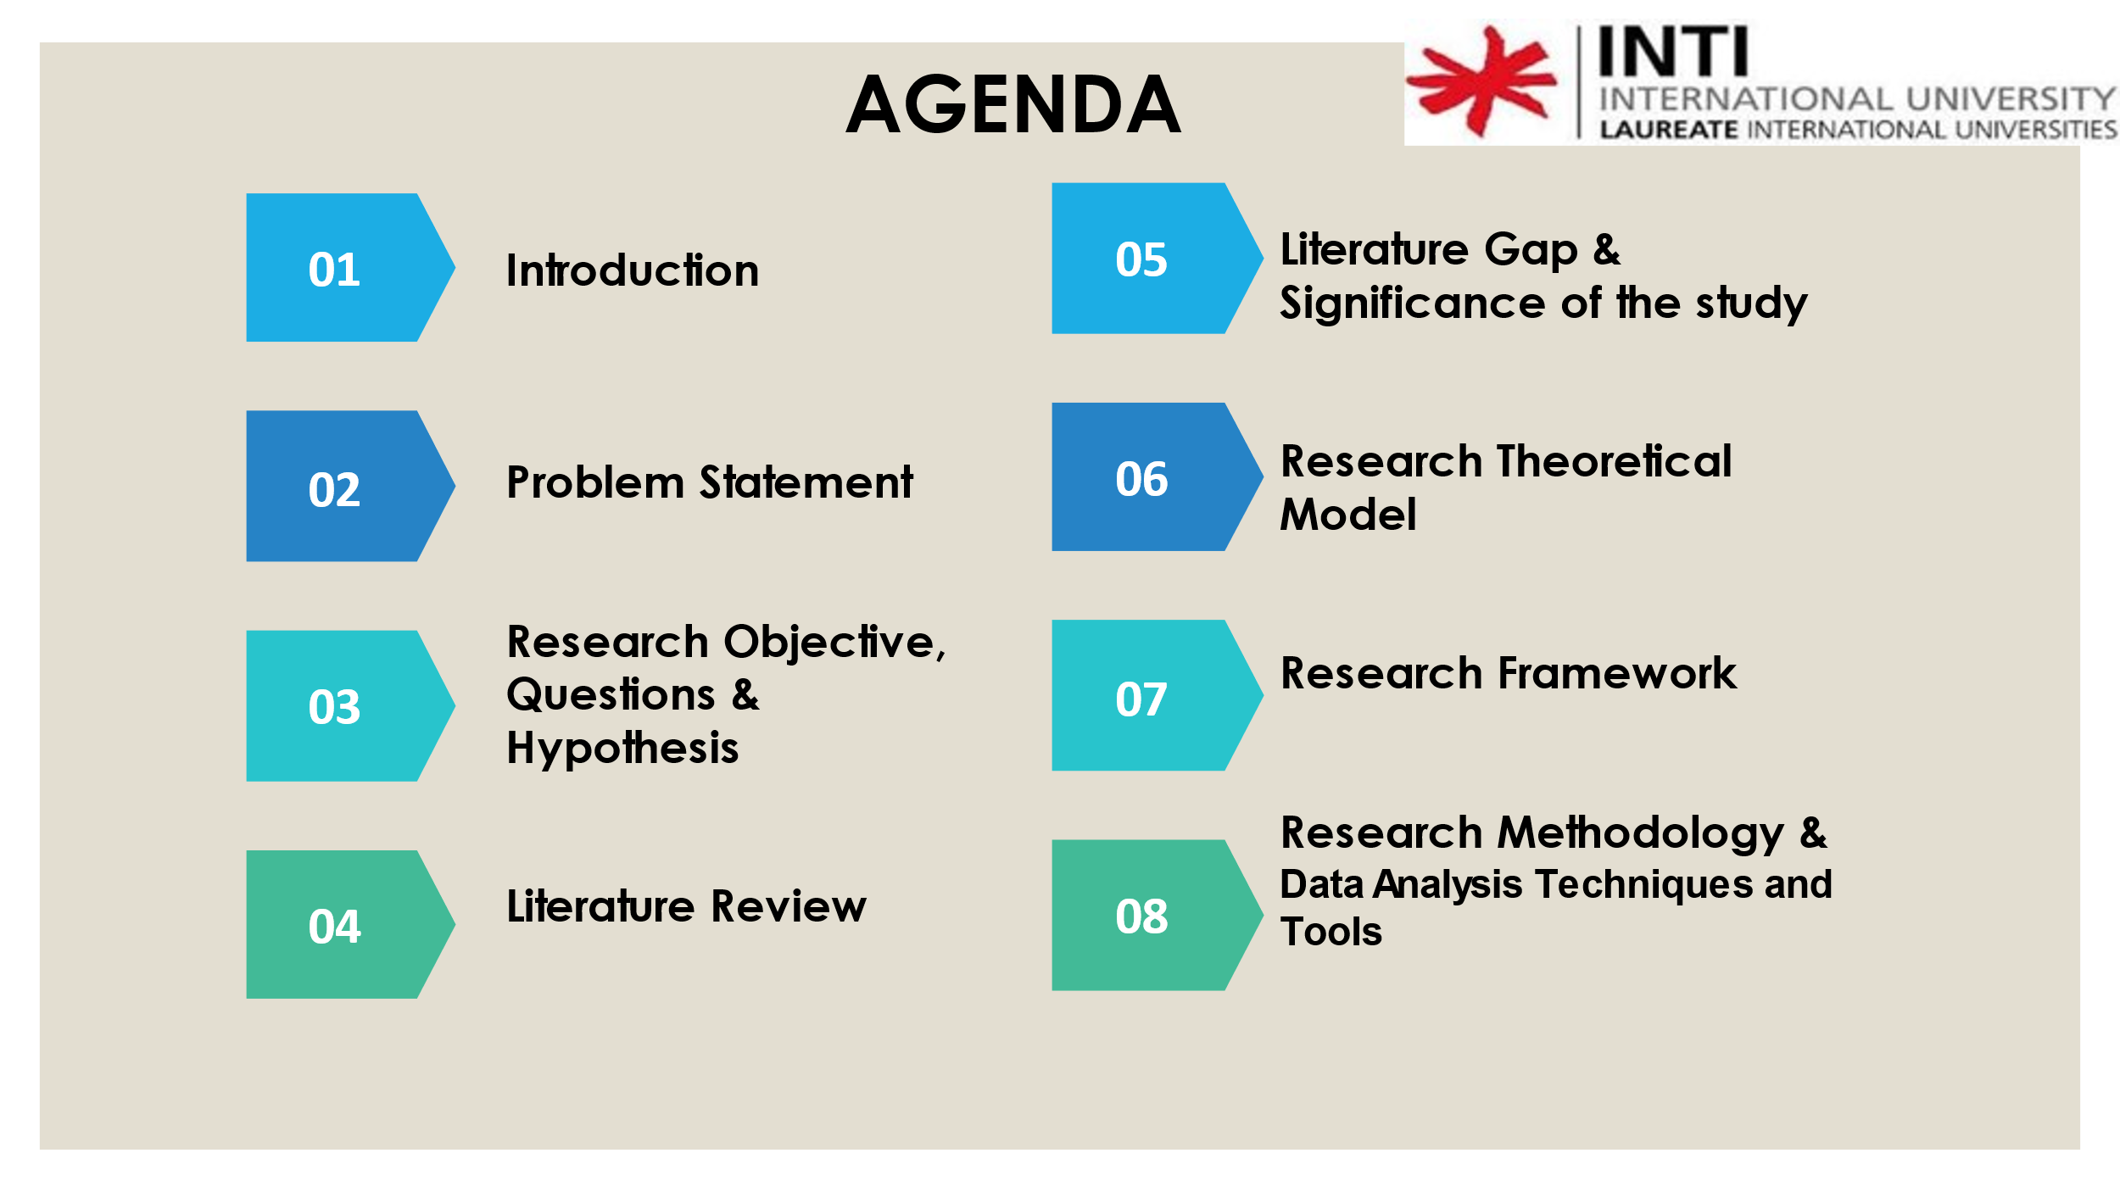
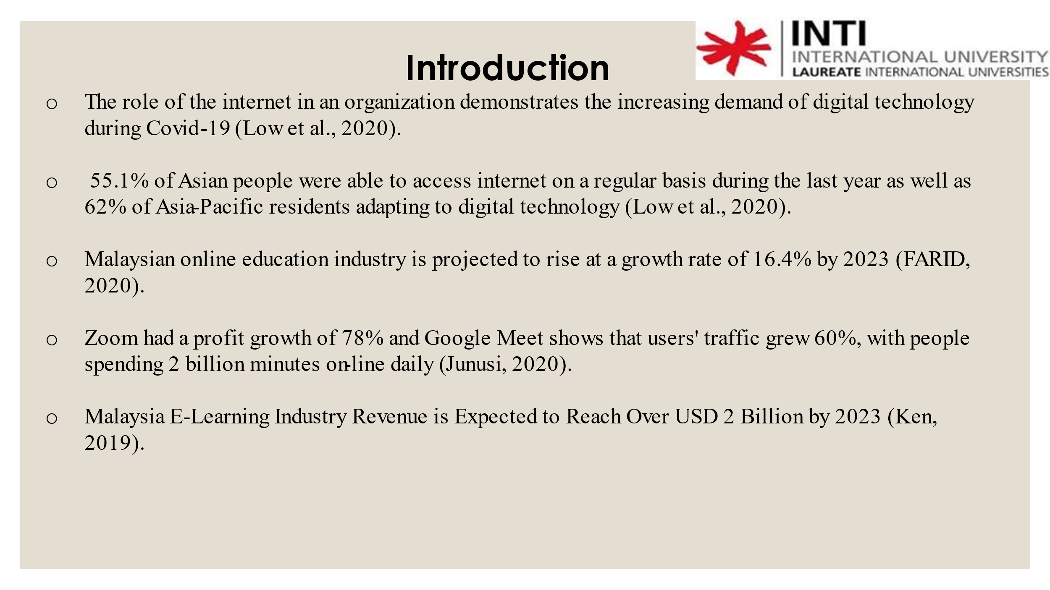
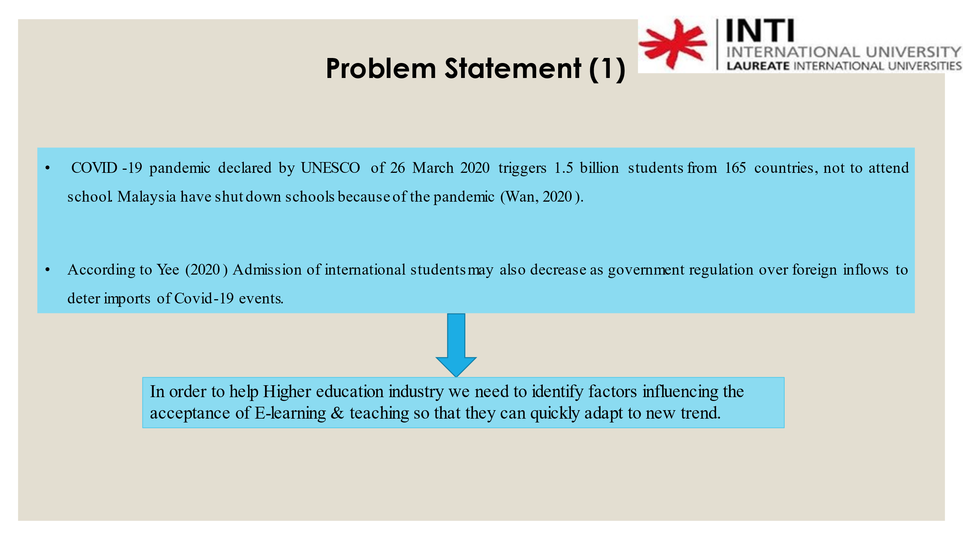
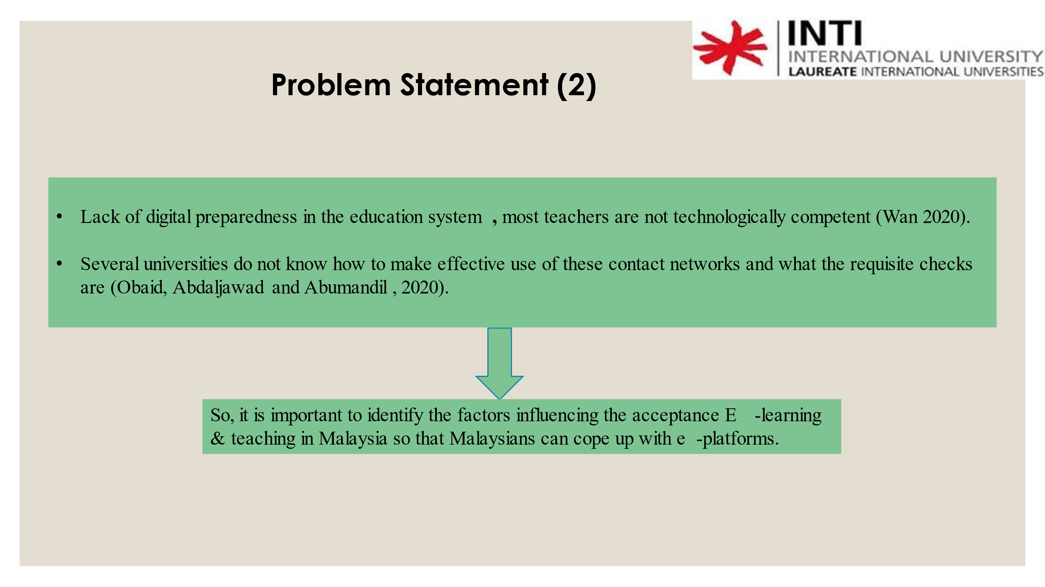
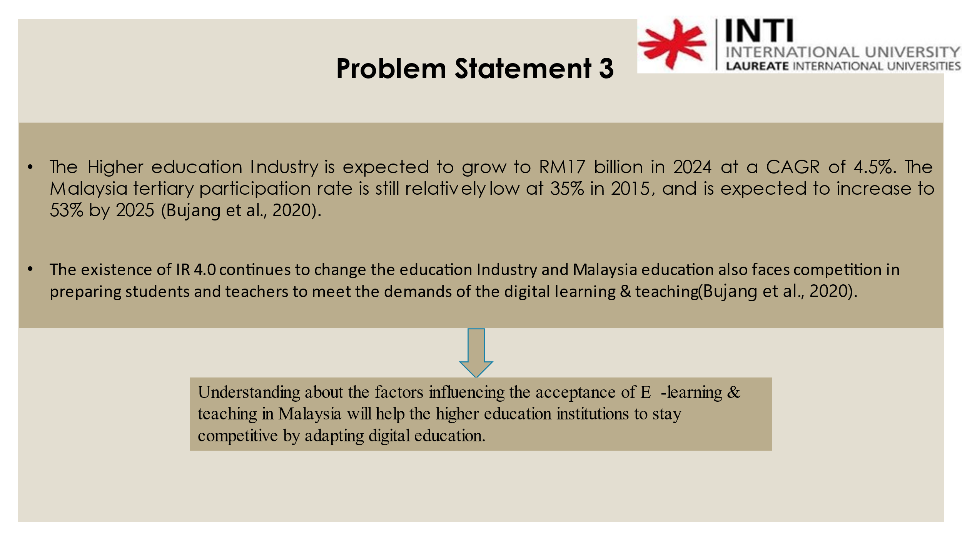

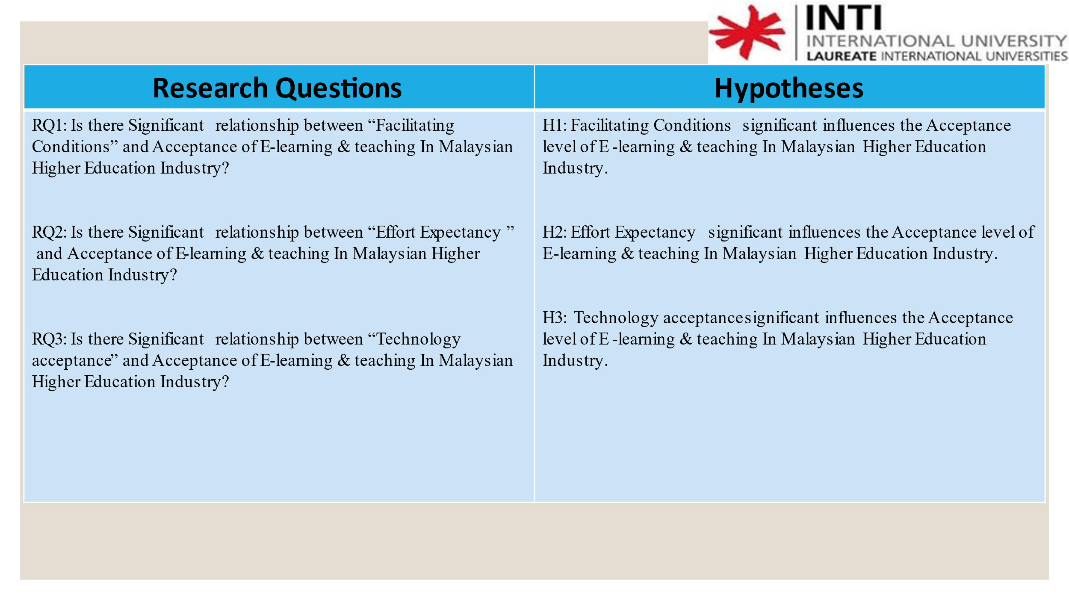
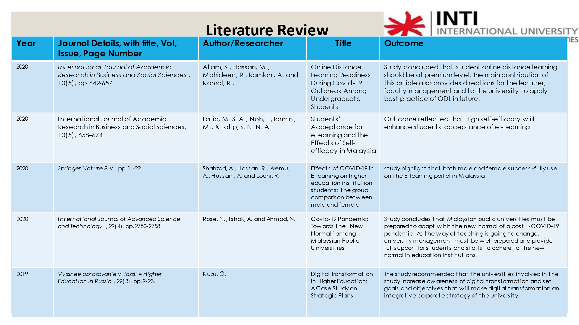
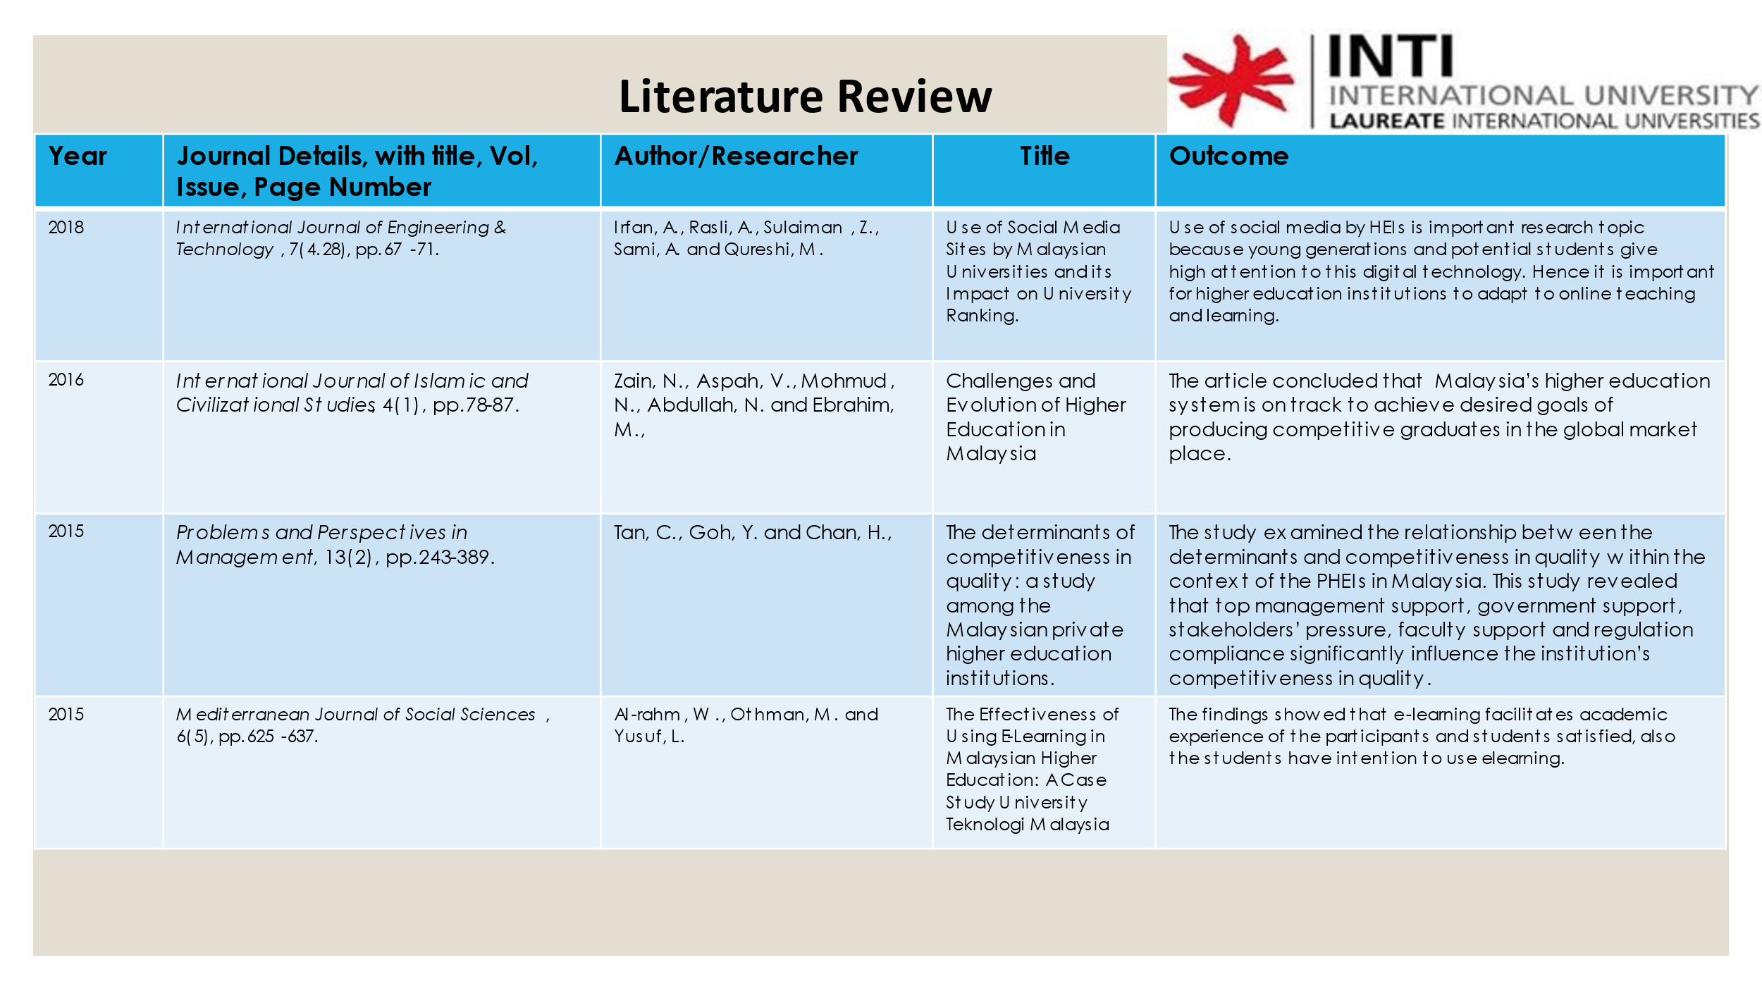
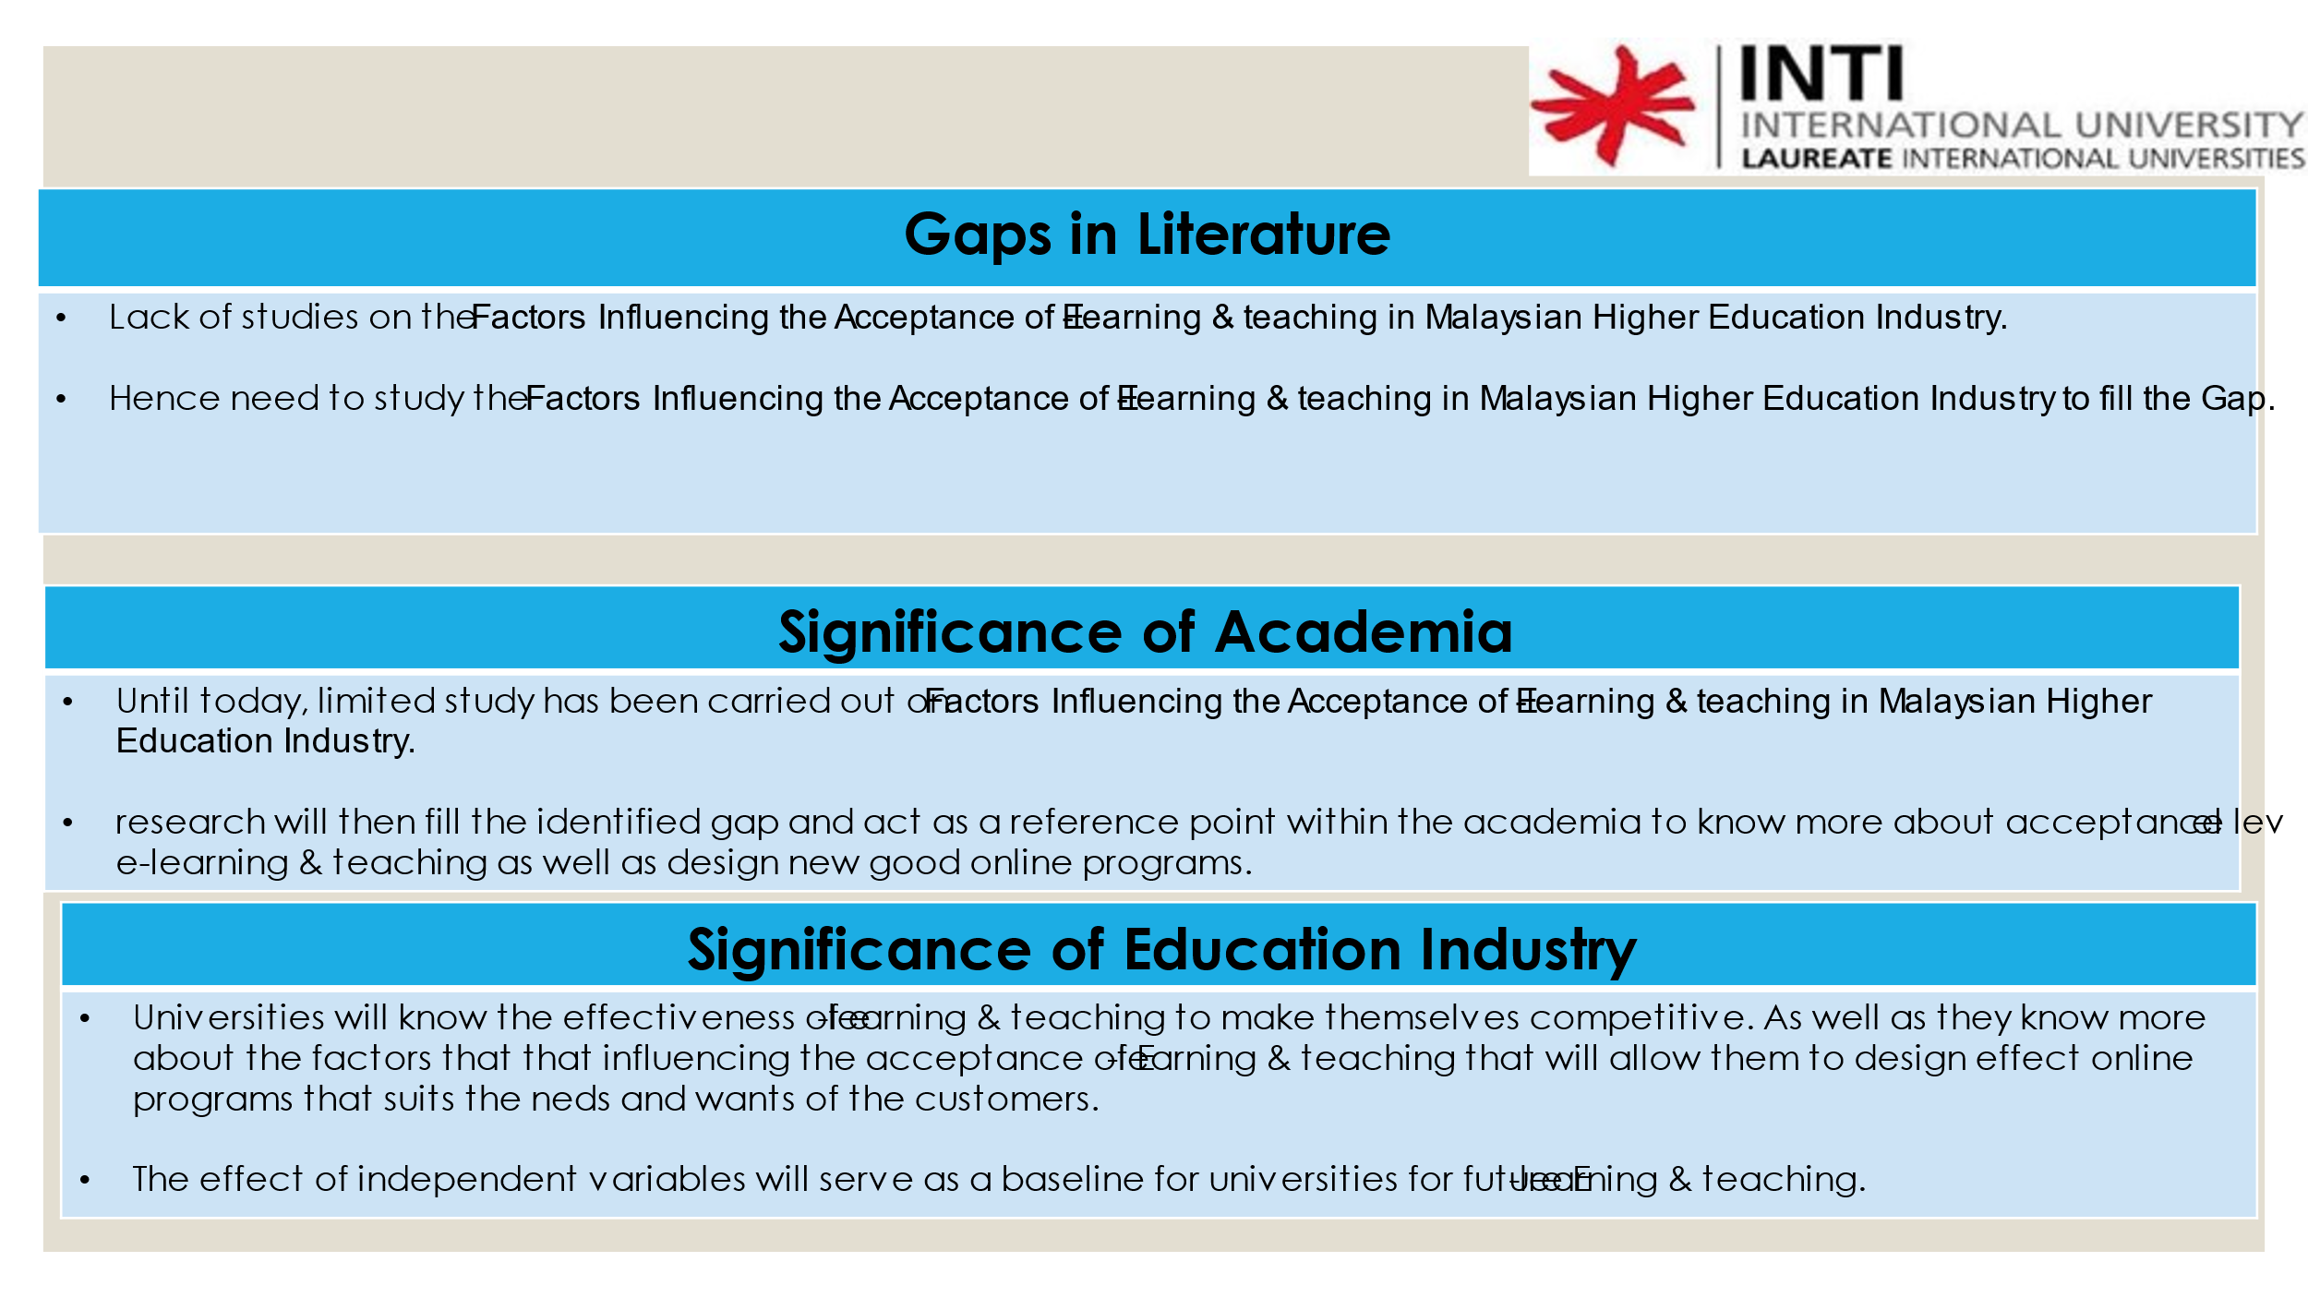
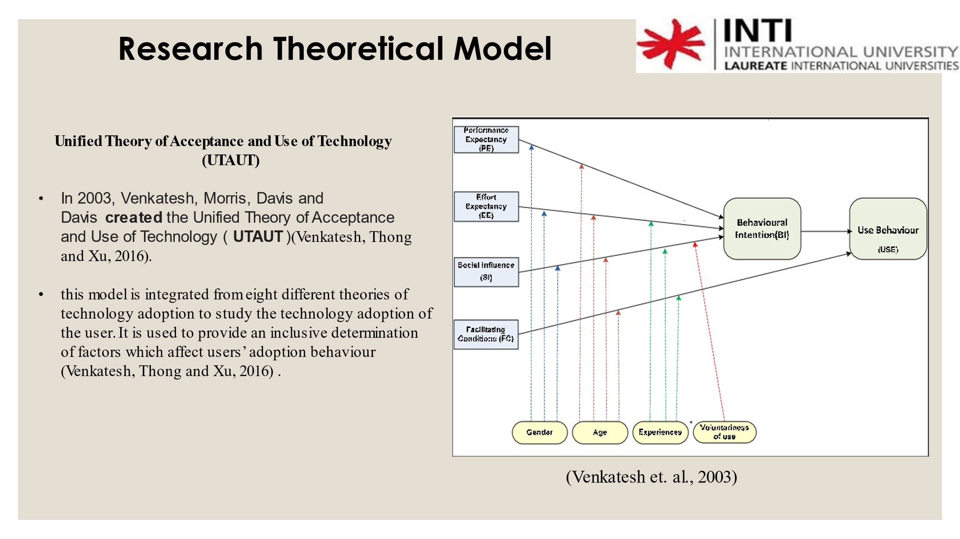
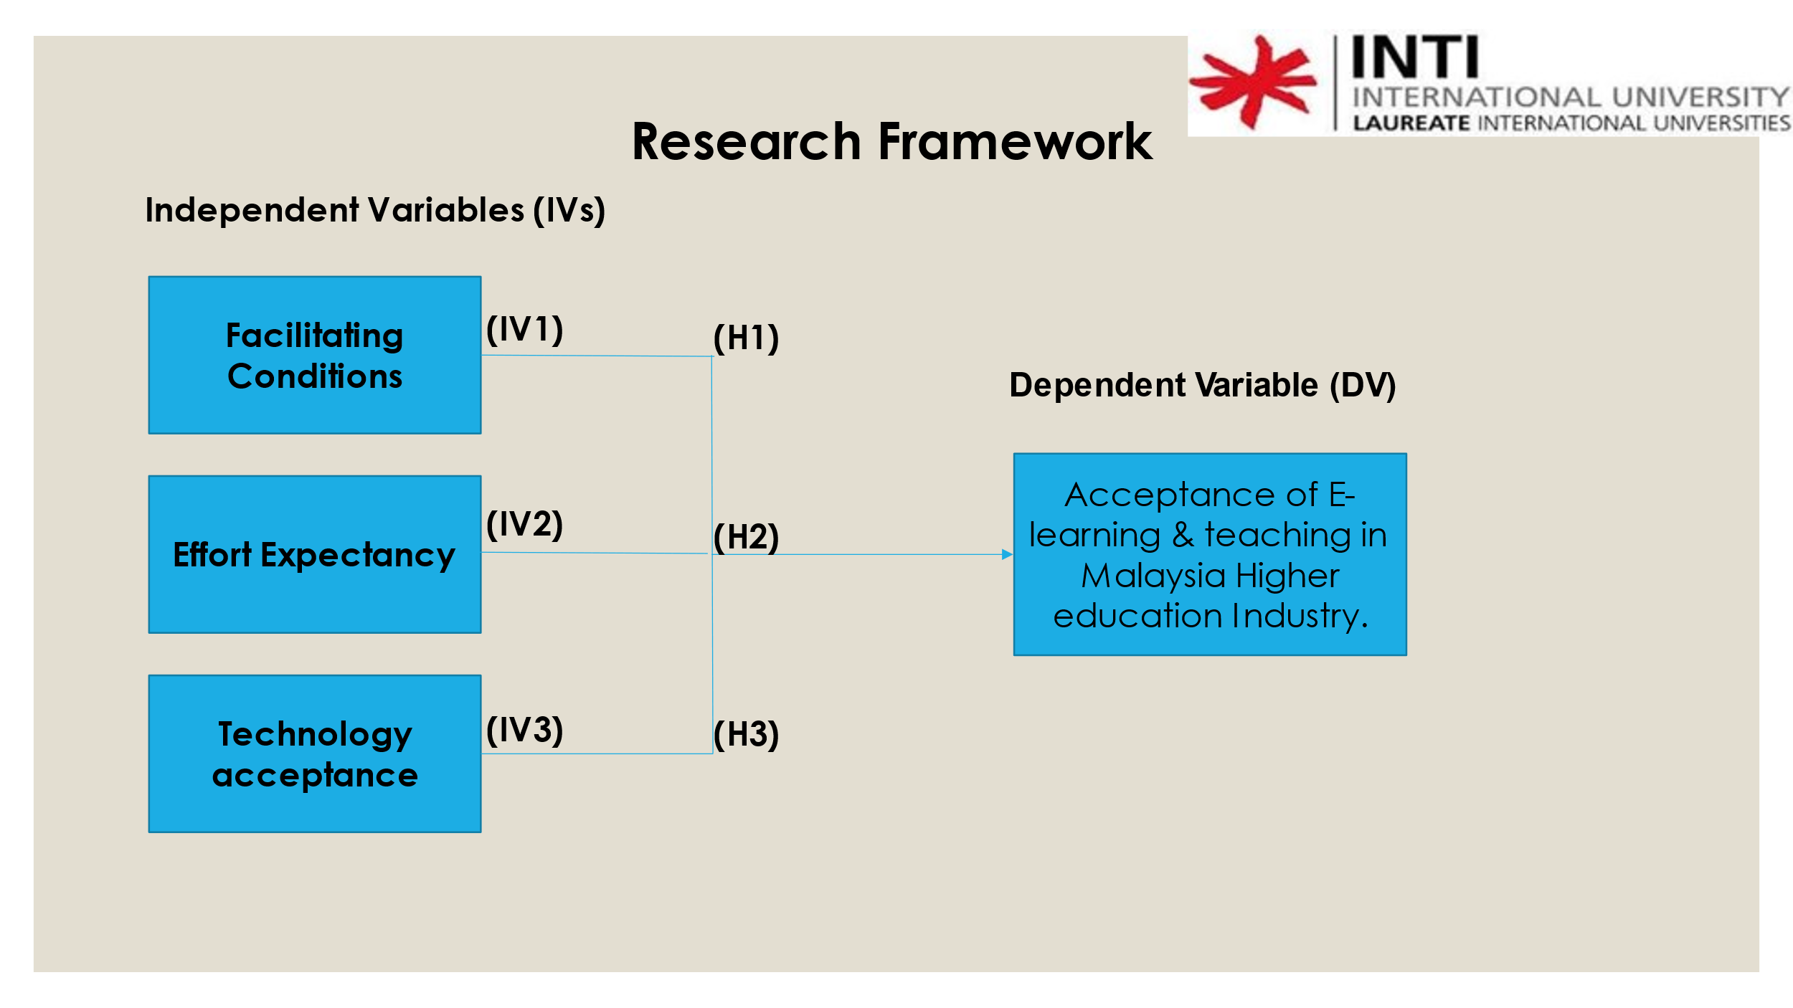
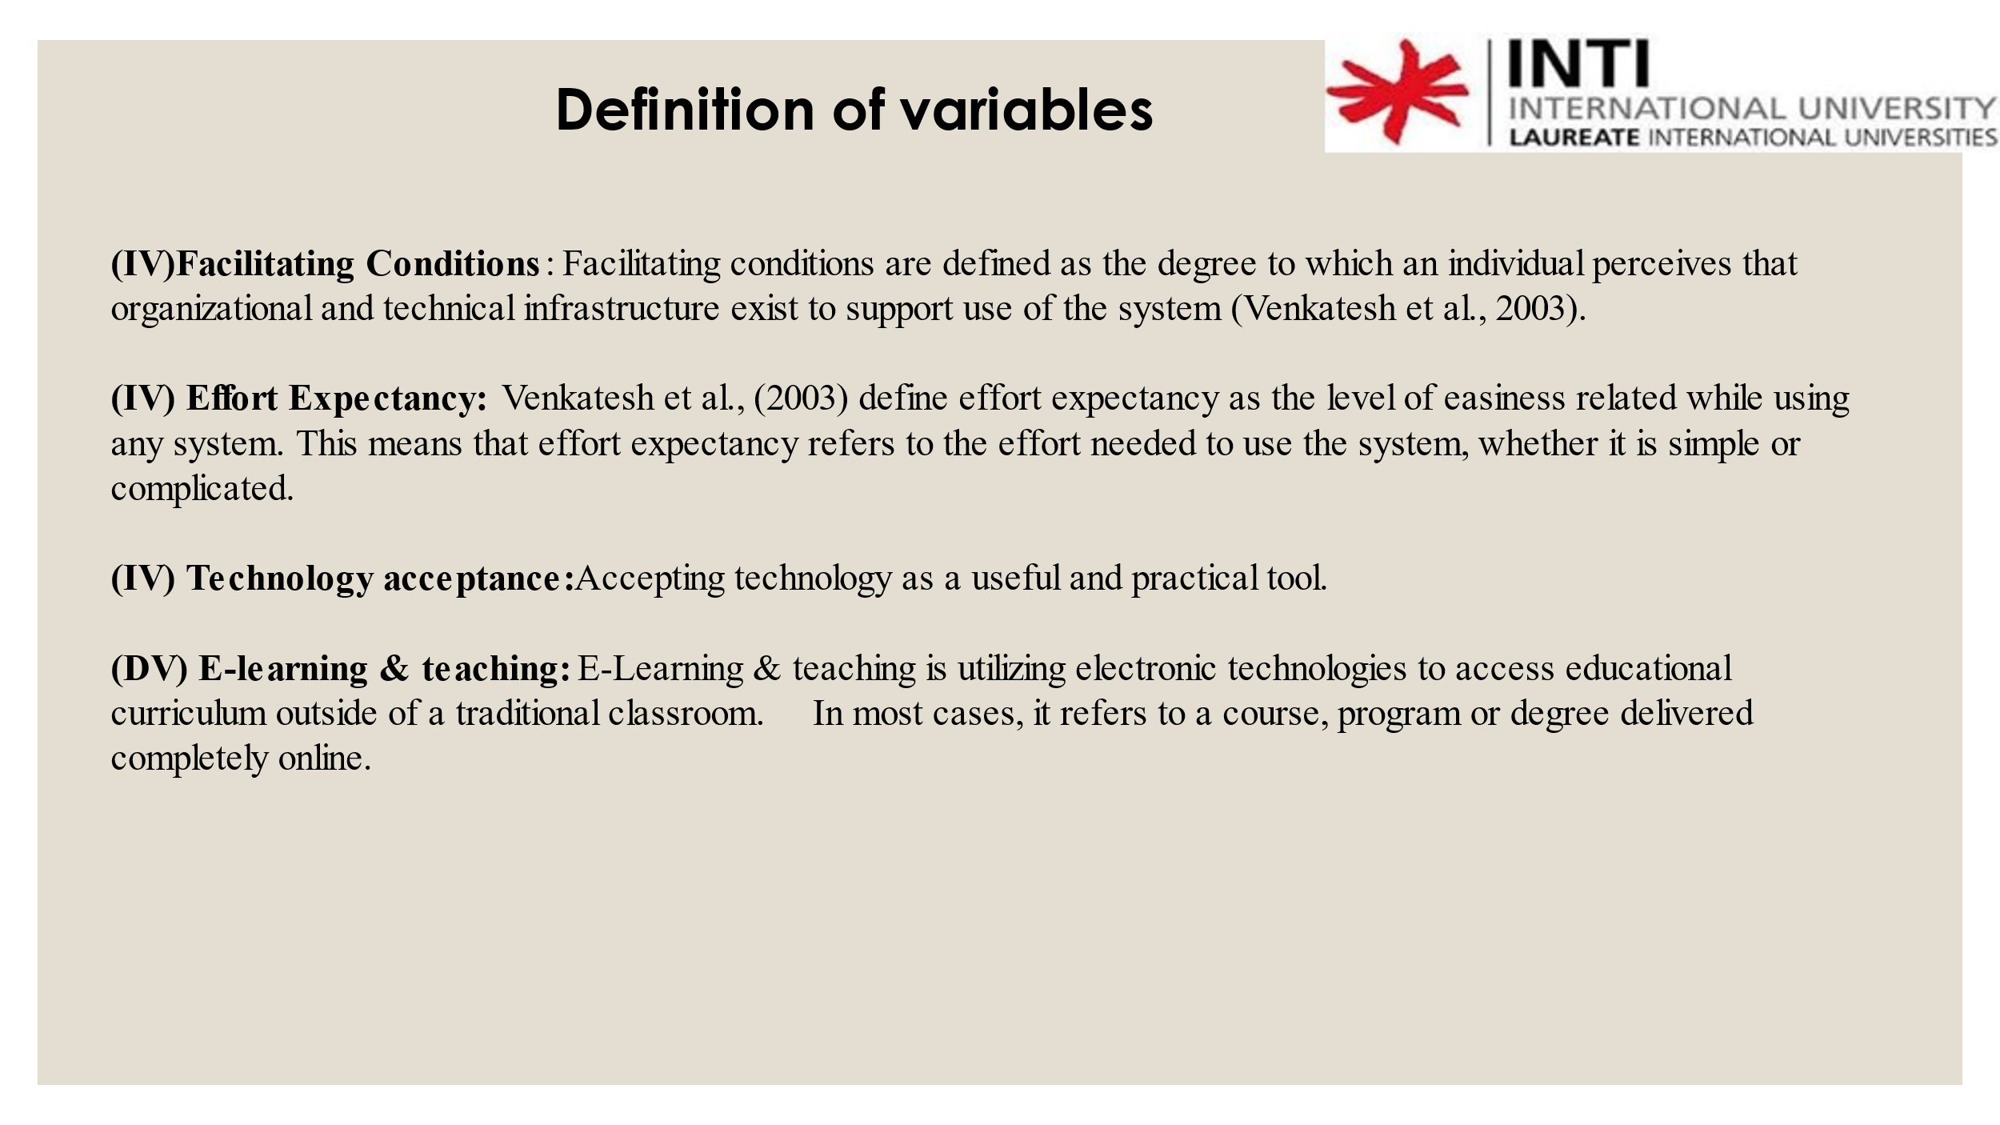
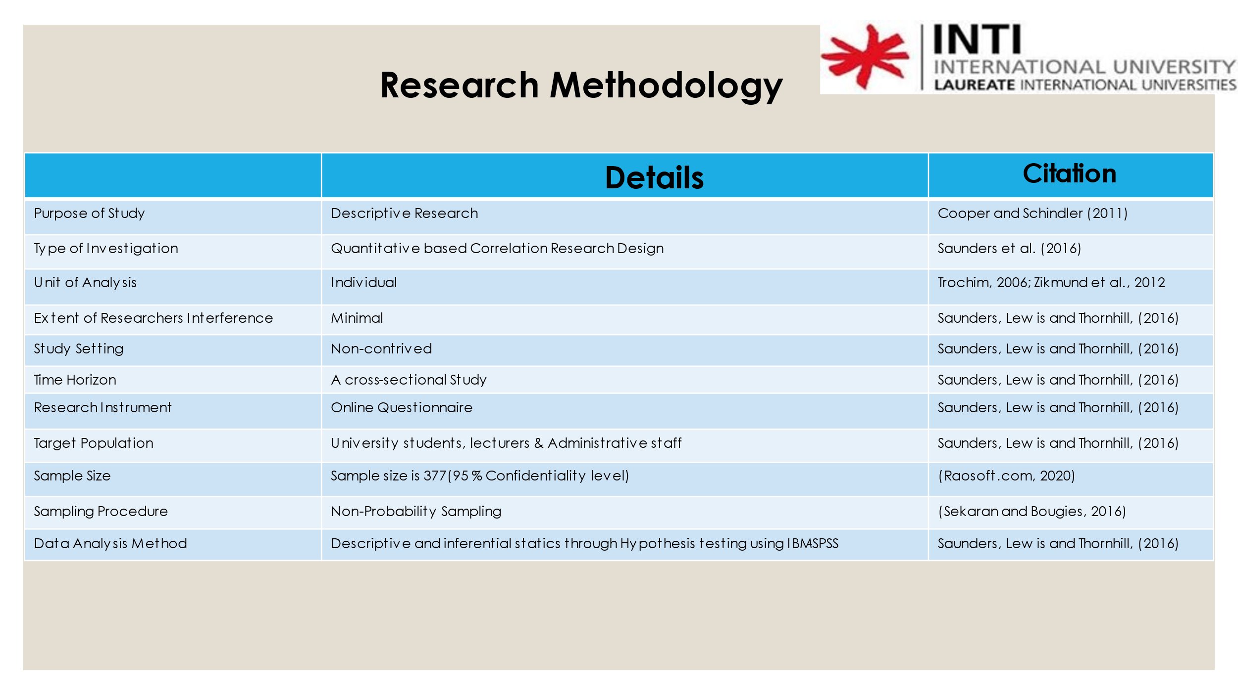
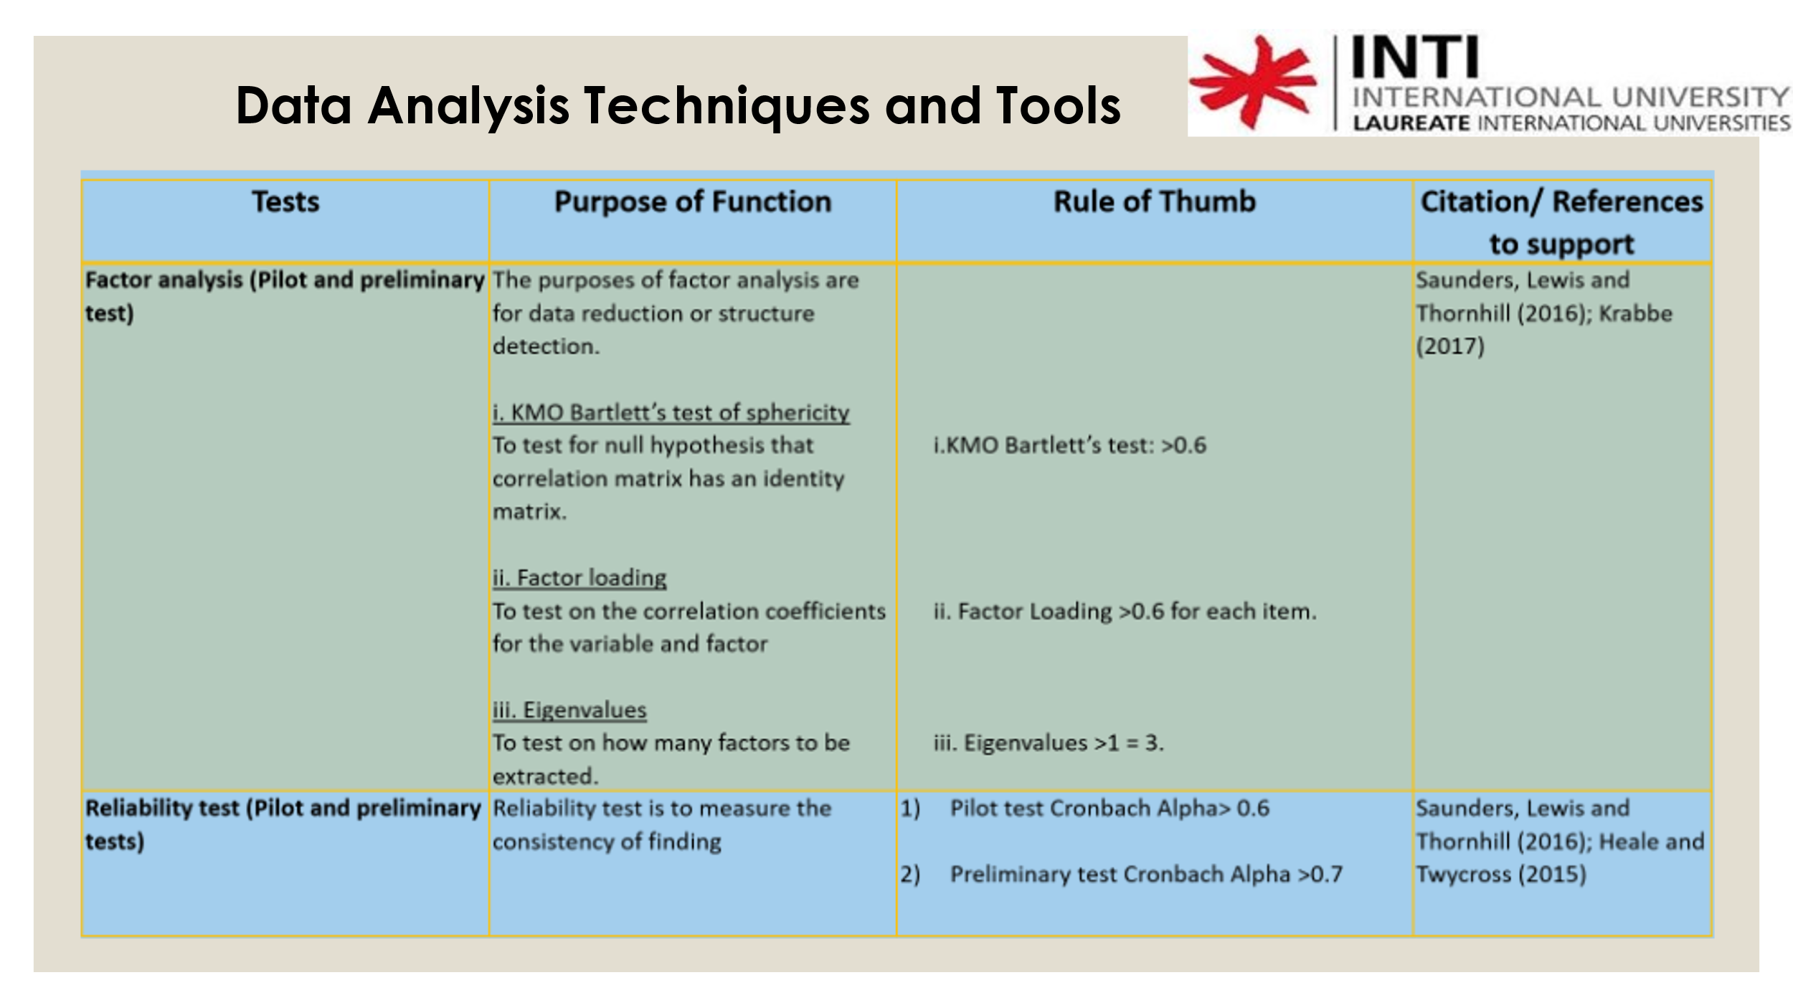
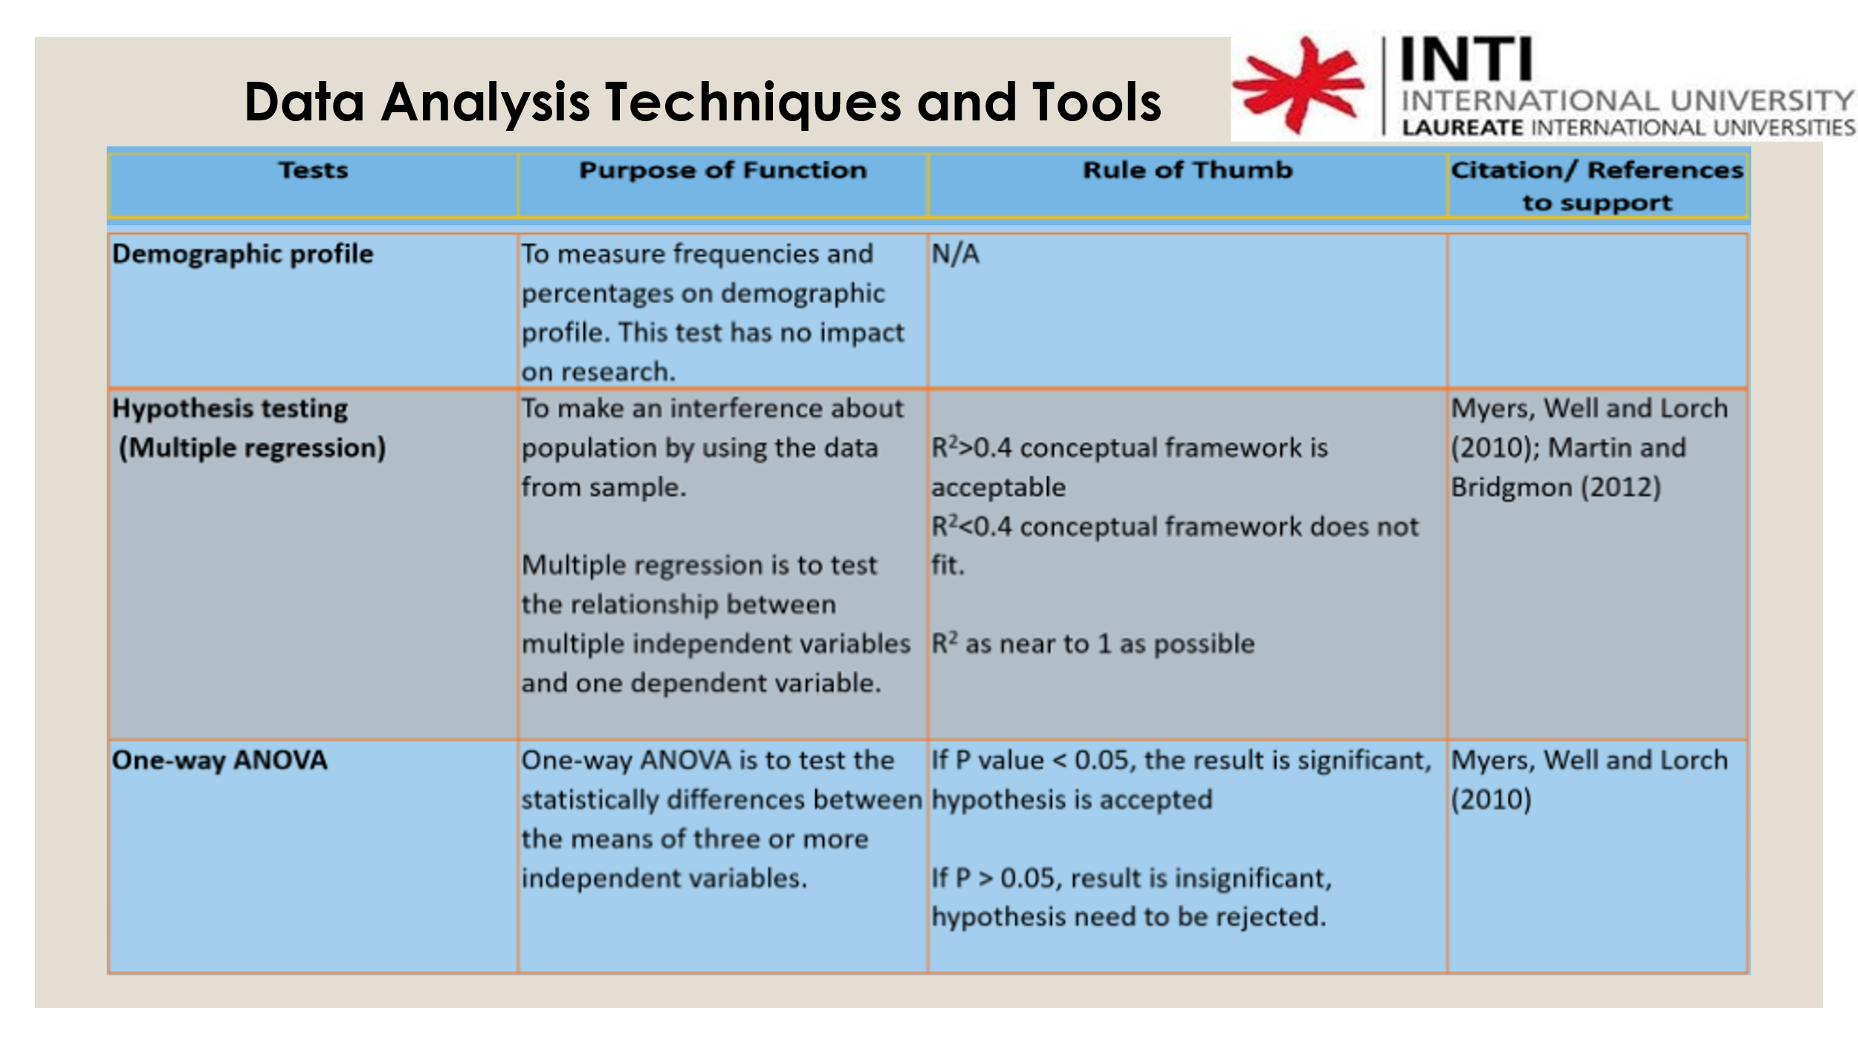
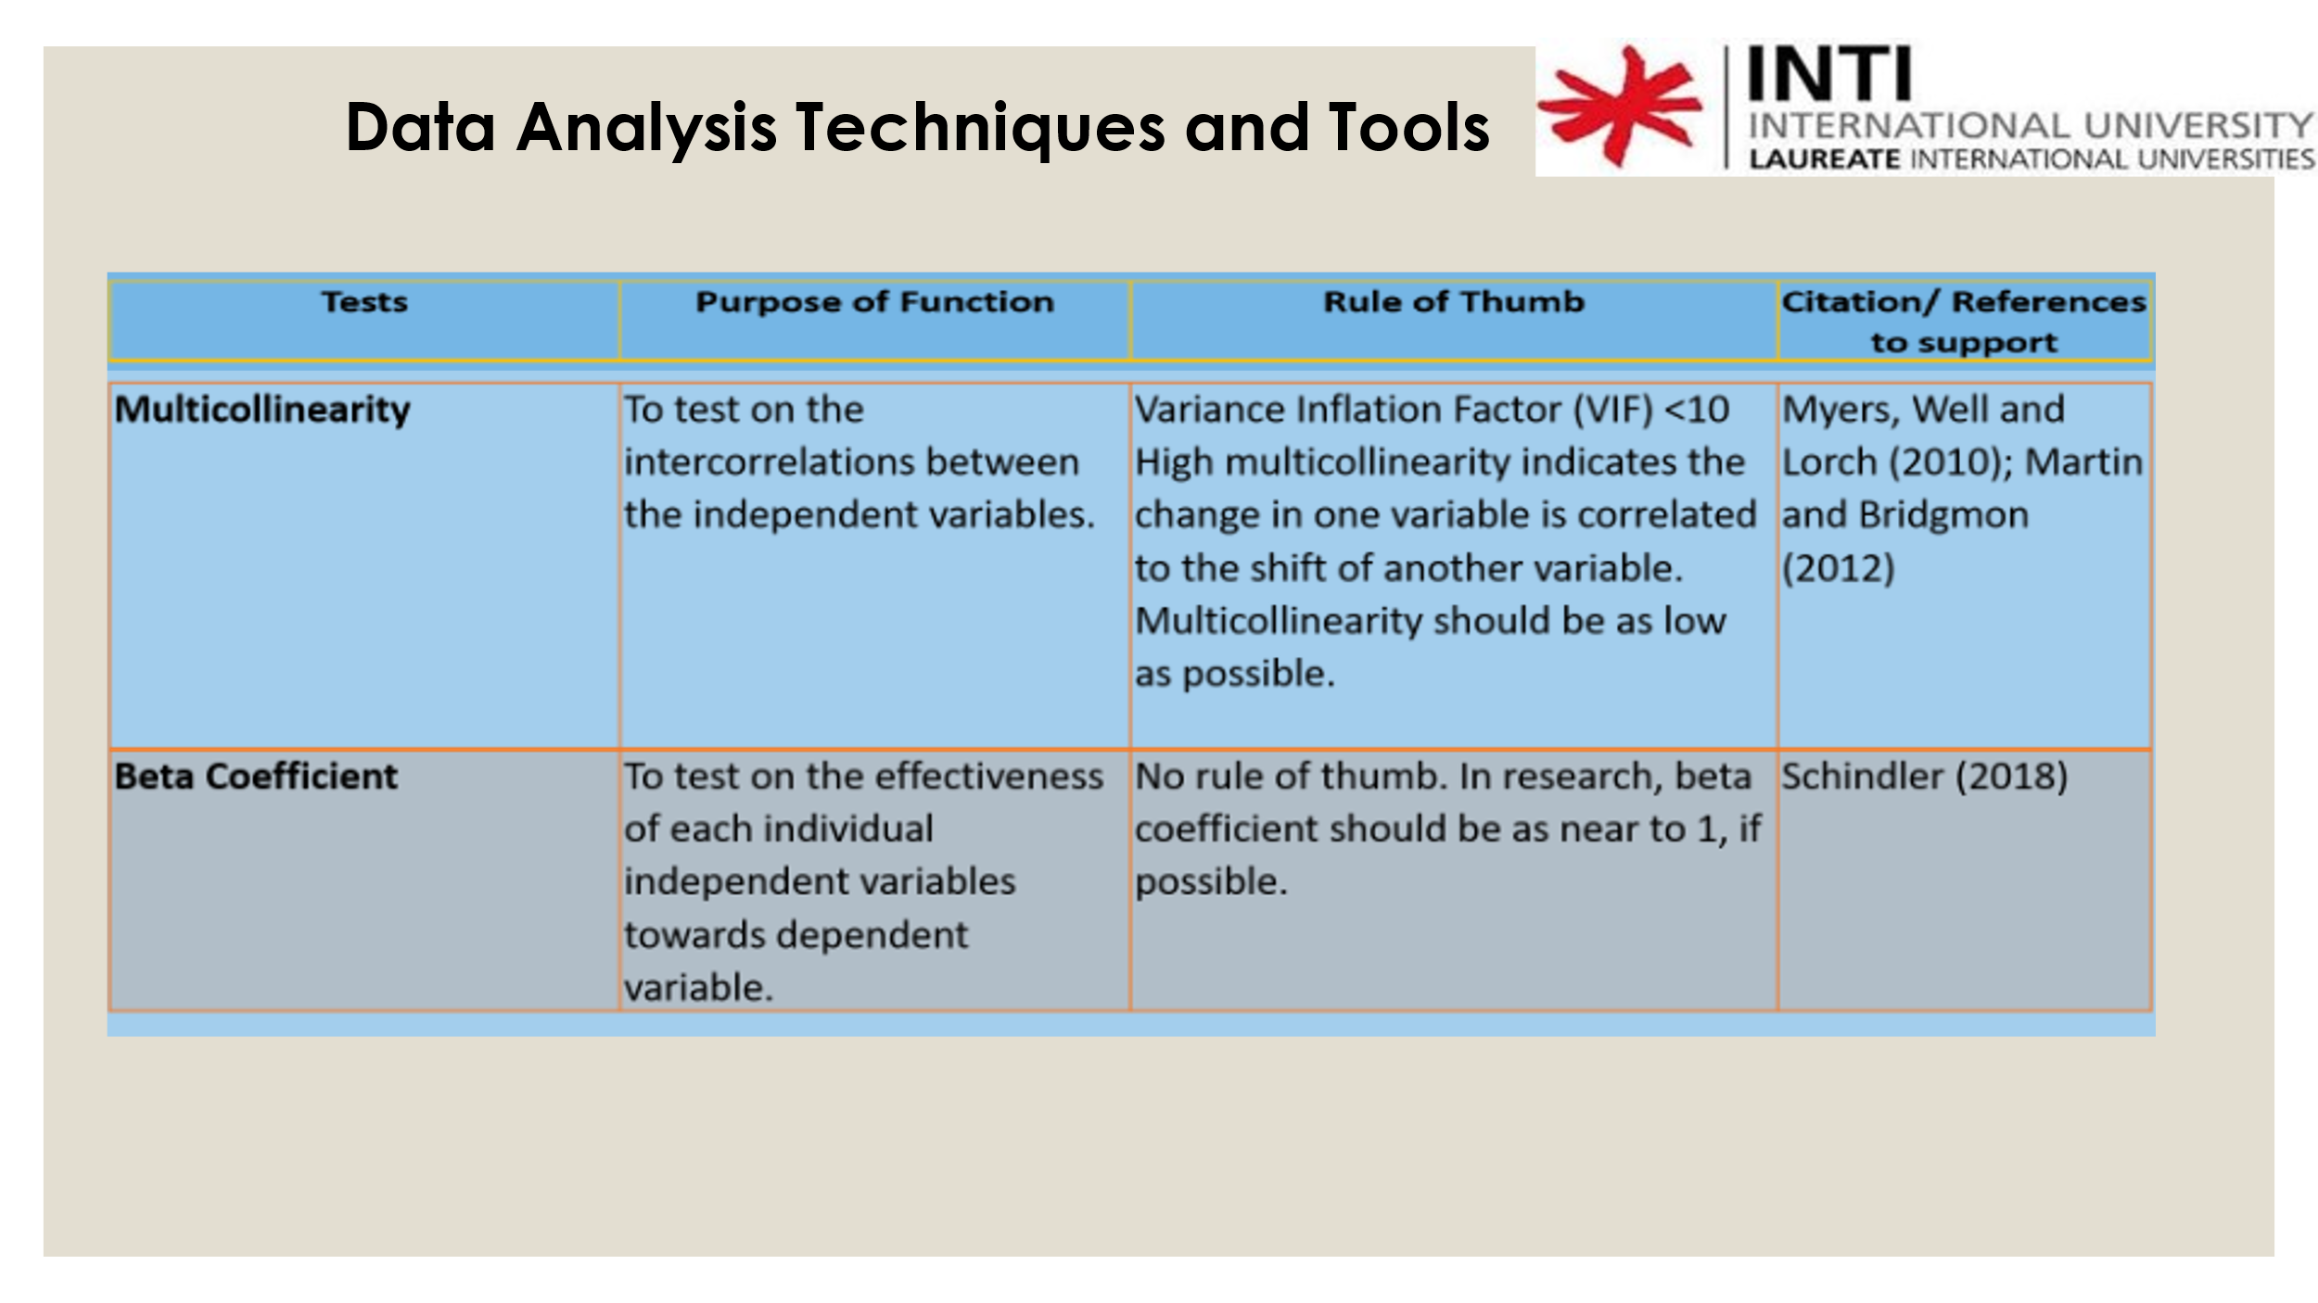
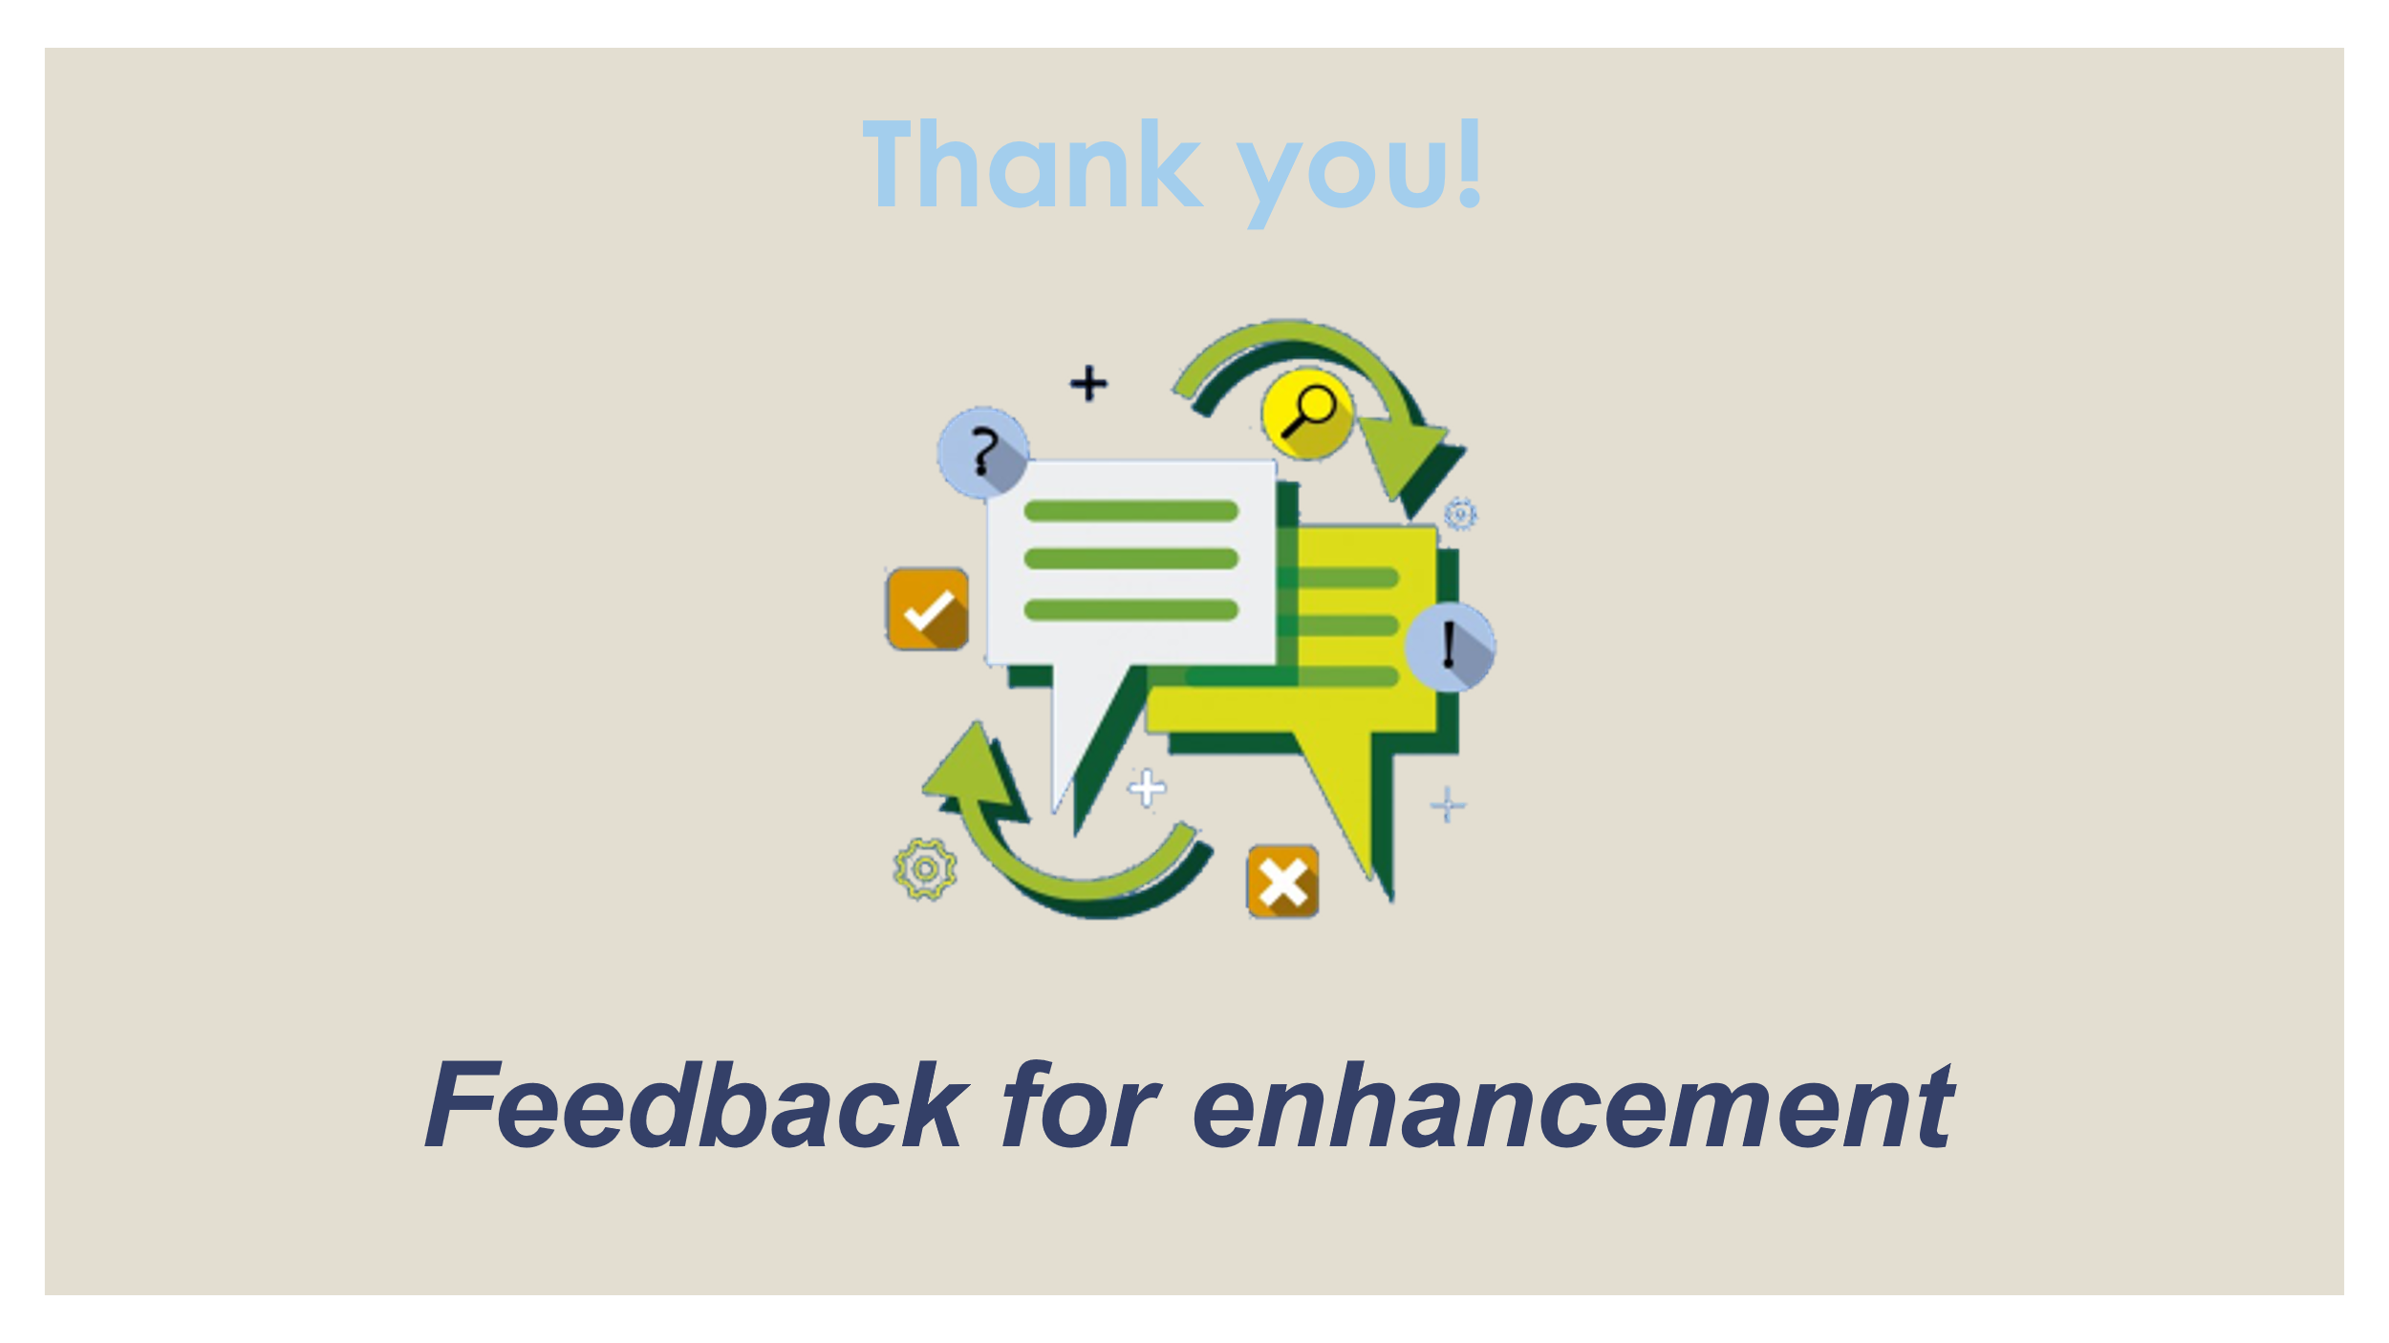

APPENDIX D

Viva slides

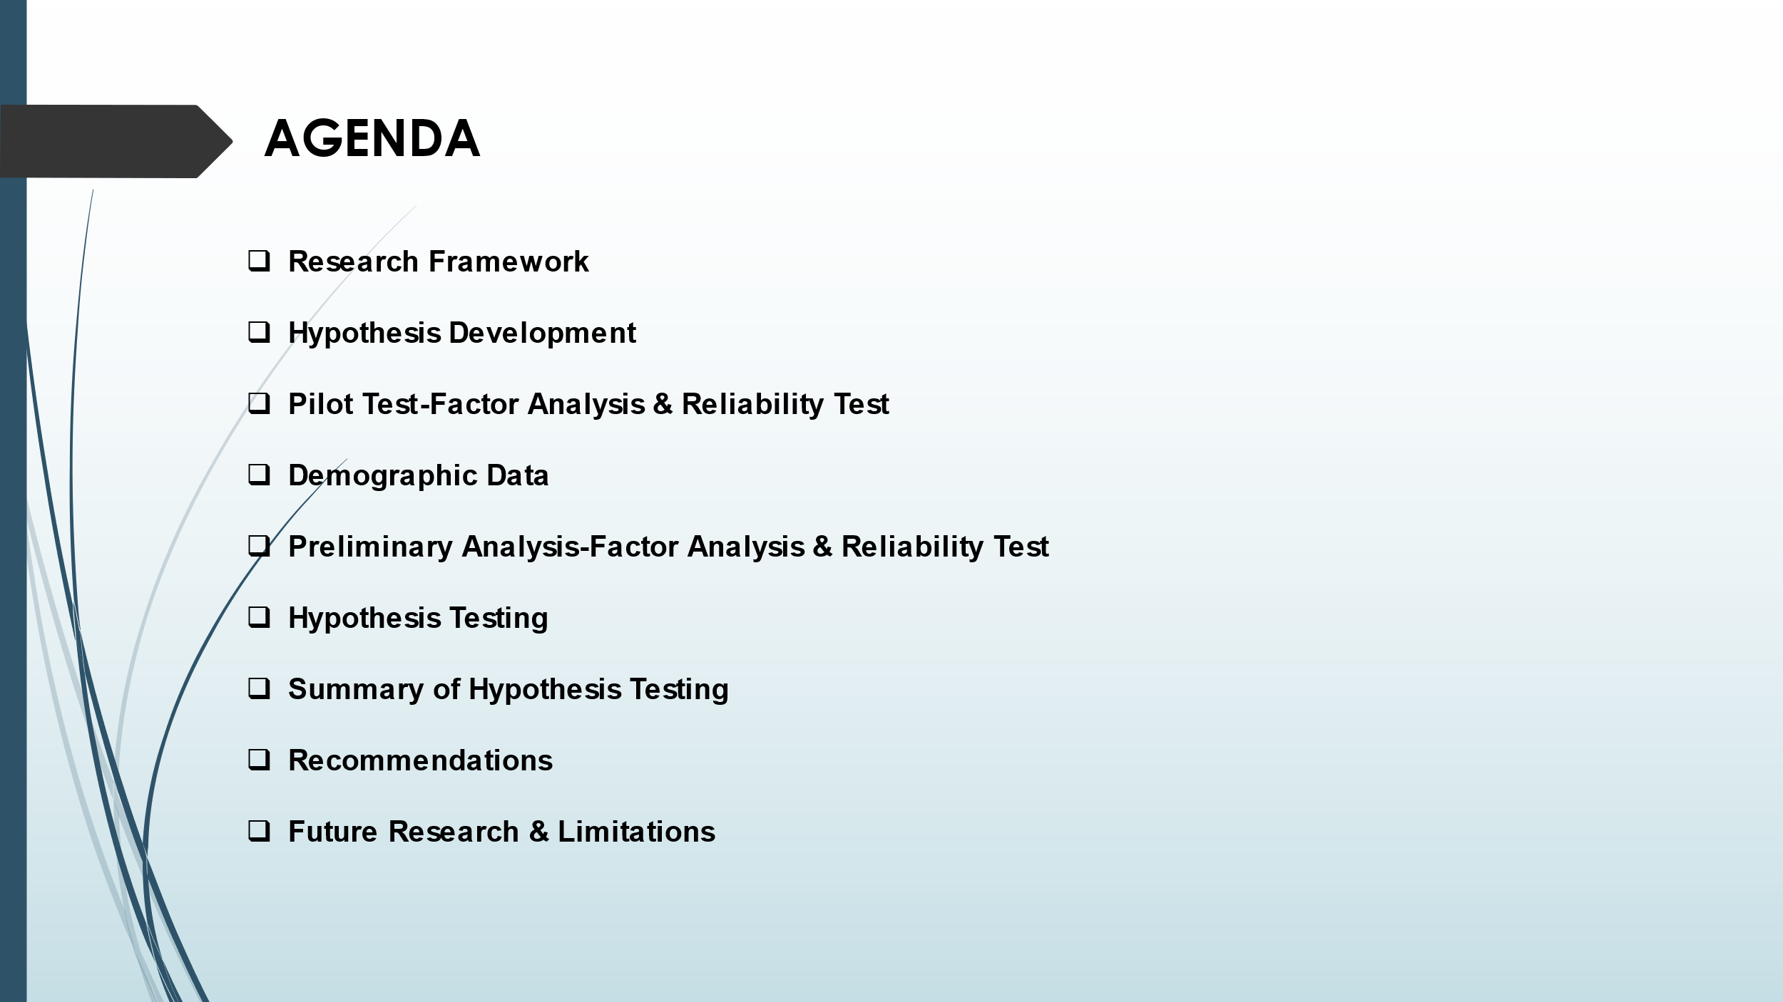
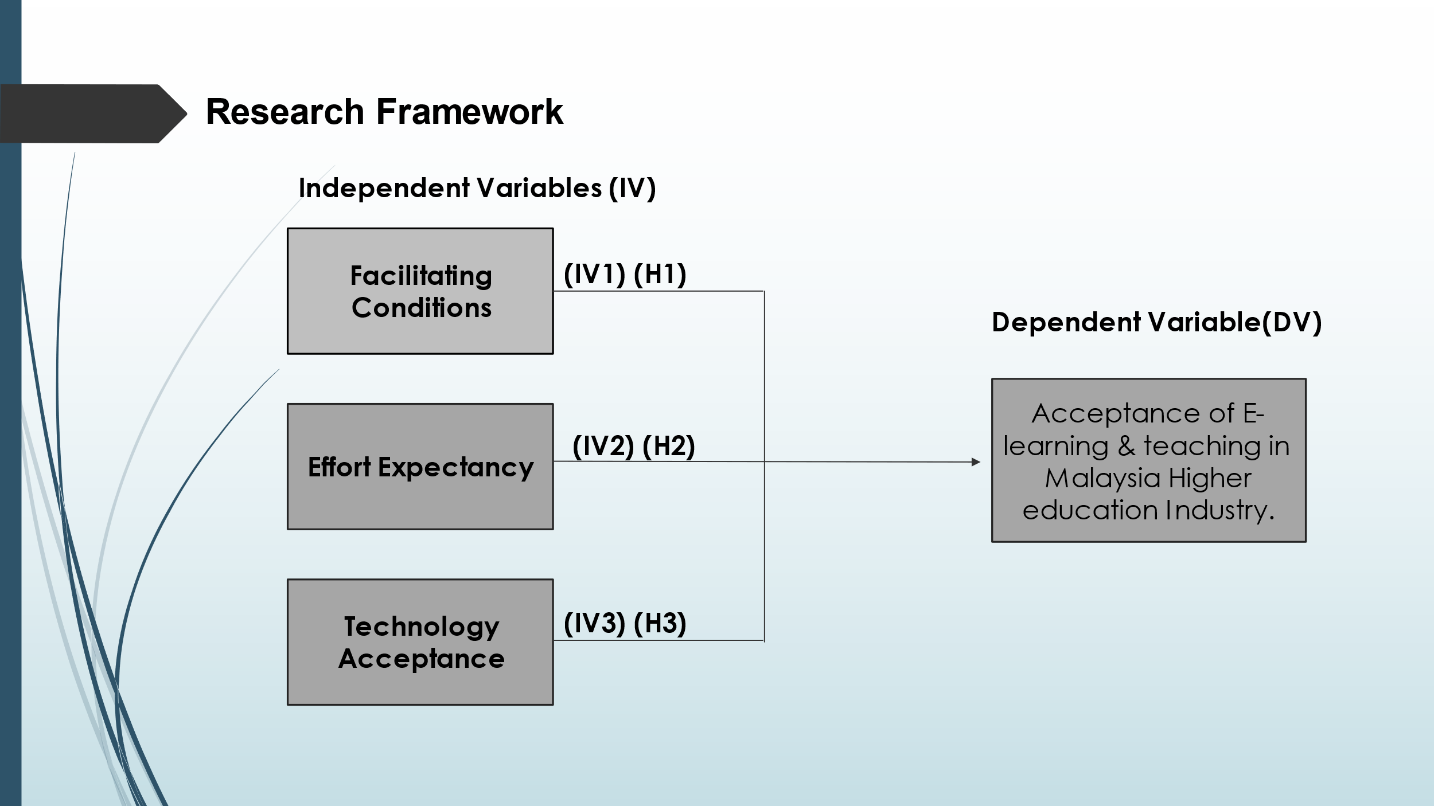
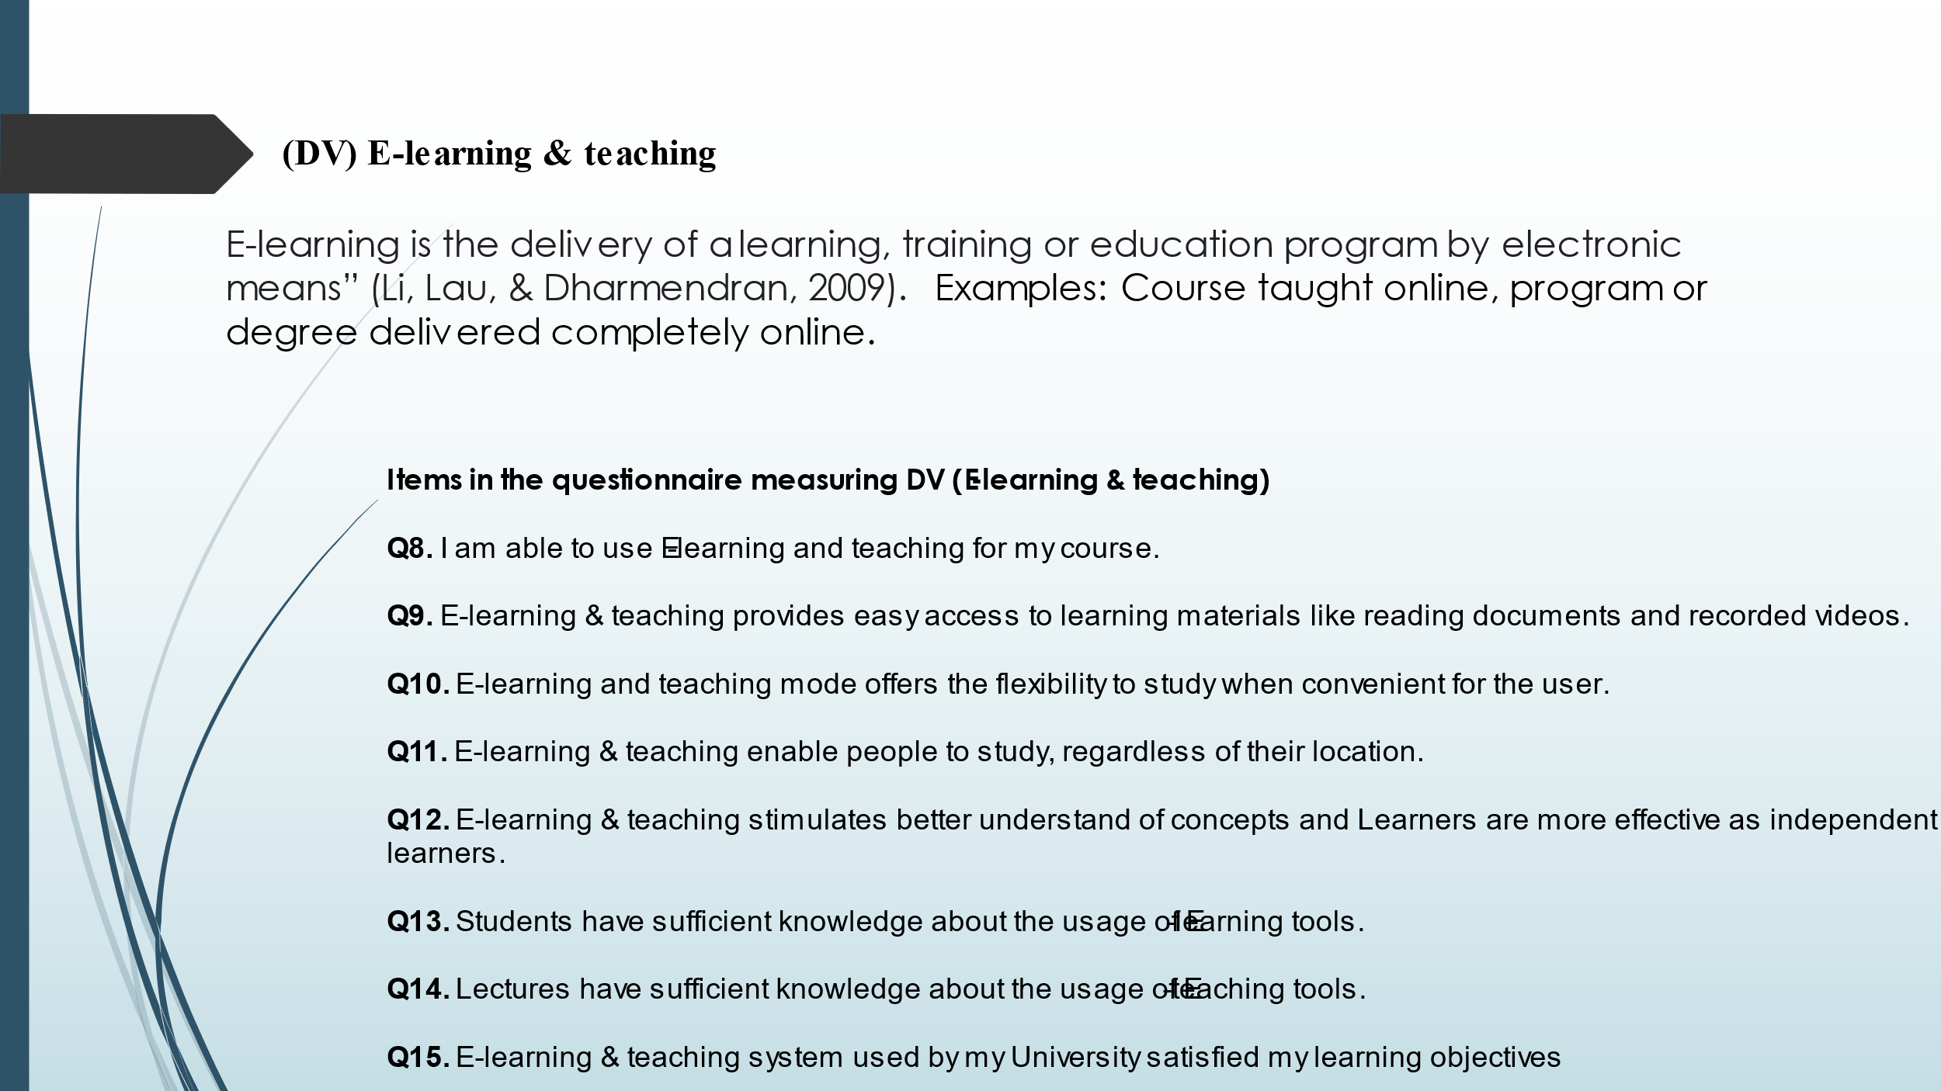
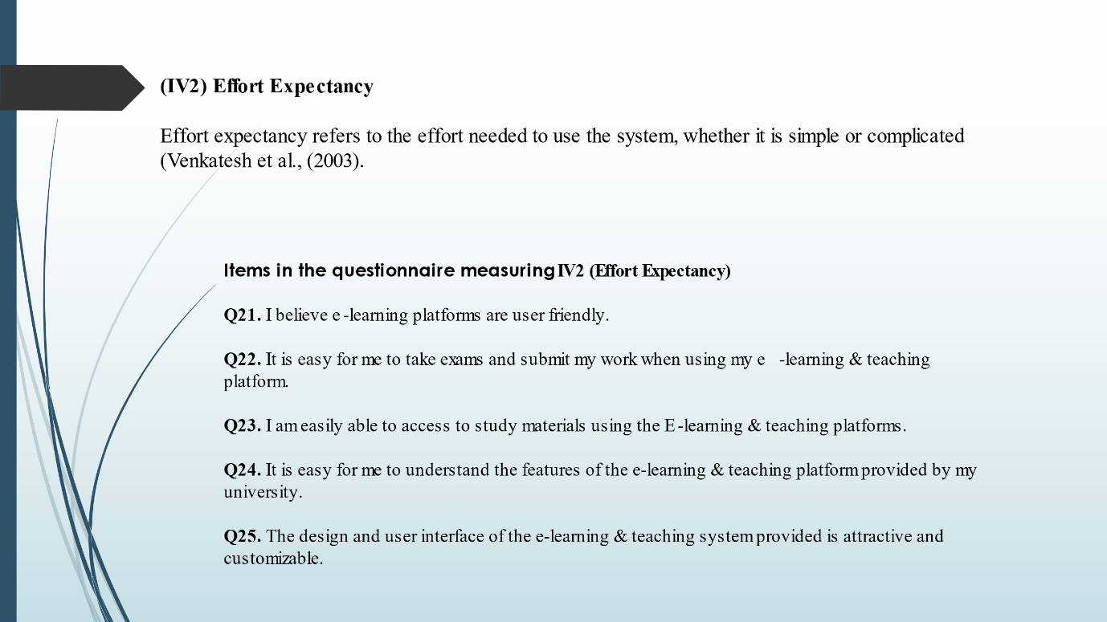
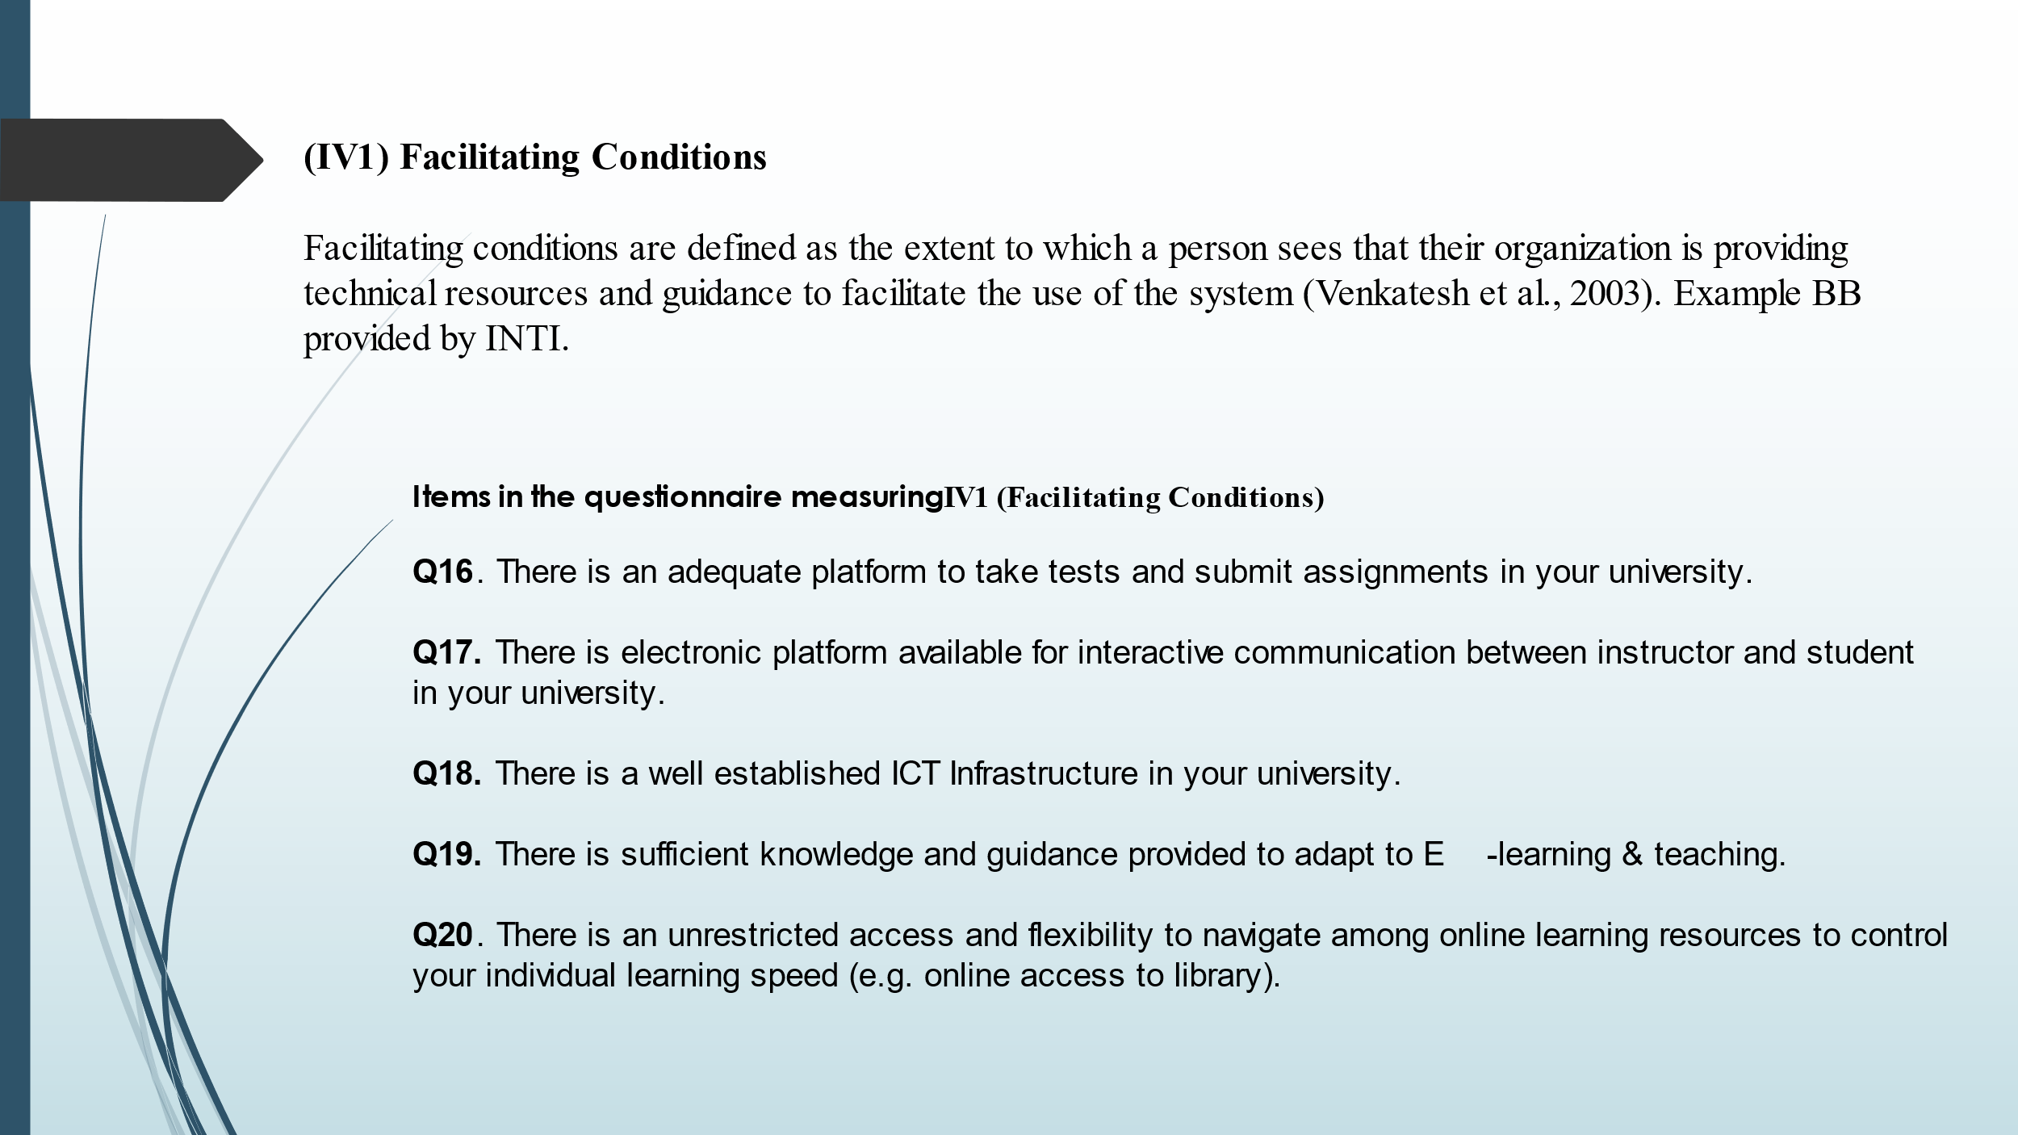
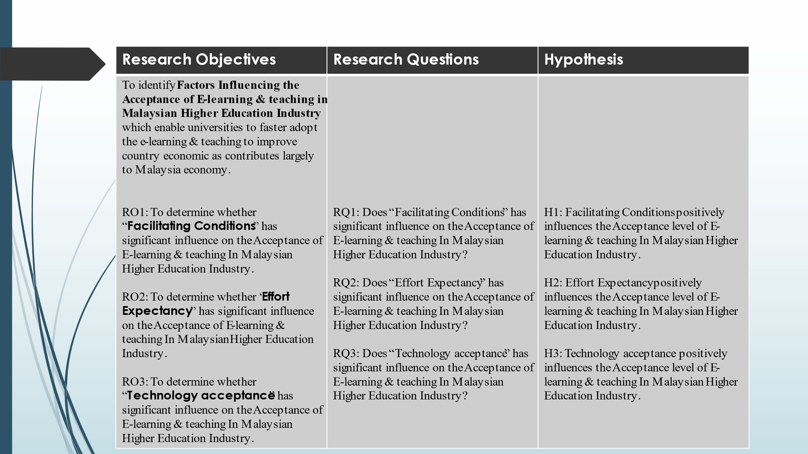
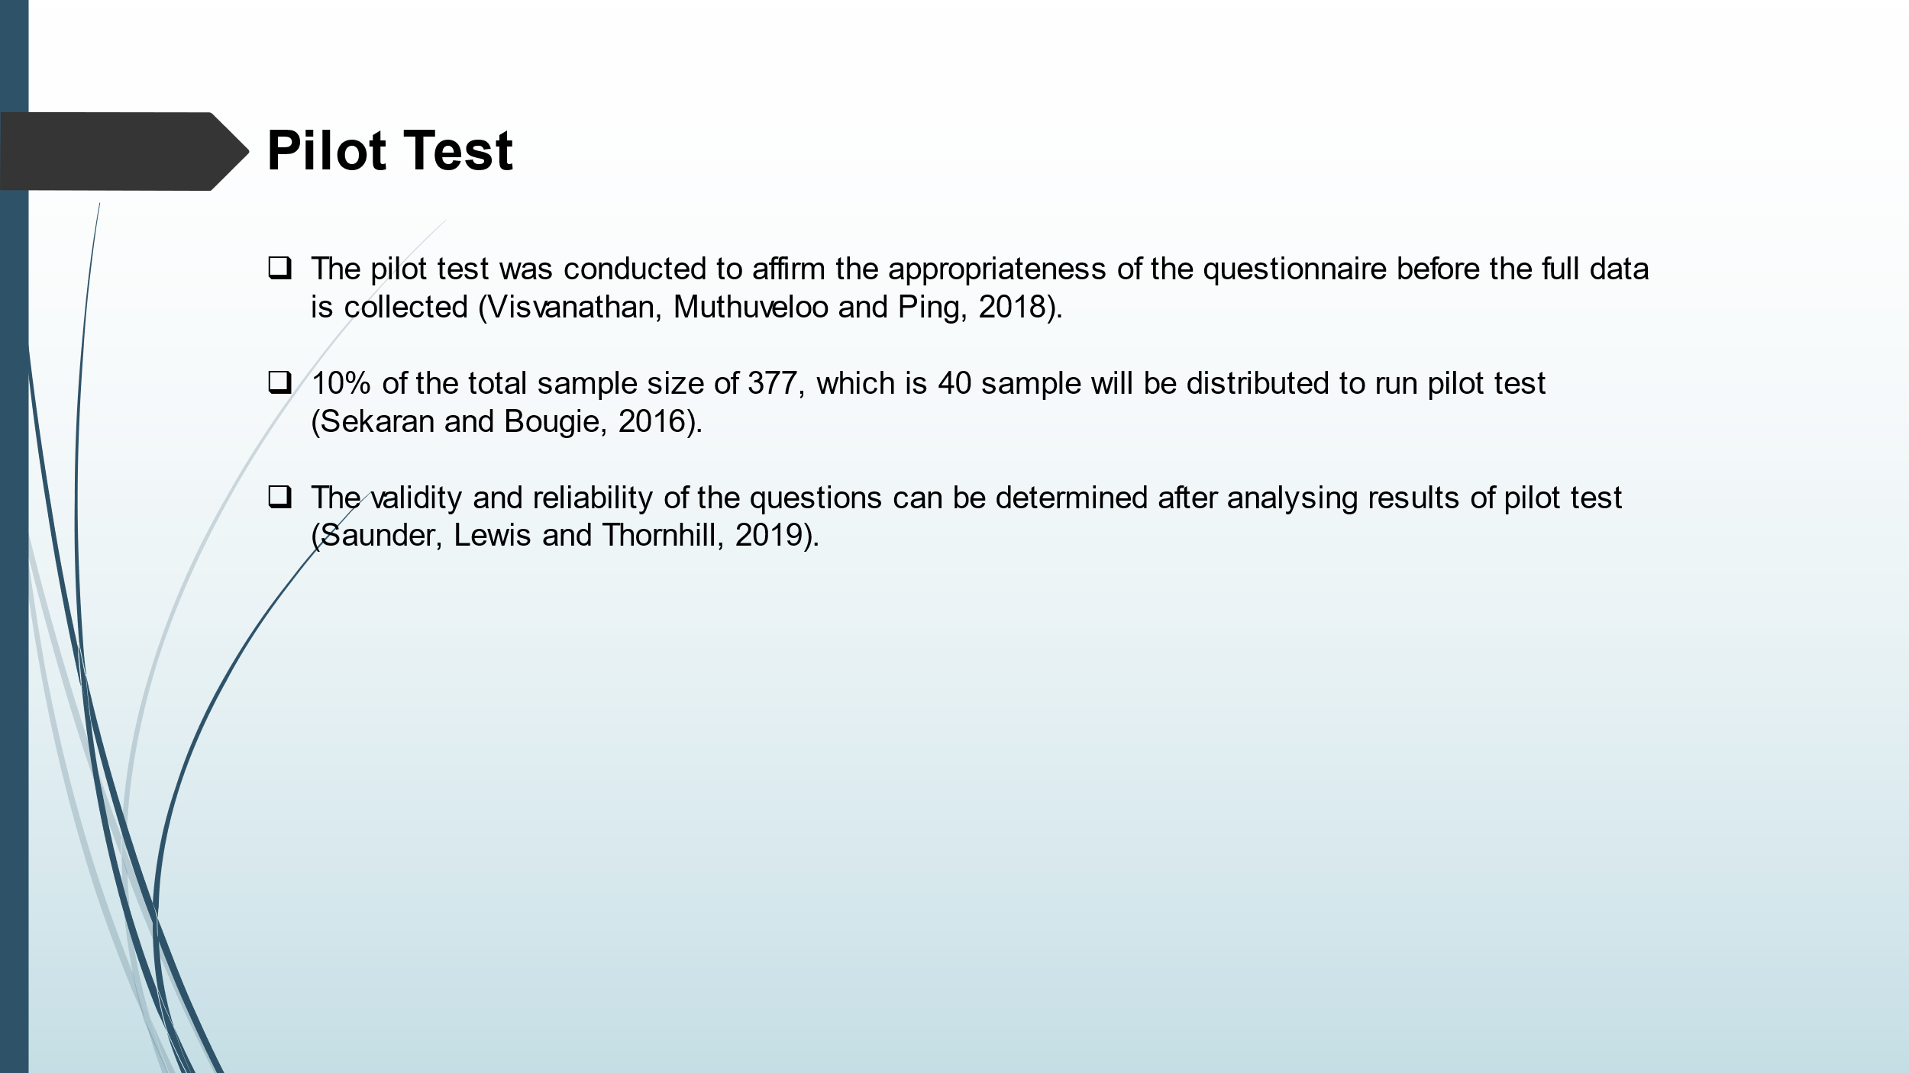
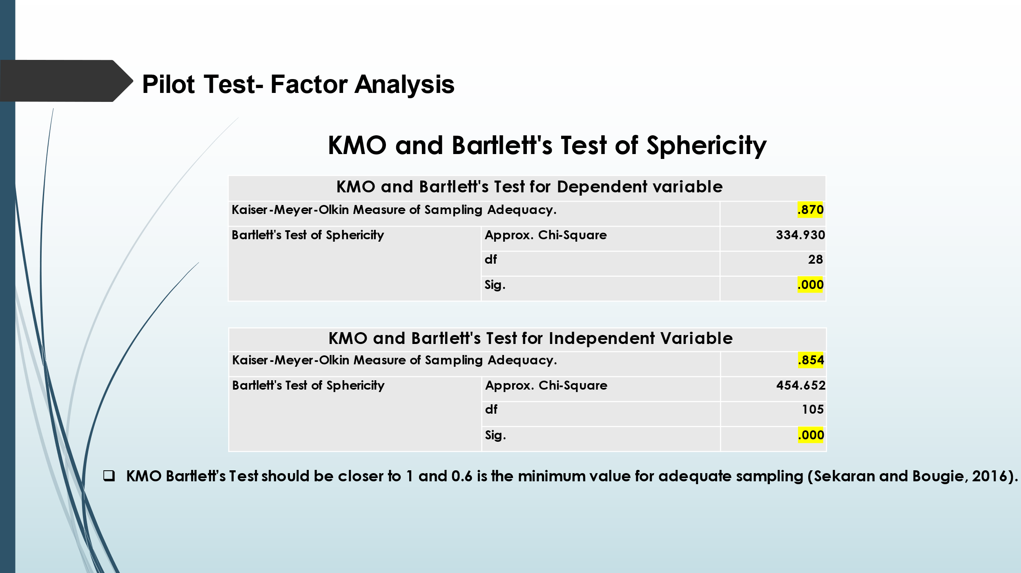
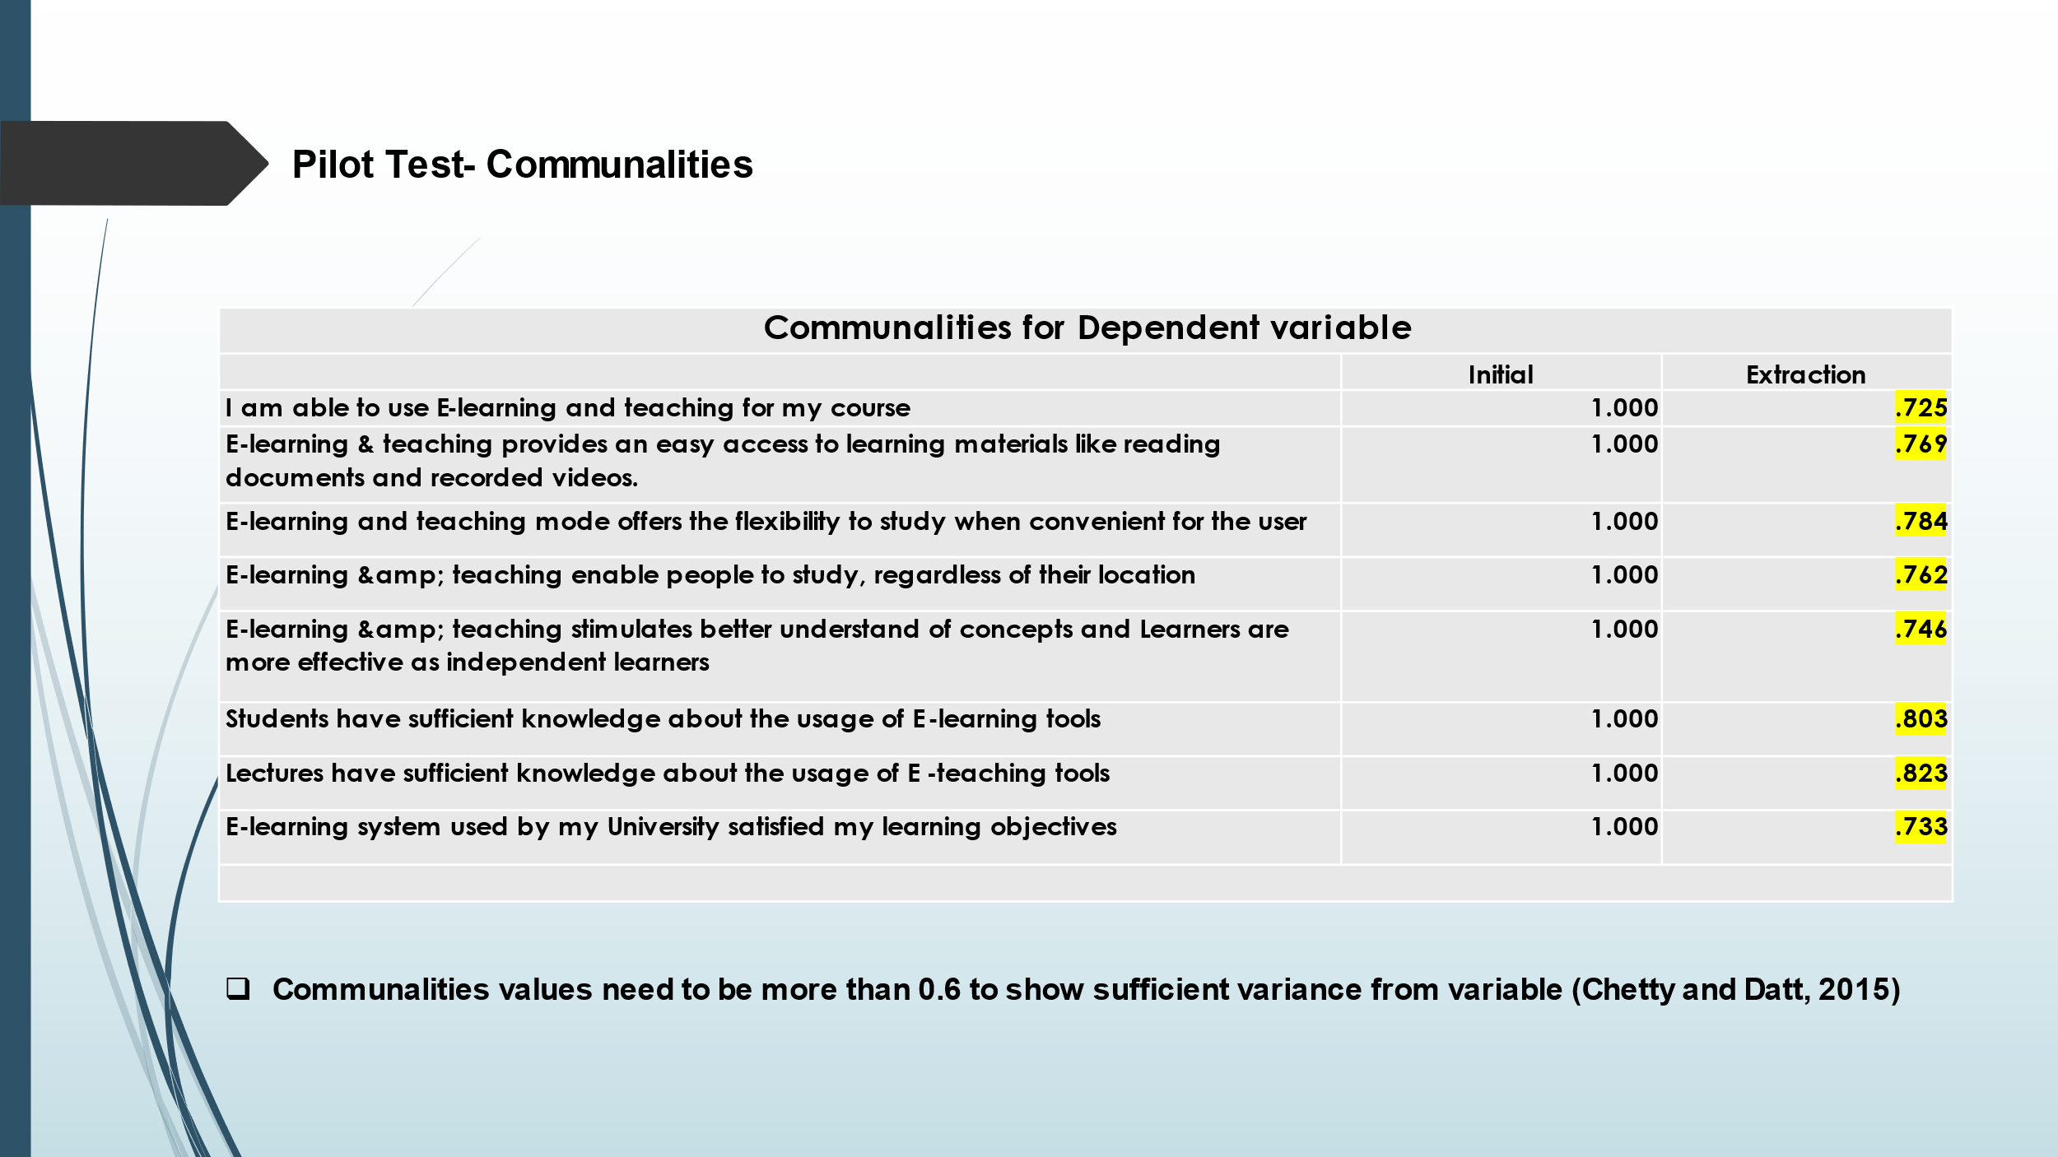
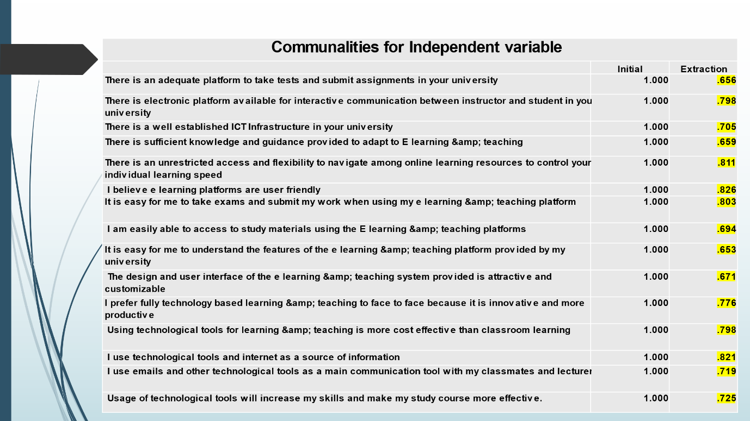
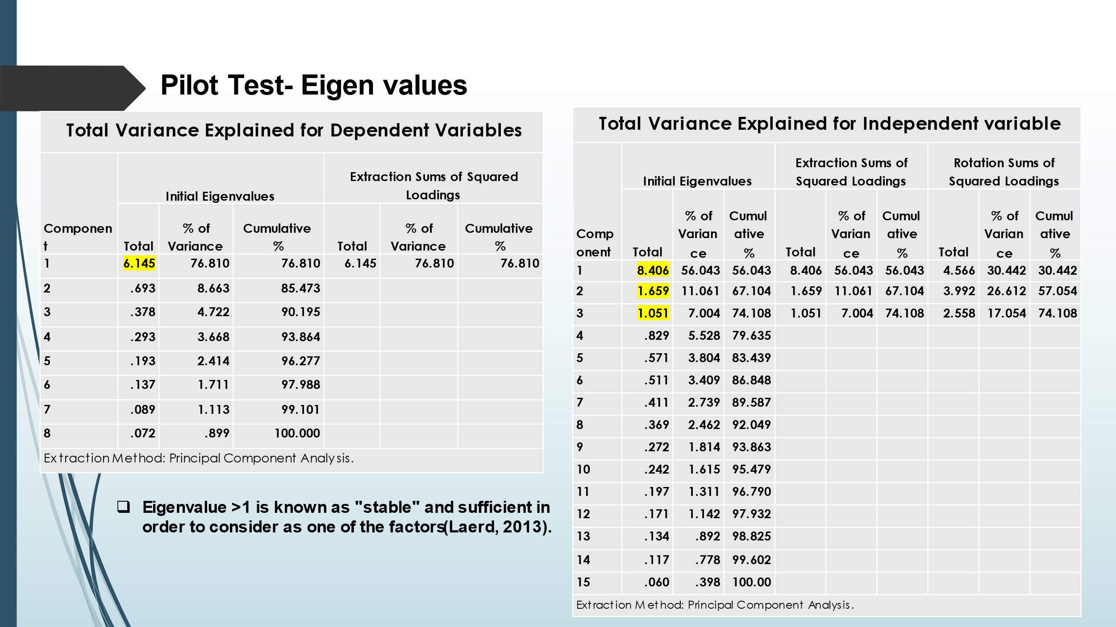
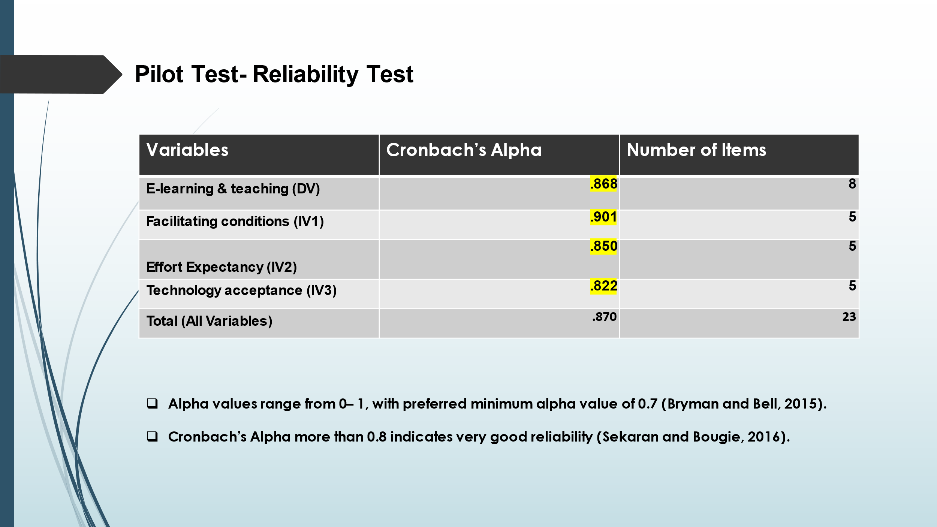
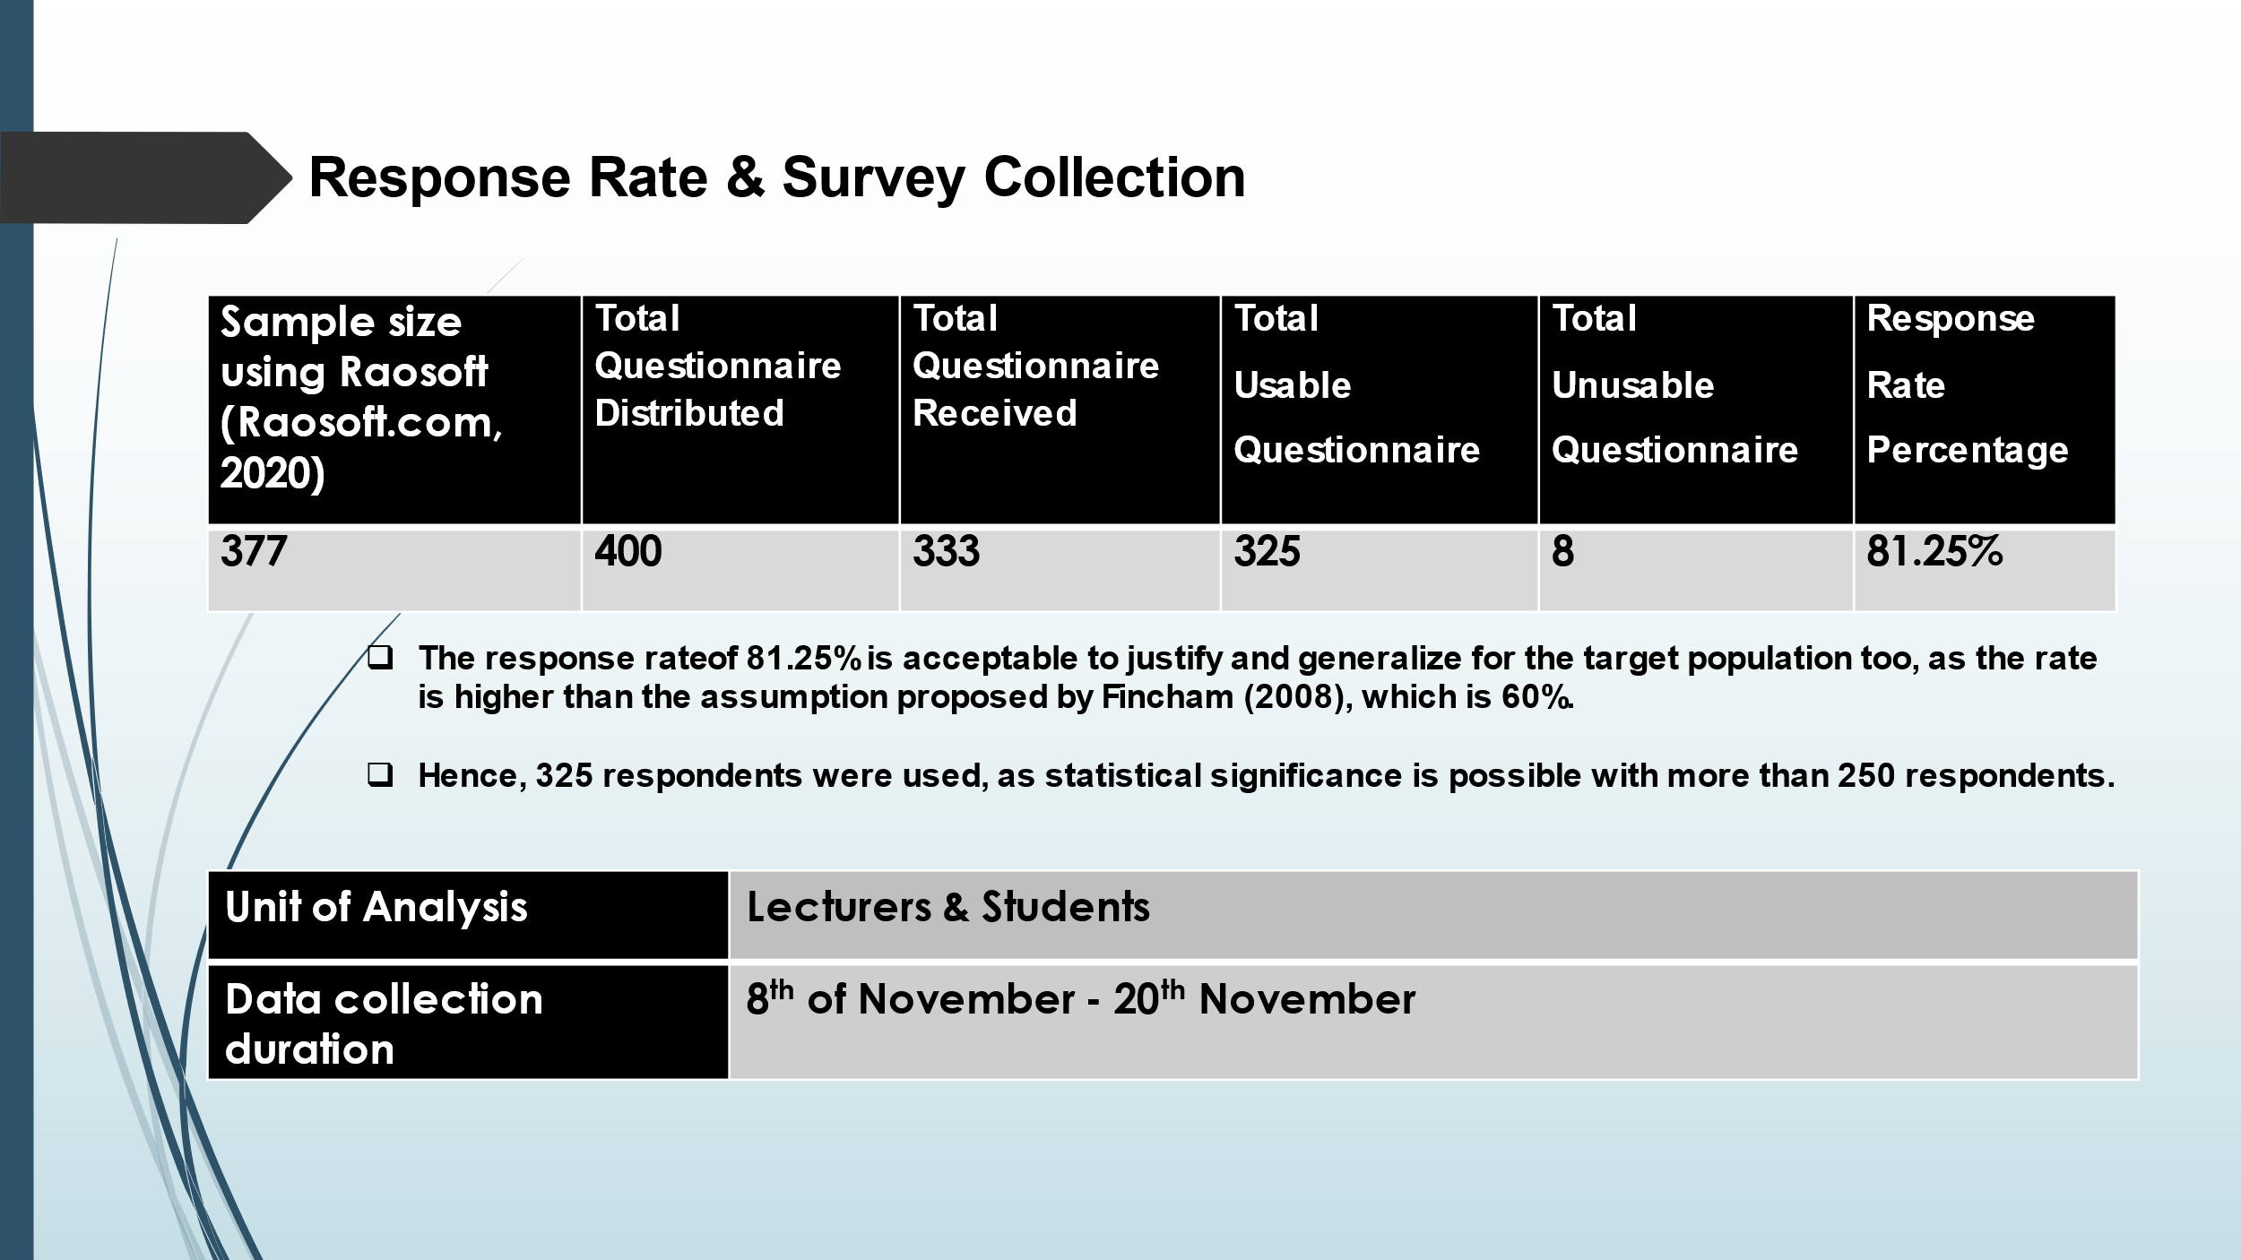

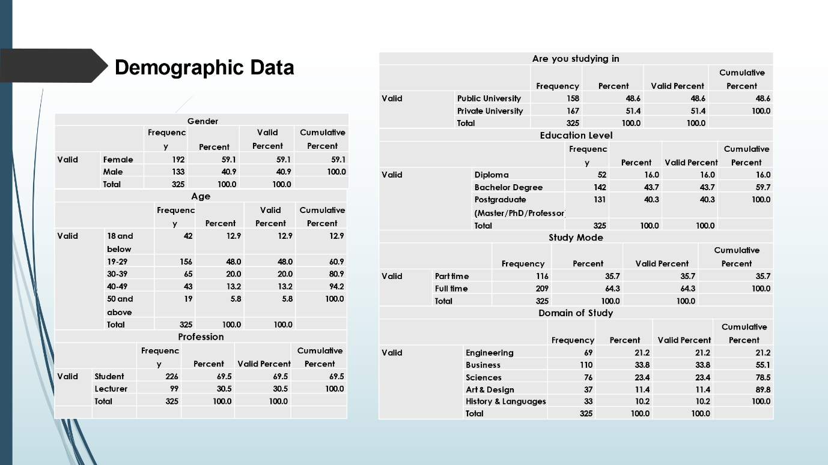
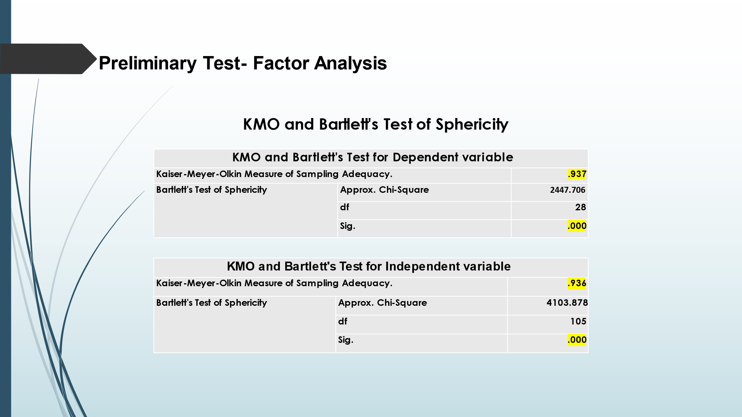

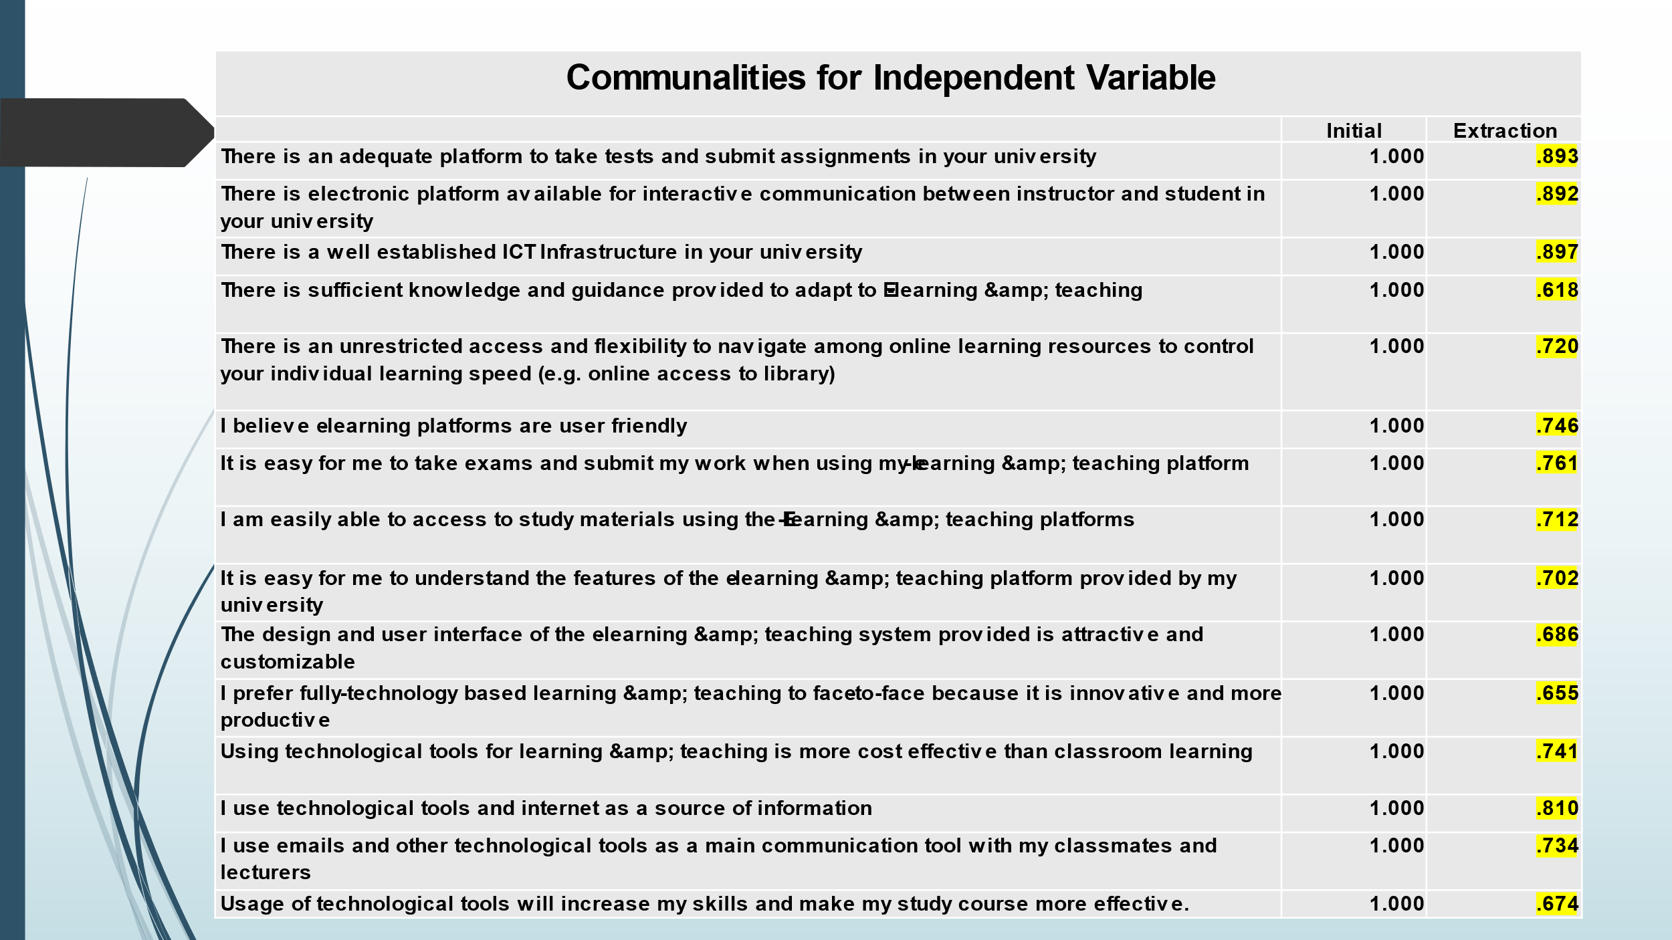
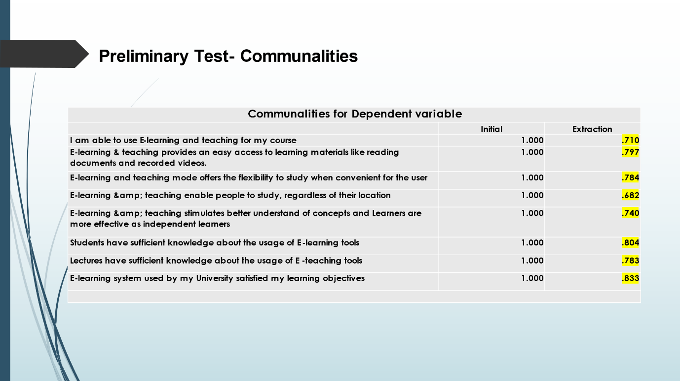
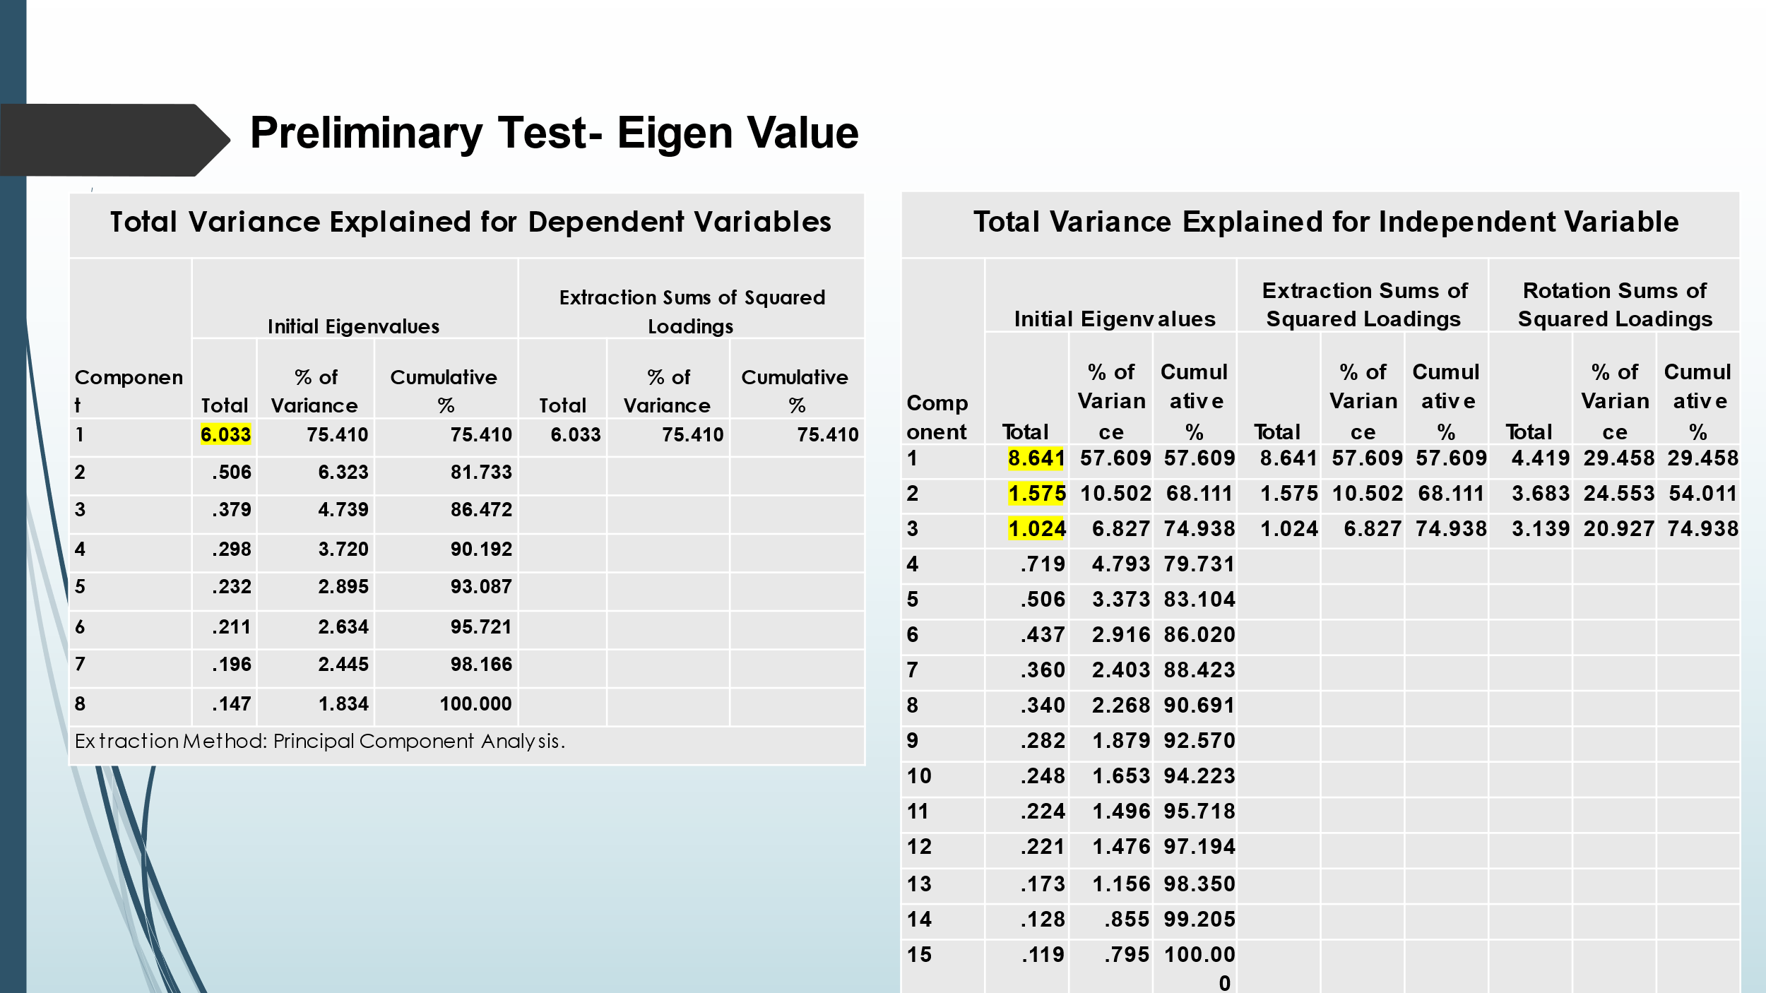

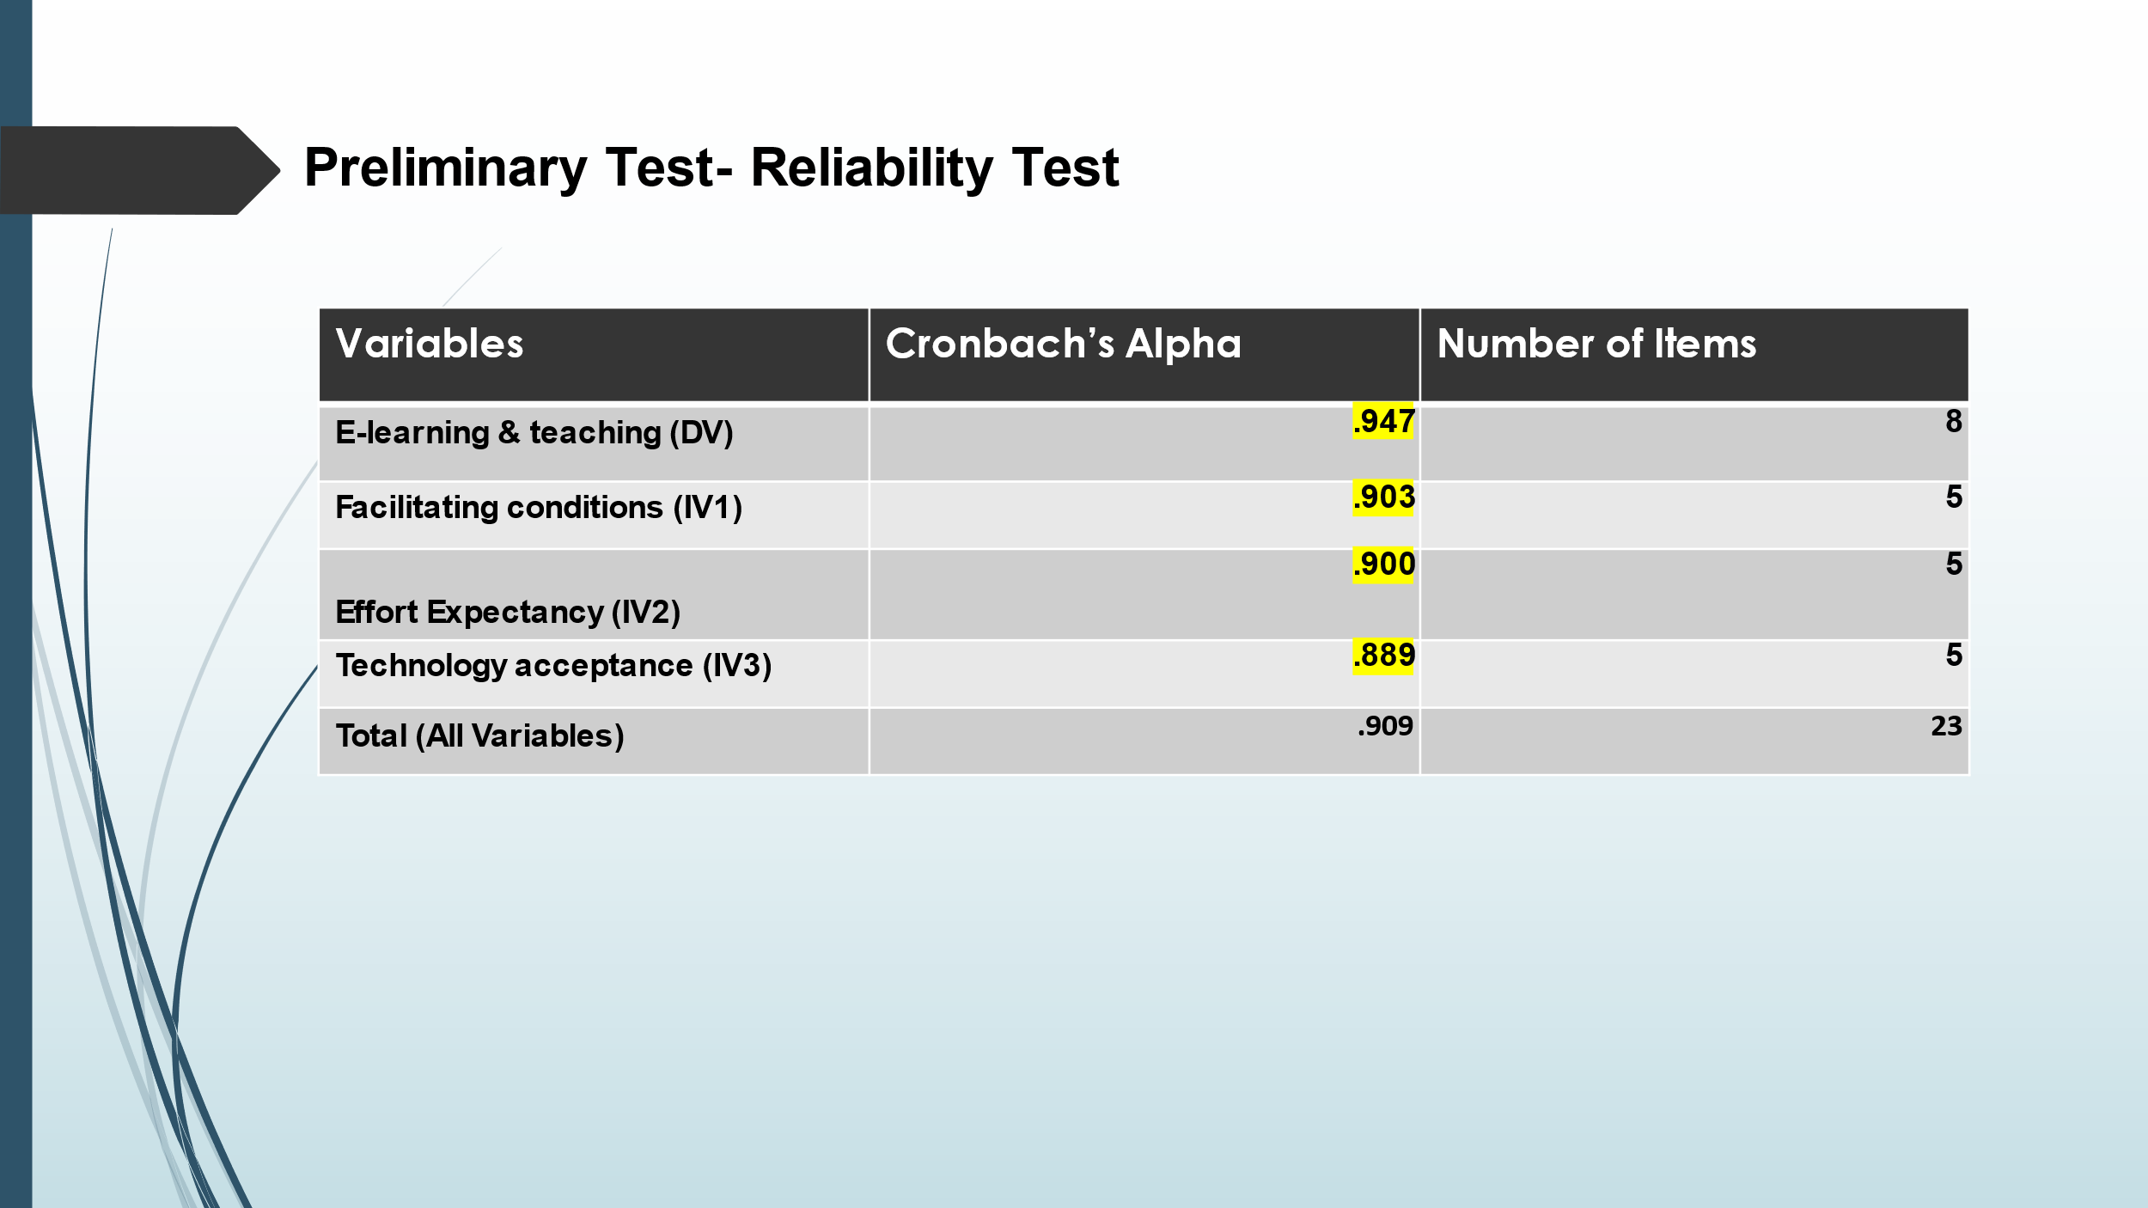
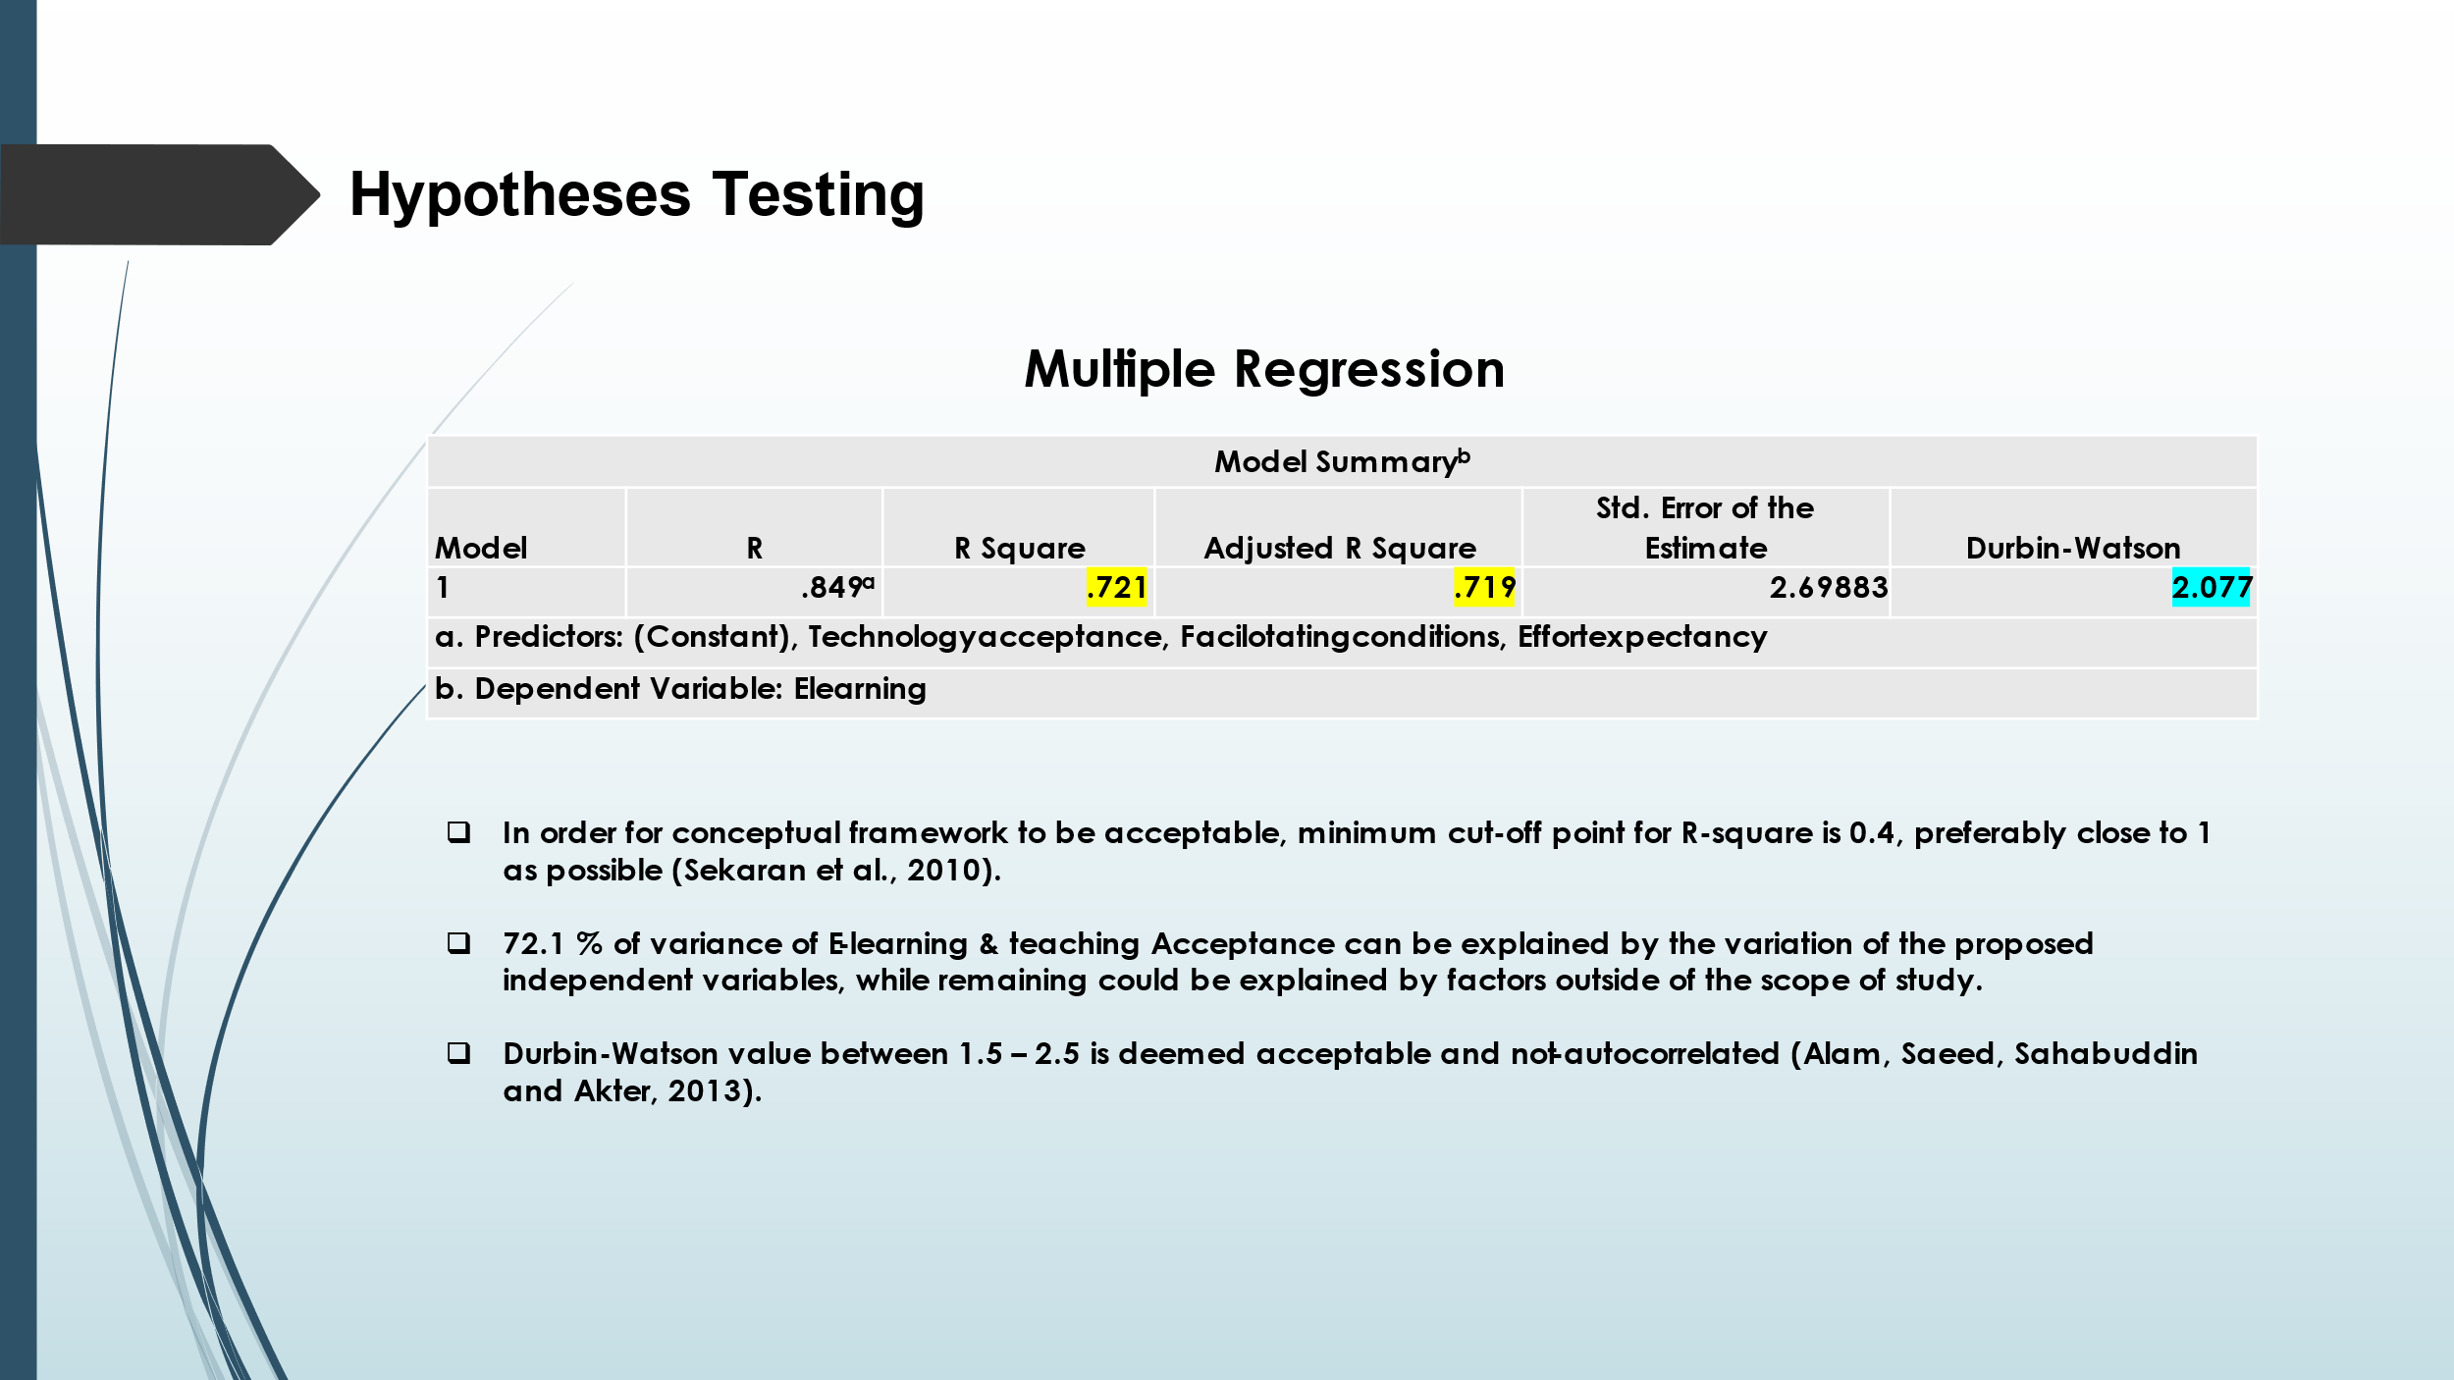
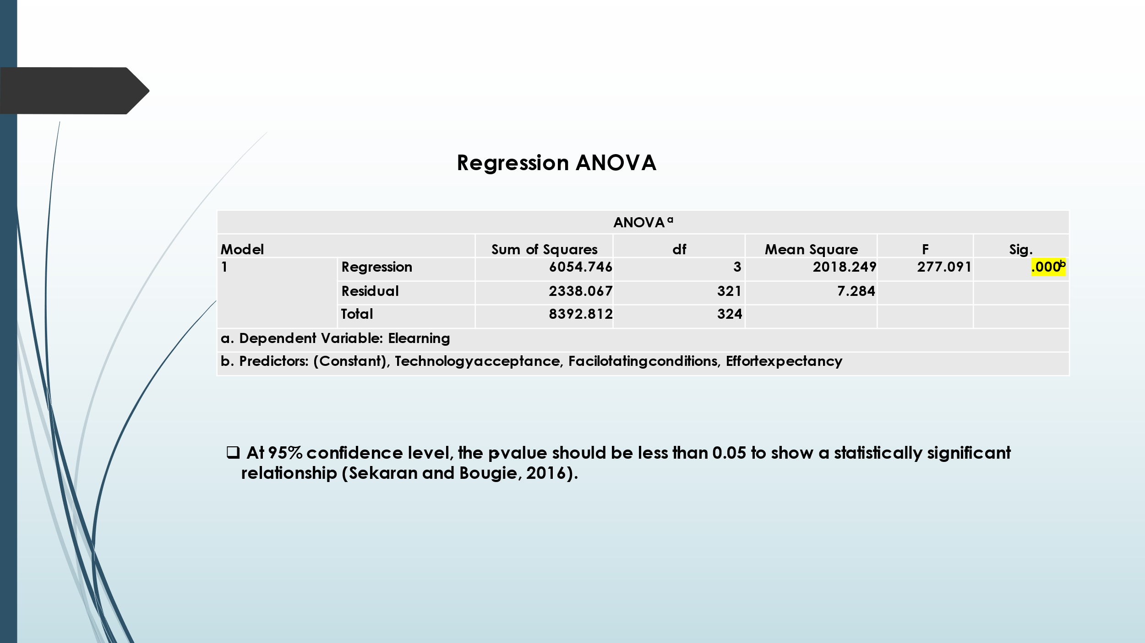
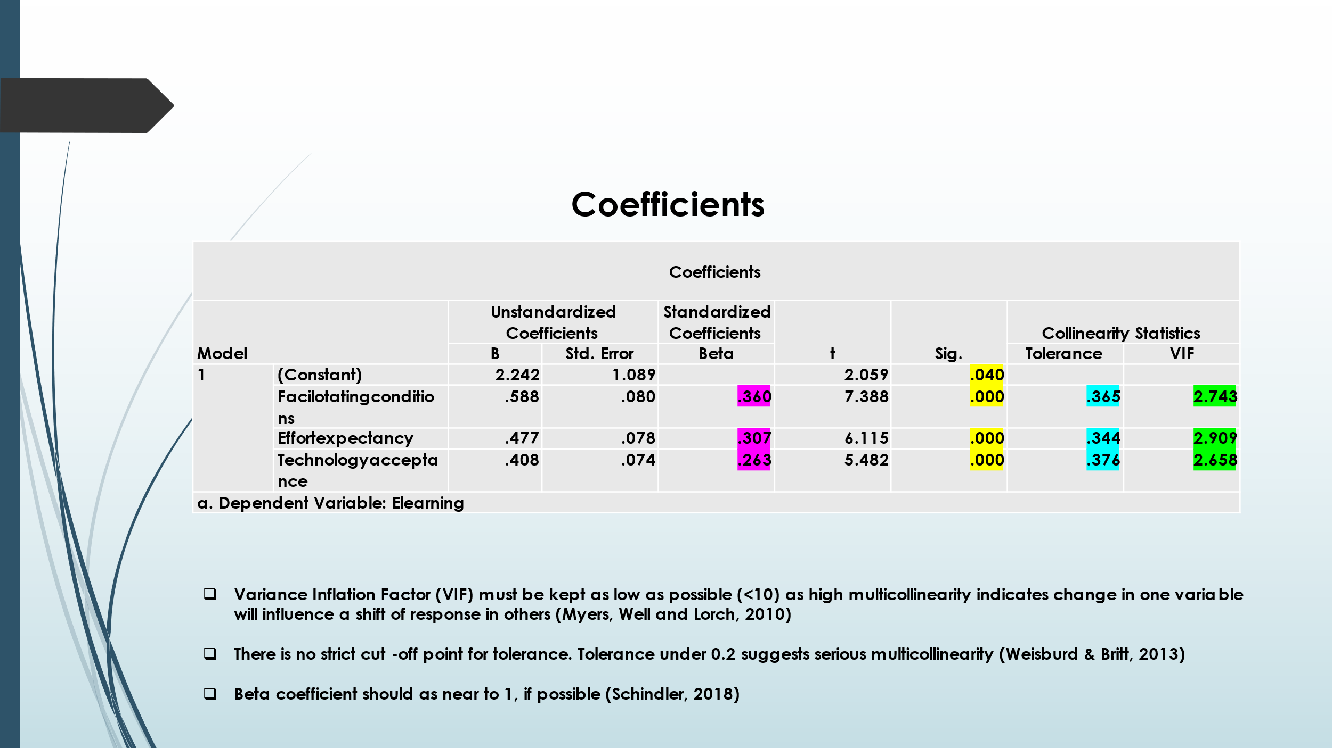

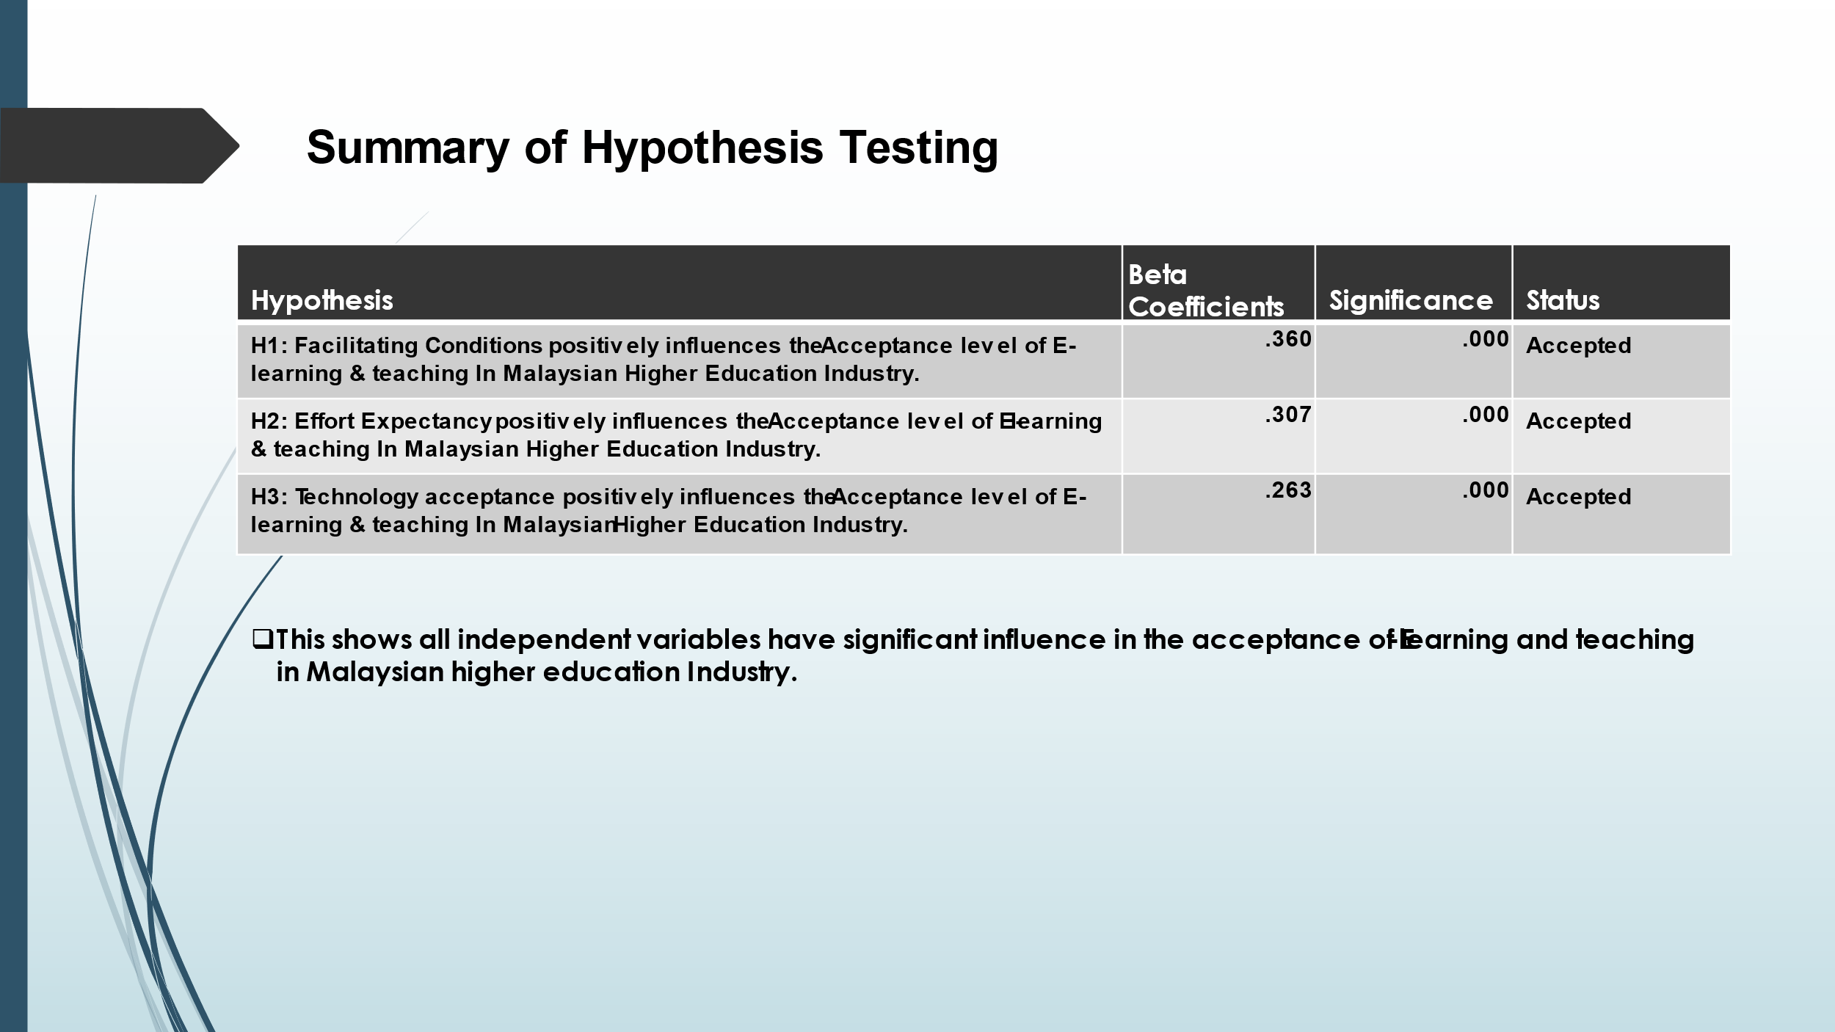
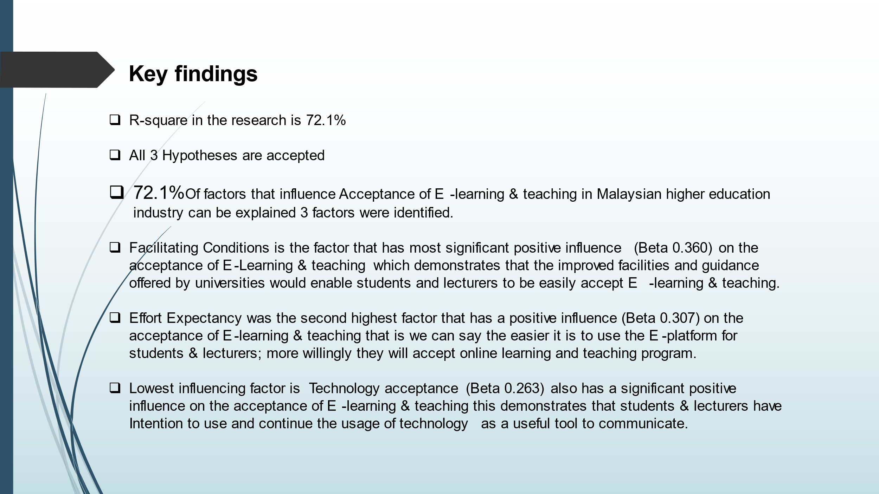
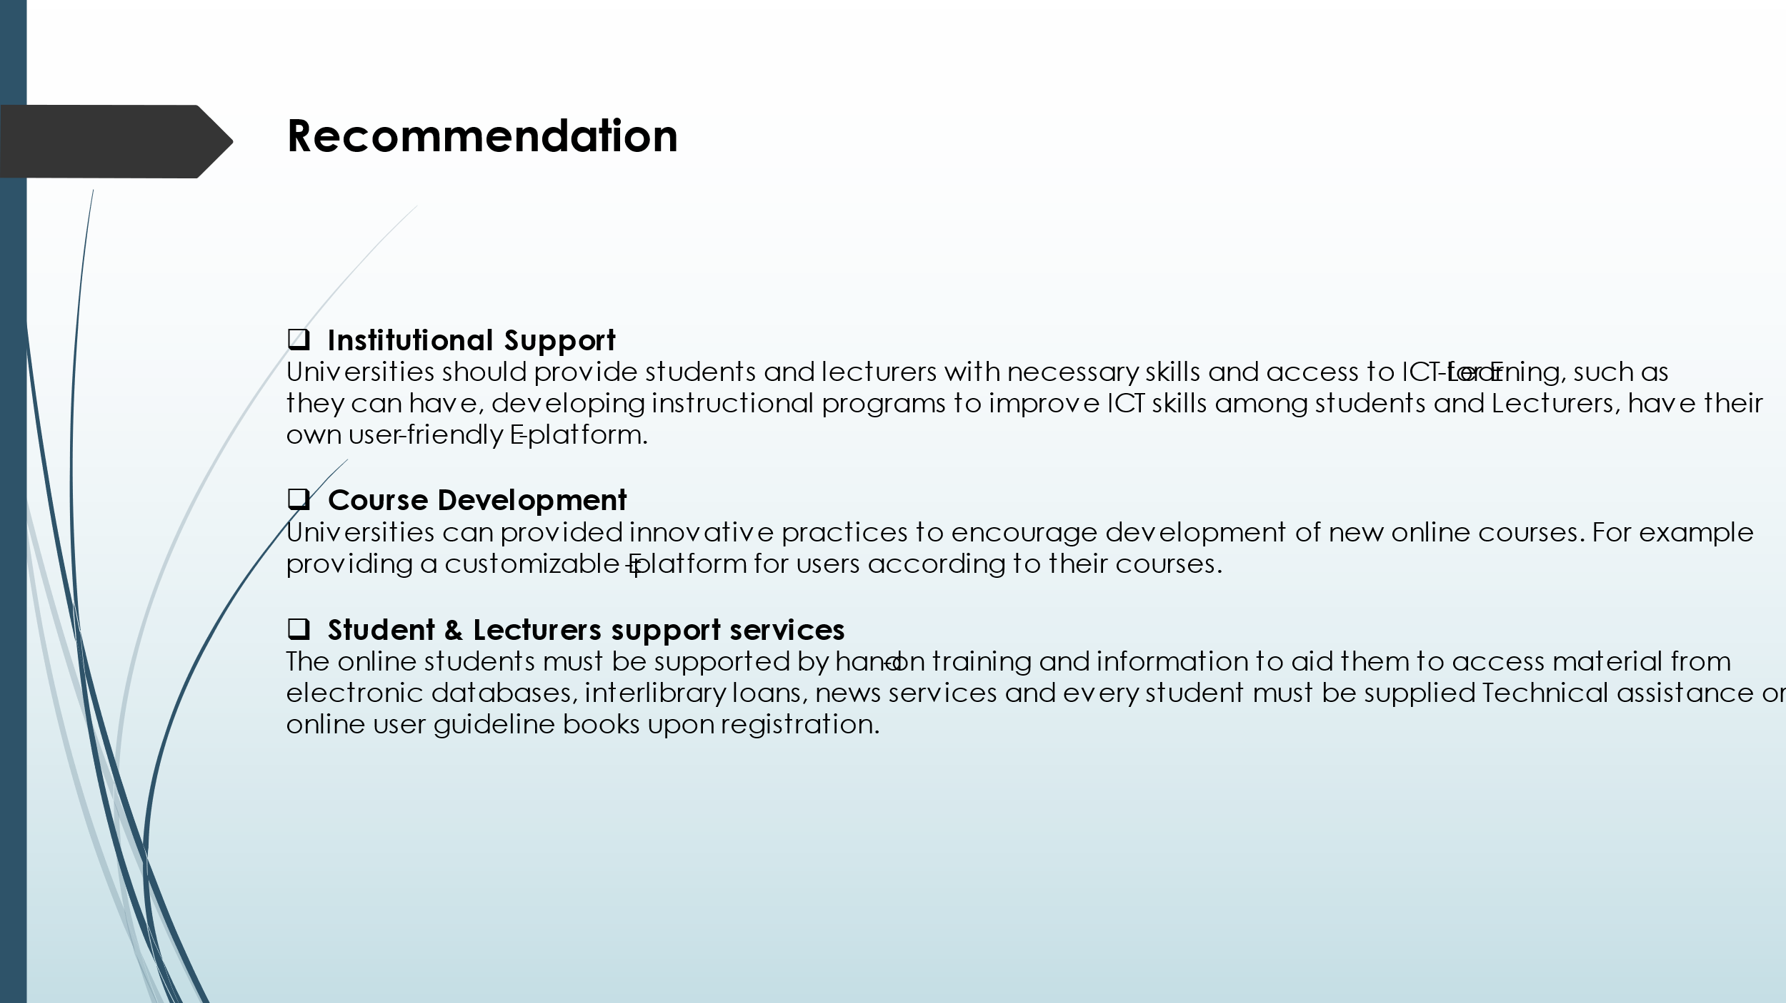
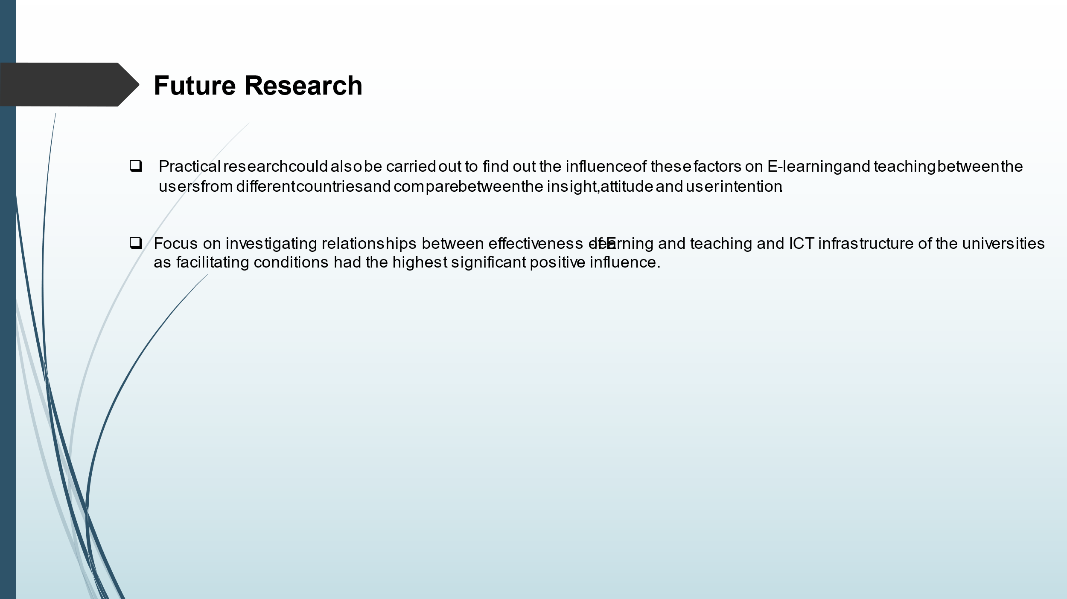
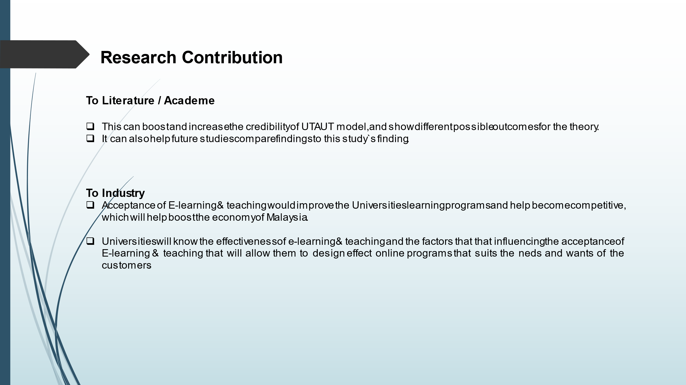


Appendix E

MBA Project Log

Meeting 1
Date of Meeting | 15/9/2020
Progress Made | Received Email from Dr Sam regarding Discussion of Research proposal.
Agreed Action | Submitted my Research Proposal to my supervisor
Student Signature | 
Supervisor’s Signature | 

Meeting 2
Date of Meeting | 21/9/2020
Progress Made | Started contacting supervisor Via Email and WhatsApp  DR Sam suggest to enhance Conceptual Framework and to improve on chapter 1 as there was slight modification in the title
Agreed Action | Adjusting Problem Statement, Research Objectives and Research Questions
Student Signature

Supervisor’s Signature

Meeting 3
Date of Meeting | 26/9/2020
Progress Made | Send the modified work to my supervisor  Feedback for improving and completing Ch. 1-3
Agreed Action | Continue working on Ch1-3
Student Signature

Supervisor’s Signature

Meeting 4
Date of Meeting | 30/9/2020
Progress Made | Continue working on Ch1-3  Discussed the Questionnaire items
Agreed Action | Complete Ch 1-3 by next meeting  come up with draft questionnaire
Student Signature

Supervisor’s Signature

Meeting 5
Date of Meeting | 15/10/2020
Progress Made | Chapter 1-3 Completed  Discussed PD slides  Showed Questionnaire draft
Agreed Action | Adjusting and Editing Questionnaire  Making PD slides
Student Signature

Supervisor’s Signature

Meeting 6
Date of Meeting | 25/10/2020
Progress Made | Showed the questionnaire  And PD slides content
Agreed Action | Questionnaire items finalized  Adjusting content of slides
Student Signature

Supervisor’s Signature

Meeting 7

Date of Meeting | 30/10/2020
Progress Made | PD slides finalized  Emailed the Second panel took appointment for proposal defence
Agreed Action | Submit the final PD slide to both supervisors
Student Signature

Supervisor’s Signature

Meeting 8
Date of Meeting | 3/11/2020
Progress Made | Discussed on the feedbacks from the Second panel with my supervisor
Agreed Action | Make suggested adjustments and present them to second panel again  Make changes in online questionnaire
Student Signature

Supervisor’s Signature

Meeting 9
Date of Meeting | 5/11/2020
Progress Made | Presented Ch. 1-3 to Second panel  Overall passed
Agreed Action | Proceed further with data collection for pilot test
Student Signature

Supervisor’s Signature

Meeting 10
Date of Meeting | 8/11/2020
Progress Made | Pilot tests data collection done  Results analysed and showed to my supervisor  Pilot test accepted
Agreed Action | Proceed further for full data collection
Student Signature

Supervisor’s Signature

Meeting 11
Date of Meeting | 20/11/2020
Progress Made | Full data collection done  Discussed with supervisor how to proceed further for analysis
Agreed Action | Rum pilot test preliminary analysis  Discuss for feedbacks on interpretation
Student Signature

Supervisor’s Signature

Meeting 12
Date of Meeting | 26/11/2020
Progress Made | Data analysis done and showed to mu supervisor
Agreed Action | Proceed further for data interpretation and outlining key findings and recommendations
Student Signature

Supervisor’s Signature

Meeting 13
Date of Meeting | 1/12/2020
Progress Made | Ch 4 and 5 draft prepared
Agreed Action | Asked to improve on key findings and recommendations  Prepare VIVA slides  Take appointment from second panel for viva
Student Signature

Supervisor’s Signature

Meeting 14
Date of Meeting | 3/11/2020
Progress Made | VIVA slide finalized
Agreed Action | Submit VIVA to second panel for VIVA on 4th dec 2020
Student Signature

Supervisor’s Signature

Meeting 15
Date of Meeting | 5/12/2020
Progress Made | Feedbacks from second panel discussed  My supervisor suggested for enhancement in format and supported literatures
Agreed Action | Come up with write up full Ch. 4 and 5
Student Signature

Supervisor’s Signature

Meeting 16
Date of Meeting | 15/12/2020
Progress Made | Chapter 1-5 complete  Some minor format changes
Agreed Action | Check plagiarism should be below 10%  Come up with complete project
Student Signature

Supervisor’s Signature

Meeting 17
Date of Meeting | 15/12/2020
Progress Made | Showed the final report  Enhancement for structuring the report
Agreed Action | Finalize the project for submission
Student Signature

Supervisor’s Signature

