

MASTER OF BUSINESS ADMINISTRATION

Consumer online buying behavior during COVID-19 in klang valley Malaysia

AUTHOR : Soumaya Jlassi
STUDENT NUMBER : I 19018277
SUPERVISOR : Associate Professor Dr. Arasu
SUBMISSION DATE : 21/12/2020
FINAL WORD COUNT : 17138 WORDS

FACULTY OF BUSINESS, COMMUNICATIONS AND LAW (FOBCAL)
SINGLE AWARD

INTI INTERNATIONAL UNIVERSITY

STUDENT’S DECLARATION

I hereby declare that I understand the meaning of “Plagiarism” and “Intellectual Property Rights” and Ethics Related to the Principles of Academic Works.
This project is hereby acknowledged as my own work and I have duly acknowledged use of published and unpublished works of other people from the print, electronic and other media.

Name : Soumaya Jlassi
Student ID : I19018277
Date / Signature : 12/21/2020



Acknowledgements

There are many individuals to thank and appreciate in their efforts and support to help me complete this research. First, i want to give my utmost thank you to my supervisor Dr. Arasu, his support, experience, patients and foremost dedication, helped me to overcome challenges. Thank you Dr. Arasu for your guidance and all the efforts you gave to this project and me.
I also want to give my thanks to Ms. Faziha, who always have been available and supportive in my research and giving me clear advice from her expertise. Thank you Ms. Faziha, for going beyond and above in aiding not only me but all your students, to ensure our development within academic research. I want to thank all of our teachers throughout this Master’s program, whose exceptional teaching skills have prepared me for writing this research. I also want to thank all the respondents in my study, as despite the challenging times of the still ongoing pandemic took time and effort into participating in my survey. Finally, I want to extend my thanks to my family, close ones and classmates for all their support, especially in times of stress, without your unswerving support, none of this would be possible.

Table of Contents
Abstract 6
Chapter 1 Introduction 1
1.0 Overview: 1
1.1 Background: 1
1.2 Problem statement: 2
1.3 Research Objectives: 3
1.4 Research Questions: 4
1.5 Significance of the study: 4
1.6 Scope of Study 5
1.7 Operational Definitions 6
1.8 Organization of Chapters 8
Chapter 2: Literature review 10
2.0 Overview 10
2.1 Online shopping: 10
2.2 Online shopping in Malaysia 10
2.3 COVID-19 and its impact 11
2.3.1 Operational challenges faced by organizations during COVID-19 11
2.3.2 Opportunities COVID-19 brought for online shopping 12
2.4 Consumer Buying Behavior 12
2.4.1 Definition of Consumer Buying Behavior 13
2.4.2 Consumer Buying Behavior process 13
2.4.3 Consumer Buying Behavior on online shopping 15
2.4.4 Factors influencing consumer buying behavior 15
2.4.4 Consumer Buying Models 21
2.4.1 Consumer behavior Model- Howard-Sheth model 21
2.4.2 Consumer behavior Model- Kotler behavioral selection model 22
2.5 Relevant marketing strategy 23
2.5.1 Marketing mix of 4P and 4C 23
2.6 Gap in literature: 24
2.7 Conceptual framework 25
2.8 Hypothesis 26
2.9 Conclusion 26
Chapter 3 Research Methodology 27
3.0 Overview 27
3.1 Research design 27
3.2 Unit of Analysis and Time Horizon 28
3.2.1 Unit of Analysis 28
3.2.2 Time Horizon 28
3.2.3 Sampling Design 28
3.2.4 Sampling Plan 29
3.2.5 Sample Size 29
3.3 Data collection method 30
3.4 Questionnaire design 30
3.5 Measurements Variables 31
3.6 Pilot Test 31
3.6.1 Pilot Test: Factor Analysis 31
3.6.2 Pilot Test: Reliability Test 32
3.7 Data Analysis 33
3.7.1 Preliminary Test 33
3.7.2 Descriptive Analysis 33
3.6.3 Hypotheses Testing 33
3.8 Ethical Considerations 35
3.9 Conclusion 35
Chapter 4: Research Findings 36
4.0 Overview 36
4.1 Pilot test 36
4.1.1 Factor analysis of Pilot test 37
4.1.2 Factor Loadings 38
4.1.3 Eigen Values 40
4.1.4 Reliability Analysis Results 41
4.1.5 Conclusion of Pilot Test 42
4.2 Response rate 42
4.2.1 Demographic profile of respondents 44
4.2.2 Gender 44
4.2.3 Age 44
4.2.4 Occupation 45
4.2.5 Monthly income range 45
4.3. Preliminary data Analysis 45
4.3.1 Factor analysis 45
4.3.2 Reliability Analysis 50
Chapter 5: Conclusion and Recommendations 58
5.1 Discussion 58
5.2 Recommendations 61
5.4 Future research: 63
5.5 Personal Reflection 63
References 65
Questionnaire 71
PD Slides 77
VIVA Slides...........................................................................................................................................82

MBA Project Log...................................................................................................................................96

Abstract

In early 2020, the world was hit by a global crisis, in the form of a COVID-19 pandemic. This has resulted in panic shopping practices in shops, vacant store shelves, out of stocks, and a huge rise in online sales. The changing customer purchasing behavior has demanded the adaptation of sellers, manufacturers, advertisers, and businesses. Economic factors have been found in previous research to be the most important factors in the process of consumer decision making, especially increased product price sensitivity, affects consumers in situations of crisis. The aim of this study was to investigate, in addition to panic purchased behavior, whether consumers' behavior in online shopping changed during COVID-19. Various studies have been done both in the global and local perspective to research on consumer online buying behavior during COVID-19. However, the focus of research on the factors that influenced consumer online buying behavior in Malaysia is still limited, and therefore this research project aims to fill this contextual gap. The purpose of this study is to determine the influence of economic, personal, psychological and social factors on consumer online buying behavior during COVID-19 among Klang Valley shoppers Malaysia. The Theory of Howard-Sheth and Kotler behavioral selection were discussed, and a conceptual framework was designed to illustrate the relationship between economic, personal, psychological and, social factors on consumer online buying behavior during COVID-19 in Klang Valley Malaysia. Four hypotheses have been elaborated and explored on the basis of the literature review. Data from 320 respondents via an online questionnaire were analyzed for this research and Hypotheses were evaluated through multi-regressive testing. Results from the hypotheses testing showed that economic, personal and, psychological factors have a significant relationship and positive influence on consumer buying behavior while social factors does not have a significant and positive influence Klang Valley shoppers online buying behavior during COVID-19.
Key words: consumer online buying behavior, COVID-19, Online shopping, Klang Valley Malaysia, Economic, Personal, Psychological, Social factors

Chapter 1 Introduction

1.0 Overview:
Consumer purchasing behavior is how an individual conducts his attitude when taking a decision on the purchase of products or services, taking into account his or her own desires, wishes and wishes. This research will cover the structured content of the topic, starting from the context of the study and the problem declaration. This chapter provides a detailed overview of consumer online shopping behavior and includes five research objectives and four research questions. The key words and their meanings will be described further under the operational meanings of the subtopic. Furthermore, the significance of the study is underlined.

1.1 Background:
Pandemics are not actually a new phenomenon, as they have been documented since ancient times, strictly connected to current modern societies. Every pandemic has led to significant changes in economic, regional, and global policies, social actions, and the minds of people Dr. (Tareq N. Hashem 2020)
Every historical pandemic has a direct impact on the major human reactions, as it directly affects health, financial security, the quality of life, and food safety. For example, the economic instability when cholera or Spanish flu struck caused immediate hunger (Jackson, 2008)
A critical situation leads people's behavior in different ways, with certain aspects of their behavior irrevocable. A pandemic of COVID-19 is not a normal crisis and various measures, including full and then partial lockdown, have been taken to control the spread of diseases. (The Star Online, 2020). This led to an immense change in people's behavior. People are living differently, buy differently, and think differently in many ways. Doors are being shut down by retailers. Consumers around the world look at new lenses for products and labels. Attitudes, conduct, and purchase patterns of customers are shifting. Thus the nation's hint of shifts in business conditions culminated in economic instabilities (Zalina et al., 2016). The drivers of competition, growth, and economic convergence in all markets are customers. Consumers often experience a change in behavior due to economic uncertainty. Actually, transactions are focused on basic needs, people shopping more consciously, purchasing locals, and embracing digital businesses (Jackson, 2008)

In Malaysia, the public panicked in a purchasing frenzy when the prime minister announced the first phase of the Movement Control Order (MCO) between 18 March and 1 April 2020. Although the government of Malaysia has consistently addressed the population in reminding people not to panic and with the assurance that there are sufficient daily needs, particularly food, the different posts on long queues and empty shelves in supermarkets have continued to panic in social media that caused panic among Malaysian citizens (The Star Online, 2020)
Previous research on behavioral studies of pandemics demonstrated the potential for significant production, investment, and consumer spending disruption due to a disease or pandemic outbreak (Jackson, 2008). Therefore it is vital to consider the indirect, yet substantial impact pandemics have on the purchase of critical items and give sellers as well as practitioner’s relevant guidance to counteract panic buying purchase.
But little research has investigated how pandemic outbreak affects the behavior and consumption of individuals, particularly in Malaysia. In the past, the cumulative burden of epidemics on populations based on aggregate and microeconomic perspective surveys have usually been focused.
This research will cover consumer online buying behavior during the COVID-19 crisis among Klang Valley Malaysia shoppers. The aim of this study is to identify the impact of COVID-19 on Klang Valley Malaysia citizen’s online purchasing behavior and to investigate factors influencing online buying behavior during the COVID-19. This study will significantly close the research gap in understanding Malaysian consumer online purchasing behavior of essential goods during a pandemic crisis such as COVID-19. At the end of the search we will also enumerate suitable marketing strategies based on the results to enhance retailer’s sells during such pandemics (Westcott & Wang, 2020).

1.2 Problem statement:
The COVID-19 outbreak has impacted almost every aspect of people’s lives in Malaysia. With most people needing to stay home more, Malaysians have been adapting to both the outbreak and the regulations.
During the Movement Control Order (MCO), businesses and stores deemed non-essential were ordered to suspend operations. To limit places where people could gather, all schools, institutes of higher learning, and houses of worship were ordered to be closed during the period. There is also a restriction on entry of all foreign tourists and visitors to the country (Meyer, 2020).
Spending habits also changed after the MCO was implemented. People began saving more amid more uncertainty over job security and income, and have instead been purchasing primarily essential goods like groceries, household supplies and even health supplements. Foot traffic to most physical stores reduced significantly and non-essential businesses were ordered to cease operations during the MCO (Unctad, 2020)
In light of the MCO, Malaysians have been spending less. A survey by the Department of Statistics Malaysia found that the average monthly household expenditure has fallen 55 per cent from MYR 6,317 to MYR 2,813 (Meyer, 2020). This can likely be attributed to the current environment putting a strain on many businesses, which has created a lot of uncertainty around Malaysians’ job security and incomes.
The pandemic situation disrupted people's daily lives, movements and business due to shopping malls and business centers in the city closed and locked their door until further notice.
Sellers faced a huge decline in their sellers due to the lockdown and suffered a heavy loss. In order to overcome this difficult situation and reach their customers most of them shifted to online selling. Unfortunately, the majority of online sellers who recently shifted their business online, do not have enough knowledge about how to optimize their website and reach their target customers (Unctad, 2020).

Therefore, it is important to carry out this analysis to decide what are the factors that influences more customer's online buying behavior during COVID-19 in order to provide the online sellers with the necessary advices so they can adapt their online strategies, meet their targets, obtain competitive benefits to improve competitiveness and output and compromise the losses they faced in the beginning of the pandemic.

1.3 Research Objectives:
Al-Shukaili and Al-Maniri (2017) have suggested that research goals should be driven, observable and attainable within a certain timeframe using the best methodology and that it is imperative to select a proper study design to comply with the study's target and hypotheses. The hypothesis are as follows:

- RO1: To determine whether personal factors have a significant impact on consumer online buying behavior among Klang Valley citizens during COVID-19
- RO2: To determine whether economic factors have a significant impact on consumer online buying behavior among Klang Valley citizens during COVID-19
- RO3: To determine whether psychological factors have a significant impact on consumer online buying behavior among Klang Valley citizens during COVID-19.
- RO4: To determine whether social factors have a significant impact on consumer online buying behavior among Klang Valley citizens during COVID-19
- RO5: To suggest suitable marketing strategy to Klang valley retailors based on the result of analysis to enhance their sales.

1.4 Research Questions:
- RQ1: Does personal factors have a significant impact on consumer online buying behavior among Klang Valley shoppers during COVID-19
- RQ2: Does economic factors have a significant impact on consumer online buying behavior among Klang Valley citizens during COVID-19
- RQ3: Does psychological factors have a significant impact on Klang Valley customer online buying behavior during COVID-19?
- RQ4: Does social factors have a significant impact on Klang Valley customer online buying behavior During COVID-19?
- RQ5: What are the suitable marketing strategy suggest to Klang valley retailors to enhance their sales?

1.5 Significance of the study:
COVID-19 is a new emerged phenomena that changed people's life and kept major effects on the economic. Till now there are little researches on the changes that occurred on customer's online behavior during this pandemic. Most of the researches focus on the consumer's behavioral changes toward grocery shopping during the pandemic and few of which focus on specific cities such as Klang Valley and specific technology such as online shopping. Therefore, this paper enriches the academic research on online customer's buying behavior among Klang Valley Malaysia shoppers during COVID-19.
This research offers observations and recommendations for online sellers and marketers who are interested to expand and enhance their business online during COVID-19. This research is beneficial for online retailers and new entrepreneurs as the information collected is a useful way for online retailers to help them decide on what they should look for focus more on when selling online during COVID-19. The research offers a deeper understanding of consumer online shopping behavior, and the causes and the basic tastes that can be prioritized when manufacturing new products.
This study is informative also to advertising agencies as it gives a better understanding on factors influencing consumer online buying behavior during COVID-19. Advertising companies may use this knowledge as creative tools to align themselves with customer desires and thereby increase the appetite for goods on the market. In addition, advertisers may concentrate on what attracts customers the most through leveraging information and thus reduce the expense whilst still delivering a message to their potential consumers.
Academically, this recent data can be used for the creation of the future research model to learn more about online consumer shopping attitude among Klang Valley Malaysia shoppers during COVID-19.
Results and study findings will boost consumers' awareness and help them understand the factors that affect their purchasing behavior during this pandemic.

1.6 Scope of Study
The scope of this study is to determine the factors influencing consumer online buying behavior during COVID-19 among Klang Valley Malaysia shoppers. The scope of this study covers female and male consumers who are using online shopping. The type of investigation is a correlation design and the focus is to determine the relationship between between economic, personal, Psychological and social factors and online buying behavior during COVID-19

1.7 Operational Definitions

Table 1. 1: Key terms
Key Terms | Definitions
Consumer | A customer is a person or company that buys goods or services from another company (Blumenthal, 2020).
Consumer Buying Behaviour | Consumer behavior is characterized as a behavior which the consumer highlights in his search for the purchase or use of products, services and ideas, and which he expects will meet his desires and needs in accordance with his available purchasing power. Also, Moon et al. (2015) noted that the customer behavior, is direct and indirect acts and behaviors that user performs in order to get products or services in a particular area.
Personal Factors | Personal factors affecting buying behavior are lifestyle, economic situation, job, age, personality, and self-concept (Fernandes, 2019).
Economic factors | The economic factors influence the economy and include interest rates, tax rates, laws, regulations, employment and public activities. These variables are not directly relevant to the corporation but impact investments in the future (Ramya et al., 2016).
Psychological factors | Psychological factors are social, cultural, and environmental and forces that affect mental health and behavior. These factors include social conditions, ties, and stresses, including education and health rivalry, and other social resources; quick technological changes; time limits for work; and changes in social roles and status (Jales, Rahman, 2018).
Social factors | Social factors influence the lifestyle of someone. This may include income, faith, patterns of buying, schooling, family size, composition and density of population (Lee, 2018)
Online shopping | Online shopping is an electronic business that permits customers to purchase products or services directly from a seller through the internet through a web browser or a smartphone application. Consumers can find an interesting product through a visit to the retailer's website directly or through a shopping vendors, which indicates the same product availability and pricing at various e-distributors. Clients can shop online with a number of computers and devices like computers, notebooks, tablets, and smartphones (Yu and Wu, 2007).
COVID-19 | COVID-19 is a new coronaviral strain disorder. ‘CO’is corona, ‘VI’ virus, and ‘D disease. The COVID-19 virus is a new virus associated with the same family of viruses as Extreme Acute Respiratory Syndrome (SARS) and certain cases of ordinary cold. This disease is also referred to as the new '2019 coronavirus or 2019-nCoV.' (World health organization)
Klang Valley | Klang Valley (Malay: Lembah Klang) is an urban conglomeration in Malaysia that is centered in Kuala Lumpur, and includes its adjoining cities and towns in the state of Selangor. It is conterminous with Greater Kuala Lumpur, although there are variations between the two (Ooi Keat Gin, 2009).

1.8 Organization of Chapters
This paper consists of five key chapters showing the overall formation of this paper. The systematization of research is important to make research simple and straightforward. Table 1.2 summarizes the short summary of the five chapters.

Table 2: Chapters summary
Chapter | Purpose of the chapter
Chapter 1:  Introduction | This chapter deals with the summary, issue report, research goals and concerns, research scope and limitations and the importance of research. The operational definition in this section also comprises the key words used in the analysis.
Chapter 2:  Literature Review | Chapter 2 starts with the literacy analysis of the under research phenomenon, followed by a literature review. The foundational theory and principles are further explained in this chapter.
Chapter 3:  Research Methodology | The following chapter addresses detailed research methods, research architecture, approaches, instruments and techniques used in the collection of data by the researcher.
Chapter 4:  Research Findings | This chapter discusses data assessment and data analysis. Results and observations are graphically portrayed with an explanation to provide readers with comprehension.
Chapter 5:  Conclusion and Recommendations | This chapter includes a description of the research's overall analysis and performance. Key results and suggestions are also discussed for further development.

Chapter 2: Literature review

2.0 Overview
The purpose of this chapter is to present the theories and literature that are important to this research. To understand changed online purchasing behavior, one must first understand the fundamentals of buying behavior and what factors impact buying behavior. This chapter therefore introduces initially developed models such as the Kotler behavioral selection model and Howard sheth Model for buying behavior. These models explain how consumers react to certain factors and how these factors influence the buying attitude. In addition, the importance of these factors is discussed and, finally, the evolving purchasing behavior during past crises to better explain the differences between previous and COVID-19 crises. In particular, all these theories were useful when building the research model and explaining the interactions among Klang Valley shoppers online buying behavior during COVID-19 and the economic, personal, psychological and social factors.

2.1 Online shopping:
Online shopping is the behavior of customers to shop online.
Internet shopping is one of the widely and frequently used shopping tool for convenient shopping. It is actually a popular way to shop in the Internet (Bourlakis et al., 2008). One benefit of online shopping is to provide customers with accurate details and a variety of options for comparing goods and costs. The easiest you can find what you are searching for online, the better the option and convenience are (Butler and Peppard, 1998).
Online buying has been shown to give modern customers more satisfaction who are searching for convenience and speed (Yu and Wu, 2007).

2.2 Online shopping in Malaysia
Malaysia, an upper-middle income region, has a mean household income of RM 7,901 per month, as reported in 2019 (Department of Statistics, Malaysia). More than 26 million Malaysians today use the Internet and figures from the GlobalWebIndex indicate that 80% of 16 to 64 year olds are shopping online already.
In 2018, Malaysians invested 483 million US dollars on online shopping, according to GlobalWebIndex. Malaysians spend substantially higher than many of their Southeast Asian neighbor’s online transactions, but the country's total consumer ecommerce revenue remains only one-quarter of the world average. However, ecommerce expenses for Malaysians increased by 24% last year and Malaysia is likely to continue to rise strongly in online sales in the following years, as Malaysian government makes the growth of the online economy a national priority (Hassanb, Mudaa and Mohdb, 2015).
Klang Valley Malaysia has been selected in this paper as a place for the current study because of the number of shops in this region, as most retailers have shifted to online sales during COVID-19.

2.3 COVID-19 and its impact
COVID-19, had emerged for the first time at the end of 2019, in Wuhan, China and was referred as 2019-nCo. Soon it was discovered that this Virus had no specific treatment and was a pandemic outbreak of a transmitting disease which quickly travelled from one individual to another when there was any physical contact between them. COVID-19 could easily transmit to a huge population within few minutes (Mahmud, 2020). Hence the only precaution which was suggested to control this disease was restricting physical movement of people. COVID-19 first appeared in Wuhan, China, at the end of 2019 and was labeled 2019-nCo. This virus was soon discovered to be uncontrollable and to be a pandemic epidemic of a transmitting disease that rapidly spread from one person to another in direct contact with one individual. COVID-19 could easily be transferred within minutes to an enormous population (Mahmud, 2020). Therefore the only precaution suggested for avoiding this disease was to reduce people's physical movement. As a result, all countries affected by the virus and others have declared a lock-down to defend themselves against the disease. This profoundly impacted people's lives as any company were temporarily shut down, which gradually affected both employers and workers and barred companies from reaching their clients. New ethical norms and living standards have had positive and negative consequences (Amir, Pagheh, and Amiri, 2020).

2.3.1 Operational challenges faced by organizations during COVID-19
In order to sustain business activities, COVID-19 obliged retailers to change their workforce. To retain and meet their customers, retailers needed to invest more in their online presence. In a very short time, they have ended in increasingly unplanned big changes (Omar, Ishak, and Jusoh, 2020). The challenges have been developed for both the shoppers and the sellers to process and adapt to these new changes in such a short time. In addition, physical contact has diminished. The businesses that re mostly affected were retailers most difficult to retailers, as the limitation of physical activity has created a distance between the retailer and the customer (Kuckertz et al., 2020).

2.3.2 Opportunities COVID-19 brought for online shopping
During this pandemic breakout, online shopping has become more popular as this is the only method that can be used by sellers. Because of the restrictions of travel during the COVID-19 epidemic, companies had to survive in every way possible and reach out to consumers. COVID-19 reformed the business model, allowing companies to adapt to their online presence, to communicate and engage with customers by means of visual interaction (Garg, Bansal and Singla, 2020). In addition, COVID-19 has paved the way for companies to create new marketing tools that enable businesses to continue targeting customers. The importance of online presence and the encouragement of digital innovation companies has played an important role. They have helped them to restructure operations by omitting their comfort zones and innovating new marketing tactics, as well as developing their customer relationships. It has created new methods for companies and made them join AI and pursue more digitalization in their work style (Buheji and Ahmed, 2020).

2.4 Consumer Buying Behavior
Consumers and their behavior have been studied in theoretical and realistic terms for several years. Research on consumer behavior goes way beyond the marketing field. In the mid-1960s, this field was researched. Understanding consumer behavior in marketing is the basis for designing marketing strategies. According to Solomon (2017), a person who identifies a want or need is the customer, purchases a product or service and then progresses through three phases of the consumption process. However the position of a person in various contexts shifts, for instance, when parents purchase goods for their children, they become buyers of their kids, but kids are still the consumers. The consumer is used as a term for the person who purchases a service or a product and the buyer is the person making the purchase (Solomon, 2017).
The purchasing activity is expected and not always deliberately performed. Many consumers wish to fulfil their needs through purchases, which may lead to high-priced brands being selected by undermined desires, e.g. for social prestige. However in a recession, more care will be taken to ensure that items with price rises that are insignificant are not purchased.
Here it is important to remember that in the last 25 years customer behavior have changed dramatically in all generations (Solomon, 2017). Kar's research (2010) indicated that after the global economic crisis customers were searching for new landmarks and making them more cost-effective, responsible and demanding. Crises thus have an economic and social effect on consumer behavior (Kar, 2010).
Buying models helped to explain and anticipate the behavior of the customer. They address how people's wants and desires are shaped not just on the economic level, but also on societal expectations, beliefs and emotions (Chisnall, 1995).

2.4.1 Definition of Consumer Buying Behavior
Echchakoui (2016) explained that consumer behavior is characterized as a behavior which the consumer highlights in his search for the purchase or use of products, services and ideas, and which he expects will meet his desires and needs in accordance with his available purchasing power. Also, Moon et al. (2015) noted that the customer behavior, is direct and indirect acts and behaviors that user performs in order to get products or services in a particular area.
Singh (2015) described the customer behavior as a collection of mental and muscular activities relating to assessment and distinction processes, as well as the acquisition and use of products, services, ideas (N. Hashem, 2020).

2.4.2 Consumer Buying Behavior process
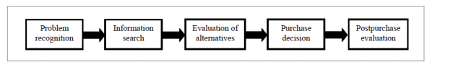
Figure1: Consumer buying decision process. Own elaboration based on Pride and Ferrell, 2007; Hansen, 2005
Source: (PRASAD KOTNI and DIVYA, 2019)

The mechanism for consumer decision-making involves different steps from the identification of consumer needs, assessment of product alternatives, the purchasing of the product, and finally an examination of the product decision after the purchase (PRASAD KOTNI and DIVYA, 2019).
The consumer purchasing model is used by the marketing experts to research and trace the behaviors and actions that consumers take from start to finish. The process is divided into five separate steps which are discussed as follows:
Need / Problem Recognition:
Need Recognition is performed as soon as a shopper identifies their needs and wants precisely. Customers would like one thing missed (problem) and would like to solve this problem (product purchase). When marketers are able to check if their target market begins to build certain preferences or desires for themselves, they will take the best opportunity to promote their products (Arekar, Jain, Kumar et..al, 2018).
Information Search:
The customer information search stage appears to change frequently as customers need new and additional information on products which can fulfil their needs. Knowledge can also be obtained by suggesting persons with previous merchandise experience. Shoppers prefer to focus on risk management and build an inventory of the choices for a selected whole at this stage. This is often done because the majority do not want to regret their choice. Commercial sources, personal sources, public sources and experiential sources are information sources (PRASAD KOTNI and DIVYA, 2019).
Evaluation of Alternatives:
This move includes the evaluation of proposed alternatives to the product lifecycle on the market. After the consumer has decided what their wishes are, they will start to search for the most successful option in the market (Sachdeva, 2015). This research is mostly focused mainly on a variety of variables, such as consistency, value or the other important issue for buyers. According to Stankevich (2019), at this stage consumers compare costs or search feedback and pick a product which best meets their parameters (PRASAD KOTNI and DIVYA, 2019)..
Purchase Decision:
Once all the previous steps have been passed, the consumer has actually made a purchasing call. At this point, the patron has analyzed every aspect and came out to a decision based on the effect of campaigns or emotional relations or personal experience or a combination of each one (PRASAD KOTNI and DIVYA, 2019).

Post Purchase Behavior:
The purchase of the products is followed by an analysis after purchase which analyses whether the product is or is not helpful to the buyer. It is further elaborated by Sachdeva (2015) that if the product has exceeded the client's standards, it will act as a full ambassador and impact alternate future customers who will be willing to increase the individual brand's consumer base. The same applies to bad encounters, but it ends future customers' path towards the goods.

2.4.3 Consumer Buying Behavior on online shopping
Globally, the phenomenon of online shopping for goods or services is important and the online trading corporations worth some US$ 2.29 trillion a year (Rahman, Islam, Esha et al, 2018). According to Mahiuddin (2016), the online market is expanding further in the next few decades as more customers become computer-edited and accept the ease of buying goods or services online.
Consumer buying behavior over the Internet was highly influenced by the quality and reliability of goods and services, which have a positive impact on customer buying good quality and service reliability (Rahman et al., 2018). In Malaysia, customer satisfaction relates to quality and reliability for goods and services and it will have a major impact on the consumer repurchase decision (Vegiayan, Ming, and Harun, 2016).
On the other hand, Rahman et al. (2018), said that various age groups had different effects on online shopping. In Malaysia, thousand years ago millennials took a favorable view of online shopping due to convenience and ease of payment, while the elderly generally had a negative sense of security (Vegiayan, et al., 2016). Online purchasing behavior over the Internet would increase if customers feel positive about Internet protection (Pandey, A and Parmar JS., 2017).

2.4.4 Factors influencing consumer buying behavior
Human behavior is largely determined by the learning process in the family or institutions that shapes an individual's perceptions, values, preferences and behavior (Ashofteh, 2017). Kotler (2016) has claimed that the purchasing behavior of a product or service is based upon a variety of external and environmental factors such as price, advertising, efficiency, and peer advice and product presentation. Ramya and.al. (2016) have grouped the factors influencing consumer buying behavior into five factors: cultural, social, personal, psychological and economic factors as shown in Table 2.2.
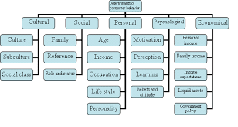
Figure 2: Factors influencing Buying Behavior
Source: (Kotler & Armstrong, 2018)

2.4.4.1 Cultural factors:
Cultural factors are divided into cultural, subcultural, and social class as shown. Culture is the central component of a consumer's desire and behavior and consists of a collection of elements including family values, expectations, and perceptions (Ramya et al, 2016). (Ramya et al, 2016). Culture is also defined as a set of values that a relatively large number of people share and are generally transmitted by generations (Fernandes, 2019). The culture of a community is changed through time but the changing mechanism takes a very long time and as a marketer, it is prudent not to change but to function within the culture (Ramya et al., 2016).
Subculture, however, is another collection of beliefs and values such as religions, nationalities, ethnic groups, and geographical regions, held by a subgroup of people from the major cultural community who can more specifically identify the group's members (Arekar e al., 2018). The seller should concentrate on planning strategy by looking at the market subcultural elements (Meddour et al, 2018).
The social class in a society where members of the same class share the same beliefs, values, and interests is an order division, according to Tyagi (2018). Socio-economic classification (SEC) is the division of society into a separate class (Ramya et al., 2016). The social group classification does not only depend on the members' income/financial level, it incorporates a number of factors such as education level, occupation, ownership, influence, wealth, and political status (Tyagi, 2018). There are three social groups according to Ramya et al.(2016), namely the upper, medium, and lower class, of which upper-class members prefer high-quality, costly services and goods to retain their social image. As for members of the middle class, customers compare and analyze potential options, while lower-class members purchase impulses and look for cheaper goods or services that can satisfy their wants and needs (Arekar et al., 2018). Consumers of the same social class are typically the same consumers and have the same buying behavior. Hence marketing should adapt according to social class their marketing strategy (Mowlaie and Aminosharieh, 2017).

2.4.4.2 Personal factors:
Some of the important personal factors affecting buying behavior are lifestyle, economic situation, job, age, personality, and self-concept.
Age and life cycle can affect the purchasing behavior of the customer. The customer explicitly changes the purchasing of goods and services over time. Family life consists of various stages, for example, the development of young singles, married pairs, unmarried couples, etc. This helps the marketers to develop appropriate products for each stage (Fernandes, 2019).
The employment of an individual has a big influence on his purchasing behavior. For example, a marketing manager from a corporation will try to buy suits while a low-level worker in the same company will buy robust workwear (Madhavan, 2017; Tyagi, 2018; Yadav, 2018).
Another aspect that affects the buyer behavior is the lifestyle of customers. Lifestyle refers to the life of an individual in a society and to things in his or her environment. It is determined by the desires, views, actions, and so on of the consumers and forms its entire model of action and global interaction (Stankevich, 2018).
Consumer economic situation has a significant effect on his purchasing behavior. If a consumer has a high income and savings, he can buy more costly goods. In exchange, a low-income and savings individual would buy cheap goods (Madhavan, 2017; Tyagi, 2018; Yadav, 2018).
Personalities shift from person to person, from time to time and place to place. It may also affect customers' purchase behavior. In reality, the personality is not what you wear, but the entire conduct of a person under various circumstances. It has many characteristics, including superiority, aggressiveness, trust, etc., which can be helpful in assessing customer behavior in respect of a specific product or service (Stankevich, 2018).

2.4.4.3 Economic factors:
The customer buying habits and decisions rely heavily on a country's or markets economic condition. If a country becomes prosperous, the economy is high, leading to increased market cash and increased consumer buying power (Khachatryan et al., 2018). In a stable economic climate, buyers are more optimistic about purchasing goods. In comparison, a poor economy represents a market that is in trouble, plagued by unemployment and decreased buying power. Economic conditions have an important impact on the consumer's purchase decision (Ramya et al., 2016). The important economic factors are:
Personal Income
If an individual has a higher disposable income, the buying ability increases at the same time. Available earnings are the money left after expenditure on an individual's basic needs.
If disposable income increases, it can lead to higher spending on different products. However, as disposable income decreases, the expenditure on several items also decreases (Lee, 2018).

Family Income
The cumulative income of family members is the full income of all family members. Where more people earn in the household, more money for basic necessities and luxuries is available to purchase. Increased family income impacts the family to buy more (Ashofeth, 2017). If the family has a surplus income, it tends to purchase additional luxury goods that an individual may otherwise not purchase (Ramya et al., 2016).

Consumer Credit
When a customer can buy goods with easy loans, it encourages higher expenditure. Sellers make access to credit convenient to customers in the form of credit cards, easy deposits, bank credits, buy from the hiring company, and many other credit choices. If the customer has more credit, the purchasing of luxury goods and comfort increases (Khachaturian et al., 2018).

Liquid Assets
Consumers with liquid assets are more likely to spend on comfort and luxury. Liquid assets are assets that can very quickly be turned into cash (Ramya et al., 2016)... Some examples of liquid assets include cash in hand, bank deposits, and shares. If a customer has greater liquid assets, he can purchase luxury items with more confidence (Tyagi, 2018).

Savings
The amount of savings that a customer needs to set aside from his profits is highly influencing. If a customer chooses to invest more, his spending expenditures will decrease. Although customers are keen to save more, much of their revenue is earmarked for purchasing goods (Ramya et al., 2016).

2.4.4.4 Social factors:
Humans are social creatures and they live with many people who affect their buying behavior. Humans try to emulate other humans and even want to be socially accepted in society. Therefore, other people around them affect their buying behavior. These factors are social factors. Social considerations include Family, Reference Groups, and Roles and status. Family plays a major role in influencing a person's purchasing actions. An individual develops childhood tastes by watching families purchase products and even as they grow up, they keep buying the same product. Effective marketing should take account of family targeting because they play an important role in influencing other family members in purchasing products or services (Lee, 2018)
Reference community is a group of people with whom a person is involved. Generally, the buyer behavior is typical and affects all people in the reference community (Yadav, 2018). This group would have a profound effect on the purchasing behavior of consumers through exchanging experiences and suggestions (Ramya et al., 2016). The reference group can be further categorized, according to Fernandes (2016), into knowledge group, utilitarian group and quality expressive group.
A person is influenced by the role that he holds in society. His purchasing behavior is primarily influenced by his status when an individual is highly positioned. An individual who is a CEO in a corporation will purchase according to his or her status, whereas an executive or an employee of the same company will have a different purchase pattern (Ramya et al., 2016). That’s why Marketer should also know the status that can be symbolized of the product and service of the company (Mowlaie et al 2017).

2.4.4.5 Psychological factors:
Human psychology is a crucial market component. These variables are difficult to quantify but strong enough to affect a decision on the purchase (Jales, Rahman, 2018). Some of the psychologically relevant variables are:
Motivation
If an individual is sufficiently inspired, it affects the person's purchasing behavior. A person's needs include social needs, fundamental needs, protection needs, needs for consideration, and needs for self-realization. The essential needs and protection needs are above all other needs, from all of these criteria. Therefore essential needs and safety standards may be driven to purchase goods and services (Meddour et al., 2018).
Perception
Consumer perception is an important element in consumer behavior. Customer perception is a mechanism by which a customer gathers product information and interprets the information for the purpose of creating a meaningful picture of a product (Jales, Rahman, 2018). If a customer sees commercials, advertisements, customer reviews, feedback from social media, etc. on a product, they make an opinion about the product. Consumer understanding, therefore, plays a significant role in purchasing consumer decisions (Meddour et al., 2018).
Learning
An individual may learn more about the product when purchasing it. Learning is achieved by practice over a period of time. The learning of the customer relies on information and skills. While skills can be gained by practice, knowledge can only be acquired by experiences. Either conditional or cognitive may be learning (Jales, Rahman, 2018). In conditional learning, the user is continuously subjected to a situation and thus develops a response. While the customer will apply his experience and expertise in cognitive training to find satisfaction and solution in the product he is purchasing (Ramya et al., 2016).
Attitudes and Beliefs
Consumers have certain behaviors and convictions that affect their purchasing decisions. On the basis of this attitude, the customer acts particularly in relation to a commodity. This position is critical in the concept of a product's brand picture. The marketing professionals, therefore, seek to consider the consumer's role in developing their marketing strategies (Ramya et al., 2016).

2.4.4 Consumer Buying Models
A consumer behavior varies owing to the many factors that influence consumer behavior. Consumer behavior Models have been developed to substantiate the various factors that influence consumer behavior and their decision-making process.

2.4.1 Consumer behavior Model- Howard-Sheth model
Model Howard-Sheth (fig. 1) is based on the idea that during shopping, customer behavior is reasonable, process repeatable and incentive-based (Input variables) (Rani, 2014). There are four major variable groups:
Input variables: stimuli arising from the marketing activities and social environment of the consumer (Rani, 2014). Include three types of stimuli, namely:
- Significant incentives - the physical and product attributes, such as price, quality, originality and accessibility, brand features,
- Symbolic incentives-product's verbal or visual features, buyer-customer product type, advertisement impact and seller promotional messages
- Social stimuli-the social buyer, family, reference groups and society in general are their root (Farley and Ring, 1970).
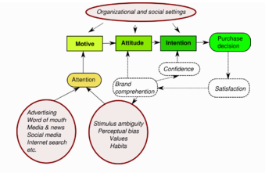
Figure 3: Simplified Howard-Sheth model
Source: (Ring, 1970)

Hypothesis constructions, including psychological factors that affect customer behaviour. The authors consider it abstract, not directly described and not intended (Rani, 2014). Two main buildings were distinguished:
- Constructs for perceptual - identify information collection attention to stimulus, message sensitivity, receptivity, blocking of information, harm, etc.
- Learning builds – how consumers shape perceptions, views and awareness affecting purchasing choices, appraisal following purchases, brand understanding, etc.
Output variables: desire to buy, attitude, understanding of branding and attention to brand. There are noteworthy consequences of internal procedures, e.g.: purchasing decisions, consumer insight and interest disclosure as well as other operation statements. The key performance variable from the marketing point of view is actually the purchase, since behavior is focused on customer desires (Rani, 2014). The output variables hierarchy includes:
- Care - scope of information approved after the purchaser has been exposed to incentives,
- Perception - the quantity of information processed and held in the mind of the consumer,
- Cognition - product-forming attitude;
- Aim - purchase or not purchase specific product;
- Buying behaviour.
External variables, however, they have no major effect on consumer decisions and are used by marketing as a criterion to segment themselves, as they have not been presented in the Howard and Sheth models and are not a direct part of the decision-making process These include: purchasing value for the customer, the consumer's features, the membership of a social group, the consumer's financial condition, the time constraint (Farley and Ring, 1970).

2.4.2 Consumer behavior Model- Kotler behavioral selection model
Consumer behaviors have a stimulus response model (Kotler, 1997) to explain the purchasing behavior of individual customers as part of the purchaser's business. A basic model that emphasizes all dimensions of consumer behavior within society is proposed by Philip Kotler. Kotler claims that consumer conduct involves the psychological, emotional and physical behaviors people use when choosing, purchasing, utilizing and disposing goods and services that fulfil their wishes and needs This model briefly notes that individual consumers are exposed to marketing stimuli such as product, price, venue and promotion. Other marketing stimuli, which include economic, technical, political and cultural aspects, are also exposed to consumer stimulations. The mental processes of the buyer are visualized as black box and buyer decisions include the choice of product, brand choice, dealer range, buying quantity and purchasing times are commented on (Kotler, 1999). The stimulus response model is shown in Figure 4.

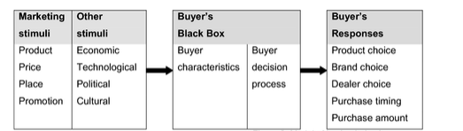
Figure 4 Model of consumer behavior
Source: ( Kolter, 1999)

2.5 Relevant marketing strategy

2.5.1 Marketing mix of 4P and 4C
Jerome McCarthy introduced the principle of the 4P marketing mix in the late 1950s, arguing that 4P refers to the product, place, price and promotion (Wang, 2005). 4P marketing mix theory can be considered a highly classical industry theory that plays a great role and have a significant impact in the practice of marketing. The essence of the 4P marketing mix are the tools of the products it offers and benefit from the sale of products (Yun-sheng, 2001). The 4P marketing mix theory focuses essentially on the product and the manner in which customers consider goods. These tactics are generally product oriented and encourage consumers to consider goods by by making an issue of products as much as possible.
Lauterborn suggested the 4C marketing mix: consumers want and need, ease, communications and expense (Eavani and Nazari, 2012). The organization should first of all put emphasis on the consumer and emphasize that customer formation is more important than product growth. It is more important than the product's role to satisfy the needs and wishes of consumers.
Not only does the company want to sell the goods but they also deliver the products that consumers want to purchase in a real way. The cost of a company's production is the cost of manufacturing goods that are appropriate for customers' needs. Companies should have a detailed understanding of the various methods of purchasing and desires of different customers, apply the convenience concept in the entire commercialization process and provide consumers with reliable efficiency, quality, price, implementation procedure and effects information by delivering pre-sale services in the right time. After sales service should concentrate on the input and the monitoring of information, deal with and respond to the comments of clients about the product’s problems to initiate a return and replacement initiative and to leverage defects to provide actively maintenance comfort, bulk goods or lifetime guarantees (Syaglova, 2015). Businesses should use contact with consumers to test out a range of marketing plans and marketing mix. If perfect outcomes are not achieved, businesses and goods have not been approved in full by customers.
The 4 Cs of marketing can be very useful for any marketing strategy. This strategic approach forces advertisers to consider their viewers before they even create a product. This approach involves coordination from start to finish throughout the whole process and starts with an understanding of what the consumer wants and needs for the goods (Syaglova, 2015).
The theory of marketing is converted from 4P to 4C, from business focusing to consumer emphasis and from business preferences to consumer focusing that represents consumers' consumption interests and requirements.

2.6 Gap in literature:
In different countries several studies have been performed about the buying behavior of the consumer and the underlying causes of the purchasing behavior. There were research in different fields and in various circumstances both globally and locally.
A research by Jahangir Alam (2020) of factors influencing "Buying Behavior Under Coronavirus Disease (COVID-19) Pandemic Situation: A Online Perspective Case in Bangladeshi" proved that there is a variety of factors affecting consumer online buying behavior during COVID-19, such as perceived risk, consumer trust , which can be taken as guidance for sellers.

Another study conducted by Dr. Tareq N. Hashem (2020) on “The Influence of COVID-19 Pandemic in Changing Customers' Orientation towards E-Shopping " showed that demographics played a role in asserting the change of customer behavior attributed to COVID-19 pandemic.
The above studies covered limited factors that can influence consumer's online buying behavior during COVID-19 and none of them covered KLang Valley Malaysia. There are more influencing variables than risk, trust and and demographics that can influence customer online shopping especially in such pandemic.
The research gap has already been reported and this research attempts to fill this gap in literature with a conceptual structure. The objective of this study is to focus on the factors influencing Consumer online buying behavior during COVID-19 in klang valley Malaysia.

2.7 Conceptual framework
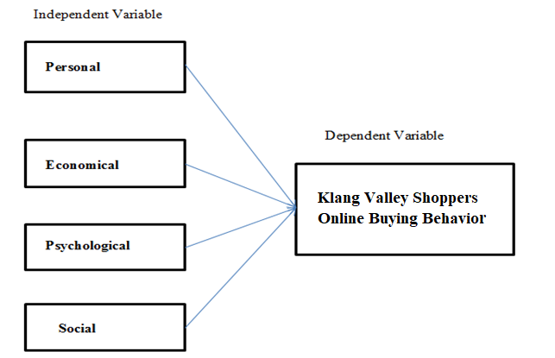
Figure 5: Conceptual framework
The theoretical framework is the basis for the study of logical expansion and description, which can explain the relationship network between independent variables and dependent variables related to the problem and determine through investigation (Libby, 2017). In the model above, the research framework shows the relationship between personal, economical, psychological as well as social factors and consumer online buying behavior among Klang Valley Malaysia shoppers.

2.8 Hypothesis
- H1: Personal factors have a significant impact on consumer online buying behavior among Klang Valley shoppers during COVID-19
- H2: Economical factors have a significant impact on consumer online buying behavior among Klang Valley citizens during COVID-19
- H3: Psychological factors a significant impact on Klang Valley customer online buying behavior during COVID-19
- H4: Social factors have a significant impact on Klang Valley customer online buying behavior during COVID-19.

2.9 Conclusion
This chapter explores the phenomenon of online consumer purchasing behavior and factors that influence on the personal, economic, psychological as well as social behavior of the consumer. A contextual gap still exists where there are still limited studies regarding consumer online buying behavior during COVID-19 in Malaysia. Kotler behavioral selection model and Howard-Sheth model found to be relevant to this study and can be applied to the conceptual framework of this research. Based on the literature review, four hypotheses were developed and discussed.

Chapter 3 Research Methodology

3.0 Overview
The research approach for this study is focused on the interpretation of the data used for the data collection process. Since it is a retrospective analysis, surveys will be circulated. The purpose of the survey, the type of the survey, the level of the testing intervention, the sample settings, the time frame, the analytical method, the process of data collection, calculations and assessments and data analysis are explained in the test design. The design of the questionnaire was tabled by the number of items for each element and references to fit the questionnaire form were cited.

3.1 Research design
Research design is intended to demonstrate how data is obtained and interpreted to create a centralized study context for achieving research objectives.
Bougie and Sekaran (2019) note that the aim of a descriptive analysis is to explain under-studies phenomena and to examine relations between variables using a research design for the purposes of correlation science. This research can be characterized as the relation between the independent and the dependent variables, since the analysis is descriptive (Schindler, 2018).The goal of this analysis, therefore, is to explore the relationship between the independent variables, Personal, Economical, Psychological and Social factors with the dependent variable that is Klang Valley Shoppers online buying behavior during COVID-19.
Bougie and Sekaran (2019) found that descriptive research is based on the collection of information in order to disseminate samples and interpret and tabulate data obtained using quantitative methods. Quantitative analysis is used in this research in order to obtain data within a limited time from multiple respondents to test the hypothesis and accomplish research goals by the obtained data (Zikmund et al., 2013).
This research data was collected from interviewees only once via questionnaires, and so this research is regarded as a cross-sectional study and not a longitudinal study (Saunders, Lewis and Thornhill, 2016).

The questionnaire consists primarily of three sections. Introduction is the first part. The key information in questionnaires is provided in a straightforward and unambiguous manner. T The misunderstanding of the questionnaire is avoided and the validity of the questionnaire is improved. The second component is personal data such as age, gender, employment and monthly income. This allows us to understand the participants and also gives us a wide range of data sources. The third section of the questionnaire is the key part.
Through the questionnaire, the online buying behavior during COVID-19 was investigated. Then the results of the questionnaire were analyzed to explore the online buying behavior during COVID-19 and the possible influential factors.
After the collection of the data through the questionnaire, the data analysis was conducted by the software analysis SPSS.
A preliminary evaluation on a small sample was performed to determine the feasibility of the study, to verify the correctness, to refine the surveys, to avoid misconceptions and ambiguities, and to improve the authenticity of the content of the questionnaires until a full analysis take place (Smith, Morrow and Ross, 2015).

3.2 Unit of Analysis and Time Horizon

3.2.1 Unit of Analysis
Analysis unit is the key research and analytical body in a study and may be an organization or an individual (Trochim, 2006; Zikmund et al., 2012). In this study, the unit of analysis is individual as questionnaire will be distributed to the respondents living in Klang Valley Malaysia.

3.2.2 Time Horizon
The data has been collected through online questionnaire from the respondents. . Cross-sectional analysis is used to gather data at one time (Saunders et al., 2012). This is also a cross-sectional analysis in terms of time horizon

3.2.3 Sampling Design
Sample design may also be regarded as the basis or structure for the collection of a sample and will affect many aspects of the studies (Sekaran et al., 2016). A sampling frame that can reflect the population concerned must be chosen to improve the efficiency of the study (Shan, 2012).
This analysis is a design for correlation research and will be a quantitative research, as questionnaires are distributed among the respondents. The data obtained from online questionnaires was analyzed in depth and used to help the analysis statically.

3.2.4 Sampling Plan
The two major sampling methods in the data collection process are referred to as probability sampling and no probability sampling (Cooper and Schindler, 2011). Probability sampling means data collection from a group of people with the same probability, while non-probability sampling means data collection at random, in which the group share the same opportunity of selection (Sekaran and Bougies, 2016). In this research the sampling design for non-probability is chosen because of time limits for convenience sample strategies. Questionnaires will be circulated through a wide network of connections to relatives, friends, and colleagues living in Klang Valley Malaysia.
The convenience sampling method is a cost-effective strategy according to Saunders et al. (2012), because the time spent gathering data is shortened and the response rate increased, thus overcoming the time constraint facing this study.

3.2.5 Sample Size
Determining the appropriate sample size is crucial in any research as sample size can greatly influence power and effectiveness of research results and feasibility of the research (Meysamie et.al, 2014).
Since there is no unique population size known to participate in the Klang Valley online shoppers, 20000 is therefore considered as the population size that will be randomly selected among members Klang Valley online shoppers. Using Raosoft.com the sample size is obtained with 5 percent agreed margin error, 95 percent confidence level and 20000 as the population size is 377 (Raosoft.com, 2020).
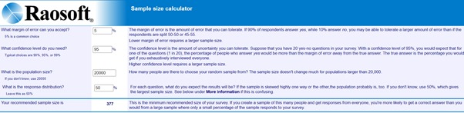
Figure 6: Determining Sample size using Raosoft
Source: (Raosoft.com, 2020)

3.3 Data collection method
The data obtained for this analysis was collected through self-administered questionnaires. In fact, self-administered questionnaires have advantages and drawbacks. One of the benefits is that the self-administered online questionnaire can cover a broader range and data gathered can be systematically analyzed by algorithms (Ponto, 2015). However the drawback of the self-administered questionnaire is that there is no interviewer present to explain questions that may be misunderstood or lead to untrustworthy results and it cannot represent the surveys as only certain categories of interested or qualified persons can be involved (Padayachee, 2016).
Section | Questions or Items | Number of Questions | Reference
A | Demographic Profile | 4 | (Etzioni, 2020)  (Pärson and Vancic, 2020)  (N. Hashem, 2020)
B (Dependent Variable) | Online consumer buying behaviour in Klang Valley Malaysia during COVID19 | 6 | (Etzioni, 2020)  (Butu, Brumă and Tanasă, 2020)
C (Independent Variables) | Personal factor | 3 | (Butu, Brumă and Tanasă, 2020)  (N. Hashem, 2020)
 | Economical factor | 3 | (Etzioni, 2020)  (N. Hashem, 2020)
 | Psychological factor | 3 | (Butu, Brumă and Tanasă, 2020)
 | Social factor | 3 | (Wijaya, 2020)

3.4 Questionnaire design
Table 3: Questionnaire design

This study is cross-sectional since the data are only collected once from the interviewees via questionnaire. The questionnaires will therefore be updated to achieve the study goals based on literature reviews of studies that are similar in nature to this research. In Section A the questionnaire comprises the respondents' demographic profile. Section B includes the dependent variable which is online buying behavior. Section C includes independent variables, which include personal economic, psychological and social factors the questionnaire. The questionnaires will be designed to ensure sufficient collection of data and not to take too long to complete. Four questions will be posed, including gender, age, occupation and monthly income in order to clarify the demographic profile of the respondents. For questions concerning independent and dependent variables, the Likert 5 scale is used ranging from 1 as ‘’Strongly Disagree’’ to 5 as ‘’Strongly Agree’’. The questionnaire will be distributed electronically, like WhatsApp or email, without knowing the identity of the respondents.

3.5 Measurements Variables
The questionnaire items representing the variable specifications are written in simple and straightforward language. Five-point Likert scale will be used and respondents are expected, on the grounds of their agreement or disagreement with the five-point Likert scale , to react to the items in questionnaires such:
1 = “Strongly Disagree”, 2 = “Disagree”, 3 = “Neutral”, 4 = “Agree”, 5 = “Strongly Agree”.

3.6 Pilot Test
Pilot test is a test trail until the studies are done (Zikmund et al., 2013). The aim of the pilot test is to evaluate, check, and inform the researchers of the potential risk of failure of the experiment, the validity and reliability of the questionnaire items (Chiew, 2015). Baker (1994) notes that 10-20% of the real sample size is the optimal size of a pilot test. The current sample size for this study is 377, so a pilot test will be carried out with about 38-40 respondents.

3.6.1 Pilot Test: Factor Analysis
Factor analysis is a methodology that can make multiple variable simpler by minimizing the data for further analysis (Sekaran and Bougie, 2016). This is important to assess the data collected and items constructed in research is suitable for analysis and to decide on retention or removal of certain items. (Kumar, 2010 and Zikmund et al., 2013).
Factor analysis involves the Kaisser-Meyet Oikin (KMO) Bartlett’s test of sphericity to test the adequacy of the results (Pallant, 2011). Based on Creswell (2014), the KMO value should vary from 0.6-1. The preferred value should be closer to 1 and 0.6 is the least proffered value. The high KMO value indicates that the KMO is highly correlated, and the low KMO value shows that the variables were a representative factors. Items with communalities values < 0.6 should be removed (Chetty and Datt, 2015).
Factor loading is to find out the correlation coefficients for the variable and factor (Zikmund et al., 2013). In other words, it is also referred to how the variables are associated with the specific factor (Yong and Pearce, 2013). High factor loading (>0.6) is preferred for testing, although low factor loading (<0.6) is less preferable than low load on any factor (Hair, 2014). The loading factor of 0.5-0.6 according to Zikmund et al. is appropriate in the pilot test because of the limited sample size (2013). The eigenvalue, according to Field (2013) represents the amount of variance of the variables a factor explains. Eigenvalue. At least 1 is considered stable" and sufficient for one of the factors (Kaiser, 1960). There are 3 IVs in this analysis, so that 3 variables must have their own value > 1 to preserve value.

3.6.2 Pilot Test: Reliability Test
The reliability test is used to continuously assess the consistency of the results of the questionnaire and the level of reliability of the measurement (Sekaran and Bougie, 2016). The Cronbach’s Alpha through SPSS is used in this cross-sectional analysis to test the coherence of the questionnaire. Based on Rovai, Baker and Ponton (2014), Cronbach's Alpha is commonly used to calculate the instrument's internal accuracy and to test whether combination of questions in scale is measuring the same thing. The alpha values differ from 0 to 1, with Bryman and Bell (2015) favored minimum alpha values of 0.7. Values above 0.7 are considered to be acceptable and adequate, values above 0.8 to be good and values above 0.9 show exceptional internal consistence (Tavakol & Dennick, 2011). An alpha value of more than 0.7 shall be sufficient for reliability in the pilot study.
Pre-testing the reliability of the sample will be carried out before the main distribution of the questionnaire. The pre-test process will involve a distribution of 38 sets of questionnaires among Klang Valley Malaysia online shoppers, which will analyze the collected data with Cronbach's Alpha. Bougie and Sekaran (2019) pointed out that if the results shown are low, the questions need to be considered and excluded due to lack of understanding.
Before the preliminary testing is carried out it is important to test if the designed questionnaire is accurate, reliable and consistent (Zikmund et al., 2013).

3.7 Data Analysis

3.7.1 Preliminary Test
The reliability test is used to continuously assess the consistency of the results of the questionnaire and the level of reliability of the measurement (Sekaran and Bougie, 2016). The Cronbach’s Alpha through SPSS is used in this cross-sectional analysis to test the coherence of the questionnaire. Based on Rovai, Baker and Ponton (2014), Cronbach's Alpha is commonly used to calculate the instrument's internal accuracy and to test whether combination of questions in scale is measuring the same thing. The alpha values differ from 0 to 1, with Bryman and Bell (2015) favored minimum alpha values of 0.7. Values above 0.7 are considered to be acceptable and adequate, values above 0.8 to be good and values above 0.9 show exceptional internal consistence (Tavakol & Dennick, 2011). An alpha value of more than 0.7 shall be sufficient for reliability in the pilot study. Before the preliminary testing is carried out it is important to test if the designed questionnaire is accurate, reliable and consistent (Zikmund et al., 2013). The measurements are assumed to be accurate if the alpha value of Cronbach is equal to or greater than 0.70 and it is suitable to be used for further analyses (Nunnally, 1978).

3.7.2 Descriptive Analysis
Description analysis is used to quantitatively interpret data collection and the collected information is shown for each variable via a frequency distribution. SPSS is used for determining the population profile by means of frequency analyses to determine the percentage of respondents, their gender, age, monthly income, occupation and their frequency distribution.

3.6.3 Hypotheses Testing
In order to test all hypotheses and to evaluate the relationship between online buying behavior (dependent variable) and personal, economic, psychological and social factors (independent variables), Multiple Linear Regression, Analysis of Variance (ANOVA) multi- collinearity and beta-coefficient tests will be done.

3.7.3.1 Multiple Regression Analysis
Multiple Regression Analysis is a method to determine the relationship between the independent variables (personal, economic, psychological and social factors) and the dependent variable (consumer buying behaviour). (Martin and Brigmon, 2012). The value for a reliable variable from a value for an independent variable is used to estimate the self-weight in the creation of equations (Cooper and Schindler, 2011). Path coefficient β describes the estimation and linear association’s strength and tendency between ratio and interval variables according to Zicmund et al. (2013). The coefficient would range from +1 to -1, in which the “+” and “-“sign reflects the direction of relationship while the number indicates the strength of the relationship (Sekaran and Bougie, 2016).
In addition, calculating coefficient, R2 is the calculation of the relation between the observed values and the forecast value (Martin et al., 2012). If R2 is near 1, most variable sections of reliable variables can be explained by a regression model; whereas R2 is close to 0, most changes cannot be explained by the reverse regression model (Sekaran et al., 2010).
- ANOVA
The ANOVA regression is used in this research to explore the link between independent variables (personal economic, psychological, and social factors) to the dependent variable (, consumer online purchasing behavior), as regression, ANOVA explores regression homogeneity and the value of gadge. When the p-value is less than 0.05 at a 95 percent confidence level, the result is considered statistically important (Bougie and Sekaran, 2019)
- Multi-Collinearity
The variation inflation factor (VIF) and tolerance are used to determine whether there is multicollinearity between variables (Kumar, 2014). It is appropriate to conclude that there is no multicollinearity in variables below 10 and tolerance values over 0.1 (Saunders et al., 2016)
- Beta Coefficient
The regression beta coefficient is how many changes will alter the dependent variable with each unit change in the independent variable according to Gardner, Mcgowan, and Moeller (2013). The closer the coefficient of beta to one is, the greater the effect of the independent variable on the dependent variable, said Bougie and Sekaran (2019)

3.8 Ethical Considerations
The researcher has to collect data in an acceptable manner, according to Bougie and Sekaran (2019), to safeguard the coherence and integrity of science. The data from the study were ethically collected and respondents were able to express their opinions without being mistaken (Hair et al. 2018). The questions were formulated in plain language and based on scientific hypotheses so that the respondents could be interpreted clearly. No third party shall except for the sole purpose of the study share or use the information acquired from respondents, notwithstanding the ethical constraints.

3.9 Conclusion
In this chapter the approach used in the study has been elaborated and the biographical data of the respondents have been quantified. This chapter also covered a variety of essential procedures, including planning for research design, building questionnaires and managing data collection. This chapter also addressed how research and analysis have been carried out for the collection of the sample. In the following chapter the results of the study will then be discussed.

Chapter 4: Research Findings

4.0 Overview
The main objective of this chapter is to examine and evaluate the data collected from online shoppers in Klang Valley Malaysia. SPSS is used to describe the outcomes of the study in the classification of data generated by the 5 point Likert scale used in the distributed questionnaires. Data collection for pilot tests was evaluated in order to evaluate the reliability and validity of variables prior to completing data collection. Tables may also be used to display the information collected from the questioners. Appropriate details and more clarification of the findings will be included in order to provide a complete understanding of the relationship between the data obtained and the study provided.

4.1 Pilot test
A pilot test is a necessary step in a research project and is conducted before implementation during the entire study to identify possible issues and shortfalls in the research instruments and procedure (Abu Hassan, Schattner, and Mazza, 2006). It is a rehearsal of the research study. It enables to test the research method with a small number of test participants before performing the main study (Wright, 2020). It may also allow researchers to get to know protocol procedures and help them decide between two opposing methods of analysis, such as interviews and not a self-administered questionnaire (Abu Hassan, Schattner, and Mazza, 2006).
For this study, several tests performed in the pilot test including the factor analysis, correlation, and reliability tests. If the findings of these studies do not comply with the thumb rule set out by some researchers (Hair et.al. 2018; Sekaran and Bougie, 2019; Saunder et.al 2019), some of the questions may require adjustment or exclusion from further analyses. The objective of the pilot test is to verify the validity of the survey before discussing the questionnaire to collect final data (Foong, Green, Zargari, Siddique, Tan, and Ogden, 2015).

4.1.1 Factor analysis of Pilot test
The test Kaiser-Meyer-Olkin is an adequacy measure for the sample which varies from 0 to 1, it is better to use a KMO value nearest to 1 and the recommended minimum is 0.6 (Bell, Bryman, and Harley, 2018). Further testing will not be conducted with the sample if the KMO value is lower than 0.6, which is the thumb standard (Hussain et al., 2018).
Table 4: KMO and Bartlett’s Test (Dependent Variables)
Kaiser-Meyer-Olkin Measure of Sampling Adequacy |  | .914
Bartlett's Test of Sphericity | Approx. Chi-Square | 1269.522
Bartlett's Test of Sphericity | df | 15
Bartlett's Test of Sphericity | Sig. | .000

Table 5: KMO and Barlett’s Test (Independent Variables)
Kaiser-Meyer-Olkin Measure of Sampling Adequacy |  | .909
Bartlett's Test of Sphericity | Approx. Chi-Square | 2058.087
Bartlett's Test of Sphericity | df | 66
Bartlett's Test of Sphericity | Sig. | .000

KMO and Bartlett tests were conducted on the independent and dependent variables. The test results show that the KMO for both independent and dependent variables are 0.914 and 0.909 respectively, (less than 0.06). The p-value of Bartlett's test is 0.000 (less than 0.05) for both variables, indicating that the test questionnaire has good structural validity.
The above results have all been fulfilled. Therefore the KMO test results permit subsequent tests, such as factor loading and self-value tests to be performed in the current sample.

4.1.2 Factor Loadings
Factor loading as also referred to as commonalties, estimate the variance for all of the components or factors in each variable. The key component extraction for correlation analyses is always 1.0, as Lohana, Rashid, Nasuredin, and Kumar (2019) have reported. If the communities are high, it means that the extracted components reflect the variables well. If the communities are low for a particular variable, which means that the value is smaller than the rule of thumb, the variable will not load significantly on no factors (Bell et. al., 2018). Hence, the extraction in pilot experiments from 0.5 to 0.599 is still possible, but the value below 0.5 cannot be permitted (Ong and Puteh, 2017). The question with an extraction value of less than 0.5 is also suggested for researchers to be removed.
Table 6: Factor loading for Pilot Test (Dependent Variables)
 | Initial | Extraction
I trust online shopping platforms | 1.000 | .823
I am using online shopping for my daily requirements | 1.000 | .720
Online Shopping satisfies my purchase needs/objectives | 1.000 | .796
I DO Online Shopping because it is flexible as I can compare the product's quality and prices | 1.000 | .795
Online Shopping allows me to buy products despite my location | 1.000 | .670
I plan to spend more on Online Shopping | 1.000 | .822

Table 7: Factor loading for Pilot Test (Independent Variables)
 | Initial | Extraction
I DO Online Shopping during COVID-19 more than usual | 1.000 | .633
I DO Online Shopping during COVID-19 only when necessary | 1.000 | .793
It is more convenient to DO Online Shopping during COVID-19 | 1.000 | .778
My Online Shopping frequency changed during COVID-19 because of the drop in my salary | 1.000 | .822
I DO more Online Shopping because of the availability of products | 1.000 | .765
I DO more Online Shopping during COVID-19 because of online sales promotions | 1.000 | .782
During COVID-19 Online Shopping is safer | 1.000 | .833
During COVID-19 product's variety has increased online | 1.000 | .822
During COVID-19 I do more Online Shopping as my usage of the internet increased | 1.000 | .726
I shifted to Online Shopping because it is the new normal | 1.000 | .875
I shifted to Online Shopping because of social media influence | 1.000 | .864
I have started Sopping Online because it was suggested by my family and friends | 1.000 | .936

Since all the research variables have a value over 0.6, questions or items in the survey questionnaire should not be removed.
The questions are therefore ideal for use in the entire set of data. However, the Eigenvalue test must be carried out with factor analysis in order to improve the verification.
Factor loadings are the degree to which an object interacts with other items.
Based on Table 7, the results for factor loadings are between 0.642 and 0.757

4.1.3 Eigen Values
The eigenvalue is used to compute the variance in a correlation matrix. For further interpretation, only variables of their own values 1.00 or higher should be retained (Tabachnick and Fidell, 2019). The eigenvalues are the variances of the factors: the total column contains the eigenvalue (Bayliss, 2020). The first factor is always the major variance. Thus the second factor will account for as much of the leftover variance and the same will continue till the last factor (Nyagilo and Njeru, 2020).

Table 8: Eigenvalues of Pilot Test (Dependent Variables)
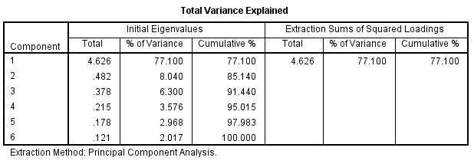
Table 9 Eigenvalues of Pilot Test (Independent Variables)
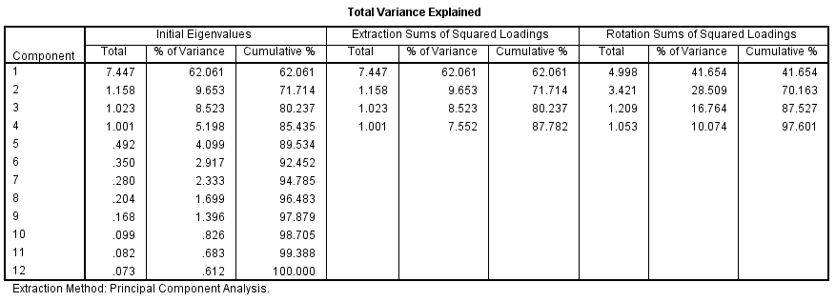

Only variables that have their own values of 1.0 and above are retained for interpretation, as stated by Kaiser (1960). This is confirmed by Hinton and McMurray (2017) according to which an eigenvalue of 1 means the factor can be explained as much variability in the data as a single original variable.
In Table 8, 1 eigenvalue is extracted and equal to the sum of the dependent variable.
In table 9, 4 eigenvalues ​​are extracted and they are equal to the number of independent variables of the study.
One of the conditions was met for extraction. According to Hussain et. Al. (2018), since the extracted value is equal to the number of independent and dependent variables, the elements that can be combined according to the correlation matrix should not be modified or checked.
Moreover, in Table 8, the factor explains 71.062% of the variance, while in Table 9, the 4 factors explain 87.417% of the variance.
The findings satisfied the requirement that the selected factors should account for at least 70-80% of the variance in Nyagilo and Njeru (2020). Thus, questions or items from the current survey will not be excluded (Lohana et. Al., 2019).
The pilot test data reflected an acceptance level that allowed complete data collection to be carried out and the analyses to be continued.

4.1.4 Reliability Analysis Results
Cronbach's alpha method is a reliable coefficient for indicating the correlation between items and for determining the reliability of the internal consistency of the data from this study (Bougie & Sekaran, 2019).

Table 10: Reliability Test (Cronbach’s Alpha) (n=38)
Reliability Test (Cronbach’s Alpha) (n=38)
Construct | Cronbach’s Alpha | N of items
Online Consumer buying behavior  Personal Factors  Economic Factors  Psychological Factors  Social factors | .939  .812  .818  .877  .726 | 6  3  3  3  3
Overall | .759 | 18

When Cronbach's alpha values ​​are equal to or greater than 0.70, the measurements are reliable (Nunnally, 1978).
According to Table 10, the dependent variables (online consumer buying behavior) show good reliability (Cronbach's alpha is above 0.6). The same applies to independent variables (personal, economic, psychological factors, and social). Their Cronbach's alpha is above 0.6
As a conclusion, it was found that when all variables were combined as 1 item (Cronbach’s Alpha=0.759). It showed that all 18 items were accurate for further study. In all, there was excellent consistency.

4.1.5 Conclusion of Pilot Test
The accuracy and significance of the data were assessed by the pilot test on the data collected from 38 respondents. As shown from the results of factor analyses and tests for reliability, all of the buildings in the study were adequate and relevant for collecting complete data and further analyses.

4.2 Response rate
In survey analysis, response rate refers to the number of respondents separated from the number of people in the study who responded to the survey. Since survey quality is usually the response rate, higher response rates are higher. Sampling bias, also referred to as non-response, is the potential question of low response rates if the non-response is unequal between participant exposure and outcome. The result achieved may not be accurate and may result in higher error levels due to the low response rate. Therefore, higher response rates are better.

Table 11: Response Rate of the Study
Sample size using Raosoft (Raosoft.com, 2020) | Total Questionnaire Distributed | Total Questionnaire Received | Total  Usable  Questionnaire | Total  Unusable  Questionnaire | Response  Rate  Percentage
377 | 400 | 333 | 320 | 13 | 84.88%

A total of 400 questionnaires have been distributed online via UH Forms to Klang Valley Online Shoppers in Malaysia. However the respondents receive were 320 replies.
Based on Bell's equation's respondent (2018); N > 50 + 8m (m represents the number of independent variables, which is 4 in this study), at least 82 questionnaires should be collected for the sample size to be appropriate. In addition, 13 responses were not used due to improper answers and confusion of questions.
Finchman (2008) also stated that, in order to explain the target population and to accept it, the appropriate response rate is 60 percent. The response rate in our case is 80% (above 60 percent).

4.2.1 Demographic profile of respondents
Table 12: Demographic Profile of Respondents
Demographic | Categories | Frequency (n=320) | Percentage (%)
Gender | Male | 100 | 31.25%
Gender | Female | 220 | 68.75%
Gender | Other | 0 | 0
Age | 18-28 | 211 | 65.93%
Age | 29-39 | 61 | 19.06%
Age | 40-50 | 38 | 11.87%
Age | +51 | 10 | 3.12%
Occupation | Student | 186 | 58.12%
Occupation | Employee | 79 | 24.68%
Occupation | Housewife | 30 | 9.37%
Occupation | Unemployed | 24 | 7.5%
Occupation | Other | 1 | 0.31%
Monthly income range | Less than 3000 Rm | 95 | 29.68%
Monthly income range | 3001-5000 Rm | 181 | 56.56%
Monthly income range | 5001-10000 Rm | 28 | 8.75%
Monthly income range | +10000 | 16 | 5%

As indicated in Table 12, the demographic characteristics of respondents have been extracted and transformed using descriptive statistics.
The information includes the sex, age, occupation, and monthly income of the consumers.

4.2.2 Gender
According to Table 4.9, a total of 320 participants in the study were female (68.75%, n=220) followed by male participants (31.25%, n=100).

4.2.3 Age
According to statistics, the survey participants in the age between 18 and 28 years old have a total of 211 people, and the proportion was 65.93%. And respondents age between 29 and 39 years have 61 people that account 19.06%. While those aged 40-50 and +51 were the smaller groups, accounting for 11.87 percent and 3.12% percent of the survey participants, respectively.

4.2.4 Occupation
As for the occupation, students were the most, with 186 accounting for 58.12% followed by Employee with 79 accounting for 24.68%. Which is followed by Housewife with 30 accounting for 9.37%. Lastly, Unemployed and other respondent accounting for 7.5% and 0.31% of the survey participants, respectively.

4.2.5 Monthly income range
Respondents' income is primarily range from 3001 to 5000 RMB, of which 181 are 56.56%. Those whose monthly household revenues is +10000 are the least, 16 are 5%, and 95 are 29.68%, whose monthly household revenues fall short of 3000 RMB.

4.3. Preliminary data Analysis
Preliminary analysis is a critical step before any research can be carried out on a quantitative sample. Two preliminary studies, factor analysis and reliability analysis, have been conducted.
According to Bell et. al. (2018), factor analysis typically utilizes the combination or indexation of assessment variables of similar constructs to minimize variables.
Cooper and Schindler claimed in 2018 that the reliability analyses reflect a scope that should unfailingly reflect the measured structure. Even if different people calculate or view the form at different times, the measurement of and construction is consistent internally (Bayliss, 2020).

4.3.1 Factor analysis
Factor analysis is a useful method to analyze variable relationships in complex topics like socioeconomic status, dietary habits, and psychology. It enables to analyze concepts that are not easily calculated by breaking down a large number of variables into many interpretable underlying factors (Balasundaram, 2009).
Several studies have been performed to validate the effectiveness of the constructs of this study. Kaiser-Meyer-Olkin (KMO) and Bartlett's tests, are used to assess research data suitability and to verify the relationship of constructs respectively according to Bayliss (2020). The overall appropriate KMO value should not be less than 0.6 (KMO >0.6). In return, the significance value for Bartlett's test should be less than 0.05 (p <0.05) as indicated by Sekaran and Bougie (2016).

4.3.1.1 Dependent variables
Table 13 KMO and Barlett’s Test
Kaiser-Meyer-Olkin Measure of Sampling Adequacy |  | .914
Bartlett's Test of Sphericity | Approx. Chi-Square | 1269.522
Bartlett's Test of Sphericity | df | 15
Bartlett's Test of Sphericity | Sig. | .000
Table 14 Factor loading
 | Initial | Extraction
I trust online shopping platforms | 1.000 | .736
I am using online shopping for my daily requirements | 1.000 | .666
Online Shopping satisfies my purchase needs/objectives | 1.000 | .751
I DO Online Shopping because it is flexible as I can compare the product's quality and prices | 1.000 | .723
Online Shopping allows me to buy products despite my location | 1.000 | .715
I plan to spend more on Online Shopping | 1.000 | .673

Table 15 Eigenvalues of Preliminary Test
 | Initial Eigenvalues |  |  | Extraction Sums of Squared Loadings
Component | Total | % of Variance | Cumulative % | Total | % of Variance | Cumulative %
1 | 4.264 | 71.062 | 71.062 | 4.264 | 71.062 | 71.062
2 | .470 | 7.838 | 78.901
3 | .391 | 6.518 | 85.419
4 | .329 | 5.484 | 90.903
5 | .281 | 4.691 | 95.594
6 | .264 | 4.406 | 100.000
Based on Table 14, the KMO and Barlett Tests for the dependent variable is .922. The KMO and Barlett Tests which have been performed follow the thumb rule which is greater than 0.6 (Cooper and Schindler, 2018).
The significant level is 0.000, which is significant at 0.05 level. Hence, the KMO and Barlett test results are also agreed (Bayliss, 2020).
Based on Table 15 that illustrates the loading factor of the dependent variable which is consumer buying behavior shows value variance from .666 to .751. The dependent variable for this analysis is therefore appropriate for further studies as the findings have been demonstrated to comply with the thumb rule.
Table 15 shows that the sum of eigenvalue derived is greater than 1 and equal to the number of dependent variables. At 71.062 percent of the variance, the dependent variable factor was extracted. As the requirements for eigenvalue have been fulfilled, further analyses can be carried out (Tabachnick and Fidell, 2019).

4.3.1.2 Independent variables
Table 16 KMO and Bartlett’s Test
Kaiser-Meyer-Olkin Measure of Sampling Adequacy |  | .909
Bartlett's Test of Sphericity | Approx. Chi-Square | 2058.087
Bartlett's Test of Sphericity | df | 66
Bartlett's Test of Sphericity | Sig. | .000

Table 17 Factor loading
 | Initial | Extraction
I DO Online Shopping during COVID-19 more than usual | 1.000 | .687
I DO Online Shopping during COVID-19 only when necessary | 1.000 | .642
It is more convenient to DO Online Shopping during COVID-19 | 1.000 | .682
My Online Shopping frequency changed during COVID-19 because of the drop in my salary | 1.000 | .722
I DO more Online Shopping because of the availability of products | 1.000 | .639
I DO more Online Shopping during COVID-19 because of online sales promotions | 1.000 | .710
During COVID-19 Online Shopping is safer | 1.000 | .700
During COVID-19 product's variety has increased online | 1.000 | .688
During COVID-19 I do more Online Shopping as my usage of the internet increased | 1.000 | .673
I shifted to Online Shopping because it is the new normal | 1.000 | .757
I shifted to Online Shopping because of social media influence | 1.000 | .671
I have started Sopping Online because it was suggested by my family and friends | 1.000 | .730

Table 18 Eigenvalues of Preliminary Test
 | Initial Eigenvalues |  |  | Extraction Sums of Squared Loadings
Component | Total | % of Variance | Cumulative % | Total | % of Variance | Cumulative %
1 | 6.001 | 50.004 | 50.004 | 50.004 | 31.189 | 31.189
2 | 1.300 | 10.830 | 60.834 | 10.830 | 23.038 | 54.227
3 | 1.023 | 8.523 | 62.589 | 7.526 | 18.240 | 72.467
4 | 1.001 | 8.338 | 69.173 | 8.338 | 14.946 | 87.417
5 | .545 | 4.542 | 79.327
6 | .525 | 4.373 | 83.701
7 | .431 | 3.593 | 87.294
8 | .397 | 3.309 | 90.603
9 | .321 | 2.675 | 93.279
10 | .294 | 2.451 | 95.730
11 | .279 | 2.323 | 98.053
12 | .234 | 1.974 | 100.000

Based on Table 16, the KMO and Barlett Tests for the independent variables is .909. The KMO and Barlett Tests which have been performed follow the thumb rule which is greater than 0.6 (Cooper and Schindler, 2018).
The significant level is 0.000, which is significant at 0.05 level. Hence, the KMO and Barlett test results are also agreed (Bayliss, 2020).
Based on Table 17 that illustrates the loading factor of the independent variables which are economical, personal, psychological and social factors show value variance from .639 to .757. The independent variables for this analysis are therefore appropriate for further studies as the findings have been demonstrated to comply with the thumb rule.
Table 18 shows that the sum of eigenvalue derived is greater than 1 and equal to the number of independent variables “4”. At 87.417 percent of the variance, the independent variables factors were extracted. As the requirements for eigenvalue have been fulfilled, further analyses can be carried out (Tabachnick and Fidell, 2019).

4.3.2 Reliability Analysis
The Reliability analysis is an analysis used to determine the consistency of variables (Sekaran and Bougie, 2016).
Cronbach’s Alpha is a measure of scale reliability. Its values must be equal to or above 0.7, to give a strong consistency based on the thumb rule (Bayliss, 2020).
As reported by Cooper and Schindler (2018) if the Cronbach’s Alpha varies from 0.7 to 0.8, it is considered appropriate, while if it is more than 0.8 but below 0.9, a reasonable consistency is considered whereas when the value is above 0.9 it is considered to have an outstanding consistency.
Table 18: Reliability Test
Reliability Test (Cronbach’s Alpha) (n=38)
Construct | Cronbach’s Alpha | N of items
Online Consumer buying behavior  Personal Factors  Economic Factors  Psychological Factors  Social factors | .937  .735  .802  .804  .741 | 6  3  3  3  3
Overall | .803 | 18

Based on Table 18, which shows the reliability test for the dependent variable and the independent variables, Cronbach's alpha value varies from 0.937 (outstanding consistency, Cooper and Schindler (2018)) for the online consumer buying behavior, 0.735 (normal consistency) for personal factors, 0.802 (reasonable consistency) for economic factors. 0.804 (reasonable consistency) for psychological factors and 0.741 (normal consistency) for social factors.
Consequently, both dependent and independent variables evaluated, and the alpha value of Cronbach is 0.803 (Cooper and Schindler, 2018). This shows that the 18 test items comply with the thumb rule and are appropriate for further study.
4.3.3 Hypothesis testing
Table 19 provides the summary of the variables for the research, the dependent variable is online consumer buying behavior among Klang Valley Malaysia shoppers and the independent variables are economical, personal, psychological and social factors.
Table 19 Summary of the Dependent Variable and Independent Variables
Dependent Variable | Independent Variables
Online Consumer Buying Behaviour | Economical factors
Online Consumer Buying Behaviour | Personal factors
Online Consumer Buying Behaviour | Psychological factors
Online Consumer Buying Behaviour | Social factors

Table 20 Research Hypotheses
Hypothesis 1 | Personal factors have a significant impact on consumer online buying behavior among Klang Valley shoppers during COVID-19
Hypothesis 2 | Economic factors have a significant impact on consumer online buying behavior among Klang Valley citizens during COVID-19
Hypothesis 3 | Psychological factors a significant impact on Klang Valley customer online buying behavior during COVID-19
Hypothesis 4 | Social factors have a significant impact on Klang Valley customer online buying behavior during COVID-19.
4 theories based on Table 20 above were suggested in this report. These hypotheses were based on Chapter 2's literary analysis. These hypotheses were tested with the multiple linear regression.
The Multiple Linear Regression test will be a core factor in the identification and support of hypotheses (Bougies and Sekaran 2019).

4.3.3.1 Multiple Linear Regression Analysis
Multiple Linear Regression is a statistical method used by many explanatory variables to predict the outcomes of the response variable. The aim is to model the linear relationship between the explanatory variables (independent) and the response variable (dependent).
Table 21 Multiple Regression Model Summary
Model | R | R Square | Adjusted R Square | Std. Error of the Estimate
1 | .771 | .595 | .590 | 2.79355

The dependent variable and independent variables were determined for multiple linear regression analysis to show the means (Halim et. al, 2020).
In the summary model table, R square value shows the impact of the dependent variable, online consumer buying behavior towards the independent variables, economical, personal, psychological and social factors.
The data in Table 21 were calculated with the dependent variable and the average of four independent variables. The R square shown in this table is .595, reflecting 4 separate variables average of 59.5% of the overall variance that affects the purchasing behavior in Klang Valley Malaysia towards online shopping. The remaining 40.5 % of variances are attributed to other variables not included in this analysis (Sekaran and Bougie, 2016).

Table 22 Regression ANOVA
Model |  | Sum of Squares | df | Mean Square | F | Sig.
1 | Regression | 3693.371 | 4 | 923.343 | 118.318 | .000b
1 | Residual | 2512.855 | 322 | 7.804
1 | Total | 6206.226 | 326

Based on Table 22, the degree of significance or F-value of the ANOVA regression, between both the mean measured by the variable dependent and 4 independent variables, is 118.318.
Table 22 has a P-value of 0.000 (less than 0.05) that fulfils the thumb rule. Since the F value is significant, we may infer that the model fits well with the study (Lockings, 2020).
After the F-value and R-squared evaluations, it is important to test beta-rate regression (Konalingam, 2017).
Beta Coefficients
There are two types of beta coefficient, namely standardized beta coefficient and unstandardized beta coefficient (Lockings, 2020).
Standardized coefficients are calculated in standard deviation units; for example, the beta value of 0.12 means that a shift of one standard variable deviation corresponds to the increase of 0.12 standard deviations of the dependent variable (Nyagilo and Njeru, 2020).
Unstandardized beta coefficient means the sum of dependent variable changes when the researchers shift the independent variable to a single unit and retain other independent variables on a permanent basis (Saunders et. al., 2017).
Saunders et. al. (2017) specifies that the coefficient range is from +1 through -1, the symbol of the association path being '+' and '-,' while that number reflects the power of the relationship in which when the number of coefficients is higher, the association is stronger.
Furthermore, Sekaran and Bougie (2016) noted that the thumb rule for study is p-value equal to be equal or below 0.05. In the following table we showed the approximate parameters and statistical relevant levels:

Table 23: Beta Coefficient Results from Multiple Linear Regression
Coefficients
Model |  | Unstandardized Coefficients |  | Standardized Coefficients | t | Sig.
 |  | B | Std. Error | Beta | t | Sig.
1 | (Constant) | 2.548 | 1.084 |  | 2.351 | 0.19
1 | Personal Factors | .375 | .104 | .158 | 3.604 | .000
1 | Economic Factors | .751 | .112 | .385 | 9.737 | .000
1 | Psychological Factors  Social Factors | .437  .204 | .106  .102 | .231  .119 | 4.113  2.005 | .000  .046
a. Dependent Variable: Online Consumer Buying Behavior
b. Independent Variable: economical, personal, psychological and social factors.

Table 23 shows the analyses using beta coefficient value of the dependent variable, online consumer buying behavior against the independent variables, economical, personal, psychological and social factors.
Economic factor is the main factor that is influencing consumer online buying behavior in Klang Valley Malaysia as the Beta value is .385. Followed Psychological Factors, beta=.231. This shows that independent variables, Economic and Psychological factors have an influence on online consumer buying behavior in Klang Valley Malaysia.
The findings of the above experiments are statistically relevant on the basis of Cooper and Schindler (2018) and in accordance with the thumb rule.

Table 24 Results from Multiple Linear Regression
Hypotheses | Statement | Results | Confirmation
H_{.1} | Personal factors have a significant impact on consumer online buying behavior among Klang Valley shoppers during COVID-19 | p-value: 0.000  β: .158 | Accepted
H_{.2} | Economic factors have a significant impact on consumer online buying behavior among Klang Valley citizens during COVID-19 | p-value: 0.000  β: .385 | Accepted
H_{.3} | Psychological factors a significant impact on Klang Valley customer online buying behavior during COVID-19 | p-value: 0.000  β: .231 | Accepted
H_{.4} | Social factors have a significant impact on Klang Valley customer online buying behavior during COVID-19. | p-value: 0.046  β: .119 | Rejected

4.3.3.2 Multicollinearity
There are Multicollinearity problems when the same construct indicators are too strongly correlated. The value of the VIF, as stated by Cooper and Schindler (2018), should be higher than 10 to show that the variables are multicollinearity.
In order to ensure there were no Multicollinearity problems, this research investigated the variation inflation factor (VIF) (Bayliss, 2020).
Table 25 Multicollinearity of Independent Variables
Model |  | Collinearity Statistics
 |  | Tolerance | VIF
1 | Personal Factors | .654 | 1.529
1 | Economic Factors | .386 | 2.593
1 | Psychological Factors | .399 | 2.507
1 | Social Factors | .355 | 2.820
On the basis of the results in Table 25, the variables were not multi-linear since their values were less than ten; therefore the factors do not correlate too strongly to result in skewness (Ong and Puteh, 2017).
Tolerance is the sum of variability in one independent variable, not explained by the other independent variables, it shows collinearity where the value is below 0.1 (Daoud, 2017).
Table 25 indicates that the tolerance for this test is higher than 0.1.
The results from the above test satisfy the criteria of the thumb rule to decide that there are no multicollinearity problems, as described by Ong and Puteh (2017).
4.4 Summary of Findings
The summary of results is shown in Table 4.26 accepts the first 3 hypothesis and rejects the last one. Therefore, it can be inferred that economical, personal, psychological factors and online buying behavior among Klang Valley Malaysia shoppers have a significant positive relationship. Economic factor has the greatest impact on the online buying behavior among Klang Valley Malaysia shoppers.
4.5 Conclusion
This chapter conducted an analysis of the data collected. In the pilot test, the validity of the study framework was first tested in a preliminary f evaluation of factor analysis and reliability test. After meeting the pilot testing requirements, large-scale data has been collected. In order to determine the adequacy of results for further analysis and for the testing of hypotheses, preliminary tests were conducted, including factor analysis and reliability tests. The findings of chapter 4 are further discussed in chapter 5 and guidelines and recommendations to support the results of the analysis are implemented.

Chapter 5: Conclusion and Recommendations
5.0 Overview
In this chapter, the research results will be explored in depth compared to the previous literature, based on the research results. Then recommendations and suggestions will go to marketers for further adjustments. Finally, the constraints of the study will be discussed and potential recommendations for analysis will be given.

5.1 Discussion
This research study focuses on determining whether there is a significant and positive influence of personal, economic, psychological, social factors on Klang valley shopper's online buying behavior during COVID-19. Chapter two offered a detailed literature review that contributes to the construction of the conceptual framework. To address research questions and research objectives, four hypotheses were developed. Chapter four showed hypothesis test results and the following chapter explains the conclusions of the study in depth.
Hypothesis 1: Personal factors have a significant impact on consumer online buying behavior among Klang Valley shoppers during COVID-19
The purpose of hypothesis 1 is to understand whether the personal factors have a significant influence on Klang valley shopper's online buying behavior during COVID-19. This hypothesis mainly includes 3 questions. The personal factors are examined from the perspective of necessity, frequency, and suitability. This study proved that personal factors have a significant influence on Klang valley shopper's online buying behavior during COVID-19.
This is justified by the following statistical results:
P-value for H1= 0.000 (less than 0.05). The beta value is β=0.158 (-1<β>1). Therefore, it can be concluded that there is a significant and positive relationship between personal factors and Klang Valley shopper’s online buying behavior during COVID-19. Hence, hypothesis 1 is accepted based on the findings.
Personal factors justified being a very deciding part of consumer online purchasing activity based on the findings, and they are perceived by consumers as a significant influence on their purchasing behavior. This finding is in line with a study by Gustav Pärson & Alexandra Vancic (2020) about "Changed Buying Behavior in the COVID-19 pandemic" which revealed that personal factors have a significant influence on consumer online buying behavior and also according to Kotler & Armstrong (2018), personal factors belong to the factors that influence the buying behavior also under normal conditions.
Hypothesis 2: Economical factors have a significant impact on consumer online buying behavior among Klang Valley citizens during COVID-19
The purpose of hypothesis 2 is to understand whether the economic factors have a significant influence on Klang valley shopper's online buying behavior during COVID-19. This hypothesis mainly includes 3 questions. The economic factors are examined from the perspective of income, product availability, and promotions. This study proved that personal factors have the highest influence on Klang valley shopper's online buying behavior during COVID-19.
This is justified by the following statistical results:
P-value for H2= 0.000 (less than 0.05). The beta value is β=0.385 (-1<β>1). Therefore, it can be concluded that there is a significant and positive relationship between economic factors and Klang Valley shopper’s online buying behavior during COVID-19. Hence, hypothesis 2 is accepted based on the findings.
Hampson and Goldrick (2013) explain that in an economic crisis consumers can become more price-sensitive (price is an economical factor) due to uncertainties such as job security and this could cause a change in buying behavior. (We addressed the issue of price sensitivity in the economic question when we asked about the increase in the purchase rate during promotions and the frequency of purchases due to the drop in income)
Also, a study by Kar (2010) showed that customers become more economical, accountable, and demanding after a global economic crisis.
Hypothesis 3: Psychological factors a significant impact on Klang Valley customer online buying behavior during COVID-19
The purpose of hypothesis 3 is to understand whether the psychological factors have a significant influence on Klang valley shopper's online buying behavior during COVID-19. This hypothesis mainly includes 3 questions. The psychological factors are examined from the perspective of safety, comfort, and product variety. This study proved that psychological factors have a significant influence on Klang valley shopper's online buying behavior during COVID-19.

This is justified by the following statistical results:
P-value for H3= 0.000 (less than 0.05). The beta value is β=0.231 (-1<β>1). Therefore, it can be concluded that there is a significant and positive relationship between psychological factors and Klang Valley shopper’s online buying behavior during COVID-19. Hence, hypothesis 3 is accepted based on the findings.
This finding is in line with a study conducted by Meher Neger and Burhan Uddin about "Factors Affecting Consumers’ Internet Shopping Behavior During the COVID-19 Pandemic: Evidence From Bangladesh" which proved also that psychological factors have a strong and beneficial correlation with consumers’ internet shopping behavior during the coronavirus disease (COVID-19) pandemic (Neger and Uddin, 2020).
Hypothesis 4: Social factors have a significant impact on Klang Valley customer online buying behavior during COVID-19.
The purpose of hypothesis 4 is to understand whether the social factors have a significant influence on Klang valley shopper's online buying behavior during COVID-19. This hypothesis mainly includes 3 questions. The social factors are examined from the perspective of the trend, social media influence, and family and friends influence. This study proved that social factors have no influence on Klang valley shopper's online buying behavior during COVID-19.
This is justified by the following statistical results:
P-value for H4= 0.046 (more than 0.05). The beta value is β=0.119 (-1<β>1). Therefore, it can be concluded that there is no relationship between social factors and Klang Valley shopper’s online buying behavior during COVID-19. Hence, hypothesis 4 is rejected.
Research conducted by Thu Ha, Nguyen, and Ayda GizawH3 about consumer buying behavior proved that advertising friends, family, and social media (social factors) can slightly influence customer buying behavior, but we cannot conclude that it has a direct influence on customer's buying behavior (Nguyen and Gizaw, 2014).

5.2 Recommendations
The psychological impact on consumer online shopping behavior proved to be strong. It is therefore important to increase consumer confidence during online shopping. For this reason, it is more convenient to use good and real photos for the products to show the consumer how the product appears from any perspective. It provides a deeper insight into the product by implementing photos of true and high quality. The customer should be able to see everything that is to be seen. It lets the consumer make the most informed choice. Adding a customer review section to the website is also recommended. Indeed if consumers know someone else has purchased it first, they find it easier to trust the product. It allows the customer to choose whether or not to buy. (Neger and Uddin, 2020). Thirdly, it is very important to add a live chat option to address the needs of customers on time. Actually, the online user is quickly bored and moves easily from a different web site when the right response is not found. A consumer will have more concerns about a product from time to time. The best way to answer this question is to give a live chat. The customer will thus get in touch with someone directly, get the answers, and feel like it is a trustworthy website (N. Hashem, 2020).
Since analyzes have shown that the frequency of online shopping (Personal factors) has increased. Online retailers should focus more on improving the customer's online user experience. First of all, most people use their phones rather than their computers nowadays. The goods on a phone and laptop are far more likely to be viewed. That's why a mobile version of the website is necessary. This simplifies the navigation (Holthaus, 2020). Second, it would help to preserve the consumer to make the web quick to navigate. Nothing is worse than a website where the client cannot see where he can go. It is also recommended that the website is laid out so that the client can see the items exactly and where it should go. This saves time and makes navigation easier. Third, adding the search bar. Many customers, when they first visit a website, they look firstly for the ‘search’ bar. They know it would be the easiest way to find the desired items. Thus the search bar on the landing page must be nice and prominent so that the user will be able to search for it and not waste time scrolling from one page to another (N. Hashem, 2020).
Data proved that economic factors have the highest influence on Klang valley shopper's online buying behavior during COVID-19. So focusing on the economical part for online retailers is very important. The magical term for many consumers is 'free delivery.' We were too frequently met with the order being canceled due to delivery costs. Free shipping leads to attracting more buyers and increasing their purchase rate. The data proved also that the customer's purchase rate increases when discounts are available. That's why Online retailers need to concentrate on profound promotions and offers for the most likely customers on the basis of their past interest, by incorporating customized modules to ensure blasts that are highly important to current customer activity. The modules and content blocks also allow to customize the status of loyalty and include exclusive deals and highlight such inventories, top category sellers, browsed goods, and product suggestions in the emails directly without generating or producing additional time (Holthaus, 2020).
5.3 Limitations
There are some limitations to be highlighted in the current research. In the 21st century, the COVID-19 has no previous findings, and the analysis has been performed for a certain short period of time in the pandemic. Due to the time limit of the analysis, the progress over a longer duration could not be documented (Pärson and Vancic, 2020).
Research on buying behavior and the influence of personal, economic, psychological and social factors on online buying behavior could be significantly different. As the study was only able to explain a small part of the changed buying behavior, more influencing variables than personal, economic, psychological and social factors would aid in explaining more of the changed buying behavior (Pärson and Vancic, 2020).
Furthermore the collection of data for the analysis is limited. Only because the social distancing occurs in the investigated country could the authors of this work carry out an online survey. Without this constraint, we would have asked customers in different places to use other approaches, for example, random sample tests outside of malls (Neger and Uddin, 2020)..
The study is limited in Klang Valley Malaysia only during the coronavirus disease (COVID-19) pandemic, and the result may be not applied to other places and other duration like post pandemic situation. The data may not be the actual representative of overall Klang Valley online shopper’s consumers’ view due to sample size like only 325 respondents (Neger and Uddin, 2020)..

5.4 Future research:
There are some indicators for future studies in the findings of the report. The fact that shopping habits have shifted after the first panic indicates that further study into online shopping patterns across different categories needs to be carried forward. The study found in terms of the economic, social and psychological factors, that online shopping behavior has changed. These three factors explain only a smaller part of the effect on changed online shopping habits, and hence the opportunity to explore much more influentially changing dimensions, such as cultural influence, that could explain changing online buying behavior (Neger and Uddin, 2020). A bigger sample may also distinguish variations between age groups and differences between people who live in Klang Valley and other cities. Depending upon whether customers lived in Austria or Sweden, the change in online shopping behavior during COVID19 has had a substantial effect, and the explanations behind this discovery should be further investigated to account for variations in evolving online purchasing habits in different countries. Finally, a similar sample should be selected for future research at a different time in the Pandemic in order to equate the outcome obtained from this study with subsequent findings (Pärson and Vancic, 2020).

5.5 Personal Reflection
Professional competency:
Conducting and delivering the study report has improved my professional skill in many respects. First, I must note that as a result of the research study, I have developed a critical attitude towards solving business problems.
Secondly, at different stage of planning and preparing the presentation, I demonstrated my interpersonal and communication skills.
In addition, as a result of my study paper, my writing skills have also improved greatly. Despite the public perception that the practise of writing letters and reports is replaced by alternate forms of business correspondence, the importance of writing is still important considering the growing importance of information technology.
Lastly, my special interest in customer purchasing behaviour problems was strengthened by drafting the Study Report. I expect to research the problems of customer behaviour further, which will be useful for me as a business leader in the future.

Personal level:
The study report was a very valuable personal experience for me. In particular, by writing a paper of nearly sixteen thousand words in total, including this personal reflection, made me feel that I am better prepared to enter the full time workforce after my studies.
I gained from the Study Report and from the presentations in several ways. I have improved my research motivation to work, I have made ambitious plans for my future career and I have been carrying out the actions and measures required to carry out those plans. My mentor, Dr Arasu, should be clearly listed for all the benefits and practical tips that can be applied in different alternative contexts excluding academic life.
By the end of the study report, my time-management skills have also enhanced. As both the research report and the presentation were on a strict deadline and I had to accept certain rules surrounding time management to deliver my work on time.
To summarize, my planning to become a full time worker and make use of my energies and skills has been improved by finishing the research report and presenting it. I think the main advantage I got from enrolling in this study course was that the course, the research report and the presentation made me confidence in my skills and abilities and also awakened my desire for a lifelong approach to study. Furthermore, through the completion of the research report and presentations, I have obtained many technical and personal benefits that include cultivating a critical attitude, enhancing the writing and time management skills of my job and improving my self-reliance.

References
Abu Hassan, Z., Schattner, P. and Mazza, D., 2006. Doing A Pilot Study: Why Is It Essential?. Malays Fam Physician, 1(2-3).
Amir, D.M., Pagheh, D.B. and Amiri, M.M. (2020). The impact of the coronavirus crisis on human social life. Poster presentation at the online meeting related to the COVID-19 crisis, pp.2–15.
Ang, S. H., Leong, S. M. & Kotler, P. (2000). The Asian Apocalypse: Crisis Marketing for Consumers and Businesses. Long Range Planning, 33(1), 97-119.
Arekar, K. et al. (2018) ‘The Impact of Social Media Sites on the Effectiveness of Consumer Buying Behavior for Electronics Goods-A Study in India’, The Electronic Journal Information Systems Evaluation, 21(2), pp. 158–166. Available at: www.ejise.com.
Ashofteh, I. and Dehghanan, H. (2017) ‘Investigating the effect of demographic factors in consumer buying decision’, International Journal of Economic Perspectives, 11(3), pp. 1434–1445.
Balasundaram, N., 2009. Factor Analysis: Nature, Mechanism & Uses in Social and Management Researches. Journal of Cost and Management Accountant, 2(15-25).
Bougie, R. and Sekaran, U. (2019) Research Method for Business: A Skill Building Approach. Hichester: John Wiley & Sons Ltd.
Bourlakis, M., Papagiannidis, S. and Fox, H, (2008), “E-consumer behaviour: Past, present and future trajectories of an evolving retail revolution”, International Journal of E-Business Research, vol. 4, no. 3, pp.64-67, 69, 71-76.
Bryman, A. (2015) Social Research Methods, 5th ed. Oxford University Press.
Butler, P. and Peppard, J, (1998), “Consumer purchasing on the internet: Processes and prospects”, European Management Journal, vol. 16, no. 5, pp.600-610.
Butu, A., Brumă, I. and Tanasă, L., 2020. The Impact Of COVID-19 Crisis Upon The Consumer Buying Behavior Of Fresh Vegetables Directly From Local Producers. Case Study: The Quarantined Area Of Suceava County, Romania.
Chisnall, P. M. (1995). Consumer behavior. London: McGraw-Hill.
Eavani, F. and Nazari, K., 2012. Marketing mix: a critical review of the concept. Elixir Marketing Mgmt, 49, pp.9914-9920.
Etzioni, E., 2020. Consumer Survey: How COVID-19 Online Shopping Habits are Shaping the Customer Journey.
Farley, J.U. and Ring, L.W., 1970. An empirical test of the Howard-Sheth model of buyer behavior. Journal of Marketing Research, 7(4), pp.427-438.
Fernandes, S. and Panda, R. (2019) ‘Influence of Social Reference Groups on Consumer Behavior: A Review’, Journal of Management Research, 19(2), pp. 131–142.
Hair, J.F., Black, W.C. and Babin, B.J. (2018) Multivariate data analysis. 8th ed. Harlow, UK: Pearson Education Limited.
Hampson, D. P. & McGoldrick, P. J. (2013). A typology of adaptive shopping patterns in recession. Journal of Business Research, 66(7), 831-838.
Hassanb, S., Mudaa, M. and Mohdb, R., 2015. Online Purchase Behavior of Generation Y in Malaysia. Procedia Economics and Finance, 37(6).
Holthaus, K., 2020. 4 Retail Marketing Strategies to Adopt During COVID-19.
Kar, M. (2010), “Consumer behavior over the last 25 years”, Oxirm Research Themes, Oxford Institute of Retail Management, The Retail Digest, 46-53.
Kar, M. (2010), “Consumer behaviour over the last 25 years”, Oxirm Research Themes, Oxford Institute of Retail Management, The Retail Digest, 46-53.
Kotler, P., & Armstrong, G. (2018). Principles of Marketing (17 ed.). Harlow: Pearson Education
Kotler, P., 1999. Marketing management: the millennium edition (Vol. 199). Upper Saddle River, NJ: Prentice Hall.
Lee, KF., Haque, A. and Maulan, S. (2018)’Understanding the effect of consumer perceptions on buying intention for air tickets online in Malaysia’. International Journal of Academic Research in Business and Social Sciences, 8(2) pp. 423-439.
Madhavan, M. (2017) ‘Measurement Model for Understanding Thai Consumers buying behavior towards Store Brands.’, Journal of Asia Pacific Studies, 4(3), pp. 395–421. Available at: http://search.ebscohost.com/login.aspx?direct=true&db=a9h&AN=123206891&site=ehost-live.
Madhavan, M. (2017) ‘Measurement Model for Understanding Thai Consumers buying behavior towards Store Brands.’, Journal of Asia Pacific Studies, 4(3), pp. 395–421. Available at: http://search.ebscohost.com/login.aspx?direct=true&db=a9h&AN=123206891&site=ehost-live.
Mahmud, S. (2020). Impact of Corona Virus on the Global Economy. Department of Economics, Shahjalal University of Science & Technology, pp.2–3.
Meyer, S. (2020). Understanding the COVID-19 Effect on Online Shopping Behavior
Mowlaie, S. and Aminosharieh, S. (2017) ‘An Investigation into Individual and Situational Factors Effective in the Level of Impulse Buying Behavior of Customers’, Journal of Ecophysiology and Occupational Health, 17(9), pp. 68–71. doi: 10.18311/jeoh/2017/18067.
N. Hashem, D., 2020. Examining the Influence of COVID 19 Pandemic in Changing Customers' Orientation towards E-Shopping. Modern Applied Science, 12(8).
N. Hashem, T., 2020. Examining the Influence of COVID 19 Pandemic in Changing Customers' Orientation towards E-Shopping. Modern Applied Science, 14(8).
Neger, M. and Uddin, B., 2020. Factors Affecting Consumers’ Internet Shopping Behavior During the COVID-19 Pandemic: Evidence From Bangladesh. Chinese Business Review, 19(3).
Nguyen, T. and Gizaw, A., 2014. Factors that influence consumer purchasing decisions of Private Label Food Products. School of Business, Society and Engineering,.
Nunnally, J. (1978) Psychometric Theory, 2nd edition. New York: McGraw-Hill.
Nunnally, J. (1978) Psychometric Theory, 2nd edition. New York: McGraw-Hill.
Omar, A.R.C., Ishak, S. and Jusoh, M.A. (2020). The impact of Covid-19 Movement Control Order on SMEs’ businesses and survival strategies. GEOGRAFIA OnlineTM Malaysian Journal of Society and Space, 16(2), pp.139–150.
Ong, F., Kassim, N., Peng, O. and Singh, T. (2014) ‘Purchase Behaviour of Consumers of Functional Foods in Malaysia: An Analaysis of Selected Demographic Variables, Attitude and Health Status’. Asia Pacific Management Review. 19(1) pp.81-98.
Ong, F., Kassim, N., Peng, O. and Singh, T. (2014) ‘Purchase Behaviour of Consumers of Functional Foods in Malaysia: An Analaysis of Selected Demographic Variables, Attitude and Health Status’. Asia Pacific Management Review. 19(1) pp.81-98.
Ooi Keat Gin (2009). Historical Dictionary of Malaysia. Scarecrow Press. pp. 157–158.
Orji, MG., Sabo, B., Abubakar, MY. and Usman, AD. (2017) Impact of Personality. Pandey, A. and Parmar, JS. (2016) ‘Factors affecting consumer’s online shopping behaviour’. International Journal of Marketing. 12(3) pp. 56-62.
Padayachee, K. (2016) ‘Internet Mediated Research: Challenges and Issues’. South African Computer Journal. 28(2) pp. 25–45.
Pärson, G. and Vancic, A., 2020. Changed Buying Behavior In The COVID-19 Pandemic.
Rahman, M. A. et al. (2018) ‘Consumer buying behavior towards online shopping: An empirical study on Dhaka city, Bangladesh’, Cogent Business and Management. Cogent, 5(1), pp. 1–22. doi: 10.1080/23311975.2018.1514940.
Rahman, M. and Hussain, B. (2014) ‘Perceptual Differences of Older Customers’ to Purchase from Online: Malaysian Perspective’. International Journal of Business and Society. 15(1) pp. 171-190.
Ramya, N. and Mohamed, SA. (2016) ‘Factors affecting consumer buying behaviour’. International Journal of Applied Research. 14(1) pp. 6-19.
Rani, P., 2014. Factors influencing consumer behaviour. International journal of current research and academic review, 2(9), pp.52-61.
Saunders, M., Lewis, P. and Thornhill, A. (2016) Research Methods for Business Students: Harlow, UK: Pearson Education Limited.
Schindler, P. S. (2018) Business research methods. 12th ed. McGraw-Hill Education.
Solomon, M. R. (2017). Buying, having and being. London: Prenticle Hall.
Stankevich, A. (2017) ‘Explaining the Consumer Decision-Making Process: Critical Literature Review’, Journal of International Business Research and Marketing, 2(6), pp. 7–14. doi: 10.18775/jibrm.1849-8558.2015.26.3001.
Syaglova, Y.V., 2015. Systemic analysis of marketing paradigms. Innovations and investments, 12, pp.70-73.
The Star Online. (2020). Special online survey to study effects of Covid-19 on Malaysians, economy. Retrieved from https://www.thestar.com.my/news/nation/2020/03/23.
Tyagi, A. (2018) ‘A study on factors affecting consumer buying behaviour’. International Journal of Business and Research. 11(1) pp.1-8
Tyagi, A. (2018) ‘A study on factors affecting consumer buying behaviour’. International Journal of Business and Research. 11(1) pp.1-8
Tyagi, A. (2018) ‘A study on factors affecting consumer buying behaviour’. International Journal of Business and Research. 11(1) pp.1-8
Tyagi, A. (2018) ‘A study on factors affecting consumer buying behaviour’. International Journal of Business and Research. 11(1) pp.1-8
Unctad. (2020). Global Trade Impact of Coronavirus (COVID-19) Epidemic.
Wang, K.Y., Lin, X.H., Han, C.K., Lin, C.C., Liao, Y.C., Ting, T.Y. and Fang, T.S., 2018, July. Study on Production and Marketing of Tea: A Company. In International Conference on Innovative Mobile and Internet Services in Ubiquitous Computing (pp. 771-782). Springer, Cham.
Westcott B. & Wang, S. (2020, April 23). China's wet markets are not what some people think they are. Retrieved from CNN: https://edition.cnn.com/2020/04/14/asia/chinawet-market-coronavirus-intl-hnk/index.html
Wijaya, T., 2020. Factor Analysis of Panic Buying During the Covid-19 Period in Indonesia. Social Sciences & Humanities Open,.
Yadav, S. S. (2018) ‘Consumer Buying Behaviour Towards Automobile Industry In National Capital Region’, Journal of Commerce & Trade, 13(2), p. 38. doi: 10.26703/jct.v13i2-6.
Yu, T. and Wu, G, (2007), “Determinants of internet shopping behavior: An application of reasoned behavior theory”, International Journal of Management, vol. 24, no. 4, pp. 744-762, 823.
Yun-sheng, W., 2001. Perfection and innovation of 4P marketing mix–How to evaluate 4P marketing mix. Commercial Research, 5(6).
Zalina, I., Firdaus, A., & Azman, I. (2016). International business competence and small and medium enterprises. Proceedia-Social and Behavior Sciences, 224, 393-400.
Zikmund, W.G, Babin, B.J., Carr, J.C. and Griffin, M. (2013) Business research methods. 9th ed. Cengage Learning.

Questionnaire

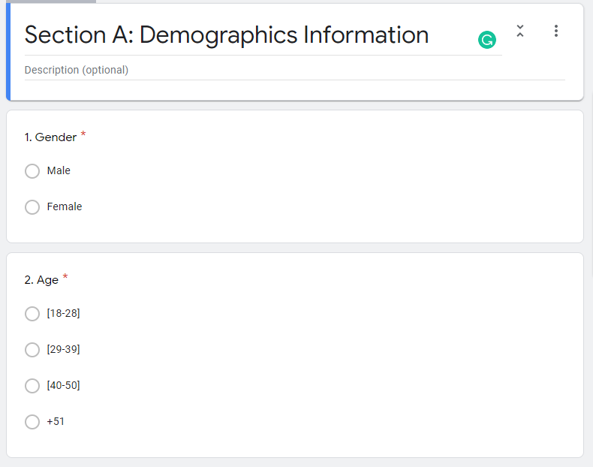
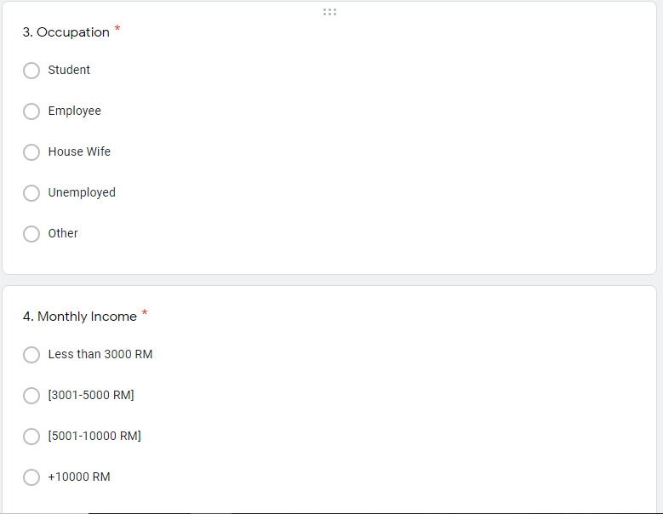
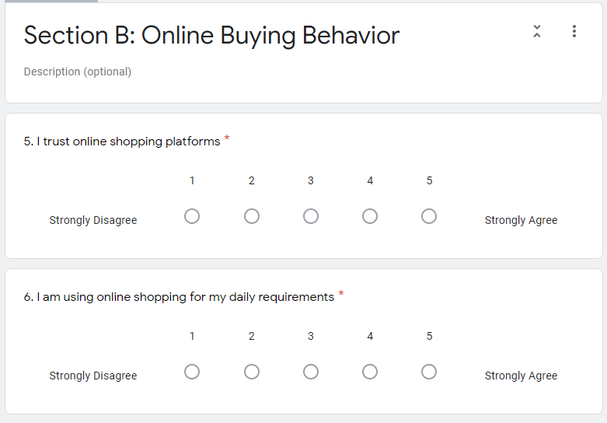
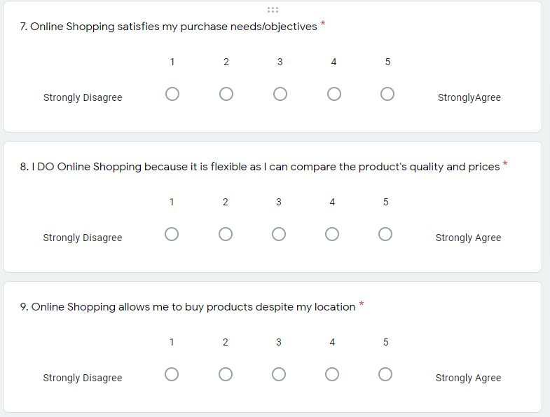
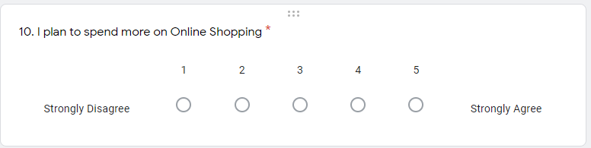
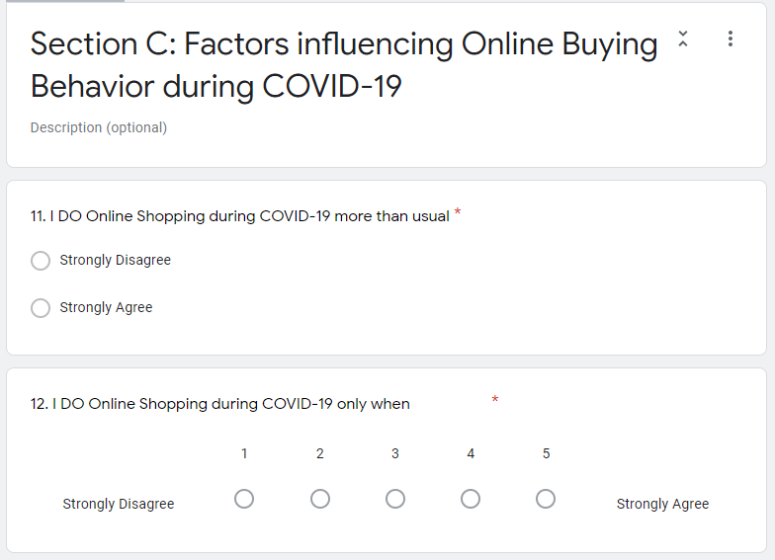
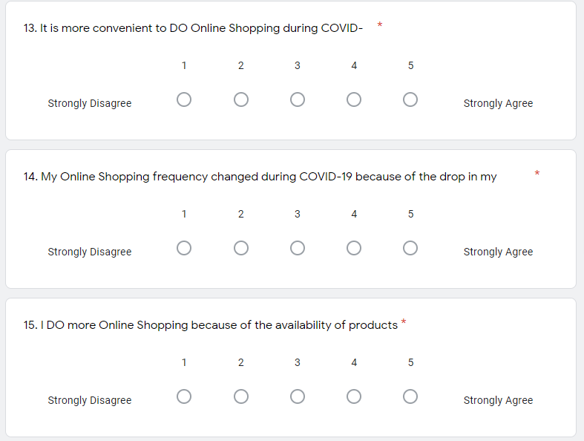
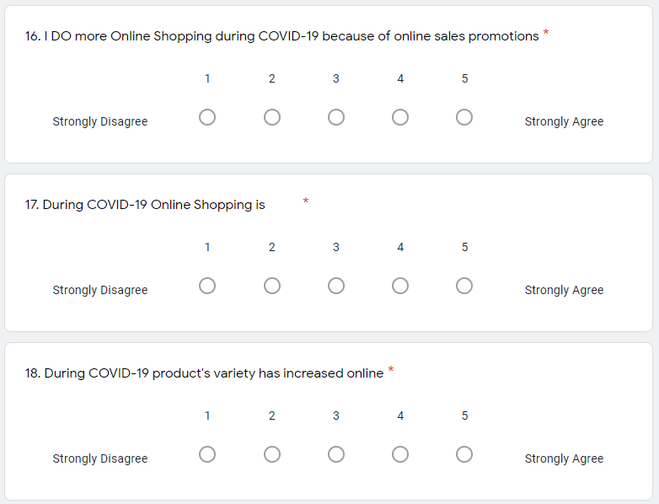
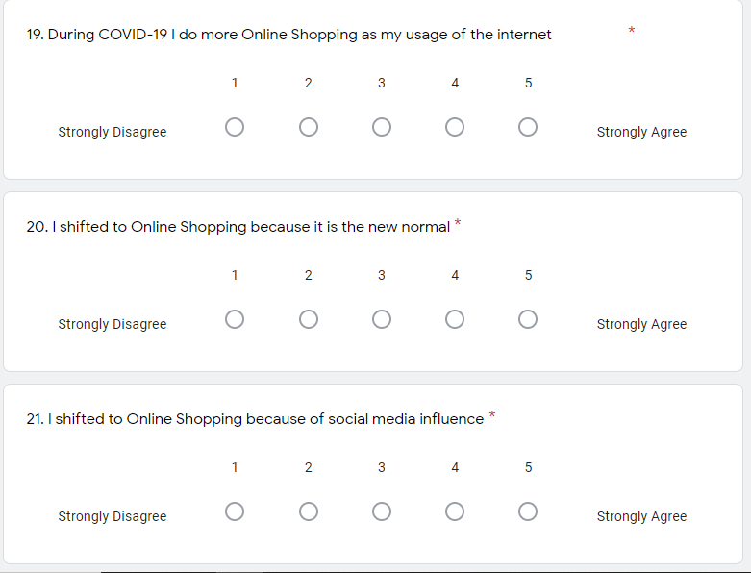
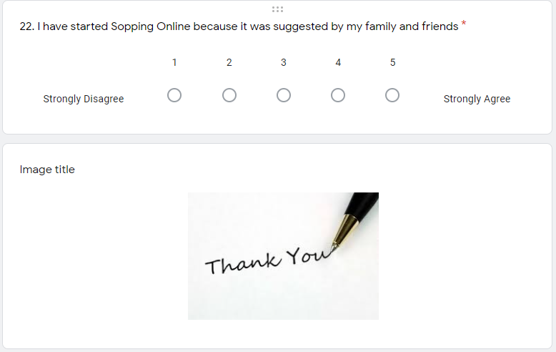

Plagiarism report

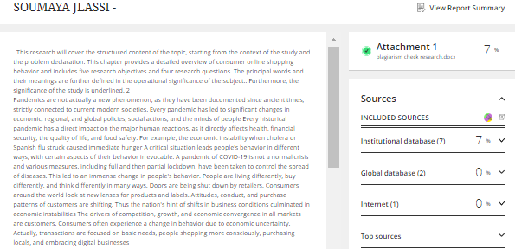

PD Slides
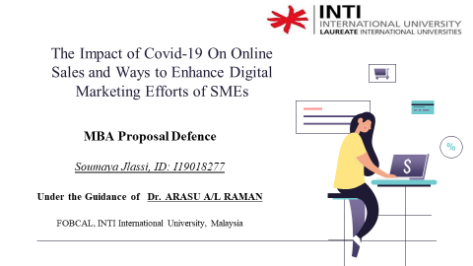
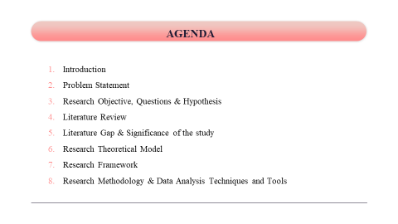
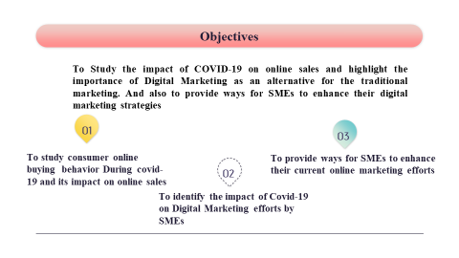
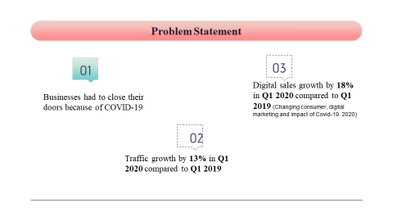
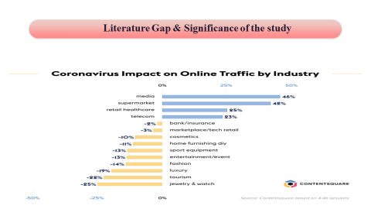
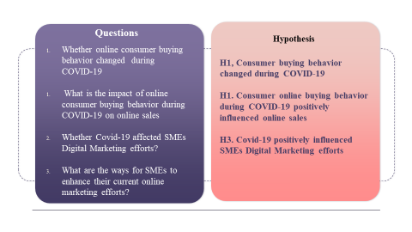
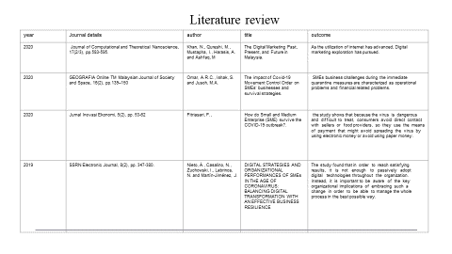
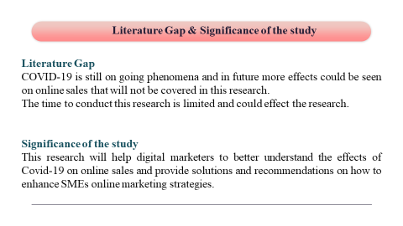
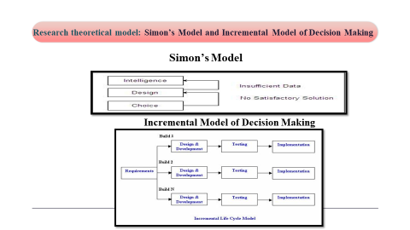
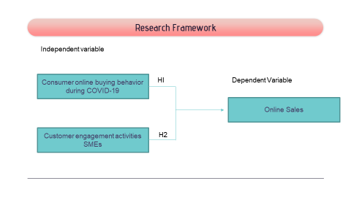
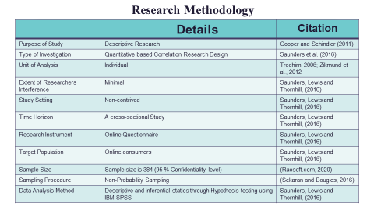
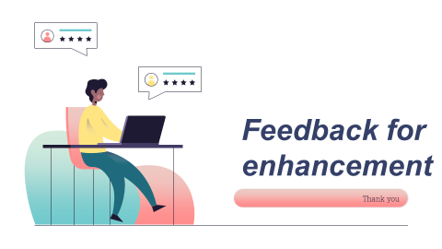

VIVA Slides
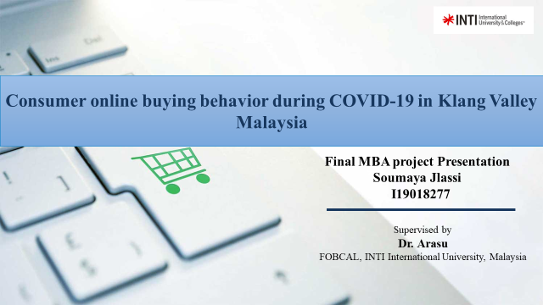
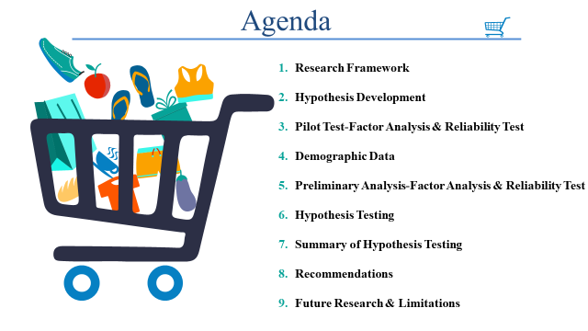
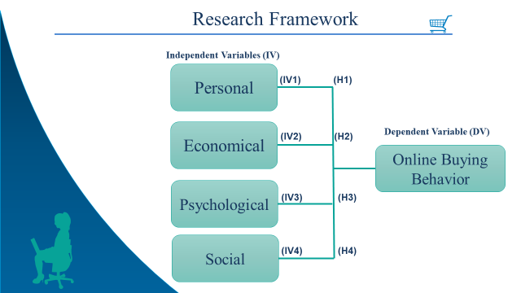
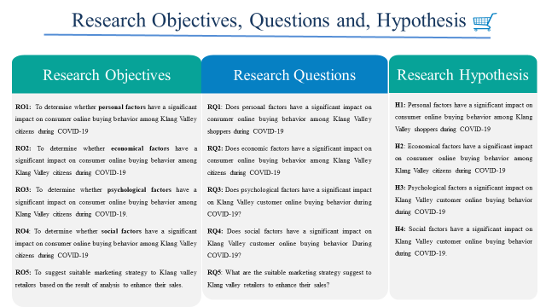
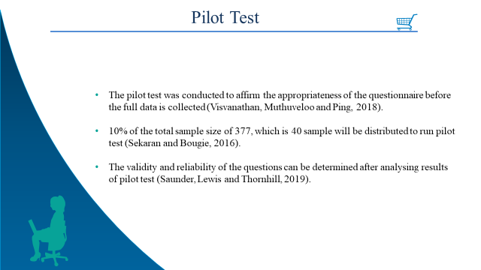
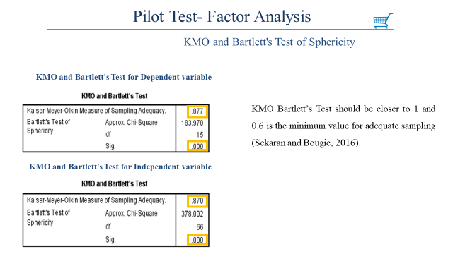
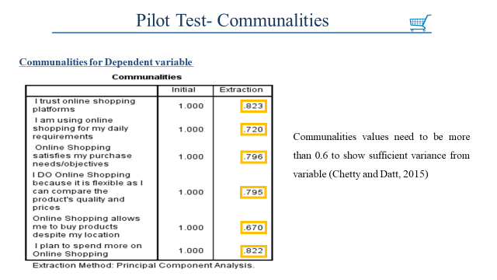
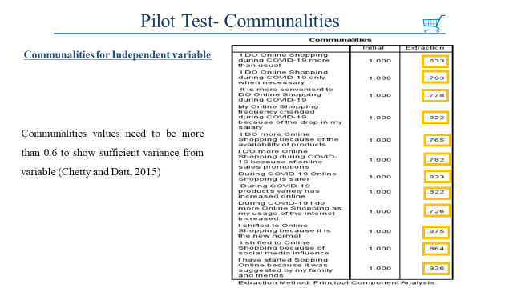
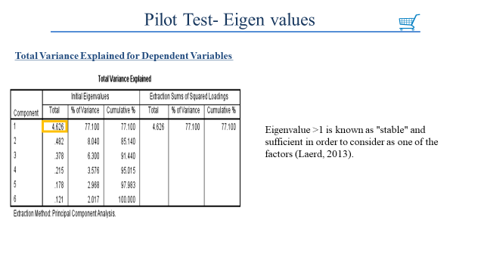
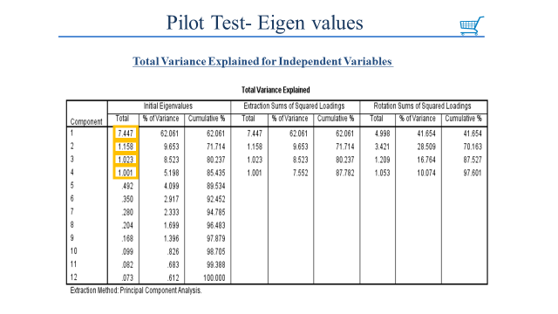
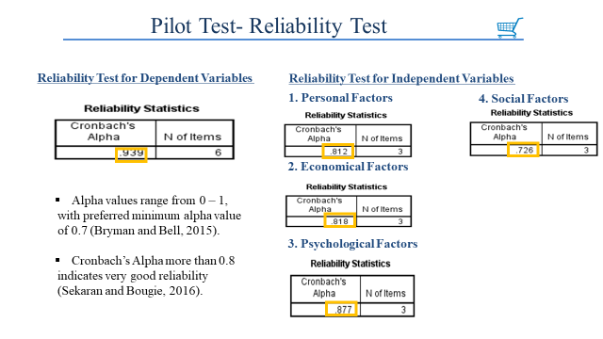
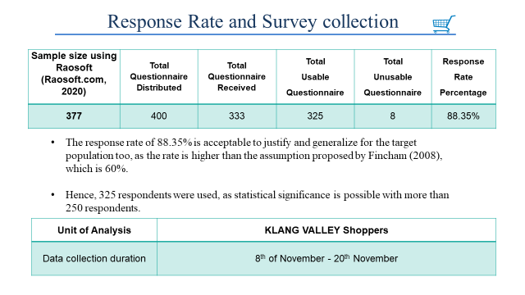
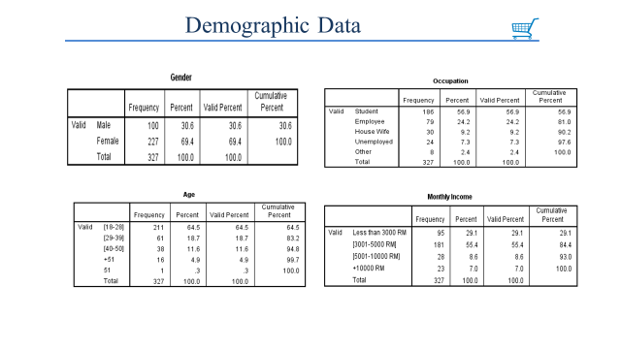
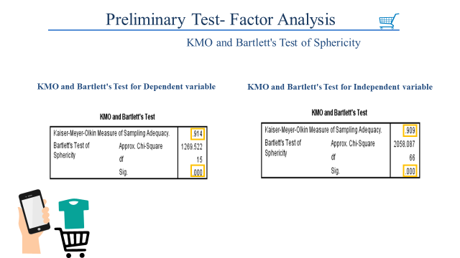
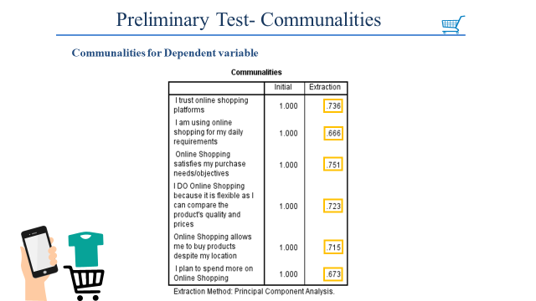
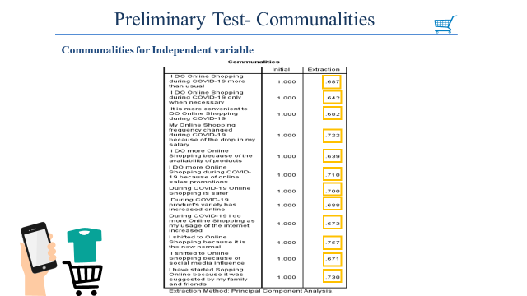
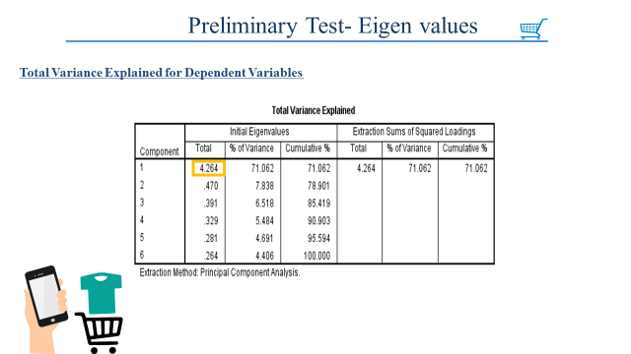
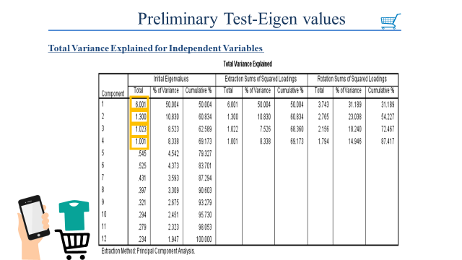
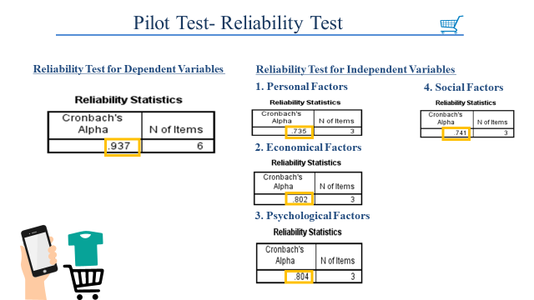
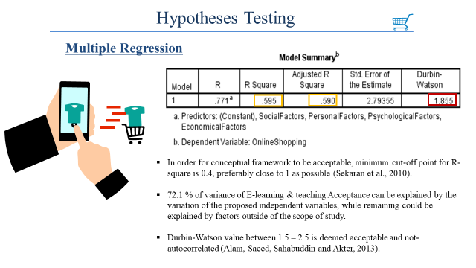
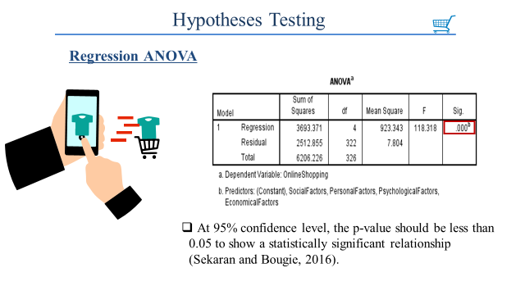
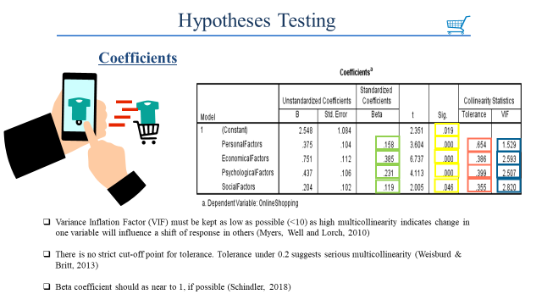
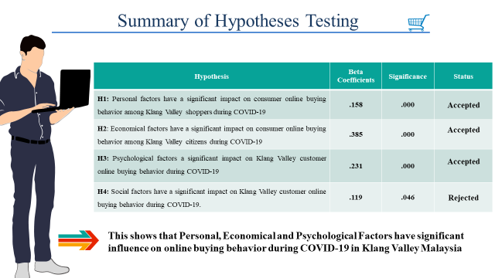
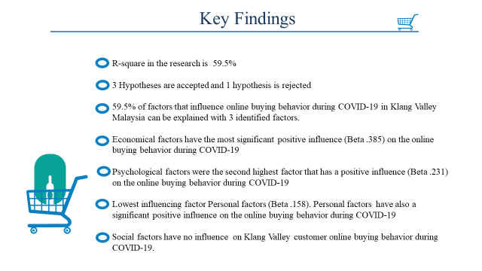
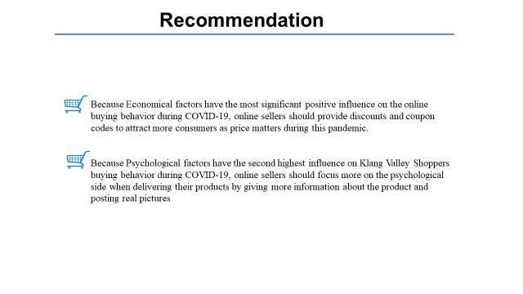


Appendix E

MBA Project Log

Meeting 2

Date of Meeting | 21/9/2020
Progress Made | Started contacting supervisor Via Email and WhatsApp  Dr. Arasu suggest to enhance Conceptual Framework and to improve on chapter 1 as there was slight modification in the title
Agreed Action | Adjusting Problem Statement, Research Objectives and Research Questions
Student Signature | 
Supervisor’s Signature

Meeting 3

Date of Meeting | 26/9/2020
Progress Made | Send the modified work to my supervisor  Feedback for improving and completing Ch. 1-3
Agreed Action | Continue working on Ch1-3
Student Signature

Supervisor’s Signature

Meeting 4

Date of Meeting | 30/9/2020
Progress Made | Continue working on Ch1-3  Discussed the Questionnaire items
Agreed Action | Complete Ch 1-3 by next meeting  come up with draft questionnaire
Student Signature

Supervisor’s Signature

Meeting 5

Date of Meeting | 15/10/2020
Progress Made | Chapter 1-3 Completed  Discussed PD slides  Showed Questionnaire draft
Agreed Action | Adjusting and Editing Questionnaire  Making PD slides
Student Signature

Supervisor’s Signature

Meeting 6

Date of Meeting | 25/10/2020
Progress Made | Showed the questionnaire  And PD slides content
Agreed Action | Questionnaire items finalized  Adjusting content of slides
Student Signature

Supervisor’s Signature

Meeting 7

Date of Meeting | 30/10/2020
Progress Made | PD slides finalized  Emailed the Second panel took appointment for proposal defence
Agreed Action | Submit the final PD slide to both supervisors
Student Signature

Supervisor’s Signature

Meeting 8

Date of Meeting | 3/11/2020
Progress Made | Discussed on the feedbacks from the Second panel with my supervisor
Agreed Action | Make suggested adjustments and present them to second panel again  Make changes in online questionnaire
Student Signature

Supervisor’s Signature

Meeting 9

Date of Meeting | 5/11/2020
Progress Made | Presented Ch. 1-3 to Second panel  Overall passed
Agreed Action | Proceed further with data collection for pilot test
Student Signature

Supervisor’s Signature

Meeting 10

Date of Meeting | 15/9/2020
Progress Made | Received Email from Dr. Arasu regarding Discussion of Research proposal.
Agreed Action | Submitted my Research Proposal to my supervisor
Student Signature

Supervisor’s Signature

Meeting 11

Date of Meeting | 8/11/2020
Progress Made | Pilot tests data collection done  Results analysed and showed to my supervisor  Pilot test accepted
Agreed Action | Proceed further for full data collection
Student Signature

Supervisor’s Signature

Meeting 12

Date of Meeting | 20/11/2020
Progress Made | Full data collection done  Discussed with supervisor how to proceed further for analysis
Agreed Action | Rum pilot test preliminary analysis  Discuss for feedbacks on interpretation
Student Signature

Supervisor’s Signature

Meeting 13

Date of Meeting | 26/11/2020
Progress Made | Data analysis done and showed to mu supervisor
Agreed Action | Proceed further for data interpretation and outlining key findings and recommendations
Student Signature

Supervisor’s Signature

Meeting 14

Date of Meeting | 1/12/2020
Progress Made | Ch 4 and 5 draft prepared
Agreed Action | Asked to improve on key findings and recommendations  Prepare VIVA slides  Take appointment from second panel for viva
Student Signature

Supervisor’s Signature

Meeting 15

Date of Meeting | 3/11/2020
Progress Made | VIVA slide finalized
Agreed Action | Submit VIVA to second panel for VIVA on 4th dec 2020
Student Signature

Supervisor’s Signature

Meeting 16

Date of Meeting | 5/12/2020
Progress Made | Feedbacks from second panel discussed  My supervisor suggested for enhancement in format and supported literatures
Agreed Action | Come up with write up full Ch. 4 and 5
Student Signature

Supervisor’s Signature

Meeting 17

Date of Meeting | 15/12/2020
Progress Made | Chapter 1-5 complete  Some minor format changes
Agreed Action | Check plagiarism should be below 10%  Come up with complete project
Student Signature

Supervisor’s Signature

Meeting 18

Date of Meeting | 15/12/2020
Progress Made | Showed the final report  Enhancement for structuring the report
Agreed Action | Finalize the project for submission
Student Signature

Supervisor’s Signature

