WUYAXUN MASTER OF BUSINESS ADMINISTRATION 2020 | 78/100  IMPACT OF TECHNOLOGY INNOVATION CAPABILITY ON BUSINESS PERFORMANCE  —AN EMPIRICAL STUDY BASED ON CHINA NEW ENERGY INDUSTRY  WU YAXUN  MASTER OF BUSINESS ADMINISTRATION  FACULTY OF BUSINESS, COMMUNICATION & LAW  INTI INTERNATIONAL UNIVERSITY  2020

INTI INTERNATIONAL UNIVERSITY

MASTER OF BUSINESS ADMINISTRATION

IMPACT OF TECHNOLOGY INNOVATION CAPABILITY
ON BUSINESS PERFORMANCE –AN EMPIRICAL STUDY ON CHINA ENERGY INDUSTRY

Author : Wu Yaxun
Student No : I20018402
Supervisor : Ms. Umi Kalsom Kassim
Submission Date : 9th December , 2020
Final Word Count : 13,874

FACULTY OF BUSINESS, COMMUNICATION & LAW

DECLARATION

“I hereby declare that this thesis is my own work and effort and that it has not been submitted anywhere for any award. Where other sources of information have been used, they have been duly acknowledged”

Name : Wu Yaxun
Student ID Number : I20018402

Signature :
Submission Date : 9th December , 2020

ACKNOWLEDGEMENT

First of all, I would like to wholeheartedly thank my respected supervisor and express my gratitude towards Ms. Umi Kalsom Kassim for her guidance and support since the beginning of this research till the very end. She has patiently dedicated her time and effort for directing me to the right path and writing this thesis. Special thanks and gratitude to Dr. Arasu Raman for his useful comments towards the betterment of this project. He has provided me with insights and guidance for accomplishing this research.

Moreover, I would like to take this opportunity to thanks the management, lecturers and staffs of Faculty of Business, Communication and Law of INTI International University for their support and assistance during this period.

Last but not least, I am grateful to my family and friends that have inspired me to continuously grow and learn.

ABSTRACT

For enterprises, technology innovation is an inexhaustible driving force for their long-term development. In order to maintain competitive advantage and ensure business performance, enterprises always take technological innovation as the starting point and actively cultivate their technological innovation ability.

Based on the theory of technology innovation capability, this thesis divides the technology innovation capability of new energy enterprises into three dimensions: technology innovation input capability, technology innovation transformation capability and technology innovation output capability. Then through the questionnaire survey data collection, with the assist of SPSS software on regression analysis of the data, get the impact of technology innovation ability on enterprise performance, and discuss the results.

Moreover, according to the empirical research on new energy enterprises, the conclusion of this thesis is that enterprises’ technology innovation ability has a significant positive impact on their business performance, among which the technology innovation investment ability of enterprises has the most significant impact. Furthermore, some recommendation for the future study is provided in this research.

Keywords: Technology innovation capability; Business performance; New energy enterprise; China

TABLE OF CONTENTS
CHAPTER I: Introduction 1
1.0 Overview 1
1.1 Background Study 1
1.2 Problem statement 2
1.3 Research Objectives 3
1.4 Research Questions 4
1.5 Significance of the Study 4
1.5.1 Significance to Academy 4
1.5.2 Significance of Industry 5
1.6 Scope of the Research 5
1.7 Limitation of the Research 6
1.8 Chapter layout 6
CHAPTER 2: Literature Review 8
2.0 Overview 8
2.1 Theoretical Basis 8
2.1.1 Technical Innovation Theory 8
2.1.2 Definition of New Energy 9
2.1.2.1 New Energy 9
2.1.2.2 New Energy industry in China 10
2.1.3 Enterprise dynamic capability theory 11
2.1.4 Dynamic innovation capability theory 12
2.2 Enterprise technological innovation capability 13
2.3 Business performance 17
2.4 Influence of technological innovation ability on enterprise performance 19
2.4.1 The improvement of the enterprise's technological innovation ability can enhance the enterprise performance 19
2.4.2 The continuous enhancement of technological innovation ability cannot continuously improve enterprise performance 22
2.5 Research hypothesis 22
2.5.1 The Influence of technological innovation investment capability on enterprise management performance 22
2.5.2 The Influence of technological innovation transformation capability on business performance 24
2.5.3 The Influence of technological innovation output capability on enterprises’ business performance 24
2.6 Conceptual framework model 25
2.7 Conclusion 26
CHAPTER 3: Research Design and Methodology 27
3.0 Overview 27
3.1 Research Design 27
3.2 Sample selection 27
3.3 Questionnaire design and data collection 29
3.4 Variable measurement 30
3.4.1 Independent variable 30
3.4.2 Dependent variable 31
3.5 Measurement 31
3.5.1 Pilot test 32
3.5.2 Preliminary tests 32
3.5.2.1 Factor Analysis 32
3.5.2.2 Reliability test 33
3.5.3 Regression Analysis 34
3.6 Conclusion 35
CHAPTER 4: Research Findings 36
4.0 Overview 36
4.1 Pilot Test for small sample 36
4.1.1 Reliability Test 36
4.1.2 Factor Analysis 37
4.2 Descriptive analysis 40
4.3 Reliability Test 42
4.3.1 Overall results 42
4.3.2 Sub item results 43
4.4 Factor Analysis 44
4.5 Hypotheses Testing 47
4.5.1 Hypothesis 1 47
4.5.2 Hypothesis 2 49
4.5.3 Hypothesis 3 50
4.6 Hierarchical regression 52
4.7 Conclusion 55
CHAPTER 5: Conclusion and suggestion 56
5.0 Overview 56
5.1 Discussion of Findings 56
5.1.1 The impact of technological innovation input capability on enterprise performance improvement 56
5.1.2 The impact of technological innovation transformation capability on the improvement of business performance 57
5.1.3 The impact of technological innovation output capability on the improvement of business performance 58
5.2 Contribution 58
5.3 Recommendations 59
5.3.1 Strengthening the training of scientific research personnel 59
5.3.2 Increase capital investment 60
5.3.3 Strengthening the advanced nature of equipment 61
5.4 Implication on Future Research 62
5.5 Personal Reflection 62
5.6 Conclusion 63
Reference 64
APPENDIX A. SURVEY QUESTIONNAIRE 69
Appendix B. Item-Total Statistics(SMALL SAMPLES) 72
Appendix C. Demographic Information of the Respondents 73
Appendix D. Proposal Defense Presentation 74
Appendix E. VIVA Presentation 79
Appendix F. MBA Project Log 88
Appendix G. TURNITIN Similarity Index 94

List of Figures

Figure 1: The number of Chinese enterprises in the "Global Top 500 New Energy Enterprises" 11
Figure 2: Revenue of Chinese enterprises in the "Global Top 500 New Energy Enterprises" 11
Figure 3: Conceptual framework model 25
Figure 4: Sample size caculation by Raosoft 28
Figure 5: Position level 41
Figure 6: Working years 41

List of Tables

Table 1: Definitions of IVs 17
Table 2: Influencing factors included in the questionnaire 29
Tabel 3: Case Processing Summary(SMALL SAMPLES) 36
Table 4: Reliability Statistics(SMALL SAMPLES) 37
Table 5: KMO and Bartlett’s Test for SMALL SAMPLES (IVS) 37
Table 6: Communalities SMALL SAMPLES (IVS) 38
Table 7: Total Variance Explained SMALL SAMPLES (IVS) 38
Table 8: KMO and Bartlett’s Test SMALL SAMPLES (DV) 39
Table 9: Communalities SMALL SAMPLES (DV) 40
Table 10: Total Variance Explained SMALL SAMPLES (DV) 40
Table 11: Case Processing Summary 42
Table 12: Reliability Statistics 42
Table 13 :Item Statistics 43
Table 14: KMO and Bartlett’s Test (technological innovation investment capability) 44
Table 15: Total Variance Explained (technological innovation investment capability) 44
Table 16: KMO and Bartlett’s Test (technological innovation transformation capability) 44
Table 17: Total Variance Explained (technological innovation transformation capability) 45
Table 18: KMO and Bartlett’s Test (technological innovation output capability) 45
Table 19: Total Variance Explained (technological innovation transformation capability) 46
Table 20: KMO and Bartlett’s Test (business performance) 46
Table 21: Total Variance Explained (business performance) 46
Table 22: Model Summary b(hypothesis 1) 47
Table 23 :ANOVAª(hypothesis 1) 48
Table 24: Coefficientsª(hypothesis 1) 48
Table 25: Model Summary ^{b}(hypothesis 2) 49
Table 26 :ANOVAª(hypothesis 2) 49
Table 27: Coefficientsª(hypothesis 2) 50
Table 28: Model Summary ^{b} (hypothesis 3) 50
Table 29 :ANOVAª (hypothesis 3) 51
Table 30: Coefficientsª (hypothesis 3) 51
Table 31: Model Summary ^{b} 52
Table 32 :ANOVAª 53
Table 33: Coefficientsª 54
Table 34：Research Hypothesis Analysis Summary 55
List of Abbreviations

Research and Development (R&D)
Independent variable (IV)
Dependent variable (DV)
Coronavirus disease 2019 (COVID-19)
Standard Operating Procedures (SOP)
Growth Enterprise Market (GEM)
Return on Assets (ROA)
Price/Earnings Ratio (P/E)
Statistics Package for Social Sciences (SPSS)
Exploratory factor analysis (EFA)
Confirmatory factor analysis (CFA)
Kaiser-Meyer-Olkin test (KMO test)
Cronbach's Alpha (Cronbach's α)

CHAPTER I: Introduction

1.0 Overview
A general overview will be given in this chapter. First of all, it emphasizes the importance of technological innovation by analyzing the research background, and then illustrate the uncertain impact of technological innovation on enterprise performance based on China's actual national conditions in the question statement part, and clearly takes the new energy industry as the research target through the industry background explanation. Next, the research objectives and problems of this research are elaborated. In addition, the significance, scope and limitations of the research are given. Finally, the organization structure of the article is elaborated in detail.

1.1 Background Study
In the 21st century, social development and scientific and technological progress are imminent. Every social progress is produced with the development and update of technology, and it is also a process to recombine the production factors, which is called innovation. Enterprises are the central part of the market and the main body of innovation. A new round of information technology reform represented by Big Data, Artificial Intelligence, Cloud Computing and 5G mobile Internet is accelerating the technological innovation ability of enterprises.

For national construction, the role of technological innovation is very important. Innovation output capability can be transformed into productivity, improve the ability of sustainable economic development, promote the leap from quantitative change to qualitative change, and become the primary driving factor to promote sound and rapid economic development (Lianto, Dachyar and Soemardi, 2018). In recent years, innovation activities, especially technological innovation, play an increasingly crucial role in improving enterprise performance. Many enterprises not only regard technological innovation as a means of competition but also start to upgrade it to the strategic level. Technological innovation strategy has become an essential competitive strategy, including the innovation of manufacturing companies, which has recently become the primary task of enterprises and industrial policymakers (Latan,2019). The governments of various countries also give enterprises the most excellent support for technological innovation from tax, law, financing, and other services.

For enterprises, technological innovation supports the long-term development of enterprises and ensures enterprise performance. Enterprises always take technological innovation as the starting point to improve enterprise performance. Recent research evidence shows that there is a specific link between innovation and financial performance (Lilly and Juma,2014). Vicente., et al. (2015) reckon that innovation capability is the ability of a company to develop new products by combining innovation behaviour, strategic capability, and internal technological process. The technological innovation capability of an enterprise has always been the key driver for the implementation of various technological innovation models. Maintaining good technology innovation ability is the fundamental guarantee for the sustainable and effective operation of corporations.

1.2 Problem statement
According to the Classification of Strategic Emerging Industries released by the National Bureau of Statistics of China on October 12, 2018, the new energy industry was included as one of the new additions (Zhang, 2019). In addition, tax, subsidy and other related incentives also directly guide and assist the new energy industry to further connect with the market. Under the time background of green development in China, that is aimed at efficiency, harmonious and sustainable economic growth and social development, continue to optimize the energy structure is the urgent need of the development of China's economic and social transformation, standing in the perspective of globalization, in order to obtain a bigger share of the market in the future, China's new energy industry need to accumulate more energy and strength, as a result, each individual in industry is also put forward higher requirements, since the more excellent performance of new energy enterprises could support China's new energy industry to achieve lasting prosperity.

Innovation drive is one of China's major development strategy. Recent years, according to the statistics of the R&D investment, China invested in the research and development of new energy industry showed a rising trend year by year. However, the new energy as a technology-intensive enterprises, rely on the policy subsidies to reduce the cost of entering the market is not a long-term strategy, on the contrary, from the perspective of the enterprise itself, the ability of continuous technological transformation and upgrading is the long-term strategy to improve enterprise development, enhance enterprise strength and develop new competitive advantages which also contribute for company to improve their business performance. Therefore, strengthening technological innovation can improve enterprise performance, but the process of corporations’ R&D will consume a lot of time and bring uncertainty to the return. These unpredictable risks will also bring unknown impact on enterprise performance. Consequently, this report will make an in-depth analysis on whether the technological innovation ability will have a positive effect on their business performance. In addition, according to the importance of technological innovation to new energy enterprises, this industry will be the target industry of this study.

1.3 Research Objectives
The goal of this report is to study the influence mechanism of technology innovation capability on business performance. There are two main objectives of this study which are to sort out the relevant definitions of enterprise's technological innovation capability and determine the dimensions. The summary for the research objectives are as below:
-Determine the dimension of enterprise technological innovation capability;
-Determine the impact of several dimensions of technological innovation on enterprise performance.

1.4 Research Questions
In order to achieve the research objectives of this thesis, the research problems that need to be solved are as follows:
-What are the dimensions of technological innovation capability;
-How do several dimensions of technological innovation capability affect the new energy enterprises’ performance;
-Which kind of technological innovation ability has the greatest impact on the performance of new energy enterprises.

1.5 Significance of the Study

1.5.1 Significance to Academy
This study enriches the theoretical system of technology innovation capability and enterprise performance. On the basis of theoretical analysis, this report defines its concept and divides its dimensions, which enriches the relevant theories of technological innovation capability. The research on the impact of technology innovation capability on enterprise performance includes qualitative and quantitative aspects, which enriches the theoretical research on enterprise performance. The research framework of the impact of technology innovation dynamic capability on enterprise performance is established. Based on the existing research theories of technological innovation capability and enterprise performance, this report puts forward the hypothesis, establishes the conceptual model of the impact of technological innovation capability on performance, and carries out empirical research. Finally, it gives the improvement countermeasures which make the whole research system more systematic and comprehensive.

1.5.2 Significance of Industry
The conclusion of this report not only helps to enhance the innovation awareness of new energy enterprises, make them realize the importance of actively carrying out innovation activities, but also provides essential guidance for the analysis and improvement of the technology innovation ability of enterprises. Generally, corporations’’ business performance is affected by many factors, and technological innovation ability is an essential factor which has a great degree of discrimination on enterprise performance. Therefore, the study on the influence of dynamic capability of technological innovation on enterprise performance is conducive to the analysis of the mechanism of different influencing factors, and provides further support and reference for the study of enterprise performance, so as to formulate corresponding strategies for enterprises to improve their competitiveness. Meanwhile, it also has special guiding significance for new energy enterprises.

1.6 Scope of the Research
The survey object of this study is mainly for new energy enterprises. The samples are from senior managers of enterprises, including general manager, deputy general manager, secretary of the board of directors, manager of the strategic development department, etc. The reason for this requirement is that the senior managers generally have a longer working time in the company, the management level is more macro, and they have a more comprehensive grasp of the company's situation; secondly, the senior managers will deeply consider the strategic issues such as the enterprise's ability and technological innovation, and they are the strategy makers, while the middle-level managers and employees below are more participants and implementers of the strategy.

1.7 Limitation of the Research
The actual survey process needs to focus on the managers of new energy enterprises, so the sample size is relatively small, which may affect the promotion of the research results. From the perspective of variables, this study considers different dimensions separately, however, in the actual business process, several dimensions may have cross effects.

1.8 Chapter layout
Chapter 1-Introduction
This part mainly introduces the basic content of this report, from the angle of macroscopic to microcosmic analysis to the research background and problem statement, and the significance is expounded from academic and industry perspective, so as to find out the objectives and problems of this research. Finally, the limitations of this study are analyzed dialectically. In general, Chapter 1 plays a guiding role in this study.

Chapter 2-Literature review
It systematically expounds the relevant theories, reviews the domestic and foreign research status of the dynamic capability of technological innovation and enterprise performance, defines the concept in the process of theoretical analysis, discusses the dimension division of variables, and puts forward research hypotheses and conceptual framework model.

Chapter3-Research design
This chapter will introduce the research methods and data collection process of this study in detail. Specifically, the relevant data of this study will be processed by SPSS 22.0. Firstly, the number of samples will be calculated and the questionnaire will be designed. Secondly, this chapter analyzes the reasons why small samples will be tested by pilot method, and explains the importance of previous studies, factor analysis and reliability test. Thirdly, this chapter defines regression analysis and conducts statistical tests on the impact of technology innovation investment ability, technology innovation transformation ability and technology innovation output ability on enterprise performance.

Chapter4-Research findings
This chapter mainly analyzes the data of the questionnaire based on the research method in the previous chapter, so as to achieve the research objectives of this thesis, verify the research hypothesis, and find out the independent variable with the most significant relationship with the dependent variable.

Chapter5-Conclusion
In this chapter, the influence degree of each variable on the dependent variable is systematically summarized. In combination with the questionnaire questions, it is pointed out the improvement that enterprises needed in three different dimensions of technological innovation ability, and puts forward targeted suggestions and countermeasures. In addition, this chapter summarizes the contribution of the report, and also analyzes the limitation, as well as the prospects for future study.

CHAPTER 2: Literature Review

2.0 Overview
This chapter reviews the basic theory and main theory involved in this report, including the theory of technological innovation, the definition of new energy, and analyzes the background of China's new energy industry. Secondly, the previous research on dynamic capacity theory and dynamic innovation capacity theory of enterprises is sorted out, and on the basis of relevant theories, three dimensions of independent variables are defined, and dependent variables are defined in combination with relevant literature. Finally, the research hypothesis and conceptual framework model of this report are proposed in this chapter.

2.1 Theoretical Basis

2.1.1 Technical Innovation Theory
Since Joseph Alois Schumpeter gave a systematical description of the theory of innovation, later scholars have been discussing and studying technological innovation for more than half a century. Schumpeter put forward the concept of innovation in the Theory of Economic Development in 1912, and then systematically elaborated it in the Business Cycle, describing innovation as the process of recombining factors of production or introducing new combinations into the production system so as to obtain potential profits (Schumpeter and Backhaus, 2003). Innovation theory emphasizes to find the most fundamental reason of its progress and growth from the level of economic development, and clearly regards economic development as the process of innovation. From the perspective of industry, in the process of continuous innovation, innovative and dynamic enterprises can flourish, while unchangeable enterprises will eventually be eliminated. In this way, social resources can be better combined, the combination of factors is constantly optimized, so as to facilitate the sustainable development of the economy (Li, 2013).

On the basis of Schumpeter's Technical Innovation Theory, the research results of subsequent scholars have been developed and four schools of theory was formed. The neoclassical school emphasizes the fundamental role of technological innovation in economic growth, and establishes the Solow Growth Model to measure its contribution rate. In addition, they also point out the important role of government intervention by means of regulation. The neo-Schumpeterian school focuses on the study of the influence of organizational internal element structure on technological innovation from the perspective of corporations and adheres to the tradition of Schumpeterian innovation theory. Institutional innovation school focuses on the analysis of the external environment of technological innovation. They believe that a good external environment can be created through a good system, so as to improve the efficiency of innovation. The national innovation system school believes that the realization of innovation is driven by the national innovation system, emphasizes the influence of each country's proprietary factors on technological innovation, and realizes the innovation performance with wider scope and better effect through the arrangement of national system (Zhang, 2019).

2.1.2 Definition of New Energy

2.1.2.1 New Energy
New energy is also known as unconventional energy. Nowadays, the definition of new energy held in the United Nations conference in 1980 is widely used. It is based on new technologies and new materials, which lead the traditional renewable energy can be modernized and utilized, so as to achieve the inexhaustible and repeated renewable goal. In general, the emergence, development, application and broader prospects of new energy are based on new technologies and pay more attention to the comprehensive utilization efficiency of energy. Therefore, in a broad sense, new energy represents a kind of energy supply system created for sustainable development. In different times and at different technological levels, new energy has different contents. At present, new energy mainly includes solar energy, biomass energy, wind energy, nuclear energy, hydrogen energy, geothermal energy and chemical energy.

2.1.2.2 New Energy industry in China
The prosperity of the new energy industry is inseparable from the development of enterprises in the industry. The development of new energy enterprises is the backbone of the healthy development of the whole industry and also an important driving force for the country to realize the reform of energy structure. The emergence and growth of new energy enterprises with increasing scale and strength is one of the important factors that help China's new energy industry to become more active on the world stage (Wang, Hang et al., 2016).

The global Top 500 list of new energy enterprises has good credibility and authority. It mainly conducts a comprehensive assessment of global new energy enterprises based on their operating income in the previous year, and is regarded as a bellwether for the development of global new energy industry. Figure 1 and Figure 2 respectively show the changes in the number and operating income of China's new energy enterprises in this list since 2011, which shows a gradually growth tendency.
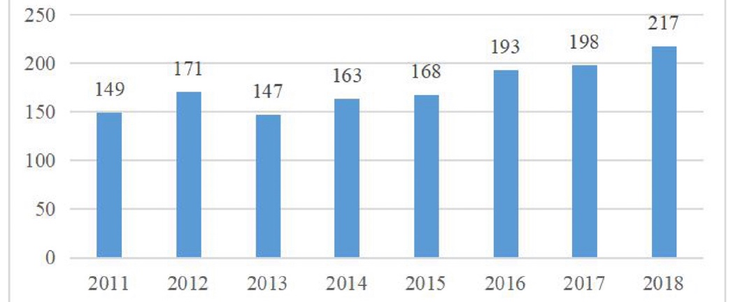
Figure 1: The number of Chinese enterprises in the "Global Top 500 New Energy Enterprises"
Source；(Zhang, 2019)
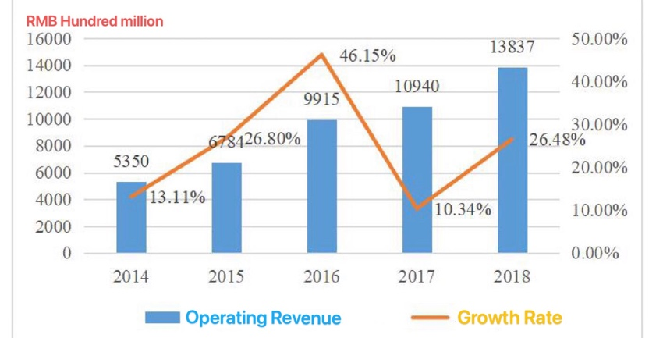
Figure 2: Revenue of Chinese enterprises in the "Global Top 500 New Energy Enterprises"
Source；(Zhang, 2019)
Through the above definition of new energy and the explanations of the background of China's new energy industry, it preliminarily proves the importance of technological innovation ability to new energy enterprises, which is the prerequisite for the following research on the impact of technology innovation ability on enterprises’ performance.

2.1.3 Enterprise dynamic capability theory
Dynamic capacity theory originated in the 1990s and was formed according to the characteristics of the changing market environment at that time (D'Aveni and Gunther, 1994). To be specific, the increasingly dynamic market environment includes the globalization of economy and market, the diversification of customer demand and the acceleration of technology innovation, which lead to the increasingly fierce competition among enterprises, and the maintenance of competitive advantage becomes a challenge. Therefore, only continuous innovation can bring sustained success.

Teece et al. (1997) believe that in a market with rapidly changing competition pattern, the ability of enterprise managers to research, integrate and construct various resources to cope with the rapidly changing environment is the source of corporate sustainable competitive advantage of enterprises, especially the control of knowledge resources is particularly important in this situation. The theoretical framework of dynamic capability proposed by Teece divides dynamic capability into recognition capability, acquisition capability and transformation capability. According to Eisenhardt and Martin (2000), the dynamic capability is a process in which companies integrate, acquire or give up resources, and reallocate them to match or even cause market changes. Zollo and Winter (2002) prefer to think that dynamic capability is a stable operation mode or convention of an enterprise, which can improve the efficiency of an enterprise through learning and absorption, and the expansion and new construction of ordinary operation and management practices.

2.1.4 Dynamic innovation capability theory
Based on the theory of the dynamic capability of enterprises, some scholars put forward the concepts of dynamic capability of technological innovation and dynamic capability of technological innovation, which is the further expansion and deepening of theoretical research on the dynamic capability of enterprises. Cheng et al.(2013)proposed the theory of dynamic innovation capability in the related research on breakthrough innovation activities and described it with two theoretical foundations. One is absorptive capability, that is, the ability of an enterprise to recognize the value of new information, then absorb it and utilize this new information to commercial purposes. The second is organizational inertia or organizational inertia. Organizational inertia is the stability of a company's innovation and development, and it is this stability that makes companies often insufficient to adapt to changes in the environment. Scholar Xu et al.(2012) proposed that if modern enterprises want to survive and develop continuously, they must have the help of technological innovation. Technology innovation capability is a comprehensive indicator of corporations’ technological innovation. The previous series of researches on the theory of technological innovation ability belongs to static analysis, and the technological innovation ability in today's highly complex and rapidly changing competitive environment should also have the characteristics of sustainability. We must study technological innovation capabilities from a dynamic perspective, so we should study technological innovation from the perspective of dynamic enterprise capabilities.

2.2 Enterprise technological innovation capability
As the source of enterprise and national competitiveness, innovation has always been the focus of scholars. As the aforementioned technology innovation related concept, some scholars think that innovation is the result of the technology updates. Schumpeter (1934) ,known as the father of the innovation, argue that innovation comes into being with the change of technology, and it constantly reintegrates the social factors of production and production condition, readjusting and points out the difference between invention and innovation connotation. In his opinion, invention and creation are only new ideas generated by enterprises, while technological innovation means that enterprises apply existing innovative achievements to the production link and produce new products. Another part of scholars believe that innovation is the process from the emergence of new technologies to the realization of enterprises' various behaviors. Thompson (1965) believes that innovation is a continuous process from the generation of new ideas to the realization and application of new methods, new processes and new technologies.

Grubler and Wilson (2014) also argue that innovation is a process of realizing new ideas that will be generated. Grossan and Apaydin (2010) a combination of these two views, put forward the connotation of innovation includes both process and results, which means after the entrepreneur finish the market survey analysis it seize the latent profit opportunities in order to obtain the commercial profit, and by improving the production process, to establish a short time-consuming, low cost, high output quality and efficient production systems, hence, companies can launch in the market of high quality new products, open up new markets. All in all, innovation is a combination of technological, organizational, business, and marketing activities. Grafström and Lindman (2017) found that innovation involves not only the emergence of new technologies, but also the improvement of older technologies. This is the same view as Bers et al. (2009) that all innovations are presupposed by previous achievements. Fu (1998) believes that the occurrence of technological innovation is due to the fact that with the progress of productivity, the enterprise needs to construct a new function to reintegrate the production factors and production conditions of the enterprise, which will contribute to bring potential benefits to the enterprise. According to the definition of technological innovation of enterprises, the connotation of technological innovation ability of enterprises can be extended in the definition of innovation. According to the enterprise theory of knowledge-based view and the definition of enterprise innovation ability by domestic and foreign researchers, Wu (2003) believes that enterprise innovation ability is the ability to run various knowledg-related activities such as technological innovation ability, production ability and sales ability. The enterprise technology innovation ability is a core component of the enterprise ability. It has the same dynamic characteristics as enterprise capability. Technology is conducive to the development of enterprises, production is to transform technology into physical objects, and sales is to make products recognized and achieve profits. Wei and Xu (1995) believed that technological innovation ability is based on the realization of the strategic goal of enterprise innovation, and the coordination of product innovation ability and process innovation ability of enterprises is not the overall function of the system thus determined. The ability of technological innovation includes three aspects: The first one is to be able to allocate the necessary resources for innovation; the second is to be able to integrate existing resources and carry out product or production process innovation; finally, enterprises can make profits through innovation activities.

The above than the definition of the technical innovation ability connotation mainly think that the ability of technology innovation ability is not a single aspect, but the combination of a series of ability, the main purpose is to achieve to generate new ideas from the market analysis to the production of new products, or by improving the process to produce new products and eventually realize the ability of business enterprise in the process of a series of collections. What is more, The generation of new ideas requires entrepreneurs to have forward-looking thinking and sharp insight, which means the process R&D requires reasonable allocation of the resources needed by enterprise technology innovation. Production capacity requires the enterprise to apply the innovation results to the production and manufacturing process of and carry out product innovation or improve the production process of the product. Sales ability requires the companies to be able to promote new innovations to market, and obtain the recognition of consumers. Organizational ability requires the ability to solve problems in the whole process of technological innovation to ensure that each step can proceed smoothly. Therefore, in this research, technology innovation ability is defined as the related ability of enterprises in a series of activities such as production, manufacturing, product marketing, operation and management in order to realize the innovation target, constantly search for new innovation opportunities, recombine internal resources of enterprises, carry out innovation activities, and so on.

Theoretically grasping the connotation of the dynamic capability of technology innovation and analyzing its constituent dimensions can promote the development of the theory of technological innovation ability. Liang and Yang (2016) divided the technological innovation capability into two dimensions: technological input and technological output by constructing a system of evaluation indicators for technological innovation capability. Xu et al.(2012) used the theoretical framework of dynamic capabilities to classify technological innovation capabilities into three dimensions: technological innovation input capability, output capability, and transformation capability.

Technological innovation investment capability refers to the level of all resources that an enterprise dynamically invests in technological innovation in the process of carrying out technological innovation activities. These resources include human, financial, and material aspects. These resources are necessary resources for enterprises to carry out technological innovation activities, and they are also essential factors that affect the ability to invest in technological innovation. Xu et al.(2012) believes that technological innovation investment includes enterprise R&D investment and technical personnel.

Technical innovation transformation capability refers that enterprises exchange energy with the external environment to realize the mutual transformation of tangible resources and intangible resources. If the input of technology innovation is the beginning of the whole innovation process, then the transformation ability of technological innovation is the catalyst between the input ability and output ability, which is the necessary condition of the innovation process. Specifically, the transformation ability of technological innovation can effectively utilize various resources and transform them into assets for enterprises to create value, so as to realize the purpose of technological innovation.

Technology innovation output capability is the direct result of the technological innovation process, such as patent, intellectual property and so on. But it should be emphasized that the technological innovation output itself is also a part of the innovation process, not the final result. Only effective transformation can make technological innovation truly create value. Therefore, it includes technological output, asset output, etc., specifically, new product output and patent output. Xu et al.(2012) believes that the number of patents and invention applications can reflect the capability of technological innovation output.

In this research, the key terms with regards to the IVs have been recorded in the below table:
Table 1: Definitions of IVs
Key Terms | Definitions
Technological innovation investment capability | The level of all resources that an enterprise dynamically invests in technological innovation in the process of carrying out technological innovation activities.
Technical innovation transformation ability | Enterprises exchange energy with external environment to realize the mutual transformation of tangible resources and intangible resources
Technological innovation output capability | It includes technology output, asset output and so on. Specifically, there are new product output and patent output

2.3 Business performance
Ruekert et al. (1985) proposed that performance includes three meanings: effect, efficiency, and adaptability. Murphy et al. (1996) divided business performance into two dimensions: growth performance and profitability performance. Based on previous scholars' research, this article believes that corporate performance mainly refers to the operating results in a certain period. At present, the leading indicators for measuring corporate performance are as follows:

I. Financial indicators, such as the primary business growth rate, return on total assets, etc. Dixit and Bipin (2019) used the return on total assets to measure the operating performance of the acquirer after the acquisition. Hsu et al., (2018) Use the universal financial performance index-return on assets (ROA) as a measurement of operational performance. The data of this type of indicator is easy to obtain, and the meaning is relatively intuitive, which can reflect the impact of the complex business activities of the enterprise; II. Market indicators, such as Tobin Q value, the price per stock market, the price-to-earnings ratio (P/E), etc. These indicators are not easily manipulated and can reflect the long-term performance of a company. Liu et al.(2020) come up self-control model based on historical performance that is used to measure performance change by combining adjustment percentage change and adjustment level change; III. The total factor productivity index calculated according to the Cobb-Douglas production function; IV. Comprehensive performance indicators based on factor analysis. Lee and Lin (2019) evaluate the performance of accounting firms from the four capital dimensions of human, process, innovation, and customer; V. Measured by the respondent’s self-reported financial performance. Turel et al. (2019) measure performance through self-reporting by the board of directors.

Most scholars will start with the characteristics of corporate profitability and development ability when measuring corporate performance, and use indicators such as ROA and primary business growth rate to measure corporate performance, and the stock price fluctuations measure market performance (Popovič, Hackney et al., 2016). Since financial indicators and market indicators have their advantages and disadvantages and can represent the long-term and short-term performance of an enterprise, this thesis uses both financial performance and market performance to measure business performance.

2.4 Influence of technological innovation ability on enterprise performance
Chinese and foreign scholars have conducted a large number of studies on the relationship between technological innovation ability and enterprise performance, and have drawn different conclusions, which can be roughly divided into the following two aspects.

2.4.1 The improvement of the enterprise's technological innovation ability can enhance the enterprise performance
In previous literature, scholars have made a clear explanation of technological innovation ability. They believe that technological innovation ability plays a crucial role in predicting the sustainable development of an organization. Generally, high-performing enterprises have more innovative ability than low-performing enterprises. Yamin, et al. (1997) believed that previous studies showed that technological innovation ability had a significant impact on enterprise performance and was one of the key factors affecting enterprise development. Hardy and Dougherty (1996) found through analysis that higher technology innovation ability can improve technology coverage rate, save production time and improve enterprise performance. In the opinion of scholar Li, Wang and Shi(2018), high technological innovation ability reduces the uncertainty of enterprises' R&D activities and expands the scope of enterprises' investment. Guan and Ma(2003) defined technological innovation ability as seven dimensions which namely, learning ability, research and development ability, manufacturing ability, market ability, resource development ability, organization ability and decision-making ability respectively. Technological innovation capability refers to the acquisition of knowledge and technology required for product design, manufacturing and assembly, and its application to the product manufacturing process. Improving technological innovation is conducive to increasing the competitiveness of enterprises. Therefore, improving technology innovation is conducive to increasing the competitiveness of enterprises. Previous research on technology innovation ability mainly focused on technology introduction, technology strategy, mechanism and transfer performance (Li and Atuahene-Gima, 2001), while an enterprise's competitive advantage may come from the efficiency and capability generated by new product development (Guan and Ma,2003). Thornhill (2006) used the survey data of 845 manufacturing companies in Canada and took the development of new products as a measure of innovation. The research showed that enterprises with innovative activities could achieve higher level of revenue growth. Ehie and Olibe (2010) compared and analyzed the impact of R&D investment on enterprise performance of manufacturing and service industries in The U.S., and the results showed that R&D investment in both industries could improve performance. Hai and Nie (2012) believed that technological innovation activities could improve the production process, develop new processes, enhance absorption capacity, thus reducing production costs and achieving the purpose of improving enterprise performance. Lai and Chang (2010), Murphy and Schlegelmilch (2013) believe that technological innovation ability can significantly improve business performance. Because the enhancement of enterprise's technology innovation ability can bring unique competitiveness to the enterprise and enhance the total stock market value of the enterprise. Based on the empirical analysis of high-tech enterprises in Zhejiang Province, Yan and Chi (2013) found that the investment in technological innovation of enterprises can guide the production and development of technological prototypes, which is conducive to the entry of new products into the market, and has a direct positive correlation with technological innovation performance. In addition, Du and Fang (2014) believed that technological innovation ability had a mediating effect on enterprise performance. Zhu, et al., (2014) believed that enterprises' constant pursuit of product improvement would attract new customers and maintain existing customers, which was conducive to improving customer loyalty, thus continuously expanding market share and improving financial performance. Ince, Imamoglu and Turkcan (2016) divided enterprises into "passive" and "active" types according to their willingness to innovate, and the active enterprise refers to the enterprise that is willing and able to continuously invest capital in developing new products and technologies and adopting new industries. The passive enterprise refers to the weak innovation willingness of enterprises, only willing to carry out minor updating of products, and the range of product function upgrading is small. Li, Sun and Zhao (2017) divided innovation into R&D innovation and non-R&D innovation, through studying the influence of different Innovation modes on enterprise performance of high-tech enterprises, they found that both innovation modes can improve enterprise performance. Chen et al. (2017) summarized the three research branches of existing scholars on technological innovation-element view, process view, and performance view, and came up with the definition of different technological innovation concepts. The essence is a process in which entrepreneurs gather existing resources, knowledge, and technology, and then transform these into market value and social value through market production. Zhao and Gao (2019) believe that the improvement of technological innovation ability can reduce production cost and increase product added-value, thus enhancing industrial value.

According to the classification of innovation by the above scholars, this study knows that technological innovation originates from R&D, and it includes product production technology innovation, raw material development and upgrading, and to the comprehensive process of expanding to the entire market and gaining recognition.

2.4.2 The continuous enhancement of technological innovation ability cannot continuously improve enterprise performance
In previous studies, some scholars also found that there was no significant relationship between technology innovation ability and enterprise performance improvement. R&D investment activities have been considered as the focus of enterprise innovation by many scholars. However, only providing a large amount of investment in R&D activities cannot maintain enterprise performance and competitiveness. Berchicci (2013) took the internal and external R&D activities of the innovative strategic atmosphere to represent the technical knowledge stock of enterprises and the expansion of enterprise organizational boundaries respectively. With the increase of the proportion of external innovation activities in innovation combination, the effect of increasing opportunity cost on enterprise performance presents an inverted "U" shape. Jiang and Yao (2015) use patent application to measure the innovation ability of enterprises, but they draw the conclusion that there is a negative correlation between enterprise innovation and its performance sensitivity.

2.5 Research hypothesis
In this study, the inference technology innovation ability will have a significant impact on enterprise performance. The following research hypotheses are sequentially deduced.

2.5.1 The Influence of technological innovation investment capability on enterprise management performance
The prerequisite for enterprises to carry out technological innovation is the investment of resources. If the investment of resources is not in place, it may affect the significant development of technological innovation of the enterprise, and the enterprise will also not be able to achieve better business performance and a lack of competitive advantage. Therefore, enterprises should pay attention to R&D investment in technology innovation, and the necessary condition for technology innovation is R&D investment (Wu and Xing, 2015). Taking GEM companies as an example, Liu (2016) analyzed the impact of technological innovation investment in electronic and biomedical sectors on company performance and concluded that although there are industry differences, the overall value of enterprises is still improved. Ince, Imamoglu and Turkcan (2016) believe that technological innovation capabilities enable companies to quickly respond to changes and obtain technological innovation strategies and innovation output. Absorptive capability enables companies to obtain the necessary information, enabling them to use external knowledge, seize market opportunities, take the lead and develop new capabilities. Technological innovation capability and absorptive capability are the key factors of innovation capability and competitiveness. Latan et al. (2020) used manufacturing companies listed on the Indonesian stock exchange as the original sample to study the innovation level represented by the corporate innovation policy and innovation strategy to increase corporate performance.

However, through the analysis of the computer industry, Ron and Jim (2014) found that the capital invested by the computer industry in conducting R&D activities is often challenging to recover, and R&D investment cannot produce an incentive effect on corporate performance. Therefore, this thesis proposes the following hypothesis:

H1: Technological innovation investment capability has a conspicuous impact on the enterprises’ business performance

2.5.2 The Influence of technological innovation transformation capability on business performance
Sabahi and Parast (2019) believe that under the existing organizational inertia, with the improvement of dynamic enterprise capabilities, enterprises can identify and obtain more innovative knowledge, technology, and development opportunities from the internal and external environment of the organization. Furthermore, through the internal system of the enterprise to digest and use. Ince, Imamoglu and Turkcan (2016) believe that technological innovation capabilities enable companies to quickly respond to changes and obtain technological innovation strategies and innovation outputs. Absorptive capability enables companies to obtain the necessary information, enabling them to use external knowledge, seize market opportunities, take the lead and develop new capabilities. The ability to transform technological innovation is a critical factor in innovation ability and competitiveness. Therefore, this thesis proposes the following hypothesis:

H2: Technological innovation transformation ability has a significant impact on the enterprises’ business performance;

2.5.3 The Influence of technological innovation output capability on enterprises’ business performance
The new technology brought about by innovation activities can help companies improve production processes, improve product quality, and develop new products, which is conducive to improving corporate financial and market benefits. Companies need to develop products, services, and technologies that competitors cannot easily imitate, and transform these products, services, and technologies into their core competitiveness. As an essential source of core competitiveness, knowledge, technology, and other intangible assets owned by enterprises have a significant impact on the improvement of business performance. Many scholars’ studies have also verified that technological innovation has a significant positive impact on corporate performance. Therefore, companies cannot achieve their business objectives and long-term stable development without the support of technology innovation capabilities. Through empirical research, Xu (2018) also found that patent quality can improve the company's operating performance. Therefore, this thesis proposes the following hypothesis:

H3: Technological innovation output capability has a prominent impact on business performance.

2.6 Conceptual framework model
According to the literature review and research hypothesis, a conceptual framework model is established as shown in Figure 1. Among them, technological innovation investment capability, technological innovation transformation capability, technological innovation output capability are independent variables, and business performance is the dependent variable. This thesis will use the model to study the impact of technological innovation capabilities on business performance.
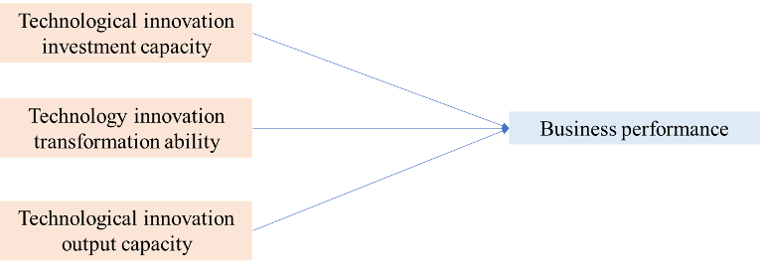
Figure 3: Conceptual framework model

2.7 Conclusion
Based on the above literature review, it can be seen that Chinese and foreign scholars have been relatively mature in their research on the effect of technological innovation on enterprise performance. Different scholars use different methods to study the relationship between these two variables, thus presenting different research results. Therefore, this research will explore the specific relationship between the input ability, transformation ability and output ability of technological innovation and enterprise performance. In the third chapter, specific research methods are presented.

CHAPTER 3: Research Design and Methodology

3.0 Overview
This chapter mainly illustrates the research methods. The quantitative research adopted in this study first describes the research ideas of this report, secondly, puts forward the measurement methods of independent and dependent variables, and then collects the questionnaire through a questionnaire survey. Finally, the data analysis method of this thesis is described.

3.1 Research Design
Generally speaking, there are two ways to obtain enterprise performance: subjective evaluation and objective data. In this report, subjective evaluation will be adopted for all variables. The reason is that most of the sample companies in this study are not listed companies and there is no public access to performance information. Secondly, previous studies have found that there is an absolute correlation between subjective performance evaluation data and objective performance data, and subjective performance evaluation data can also reflect the business performance of enterprises. Therefore, according to the above research results, the subjective evaluation method was adopted to measure all the variables.

3.2 Sample selection
The survey object of this study is mainly aimed at the new energy industry in china, which has active technological innovation activities. The respondents of the questionnaire must be the middle and senior managers of the enterprise, including the General Manager, general Secretary of the Board, manager of the strategic development department, etc. The reason for this requirement lies in the fact that the middle and senior managers generally have a longer working time in the company, have a higher management level, and have a more comprehensive grasp of the company's situation. Secondly, the ordinary employees are the participants and executioners of the strategy, while the middle and senior managers are the strategy makers, and they will think deeply about the strategic issues such as enterprise capability and technological innovation. Consequently, their data will further enhance the reliability of this report on the research topic of the impact of technological innovation ability on business performance.

Because it is impossible to count the specific number of executives of new energy enterprises, the total population cannot be obtained in this study. However, according to the accounting on the website of sample calculator platform Raosoft, 377 samples are suggested in this study. Therefore, 377 executives from Chinese new energy enterprises will be randomly selected to obtain the questionnaire data.
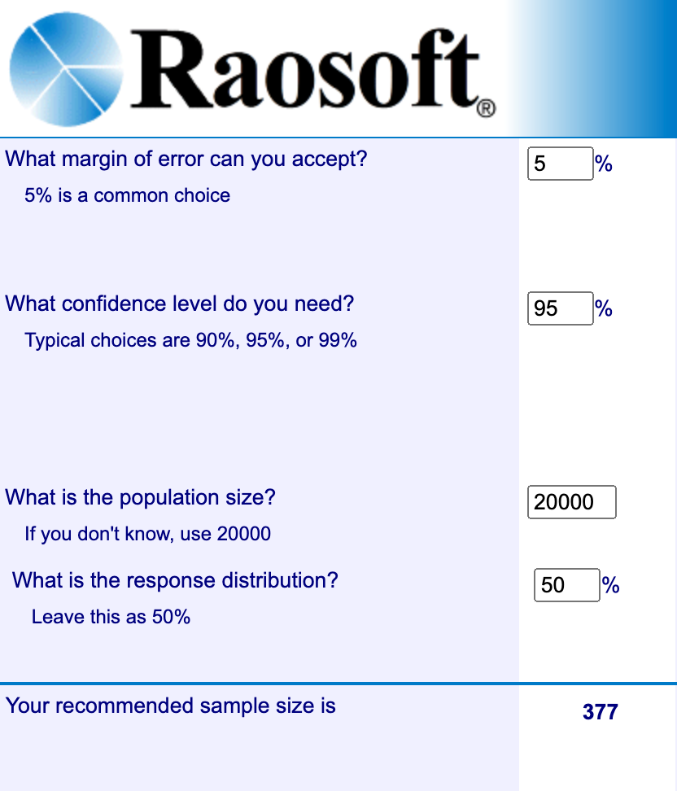
Figure 4: Sample size calculation by Raosoft
Source: (Raosoft.com, 2020)

3.3 Questionnaire design and data collection
Under the influence of COVID-19, all companies and industries need to comply with SOP, which lead the questionnaire cannot be conducted face to face with participants in the form of paper questionnaire. Therefore, this research will be issued in the form of online questionnaire.

The questionnaire for this study is shown in Table 2 which uses the Likert’s seven-level scale method. The seven-level scale is a more detailed than five-level scale. The degree of satisfaction of people is measured with a value of 1-7 (Churchill, 1979). This study uses multiple items in the questionnaire design to verify the research hypotheses to improve the reliability and validity of the measurement.
Table 2: Influencing factors included in the questionnaire
Variables | Label | Items
Technological innovation investment capability (Jiwon 2015) (X1） | X11 | The company has enough scientific research personnel to carry out R&D activities
 | X12 | Scientific research personnel have high scientific research quality to ensure the quality of completed projects
 | X13 | Companies can invest in R&D equipment in time according to technological development and market changes
 | X14 | The company invests sufficient funds to support project research and development activities
 | X15 | Companies can pay more for market research, design, process and material preparation, advertising activities, etc.
Technology innovation transformation ability (Lichtenthaler and Muethel, 2012)（X2) | X21 | The higher conversion rate of independent patents
 | X22 | The company has two or more products with independent intellectual property rights
 | X23 | The new products produced meet the requirements of R&D design
 | X24 | When purchasing technology for technological innovation, it can bear technology introduction fees, transformation fees, and digestion and absorption expenses
 | X25 | Enterprises have close cooperative and innovative relations with research institutes and universities
Technological innovation output capability (Xu et al.,2012) (X3) | X31 | The proportion of new products in the company in the past three years
 | X32 | The proportion of the company’s new product sales revenue in the whole sales revenue in the past three years
 | X33 | Compared with competitive products, the company's innovative products are cost-effective
 | X34 | Market share of new products
 | X35 | The export share of new products
Business performance  (Rajapathirana and Hui, 2018) (Y) | Y1 | Compared with the industry average, the company's return on assets is very high
 | Y2 | Compared with the industry average, the company has a high return on investment
 | Y3 | Compared with the industry average, corporate profit margins are high
 | Y4 | Satisfaction with the company's new product development
 | Y5 | Most of the company’s profits comes from new products or services

3.4 Variable measurement

3.4.1 Independent variable
In Table 2, X1 represents the company's technological innovation investment capability. Paik and Chang (Paik and Hyun, 2015)pointed out in their research that the investment capability of enterprise technology innovation includes investment in human resource, finance and production materials. Therefore, based on their theory, the questionnaire designed 5 related research projects, which are represented by X11, X12, X13, X14 and X15 respectively.

X2 represents the company's technological innovation and transformation capabilities. Referring to the relevant studies of Lichtenthaler and Muethel(2012), this thesis believes that the company's conversion ability is mainly considered from three aspects: patent conversion rate, scientific research level and conversion fund. Therefore, this variable contains five options in the questionnaire survey, represented by X21, X22, X23, X24 and X25 respectively.

X3 represents the company's ability to produce technological innovation. According to Xu et al.(2012) relevant research, this thesis believes that the company's capability is mainly considered from four aspects: innovative products, innovative income, peer competitiveness and market share. Therefore, five options are designed for this variable in the questionnaire, represented by X31, X32, X33, X34 and X35 respectively.

3.4.2 Dependent variable
For the measurement of enterprise performance, on the one hand, it is difficult to collect the real data of the enterprise. On the other hand, the absolute financial data of the enterprise is affected by many related factors, and especially the relative financial performance has a strong correlation (Rajapathirana and Hui, 2018). Moreover, the questionnaire data generally has relatively stable reliability and validity. Through the literature review and the above summary, the measurement indicators of corporate performance are divided into five items for measurement, represented by Y1, Y2, Y3, Y4, Y5 respectively.

3.5 Measurement
First of all, on the basis of understanding the relationship between innovation ability and enterprise performance, this study puts forward theoretical assumptions and models of independent variables and dependent variables. Secondly, in order to guarantee the quality of the inventory data, 32 sample data were elaborated by SPSS 22.0 software to confirm the reliability and validity of the study sample. Next, through descriptive statistical analysis of sample data to determine whether it is suitable for structural equation analysis. Based on the reliability analysis, the structural relationship of the model is verified, which guarantees the scientific nature and rigor of the research. Finally, this report uses multiple regression analysis to verify the relationship between technology innovation ability and enterprise performance.

3.5.1 Pilot test
Pilot testing also called cognitive testing, which is a small-scale preliminary study with the purpose of assessing feasibility, time, cost, adverse events and effect quantity, in this way, the suitability of the sample is predicted before the implementation of the comprehensive research project so that the research design can be improved in time (Hair,et al., 2019). In general, around 10% of the sample size is taken for the preliminary test. In order to further test the degree of consistency with this study, according to the sample size (377) required for this survey, this thesis conducts a preliminary study on the data of 32 managers of new energy enterprises in the sample, and revises the questionnaire through factor analysis and reliability test.

3.5.2 Preliminary tests
Reliability and validity are two commonly used indicators to test the effectiveness of measurement tools in a questionnaire survey. Reliability is reflected by factor analysis, and validity is reflected by reliability analysis

3.5.2.1 Factor Analysis
Factor analysis mainly reflects the correctness of measurement tools, that is, a scale can measure the degree of the corresponding structure correctly. Although the mature scale in this study has been widely used in domestic and foreign literature, in order to ensure the adaptability of the questionnaire and the scale in the Chinese context still have an excellent fitting effect, this study will use factor analysis to test. Factor analysis includes two types, exploratory factor Analysis (EFA) and validating factor analysis (CFA). EFA is a kind of dimension reduction processing technology, which can find out the essential structure of multivariate variables. The main purpose of EFA is to find out the number of factors affecting the observed variables and the correlation between each factor and each observed variable. It is used to detect immature scales. CFA has been assumed that each index variable matches a specific factor before using the scale. The purpose of CFA is to test and observe whether the number of factors and the factor load of variables are consistent with expectations based on established theories (Kyriazos, 2019).

Spss22.0 was used to test whether the data was suitable for factor analysis. According to the KMO size to judge whether the data is suitable for factor analysis. Hair,et al., (2019) gave a commonly used KMO measure: when KMO is less than 0.5, it is not suitable for factor score analysis. When 0.5 < KMO < 0.599, a little bit is suitable for factor analysis. When 0.6 ＜ KMO ＜ 0.699, it is just suitable for factor analysis. When 0.7 < KMO < 0.799, it is suitable for factor analysis. When 0.8 < KMO < 0.9, it is suitable for factor analysis. When 0.9 < KMO, it is very suitable for factor analysis. Therefore, KMO greater than 0.7 and Bartlett's spherical test above 0.05 is significant standards for exploratory research.

Secondly, the maximum variance method was used to rotate the factors of measurement items to extract common factors. According to Hair,et al., (2019), this report takes the feature root greater than 1 as the standard of factor extraction. In the process of factor analysis of measurement items, the factor load value of items is required to be greater than 0.5, and there is no cross load at the same time, and the total explanation degree of factor difference is greater than 60%. The number of items in each factor should be greater than 2 items as far as possible, indicating that the measurement items meet the requirements.

3.5.2.2 Reliability test
Reliability reflects the reliability of measurement tools, that is, the consistency of the results obtained by repeated measurement of the same object with the same scale(Hair,et al., 2019). In practical research, researchers often design a series of questions to indirectly reflect the reality of things. However, whether these subjects can achieve the purpose of the research still needs to be further analyzed by statistical means. For example, in this report, the researcher wanted to judge the consistency between the technology innovation and business performance of enterprises. In this case, we can use Cronbach's α analysis. Cronbach's statistical analysis is mainly used to evaluate the consistency of continuous variables and ordered classification variables, which is applicable to the data in this study.

Therefore, Cronbach's α coefficient was used to measure the reliability of each scale, and SPSS software was used for statistical analysis. According to Hair,et al., (2019), the general criterion of reliability is that the value of α should be at least greater than 0.5, and it is better to be greater than 0.7, which proves that the scale has good reliability; if it is less than 0.5, it should be rejected. In this study, 0.7 will be used as the critical value.

3.5.3 Regression Analysis
To test the impact of exploratory and exploitative technological innovation strategies on innovation performance and business performance, regression analysis is used in this study. SPSS software was used to test the hypothesis. The F value of the model and its significance and the coefficient and significance of the corresponding variables were used to judge whether the hypothesis was tenable. Also, multiple linear regression may have the problem of multicollinearity; that is, multiple predictive variables show a common trend of change. In this study, we use the variance expansion factor (VIF index) to test this problem. The larger the VIF value is, the greater the multicollinearity between variables. Generally speaking, the critical value is 10, and if the VIF value does not exceed 10, there is no severe multicollinearity problem (Hair,et al., 2019).

3.6 Conclusion
In this chapter, the research methods and data collection process are introduced in detail so as to clarify the characteristics of the research. Specifically, the online questionnaire designed for this study contains 24 questions and uses improbability convenience sampling. The analysis unit of this study is the senior executives of Chinese new energy enterprises, with a sample size of 377. In addition, the importance of preliminary study, factor analysis and reliability test are also explained. Factor Analysis, Reliability Test and Regression Analysis were defined in the hypothesis testing. And d statistical test is conducted on the impact of technology Innovation Investment Capability, technology innovation Transformation capability and technology innovation output Capability on business performance. All relevant data will be processed using SPSS 22.0, and Chapter4 will include statistical analysis and research results.

CHAPTER 4: Research Findings

4.0 Overview
This chapter will analyze the data of the questionnaire survey. First, the reliability and validity of the questionnaire were explained through the preliminary test, and the rationality and validity of the scale were proved. Then a formal large-scale questionnaire survey was conducted, and SPSS was used to analyze the data. Finally, the research model of this report is explained according to the data, and the hypothesis of this study is verified by regression method.

4.1 Pilot Test for small sample
In order to ensure the reliability and validity of the questionnaire, this study first collected data from 32 questionnaires and conducted reliability test and factor analysis.

4.1.1 Reliability Test
The so-called reliability analysis is the consistency and stability of the results after multiple measurements. In SPSS, the tool used to measure reliability is alpha coefficient, also known as internal consistency coefficient. It is used to test whether the measurement results of the measurement tools used in the study are reliable, and it is the precondition for a series of analysis to be carried out (Hair,et al., 2019).
Table 3: Case Processing Summary(SMALL SAMPLES)
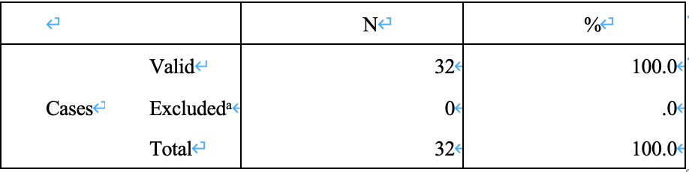
Table 4: Reliability Statistics(SMALL SAMPLES)
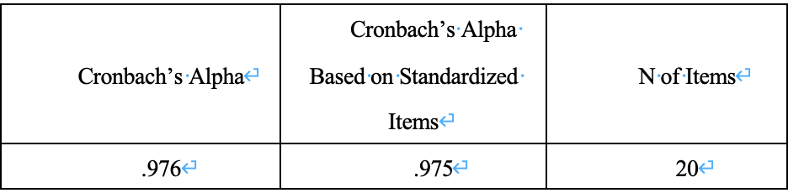
Based on the Table3 and Table 4, which are the result of reliability test, the Cronbach's alpha value based on the standardized item is 0.975(>0.7), which shows good reliability, and more specific values are reflected in Appendix B.

4.1.2 Factor Analysis
According to the principle of factor analysis, the first thing needs to measure is the adequacy of KMO samples and test the Bartlett sphere. Generally speaking, the value of KMO is more significant than 0.8, which means very suitable for EFA; when the value of KMO is between 0.7 and 0.8, it is suitable for EFA; when the value of KMO is 0.7 or below, it is not ideal for EFA. In this study, principal component analysis is used to explore EFA of business performance and technology innovation capability scale, in order to obtain accurate data structure and provide support for later research.

Table 5: KMO and Bartlett’s Test for SMALL SAMPLES (IVS)
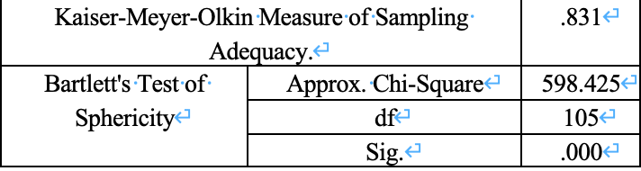
Due to the small number of samples in the testing stage, this study carried out factor analysis on 15 items in three dimensions of the enterprise's technological innovation ability. KMO value in Table 5 is 0.831 which greater than 0.8, and P < 0.05 for Bartlett test. Therefore, it can be preliminarily judged that this study is suitable for factor analysis.
Table 6: Communalities SMALL SAMPLES (IVS)
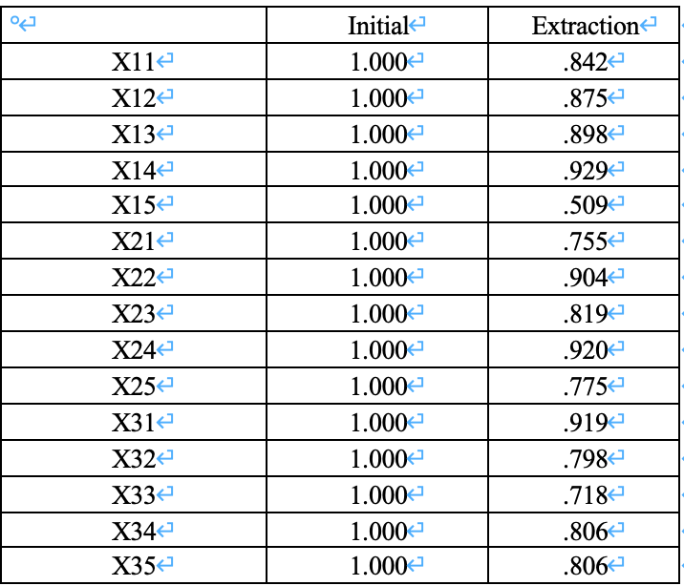
Analyzing the commonality of factor variables is an important prerequisite for extracting common factors. If the data extraction results show that the higher the variables are shared, the lower the degree of data information loss, then factor analysis is more suitable for data analysis. The results in Table 6 show that the initial public degree of 15 indexes is 1.000. The degree of commonality of the four indicators is above 90%, the degree of commonality of the six indicators is above 80%, and the degree of commonality of the four indicators is above 70%. When principal components are used to extract each factor, the initial public degree is set to 1. The closer the degree of factor extraction is to 1, the more the selected common divisor can explain the original data information of the variable. Therefore, the principal component extraction method is more suitable.
Table 7: Total Variance Explained SMALL SAMPLES (IVS)
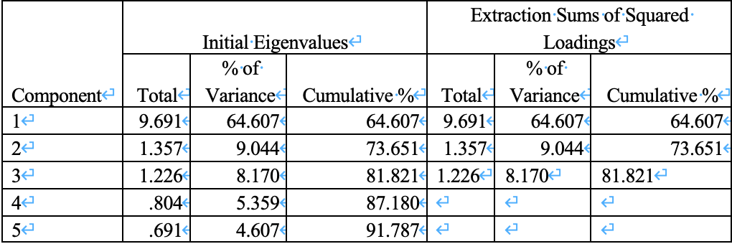
According to Table 7, the component of the first column is the sequence number of the initial value. The sum of the second column represents the eigenvalue, which measures the importance of the factor. The third column is the variance contribution rate, which means the ratio of the variance explained by the factor in the total variance of the original variable. The fourth column is the cumulative number of the third column, which represents the proportion of variance accumulation explained by the first n factors in the total variance. Total variance explained needs to satisfy two conditions: the eigenvalue is greater than 1, and the other is that the cumulative contribution rate is greater than 80%.

The results of total variance explained show that three eigenvalues are extracted, and the cumulative contribution rate is 81.821%. The two conditions are satisfied, which indicates that these three eigenvalues, namely the three common factors, can fully represent the three selected enterprise technological innovation dimensions, and the variable information lost in the extraction process is less. At this time, it can be concluded that these three common factors can basically replace the original scattered enterprise technology innovation index, which shows that the design of enterprise technology innovation questionnaire in this research is relatively ideal and can be used for formal investigation and analysis.

Table 8: KMO and Bartlett’s Test SMALL SAMPLES (DV)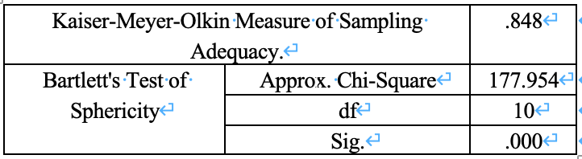
Factor analysis is carried out on the dependent variable enterprise performance scale. Based on Table 8, Bartlett test showed that sig. was 0.000. The KMO value is 0.848, indicating that the degree of information overlap among variables is not exceptionally high so that factor analysis can be tried.

Table 9: Communalities SMALL SAMPLES (DV)
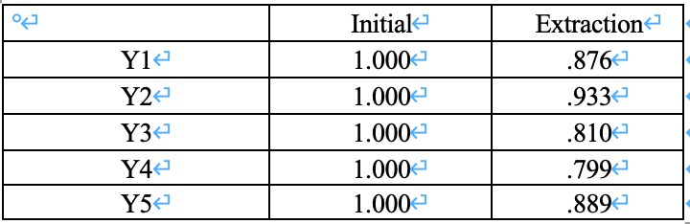
Based on Table 9, the initial common degree of five items is 1.000; the common degree of one item extraction variable is more than 90%, the common degree of three items is more than 80%, and the common degree of one item is more than 70%. Therefore, the method of extracting factors in this study is more suitable.

Table 10: Total Variance Explained SMALL SAMPLES (DV)
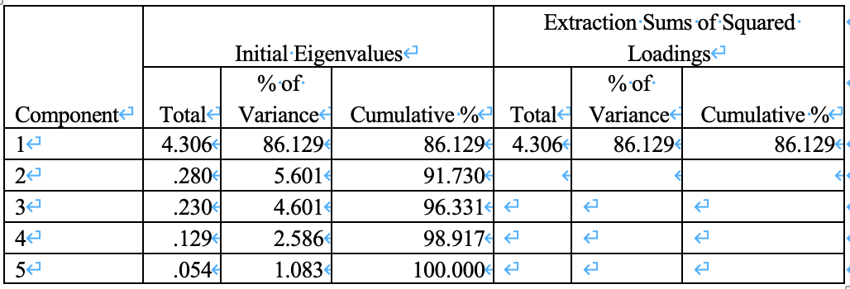
The results of Table 10 show that one eigenvalue is extracted and the cumulative contribution rate is 86.129%. It shows that the eigenvalue, that is, the common factor can fully represent the business performance of the enterprise, and there is less variable information lost in the extraction process.

4.2 Descriptive analysis
According to the previous survey, the reliability and validity of the questionnaire items were verified in this study. In addition, considering the problems of questionnaire collection and screening, this study issued a total of 500 questionnaires and recovered 377 valid questionnaires, which met the requirements of this empirical study.

Figure 5: Position level
Figure 6: Working years

First of all, this study carries out a descriptive analysis of the data of basic information in the first part of the questionnaire. Specifically, among the 377 executives from new energy industry, 79.05% are men and 20.95% are women. In terms of academic qualifications, about 50% of the respondents had bachelor's degrees, followed by nearly 29% with master's degrees. According to Figure5, most of the participants have more than 5 years of work experience, 37% of the executives have 5-10 years of work experience, and about 32% have 10-20 years of work experience. According to Figure 6, 34.48% are senior executives, 49.87% are functional department leaders, and 15.65% are technology R&D personnel, which are relatively average in distribution. More specific values are reflected in Appendix C.

4.3 Reliability Test

4.3.1 Overall results
Table 11: Case Processing Summary
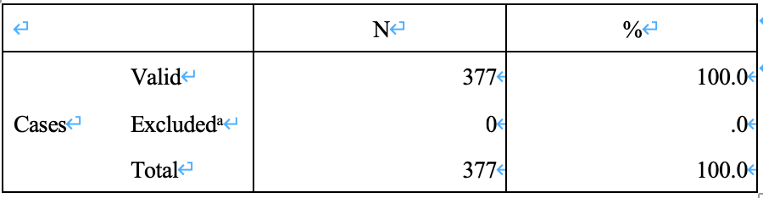
Table 11 is the case processing summary, listwise deletion based on all variables in the procedure. It can be seen from the table that there are 377 valid data in this study, and there is no missing data.

Table 12: Reliability Statistics
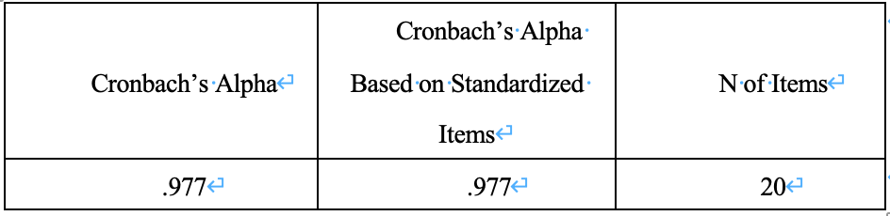
In this study, the Cronbach's α coefficient of 20 items measuring enterprise's technological innovation and business performance is 0.977, which indicates a high level of internal consistency among the 20 items. In general, project consistency is related to the content of the measurement. The larger Cronbach's inclination coefficient is, the stronger internal consistency is indicated. Previous studies have shown that as long as the Cronbach's α coefficient is greater than 0.7, this study believe that the consistency between items is meritorious.

The internal coefficient of standardized Cronbach's ( Cronbach's Alpha is based on standardized items column) refers to the internal coefficient of Cronbach's calculated after all items are standardized and the variance is 1, which also known as Spearman Brown's progressive reliability coefficient (Hair,et al., 2019).

4.3.2 Sub item results
Table 13 :Item Statistics
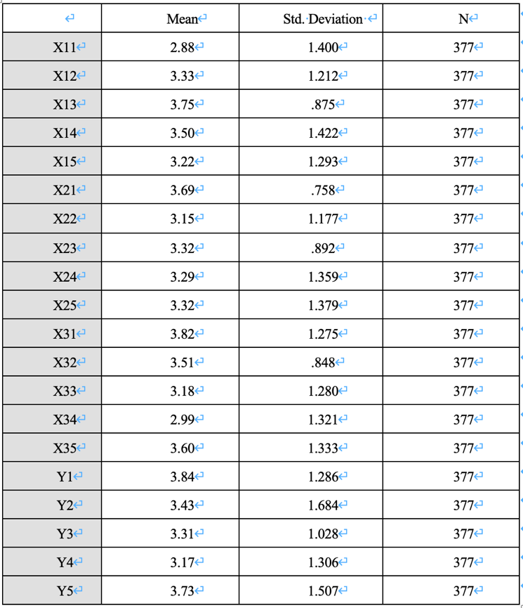
The output results of item statistics are shown in table 13.This study divide each item into Likert 7 levels and assign values to each level. Taking X11 as an example, the average value of this entry is 2.88, the standard deviation is 1.400, and the number of cases is 377. It can be seen that the average answer of X11 is close to "Somewhat disagree" which assigned as 3 in the questionnaire.

4.4 Factor Analysis
Table 14: KMO and Bartlett’s Test (technological innovation investment capability)
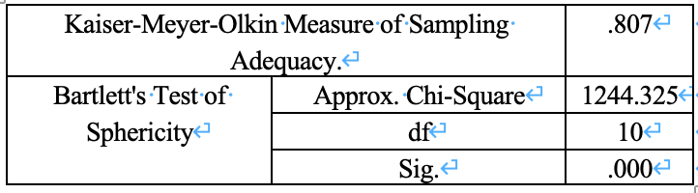
Based on Table14, the KMO value of investment ability of enterprise technology innovation is 0.807, which is greater than 0.5, so it shows that there is correlation between variables, which meets the requirements. Moreover, the result of Bartlett's spherical test shows its Sig. is 0.000, which is less than 0.05. In other words, this data can be used for factor analysis.

Table 15: Total Variance Explained (technological innovation investment capability)
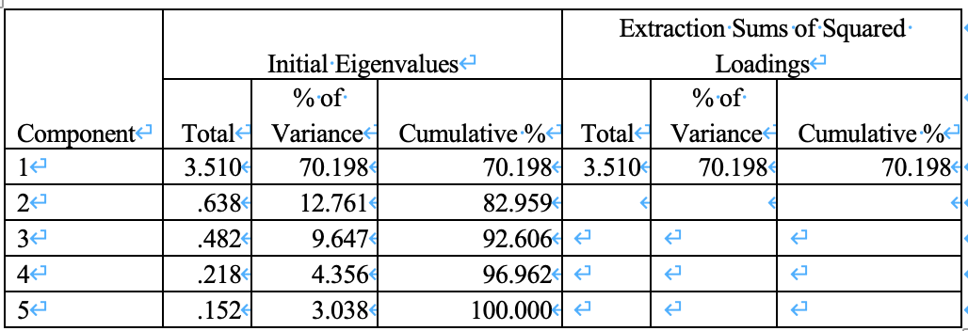
According to Table15, one eigenvalue is extracted, and the cumulative contribution rate is 70.198%. There is less information lost in the extraction process.

Table 16: KMO and Bartlett’s Test (technological innovation transformation capability)
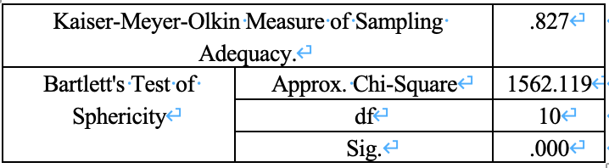
According to Table 16, the KMO value of transformation ability of enterprise technology innovation is 0.827, which meets the requirements of greater than the threshold value of 0.5, which shows there is correlation between variables. What is more, the result of Bartlett's spherical test is 0.000 which less than 0.05. In other words, this data can be used for factor analysis.

Table 17: Total Variance Explained (technological innovation transformation capability)
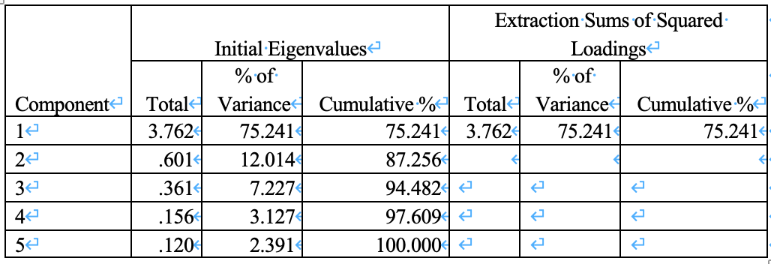
Based on Table 17, one eigenvalue is extracted, and the cumulative contribution rate is 75.241%, which indicates that there is less information lost in the extraction process.

Table 18: KMO and Bartlett’s Test (technological innovation output capability)
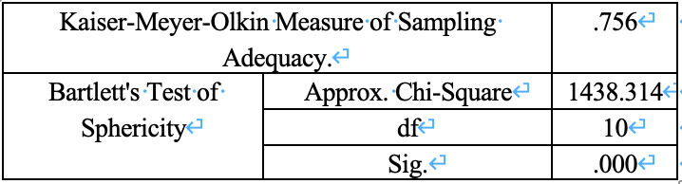
In addition, according to Table18, the KMO value of output ability of technological innovation is 0.756, which is greater than the threshold value of 0.5, so it shows that there is a correlation between variables, which meets the requirements. Then the result of Bartlett's spherical test is 0.000 which less than 0.05. In other words, this data can be used for factor analysis.

Table 19: Total Variance Explained (technological innovation transformation capability)
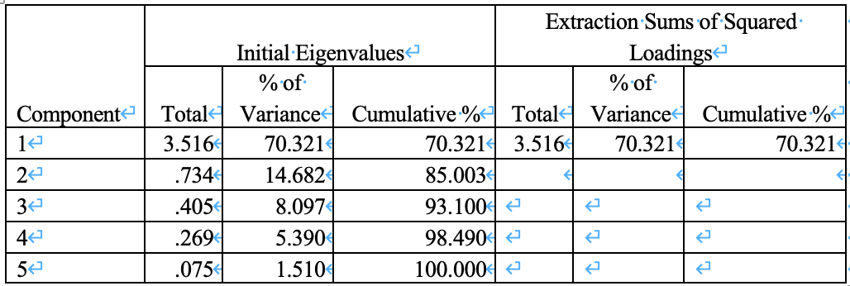
Based on Table19, one eigenvalue is extracted, and the cumulative contribution rate is 70.321%. There is less information lost in the extraction process.

Table 20: KMO and Bartlett’s Test (business performance)
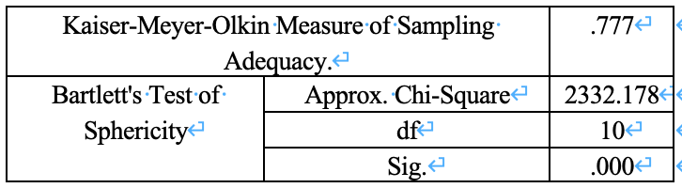
Then factor analysis is carried out on the dependent variable, that is, the business performance of the enterprise. According to Table20, the value of KMO is 0.777, which is greater than the threshold value of 0.5, so it shows that there is a correlation between variables, which meets the requirements. Then there is the result of Bartlett's spherical test, which is 0.000, so it is less than 0.05. In other words, this data can be used for factor analysis.

Table 21: Total Variance Explained (business performance)
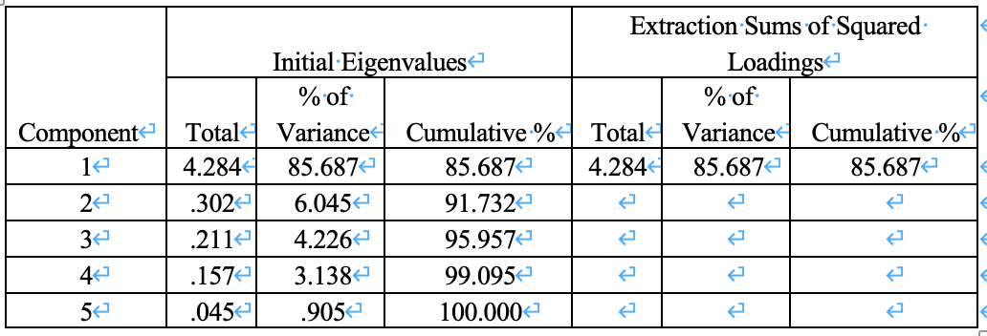
Based on Table21, one eigenvalue is extracted, and the cumulative contribution rate is 85.687%. There is less information lost in the extraction process.

4.5 Hypotheses Testing

4.5.1 Hypothesis 1
Table 22: Model Summary ^{b}(hypothesis 1)
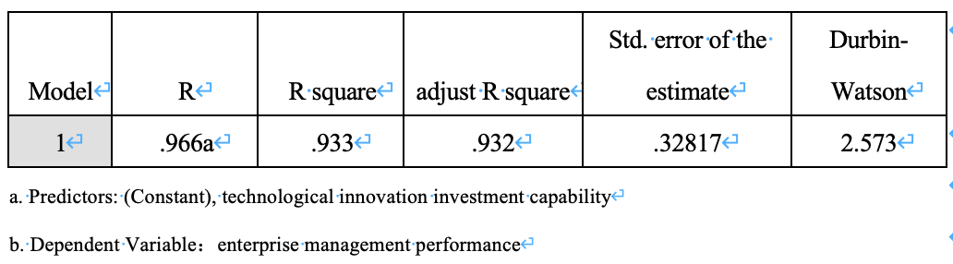
Based on the results of Table22 , R is 0.933, which shows that 93.3% of the regression relationship between the total variation of business performance of dependent variables and enterprise technological innovation investment can be explained, and the explanatory power is strong. The adjusted R-square reflects the explanatory power of dependent variables to the model when the influence of increasing independent variables is eliminated, which is 0.932. Moreover, the Durbin Watson test value was 2.573. Generally speaking, Durbin Watson test values are distributed between 0 and 4, and the closer to 2, the more independent the observations are (Hair,et al., 2019).

Table 23 :ANOVAª(hypothesis 1)
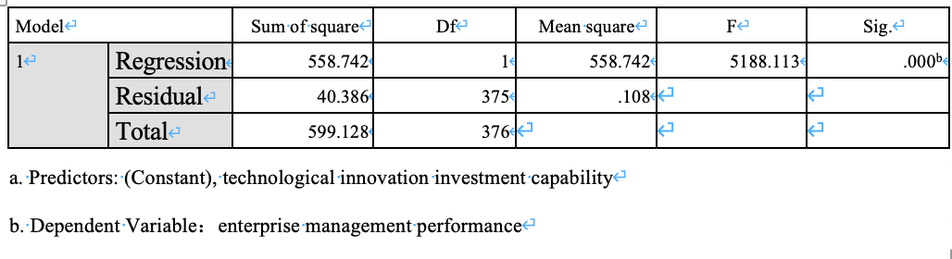
The results of Table23 shows that the regression model was statistically significant. F (1, 375) = 5188.113, P < 0.001, indicating that there is a linear correlation between dependent variables and independent variables. And P value < 0.05 which means that the regression is statistically significant, and further illustrates there is a linear correlation between dependent variables and independent variables.

Table 24: Coefficientsª(hypothesis 1)
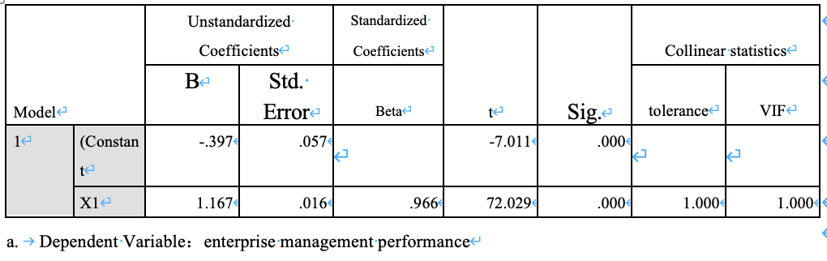
The intercept and slope are obtained in Table24; hence, this research could predict the DV (business performance) according to the IV (enterprise technological innovation investment capability). In SPSS, the intercept is called "constant", that is -0.397. At the same time, we can also judge the statistical significance of intercept by P-value. Through P-value (P < 0.001), we can also see that the intercept of this study has statistical significance, that is, the difference between intercept value (- 0.397) and 0 has statistical significance.

The slope represents the change value of the dependent variable for each unit change of the independent variable. In this study, the slope of enterprise technology input is 1.167, which means that every time technology input increases by 1, business performance increases by 1.167. For example, if the input intensity of technological innovation of an enterprise increases from 1 to 2, the business performance of the enterprise will be 1.167+1.167 × 1 = 2.334.

Therefore, Hypothesis 1 is confirmed, which means enterprises’ technology innovation investment capability has a significant impact on the business performance of enterprises.

4.5.2 Hypothesis 2
Table 25: Model Summary ^{b}(hypothesis 2)
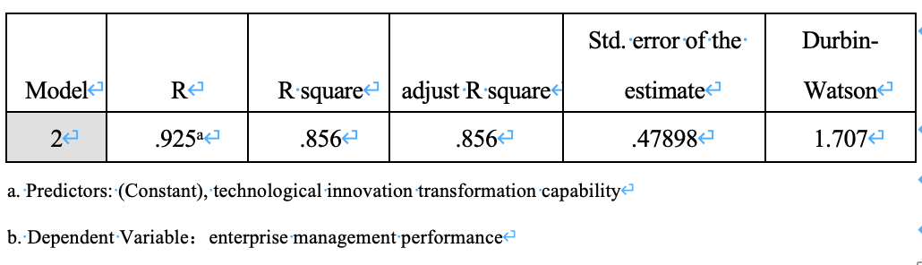
Based on Table25, the R-square is 0.856, which indicates that about 85.6% of business performance was explained by technological innovation transformation capability. The adjusted R-square reflects that the explanatory power of dependent variables to the model is still 0.856 when the influence of increasing independent variables is eliminated.

Table 26 :ANOVAª(hypothesis 2)
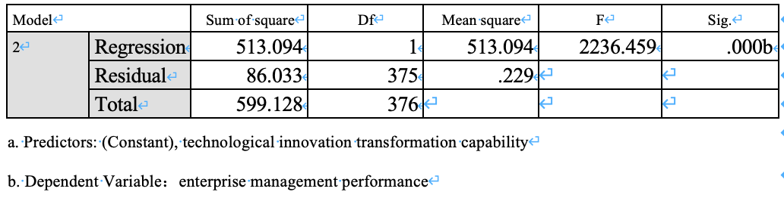
Looking at the Table26, the significant value= 0.000 < 0.001. It shows that the regression model has passed the F test with the confidence level of 0.001, and thinks that there is a linear relationship between business performance and technological innovation transformation ability.

Table 27: Coefficientsª(hypothesis 2)
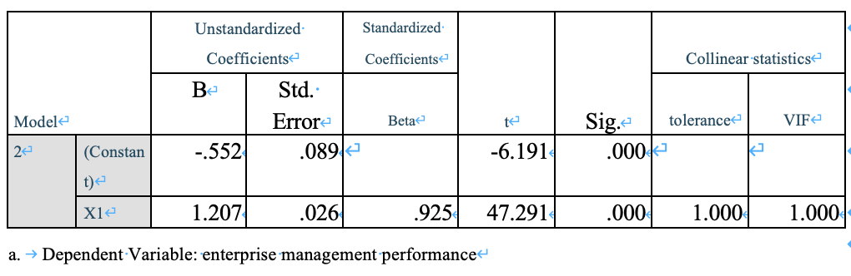

According to Table27,the significance value p = 0.000 < 0.001. It can further explain that the results of the F test for the linear regression model are consistent with the t-test of the overall regression coefficient. The regression coefficient of the body mass index of the regression model is 1.207, which shows that technology conversion ability has a positive impact on business performance of dependent variables. When technology conversion ability increases by one unit, business performance increases by 1.207 units.

Therefore, Hypothesis 2 is confirmed, which means enterprises’ technology innovation investment capability has a significant positive impact on the business performance of enterprises.

4.5.3 Hypothesis 3
Table 28: Model Summary ^{b} (hypothesis 3)
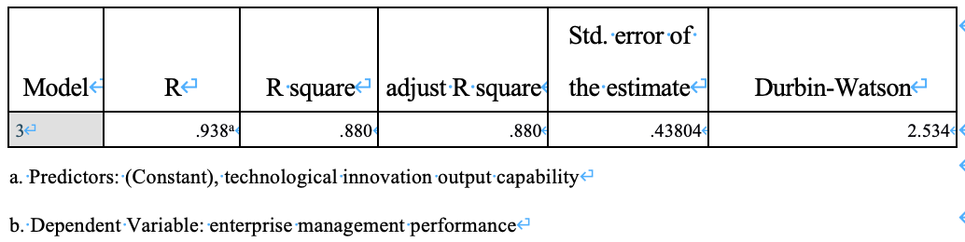
Based on Table28, R-square is 0.880, which shows that the percentage of the total variation of the dependent variable's business performance to the regression relationship between the independent variable the technological innovation output capability is 88.0%, which has strong explanatory power. The adjusted R-square reflects that the explanatory power of dependent variables to the model is still 0.880 when the influence of increasing independent variables is eliminated.

Table 29 :ANOVAª (hypothesis 3)
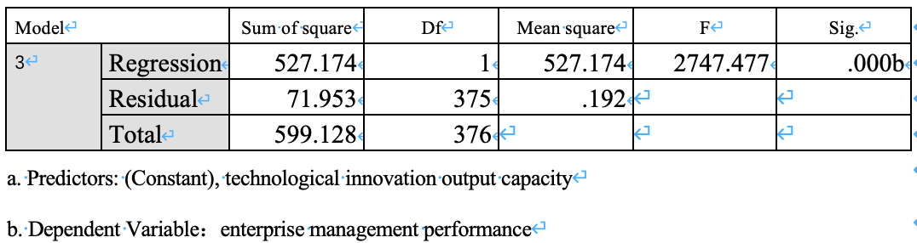

Looking at the "ANOVA" Table 29, the significance value p = 0.000 < 0.001 indicates that the regression model has passed the F test with the confidence level of 0.001. It is considered that there is a linear relationship between business performance and the technological innovation output capability of enterprises.

Table 30: Coefficientsª (hypothesis 3)
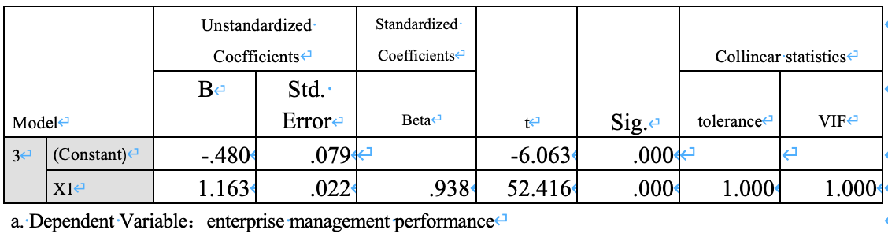

Looking at the "coefficient" Table30, significance value p = 0.000 < 0.001, which further indicates that the F test of the linear regression model is consistent with the t-test hypothesis test of the overall regression coefficient. According to the regression coefficient 1.163 of the body mass index of the regression model, it can be seen that the technology innovation output capability has a positive impact on the business performance of the dependent variable. When the technology conversion ability of the enterprise increases by one unit, the business performance increases by 1.163 units.

Therefore, Hypothesis 3 is confirmed, which means enterprises’ technology innovation investment capability has a significant impact on the business performance of enterprises.

4.6 Hierarchical regression
Hierarchical regression is the comparison of two or more regression models. If other things being equal, one model explains more variation than the other, that model is a better model. In general, the differences between the variances explained by the two models can be estimated and tested using statistical significance(Kyriazos, 2019).

Table 31: Model Summary ^{b}
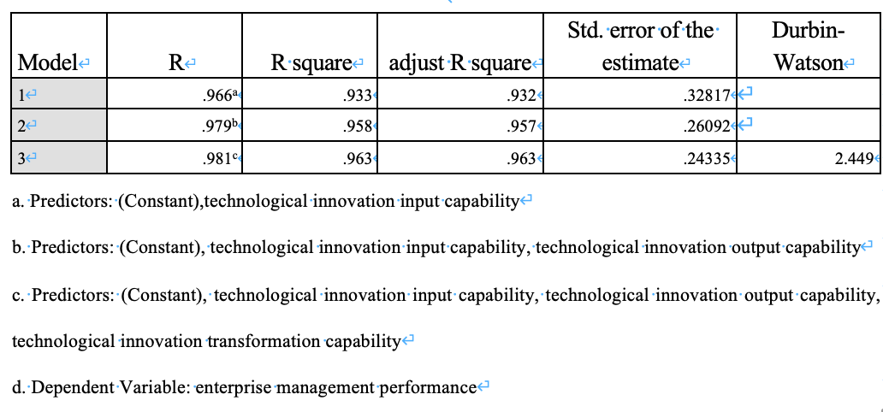
According to Table31, it can be seen from the model column that there are three models in this study: model 1, model 2 and model 3. The variables entered column shows the number of variables added to each model in the study compared to the previous model.

Model 1 is the first model, there is no antecedent variable, so the independent variable of the model is only the degree of enterprise technological innovation investment. Compared with the previous model (model 1), model 2 increases the technological innovation transformation capability of enterprises; model 3 increases the innovation output capability of enterprises compared with model 2. It should be noted that the variables included in model 2, and model 3 are based on the previous model.
Measures of model fit for the three models, R² is an important indicator of multi-level regression, which reflects the extent to which independent variables explain the variation of dependent variables. It can be seen from the above table that with the increase of the number of independent variables, R² of model 1-3 gradually increases, which are 0.966, 0.979 and 0.981, respectively, indicating that the predictive ability of each model for dependent variables is gradually strengthened.

Each model of hierarchical regression is equivalent to a multiple linear regression model. The output ANOVA table of SPSS includes the evaluation of each model, as follows:
Table 32 :ANOVAª
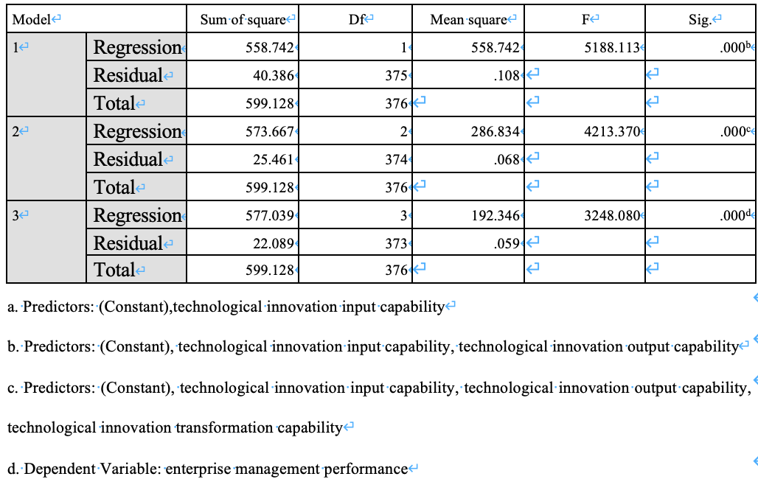
In Table 32, Model 3 is the whole model, which includes four variables: technology innovation input capability, technology innovation transformation capability and technology innovation output capability. The results showed that the model was statistically significant, f = 3248.080, P < 0.001, indicating that there was a linear correlation between dependent variables and independent variables, indicating that compared with the empty model, the inclusion of the three independent variables is helpful to predict the dependent variables.

As mentioned above, the hierarchical regression model mainly focuses on the final model, which is model 3, and it is also the case when interpreting the regression coefficient.
Table 33: Coefficientsª
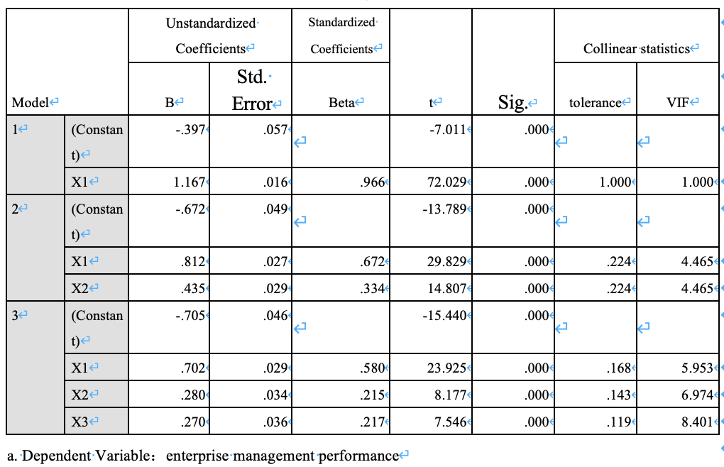
In Table 33, the coefficients corresponding to the three independent variables indicate that the three independent variables can promote the operating performance of the dependent variables. Moreover, it can be estimated from the coefficient that, among the three dimensions of enterprise technological innovation, the input ability of enterprise technological innovation is the main influencing factor, while the transformation ability of technological innovation and output ability of technological innovation have less influence .

4.7 Conclusion
Through the empirical analysis in this chapter, we find that all hypotheses have been confirmed; that is, technological innovation has a significant positive impact on business performance. At the same time, through the results of hierarchical regression, we find that the investment capability of technological innovation has the most significant impact on business performance.

Table 34：Research Hypothesis Analysis Summary
Hypotheses | Status
H1: technological innovation investment capability has a significant impact on the business performance of enterprises; | Accepted
H2: technological innovation transformation capability has a significant impact on the business performance of enterprises; | Accepted
H3: technological innovation output capability has a significant impact on business performance. | Accepted

CHAPTER 5: Conclusion and suggestion

5.0 Overview
Through the above empirical analysis, this report examines the promoting effect of technological innovation ability on enterprise performance. Based on the results of theoretical and empirical analysis, this chapter will answer the research questions of this thesis, and put forward targeted countermeasures to improve enterprise performance. The empirical results show that the comprehensive factors of technological innovation ability have a significant promoting effect on the comprehensive factors of enterprise performance, and among the three dimensions of enterprise technological innovation, the investment ability of enterprise technological innovation plays a more significant role. In addition, new energy enterprises should improve the awareness of technological innovation, pay attention to technological innovation investment, strengthen the effective coordination activities of different stages of technological innovation, so as to continuously improve the business performance of enterprises.

5.1 Discussion of Findings

5.1.1 The impact of technological innovation input capability on enterprise performance improvement
Investment in technological innovation is the basis for enterprises to realize technological innovation activities and has a positive impact on the financial performance and growth performance of enterprises. It can be seen from the above empirical results that it is necessary to attach importance to technological innovation investment. Generally speaking, the investment intensity of technological innovation of an enterprise is based on the existing strength of the enterprise. According to the data of the questionnaire survey, the executives of most new energy enterprises have a high degree of recognition for the R&D investment in equipment and capital of their companies, while the degree of recognition for the investment in personnel is relatively low. However, in the process of enterprise operation, it is difficult to improve enterprise performance only by capital and equipment investment. Therefore, in the process of investment in technological innovation ability of enterprises, attaching importance to the investment of talents will also have important significance to the growth of enterprise performance.

5.1.2 The impact of technological innovation transformation capability on the improvement of business performance
The empirical study shows that the transformation ability of technological innovation has a significant positive impact on the financial performance and growth performance of enterprises. Research found that the transformation of technology innovation ability is not improved, according to the answers of the senior executives to relevant questions, their scores for the patent conversion ability and external information conversion ability of the new energy enterprise they work for are not high, the impact of the transformation ability of technological innovation on financial performance is not significant compared with the input ability. However, the inconsistencies in the evaluation criteria of scientific research projects and the imperfect management mechanism may also be the reasons. To be specific, technological innovation is a process, which is the result of the long-term development of an enterprise. This process needs to be deeply digested and absorbed. Otherwise, the degree of technological innovation will stay at the stage of imitation and follow-up, which will be difficult to grow and develop and leading to poor performance of the enterprise.

5.1.3 The impact of technological innovation output capability on the improvement of business performance
Output of technological innovation is the final link of enterprise technology innovation activities. It can be seen from the above empirical results; the output of technological innovation ability is very significant for the impact of enterprise performance. According to the score of new product income and export share in the questionnaire data, and combined with the perspective of the market, it can be analyzed that if we continue to improve the output capacity of technological innovation, on the premise of ensuring product quality, product differentiation will have a certain impact on performance.

The rational development of technological innovation activities is based on the orderly development of other activities. Innovation is not a matter of one department of an enterprise, but the face of the whole enterprise. Specifically, financial management activities can provide financial support for technological innovation and inject vitality into technological innovation activities. Human resource management activities can maximize the allocation of human being resources. Marketing management activities refer to introducing products to the market through channel construction and promotion activities after production. Coordination and cooperation among various departments within an enterprise can help new products to be recognized so as to improve the output ability and enterprise performance of technological innovation.

5.2 Contribution
First of all, this report uses comprehensive indicators and empirical methods to measure the technological innovation ability of enterprises. In the existing research, the evaluation index selection method of technological innovation ability is relatively single, and the simple static financial indicators, such as R&D input intensity and patent output, are used as the representative of technological innovation ability. However, technological innovation capability is a dynamic ability of development and change. To evaluate and measure it, we need to consider all aspects of its factors. In this report, the dynamic perspective of technological innovation capability is divided into three dimensions, which comprehensively measures the level of the technological innovation ability of enterprises by way of senior management scoring.

Secondly, this report constructs a theoretical model of the impact of technological innovation dynamic capabilities on enterprise performance. Innovation plays an essential role in the process of enterprise growth, competitiveness, management efficiency and long-term profit maximization. Based on the theory of dynamic capabilities, this report constructs a theoretical model of the relationship between technological innovation dynamic capabilities and enterprise performance from a dynamic perspective. The dynamic capability of technological innovation includes three dimensions, which are divided from the process of technological innovation, and integrate the dynamic characteristics in each dimension. They are technological innovation input capability, technological innovation transformation capability and technological innovation output capability. Enterprise performance is divided into two dimensions: financial performance and growth performance, which is mainly considered from the essential aspects of the impact of technological innovation on performance. Through the model construction and empirical test, this report reveals the impact of technological innovation dynamic capability on enterprise performance.

5.3 Recommendations

5.3.1 Strengthening the training of scientific research personnel
Scientific research personnel are the main force of technological innovation activities and guarantee the stable development of competitive products and enterprises. In order to obtain the development of innovative products, enterprises must have innovative talents. Innovative talents often have the quality of innovative consciousness, scientific research spirit and strong innovation ability, which plays an essential role in the technological innovation of enterprises. Moreover, the influence of dynamic environment makes the talents needed by enterprises more innovative. Therefore, in order to ensure long-term stable development, enterprises need to do the following in terms of talent management. First of all, the introduction of higher education and senior technical personnel, increase the proportion of technological innovation talents. Secondly, strengthen the cultivation of technical innovation ability of internal technicians, organize regular training activities, and strengthen the team building of enterprise technicians. Thirdly, implement the mechanism and system to encourage employees' technological innovation, and give them monetary and spiritual encouragement for their technological innovation activities and research and development. Finally, motivate employees' enthusiasm for technological innovation through KPI, and strive to improve the overall technological innovation ability of the enterprise.

5.3.2 Increase capital investment
Technological innovation is a high-risk activity, which often needs a lot of capital investment. Therefore, under the condition of not affecting the normal development of enterprises, enterprises should try their best to meet the funds needed for technological innovation. In addition, in order to effectively solve the problem of insufficient enterprise innovation funds, enterprises need to improve the guarantee system of enterprise technological innovation capital investment. Enterprises can combine various financing channels which is beneficial to reduce the risk to a certain extent.

5.3.3 Strengthening the advanced nature of equipment
Advanced production equipment is the premise of technological innovation. However, the purchase of equipment is a high investment. The payback period of investment can be as short as five years and as long as more than ten years, which is a heavy burden for enterprises. If there is no advanced equipment, enterprises can complete technological innovation activities in the following ways. On the one hand, while the original equipment can still provide utility, it can be improved on the basis of the original production equipment to improve the automation level of the equipment, so as to catch up with the production level of advanced equipment and improve the artificial efficiency. Moreover, equipment leasing (such as financial leasing) can reduce the economic burden of enterprises. It can not only use advanced equipment to carry out technological innovation activities, but also reduce the labor intensity of workers, increase efficiency and production capability, and improve the overall efficiency of enterprises.

5.3.4 Increase government support
Based on the external market risks, internal technical risks and management risks faced by energy enterprises, in order to reduce the pressure of energy enterprises' development on national energy security, social operation and enterprise development, the government should increase its support for energy enterprises. In terms of financial subsidies, the government should relax the conditions for enterprises to make loans for technological innovation and research and development, lower the threshold for access, and encourage enterprises to improve their technological innovation ability through capital borrowing. In addition, greater support will be given to small energy enterprises to mitigate the negative impact of investment in technological innovation on their financial performance.

5.4 Implication on Future Research
In terms of sampling, the number of samples still cannot meet the requirements of large sample with universal significance, and the industry type of research enterprises is not broad, which affects the universality of the research results. In future research, we should consider a broader range of industry types, and make the sample coverage should be more comprehensive so that the research conclusion is more reliable and has a more promotional value. Moreover, it needs to set up scales and statements based on literature analysis to strengthen the pertinence and comprehensiveness further.

In terms of data sources, the article collects cross-sectional data and fails to consider the lag between variables. In the future, studying the long-term causality between variables by taking data from different periods and conducting long-term follow-up surveys. In addition, with the development of the economy and the change of the external network environment, the model needs to have a dynamic evolution process. In the future, we will try to test the universality of the research.

5.5 Personal Reflection
Due to the limitations of my research level and theoretical knowledge, the conclusion of this report has some shortcomings. There are many factors affecting the performance of technological innovation ability of enterprises, and there may be intermediary factors. The factors considered in this study are relatively single, which need to be further improved and supplemented to make the study more scientific and reasonable. In addition, the samples of this study are new energy enterprises in China, and the results of the empirical study may not be universal or representative of all enterprises. In the future research, more enterprises in the industry can be selected to make the research pertinence and comprehensiveness.

5.6 Conclusion
Based on theoretical analysis, conceptual model and empirical test results, this report verifies the relationship between technological innovation dynamic capability and enterprise performance of new energy enterprises. Based on the perspective of the dynamic capability of technological innovation, this report puts forward relevant countermeasures to promote enterprise performance from three stages of input, transformation and output.

Reference
- Berchicci, L., 2013. Towards an open R&D system: Internal R&D investment, external knowledge acquisition and innovative performance. Research Policy, 42(1), pp.117-127.
- Bers, J., Dismukes, J., Miller, L. and Dubrovensky, A., 2009. Accelerated radical innovation: Theory and application Author links open overlay panel. Technological Forecasting and Social Change, 76(1), pp.165-177.
- Chen, J., Zhao, C., Jia, X. and Mei, L., 2017. Reconstructing firm's technological innovation capability evaluation system: from knowledge management to value creation. Technical economy, 036(009), pp.1-8,30.
- Cheng, C. and Chen, J., 2013. Breakthrough innovation: the roles of dynamic innovation capabilities and open innovation activities. Journal of Business & Industrial Marketing, 28(5), pp.444-454.
- Churchill, G., 1979. A Paradigm for Developing Better Measures of Marketing Constructs. Journal of Marketing Research, 16(01), pp.64-73.
- Christensen, J., 2004. Asset profiles for technological innovation. Research Policy, 24(5), pp.727-745.
- Crossan, M. and Apaydin, M., 2010. A Multi-Dimensional Framework of Organizational Innovation: A Systematic Review of the Literature. Journal of Management Studies, 47(6), pp.1154-1191.
- D'Aveni, R. and Gunther, R., 1994. Hypercompetition. New York: The Free Press.
- Dixit, B., 2019. Operating performance of acquirers after acquisition: evidence from India. Journal of Indian Business Research, 12(3), pp.327-341.
- Du, Y. and Fang, Y., 2014. Research on the Relationship between enterprise middle management Ability and Technological Innovation Performance -- The Mediating effect test of Enterprise innovation Ability. Soft science, (04), pp.42-47.
- Eisenhardt, K. and Martin, J., 2000. Dynamic capabilities: what are they?. Strategic Management Journal, 21(10-11), pp.1105-1121.
- Ehie, I. and Olibe, K., 2010. The effect of R&D investment on firm value: An examination of US manufacturing and service industries. International Journal of Production Economics, 128(1), pp.127-135.
- Fu, J., 1998. Technical Innovation Theory. Beijing: TSINGHUA UNIVERSITY PRESS.
- Guan, J. and Ma, N., 2003. Innovative capability and export performance of Chinese firms. Technovation, 23(09), pp.737-747.
- Grubler, A. and Wilson, C., 2014. Energy Technology Innovation Learning From Historical Successes And Failures. NY,USA: CAMBRIDGE UNIVERSITY PRESS.
- Grafström, J. and Lindman, Å., 2017. Invention, innovation and diffusion in the European wind power sector. Technological Forecasting and Social Change, 114, pp.179-191.
- Hair, J., BLack, W., Babin, B. and Anderson, R., 2019. Multivariate Data Analysis. 8th ed. United Kingdom : Cengage: Andover, Hampshire.
- Hsu, C., Lai, W. and Yen, S., 2018. Boardroom Diversity and Operating Performance: The Moderating Effect of Strategic Change. Emerging Markets Finance and Trade, 55(11), pp.2448-2472.
- Hardy, C. and Dougherty, D., 1996. Sustained Product Innovation in Large, Mature Organizations: Overcoming Innovation to Organization Problems. Academy of Management Journal, 39(05), pp.1120-1153.
- Hai, B. and Nie, M., 2012. Internationalization, innovation and Enterprise performance: an empirical study based on Hubei Province. Research Management, 033(004), pp.1-9.
- Ince, H., Imamoglu, S. and Turkcan, H., 2016. The Effect of Technological Innovation Capabilities and Absorptive Capacity on Firm Innovativeness: A Conceptual Framework. Procedia - Social and Behavioral Sciences, 235, pp.764-770.
- Jiang, W. and Yao, W., 2015. Enterprise Innovation and Executive Compensation-Performance Sensitivity -- Based on the Experience of State-owned Listed Companies. Economic management, 37(05), pp.63-73.
- Kyriazos, T., 2019. Applied Psychometrics: The Modeling Possibilities of Multilevel Confirmatory Factor Analysis (MLV CFA). Psychology, 10(6), pp.777-798.
- Li, H. and Atuahene-Gima, K., 2001. Product Innovation Strategy and the Performance of New Technology Ventures in China. Academy of Management Journal, 44(6), pp.1123-1134.
- Liu, W., Yan, X., Si, C., Xie, D. and Wang, J., 2020. Effect of buyer-supplier supply chain strategic collaboration on operating performance: evidence from Chinese companies. Supply Chain Management: An International Journal, 25(6), pp.823-839.
- Lee, C. and Lin, C., 2019. The major determinants of influencing the operating performance from the perspective of intellectual capital: Evidence on CPA industry. Asia Pacific Management Review, 24(2), pp.124-139.
- Lilly, J. and Juma, D., 2014. INFLUENCE OF STRATEGIC INNOVATION ON PERFORMANCE OF COMMERCIAL BANKS IN KENYA: THE CASE OF KENYA COMMERCIAL BANK. European Journal of Business Management, 2(1), pp.336-341.
- Lianto, B., Dachyar, M. and Soemardi, T., 2018. Continuous Innovation: A literature review and future perspective. International Journal on Advanced Science, Engineering and Information Technology, 8(3), pp.771-779.
- Li, Y., 2013. Li Yiping: Innovation And Economic Development. [online] Theory.people.com.cn. Available at: <http://theory.people.com.cn/n/2013/0129/c40531-20362868.html>.
- Lai, W. and Chang, P., 2010. Corporate motivation and performance in R&D alliances. Journal of Business Research, 63(5), pp.490-496.
- Liu, L., 2016. Industrial Heterogeneity, Technological Innovation and Enterprise Value. Journal of Technical Economics & Management, 36(05), pp.8-15.
- Latan, H., Chiappetta Jabbour, C., Lopes de Sousa Jabbour, A., de Camargo Fiorini, P. and Foropon, C., 2020. Innovative efforts of ISO 9001-certified manufacturing firms: Evidence of links between determinants of innovation, continuous innovation and firm performance. International Journal of Production Economics, 223, p.107526.
- Lichtenthaler, U. and Muethel, M., 2012. RETRACTED: The role of deliberate and experiential learning in developing capabilities: Insights from technology licensing. Journal of Engineering and Technology Management, [online] 29(2), pp.187-209. Available at: <https://doi.org/10.1016/j.jengtecman.2011.10.001> .
- Liang, Y. and Yang, S., 2016. Research on the Coordination Degree of Coupling Between the Technological Innovation Capacity and Service Capacity. Science and Technology Management Research, 36(24), pp.48-53.
- Li, H., Wang, M. and Shi, H., 2018. Relationship between CEO tenure, JUMP in R&D investment and corporate performance -- Empirical Evidence from China's listed companies. Technical and economic, 37(10), pp.55-65.
- Li, Z., Sun, K. and Zhao, Q., 2017. Differentiation of the impact of R&D innovation and non-R&D innovation on performance - Based on an empirical study of high-tech enterprises. Technical and economic, 36(11), pp.7-15.
- Murphy, G., Trailer, J. and Hill, R., 1996. Measuring performance in entrepreneurship research. Journal of Business Research, 36(01), pp.15-23.
- Murphy, P. and Schlegelmilch, B., 2013. Corporate social responsibility and corporate social irresponsibility: Introduction to a special topic section. Journal of Business Research, 66(10), pp.1807-1813.
- Paik, J. and Hyun, J., 2015. Post-Catch-Up Strategy for Medium-Sized South Korean Firms: Improving Technological Capabilities by Balancing R&D Intensity and Open Innovation. Engineering Management Journal, [online] 27(04), pp.164-176. Available at: <https://doi.org/10.1080/10429247.2015.1100931>.
- Popovič, A., Hackney, R., Tassabehji, R. and Castelli, M., 2016. The impact of big data analytics on firms’ high value business performance. Information Systems Frontiers, 20(2), pp.209-222.
- Ron, A. and Jim, E., 2014. Innovation Ecosystems: An Interview with Ron Adner: Ron Adner Talks with Jim Euchner about the Challenges and Benefits of Managing Your Innovation Ecosystem. Research-Technology Management, 57(06), pp.10-14.
- Ruekert, R., Walker, O. and Roering, K., 1985. The Organization of Marketing Activities: A Contingency Theory of Structure and Performance. Journal of Marketing, 49(1), p.13.
- Rajapathirana, R. and Hui, Y., 2018. Relationship between innovation capability, innovation type, and firm performance. Journal of Innovation & Knowledge, 3(1), pp.44-55.
- Sabahi, S. and Parast, M., 2019. Firm innovation and supply chain resilience: a dynamic capability perspective. International Journal of Logistics Research and Applications, 23(3), pp.254-269.
- Schumpeter, J. and Backhaus, U., 2003. The Theory Of Economic Development. 1st ed. [ebook] Boston, MA: Kluwer Academic Publishers 2003, pp.61-116. Available at: <https://doi.org/10.1007/0-306-48082-4_3>.
- Schumpeter, J. and OPIE, R., 1934. The Theory Of Economic Development. An Inquiry Into Profits, Capital, Credit, Interest, And The Business Cycle ... Translated ... By Redvers Opie. Cambridge, MA.: Harvard university press.
- Turel, O., Liu, P. and Bart, C., 2019. Is board IT governance a silver bullet? A capability complementarity and shaping view. International Journal of Accounting Information Systems, 33, pp.32-46.
- Teece, D., Pisano, G. and Shuen, A., 1997. Dynamic capabilities and strategic management. Strategic Management Journal, 18(7), pp.509-533.
- Thompson, V., 1965. Bureaucracy and Innovation. Administrative Science Quarterly, 10(1), pp.1-20.
- Vicente, M., Abrantes, J., Seabra, C. and Teixeira, M., 2015. Measuring innovation capability in exporting firms: The INNOVSCALE. International Marketing Review, [online] 32(1), pp.29-51. Available at: <https://doi.org/10.1108/IMR-09-2013-0208> .
- Wu, S. and Xing, J., 2015. Research on the relationship between technological innovation and business performance. Economist, (012), pp.26-27，29.
- Wang, Q., Hang, Y., Sun, L. and Zhao, Z., 2016. Two-stage innovation efficiency of new energy enterprises in China: A non-radial DEA approach. Technological Forecasting and Social Change, 112, pp.254-261.
- Wu, J., 2003. The Formation Mechanism of the Core Competence Based on Organizational Learning. Chinese Soft Science, (11), pp.65-70.
- Wei, J. and Xu, R., 1995. The concept, structure, measurement and evaluation of enterprise innovation capability. Scientific management research, (05), pp.50-55.
- Xu, N. and Xu, X., 2012. Control Rights Incentive Duality and Technology-innovation Dynamic Capability -- Empirical Analysis Based on High-tech Listed Companies' Panel data. CHINA INDUSTRIAL ECONOMICS, 24(10), pp.109-120.
- Xu, B., 2018. Winning by quality: technological innovation and business performance of enterprises. Operation and management, 27(11), pp.197-203.
- Yamin, S., Mavondo, F., Gunasekaran, A. and Sarrosa, J., 1997. A study of competitive strategy, organisational innovation and organisational performance among Australian manufacturing companies. International Journal of Production Economics, 52(1-2), pp.161-172.
- Yan, Y. and Chi, R., 2013. R&D investment, Technology acquisition model and Enterprise Innovation Performance -- Based on the demonstration of high-tech enterprises in Zhejiang Province. Scientific research management, 34(5), pp.48-55.
- Zhao, Y. and Gao, Y., 2019. The Driving effect of Technological Innovation on the Upgrading of global value chain of high-tech Industry -- Evidence from Hubei High-tech Industry. Scientific and technological progress and countermeasures, 36(3), pp.52-60.
- Zhu, N., Zhu, L., Kong, Y. and Shen, Y., 2014. Research on the Synergistic influence of technological innovation input and social responsibility undertaking on financial performance. Accounting Research, (2), pp.57-63.
- Zhang, Y., 2019. Study On The Relationship Between R&D Investment And Growth Of New Energy Listed Companies. Master. Northwest University of China.
- Zollo, M. and Winter, S., 2002. Deliberate Learning and the Evolution of Dynamic Capabilities. Organization Science, 13(3), pp.339-351.

APPENDIX A. SURVEY QUESTIONNAIRE

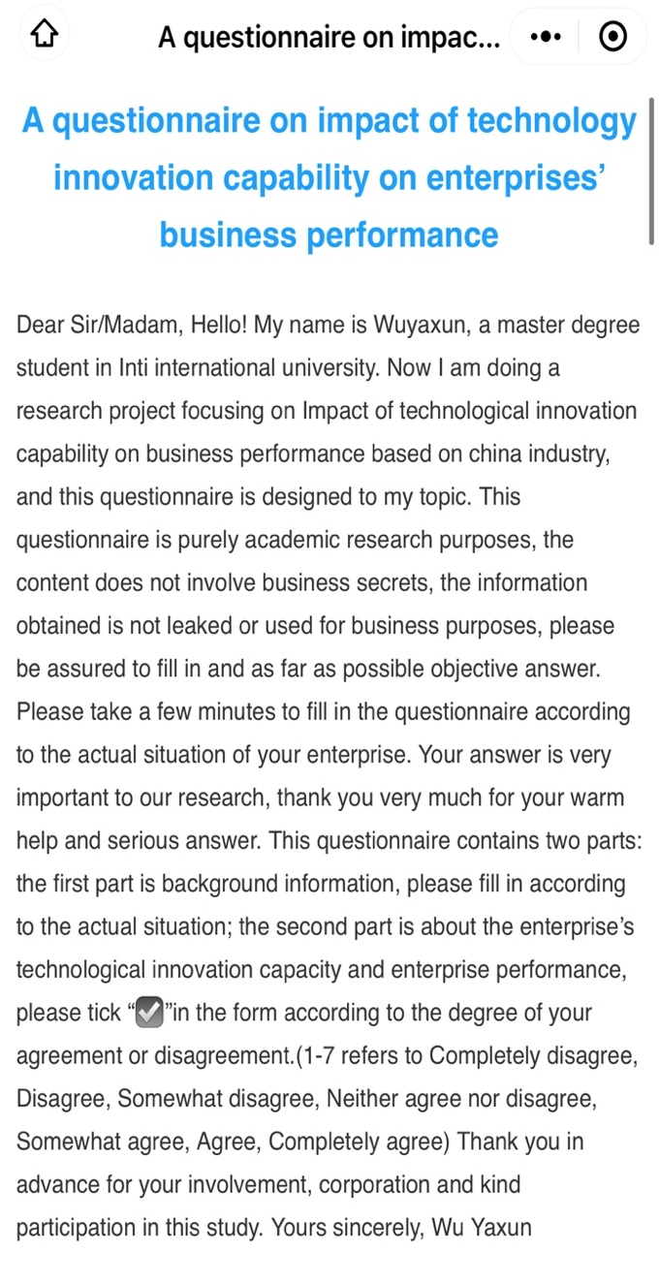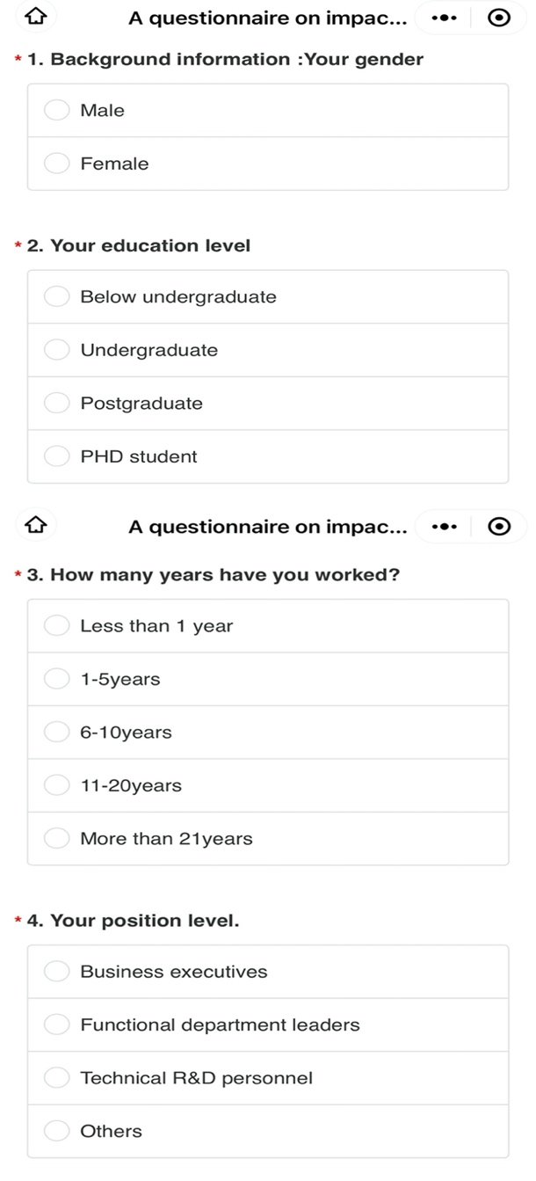

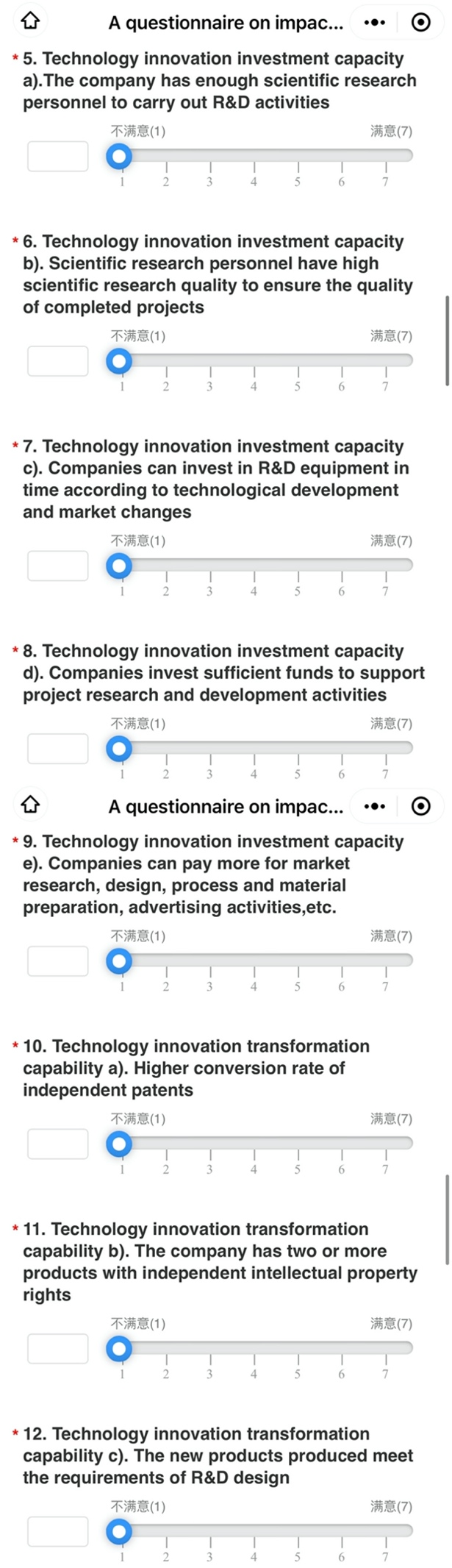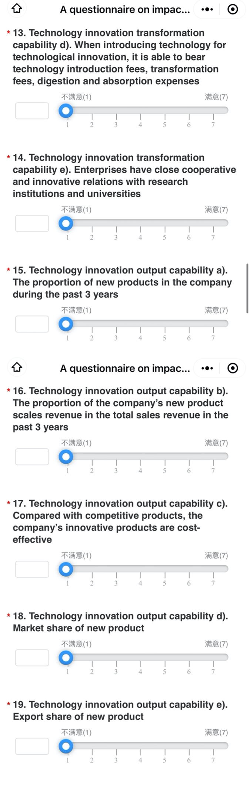
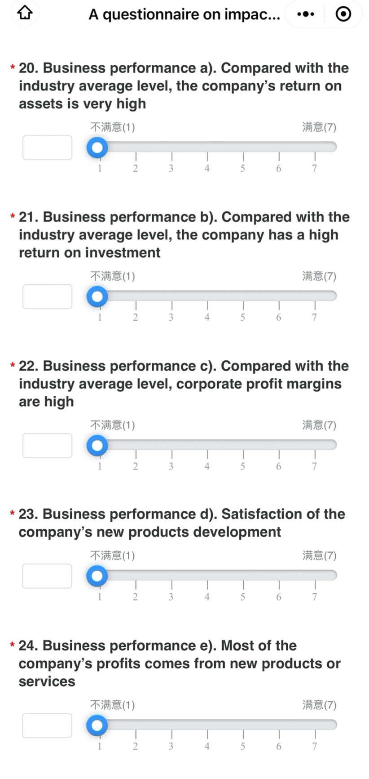

Appendix B. Item-Total Statistics(SMALL SAMPLES)
 | Means | standard deviation | Number of cases
The company has enough scientific research personnel to carry out R&D activities | 3.09 | 1.634 | 32
Scientific research personnel have high scientific research quality to ensure the quality of completed projects | 3.59 | 1.316 | 32
Companies can invest in R&D equipment in time according to technological development and market changes | 3.88 | .793 | 32
The company invests sufficient funds to support project research and development activities | 3.75 | 1.481 | 32
Companies can pay more for market research, design, process and material preparation, advertising activities, etc. | 3.44 | 1.343 | 32
Higher conversion rate of independent patents | 3.75 | .803 | 32
The company has two or more products with independent intellectual property rights | 3.44 | 1.243 | 32
The new products produced meet the requirements of R&D design | 3.59 | 1.160 | 32
When purchasing technology for technological innovation, it is able to bear technology introduction fees, transformation fees, and digestion and absorption expenses | 3.53 | 1.626 | 32
Enterprises have close cooperative and innovative relations with research institutes and universities | 3.72 | 1.486 | 32
The proportion of new products in the company in the past three years | 3.94 | 1.294 | 32
The proportion of the company’s new product sales revenue in the total sales revenue in the past three years | 3.47 | .879 | 32
Compared with competitive products, the company's innovative products are cost-effective | 3.38 | 1.454 | 32
Market share of new products | 3.28 | 1.350 | 32
The export share of new products | 3.84 | 1.370 | 32
Compared with the industry average, the company's return on assets is very high | 4.03 | 1.492 | 32
Compared with the industry average, the company has a high return on investment | 3.63 | 1.809 | 32
Compared with the industry average, corporate profit margins are high | 3.44 | 1.045 | 32
The satisfaction of the company's new product development | 3.38 | 1.338 | 32
Most of the company’s profits comes from new products or services | 4.16 | 1.568 | 32

Appendix C. Demographic Information of the Respondents
Demographic | Categories | Frequency | Percentage (%)
Gender | male | 298 | 79.05
 | female | 79 | 20.95
Education level | Diploma | 34 | 9.02
 | Bachelor Degree | 189 | 50.13
 | Master Degree | 109 | 28.91
 | Doctoral Degree | 45 | 11.94
working years | 1-5 years | 83 | 22.02
 | 5-10 years | 140 | 37.14
 | 10-20 years | 120 | 31.83
 | Over 21 years | 34 | 9.02
Position level | Corporate executives | 130 | 34.48
 | Leaders of functional departments | 188 | 49.87
 | Technical R & D Manager | 59 | 15.65

Appendix D. Proposal Defense Presentation
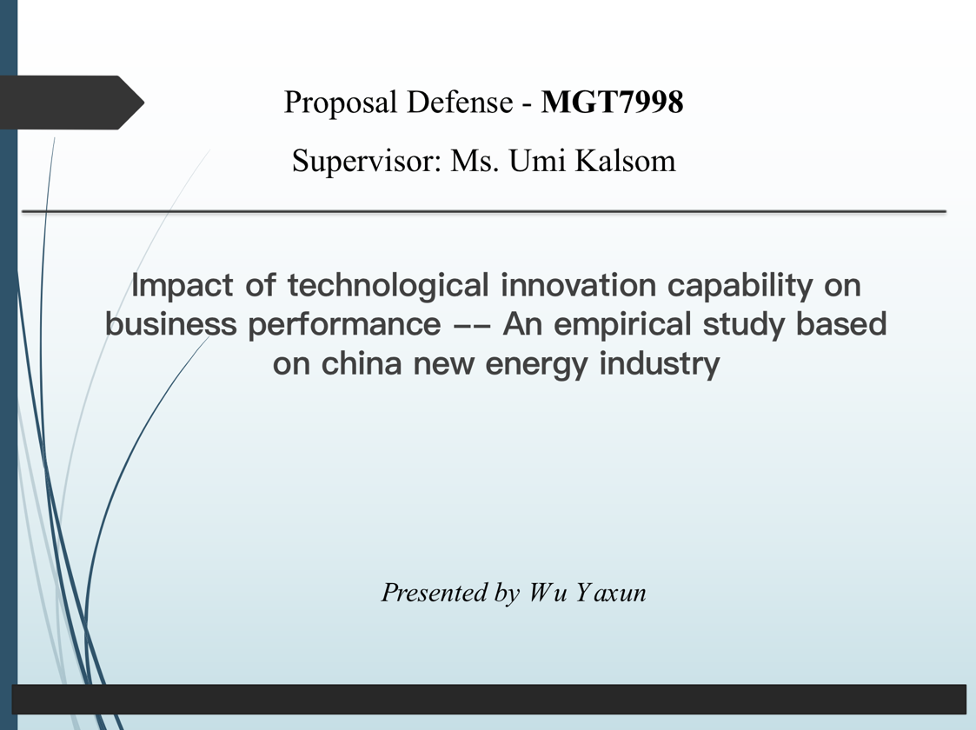

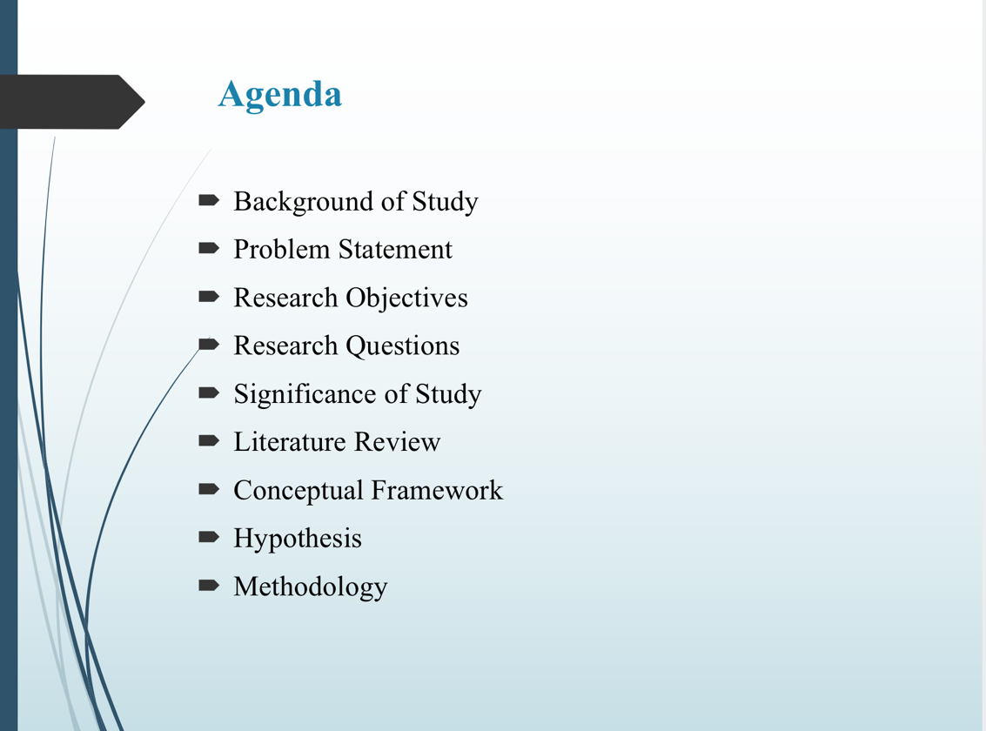
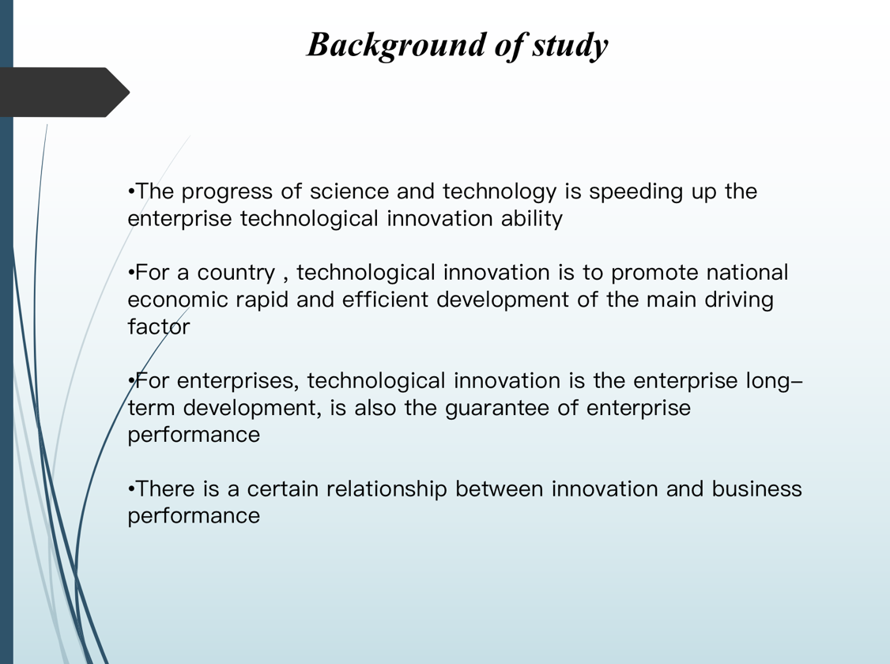

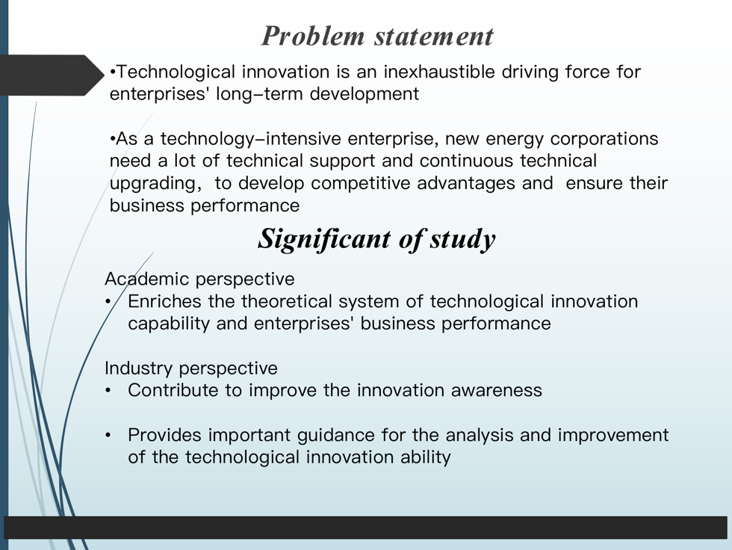
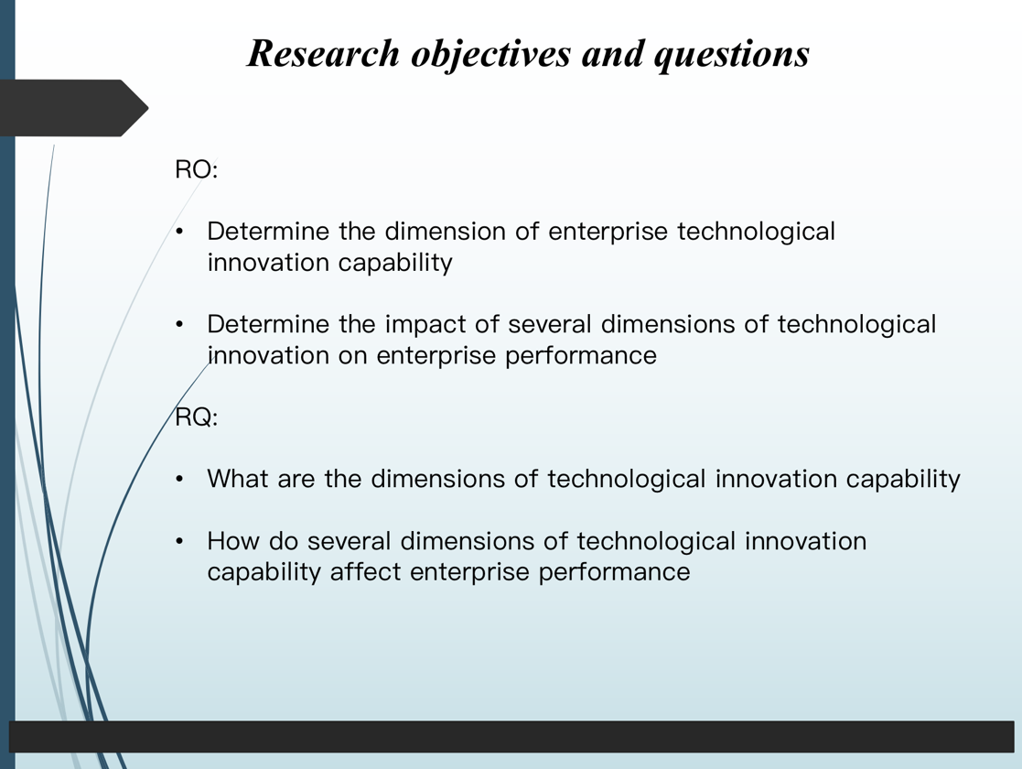

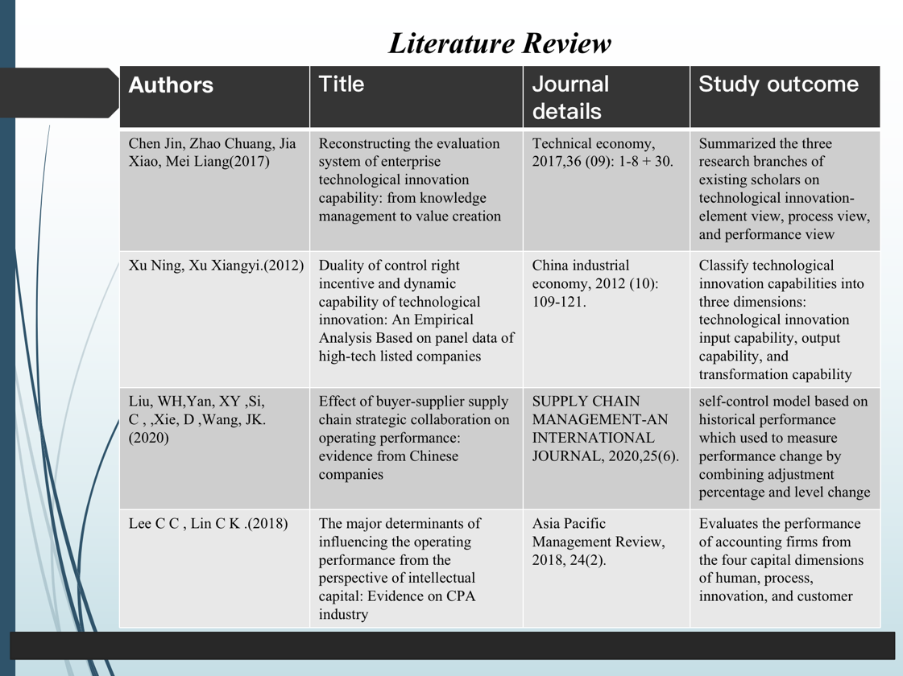
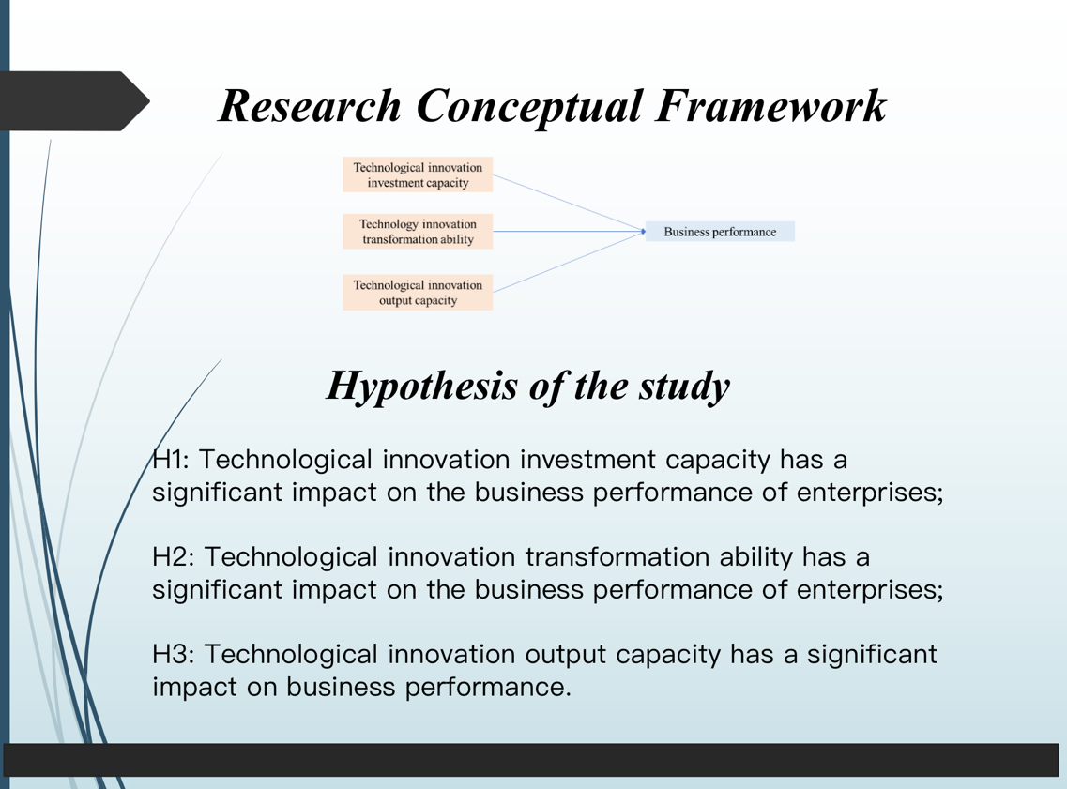

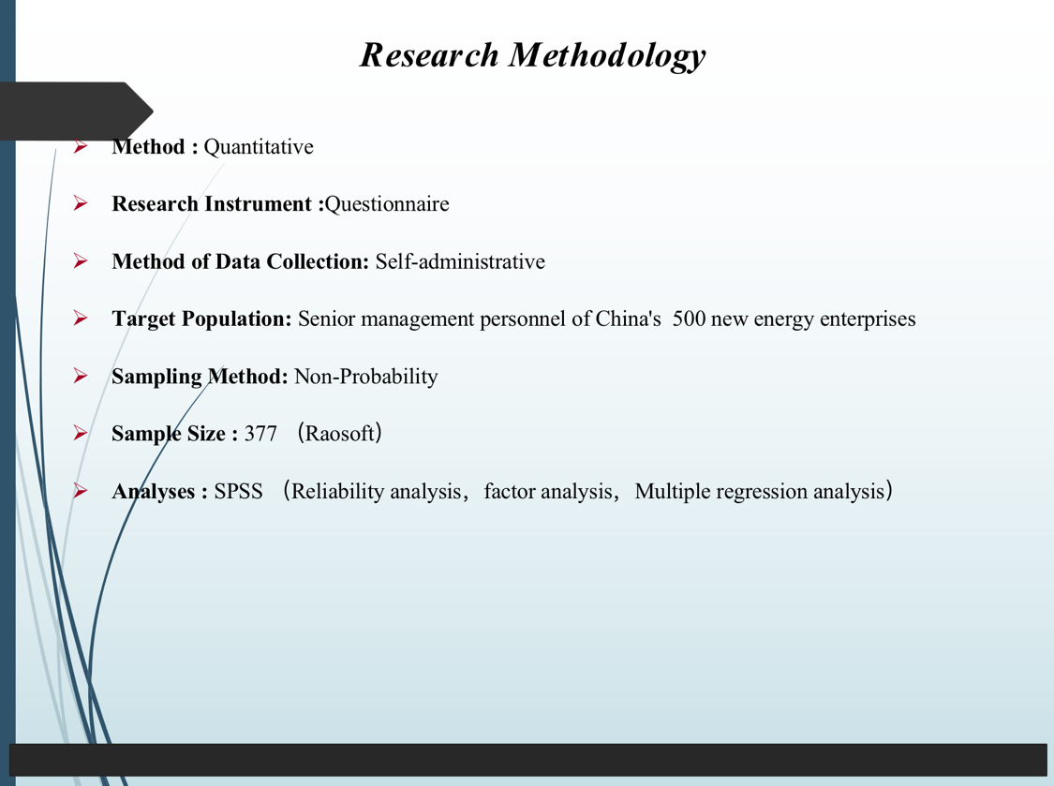
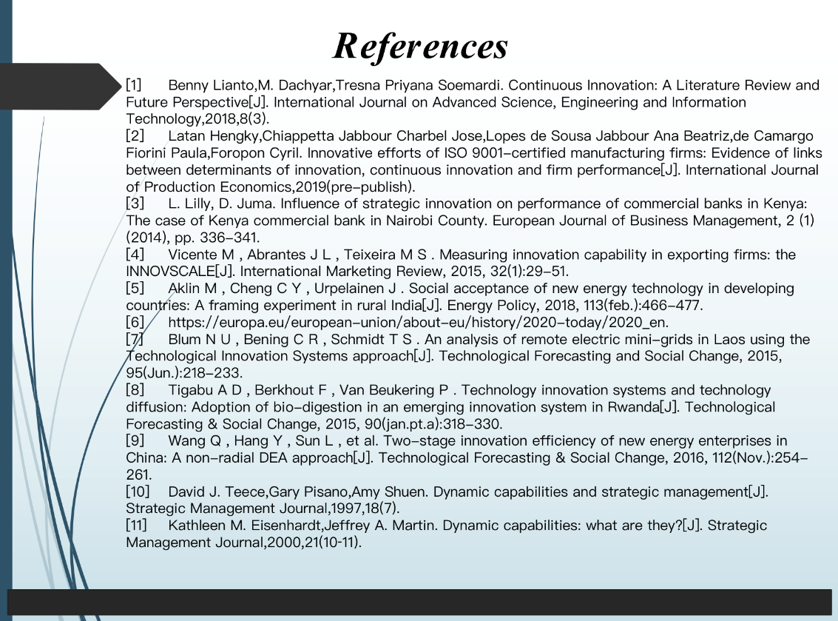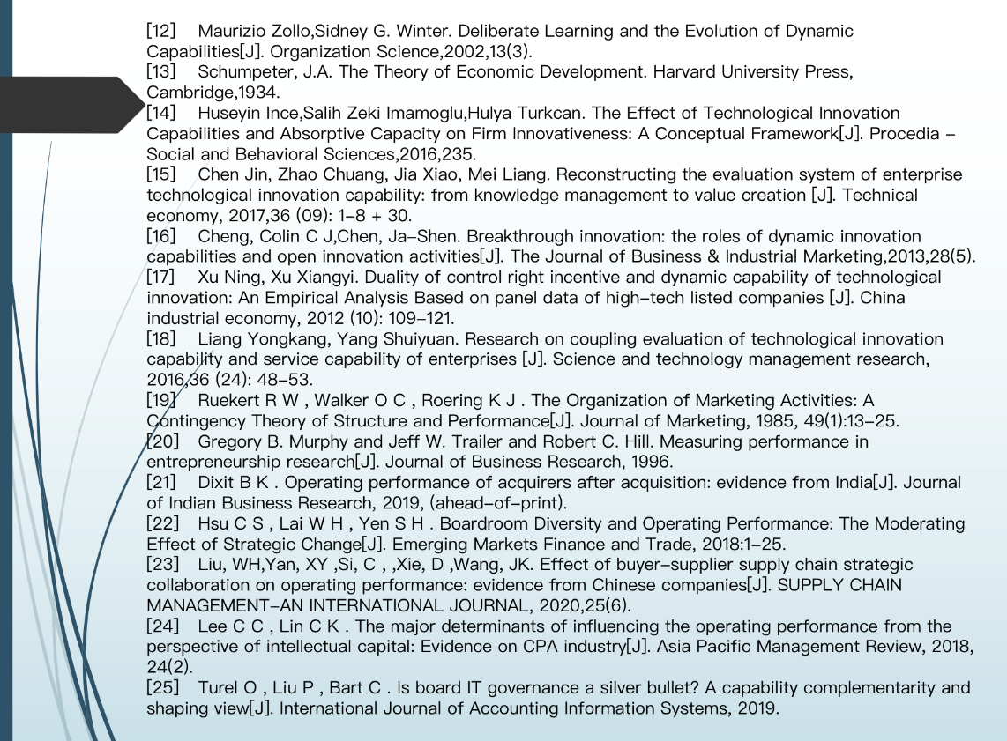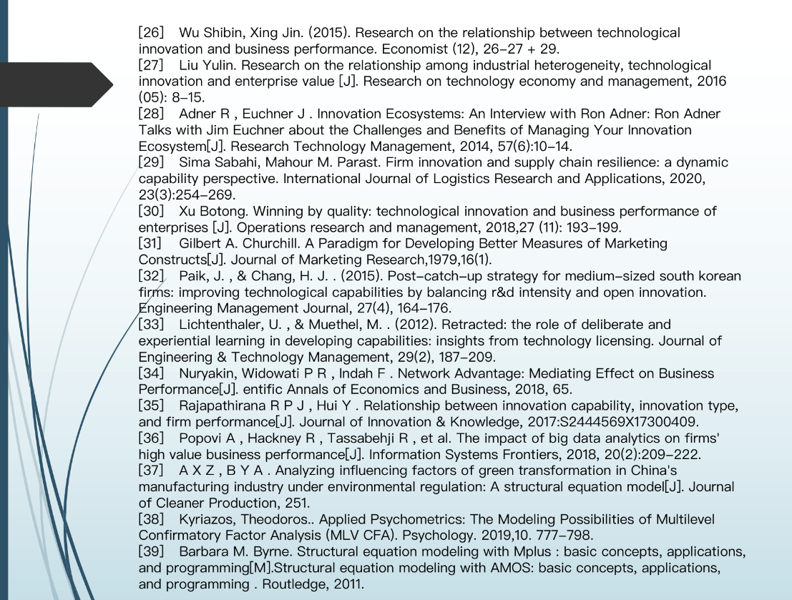

Appendix E. VIVA Presentation
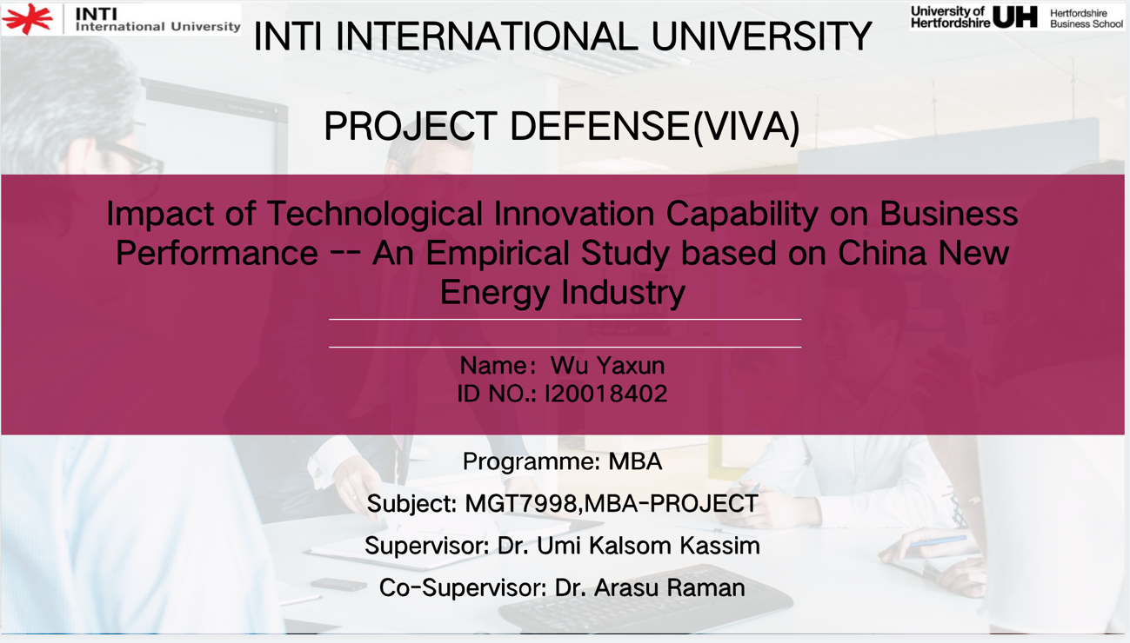
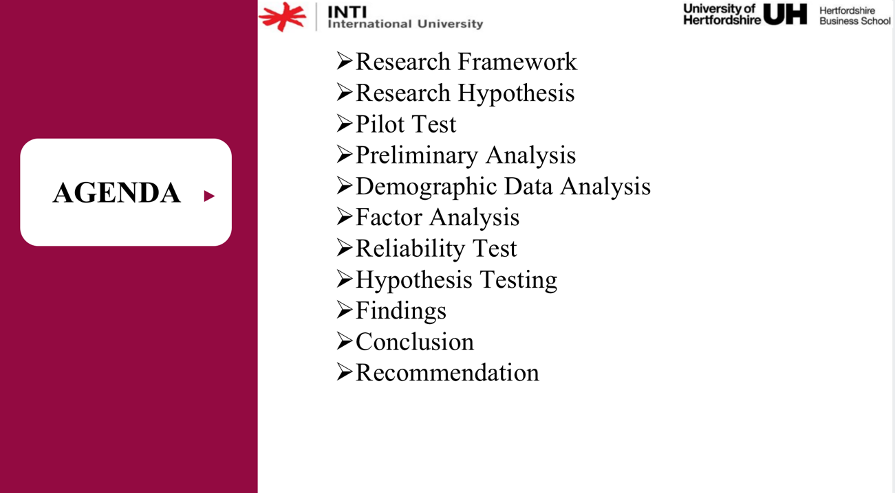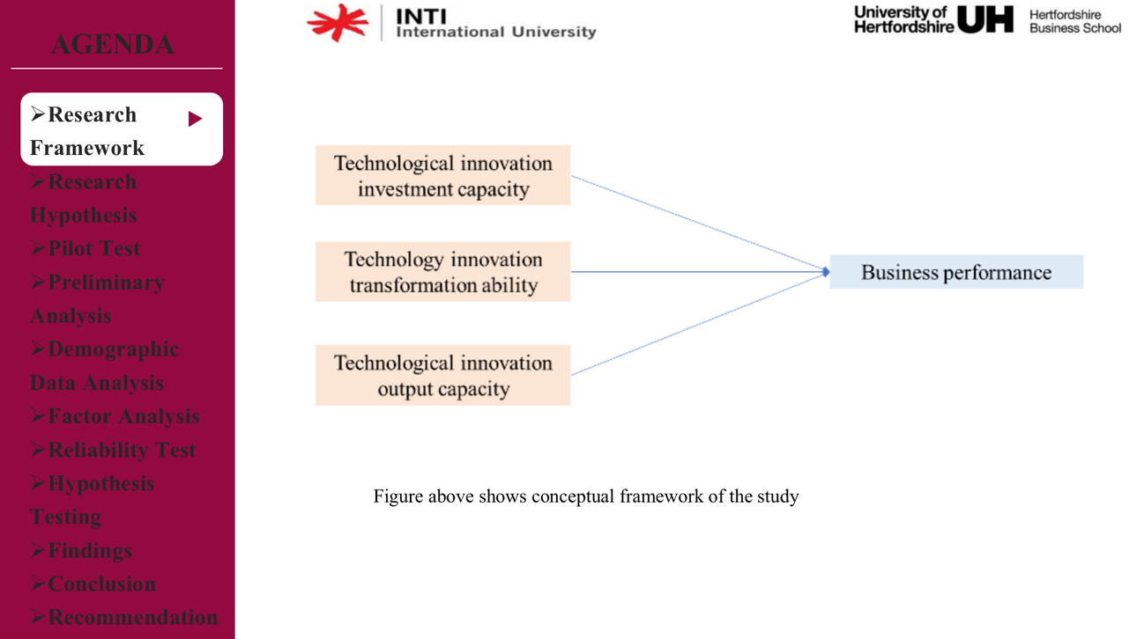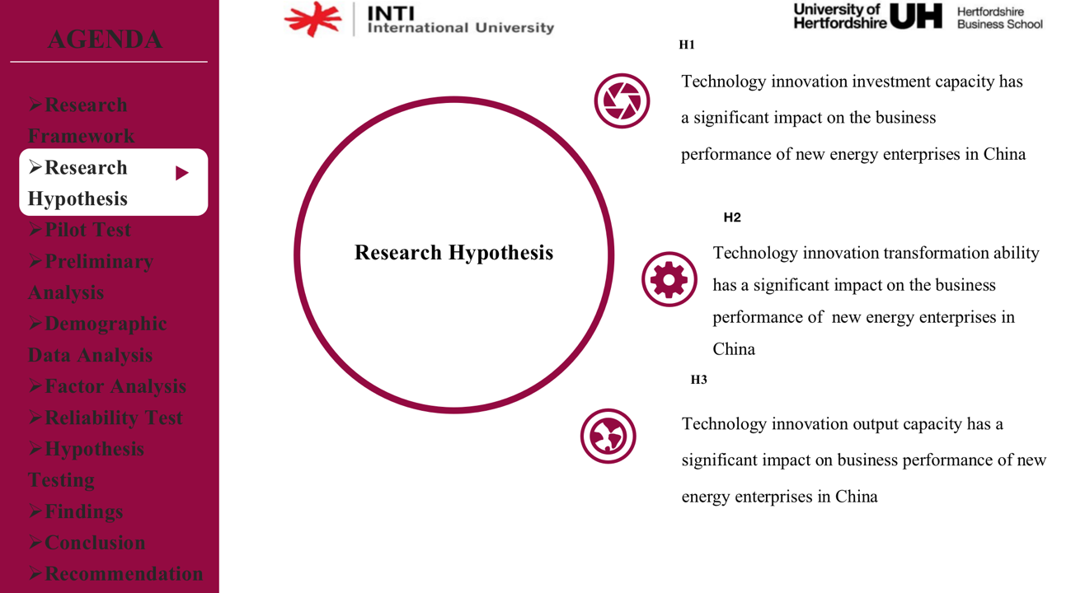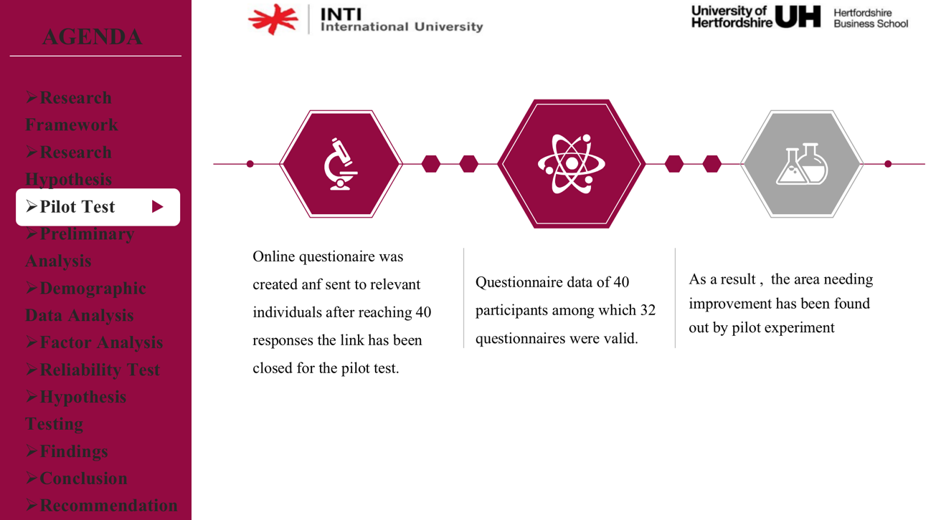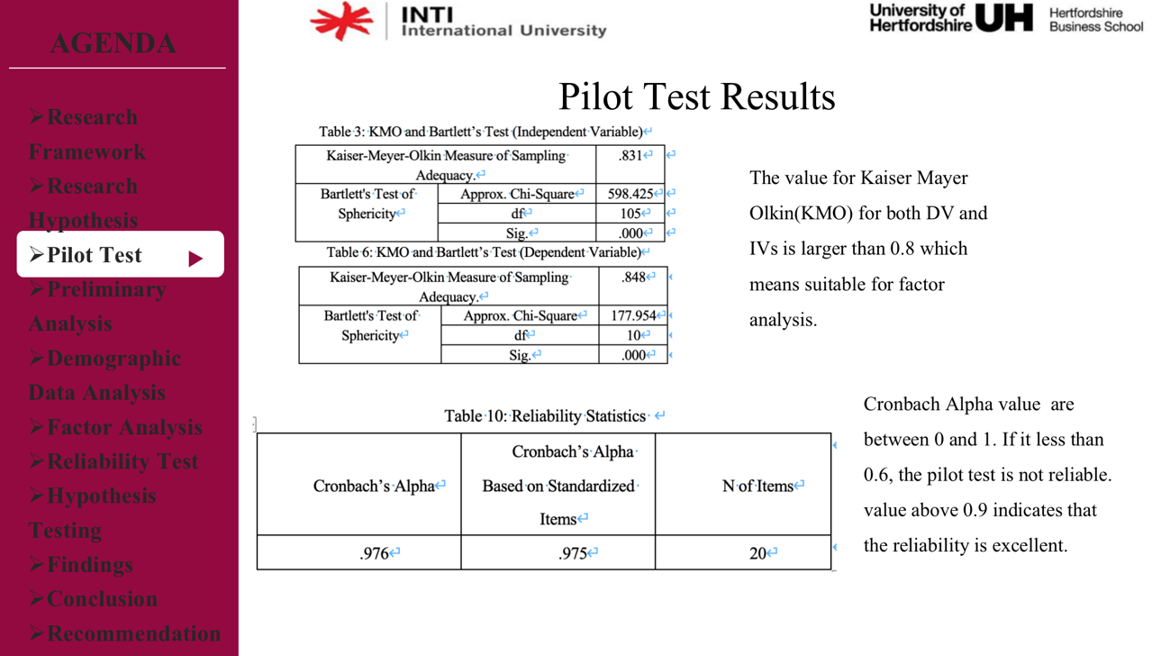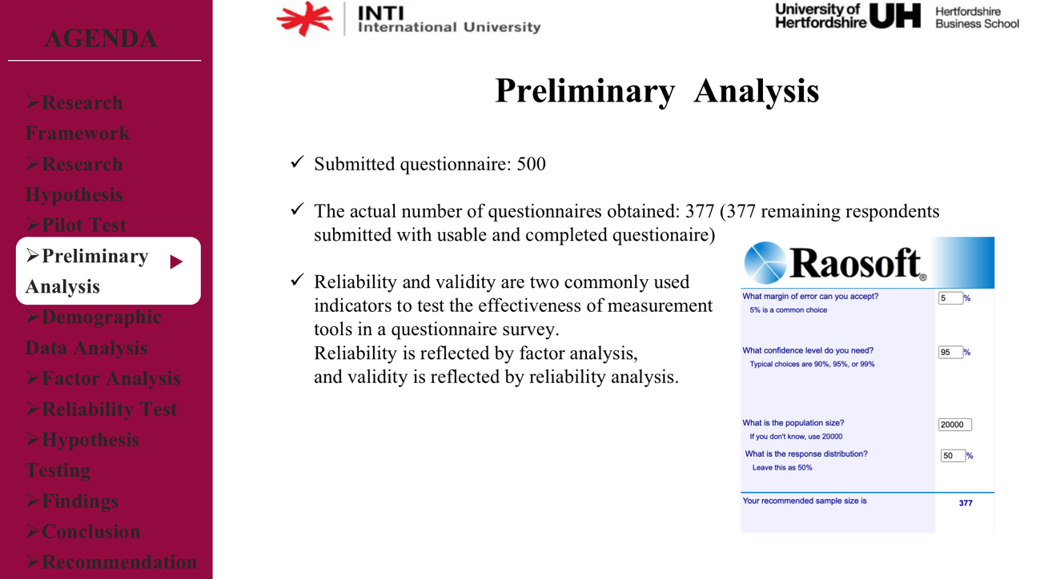
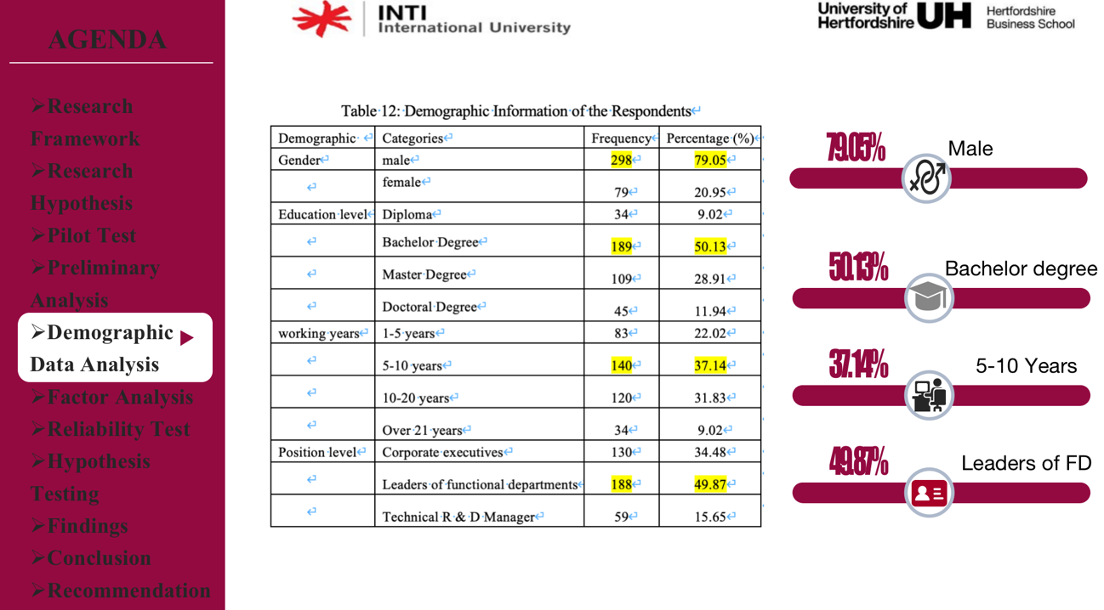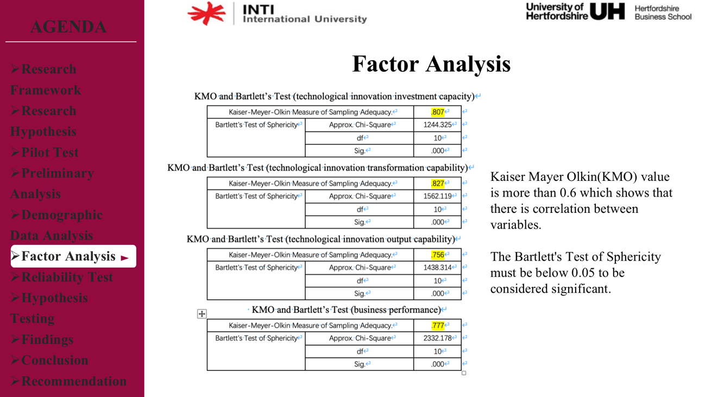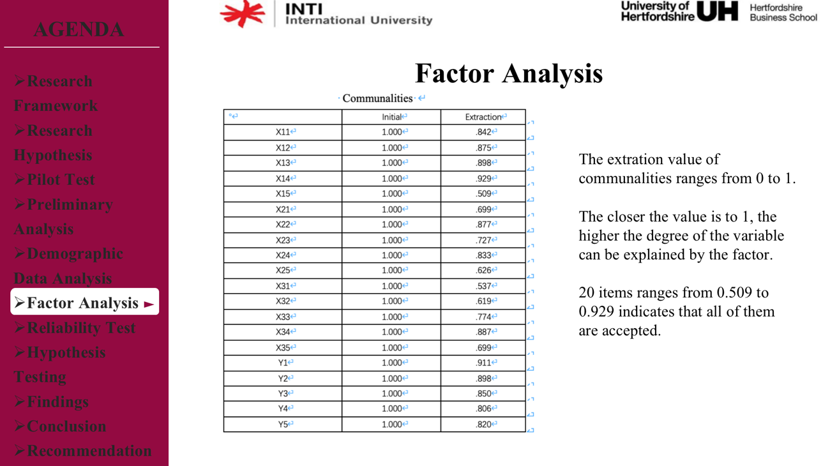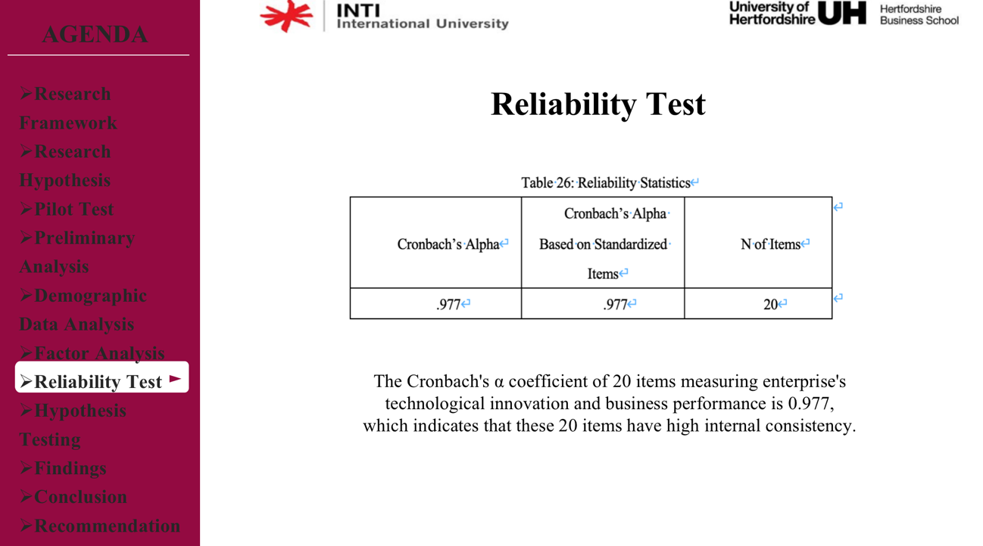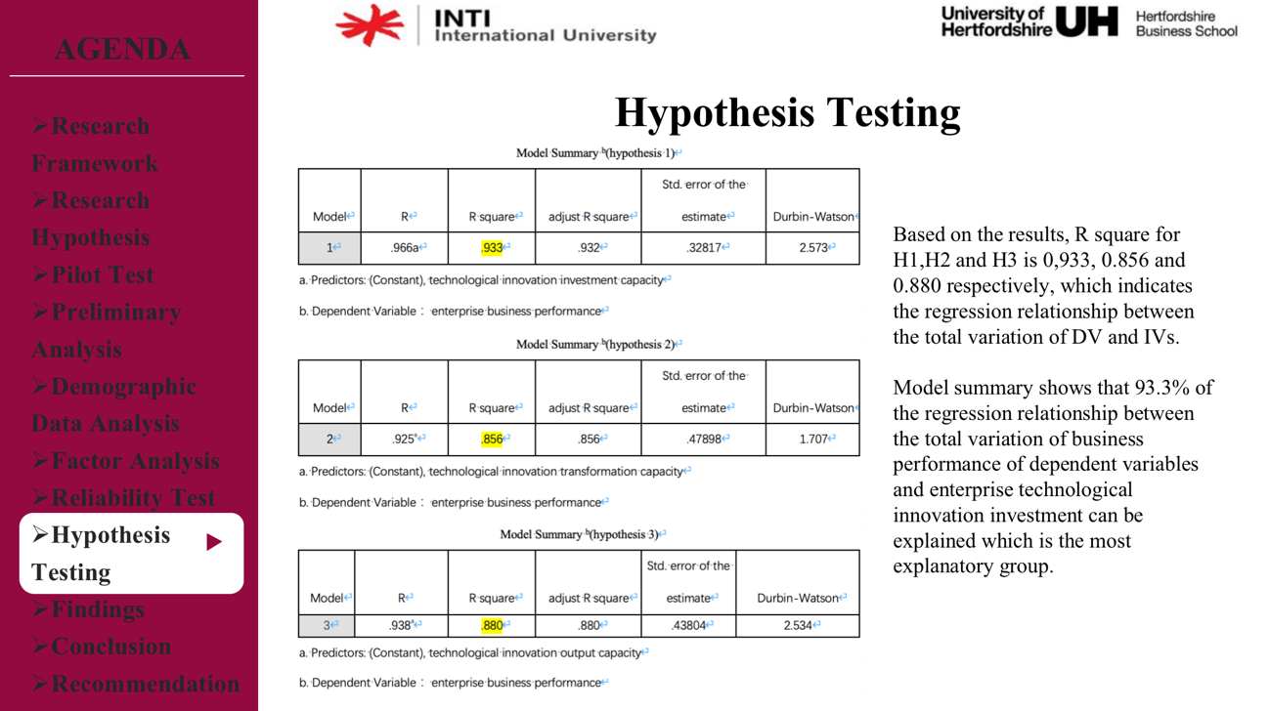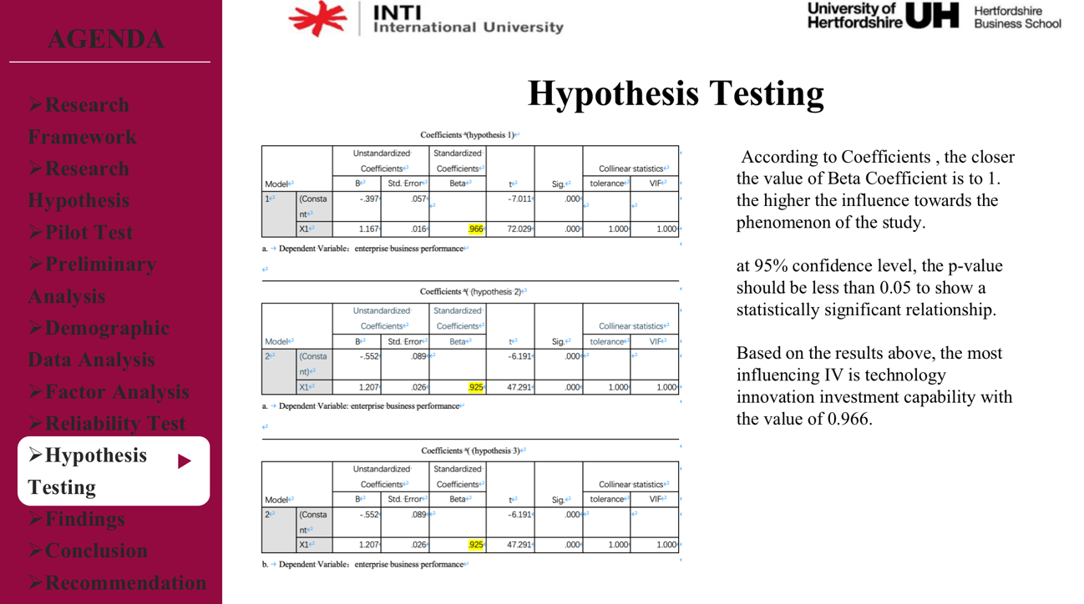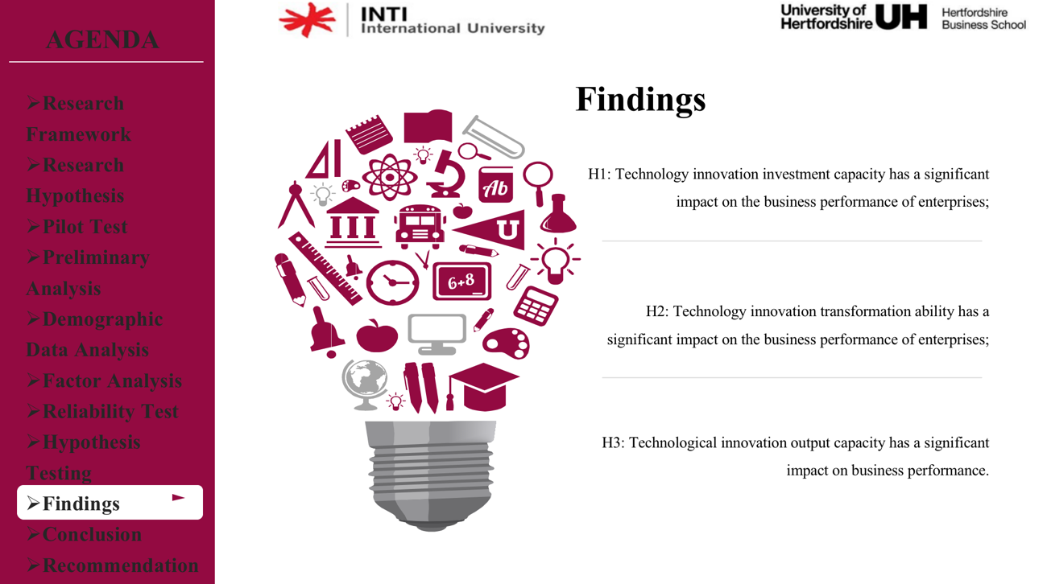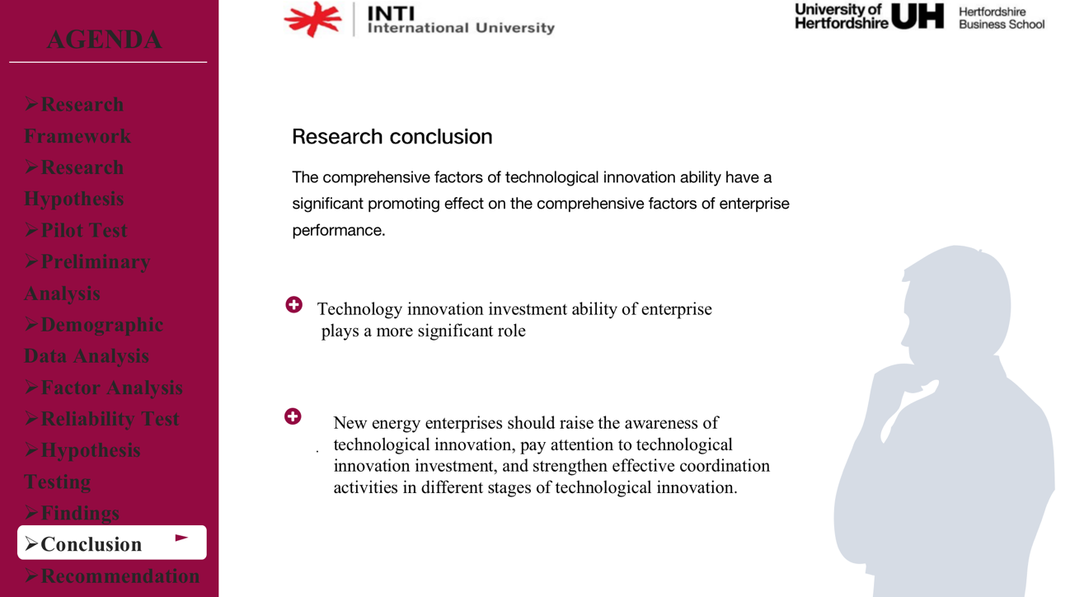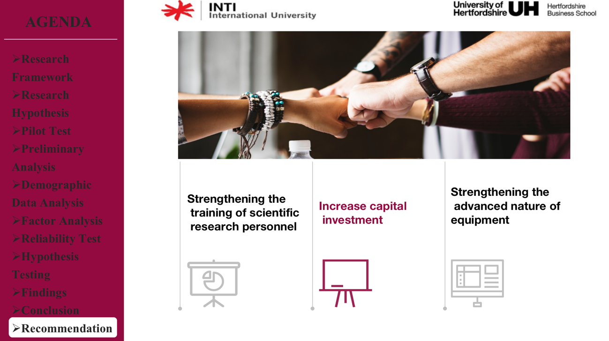

Appendix F. MBA Project Log
Student Name: | Wu Yaxun
Supervisor’s Name: | Ms. Umi Kalsom Kassim
Dissertation Topic: Impact of Technological Innovation Capability on Business Performance -- An Empirical Study Based on China New Energy Industry

SECTION A. MONITORING STUDENT DISSERTATION PROCESS

The plan below is to be agreed between the student & supervisor and will be monitored against progress made at each session.

Activity | Milestone/Deliverable Date
Discussing Research Topic | 22/9
Revision of IRRP plate |  | 28/9
Discussion on Research Framework |  |  | 05/10
Revision of Chapter 2 |  |  | 14/10
Discussing Research Methodology |  |  |  | 19/10
Review of Chapter 3 and Preparing for Proposal Defense |  |  |  | 30/10
Discussion on feedback from Proposal Defense |  |  |  |  | 04/11
The results and findings of research |  |  |  |  |  | 12/11
Preparation for VIVA defense |  |  |  |  |  | 20/11
Review of Chapter 5 |  |  |  |  |  |  | 30/11

SECTION B. RECORD OF MEETINGS

The expectation is that students will meet their supervisors up to seven times and these meetings should be recorded.

Meeting 1
Date of Meeting | 22nd September 2020
Progress Made | Discussing Research Topic
Agreed Action | Future clarification of research topic
Student Signature

Supervisor’s
Signature

Meeting 2
Date of Meeting | 28th September 2020
Progress Made | Revision of IRRP plate
Agreed Action | Adjusting Problem Statement, Research Objectives and Research Questions
Student Signature

Supervisor’s
Signature

Meeting 3
Date of Meeting | 5th October 2020
Progress Made | Discussion on Research Framework
Agreed Action | Literature on Framework, Independent Variables and Dependent Variable
Student Signature

Supervisor’s
Signature

Meeting 4
Date of Meeting | 14th October 2020
Progress Made | Revision of Chapter 2
Agreed Action | Future enrichment of Literature Review
Student Signature

Supervisor’s
Signature

Meeting 5
Date of Meeting | 19th October 2020
Progress Made | Discussing Research Methodology
Agreed Action | Adjusting and Editing Questionnaire
Student Signature

Supervisor’s
Signature

Meeting 6
Date of Meeting | 30th October 2020
Progress Made | Review of Chapter 3 and Preparing for Proposal Defense
Agreed Action | Adjusting Chapter 3 and determining content of slides
Student Signature

Supervisor’s
Signature

Meeting 7
Date of Meeting | 4th November 2020
Progress Made | Discussion on feedback from Proposal Defense
Agreed Action | Adjusting Chapter 1-3 based on feedbacks
Student Signature

Supervisor’s
Signature

Meeting 8
Date of Meeting | 12th November 2020
Progress Made | Discussion of Chapter 4
Agreed Action | The results and findings of research
Student Signature

Supervisor’s
Signature

Meeting 9
Date of Meeting | 20th November 2020
Progress Made | Preparation for VIVA defense
Agreed Action | Determining the content of the slides
Student Signature

Supervisor’s
Signature

Meeting 10
Date of Meeting | 30th November 2020
Progress Made | Review of Chapter 5
Agreed Action | Discussion on Recommendation and Conclusion
Student Signature

Supervisor’s
Signature

Section C. Comments on Management of Project
(to be completed at the end of the dissertation process)

Student Comments

During my MBA Project my supervisor had given me very helpful guidance and improve my skills in research. My supervisor helped me to learn valuable knowledge that would contribute to my future study.

Supervisor Comments

__________________________________________________________________________________

Signature of  Student | Date: 10/12/2020
Signature of  Supervisor | Date: 10/12/2020

Appendix G. TURNITIN Similarity Index
