
INTI INTERNATIONAL UNIVERSITY
MASTER OF BUSINESS ADMINISTRATION
MGT7998
MBA Proposal
The analysis of online package tour promotion impact on buying intention in Beijing, China

Author: Lu Yitong
Student No: I19016943
Supervisor: Dr. Ow Yong Mun Geet
Submission Date: 18December2020
Final Word Count:12207 words

Table of Content
Abstract 1
Chapter 1 Introduction 2
1.0 Background of Research 2
1.1 Online Tourism Booking Users Size Growth Rapidly 2
1.3 Problems Statements 3
1.3.1 Promotion Type Problems 3
1.3.2 Promotion Intensities Problems 4
1.3.3 Interaction Between Promotion Types And Intensities Problems 5
1.4 Research Objectives 5
1.5 Research Questions 5
1.6 Significance of Research 6
1.6.1 Theoretical Significance 6
1.6.2 Practical Significance 6
1.7 Scope of Research 7
1.7.1 Package Tours Research Scope 7
1.7.2 Target Respondent 7
1.8 Limitation of Research 8
1.9 Operational Definition 9
1.9.1 Independent Variables 9
1.9.2 Dependent Variable 9
1.9.3 Moderator Variables 9
Chapter 2 Literature review 10
2.0 Overview 10
2.1 Critical literature review 11
2.1.1 Research On Online Package Tour 11
2.1.2 Research On Promotion Type 11
2.1.3 Research On Promotion Intensity 11
2.1.4 Research on Buying Intention 11
2.1.5 Research On Promotion Impact Buying Intention 12

2.1.6 Research On Promotion Intensity Impact Buying Intention 12
2.1.7 Research On The Interaction Between Promotion Type And Intensity 12
2.2 Conceptual Framework 12
2.3 Fundamental Theory 13
2.3.1 Psychological Account Theory(mental theory) 13
2.4 Research Hypotheses 14
2.4.1 H1 Promotion Type Is A Significant Factor That Affecting Buying Intention 14
2.4.2 H2 Promotion Price Intensity Is a Significant Factor That Affecting Buying Intention 14
2.4.3 H3 Interaction between buying intention and promotion intensity is a significant factor 15
Chapter 3 Research Methodology 15
3.0 Research Method 15
3.1 Quantitative Research 15
3.2 Questionnaire Survey 16
3.3 Statistical Analysis 16
3.4 Data Collection 16
3.4.1 Target Population 16
3.4.2 Sample Size 16
3.4.3 Sample Procedure 16
3.5 Data Analysis 17
3.5.1 Pilot Test 17
3.5.2 Reliability Test 17
3.5.3 Validity Test 17
3.5.4 Normality Test 17
3.5.5 Non-parametric Test 18
3.5.6 Correlation Test 18
3.5.7 Multiple Regression Analysis 18
3.5.8 Two Way ANOVA Analysis 18
3.6 Ethical Consideration 19
Chapter 4 Data Analysis And Finding Discussion 19
4.0 Survey Plan Introduction 19
4.1 Data Analysis Test 20
4.1.1 Pilot Test 20
4.1.2 Normality Test Analysis 22
4.1.3 Non-parametric Tests Analysis 23
4.1.4 Cross Tab Correlation Analysis 24
4.1.5 Multiple Linear Regression Analysis 26
4.1.6 Two Way ANOVA(interaction) 28
4.1.6.1 China Domestic 5 days Package Tour 29
4.2 Hypothesis Result 32
4.3 Findings Summary 33
4.4 Introduction 33
4.5 Overall Findings Analysis 33
4.5.1 H1:Promotion Type Is A Significant Factor That Affecting Buying Intention 33
4.5.2 H2:Promotion Intensity Is A Significant Factor That Affecting Buying
Intention 34
4.5.3 H3:Interaction Between Promotion Type And Promotion Intensity Is A Significant Factor 34
4.6 Implication Of The Study 35
4.6.1 Practical Purpose 35
Chapter 5 Conclusion And Suggestion 36
5.0 Conclusion 36
5.1 Suggestion 37
5.2 Further Improvement 37
Reference 39
Appendix 1 Questionnaire 44
Appendix 2 Frequency analysis 45
Appendix 3 Meeting Record 47
Acknowledgment 57

Figure Page
Figure 1 User Size and Utilization Ratio of Travel Booking Jun. 2016 -
Jun 2019 - 2 -
Figure 2:Online Package Tour Impact On Buying Intention Model - 13 -

Table Page
Table 1:All Items Of Reliability Test Result - 19 -
Table 2:Each Item Of Reliability Test Result - 20 -
Table 3:All Items Of Validity Test - 21 -
Table 4:Each Item Of Validity Test - 21 -
Table 5:Normality Test Result Between Buying Intention And Promotion Intensity - 22 -
Table 6:NormalityTest Result Between Buying Intention And Promotion Type - 22 -
Table 7:Independent Mann Whitney U-test - 23 -
Table 8:The Correlation Between Promotion Type And Buying Intention - 24 -
Table 9:The Phi and Value Between Promotion Type And Buying Intention - 24 -
Table 10:The Correlation Between Promotion Intensity And Buying Intention - 25 -
Table 11:The Phi And Value Between Promotion Intensity And Buying Intention - 25 -
Table 12:Multiple Linear Regression Model Summary Between Promotion Type, Intensity And Buying Intention - 27 -
Table 13:ANOVA Analysis Between Promotion Type, Intensity And Buying
Intention - 27 -
Table 14:Coefficients Analysis Between Promotion Type, Intensity And Buying Intention - 27 -
Table 15:Interaction Between Promotion Type And IIntensity For China Domestic 5 Days Package Tour - 28 -
Table 16:Levene’s Test For China Domestic 5 Days Package Tour - 29 -
Table 17:Test Of Between-Subjects effect - 29 -
Table 18:Interaction Between Promotion Type And Intensity ForOutbound 15 days - 30 -
Table 19:Levene’s Test For Outbound 15 Days Package Tour - 30 -
Table 20:Test Of Between-Subjects Effects - 31 -
Table 21:The Illustration Of Hypothesis Result - 31 -
Table 22:Questionnaire - 43 -
Table 23:Frequency Table:The Illustration Of Hypothesis Result - 46 -
Abbreviation Page
OTA:Online Travel Agency - 2 -

Abstract
In recent years, the online tourism market became highly competitive. To attract consumers to buy their products, online travel agencies all use the promotion strategy to increase consumers' buying intention. Promotion refers to online travel agencies put forward low-cost packages tours to stimulate consumers' to buy package tours.
In this research, the author will use statistical methodology to examine two promotion types and promotion intensity affects buying intention. For promotion types, one is percentage promotion, for example, 50% and 20% off. Another one is cash reduction promotion. There have two levels for the promotion intensity, high and low, for example, 800 cash reduction and 50% off are high promotion, 200 cash reduction and 20% off is low promotion. The purpose of this study is to examine whether consumers' buying intention will be influenced by two promotion types and promotion intensity,and which promotion types and promotion price intensity can increase consumers’ buying intention. This thesis first reviews the literature on how promotion type and promotion price intensity influence buying intention respectively, and then constructs a conceptual framework, then defines the concepts of the online package tours, promotion type, promotion intensity as well as buying intention. Based on the Psychological account theory, this thesis combined with the characteristics of the two different types of online package tours, the moderator variable is package tours, there are two independent variables, promotion type and promotion intensity, the dependent variable is buying intention. Then the author uses first-hand data obtained from the online questionnaire to do the data analysis.

Key words:Online package tour,promotion type,promotion intensity,buying intention

Chapter 1 Introduction

1.0 Background of Research

1.1 Online Tourism Booking Users Size Growth Rapidly
According to the data provided by China Internet Network Information Center and China Business Industry Information Research Institute,as the figure 1 illustrated, from June 2016 to June 2019, the number of online travel booking users size reached 420 million, compared with June 2016, which increase 100 million, with a growth rate of 11.8%. The growth rate of online booking package tour users' size is the fastest. At present, China's OTA platform focuses on expanding the market share on package tours, and it realizes continuous and stable growth through package tours. Package tour booking tends to be normal, and the number of customers who book online is significantly more than that of traditional offline travel agencies. The mobile Internet, the APP application experience is constantly improved, and value-added content such as check-in and service reservation is implanted into it to meet the "efficient and personalized needs" for users and promote Internet users to use online booking package tours.
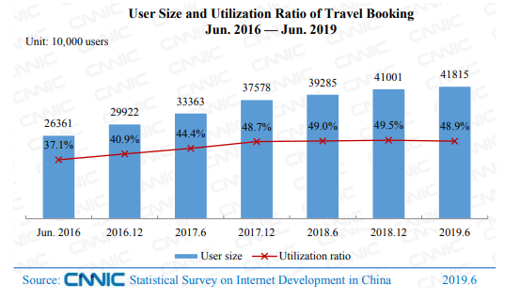
Figure 1 User Size and Utilization Ratio of Travel Booking Jun. 2016 — Jun. 2019
1.2 Promotion War Between Online Tourism Platforms
Online booking is still the mainstream way for tourists to book package tours through professional tourism websites and apps. At the same time, consumers care about promotion type and promotion intensity before they decide to buy the package tour. Online tourism platforms have launched large-scale promotional activities such as cash reduction or percentage promotion for different package tours, which are very attractive. High promotion intensity attracts customers' attention to buy package tours has become one of the marketing strategies. It is inevitable for OTA to compete in the market by making profits. When the demand for its growth rate exceeds the actual growth rate of its users, will inevitably face promotion wars. For example, some online tourism platforms launch "tourism membership promotion day", which covers thousands of products from different travel agencies on the platform, the maximum reduction can exceed 1000 RMB. The promotion activities include package tours and other major tourism products. Customers can visit the "membership day" page to buy products, they can get cash reduction or 20%-50% off respectively.

1.3 Problems Statements

1.3.1 Promotion Type Problems
In this research, promotion types are divided into cash reduction and percentage promotion. Cash reduction refers to that when customers buy package tours online, the travel agency will directly reduce the price, or refund part of the package tour fee based on the original price. Percentage promotion refers to a 50% or 20% discount based on the original price. Before the online travel agency carries on promotion, the travel operation will formulate package tours promotion price to attract the consumer to buy the product. However, due to the lack of in-depth research and data analysis on promotion types, online travel agencies are not sure which package tours should be applied for different promotion types. The different types of promotion for different package tours will have a certain impact on consumers' buying intention. Through the analysis from OTA platforms promotion activities, the author found that most online travel agencies use the same promotion type for different package tours. However, this will lead to many problems involving cost waste, and unreasonable promotion types will reduce the profits.Therefore,whether there are differences in the effect of different promotion types for different package tours; based on different products, how consumers will react to these two main forms of promotion types, whether promotion types will impact on consumers' buying intention should be examined.

1.3.2 Promotion Intensities Problems
In this research, the promotion intensities are divided into high and low. High promotion refers to the reduction of the highest promotion on the basis of the original price by the online travel agency when customers buying package tours. Before the online travel agency carries out product promotion activities, travel operators will make different intensities according to the different package tours to attract consumers to buy. However, due to the lack of in-depth research and data analysis on the promotion intensities, online travel agencies are not sure which products should be applied for different promotion intensities. However, the different promotion intensities of different package tours will have a certain impact on consumers' buying intention. Through analysis, the author finds that most travel agencies use the highest promotion intensity for different package tours. The unreasonable promotion will reduce the profits of travel agencies, but orders will not increase. Therefore, whether there are differences in the effect of different promotion intensities for different products; based on different package tours, how consumers will react to these two main forms of promotion intensities, whether promotion intensities will impact consumers' buying intention should be examined.

1.3.3 Interaction Between Promotion Types And Intensities Problems
Due to the lack of in-depth research, data analysis and relevant experience on the interaction between promotion types and intensities, the operators of online travel agencies do not know what promotion intensities should be matched with different promotion types for different package tours. However, the interaction between different promotion types and intensities will affect consumers' buying intention. Through the analysis, the author found that most of the online travel agencies can not apply the interaction flexibly , they only use a single promotion type and intensity for all package tours, which will bring negative impact on enterprises' business.There fore,it is necessary to examine the interaction between promotion types and intensities.

1.4 Research Objectives
The author does this research mainly for four purposes:
First, the author will examine whether two promotion types, percentage and cash promotion will affect consumers’ buying intention through data analysis.
Second, the author will examine whether two promotion intensities, high and low will affect buying intention through data analysis.
Third, the author will examine the interaction between two promotion types and promotion intensities affect on buying intention through data analysis.
Fourth,the author will provide some suggestions for online travel agencies and operators to design promotion package tours more reasonably and effectively according to the analysis result.

1.5 Research Questions
1. Does promotion type is a significant factor that affects buying intention?
2. Does promotion intensity is a significant factor that affects buying intention?
3. Does interaction between promotion type and promotion intensity of package tour is a significant factor?

1.6 Significance of Research

1.6.1 Theoretical Significance
Because of the rapid growth of online tourism, which has brought new opportunities for the development of online tourism business. However, the promotion from online travel agencies also brings a series of problems. At present, scholars' research on the promotion impact online package tours is insufficient, and the empirical research on the promotion is relatively lacking, which can not provide complete theoretical support for a series of existing problems. Therefore, based on the framework and psychological account theory, this thesis analyzes the impact of online package tour promotion on tourists' buying intention, and obtains first-hand data by questionnaire survey, and conducts the empirical test, to enrich and develop research in the future.

1.6.2 Practical Significance
With the rapid development and popularity of the Internet, which changed people's attitudes towards online consumption, the number of Internet users who buy package tours online will continue to increase, and the online tourism market will continue to develop rapidly. But, because the operators from the OTA platform have no research on the promotion type, intensity and buying intention. They do not know and have no experiences in how promotion can affect consumers' buying intention, they only follow the promotion type and intensity from other platforms, this kind of promotion can not help the OTA's to increase their long-term sales growth, and also can not solve the fundamental problems of marketing. As a result, the price of package tours is difficult to improve and recover, which will resulting in the reduction of profits. And the long-term price reduction will damage the brand image, then leads to false prosperity of the market and misleads the marketing decision of OTA. Therefore, there will have a promotion war. Because of this, this thesis examines the interaction between promotion types, promotion intensity and buying intention, then provides some suggestions for online tourism enterprises.

1.7 Scope of Research

1.7.1 Package Tours Research Scope
In this research, online package tour is defined as tourism products that can be booked online via PC terminal or mobile terminal, including group tour package and destination local products, excluding individual air tickets, hotels, air tickets plus single hotels booking, and high-end or customized vacation tourism products.（Zhang Rongjie,2015）Online package tours are divided into two categories: one is a domestic short distance tour in Shanghai for 5-day and an outbound long distance tour for America and Canada for 15-day. According to the "2018 tourism trend report" released by China Tourism Statistics Center, Shanghai was the most popular tourist cities in China. The United States and Canada package tour ranked second popular outbound long-distance tours. Therefore, the author selects Shanghai as the domestic short-distance tour destination and the US and Canada lines as the outbound long distance tour destinations. By browsing the actual tourism products displayed on online travel websites, this research defines the domestic short distance tour as Shanghai five-day tour and selects the middle price level of the same package tour in the market; defined the outbound package tour as 15-day long distance tours in the United States and Canada and selected the medium price level of the same package tour in the market.Further more, half of the tourists fond of package tours, because package tours can save a lot of money and time.

1.7.2 Target Respondent
According to the report of Beijing Tourism Big Data 2017, under the fast-paced working, most people from Beijing are fond of 3-5 days short distance and 10-15 outbound long-distance package tour. Shanghai is their favorite tourist destination. The reason why the author select Beijing as the target city because people from Beijing are easy to obtain a visa from different countries, more and more people are willing to travel. Furthermore, Beijing ranked the second city with a great number of outbound tourists in China, with a high growth rate and high consumption capacity, and the number of outbound tourists per year exceeds 1-2 million.

1.8 Limitation of Research
In the process of writing, although the author reviewed a lot of previous research results and related research reports, due to the research conditions, personal capability, limitations of data collection and other issues, there are still many deficiencies in this study. The author is hoping research can be combined with the development of online tourism enterprises for further improvement.
(1) Limitations of package tour types, promotion types and intensities
This research selects the two package tours as the classification standard and divides the package tours into a domestic 5 days short distance and a 15 days long-distance outbound package tour. Although the different package tours will impact product type and intensity. If research starts from the angle of product types, it may play a more significant role in regulating the promotion. However, due to the limited academic ability, there is no evidence to classify tourism products.
There are only two promotion types, percentage discount and cash reduction, two promotion intensity, low (20%) and high (50%) were considered. However, in practice, there are various promotion types and intensities, and different tourists have a different perception of different level.
(2) Software and model limitation
Some theories and methods can not be realized in SPSS and need to be analyzed by other software in future research.

1.9 Operational Definition
According to the research content of this research, the variables are divided into three, moderator variable, independent variable and dependent variable. Among them, the moderator variable is divided into two aspects: the China domestic 5 days package tour and the outbound 15 days package tour; the independent variable is the promotion type and promotion intensity. The promotion type is divided into cash reduction and percentage promotion. The promotion intensity is divided into high and low; the dependent variable is the buying intention. The change of one variable may cause the change of other variables.

1.9.1 Independent Variables
(1)Promotion type: in this research, it refers to the entire set of activities, which communicate the product, brand, or service to the user. To make consumer aware, attract and induce to buy the product, include:200rmb,800rmb cash reduction,50% and 20% off percentage promotion.
(2)Promotion intensity: in this research, it refers to the preferential level given to consumers by online travel agencies, include high discount 50% off and 800 RMB cash reduction, and low discount 20% off and 200 RMB cash reduction.

1.9.2 Dependent Variable
Buying intention definition: in this research, it refers to the probability, the willingness and inclination of consumers to buy package tours.

1.9.3 Moderator Variables
Online package tour definition: China 5 days package tour; Outbound 15 days package tour which can book from online travel agencies.
Organization of chapter
(1)Chapter one begins with the research background of the factors that influence buying intention among online package tour in Beijing. It then comes with the problem statement to derive the research objective and research questions. After that, is significant of research has indicated to know who is going to benefited in this research and the scope of the study will be listed too. Before ending, there will be the proposed chapters written to see what the following contents are.
(2)Chapter two starts with the introduction on defining the topic of independent variables, moderator variable and dependent variable. A critical literature review will be done here to understand each variable well. Then, one related theory will be identified to better understand the research. After that will introduce the hypothesis. Before the summary is written, there will be a valid research framework derive from this study.
(3)Chapter three starts with research methodology and instrument, and ethical consideration. Thus, the research equation will be used to indicate and calculate the data in a systematic way.
(4)Chapter four is data analysis, to understand the result of the study which later transforms it into the hypothesis result to support further research.
(5)Chapter five is the discussion of the findings based on the research. After that, is the implication of the study. Last, it comes with recommendations for future research.

Chapter 2 Literature review

2.0 Overview
This thesis uses "promotion " and "buying intention" as the keywords to search academic journals in the Elsevier Science Direct electronic journal database, there has more than 100 related literature is obtained. Based on these research results, this thesis analyzes and summarizes the research on promotion, buying intention and promotion type and intensity impact on consumers' buying intention to show the research status.

2.1 Critical literature review

2.1.1 Research On Online Package Tour
Online package tours play an important role in the field of consumer buying intention. Consumers have different views on different types of the package tour, which leads to different effects of buying intention. In this research, package tours can be classified according to different classification standards. Because the distance of package tour determines the price to a certain extent and divides the online package tour into domestic short distance tourism and outbound long-distance tour. （Zhang Rongjie,2015）

2.1.2 Research On Promotion Type
The description of the same promotion information in different ways may make consumers have different cognition, which leads to different buying intentions. There are two logically similar descriptions for the same scheme, which will lead to different decision-making judgments. Therefore, the promotion of different types will have a different impact on buying intention. (Monroe,1980)

2.1.3 Research On Promotion Intensity
Gupta and Cooper (1992), Harlam et al. (1995) respectively studied that consumers determine the attractiveness of promotion and the actual saved currency through the promotion intensity. By setting promotion intensity, OTA can present promotion high and low, which will affect consumers' perception of promotion and change consumers' willingness to buy products. Gupta and Cooper (1992) believed that when the promotion is more than 20%, consumers will change their buying decisions.

2.1.4 Research on Buying Intention
Buying intention is a kind of decision-making that studies the reason to buy the product by the consumer (Shah et al., 2012).

2.1.5 Research On Promotion Impact Buying Intention
In the 1960s, there was a study on the impact of promotion on consumers' buying intentions. The main research contents are divided into two parts: the influence of promotion types, promotion intensities. Heath T. B, et al. (1995) considered that under a high price promotion intensity, the perception of cash reduction was higher than that of percentage.

2.1.6 Research On Promotion Intensity Impact Buying Intention
Mukherjee, A. et al. (2016) considered that promotion intensity directly affects buying intention. Gupta et al. (1992) believed that consumers are sensitive to the promotion intensity.

2.1.7 Research On The Interaction Between Promotion Type And Intensity
Different types and intensities of promotions have different effects on consumers (Grewal, 1998). Gupta et al.（1992）believed that consumers' sensitivity to high cash reduction and high percentage promotion. The interaction between the promotion type and intensity of different products can cause changes in consumers' buying intention.

2.2 Conceptual Framework
Consumers' buying intention is formed under the influence of the package tour promotion . Before buying a package tour after seeing the promotion details, consumers will evaluate and select the promotion of the package tours, and form their buying intention under the psychological account theory. The main effect of promotion on buying intention is in the stage of evaluation and selection. Different promotion types and intensities will have different effects on buying intention. Therefore, this research selects the promotion type and intensity as the independent variables, the package tour as the moderator variable, buying intention as the dependent variable. Based on psychological account theory, this research constructs a model of the impact of online package tour promotion impact on buying intention, as shown in Figure 3:
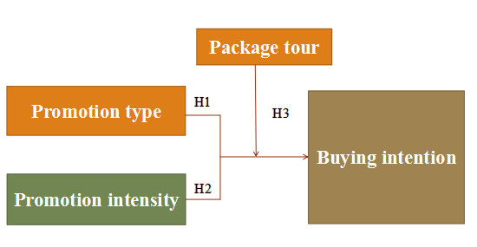
Figure 2 online package tour impact on buying intention model

2.3 Fundamental Theory

2.3.1 Psychological Account Theory(mental theory)
In this research, psychological account theory(mental theory) refers to when consumers see the package tour promotion online, they will compare to the promotion type and intensity, what going on in their mind will affect their make decision buy or not buy. Consumer response to the promotion includes absolute value promotion and relative value promotion(Chad Saller 1985)
Absolute value promotion refers to direct cash reduction. For example, the Shanghai package tour is directly reduced by 200 yuan or 800 yuan in cash; while the relative value promotion refers to the percentage discount, for example, 15 days USA and Canada package tour, consumers can get 50% or 20% off. There is a big difference between consumers' experience of absolute value and relative value promotion, and there is a regular pattern: when the origin price of a package tour is high, consumers are more sensitive to absolute value promotion than relative value. When the origin price of a package tour is low, consumers are more sensitive to the relative value promotion than absolute value promotion.

2.4 Research Hypotheses

2.4.1 H1 Promotion Type Is A Significant Factor That Affecting Buying Intention
In this research, the form of promotion includes cash reduction and percentage promotion. Research shows that ，consumers often rely on price as an important basis for measuring goods and making buying intention (Gao Xiaoqian,2012).
Zeithaml also shows through a large number of studies that consumers are more likely to buy a product if the type of promotion is attractive to consumers. If the same promotion can be described in different ways, which may lead to different cognition of buying intention. Previous studies have also pointed out that the price of products will also have an impact on the effect of promotion patterns. Relevant research shows that under the same promotion intensities, for low-cost products, the cash promotion will make consumers can increase consumers' buying intention than the percentage promotion. When consumers face high price products, in this research, high price product means outbound 15 days package tour, consumers are more sensitive to cash reduction because they can directly know the total amount saved under cash reduction. Therefore, compared with the percentage discount, consumers have stronger buying intentions. When consumers face low price products, in this research, low price product means China domestic 5 days package tour, consumers are more sensitive to percentage promotion. This research selects different online package tours as the classification standard, and different package tours determine the promotion.

2.4.2 H2 Promotion Price Intensity Is a Significant Factor That Affecting Buying Intention
Previous studies show that the factor that affects consumers' buying intention is not only promotion types(Gupta & Cooper, 1992). Promotion is a part of the package tour, the basic clues for consumers to evaluate their psychological account(Olson and Jacoby, 1972). Grewal et al. Pointed out, promotion intensities change will affect consumers' buying intention (Grewal,D.,1998). Gao Xiaoqian (2012) verified that promotion intensities are related to buying intention, and there has a significant difference . Miao Shuyun (2013) believes that the promotion intensities has a positive correlation with buying intention and its significant impact on buying intention.

2.4.3 H3 Interaction between buying intention and promotion intensity is a significant factor
Research shows that the interaction between promotion types and promotion intensities will affect consumers' psychological account evaluation about the promotion and have a significant impact on consumers' buying intention (Gupta & Cooper, 1992)

Chapter 3 Research Methodology

3.0 Research Method

3.1 Quantitative Research
Quantitative research is generally conducted to obtain statistical results for the whole of a specific research object. It has the characteristics of exploration, diagnosis and prediction. It does not pursue accurate conclusions, but only understands the problem, finds out the situation and obtains perceptual knowledge. In quantitative research, information is represented by number. When processing and analyzing these figures, it is necessary to define the scale on which the information is measured and processed. S. S. Stevens divides the scale into four types: nominal scale, ordinal scale, spacing scale and ratio scale .(Paolo Brandimarte,2011)

3.2 Questionnaire Survey
This research uses questionnaires to collect data. The questionnaire is divided into two section: basic personal information of respondents, the related items of the study on the impact of online package tour promotion on buying intention. The contents of each part are as follows:
First part: background introduction of this survey. The purpose and significance of the investigation are mainly explained to the respondents. Please fill in the survey at ease.
The second part: questions about promotion type and intensity impact buying intention. The package tours of 1 moderator variable (domestic 5 days tour and outbound 15 days tour) and 2 independent variables are promotion types (cash, percentage ), promotion intensities (high and low)

3.3 Statistical Analysis
The first-hand data is sorted out and analyzed by the statistical analysis method. In this paper, SPSS 21 software was used to analyze the data.

3.4 Data Collection

3.4.1 Target Population
The target population for a survey is the entire set of units for the survey data are to be used to make inferences. The target population defines those units for which the findings of the survey are meant to generalize(Paul J. Lavrakas,2008).In this research, the target population, people above 18 years old live in Beijing at present.

3.4.2 Sample Size
It refers to the number of units that were chosen from which data were gathered(Paul J. Lavrakas,2008).In this research, Sent out 400 questionnaires, collected 254 samples with 4 spoiled samples.

3.4.3 Sample Procedure
Convenience sampling. Convenient sampling, also known as "random sampling", refers to the sampling method in which investigators choose samples according to the principle of randomness. It can be seen that a random survey is completely based on the random sample selected by the investigators. Random sampling is the most convenient, cost-effective and time-saving method. Generally speaking, the random sampling method is often used in preliminary market surveys or when the survey situation is not clear. (Paul J. Lavrakas,2008)

3.5 Data Analysis

3.5.1 Pilot Test
As a traditional research method, a pilot test (also known as a cognitive test) is used to develop quantitative survey projects, which test the appropriateness of the questionnaire before full data analysis(Justice,Nambiar and Tchkonia et al.,2019),as well as reliability and validity of the items.(Saunder,Lewis and Thornhill,2019)

3.5.2 Reliability Test
It refers to test the consistency of the results obtained by repeated measurement of the same object with the same method, that is, the degree of reflecting the actual situation.(Wu Minglong, 2010)

3.5.3 Validity Test
It refers to the degree to which measuring tools or means can accurately measure the things to be measured. Validity refers to the degree to which the measured results reflect the content to be investigated. The more consistent the measurement results with the content, the higher the validity; otherwise, the lower the validity.(Wu Minglong, 2010)

3.5.4 Normality Test
It refers to judge whether the population obeys the normal distribution by using the observation data, which is an important special test in statistical judgment. Commonly used methods include is Shapiro Wilktest .(Asghar Ghasemi,Saleh Zahediasl,2012)

3.5.5 Non-parametric Test
The non-parametric test is an important part of statistical analysis methods, it tests the distribution of the population by using sample data when the population variance is unknown. Because the non-parametric test method does not involve the parameters of population distribution.(Morten W Fagerland,2012)

3.5.6 Correlation Test
It refers to the test whether two or more variable correlates, to measure the degree of correlation between two variable factors. Correlation analysis can be carried out only when there is a certain connection or probability between the relevant elements.Correlation does not equal causality.(Wu Minglong, 2010)

3.5.7 Multiple Regression Analysis
Multiple Regression Analysis is a statistical method that uses several independent variables to predict the outcome of a dependent variable. The goal of multiple linear regression is to model the linear relationship between the independent variables and the dependent variable(Wu Minglong, 2010)

3.5.8 Two Way ANOVA Analysis
In statistics, analysis of variance (ANOVA) is a set of statistical models used to distinguish the observed variance and its components in a specific variable. In its simplest form, ANOVA provides a statistical test of whether the average of an array is equal or not. Two way ANOVA can determine the differences and possible interactions of variables when presented from the perspective of two or more categories. When performing two-way ANOVA, it enables to compare variables produced by independent or combined actions.(Mac Farland, Thomas W,2012)

3.6 Ethical Consideration
(1) All respondents who participate in this research are voluntary. Besides, participants have the right to withdraw from the study at any stage if they wish.
(2) When preparing questionnaires, interviews, focus group questions, aggressive, discriminatory or other unacceptable language will be avoided.
(3) Privacy and anonymity or interviewees are the most important.
(4) There is no conflict of interest. Any form of communication related to research is conducted honestly and transparently. No misleading information and biased presentation of raw data.

Chapter 4 Data Analysis And Finding Discussion

4.0 Survey Plan Introduction
In this thesis, the author used 4 days to collect data. Gave out 400 questionnaires, there has 254 questionnaires were collected, 4 spoiled, questionnaires. And the effective rate was 100%. This research followed two principles to eliminate invalid questionnaires: (1) there is an obvious contradictory answer; (2) the answer time of the questionnaires is less than 10 seconds. (3)Do not fill in all questions. After received all questionnaires, a pilot was conducted to measure the reliability and validity of the questionnaire design. Then, according to the results of reliability and validity analysis, the items with low reliability and validity are modified or eliminated to improve the questionnaire design.
The data were analyzed using IBM SPSS 21 software to examine the hypothesis results. The questionnaire includes age (1 for 18-31, 2 for 31-40, 3 for 41-50, 4 for more than 50); gender (1 for female, 2 for male); promotion type and promotion intensity of 2 different types of package tours (0 means that purchase intention is not affected respondent to buy the package tour, 100 means that purchase intention significantly affected respondent to buy the package tour). Through used SPSS statistical software to analyze data, to examine the relationship between each variable.

4.1 Data Analysis Test

4.1.1 Pilot Test
Reliability test analysis
This methodology is to test whether the questionnaire reliable,consistent,stable or not. The most commonly used method of reliability analysis is the attitude coefficient. Therefore, this research analyzed the reliability of the questionnaire by using Cronbach's alpha coefficient method. If the Cronbach's alpha coefficient of the total scale is above 0.9, it means that the reliability is very good; if the figure of Cronbach's alpha coefficient between 0.8 and 0.9, it means that it is good; if it is between 0.7 and 0.8, acceptable, it means that some items need to be corrected; if it is below 0.7, it means that some items need to be eliminated. The author selected all items to conduct a reliability analysis. (George and Mallery,2003)The results obtained by SPSS 21 statistical software are as follows:
Through the reliability test,as the table 1illustrated,it can find that the figure of Cronbach's alpha coefficient of the promotion type and promotion price intensity on purchase intention questionnaire are 0.886, as the table 2 illustrated,each item is greater than 0.83, which indicates that the questionnaire items are well designed.The original questionnaire design is retained.
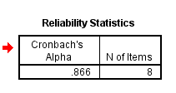
Table 1:All items of reliability test result
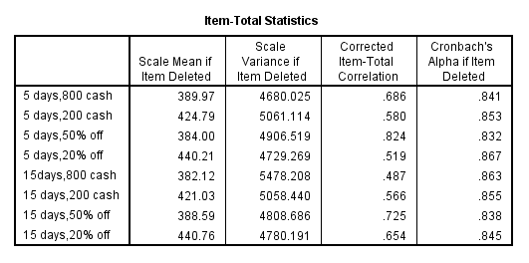
Table 2:Each item of reliability test result

Validity test Analysis
Validity test is to test sample adequacy and test the factor.It includes content validity and structure validity. Content validity is a measure of the applicability of the questionnaire items to the relevant content, which is generally established by the more qualified judges to evaluate the measurement in detail and systematically. The measured results reflect the degree of content that examined,the more consistent the measurement results with the investigation contents, the higher the validity. On the contrary, the lower the validity.In this research,the questionnaire items are based on the experience of domestic and foreign scholars and theory in setting questionnaire questions and discussion with supervisor. Therefore, the measurement scale of variables in this research has high content validity.
Structural validity is test whether the measurement results can confirm or explain the hypothesis of a certain theory, and the degree of interpretation. Factor analysis is an ideal method to measure the construct validity of the scale. Through reading the relevant literature, it can be seen that only when the data pass the KMO and Bartlett test, the author can continue to do factor analysis. The following measures are generally used to define the test values of KMO and Bartlett. The value of KMO is above 0.9, which indicates that it is very suitable for factor analysis; 0.7-0.8 suitable; 0.6-0.7:acceptable;0.5-0.6 means poor; below 0.4: should give up(Vogt, W.P. ,2005). The results are shown in the table below:
As table 3 illustrated that the KMO is 0.767 and each item is greater than 0.4,the significance level of Bartlett's is 0.000 (< 0.01). The total variance explained rate is higher than 50%, which is acceptable. So the test items have good difference and high validity, which is suitable for further analysis.
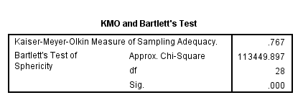
Table 3:All items of validity test
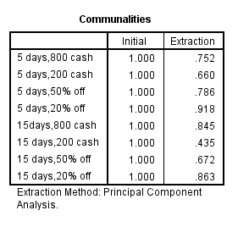
Table 4:Each item of validity test

4.1.2 Normality Test Analysis
A normality test is used to determine whether sample data has been drawn from a normally distributed population (within some tolerance). Many statistical processes depend on normality, which is the premise of parameter statistical analysis. Generally speaking, when testing the normality of data, most of the data will reject the hypothesis of normal distribution. As long as the data sample is large and the data is close to the normal distribution,α>0.05 it is acceptable(Asghar Ghasemi , Saleh Zahedia,2012)
However, as table 5 and 6 illustrated,the population did not normally distribute, as the p-value is 0.00 and 0.00 respectively, which is less than α(α>0.05). Thus the author should adopt another methodology to forward the next step analysis, that is Mann Whitney U-test which is a non-parametric test to conduct analysis. The non-parametric test does not make a strict assumption for normal distribution, and this method does not involve population parameters.
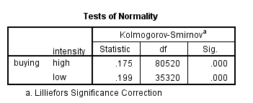
Table 5:Normality test result between buying intention and promotion intensity
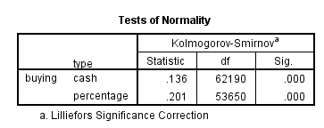
Table 6:Normality test result between buying intention and promotion type

4.1.3 Non-parametric Tests Analysis
A non-parametric test is a kind of methodology based on this kind of consideration, in the case of unknown or little known population variance, using sample data to infer the distribution of the population. Because the non-parametric test does not involve the parameters of population distribution in the inference process, it is called the "non-parametric" test. Non-parametric tests serve as an alternative to parametric tests.Non-parametric tests include several tests.In this research, the author selected the most common tests to conduct data analysis: Mann Whitney U test is a non-parametric form of independent sample t-test.
As table 7 illustrated p-value=0.000<0.05, which indicates that we reject the Null hypothesis. The author used an accurate p-value to judge the hypothesis. here has statistical difference between the promotion intensity and promotion type.(N. Uttam Singh, Aniruddha Roy & A. K. Tripathi ,2013)
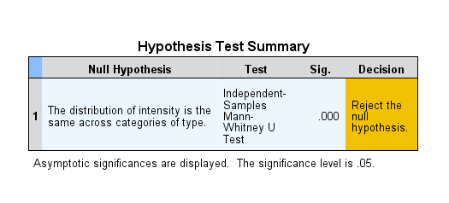
Table 7:Independent Mann Whitney U-test

4.1.4 Cross Tab Correlation Analysis
Cross tab correlation test is a quantitative method to examine the correlation between independent variable and dependent variable close or not close,whether there has relationship between the two variables.Different from Pearson correlation test,it test for ordinal independent variable,Pearson is for nominal.((Stephanie Glen.,2016))
1.The relationship between promotion type and buying intention
As the table 8 illustrate,p-value=0.000,that is to say,there has significant different between promotion type and buying intention.(Stephanie Glen.,2016)
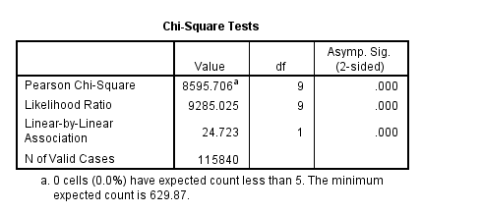
Table 8:The correlation between promotion type and buying intention

As the table 9 illustrated,the phi value is 0.272,there has moderate positive relationship between promotion type and buying intention.(Stephanie Glen.,2016)
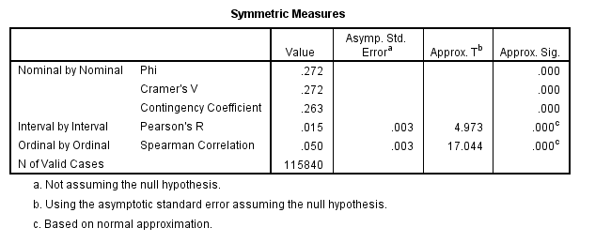
Table 9:The phi and value between promotion type and buying intention

2.The relationship between promotion intensity and buying intention
As the table 10 illustrate,p-value=0.000,that is to say,there has significant different between promotion intensity and buying intention.(Stephanie Glen.,2016)
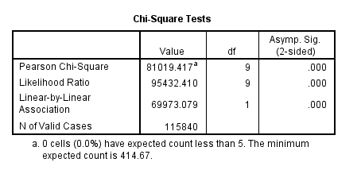
Table 10:The correlation between promotion intensity and buying intention

As the table 11 illustrated,the phi value is 0.836,there has very strong positive relationship between promotion intensity and buying intention.(Stephanie Glen.,2016)
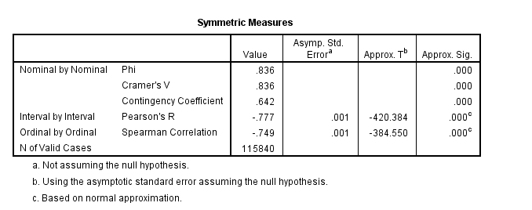
Table 11:The phi and value between promotion intensity and buying intention

4.1.5 Multiple Linear Regression Analysis
Regression analysis is a statistical analysis method for two variables with correlation. That is to say, regression reflects the dependency relationship between variables. In regression analysis, the goodness of fit test is used to judge whether the sample is representative. The closer the R square is to 1, the better the fitting degree is. F value is an important index to judge the significance of variables. The larger the F value, the closer the relationship between dependent variables and independent variables in the model. In data analysis, the F value is represented by sig, which is the concomitant probability. The criterion to judge whether there is a significant correlation between variables is whether the p-value is less than 0.05. And if P < 0.05, it indicates a significant correlation between variables(Gulden Kaya Uyanik,2013)

Regression between promotion type,intensity and buying intention
As table 12 illustrated, it can be seen that the regression coefficient between promotion type, intensity and buying intention is 0.781, and the p-value is 0.00, less than 0.050, so there has obvious significance. The Adjusted R square =0.610, which indicates that 61% of the variance in the dependent variable can be explained by independent variables. The Durbin-Watson is to test the auto-correlation in the residuals. The Durbin-Watson is 0.031, that is to say, there has a positive auto-correlation between promotion type, intensity and buying intention. (Ringle et al., 2015)
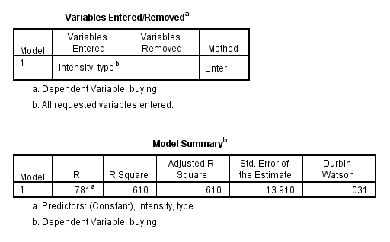
Table 12:Multiple linear regression model summary between promotion type, intensity and buying intention

As the table 13 illustrated, F(2, 1155837 )= 90501, p < 0000,the result mean model has good degree of the fitting.(Ringle et al., 2015)
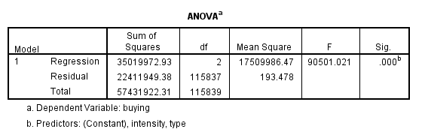
Table 13:ANOVA analysis between between promotion type, intensity and buying intention

As the table 14 illustrated,p-value is 0.000(<0.05),significant.Variance inflation factor (VIF) is 1.013,less than 5,that is to say,there has no multiple collinearity in a set of multiple regression variables.model has good degree of the fitting
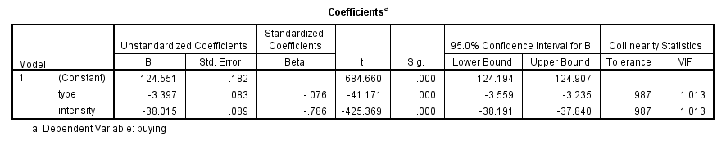
Table 14:Coefficients analysis between promotion type, intensity and buying intention

4.1.6 Two Way ANOVA(interaction)
There are two types of double factor variance analysis: one is non-interactive two factors analysis of variance, which assumes that the effects of factor A and factor B are independent, and there is no relationship between them; the other is the two-factor analysis with interaction, which assumes that the combination of factor A and factor B will produce a new effect. The new effect is produced by the combination of the two factors, which belongs to the background with interaction.

4.1.6.1 China Domestic 5 days Package Tour
As table 15 illustrated that there has a significant difference of 5 days China domestic package tour between different promotion types and price intensity on buying intention.The Mean of high cash promotion is 74.37, less than the percentage high promotion 81.76. Cash low promotion mean is 40.87, greater than the low promotion percentage of 26.81. That is to say, for 5 days domestic package, a high percentage promotion increases respondents’ buying intention. High cash promotion is their second selection for increasing their buying intention.
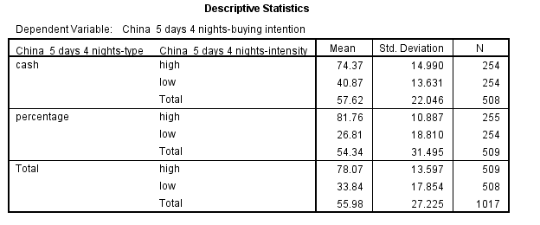
Table 15:Interaction between promotion type and intensity for China domestic 5 days package tour

As table 16 illustrated,concern for the levene’s analysis,As p-value=0.000(<0.05),significant.
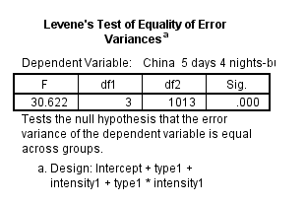
Table 16:Levene’s test for China domestic 5 days package tour.

As table 17 illustrated that p-value is 0.000(<0.05),significant.And Adjusted R square 0.702,that is to say 70.2% of variance in dependent variable can be explained by two independent variable.The model has good degree of the fitting.
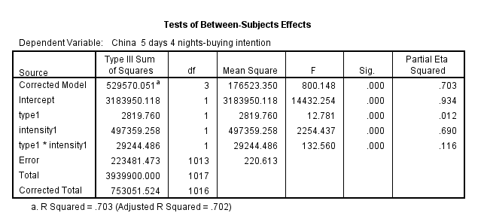
Table 17:Test of between-subjects effect

4.1.6.2 Outbound 15 Days Package Tour
As table 18 illustrated that there has significant different of 15 days outbound package tour between different promotion type and price intensity on buying intention. The mean of high cash promotion is 83.74,greater than the percentage high promotion 77.17.Cash low promotion mean is 45.87,greater than the low promotion percentage 25.51.That is to say,for 15 days outbound package,high cash promotion increase respondents buying intention.
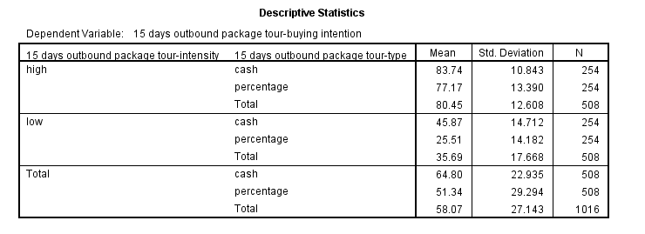
Table 18:Interaction between promotion type and intensity for outbound 15 days package tour

As table 19 illustrated,concern for the levene’s analysis,as p-value=0.000(<0.05),significant.
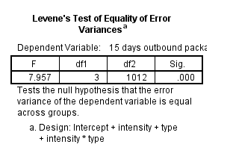
Table 19:Levene’s test for outbound 15 days package tour.

As tale 20 illustrated that,p-value is 0.000(<0.05),significant.And Adjusted R square 0.758,that is to say 75.8% of variance in dependent variable can be explained by two independent variable.The model has good degree of the fitting

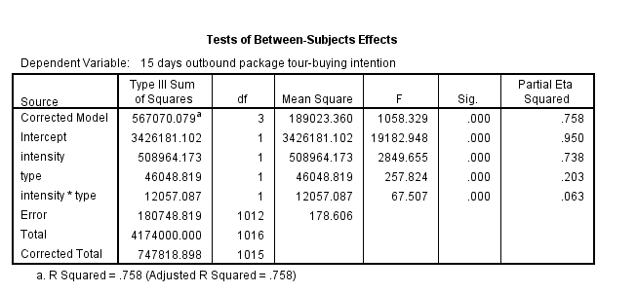
Table 20:Test of between-subjects effects

4.2 Hypothesis Result
As table 21 illustrated that the p-value of H1,H2 and H3 are all equal to 0.000(<0.055),significant.That is to say the hypothesis is accepted.
 | Hypothesis statement | Sig. | Result
H1 | Promotion type is a significant factor that affecting buying intention | .000 | Accepted
H2 | Promotion price intensity is a significant factor that affecting buying intention | .000 | Accepted
H3 | Interaction between buying intention and promotion intensity is a significant factor | .000 | Accepted
Table 21:The illustration of hypothesis result

4.3 Findings Summary
In this research, author collected 254 respondents’ data,and the data was analyzed by SPSS 21. There were several test conducted to verify the hypothesis:reliability and validity test, cross tab correlation analysis, normality and non parametric test,multiple linear regression test and two way ANOVA analysis.

4.4 Introduction
In this chapter,author will have discussion on the overall review of the research findings done by questionnaire.After that,author will explain the implication of this study,there will be some recommendations provided by author to improve the research findings for future research purpose.

4.5 Overall Findings Analysis
This research has examined the factor of promotion type,promotion price intensity,buying intention and product type,and which influence buying intention among online package tour in Beijing.
 | Hypothesis statement | sig | Result
H1 | Promotion type is a significant factor that affecting buying intention | 0.000 | Accepted
H2 | Promotion price intensity is a significant factor that affecting buying intention | 0.000 | Accepted
H3 | Interaction between promotion type and promotion price intensity is a significant factor | 0.000 | Accepted
The illustration of hypothesis result

4.5.1 H1:Promotion Type Is A Significant Factor That Affecting Buying Intention
Through empirical analysis, the correlation value and regression coefficient value is 0.000, that is to say, promotion type significant impact on buying intention. According to ANOVA mean value, the author found that for different package tours, the effect of promotion type is more significant on buying intention. This shows that the respondents will have different buying intentions for two different types of promotion. This is consistent with the research results of Zheng Shaocheng (2009), Gao Xiaoqian (2012) and Miao Shuyun (2013).

4.5.2 H2:Promotion Intensity Is A Significant Factor That Affecting Buying Intention
Through empirical analysis, the correlation value and regression coefficient value is 0.000, that is to say, promotion type significant impact on buying intention. According to ANOVA mean value, the author found that for different tours package tours, the effect of promotion intensity is more significant on buying intention. This shows that the respondents will have different buying intentions for two different promotion intensities. This is consistent with the research results of Zheng Shaocheng (2009), Gao Xiaoqian (2012) and Miao Shuyun (2013).

4.5.3 H3:Interaction Between Promotion Type And Promotion Intensity Is A Significant Factor
Through empirical analysis, according to the two way ANOVA test of between-subjects effects p-value is 0.000, that is to say, the interaction between promotion type and promotion price intensity is a significant factor for both China's domestic 5 days package tour and outbound 15 days package tour. According to ANOVA mean value, for China's domestic 5 days package tour, the high percentage promotion has a significant impact on buying intention. For an outbound 15 days package tour, high cash promotion has a significant impact on buying intention. This is consistent with the research results of Zheng Shaocheng (2009), Gao Xiaoqian (2012) and Miao Shuyun (2013)

4.6 Implication Of The Study

4.6.1 Practical Purpose
OTA really want customer to buy a package tour, then they should set the high promotion intensity ,because H2 is valid .
OTA can use high cash promotion to formulate outbound package,and high percentage promotion to formulate China domestic package tour,because H3 is valid.According to the different package tours, formulate reasonable promotion types,for outbound package tours,the cash promotion strategy is adopted should be adopted.From the above empirical analysis, the high cash promotion is more significant than the percentage discount on buying intention for outbound package tours,. This shows that tourists have different buying intentions when they present two different types of promotion. That is to say, the cash promotion can increase the tourists' buying intention more than the percentage promotion. Therefore, for OTA, high cash promotion strategy should be adopted.
For China's domestic short line package tour, the high percentage promotion strategy can be adopted. The results show that for a domestic short distance package tour, the effect of high percentage promotion is more significant than cash promotion on buying intention under the same promotion intensity. This shows that tourists will have a different psychological account of buying intention to the two different types of promotion. That is to say, under the same promotion intensity,high percentage promotion can increase the tourists' buying intention more than the cash promotion. Therefore, for OTA, the high percentage promotion strategy can be adopted.

Chapter 5 Conclusion And Suggestion

5.0 Conclusion
With the rapid development of information technology, online tourism market competition is becoming increasingly fierce, online tourism enterprises have launched colorful promotional activities. This study mainly focuses on the relationship between promotion and buying intention. Based on the relevant reports published by online tourism enterprises, this thesis selects the research objective, designs 11 questions, and studies the problems: the interactive influence of product type, promotion type and promotion intensity on tourists' buying intention by using SPSS software.The main conclusions are as follows:
The influence of product type, promotion type and promotion intensity on buying purchase intention; product type plays a moderating role in the influence of promotion type on tourists' buying intention. For domestic short distance travel products, the effect of percentage promotion is more significant than cash promotion on tourists' buying intention under the same promotion intensity. For outbound package tours, under the same promotion intensity, cash promotion has a more significant impact on tourists' buying intention than percentage discount. This conclusion also confirms the theory of frame effect put forward by scholars. Tourists' online purchase of tourism products is affected by the price framework. This also enlightens OTA should consider the role of price framework for different tourism package tour when making promotion. It is found that for the two types of package tours, the high promotion intensity will have a greater impact on tourists under both promotion type. This also has something to do with the fierce price war among many online tourism enterprises in the past. Therefore, when OTA adopted high promotion intensity strategy, they should guarantee the service.

5.1 Suggestion
Promotion should be design hierarchical.Although the vast majority of tourism operators are non-experts in data analysis and research. It is difficult for them to conclude the promotion type and promotion intensity with different package tours through their knowledge and information.But author is hoping they can borrow some promotion design experience from this research.Because now,when they design a promotion, they will link the promotion with only one type and intensity, which can not satisfy customers' needs. OTA Operators usually think that all package tours with a high price will be good. According to the psychological characteristics of consumers, the formulation of promotion should have different intensities, high, medium and low, so that tourists can choose and compare when buying package tours. After evaluation of promotion,consumers have more choice buying the package tours.

5.2 Further Improvement
(1) Repeat research with a greater scope of package tours
In this research, the author only examines two types of package tours. In real life, there has a great number of China domestic and outbound package tours and free itinerary tours. Such as domestic 3- 5 days short line tours,5-10 middle long line package tour, above 10 days long line package tour.Outbound 3- 5 days short line tours,5-10 middle long line package tour, above 10 days long line package tour. And there also have Free itinerary tours, for example, tours include hotel, air ticket and coach(or visa for outbound tours). Different package tours will have different promotion types and intensity, which will affect consumers buying intentions differently.
- Repeat research with more different promotion type
In this study, the author only considers two promotion types: percentage discount and amount discount. But in real life, there are many kinds of promotions that travel agencies can design. Moreover, different consumers have different psychological accounts with different promotion type. In the future research, the author will not only focus on cash promotion and percentage promotion but also study more promotion types, such as coupon promotion, buy 1 get one promotion, buy products send tourism-related products, parent-child families and honeymoon families have different promotion types, to investigate and compare the impact of different types of promotion on consumers' buying intention.
- Repeat research with more different promotion intensity
In this study, the author only considers two promotion intensities: high and low. But in real life, there are many kinds of discounts that travel agencies can design. Moreover, different tourists have different psychological accounts with different promotion intensities. In the future research, the author will not only focus on high and low promotion intensities, but also study more promotion intensities, such as high,low ,medium,and mixed different promotion intensities, to investigate and compare the impact of different intensities of promotion on consumers' buying intention.
- Use another model,statistical method,software to increase the accuracy of research.
First of all, because the SPSS software is not flexible enough to do data analysis what kind of analysis and what results to present should not be redundant and useless for research. SPSS results often contain some redundant content, which the author does not need. Secondly, in practice, for the Likert questionnaire, the parameter test of SPSS is generally unable to carry out to examine the normal distribution, and then it can only be solved by the non-parametric method. And the variance homogeneity generally will default to homogeneity, but when the author use SPSS to do analysis, most of them are not homogeneous. So this brings some errors to the research, which is not accurate enough. Therefore, the author will try to use other analysis software to test the data in future research to ensure the accuracy of the research content. Finally, the improvement of model construction. Because the author's capability is lack, it is impossible to conduct an in-depth analysis of mediating variables and moderating variables. Therefore, in this research, the model is relatively simple, without considering mediating variables, such as the perceived value and perceived quality. In future research, the author will learn more about mediating variable and moderator variable knowledge, which will lay a foundation for future research improvement.

Reference
1.Algina, J. and Olejnik, S., 2008. Sample Size Tables for Correlation Analysis with Applications in Partial Correlation and Multiple Regression Analysis. Taylor and Francis Online, 38(issue 3), 309-323.
2.Aydinli, Aylin Bertini, Marco and Lambrecht, Anja 2014, “Price Promotion for Emotional Impact,” Journal of Marketing, 78 (4), 80–96.
3.Amaro, S., Duarte, P. 2015. “An Integrative Model of Consumers’ Intentions to Purchase Travel Online.” Tourism Management 46:64–79.
4.Baron, R.M., Kenny, D.A. 1986. The moderator-mediator variable distinction in social psychological research: Conceptual, strategic, and statistical considerations. Journal of Personality and Social Psychology, 51(6), 1173–1182
5.Berry, L.L., Carbone, L.P., Heackel, S.H. 2002. Managing the total customer experience. MIT Sloan Management Review, 43(5), 85–89.
6.Bettina Rockenbach,2004. The behavioral relevance of mental accounting for the pricing of financial options. ELSEVIER, 53(issue 44), 513-527.
7.Belleau, B. D., Summers, T.A., Xu, Y., Pinel, R. 2007. Theory of reasoned action: Purchase intention of young consumers. Clothing and Textile Research Journal, 25(3), 244–257.
8.Bonsón Ponte,E.,E.Carvajal-Trujillo and T.Escobar-Rodríguez,2015，Influence of trust and perceived value on the intention to purchase travel online:Integrating the effects of assurance on trust antecedents[J].Tourism Management,.47:286-302
9.Bagchi, Rajesh and Davis, Derick, 2015, ‘“18% Off the Original Price Then Another 12% Off or '12% Off Then 18% Off: How Multiple Discounts Influence 10.Consumer Evaluations,” in Advances in Consumer Research,Diehl, K. and Yoon, C. , eds. Duluth, MN: Association for Consumer Research, 43,284–85
11.Cronbach, L., 1951. Coefficient alpha and the internal structure of tests. 1st ed. USA: Psychometrika
12.Cotton, B. C., Babb, E. M. 1978. “Consumer Response to Promotional Deals.” Journal of Marketing 42 (3): 109–13.
Chandon,Pierre,Brian Wansink,Glies Laurent,2000,.A benefit congruent framework of sales promotion effectiveness.Journal of Marketing,64(10),65-81.
13.Cheema, Amar , and Soman, Dilip, 2006, “Malleable Mental Accounting: The Effect of Flexibility on the Justification of Attractive Spending and Consumption Decisions,” Journal of Consumer Psychology, 16 (1), 33–44.
14.Carroll, W. J., Kwortnick, R. J., Rose, N. L. 2007. “Travel Packaging: An Internet Frontier.” Cornell Hospitality Reports 17 (7): 4-16.
15.Corder, G. and Foreman, D., 2014. Non-parametric Statistics: A Step-by-Step Approach. 2nd ed. New Jersey: John Wiley & Sons.
16.Dodds,W.B.,Monroe,K.B.,&Grewal,1991,D.Effects of price, brand, and store information on buyers'product evaluations.Journal of Marketing Research,28(3),307-319
17.Discovering statistics using SPSS. 3 ed. London: SAGE publications Ltd; 2009. p. 822
18.De Winter, JCF, Dodou, D. 2010.Five-point Likert Items: t test versus Mann–Whitney–Wilcoxon. Practical Assess Res Eval ; 15: 1–12
19.Field, A., 2005. Discovering Statistics Using SPSS. 2nd ed. London: Sage Publications
20.Gupta,Sunil and Lee G. Cooper，1992. The Discounting of Discounts and Promotion Threshold Journal of Consumer Research,(3)19:401—411.
21.Grewal,D.,The Effect of Store Name,1998，Brand Name and Price Discounts on Consumers' Evaluations and Purchase Intentions. Journal of Retailing, .74(3):331-352
22.Gloeckner, G. and Barrett, K., 2004. SPSS for Introductory Statistics: Use and Interpretation. 2nd ed. London: Psychology Press.
23.Gamst, G., Meyers, L. and Guarino, A., 2008. Analysis of Variance Designs: A Conceptual and Computational Approach with SPSS and SAS. 1st ed. New York: Cambridge University Press.
24.Ghasemi, A. and Zahediasl, S., 2012. Normality Tests for Statistical Analysis: A Guide for Non-Statisticians. Int J Endocrinol Metab, [Online]. 10(2), 486–489.. Available-at: https://www.ncbi.nlm.nih.gov/pmc/articles/PMC3693611/ [Accessed 10 December 2020]
25.Gao,Xiaoqian,2012,The impact of promotion type and buying intention.Social Science Journal,5:461-463
26.Hersch, Joni, Viscusi, W. Kip. 1996. “Gender Differences in Promotions and Wages.” Industrial Relations, 35(4),461–72.
27.Heath, Chip , and Soll, Jack B. 1996, “Mental Budgeting and Consumer Decisions,” Journal of Consumer Research, 23 (1), 40–52
28.Hair, J., Black, W., Anderson, B. and Tatham, R., 2006. Multivariate Data Analysis. 6th ed. Upper Saddle River: Pearson Prentice Hall.
29.Hutter, K., Hautz, J., Dennhardt, S. and Füller, J. 2013,The impact of user interactions in social media on brand awareness and purchase intention: the case of MINI on Facebook, Journal of Product & Brand Management, Vol. 22 No. 5-6,342-351.
30.https://bmcmedresmethodol.biomedcentral.com/articles/10.1186/1471-2288-12-78. [Accessed 10 December 2020].
31.Hart, A . .Mann–Whitney test is not just a test of medians 2019: differences in spread can be important. BMJ ; 323: 391–393.
32.Johnson DE , Graybill FA,1972. An analysis of a two-way model with interaction and no replication . Journal of American Statistical Association; 67: 862-868 .
33.Jeong-Yeol Park. 2016. Did I Get the Best Discount? Counterfactual Thinking of Tourism Products. Journal of Travel 57 (1): 17–30
34.Kim, Hyeong Min and Kramer, Thomas 2006, “‘Pay 80%’ Versus 'Get 20% Off: The Effect of Novel Discount Presentation on Consumers’ Deal Perceptions,” Marketing Letters, 17 (4), 311–21.
35.Litwin, M., 1995. How to Measure Survey Reliability and Validity. 1st ed. London: SAGE.
35.Mandel J.,1961，Non-addtivity in two-way analysis of variance . Journal of American Statistical Association ; 56: 878-888
36.Mowen,J.C.,& Brown,1980，S.W.On Explaining and Predicting the Effectiveness of Celebrity Endorser.Advances in Consumer Research,Michigan: Association for Consumer Research: 8:437-441
37.Milkman, Katherine L. , and Beshears, John 2009, “Mental Accounting and Small Windfalls: Evidence from an Online Grocer,” Journal of Economic Behavior & Organization, 71 (2), 384–94.
38.Miao Shuyun ,2013, Research on the influencing factors of promotion on buying intention.Jiangxi Finance University.25(1):2
- Morgan, G., 2019. IBM SPSS for Introductory Statistics. 6th ed. London: Routledge.
40.Newcombe, RG, 2006. Confidence intervals for an effect size measure based on the Mann–Whitney statistic. Part 1: general issues and tail-area-based methods. Stat Med ; 25: 543–557.
41.Olson JC,1972,Jacoby.Research of Perceiving Quality.Emerging Concepts in Marketing,9:220-226.
42.Parasuraman, A., Zheitmal, V. and Berry, L., 1998. A multiple-item scale for measuring consumer perceptions of service quality. retailing, 64, 12-40
43.Paula, R. and Priest, H., 2006. Reliability and validity in research. Nursing Standard, vol. 20, no. 44.
44.Pallant, J., 2020. SPSS Survival Manual: A step by step guide to data analysis using IBM SPSS. 1st ed. Australia: Allen and Unwin.
45.Sarah Tanford，2012. “Travel Packaging on the Internet: The Impact of Pricing Information and Perceived Value on Consumer Choice.” Journal of Travel research, 51 (1): 68-80.
46.Sekaran, U. and Bougie, R., 2013. Research Methods for Business.. 6th ed. West Sussex: John Wiley & Sons.
47.SUN, Y., 2017. The influence mechanism of e-commerce promotion strategy on consumers' impulsive purchase behavior -- the mediating effect of impulse purchase-intention.Journal-of-Liming-Vocational-University,[Online].NO.2,37-44.Available-at:https://www.ixueshu.com/document/e9d0c5b740fa8306d3bfb04d63c3d6ef318947a18e7f9386.html[Accessed-1 October 2020]
48.SPSS SYNTAX. 2020. Data Analysis in SPSS.[ONLINE] Available at: [Accessed 10 December 2020]
49.Thaler, Andrew 1985, “Mental Accounting and Consumer Choice,” Marketing Science, 4 (3), 199–214.
50.Thaler, Andrew (1999), “Mental Accounting Matters,” Journal of Behavioral Decision Making, 12 (3), 183–206
51.Yoo, B., Donthu, N. and Lee, S., 2000. An Examination of Selected Marketing Mix Elements and Brand Equity. Journal of the Academy of Marketing Science, 28, 195-211.
52.Wang Xingyue,2015,Online tourism product promotion impact on buying intention.Zhengzhou.Zhengzhou University,2:1-84
53.Zeithaml V A.1988,Consumer perceptions of price,quality,and value:a means-end model and synthesis of evidence[J].Journal of Marketing,52(3):2-22
54.Zhang, R., 2015. Research on the influencing factors of online tourism product purchase decision. Wuhan University of Technology, 63: 1.

Appendix 1 Questionnaire
Dear MS. or Mr
My name is Lu Yitong. I am a graduate student majoring in business administration at INTI international university in Malaysia. To study the online package tour promotion impact on buying intention in Beijing, China, this questionnaire was carried out. Thank you for filling in this questionnaire.
Thank you for your support for my graduation thesis. There is no right or wrong choice in the survey. Please fill it according to your real feelings and opinions. The information collected in this survey is only for academic research. Please do not have any worries. Thank you for your support.
If you have further problems,please contact me without any hesitation.My email is:i19016943@student.new.inti.edu.my.
The analysis of online package tour promotion influence on buying intention in Beijing
List below are four promotions for an identical 5 days 4 nights China domestic package tour.Based on the design of these promotions,please indicate how much the design increases your intention to buy the package using a number from 0-100.
0-design of the promotion,has no effect towards making me more willing to buy the package tour.100-design of the promotion has significant effect toward making me more willing to buy the package tour.
Promotion 1-Package tour now is reduce 800 RMB cash less than its original price.
Promotion 2-Package tour now is reduce 200 RMB cash less than its original price.
Promotion 3-Package tour now is get 50% off less than its original price.
Promotion 4-Package tour now is get 20% off less than its original price
List below are four promotions for an identical 15 days 13 nights outside China package tour.Based on the design of these promotions,please indicate how much the design increases your intention to buy the package tour using a number from 0-100.
0-design of the promotion,has no effect towards making me more willing to buy the package tour.100-design of the promotion has significant effect toward making me more willing to buy the package tour.
Promotion 1-Package tour now is reduce 800 RMB cash less than its original price.
Promotion 2-Package tour now is reduce 500 RMB cash less than its original price.
Promotion 3-package tour now is get 50% off less than its original price.
Promotion 4-package tour now is get 20% off less than its original price.
Gender Female Male
Your age____
Your education
under high school
high school
Bachelor
Master
Above Master

Table 22:Questionnaire

Appendix 2 Frequency analysis
According to the frequency table illustrate,most of the respondents are female,accounts for 50.8%,female accounts for 49.2%.And education with bachelor degree accounts for 58.7,second is master,accounts for 30.7%.18-30 years old accounts for 67.3%,that is to say,most of the respondents are young generation.The author consider that,with the continuous development of the tourism market, the demand differentiation of consumer groups is more and more obvious, and the market is constantly subdivided. The "young women tourism" market is gradually emerging and has begun to attract people's attention. Therefore, tourism operators should pay more attention to the psychological characteristics and activity mode of young female tourists, and providing reasonable promotion prices for them, which can effectively enhance their buying intention and enhance tourism competitiveness.With the continuous development of the tourism market, the demand differentiation of consumer groups is more and more obvious, and the market is constantly subdivided. The "young women tourism" market is gradually emerging and has begun to attract people's attention. Therefore, tourism operators should pay more attention to the psychological characteristics and activity mode of young female tourists, and providing reasonable promotion prices for them, which can effectively enhance their buying intention and enhance tourism competitiveness.Because young female customers are especially focused on price and promotion. Women are very sensitive to promotion when they intend to buy products at low prices. The young female often spends more time than other age groups. Special promotions can always attract young women.
Therefore, the author thinks that female tourists not only want to buy the best products at the lowest price but also want to show their social status and cultural accomplishment to others through the price of the products they buy. Therefore, tourism operators should pay attention to the psychological account of the promotional products and formulate reasonable promotion to meet female consumers' needs. First of all, there are few potential tourists for the promotion of mature or short line tourism products in the market. In marketing, traditional young women should be mainly targeted. Most of them are diligent and thrifty. Promotion strategies such as seasonal promotion and quantity promotion can stimulate their buying intention. Secondly, for the tourism products that have formed brands, especially the unique outbound tourism products, brand awareness is high and the product life cycle is long. When designing the promotion, high cash promotion is adopted, aiming at the modern young and highly educated women. They have a strong ability to accept new things. When OTA sell products, they can make use of the price psychology of "good product but cheap" to attract them and increase their buying intention.

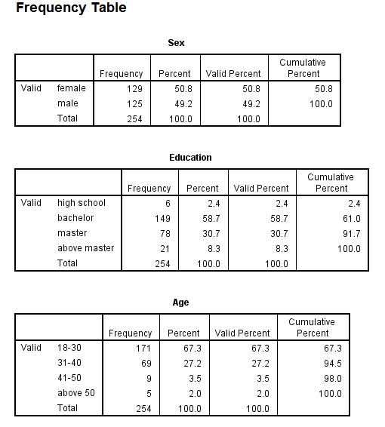
Table 22:Frequency table

Appendix 3 Meeting Record
SECTION A. MONITORING STUDENT DISSERTATION PROCESS
The plan below is to be agreed between the student & supervisor and will be monitored against progress made at each session
Activity | Milestone/Deliverable Date
Activity | September | October | November | December
The project topic determined | √
The related literature articles | √
The analysis method |  | √
Methodology |  | √
Study population |  | √
Data collection |  |  | √
Descriptive analysis |  |  | √
Correlation analysis |  |  | √
Recommendation |  |  | √
Limitation |  |  | √
Conclusion |  |  |  | √
The whole paper checking |  |  |  | √

SECTION B.
Ethics form protocol number:
SECTION C. RECORD OF MEETINGS
The expectation is that students will meet their supervisors up to ten times and these meetings should be recorded.
Meeting 1
Date of Meeting | 14/09 2020
Progress Made | First meeting mainly discussed the research title and the general content of the whole thesis with first supervisor. The main direction of the paper is the online package tour impact promotion impact on buying intention.
Agreed Action | Reached a consensus on the main content of the project.
Student Signature | Lu Yitong
Supervisor’s
Signature

Meeting 2
Date of Meeting | 22/09/2020
Progress Made | Discussed the definition of the independent variables and dependent variable.
Agreed Action | Agreed topic: Modify ppt and variable definition
Student Signature | Lu Yitong
Supervisor’s
Signature

Meeting 3
Date of Meeting | 28/09/2020
Progress Made | 1.List the example of the variable  2.Develop at least 2 survey questions linking dependent variables and dependent variables.
Agreed Action | Continued to explain the definitions of independent and dependent variables
Student Signature | Lu Yitong
Supervisor’s
Signature

Meeting 4
Date of Meeting | 05/10 2020
Progress Made | Prepare the survey questions  Test your survey questions
Agreed Action | Try five friends to test questionnaire and have a pilot test
Student Signature | Lu Yitong
Supervisor’s
Signature

Meeting 5
Date of Meeting | 12/10 2020
Progress Made | Find questionnaire mistakes and correct
Agreed Action | Prepare survey introductory paragraph
Student Signature | Lu Yitong
Supervisor’s
Signature

Meeting 6
Date of Meeting | 19/10/2020
Progress Made | Prepare ppt to present to second marker  Include chap 1 2 and 3
Agreed Action | Supervisor review all survey question
Student Signature | Lu Yitong
Supervisor’s
Signature

Meeting 7
Date of Meeting | 2/11 2020
Progress Made | Modify ppt for first panel(chapter 1,2,3)
Agreed Action | Before first panel instruction.
Student Signature

Supervisor’s
Signature

Meeting 8
Date of Meeting | 23/11 2020
Progress Made | Distribute questionnaires and collect data
Agreed Action | Agreed to collect data
Student Signature | Lu Yitong
Supervisor’s
Signature

Meeting 9
Date of Meeting | 30/11 2020
Progress Made | Show data Analysis  Work on second panel presentation  Finish chapter 4,5
Agreed Action | Agree with the data analysis section and finish section 4,5
Student Signature | Lu Yitong
Supervisor’s
Signature

Meeting 10
Date of Meeting | 05/12 2020
Progress Made | Improve the PPT content of the second defense
Agreed Action | This meeting agree to the contents of the PPT in chapters 1 to 5
Student Signature | Lu Yitong
Supervisor’s
Signature

Section D. Comments on Management of Project
(to be completed at the end of the dissertation process)
Student Comments
Through this paper, first of all, thanks to Dr Ow Yong for his advice. It made me very clear in the e-commerce field papers that I had misunderstood. Secondly, I learned to complete a master's degree thesis, structure, methods and so on. Thirdly, the importance of communication. Timely communication with my supervisor will make me get twice the result with half the effort compared to myself effort.
Supervisor Comments
Despite the challenging beginning, student has managed to work on his best capacity and handle the project.
Signature of  Student Lu Yitong | Date 18/12/2020
Signature of  Supervisor | Date 18/12/2020

Acknowledgment
As time goes by, I have finished my one-year master's program at INTI International University, Malaysia. The pace of time is too fast, and I will say goodbye to my University. This summer, with the completion of the thesis, the pace of graduation is getting closer and closer. There have harvest and achievement in postgraduate life. These will become beautiful memories engraved in my life.
First of all, thank my first supervisor, Dr. Ow young. He is conscientious and responsible, and his teaching is rigorous. In the ordinary study, Dr.Ow young taught us a lot of reading and writing experience. In the process of writing the research, Dr.Ow young gave me a lot of guidance from the topic selection to the writing, data analysis and suggestions . Dr.Ow Yong's tireless teaching spirit and engaged of prudent research attitude are deeply affected me, let me learn a lot from him. And he spent a lot of time to instruct me on how to modify my presentation and how to convey my opinion to others well. Here, I would like to express my thanks to Dr.Ow Yong. Secondly, I would like to thank Ms. Ah Huai for giving me a lot of suggestions on how to modify the details. She is professional,earnest, patient and responsible. Finally, I would like to thank all the lecturers and staff at INTI International University for their training and helps which makes me improve my capability on research.
Thanks to my team members Donata, Chen Jimiao and Wang Yao, those people who have accompanied me through this unforgettable year. We help each other, understand and support each other, solve problems together. Thanks to all the students enrolled in January 2020 for their company and encouragement.
I would like to thank my parents in particular for their unconditional support for my studies. They are my driving force and my strongest backing. They encourage and comfort me when I'm down, and help me when I'm in trouble.
Thanks to all supervisors and tutors who participated in the review of my thesis! I sincerely wish all the lecturers, classmates, friends who have helped me to be healthy and happy.

