MASTER OF BUSINESS ADMINISTRATION  PENG NA  2020 | THE RELATIONSHIP BETWEEN SOCIAL MEDIA  AND  CUSTOMER RETENTION IN NILAI, MALAYSIA  PENG NA  MASTER OF BUSINESS ADMINISTRATION  FACULTY OF BUSINESS, COMMUNICATION & LAW  INTI INTERNATIONAL UNIVERSITY  2020
INTI INTERNATIONAL UNIVERSITY
MASTER OF BUSINESS ADMINISTRATION
THE RELATIONSHIP BETWEEN SOCIAL MEDIA
AND
CUSTOMER RETENTION

Author : Peng Na
Student No : I20018468
Supervisor : Dr. Lim Kim Yew
Submission Date : December 20, 2020
Final Word Count : 13293

DECLARATION
I hereby declare that this thesis is my own work and effort and that it has not been submitted anywhere for any award. As for other sources of information have been used, they have been duly acknowledged.
Name | : | Peng Na
Student ID | : | I20018468
Signature | : | Peng Na
Date | : | December 20,2020
···························································

ACKNOWLEDGEMENTS
First of all, I would like to thank my tutor, Dr. Lim Kim Yew, for his patient guidance and academic support for my graduation thesis in the past six months. In the past six months, I have been taught a lot of research skills and academic attitude. I am very grateful to all the professors who have taught me this year so that I can learn so much knowledge. In addition, I would like to thank Ms Ah Huai for her help and profound opinions on my graduation thesis.
In addition, I would like to thank the management, lectures and staff of Faculty of Business, Communication and Law of INTI International University for their help and guidance，so that I can be able to appreciate such educational resources and feel different colourful learning and lifestyle. Let me look at the world rationally in the future. Finally, I would like to thank the friends I made on the way to study, and thank them for their help and encouragement

·TABLE OF CONTENTS
DECLARATION 3
ACKNOWLEDGEMENTS 4
ABSTRACT 9
CHAPTER 1 11
INTRODUCTION 11
1.0 Introduction 11
1.1 Problem Statement 13
1.2 Research Objectives 15
1.3 Research Questions 16
1.4 Scope of the Study 16
1.5 Study’s terms definitions 17
1.5.1 Customer Retention 17
1.5.2 Social Presence 17
1.5.3 Customer Engagement 17
1.5.4 Media Richness 18
1.6 Summary 18
CHAPTER 2 19
LITERATURE REVIEW 19
2.0 Introduction 19
2.1 Key Literature 19
2.1.1 Customer Retention 19
2.1.2 Social Presence 22
2.1.3 Customer Engagement 24
2.1.4 Media Richness 29
2.2 Conceptual Framework 32
2.3 Hypotheses of the Research 33
CHAPTER 3 34
METHODOLOGY 34
3.0 Introduction 34
3.1 Type of/research types 34
3.2. Technique of data collection 34
3.2.1 The purpose of the questionnaire 34
3.2.2 Population and sample research 35
3.3 Processing and data analysis 35
3.5 Questionnaire 36
3.6 Reliability and validity 37
3.6.1 Reliability analysis 37
3.6.2 Validity analysis 38
3.7 Data collection 40
3.7.1 Data Collection 40
3.7.2 Processing of Data 41
3.7.3 Checking of Questionnaire 41
3.7.4 Editing of Questionnaire 41
3.7.5 Coding of Questionnaire 41
3.7.6 Transcribing of Questionnaire 41
3.7.7 Cleaning of Data 42
CHAPTER 4 43
RESEARCH RESULTS AND FINDINGS 43
4.0 Introduction 43
4.1 Respondents Profile 43
4.2 Skewness-Kurtosis Normality Test 47
4.3 Correlation Analysis 49
4.4 Hypothesis Testing 52
4.4.1 Multiple Regression Analysis 52
4.4.2 Test of Significance 55
CHAPTER 5 57
DISCUSSION AND CONCLUSION 57
5.0 Introduction 57
5.1 Discussion of Main Findings 57
5.2 Implications of the Study 59
5.2.1 Social presence 59
5.2.2 Customer engagement 59
5.2.3 Media richness 59
5.3 Research Limitations & Suggestions for Future Research 60
5.4 Conclusions and Recommendations 61
5.5 Personal Reflection 64
6.0 References 66
7.0 Appendix 72
Appendix A: Survey Questionnaire 72
Survey Questionnaire 72
SECTION A 72
SECTION B 75
Appendix B: All the Tables of Fingding Results 77
Appendix C: Proposal Defense Presentation 86
Appendix D: VIVA Presentation 90
Appendix E: MBA Project Log 96
Appendix F: Turnitin 98

LIST OF TABLES
Figure 1.1:Conceptual framework 15
Figure 2.1:Conceptual framework 33
Figure 3.1：Cronbach's Alpha variable rule 37
Figure 3.2：Reliability test-Cronbach's Alpha 38
Figure 3.3:KMO and Bartlett's Test 39
Figure 3.4:Normal P-p Plot of Regression Standardized Residual 40
Figure 4.1:The analysis of gender frequency 43
Figure 4.2:The analysis of age frequency 44
Figure 4.3:The analysis of educational level frequency 44
Figure 4.4:The analysis of race frequency 45
Figure 4.5:The analysis of monthly income frequency 45
Figure 4.6:The analysis of marital status frequency 46
Figure 4.7:The analysis of hypermarket consumption frequency 46
Figure 4.8:Statistics 49
Figure 4.9:Correlation analysis 51
Figure 4.10:Model Summary 52
Figure 4.11:ANOVA 53
Figure 4.12:Coefficients 54
Figure 4.13:Test of Significance 55
Figure 4.14：Hypotheses testing 56

ABSTRACT
This paper focuses on the impact of social media on customer retention. I measured social media by dividing it into three leading indicators: social presence, customer engagement, and media richness. In the era of Web 2.0, under the influence of enterprise globalization, enterprises' choice of marketing strategy has been updated continuously. Social media development helps enterprises reduce the distance between them and customer groups so that brands can retain customers by using the network. We selected customers from shopping malls near Nilai in Malaysia as the respondents.
I distributed the questionnaire through the network platform and collected 126 valid questionnaires. After data collection, the questionnaire data were analyzed by SPSS software. I mainly conducted descriptive data analysis, correlation analysis and multiple linear regression analysis. The results of data analysis show that among the three independent variables, only customer engagement and media richness have a significant effect on customer retention, on the contrary, social presence has no significant impact on customer retention in statistics.

CHAPTER 1

INTRODUCTION

1.0 Introduction
Hypermarket refers to a kind of modern retail model that can provide customers with the goods they need in a specific place. The sales model of the hypermarket is also a very effective way of product distribution. Hypermarkets are retail industries based on self-service and can sell products of different functions and types. In Malaysia, the area of hypermarkets is between 2500 square meters and 8000 square meters. Nowadays, the retail industry has the following characteristics: 1) the price of goods is fixed; 2) entertainment; 3) service; 4) customers are not required to consume; 5) the scale of hypermarkets has specific requirements. In 1963, Carrefour entered the market as the first hypermarket. Carrefour entered the market as a supermarket at first. In 1959, Carrefour transformed into the first hypermarket. At first, there are three main components of hypermarkets: 1) one-stop shopping in a large space; 2) relatively low price of goods; 3) parking lot (Kadhim et al., 2020). The situation of FDI inflow has improved due to the development of wholesale and retail industry in Malaysia. In Malaysia, the emergence of large stores such as Tesco and AEON has enhanced the retail industry's competitiveness (Ghaffarkadhim et al., 2019). The retail industry contributes a lot to Malaysia's GDP and provides more jobs. Customers have a high recognition of the retail industry in hypermarkets. They think that shopping in supermarkets is a necessary way to buy essential goods and materials. There are 14 states in Malaysia, including about 334 hypermarkets. These hypermarkets have improved the retail industry's production and viability (Selvaraju et al., 2020).
Danesh et al. studied the retail market in Malaysia and found that customer retention is positively related to many factors, such as customer satisfaction and customer engagement (Tsai and Lin, 2017). In marketing, business globalization pays more and more attention to customer relationship and relationship marketing, especially customer retention and relationship network, and develops new marketing strategies in the actual operation process (Saha, 2020).
By the end of 2012, about 19 million people in Malaysia had access to the Internet, accounting for 66% of the country's population. In 2010, the Malaysian government proposed My e‐Government (myEG), which can provide citizens with one-stop government services, such as paying taxes or summoning. In the following years, the development of social media in Malaysia has become more and more popular. Malaysians upload their daily activities through the Internet. So far, about 70% of Malaysian Internet users have signed up for Facebook. Within Asia, Malaysia has the fifth largest number of Facebook users.
Social media influences people's habits of communication, writing, information sharing and consumption. Social media usually refers to "online tools on social media platforms that allow users to have social interaction, promote information sharing and creation, and help companies connect more closely with customers" (Garrido Moreno et al., 2018). With the wide application of digital and social media, people's consumption behaviour and mentality have changed significantly. Compared with the traditional sales method, a social media marketing strategy is more common nowadays and has become a very important part of the company's sales strategy (Unni, 2020).
The title of the paper is "exploring the relationship between customer retention and social media.". First of all, I will have a general understanding of the previous research results by reading the relevant literature in the past, and deeply understand the concept of social presence, customer engagement, media richness and customer retention. Secondly, I will examine how social media affects customer retention and the impact of social media on customers' daily shopping habits and identify research objectives, research questions and related conjectures. Finally, after having a particular knowledge base, the questionnaire information and data are collected through sampling survey. The shopping malls near Nilai in Malaysia are taken as the destination of the sampling questionnaire survey. Social media has a dual impact on customer retention. Based on the data collected, I will analyze its positive and negative impacts and explore the relationship between customer retention and social media (Unni, 2020).

Problem Statement
The emergence of the Internet has a significant impact on the communication between people. Social media helps businesses build communication with customers. Marketing scholars and people at work are interested in the meaning of customer interaction. The popularity of the Internet promotes the emergence of digital communication, such as e-mail, blog, etc., making communication between people or between individuals and organizations more convenient. In the era of Web 2.0, the Internet has ushered in new social tools, such as Twitter, Facebook and Youtube. The emergence of new social tools promotes the communication between sellers and buyers, as well as the emergence of communities on the network platform, which indirectly affects the marketing strategy of enterprises. Social media tools can help individuals and organizations communicate asynchronously, making the relationship between enterprises and customers closer, and reducing geographical and time constraints. In the era of Web 2.0, social media can help enterprises better serve customers and transform digital customers into valuable customers (Sashi et al., 2019). However, some scholars have also proposed that enterprises may also be affected by social media publicity. For example, social media marketing is not conducive to maintaining customer relations and indirectly affecting customer retention. Therefore, in order to improve the positive impact of social media on customer retention, it is necessary to study the relationship between social media and customer retention（Liu et al., 2019）.
Customers who participate in social media will promote specific products or brands, help enterprises create some value, contribute to the innovation in the company's operation process, and improve customer retention. On social media platforms such as Facebook, customer engagement typically involves reviews, recommendations, reviews and word of mouth. However, only when customers are loyal or happy, can they help enterprises create propaganda value (Sashi et al.,2019).
According to the Retail Feedback Group's US Supermarket Experience 2013 report, in the Supermarket industry in the United States, three-quarters of the customers will be using social media to interact with the Supermarket. But in that three-quarters of the customers, only a quarter of people can communicate with the Supermarket. It also indirectly shows that the current Retail market did not seize the chance to communicate with customers (2020). With the iterative updating of technology, high-tech products release the clerks in supermarkets from necessary work, so as to have more time and energy to serve customers, so that customers can feel a stronger sense of social presence. But does this sense of existence play a positive role? Further discussion is needed (Mojumder,2020). Customer engagement plays a role in brand effectiveness, customer retention and even customer relationship management. But up to now, in the context of the retail industry, there have been few studies on the relationship between customer engagement and customer retention (Mohd-Ramly and Omar,2017). With the proliferation of online media and online shopping, can customers' shopping experience in offline hypermarkets improve customer retention? Whether customer retention is affected by customer engagement and media richness (Dinesh et al., 2018)?
The research topic of this study is to explore the relationship between customer retention and social media. After reading the previous literature, I established the following theoretical model, which can be referred to in Figure 1. The theoretical models mainly include Social presence, customer engagement and media richness, and customer retention. The relationships between social presence and customer retention, customer engagement and customer retention, as well as media richness and customer retention, are discussed respectively.
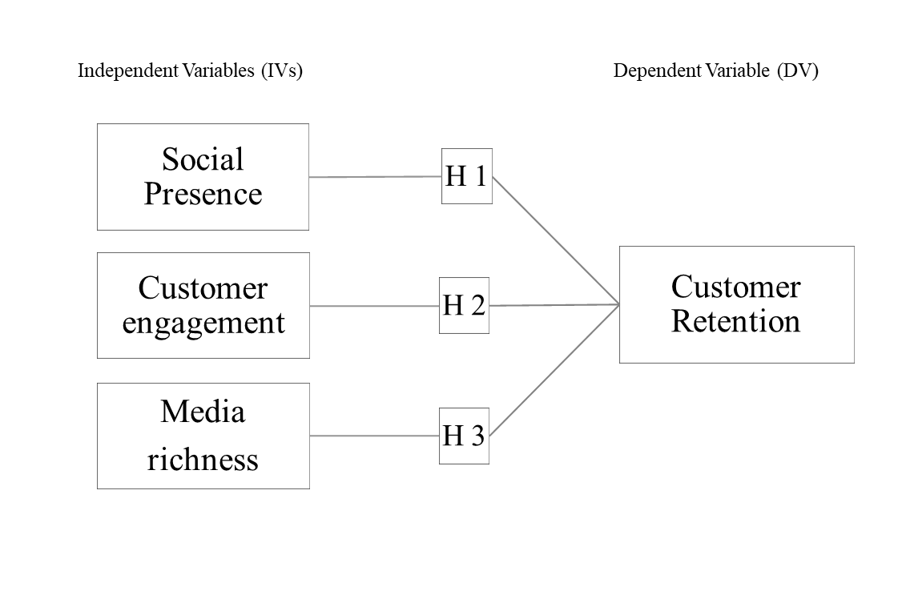
Figure 1.1:Conceptual framework

1.2 Research Objectives
The topic of this study is to explore the impact of social media on customer retention. I conducted a random sampling survey in the hypermarket in Nilai, Malaysia, and determined the following research objectives based on the theoretical model.
- To examine the relationship between social presence and customer retention
- To examine the relationship between media richness and customer retention
- To examine the relationship between customer engagement and customer retention

1.3 Research Questions
The following are the specific research questions.
- What is the relationship between social presence and customer retention?
- What is the relationship between customer engagement and customer retention?
- What is the relationship between media richness and customer retention?

1.4 Scope of the Study
In order to ensure the smooth progress of the research demonstration process, I have described some specific research objectives that are limited to the research scope as much as possible in Chapter 1.3. Next, I will describe the geographical location, target interviewees, research time and theories to be applied in the research
I will study the geographical location of hypermarkets near Nilai, Malaysia, including Aeon Mall, Mesa Mall and Tesco. The location close to me is determined mainly for the following reasons: it is a unique period at present, so try to make the location closer. In addition, considering the limitation of the time of completing the paper, the nearest place is more feasible. The target interviewees should be the customers of the hypermarket. According to the calculation formula of sample size, the estimated sample size is about 380 people, and the confidence level is set at 95%, with 5% error allowed. The study's time is recent, and it is scheduled to be in early to mid-November 2020 to complete the data collection phase. Prior to this, by reading a large number of pieces of literature, four proper nouns in the theoretical model were investigated, and the questionnaire questions were designed accordingly.

1.5 Study’s terms definitions

1.5.1 Customer Retention
In 1970, O. Hirschman, a German economist, retained the definition.O. Hirschman mainly presented the antisense aspect of retention. The opposite side of customer retention is that the number of customers decreases or the customers choose to quit and no longer consume in a particular brand due to some problems with the enterprise's goods or services. Customers can cause the enterprise's income to be reduced, unable to retain the customer (members). Company operators must find a new business strategy to save customer churn（Dragnea and Mihăiță, 2020）.

1.5.2 Social Presence
The idea of a social presence is now prevalent. The concept of a social presence originated in the 1970s (1976), mainly to understand how media works in communication. Short et al. (1976) published his book "The Social Psychology of Telecommunications" in 1976 and defined social presence in the book: the individual's perception to another individual during communication. Short et al. (1976) believed that social presence is a characteristic of communication media. The social presence of the media will, more or less affect the way and efficiency of interpersonal communication. For example, Short et al. (1976) believed that some forms of media, such as video files, would have a higher social presence than audio files (Lowenthal and Snelson,2017).

1.5.3 Customer Engagement
In fact, the concept of customer engagement is very extensive, which not only refers to the interaction between customers and brands but also includes the interaction, participation and co-creation between customers. Based on these theories, customer engagement refers to the enterprise's efforts to create opportunities for customers to interact and participate in order to build a closer and more meaningful relationship between the brand and customers. Through the above discussion, the interaction, collaboration and participation of customers should also be considered when studying customer engagement (Braun et al., 2017).

1.5.4 Media Richness
The theory of media richness was developed in the mid-1980s by scholars Daft and Lengel and Trevino. According to media enrichment theory, media diversity and content ambiguity can be relied on to make media communication more efficient. The "richness" of media is mainly reflected in the following four aspects :(a) Timely feedback of information;(b) Diversity of cues;(c) The richness of languages;(d) Personal attention. Therefore, if it is a high ambiguity and complexity work, the media with high richness may be the most accurate to convey information (Ishii et al., 2019).

1.6 Summary
The thesis mainly explores "the relationship between customer retention and social media".I based the theoretical model (please refer to Figure 1). The specific research problem is the relationship between social presence, customer engagement, media richness and customer retention. With the rise of the Internet industry, the emergence of social media tools has played a significant role in transforming consumer behaviour. Among them, online sales of hypermarkets are also in full swing. Therefore, I chose hypermarkets near Nilai, Malaysia, as the destination of empirical research and randomly selected customers for questionnaire interview. In the early stage, I will review the previous literature and elaborate on the theoretical model of "customer retention-social media", so as to explain the previous scholars' elaboration on the relationship between "customer retention-social media".I will conduct empirical research in the middle stage. Finally, based on these, I will elaborate on some recommendations on the future of customer retention based on social media tools.

CHAPTER 2

LITERATURE REVIEW

2.0 Introduction
The literature review link will mainly focus on the relevant content of the nouns in the theoretical model to understand the knowledge points related to customer retention at a deeper level. At the same time, the test methods will be summarized for later empirical research.

2.1 Key Literature

2.1.1 Customer Retention
Statistics show that most enterprises are not good at managing customer retention, and 85% of customers think brands can provide more products or services to retain customers. Although many senior executives within the organization consider customer retention to be their most important job, a whopping 49 per cent of senior managers believe that their customer retention capabilities do not meet the organization's needs. But in this digital age, customer retention matters. In MusicWatch's data, only 48 per cent of users who had used Apple Music were still using the service two months after its launch. In mobile apps, including all types of mobile apps, about 75 per cent of web users become friends within three months. In the past, scholars did not pay much attention to some detailed points in the marketing link, such as who the target users are, when the activities are carried out, and what are the incentives, etc. (Ascarza et al., 2018).
There are many definitions of customer retention, but the core is persistence -- the consumer's ability to maintain continuous interaction with the brand. In addition, customer retention can be described as one of the consumer behaviours. Therefore, customer retention refers to the behaviour that customers can maintain transactions with the company. However, it should be emphasized that transaction does not only refer to currency transaction but also includes the replacement of other services, such as free value-added services provided by the company (Ascarza et al., 2018).
Customer retention can play a significant role in predicting consumer behaviour and is considered by many scholars as an essential indicator (Kumar et al., 2017). Some scholars will use THE MCDM method to predict the degree of customer retention in the future because MCDM can refer to different standards at the same time to help decision-makers select the best solution. In addition, MCDM has another advantage. Different measuring units may be encountered when dealing with different standards, which can be solved by using MCDM (Kumar et al., 2017). However, based on the theoretical model, I need to consider customer retention and the other three concepts, so this study does not consider using MCDM to measure customer retention rate.
Alshurideh has researched customer retention before, and the motivation of the research is similar to that of Ascarza et al. For many brands, customer retention faces challenges (Alshurideh,2016). There are many reasons why enterprises cannot improve customer retention rate. Alshurideh listed the following reasons: enterprises face too much competition; enterprises need too much cost to improve customer conversion rate, increase resources and attract new customers. In addition, Alshurideh also classifies relationships in customer retention. In the past, scholars would distinguish different relationships based on such factors as transactions, the closeness between enterprises and customers, and time. And in terms of time, there are differences in relationship longevity and duration. Goffin (2006) said that it is not enough and ineffective to distinguish long-term and short-term relationships only based on the time dimension (Alshurideh, 2016).
Some scholars have studied the effect of social media on customer retention based on social media background in Indonesia. More than 91% of customers set up personal accounts on Facebook in Indonesia, while only 27% use Twitter. Because of this data, many brands have taken digital media as an important marketing tool in order to establish a closer relationship with consumers. Especially for small and medium-sized enterprises, there are many benefits of using the Internet to publicize their services, including the ability to improve brand popularity and brand awareness of new customers when the cost is relatively low. Customer retention refers to a series of activities that enable consumers to continue to consume and participate in the same brand (Santoso and Dewi, 2018). Homburg and Bruhn (2001) pointed out that the goal of product brand activities caused by customer retention is to ensure the close transactional relationship among manufacturers, suppliers, and customers. Customer retention can also help enterprises increase market share, and these economic activities can reduce the rate of customer churn. For customer retention, another view is to create loyal customers for the brand and how to help the company stimulate customers' continuous consumption and improve brand participation through economic activities. Zhang, Dixit, and Friedmann (2010) also pointed out that customer retention also represents the active level of customers' consumption and participation in a certain brand (Santoso and Dewi, 2018). This is why customer retention is so important to the sales performance of an enterprise. Now, many enterprises will use digital media to obtain customer information to price and evaluate products or services. Most consumers will pay more attention to price factors, and some consumers will prefer quality factors and punctuality factors. For example, customers will care about delivery related matters when ordering goods on social media (Mohd Johan et al., 2020).
In this research, I took the hypermarket near Nilai, Malaysia as the empirical research destination, so I also looked at the knowledge related to customer retention of the retail industry in other regions when referring to relevant literature research. Arafah mentioned in his research that the retention of relationships was driven by two factors (desire and dependence). If the customer is based on desire, then the customer is willing to maintain the relationship, but if the customer is based on dependency (based on constraints), then the customer may be able to maintain the relationship without any other option. In the organized retail industry, hypermarkets can improve customer retention mainly through two methods: one is to arouse customers' desire for shopping, the other is to improve customers' sense of dependence on enterprises (Arafah,2016).

2.1.2 Social Presence
The meaning of social existence is that the users of media tools can understand and recognize the media's existence psychologically. In the era of booming e-commerce, social media marketing is becoming more and more popular among enterprises, and social existence plays a significant role in social media marketing. Social existence can well explain users' trust and enjoyment of intermediary media. Social media marketing strategies include building platforms on which users can interact with companies and customers their age, so "authenticity" is essential. From the perspective of authenticity, social existence can be regarded as a positive factor in network trust and stimulate consumption desire. In his research, Shen (2012) mentioned that customers would feel more comfortable if they can feel that the other end of the network is a real person when consuming on the network platform. Russell mentioned that if an enterprise publishes advertisements on social media tools, it will be weak in persuading and inducing customers if it is too official or makes customers think it is an advertisement at first sight (Jin et al., 2019).
Men and Tsai said that in social media marketing strategies, social presence could effectively make customers feel the existence of human nature because social presence can well help the brand give customers more perceived authenticity and increase the brand's influence. Weisberg et al. said that when customers take the brand side as a real existence on social networks, there is an excellent chance that customers will have a strong sense of jealousy and thus have a desire for specific products. Therefore, social existence is a critical link in the era of booming e-commerce (Jin et al., 2019). Hasanuddin et al. Also recognize the importance of social communication on social media platforms. If customers perceive the distance between them and the communication objects during their interaction on social media platforms, they will think that the media is not humanized or friendly. Tu and Msisaac mentioned in previous studies that social existence was divided into three aspects to establish the theoretical framework, namely, social context, network communication and interactivity (Jin et al., 2019).
When communicating on social media platforms, social presence refers to the degree to which a person is perceived by users at the other end of the Internet. People with a high degree of social presence are more real when they are understood and recognized, and information exchange is more smooth. Some scholars believe that social existence is the characteristic of media. Short et al. (1976) hypothesized that "the difference of social presence will affect the fluency of interaction among individuals" when studying the influence of social presence on customer retention. When measuring the social presence, they considered two factors: closeness and immediacy. If "intimacy" and "immediacy" are taken as the criteria, the social presence given to customers by communication on social media platforms is relatively low (Oregon et al., 2018). Of course, in addition to intimacy and immediacy, the physical distance between individuals, topics, language differences and communication cues all have an impact on social existence. Lakin (2005) believes that social presence is not a unilateral behaviour, but an interactive behaviour. Therefore, media platforms with low social presence can be enriched. As mentioned before, social presence is the degree to which an individual is perceived by another in a certain media environment. In the process of educational activities, if a teacher (communicator) perceives the existence of another individual rather than interacting with a machine, the communicator's sense of social existence is relatively high (Oregon et al., 2018). Therefore, many scholars in the media, marketing and other fields will pay great attention to the role of social existence. In the field of education, Homer, plass, &amp; Blake (2008) research results show that students' satisfaction with learning process will be higher and students' memory of knowledge will be increased if communicators spread information in a way with a high degree of social existence. Even in the field of marketing, social presence also plays a very important role. Consumers who lack a sense of social presence will have a lower degree of brand sentiment (Oregon et al., 2018).
Haenlein (2010) believes that social media tools, as glue, make social relations closer. When measuring social media, it's important to choose which metrics to use. According to the results of previous literature studies, social presence has a profound impact on customer satisfaction. In addition, social presence is a feature of social media that helps brands communicate with customers (Rofiq et al., 2020.).Therefore, based on the above information, I proposed the following hypothesis in this study.

2.1.3 Customer Engagement
Netflix's famous recommendation system is an excellent example of cross-marketing. For example, in a grocery store, the clerk displays complimentary items such as pizza and drinks together. In fact, with the development of big data and technology, researchers can obtain data through RFID, mobile phone applications and so on, which will help operators provide customers with a better shopping experience. A number of studies have now confirmed the effect of customers' shopping habits on product sales. However, from the perspective of customer participation theory, more information and variables can be provided to researchers (Venkatesan, 2017). Customer engagement is a new concept in modern marketing. In order to explore new customers, maintain and spread brand reputation, brand owners will find more new ideas through community activities and provide customers with better services and products. Therefore, customer participation is already an endogenous demand of the company, and customers can help the company create more value. More and more scholars and practitioners realize that customers are receivers of value and creators of value. Therefore, it is vital to study customer participation (Braun et al., 2017).
In the process of studying customer participation, Braun et al. Believed that attention should be paid to the role of different types of customer participation in customer retention. Word of mouth is the least time, effort and money spent on customer engagement. The types of customer engagement on social media platforms, such as customer reviews or new ideas for a business product, are more taxing and require more resources. Therefore, this type of customer participation will also have more effect on customer retention. Therefore, it is necessary to consider customer participation in the research process and pay attention to the impact of different forms of customer participation on customer retention (Braun et al., 2017).
When Braun et al. Studied the relationship between customer participation and customer retention, he carried out qualitative research as well as quantitative research. They interviewed customers of a particular brand 47 times. In fact, considering the factors of special moment and research time limit, focus interview and other research methods are not appropriate. Braun et al. Mainly carried out the following contents in the interview. First, they asked respondents to describe their experiences interacting with the brand and their personal comments. Second, respondents explain their reasons for interacting with the brand. Third, the types and reasons of customer participation. In the course of Braun et al. 's study, some of the respondents' comments were useful.
I would like to help the brand is voluntary and does not require any other benefits. And providing the company with personal ideas and good interaction with the company is voluntary (including writing reviews on social media platforms, recommending products to people around you, and participating in online events). I am confident and proud of the brand's products and services, which indirectly promotes my contact with the brand.
Through qualitative research, Braun et al. have a more in-depth explanation of the definition of customer participation, that is, the status of customers' investment in brand awareness, emotion and behaviour. The interview also shows that customer participation is an important point in customer retention. Customer participation also affects customers' online shopping behaviours. Therefore, in addition to paying attention to web pages' beauty, merchants should also pay attention to provide excellent services for customers when selling goods on the Internet. Based on the network platform's sales environment, sellers should pay attention to the critical information of products, excellent services, and the accessibility of the platform to improve the level of customer participation (Johan et al., 2020).
The rapid development of social media has made the forms of customer participation more and more diversified. Therefore, it is necessary to propose some concepts and definitions of media participation to explore customer participation ideas. Teichmann et al. Mentioned that the development of the Internet and social media tools affects customers' decisions to varying degrees and provides a right channel for enterprises to promote their brand products and services. Singh and Sonnenburg mentioned that customers post comments on their experience of brand products and services on social media platforms, such as blogs or FACEBOOK communities. This process enables customers to unconsciously participate in the production and operation of enterprises' products. Gensler et al. believed that enterprises and customers would have positive benefits from some informal interaction activities on the social media platform, which might include maintaining customer relations, customers' evaluation of new products, viral dissemination of information, customers' attitude towards brand services, etc. Therefore, if an enterprise cannot correctly manage users' information on social media platforms, its image will be destroyed (Pentina et al., 2018). Calder et al. argued that consumer engagement behaviours could be more expressed in consumer behaviour's psychological motivation, thus interacting in a brand community on social media before actually behaving. In addition, through the research process, customers' motives, such as utilitarianism, hedonism, self-esteem, community, time, and so on, can be better discovered. Hollebeek et al. Divided consumer participation behaviour into three aspects: cognitive processing, user emotion and activation (Pentina et al., 2018). Kumar et al. Have a different understanding of CEB and consider CEB as apparent consumer behaviour. Obviously, this kind of understanding is more conducive to measuring the degree of consumer participation in the environment where social media is prevalent, which will be more operable. In their research process, Brodie and Colleagues (2013) classified the contents of brand communities on social media tools, such as sharing, learning, advocacy, socialization and other processes. The classification of brand community content on social platforms can help us better understand customers' attitudes towards social media marketing. It is worth noting that different customer interaction content and implicit and explicit content of different content types should be paid attention to during the classification process (Pentina et al., 2018).
Muntinga et al. (2011) in the research literature, the consumer participation in social media also has the classification, it is mainly divided into three aspects: (1) the customer only consumer behaviour, also is the least positive behaviour, (2) make a contribution to the customers on social media platforms, such as comments, etc., and the ability to share interesting posts, with friends, (3) customers to create, is also the most positive consumer participation behaviour. However, they are not exhaustive about these categories, and their applicability is limited. Jaakkola and Alexander (2014) have another classification method for consumer media participation behaviour, including (1) joint development, (2) information expansion, (3) influence, and (4) incentive. Looking at the four aspects as a whole, we can see that this behaviour is a progressive relationship. These two categories of consumer participation behaviours have something in common: helping the brand increase customers' value in the production process. The difference is that the first method focuses more on customers' role in developing the brand's products and services. In contrast, the second method focuses on promoting the brand's products and services (Pentina et al., 2018).
Scheinbaum (2016), when studying digital participation topics, usually uses the following parameters as effectiveness indicators, such as users' thumb up, comments, posts, followers and click data of posts, etc., to evaluate users' participation in social media. In addition, it should be noted that brands usually place advertisements on social media platforms, so is there any relationship between the advertising effect and users' participation in social media? There seems to be little research on this. In his research, Voorveld et al. mentioned that user participation in social media could be distinguished according to user experience or motivation, including information, traffic, interaction, recognition and entertainment. In addition, according to the relationship and interaction mode between users and brands, current social media can be divided into the following four categories (Voorveld et al., 2018).
- Relational social media such as Facebook and LinkedIn.This kind of social media will be based on the user's personal information and mainly promote customized information that suits the user's taste.
- We Media." We media" has been very popular in recent years. Similar to relational social media, such platforms also provide users with the right to self-manage media content based on personal information. Twitter, for example.
- Creative social media. These platforms are mainly based on users' content and encourage users to develop their interests and creativity like YouTube and Instagram.
- Collaborative. These social platforms are based on content posted by users. Such social media can provide users with comments, consultations and browse hot content (Voorveld et al., 2018).
After users become fans of the brand community on social media platforms, subsequent customer engagement (media engagement) is generated. The closer the relationship between the customer and the company, the more frequently the fans will interact with the brand and even help promote it. These fans are both transactional customers and potential fans (Dewnarain et al., 2019). Therefore, in view of this information, I made the following assumptions in this study. When Braun et al. Studied the impact of customer participation on customer retention, they concluded that customer participation is an important indicator to determine customer retention no matter what kind of customer participation is. In Johan et al.'s research model, the relationship between customer retention and customer participation is studied. According to their research results, there is a positive correlation between customer retention and customer participation.

2.1.4 Media Richness
Massey et al. In the process of their research mentioned along with the development of social media and the popularity of digital, for users, social media or substitute for information transport has the following characteristics, such as richness (consider the ability in information transmission), social existence, synchronization (or asynchrony) and rehearsal. The richness of the media is mainly reflected in its ability to process large amounts of information (Gimpel et al., 2016). The richness of media includes the following four levels :(1) the power of timely information feedback, (2) the media can provide more information and interaction ways, (3) the richness of language, (4) the attention of individuals. This point refers to how the media can help the two sides of the conversation feel each other's emotions and information content. The development of digitalization promotes social media's ability, especially in information sharing, to differentiate media richness by analyzing social media insight and the power of quick understanding. The current communication methods can be ranked in terms of media richness by analysing previous literature, with video or other methods similar to face-to-face interaction being the most abundant, followed by audio interaction, and finally text communication, such as e-mail (Gimpel et al., 2016).
Media richness can set the framework within which social media tool platforms operate. So some social media platforms are more diverse and less ambiguous than others. In terms of text, media richness is reflected in the content and context of the text. The media richness of video (i.e. in the face-to-face meeting) is reflected in the current environment, expression, language, and body movements. The information expressed in these aspects will be combined and conveyed to the other party (Tanupabrungsun and Hemsley,2018). Brinker et al. have said that diversity of media can only be supported by increasing new media technologies. For example, people can enrich the content of e-mails by adding emoticons or pictures. In general, the richness of media is not only an objective value but also will improve with the needs of users. Kaptelinin and Nardi believe that the richness of social media also varies with different platforms. For example, in the process of using Twitter, the platform will give users some hints or other operation possibilities. These indirectly make users' Twitter posts richer and more compelling and increase the meaning of shared information. This media richness makes it easier for users to share information that is not easily understood. In this respect, experienced and experienced users will be more familiar with it, and diversified hints will provide users with a more effective operating atmosphere and increase their diversity. Daft and Lengel have mentioned that different firms need different types of information, which applies equally to media. Therefore, it is very necessary to know your target users, and different indicative operations can be displayed according to the needs of customers and the goals of social media platforms (Tanupabrungsun and Hemsley,2018). Tanupabrungsun et al., in their research, treated the value of each part of the tweet as equivalent, which would result in certain limitations. For example, when researchers calculate the quality of interactions, they assign equal weight to the context, interaction style, retweet, and other tweet parts. However, psychological research data shows that our body language, speech statements, intonation, etc. have different communication weights (Tanupabrungsun and Hemsley,2018).
With the development of technology, the mobile social media environment is becoming more and more popular. In the past, e-mail and short message services were widely used in social media platforms to inform consumers of the latest information of brands through these two channels. However, SMS is not good at spreading information, and its threshold is very low. The main reason is that there are many restrictions on information content, which is not friendly to the customer's experience. The E-mail also has many restrictions on information dissemination. For example, after sending the e-mail, it can't ensure that consumers can see the information for the first time. When using social media, consumers should pay attention to the presentation of content, the richness of media and the effectiveness of information dissemination, which will affect the subsequent emotions and interests of consumers. The most abundant information media is face-to-face communication, which can meet the requirements of sufficient information content, body language, various hints and instantaneity（Lan and Sie, 2010）. And the information in the form of words is the simplest way of communication. Moreover, media enrichment theory is not a new concept. Scholars in many fields have studied the impact of media richness on education, management, decision-making quality and market. And most of the research, including theoretical research and empirical research, has a wide influence. In the process of empirical research, Lan and Sie (2010) are of great significance in measuring media richness. They measure the influence of media richness on dependent variables by means of information transmission, including SMS, e-mail, etc.; in addition, they also measure the influence of media richness on dependent variables by variables such as content diversity, accuracy, immediacy and effectiveness（Lan and Sie, 2010）.
The definition of media richness theory is also constantly updated with time. In the past, there was such a definition of media richness round: in a specific period of time, the information transmitted changes the ability of individual understanding. In other words, media richness refers to the ability to break through different barriers, explain clearly what you want to express to the target audience, or explain vague problems clearly, then this kind of communication is rich. In addition, the length of communication also affects richness. Some scholars believe that if we can't explain clearly and vaguely for a long time, then the richness of media is considered to be low. But I think this definition only focuses on the validity of the interpretation content and does not involve other measurement factors, such as emotion and the difference in the application in different fields. However, in the theoretical model of measuring media richness, the timeliness, effectiveness and richness of content have given a good perspective to later researchers (Gimpel et al., 2016). As Facebook and other online platforms become more popular, and social media marketing strategies become more prevalent, brands are trying to use social media tools to attract new customers or retain existing ones. Kaplan and Haenlein mentioned in their book that there are several aspects to consider when considering social media, including media richness. In their research on the relationship between customer retention and media richness, Gimpel et al. found that enterprises' use of social media tools to promote has a positive effect on customer retention. However, media richness has a noticeable impact on customer retention, and the impact relationship is positive (Gimpel et al., 2016).

2.2 Conceptual Framework
Based on the careful study of previous kinds of literature in the previous chapters, I proposed the conceptual framework as shown in figure 2, including Social Presence, Media Richness and Customer engagement, as well as dependent variable Customer retention.
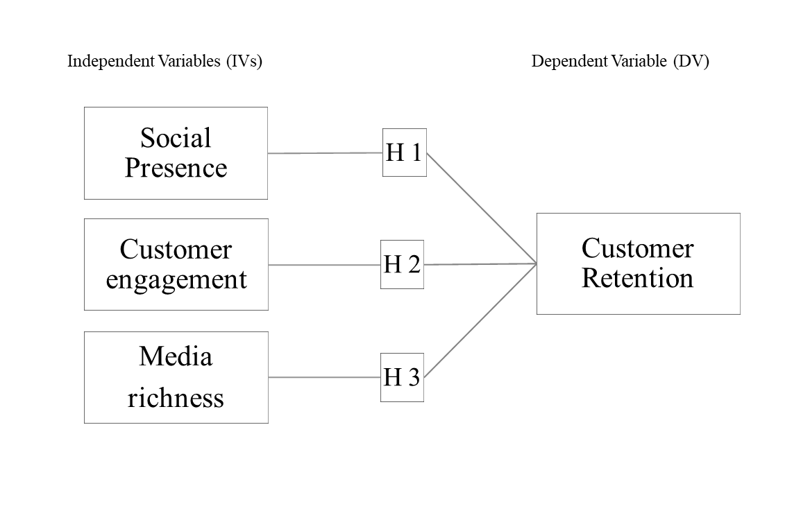
Figure 2.1:Conceptual framework

2.3 Hypotheses of the Research
Hypothesis One
H1: There is a positive relationship between social presence and customer retention
Hypothesis Two
H2: There is a positive relationship between customer engagement and customer retention.
Hypothesis Three
H3: There is a positive relationship between media richness and customer retention.

CHAPTER 3

METHODOLOGY

3.0 Introduction
I chose the quantitative research method. Hair, Bush & Ortinau (2003) mentioned that the quantitative research method focuses more on how to measure and how to better select samples. The emphasis of this method is to collect data and conduct an in-depth analysis of effective data.

3.1 Type of/research types
Research design is the outline of the research subject in the marketing field. The purpose of this study is to describe and test the relationship between variables in the hypothesis (Santoso and Dewi,2018). Therefore, my research aims to explore the relationship between customer retention and media richness, customer engagement, and social existence. First of all, I will design the questionnaire. In order to adapt to the environment of the field survey destination, the question set will also focus on the theme of the hypermarket. In the future, questionnaire collection will be conducted in the hypermarket near Nilai, Malaysia, that is, field research and sampling survey will be conducted.

3.2. Technique of data collection

3.2.1 The purpose of the questionnaire
By consulting relevant literature, query and research model-related questions, and design questionnaires. This is also the main method I choose to collect data. Neumann (2003) mentioned in the previous study that the respondents filled in the questionnaire by themselves, and the researchers had created the questionnaire in advance and screened the questions set. It is ideal for quantitative research to collect data by means of a questionnaire, which can help researchers quickly obtain large-scale information. Malhotra (2010) also proposed several purposes for the questionnaire survey method in the study (Santoso and Dewi,2018).
- According to the target information, translated into specific questions, interviewees can write answers based on the questions.
- The questionnaire should be able to stimulate the respondents' participation level, and they should be willing to fill in and complete the whole questionnaire.
- Minimize the extent of errors.

3.2.2 Population and sample research
Malhotra(2010) mentioned that a population is a group of groups with some similar characteristics, whose characteristics should be consistent with the research problem. In my study, the sample population was mainly customers. In this study, I mainly used the random sampling method, namely the non-probabilistic sampling method (Santoso and Dewi,2018). I selected about 400 customers around Nilai, Malaysia, as the sample population. I mainly distributed questionnaires in supermarkets near Nilai area, including Aeon Mall, Mesa Mall and Tesco. The selection of these hypermarkets is mainly due to the special period, time and financial budget constraints. Moreover, due to the competition between the destination and the researcher, the customer flow of the hypermarket is relatively large, which can well solve the problems raised by the interviewees in the data collection. In the research model, the independent variables include media diversity, customer participation and social existence, and the dependent variables are customer retention (Santoso and Dewi,2018).

3.3 Processing and data analysis
As for the steps of processing and data analysis, I will use SPSS software to analyze the data after establishing the theoretical research model, completing the questionnaire design and collecting data. First, the validity and reliability of the data will be tested, and then multiple regression will be conducted on the data
The next step is to obtain the data and information about the post-charging questionnaire survey. The preliminary data will be sorted out according to the classification of variables and variables, and the use of software SPSS 24 (social science statistical program) of Windows is discussed. The steps are to establish a research model, prepare a questionnaire, collect data, test validity and reliability, and use multiple regression method to test the results of the model and hypothesis (Santoso and Dewi,2018).

3.5 Questionnaire
By studying relevant literature and based on theoretical models and hypotheses, I finally decided to divide the questionnaire into three parts. The theoretical model mainly includes social existence, customer participation, media richness and customer retention. First of all, the first part of the questionnaire asked questions about social existence, media richness, customer participation and customer retention by using Likert's 5-component table. The Likert scale's advantage is that it is relatively easy to design, widely used in marketing, and interviewees can easily find their psychological position through the scale (Chyung et al., 2017). I put the most important questions in the first part to ask the interviewees. For the three independent variables and one dependent variable in the research model, I used the Likert scale to ask questions, respectively. Variables in the first part include customer retention, customer engagement, media diversity, and social presence. The second part of the questionnaire mainly asks the basic information (demographic information) of the interviewees, including age, gender, monthly income, education, marital status, race, etc. In addition, after data collection, I will use SPSS software to conduct reliability and validity test, descriptive analysis and regression analysis on the data to verify the correctness of the hypothesis statement.

3.6 Reliability and validity

3.6.1 Reliability analysis
Reliability and validity test is the test of the effect and quality of measurement tools in the process of evaluating research. Deborah A. Abowitz, T. Michael Toole and other scholars also proposed that validity and reliability test are very necessary for the study of architecture, especially in the use of social science research methods (Mohajan,2017). Walizer et al.(2005) put forward the concept of validity in his research, which is an auxiliary tool to help measure the degree of data compliance. The main purpose is to help researchers confirm the degree to which the research data is consistent with the facts. When the research subject needs to confirm the relationship by measuring something, then the applied validity test is reasonable (Santoso and Dewi,2018). Cronbach's Alph method was mainly used in this study to measure validity.
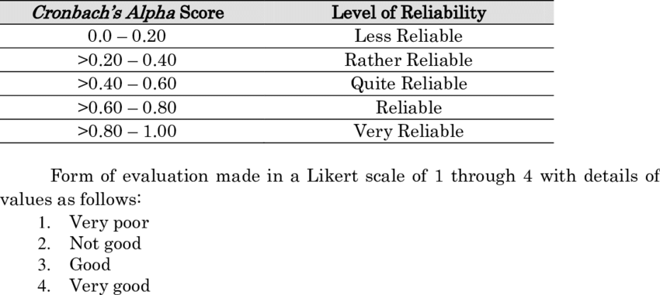
Figure 3.1：Cronbach's Alpha variable rule
Source: Developed for research
Please see the chart for the exported results after input the raw data into SPSS software. There are three independent variables. In terms of Social Presence, I asked four questions, seven questions about customer engagement, two questions about media Richness and two questions about customer Retention. As we can see from the chart, the hypothesis I proposed is expected to receive positive answers. In addition, the Alpha value is greater than 0.6, so the data collected are generally reliable (Santoso and Dewi,2018).
Validity testing is also required during the testing process. During the interview, the interviewees did not make any complaints or other responses, so the questions of the questionnaire were clear and understandable to the interviewees, and there were no mistakes or questions. It is effective in terms of content.
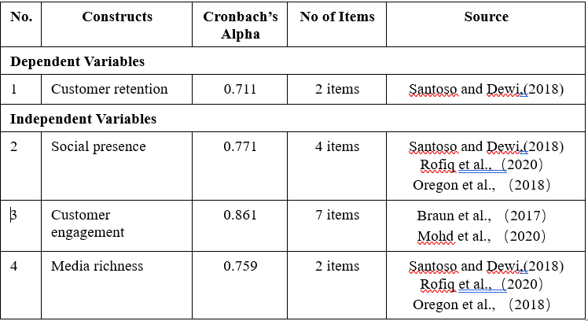
Figure 3.2：Reliability test-Cronbach's Alpha

3.6.2 Validity analysis
In a statistical sense, validity refers to the level at which the results of a relationship between variables are logical. Since my research type is mainly quantitative, I choose to measure the validity of the content, which is usually used to test the validity of the content of the scale. I used SPSS software to perform KMO and Bartlett's Test on the data. According to the empirical rule of statistics, when the value is between 0.8 and 1, it indicates that I have collected sufficient data. In addition, Field proposed that when the output value of KMO and Bartlett's Test was between 0.8 and 0.89, it indicated that the data was valid (Field, 2013).
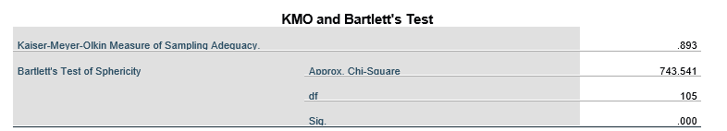
Figure 3.3:KMO and Bartlett's Test

In addition, from the figure below "Normal P-p Plot of Regression Standardized Residual", it can be seen that Customer Retention meets the Normal distribution principle. So in general, these points are pretty much all along the diagonal.

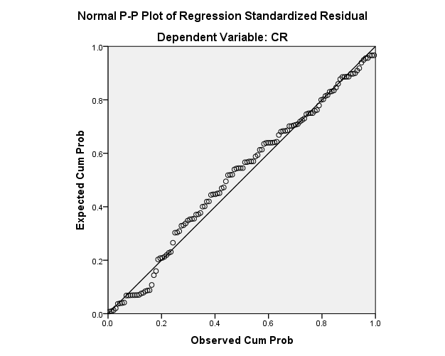
Figure 3.4:Normal P-p Plot of Regression Standardized Residual

3.7 Data collection

3.7.1 Data Collection
I collect information by issuing questionnaires on the Internet platform. The questionnaire mainly consists of two parts. The first part is through the Likert scale. The second part is the demographic data. I mainly studied the significance of three independent variables Social Presence, Customer engagement and Media richness to Customer retention. I took Nilai, Malaysia as the main research case, so I originally planned to distribute the questionnaire in the shopping mall near Nilai, but due to special circumstances, I distributed the questionnaire through the network platform and distributed it to students and staff of schools near Nilai. I received a total of 126 valid questionnaires.

3.7.2 Processing of Data
After the data collection is completed, the data information will be summarized and sorted through the network platform, and invalid information will be eliminated. Then I will input the data into SPSS software for encoding and transcription.

3.7.3 Checking of Questionnaire
Before issuing the questionnaire, I checked the content and form of the questionnaire and made changes. It is necessary to check the contents of the questionnaire before its release (Witt, 2017).

3.7.4 Editing of Questionnaire
In order to enhance the accuracy and completeness of the questionnaire, I modified the questionnaire designed for the first time, filtered the questions, and replaced the questions with inappropriate forms. In addition, the questions with unclear and inconsistent answers were replaced (Witt, 2017).

3.7.5 Coding of Questionnaire
The questionnaire's content was encoded, and I transcribed and encoded each question and option (Witt, 2017). For each option of the question, I will edit with subtitles or numbers such as A, B and C to facilitate the later sorting of the collected questionnaire information into SPSS files.

3.7.6 Transcribing of Questionnaire
At this stage, I conducted the whole encoded information through SPSS software. Generally, questions in the questionnaire include both positive and negative questions (Witt, 2017). To ensure the consistency of each question, all questions need to be assigned points before transcribing. Since I used a Likert scale, I assigned values from 1 to 5.1= strongly disagree, 2= disagree, 3= neutral, 4= agree, 5= strongly agree.

3.7.7 Cleaning of Data
Finally, I cleaned up the items with unclear answers and missing answers in the information collation stage. I have received a total of 127 questionnaires, and the answer to one questionnaire is missing. Therefore, only 126 valid questionnaires can be used for analysis in the end.

CHAPTER 4

RESEARCH RESULTS AND FINDINGS

4.0 Introduction
The fourth chapter is mainly about the analysis of 126 valid questionnaires finally collected. From November 10, 2020, to November 24, 2020, I released questionnaires to residents in NILAI area through the Internet platform. A total of 127 questionnaires were collected, 126 of which were valid. I use SPSS software to sort out, summarize and analyze the data. In this chapter, I will elaborate on the statistical results. The analysis results will include a detailed description of the variables and a relationship analysis, as well as an overview of the characteristics of the respondents. In addition, the hypothesis and research questions proposed at the beginning of the paper will be summarized.

4.1 Respondents Profile

Figure 4.1:The analysis of gender frequency
As can be seen from the above table, the proportion of male and female interviewees is the same, with females accounting for 50% (63) and males for 50% (63).
Figure 4.2:The analysis of age frequency
As can be seen from the age statistics table, respondents aged 26 to 29 are the most, accounting for 38.1% (48) of the total. Respondents aged 22 to 25 accounted for 27% of the total (34). Respondents aged 30 to 34 accounted for 17.5% (22) of the total. This was followed by those aged 35 to 39, accounting for 8.7% (11) of the total. Respondents aged between 40 and 44 accounts for 4% (5) of the total. Respondents aged 45 to 49, 50 to 55, and 56 and over accounted for the fewest, accounting for 1.6 per cent (2) of the total respectively.
Figure 4.3:The analysis of educational level frequency

As can be seen from the frequency table of education level, among the interviewees, 54% (68) have the education level of master's degree, accounting for the majority. There are 28 respondents with A/BS Degree, accounting for 22.2% of the total. Graduate Diploma interviewees account for 15.1% of the total number, with 19 participants. Among the interviewees, those with doctoral education level are the least, accounting for 8.7% (11) of the total.
Figure 4.4:The analysis of race frequency

As can be seen from the ethnic frequency table, among the 126 interviewees, Chinese people account for the majority, accounting for about 44.4% (56) of the total. People of other races came in second, accounting for 24.6% (31) of the total. In third place are Malays, accounting for 18.3% (23) of the total. Indians account for 12.7% (16) of the total.
Figure 4.5:The analysis of monthly income frequency

As can be seen from the monthly income frequency table, most respondents' monthly income ranged from RM3000 to Rm4999, accounting for 37.3% (47) of the total. Respondents with monthly income between RM1,000 and RM2,999 were second, accounting for 35.7% (45) of the total. Those earning more than RM5,000 per month accounted for 18.3% (23) of the total. The least number of respondents with a monthly income below RM1,000, accounting for 8.7% of the total (11). This means that the proportion of monthly income is balanced on the whole, and data of different groups with different consumption habits can be collected.
Figure 4.6:The analysis of marital status frequency

According to the marital status frequency table, 50.8% (64) of the respondents were single. Of these, 43.7% (55) were married.4.8% (6) of the respondents are divorced. Only 0.8% (1) of the respondents were widowed.
Figure 4.7:The analysis of hypermarket consumption frequency

It can be seen from the consumption frequency table of the shopping mall that 42.9% (54) of the respondents are "Several times per week" and ranked the first. A total of 17.5% (22 per cent) of the respondents visit an outlet once a week. Several times per month accounted for 15.1% (19) of the respondents., 11.1% of respondents go to hypermarkets every day (14). The respondents whose frequency was "Once a month", "Several times per year" and "Only on special Occasions" accounted for 4% (5), 1.6% (2) and 7.9% (10) of the total number respectively. Basically, the frequency of 126 interviewees going to hypermarkets is different, which is more conducive for me to understand the opinions of people with different living habits.

4.2 Skewness-Kurtosis Normality Test
When we do descriptive analysis, we usually test the skewness and kurtosis value of the SPSS software data. Skewness and the kurtosis value can help researchers to grasp the state of data distribution. Skewness refers to the symmetry of the data distribution. If the data distribution is completely symmetric, then the skewness value should be 0. When the skewness value is between -0.5 and 0.5, this indicates a high degree of symmetry in the data distribution. If the skewness values are between -1 and -0.5 and between 0.5 and 1, the data distribution skewness is moderate. If the skewness is less than -1 or greater than 1, the data distribution is highly skewed. As can be seen from the Skewness- Kurtosis Test table, the Skewness values of Social Presence, Customer Engagement and Media Richness were respectively -0.315, 0.056 and -0.157.Between -0.5 and 0.5. Therefore, the distribution of the data I collected is highly symmetric. The skewness value of the dependent variable Customer Retention is -0.418, which also ranges from -0.5 to 0.5, so its data symmetry is high（Mishra et al., 2019）.
Kurtosis refers to the measurement of the tail portion of the data distribution and the comparison with the normal distribution. Normally, kurtosis is compared to 3.If the kurtosis value is greater than 3, and it indicates that the data distribution curve presents a sharp state, and the frequency of the variable will be densely distributed on the left and right sides of the mode. If kurtosis is less than 3, then the peak of the data distribution curve is relatively flat（Mishra et al., 2019）.
From the above statement, if the kurtosis of the data set I collected is greater than 0, there will be more data in the tail than in the normally distributed state.Conversely, if the kurtosis is less than 0, the tail of the data will be smaller than the data in the normally distributed state.In most cases, kurtosis is measured in terms of a normal distribution. If the kurtosis index of the data goes to 0, then the data distribution is said to be normal. These are called perfectly symmetric distribution. If the result of the data detection is a negative kurtosis value, then it is called light tail distribution.Conversely, if the kurtosis of the data distribution is positive, we call it a heavy-tailed distribution or a thin-tailed distribution. The general guideline is that if the number is greater than +1, the distribution is too sharp; Similarly, distributions with kurtosis less than -1 indicating that the distribution is too skewed and kurtosis exceeds these criteria are considered abnormal."The kurtosis values of the variables I measured were 0.379, -0.296, 0.574 and 0.382, respectively. All of these numbers are less than 1.
According to the Test of Skewness-Kurtosis Normality, combining Skewness and Kurtosis, their values are all within an acceptable range, then the collected data conforms to the standard of a normal distribution, which can be further studied.
Figure 4.8:Statistics

4.3 Correlation Analysis
Association is a technique often used in statistics. Correlation refers to the correlation between two variables and the degree of correlation. For example, we have a set of data about height and weight. Through correlation analysis, we can find out the relationship between the two and the correlation. When the correlation coefficient is between -1 and +1, scholars divide the correlation into three categories. The first is a positive/negative correlation. The second is a linear, nonlinear and curvilinear correlation. The third refers to simple, partial, and multiple relationships（Gogtay and Thatte， 2017）. The SPSS software I used in the study included four methods to measure the correlation between variables, and finally, I chose Pearson technology that could analyze the bivariates.
There are five categories for the degree of correlation（Gogtay and Thatte， 2017）.
- Perfect correlation: Two variables have exactly the same rate of change.
- Highly correlated: The correlation coefficient between the two variables is greater than 0.75.
- Moderate correlation: The coefficient of correlation between the two variables is between 0.5 and 0.75.
- Mild correlation: The correlation coefficients between the two variables were between 0.25 and 0.5.
- Completely unrelated: The correlation coefficient between the two variables is between 0 and 0.25.
Before doing a correlation analysis, an important step is to check the importance. I need to determine if Sig. (P-value) is over 0.05. If P is less than 0.05, a significant relationship exists between the two variables. Then I will analyze the correlation and significance of variables through the results derived from SPSS.
Figure 4.9:Correlation analysis

As shown from the above table, sig.=0.000 (< 0.05), which indicates that Customer Retention, Social Presence, Customer Engagement and Media Richness are statistically significant.
Next, we examine the correlation analysis between dependent and independent variables. The Pearson Correlation coefficient between Customer Retention and Social Presence is 0.473. This indicates that the degree of correlation between the two variables is mild and positive. The correlation coefficient between Customer Retention and Customer Engagement is 0.507, indicating that the two variables are moderately correlated and positively correlated. The correlation coefficient between Customer Retention and Media Richness is 0.538, which indicates a moderate correlation and a positive correlation between them.

4.4 Hypothesis Testing

4.4.1 Multiple Regression Analysis
In this chapter, I analyzed variables by using multiple linear regression in SPSS software. First, let's review the three assumptions listed at the beginning of this article.
H1: There is a positive relationship between social presence and customer retention
H2: There is a positive relationship between customer engagement and customer retention.
H3: There is a positive relationship between media richness and customer retention.
Figure 4.10:Model Summary

From the above table (Model Summary), we can see that Durbin-Watson has a value of 1.997 (< 2). Durbin-Watson is in the acceptable range when the measurement is between 1.5 and 2.5. In addition, the value of R Square is 0.359, which indicates that the 35.9% variance of Customer Retention is caused by Social Presence, Customer Engagement and Media Richness. The remaining 64.1% were due to other causes.
Figure 4.11:ANOVA

According to the results shown in the "ANOVA" table, Sig.=0.000, which indicates that at least one independent variable will cause the change of the dependent variable. There was a significant relationship between the variables.
Figure 4.12:Coefficients
From the above table, it can be seen that the VIF values of Social Presence, Customer Engagement and Media Richness are 2.048, 2.010 and 1.612, respectively. And all three numbers are much less than 10. This indicates that there is no autocorrelation between the variables.
In addition, the Beta values of the three independent variables are 0.120, 0.238, and 0.337, respectively, and they are all greater than 0.1. This indicates that Social Presence, Customer Engagement and Media Richness have an obvious positive influence on the dependent variable Customer Retention. According to the Beta value, it can be seen that Media Richness has the greatest influence on Customer Retention, Customer Engagement has medium influence, and Social Presence has the least influence on Customer Retention. The t values of the three independent variables are 1.154, 2.317 and 3.660, respectively. Only the T values of Customer Engagement and Media Richness were greater than 1.64. The values of sig of three independent variables are 0.251, 0.022 and 0.000 respectively, and only Customer Engagement and Media Richness sig. The value is less than 0.05. Based on the above information, Customer Engagement and Media Richness had an influence on the dependent variable statistically, while Social Presence had no significant statistical significance.
According to the multiple linear regression equation Y=b₀+b₁X₁+b₂X₂+……+b_{p}X_{P}.Substitute the value into the equation, and we get the following formula.
Y=b₀+b₂CE+b₃MR
=1.766+0.073CE+0.349MR
CE=Customer Engagement
MR=Media Richness

4.4.2 Test of Significance
Figure 4.13:Test of Significance

H1: There is a positive relationship between social presence and customer retention
The sig. Value of social presence was 0.251 (> 0.05), indicating that hypothesis 1 was rejected and there was no significant positive correlation between the independent variable social presence and the dependent variable Customer Retention.
H2: There is a positive relationship between customer engagement and customer retention.
From the table, you can see the SIG of Customer Engagement. The value is 0.022 (< 0.05), which indicates that hypothesis 2 is acceptable. There is an obvious positive correlation between independent variable Customer Engagement and dependent variable Customer Retention.
H3: There is a positive relationship between media richness and customer retention.
The significance test shows that the sig value of Media Richness was 0.000 (< 0.05), which indicates that hypothesis 3 can be accepted. The independent variable Media Richness is significantly positively correlated with the dependent variable Customer Retention.
For the above analysis results, I have made a table of the hypothetical results, please see figure 20.
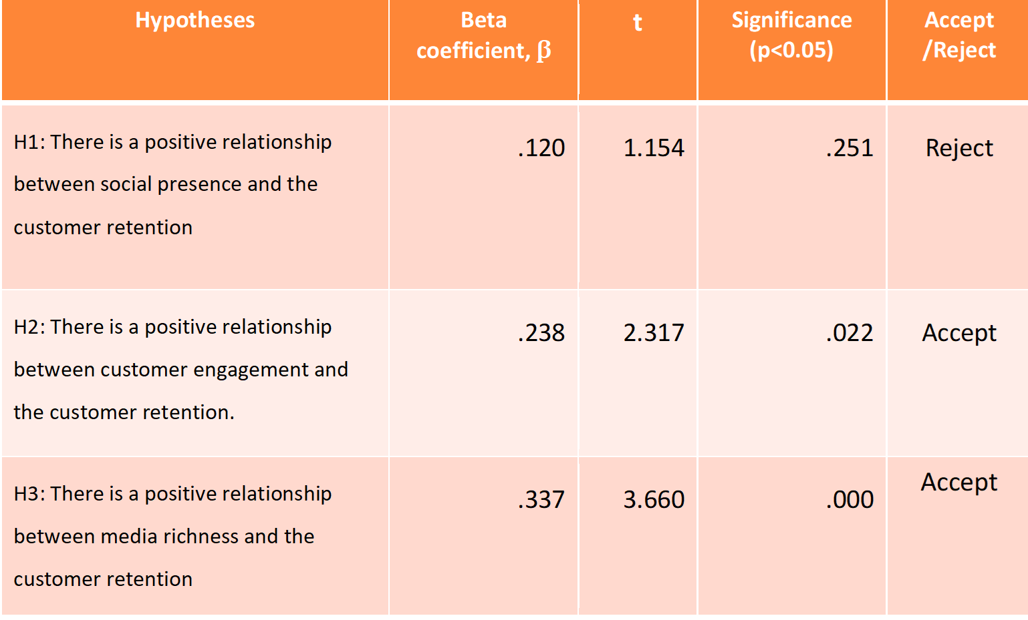
Figure 4.14：Hypotheses testing

CHAPTER 5

DISCUSSION AND CONCLUSION

5.0 Introduction
The fifth chapter is mainly about the further analysis of the data results in the fourth chapter. The fifth chapter will also analyze and discuss the research problems raised at the beginning. Reading the research results of previous relevant researchers will help provide necessary concepts for this study and deepen my understanding of the research topic and model. The analysis of this study can bring some previous research results to the brand side, and help enterprises to better understand the consumption habits of customers. The research results can provide some suggestions for brand retention. In the company's operation to better establish their own business model and strategy, consolidate and increase market share. And some ideas for future researchers.

5.1 Discussion of Main Findings
This study's theme is the significance and influence of Social Presence, Customer Engagement and Media Richness on Customer retention. Chapter 5 will focus on discussing and summing up the three independent variables: Social Presence, Customer Engagement and Media Richness, and whether they can help improve customer retention. I'll start with the three hypothetical questions I raised at the beginning of the article.
Findings on the Hypotheses
H1: There is a positive relationship between social presence and customer retention
According to the data analysis results, social presence has no significant significance for customer retention in terms of statistics. Through reading relevant literature, Santoso and Dewi (2018) hold the same attitude towards the relationship between social Presence and customer retention. Santoso and Dewi (2018) in the research process, the respondents have a high degree of social presence, but this is only because customers tend to use social media to get brand-related information, so social media is conducive to help customers achieve information interactivity. However, social Presence has a relatively small impact and significance on customer retention, which indicates that the interaction on the social media platform has a relatively small impact on customers. Customers' posts and other activities on social media platforms are just a kind of communication between customers and brands, and a process of communication and interaction with enterprises.
H2: There is a positive relationship between customer engagement and customer retention.
According to the research and analysis results in Chapter 4, customer engagement is statistically significant to customer retention. Mohd Johan et al. (2020) also showed the importance of customer participation to customer retention in their previous research results, and the correlation between them was strong. Mohd Johan et al. (2020) believe that when an individual has a high degree of participation in the brand's products or services, it will correspondingly improve the customer's attitude towards the enterprise, so as to further enhance the customer's participation in the brand's activities. In addition, this research result is also supported by Braun et al. (2017).Their research points out that customer engagement exerts a greater influence on customer retention in service-related situations than in the production environment. When customers participate in related activities, the role of emotion can not be ignored. Also consider the three types of customer engagement: company driven, customer-driven and third-party driven. These three different customer engagements also have different influences on customer retention (Braun et al., 2017).
H3: There is a positive relationship between media richness and customer retention.
According to the research results, media Richness has a positive correlation role in statistics of customer retention. The results of this argument are confirmed by Santoso and Dewi (2018). Santoso and Dewi (2018) point out in the proof process that media Richness has the most profound influence on customer retention in terms of social media.

5.2 Implications of the Study

5.2.1 Social presence
In the analysis of the results, social Presence had no significant effect on customer retention. The questionnaire information was collected by reading literature and reading. I think the reason for this result may be that consumer knowledge acquires brand information through social media platforms. These can only help the brand to complete the process of interaction and communication with customers but have little impact on customer retention. In addition, customers join the brand interactive community on the social platform, usually before the customer is already a fan of the enterprise. Therefore, enterprises should pay attention to the ability of content management and information feedback on the network platform, which is conducive to the establishment of brand image by customers.

5.2.2 Customer engagement
The results show that customer engagement has a significant impact on customer retention in terms of statistics through the analysis of the collected data. This shows that consumer participation can help enterprises improve customer retention, and it is also one of the challenges faced by enterprises. The company needs to improve its own insight, propose effective activities that meet customer needs to satisfy customer ideas and make customers willing to participate in brand activities.

5.2.3 Media richness
The research results show that media richness has the greatest influence on customer retention among the three independent variables and has a significant positive correlation in statistics. The results are also in line with trends in contemporary digital media. As the Internet age continues to update, media richness can help businesses and customers communicate more diversified and smoothly. But as well as increasing media richness, companies also need to think about cost budgeting. Making a reasonable and effective trade-off between the two.

5.3 Research Limitations & Suggestions for Future Research
There are many limitations in this study, and I will list them one by one in the following, hoping to avoid them in future studies.When I put forward the limitation, I will also accompany with some personal thoughts and suggestions.
First, the distribution and collection of questionnaires were limited. Since the time of this study was at the height of COVID-19 outbreak, the Nilai area where I was located was also classified as the red Danger area, so I could only issue and collect questionnaires through the Internet. Compared with face-to-face questionnaires, face-to-face questionnaires can better guarantee the filling quality of questionnaires. Second is limit the size of the questionnaire, I choose the nearby Nilai area hypermarket customers to fill in the questionnaire, the mall itself is a relatively large public place, so I set the number of questionnaires for 380 at the beginning, but as a result of the limitation of the outbreak, the number of questionnaires to collect through the network is not enough, I only collected 127 copies of valid questionnaires is 126. In addition, it is not possible to ensure that each respondent can fully understand the contents of the questionnaire by issuing questionnaires online, which will also affect the results of the questionnaire data.
Second, the sig. of the significance of social Presence in customer Retention is 0.251, indicating no significant effect between the two. This is the opposite of what I read in the literature. I think the reasons are as follows. My questionnaire is mainly distributed in hypermarkets near Nilai area. Regional restrictions may lead to group restrictions, and if the data is extended to a larger area, different results may be obtained.
Third, the research theme of this study is the influence of social media on customer retention. Social media is divided into three indicators for measurement, including social Presence, customer engagement and media richness. But by reading the relevant literature, customer engagement can be further subdivided into categories. These categories include customer-driven, enterprise-driven, and third party driven participation. Different drivers may also have an impact on the results. Therefore, customer engagement can be divided in a more detailed way into future studies.
Fourth, the independent variables in the model in this study are only social Presence, customer engagement, and media richness, mainly because of time and other aspects. However, many other factors, such as Affective commitment and Service quality, can also be considered when measuring social media's impact on customer retention.
Fifth, the age and race of the respondents were not balanced. Almost half of the respondents were Chinese. In terms of gender, it is relatively even, with a 50/50 split between men and women. In terms of age, respondents aged between 26 and 29 accounted for 38.1% of the total, while older respondents were rare, with respondents aged over 40 accounting for about 9% of the total. Due to the unbalanced population of respondents' background, the data analysis results are not universally applicable. Therefore, in future study, the researchers should meet the demographic requirements of the population proportion.

5.4 Conclusions and Recommendations
This study mainly explores the impact of social media on customer retention. Three independent variables are used to measure the relationship between them. The three independent variables include social Presence, Customer engagement and media richness. According to the analysis data results, customer engagement, and media richness have significant effects on customer retention statistically. The social presence of customer retention had no obvious effect on statistics. Therefore, based on the research results, I will give some ideas and suggestions to brand owners, marketing staff, retailers, and future researchers in the following paragraphs.
There are many reasons that determine customer retention. However, with the increasing popularity of social media, social media platforms have become an indispensable marketing tool. According to the results of this study, customer engagement and media richness have a significant influence on customer retention. Brands, marketers and even producers should pay attention to the impact of these factors. Of course, appropriate use of relevant marketing strategies can have a positive effect, but when excessive use of social media marketing can sometimes have the opposite effect.
First of all, make some suggestions from the perspective of customer engagement.
- In the past, sellers or senior managers of enterprises would consider marketing strategies according to customers' needs, which also determined that initiative and control were usually in enterprises' hands. For example, by studying the needs of customers in the market, the enterprise will have enough information and data before deciding how to implement the strategy. But the rise of social media has ceded control to customers. Therefore, both brand owners and marketers should consider how to create relationships with customers through social media platforms so that customers can participate in the process of adding value to products or services. Brand owners can maintain smooth and continuous interaction with customers through a variety of social media. But when choosing a social media platform, consider its advantages and disadvantages separately. It also takes into account changes and transitions in the consumer engagement phase, gradually helping the company to increase customer retention.
- The company shall consider customer participation when releasing new products or services because customer participation may create value and profits for the brand in the long term. For example, when developing new products, companies can consider the knowledge and feedback provided by customer participation. This stage may be resource-intensive, but it can help manufacturers improve the effectiveness of developing new products and improve the success rate of the brand in the market.
- It is necessary to actively consider customer participation based on the industry category of the enterprise. For example, in health care industries, referrals in customer engagement may make more sense than buy-backs. But in some web services industries, such as gaming, the preferred behaviour of customers may be online reviews.
- Different customer behaviours should be classified, and potential customers should be developed. For example, some customers do not purchase frequently but tend to develop participation behaviours, so enterprises should pay attention to such customer groups.
The data analysis results show that media richness has a significant influence on customer retention, and the influence degree is the largest among the three independent variables. Therefore, regarding Media Richness, I will make the following suggestions.
- Enterprises should also consider the maintenance of offline customer relations when they release products or service content with rich media. And to keep online and offline knowledge common. Especially within the company staff, information transparency and liquidity should be high and timely notify the retailer's sales staff. Otherwise, customers will question the brand impression due to information confusion or contradiction.
- The company's products or services shall be combined in the release of information content. Customers often use social media platforms to gain access to unknown information. So when it comes to maintaining a corporate image on social media platforms, it's important to think about what customers want rather than what messes up content.
- Active customers on each social media platform are different, such as the age gap between active users of Facebook and Douyin. Therefore, enterprises should find out the market positioning and target customer groups and then select social media to implement effective marketing mix strategies.
- The company needs to have efficient communication activities for publicity on social media platforms. In addition, it also needs the support of human resources with excellent communication skills. The use of the Internet for marketing has both advantages and disadvantages. Therefore, in terms of content editing, attention should be paid to customers' emotions and needs. Target customers can more easily accept only in a good way.
- When adopting the theory of media richness for practice, enterprises need to pay attention to various social media platforms' information consistency.

5.5 Personal Reflection
I am very happy to have this experience, from the beginning to decide the research topic to the final paper submission. In this process, I met many challenges and learned a lot. It was difficult for me to decide the topic at first because I had to choose not only the topic, but also build my own research model, and later I had to correct the title. I am very grateful to my mentors and lucky to have two mentors. In the process of editing the questionnaire, the format and questions were also edited with painstaking efforts. At the same time, it was also necessary to consider whether the questionnaire format and the number of questions collected in the special period could meet the requirements. After the data collection, I used SPSS software to analyze the data. In fact, I studied SPSS in the first semester of my postgraduate course, so I was not very familiar with the software's functions. After looking up a lot of data, little by little to experiment, finally, present the current analysis results. The process of reading literature also benefited me a lot, which improved my familiarity with the paper and gave me confidence in reading English papers.
In this process, I encountered many obstacles and challenges, such as determining research questions, research objectives, literature review, research models and so on. It helped me focus. At the same time, I also learned that social media could be measured in multiple dimensions and exert a significant impact on customer retention. For example, customer engagement and media richness independent variables have an obvious influence on customer retention. Finally, I would like to express my heartfelt gratitude to the mentors who have given me valuable knowledge during this research.

6.0 References
- Kadhim, K.G., Harun, A., Othman, B., Melhem, I., Mechman, A. and Mohammed, A., THE INFLUENCE OF CORPORATE SOCIAL RESPONSIBILITY COMMUNICATION (CSR) ON CUSTOMER SATISFACTION TOWARDS HYPERMARKETS IN KUALA LUMPUR MALAYSIA.
- Ghaffarkadhim, K., Harun, A., Othman, B.A. and Raja, P., 2019. Hypermarkets in malaysia: Issues of expansion, distribution and corporate social responsibility. International Journal of Psychosocial Rehabilitation, 23(2), pp.659-670.
- Garrido-Moreno, A., García-Morales, V.J., Lockett, N. and King, S., 2018. The missing link: Creating value with social media use in hotels. International Journal of Hospitality Management, 75, pp.94-104.
- Unni, M.V., 2020. Does Digital and Social Media Marketing Play a Major Role in Consumer Behaviour?. International Journal of Research in Engineering, Science and Management, 3(4), pp.272-278.
- Sashi, C.M., Brynildsen, G. and Bilgihan, A., 2019. Social media, customer engagement and advocacy. International Journal of Contemporary Hospitality Management.
- Liu, S., Perry, P. and Gadzinski, G., 2019. The implications of digital marketing on WeChat for luxury fashion brands in China. Journal of Brand Management, 26(4), pp.395-409.
- 2020. [online] Available at: <https://www.retailfeedback.com/blog/item/17-2013-u-s-supermarket-experience-study.html> [Accessed 1 October 2020].
- Dragnea, M. and Mihăiță, N.V., 2020. Customer Retention, Behavior and Emotions. VISION, pp.1283-1290.
- Lowenthal, P.R. and Snelson, C., 2017. In search of a better understanding of social presence: An investigation into how researchers define social presence. Distance Education, 38(2), pp.141-159.
- Dessart, L., 2017. Social media engagement: a model of antecedents and relational outcomes. Journal of Marketing Management, 33(5-6), pp.375-399.
- Ishii, K., Lyons, M.M. and Carr, S.A., 2019. Revisiting media richness theory for today and future. Human Behavior and Emerging Technologies, 1(2), pp.124-131.
- Ascarza, E., Neslin, S.A., Netzer, O., Anderson, Z., Fader, P.S., Gupta, S., Hardie, B.G., Lemmens, A., Libai, B., Neal, D. and Provost, F., 2018. In pursuit of enhanced customer retention management: Review, key issues, and future directions. Customer Needs and Solutions, 5(1-2), pp.65-81.
- Kumar, A., Luthra, S., Khandelwal, D.K., Mehta, R., Chaudhary, N. and Bhatia, S., 2017. Measuring and improving customer retention at authorised automobile workshops after free services. Journal of Retailing and Consumer Services, 39, pp.93-102.
- Alshurideh, M.T., 2016. Is customer retention beneficial for customers: A conceptual background. Journal of Research in Marketing, 5(3), pp.382-389.
- Arafah, W., 2016. CUSTOMER RETENTION STRATEGIES AT HYPERMARKETS IN JAKARTA. Business and Entrepreneurial Review, 10(2), pp.121-130.
- Jin, S.V., Muqaddam, A. and Ryu, E., 2019. Instafamous and social media influencer marketing. Marketing Intelligence & Planning.
- Fattah, R.A. and Sujono, F.K., 2020. Social Presence of Ruangguru in Social Media during Covid-19 Pandemic. Jurnal The Messenger, 12(2), pp.180-191.
- Pentina, I., Guilloux, V. and Micu, A.C., 2018. Exploring social media engagement behaviors in the context of luxury brands. Journal of Advertising, 47(1), pp.55-69.
- Voorveld, H.A., van Noort, G., Muntinga, D.G. and Bronner, F., 2018. Engagement with social media and social media advertising: The differentiating role of platform type. Journal of advertising, 47(1), pp.38-54.
- Gimpel, H., Huber, J. and Sarikaya, S., 2016. Customer satisfaction in digital service encounters: The role of media richness, social presence, and cultural distance.
- Tanupabrungsun, S. and Hemsley, J., 2018. Studying celebrity practices on Twitter using a framework for measuring media richness. Social Media+ Society, 4(1), p.2056305118763365.
- Gimpel, H., Huber, J. and Sarikaya, S., 2016. Customer satisfaction in digital service encounters: The role of media richness, social presence, and cultural distance.
- Rofiq, M., Firdi, A. and Respati, H., 2020.The Effect of Brand Image and Social Media on Customer Retention through Customer Satisfaction at Kaliwatu Adventure.
- Dewnarain, S., Ramkissoon, H. and Mavondo, F., 2019. Social customer relationship management: An integrated conceptual framework. Journal of Hospitality Marketing & Management, 28(2), pp.172-188.
- Venkatesan, R., 2017. Executing on a customer engagement strategy.
- Braun, C., Hadwich, K. and Bruhn, M., 2017. How do different types of customer engagement affect important relationship marketing outcomes? An empirical analysis. Journal of Customer Behaviour, 16(2), pp.111-144.
- Johan, M.R.M., Xyn, T.M., Manab, N.F.A., Syed, M.A.M. and Adnan, H.M., 2020.Customer Retention in Digital Media Business Platforms in Malaysia.
- Santoso, R.K. and Dewi, N.F., 2018. The Influence of Social Media Against Customer Retention (Case Study on J. Co). KnE Social Sciences, pp.1436-1472.
- Rofiq, M., Firdi, A. and Respati, H., The Effect of Brand Image and Social Media on Customer Retention through Customer Satisfaction at Kaliwatu Adventure.
- Oregon, E., McCoy, L. and Carmon-Johnson, L., 2018. Case Analysis: Exploring the Application of Using Rich Media Technologies and Social Presence to Decrease Attrition in an Online Graduate Program. Journal of Educators Online, 15(2), p.n2.
- Chyung, S.Y., Roberts, K., Swanson, I. and Hankinson, A., 2017. Evidence‐based survey design: The use of a midpoint on the Likert scale. Performance Improvement, 56(10), pp.15-23.
- Mohajan, H.K., 2017. Two criteria for good measurements in research: Validity and reliability. Annals of Spiru Haret University. Economic Series, 17(4), pp.59-82.
- Tsai, M.C. and Lin, J.C., 2017.THE INFLUENCE OF INERTIA ON REPURCHASE INTENTION OF HYPERMARKET CUSTOMERS.
- Saha, M., 2020. Customer Engagement with 7 Ps of Marketing. Available at SSRN 3540310.
- Selvaraju, M., Degeras, D.K., Beleya, P., Suliman, K.R. and Yacob, P., 2020, April. Reducing Supply Chain Cost Vulnerability using a Resilient Strategy: Malaysian Hypermarket Retail Perspective. In 2020 IEEE 7th International Conference on Industrial Engineering and Applications (ICIEA) (pp. 464-468). IEEE.
- Mojumder, J.,2020. Industry 4.0-enabled In-Store Customer Experiences–Evidence from Offline Retailing Bijay Bhujabal1.
- Mohd-Ramly, S. and Omar, N.A., 2017. Exploring the influence of store attributes on customer experience and customer engagement. International Journal of Retail & Distribution Management.
- Dinesh, P., Norida, A. and Ali, H.M.R., 2018. Customer Satisfaction And Customer Retention Towards Retail Store In Malaysia. International Journal of Human and Technology Interaction (IJHaTI), 2(2), pp.57-66.
- Manzoor, U., Baig, S.A., Hashim, M. and Sami, A., 2020. Impact of Social Media Marketing on Consumer’s Purchase Intentions: The Mediating role of Customer Trust. International Journal of Entrepreneurial Research, 3(2), pp.41-48.
- Wahieb, R.M., 2017. Internal organizational barriers to the adoption of social media marketing in the retailing industry of electronics and home appliances-the case of Egypt (Doctoral dissertation, University of Salford).
- Xinyang, W., 2019. Factors Positively Impacting Loyalty of Walmart Hypermarket Customers in Yuxi City in China.
- Zaker, R.A., 2017. The Effect of Social Media on the Successful Implementation of CRM.
- Yeow, C.C., 2019. Customers’ Intention to Purchase Halal Products in Malaysia: A Case of Non-Muslims (Doctoral dissertation, UTAR).
- Agnihotri, R., Trainor, K.J., Itani, O.S. and Rodriguez, M., 2017. Examining the role of sales-based CRM technology and social media use on post-sale service behaviors in India. Journal of Business Research, 81, pp.144-154.
- Manzoor, U., Baig, S.A., Hashim, M. and Sami, A., 2020. Impact of Social Media Marketing on Consumer’s Purchase Intentions: The Mediating role of Customer Trust. International Journal of Entrepreneurial Research, 3(2), pp.41-48.
- Carlson, J.R. and Zmud, R.W., 1999. Channel expansion theory and the experiential nature of media richness perceptions. Academy of management journal, 42(2), pp.153-170.
- Field, A., 2013. Discovering statistics using IBM SPSS statistics. sage.
- Witt, H., 2017. Exploratory analysis of the reliability and validity of the Chinese version of the body checking questionnaire. Widener University.
- Anastasiadou, S.D., 2011. Reliability and validity testing of a new scale for measuring attitudes toward learning statistics with technology. Acta Didactica Napocensia, 4(1), pp.1-10.
- Mishra, P., Pandey, C.M., Singh, U., Gupta, A., Sahu, C. and Keshri, A., 2019. Descriptive statistics and normality tests for statistical data. Annals of cardiac anaesthesia, 22(1), p.67.
- Gogtay, N.J. and Thatte, U.M., 2017. Principles of correlation analysis. Journal of the Association of Physicians of India, 65(3), pp.78-81.
- Lan, Y.F. and Sie, Y.S., 2010. Using RSS to support mobile learning based on media richness theory. computers & education, 55(2), pp.723-732.

7.0 Appendix

Appendix A: Survey Questionnaire

Survey Questionnaire
Dear interviewees,
I am currently studying at INTI International University in Nilai, Malaysia. I am an international student studying for a master's degree. I am currently studying the impact of social presence, customer participation and media richness on customer retention, which is one of the requirements of my graduate thesis. First of all, I will keep your identity and any related private information confidential ，which will only be used in this study. There are three main parts in this questionnaire, which will take you about 5 minutes to complete. Your answer is very valuable to me. Please fill in according to your real experience and feelings.
Thank you very much for your precious time and your participation!
Yours faithfully,
Peng Na

SECTION A
INDEPENDENT VARIABLES
Questionnaire | Strongly disagree | Disagree | Neutral | Agree | Strongly agree
Questionnaire | 1 | 2 | 3 | 4 | 5
Social Presence
1. Using the social media can represent me in interacting with hypermarket directly.
2. Social Media platform is my broker in interacting with hypermarket and other social media users.
3. Using the social media platforms make me closer with hypermarket compared to the other way.
4.By joining in the social media make me closer in conveying the ideas and suggestions and complaints to the hypermarket.
Customer Engagement
1. I like to spend time on social media reading the latest information of the supermarket.
2. I think the information on social media about hypermarkets is real and timely.
3. I'm pleased that social media marketing allows me to keep up with the latest products and services.
4. Social media has made my life easier .
5. Only when the price of online products is lower than the offline price will I prefer online shopping .
6. When I interact with brands on social platforms, I experience it well.
7.I get information from social media platforms before I decide to go to a hypermarket.
Media Richness
1. Social media allows me to give and receive timely feedback.
2. Social media allows the brand and me to communicate a variety of different cues (such as emotional tone, attitude, or formality) in our messages.

DEPENDENT VARIABLE
Questionnaire | Strongly disagree | Disagree | Neutral | Agree | Strongly agree
Questionnaire | 1 | 2 | 3 | 4 | 5
Customer Retention
1. The social media marketing of the supermarket will drive your purchase decision.
2. There is enough information about big-box products and services on social media platforms.

SECTION B

Note: Please tick a (√) on one of the square. Please complete the following personal information section to help me collect and analyze the results.
1. Please specify your gender:
- Male
- Female

2. Please specify your age:
- 22-25
- 26-29
- 30- 34
- 35-39
- 40-44
- 45-49
- 50-55
- More than 56

3. What is your current educational level:
- Doctorate Degree
- Master's Degree
- Graduate Diploma
- BA/BS Degree

4.What’s your race?
- Malay
- Indian
- Chinese
- Others

5. Monthly Income?
- Below RM1,000
- RM1,000-RM2,999
- RM3,000-RM4,999
- RM5,000 and above

6.Current Marital Status
- Single
- Married
- Divorced/Separated
- Widowed
- Others, please specify: ___________

7. Your frequency of hypermarket consumption
- Daily
- Once a week
- Several times per week
- Once a month
- Several times per month
- Once a year
- Several times per year
- Only on special occasions

Appendix B: All the Tables of Fingding Results
Figure 3.1：Cronbach's Alpha variable rule
Figure 3.2：Reliability test-Cronbach's Alpha
Figure 3.3:KMO and Bartlett's Test
Figure 3.4:Normal P-p Plot of Regression Standardized Residual

Figure 4.1:The analysis of gender frequency
Figure 4.2:The analysis of age frequency
Figure 4.3:The analysis of educational level frequency
Figure 4.4:The analysis of race frequency
Figure 4.5:The analysis of monthly income frequency
Figure 4.6:The analysis of marital status frequency
Figure 4.7:The analysis of hypermarket consumption frequency
Figure 4.8:Statistics
Figure 4.9:Correlation analysis
Figure 4.10:Model Summary
Figure 4.11:ANOVA
Figure 4.12:Coefficients
Figure 4.13:Test of Significance
Figure 4.14：Hypotheses testing

Appendix C: Proposal Defense Presentation
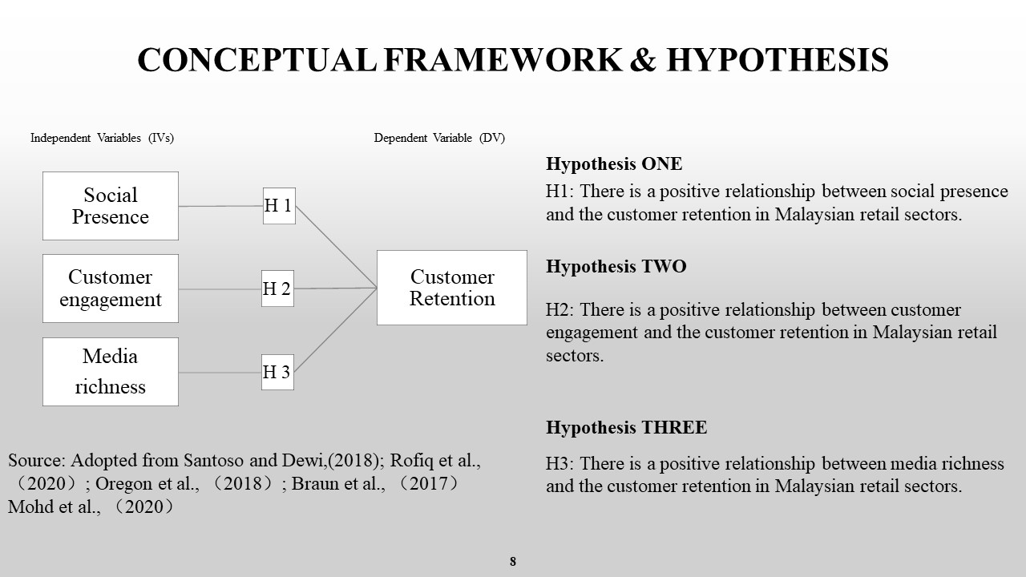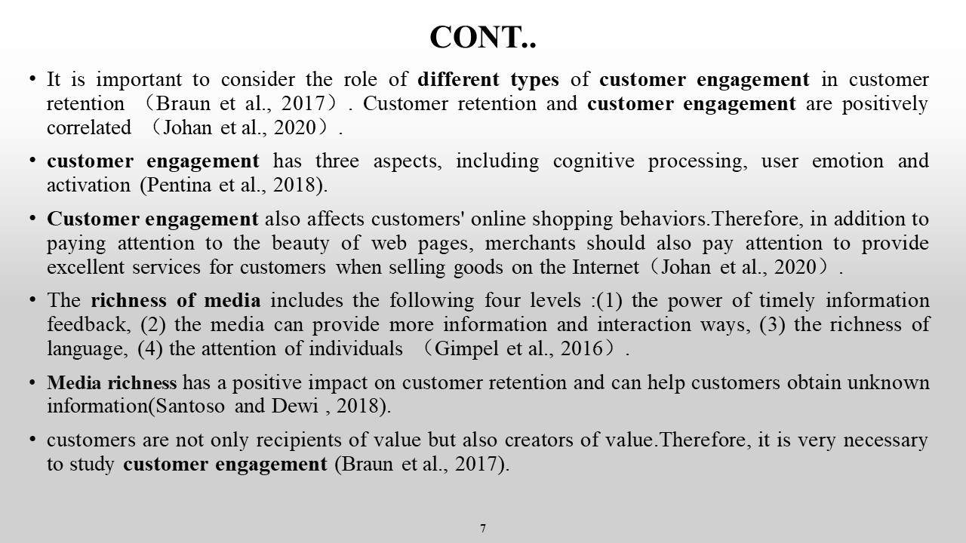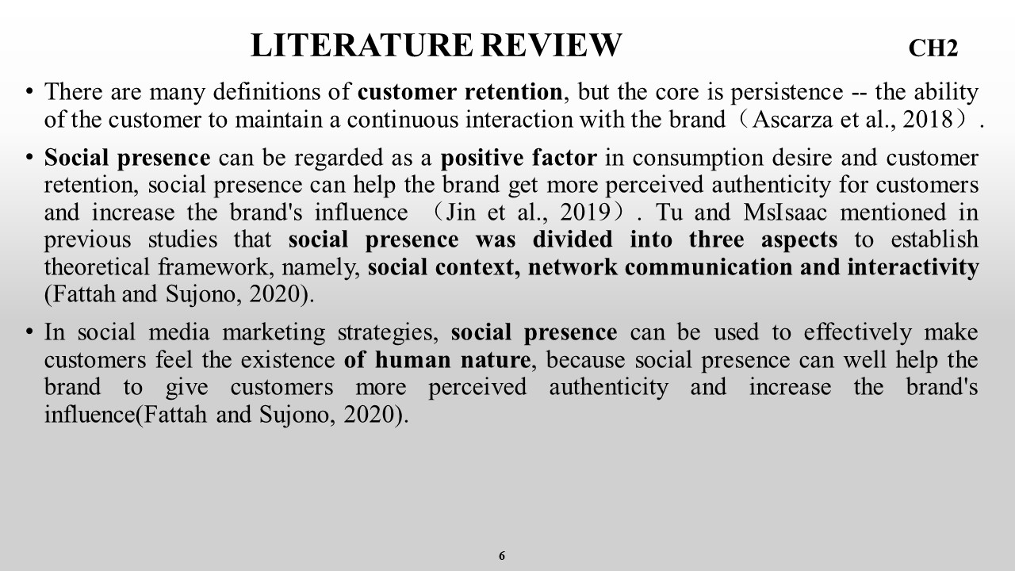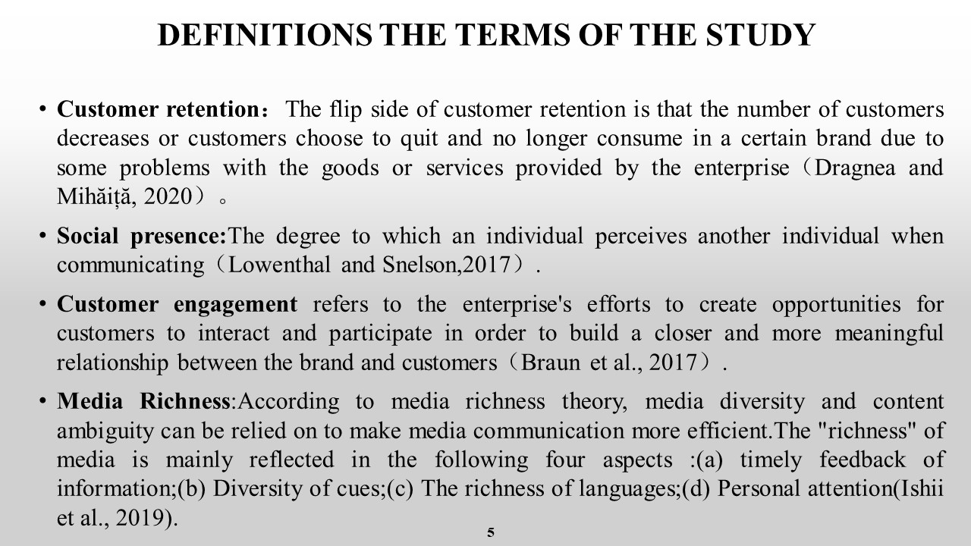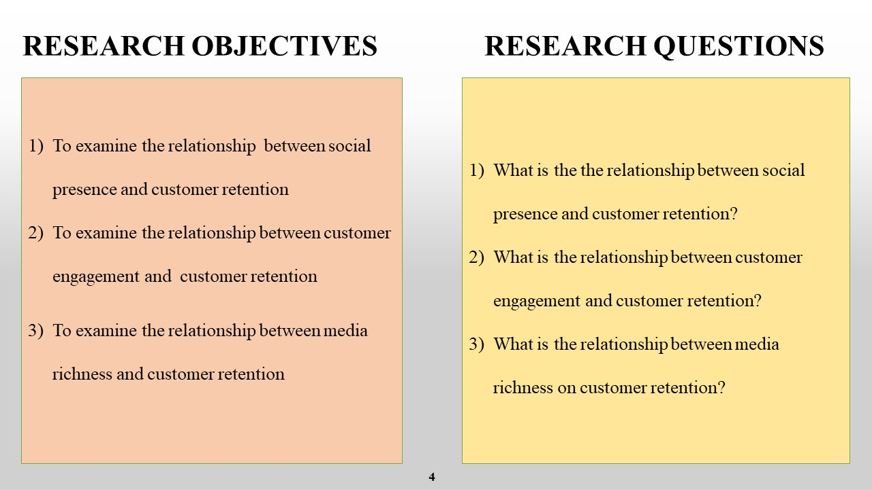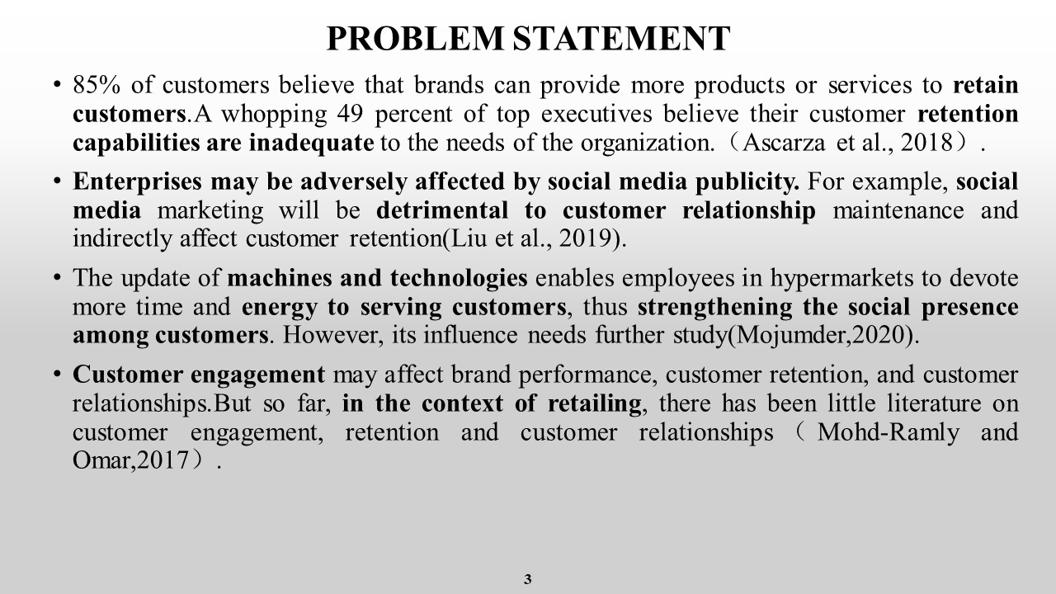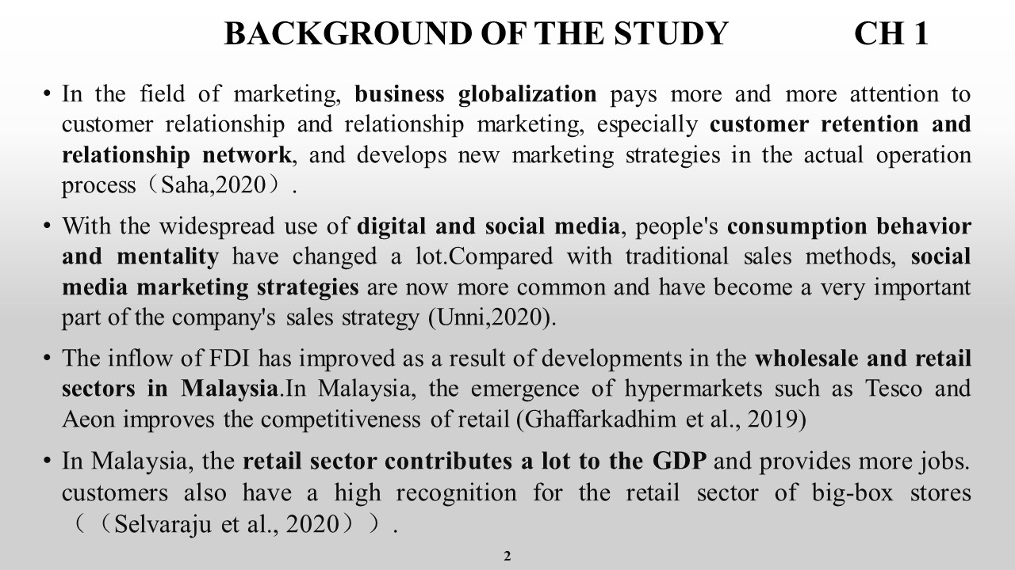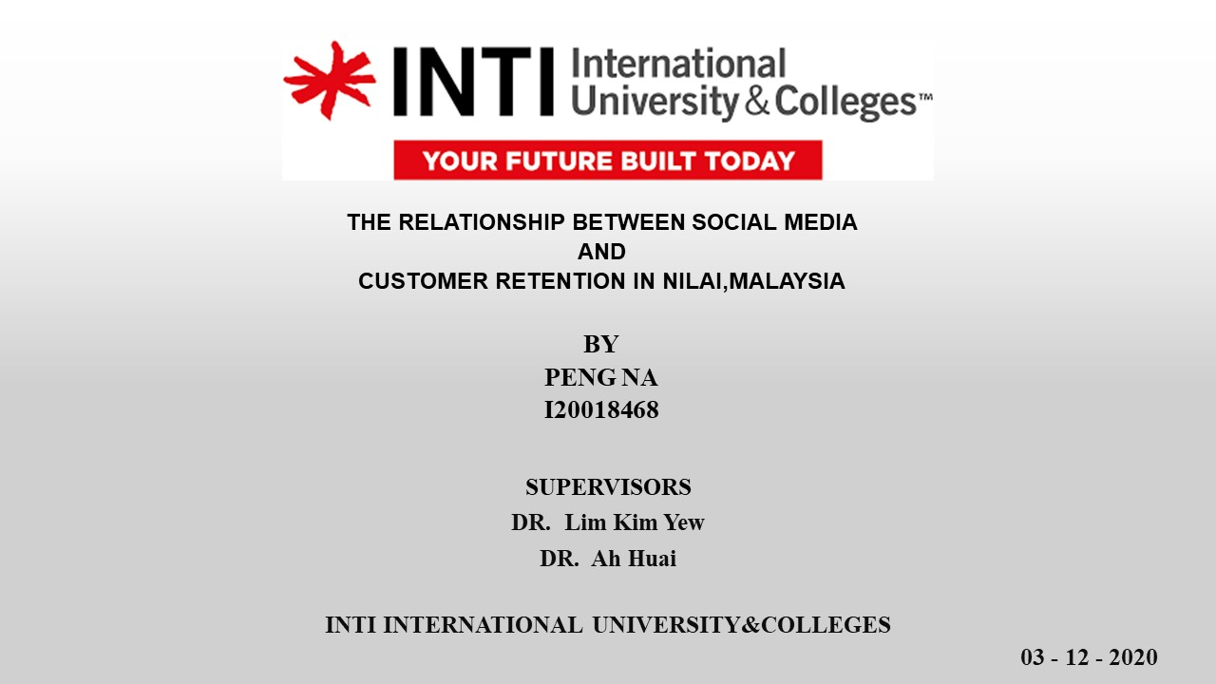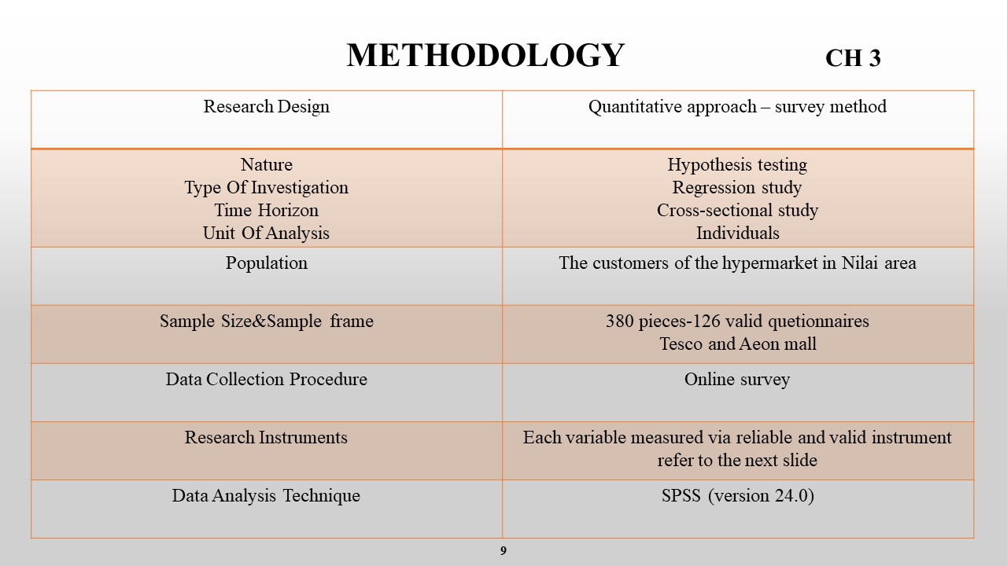

Appendix D: VIVA Presentation
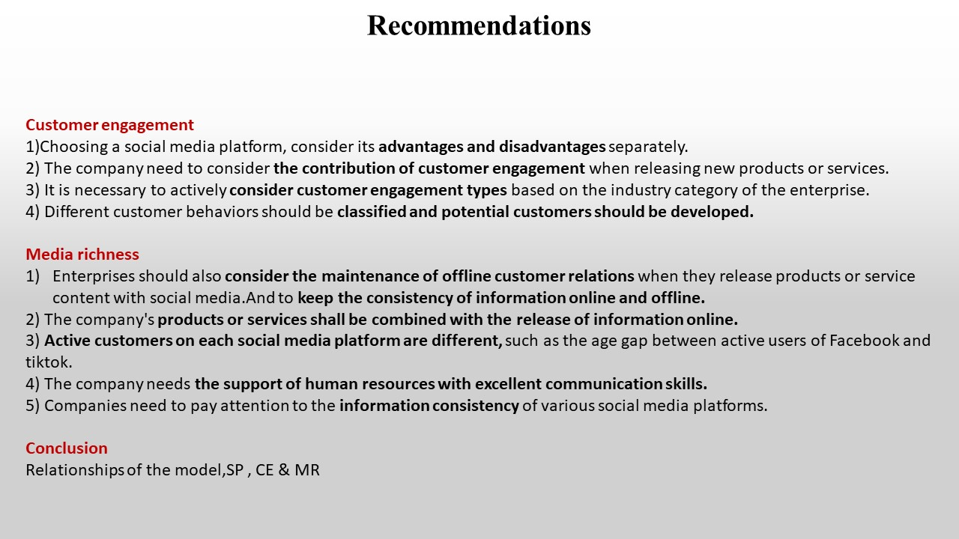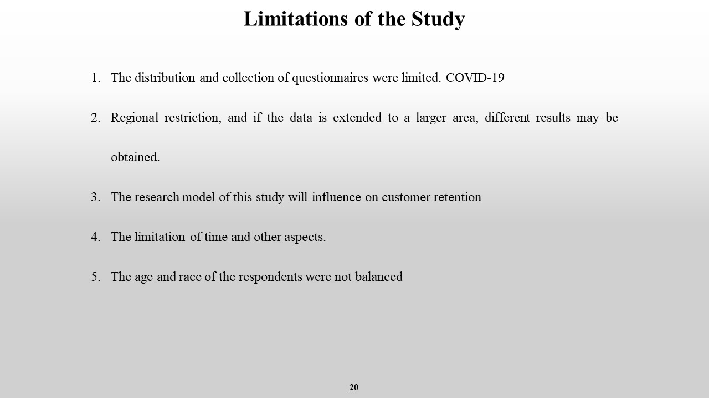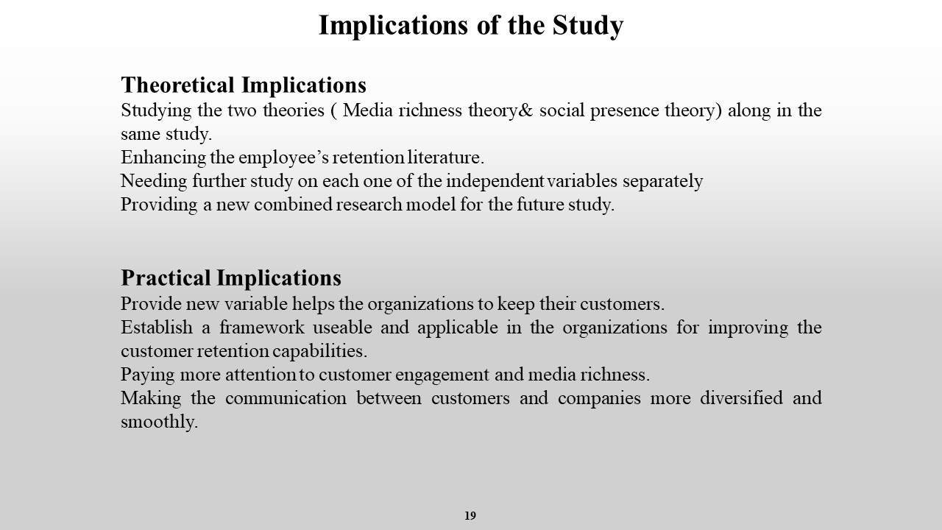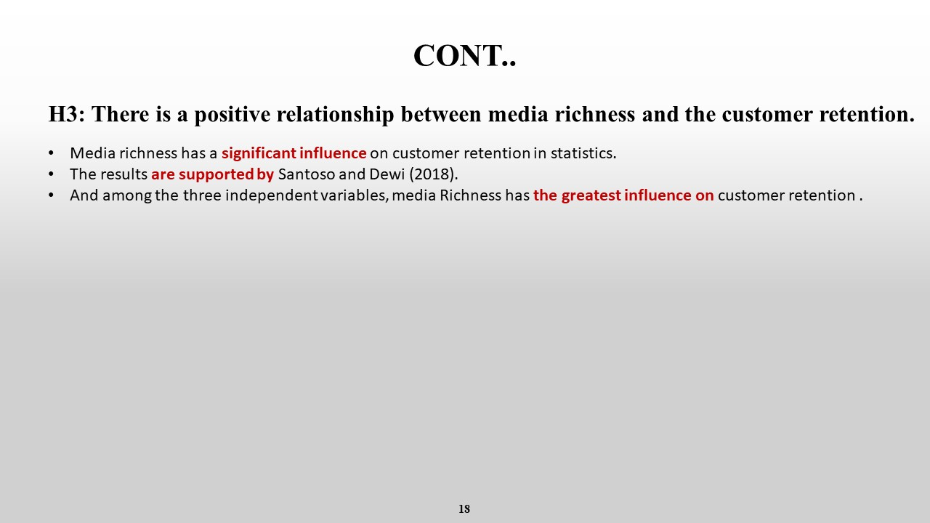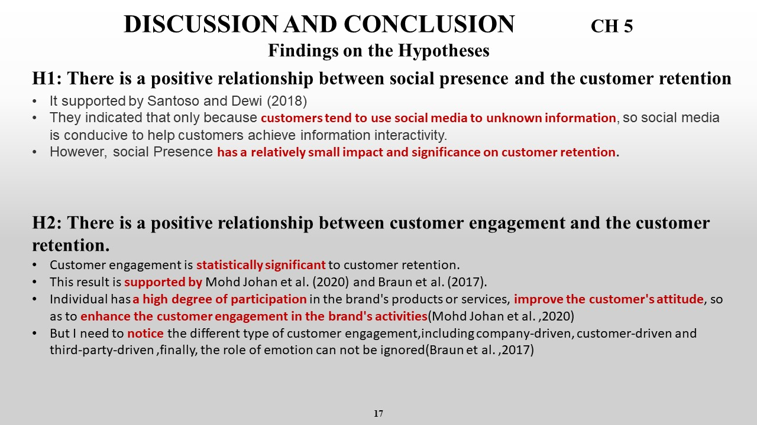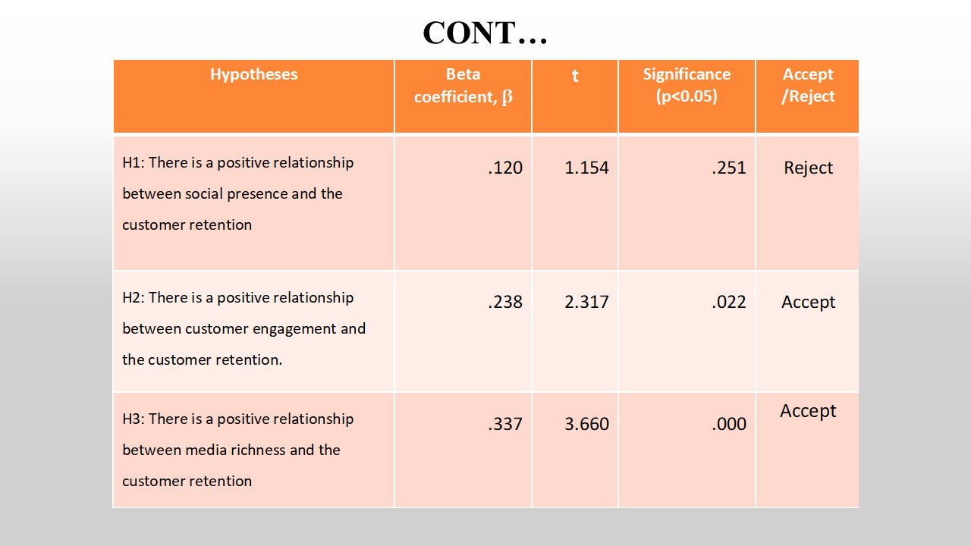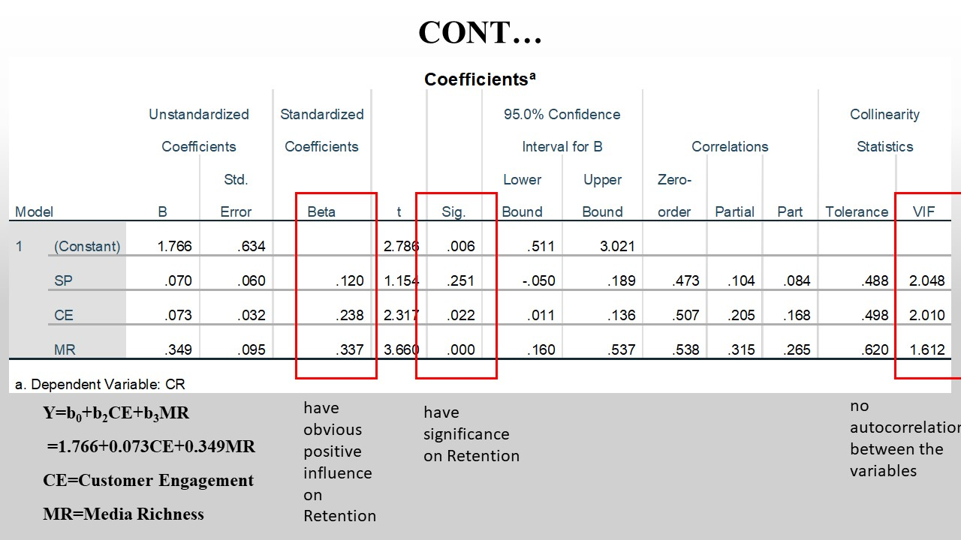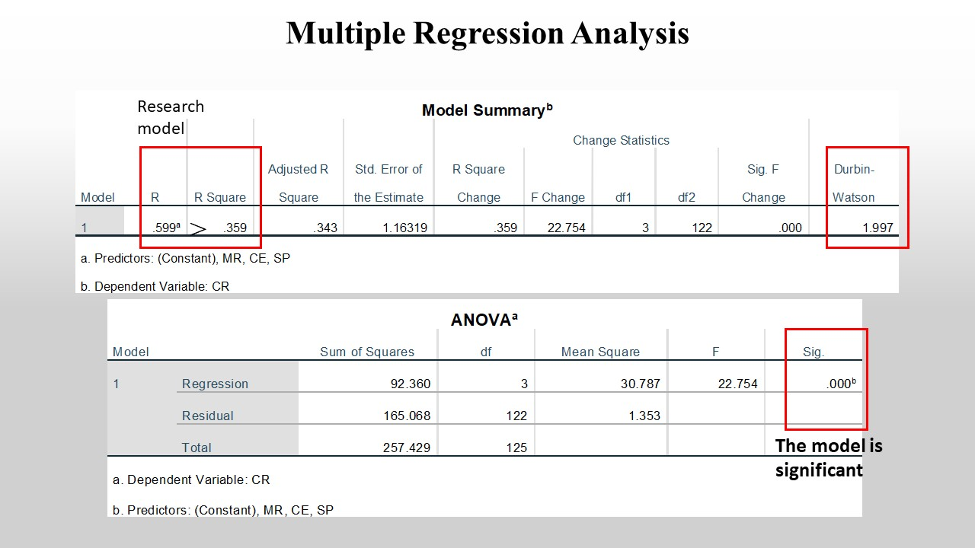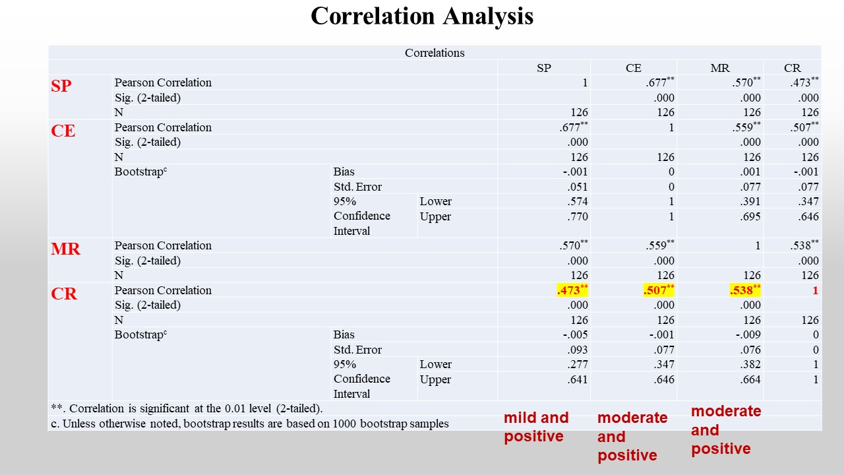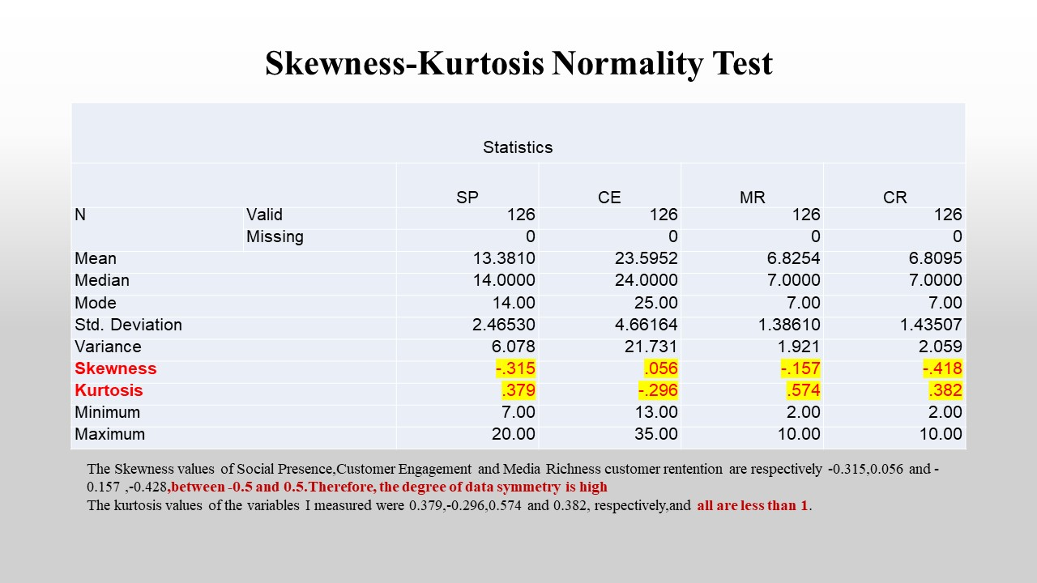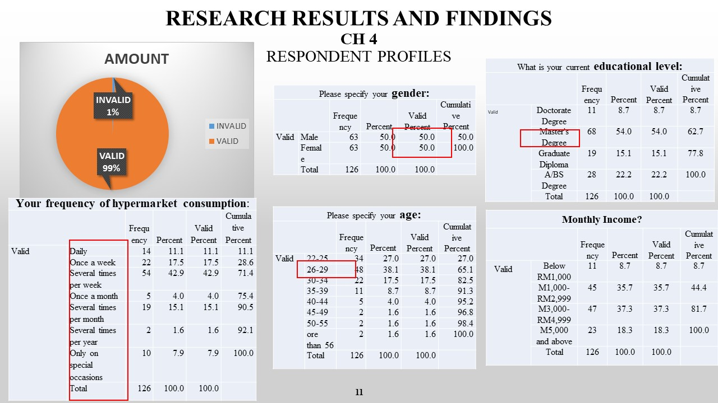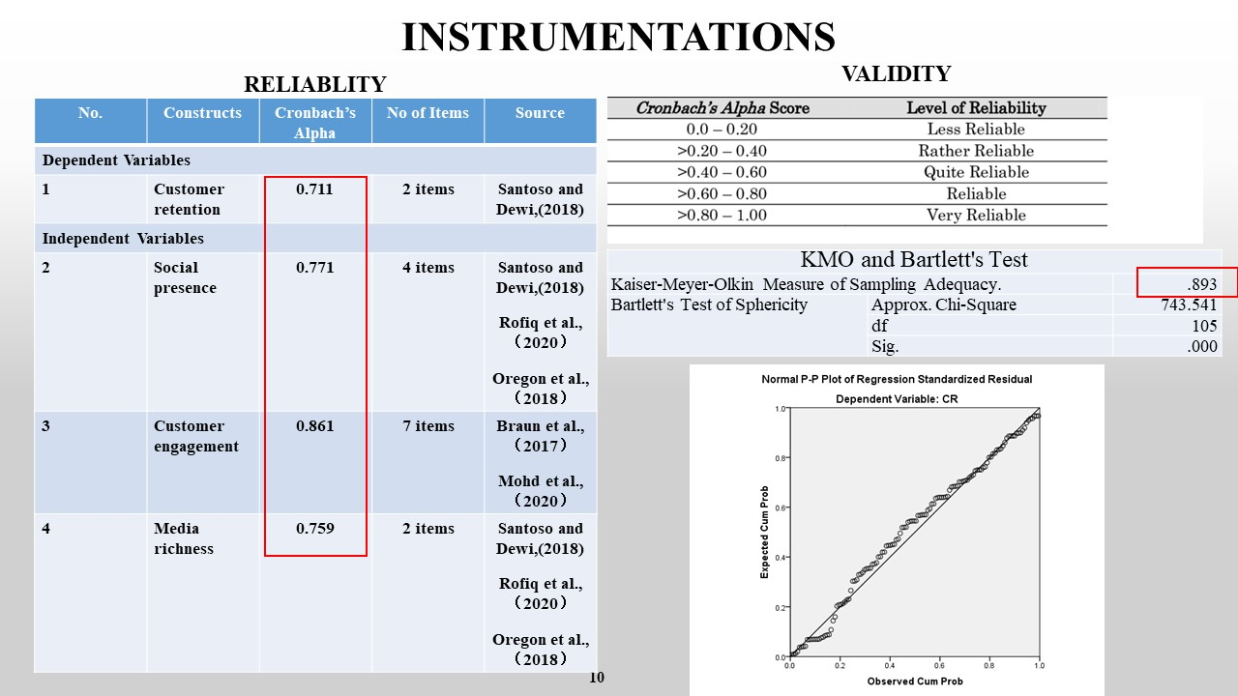

Appendix E: MBA Project Log
PROJECT PAPER LOG
This is an important document, which is to be handed in with your dissertation. This log will be taken into consideration when awarding the final mark for the dissertation.

Student Name: | Peng Na
Supervisor’s Name: | Dr. Lim Kim Yew
Dissertation Topic:
The Relationship Between Social Media and Customer Retention In Nilai, Malaysia

SECTION A. MONITORING STUDENT DISSERTATION PROCESS

The plan below is to be agreed between the student & supervisor and will be monitored against progress made at each session.

Activity | Milestone/Deliverable Date
Discussion on Research Topic | 25/9
Revision of Chapter 1 |  | 06/10
Research Framework |  | 12/10
Revision of Chapter 2 |  |  | 20/10
Discussion of Research  Methodology |  |  | 22/10
Review of Chapter 3 |  |  |  | 02/11
Discussion on Feedback from  Proposal Defense |  |  |  |  | 10/11
Discussion on Chapter 4 |  |  |  |  |  | 20/11
Discussion on Findings of the  Research |  |  |  |  |  |  | 30/11
Preparation for the Final  Defense |  |  |  |  |  |  |  | 01/12
Discussion on Chapter 5 |  |  |  |  |  |  |  | 06/12

Appendix F: Turnitin
