**INTI INTERNATIONAL UNIVERSITY**

**MASTER OF BUSINESS ADMINISTRATION**

**The Impact of E-commerce Livestreaming Sellers’ Characteristics**

**on Consumer Buying Behavior – Taking Taobao as A Case**

**Author: CHEN Jimiao**

**Student No: I19017041**

**Supervisor: Dr. Mun Geet Ow Yong**

**Submission Date: 18 December 2020**

**Ethics Number:**

**Final Word Count: 13,942**

**FACULTY OF BUSINESS, COMMUNICATIONS, AND LAW**

I

**ABSTRACT**

By virtue of the rapidly developing live streaming in e-commerce, livestreaming sellers is risen to cope with such development to provide opinion and information to consumers. Whether their characteristics can accurately and effectively influence consumers in e-commerce platforms. Therefore, effective characteristics of livestreaming sellers need to be identified. The objective of this research is to examine what factors of livestreaming sellers can affect consumers’ buying behavior on Taobao Live. Conceptual Model of this research had four characteristics of e-commerce livestreaming sellers, like professionalism, product involvement, popularity, visual cues, also, perceived value as mediating variable and product price as moderating variable, these were used to test the relationship between each variable. A total of 204 valid participated in as sample for the research. The data was collected via self-completion online delivery questionnaire and analyzed through descriptive analysis, correlation and regression assessment. The result of the research suggests that the livestreaming sellers' characteristics toward consumer buying behavior is positively affected by perceived value, while the relationship between livestreaming sellers and perceived value is negatively influenced by product price. Further, this study given conclusion of hypotheses testing and recommendations to e-commerce company and livestreaming sellers to improve the way of how to better effectively influencing consumers’ buying behavior.

***Keywords:*** *E-commerce livestreaming seller, Characteristics, Consumer Buying Behavior*

II

**ACKNOWLEDGEMENT**

This MBA project is the result of not only the researcher's effort and passion; it is the fruit of a many people's diligence and sincerity. I would like to express my sincere gratitude to those people who have contributed to the completion of this research.

First of all, I would express my truly gratefulness to my supervisor Dr. Mun Geet Ow Yong, for his on-going patience, support and personal guidance in completing this thesis. Also, I would like to thank to my second marker Ms. Ah Huai Ah Chan, without her useful advices, perseverance and sincerity, this research would never be completed.

I would acknowledge my honest gratitude to my friends and my classmates for giving me a great opportunity to study in this MBA course and conducting this research.

I also want to express my appreciation to my MBA lecturers, researchers, and staffs who have helped me along the way. Especially for my team members Lu, Wang and Donata, without their precise helping, I never would have been capable of completing this thesis.

Last but not least, the greatest appreciation to my beloved family members, who always give me care, happiness and motivation to overcome difficulties.

III

**DECLERATION**

I hereby declare that this research project is of my own effort except for the information that has been used from authors that have been cited accordingly and ethically.

CHEN Jimiao 18th December 2020

IV

**TABLE OF CONTENTS**

**ABSTRACT I**

**ACKNOWLEDGEMENT II**

**DECLERATION III**

**TABLE OF CONTENTS IV**

**LIST OF TABLES VIII**

**LIST OF FIGURES VIII**

CHAPTER 1: INTRODUCTION 1

1.1 Research Background 1

1.2 Problem Statement 1

1.2.1 Problem statement 1 2

1.2.2 Problem statement 2 2

1.3 Research Objectives 3

1.4 Research Questions 4

1.5 Significance of the Research 4

1.5.1 Significance to Academy 5

1.5.2 Significance to Industry 5

1.6 Scope of the Research 6

1.7 Limitation of the Research 6

1.7.1 Limited Sample Range 6

1.7.2 Incomplete Consideration of Influencing Factors 7

1.8 Organization of Chapters 7

CHAPTER 2: LITERATURE REVIEW 9

2.1 Overview 9

2.2 Broader Concepts Related to Livestreaming Literature 9

2.2.1 Network Livestreaming 9

2.2.2 E-commerce Livestreaming 12

2.2.3 E-commerce Livestreaming Seller 13

2.3 Specific Concepts Related to Variables in Conceptual Framework 14

2.3.1 Characteristics of Livestreaming Sellers 14

2.3.1.1 Professionalism 14

2.3.1.2 Product involvement 15

2.3.1.3 Popularity 16

2.3.1.4 Visual Cues 16

2.3.1.5 Perceived Value 17

2.3.1.6 Product Price 18

2.3.1.7 Consumer Buying Behavior 19

2.6 Conceptual Framework 20

2.7 Hypotheses 20

CHAPTER 3: METHODOLOGY 21

3.1 Overview 21

3.2 Research Design 21

3.3 Unit of Analysis 22

3.4 Sampling 23

3.5 Data Collection Method 23

3.6 Analysis Method 23

CHAPTER 4: RESEARCH FINDINGS 24

4.1 Overview 24

4.2 Descriptive Statistics 25

4.3 Reliability and Validity Analyses 27

4.4 Results of Hypothesis Testing 29

4.4.1 Correlation Analysis 29

4.4.2 Regression Analysis of E-commerce Livestreaming sellers’ Characteristics and Consumer Buying Behavior 31

4.4.3 Regression Analysis of the Mediating Effect of Perceived Value 33

4.4.4 Regression Analysis of the Moderating Effect of Product Price 38

4.5 Summary of Findings 42

CHAPTER 5: CONCLUSION & RECOMMONDATIONS 43

5.1 Overview 43

5.2 Conclusion 43

5.2.1 Effective Characteristic of E-commerce Livestreaming Sellers Can Improve Consumer Buying Behavior 44

5.2.2 Enhancing Perceived Value & Setting Reasonable Product Price Can Improve Consumer Buying Behavior 45

5.3 Recommendations 45

5.3.1 Focus on Live Communication to Increase Consumers’ Stickiness 46

5.3.2 Enriching Livestreaming Content and Improve Marketing Effects 47

5.3.3 Identifying and Training E-commerce Livestreaming Sellers 48

5.4 Future Research Focus 49

5.5 Personal Reflection 50

5.5.1 Topic Selection is the Top Priority 50

5.5.2 Theoretical Research is the Foundation of the Thesis 51

REFERENCE 52

APPENDICES 59

*Appendix 1: Survey questionnaire* 59

*Appendix 1.1: Questionnaire in English* 59

*Appendix 1.2: Questionnaire in Chinese* 64

*Appendix 3: SPSS output of correlation assessment* 76

*Appendix 4: SPSS output of regression assessment* 77

*Appendix 5: Ethics Form* 80

*Appendix 6: MBA Project Log* 80

*Appendix 7: SafeAssign full report* 88

VIII

**LIST OF TABLES**

Table 4.1: Demographics of Respondents 25

Table 4.2: Summary Table of Reliability Statistics 27

Table 4.3: Summary Table of KMO and Bartlett's Test 28

Table 4.4: Summary Table of Correlation Analysis 29

Table 4.5: Summary Table of Regression Models of Each Characteristic & Buying

Behavior 31

Table 4.6: Multiple Linear Regression Model of Product Involvement, Popularity,

Visual Cues and Perceived Value 34

Table 4.7: Regression Model of Perceived Value and Buying Behavior 35

Table 4.8: Regression Analysis Summary of the Mediating Effect of Perceived

Value 36

Table 4.9: The Regression Coefficients Table of the Mediating Effect of Perceived

Value 37

Table 4.10: Regression Analysis Results of Moderating Effect of Product Price 39

Table 4.11: Summary Table of Hypothesis Test Results 42

**LIST OF FIGURES**

Figure 2.1: Conceptual Framework 20

Figure 4.1: Four steps of mediating effect test 33

Figure 4.2: Diagram of moderating effect of product price …………...……………. 41

## CHAPTER 1: INTRODUCTION

## 1.1 Research Background

A study by Cunningham, Craig, & Lv, (2019) pointed out that the number of livestreaming platforms and apps in the Chinese market had been growing fast, and the number of people watching network livestreaming is still increasing compared to previous years. The emergence of mobile video livestreaming has broken the space and background restrictions of traditional PC-side network livestreaming, it achieves the effect that everyone can livestreaming anytime, anywhere, and enriches the content available for network livestreaming. At the same time, e-commerce livestreaming sellers continue to emerge, their introduction and recommendation of products during the livestreaming process not only promotes the product, but also allows consumers to deepen their understanding of the product and help consumers make buying decisions.

The report of Chen (2019) shows that as of November 2019, the number of Taobao online shopping livestreaming users reached 41.33 million, an increase of 130.5% compared to November 2018. Monitoring data from the iiMedia shows that as of the first half of 2020, the scale of China's e-commerce livestreaming market has reached USD 137.2 billion, with a market growth rate of 111%‌ (L.D. Investments, 2020). The CNNIC survey shows that 74.3% of consumers will search for relevant product information and user reviews before shopping, which can make reference for their own decisions (Damrongrat & Zhi, 2017). This shows that there is a good foundation for the future development of e-commerce livestreaming sellers.

## 1.2 Problem Statement

Consumers' demand for online shopping livestreaming is increasing, it is necessary to explore what kind of livestreaming sellers can effectively attract consumers. Network can enable e-commerce livestreaming sellers to communicate with consumers in real time. Zaitceva (2018) pointed out that video has a stronger visual appeal, is more efficient than graphic information dissemination, and is easier to reach consumers' hearts and effectively capture consumers’ attention. According to the report of iiMedia, here are 20 thousand livestreaming sellers on Taobao Live, the competition among these livestreaming sellers is relatively high (Wongkitrungrueng, Dehouche & Assarut, 2020). So, E-commerce merchants need to identify what factors of these sellers effectively influencing consumers.

## 1.2.1 Problem statement 1

For e-commerce, what is effective characteristics of e-commerce livestreaming seller? Although the online livestreaming of e-commerce livestreaming sellers adopted the form of live video, there are significant differences in the dissemination effect among various livestreaming sellers (Chen, Zhao, and Wang, 2020). The video display of products can display product details in all directions, but in the process of interaction between livestreaming merchants and consumers, what characteristics made these sellers have an advantage in product video display and attract consumers in livestreaming platforms (Butler and Peppard, 1998). When they answer consumers’ questions, or display products according to consumer needs, is it effective? Whether consumers can have a more comprehensive understanding of product information? This research will figure out the effective characteristics of e-commerce livestreaming sellers.

## 1.2.2 Problem statement 2

How to select and cultivate effective e-commerce livestreaming sellers? With the advent of the web 4.0 era, the amount of information contained in online shopping is even greater, it is quite difficult for consumers to filter out useful information within a limited time (Iqbal, and Nawaz, 2019). The emergence of network livestreaming has provided e-commerce merchants with new marketing methods, which have attracted many businesses. Many businesses lack relevant professional livestreaming sellers and lack of time to study e-commerce livestreaming, so it is necessary to train e-commerce livestreaming sellers that are more effective in related product marketing (Liu, Aremu and Yoo, 2020). It can be seen that it is particularly urgent and necessary to study the influence factors of e-commerce livestreaming sellers on consumers' buying behavior and put forward suggestions to better implement e-commerce livestreaming and create value for enterprises.

## 1.3 Research Objectives

In order to adapt to the e-commerce environment and cater to the boom of the live streaming economy, this article is dedicated to studying the impact of e-commerce livestreaming sellers on consumer buying behavior. Analyze the influence of e-commerce livestreaming sellers from four dimensions, that is, the degree of professionalism of e-commerce livestreaming sellers in evaluating products, the degree of involvement in products, their popularity in e-commerce platforms, and visual cues of product information transmission. Based on the theory of perceived value, the author will also test the mediating variable of this influencing mechanism, and finally analyze the moderating effect of product price on the relationship between the four characteristics of e-commerce livestreaming sellers and perceived value. Through empirical research, prove that whether these factors have a significant impact on consumer buying behavior. Specifically, the objectives of this research are as follows:

1. To analyze the relationship between Taobao livestreaming sellers’ characteristics (professionalism, product involvement, popularity, visual cues) and consumer buying behavior.

2. To study the mediating effect of perceived value on the relationship between the characteristics of Taobao livestreaming sellers and consumer buying behavior.

3. To study the moderating effect of product price on the relationship between the characteristics of Taobao livestreaming sellers and consumer perceived value.

## 1.4 Research Questions

This article is devoted to exploring the different characteristics of e-commerce livestreaming sellers and the differences in the impact of consumers' buying behavior from four aspects: professionalism, product involvement, popularity, and visual cues of information dissemination. So, what are the relationships between livestreaming sellers’ characteristics and consumer buying behavior? In addition, what is the mediating effect of perceived value? And what is the moderating effect of product prices? These variables will be used to examine the correlation between e-commerce livestreaming seller characteristics and consumer buying behavior. The author hopes to clarify the effects of different variables, the differences in the influence of these variables, and to clarify the relationship between the independent variables and dependent variable. Specifically, the questions of this study are as follows:

1. What is the relationship between Taobao livestreaming sellers’ characteristics (professionalism, product involvement, popularity, visual cues) and consumer buying behavior?

2. What is the mediating effect of perceived value on the relationship between the characteristics of Taobao livestreaming sellers and consumer buying behavior?

3. What is the moderating effect of product price on the relationship between the characteristics of Taobao livestreaming sellers and consumer perceived value?

## 1.5 Significance of the Research

Livestreaming marketing is widely adopted by enterprises due to its advantages of low cost, unlimited on time and space, and wide range of influence. Academia and businesses have begun to pay more attention to e-commerce livestreaming, e-commerce livestreaming sellers and consumers are important participants in e-commerce livestreaming. Therefore, the relationship between the characteristics of e-commerce livestreaming sellers and consumer buying behavior is studied. It has certain significance to academy and industry.

## 1.5.1 Significance to Academy

At present, many scholars have affirmed the advantages of e-commerce livestreaming marketing, however, the academic research on e-commerce livestreaming has not been fully developed, and there is a lack of relevant empirical research. In the past, research on opinion leaders and consumers mainly focused on the information factors in communication, and there was insufficient research on opinion leaders themselves. Researches on online opinion leaders are mainly focused on virtual communities, and research on opinion leaders in livestreaming is relatively scarce. Although the theoretical development of consumer buying behavior is becoming more perfect, there are more mature research results, but the specific application of consumer buying behavior has not yet involved the field of e-commerce livestreaming.

Therefore, this study explores the influence of e-commerce livestreaming sellers on consumer buying behavior, and the moderating effect of product prices in the relationship between the characteristics of e-commerce livestreaming sellers and consumer buying behavior. The article has certain academic significance, it improved theoretical research on opinion leaders and consumer buying behavior in the context of e-commerce livestreaming, provide data support for further in-depth research and promote the inheritance of theoretical research.

## 1.5.2 Significance to Industry

Although it is more common for e-commerce companies to use network livestreaming, there are not many companies that do well in e-commerce livestreaming. In the process of livestreaming, recommendation of e-commerce livestreaming sellers talks about their understanding of the product and the experience in using the product, and answer consumers' questions. This not only enhances the atmosphere of the entire livestreaming, but also reduces consumers' inner worries. In e-commerce livestreaming marketing, e-commerce livestreaming sellers have the most direct and extensive contact with consumers, they have attracted the attention of the business community, but in the actual operation of e-commerce livestreaming, the effect is not so ideal.

Therefore, this study builds a model of the influence of e-commerce livestreaming seller characteristics on consumer buying behavior and the mediating effect of perceived value in the process of livestreaming between e-commerce live seller characteristics and consumer buying behavior, and collects data to conduct empirical analysis on the model. The empirical results will show that which characteristics of e-commerce live sellers are more likely to affect consumer buying behavior. According to the conclusions of this research, it provides guidelines and practical guidance for e-commerce companies on how to effectively use e-commerce live sellers for product promotion. Therefore, this research has certain practical significance.

## 1.6 Scope of the Research

This article explores four characteristics of e-commerce livestreaming sellers, studies the influence of these factors on consumer buying behavior, and selects live sellers on Taobao Live as a case study, and at the same time clarifies the scope of sampling and target population. This research mainly sorts out the relevant literature of former scholars’ research on network livestreaming, e-commerce livestreaming, e-commerce livestreaming sellers, opinion leaders, consumer buying behavior, etc., and then forms the research framework and scope of this article. In addition, China’s e-commerce live streaming platforms are various, this article selects the Taobao live and it has a large number of users.

## 1.7 Limitation of the Research

## 1.7.1 Limited Sample Range

In the process of selecting samples, the samples are limited due to regional restrictions. The samples are mainly from undergraduates and postgraduates of South China University of Technology in Guangzhou. Based on differences in regions, ages, income levels, consumption levels, consumer psychology and habits, future research can expand the selection of samples from the above perspectives, increase the diversity of samples, and enhance the reliability of empirical analysis.

## 1.7.2 Incomplete Consideration of Influencing Factors

This research takes e-commerce livestreaming as the research scope, and does not investigate product categories in the design of the research. Female consumers tend to be more interested in livestreaming of beauty and dressing, while male consumers are more interested in science and technology and online games. This research not start with different product categories and measure the influence of e-commerce livestreaming seller characteristics on consumer buying behavior for a certain type of product. For the individual characteristics of consumers, such as age, gender, income, education, etc., these can be tried to test the moderating effect of the characteristics of e-commerce livestreaming sellers and consumers' buying behavior. Also, there is no more discussion about the influence of other factors on consumer buying behavior. For example, different consumer behavior patterns, cognitive and impulsive.

## 1.8 Organization of Chapters

This article mainly contains five chapters, which are as follows:

Chapter 1 Introduction

The introduction explains the research background and states existing problems, puts forward the research objectives and questions, indicates significance of this article, elaborates the research scope and the limitations. Final, it introduces the structure of the whole article.

Chapter 2: Literature review

First, the concept distinction and logical explanation of network livestreaming, e-commerce livestreaming, e-commerce livestreaming sellers, opinion leaders, and consumer buying behaviors are carried out. Then it sorts out the relevant research that has existed in the academic researches, reviews the relevant research on consumer buying behavior, and studies the relationship between e-commerce livestreaming seller and consumer buying behavior. This part proposes hypotheses and models for the influence of e-commerce livestreaming seller characteristics on consumer buying behavior. The variables in the model are defined and research hypotheses are proposed.

Chapter 3: Methodology

The survey design of the influence of the characteristics of e-commerce livestreaming sellers on consumers' buying behavior. In this study, the relevant mature scales were referred to, and the questionnaires were designed according to the characteristics of the e-commerce livestreaming, questionnaire distribution through online survey platform. This part explains research design, unit of analysis, sampling, data collection method and analysis method.

Chapter 4: Research Findings

Empirical analysis of the influence of e-commerce livestreaming seller characteristics on consumer buying behavior. According to the results of the questionnaire survey, SPSS was used to conduct descriptive statistical analysis and reliability and validity test of the questionnaire. Perform correlation analysis and regression analysis on the data of four factors of e-commerce livestreaming seller characteristics and consumer buying behavior, the effective data collected by the survey. This part tests the mediating effect of perceived value between e-commerce livestreaming sellers and consumer buying behaviors, also tests the moderating effect of product prices between e-commerce livestreaming sellers and consumer buying behavior.

Chapter 5: Conclusions and Suggestions.

Based on the findings of the statistics analysis, summarize the results of this research, and put forward suggestions on how e-commerce companies can effectively use e-commerce livestreaming sellers to carry out livestreaming promotion based on the research results, hoping to provide certain reference value for future related research.

## CHAPTER 2: LITERATURE REVIEW

## 2.1 Overview

This section sorts out related research on network livestreaming, e-commerce livestreaming sellers and consumer buying behavior. Consumers will refer to the comments of live sellers before making a purchase decision, E-commerce livestreaming sellers play a huge role in word-of-mouth communication networks. Among them, the perceived value has an impact on the buying behavior of consumers, and the product price has a certain impact on the perceived value of consumers. The theoretical basis is the prerequisite and foundation for the mutual influence of various factors and the establishment of the mechanism. This chapter mainly introduces the relevant theories needed in the construction of this research framework, such as the theory of perceived value, the theory of consumer buying behavior and related e-commerce researches.

## 2.2 Broader Concepts Related to Livestreaming Literature

## 2.2.1 Network Livestreaming

(1) Definition of network livestreaming

Regarding the definition of network livestreaming, the academic community has not reached a consensus. Campbell et al. (2003) stated that online video live broadcast refers to the conversion of live video, sound, and images into digital signals in the livestreaming, which are transmitted to the audience in real time through the network medium. The audience will also post questions in the livestreaming, and the host will give feedback in the live video.

Bilal and Erbad (2017) emphasized in their article that network livestreaming is highly interactive, supported by mobile devices and various livestreaming apps, forming the interactive dissemination of video information.

Lin and Lu (2017) believed that network livestreaming is a real-time social networking method. The anchor releases video information to users based on streaming media technology. After receiving the information, users respond in real time through likes, rewards, and bullet screens.

In this research, network livestreaming is defined as a social mode in which the host uses video live broadcast on the livestreaming platform to deliver live content to the audience and realize real-time interaction with the audience.

(2) Research in international

Network livestreaming originated from Twitch TV, which was the game live broadcast in 2011, and has a relatively short development period (Johnson and Woodcock, 2019). Chew and Tandoc Jr (2020) mainly studied the impact of mobile video livestreaming on journalism, and believed that mobile video livestreaming can enable news and information to be disseminated in a timely and effective manner. Due to the development of the Internet, technical barriers and lower thresholds, UGC (User Generated Content) has become the norm. Everyone can broadcast live images via mobile phone and livestreaming software anytime and anywhere. Traditional live news is difficult to get to the scene in the first time for breaking news. Therefore, mobile video live broadcasting had a greater impact on traditional journalism.

Tu et al. (2018) analyzed the livestreaming economy, stated that the inflow of capital has given impetus to the development of the livestreaming economy, the participation of celebrities and entrepreneurs has driven the enthusiasm of the public for network livestreaming. It is common for major international brands to use live broadcast methods for product marketing, brand owners and Internet celebrities actively cooperate to help companies carry out product marketing. In the process of watching the livestreaming videos, consumers complete the collection of information, generate purchase intentions, and the final buying behavior occurs, and the consumption path and time become shorter (Hu, Zhang and Wang, 2017). Also, Tellis et al. (2019) pointed out that when brands use online celebrity to live broadcast for marketing, they need to accurately grasp the brand's marketing points. Therefore, they need to subdivide the online celebrities and cultivate them in their respective professional fields.

It can be seen that foreign research on network livestreaming mainly analyzes the rise of the livestreaming economy and the reasons for the emergence of the Internet celebrity economy from a macro perspective, and gives some prospects for the application of network livestreaming in various industries. On the whole, foreign scholars' research on network livestreaming is still at the stage of expounding and theoretical analysis, and there is a lack of relevant empirical research.

(3) Research in China

Domestic research on network livestreaming is mainly conducted from the perspectives of classification and characteristics. There are two main types. Lu et al. (2018) divided the network livestreaming into video livestreaming, voice livestreaming and text livestreaming in the form of livestreaming. In terms of the content of network livestreaming, Xiaojun (2020) divided it into game livestreaming, show livestreaming, outdoor livestreaming, e-commerce livestreaming, life livestreaming, and entertainment livestreaming.

According to the content source of network livestreaming, Liu (2018) divided it into traditional network livestreaming and new network livestreaming. Traditional network livestreaming refers to collecting analog TV signals, converting the TV signals into digital signals, and uploading them to the Internet; in essence, the content of the live TV broadcasting is transferred to the Internet (Sripanidkulchai, Maggs and Zhang 2004). The new type of network livestreaming refers to users who collect audio and video by themselves through electronic devices such as mobile phones or computers, and convert them into digital signals and upload them to the network (Chen, Liu and He, 2018). The content of the livestreaming is mainly UGC (User Generated Content), it can be seen that the main difference between traditional network livestreaming and new network livestreaming is not the technical means, but the content produced. Kang et al. (2020) found that the audience of traditional network livestreaming can only be the audience and cannot participate in the live broadcast process, it lacked interactivity and feedback; in the new network livestreaming, users can directly participate in the live streaming process and interact with the host in real time.

Scholars also conducted in-depth research on the characteristics of network livestreaming. The spread of livestreaming is extremely fast and influential, watching or conducting network livestreaming has become a social phenomenon. Hou et al. (2019) believed that the current network livestreaming content is colorful, and viewers can choose to watch diversified livestreaming content according to their own hobbies. The competition between livestreaming platforms makes them continue to devote themselves to enhancing the fun level of network livestreaming.

## 2.2.2 E-commerce Livestreaming

E-commerce livestreaming is an application field of network livestreaming, which is a marketing behavior carried out by e-commerce enterprises or e-commerce anchors through livestreaming (Cai and Wohn, 2019). From the existing research, the academic studies have not directly defined the e-commerce livestreaming, but classified the e-commerce livestreaming as a category in the network livestreaming. E-commerce livestreaming is divided into two types: enterprise-oriented and consumer-oriented. Enterprise-oriented livestreaming mainly include product launches and event marketing (Oppenheim, Ratakonda and Chee, 2009); Consumer-oriented livestreaming is mainly divided into brand-oriented and product-oriented (including product promotion, e-commerce sales, etc.), and active user interaction is the basis for in-depth participation in e-commerce livestreaming (Bründl, Matt and Hess, 2017).

In the e-commerce livestreaming, the seller’s dissemination of product information is directly conveyed to the audience, which reduces the distortion of product information in the dissemination process and has higher credibility.

Xu et al. (2019) indicated that during the product introduction, the product purchase link will pop up at the same time as the product promotion, allowing consumers to watch and buy, and click on the link to make instant purchases after generating purchase intention. Live streaming has gradually formed a unique marketing chain: livestreaming platform - online store - commercial behavior.

Cenfetelli and Benbasat (2019) pointed out that in addition to the characteristics of network livestreaming, e-commerce livestreaming also has some differences: Network livestreaming have a wide audience and diversified content, but most of the viewers of e-commerce livestreaming are women.

Chaffey, Edmundson-Bird and Hemphill (2019) proposed that e-commerce livestreaming is an important module in many well-known e-commerce websites and apps, and it carries the important function of attracting traffic and converting buying power for the platform, e-commerce livestreaming can flexibly carry out product marketing, and become an important boost for the e-commerce industry.

Combining the above scholars' research on e-commerce livestreaming, the author believed that the major difference between network livestreaming and e-commerce livestreaming is that the purpose of livestreaming is different. The focus of the former is only to gather more audiences and create a lively livestreaming atmosphere; The latter makes detailed breakdowns of audience types and needs, and conducts targeted publicity and promotion of products that meet audience needs, turning high popularity into buying power.

Finally, this study defines e-commerce livestreaming as follows:

Enterprises or businesses use livestreaming platforms as the carrier to carry out livestreaming promotion through livestreaming sellers to achieve the purpose of increasing sales and improving the company's brand effect.

## 2.2.3 E-commerce Livestreaming Seller

Chen et al. (2019) pointed out that as a special group of network livestreaming, e-commerce livestreaming sellers not only need to positively shape and maintain their personal image, and continuously learn to improve professionalism, but also need to connect with the endorsements of the company and have a professional team to maintain fan groups and conduct livestreaming planning. Therefore, the professionalism and quality of e-commerce livestreaming sellers are relatively high.

First of all, the threshold for e-commerce livestreaming sellers is relatively high. Celebrities or professionals with large audiences and professional knowledge are more likely to be favored by merchants or enterprises (Sun et al., 2019).

Secondly, there are differences in the sources of income between network livestreaming anchors and e-commerce livestreaming sellers. The main source of income for livestreaming anchors is the audience's rewards or virtual gifts, while e-commerce livestreaming sellers also have an important source of income: product promotion fees (Liu, 2020).

Combining the characteristics of e-commerce livestreaming, it can be concluded that e-commerce livestreaming sellers possess professional knowledge in a certain field with the purpose of product promotion and sales, and deliver product information and usage details to consumers through network livestreaming.

## 2.3 Specific Concepts Related to Variables in Conceptual Framework

## 2.3.1 Characteristics of Livestreaming Sellers

## 2.3.1.1 Professionalism

Chan & Misra (1990) believes that only by being very familiar with the product and possessing professional knowledge can it attract consumers to consult with it and help consumers make correct consumption decisions.

Gilly & Wolfinbarger (1998) believes that the professionalism of opinion leaders is the level of knowledge and experience that opinion leaders can make consumers feel. Money, Gilly and Graham (1998) also found that the professionalism of word-of-mouth speakers can reduce consumers' perceived risks and reduce consumers' concerns about products, and consumers are more willing to accept expert advice and purchase related products.

Based on the research of opinion leaders, Alba & Hutchinson (1987) found that professionalism includes not only the professional knowledge of the products, but also the use experience and service experience.

The research of Bansal & Voyer (2000) also shows that a wealth of professional knowledge can attract consumers to listen to the opinions of opinion leaders, thereby influencing consumers’ buying decisions.

Lang and Armstrong (2018) conducted research from the perspective of female consumers and found that the professionalism of online opinion leaders has a significant positive impact on female consumers’ buying behavior.

Based on the above, this research defines the professionalism of e-commerce livestreaming sellers as: what consumers can perceive, the e-commerce live sellers' own experience and professional knowledge of their promoted products.

## 2.3.1.2 Product involvement

Zaichkowsky (1985) defines involvement from the perspective of consumers, that is, consumers judge the importance of certain products to themselves according to their own needs and values, and the strength of willingness to produce a lasting perception for the product.

Quester & Lim (2003) believes that contextual involvement should be eliminated from product involvement, because the participants can maintain long-term and sustained attention due to their own hobbies or professional research needs in the field.

High involvement not only reflects the live seller’s own interest in the product, but also the basis for the professionalism.

This study defines that continuous involvement in products is an important feature of live sellers. In order to maintain or expand their influence in consumers, live sellers must continuously and actively contact product information, and constantly pay attention to product updates, technology upgrades, etc. Therefore, they spend more time familiarizing themselves with products than ordinary people.

## 2.3.1.3 Popularity

Generally speaking, people are more willing to trust and worship celebrities. Based on this, companies use celebrity advertising endorsements to trigger consumer interest in products and desire to buy.

Agrawal (1995) confirmed that the popularity of celebrities can directly and significantly affect consumer trust.

A study by Chevalier & Mayzlin (2006) also shows that if a speaker has a certain reputation and high exposure, his opinions can have a significant impact on product sales. The reputation and exposure are both the embodiment of its popularity.

Zhang, Zhao and Xu (2016) believed that the popularity of opinion leaders is mainly manifested in being well-known by the public, while having a good reputation, high exposure and high social influence in their professional fields. Therefore, their views are more easily accepted and adopted by consumers.

Therefore, this study defines the popularity of e-commerce live sellers as: the reputation and exposure of e-commerce livestreaming sellers and the depth and breadth of their influence on the e-commerce livestreaming platform.

In the live broadcast platform, these live sellers with good reputation and high exposure rate, their product opinions are more likely to be trusted by consumers and affect consumers' buying behavior.

## 2.3.1.4 Visual Cues

The visual clues can help consumers to have a better understanding about the product, and very likely to produce favors or rejection both emotional and psychological.

Lurie & Mason (2007) stated that information spread by visual cues of online word-of-mouth can help consumers consumer form product expectations and make decision, and the amount of online word-of-mouth and visual cues can affect consumers’ perception, and ultimately affect sales.

Davis & Khazanchi (2008) gave the definition of word-of-mouth visual cues, it is any spreading means related to image that opinion leaders use when evaluating the characteristics of a product or service.

This study defines visual cues as any image transmission methods evaluating the characteristics of a product or service. Rich visual cues can bring interest and vivid experience of products to consumers. Visual cue is one of the key characteristics of network information, and the visual display of information will bring information receivers a profound impression, and then affects the effect of information transmission.

## 2.3.1.5 Perceived Value

Sweeney & Soutar (2001a) divide perceived value into emotional value, social value, functional value and price value. And functional value and emotional value will always be a part that recognized by most researchers.

1. Functional value

Sweeney & Soutar (2001b) suggest that the function value can be divided into two classes: one is Functional Value due to Quality, the other one is Functional Value due.

Further, Lapierre (2000) argues that the value of functional value is the relationship between the quality of the products, including product durability, reliability, product performance and continuous improvement of the products, etc.

When consumers consider the live seller have a guaranteed for product and have expectations about the quality of the product, the trust and perceived value of the product will be increased.

This study defines the functional value as: the value of quality and performance etc. of products which live sellers recommended that consumers can feel.

2. Emotional value

Emotional resonance caused by the social value is also a kind of emotion, as a result, some researchers think that emotional value and social value is similar.

Sweeney & Soutar (2001c) argue that consumers' perceptions of social value to the product is the enhancing of consumers’ social self-awareness. It is the same as the promotion of the position of society, the improvement of the social image, feelings of being recognized by others that the product can bring to the consumers.

Products recommended by live sellers often cause the social value and emotional value perception of consumer. It is all because that products recommended by them who are the experts or leaders in some field tend to have good quality or taste and bring not only pleasure to consumption, but also some kind of social identity.

Therefore, this research defines the emotional value as: the value of emotional and social self-consciousness that the products recommended by live sellers bring.

## 2.3.1.6 Product Price

According to Samuelson (2009), the price is a factor that is determined by the interaction between demand and supply in the factors of production, price is also the amount of money that is used as a tool of exchange to obtain a product or service.

According to Armstrong et al (2012), pricing decisions are depending on a sense of environmental forces and competition that are very complicated. The company not only set a single price, but setting in the form of a structure pricing structure that includes different items in each product line. The items that can be used for measuring the price are Fair Price, Fix Price, Reliable Price and Relative Price.

Marian et al (2014) classified products into price tiers, used the average price per 100 grams (100 ml in the case of milk) as reference point. This allows the study to have the same measurement unit and rule out variation that comes from pack types. They divided price variation is reduced to three levels: low, medium and high price tiers.

This study defines that product price involves different amount of money is the sum of different values that a customer gives up to gain the benefits of having or using a product or service. Thus, customers exchange a certain value for having or using the product, the amount has 3 levels: low, medium and high.

## 2.3.1.7 Consumer Buying Behavior

Walters and Paul (1970) first proposed the concept of consumer behavior, which is a decision-making behavior of consumers in the process of purchasing and using products. With the development of practice and academics, the definition of consumer behavior is constantly evolving and improving.

Schiffman and Kanuk (1991) believe that consumer behavior includes various decision-making behaviors before and after shopping, such as performance in seeking, purchasing, and use.

Chong, Chan and Ooi (2012) proposed that at different stages of consumers, companies should adopt different marketing measures. In the stage of problem recognition, companies should stimulate consumers and stimulate their desire to buy; in the information collection stage, companies should provide consumers with comprehensive information reference, thereby influencing consumer decision-making plans; in the selection stage and purchase stage, Companies use promotion, interactive communication and other methods to further stimulate the purchase decision.

Peter, Olson and Grunert (1999) proposed that the consumer buying behavior analysis model is divided into four parts: consumer perception, consumer behavior, consumer environment and marketing strategy. Consumer perception refers to their feelings and thoughts about things. Consumer behavior refers to consumers' behavior before purchase, behavior during purchase, and specific behavior after purchase.

Kotler and Keller (2005) proposed that consumer behavior is the general term for a series of activities in the process of consumers seeking goods or services, including pre-purchase behavior, purchase and post-purchase evaluation. Pre-purchase behavior includes three aspects, namely, confirming their own needs, collect information and evaluate purchase options.

This study defines that consumer buying behavior involves a series of processes from stimulus desire, purchase, and post-purchase behavior, including desire for product, decision, willingness to buy, increase buying frequency, willingness to recommend.

## 2.6 Conceptual Framework

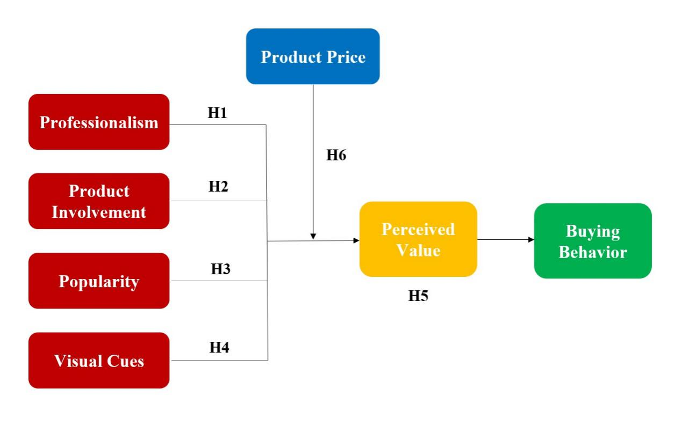

Figure 2.1: Conceptual Framework

## 2.7 Hypotheses

H1: The professionalism of e-commerce livestreaming sellers has a positive influence on consumer buying behavior

H2: The product involvement of e-commerce livestreaming sellers has a positive influence on consumer buying behavior

H3: The popularity of e-commerce livestreaming sellers has a positive influence on consumer buying behavior

H4: The visual cues of e-commerce livestreaming sellers have a positive influence on consumer buying behavior

H5: Perceived value has mediating effect between the characteristics of e-commerce livestreaming sellers and consumer buying behaviors

H6: Product price has a moderating effect between the characteristics of e-commerce livestreaming sellers and perceived value

## CHAPTER 3: METHODOLOGY

## 3.1 Overview

On the basis of the research framework and hypotheses of the previous chapter, this chapter will start with the research variables, design the scale on the basis of relevant literature research, and clarify the variable measurement items and questions. Based on this, design questionnaires, conduct empirical research, select appropriate samples for questionnaire collection, describe survey methods and data statistics methods, and prepare for subsequent specific data analysis.

## 3.2 Research Design

This study uses quantitative methods. It uses questionnaires as a research tool. Data collection is based on questionnaires distributed to respondents, which is the main tool (Mitchell and Jolley, 2012). The questionnaire is designed to accumulate enough information related to the research objectives.

This research mainly focuses on the relationship between e-commerce livestreaming sellers and consumer buying behavior, so effective survey subjects should have shopping experience in the context of e-commerce livestreaming. This research uses [www.wjx.cn](http://www.wjx.cn/) to make questionnaires, distribute the questionnaires online, and show the QR code of the questionnaire to these students. They scan the QR code with their mobile phones, open the link, and fill in the questionnaire.

After data collection complement, the author starts analyze these data and conclude the results of analyses and tests. Data analysis has two main contents: descriptive statistics and analysis of sample data, and empirical analysis is used to test whether the previous research hypotheses are valid.

First of all, it is necessary to sort out the collected valid questionnaire data and analyze the reliability and validity of the scale data.

Finally, correlation analysis and regression analysis are used to verify whether the research hypotheses in the model is valid.

## 3.3 Unit of Analysis

According to the needs of this research, unit of the research should meet the following conditions:

First, they must be Internet users;

Second, they had experience in searching shopping information through the Internet;

Third, they had shopping experience on the e-commerce live streaming platform and have been affected by the e-commerce livestreaming sellers.

According to these conditions, netizens on online forums, social sharing sites, and e-commerce communities are most suitable. Among these netizens, the young group is the major audience affected by e-commerce livestreaming sellers. Because young people, such as college students or young white-collar workers, have a higher level of education, are more sensitive to new things, and have more obvious characteristics of impulsive consumption (Chen and Lin, 2018). Also, they have convenient access to the Internet, heavily use the Internet, and like to buy products online, so university students meet the sampling needs of this study. Therefore, this research selects university students as individuals, these different student from different social classes, these form the main analyzed group of the research.

## 3.4 Sampling

The respondents for this study were selected according to the convenience sampling procedure. Cresswell (2014) pointed out that the convenience sampling procedure is a quantitative procedure, and researchers choose participants because they are willing and acceptable to accept the research. The research was conducted at South China University of Technology in Guangzhou. The participants in this study are at least 200 students, who are come from different regions of China and social classes. All students participating in the research are studying and live in this school. Participants included women and men, and the age of the subjects was 18 to 30 years old.

## 3.5 Data Collection Method

This study uses questionnaire and survey, quantitative data collection, collects primary date, the questionnaire asks closed-end questions, and provides a list of possible answers. This method is easier for the respondents because they just choose from the list of answers. Because the questions and answers are standardized, the researcher can use the collected date to do analysis. However, Zhou et al. (2017) stated that closed-ended questions may be limited in a given choice, the participants may not see their answer.

This questionnaire is usually conducted online distribution via the Internet. It allows the researcher not only to collect information, but also to know where participants answered the questions and when they participated in this survey.

## 3.6 Analysis Method

This article uses SPSS software for data analysis, data entry, analysis and testing of valid questionnaires. The following specific analysis methods are used:

First, descriptive statistics. This explains the sample structure and distribution of this survey. Statistics of demographic characteristics such as gender, age, monthly income, education level, and basic information of online shopping experience of the respondents.

Second, reliability and validity analyses. The reliability analysis of the data indicates that the measurement data has stability and consistency. Validity analysis shows the accuracy of the variables.

Third, correlation analysis. Correlation is used to measure the closeness of the relationship between variables, and the Pearson correlation coefficient R is generally used to test.

Fourth, regression analysis. After verifying the correlation between the two variables, the author can continue to use this method to test the causal relationship between the two variables. This article uses regression analysis to explore the relationship between the characteristics of e-commerce livestreaming sellers, perceived value, and consumer buying behavior, and uses this method to examine the moderating effect of product prices and the mediating effect of perceived value.

## CHAPTER 4: RESEARCH FINDINGS

## 4.1 Overview

This chapter has two main contents: one is statistics and analysis of sample data, and the other is to use empirical analysis to test whether the previous research hypotheses are valid. First of all, it is necessary to sort out the collected valid questionnaire data and analyze the reliability and validity of the scale data. Finally, correlation analysis and regression analysis are used to verify whether the research hypotheses in the model are valid.

## 4.2 Descriptive Statistics

This article uses electronic questionnaires to distribute, and the target is young people. In this survey, a total of 260 questionnaires were distributed and 225 were received. Excluding invalid ones, 204 valid questionnaires were finally obtained. The effective response rate reached 78%, which met the requirements. The frequencies of valid sample data are shown in Table 4.1 below.

**Table 4.1: Demographics of Respondents (n = 204)**

|  |  |  |  |  |
| --- | --- | --- | --- | --- |
|  | | Frequency | | Percentage |
| Gender | Male | | 98 | 48.0 |
| Female | | 106 | 52.0 |

|  |  |  |  |
| --- | --- | --- | --- |
| Age | Under 18 years old | 22 | 10.8 |
| 18-24 years old | 123 | 60.3 |
| 25-29 years old | 36 | 17.6 |
| Over 30 years old | 23 | 11.3 |

|  |  |  |  |
| --- | --- | --- | --- |
| Educational Background | High school and below | 26 | 12.7 |
| Undergraduate | 154 | 75.5 |
| Master | 18 | 8.8 |
| PhD | 6 | 2.9 |

|  |  |  |  |
| --- | --- | --- | --- |
| Job | Student | 140 | 68.6 |
| Employees | 39 | 19.1 |
| Self-employed | 25 | 12.3 |

|  |  |  |  |
| --- | --- | --- | --- |
| Monthly Consumption | Below 800 yuan | 14 | 6.9 |
| 800-1200 yuan | 46 | 22.5 |
| 1,201-1,500 yuan | 65 | 31.9 |
| 1500-2000 yuan | 57 | 27.9 |
| More than 2001 yuan | 22 | 10.8 |

|  |  |  |  |
| --- | --- | --- | --- |
| Usage Time | 1 year or less | 57 | 27.9 |
| 1-2 years | 84 | 41.2 |
| 2-3 years | 49 | 24.0 |
| 3-5 years | 12 | 5.9 |
| More than 5 years | 2 | 1.0 |

According to the results of frequency statistical analysis, it can be seen that as far as the research objects are concerned, there are more girls than boys, boys accounting for 48% and girls is 52%. From the perspective of online shopping experience, girls often use online shopping apps, and they are more likely to be affected by e-commerce livestreaming sellers or e-commerce marketing. In addition, the ratio of male to female in the collected data is normal that there are more girls than boys.

Respondents aged 18-29 accounted for the majority, 77.9% in total, mainly young people, who like to follow the trend and are more susceptible to the influence of e-commerce livestreaming; In terms of academic qualifications, the respondents have relatively high academic qualifications, with a total of 87.3% of those with a bachelor’s degree or above. In terms of jobs, 68.6% of the respondents said they are students at school and they are also the main consumer group of e-commerce livestreaming. From the perspective of monthly consumption level, the majority of consumers’ spending are between 800 - 2000 Yuan, accounting for 82.3% of the total. This is related to the fact that most of the respondents are college students in Guangzhou.

The total number of respondents who have used Taobao Live for 1-3 years accounted for 93.1%, these participants have rich online shopping experience, and most of them have a long time to use Taobao Live. E-commerce livestreaming has become an important channel for consumers to obtain products’ information. In summary, the samples collected in this study meet the requirements of the research.

## 4.3 Reliability and Validity Analyses

Reliability testing is an indicator that reflects the true degree of measurement data, including the measurement of consistency, stability and reproducibility of sample data (Larsson, 2015). This article uses Cronbach’s Alpha to measure the reliability of each variable. Generally speaking, the reliability coefficient is higher, the result of the test is more stable. According to the standard, the reliability analysis of the variables in this study is carried out, and the specific test results are shown in Table 4.2.

|  |  |  |
| --- | --- | --- |
| **Table 4.2: Summary Table of Reliability Statistics** | | |
| Measured variable | Cronbach's Alpha | N of Items |
| Professionalism | .719 | 2 |
| Product Involvement | .797 | 3 |
| Popularity | .729 | 2 |
| Visual Cues | .760 | 3 |
| Product Price | .817 | 4 |
| Perceived Value | .869 | 6 |
| Buying Behavior | .822 | 5 |
| Total | .756 | 25 |

It can be seen from the above table that the overall reliability coefficient of the scale is 0.756, which is higher than 0.7, indicating acceptable reliability; the reliability coefficients of professionalism, product participation, visual prompts, product prices, and perceived value are all greater than 0.7, indicating the design of the measurement items of the scale in this paper is acceptable, showing acceptable internal stability and consistency. The reliability coefficients of product price, perceived value and buying behavior are all greater than 0.8, indicating good reliability. Therefore, the reliability of this questionnaire is acceptable, and the next step of validity analysis can be carried out.

Validity analysis reflects the validity of the measurement results and is another indicator to evaluate the quality of the scale, factor analysis is usually used to measure the structural validity of the scale (Rourke and Anderson, 2004). If the KOM value is higher, the correlation coefficient is also higher, that means greater significant validity in the measurement results. This research uses KMO and Bartlett sphere test, the test results are shown in Table 4.3 below.

|  |  |  |  |  |
| --- | --- | --- | --- | --- |
| **Table 4.3: Summary Table of KMO and Bartlett's Test** | | | | |
| Variable | KMO | Bartlett's Test of Sphericity | | |
| Approx. Chi-Square | df | Sig. |
| Professionalism | .678 | 158.293 | 3 | .000 |
| Product Involvement | .718 | 276.945 | 6 | .000 |
| Popularity | .686 | 175.485 | 3 | .000 |
| Visual Cues | .728 | 314.201 | 6 | .000 |
| Product Price | .800 | 307.022 | 6 | .000 |
| Perceived Value | .817 | 438.164 | 6 | .000 |
| Buying Behavior | .808 | 261.950 | 6 | .000 |
| Total | .798 | 224.194 | 21 | .000 |

According to the test results in Table 4.3, the KMO values of the measured variable are greater than 0.6, and the sample can be subjected to factor analysis. If the P value is less than 0.01, it means that it has passed the validity test and can be used for factor analysis. In this study, 25 question items are classified into 7 types of factors, most of the item coefficients are greater than 0.7, that is, the items under each variable can be aggregated together according to the theoretical distribution, and the result can be obtained. The questionnaire has good content validity and meets research requirements.

## 4.4 Results of Hypothesis Testing

## 4.4.1 Correlation Analysis

Correlation Analysis can judge the degree of correlation between elements, which is an analysis of the correlation elements between variables (Gogtay and Thatte, 2017). This article uses the Pearson correlation coefficient. R is generally used to express Pearson's coefficient. If |R| is closer to 1, the correlation between variables is stronger. This part uses correlation analysis to analyze the correlation among variables such as e-commerce livestreaming seller characteristics, product prices, perceived value, and consumer buying behavior. The specific results are shown in Table 4.4.

**Table 4.4: Summary Table of Correlation Analysis**

|  |  |  |  |  |  |  |  |  |  |  |  |  |  |  |
| --- | --- | --- | --- | --- | --- | --- | --- | --- | --- | --- | --- | --- | --- | --- |
|  | Professionalism | | | Product Involvement | | Popularity | | Visual Cues | | Product Price | | Perceived Value | | Buying Behavior |
| Professionalism |  | 1 |  | |  | |  | |  | |  | |  | |
| Product Involvement |  | -.079 | 1 | |  | |  | |  | |  | |  | |
| Popularity |  | .062 | .344** | | 1 | |  | |  | |  | |  | |
| Visual Cues |  | .028 | .218** | | .345** | | 1 | |  | |  | |  | |
| Product Price |  | .032 | .333** | | .403** | | .235** | | 1 | |  | |  | |
| Perceived Value |  | .006 | .320** | | .312** | | .320** | | .411** | | 1 | |  | |
| Buying Behavior |  | .115 | .241** | | .310** | | .266** | | .385** | | .427** | | 1 | |
| **. Correlation is significant at the 0.01 level (2-tailed). | | | | | | | | | | | | | | |

The data analysis results in Table 4.4 show that the correlation coefficient between the professionalism of e-commerce livestreaming sellers and consumer buying behavior is 0.115, and is significantly correlated at the 0.05 level, which preliminarily proves Hypothesis 1.

The correlation coefficient between product Involvement of e-commerce livestreaming sellers and consumer buying behavior is 0.241, and is significantly correlated at the 0.01 level, which preliminarily proves Hypothesis 2.

The correlation coefficient between the popularity of e-commerce livestreaming sellers and consumer buying behavior is 0.310, and is significantly correlated at the 0.01 level, which preliminarily proves Hypothesis 3.

The correlation coefficient between visual cues of e-commerce livestreaming sellers and consumer buying behavior is 0.266, and is significantly correlated at the 0.01 level, which preliminarily proves Hypothesis 4.

The correlation coefficients between the characteristics of e-commerce livestreaming sellers and perceived value are 0.006, 0.320, 0.312, and 0.320 respectively, the correlations are significant; the correlation coefficient between perceived value and consumer buying behavior is 0.427, which is significantly correlated at the 0.05 level; in summary , perceived value is positively correlated with the characteristics of e-commerce livestreaming sellers and consumer buying behavior, which preliminarily proves Hypothesis 5.

The correlation coefficients between the characteristics of e-commerce livestreaming sellers and product price are 0.032, 0.333, 0.403, 0.235 respectively, the correlations are significant; the correlation coefficient between product price and perceived value is 0.411, which is significantly correlated at the 0.05 level; in summary, product price is positively correlated with the characteristics of e-commerce livestreaming sellers and perceived value, which preliminarily proves Hypothesis 6.

According to the data, the correlation coefficient between the variables is at a significant level. Each characteristic of e-commerce livestreaming seller has a significant positive correlation with product price, perceived value, and consumer buying behavior, which can be further tested by regression methods.

## 4.4.2 Regression Analysis of E-commerce Livestreaming sellers’ Characteristics and Consumer Buying Behavior

The analysis here is about the influence of the independent variables on the dependent variable in conceptual model, that is, the study of the relationship between the characteristics of e-commerce livestreaming sellers and consumer buying behavior. This article examines the explanatory power of professionalism, product involvement, popularity and visual cues on dependent variable, and judges its relative effects on dependent variable based on the size of regression coefficients. The value range of the regression coefficient is 0~1, when it is closer to 1, it is better to fit and can better explain the independent variables to the dependent variable. When the significance level of T or F value is less than 0.05, the regression equation is meaningful. The specific regression analysis results are shown in Table 4.5 below.

|  |  |  |  |  |  |  |  |  |  |  |  |  |  |  |  |  |  |
| --- | --- | --- | --- | --- | --- | --- | --- | --- | --- | --- | --- | --- | --- | --- | --- | --- | --- |
| **Table 4.5: Summary Table of Regression Models of Each Characteristic & Buying Behavior** | | | | | | | | | | | | | | | | | |
| Model | | | Unstandardized  Coefficients | | | | Standardized Coefficients | | | t | | Sig. | |  | | |  |
| B | | | Std. Error | Beta | | | Adjusted R2 | | | F |
| 1 | (Constant) | | 3.717 | | | .216 |  | | | 17.219 | | .000 | |  | | |  |
| Professionalism | | .089 | | | .054 | .115 | | | 1.639 | | .103 | | .008 | | | 2.685 |
| 2 | | (Constant) | | 3.267 | .229 | | |  | | | 14.265 | | .000 | |  |  | | |
| Product  Involvement | | .198 | .056 | | | .241 | 3.524 | | | | .000 | | .053 | 12.417 | | |
| 3 | | (Constant) | | 3.324 | .163 | | |  | 20.421 | | | | .000 | |  |  | | |
|  | | Popularity | | .173 | .037 | | | .310 | 4.641 | | | | .000 | | .092 | 21.543 | | |
| 4 | | (Constant) | | 3.252 | .208 | | |  | 15.639 | | | | .000 | |  |  | | |
|  | | Visual Cues | | .201 | .051 | | | .266 | 3.923 | | | | .000 | | .066 | 15.394 | | |
| a. Dependent Variable: Buying Behavior | | | | | | | | | | | | | | |  |  | | |

According to Table 4.5, in Model 1, the predictor variable represents professionalism; the dependent variable represents Buying behavior. The regression coefficient between the two is 0.115, and the adjusted R2 is 0.008, which professionally explains the 0.8% change in consumer buying behavior. The F value is 2.685, and the Sig. value is greater than 0.001, which does not meet the F test requirements and is not significant. In summary, we can see that professionalism has no positive influence on consumers' buying behavior, here is insufficient evidence to support H1 – hence invalid.

In Model 2, the predictor variable represents product involvement; the dependent variable represents buying behavior. The regression coefficient between the two is 0.241, and the adjusted R2 is 0.053, which professionally explains the 5.3% change in consumer buying behavior. The F value is 12.417, and the Sig. value is less than 0.001, which meet the F test requirements and is significant. In summary, we can see that product involvement has positive influence on consumers' buying behavior, here is sufficient evidence to support H2 – hence valid.

In Model 3, the predictor variable represents popularity; the dependent variable represents buying behavior. The regression coefficient between the two is 0.310, and the adjusted R2 is 0.092, which professionally explains the 9.2% change in consumer buying behavior. The F value is 21.543, and the Sig. value is less than 0.001, which meet the F test requirements and is significant. In summary, we can see that popularity has positive influence on consumers' buying behavior, here is sufficient evidence to support H3 – hence valid.

In Model 4, the predictor variable represents visual cues; the dependent variable represents buying behavior. The regression coefficient between the two is 0.266, and the adjusted R2 is 0.066, which professionally explains the 6.6% change in consumer buying behavior. The F value is 15.394, and the Sig. value is less than 0.001, which meet the F test requirements and is significant. In summary, we can see that visual cues have positive influence on consumers' buying behavior, here is sufficient evidence to support H4 – hence valid.

## 4.4.3 Regression Analysis of the Mediating Effect of Perceived Value

Early studies generally used the stepwise regression method of Baron and Kenny (1986) to verify the mediating effect. Subsequently, Demming, Jahn and Boztug (2017) pointed out that how to conduct mediation analysis in markeing research, and making the test of the mediating effect more concise and understandable. This article uses the related method to test mediating effect of perceived value, which is mainly completed in four steps:

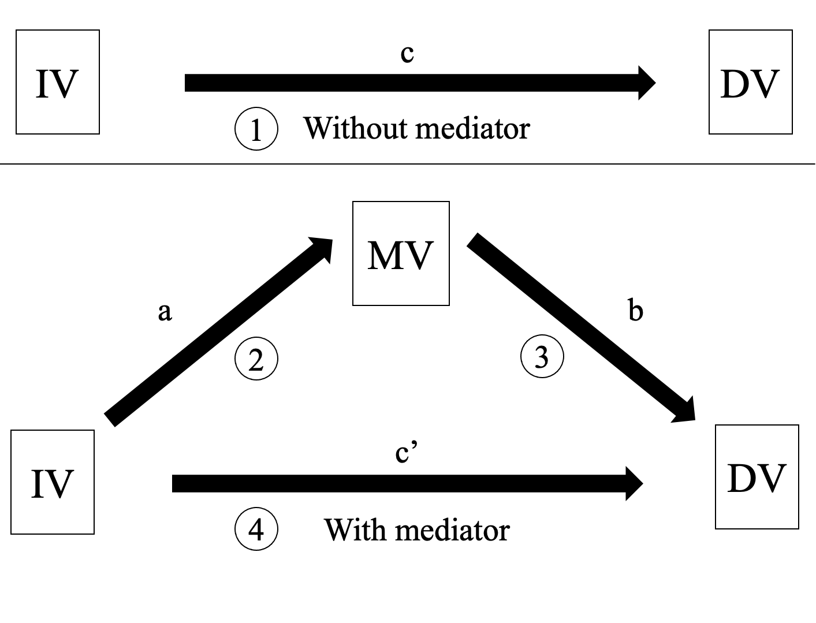

Figure 4.1: Four steps of mediating effect test

1. If the regression of the independent variables and the dependent variable is significant, proceed to the next step, otherwise stop;

2. The regression between the independent variable and the mediating variable, if the result is significant, proceed to the next step, otherwise stop;

3. If the regression between the mediating variable and the dependent variable is significant, proceed to the next step, otherwise stop;

4. Perform regression analysis between independent variables, mediating variable and dependent variable, add interactive terms of independent variables and mediating variable, compare the changes of the regression coefficients and the significant changes after adding mediator, thus to test the mediating effect.

The specific test results are as follows:

For the first step, the regression of the independent variables to the dependent variable in the conceptual model has been verified in the regression analysis of the previous four hypotheses, and results shown that effective characteristics are product involvement, popularity and visual cues, professionalism is not an effective characteristic and removed from the test of mediating effect. So directly start the second step, which is to test the significance of the relationship between the independent variables and the mediating variable. Taking the characteristics of e-commerce livestreaming sellers as independent variables, introduce its effective three characteristics into the regression model, and use perceived value as the dependent variable for regression analysis, as shown in Table 4.6 below.

**Table 4.6: Multiple Linear Regression Model of Product Involvement, Popularity, Visual Cues and Perceived Value**

|  |  |  |  |  |  |  |  |  |
| --- | --- | --- | --- | --- | --- | --- | --- | --- |
| Model | | Unstandardized  Coefficients | | Standardized Coefficients | t | Sig. |  |  |
| B | Std. Error | Beta | Adjusted R2 | F |
| 5 | (Constant) | 2.360 | .244 |  | 9.675 | .000 | .177 | 15.584 |
| Product  Involvement | .165 | .052 | .217 | 3.180 | .002 |  |  |
| Popularity | .083 | .036 | .163 | 2.293 | .023 |  |  |
| Visual Cues | .151 | .047 | .216 | 3.172 | .002 |  |  |
| a. Dependent Variable: Perceived Value | | | | | | |  |  |

As can be seen from model 5 of table 4.6, the regression coefficients of product involvement, popularity and visual cues to perceived value are 0.217, 0.163, and 0.216, respectively. The overall F value is 15.584, and the significance P value is less than 0.01, which means it is significant at the 1% level. That is to say, the three characteristics significantly affect the perceived value of consumers. The adjusted R2 is 0.177, indicating that the three IVs explain the change of perceived value at 17.7%. In summary, the characteristics of e-commerce livestreaming sellers are significant and positively affect consumers' perceived value.

The third step is to verify the regression of the mediating variable and the dependent variable, and use SPSS software to perform regression analysis on perceived value and consumer buying behavior. The specific result is shown in Table 4.7 below.

**Table 4.7: Regression Model of Perceived Value and Buying Behavior**

|  |  |  |  |  |  |  |  |  |
| --- | --- | --- | --- | --- | --- | --- | --- | --- |
| Model | | Unstandardized  Coefficients | | Standardized Coefficients | t | Sig. |  |  |
| B | Std. Error | Beta | Adjusted R2 | F |
| 6 | (Constant) | 2.216 | .277 |  | 8.002 | .000 | .178 | 45.085 |
| Perceived  Value | .464 | .069 | .427 | 6.715 | .000 |  |  |
| a. Dependent Variable: Buying Behavior | | | | | | |  |  |

According to the model 6 in table 4.7, the adjusted R2 is 0.178, which means that the perceived value can explain 17.8% of consumer buying behavior. The overall F value is 45.085, the P value is 0.000, which is less than 0.01, the significance is valid, and the overall regression effect is significant. The regression coefficient of perceived value to buying behavior is 0.427, indicating that perceived value significantly affects customers' buying behavior. Therefore, the next step of verification can be processed.

On the basis of the previous analysis, the final step of verification is carried out. This step use consumer buying behavior as the dependent variable, the independent variables and mediating variable are put into the model for regression analysis. In order to test the relationship between the characteristics of e-commerce livestreaming sellers, perceived value and consumer buying behavior, this step add the mediating variables, observe whether the regression coefficient of the mediating variable is significant, and the changes in the regression coefficients of the independent variables to the dependent variable. If the influence of IVs on DV become insignificant, it means a complete mediating effect; if the influence is weakened but still significant, it means a partial mediating effect.

**Table 4.8: Regression Analysis Summary of the Mediating Effect of Perceived Value**

|  |  |  |  |  |
| --- | --- | --- | --- | --- |
| Model | R2 | Adjusted R2 | F | Sig. |
| 7 | .141 | .128 | 10.900 | .000b |
| 8 | .228 | .213 | 14.723 | .000c |

|  |
| --- |
| a. Dependent Variable: Buying Behavior |
| b. Predictors: (Constant), Visual Cues, Product Involvement, Popularity |
| c. Predictors: (Constant), Visual Cues, Product Involvement, Popularity, Perceived Value |

|  |  |  |  |  |  |  |
| --- | --- | --- | --- | --- | --- | --- |
| **Table 4.9: The Regression Coefficients Table of the Mediating Effect of Perceived Value** | | | | | | |
| Model | | Unstandardized  Coefficients | | Standardized  Coefficients | t | Sig. |
| B | Std. Error | Beta |
| 7 | (Constant) | 2.624 | .273 |  | 9.620 | .000 |
| Product Involvement | .110 | .058 | .133 | 1.895 | .002 |
| Popularity | .115 | .041 | .208 | 2.840 | .001 |
| Visual Cues | .125 | .053 | .166 | 2.356 | .000 |
| 8 | (Constant) | 1.780 | .314 |  | 5.671 | .000 |
| Product Involvement | .051 | .056 | .062 | .902 | .020 |
| Popularity | .086 | .039 | .154 | 2.190 | .005 |
| Visual Cues | .071 | .052 | .094 | 1.378 | .001 |
| Perceived Value | .357 | .075 | .329 | 4.760 | .000 |
| a. Dependent Variable: Buying Behavior | | | | | | |

It can be seen from table 4.8 of Regression Analysis Summary of the Mediating Effect of Perceived Value, in Model 8, the adjusted R2 is 0.213, and the significance P value is 0.000, which is less than 0.01. It is significantly correlated, indicating that the characteristics of e-commerce livestreaming sellers and perceived value can explain 21.3% of consumer buying behavior. And the overall F value is 14.723, indicating that the overall regression effect of Model 8 is significant.

In order to test the mediating effect of perceived value, the author compared the regression coefficients of Model 7 and Model 8 in table 4.9, and found the following results:

After the introduction of perceived value, the β value of the regression coefficient of product involvement on buying behavior is 0.062, and the Sig. is 0.020, passing the significance test. At this time, the regression coefficient becomes smaller and the relationship is still significant, indicating that the perceived value plays a part of the mediating effect between product involvement and consumer buying behavior.

After the introduction of perceived value, the β value of the regression coefficient of popularity on buying behavior is 0.154, and the Sig. is 0.005, passing the significance test. At this time, the regression coefficient becomes smaller and the relationship is still significant, indicating that the perceived value plays a part of the mediating effect between product involvement and consumer buying behavior.

After the introduction of perceived value, the β value of the regression coefficient of visual cues on buying behavior is 0.094, and the Sig. is 0.001, passing the significance test. At this time, the regression coefficient becomes smaller and the relationship is still significant, indicating that the perceived value plays a part of the mediating effect between visual cues and consumer buying behavior.

In summary, after a four-step test of mediating effect of Perceived Value, e-commerce livestreaming seller’s product involvement, popularity and visual cues can significantly positively affect perceived value, and perceived value can significantly positively affect consumer buying behavior. Meanwhile, perceived value has partial mediating effect between the three effective characteristics of e-commerce livestreaming sellers and consumer buying behavior, here is sufficient evidence to support H5- hence valid.

## 4.4.4 Regression Analysis of the Moderating Effect of Product Price

The moderating variable can adjust the intensity and direction of the independent variables’ effect on the dependent variable. The introduction of moderating variable can further study the relationship between independent variables and dependent variable (Aguinis et al., 2004). Generally, hierarchical regression analysis is used to verify the moderating effect. This article assumes that the influence of characteristics of e-commerce livestreaming sellers on perceived value will be affected by product price.

Based on the survey data, this article uses regression analysis to test this hypothesis. The first step is to add effective independent variables (product involvement, popularity, visibility) and product price to the regression model, which is model 1. The second step is to add the interaction terms of each IV and product price, which is model 2. If the R2 coefficient of Model 2 changes, and the interaction term passes the significance test, it indicates that the moderating effect is significant, and the product price has a moderating effect on the relationship between the characteristics of e-commerce livestreaming sellers and the perceived value. The results are shown in Table 4.10.

**Table 4.10: Regression Analysis Results of Moderating Effect of Product Price**

|  |  |  |  |  |  |  |  |  |  |  |  |  |  |  |  |  |  |  |  |  |  |  |  |  |  |  |  |  |  |  |  |  |  |  |
| --- | --- | --- | --- | --- | --- | --- | --- | --- | --- | --- | --- | --- | --- | --- | --- | --- | --- | --- | --- | --- | --- | --- | --- | --- | --- | --- | --- | --- | --- | --- | --- | --- | --- | --- |
| Model | | | Unstandardized  Coefficients | | | | | Standardized  Coefficients | | | | | | t | | Sig. | | | | |  | | | | | | |  | | | | | | |
| B | | Std. Error | | | Beta | | | | | | R2 Change | | | | | | | Sig. F Change | | | | | | |
| 1a | (Constant) | | 3.989 | | .025 | | |  | | | | 157.372 | | | .000 | | | | | | .207 | | | | | | | .000 | | | | | | |
| Zscore (Product Involvement) | | .083 | | .027 | | | .206 | | | | 3.091 | | | .002 | | | | | |  | | | | | | |  | | | | | | |
| Zscore (Product Price) | | .139 | | .027 | | | .343 | | | | 5.146 | | | .000 | | | | | |  | | | | | | |  | | | | | | |
| 2a | (Constant) | | 3.973 | | .027 | | |  | | | | 149.737 | | | .000 | | | | | | .016 | | | | | | | .047 | | | | | | |
| Zscore (Product Involvement) | | .095 | | .027 | | | .235 | | | | 3.470 | | | .001 | | | | | |  | | | | | | |  | | | | | | |
| Zscore (Product Price) | | .145 | | .027 | | | .358 | | | | 5.378 | | | .000 | | | | | |  | | | | | | |  | | | | | | |
| Product Involvement  *Product Price | | .051 | | .025 | | | .130 | | | | 1.998 | | | .047 | | | | | |  | | | | | | |  | | | | | | |
| 1b | | (Constant) | | 3.989 | | .026 | | |  | | | | 156.176 | | | | .000 | | | | | .195 | | | | | .000 | | | | | | |
| Zscore (Popularity) | | .071 | | .028 | | | .175 | | | | 2.524 | | | | .012 | | | | |  | | | | |  | | | | | | |
| Zscore (Product Price) | | .138 | | .028 | | | .341 | | | | 4.931 | | | | .000 | | | | |  | | | | |  | | | | | | |
| 2b | | (Constant) | | 3.941 | | .028 | | |  | | | | 141.161 | | | | .000 | | | | | .052 | | | | | .000 | | | | | | |
| Zscore (Popularity) | | .100 | | .028 | | | .248 | | | | 3.550 | | | | .000 | | | | |  | | | | |  | | | | | | |
| Zscore (Product Price) | | .142 | | .027 | | | .352 | | | | 5.243 | | | | .000 | | | | |  | | | | |  | | | | | | |
| Popularity  *Product Price | | .120 | | .032 | | | .242 | | | | 3.729 | | | | .000 | | | | |  | | | | |  | | | | | | |
| 1c | (Constant) | | 3.989 | | | .025 | | | |  | 158.888 | | | | .000 | | | | |  | | | | | |  | | | | | | |
| Zscore (Visual Cues) | | .096 | | | .026 | .236 | | | | 3.692 | | | | .000 | | | | .222 | | | | | | .000 | | | | | |
| Zscore (Product Price) | | .144 | | | .026 | .356 | | | | 5.562 | | | | .000 | | | | |  | | | | | | .031 | | | | | |
| 2c | (Constant) | | 3.979 | | | .025 |  | | | | 156.936 | | | | .000 | | |  | | | | | | .018 | | |
| Zscore (Visual Cues) | | .114 | | | .027 | .282 | | | | 4.220 | | | | .000 | | |  | | | | | |  | | | | | |
| Zscore (Product Price) | | .141 | | | .026 | .349 | | | | 5.496 | | | | .000 | | |  | | | | | |  | | | | | |
| Visual Cues  *Product Price | | .046 | | | .021 | .141 | | | | 2.176 | | | | .031 | | |  | | | | | |  | | | | | |
| a. Dependent Variable: Perceived Value | | | | | | | | | | | | | | | | | | | | | | |  | | | | | |  | | | | | |

It can be seen from Table 4.10 that in three Model 1, the three dimensions of the independent variables positively affect consumers' perceived value. When the interactive term is added in three Model 2, R2 Change are 0.016, 0.052, 0.018 respectively, the positive impact of the three dimensions on the perceived value is still significant. Also, the Sig. F Change of the interaction terms of the three dimensions and product price are 0.047, 0.000, and 0.031 respectively, the results are significant. So, the moderating effect of product price is still existence, that is, the product price can moderate the relationship between the characteristics of e-commerce livestreaming sellers and perceived value.

For e-commerce livestreaming sellers with high characteristic levels, if the product price is higher, the effect on perceived value is smaller; for e-commerce livestreaming sellers with low characteristic level, if the product price is higher, the effect on perceived value is greater. There is sufficient evidence to support Hypothesis 6, hence valid.

In order to clarify the moderating effect of product price on the relationship between the characteristics of e-commerce livestreaming sellers and consumer buying behavior, and to visualize the relationship, this article draws an interaction diagram, as shown in Figure 4.2.



Figure 4.2: Diagram of moderating effect of product price

When the product price is at a low level, the gap in perceived value between high-characteristic e-commerce livestreaming sellers and low-characteristic e-commerce livestreaming sellers is small;

When the product price is at a high level, the gap in perceived value between high-characteristic e-commerce livestreaming sellers and low-characteristic e-commerce livestreaming sellers is large.

It can be concluded that product price negatively moderates the relationship between the characteristics of e-commerce livestreaming sellers and consumers' buying behavior.

## 4.5 Summary of Findings

The above analysis verifies the assumptions in the theoretical model of this paper through data logic. In the e-commerce live streaming platform, the characteristics of live sellers have a positive effect on consumer buying behavior, which is reflected in the positive influence of the three characteristics of product involvement, popularity, and visual cues on consumer buying behavior. Perceived value mediates the positive correlation between the characteristics of e-commerce livestreaming sellers and consumer buying behavior. Product price has a moderating effect between the characteristics of e-commerce livestreaming sellers and perceived value, it can negatively influence perceived value; high product price weakens the impact of e-commerce livestreaming sellers on perceived value. Author combine the hypothesis test results as shown in Table 4.11 below.

**Table 4.11: Summary Table of Hypothesis Test Results**

|  |  |
| --- | --- |
| Hypothesis | Result |
| H1: The professionalism of e-commerce livestreaming sellers has a positive influence on consumer buying behavior | Invalid |
| H2: The product involvement of e-commerce livestreaming sellers has a positive influence on consumer buying behavior | Valid |
| H3: The popularity of e-commerce livestreaming sellers has a positive influence on consumer buying behavior | Valid |
| H4: The visual cues of e-commerce livestreaming sellers have a positive influence on consumer buying behavior | Valid |
| H5: Perceived value has mediating effect between the characteristics of e-commerce livestreaming sellers and consumer buying behaviors | Valid |
| H6: Product price has a moderating effect between the characteristics of e-commerce livestreaming sellers and perceived value | Valid |

## CHAPTER 5: CONCLUSION & RECOMMONDATIONS

## 5.1 Overview

Based on the previous theoretical model, data analysis and testing, this chapter summarizes and includes three parts: First, analyze and discuss the data results of this research. Secondly, give marketing suggestions for merchants to select and train e-commerce livestreaming sellers. Finally, put forward the expectation and direction of future research, as well as personal reflection of this research.

## 5.2 Conclusion

Based on the fast-developing e-commerce live streaming, this article studies the influence of e-commerce livestreaming sellers’ characteristics on consumer buying behavior. E-commerce live streaming is mainly characterized by interactive communication and content production, livestreaming sellers play an important role on this type of platform, and affect consumer buying behavior in the process of consumers searching or receiving information. Based on literature review and theoretical support, this article takes the characteristics of e-commerce live streaming sellers as independent variables and selects four dimensions including professionalism, product involvement, popularity and visual cues to study its impact on consumer buying behavior. And take perceived value as a mediating variable, and add product price as a moderating variable, use SPSS software to analyze the survey data, verify the relationship of the model, and finally get the following conclusions:

## 5.2.1 Effective Characteristic of E-commerce Livestreaming Sellers Can Improve Consumer Buying Behavior

The introduction of products by e-commerce livestreaming sellers during the live streaming is related to product involvement, popularity and visual cues. If here is higher involvement of e-commerce livestreaming sellers in products, the clearer attributes, functions and uses of the products and related precautions, these make consumers gradually deepen their understanding of product performance, and may buy products based on their desire to try. The empirical results of this study show that the product involvement of e-commerce livestreaming sellers has a positive impact on consumers' buying behavior.

In live e-commerce shopping, consumers cannot actually perceive the product, and only rely on the display and introduction of the product by the e-commerce livestreaming seller to make a decision about whether to buy. Therefore, higher popularity of e-commerce livestreaming seller can cause higher consumers' trust, which makes it easier to stimulate consumers' desire to buy. The empirical results of this study show that the popularity of e-commerce livestreaming sellers has a positive impact on consumers' buying behavior.

In the process of live e-commerce shopping, consumers perceive products through live video and different visual cues, if the introductions of e-commerce livestreaming sellers use diversified display methods, it will be more professional and comprehensive, consumers will be able to obtain product information effectively, which will generate a stronger desire to buy. The empirical results of this research show that the visual cues of e-commerce livestreaming sellers have a positive impact on consumers' buying behavior.

## 5.2.2 Enhancing Perceived Value & Setting Reasonable Product Price Can Improve Consumer Buying Behavior

Perceived value is a mediating variable for e-commerce livestreaming sellers to influence consumer buying behavior, so the improvement of characteristics of livestreaming sellers can increase the perceived value and influence consumer buying behavior. Product prices can adjust the effect of livestreaming sellers on consumer buying behavior. Under the situation of low price, consumers communicate with live sellers more frequently and obtain more comprehensive information, which helps to enhance consumers' trust in livestreaming sellers and consumers are more willing to accept product information and suggestions. The product involvement and popularity of e-commence livestreaming sellers can affect the perceived value, thereby affecting the conversion of buying behavior. Goods or services with suitable price recommended by well-known livestreaming sellers will be forwarded and imitated, such as the frequently appearing Internet celebrities and celebrity recommendations. Consumers see visual information to form expectations and stimulate their desire to buy. E-commerce livestreaming sellers will present relevant product details on the e-commerce platform, and these pictures, texts or videos have an impact on consumers’ perceptions and directly affect the number of sales.

## 5.3 Recommendations

The research of this article grasps the background of the development of e-commerce live streaming, application of the Internet is becoming wider and the network is more social and interactive, information dissemination and word-of-mouth marketing have great market potential. This article realizes that livestreaming sellers play a crucial role in guiding consumer behavior in the e-commerce environment. It is hoped that companies can fully realize the value of livestreaming sellers and use their word-of-mouth marketing influence to provide a certain reference for the upgrade of corporate marketing strategies. It also provides some inspiration for future e-commerce operations.

## 5.3.1 Focus on Live Communication to Increase Consumers’ Stickiness

Traditional e-commerce platforms focus on business presentations, it has less information exchanges between buyers and sellers, which cause low trust in shopping and greater uncertainty, so the development of e-commerce live streaming emphasizes its social attributes, focuses on introducing various social elements, and insist focusing on users, it promotes the interaction between users and merchants. This change creates an atmosphere of a virtual community, increases interaction and exchanges with friends, can increase the activity of the e-commerce platform, help enhance consumers’ sense of participation and belonging, enhance user stickiness, and enhance consumers’ trust of business platforms and products. For example, Taobao is to use the experience sharing of Internet celebrities to attract consumers, it is targeted at fashionable women and attracts users to leave messages and interact with each other through sharing of photos, text, and videos, and exchanges with each other about the buying or use experience of single product. Experts or celebrity users have a certain influence in the group, consumers often have a stronger sense of trust in them. The things they share will receive users’ likes, comments, sharing and other interactions. Using this social network relationship, A wave of chasing trends has formed on the platform, which drives consumption.

The updating and upgrading of mobile technology and the rapid development of the Internet have changed our lifestyle and consumption habits. Compared with traditional shopping models, online shopping has huge advantages and has gradually become a popular shopping position. Lin (2019) indicated that the number of netizens continues to increase, and more e-commerce platforms have gathered on the mobile terminal of the Internet, the market potential of e-commerce is huge. Hua (2019) reported that the trend of e-commerce livestreaming has become more popular, and the social model has emerged, netizens have more frequent exchanges and sharing interactions, providing a broad platform and space to promote the survival and development of livestreaming sellers. Therefore, companies should seize the opportunity of e-commerce livestreaming development, make full use of the influence of livestreaming sellers on consumers, conduct word-of-mouth marketing, increase visibility and reputation, and develop brand markets. So, e-commerce livestreaming sellers focus on live communication can increase consumers’ stickiness.

## 5.3.2 Enriching Livestreaming Content and Improve Marketing Effects

In e-commerce livestreaming platforms, refined management has become a major development trend, E-commerce platforms are paying more attention to content construction in vertical segments, creating a distinctive brand imprint, hoping to attract more consumers. Through big data analysis, the platform understands consumers' points of interest and consumption behavior paths on the platform, introduces subdivision communities, and forms different types of interest circles. Through the operation of community content, increase user activity, guide users to share and interact, stimulate consumption desire, and promote consumption behavior. Major e-commerce platforms are increasingly focusing on the construction and operation of content, attracting consumers with high-quality content, and creating exclusive brands.

For example, Taobao Live is an e-commerce livestreaming platform that focuses on content construction. It focuses on young people and starts from the shopping notes of masters and cultivates content through shopping list sharing, travel must-buy guides, skin care tips, popular items, etc. These constantly enriching platform content, and gradually forming a shopping platform with user-generated content, so it expanding from cosmetics and clothing to health care products, mothers and babies, home furnishings, food and other fields, the livestreaming content has clear goals and complements. There are Internet celebrities and talents in each sub-circle to share, using high-quality products, and their content can attract users, and directly implant product links in live video to guide consumers to shopping.

In the era of attention economy, consumers are increasingly attracted to high-quality content. Major e-commerce platforms are competing for user traffic, and topicality and content are becoming more important. Traditional e-commerce platforms are also developing the livestreaming segment, hoping to tap the high traffic in the live interaction and combine their original advantages to develop e-commerce business. For example, Taobao develops different modules, and sets up different circles or channels according to different needs of users to meet multiple needs and enhance user experience. The e-commerce model has developed from a single product review to likes, comments, interactive communication, and live shopping in communities or circles, with richer content and more diversified forms. So, e-commerce companies enrich livestreaming content can improve marketing effects.

## 5.3.3 Identifying and Training E-commerce Livestreaming Sellers

E-commerce livestreaming sellers can influence consumer buying behavior as well as enterprises or merchants. E-commerce livestreaming sellers can influence on consumers through information release or dissemination links, and indirectly affect the sales of products or services (Lin and Wang, 2015). The rise of the Internet celebrity economy, more and more merchants pay attention to the development of e-commerce livestreaming sellers, and refer to their opinions or comments for production or sale. This model is a new form of e-commerce and will promote the sales of some free-brand on e-commence platforms. Therefore, enterprises or e-commerce merchants should focus on business cooperation with e-commerce livestreaming sellers, and actively cultivate e-commerce livestreaming sellers that suit your product.

The product involvement of livestreaming sellers that consumers care about can be in the professional field, or it can be the accumulation of a lot of experience. Companies can identify e-commerce livestreaming sellers by using quantity and product knowledge richness. Generally speaking, the more well-known e-commerce livestreaming sellers will have a greater appeal and influence. But in the face of rationalized products, the degree of influence of product involvement will be greater than that of popularity. If the products of e-commerce livestreaming sellers are highly involved, it is easier to get consumers' attention. Companies can check the time and energy livestreaming sellers spend on related products through the live streaming records of e-commerce livestreaming sellers and product sales records, these can be used to examine their marketing effects. Companies should be good at digging and identifying people who interact with consumers, and select and cultivate a group of people who are trusted by consumers and who are familiar with products or services.

## 5.4 Future Research Focus

In the process of conducting this research, due to the limitations and shortcomings of the research time, future research needs to be further improved and perfected. The specific manifestations are as follows:

(1) In the process of selecting samples, lack of consideration of regional factors. The samples are mainly from undergraduates and postgraduates from colleges and universities in Guangzhou. Taking into account the differences in region, age, income level, consumption level, consumer psychology and habits, follow-up research can expand the selection of samples from the above perspectives and increase the diversity of samples, thus, enhance the reliability of empirical analysis.

(2) This study takes the e-commerce live streaming sellers as the research scope. In the design of the questionnaire, the product category in the livestreaming is not investigated, which is a great regret. Female consumers tend to be more interested in livestreaming of beauty and clothing categories, while male consumers are more interested in science and technology and online game. In follow-up research, researchers can start with different product categories and measure the influence of e-commerce livestreaming sellers’ characteristics on consumer buying behavior for a certain type of product. For individual characteristics of consumers, like age, gender, income, educational background, etc., researchers can try to test the moderating effect of these individual characteristics, and explore in depth how the relationship change between independent variables and dependent variable.

(3) This study found that product price is not a positive moderating effect on the characteristics of e-commerce livestreaming sellers and perceived value. This article has not explored the reasons for the negative moderating effect of product price on e-commerce livestreaming sellers and perceived value. In the follow-up research, experimental research can be conducted to find out the price level and pricing model that have the most favorable impact on consumers' buying behavior during the live streaming process.

## 5.5 Personal Reflection

## 5.5.1 Topic Selection is the Top Priority

The purpose of choosing the topic is to make the author clear the thought and direction of writing, and all subsequent work must move in the predetermined direction. In addition to the direction, the key points and difficulties of the thesis should be clarified when starting the topic. Some work may be completed on the basis of the previous research results, but some work may require the author of this paper to graft and integrate related theories and make breakthroughs in related methods. These things that no one has done before are the innovative points of the article, and are often the key and difficult points. Defining the priorities will not only help make the paper clearly structured and focused, but also help the author formulate writing plans and complete writing efficiently.

In fact, the key to the thesis is not to write, but to think, to have good ideas, and the establishment of good ideas starts with the topic selection. It’s best to choose a good topic that is cutting-edge and that you are interested in. Because there is not much difference between the time spent on a good topic and a bad topic. The author has to search literature and data, analyze these. The meaning of good and bad topics is completely different. The topic selection is very important, at the stage of this, the author should read a lot of references and invest a lot of time.

## 5.5.2 Theoretical Research is the Foundation of the Thesis

The author thinks that the literature review is the most important part to write. This part is not like other parts, it does need to collect data for verification like the empirical part. The theory always needs to learn from others, but in fact it is not simple. This kind of thinking made me take a lot of detours in the thesis writing. General conceptual and common-sense things cannot be asked, because this will reduce the level of the thesis and is too esoteric. What is not used in this paper cannot be requested because it has nothing to do with the following. At the same time, the length of this part of the content should be guaranteed, and the following innovations should be prepared. For this reason, I have been looking for theory for a long time, and even after the first draft of the article, there are still many imperfections in my theory. Generally speaking, the literatures are the support and the foundation, and it must be clear first.

This thesis made the author deeply realize that the writing of the theoretical part is not a simple reference. The theoretical part plays an important role in the thesis: the theory is wrong, all the empirical evidence will be meaningless; the theory is shallow, the whole article and the grade of the paper is down. What literature you choose to use, which part of the article to focus on, and how to connect theory and empirical evidence are directly decide the quality of the paper. The master's thesis is a systematic process, the theory corresponds to the research content, and the research content corresponds to the research method. The theoretical part must be deducted, and innovation points must be deducted to support the following chapters. The detailed writing to ensure that the article is compact, concise and clear.

## REFERENCE

Cunningham, S., Craig, D. & Lv, J., 2019. China’s livestreaming industry: platforms, politics, and precarity. *International Journal of Cultural Studies*, *22*(6), pp.719-736.

Chen, T. 2019. 2020 China Digital Marketing Trend. [online] WalktheChat. Available at: https://walkthechat.com/2020-china-digital-marketing-trend/ [Accessed 02 Nov. 2020].

‌L.D. Investments. 2020. *Livestreaming Set To Unlock Greater E-Commerce Spending In China*. [online] Seeking Alpha. Available at: https://seekingalpha.com/article/4353728-livestreaming-set-to-unlock-greater-e-commerce-spending-in-china [Accessed 02 Nov. 2020].

‌

Damrongrat, N. and Zhi, X. 2017. The Factors Influencing on Online Store Selecting Intention for Purchasing Imported Products of Chinese Consumers.

Zaitceva, E., 2018. The fight for customers’ attention: YouTube as an advertising platform.

Wongkitrungrueng, A., Dehouche, N. & Assarut, N., 2020. Live streaming commerce from the sellers’ perspective: implications for online relationship marketing. *Journal of Marketing Management*, *36*(5-6), pp.488-518.

Chen, C.D., Zhao, Q. and Wang, J.L., 2020. How livestreaming increases product sales: role of trust transfer and elaboration likelihood model. *Behaviour & Information Technology*, pp.1-16.

Butler, P. and Peppard, J., 1998. Consumer purchasing on the Internet:: Processes and prospects. *European management journal*, *16*(5), pp.600-610.

Iqbal, Q. and Nawaz, R., 2019. Rife information pollution (infollution) and virtual organizations in industry 4.0: within reality causes and consequences. In *Big Data and Knowledge Sharing in Virtual Organizations* (pp. 117-135). IGI Global.

Liu, L., Aremu, E.O. and Yoo, D., 2020. Brand Marketing Strategy of Live Streaming in Mobile Era: A Case Study of Tmall Platform. *Journal of East Asia Management*, *1*(1), pp.65-87.

Campbell, R., Tan, S.M., Xie, D. and Chen, Z., Campbell Roy H., 2003. Method and system for transmitting and/or retrieving real-time video and audio information over performance-limited transmission systems. U.S. Patent Application 10/251,910.

Bilal, K. and Erbad, A., 2017. Edge computing for interactive media and video streaming. In *2017 Second International Conference on Fog and Mobile Edge Computing (FMEC)* (pp. 68-73). IEEE.

Lin, J. and Lu, Z., 2017. The rise and proliferation of live-streaming in China: Insights and lessons. In *International Conference on Human-Computer Interaction* (pp. 632-637). Springer, Cham.

Johnson, M.R. and Woodcock, J., 2019. The impacts of live streaming and Twitch. tv on the video game industry. *Media, Culture & Society*, *41*(5), pp.670-688.

Chew, M. and Tandoc Jr, E.C., 2020. LIVES AND LIVESTREAMING. *Critical Incidents in Journalism: Pivotal Moments Reshaping Journalism around the World*, p.178.

Tu, W., Yan, C., Yan, Y., Ding, X. and Sun, L., 2018. Who is earning? Understanding and modeling the virtual gifts behavior of users in live streaming economy. In 2018 IEEE Conference on Multimedia Information Processing and Retrieval (MIPR) (pp. 118-123). IEEE.

Hu, M., Zhang, M. and Wang, Y., 2017. Why do audiences choose to keep watching on live video streaming platforms? An explanation of dual identification framework. Computers in Human Behavior, 75, pp.594-606.

Tellis, G.J., MacInnis, D.J., Tirunillai, S. and Zhang, Y., 2019. What drives virality (sharing) of online digital content? The critical role of information, emotion, and brand prominence. Journal of Marketing, 83(4), pp.1-20.

Lu, Z., Xia, H., Heo, S. and Wigdor, D., 2018. You watch, you give, and you engage: a study of live streaming practices in China. In *Proceedings of the 2018 CHI conference on human factors in computing systems* (pp. 1-13).

Xiaojun, Y., 2020. Study on The Communication Impact of Live Streaming E-Commerce Mode in China.

Liu, Y.L., 2018. New Forms of Story Telling: Using Live Streaming as an Example. In 23rd Congress of the Worldwide Association of Women Journalists and Writers: A complex world needs all its voices.

Sripanidkulchai, K., Maggs, B. and Zhang, H., 2004. An analysis of live streaming workloads on the internet. In *Proceedings of the 4th ACM SIGCOMM conference on Internet measurement* (pp. 41-54).

Chen, J., Liu, H. and He, J., 2018. Considering Real-Time User Participation for Anchor Recommendation on Live Streaming Platforms.

Kang, K., Lu, J., Guo, L. and Li, W., 2020. The dynamic effect of interactivity on customer engagement behavior through tie strength: Evidence from live streaming commerce platforms. International Journal of Information Management, pp.102251.

Hou, F., Guan, Z., Li, B. and Chong, A.Y.L., 2019. Factors influencing people’s continuous watching intention and consumption intention in live streaming. Internet Research.

Cai, J. and Wohn, D.Y., 2019. Live streaming commerce: Uses and gratifications approach to understanding consumers’ motivations. In Proceedings of the 52nd Hawaii International Conference on System Sciences.

Oppenheim, D., Ratakonda, K. and Chee, Y.M., 2009. Enterprise oriented services. In Service-Oriented Computing. ICSOC/ServiceWave 2009 Workshops (pp. 82-95). Springer, Berlin, Heidelberg.

Bründl, S., Matt, C. and Hess, T., 2017. Consumer use of social live streaming services: The influence of co-experience and effectance on enjoyment.

Xu, X., Wu, J.H., Chang, Y.T. and Li, Q., 2019. The Investigation of Hedonic Consumption, Impulsive Consumption and Social Sharing in E-commerce Live-streaming Videos. In PACIS (p. 43).

Cenfetelli, R. and Benbasat, I., 2019. The Influence of E-Commerce Live Streaming on Lifestyle Fit Uncertainty and Online Purchase Intention of Experience Products.

Chaffey, D., Edmundson-Bird, D. and Hemphill, T., 2019. Digital business and e-commerce management. Pearson UK.

Chen, C., Hu, Y., Lu, Y. and Hong, Y., 2019. Everyone can be a star: Quantifying grassroots online sellers’ live streaming effects on product sales.

Sun, Y., Shao, X., Li, X., Guo, Y. and Nie, K., 2019. How live streaming influences purchase intentions in social commerce: An IT affordance perspective. Electronic Commerce Research and Applications, 37, p.100886.

Liu, Z., 2020. Research on the current situation and future trend of web celebrity e-commerce live streaming industry. In 2020 The 4th International Conference on Business and Information Management (pp. 133-137).

Chan, K.K. and Misra, S., 1990. Characteristics of the opinion leader: A new dimension. Journal of advertising, 19(3), pp.53-60.

Gilly, M.C. and Wolfinbarger, M., 1998. Advertising's internal audience. Journal of Marketing, 62(1), pp.69-88.

Money, R.B., Gilly, M.C. and Graham, J.L., 1998. Explorations of national culture and word-of-mouth referral behavior in the purchase of industrial services in the United States and Japan. Journal of marketing, 62(4), pp.76-87.

Alba, J.W. and Hutchinson, J.W., 1987. Dimensions of consumer expertise. Journal of consumer research, 13(4), pp.411-454.

Bansal, H.S. and Voyer, P.A., 2000. Word-of-mouth processes within a services purchase decision context. Journal of service research, 3(2), pp.166-177.

Lang, C. and Armstrong, C.M.J., 2018. Collaborative consumption: The influence of fashion leadership, need for uniqueness, and materialism on female consumers’ adoption of clothing renting and swapping. Sustainable Production and Consumption, 13, pp.37-47.

Zaichkowsky, J.L., 1985. Familiarity: product use, involvement or expertise?. ACR North American Advances.

Quester, P. and Lim, A.L., 2003. Product involvement/brand loyalty: is there a link?. Journal of product & brand management.

Agrawal, M., 1995. Review of a 40‐year debate in international advertising. International Marketing Review.

Chevalier, J.A. and Mayzlin, D., 2006. The effect of word of mouth on sales: Online book reviews. Journal of marketing research, 43(3), pp.345-354.

Zhang, L., Zhao, J. and Xu, K., 2016. Who creates trends in online social media: The crowd or opinion leaders?. *Journal of Computer-Mediated Communication*, *21*(1), pp.1-16.

Lurie, N.H. and Mason, C.H., 2007. Visual representation: Implications for decision making. Journal of marketing, 71(1), pp.160-177.

Davis, A. and Khazanchi, D., 2008. An empirical study of online word of mouth as a predictor for multi‐product category e‐commerce sales. Electronic markets, 18(2), pp.130-141.

Sweeney, J.C. and Soutar, G.N., 2001a. Consumer perceived value: The development of a multiple item scale. Journal of retailing, 77(2), pp.203-220.

Sweeney, J.C. and Soutar, G.N., 2001b. Consumer perceived value: The development of a multiple item scale. Journal of retailing, 77(2), pp.203-220.

Lapierre, J., 2000. Customer‐perceived value in industrial contexts. Journal of business & industrial marketing.

Sweeney, J.C. and Soutar, G.N., 2001c. Consumer perceived value: The development of a multiple item scale. Journal of retailing, 77(2), pp.203-220.

Samuelson, P.A., 2010. Economics. Tata McGraw-Hill Education.

Armstrong, C.W., Foley, N.S., Tinch, R. and van den Hove, S., 2012. Services from the deep: Steps towards valuation of deep sea goods and services. Ecosystem Services, 2, pp.2-13.

Marian, L., Chrysochou, P., Krystallis, A. and Thøgersen, J., 2014. The role of price as a product attribute in the organic food context: An exploration based on actual purchase data. Food Quality and Preference, 37, pp.52-60.

Walters, C.G. and Paul, G.W., 1970. Consumer behavior: An integrated framework. RD Irwin.

Schiffman, L.G. and Kanuk, L.L., 1991. Consumer Behavior, 4-th Edition.

Chong, A.Y.L., Chan, F.T. and Ooi, K.B., 2012. Predicting consumer decisions to adopt mobile commerce: Cross country empirical examination between China and Malaysia. Decision support systems, 53(1), pp.34-43.

Peter, J.P., Olson, J.C. and Grunert, K.G., 1999. Consumer behavior and marketing strategy.

Kotler, P. and Keller, K.L., 2005. Marketing Management (Marketing Management).

Mitchell, M.L. and Jolley, J.M., 2012. Research design explained. Nelson Education.

Chen, C.C. and Lin, Y.C., 2018. What drives live-stream usage intention? The perspectives of flow, entertainment, social interaction, and endorsement. Telematics and Informatics, 35(1), pp.293-303.

Cresswell, J., 2014. Research design. Thousand Oaks: Sage publications.

Zhou, R., Wang, X., Zhang, L. and Guo, H., 2017. Who tends to answer open-ended questions in an e-service survey? The contribution of closed-ended answers. Behaviour & Information Technology, 36(12), pp.1274-1284.

Larsson, O.S.K.A.R., 2015. Reliability analysis. Lecture notes, Lund University.

Rourke, L. and Anderson, T., 2004. Validity in quantitative content analysis. Educational technology research and development, 52(1), p.5.

Gogtay, N.J. and Thatte, U.M., 2017. Principles of correlation analysis. Journal of the Association of Physicians of India, 65(3), pp.78-81.

Baron, R.M. and Kenny, D.A., 1986. The moderator–mediator variable distinction in social psychological research: Conceptual, strategic, and statistical considerations. Journal of personality and social psychology, 51(6), p.1173.

Demming, C.L., Jahn, S. and Boztug, Y., 2017. Conducting mediation analysis in marketing research. Marketing Zfp, 39(3), pp.76-98.

Aguinis, H., Beaty, J.C., Boik, R.J. and Pierce, C.A., 2005. Effect size and power in assessing moderating effects of categorical variables using multiple regression: a 30-year review. Journal of applied psychology, 90(1), p.94.

Lin, Y., 2019. E-urbanism: E-commerce, migration, and the transformation of Taobao villages in urban China. Cities, 91, pp.202-212.

Hua, H., 2019. Mobile marketing management: Case studies from successful practices. CRC Press.

Lin, M.J. and Wang, W.T., 2015. Examining e-commerce customer satisfaction and loyalty: an integrated quality-risk-value perspective. Journal of Organizational Computing and Electronic Commerce, 25(4), pp.379-401.

## APPENDICES

## *Appendix 1: Survey questionnaire*

## *Appendix 1.1: Questionnaire in English*

Survey Questionnaire

The Impact of E-commerce Livestreaming Sellers’ Characteristics on Consumers’ Buying Behavior

Dear Sir/Madam:

Hello, thank you very much for taking the time to participate in this survey activity. I am a master student majoring in business administration at Inti International University, and I am collecting data for my graduation research project. This questionnaire will be used for the writing of the dissertation, using an anonymous method, and the data is strictly confidential. Thank you for your cooperation!

Note: Livestreaming sellers refer to individuals who often use E-commerce platform as a channel to provide product information to consumers, thereby affecting the attitude and behavior of them.

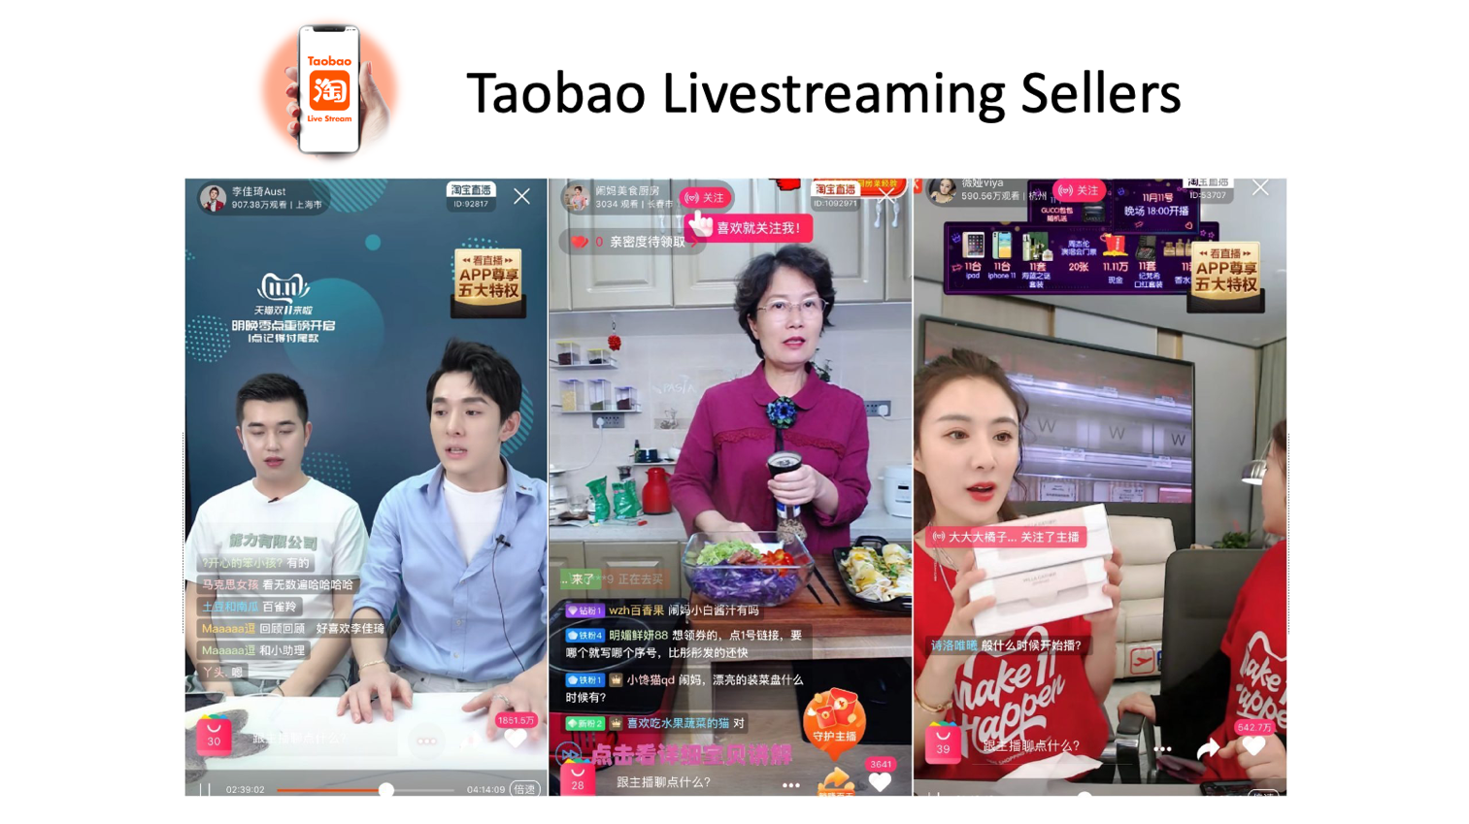

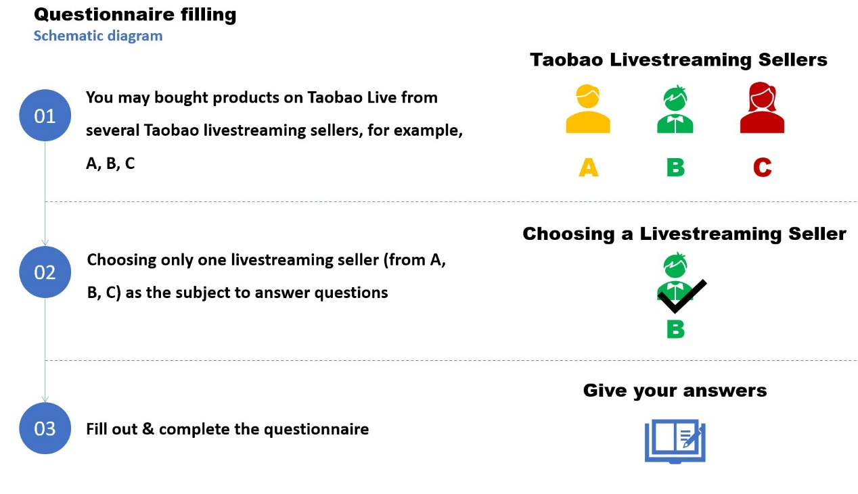

**Part 1: E-commerce livestreaming seller**

1. Have you ever used Taobao livestreaming?

A. Yes (please continue to answer the questions)

B. No (please end the answer)

2. Do you follow to a Taobao livestreaming seller?

A. Yes

B. No

3. Did you ever buy product from a Taobao livestreaming seller?

A. Yes (please continue to answer the questions)

B. No (please end the answer)

**Part 2: Demographic**

4. Your gender:

A. Male

B. Female

5. What is your age?

A. Under 18 years old

B. 18-24 years old

C. 25-29 years old

D. Over 30 years old

6. What is your educational background?

A. High school and below

B. Undergraduate

C. Master's degree

D. PhD

E. Others

7. What is your occupation?

A. Student

B. Employees

C. Self-employed

D. Others

8. Your monthly consumption (students in school are subject to the average monthly personal consumption amount)

A. Below 800 yuan

B. 800-1200 yuan

C. 1,201-1,500 yuan

D. 1500-2000 yuan

E. More than 2001 yuan

9. How long have you used the Taobao Live?

A. 1 year or less

B. 1-2 years

C. 2-3 years

D. 3-5 years

E. More than 5 years

**Part 3: Characteristics of e-commerce livestreaming seller and consumer buying behavior**

Please recall your last experience of watching this Taobao livestreaming seller and buying product, and give an answer based on the situation.

Please make a choice based on your feelings at the time about the degree of agreement described below.

1=Strong Disagree; 2=Disagree; 3=Neutral; 4=Agree; 5=Strong Agree

|  |  |
| --- | --- |
| Professionalism | Rating |
| 1.1 I think the live seller must have relevant knowledge in this product field | ①------②------③------④-----⑤ |
| 1.2 I think the live seller must have rich practical experience in this product field | ①------②------③------④-----⑤ |

|  |  |
| --- | --- |
| Product Involvement | Rating |
| 2.1 I think the live seller must pay much attention to the product for a long time | ①------②------③------④-----⑤ |
| 2.2 I think the live seller must like the products that he/she sell to consumers | ①------②------③------④-----⑤ |
| 2.3 I think that the live seller needs to spend a lot of time using this kind of products before selling | ①------②------③------④-----⑤ |

|  |  |
| --- | --- |
| Popularity | Rating |
| 3.1 When I watched and bought the product from the live seller, I have to consider his/her reputation on Taobao Live | ①------②------③------④-----⑤ |
| 3.2 I watched and bought the product from the live seller who is a high exposure-rate person on Taobao Live | ①------②------③------④-----⑤ |

|  |  |
| --- | --- |
| Visual Cues | Rating |
| 4.1 I watched the live seller who has detailed text descriptions | ①------②------③------④-----⑤ |
| 4.2 I watched the live seller who has clear and vivid pictures | ①------②------③------④-----⑤ |
| 4.3 I watched the live seller who has an intuitive and true video explanation | ①------②------③------④-----⑤ |

|  |  |
| --- | --- |
| Product Price | Rating |
| 5.1 If the price is beyond my ability to pay, I will reject the recommended products by the live seller | ①------②------③------④-----⑤ |
| 5.2 If the price is higher than my expectation but I can afford it, I still buy the recommended products by the live seller | ①------②------③------④-----⑤ |
| 5.3 I buy products with suitable price recommended by the live seller what I can afford | ①------②------③------④-----⑤ |
| 5.4 I buy products with low price recommended by the live seller what I can afford | ①------②------③------④-----⑤ |

|  |  |
| --- | --- |
| Perceived Value | Rating |
| 6.1 I think the product recommended by the live seller is acceptable | ①------②------③------④-----⑤ |
| 6.2 I think the product recommended by the live seller is useful | ①------②------③------④-----⑤ |
| 6.3 I think the product recommended by the live seller is trustworthy | ①------②------③------④-----⑤ |
| 6.4 I think the live video of the live seller is pleasing to the eye | ①------②------③------④-----⑤ |
| 6.5 The product recommended by the live seller meets my expectations | ①------②------③------④-----⑤ |
| 6.6 I think it is happy to buy products recommended by live sellers | ①------②------③------④-----⑤ |

|  |  |
| --- | --- |
| Buying Behavior | Rating |
| 7.1 The live seller can stimulate my desire to buy | ①------②------③------④-----⑤ |
| 7.2 The live seller provided me with great help in my purchase decision | ①------②------③------④-----⑤ |
| 7.3 Among similar products, I will first buy the recommended products by the live seller | ①------②------③------④-----⑤ |
| 7.4 I am willing to buy the products again/multiple times, which are recommended by the live seller | ①------②------③------④-----⑤ |
| 7.5 I would like to recommend/share the products recommended by the live seller to my friends | ①------②------③------④-----⑤ |

## *Appendix 1.2: Questionnaire in Chinese*

电商直播主播的特征对消费者购买行为的影响

尊敬的先生/女士：

您好，非常感谢您抽出宝贵的时间参与此调查活动。我是英迪大学工商管理专业的硕士研究生，正在为我的毕业研究项目收集数据。该问卷将用于匿名撰写论文，并且数据严格保密。谢谢您的合作！

提示：电商直播主播是指经常使用电子商务平台作为渠道向消费者提供产品信息，从而影响消费者的态度和购买行为的个人。

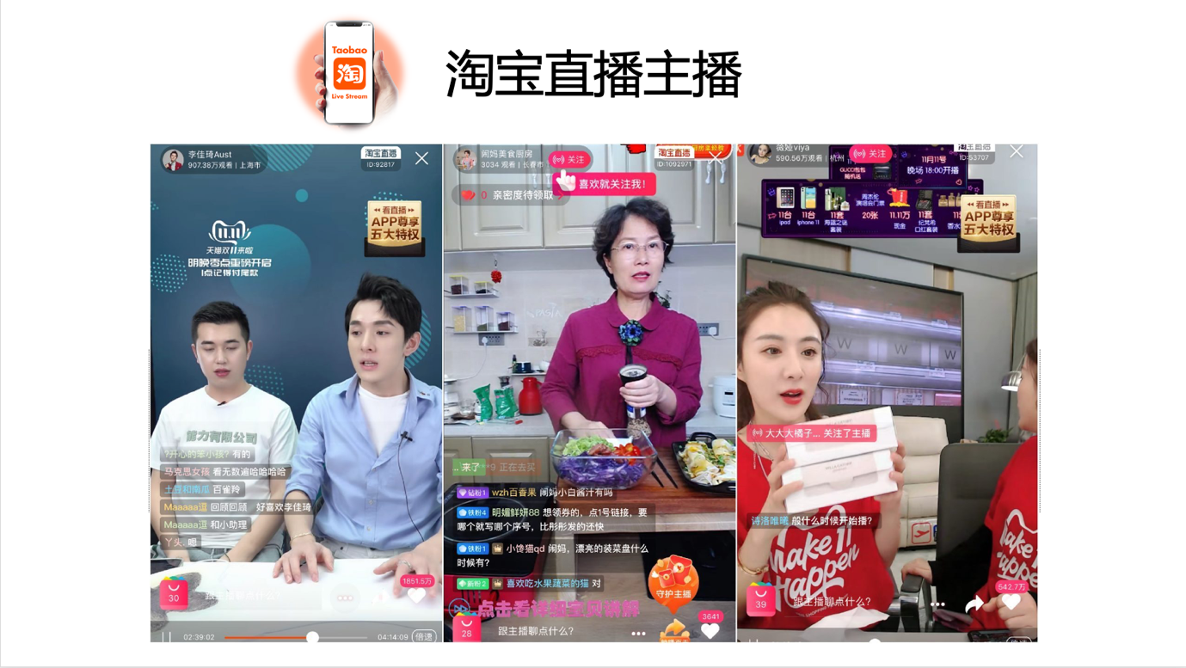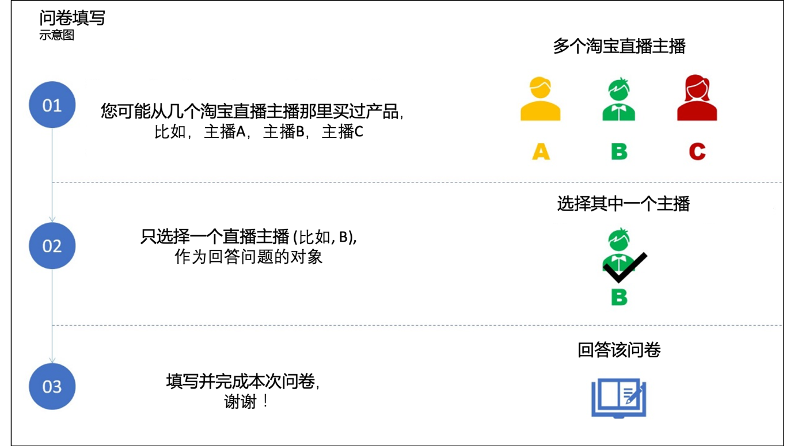

**第1部分：电商直播主播**

1.您是否曾经使用过淘宝直播？

A. 是（请继续回答问题）

B. 否（请结束答题）

2.您是否关注淘宝直播主播？

A. 是

B. 没有

3.您是否曾经从淘宝直播主播那里购买产品？

A. 是（请继续回答问题）

B. 否（请结束答题）

**第2部分：基本信息**

4.您的性别？

A. 男

B. 女

5.您的年龄？

A. 18岁以下

B. 18-24岁

C. 25-29岁

D. 30岁以上

6.您的教育背景是什么？

A. 高中及以下

B. 大学本科

C. 硕士

D. 博士

E. 其他

7.您的职业是什么？

A. 学生

B. 雇员

C. 自雇人士

D. 其他

8.您的每月消费额（在校学生以平均每月个人消费量为准）

A. 800元以下

B. 800-1200元

C. 1,201-1,500元

D. 1500-2000元

E. 2001元以上

9.您使用淘宝直播多久了？

A. 1年以内

B. 1-2年

C. 2-3年

D. 3-5年

E. 5年以上

**第3部分：电商直播主播的特征和消费者购买行为**

请回想起您最近观看的这个淘宝直播主播和购买产品的经验，并根据当时的情况给出答案。

请根据您当时的感受对以下所述的同意程度做出选择

1 =强烈不同意；2 =不同意；3 =中立；4 =同意；5 =强烈同意

**专业度**

10.我认为该直播主播具有该产品领域的相关知识

○强烈不同意

○不同意

○中立

○同意

○强烈同意

11.我认为该直播主播在此产品领域具有丰富的实践经验

○强烈不同意

○不同意

○中立

○同意

○强烈同意

**产品参与度**

12.我认为该直播主播必须长期关注该产品

○强烈不同意

○不同意

○中立

○同意

○强烈同意

13.我认为该直播主播必须喜欢他/她出售给消费者的产品

○强烈不同意

○不同意

○中立

○同意

○强烈同意

14.我认为该直播主播在销售之前需要花费大量时间使用这种产品

○强烈不同意

○不同意

○中立

○同意

○强烈同意

**知名度**

15.当我从该直播主播观看并购买产品时，我必须考虑他/她在淘宝直播上的声誉

○强烈不同意

○不同意

○中立

○同意

○强烈同意

16.在淘宝直播上，我购买了产品并且该直播主播有较高的曝光率

○强烈不同意

○不同意

○中立

○同意

○强烈同意

**视觉提示**

17.我看了该直播主播的直播，有详细的文字说明

○强烈不同意

○不同意

○中立

○同意

○强烈同意

18.我看了该直播主播的直播，有清晰生动的图片

○强烈不同意

○不同意

○中立

○同意

○强烈同意

19.我看了该直播主播的直播，有直观，真实的视频说明

○强烈不同意

○不同意

○中立

○同意

○强烈同意

**产品价格**

20.如果价格超出了我的支付能力，我将拒绝该直播主播推荐的产品

○强烈不同意

○不同意

○中立

○同意

○强烈同意

21.如果价格高于我的期望，但我可以负担得起，我仍然会购买该直播主播推荐的产品

○强烈不同意

○不同意

○中立

○同意

○强烈同意

22.我会购买该直播主播推荐的价格合适的产品，我可以买得起

○强烈不同意

○不同意

○中立

○同意

○强烈同意

23.我会购买该直播主播推荐的低价产品，我可以买得起

○强烈不同意

○不同意

○中立

○同意

○强烈同意

**感知价值**

24.我认为该直播主播推荐的产品是可以接受的

○强烈不同意

○不同意

○中立

○同意

○强烈同意

25.我认为该直播主播推荐的产品很有用

○强烈不同意

○不同意

○中立

○同意

○强烈同意

26.我认为该直播主播推荐的产品值得信赖

○强烈不同意

○不同意

○中立

○同意

○强烈同意

27.我认为该直播主播的直播视频令人赏心悦目

○强烈不同意

○不同意

○中立

○同意

○强烈同意

28. 该直播主播推荐的产品符合我的期望

○强烈不同意

○不同意

○中立

○同意

○强烈同意

29.购买该直播主播推荐的产品，我感到很开心

○强烈不同意

○不同意

○中立

○同意

○强烈同意

**购买行为**

30. 该直播主播可以激发我购买的欲望

○强烈不同意

○不同意

○中立

○同意

○强烈同意

31. 该直播主播为我的购买决定提供了极大的帮助

○强烈不同意

○不同意

○中立

○同意

○强烈同意

32.在同类产品中，我将首先购买该直播主播推荐的产品

○强烈不同意

○不同意

○中立

○同意

○强烈同意

33.我愿意 再次/多次 购买该直播主播推荐的产品

○强烈不同意

○不同意

○中立

○同意

○强烈同意

34.我想 推荐/分享 该直播主播推荐的产品给我的朋友

○强烈不同意

○不同意

○中立

○同意

○强烈同意

***Appendix 2: SPSS output of descriptive analysis***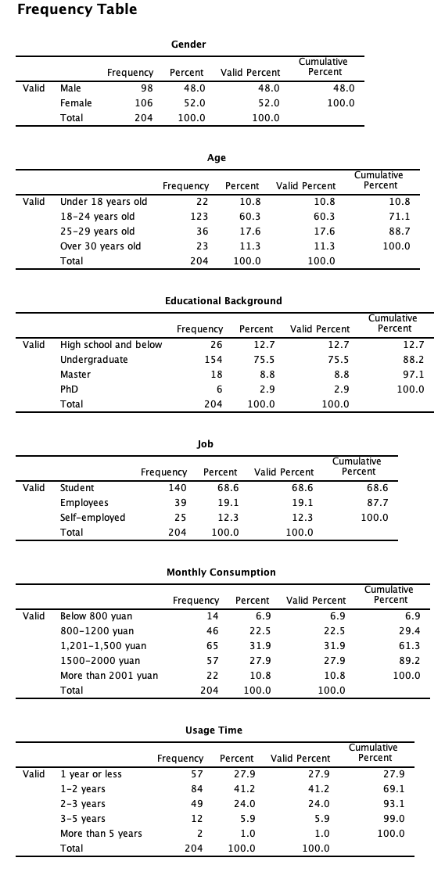

## *Appendix 3: SPSS output of correlation assessment*

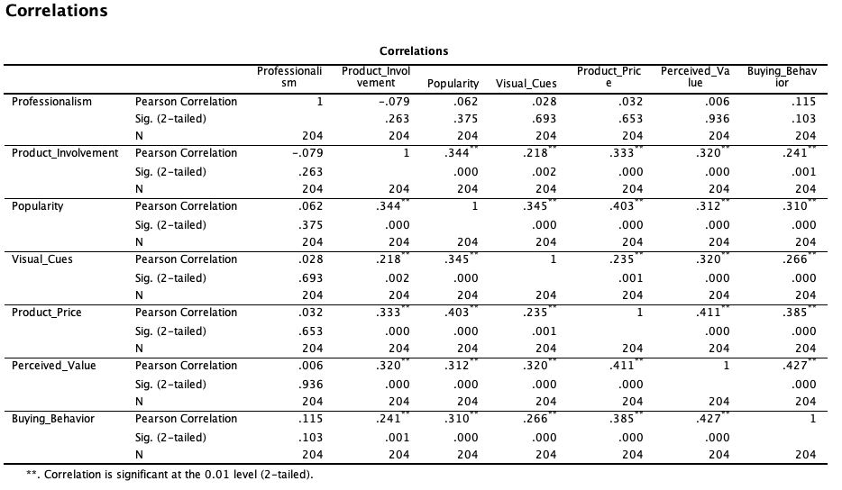

## *Appendix 4: SPSS output of regression assessment*

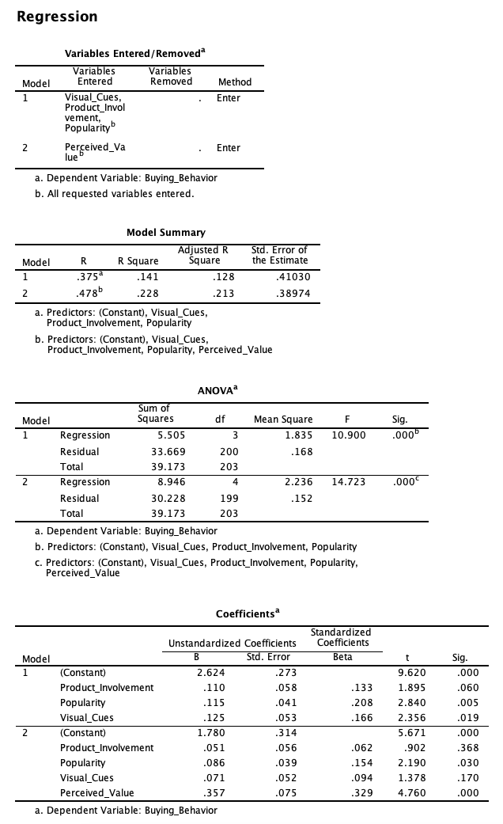

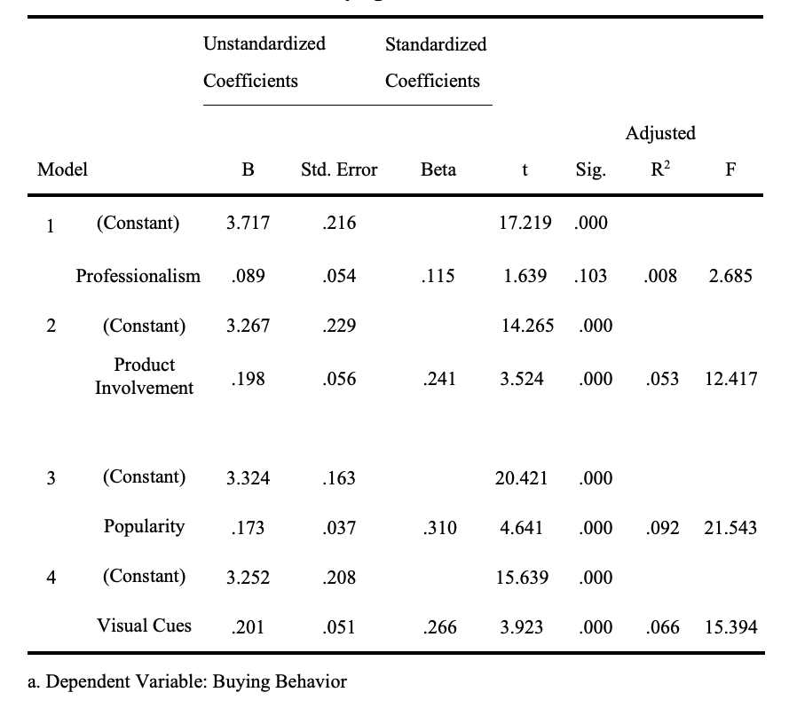

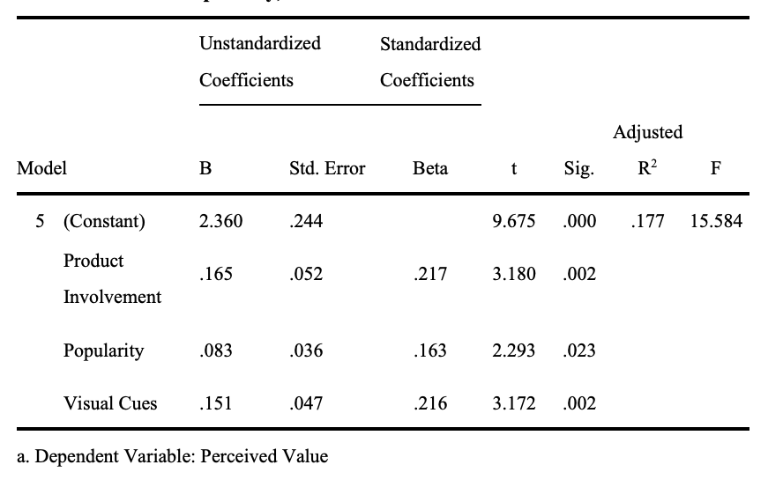

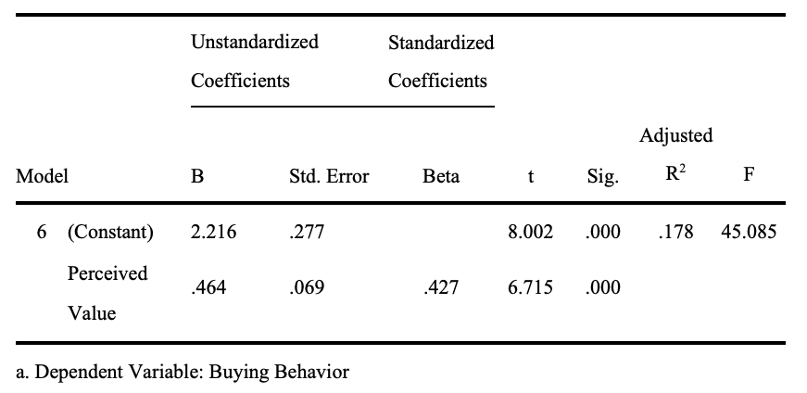

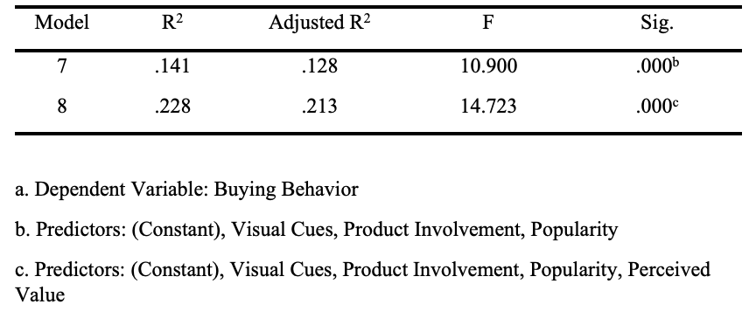

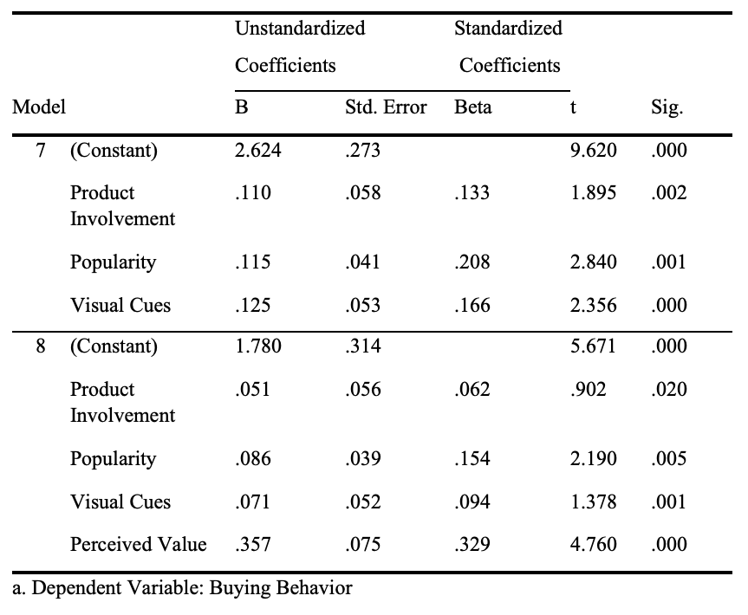

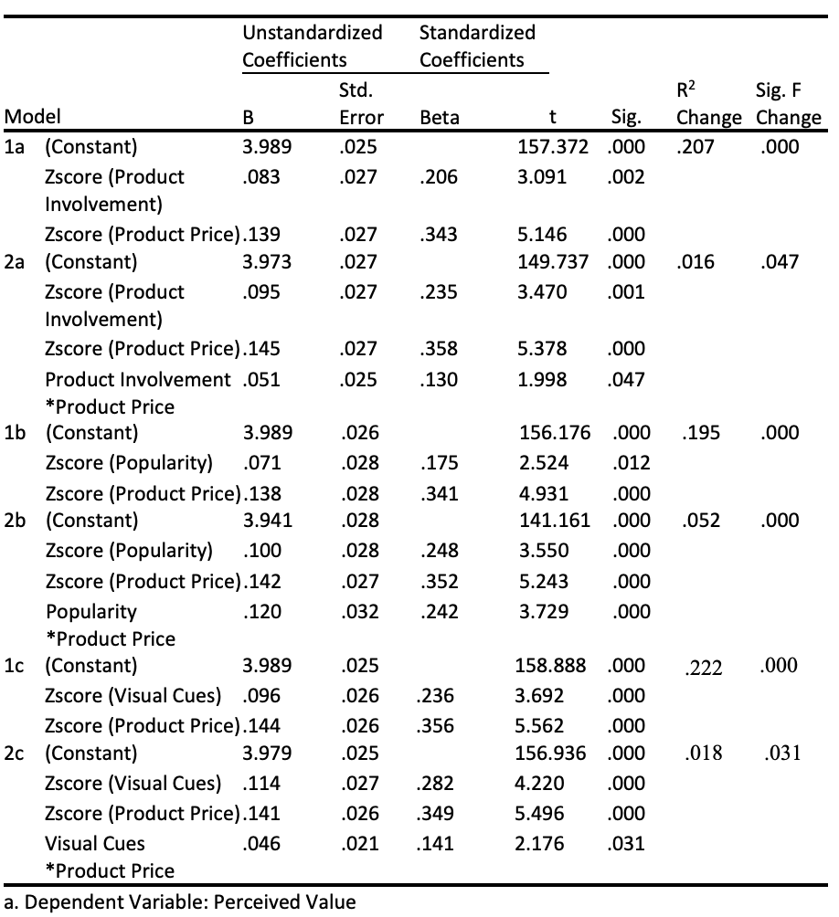

## *Appendix 5: Ethics Form*

## *Appendix 6: MBA Project Log*

|  |  |  |  |  |  |  |  |  |  |  |  |  |  |  |  |  |  |  |  |  |  |  |  |  |  |  |  |  |  |  |  |  |  |  |  |  |  |  |  |  |  |  |  |  |  |  |  |  |  |  |  |  |  |  |  |  |  |  |  |  |  |  |  |  |  |  |  |  |  |
| --- | --- | --- | --- | --- | --- | --- | --- | --- | --- | --- | --- | --- | --- | --- | --- | --- | --- | --- | --- | --- | --- | --- | --- | --- | --- | --- | --- | --- | --- | --- | --- | --- | --- | --- | --- | --- | --- | --- | --- | --- | --- | --- | --- | --- | --- | --- | --- | --- | --- | --- | --- | --- | --- | --- | --- | --- | --- | --- | --- | --- | --- | --- | --- | --- | --- | --- | --- | --- | --- |
| SECTION A. MONITORING STUDENT DISSERTATION PROCESS  The plan below is to be agreed between the student & supervisor and will be monitored against progress made at each session   |  |  |  |  |  | | --- | --- | --- | --- | --- | | Activity | Milestone/Deliverable Date | | | | | September | October | November | December | | The project topic determined | √ |  |  |  | | The related literature articles | √ |  |  |  | | The analysis method |  | √ |  |  | | Methodology |  | √ |  |  | | Study population |  | √ |  |  | | Data collection |  |  | √ |  | | Descriptive analysis |  |  | √ |  | | Correlation analysis |  |  | √ |  | | Recommendation |  |  | √ |  | | Limitation |  |  |  | √ | | Conclusion |  |  |  | √ | | The whole paper checking |  |  |  | √ |   SECTION B.  Ethics form protocol number: |
| SECTION C. RECORD OF MEETINGS  The expectation is that students will meet their supervisors up to ten times and these meetings should be recorded.  Meeting 1   |  |  | | --- | --- | | Date of Meeting | 05/10 2020 | | Progress Made | This meeting mainly discussed the confirmation of the thesis title and the general content of the whole thesis with my supervisor. The main direction of the paper. | | Agreed Action | Reached a consensus on the main content of the project. | | Student Signature | CHEN Jimiao | | Supervisor’s  Signature |  |   Meeting 2   |  |  | | --- | --- | | Date of Meeting | 12/10 2020 | | Progress Made | Discussed the determination of the final topic. And how to structure the paper. Continued to read independent variables and dependent variable. | | Agreed Action | Agreed topic: The Impact of E-commence Livestreaming Sellers’ Characteristics on Consumer Buying Behavior--Taking Taobao as A Case. Continued to read a lot of articles related to my research. | | Student Signature | CHEN Jimiao | | Supervisor’s  Signature |  |   Meeting 3   |  |  | | --- | --- | | Date of Meeting | 19/10 2020 | | Progress Made | According to the suggestions given by supervisor, the contents of the Chapter 1to Chapter 3 are summarized. And continued to read a lot of literature about it. | | Agreed Action | Continued to explain the definitions of independent variables, dependent variable, mediating variable and moderating variable. | | Student Signature | CHEN Jimiao | | Supervisor’s  Signature |  |   Meeting 4   |  |  | | --- | --- | | Date of Meeting | 26/10 2020 | | Progress Made | This meeting was going to confirm Chapter 3-----Methodology. To discuss sample size and sampling method. And by using quantitative analysis method----Multiple Linear regression was used. | | Agreed Action | The meeting agreed on the methodology to be used | | Student Signature | CHEN Jimiao | | Supervisor’s  Signature |  |   Meeting 5   |  |  | | --- | --- | | Date of Meeting | 02/11 2020 | | Progress Made | Present PPT | | Agreed Action | Read a lot of relevant articles in the literature Review Chapter. Improved the independent variables and dependent variables. | | Student Signature | CHEN Jimiao | | Supervisor’s  Signature |  |   Meeting 6   |  |  | | --- | --- | | Date of Meeting | 9/11 2020 | | Progress Made | This meeting mainly discussed the Conceptual Framework. Modify the independent and dependent variables. | | Agreed Action | It is agreed the Modify the independent and dependent variables | | Student Signature | CHEN Jimiao | | Supervisor’s  Signature |  |   Meeting 7   |  |  | | --- | --- | | Date of Meeting | 16/11 2020 | | Progress Made | Modify the independent variable and determine the definition of the independent variable | | Agreed Action | The supervisor advised and agreed that Change of independent variable and design the questionnaire | | Student Signature | CHEN Jimiao | | Supervisor’s  Signature |  |   Meeting 8   |  |  | | --- | --- | | Date of Meeting | 22/11 2020 | | Progress Made | Distribute questionnaires and collect data | | Agreed Action | Agreed to collect data | | Student Signature | CHEN Jimiao | | Supervisor’s  Signature |  |   Meeting 9   |  |  | | --- | --- | | Date of Meeting | 30/11 2020 | | Progress Made | Data reliability analysis, descriptive analysis, Pearson correlation analysis, multiple regression analysis | | Agreed Action | Agree with the data analysis section | | Student Signature | CHEN Jimiao | | Supervisor’s  Signature |  |   Meeting 10   |  |  | | --- | --- | | Date of Meeting | 05/12 2020 | | Progress Made | Improve the PPT content of the second defence | | Agreed Action | This meeting agree to the contents of the PPT in chapters 1 to 5 | | Student Signature | CHEN Jimiao | | Supervisor’s  Signature |  |   Section D. Comments on Management of Project  (to be completed at the end of the dissertation process)  Student Comments  Through this paper, first of all, thanks to Dr. Mun Geet Ow Yong for his advice. It made me very clear in the e-commerce field papers that I had misunderstood. Secondly, I learned to complete a master's degree thesis, structure, methods and so on. Thirdly, the importance of communication. Timely communication with my supervisor will make me get twice the result with half the effort compared to myself effort.  Supervisor Comments  Despite the challenging beginning, student has managed to work on his best capacity and handle the project.   |  |  | | --- | --- | | Signature of  Student CHEN Jimiao | Date： 18/ 21/ 2020 | | Signature of  Supervisor | Date： | |

## *Appendix 7: SafeAssign full report*

