
Campus Name: INTI International University (Laureate International University)
Programme Code: MBADI
Session: Sept 2020
Subject Code & Name: MGT 7998.9B1 MBA Project
Assignment Title: MBA Project – Factors that influence SMEs Online marketing practices:A case study in Kenya)
Student’s Name & ID: DONATA CHEBET (I20018720)
Lecturer: Dr Asokan Vasudevan
Submission Date: Dec 2020

Contents
ABSTRACT 4
Chapter 1 5
1.0 Introduction 5
1.1 Background of Study 5
1.2 Problem Statement 7
1.3 Research objectives 8
1.5 Purpose of Study 8
1.6 Scope of Study 9
1.7 Limitation of Study 9
1.8 Definition of Key Terms 9
1.9 Chapter summary 10
Chapter Two 11
2.0 Literature Review 11
2.1 Introduction 11
2.2 SMEs use of Online Marketing 11
2.4 Online marketing platforms. 13
2.5 Factors Influencing the use of online Marketing practices in SMEs 14
2.5.1 Resources 14
2.5.2 SME Owner Characteristic 14
2.5.3 Organization Characteristics 15
2.6 Strategies SMEs in Kenya adopt to ensure effective use of online marketing 16
2.6.1 Product strategy 16
2.6.2 Price strategy 16
2.7 Implication advantage of online marketing practices 16
2.7.1 online marketing practices advantage on customer interactions 17
2.7.2 Online marketing practices impact on operational costs 17
2.7 Hypothesis Development 18
2.8 Conceptual Framework 19
2.9 Chapter summary 19
3.7 Multilinear Regression 25
3.8 Coefficient correlation 26
4.0 Data Analysis 27
4.1 Introduction 27
4.2 Response Rate 27
4.3 Reliability Test 29
4.4 Validity 29
4.5 Response Rate and Demographics 30
4.5.1 Response Rate 30
4.5.2 Demographic 30
4.5.2.6 Level of Training in Information Technology 32
4.6 SMEs Online Marketing Practice 33
4.6.1 Rating of Online Marketing Practice 33
4.6.2 Pearson Correlation Test for SMEs Online Marketing Practices 34
4.6.3 Regression Model Summary 35
4.6.4 ANOVA Analysis Summary 36
4.7 SMEs Resources Impact on Online Marketing Practices 36
4.7.1 Pearson Correlation Test for SMEs Resources influence on online marketing practice 37
4.7.2 Regression Model Summary 37
4.7.3 ANOVA Analysis 38
4.7.4 Regression Analysis Coefficients for SMEs Resources 38
4.8 SMEs owners Characteristics Influence on SMEs Online marketing practices 39
4.8.1 Ratings of SMEs Owner Characteristics Influence on the use of Online Marketing 39
4.8.2 Pearson Correlation Test for SMEs Owner Characteristic influence on Online Marketing Practices 40
4.8.3Regression Model Summary 41
4.8.4 ANOVA Analysis 42
4.8.5 Regression Analysis Coefficients for SMEs Owner Characteristics 42
4.9 SMEs Organization Characteristics Impact on Online Marketing 43
4.9.1 Rating of SMEs organization Characteristics 43
4.9.2 Pearson Correlation Test on Influence of SME organization on online marketing practices 44
4.9.3Regression Model Summary 45
4.9.4 ANOVA Analysis 46
4.9.5 Chapter Summary 47
Chapter 5 48
5.0 Conclusion and Recommendation 48
5.1 Introduction 48
5.4.1 Hypothesis 1 49
5.4.2 Hypothesis 2 49
5.4.3 Hypothesis 3 50
5.5 Theoretical Implications 50
5.6 Practical Implications 51
5.7 Limitation of study 51
5.8 Recommendation for future Works 51
5.9 Conclusion 52
References 53

ABSTRACT
This study intended to investigate the factors that influence SMEs online marketing practices in Kenya, the scope was narrowed down to SMEs in the service industry located in Kisumu county. The study was able to answer the following questions: The SMEs characteristics impact on the use of online marketing, the impact SME owner has on the adoption of online marketing and how resources are limiting SMEs from fully utilizing the potential of online platforms. The study used case study design, used descriptive questionnaire to collect data from 169 (89.76% response rate) respondents. The data was subjected to qualitative analysis using SPSS Software to determine the relationships between the study variables(Reliability and factor analysis on the variables was >0.6). The study showed that SME owners’ perception(R=82%) towards online marketing is an important function of the business because in most cases the owner sees the strategic benefits of using online marketing platforms. Pressure from competitors and suppliers are considered by owners when using online marketing to meet the demand of customers. The use of online marketing is also primarily driven by the nature of the enterprise business sector. Also, limited resources (R=74%) hinder most SMEs from gaining the benefits of online marketing.
KEY Words: Online Marketing ,Internet, Competitiveness ,Small and Medium Enterprises

Chapter 1

1.0 Introduction

The research focus is on SMEs online marketing practices in Kenya. The research investigates the factors that are limiting SMEs in Kenya from fully exploiting the potential of online marketing. This chapter explains the current extend of online marketing among SMEs and the various marketing approaches being used by SMEs when it comes to marketing. The chapter explains the factors that influence online marketing, afterward research objectives are determined and narrowed to three specific objectives based on the variables understudy. Using the objectives, research questions are created as a guide base for the rest of the study. The end of the chapter defines the variables and the specific context of study.

1.1 Background of Study
Small and medium enterprises are known to be the economic pillars of most developing countries. Being self-employed or entrepreneur is the most common mode of earning a living (Hernández-Linares and María Concepción López 2020) Online marketing practices involve the use of social media platforms, paid advertising, affiliate marketing and search engine platforms to encourage potential consumers to purchase or recommend your products and services .SMEs play a huge role in the economy for example in Europe 90 percent of companies are SMEs and those companies provide more than 70 per cent of private sector employment.
Online marketing is technology-based activity that is considered as one of major aspects in marketing practice (Coviello and Patricia P, 2015) which involves using the internet and other interactive technology to create a common ground for enterprises and customers. Online marketing provides customers easy access to information and customers are also able to relay feedback to respective busines (Fehrer and Brodie, 2018).The use of online marketing is recognized as a key business input that must be integrated with enterprises marketing activities. In most cases the use of online marketing is usually associated with customer acquisition and retention. Effective online marketing practice can improve enterprises to improve its competitiveness organizational capabilities that will in turn improve marketing decisions when targeting customers (Uthman, 2009).

The marketing reality of SMEs is far from that of large corporations and hence digitization is a greater challenge for them. SME marketing techniques are informal, reactive and spontaneous (Gilmore, 2007). SMEs are characterized sales focused and the main goal of their marketing is just to create awareness of the enterprise and products (Reijonen and Komppula, 2018), In general, marketing in SMEs has been characterized as disorganized and unplanned, although some SMEs do engage in formal and conventional marketing practices like marketing planning (Hill, 2011). The advantage of online marketing is that enterprises stand to increase the exposure to global markets , improve communication ,reduce transactions costs; this can only be achieved on online marketing platforms. (Chaffey, 2009) explains that the performance of online marketing is linked to financial benefits obtained from management responsible in identifying the changing trends in customer needs. The effectiveness of online marketing is linked to the input of different technology i.e., emails to fulfil changing customer needs. Online marketing has created increased competitions and enterprises to standardize products and prices among competitors (Porter and Michael, 2001).
In Most literature findings, the success of small and medium enterprises depends on how effective their marketing system is when it comes to generating sales. Marketing as a concept enlightens SMEs on platforms available to convey their message .Conventional way was by use of radio, printouts, television but currently the use of emerging media such as online marketing is cost effective than the conventional methods. This has made SMEs to shift their budgets towards online platforms (Ritchie, 2005). Despite the increased use of the internet for the past years, majority of the SMEs in Kenya are yet to fully understand the potential of online marketing they tend to underutilize marketing opportunities that exist online (Cragg, T. and McNamara, 2018).
Limited access to new markets is a major constrains to SMEs growth and competitiveness in Kenya due to the globalization and shrinking domestic market (Kenya, 2018).SMEs are limited to information and this makes them less aware of the opportunities in the market. In most cases markets don not function well because of Insufficient information ,high transaction costs and stiff competition of similar products. Online improves communication with customers ,competitive positioning, produce of quality products, reduced logistics costs and access to a wider market. In Kenya SMEs are skeptical to adopt the use of online marketing because they perceive online marketing as cost intensive and lack the knowledge of how online marketing can improve their business performance. There is limited research on the practice of online marketing performances of SMEs in Kenya.

1.2 Problem Statement
The use of the internet has introduced SMEs to online marketing but very few enterprises are fully reaping from the use of online marketing. In most cases you will find an SME has business website but have limited knowledge on how to interact with it to its potential (Reijonen, 2010).Part of the problem is resources and technology capabilities as well as the implementation of the rapid changing technology word. (Dhewi, 2019).The nature of products, services determine the marketing practices as to whether to use conventional marketing or adopt online marketing . SMEs are insufficiently equipped to embrace opportunities presented while confronting challenges of globalization. SMEs owners limited knowledge on online marketing limits SMEs from engaging in global markets which offer SMES Opportunities to participate in the regional and international markets while internationalisation presents opportunity for growth and development beyond the local market. In most cases SMEs encounter difficulties accessing markets due to limited market knowledge ,inadequate marketing capacity and inefficient market research leading to discrepancy between demand and supply (Moyi, 2006 ).
SMEs in Kenya encounter difficulties accessing markets due to limited market information, poor marketing capacity and poor market research leading to a discrepancy between the supply and demand (GOK, 2011). Another challenge faced by SMEs is difficulty in addressing trust and confidence with customers,SMEs in Kenya are more vulnerable than large firms to problems linked to authentication/certification, data security and confidentiality and the settling of commercial disputes.
SMEs in Kenya face stiff competition from other companies thus it needed to constantly reinforce its organization structure,brand and play up their value offerings. SMEs are tasked to ensure that online site are continuously updated with the latest technology and business trends, as well as balances its business overhead and upfront capital involved in creating its tour packages among other challenges. Given the various study gaps that had been highlighted above, there was a need for this study that sought to outline factors that influence SMEs online marketing practice to improve their competitiveness with a key focus on SMEs in Kenya.

1.3 Research objectives
RO1.To what extend does SMEs owner impact on online marketing practices
RO2. To what extend do SMEs resources impact on online marketing practices.
RO3. To what extend has SMEs organization characteristics impacted on the use of online marketing

1.4 Research Questions
RQ1. What is the impact of SMEs owner characteristic on online marketing practices?
RQ2.What is the impact of SMEs resources on online marketing?
RQ3.What is the effect of SMEs organization characteristics on online marketing?

1.5 Purpose of Study
The purpose of this research is to find out how SMEs are performing online marketing, the factors that are limiting to fasten this process hindering SMEs from fully engaging in online marketing. Most SMEs have a personalized brand image impacting of how the owner wants to the brand to be portrayed to the rest of the world.

1.6 Scope of Study
The research was based on Kenya and its targeted SMEs who practice online marketing. This niche was chosen because of their strategies in online marketing and use of online marketing platforms. Ascertaining the effective modes that SMEs use when it comes to online marketing. The results of the study were limited to SMEs in Kenya and thus a base for other studies

1.7 Limitation of Study
Time constrains but the respondents were able to give feedback within the set frame .The study focuses on SMEs as general and the results might be biased because different sectors of SMEs use online market depending on customer niche and the current demand and supply

1.8 Definition of Key Terms
Online Marketing
is also referred to as web marketing and can be also be defined as the use of the internet and related digital technologies to achieve marketing objectives to support online marketing activities to build customer relationships and improve service delivery (Harrigan, 2012). Internet
This is the global network which connects millions of computers and phones. It is like a medium that connects billions of devices worldwide (Lloyd, 2008).
Competitiveness
The ability of an enterprise to increasingly attract buyers while providing them with excellent experience and do so in a profitable way while factoring in the wellbeing of the customers and the original capital for future generation (Jarvinen, 2012).
Small and Medium Enterprises
In Kenya, enterprises are classified by the number of employees. The 1999 National Micro and Small Survey defined SMEs as organizations in both formal and informal sectors employing 5-99 employees .Small employees 5-49 while medium 50-99.
Sole proprietorship
This is unincorporated enterprise owned by a single individual. Most SMEs are sole proprietors since it is easy to manage and file tax returns. These enterprises are usually having personalized marketing since they are usually portrayed as an extension of the owner, the owner is personally responsible for any debts or liabilities incurred by the enterprise.
Partnership:
This is a small business with two or more owner. Each partner has input to the business impacting on online marketing practices. The partners are both liable for any losses made by the business placing partners personal assets at risk.

1.9 Chapter summary
This Chapter has given an insight of brief relationship between SMEs and online marketing. This chapter explains how online marketing the new way is to reach new customers. The chapter also gives scope and significance of the study as well as the definition of terms that have been used.

Chapter Two

2.0 Literature Review

2.1 Introduction
The factors that impact on SMEs online marketing are discusses to show the extend of SMEs online marketing practices. Literature review evaluates the context and independent variables such as SMEs owner characteristics, Resources ,SME organization characteristics. This chapter looks in depth of literature to explain why the researcher arrived at this topic of research. This section explains the extend of SMEs online marketing practice which is the basis of the research. The conceptual framework of the research is drafted to show the relationship between the independent and dependent variables and lastly research Hypothesis are established as a guide for this research.

2.2 SMEs use of Online Marketing
This is extended to which SMEs have been able to use of online marketing considering the unique business environment, characteristics of the owner (skills and abilities) and available resources (Gilmore & O’Donnell, 2004) to attain sales. Marketing is usually regarded as an engagement with customers (Deans & Knightbridge, 2013) and through self-marketing by the owners (Shepherd, n.d.) .
Marketing theories mostly focus on 4Ps (Price, Product, Promotion ,Place) which are effective for large enterprises .SMEs practice marketing but in their own unique style projecting their ability to offer products and services that suits their customers, and this is achieved by having in depth knowledge of their customers’ needs and being able to communicate with customers on a personal ground. This Kind of marketing approach resonates with service dominant logic (Vargo& Lusch,2012) where goods are a medium of service which is defined as an application of competencies such as knowledge and skills for the benefit of a party. The advantage of self-marketing by SME owner can create personal brand which can be differentiated from competitors and indication that SMEs engage in marketing but with a different 4Ps model(personal, practice ,production and perseverance).
Internet marketing can be used by SMEs to enhance personalization which in turn will improve customer loyalty (Eid & El-Kassrawy (2012).Previous research has shown that SMEs use the online marketing to complete business transactions and relatively small percentage use it for communication (Achieng, 2016). While large firms may convert this relatively static process into a more dynamic process of discovery through data mining, SMEs typically lack the resources and capabilities required to transform transaction information into a more dynamic market-sensing ability (Bhandari & Singh,2018).Resources and capabilities needed to convert transaction data into important information entails at least two substantial and potentially prohibitive costs.Development and maintenance costs are much higher if carefully detailed and formatted back-end data-base management features are required and interpret advanced data-mining software effectively can be very expensive (Bhandari & Singh, 2018). As a result of these costs, the more challenging is online marketing practice to be implicated in strategic flexibility for SMEs.
Access to new markets and new market information remains a severe constraint to SMEs development and competitiveness in Kenya. Prescribed policies to address these challenges seem not to be effective (Kenya, 2018). Overall aggregate demand is low; markets are saturated due to dumping and overproduction, and in most cases markets do not function well due to lack of information and high transaction costs. Most of the SMEs are ill-prepared to compete in globalised liberalized markets while fewer are capable of venturing into the export markets to tap into new market frontiers. This confines majority of SMEs to narrow local markets characterised by intense competition. Small capital base and limited technology also confine SMEs to poor quality products that cannot compete effectively in a globalised competitive market environment.
More than 95% of SMEs in Kenya own mobile phones with subscription reaching 30.7 million in April, 2013 and mobile penetration at 78% (Kiveu, 2013). This offer SMEs a great opportunity to employ the services of this preferred tool to enhance market access. Mobile phones offer various functionalities that can enhance market access and include communication, enabling market transactions, product promotion, customer relationship, market research and other internet enabled services. Mobile phones offer a quick, efficient and affordable way of communication to SMEs which is essential for initiating and maintaining customer relationship, facilitating market transactions, acquisition of market information and for communicating product information to customers.

2.4 Online marketing platforms.
In simple understanding, online marketing is the use of the internet when communicating and delivering value to customers. The internet is a basic toll in our daily lives due to rapid development of technology. With emerging technology individuals are prompt to search for everything they want online tremendously changing the retail landscape and conventional marketing strategies. Online marketing integrates the use of social media marketing, mobile marketing, and search engine marketing (Wilson, 2018).
There are well known online marketing platforms such as Amazon, eBay depending on your region which sell a wide range of goods and services. In Kenya there is a good number of online marketing platforms such as OLX.co.ke, Jumia.co.ke and Cheki.co.ke .These platforms have created self-presentation to SMEs as well as customers on a wide variety of goods and services through the internet i.e., Olx.co.ke allows sellers to transact both new and used household items, motor vehicles as well as real estate. A potential buyer gets the opportunity to choose from the diverse variety of items at one point without having to physically visit the shops. Online market has also enabled small enterprises to access new market niche increasing opportunities.
SMEs in Kenya use : Twitter (for microblogging service), Facebook (for online social networking), LinkedIn(for professional networking), YouTube (for video sharing), Instagram(for photo and video), and Google Plus (for social networking), Samuel

2.5 Factors Influencing the use of online Marketing practices in SMEs

2.5.1 Resources
This includes finances ,time, skill, and personnel are the major factors impacting on online marketing. Lawrence (2012) explains that resource limitations such as time ,capital and preference to use conventional mechanism to conduct business limits organizations from gaining benefits of using online marketing’s have been using little on online marketing and in turn not fully use optimum solutions for much of their business. Most SMEs do not have Return on Investment as a result they are unable to invest in new technologies that could help them fast track their business.
SMEs have been seen as spending little on technology, therefore they do not use the optimum solutions for much of their business. SMEs are also concerned with Return on Investment (ROI). The pressure to show a return on the investment often leads to SMEs being more concerned with medium-term survival rather than long-term viability (Otoo and Opuni 2018). As a result, owners are often hesitant to make substantial investments when short-term returns are not guaranteed, as is the case of online marketing. As a result, they are unable to invest in new technologies that could actually help put them on the fast track.

2.5.2 SME Owner Characteristic
The use of online marketing by SMEs is a decision that is influenced by the business owner. The success of a SME to implement the use of online marketing is when the owner takes the role of innovation champion. Most SMEs owners view online marketing as an important tool for their business (Ramsey, 2012).In most cases some SMEs tend to prefer comfort because it is a familiar adventure instead of indulging into a new venture(reluctant to think out of the box) when seeking new solutions .SMEs need to personally be ready to adopt online marketing despite the adoption being driven by business demand and technology (Gary, London,UK). Some SMEs owners are yet to be convinced with the strategic benefits of utilizing new technology and online platforms. (Gary, London,UK)explains that despite the use of online marketing practices is driven demand or technology innovations, SMEs must individually be ready to progress to the next stage and this process involves being educated with new knowledge.
The adoption of online marketing by SMEs is a decision made by the business owner and the manager. Successful companies that embrace IT and online marketing are often those whose owners take on the role as innovation champion. SMEs owner perceive online marketing as an important function for their business (Ramsey and McCole, 2013). However, many SMEs prefer the comfort of what they perceive as familiar over indulging into any new venture. They are reluctant to “think outside the box” in order to seek new business solutions (Cyert and March, 2012). Some SMEs do not perceive (or are not convinced by) the potential strategic benefits of being the first to utilize new technologies and marketing platforms. Some do not perceive the relevance of using new technologies to their business, although they understand the online 17 buying and selling functions offered by online marketing facilitated by new technologies (Ramsey and Gray, 2003). Gary (2013) argues that whether the adoption is driven by business demand or technology push, the SMEs need to be personally ready before moving on to the next stage and that the process involves learning and new knowledge.

2.5.3 Organization Characteristics
A number of factors influencing adoption of online marketing has to do with the organization itself. For instance, the age of the organization is a major factor - the older the organization, the higher the level of adoption. The older organizations have an advantage over younger ones because reliability and accountability tend to increase with age, and failure rates tend to decrease as firms grow older (Brashear-Alejandro, 2014). The nature of the industry, the size, the common practice, and the traditional way of doing business impose a significant impact on the adoption of new technologies and online marketing. The high level of intangibility of the product mix can be viewed as one of the major impediments to future utilization of online marketing (Gary, London,UK). Unique nature of an industry in relation to utilization of online marketing he found that adoption has also been found to be largely dependent on external pressure from the business competitors as well as its supply chain. SMEs might adopt online marketing because of their competition using it as not to lose their competitor’s advantage. There may be a sense that business is dictated mainly by the end customer, supplier or distributor who does not want to embrace online marketing as a business technology, instead preferring conventional, traditional methods. If an organization has large amount of data and transaction, then it is mor e likely to adopt online marketing which can help streamline operations and offer process efficiencies within the organization (Anon., 2005).

2.6 Strategies SMEs in Kenya adopt to ensure effective use of online marketing
The internet has lowered barrier for new competitors to easily enter online marketing and this does not require a huge offline capital investment. As the number of people with internet access is increasing, competition for online business is projected increase. The internet has brought more companies into competition with another by expanding the geographical markets (Porter, M.E. and Michael, 2001).SMEs in Kenya are forced to adopt different strategies to remain competitive such as :

2.6.1 Product strategy
SMEs in most cases are being forced to lower their prices since they cannot achieve competitive advantage by exploiting customers as they did in physical market (Viswanathan,2012). Customers can carry out complete search of products being offered by SMEs virtually at no cost (Allen and Fjermestad,2010).Customers can also easily compare prices

2.6.2 Price strategy
Lower search for price and products on the internet marketplace has promoted price competition among sellers. The internet significantly impacts competition and intensive pricing competition can reduce sellers’ profits. To eliminate these SMEs, employ appropriate pricing strategies to sell products over the internet

2.7 Implication advantage of online marketing practices

The of online marketing is that its cost effective, it is cost effective to use the internet when considering business to business communications and marketing. There are certain costs that are incurred by SMEs such internet monthly subscriptions to an internet services provider, the cost of busying computers, training costs and also the cost of designing an maintaining a website (Kiang and Shang, 2000).However there are other costs which are automatically saved such as the time cost, thus making the internet and effective tool for marketing’s can trace their customers on the internet, how long they spent on their website and which page attracts customers more. This is an ideal way to collect data on market needs, wants and desires

2.7.1 online marketing practices advantage on customer interactions

A unique role of online marketing is to create Buzz marketing, that enabling customers to talk to one another is, in a sense, an extension of traditional word of mouth communication (Bambauer-Sachse and Mangold, 2011) .SMEs are faced with the question of how this power can be attached to benefit the enterprise. Organizations cannot directly control what ccustomers are saying, however they do have the ability to influence the conversations consumers are having . The question remains how can SME owners use social media like twitter to influence customer conversation or interact with customers.
Networking is a widely cited marketing activity for SME’s and is important during their establishment, development, and growth (Mohamed, and Walsh, 2007). In marketing their firms, SMEs rely heavily on their personal contact network. Traditionally, economic structures favor bigger firms; however, today’s economy is distinguished by relationships, network, and information, favoring some of the characteristics of SMEs. Rather than relying exclusively on their personal contact network, small businesses rely on the networks of customers as well (Mohamed and Walsh, 2007).

2.7.2 Online marketing practices impact on operational costs
Online marketing practices help SMEs in Kenya to engage with customers in a timely and direct manner at low cost and higher levels of efficiency than with more traditional communication tools. This makes online platforms appropriate for small and medium size companies (Garengo and Bititci, 2005). Online platforms and social media offer a great quantity of services on the Internet. Social networks like Facebook, Myspace, and LinkedIn and micro-blogs like Twitter can be used in a different way such as news passing, advertisements and connecting with others in the world that cut down the cost of employing others to work physically.
The marketing tools can be freely and easily used compare to other promotion tools (Gilmore, 2007). The main purposes of using online marketing platforms is that they are the amplification of word of mouth marketing, market research, general marketing, idea generation and new product development, co innovation, customer service, public relations, employee communications and reputation management. Indeed, social networks can increase product and brand awareness, web traffic, customer loyalty, but also improve the company’s Search Engine Optimization, and even increase the success of new product
2.7.3 Create SMEs Brand Awareness
Online marketing gives chance for ccustomers to comment or post questions as a form of engagement about the SME brand. Through the use online platforms, SME owners can find out what is being said about their brand and they can also connect with ccustomers (Holland, C.P. and Gutiérrez-Leefmans, M, 2018) . Ccustomer’s can generate new business and promote SME brand by sharing on various platforms. Loyal customers also help generate “online word of mouth” which is very crucia for SMEs. Engagement with consumers provides SMEs with opportunities to use social media as a tool for their marketing strategies. However, many small business owners struggle to effectively reach their customers.
An equivalent 57% of small and medium businesses say online platforms have improving the brand identification to the society. Online platforms help to foster communication around brands and products, enhancing positive as well as negative word of mouth around a business and its products and services. Any message or piece of information shared on the Social Media channels can be seen by thousands of people in an extremely short period of time.The advantage of impelmenting online marketing practices is to increase brand exposure. This occur when the customer becomes aware of a product,serviceor advertisement throughat least one of their five senses, whether or not they paid attention to it. Although the word of mouth has utomatically expanded aroubnd the brand, large variety of online platforms has increased brand visibility.

2.7 Hypothesis Development
H1) SMEs owner characteristic has significant impact on online marketing practices.
Most SMEs owners view online marketing as an important tool for their business (Ramsey, 2012).
Through the use online platforms, SME owners can find out what is being said about their brand and they can also connect with ccustomers (Holland, C.P. and Gutiérrez-Leefmans, M, 2018)

H2) SMEs resources have significant impact on online marketing practice
Lawrence (2012) explains that resource limitations such as time ,capital and preference to use conventional mechanism to conduct business limits organizations from gaining benefits of using online marketing’s have been using little on online marketing and in turn not fully use optimum solutions for much of their business. , the cost of busying computers, training costs and the cost of designing and maintaining a website (Kiang and Shang, 2000).

H3) SMEs organization characteristics has significant impact on the use of online marketing practice
The older organizations have an advantage over younger ones because reliability and accountability tend to increase with age, and failure rates tend to decrease as firms grow older (Brashear-Alejandro, 2014).

2.8 Conceptual Framework

The conceptual frame work will used to describe the relationship between the different variables under study. Figure below shows the theoretical framework developed for this research outlining the relationship between the dependent and independent variable.
Independent variable Dependent Variable
Owner characteristics

online marketing practice
Resources

Organization characteristics

2.9 Chapter summary
The has discussed in detail the online marketing practices of SMEs. The various factors that influence online marketing practice and the extent to which SMEs use online marketing to their advantage. The chapter has also elaborated the different platforms SMEs can adopt to ensure effective use of online marketing to improve their competitiveness .This chapter also show the hypothesis that will be guide for the research.

Chapter Three
Introduction
This Chapter focuses on outlining research methodology of this research which includes sampling method and questionnaire. The next section of the chapter will outline the measures taken using pilot test, factor analysis and reliability test for the research. The chapter will be followed by describing the collected data. The last section will outline the analysis planned and the tools to be used in the research which included descriptive analysis, multiple linear regression, and beta coefficient.
3.2 Research design
This study used descriptive research design. Descriptive research design attempts to identify and explain the variables that existed in a given situation and describe the relationship that exist between these variables in order to provide a picture of a particular phenomenon (Cooper, 2003). The study sought to establish the relationships between the factors that influence online marketing practices. Descriptive design was convenient for this study as it enabled the researcher make inferences on the impact of resources, owner characteristics and structure to small businesses enterprises. The dependent variables in the study included the SMEs online marketing practices, while the independent variable is SMEs owner characteristics ,SMEs resources ,SMEs organization structure.

3.3 Sampling Design
When selecting sampling techniques, researchers must select probability sampling and non-probability sampling (Parveen, 2017). Probability sampling is when each sample has an equal probability of being chosen to involve in the research, while non-probability sampling uses a non-randomized method to draw the sample and normally involves judgment (Parveen, 2017). Instead of using randomization, participants are selected for a specific reason such as easy to access (Showkat & Parveen, 2017). Due to the limitation of time, minimization of cost and restricted interaction between people during Covid-19 pandemic season, the sampling techniques selected for this research will be non-probability sampling. This technique allows the author to access available respondents nearby, which will help the author to collect sufficient data in a short amount of time and avoid unnecessary contact with the respondent.
The SME respondents will be selected from Kisumu County one of the major industrious town to ease the data collection process and narrow the scope of study.

3.3.1 Population
The study population consisted of all small and medium enterprises in the service sector located in Kisumu County in Kenya . According to Circuit Business Systems (CBS)and K-Rep Baseline survey, there were over a 1.4 M million registered SMEs in Kenya.
3.3.2 Sample Frame
A sampling frame is a list of elements from which the sample is actually drawn and is closely related to the population under study (Cooper, 2003). In this study, the sampling frame included the SME business owners of service sector that were present during the administration of the questionnaires to the respondents. Since the sampling frame comprised of SMEs owners operated. The sampling frame was obtained from the registry of Trade Department of the Kenya.
3.3.2.1 Sampling Technique
Sample was obtained using stratified random sampling. Probability sampling technique is when the sample is drawn from the population represents proportionately to the stratum’s share of the population (Balakrishnan, 2007).The researcher randomly selected 1 in 6 SMEs in the service sector in Kisumu County. The participants were stratified into sole and partnership enterprises to ensure every element in the population was well represented and also achieve statistical efficiency.
3.3.2.2 Sample Size
The sample size is a smaller set of the larger population (Cooper, 2003). An under-sized study can be a waste of resources for not having the capability to produce useful results, while an over-sized one uses more resources that are necessary. The researcher adopted Cochran’s formula to calculate the sample size. Where N is the population size is the adjusted sample size

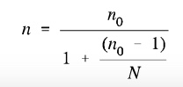
200/(1+200/1000))=166

The general rule in most social sciences researchers is to use the largest sample as possible because the main interest is to learn about the population from which the sample is selected. The sample size that was obtained from the calculation was a representative of the whole study population. The researcher used non-probability sampling in distributing the questionnaires to business owners who agreed to participate in the study. Not every respondent had an equal chance of being included in the sample because there was no census or complete list of all small business men in the area.
3.4 Measurements
3.4.1 Pilot Test
Pilot test is one of the important procedures in research especially for those that need to collect a large amount of data (Mohamad, 2018). It is usually the initial step of the entire research protocol and is usually a smaller-sized study as compared to the main study .The main purpose of conducting a pilot test is to put the research design into a trial to determine actual and potential issues, so that the researcher can make revisions and improve the framework before the final research (Cuillot, 2019). The sample size of the pilot test is 0.1 of the main study (Bell, et. al., 2020). Since the sampling size of the main research is 166 then the pilot sample will be approximately 20 SMEs.Through a pilot test, the researcher will be able to evaluate the future execution of the methods and its feasibility of data collection, randomization, measurement, and assessment of procedure which will greatly improve the quality of the final result obtained.
3.4.2 Factor Analysis
Factor Analysis combines questions with similar ratings to create new summarised factors with continuous measurements such as a 5-point Likert scale (Bell, et. al., 2010). Factor analysis reduces the numbers of variables and simplify the analysis, to achieve more streamlined research.By using factor analysis, the connections between different variables can be outlined by investigating the relationship between the variables (Ayuni & Sari, 2018).
Kaiser-Meyer-Olkin (KMO) and Bartlett’s Test of Sphericity is applied to evaluate the appropriateness of the data for factor analysis and therefore it is required before the factor analysis . According to Kaiser, a KMO value below 0.5 is unacceptable, between 0.5 to 0.6 is miserable, between 0.6 to 0.7 is mediocre, between 0.7 to 0.8 is middling and above 0.8 is meritorious (Kaiser, 1974). To measure the adequacy of the sampling, the KMO of the sampling needs to be more than a minimum of 0.5 to prove that sampling is sufficient and the data can factor well (Hadi, N. U., Abdullah, N., & Sentosa, I, 2016). If the KMO is less than 0.6, it means that the sampling is not adequate and requires improvement. This research will use 0.6 as the minimum acceptable value to ensure that the data falls under the average range and is acceptable for the next step of the study. Factor loading is another test applicable for factor analysis, which can be understood as a measure of how much the variable contributes to the factor, therefore, higher factor loading values show that the dimensions of the factors are accounted more precisely by the variables (Yong , 2013). The eigenvalues need to be larger than one and equal to the total number of dependents and independent variables (Chatelin, 2012)

3.4.2 Reliability Test

The reliability of an instrument is its consistency in evaluating a particular phenomenon; which means that the same result should be obtained when repeatedly measure a similar phenomenon (Ursach,2015). The instrument is considered reliable when the test score is consistent over different occasions of a testing, different editions of test with different questions or problems, and different scoring of the test-takers’ responses by different raters (Livingston, 2018). Cronbach’s alpha is one of the most widely applied measures for reliability in social and organizational sciences, developed by Lee Cronbach back in 1951 by expressing the reliability of instruments with a number between 0 to 1 (Bonett, D.G. and Wright, T.A., 2015).The recommended Cronbach’s alpha value for the main test is between 0.7 to 0.9 but the acceptable level of reliability for the pilot test is between >0.6 because of the size of sampling size(small).
3.5 Data Collection Method
The study applied primary data collection. The primary data collection method was conducted through the utilization of google docs questionnaires. Cooper (2003) explained that a questionnaire is an important data collection tool as it provides an effective and efficient way of gathering information within a very short time. The questionnaire comprised of descriptive questions. Closed ended questions were used since they were not only easy to analyze but also facilitated the harmonization of information obtained from the respondents. The questionnaires were subdivided into four sections: the first section contained the population demographics, the second section highlighted the SMEs owners characteristics that impact on online marketing, the third section covered the impact of resources on SMEs adoption of online marketing and finally the fourth section examined the extend of online marketing practices of small businesses. A 5-point Likert scale was used to seek level of satisfaction from the listed structured close-ended questions where;1 = strongly disagree, 2= disagree, 3 = neutral, 4 = agree, 5 = strongly disagree
3.5 Research Procedures
Kothari (2004) defined the research procedure as the step by step sequence of activities that will be followed in the same order to perform this research. The researcher sought permission from the participating businesses by submitting an official request inform of an email, explaining the intention to conduct the field survey. The researcher emailed 100 respondents respondents who were given ample time to respond. The respondents were assured of confidentiality for the responses provided. A pilot test will be conducted to adhere to the fundamentals described by (Cooper, 2003) who defines pilot test as a tool that should be administered to detect weakness in the research design and the instruments, also to enable to familiarize with the administration of the data collection instruments. The pilot test involved 20 respondents, who owned small businesses that An effort to avoid leading questions will be made during the interview. The following measures were taken to increase the validity: Probing technique was used, where control questions were asked to assure that no misunderstandings take place regarding the questions. The researcher then administered the questionnaires to a number of 166 respondents.
3.6 Data Analysis Methods
All the returned questionnaires were checked for completeness. The questionnaires were then coded and computed to the Statistical Package for the Social Sciences (SPSS-26). The computed data was cleaned to ensure consistency and accuracy. The next step stage involved processing the computed data in descriptive statistics. According to Cooper and Schindler (2008) descriptive analysis is a process of transforming a mass of raw data into tables, charts, with frequency distribution and percentages, which are a vital part of making sense of the data (Beri, 2007). In this study, frequency distribution and mean tables were used to present the field data. The demographic data was tabulated using frequency and percentages. Descriptive statistics was used in presentation of responses on the study variables.

3.7 Multilinear Regression

Multiple linear regression is applied when testing hypothesis. Multiple linear regression is a statistical analysis that examines the relationship between one dependent variable and two or more independent variables (Kologlu & Ozyilmaz, 2018). The R-squared multi-regression hypotheses testing is used to measure the degree of deviation of the model from the framework which explains the strength of the relationship between the independent and dependent variables. The R squared value needs to be larger than 0.3 to indicate that the model fits the framework. The closer the R squared value to 1, the stronger the relationship between the model and the framework (Witteloostujin & Beugelsdijk, 2017). In this research, H1, H2, and H3 are all analyzed using multiple linear regression.
Pearson correlation is when a number exits between -1 and 1, and indicates how strong two variables are related to linearly (Berg, 2020). The magnitude of Pearson correlation lower than 0.3 will be considered negligible and a value between 0.3 to 0.5 is rated as low correlation. Pearson correlation between 0.5 to 0.7 and 0.7 to 0.9 is interpreted as moderate correlation and high correlation respectively. Lastly, 0.9 and above is considered as very high correlation (Hinkle, 2003).

3.8 Coefficient correlation

Coefficient analysis is a statistical instrument generally applied to determine the strength of the relationship between each independent variable and the dependent variable (Bougie, 2019). A greater value of the beta coefficient essentially means that the influence of the independent variable on the dependent variable is stronger ( Bougie, 2019). The influence of the independent variable on the dependent variable will increase when the beta coefficient is closer to one. In this research, the beta coefficient is used to investigate the relationship between independent variable SMEs owners characteristics ,SMEs organization characteristics, SMEs Resources and the extend of online marketing practices in Kenya.

3.7 Chapter Summary
This chapter highlighted the various methods and procedures the researcher adopted in conducting research on SMEs online marketing practices: a case study of Kenya. The chapter was organized in the following structure: the research design, population and sample, data collection methods, sampling 2 design and sample size, research procedures, data analysis methods and lastly the chapter summary. The population consisted of 12,500 small businesses in Kenya who have adopted online marketing practices. The study used random sampling method to select the sample size. The data was collected using structured questionnaires. Chapter four presents an analysis of the information gathered from the field based on the research specific objectives.

Chapter 4

4.0 Data Analysis

4.1 Introduction
This chapter presents analysis from the questionnaire collected from respondents, which allowed the researcher to achieve the objective of the whole research with the help of IBM SPSS-26 software. The first part of the chapter focusing on conducting a factor analysis and reliability test on the result collected for the pilot test followed by improvements on the instruments. The next section of this chapter analyzed the full data collected for the main study, and multiple tests were conducted to determine the relationship between dependent and independent variables. Test conducted were factor analysis, reliability test, descriptive analysis, multiple linear regression, and beta coefficient.

4.2 Response Rate
One hundred and sixty-six set of questionnaires was distributed via WhatsApp, only one hundred and forty-nine responses were received an equivalent to 89.76% response rate, and this was due to limited time given to collect data.
Description | Result
No. of questionnaires distributed | 166
No. of questionnaire received | 149
Response Rate | 89.76%

Out of 166 questionnaires sent out via whatsapp,149 were returned. Analysis was conducted using available data; factor analysis and reliability tests were conducted to confirm the proportionate of collected data. Descriptive analysis was conducted to determine the demographic profile and lastly regression analysis on variable relationships.
Pilot Test
Pilot Test was done on 10% of the sample size. Factor analysis was conducted using KMO and Bartletts Test of Sphericity and Cronbach alpha for reliability test.

KMO and Bartletts Test
KMO means that the proportions of variance in the variables that might be caused by an underlying factor. KMO tests whether the partial correlations among the variables is small. 0.708 is good .Total variance explained is 61.74 showing that the variables are of each other.
Table 4.1 KMO pilot test
Variables | items | KMO | Bartletts Test of Sphericity
Variables | items | KMO | Approx. Chi-Square | df | Sig
Online marketing practices | 5 |  | 42.588 | 10 | <.001
Owners characteristics | 5 |  | 171.444 | 10 | <.001
SMEs characteristics | 5 |  | 57.253 | 10 | <.001
Resources | 5 |  | 89.766 | 10 | <0.01

Table 4.2 Pilot Test for Cronbach alpha
Variables | Items | Cronbach alpha
dv-onlinemarketing practices | 5 | 0.692
iv-smesowner characteristics | 5 | 0.642
iv-smeorganization characteristics | 5 | 0.712
iv-resources | 5 | 0.631
Reliability test was done using Cronbach’s alpha value to determine each variable. The reliability ranges between 0.6-0.7 This shows that there is internal consistency and reliability of the instrument.

4.3 Reliability Test
Reliability refers to how dependably or consistently a test measures a characteristic. If a person takes the test again, will he or she get a similar test score, or a much different score? A test that yields similar scores for a person who repeats the test is said to characteristic measure a reliably.Accepted Cronbach value is between 0.6 to 0.7 (Bland, J.M. and Altman, 1997)
Cronbach’s Alpha is used to measure the internal consistency between items in a scale. When a measure has good test-retest reliability and internal consistency, we are more confident that the scores represent what they are supposed to. A value of 0.721 was obtained which indicates a high level of internal consistency for our scale
Cronbach’s Alpha | Cronbach’s Alpha based on standardized items | No of Items
.721 | .721 | 20

4.4 Validity
Validity is the extent to which the scores from a measure represent the variable they are intended to. Validity measures the degree of validity of a research instrument. An instrument is said to be valid if it can measure what is to be measured or desired. An instrument is said to be valid if it can reveal the data the variables studied. Test of validity of the questionnaire is conducted using the Pearson Product Moment Correlations, here, each item in the questionnaire is correlated with the total score, if the items to correlate then the values are valid. Based on the significant values obtained by the Sig. (2-tailed) table above all values are below 0.05 hence we can conclude that all variables are valid
Table 4.3Showing Validity Significance Statistics
Total score
Pearson Correlations 185* 242* 274* 265* 277* 229* 179* 309* 350* 303* 384* 185* 350* 185* 215* 252* 282*
228* 178* 212* 221* 228*1
Sig(2-tailed) .004 .003 .001. 001 .001 .005 .029. 002 .001 .005 .030 .009 .007 .005 .029 .024 .008 .001 .001

4.5 Response Rate and Demographics

4.5.1 Response Rate
At least 169 questionnaires were sent out to target respondents but only 149 were duly filled and handed back accounting for 89.76% response rate

4.5.2 Demographic

4.5.2.1 Length of Business
Majority of the respondents interviewed have been running their businesses for between 8-10 years represented with a 32.9% of the total respondents. Followed closely with that have 11 or more years with 26.8%, 5-7 years with 20.1%, 2-4 years with 10.7% and lastly at least a year of running/managing the business with 9.4%. This shows that majority of those interviewed have great experience in their respective businesses with most of them, at least 80%, having more than five years or more experience.

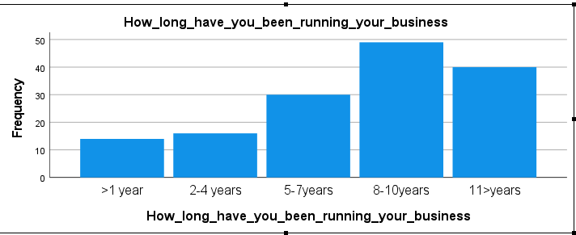

4.5.2.3 Extend of online marketing use
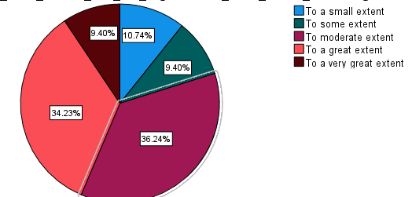

Majority of the enterprises do use online marketing to market their goods to attract more customers. Most of the respondents, 30.4% did say they use online marketing at a great extent to market their goods while 32.1% said they moderately use online marketing and 16% said to a very small extent they use online marketing.

4.5.2.4 Online Platform Suits the business
Majority of the respondents 38.26%, said Jumia ecommerce platform best suits their businesses while 36.24% said Olx ecommerce platform best suits their business with the rest, 25.5% saying Cheki ecommerce plat best suits their business
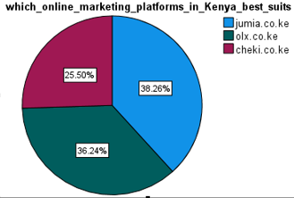

4.5.2.5 Social Platform Integrated with Online Marketing
Majority of the businesses have integrated/use Facebook for their online marketing with 57.72% of the respondents saying they do use it to market their products. 30.20% of the respondents said they have integrated Instagram and do use it for online marketing, 8.05% said they use Twitter as their online marketing tool while the remaining 4.03% said they do use other social media platforms to market their products.

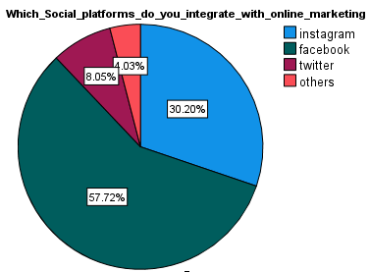

4.5.2.6 Level of Training in Information Technology
At least all the respondents have a training in information technology. Majority, more than 60% have a certificate or a higher training in Information Technology hence they do understand more about online marketing and the various social media platforms used. 36.24% of the respondents said they have a high school training to information technology, 14.79% have a certificate, 42.28% have a diploma while 8.05% have a degree.

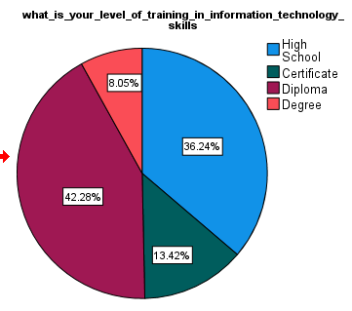

4.6 SMEs Online Marketing Practice

4.6.1 Rating of Online Marketing Practice
Several statements were used to rate to help the respondents to rate SMEs online marketing practices in their respective enterprises. The respondents selected in a scale of one to five representing Strongly Disagree, Disagree, Neutral, Agree and Strongly Agree. An average of more than 3.5 and above indicate a positive impact of online marketing to the company while an average of less than 1.5 indicate small or equally no impact of by online marketing.
From the table below we observe that majority of the respondents 50.6% agree that they use online marketing for communication and customer relations. Likewise, 62.5% of respondents agreed that they personalize online marketing to avoid replica of the SME brand. Only 57.7% agreed that they use online platforms to accomplish effective pricing strategies which are based on customer discrimination while 59.5% said that online marketing adoption is driven by nature of our business and external pressure from clients and suppliers. 55.7% of the respondents did agree that when using online marketing they incorporate the use of social media when promoting goods and services. This support earlier statement where a small percentage of the respondents said they primarily use online marketing for market communication and customer relationship management showing there is much more online marketing does in addition to communication and relation management.

SMEs Online Marketing Practices | SD% | D% | N% | A% | SA% | Mean | Std Dev
We use online marketing for communication and customer relationship management | 6.5 | 28.6 | 7.7 | 50.6 | 6.5 | 3.2202 | 1.12896
Our enterprise markets itself by creating a personal brand which cannot be replicated | 4.8 | 14.3 | 10.1 | 62.5 | 8.3 | 3.5536 | .99555
We use online marketing platforms to accomplish effective pricing strategies that are based on customer discrimination | 1.8 | 24.4 | 5.4 | 57.7 | 10.7 | 3.5119 | 1.03234
Our adoption of online marketing is driven by nature of our business and external pressure from clients and suppliers | 1.8 | 20.8 | 10.1 | 59.5 | 7.7 | 3.5060 | .966649
We incorporate the use of online platforms and social media when promoting our products and services | 2.4 | 24.6 | 6.6 | 55.7 | 10.8 | 3.4790 | 1.05190

4.6.2 Pearson Correlation Test for SMEs Online Marketing Practices
A Pearson correlation test was carried out to verify the significance of the various factors to extent of online marketing. A p-value of <0.05 was set as the set threshold for significance. Personal brand has a positive correlation with nature of business, use of online platforms, primarily market communication and customer relationship management and lastly nature of business 0.206 (p = 0.08), 0.16 (p = 0.00), 0.16 (p = 0.118) and 0.129 (p = 0.00) respectively. Even though all have a positive relationship, the relationship is not that significant as the values are less than 0.5. Unique business environment has a negative relationship with facilitates the promotion and distribution of our products across the country -0.259 (p = 0.00), likewise even though a negative relationship its quite in significant as it is equals to zero.

Table 4.4 Showing Pearson Correlation Test for online marketing practice

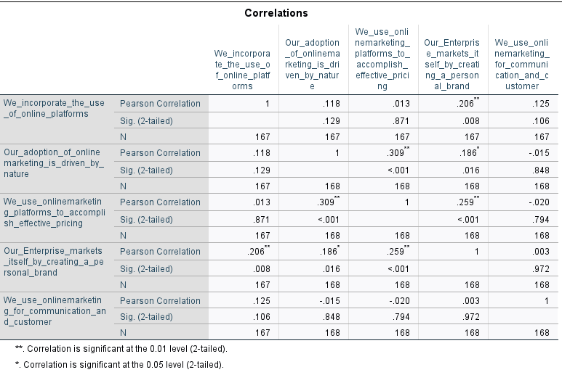
Use of online marketing is driven by nature of our business has a negative relation with all the factors except communication and customer engagements with a value of 0.168 which is almost significant as the value is almost 0.5. Similarly, constant engagement has positive relationships with the other factors except other transactions with our customers which is negative with a value of -0.106 (p = 0.00) which also is not that significant as the value is almost zero. Only the relationship between creating a personal brand and effective pricing have a value above 0.5 which is almost significant therefore the two factors have got a huge positive impact on online marketing.

4.6.3 Regression Model Summary
A regression test was done to determine the significance independent factors on online marketing practices by SMEs. Table below shows the results obtained from the test. The R square value for the model shows that 84.6% of the variance in the model could be explained by the different factors

Table 4.5:Showing Regression model for online marketing practice
Model Summary
Model | R | R Square | Adjusted R Square | Std. Error of the Estimate | Change Statistics
 |  |  |  |  | R Square Change | F Change | df1 | df2 | Sig. F Change
1 | .729ª | .846 | .754 | .34607 | .846 | 158.906 | 7 | 142 | .000

4.6.4 ANOVA Analysis Summary for online marketing practice

ANOVAª
Model |  | Sum of Squares | df | Mean Square | F | Sig.
1 | Regression | 61.643 | 7 | 10.310 | 158.906 | .000^{b}
1 | Residual | 7.689 | 142 | .061
1 | Total | 69.332 | 169

From ANOVA its observed that the independent variables, statistically and significantly predict the dependent variable, F (7, 142) = .000, p < .05 that is the regression model is a good
fit of the data.

4.7 SMEs Resources Impact on Online Marketing Practices

 | SD  % | D  % | N  % | A  % | SA  % | Mean | Std Dev
As an enterprise we are well equipped with electronic gadgets | 1.8 | 31.4 | 0 | 62.1 | 4.7 | 3.4 | 1.03596
Our enterprise has necessary resources and capabilities required to collect data from online transactions | 5.1 | 5.9 | 16.6 | 45.0 | 28.4 | 3.9 | 1.0142
As and enterprise we can afford unlimited internet access | 2.2 | 24.9 | 14.8 | 47.9 | 10.1 | 3.4 | 1.83063
As an enterprise we have a team of well-trained personnel to conduct online marketing | 2.4 | 14.2 | 7.5 | 62.7 | 11.2 | 3.7 | 0.93788
Online marketing has reduced physical presence in various towns to reach our customers to offer our products and services | 3.4 | 20.1 | 10.1 | 57.4 | 8.9 | 3.5 | 1.02405

As observed from the table, 62.1% of the respondents agreed that the enterprises had enough resources in terms of electronic gadgets to conduct online marketing platforms. 45.0% of the respondents said that they have enough resources in terms of skilled personnel to conduct online marketing.Only 58% said that as enterprises they changed/differentiated their products to be able to cut an edge against their competitors. 47.9% agreed that they have unlimited internet to conduct online marketing. A further 62.7% said they have a team of well-trained personnel in online marketing skills.Latsly57.4% said they said that online marketing has reduced the need for physical presence in various towns to reach more customers.

4.7.1 Pearson Correlation Test for SMEs Resources influence on online marketing practice

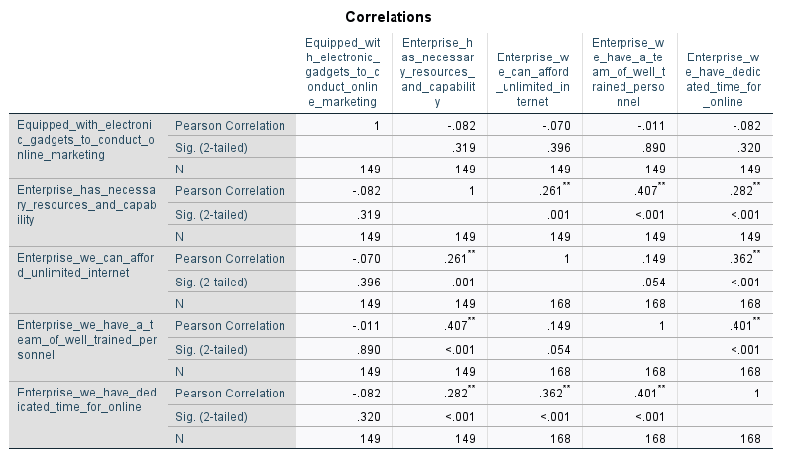

4.7.2 Regression Model Summary of SMEs resources
A regression test was done to determine the significance and the extent of influence of the different strategies SMEs use. Table 4.6 shows the results obtained from the test. The R square value for the model shows that 74% of the variance in the model could be explained by the different factors

Table 4.6 Model Summary for SMEs Resources Affecting Online Marketing Practices
Model Summary
Model | R | R Square | Adjusted R Square | Std. Error of the Estimate | Change Statistics
 |  |  |  |  | R Square Change | F Change | df1 | df2 | Sig. F Change
1 | .416ª | .74 | .153 | .60451 | .74 | 6.032 | 4 | 142 | .000

4.7.3 ANOVA Analysis for SMEs Resources Affecting Online Marketing Practices
From ANOVA table 4.7 its observed that the independent variable SME resources, are statistically significant predict the dependent variable, F (6, 162) = .000, p < .05 that is the regression model is a good fit of the data.
Table 4.7 Shows the ANOVA analysis Summary on Resources Affecting Online Marketing Practices
ANOVAª
Model |  | Sum of Squares | df | Mean Square | F | Sig.
1 | Regression | 12.129 | 4 | 2.140 | 6.032 | .000^{b}
1 | Residual | 58.413 | 142 | .342
1 | Total | 70.542 | 146

4.7.4 Regression Analysis Coefficients for SMEs Resources

Table 4. shows the regression coefficient obtained from the multiple regression. The general form of the equation to predict extent of online marketing is:
Y = 1.321 + 0.104 Sufficient resources to mine data + 0.012 electronic gadgets + 0. 027 Unlimited internet connection + 0.34 well trained team + 0.164 dedicated online marketing time
All the coefficients are positive showing that any increase on the various strategies will have an increase in the extent of SMEs online marketing practices
Table 4.8 showing Regression Analysis Coefficients for SMEs Resources
Coefficientsª
Model |  | Unstandardized Coefficients |  | Standardized Coefficients | t | Sig. | 95.0% Confidence Interval for B
 |  | B | Std. Error | Beta | t | Sig. | Lower Bound | Upper Bound
1 | (Constant) | 1.321 | .269 |  | 5.688 | .000 | 1.073 | 2.215
1 | Sufficient resources to collect data | .104 | .051 | .176 | 2.087 | .038 | .004 | .206
1 | SME equipped with electronic gadgets | .012 | .040 | .051 | .656 | .513 | -.065 | .130
1 | Unlimited internet access | .027 | .041 | .053 | .525 | .600 | -.074 | .129
1 | A team of well-trained personnel | .034 | .060 | .063 | .726 | .459 | -.075 | .162
1 | Dedicated time for online marketing | .164 | .053 | .254 | 2.304 | .002 | .067 | .280
a. Dependent Variable: SMEs online marketing practice

4.8 SMEs owners Characteristics Influence on SMEs Online marketing practices

Respondents asked to rate factors that did influence use of online marketing using a series of statements. The statements were scaled with Strongly Disagree, Disagree, Neutral, Agree and Strongly Agree to grade their response.

4.8.1 Ratings of SMEs Owner Characteristics Influence on the use of Online Marketing
From table 4.8.1 we observe that all the four factors have an average of more than 3 hence proof of significant effect of the factors to the use of online marketing. 37.5% of the respondents perceived online marketing as an important function of the business, hence helping the enterprise manage different aspects online marketing without struggling. 31.5% of the respondents agreed that SME owners they are well informed in online marketing practices. 47.9% of the respondents did say that they take up the role of innovation champion. Lastly, 29-8% agreed that they are well knowledgeable in online marketing practices.
Table 4.8.1
 | SD  % | D  % | N  % | A  % | SA  % | Mean | Std Dev
As SME owner I perceive online marketing as an important function of our business | 6.0 | 6.5 | 23.8 | 37.5 | 20.2 | 3.2 | 1.01290
As SME owner I am well informed and trained on online marketing practices | 6.0 | 14.9 | 11.3 | 31.5 | 25.0 | 3.4 | 1.0461
As SME owner I perceive the strategies benefits of utilizing new technology | 2.4 | 24.9 | 14.8 | 47.9 | 10.1 | 3.1 | 1.02084
As SME owner I take up the role of innovation champion | 2.4 | 14.2 | 9.5 | 62.7 | 11.2 | 3.7 | 0.93788
As SME owner I am well knowledgeable in online marketing skills | 10.1 | 18.5 | 13.7 | 29.8 | 16.6 | 3.2 | 0.85132

4.8.2 Pearson Correlation Test for SMEs Owner Characteristic influence on Online Marketing Practices
From table 4.8.2, we observe that all the factors have a positive correlation against each other. Even though not significant, as the values are all less than 0.5 but above 0.0. This shows that the factors, have to influence positively uptake or the practice of online marketing in the various enterprises. Only one, use of search engine optimization to make the enterprises more visible online, had a negative correlation against other factors. This can be explained as these SMEs their major intentions when it comes to online marketing is to advertise the products to get customer leads and prospects and follow but not to have a huge online presence which is the work of search engine optimization

Table 4.8.2 Showing Pearson Correlation Test for SMEs Owners Characteristics Employ to Ensure Effective Use of Online Marketing

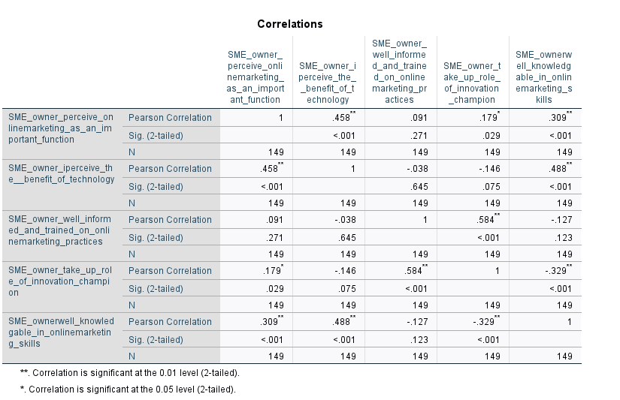

4.8.3 Regression Model Summary
A regression test was done to determine the significance and the extent of influence of the different strategies SMEs use. Table 4.8.3 shows the results obtained from the test. The R square value for the model shows that 82% of the variance in the model could be explained by the different factors

Table 4.8.3 Model Summary for Factors Affecting Extent of SMEs online marketing practice
Model Summary
Model | R | R Square | Adjusted R Square | Std. Error of the Estimate | Change Statistics
 |  |  |  |  | R Square Change | F Change | df1 | df2 | Sig. F Change
1 | .468ª | .82 | .153 | .62156 | .82 | 6.042 | 6 | 172 | .000

4.8.4 ANOVA Analysis Owner Characteristic Affecting Extent of SMEs online marketing practice

From ANOVA table 4.8.4its observed that the independent variables, which are statistically significant predict the dependent variable, F (6, 142) = .000, p < .05 that is the regression model is a good fit of the data.
Table 4.8.4 Shows the ANOVA analysis summary on SMEs owner characteristics
ANOVAª
Model |  | Sum of Squares | df | Mean Square | F | Sig.
1 | Regression | 13.138 | 6 | 2.190 | 6.052 | .000^{b}
1 | Residual | 58.612 | 142 | .362
1 | Total | 71.750 | 148

4.8.5 Regression Analysis Coefficients for SMEs Owner Characteristics
All the coefficients are positive showing that any increase on the various strategies will have an increase in the extent of online marketing practices.
Y=1.461+0.104SME owner perceive online marketing as an important fuction+0.032 SME owner is well informed and trained in online marketing practises+0.017 SME owner perceives strategic benefits of new technology+ 0.42 SME owner take up role of innovation champion +0.13 SME owners are well knowledgeable in online marketing.
Table 4.8.5 Regression Analysis Coefficients for SMEs Owner Characteristics
Coefficientsª
Model |  | Unstandardized Coefficients |  | Standardized Coefficients | t | Sig. | 95.0% Confidence Interval for B
 |  | B | Std. Error | Beta | t | Sig. | Lower Bound | Upper Bound
1 | (Constant) | 1.461 | .279 |  | 5.668 | .000 | 1.073 | 2.21
1 | As SME owner I perceive online marketing as an important function of business | .104 | .051 | .167 | 2.087 | .038 | .006 | .216
1 | As SME owner I am well informed and trained on online marketing practices | .032 | .060 | .051 | .646 | .513 | -.065 | .130
1 | As SME owner I perceive the strategic benefits of utilizing new technology | .017 | .041 | .013 | .515 | .630 | -.074 | .119
1 | As SME owner I take up the role of innovation champion | .042 | .060 | .043 | .726 | .496 | -.075 | .142
1 | As SME owner I am well knowledgeable in online marketing | .134 | .054 | .254 | 3.204 | .002 | .067 | .210
a. Dependent Variable: SMEs Online marketing practices

4.9 SMEs Organization Characteristics Impact on Online Marketing

4.9.1 Rating of SMEs organization Characteristics
Several statements were used to rate to help the respondents to rate the extent of online marketing in their respective enterprises. The respondents selected in a scale of one to five representing Strongly Disagree, Disagree, Neutral, Agree and Strongly Agree. An average of more than 3.5 and above indicate a positive impact of online marketing to the company while an average of less than 1.5 indicate small or equally no impact of by online marketing.
From the table below we observe that majority of the respondents 64.5% agree that online marketing does consider and require a unique business environment for it to flourish. Likewise, 63% of respondents agreed that online marketing helps deal have a constant engagement with clients. Only 26.6% of the respondents believe that company’s online marketing requires them to have an in-depth knowledge of their customers’ needs while 34.4% said that online marketing is primarily for market communications and customer relationship management showing that there is more to online marketing that the respondents are already practicing. 55% of the respondents did agree that they use online marketing to carry other transactions with customers. This support earlier statement where a small percentage of the respondents said they primarily use online marketing for market communication and customer relationship management showing there is much more online marketing does in addition to communication and relation management. Lastly, 30.1% agreed that online marketing platform does facilitate the promotion and distribution of products across the country.
Table 4.9.1 Showing the rating of Online Marketing Use
Extent of Online Marketing Use | SD  % | D  % | N  % | A  % | SA  % | Mean | Std Dev
SME is hesitant to budget for online marketing when short term returns are not guaranteed | 0.4 | 7.1 | 27.8 | 41.4 | 23.1 | 3.8 | 0.64821
The period of conducting business determines adoption of online marketing | 6.5 | 17.2 | 11.8 | 34.9 | 29.6 | 2.8 | 1.23015
The unique nature of business size determines the adoption of online marketing | 14.6 | 32.5 | 25.4 | 12.4 | 14.2 | 3.6 | 1.26174
We use online marketing as a result of competition from competitors | 16.4 | 33.7 | 16.6 | 16.6 | 17.8 | 2.9 | 1.35046
We use online marketing because we have large amount of data transactions | 10.2 | 19.5 | 14.2 | 32.1 | 22.9 | 3.3 | 1.31928

4.9.2 Pearson Correlation Test on Influence of SME organization on online marketing practices
A Pearson correlation test was carried out to verify the significance of the various factors to extent of online marketing. A p-value of <0.05 was set as the set threshold for significance. Online marketing budget has a positive correlation with reliability and accountability unique nature of business, competition from competitors and customer relationship management and lastly large amount of transactional data of 0.436 (p = 0.00), 0.12 (p = 0.612), 0.16 (p = 0.127)) respectively. Even though all have a positive relationship, the relationship is not that significant as the values are less than 0.5. Unique business environment has a negative relationship with facilitates the promotion and distribution of our products across the country -0.142 (p = 0.65), likewise even though a negative relationship its quite in significant as it almost equals to zero.

Table 4.10 Showing Pearson Correlation Test for SMEs organization characteristics influencing Extent of Online Marketing Use

*. Correlation is significant at the 0.05 level (2-tailed). 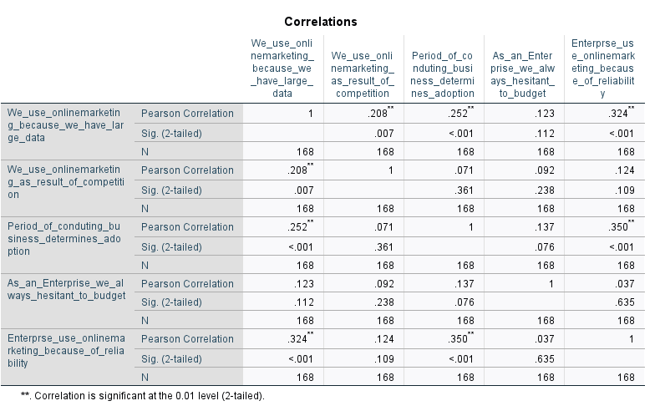

4.9.3Regression Model Summary
A regression test was done to determine the significance and the extent of influence of the independent factors on online marketing use by SMEs. Table 4.9.3 shows the results obtained from the test. The R square value for the model shows that 82.4% of the variance in the model could be explained by the different factors.

Table 4.9.3 Model Summary for SME organization characteristics
Model Summary
Model | R | R Square | Adjusted R Square | Std. Error of the Estimate | Change Statistics
 |  |  |  |  | R Square Change | F Change | df1 | df2 | Sig. F Change
1 | .919ª | .824 | .857 | .24707 | .824 | 148.406 | 6 | 142 | .000

4.9.4 ANOVA Analysis
Table 4.9.4 Shows the ANOVA analysis summary
ANOVAª
Model |  | Sum of Squares | df | Mean Square | F | Sig.
1 | Regression | 61.863 | 5 | 10.310 | 168.906 | .000^{b}
1 | Residual | 9.889 | 172 | .361
1 | Total | 71.751 | 168
From ANOVA table 4.9.4 its observed that the independent variables, statistically and significantly predict the dependent variable, F (6, 172) = .000, p < .05 that is the regression model is a good fit of the data.
Y=0.064+0.150 online marketing budget+0.204reliability and accountability+0.171+0.148 competition from competitors+0.146 large amount of transactional data
All the factors have a positive effect on the extent use of online marketing, any increase on the factors will have an increase in extent of online marketing practices.

Table 4.9.5 Showing Results for Regression Analysis Coefficients for SMEs Organization Characteristics
Coefficients
Model |  | Unstandardized Coefficients |  | Standardized Coefficients | t | Sig. | 95.0% Confidence Interval for B
 |  | B | Std. Error | Beta | t | Sig. | Lower Bound | Upper Bound
1 | (Constant) | .064 | .110 |  | .625 | .613 | -.145 | .268
1 | Online marketing budget | .150 | .026 | .207 | 5.757 | .000 | .099 | .202
1 | Reliability and accountability | .204 | .019 | .394 | 9.859 | .000 | .167 | .221
1 | Unique nature of business | .171 | .019 | .327 | 9.021 | .000 | .133 | .208
1 | Result of competition from competitors | .148 | .011 | .327 | 7.394 | .000 | .116 | .200
1 | Large amount of transactional data | .146 | .019 | .297 | 7.929 | .000 | .111 | .164
a. Dependent Variable: Extent of online marketing use

4.9.5 Chapter Summary
The findings of the study have been presented in the form of table summaries and figures with explanations on the numerical figures presented. The chapter has used statistical figures of means, standard deviations, and correlations to test the various results that were obtained. The next chapter gives the study discussions, conclusions, and recommendations

Chapter 5

5.0 Conclusion and Recommendation

5.1 Introduction
This chapter concludes the study. The chapter discusses the summary of findings, discussions, and study conclusions. The chapter discusses recommendations for improvement and for improvement and for further studies.
5.2 Recapitulation of Study Findings
5.3 Discussions of Results
This study sought to outline online marketing practices of small and medium enterprises in Kenya. The study used descriptive research design. The population study comprised of SME owners from a selected town in Kenya(Kisumu) in the service sector .The study questionnaire was sent via WhatsApp to 166 respondents. The study relied on primary data which was collected using a questionnaire. The collected data was subjected to analysis using Statistical Package for Social Sciences(SPSS-26).Correlation analysis was determined to determine the relationships between the study variables.
The study showed that there was significant use of online marketing practices in Kenya with 50.6 respondents agreeing that they use online marketing for communication and 59.5% agree that adoption of online marketing is driven by nature of business. Despite the Use of online marketing to promote products has r=-0.259 p=0.00 the other factors had a positive value which shows that increase in the values will result to a positive extend in online marketing practices’ resources have contributed to online marketing practices by variance of 74% Y = 1.321 + 0.104 Sufficient resources to mine data + 0.012 electronic gadgets + 0. 027 Unlimited internet connection + 0.34 well trained team + 0.164 dedicated online marketing time.All the coefficients are positive showing that any increase on the various strategies will have an increase in the extent of SMEs online marketing practices. The equation shows that additional increase in SMEs resources will impact on SMEs online marketing practices. The study also showed that there was significant relationship between the SME organization factors and online marketing practices with a variance of 86% shows that various factors contribute to SMEs online marketing practices Owners also had impact on SMEs adoption of online marketing, Y=1.461+0.104SME owner perceive online marketing as an important fuction+0.032 SME owner is well informed and trained in online marketing practises+0.017 SME owner perceives strategic benefits of new technology+ 0.42 SME owner take up role of innovation champion +0.13 SME owners are well knowledgeable in online marketing, from the equation shows SMEs owners attitude is directly proportional to SMEs online marketing practices.

5.4.1 Hypothesis 1

H1) SMEs owner characteristic has significant impact on online marketing practices.
SME owner Characteristics was the first independent variable identified in this research with 5 related questions included in the study questionnaire. The questions were limited the extent to which SMEs characteristics affect SMEs online marketing practices. From the data analysis on SPSS-26 Pearson Correlation coefficient of credibility 5 but above 0.0. This shows that the factors, have to influence positively uptake or the practice of online marketing in the various enterprises indicating that the result supported the hypothesis.
The study showed that SME owners see the strategic benefits of using online marketing platforms. According to Ramsey and McCole(2013),some SMEs are yet to be convinced to practices online marketing. Some owners do not perceive the relevance of using new technology to their business although they understand that online buying and selling platforms are facilitated by new technology .SME owners should be educated to latest online marketing skills to promote their businesses and reach a wider range of customers.

5.4.2 Hypothesis 2

H2) SMEs resources have significant impact on online marketing practice
This was the second independent variable included in this research the significance of SMEs resources on online marketing. Five questions were designed to determine the influence of resources. Chapter 4, the Person Correlation of informativeness. Y = 1.321 + 0.104 Sufficient resources to mine data + 0.012 electronic gadgets + 0. 027 Unlimited internet connection + 0.34 well trained team + 0.164 dedicated online marketing time all the coefficients are positive showing that any increase on the various strategies will have an increase in the extent of SMEs online marketing practices.
The study also showed that the limited resources had hindered the company from gaining the full benefits of online marketing. According to Lawrence (2012), limited resources like financial, time, management, training, and personnel are often highlighted as major factors impacting the decision to adopt online marketing. He further argues that resource limitations such as time and capital coupled with preferences for traditional mechanisms to do business, inhibited firms from gaining benefits from introducing online marketing technology.

5.4.3 Hypothesis 3
H3)SMEs organization characteristics has significant impact on the use of online marketing practice
SMEs organization characteristics was the independent variable to be analyzed and five questions were asked in the questionnaire in relation to organizational characteristics influence on online marketing practice. From the equation Y=0.064+0.150 online marketing budget+0.204reliability and accountability+0.171+0.148 competition from competitors+0.146 large amount of transactional data.All the factors have a positive effect on the extent use of online marketing, any increase on the factors will have an increase in extent of online marketing practices and indication that the hypothesis for SMEs characteristics is valid.
The study also showed that the external pressure had driven the SMEs online marketing practices. According to Ramsey and McCole (2013) addresses the unique nature of an industry in relation to utilization of online marketing he found that, adoption has also been found to be largely dependent on external pressure from the business competitors as well as its supply chain. The study also showed that the practice of online marketing was primarily driven by the nature of SMEs business isector. From the results it’s important for SMEs to structure itself in a way to easily adopt online marketing to keep up with competition.

5.5 Theoretical Implications
Marketing theories drawn from conventional textbooks (Jarvinen et al,2012) continue to focus primarily on marketing planning, marketing research and the implementation of marketing mix such the 4Ps (price, place, product, promotion) which are more appropriate for large organizations and not favor SMEs. SME marketing takes into account the unique business environment, characteristics of owner/managers (such as skills and abilities) and resources . SMEs therefore, are practicing marketing but in their own unique style reflecting their ability to offer products and services that exactly suit their customers, by having in-depth knowledge of their customers’ needs and being able to communicate with their customers on a personal basis. The personal brand of the owner who personifies the business with a unique set of skills, which cannot be replicated. SMEs co-produce their business with their customers with much of their work is shaped to exact customer requirements such as bespoke Information and
Technology (IT) systems or specific ranges of goods.

5.6 Practical Implications

The research provided a reference to SMEs and how to improve online marketing practices to improve competitiveness. All the independent variables were found to be connected when it comes to factors that are affecting SMEs online marketing practices. SME owners should aggressively promote their products and service on social media and online platforms to reach a wider range of customers. SMEs should rethink their marketing strategies which will contribute to their growth as well as create product awareness’s should ensure that they have competent employees with online marketing skills. Owners of SMEs to understand and anticipate changes in the technological environment and utilize technologies that serve human needs. They must be sensitive to aspects of any innovation that might harm users and bring about opposition.

5.7 Limitation of study

There are certain Limitations encountered when executing the study. Population sample size for the study was limited by time frame and I also being limited to having respondents from county in the country. I will recommend future researchers to factor in time constraints when conducting this type of study.

5.8 Recommendation for future Works

The research focus was SMEs in Kenya as a whole and future research opportunities should be based on SMEs in different sectors.
The study shows that online marketing tools offer clear benefits to SMEs, accordingly, the study recommends that SME owners and managers employ the use of online marketing tools beyond the purpose of managing customers and competitor information to coordinate business activities
SMEs to understand and anticipate changes in the technological environment and utilize technologies that serve human needs. They must be sensitive to aspects of any innovation that might harm users and bring about opposition.
The study therefore recommends that managers and owners of SMEs be free and willing to adopt any business model, enabled by a variety of the online marketing platform to achieve their business purpose. These managers and owners should also be committed to align their online marketing activities to service their major customers and business partners

5.9 Conclusion
From the study it can be concluded that the company’s online platform takes into account the unique environment surrounding the company and it facilitates the company’s ability to constantly engage its customers as well as matched their needs to their packages. The online marketing platform required the company 58 staff to have an in-depth knowledge of their customers’ needs and this facilitated the company’s ability to create and market its personal brand that could not be replicated
SMES have limited resources that hindered its ability of gaining the full benefits of online marketing and the owners of the enterprises were hesitant in making substantial investments when short-term returns were not guaranteed. The study concludes that the Kenyan government has facilitated the adoption of online marketing for SMEs but has failed in providing the necessary regulatory framework appropriate for conducting online marketing. SMEs in Kenya used online platform to collect information about new products desired by its customers It can be concluded that the company used the online platform to build direct links with its customers, which reduced the company’s need to be physically present in various countries to reach clients.

References
Achieng, B., 2016. How smes are using online marketing to improve their competitiveness in Kenya. A case study of Tembea East Africa Safaris.
Anon., 2005. Ramayah, T., Yan, L.C. and Sulaiman, M. SME e-readiness in Malaysia: Implications for Planning and Implementation., 11(1), pp. 103-120.
Anon., n.d. s.l.:s.n.
Ayuni, N. W. D., & Sari, I. G. A. M. K. K, 2018. Analysis of factors that influencing the interest of Bali State Polytechnic’s students in entrepreneurship. In Journal of Physics: Conference Series, 953(1), p. 012071.
Balakrishnan, N., Leiva, V. and Lopez, J, 2007. Acceptancsampling plans from truncated life tests based on the generalized Birnbaum–Saunders distribution.. Communications in Statistics—Simulation and Computation, 36(3), pp. 643-656.
Bambauer-Sachse, S. and Mangold, S, 2011. Brand equity dilution through negative online word-of-mouth communication.. Journal of retailing and consumer services, 18(1), pp. 38-45.
Bhandari, D., Singh, R.K. and Garg, S.K, 2018. Justification of Justification of advanced manufacturing technologies for small and medium enterprises from auto component sector. International Journal of Productivity and Quality Management, 23(4), pp. 473-491.
Bhandari, D., Singh, R.K. and Garg, S.K, 2018. Justification of advanced manuJustification of advanced manufacturing technologies for small and medium enterprises from auto component sector: AHP approach.. International Journal of Productivity and Quality Management,, 23(4), pp. 473-491.
Bland, J.M. and Altman, 1997. Statistics notes: Cronbach's alpha.. s.l.:s.n.
Bonett, D.G. and Wright, T.A., 2015. Cronbach's alpha reliability: Interval estimation, hypothesis testing, and sample size planning.. Journal of Organizational Behavior, 36(1), pp. 3-15.
Brashear-Alejandro, T., Biggemann, S., Todd, P.R., Javalgi, R.G. and Grossman, D., 2014. Understanding the characteristics Understanding the characteristics of the growth of SMEs in B-to-B markets in emerging economies: an organizational ecology approach.. Journal of Business & Industrial Marketing.
Chaffey, D. E.-C. F. M. R. a. J. K., 2009. internet marketing: strategy, implementation and practice. s.l.:Pearson Education..
Chatelin, F. e., 2012. Eigenvalues of Matrices. Society for Industrial and Applied Mathematics ed. s.l.:s.n.
Cooper, D.R., Schindler, P.S. and Sun, J, 2003. Business research methods. s.l.:s.n.
Coviello, Nicole E., Marian V. Jones, and Patricia P. McDougall-Covin. , 2015. Is International Entrepreneurship research a viable spin-off from its parent disciplines.. Rethinking entrepreneurship: debating research orientations,, pp. 78-100.
Cragg, T. and McNamara, 2018. An ICT-based framework to improve global supply chain integration for final assembly SMES. Journal of Enterprise Information Management..
Deans, K.R., Gray, B.J., Ibbotson, P.O., & Knightbridge, K., 2013. Web marketing practices of service providers.. 23(3), 82-102 ed. s.l.:The Service Industries Journal.
Dhewi, R., 2019. E-COMMERCE IMPLEMENTATIONS FOR RECYCLED PRODUCTS BY SMALL MEDIUM. Jurnal Pengabdian kepada Masyarakat, 1(1), pp.34-39., 1(1), pp. 34-35.
Eid, R., & El-Kassrawy, Y. (2012), 2012. The effect of the Internet use on consumer relations. 2(3), 39-51. ed. s.l.:International Journal of.
Fehrer, J.A., Woratschek, H., Germelmann, C.C. and Brodie, R.J, 2018. Dynamics and drivers of customer engagement:. Journal of Service Management, 21(1), pp. 2-21.
Garengo, P., Biazzo, S. and Bititci, 2005. Performance measurement systems in SMEs:. A review for a research agenda. International journal of management reviews, 7(1), pp. 25-47.
Gary, C., London,UK. A stage model of ICT adoption in small firms. Workshop in Rimini -Firms and Consumers Facing E-Commerce. Strategies to Increase its Adoption and Usage.
Ghojogh, B., Karray, F. and Crowley, M., 2019. Eigenvalue and generalized eigenvalue problems. arXiv preprint arXiv:1903.11240..
Gilmore, A., Carson, D., & O’Donnell, A., 2004. Small business owners and their attitude to risk. 22(3), 349-360. ed. s.l.:Market Intelligence & Planning.
Gilmore, C. a. O., 2007. E-marketing and SMEs:Operational lessons for furture.. 19(3) ed. s.l.:European Business Review.
Hadi, N. U., Abdullah, N., & Sentosa, I, 2016. An easy approach to exploratory factor analysis: Marketing perspective. Journal of Educational and Social Research, 6(1), p. 215.
Harrigan, P. R. E. &. I. P., 2012. Exploring and explaining SME marketing:investigating e-CRM using a mixed methods approach.. g, 20(2), 127-163. ed. s.l.:Journal of Strategic.
Hatten, 2011. s.l.:s.n.
Hernández-Linares, Remedios, Franz W. Kellermanns, and María Concepción López-Fernández., 2020. Dynamic capabilities and SME performance: The moderating effect of market orientation. Journal of Business Management, pp. 1-34.
Hill, J., 2011. A multidimensional study of the key determinants of effective SME. 7(6), 211-235. ed. s.l.:International Journal of Entrepreneurial Behaviour &.
Holland, C.P. and Gutiérrez-Leefmans, M, 2018. A taxonomy of SME e-commerce platforms derived from a market-level analysis.. International Journal of Electronic Commerce,, 22(2), pp. 161-201.
Jarvinen, J. T. A. K. H. &. J. C., 2012. Digital and social. 22(2), 102-117 ed. s.l.:Marketing Management Journal,.
Jones, P. P. G. B. M. J. A. Z. S. a. B., 2013. E-commerce for SMEs ;empirical insights from three countrie. Journal of Small Business and Enterprise Development..
Kenya, G. o., 2018. Development of Micro and Employment Creation for poverty reduction. Sessional Paper No. 2 o ed. Nairobi: Government printer.
Kiang, M.Y., Raghu, T.S. and Shang, K.H.M, 2000. Marketing on the Internet—who can benefit from an online marketing approach. Decision Support Systems, 27(4), pp. 383-393.
Kiveu, M. a. O. G., 2013. Enhancing market access in Kenyan SMEs using ICT. Global Business and Economics Research Journal, 2(9), pp. 29-46.
Lawrence, K., 2012. Factors inhibiting the utilization of electronic commerce facilities in Tasmanian small to medium sized enterprises. 587-597. ed. s.l.:Proceedings of the 8th Australasian conference on information systems.
Lloyd, M. &. K. H., 2008. ICT and SMEs competitiveness in South Africa. University ed. pretoria: Unpublished Thesis.
Mohamed, S., Coles, R., Mynors, D., Chan, P., Grantham, A. and Walsh, K, 2007. Understanding one aspect of the knowledge leakage concept among SMEs:People. International journal of electronic business, 5(2), pp. 204-219.
Moyi, E. G. O. I. M. a. E. R., 2006 . Developing a marketing framework for micro and small enterprises in Kenya. Nairobi: KIPPRA.
O’Donnell, A., 2011. Small firm marketing: synthesising and supporting received wisdom. 18(4), 781-805 ed. s.l.:Journal of Small Business and Enterprise Development.
Otoo, A.A.A., Zhiwen, L., Otoo, C.O.A. and Opuni, M, 2018. E-Commerce in Adoption DevelE-Commerce in Adoption Developing Countries: A Literature Review of the Stages of E-Commerce Evolution and Adoption among SMEs.. s.l.:s.n.
Porter, M.E. and Michael, 2001. Strategy and the Internet.. ilustraciones Gibbs, pp. 63-78.
Ramsey, E., Ibbotson, P., Bell, J. and Gray, B, 2003. E‐opportunities of service sector SMEs: an Irish cross‐border study.. Journal of small business and enterprise development..
Ramsey, E. &. I. P., 2012. E’ entrepreneurial SMEs: An Irish study of micro and. Journal of International Influences,, pp. 3, 317-332.
Reijonen, H. and Komppula, 2018. Should SMEs pursue public procurement to improve innovative performance. Technovation , Volume 69, pp. 2-14.
Reijonen, H., 2010. Do all SMEs practise same kind of marketing?. Journal of Small Business and Enterprise Development..
Ritchie, B. a. B. C. 2., 2005. ICT adoption by SMEs. New technology, work and employment, 20(3), pp. 205-217.
Rugova, B. and Prenaj, B, 2016. Social media as marketing tool for SMEs. : opportunities and challenges., 2(3), pp. 85-97.
Schleberger, E., 2012. Report of Regional meeting of the working group: Entrepreneurship development and training.. intenational journal of management sciences, Issue Available at: wwwfes. de/fulltext. buer Accessed on 2020, pp. 03-12.
Shepherd, C., n.d. SMEs and e-commerce adoption. 8(2), 44-45. ed. s.l.: International Journal of Emerging.
Uthman, O. L. S. a. M. T., 2009. Factors associated with attitudes towards intimate partner violence against women: a comparative analysis of 17 sub-Saharan countries.. BMC international health and human rights, 9(1), p. 14.
Vargo, S.L., & Lusch, R.F., 2012. Evolving to a New Dominant Logic for Marketing. Journal of Marketing ed. s.l.:s.n.
Wilson, V. a. M., 2018. Online marketing use: small and medium enterprises (SMEs) experience from Kenya. Orsea Journal, 7(2).

APPENDICES
APPENDIX 1:COVER LETTER

INTI International university
P.O BOX 71800
Nilai, Negeri Sembilan

Dear Respondent,

RE:REQUEST TO PARTICIPATE IN MY RESEARCH
I am a graduate student at INTI international university majoring Master’s in Business Administration
You are invited to participate in my online survey: Online Marketing practices used by SMEs in Kenya. It will take you 10mins to complete the questionnaire.
Your participation this study is completely voluntary, there are no foreseeable risks associated with this research, however if you feel uncomfortable answering any question you can withdraw from the survey at any point. It is very important for me to get your feedback.
This is an academic research, all the information collected will be used for academic purposes only and your confidentiality will be strictly adhered to.
If you have any questions at any time about the survey, you may contact Donata Chebet 01112283696

Yours Sincerely,

Donata Chebet

APPENDIX II:QUESTIONNAIRE
Kindly fill the questionnaire appropriately

- Demographics

- Please indicate enterprise ownership
Sole proprietor ( )
partnership ( )

- How long have been running your business
<1year ( ) 2-4 years ( ) 5-7years ( ) 8-10 years ( ) 11>years ( )

- To what extend has the organization used online marketing to conduct its business
Very great extend ( ) Great extend ( ) Low extend ( ) Least extend ( )

- Online marketing platforms used by your enterprise in kenya
Jumia.co.ke( )
Cheki.co.ke( )
olx.co.ke ( )
Others ( )
- Which social platforms do you integrate with online marketing?
Facebook ( )
Instagram ( )
Twitter ( )
Others ( )
- What is your level of training in information technology skills?
Very great extend ( ) Great extend ( ) Low extend ( ) Least extend ( )

B) SME owner characteristic
Using the SD-Strongly Disagrees-Not Sure-NS, A-Agree and SA-Strongly Agree: Rate the following statement in terms of online marketing practices in your organization
SME Owner Characteristics | SD | NS | D | A | SA
As SME owner, I perceive online marketing as an important function of our business
As SME owner I am well informed and trained on online marketing practices
As SME owner I perceive the strategic benefits of utilizing new technology and marketing platforms
As SME owner I take up the role of innovation champion
As SME owner I am well knowledgeable in online marketing skills

C) SMEs Resources
Using the SD-Strongly Disagrees-Not Sure-NS, A-Agree and SA-Strongly Agree: Rate the following statement in terms of online marketing practice in your organization

SMEs Resources | SD | NS | D | N | SA
As an enterprise we are well equipped with electronic gadgets (phones, computers) to conduct online marketing
Our enterprise has necessary resources and capability required to collect data from online transactions
As an enterprise we can afford unlimited internet access
As an enterprise we have a team of well-trained personnel to conduct online marketing
As an enterprise we have dedicated time for online marketing

D)SMEs organization Characteristics
SMEs organization Characteristics | SD | NS | D | N | SA
As an enterprise we always hesitant to budget for online marketing when short term returns are not guaranteed
The period of conducting business determines adoption of online marketing practices due to reliability and accountability
The unique nature of business, size determine the adoption of online marketing
We use online marketing as a result of competition not to lose to our competitor i.e., suppliers
We use online marketing because we have large amount of data transaction to streamline operations process efficiency.

E)SMEs Online marketing practices
SMEs online marketing practices | SD | NS | D | N | SA
We use online marketing for communication and customer relationship management
Our enterprise markets itself by creating a personal brand which cannot be replicated
We use online marketing platforms to accomplish effective pricing strategies that are based on customer discrimination
Our adoption of online marketing is driven by nature of our business and external pressure from clients and suppliers
We incorporate the use of online platforms and social media when promoting our products and services

THANK YOU

Pilot Test
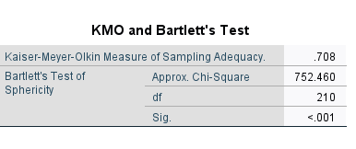
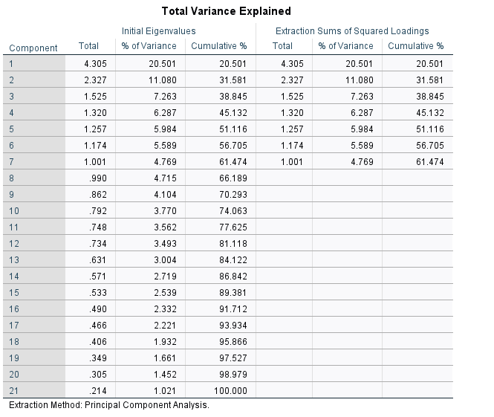
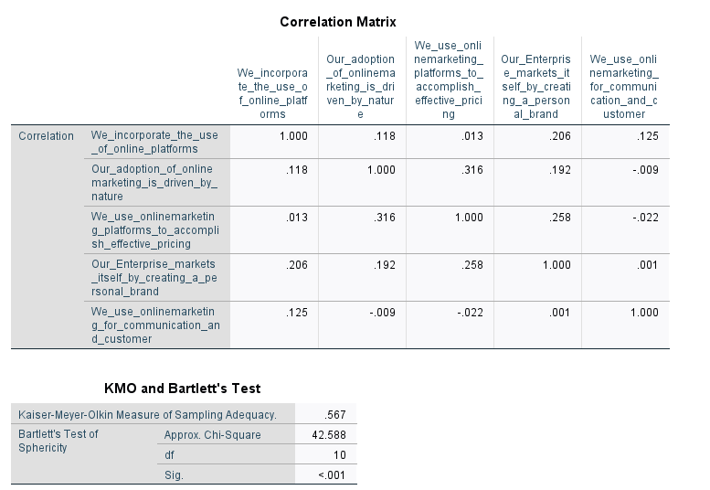
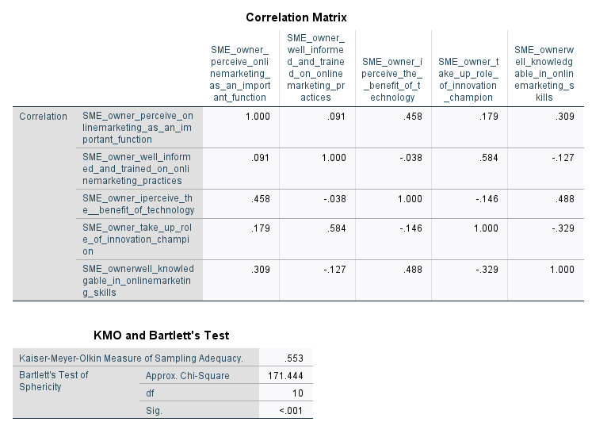
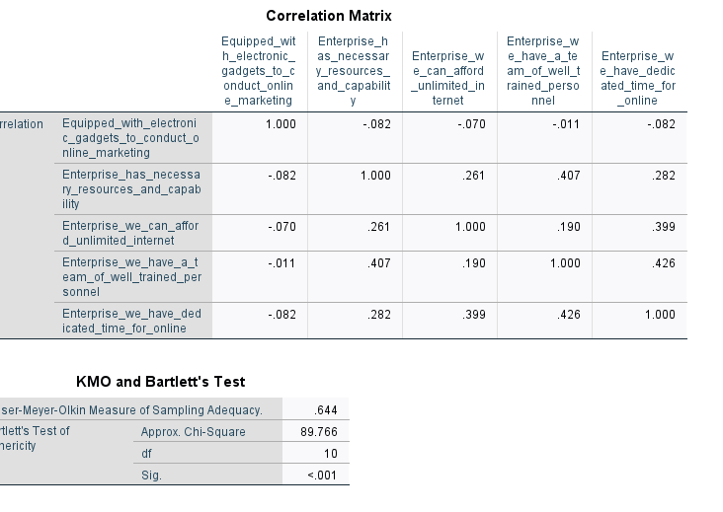
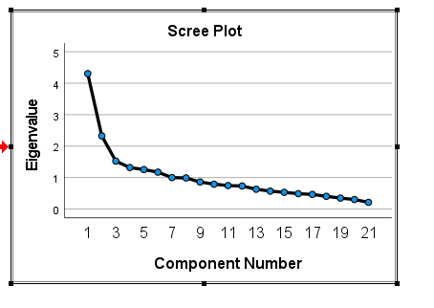
Descriptive extend of online marketing use
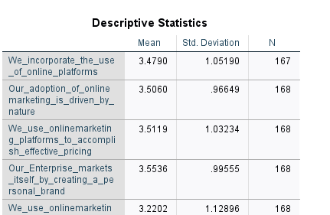
SMEs resources
