SALAAR FAROOQ MASTER OF BUSINESS ADMINISTRATION 2020 | Analyzing the factors affecting consumer buying decision on jewelry online shopping  in Guangzhou, China.  BAIJIAYU  MASTER OF BUSINESS ADMINISTRATION  FACULTY OF BUSINESS, COMMUNICATION & LAW  INTI INTERNATIONAL UNIVERSITY  2020

INTI INTERNATIONAL UNIVERSITY
MASTER OF BUSINESS ADMINISTRATION

Analyzing the factors affecting consumer buying decision
on jewelry online shopping
in Guangzhou, China.

Author: BAIJIAYU

Student No:I19017900

Supervisor: Ms Faziha Abd Malek

Submission Date: 12.12.2020

Final Word Count: 11354

Declaration

I hereby declare that this thesis is my own work and effort and that it has not been submitted anywhere for any award. Where other sources of information have been used, they have been duly acknowledged.

Name :BAIJIAYU
Student ID :I19017900
Signature :BAIJIAYU
Date :12/12/20

Table of Content
1.0 Overview of Chapter 1 4
1.1 Research Background 4
1.2 Problem Statement 5
1.3 Research Objectives 7
1.4 Research Questions 7
1.5 Hypothesis development 8
1.6 Significance of the Study 8
1.7 limitation 9
1.8 The Scope of the Study 9
1.9 Ethical consideration 10
Chapter 2: Literature Review 11
2.1 Introduction 11
2.1 Consumer Buying decision 11
2.2 Global Perspective of Consumer Buying jewelry decision 12
2.3 Guangzhou Perspective of Consumer Buying jewelry decision 13
2.4 Factors Influencing Consumer Buying decision 14
2.5 Theory of Reasoned Actions 16
2.6 Gaps in the Literature 17
2.6 Conceptual Framework 18
2.7 Chapter Conclusion 19
CHAPTER 3: Research Methodology 19
3.1 Research Design 19
3.2 Measuring Instrument 20
3.3 Tests and Analysis 21
3.4 Sampling Design 21
3.4.1 Target population 22
3.4.2 Sampling frame and sampling location 22
3.4.3 Sampling technique 22
3.4.4 Sample size 22
3.5 Data Collection Method 23
3.6 Data Analysis 23
3.6.1 Descriptive analysis 24
3.6.2 Reliability test 24
3.6.3 Inferential analysis 25
3.7 Pilot Study 26
3.8 Factor analysis 27
3.9 Demographic Information 28
3.10 Hypothesis Testing 28
3.10.1 Multiple Regression Analysis 28
3.10.1.1 Beta Coefficient 29
3.10.2 One-Way ANOVA 29
3.11 Conclusion 30
GANTT CHART OF TIMELINE 30
Chapter 4 31
Data Analysis and Results 31
4.0 Introduction 31
4.1 Pilot Test 31
4.2 Descriptive Analysis and Frequency 32
4.2.1 Age 32
4.2.2 Gender 33
4.2.3 Education Level 34
4.2 Factor Analysis 34
4.3 Reliability Test 35
4.4 Hypothesis Testing 36
4.6 Hypotheses 39
4.7 Discussion on findings 39
4.8 Conclusion 40
Chapter 5: Conclusions and Recommendation 40
5.1 Introduction 40
5.2 Managerial implications 40
5.3 Contributions 41
5.4 Limitation 41
5.5 Recommendation on research 42
5.6 Personal reflection 42
REFERENCES & APPENDICES 43
Repeat rate 46
data 46
questionnaire 48

Analyzing the factors affecting consumer buying decision on jewelry online shopping in Guangzhou, China.
BAIJIAYU I19017900

Abstract
From 2010 to 2018, China's jewellery market grew year on year, according to Euromonitor. In 2018, the market size of China's jewelry industry reached 696.5 billion yuan, with a year-on-year growth of 6.7%. In the future, with the improvement of per capita disposable income and economic strength, it is expected that the demand for high-end jewelry products will continue to increase, and the total sales scale of the industry will continue to grow, which is expected to reach 874.2 billion yuan by 2022. At present, offline purchase is still the main way of jewelry shopping in China. With the continuous development of e-commerce, understanding the determinants that affect jewelry consumers will help decision makers and marketers to formulate effective policies and marketing strategies to determine the market position of jewelry online shopping. The purpose of this study is to explore the potential factors influencing Chinese consumers' choice of jewelry online shopping. To analyze the influencing factors of Chinese consumer decision and jewelry purchase in order to better understand consumers and provide suggestions for future research.
Key words: consumption decision; Jewelry online shopping; Guangzhou

1.0 Overview of Chapter 1
This chapter clarifies the background of the study and presents the problem statement. In addition, the research objectives, research questions and hypotheses mentioned in the first chapter are also the main parts of this chapter. In addition, the research scope and significance of this paper indicate the research field and purpose. In addition, restrictions and operational definitions are described in this chapter. Finally, the organization of the chapters explains the main content of each chapter.

1.1 Research Background
The penetration rate of jewelry consumption is expected to increase with the increase of per capita income, and 50,000 yuan is the threshold for the proportion of jewelry consumption to jump. Income is 50000 yuan in 2018, only 45% of the population consumption the jewelry, and after earning more than $50000, having jewelry consumption significantly increased to 64%, to further improve the income level of jewelry consumption proportion of boosting effect is abate, but the number of years spent in 10000 yuan of above proportion rising with the income increase. At present, the median per capita disposable income of urban households in China is only 36,000 yuan. With the increasing number of people with incomes over 50,000 yuan, the penetration rate of jewelry consumption in China is expected to continue to increase.

The proportion of jewelry spent in the past year Unit (yuan)
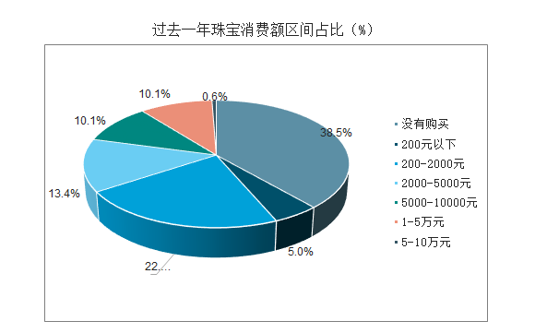
NO buying
Under 200yuan
200-2000
2000-5000
5000-10000
10k-50k
50k-100k
source:Jewelry Administration of Chin
The purchase of jewelry is still dominated by offline channels. Among the respondents, less than a quarter of them said they would buy jewelry online. They were concerned about the authenticity, quality and after-sales quality of products from online channels (48.6%) and the inability to actually wear the jewelry online (20.7%), which were important factors affecting online purchases. In addition, the results of this survey are different from the conventional understanding. Young people under the age of 25 do not show a higher acceptance of online consumption in jewelry, and only 20% of respondents buy jewelry online through channels. It is believed that the stickiness of offline channels in jewelry consumption makes the depth and breadth of offline channels a key factor in brand competition at this stage

1.2 Problem Statement
There are many factors that influence people's choice to buy jewelry online. Before analyzing these factors, we should first analyze consumers' buying decision, so as to better analyze the influencing factors.

1. Insufficient r&d and design personnel and small product differences

The jewelry industry is relatively short of r&d and design personnel. The style design of jewelry is both creative and fashionable, and the r&d and design personnel are of great importance to the product design of jewelry enterprises. After years of development, China's jewelry industry has formed a group of professional designers, but at present, the jewelry industry is still in the stage of rapid development, research and design of high-end talent highlighted shortage.

2.Intense industry competition, low concentration
Since the beginning of this century, China's jewelry market has been maintaining a strong demand, and the vast market space makes all kinds of capital enter. At present, China's jewelry industry is characterized by numerous and dispersed enterprises, low market concentration, and no prominent scale advantage of leading enterprises in the industry, so it is still difficult to dominate and influence the order of the entire industry.
Different type of shopping 2019 in china
Category analysis of online shopping goods
In particular, the highest proportion of Chinese netizens among the categories of online goods is washing and care items (40.8 percent), followed by beauty and cosmetics (33.1 percent), food and beverage (32.2 percent) and household products (31.7 percent)
jewelry take 3.9%

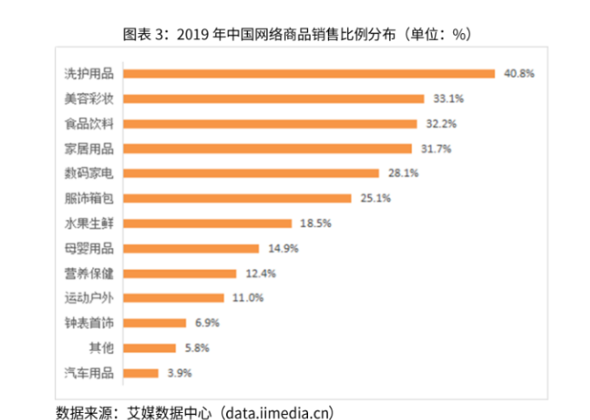
The distribution of online commodity sales in China in 2019
wash supplies
Beauty makeup
Food
furniture
Home appliance
Bag
Fruit
Baby product
Drink
Sport
Watch
Others
jewelry
Source:data.iimedia.cn

1.3 Research Objectives
This research is focusing on achieving the following objectives:
1. To identify whether price has significant effect in influencing people to purchase jewelry online in Guangzhou.
2. To identify whether place has significant effect in influencing people to purchase jewelry online in Guangzhou.
3. To identify whether quality has significant effect in influencing people to purchase jewelry online in Guangzhou.
4. To identify whether service has significant effect in influencing people to purchase jewelry online in Guangzhou.

1.4 Research Questions
Research question on this study are:
1.Does price has significant effect in influencing consumer to purchase jewelry online in Guangzhou?
2.Does placehas significant effect in influencing consumer to purchase jewelry online in Guangzhou?
3.Does quality has significant effect in influencing consumer to purchase jewelry online in Guangzhou?
4.Does service has significant effect in influencing consumer to purchase jewelry online in Guangzhou?

1.5 Hypothesis development
The hypothesis formulation on this study are following:
H1: There is a positive relationship between price and consumer buying decision.
H2: There is a positive relationship between quality and consumer buying decision.
H3: There is a positive relationship between place and consumer buying decision.
H4: There is a positive relationship between service and consumer buying decision.

1.6 Significance of the Study
Academic perspective
This study will contribute to the study of Chinese jewelry consumers and provide reference for future scholars to continue to study factors which can influence customer purchase.
Organization perspective
The study could provide a reference for jewelry merchants planning to adopt online marketing. In addition, the findings of this study can also help jewelry merchants that have adopted online sales to improve customer satisfaction and purchase rate by improving services and strategies. Profits increase when customers' expectations are met.
According to the research on the factors affecting jewelry online shopping, this paper has the following research significance
First, traditional businesses have taken advantage of the opportunities offered by the popularity of the Internet and big data. Online shopping has become increasingly popular in terms of scale, and e-commerce offers unparalleled opportunities for diverse growth as big data technology matures. The jewelry industry should take advantage of the growth potential provided by the Internet and the popularity of big data to further expand market size, maintain stronger customer relationships and improve business performance.
Secondly, it is of great practical significance to study the precise positioning of jewelry online shopping. The comparative study and estimation of consumers' purchasing decisions and the application of the predicted results to the real precision marketing of the company will bring huge benefits to the industry. Using e-commerce purchasing data to lead the marketing path can not only save the cost of the jewelry company, but also bring positive marketing strategies to achieve a win-win situation for suppliers and customers.
Third, this kind of research has practical guiding significance. Precision marketing and customer relationship management research, and has practical application
Finally, follow the trend of The Times and keep up with the way of economic growth

1.7 limitation
Today, online shopping is widely used for sales in various mainstream industries along with e-commerce. Although conventional businesses are becoming increasingly relevant, it is not easy to obtain first-hand information, as it has become the corporate secret of companies. The test samples are therefore not properly detailed to any degree, so there are certain errors. The acquisition of secondary materials often allows subjectivity lacking in the papers. Some of them focus on these unique industries and do not represent all of them.

1.8 The Scope of the Study
The sample size of the interviewees in this study is less than 1000 due to limited time, which is not adequate to represent all customers in Guangzhou and it is difficult to ensure that men and women are distributed fairly in the survey. This can lead to results that only reflect those groups' purchase intentions. In addition, the collected data does not guarantee the accuracy of the research process, as participants could respond untruthfully and unkindly to the questionnaire.

1.9 Ethical consideration
In this research, ethical considerations are very important. The role of researchers, who mainly collect and evaluate data based on applicable literature and market research, will play a full role in this report. When they perform interviews and collect data via questionnaires, researchers can get the consent and permission of the respondents. The collected data and information will be kept confidential, making sure that the personal information of the investigator will not be shared. Respondents of the data will volunteer to participate in the research team. In undertaking this research, the ethical values considered are mainly respect for persons, maintaining confidentiality and beneficence/non-maleficence.
Respect for individuals
Considering that people are free to decide whether or not to participate in the research, at the first presentation, this questionnaire made it clear. In addition, researchers will include information in the introductory statement to the questionnaire about who will obtain the data and why it will be used. Participants lacked any reckless attitude and pressure throughout the questionnaire.
Confidentiality
The main purpose of this study was to protect the privacy and confidentiality of participants' information, which would facilitate their active participation and response. In order to further achieve anonymous responses, the questionnaires will not be numbered, nor will participants' contact information such as names be asked.

Beneficence / Non- maleficence
The questionnaire is considered more intrusive than the interview and may still be harmful to participants. To improve participants' sense of security in the study, researchers reminded participants that sensitive questions about themselves would be checked during the pilot study phase. Therefore, this research will ensure that problems, knowledge or decision are not threatened and information is absolutely safe.

Chapter 2: Literature Review

2.1 Introduction
The aim of this chapter is to review all variables related to this research in the literature. This part introduces the price, quality, location, service and other variables that influence the online jewellery shopping behaviour of consumers, explain the controlling variables related to the purchasing behaviour of customers. add some theories which are grounded. fill in the literature gaps. This literature review includes peer-reviewed journal articles, working papers, textbooks and other publishing resources related to consumer buying decision on jewelry online shopping. This chapter will discuss on the literature reviews related to consumer buyinf decision consist of price, quality, place and service. Each factors will be discussed in detail. The relationship and effects between consumer buying decision on jewelry online shopping will be debate and hypotheses will be made. Finally, it will also demonstrate the conceptual structure for achieving the aims of this report.

2.1 Consumer Buying decision
Consumer purchasing behaviour is the sum of consumer mood, preference, intent and use, which relates to the purchasing behaviour of the ultimate consumer (Velumani, 2014). It is known as the percentage of the likelihood of a person buying a product or service and the purchase must be associated with a category of connotation (Whitlark, 2013). The main objective of learning how to select, use and disposal of products and experience, taste, price and brand on the basis of customer purchasing decision by person, group or organisation (Kotler and Keller, 2012).The purchase of jewelry is divided into physical stores and online shopping. The difference needs to be analyzed concretely

2.2 Global Perspective of Consumer Buying jewelry decision
Euromonitor data shows that the size of the global jewellery industry reached US$ 356.4 billion in 2018, with 4 percent growth year-on-year and a compound annual growth rate of 6.18 percent from 2004 to 2018. In 2020, the market size is projected to hit US$ 398.3 billion. In the global jewellery industry, there are primarily four categories of competitors: multinational specialist jewellery Brands, operators of multi-brand luxury products, regional retailers of jewellery and low-end jewellery producers; the influence of brand value and industry has steadily decreased.
The worldwide jewellery industry is extremely divided in terms of market share, with low penetration and fierce competition. In 2017, the CR5 of global jewellery groups was 8.5 percent, according to Euromonitor, while the CR10 was just 12 percent. CR5 was 8.1 percent of the global jewellery brand, while CR10 was just 11.3 percent. Chow Tai Fook, Richemont Group and Laofengxiang are the largest three jewellery companies in the world. The global jewellery brands CR5 and CR10 are expected to be 8.2% and 11.5% respectively in 2018. The ratio for jewellery firms was 8.4 percent for CR5 and 12.2 percent for CR10.

Market purchase acknowledges two key methods: social-oriented conduct and personal-oriented conduct (Whitlark, 2013). Social-oriented behaviour stems from the desire to please others while intrinsically motivated and self-fulfilling individual-oriented behaviour is (Hwang and Kim, 2016). Businesses will get to know the needs and preferences of customers and can further satisfy the demands of consumers by being conscious of and anticipating the habits of consumers, which will ultimately help to attract consumers and achieve long-term goals (Mansoor and Jalal, 2011).

2.3 Guangzhou Perspective of Consumer Buying jewelry decision

In order to explore sustainable consumption of fashion products in China, understanding the notion of face-saving is important, buying and using fashion products may be linked to improving the public image of Chinese consumers (Bearden and Etzel, 2010).
Chinese customers have historically purchased goods to meet specific social needs: for example when a person has a guest or a friend, drinking is such an occurrence, brand and price are very important (Yan, 2013). The Chinese specificity can be attributed to Chinese customer purchasing behaviour: more classification leads to more stereotypical decisions.
The use of Mandarin needs the brains of more people, so it is easier for the Chinese to remember product attributes (Guo and Meng, 2014). In addition, because of foreign brands, the creation of transnational companies has changed the everyday life of Chinese people and they are genuinely enthusiastic about adopting foreign goods for the following reasons: good quality, good reputation, diversified options, more attractive appearance, sense of freedom (Faure and Fang, 2016).
Social values have been found to have a significant effect on assessing consumer conduct in China (Jin and Kang, 2014). China's consumer decision is strongly influenced by its sociocultural environment, and different genders lead to different decisions (Mohd, 2013).

These factors, such as consumers' household income, expected price of products and expected benefits of products, have a certain predictability and stability. Consumers' purchase decisions are made under the influence of expected factors, and are also direct factors affecting purchase decisions.

2.4 Factors Influencing Consumer Buying decision
As I mentioned before, there are four main factors affecting online jewelry shopping in Guangzhou: price, quality, location and service
Consumer buying decision is a rich appearance, is a complex psychological activity process, consumers' purchasing decision and motivation, marketing research is implemented to consumers as the center of the inevitable requirement of market marketing idea, buying decision is one of the main way of human activity, human activity is the driving force from a variety of psychological motivation, which is an important topic of the study of contemporary psychology. Under the condition of highly developed modern economic life, the consumer buying decision rarely influenced by one or two factors, he is often the result of mutual influence of many factors, especially for jewelry necessary consumer goods marketing, this is not the life more necessary from deeper, broader perspective to analyze consumer's buying decision and purchasing psychology, it is concluded that the correct results, and is used to guide the practice of the jewelry marketing.

price
In advertisement, an important factor is cost. Consumers will display reaction and sensitivity when confronted with changes in the price of a commodity that is described as sensitive (Moe, 2010). Lichtenstein, Black (2012) indicated that it is possible to see price sensitivity as a measuring object. In order to examine how consumers respond to price increases in the sense of price acceptance, Liechtenstein (2012) conducted a survey. In fact, in the industry, there are several options available to customers. Dahan and Srinivasan (2014) suggest that price tags are only seen by 54% and 60% of customers or users.
Mortimer and Clarke (2011) observed that when shopping, women, older people and domestic helpers are more likely to look for costs. Consumers have different buying skills regardless of what the product is but consumers will still find a price to be satisfied (Kotler, 2014). In addition, customers are able to move quickly from one commodity to another at a lower price and become more open to the price of goods (Bhardwaj, 2015). According to Alfred (2013), price is the biggest marketing problem for the manager and the greatest sign of stress.

Quality
According to a recent study by First Insight, a technology firm changing how leading retailers make commodity investment and pricing decisions, quality is becoming more important than price to most customers, as 53 percent rank quality as the most important factor when making purchases compared to price (38 percent). The report also states that consumer discount expectations are dropping as a growing percentage of customers surveyed said discounts from department stores did not impact discount expectations across other categories, including cars, smartphones, furniture, home appliances, and home electronics.
The survey questioned 1000 U.S. participants about their purchasing preferences, buying behaviour and driving decisions, and tracked shifts in consumer opinion on the effect of department stores and mass merchants' widespread discounting from March 2017 to December 2017.
"Consumers have been trained by department stores and mass merchants for years to concentrate on finding deals, and many retailers have responded with deep discounts," said Greg Petro, First Insight CEO and Founder. The findings of this study suggest that as retailers who have been focusing on providing customers with the quality, differentiated goods they want and the price they want, we might be hitting a tipping point as they gain greater momentum and shift the attitude of the buyer. As the pendulum swings away from discounts, retailers have an opportunity to capture higher revenue in every segment, from clothing to furniture and appliances, through quality goods.
According to the findings, the groups of furniture and vehicles reflected the sharpest percentage shift in perceptions, with the number of individuals stating that discounts had no effect on purchases rising 98 percent and 74 percent respectively. Home appliances (36 percent), home electronics (27 percent) and smartphones (26 percent) also saw substantial rises in individuals who said discounts in these categories had no effect on their buying decisions.
Place
The shopping process of using mobile devices has become an important part of e-commerce, while word-of-mouth recommendation and friends' preferences have become major factors affecting consumers' shopping decisions. The combination of social networking on the Internet with physical space and real-time time has led to location-based social services With the rapid development of Service, users can switch between virtual network and real consumption, and complete all kinds of information query decision and consumption decision that cannot be completed by non-mobile network. All these provide excellent business opportunities for merchants to contact those targeted consumers who are in the shopping decision.place is very important for jewelry purchases
Service
On the basis of realizing commercial value, jewelry stores also need professional jewelry knowledge as support. Professional jewelry service
It will make jewelry online sales have different competitive advantages from general jewelry sales units, thus enhancing the core competitiveness of jewelry stores in online shopping market and becoming a decisive factor affecting jewelry purchase.
For now, the jewelry shopping service is still in its infancy, jewelry sales staff service consciousness is not strong, under the fierce competition, explore a set of mature jewelry network marketing service mode is very important to strengthen the competitiveness, not only can improve the compliance and rationality of consumers to buy jewelry, can also increase the jewelry store sales and sales network

2.5 Theory of Reasoned Actions
Figure 1: (TRA)
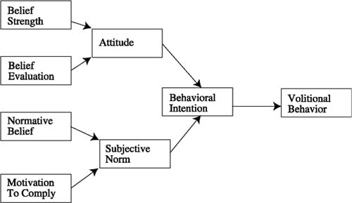
Source: Southey (2011) https://images.app.goo.gl/crqkqktwQU8Y3vbdA

TRA is an extension of the previous model of attitude theory used to explain convincing evidence (Li, 2013). TRA offers a model focused on the attitude and normative values of a person to predict behavioural intentions (Cheung and Vogel, 2013).
The TRA model is commonly used to test voluntary customer motivation, which is especially useful for consumer evaluation since business decisions appear to be focused on the smaller scale of smaller person groups (Tsou, 2012). TRA suggested that because of attitudes and social values, individuals want to take action (Hsu and Huang, 2012). The theory of rational behaviour (TRA) implies that the buying behaviours of individuals are rational and greatly affected by social influences and that the behaviours of consumers can be resolved by obtaining knowledge (Setterstrom, Pearson and Orwig, 2013).

2.6 Gaps in the Literature
There are numerous studies on consumer purchasing behaviour towards different goods, such as how the cognitive-affective model of buying intentions can be formed by brand, price and origin (Chan, Monroe and Kwan, 2014), as well as how the self-concept can decide the purchase choice of consumers (Chan, Monroe and Kwan, 2014) (Sirgy, 2014). Mansoor and Jalal (2011), for example, reported that four major factors can affect the buying behaviours of consumers, which are cultural, social, personal and psychological factors. In addition, consumer purchasing behaviour is typically affected by internal variables, external variables and business variables (Prakash, 2010).
From the analysis of the relevant variables in the literature discussed above, consumer buying decision has been discussed by many past researchers, but the information on the relevant variables of jewelry buying is still limited, especially in Guangzhou, where such studies are inconsistent. A research gap has been identified, prompting researchers to fill it with research in the area of online shopping

2.6 Conceptual Framework
The theoretical structure is the basis for rational research creation and explanation, and can describe and determine the network of relationships between independent variables and problem-related dependent variables through research (Libby, 2017). The research paradigm shows the relationship between price, quality as well as brand awareness and GMO's purchasing behaviour in this model.

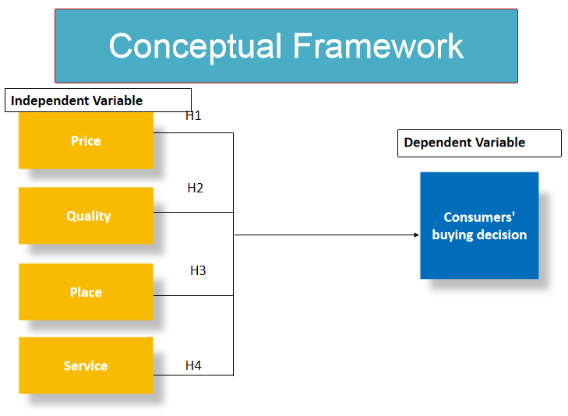

2.7 Chapter Conclusion
This research offers a conceptual and insightful analysis of the consumer purchase behaviour literature and analyses the factors that affect it. Discussing previous research on the purchasing behaviour of consumers and its importance, and how general and common factors affect the buying behaviour of consumers. This chapter also contains definitions of specific factors such as price, a. Furthermore the next section identifies the relationship between particular factors and the buying behaviours of consumers, which demonstrates how these factors affect the purchasing behaviour of consumers. All of the study is based on the TRA basic theory and is carried out in this chapter on the basis of the research framework.

CHAPTER 3: Research Methodology

3.1 Research Design
This study will conduct a quantitative study. Quantitative research is a deductive method in the research process, the purpose is to prove, refute or prove the existing theories. The research design provides guidance for the research. Research should be appropriate for the purpose of the research and provide information about research questions and hypotheses. This includes data collection methods and statistical methods for analyzing data collection results and evaluating hypotheses. Quantitatively study the relationship between measurement and test variables, providing correlation or causality. The survey will be distributed through Google Forms online and allocated randomly to random respondents. The quantitative approach has been selected because a large number of samples are required to enhance the accuracy of data collection in order to assess the cognition of employees. Questionnaire surveys, in comparison, take less time than qualitative surveys. Qualitative research adopts the approach of interviews.The reason for choosing this method is that we need to understand the perspectives of consumers' buying decision and factors, that is, the data collected by researchers can be easily converted into quantities. In this study, we adopted a quantitative research design to measure the influence of consumers on jewelry purchase decision. Participants' responses to interviews and questionnaires will be used to verify the relationship and develop the methods and data summary used in this research. Data analysis mainly uses descriptive statistics and inference statistics. Descriptive statistics are obtained using the Social Science Statistics Software Package (SPSS). By using the latest version 26, it will better help researchers to strengthen the reliability of the data, analyze the data effectively, obtain true and accurate information for this research, and make this research more valuable. At the same time, this study also tested the previous hypotheses and used inference statistics to obtain estimates.

3.2 Measuring Instrument
The styles of price ，quality, place, service and quality of jewelry online shopping and consumer buying decision Electronic questionnaires, in the form of questionnaires, may be obtained. In the one side, consider the shopping patterns of the consumer and the principle of deviation correction. Current online shopping marketing effect assessment and on this basis, full marketing and programme improvements were implemented.
This questionnaire is divided into three sections:: This one also wrong. First section: Demographic factors. Second section: Independent variables: Price, Quality, Place, Service. Third section: Summarization on Factors influencing customer buying decision.

3.3 Tests and Analysis
Through the correlation test of the software, the correlation coefficient of the two variables is 0.839. If the significance level is set to 0.05, the significance test cannot be passed, indicating that the correlation between the two variables is not obvious

3.4 Sampling Design
Sample design is the basis of research sample selection. Sampling is the process of selecting several people from the target population before data collection (Kahn, 2018). The sample is a subset of the population represented by the interested population, because collecting data from the whole population will take time, cost and a lot of human resources. Sampling enables researchers to obtain information about population characteristics, thus forming generalizations.
Sample size is the number of items selected from the population to form a sample. A study needs a sufficient number of representatives to summarize the population well (Kaplan, 2018). In order to represent the whole population, the sample size must be the optimal value based on the population size. The selection of sample size should be based on the reliability, flexibility and representativeness of the population (Armstrong, 2018).

3.4.1 Target population
The target population of this study will be in Guangzhou China. The target participants are students and employees of young generation, including gender, different age groups, education background and monthly income. Nearly 385 of the participated in this study by simple random sampling method. Therefore, the results of the analysis samples will be used as a representative of the whole population. The questionnaire was distributed by the researcher to the employees and students in person to ensure the effective, efficient and timely responses were collected. The survey was conducted in Nov 2020 and the results will be computerized through SPSS software.

3.4.2 Sampling frame and sampling location
The sampling framework for this study is designed for student and employee currently working and studing in Guangzhou. The physical representation of all elements in the population of the selected sample is called the sample frame. In this study, employees from different age groups, gender, education background and monthly income were selected as the research objects to represent the number of students and employees.

3.4.3 Sampling technique
The sampling technique used in this study is simple random sampling. Simple random sampling is the least deviation technique that researchers can use to obtain the most general population (Kuly, 2018). Participants in the study were selected in Guangzhou. The online questionnaire is distributed to participants within a given time range.

3.4.4 Sample size
Approximately 385 respondents, and 385 samples were used in this study. Sample size is the number of items selected from the population to form a sample. The sample size must be based on the optimal population size to represent the whole population. The data collected must represent the population. Quantitative research methods enable researchers to use small groups of people to summarize large groups of people, which may be expensive and time-consuming research (Levinson, 2017). The questionnaire was compiled and distributed to employees and students. The online questionnaire will be collected within five days.

3.5 Data Collection Method
Data collection plays an important role in statistical analysis. The primary data collected in this study is the data collected by researchers directly from participants (Munden, 2017). The primary data were collected from participants through a questionnaire designed specifically for this study. Questionnaire survey is the best tool to collect a large number of primary data, because these data can provide population information to facilitate the statistics (Solley, 2017). The purpose of the questionnaire is to study the factors impact of consumer buying decision on jewelry online shopping based on a study of jewelry manufacturing industry. This study adopts the questionnaire survey method because it provides a wide range of data and collects information about the scope of the study from a large number of participants. The initial data collection time is 3 weeks.
The researchers will assign the questionnaire randomly to a large group of samples for quantitative research during the entire research process and collect the main data. The structure design and the questionnaire method will influence the response rate and accuracy of quality data, according to Dundon (2017). This involves how researchers collect information, including questionnaires, interviews and literature reviews, from various sources. Researchers ensure the reliability and consistency of the research tools used. This has led to researchers discovering that that price, quality, place and service has increased consumer buying decision.

3.6 Data Analysis
It is necessary to use demographic statistics, such as the respondent's gender, age, occupation and income, which can influence the purchasing decisions of a consumer.
This study mainly uses statistical methods to analyze the survey data and test the research hypothesis. The statistical tool used in this study is SPSS software version 26, which is used for descriptive analysis, reliability analysis and inference analysis. Pearson correlation coefficient and multiple regression analysis were used to verify the relationship between price, quality, place and service and consumer buying decision.

3.6.1 Descriptive analysis
In this study, descriptive analysis was used to measure frequency, percentage, mean, and standard deviation. This study summarized and used quantitative data including demographic characteristics. Descriptive analysis refers to calculating data when the Range, median, and width of pattern are required (Locke, 2018). This is part of all the information. Descriptive analysis is difficult to quantify when the data set is huge, but to make the job simpler, it can be solved with proper application. To obtain the average value of the data set that the researcher wants, the average value, mode value and median value of the data set held by the researcher are obtained.. Statistics provide a summary of variable characteristics and measurements in order to better understand the data and results (Holbecha, 2017). Descriptive statistics enables quantitative analysis of data to be presented in a simple form.

3.6.2 Reliability test
Reliability analysis is the process of measuring and determining the reliability, consistency and reproducibility of any research results (Soane, 2017). The most important thing is that it satisfies the validity and parallelism assumptions. Validity and reliability are one of the key factors of this study. In order to establish transparency in data collection, researchers need to do this. This is to ensure that there are no errors in the calculations and measurements that researchers use to produce consistent results.In order to ensure that the instruments used can produce similar results under the same or similar repetition times, the researchers conducted reliability tests to get more accurate data for future analysis. Cronbach's Alpha is the most commonly used reliability test in this study. Gatenb (2017) stated that to analyze reliability data is a simple method for researchers to measure information reliability by using Cronbach's Alpha. Therefore, the researchers chose Cronbach's Alpha to test the structural reliability of this study. In order to obtain good reliability, Cronbach's Alpha coefficient must be equal to 0.7 or above (Truss, 2016). Reliability analysis is a comprehensive measure before measuring with instruments and tools. Therefore, through a preliminary study, reliability analysis is carried out in this study. Conducting the preliminary research before actual research to try out research tools (Reed, 2017). The reliability results of Cronbach's Alpha will show the reliability of the instrument. The values of Cronbach's Alpha are shown in table 3.6.2.
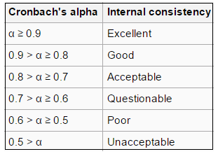
Table 3.6.2 Cronbach's Alpha value

3.6.3 Inferential analysis
Using statistical methods to test the research hypothesis, and through the analysis of the relationship between dependent variables and independent variables to come to the conclusion of the study. Reasoning analysis includes Pearson correlation coefficient, multiple regression analysis and other statistical techniques (Kular, 2017).
Pearson correlation coefficient
Pearson correlation coefficient is the most widely used statistical data to measure the relationship or association between two continuous variables used for testing consumer purchasing decisions (quality, location, service, price) and manufacturing industry online purchasing.
Analysis of correlation is to evaluate the intensity and direction of the association between two continuous variables (Taus, 2017). The Pearson coefficient of correlation (R) is between -1 and 1, which implies a positive or negative correlation. A completely negative linear relationship between the variables exists when R is -1. The corresponding variable decreases when a variable increases (Kahe, 2019). On the other hand, if the R value is 1, it implies that the variables have a completely positive linear relationship, so the two variables increase or decrease together (Ott, 2018). However, there is no linear relationship between variables when the value is 0. -A complete correlation of 1 or 1 on the scatter plot will result in a straight line (Pfeffer, 2017). Pursuant toGuildford's rule of thumb, the strength of the relationship can be determined by the value of Pearson's correlation coefficient (R) (ignoring the sign). Therefore, this study uses Guildford's rule of thumb to determine the strength of the relationship between the dependent variable and the independent variable (Pollarp, 2018). Guildford's rule of thumb is shown in table 3.6.3.

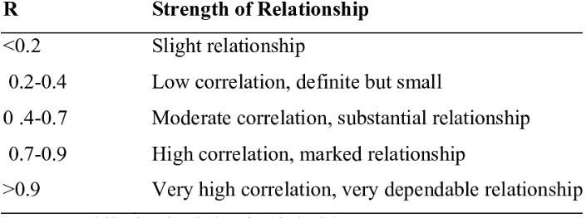
Table 3.6.3. Guildford's rule of thumb

3.7 Pilot Study
Hazzi and Maldaon (2015) believe that the pilot study is a small-scale study designed to determine whether an important part of the captured research is feasible and whether it will help achieve the research goals. Pre-study is a way for researchers to identify errors before further main investigations and data collection. Based on Hazzi and Maldaon (2015), based on 10%-20% of the total sample size, a preliminary study was conducted to verify the reliability and validity of the survey. As stated in Pattan (2016), in preliminary research, prepared questionnaires must be used to collect feedback for analysis. Researchers use these data to conduct preliminary research and will be able to study and analyze feedback related to independent and dependent variables. The purpose of the experimental study should be related to the feasibility and main components of the study to be tested. This preliminary study used factor analysis to evaluate the reliability of the results of the study. Factor analysis tests the grouping and interrelationship of variables in this study, reducing the total number of factors to the most significant factor. In this pilot study, Bartlett's KMO test was used to test the adequacy of the sample to determine the adequacy of the sample and the validity of the data in the study (Fincham, 2008). The reliability test of the pilot study was used to test the consistency of the values, and the Cronbach Alpha value was used to test the internal consistency and reliability of the variables.

3.8 Factor analysis
According to the research of Kline (2014), factor analysis is a statistical method used to find out whether it is possible to group all variables into fewer items in each variable to show the relationship between variables. Exploratory factor analysis is used in the research of the interrelationship of a set of variables reviewed in the early steps of the research, while confirmatory factor analysis is used in the later research analysis to evaluate the research framework of hypothesis matching. Factor analysis generally includes three stages: In the first step, the values of the Bartlett sphere test and the Kaiser-Meyer-Holkin test, namely KMO, are applied, which represents a measure of sampling adequacy (MSA). The significance value of the Bartlett sphericity test should be (p<0.05). According to MSA, the value of KMO can be explained according to the table below (Kline, 2014).

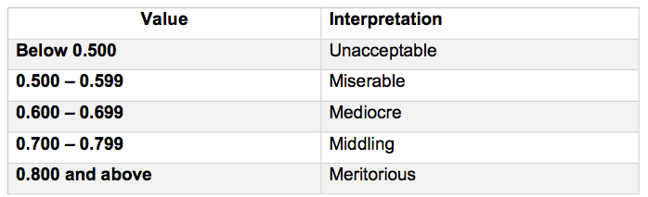
Table 3.8: KMO Value Interpretation for MSA
Source: Kline (2014)
The second step is to observe the value of KMO, which indicates the strength of correlation between items. According to the Kline (2014) correlation matrix, when the value of the coefficient is greater than 0.3, it is considered acceptable. In this case, if most of the values of this term are lower than acceptable values, then factor analysis is considered inappropriate. In the final step, extracting each factor is the main goal, however, the least valuable factor needs to be explained as more differences in the actual data set. The load factor is a value between 0 and 1, and the value represents the highest item with better effectiveness. Therefore, items with a load factor value of less than 0.5 will be ignored, and the remaining items in the variables will be accepted and proceed to the next step (Brown, 2014).

3.9 Demographic Information
Demographic information refers to the part of collecting necessary data from study participants (Patten, 2016). Demographic information is collected and analyzed using descriptive analysis research. This study collected demographic information such as age, gender, marital status, education level and average monthly income. The information collected in the demographic information will be analyzed using IBM SPSS 26, and this information will be used for target demographic and generalization purposes.

3.10 Hypothesis Testing
Hypothesis testing is a statistical method applied to a set of data to make statistical decisions (Bonett and Wright, 2015). This study uses multiple regression analysis and one-way analysis of variance to test the relationship between two or more variables, or the dependent variable or independent variable, and uses a logical method to analyze the statement (Yockey, 2011). Multiple regression was used to test the influence of independent variable price, quality, location and service on the purchase decision of dependent variable consumers.

3.10.1 Multiple Regression Analysis
According to Sekaran and Bougie (2016), when there are multiple independent variables predicting the value of a dependent variable, multiple linear regression is used, also known as linear multiple regression. Multiple linear regression is basically the same as simple linear regression in that it is an extension of more than one independent variable. The coefficient of the independent variable can be positive or negative, indicating the degree of influence of the independent variable on the dependent variable. The higher the coefficient value, the stronger the influence of the variable. You need to pay attention to the significance value of all variables, because a significance value greater than 0.05 means that the variable is not reliable for the model. This study uses multiple regression analysis methods to explore the impact of price, quality, location and service on the purchasing decision of Guangzhou consumers.

3.10.1.1 Beta Coefficient
In multiple regression analysis, when the p value is less than 0.05, the coefficient table not only determines the relationship between the independent variable and the dependent variable, but also illustrates the predictive significance of each variable (Sekaran and Bougie, 2016). The standardized beta coefficient in the multiple regression analysis table refers to the comparison of the strength of the respective variable to the dependent variable.

3.10.2 One-Way ANOVA
Use one-way analysis of variance to determine the significant difference between the means of one or more independent variables. P-value determines the correlation and significance between variables, and P-value less than 0.05 can be accepted (Sekaran and Bougie, 2016). Use analysis of variance test to determine whether the survey results are significant. The analysis of variance test helped this study decide whether to reject the null hypothesis or support the alternative hypothesis.

3.11 Conclusion
This chapter details how to conduct research and find the following steps to find answers to the research goals. The research design includes a research plan, which clarifies the characteristics of the research. There are 31 questions in the online questionnaire designed in this study, using non-probability convenience sampling. In addition, this chapter also explains the importance of preliminary research, factor analysis and reliability testing. In addition, one-way analysis of variance and multiple regression analysis are defined for hypothesis testing. All relevant data will be processed using IBM SPSS 22.0, and the impact of price, quality, location and service on consumer purchase decision will be statistically tested. Chapter 4 will include statistical analysis and research results.

GANTT CHART OF TIMELINE
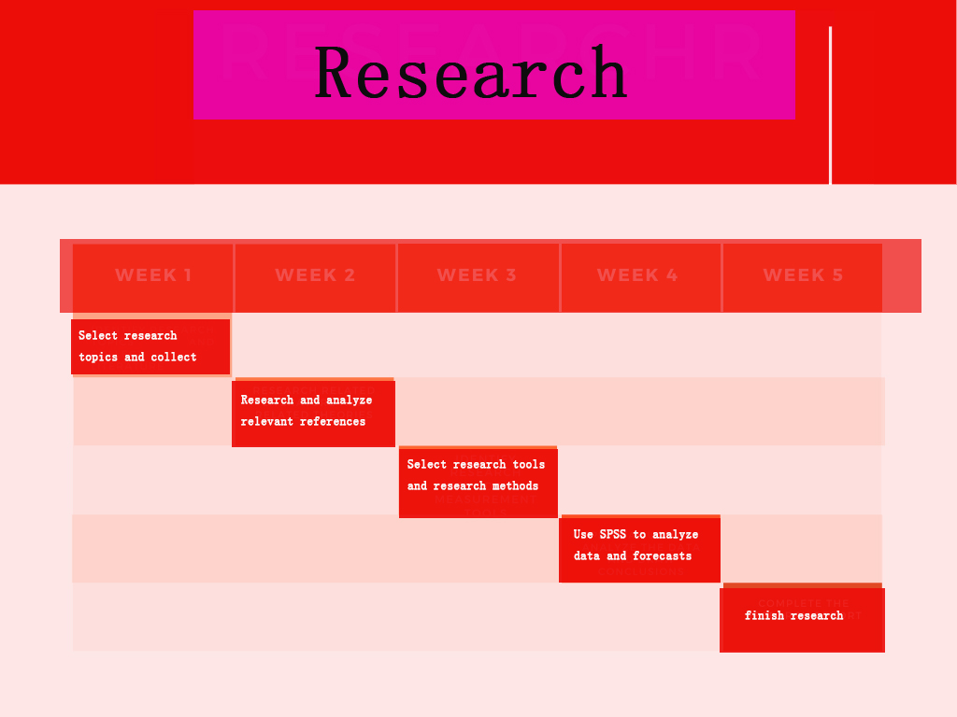

Chapter 4

Data Analysis and Results

4.0 Introduction
This chapter conducts statistical analysis on the collected data and results. The first part of this chapter introduces the demographic profile of the survey participants. This study uses reliability analysis, factor analysis and descriptive analysis to test the validity of the measurement method. Through Pearson coefficient correlation analysis and multiple regression analysis, the intensity and relationship between the dependent variable and the independent variable of this study are explained, which is explained in the last part of this chapter.

4.1 Pilot Test
Since the total sample size is 385 participants, for the pilot test, 10% of the sample size needs to be collected and tested after complete data collection and analysis. In this study, we collected 40 samples for pilot trials. Before continuing to collect all the data, perform factor analysis and reliability tests. Please refer to Appendix A for details.

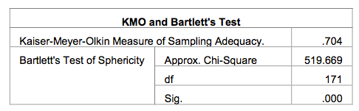
Table 4.1: KMO and Bartlett's Test, Pilot Test

The value for Kaiser Mayer Olkin (KMO) for both dependent and independent variables is 0.704 which falls under the “middling” category based on MSA.
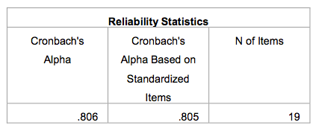
Table 4.1: Cronbach's Alpha, Pilot Test
The Cronbach'sα value of the reliability test for the four variables of quality, price, location and service is 0.806, indicating that these variables have good internal consistency. Since the Cronbach's Alpha of all variables is above 0.8, it shows that the variables are internally consistent and reliable. Therefore, this pilot test passed and comprehensive data can be collected. See Appendix B for details.

4.2 Descriptive Analysis and Frequency
Demographic profile of 321 respondents on this research include age, gender, education level and geographical location of respondents.

4.2.1 Age
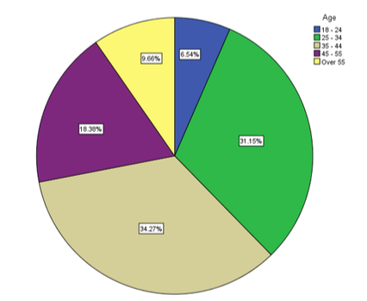
According to Figure 1, most of the respondents were in the 35-44 age group, with 110 cases in total, accounting for 34.27% of the total. The second highest respondent was in the 25-34 age group, with 100 respondents, accounting for 31.15%. This is followed by the 45-55 age group and 59 participants, accounting for 18.38%. There were 31 cases in the age group over 55 years old, accounting for 9.66%. The lowest case among the survey subjects belonged to the 18-24 age group, with 21 participants, accounting for 6.54% overall.

4.2.2 Gender
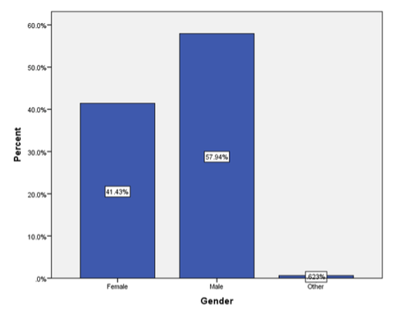
According to Figure 2, most of the interviewees are men, and 186 investors out of 321 interviewees, the overall proportion is 57.94%. 133 respondents were women, accounting for 41.43%. In addition, there are only 2 respondents of other genders, which is only 0.623%.

4.2.3 Education Level
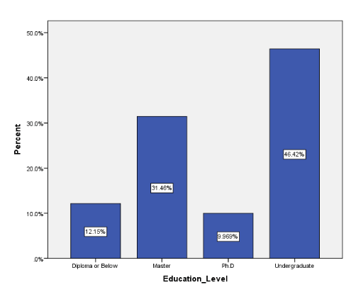
According to Figure 3, most of the respondents came from a bachelor degree, 149 cases, accounting for 46.42%. The second highest respondent is a master's degree holder, with 101 cases, accounting for 31.46% overall. 39 people hold a diploma and below, accounting for 12.15% of the respondents. The number of doctoral students is the smallest, reaching 32, only 9.969%.

4.2 Factor Analysis
In this analysis, the component matrix is used to represent the factor load value, and the factor load value represents the correlation between variables, which is significant when the value is greater than 0.5. If the Kaiser Mayer Olkin (KMO) value is greater than 0.6 (KMO>0.6), the value is sufficient. The Barrett sphericity test must be below 0.05 to be considered significant.
Factor Analysis for both dependent variables and independent variables are tested using SPSS and areshown in table 1.
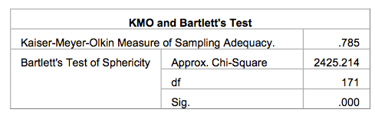
Table 1: KMO and Bartlett's Test, Factor Analysis
Factor analysis results show that there is a correlation between the independent variable and dependent variable in this study, and the KMO value is 0.785, which belongs to the "medium" category of MSA value.
As can be seen from the above table, the significance value of sphericity of Bartlett test is 0.00, less than 0.05, indicating that there is sufficient correlation between variables. Therefore, when the KMO value is 0.785 and Bartlett's sphericity test is of great significance, factor analysis is carried out for this study.

4.3 Reliability Test
In order to carry out and satisfy factor analysis, it is necessary to carry out reliability test on related dependent variables and independent variables. Reliability tests are designed to examine the internal consistency of measurements that show the same results under the same circumstances (Sekaran and Bougie, 2016). The study consists of five variables and 25 items that will test for Kronbach alpha values. The values of Kronbach a in this study are shown in Table 2.
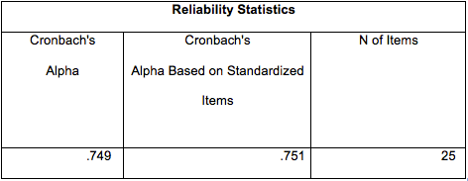
Table 2: Cronbach’s Alpha, Reliability Test
As shown in the table above, the Cronbach a value of all dependent and independent variables is 0.749. This value indicates that all variables have acceptable internal consistency, so Cronbach's Alpha value above 0.7 is reliable and acceptable from all 25 items in this study. Therefore, this study can be continued. The following table shows the Cronbach a values for each variable.
Factors | Cronbach’s Alpha | Items in each Variable
Price | 0.847 | 5 Items
Quality | 0.824 | 5 Items
Place | 0.812 | 5 Items
Service | 0.791 | 5 Items
Table 3: Cronbach's Alpha Values for each Variable
As shown in the table, the highest Cronbach alpha value of the price is 0.847, indicating the highest internal consistency with the five questions, followed by quality with a value of 0.824, location at 0.812, and the lowest service at 0.791. In general, Cronbachα for these variables is highly reliable. In summary, the Cronbachα values of all factors are greater than 0.5, which means that the data has high internal consistency and reliability between 0.791 and 0.847.

4.4 Hypothesis Testing
In this study, multiple regression analysis and one-way ANOVA were used to test the relationship between two or more dependent variables or independent variables, and logical methods were used for analysis and statement (Yockey, 2011). Multiple regression analysis was used to investigate the effects of independent variables such as price, quality, location and service on the dependent variables of consumer buying decision.
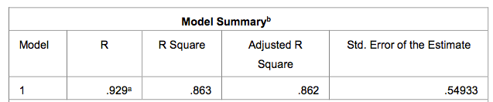

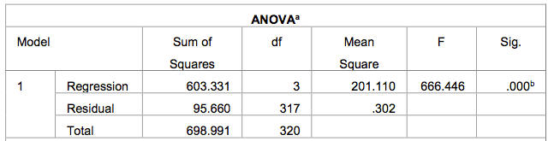
Table 4: ANOVA Table
According to the ANOVA table, the regression model was statistically significant at the 0.000 level (F=666.446). The model summary table shows R and R squared values. The R value is 0.929, representing the correlation value, and the R square value is 0.863, suggesting that 86.3% of consumer buying decision is explained by predictors of price, location, quality, and service.
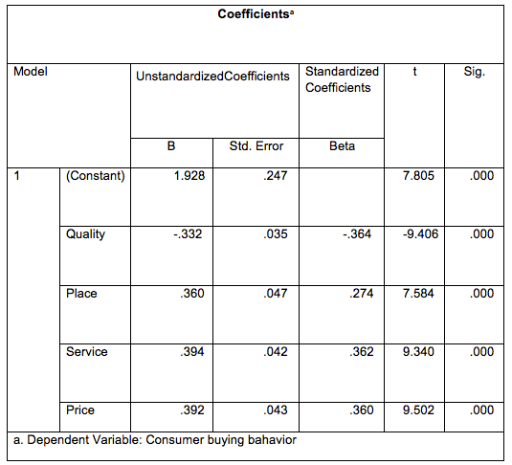
Table 5: Multiple Regression Analysis
Table 5 shows the coefficient statistical results of independent variable price, location, service, quality and dependent variable of Chinese consumer purchase decision. The significance of each variable and dependent variable was statistically analyzed in Table 5.
The statistical results show that the price has statistical significance, P value is 0.000, t value is 9.502, indicating that the price intensity is about negative 95%. The value of the standardization coefficient of the price is. 392。 Therefore, in China, there is an important relationship between price and consumers' consumption habits. The statistical results show that the quality has statistical significance, P value is 0.000, t value is -9.406, and the mass intensity is about negative 94%. The standard coefficient of mass is -0.364. For every point of quality improvement, the purchasing power of consumers decreases by 0.364. Therefore, in China, quality has an important relationship with consumers' consumption habits. According to the table, place is statistically significant with P value of 0.000 and t value of-7.584, indicating that the intensity of place is about 76%. The local standard coefficient is 0.274. The improvement of every place will increase the purchasing decision of consumers by 0.274. Therefore, location has a significant relationship with Chinese consumers' purchase decision. It can be seen from the table that the service is significant, with P value of 0.000 and t value of 9.340, indicating that the service intensity is about 93%. The standardization coefficient of service beta is 0.362, which means that every improvement of service will increase the purchasing decision of consumers by 0.362. Therefore, in China, there is a significant relationship between service and consumer purchase decision.
To sum up, the four independent variables in this study were all accepted and had significant relationship with the dependent variables. All of them had strong fitting ability to the regression modeland they all strongly fit the regression model and the summary of equation for all variables is:
Y= 1.928 - 0.332 Quality + 0.360 Place + 0.394 Service + 0.392 Price
Whereby,
Y=Consumer’s buying bahvior
Q = Quality
P = Place
S = Service
P = Price

4.6 Hypotheses
According to multiple regression analysis and One-Way ANOVA the result indicated that all four independent variables are statistically significant and therefore H1, H2 and H3 as well as H4 are accepted.
Hypothesis | Result
H1: There is a positive relationaship between price and consumer buying decision. | Supported
H2: There is a positive relationaship between quality and consumer buying decision. | Supported
H3: There is a positive relationaship between place and consumer buying decision. | Supported
H4: There is a positive relationaship between service and consumer buying decision. | Supported
Table 6: Hypothesis Testing Result

4.7 Discussion on findings
According to the pre-test of 40 responses in this study, 25 items are all related to 4 independent variables and 1 dependent variable, which meet the requirements of factor analysis and reliability testing. Therefore, all replies have been collected. Among the targeted 348 responses, 321 investor responses were collected. We conducted factor analysis and reliability testing, and 25 of them met the minimum requirements for hypothesis testing. Through multiple regression analysis to test the influence of the independent variable on the dependent variable, the three independent variables (price, quality, location and service) have a strong relationship with the independent variable (consumer buying bahavior).

4.8 Conclusion
This chapter uses reliability analysis, factor analysis and descriptive analysis to determine the validity of the measurement method of this study. In addition, the inference analysis and multiple regression analysis of Pearson's coefficient were carried out on the intensity and relationship between the dependent variable and the independent variable, and the hypothesis of this study was tested. Based on these findings, the three hypotheses of this study are all supported. The next chapter will discuss in detail the statistical analysis, meaning, limitations and future recommendations of this study.

Chapter 5: Conclusions and Recommendation

5.1 Introduction
The findings of research and statistical analysis carried out in the previous chapter are discussed in the content of this chapter. In addition, this chapter includes limited research, recommendations for future research and personal reflection.

5.2 Managerial implications
This research is of great significance for improving online shopping by improving consumer's buying bahavior. After analyzing the factors affecting consumer buying decision on jewelry online shopping in Guangzhou, we found that the relationship between factors that affect consumer buying bahavior (service, place, quality and price) and improved the awareness about consumer preference for selecting jewelry through online.
Specifically, choosing the young generaton as participants will help researcher understand the impact of improving consumer buying bahavior on jewelry online shipping. The study also found that price, quality, place and service are related to improving consumer buying bahavior.

5.3 Contributions
Contributions of this research are contributions to the academia and contributions to the industry.
Contributions to Academia
First of all, students can refer to the results of Chinese research for further research. There are few researches on the psychological factors that affect Chinese consumers' buying decision. Second, this research can help further conduct research on consumer purchasing decision decisions in China, especially factors such as price, quality, locality, and service. Finally, the focus of this research is to study the factors that influence the purchasing decision of Chinese consumers. In this regard, more literature is needed to study the possible impact on consumers.

Contributions to Industry
There is a lot of research on consumer buying decision, but it is very limited in China. The results of this research can be used to encourage further research on this topic. The findings of these studies have brought great advantages to the government, enabling the government to understand consumer decision-making in China and predict the outcome of factors. In addition, the market can use the results of this research to predict and recommend consumers to respond to abnormal situations and better respond to the market.

5.4 Limitation
Due to certain circumstances, this study faces some limitations. These restrictions are as follows: Lack of articles and online resources on the buying decision of Chinese consumers: As this field of jewelry online shopping is a new field compared with traditional theories, the number of articles and documents available is limited, especially in Guangzhou, China. There is less research on the buying decision of Chinese consumers. Limited time: As this study uses non-probabilistic convenience sampling, the time to collect data is limited, and online questionnaires may not be evenly delivered to all categories of consumers. Therefore, these responses may not be statistically representative of the entire population.

5.5 Recommendation on research
Several aspects can be studied in the future in order to obtain comprehensive discoveries. First of all, this research mainly discusses the four aspects of consumers' buying decision, namely quality, price, place and service, but there are many other important factors that have not been fully analyzed and explored. Therefore, adding more research variables can be considered for future research. Because these four variables may not be enough to support this research. This requires research to find comprehensive factors. Secondly, it is recommended to extend the survey time and carefully allocate the questionnaire to specific groups of people to better calculate the entire population. Extending the study period to 15 weeks is very short. If there is more time for future research, the research field may cover the entire Guangzhou. This will be a huge job, but it has its value. Third, this research was conducted using quantitative research methods, with the purpose of testing the factors and influences of consumer purchasing decision. Future research should be based on the information collected from qualitative research, using more quantitative research methods. A combined research method study will provide more subjective and in-depth data on this topic, which can help future researchers understand the nature and impact of consumers' buying decision. In addition, this study only used 321 respondents because it saves time and costs. Future research should target a larger population and collect larger data on the subject to generalize the subject.

5.6 Personal reflection
This research helped me to become familiar with and understand the whole research process from preliminary steps to explanation and submission steps. The challenge started with finding a suitable title, and gradually editing and correcting the title with the help of professionals and respected supervisors. This gave me an insight into how to narrow the scope of research on specific issues in order to obtain results. But remain open to discovery. This new experience inspired me to maintain a focused attitude and write down each word carefully during the research process, and the research process should have appropriate documentation to prove its effectiveness. On the other hand, reading many journals and articles improved my skills in reading research papers. Identifying the problem and finding a solution makes me face challenges. I have to stay focused and continue to work hard, especially in terms of defining problem statements, research goals, and literature reviews of key theories, dependent variables and independent variables. Research methods, measurement and statistical analysis are valuable parts of what I learned from this research. Using consumer buying decision in this research can enable me to understand consumer buying factors and which factors influence their decision, especially in the online jewelry shopping. The results of this research also helped me gain insights into consumer decision patterns and keep in mind the factors that consumers make in purchasing decisions. In the end, I would like to express my gratitude and appreciation for the valuable learning experience provided by this research.

REFERENCES & APPENDICES
- Allen, E. and Fjermestad, J. (2017), "E‐commerce jewelry marketing strategies: an integrated framework and case analysis", Logistics Information Management, Vol. 14 No. 1/2, pp. 14-23.
- Young, L.W. and Johnston, R.B. (2018), "A framework for evaluating the impact of the internet on business‐to‐business e‐commerce jewelry value delivery options", Journal of Systems and Information Technology, Vol. 7 No. 1/2, pp. 129-152.
- Susanty, A., Handoko, A. and Puspitasari, N.B. (2020), "Push-pull-mooring framework for e-commerce adoption in jewelry enterprises", Journal of Enterprise Information Management, Vol. 33 No. 2, pp. 381-406.
- Susanty, A., Sirait, N.M. and Bakhtiar, A. (2018), "The relationship between information sharing, informal contracts and trust on performance of supply chain management in the SMEs of batik", Measuring Business Excellence, Vol. 22 No. 3, pp. 292-314.
- "B2B: How to Build a Profitable jewelry E-commerce Strategy",(2018), Work Study, Vol. 50 No. 4.
6.Saffu, K., Walker, J.H. and Hinson, R. (2018), "Strategic value and electronic commerce adoption among jewelry enterprises in a transitional economy", Journal of Business & Industrial Marketing, Vol. 23 No. 6, pp. 395-404.
7.Shaltoni, A.M., West, D., Alnawas, I. and Shatnawi, T. (2018), "Electronic marketing orientation in the jewelry Enterprises context", European Business Review, Vol. 30 No. 3, pp. 272-284.
8.Yadav, M. and Rahman, Z. (2018), "The influence of social media marketing activities on customer loyalty: A study of e-commerce jewelry industry", Benchmarking: An International Journal, Vol. 25 No. 9, pp. 3882-3905.
9.Abebe, M. (2019), "Electronic commerce adoption, entrepreneurial orientation and small- and medium-sized enterprise (SME) performance", Journal of jewelry Business and Enterprise Development, Vol. 21 No. 1, pp. 100-116
10.Alzahrani, J. (2019), "The impact of e-commerce adoption on business strategy in Saudi Arabian small and medium enterprises (SMEs)", Review of Economics and Political Science, Vol. 4 No. 1, pp. 73-88.
11.Awa, H., Baridam, D. and Nwibere, B. (2017), “Demographic determinants of electronic commerce (EC) adoption by SMEs”, Journal of Enterprise Information Management, Vol. 28 No. 3, pp. 326-345.
12.Damanpour, F. and Damanpour, J. (2018), “E-business e-commerce evolution: perspective and strategy”, Managerial Finance, Vol. 27 No. 7, pp. 16-33.
13.Faloye, D. (2019), “The adoption of e-commerce in small businesses: an empirical evidence from retail sector in Nigeria”, Journal of Business and Retail Management Research (JBRMR), Vol. 8 No. 2, pp. 54-65.
14.Gunasekaran, A., Marri, H., McGaughey, R. and Nebhwani, M. (2002), “E-commerce and its impact on operations management”, International Journal of Production Economics, Vol. 75 Nos 1/2, pp. 185-197.
15.Hamad, H., Elbeltagi, I. and El-Gohary, H. (2018), “An empirical investigation of business-tobusiness e-commerce adoption and its impact on SMEs competitive advantage: the case of egyptian manufacturing SMEs”, Strategic Change, Vol. 27 No.

Appendix A: Pilot Test – Factor Analysis
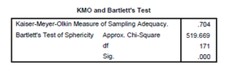

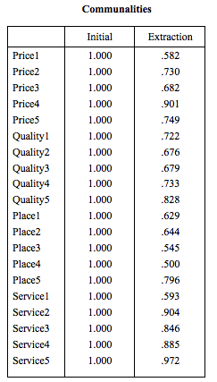
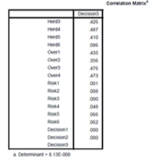

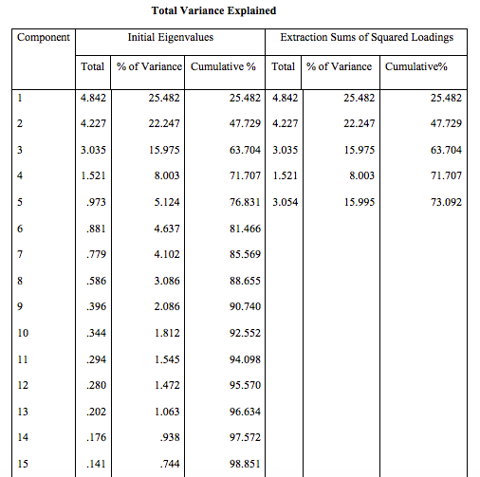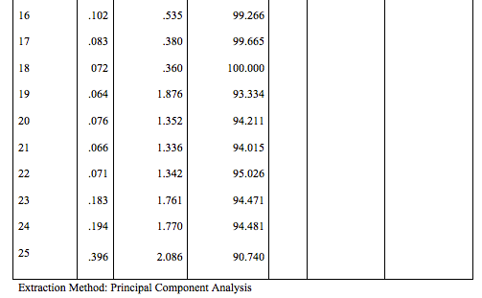

Appendix B: Pilot Test – Reliability Test

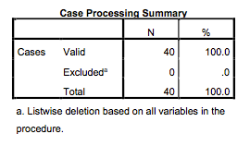
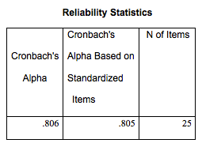

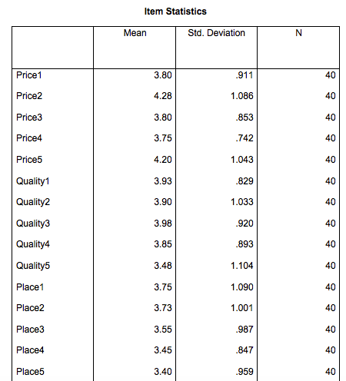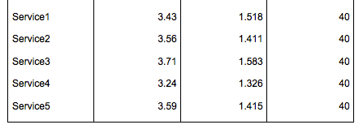

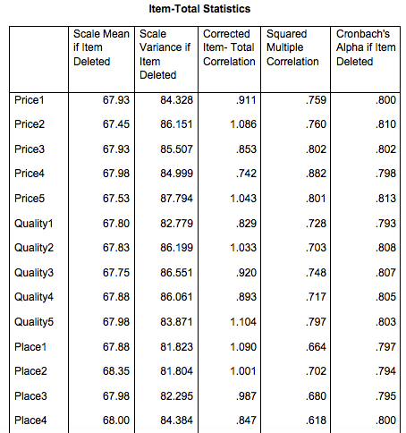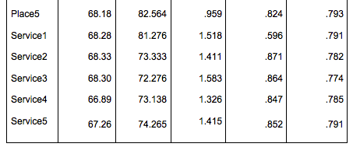

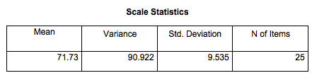

Appendix C: Factor Analysis

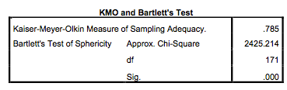
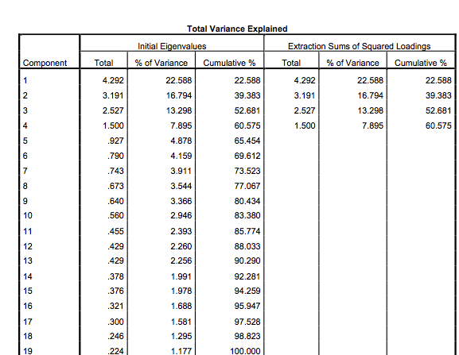

Appendix D: Reliability Test after Factor Analysis
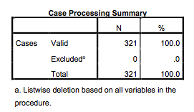

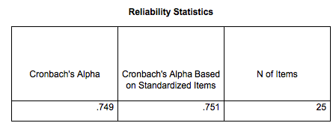
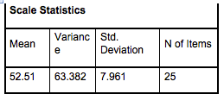
Appendix E: Multiple Regression Anlysis and One-Way ANOVA
Regression

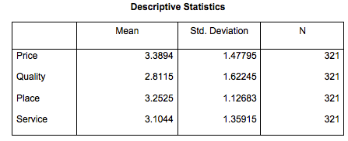
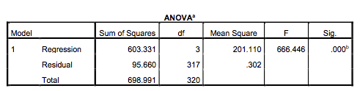
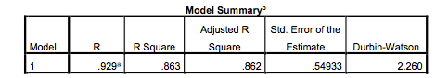

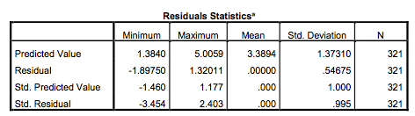

questionnaire

Questionnaire Survey
This questionnaire is conducted to analyze the factors affecting jewelry online shopping in Guangzhou
SECTION A: DEMOGRAPHIC PROFILE
Instruction: Please read each of the following questions and provide the correct information by placing a TICK in the space provided.
- Gender:
[ ] Male
[ ] Female
[ ] Other

- Age group:
[ ] 18 - 24 years old
[ ] 25 - 34 years old
[ ] 35-44 years old
[ ] 45-55 years old
[ ] Over 55

- Race:
[ ]Chinese
[ ]USA
[ ]If others, please specify: __________

- Education level:
[ ] Diploma or below
[ ] Master
[ ] Phd
[ ] Undergraduate

- Monthly Salary:
[ ] Below RMB 1000
[ ] RMB 1000 - RMB 1999
[ ] RMB 2000 - RMB 2999
[ ] RMB 3000 - RMB 3999
[ ] RMB 4000 above

- How often do you purchase online:
[ ] Once a month
[ ] 2-3 times in a month
[ ] 4-5 times in a month
[ ] More than 5 times in a month

Section B: Construct Measurement
Instruction: Please indicate how strong you agree or disagree to each statement by placing a circle from 1 ( Strongly Disagree ) to 5 ( Strongly Agree ). Respondent may refer to the most recent online purchase experience to answer the questions.
(1=Strongly Disagree); (2= Disagree); (3= Neutral); (4=Agree); (5=Strongly Agree);
Price
No. | Based on my recent purchase from online platform: | SD | D | N | A | SA
1. | online jewellery making charges is less as compared to retail jewellery shops | 1 | 2 | 3 | 4 | 5
2. | I like to bargain for diamond smith charge discount. I’m satisfied with price discount for diamond smith charge. | 1 | 2 | 3 | 4 | 5
3. | Season sales promotion, such as: luck draw, free gift and contest | 1 | 2 | 3 | 4 | 5
4. | I can communicate directly with the online shop owner about the price of the product | 1 | 2 | 3 | 4 | 5
5. | The seven-day trial period is unconditional refund | 1 | 2 | 3 | 4 | 5

Quality
No. | Based on my recent purchase from online platform: | SD | D | N | A | SA
1. | Product information quality affects my purchase intension | 1 | 2 | 3 | 4 | 5
2. | I can find more designs available while online shopping, which makes my shopping experience more attractive. | 1 | 2 | 3 | 4 | 5
3. | I can buy from a reputable jeweler as l can read reviews and testimonials, ask for referrals and recommendations and do a thorough background check of my jeweler. | 1 | 2 | 3 | 4 | 5
4. | I can see the star rating of the online store and the real evaluation of the people who have bought the product to judge the quality of the product
5. | I can go for customized jewelry to meet my perfect standards like its size, style, design, color and setting | 1 | 2 | 3 | 4 | 5
Place
No. | Based on my recent purchase from online platform, the online platform: | SD | D | N | A | SA
1. | I like to view many diamond jewelleries quickly when shopping online | 1 | 2 | 3 | 4 | 5
2. | Comparing with asking sales assistant in physical shop, I feel less pressure with chatting online with assistant. | 1 | 2 | 3 | 4 | 5
3. | I buy diamond jewellery online only when it comes with diamond grading report (or diamond certification) from international acceptance and independent laboratories. | 1 | 2 | 3 | 4 | 5
4. | I think Internet shopping offers better selection than local stores. | 1 | 2 | 3 | 4 | 5
5. | Viewing larger photo, 360 degree surrounding perspective of diamond jewellery and seeing it on a real moving model, help me get better idea of how diamond jewellery suits on me. | 1 | 2 | 3 | 4 | 5

Service
No. | Based on my recent purchase from online platform, the online platform: | SD | D | N | A | SA
1. | electronic payment is safe. | 1 | 2 | 3 | 4 | 5
2. | Provided accurate information of a product according to my preferences. | 1 | 2 | 3 | 4 | 5
3. | has mechanism to ensure the safe transmission of its users' information. | 1 | 2 | 3 | 4 | 5
4. | was interested in getting feedback. | 1 | 2 | 3 | 4 | 5
5. | The free warranty period of jewelry purchased online will be longer than that of physical stores | 1 | 2 | 3 | 4 | 5

Consumer buying decision
No. | Based on my recent purchase from online platform: | SD | D | N | A | SA
1. | I think the quality of the product is what determines my purchase | 1 | 2 | 3 | 4 | 5
2. | I think the price of the product is what determines my purchase | 1 | 2 | 3 | 4 | 5
3. | I think the place of the product is what determines my purchase | 1 | 2 | 3 | 4 | 5
4. | I think the service of the product is what determines my purchase | 1 | 2 | 3 | 4 | 5
5. | I think the quality, price, place and service of the product are the factors that determine my purchase decision | 1 | 2 | 3 | 4 | 5

APPENDIX

PROJECT PAPER LOG

This is an important document, which is to be handed in with your dissertation. This log will be taken into consideration when awarding the final mark for the dissertation.

Student Name: | BAIJIAYU
Supervisor’s Name:

Dissertation Topic:

Analyzing the factors affecting consumer buying decision
on jewelry online shopping
in Guangzhou, China.

SECTION A. MONITORING STUDENT DISSERTATION PROCESS

The plan below is to be agreed between the student & supervisor and will be monitored against progress made at each session.

Activity | Milestone/Deliverable Date
Discuss research topics | 15/9
Revision for chart 1 |  | 26/9
Research framework |  |  | 3/10
Discuss for chart 2 |  |  |  | 12/10
Discuss Methodology |  |  |  |  | 21/10
Revision for chart 3 |  |  |  |  |  | 28/10
Discussion Questionnaire |  |  |  |  |  |  | 5/11
Discuss for chart 4 |  |  |  |  |  |  | 14/11
Discuss for chart 4 |  |  |  |  |  |  | 26/11
Discuss VIVA |  |  |  |  |  |  | 3/12
finalization |  |  |  |  |  |  | 8/12
touch up the whole article |  |  |  |  |  |  |  | 12/12

SECTION B. ETHICS

Ethics form protocol number:

SECTION C. RECORD OF MEETINGS

The expectation is that students will meet their supervisors up to seven times and these meetings should be recorded.

Meeting 1
Date of Meeting | 15/9
Progress Made | Discuss research topics
Agreed Action | Future report topic
Student Signature | BAIJIAYU
Supervisor’s
Signature

Meeting 2
Date of Meeting | 26/9
Progress Made | Revision for chart 1
Agreed Action | adjust Research Objectives、problem、question
Student Signature | BAIJIAYU
Supervisor’s
Signature

Meeting 3
Date of Meeting | 3/10
Progress Made | Research framework
Agreed Action | Adjust four factors of Independent Variable
Student Signature | BAIJIAYU
Supervisor’s
Signature

Meeting 4
Date of Meeting | 12/10
Progress Made | Discuss for chart 2
Agreed Action | Adjust the article reviews
Student Signature | BAIJIAYU
Supervisor’s
Signature

Meeting 5
Date of Meeting | 21/10
Progress Made | Discuss Methodology
Agreed Action | Choose Research Method.Data Collection.sample Size
Student Signature | BAIJIAYU
Supervisor’s
Signature
 | Discuss for chart 4

Meeting 6
Date of Meeting
Progress Made | Revision for chart 3
Agreed Action | Adjust chart 3 and get ready for the next chapter
Student Signature | BAIJIAYU
Supervisor’s
Signature

Meeting 7

Date of Meeting | 5/11
Progress Made | Discussion Questionnaire
Agreed Action | Adjust Questionnaire size and Table of Questionnaire
Student Signature | BAIJIAYU
Supervisor’s
Signature

Meeting 8
Date of Meeting | 14/11 26/11
Progress Made | Discuss for chart 4
Agreed Action | Adjust the result of find and data
Student Signature | BAIJIAYU
Supervisor’s
Signature

Meeting 9
Date of Meeting | 3/12
Progress Made | Discuss for VIVA
Agreed Action | Adjust PPT and touch up the data analyze
Student Signature | BAIJIAYU
Supervisor’s
Signature

Meeting 10
Date of Meeting | 8/12 12/12
Progress Made | Finalization  touch up the whole article
Agreed Action | Check the repeat rate and improve the quality of report  Put all the appendix into report
Student Signature | BAIJIAYU
Supervisor’s
Signature

Section D. Comments on Management of Project

(to be completed at the end of the dissertation process)

Student Comments

During the completion of the thesis, my Supervisor tutor gave me a lot of advice and guidance and was very patient and friendly. Thank you very much .

Supervisor Comments

Student putting effort in completing the project but he has to prioritize in order to make sure he is following the timeframe to get the project completed. Need to learn on being independent in terms of checking information where the sources are available. _________________________________________________________________________________

__________________________________________________________________________________

__________________________________________________________________________________

Signature of BAIJIAYU  Student | Date 12/12/20
Signature of  Supervisor | Date 12/12/20
Ethics  Confirmed | Date

Repeat rate
