ARSLAN AHMED MASTER OF BUSINESS ADMINISTRATION 2020 | IMPACT OF COVID-19 ON THE HOSPITALITY INDUSTRY OF UAE  ARSLAN AHMED  MASTER OF BUSINESS ADMINISTRATION  FACULTY OF BUSINESS, COMMUNICATION & LAW  INTI INTERNATIONAL UNIVERSITY  2020

INTI INTERNATIONAL UNIVERSITY
MASTER OF BUSINESS ADMINISTRATION

FACULTY OF BUSINESS, COMMUNICATION & LAW

IMPACT OF COVID-19 ON HOSPITALITY INDUSTRY OF UAE
Author: Arslan Ahmed
Student ID: I20018398
Supervisor: ASSOC. PROF. DR. TAN SENG TECK
Submission Date: 18th December 2020
Final Word Count: 18,007

DECLARATION
“I hereby declare that this thesis is my own work and effort and that it has not been submitted anywhere for any award. Where other sources of information have been used, they have been duly acknowledged”
Name: Arslan Ahmed
Student ID: I20018398
Signature: Arslan Ahmed
Date: 18th December 2020

ACKNOWLEDGEMENT
First of all, I would like to wholeheartedly thank my respected supervisor and express my gratitude towards ASSOC. PROF. DR. TAN SENG TECK for his guidance and support since the beginning of this research till the very end. He has patiently dedicated his time and effort for directing me to the right path and writing this thesis. Special thanks and gratitude to Ms. Ah Huai for her useful comments towards the betterment of this project. She has provided me with insights and guidance for accomplishing this research.
Moreover, I would like to take this opportunity to thank the management, lecturers and
staffs of Faculty of Business, Communication and Law of INTI International University
for their support and assistance during this period. Last but not least, I am grateful to my family and friends that have inspired me to continuously grow and learn.

ABSTRACT
The purpose of this research is to investigate the impact of Covid-19 on the hospitality industry of UAE, to achieve this purpose, a questionnaire used as an instrument to gather primary data from the participants working in the hospitality industry of UAE, using non-probability convenience sampling. The responses collected from 325 individuals working in the UAE hospitality industry out of total hospitality workforce of 400,000 by using an online questionnaire.
Factor analysis used to indicate the intercorrelation of independent variables and dependent variables. The KMO value of variable indicated 0.890, which is in the meritorious category, and the findings indicate that there is a significant relationship between Fear of Contagion, Travel Restrictions, Operational Challenges and UAE Hospitality Industry. Multiple regression analysis and Correlation shows that Fear of Contagion, Travel Restriction and Operational Challenges have a significant and positive influence on UAE Hospitality Industry. According to multiple regression analysis, 75% of individual believe Covid-19 negatively impacted the hospitality industry of UAE, explained by the Fear of Contagion, Travel Restriction and Operational Challenges. Furthermore, recommendations for future study is provided in this research.
Keywords: Fear of Contagion, Travel Restrictions, Operational Challenges, Hospitality Industry, UAE

TABLE OF CONTENTS

CHAPTER I: INTRODUCTION 1

  - Introduction 1
  - Background 1-2
  - Problem Statement 2
  - Research Questions 3
  - Research Objectives 3
  - Significance of the Study 3-4
  - Limitations of the Study 4
  - Scope of the Study 4-5

CHAPTER II: LITERATURE REVIEW 6

  - Introduction 6
  - Introduction to the Hospitality Industry 6
    - Definition 6
    - History of Hospitality Industry 6-8
    - Economic Contribution of Hospitality & Tourism Industry 8-11
    - Major Players of Hospitality Industry 11
      - Wyndham Hotels and Resorts 12
      - Marriott International 12
      - Choice Hotels International 13
      - Hilton Worldwide Holdings Inc 13
      - InterContinental Hotels Group 14
      - Accor 14
      - Best Western Hotels 15
      - Radisson Hospitality, Inc. 15
      - Hyatt Hotels Corporation 16
      - Millennium & Copthorne Hotels 16
    - Classification of Hotels 17
      - Classification by Start Rating 17
        - One-Star 17
        - Two-Star 17
        - Three-Star 17
        - Four-Star 17-18
        - Five-Star 18
      - Hotel Classification by Size 18
        - Small 18
        - Medium 18
        - Large 18
        - Mega 18
      - Hotel Classification by Price 19
        - Limited-Service Hotels 19
        - Full-Service Hotels 19
        - Luxury Hotels 19
      - Hotel Classification by Market Segment 19
        - Convention Hotels 19
        - Resorts 20
        - Casino Hotels 20
        - Vacation Ownership 20
      - Other Hotel Classification 20
        - Airports Hotels 20
        - Motels 20
        - Extended-Stay Hotels 20-21
        - Historic Conversion 21
        - Boutique Hotels 21
  - Hospitality Industry and Covid-19 Pandemic 21
    - Covid-19 Outbreak 21-24
    - Impact of Covid-19 on Hospitality Industry Globally 24-28
  - Relevant Theoretical Model 28-29
  - Conceptual Framework 29-30
  - Research Hypothesis 31
    - UAE Hospitality Industry 31-38
    - Fear of Contagion 38-40
    - Travel Restrictions 40-42
    - Operational Challenges 42-43

CHAPTER III: RESEARCH METHODOLOGY 44

  - Introduction 44
  - Research Design 44
  - Measuring Instrument 44
  - Factor Analysis 45
  - Reliability Test 45
  - Demographic Information 46
  - Hypothesis Testing 46
    - Multiple Regression Analysis 46
      - Beta Coefficient 46
  - Population, Unit of Analysis, Sample Selection and Sampling Techniques 46-47
  - Data Collection and Data Analysis Methods 47
    - Questionnaire Design 47-48
  - Ethical Consideration 48

Chapter IV: Research Findings and Discussion ........................................................ 49
  - Introduction 49
  - Pilot Test 49-50
  - Descriptive Analysis and Frequency 50
    - Gender 50
    - Age 51
    - Education 52
    - Designation 53
    - Region 54
    - Hotel Group 55
  - Factor Analysis 56-57
  - Reliability Test 57-58
  - Hypothesis Testing 58
    - Multiple Regression Analysis 58-60
    - Correlation 60-62
  - Discussion on Findings 62-63
  - Summary of Hypothesis Results 63

Chapter V: Conclusion and Recommendations 64
  - Introduction 64
  - Findings and Conclusion 64-65
  - Recommendations 65-66
  - Contributions 66
    - Contribution to Academia 66
    - Contributions to Industry 66-67
    - Contribution to Government 67
    - Contribution to Medical Community 67
  - Recommendations for Future Research 67
  - Personal Reflection 68

REFERENCES i

APPENDICES xvi
Appendix A: Pilot Test- Factor Analysis xvi
Appendix B: Pilot Test- Reliability Test xxi
Appendix C: Descriptive Analysis and Frequency xxv
Appendix D: Factor Analysis xxvii
Appendix E: Reliability Test xxx
Appendix F: Hypothesis Testing – Multiple Regression Analysis xxxii
Appendix G: Questionnaire xxxiv
Appendix H: Proposal Defense Presentation xliv
Appendix I: VIVA Presentation li
Appendix J: MBA Project Log lxi
Appendix K: SafeAssign Similarity Index lxvi

LIST OF FIGURES

Figure 1: Wyndham Brands 11
Figure 2: Marriott Brands 12
Figure 3: Choice Brands 12
Figure 4: Hilton Brands 13
Figure 5: InterContinental Brands 13
Figure 6: Accor Brands 14
Figure 7: Best Western Brands 14
Figure 8: Radisson Brands 15
Figure 9: Hyatt Brands 15
Figure 10: Millennium Brands 15
Figure 11: Decline of International Tourism in 2020 24
Figure 12: Hotel RevPAR by Region in 2020 25
Figure 13: Hotel Occupancy Rate by Region in 2020 26
Figure 14: Health Belief Model 27
Figure 15: Research Framework (Independent and Dependent Variables) 29
Figure 16: UAE Hotel’s RevPAR (AED) 2020 36
Figure 17: UAE Hotel Occupancy in 2020 36
Figure 18: Sample size calculation with the use of Raosoft 46
Figure 19: Respondent’s Gender 50
Figure 20: Respondent’s Age 51
Figure 21: Respondent’s Education 52
Figure 22: Respondent’s Designation 53
Figure 23: Respondent’s Region 54
Figure 24: Respondent’s Hotel Group 55

LIST OF TABLES

Table 1: Tourists Arrivals by Regions in 2019 9
Table 2: World’s Top 10 Tourism Destination’s Receipts in 2019 9
Table 3: Top 10 Hotel Groups by Revenue in 2019 10
Table 4: World’s Top 10 Tourism Destination’s Arrivals in 2019 10
Table 5: 10 Biggest Hotel Groups 11
Table 6: Largest Hotels in The World by the Number of Rooms 17
Table 7: Covid-19 Data Worldwide on 21 October 2020 23
Table 8: Hotel Guests by Region in UAE 32
Table 9: Tourist Arrival of Gulf Cooperation Countries in 2018 32
Table 10: GDP Contribution of UAE Hospitality Industry (USD million) 33
Table 11: Total Number of Hotel Establishments in UAE 33
Table 12: Largest Hotels in UAE by Number of Rooms 34
Table 13: Key Performance Indicators of UAE Hotels 34
Table 14: Covid-19 Data UAE on 24 October 2020 38
Table 15: Range and acceptance of The KMO and Bartlett method 44
Table 16: Cronbach's Alpha Scores Levels 44
Table 17: KMO and Barlett’s Test, Pilot Test 49
Table 18: Cronbach’s Alpha, Pilot Test 49
Table 19: KMO and Barlett’s Test, Factor Analysis 56
Table 20: Factor Analysis of Dependent and Independent Variables 56
Table 21: Cronbach’s Alpha, Reliability Test 57
Table 22: Cronbach’s Alpha value for each variable 58
Table 23: Model Summary of Independent Variables 58
Table 24: ANOVA Table 59
Table 25: Multiple Regression Analysis 59
Table 26: Interpretation of correlation scale 60
Table 27: Correlation of UAE hospitality Industry and Fear of Contagion 61
Table 28: Correlation of UAE hospitality Industry and Travel Restriction 61
Table 29: Correlation of UAE hospitality Industry and Operational Challenges 62
Table 30: Hypothesis Testing Results 63

LIST OF ABBREVIATIONS

Revenue Per Available Room (RevPAR)
World Tourism Organization (UNWTO)
Key performance Indicators (KPIs)
Average Daily Rate (ADR)
Gulf Cooperation Council (GCC)
Kaiser-Meyer-Olkin (KMO)
Measurement of Sampling Adequacy (MSA)
Standard Operating Procedure (SOP)

Chapter I: INTRODUCTION
  - Introduction
Chapter one will discuss the overview of the “impact of Covid-19 on the hospitality industry of UAE”. This chapter will start with the background of the research topic and explains the problem statement of the study. It will also discuss the research objectives and questions. This chapter will also discuss the significance of the study for the industry, academia, government, and medical community, and at last, this chapter will explain the limitation of the study.
  - Background
The tourism industry is the fastest growing industry in the world, and currently, it is the 3rd largest industry in the world; it contributed USD 8.9 trillion in world GDP in 2019 (World Travel & Tourism Council, 2020).
The hospitality industry, also is known as the hotel industry, is a part of the tourism industry. The hospitality industry consists of hotels, resorts, and motels. The word hospitality is a French word meaning to “provide shelter to the travelers.” There are many classifications of hotels based on the level of service, price, size, location, and market segmentation. The hospitality industry, along with the tourism industry, greatly contributes to the economy of the world, and it interlinked with tourism and other tourism sectors. The hospitality industry also acts as the multiplier effect by generating income for the different sectors of the economy. It also helps to generate foreign exchange, employment, development, and improve the image of the destination (Walker & Walker, 2014).
The hospitality industry in the UAE has seen significant growth in recent years, and many international hotel companies are operating their hotels in the UAE. In recent years UAE has established itself as a tourist destination and business hub. The strategic location of the country gives it a great advantage to attract tourists from around the world. The UAE government, in recent years, plans to shift its economy from oil to other economic sectors for the stable economy of the country. In 2019, the tourism industry contributed 11.9% to the country’s GDP and provided 745,000 jobs (Corder, 2020).
The hospitality industry of UAE employs 398,000 people and contributed USD 9.1 billion in 2019 (UAE Federal Competitiveness and Statistics Authority, 2020). The hospitality sector is still growing, and there 219 hotels under construction in UAE as of 2020 (Top Hotel Projects, 2020).
The recent Covid-19 pandemic impacted all sectors of the economy, especially airlines, tourism, and hospitality industry globally. It also affected the hospitality industry in the UAE. The measures taken by the government like lockdown and travel restrictions have damaged the sector; further, the fear of Covid-19 among the people decline the travel and tourism in the UAE. This study will explain the factors that affected the industry. The study will measure the damage to the industry and how the industry and is trying to survive during this pandemic.
  - Problem Statement
Tourism is the world’s 3rd largest industry, which contributed USD 8.9 trillion to the world’s GDP in 2019 and provides 330 million jobs worldwide (World Travel & Tourism Council, 2020). The hospitality industry is part of the tourism industry, and both interlinked with each other; without tourism, there are no guests for the hotels. Tourism sectors interlinked with each other and create a multiplier effect on the economy (Walker, 2017).
The hospitality industry, along with other tourism sectors, is quite sensitive to any uncertain situations like natural disasters, terrorism, pandemics, and economic downfalls. These factors severely affect the hospitality business as these factors create uncertainty, and tourists stop traveling and staying in hotels (Günay, Bayraktaroğlu & Özkul, 2020).
Covid-19 pandemic creates a lot of fear among citizens and travelers. The governments implemented the lookdowns, and travel restrictions are also imposed. The airlines were shut down or limit their operations, declining international travel around the world (Günay, Bayraktaroğlu & Özkul, 2020).
Due to the lockdown and travel restrictions, hotels around the world faced a loss of billions of dollars due to the cancellations and requests to postponed the bookings. Many hotels were closed or had to limit the operations (Oruonye & Ahmed, 2020). In the US also, hotels lost occupancy, and revenue dropped to 50% (Rokou, 2020).
Like other countries, UAE also implemented different measures like lockdowns and stopping international flights, resulting in a decline of tourism in the country and affecting the hospitality industry (Turak, 2020). Industry in UAE also facing the same challenges and drop in the occupancy and revenue, which resulted in a high financial loss for the hotels. The hospitality industry in the UAE could lose 30% of jobs (Fattah, 2020). The industry is also facing many operational challenges due to the new guidelines hotels need to follow (Nair, 2020).

  - Research Questions
The objective of this is to determine the impact of Covid-19 on the hospitality industry of the UAE.
- Does Covid-19 related travel restrictions affect the hospitality industry of the UAE?
- Does the fear of contagion among travelers affect the hospitality industry of the UAE?
- Does Covid-19 create operational challenges for the hospitality industry of the UAE?
- Does Covid-19 pandemic affect the revenue of the hospitality industry in the UAE?
- Do any measures taken to overcome this crisis by the hospitality industry of the UAE?
  - Research Objectives
- To identify what type of travel restrictions implemented in the UAE.
- To know if the fear of the contagion led to cancellations/occupancy decline in the hospitality industry of UAE.
- To estimate the revenue loss to the hospitality industry of the UAE.
- To identify the operational challenges of the hospitality industry of the UAE.
- To identify the measures taken by the UAE hospitality industry.
  - Significance of the Study
This research has significant importance for different stakeholders. First, this research will set a benchmark for future researchers who would like to research this topic and can see this research and get guidance from it and make improvements in any future studies. Research can also further elaborate on the subject and include more factors and knowledge into current research.
This research will also contribute to the academic field, and future students can see and learn from this and write their research; it will also help students of hospitality management to understand how the industry is performing and will provide them with valuable knowledge which can be useful in their career in future.
Most importantly, this study will help hospitality employees how this pandemic created challenges for them and how they can implement different strategies to overcome them. They can develop different strategies to overcome operational challenges and create marketing strategies to attract guests. It will also help top management of the hospitality industry to develop long-term plans which can help the industry to avoid this kind of situation in the future.
This study will also help the government to see the current situation of the industry and try to come up with possible solutions. The UAE Government has been promoting the country to be a tourist destination. In the current situation, the government must assess the situation to help them to survive and revive so that the country can maintain its image and progress further.
This research can also help the medical and scientific community to create and develop different ways to detect viral diseases and limit the spread of the infection, as the hospitality industry deals with people, crowded places, visitors coming from various regions and background, medical and scientific community need to come up with methods and techniques which can help to identify and detect the viral diseases effectively and quickly.
  - Limitations of the Study
This study is trying to present the Covid-19 impact on the hospitality industry of the UAE, but there will be some limitations in this study. First, as Covid-19 is still ongoing phenomena and, in the future, more effects could be seen in the hospitality industry, which might not be covered in this research. Second, the time to conduct this research is limited and could affect the study. Third, data will be collected from hotels in the UAE, but it is not possible to collect data from all the hotels in the UAE. Fourth, the Covid-19 pandemic is a recent event, and there is not much research done on its effect on the hospitality industry, especially in UAE, which does not provide basis for the literature review.
  - Scope of the Study
This study will be conducted on the hospitality industry of the UAE, which is a famous tourist destination and famous for its world-class hotels. The hospitality industry of UAE was booming before Covid-19, and guests from all over the world visit UAE.
As per the objectives of this research, the study will be conducted from the industry perspective, because to know how Covid-19 has affected the industry; the best approach is to see from the employees’ point of view. This study will present how Covid-19 has affected the business in terms of declining revenue and how limited travel has affected the number of guests in hotels causing low occupancy rates. There are not many studies conducted on the issue, so this study will provide insight into how hotels are operating in these challenging times and trying to survive this pandemic, as pandemic has severely affected the industry. Hospitality is the second most affected industry after the airline industry.
This study will identify three major factors that are affecting the industry; these factors are Fear of Contagion, Travel Restrictions, and Operational Challenges, this will explain how each factor has affected the industry. The study will explain how Travel Restrictions and Fear of Contagion have reduced travel worldwide and affected the hotel occupancy rates and affected the revenue of the hotels. This study will also explain how Covid-19 has affected the operational activities of the hotels and increase the cost. Further, this study will describe what measure hotels are taking and what strategies they are implementing to attract the guests and building trust so that guests can return to hotels.
As discussed before, this study will be conducted to see effects on the industry and look into it from an employee’s perspective, so this study will not focus on guests’ visiting preferences, behavior, or their opinion.
- Research focus: Impact of Covid-19 on Hospitality Industry
- Geographic: United Arab Emirates
- Sample: Hotel Staff
- Unit: Employees working in hotels of UAE
- Approach: Quantitative Study

Chapter II: Literature Review
  - Introduction
In this chapter, the history of the hospitality industry discussed, along with the economic importance and major hotel companies operating today. The classification of the hotels is also covered. Furthermore, this chapter also describes the Covid-19 pandemic and its impact on the tourism and hospitality industry globally. The theoretical model related to this study and conceptual framework also discussed. Focusing on the research topic, this chapter also introduces the hospitality industry of the UAE and the current situation. The variables impacting the UAE hospitality industry are also discussed in this chapter, followed by the conclusion.
  - Introduction to the Hospitality Industry
    - Definition
“Hospitality” is a French word that comes from “hospice” meaning “to provide care or shelter to the travelers.” In ancient times providing food, shelter, and safety called hospitality (Walker & Walker, 2014).
    - History of the Hospitality Industry
The first recorded evidence of the hospitality can be traced back to 4,500 BC in Sumerian civilization, present-day Iraq. Later, from 4000 BC to 2000 BC, offerings of hospitality started showing up in different cultures across the world like Europe, India, and China (Symons, 2012).
The first written evidence of the hospitality can be traced back to 1700 BC in ancient Rome and Greece; this was the time when Europe saw the emergence of taverns, which provide a place to stay and relax to travelers. People come to taverns to enjoy beer and to socialize (Walker & Walker, 2014).
In Mesopotamia (Iraq), during the reign of Hammurabi in 1700 BC, the owners of taverns were to report any criminals living in their taverns, and failing to do so could be punished with the death penalty. Even adding water in beer could be punished with the death penalty (Reynolds, Barrow & Powers, 2012).
In ancient times, the means of travel were slow and difficult, making overnight accommodations very important and necessary. Most of the travelers used to rely on the citizens to provide the overnight stay, but during the age of Roman and Greek empires, the emergence of taverns grew rapidly and spread in entire Europe. In the Roman Empire, Roman Government established taverns along all major roads every 25 miles to provide fresh horses for the government officials, and to stay in taverns, special permission was required (Cook, Hsu & Taylor, 2018).
In the coming ages, wealthy people start establishing their taverns and inns, run by their slaves. Even the gladiators began establishing their inns and restaurants by investing their rewards from games. During Roman Empire in 40 BC, a man named “Seqius Locates” introduce the idea of “business lunch” for the shipbrokers who were too busy to go home for lunch (Walker & Walker, 2014).
During the 8th century, Charlemagne, the emperor of the Carolingian Empire, established lodging facilities in Europe to protect pilgrims and provide them with a place to stay. These lodging facilities used to provide a bed, free bread, cobbler, barber, and food for the travelers (Walker & Walker, 2014).
In the 13th century, when Marco Polo traveled to China, thousands of inns were already established across the world, and Chinese inns were the best among them; journeys of Marco Polo increase the interest of traveling among people (Cook, Hsu & Taylor, 2018).
During the 16th century, the quality of inns improved, which helped to increase travel further. Rich people use to travel by stagecoaches and stay in inns, who demanded the upgradation of the inns. The availability of coffee in Europe, which was brought by travelers from Turkey, further increase the business of inns. The import of tea also attracted people to come to inns and socialize. In 1652, the first coffee house opened in England, and tea and coffee became part of the everyday life of English culture, and coffee houses became the socializing hubs (Walker & Walker, 2014).
During the French Revolution from 1789-1799, there was a revolution in the culinary arts, and it shaped the concept of restaurants; when Monsieur Boulanger start selling soup, he called his soups “restorantes” a French word meaning “to restore,” implying his soups restore the strength, eventually establishing the term “restaurant” for outlets selling food (Symons, 2012).
Meanwhile, in North America, the inns start establishing as travel grew. People start visiting inns to conduct a meeting, do business, getting news, and to socialize. The owners of the inns were considered respectful and financially strong individuals. During the Revolutionary War, the popularity of inns grew further. Due to the French influence on America, the inns were given a different name, “hotel,” which is a French word meaning “place to provide care” (Walker & Walker, 2014).
During the French revolution, many chefs lost their job or were targeted by the rebels due to their employment with nobilities. French chefs had to run to America and Canada, bringing their expertise to a new continent, and introducing French cuisines in the Americas and developed the hospitality industry there (Symons, 2012).
In the 19th century, chefs like Antoine Carême and Auguste Escoffier wrote books on culinary and started the modern era of the food service. Auguste Escoffier considered as the greatest chef in history who revolutionized modern culinary arts and established the designations for cooks in the kitchen where everyone has a specific job, establishing the hygiene practices in the kitchen and standardizing the menu for the guests (Cook, Hsu & Taylor, 2018).
After World War II, America saw growth in travel when roads improved, hotels, coffee shops, motels, and restaurants development spread across the country. Advancement and affordability of air travel took travelers around the world. During the 1980s, baby boomers traveled intensively due to their buying power (Reynolds, Barrow & Powers, 2012).
In the 1990s, the hospitality industry saw ups and downs due to the recession, the Gulf War, and 9/11, which damaged the industry (Walker & Walker, 2014)
    - Economic Contribution of the Hospitality & Tourism Industry
The tourism industry is an umbrella term to describe all the sectors of tourism, which are travel (airlines, cruise ships, rail, automobile, etc.), recreations (attractions, gaming, parks, etc.), food & beverage (restaurants, bars, pubs, cafes, etc.), events (meeting, weddings, parties, conventions, exhibitions, product launch, etc.), hospitality (hotels, resorts, motels, etc.). The hospitality industry and tourism industry are interrelated, and without tourists, hotels do not have any business (Walker, 2017).
Tourism is an activity of individuals to move out of their usual environment for any business or leisure purpose. The individual who performs this activity is called a tourist (Tabash, 2017).
Tourism has emerged as the largest industry, which affects the growth of the economy (Lashkarizadeh, et al. 2012). In 2019, the tourism industry was the world’s 3rd largest industry after information & communication and financial services. The tourism sector contributes to 330 million jobs and USD 8.9 trillion to the world’s GDP, which is 10.3% of the world’s GDP. In 2019, Asia-Pacific contributed USD 3 trillion, Americas USD 2.5 trillion, Europe USD 2 trillion, Middle-East USD 245.5 billion, and Africa USD 168.5 billion in the world Economy (World Travel & Tourism Council, 2020).

Rank | Region | Tourist Arrivals (million)
1 | Europe | 744.3
2 | Asia & Pacific | 360.1
3 | Americas | 219.4
4 | Africa | 72.4
5 | Middle East | 61.4
Table 1: Tourists Arrivals by Regions in 2019
Source: (UNWTO, 2020).

The tourism industry has been growing for many years, and in the last ten years, it saw exponential growth; in 1995, world tourism arrivals were only 532.953 million (Haryanto, 2020), and in 2019, it reached 1.5 billion international tourists, and it is expected to grow to 1.8 billion by 2030 (United Nations World Tourism Organization, 2020). Tourism helps to create economic activities and growth by providing employment, investment, foreign exchange, technology, infrastructure, and development (Haryanto, 2020).

Rank | Country | Receipts (USD billion)
1 | USA | 214.1
2 | Spain | 79.7
3 | China | 75.3
4 | France | 63.8
5 | Thailand | 60.5
6 | United Kingdom | 50.4
7 | Italy | 49.6
8 | Japan | 46.1
9 | Australia | 45.7
10 | Germany | 41.6
Table 2: World’s Top 10 Tourism Destination’s Receipts in 2019
Source: (UNWTO, 2020).

Many countries take advantage of infrastructure, accessibility, labor force, and natural attractions available in their country to attract tourists and develop themself as a tourist destination; meanwhile, other countries which do not possess these resources also tries to develop tourist attractions, infrastructure and improve the image of the destination to build a positive image of the country and generate income for their economy (Cook, Hsu & Taylor, 2018).
The tourism industry creates a multiplier effect. The multiplier effect helps to measure how many times money circulated within the economy spend by the tourists. Most develop tourism economies generate the multiplier effect of 1.5 to 2.0, which means money spent in the destination is used from 1.5 to 2 times (Walker, 2017). A study in Malaysia suggested that tourism, directly and indirectly, supports 52 different industries in Malaysia (Mazumder & Ahmed, 2011).
When a tourist decides to go on a trip abroad, they buy an air ticket and takes a taxi to reach the hotel, generating income for the transport sector; later, when they stay at a hotel and eats at restaurants, it generates income for the hospitality and food & beverage sector when they go for shopping it generates income for retail sector this chain reaction leads to many sectors generating income which eventually helps the entire economy of the country (Barrows & Powers, 2009).

 | Company | Total Revenue (millions)
1 | Marriott International | 20,972
2 | Hyatt Hotels Corporation | 5,020
3 | InterContinental Hotels Group | 4,627
4 | Accor | 4,049
5 | Best Western Hotels | 3000
6 | Hilton Worldwide | 2,369
7 | Wyndham Hotels and Resorts | 2,053
8 | Choice Hotels International | 1,114
9 | Millennium & Copthorne Hotels | 1,025
10 | Radisson Hotel Group | 999
Table 3: Top 10 Hotel Groups by Revenue in 2019
Source: Adapted from (Marriott, Hyatt, InterContinental, Accor, Best Western, Hilton, Wyndham, Choice, Millennium, Radisson, 2020).

Rank | Country | Tourist Arrivals (million)
1 | France | 89.4
2 | Spain | 83.7
3 | USA | 79.3
4 | China | 65.7
5 | Italy | 64.5
6 | Turkey | 51.2
7 | Mexico | 45
8 | Thailand | 39.8
9 | Germany | 39.6
10 | United Kingdom | 39.4
Table 4: World’s Top 10 Tourism Destination’s Arrivals in 2019
Source: (UNWTO, 2020).
Tourism is a broad industry consist of many sectors, and it interlinked with other industries, which makes it highly profitable for the economy of different countries. The tourism industry also helps to develop other sectors of the economy like real estate, sports & recreation, infrastructure, employment, government income, transport, and foreign exchange (Cook, Hsu & Taylor, 2018). Tourism and hospitality are important sectors of any country’s economy and will remain in the future also, and those countries that invest in this industry will gain economic, cultural, infrastructural benefits. Tourism and hospitality have a bright future, and countries and organizations should work more to develop and enhance this industry.
    - Major Players of the Hospitality Industry
Mass tourism creates the need for large hotels and the standardization of hotels. Independent hotels start turning into hotel chains. Standardization created a star system in hotels to explain the level of service and standard of the hotel. Brand name because high in value and independent hotels start paying royalties to get the famous brand names (Camilleri, 2018). The 20th century saw massive growth of hotel chains, where famous hoteliers like Conrad Hilton, John Willard Marriott, Hyatt Robert von Dehn, Paul Dubrule, and Gérard Pélisson created giant hotel chains and established their names in the hospitality industry, and now in the 21st century, their hotels are around the world and best in the field of the hospitality industry (Walker & Walker, 2014).

 | Company | Number of Hotels | Number of Rooms | Countries
1 | Wyndham Hotels and Resorts | 8,513 | 8,31,025 | 80
2 | Marriott International | 7,989 | 14,00,693 | 135
3 | Choice Hotels International | 7,118 | 5,97,018 | 42
4 | Hilton Worldwide | 6,208 | 9,71,780 | 118
5 | InterContinental Hotels Group | 5,918 | 8,83,364 | 68
6 | Accor | 5,506 | 7,39,537 | 101
7 | Best Western Hotels | 4,700 | 2,79,251 | 100
8 | Radisson Hotel Group | 1,237 | 2,26,473 | 100
9 | Hyatt Hotels Corporation | 999 | 2,25,874 | 67
10 | Millennium & Copthorne Hotels | 126 | 23,465 | 22
Table 5: 10 Biggest Hotel Groups
Source: Adapted from (Marriott, Hyatt, InterContinental, Accor, Best Western, Hilton, Wyndham, Choice, Millennium, Radisson, 2020).

      - Wyndham Hotels and Resorts
Wyndham Hotels and Resorts started in 1990 by acquiring Ramada hotel and Howard Johnson hotel in the USA. Over the years, Wyndham Hotels acquire and created many hotel brands (Wyndham Hotels & Resorts, Inc., 2019). Wyndham is the largest hotel group in the world, with 8,513 hotels and 20 brands (Wyndham Hotels & Resorts, Inc., 2020).


Figure 1: Wyndham Brands
Source: (Wyndham Hotels & Resorts, Inc., 2020).

      - Marriott International
Marriott International was started in 1927 from a root beer stand in Washington, D.C, by John Willard Marriott and his wife, Alice. Later, two restaurants were established in 1928, making a restaurant chain named “Hot Shoppes.” In 1937, Hot Shoppes started to provide catering services for the passengers at Hoover airport. In 1957, Marriott opened its first-ever hotel in Arlington, Virginia. Marriott hotels become an international hotel chain by opening a hotel in Mexico in 1969 and entered into the cruise line business in 1972 by partnering with SunLine cruise. Marriott is the second largest hotel chain with 30 brands and 7,994 hotels worldwide (Marriott International, Inc, 2020).
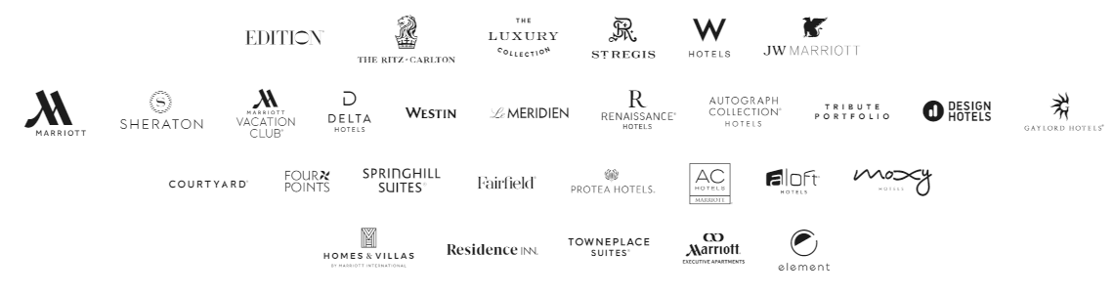
Figure 2: Marriott Brands
Source: (Marriott International, Inc, 2020).

      - Choice Hotels International
Choice Hotels International was created in 1939, with the partnership of seven different owners of motels creating the same quality standards and facilitates to increase profits and to create one brand. The company brings facilities like a 24-hour front desk, phones in rooms, carpeting, and daily linen change in guest rooms. In 1972, the company becomes international when it opened its first hotel in West Germany. Today, Choice Hotels International is the third-largest hotel group with 12 brands and 7118 hotels worldwide (Choice Hotels International, Inc., 2020).

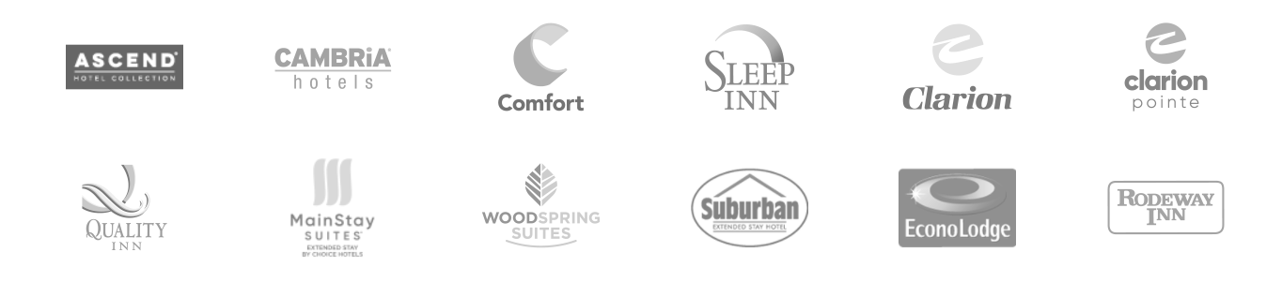
Figure 3: Choice Brands
Source: (Choice Hotels International, Inc., 2020).

      - Hilton Worldwide Holdings Inc
Hilton Worldwide Holdings Inc.’s journey started in 1919 when Conard Hilton bought his first hotels in Texas. Hilton hotels are known for bringing facilities in the hotel that have never been seen before. In 1927, the Waco Hilton hotel was the first hotel to provide cold water and air-conditioning in rooms. In 1947, Roosevelt Hilton was the first hotel to provide TV in guest rooms. Hilton hotels become an international chain by opening its first hotel in Puerto Rico. Hilton was the first hotel to create the central reservation system named HILCRON in 1955. Hilton is the fourth-largest hotel group with 18 brands and 6,208 hotels worldwide (Hilton, 2020).

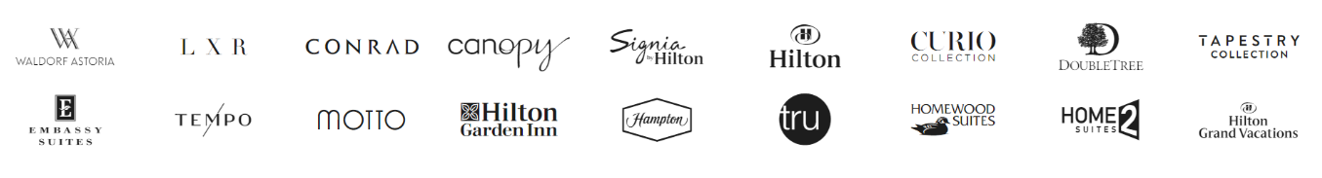
Figure 4: Hilton Brands
Source: (Hilton, 2020).
      - InterContinental Hotels Group
InterContinental Hotels Group started its journey in 1777 when James Watt established a brewery named “Bass Brewery” in Staffordshire, England. In 1969, the company entered into the hotel business by the name of Crest Hotels. Later, in 1988, the company bought the Holiday Inn hotel and made it one of the largest hotel brands. Bass Brewery bought InterContinental hotels from Saison Group in 1988, and later in 2003, the group named was changed to InterContinental Hotels Group. Today the company has 14 hotel brands and the fifth largest hotel group in the world with hotels 5,918 (InterContinental Hotels Group, 2020).

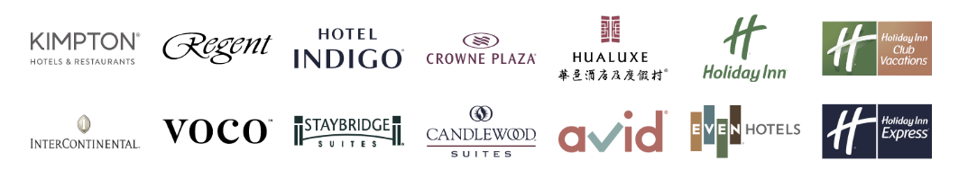
Figure 5: InterContinental Brands
Source: (InterContinental Hotels Group, 2020).

      - Accor
Accor’s first hotel was established in 1967 by Paul Dubrule and Gérard Pélisson in Paris, France, named Novotel. In 1972, the company became an international chain by opening its first overseas hotel in Switzerland. In 1980, the company bought Sofitel hotels. Over the years, Accor created and bought many other hotel brands and expanding its portfolio in many regions around the world. Today Accor is the sixth-largest hotel group with 50 brands and 5506 hotels worldwide (Accor, 2020).

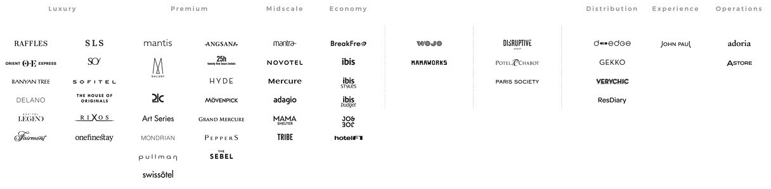
Figure 6: Accor Brands
Source: (Accor, 2020).

      - Best Western Hotels
Best Western Hotels were founded in 1946 by businessman “Merile Key Guertin,” who started the group with the establishment of motels in the USA. In 1975, the company became an international hotel chain by opening its hotels in Australia and New Zealand, and throughout the 1980s expanded in Europe by opening many hotels in different European countries and start expanding in Asia in the 1990s. Today, Best Western is the seventh-largest hotel group with 18 brands and 4,700 hotels worldwide (Best Western International, Inc., 2020).

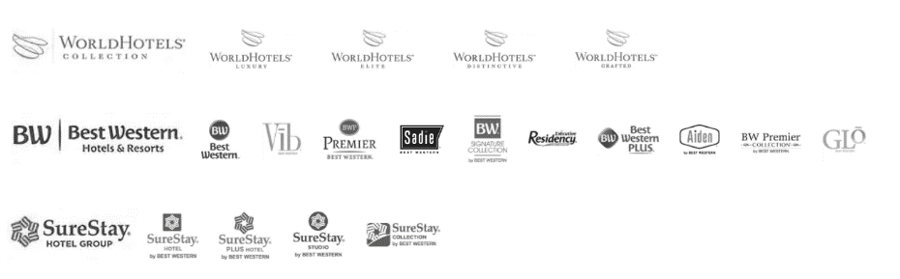
Figure 7: Best Western Brands
Source: (Best Western International, Inc., 2020).

      - Radisson Hospitality, Inc.
Radisson Hospitality, Inc., was formed with the partnership of Carlson Hotels and SAS International Hotels in 1986 and named Carlson. In 2012, the group bought 51% shares of Rezidor Hotel Group, changing its name to Carlson Rezidor Hotel Group. In 2016, a Chinese group name HNA Group bought the group and changed the group name once again. The present name of the group is Radisson Hospitality, Inc., and has 7 brands and 1,237 hotels, making it the eighth-largest hotel group (Radisson Hospitality, 2020).

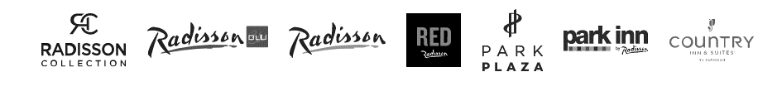
Figure 8: Radisson Brands
Source: (Radisson Hospitality, 2020).

      - Hyatt Hotels Corporation
Hyatt Hotels Corporation started its journey in 1957 when Jay Pritzker bought Hyatt House Motel in Los Angeles. Hyatt Hotels became an international chain in 1969 when it opened the first overseas hotel in Hong Kong. In 1972, Hyatt Hotels became the first hotel to launch a toll-free number for reservations. In 2009, Hyatt Hotels started trading publicly on the New York Stock Exchange. Hyatt Hotels Corporation has 18 brands, and it is the ninth-largest hotel group in the world, with 999 hotels (Hyatt Hotels Corporation, 2020).

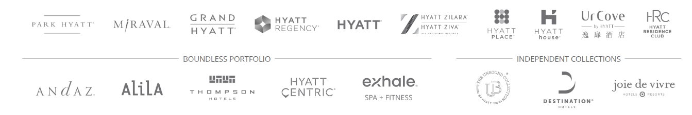
Figure 9: Hyatt Brands
Source: (Hyatt Hotels Corporation, 2020).

      - Millennium & Copthorne Hotels
Millennium & Copthorne Hotels established itself as a hotel group in 1989, by Kwek Leng Beng. The company started its business with six hotels in Asia. In 1993, the group bought a hotel in London, expanding itself in Europe, and in 1996 registered itself in London Stock Exchange. In 2001, Millennium started expanding in Middle-East by signing hotel contracts in UAE. In 2007, Millennium started its business in China. Today it is the tenth-largest hotel company in the world with ten brands and 126 hotels (Millennium & Copthorne Hotels, 2020).

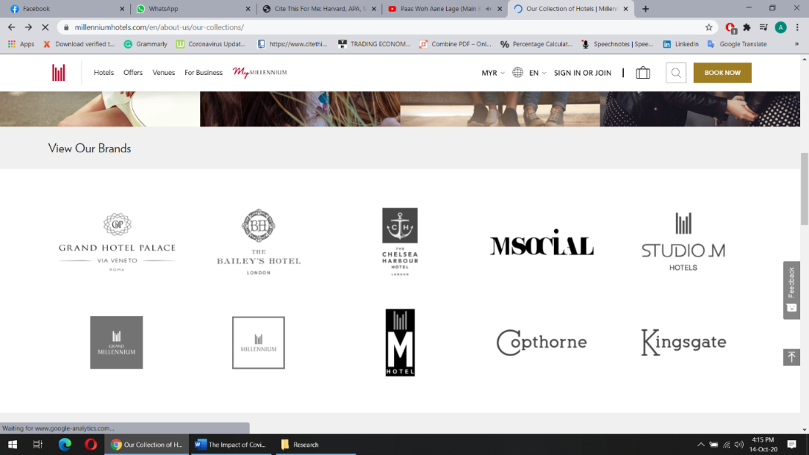
Figure 10: Millennium Brands
Source: (Millennium & Copthorne Hotels, 2020).

    - Classification of Hotels
Hotels can be classified into different categories according to their rating, location, size, market, function, and price.
      - Classification by Start Rating
The quality of the service is the center of the hotel industry and the most important factor in attracting guests. Most hotels can have similar architectural and physical characteristics; it is the service that differentiates between a good and great hotel (Sepula et al., 2018).
        - One-Star
Mostly one-star hotels are owned by a family or sole proprietor; these hotels do not provide any service and provide the only place to rest or sleep; rooms have limited furniture and bathroom in the rooms and do not have any restaurant on-premises. One-star hotels do not have any other facilities (Dubai Department of Tourism & Commerce Marketing, 2014).
        - Two-Star
Two-star hotels are also small or medium hotels mostly operated by a chain, franchise, or by a sole proprietor. These hotels provide limited housekeeping services, and rooms are equipped with TV and phone. Room service is not available in a two-star hotel, but a restaurant will be on-premises to offer breakfast (Abu Dhabi Department of Culture & Tourism, 2018).
        - Three-Star
Three-star hotels are stylish and provide a comfortable stay for guests. These hotels are part of major international hotel chains like Hilton, Marriott, InterContinental, etc. These hotels have a decorative lobby and designated front desk. Three-star hotels provide more services and facilities as compared to one-star or two-star hotels like on-site restaurant and rooms service providing breakfast, lunch, and dinner. Rooms have good quality and furniture and a flat-screen TV. Gym, swimming pool, and valet services are also available. These hotels are mostly located near business areas, attractions, shopping centers, or transportations hubs (Dubai Department of Tourism & Commerce Marketing, 2014).
        - Four-Star
Four-star hotels are large and upscale properties providing full-service with uniformed staff. The rooms are spacious and include premium furniture and stylish bathrooms with amenities. Rooms have entertainment systems and a flat-screen TV. Four-star hotels provide valet service, swimming pools, fitness centers, fine dining restaurants, and rooms service. Four-star hotels also provide meeting space and business center. (Abu Dhabi Department of Culture & Tourism, 2018).
        - Five-Star
Five-star hotels are the most luxurious properties with unique architecture and the best interior designing and furnishing. These hotels have large lobbies and designated concierge and front desks, providing unparalleled service by uniformed staff and personal butlers. The rooms are equipped with HD TVs, internet, lavish bathrooms, laundry service. Five-star hotels have multiple food & beverage outlets on the premises and offering different cuisines and room service available operating 24/7. Five-star hotels also provide large banquet and meeting rooms. These hotels also provide limousine service, spa, and swimming pool (UNWTO, 2015).
      - Hotel Classification by Size
Hotels can be classified by the size also where the number of rooms available in the hotels uses as the benchmark.
        - Small
Hotels that consist of less than 100 rooms are considered small-size hotels.
        - Medium
Hotels consist of between 100 to 299 rooms are considered as medium size hotels.
        - Large
Hotels consist of between 300 to 1000 rooms are considered large size hotels.
        - Mega
Hotels consist of more than 1000 rooms are considered mega-size hotels.

Rank | Hotel | Country | Number of Rooms
1 | First World Hotel | Malaysia | 7,351
2 | MGM Grand | USA | 6,852
3 | CityCenter | USA | 6,790
4 | Izmailovo Hotel | Russia | 5,000
5 | Wynn Las Vegas | USA | 4,750
6 | The Luxor | USA | 4,407
7 | Ambassador City Jomtien | Thailand | 4,219
8 | The Venetian | USA | 4,049
9 | Sheraton Grand | China | 4,001
10 | Excalibur Hotel and Casino | USA | 3,981
Table 6: Largest Hotels in The World by the Number of Rooms
Source: (Levin, 2019)
      - Hotel Classification by Price
Hotels can be classified by the price, also where guests can choose among limited-service, full-service, or luxury hotels.
        - Limited-Service Hotels
Limited-service hotels, also called budget or economy hotels, are very simple hotels providing only rooms and limited or no food and beverage service. These hotels do not provide any amenities or other services. These hotels are best for those guests who wanted to spend minimum time at the hotel at an affordable price (Barrows & Powers, 2009).
        - Full-Service Hotels
Full-service hotel rates are above average, ranging from 50USD to 150USD, and they provide many facilities, including food & beverage services. These hotels are mostly the choice of business travelers who are not looking for a luxurious stay rather a comfortable stay and with necessary facilities (Cook, Hsu & Taylor, 2018).
        - Luxury Hotels
Luxury Hotels provide a high standard of services and amenities. These hotels provide a luxurious lifestyle instead of simple lodging facilities for which customers are willing to pay. The price range of these hotels are quite high, ranging from 300USD to 1000USD per night or even above, based on the location and season. Mostly these hotels are located in major cities and tourist destinations (Jones, 2002).
      - Hotel Classification by Market Segment
Hotels can be classified according to the market segment, which targets its guest according to their specific needs and wants.
        - Convention Hotels
Convention Hotels offers large meeting facilities for business travelers with many meeting rooms and ballrooms. These hotels are normally more than 500 rooms and have a large variety of restaurants and facilities. These hotels are mostly located near to other convention hotels or convention centers to cater to large conferences and exhibitions in the city (Walker & Walker, 2014).

        - Resorts
Resorts or resort hotels are located in remote and large areas surrounding by natural beauty. The architect and design of the resorts are according to the surrounding environment to create a theme. Resorts offer extensive food & beverage varieties with fine dining, and casual restaurants and rooms are spacious and luxurious to provide a relaxing environment for the guests. Previously resorts were mostly seasonal with a water park to attract guests in summer or ski resorts targeting guests in winter, but nowadays, most of the resorts operate the entire year. Resorts are located in a remote location where it’s difficult to travel frequently, making resorts a place for the families to spend their vacations and relax (Mill, 2007).
        - Casino Hotels
Casino hotels are different from other hotels as they make more money from gaming rather than rooms. Nowadays, casino hotels are trying to attract business and family travelers also, but gaming is strictly for adults only (Walker, 2017).
        - Vacation Ownership
Vocational ownership, also called timeshare, are the residents, which can be bought by the individuals for a certain time period in a year. The residences or apartments are fully furnished (Barrows & Powers, 2009).
      - Other Hotel Classification
        - Airports Hotels
Airport hotels are located near the airports providing accommodation for the traveler who missed their flights, layovers, or wanted to have a place to stay near the airport for the ease of traveling. These hotels also attract airline crew due to the advantage of being near to the airport (Barrows & Powers, 2009).
        - Motels
Motels are located near the highways and attract travelers who are using automobiles. Motels have a large parking space. The service facilities in motels are limited. Motel room doors usually face the parking area to give easy access to the parking (Eilers, 2020).
        - Extended-Stay Hotels
Extended-stay hotels provide large rooms with a kitchen and living room separate from the bedroom and rooms equipped with a stove, microwave oven, and refrigerator. Food & beverage service might not be available or limited. The rooms rates are also less than other types of hotels. These hotels target guests who want to stay for an extended period (Walker, 2017).
        - Historic Conversion
Some hotels are established in historic buildings after renovation and changes according to the modern-day needs and requirements. These hotels attract guests who like to visit and stay in historical places and enjoy the experience with modern-day facilities (Barrows & Powers, 2009).
        - Boutique Hotels
Boutique Hotels can be at any price and service-level, but the theme of the boutique hotels is different from the other properties. The interior design of these hotels is homey or postmodern style. Boutique hotels are small, with 25 to 150 rooms, but the level of the service they provide is extremely high (Khosravi, Malek & Ekiz, 2014).
  - HOSPITALITY INDUSTRY AND COVID-19 PANDEMIC
    - Covid-19 Outbreak
Wuhan city, located in the Hubei province of Central China, witnesses the first covid-19 patient in December 2019, when a number of people showed symptoms of the pneumonia-like disease, but some of the patients start developing severe illness, which resulted in the deadly outcome (Cano, 2020).
One thing common among the patients was, they all had exposure to the Huanan Seafood Market, from where this unknown disease started and now spreading rapidly to the other parts of China. Chinese Centre for Disease Control and Prevention able to identify the disease as coronavirus in the first week of January 2020 (Ahmed, 2020).
Initial, patients with this new disease had exposure to the seafood market, but now this disease was spreading among patients who never visited the market, increasing the fear among the doctors that disease has started spreading from human-to-human (Islam, Sobur & Rahman, 2020).
The virus spread like fire due to the increase of travel during Chinese New Year celebrations, and within few days, this disease starts spreading rapidly, affecting many cities in China and then other countries by the travelers who were traveling to other countries and from those who recently come back from China (Muhie, 2020).
To slow down the spread of the Covid-19 Chinese Government took extreme measures like lockdowns, roadblocks, business shutdowns, schools being closed, travel bans, shops were not allowed to open, and intercity travel was also banned. Chinese authorities closed the wet market also and, on 3rd January, informed the World Health Organization about the pandemic and shared the entire genome of the Covid-19 with World Health Organization on 10th January 2020. Chinese authorities also developed the testing kit for Covid-19 (Islam, Sobur & Rahman, 2020).
Covid-19 was spreading rapidly and affecting country after country; by the end of January, Covid-19 affected 27 countries. On 30th January, the World Health Organization declared the Covid-19 outbreak as a public health emergency (Ahmed, 2020).
On 11th February, the International Committee on Taxonomy of Viruses named this new virus as Covid-19, which means coronavirus disease-2019, and the World Health Organization declared that the Covid-19 would be the official name of the disease. International Committee on Taxonomy of Viruses able to recognize the disease as of the species of severe acute respiratory syndrome coronaviruses (Islam, Sobur & Rahman, 2020).
By 11th March 2020, Covid-19 had affected more than 80,000 people and a total of 3000 deaths in China; worldwide, the disease spread to 113 countries with more than 37,000 cases and 1130 deaths. The rapid spread of the disease increased the concerns of the World Health Organization, which decided to declare the outbreak as pandemic (Shim et al., 2020).
Coronaviruses found in various animal species like birds, cats, camels, bats, and cattle. There are four types of coronaviruses found in humans; out of the two is highly contagious, which are Severe Acute Respiratory Syndrome Coronavirus (SARS-CoV) and the Middle East Respiratory Syndrome Coronavirus (MERS-CoV). These two diseases are much more fatal as the mortality rate of SARS-CoV is 10% and for MERS-CoV is 34.4% (Ahmed, 2020).
The outbreak of SARS-CoV was also started in China from the wet market in 2002. The disease started from Guangdong province and eventually spread to 37 countries, killing 774 people and affecting more than 8,000 worldwide (Islam, Sobur & Rahman, 2020). The virus was spread by a doctor treating patients infected with this disease and was staying in a hotel in Hong Kong; he infected 16 other foreign guests staying in the hotel, eventually spreading the disease to Canada, Singapore, Vietnam, and United States (Cano, 2020). On the other hand, MERS-CoV started in Middle-East in 2012 and by 2015 spread to 21 countries affecting 1,465 people and killing between 400 to 500. The origin of this virus was also animals; it started from camels (Ahmed, 2020).
Under a microscope, Covid-19 looks sphere shape with a fatty layer and has spikes like a crown on top, hence named corona “crown.” Covid-19 is genetically similar to SARS-CoV, therefore, also called SARS-CoV-2 (Muhie, 2020).
The origin of Covid-19 is believed to be zoonotic, more specifically bats, but till now, it has not been identified which animal caused the transmission of the disease between bats and humans. During the SARS-CoV, an intermediate animal was civet (Ahmed, 2020). Human-to-human transmission of Covid-19 is occurring through sneeze and cough, when infected patient’s respiratory droplets which are greater than 5 microns inhaled by another person, extended contact with Covid-19 carrier or having contact with the infected surface (Cano, 2020).
The incubation time of Covid-19 is between 2 to 14 days. Covid-19 is most contagious when the patient is symptomatic. Covid-19 is more contagious as compared to SARS-CoV and MERS-CoV but less mortality rate. Covid-19 is mostly affecting males with a median age of 59. The common symptoms of Covid-19 are fatigue, headache, dry cough, fever, shortness of breath, and anorexia (Muhie, 2020).
The first-time coronavirus appears in humans was in 1965, when Tyrell and Bynoe discover the first human coronavirus in a patient who had a common cold; they named it B814. When Tyrell study this virus under a microscope, he found that it resembles the previously discover bronchitis virus found in chicken in the 1930s, and both have a similar shape. The lifecycle of the coronavirus consists of four phases (i) entry and attachment, (ii) replicate protein expression, (iii) replication, and transcription (iv) assemble and release (Jahangir, Muheem & Rizvi, 2020).
Until now, the medical community has not been successful in finding the cure of the disease or have consensuses on a particular treatment of Covid-19. Doctors are more focused on reducing the spread of the disease by treating patients in isolation and using personal protective equipment (Ahmed, 2020).
Most Covid-19 patients do not show any symptoms or mild symptoms and do not require any treatment, but patients with severe symptoms will require treatment and intensive care. As for now, doctors are using different treatments like using ventilation, keeping fluid balance, and providing oxygen or drugs like hydroxychloroquine is being also used (Muhie, 2020).
According to World Health Organization recommendations, by taking some precautions, people can reduce the chances of getting infected from Covid-19 like regularly washing hands with soaps or using sanitizer, avoid touching face, maintaining a distance of at least 1 meter, using a face mask, and keeping home or workplace clean (Jahangir, Muheem & Rizvi, 2020).

Region | Total Cases | Total Deaths | Total Recoveries
World | 41,050,369 | 1,129,741 | 30,632,287
North America | 10,215,973 | 337,097 | 6,801,404
South America | 9,096,264 | 282,089 | 8,060,229
Asia | 12,692,460 | 227,053 | 11,093,638
Europe | 7,335,567 | 242,243 | 3,268,980
Africa | 1,674,836 | 40,289 | 1,376,599
Table 7: Covid-19 Data Worldwide on 21 October 2020
Source: (World Health Organization, 2020)

    - Impact of Covid-19 on Hospitality & Tourism Industry Globally
Covid-19 has negatively affected all kinds of economic activities since its first case appeared in December 2019 in Wuhan, China (Ayittey et al., 2020). Despite all efforts of governments and organizations, this domestic infection became a global pandemic (Brooks et al., 2020).
The scale and rapid spread of this pandemic caused a massive economic slowdown, business shutdown, and supply chain disruption worldwide, which never seen before (Celestin, 2020). The first half of 2020 has seen an economic decline of two-third in revenue as compared to the same period of 2019 (Karantzavelou, 2020). Covid-19 can cause a decline of 3% in the world economy and a 6.1% decline in developed countries, and the inflation rate will be 3% globally (Haryanto, 2020).
Tourism and hospitality are quite sensitive sectors to unwanted phenomena, like pandemics, terrorism, depressions, wars, and natural disaster. These factors greatly affect the growth of tourism and hospitality; mostly, these factors are unexpected and hard to predict and manage, which causes massive negative effects on hospitality and tourism. We have seen in the past that infectious diseases like swine flu, avian flu, and Ebola also affected tourism (Günay, Bayraktaroğlu & Özkul, 2020). Any economic downfall, pandemic, or natural disaster directly affect the tourism and hospitality industry; people start cutting their travel budget or avoid traveling to the affected destination (Bhutia, 2020).
Covid-19 pandemic severely damages the tourism and hospitality industry all over the world. The halt of international and domestic travel forced hotels and other tourism sectors to shut down (Chinazzi et al., 2020). This kind of decline in the tourism and hospitality industry was only seen during World War I and World War II (Cao, et al., 2020). Due to the Covid-19 pandemic, 1.6 million jobs are lost in the hospitality industry and $2.4 billion in weekly salaries and cause a decline of 22% in tourism and could cause a decline of 60 to 80% in 2020 (Haryanto, 2020). Covid-19 pandemic has risk 50 million jobs in the tourism industry (World Economic Forum, 2020).

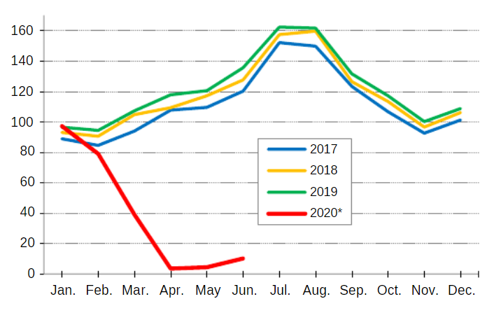
Figure 11: Decline of International Tourism in 2020
Source: (UNWTO, 2020)

Hotels around the world received requests to cancel or postpone the booking, which worth billions of dollars due to Covid-19, forcing hotels to close or limit their operations and layoff their staff (Oruonye & Ahmed, 2020).
The U.S has seen a significate decline in its hospitality industry, where hotels’ occupancy dropped 53%, and RevPAR dropped 32.5%. The events industry also has seen a decline where 72.6% of events have been canceled, and 27.4% are postponed (Rokou, 2020).
The tourism industry in Europe is also going to face a severe blow to its tourism sector, and it is estimated that it could lose €1 billion per month due to the Covid-19 pandemic (United Nations World Tourism Organization, 2020). Tourist destinations, restaurants, bars, hotels, tourist’s attraction is being close all over Europe, and events have been canceled or postponed (Celestin, 2020). Italy is one the worst-hit country by Covid-19. Most of the Covid-19 cases in other European countries originated from Italy. Italian government implemented strict lockdowns all over the country, affecting the hospitality industry in those regions, which does not have significate Covid-19 cases (Casilli, 2020). Covid-19 greatly affected Italy’s hospitality industry, as 90% of hotels in Rome and 80% in Sicily closed to Covid-19 and estimated shows that Italy loses €200 million in the tourism sector only in the first quarter (Federazione Italiana del Turismo, 2020). Hungary hospitality sector witnesses a 40% to 50% cancellation in hotels due to Covid-19 (Oruonye & Ahmed, 2020).

Figure 12: Hotel RevPAR by Region in 2020
Source: (STR, Inc, 2020)

Turkey, which is the sixth most visited country in the world, is also affected by the pandemic. In 2019, Turkey welcomed 46 million visitors and generated $34.5 billion, but all went downhill when Turkey witness its first Covid-19 patient in March 2020, and widespread lockdowns start affecting its tourism industry, and 70% of hotel booking was canceled (Özdemir, 2020).
Covid-19 also affected sports events, postponing major sports events like Euro Football Championship 2020 and Olympic Games to 2021 (Burrows, 2020). Covid-19 even affected cruise lines business; major companies stop their operations. Some cruise ships are even stuck at sea, as many countries deny their entry (Sloan, 2020).
The tourism and hospitality industry affected China and Chinese tourists, also as it was the first country to report Covid-19 cases. Today, China is one of the largest countries in terms of inbound and outbound tourism, and Chinese tourists spend billions of dollars traveling all over the world (Oruonye & Ahmed, 2020). The Chinese tourism industry generates CN¥ 5,128 billion, but Covid-19 affects the industry negatively, especially during peak season when millions of Chinese tourists were traveling to and from China. Chinese tourist accounts for 10% of international tourists. In 2019, China alone contributed $127.3 billion to the tourism industry (Hoque et al., 2020). Hilton hotels closed its 150 hotels in China during the pandemic, and as per the CEO of Hilton hotels Chris Nassetta, the company is expected to lose $25 million to $50 million in China (Miller, 2020).
In Malaysia, Covid-19 led to the cancellation of 170,084 hotel rooms, causing a loss of RM68,190,364 only from January to March and by June loss of RM3.3 billion (Foo, Chin, Tan & Teng, 2020).

Figure 13: Hotel Occupancy Rate by Region in 2020
Source: (STR, Inc, 2020)

Another famous Asian tourist destination India, could not save itself from Covid-19, where 55 million tourism-related jobs are at stake. The hospitality industry is likely to hit most, laying off its staff due to low occupancy in hotels. In 2019, the Indian tourism sector generated $194.3 billion from its domestic and international tourism, but the current situation creates many difficulties for the Indian tourism sector (Kumar and Rout, 2020).
Covid-19 has affected tourism in Africa also but not to the level of other regions. The African tourism sector expected to grow 3% to 5% in 2020, but this pandemic has slowed the growth, and it expected that tourism in Africa would see negative growth (Celestin, 2020).
  - Relevant Theoretical Model
The Health Belief Model is used in this research to describe the current situation of the Covid-19 pandemic. The reason for choosing this model is because it clearly explains the current preventive behavior of travelers, citizens, and governments. People are afraid of Covid-19 and stop or reduce their travel, keeping social distance, and not staying in hotels. This model further helps to explain the three independent variables of this study, which are fear of contagion, travel restrictions, and operational challenges, which affects the dependent variable, which is the UAE hospitality industry, because people are avoiding travel due to fear of the virus and hotels are losing business.
The four paradigms of the Health Belief Model are perceived susceptibility, perceived severity, perceived benefits, perceived barriers, belief in personal health threat, and belief in the effectiveness of health behavior (Guidry et al., 2019).

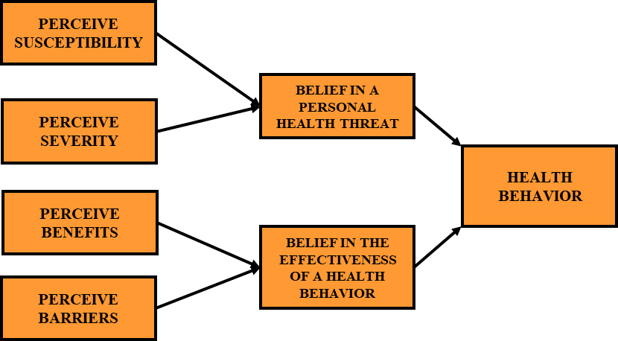
Figure 14: Health Belief Model
Source: Adapted from (Natarajan & Williams, 2020).
Perceived Susceptibility: When an individual understands the risk of a specific disease. In the case of this Covid-19, perceived susceptibility helps individuals to understand that the Covid-19 is a contagious disease spreading by coming in contact with an infected person, and it is spreading all over the world (Raamkumar, Tan & Wee, 2020).
Perceived Severity: When an individual understands the consequences of a disease. In the case of Covid-19, perceived severity helps understand the consequences of being infected by Covid-19 like self-isolation, admitted to a hospital, physical harm, psychological effects, or even death (Natarajan & Williams, 2020).
Perceived Benefits: When an individual realize there are benefits to prevent and manage the disease. In this case, perceived benefits, helps individuals to understand that keeping social distance, avoiding crowded places, washing hands, and avoiding coming in contact with an infected person will save an individual from getting infected by the Covid-19 (Jose et al., 2020).
Perceived Barriers: Realization and identification of potential barriers towards the health behavior change. In this case, perceived barriers could be hurdle for individuals like if the personal protective equipment are not available, individual still need to go to work because they cannot survive economically, students have to go to school because an internet or online education facilities are not available (Raamkumar, Tan & Wee, 2020).
These four paradigms lead an individual to develop a behavior, either considering it a threat or the effectiveness of health, making a decision to develop a health behavior. In the case of Covid-19, people start using personal protective equipment, avoiding crowded places, practice social distancing, hand washing, using hand sanitizers, temperature checks and various other measures (Natarajan & Williams, 2020).
  - Conceptual Framework
Conceptual framework act as a blueprint or foundation of the study. The conceptual framework act as a map or travel guide, which helps the researcher to follow a path from which a researcher should not deviate. The conceptual framework further helps the researcher to present his/her point of view about the study (Grant & Osanloo, 2014). The aspect of the research should be connected to the conceptual framework. When creating a conceptual framework, a researcher must have a proper understanding of the purpose, problem, significance, and objectives of the research (Adom, Hussein & Agyem, 2018).
The benefit of using a conceptual framework is, it provides information about how the researcher approaching his/her research and which tools and procedures he/she is adopting. The conceptual framework helps the researcher to explain the problem in the simplest way and explains the importance of the study, and explains why the research is worth studying (Grant & Osanloo, 2014). The conceptual framework must resonate with other aspects of the research, like problem, survey, methodology, findings, and conclusion (Ravitch & Carl, 2016).
The conceptual framework of the research is different from the theoretical framework because the conceptual framework is not adopted from a theory but rather created by the researcher to explain his/her point of view regarding the research topic and explains the relationship between the variables. The design of the conceptual framework is not accepted but act as a proposal to explain the research problem. It helps to develop a new theory which can be helpful in the field to explain the problem (Adom, Hussein & Agyem, 2018).
The conceptual framework constructed for this study has three independent variables, which are fear of contagion, travel restriction, and operational challenges, and one dependent variable, which is the UAE hospitality industry.

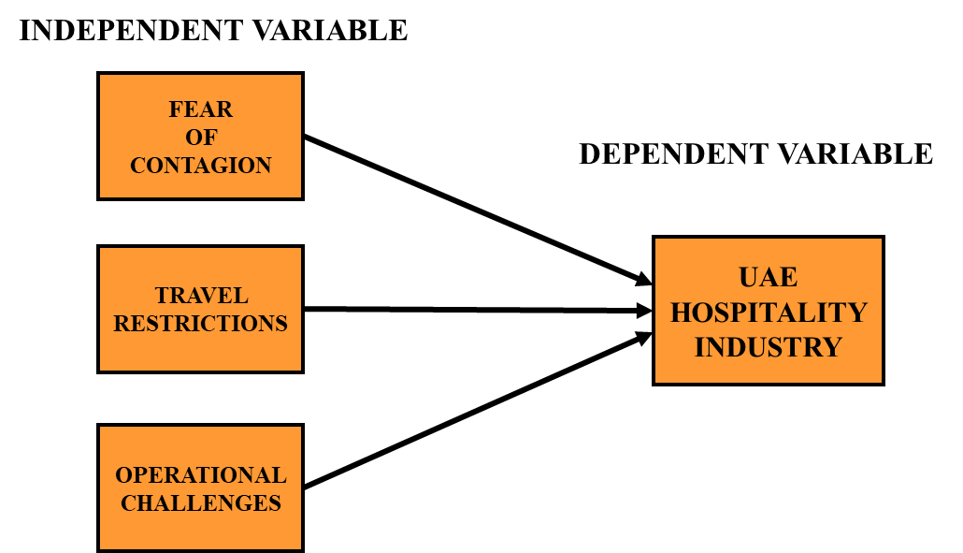
Figure 15: Research Framework (Independent and Dependent Variables)

  - Research Hypothesis
H1: Fear of contagion is negatively affecting the hospitality industry of the UAE.
H2: Travel restrictions by governments is negatively affecting the hospitality industry of the UAE.
H3: Operational challenges are negatively affecting the hospitality industry of the UAE.

    - UAE Hospitality Industry
The United Arab Emirates, also known as UAE, is a country located in Middle-East. It borders with Saudi Arabia and Oman and maritime border with Iran and Qatar. UAE has seven states, which are Abu Dhabi, Dubai, Sharjah, Raʾs al-Khaymah, Al-Fujayrah, Umm al-Qaywayn, and Ajam. UAE capital is Abu Dhabi. The official language of UAE is Arabic, but due to a large number of expatriates, Hindi, Urdu, Tagalog, English are major spoken languages. Expatriates in UAE makes a large community which comprises of more than 200 nationalities. The official religion of the country is Islam, but other religions are also free to practice their faith and establish their places of worship, so many churches and temples can be found in UAE along with mosques. UAE is a desert country and has a hot climate temperature. In January, it can be around 18 Cº and can reach to 46 Cº in summer (UAE Government, 2020a).
Abu Dhabi is the largest state of UAE, and its capital is also Abu Dhabi, which serves both as the capital of Abu Dhabi and UAE. The land area of Abu Dhabi is 67,340 sq. km and a population of 2,908,173 in 2016. Abu Dhabi has more than 200 islands along the coastline (UAE Government, 2020b).
Dubai is the second largest state and the most famous state of UAE in the world, most people even mistakenly think of it as a country, but it is one of seven states of UAE. The land area of Dubai is 4,114sq. Km with a population of 3,355,900 in 2019. Dubai is famous for its high standard hotels, shopping malls, modern architecture, and entertainment (UAE Government, 2020c).
Once Dubai was just a desert and small village of fishermen, established in 1833 by the tribe of Al Maktoum. Dubai starts progressing in the fishing and pearling industry, and traders from around the world used to come here for business. In 1966, first-time oil was discovered in Dubai, which attracted foreign investment, tourism, the shipping industry in the region. In 1985, the foundation of Emirates Airlines was laid, which is now one of the largest airlines in the world. Once known for its finishing sector, today is the home of more than 200 nationalities and the land of some of the tallest buildings in the world like Burj Khalifa, Gevora Hotel, JW Marriott Marquis Hotel, and The Marina Torch (Dubai Corporation of Tourism & Commerce Marketing, 2020).
Sharjah is the third-largest state of UAE. The land area of Sharjah is 2,590sq. Km and population of 1,171, 097 in 2012. Sharjah is also a tourist destination, especially famous for its cricket stadium hosting international cricket matches (UAE Government, 2020d).
Ras Al Khaimah is the fourth-largest state of UAE with 1684sq. Km and a population of 345,000. Ras Al Khaimah has many islands and a coastline of 65km at the Strait of Hormuz. Ras Al Khaimah has established itself in the industrial, tourism, and agriculture sector (Ras Al Khaimah Government, 2020).
Fujairah is the fifth-largest state of UAE, with a land area of 1,450 sq. km. Fujairah is a mountain area and does not have a desert, and the climate is colder than the rest of the UAE (Fujairah Government, 2019).
Umm Al Quwain is the sixth state of UAE and has a land area of 720 sq. km and a population of 73,000. The major export of the state is seafood (UAE Government, 2020e).
Ajman is the seventh and smallest state of UAE, with a land area of 259 sq. km and a population of 373,000 (Ajman Tourism Development Dept, 2020).
UAE population is about 9.6 million, and the workforce is 7.3 million (UAE Ministry of Economy, 2019). In 2019, the GDP of UAE was $421 billion (UAE Federal Competitiveness & Statistics Authority, 2020). In 2019, the inflation rate of the country was 3.1%, and unemployment of 2.35%. Country exports were $389.3 billion, and imports were $416 billion.
In 2016, UAE Government held a meeting in Dubai to diversify the economy and shift it from oil to innovation, knowledge, foreign direct investment, privatization, and the tourism sector (UAE Government, 2020f). UAE economy has relied on its oil export for many years, but the decline of oil prices in recent years forced the UAE to invest in other economic sectors. UAE initiated “UAE Vision 2021,” according to which UAE has planned to develop world-class healthcare, sustainable environment and infrastructure, knowledge-based economy, first-rate education, safe public, and cohesive society (Patel, 2019).
Abu Dhabi, which produces most of the oil in UAE, is now shifting its economy to tourism and planning to launch mega-projects to turn the oil state into a tourism destination. Since the 2015 oil price crash, the UAE Government is looking for alternatives to support its economy. Currently, oil contributes to 30% of UAE GDP, which the UAE government wants to reduce to 20% by 2021 (Turak, 2018).
The tourism sector of UAE attracts tourists around the world who visit the country to explore and enjoy. Tourists visit the UAE for various reasons like shopping, adventure, sports, culture, medical, educations, meeting, social events, entertainment, and marine tourism (Ministry of Economy, 2020). The tourism sector provided 745,000 jobs in the country and contributed 11.9% to the GDP in 2019 (Corder, 2020).

 | 2019 | 2018 | 2017 | 2016 | 2015
UAE | 4,563,405 | 4,306,469 | 4,240,134 | 3,901,907 | 3,945,220
GCC | 3,282,870 | 3,298,684 | 3,562,274 | 3,781,396 | 3,482,305
Arab Countries | 2,908,812 | 2,628,313 | 2,691,335 | 2,608,077 | 2,380,206
Asia | 7,080,234 | 6,549,875 | 5,974,419 | 5,095,041 | 4,332,200
Europe | 6,362,080 | 6,074,424 | 5,577,176 | 5,028,572 | 4,627,045
America | 1,400,392 | 1,336,534 | 1,263,939 | 1,181,389 | 1,253,027
African | 1,177,290 | 982,855 | 857,484 | 823,477 | 838,903
Oceania | 351,920 | 358,474 | 397,131 | 380,717 | 399,751
Other | 11,843 | 13,338 | 69,898 | 67,914 | 158,953
Total | 27,138,846 | 25,548,966 | 24,633,790 | 22,868,489 | 21,417,611
Table 8: Hotel Guests by Region in UAE
Source: (UAE Federal Competitiveness and Statistics Authority, 2020).

Rank | Country | Arrivals
1 | United Arab Emirates | 22,575,441
2 | Saudi Arabia | 15,334,335
3 | Bahrain | 12,044,694
4 | Qatar | 18,190,000
5 | Kuwait | 8,507,971
6 | Oman | 3,000,000
Table 9: Tourist Arrival of Gulf Cooperation Countries in 2018
Source: (UNWTO, 2019)

Recently Abu Dhabi opened a Louvre Abu Dhabi Museum to attract tourists, which cost $1 billion. Through these initiatives, the UAE Government is expecting to attract 8.5 million tourists yearly. In 2017, Abu Dhabi saw a 10% increase in its hotel occupancy (Turak, 2018).
Recently Sharjah Commerce and Tourism Development Authority laid a road map to strengthen the development of the tourism industry in the state and develop solutions to solve the challenges the tourism industry is facing (Corder, 2020).
Ras Al Khaimah, which is the state of UAE, is promoting adventure, sports, and recreational tourism in the state, offering RAK Sailing Academy, Iceland Water Park, desert safari, Bassata Desert Village, Bedouin Oasis Desert Camp, Al Hamra Golf Club, Banyan Tree Al Wadi Archery Range, RAK Tennis Association, RAK Zoo, Khatt Springs. Ras Al Khaimah has many 5-star hotels and restaurants; major brands like Hilton, Waldorf, Rixos, and Rotana operate their hotel in the state (Ras Al Khaimah Government, 2020).
UAE workforce is 7.3 million, and 5.4% works in the hospitality industry in UAE, which means the hospitality industry employs around 394,000 people (UAE Federal Competitiveness and Statistics Authority, 2020). There are currently 219 hotels under construction in the UAE, which will contribute 65,876 additional rooms to inventory (Top Hotel Projects, 2020). In 2019, the hospitality industry contributed $9.1 billion to the country’s GDP, and compensation to employees in the hospitality industry was $4.87 billion (UAE Federal Competitiveness & Statistics Authority, 2020).

2019 | 2018 | 2017 | 2016 | 2015
9,132 | 8,798 | 8,397 | 7,769 | 7,271
Table 10: GDP Contribution of UAE Hospitality Industry (USD million)
Source: (UAE Federal Competitiveness and Statistics Authority, 2020).

In November 2013, UAE was selected to host Expo 2020, which was due to be held from October 20, 2020, to April 10, 2021, but due to Covid-19 re-scheduled to October 1, 2021, to March 31, 2022. It is going to be held in Dubai, where 192 countries are going to participate in it. The theme of the Expo 2020 is “Connecting Minds, Creating the Future” (Expo 2020, 2020). The site has been ready to host the event; it will promote the UAE tourism and hospitality industry. UAE hospitality industry is expecting to host 25 million guests. The UAE established a 1000-acre site for the event between Dubai and Abu Dhabi. The UAE government plans to use 80% of infrastructure in the future as a commercial and residential area (Page, 2020).
Establishment | 2019 | 2018 | 2017 | 2016 | 2015
5 Stars | 215 | 195 | 175 | 166 | 157
4 Stars | 236 | 222 | 196 | 178 | 172
3 - 1 Stars | 354 | 355 | 355 | 358 | 355
Hotel Apartments | 331 | 334 | 332 | 358 | 372
Total Hotel Establishments | 1,136 | 1,106 | 1,058 | 1,060 | 1,056
Table 11: Total Number of Hotel Establishments in UAE
Source: (UAE Federal Competitiveness and Statistics Authority, 2020).
Recently agreement to normalize the relationship between UAE and Israel has a greater impact on the region. Both countries want to work together in the fields of business, technology, and tourism. The UAE has already started the direct flights between Israel and UAE, and diplomatic ties have been established. Both countries were trying to reach an agreement for many years, and in 2015 Abu Dhabi, a diplomatic office, was also opened by Israel (Cook, 2020).
The agreement can positively impact the tourism and hospitality industry in both countries. Tourism experts believe that up to 1.25 million tourists will travel between both countries in the upcoming years. In the initial stages, 500,000 tourists from Israel could visit UAE. The currency rate conversion between the two counties is almost the same, which can be great for UAE to attract Israeli tourists in the country. The process can take up to 3 to 4 months, but once it starts it will be the biggest market for the UAE hospitality industry opened in the last ten years (Abbas, 2020).
Hotels in Abu Dhabi are preparing to welcome the Israeli tourists, and recently Abu Dhabi Department of Culture and Tourism and the Emirates Agency for Kosher Certification signed an agreement to serve Kosher food in the Abu Dhabi hotels. Hotels in Dubai also starts serving Kosher food (Corder, 2020). Kosher is a Hebrew term for the dietary standard for the followers of the Jewish religion (Hill, 2019).

Rank | Hotel | Location | Number of Rooms
1 | JW Marriott Marquis | Dubai | 1608
2 | Atlantis The Palm | Dubai | 1539
3 | Two Seasons Hotel & Apartments | Dubai | 1010
4 | Hilton Dubai Al Habtoor City | Dubai | 1004
5 | Grand Millennium Al Wahda | Abu Dhabi | 840
6 | Atana Hotel | Dubai | 828
7 | Ghaya Grand Hotel | Dubai | 765
8 | Grosvenor House | Dubai | 750
9 | DoubleTree Marjan Island | Ras Al Khaimah | 723
10 | Citymax Hotel | Dubai | 691
Table 12: Largest Hotels in UAE by Number of Rooms
Source: (Marriott, Atlantis, Two Season, Hilton, Grand Millennium, Atana, Ghaya, Grosvenor, DoubleTree, Citymax, 2020)

 | 2019 | 2018 | 2017 | 2016 | 2015
Actual Guest Arrivals (No.) | 27,138,846 | 25,548,966 | 24,633,790 | 22,868,489 | 21,417,611
RevPAR | 273 | 300 | 326 | 338 | 374
Guest Nights (No.) | 84,963,118 | 80,343,014 | 78,179,269 | 73,854,531 | 69,766,747
Length of Stay (Avg) | 3.13 | 3.14 | 3.17 | 3.23 | 3.26
Available Rooms (No.) | 183,193 | 173,086 | 162,225 | 155,704 | 148,632
Occupancy Rate (%) | 74.09% | 73% | 76% | 75% | 75%
Room Revenue | 18,228,283,713 | 18,969,897,235 | 19,286,793,192 | 19,199,591,199 | 20,292,769,715
Food & Beverages | 11,644,105,112 | 11,563,808,785 | 11,474,166,341 | 11,515,955,742 | 11,689,873,713
Other Revenue | 799,682,874 | 792,652,892 | 986,403,284 | 915,258,438 | 926,347,076
Total Revenue | 30,672,071,700 | 31,326,358,912 | 31,747,362,818 | 31,630,805,379 | 32,908,990,504
Table 13: Key Performance Indicators of UAE Hotels
Source: (UAE Federal Competitiveness and Statistics Authority, 2020).

UAE hospitality received a severe blow from the Covid-19 pandemic. UAE Government was expecting to attract 20 million tourists in 2020, but due to Covid-19, the government has to implement the lockdown and stop issuing the tourists visas in March, which completely halt the tourism industry, and UAE hotels were almost empty. Many hotels were closed for two months, and there was no tourism in the country from March to July. Hotels tried to attract local guests during the pandemic, but it could not support the industry as the local population is very small portion of the UAE population, and many people who lost the jobs went back to their country (Feilder, 2020).
Dubai Municipality checks the compliance of properties to the Covid-19 measures and has inspected 1,228 venues; the compliance rate in Dubai is 89%, but there are many violations also as Dubai Municipality fined eight restaurants and 133 cafes (Hotelier Middle East, 2020c).
Covid-19, one side affected the business of the hospitality industry, and on the other side, damage the valuation of the hotels also quite difficult. Hotels use key performance indicators like occupancy rate, RevPAR, ADR, revenue, and cost to determine the value of the hotel, but due to the current pandemic, the hotel business has been severely affected and effected the KPIs, which are now irrelevant due to outdated, unavailable or unreliable. It can be challenging for those looking to buy or sell their properties (Corder, 2020a).
Dubai, Abu Dhabi, and Sharjah launched their hygiene stamp for the tourism and hospitality industry, and the aim of the stamp is to increase the confidence of the guests and tourists and check the precautions and check health and safety measures taken by the establishments and their compliance with tourism authority. This is to ensure that the hotels are taking all measures to protect the health and safety of the guests (Hotelier Middle East, 2020a). Dubai Tourism Department has awarded the hygiene stamp to 90% of hotels of the state. To get this, stamp hotels need to go through an inspection by the tourism department and need to get after every two weeks with new inspections (Hotelier Middle East, 2020b).
In August 2020, the government allowed to resume events and concerts with proper health and safety measures. According to government instruction, there must be a 2-meter distance between seating and the venue must be sanitized every 30 mins, and the attendees and staff must wear masks (Corder, 2020b).
RevPAR (Revenue per Available Room) is a common term used in hotels to calculate the revenue of the hotel and one of the key performance indicators. It is calculated by dividing the total number of rooms in the hotel by the total revenue of the hotel (Barrows & Powers, 2009).
The below graph shows the performance of hotels in 2020. Due to the pandemic, the RevPAR of this year is very low, especially starting from March when the pandemic was at the peak, and the lockdown was implemented. In July, RevPAR starts picking up when the UAE Government lift the lockdown, and international tourists were allowed to come to UAE. Looking at the number the performance of the hotel is quite bad this year and comparing it will last 5 years it will be the worst year for the hospitality industry of the country.

Figure 16: UAE Hotel’s RevPAR (AED) 2020
Source: (STR, Inc, 2020)

In terms of the occupancy rate, also hotels did not perform well, and this year is one of the slowest years. This is due to the lockdown and travel restrictions by the UAE Government and by other countries, which lead to the decline of tourism globally, and hotels could not host many guests. Between March to July, hotels operated with only 30% to 40% occupancy.

Figure 17: UAE Hotel Occupancy in 2020
Source: (STR, Inc, 2020)

UAE Government must take the measures to normalize the situation of the hospitality industry because one of the largest contributors to the economy and provide hundreds of thousands of jobs in the country not only to the UAE national but people coming from different countries.
    - Fear of Contagion
Humans have faced many pandemics in history, but recent advancements in transportation, an increase of travel, and globalization, which helped pandemics to reach farther and spread faster in the world, creating global pandemics (Ornell, Schuch, Sordi & Kessler, 2020).
Fear is a primitive feeling all humans have and arises when they face any danger or threat. Fear is a natural response toward any threat; when humans face any threat, their body responds by increasing the pulse, acceleration of the breathing, muscle stiffness, and body prepare itself to respond to the danger (Dozois & Rnic, 2019). Fear is a biological process and important for survival and work as a defensive mechanism against threats (Ornell, Schuch, Sordi & Kessler, 2020).
Contagious diseases come under the category of infectious diseases; these diseases can be transmitted easily by physical contact, coming in contact with any object touch by infected person and secretion. There are many kinds of contagious diseases like Pneumonia, Influenza, Diarrhea, Ebola, Norovirus, and many more (Linkon et al., 2015), but the most common in the current situation is Coronaviruses, more specifically SARS-CoV-2, known as Covid-19 (Muhie, 2020).
Covid-19 is threatening people’s mental and physical condition as well as their lives. It is increasing stress, anxiety, and depression (Bakioğlu & Korkmaz, 2020). False claims and disinformation regarding the death rate, the spread of the virus, its lifespan, and remedies caused even more fear and created panic among people all over the world (Ornell, Schuch, Sordi & Kessler, 2020).
Countries took different measures and precautions to stop or limit the spread of Covid-19, which caused stress and panic among the people. This panic and stress caused people to stock goods and start buying guns in many countries to protect themselves from possible theft and looting (Bakioğlu & Korkmaz, 2020). Many governments asked citizens to practice social distance, quarantine, and isolation. These steps created fear and stress among people all over the world; a study in Canada reports that one-third of respondents are worried due to this crisis, and a study in Germany reports that most Germans are also worried; similarly, a study in the USA finds 56% Americans are worried due to this pandemic (Pakpour and Griffiths, 2020).
Shut down and closing of schools, businesses, workplaces, social gatherings, and isolations increased stress, panic, and depression among citizens and patients of Covid-19. The fear among Covid-19 patients is even higher. The fear of death created a sense of helplessness, loneliness, and abandonment among patients (Ornell, Schuch, Sordi & Kessler, 2020).
During this pandemic, a new term “social distance” has entered into the common language throughout the world (Celestin, 2020). Centers for Disease Control and Prevention describe social distancing as reducing the number of contacts and closeness to others, avoiding mass gatherings, and keeping physical distance to reduce the risk of disease transmission (Agusi, Ijoma, Ijoma & Meseko, 2020). The Covid-19 virus cannot be seen, and the medical community is yet to come up with the vaccine to counter the Covid-19; till then, the best solution to keep oneself safe from Covid-19 is to keep the social distant; it is very important to break the chain of Covid-19 to stop its further spread (Ibrahim, 2020).
UAE government has implemented measures that must follow by the citizens during this crisis. The citizens who show mild symptoms or are asymptomatic, allowed to quarantine at homes if there is no other person with a high-risk of Covid-19. The patient house members must follow the proper precautions, and the house must be properly equipped with a separate bathroom, phone/mobile, and thermometer for the patient. The test report will be sent to the patient via SMS, and once the report is negative, the patient must complete the fourteen-day quarantine after the result. In case the result is positive, the patient is contacted by telephone call, and the patient health and home quarantine measures are inquired; and in case of unstable or unsuitable home quarantine, the case will refer to the hospital, and start the preparation for the patient transfer (Dubai Covid-19 Command and Control Center, 2020).
Total Cases | 122,273
Total Deaths | 475
Total Recoveries | 115,068
Total Tests | 12,223,225
Active Cases | 6,730
Table 14: Covid-19 Data UAE on 24 October 2020
Source: (UAE Federal Competitiveness and Statistics Authority, 2020)

    - Travel Restrictions
World Health Organization declared an emergency on 30 January 2020; in response to Covid-19 spread, by that time, 11 countries had already implemented the travel restrictions, mostly to and from China or infected countries. This number increased to 56 countries by 24 February 2020, to 86 countries on 11 March 2020, and by 20 April 2020, the total number of countries and territories implemented travel restriction reached 217. The entire world witness lockdowns and travel restrictions, never seen before in history. Countries closed their borders and stop their air travel (World Tourism Organization, 2020).
On 22 January 2020, North Korea became the first country to implement a lockdown banning all tourists from entering the country (Günay, Bayraktaroğlu & Özkul, 2020). China was the second country to implement the lockdown in Wuhan on 23 January 2020, forcing 11 million people to stay at homes or limit the movement, schools, public offices, universities, public offices, shopping malls, etc. (Liew, 2020). On 24 January 2020, China government extended the travel restriction to 13 cities restraining 35 million citizens from traveling, soon other countries start implementing lockdowns, cancelling flights to China, banning public gatherings, installing thermal cameras, and screening passengers (Günay, Bayraktaroğlu & Özkul, 2020).
The rapid spread of Covid-19 globally forced governments to implement travel restrictions. Most countries restricted their borders and international flights and asked citizens to travel only if it is necessary or in emergency situations, which resulted in the massive shutdown of air, land, and sea transportation (Günay, Bayraktaroğlu & Özkul, 2020).
Most countries suspended religious activities, blocked roads, and imposed curfews and lockdowns (Jashaami, 2019). Countries banned non-essential traveling, suspended tourist visas, and closed airports. During the travel ban, most airlines were flying their aircraft almost empty and forcing other airlines to fully or partially suspend operations (Oruonye & Ahmed, 2020).
In the early stages of the pandemic, there were two types of travel restrictions, but once Covid-19 was declared as an emergency, two more types of travel restriction were enforced, which were partial or full suspension of flights, full or partial border shutdowns, travel restriction for specific destinations, and other measures. There were 63 countries that shutdown their international flights, 39 countries closed their border, and 16 countries implemented other measures (World Tourism Organization, 2020).
The first victim of the intensive lockdowns and travel bans was the airline industry, and the second was the hospitality industry worldwide, and hotels start witnessing a decline in their occupancy (Liew, 2020). Travel restrictions immediately affected all sectors of the tourism industry, including hotels, restaurants, events, transport, and recreational activities (Kumar & Rout, 2020). The tourism industry was most affected due to travel restriction as it is a social activity, and the potential to bring any infectious disease to different regions, countries, and continents is extremely high, especially the airline industry (Özdemir & Yildiz, 2020).
Many airline and cruise ship passengers requested to cancel their trips or change destinations (Celestin, 2020). Many airlines and cruise ships cancelled their trips, affecting their revenue (Hoque et al., 2020). According to some estimates, the airline industry could lose USD314 billion due to crises. The travel restrictions also damage sea transportation, which is responsible for 80% of the trade of the world, disrupting the supply chain worldwide; many countries refused ships to dock or ask passengers to quarantine in ships (Haryanto, 2020).
On 26 March 2020, the UAE Government implemented a full lockdown in Dubai and partial lockdown in other states. On 30 May, Dubai also changed to partial lockdown, and a nationwide lockdown was from 11:00 pm to 06:00 am. UAE Government starts imposing fines for the violations of travel restriction; citizens were asked to travel in an emergency or only due to necessity. People are required to apply for online permits to go out and wear masks; otherwise, they will be fined. The government suspended all prayers in mosques. Drive through Covid-19 test facilities were created, and the government announced free Covid-19 tests for all those who show symptoms, both citizens and residents (UAE Federal Competitiveness and Statistics Authority, 2020).
Tourists were allowed to enter Dubai since July 2020, but strict measures were taken at the airport, and an advisory was released for the passengers coming to Dubai. Passengers are required to go through the Covid-19 test in the last 96 hours and bring the report when entering Dubai. Passengers are required to maintain a social distance. Any passenger showing Covid-19 symptoms are required to stay at home, and only those individuals who hold valid ticket are allowed in the airport. Dubai airport installs sanitizers, and thermal screening and masks are mandatory for the passengers and staff (Dubai Airports, 2020).
The CEO of Dubai Airports inform that the number of passengers coming to Dubai International Airport decrease 19.8% due to Covid-19. He further said that the practice of social distance has heavily damaged the travel and tourism industry (Turak, 2020).
All commercial flights at Abu Dhabi airport suspended since March 2020, and only humanitarian and cargo flights are operational. Airport staff tested for the Covid-19, and disinfection is done every few hours (Abu Dhabi Airports, 2020).
    - Operational Challenges
Covid-19 has created numerous challenges for the hospitality industry of the UAE. During this pandemic, hotels are facing challenges like government SOPs, staff shortage, change of supplier, and hiring issues.
The hospitality industry is facing visa process issues also as the UAE Government has stopped issuing work visas since March (Skaf, 2020). It is expected UAE job market could lose 900,000 jobs due to Covid-19, and the hospitality industry could be the largest affected industry. The expatriate could be the biggest victim of the crisis because once any foreigner resigns or loss the job, he has to leave the country within 28 days or get a new visa (Maceda, 2020). Most of the hotels are not hiring staff anymore due to the low occupancy and financial losses, but after the lockdown is lifted, some hotels are now started their operations, but they can hire staff only from UAE, which is not easy as most of the population is foreign. The severe impact on the industry has left many jobless (Nair, 2020). In October, the government allowed work visas for specific fields, but as most hotel jobs come under unskilled jobs. Most of the hotels are unable to apply for work visas for the staff or new hire. This can impact the daily operations of the hotels and can affect the quality of the service also.
According to some estimates, the hotel industry could lose 30% of jobs due to the pandemic (Fattah, 2020). This could be very costly for the industry, both in terms of the manpower and cost of hiring. UAE workforce mostly comprises of foreign national, and whenever a hotel hires an employee, it bears the visa fee and air ticket of the employees, which could be very costly to hire and bring those employees back to UAE, it will be time-consuming also, creating an extra burden on the human resources department of the hotels.
Many hotels are sending the staff on unpaid leave or asking them to use all of their vacations. Some hotels have closed some floors to cut the utility and labor costs. Hotels have suspended their capital expenditures and changed their food & beverage suppliers like buying more affordable meat from brazil instead of the expensive US or Australian meat to survive the current pandemic. Hotels are focusing more on housekeeping to reduce the risk of the Covid-19, which increases the cost and very labor-intensive job, creating more operational challenges for the hotels (Nair, 2020).
Major hotel chains like Marriott, Hilton Four Seasons, and Accor launched their new guidelines for hygiene, cleanliness, and safety programs to counter the risk of Covid-19 in their properties and protect the guests and employees (Holtham, 2020).
Many hotels had to create videos and other promotional materials showing the hygiene and safety measures to attract guests. Many hotels trying to attract locals by offering staycation and reducing the room rates (Nair, 2020).
There are many SOPs implemented by the UAE government, which hotels must follow. These SOPs created extra work and cost for the hotels. Hotels staff and guests must wear face masks, and temperature check is mandatory when entering the property. Staff meeting should not be held, and staff must practice social distancing. Proper disinfection must be performed in the property. Only those guests should be allowed who made online payments. Hotels are not allowed to open bar, prayer room, and spas are not allowed to open till further notice. Hotels must provide online check-ins if possible (Dubai Tourism, 2020).

Chapter III: Research Methodology
  - Introduction
This chapter explains the research methodology of the study. It explains how this research will be conducted. Further, this study will explain the research design, various tools, and sampling methods used in this research. This chapter will also explain who will be the participants of this study and what is the criteria for their inclusion. The survey questionnaire and data collection and different kinds of data analysis are also explained in this chapter.
  - Research Design
The research design will explain how the data collection and analysis will be done to achieve the research objectives (Zikmund, Babin & Carr et al., 2013). A descriptive study explains the phenomenon of the study and describes the relationship between the variables (Bougie & Sekaran, 2019). This research is a quantitative-based descriptive correlation design that determines the relationship between independent variables, which are Fear of Contagion, Travel Restriction, Operational Challenges, and dependent variable, which is the UAE Hospitality Industry. This is descriptive research, and an online survey questionnaire will be used to collect data and information, which will be analyzed by using SPSS 26.
  - Measuring Instrument
Information gathering will be done through a survey questionnaire; for this study online survey tool “Google Form” will be used, and survey forms will be distributed through LinkedIn. The survey questionnaire is a very important part of the research, which will help to measure the responses of participants and will help to draw conclusions of this study. The survey questionnaire will be created as simple as possible, so participants can understand and fill the survey form without any confusion and can be easily analyzed. If the questionnaire is difficult, it will difficult to understand and will not attract participants to fill it, and results will be incomplete or unreliable, or untrustworthy. The length of the survey questionnaire should not be lengthy; otherwise, participants will lose their interest. Google form is a free online survey tool that is easy and efficient. Google form is user friendly and easy to create the survey form and easy to fill. The survey form can be sent through emails or through any social media by sending the link to the survey form. It will help to reach the maximum number of participants in minimum time, and it is easy to use interface will help to get responses in a much faster time. The survey questionnaire will be connected to the variables and to the research hypothesis.
  - Factor Analysis
Factor analysis is used to deduce the number of factors from a number of variables (Hair et al., 2018). Keiser-Meyer-Olkin and Bartlett’s Test of Sphericity will be used to check if the data is relevant and usable for the study. Kaiser-MeyerOlkin and Bartlett’s Test of Sphericity will be used for the sample adequacy measurement, which magnitude change from 0 to 1 and higher value shows more precision.

Range | Acceptance
Below 0.5 | Unacceptable
0.5 – 0.599 | Miserable
0.6 – 0.699 | Mediocre
0.7 – 0.799 | Middling
0.8 and above | Meritorious
Table 15: Range and acceptance of The KMO and Bartlett method
Source: (Validity of Correlation Matrix and Sample Size, 2020)

  - Reliability Test
Reliability will be check by Cronbach’s Alpha test. It will be used to check the precision of the Likert-scale. It will help to check if the multiple questions in the survey are reliable. The score of Cronbach’s Alpha must be higher than 0.7. It will be used to check the accuracy of three independent variables and the dependent variable.

Cronbach’s Alpha | Internal Consistency
α ≥ 0.9 | Excellent (High-Stakes Testing)
0.7 ≤ α <0.9 | Excellent (High-Stakes Testing)
0.6 ≤ α <0.7 | Acceptable
0.5 ≤ α < 0.6 | Poor
α < 0.5 | Unacceptable
Table 16: Cronbach's Alpha Scores Levels
Source: (Tavakol & Dennick, 2011)

  - Demographic Information
Demographics will collect information regarding the quantifiable statistics of the participants. Demographic information will comprise of participant's characteristics data. Demographic information of this study will include gender, age, education, designation, region, and hotel group. IBM SPSS 26.0 will be used to analyze demographic information. It can be further use for the generalization of the targeted population.
  - Hypothesis Testing
    - Multiple Regression Analysis
Multiple linear regression is a statistical technique; it is also known as multiple linear regression. Multiple linear regression is similar to the simple regression analysis, but it is used to show the relationship between the dependent variable and two or more independent variables (Sekaran & Bougie, 2016). If the coefficient has a higher value, it means a variable has a strong influence; any value higher than 0.05 shows that the variables are not reliable.
In this research, multiple linear regression will be used to identify the relationship between the independent variable of Fear of Contagion, Travel Restriction, and Operational Challenges on the dependent variable UAE Hospitality Industry.
      - Beta Coefficient
For multiple regression analyses, the beta coefficient will help to measure the strength between the independent variable and dependent variables. The more the Beta Coefficient is near to the one stronger, the influence of the independent variable will be on the dependent variable (Sekaran & Bougie, 2016).
  - Study Population, Unit of Analysis, Sample Selection and Sampling Techniques
This research covers only the impact on the hospitality industry and does not cover the customer behavior or their intentions to stay in hotels, so the participant of this will be the hotel staff who can provide valuable information about the impact of Covid-19 on the hospitality industry of UAE. The sample size of the population of this study is calculated from the Raosoft website, which helps to calculate the sample size. For this study, the sample size of 384 hotel staff in the UAE will be sampled (Raosoft.com, 2020). The sample size which 384, is calculated by the Raosoft from the population of 398,000 hospitality employees working in the UAE. This study will collect data from the interested participants, which will be the population of this study, and sample collection will be selected randomly.
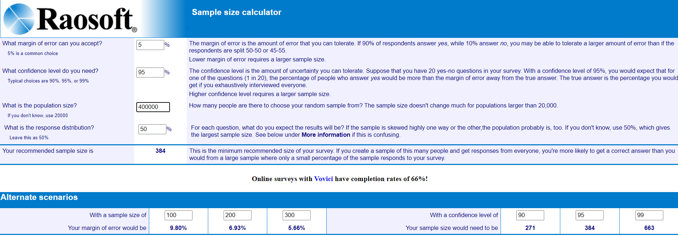
Figure 18: Sample size calculation with the use of Raosoft
Source: (Raosoft.com, 2020)

The sampling method of this study will be a non-probability sampling method. The non-probability method is cost-effective and time-effective. More specifically, snowballing and purposive sampling will be used, which are types of non-probability sampling. Purposive sampling will be used as this research is going to study the impact of Covid-19 on the hotel, so the hotel staff will be included in the study as they link to the purpose of the study. While the snowballing technique will reach a larger population as managers, colleagues, and hotel staff sent the questionnaire to more people working in the industry.
  - Data Collection and Data Analysis Methods
Data analysis process carried out to inspect and retrieve information that can be used in the decision making and conclusion of the study. SPSS 26 is used for the descriptive analysis, like graphs, frequencies, means, percentages, standard deviation, and cross-tabulations, to measure the relationship between different variables, cross-tabulation will be used. This study will use the primary data collection method, and a questionnaire will be distributed to participants and later analyze by the IMB SPSS 26.
    - Questionnaire Design
The questionnaire of this study includes 26 questions, out of which 6 questions are related to demographic and 20 related to the variables and research objectives. This questionnaire includes only closed-ended questions to get precise responses from the participants.
Likert scale methods have been used in this study get the responses from the participants; this method is used due to the simplicity and precise response.
Likert scale from a scale of 1 to 5 is used in 20 questions to get the response of participants about how strong they agree or disagree with the statement.
The questionnaire is divided into six sections. Section A is related to demographic questions. Section B is related to the independent variable “Fear of Contagion.” Section C is related to the independent variable “Travel Restrictions.” Sections D is related to the independent variable “Operational Challenges.” Section E is related to the dependent variable “UAE hospitality industry” and research objective “To estimate the financial loss in the hospitality industry of the UAE.” Section F is related to the dependent variable “UAE hospitality industry” and to the research objective “to identify the measures taken by the UAE hospitality industry during this crisis.” Refer to Appendix G for the survey questionnaire.
  - Ethical Consideration
This study fully complies with research ethics and practices. While collecting data from participants, the intent of collecting data was informed to them, and the introduction was given, so participants know who is conducting data collection and why, to ensure privacy and anonymity, the questionnaire did not require names, mobile numbers, or any other contact details, which can lead to the participants. Participants must not feel any compulsion to participate in the study and feel free to participate by their own choice. During this research, there must not be any harm to the participants of this study, and their private data must be protected; further anonymity of the participants is ensured. All the data was protected and not misused. Data should not be misinterpreted and distorted. Any information collected from other sources or writers must be cited, and proper references are provided.

Chapter IV: Research Findings and Discussion
  - Introduction
In this chapter, information analysis and interpretation will be done and will provide the result of data collection, which was collected through a questionnaire. The data is analyzed by statistic software named IBM SPSS 26.0, to display the demographic and statistical information graphs and charts are used.
  - Pilot Test
The total sample size of the study is 384 participants. The pilot test is normally conducted on 10% of the total participants. In this study, the 40 respondents are used as pilot tests. The pilot test was conducted before the total data collection; it includes reliability test and factor analysis, more details in Appendix A.

KMO and Bartlett's Test
Kaiser-Meyer-Olkin Measure of Sampling Adequacy. |  | .708
Bartlett's Test of Sphericity | Approx. Chi-Square | 743.917
Bartlett's Test of Sphericity | df | 253
Bartlett's Test of Sphericity | Sig. | .000
Table 17: KMO and Barlett’s Test, Pilot Test

Kaiser Mayer Olkin (KMO) value of the independent and dependent variables is 0.708, which comes under the “middling” category based on Measurement of Sampling Adequacy (MSA).

Reliability Statistics
Cronbach's Alpha | Cronbach's Alpha Based on Standardized Items | N of Items
.931 | .931 | 20
Table 18: Cronbach’s Alpha, Pilot Test

Cronbach’s Alpha value of the reliability test of 3 independent variables, which are Fear of Contagion, Travel Restrictions, Operational Challenges and 1 dependent variable, which is UAE Hospitality Industry is 0.931, which show that variables have good internal consistency. Based on the result of the pilot test, data collection can be started as the pilot test is passed.
  - Descriptive Analysis and Frequency
The demographic part of this research includes gender, age, education, designation, region, hotel groups of 325 respondents.
    - Gender
Based on figure 19, majority of the respondents are male which consist of 63.10% of overall respondents totalling 205 respondents out of 325 respondents, while female respondents are 36.90% of the overall sample size which comprised of 120 respondents.

Figure 19: Respondent’s Gender

    - Age
According to Figure 20, the highest number of respondents are from the age group of 30-39, which are 164 respondents totalling to 50.50% of overall respondents. The second-highest number is 24.90% of the overall sample size for the age group of 40-49, which are 81 respondents. Third highest age group is 20-29, which is 18.50% overall respondents consist of 60 respondents; at last 6.20% of respondents are from the age group of 50 and above consist of 20 respondents.

Figure 20: Respondent’s Age

    - Education
According to Figure 21, the majority of the respondent hold bachelor degree with 67.70% of overall sample size consists of 220 respondents. Second highest respondents hold a diploma, which is 57 respondents consist of 17.50% of overall respondents. On third 38 respondents holds Master/PhD making 11.70% of overall sample size. There are 10 respondents holding Primary/Secondary school education, making 3.10% of the overall sample size.

Figure 21: Respondent’s Education

    - Designation
Figure 22 shows 95 respondents are managers, which is 29.20% of total sample size. Second highest 86 respondents are associates, and 26.50% of the overall sample size. Third highest respondents are directors who are 58 respondents consist of 17.80% of overall sample size. Fourth highest respondents are supervisors consist of 17.50% of the total population, totalling 57 respondents. Lastly, responses from the general managers are 29, which are 8.90% of total sample size.

Figure 22: Respondent’s Designation

    - Region
According to Figure 23 the majority of the respondents based in UAE are from South Asia, there are a total of 146 respondents consist of 44.90% of the total sample size. Followed by Europe 60 respondents 18.50%, Asia Pacific 56 respondents 17.20%, Middle East 42 respondents 12.90%, Africa 20 respondents 6.20% and lastly South America with 1 respondent 0.30% of the total population.

Figure 23: Respondent’s Region

    - Hotel Group
According to Figure 24 the most respondents are from Marriott which are 126 respondents, comprising of 38.8% of overall population. Followed by 26 respondents from Jumeirah 8.0% of overall sample size, 20 respondents from Address 6.2%, 18 respondents from Hyatt 5.5%, 17 respondents from Intercontinental 5.2%, 17 respondents from Hilton 5.2%, 16 respondents from Oberoi 4.9%, 15 respondents from Taj 4.6%, 14 respondents Mandarin Oriental 4.3%, 13 respondents from Atlantis 4.0%, 11 respondents from Wyndham 3.4%, 9 respondents from Shangri-La 2.8%, 9 respondents from Anantara 2.8%, 5 respondents from Radisson 1.5%, 5 respondents from Millennium 1.5%, 2 respondents from Rotana 0.6%, 1 respondent from Accor 0.3%, 1 respondent from Four Seasons 0.3%.

Figure 24: Respondent’s Hotel Group

  - Factor Analysis
In this analysis, the component matrix represents the value of the loading factor. The value of the factor load describes the correlation between the variables. If the value of the Kaiser Mayer Olkin (KMO) is above 0.6, it shows that the value is acceptable. The value of the Bartlett sphericity test must be below 0.05 to be considered significant. Below in Table 19, component analysis of dependent and independent variable can be seen, which was done by the IBM SPSS 26.
KMO and Bartlett's Test
Kaiser-Meyer-Olkin Measure of Sampling Adequacy. |  | .896
Bartlett's Test of Sphericity | Approx. Chi-Square | 3772.106
Bartlett's Test of Sphericity | df | 190
Bartlett's Test of Sphericity | Sig. | .000
Table 19: KMO and Barlett’s Test, Factor Analysis

Communalities
 | Initial | Extraction
SI1 | 1.000 | .802
SI2 | 1.000 | .723
SI3 | 1.000 | .795
PP1 | 1.000 | .776
PP2 | 1.000 | .768
PP3 | 1.000 | .732
VA1 | 1.000 | .556
VA2 | 1.000 | .615
VA3 | 1.000 | .648
C1 | 1.000 | .709
C2 | 1.000 | .623
C3 | 1.000 | .603
C4 | 1.000 | .605
C5 | 1.000 | .567
C6 | 1.000 | .675
C7 | 1.000 | .758
C8 | 1.000 | .672
C9 | 1.000 | .557
C10 | 1.000 | .680
C11 | 1.000 | .727
Extraction Method: Principal Component Analysis.
Table 20: Factor Analysis of Dependent and Independent Variables
The value of the Kaiser Mayer Olkin (KMO) is 0.89, which is considered to be “Meritorious” based on the value of Measurement of Sampling Adequacy (MSA), this shows that there is relevancy between independent and dependent variables of the study. Table 19 above shows the value of Bartlett’s Test of Sphericity which is 0.00, which is less than the maximum value of 0.05, shows that there is a correlation between variables.
According to Table 20, which is the communalities table, the extraction value for each variable is 0.5 or above. The values range from 0.556 to 0.802, which show that the variables are accepted.
  - Reliability Test
In order to complete the factor analysis, the reliability test must be conducted on the independent and dependent variables. Reliability tests help to check the internal consistency, it shows the same situation shows the same outcome (Sekaran and Bougie, 2016). In this study, there are 4 variables, 3 independent and 1 dependent variable. The Cronbach’s Alpha Values tested for the 20 items, and the value is 0.856. Table 21 shows the Cronbach Alpha value of 20 items, which is 0.856. The value is acceptable and reliable and shows “Good” reliability level, and the study can proceed.

Reliability Statistics
Cronbach's Alpha | Cronbach's Alpha Based on Standardized Items | N of Items
.856 | .856 | 20
Table 21: Cronbach’s Alpha, Reliability Test

Below Table 22 shows each variable and its Cronbach’s Alpha value. The highest value 0.888 for Fear of Contagion, shows high internal consistency in 3 questions, 0.880 for Travel Restrictions in 3 questions, 0.841 for Operational Challenges in 3 questions, 0.827 for UAE Hospitality Industry in 11 questions. The Cronbach’s Alpha values for the variables are above 0.5 and falls into “Good” reliability level and shows high internal consistency.

Factors | Cronbach's Alpha | Items in each variable
UAE Hospitality Industry | .827 | 11
Fear of Contagion | .888 | 3
Travel Restriction | .880 | 3
Operational Challenges | .841 | 3
Table 22: Cronbach’s Alpha value for each variable

  - Hypothesis Testing
In this study, the correlation and Multiple Regression Analysis is used to describe the relationship between the variables and analysis.
    - Multiple Regression Analysis
Multiple Regression helps to explain the influence of the independent variable on the dependent variables. There are 3 independent variables, which are Fear of Contagion, Travel Restrictions, and Operational Challenges and 1 dependent variable, which is the UAE Hospitality Industry.

Model Summary^{b}
Model | R | R Square | Adjusted R Square | Std. Error of the Estimate | Durbin-Watson
1 | .759ª | .756 | .698 | 2.16673 | 1.692
a. Predictors: (Constant), Operational Challenges, Fear of Contagion, Travel Restriction
b. Dependent Variable: UAE Hospitality Industry
Table 23: Model Summary of Independent Variables

Model Summary shows the value of R and R-square. In this study, the value of R is 0.759, and R-square value is 0.756, that describes that the 75.6% of the respondent believe the Covid-19 impacted the hospitality industry of UAE, which were explained by the variables named Fear of Contagion, Travel Restrictions, and Operational Challenges while remaining could be explained by factors outside of the scope of the study. More details in Appendix F.

ANOVAª
Model |  | Sum of Squares | df | Mean Square | F | Sig.
1 | Regression | 259.479 | 3 | 617.493 | 131.530 | .000^{b}
1 | Residual | 150.466 | 321 | 4.695
1 | Total | 409.946 | 325
a. Dependent Variable: UAE Hospitality Industry
b. Predictors: (Constant), Operational Challenges, Fear of Contagion, Travel Restriction
Table 24: ANOVA Table.

Coefficientsª
Model |  | Unstandardized Coefficients |  | Standardized Coefficients | t | Sig.
 |  | B | Std. Error | Beta | t | Sig.
1 | (Constant) | -.628 | .224 |  | -2.585 | .000
1 | Fear of Contagion | .420 | .054 | .362 | 7.807 | .000
1 | Travel Restriction | .282 | .048 | .237 | 7.235 | .000
1 | Operational Challenges | .187 | .037 | .135 | 6.909 | .000
a. Dependent Variable: UAE Hospitality Industry
Table 25: Multiple Regression Analysis

Table 25 shows the Coefficients results of independent and dependent variables and significance of all independent variables, which are Fear of Contagion, Travel Restriction, Operational Challenges and dependent variable, which is the UAE Hospitality Industry.
According to Table 25, Fear of Contagion has statistical significance with a p-value of 0.000 and t-value of 7.807, which means Fear of Contagion has positive strength of 78%. The value of Beta of Fear of Contagion is 0.362, which means that improvement in every single unit of Fear of Contagion impact on UAE Hospitality Industry will increase 0.362. It also shows that Fear of Contagion has a positive relationship with UAE Hospitality Industry.
In Table 25, Travel Restriction has statistical significance with a p-value of 0.000 and t-value of 7.235, which means Travel Restriction has positive strength of 72%. The value of Beta of Travel Restriction is 0.237, which means that improvement in every single unit of Travel Restriction impact on UAE Hospitality Industry will increase 0.237. It also shows that Travel Restriction has a positive relationship with UAE Hospitality Industry.
According to Table 25, Operational Challenges has statistical significance with a p-value of 0.000 and t-value of 6.909, which means Operational Challenges has positive strength of 69%. The value of Beta of Operational Challenges is 0.135, which means that improvement in every single unit of Operational Challenges impact on UAE Hospitality Industry will increase 0.135. It also shows that Operational Challenges has a positive relationship with UAE Hospitality Industry.
In conclusion, all 3 independent variables of this study are accepted and have a significant and positive relationship with the dependent variable. All the variable fit in regression model strongly. The summary of the variables is:

Y = 0.420 SI + 0.282 PP + 0.187 VA – 0.628
Y = UAE Hospitality Industry
SI = Fear of Contagion
PP = Travel Restriction
VA = Operational Challenges
    - Correlations
Correlation helps to describe the relationship between independent variables and dependent variables. Pearson correlation is used to describe the relationship between the variables. Relationship between 2 quantitative variables can be measured by it. Below Table 26 show scale and interpretation of the correlation results.

SCALE | INTERPRETATION
0 to 0.29 | Weak
0.30 to 0.49 | Moderate
More than 0.50 | Strong
Table 26: Interpretation of the correlation scale

H1: Fear of contagion is negatively affecting the hospitality industry of UAE
Correlations
 |  | UAE Hospitality Industry | Fear of Contagion
UAE Hospitality Industry | Pearson Correlation | 1 | .629**
UAE Hospitality Industry | Sig. (2-tailed) |  | .000
UAE Hospitality Industry | N | 325 | 325
Fear of Contagion | Pearson Correlation | .629** | 1
Fear of Contagion | Sig. (2-tailed) | .000
Fear of Contagion | N | 325 | 325
**. Correlation is significant at the 0.01 level (2-tailed).
Table 27: Correlation of UAE hospitality Industry and Fear of Contagion

Table 27 shows the Sig=0.000; this describes a positive and strong relationship between Fear of Contagion and UAE Hospitality Industry. It also shows that the Pearson Correlation value is more than 0.5, which describe that the Fear of Contagion has a high impact on the UAE Hospitality Industry and guest are not staying in hotels due to fear of Covid-19.

H2: Travel restrictions by governments is negatively affecting the hospitality industry of the UAE
Correlations
 |  | UAE Hospitality Industry | Travel Restrictions
UAE Hospitality Industry | Pearson Correlation | 1 | .645**
UAE Hospitality Industry | Sig. (2-tailed) |  | .000
UAE Hospitality Industry | N | 325 | 325
Travel Restrictions | Pearson Correlation | .645** | 1
Travel Restrictions | Sig. (2-tailed) | .000
Travel Restrictions | N | 325 | 325
**. Correlation is significant at the 0.01 level (2-tailed).
Table 28: Correlation of UAE hospitality Industry and Travel Restriction

Table 28 shows the Sig=0.000; this describes a positive and strong relationship between Travel Restrictions and UAE Hospitality Industry. It also shows that the Pearson Correlation value is more than 0.5, which describe that the Travel Restrictions has a high impact on the UAE Hospitality Industry and guest are not able to travel and stay in hotels due to travel restrictions imposed by the different governments.

H3: Operational challenges are negatively affecting the hospitality industry of UAE
Correlations
 |  | UAE Hospitality Industry | Operational Challenges
UAE Hospitality Industry | Pearson Correlation | 1 | .586**
UAE Hospitality Industry | Sig. (2-tailed) |  | .000
UAE Hospitality Industry | N | 325 | 325
Operational Challenges | Pearson Correlation | .586** | 1
Operational Challenges | Sig. (2-tailed) | .000
Operational Challenges | N | 325 | 325
**. Correlation is significant at the 0.01 level (2-tailed).
Table 29: Correlation of UAE hospitality Industry and Operational Challenges

Table 29 shows the Sig=0.000; this describes a positive and strong relationship between Operational Challenges and UAE Hospitality Industry. It also shows that the Pearson Correlation value is more than 0.5, which describe that the Operational Challenges has a high impact on the UAE Hospitality Industry and staff and hotel management are facing difficulties to run their operations and due to government SOPs, and increase cost, social distancing and other operational difficulties.
  - Discussion on Findings
The pilot test with 40 respondents was conducted for this study, and all 20 items related to 3 independent variables and 1 dependent variable met the requirement during the reliability test and factor analysis. After the pilot test, the data collection was continued, during which 325 responses were collected out of 384, which was the targeted sample size. All 20 items met the requirement for the hypothesis testing.
According to the multiple regression analysis of independent, which are Fear of Contagion, Travel Restrictions, Operational Challenges and dependent variables, which is the UAE Hospitality Industry shows a strong relationship with each other.
Based on the multiple regression analysis Fear of Contagion has a strong relationship with the UAE Hospitality Industry as people are afraid of Covid-19 they not travelling and preferring to stay at home. People are afraid because still there is no treatment of the infection, and Covid-19 proved to be deadly among many people; this led to less occupancy in the hotels of UAE.
According to the multiple regression analysis, Travel Restrictions has a strong relationship with the UAE Hospitality Industry. Many governments and countries have imposed travel bans and lockdowns, which limits the domestic and international travel. The UAE Government also implemented the travel restrictions and lockdowns, which led to the decline of inbound tourism in the UAE and directly impacted the UAE hospitality industry UAE
According to the multiple regression analysis, Operational Challenges has a strong relationship with the UAE Hospitality Industry. Covid-19 has increased the tasks and challenges of the UAE Hospitality Industry, as hotels need to disinfect, follow government SOPs, maintaining social distancing, staff Covid-19 tests, and supply chain disruption etc. which increase the cost of the operations and created extra workload for the UAE Hospitality Industry.
  - Summary of Hypothesis Results
According to the Correlation and Multiple Regression Analysis, there is statistical significance in all 3 independent variables; therefore, all H1, H2, H3 are acceptable.

HYPOTHESIS | RESULTS
H1: Fear of Contagion is negatively affecting the hospitality industry of the UAE | Supported
H2: Travel Restrictions by governments is negatively affecting the hospitality industry of the UAE | Supported
H3: Operational Challenges are negatively affecting the hospitality industry of the UAE | Supported
Table 30: Hypothesis Testing Results

Chapter V: Conclusion and Recommendations
  - Introduction
This chapter will discuss the result of chapter 4 and provide a conclusion of this study. It will also discuss the limitation of the study and will provide recommendations; at last, this chapter will provide personal reflection.
  - Findings and Conclusion
The purpose of this research is to identify how Covid-19 impacted the hospitality industry. This study identifies three major factors that impacted the hospitality industry of UAE caused by Covid-19, which are Fear of Contagion, Travel Restrictions, and Operational Challenges. A questionnaire distributed to hotel employees working in UAE and data collection was done to test 3 hypotheses.
Statistical analysis showed that there is a positive and significant relationship between 3 independent variables, which are Fear of Contagion, Travel Restrictions and Operational Challenges and the dependent variable, which is the UAE Hospitality Industry. The R-value of this research is .756, which indicate that 75.6% respondents believe that impact on the UAE Hospitality Industry is affected by the three factors which are Fear of Contagion, Travel Restrictions, and Operational Challenges. Findings and analysis indicate that there is a significant and positive relationship between the dependent variable and three independent variables.
Hypotheses 1 (H1): Fear of Contagion is negatively affecting the hospitality industry of the UAE
Fear of Contagion has the highest Beta value which is 0.362, that indicates UAE Hospitality Industry is most affected by the Fear of Contagion, as more and more people are afraid of the infection and are not travelling. The trend will last till there is enough vaccination done, and people again feel safe to travel.
Hypotheses 2 (H2): Travel Restrictions by governments is negatively affecting the hospitality industry of the UAE
Travel Restrictions has second-highest Beta value which is 0.237, which indicates due to government travel restrictions and lockdowns, people are unable to travel freely, especially international travel, which negatively affected the hospitality industry of UAE. Hotels are not able to welcome many guests, which is affecting the occupancy rates and revenue.
Hypotheses 3 (H3): Operational Challenges are negatively affecting the hospitality industry of the UAE
Operational Challenges has the third-highest Beta value, which is 0.135, which indicates that the operational challenges affected the hospitality industry of the UAE. These operational challenges arise from government SOPs, staff medical tests, hotel disinfection, supply chain disruption, temporary closer to restaurants and rooms to contain the spread of Covid-19 and overcome staff shortage.
In conclusion, all three hypotheses support the study based on statistical analysis.
  - Recommendations
- UAE Government must support the hospitality industry. UAE Government can reduce or exempt taxes and other fees for the hotels. It will help hotels to run the business and survive this pandemic.
- UAE Government should ease travel restrictions by maintaining precautions. UAE Government should make traveling procedure easy. The documentation must be done, but the procedure must be simple to fast to attract guests and tourists.
- UAE Government should make the vaccine available as soon as possible for travelers. UAE is a rich country and can invest in procurement of Covid-19 vaccine, as UAE national population is just 3 million and 6.5 million are expatriates and each year, more than 20 million tourist visits UAE. UAE Government can vaccinate tourists also. It will help the UAE to attract tourist and will create goodwill for the destination.
- The hospitality industry should increase marketing efforts. The hotels must put extra efforts to attract guests. Hotels need to create videos and add information regarding the precaution measure so that guests can feel safe. Information and videos can include staff wearing masks, disinfection procedure, certifications from UAE Government etc.
- Hotels should be flexible with booking conditions and cancellation rules. The Covid-19 pandemic is not slowing down, and government and countries are changing their policies on a weekly and monthly basis, which makes it difficult for tourists to plan their visit and if they have to spend extra money because off change in policies and later have to pay for the cancellation or reschedule of their hotel bookings, it will refrain guests from making reservations. Flexible booking conditions and not charging for cancellation will help to attract more guests.
- Adopt preventative measures for guests and staff. Hotels must use the latest technology to disinfect the property, detect Covid-19, and implement cash-less payment. Hotels can maximize cash-less payment to avoid the spread of potential infection. Hotels can install temperature check device to avoid potential Covid-19 guest in the hotel, now new methods and technologies are coming which can detect Covid-19 in minutes, hotels can have those devices to detect possible spread in the hotel. Hotels should also reduce the paper bill and move to electronic bills for the rooms and restaurant bills, to avoid contact. Hotels can also fix glass or plastic panels at the front desk to avoid contact, as receptions are most crowded and have maximum contact. Hotels also need to buy good disinfectants which are easy to use and can kill Covid-19 virus to maintain maximum protection.
- Hotels should focus on maintenance efforts. During this pandemic some hotels have closed their operation or temporarily closed some outlets or rooms, this is the time when hotels can focus on their renovation and other maintenance services, once the Covid-19 is limited tourism will return, and hotels will see a rise in occupancy level, by renovation and maintenance hotels can present themselves better position above those properties which did not do that.
  - Contributions
This study contributes to the different stakeholders like academia, industry, government, medical community.
    - Contributions to Academia
This research will also contribute to the academic field, and future students can see and learn from this and write their research; it will also help students of hospitality management to understand how the industry is performing and will provide them with valuable knowledge which can be useful in their career in future.
This research will set a benchmark for future researchers who would like to research this topic and can see this research and get guidance from it and make improvements in any future studies. Research can also further elaborate on the subject and include more factors and knowledge into current research.
    - Contributions to Industry
Most importantly, this study will help hospitality employees how this pandemic created challenges for them and how they can implement different strategies to overcome them. They can develop different strategies to overcome operational challenges and create marketing strategies to attract guests. It will also help top management of the hospitality industry to develop long-term plans which can help the industry to avoid this kind of situation in the future.
    - Contribution to Government
This study will also help the government to see the current situation of the industry and try to come up with possible solutions. The UAE Government has been promoting the country to be a tourist destination. In the current situation, the government must assess the situation to help them to survive and revive so that the country can maintain its image and progress further.
    - Contribution to Medical Community
This research can also help the medical and scientific community to create and develop different ways to detect viral diseases and limit the spread of the infection, as the hospitality industry deals with people, crowded places, visitors coming from various regions and background, medical and scientific community need to come up with methods and techniques which can help to identify and detect the viral diseases effectively and quickly.
  - Recommendations for Future Research
This study can be the basis of any future study conducted on the same topic and can be improved with more detail information and by adding more aspects which are not included in this study, as during this study pandemic is still going on most of the information contained in this research currently available.
Future studies and can cover much more information, as more and more information coming now regarding this pandemic and its effects on the hospitality industry, as shown in this study the Fear of Contagion, Travel Restriction and Operational Challenges have affected the hospitality industry. Hotels can conduct their research and base on this research and see how each hotel is affected by the pandemic and find solutions to revive the business.
UAE Government can also conduct further studies and can have a broader understanding as they have more resources and information to better estimate the impact and suggest and implement solutions. UAE Government can also include other tourism sectors in the study to have a bigger overview, as tourism sectors interlink with each other, and it is very important to support all sectors to revive the industry.

  - Personal Reflection
I chose to conduct my research on this topic, as I worked in the Hospitality Industry for six years, and I was working for Marriott International in UAE, and my degree is also in hospitality management.
Covid-19 has negatively impacted the hospitality and tourism industry around the world. It is the most recent phenomenon which and which impacted the hospitality industry, which never seen before in history. As a hospitality professional, it was an opportunity to see learn more about this pandemic and how it affected the industry in the UAE.
This research helped me to know to learn more about the research and its steps, like coming up with the appropriate title, creating research questions, identifying target population, finding journals and creating a questionnaire. During this journey, my lecturer, supervisor, second panel and friends helped me to successfully complete my research.
It was a new experience for me that taught me how to write a literature review and carefully select each word and identify and point out the exact problem of the study. This research also helped me to improve my reading and writing skills. I have read many journals and books, which helped me to select the right information and material for my research.
This research also helped me to improve my research and computer skills as I had to find information regarding the tourism and hospitality information for which I had to visit many websites, create an online questionnaire, and improve my research structure. It also helped me to improve my presentation skills and create presentation slides and easily and effectively convey the information to the supervisor and second panel.
Completing this research motivated me to face challenging situations, problem-solving, and time management. After completing this research, it also motivated me to do more research on another topic in future and pursue my PhD. I am confident in future all these skills and knowledge will help me in my PhD studies and future career.

REFERENCES
- Abbas, W., 2020. Special: UAE-Israel Travel Could Get A Boost. [online] https://www.khaleejtimes.com/business/local/UAE-Israel-travel-could-get-a-boost-. Available at: <https://www.khaleejtimes.com/business/local/UAE-Israel-travel-could-get-a-boost-> [Accessed 25 October 2020].
- Abu Dhabi Airport, 2020. Flying In And Out Of Abu Dhabi International Airport. [online] www.abudhabiairport.ae. Available at: <https://www.abudhabiairport.ae/en/announcement#:~:text=After%20the%20four%2Dday%20isolation,their%20arrival%20in%20the%20UAE.> [Accessed 23 October 2020].
- Abu Dhabi Department of Culture & Tourism, 2018. Abu Dhabi Hotel Classification Manual. Abu Dhabi: Department of Culture & Tourism, pp.1-75.
- Accor, 2020. Our History. [online] group.accor.com. Available at: <https://group.accor.com/en/group/who-we-are/our-history> [Accessed 14 October 2020].
- Adom, D., Hussein, E. and Agyem, J., 2018. THEORETICAL AND CONCEPTUAL FRAMEWORK: MANDATORY INGREDIENTS OF A QUALITY RESEARCH. INTERNATIONAL JOURNAL OF SCIENTIFIC RESEARCH, 7(1), pp.438-441.
- Agusi, E., Ijoma, S., Ijoma, S. and Meseko, C., 2020. The COVID-19 pandemic and social distancing in Nigeria: ignorance or defiance. Pan African Medical Journal, 35(2), pp.1-3.
- Ahmed, S., 2020. The Coronavirus Disease 2019 (Covid-19): A Review. Journal Of Advances In Medicine And Medical Research, 32(4), Pp.1-9.
- Ajman Tourism Development Dept, 2020. About Ajman. [online] ajman.travel/en. Available at: <https://ajman.travel/en/facts/about-ajman/> [Accessed 13 October 2020].
- Bakioğlu, F. and Korkmaz, O., 2020. Fear of COVID-19 and Positivity: Mediating Role of Intolerance of Uncertainty, Depression, Anxiety, and Stress. International Journal of Mental Health and Addiction,.
- Barrows, C. And Powers, T., 2009. I N T R O D U C T I O N T O T H E Hospitality Industry. 7th Ed. New Jersey: John Wiley & Sons, Inc., Pp.268-283.
- Bell, A., 2020. Navigating The Hotel Star System. [Online] Www.Investopedia.Com. Available At: <Https://Www.Investopedia.Com/Financial-Edge/0410/Navigating-The-Hotel-Star-System.Aspx> [Accessed 2 October 2020].
- Best Western International, Inc., 2020. Best Western Timeline And Story. [online] www.bestwestern.com. Available at: <https://www.bestwestern.com/en_US/about/press-media/best-western-timeline-and-story.html> [Accessed 15 October 2020].
- Best Western International, Inc., 2020. Discover Best Western. [online] www.bestwestern.com. Available at: <https://www.bestwestern.com/en_US/hotels/discover-best-western.html> [Accessed 15 October 2020].
- Bhutia, P., 2020. Effect Of Covid-19 On Sikkim Tourism – A Case Study. Ugc Care Journal, 19(32), Pp.298-309.
- Bougie, R. and Sekaran, U. 2019. Research Method for Business: A Skill Building Approach. Hichester: John Wiley & Sons Ltd.
- Burrows, J., 2020. 2021 Sporting Calendar: From Tokyo Olympics To Euro 2020, The Rescheduled Events For Next Year. [Online] Https://Www.Telegraph.Co.Uk/Sport/0/2021-Sporting-Calendar-Tokyo-Olympics-Euro-2020-Rescheduled/. Available At: <Https://Www.Telegraph.Co.Uk/Sport/0/2021-Sporting-Calendar-Tokyo-Olympics-Euro-2020-Rescheduled/> [Accessed 9 October 2020].
- Camilleri, M. A. (2018). The Tourism Industry: An Overview. In Travel
Marketing, Tourism Economics and the Airline Product (Chapter 1, pp. 3-27). Cham,
Switzerland: Springer Nature.
- Cano, G., 2020. A Perspective About Coronavirus Disease 2019 (Covid-19). Digital Scientific Journal, [Online] 4(2).
- Cao, W., Fang, Z., Guoqiang, H., Han, M., Xu, X., Dong, J. And Zheng, J., 2020. The Psychological Impact Of The Covid-19 Epidemic On College Students In China. Psychiatry Research, 287(112934).
- Casilli, R., 2020. In Pictures: The Impact Of Coronavirus On Italy’s Tourism. [Online] Www.Aljazeera.Com. Available At: <Https://Www.Aljazeera.Com/Gallery/2020/3/3/In-Pictures-The-Impact-Of-Coronavirus-On-Italys-Tourism/> [Accessed 9 October 2020].
- Celestin, R., 2020. Impact Of Covid-19 Pandemic To Meetings, Incentives, Conferences And Exhibitions (Mice) Tourism In Rwanda. The Strategic Journal Of Business & Change Management, 7(3), Pp.395-409.
- Chinazzi, M., Davis, J., Ajelli, M., Gioannini, C., Litvinova, M., Merler, S., Piontti, A., Mu, K., Rossi, L., Sun, K., Viboud, C., Xiong, X., Yu, H., Halloran, M., Longini Jr., I. And Vespignani, A., 2020. The Effect Of Travel Restrictions On The Spread Of The 2019 Novel Coronavirus (Covid-19) Outbreak. Science, 368(6489), Pp.395-400.
- Choice Hotels International, Inc., 2020. A HISTORY OF INNOVATION. [online] www.choicehotels.com. Available at: <https://www.choicehotels.com/about/corporate-history> [Accessed 14 October 2020].
- Cook, R., Hsu, C. And Taylor, L., 2018. Tourism The Business Of Hospitality And Travel. 6th Ed. New York: Pearson Education Limited, Pp.175-201.
- Cook, S., 2020. What’S Behind The New Israel-UAE Peace Deal?. [online] https://www.cfr.org/in-brief/whats-behind-new-israel-uae-peace-deal. Available at: <http://What’s Behind the New Israel-UAE Peace Deal?> [Accessed 25 October 2020].
- Corder, J., 2020. Official Kosher Meal Certificate Launched For Abu Dhabi Hotels. [online] www.hoteliermiddleeast.com. Available at: <https://www.hoteliermiddleeast.com/news/120004-official-kosher-meal-certificate-launched-for-abu-dhabi-hotels> [Accessed 25 October 2020].
- Corder, J., 2020. Tourism Is Crucial To UAE’S Long-Term Economic Development Plan, Says Officials. [online] www.arabianindustry.com. Available at: <https://www.arabianindustry.com/hospitality/news/2020/aug/26/tourism-is-crucial-to-uaes-long-term-economic-development-plan-says-officials-6422416/#close> [Accessed 23 October 2020].
- Corder, J., 2020a. COVID-19 Has Made Valuing Hotels Impossible According To Cavendish Maxwell Report. [online] www.hoteliermiddleeast.com. Available at: <https://www.hoteliermiddleeast.com/news/118768-covid-19-has-made-valuing-hotels-impossible-according-to-cavendish-maxwell-report> [Accessed 23 October 2020].
- Corder, J., 2020b. Events In Dubai Resume As Tourism Normalises. [online] www.hoteliermiddleeast.com/. Available at: <https://www.hoteliermiddleeast.com/news/118800-events-in-dubai-resume-as-tourism-normalises> [Accessed 23 October 2020].
- Dozois, D. and Rnic, K., 2019. Abnormal Psychology: Perspectives. 6th ed. Toronto: Pearson, pp.48-61.
- Dubai Airports, 2020. COVID-19 UPDATE. [online] www.dubaiairports.ae. Available at: <https://www.dubaiairports.ae/> [Accessed 23 October 2020].
- Dubai Corporation of Tourism & Commerce Marketing, 2020. About Dubai. [online] www.visitdubai.com. Available at: <https://www.visitdubai.com/en/explore-dubai/about-dubai#About%20Dubai> [Accessed 13 October 2020].
- Dubai Covid-19 Command and Control Center, 2020. Home Isolation And Quarantine Guidelines During Coronavirus (COVID 19) Pandemic. First Issue/ May 2020. Dubai: Government of Dubai, pp.1-15.
- Dubai Department of Tourism and Commerce Marketing, 2014. Budget Hotel Check List. Version 1. Dubai: Department of Tourism and Commerce Marketing, pp.1-24.
- Dubai Department of Tourism and Commerce Marketing, 2014. Hotel 3 Star Check List. Version 1. Dubai: Department of Tourism and Commerce Marketing, pp.1-60.
- Dubai Tourism, 2020. HOTEL ESTABLISHMENT GUIDELINES. COVID19 – VERSION 3. Dubai: Dubai Tourism, pp.1-121.
- Eilers, C., 2020. Types Of Hotels: Complete Glossary Of 30+ Hotel Types Terms Defined. [Online] Djaunter.Com. Available At: <Https://Djaunter.Com/Types-Of-Hotels/> [Accessed 2 October 2020].
- Expo 2020, 2020. Expo 2020 Dubai At A Glance. [online] www.expo2020dubai.com. Available at: <https://www.expo2020dubai.com/en/discover/optimism-survey> [Accessed 23 October 2020].
- Fattah, Z., 2020. Dubai Hotels May Cut 30% Of Jobs Until Demand Recovers: STR. [online] www.bloombergquint.com. Available at: <https://www.bloombergquint.com/onweb/dubai-may-lose-a-third-of-hotel-jobs-as-virus-devastates-tourism> [Accessed 25 October 2020].
- Feilder, R., 2020. How Has The Coronavirus Pandemic Impacted The UAE?. [online] storymaps.arcgis.com. Available at: <https://storymaps.arcgis.com/stories/a1b0be69bbea4b60ad7a7b34ec4fa158> [Accessed 25 October 2020].
- Foo, L., Chin, M., Tan, K. And Teng, P., 2020. The Impact Of Covid-19 On Tourism Industry In Malaysia. Current Issues In Tourism, Pp.1-5.
- Foris, D., 2014. Comparative Analysis Of Hotel Classification And Quality Mark In Hospitality. Journal Of Tourism And Hospitality Management, 2(1), Pp.26-39.
- Fujairah Government, 2019. About Fujairah. [online] fujairah.ae. Available at: <https://fujairah.ae/en/pages/about.aspx> [Accessed 13 October 2020].
- Grant, C. and Osanloo,A., 2014. Understanding, Selecting, and Integrating a Theoretical
Framework in Dissertation Research: Creating the Blueprint for ‘House’.
Administrative Issues Journal: Connecting Education, Practice and Research, Pp. 12-22.
- Guidry, J., Carlyle, K., Perrin, P., LaRose, J., Messner, M. and Ryan, M., 2019. Using the Health Belief Model to Analyze Instagram Posts about Zika for Public Health Communications. Emerging Infectious Diseases, 25(1), pp.179-180.
- Günay, F., Bayraktaroğlu, E. And Özkul, K., 2020. Assessing the Short-Term Impacts of Covid-19 Pandemic on Foreign Visitor’s Demand for Turkey: A Scenario Analysis. Journal of Ekonomi, 4(2020), Pp.80-85.
- Hair, J.F., Black, W.C. and Babin, B.J. 2018. Multivariate data analysis. 8th ed. Harlow, UK: Pearson Education Limited.
- Haryanto, T., 2020. COVID-19 PANDEMIC AND INTERNATIONAL TOURISM DEMAND. Journal of Developing Economies, 5(1), pp.1-5.
- Hill, A., 2019. Kosher Food: Everything You Need To Know. [online] www.healthline.com. Available at: <https://www.healthline.com/nutrition/what-is-kosher> [Accessed 25 October 2020].
- Hilton, 2020. HISTORY AND HERITAGE. [online] www.hilton.com. Available at: <https://www.hilton.com/en/corporate/#2010s> [Accessed 14 October 2020].
- Holtham, A., 2020. How Hotels Are Making Changes In The Age Of COVID-19. [online] www.cntravellerme.com. Available at: <https://www.cntravellerme.com/how-hotels-are-making-changes-in-the-age-of-covid-19> [Accessed 25 October 2020].
- Hoque, A., Shikha, F., Hasanat, M., Arif, I. And Hamid, D., 2020. The Effect Of Coronavirus (Covid-19) In The Tourism Industry In China. Asian Journal Of Multidisciplinary Studies, 3(1).
- Hoque, A., Shikha, F., Hasanat, M., Arif, I. and Hamid, P., 2020. The Effect of Coronavirus (COVID-19) in the Tourism Industry in China. Asian Journal of Multidisciplinary Studies, 3(1).
- Hotelier Middle East, 2020a. Sharjah Rolls Out Own Hygiene Stamp For Tourism Industry. [online] www.hoteliermiddleeast.com. Available at: <https://www.hoteliermiddleeast.com/news/118702-sharjah-rolls-out-own-hygiene-stamp-for-tourism-industry> [Accessed 23 October 2020].
- Hotelier Middle East, 2020b. Dubai Hygiene Stamp Given To 90 Percent Of Hotels So Far. [online] www.hoteliermiddleeast.com. Available at: <https://www.hoteliermiddleeast.com/news/119293-dubai-hygiene-stamp-given-to-90-percent-of-hotels-so-far> [Accessed 23 October 2020].
- Hotelier Middle East, 2020c. Eight Dubai Restaurants Closed For Violations Since Shisha Reopening. [online] www.hoteliermiddleeast.com. Available at: <https://www.hoteliermiddleeast.com/news/118828-eight-dubai-restaurants-closed-for-violations-since-shisha-reopening> [Accessed 23 October 2020].
- Http://Www.Assoturismo.It. 2020. Coronavirus: Assoturismo, Already Burned 200 Million Euros Of Bookings For March. Messina: Work For Normalization Or Skip Everything. [Online] Available At: <Http://Www.Assoturismo.It/Coronavirus-Assoturismo-Gia-Bruciati-200-Milioni-Di-Euro-Di Prenotazioni-Per-Marzo-Messina-Lavorare-Per-La-Normalizzazione-O-Salta-Tutto.Html> [Accessed 9 October 2020].
- Hyatt Hotels Corporation, 2020. OUR HISTORY. [online] www.hyatt.com. Available at: <https://www.hyatt.com/development/ourhistory> [Accessed 14 October 2020].
- Ibrahim, A., 2020. INFLUENCE OF SOCIAL DISTANCING ON COVID-19. International Engineering Journal for Research & Development, 5(5), pp.1-4.
- InterContinental Hotels Group, 2020. Our History. [online] www.ihgplc.com. Available at: <https://www.ihgplc.com/en/about-us/our-history> [Accessed 14 October 2020].
- Islam, M., Sobur, M. And Rahman, M., 2020. Coronavirus Disease 2019 (Covid-19) Pandemic, Lessons To Be Learned!. Journal Of Advanced Veterinary And Animal Research, [Online] 7(2), Pp.260-280.
- Jahangir, M., Muheem, A. And Rizvi, M., 2020. Coronavirus (Covid-19): History, Current Knowledge And Pipeline Medications. International Journal Of Pharmaceutics & Pharmacology, [Online] 4(1).
- Jashaami, A., 2019. The Effect of Strategic Foresight on Tourism Marketing after COVID-19. African Journal of Hospitality, Tourism and Leisure, 8(1), pp.1-11.
- Jones, P., 2002. Introduction To Hospitality Operations: An Indispensable Guide To The Industry. 2nd Ed. Andover: Nelson Education Ltd, Pp.74-75.
- Jose, R., Narendran, M., Bindu, A., Beevi, N., Manju, L. and Benny, P., 2020. Public perception and preparedness for the pandemic COVID 19: A Health Belief Model approach. Clinical Epidemiology and Global Health,.
- Karantzavelou, V., 2020. Ufi Global Barometer Shows Global Impact Of Covid-19 Pandemic. [Online] Www.Traveldailynews.Com. Available At: <Https://Www.Traveldailynews.Com/Post/Ufi-Global-Barometer-Shows-Global-Impactof-Covid-19-Pandemic> [Accessed 9 October 2020].
- Khim-Sen Liew, V., 2020. The Effect of Novel Coronavirus Pandemic on Tourism Share Prices. Journal of Tourism Futures,
- Khosravi, S., Malek, A. And Ekiz, E., 2014. Why Tourists Are Attracted to Boutique Hotels: Case of Penang Island, Malaysia. Journal of Hospitality & Tourism, 12(1), Pp.26-41.
- Kumar, P. And Rout, H., 2020. Impact Assessment of Covid-19: In Tourism Perspective. Dogo Rangsang Research Journal, 10(6), Pp.281-295.
- Kumar, P. And Rout, H., 2020. Impact Assessment of Covid-19: In Tourism Perspective. Dogo Rangsang Research Journal, 10(6), Pp.281-295.
- Levin, N., 2019. 10 Largest Hotels In The World. [online] largest.org. Available at: <https://largest.org/structures/hotels/> [Accessed 23 October 2020].
- Linkon, K., Prodhan, U., Liton, M., Islam, M., Lisa, L. and Paul, D., 2015. Journal of Biosciences and Medicines. Journal of Biosciences and Medicines, 3, pp.17-24.
- Maceda, C., 2020. Millions Of Jobs Lost In Coronavirus Pandemic May Not Return: IMF. [online] www.zawya.com. Available at: <https://www.zawya.com/mena/en/economy/story/Millions_of_jobs_lost_in_coronavirus_pandemic_may_not_return_IMF-ZAWYA20200712072305/> [Accessed 25 October 2020].
- Marriott International, Inc, 2020. Our Story. [online] www.marriott.com. Available at: <https://www.marriott.com/about/culture-and-values/history.mi#ourstory> [Accessed 14 October 2020].
- Mazumder, M. and Ahmed, E., 2011. Estimating Total Contribution of Tourism to Malaysian Economy. International Journal of Business, Management and Social Sciences, 2(3), pp.29-34.
- Mill, R., 2007. Resorts: Management and Operation. 2nd Ed. New Jersey: John Wiley & Sons, Inc., Pp.1-19.
- Millennium & Copthorne Hotels, 2020. About Us. [online] www.millenniumhotels.com. Available at: <https://www.millenniumhotels.com/en/about-us/our-heritage/> [Accessed 14 October 2020].
- Miller, H., 2020. Hilton Has Closed 150 Hotels In China Due To Coronavirus. [Online] Www.Cnbc.Com. Available At: <Https://Www.Cnbc.Com/2020/02/11/Hilton-Has-Closed-150-Hotels-In-China-Due-To Coronavirus.Html#: ~:Text=Hilton%20has%20had%20to%20close, Company’s%20fourth%20quarter%20earnings%20call.> [Accessed 9 October 2020].
- Ministry of Economy, 2020. Patterns Of Tourism. [online] www.economy.gov.ae. Available at: <https://www.economy.gov.ae/english/Knowledge-Section/Tourism-Promote/tourism-sector/Pages/patterns-of-tourism.aspx> [Accessed 23 October 2020].
- Muhie Oa., 2020. Update On Covid-19 Pandemic. International Journal Of Health And Biological Sciences, 3(2), Pp.1-5
- Nair, D., 2020. How Hotels In The Middle East Are Coping With Coronavirus Impact. [online] gulfnews.com. Available at: <https://gulfnews.com/business/how-hotels-in-the-middle-east-are-coping-with-coronavirus-impact-1.70167105> [Accessed 25 October 2020].
- Natarajan, D. And Williams, S., 2020. Compliance with Social Distancing to Combat Covid-19 In the Context of The Health Belief Model. International Journal of Scientific Research, 9(5), Pp.1-3.
- Ornell, F., Schuch, J., Sordi, A. and Kessler, F., 2020. "Pandemic fear" and COVID-19: mental health burden and strategies. Revista Brasileira de Psiquiatria, pp.1-4.
- Oruonye, E. And Ahmed, Y., 2020. An Appraisal Of The Potential Impacts Of Covid-19 On Tourism In Nigeria. Journal Of Economics And Technology Research, 1(1), Pp.32-41.
- Özdemir, D. And Yildiz, D., 2020. How Covid-19 Outbreak Affects Tourists’ Travel Intentions? A Case Study in Turkey. Social Mentality and Researcher Thinkers Journal, 6(32), Pp.1101-1113.
- Özdemir, M., 2020. How Covid-19 Outbreak Affects Tourists' Travel Intentions? A Case Study In Turkey. Social Mentality And Researcher Thinkers Journal, 6(32), Pp.1101-1113.
- Page, T., 2020. Let The Countdown Recommence: Dubai Prepares For Expo 2020. [online] edition.cnn.com. Available at: <https://edition.cnn.com/2020/10/01/middleeast/dubai-expo-2020-one-year-out-2021-spc-intl/index.html> [Accessed 23 October 2020].
- PAKPOUR, A. and GRIFFITHS, M., 2020. The fear of COVID-19 and its role in preventive behaviors. Journal of Concurrent Disorders,.
- PATEL, N., 2019. How Is The UAE Diversifying Its Economy To Attract Investment?. [online] www.tradefinanceglobal.com. Available at: <https://www.tradefinanceglobal.com/posts/how-is-the-uae-diversifying-its-economy-to-attract-investment/> [Accessed 23 October 2020].
- Raamkumar, A., Tan, S. And Wee, H., 2020. Use of Health Belief Model–Based Deep Learning Classifiers for Covid-19 Social Media Content to Examine Public Perceptions of Physical Distancing: Model Development and Case Study. Jmir Public Health and Surveillance, 6(3), Pp.1-8.
- Radisson Hospitality, 2020. HISTORY & HERITAGE. [online] www.radissonhospitalityab.com. Available at: <https://www.radissonhospitalityab.com/about-us/our-heritage> [Accessed 15 October 2020].
- Radisson Hotel Group, 2020. Our Heritage. [online] www.radissonhotelgroup.com. Available at: <https://www.radissonhotelgroup.com/brands> [Accessed 15 October 2020].
- Ras Al Khaimah Government, 2020. Facts About Ras Al Khaimah. [online] www.rak.ae. Available at: <https://www.rak.ae/wps/portal/rak/about/ras-al-khaimah/facts> [Accessed 13 October 2020].
- Ravitch, S. M. and Carl, N. M. 2016. Qualitative Research: Bridging the Conceptual,
Theoretical and Methodological. LosAngeles, U.S.A.: SAGE Publications, Inc.
- Real-statistics.com. 2020. Validity of Correlation Matrix and Sample Size. [online] Available at:
https://www.real-statistics.com/multivariate-statistics/factor-analysis/validity-of-correlation-matrix-and-sample-size/ [Accessed 19 October 2020].
- Reynolds, D., Barrow, C. and Powers, T., 2012. Introduction To The Hospitality Industry. 8th ed. New Jersey: John Wiley & Sons, Inc.
- Rokou, T., 2020. Event Cancellations And Postponements Due To Covid-19 Lead To Mice Industry Decline. [Online] Www.Traveldailynews.Com. Available At: <Https://Www.Traveldailynews.Com/Post/Event-Cancellations-And-Postponements-Due-To-Covid-19-Lead-To-Mice-Industry-Decline> [Accessed 9 October 2020].
- Sekaran, U. and Bougie, R., 2016. Research Methods for Business A Skill-Building Approach. 7th ed. Chichester, West Sussex: John Wiley & Sons Ltd., pp.314-315.
- Sepula, M., Kieti, D., Korir, J., Cheloti-Mapelu, I. And Bello, F., 2018. Does Grading Standard Dimension Of Hotel Rating System Predict Customer Satisfaction? Empirical Evidence From Malawi. Journal Of Tourism And Hospitality Management, 6(2), Pp.149-163.
- Shim, E., Tariq, A., Choi, W., Lee, Y. And Chowell, G., 2020. Transmission Potential And Severity Of Covid-19 In South Korea. International Journal Of Infectious Diseases, [Online] 93, Pp.339-344.
- Skaf, S., 2020. UAE Suspends Issuing Work Permits Amid Coronavirus Outbreak. [online] english.alarabiya.net. Available at: <https://english.alarabiya.net/en/News/gulf/2020/03/19/UAE-suspends-issuing-work-permits-amid-coronavirus-outbreak> [Accessed 25 October 2020].
- Sloan, G., 2020. Thousands Still Trapped At Sea As More Ports Turn Away Cruise Ships. [Online] Thepointsguy.Com. Available At: <Https://Thepointsguy.Com/News/Cruise-Ships-Stranded-As-Ports-Close-Coronavirus/> [Accessed 9 October 2020].
- STR, Inc, 2020. MONTHLY DATA. [online] www.hotelnewsnow.com. Available at: <https://www.hotelnewsnow.com/Articles/ByCategory?category=Monthly%20Data> [Accessed 22 October 2020].
- Symons, M., 2012. The rise of the restaurant and the fate of hospitality. Emerald Insight, 25(2), pp.247-263.
- Tabash, M., 2017. The Role of Tourism Sector in Economic Growth: An Empirical Evidence From Palestine. International Journal of Economics and Financial Issues, 7(2), pp.103-108.
- Tavakol, M. and Dennick, R., 2011. Making sense of Cronbach's alpha. International Journal of Medical Education, 2, pp.53-55.
- TOP HOTEL PROJECTS, 2020. MIDDLE EAST Hotel Construction Report. October 2020. Rotenburg: TOP HOTEL PROJECTS, pp.1-10.
- Turak, N., 2018. Abu Dhabi Wants To Use Tourism Mega-Projects To Diversify Away From Oil. [online] www.cnbc.com. Available at: <https://www.cnbc.com/2018/04/13/abu-dhabi-targets-tourism-mega-projects-to-diversify-away-from-oil.html> [Accessed 23 October 2020].
- Turak, N., 2020. Social Distancing Will Be ‘Ruinous’ For Travel Industry, Dubai Airports CEO Says After Passenger Numbers Tank. [online] www.cnbc.com. Available at: <https://www.cnbc.com/2020/05/14/dubai-airports-passenger-numbers-plunged-20percent-in-the-first-quarter-as-coronavirus-crushed-travel.html> [Accessed 21 October 2020].
- UAE Federal Competitiveness and Statistics Authority, 2020. ​​​​​​​​​​Statistics By Subject​​​. [online] fcsa.gov.ae. Available at: <https://fcsa.gov.ae/en-us/Pages/Statistics/Statistics-by-Subject.aspx#/%3Ffolder=Economy/Tourism&subject=Economy> [Accessed 15 October 2020].
- UAE Federal Competitiveness and Statistics Authority, 2020. ​​​​​​​​​​Statistics By Subject​​​. [online] fcsa.gov.ae. Available at: <https://fcsa.gov.ae/en-us/Pages/Statistics/Statistics-by-Subject.aspx#/%3Fyear=&folder=Economy/Tourism> [Accessed 23 October 2020].
- UAE Federal Competitiveness and Statistics Authority, 2020. Latest United Arab Emirates COVID-19 Data. [online] fcsa.gov.ae. Available at: <https://fcsa.gov.ae/en-us/Pages/Covid19/UAE-Covid-19-Updates.aspx> [Accessed 21 October 2020].
- UAE Federal Competitiveness and Statistics Authority, 2020. The UAE Government's Initiatives To Combat The Covid-19 Crises. Second Edition. Dubai: UAE Federal Competitiveness and Statistics Authority, pp.1-216.
- UAE Government, 2020a. Fact Sheet. [online] u.ae/en. Available at: <https://u.ae/en/about-the-uae/fact-sheet> [Accessed 23 October 2020].
- UAE Government, 2020b. Abu Dhabi. [online] u.ae/en. Available at: <https://u.ae/en/about-the-uae/the-seven-emirates/abu-dhabi> [Accessed 13 October 2020].
- UAE Government, 2020c. Dubai. [online] u.ae/en. Available at: <https://u.ae/en/about-the-uae/the-seven-emirates/dubai> [Accessed 23 October 2020].
- UAE Government, 2020d. Sharjah. [online] u.ae/en/about-the-uae. Available at: <https://u.ae/en/about-the-uae/the-seven-emirates/sharjah> [Accessed 13 October 2020].
- UAE Government, 2020e. Umm Al Quwain. [online] u.ae/en. Available at: <https://u.ae/en/about-the-uae/the-seven-emirates/umm-al-quwain> [Accessed 13 October 2020].
- UAE Government, 2020f. Economy. [online] /u.ae/en. Available at: <https://u.ae/en/about-the-uae/economy> [Accessed 23 October 2020].
- UAE Ministry of Economy, 2019. Annual Economic Report. 27th Edition. Abu Dhabi: UAE Ministry of Economy, pp.1-88.
- United Nations World Tourism Organization. 2020. Impact Assessment Of The Covid19 Outbreak On International Tourism. [Online] Available At: <Https://Www.Unwto.Org/Impact-Assessment-Of-The-Covid-19-Outbreak-On-International-Tourism> [Accessed 9 October 2020].
- UNWTO, 2015. Hotel Classification Systems: Recurrence of Criteria In 4- And 5-Star Hotels. Madrid: UNWTO, pp.1-36.
- UNWTO, 2020. World Tourism Barometer. [online] www.e-unwto.org. Available at: <https://www.e-unwto.org/doi/epdf/10.18111/wtobarometereng.2020.18.1.5> [Accessed 21 October 2020].
- Walker, J. And Walker, J., 2014. Introduction To Hospitality Management. 4th Ed. Essex: Pearson Education Limited, Pp.67-83.
- Walker, J., 2017. Exploring The Hospitality Industry. 3rd Ed. Essex: Pearson Education Limited, Pp.98-119.
- WALKER, J., 2017. EXPLORING The HOSPITALITY INDUSTRY. 3rd ed. Essex: Pearson Education Limited.
- World Economic Forum. 2020. This Is How Coronavirus Could Affect The Travel And Tourism Industry. [Online] Available At: <Https://Www.Weforum.Org/Agenda/2020/03/World-Travel-Coronavirus-Covid19-Jobs-Pandemic-Tourism-Aviation/> [Accessed 9 October 2020].
- World Health Organization, 2020. WHO Coronavirus Disease (COVID-19) Dashboard. [online] https://covid19.who.int/. Available at: <https://covid19.who.int/> [Accessed 21 October 2020].
- World Tourism Organization, 2020. COVID - 19 RELATED TRAVEL RESTRICTIONS A GLOBAL REVIEW FOR TOURISM. Second report as of 28 April 2020. Madrid: World Tourism Organization, pp.1-16.
- World Travel & Tourism Council, 2020. GLOBAL ECONOMIC IMPACT & TRENDS 2020. June 2020. London: World Travel & Tourism Council, pp.1-15.
- World Travel And Tourism Council. 2019. Economic Impact Reports. [Online] Available At: <Https://Wttc.Org/Research/Economic-Impact> [Accessed 9 October 2020].
- Www.Hospitalitynet.Org. 2020. Global Tourism & Leisure Industry Deals Total $8.34bn In Q2 2020. [Online] Available At: <Https://Www.Hospitalitynet.Org/News/4099914.Html> [Accessed 9 October 2020].
- Www.Worldometers.Info. 2020. Covid-19 Coronavirus Pandemic. [Online] Available At: <Https://Www.Worldometers.Info/Coronavirus/#Countries> [Accessed 9 October 2020].
- Wyndham Hotel Group, LLC., 2020. Wyndham Hotels & Resorts Locations. [online] www.wyndhamhotels.com. Available at: <https://www.wyndhamhotels.com/locations> [Accessed 15 October 2020].
- Wyndham Hotels & Resorts, Inc., 2019. Wyndham Hotels & Resorts, Inc. Annual Report. Annual report 2019. WASHINGTON, D.C: Wyndham Hotels & Resorts, Inc., p.9.
- Zikmund, W.G, Babin, B.J., Carr, J.C. and Griffin, M. (2013) Business research methods. 9th ed. Cengage Learning.

APPENDICES
Appendix A: Pilot Test- Factor Analysis

KMO and Bartlett's Test
Kaiser-Meyer-Olkin Measure of Sampling Adequacy. |  | .708
Bartlett's Test of Sphericity | Approx. Chi-Square | 743.917
Bartlett's Test of Sphericity | df | 253
Bartlett's Test of Sphericity | Sig. | .000

Communalities
 | Initial | Extraction
To what extend the fear of Covid-19 affected the hospitality industry in UAE? Rate from 1 to 5 as 1 being "least affected" and 5 being "most affected." | 1.000 | .788
How tourists reacted to the Covid-19 Pandemic? Rate from 1 to 5 as 1 being "least reacted" and 5 being "most reacted." | 1.000 | .750
What measures your hotel has implemented to reduce the risk of Covid-19? Rate from 1 to 5 as 1 being "least implemented" and 5 being "most implemented". | 1.000 | .636
To what extend travel restrictions affected the Hospitality Industry? Rate from 1 to 5 as 1 being "least affected" and 5 being "most affected." | 1.000 | .866
Which type of Travel restrictions implemented by the UAE Government? Rate from 1 to 5 as 1 being "least implemented" and 5 being "most implemented." | 1.000 | .796
Which type of guests affected most by travel restrictions? Rate from 1 to 5 as 1 being "least affected" and 5 being "most affected." | 1.000 | .739
To what extend Covid-19 has affected the operations of your hotel? Rate from 1 to 5 as 1 being "least affected" and 5 being "most affected." | 1.000 | .820
To what extent these factors affected the operations of your hotel? Rate from 1 to 5 as 1 being "least affected" and 5 being "most affected." | 1.000 | .814
Which strategies your hotel implemented for better operations? Rate from 1 to 5 as 1 being "least Implemented" and 5 being "most Implemented." | 1.000 | .666
The revenue of hotel decreased due to Covid-19 | 1.000 | .895
The expenses of hotel increase due to Covid-19 | 1.000 | .849
Which of the following is most affected by the Covid-19? Rate from 1 to 5 as 1 being "least affected" and 5 being "most affected." | 1.000 | .862
Which measures are taken by your hotel to reduce its expenses during Covid-19? Rate from 1 to 5 as 1 being "least Implemented" and 5 being "most Implemented." | 1.000 | .748
Hotels have taken steps to recover from Covid-19 | 1.000 | .622
Which strategies your hotel is implementing to attract guests during Covid-19? Rate from 1 to 5 as 1 being "least Implemented" and 5 being "most Implemented". | 1.000 | .742
Which Marketing strategies your hotel is implementing to reach target market during Covid-19? Rate from 1 to 5 as 1 being "least Implemented" and 5 being "most Implemented". | 1.000 | .834
How each of the major demand segments expected to recover, once the COVID-19 outbreak is over? Rate from 1 to 5 as 1 being "least expected" and 5 being "most expected". | 1.000 | .818
Did your hotel receive any support from the government? Rate from 1 to 5 as 1 being "least supported" and 5 being "most supported." | 1.000 | .695
Which will be the most challenging for your hotel after Covid-19? Rate from 1 to 5 as 1 being "least Challenging" and 5 being "most challenging." | 1.000 | .871
How optimistic are you about the future of the hospitality industry? Rate from 1 to 5 as 1 being "least optimistic" and 5 being "most optimistic." | 1.000 | .786
Extraction Method: Principal Component Analysis.

Total Variance Explained
Component | Initial Eigenvalues |  |  | Extraction Sums of Squared Loadings
Component | Total | % of Variance | Cumulative % | Total | % of Variance | Cumulative %
1 | 9.594 | 41.712 | 30.124 | 9.594 | 41.712 | 41.712
2 | 2.959 | 12.866 | 38.569 | 2.959 | 12.866 | 54.579
3 | 1.732 | 7.528 | 45.615 | 1.732 | 7.528 | 62.107
4 | 1.466 | 6.373 | 51.243 | 1.466 | 6.373 | 73.407
5 | 1.133 | 4.927 | 56.799
6 | 1.063 | 4.623 | 61.699
7 | .888 | 3.775 | 66.403
8 | .830 | 3.610 | 70.621
9 | .586 | 2.459 | 74.362
10 | .519 | 2.255 | 77.792
11 | .421 | 1.829 | 81.063
12 | .375 | 1.632 | 83.906
13 | .277 | 1.205 | 86.478
14 | .272 | 1.183 | 88.993
15 | .234 | 1.018 | 91.303
16 | .171 | .745 | 93.345
17 | .146 | .637 | 95.322
18 | .118 | .511 | 96.990
19 | 0.94 | .409 | 98.574
20 | .060 | .260 | 100.000

Component Matrixª
 | Component
 | 1 | 2 | 3 | 4
To what extend the fear of Covid-19 affected the hospitality industry in UAE? Rate from 1 to 5 as 1 being "least affected" and 5 being "most affected." | .507 | .588 | .257 | .269
How tourists reacted to the Covid-19 Pandemic? Rate from 1 to 5 as 1 being "least reacted" and 5 being "most reacted." | .193 | .749 | .304 | .216
What measures your hotel has implemented to reduce the risk of Covid-19? Rate from 1 to 5 as 1 being "least implemented" and 5 being "most implemented". | .651 | -.057 | .088 | -.155
To what extend travel restrictions affected the Hospitality Industry? Rate from 1 to 5 as 1 being "least affected" and 5 being "most affected." | .619 | .049 | -.560 | .025
Which type of Travel restrictions implemented by the UAE Government? Rate from 1 to 5 as 1 being "least implemented" and 5 being "most implemented." | .324 | .811 | .178 | .020
Which type of guests affected most by travel restrictions? Rate from 1 to 5 as 1 being "least affected" and 5 being "most affected." | .716 | -.328 | .037 | .295
To what extend Covid-19 has affected the operations of your hotel? Rate from 1 to 5 as 1 being "least affected" and 5 being "most affected." | .517 | -.470 | .473 | .001
To what extent these factors affected the operations of your hotel? Rate from 1 to 5 as 1 being "least affected" and 5 being "most affected." | .864 | -.022 | -.086 | -.110
Which strategies your hotel implemented for better operations? Rate from 1 to 5 as 1 being "least Implemented" and 5 being "most Implemented." | .716 | -.110 | .252 | -.257
The revenue of hotel decreased due to Covid-19 | .679 | -.249 | -.338 | -.375
The expenses of hotel increase due to Covid-19 | .811 | -.298 | -.147 | .261
Which of the following is most affected by the Covid-19? Rate from 1 to 5 as 1 being "least affected" and 5 being "most affected." | .673 | -.326 | .268 | .442
Which measures are taken by your hotel to reduce its expenses during Covid-19? Rate from 1 to 5 as 1 being "least Implemented" and 5 being "most Implemented." | .483 | .367 | -.402 | .436
Hotels have taken steps to recover from Covid-19 | .394 | .220 | -.397 | .223
Which strategies your hotel is implementing to attract guests during Covid-19? Rate from 1 to 5 as 1 being "least Implemented" and 5 being "most Implemented". | .613 | .253 | .035 | -.470
Which Marketing strategies your hotel is implementing to reach target market during Covid-19? Rate from 1 to 5 as 1 being "least Implemented" and 5 being "most Implemented". | .758 | -.101 | -.085 | .030
How each of the major demand segments expected to recover, once the COVID-19 outbreak is over? Rate from 1 to 5 as 1 being "least expected" and 5 being "most expected". | .743 | .046 | -.156 | -.149
Did your hotel receive any support from the government? Rate from 1 to 5 as 1 being "least supported" and 5 being "most supported." | .749 | -.024 | .005 | .003
Which will be the most challenging for your hotel after Covid-19? Rate from 1 to 5 as 1 being "least Challenging" and 5 being "most challenging." | .632 | -.511 | .344 | .103
How optimistic are you about the future of the hospitality industry? Rate from 1 to 5 as 1 being "least optimistic" and 5 being "most optimistic." | .727 | .340 | .346 | .033
Extraction Method: Principal Component Analysis.
a. 4 components extracted.

Appendix B: Pilot Test- Reliability Test
Case Processing Summary
 |  | N | %
Cases | Valid | 40 | 100.0
Cases | Excludedª | 0 | .0
Cases | Total | 40 | 100.0
a. Listwise deletion based on all variables in the procedure.

Reliability Statistics
Cronbach's Alpha | Cronbach's Alpha Based on Standardized Items | N of Items
.931 | .931 | 20

Item Statistics
 | Mean | Std. Deviation | N
To what extend the fear of Covid-19 affected the hospitality industry in UAE? Rate from 1 to 5 as 1 being "least affected" and 5 being "most affected." | 3.60 | .778 | 40
How tourists reacted to the Covid-19 Pandemic? Rate from 1 to 5 as 1 being "least reacted" and 5 being "most reacted." | 3.75 | .870 | 40
What measures your hotel has implemented to reduce the risk of Covid-19? Rate from 1 to 5 as 1 being "least implemented" and 5 being "most implemented". | 3.68 | .971 | 40
To what extend travel restrictions affected the Hospitality Industry? Rate from 1 to 5 as 1 being "least affected" and 5 being "most affected." | 3.40 | 1.128 | 40
Which type of Travel restrictions implemented by the UAE Government? Rate from 1 to 5 as 1 being "least implemented" and 5 being "most implemented." | 3.65 | .921 | 40
Which type of guests affected most by travel restrictions? Rate from 1 to 5 as 1 being "least affected" and 5 being "most affected." | 4.45 | .846 | 40
To what extend Covid-19 has affected the operations of your hotel? Rate from 1 to 5 as 1 being "least affected" and 5 being "most affected." | 4.20 | 1.018 | 40
To what extent these factors affected the operations of your hotel? Rate from 1 to 5 as 1 being "least affected" and 5 being "most affected." | 3.93 | 1.141 | 40
Which strategies your hotel implemented for better operations? Rate from 1 to 5 as 1 being "least Implemented" and 5 being "most Implemented." | 3.75 | .954 | 40
The revenue of hotel decreased due to Covid-19 | 3.88 | 1.181 | 40
The expenses of hotel increase due to Covid-19 | 4.35 | .949 | 40
Which of the following is most affected by the Covid-19? Rate from 1 to 5 as 1 being "least affected" and 5 being "most affected." | 4.08 | .971 | 40
Which measures are taken by your hotel to reduce its expenses during Covid-19? Rate from 1 to 5 as 1 being "least Implemented" and 5 being "most Implemented." | 4.08 | .971 | 40
Hotels have taken steps to recover from Covid-19 | 4.23 | .768 | 40
Which strategies your hotel is implementing to attract guests during Covid-19? Rate from 1 to 5 as 1 being "least Implemented" and 5 being "most Implemented". | 3.73 | 1.240 | 40
Which Marketing strategies your hotel is implementing to reach target market during Covid-19? Rate from 1 to 5 as 1 being "least Implemented" and 5 being "most Implemented". | 4.45 | .783 | 40
How each of the major demand segments expected to recover, once the COVID-19 outbreak is over? Rate from 1 to 5 as 1 being "least expected" and 5 being "most expected". | 4.13 | .939 | 40
Did your hotel receive any support from the government? Rate from 1 to 5 as 1 being "least supported" and 5 being "most supported." | 3.85 | .975 | 40
Which will be the most challenging for your hotel after Covid-19? Rate from 1 to 5 as 1 being "least Challenging" and 5 being "most challenging." | 4.28 | .905 | 40
How optimistic are you about the future of the hospitality industry? Rate from 1 to 5 as 1 being "least optimistic" and 5 being "most optimistic." | 3.75 | .927 | 40

Item-Total Statistics
 | Scale Mean if Item is deleted | Scale Mean if Item is deleted | Corrected item Total Correlation | Squared Multiple Correlation | Cronbach's  Alpha if Item Deleted
To what extend the fear of Covid-19 affected the hospitality industry in UAE? Rate from 1 to 5 as 1 being "least affected" and 5 being "most affected." | 87.63 | 177.266 | .503 | . | .929
How tourists reacted to the Covid-19 Pandemic? Rate from 1 to 5 as 1 being "least reacted" and 5 being "most reacted." | 87.48 | 182.922 | .196 | . | .933
What measures your hotel has implemented to reduce the risk of Covid-19? Rate from 1 to 5 as 1 being "least implemented" and 5 being "most implemented". | 87.55 | 171.536 | .621 | . | .927
To what extend travel restrictions affected the Hospitality Industry? Rate from 1 to 5 as 1 being "least affected" and 5 being "most affected." | 87.83 | 170.199 | .571 | . | .928
Which type of Travel restrictions implemented by the UAE Government? Rate from 1 to 5 as 1 being "least implemented" and 5 being "most implemented." | 87.83 | 170.199 | .571 | . | .928
Which type of guests affected most by travel restrictions? Rate from 1 to 5 as 1 being "least affected" and 5 being "most affected." | 87.83 | 170.199 | .571 | . | .928
To what extend Covid-19 has affected the operations of your hotel? Rate from 1 to 5 as 1 being "least affected" and 5 being "most affected." | 87.03 | 175.153 | .449 | . | .930
To what extent these factors affected the operations of your hotel? Rate from 1 to 5 as 1 being "least affected" and 5 being "most affected." | 87.30 | 162.985 | .824 | . | .923
Which strategies your hotel implemented for better operations? Rate from 1 to 5 as 1 being "least Implemented" and 5 being "most Implemented." | 87.48 | 170.769 | .666 | . | .926
The revenue of hotel decreased due to Covid-19 | 87.35 | 167.874 | .621 | . | .927
The expenses of hotel increase due to Covid-19 | 86.88 | 168.830 | .752 | . | .925
Which of the following is most affected by the Covid-19? Rate from 1 to 5 as 1 being "least affected" and 5 being "most affected." | 87.15 | 171.772 | .612 | . | .927
Which measures are taken by your hotel to reduce its expenses during Covid-19? Rate from 1 to 5 as 1 being "least Implemented" and 5 being "most Implemented." | 86.83 | 178.610 | .458 | . | .930
Hotels have taken steps to recover from Covid-19 | 87.00 | 180.103 | .368 | . | .931
Which strategies your hotel is implementing to attract guests during Covid-19? Rate from 1 to 5 as 1 being "least Implemented" and 5 being "most Implemented". | 87.50 | 167.846 | .588 | . | .928
Which Marketing strategies your hotel is implementing to reach target market during Covid-19? Rate from 1 to 5 as 1 being "least Implemented" and 5 being "most Implemented". | 86.78 | 173.102 | .707 | . | .926
How each of the major demand segments expected to recover, once the COVID-19 outbreak is over? Rate from 1 to 5 as 1 being "least expected" and 5 being "most expected". | 87.10 | 170.554 | .687 | . | .926
Did your hotel receive any support from the government? Rate from 1 to 5 as 1 being "least supported" and 5 being "most supported." | 87.38 | 169.779 | .691 | . | .926
Which will be the most challenging for your hotel after Covid-19? Rate from 1 to 5 as 1 being "least Challenging" and 5 being "most challenging." | 86.95 | 173.997 | .564 | . | .928
How optimistic are you about the future of the hospitality industry? Rate from 1 to 5 as 1 being "least optimistic" and 5 being "most optimistic." | 87.48 | 170.153 | .714 | . | .926

Appendix C: Descriptive Analysis and Frequency

Gender
 |  | Frequency | Percent | Valid Percent | Cumulative Percent
Valid | Male | 205 | 63.1 | 63.1 | 63.1
Valid | Female | 120 | 36.9 | 36.9 | 100.0
Valid | Total | 325 | 100.0 | 100.0

Age
 |  | Frequency | Percent | Valid Percent | Cumulative Percent
Valid | 20 - 29 | 60 | 18.5 | 18.5 | 18.5
Valid | 30 - 39 | 164 | 50.5 | 50.5 | 68.9
Valid | 40 - 49 | 81 | 24.9 | 24.9 | 93.8
Valid | 50 and Above | 20 | 6.2 | 6.2 | 100.0
Valid | Total | 325 | 100.0 | 100.0

Education
 |  | Frequency | Percent | Valid Percent | Cumulative Percent
Valid | Primary/Secondary School | 10 | 3.1 | 3.1 | 3.1
Valid | Diploma | 57 | 17.5 | 17.5 | 20.6
Valid | Degree | 220 | 67.7 | 67.7 | 88.3
Valid | Masters/PhD | 38 | 11.7 | 11.7 | 100.0
Valid | Total | 325 | 100.0 | 100.0

Designation
 |  | Frequency | Percent | Valid Percent | Cumulative Percent
Valid | Associate | 86 | 26.5 | 26.5 | 26.5
Valid | Supervisor | 57 | 17.5 | 17.5 | 44.0
Valid | Manager | 95 | 29.2 | 29.2 | 73.2
Valid | Director | 58 | 17.8 | 17.8 | 91.1
Valid | General Manager | 29 | 8.9 | 8.9 | 100.0
Valid | Total | 325 | 100.0 | 100.0

Race
 |  | Frequency | Percent | Valid Percent | Cumulative Percent
Valid | Africa | 20 | 6.2 | 6.2 | 6.2
Valid | Asia Pacific | 56 | 17.2 | 17.2 | 23.4
Valid | Europe | 60 | 18.5 | 18.5 | 41.8
Valid | Middle East | 42 | 12.9 | 12.9 | 54.8
Valid | South America | 1 | .3 | .3 | 55.1
Valid | South Asia | 146 | 44.9 | 44.9 | 100.0
Valid | Total | 325 | 100.0 | 100.0

Hotel Group
 |  | Frequency | Percent | Valid Percent | Cumulative Percent
Valid | Accor Hotels | 1 | .3 | .3 | .3
Valid | Address Hotels & Resorts | 20 | 6.2 | 6.2 | 6.5
Valid | Anantara Hotels, Resorts & Spas | 9 | 2.8 | 2.8 | 9.2
Valid | Atlantis Hotel | 13 | 4.0 | 4.0 | 13.2
Valid | Four Seasons Hotels and Resorts | 1 | .3 | .3 | 13.5
Valid | Hilton Hotels & Resorts | 17 | 5.2 | 5.2 | 18.8
Valid | Hyatt Hotels Corporation | 18 | 5.5 | 5.5 | 24.3
Valid | InterContinental Hotels & Resorts | 17 | 5.2 | 5.2 | 29.5
Valid | Jumeirah Hotels & Resorts | 26 | 8.0 | 8.0 | 37.5
Valid | Mandarin Oriental Hotel Group | 14 | 4.3 | 4.3 | 41.8
Valid | Marriott International | 126 | 38.8 | 38.8 | 80.6
Valid | Millennium & Copthorne Hotels | 5 | 1.5 | 1.5 | 82.2
Valid | Oberoi Group | 16 | 4.9 | 4.9 | 87.1
Valid | Radisson Hotels | 5 | 1.5 | 1.5 | 88.6
Valid | Rotana Hotels | 2 | .6 | .6 | 89.2
Valid | Shangri-La Hotels & Resorts | 9 | 2.8 | 2.8 | 92.0
Valid | Taj Hotels | 15 | 4.6 | 4.6 | 96.6
Valid | Wyndham Hotels and Resorts | 11 | 3.4 | 3.4 | 100.0
Valid | Total | 325 | 100.0 | 100.0

Appendix D: Factor Analysis

KMO and Bartlett's Test
Kaiser-Meyer-Olkin Measure of Sampling Adequacy. |  | .896
Bartlett's Test of Sphericity | Approx. Chi-Square | 3772.106
Bartlett's Test of Sphericity | df | 190
Bartlett's Test of Sphericity | Sig. | .000

Communalities
 | Initial | Extraction
SI1 | 1.000 | .802
SI2 | 1.000 | .723
SI3 | 1.000 | .795
PP1 | 1.000 | .776
PP2 | 1.000 | .768
PP3 | 1.000 | .732
VA1 | 1.000 | .556
VA2 | 1.000 | .615
VA3 | 1.000 | .648
C1 | 1.000 | .709
C2 | 1.000 | .623
C3 | 1.000 | .603
C4 | 1.000 | .605
C5 | 1.000 | .567
C6 | 1.000 | .675
C7 | 1.000 | .758
C8 | 1.000 | .672
C9 | 1.000 | .557
C10 | 1.000 | .680
C11 | 1.000 | .727
Extraction Method: Principal Component Analysis.

Component Matrixª
 | Component
 | 1 | 2 | 3 | 4
SI1 | .035 | .891 | .037 | .081
SI2 | .017 | .847 | .067 | -.018
SI3 | .008 | .887 | .014 | .090
PP1 | -.032 | .879 | -.002 | .042
PP2 | -.003 | .875 | -.025 | .040
PP3 | -.050 | .851 | -.069 | -.025
VA1 | .549 | -.025 | -.179 | .150
VA2 | .677 | -.007 | -.247 | .309
VA3 | .714 | -.026 | -.125 | .349
C1 | .729 | -.076 | -.223 | .349
C2 | .778 | -.013 | -.094 | .092
C3 | .773 | -.029 | .042 | .042
C4 | .775 | .000 | .066 | .024
C5 | .740 | .031 | .133 | -.019
C6 | .746 | .092 | .201 | -.263
C7 | .799 | .018 | .191 | -.286
C8 | .732 | -.015 | .178 | -.323
C9 | .340 | .131 | .123 | -.640
C10 | -.058 | -.074 | .761 | .303
C11 | -.036 | -.038 | .795 | .304
Extraction Method: Principal Component Analysis.
a. 4 components extracted.

Total Variance Explained
Component | Initial Eigenvalues |  |  | Extraction Sums of Squared Loadings |  |  | Rotation Sums of Squared Loadings
Component | Total | % of  Variance | Cumulative  % | Total | % of  Variance | Cumulative  % | Total | % of  Variance | Cumulative %
1 | 6.009 | 30.045 | 30.045 | 6.009 | 30.045 | 30.045 | 4.753 | 23.764 | 23.764
2 | 4.603 | 23.015 | 53.061 | 4.603 | 23.015 | 53.061 | 4.585 | 22.927 | 46.690
3 | 1.537 | 7.685 | 60.746 | 1.537 | 7.685 | 60.746 | 2.556 | 12.782 | 59.472
4 | 1.241 | 6.206 | 66.951 | 1.241 | 6.206 | 66.951 | 1.496 | 7.479 | 66.951
5 | .996 | 4.978 | 71.929
6 | .683 | 3.417 | 75.346
7 | .591 | 2.956 | 78.302
8 | .549 | 2.747 | 81.049
9 | .506 | 2.528 | 83.577
10 | .444 | 2.221 | 85.798
11 | .410 | 2.048 | 87.846
12 | .369 | 1.847 | 89.694
13 | .331 | 1.655 | 91.349
14 | .320 | 1.598 | 92.947
15 | .289 | 1.443 | 94.389
16 | .252 | 1.259 | 95.648
17 | .247 | 1.233 | 96.881
18 | .230 | 1.151 | 98.032
19 | .209 | 1.047 | 99.079
20 | .184 | .921 | 100.000
Extraction Method: Principal Component Analysis.

Appendix E: Reliability Test

Case Processing Summary
 |  | N | %
Cases | Valid | 325 | 100.0
Cases | Excludedª | 0 | .0
Cases | Total | 325 | 100.0
a. Listwise deletion based on all variables in the procedure.

Reliability Statistics
Cronbach's Alpha | Cronbach's Alpha Based on Standardized Items | N of Items
.856 | .856 | 20

Item Statistics
 | Mean | Std. Deviation | N
SI1 | 4.92 | .269 | 325
SI2 | 4.69 | .478 | 325
SI3 | 4.83 | .385 | 325
PP1 | 4.61 | .516 | 325
PP2 | 4.84 | .367 | 325
PP3 | 4.89 | .308 | 325
VA1 | 4.58 | .572 | 325
VA2 | 4.04 | .776 | 325
VA3 | 3.37 | 1.078 | 325
C1 | 4.55 | .598 | 325
C2 | 4.70 | .515 | 325
C3 | 4.66 | .489 | 325
C4 | 4.76 | .427 | 325
C5 | 4.13 | .752 | 325
C6 | 4.74 | .439 | 325
C7 | 4.62 | .540 | 325
C8 | 4.61 | .516 | 325
C9 | 4.63 | .498 | 325
C10 | 4.21 | .752 | 325
C11 | 3.95 | .994 | 325

Item-Total Statistics
 | Scale Mean if Item is deleted | Scale Mean if Item is deleted | Corrected item Total Correlation | Squared Multiple Correlation | Cronbach's  Alpha if Item Deleted
SI1 | 4.92 | .269 | 294
SI2 | 4.69 | .478 | 294
SI3 | 4.83 | .385 | 294
PP1 | 4.61 | .516 | 294
PP2 | 4.84 | .367 | 294
PP3 | 4.89 | .308 | 294
VA1 | 4.58 | .572 | 294
VA2 | 4.04 | .776 | 294
VA3 | 3.37 | 1.078 | 294
C1 | 4.55 | .598 | 294
C2 | 4.70 | .515 | 294
C3 | 4.66 | .489 | 294
C4 | 4.76 | .427 | 294
C5 | 4.13 | .752 | 294
C6 | 4.74 | .439 | 294
C7 | 4.62 | .540 | 294
C8 | 4.61 | .516 | 294
C9 | 4.63 | .498 | 294
C10 | 4.21 | .752 | 294
C11 | 3.95 | .994 | 294

Appendix F: Hypothesis Testing – Multiple Regression Analysis

Descriptive Statistics
 | Mean | Std. Deviation | N
UAE Hospitality Industry | 3.91 | 1.053 | 325
Fear of Contagion | 3.80 | .909 | 325
Travel Restriction | 3.82 | .886 | 325
Operational Challenges | 4.00 | .767 | 325

Variables Entered/Removedª
Model | Variables Entered | Variables Removed | Method
1 | Operational Challenges,  Fear of Contagion,  Travel Restriction^{b} | . | Enter
a. Dependent Variable: UAE Hospitality Industry
b. All requested variables entered.

Model Summary^{b}
Model | R | R Square | Adjusted R Square | Std. Error of the Estimate | Durbin-Watson
1 | .759ª | .756 | .698 | 2.16673 | 1.692
a. Predictors: (Constant), Operational Challenges, Fear of Contagion, Travel Restriction
b. Dependent Variable: UAE Hospitality Industry

ANOVAª
Model |  | Sum of Squares | df | Mean Square | F | Sig.
1 | Regression | 259.479 | 3 | 617.493 | 131.530 | .000^{b}
1 | Residual | 150.466 | 290 | 4.695
1 | Total | 409.946 | 293
a. Dependent Variable: UAE Hospitality Industry
b. Predictors: (Constant), Operational Challenges, Fear of Contagion, Travel Restriction

Coefficientsª
Model |  | Unstandardized Coefficients |  | Standardized Coefficients | t | Sig.
 |  | B | Std. Error | Beta | t | Sig.
1 | (Constant) | -.628 | .224 |  | -2.585 | .000
1 | Fear of Contagion | .420 | .054 | .362 | 7.807 | .000
1 | Travel Restriction | .282 | .048 | .237 | 7.235 | .000
1 | Operational Challenges | .187 | .037 | .135 | 6.909 | .000
a. Dependent Variable: UAE Hospitality Industry

Residuals Statisticsª
 | Minimum | Maximum | Mean | Std. Deviation | N
Predicted Value | 32.0559 | 43.9262 | 40.3197 | 2.51445 | 294
Residual | -6.32399 | 4.94647 | .00000 | 2.15561 | 294
Std. Predicted Value | -3.287 | 1.434 | .000 | 1.000 | 294
Std. Residual | -2.919 | 2.283 | .000 | .995 | 294
a. Dependent Variable: UAE Hospitality Industry

Appendix G: Questionnaire

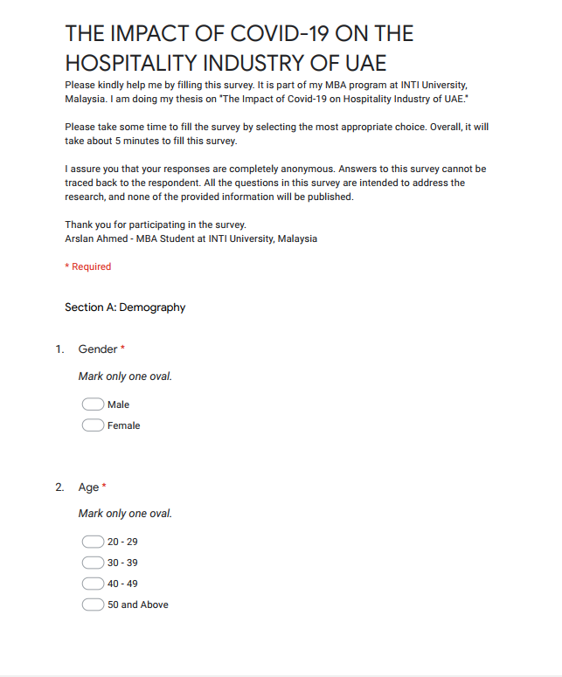

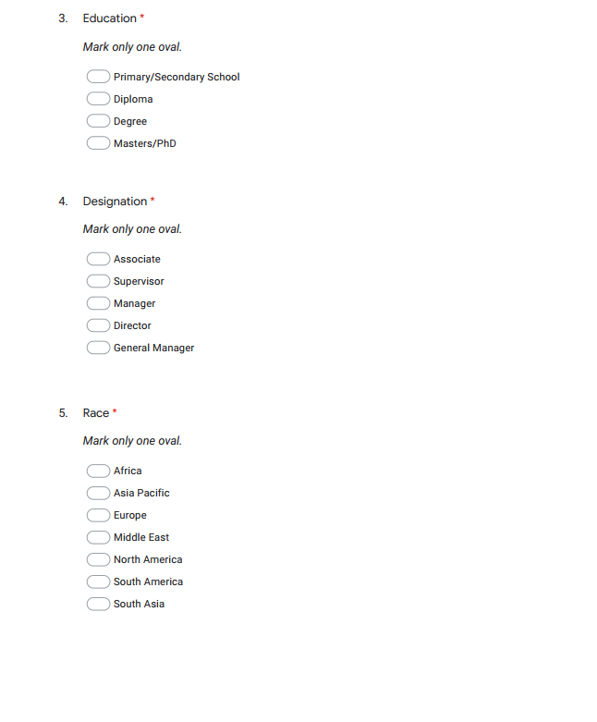

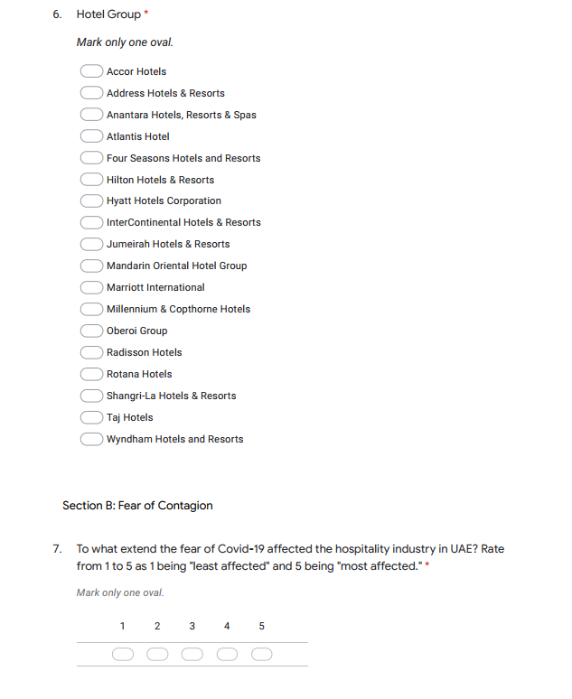

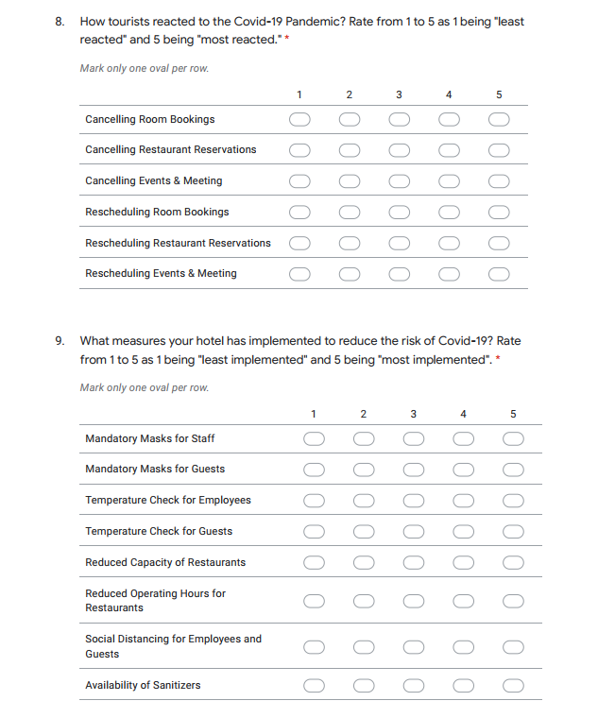

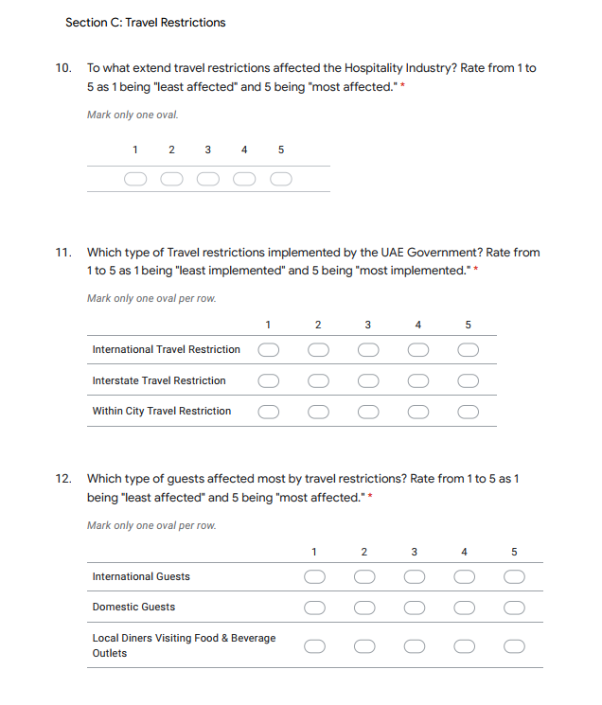

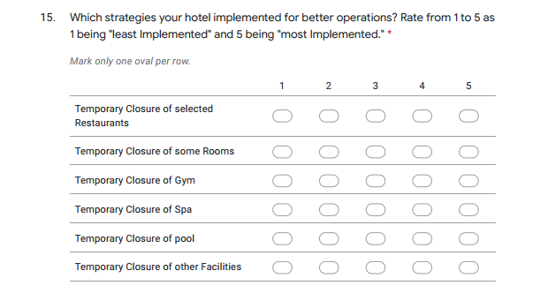
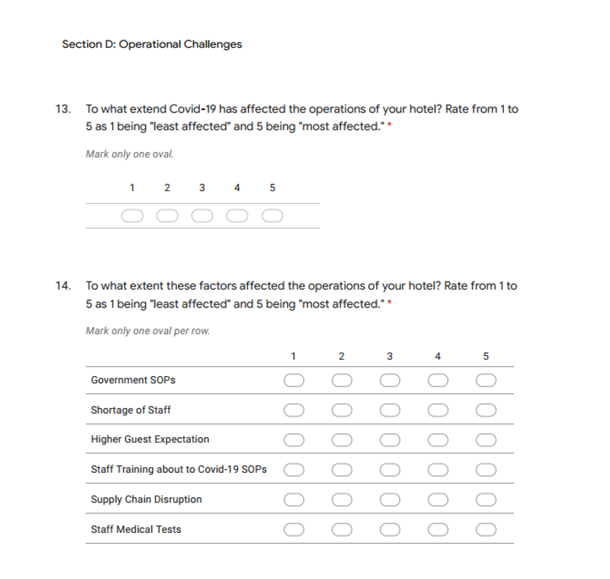

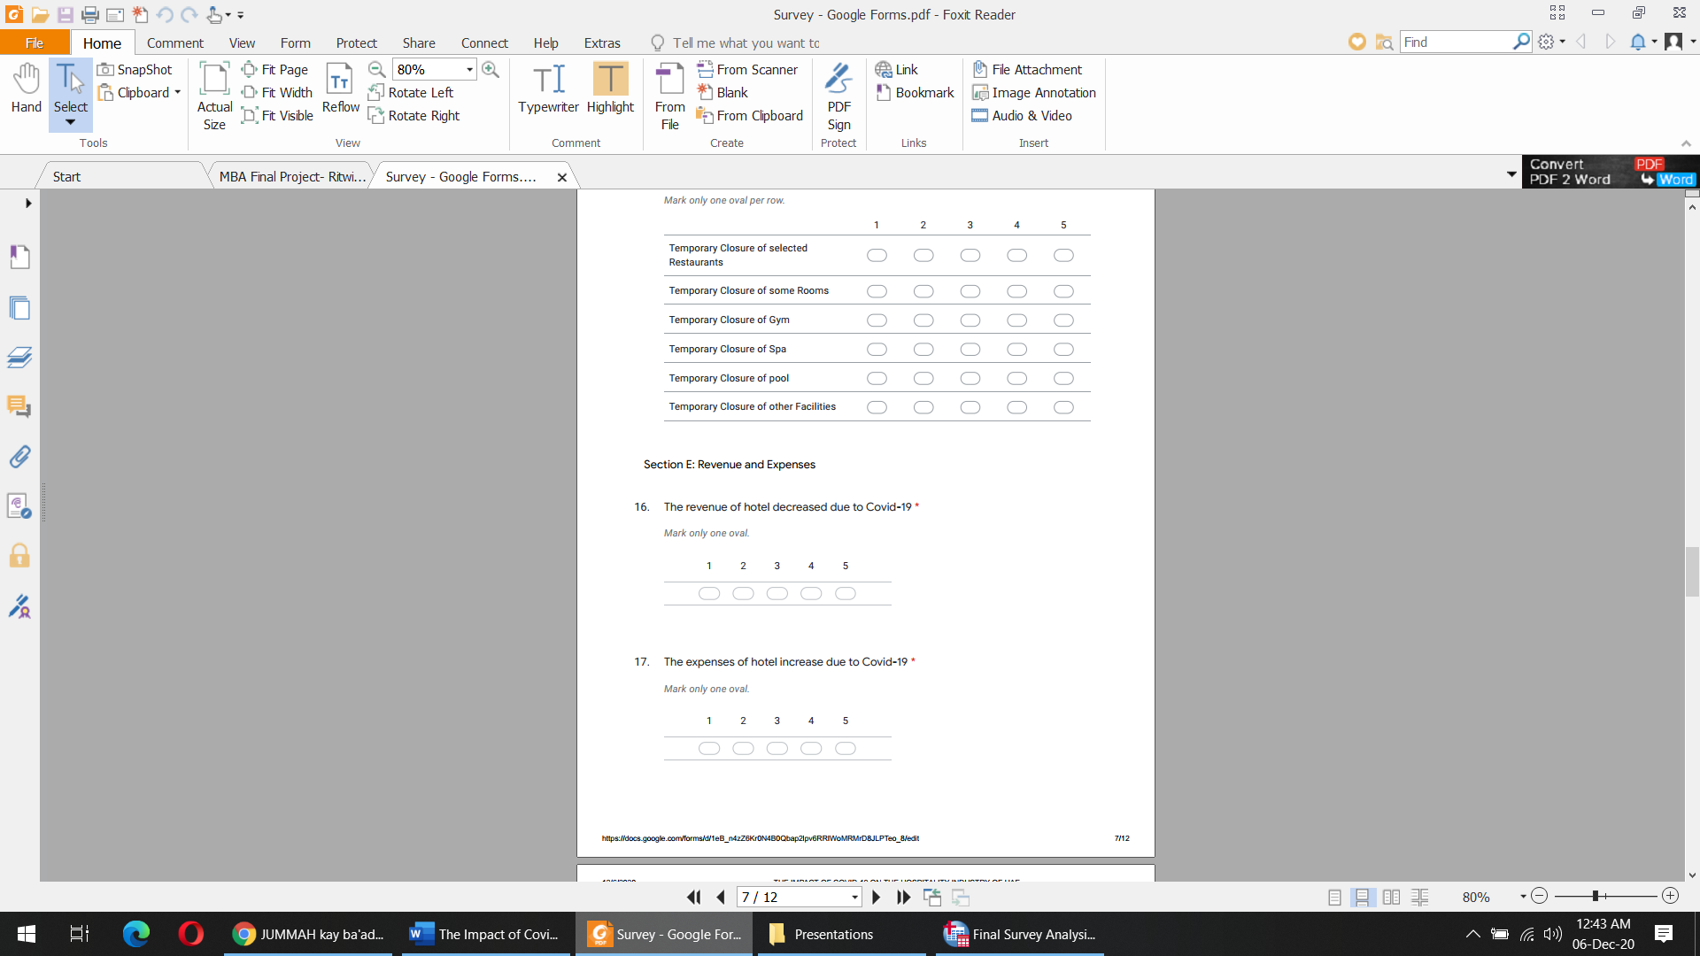
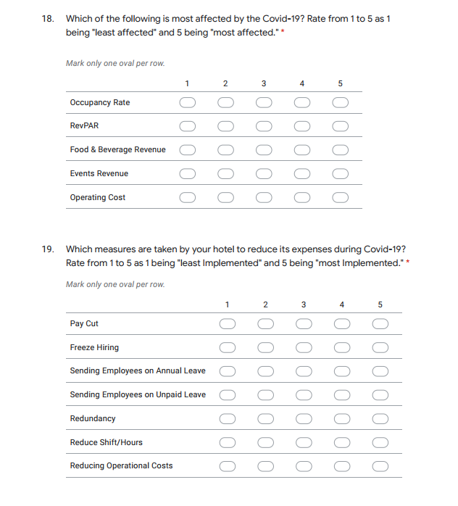

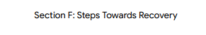
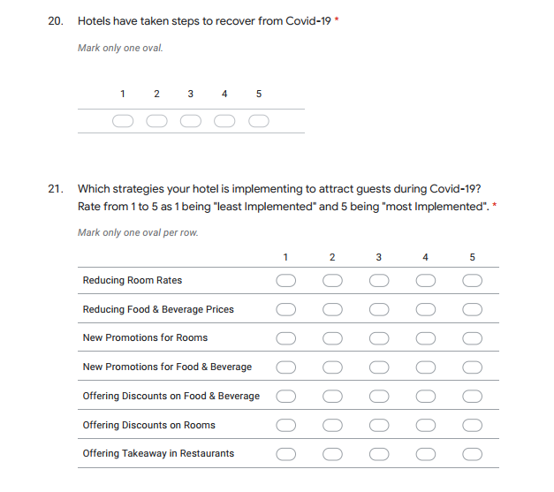

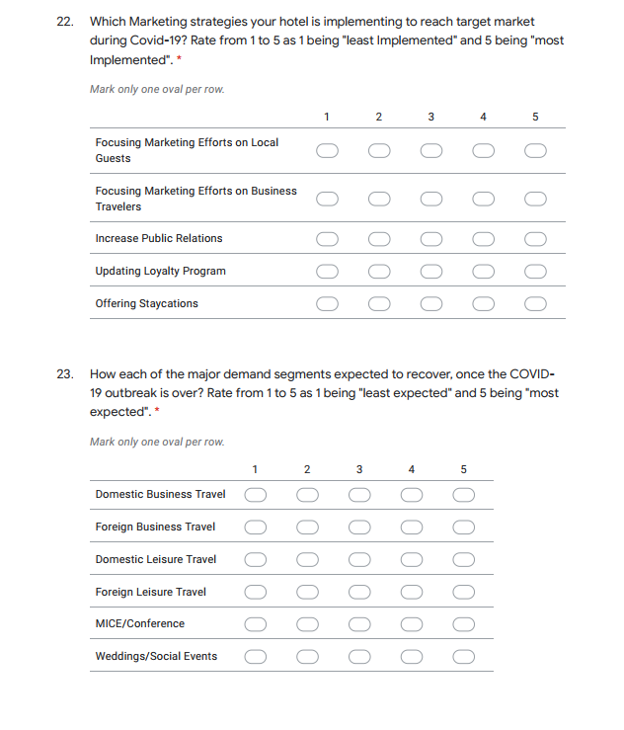

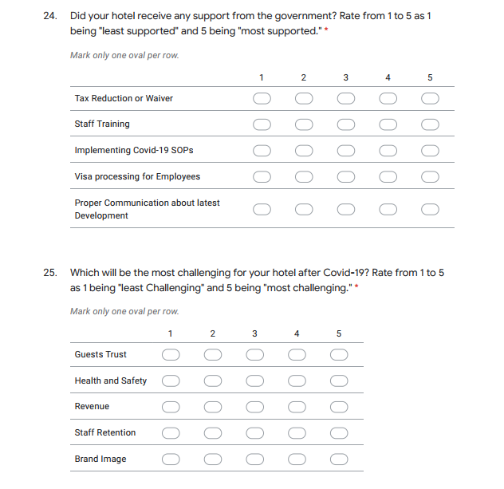
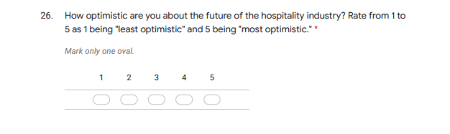

Appendix H: Proposal Defense Presentation

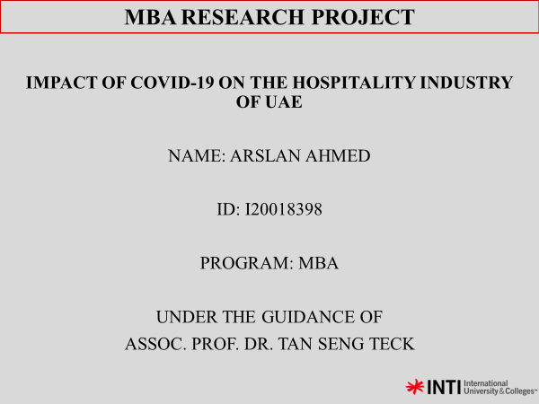

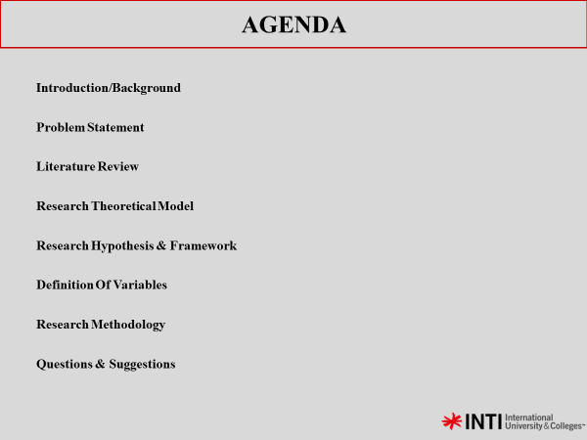

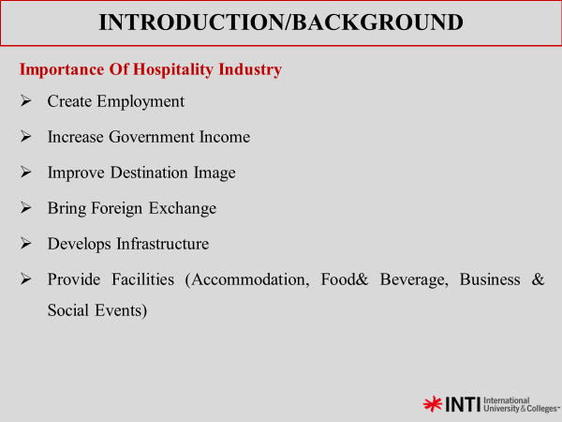

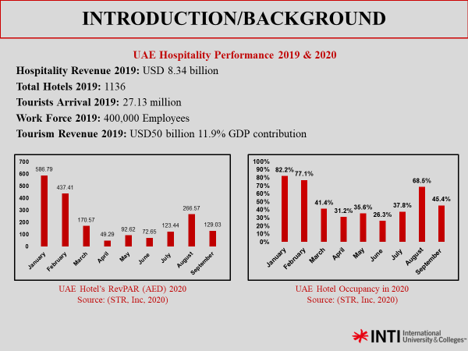

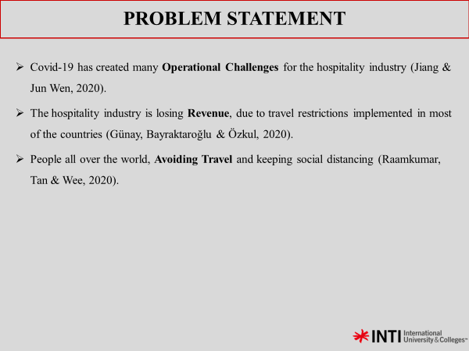

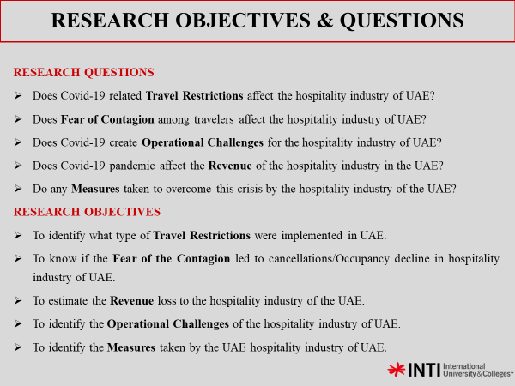

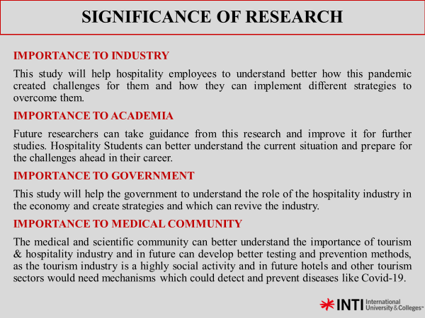

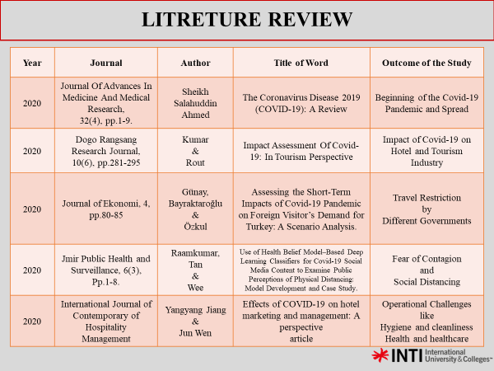

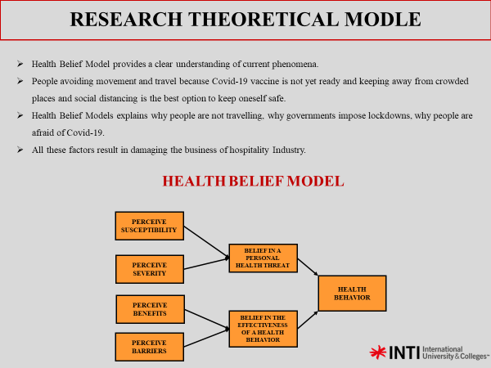

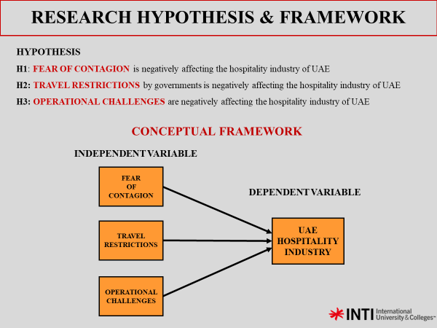

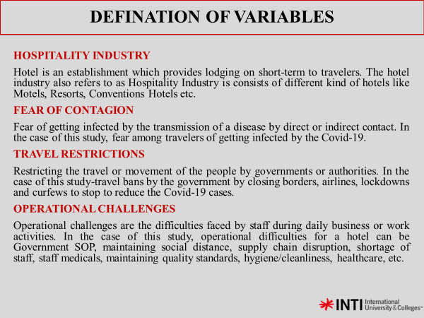

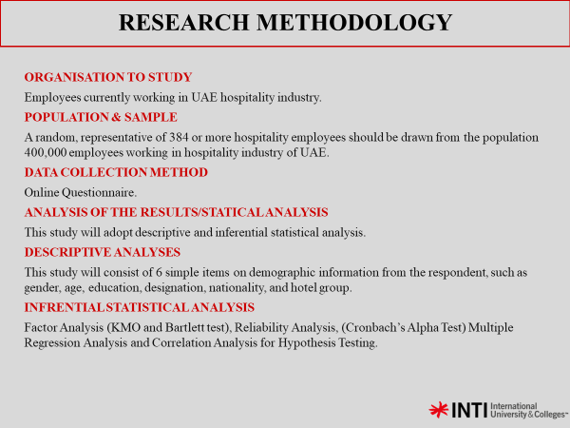

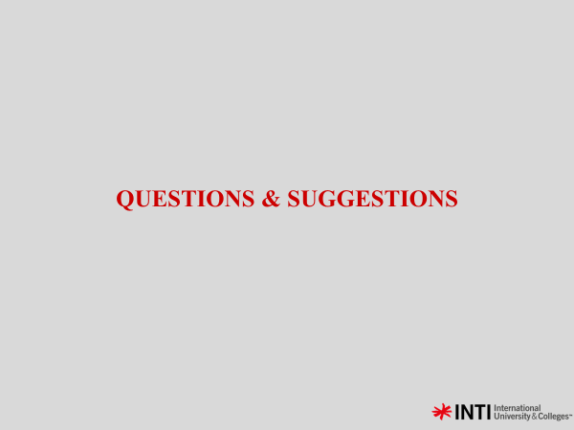

Appendix I: VIVA Presentation

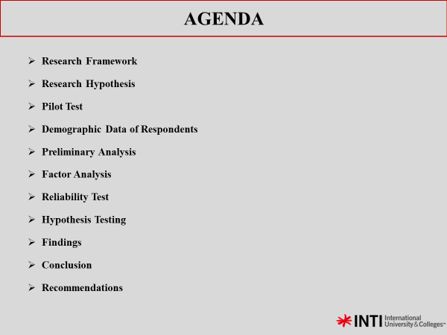
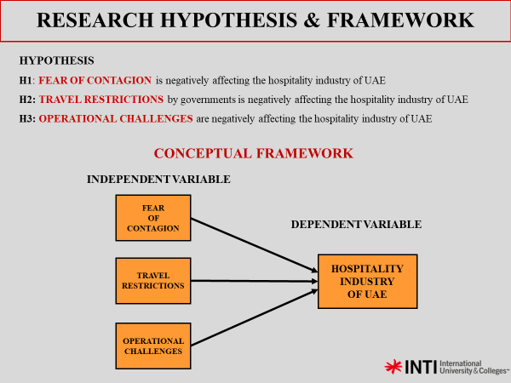

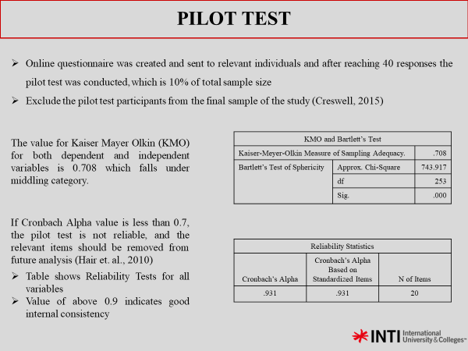

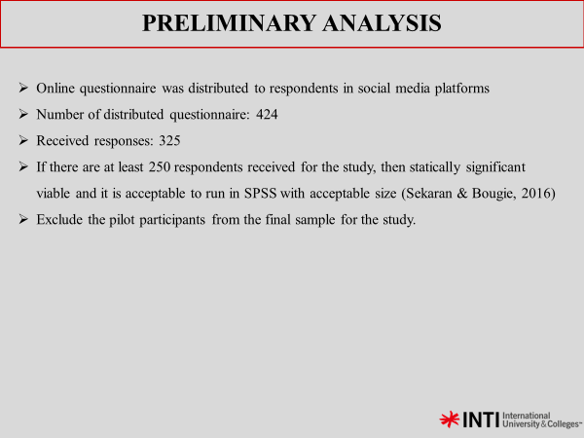

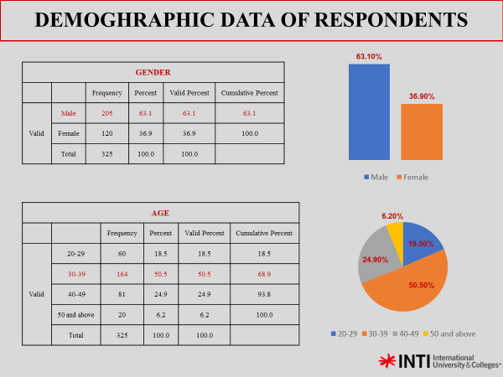

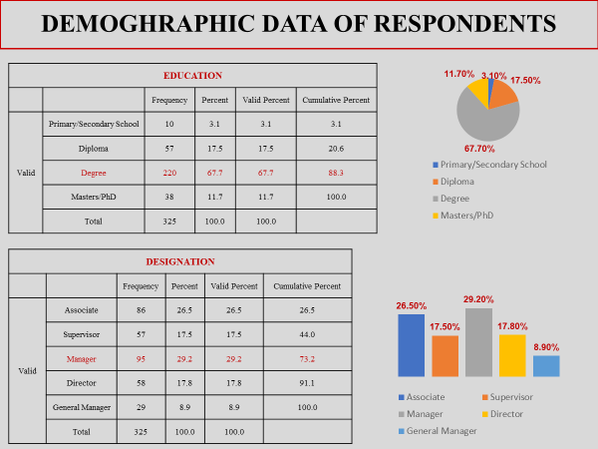

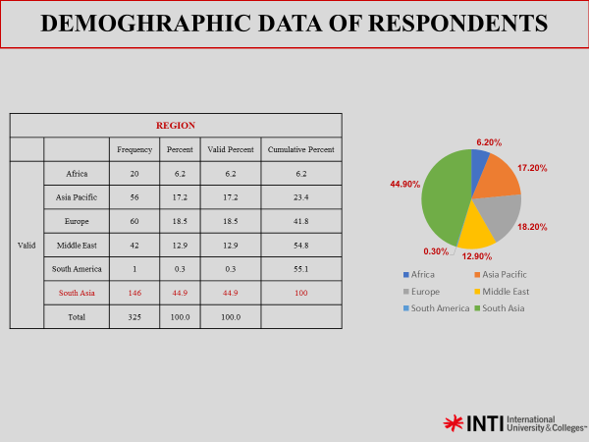

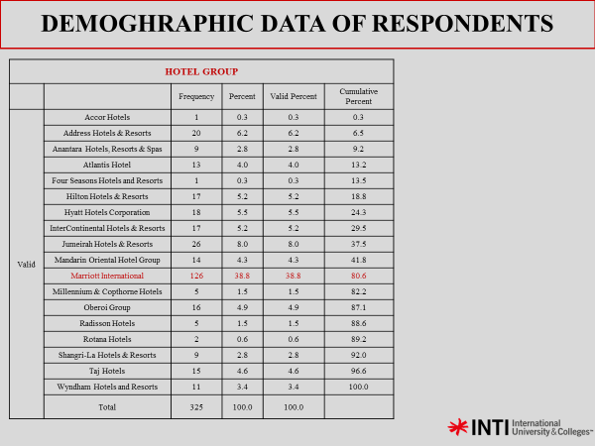

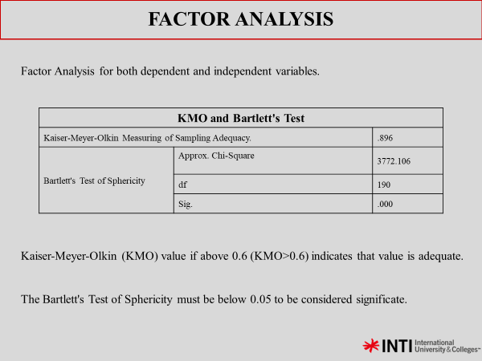

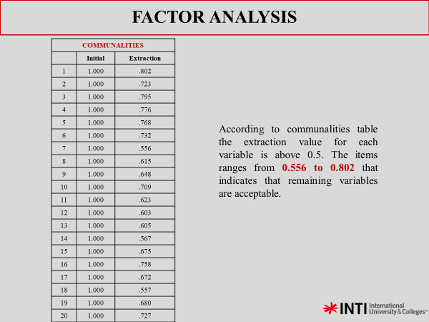

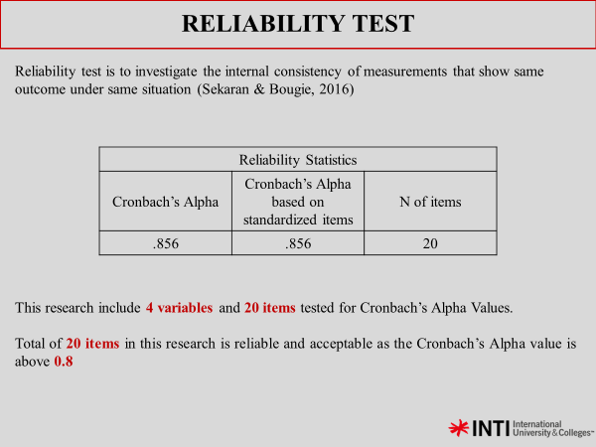

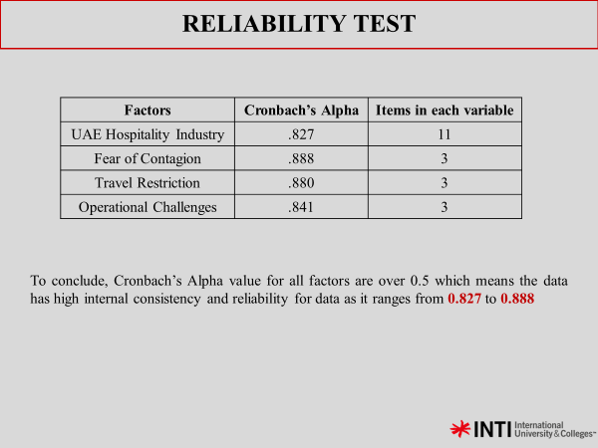

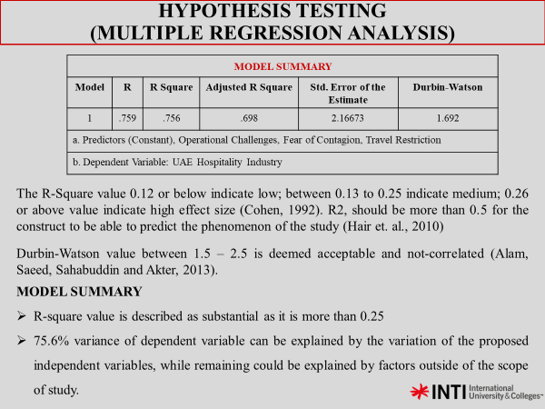
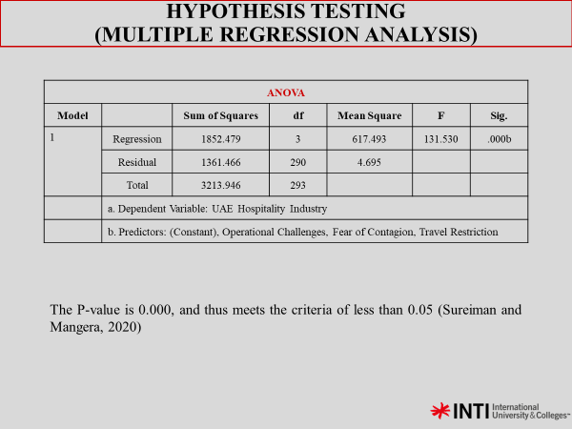

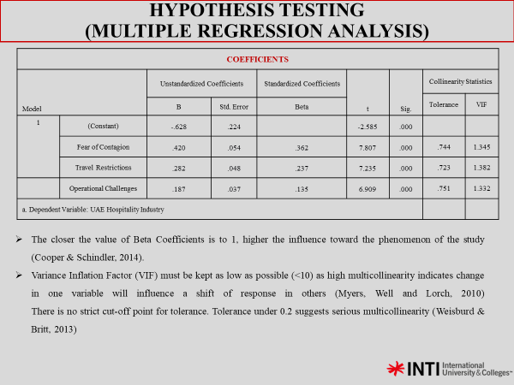

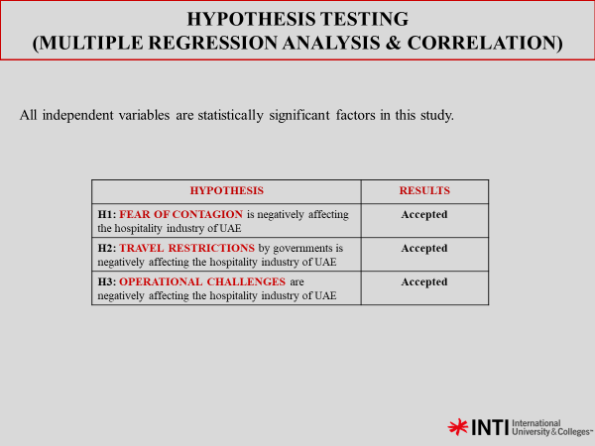

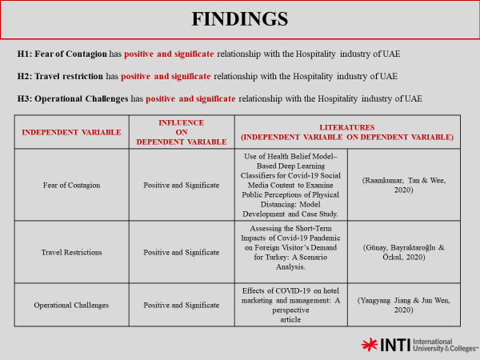

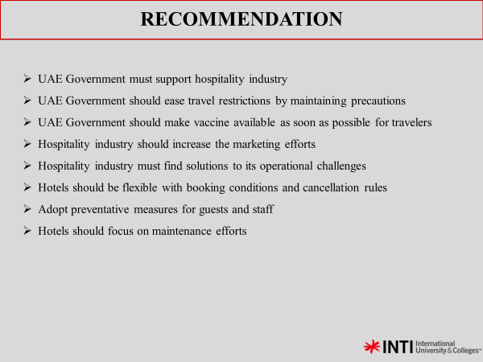

Appendix J: MBA Project Log
Student Name: | Arslan Ahmed
Supervisor’s Name: | Assoc. Prof. Dr. Tan Seng Teck
Dissertation Topic: Impact of Covid-19 on the Hospitality Industry of UAE

SECTION A. MONITORING STUDENT DISSERTATION PROCESS
The plan below is to be agreed between the student & supervisor and will be monitored against progress made at each session.

Activity | Milestone/Deliverable Date
Research Topic | 14/9
Research Framework |  | 21/9
Research Methodology |  |  | 28/9
Survey Questionnaire |  |  |  | 5/10
Chapter 1,2,3 |  |  |  |  | 22/10
Proposal Defense |  |  |  |  |  | 6/11
Data Collection |  |  |  |  |  |  | 30/11
VIVA |  |  |  |  |  |  |  | 3/12
Chapter 4 |  |  |  |  |  |  |  |  | 6/12
Chapter 5 |  |  |  |  |  |  |  |  |  | 8/12
Thesis adjustment and finalization |  |  |  |  |  |  |  |  |  |  | 14/12

SECTION B. RECORD OF MEETINGS

The expectation is that students will meet their supervisors up to seven times and these meetings should be recorded.

Meeting 1

Date of Meeting | 14-September-2020
Progress Made | Research Topic
Agreed Action | Further clarification of research topic
Student Signature | Arslan Ahmed
Supervisor’s Signature | Ow Yong Mun Geet

Meeting 2

Date of Meeting | 21-September-2020
Progress Made | Research Framework
Agreed Action | Adjusting Problem Statement, Research Objectives and Research  Questions
Student Signature | Arslan Ahmed
Supervisor’s Signature | Ow Yong Mun Geet

Meeting 3

Date of Meeting | 28-September-2020
Progress Made | Research Methodology
Agreed Action | Creating questionnaire and target population
Student Signature | Arslan Ahmed
Supervisor’s Signature | Ow Yong Mun Geet

Meeting 4

Date of Meeting | 5-October-2020
Progress Made | Questionnaire
Agreed Action | Further enrichment of questionnaire
Student Signature | Arslan Ahmed
Supervisor’s Signature | Ow Yong Mun Geet

Meeting 5

Date of Meeting | 22-October-2020
Progress Made | Finalizing Chapter 1,2,3
Agreed Action | Preparing for proposal defense
Student Signature | Arslan Ahmed
Supervisor’s Signature | Tan Seng Teck

Meeting 6

Date of Meeting | 02-November-2020
Progress Made | Review of Chapter 3 and Preparing for Proposal Defense
Agreed Action | Adjusting Chapter 3 and determining content of slides
Student Signature | Arslan Ahmed
Supervisor’s Signature | Tan Seng Teck

Meeting 7

Date of Meeting | 06-November-2020
Progress Made | Discussion on Feedback from Proposal Defense
Agreed Action | Preparation to procced for Chapter 4
Student Signature | Arslan Ahmed
Supervisor’s Signature | Tan Seng Teck

Meeting 8
Date of Meeting | 28-November-2020
Progress Made | Discussion of Chapter 4
Agreed Action | The results and findings of research
Student Signature | Arslan Ahmed
Supervisor’s Signature | Tan Seng Teck

Meeting 9
Date of Meeting | 03-December-2020
Progress Made | Preparation for final defense (VIVA)
Agreed Action | Determining the content of the slides
Student Signature | Arslan Ahmed
Supervisor’s Signature | Tan Seng Teck

Meeting 10
Date of Meeting | 14-December-2020
Progress Made | Review of Chapter 5
Agreed Action | Discussion on Recommendation and Conclusion
Student Signature | Arslan Ahmed
Supervisor’s Signature | Tan Seng Teck

Section D. Comments on Management of Project
(to be completed at the end of the dissertation process)
Student Comments
During my MBA Project my supervisor had given me very helpful guidance and improved my skills in research. My supervisor helped me to learn valuable knowledge that would contribute to my future
Supervisor Comments
_____________________________________________________________________________________________________________________________________________________________________________________________________________________________________________________

Signature of Student: Arslan Ahmed | Date: 14-December-2020
Signature of Supervisor: Tan Seng Teck | Date: 14-December-2020

Appendix K: SafeAssign Similarity Index

