

Board Characteristics and Insurance company Performance: A study in China Sector

Name: Cheng Qian
ID No.:I18015906
Programmer: MBA
Under the Guidance of
MR. Salaar Farooq
INTI International University
Final Word Count: 9586

Declaration

I hereby declare that this thesis is my own work and effort and that it has not been submitted anywhere for any award. Where other sources of information have been used, they have been duly acknowledged.

[Name/identification Number ]: Cheng Qian/I18015906

Signature: Cheng Qian

Date:7/4/2020

Acknowledgement

It is impossible to finish this thesis successfully without the help from many people
Therefore, I must express my gratefulness sincerely to them.

First of all, I would like to express my gratefulness to my supervisor Mr. Salaar. Without his careful and responsible guidance, I would not get so much knowledge in this area. Without his consistent and illuminating instruction, this research paper cannot be accomplished. I am deeply grateful for his help in the completion of this thesis. Besides that, I also need to thank my second marker Ms. Rebecca who has given a few useful suggestions for my thesis writing.

In addition, special thanks should go to my friends and my fellow classmates who have put considerable time and effort into their comments and recommendations about my paper. They gave me their help and time in listening to me and helping me work out my problems.

Lastly, I should give thanks to my parents as without their love I cannot put all my effort on this study.

Table of Contents
Board Characteristics and Insurance company Performance: A study in China Sector 1
Abstract 6
Chapter I: Introduction 7
1.1 Background of Insurance Company 7
1.2 Problem statement 9
1.3 Research Questions 9
1.4 Research Objectives 10
1.5 Significance of Study 10
1.6 Assumptions 11
1.7 Limitation of Study 11
1.8 Scope of Study 11
1.9 Structure of Study 12
Chapter 2: Literature Review 13
2.1 Introduction 13
2.2 Insurance Industry 13
2.2.1 Overview of ChinacInsurance Industry 13
2.2.2 China Insurance Company System 14
2.3 Insurance Company Performance 15
2.3.1 Insurance Company Performance Measurement 15
2.3.2 Corporate Governance and Insurance Company Performance 17
2.4 Board Characteristics in insurance industry 17
2.4.1 Board Size 18
2.4.2 Board Meeting Times 19
2.4.3 Gender of Directors 20
2.5 Framework of Conceptual 21
H₃: There is no relationship between percentage of female directors and the insurance company performance( Long and Li, 2017). 22
Chapter 3 Research Methodology 23
3.1 Introduction 23
3.2 Research Design 23
3.3 Research Method 23
3. 4 Data Collection 24
3.4.1 Methods 24
3.4.2 Validity and Reliability of the Data 25
3.4.3 Time Horizon of Data 25
3.4.4 Independent Variables and Dependent Variables 25
3.5 Analysis Method 25
3.5.1 Descriptive Analysis 26
3.5.2 Multiple Linear Regression Analysis 26
Chapter 4: Findings and Discussions 27
4.1 Introduction 27
4.2 Correlation test 27
4.3 Multiple Linear Regression Analysis 29
4.4 Conclusion 33
Chapter 5: Conclusions, Recommendations and Personal Reflections 35
5.1 introduction 35
5.2 Conclusions of This Study 35
5.3 Implication 35
5.4 Limitations and Suggestions for Further Study 36
5.5 Personal Reflection 37
References 38
Appendixes 41

Abstract

This project aims to finding out the relationship between the board characteristic and
the insurance company performance during the last five years in China.

During the recent years the global economy developed very fast and there is no doubt that China made great contribution to this development. To China insurance company sector plays a very important part in developing its economy. So, there should paid much attention on insurance company performance. The impact of board characteristic on the insurance company performance cannot be ignored.

In this study the quantitative method is used. The used data are collected by some official website and the insurance company annual report. In the analyzing of the data the descriptive analysis and the multiple linear regression analysis are used. Based on the result of the analysis, we find that the board size, the board meeting times and percentage of female in the board have significant influence on the insurance company performance.

At last of the paper, the recommendations are given. The insurance company should pay more attention to its board characteristics in order to make itself competitive in the industry.

Board Characteristics and Insurance Company Performance: A study in China Sector

Chapter I: Introduction

Background of Insurance Company

The first life insurance policy was recorded in England in the 16th century, which had marked the long establishment of insurance industry. As time passes, insurance companies have set clear functions in financial system and status, be it in terms of life insurance or general insurance. The insurance company worked in collaboration with banking and security industries to serve the economy of a country. Furthermore, the insurance company not only is the indispensable part of the modern financial system that performing a series of functions, but contributes to the smooth running of the economy by providing a variety of insurance services to reduce risk(Ahmad and Sungip, 2008).

For instance, insurance companies have a ability to help individuals and communities recover from natural disasters. Moreover, insurance companies are large employers and invest organizations which creating a huge amount of occupations and helping to fund economic activities such as infrastructure projects. Besides that, the insurance company also plays a vital characteristic in the functioning of a country's economy because it encourages people and businesses to make high-value investments, such as grantee the value of property or invest in corporate infrastructure. There is no doubt that a strong insurance industry is the hallmark of modern society and economy(Baccarani et,al 2013).

However, with the false appearance of prosperity before the financial crisis in 2008, the insurance industry seems to be escaping the service items stipulated by the board of directors and increasingly forming independent third-party business activities in the economic field. For instance, the insurance industry no longer limited to the traditional life and property products, but develops insurance products related to financial management and investment(Bailey, et al, 2016).

Since the global financial crisis happended in 2008, the insurance industry continued to supervise the directors' governance exclusively. This practice makes scholars wonder if there are unique relationships between the insurance industry's board and company performance, and what the specifics of this arrangement are. In previous studies we find that the composing of board members in the insurance industry plays a crucial role in the financial success of their business, as well as finding that smaller boards would bring more advantages in improving the financial performance of the insurance firm (Creswell and Clark, 2017).

As a top decision-making department in a company, the board of insurance industry is a vital factor that determines the performance of the whole enterprise. Further, the role of directors is different from other characters, such as stakeholders and policyholders of insurance companies. Every decision that board making lead to a significant influence on the future insurance company performance, in other words, it directly affects the fate of the insurance company(Embrechts, et al, 2013).

Meanwhile, studies have shown that there are sufficient evidences and reasons to demonstrate that board size,board meeting times and percentage of female directors will affect the performance of insurance companies. For instance, companies which hold 7 meeting times a will lead to a better company performance(Englander, 2012 ). Besides that, some other factors of board will also influence the performance of insurance companies to some extent, such as the educational level of directors and the religious belief of directors.

Chinese insurance industry has grown steadily from the viewpoint of global insurance industry growth, and has become the largest and most competitive industry on the domestic financial market. By the end of 2018, China's mainland insurance company net assets had reached $1,111 trillion (the world bank, 2018), which has been a main driver of China's financial boom. Faced with such an enormous thing, it is of profound importance to understand the impact the board structure of the insurance industry has had on the success of China insurance companies.

Problem statement

As mentioned above, the insurance industry plays an vital role in China economic development, and the performance of insurance industry is one of the important factors affecting the entire Chian financial market. Therefore, the factors affecting the performance of insurance companies have become an important issue for people to study.

Nowadays, more and more researchers begin to attach importance to the organization management. They believe that good leaders will undoubtedly lead the enterprise to a more vigorous development, which means that the ability level of top management in the board of directors will determine the future fate of the enterprise. Therefore, the relationship between the structure of the board of directors and corporate performance becomes a problem which is worth studying.

There are three factors that demonstrate a huge impact on the performance of China's insurance industry, including board size, the frequency of meetings times as well as the percentage of female directors. All of them together are called board level governance. In the following research, we will discuss specifically how board size, frequency of the meetings times and the percentage of female directors affect the performance of the insurance industry.

1.3 Research Questions

This research is composed of three main questions. Details are as following:

1, what is the relationship between the board size and insurance company performance.

2, what is the relationship between the frequency of board meeting times and insurance company performance.

3, what is the relationship between the percentage of female directors and insurance company performance.

Research Objectives

Considering that the global insurance industry is making a crucial significant contribution to the global economy and the importance of the success of the board of directors' characteristics to the insurance industry, this analysis aims to figure out the relationship between the characteristics of the board of directors and the success of the insurance market. The following questions will focus on study priorities.

First of all, reseraching the relationship between insurance company performance and board size in China insurance company.

Secondly, reseraching the relationship between insurance company performance and board meeting times in China insurance company.

Thirdly, reseraching the relationship between insurance company performance and the percentage of female directors in China insurance company.

1.5 Significance of Study

This research is not only contribute to China insurance market construction, but also the world insurance construction. Furthermore, this study clarifies the relationship between the characteristics of insurance industry board in China and the performance of the insurance company, while points out that the board structure has three main factors affecting the performance of the insurance company. To explain further, this study demonstrates significant references to the academic researcher, countries and industries.

In terms of academic part, this study will help scholars to conduct research in the econmic field and provide them with research materials.

For the government aspect, this study will help the government to draft an economy development plan. For instance, the government can guide insurance companies to improve their performance or profits through ethical corporate governance.

For insurance companies, this study will help companies to understand how the board of directors will influence the company performance. Furthermore, make up insurance companies’ inadequacy on this foundation.

This study exposes the strengths and weaknesses of each board structure (supported by data), thus enabling companies to make better decisions.

1.6 Assumptions

In this research, we assuming that other external factors on insurance companies performance of are ignored, meanwhile, in order to accurately reflect the study object and results of the research, we will appropriately interpret the results of the study.

1.7 Limitation of Study

As we all know, limitations of a study are hard to avoid. In other words, this study also has some limitations. First of all, from the perspective of longitudinal comparison, this study only selects the chronological timeline within a fixed period(2013-2018) to help us in analyzing the problems stated above. Secondly, there are only50 insurance companies which we choose in China as samples for analysis.

1.8 Scope of Study

In this part we will state about the scope of study. The target market which we will research in this study is the China insurance market. This implies that the data we used in this study, including the company information and financial information of insurance companies are all from China. Besides that, this research focus of this study is to figure out the relationship between the the board of directors and China insurance company performance.

1.9 Structure of Study

“This research contains 5 chapters, including chapter 1: Introduction; chapter 2: Literature review; chapter 3: Methodology; chapter 4: Finding &Discussion and chapter 5: Conclusion. All those 5 chapters are organized as the following structure”:

The first chapter aims at introducing the basic information which we need in our research.

The second chapter aims at summarizing the research of previous scholars in the financial field and provides literature support for the following research.

The third chapter aims at introducing the data collection methods and data analysis in detail.

The fourth chapter will expound the research results and discuss what we find in this research.

The fifth chapter aims to summarize the full text and draw a conclusion, giving reasonable suggestions and personal reflection.

Chapter 2: Literature Review

2.1 Introduction
In this chapter, we will explain the relevant research data and research models, which are used to support the research in this paper.

2.2 Insurance Industry

2.2.1 Overview of China Insurance Industry

Insurance is a vital part of modern economic system. Whether in the past or the present era, the main purpose of insurance is to protect human health and property. Furthermore, insurance companies protect their operations by dealing with risks in cost-effective way. Universally, we cannot avoid every dangerous accidents or bad events happened in human life. Each time, these risks produce a negative impact on individuals. But individuals can avoid these risks through insurance, in other words, insurance is a safety measure that any individual takes against to the danger in advance.

Especially in modern times, the insurance industry has achieved unprecedented success in the financial market. For instance, in such countries like Germany, Britain, Switzerland and other developed countries, the insurance industry has become an important part of their economy. On the other hand, insurance enables people and businesses to protect themselves against certain potential losses and financial difficulties at a reasonable and acceptable rate. Nowadays, some types of insurance play an important role in the economy. For example, people widely used car insurance, property insurance, medical insurance and life insurance in their life. These types of insurance are so vital in social life thus when people use the type of insurance, it has a positive impact on their lifestyle, social activities and longevity. Insurance markets and insurance companies play a particular role in the economy. It is well known that the insured and the insurance company meet in the insurance market. Daily insurance market activity has a positive impact on economic growth. Insurance activities also help to increase the country's gross domestic product. Insurance, on the other hand, increases employment in the economy. Improving economic and financial stability is also one of the main advantages of insurance. For these reasons, we can say that insurance is a reliable economic system.

2.2.2 China Insurance Company System

As we know, finance is the core of modern economy, meanwhile, insurance is a vital part of modern financial system. Since Chinese economic reform in 1989, China insurance industry demonstrated and maintained a rapid trend of development, making enormous contributions to China national economy and society in a sustainable and healthy way.

Insurance business presents a trend of sustainable development and insurance market scale expands rapidly. After the revival of the domestic insurance sector in 1980, the insurance industry in China has sustained an average annual growth rate above 30%, which had became the fastest growing industries in the domestic economy. By the end of 2018, the total assets of insurance companies had exceeded US$ 2819.43 trillion(China statistics). Furthermore, China insurance industry has developed vigorously and played an vital role in promoting reform, safeguarding the country economy, stabilizing the society and benefiting the people(China statistics).

At the end of 2018, China had 164 insurance companies registered with and regulated at China Insurance Regulatory Commission. According to the sources of capital, there were 76 life insurance companies, 48 of them were Chinese-funded and the rest were foreign-funded. Furthermore, there were 79 property insurance companies, including 57 Chinese-funded and 22 foreign-funded ones. Besides that, there were 9 Pension insurance companies which were Chinese – funded companies totally(China statistics). Till 2018 December, more than 12 million employees were working in insurance companies(China statistics).

The reform of the insurance industry continued to deepen, and the market operation mechanism was gradually improved. For China insurance companies, some major progress has been made in reforming the whole insurance system. For instance, People's Insurance Company of China (PICC), China life insurance and China reinsurance corporation completed their restructuring progress in 2003. Meanwhile, PICC, China life insurance and Ping An insurance group had successfully listed overseas. In addition, China has steadily pushed forward the reform of the management system of clause rate, and gradually formed a market pricing mechanism for insurance products. Marked by the establishment of PICC asset management company in 2003, important steps were taken in the reform of the management system for the use of insurance funds, and the separate management system for production and life insurance was basically established(China statistics).

The function of insurance has been enriched and deepened. After the occurrence of some major disasters, the insurance company paid compensation in time and played an important role in post-disaster reconstruction and restoration for normal production. By the end of June 20184, the balance of insurance funds had reached 2.2954 trillion USD(China statistics), providing a large amount of funds for China economic development. Furthermore, insurance companies have generally strengthened their services in disaster prevention, loss prevention and social security. Meanwhile, insurance industry has assumed more social responsibilities nowadays.

2.3 Insurance Company Performance

2.3.1 Insurance Company Performance Measurement

Theoretically a company's income margin is influenced by the amount of sales and expense. These two aspects — sales and expense — are influenced by the basic characteristics of the business, the characteristics of the market and the macroeconomic variables (Buyinza et al, 2010). Company-specific functions that primarily directly controlled by size, sales growth, capital, efficiency, and risk management (Demirguc Kunt et al, 2008). Both established a positive correlation between size and profitability. Asima Kopoulos found that price, revenue growth and investment positively impacted the company's profitability. However, this paper would examine the ratio of the insurance firms' annual financial accounts to consider the specific effect of the board of directors' characteristics on the performance of the firm. Among them, this paper will focus on analyzing ROE and ROA of sample companies. The concepts used are explained below.

Ratio analysis is a common method of review of the financial statements that is used in many main fields to easily represent the financial results of a business. In addition, ratio analysis is also used to calculate, for example, various dimensions of an organization; performance, underwriting capacity and insurance industry business risk. As a tool in research, the study of the ratios has many essential features. Meanwhile, the annual accounts contain some details used in the ratio analysis. Calculating ratios allows to compare organizations of different sizes and character. Analysis of the ratios can be used to compare the financial output of a business to the industry average. Additionally, in the context of a pattern analysis, ratio analysis may be used to classify places where output increases or declines over time.

The figures used to calculate the financial ratios are taken from balance sheets, statement of income and statement of cash flow. That provide the accounting or financial statements of the company. The documentation in the study were based on the organisation's accounting procedures and practices. Financial ratios measure multiple facets of a business, and are an important part of the review of financial statements. Financial ratios are defined by the financial dimensions of the undertaking being calculated.

Return on equity (ROE) This formula calculates how much income the investment receives from a shareholder. Higher return on equity implies greater return on investments for shareholders.

Return on Assets (ROA) This formula tests the productivity of a company with respect to its total assets. Strong return on investment means that management is making good use of client investment to earn income.

Growth rate of total assets Cooper (Cooper, 2018) notes that the results suggest that corporate activities associated with asset growth (i.e. investments, public equity offers, public bond offers, and bank loan initiations) continue to be accompanied by periods of abnormally low returns, whereas activities associated with asset contraction (i.e. spin-offs, share repurchases, bond prepayments, etc.).

2.3.2 Corporate Governance and Insurance Company Performance

Corporate governance is the structure which directs and regulates companies. Boards of directors are responsible for the operation of their companies. The position of the shareholders in governance is to select the directors and auditors, and to ensure that there is an effective governance system in place.
The Board's roles include setting corporate priorities for the group, providing guidance to execute them, managing market operations and reporting to shareholders on their stewardship. Therefore, corporate governance is about what a corporation's board does and how it sets the company's principles, which is to be differentiated by full-time managers from the day-to-day operating operations of the corporation.
But good governance will have broader implications for the listed sector because it is fundamentally about enhancing openness and responsibility within current structures. One of the fascinating trends in recent years has been how the 'private' governance term was used to identify problems of governance and responsibility within the corporate sector. This may be ambiguous and deceptive because corporate governance has been designed and established to tackle the governance of listed corporate organizations and is not meant to encompass all forms of entity that could have specific oversight mechanisms. Many research reports suggest that economically well-governed businesses perform well.

2.4 Board Characteristics in insurance industry

The board structure applies to the number of directors within and outside. The internal director is the company's accountant, who is actively active in the company's everyday operations. On the other hand, outside directors are executives who have the strategic insight needed to ensure that shareholders' interests are secured (Lawal, 2012). In general, a full-time employee of a organization is called an internal director, while an external director is called a director whose principal role is not in the business (magician, 2009). Inside directors are board members and the company's executives, such as the chief executive (CEO). They have a dual role, acting as regulatory body leaders, and operating as company managers. By contrast, the company's managers are not outside administrators. We are representative persons chosen by the applicable company or sector for their knowledge and skills. In comparison, outside directors perform only one position – they are not business executives – and are thus considered the more impartial board members. The chairperson may be a director inside, or a director outside. (Bhakat and Black, 2002). To carry out its supervisory function efficiently, boards of directors must be relatively independent of management (Dahya and McConnell, 2007).

The way the board is organized is primarily informed by the unity of the company. A board is autonomous because it has more directors unrelated to it than directors within it. Independent external directors achieve the independence needed and eliminate bias in the Board cycle (Bhakat and Black, 2002). To a large extent, the authors argue, this assumption is based on belief rather than evidence. While most best practice guidelines emphasize the need for mixed directors and greater outside directors, Empirical research remains unclear about how such incorporation substantially boosts the efficiency of companies (Dahya and McConnell, 2007).

2.4.1 Board Size

The composition of the Board applies to the cumulative number of members on the board of a company. It is indeed crucial to know the optimal board size for organisations, as the number and caliber of directors determines the success of these entities. The fundamental issue with the size of the board is that as the size of the board grows, it will enter a level of diminishing returns where there will be adverse impacts on the board's operation, for example as contact and teamwork are an arduous mess and time consuming mechanism for the multiple members of a broad board (Liu and Fong, 2010).

There is quite far no universally accepted standard to control the number of directors that a company may have. Within Chinese corporate law, the number of directors on the board can range from five to nineteen people (Liu and Fong, 2010). Lawal (2012), however, proposed a total of seven members of the council, and a maximum of nine. Yuanto, (2003) also proposed the composition of a board of five members. This was also endorsed by Yammeesri and Herath (2010) who say that when the board size is no more than seven or eight members, the board of directors can perform its duties efficiently. Any practitioners and researchers firmly agree that the composition of the board is a result of variables that include the company's age, size and the sector it belongs to (Lawal, 2012).

2.4.2 Board Meeting Times

Another factor affecting the efficiency of the insurance business is the size of the Board meeting. The board is the determining force deciding the fate of the company. The Council makes all the crucial decisions. The executive meeting is the primary decision-making method for the executive. How many times each year there is a board meeting will demonstrate how many significant decisions are taken. The size of the Board meeting would also impact the insurance company's productivity and cohesion. When the directors are willing to meet regularly, they will be more acquainted with each other and, as they work together, they will learn other working strategies and interact harmoniously with each other. The more often the Board meetings are held, the more the insurance company will perform. (Jiraporn, 2013)

To ensure that the decision is right, supervisors need to discuss the issue in depth and consider virtually any aspect that applies to the problem, so that further board meetings are needed. They will organize further board meetings and ensure that the top executives have ample time to discuss issues and provide a good atmosphere for conversation. The increasing the number of Board members, the more decisions can be made. The best decisions help the insurance firm achieve higher results, so the board meeting plays a very significant role in determining the success of the insurance company (Jiraporn, 2013). Another view, though, suggests that the more often the board meeting held; the worse the result would be. They assume that, if the organization pays far too much attention to the board meeting, the decision is not taken promptly, that would have a negative effect on the market's willingness to react. We further argue that there will be more competing viewpoints as they have more meetings, and that these will affect the morale of the organization. They conclude that the number of board meetings would the the efficiency of the organization(Bathula, 2008). All in all, a significant percentage of researchers consider the organization's board size would affect the company's efficiency.

2.4.3 Gender of Directors

Gender equity has become the focus of concern among other social demographic influences and is known as the value-creator of corporate governance. So far as job climate and working relationships are concerned, "the role of workers will compensate for percentage disparities in corporate composition, problem solving, and job dispute management attitudes" and have a direct effect on board activities. This was known that women, unlike men, have different attributes, abilities and characteristics that can place them on the board and provide the business with better results Various theoretical viewpoints have tried to provide the advantages of diversification, especially in terms of growing women's share in corporate governance and efficiency. It is important to summarize the various viewpoints on gender inequality and its effect on results as follows:
(1) raising the diversity of viewpoints in the Board of Directors inevitably leads to diversification of ideas and improved imagination and innovation;
(2) enhancing the consistency of decision-making, as gender diversity influences the solution and decision-making of challenges, as well as the insights and choices provided;
(3) gender diversity will contribute to a deeper interpretation of opportunities which are also genes.

However, due to the diversity of opinions, the more diverse the board is, the greater conflict will happen while making decisions, owing to the longe decision-making time and lower the efficiencyTherefore, there is a problem that requires a swift answer. Diversity within the board is often seen as restricting the board's ability to take decisive steps and to implement policy improvements when the climate becomes unpredictable. Additionally, when it comes to making economic and financial choices, women are more risk-averse than men, which inevitably impacts the organization's capital management choices.

2.5 Framework of Conceptual

The three factors listed above are assumed to influence the efficiency of insurance undertakings according to the lectures in insurance field. The framework of conceptual are as follows:

The relationship among the insurance company’s performance and independent variables shows as the following:

H₁: There is a negative relationship between board size and insurance company performance( Shiu, 2014.).

H₂: There is a negative relationship between board meeting times and insurance company performance( Bulinskaya and Shigida, 2019).

H₃: There is no relationship between percentage of female directors and the insurance company performance( Long and Li, 2017).

Chapter 3 Research Methodology

3.1 Introduction

Methodology in analysis is used as the way to conclude at the study outcome. It is divided into three steps: the compilation, review and evaluation of the data. This helps to work out the study strategy. The way to get the data to match the research needs is defined in the research. In addition, this component covers the approach to analysis, the way data is gathered and the way it is evaluated. The data can be obtained in two ways based on Uma Sekaran(fourth edition), the main sources and the secondary sources. The data were obtained at secondary sources in this stuudy.

3.2 Research Design

Study structure is defined as the structure or arrangement used when performing analysis. It involves techniques for collecting the information that can be used to achieve the findings of the research: where to gather the information, and how to interpret the gathered information. The research architecture will suit the research goals (Sejaran, 2010).

This research attempts to figure out whether the success of the insurance business is affected by the characteristics of the board in China. The conclusions in this analysis are posed by excluding all other non-financial and financial considerations which would affect the success of the insurance business in China. Within this analysis we concentrate mainly on the relationship between the results of the insurance firm and the characteristics of the board in the field of Chinese insurance industry. The metrics used to calculate the efficiency of the insurance firm are the ROA (return on assets), ROE (return on equity), and GROTA (total asset growth rate). The factors used to characterize the features of the board are the size of the board, the percentage of female directors and the frequency of board meetings.

3.3 Research Method

The quantitative approach is used for the research because of the criteria and objectives of this study. The proposition of the relationships between the variables or the hypothesis is first mentioned based on the quantitative approach. The research problem should be explained in the state of this testing process, and the study hypothesis should be given, the numerical results should be obtained, then the statistical approach should be used to analyze the data, and the analysis should eventually test the hypothesis and give the answer.

3. 4 Data Collection

3.4.1 Methods

Form of data processing is an investigation conduit. Through using the data gathered, it is possible to relate the theory to the test findings. There are various methods, environment, and data collection sources (Sekaran, 2012). The secondary sources are used in this paper to solve the problem, check the theory and achieve the target. The secondary source applies to the information that existed sources would access. This paper used the details of the 50 Chinese insurance firms as references between 2014 and 2018 (OÜ, 2018). Based on the CIRC(China insurance company’s Regulatory Commission) these companies are the top 50 insurance company’s in China. The 4 stated owned insurance companies are included in the sample. It also includes the 6 rural insurance companies, 30 city insurance company’s and 10 joint-stock insurance companies. These bank types are offered on CIRC-based basis. While China has more than 150 insurance companies, the combined assets of the banks listed in this paper are greater than 60 percent of the Chinese insurance company industry as a whole. Such companies' financial status either meets the Chinese Accounting Principles or the International Accounting Standards such that the insurance company's annual report can be conveniently accessed from the facts. The insurance company's board characteristics can be accessed from the banks' websites or financial reports and the details is accurate.

3.4.2 Validity and Reliability of the Data

The data is gathered in this analysis from the Internet. Since all websites use to access the data are official government websites, the data are considered accurate and real. Any of the statistics was gathered by the insurance providers' annual report, which also means the results are accurate and credible.

3.4.3 Time Horizon of Data

Since this analysis is intended to figure out the relationship between the results and board characteristic of the insurance industry in China, the data from the five years is used to do the work. The recent data was selected to ensure the precision of the analysis. In this paper we chose the 2014 to 2018 data type.

3.4.4 Independent Variables and Dependent Variables

In this analysis, there are three dependent variables in relation to the board characteristics. Such factors are board size, meeting dates a year and the number of women in management. Additionally, there is one factor variable which is the output of the insurance business. The table below displays then the variables used in this analysis.
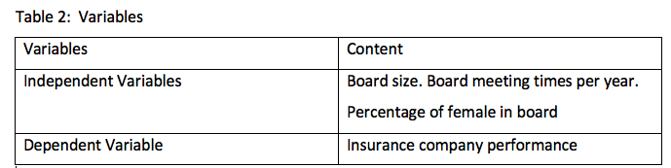

3.5 Analysis Method

Since this thesis chooses the quantitative method of performing the work, the experiment is carried out using the SPSS. In this research the descriptive approach is used to define the variables from 2014 to 2018 in separate areas. The multiple linear regression method is often used in this analysis to derive the outcome, which is used to determine if there is a clear association between dependent variables which independent variable. In this paper the multiple regression is used to check whether the insurance company's output will be influenced by the board's characteristics in China from 2014 to 2018.

3.5.1 Correlation test

The Pearson Correlation test is widely used to calculate the following:1,Correlations between Variables pairs. 2, The associations of variables inside and between sets. In comparison, the Pearson bivariate correlation shows the following:1, That there is a statistically important causal relation between two continuous variables. 2, Linear relationship power (i.e. how close the relationship is to being a perfectly straight line), 3, linear relationship trajectory (increasing or decreasing). Here is the Correlation test with board characteristics and company performance.

3.5.2 Multiple Linear Regression Analysis

A widely used approach is mathematical interpretation of an application using multiple linear regression. It is used to evaluate the more than two independent and conditional variables. In this paper the multiple linear regression approach is used to determine the association between the insurance company's performance and board characteristics in China.

Chapter 4: Findings and Discussions

4.1 Introduction

In this chapter, the related approaches are used to analyze the data. The correlation test and multiple linear regression analysis are two main method used in this study. The variables characteristics are analyzed by the descriptive analysis. The relationship between the dependent variable and independent variables is tested by the multiple linear regression analysis. They are used to meet the objective of this study that stated in chapter one. Based on the analysis the results and findings are explained in detail. At last we will draw the formular.

4.2 Correlation test

The Pearson Correlation test is widely used to calculate the following:1,Correlations between Variables pairs. 2, The associations of variables inside and between sets. In comparison, the Pearson bivariate correlation shows the following:1, That there is a statistically important causal relation between two continuous variables. 2, Linear relationship power (i.e. how close the relationship is to being a perfectly straight line), 3, linear relationship trajectory (increasing or decreasing). Here is the Correlation test with board characteristics and company performance.

Table 1: Board meeting times and company performance correlation
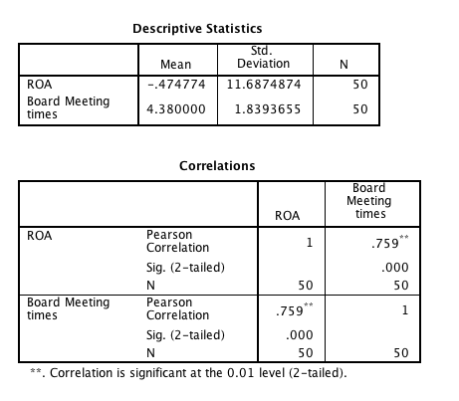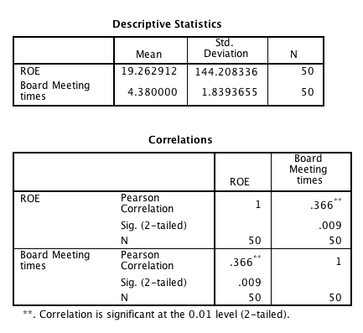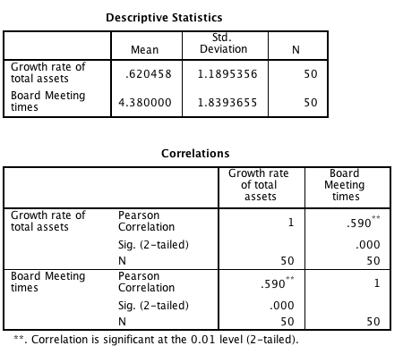

In a single value between -1 and + 1, the "r" represents the frequency of the correlation or co-occurrence between variables. This value which measures the intensity of the association is called the correlation coefficient which is usually expressed as the letter r.

From graph 1 we can find that r= 0.759 ,close to 1,which means there is a strongly positive correlated with board meeting times.

From graph 2 we can find that r= 0.336,close to 0,which means there is a slightly positive correlated with board meeting times and ROE.

From graph 3 we can find that r= 0.590,close to 1,which means there is a strongly positive correlated with board meeting times and GROTA.

Finally, we can draw a conclusion that board meeting times has a positive impact on company performance.

Table 2: Board size and company performance correlation

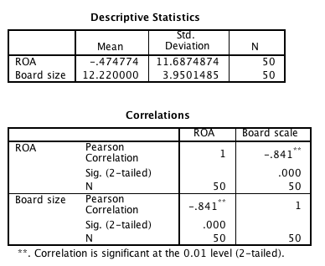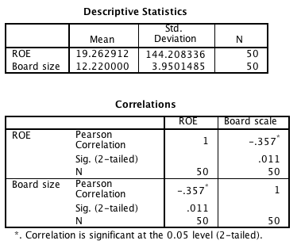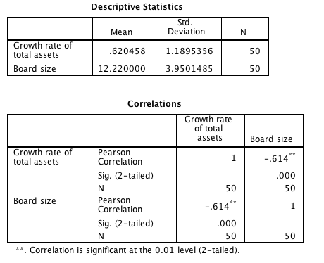
From graph 1 we can find that r= =-0.841, close to -1, which means there is a strongly negative correlated with board size and ROA.

From graph 2 we can find that r= =-0.357, close to 0, which means there is a slightly negative correlated with board size and ROE.

From graph 3 we can find that r= =-0.614, close to -1, which means there is a strongly negative correlated with board size and GROTA.

Finally, we can draw a conclusion that board meeting times has a positive impact on company performance.

4.3 Multiple Linear Regression Analysis
Table 1:
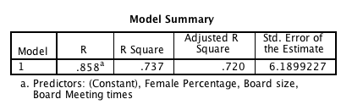

This table shows part of overall predictability of the model. The R shows the degree of the regression. If the R² is larger than 0.03 and close to 1 or 100%, this means the regression is good. This table shows that the R² is 0.737> 0.03 that means the regression is good and the variation in board meeting times, board size, female directors’ percentage and ROA can be explained by the regression.

Table 2:
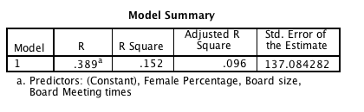
This table shows that the R² is 0.096> 0.03 that means the regression is good and the variation in board meeting times, board size, female directors’ percentage and ROE can be explained by the regression.

Table 3:
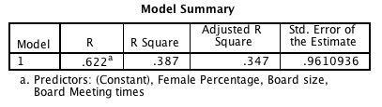

This table shows that the R² is 0.387 > 0.03 that means the regression is good and the variation in board meeting times, board size, female directors’ percentage and GROTA can be explained by the regression..

Table 4:
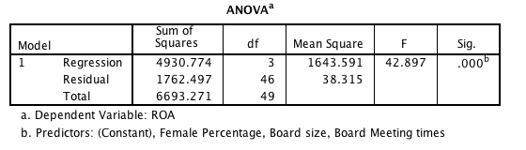

From the above table we can get that the F vale is 42.289 (Sig. 0. 000< p= 0.05) means that the overall regression is significant. Thus, there are enough reasons to show that the board meeting times, board size and female directors’percentage can predict the ROA.

Table 5
ANOVAª
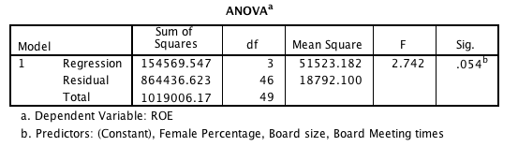
From the above table we can get that the F vale is 2.742 (Sig. 0. 054 < p= 0.05) means that the overall regression is significant. Thus, there are enough reasons to show that the board meeting times, board size and female directors’percentage can predict the ROE.

Table 6:
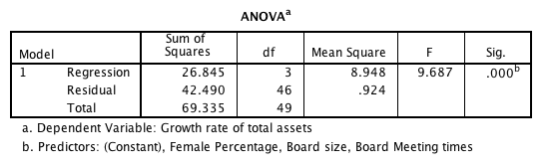
From the above table we can get that the F vale is 9.687 (Sig. 0. 000 < p= 0.05) means that the overall regression is significant. Thus, there are enough reasons to show that the board meeting times, board size and female directors’percentage can predict the GROTA.

Table 7
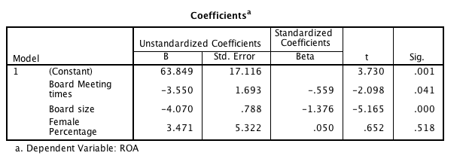
This table shows the relationship among board meeting times, board size, female directors’ percentage and ROA. Based on the result, the board meeting times, board size and female directors’percentage are significant corrected with ROA.

As board meeting times, the t value is -2.098 (sig.=0.041< p= 0.05), which shows that board meeting times has negitive influence on ROA.

As board size, the t value is -5.165 (sig.=0.000< p= 0.05), which shows that the board size has a negitive influence on ROA.

As female directors’ percentage, the t value is 0.652 (sig. =0.518> p= 0.05), which shows that female directors’ percentage has no influence on ROA.

Table 8
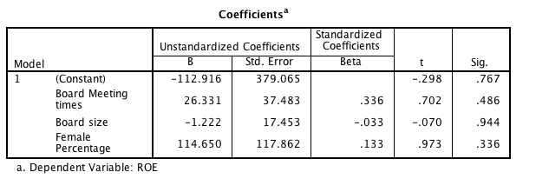
This table shows the relationship among board meeting times, board size, female directors’ percentage and ROE. Based on the result, the board meeting times, board size and female directors’percentage are significant corrected with ROA.

As board meeting times, the t value is 0.702 (sig.=0.486 > p= 0.05), which shows that board meeting times has no significant influence on ROE.

As board size, the t value is -0.070 (sig.=0.944 > p= 0.05), which shows that the board size has a significant influence on ROE.

As female directors’ percentage, the t value is 0.973 (sig. =0.336> p= 0.05), which shows that female directors’ percentage has no significant influence on ROE.

Table 9
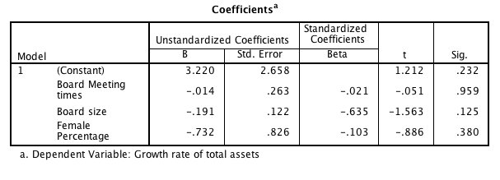
This table shows the relationship among board meeting times, board size, female directors’ percentage and GROTA. Based on the result, the board meeting times, board size and female directors’percentage are significant corrected with GROTA.

As board meeting times, the t value is -0.051 (sig.=0.959 > p= 0.05), which shows that board meeting times has no significant influence on GROTA.

As board size, the t value is -1.563 (sig.=0.125> p= 0.05), which shows that the board size has no significant influence on GROTA.

As female directors’ percentage, the t value is -0.886 (sig. =0.380> p= 0.05), which shows that female directors’ percentage has no significant influence on GROTA.

Based on the graph above, finally we can draw a formular :

ROA= 63.849 – (3.550×board meeting times) - (4.070×board size )

4.4 Conclusion

As the insurance company’s performance is measured by ROA ROE and GROTA. Based on table 7 we can draw a conslusion that the board meeting times have a negative influence on ROA. Then the Hypothesis 1 is supported.

Based on table 7 we can draw a conslusion that the board size have a negative influence on ROA.Then we can conduct that the Hypothesis 2 is supported.

Based on table 7,8,9, we can draw a conslusion that the female director’ percentage have nonegative influence on ROA. Then the Hypothesis 3 is supported.

Based on the above findings and discussion, the three hypotheses are tested. The result is that small size board which have less directors will have a better impact on insurance companies’ performance. Less board meeting times will have a better impact on insurance companies’ performance.

Chapter 5: Conclusions, Recommendations and Personal Reflections

5.1 introduction

In this section, the final chapter of the study is given the guideline for the result, the drawbacks and the personal reflection. The results are drawn based on the above review of this study. The interpretation is given based upon the assumption. Then the shortcomings of this research are mentioned, and suggestions are given for further review. It finally reflects personal reflection.

5.2 Conclusions of This Study

The purpose of this analysis is to figure out the relationships between the characteristics of the board and the success of insurance companies in China. The structure is obtained based on previous researches. The secondary data were used in this analysis. The data were obtained from insurance insurers' financial reports that they submitted to their websites by the insurance providers. There are four variables in this research: one dependent variable and three independent variables. The dependent variable is the performance of the insurance firm but there are three vice-dependent factors, since the performance of the insurance company is determined by the ROE, ROA and growth rate of total Assets. The three independent variables are the board size, the meeting times and the percentage of female directors. The descriptive approach is used to define the variables and get the outcomes of this study and the multiple regression approach is used to determine the relationship between the dependent variable and independent variables. After all the research is tested for the hypotheses. Based on the test, supports are two theories and one theory is discounted. This is to suggest that each year the board and board meeting have a huge impact on the success of the insurance business in China.

5.3 Implication

The findings of this study indicate that the composition of the board and the number of meeting times on the board have a major impact on the success of the insurance industry in China. The size of the board has a negative association with the performance of the insurance firm which means the larger the board of insurance firms is the worse results the insurance companies would get. Group meetings dates per annum have a favorable relationship to the results of the insurance business in China. This is, the more board meetings the insurance firms have per annum, the greater results they will get.

The insurance companies should pay more attention to their management for the Chinese insurance business market, in particular the management of the board of insurance firms. As insurance company board characteristics really play a very important role in determining insurance company results. We ought to pay adequate attention to the board management for the insurance industry to agree about the best board features to help them achieve the strategic advantages in the market.

The board of insurance firms will improve their constructive effect on the performance of the insurance industry and correct the mistakes which would undermine the efficiency of the insurance business.

5.4 Limitations and Suggestions for Further Study

All in all, the work has three weaknesses.

"The time period chosen in this analysis is, first of all, tight. In this analysis only 5 years are selected in this work from 2014 to 2018. This decision is taken because this span of time may already reflect the past of the recent Chinese insurance business but the retrospective duration should be extended for detailed analysis. Thus the further inquiries will extend the reach of the report. The next weakness is the variables chosen in this study There are several variables that can affect the performance of the insurance company and there are are several other variables that will calculate the performance of the insurance company, in this study only few variables are chosen to do the research. Then they will use more variables to do the analysis for further study. The final principal drawback of this research is the process of analysis. We just use descriptive analysis and linear regression analysis to get the findings in this report. The more work will use more form of study to analyze the data to get better endorsed outcomes.

5.5 Personal Reflection

While doing the study, I've learned a lot that's very helpful to me First of all, this work makes me better understand the business of the Chinese insurance firms. It helps me to learn the various types of insurance undertakings in China and their different features. This also helps me to think more about the state of the Chinese insurance industry. Second, it also allows me to learn how to assess the insurance providers on the basis of the insurance firms' annual statements. I always learn how to extract relevant knowledge from the insurance company's annual report. Last but not least, it makes me extract better acquainted with the analysis process and the best way to interpret the results and get the answer. I know few things about these issues before doing the research.nThere are enough reasons for me to conclude that this thesis would support me a lot in my future analysis and life.

References

Ahmad, A. and Sungip, Z., 2008. An assessment on service quality in Malaysia insurance industry. Communications of the IBIMA, 1, pp.13-26.

Akturan, U. and Tezcan, N., 2012. Mobile banking adoption of the youth market: Perceptions and intentions. Marketing Intelligence & Planning, 30(4), pp.444-459.

Akaranga, S.I. and Makau, B.K., 2016. Ethical Considerations and their Applications to Research: a Case of the University of Nairobi. Journal of educational policy and entrepreneurial research, 3(12), pp.1-9.

Aguinis, H. and Vandenberg, R.J., 2014. An ounce of prevention is worth a pound of cure: Improving research quality before data collection. Annu. Rev. Organ. Psychol. Organ. Behav., 1(1), pp.569-595.

Baccarani, M., Deininger, M.W., Rosti, G., Hochhaus, A., Soverini, S., Apperley, J.F., Cervantes, F., Clark, R.E., Cortes, J.E., Guilhot, F. and Hjorth-Hansen, H., 2013. European LeukemiaNet recommendations for the management of chronic myeloid leukemia: 2013. Blood, 122(6), pp.872-884.

Bailey, J.E., Surbhi, S., Bell, P.C., Jones, A.M., Rashed, S. and Ugwueke, M.O., 2016. SafeMed: using pharmacy technicians in a novel role as community health workers to improve transitions of care. Journal of the American Pharmacists Association, 56(1), pp.73-81.

Beveridge, W., 1942. Social insurance and allied services.

Berman, H.M., Battistuz, T., Bhat, T.N., Bluhm, W.F., Bourne, P.E., Burkhardt, K., Feng, Z., Gilliland, G.L., Iype, L., Jain, S. and Fagan, P., 2002. The protein data bank. Acta Crystallographica Section D: Biological Crystallography, 58(6), pp.899-907.

Breiman, L., 2017. Classification and regression trees. Routledge.

Bulinskaya, E.V. and Shigida, B.I., 2019. Modeling and asymptotic analysis of insurance company performance. Communications in Statistics-Simulation and Computation, pp.1-14

Creswell, J.W. and Clark, V.L.P., 2017. Designing and conducting mixed methods research. Sage publications.

Diamond, D.W. and Dybvig, P.H., 1983. Bank runs, deposit insurance, and liquidity. Journal of political economy, 91(3), pp.401-419.

Embrechts, P., Klüppelberg, C. and Mikosch, T., 2013. Modelling extremal events: for insurance and finance (Vol. 33). Springer Science & Business Media.

Ehrlich, I. and Becker, G.S., 1972. Market insurance, self-insurance, and self-protection. Journal of political Economy, 80(4), pp.623-648.

Englander, M., 2012. The interview: Data collection in descriptive phenomenological human scientific research. Journal of phenomenological psychology, 43(1), pp.13-35.

Ewold, F., 1991. Insurance and risk. The Foucault effect: Studies in governmentality, pp.197-210.

Flicek, P., Amode, M.R., Barrell, D., Beal, K., Brent, S., Carvalho-Silva, D., Clapham, P., Coates, G., Fairley, S., Fitzgerald, S. and Gil, L., 2011. Ensembl 2012. Nucleic acids research, 40(D1), pp.D84-D90.

Goovaerts, M.J., De Vylder, F. and Haezendonck, J., 1984. Insurance premiums: theory and applications (p. 406). Amsterdam: North-Holland.

Hanmer, M.J. and Ozan Kalkan, K., 2013. Behind the curve: Clarifying the best approach to calculating predicted probabilities and marginal effects from limited dependent variable models. American Journal of Political Science, 57(1), pp.263-277.

Hackman, C.L. and Knowlden, A.P., 2014. Theory of reasoned action and theory of planned behavior-based dietary interventions in adolescents and young adults: a systematic review. Adolescent health, medicine and therapeutics, 5, p.101.

Hayes, A.F. and Preacher, K.J., 2014. Statistical mediation analysis with a multicategorical independent variable. British Journal of Mathematical and Statistical Psychology, 67(3), pp.451-470.

Hajli, M.N., 2014. A study of the impact of social media on consumers. International Journal of Market Research, 56(3), pp.387-404.

Hariharan, B., Arbeláez, P., Bourdev, L., Maji, S. and Malik, J., 2011, November. Semantic contours from inverse detectors. In 2011 International Conference on Computer Vision (pp. 991-998). IEEE.

Hubbard, R.G., Skinner, J. and Zeldes, S.P., 1995. Precautionary saving and social insurance. Journal of political Economy, 103(2), pp.360-399.

Hsiao, W. and Shaw, R.P. eds., 2007. Social health insurance for developing nations. The World Bank.

Keeley, M.C., 1990. Deposit insurance, risk, and market power in banking. The American economic review, pp.1183-1200.

Kuhlmann, S. and Wollmann, H., 2019. Introduction to comparative public administration: Administrative systems and reforms in Europe. Edward Elgar Publishing.

Long, Y. and Li, Y., 2017, November. Study on insurance company operating performance analysis method. In 2017 International Conference on Smart City and Systems Engineering (ICSCSE) (pp. 89-92). IEEE

MacLane, S., 2012. Homology. Springer Science & Business Media.

Nathanson, E., Lambregts-van Weezenbeek, C., Rich, M.L., Gupta, R., Bayona, J., Blöndal, K., Caminero, J.A., Cegielski, J.P., Danilovits, M., Espinal, M.A. and Hollo, V., 2006. Multidrug-resistant tuberculosis management in resource-limited settings. Emerging infectious diseases, 12(9), p.1389.

OÜ, S., 2018. Company Valuation.

Puspitasari, K., Sebayang, H.T. and Guritno, B., 2013. Pengaruh Aplikasi Herbisida Ametrin dan 2, 4-D dalam Mengendalikan Gulma Tanaman Tebu (Saccharum officinarum L.). Jurnal Produksi Tanaman, 1(2).

Rothschild, M. and Stiglitz, J., 1978. Equilibrium in competitive insurance markets: An essay on the economics of imperfect information. In Uncertainty in economics (pp. 257-280). Academic Press.

Staub, E., 2013. Positive social behavior and morality: Social and personal influences. Elsevier.

Sniehotta, F.F., Presseau, J. and Araújo-Soares, V., 2014. Time to retire the theory of planned behaviour.

Slade, E.L., Williams, M.D. and Dwivedi, Y.K., 2014. Devising a research model to examine adoption of mobile payments: An extension of UTAUT2. The marketing review, 14(3), pp.310-335.

Wijaya, B.S., 2015. The development of hierarchy of effects model in advertising. International Research Journal of Business Studies, 5(1).

Yaari, M.E., 1965. Uncertain lifetime, life insurance, and the theory of the consumer. The Review of Economic Studies, 32(2), pp.137-150.

Appendixes 1

Appendixes 2
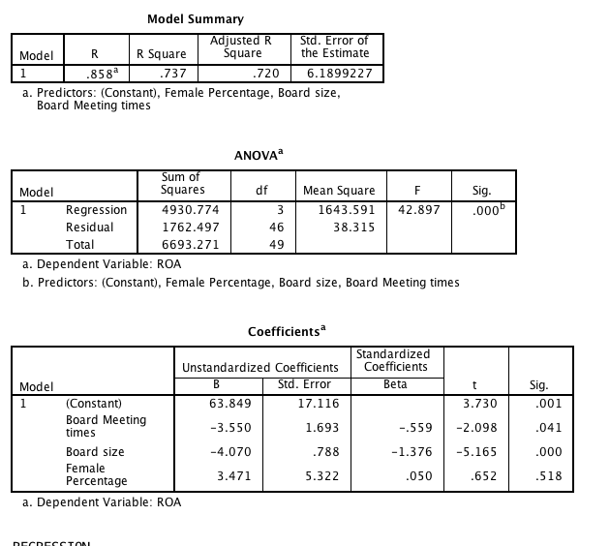
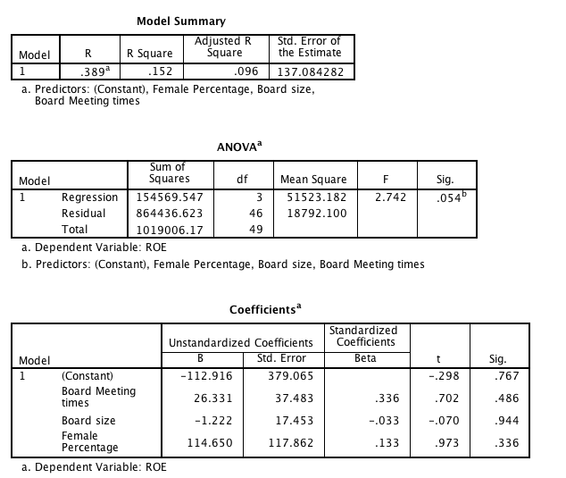
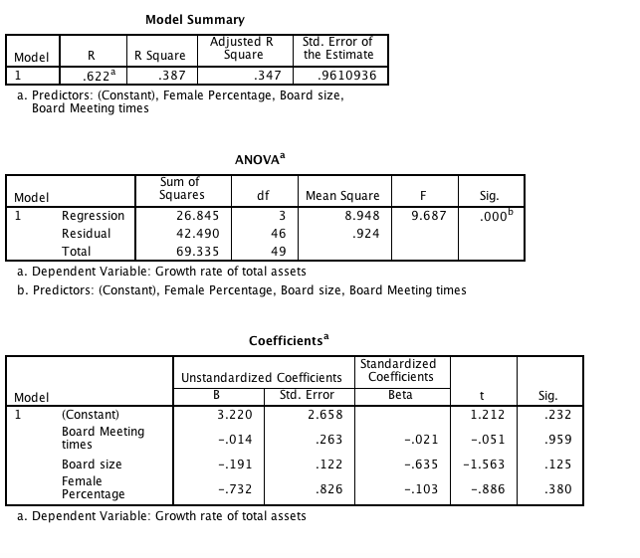

APPENDIX 3

MBA Project Assessment Form

First Marker / Supervisor Form

Student ID |  | . |  |  |  | Marks % | Signature | Final Agreed Mark
Student ID |  |  |  | First Marker /  Supervisor’s name
Student Name

Award a mark for each section and an A - C for an overall grade. Please refer to the rubric attach for marking.

Sections: | Subsections: | Comments:
Process | Dissertation Proposal (15%)  Reflection (5%)  Marks: _______ / 20%
Dissertation management | Management  Marks: _______ / 10%
Structure | Logical sequencing  Writing style  Referencing  Presentation  Marks: _______ / 10%
Method | Methodology  Methods of data collection  Marks: _______ / 15%
Literature | Identification of appropriate/relevant theory  Literature employed  Critical assessment/review  Independence of thought/ideas  Marks: _______ / 20%
Analysis | Analysis of data  Discussion  Conclusions and recommendations  Marks: _______ / 25%

Overall comments by Supervisor

Comments by External Examiner
Appendix 4

INITIAL RESEARCH PAPER PROPOSAL(IRPP) (30%)

Student Name, Student ID, Degree:

Cheng Qian, I18015906, Dual degree.

Course name and Code: Business research methods (MGT6202).

Lecturer: Dr.Arasu Raman.

INITIAL RESEARCH PAPER PROPOSAL(IRPP) (30%)
MBA Dual Degree
Inti International University, University of Hertfordshire

STUDENT NAME & ID NO | Cheng Qian I18015906
BROAD AREA | Finance
Concise Title [5 m] | Board Characteristics and Insurance company Performance: A study in China Sector
Problem Definition [35 m] | - 1 This essay will argue about factors affects the quantity of insurance contract signed in Malaysia. Based on the research, Insurance companies can take a series of measures to conclude more insurance contracts and make profits.  - 2 “This essay will use two theories: Reasoned Action Theory and Technology Acceptance Model  - 3 Whether the trust of Consumer to insurance policies will influences the profits of insurance firms in Malaysia(Peter, Richard 2018).  - 4 Based on the research, Insurance companies can take a series of measures to conclude more insurance contracts and make profits.  - 5 The study's significance for academia: this study will show how consumer psychology affects the income of a company. The significance of the research to government: by the amount of insurance contracts signed, the government can revise the state social welfare system. The significance of the research for sector is to enable insurance companies to make the law more lucrative (Sabine et al 2019).  6“<Trust, happiness, and households’ financial decisions>”(Delis, et al 2015)
Research Questions OR Objectives [10 m] | What are the variables that affect insurance companies ' earnings in Malaysia?  What are the primary variables affecting the insurance industry's earnings?  What are micro variables affecting the insurance industry's earnings?  What are the macro variables affecting the insurance industry's earnings?
Scope of study [5 m] | - This paper aims to research whether consumer confidence in insurance policies affects insurance companies' earnings.  - This research focuses on geography in Nilai, Malaysia.  - The study's sample focus is on individuals between the ages of 18 and 60 with monthly revenue in Ringgit 1500-10000.  - The study's analytical unit focuses on the factor that influences the above-mentioned individuals in choosing insurance businesses.  - Applied study is the study methodology method, including the selected analytical method.
Significance of the Research [5 m] | - This paper will demonstrate how does consumer psychology affect a company's revenue.  - The government can revise the state social welfare system through the number of insurance contracts signed.  - Allowing insurance companies making more profitable within the law.
Literature Review [10 m] | - the key concepts or theories:  - “Theory of Reasoned Action (TRA)”  - “Theory of Acceptance Model (TAM)”  - “Reasoned Action Theory (TRA) explains the connection between human attitudes and behaviors (Staub, 2013).  - Primarily, the TAM model explains how consumers can accept and use a technology(Alharbi & Drew, 2014).”  - Hypotheses: here is a significant relationship between Convenient company office location, Infrastructure, Fast and efficient counter services, Lower service charge, Reputation of company and the profits of insurance firms.”
Research Methodology [20 m] | - “Descriptive research method is used in this essay. It is used to identify and obtain information on the characteristics of a particular issue.”  - Sampling procedure and size: A random sample of 390 people is taken at the Kuala Lumpur international airport.  - “Data collection approach & Ethical consideration: Online surveys. The questions in the questionnaire will not involve human rights, racial discrimination and other issues, and the collected information is only for research purposes. The questionnaire which we designed is based on the issues; the questionnaire including Single and multiple choice, Likert scale.”  - Data analysis approach/technique/tools: SPSS
WRITTEN IRPP MARKS: | 90 marks
ORAL PRESENTATION: | Please see assessment format on the last page (Appendix 1)  10 marks

Reference
Staub, E., 2013. Positive social behavior and morality: Social and personal influences. Elsevier.

Alharbi, S. and Drew, S., 2014. Using the technology acceptance model in understanding academics’ behavioural intention to use learning management systems. International Journal of Advanced Computer Science and Applications, 5(1), pp.143-155.

Peter, R. and Ying, J., 2019. Do you trust your insurer? Ambiguity about contract nonperformance and optimal insurance demand. Journal of Economic Behavior & Organization.

International Journal of Bank Marketing, 2019, Vol. 37, Issue 2, pp. 579-594.

International Journal of Bank Marketing, 2019, Vol. 37, Issue 2, pp. 579-594.

J. Passthrough Entities 15 (2011) / Journal of Passthrough Entities, Vol. 14, Issue 6
(November-December 2011), pp. 15-67

