|  |  |
| --- | --- |
| **MENG CHUNYI MASTER OF BUSINESS ADMINISTRATION 2020** | **A Study on Female Clothing Consumption in Beijing, China**  **MENG CHUNYI**  **MASTER OF BUSINESS ADMINISTRATION FACULTY OF BUSINESS, COMMUNICATION & LAW INTI INTERNATIONAL UNIVERSITY**  **2020** |

**A Study on Female Clothing Consumption in Beijing, China**

**MENG CHUNYI**

**MASTER OF BUSINESS ADMINISTRATION**

**FACULTY OF BUSINESS, COMMUNICATION & LAW**

**INTI INTERNATIONAL UNIVERSITY**

**2020**

**INTI INTERNATIONAL UNIVERSITY**

**MASTER OF BUSINESS ADMINISTRATION**

**A Study on Female Clothing Consumption in Beijing, China**

Author: Meng Chunyi

Student No: I19016632

Supervisor: Dr.Sukjeet.Kuar.Sandhu

Submission Date: April 2020

Final word count: 13329

**ABSTRACT**

With the rapid development of China's economy, the social consumption is also unprecedentedly high, which makes the urban women especially obvious in the clothing consumption market. According to the National Bureau of Statistics data show that the value of China's garment industry reached $267.3 billion in 2017, up 8.04 percent from $347.4 billion in 2018. China is the largest country in the world clothing consumption. But in contrast, China's clothing industry and stores have been declining year by year (Zhao, Chow and Sharples, 2019).

This study analyzed the data collected from questionnaires and then used SPSS to prove that the three independent variables, fashion trend, money attitude and emotional response, have a positive correlation with women's clothing consumption in Beijing.

Through the analysis of the factors that affect Beijing women clothing consumption, the management and development of Chinese clothing marketing formats put forward relevant suggestions, make it can in the fierce competition in the better organization resources to meet the needs of the consumers.

**Key words: female clothing consumption ; fashion trend ; Beijing**

**ACKNOWLEDGEMENT**

I would like to express my sincere appreciation to everyone who contributed to the accomplishment of this dissertation. I am thankful to my supervisor, Dr.Sukjeet.Kuar.Sandhu for her excellent guidance, effort, patience, and time throughout the study. My thanks also go to my examiner, Mr. Salaar who has been supportive and offered her valuable comments.

Special thanks to my friends who helped me distribute the questionnaires to their acquaintances. I would also like to spare my utmost thanks to those respondents who have been kind enough to answer my queries as well as the authors whose work helped me have a thorough understanding of the subject. The inputs provided have made the findings of my research conclusive. Very special thanks go to all those who have generously assisted in my work in a way or another.

None of this would have been possible without my family and closest friends. For the support, encouragement, and unconditional love through the times I did not believe in myself, I am forever grateful to them.

**DECLARATION**

I hereby declare that this thesis is my own work and effort and that it has not been submitted anywhere for any award. Where other sources of information have been used, they have been duly acknowledged.

Name : Meng Chunyi

Student ID : I19016632

Signature : Meng Chunyi

Date : April 2020

**Content**

1.0 Introduction 1

1.1.1 Background of clothing market 1

1.1.2 Background of female clothing consumption 2

1.1.3 Background of female clothing consumption in Beijing 3

1.2 Problem statement 4

1.3 Research questions 8

1.4 Research Objectives 8

1.4.1 Specific Research Objectives 8

1.5 Significance of the study 9

1.6 Limitation 9

1.7 Scope of the study 10

1.8 Ethical consideration 10

2.0 literature review 10

2.1 Female clothing consumption 11

2.1.1 Global Perspective of female clothing consumption 11

2.1.2 China Perspective of female clothing consumption 13

2.1.3 Beijing Perspective of female clothing consumption 14

2.2 Factors influencing female consumption on clothing. 15

2.2.1 Fashion trend 15

2.2.2 Money attitude 16

2.2.3 Emotional 19

2.3 Theoretical and Model of Consumption 20

2.3.1 Fashion theory 20

2.3.2 Bourdieu's Class Theory 21

2.3.3 Cognitive-affective Model 23

2.3.4 Theory of Reasoned Actions (TRA) 24

3.0 Research methodology 25

3.1 Research design 25

3.1.1 Conceptual Framework 25

3.1.2 Measuring instrument 26

3.2 Study Population, Unit of Analysis, Sample Selection and Sampling Techniques 27

3.2.1 Study Population 27

3.2.2 Unit of Analysis 27

3.2.3 Sample Selection 28

3.3 Validity and Reliability Tests and Analysis 28

3.3.1 Validity Tests and Analysis 29

3.3.2 Reliability Tests and Analysis 29

3.4 Data Collection and Analysis Methods 30

3.4.1 Data Collection 30

3.4.2 Analysis Methods 30

3.4.3 Descriptive analysis 30

3.4.4 Correlation analysis 31

3.4.5 Regression Analysis 31

4.0 Research finding 31

4.1 Pilot test 32

4.1.1 Factor analysis of Pilot test 32

4.1.2 Reliability test of pilot test 33

4.1.3 Correlation test of pilot test 34

4.2 Descriptive statistics of respondents 34

4.3 Preliminary data analysis 39

4.3.1 Factors analysis 39

4.3.2 Reliability test 44

4.4 Correlation analysis 45

4.5 Hypothesis analysis 46

4.5.1 ANOVA analysis 46

4.5.2 Model Summary 47

4.5.3 Coefficients 48

4.6 Summary of findings 49

4.6.1 Findings of research hypothesis 50

4.6.2 Findings of research questions 52

5.0 Summary 53

5.1 Conclusion 53

5.2 Limitation 54

5.3 Recommendations 55

5.4 Further research 58

5.5 Personal reflection 58

6.0 Reference 60

7.0 Appendix 65

**Chapter 1**

# 1.0 Introduction

### 1.1.1 Background of clothing market

Clothing expenditure is an indispensable part of people's life. Clothing market is also an important part of economic development. Clothing is one of the most complex commodities in human production and consumption. The diversity and richness of clothing consumption are beyond the reach of other commodities. With the continuous development and progress of the society, the clothing consumption market also shows an unprecedented upsurge (showed at figure1). For a variety of psychological and behavioral needs, women in the clothing consumption showed a huge consumption capacity (Adnan &Islam, 2019).

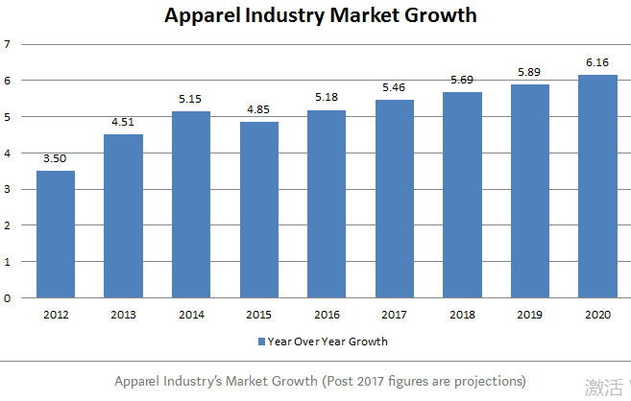

Figure1-1: Apparel industry market growth (Ganit, 2020)

### 1.1.2 Background of female clothing consumption

Modern women are more independent in economy, they see themselves more delicate and thorough, self-cognition is more clear, personality taste is more unique, emotion is more sensitive and strong, all these can be perfectly reflected through the consumption of women's clothing. It is easy for women to purchase clothes to show their unique personality and reflect their own taste and aesthetics. At present, women's clothing consumption has occupied the first place in women's consumption demand, so the importance of women's clothing consumption market is self-evident (showed at figure 2). "Women are the number one opportunity," says Tom Peters, a business guru, in his book the innovation cycle.

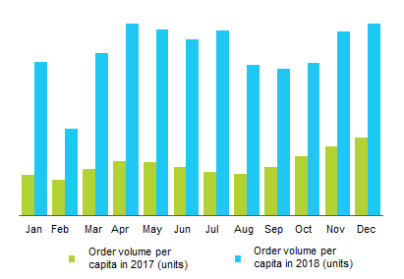

图 0-1 Clothing consumption among Chinese women in 2017 and 2018

Figure1-2: Clothing consumption among Chinese women in 2017 and 2018.(iresearchchin.com, 2018)

### 1.1.3 Background of female clothing consumption in Beijing

Beijing is the capital of China. This special status makes Beijing consumers more receptive to foreign cultures and concepts, including clothing concepts. In addition, Beijing residents have relatively high economic income and education level, so Beijing has always been the preferred city for overseas brands to explore the Chinese market (Jung & Choi, 2020).

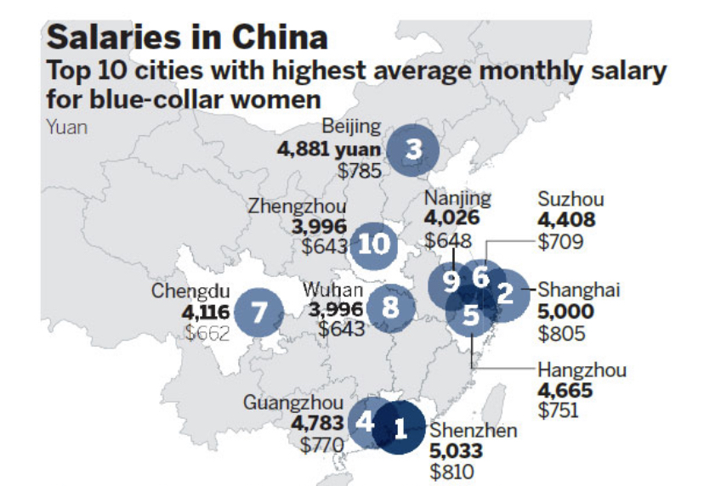

Figure1- 3: Salaries in China

Source: China Daily

In 1992, China allowed foreign retailers to enter the Chinese market for the first time, including Beijing in six cities. In recent years the development of Beijing in the most prominent, and also all kinds of clothing brand stores also have mushroomed are located in Beijing, such as Giordano sprint Nextel, Adidas, Nike, LV and Egypt, Jeanswest, GUCCI, etc have been entering the Beijing market, with their popular clothing, unique marketing approach, active the clothing market of Beijing. Therefore, Beijing women's clothing consumption for the study of women's clothing consumption has an important representative.

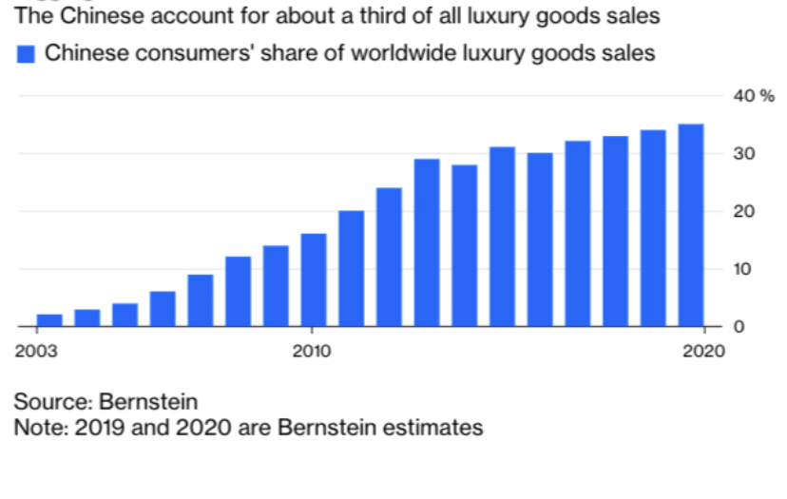

Figure 4: Chinese consumers share of worldwide luxury goods sales from 2003 to 2020

Source: Bernstein

The world's garment market is surging, the competition is intense and the demand for garment consumption is diversified, differentiated and personalized, which puts forward higher standards and requirements for the garment industry. Therefore, both clothing manufacturers and retailers should aim and observe the psychology and behavior of female consumers and adopt corresponding marketing strategies if they want to occupy a place in the highly competitive female clothing market (Zhang, 2017). Based on the research on the consumption of women's clothing in Beijing, this paper provides decision-making basis for the apparel enterprises that produce and sell professional women's clothing.

## 1.2 Problem statement

According to the National Bureau of Statistics data show that the value of China's garment industry reached $267.3 billion in 2017, up 8.04 % from $347.4 billion in 2018. China has overtaken the largest country in the world clothing consumption, and women's leisure clothing market retail size increased from 2016 in 85.89 billion yuan in 2019 to 1, 34.39 billion yuan, the compound annual growth rate of 11.8%, the same year, women's leisure clothing market accounted for 65.3% of adult leisure clothing market. The proportion of the total clothing market size is 13.3%, indicating that casual clothing is the main category of domestic women's clothing consumption. However, since 2016, domestic women's wear has been in high inventory, and Chinese women have been choosing overseas purchasing and overseas consumption. According to the data of the world Tourism Organization (UNMTO) in 2016, the total overseas consumption of Chinese mainland tourists reached 261.1 billion us dollars, of which clothing consumption accounted for as much as 28%. Compared with the expenditure of clothing consumption, the Chinese women's clothing market has been suffering from a cold wind in recent years (Moon, 2019). 2019 seems to be an unfriendly year for China's apparel industry. Closings, losses and unsalable inventory appear to be the three key words for Chinese clothing brands in 2019. Judging from the development history of Chinese garment enterprises, more attention was paid to the data scale during the rapid development.

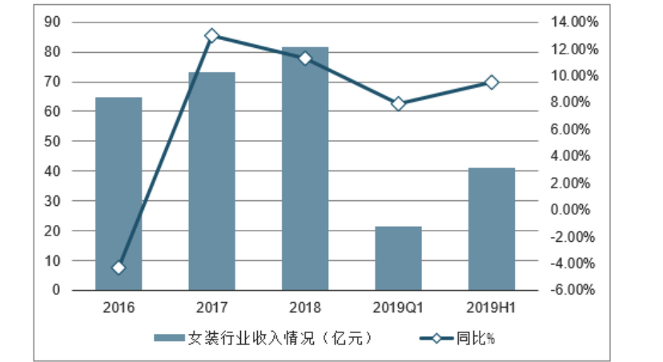

Figure 1-4: Women's clothing industry revenue from 2016-2019 in China.

Source: China Daily

However, in recent years, garment enterprises frequently fall into crisis, inventory is slow to sell, the tide of closing stores and so on (Yao, 2019). Here are three factors that influence women's clothing consumption.

In terms of women's clothing fashion trend, almost women want to wear clothes that are unique and look good, and the uniform design and popular creativity make them lose interest in these clothes (Dickson, 2010). Domestic products is given priority to with imitation, such as lack of innovation is causing severe downturn in the main performance, some domestic brands from a few years ago began to blindly expand the scope of business, find a way of scale to win but it appeared in the process of expanding the store to open the problem of too much, a lot of domestic brands on the positioning is not clear, the characteristics of the differentiation is not obvious (Zhang, Gale and Eckert, 2018).

In terms of money attitudes. When choosing clothes, Chinese female consumers prefer to buy luxury goods. Although the functional value of luxury brands is usually not significantly higher than that of non-luxury brands, women's attitude towards luxury brands is positive. For female consumers, luxury brands have more uniqueness, status and enjoyment than non-luxury brands (Yan, 2010). In particular, middle - and high-income women are more willing to buy foreign luxury brands such as LV, GUCCI and FENDI than domestic brands. They prefer to show their status with luxuries. The Chinese mainland has a huge clothing market, and overseas women's wear brands have occupied the market share in China, especially luxury brands, which has inhibited the growth of Chinese women's wear brands (Yu, 2019).

Emotional is also a factor that affects the consumption of women's clothing (Yu, 2018). When buying clothes, Chinese female consumers not only pay attention to product characteristics or guide consumers to pay attention to product characteristics, but also pay attention to the corresponding emotional substation and the symbolic meaning behind the products. Apparel product design attributes stimulation can form different consumption psychology, is not just because it brings the function of the consumer demand, in fact, in all types of clothing products to meet the functional requirements of clothing, consumers get at this time of spiritual pleasure and satisfaction on the psychological meaning and become a costume design attribute is the important foundation of stimulating consumption. Finally, it is found that the stimulating consumption of clothing design attributes to consumers is not usually one-time, but in a continuous process. A well-designed garment often takes into account all aspects of consumers' psychological appeals in the process of clothing selection, so as to meet their sense of existence, physical and emotional needs, and even vanity, so as to make the garment itself more attractive, so as to avoid consumers' premature visual fatigue. The problem for Chinese clothing designers is that they pursue too much foreign fashion design, form a similar but different brand name, and ignore corporate brand culture and Chinese cultural context.

## 1.3 Research questions

There are four inquiries in this examination:

1. Is there any relationship between fashion tend and female clothing consumption in Beijing, China?

2. Is there any relationship between money attitude and female clothing consumption in Beijing, China?

3. Is there any relationship between emotional respond and female clothing consumption in Beijing, China?

5. Which factor is the most significant in influencing female clothing consumption in Beijing, China?

## 1.4 Research Objectives

Research Objectives are the clear beginning of the study which mean it is important for the study in that can ensure the overall outcome of the study (Richard, 2017).

In each study, goals and objectives to support the research and application of a good framework is very important, well organized and good goal will effectively guide the research process, this will determine all other aspects of the design (Gunaydin and McCusker, 2015).

The main purpose of this study is to analyze the consumer behavior toward female clothing consumption in Beijing and its influencing factors.

### 1.4.1 Specific Research Objectives

RO1: To determine whether fashion has a relationship with female consumers buying behavior in Beijing.

RO2: To determine whether money attitude has a relationship with female consumers buying behavior in Beijing.

RO3: To determine whether emotional respond has a relationship with consumer buying behavior in genetic modified food in China.

Ro4: To determine which factor is the most significant in influencing female clothing consumption in Beijing, China

## 1.5 Significance of the study

This research studies the overall level of Beijing's female clothing consumption, clothing consumption quantity, structure, and the different age, income, marital status of female clothing consumer segmentation characteristics and preferences, etc, on the basis of the summarized and put forward relevant suggestions, reveals the overall and subdivision of the female apparel consumption, including, Beijing female overall clothing consumption level, preferences, and pay attention to the different properties, Beijing women clothing consumption preference, characteristics of market segments. In view of different types of clothing, the paper makes different division and specific analysis of customer groups, reveals the different needs and preferences of different types of customer groups, and then puts forward specific Suggestions for clothing production and distribution manufacturers, so as to occupy a more favorable position in the fierce competition in the female clothing market.

## 1.6 Limitation

First, the limitations of factor, since this paper only analyzes fashion trend, money attitude and emotional respond factors, it does not analyze all factors that may affect customers' purchase intention. Apart from the selected factors, it may have a slight impact on buying intentions, but not on the key factors. Thus the usefulness of the results remains unknown.

Second is sample limitations. The research samples of this paper are the overall situation, characteristics and preferences of the clothing consumption of female consumers over 16 years old in the eight districts of Beijing.

Third, the clothing category in this paper is limited to trunk clothing, such as jacket, trousers and dress, and does not include other accessories consumption.

## 1.7 Scope of the study

In this paper, the main object of the study is women in the eight districts of Beijing. A total of 400 questionnaires were issued to investigate the overall status, characteristics and preferences of clothing consumption of female consumers over 16 years old in Beijing. The clothing in this article refers to the narrow sense of clothing, mainly referring to the trunk clothing, excluding the first clothing (hat), foot clothing (shoes, socks), hand clothing (gloves), makeup, body accessories, hair style and other contents. Among them, garments are mainly studied by outerwear, while underwear is rarely studied.

## 1.8 Ethical consideration

In this paper, we treat each participant equally. Questionnaires were randomly distributed to all groups and filled in anonymously, avoiding discrimination income and education. At the same time, in the questionnaire survey, do not take the case of comparison with other projects, to avoid misleading consumer propaganda.In the processing of sample results, we do not differentiate the sample data by age, such as the comparison of income level and education level.

**Chapter 2**

# 2.0 literature review

The purpose of this chapter is to review the literature on all variables related to this study. Firstly, this part define women consumption on clothing both in global and Beijing. Secondly, introducing the factors including fashion trend, money attitude and emotional respond has a relationship to female clothing consumption. Thirdly, influencing factors linkage with consumer buying behavior will be showed. Fourthly, some grounded theory will be introduced in this part.

## 2.1 Female clothing consumption

The marketing of consumer behavior is defined as: "Perception, cognition, behavior and dynamic interaction of environmental factors, is the human life in the trading behavior of the functions of the foundation," consumer behavior is the role of consumption as the core of human behavior, including consumer acquisition, disposal and use of the product or service all reflect and associated activities (Lang &Armstrong, 2018). Consumer behavior refers to the behavior of consumers in the process of purchasing and trading commodities.

Clothing consumption behavior includes the subject of consumption, the object of consumption and the subject's evaluation of the object. The main body of consumption, that is, the people who play a decisive role in the purchase behavior; Consumption object, that is, the quality and personality shown by the consumer goods of clothing, includes the intrinsic attributes such as color, style, texture and workmanship of clothing, as well as the extrinsic attributes such as purchase opportunity, purchase channel and brand level of clothing (Park & Yoo, 2012).

The evaluation of the subject to the object is reflected in the degree of consumers' attention to the internal and external attributes of commodities in the process of buying clothes.

### 2.1.1 Global Perspective of female clothing consumption

In the 18th century, the consumer society began to emerge in Britain, the United States and France in the 19th century. In this context, some western sociologists began to try to take "consumption" or "consumption culture" as the research paradigm to explore the social and cultural nature of contemporary consumption (Khare & Rakesh, 2010). In the consumer society, women are always the typical representative of this trend. Women in the consumer society have the pursuit of novelty and unique, individual taste, beauty and fashion, fashion consumption, pay attention to the value of symbols and other special characteristics, the modern sense of sociological consumption from the opening (Armstrong, Niinimäki, Kujala &Karell, 2015). It has been closely linked to women's consumption since the beginning. American sociologist Veblen thinks that consumption is the contrast between wealth competition and discrimination. In 1899, he first noticed the emergence of the leisure class and its conspicuous consumption Phenomenon, proposed that "clothing is a manifestation of money culture." As for the consumption behavior of clothes, he thinks that "the spending on clothes for the sake of boasting is always more prominent and the custom is always more common. No one can deny the fact that most of the consumption of clothing by all classes is for outward decency rather than for warmth. If we do not measure up to the standards of social custom in our dress, we are embarrassed, and perhaps no other sense of acuteness can match this. In Veblen's opinion, the behavior of clothing consumption is to let others know the money power, power and identity of consumers, so that consumers win honor and obtain self-satisfaction (Kingma & van, 2015).

German sociologist Simmel believes that consumption is the need of the higher social classes to continuously launch new fashion. Fashion is the product of class division. "the fashions of the higher strata of society distinguish themselves from the lower strata, and when the lower strata begin to imitate the fashions of the higher strata, the higher strata abandon this fashion and create another fashion." On the other hand, "Fashion is the imitation of established patterns, which meets the needs of social adjustment; It leads the individual down the path that everyone is on, and it provides a universal rule that turns individual behavior into a template. But it also meets the requirements of difference, change and individuation." Simmel pointed out that "Fashion is like a valve for women to find an outlet to express themselves and pursue the satisfaction of individuality that is not available in other fields." At the same time, his view is also reflected in the consumption of clothes. He believes that "The rhythm of pace, speed and posture is fundamentally determined by clothes(Bianchi & Birtwistle, 2010). "

### 2.1.2 China Perspective of female clothing consumption

Zhou and Quan (2010) found in their research on the clothing consumption behavior of white-collar women in Shanghai and Beijing. White-collar women in Shanghai are more likely to buy on impulse, while those in Beijing are more likely to buy on reality.Irrational consumption phenomenon in Shanghai and Beijing white-collar young women accounted for the majority. The style and color of clothing is the most concerned factor of white-collar female consumers. White-collar women in Shanghai pay more attention to style and color than in Beijing. However, white-collar women in Beijing pay more attention to fabrics and workmanship than in Shanghai.White-collar female consumers in Shanghai and Beijing pay great attention to the collocation of clothes, and the single piece of clothing can no longer meet the consumption demand. Yang (2012) in the east China area in young and middle-aged women's clothing behavior analysis found that young female when buying clothes, will choose clothing quality is guaranteed a large clothing store and brand stores and other places, they attaches great importance to the suitability of wearing comfort and self image, which sells clothing display is an important approach to their clothing information, tend to make their decision to buy clothing has a direct effect.

Wu (2013) pointed out that under the influence of different age, status, occupation, economy and education level, the clothing consumption of adult women had obvious group characteristics. However, these factors are not fixed, they will constantly change with the changes of the surrounding environment.

### 2.1.3 Beijing Perspective of female clothing consumption

Analysis of Beijing clothing consumption potential and the current level of the analysis done in Beijing residents of clothing consumer spending in the late ninety to early 21st century presents different trends in recent years, and analyzed in detail from 1996 to 2001 per person per year clothing expenditures and growth; And with the increase of people's income, people's demand for clothing also presents new changes (Jun & Qian, 20010). And points out that in the face of huge clothing consumption market, clothing enterprises are faced with how to find his own clothing market segment, clear the size of the clothing consumption market scale, so that the arrangement of enterprise's production and sales, so as to satisfy people's growing clothing consumption demand, and can enhance the economic benefits of the enterprise itself.

From the perspective of clothing consumption changes in new China and social changes -taking Beijing urban residents as an example, a study on the Development stage of clothing from the perspective of clothing development and social changes (Podoshen & Zhang, 2011). The author believes that clothing is a special carrier of social changes. From 1949 to 1999, the consumption of clothing of urban residents in Beijing went through three stages, which was also a period of great social changes in China. Among them, the monotonous period dominated by simple and mechanical cloth processing reflected the intervention of political ethics in social life. The transformation from "single type" to "diversified type" reflects the adjustment of the internal structure of China's economy. The mature period of individuation, ready-to-wear and high-grade reflects the development of China's social economy, the improvement of people's living standard and the transformation of aesthetic concept under the background of market economy (O' Cass & Siahtiri, 2013).

Above two articles from the change of Beijing clothing consumption analysis of Beijing clothing market potential and the current level of the market, not just female apparel consumption of specific characteristics and specific preferences do classification to explain in detail, and the clothing market is fast changing, the above two articles are at the start of the decade of Beijing clothing market research, so this article will be Beijing's female further analysis of the current period as the research object the concrete factors influencing the female consumption, peculiar to women consumption characteristics and consumer preferences.

## 2.2 Factors influencing female consumption on clothing.

### 2.2.1 Fashion trend

Yang(2013) 's research thinks: at present, the personalized tendency of women is becoming stronger and stronger. The lifestyle of modern women has shown a new trend in the consumption of clothing, which is the pursuit of diversification of clothing, the courage to try challenging new things, the increased self-awareness of clothing consumption, the compliance with the trend, and the increasingly high requirements for appearance, and extremely enjoy the sex.

Aiming at the clothing consumption of white-collar women, Xing (2016) concluded through research that white-collar women pay attention to external beauty, have obvious perceptual consumption tendency, are greatly affected by word of mouth communication, pay attention to product details, pursue life quality, be sensitive to price, and pay attention to consumption experience. Wu (1015) believes that young and middle-aged women's wear consumers are the most dynamic consumer group. They are full of fantasy, sharp thinking, passionate and unrestrained, and are the trendsetter of fashion and trend.When they make clothing consumption, the factors that affect consumption are personality, store image, price, shopping environment and popularity.

Women in the new era are confident, emancipated and do not believe in tradition.In the process of consumption, they do not want to use the same commodities as others, they want to determine a personalized self-image through consumption activities, to reflect their own style, often in accordance with their own aesthetic orientation to decorate themselves, focusing on reflecting the distinctive self, highlighting the personalized characteristics of consumption.Their purchasing psychology is the pursuit of fashion (Zhang, 2006). In particular, the characteristics of female college students determine their personalized consumption behavior, which is embodied in fashion and stylization. The purchase of some fashionable products is often innovator and early user, but it is different from "alternative", "trendy", it is more reflected as a fashion and stylized (Cheng, 2006).

### 2.2.2 Money attitude

Jiang (2012) studied the relationship between face, symbols and consumption, and believed that face culture, as a unique cultural psychological phenomenon of Chinese people, greatly affected the daily social life of Chinese people.From the perspective of sociology, the symbolic meaning of face makes face become a symbol resource. The essence of Chinese people's saving face in consumption is to gain and show face through consumption, and through this display of face to strengthen their identity, and this face consumption behavior widely exists in all social classes. Lu (2008) studied the conspicuous consumption of modern people and believed that conspicuous consumption is characterized by comparison, waste, vanity and extravagance. The great abundance of material products is the material basis for people's conspicuous consumption. Some media reports have played a special guiding role in conspicuous consumption. "face saving" psychology is the cultural factor that produces conspicuous consumption. The consumption behavior effect of the first rich class provides the possibility for the spread of conspicuous consumption. Conspicuous consumption disrupts the balance of the ecosystem, violates the development of a harmonious society, interferes with the principle of fairness and justice, and distorts people's view of happiness.

Yuan (2009) by investigating the domestic consumer consumption idea and attitude towards high-end brand-name goods, found that face consciousness with conspicuous consumption behavior was significantly positively related to the four dimensions, and has a significant positive effect on propensity to consume status, but the status of consumption tendency of conspicuous consumption behavior affect the overall is not obvious, only to the materialism and group identity exchange two dimensions have less negative effects.

Zhou (2017) believed that modern women express and embody themselves through a variety of consumption, obtain a sense of psychological balance in shopping, and gain psychological advantages and self-confidence through possessing things that others do not have. They pursue famous brand, reflecting their own identity in consumption, expressing their personal taste. The anthropologist Zeng (2019) describes the consumption characteristics of Asia's emerging middle class as "they live fashionable lives and demand high-quality products and services. The pursuit of quality products and services is part of their conscious pursuit of high-quality life."

Tao (2019) believes that the reason why women are so keen to buy luxury goods lies in: (1) luxury consumption can satisfy the emotional consumption psychology of female consumers; (2) luxury consumption can satisfy female consumers' psychology of showing off their status and status; (3) luxury consumption can satisfy women's psychology of vanity and keeping up with the joneses; (4) luxury consumption can satisfy female consumers' psychology of showing individuality and pursuing fashion. Through the purchase of luxury goods by Chinese women, Li (2016) summarized the consumption awareness of female luxury goods: (1) pay attention to the interdependence between people in self-concept; (2) pursue a balance between individual and group interests; (3) high recognition of social hierarchy.

Wong and Ahuvia (2010) argue that China has been part of the wealthy women, on the luxury consumption rationalization gradually, to mature western consumption concept, advocated by the luxury to self pleasure experience, the pursuit of personal meaning of products, can according to your own taste and standard to judge the quality of the products is the pursuit of "people oriented" this part of the consumer, they belong to the affected by western individualism culture and attaches great importance to the independent self-concept, don't like dependencies and level of people. However, compared with traditional western consumers, their consumption values are essentially different, which is reflected in the difference in the definition of "enjoyment".

The word "luxury" originated from the Latin "Luxus", which originally referred to extraordinary fertility or creativity.From an economic point of view, luxury goods refer to a category of goods in which the increase in demand is greater than the increase in income. Luxury goods in the world is defined as "a kind of beyond the range of people survival and development needs, unique, rare, rare characteristics of consumer goods, also known as the necessaries of life(Lang, 2013)".

According to the Maslow's demand of five levels: physiological needs, security needs, social needs, esteem needs, self-actualization needs, we considered ordinary consumer service here in lower physiological and security needs, but easy to saturation, demand elasticity of demand is small; Luxury, on the other hand, serves the needs of higher sociability and respect, even self-actualization. VorganLaci Le (2010) defines luxury as a lifestyle that is considered luxurious in whole or in part by the respective societies, largely determined by the product or service. Werner (2015) defines luxury from the perspective of economics: a consumer product that is beyond the scope of people's survival, development and needs, and has the characteristics of uniqueness, scarcity and rarity.

### 2.2.3 Emotional

Aiming at the research related to women's clothing consumption, domestic scholars put forward the consumption behavior characteristics of female consumer groups, such as perceptual consumption, trend consumption, individual consumption and experience consumption, in the research on the general marketing strategy of female consumer groups (Reppel & Gruber, 2012). Similar to foreign studies, some scholars also study female consumption from the perspective of emotional experience. Li (2010), a scholar, believes that female consumer group is a rising consumer group and the backbone of fashion consumption, whose consumption awareness and consumption rights all affect the product design and marketing strategies of apparel enterprises. The change of growing environment has changed the consumption habit, brand concept and brand psychology of modern women at the same time. The consumer demand tends to be personalized and diversified, paying attention to the additional "emotional experience" of products. Based on Maslow's hierarchy of needs theory, You (2010) concluded that fashion consumption is a manifestation of modern women's clothing consumption as well as their social needs, and they constantly pursue fashion products and "love the new and hate the old". Liu (2013) analyzed the consumption characteristics of female consumers in the online environment, believing that women not only pay attention to the purchase itself, but also pay attention to various feelings in the purchase, reflecting the complete shopping experience.In the analysis of white-collar women's clothing consumption behavior, Xing (2010) believed that white-collar women now pay attention to consumption experience, and the experience of shopping pleasure is very important to many white-collar women, even more than what they buy.

The research of tan and Jia (2017) found that for urban female consumers, the price of commodities is no longer the primary or important factor influencing consumption, but the symbolic significance, performance ability and consumption experience of commodities are the important basis influencing consumption choice.This demand trend of individuation, self-expression and self-satisfaction is explained from the perspective of consumer psychology, which is the pursuit and display of consumers' self-concept. Consumers' self-concept is different, so are their buying behaviors. Therefore, it is an effective way to study and analyze the self-concept of female consumers and take self-concept as an important segmentation criterion of female consumption market. Zhang and Li (2011) found that women's consumption behavior is not a simple purchase activity, but a complex behavior formed by the comprehensive effect of various factors under a certain historical and cultural background.

## 2.3 Theoretical and Model of Consumption

### 2.3.1 Fashion theory

In the literature on clothing fashion and psychology, G Simmel (1957) explained the popular theory in 1971 from the perspective of psychological state and dualism, which held that human beings not only have the impulse to pursue individual difference, but also have the impulse to require equalization of all social members. He believes that the contradiction between the difference and the equalization of the binary power and the change of the principal, the main reason for the occurrence and end of the popular events.

Furthermore, G. Simmel (1957), and the difference between proposed (demarcation) this an antagonistic psychological tendency to explain. He believes that through imitation, people can get satisfaction and security in similarity, consistency, universality and normality, but such psychological tendency of imitation will be checked and balanced by psychological tendency. That is, people will strive for their personal differences, independence, specificity and variability. It can be seen that the impulse of individual differentiation and social equalization, as well as the psychological tendency of imitation and distinction, coexist in the popularity, and then most people imitate and follow the popularity. But when a fad is generally accepted by the general public, it disappears. From the perspective of human psychology, this viewpoint explains the reason why people pursue fashion trends and summarizes the development rules of fashion trends. On the one hand, the fashion trend is related to the environment of the individual, on the other hand, it is related to the characteristics of consumers themselves, which is similar to the starting point of this paper. This paper also studies the clothing consumption level and characteristics of individual women in the context of Beijing.

### 2.3.2 Bourdieu's Class Theory

People's concept of money in clothing consumption has gradually evolved into the class nature represented by clothing. Bourdieu's class theory has three core concepts: habit, field and capital. His consumption behavior is a kind of practice. Only through these three concepts can we understand the class characteristics of consumption.First of all, people of different classes have different habitual habits, which are reflected as tastes through consumption activities. Individual status is determined not only by economic capital, but also by cultural capital. Secondly, Bourdieu believed that the owners of different types of capital showed different consumption tastes, so the total amount of capital owned by individuals affected the choice of consumption mode.The types of capital in Bourdieu's capital theory include economic capital, cultural capital and social capital, among which cultural capital and economic capital have strong explanatory power for consumption choice (Riley, 2017).

As Bourdieu points out, "taste is the physical control of distribution that makes it possible to feel or intuit what an individual who occupies a particular place in a social space may (or may not) encounter and therefore fit. It plays a social guiding role, guiding the occupant of a particular position in social space to the social status suitable for its characteristics, and to the practice or commodity suitable for the occupant of the position. Given the distribution of the selected practice or thing in the social space, and the actual knowledge of other actors in relation to the correspondence between goods and groups, it implies an actual expectation of what the social significance and value of the practice or thing is.It can be seen that what members of a class show through their consumption behavior is their position in social space. Bourdieu also described and analyzed the relationship between class habits and tastes. He pointed out that two basic class tastes arose from the differences in economic conditions: the taste for luxuries and the taste for necessities. The former is the embodiment of the habits of the ruling class with good economic conditions, while the latter is the manifestation of the habits of the general class.Two diametrically opposed tastes embody the habits of two classes in different circumstances (Harker, Mahar & Wilkes, 2016).

### 2.3.3 Cognitive-affective Model

There has been a lot of theoretical research on consumption. The consumer buying behavior towards various products such as how fashion trend, money attitude and emotional can form the cognitive-affective model of buying intentions (Chan and Monroe, 2014), as well as how the self-concept can determine consumers’ purchase preference (Sirgy, 2014). In their article on “Female self-concept and clothing consumption behavior”, Tan and Geng (2018), starting from the symbolic meaning of clothing consumption, pointed out that the different symbolic meaning, expressive ability and consumption experience of different clothes are the important basis for influencing consumers' consumption choices. From the perspective of consumer psychology, it is consistent with female self-concept. The quality, style and color of clothing, as well as the brand and place of purchase, are important tools for female consumers to reinforce their self-concept. In foreign countries, in the 1980s, Sigry put forward the self-concept and product image consistency theory, which holds that products containing image meaning usually evoke self-concept of the same image. This theory not only explains the consistent relationship between product image, self-concept and consumption behavior, but also indicates that consumers' self-concept is an important factor affecting purchase motivation, which lays a foundation for the application of self-concept theory in consumer research. Later, many scholars extended and cited the theory and proved it from various industries and fields (Shaw, 2011).

The above documents and theories are the five types of female consumers (family self consumers, emotional, spiritual self, self expression model and the development of self understanding type) is divided into the foundation, further study, self concept directly application of female consumer behavior research mostly stay in qualitative research stage. At the same time, the same self concept of women for clothing consumption goods conditions, regional characteristics, and the same consumer itself age, income, marital status and so on the influence of different factors, this article is in reference on the basis of the theory of literature, women of Beijing as the research object, according to the different personal characteristics of the different consumers to further empirical analysis (Colls, 2014).

### 2.3.4 Theory of Reasoned Actions (TRA)

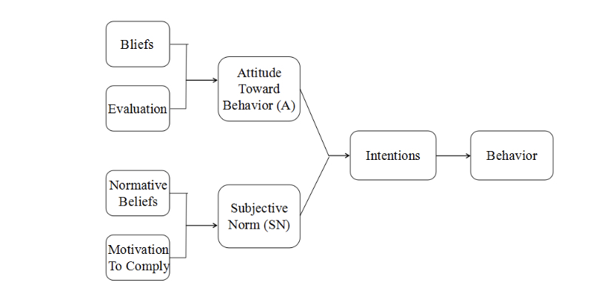

Figure 3: Theory of Reasoned Action (TRA)

Source: Southey (2011)

TRA, proposed by Ajzen in 1975 (Chawla, 2015), is the basis for understanding and predicting consumer buying behavior (Yu and Wu, 2010). Rational behavior theory (TRA) is a theory used to determine the behavioral intention of consumers, in which behavioral intention is an "attitude-behavior" behavior. The theory of "behavior intention", it refers to when doing a particular behavior will or won't. It is determined by behavioral attitudes and subjective norms. In addition, subjective norm refers to the consumer to family or friends or other reference groups influence on the behavior perceived opinions (Chang, 2016). Thus, the theory predicts consumers' attitudes toward a behavior, not toward a product or service.

**Chapter 3**

# 3.0 Research methodology

## 3.1 Research design

### 3.1.1 Conceptual Framework

According to the literature review, there are many factors that have an impact on women's clothing consumption in Beijing. This study collected relevant data through questionnaires and drawing conclusions according to the analysis of data. The following framework selects fashion trend, money concept of luxury goods and emotional response of clothing stores as the independent variables of women's clothing consumption in Beijing.

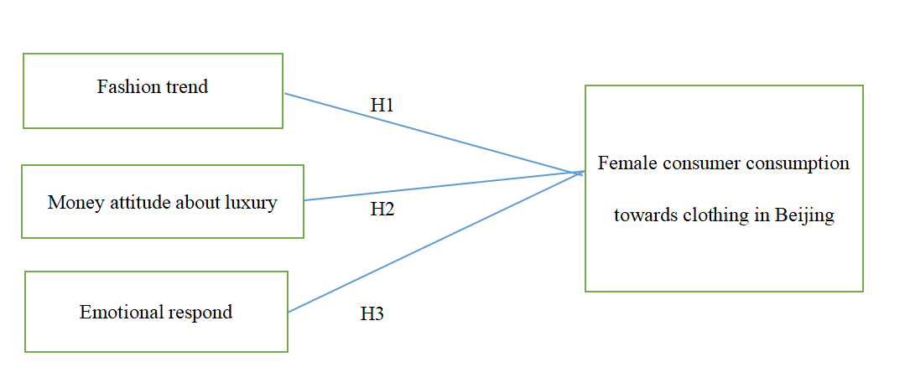

Figure4: Theoretical Framework

H1: Fashion trend has an important impact on purchase decision-making when buying clothing in Beijing.

H2: Money attitude has an important impact on purchase decision-making when buying clothing in Beijing.

H3: Emotional respond has an important impact on purchase decision-making when buying clothing in Beijing.

### 3.1.2 Measuring instrument

This exploration investigates the connection between the three free factors and the examination object by acquiring significant data of the exploration object. This research studies the factors that affect the consumption of female clothing in Beijing. First of all, starting from the theoretical basis research. Secondly, questionnaire survey is designed based on theoretical research.

The questionnaire survey of this research is mainly composed of three parts. Part A of the questionnaire is about the participants' personal information, including marital status, age, highest education level, monthly income level, etc. This encourages us to have some information on the members, likewise furnishes us with countless information sources. The second part is to understand the general situation of female consumers' clothing purchase, such as the frequency, cost and source of clothing purchase. Part C Part are an integral part of women's apparel consumer questionnaire. The design of the problem basically adopts the closed problem. Try to make the words concise and easy to understand. The scale designed by the questionnaire adopts the like-rt scale which is widely used in the questionnaire survey (Seven-point scale). On this basis, determine whether the factors are related to clothing consumption.

The five-point likert scale was adopted, such as 1= Strong disagree, 2=Slight disagree, 3= Disagree, 4= Neutal 5= Agree 6=Slight agree 7= Strongly Agree. It will use numerical and statistical analysis and will be presented in graphical form. However, when the answer to an open question is unclear, research may be needed.In such cases, in-depth interviews may be required to further understand the responses and comments from a specific sample, which helps to accurately interpret the results. In the Google spreadsheets to create an online questionnaire to collect digital data, and will be sent to respondents questionnaire link by email. The online survey can also be spread through Facebook. Thus, respondents may simply connect to a link that points directly to the survey. Therefore, this study is aimed at the clothing consumption of female consumers, so the online questionnaire is designed. Therefore, this study is more inclined to use primary data and online questionnaire survey collection method.. After collecting the data, SPSS will be used to analyze the data.

## 3.2 Study Population, Unit of Analysis, Sample Selection and Sampling Techniques

### 3.2.1 Study Population

As indicated by China's 6th evaluation, Beijing has a populace of 20.7 million. The object of this paper is the clothing consumption of women in Beijing. It is estimated that women make up 48.4% of the total population, which is about 10.05 million. Because of the enormous populace, this examination receives the technique for arbitrary testing explore.

### 3.2.2 Unit of Analysis

The unit of analysis is the object of social investigation. The object of investigation is the object being questioned in the process of data collection; The substance of the overview is to investigate the properties and qualities of the unit. The analysis unit may be the same as the survey object or sampling unit, or it may be different. The study was echoed by Beijing's female residents, who are individuals.

### 3.2.3 Sample Selection

Population over 10.5 million in this survey (N). The calculation results of Krejcie & Morgan(1970) are as follows:

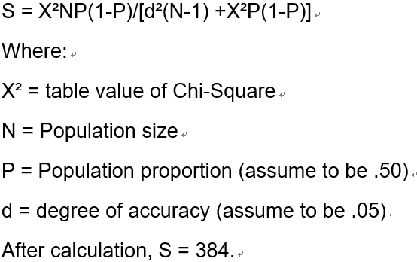

However, in this study, the sample size was expanded to 400 to further enhance the accuracy of the data.

## 3.3 Validity and Reliability Tests and Analysis

The design level of the questionnaire directly affects the quality of the paper, and the most important judgment of the quality of the questionnaire is the reliability and validity of the questionnaire. Therefore, in order to ensure the validity and credibility of the research purpose of this paper, it is necessary to select 30-40 questionnaires to investigate the validity and reliability of the questionnaire data.

### 3.3.1 Validity Tests and Analysis

The questionnaire validity refers to the authenticity and accuracy of questionnaire, including criterion validity, content validity and structure validity. This paper mainly studies the content validity and structure validity of the questionnaire. In the aspect of content validity, it is mainly composed of two parts. The first draft of the questionnaire was determined and the questionnaire was pre-surveyed. When drafting the first questionnaire, I read the excellent research results at home and abroad and further modified the questionnaire. It is feasible to determine the validity of the questionnaire in the pre-survey stage. Accordingly, from the purpose of the structure of the poll, the survey has great legitimacy. In terms of structural validity, this paper mainly studies the consumption of women's clothing in Beijing, so the factor analysis method is used to test the structural validity of the questionnaire

### 3.3.2 Reliability Tests and Analysis

The internal reliability test is used to analyze the consistency of the scores given by the respondents. The reliability test was used as part of an overall study to determine the intentions of female consumers when buying clothing. Reliability analysis is an effective analysis method to measure whether the comprehensive evaluation system has certain stability and reliability. It is to study the validity (reliability) of the scale. The reliability analysis of SPSS used in this paper is to make a basic statistical description of each evaluation project, calculate the simple correlation coefficient of each project, and put forward the correlation coefficient between the other projects after one project. Since the reliability of retest is mostly a factual questionnaire, the semi-reliability method and Cronbach's alpha can be used for reliability analysis. In addition, because Cronbach's alpha is more widely used, Cronbach's alpha coefficient is used at the end of this paper. Methods the internal consistency of the questionnaire was tested.

## 3.4 Data Collection and Analysis Methods

### 3.4.1 Data Collection

The total population of this study was 10.05 million.You need 400 participants. The survey will be distributed online. Will be random questionnaire on the Internet. It can save cost and shorten the investigation time. A preliminary study will be conducted before the questionnaire is issued. In the pilot study, participants will be given a small number of questionnaires to determine their understanding and clarity of the questions in the questionnaire and to make improvements to the areas in the questionnaire that need to be modified.

### 3.4.2 Analysis Methods

After the finish of the questionnaire information assortment, the gathered information will be sifted through and contribution to SPSS 22.0. Then descriptive statistical analysis was conducted to understand the participants' personal information, including gender, age, house number, etc. Finally, the researchers carried out correlation analysis and regression analysis on related problems.

### 3.4.3 Descriptive analysis

Descriptive statistical analysis is an analytical method that USES statistical indicators to describe its characteristics. This description may seem simple, but it is actually the basis of many advanced analyses. Many advanced analytical methods have certain data, assumptions and applicable conditions.

### 3.4.4 Correlation analysis

Correlation analysis validates a linear relationship between two or more variables. From the correlation coefficient r, we can see the correlation degree and positive and negative correlation between the two variables. When the standard deviation of two variables is not 0, the correlation coefficient is defined. When one or two variables have measurement errors, their correlation weakens.

### 3.4.5 Regression Analysis

Regression analysis is often used for predictive analysis.Regression analysis mainly measures the influence of independent variable X on the dependent variable Y by establishing a regression model between the dependent variable Y and the independent variable X that affects it, and then predicts the development trend of the dependent variable Y. For example, women buy clothes according to fashion trends. By analyzing this dependence, we can predict that the next fashion trend will stimulate women's consumption on clothes.

**Chapter 4**

# 4.0 Research finding

This investigation utilized SPSS 22.0 programming of substantial surveys gathered for measurable examination. Assessment data have practical significance in the questionnaire and the relationship between independent variable and dependent variable is through the reliability and validity analysis, validation, and the influence of the three variables in this article analyzed the women's clothing to buy through the descriptive statistics analysis, correlation analysis and regression analysis. This section through the information examination to test this theory.

## 4.1 Pilot test

Piroska (2014) pointed out that the sample size of 30-40 is usually enough for a pilot test. Therefore, a total of 40 questionnaires were used in this study to conduct a preliminary study. In this study, factor analysis (validity test), reliability test and correlation test were used.

### 4.1.1 Factor analysis of Pilot test

For the tests of independent and dependent variables of KMO and Bartlett, the results are shown in the following table.

**Table 4-1:** **KMO and Bartlett's test**

|  |  |  |  |  |
| --- | --- | --- | --- | --- |
| Variable | Number of questions | Factor Loading |  | Bartlett's significant (p<0.05) |
| Fashion trend | 5 | 0.853-0.960 | 0.836 | 0.000 |
| Money attitude | 5 | 0.764-0.950 | 0.761 | 0.000 |
| Emotional respond | 5 | 0.645-0.935 | 0.840 | 0.000 |
| Buying influence | 3 | 0.779-0.906 | 0.783 | 0.000 |

We conducted KMO and Bartlett tests on the four dimensions of fashion trend, money concept, emotional response and consumer purchase decision. The test outcomes indicated that the KMO of each measurement ran from 0.761 to 0.862, which were all more prominent than 0.6, and the p estimation of Bartlett test was 0.000, under 0.05, shows that the survey has great structure legitimacy test.

### 4.1.2 Reliability test of pilot test

The validity of the test questionnaire is represented by Cronbach's Alpha coefficient. Usually when the result value is greater than 0.7, illustrates the questionnaire reliability and internal consistency is better. For the reliability analysis of the analyzed test questionnaire, the results are shown in the following table:

**Table 4-2: Reliability Statistics**

| Variable | Cronbach's Alpha |  | N of Items |
| --- | --- | --- | --- |
| Fashion trend | 0.960 | 0.960 | 5 |
| Money attitude | 0.970 | 0.971 | 5 |
| Emotional respond | 0.955 | 0.955 | 5 |
| Buying influence | 0.941 | 0.945 | 3 |

The results of reliability analysis show that the Cronbach's Alpha coefficient and the standardized Cronbach's Alpha coefficient of each dimension are both greater than 0.9, indicating that the questionnaire has a high reliability and internal consistency. Therefore, the dimensions of this questionnaire have high reliability and internal consistency.

### 4.1.3 Correlation test of pilot test

**Table 4-3: Correlations**

| Fashion trend | Q11 | Q12 | Q13 | Q14 | Q15 |
| --- | --- | --- | --- | --- | --- |
| Q11 | 1 |  |  |  |  |
| Q12 | .864** | 1 |  |  |  |
| Q13 | .713** | .785** | 1 |  |  |
| Q14 | .794** | .853** | .803** | 1 |  |
| Q15 | .612** | .756** | .870** | .678** | 1 |
|  |  |  |  |  |  |
| Money atiitiude | Q16 | Q17 | Q08 | Q19 | Q20 |
| Q16 | 1 |  |  |  |  |
| Q17 | .883** | 1 |  |  |  |
| Q18 | .768** | .802** | 1 |  |  |
| Q19 | .902** | .768** | .727** | 1 |  |
| Q20 | .850** | .976** | .813** | .795** | 1 |
|  |  |  |  |  |  |
| Emotional respond | Q21 | Q22 | Q23 | Q24 | Q25 |
| Q21 | 1 |  |  |  |  |
| Q22 | .804** | 1 |  |  |  |
| Q23 | .846** | .812** | 1 |  |  |
| Q24 | .814** | .877** | .825** | 1 |  |
| Q25 | .897** | .855** | .902** | .921** | 1 |
|  |  |  |  |  |  |
| Buying influence | Q26 | Q27 | Q28 |  |  |
| Q26 | 1 |  |  |  |  |
| Q27 | .824** | 1 |  |  |  |
| Q28 | .824** | .938** | 1 |  |  |



The results of correlation coefficient test of items in each dimension show that the correlation coefficient of items such as fashion trend, money attitude, emotional response and purchase influence all have high significant correlation.

## 4.2 Descriptive statistics of respondents

After statistical analysis of the basic situation of the investigation object. According to the statistics, among the 400 women who participated in this survey, 49.2%, the age of the participants is mainly between 38 and 48 years old, a total of 124 people. The figure was 31 per cent, followed by 96 people aged 49-59 at 27 per cent and 96 people aged 27-37 at 24 per cent. Those aged 60 and older and those aged 16-26 were less likely, accounting for 7 % and 11 % of the participants, respectively.

Education background is mainly in the highest degree stage, with 152 people accounting for 38% of the total number of undergraduates, followed by 140 people accounting for 35% of the total number of junior college students.

The monthly personal income of the respondents is mainly concentrated in 6,001-800 people, among which 116 people account for 29%, followed by 4001-6,000,108 people accounting for 27%. The number of people with income between 8001-1200 and less than 4000 is about the same, respectively 88 and 64, accounting for 22% and 16%. The number of people earning more than 11, 001 is the lowest, with only 24 accounting for 6%.

Of the respondents' family monthly incomes, the largest number was 128 (32%) between 10,001 and 20,000, followed by 96 (24%) between 2001-30,000. The third place is 30001-40000, with 60 accounting for 15%. Among them, the lowest number is the family whole income over 40000, with only 36 accounting for 9%.

Among the respondents, 144 were Middle Management, accounting for 36% of the respondents, followed by 96 Executives/Officers, accounting for 24%. There are 80 employees in Senior Management, accounting for 20%. The minimum is 5%.

**Table 4-4: Personal basic information statistics**

| Items | Options | Frequency | % |
| --- | --- | --- | --- |
| age | 16-26 | 44 | 11.0 |
|  | 27-37 | 96 | 24.0 |
|  | 38-48 | 124 | 31.0 |
|  | 49-59 | 108 | 27.0 |
|  | 60 and above | 28 | 7.0 |
| highest education | Associate/Diploma | 140 | 35.0 |
|  | Bachelor/Degree | 152 | 38.0 |
|  | High School or Below | 68 | 17.0 |
|  | Master or Above | 40 | 10.0 |
| monthly income income (RMB) | 4001-6000 | 108 | 27.0 |
| 6001-8000 | 116 | 29.0 |
| 8001-12000 | 88 | 22.0 |
| Less than 4000 | 64 | 16.0 |
| More than 12001 | 24 | 6.0 |
| household monthly income income (RMB) | Less than 10000 | 80 | 20.0 |
| 10001-20000 | 128 | 32.0 |
| 20001-30000 | 96 | 24.0 |
| 30001-40000 | 60 | 15.0 |
| More than 40000 | 36 | 9.0 |
| occupation level | Clerical level | 60 | 15.0 |
| Executives/Officers | 96 | 24.0 |
| Middle Management | 144 | 36.0 |
| Senior Management | 80 | 20.0 |
| Technicians/Assistants | 20 | 5.0 |

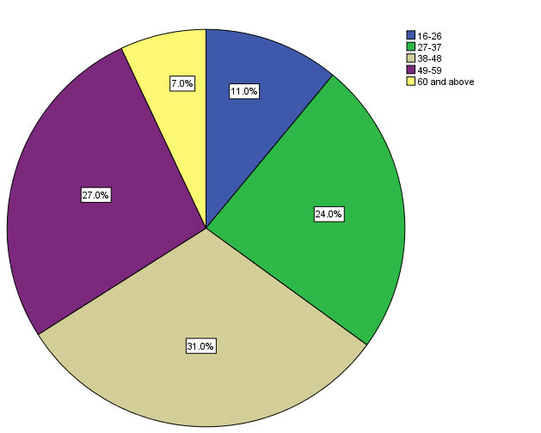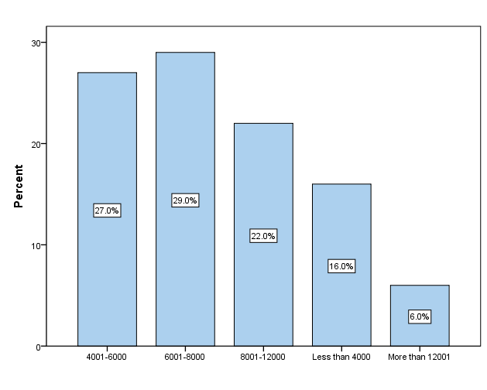

**Figure 4-2-1 Age and monthly personal income pie chart**

According to the clothing consumption survey in part B, the vast majority of people spend 0-500 yuan on clothing in a month, 168 of which account for 42%. The second monthly clothing purchase in the 501-1000 people have 90, accounting for 22.5%. There are 44 people who consume 1,001 to 1,500, accounting for 11%, 70 people who consume from 1501-2000, accounting for 17.5%, and 28 people who purchase more than 2,001 clothes per month, accounting for 7%.

Among the women surveyed, 208 at 52% , bought clothes once a quarterly. This was followed by 116, or 29%t, who bought clothes once a month. 15% of people bought clothes at random, 60 of them. The lowest number of shoppers was 24, or 4 per cent, who bought clothes once a week.

In terms of clothing purchasing channels, with the rise of online shopping, the number of people who buy clothes in physical stores is the lowest, with only 44 people, accounting for 11%. The rest chose to shop online- shopping platform and Wechat business with 168 and 188, 42% and 47%, respectively.

In ladies' garments shopping, the wellspring of data before buy. In the surveyed, there are 156 people at 39% realized the information from the advertisement. The second was through relatives and friends, with 132 at 33% of the total. 72 person get information from sales before the purchase, at 18%. At the very least, there were only 40 people who bought clothes from previous experience, accounting for 10% of the total

**Table 4-5: Clothing consumption information statistics**

|  |  |  |  |
| --- | --- | --- | --- |
| Items | Options | Frequency | % |
| How much did you spend on clothing per month (RMB/CNY) | 0-500 | 168 | 42.0 |
| 501-1000 | 90 | 22.5 |
| 1501-2000 | 70 | 17.5 |
| 1001-1500 | 44 | 11.0 |
| more than 2001 | 28 | 7.0 |
| How often do you buy clothes | Once a week | 24 | 4.0 |
| Once a quarterly | 208 | 52.0 |
| Once a month | 116 | 29.0 |
| Random | 60 | 15.0 |
| How do you purchase the clothes | Hypostatic store | 44 | 11.0 |
| Platform | 168 | 42.0 |
| Wechat businession | 188 | 47.0 |
| Where did your pre-purchase information come from | Advertising | 156 | 39.0 |
| Past experience | 40 | 10.0 |
| Relatives and friends | 132 | 33.0 |
| Sales | 72 | 18.0 |

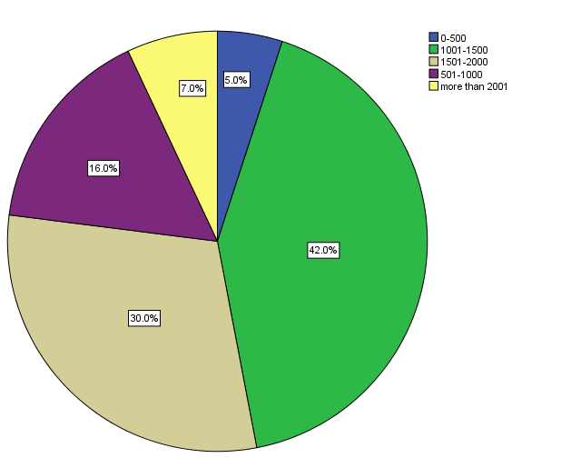 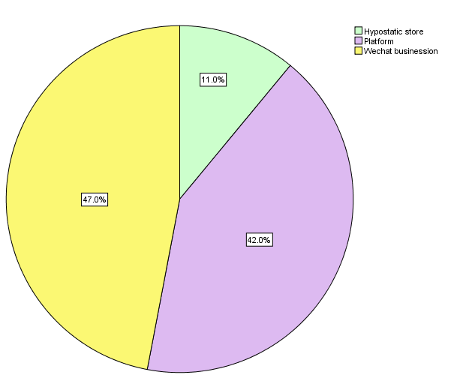

**Figure 4-2-1 Monthly spending on clothes and Purchase channel pie chart.**

## 4.3 Preliminary data analysis

Preliminary data analysis included factor analyses based on each dimension (Fashion trends, Money attitude, Emotional response, and buying influence). In addition, the overall questionnaire and reliability tests were conducted to ensure the reliability and internal consistency of the overall questionnaire. The purpose of factor analysis is to explore the basic structure of a research project by simplifying components into a more manageable set of configurations. Next comes the reliability analysis, which assesses the degree of consistency and stability of the items used in the measuring instruments.

### 4.3.1 Factors analysis

**4.3.1.1 Fashion trend**

**Table 4-5: KMO and Bartlett's Test of Fashion trend**

| Kaiser-Meyer-Olkin Measure of Sampling Adequacy. | | 0.920 |
| --- | --- | --- |
| Bartlett's Test of Sphericity | Approx. Chi-Square | 718.207 |
| df | 10 |
| Sig. | 0.000 |

**Table 4-6: Total Variance Explained of Fashion trend**

| Component | Initial Eigenvalues | | |  | | |
| --- | --- | --- | --- | --- | --- | --- |
| Total | % of Variance | Cumulative % | Total | % of Variance | Cumulative % |
| 1 | 4.555 | 91.090 | 91.090 | 4.555 | 91.090 | 91.090 |
| 2 | 0.152 | 3.044 | 94.134 |  |  |  |
| 3 | 0.121 | 2.429 | 96.563 |  |  |  |
| 4 | 0.107 | 2.130 | 98.694 |  |  |  |
| 5 | 0.065 | 1.306 | 100.000 |  |  |  |
| Extraction Method: Principal Component Analysis. | | | | | | |

Factor analysis results of fashion trends showed that KMO=0.920 and Bartlett test significance test p-value =0.000<0.05, indicating that fashion trends in this dimension were suitable for factor analysis.

The results of total variance analysis show that a common factor can be extracted from all the items included in this dimension, which can explain the above 91.09% change, indicating that the items included in this product can better represent the variables of fashion trend.

4.3.1.2 Money attitude

Table 4-7: KMO and Bartlett's Test of Money attitude

| KMO and Bartlett's Test | | |
| --- | --- | --- |
| Kaiser-Meyer-Olkin Measure of Sampling Adequacy. | | 0.906 |
| Bartlett's Test of Sphericity | Approx. Chi-Square | 754.854 |
| df | 10 |
| Sig. | 0.000 |

Table 4-8: Total Variance Explained of money attitude

| Component | Initial Eigenvalues | | | Extraction Sums of Squared Loadings | | |
| --- | --- | --- | --- | --- | --- | --- |
| Total | % of Variance | Cumulative % | Total | % of Variance | Cumulative % |
| 1 | 4.564 | 91.287 | 91.287 | 4.564 | 91.287 | 91.287 |
| 2 | 0.185 | 3.695 | 94.981 |  |  |  |
| 3 | 0.129 | 2.588 | 97.570 |  |  |  |
| 4 | 0.065 | 1.303 | 98.873 |  |  |  |
| 5 | 0.056 | 1.127 | 100.000 |  |  |  |
| Extraction Method: Principal Component Analysis. | | | | | | |

Factor analysis results of money attitude showed that KMO=0.906 and Bartlett test significance test p-value =0.000<0.05, indicating that fashion trends in this dimension were suitable for factor analysis.

The consequences of all out difference examination show that all the things remembered for this measurement can separate a typical factor, which can clarify the above 91.287% variety, demonstrating that the things remembered for this item can all the more likely speak to the cash demeanor factors.

**4.3.1.3** **Emotional respond**

Table 4-9: KMO and Bartlett's Test of emotional respond

| Kaiser-Meyer-Olkin Measure of Sampling Adequacy. | | 0.909 |
| --- | --- | --- |
| Bartlett's Test of Sphericity | Approx. Chi-Square | 715.200 |
| df | 10 |
| Sig. | 0.000 |

4-10 Total Variance Explained of emotional respond

| Component | Initial Eigenvalues | | | Extraction Sums of Squared Loadings | | |
| --- | --- | --- | --- | --- | --- | --- |
| Total | % of Variance | Cumulative % | Total | % of Variance | Cumulative % |
| 1 | 4.535 | 90.696 | 90.696 | 4.535 | 90.696 | 90.696 |
| 2 | 0.189 | 3.789 | 94.485 |  |  |  |
| 3 | 0.123 | 2.462 | 96.947 |  |  |  |
| 4 | 0.087 | 1.738 | 98.685 |  |  |  |
| 5 | 0.066 | 1.315 | 100.000 |  |  |  |
| Extraction Method: Principal Component Analysis. | | | | | | |

Factor analysis results of emotional respond showed that KMO=0.909 and Bartlett test significance test p-value =0.000<0.05, indicating that fashion trends in this dimension were suitable for factor analysis.

Through total variance analysis, we can see the dimension of all project can extract a common factor, can explain the above 91.287% of the variation, shows that the product contained in the project to better represent money attitude variables.

**4.3.1.4 Buying influence**

Table 4-11: KMO and Bartlett's Test of buying influence

| Kaiser-Meyer-Olkin Measure of Sampling Adequacy. | | 0.642 |
| --- | --- | --- |
| Bartlett's Test of Sphericity | Approx. Chi-Square | 35.524 |
| df | 3 |
| Sig. | 0.000 |

Table 4-12: Total Variance Explained of buying influence

| Component | Initial Eigenvalues | | | Extraction Sums of Squared Loadings | | |
| --- | --- | --- | --- | --- | --- | --- |
| Total | % of Variance | Cumulative % | Total | % of Variance | Cumulative % |
| 1 | 1.728 | 57.612 | 57.612 | 1.728 | 57.612 | 57.612 |
| 2 | 0.689 | 22.973 | 80.586 |  |  |  |
| 3 | 0.582 | 19.414 | 100.000 |  |  |  |
| Extraction Method: Principal Component Analysis. | | | | | | |

Factor analysis results of buying influence showed that KMO=0.642 and Bartlett test significance test p-value =0.000<0.05, indicating that fashion trends in this dimension were suitable for factor analysis.

By total variance analysis can see, the dimension contained in all projects can extract a common factor, the common factor may explain the variation of 57.612%, show that the product contained in the project can purchase influence to better represent variables.

### 4.3.2 Reliability test

**Table 4-13: Summary of results of reliability test**

| Variable | Cronbach's Alpha | Cronbach's Alpha Based on Standardized Items | N of Items |
| --- | --- | --- | --- |
| Fashion trend | 0.976 | 0.976 | 5 |
| Money attitude | 0.976 | 0.976 | 5 |
| Emotional respond | 0.974 | 0.974 | 5 |
| Buying influence | 0.931 | 0.931 | 3 |

Reliability analysis showed that Cronbach's Alpha>0.9 standardized fashion trend, money attitude, emotional response, buying influence and Cronbach's Alpha>0.9, indicating that the questionnaire had high reliability and internal consistency.

## 4.4 Correlation analysis

In order to analyze the influencing factors of women's clothing consumption in Beijing, Pearson correlation analysis was conducted on the respondents' opinions on fashion trend, money attitude, emotional response, and buying influence.The analysis results are shown in the following table:

Table 4-14: Correlations

|  | | Fashion trend | Money attitude | Emotional respond | Buying influence |
| --- | --- | --- | --- | --- | --- |
| Fashion trend | Pearson Correlation | 1 | 0.471** | 0.314** | 0.768** |
| Sig. (2-tailed) | — | 0.000 | 0.001 | 0.000 |
| Money attitude | Pearson Correlation | 0.471** | 1 | 0.434** | 0.810** |
| Sig. (2-tailed) | 0.000 | — | 0.000 | 0.000 |
| Emotional respond | Pearson Correlation | 0.314** | 0.434** | 1 | .726** |
| Sig. (2-tailed) | 0.001 | 0.000 | — | 0.000 |
| Buying influence | Pearson Correlation | 0.768** | 0.810** | 0.726** | 1 |
| Sig. (2-tailed) | 0.000 | 0.000 | 0.000 | — |

**. Correlation is significant at the 0.01 level (2-tailed).

According to the results of correlation analysis, said affect clothing consumer purchase and correlation coefficient, in Beijing, between China and the fashion trend is 0.768. Significance test of the p value is less than 0.05, is 0.00, shows a significant positive correlation between fashion trends.Similarly, according to the correlation analysis results table, the correlation coefficients of women's buying influence, money attitude and emotional response investigated in Beijing, China were 0.810 and 0.726, respectively, and the p values of coefficient significance test were 0.000 < 0.05, demonstrating that there was a critical positive connection between's the two factors and ladies' apparel utilization.

## 4.5 Hypothesis analysis

According to relevant analysis results, in order to quantitatively measure the relationship between women's clothing consumption and Fashion trend, money attitude and emotional response in Beijing, China, a multiple linear regression model was established with women's clothing consumption tendency as the dependent variable and production Fashion trend, money attitude and emotional response as independent variables:

$$BI=β_{0}+β_{1}fashion+β_{2}money+β_{3}emotional+μ$$

Where, $BI$ is Buying influence， $fashion$、 $money$、 $emotional$ is Fashion trend、Money attitude and Emotional respond， $β_{0}$ is intercept term， $β_{1}\sim β_{3}$ is regression coefficient， $μ$ is random error term.

### 4.5.1 ANOVA analysis

Table 4-15: ANOVA

| Model | | Sum of Squares | df | Mean Square | F | Sig. |
| --- | --- | --- | --- | --- | --- | --- |
| 1 | Regression | 642.577 | 3 | 214.192 | 1358.812 | 0.000a |
| Residual | 15.133 | 96 | 0.158 |  |  |
| Total | 657.710 | 99 |  |  |  |
| a. Predictors: (Constant), Emotional respond, Fashion trend, Money attitude  b. Dependent Variable: Buying influence | | | | | | |

Analysis of variance, according to the result table model F value significance test = 1358.812. P value is under 0.05 which is 0.000, set up a multivariate relapse model is essentially viable data.

### 4.5.2 Model Summary

Table 4-16: Model Summary

| Model | R | R Square | Adjusted R Square | Std. Error of the Estimate |
| --- | --- | --- | --- | --- |
| 1 | 0.988a | 0.977 | 0.976 | 0.39703 |
| a. Predictors: (Constant), Emotional respond, Fashion trend, Money attitude | | | | |

According to the model summary result table, the goodness of model fit R squared = 0.977, and the adjusted R squared =0.976 were both larger, indicating that the independent fashion trend, money attitude and emotional response of the independent multiple linear regression model could explain the influence of buying dependent variables 97.7.% change.

### 

### 4.5.3 Coefficients

Table 4-17: Coefficientsa

| Model | | Unstandardized Coefficients | | Standardized Coefficients | t | Sig. |
| --- | --- | --- | --- | --- | --- | --- |
| B | Std. Error | Beta |
| 1 | (Constant) | -0.208 | 0.270 |  | -0.771 | 0.443 |
| Fashion trend | 0.206 | 0.008 | 0.440 | 24.849 | 0.000 |
| Money attitude | 0.206 | 0.009 | 0.428 | 22.951 | 0.000 |
| Emotional respond | 0.196 | 0.008 | 0.402 | 23.177 | 0.000 |
| a. Dependent Variable: Buying influence | | | | | | |

The coefficient result table shows that the fashion trend of the regression coefficient is 0.0206, the coefficient of significance test t value was 24.849, p value is 0.000 < 0.05, suggesting that fashion trends and purchase the regression coefficient between the significant effect. The relapse coefficient of cash disposition and purchasing impact was 0.206, the t-estimation of coefficient centrality test was 22.951, and the p esteem was 0.000<0.05, showing that the relapse coefficient of cost was altogether powerful. Essentially, the relapse coefficient of passionate reaction and purchasing impact was 0.195, the t-estimation of coefficient hugeness test was 23.177, and the p-esteem <0.05, demonstrating that the relapse coefficient between the two variable and purchasing impact was noteworthy. Therefore, the fitting regression equation is:

$$BI=-0.208+0.206fashion+0.206money+0.196emotional$$

Each additional unit, a fashion trend products rose by an average of 0.206 units to buy influence; For each extra money attitude unit, the buy sway expanded by a normal of 0.206 units.The buying influence increased by 0.196 on average for each additional emotional response area. From the regression coefficient, it can be intuitively seen that fashion trend and money attitude have a greater impact on women's clothing consumption behavior, while emotional response has a smaller impact on women's clothing consumption behavior.

## 4.6 Summary of findings

In this chapter, the reliability and validity of the questionnaire were tested. After proving that the reliability and validity of the questionnaire reached the applicable standards, the data of 400 Beijing women were collected and investigated in the later period. After collecting the data, the analysis of each independent variable and dependent variable shows that there is a strong correlation between each independent variable and dependent variable. By verifying the hypothesis of the four independent variables, it was found that fashion trend, money attitude and emotional respond had a strong positive correlation with the dependent variable female clothing buying consumption.

### 4.6.1 Findings of research hypothesis

The verification of hypothesis is shown in the following table:

**Table 4-18: Hypothesis Finding**

|  |  |
| --- | --- |
| Hypothesis | Result |
| H1: Fashion trend has a positive relationship with female consumers buying behavior in Beijing, China. | Accepted |
| H2: Money attitude has a positive relationship with female consumers buying behavior in Beijing, China. | Accepted |
| H3:Emotional respond has a positive relationship with female consumers buying behavior in Beijing, China. | Accepted |

Hypothesis 1 proposes this hypothesis to determine whether fashion trends have a significant impact on the clothing consumption of female consumers in Beijing.This hypothesis mainly includes five questions, from the attention to fashion magazines, to bloggers' clothing collocation, to other women's clothing, to the degree of imitation of other women's clothing style, and whether they will buy clothes according to fashion trends.This study proves that fashion trends have a significant impact on the clothing consumption of female consumers in Beijing.

Hypothesis 2 proposes this hypothesis to understand whether Money attitude has a significant impact on the clothing consumption of female consumers in Beijing. This hypothesis mainly includes five questions, such as whether people will worship others' money, their attitude towards excessive consumption of clothes, their psychology of keeping up with the Joneses, their sense of status brought by money consumption, their spendthrift mentality when buying clothes and the factors of money attitude. This study proves that in Beijing, China, money attitude has a significant impact on the clothing consumption of female consumers.

Hypothesis 3 proposes this hypothesis to see if the impact of emotional response on women's clothing consumption in Beijing is significant.This hypothesis examines the emotional response factor primarily from five levels of women's consideration of the meaning behind the clothing and the emotional response to the clothing.This study demonstrated that emotional respond had a significant impact on the clothing consumption of female consumers in Beijing, China.

In summary, by testing the hypothesis of the three independent variables, it was found that fashion trend and money attiude had the most significant relationship with the dependent variable of Beijing women's clothing consumption, while emotional response also had a significant positive correlation with Beijing women's clothing consumption.

With the advancement of women's status in the society, as women in the new era, they hope to gain the respect and attention of others in social exchanges, so they pay great attention to their appearance, hoping to appear youthful and energetic and solemn. Therefore, when women consume, they pay more attention to fashion and want to catch up with the trend of The Times so as to attract the attention of others. At the same time, women out of a very strong self-esteem needs, in the consumption will also have comparison and show off psychology. Comparing and showing off psychology is a kind of consumption psychology whose main purpose is to keep up with others and surpass others, and its core is to "surpass others". This is a woman who, when buying a product, is not concerned with the actual value or need of the product, but with the desire to outdo others.Some women in order to show off their own noble, rich, in order to meet vanity, some of the gold and silver jewelry that they think others can not afford to buy to dress up their own, so as to raise their own identity. Meanwhile, women's exquisite inner feelings also make it easier for them to think about the meaning behind the clothes, as well as the emotional response brought by the clothes, hoping that the clothes can express their inner feelings. Therefore, in current brands, clothes with cultural background and emotional sustenance can attract more attention from female consumers.

### 4.6.2 Findings of research questions

Four questions were explored in this study. The results are as follows:The analysts utilized relapse examination to address the investigation's inquiries. The outcomes are as per the following:

For the first research question, is fashion trend has a significant influence on female clothing consumption, and the answer is yes. As indicated by the coefficient table, b esteem shows that for each 1 unit increment in design pattern, women's apparel utilization increments by 0.206 units. Therefore, it can be said that fashion trend factors have a great impact on female clothing consumption .Otherwise, from the sig value in the coefficient table, the sig value of the fashion trend is 0.000, which is less than 0.05, so the fashion trend has statistically significant for female clothing consumption.

On the second research question, whether money attitudes have a significant impact on women's clothing consumption, the answer is yes. As indicated by the coefficient table, b esteem speaks to that for each 1 unit increment in money attitude, ladies' apparel utilization increments by 0.206 units. Therefore, it can be said that the factor of money attitude has a significant impact on female clothing consumption. Besides, as indicated by the sig esteem in the coefficient table, the sig estimation of the cash demeanor is 0.000, which is under 0.05, so the cash disposition is factually critical for female attire utilization. As for the third research question, is emotional respond has a relationship with Beijing female clothing consumption. As appeared in the coefficient table, the estimation of b demonstrates that if the enthusiastic react increments by 1 unit, the utilization of Beijing female attire will increment by 0.196 units. Therefore, it can be said that the factor of emotional respond has a significant impact on Beijing female clothing consumption. What's more, as per the sig esteem in the coefficient table, the sig estimation of the cost is 0.000, which is under 0.05, so the enthusiastic react is factually critical for female attire utilization.

The fourth research question is which factor has the greatest influence on female clothing consumption, and the answer is that fashion trend is as big as money attitude. From the comparison of the above three survey questions, it can be seen that female clothing consumption is most influenced by fashion trend and money attitude, which is 0.206 units. The impact of emotional response on female clothing consumption was the least, with 0.196 units.

**Chapter 5**

# 5.0 Summary

## 5.1 Conclusion

This research studied the related factors which influence the female consumers clothing consumption of Beijing, and through the questionnaire to collect the information and opinions of 400 participants. Through the analysis of the results, it is found that three factors, fashion trend, money attitude and emotional response, have an impact on the clothing consumption habits of women in Beijing. The Chinese clothing market is facing a lot of difficulties at present, but the survey shows that most people have the purchasing power and are willing to spend money on clothes, which shows that Chinese clothing market is still very big. Thus, it is found that attracting female consumers is more about "keeping up with the joneses", such as liking to wear clothes to imitate other fashion bloggers or celebrities, or buying expensive clothes to prove their face. By contrast, the culture and meaning of the clothes themselves are the least important. It shows that the external social value of clothes to women is more important than the clothes themselves. Therefore, for domestic brands and factories of women's clothing, they should pay more attention to the production of clothing from the perspective of fashion trend and money attitude, so as to attract more consumers.

## 5.2 Limitation

Firstly, in this study, only the consumption of women's clothing in Beijing, a first-tier city in China with a high income level, was investigated. Therefore, this study did not obtain accurate information of women's clothing consumption in the third and fourth lines. In addition, this study is based on the actual situation of Chinese women's clothing consumption. Because of China's special economic and social situation, the conclusions may not apply to other countries. In terms of the questionnaire, this time the questionnaire is collected online, which makes it difficult to control the specific situation of the respondents, so the collected data may be deviated from the actual situation. Because many respondents may not take the survey seriously. Finally, this survey is about women's clothing consumption in Beijing, China, which can provide references for other studies, but cannot be applied to specific situations in other cities.

Secondly, this paper studies three factors that affect women's clothing consumption, and mainly discusses the dimension and overall level of factors that affect women's clothing consumption. Due to internal and external factors such as limited experience, the research object is random, and the personal information of the research object is not comprehensive enough. As for the different influences of these influencing factors on women's clothing consumption, there is no more detailed investigation, which leads to the lack of certain depth of research.

Last, research methods are inadequate. In this paper, questionnaire survey, literature method, factor analysis, regression analysis and other research methods are used. The data mainly come from questionnaire survey. Although the questionnaire design and survey are carried out after certain research, the data and parameters are limited. In addition, the questionnaire of this study is designed on the basis of theoretical research. Although the first draft of the plan and the revision of the questionnaire, the level of reliability and validity analysis are also high, it is still difficult to ensure that the questionnaire is absolutely complete, and it is impossible to determine the problem coverage of the questionnaire without errors.

## 5.3 Recommendations

This survey mainly focuses on women's clothing consumption in Beijing.Therefore, the researchers put forward many Suggestions for the development of women's wear brands in China in combination with this survey.

First of all, according to the significant influence of the fashion trend in this study on the clothing consumption of women in Beijing, Chinese brands should take the fashion trend as the design concept. For example, now that the international fashion trend of clothing leisure is enduring, leisure women's wear will continue to sell like hot cakes. The design concept of leisure style will gradually penetrate into all areas of the clothing market, so that traditional women's wear reflects a stronger modern social leisure color. Office women in modern society are eager to return to the relaxed and free mood of nature after work, which also laid a foundation for the brisk sales of casual women's wear. So the domestic women's clothing brand in the design of clothing, add more casual elements. Reduce the impression of sameness to customers and similarity of brands, innovate while following the fashion trend,

Second, because women now pay more attention to the "face problem" when buying clothes, it gives meaning to the social intercourse and social status of clothes.So one reason why the Chinese brand industry is in a slump is that women are more likely to buy luxury goods. According to the survey found that 80 of the millennial generation accounted for a third of global luxury consumption become growth initiative, along with all the Chinese luxury consumption age, 36.7 years, per capital than most developed countries in their 40 s, the main consumer groups, younger and more than half of China's millennium generation will buy luxury goods when travel, currently has a good situation is millennial because income limit and unique taste more advocate individual character consumption, millennial love personality more than heavy luxury. On the one hand, their incomes are still lagging behind those of previous generations. According to the survey, only 66% of millennial are high-income groups. On the other hand, their tastes are more unique than those of the previous generation, with millennial paying more attention to the products themselves, pursuing quality and individuality, and downplaying brands and logos. This means that light luxury products, which can both save costs and demonstrate individuality, especially emerging and niche brands, will become the favorite of millennial, thus entering a boom period that is better than luxury. Chinese millennial are changing the luxury consumption market and buying behavior. Luxury brands such as GUCCI and LV have a long history and cultural heritage which is impossible for Chinese brands to establish in a short time. So creating Chinese light luxury brand is a better idea. And can adopt the online sales method, can obtain the rapid growth from the online. On the one hand, the online channels become important due to the low pricing, wide audience and frequent purchase of light luxury products. However, the online sales of heavy luxury products seem to be in contradiction with their scarcity, with little online sales. On the other hand, China has a larger online population of millennial, and online sales of luxury goods are growing faster. Therefore, domestic brands can take the road of light luxury online sales and stimulate women's clothing consumption demand.

Thirdly, three factors, consumption ability, consumption psychology and social progress, have jointly promoted the concept of personalized customization, which is based on the expression of people's own demands. Clothing has become the expression of their own personality and pursuit of the external show, choose their favorite personalized clothing is a mainstream fashion. In addition, when women buy clothes, they also pay attention to the meaning behind them, so clothes are sometimes also something that women express their personality and ideas. For example, women pay more attention to the pattern of clothes and the LOGO on clothes than to the color of a dress. Or the weight of color matching and style design in their mind has exceeded the quality and price of the dress. So domestic clothing brands can promote personalized services, in addition to tailoring, tailor-made, there will be special design and other in-depth personalized services, to meet the needs of different levels of female consumers. Personalized demand and customization will become more and more popular with the deepening of people's understanding of themselves. Express the appeal, affirm the core value, and satisfy the lonely attribute, which is bound to be the next blue ocean of dividends in the clothing industry.

## 5.4 Further research

According to the research and further thinking and discussion in this paper, the following prospects are put forward: the research samples should be further expanded in the follow-up research, and the sample size can be expanded or more investigation areas can be included. In addition, the influence of different variables on women's clothing consumption, such as price, fabric, color and design preference, can be selected to explore the influence of other variables on women's clothing consumption in Beijing. So as to have a more comprehensive understanding of the factors that will affect women's clothing consumption and the correct direction of improving Chinese women's clothing brands in the future.

## 5.5 Personal reflection

The process of selecting and designing a project lasted for half a year until the end of the research. This process is busy with happiness, from the confusion of determining the research direction at the beginning, to the enrichment after reading a large number of literature, to the difficulty of collecting and analyzing data, and finally to the happiness of writing down the research summary. The study builds on the work of many previous researchers. During the completion of the research, I read a lot of literature and online materials, and had a deeper understanding of women's clothing consumption. When selecting the topic, because I have a better understanding of women, and clothing is an indispensable thing in life, and I am very interested in the factors that lead to the decline of Chinese clothing brands after the preliminary reference, I choose the research related to women's clothing. After reading a large number of documents to determine the affect clothing consumption in the dependent variable, and in the subsequent made a questionnaire, although the process is very long but is very interesting, because in the survey found some novel ideas, such as most women will choose to buy luxury goods rather than considering price or the women's apparel consumption factor. However, the survey has some shortcomings.

In the course of my research, I took many suggestions from my supervisor to improve these shortcomings. This research received a lot of help from my supervisor, Dr. Sukjeet. I am particularly lucky that my tutor has made some research results on women's clothing consumption and given me many professional suggestions. For example, how to determine the dependent variables, how to improve the accuracy of the data collected by questionnaires, and how to find relevant literature. I am very grateful to Dr. Sukejeet for her guidance in my busy work. With her help, many aspects such as literature review, questionnaire survey and framework have been greatly improved. Finally, I would like to thank my second panel, Me. Salaar, for his professional advice on my research. With his help, I understood the meaning and explanation of the three independent variables more clearly. Meanwhile, Mr. Salaar also pointed out the shortcomings of this study, which enabled me to have a more perfect thinking and improve the theoretical framework of this study. Under the guidance of two mentors, I completed this research. Their help not only improved my research papers, but also taught me how to do a research.

# 6.0 Reference

Adnan, A.T.M., Khan, A.N. and Islam, M.S., 2019. Competitive Position of Bangladesh and China in the Global Clothing Export Market: An Analysis of Revealed Comparative Advantage. Trends Economics and Management, 13(34), pp.9-28.

Bhardwaj, V. and Fairhurst, A., 2010. Fast fashion: response to changes in the fashion industry. The international review of retail, distribution and consumer research, 20(1), pp.165-173

Boddington, P., Featherstone, K. and Northcott, A., 2020. The Presentation of the Clothed Self on the Hospital Ward: An ethnographic account of perceptual attention and implications for the personhood of people living with dementia.

Choi, M.Y., 2010. A study on the clothing involvement and clothing consumption behavior of female university students according to gender role attitude. Journal of the Korean Society of Costume, 60(8), pp.15-28.

Durvasula, S. and Lysonski, S., 2010. Money, money, money–how do attitudes toward money impact vanity and materialism?–the case of young Chinese consumers. Journal of Consumer Marketing.

Hansen, K.T., 2010. The City, Clothing Consumption, and the Search for “the Latest” in Colonial and Postcolonial Zambia. The Force of Fashion in Politics and Society: Global Perspectives from Modern to Contemporary Times, pp.215-234.

Hong, K.H. and Lee, Y.J., 2010. Clothing selection criteria and the use of fashion information sources based on the perceived age of elderly female consumers in their 60s~ 70s. Journal of the Korean Society of Clothing and Textiles, 34(2), pp.200-211.

Jang, E.J. and Lee, E.J., 2017. The effects of consumption value of outdoor female consumers on relationship quality and long-term relationship orientation. Journal of the Korean Society of Clothing and Textiles, 41(1), pp.116-130.

Jung, H.J., Choi, Y.J. and Oh, K.W., 2020. Influencing Factors of Chinese Consumers’ Purchase Intention to Sustainable Apparel Products: Exploring Consumer “Attitude–Behavioral Intention” Gap. Sustainability, 12(5), p.1770.

Khare, A. and Rakesh, S., 2010. Predictors of fashion clothing involvement among Indian youth. Journal of Targeting, Measurement and Analysis for marketing, 18(3-4), pp.209-220.

Kim, J.Y., Jun, D.G. and Oh, K.W., 2010. The effects of clothing consumption values and subjective age on the fashion adoption of elderly women. Journal of the Korean Society of Clothing and Textiles, 34(6), pp.1008-1020.

Kim, P. and Colombi, C., 2019, July. ART FASHIONIZATION AND THE NEW CULTURAL DIASPORA OF ART. In 2019 Global Fashion Management Conference at Paris (pp. 672-676).

Koukounas, E., Dimitriadis, S. and Miller, P., 2017. The effects of gender, clothing style, and alcohol consumption on the perception of sexual intent. Journal of Substance Use, 22(2), pp.211-217.

Lang, C. and Armstrong, C.M.J., 2018. Collaborative consumption: The influence of fashion leadership, need for uniqueness, and materialism on female consumers’ adoption of clothing renting and swapping. Sustainable Production and Consumption, 13, pp.37-47.

Lang, C., Armstrong, C.M. and Brannon, L.A., 2013. Drivers of clothing disposal in the US: An exploration of the role of personal attributes and behaviours in frequent disposal. International Journal of Consumer Studies, 37(6), pp.706-714.

Leung, A. and Kier, C., 2010. Music preferences and young people's attitudes towards spending and saving. Journal of Youth Studies, 13(6), pp.681-698.

Li, G., Li, G. and Kambele, Z., 2012. Luxury fashion brand consumers in China: Perceived value, fashion lifestyle, and willingness to pay. Journal of Business Research, 65(10), pp.1516-1522.

LIANG, J.F. and LI, X.S., 2011. Analysis on Female Clothing Consumer Behavior under E-Commerce Environment [J]. Journal of Zhejiang Sci-Tech University, 5.

Lin, H., Hu, X. and Huang, W., 2018, July. Research on Female University Students’ Winter Clothing Colors in Guangdong, China. In International Conference on Applied Human Factors and Ergonomics (pp. 344-354). Springer, Cham.

LIU, L.X. and WANG, J.W., 2012. Multi-brand strategy and communication model innovation of Hangzhou female clothing. Silk, (4), p.19.

Moon, C.H., 2019. “Made in China”: Material meanderings of fast-fashion cities. Fashion and Materiality: Cultural Practices in Global Contexts, p.157.

O'Cass, A. and Siahtiri, V., 2013. In search of status through brands from Western and Asian origins: Examining the changing face of fashion clothing consumption in Chinese young adults. Journal of Retailing and Consumer Services, 20(6), pp.505-515.

Park, H.J. and Yoo, T.S., 2012. The structural analysis of the variables among clothes consumption value, need for uniqueness, use information sources related to importance of apparel product attributes and store attributes. Journal of the Korean Society of Clothing and Textiles, 36(8), pp.802-813.

Pereira, M.C. and Coelho, F., 2020. Regulatory Focus, Money Attitudes and Financial Literacy: Evidence from Portuguese Young Adults. Journal of Family and Economic Issues, pp.1-11.

Pilcher, J., 2010. What not to wear? Girls, clothing and ‘showing’the body. Children & society, 24(6), pp.461-470.

Podoshen, J.S. and Andrzejewski, S.A., 2012. An examination of the relationships between materialism, conspicuous consumption, impulse buying, and brand loyalty. Journal of Marketing Theory and Practice, 20(3), pp.319-334.

SHEN, H.J. and LI, Z., 2013. A survey on female consumers' rainproof clothing demand [J]. Shanghai Textile Science & Technology, 2.

Su, J., Watchravesringkan, K.T., Zhou, J. and Gil, M., 2019. Sustainable clothing: perspectives from US and Chinese young Millennials. International Journal of Retail & Distribution Management.

Van Buren, M.C., Massey, E.K., Maasdam, L., Zuidema, W.C., Hilhorst, M.T., Ijzermans, J.N. and Weimar, W., 2010. For love or money? Attitudes toward financial incentives among actual living kidney donors. American Journal of Transplantation, 10(11), pp.2488-2492.

Wong, J., 2010. An analysis of money attitudes: Their relationships & effects on personal needs, social identity and emotions. Journal of Leadership, Accountability and Ethics, 8(1), pp.57-64.

Zhan, L. and He, Y., 2012. Understanding luxury consumption in China: Consumer perceptions of best-known brands. Journal of Business Research, 65(10), pp.1452-1460.

Zhang, X., Gale, C. and Eckert, C., 2018. Chinese Consumers and the Knitwear Fashion Market. In Chinese Consumers and the Fashion Market (pp. 193-212). Springer, Singapore.

# 7.0 Appendix

Appendix 1: Descriptive Analysis

Appendix 2: Reliability Analysis

Appendix 3: Correlation test

Appendix 4: Factor analysis

Appendix 5: Reliability test

Appendix 6: Correlation analysis

Appendix 7: Hypothesis analysis

Appendix 8: Initial Research Paper Proposal

Appendix 9: Viva Slides

Appendix 10: MBA Project Log Book

Appendix 11: Survey Questionnaire

Appendix 12: Comments on Management of Project

Appendix 13: Turnitin Report

**Appendix 1: Descriptive Analysis**

Personal basic information statistics

| Items | Options | Frequency | % |
| --- | --- | --- | --- |
| age | 16-26 | 44 | 11.0 |
|  | 27-37 | 96 | 24.0 |
|  | 38-48 | 124 | 31.0 |
|  | 49-59 | 108 | 27.0 |
|  | 60 and above | 28 | 7.0 |
| highest education | Associate/Diploma | 140 | 35.0 |
|  | Bachelor/Degree | 152 | 38.0 |
|  | High School or Below | 68 | 17.0 |
|  | Master or Above | 40 | 10.0 |
| monthly income income (RMB) | 4001-6000 | 108 | 27.0 |
| 6001-8000 | 116 | 29.0 |
| 8001-12000 | 88 | 22.0 |
| Less than 4000 | 64 | 16.0 |
| More than 12001 | 24 | 6.0 |
| household monthly income income (RMB) | Less than 10000 | 80 | 20.0 |
| 10001-20000 | 128 | 32.0 |
| 20001-30000 | 96 | 24.0 |
| 30001-40000 | 60 | 15.0 |
| More than 40000 | 36 | 9.0 |
| occupation level | Clerical level | 60 | 15.0 |
| Executives/Officers | 96 | 24.0 |
| Middle Management | 144 | 36.0 |
| Senior Management | 80 | 20.0 |
| Technicians/Assistants | 20 | 5.0 |

Age and monthly personal income pie chart



Clothing consumption information statistics

|  |  |  |  |
| --- | --- | --- | --- |
| Items | Options | Frequency | % |
| How much did you spend on clothing per month (RMB/CNY) | 0-500 | 168 | 42.0 |
| 501-1000 | 90 | 22.5 |
| 1501-2000 | 70 | 17.5 |
| 1001-1500 | 44 | 11.0 |
| more than 2001 | 28 | 7.0 |
| How often do you buy clothes | Once a week | 24 | 4.0 |
| Once a quarterly | 208 | 52.0 |
| Once a month | 116 | 29.0 |
| Random | 60 | 15.0 |
| How do you purchase the clothes | Hypostatic store | 44 | 11.0 |
| Platform | 168 | 42.0 |
| Wechat businession | 188 | 47.0 |
| Where did your pre-purchase information come from | Advertising | 156 | 39.0 |
| Past experience | 40 | 10.0 |
| Relatives and friends | 132 | 33.0 |
| Sales | 72 | 18.0 |

Monthly spending on clothes and Purchase channel pie chart.

 

**Appendix 2: Reliability Analysis**

Reliability Statistics

| Variable | Cronbach's Alpha |  | N of Items |
| --- | --- | --- | --- |
| Fashion trend | 0.960 | 0.960 | 5 |
| Money attitude | 0.970 | 0.971 | 5 |
| Emotional respond | 0.955 | 0.955 | 5 |
| Buying influence | 0.941 | 0.945 | 3 |

**Appendix 3: Correlation test**

Correlations

| Fashion trend | Q11 | Q12 | Q13 | Q14 | Q15 |
| --- | --- | --- | --- | --- | --- |
| Q11 | 1 |  |  |  |  |
| Q12 | .864** | 1 |  |  |  |
| Q13 | .713** | .785** | 1 |  |  |
| Q14 | .794** | .853** | .803** | 1 |  |
| Q15 | .612** | .756** | .870** | .678** | 1 |
|  |  |  |  |  |  |
| Money atiitiude | Q16 | Q17 | Q08 | Q19 | Q20 |
| Q16 | 1 |  |  |  |  |
| Q17 | .883** | 1 |  |  |  |
| Q18 | .768** | .802** | 1 |  |  |
| Q19 | .902** | .768** | .727** | 1 |  |
| Q20 | .850** | .976** | .813** | .795** | 1 |
|  |  |  |  |  |  |
| Emotional respond | Q21 | Q22 | Q23 | Q24 | Q25 |
| Q21 | 1 |  |  |  |  |
| Q22 | .804** | 1 |  |  |  |
| Q23 | .846** | .812** | 1 |  |  |
| Q24 | .814** | .877** | .825** | 1 |  |
| Q25 | .897** | .855** | .902** | .921** | 1 |
|  |  |  |  |  |  |
| Buying influence | Q26 | Q27 | Q28 |  |  |
| Q26 | 1 |  |  |  |  |
| Q27 | .824** | 1 |  |  |  |
| Q28 | .824** | .938** | 1 |  |  |

**. Correlation is significant at the 0.01 level (2-tailed).

**Appendix 4: Factor analysis**

KMO and Bartlett's Test of Fashion trend

| Kaiser-Meyer-Olkin Measure of Sampling Adequacy. | | 0.920 |
| --- | --- | --- |
| Bartlett's Test of Sphericity | Approx. Chi-Square | 718.207 |
| df | 10 |
| Sig. | 0.000 |

Total Variance Explained of Fashion trend

| Component | Initial Eigenvalues | | | Extraction Sums of Squared Loadings | | |
| --- | --- | --- | --- | --- | --- | --- |
| Total | % of Variance | Cumulative % | Total | % of Variance | Cumulative % |
| 1 | 4.555 | 91.090 | 91.090 | 4.555 | 91.090 | 91.090 |
| 2 | 0.152 | 3.044 | 94.134 |  |  |  |
| 3 | 0.121 | 2.429 | 96.563 |  |  |  |
| 4 | 0.107 | 2.130 | 98.694 |  |  |  |
| 5 | 0.065 | 1.306 | 100.000 |  |  |  |
| Extraction Method: Principal Component Analysis. | | | | | | |

KMO and Bartlett's Test of Money attitude

| KMO and Bartlett's Test | | |
| --- | --- | --- |
| Kaiser-Meyer-Olkin Measure of Sampling Adequacy. | | 0.906 |
| Bartlett's Test of Sphericity | Approx. Chi-Square | 754.854 |
| df | 10 |
| Sig. | 0.000 |

Total Variance Explained of money attitude

| Component | Initial Eigenvalues | | | Extraction Sums of Squared Loadings | | |
| --- | --- | --- | --- | --- | --- | --- |
| Total | % of Variance | Cumulative % | Total | % of Variance | Cumulative % |
| 1 | 4.564 | 91.287 | 91.287 | 4.564 | 91.287 | 91.287 |
| 2 | 0.185 | 3.695 | 94.981 |  |  |  |
| 3 | 0.129 | 2.588 | 97.570 |  |  |  |
| 4 | 0.065 | 1.303 | 98.873 |  |  |  |
| 5 | 0.056 | 1.127 | 100.000 |  |  |  |
| Extraction Method: Principal Component Analysis. | | | | | | |

KMO and Bartlett's Test of emotional respond

| Kaiser-Meyer-Olkin Measure of Sampling Adequacy. | | 0.909 |
| --- | --- | --- |
| Bartlett's Test of Sphericity | Approx. Chi-Square | 715.200 |
| df | 10 |
| Sig. | 0.000 |

Total Variance Explained of emotional respond

| Component | Initial Eigenvalues | | | Extraction Sums of Squared Loadings | | |
| --- | --- | --- | --- | --- | --- | --- |
| Total | % of Variance | Cumulative % | Total | % of Variance | Cumulative % |
| 1 | 4.535 | 90.696 | 90.696 | 4.535 | 90.696 | 90.696 |
| 2 | 0.189 | 3.789 | 94.485 |  |  |  |
| 3 | 0.123 | 2.462 | 96.947 |  |  |  |
| 4 | 0.087 | 1.738 | 98.685 |  |  |  |
| 5 | 0.066 | 1.315 | 100.000 |  |  |  |
| Extraction Method: Principal Component Analysis. | | | | | | |

KMO and Bartlett's Test of buying influence

| Kaiser-Meyer-Olkin Measure of Sampling Adequacy. | | 0.642 |
| --- | --- | --- |
| Bartlett's Test of Sphericity | Approx. Chi-Square | 35.524 |
| df | 3 |
| Sig. | 0.000 |

Total Variance Explained of buying influence

| Component | Initial Eigenvalues | | | Extraction Sums of Squared Loadings | | |
| --- | --- | --- | --- | --- | --- | --- |
| Total | % of Variance | Cumulative % | Total | % of Variance | Cumulative % |
| 1 | 1.728 | 57.612 | 57.612 | 1.728 | 57.612 | 57.612 |
| 2 | 0.689 | 22.973 | 80.586 |  |  |  |
| 3 | 0.582 | 19.414 | 100.000 |  |  |  |
| Extraction Method: Principal Component Analysis. | | | | | | |

**Appendix 5: Reliability test**

Summary of results of reliability test

| Variable | Cronbach's Alpha | Cronbach's Alpha Based on Standardized Items | N of Items |
| --- | --- | --- | --- |
| Fashion trend | 0.976 | 0.976 | 5 |
| Money attitude | 0.976 | 0.976 | 5 |
| Emotional respond | 0.974 | 0.974 | 5 |
| Buying influence | 0.931 | 0.931 | 3 |

**Appendix 6: Correlation analysis**

Correlations

|  | | Fashion trend | Money attitude | Emotional respond | Buying influence |
| --- | --- | --- | --- | --- | --- |
| Fashion trend | Pearson Correlation | 1 | 0.471** | 0.314** | 0.768** |
| Sig. (2-tailed) | — | 0.000 | 0.001 | 0.000 |
| Money attitude | Pearson Correlation | 0.471** | 1 | 0.434** | 0.810** |
| Sig. (2-tailed) | 0.000 | — | 0.000 | 0.000 |
| Emotional respond | Pearson Correlation | 0.314** | 0.434** | 1 | .726** |
| Sig. (2-tailed) | 0.001 | 0.000 | — | 0.000 |
| Buying influence | Pearson Correlation | 0.768** | 0.810** | 0.726** | 1 |
| Sig. (2-tailed) | 0.000 | 0.000 | 0.000 | — |

**. Correlation is significant at the 0.01 level (2-tailed).

**[Appendix](#bookmark42" \o "Current Document) 7: Hypothesis analysis**

ANOVA

| Model | | Sum of Squares | df | Mean Square | F | Sig. |
| --- | --- | --- | --- | --- | --- | --- |
| 1 | Regression | 642.577 | 3 | 214.192 | 1358.812 | 0.000a |
| Residual | 15.133 | 96 | 0.158 |  |  |
| Total | 657.710 | 99 |  |  |  |
| a. Predictors: (Constant), Emotional respond, Fashion trend, Money attitude  b. Dependent Variable: Buying influence | | | | | | |

Model Summary

| Model | R | R Square | Adjusted R Square | Std. Error of the Estimate |
| --- | --- | --- | --- | --- |
| 1 | 0.988a | 0.977 | 0.976 | 0.39703 |
| a. Predictors: (Constant), Emotional respond, Fashion trend, Money attitude | | | | |

Coefficientsa

| Model | | Unstandardized Coefficients | | Standardized Coefficients | t | Sig. |
| --- | --- | --- | --- | --- | --- | --- |
| B | Std. Error | Beta |
| 1 | (Constant) | -0.208 | 0.270 |  | -0.771 | 0.443 |
| Fashion trend | 0.206 | 0.008 | 0.440 | 24.849 | 0.000 |
| Money attitude | 0.206 | 0.009 | 0.428 | 22.951 | 0.000 |
| Emotional respond | 0.196 | 0.008 | 0.402 | 23.177 | 0.000 |
| a. Dependent Variable: Buying influence | | | | | | |

**[Appendix](#bookmark42" \o "Current Document) 8: Initial Research Paper Proposal**

|  |  |  |  |
| --- | --- | --- | --- |
| Student Name | Meng chunyi | ID No | I19016632 |
| Broad Area | Marketing | | |
| Concise Title | A study on female clothing consumption in Beijing, China | | |
| Problem Definition | With the rapid development of domestic economy, urban women consumption scope expands unceasingly, has become increasingly rich and varied content, thereby giving impetus to the prosperity of the female supplies market, is an obvious especially in the clothing consumption market, the clothing consumption has been ranked the first. Because the female think the different symbolic meaning, expressive ability and consumption experience of different clothes are the important basis of consumer choice (Tan and Guan, 1998).  Wang (2016) pointed out that consumers have entered the era of emotional satisfaction and attention should be paid to the psychological experience of female consumers in the process of purchasing goods. Only when enterprises master the different psychological characteristics of female consumers and meet their psychological needs can they become bigger and stronger.  This paper through to the Beijing women's apparel consumption incremental analysis, the main three kinds of clothing sales management and development of some Suggestions, to be able to in the fierce competition to better organize resources to meet the needs of the consumers, help garment industry practitioners faster find women consumer demands for clothing, Thus the establishment of targeted marketing strategy, marketing activities to achieve success. | | |
| Research Questions or Objective | Overarching Research Object: To analyze the factors influence the female’s clothing consumption demand.  RO1: To determine what factors will influence female consumer preference on clothing.  RO2: How can develop the female clothing industry. | | |
| Scope of study | This paper reveal the overall and segmentation characteristics of women's clothing consumption, including the the overall clothing consumption level, preference and different attributes of Beijing women, as well as the clothing consumption preference and characteristics of different market segments of Beijing women. According to different types of clothing business, the paper makes different division and specific analysis of customer groups. | | |
| Significance of the Research | For academic significance: This paper from the different division to analyze can provide useful references for students and researchers. It can let students have a better understand on consumer psychology  For industry: This paper reveals the different needs and preferences of different types of customer groups, and then puts forward specific Suggestions for clothing production and distribution manufacturers, so as to occupy a more favorable position in the fierce competition in the women's clothing market.. | | |
| Literature Review | In the 1980s, Sigry came up with the self-concept/product image congruence theory, which states that products that contain an image often evoke a self-concept of the same image. This theory not only explains the consistent relationship between product image, self-concept and consumption behavior, but also indicates that consumers' self-concept is an important factor affecting purchase motivation, which lays a foundation for the application of self-concept theory in consumer research.  From the different consumption characteristics of women, female consumption can be divided into six types: modern fashion aspiration, conservative practical type, sincere personality, negative (traditional) ordinary type, boasting type and others ambition type. It also reveals that women with different consumption characteristics have different dressing styles and preferences (Tian and Liu). | | |
| Research methodology | Theoretical analysis: after consulting female studies, consumer psychology, clothing science, statistics and relevant journals, magazines and foreign materials, I learned the theoretical viewpoints, research methods, technical routes and writing styles of various literatures, and made theoretical guidance for the research of this paper.  2. Questionnaire survey method: divide the questionnaire into basic information and purchase preference according to research needs.  3. Interview method; Some women in the questionnaire were interviewed to get a more accurate understanding of their clothing consumption characteristics. The interview mainly expands the depth and breadth of the questions involved in the questionnaire, and discusses the reasons for the answers selected in the questionnaire.  4. SPSS statistical method: SPSS22.0 was used to conduct descriptive statistics and cross analysis on the collected data. | | |

**Appendix 9: Viva Slides**

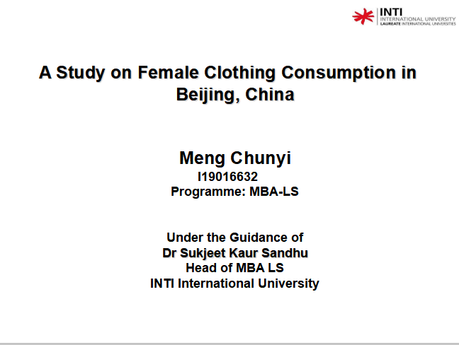

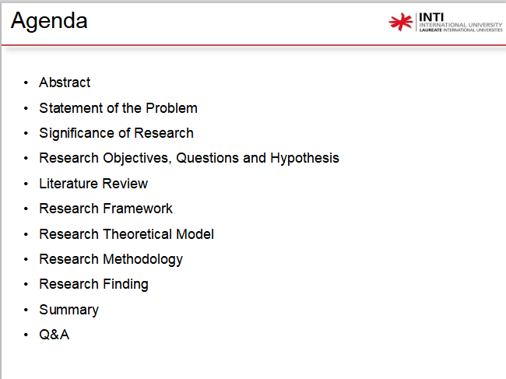

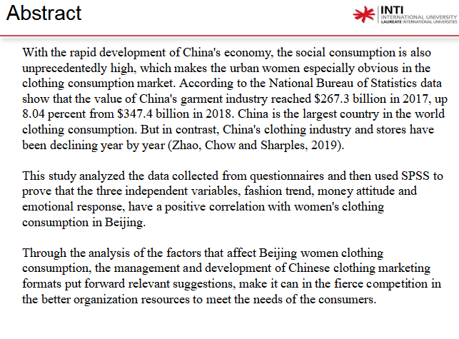

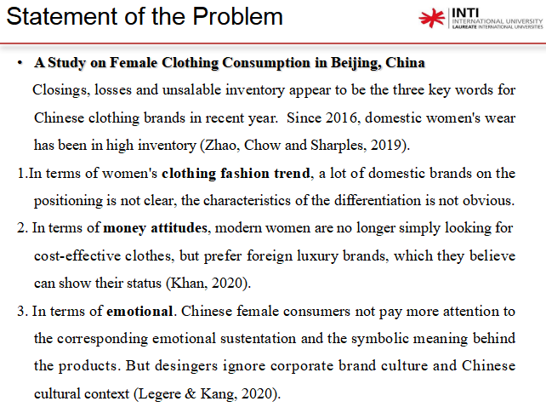

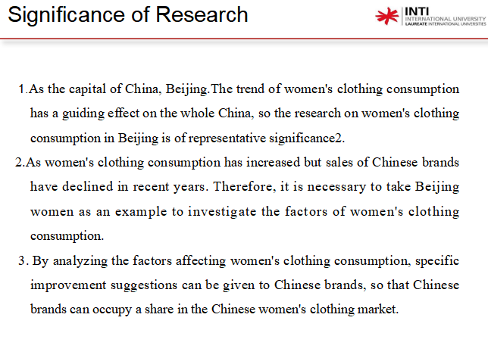

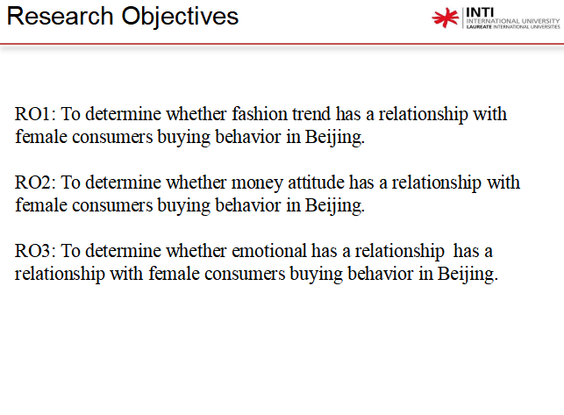

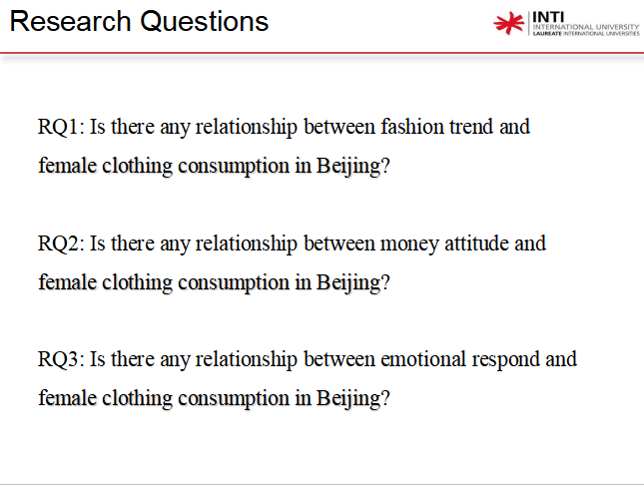

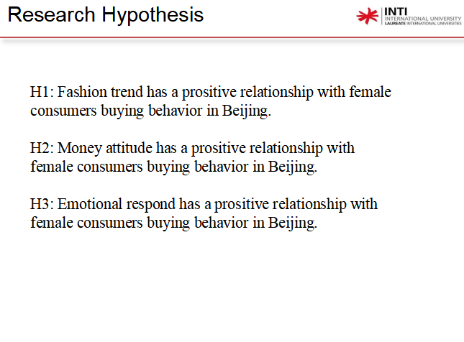

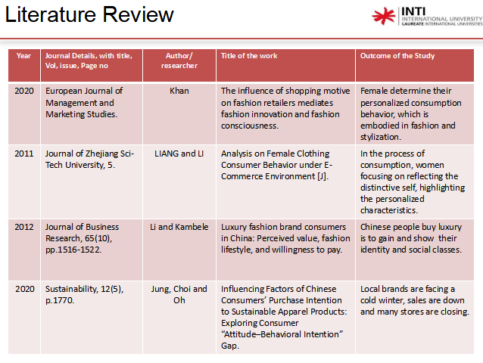

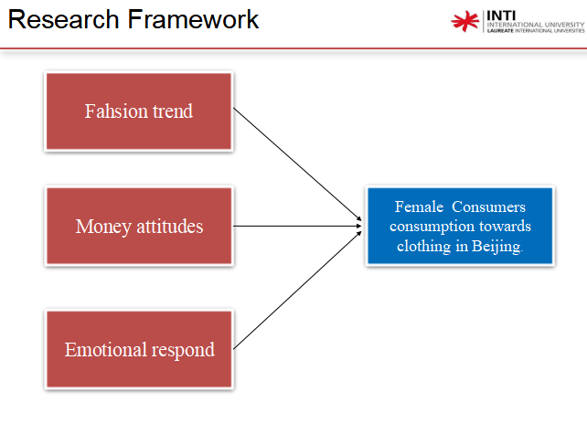

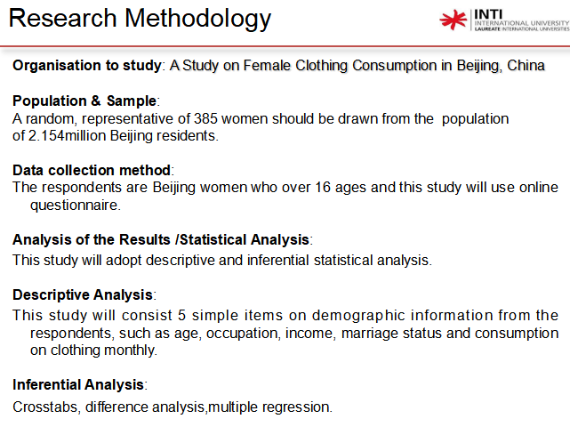

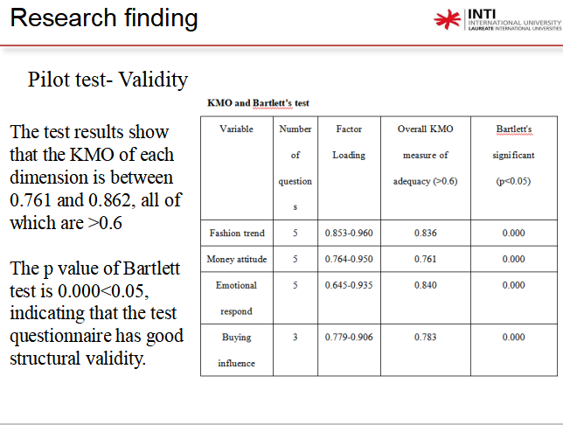

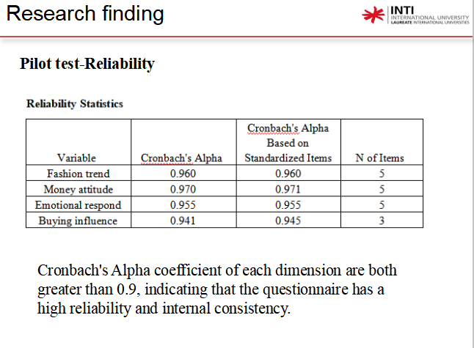

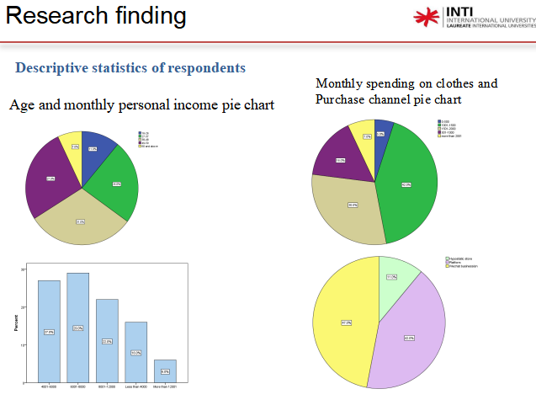

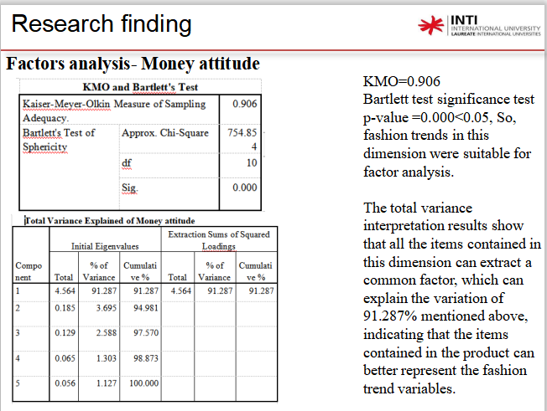

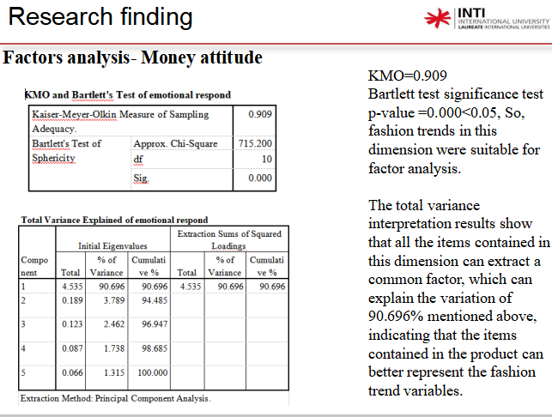

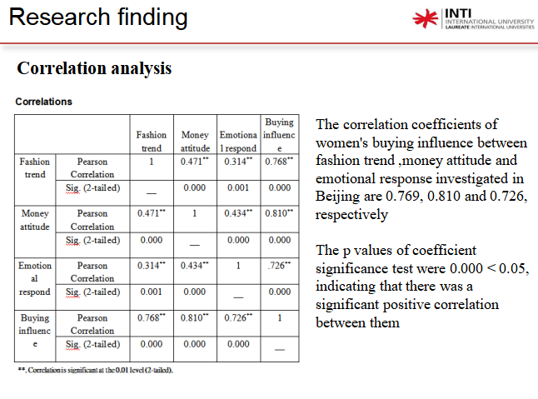

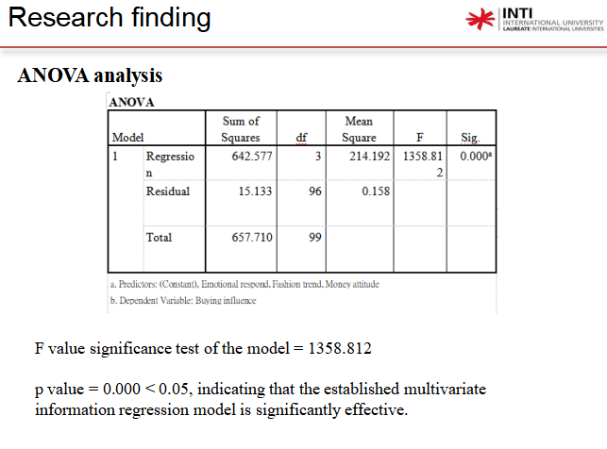

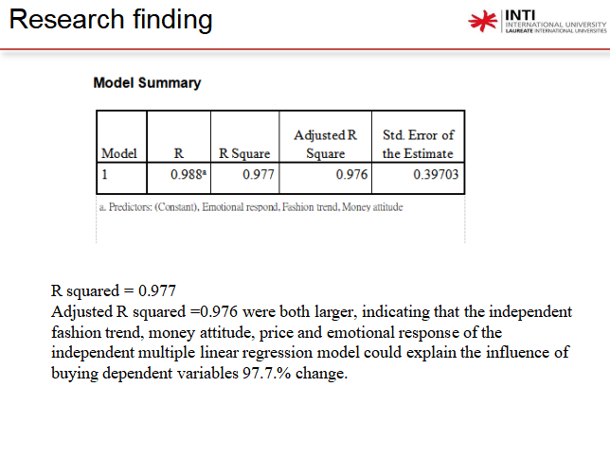

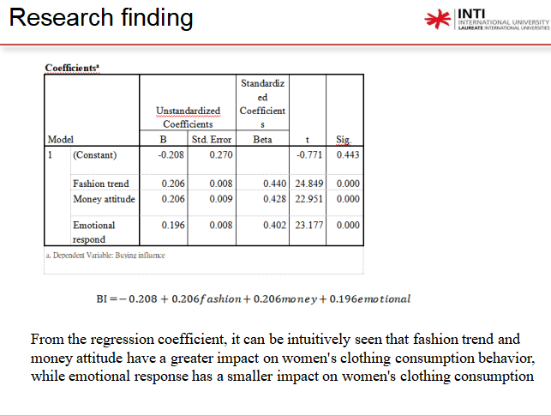

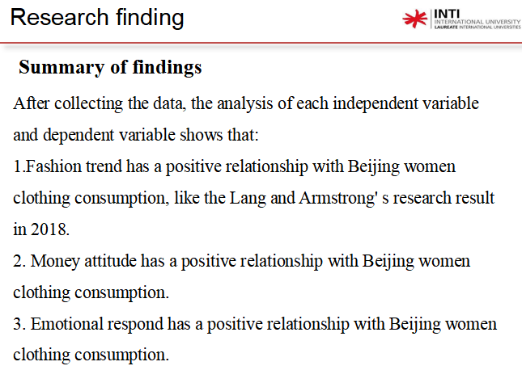

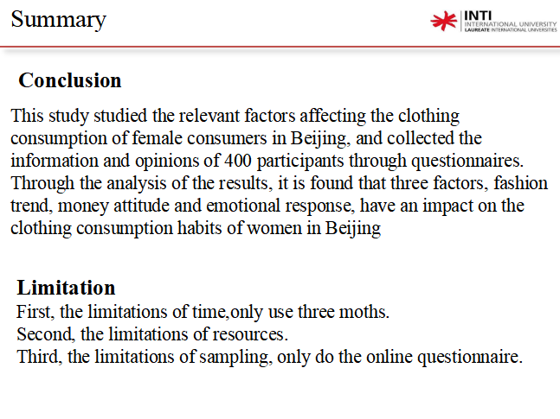

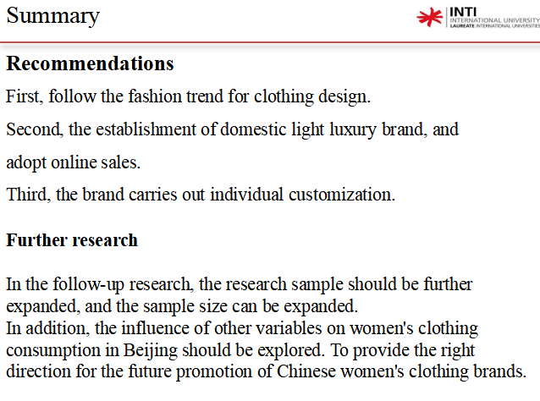

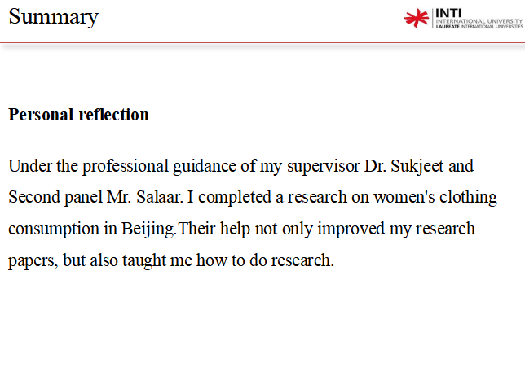

**[Appendix](#bookmark42" \o "Current Document) 10: PROJECT PAPER LOG**

|  |  |
| --- | --- |
| Student Name: | MENG CHUNYI |
| Supervisor’s Name: | Dr.Sukjeet.Kuar.Sandhu. |
| Dissertation Topic:  A Study on Female Clothing Consumption in Beijing, China | |

RECORD OF MEETINGS

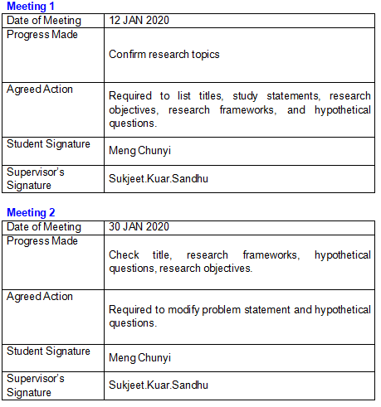

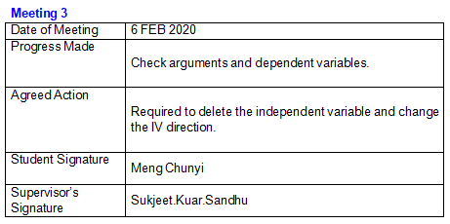

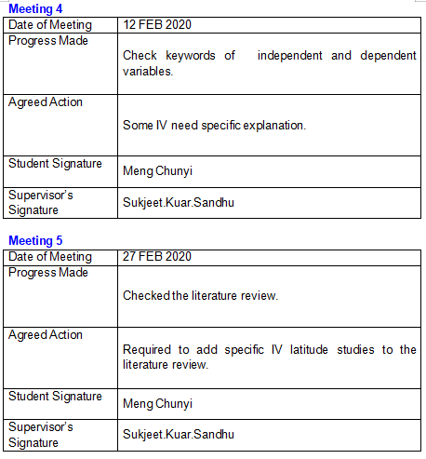



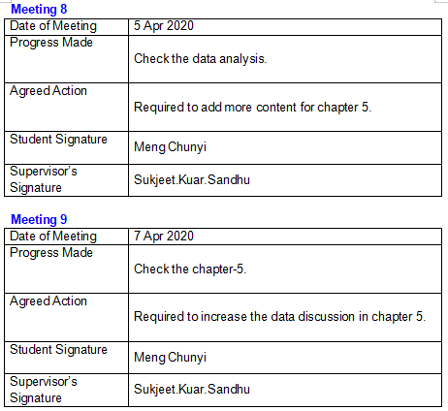



**Appendix 11: Questionnaire**

Questionnaire on women's clothing consumption

Hello, I am an MBA student from INTI International University. The purpose of this survey is to investigate the clothing consumption of female consumers. If you can fill in the questionnaire in your busy schedule, I will be very grateful. This survey is for study only and will not have any adverse effect on your life. Thank you for your cooperation.

Section A Demographic Information

What is your age?

□ 16-26 □ 27-37 □ 38-48 □ 49-59 □ 60 and above

What is your highest education?

High School or Below □ Associate/Diploma □ Bachelor/Degree

Master or Above

What is your monthly income income (RMB):

□ Less than 4000 □ 4001-6000 □ 6001-8000 □ 8001-12000

□ More than 12001

What is your household monthly income income (RMB):

□ Less than 10000 □ 10001-20000 □ 20001-30000 □ 30001-40000 □ More than 40000

What is your occupation level?

□ Senior Management □ Middle Management □ Executives/Officers □ Clerical level □ Other

What is your marriage status?

□ Single □ Married with Children □ Married without Children □ Divorced/Separted/Widow

Section B

How much did you spend on clothing per month? (RMB/CNY)

□ 0-500 □ 501-1000 □ 1001-1500 □ 1501-2000

□ more than 2001

How often do you buy clothes?

□Once a week □ Once a month □ Once a quarterly □ Random

How do you purchase the clothes?

□Hypostatic store □ Platform □ Wechat business

Where did your pre-purchase information come from？

□Relatives and friends □Advertising □ Sales □ Past experience

Section C

1)Strongly Disagree 2) Slight Disagree 3)Disagree 4) Neutral 5)Agree 6) Slight Agree 7) Strongly Agree

|  |  |  |  |  |  |  |  |
| --- | --- | --- | --- | --- | --- | --- | --- |
| Fashion trend | Rating of Response | | | | | | |
| 1 | 2 | 3 | 4 | 5 | 6 | 7 |
| I like to read fashion magazines. |  |  |  |  |  |  |  |
| I follow a lot of fashion bloggers from Europe, the us and China on Instagram. |  |  |  |  |  |  |  |
| I watch what other women wear. |  |  |  |  |  |  |  |
| When I buy clothes, I refer to magazines and other people's clothes. |  |  |  |  |  |  |  |
| I will buy clothes that I've never tried before because of fashion trends. |  |  |  |  |  |  |  |

|  |  |  |  |  |  |  |  |
| --- | --- | --- | --- | --- | --- | --- | --- |
| Money attitude | Rating of Response | | | | | | |
| 1 | 2 | 3 | 4 | 5 | 6 | 7 |
| I seem to find that I show more respect to people with more money than I have. |  |  |  |  |  |  |  |
| After seeing someone wearing something nice, I have desire to purchase it straight away. |  |  |  |  |  |  |  |
| I often spend money and end up buying unnecessary things even though I am in debts. |  |  |  |  |  |  |  |
| I must admit that I purchase things because I know they will impress others. |  |  |  |  |  |  |  |
| I am a compulsive spender and “spoil” my self constantly and have a unhealthy attitude towards money. |  |  |  |  |  |  |  |

|  |  |  |  |  |  |  |  |
| --- | --- | --- | --- | --- | --- | --- | --- |
| Emotional respond | Rating of Response | | | | | | |
| 1 | 2 | 3 | 4 | 5 | 6 | 7 |
| I like to wear clothes that represent traditional culture. |  |  |  |  |  |  |  |
| I think the design of clothes can show my personality |  |  |  |  |  |  |  |
| .I choose my clothes according to my mood. |  |  |  |  |  |  |  |
| When I choose a dress, I think about what other people will think of me in it. |  |  |  |  |  |  |  |
| When I buy clothes, I pay more attention to the meaning of the patterns on the clothes than to the color and style. |  |  |  |  |  |  |  |

|  |  |  |  |  |  |  |  |
| --- | --- | --- | --- | --- | --- | --- | --- |
|  | Rating of Response | | | | | | |
| 1 | 2 | 3 | 4 | 5 | 6 | 7 |
| Fashion trend have a big impact on my clothing purchases. |  |  |  |  |  |  |  |
| Money attitude have a big impact on my clothing purchases. |  |  |  |  |  |  |  |
| Emotional respond have a big impact on my clothing purchases. |  |  |  |  |  |  |  |

**Appendix 12: Comments on Management of Project**

(to be completed at the end of the dissertation process)

Student Comments

To be able to complete this paper, I would first like to thank Dr.Sukjeet.Kuar.Sandhu for guiding me, When I am in trouble. She will point out the mistakes in the paper and explain it to me. At the same time, I also thank to my second pannel Mr, salaar. His comments are very helpful to me. After complete this research, I think have learned many knowledge. It is a fortune in the future for me.

Supervisor Comments

Student is hardworking and put lot of energy in completing the project.

|  |  |
| --- | --- |
| Signature of  Student Meng chunyi | Date  21.4.2020 |
| Signature of  Supervisor Sukjeet.Kuar.Sandhu | Date  21.4.2020 |
| Ethics  Confirmed | Date |

**Appendix 13: Safe assign Report**

