

MGT7998 PROJECT

TITLE:
Pingyao beef group performance challenges and improvements

SUBMITTED TO:
Supervisor
Dr. Siti Nurbaayah
Dr. Rashedul Hasan

STUDENT ID:
Li Xianzhen (I18016174)

2019

TABLE OF CONTENT
PAGE
ABSTRACT………...….…………………………………………………………………….4
1.0 INTRODUCTION……………………………………………………………………..4
1.1 BACKGROUND…………………………………………..………...……...…5
1.2 PROBLEM STATEMENT……………………………………………………6
1.3 RESEARCH OBJECTIVE/QUESTIONS……………………….7
1.4 SIGNIFICANCE OF THE STUDY…………...………………………………7
1.5 LIMITATION OF THE STUDY…………………..……………………….....8
1.6 RESEARCH CATEGORY…………………………..……………………..9
2.0 LITERATURE REVIEW………………………..…………………………………...10
2.1 HYPOTHESIS………………………………………………...……………..11
3.0 RESEARCH METHODOLOGY…………………………….………………………11
3.1 RESEARCH DESIGN……………………………….………………………11
3.2 MEASURING INSTRUMENT……………………….……………………12
3.3 VALIDITY AND RELIABILITY TEST AND ANALYSIS ...…..……12
3.4 SAMPLING SELECTION……………………………….…………………12
3.5 DATA COLLECTINO AND ANALYSIS…………..…………………12
4.0 ANALYSIS AND DISCUSSION…………………………….………………..…….14
4.1 FREQUENCY DISTRIBUTION TO INTERPRET THE SURVEY DATA..14
4.1.1 DEMOGRAPHIC PROFILES OF RESPONDENTS……...………...14
4.1.2 RESPONDENTS’ VIEW ON THE FACTORS WHICH ARE RELATED TO PERFORMANCE IN PINGYAO BEEF GROUP…………………………………………………………...26
4.2 DESCRIPTIVE ANALYSIS OF THE RELATIONSHIP BETWEEN THE FACTORS WHICH INFLUENCE EFFICIENCY AND PERFORMANCE………………………………………………………...27
4.3 INFERENTIAL ANALYSIS ……………………….……………………….31
4.3.1 PEARSON CORRELATION TEST ………………….…...………...32
4.3.2 MULTIPLE REGRESSION……………………………………...….32
5.0 CONCLUSION……..……………………………….……………………………….36
5.1 RECOMMENDATIONS AND FUTURE RESEARCH…………….36
BIBLIOGRAPHY…………………………………………………………………….38
APPENDIX A………………………………………..………………………………………40
APPENDIX B……………………………………………………………………...…………43

ABSTRACT
The performance of Pingyao Beef Group has an important impact on the company's performance efficiency and future development. However, Pingyao beef group company management, related preferential policies, technology and training are challenging issues that affect performance efficiency. Understanding the factors affecting the efficiency of performance in group provides valuable research. The company chosen for this research is Pingyao beef group. Quantitative research analysis methods are applied in this related research. The author developed a more comprehensive questionnaire through reference materials and relevant literature to collect the main factors that affect the performance of Pingyao Beef Group Company. Select the relevant sample size from Pingyao Beef Group Company by using the technology of relevant accurate models and tools. The frequency distribution chart can be used to clearly explain the frequency and percentage of related factors. Then use descriptive statistical tools, Pearson related research and multiple regression models and other data analysis tools to study and analyze the relationship between performance efficiency and group company management, related preferential policies, technology and training.
Keywords: Performance, factors affecting efficiency, demographic variables, Pingyao beef group

Pingyao beef group performance challenges and improvements
CHAPTER 1: INTRODUCTION
  - BACKGROUND
Organizational performance refers to the efficiency of organizational operations, and organizational efficiency is the achievement of organizational goals. Because the enterprise organization is the connection of many subject contracts, the goal of the organization is actually a target system composed of a set of goals, which can be summarized as "the maximization of the interests of stakeholders", which is a typical multi-objective optimization model (Kochhar, 2008). In addition, the goals of an organization are also dynamic. As the environment changes and the evolution of the organization itself, its goals will continue to evolve. Therefore, the performance requirements of enterprises are gradually changing (Agyeman and Ponniah, 2014).
In recent years, with the continuous development of the market economy and the acceleration of the process of economic globalization, the challenges faced by various enterprises have become greater and greater, and the beef industry is no exception (Alkahtani, 2015). In fact, China's beef processing industry is currently in a state of fierce competition (Almazari, 2012). In order to maintain its leading edge in such a competitive environment, Shanxi Pingyao Beef Group must have the necessary operating strategies. In view of this, this article analyzes in detail the factors affecting the performance of Guanyun Pingyao beef. Pingyao Beef Group has made a huge contribution to the economy of Pingyao County and even Shanxi Province (Yigong, 2015).
The purpose and intent of this article is to find out what affects the production efficiency and performance of Pingyao Beef Group. Emphasis will be on determining the underlaying factors that lead to this assumed company performance needs improvement (Al-qahtani and Gadhoum, 2016). Through a specific survey of the employees of Pingyao Beef Group, we can understand and study what detailed measures need to be taken to improve the performance efficiency of Pingyao Beef Group. There are 3 variables such as group management, relevant policies, technology and training which were selected to study on how influence performance (Cain, et.al,2002).
Team management has a very important position in company performance management. Every group employee needs to perform daily work under company management, which plays an important role in company performance efficiency (Andish, et al, 2013). Organizations have a comprehensive impact, which is the product of the organization's collective action of members. Organizational management is the process of structuring the organisation, identifying roles or functions and clarifying the relationship between responsibilities and competences So that leaders of the company will collaborate and work together to accomplish the organizational goals effectively (Fenner, 1997). Organizational management, also known as organizational tasks, is one of the management activities.
Moreover, relevant policies in all aspects of the company occupy a very important position. Relevant policies are: compensation policy, welfare policy, organization policy, government policy, etc. These policies have an important impact on the company's performance (Burja and Mărginean, 2014). The company's remuneration policy is very important to employees. Stable remuneration helps to motivate employees to work hard, and the salary distribution must be continuously optimized and upgraded (Burja and Mărginean, 2014). Welfare policies are formulated to satisfy the material and spiritual lives of all company members. The content of welfare policy is very extensive, covering many aspects of employees' lives. Educational welfare, health welfare, cultural welfare and housing welfare are all welfare policies. Government policies support the company's development prospects (Bertsch, Geldermann, and Lühn, 2017).
Last but not least, technology and training course programs will make a huge contribution to the organization after company training and development research, which will help employees improve performance and wages (Alkahtani, 2015). If the organization provides limited training and development plans, the employees of the company that will benefit from it will be a small part; and if Pingyao Beef Group invests a lot of money and energy in training and development plans to improve the interests of the group and overall performance, This may also affect the company's performance and development, so trained employees will receive higher labor remuneration from the group company based on their own skills and capabilities (Bolek, 2013).
1.2 SPECIFIC PROBLEM STATEMENT
Pingyao Guanyun Beef Group's performance is currently not satisfactory due to the impact of the epidemic and various aspects of management. The Productivity Report 2019 stated the major challenge facing by the manufacturing sector in Pingyao beef group is performance.In the manufacturing sector, they area not only competing with the external competitor, they also face sub-sector in domestic pursue for management, relevant policies, technology and training (Collier, et al, 2010). The company management is relatively unreasonable, the relevant policy formulation is not considered, and the technology introduction and staff training are not in place (CHI, et al, 2013).
Pingyao Beef Group ’s performance efficiency issues have caused the attention and thought of various management, because the shortage of manpower and the cost issues caused by recruitment will directly affect the company ’s organizational productivity and negatively affect the company ’s financial situation (Chang, et al, 2006). Management believes group management, relevant policies, technology and training will affect the performance. However, these related factors have not been correctly identified and tested by the group company. Pingyao Beef Group wants to investigate and determine the biggest factor affecting performance efficiency in order to improve the company ’s interests and reduce the adverse impact on the company (CHEN, 2013).
Through the relevant findings of the researchers, the three factors of the company management, company related policies, technology and training are targeted (Demo, 2012). This research can provide readers with new thinking and unique insights in the field of research.
1.3 RESEARCH OBJECTIVE AND RESEARCH QUESTION
The main purpose of this study is to study and determine the factors that affect the performance efficiency of Pingyao Beef Group, and put forward appropriate and useful suggestions and summary to solve this problem to the greatest extent.
1.3.1 Research Objective
- To determine relationship between group management and performance
- To determine relationship between relevant policies and performance
- To determine relationship between technology and training and performance
1.3.2 Research Questions
- What is the relationship between group management and performance?
- What is the relationship between relevant policies and performance?
- What is the relationship between technology and training on performance?
1.4 SIGNIFICANCE OF STUDY
This research exploration is very important for each manager and leader to study performance efficiency and related factors that affect performance, and has far-reaching significance. It gives better analysis of the relationship of group management, relevant policies, technology and training in Pingyao beef group (Fama and French, 2000). This study will analyze the relationship between group company performance and its related factors. This research and results are very useful for senior leaders and managers to improve performance efficiency and take extraordinary measures to compensate for performance deficiencies (Gibson, 2001).
There is no doubt that the results of this research will be helpful to and learn from similar industries, because it will provide some useful insights and information as a reference for the company ’s future development, and senior leaders and management can use it as a reference to discuss research performance efficiency Reasons for lows and countermeasures (GLOBAL and 2015).
Moreover, the research also helps the organization to reduce the low efficiency and low productivity. From a long-term perspective, the study helps the group companies establish an effective management chain by analyzing appropriate factors that affect performance. Only in this way, the group company will be able to achieve the goal of better sustainable development (He, 2019).
Finally, it is particularly important that this research will undoubtedly be beneficial to scholars because they can obtain relevant practical knowledge and research in these areas. In addition, this study retains the reference value of the relevant field for this research (Hair et al., 2007).
1.5 LIMITATION OF THE STUDY
The specific research and exploration of this article is to collect data using a questionnaire survey. Although this method is very flexible, the employees surveyed may answer questions because they have not thought about it. In addition, the small sample size limit will make it difficult for this study to provide reasonable and effective model analysis (George 2015). Secondly, the time limit of this study is that researchers do not have enough time to collect data. This is another limitation of this investigation and study, which will lead to the lack of in-depth and accurate reflection of the research analysis results.
In addition, the defined factors that affect performance efficiency are limited and inaccurate, and there are still many factors that have not been fully researched and developed. This may lead to insufficient understanding of this study and affect the results.
1.6 RESEARCH CATEGORY
This study is to investigate the factors influencing the efficiency of performance in Pingyao beef group. Questionnaires and interview questionnaires collect data from target respondents, and then conduct research through quantitative methods and tools. The defined variable size is suitable for the sample size of this study. The research and discussion in this article is to use SPSS tools that can be quantitatively analyzed, so that more accurate and relevant data can be obtained for analysis and research, and the specific conditions and status of frequency distribution are summarized by formulating clear pie charts, bar charts and tables. These operations are used to explain the population of the interviewee. Survey data on statistical characteristics and related factors. Through the use of SPSS data analysis tools that can be quantitatively analyzed to analyze the relationship between performance and related factor variables.

1.7 Ethical Consideration
The author must ensure that this proposed study submitted is original without plagiarizing the creative works of other researchers. When similar ideas are taken, throughout the study, the researcher must specifically mention the name of the original authors and published years. The writer will not consider any conflict of interest to the topic at hand when doing this research.
The author will also respect the rights of the respondents during the interviews. Sensitive issues such as sexism, prejudice, and many more would not be discussed throughout the interviews. The investigator will trust the participants if they are reluctant to answer any questions asked during the interviews. Participants will be told of the essence of the research project which requires informed consent to engage in the interviews. The study information remained secret during the research, unless permission is granted. There will be no public disclosure of information collected to the author.
CHAPTER 2: LITERATURE REVIEW
  - REVIEW OF LITERATURE
Group company performance management is a special and controversial global issue. The efficiency of performance is the main concern for company today. Managers anxious about their company performance to operate the business. Organizations harmonize all aspects to guarantee effective leadership in the future (Hooi, 2007). The performance of the Pingyao Guanyun Beef Group is currently unsatisfactory due to the impact of the epidemic as well as various management aspects. One of the first studies to discuss the influence of the performance of Pingyao beef group is management (1972). The author developed a model that contemplates the aspiration of organization in having a determined management, considering a high management with a high performance. After testing his model in beef industries, he found that optimal strategy depended on the type of management (Hymer and Pashigian, 1962).
Regarding the discussion of management style, group company management is an important component that affects performance efficiency (Li, 2017). The clearer the organization and management of the group, the stronger the sense of common goals, the higher the employee's work efficiency, and the higher the employee's job satisfaction, which will bring more benefits to the company (Kuria, Alice and Wander, 2012). Therefore, it is very important for job-seekers to understand and analyze the management method and direction of the organization. It is very important to become an excellent member of the group company team in order to cooperate with colleagues and leaders for better progress Influence and meaning. It also shows that Pingyao Beef Group's well-organized working environment and management style culture are affecting employees' enthusiasm and company performance all the time (Andish et al., 2013). Senior managers and leaders with good management style need to create a comfortable working environment and a good working atmosphere in order to maintain the positive work enthusiasm and good morale of employees (Kim et al., 2009).
Related research believes that technology and training have a very important relationship with performance. Technology and training constantly motivate employees to advance and progress. The field of training and development has been proven by relevant scholars to be directly proportional to performance, which is of great significance and R & D value for the company's future development (Tangthong et.al, 2014). One of the important determinant of organizational success in the efficiency of performance is technology and training. It is a resource that can be integrated with technology and training, so that it can establish valuable and meaningful working methods and thought states. Technology and training are two major parts in the efficiency of performance (Chen 2014). The benefits of introducing technology and training are many, such as saving the budget cost of recruitment, improving productivity and profit performance, and improving employee performance, so as to achieve the relevant goals and expectations of the group company (Oladapo, 2014).
Relevant policies have always been esteemed and precious. For group companies, it is important to use relevant preferential and advantageous policies to maintain a competitive advantage (Fishman, 1998). The group company should use various advantageous policies to seize the opportunity to develop and grow as much as possible. To further clarify, relevant policies will encourage the group companies to remain competitively sustainable (Samal, 2014). Insufficient imported technology and lack of training are worth pondering by Pingyao Beef Group. Excellent and positive employees of the group company will be retained. Regarding the employment of employees, leadership plays a unique position and role. The company's development potential and organizational cultural level have a crucial impact on talent retention (Frank and Taylor,2014). Group companies need to increase investment and influence in order to cultivate skilled and capable labor for the company.
CONCEPTUAL FRAMEWORK AND HYPOTHESIS
Conceptual Framework
Dependent variable
Independent variable
Group management

Performance
Relevant policies
Technology and Training

According to all referenced literatures, the researchers concluded and analyzed that the group company management, related policies, technology and training are the main factors affecting performance efficiency. From all relevant research, the relevant conceptual framework of this research can cover all relevant variables (group company group management, related policies, technology and training). The relevant models of the relevant literature on these factors are comprehensive, so this study will draw more effective research results and analysis based on this, and the analysis results of independent and dependent variables will be obtained through analysis.
Hypothesis
- There is a significant relationship between Pingyao beef group company management and performance.
- There is a significant relationship between relevant policies and performance.
- There is a significant relationship between technology and training factor and performance.
CHAPTER 3 : RESEARCH METHODOLOGY
3.1 RESEARCH DESIGN
In this specific study, the research design and principle analysis were carried out by using quantitative research methods. Quantitative research methods are used to analyze the collected data and questionnaires about the relevant factors that affect the performance efficiency of the group company. In the related research of the questionnaire survey, the Pingyao Beef Group Company was measured and quantified the relevant factors affecting the performance by using the five-point Likert scale method. In addition, it also defines the relevant factors that affect performance-dependent variables and independent variables. Then explain whether each independent variable has a certain effect on the dependent variable. The measurement methods of related studies need to be cautious and conscientious. The author chose to use the quantitative research analysis method in this study because the quantitative research analysis method is easy to control and can accurately grasp the relationship between related variables. Especially for research in this area, many independent variables and controllable variables are involved in the factors that affect performance. (Group company management, related policies, technology and training).
3.2 MEASURING INSTRUMENT
Use the data analysis function in SPSS to analyze and summarize the data collection in the questionnaire, and summarize it into forms such as tables, pie charts and bar charts. This article uses data related to frequency distribution, frequency percentage and cumulative percentage to explain the data survey and demographic analysis of the employees surveyed. Data analysis functions in Microsoft SPSS (such as descriptive statistical data tools, Pearson correlation analysis and multiple regression analysis) are used to analyze the factors that affect performance efficiency (group company management, related policies, technology and training) and the performance of Pingyao beef group company Relationship.

VALIDITY AND RELIABILITY TEST AND ANALYSIS
Reliability is defined as the quality assessment process and has an objective of full explanation, while effectiveness depends on assumptions on qualification checks to avoid any misleading information being produced. Ancillary data analysis and IBM SPSS technology will be used in this study to establish credibility and reliability for testing questions that could be asked during the interview.
Reliability Statistics
Cronbach's Alpha | N
.993 | 15

Cronbach's Alpha 0.993>0.7 , this shows that the data collection is validity and reliability.

  - SAMPLE SELECTION

This study uses sampling techniques for analysis. This is a very accurate non-probabilistic sampling research analysis method. Through this research technique and method, research factors and objects can be selected because they are malleable and accessible (Explorable.com). In the survey study here, we will use sampling techniques to select respondents from the Pingyao beef group company sector. Through accurate sampling techniques, the specific questionnaires of 60 employees of Pingyao Beef Group were distributed.
3.5 DATA COLLECTION RESEARCH ANALYSIS
3.5.1SPECIFIC DATA COLLECTION
The performance factors of Pingyao Beef Group Company are obtained from the primary and secondary data sources, and through the in-depth analysis of this article, we provide suggestions for solving performance problems. In this survey, the main data collection was collected through a questionnaire, which was completed by existing employees of Pingyao Beef Group. The original questionnaire data is more reliable, credible, and objective, so this is more convincing and effective than second-hand data (Sekaran & Bougie, 2010). In this paper, the researchers collected relevant data information required by this research through a data questionnaire. This can ensure that Pingyao Beef Group can accurately obtain information and data when distributing the questionnaire to the respondents.
For the closed questionnaire of this study, the object of this study is about the employees of Pingyao Beef Group. These employees hold various levels of positions in Pingyao Beef Group, such as operators, supervisors, executive employees and company managers.
3.5.2 INTERPRETATION OF VARIABLES
The questionnaire is one of the important tools for obtaining first-hand resource data. The questionnaire used in this study is divided into two specific parts, namely Part A and Part B. Part A Part A deals with the specific background of the interviewee; Section B relates to the factors or causes of the efficiency of performance.
Section A: Background of the Surveyed emplyee
Part A Part A requires the surveyed employees to fill out their relevant demographic data and personal specific details. The specific issues in this part include gender, age, education level, marital status, monthly income, the number of years worked, and the specific type of work. After obtaining these specific data, use frequency distribution and percentage to carry out specific analysis and data model operation.
Section B: Factors contributing to the performance
This section involves the measurement of the effect of group management, relevant policies, technology and training; towards the performance. There are 15 specific questions in this section. Table 1 lists the number of specific questions for each performance influencing factor.
Factors contributing to the performance of Pingyao beef group | Number of Questions
Group company management | 5
Relevant policies | 5
Technology and training | 5
Total | 15
Table 1: Number of questions for each relevant and specific factor
In the relevant data survey in this section, the interviewees used the 5-point Likert scale to discuss and study the relevant performance issues of this article. For the relevant accurate and clear analysis models and methods, summarize the corresponding scores through each question filled out by employees. The concepts and knowledge of the five-point Likert scale are easily accepted and understood by the interviewees. Therefore, they can accurately answer all relevant questions according to their specific circumstances. Table 2 clearly shows the 5-point Likert scale, which is very clearly used to indicate the relevant factors that affect the influencing factors of Pingyao Beef Group Company.
Choices | Score
Strongly Agree | 5
Agree | 4
Neutral | 3
Disagree | 2
Strongly Disagree | 1
Table 2: 5-point Likert Scale specific table
CHAPTER 4 : ANALYSIS AND DISCUSSION
4.1 INTERPRET SURVEY DATA ACCURATELY WITH CLEAR FREQUENCY DISTRIBUTION
The questionnaire survey was conducted on the current employees of Pingyao Beef Group. The sample size of this study was 60 employees of group companies. The following sections involve very clear frequency distribution maps for data analysis and related investigations.
4.1.1 THE DEMOGRAPHIC-RELATED SITUATION OF THE EMPLOYEES SURVEYED
This section mainly introduces the demographic data of the employees surveyed. The frequency distribution and percentage charts clearly show seven related demographic variables, such as gender, age, education level, marital status, working years in Pingyao Beef Group, monthly income and job status.
Gender
There are two clear and clear options under this gender classification, namely male options and female options. Among the 60 employees surveyed, the percentage of male employees surveyed is the same as the percentage of female employees surveyed. Among them, 50% of the respondents are female respondents, and 50% of the respondents are male respondents. Interviewer. Table 3 clearly shows the specific frequency distribution of the employees surveyed by this project. Figure 1 clearly summarizes and summarizes the percentage of employees surveyed by gender.
Gender | N | Percentage (%) | Cumulative Percentage (%)
Male | 30 | 50 | 50
Female | 30 | 50 | 100.00
Table 3: Frequency distribution of surveyed employee about gender
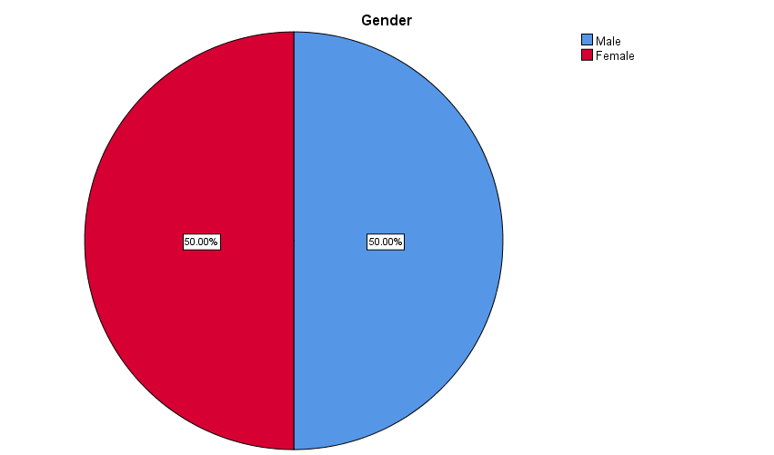
Figure 1: Pie chart illustrates the percentage of surveyed employee based on gender
Age
Under the category classification related to the age, the surveyed employees of Pingyao Beef Group Company have six specific choices, including 18-25 years old, 26-30 years old, 31-40 years old, 41 -50-year-old age group, 51-60 age group and over 60-year-old age range of analysis and research. Among the 60 respondents surveyed, the percentage between the ages of 26-30 and 31-40 showed the highest, with 23.3% respectively; followed by age range 18-25 and 41-50 which is 20% respectively, age range 51-60 is 10% and above 60 years is 3.3%. Table 4 clearly lists the frequency distribution of employees surveyed according to age. Figure 2 clearly shows the percentage value of the age of employees of Pingyao Beef Group.
Age (Years) | N | Percentage (%) | Cumulative Percentage (%)
18-25 | 12 | 20.00 | 20.00
26-30 | 14 | 23.30 | 43.30
31-40 | 14 | 23.30 | 66.70
41-50 | 12 | 20.00 | 86.70
51-60 | 6 | 10.00 | 96.70
Above 60 | 2 | 3.30 | 100.00
Table 4: Frequency distribution of surveyed employee about age
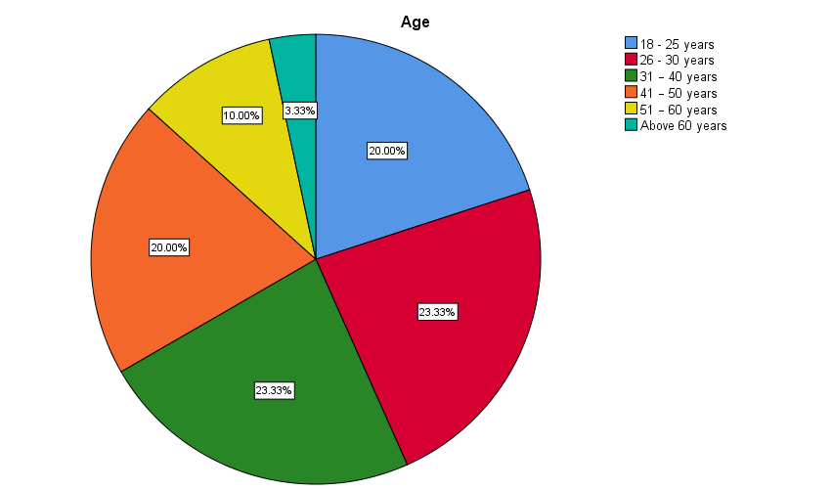
Figure 2: Pie chart illustrates the percentage of surveyed employee about age
Education level
Under the specific category of education, there are six options to choose from, namely illiteracy, high school, intermediate, degree, master's degree and PHD. Among the 60 surveyed respondents, 35% of the surveyed respondents have a high school degree, 25% of the surveyed respondents have an intermediate degree, 21.70% of the respondents are illiterate, 3.30% Respondents surveyed have a master's degree, and 0% of respondents surveyed have a PHD degree. Table 5 clearly shows the frequency distribution of surveyed employee interviewees regarding education level. Figure 3 clearly shows the percentage of employees and educators surveyed.
Education Level | N | Percentage (%) | Cumulative Percentage (%)
Illiterate | 13 | 21.70 | 21.70
High school | 21 | 35.00 | 56.70
Intermediate | 15 | 25.00 | 81.70
Degree | 9 | 15.00 | 96.70
Masters degree | 2 | 3.30 | 100.00
Doctor degree | 0 | 0.00 | 100.00
Table 5: Frequency distribution of surveyed employee about education level

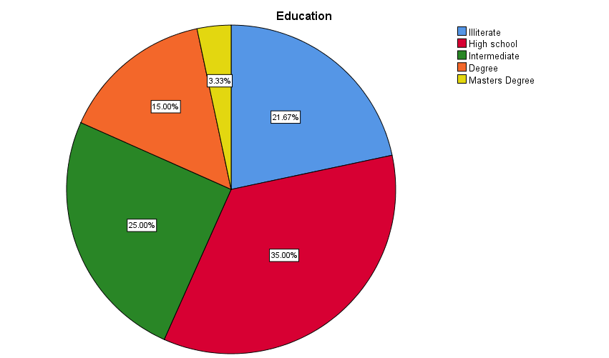
Figure 3: Pie chart illustrates the percentage of surveyed employee about education level
Tenure with Pingyao beef group
During the tenure of Pingyao beef group company employees, there are five options to choose from, including less than 1 year, 1-5 years, 5-10 years, 10-15 years, and more than 15 years. Among the 60 respondents, majority of respondents (35.0%) have been working in Pingyao beef group for 1-5 years while minority of respondents (5.0%) have been working in Pingyao beef group for above 15 years. Besides that, 11.7%, 31.7%, and 16.7% of respondents have been working in Pingyao beef group for less than 1 year, 5-10 years, 10-15 years respectively. Table 6 clearly shows the frequency distribution of the surveyed respondents classified by Pingyao Beef Group based on these terms. Figure 4 clearly shows the percentage of employees who were surveyed in Pingyao Beef Group.
Tenure with Pingyao beef group | N | Percentage (%) | Cumulative Percentage (%)
Less than 1 year | 7 | 11.7 | 11.7
1-5years | 21 | 35.0 | 46.70
5-10 years | 19 | 31.7 | 78.30
10-15 years | 10 | 16.7 | 95.00
Above 15 years | 3 | 5.0 | 100.00
Table 6: Frequency distribution of surveyed employee about tenure with Pingyao beef
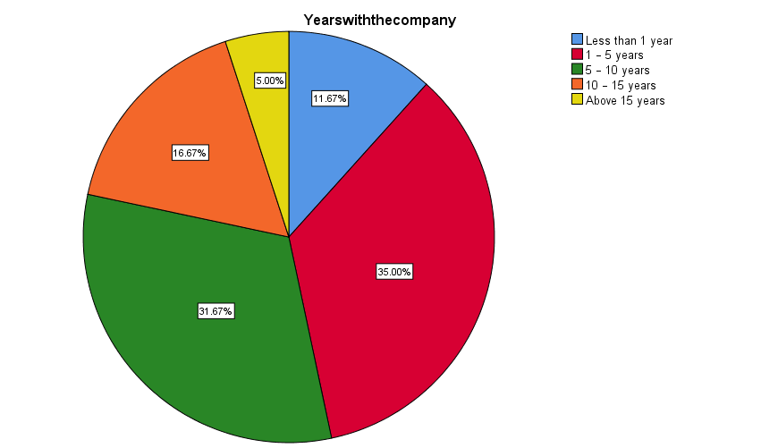
Figure 4: Pie chart illustrates the percentage of surveyed employee about tenure with Pingyao beef group
Monthly income
There are four options available under the monthly income (CNY) category, which include below CNY 3000, CNY3001-CNY7000, CNY7001-CNY12000 and more than 12001. Among the 60 surveyed respondents, 55% of the surveyed respondents' monthly income ranges from 3001-CNY7000 yuan; 20% have monthly income range of below CNY 3000, 16.7% have monthly income range of CNY7001-CNY12000 and 8.30% have monthly income more than CNY12001 respectively. Table 7 clearly shows the frequency distribution of the surveyed employee interviewees regarding the monthly income amount. Figure 5 clearly shows the percentage of employees surveyed about employee monthly income.
Monthly Income (CNY) | N | Percentage (%) | Cumulative Percentage (%)
Below CNY 3000 | 12 | 20.00 | 20.00
CNY3001-CNY7000 | 33 | 55.00 | 75.00
CNY7001-CNY12000 | 10 | 16.70 | 91.70
More than 12001 | 5 | 8.30 | 100.00
Table 7: Frequency distribution of surveyed employee about monthly income (CNY)
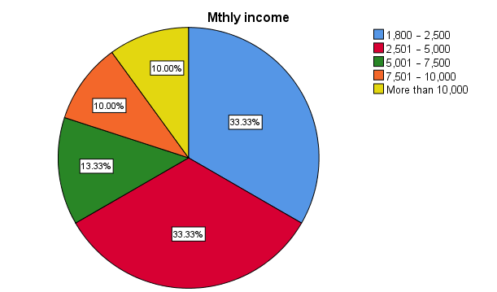
Figure 5: Pie chart illustrates the percentage of surveyed employee about monthly income (CNY)
Job category
There are four options available under this category of monthly income, including operators, supervisors, company executives, managers and above. Among the 60 respondents, 41.7% of respondents are operator, 35.00% are supervisor, 15.00% and 8.3% respectively are executive and manager and above. Table 8 specifically lists the frequency distribution of the surveyed respondents about job categories. Figure 6 clearly shows the percentage of employees surveyed who conducted scientific research by employee position category.
Job Category | N | Percentage (%) | Cumulative Percentage (%)
Operator | 25 | 41.70 | 41.70
Supervisor | 21 | 35.00 | 76.70
Executive | 9 | 15.00 | 91.70
Managers and above | 5 | 8.30 | 100.00
Table 8: Frequency distribution of surveyed employee about job category

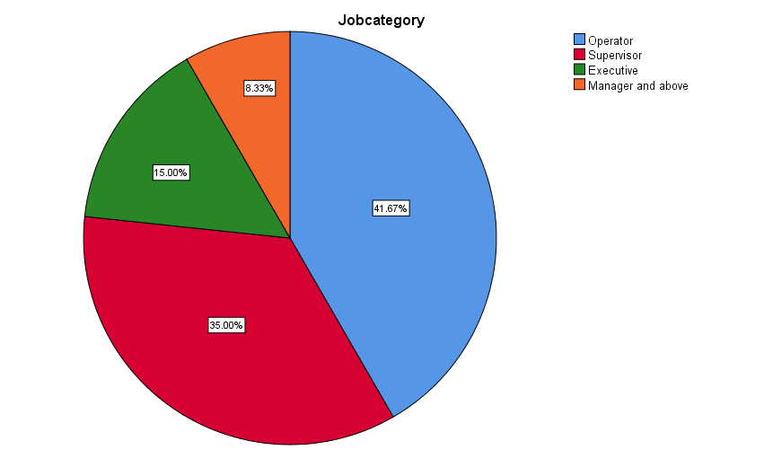
Figure 6: Pie chart illustrates the percentage of surveyed employee about job category

4.1.2 SURVEYED EMPLOYEES' VIEWS ON FACTORS RELATED TO THE PERFORMANCE OF PINGYAO BEEF GROUP
This section mainly introduces the specific correlation between the surveyed respondents and the influencing factors related to the performance efficiency of Pingyao Beef Group Company. Respondents surveyed need to evaluate and study 15 related statement issues, and classify them from very disagree to strongly agree to reflect the three main factors of performance efficiency. These factors include group management, relevant policies, technology and training. Questionnaire data is expressed in terms of frequency distribution and percentage.
Factor 1: Group management
Five relevant statements have been drawn up in the questionnaire, so as to obtain relevant opinions of the surveyed respondents on the management of Pingyao Beef Group Company. Table 9 clearly lists the related frequency distribution of the company's management by the interviewees of Pingyao Beef Group.

Statements related to performance efficiency | Frequency | Response
Statements related to performance efficiency | Frequency | Strongly disagree | Disagree | Neutral | Agree | Strongly Agree
The company in profitability | Number of respondents | 0 | 5 | 18 | 29 | 8
The company in profitability | Percentage (%) | 0.00 | 8.3 | 30.00 | 48.30 | 13.30
The company in profitability | Cumulative Percentage | 0.00 | 8.3 | 38.30 | 86.70 | 100.00
Company reputation | Number of response | 0 | 5 | 18 | 29 | 8
Company reputation | Percentage (%) | 0.00 | 8.30 | 30.0 | 48.3 | 13.3
Company reputation | Cumulative Percentage | 0.00 | 8.30 | 38.3 | 86.70 | 100.00
Customer repurchase | Number of respondents | 0 | 5 | 18 | 29 | 8
Customer repurchase | Percentage (%) | 0.00 | 8.30 | 30.00 | 48.30 | 13.30
Customer repurchase | Cumulative Percentage | 0.00 | 8.30 | 38.30 | 86.70 | 100.00
Asset operation status | Number of respondents | 0 | 5 | 18 | 29 | 8
Asset operation status | Percentage (%) | 0.00 | 8.30 | 30.00 | 48.30 | 13.30
Asset operation status | Cumulative Percentage | 0.00 | 8.30 | 38.30 | 86.70 | 100.00
Development capacity | Number of respondents | 0 | 5 | 18 | 29 | 8
Development capacity | Percentage (%) | 0.00 | 8.30 | 30.00 | 48.30 | 13.30
Development capacity | Cumulative Percentage | 0.00 | 8.30 | 38.30 | 86.70 | 100.00
Table 9: Frequency distribution of the surveyed workers' response regarding the performance in Pingyao beef group
Statement 1: The company in profitability.
48.30% and 0% of the surveyed respondents agreed and strongly disagreed to consider the company's profitability. However, 8.30% disagree and 13.3% strongly agree while 30% of them are neutral.
Statement 2: Company reputation.

48.3% and 0% of respondents agree and strongly disagree they focus on company reputation. However, 8.30% and 13.30% of respondents disagree and strongly agree while 30.00% of them are neutral about company reputation.
Statement 3: Customer repurchase.
48.30% and 0% of respondents agree and strongly disagree about customer repurchase. However, 8.30% and 13.30% of the surveyed respondents respectively expressed disagreement and strong agreement, while 30% of the surveyed respondents held a neutral attitude towards customer repurchase.
Statement 4: Asset operation status.
48.30% and 0% of respondents agree and strongly disagree about asset operation status. However, 8.30% and 13.30% of respondents disagree and strongly agree while 30.00% of them are neutral about asset operation status.
Statement 5: Development capacity.

48.30% and 0% of respondents agree and strongly disagree about development capacity. However, 8.30% and 13.30% of respondents disagree and strongly agree while 30.00% of them are neutral regarding the development capacity.
Summary and findings about factor 1: performance
Among the 60 respondents, majority of them are often think about the company in profitability and company reputation are the very important factors in the company performance. Besides, customer repurchase also play a key role in the efficiency of performance. However, the asset operation status and development capacity occupy a secondary position in company performance.
Factor 2: Group management
Five relevant statements have been clearly formulated in the questionnaire to solicit the surveyed respondents' suggestions on related management and related policies of Pingyao Beef Group Company. Table 9 specifically lists the specific frequency distribution of the company's management by the surveyed respondents in the Pingyao beef group company.

Statements related to group company management factor | Frequency | Response
Statements related to group company management factor | Frequency | Strongly disagree | Disagree | Neutral | Agree | Strongly Agree
The company provides basic good benefits for employees | Number of respondents | 0 | 4 | 21 | 25 | 10
The company provides basic good benefits for employees | Percentage (%) | 0.00 | 6.70 | 35.00 | 41.70 | 16.70
The company provides basic good benefits for employees | Cumulative Percentage | 0.00 | 6.70 | 41.70 | 83.30 | 100.00
Help employees of the group company to prevent and control workplace accidents | Number of response | 0 | 4 | 20 | 26 | 10
 | Percentage (%) | 0.00 | 6.70 | 33.30 | 43.30 | 16.70
 | Cumulative Percentage | 0.00 | 6.70 | 40.00 | 83.30 | 100.00
Prevent and control staff entering the company's facilities and buildings to ensure the safety of employees | Number of respondents | 0 | 5 | 20 | 25 | 10
 | Percentage (%) | 0.00 | 8.30 | 33.30 | 41.70 | 16.70
 | Cumulative Percentage | 0.00 | 8.30 | 41.70 | 83.30 | 100.00
The facilities and physical condition | Number of Surveyed employee | 0 | 5 | 19 | 26 | 10
The facilities and physical condition | Percentage (%) | 0 | 8.30 | 31.70 | 43.30 | 16.70
The facilities and physical condition | Cumulative Percentage | 0 | 8.30 | 40.00 | 83.30 | 100.00
Group companies care about employees' quality of life and health | Number of respondents | 0 | 5 | 18 | 28 | 9
 | Percentage (%) | 0.00 | 8.30 | 30.00 | 46.70 | 15.00
 | Cumulative Percentage | 0.00 | 8.30 | 38.30 | 85.00 | 100.00
Table 9: Frequency distribution of the surveyed workers' response regarding the group management in Pingyao beef group
Statement 6: The company provides basic good benefits for employees
41.70% and 0% of the respondents respectively agree and strongly disagree that the company I work for provides basic benefits. However, 6.70% disagree and 16.70% strongly agree while 35.00% of them are neutral regarding the company I work for provides basic benefits.
Statement 7: Help employees of the group company to prevent and control workplace accidents.
43.30% and 0% of the surveyed respondents agreed and strongly disagreed. The work plan or process formulated by Pingyao Beef Group Company can help company employees prevent accidents and prevent and control them. However, 6.70% and 16.70% of respondents disagree and strongly agree while 33.30% of them are neutral about help employees cope with incidents and prevent workplace accidents.
Statement 8: Prevent and control staff entering the company's facilities and buildings to ensure the safety of employees
41.7% and 0% of the surveyed respondents agreed and strongly disagreed. They have relative access control to the staff of the facilities and buildings of the Pingyao beef group company, and they must actively prevent and control the safety of the company's employees. However, 8.30% and 16.70% of the surveyed respondents expressed disagreement and strongly agreed opinion status, respectively, while 33.30% of the surveyed respondents conducted access security control on the staff of the company's facilities and buildings The situation expressed a neutral opinion.

Statement 9: The facilities and physical condition for relevant emplyee

43.30% and 0% of the surveyed respondents agreed and strongly disagreed. Whether the facilities of the Pingyao beef group company served by the company's employees provide employees with a comfortable and healthy environment and are suitable for employees to work. However, 8.30% and 16.70% of the surveyed respondents expressed disagreement and strong agreement respectively, while 31.70% of the surveyed respondents had a view on the infrastructure of the company served by Pingyao Beef Group He holds a neutral opinion and attitude.
Statement 10: Group companies care about employees' quality of life atmosphere and health
46.7% and 0% of the surveyed respondents expressed their agreement and strong disagreement respectively. Pingyao Beef Group is very concerned about the quality of life and health of its employees. However, 8.30% and 15.00% of respondents disagree and strongly agree while 30.00% of them are neutral regarding the company I work for is concerned with my health and quality of life.
Summary and findings about factor 2: Group management
Among the 60 respondents surveyed, most of the company's employees 'work efficiency is related to employees' health and living environment, which has a positive impact on employee management and the company's future development and growth. In addition, the work plan or process established by the Pingyao Beef Group company where employees work can help company employees respond to unexpected accidents and prevent workplace accidents, and provide company employees with good facilities and environmental conditions. Most company employees The facilities and atmosphere provided are satisfactory and comfortable. In addition, the services and basic benefits provided by the company (for example, free food provision, medical care supply, transportation subsidies, etc.), Pingyao beef group company employees feel that the facilities provided need to be improved.
Factor 3: Relevant policies
Five specific statements have been drawn up in the questionnaire to solicit respondents' specific opinions on related policies of Pingyao Beef Group. Table 10 clearly lists the respondent's response to specific policies in terms of frequency distribution.
Statements related to working atmosphere factor | Frequency | Response
Statements related to working atmosphere factor | Frequency | Strongly disagree | Disagree | Neutral | Agree | Strongly Agree
The salary is satisfactory and there is potential for development | Number of respondents | 0 | 4 | 19 | 27 | 10
 | Percentage (%) | 0.00 | 6.70 | 31.70 | 45.00 | 16.70
 | Cumulative Percentage (%) | 0.00 | 6.70 | 38.30 | 83.30 | 100.00
Think the future income is bullish | Number of responsedents | 0 | 4 | 19 | 27 | 10
Think the future income is bullish | Percentage (%) | 0.00 | 6.70 | 31.70 | 45.00 | 16.70
Think the future income is bullish | Cumulative Percentage (%) | 0.00 | 6.70 | 38.30 | 83.30 | 100.00
Welfare policy is good for employee | Number of Surveyed employee | 0 | 4 | 18 | 28 | 10
Welfare policy is good for employee | Percentage (%) | 0.00 | 6.70 | 30.00 | 46.70 | 16.70
Welfare policy is good for employee | Cumulative Percentage (%) | 0.00 | 6.70 | 36.70 | 83.30 | 100.00
Relevant policy interests are better than other group companies. | Number of Surveyed employee | 0 | 4 | 19 | 28 | 9
 | Percentage (%) | 0.00 | 6.70 | 31.70 | 46.70 | 15.00
 | Cumulative Percentage | 0.00 | 6.70 | 38.30 | 85.00 | 100.00
The government’s policy is to benefit the performance. | Number of surveyed employee | 0 | 4 | 19 | 28 | 9
The government’s policy is to benefit the performance. | Percentage (%) | 0.00 | 6.70 | 31.70 | 46.70 | 15.00
The government’s policy is to benefit the performance. | Cumulative Percentage | 0.00 | 6.70 | 38.30 | 85.00 | 100.00
Table 10: Frequency distribution of the surveyed workers' response regarding the relevant policies in Pingyao beef group
Statement 11: The salary is satisfactory and there is potential for development
45.00% and 0% of the respondents respectively agree and strongly disagree that I feel I am being paid a fair amount about the remuneration policy. Meanwhile, 6.70% and 16.70% of the respondents disagree and strongly agree whereas 31.70% of them are neutral that I feel I am being paid a fair amount about the remuneration policy.
Statement 12: Think the future income is bullish

45.00% of the surveyed respondents agreed with their opinions and expressed that employees are very satisfied with the salary increase policy. Meanwhile, only 6.70% and of the respondents disagree and whereas 31.70% of them are neutral that I feel satisfied with my chances for salary increases policy.
Statement 13: Welfare policy is good
46.70% and 16.70% of the respondents respectively agree and strongly agree that I feel satisfied with the benefits policy I receive. At the same time, respondents who were not surveyed expressed strong objections, and 30.00% of the employees surveyed held neutral attitudes and opinions.

Statement 14: Relevant policy interests are better than other group companies.
46.70% and 15.00% of the surveyed respondents agreed and strongly agreed with the views that Pingyao Beef Group received all relevant policy benefits as well as those provided by most group companies. However, 6.70% and 0% of the surveyed respondents respectively expressed disagreement and very disagreement, and 31.70% of the surveyed respondents provided relevant preferential policies provided by company employees. They hold neutral opinions and attitudes.

Statement 15: The government’s policy is to benefit the performance.

46.70% and 15.00% of respondents agree and strongly agree that the government’s policy is to benefit the performance. However, 6.70% and 0% of the surveyed respondents expressed opposing and strongly opposed opinions and attitudes respectively, while 31.70% of the surveyed employees expressed a neutral attitude that the preferential policies given by the government are conducive to company performance development.
Summary and findings about factor 2: Relevant policies
Majority of the respondents claim that Pingyao beef group did provides benefits policy and the relevant policies benefits employees receive are as good as most other organizations offer and the government’s policy is to benefit the performance. However, being paid a fair amount about the remuneration policy and employees’ chances for salary increases policy, employees in these two areas are not very satisfied.
Factor 4: Technology and Training
Five related research questions have been formulated in the questionnaire to ask the surveyed employees' attitudes and views on the technology and training of Pingyao Beef Group. Table 11 clearly and specifically lists the employees ’responses to the passing frequency of technology and training.
Statements related to technology and training factor | Frequency | Response
Statements related to technology and training factor | Frequency | Strongly disagree | Disagree | Neutral | Agree | Strongly Agree
The company keeps equipment up to date. | Number of respondents | 0 | 5 | 18 | 28 | 9
The company keeps equipment up to date. | Percentage | 0.00 | 8.30 | 30.00 | 46.70 | 15.00
The company keeps equipment up to date. | Cumulative Percentage (%) | 0.00 | 8.30 | 38.30 | 85.00 | 100.00
The company has done a good job in providing technology and training. | Number of response | 0 | 5 | 18 | 29 | 8
 | Percentage (%) | 0.00 | 8.30 | 30.00 | 48.30 | 13.30
 | Cumulative Percentage | 0.00 | 8.30 | 38.30 | 86.70 | 100.00
Obtain the skills and training necessary to carry out the work effectively | Number of respondents | 0 | 5 | 19 | 28 | 8
 | Percentage (%) | 0.00 | 8.30 | 31.70 | 46.70 | 13.30
 | Cumulative Percentage | 0.00 | 8.30 | 40.00 | 86.70 | 100.00
New technologies and processes are constantly being improved. | Number of respondents | 0 | 5 | 18 | 29 | 8
 | Percentage (%) | 0 | 8.30 | 30.00 | 48.30 | 13.30
 | Cumulative Percentage | 0 | 8.30 | 38.30 | 86.70 | 100.00
Have the opportunity to gain promotion opportunities by learning new skills. | Number of respondents | 0 | 5 | 18 | 29 | 8
 | Percentage (%) | 0.00 | 8.30 | 30.00 | 48.30 | 13.30
 | Cumulative Percentage | 0.00 | 8.30 | 38.30 | 86.70 | 100.00
Table 11: Frequency distribution of the surveyed workers' response regarding the technology and training in Pingyao beef group
Statement 16: The company keeps equipment up to date.
46.70% and 0% of respondents respectively agree and strongly disagree that the company keeps equipment up to date. However, 8.30% and 15% of respondents respectively disagree and strongly agree while there is 30% respondent are neutral.
Statement 17: The company has done a good job in providing technology and training.
48.30% and 0% of respondents agree and strongly disagree the company does a good job of providing the training/ skill building. However, 8.30% and 13.30% of respondents disagree and strongly agree while 30.00% of them are neutral about the company does a good job of providing the training/ skill building.
Statement 18: Obtain the skills and training necessary to carry out the work effectively
46.70% and 0% of the employees surveyed agreed and strongly disagreed with regard to technology and training. However, 8.30% and 13.30% of the employees surveyed expressed disagreement and strong agreement with opinions and attitudes, and 31.70% of the company employees held neutral opinions and attitudes in this regard.
Statement 19: New technologies and processes are constantly being improved.
48.30% and 0% of respondents agree and strongly disagree that new technologies and processes are constantly being improved. Nevertheless, 8.30% and 13.30% of respondents disagree and strongly agree while 30% of them are neutral about new technologies and processes are constantly being improved..
Statement 20: Have the opportunity to gain promotion opportunities by learning new skills.
48.30% and 0% of the employees surveyed agreed and strongly disagreed about the opportunity to learn new skills and get promotion opportunities. However, 8.30% and 13.30% of the employees surveyed expressed disagreement and strongly agreed attitudes and opinions, while 30.00% of the employees surveyed held a neutral attitude and opinion on this issue.
Summary and findings about factor 4: Technology and Training
Many surveyed employees who conducted the questionnaire survey had relatively positive responses and feedback to the technology and training provided by Pingyao Beef Group. According to the majority of employees in the Pingyao beef group company, the group company does provide relevant technology and training to help them acquire new skills to improve the company's job performance. The employees of the company under investigation can obtain relatively satisfactory development opportunities. In addition, a considerable number of employees surveyed showed that the group company did provide relevant technology and training for employees, so that the performance work can be completed efficiently. However, some bottom-level employees have relatively few opportunities for promotion.
4.2 THE RELATIONSHIP BETWEEN PINGYAO BEEF GROUP ’S PERFORMANCE AND RELATED FACTORS IS EXPLAINED BY DESCRIPTIVE ANALYSIS
This section deals with the relationship between efficiency and various factors. In the quantitative analysis tool SPSS, the average, median, standard deviation, kurtosis value, skewness value and other related values are accurately calculated. Table 12 clearly shows the analysis of related factors affecting Pingyao Beef Group. The bar chart in Figure 7 clearly shows the average status of related factors. These data are analyzed and researched and developed through the 5-point Likert scale.

Figure7: Mean rating
According to Figure 12, it is specifically indicated that the average score on the relevant policy is the highest (average = 3.714); followed by group management (mean=3.682) while the lowest mean rating is technology and training (mean=3.668).
 | Mean | SD | Kurtosis | Skewness
Group management | 3.682 | 0.8414 | -0.506 | -0.1462
Relevant policies | 3.714 | 0.8178 | -0.3974 | -0.188
Technology and Training | 3.668 | 0.8202 | -0.326 | -0.2558
Table 12: Descriptive analysis
According to the specific descriptive analysis results in Table 22, the average grade and median score of technology and training are the lowest (average = 3.668), while the average score and median score of the relevant policies are the highest (average = 3.714). Meanwhile, the mean rating for group management is in between (mean=3.682). The standard deviation calculated for group management is 0.8414, for relevant policies is 0.8178 and technology and training is 0.8202. The kurtosis and skewness values calculated by Pingyao beef group company management are -0.506 and -0.1462; relevant policies is -0.3974 and -0.188 respectively and for technology and training is -0.326 and -0.2558 respectively. The three distribution shapes of Pingyao beef group company management, related preferential policies, technology and training are clearly normal distribution. The kurtosis values are accurately between 3 and -3, and the skewness values are clearly between 1 and -1.
4.3 INFERENTIAL ANALYSIS
Inferential analysis is used to provide the general conclusion of the research. And inferential analysis also is an explanation of the relationship between independent variable and dependent variable.
In this research, there will have 4 hypotheses will be tested by using Pearson Correlation Coefficient and Multiple Regression Analysis. The both analysis will show the result with model summary, ANOVA and coefficient.
Pearson correlation coefficient used to indicates the direction, strength and significance of the bivariate relationship among all the variables that were measured at an interval or ratio level (Hair et al., 2007). As shown in Table 13 below, the formula shows the relevant rules of thumb regarding the range of coefficients and the strength of association.
Coefficient specific range | Strength
±0.91 to ±1.00 | Very strong
±0.71 to ±0.90 | High
±0.41 to ±0.70 | Moderate
±0.21 to ±0.40 | Small but definite relationship
±0.01 to ±0.20 | Slight, almost negligible

Table 13 Coefficient size
(Source: Hair et.al, 2007)
4.3.1 Pearson Correlation Test Analysis.
4.3.1.1 Hypothesis 1

 |  | Performance | GroupManagement
Performance | Pearson Correlation | 1 | .844**
Performance | Sig. (2-tailed) |  | .000
Performance | N | 60 | 60
GroupManagement | Pearson Correlation | .844** | 1
GroupManagement | Sig. (2-tailed) | .000
GroupManagement | N | 60 | 60
Table 14 Correlation between Group management and Performance
H0: There is no significant relationship between group company management and performance
H1: There is significant relationship between Pingyao beef group company management and performance
Based on the Pearson correlation test in table 14 the correlation value is 0.844 which is positive relationship between group management and performance. Thus, when group management is good, the performance is good. This also proves that both of the variables have the high relationship of each other. The correlation value data obtained through the analysis and research tool is 0.844, which belongs to the category of ± 0.71 to ± 0.90. Thus, there is high relationship between group management and performance. The correlation value P value accurately calculated by the analysis tool = 0.000, which is no doubt less than 0.05. So it is concluded that H0 is rejected and H1 is accepted.
4.3.1.2 Hypothesis 2
 |  | Performance | RelevantPolicies
Performance | Pearson Correlation | 1 | .933**
Performance | Sig. (2-tailed) |  | .000
Performance | N | 60 | 60
RelevantPolicies | Pearson Correlation | .933** | 1
RelevantPolicies | Sig. (2-tailed) | .000
RelevantPolicies | N | 60 | 60
Table 15 Correlation between Relevant Policies and Performance
H0: There is no significant relationship between relevant policies and performance
H1: There is significant relationship between relevant policies and performance
Based on the Pearson correlation test in table 15 the correlation value is 0.933 which is positive relationship between relevant policies and performance. Thus, when relevant policies is good, the performance is good. This also proves that both of the variables have the very strong relationship of each other. The correlation value is 0.933 which is falls in the range ±0.91 to ±1.00. Thus, there is very strong relationship between relevant policies and performance. The correlation value P value accurately calculated by the analysis tool = 0.000, which is no doubt less than 0.05. So it is concluded that H0 is rejected and H1 is accepted.
      - Hypothesis 3
 |  | Performance | TechnologAndTraining
Performance | Pearson Correlation | 1 | .997**
Performance | Sig. (2-tailed) |  | .000
Performance | N | 60 | 60
TechnologAndTraining | Pearson Correlation | .997** | 1
TechnologAndTraining | Sig. (2-tailed) | .000
TechnologAndTraining | N | 60 | 60

Table 16 Correlation between Technology and Training factor and Performance
H0: There is no significant relationship between technology and training and performance
H1: There is significant relationship between technology and training and performance
According to the specific Pearson correlation test in Table 16, the correlation value is 0.997, which indicates that there is a positive correlation between technology and training and performance efficiency. Thus, when technology and training is good, the performance is good. This also proves that both of the variables have the very strong relationship of each other. The correlation value is 0.997 which is falls in the range ±0.91 to ±1.00. Thus, there is small but definite relationship between technology and training and performance. The correlation value P value accurately calculated by the analysis tool = 0.000, which is no doubt less than 0.05. So it is concluded that H0 is rejected and H1 is accepted.
    - Multiple Regression Analysis
The multiple regression analysis model is clearly used to measure the relationship between influencing factors and performance. The specific analysis is shown below.
4.3.2.1 Model summary
Model | R | R Square | Adjusted R Square
 |  |  |  | Sig. F Change
1 | .997ª | .995 | .995 | .000 | 2.459

Table 17 Model Summary Analysis

According to the specific display in Table 17, R-squared value = 0.997, which is 99.7%. This meant that 99.7 percent of the dependent variable of performance can be explained by the three independent variables (Group management, Relevant policies, Technology and Training). On the other hand, it is stated that the above conclusions are drawn from the chart, and 0.3% of the related dependent variables are determined and explained by other potential related factors that are not considered in the research and discussion of this article.
4.3.3.2 ANOVA

Model |  | Mean | F | Sig.
1 | Regression | 13.045 | 3696.956 | .000^{b}
1 | Residual | .004
1 | Total

Table 18 ANOVA Analysis

According to Table 18, the data P value = 0.000, which is undoubtedly less than 0.05, and the precise value of the F statistic is 3699.956. As a result, the model for this study is adequate descriptor of the relation between the predictor variables and dependent variable. Thus, the independent variable is significant in explained the variance of the performance.
4.3.2.3 Multiple Regression Analysis
Model |  |  |  |  | T | Sig.
 |  | B | Std. Error | Beta | T | Sig. | Lower Bound | Upper Bound | Tolerance | VIF
1 | (Constant) | .024 | .037 |  | .662 | .511 | -.050 | .098
1 | GroupManagement | .019 | .023 | .020 | .837 | .406 | -.027 | .066 | .164 | 6.112
1 | RelevantPolicies | .119 | .038 | -.118 | -3.141 | .003 | -.195 | -.043 | .063 | 15.817
1 | TechnologAndTraining | 1.094 | .029 | 1.092 | 37.153 | .000 | 1.035 | 1.153 | .104 | 9.633

Table 19 Multiple Regression Coefficient
According to Table 19, we can clearly show the following specific regression equation:
Performance= 0.024 + 0.019(Group management) +0.119(Relevant policies) – 1.094(Technology and Training)
Based on the P-value in the table, Relevant policies and Technology and Training are significantly influent performance whereas group management is not showing it significance.
5.0 CONCLUSION RESEARCH
The goal of this case study is to investigate the factors causing the efficiency of performance in Pinyao beef group. Through these detailed related questionnaire surveys, we can specifically quantify and analyze the existing 60 randomly selected company employees of Pingyao Beef Group. There are 3 independent variable being used in this research such as group management, relevant policies and technology and training. According to the references previously referred to and mentioned by students, there is a certain degree of positive or negative correlation between the performance of Pingyao Beef Group Company and the related factors that affect performance. From the result we analyzed, among all these factors, we manage to identify two main factors which are ranked as the highest possibility that influence performance, which are relevant policies and technology and training. While for group management is not a concern for Pingyao beef group to have high performance.
Overall, this study concludes that the main factors that links to performance in Pingyao beef group are relevant policies and technology and training. Hence, we would recommend Pingyao beef group to research their relevant policies and improve technology and training. According to relevant recommendations, the management personnel of Pingyao Beef Group Company should carry out macro-control in its related fields according to the specific conditions of the company, continuously improve the workload and ability of the company ’s employees, formulate relevant policies, improve equipment technology and regularly evaluate and train its company employees . Employees who can learn actively and learn new skills from skill training should be appropriately rewarded.
5.1 RECOMMENDATIONS AND FUTURE OUTLOOK
Performance efficiency may have a great impact and impact on the business level of Pingyao Beef Group. According to this quantitative analysis and research, the relevant preferential policies, technology and training, and the performance of Pingyao Beef Group Company are interrelated and have produced a domino chain effect, which has a positive impact on the performance of Pingyao Beef Group Company. , Which is consistent with the previous literature. However, factor like group management found not significantly affect the performance in Pingyao beef group. The findings in this study have discrepancy to the literature review on this factor. It could be the group management is quite competitive compare to similar industry. Besides, in term of remuneration, with the minimum wages implemented by current government, the staff might think the benchmark of salary in the labor market is almost the same. Furthermore, some of the literature reviewed in this study picked from oversea source, it could be the differences on group management in different country or organization.
In this related research survey, we only investigated the factors that may affect the performance of Pingyao Beef Group. This article can further explore this specific research by investigating other variables that may be influential (such as the job satisfaction of Pingyao Beef Group employees and the specific scope of work). In addition, the relevant scientific researchers in the future can conduct close interviews with the surveyed respondents. Through open questionnaires, it may be possible to obtain more explanations and accurate data to make the data more reliable and based.
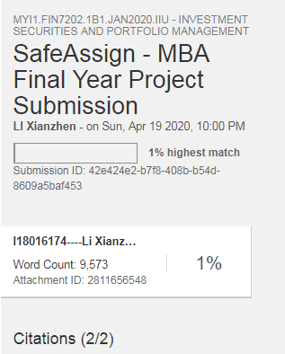

BIBLIOGRAPHY
Abraham, R., Harris, J. and Auerbach, J., 2017. Earnings yield as a predictor of return on assets, return on equity, economic value added and the equity multiplier. Modern Economy, 8(1), pp.10-24.
Angbazo, L., 1997. Commercial bank net interest margins, default risk, interest-rate risk, and off-balance sheet banking. Journal of Banking & Finance, 21(1), pp.55-87.
Almazari, A.A., 2012. Financial performance analysis of the Jordanian Arab bank by using the DuPont system of financial analysis. International Journal of Economics and Finance, 4(4), pp.86-94.
Agyeman, C.M. and Ponniah, V.M. (2014). Employee Demographic Characteristics and Their Effects on Turnover and Retention in MSMEs. International Journal of Recent Advances in Organizational Behaviour and Decision Sciences, 1(1), pp.12-29.
Alkahtani, A.H. (2015). Investigating Factors that Influence Employees’ Turnover Intention: A Review of Existing Empirical Works. International Journal of Business and Management, 10(12), pp.152-166.
Al-qahtani, M.R. and Gadhoum, Y. (2016). Employee Turnover in the Manufacturing Organization: Case of the Eastern Region of Saudi Arabia. Asia Pacific Journal of Advanced Business and Social Studies, 2(2), pp. 274-296.
Andish, H. et al. (2013). Organizational Culture and its Impact in Organizations. Interdisciplinary Journal of Contemporary Research in Business, 5(1), pp. 1126-1130.
Burja, V. and Mărginean, R., 2014. The study of factors that may influence the performance by the Dupont analysis in the furniture industry. Procedia Economics and Finance, 16, pp.213-223.
Bertsch, V., Geldermann, J. and Lühn, T., 2017. What drives the profitability of household PV investments, self-consumption and self-sufficiency?. Applied Energy, 204, pp.1-15.
Bolek, M., 2013. Working capital management profitability and risk: Analyse of companies listed on the Warsaw Stock Exchange. e-Finanse: Financial Internet Quarterly, 9(3), pp.1-10.
Collier, H.W., McGowan Jr, C.B. and Muhammad, J., 2010. Evaluating the impact of a rapidly changing economic environment on bank financial performance using the Dupont system of financial analysis. Asia Pacific Journal of Finance and Banking Research, 4(4), p.25.
CHI, W. et al. (2013). Determinants of Audit Staff Turnover: Evidence from Taiwan. International Journal of Auditing, 17(1), pp.100-112.
Chang-gui, Z., Jia-bao, D. and Zhen-xu, W., 2006. Development and Utilization of By-products in Animal and Poultry. MEAT RESEARCH-BEIJING-, 3(85), p.40.
Caves, D.W., Christensen, L.R. and Tretheway, M.W., 1984. Economies of density versus economies of scale: why trunk and local service airline costs differ. The RAND Journal of Economics, pp.471-489.
CHEN, H.T., QI, Y.M., XU, X.L., ZHANG, N., SUN, B.G. and HUANG, M.Q., 2013. Analysis of Volatile Compounds in Yueshengzhai Fragrant Beef. Food Science, 2013(18), p.32.
Demo, G., Neiva, E. R., Nunes, I., & Rozzett, K. (2012). Human resources Management
policies and practices scale (HRMPPS) : Exploratory and confirmatory factor analysis.
Brazillian Administration Review, 9(4), 395–420
EXPLORABLE.COM (n.d.). Convenience Sampling. [Online] Available at: <https://explorable.com/convenience-sampling> [Accessed 21 February 2017].
Fama, E.F. and French, K.R., 2000. Forecasting profitability and earnings. The Journal of Business, 73(2), pp.161-175.
Gibson, C.H., 2001. Financial reporting and analysis: Using financial accounting information. South-Western Pub.
GLOBAL, K.N.G. and CULINARY, P., 2015. A “China Shanxi Food Festival in New York” took place on May 5–9, 2014. It opened with a food gala at the United Nations headquarters prepared by 16 chefs selected from the sixty thousand restaurants across North China’s Shanxi Province. The UN UnderSecretaryGeneral and former Indian ambassador to China Vijay Nambiar tried his hand at making the province’s iconic knifeshaved noodles.“In. The Globalization of Asian Cuisines: Transnational Networks and Culinary Contact Zones.
He, Y., 2019, September. Management Reform of Time-honored Enterprise Based on Social Media Taking Shanxi Time-honored Brand as an Example. In The 4th International Conference on Economy, Judicature, Administration and Humanitarian Projects (JAHP 2019). Atlantis Press.
Hair, Jr., Money, A. H., Samouel, P., and Page, M. (2007). Research Methods for
Business. West Sussex: John Wiley Sons, Inc.
Hooi, L. W. (2007). Human capital development policies: enhancing employees’
satisfaction. Journal of European Industrial Training, 31(4), 297–332.
Hymer, S. and Pashigian, P., 1962. Turnover of firms as a measure of market behavior. The Review of Economics and Statistics, pp.82-87.
Kim, O., Lim, S.C. and Park, T., 2009. Measuring the impact of sales on earnings and equity price. Review of Quantitative Finance and Accounting, 32(2), pp.145-168.
KURIA, H.M., ALICE, O. & WANDERI, P.M. (2012). Assessment of Causes of Labour Turnover in Three and Five Star-Rated Hotels in Kenya. International Journal of Business and Social Science, 3(15), pp.311-317.
Li, Z., 2017. Reform and development of agriculture in China. Springer.
Lízalová, L. and Kozáková, P., 2013. Effect of the equity multiplier indicator in companies according the sectors. Acta Universitatis Agriculturae et Silviculturae Mendelianae Brunensis, 61(2), pp.385-392.
Méndez-Naya, J., 2008. Merger profitability in mixed oligopoly. Journal of Economics, 94(2), pp.167-176.
McGowan, C.B. and Stambaugh, A.R., 2012. Using disaggregated return on assets to conduct a financial analysis of a commercial bank using an extension of the DuPont system of financial analysis. Accounting and Finance Research, 1(1), pp.152-161.
Malkiel, B.G. and Saha, A., 2005. Hedge funds: Risk and return. Financial analysts journal, 61(6), pp.80-88.
MASTEEL.COM (n.d.). Company Information and History. [Online] Available at: < http://www.masteel.com.my/about-2/company-profile/ > [Accessed 13 March 2017].
MAYHEW, R. (2017). Employee Turnover Definitions & Calculations. [Online] Available at: <http://smallbusiness.chron.com/employee-turnover-definitions-calculations-11611.html> [Accessed 13 March 2017].
Penman, S.H. and Zhang, X.J., 2002. Accounting conservatism, the quality of earnings, and stock returns. The accounting review, 77(2), pp.237-264.
QI, Y.M., CHEN, H.T., TAO, H.Q. and SUN, B.G., 2011. Analysis of Volatile Compounds of Pingyao and Yueshengzhai Spiced Beef by Gas Chromatography-Mass Spectrometry [J]. Food Science, 22.
Rowden, R. W., & Ahmad, S. (1999). The relationship between workplace learning and
job satisfaction in small to mid-sized businesses in Malaysia. Human Resource
Development International, 3(3), 307–322.
Shuo-shuo, W., Xue-qin, X. and Qi-xing, J., 2016. Effect of Tumbling on Frozen Prepared Pork Chops Quality. The Food Industry, (12), p.43.
Stigler, G.J., 1958. The economies of scale. The Journal of Law and Economics, 1, pp.54-71.
Turner, J., Broom, K., Elliott, M. and Lee, J.F., 2015. A decomposition of hospital profitability: An application of DuPont analysis to the US market. Health services research and managerial epidemiology, 2, p.2333392815590397.
Tamulevičienė, D., 2016. Methodology of complex analysis of companies’ profitability. Entrepreneurship and sustainability issues, 4, pp.53-63.
Tembleque-Vilalta, M. and Suau-Sanchez, P., 2016. A model to analyse the profitability of long-haul network development involving non-hub airports: The case of the Barcelona–Asian market. Case Studies on Transport Policy, 4(2), pp.188-197.
Wang, S.Y., 2011. In search of authenticity in historic cities in transformation: the case of Pingyao, China. Journal of Tourism and Cultural Change, 9(1), pp.18-30.
Wank, D.L., 2015. Knife-Shaved Noodles Go Global: Provincial Culinary Politics and the Improbable Rise of a Minor Chinese Cuisine. In The globalization of asian cuisines (pp. 187-208). Palgrave Macmillan, New York.
Xiong, W., 2003. Pingyao: the living ancient city (Doctoral dissertation, Texas Tech University).
YAN, N.N., WANG, X.P., LIU, S.X. and LIU, Y.F., 2013. Current Situation and Development Trend of Beef Production and Processing in Shaanxi. China Cattle Science, (5), p.3.
Zegang, C. and Shurui, L., 2011. Affection on Pingyao Beef Quality of Vacuum Rooling and Kneading and Still Preserving. Farm Products Processing, (5), p.30.
https://corporatefinanceinstitute.com/resources/knowledge/finance/profitability-ratios/
https://yourfreetemplates.com/free-dupont-analysis-template/
https://www.tutor2u.net/economics/reference/long-run-average-cost-lrac

APPENDIX A:
Questionnaires to be filled by the staffs of Pingyao beef group
Dear Participants:
This study is a requirement for the partial fulfilment of Master of Business management program (MBA) at the INTI International University. The purpose of this study is to get DIMENSIONS OF SERVICE QUALITY AS AN MEASUREMENT OF CUSTOMER SATISFACTION IN MALAYSIA BANKING INDUSTRY PINGYAO BEEF GROUP PERFORMANCE CHALLENGES AND IMPROVEMENTS. This questionnaire takes only a few moments of your time to complete. Please respond by ticking the appropriate box or filling in your answers in the blank spaces provided. This is an academic exercise and all information collected from respondents will be treated with strict confidentiality. Thank you very much for your cooperation.
SECTION A: DEMOGRAPHIC PROFILE OF THE RESPONDENTS
Please circle the letter of your choice for questions 1 to 7 which are related to your background information:
1. Gender : A. Male B. Female
2. Age : A. 18 - 25 years B. 26 - 30 years C. 31 – 40 years D. 41 – 50 years E. 51 – 60 years F. Above 60 years
3. Education: A. Illiterate B. High school C. Intermediate D. Degree E. Masters Degree F. Doctor Degree
4. Marital Status: A. Married B. Single C. Widowed D. Divorced
5. Monthly Income : A. below CNY3000 B. CNY 3001 - CNY7000
C. CNY 7001- CNY12000 D. more than CNY12001
6. Years with the company : A. Less than 1 year B. 1 – 5 years C. 5 – 10 years D. 10 – 15 years E. Above 15 years
7. Job Category: A. Operator B. Supervisor C. Executive D. Manager and above

SECTION B: FACTORS AFFECTING THE EFFICIENCY OF GROUP’S PERFORMANCE
Please tick [√] the box in this section to rate your agreement or disagreement level on each statement. The statements below involve three factors which contributing to the performance.
Rating Scale:
1 = Strongly disagree 2 = Disagree 3 = Neutral
4 = Agree 5 = Strongly agree
Factor 1: Performance
No. | Statements related to group management | Scale
No. | Statements related to group management | 1 | 2 | 3 | 4 | 5
1 | The company in profitability
2 | Company reputation
3 | Customer repurchase
4 | Asset operation status
5 | Development capacity
Factor 2: Group management
No. | Statements related to group management | Scale
No. | Statements related to group management | 1 | 2 | 3 | 4 | 5
1 | The company I work for provides basic benefits (e.g., health care, transportation assistance, food aid, etc)
2 | The company I work for has programs or processes that helps employees cope with incidents and prevent workplace accidents.
3 | The company I work for is concerned with the safety of their employees by having access control of people who enter the company building/facilities
4 | The facilities and physical condition (lighting, ventalition, noise and temperature) of the company I work for are ergonomic, comfortable and appropriate.
5 | The company I work for is concerned with my health and quality of life.

Factor 3: Relevant policies
No. | Statements related to relevant policies | Scale
No. | Statements related to relevant policies | 1 | 2 | 3 | 4 | 5
1 | I feel I am being paid a fair amount about the remuneration policy.
2 | I feel satisfied with my chances for salary increases policy.
3 | I feel satisfied with the benefits policy I receive.
4 | The relevant policies benefits I receive are as good as most other organizations offer.
5 | The government’s policy is to benefit the performance.
Factor 4: Technology and Training
No. | Statements related to technology and training | Scale
No. | Statements related to technology and training | 1 | 2 | 3 | 4 | 5
1 | The company keeps equipment up to date.
2 | The company does a good job of providing the training/ skill building.
3 | I am given the training and support I need to do my job effectively.
4 | New technologies and processes are constantly being improved.
5 | I have the opportunity to learn skills that will improve my chances for promotion.

The questionnaire’s questions in used in the study adapted and adopted from different researches, included Mobley, Horner and Hollingsworth, (1978) Chen, Hui and Sego, (1998) – Turnover intention; Hooi (2007) - Training and development opportunities; Demo, Neiva, Nunes, & Rozzett (2012) - Working Environment; Rowden & Ahmad (1999) - Staff Benefit. Table shows the question contributors for the questionnaire that used in this study:
Section A
Information | Item | Source
Demographic Profile | 7 | Self-developed
Section B
Questions | Item | Source
Group management | 5 | Mobley, Horner and  Hollingsworth, (1978)  Chen, Hui and Sego,  (1998)
Relevant policies | 5 | Rowden & Ahmad (1999)
Technology and Training | 5 | Demo, Neiva, Nunes, & Rozzett (2012)
Total | 22

APPENDIX B:
Gender
 |  | Frequency | Percent | Valid Percent | Cumulative Percent
Valid | Male | 30 | 50.0 | 50.0 | 50.0
Valid | Female | 30 | 50.0 | 50.0 | 100.0
Valid | Total | 60 | 100.0 | 100.0

Age
 |  | Frequency | Percent | Valid Percent | Cumulative Percent
Valid | 18 - 25 years | 12 | 20.0 | 20.0 | 20.0
Valid | 26 - 30 years | 14 | 23.3 | 23.3 | 43.3
Valid | 31 – 40 years | 14 | 23.3 | 23.3 | 66.7
Valid | 41 – 50 years | 12 | 20.0 | 20.0 | 86.7
Valid | 51 – 60 years | 6 | 10.0 | 10.0 | 96.7
Valid | Above 60 years | 2 | 3.3 | 3.3 | 100.0
Valid | Total | 60 | 100.0 | 100.0

Education
 |  | Frequency | Percent | Valid Percent | Cumulative Percent
Valid | Illiterate | 13 | 21.7 | 21.7 | 21.7
Valid | High school | 21 | 35.0 | 35.0 | 56.7
Valid | Intermediate | 15 | 25.0 | 25.0 | 81.7
Valid | Degree | 9 | 15.0 | 15.0 | 96.7
Valid | Masters Degree | 2 | 3.3 | 3.3 | 100.0
Valid | Total | 60 | 100.0 | 100.0

MaritalStatus
 |  | Frequency | Percent | Valid Percent | Cumulative Percent
Valid | Married | 32 | 53.3 | 53.3 | 53.3
Valid | Single | 22 | 36.7 | 36.7 | 90.0
Valid | Widowed | 2 | 3.3 | 3.3 | 93.3
Valid | Divorced | 4 | 6.7 | 6.7 | 100.0
Valid | Total | 60 | 100.0 | 100.0
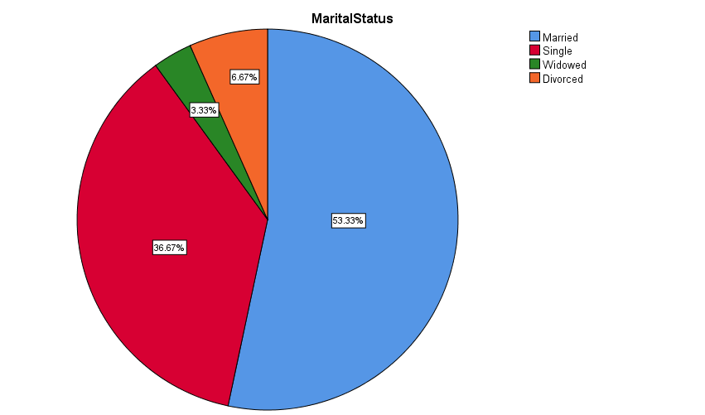

Yearswiththecompany
 |  | Frequency | Percent | Valid Percent | Cumulative Percent
Valid | Less than 1 year | 7 | 11.7 | 11.7 | 11.7
Valid | 1 – 5 years | 21 | 35.0 | 35.0 | 46.7
Valid | 5 – 10 years | 19 | 31.7 | 31.7 | 78.3
Valid | 10 – 15 years | 10 | 16.7 | 16.7 | 95.0
Valid | Above 15 years | 3 | 5.0 | 5.0 | 100.0
Valid | Total | 60 | 100.0 | 100.0
MonthlyIncome
 |  | Frequency | Percent | Valid Percent | Cumulative Percent
Valid | below CNY3000 | 12 | 20.0 | 20.0 | 20.0
Valid | CNY 3001 - CNY7000 | 33 | 55.0 | 55.0 | 75.0
Valid | CNY 7001- CNY12000 | 10 | 16.7 | 16.7 | 91.7
Valid | more than CNY12001 | 5 | 8.3 | 8.3 | 100.0
Valid | Total | 60 | 100.0 | 100.0
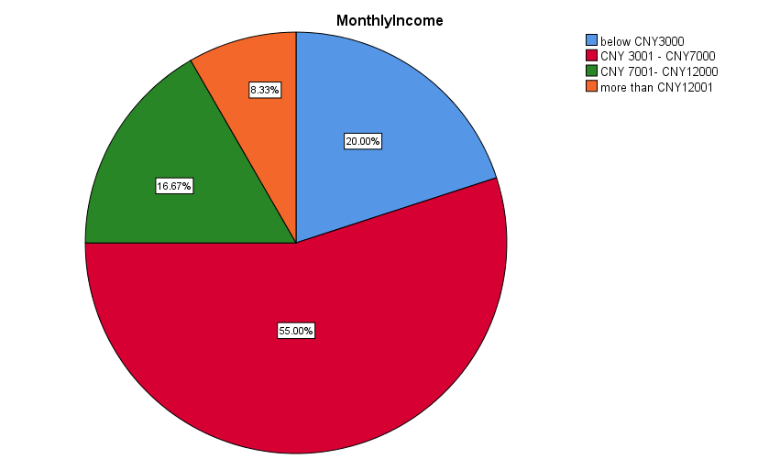

Jobcategory
 |  | Frequency | Percent | Valid Percent | Cumulative Percent
Valid | Operator | 25 | 41.7 | 41.7 | 41.7
Valid | Supervisor | 21 | 35.0 | 35.0 | 76.7
Valid | Executive | 9 | 15.0 | 15.0 | 91.7
Valid | Manager and above | 5 | 8.3 | 8.3 | 100.0
Valid | Total | 60 | 100.0 | 100.0

Reliability Statistics
Cronbach's Alpha | N of Items
.993 | 15
Cronbach's Alpha>0.7

Item Statistics
 | Mean | Std. Deviation | N
ThecompanyIworkforprovidesbasicbenefitse.g.healthcar | 3.68 | .833 | 60
ThecompanyIworkforhasprogramsorprocessesthathelpsempl | 3.70 | .830 | 60
ThecompanyIworkforisconcernedwiththesafetyoftheiremp | 3.67 | .857 | 60
Thefacilitiesandphysicalconditionlightingventalitionno | 3.68 | .854 | 60
ThecompanyIworkforisconcernedwithmyhealthandqualityo | 3.68 | .833 | 60
IfeelIambeingpaidafairamountabouttheremunerationpoli | 3.72 | .825 | 60
Ifeelsatisfiedwithmychancesforsalaryincreasespolicy | 3.72 | .825 | 60
IfeelsatisfiedwiththebenefitspolicyIreceive | 3.73 | .821 | 60
TherelevantpoliciesbenefitsIreceiveareasgoodasmostoth | 3.70 | .809 | 60
Thegovernmentspolicyistobenefittheperformance | 3.70 | .809 | 60
Thecompanykeepsequipmentuptodate | 3.68 | .833 | 60
Thecompanydoesagoodjobofprovidingthetrainingskillbui | 3.67 | .816 | 60
IamgiventhetrainingandsupportIneedtodomyjobeffectiv | 3.65 | .820 | 60
Newtechnologiesandprocessesareconstantlybeingimproved | 3.67 | .816 | 60
Ihavetheopportunitytolearnskillsthatwillimprovemychan | 3.67 | .816 | 60

Item-Total Statistics
 | Scale Mean if Item Deleted | Scale Variance if Item Deleted | Corrected Item-Total Correlation | Cronbach's Alpha if Item Deleted
ThecompanyIworkforprovidesbasicbenefitse.g.healthcar | 51.63 | 122.745 | .918 | .993
ThecompanyIworkforhasprogramsorprocessesthathelpsempl | 51.62 | 122.749 | .922 | .993
ThecompanyIworkforisconcernedwiththesafetyoftheiremp | 51.65 | 122.435 | .908 | .993
Thefacilitiesandphysicalconditionlightingventalitionno | 51.63 | 122.168 | .927 | .993
ThecompanyIworkforisconcernedwithmyhealthandqualityo | 51.63 | 122.406 | .937 | .993
IfeelIambeingpaidafairamountabouttheremunerationpoli | 51.60 | 121.939 | .975 | .992
Ifeelsatisfiedwithmychancesforsalaryincreasespolicy | 51.60 | 121.939 | .975 | .992
IfeelsatisfiedwiththebenefitspolicyIreceive | 51.58 | 122.010 | .977 | .992
TherelevantpoliciesbenefitsIreceiveareasgoodasmostoth | 51.62 | 122.342 | .972 | .992
Thegovernmentspolicyistobenefittheperformance | 51.62 | 122.376 | .970 | .992
Thecompanykeepsequipmentuptodate | 51.63 | 121.999 | .961 | .993
Thecompanydoesagoodjobofprovidingthetrainingskillbui | 51.65 | 122.570 | .949 | .993
IamgiventhetrainingandsupportIneedtodomyjobeffectiv | 51.67 | 122.497 | .949 | .993
Newtechnologiesandprocessesareconstantlybeingimproved | 51.65 | 122.570 | .949 | .993
Ihavetheopportunitytolearnskillsthatwillimprovemychan | 51.65 | 122.570 | .949 | .993

Scale Statistics
Mean | Variance | Std. Deviation | N of Items
55.32 | 140.390 | 11.849 | 15

Statistics
Frequency Table

Thecompanyinprofitability
 |  | Frequency | Percent | Valid Percent | Cumulative Percent
Valid | Disagree | 5 | 8.3 | 8.3 | 8.3
Valid | Neutral | 18 | 30.0 | 30.0 | 38.3
Valid | Agree | 29 | 48.3 | 48.3 | 86.7
Valid | Strongly agree | 8 | 13.3 | 13.3 | 100.0
Valid | Total | 60 | 100.0 | 100.0

Companyreputation
 |  | Frequency | Percent | Valid Percent | Cumulative Percent
Valid | Disagree | 5 | 8.3 | 8.3 | 8.3
Valid | Neutral | 18 | 30.0 | 30.0 | 38.3
Valid | Agree | 29 | 48.3 | 48.3 | 86.7
Valid | Strongly agree | 8 | 13.3 | 13.3 | 100.0
Valid | Total | 60 | 100.0 | 100.0

Customerrepurchase
 |  | Frequency | Percent | Valid Percent | Cumulative Percent
Valid | Disagree | 5 | 8.3 | 8.3 | 8.3
Valid | Neutral | 18 | 30.0 | 30.0 | 38.3
Valid | Agree | 29 | 48.3 | 48.3 | 86.7
Valid | Strongly agree | 8 | 13.3 | 13.3 | 100.0
Valid | Total | 60 | 100.0 | 100.0

Assetoperationstatus
 |  | Frequency | Percent | Valid Percent | Cumulative Percent
Valid | Disagree | 5 | 8.3 | 8.3 | 8.3
Valid | Neutral | 18 | 30.0 | 30.0 | 38.3
Valid | Agree | 29 | 48.3 | 48.3 | 86.7
Valid | Strongly agree | 8 | 13.3 | 13.3 | 100.0
Valid | Total | 60 | 100.0 | 100.0

Developmentcapacity
 |  | Frequency | Percent | Valid Percent | Cumulative Percent
Valid | Disagree | 5 | 8.3 | 8.3 | 8.3
Valid | Neutral | 18 | 30.0 | 30.0 | 38.3
Valid | Agree | 29 | 48.3 | 48.3 | 86.7
Valid | Strongly agree | 8 | 13.3 | 13.3 | 100.0
Valid | Total | 60 | 100.0 | 100.0

Frequency Table

ThecompanyIworkforprovidesbasicbenefitse.g.healthcar
 |  | Frequency | Percent | Valid Percent | Cumulative Percent
Valid | Disagree | 4 | 6.7 | 6.7 | 6.7
Valid | Neutral | 21 | 35.0 | 35.0 | 41.7
Valid | Agree | 25 | 41.7 | 41.7 | 83.3
Valid | Strongly agree | 10 | 16.7 | 16.7 | 100.0
Valid | Total | 60 | 100.0 | 100.0

ThecompanyIworkforhasprogramsorprocessesthathelpsempl
 |  | Frequency | Percent | Valid Percent | Cumulative Percent
Valid | disagree | 4 | 6.7 | 6.7 | 6.7
Valid | Neutral | 20 | 33.3 | 33.3 | 40.0
Valid | Agree | 26 | 43.3 | 43.3 | 83.3
Valid | Strongly agree | 10 | 16.7 | 16.7 | 100.0
Valid | Total | 60 | 100.0 | 100.0

ThecompanyIworkforisconcernedwiththesafetyoftheiremp
 |  | Frequency | Percent | Valid Percent | Cumulative Percent
Valid | Disagree | 5 | 8.3 | 8.3 | 8.3
Valid | Neutral | 20 | 33.3 | 33.3 | 41.7
Valid | Agree | 25 | 41.7 | 41.7 | 83.3
Valid | Strongly agree | 10 | 16.7 | 16.7 | 100.0
Valid | Total | 60 | 100.0 | 100.0

Thefacilitiesandphysicalconditionlightingventalitionno
 |  | Frequency | Percent | Valid Percent | Cumulative Percent
Valid | Disagree | 5 | 8.3 | 8.3 | 8.3
Valid | Neutral | 19 | 31.7 | 31.7 | 40.0
Valid | Agree | 26 | 43.3 | 43.3 | 83.3
Valid | Strongly agree | 10 | 16.7 | 16.7 | 100.0
Valid | Total | 60 | 100.0 | 100.0

ThecompanyIworkforisconcernedwithmyhealthandqualityo
 |  | Frequency | Percent | Valid Percent | Cumulative Percent
Valid | Disagree | 5 | 8.3 | 8.3 | 8.3
Valid | Neutral | 18 | 30.0 | 30.0 | 38.3
Valid | Agree | 28 | 46.7 | 46.7 | 85.0
Valid | Strongly agree | 9 | 15.0 | 15.0 | 100.0
Valid | Total | 60 | 100.0 | 100.0

IfeelIambeingpaidafairamountabouttheremunerationpoli
 |  | Frequency | Percent | Valid Percent | Cumulative Percent
Valid | Disagree | 4 | 6.7 | 6.7 | 6.7
Valid | Neutral | 19 | 31.7 | 31.7 | 38.3
Valid | Agree | 27 | 45.0 | 45.0 | 83.3
Valid | Strongly agree | 10 | 16.7 | 16.7 | 100.0
Valid | Total | 60 | 100.0 | 100.0

Ifeelsatisfiedwithmychancesforsalaryincreasespolicy
 |  | Frequency | Percent | Valid Percent | Cumulative Percent
Valid | Disagree | 4 | 6.7 | 6.7 | 6.7
Valid | Neutral | 19 | 31.7 | 31.7 | 38.3
Valid | Agree | 27 | 45.0 | 45.0 | 83.3
Valid | Strongly agree | 10 | 16.7 | 16.7 | 100.0
Valid | Total | 60 | 100.0 | 100.0

IfeelsatisfiedwiththebenefitspolicyIreceive
 |  | Frequency | Percent | Valid Percent | Cumulative Percent
Valid | Agree | 4 | 6.7 | 6.7 | 6.7
Valid | Neutral | 18 | 30.0 | 30.0 | 36.7
Valid | Agree | 28 | 46.7 | 46.7 | 83.3
Valid | Strongly agree | 10 | 16.7 | 16.7 | 100.0
Valid | Total | 60 | 100.0 | 100.0

TherelevantpoliciesbenefitsIreceiveareasgoodasmostoth
 |  | Frequency | Percent | Valid Percent | Cumulative Percent
Valid | Disagree | 4 | 6.7 | 6.7 | 6.7
Valid | Neutral | 19 | 31.7 | 31.7 | 38.3
Valid | Agree | 28 | 46.7 | 46.7 | 85.0
Valid | Strongly agree | 9 | 15.0 | 15.0 | 100.0
Valid | Total | 60 | 100.0 | 100.0

Thegovernmentspolicyistobenefittheperformance
 |  | Frequency | Percent | Valid Percent | Cumulative Percent
Valid | Disagree | 4 | 6.7 | 6.7 | 6.7
Valid | Neutral | 19 | 31.7 | 31.7 | 38.3
Valid | Agree | 28 | 46.7 | 46.7 | 85.0
Valid | Strongly agree | 9 | 15.0 | 15.0 | 100.0
Valid | Total | 60 | 100.0 | 100.0

Thecompanykeepsequipmentuptodate
 |  | Frequency | Percent | Valid Percent | Cumulative Percent
Valid | Disagree | 5 | 8.3 | 8.3 | 8.3
Valid | Neutral | 18 | 30.0 | 30.0 | 38.3
Valid | Agree | 28 | 46.7 | 46.7 | 85.0
Valid | Strongly agree | 9 | 15.0 | 15.0 | 100.0
Valid | Total | 60 | 100.0 | 100.0

Thecompanydoesagoodjobofprovidingthetrainingskillbui
 |  | Frequency | Percent | Valid Percent | Cumulative Percent
Valid | Disagree | 5 | 8.3 | 8.3 | 8.3
Valid | Neutral | 18 | 30.0 | 30.0 | 38.3
Valid | Agree | 29 | 48.3 | 48.3 | 86.7
Valid | Strongly agree | 8 | 13.3 | 13.3 | 100.0
Valid | Total | 60 | 100.0 | 100.0

IamgiventhetrainingandsupportIneedtodomyjobeffectiv
 |  | Frequency | Percent | Valid Percent | Cumulative Percent
Valid | Disagree | 5 | 8.3 | 8.3 | 8.3
Valid | Neutral | 19 | 31.7 | 31.7 | 40.0
Valid | Agree | 28 | 46.7 | 46.7 | 86.7
Valid | Strongly agree | 8 | 13.3 | 13.3 | 100.0
Valid | Total | 60 | 100.0 | 100.0

Newtechnologiesandprocessesareconstantlybeingimproved
 |  | Frequency | Percent | Valid Percent | Cumulative Percent
Valid | Disagree | 5 | 8.3 | 8.3 | 8.3
Valid | Neutral | 18 | 30.0 | 30.0 | 38.3
Valid | Agree | 29 | 48.3 | 48.3 | 86.7
Valid | Strongly agree | 8 | 13.3 | 13.3 | 100.0
Valid | Total | 60 | 100.0 | 100.0

Ihavetheopportunitytolearnskillsthatwillimprovemychan
 |  | Frequency | Percent | Valid Percent | Cumulative Percent
Valid | Disagree | 5 | 8.3 | 8.3 | 8.3
Valid | Neutral | 18 | 30.0 | 30.0 | 38.3
Valid | Agree | 29 | 48.3 | 48.3 | 86.7
Valid | Strongly agree | 8 | 13.3 | 13.3 | 100.0
Valid | Total | 60 | 100.0 | 100.0

Group management (Mean score)

Descriptive Statistics
 | N | Minimum | Maximum | Mean | Std. Deviation
Q1 | 60 | 2 | 5 | 3.68 | .833
Q2 | 60 | 2 | 5 | 3.70 | .830
Q3 | 60 | 2 | 5 | 3.67 | .857
Q4 | 60 | 2 | 5 | 3.68 | .854
Q5 | 60 | 2 | 5 | 3.68 | .833
Average | 60 |  |  | 3.682

Relevant policies

Descriptive Statistics
 | N | Minimum | Maximum | Mean | Std. Deviation
Q1 | 60 | 2 | 5 | 3.72 | .825
Q2 | 60 | 2 | 5 | 3.72 | .825
Q3 | 60 | 2 | 5 | 3.73 | .821
Q4 | 60 | 2 | 5 | 3.70 | .809
Q5 | 60 | 2 | 5 | 3.70 | .809
Average | 60 |  |  | 3.714
Technology and Training

Descriptive Statistics
 | N | Minimum | Maximum | Mean | Std. Deviation
Q1 | 60 | 2 | 5 | 3.68 | .833
Q2 | 60 | 2 | 5 | 3.67 | .816
Q3 | 60 | 2 | 5 | 3.65 | .820
Q4 | 60 | 2 | 5 | 3.67 | .816
Q5 | 60 | 2 | 5 | 3.67 | .816
Average | 60 |  |  | 3.668

Descriptive Statistics
 | N | Minimum | Maximum | Mean | Std. Deviation | Skewness |  | Kurtosis
 | Statistic | Statistic | Statistic | Statistic | Statistic | Statistic | Std. Error | Statistic | Std. Error
Q1 | 60 | 2 | 5 | 3.68 | .833 | -.065 | .309 | -.553 | .608
Q2 | 60 | 2 | 5 | 3.70 | .830 | -.118 | .309 | -.505 | .608
Q3 | 60 | 2 | 5 | 3.67 | .857 | -.124 | .309 | -.569 | .608
Q4 | 60 | 2 | 5 | 3.68 | .854 | -.177 | .309 | -.521 | .608
Q5 | 60 | 2 | 5 | 3.68 | .833 | -.247 | .309 | -.382 | .608
Valid N (listwise) | 60

Descriptive Statistics
 | N | Minimum | Maximum | Mean | Std. Deviation | Skewness |  | Kurtosis
 | Statistic | Statistic | Statistic | Statistic | Statistic | Statistic | Std. Error | Statistic | Std. Error
Q6 | 60 | 2 | 5 | 3.72 | .825 | -.171 | .309 | -.447 | .608
Q7 | 60 | 2 | 5 | 3.72 | .825 | -.171 | .309 | -.447 | .608
Q8 | 60 | 2 | 5 | 3.73 | .821 | -.224 | .309 | -.379 | .608
Q9 | 60 | 2 | 5 | 3.70 | .809 | -.187 | .309 | -.357 | .608
Q10 | 60 | 2 | 5 | 3.70 | .809 | -.187 | .309 | -.357 | .608
Valid N (listwise) | 60

Descriptive Statistics
 | N | Minimum | Maximum | Mean | Std. Deviation | Skewness |  | Kurtosis
 | Statistic | Statistic | Statistic | Statistic | Statistic | Statistic | Std. Error | Statistic | Std. Error
Q11 | 60 | 2 | 5 | 3.68 | .833 | -.247 | .309 | -.382 | .608
Q12 | 60 | 2 | 5 | 3.67 | .816 | -.272 | .309 | -.297 | .608
Q13 | 60 | 2 | 5 | 3.65 | .820 | -.216 | .309 | -.357 | .608
Q14 | 60 | 2 | 5 | 3.67 | .816 | -.272 | .309 | -.297 | .608
Q15 | 60 | 2 | 5 | 3.67 | .816 | -.272 | .309 | -.297 | .608
Valid N (listwise) | 60

Pearson Correlation Test

Correlations
 |  | Performance | GroupManagement
Performance | Pearson Correlation | 1 | .844**
Performance | Sig. (2-tailed) |  | .000
Performance | N | 60 | 60
GroupManagement | Pearson Correlation | .844** | 1
GroupManagement | Sig. (2-tailed) | .000
GroupManagement | N | 60 | 60
**. Correlation is significant at the 0.01 level (2-tailed).

Correlations
 |  | Performance | RelevantPolicies
Performance | Pearson Correlation | 1 | .933**
Performance | Sig. (2-tailed) |  | .000
Performance | N | 60 | 60
RelevantPolicies | Pearson Correlation | .933** | 1
RelevantPolicies | Sig. (2-tailed) | .000
RelevantPolicies | N | 60 | 60
**. Correlation is significant at the 0.01 level (2-tailed).

Correlations
 |  | Performance | TechnologAndTraining
Performance | Pearson Correlation | 1 | .997**
Performance | Sig. (2-tailed) |  | .000
Performance | N | 60 | 60
TechnologAndTraining | Pearson Correlation | .997** | 1
TechnologAndTraining | Sig. (2-tailed) | .000
TechnologAndTraining | N | 60 | 60
**. Correlation is significant at the 0.01 level (2-tailed).

Multiple Regression

Variables Entered/Removedª
Model | Variables Entered | Variables Removed | Method
1 | TechnologAndTraining, GroupManagement, RelevantPolicies^{b} | . | Enter
a. Dependent Variable: Performance
b. All requested variables entered.

Model Summary^{b}
Model | R | R Square | Adjusted R Square | Std. Error of the Estimate | Change Statistics |  |  |  |  | Durbin-Watson
 |  |  |  |  | R Square Change | F Change | df1 | df2 | Sig. F Change | Durbin-Watson
1 | .997ª | .995 | .995 | .05940 | .995 | 3696.956 | 3 | 56 | .000 | 2.459
a. Predictors: (Constant), TechnologAndTraining, GroupManagement, RelevantPolicies
b. Dependent Variable: Performance

ANOVAª
Model |  | Sum of Squares | df | Mean Square | F | Sig.
1 | Regression | 39.136 | 3 | 13.045 | 3696.956 | .000^{b}
1 | Residual | .198 | 56 | .004
1 | Total | 39.333 | 59
a. Dependent Variable: Performance
b. Predictors: (Constant), TechnologAndTraining, GroupManagement, RelevantPolicies

Coefficientsª
Model |  | Unstandardized Coefficients |  | Standardized Coefficients | t | Sig. | 95.0% Confidence Interval for B |  | Collinearity Statistics
 |  | B | Std. Error | Beta | t | Sig. | Lower Bound | Upper Bound | Tolerance | VIF
1 | (Constant) | .024 | .037 |  | .662 | .511 | -.050 | .098
1 | GroupManagement | .019 | .023 | .020 | .837 | .406 | -.027 | .066 | .164 | 6.112
1 | RelevantPolicies | -.119 | .038 | -.118 | -3.141 | .003 | -.195 | -.043 | .063 | 15.817
1 | TechnologAndTraining | 1.094 | .029 | 1.092 | 37.153 | .000 | 1.035 | 1.153 | .104 | 9.633
a. Dependent Variable: Performance

