**INTI INTERNATIONAL UNIVERSITY**

**MASTER OF BUSINESS ADMINISTRATION**

**Chinese Graduates Job Selection Preferences in Shanghai**

**Author:** Xiao Yan Ru

**Student ID Number:** I17012506

**Supervisor:** Umi Kalsom

**Submission Date:** 16th August 2018

**Final Word Count:** 1,3720

## Acknowledgement

## Thanks to my supervisor Ms. Umi Kalsom’s rigorous and meticulous work, and the warm style have always been a model for me to work and study; her enthusiasm for teaching and humble hardworking attitude have given me endless enlightenment. Every detail and every data in this paper is inseparable from her careful guidance. Her cheerful personality and tolerance attitude help me to quickly integrate into our new research. Thanks to my classmates, who experienced this process along with me. In this one-year study abroad life, we learnt and enjoyed a lot, without doubt suffered some as well, as there were busy and difficult times with hectic study life, every time we meet or discuss, everyone treasures. When we are together, its lifetime memory. Thanks to my parents and best friend, I have to say their being healthy and happy is my biggest wish. At the time when the thesis is about to be completed, my mood can't be calm. From the beginning of the entry to the successful completion of the thesis, how many respectable teachers, classmates, and friends have given me help without words.

## Please accept my sincere gratitude here! Thank you all for your support and encouragement, moreover enlightenment for my future life.

## Xiao Yan Ru

## Date: 16th August, 2018

## Declaration

I hereby declare that this thesis is acknowledged as my own work and I confirm that the work submitted is my own, except where work which has formed part of jointly-authored publications has been included. My contribution and those of the other authors to this work have been explicitly indicated below. I confirm that appropriate credit has been given within this thesis where reference has been made to the work of others.

Name: Xiao Yan Ru

Student ID: I17012506

Signature: Xiao Yan Ru

## Date: 16th August, 2018

## Abstract

The research purpose of this report is to explore whether the factors of salary, type of work, benefits and welfare have any impact on the job selection preferences of Shanghai graduates or not. Given the fact that China is developing rapidly and steadily, knowing the factors influence the job behavior will help the managers and employers to improve the job attraction and also employees retaining, reducing employee’s turnover, which will be helpful in assisting the city develop in a healthier and sustainable way.

There are five chapter in the whole report, there are 400 participants who are Shanghai graduates last year completed the questionnaires successfully, the data collected was analyzed through SPSS software. Descriptive analysis, reliability test and correlation analysis were used in the study. Research methodology application, research design, sampling design, questionnaire design and measurements of the study are all included in it. In order to avoid misunderstanding, the questionnaire were prepared with both English and Chinese version. Based on the results of data analysis, it has been shown that the salary, benefits and welfare can influence the Shanghai graduates job selection behavior, however, there is no relationship between type of work and job selection behavior among graduates in Shanghai, China.

**Keyword:** Job selection behavior, Job selection preferences Salary, Benefits and welfare, Shanghai graduates

Table of Contents

Acknowledgement 1

Declaration 2

Abstract 3

CHAPTER 1 INTRODUCTION 6

1.0 Overview 6

1.1 Background 6

1.2 Problem Statement 7

1.3 Research Objectives 8

1.4 Research Questions 8

1.5 Scope of the Study 9

1.6 Significance of the Study 10

1.6.1 Significance to Industry 11

1.7 Limitations of the Study 12

1.8 Operational Definitions 13

1.9 Organization of Chapters 13

CHAPTER 2 LITERATURE REVIEW 14

2.1 Overview 15

2.1.1 Global Perspective 17

2.1.2 Local Perspective 19

2.2 Independent Variables 20

2.2.1 Salary 20

2.2.2 Type of work 21

2.2.3 Benefits and Welfare 24

2.3 Relationship Between Dependent Variable and Independent Variables 25

2.3.1 Salary 26

2.3.2 Type of Work 26

2.3.3 Benefits and Welfare 27

2.4 Moderating Variable 28

2.5 Grounded theories 29

2.6 Framework 30

31

2.7 Hypotheses 32

2.8 Conclusion 32

CHAPTER 3 RESEARCH METHODOLOGY 31

3.0 Overview 33

3.1 Research Design 33

3.2 Sampling Design 34

3.2.1 Introduction and Justification of Sampling Design 34

3.2.3 Sample Size 34

3.2.4 Unit of Analysis 35

3.3 Questionnaire Design 36

3.3.1 Justification and Definition of Questionnaire Design 36

3.3.2 Likert Scale 37

3.3.3 Adopting and Adapting Instruments 38

3.4 Measurements 38

3.4.1 Pilot Test 39

3.4.2 Factor Analysis 39

3.4.3 Reliability Test 40

3.4.4 Demographic, Preliminary test and Hypotheses Testing 41

3.4.5 Hypothesis Testing 42

3.4.6 Simple Linear Regression and Multiple Linear Regression 43

3.5 Conclusion 43

CHAPTER 4 RESEARCH FINDINGS 42

4.0 Introduction 45

4.1 Descriptive Analysis 45

4.2 Reliability Analysis 47

4.3 KMO Analysis 48

4.4 Correlations Test 45

4.5 Linear Regression Analysis 50

4.5.1 Salary 51

4.5.2 Type of Work 52

4.5.3 Benefit or Welfare 53

4.6 Summary of Hypothesis Results 54

CHAPTER 5 CONCLUSION AND RECOMMENDATIONS 51

5.0 Introduction 55

5.1 Conclusion 55

5.2 Recommendations 55

5.3 Contribution 56

5.4 Implications for Further Research 57

5.5 Personal Reflection 58

REFERENCES 59

Appendix: Questionnaires 94

# **CHAPTER 1 INTRODUCTION**

## **1.0 Overview**

This chapter introduces the research background, problem statement, research objectives, research question, significance of the study, limitation of the study and scope of the study along with the operational definition of a research study regarding “Chinese Graduates job selection preferences in Shanghai.

## **1.1 Background**

The fundamental purpose of college students' employment is to pursue the maximization of utility, simply put, it is the pursuit of finding the "best" job (Diamond & Vorley, 2012). If this pursuit is guided by the goal of complete rationality and the selection process, it will tend to adopt the optimal (Janicek, 2016). However, under the influence of a series of factors, such as social intervention, family concept and resource constraints, limitations of self-awareness, and human capital status constraints, college students may not be able to form completely correct beliefs about employment choice behavior or fail to make the right choice consistent with beliefs (Lavecchia & Liu, 2015). There is a non-utility-maximizing result, a situation in which college students often find it impossible to find the "best" job (Goodman & Joshi, 2015). Therefore, in order to guide students 'employment preferences and promote students' employment, it is necessary to make efforts in a series of constraints that lead to irrational preference behaviors (Samson, 2015). Study on market demand and improve on ability to adapt to their own orbit, to make a reasonable choice of their first job (Kesler, 2007). Nowadays, as the work environment has become increasingly competitive, job market is tightening (Ortlieb, 2015). The number of quits, or voluntary separations, is rising year-over-year (Konczal, 2016). This increasing quit-rate level tells us that not only are employees leaving their existing jobs for better opportunities, but that as an employer, you must anticipate filling even more roles--some preemptively (Dickson, 2015). In addition, the graphic below shows us that altogether, job openings are occurring even faster than people entering the workforce or quitting current jobs (West, 2015). In this 21st century, many occupations are still stereotyped by gender, much research indicates that women tend to have less career opportunities and earn lower salaries compared with men (Park, 2016).

## **1.2 Problem Statement**

Shanghai college graduates are looking in new directions when starting their careers, according to a recent Shanghai government survey (Chu, 2013). Shanghai college graduates earn an average monthly salary of 4,800 Yuan, before taxes, which is lower than what graduates expect to make by about 1,000 Yuan (Zuo, 2017). A high number of graduates hope to work in Shanghai after graduation, and fewer and fewer students plan to go into civil service (Zhu, 2011).

As China's higher education evolves from elite education to mass education, the advantages of university graduates in occupational competitiveness are gradually declining (Chou, 2010). In addition, many problems such as the teaching content, teaching methods, teaching objectives and social needs in China's higher education are out of step (Ko, 2016). Students must Enhance the concept of vocational education, and constantly enhance their professional skills, regaining professional competitiveness through lifelong vocational education is their only way out (Mortaki, 2012).

According to the statistic analysis of employment status of graduates in universities listed in the last two years of "China's Outsourcing of Service Outsourcing and Best Practice of Service Organizations" by Ding Tao Industrial Research Institute, the undergraduates who have undergone professional training by training institutions are more directly employed than without training College students, the average starting salary of 10.22%, shows that vocational college students, employment competitiveness was significantly higher than untrained students (Chen & Li, 2013).

Taking the largest IT training institute in the country as an example, the average salary of graduates from January to June 2014 in Daini was 4057 yuan, which is 1614 yuan more than social college students (Jin, 2015).

## **1.3 Research Objectives**

Limited studies have been carried out on the factors of the student’s job preferences in

Shanghai, therefore this study aims to identify whether starting salary, type of work and benefits influence job seeking preferences of fresh college students in Shanghai, China (Zhang, 2014). This research may be advantage to the employers, as the employers can get a much better thoughtful aspect that the students think that are significant when selecting among several employment deals (Felix, 2015). Employee selection and staff process can be enhanced by the employers having a better understanding of the important decision factors that influence graduate’s employment preferences (Jain & Bhatt, 2015). Therefore, by understanding these factors employees turnover can be reduced, employee satisfaction will increase and move effective employment plans (Lee, 2016). With reference to Zikmund, Babin, Carr and Griffin (2013), research objectives are shown with specific purposes in the initial stage of the research, which can be achieved when conducting the study, therefore, to reach the aim of the study, the research objectives provides guidance to this study include the following (Perng, 2014):

1. To determine whether salary is an important factor for graduate’s job selection preferences in Shanghai.
2. To determine whether type of work is an important factor for graduate’s job selection preferences in Shanghai.
3. To determine whether benefits and welfare is an important factor for graduate’s job selection preferences in Shanghai.
4. To determine whether gender is an important factor for graduate’s job selection preferences in Shanghai.

## **1.4 Research Questions**

To align with the research objectives, the study will focus on elements which influence graduates job seeking behavior, as the research questions are closely linked with research objectives, which are as following (Gavin, 2016):

1. What is the relationship between salary and graduate’s job selection in Shanghai?
2. What is the relationship between type of work and graduate’s job selection in Shanghai?
3. What is the relationship between benefits and welfare and graduate’s job selection in Shanghai?
4. What is the relationship between gender and graduate’s job selection in Shanghai?

## **1.5 Scope of the Study**

This research focuses on the scope of newly college graduates in Shanghai or who have the intention to work in this city (Hui, 2015). Through this research we can learn the innovation of HRM concept, establish a people-oriented management philosophy, learn the efficiency of an enterprise depends on whether each member in the enterprise can fully utilize their talents and coordinate their division of labor (Wang, 2016). The formation of philosophy also helps to build a win-win organizational culture within the enterprise and create motivation and enthusiasm for the aggressiveness of employees so as to create an enterprise Fair, just and democratic atmosphere (Emrich & Shyamsunder, 2015). Human Resource Management System Innovation is the innovation of human resources management which must be implemented to the construction of the system, not only to adapt to changes in the situation, but also to start with the actual conditions of our country and the units, enhance the concept of employee groups, develop team spirit, improve and improve staff life (Sullivan, 2011). Technological Innovation of Human Resource Management is the Information technology which has infiltrated into every aspect of enterprise management, it has greatly improved the work efficiency of manpower management and management, which is an important means of human resource management innovation (Nassazi, 2013). Web site development and maintenance of corporate culture and corporate image building a new tool for publicity, is a human resource management led by a new function also an important manifestation of human resource management technology innovation and its attractive corporate culture and motivation is the key to successful business (Yang & Choi, 2013). Cultural innovation has a direct influence on the staff's sense of concept and way of thinking, and restricts the behavior of employees, is the fundamental driving force of human resources management innovation (Adewal & Anthonia, 2013).

## **1.6 Significance of the Study**

According to the content of modern enterprise management, personnel recruitment management modernization reflects the concept of recruitment, recruitment basis, recruitment process, recruitment and recruitment methods and techniques in five areas (Martin, 2016).

The concept of hiring is the guiding ideology of the whole hiring process and activity (Campbell & Pinnington, 2013). It is the principle of hiring, which is the guiding principle and implementing principle of recruiting. Identifying a good hiring concept has an important role in designing and organizing efficient hiring (Teena & Sanjay, 2014). Recruitment basis refers to the enterprises in the recruitment of personnel to be considered when the relevant factors and based on the relevant standards, such as national laws and policies, the organization's development strategy, human resources planning and recruitment plans (PTI, 2014).

The hiring process refers to a series of activities that the company announces after the hiring advertisement to the hiring staff and has clear time, place and procedure (STALEY, 2013 ). The basic hiring process includes: the formulation and approval of the hiring plan, the release of the hiring information, the evaluation and Selection, hiring and assessment and other sectors (Nikolaou & Oostrom, 2015). Recruitment methods and techniques are mainly refers to the business in attracting, selection, hiring, evaluation of the various methods used and the use of technical means (Sullivan, 2013). Recruiters refer to the departments and personnel responsible for the recruitment process that are worth noting, it is due to the different political, economic, legal and cultural environments in different countries, the degree of modernization of recruitment management in different countries and regions will also vary (Campbell, 2013).

Recruitment determines the enterprise can absorb excellent human resources and is the starting point for the input of human resources, without the attraction of excellent human resources, companies can not achieve their acceptance, therefore, the quality of the recruitment work directly determines the manpower In this sense, recruiting work is of great significance to the future growth and development of enterprises (Li, 2015).

Hiring job influences the flow of people hiring information in the process of real or not, will influence the candidates to enter the business after the flow (Klosters, 2014). If the information passed to the outside is untrue, only showing the good side of the business and concealing the bad side, employees will have a greater sense of loss when they enter the business, which will lower their job satisfaction and result in a higher turnover rate; On the contrary, if the message is more objective and truthful, it will help reduce the flow of people (Waheed, 2014). As a basic function of human resources management, the cost of recruitment activities constitutes a human resource management into the important part of this, the recruitment costs include advertising costs, promotional materials costs, recruiters Wages and so on, all the costs together are generally higher. Therefore, the effective conduct of recruitment activities can greatly reduce its costs, thereby reducing the cost of human resources management (MUSCALU, 2015).

### **1.6.1 Significance to Industry**

This research could provide a better insight to the job seekers about the requirements of employers or companies, which help them to make better decisions in future job selection. In addition, the the outcome of this study is also beneficial for Universities or schools. Job preferences have been seen in different industries, not only improve the college education quality, but also help Universities to adjust the quality course development and improvement (Educ, 2016).

## **1.7 Limitations of the Study**

Firstly, the general findings could be limited to job seekers who are young or to the participants in Shanghai city only. Individual difference variables in job choosing decisions are also considered as important and acknowledged by the authors, which factor is not considered in the current study (Ramasamy, 2016).

The second limitation of this research is a certain mount of participants and their personal perceptions about important factor when applying for their first full-time job after graduation (Farrugia, 2015). If applying this study on a broader contest, the result is mostly likely to be biased since the students are studying in the similar universities in the same region. Having been exposed to the similar kind of organizational branding activities, they obtained their ideas about their future at the labor market from the similar information sources. If performing the same study in another district of Shanghai, the answers would be very much different as those students had their preferences from another environment.

## **1.8 Operational Definitions**

## 

Through this research: Finding a job that is good for one's own development is crucial to one's own future, but it is also important for a business to find a long-term employee, and only the human Resources can correctly determine the business needs of staff. To understand the staff for the enterprise (Pillay, 2014). Through human resources to make people live in harmony, co-ordination, and gain the identity of the group process is a staff and organization between the concept of personal awareness and organization, personal behavior and organizational norms assimilation process, interpersonal coordination functions and organizational assimilation (Akrani, 2011). At the same time, the assimilation of the organization of the enterprise, that is, the convergence of the individual values ​​and the concept of organization, individual behavior subject to the norms of organization, so that employees and organizations agree and have a sense of belonging (Mielonen, 2011).

In the group of harmonious interpersonal relationships, the organization, the communication between people and organizations; human resources management department according to the organizational structure to determine the job description and quality requirements of employees, and organizational goals to develop human resources needs and supply plans, and based on human Resource supply and demand plans to carry out recruitment, assessment, selection, hiring and configuration work, hence obviously, the human resources needed are the first to be managed (Dreesch, 2005).

## **1.9 Organization of Chapters**

**Chapter 1 Introduction**

Chapter 1 is the first page of providing basic information and overview introduction of the whole chapter.

**Chapter 2 Literature Review**

The second chapter comprises of literature review, theories of job seeking behavior and the intention behind that. Followed by the factors of independent variables and moderating variables, along with the relationship of them between with dependent variables respectively. Research the from global perspective and local perspective, after that framework of study and hypotheses will be discussed.

**Chapter 3 Research Methodology**

In this chapter, the research design, unit of analysis, sample design will be introduced. Besides that, instrument of measurement, collection of data and analyses of methods are also included.

**Chapter 4 Research Findings**

Chapter 4 Contains the major findings from obtained from group interview.

**Chapter 5 Conclusion and Recommendation**

This is the final chapter consists of conclusion of the study. To have a better further researching, some certain recommendations will be given.

# **CHAPTER 2 LITERATURE REVIEW**

## **2.1 Overview**

This chapter covers the content of phenomenon definition of the literature, global perspective and local perspective review, commonly seen Independent Variables and how it influences Dependent variables, the link between Dependent variables and Independent variables as well as stating the relations with Moderating Variables. Followed by introduction of grounded theories and framework, along with hypotheses.

### **2.1.1 Global Perspective**

Employment guidance originated in the United States. Employment guidance for college graduates in developed countries is based on the "market employment system" or "free employment system (Anderson, 2016)." Foreign student employment promotion measures can be divided into three categories: demand promotion measures, supply promotion measures and promotion Supply and demand of supporting measures. Graduates, as the leading group in the labor market, have unstable jobs in the labor market due to their high stock of human capital. Improve the employment of college graduates, and effectively reduce the employment difficulties of college graduates (Djuraskovi, 2016). At the same time, it provides a way for college graduates to develop their own abilities (Lawrence, 2014 ). In the employment guidance of developed countries in foreign countries, it shows the professionalization, specialization and high-quality Features Most professional schools in the UK set up professional car services to help them develop career management skills and provide a large number of professional services in the United States (Karageorge, 2008). Specialized career services have been set up in universities to provide employment information, employment counseling and provisioning services directly to online recruits, job-seekers in Japan for the specific needs of university graduates and public service jobseekers, and Canada to emphasize guidance or professional services the core function of how to design a course for a university through an employment or education curriculum is to provide information about employability (Santamaria, 2003). Through this series of training on the quality of college student employment has also been greatly improved. Undergraduate students in each of the different fields can play their role better.

Career guidance of college students and the market demand and professional requirements of the combination. In foreign colleges and universities through social appraisal of various colleges and universities on the overall ranking of published appraisal and cooperative education, etc., to strengthen ties with the professional community and strengthen the integration with society in order to understand the job market demand, take the initiative to adapt to economic development, to meet the employment of college students and labor market requirements (Corominas, 2010). Foreign colleges and universities attach importance to cooperative education (Yang, 2009). Through internship programs, students' ability to work and professional skills are enhanced, so as to enhance the competitiveness of graduates in the employment market (Pheko, 2017). Through the cooperation with employers, they can also obtain the information of running schools and improve their education and talents Targeted training has strengthened the school's educational function and survival foundation. Employment guidance through various means to provide students with information services (Singer, 2003). Employment institutions in foreign universities are relatively large scale, there are generally dozen to dozens of specialized offices. Employment guidance center attaches great importance to the collection and processing of employment information, and all open-shelf reading, for students to inquire at any time. Through the campus computer network to send employment information (Sun, 2012 ); provide free employment guidance newspapers; set up advertising columns, publishing information; provide the United States, major large enterprises, the company's information and so on. Communicate employment-related information and situations through various media and channels so that students can get the information they need most quickly and easily (Matthew, 2017). Each school has set up different forms of specialized agencies to ensure that the necessary staffing and funding, the main mode of operation is not suited to professional education deficiencies and student quality, systematic training courses (Clarke, 2006); students are not only employment-oriented service system object Job search is the main body (Paré, 2005). With the continuous development of society and the arrival of the era of knowledge-based economy, government attention and input have been continuously strengthened in the employment service for undergraduates in Germany (Kefela, 2010). All colleges and universities have also adjusted their tactics of personnel training (Washington, 2014). The emphasis is placed on improving students' adaptability to quality, Information, internationalization. Through joint ventures to establish a social practice base for college students to carry out social practice classes (Rico, 2004); invite human resources executives to conduct counseling, etc., to cultivate students' professional awareness, enable students to advance into the community and accelerate the change of their social roles (Bureau, 2017). All sectors of society should constantly improve and standardize the employment market (Mulford, 2003). Students should also actively understand the employment market, enter the job market, and feel and experience it in the market (Carberry, 2015). Schools, society and individuals all have their own responsibilities and responsibilities, give full play to their respective strengths and characteristics to guide them together, and form a huge employment guidance network to provide more effective employment guidance to students (Hénard, 2012).

### **2.1.2 Local Perspective**

China has enjoyed rapid economic growth. At present, the country has the second-largest economy in the world after the United States (Lin, 2012). Although economic growth has slowed in recent years, the employment prospects are generally good, but the role of graduates is highly competitive. Compared to the UK, the cost of living for 1.3 billion people is relatively low, though it depends on the geographical location (Jone, 2016). The prices in big cities such as Shanghai and the capital Beijing are not surprising, and the prices are higher. Shanghai is one of the largest cities in China and has a different culture in Shanghai (Hong, 2015). Shanghai is also a place where jungle is strong, while the strong survive while the weak are eliminated, where every graduate's salary is not the same (Zhou, 2016). Because in Shanghai enterprises tend to value the ability of graduates. Therefore, under such circumstances, the perseverance and potential of graduates can be stimulated. Graduates in order to better survive (Henderson, 2011). They have to work harder. In the continuous efforts of graduates, businesses also demand for such young people (Pollard, 2015). At the same time, they appreciate the special space. According to expert analysis, college graduates engaged in professional counterparts can give full play to and use their professional knowledge to better combine personal expertise with social needs and learn from them. From the employer's point of view, but also conducive to the full utilization of human resources, thereby further improving work efficiency, employers are also mostly willing to give priority to hiring professional counterparts of college graduates (Peter, 2010). Judging from the development trend in recent years, the proportion of college graduates who study majors and jobs has risen, while the proportion of non-professional college graduates has declined (Autor, 2014). Experts also reminded, college graduates in the job search process also do not have to rigidly adhere to the profession, if it is difficult to find a professional counterpart for a while, according to individual strengths or hobbies, choose to engage in their own favorite industries, is still an ideal choice (Fry, 2009). Judging from the average monthly salary of different industries, the current average monthly salary of college graduates employed in the financial industry is 8216 yuan, ranking first in all industries. Education and health industries followed by college graduates, the average monthly salary of 7,908 yuan and 7,653 yuan respectively (Cronin, 2014). Industry experts said that finance is an important lever for the government in macroeconomic adjustment in the modern economy and society (statistics, 2017). The construction of the four centers in Shanghai urgently requires that finance play a greater role (Huat, 2004). The overall average monthly salary of the financial industry is relatively high, which is an objective requirement of gathering financial professionals and promoting the rapid and healthy development of the financial industry (Goyet, 2006). From the characteristics of the financial industry, especially the banking and securities industries, the monthly salary level of employees may increase substantially within a relatively short period of one to two years of employment, and the other benefits not included in the monthly salary are more favorable (Tessema, 2013). Therefore, the financial industry the actual income level of practitioners may be much higher than in other industries (Lo, 2009).

The main reason for the departure of Shanghai graduates is that 33.8% of the college graduates who choose to leave because of dissatisfaction with the personal promotion space have become the primary factor for the graduation of college graduates. About 26.9% of college graduates quit because salary income did not meet expectations, ranking second (Li, 2015). According to experts' analysis, the graduation rate of college graduates has risen both from the employment situation to a better choice of employment diversified social factors, as well as college graduates pay more attention to their own growth and career development of personal factors (Tremblay, 2012). Some university graduates before entering the workplace, for their own scientific and rational career planning, change the main purpose of the job is to enrich the workplace experience, enhance personal ability, and strive to achieve workplace goals (Tomlinson, 2012). However, some college graduates may be counterproductive because of inadequate job-seeking preparation, lack of comprehensive and accurate understanding of the work to be undertaken, industries and employers, blindly ambitious and frequent job changes (Orazi, 2014). Experts suggest that graduates should be based on their own conditions reasonable to set career goals, looking for work for their own, in order to reduce the risk of "wrong line" to improve the stability of employment; the same time, employers should also establish a scientific and effective personnel training and the reserve mechanism, so that employees see the individual career prospects in the team (Wang, 2017).

At the same time, the policy of Shanghai is very good. At the same time, some experts pointed out that some college graduates are doing their best to make their careers work in a flexible manner (OECD, 2016). However, they lack awareness of precaution and precaution, ignoring the importance of participating in social insurance (Pohl, 2015). Risks such as unemployment, work-related injuries and even loss of ability to work make it difficult to obtain the appropriate social security and necessary material assistance (Saxena, 2006). According to the existing policies and regulations of Shanghai Municipal Bureau of Human Resources and Social Security, graduates of flexibly employed college graduates who participate in social insurance and meet the relevant conditions receive a subsidy of nearly 800 yuan per month for social insurance (Mingfu, 2010). They can receive a maximum of two years and a total allowance of nearly 2 million (Chen, 2016). It is not only conducive to improving the ability of flexible employment of college graduates to resist risks, but also reduce the cost of participating in social insurance (Holmes, 2016).

## **2.2 Independent Variables**

### **2.2.1 Salary**

Shanghai has a lot of talent in China, and wages have become one of the goals of working in Shanghai (Xiao, 2016). People have more wages to live a better life, driving undergraduates in Shanghai working under increasing pressure. With the enormous economic pressure in Shanghai, the arrival of more capable college students has been created (Cao, 2015). A recent report shows that the average monthly income of university graduates is 4,376 yuan, 30% more than the average income five years ago (Sven, 2015). According to the survey of graduates gained three years of work experience, their income will rise significantly in the growth (Kuo, 2016). The monthly income of university graduates increased by 20% from 2012 to 2016, while that of higher vocational graduates increased by 22% over the same period. This is the ninth report that McCulf has been hiring for Chinese graduates since its first release in 2009 (Xin, 2017). The study is based on data from 2016 graduates who had been working outside school for six months by 2017 (Benner, 2017). Therefore, the income of the previous period of graduation is not high (Leal, 2015).

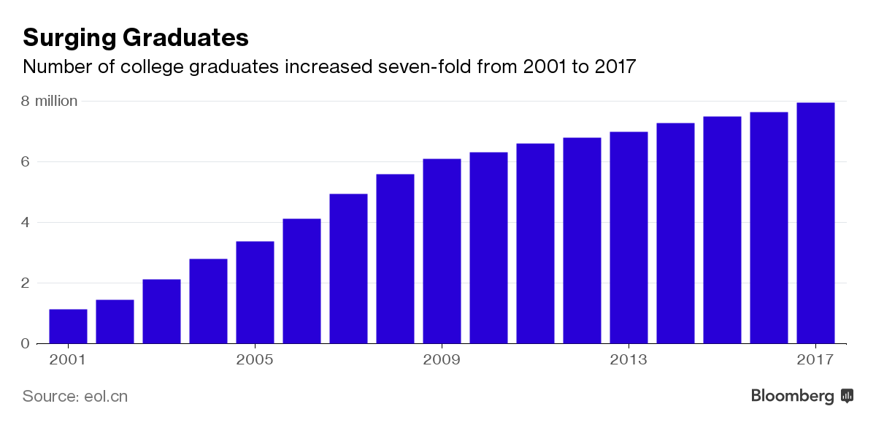

*Graph 1.1:* Number of college graduates increased from 2001-2007

As we can see from the above *Graph 1.1*, the number of college graduates has increased from 2001-2007. Chinese business culture plays a crucial role in China's business decisions (Fogel, 2010). It is not uncommon in Chinese culture to see a low-educated rogue boss scolding an MBA graduate in a vulgar language. In addition to being bullied by the boss, the Chinese job market is facing more difficult realities (Nakassis, 2011). According to a recent MBA survey by BRecruit, a global recruitment services provider, half of the 300 MBA students in Shanghai are "dissatisfied with the employment services offered by business schools (Gray, 2015). MBA students come from Shanghai Jiao Tong University, China Europe International Business School, Antai College of Economics and Management, etc. 13 business schools (Jiang, 2008). Sadly, because of working conditions and wages, most MBA students regret their investment in education (Pak, 2004). In 2015, Chinese MBA tuition fees ranged from $ 7,200 to $ 64,000. However, the average monthly salary of Chinese master graduates in 2014 was 580-660 U.S dollars (Zuo, 2017). When comparing high tuition fees to low pay, when MBA respondents were dissatisfied, it was not surprising that the lowest tuition factor in the survey was scored (Gray, 2015). China has a workforce of 755 million population, accounting for 26.3% of the world's total amount, equals to 1.64 times the population of 432 million in high-income countries (A Vast Range of Related Industries, 2015). However, China's total capital investment accounts for only 3.4% of the world total (Pozzebon, 2015). Since China will not enter the zero-labor-growth phase by 2020, it will not be possible to achieve full employment (Nan, 2004). This inevitably changes to a market economy, And the complex labor costs associated with maintaining the country's long-term viability (Tanzi, 2001). Therefore, the population in Shanghai is saturated and the strength of the ability to reflect the amount of wages (Wang, 2014).

### 

### **2.2.2 Type of work**

According to statistics from graduation university to Shanghai, the statistics released by Shanghai Human Resources and Social Security Bureau Employment Promotion Center show that 97,000 graduates from Shanghai 2016 who entered Shanghai's human resources market and graduated one year after graduation the rate is 95.9% (Yang, 2010). Attendance here refers to the ratio of the number of university graduates who have completed the employment registration formalities and are still in employment status to the number of college graduates entering the human resources market of this Municipality (Radhakrishnan, 2016). This means that 93,000 people have been registered for employment in the human resources and social security departments and are still in employment. Survey data show that the current job "very satisfied" about 16.5% of college graduates, said "more satisfied" about 63.2%, both together accounted for about 79.8%; on the current job "less satisfied "Or" very dissatisfied "college graduates accounted for about 6.1% (Wang, 2016). Expert analysis pointed out that with the changes in the population structure of the city and the promotion of employment efforts continue to strengthen the employment rate of college graduates in Shanghai showed a steady trend in recent years, the overall employment situation remained stable employment environment continues to improve, this is the university Graduate employment satisfaction with the root causes of the higher (Jame, 2017). Financial industry is a popular industry in Shanghai Statistics show that the average monthly salary of graduates of the 2016 Shanghai college graduates one year after their graduation was 6236 yuan, an increase of 25.0% over the average monthly salary of the first employment (statistics, 2017). From the different qualifications of the situation, the average monthly salary of college graduates 4645 yuan, 5495 yuan for undergraduates, master's degree or above graduates of 8972 yuan (statistics, 2017). In addition, the higher the education level, the higher the average monthly salary (William, 2011).

From the average monthly salary of different industries, the current average monthly salary of college graduates employed in the financial industry is 8,216 yuan, ranking the first place among all industries. Education and health industries followed by college graduates, the average monthly salary of 7,908 yuan and 7,653 yuan respectively (Tuttle, 2017). Industry experts said that finance is an important lever for the government in macroeconomic adjustment in the modern economy and society (Lenin, 2007). The construction of the four centers in Shanghai urgently requires that finance play a greater role. The overall average monthly salary of the financial industry is relatively high, which is an objective requirement of gathering financial professionals and promoting the rapid and healthy development of the financial industry (Long, 2016). From the characteristics of the financial industry, especially the banking and securities industries, the monthly salary level of employees may increase substantially within a relatively short period of one to two years of employment, and the other benefits not included in the monthly salary are more favorable (Pascal, 2017). Therefore, the financial industry the actual income level of practitioners may be much higher than in other industries (Herzig, 2009). Statistics show that in 2016, the number of Shanghai college graduates who took up employment in this Municipality accounted for 21.1% of them who left their primary employment within a year after graduation, an increase of 2.6 percentage points from the same period of the 2015 graduates (Statistics, 2011). Judging from the situation of different majors, the graduation rate of art major college graduates is higher, and 38.9% of graduates have already left their primary employment units. In economics, law graduates also have relatively high quit rates of 25.9% and 25.4% respectively (Carnevale, 2011). The rate of job-hopping among college graduates in education, history and agronomy was relatively low at 14.0%, 15.0% and 17.4% respectively. The main reason for graduating from the graduates, due to dissatisfaction with the personal promotion of space and leaving the university graduates accounted for about 33.8%, becoming the primary factor leaving college graduates (Parker, 2014). About 26.9% of college graduates quit because salary income did not meet expectations, ranking second (Montgomery, 2002). The analysis shows that the graduation rate of Shanghai college graduates rises both from the employment situation to a better choice of employment diversified social factors, as well as college graduates pay more attention to their own growth and career development of personal factors (Han & Mok, 2016). Some university graduates before entering the workplace, for their own scientific and rational career planning, change the main purpose of the job is to enrich the workplace experience, enhance personal ability, and strive to achieve workplace goals (Wan, 2006). However, some college graduates may be counterproductive because of inadequate job-seeking preparation, lack of comprehensive and accurate understanding of the work to be undertaken, industries and employers, blindly ambitious and frequent job changes (William, 2013). Experts suggest that graduates should be based on their own conditions reasonable to set career goals, looking for work for their own, in order to reduce the risk of "wrong line" to improve the stability of employment; the same time, employers should also establish a scientific and effective personnel training and the reserve mechanism, so that employees see the individual career prospects in the team (Jone, 2003). Different types of industries enable employees to wake up awareness (Waigmann, 2002). The pursuit of the hot industry. Therefore, the industry is also a big influence for graduates (Wilton, 2003)

### **2.2.3 Benefits and Welfare**

College graduates are the country's precious wealth. Promoting the employment of college graduates and entrepreneurship is related to the well-being of many families and the stability and social stability of the community (Yin, 2016). It is also an important support for releasing the bonuses of talents, raising total factor productivity and promoting economic restructuring and upgrading. Statistics show that in 2017, there were 174,000 university graduates in Shanghai, employment rate has reached 96.9%, compared with previous years, employment quality and job sufficiency have increased (Agenda, 2013). In order to gain a better understanding of the employment status of college graduates, the Employment Promotion Center of Shanghai Human Resources and Social Security Bureau, in conjunction with the Shanghai Student Affairs Center, jointly released the "Report on Employment of Shanghai Graduates in 2017" by the series of "Happy Business Report" Based on the employment registration information of Shanghai Municipality and the data from the sample survey of college graduates, the study analyzed the 90,000 students who entered the human resources market of the city except those who went abroad and went to other provinces and cities for employment except for the graduates from Shanghai in 2017 Employment status. The influence of welfare in Shanghai is that city graduates who graduated from ordinary institutions of higher learning in 2014 and onwards will be eligible for initial employment after graduation within two years of graduation and flexible employment registration procedures in the municipality and payment of social insurance premiums according to the flexible employment regulations (Maclean, 2012). Apply for subsidies for social insurance subsidies for the city in accordance with the previous year the average wage of 60% workers and around 50% of social insurance premium calculated as contribution base (Wei, 2013).

The Welfare for foreign students in Shanghai is to encourage overseas returnees to start a business in Shanghai and launches the "Measures for the Administration of Shanghai PuJiang Talents Program" as well as other policies for overseas returned students and teams who returned to Shanghai for work and start business may receive Government income of 100,000 to 500,000 yuan, In the meantime, a number of districts have also introduced encouraging policies such as interest-free loans for overseas students who can get a starting-up fund of 150,000 yuan in Pudong New Area for starting a business (Yang, 2017 ). The employer arranges the laborer to work in the open air and arranges for the workers to pay high-temperature seasonal allowances to workers who work in workplaces that can not take effective measures to reduce the temperature below 33 ℃ to a monthly standard of 200 yuan per month from June to September Month, subsidy policy for 4 consecutive months Therefore, from these aspects, the temptation to find a job in Shanghai is very big for graduates (Mesa, 2014). Employment difficulties in Shanghai is for Students with difficulties in employment accepting one-time Subsidies for employers with difficulties in employment of enterprises, institutions, private organizations, and non-enterprises in Shanghai municipality adopting adopted "Difficult Employment Difficulties" and signing labor contract of more than one Year Personnel "belongs to the urban and township registered unemployed subsidy of 10,000 yuan per person (Liu & Wang, 2012). Whoever absorbed" Difficulty in employment "belong to the co-insurance of rural surplus labor force and one-time payment of social insurance premiums for land acquisition compensation of 15 years per person per year 5000 Yuan subsidy period of up to 2 years for the 2017 session of Shanghai college graduates in job search career process, 62.8% of the graduates are most concerned about is the space for career development; attention to the pay and benefits followed, accounting for about 62.6% (Trieu, 2013 ). Among the many factors that influence the quality of employment, the concerns of the 2017 college graduates in terms of enterprise size and corporate reputation are relatively low, both below 8% (Hang, 2015). Therefore, the welfare of Shanghai to graduates Huge influence legislation (Serdyukov, 2017).

## **2.3 Relationship Between Dependent Variable and Independent Variables**

### **2.3.1 Salary**

As the economy in China grows modestly in 2016, as more and more domestic companies mature, domestic companies increasingly consider the long-term nature of their teams and choose to recruit highly qualified people in all sectors - including finance, numbers and marketing - Not just the top leaders (EMCC, 2009). Wages are very important for the jobs that Shanghai's graduates are looking for, working for graduates in Shanghai alone (Schucher, 2014). First, we must face the basic necessities of life (Pearson, 2012). Next is the house, as China has embarked on measures to curb property price surges and address debt risks (Koukoulas, 2016). The role of infrastructure in human resources and accounting and finance will prove to be a steady area of ​​growth and key players in governance and compliance will continue to demand that qualified personnel become increasingly difficult Found in all industries (Wen, 2009). Salary growth will reflect the needs and shortages of certain skills in the market, and job safety and stability will be key drivers of the company's ability to attract and retain talent (Petter, 2008). Those who work in the Internet field will get the most out of their peers (Valaitis, 2005). According to the report, the income of new graduates is more than 40% higher than the average monthly disposable income of China's urban residents of $ 2,801 (Bu, 2014). Disposable income refers to the income after tax and social insurance deductions (Ryan, 2004). They are also 30% more than 3,366 yuan four years ago. This is the benefit of graduates working in Shanghai (Douglas, 2013).

### **2.3.2 Type of Work**

From the type of work in Shanghai to see college graduates work in professional counterparts, be able to give full play to and use of professional knowledge, better personal expertise and social needs organically combine to learn practical purposes (Johnson, 2009). From the employer's point of view, but also conducive to the full utilization of human resources, thereby further improving work efficiency, employers are also mostly willing to give priority to hiring professional counterparts of college graduates (Okoye, 2013). Judging from the development trend in recent years, the proportion of college graduates who study majors and jobs has risen, while the proportion of non-professional college graduates has declined. Experts also reminded, college graduates in the job search process also need not rigidly adhere to the profession, if it is difficult to find a professional counterparts for a while, according to individual strengths or hobbies, choose to engage in their favorite industries, is still an ideal choice (Gibbons, 2016).

According to the survey, 4695 of the university graduates in Shanghai chose flexible employment, that is, they did not establish any fixed labor relationship with any employer and paid labor and earned their income through freelance work, self-employment or self-employment the form of employment (Yan, 2016). From the proportion of view, the flexible employment of college graduates accounted for about 5.1% of the total number of employed. Among them, college graduates with a college degree, the proportion of choosing flexible employment is 8.1%, college degree or above college graduates only 3.4% (Johnson, 2010).

Expert analysis pointed out that under the background of "mass entrepreneurship and mass innovation", the "Internet +" economy continues to grow and develop, providing more and more choices for university graduates (Lengen, 2016). Working hours, workplaces can arrange their own arrangements, the income is also more generous flexible employment methods, and gradually by college graduates of all ages, inspired the enthusiasm of young college student’s entrepreneurship and innovation, more and more young people began to pursue a different way of life (Jun, 2016). So, for graduates who are employed in Shanghai: it is a good choice (Chan, 2014). The demand of various talents in Shanghai has laid a better development path for interns (Su, 2016).

### **2.3.3 Benefits and Welfare**

Many graduates in Shanghai work in a flexible way to make their career prosperous (Zhou, 2018). However, they lack awareness of precaution and risk prevention, neglecting the importance of participating in social insurance. If they encounter labor risks such as unemployment, work-related injuries or even incapacity to work, It is difficult to obtain the corresponding social security and the necessary material assistance (Pouliakas, 2010). According to the existing policies and regulations of Shanghai Municipal Bureau of Human Resources and Social Security, graduates of flexibly employed college graduates who participate in social insurance and meet the relevant conditions can get nearly 800 yuan a month because, with the support of the government, That is a big benefit (Chen, 2016). Shanghai Human Resources and Social Security Bureau introduced employment training, vocational training camp and other policies and measures (Hilala, 2016). Eligible students can go to probationary bases recognized by the government to participate in traineeship, both to experience the workplace, gain practical experience, you can also enjoy the monthly subsidy of 1840 yuan of government subsidies (Chang & Turner, 2011). Trainees in industry training camps can take part in experiential training courses and receive targeted training in resume production, interview simulation and workplace experience in a fully simulated workplace environment (Tokyou, 2004). For the graduates who need to accumulate work experience urgently, such policy measures can be described as "timely assistance." which is the purpose for graduates to stay in Shanghai (Chen, 2015).

## **2.4 Moderating Variable**

An online survey conducted by university graduates in 2011 found that the average monthly contract income of women was lower than that of men, and the higher the academic level, the greater the monthly income gap between men and women (Daczo, 2012). Among them, the average contract monthly income of female higher vocational graduates was 1917 yuan, 169 Yuan lowers than that of boys (John, 2015), the average contracted monthly income of female graduates was 2243 yuan, 330 yuan lower than that of boys and the average contract of female master graduates in 2011 Monthly income of 3623 yuan, 815 yuan lower than boys (Ruel, 2014 ).

The survey also found that state-owned enterprises tended to be more masculine in terms of employment (Tang, 2016). Among the 2011 college graduates surveyed, the percentage of female higher vocational, undergraduate and master graduates signing agreements with state-owned enterprises was 9%, 9% and 10% lower than that of men respectively (Potter, 2014). In contrast, women undergraduate and vocational graduates and private enterprises signed the highest proportion of 45% and 65% respectively, while the percentage of female graduate students going to government agencies and research institutions was the highest (32%), far higher the percentage of male master graduates signing this type of unit (18%) (Satterlee, 2009). This may be related to the age of marriage and childbirth after the graduation of female graduates and the pursuit of job stability (Musick, ‎2012). Through reports, women in the community often engage in lower-paid jobs, especially in the fields of economy, finance and culture with higher incomes, although the number of women accounts for 60% to 70%, men still occupy a certain dominant position in management (Clements & Wingender, 2013). Researcher said that in order to narrow this gap, we must first rely on the economic and social development (Bourgeois, 2014). The rapid economic development and the adjustment of industrial structure are conducive to women's employment expansion (Joeke, 2005). Second, women should improve their own quality, the so-called social comprehensive competitiveness (Pantić, 2014). Of course, the traditional cultural values ​​such as weak men and women can have a negative influence on women's development (Stamarski, 2015). In the recruitment process, employers still discriminate against women (Stamarski, 2015). Therefore, the differences in wages and benefits caused by the work of Shanghai's tea with different genders are also different (Yuan, 2016).

## 

## **2.5 Grounded theories**

Social exchange theory is a model which based on some estimating of rewards and punishments of people (Crossman, 2017). As a series of interactions between people, what determines our interactions are expectations of rewards or punishments from the others, which rewards could be different kind of forms such as money, social recognition, gifts or a everyday smile, a nod on the back. Punishments also have in many forms like hitting, humiliation in public, as well as raising eyebrow or a frown (Birtch & Chiang, 2015).

Worked engagement can be explained by Social exchange theory, which is the source of staff engagement and one of the most popular conceptual model in organizational behavior. (Ariani, 2013). For instance, the employees would be responsible to become cognitive, emotionally and physically, such as positive attitudes constructive behaviors in work role if the company or organization offers support to (Moss, 2016). At work, social exchange theory plays a quite significant role. For example, based on the statistics, almost 25% of employees would take a job somewhere else if the salary is 10% more. In the workplace, a number of social exchanges that may take place between the employees and the company or organization, their supervisor or leaders, and their work group or colleagues, like job characteristics would influence job outcomes. The staff don’t have to put a lot of time or resources to make a big difference in workplaces. By recognizing your employees’ hard work regularly will be beneficial to the social exchange theory equation (Lee & Veasna, 2016).

Faced with the rapid economic development in Shanghai, the renewal and flow of the labor market are also drawing more and more attention (Allard, 2010). Shanghai, as an economic metropolis, faced with graduates of colleges and universities who employ hundreds of thousands of people each year (Smith, 2008). How to attract the graduates who need to get into the job poses a real problem to promote the employment of Shanghai university students, is conducive to self-reliance graduates, through their work income from their parents, to meet their own supply of life (AUTHORITY, 2015). Employment is the foundation of people's livelihood (Ho, 2004). With work, a series of social insurance policies can be paid in order to have the financial ability to create the value of life in the future (Jacobsen, 2016). Attracting fresh graduates, but also for the enterprise to bring some value and profits (Pollard, 2015).

Judging from the total amount, there is still an excess of labor supply, while on the other hand, there is a shortage of labor supply (Ehrenberg & Smith, 2012). With the progress of science and technology and the optimization and upgrading of industrial structure, part of the on-the-job labor force has become structurally unemployed and has become a new unemployed group due to the knowledge of skills or experience that the stock of human capital can not adapt to the new industries and new jobs brought about by it (Allen, 2016). At the same time due to the low level of human capital quality, employment risk rate increases, job stability weakened (Auer, 2006). Without any government intervention, capitalism can not achieve "full employment" through the self-regulation of the market's role. The goal that he requires to achieve is to achieve and maintain "full employment" in the capitalist economy (CHAPRA, 2016). The meaning of "full employment" is that productive resources are fully utilized (Reader, 2017)

The effective demand is the total demand price when the total supply price equals the total demand price, which is the total demand price at the time when the entrepreneur's production can obtain the maximum profit. Effective demand therefore refers to the market's demand for affordability (Pen, 2006). The total social employment depends on the total demand. On the basis of these theories, Keynes put forward the policy suggestion of the state to intervene in the purification agent, that is, through the government adopting a series of fiscal and monetary policies to increase public expenditure, reduce the interest rate to stimulate consumption and increase investment so as to raise effective demand and realize the whole society Full employment (Karanshawy, 2015)

## **2.6 Framework**

## 

**Dependent Variable**

**Independent Variables**

Salary

**H1**

Type of work

**H2**

Job Selection Behavior

Benefit or welfare

**H3**

Gender

**H4**

*Figure 2.1* Conceptual Framework

As *Figure 2.1* indicates, the framework of this research which is job selection behavior are mainly influenced by three independent variables and one moderating variables, which is gender.

## **2.7 Hypotheses**

**Hypothesis 1**: The salary has a significant relationship on college graduate’s job selection in Shanghai, China.

**Hypothesis 2:** The type of work has a significant relationship on college graduate’s job selection in Shanghai, China.

**Hypothesis 3:** The benefits and welfare have a significant relationship on college graduate’s job selection in Shanghai, China.

**Hypothesis 4:** The gender has a significant relationship on college graduate’s job selection in Shanghai, China.

## **2.8 Conclusion**

This chapter included the literature review of the employment preferences behavior of undergraduates in Shanghai and the employment of undergraduates in the world. Advantages of employment in Shanghai university students in China, and the employment advantage of college students in foreign countries. By getting to know step-by-step college-to-Shanghai job selection preferences for benefits and benefits payroll content.

# **CHAPTER 3 RESEARCH METHODOLOGY**

## **3.0 Overview**

This chapter will focus on the research methodology application, research design, sampling design, questionnaire design and measurements of the study. Firstly, research design covers the purpose of this study, verification study and cross-sectional study. Followed by sampling design, which consists of justification of the sample method, sample size and unit of analysis. After that questionnaire design, Likert Scale and data analysis will be discussed. Lastly, measurements of dependent variables and independent variable will be illustrated. To achieve the goal of this research, descriptive study and correlation analysis will be used throughout the whole study.

## **3.1 Research Design**

The purpose of this study is explore the job seeking behavior of Chinese college graduates in Shanghai, therefore, the research is supposed to limit with graduates who are in Shanghai city, China (Yuen, 2013).

This study is a formal research of nature and the scope of the research is very vast, also it is to describe the characteristics of the relationship of two variables, therefore, it is applicable for descriptive research study, with which be adopted to achieving the study purpose and getting new insights into it (Sekaran & Bougie, 2016). However, different from exploratory research, it is also considered as verification study because this study is based on previous understandings and targeting to verify what previous study have done which in a different context (Zikmund, 2013).

The research design is nearly to determine the frequency of a particular attribute and data are collected in a whole defined study population to examine the relationships between variables, therefore the data collection is through questionnaires and the data is collected once only, as a result, it is considered as cross-sectional study design (Dermatol, 2016). A cross-sectional quantitative research will be used to analyze the factors influencing respondent’s job seeking behavior. In cross-sectional research, data are collected from the research respondents at a single point within a relatively short time period, which is three months, as that's the limited project time been given (Buck, 2015). Thus, the researchers did not directly measure changes that come over time in this study but rather used descriptive statistics (percentage, average mean) and inferential statistics (one way-ANOVA and correlations) to report the data analysis and findings (Ali & Bhaskar, 2016).

## **3.2 Sampling Design**

### **3.2.1 Introduction and Justification of Sampling Design**

Sampling in Statistics is choosing a sample from a statistical population of estimating the whole populations characteristics (Watson, 2016). The sample method which will be used in this research is convenience sampling under nonprobability sampling, because the sources are convenient and easy to collect, meanwhile costing less money and time to carry out compare with probability sampling, Since this research is conducted by master student with limited time, nonprobability sampling is a better choice for this study (Alkassim et al., 2015). According to literature, Convenience Sampling is affordable, easy, also the subjects are selected due to the accessibility and proximity for researching (Farrokhi, 2012).

Sampling design in the research means the framework that services the basis for a study sample selection and it would affect other important areas of the survey, therefore, a reliable and appropriate sample design must be selected before collecting data in order to conduct a clear and precise study (Vosloo, 2014). It is now possible to see how both sampling design and sample size are critical to establish the representativeness of the sample for generalizability (Guetterman, 2015).

In the present study, Likert-Scale analysis were used for this questionnaire, where the respondents could either strongly disagree, disagree, neither agree nor disagree, agree, or strongly agree with a number of statements regarding various issues related to job preferences after graduation (Kostoulas, 2013). The reason of applying this analysis in this study is because it can be used to measure someone’s attitude by measuring the extent to which they agree or disagree with, to measure respondents attitude towards the question or statement (Sekaran, 2011).

### **3.2.3 Sample Size**

Sample size is the number of sampling units which are chosen from the whole population for the purpose of research (Charles et al., 2015). To estimate the prevalence of the conditions of interest with great accuracy, the sample size should be large and sufficient (Chandrashekara & Suresh, 2012). The population addressed in this investigation consists of all of the bachelor degree fresh graduates who studied in Shanghai (Bardsher, 2013). To achieve study objectives of current study, data were collected from 400 respondents including college students who will graduate this year in Universities in Shanghai, China (Huang, 2012). According to Krejcie and Morgan (1970), when the number of samples is greater than one million target population, so the maximum sample size for this reach should be 384, as the target population of graduates in Shanghai 2017 is 8 million (Koech, 2015).

### **3.2.4 Unit of Analysis**

According to Sekaran and Bougie (2013), the unit of analysis is the major entity analyzing in the research and is aggregating the data collected in the the analysis stage of following data. In the present research, the respondents are all college students and fresh graduates in Shanghai, regarding of their majors and school locations (Kidwai et al., 2016). Although there are a few types of unit of analysis which are commonly seen, such as groups, organizations, social interactions, but the sample unit is in this research is the individuals selected, as a result, the unit of analysis in this survey is individual, specifically speaking, the individual is the Chinese college graduates in Shanghai to whom the questionnaire will be distributed for data collection (Chica et al., 2016).

## **3.3 Questionnaire Design**

### **3.3.1 Justification and Definition of Questionnaire Design**

Questionnaire design can be defined as the design process for the format and questions in the survey instrument that will be used to collect data about a particular phenomenon (Joseph & Patel, 2016). A descriptive correlation design was applied in this research to illustrate the levels of job satisfaction and preferences towards different type of work among college students and also to examine the relationship between those variables (Munisamy, 2013). Quantitative research is utilized in this study, self-administered survey and questionnaire are quite effective methods to used, it is also easy and convenient for distribution at the same time. In this research, online questionnaire will be conducted, as first of due to the limited three months project time based on the lii (2004), when limited time is data collection it is applicable to use online questionnaire, besides, its distinctive features related to design, distribution and evaluation of data are also the advantages of applying this data collection method (Brown et al., 2013). The relevance of the topic to the responders is also a major factor in the response rate for any survey (Dillman, 2007). The length of survey is another significant factor in response rate (Liu et al., 2017). Based on 25,080 real-world web surveys, Liu and Wronski (2017) found a negative relationship between completion rate and survey length and question difficulty. They also suggested that surveys without progress bars have higher completion rates than surveys with progress bars. McPeake et al. (2014) suggested keeping the survey as short as possible. Two early studies found that surveys which take thirteen minutes or less have higher response rates (Asiu & Blackwell, 2011).

The main parts of questionnaire design includes firstly three demographic items, such as gender, ages, income and company information; after that followed by five dependent variable items and five independent variables for each factor influences the dependent variable of job seeking behavior for college graduates in Shanghai, China (Batmunkh1 et al., 2016). The non-probability samples are applied as the sampling method in the present study, which will explore the factors which might influence graduates job selection behavior, however the amount of population is large, convenient sampling applied to process the research (Lee, 2011).

### **3.3.2 Likert Scale**

Based on literature, one of the most effective and well-known method for measuring the elements is Likert scale which connected with closely to satisfaction survey (Dolnicar, 2012). The Likert Scale is used to examine the strong relationships of subjects agree or disagree with surveys or statements on a 5- point scale with anchors as follows according to Sekaran and Bougie (2012):

Strongly Neither Agree Strongly

Disagree Agree Agree

Disagree Nor Disagree Agree

1 2 3 4 5

Figure 3.1 Likert Scale on a 5-point scale

The Likert Scale is best used to measure and evaluate respondent’s sentiment or opinions to a specific products or service (Smith et al., 2014). In the present research, respondents were expected to provide personal preferences in making job choices, the valuation of and expectation of individuals, the probability to make future decisions etc. that is the reason why it is been recommended to use Likert Scale in this study (Millikin, 2016). Hence, based on the analysis, Likert scale is applied by this research to measure the variables includes salary satisfaction, job types, welfare or bonus providing, personal sense of achievements, promotion opportunities etc (Swamy, 2015).

### **3.3.3 Adopting and Adapting Instruments**

Adopting items is simpler with little effort required, few modifications might be needed if it is adopted though (Alsaffar & rDeniz, 2013). Nevertheless to researchers, the questionnaire still need be designed appropriately so it is significant that you read about developing a questionnaire (Adams, 2010). Adapting an instrument while as requires much substantial changes than adopting an instrument, but both adapting and adopting methods will be used in this research (Andreassen et al., 2016). In this case, the general design of another instrument is followed by the researchers but adds items, removes items, or changing each item’s content essentially, because adapting an items is like to developing a new item, it is important for the researchers to understand the key principles of developing an item which will be described in the next step (Zamanzadeh, 2015). When adapt items, the researchers ought to report the same information in the Instruments section as when adopt items, what changes were made to the instrument and why should also be included (Bastos, 2014).

|  |  |  |  |
| --- | --- | --- | --- |
| **Section** | **Variable** | **Items** | **Sources** |
| **A** | Demographic Profile | 3 | Fryrear (2016); Liu (2009); Found (2005) |
| **B**  **(Dependent Variable)** | Job Seeking Behavior | 3 | Faberman et al. (2015); Witte et al. (2005); Luc et al (2013) |
| **C**  **(Independent Variable)** | Salary | 5 | Taylor et al. (2007); Jacob et al. (2016);  Fan et al. (2014); Hancock (2017); Duan et al. (2014) |
| Type of Work | 5 | Nicholson (2016);  Dawis (2001); Jun (2016); Gibbons (2016); Scott (2016) |
| Benefits and Welfare | 5 | Chen (2016); Hilala (2016); Tokyou (2014); Prasad (2011); Ginns and Tu (2011) |

*Table 3.1: Summary for Questionnaire Adoption/Adaption*

## **3.4 Measurements**

### **3.4.1 Pilot Test**

Basically, the definition of Pilot test is a trail on small scale basis to test before full scale performance in research (Thabane, 2012). The pilot test should be run after the proposed research project has been designed fully, but before launching final project, it is an important initial step in any research, with which applies to all types of research studies (Kanji, 2015).

The purpose to of applying Pilot test is to ensure everyone in the sample understands the questions in the same way, besides that to test if any questions make respondents feel uncomfortable and track how long time it takes to complete the survey in reality (Schade, 2015)..

On Pilot tests, there are limited published guidance with regard to the sample size, but generally, it has been found that sample size of 10%-20% of the sample size for practical research is a reasonable number of respondents to enroll in pilot study (Ageron et al., 2014).

### **3.4.2 Factor Analysis**

Factor analysis is a statistical method used to measure the impact of unobserved variables called factors on a considerable amount of observed variables, using for exploratory or confirmatory purposes mainly (Yong, 2013). In terms of the purpose, factor analysis aims to reduce some of individual items into a certain limited number of dimensions, which mainly used for simplifying data, like reducing the variables numbers in regression models (Brown & Williams, 2012). Examining statistics allows the researcher to dissect variables such as demographics and target respondents (Davis, 2014). The only assumption in real is showing the relationships between the variables as represented by the correlation coefficient (Allen, 2016).

The Kaiser-Meyer-Olkin varies between 0 and 1 and is for measuring sampling adequacy, which means the values closer to 1 are better and the suggested minimum value is 0.6 (Peri, 2012). The Bartlett's Sphericity test is the test for null hypothesis that the correlation matrix has an identity matrix. Providing the minimum standard, these tests are indispensable to proceed for factor analysis (Szüle, 2016).

The factor loadings, which is very important, named component loadings in PCA as well, is the correlation coefficients between the original variables and the factors (Cadima & Jolliffe, 2016). Squared factor loadings show in what percentage does a factor explain to variance in an original variable (Kline, 2013). The suggested rule is that if a factor has four or more loadings higher than 0.6 then it considered as reliable in spit of sample size, besides that, factors with more than 10 ladings greater than 0.4 are also reliable if the sample size is higher than 150 (Ramasubbian, 2012). At last, factors with a small volume of low loadings should not be interpreted only if the sample size is above 300 or more (Mundform & Pearson, 2010). Communalities is what indicate the number of variance in every variable which is accounted for and initial communalities estimating variance in each variable accounted for by all components or factors (Costello & Osborne, 2011). Communality of the items generally with an average value higher than 0.6 is acceptable for sample size more than 250, which high value indicates relevant variable describe that factor very well.

### **3.4.3 Reliability Test**

Reliability test refers to a test is seen as being reliable when used under stable conditions by researchers, with consistent results and the results not varying (Terracciano & Yamagata, 2010). Reliability reflects consistency and replicability over time. Furthermore, reliability shows the the degree to which test is free from measurement errors (Bruin et al., 2015). To enhance the reliability of the research the questionnaire language were designed with both Chinese and English version to ensure the respondents full comprehension of the statements (Yu, 2010).

The internal consistency reliability of a measurement scale usually have two statistics, which including Cronbach’s alpha, and composite reliability indicator (Yahya, 2012). The recommended acceptable value of the Cronbach’s alpha for a reliable score is 0.7, which is calculated with the assumption that all measured indicators are equally weighted (Taber, 2016). Composite reliability is the alternative measurement for calculating the Cronbach’s alpha which is regarded as a more precise reliability way than the Cronabch’s alpha, so the suggested acceptable value for composite reliability is 0.70 or greater (Chien et al., 2017).

### **3.4.4 Demographic, Preliminary test and Hypotheses Testing**

Demographic measures, simply put, are questions that allow researchers to identify non-opinion characteristics of respondents, such as birth, profession, nationality, income level, occupation and educational level or company’s profile with demographic details for better understandings (DeFranzo, 2012). Demographic analysis typically are to identify key respondent characteristics that might influence opinion associated with behaviors and experiences, which items could be found at the end of a questionnaire most of the time (Ayala & Elder, 2011). Reasons of using it is to build rapport with the respondent through substantive questions asking; Lessening the likelihood that asking these personal questions will lead to a refusal to completing the questionnaire and preventing priming the respondent etc (Bell et al., 2014).

The preliminary tests aim to demonstrating through tests conducted on concrete manufactured in laboratories, with using the prepared materials, dosage and constructing methods it is possible to obtain concrete which acquires the strength and durability factors by the design (Dmitrienko, 2017). This test reveals the physiological factors that the research preliminary testing, however, is merely the beginning of the process (Metcalfe & Newington, 2014).

Preliminary testing for normality is recommended for moderate-to-large sample sizes. In a preliminary test, a specific assumption is checked and the outcome of the pretest then determines which method should be used for assessing the main hypothesis (Keselman et al., 2013). To avoid failure in the first round of reliability test causing inaccurate analyses and poor business decisions. We will utilize secondary data to run preliminary test and reliability test again (Stewart, 2014).

### **3.4.5 Hypothesis Testing**

Test of hypothesis is considered as the most important instrument in research in general (2015, 2015).Based on social and behavioral sciences, the statistical hypothesis test is one of the basic factor of the toolbox of the empirical researcher (Schneider, 2014). Hypothesis testing is an important part of the sampling inference, which based on the original data to make an overall index is equal to a certain value, whether a particular random variable obeying a certain probability distribution assumption, and then using the sample data with statistical methods to calculate the statistics about the inspection, based on the principles of a certain probability, to judge at little risk estimate and overall value (or estimated and actual distribution) whether there was a significant difference, should accept the null hypothesis to choose a kind of test method (Batista et al., 2013).

The overall index is estimated by the sample index, and the conclusion is totally reliable. Some only have varying degrees of reliability, which need to be further tested and verified (Beltyukova et al., 2013). Through the test, whether there is a difference between the sample index and the assumed overall index, whether the original hypothesis is accepted. It must be clear that the purpose of the test is not to suspect the sample. A hypothesis test evaluates the data by using a test statistic set up to contrast the null hypothesis with the alternative hypothesis, and the p-value is the probability to obtain, assume the null hypothesis is true, outcomes of the test statistic that are at least as high as the outcome actually observed (Altman et al., 2016). It is more conducive to the advance of science to report p-values than merely whether the hypothesis was rejected at the conventional 0.05 level of significance (Bang & Kim, 2016).

### **3.4.6 Simple Linear Regression and Multiple Linear Regression**

Linear regression as a statistics analysis technique consists of two types, which are simple linear regression and multiple linear regression (Blettner et al., 2010). The simple linear regression is used to predict a dependent variable, while as Multiple regression is an extension of simple linear regression which used to predict the value of a variable based on the value of two or more other variables (Analysis, 2010). The variable of what we want to predict is dependent variable or could be the outcome, target and criterion variable (Oswald et al., 2012).

Regression analysis were used for measuring the significant relationships between dependent variable and independent variables (Brien & Scot, 2012). In this study, multiple linear regression have to be used to determine the statistical significance between salary rate and the applicants preference behavior in selecting the job and there is a significant relationship between job seeking behavior and type of work, and between job seeking behavior and company’s welfare and benefits (Verbeek, 2017). One-way ANOVA is used to study whether the different levels of a controlled variable have a significant effect on the observed variables (Winter, 2015). In this case, the effect of single factors on observed variables is studied, therefore, the factor of salary, type of work, benefits and welfare influence to college graduates can be analyzed through One-way ANOVA, as it is also used to compare means of two or more samples and determine whether there is any significant differences between the means of independent variables with groups or single units (Green, 2011).

## **3.5 Conclusion**

To sum up, research design, Sample design and questionnaire designs were discussed in the above chapter separately. Quantitative research method were used and questionnaire items were either adapted or adopted for this study through distributing questionnaires online. Descriptive statistics, reality test, correlation and regression analysis are used to measure the variables through SPSS software. Furthermore, data collected from the questionnaire and findings of the research will be discussed statistically in the following chapter, along with providing accurate evidence for supporting the research results.

# **CHAPTER 4 RESEARCH FINDINGS**

## 4.0 Introduction

In this chapter, the description has been made to the analysis of data collected through online questionnaires and then illustrated by SPSS software, followed that is the discussion of the research findings. The findings which relevant to the research questions and research objectives that guided the study. Data were utilized for identifying, describing and exploring the relationship between job selection behavior and graduate’s preferences toward salary, type of work, benefits and welfare in Shanghai, China. There are 400 questionnaires which are expected to be received and hypotheses proposed to show the research objective of this study is been achieved.

## 4.1 Descriptive Analysis

Descriptive analysis was utilized in describing the demographic characteristics which are related to the participant’s gender, age, employment status, salary among Shanghai college graduates.

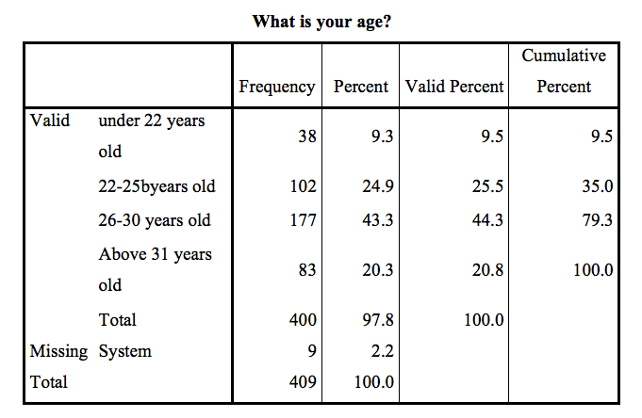

Among the number of Shanghai graduates surveyed, we can see that the majority of people are between the ages of 26-30 and 43.3 percent of the total. Second, the age between 22-25 years old accounts for 24.9% of the total.

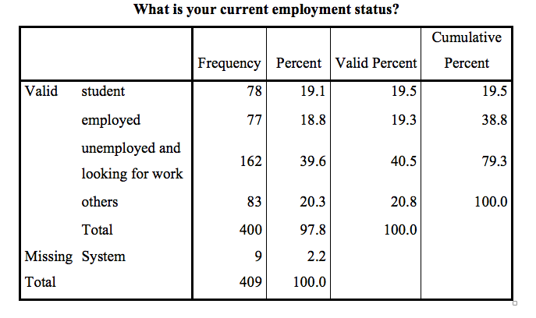

From the number of people surveyed, we can see that the unemployed are looking for a lot of jobs, followed by other people. The last employee who is working needs to change jobs.

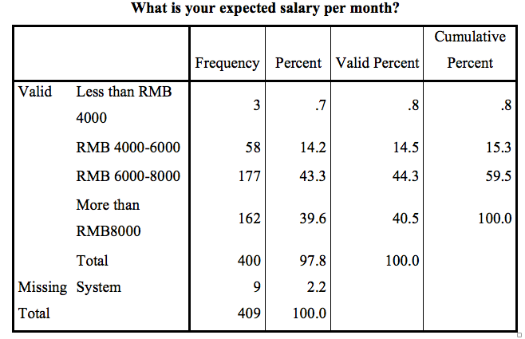

Explain the problem from this chart. Most employees who work in Shanghai have a salary between RMB 6000 and 8000, followed by more than 8,000. Very few people are under 4,000 yuan.

## 4.2 Reliability Analysis

In the present study, the reliability was tested through the Cronbach’s alpha coefficient test. As variables are reliable when the value of cronbach’s alpha is more than 0.7, the test result of this research is 0,814, which means items were correlated with each other. It has been found that the reliability test results support the study of the whole process of the appropriateness of using instruments and test the concept in the field of study is appropriate. Therefore, the results of these instruments are applied to higher levels of analysis.

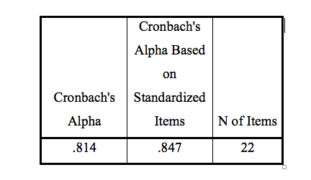

*Table 4.2.1 Cronbach's Alpha’s value of all variables*

## 4.3 KMO Analysis

Kaiser provides the KMO metrics which used frequently: 0.9 or more means very suitable; 0.8 is suitable; 0.7 regarded as general; 0.6 refers to less suitable; below 0.5 is considered extremely unsuitable. It as been accepted that KMO values is between 0 and 1. When the sum of squares is higher than the sum of the squares, the simple correlation coefficient between variables, also the partial correlation coefficient the value of KMO approaches to 1. When the KMO value is close to 1, the stronger the correlation between variables is, which indicates the original variables is more applicable for factor analysis. The KMO value is close to 0 when the simple correlation coefficient between each variable is close to zero. KMO value is close to 0, the correlation between all variables is weak, the original variables, the more uncomfortable. As cooperative factor analysis shows from the above graph, the value of KMO is greater than 0.6, so this means that the analysis can continue.

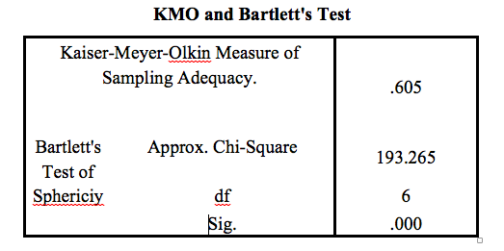

## 4.4 Correlations Test

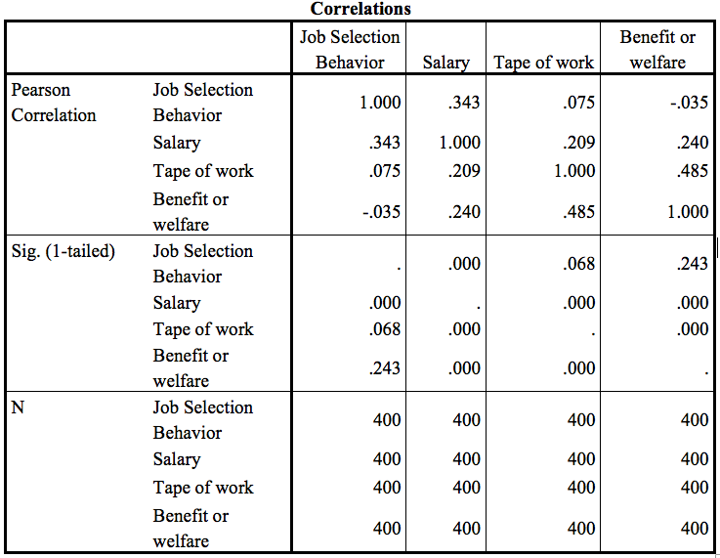

The larger the numerator from the graph, the smaller the denominator, the larger the correlation coefficient. In the above figure, the distance from each point to the fitted line is similar, but the points on the left are larger in the Y-axis, and the correlation coefficient on the left is larger than the right. The positive and negative correlations of the correlation coefficients are two different, unrelated concepts. Positive or negative indicates whether the correlation is positive or negative, and it does not matter the magnitude of the correlation. The size is only responsible for indicating the size of the correlation, regardless of whether it is positive or negative. In general, after taking the absolute value, 0-0.09 is no correlation, 0.3-weak, 0.1-0.3 is weak correlation, 0.3-0.5 is medium correlation, and 0.5-1.0 is strong correlation. The larger the sample book, the smaller the correlation coefficient that needs to be significant. So this is related to the sample size. If the sample is large, say more than 400, the correlation coefficient is often low. The strength of the judgment is mainly significant, not the correlation coefficient itself. However, both statistics need to be reported at the time of writing the paper.

## 4.5 Linear Regression Analysis

### 4.5.1 Salary

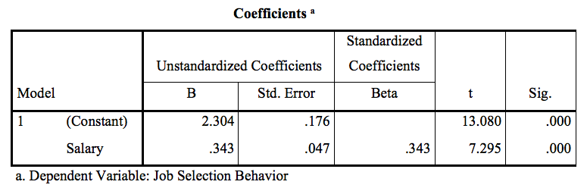

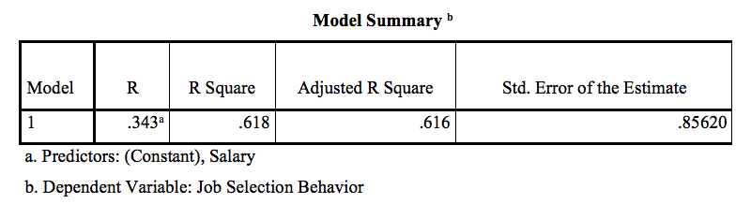

### 4.5.2 Type of Work

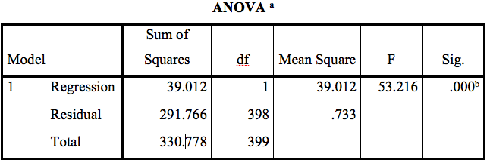

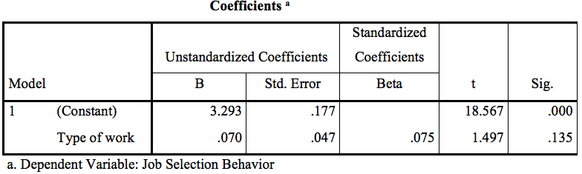

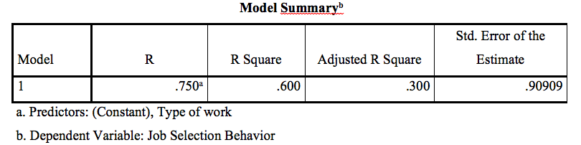

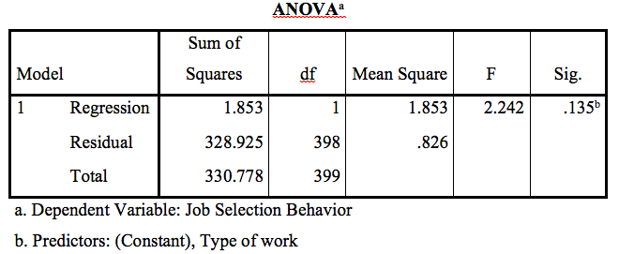

### 4.5.3 Benefit or Welfare

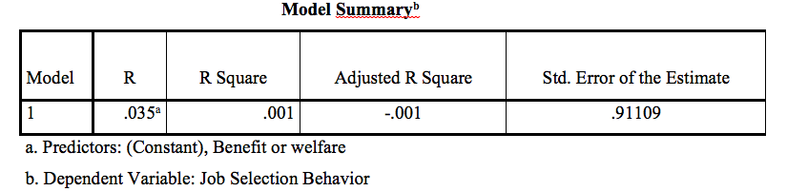

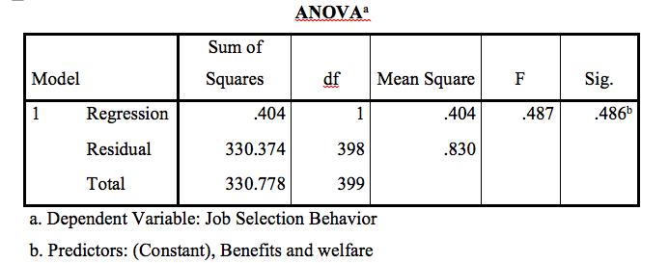

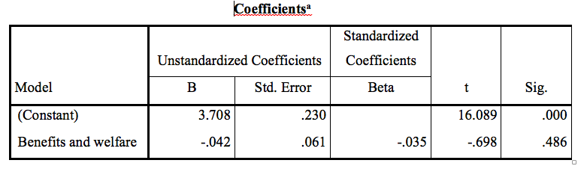

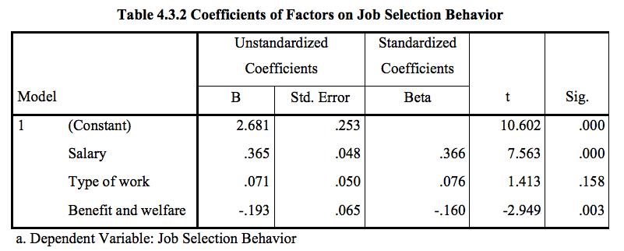

From this chart, we can see that salary and benefits are acceptable. Because the sig value is less than 0.05. The hypothetical item of work type cannot be accepted. Because the sig value is greater than 0.05, it is only rejected.

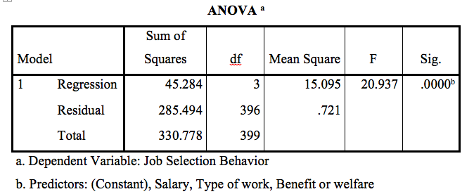

As the below tables shows, the hypothesis result p-value is 0.000 which indicates that the independent variables and dependent variables are associated in a significant way. Which specifically means job selection behavior has a significant linear relationship with Salary, type of work, benefit and welfare.

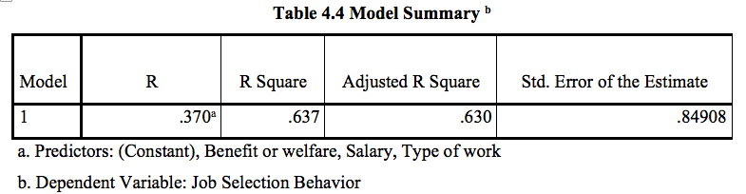

As the above tables shows R square is 0.637 which means that around 63% of the whole behavior of job selection is able to be predicated by using the present proposed model as the complementary tool. Besides that, it has also been discussed that some other factors which can influence the job selection behavior by using this tool, but not included in this research model.

## 4.6 Summary of Hypothesis Results

To summarize, data analysis methodology, research outcomes and findings of the research etc. have all been presented in this chapter. It has been found that these study findings have been is consistent with the findings of several related studies on job selection behavior. Besides that, the influence of all kinds of demographic data on job selection behavior has been explored. Data discovery is described as a correlation with research variables and presented in tabular form. The next chapter will discuss the impact of these studies on nursing practices, the treatment of education and nursing studies. The limitations of this study will also be put forward.

# **CHAPTER 5 CONCLUSION AND RECOMMENDATIONS**

## 5.0 Introduction

In this chapter, recommendations for job selection in Shanghai China will be provided in order to have positive influences on the the improvement of job seeking efficiency. In addition, the contribution and implication in further research will be discussed in this chapter. At the last part personal reflection of the author will be covered.

## 5.1 Conclusion

To conclude, based on the data analysis, it has been proved that the factors involving salary, benefits and welfare have the significant relationship on the job selection preferences of graduates in Shanghai, China. At the same time, there is significant and positive relationship between salary, benefits and welfare and little relevant with type of work to the preferences of graduates in Shanghai, China.

## 5.2 Recommendations

Taking the overall findings of the study into account, it has been proved that researchers have successfully the objectives of the research. In order to further expand the research correlation, the recommendations are given as follows: First of all, Salary is strongly related to the job attractiveness and graduates’ interest toward the job. Thereby, it is recommended that employers take this factor into consideration when hiring the new employees and retaining the talents, this will help in improving the satisfaction of employees as well. Certainly, it has been identified that type of work is another factor influences the job selection behavior of Shanghai graduates, helping graduate finding the position matching with their major, qualifications and skills when selecting a position is recommended given the analysis facts.

Further recommends that employers in Shanghai should emphasize on is the job’s benefits and welfare, because it is also accountable of attracting and retaining graduates job selection preferences. Type of work does not have much significant relationship on the job selection preferences of graduates in Shanghai, China, therefore, it less focus in this aspect its acceptable.

## 5.3 Contribution

This study focuses on researching the elements influencing the job selection preferences among college graduates in Shanghai, China. Firstly, Theoretical contributions. The study does primary contributions to prior literature in the aspect of job selection largely examined the impact of preferences on graduates’ s job selection perception and its behavioral outcomes. Enhanced understanding of on Shanghai graduates ’s attitude and behavior and enrich the studies of on the elements of job selection preferences. In the meantime, it could also provide the timely reference for researchers and scholars to refer for future research development.

Secondly, Managerial contribution. The findings of the study provide several managerial implications to managers, employers and job seeker. For Managers and employers, this research provides the effective evidences and suggestions for them to improve the job attraction and also employees retaining, which will lead to positive influences on sustainable of business or companies. Furthermore, this study could also provide guidance for college students to improve on the qualifications and skills for future job searching. For job-seekers, this study allows them to better understand the demands of applicants for employers or corporations, to help them make better choices in their future job choices. In addition, the results of this study also is advantageous to the university or school. Employment preference has been developed in various industries not only increasing the education quality of higher learning institutions, but also helping to adjust the development and improvement of high quality curriculum in colleges and universities.

## 5.4 Implications for Further Research

It has to be admitted that a lot of researchers about the elements which can influence the job selection behavior to Shanghai graduates will be further studied and developed. Improvements should take into consideration are firstly the questionnaire distribution method. As the questionnaires were mainly distributed through online channels.

Secondly, the sample size to be expanded. As mentioned in chapter 3, the size of sample was determined as 384 by statistics of the whole Shanghai graduates in 2017, as the target population for this research was 174 thousand graduates in 2017 in Shanghai China, but the whole population size increased nearly 180 thousand in 2018. Therefore, the sample size should increase accordingly with target population in the future research. Meanwhile the relative small sample size could not represent the whole population.

Finally, as mentioned more factors and independent variables which will influence the graduates job selection preferences in order to improve the completeness, because this study only focus on analyzing three factors. Moreover, it is recommended to expand the geographical areas on population of statistics in order to have more high quality research in the future, as in the current report, only Shanghai area graduates have been targeted as the participants, not in other areas.

## 5.5 Personal Reflection

I have gained a great deal of benefits in completing this MAB project. The research and the report made me believe in my skills and abilities, and they woke me up to a desire to learn as a lifelong process. Further more, in the process of complete study and do reports, I have gained a series of professional and personal gains, including the cultivation of critical thinking, improve writing and time management skills, improve the level of confidence. In this journey of learning, What I have also learnt is not limited to further understanding of job selection preferences, but the challenges experienced and self-learning development skills with regard to all information and knowledge related, which will contribute the positive impacts on my future career and life journey.

At last, I would like to appreciate my supervisor Ms. Umi Kalsom and my second marker Mr. Francis Wong, who have provided the valuable guidance, teaching suggestions for me to complete the project. Thank you very much for their helping.

## **REFERENCES**

Adewal & Anthonia, 2013. Impact of Organizational Culture on Human Resource Practices: A Study of Selected Nigerian Private Universities. *Journal of Competitiveness.*

Agenda,2013.[Online]Available at: http://www.governance.ualberta.ca/GeneralFacultiesCouncil/AcademicPlanningCommittee/~/media/Governance/Documents/GO05/ACP/12-13/MY-22/Meeting%20Material/Item-7-CIP-May17-version.pdf

Allard,2010.[Online] Available at: http://www.scielo.br/scielo.php?script=sci_arttext&pid=S1808-24322010000200009

Anderson,2016.[Online] Available at: https://apps.americanbar.org/litigation/committees/womanadvocate/practice.html

Anon., 2015. [Online] Available at: http://www.jama-english.jp/publications/MIJ2015.pdf

Auer, 2006. *Offshoring and the Internationalization of Employment.* [Online]   
Available at: http://www.ilo.org/wcmsp5/groups/public/---dgreports/---dcomm/---publ/documents/publication/wcms_071687.pdf

Anderson, 2016. [Online] Available at: <https://apps.americanbar.org/litigation/committees/womanadvocate/practice.html>.

Djuraskovi, R.&., 2016. Mismatch between education and labour market needs.

AUTHORITY, 2015. [Online]   
Available at: http://www.pka.gov.my/phocadownload/Gateway/PKA%20Gateway%202015.pdf

Ayala & Elder, 2011. *Qualitative methods to ensure acceptability of behavioral and social interventions to the target population*.

Alsaffar & rDeniz, 2013. Assessing the Validity and Reliability of a Questionnaire on Dietary Fibre-related Knowledge in a Turkish Student Population.

A Vast Range of Related Industries, 2015. [Online] Available at: <http://www.jama-english.jp/publications/MIJ2015.pdf>.

Adams, 2010.

Andreassen, Bilder & Torsheim, 2016. When Is a New Scale not a New Scale? The Case of the Bergen Shopping Addiction Scale and the Compulsive Online Shopping Scale. Int J Ment Health Addict.

Auer, 2006. Offshoring and the Internationalization of Employment. [Online] Available at: <http://www.ilo.org/wcmsp5/groups/public/---dgreports/---dcomm/---publ/documents/publication/wcms_071687.pdf>.

Altman, Carlin & Greenland, 2016. Statistical tests, P values, confidence intervals, and power: a guide to misinterpretations.

Analysis, I.t.M.R., 2010. Multiple Linear Regression Analysis.

Oswald, Nathans & Nimon, 2012. Interpreting Multiple Linear Regression: A Guidebook of Variable Importance.

Bang & Kim, 2016. Three common misuses of P values.

Blettner, Hommel & Schneider, 2010. Linear Regression Analysis.

Brien & Scot, 2012. Correlation and Regression.

Bell, Gordon & Fahmy, 2014. *Quantitative conversations: the importance of developing rapport in standardised interviewing*.

Benner, 2017,. [Online]   
Available at: https://www.americanprogress.org/issues/education-k-12/reports/2017/02/23/426723/reimagining-the-school-day/

Bourgeois, 2014. [Online] Available at: https://tspace.library.utoronto.ca/bitstream/1807/68238/1/Bourgeois_Robyn_S_201411_PhD_thesis.pdf

Bu, 2014. [Online] Available at: https://www.jefferies.com/CMSFiles/Jefferies.com/files/Insights/China_Year%20of%20Horse.pdf

Birtch & Chiang, 2015. A social exchange theory framework for understanding the job characteristics–job outcomes relationship: the mediating role of psychological contract fulfillment. The International Journal of Human Resource Management .

Lee & Veasna, 2016. The Effects of Social Exchange Perspective on Employee Creativity: A Multilevel Investigation.

Bureau, 2017. School Administration Guide. [Online] Available at: <http://www.edb.gov.hk/attachment/en/sch-admin/regulations/sch-admin-guide/SAG_E.pdf>.

Campbell, 2013. *Who is Responsible for the Quality of a Hire?.* [Online]   
Available at: https://www.socialtalent.com/blog/recruitment/who-is-responsible-for-the-quality-of-a-hire

Campbell & Pinnington, n.d. Human Resource Management: Ethics and Employment.

Carberry, 2015. [Online]   
Available at: https://www.educationandemployers.org/wp-content/uploads/2015/02/How-should-our-schools-respond-to-the-demands-of-the-twenty-first-century-labour-market-eight-perspectives.pdf

Crossman, 2017. Understanding Social Exchange Theory. [Online] Available at: <https://www.thoughtco.com/social-exchange-theory-3026634>.

Carnevale, 2011. [Online]   
Available at: https://cew.georgetown.edu/wp-content/uploads/2014/11/whatsitworth-complete.pdf

Chen, 2016. [Online]   
Available at: http://www.geog.ucla.edu/sites/default/files/users/fan/a133_chen_and_fan_2016_chinas_hukou_puzzle_cr.pdf

Chen, 2016. *hina’s Hukou Puzzle: Why Don’t Rural Migrants Want Urban Hukou*.* [Online]   
Available at: http://www.geog.ucla.edu/sites/default/files/users/fan/a133_chen_and_fan_2016_chinas_hukou_puzzle_cr.pdf

Chen & Li, 2013. *Reflections on Education and Technological Development in China ,* s.l.: Deloitte China.

Chou, 2010. [Online]   
Available at: http://www3.nccu.edu.tw/~iaezcpc/publications/C_publications/Journals/Ch5._Prudence_Higher_Education_Development_final.pdf

Clarke, 2006. [Online]   
Available at: https://www.ncbi.nlm.nih.gov/books/NBK2676/

Chien, Jen & Shao, 2017. Development of a Microsoft Excel tool for applying a factor retention criterion of a dimension coefficient to a survey on patient safety culture.

DeFranzo, 2012. Why Use Demographic Questions in Surveys?.

Corominas, 2010. [Online]   
Available at: http://www.aqu.cat/doc/doc_12987231_1.pdf

Diamond & Vorley, a. J. e., 2012. Behavioural Approaches to Understanding Student Choice.

Chen, 2016. [Online] Available at: <http://www.geog.ucla.edu/sites/default/files/users/fan/a133_chen_and_fan_2016_chinas_hukou_puzzle_cr.pdf>.

Tokyou, 2004. Symposium on Globalization and the Future of Youth in Asia. [Online] Available at: <https://misslolita-lingerie.com/report/best-websites-to-order-a-anatomy-report-harvard-business-98-pages-26950-words-online>.

Chen, 2015. [Online] Available at: <https://search.proquest.com/openview/9db84817b90796e721d9531505b5dd10/1?pq-origsite=gscholar&cbl=18750&diss=y>.

Dickson, 2015. [Online]   
Available at: https://dspace.library.colostate.edu/bitstream/handle/10217/166924/Dickson_colostate_0053A_12885.pdf;sequence=1

Djuraskovi, R. &., 2016. *MISMATCH BETWEEN EDUCATION AND LABOUR MARKET NEEDS,* s.l.: s.n.

DOUGLAS, 2013. [Online]   
Available at: http://onlinelibrary.wiley.com/store/10.1111/ipd.12170/asset/ipd12170.pdf;jsessionid=75486D240963A610A534AA47C4DEAE27.f01t04?v=1&t=je44wpv8&s=73340121d038bee44752a848625d1fc678819432

Dreesch, 2005. An approach to estimating human resource requirements to achieve the Millennium Development Goals. *Health Policy and Planning.*

Dmitrienko, 2017. Developing design methods of concrete mix with microsilica additives for road construction.

Dickson, 2015. [Online] Available at: <https://dspace.library.colostate.edu/bitstream/handle/10217/166924/Dickson_colostate_0053A_12885.pdf;sequence=1>.

Duysters & Hoyos, n.d. *PROCEEDINGS OF THE 9TH INTERNATIONAL CONFERENCE ON INNOVATION AND MANAGEMENT,* s.l.: s.n.

Diamond & Vorley, a.J.e.a., 2012. Behavioural Approaches to Understanding Student Choice.

Educ, 2016. Effective Teaching Methods in Higher Education: Requirements and Barriers.

EMCC, 2009. [Online]

Available at: https://www.eurofound.europa.eu/observatories/emcc/comparative-information/erm-case-studies-employment-impact-of-relocation-of-multinational-companies-across-the-eu

Emrich & Shyamsunder, 2015. *Win-Win-Win! Constructive Cultures Benefit Women and Men, and Organizations Too.* [Online]   
Available at: http://constructiveculture.com/win-win-win-constructive-cultures-benefit-women-

and-men-and-organizations-too/

Farrugia, 2015. Extra Curricular Activities: The Perception of Graduates of how student engagement affects career development.

Felix, 2015. *50 Job Interview Questions and Answers.* [Online]   
Available at: https://www.resumeok.com/49-job-interview-questions-and-answers/

Fogel, 2010. [Online] Available at: https://www.usi.edu/media/3654697/Business-Environment-China.pdf

Fry, 2009. *A Handbook for Teaching and Learning in Higher Education.* [Online]   
Available at: http://biblioteca.ucv.cl/site/colecciones/manuales_u/A%20Handbook%20for%20Teaching%20and%20Learning%20in%20Higher%20Education%20Enhancing%20academic%20and%20Practice.pdf

Fogel, 2010. [Online] Available at: <https://www.usi.edu/media/3654697/Business-Environment-China.pdf>.

Gibbons, 2016. [Online]   
Available at: http://ir.uiowa.edu/cgi/viewcontent.cgi?article=6634&context=etd

Goyet, 2006. [Online] Available at: <https://www.ncbi.nlm.nih.gov/books/NBK11792/>.

Gray, 2015. [Online] Available at: <https://www.linkedin.com/pulse/why-mba-grads-shanghai-china-happy-jobs-tanya-t-gray>.

Goodman, Joshi, Nasim & Tyler, 2015. *Social and emotional skills in childhood and their long-term effects on adult life,* s.l.: s.n.

Goyet, 2006. [Online] Available at: https://www.ncbi.nlm.nih.gov/books/NBK11792/

Gray, 2015. [Online] Available at: https://www.linkedin.com/pulse/why-mba-grads-shanghai-china-happy-jobs-tanya-t-gray

Hénard, 2012. [Online]   
Available at: http://www.oecd.org/education/imhe/QT%20policies%20and%20practices.pdf?TSPD_101_R0=696f1778125c2d794cbb84df3eabc55ak5j0000000000000000a88a1771ffff00000000000000000000000000005a91538c00af7af3e9

Henderson, 2011. [Online]   
Available at: http://citeseerx.ist.psu.edu/viewdoc/download?doi=10.1.1.668.6306&rep=rep1&type=pdf

Herzig, 2009. *ORPORATE SOCIAL RESPONSIBILITY, THE FINANCIAL SECTOR AND*

*ECONOMIC RECESSION.* [Online]   
Available at: https://www.nottingham.ac.uk/business/businesscentres/crbfs/documents/researchreports/paper86v2.pdf

Ho, 2004. [Online]   
Available at: https://ses.library.usyd.edu.au/bitstream/2123/615/2/adt-NU20050105.09065102whole.pdf

Holmes, 2016. [Online]   
Available at: https://www.odi.org/sites/odi.org.uk/files/resource-documents/10620.pdf

Huat, 2004. [Online]   
Available at: http://www.nus.edu.sg/sawcentre/docs/competing%20international%20financial%20centers-a%20comparative%20study%20between%20hong%20kong%20and%20singapore.pdf

Jain & Bhatt, 2015. *Employment preferences of job applicants: unfolding employer branding determinants.* [Online] Available at: http://www.emeraldinsight.com/doi/abs/10.1108/JMD-09-2013-0106?mobileUi=0&journalCode=jmd

Jame, 2017. *A FUTURE THAT WORKS: AUTOMATION, EMPLOYMENT, AND PRODUCTIVITY.* [Online] Available at: https://www.mckinsey.com/~/media/McKinsey/Global%20Themes/Digital%20Disruption/Harnessing%20automation%20for%20a%20future%20that%20works/MGI-A-future-that-works_Full-report.ashx

Jiang, 2008. [Online]   
Available at: https://www.ipo.umass.edu/_customtags/ct_FileRetrieve.cfm?File_ID=06007272724F0B740672047503731C04080C0014760107716E00030206740674720473010670760506

Jin, 2015. *Average starting pay of Chinese college grads nears 2,700 yuan.* [Online]   
Available at: http://en.people.cn/n/2015/0827/c98649-8942367.html

Joeke, 2005. *Trade-Related Employment For Women In Industry And Services In Developing Countries.* [Online] Available at: http://citeseerx.ist.psu.edu/viewdoc/download?doi=10.1.1.453.3807&rep=rep1&type=pdf

John, 2015. [Online]   
Available at: https://www.nsf.gov/statistics/2016/nsf16300/digest/nsf16300.pdf

Johnson, 2009. [Online]   
Available at: http://digitalcommons.macalester.edu/cgi/viewcontent.cgi?article=1447&context=macintl

Railosvuo & Jenni, 2013. Employee preferences for compensation practices in the Finnish setting.

Lin, 2012. hina and the Global Economy. [Online] Available at: <https://www.frbsf.org/economic-research/files/Lin.pdf>.

Jone, 2016. [Online] Available at: <https://web.stanford.edu/~chadj/facts.pdf>.

Henderson, 2011. [Online] Available at: <http://citeseerx.ist.psu.edu/viewdoc/download?doi=10.1.1.668.6306&rep=rep1&type=pdf>.

Pollard, 2015. [Online] Available at:

<https://www.gov.uk/government/uploads/system/uploads/attachment_data/file/474251/BIS-15-464-employer-graduate-recruitment.pdf>.

Fry, 2009. A Handbook for Teaching and Learning in Higher Education. [Online] Available at: <http://biblioteca.ucv.cl/site/colecciones/manuales_u/A%20Handbook%20for%20Teaching%20and%20Learning%20in%20Higher%20Education%20Enhancing%20academic%20and%20Practice.pdf>.

Statistics, 2017. [Online] Available at: <https://www.chinanews7.com/95-after-this-graduates-okay-see-how-much-their-starting-salary/>.

Statistics, 2017. 8 percent last year Graduates are satisfied with the job, the average monthly salary of 6236 yuan. [Online] Available at: <http://www.top-news.top/news-13113333.html>.

Tessema, 2013. he Effects of Employee Recognition, Pay, and Benefits on Job Satisfaction: Cross Country Evidence. [Online] Available at: <https://pdfs.semanticscholar.org/d999/306d685a85cbe2232a844f8415a689e985f0.pdf>.

Lo, 2009. [Online] Available at: <https://www.ncbi.nlm.nih.gov/books/NBK22944/>.

Li, 2015. Social Assessment Report of Urumqi Urban Transportation Improvement ProjectII. [Online] Available at: <http://documents.shihang.org/curated/zh/631671468261575153/pdf/SFG1110-IPP-P148527-Urumqi-SA-Box391461B-PUBLIC-Disclosed-5-19-2015.pdf>.

Tremblay, 2012. [Online] Available at: <http://www.oecd.org/education/skills-beyond-school/AHELOFSReportVolume1.pdf?TSPD_101_R0=044848c0e3702d26883bfff2ed4c9137kxT0000000000000000a88a1771ffff00000000000000000000000000005a910e6c00a971f2df>.

Orazi, 2014. WORKPLACE LEADERSHIP A REVIEW OF PRIOR RESEARCH. [Online] Available at: <http://www.workplaceleadership.com.au/app/uploads/2014/07/Workplace-Leadership-A-Review-of-Prior-Research-2014.pdf>.

Wang, 2017. [Online] Available at: <http://www.top-news.top/news-13113333.html>.

OECD, 2016. [Online] Available at: <https://www.oecd.org/china/Education-in-China-a-snapshot.pdf?TSPD_101_R0=67d7fb834450c0f96d26fdb95b80fcfaw260000000000000000a68a1771ffff00000000000000000000000000005a9111340089481f32>.

Saxena, 2006. [Online] Available at: <https://www.ncbi.nlm.nih.gov/pmc/articles/PMC1472261/>.

Chen, 2016. hina’s Hukou Puzzle: Why Don’t Rural Migrants Want Urban Hukou*. [Online] Available at: <http://www.geog.ucla.edu/sites/default/files/users/fan/a133_chen_and_fan_2016_chinas_hukou_puzzle_cr.pdf>.

Holmes, 2016. [Online] Available at: <https://www.odi.org/sites/odi.org.uk/files/resource-documents/10620.pdf>.

Sven, 2015. [Online] Available at: <https://brage.bibsys.no/xmlui/bitstream/handle/11250/300698/Sandra%20Baldvinsson%20Sotkajærvi.pdf?sequence=1>.

Kuo, 2016. 3 great forces changing China’s consumer market. [Online] Available at: <https://www.weforum.org/agenda/2016/01/3-great-forces-changing-chinas-consumer-market/>.

Leal, 2015. [Online] Available at: <https://edsource.org/2015/survey-most-high-school-students-feel-unprepared-for-college-careers/83752>.

Nakassis, 2011. [Online] Available at: <http://www.uap.ualberta.ca/book-images/Open%20Access/9781772121858_WEB.pdf>.

Jiang, 2008. [Online] Available at: <https://www.ipo.umass.edu/_customtags/ct_FileRetrieve.cfm?File_ID=06007272724F0B740672047503731C04080C0014760107716E00030206740674720473010670760506>.

Pak, 2004. [Online] Available at: <https://cue.usc.edu/files/2016/01/The-life-histories-of-10-individuals-who-crossed-the-border-from-community-colleges-to-4-year.pdf>.

Gray, 2015. [Online] Available at: <https://www.linkedin.com/pulse/why-mba-grads-shanghai-china-happy-jobs-tanya-t-gray/>.

Jun, 2006. [Online] Available at: <https://www.intechopen.com/books/unemployment-perspectives-and-solutions/factors-affecting-employment-and-unemployment-for-fresh-graduates-in-china>.

Peter, 2010. [Online] Available at: <http://www.p21.org/storage/documents/aacte_p21_whitepaper2010.pdf>.

Lawrence, 2014. The Six Critical Abilities Students Need for Success After College. [Online] Available at: <https://www.forbes.com/sites/forbesleadershipforum/2014/06/05/the-six-critical-abilities-students-need-for-success-after-college/#1ce463275a18>.

Karageorge, 2008. [Online] Available at: <https://www.childwelfare.gov/pubPDFs/childcare.pdf>.

Santamaria, 2003. Public Policies and Career Development: A Framework for the Design of Career Information, Guidance and Counseling Services in Developing and Transition Countries. [Online] Available at: <http://borbelytiborbors.extra.hu/GC/Philippines%20Final%20Report.pdf>.

Corominas, 2010. [Online] Available at: <http://www.aqu.cat/doc/doc_12987231_1.pdf>.

Yang, 2009. Foreign Universities in China: a case study. [Online] Available at: <https://www.nottingham.ac.uk/aglobaluniversity/documents/foreignuniversitiesinchinaacasestudy.pdf>.

Pheko, 2017. [Online] Available at: <http://www.tandfonline.com/doi/full/10.1080/02673843.2016.1234401>.

Singer, 2003. [Online] Available at: <https://www.brookings.edu/wp-content/uploads/2016/06/immigrants-human-capital-singer.pdf>.

Sun, 2012. Career Guidance and Counseling for University Students in China. [Online] Available at: <https://www.ncbi.nlm.nih.gov/pmc/articles/PMC3400752/>.

Matthew, 2017. How to Write a Letter to the Editor and an Opinion Editorial. [Online] Available at: <https://www.zerotothree.org/resources/480-how-to-write-a-letter-to-the-editor-and-an-opinion-editorial>.

Clarke, 2006. Chapter 25Nurse Staffing and Patient Care Quality and Safety. [Online] Available at: <https://www.ncbi.nlm.nih.gov/books/NBK2676/>.

Paré, 2005. Staying at Home" versus "Working": A Call for Broader Conceptualizations of Parenthood and Paid Wor. [Online] Available at: <https://quod.lib.umich.edu/m/mfr/4919087.0010.105/—staying-at-home-versus-working-a-call-for-broader?rgn=main;view=fulltext>.

Kefela, 2010. Knowledge-Based Economy and Society Has Become a Vital Commodity to Countries. [Online] Available at: <http://soeagra.com/ijert/vol2/10.pdf>.

Washington, 2014. Strategies for Improving Student Retention. [Online].

Rico, 2004. The History of the Puerto Rico and Latin America Of ce. [Online] Available at: <http://www.collegeboard.com/prod_downloads/about/association/cb-prlao-history-full-publication-2009.pdf>.

Mulford, 2003. [Online] Available at: <http://www.oecd.org/education/school/37133393.pdf?TSPD_101_R0=7e806ab0ddb51f3cd368b80bd0d740f5p5q0000000000000000a88a1771ffff00000000000000000000000000005a9152fa0058ea9c56>.

Carberry, 2015. [Online] Available at: <https://www.educationandemployers.org/wp-content/uploads/2015/02/How-should-our-schools-respond-to-the-demands-of-the-twenty-first-century-labour-market-eight-perspectives.pdf>.

Hénard, 2012. [Online] Available at: <http://www.oecd.org/education/imhe/QT%20policies%20and%20practices.pdf?TSPD_101_R0=696f1778125c2d794cbb84df3eabc55ak5j0000000000000000a88a1771ffff00000000000000000000000000005a91538c00af7af3e9>.

Pozzebon, 2015. [Online] Available at: <http://uk.businessinsider.com/statistics-on-chinas-investment-abroad-2015-2/?IR=T>.

Nan, 2004. [Online] Available at: <http://journals.openedition.org/chinaperspectives/786>.

Tanzi, 2001. [Online] Available at: <https://www.imf.org/external/pubs/ft/issues/issues27/>.

Wang, 2014. [Online] Available at: <http://www.chinadaily.com.cn/china/2014-05/19/content_17516078.htm>.

Yang, 2010. [Online] Available at: <https://mafiadoc.com/shanghai-manual-sustainable-development-knowledge-platform_598863cd1723ddcc692ee13b.html>.

Radhakrishnan, 2016. [Online] Available at: <http://www.nuepa.org/New/download/NEP2016/ReportNEP.pdf>.

Wang, 2016. [Online] Available at: <http://www.top-news.top/news-13113333.html>.

Jame, 2017. A future that works: automation, employment, and productivity. [online] available at: <https://www.mckinsey.com/~/media/McKinsey/Global%20Themes/Digital%20Disruption/Harnessing%20automation%20for%20a%20future%20that%20works/MGI-A-future-that-works_Full-report.ashx>.

Statistics, 2017. [Online] Available at: <http://www.top-news.top/news-13113399.html>.

William, 2011. The Average Salary Without a College Degree. [Online] Available at: <http://work.chron.com/average-salary-college-degree-1861.html>.

Tuttle, 2017. [Online] Available at: <http://time.com/money/4777074/college-grad-pay-2017-average-salary/>.

Lenin, 2007. Government economic policy. [Online] Available at: <https://www.britannica.com/topic/government-economic-policy>.

Long, 2016. [Online] Available at: <https://www.sciencedirect.com/science/article/pii/S0743016716300456>.

Herzig, 2009. ORPORATE SOCIAL RESPONSIBILITY, THE FINANCIAL SECTOR AND ECONOMIC RECESSION. [Online] Available at: <https://www.nottingham.ac.uk/business/businesscentres/crbfs/documents/researchreports/paper86v2.pdf>.

Pascal, 2017. [Online] Available at: <https://content.next.westlaw.com/3-503-3433?transitionType=Default&contextData=(sc.Default)&__lrTS=20170522070021646&firstPage=true&bhcp=1>.

Statistics, 2011. [Online] Available at: <http://www.top-news.top/news-13113333.html>.

Carnevale, 2011. [Online] Available at: <https://cew.georgetown.edu/wp-content/uploads/2014/11/whatsitworth-complete.pdf>.

Parker, 2014. The expectation gap: Students’ and universities’ roles in preparing for life after grad. [Online] Available at: <https://www.theglobeandmail.com/news/national/education/the-expectation-gap-students-and-universities-roles-in-preparing-for-life-after-grad/article21187004/>.

Montgomery, 2002. [Online].

Wan, 2006. Expansion of Chinese Higher Education Since 1998: Its Causes and Outcomes. [Online] Available at: <https://files.eric.ed.gov/fulltext/EJ752324.pdf>.

William, 2013. [Online] Available at: <https://orca.cf.ac.uk/57128/1/2013%20Williams%20L.pdf>.

Jone, 2003. [Online] Available at: <http://www.baltimorecityschools.org/cms/lib/MD01001351/Centricity/Domain/8910/2003-04_Minutes/20030923-Minutes.pdf>.

Waigmann, 2002. [Online] Available at: <https://ec.europa.eu/research/swafs/pdf/pub_gender_equality/wir_final.pdf>.

Wilton, 2003. [Online] Available at: [https://www.google.com.hk/search?biw=695&bih=756&ei=2uaTWoWPO4vgvATX27egDg&q=The+pursuit+of+the+hot+industry.+Therefore%2C+the+industry+is+also+a+big+influence+for+graduates&oq=The+pursuit+of+the+hot+industry.+Therefore%2C+the+industry+is+also+a+big+influence+for+graduates&gs_l=psy-ab.3.47670.47670.0.48647.1.1.0.0.0.0.71.71.1.1.0.0.1c.64.psy-ab.0.0.0.0.KtaCAlcAwFM](https://www.google.com.hk/search?biw=695&bih=756&ei=2uaTWoWPO4vgvATX27egDg&q=The+pursuit+of+the+hot+industry.+Therefore%2C+the+industry+is+also+a+big+influence+for+graduates&oq=The+pursuit+of+the+hot+industry.+Therefore%2C+the+industry+is+also+a+big+influence+for+graduates&gs_l=psy-ab.3...47670.47670.0.48647.1.1.0.0.0.0.71.71.1.1.0....0...1c..64.psy-ab..0.0.0....0.KtaCAlcAwFM).

Yin, 2016. [Online] Available at: <http://dpi-proceedings.com/index.php/dtem/article/viewFile/4075/3715>.

Agenda, 2013. [Online] Available at: <http://www.governance.ualberta.ca/GeneralFacultiesCouncil/AcademicPlanningCommittee/~/media/Governance/Documents/GO05/ACP/12-13/MY-22/Meeting%20Material/Item-7-CIP-May17-version.pdf>.

Maclean, 2012. [Online] Available at: <https://www.adb.org/sites/default/files/publication/30071/skills-development-inclusive-growth-asia-pacific.pdf>.

Wei, 2013. [Online] Available at: <https://books.google.com.my/books?id=iwhJCAAAQBAJ&pg=PA136&lpg=PA136&dq=Apply+for+subsidies+for+social+insurance+subsidies+for+the+city+in+accordance+with+the+previous+year+the+average+wage+of+workers+60%25&source=bl&ots=3F3vweP_vM&sig=J8aZKxKj1T5kzYBhz7eHKLk0W1w&hl=zh-TW&sa=X&ved=0ahUKEwjQ4duBtsPZAhULLo8KHeDcALoQ6AEINTAC#v=onepage&q=Apply%20for%20subsidies%20for%20social%20insurance%20subsidies%20for%20the%20city%20in%20accordance%20with%20the%20previous%20year%20the%20average%20wage%20of%20workers%2060%25&f=false>.

Yang, 2017. Foreign graduates in country gravitate to startups. [Online] Available at: <http://www.telegraph.co.uk/news/world/china-watch/business/shanghai-encourages-foreign-startups/>.

Mesa, 2014. Technical Assistance Consultant’s Repor. [Online] Available at: <https://ews.rightsindevelopment.org/files/documents/02/ADB-47009-002_GrfgIuU.pdf>.

Trieu, 2013. [Online] Available at: <https://deepblue.lib.umich.edu/bitstream/handle/2027.42/97906/htrieu_1.pdf?sequence=1>.

Serdyukov, 2017. [Online] Available at: <http://www.emeraldinsight.com/doi/full/10.1108/JRIT-10-2016-0007>.

EMCC, 2009. [Online] Available at: <https://www.eurofound.europa.eu/observatories/emcc/comparative-information/erm-case-studies-employment-impact-of-relocation-of-multinational-companies-across-the-eu>.

Schucher, 2014. [Online] Available at: [https://www.giga hamburg.de/de/system/files/publications/wp258_schucher.pdf](https://www.giga-hamburg.de/de/system/files/publications/wp258_schucher.pdf).

Ropter, 2003. Employer branding is more important today than ever before. [Online] Available at: <https://www.nigelwright.com/news-insights/news/employer-branding-is-more-important-today-than-ever-before/>.

Johnson, 2009. [Online] Available at: <http://digitalcommons.macalester.edu/cgi/viewcontent.cgi?article=1447&context=macintl>.

Okoye, 2013. [Online] Available at: <http://hrmars.com/hrmars_papers/The_Effect_of_Human_Resources_Development_on_Organizational_Productivity.pdf>.

Johnson, 2010. [Online] Available at: <https://www.urban.org/sites/default/files/publication/28421/412039-How-Did-Older-Workers-Fare-in-.PDF>.

Jun, 2016. Reason Analysis and Solution Proposing for the Lack of Motivation among College Students.

Su, 2016. [Online] Available at: <http://graduate.savills.co.uk/media/173898/careers_in_property_2016.pdf>.

Pouliakas, 2010. [Online] Available at: <http://citeseerx.ist.psu.edu/viewdoc/download?doi=10.1.1.462.6332&rep=rep1&type=pdf>.

John, 2015. DOCTORATE RECIPIENTS FROM U.S. UNIVERSITIES. [Online] Available at: <https://www.nsf.gov/statistics/2016/nsf16300/digest/nsf16300.pdf>.

Ruel, 2014. [Online] Available at: <https://www.ncbi.nlm.nih.gov/pmc/articles/PMC3686840/>.

Potter, 2014. [Online] Available at: <https://chinaeconomicreview.com/chinese-graudates-prefer-working-soes-bad-for-economy/>.

Satterlee, 2009. [Online] Available at: <https://drum.lib.umd.edu/bitstream/handle/1903/9494/Satterlee_umd_0117E_10505.pdf?sequence=1&isAllowed=y>.

Musick, ‎2012. [Online] Available at: <https://www.ncbi.nlm.nih.gov/pmc/articles/PMC3340888/>.

Bourgeois, 2014. [Online] Available at: <https://tspace.library.utoronto.ca/bitstream/1807/68238/1/Bourgeois_Robyn_S_201411_PhD_thesis.pdf>.

Joeke, 2005. Trade-Related Employment For Women In Industry And Services In Developing Countries. [Online] Available at: <http://citeseerx.ist.psu.edu/viewdoc/download?doi=10.1.1.453.3807&rep=rep1&type=pdf>.

Pantić, 2014. [Online] Available at: <http://www.doiserbia.nb.rs/img/doi/0013-3264/2014/0013-32641400061P.pdf>.

Stamarski, 2015. [Online] Available at: <https://www.ncbi.nlm.nih.gov/pmc/articles/PMC4584998/>.

Yuan, 2016. Gender Difference on the Association between Dietary Patterns and Obesity in Chinese Middle-Aged and Elderly Populations. [Online] Available at: <https://www.ncbi.nlm.nih.gov/pmc/articles/PMC4997363/>.

Allard, 2010. [Online] Available at: <http://www.scielo.br/scielo.php?script=sci_arttext&pid=S1808-24322010000200009>.

Smith, 2008. [Online] Available at: <http://www.zurnalai.vu.lt/informacijos-mokslai/article/viewFile/3378/2446>.

Ho, 2004. [Online] Available at: <https://ses.library.usyd.edu.au/bitstream/2123/615/2/adt-NU20050105.09065102whole.pdf>.

Authority, 2015. [Online] Available at: <http://www.pka.gov.my/phocadownload/Gateway/PKA%20Gateway%202015.pdf>.

Jacobsen, 2016. [Online] Available at: <https://www.google.com.hk/search?q=Employment+is+the+foundation+of+people%27s+livelihood.+With+work,+a+series+of+social+insurance+policies+can+be+paid+in+order+to+have+the+financial+ability+to+create+the+value+of+life+in+the+future&ei=vPmTWrSrAojJvgSWp5TADA&start=10&sa=N&biw=695&bih=779>.

Pollard, 2015. [Online] Available at: <https://www.gov.uk/government/uploads/system/uploads/attachment_data/file/474251/BIS-15-464-employer-graduate-recruitment.pdf>.

Reader, 2017. What Are the Advantages of Full Employment? [Online] Available at: <https://bizfluent.com/info-7743400-advantages-full-employment.html>.

Pen, 2006. [Online] Available at: <https://iea.org.uk/wp-content/uploads/2016/07/Coyne-Interactive.pdf>.

Karanshawy, 2015. [Online] Available at: <http://www.irti.org/English/Research/Documents/Conferences/ICIEF/ICIEF_9/Islamic%20Finance%20Book_Volume_2.pdf>.

Samson, 2015. [Online] Available at: <https://www.behavioraleconomics.com/introduction-behavioral-economics/>.

Kesler, 2007. What Separation of Powers Means for Constitutional Government. [Online] Available at: <https://www.heritage.org/political-process/report/what-separation-powers-means-constitutional-government>.

Konczal, 2016. “If we are wrong and high profit margins manage to endure for the next few years (particularly when global demand growth is below trend), there are broader questions to be asked about the efficacy of capitalism.”. [Online] Available at: <http://rooseveltinstitute.org/wp-content/uploads/2016/07/Declining-Entrepreneurship-Labor-Mobility-and-Business-Dynamism-A-Demand-Side-Approach.pdf>.

West, 2015. [Online] Available at: <https://www.brookings.edu/wp-content/uploads/2016/06/robotwork.pdf>.

Park, 2016. [Online] Available at: <https://digitalcommons.bard.edu/cgi/viewcontent.cgi?article=1267&context=senproj_s2016>.

Zuo, 2017. Study finds some of China's new graduates earn $588 a month — less than the cost of an iPhone. [Online] Available at: <http://www.businessinsider.com/china-graduates-income-disparity-2017-6/?IR=T>.

Zhu, 2011. [Online] Available at: <http://tuprints.ulb.tu-darmstadt.de/2749/1/Educational_Attainment_and_Career_Aspiration_of_Contemporary_Chineses_Rural_Youth.pdf>.

Chou, 2010. [Online] Available at: <http://www3.nccu.edu.tw/~iaezcpc/publications/C_publications/Journals/Ch5._Prudence_Higher_Education_Development_final.pdf>.

Ko, 2016. [Online] Available at: <https://www.educationdevelopmenttrust.com/~/media/EDT/Reports/Research/2015/r-effective-teaching.pdf>.

Mortaki, 2012. [Online] Available at: <http://www.ijhssnet.com/journals/Vol_2_No_24_Special_Issue_December_2012/8.pdf>.

Wang, H., 2016. An Introduction on the Role of Organization Capital for the Enterprise’s Endogenous Growth. Service Science and Management.

Emrich & Shyamsunder, 2015. Win-Win-Win! Constructive Cultures Benefit Women and Men, and Organizations Too. [Online] Available at: <http://constructiveculture.com/win-win-win-constructive-cultures-benefit-women-and-men-and-organizations-too/>.

Chen & Li, 2013. Reflections on Education and Technological Development in China. Deloitte China.

Jin, 2015. Average starting pay of Chinese college grads nears 2,700 yuan. [Online] Available at: <http://en.people.cn/n/2015/0827/c98649-8942367.html>.

Zhang, 2014. Factors that Motivate Academic Staff to Conduct Research and Influence Research Productivity in Chinese Project 211 Universities. Australian Capital Territory: University of Canberra.

Felix, 2015. 50 Job Interview Questions and Answers. [Online] Available at: <https://www.resumeok.com/49-job-interview-questions-and-answers/>.

Jain & Bhatt, 2015. Employment preferences of job applicants: unfolding employer branding determinants. [Online] Available at: <http://www.emeraldinsight.com/doi/abs/10.1108/JMD-09-2013-0106?mobileUi=0&journalCode=jmd>.

Lee, 2016. Employee Job Satisfaction and Engagement: Revitalizing a Changing Workforce. SHRM.

Sullivan, 2011. Increasing Employee Productivity: The Strategic Role That HR Essentially Ignores. [Online] Available at: <http://www.oxfordhandbooks.com/view/10.1093/oxfordhb/9780199547029.001.0001/oxfordhb-9780199547029-e-1>.

Sullivan, 2011. Increasing Employee Productivity: The Strategic Role That HR Essentially Ignores. [Online] Available at: <https://www.ere.net/increasing-employee-productivity-the-strategic-role-that-hr-essentially-ignores/>.

WAKELY, 2016. 5 Ways HR Can Build Your Brand. [Online] Available at: <https://www.thebalance.com/hr-building-brand-1917670>.

Adewal & Anthonia, 2013. Impact of Organizational Culture on Human Resource Practices: A Study of Selected Nigerian Private Universities. Journal of Competitiveness.

Martin, 2016. 8 Proven Recruitment Strategies. [Online] Available at: <https://www.cleverism.com/8-proven-recruitment-strategies/>.

Teena & Sanjay, 2014. SHRM: alignment of HR function with business strategy. Strategic HR Review, 13(4/5).

PTI, 2014. 2014. [Online] Available at: <http://www.whatishumanresource.com/recruitment>.

STALEY, 2013. NAVIGATING THROUGH THE STATE OF CALIFORNIA’S SELECTION PROCESS. California Department of Human Resources.

Nikolaou & Oostrom, 2015. Employee Recruitment, Selection, and Assessment. Business & Economics.

Sullivan, 2013. Why You Can’t Get A Job … Recruiting Explained By the Numbers. [Online] Available at: <https://www.ere.net/why-you-cant-get-a-job-recruiting-explained-by-the-numbers/>.

Campbell, 2013. Who is Responsible for the Quality of a Hire? [Online] Available at: <https://www.socialtalent.com/blog/recruitment/who-is-responsible-for-the-quality-of-a-hire>.

Li, 2015. Nestle Employee Recruitment Research. Shanghai: International Journal of Business and Social Science Shanghai University of Science & Technology.

Klosters, 2014. Matching Skills and Labour Market Needs. Global Agenda Council on Employment.

Waheed, 2014. Impact of work-family conflits on job satisfaction, organizational commitment and intentions to turnover among faculty members: a perspective of public sector universities of pakistan. iccbm 2014-conference proceedings.

muscalu, 2015. Sources of human resources recruitment organization. management and economics .

Educ, 2016. Effective Teaching Methods in Higher Education: Requirements and Barriers.

Ramasamy, 2016. nitial Job Choice in the Greater China Region. SAGE Journals.

Farrugia, 2015. Extra Curricular Activities: The Perception of Graduates of how student engagement affects career development.

Dreesch, 2005. An approach to estimating human resource requirements to achieve the Millennium Development Goals. Health Policy and Planning.

Mielonen, 2011. MAKING SENSE OF SHARED LEADERSHIP. A case study of leadership processes and practices without formal leadership structure in the team context.

Lavecchia & Liu, 2015. 8853 Behavioral Economics of Education: Progress and Possibilities. Forschungsinstitut zur Zukunft der Arbeit Institute for the Study of Labor.

Janicek, 2016. Goal Setting Theory Overview.

Goodman & Joshi, 2015. Social and emotional skills in childhood and their long-term effects on adult life.

Ortlieb, 2015. Just graduating from university is no longer enough to get a job. [Online] Available at: <http://theconversation.com/just-graduating-from-university-is-no-longer-enough-to-get-a-job-36906>.

Chu, 2013. Looking to China for scientific careers. [Online] Available at: <http://www.sciencemag.org/features/2013/11/looking-china-scientific-careers>.

Hui, 2015. [Online] Available at: [In rural China, going to college is just another way to disappoint your parents](In%20rural%20China,%20going%20to%20college%20is%20just%20another%20way%20to%20disappoint%20your%20parents).

Duysters, n.d. 2012. Wuhan University of Technology Press.

Nassazi, 2013. EFFECTS OF TRAINING ON EMPLOYEE PERFORMANCE.

Yang & Choi, 2013. Strategic Human Resource Management for the Technology Innovation for SME’s In Korea. Asian Journal of Business Research.

Campbell & Pinnington, 2013. Human Resource Management: Ethics and Employment.

Yan, 2016. Half of fresh graduates get job or become entrepreneurs. [Online] Available at: <http://www.chinadaily.com.cn/china/2016-05/09/content_25163406.htm>.

Hilala, 2016. The Role of Vocational Education and Training in Palestine in Addressing Inequality and Promoting Human Development.

Daczo, 2012. WAGE INEQUALITY AND THE GENDER WAGE GAP: ARE AMERICAN WOMEN SWIMMING UPSTREAM?.

Tang, 2016. Class and Gender.

Clements & Wingender, 2013. Women, Work, and the Economy.

Ehrenberg & Smith, 2012. Modern Labor Economics.

Allen, 2016. Analysis of Trends and Challenges in the Indonesian Labor Market.

Douglas, 2013. [Online] Available at: <http://onlinelibrary.wiley.com/store/10.1111/ipd.12170/asset/ipd12170.pdf;jsessionid=75486D240963A610A534AA47C4DEAE27.f01t04?v=1&t=je44wpv8&s=73340121d038bee44752a848625d1fc678819432>.

Petter, 2008. [Online].

Pearson, 2012. Original I Ching: An Authentic Translation of the Book of Changes.

Koukoulas, 2016. House prices are surging because of low supply – it's Economics 101. [Online].

Wen, 2009. [Online] Available at: <https://en.wikisource.org/wiki/Report_on_the_Work_of_the_Government_(2009)>.

Cao, 2015. New York University Shanghai: What Is the Deal? [Online] Available at: <https://chinachange.org/2015/02/05/new-york-university-shanghai-what-is-the-deal/>.

Liu & Wang, 2012. Expansion of higher education and the employment crisis: policy innovations in China. [Online].

Hang, 2015. [Online] Available at: <http://www.tandfonline.com/doi/abs/10.1080/10611932.2014.994943>.

Han & Mok, 2016. From ‘brain drain’ to ‘brain bridging’: transnational higher education development and graduate employment in China. 38(3).

Tomlinson, 2012. Graduate Employability: A Review of Conceptual and Empirical Themes. Higher Education Policy, 25(4), pp.407–31.

Benner, 2017. [Online] Available at: <https://www.americanprogress.org/issues/education-k-12/reports/2017/02/23/426723/reimagining-the-school-day/>.

Autor, 2014. Skills, education, and the rise of earnings inequality among the “other 99 percent”.

Cronin, 2014. How Education Drives Inequality Among the 99%.

Mingfu, 2010.

Pohl, 2015. Fall Risk Awareness and Safety Precautions Taken by Older Community-Dwelling Women and Men—A Qualitative Study Using Focus Group Discussions.

Moss, 2016. Social exchange theory.

Ariani, 2013. The Relationship between Employee Engagement, Organizational Citizenship Behavior, and Counterproductive Work Behavior.

Perng, T.F., 2014. Factors influencing consumers’ repurchase intention of groupon.

Gavin, 2016. Constructing a Study Design: Aligning Research Question with Methodology, Design, and Degree Program. [Online] Available at: <https://research.phoenix.edu/blog/constructing-study-design-aligning-research-question-methodology-design-and-degree-program>.

Yuen, 2013. Why Chinese College Graduates Aren't Getting Jobs. [Online] Available at: <https://www.theatlantic.com/china/archive/2013/05/why-chinese-college-graduates-arent-getting-jobs/276187/>.

Sekaran & Bougie, 2016.

Dermatol, 2016. Methodology Series Module 3: Cross-sectional Studies. Indian J Dermatol.

Watson, 2016. Repeated Random Sampling in Year 5. Journal of Statistics Education , 24.

Alkassim, Etikan & Musa, 2015. Comparison of Convenience Sampling and Purposive Sampling. American Journal of Theoretical and Applied Statistics.

Farrokhi, 2012.

Vosloo, 2014.

Guetterman, 2015. Descriptions of Sampling Practices Within Five Approaches to Qualitative Research in Education and the Health Sciences. 16.

Kostoulas, 2013. ON LIKERT SCALES, ORDINAL DATA AND MEAN VALUES. [Online] Available at: <https://achilleaskostoulas.com/2013/02/13/on-likert-scales-ordinal-data-and-mean-values/>.

Sekaran, 2011. Research Methods for Business.

Charles, Gentles & Ploeg, 2015. Sampling in Qualitative Research: Insights from an Overview of the Methods Literature.

Chandrashekara & Suresh, 2012. Sample size estimation and power analysis for clinical research studies.

Bardsher, 2013. Next Made-in-China Boom: College Graduates. [Online] Available at: <https://www.nytimes.com/2013/01/17/business/chinas-ambitious-goal-for-boom-in-college-graduates.html>.

Koech, 2015. International Journal of Education and Research .

Kidwai, Liang & Zhang, 2016. Insights and Lessons from the Highest-Ranking Education System in the World.

Chica, Duquia & Mesa, 2016. Sampling: how to select participants in my research study.

Joseph & Patel, 2016. Questionnaire Designing Process: A Review. Journal of Clinical Trials.

Munisamy, 2013. Identifying factors that influences job performance amongst employees in oil palm plantation.

Smith, Liu & Luvai, 2014. Assessing Residential Customer Satisfaction for Large Electric Utilities.

Millikin, 2016. How To Write Better Likert Scale Questions. [Online] Available at: <https://www.surveygizmo.com/resources/blog/better-likert-scale-questions/>.

Swamy, 2015. Quality of Work Life: Scale Development and Validation. International Journal of Caring Sciences , 8(12).

Kanji, 2015. Turning Your Research Idea into a Proposal Worth Funding.

Schade, 2015. Pilot Testing: Getting It Right (Before) the First Time.

Ageron, Courvoisier & Hudelson, 2014. Sample size for pre-tests of questionnaires.

Yong, 2013. A Beginner’s Guide to Factor Analysis: Focusing on Exploratory Factor Analysis.

Brown & Williams, 2012. Exploratory factor analysis: A five-step guide for novices. Australasian Journal of Paramedicine, 8(3).

Davis, 2014. Examining Student Perceptions: Ethics and Misconduct in Today 's Police Department.

Allen, 2016. The SAGE Encyclopedia of Communication Research Methods.

Peri, 2012. Factor Analysis - KMO-Bartlett's Test & Rotated Component Matrix. [Online] Available at: <http://badmforum.blogspot.my/2012/08/factor-analysis-kmo-bartletts-test.html>.

Szüle, 2016. Introduction to data analysis - Corvinus Research Archive.

Cadima & Jolliffe, 2016. Principal component analysis: a review and recent developments. Philos Trans A Math Phys Eng Sci.

Kline, 2013. Handbook of Psychological Testing.

Ramasubbian, 2012. Opinion on the Growth of Financial Inclusion in State of Tamil Nadu: An Empirical Analysis.

International Journal of Engineering Research and Development, 4(7).

Mundform & Pearson, 2010. Recommended Sample Size for Conducting Exploratory Factor Analysis on Dichotomous Data. 9(5).

Costello & Osborne, 2011. Best Practices in Exploratory Factor Analysis: Four Recommendations for Getting the Most From Your Analysis. North Carolina State University.

Terracciano & Yamagata, 2010. Internal Consistency, Retest Reliability, and their Implications For Personality Scale Validity.

Bruin, Schmidheiny & Straumann, 2015. Discriminant validity and test re-test reproducibility of a gait assessment in patients with vestibular dysfunction.

Yu, 2010. Presented in Partial Fulfillment of the Requirements for the Degree Doctor of Philosophy in the Graduate School of The Ohio State University.

Yahya, 2012. Research results: exploratory analysis.

Taber, 2016. The Use of Cronbach’s Alpha When Developing and Reporting Research Instruments in Science Education.

Metcalfe & Newington, 2014. Factors influencing recruitment to research: qualitative study of the experiences and perceptions of research teams.

Keselman, Othman & Wilcox, 2013. Journal of Modern Applied Statistical Methods.

Stewart, 2014. How to Evaluate External Secondary Data.

Schneider, 2014. Null hypothesis significance tests: A mix-up of two different theories – the basis for widespread confusion and numerous misinterpretations.

Verbeek, 2017. Using linear regression to establish empirical relationships.

Hill , 2011. the sequential kaiser‐meyer‐olkin procedure as an  alternative for determining the number of  factors in common‐factor analysis:  a monte carlo simulation .

Johnson, 2010. [Online]   
Available at: https://www.urban.org/sites/default/files/publication/28421/412039-How-Did-Older-Workers-Fare-in-.PDF

Jone, 2003. [Online]   
Available at: http://www.baltimorecityschools.org/cms/lib/MD01001351/Centricity/Domain/8910/2003-04_Minutes/20030923-Minutes.pdf

Jone, 2016. [Online]   
Available at: https://web.stanford.edu/~chadj/facts.pdf

Jun, 2006. [Online]   
Available at: https://www.intechopen.com/books/unemployment-perspectives-and-solutions/factors-affecting-employment-and-unemployment-for-fresh-graduates-in-china

Jun, 2016. Reason Analysis and Solution Proposing for the Lack of Motivation among College Students.

Karageorge, 2008. [Online]   
Available at: https://www.childwelfare.gov/pubPDFs/childcare.pdf

Karanshawy, 2015. [Online]   
Available at: http://www.irti.org/English/Research/Documents/Conferences/ICIEF/ICIEF_9/Islamic%20Finance%20Book_Volume_2.pdf

Kefela, 2010. *Knowledge-Based Economy and Society Has Become a Vital Commodity to*

*Countries.* [Online]   
Available at: http://soeagra.com/ijert/vol2/10.pdf

Kesler, 2007. [Online]   
Available at: https://www.heritage.org/political-process/report/what-separation-powers-means-constitutional-government

Klosters, 2014. Matching Skills and Labour Market Needs. *Global Agenda Council on Employment.*

Ko, 2016. [Online]   
Available at: https://www.educationdevelopmenttrust.com/~/media/EDT/Reports/Research/2015/r-effective-teaching.pdf

Konczal, 2016. [Online]   
Available at: http://rooseveltinstitute.org/wp-content/uploads/2016/07/Declining-Entrepreneurship-Labor-Mobility-and-Business-Dynamism-A-Demand-Side-Approach.pdf

Kuo, 2016. *3 great forces changing China’s consumer market.* [Online]   
Available at: https://www.weforum.org/agenda/2016/01/3-great-forces-changing-chinas-consumer-market/

Lawrence, 2014 . *The Six Critical Abilities Students Need for Success After College.* [Online]   
Available at: https://www.forbes.com/sites/forbesleadershipforum/2014/06/05/the-six-critical-abilities-students-need-for-success-after-college/#1ce463275a18

Leal, 2015. [Online] Available at: https://edsource.org/2015/survey-most-high-school-students-feel-unprepared-for-college-careers/83752

Lee, 2016. *Employee Job Satisfaction and Engagement: Revitalizing a Changing Workforce,* s.l.: SHRM.

Lenin, 2007. *Government economic policy.* [Online]   
Available at: https://www.britannica.com/topic/government-economic-policy

Li, 2015. *Social Assessment Report of Urumqi Urban Transportation Improvement ProjectII.* [Online] Available at: http://documents.shihang.org/curated/zh/631671468261575153/pdf/SFG1110-IPP-P148527-Urumqi-SA-Box391461B-PUBLIC-Disclosed-5-19-2015.pdf

Li, 2015. *Nestle Employee Recruitment Research,* Shanghai: International Journal of Business and Social Science .

Lin, 2012. [Online] Available at: https://www.frbsf.org/economic-research/files/Lin.pdf

Lo, 2009. [Online] Available at: https://www.ncbi.nlm.nih.gov/books/NBK22944/

Long, 2016. [Online]   
Available at: https://www.sciencedirect.com/science/article/pii/S0743016716300456

Maclean, 2012. [Online]

Available at: https://www.adb.org/sites/default/files/publication/30071/skills-development-inclusive-growth-asia-pacific.pdf

Martin, 2016. *8 Proven Recruitment Strategies.* [Online]   
Available at: https://www.cleverism.com/8-proven-recruitment-strategies/

Matthew, 2017. [Online]   
Available at: https://www.zerotothree.org/resources/480-how-to-write-a-letter-to-the-editor-and-an-opinion-editorial

Mesa, 2014. *Technical Assistance Consultant’s Repor.* [Online]   
Available at: https://ews.rightsindevelopment.org/files/documents/02/ADB-47009-002_GrfgIuU.pdf

MEYER, 2015. [Online]   
Available at: https://cricketdiane.wordpress.com/tag/alternative-energy/

Mielonen, 2011. MAKING SENSE OF SHARED LEADERSHIP. A case study of leadership processes and practices without formal leadership structure in the team context.

Montgomery, 2002. [Online].

Mulford, 2003. [Online]   
Available at: http://www.oecd.org/education/school/37133393.pdf?TSPD_101_R0=7e806ab0ddb51f3cd368b80bd0d740f5p5q0000000000000000a88a1771ffff00000000000000000000000000005a9152fa0058ea9c56

MUSCALU, 2015. SOURCES OF HUMAN RESOURCES RECRUITMENT ORGANIZATION. *Management and Economics .*

Musick, ‎2012. [Online]   
Available at: https://www.ncbi.nlm.nih.gov/pmc/articles/PMC3340888/

Nakassis, 2011. [Online]   
Available at: http://www.uap.ualberta.ca/book-images/Open%20Access/9781772121858_WEB.pdf

Nan, 2004. [Online]   
Available at: http://journals.openedition.org/chinaperspectives/786

Nikolaou & Oostrom, 2015. *Employee Recruitment, Selection, and Assessment,* s.l.: s.n.

OECD, 2016. [Online]   
Available at: https://www.oecd.org/china/Education-in-China-a-snapshot.pdf?TSPD_101_R0=67d7fb834450c0f96d26fdb95b80fcfaw260000000000000000a68a1771ffff00000000000000000000000000005a9111340089481f32

Okoye, 2013. [Online]   
Available at: http://hrmars.com/hrmars_papers/The_Effect_of_Human_Resources_Development_on_Organizational_Productivity.pdf

Orazi, 2014. *WORKPLACE LEADERSHIP A REVIEW OF PRIOR RESEARCH.* [Online]   
Available at: http://www.workplaceleadership.com.au/app/uploads/2014/07/Workplace-

Leadership-A-Review-of-Prior-Research-2014.pdf

Pak, 2004. [Online]   
Available at: https://cue.usc.edu/files/2016/01/The-life-histories-of-10-individuals-who-crossed-the-border-from-community-colleges-to-4-year.pdf

Pantić, 2014. [Online]   
Available at: http://www.doiserbia.nb.rs/img/doi/0013-3264/2014/0013-32641400061P.pdf

Paré, 2005. [Online]   
Available at: https://quod.lib.umich.edu/m/mfr/4919087.0010.105/—staying-at-home-versus-working-a-call-for-broader?rgn=main;view=fulltext

Park, 2016. [Online]   
Available at: https://digitalcommons.bard.edu/cgi/viewcontent.cgi?article=1267&context=senproj_s2016

Parker, 2014. *The expectation gap: Students’ and universities’ roles in preparing for life after grad.* [Online]   
Available at: https://www.theglobeandmail.com/news/national/education/the-expectation-gap-students-and-universities-roles-in-preparing-for-life-after-grad/article21187004/

Pascal, 2017. [Online]   
Available at: https://content.next.westlaw.com/3-503-3433?transitionType=Default&contextData=(sc.Default)&__lrTS=20170522070021646&firstPage=true&bhcp=1

Pen, 2006. [Online] Available at: https://iea.org.uk/wp-content/uploads/2016/07/Coyne-Interactive.pdf

Peter, 2010. [Online]   
Available at: http://www.p21.org/storage/documents/aacte_p21_whitepaper2010.pdf

petter, 2008. [Online].

Pheko, 2017. [Online]   
Available at: http://www.tandfonline.com/doi/full/10.1080/02673843.2016.1234401

Pollard, 2015. [Online]   
Available at: https://www.gov.uk/government/uploads/system/uploads/attachment_data/file/474251/BIS-15-464-employer-graduate-recruitment.pdf

Potter, 2014. [Online]   
Available at: https://chinaeconomicreview.com/chinese-graudates-prefer-working-soes-bad-for-economy/

Pouliakas, 2010. [Online]   
Available at: http://citeseerx.ist.psu.edu/viewdoc/download?doi=10.1.1.462.6332&rep=rep1&type=pdf

Pozzebon, 2015. [Online]   
Available at: http://uk.businessinsider.com/statistics-on-chinas-investment-abroad-2015-2/?IR=T

PTI, 2014. *2014.* [Online]   
Available at: http://www.whatishumanresource.com/recruitment

Radhakrishnan, 2016. [Online]   
Available at: http://www.nuepa.org/New/download/NEP2016/ReportNEP.pdf

Railosvuo & Jenni, 2013. *Employee preferences for compensation practices in the Finnish setting,* s.l.: s.n.

Ramasamy, 2016. nitial Job Choice in the Greater China Region. *SAGE Journals.*

Reader, 2017. [Online]   
Available at: https://bizfluent.com/info-7743400-advantages-full-employment.html

Rico, 2004. [Online]   
Available at: http://www.collegeboard.com/prod_downloads/about/association/cb-prlao-history-full-publication-2009.pdf

Ropter, 2003. *EMPLOYER BRANDING IS MORE IMPORTANT TODAY THAN EVER*

*BEFORE.* [Online]   
Available at: https://www.nigelwright.com/news-insights/news/employer-branding-is-more-important-today-than-ever-before/

Ruel, 2014 . [Online]   
Available at: https://www.ncbi.nlm.nih.gov/pmc/articles/PMC3686840/

Ryan, 2004. [Online] Available at: https://books.google.com.my/books?id=Ox4PdZV8YUIC&pg=PT57&lpg=PT57&dq=Disposable+income+refers+to+the+income+after+tax+and+social+insurance+deductions&source=bl&ots=4b6HUS6Ntl&sig=KD6dOF8dDH-YaZq9TzsHf1ikJdI&hl=zh TW&sa=X&ved=0ahUKEwj2oJa1u8PZAhUFRo8KHYY9C8sQ6AEIcDAJ#v=onepage&q=Disposable%20income%20refers%20to%20the%20income%20after%20tax%20and%20social%20insurance%20deductions&f=false

Samson, 2015. [Online]   
Available at: https://www.behavioraleconomics.com/introduction-behavioral-economics/

Santamaria, 2003. *Public Policies and Career Development: A Framework for the Design of Career Information, Guidance and Counseling Services in Developing and Transition Countries.* [Online] Available at: http://borbelytiborbors.extra.hu/GC/Philippines%20Final%20Report.pdf

Satterlee, 2009. [Online] Available at: https://drum.lib.umd.edu/bitstream/handle/1903/9494/Satterlee_umd_0117E_10505.pdf?sequence=1&isAllowed=y

Saxena, 2006. [Online] Available at: https://www.ncbi.nlm.nih.gov/pmc/articles/PMC1472261/

Schucher, 2014. [Online] Available at: https://www.giga-hamburg.de/de/system/files/publications/wp258_schucher.pdf

Serdyukov, 2017. [Online]   
Available at: http://www.emeraldinsight.com/doi/full/10.1108/JRIT-10-2016-0007

Singer, 2003. [Online]   
Available at: https://www.brookings.edu/wp-content/uploads/2016/06/immigrants-human-

capital-singer.pdf

Smith, 2008. [Online]   
Available at: http://www.zurnalai.vu.lt/informacijos-mokslai/article/viewFile/3378/2446

STALEY, 2013 . *NAVIGATING THROUGH THE STATE OF CALIFORNIA’S SELECTION PROCESS ,* s.l.: s.n.

Stamarski, 2015. [Online]   
Available at: https://www.ncbi.nlm.nih.gov/pmc/articles/PMC4584998/

Statistics, 2017. [Online]   
Available at: https://www.chinanews7.com/95-after-this-graduates-okay-see-how-much-their-starting-salary/ statistics, 2017. *8 percent last year Graduates are satisfied with the job, the average monthly salary of 6236 yuan.* [Online] Available at: http://www.top-news.top/news-13113333.html

Su, 2016. [Online] Available at: http://graduate.savills.co.uk/media/173898/careers_in_property_2016.pdf Sullivan, 2011. *Increasing Employee Productivity: The Strategic Role That HR Essentially*

*Ignores.* [Online]   
Available at: http://www.oxfordhandbooks.com/view/10.1093/oxfordhb/9780199547029.001.0001/oxfordhb-9780199547029-e-1

Sullivan, 2011. *Increasing Employee Productivity: The Strategic Role That HR Essentially Ignores.* [Online]   
Available at: https://www.ere.net/increasing-employee-productivity-the-strategic-role-that-hr-essentially-ignores/

Sullivan, 2013. *Why You Can’t Get A Job … Recruiting Explained By the Numbers.* [Online]   
Available at: https://www.ere.net/why-you-cant-get-a-job-recruiting-explained-by-the-numbers/

Sun, 2012 . [Online]   
Available at: https://www.ncbi.nlm.nih.gov/pmc/articles/PMC3400752/

Sven, 2015. [Online]   
Available at: https://brage.bibsys.no/xmlui/bitstream/handle/11250/300698/Sandra%20Baldvinsson%20Sotkajærvi.pdf?sequence=1

Tanzi, 2001. [Online]   
Available at: https://www.imf.org/external/pubs/ft/issues/issues27/

Teena & Sanjay, 2014. SHRM: alignment of HR function with business strategy. *Strategic HR Review,* 13(4/5).

Tessema, 2013. *he Effects of Employee Recognition, Pay, and Benefits on Job Satisfaction: Cross Country Evidence.* [Online]   
Available at: https://pdfs.semanticscholar.org/d999/306d685a85cbe2232a844f8415a689e985f0.pdf

Tokyou, 2004. *Symposium on Globalization and the Future of Youth in Asia.* [Online]   
Available at: https://misslolita-lingerie.com/report/best-websites-to-order-a-anatomy-report-

harvard-business-98-pages-26950-words-online

Tremblay, 2012. [Online] Available at: http://www.oecd.org/education/skills-beyond school/AHELOFSReportVolume1.pdf?TSPD_101_R0=044848c0e3702d26883bfff2ed4c9137kxT0000000000000000a88a1771ffff00000000000000000000000000005a910e6c00a971f2df

Trieu, 2013 . [Online] Available at: https://deepblue.lib.umich.edu/bitstream/handle/2027.42/97906/htrieu_1.pdf?sequence=1

Tuttle, 2017. [Online]   
Available at: http://time.com/money/4777074/college-grad-pay-2017-average-salary/

Valaitis, 2005. [Online] Available at: https://www.ncbi.nlm.nih.gov/pmc/articles/PMC1550685/

Waheed, 2014. IMPACT OF WORK-FAMILY CONFLITS ON JOB SATISFACTION, ORGANIZATIONAL COMMITMENT AND INTENTIONS TO TURNOVER AMONG FACULTY MEMBERS: A PERSPECTIVE OF PUBLIC SECTOR UNIVERSITIES OF PAKISTAN. *ICCBM 2014-Conference Proceedings.*

Waigmann, 2002. [Online]   
Available at: https://ec.europa.eu/research/swafs/pdf/pub_gender_equality/wir_final.pdf

Valaitis, 2005. [Online] Available at: <https://www.ncbi.nlm.nih.gov/pmc/articles/PMC1550685/>.

WAKELY, 2016. *5 Ways HR Can Build Your Brand.* [Online]   
Available at: https://www.thebalance.com/hr-building-brand-1917670

Wan, 2006. *Expansion of Chinese Higher Education Since 1998: Its Causes and Outcomes.* [Online] Available at: https://files.eric.ed.gov/fulltext/EJ752324.pdf

Wang, 2014. [Online]   
Available at: http://www.chinadaily.com.cn/china/2014-05/19/content_17516078.htm

Wang, H., 2016. An Introduction on the Role of Organization Capital for the Enterprise’s Endogenous Growth. *Service Science and Management,* 5.

Washington, 2014. *Strategies for Improving Student Retention.* [Online].

Wei, 2013. [Online]   
Available at: https://books.google.com.my/books?id=iwhJCAAAQBAJ&pg=PA136&lpg=PA136&dq=Apply+for+subsidies+for+social+insurance+subsidies+for+the+city+in+accordance+with+the+previous+year+the+average+wage+of+workers+60%25&source=bl&ots=3F3vweP_vM&sig=J8aZKxKj1T5kzYBhz7eHKLk0W1w&hl=zh-TW&sa=X&ved=0ahUKEwjQ4duBtsPZAhULLo8KHeDcALoQ6AEINTAC#v=onepage&q=Apply%20for%20subsidies%20for%20social%20insurance%20subsidies%20for%20the%20city%20in%20accordance%20with%20the%20previous%20year%20the%20average%20wage%20of%20workers%2060%25&f=false

Wen, (2009. [Online]   
Available at: https://en.wikisource.org/wiki/Report_on_the_Work_of_the_Government_(2009)

West, 2015. [Online]   
Available at: https://www.brookings.edu/wp-content/uploads/2016/06/robotwork.pdf

William, 2011. *The Average Salary Without a College Degree.* [Online] Available at: http://work.chron.com/average-salary-college-degree-1861.html

William, 2013. [Online] Available at: https://orca.cf.ac.uk/57128/1/2013%20Williams%20L.pdf

Xin, 2017. [Online] Available at: <http://www.chinadaily.com.cn/business/2017-06/13/content_29726310.htm>.

Xin, 2017. [Online]   
Available at: http://www.chinadaily.com.cn/business/2017-06/13/content_29726310.htm

Yang, 2009. [Online]   
Available at: https://www.nottingham.ac.uk/aglobaluniversity/documents/foreignuniversitiesinchinaacasestudy.pdf

Yang, 2010. [Online] Available at: https://mafiadoc.com/shanghai-manual-sustainable-development-knowledge-platform_598863cd1723ddcc692ee13b.html

Yang, 2017 . *Foreign graduates in country gravitate to startups.* [Online]   
Available at: http://www.telegraph.co.uk/news/world/china-watch/business/shanghai-encourages-foreign-startups/

Yin, 2016. [Online] Available at: http://dpiproceedings.com/index.php/dtem/article/viewFile/4075/3715

Yuan, 2016. [Online] Available at: https://www.ncbi.nlm.nih.gov/pmc/articles/PMC4997363/

Zhang, 2014. *Factors that Motivate Academic Staff to Conduct Research and Influence Research Productivity in Chinese Project 211 Universities,* Australian Capital Territory: s.n.

Zhou, 2016. *Wage Inequality across Cities.* [Online] Available at: https://www.duo.uio.no/bitstream/handle/10852/52406/Zhou-Xiaohong.pdf?sequence=14

ZHOU, 2018. *Shanghai graduate report released.* [Online] Available at: http://usa.chinadaily.com.cn/a/201802/17/WS5a874263a3106e7dcc13ce2c.html

Zhu, 2011. [Online]   
Available at: http://tuprints.ulb.tu darmstadt.de/2749/1/Educational_Attainment_and_Career_Aspiration_of_Contemporary_Chineses_Rural_Youth.pdf

Zuo, 2017. [Online] Available at: <http://www.scmp.com/news/china/society/article/2098225/chinas-new-graduates-earn-us588-month-less-cost-iphone>.

Zuo, 2017. [Online] Available at: http://www.scmp.com/news/china/society/article/2098225/chinas-new-graduates-earn-us588-month-less-cost-iphone

Zuo, 2017. [Online] Available at: http://www.businessinsider.com/china-graduates-income-disparity-2017-6/?IR=T

Zhou, 2016. *Wage Inequality across Cities*. [Online] Available at: <https://www.duo.uio.no/bitstream/handle/10852/52406/Zhou-Xiaohong.pdf?sequence=14>.

Zamanzadeh, 2015. Design and Implementation Content Validity Study: Development of an instrument for measuring Patient-Centered Communication.

## Appendix: Questionnaires

**A SURVEY ON CHINESE GRADUATES JOB SELECTION PREFERENCES IN SHANGHAI**

This questionnaire will be used for the final project of Master of Business management program(MAB) at INTI International University. The purpose of this study is to get Chinese college graduates' perspective toward job selection preferences in Shanghai.

This is an academic research, thus the data obtained will be analyzed for statistical purposes. All information obtained would be kept strictly confidential. Kindly complete the questionnaire by answering all questions in each section.   
  
Thank you very much for your participation.

**SECTION 1: Demographic Profile**

1. What is your gender?

* Male
* Female

2. What is your age?

* Under 22 year’s old
* 22-25 year’s old
* 26-30 year’s old
* Above 31 year’s old

3. What is your current employment status?

* Student
* Employed
* Unemployed and looking for work
* Others

4. What is your expected salary per month?

* Less than RMB4,000
* RMB4,000-6,000
* RMB6,000-8,000
* More than RMB8,000

Please rate the following based on a 5-point Likert scale and select one appropriate answer which most closely describes your overall opinion towards each of them ( 1. Strongly disagree 2. Disagree 3. Neutral 4. Agree 5. Strongly agree)

**SECTION 2: Job Selection Behavior**

5. I think male and female employee's perspective toward job preferences are quite different.

1 Strongly disagree

2 Disagree

3 Neutral

4 Agree

5 Strongly agree

6. The preference of me in terms of salary, type of work, benefits and welfare will affect my job selection choice.

1 Strongly disagree

2 Disagree

3 Neutral

4 Agree

5 Strongly agree

7. I think my job selection preferences will partly be affected by my gender.

1 Strongly disagree

2 Disagree

3 Neutral

4 Agree

5 Strongly agree

**SECTION 3: Salary**

8. The salary plays an important role for me to select a job.

1 Strongly disagree

2 Disagree

3 Neutral

4 Agree

5 Strongly agree

9. I will mostly probably accept the job offer if the salary meets the expectation.

1 Strongly disagree

2 Disagree

3 Neutral

4 Agree

5 Strongly agree

10. The salary rate effects the motivation positively.

1 Strongly disagree

2 Disagree

3 Neutral

4 Agree

5 Strongly agree

11. The salary increment annually gives motivation to employees.

1 Strongly disagree

2 Disagree

3 Neutral

4 Agree

5 Strongly agree

12. Higher salary makes me feel more confident and motivates me to work harder.

1 Strongly disagree

2 Disagree

3 Neutral

4 Agree

5 Strongly agree

**SECTION 4: Type of Work**

13. The type of work will affect my job selection preference.

1 Strongly disagree

2 Disagree

3 Neutral

4 Agree

5 Strongly agree

14. I think I should work related with my major and interests or qualifications and skills.

1 Strongly disagree

2 Disagree

3 Neutral

4 Agree

5 Strongly agree

15. I will not apply for the position which does not match with my expected industry or job.

1 Strongly disagree

2 Disagree

3 Neutral

4 Agree

5 Strongly agree

16. The type of work I choose will affect my work motivation and satisfaction.

1 Strongly disagree

2 Disagree

3 Neutral

4 Agree

5 Strongly agree

17. My professional skills will be more well-developed by selecting the right type of work suits me.

1 Strongly disagree

2 Disagree

3 Neutral

4 Agree

5 Strongly agree

**SECTION 5: Benefits and Welfare**

18. Employees must be provided social welfare ( paid sick leave, annual holidays, training, travel allowance, etc.) at a high standards.

1 Strongly disagree

2 Disagree

3 Neutral

4 Agree

5 Strongly agree

19. Employees attach importance on moral incentives ( appreciation, respect, etc.) as well as physical.

1 Strongly disagree

2 Disagree

3 Neutral

4 Agree

5 Strongly agree

20. I tend to select the job in which company provides extra benefits like commission and bonus.

Strongly disagree

1 Strongly disagree

2 Disagree

3 Neutral

4 Agree

5 Strongly agree

21. It is necessary that employees' s loyalty, honesty and integrity are valued by the company.

1 Strongly disagree

2 Disagree

3 Neutral

4 Agree

5 Strongly agree

22. I will be more interested in the job offer if medical insurance provided.

1 Strongly disagree

2 Disagree

3 Neutral

4 Agree

5 Strongly agree

**中国上海高校毕业生择业偏好调查**

本问卷将用于马来西亚英迪国际大学工商管理硕士(MAB)期末项目。本研究的目的是了解中国大学毕业生对上海就业选择偏好的看法。

这是一项学术研究，因此所得的数据将用于统计分析。所有获得的信息都将严格保密。请通过回答每个部分的所有问题来填写问卷。

非常感谢您的参与！

**第一部分:个人基本信息**

1. 你的性别是什么?

男性

女

2. 你的年龄是什么?

22岁以下

22 - 25岁

岁26 - 30日

31岁以上

3. 你目前的工作状况如何?

学生

使用

失业并正在找工作

其他人

4. 你期望的月薪是多少?

少于4000元

4000 - 6000元

6000 - 8000元

超过8000元人民币

请以李克特五点量表为基础，对下列问题进行打分，并从中选出最能反映你对每一个问题总体看法的恰当答案( 1.强烈反对 2.不同意 3.中性 4.同意 5.强烈同意 )

**第二部分:择业行为**

5. 我认为男性和女性员工对工作偏好的看法是完全不同的。

1强烈反对

2不同意

3中性

4同意

5强烈同意

6. 我在薪酬、工作类型、福利待遇等方面的偏好会影响我的工作选择。

1强烈反对

2不同意

3中性

4同意

5强烈同意

7. 我认为我的择业偏好会受到我的性别的影响。

1强烈反对

2不同意

3中性

4同意

5强烈同意

**第三部分:工资**

8. 薪水对我选择工作很重要。

1强烈反对

2不同意

3中性

4同意

5强烈同意

9. 如果薪水符合预期，我很可能会接受这份工作。

1强烈反对

2不同意

3中性

4同意

5强烈同意

10. 工资水平对激励有正向影响。

1强烈反对

2不同意

3中性

4同意

5强烈同意

11. 每年的加薪给员工以动力。

1强烈反对

2不同意

3中性

4同意

5强烈同意

12. 更高的薪水让我更加自信，激励我更加努力工作。

1强烈反对

2不同意

3中性

4同意

5强烈同意

**第四部分:工作类型**

13. 工作类型会影响我对工作的选择。

1强烈反对

2不同意

3中性

4同意

5强烈同意

14. 我认为我应该从事与我的专业和兴趣或资格和技能相关的工作。

1强烈反对

2不同意

3中性

4同意

5强烈同意

15. 我不会申请与我期望的行业或工作不匹配的职位。

1强烈反对

2不同意

3中性

4同意

5强烈同意

16. 我选择的工作类型会影响我的工作动机和满意度。

1强烈反对

2不同意

3中性

4同意

5强烈同意

17. 通过选择适合我的工作，我的专业技能会得到更好的发展。

1强烈反对

2不同意

3中性

4同意

5强烈同意

**第五部分:薪资与福利**

18. 员工必须获得高标准的社会福利(带薪病假、年假、培训、差旅津贴等 )。

1强烈反对

2不同意

3中性

4同意

5强烈同意

19. 员工重视道德激励(欣赏、尊重等) 和身体素质。

1强烈反对

2不同意

3中性

4同意

5强烈同意

20. 我倾向于选择公司提供额外福利的工作，比如佣金和奖金。

1强烈反对

2不同意

3中性

4同意

5强烈同意

21. 公司必须重视员工的忠诚、诚实和正直。

1强烈反对

2不同意

3中性

4同意

5强烈同意

22. 如果有医疗保险的话，我会对这份工作更感兴趣。

1强烈反对

2不同意

3中性

4同意

5强烈同意

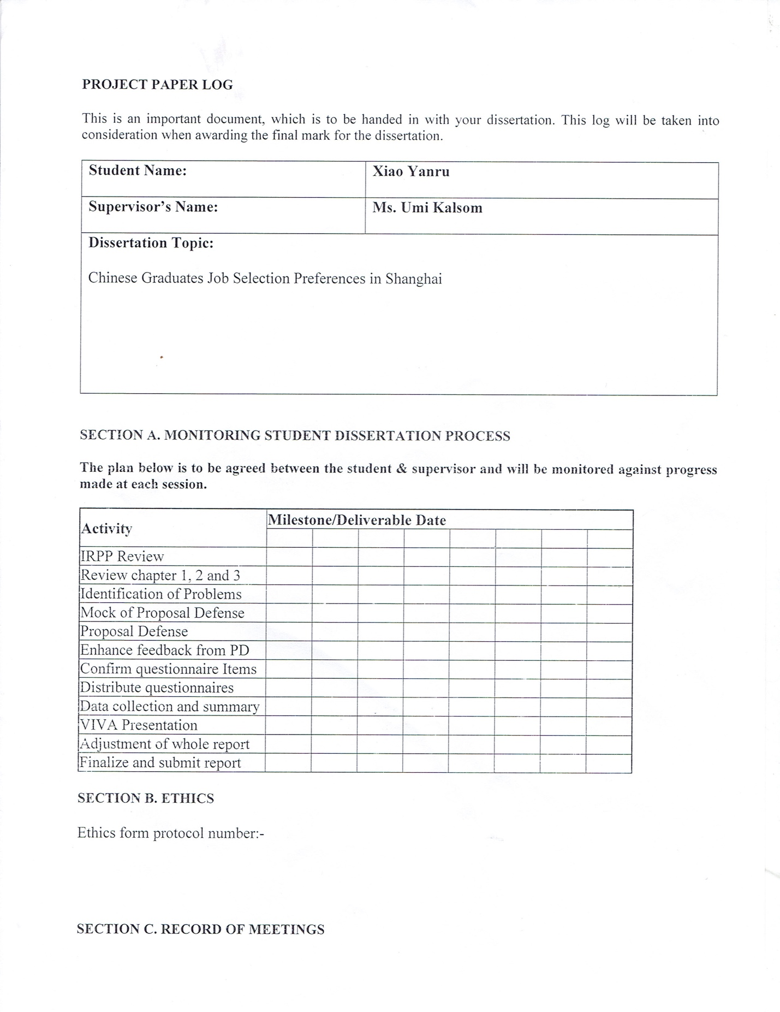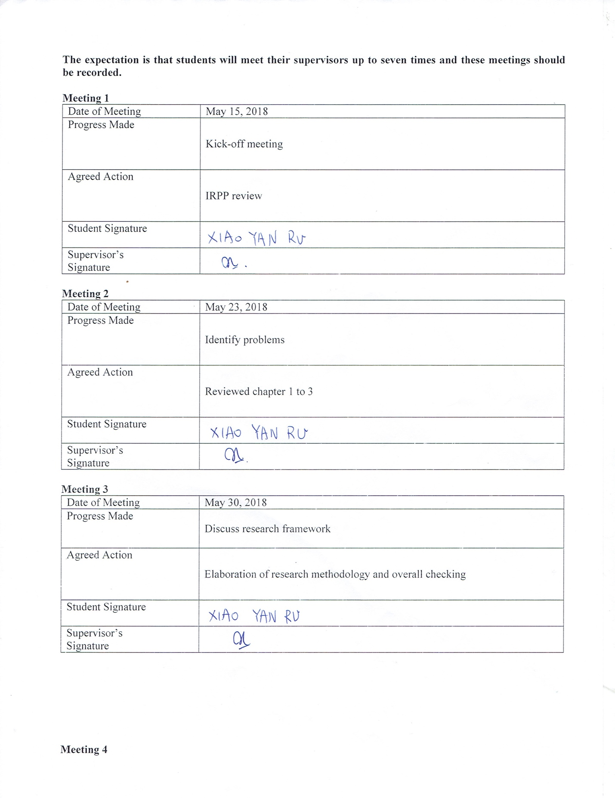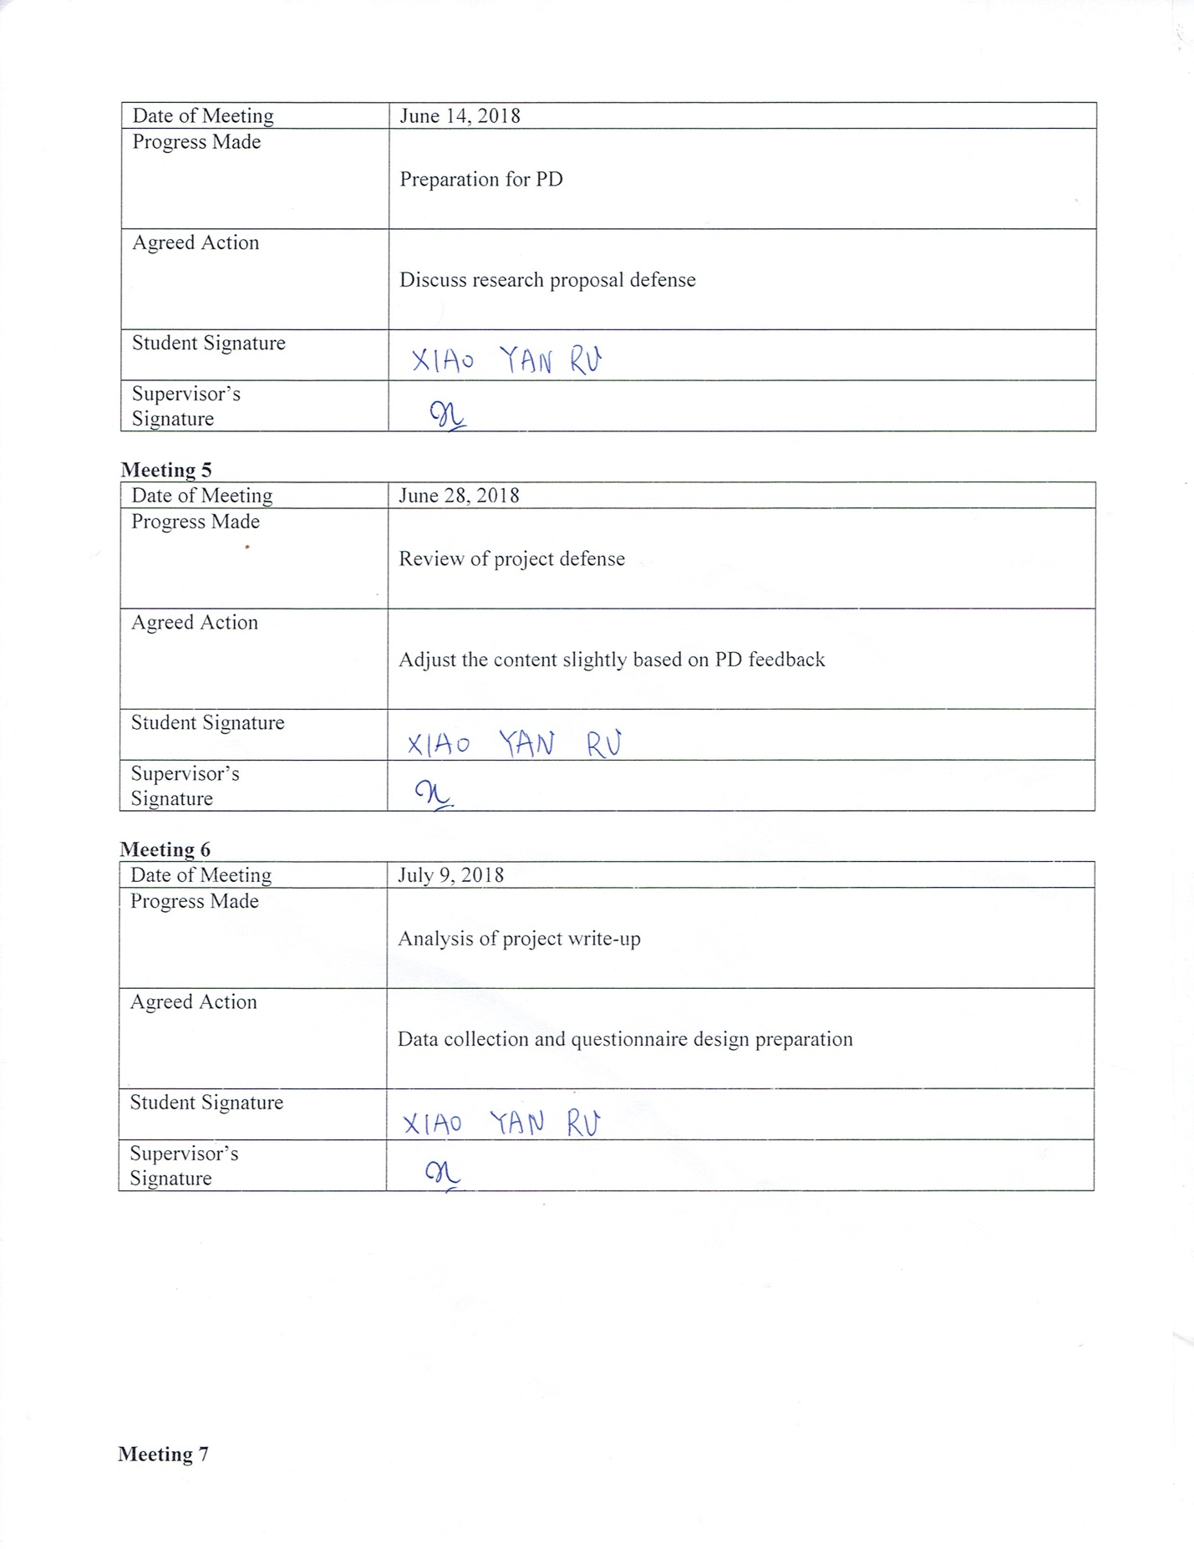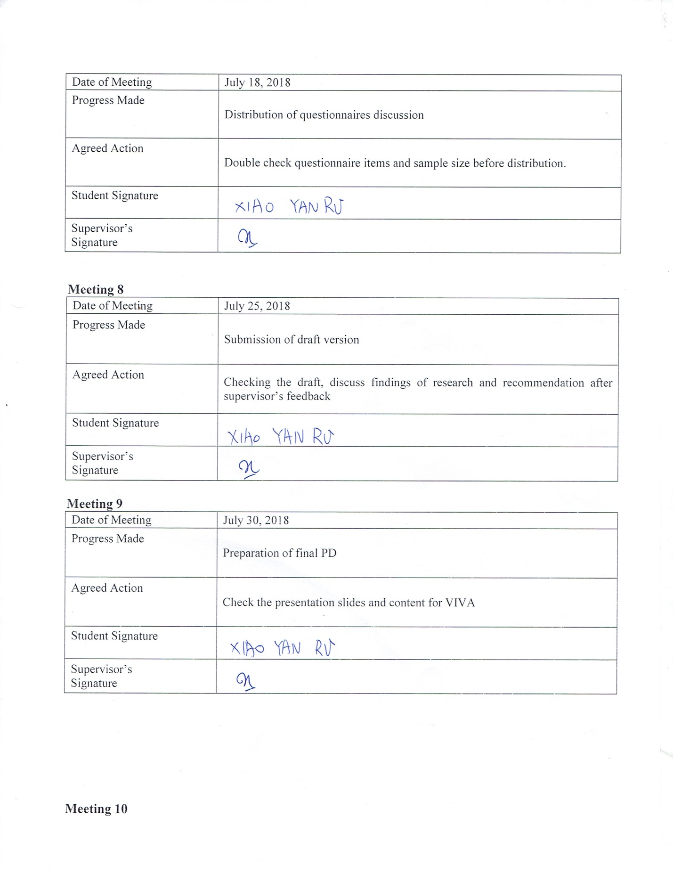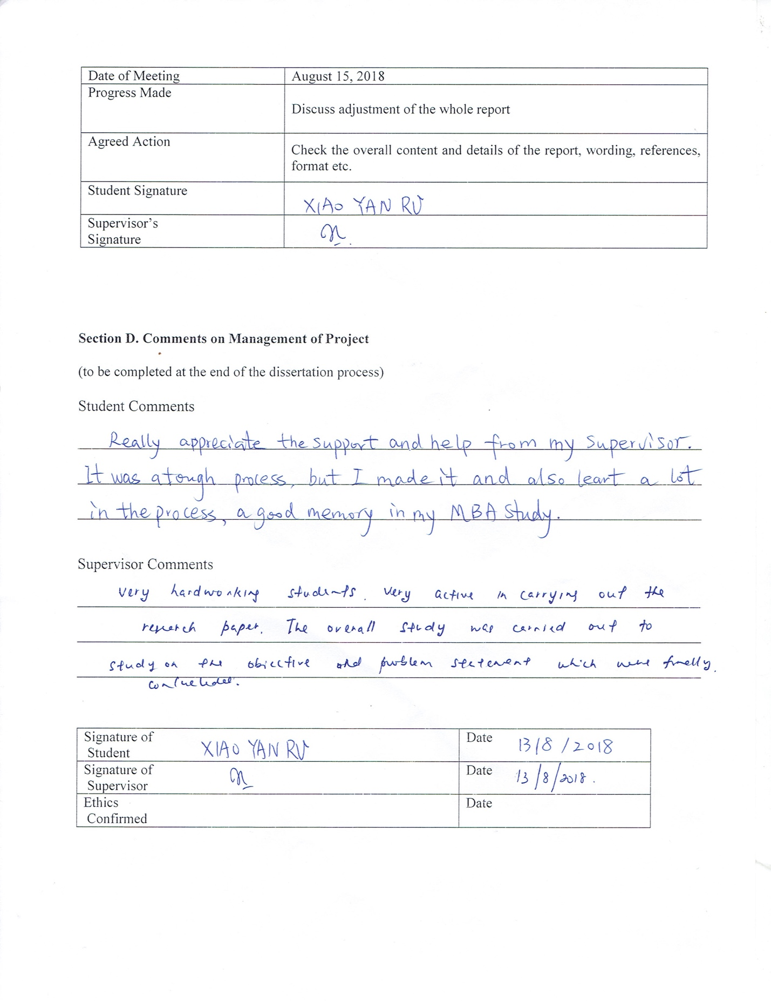

../Turnitin%20result.pdf