Fan Jiayuan MASTER OF BUSINESS ADMINISTRATION 2020 | Identifying factors influencing customer buying behavior towards traditional Tea House in Guangzhou, China  Name: FAN JIAYUAN  ID: I18016301  MASTER OF BUSINESS ADMINISTRATION  INTI INTERNATIONAL UNIVERSITY  2020

Identifying factors influencing customer buying behavior towards traditional Tea House in Guangzhou, China

FAN JIAYUAN

MASTER OF BUSINESS ADMINISTRATION
FACULTY OF BUSINESS, COMMUNICATION & LAW
INTI INTERNATIONAL UNIVERSITY

2020
INTI INTERNATIONAL UNIVERSITY
MASTER OF BUSINESS ADMINISTRATION
Identifying factors influencing customer buying behavior towards traditional Tea House in Guangzhou, China

Author: Fan Jiayuan
Student No: I18016301
Supervisor: Ms. Faziha Abd Malek
Submission Date: 10/4/2020
Final word count: 13036

ABSTRACT
At the mention of Tea House, people naturally think of some people with connotation, because savoring tea is an art and a kind of enjoyment in China. Traditional Tea House is places where people drink tea and have a rest and reduce pressure. The lack of research on consumer buying behavior has affected the development of Tea House enterprises in Guangzhou.

Based on literature review, a research on the consumer behavior of tea restaurants is conducted. Questionnaire was designed, distributed, and analyzed using the SPSS software. Descriptive statistics and correlation analysis were extracted from the data to discover customer needs, communication, convenience, and willingness to pay. Factors behind the behavior were then analyzed to determine market opportunities of the tea restaurant and marketing strategy recommendation was proposed.

The recommendations include: on choice of market segments, adjust market positioning; on customer needs, provide customer-centered product and service; on customer communication, take advantage of every communication opportunity and actively establish communication with consumers; on customer convenience, make the customer as the “king”; on customer willingness to pay, use market penetration pricing.

Key words: Tea House; consumer behavior; Guangzhou

ACKNOWLEDGEMENT

I would like to express my sincere appreciation to everyone who contributed to the accomplishment of this dissertation. I am thankful to my supervisor, Ms. Faziha for her excellent guidance, effort, patience, and time throughout the study. My thanks also go to my examiner, Dr. Alex who has been supportive and offered her valuable comments.
Special thanks to my friends who helped me distribute the questionnaires to their acquaintances. I would also like to spare my utmost thanks to those respondents who have been kind enough to answer my queries as well as the authors whose work helped me have a thorough understanding of the subject. The inputs provided have made the findings of my research conclusive. Very special thanks go to all those who have generously assisted in my work in a way or another.
None of this would have been possible without my family and closest friends. For the support, encouragement, and unconditional love through the times I did not believe in myself, I am forever grateful to them.

DECLARATION

I hereby declare that this thesis is my own work and effort and that it has not been submitted anywhere for any award. Where other sources of information have been used, they have been duly acknowledged.

Name: Fan Jiayuan
Student ID: I18016301
Signature: Fan Jiayuan
Date: 10/4/2020

List of Figure
Figure 1-1: Tea House main geographical distribution in 2016
Figure 1-2: Age proportion of customer in Tea House in Guangzhou
Figure 1-3: Tea House search volume in September 1, 2016 - September 1, 2018
Figure 1-4: The total population of Guangzhou in the past 70 years
Figure 2-1 : Model of consumer behavior
Figure 2-2: Factors influencing consumer behavior
Figure 2-3：Maslow’s Hierarchy of Needs
Figure 2-4：Framework
Figure 3-1: Sample size
Figure 4-2-1: Age and Gender distribution ratio pie chart
Figure 4-2-2 Occupation and Monthly family income distribution ratio histogram
List of Table
Table 4-1: KMO and Bartlett tests
Table 4-2: Reliability test
Table 4-3: Correlation test
Table 4-4: Personal basic information statistics
Table 4-5: KMO and Bartlett's Test of Personal
Table 4-6: Total Variance Explained of Personal
Table 4-7: KMO and Bartlett's Test of Psychological
Table 4-8: Total Variance Explained of Psychological
Table 4-8: Total Variance Explained of Psychological
Table 4-8: Total Variance Explained of Psychological
Table 4-9: KMO and Bartlett's Test of Economical
Table 4-10: Total Variance Explained of Economical
Table 4-11: KMO and Bartlett's Test of Social
Table 4-12: Total Variance Explained of Social
Table 4-13: KMO and Bartlett's Test of Consumer Buying Behavior
Table 4-14: Total Variance Explained of Consumer Buying Behavior
Table 4-15: Summary of results of reliability test
Table 4-16: Cross-analysis of age and frequency of Tea House
Table 4-17: Cross-analysis of occupation and frequency of Tea House
Table 4-18: Cross-analysis of Monthly family income and frequency of Tea House
Table 4-19: Correlation analysis
Table 4-20: ANOVA
Table 4-21: Model Summary
Table 4-22: Coefficients
Table 4-23: Hypothesis result

List of Abbreviations
RO: Research Objectives
RQ: Research Questions
H: Hypothesis
IV: Independent variable
DV: Dependent Variable

Content
1.0 Introduction 1
1.1 Background 1
1.2 Problem Statement 3
1.3 Research Questions/Objectives 5
1.4 Significance of the Study 6
1.5 Limitations 6
1.6 Scope of the Study 7
1.7 Ethical consideration 7
2.0. Literature review 9
2.1 Competition between traditional Tea House and other Tea House in China 9
2.2 The Relevant Theory of Consumer buying behavior 9
2.2.1 Consumer behavior buying pattern 9
2.2.2 The consumer purchasing decision process 10
2.2.3 Howard- Sheth model 11
2.2.4 Kotler behavioral selection model 12
2.5.5 Characteristics influencing consumer behavior 12
2.3 Factors Affecting Consumer buying behavior 13
2.3.1 Personal factors 13
2.3.2 Economical factors 15
2.3.3 Psychological factors 17
2.3.4 Social factors 20
2.4 Relevant marketing strategy 23
2.4.1 Marketing mix of 4P and 4C 23
2.5 Conceptual Framework 25
2.6 Hypothesis 26
2.7 Chapter Conclusion 26
3.0 Research methodology 27
3.1 Research design 27
3.2 Study Population, Unit of Analysis, Sample Selection and Sampling Techniques 28
3.2.1 Study Population 28
3.2.2 Analysis unit 29
3.2.3 Sample Selection 29
3.3 Data Collection and Analysis Methods 29
3.3.1 Data Collection 29
3.3.2 Analysis Methods 30
3.4 Measuring Instrument 31
3.4.1 Descriptive analysis 31
3.4.2 Cross analysis 31
3.4.3 Regression Analysis 32
3.5 Validity and Reliability Tests and Analysis 32
3.5.1 Validity Tests and Analysis 32
3.5.2 Reliability Tests and Analysis 33
4.0 Data analysis 33
4.1 Pilot test 33
4.1.1 Factor analysis of Pilot test 34
4.1.2 Reliability test of pilot test 34
4.1.3 Correlation test of pilot test 35
4.2 Descriptive statistics 36
4.3 Preliminary data analysis 38
4.3.1 Factors analysis 38
4.3.3 Reliability test 43
4.4 Cross Analysis 44
4.5 Correlation analysis 46
4.6 Hypothesis analysis 48
4.6.1 ANOVA analysis 48
4.6.2 Model Summary 49
4.6.3 Coefficients 49
4.7 Result discussion 51
4.7.1 Summary on hypothesis 51
4.7.2 Summary on research questions 53
5.0 Summary 54
5.1 Conclusion 54
5.2 Limitation 55
5.3 Recommendations 55
5.4 Future research 58
5.5 Conclusion 58
5.6 Personal reflection 59
Reference 60
Appendix 71
Appendix 1: PROJECT PAPER LOG 71
Appendix 2: Questionnaire 75
Appendix 3: Initial Research Paper Proposal 77
Appendix 4：Comments on Management of Project 80
Appendix 5: Viva slides 82
Appendix 6: SafeAssign report 95

1.0 Introduction

1.1 Background
China has a long history of tea culture; tea culture in the Tang and Song dynasties has been very famous. The emergence of tea culture began with the active entry into the world of Confucianism and absorbed the essence of Confucianism, Buddhism and Taoism. Buddhism emphasizes "Zen tea blends into one" with tea to help Zen, tea to worship Buddha, not only from the tea taste bitter silence but also from the injection of Buddhist philosophy and Zen (Li, 2019). The Taoist doctrine injects the philosophical thought of "harmony between nature and man" into the tea ceremony, which not only sets up the soul of the tea ceremony, but also injects the aesthetic idea of advocating nature, truth and simplicity, and the thoughts of rebirth, precious life and health preservation (Yan, Ge & Xiong, 2020). The essence of Chinese traditional Tea House culture lies in the inheritance of tea ceremony, which highlights the interactivity, communication and timeliness of relevant information. At the mention of Tea House, people naturally think of some people with connotation, because savoring tea is an art and a kind of enjoyment in China. Tea House is mainly distributed in coastal cities, especially Guangzhou, Shanghai and several southern cities (Lin and Chang, 2020).
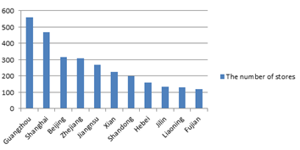
Figure1-1: Tea House main geographical distribution in 2016
Source: Lin Ke Ai Pu in China

There are mainly three types of Tea Houses in China: middle and high-end Tea Houses located in Central Business District (CBD) business district, such as Charme Tea House；Tea House with delicate and delicious dishes favored by small bourgeois, such as Bi For Time Tea House; traditional casual and affordable Tea House (Lai, 2015). Tea House for everyone to provide an equal environment, so that people can chat, makes friends, gather, and talk freely. Consumers who come to consume can release their real selves, because there is no competition for jobs, any variety and bondage of the family, but only to relax themselves. It is common for Chinese people to wait in line with the number paper during the peak time.

The sales of Tea Houses in China are estimated to have increased from 17.7 billion yuan in 2011 to 65 billion yuan in 2016. According to incomplete statistics, there were 3,728 Tea Houses in mainland China as of 2011 (Jiang, 2019). In Guangzhou, a first-tier city, restaurants of all sizes are almost everywhere. People have many choices, from fast food costing as little as a few yuan to buffet costing hundreds or even thousands of yuan, so the catering market in Guangzhou has already reached the saturation level. But this situation does not exist in Tea Houses, according to the survey, although the real traditional Tea Houses is not difficult to see in Guangzhou, but far from the saturation of the market capacity, the market gap is still large.

The market share of Chinese Tea Houses has been increasing by a large margin and has been occupying more and more market shares year by year at the rate of 20% from 2008 to 2012. In terms of the industry, the sales volume of Tea House enterprises in 2008 increased by 43.25% over the previous year, ranking the highest in the industry (Jiang, 2019). In 2009, from the perspective of turnover and growth rate, Tea House enterprises are still developing rapidly. The growth rate of turnover is far higher than that of other business forms in the top 100, with the growth rate of more than 50%.

This study is to understand the influence factors of Chinese consumer behavior and product purchase in Tea Houses. The purpose is to find out the important variables in the marketing process of Tea House. In addition, according to analyze and discuss the variables of consumer consumption in Tea House, so as to determine the market potential and market opportunities of Tea House.

1.2 Problem Statement
The main target customers of traditional Tea Houses in Guangzhou are people between 40 and 60 years old, who have more time to savor tea and talk about it, while young people prefer to go to bubble tea shops and fast food restaurants (Lin & Chang, 2020). From Figure1-2, Consumers aged between 41 and 60 accounts for 92%, while consumers aged between 0 and 20 only accounts for 1%. The age difference between consumers is very obvious.
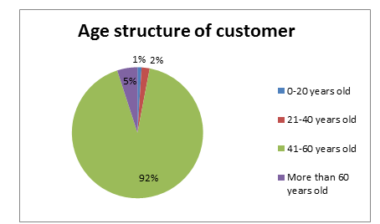
Figure1-2: Age proportion of customer in Tea House in Guangzhou
Source: China Baidu Data Analysis

Since 2016, the sales of each Tea House brand have declined significantly because of the popularity of bubble tea. Total sales for the Tea House industry are down 10 % from the same period in 2015 and net profit is down more than 50 %. The overall Internet search index of Tea Houses has shown a downward trend. And the number of Tea Houses in China dropped from 4,110 to 3,410, with a mortality rate of 17% (Gatling et al., 2020). On the one hand, the upgrade of Tea House itself is slow, while the iteration cycle of Chinese restaurants is constantly shortened under the promotion of consumption upgrade. On the other hand, consumers have higher and higher requirements for quality. In the brand financial report, all brands attribute China's economy will gradually shift to a consumption-led model while maintaining steady growth. With the development of the economy, Chinese consumers will have more wealth and diversified consumption preferences by 2027.

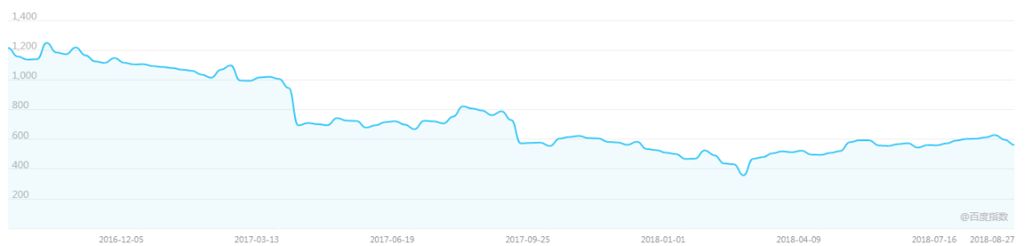
Figure1-3: Tea House search volume in September 1, 2016 - September 1, 2018
Source: China Baidu Search Index

The study is conducted to identify the factors influencing customer‘s consumption in traditional Tea House, so that suitable strategies can be suggested to improve the sales. The weak market of Tea House cannot leave the influence of the Chinese market environment, but more from the brand's own aging and slow renewal (Erkmen and Hance, 2019). Tea House enterprises should find a better marketing strategy, in order to let the brand rebirth as soon as possible.

1.3 Research Questions/Objectives
The main purpose of this study is to analyze the consumption behavior of Chinese consumers towards Tea Houses and its influencing factors.
RQ1: Does personal factors have a significant impact on customer buying behavior?
RQ2: Does economical factors have a significant impact on customer buying behavior?
RQ3: Does psychological factors have a significant impact on customer buying behavior?
RQ4: Does social factors have a significant impact on customer buying behavior?
RQ5: What are the suitable marketing strategies suggested to Tea Houses?
Objectives
RO1: To determine whether personal factors have a significant impact on consumer buying behavior in Tea Houses.

RO2: To determine whether economical factors have a significant impact on consumer buying behavior.

RO3: To determine whether psychological factors have a significant impact on consumer buying behavior.

RO4: To determine whether social factors have a significant impact on consumer buying behavior.

RO5: To suggest suitable marketing strategy to the Tea House based on the result of analysis.

1.4 Significance of the Study
Academic significance: In the academic field, there is little research on Tea Houses, most of which focus on the overall situation of Chinese Tea Houses, and few of which focus on specific cities such as Guangzhou. Therefore, this paper enriches the academic research on Tea House enterprises.

For the government and industry: this is conducive to the regulation of China's Tea House market, to maintain market stability. It provides some valuable ideas for the research and sustainable development of similar tea catering enterprises.

1.5 Limitations
In this study, the purchasing behavior of consumers was studied through questionnaires. Limited by time, labor, cost and other factors, this paper only takes Guangzhou Tea House as an example for investigation and analysis. In addition, the collection of samples is mainly field survey and network survey, and most of the data are obtained through network survey. After the screening of questionnaires, inevitably, a few parts of the authenticity of questionnaires remain to be verified. Secondly, the limited number of samples will also affect the effect of data analysis. The sample size is not large enough to fully reflect the characteristics of consumers' consumption behavior, which also has certain limitations. In the future, more comprehensive first-hand information can be obtained through more extensive surveys; so as to better known consumers' consumption behaviors and formulate more scientific and perfect market competition strategies.

The marketing strategy suggested in this paper should be further investigated in more detail and more factors should be taken into consideration in the in-depth operation. Due to the limited level, this paper has many shortcomings in the depth of research and demonstration.

1.6 Scope of the Study
The purpose of this study is to analyze how personal, economical, psychological and social significantly affect consumers' purchasing behavior in Tea Houses, the scope of the study is Guangzhou, China. According to the census results, the population of Guangzhou in 2019 is 12.968 million (Gao and Wang, 2020). The sample size of the questionnaire is 400, which were randomly distributed in 11 districts of Guangzhou. This paper focuses on potential buyers and buyers. The research methods included literature review, questionnaire survey and SPSS statistical analysis.
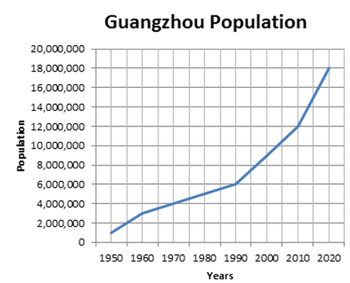
Figure1-4: The total population of Guangzhou in the past 70 years
Source: China National Bureau of Statistics

1.7 Ethical consideration
In designing the questionnaire, we respect everyone's privacy and do not treat the investigators differently. The questionnaires were randomly distributed without discrimination on gender, occupation or income. The questionnaires were also anonymous and would not reveal personal information. At the same time, in the questionnaire analysis, different Tea Houses will not be evaluated to avoid misleading consumers for publicity and advertising. In the process of processing the sample results, there will be no second-hand sales data and the results will be used to publicize the store.

1.8 Chapter organization

Chapter 1 introduces the research background and problem statement. Through the research objectives and research questions, the significance of the research is derived. After that, the limitations and scope of the research are expounded, and finally, the ethical considerations are discussed.

Chapter 2 is a review of relevant literatures, which are related to the variables of this study: personal, economical, psychological, social factors.

Chapter 3 discusses the research methods in detail, including research design, measuring instrument, questionnaire survey, sample size, sample design, survey methods, data processing and analysis.

Chapter 4 is the results of data analysis and online survey. IBM-SPSS 22.0 is used to chart the research results, and descriptive analysis, cross analysis, difference analysis and multiple regression analysis are used to verify the hypotheses, and finally the data is summarized.
Chapter 5 analyzes and discusses the main research results of this study, and puts forward suggestions for the improvement of Chinese Tea House enterprises.

2.0. Literature review

2.1 Competition between traditional Tea House and other Tea House in China
Common Tea House has fierce competition with traditional Tea House brands. Since 2005, Common Tea House in China has witnessed rapid growth in sales and high gross profit, attracting numerous market participants. Common Tea House belongs to the public consumption, products like ordinary milk tea, bubble tea and so on. Traditional Tea House, generally not too much advertising and celebrity endorsement, mainly by the old customers and some people like classical stay in business, while other common Tea House, too much in the film and television advertising and celebrity endorsement, so popular by young people, the store is also decorated also very accord with young people's aesthetic, in time to follow the tide of fashion. There will be one common Tea House within 100 meters of the first-tier cities, while there will be one traditional Tea House within 2 to 3 kilometers. In recent years, more and more traditional Tea houses have closed down. The consumer of common Tea House is very much, consumer basically is teenager student. The style that the shop decorates accords with youth aesthetic, decorate a design to have a characteristic relatively. So the market demand now and the market demand in the future are huge. The main consumer force of traditional Tea Houses at present is the population over 40 years old. In recent years, traditional Tea House is frequently threatened by crisis in the fierce market competition. Common Tea House is a huge threat to the survival of traditional Tea Houses.

2.2 The Relevant Theory of Consumer buying behavior
Generally speaking, when customers purchase products, they first generate the demand for the product, and then they confirm the purchase, and then they look for the information that can meet the demand according to their own needs, so as to generate the corresponding product cognition (Kotwal Gupta and Devi, 2008). After the cognitive evaluation of the goods, the selection and brand, decision and purchase behavior are evaluated. Finally, the goods used after the purchase is evaluated.
As the decision-maker of consumer behavior, the core part of consumer behavior is consumer decision making (Teo and Yeong, 2003). Generally speaking, there are certain steps to follow in the decision-making process of consumers. First, requirements identification, information search and then evaluation of alternatives followed by purchase action and after-sales evaluation.

The first step for a consumer to enter the market is to identify the "problem" that they need to solve, that is, the existence of a demand. The problems on the consumer demand side come from a number of sources, mainly from the shortage of goods, which is mainly aimed at basic personal or household items.

The second step is to gather information. Consumers' information sources include consumers' personal experience, relevant public influence, mass media and other aspects. Enterprises should pay attention to the above factors to provide information to consumers, and at the same time, consider the factors that affect consumers' access to information.

The third step is to evaluate the scheme. In more complex purchases, consumers value and compare information they already have so they can make a decision about what to do next. Enterprises should constantly develop products to meet the different needs of consumers, and try to make their own business of commodity trademarks, characteristics to leave an impression on consumers, in order to facilitate consumer choice and comparison.

The fourth step is purchase action. Consumers will choose a product that is in a dominant position.

The finally step is after-sales evaluation. After the consumer has purchased the product, the purchase decision process continues, he has to evaluate the purchase of the product. The enterprise still must give full attention to this step, because it is related to the future market of the product and the credibility of the enterprise. There are two theories to judge the post-purchase behavior of consumers, one is "expected satisfaction theory"; the other is called the cognitive gap theory.

In the 1960s, Howard proposed another model of consumer behavior, and later published the theory of buying behavior together with Sheth (Farley and Ring, 1970). This is the famous Howard and Sheth’s idea. This model describes customers' buying behavior mainly through four factors.

" Howard- Sheth model " points out that the stimulus of consumer buying behavior is the external factors and input factors that influence and influence the psychology of consumers through arousing and becoming motivation. Consumers by the original consumer experience and external factors, the influence of input factors, first adopted approaches to information, to produce their own to buy consumer motivation, make a series of reactions to choose alternative goods, all kinds of intermediary factors to influence consumer decisions, or put forward various rules of various sheet with alternatives (Lutz and Resek, 1972). The interplay among these mediating factors, choices and motivations leads to a certain attitude or tendency on the part of consumers. This attitude or tendency is combined with other limiting factors, such as purchase behavior, to produce the consumption result, that is, consumers' purchase intention and their actual purchase behavior. He thinks the impact on many factors, can be roughly divided into two kinds: the external factors and internal factors, external factors include social class, reference groups, culture and subculture, social environment, family, time, etc.; Internal factors include feelings, self, perception, attitude, motivation, values, lifestyle and personality (Rani, 2014).

2.2.4 Kotler behavioral selection model
Philip Kotler proposes a simple model that emphasizes both aspects of consumer behavior in society. Kotler believes that consumer behavior includes the psychological, emotional and physical activities that people use when they choose, buy, use and dispose of products and services that meet their needs and desires (Kotler, 1999). This model shows that consumers' reaction to purchase behavior is not only influenced by marketing, but also influenced by external factors. However, consumers with different characteristics will have different psychological activities. Through the decision-making process of consumers, certain purchase decisions are made, and finally consumers' choices on products, brands, dealers, purchase timing and purchase quantity are formed.

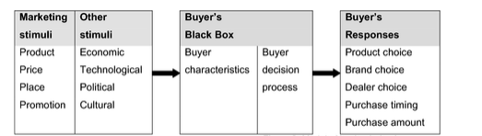
Source: ( Kolter, 1999)

2.2.5 Characteristics influencing consumer behavior
If a market environment has determined that the consumer buying decisions, its behavior is not isolated, in the purchase decision of the process. The consumer buying behavior is relevant to several factors or forces can be roughly divided into five kinds. They are: Psychological factors; Social factors; Cultural factors; Economic factors; Personal factors (Nagarkoti, 2014). By understanding these characteristics and taking action, companies can better meet customer expectations and improve their marketing strategies.
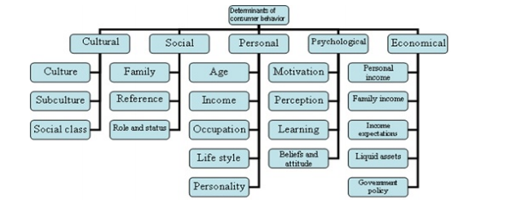
Source: (Iitmaverick, 2012)

2.3 Factors Affecting Consumer buying behavior

2.3.1 Personal factors
Personal factors also influence buyer behavior. The characteristics of each consumer will influence on the buying behavior and decisions. These can be age, income, occupation, lifestyle and personality (Lee, 2008).

Age is the most important factor in personal factors. Consumers buy different goods and services at different stages of their lives. Customers often is various, not sure, need to analyze and guide, few customers, especially the buyers of consumer goods on their own to buy consumer products formed the very accurate description, that is to say, in front of the customer, he has great interest in products but still don't know what they will buy back. In this case, it is necessary to enhance communication with customers and define their needs. (Ramy and Ali, 2016). The definition of customer demand refers to the process of gradually discovering customers' desire, use, function and style of products purchased by customers through long-term communication between buyers and sellers, and describing and showing customers' vague understanding in an accurate way. Consumers of different genders also have great differences in their purchasing behaviors. Communication should not be superficial; otherwise it can only be empty talk. The same is true for the definition of customer demand, which is regarded as a simple desire to buy, or a simple purchase process that is obviously restricted by limitations. Only by in-depth understanding of the customer's life, work and communication, can we find out his real demand for the same product.

Income mainly forms the purchasing power of the consuming population, and the higher the level of income, the greater the purchasing power. Therefore, for business marketing, it is necessary to distinguish the following concepts: personal disposable income. That is the balance after deducting various taxes (income tax, etc.) and non-tax burden (such as union fees, endowment insurance, medical insurance, etc.) in personal income. It is the part of an individual consumer that can spend or save, forming the actual purchasing power; can be arbitrary control of personal income, personal disposable income minus to maintain necessary for individual and family expenses (like electricity, food, clothing, housing, etc.) and other fixed expenses (such as tuition fees, etc.) after the rest of the part (Taylor and Taylor, 2004). This part of the income is consumer can command, so it is the most active factor in consumer demand, also want to consider to the enterprise to carry out marketing activities of the main object; household income, the consumption of many products is based on the family as a unit, such as refrigerator, television, air conditioning, so the level of household income will affect the market demand for many products.

Occupation has a great influence on purchasing behavior (Rani, 2014). People in different occupations have different incomes and purchasing power. People in different occupations also have different needs and buying preferences. Therefore, it is very important for enterprises to segment the market of different occupational groups.

Lifestyle will affects consumers' buying behavior, and lifestyle is the way people live and spend time and money, reflecting a person's activities, interests and opinions (Kim, Rao & Cho, 2000). Market development today, regardless of the number of varieties have been preliminary have let consumers can according to individual psychological desire to select and purchase goods or services, on the basis of consumer choice is not just the use value of goods, but also include other "extension", psychological identity has become consumers make buying a particular brand of product decisions prerequisites, personalized consumption is becoming also will become the mainstream of consumption. For example, if a customer wants a unique lifestyle, they will look for products that embody this personality.

The rich literature on personality research in psychology and other behavioral sciences has led marketing researchers to conclude that personality traits should help predict buying activities such as brand or store preference (Shehzadi et al., 2016). In the 1950s, the American scholar Evans tried to use personality to predict whether consumers would own a Ford or a Chevy. He distributed a standard personality inventory to the owners of Ford and Chevy, and then used discriminant analysis to analyze the collected data. It found that personality traits accurately predicted the actual car owner 63 percent of the time (Nagarkoti, 2014). Since this prediction would also be accurate 50% of the time in the random case, personality does not have much of a predictive power for behavior. Vance concludes that personality is less valuable in predicting the choice of car brand. Although several follow-up study found about there is relationship between personality and product selection and use of evidence, but personality can explain the changes in the quantity is small, and so far, even if is conclusive study, personality can explain the change of quantity is not more than 10%, only smaller predictive power on behavior, personality, in fact is not surprising, because it is just one of many factors that influence consumer behavior factors. Even if personality traits are effective predictors of behavior or buying intentions, the ability to segment a market based on them depends on a number of conditions.

2.3.2 Economical factors
Economical factors are consumers' personal income, family income, expected income, liquid assets, government policies, etc. (Ramya and Ali, 2016). When a commodity price is too high or rising prices, consumer demand for the goods will reduce, on the contrary, when the price of a commodity is low or falling, consumer demand for its will continue to increase, so the price of goods itself is the most direct factors influencing consumer choice. The consumer economy condition is better, may produce the higher level demand, buys the higher grade commodity, and enjoys the higher level consumption. Generally speaking, other things being equal, the higher the consumer's income, the greater the demand for goods.However, with the continuous improvement of people's income level, the structure of consumption demand will change, that is, with the increase of income, the demand for some goods will increase, while the demand for some goods will decrease. Personal disposable income refers to the actual income (i.e., the currency balance) that an individual has at his disposal after deducting taxes and mandatory deductions from his total income (Mittal, 2018). An increase in disposable income leads to an increase in expenditure. On the other hand, the decline in disposable income will lead to a decline in all expenditures.

Family income refers to the total income of all members of a family, which is divided into high-income families and low-income families (Pandya and Pandya, 2018). Family income directly affects household purchasing behavior.

Income expectation is one of the important determinants of individual purchasing behavior (Moreno et al, 2017). If a person expects his income to increase, he will spend more on shopping and luxuries. If he expects his future income to decline, he will spend less on nonessentials and luxuries and limit his spending to basic necessities.

Liquid assets are assets that can be quickly converted into cash without any loss (Ramya and Ali, 2016). Liquid assets include cash on hand, bank deposits, securities, etc. If a person has more liquid assets, he will buy the goods and luxuries he likes. If he had less liquid assets, he could not spend more on non-necessities and luxuries.

Government policies can indirectly affect consumers' purchasing behaviors (Kim, Rao & Cho, 2000). By regulating prices, the government will affect the sales volume of commodities and thus affect consumers' purchasing behaviors.

2.3.3 Psychological factors
Consumer buying behavior is influenced by individual motivation, perception, learning, belief and attitude and other major psychological factors (Ramya and Ali, 2016).

Solomon states that motivation occurs when a need, that the consumer wishes to satisfy, is aroused. The behavior of the consumers is derived from motivation (Kazi and Khan, 2020). Motivation will press an individual enough to satisfy a certain wanted need, and a need will become a motive when it raises a certain amount of intensity. Motivation is the internal capacity that motivates one's actions towards a certain goal. At any given time, a buyer is influenced by multiple motives rather than just one. At one point, some motives are stronger than others, but such strong motives are different at different points in time. Sometimes motivation can reduce or increase stress. But if one motivation forces us toward one goal and another drags us toward another, the pressure may increase because we are not achieving any of them.

Psychologists have come up with many theories about human motivation, among which Maslow's "hierarchy of needs" is the one most commonly used to explain consumer behavior. The basic point of this theory is that human needs can be arranged in five levels from bottom to top according to their intensity: survival needs, safety needs, social needs, esteem needs and self-actualization needs (McLeod, 2007).. People always from the low to the high, first to meet the most important needs, only when the most important needs are relatively satisfied, the next level of needs will play a leading role.
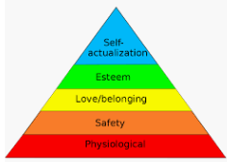
Figure 2-3：Maslow’s Hierarchy of Needs
Source (Schiffman & Kanuk，2000)
Perception is a series of processes of awareness, sensation, attention and perception of internal and external information. Perception can be divided into sensory process and perceptual process. The sensory information includes the internal physiological state and mental activity of the organism, as well as the existence of the external environment and the relationship of existence. The senses not only receive information, but are also affected by psychological effects. In the process of perception, sensory information is processed in an organized way, and the existing form of things is understood. Customer perceived value is a subjective evaluation of the effectiveness of a product or service by subtracting the cost of obtaining the product or service from the perceived benefits of the product or service (Lapierre, 2000). It reflects the customer's specific cognition of the value of the product or service, thus distinguishing it from the objective value of the product or service in the general sense. Customer perceived value is considered to be the result of subjective perception of customer's transferred value.

Customers don't buy things; they buy what they expect. Consumers want to achieve certain customer value in the transaction process. The essence of customer value is customer perception, that is, customers' subjective perception of the interaction process and result with an enterprise, including the comparison and tradeoff between customers' perceived gains and perceived losses. Customer perceived value refers to customers' subjective cognition of the value of products or services provided by enterprises, which is different from the concept of customer value in the traditional sense. The latter refers to the value that an enterprise believes its products or services can provide to customers, which belongs to the internal cognitive orientation of the enterprise (Cretu and Brodie, 2007). The former refers to the value judgment of customers on the products or services provided by the enterprise, which belongs to the external customer cognitive orientation. Guests' perceptive value is the core of Perceived Benefits and Perceived sacrifice tradeoff between. This concept contains two meanings: first, value is personalized and varies from person to person.

Learning refers to the change of personal behavior caused by experience, that is, consumers gradually acquire and accumulate experience in the practice of purchasing and using commodities, and adjust their purchasing behavior according to the experience. Learning occurs through the interaction of driving forces, stimuli, cues, reactions, and reinforcement. The driving force is the internal stimulating force that induces people to act (Herhausen and Schögel, 2013). For example, a consumer values status, and respect needs is a driving force. This drive is directed to a stimulus such as a designer suit, and the drive becomes motivation. Under the control of motivation, consumers need to make a reaction to buy a famous suit. However, the purchase behavior often depends on the stimulus of the surrounding prompt, such as watching the relevant TV ads, visiting the display of goods, he will complete the purchase. If he is satisfied with the clothes, his reaction to the goods will be strengthened, and if he encounters the same incentive again, he will have the same reaction, that is, he will take the action of buying. If the response is repeatedly reinforced, over time, it becomes a buying habit. This is how consumers learn.

Enterprise marketing should pay attention to the role of learning this factor in consumer buying behavior, through a variety of ways to provide information to consumers, such as repeated advertising, the purpose is to achieve to strengthen incentives, stimulate driving force, people's driving force to stimulate the point of immediate action. At the same time, the goods and services provided by enterprises should always be of high quality. Only through learning can consumers develop a preference for enterprise brands and form the habit of purchasing their own products.
Social factors include small groups or in other words reference groups, family, and social roles and status. These factors have special skills, knowledge, personality or other characteristics that can have social influence on others. Family is the most important social factor (Kotler et al., 2013).

The family is between the society and the individual. The family includes the individual and forms the consumer group (Sheth, 1974). Each member affects each other, the general wife manages domestic financial situation is more. At the same time, family life cycle is also a factor influencing consumer behavior.

A reference group is two or more people who are interdependent in pursuit of a common goal or interest. Individual attitudes and behaviors can be influenced by various groups. The group that has a direct or indirect influence on the person's attitude and behavior is the reference group. Reference groups have an impact on consumers in demonstrating new behavior patterns and lifestyles, and in promoting attitudes and perceptions about products and businesses (Bearden and Etzel, 1982). Reference groups also put pressure on individuals to behave in a consistent way and to play a real role in products, brands and so on. Therefore, in the analysis of consumer behavior, it is necessary to accurately judge the reference group of target consumers, find out the concept guides, and communicate with them in a focused way so that the reference group can exert greater influence.

Social status and role means that everyone plays a certain role and has a corresponding status in the society, which will have an impact on purchasing decisions and behaviors (Yurchisin and Johnson, 2004). People with different social roles and positions often have different consumption behaviors. In other words, the consumption of different social classes is determined by their own life quality and lifestyle. People usually choose products and services that match their status, and products and brands may also become status symbols. Social class refers to the group with relative homogeneity and permanence in the society. Sociologists concluded that the upper class, the lower class, the upper class, the middle class and the working class accounted for about 70%. Social class is an important factor influencing consumer behavior because members of each class have similar values, interests and behaviors. In the field of consumption, different social classes have different preferences for products and brands, as well as obvious differences in the ways of information transmission and contact.

Beliefs and attitudes are people's fixed views or opinions about something formed through learning or personal experience. These beliefs and attitudes affect people's future buying behavior. Beliefs and attitudes are hard to change once they are formed, and they lead consumers to buy certain goods habitually. The attitude of consumers refers to the emotional reaction of consumers to objects, attributes and interests, that is, consumers have a consistent preference or dislike for a certain product, brand or company through learning. Consumers form an attitude toward a product, service, or business, store it in memory, and when needed, take it out of memory to cope with or help solve the purchase problem they are facing (Gadenne, 2011). In this way, attitudes help consumers adapt to the dynamic buying environment more effectively, so that they don't have to interpret and react in new ways to every new thing or new product or new marketing tool. In this sense, the formation of attitude can meet or help to meet some consumption needs, or in other words, attitude itself has a certain function.

Although many theories about the function of attitude have been developed in the academic world, the four functions of D. Katz have received much attention. Adjustment Function: it means that attitude can make people better adapt to the environment and avoid disadvantages (Kobia and Liu, 2017). Human beings are social animals, and others and social groups play an important role in the survival and development of human beings. Only by forming appropriate attitudes can one gain approval, reward, or fellowship with certain important people or groups. Ego Defense Function: it refers to the formation of attitudes about certain things, which can help individuals avoid or forget the harsh environment or the reality that is difficult to face, so as to protect their existing personality and maintain their mental health. Knowledge Function: it refers to the formation of a certain attitude, which is more conducive to the understanding and understanding of things. In fact, attitudes can serve as a standard or reference to help people understand the world, helping them to give meaning to the changing external world. Value-express Function: it means to form an attitude to express one's core values to others. In the late 1970s and early 1980s, when the door was just opened to the outside world, some young people wore plaid shirts and bell-bottom pants as fashion, while many middle-aged and elderly people complained about this kind of dress, which actually reflected the different values of the two generations in accepting foreign cultures.

Consumer belief refers to the knowledge held by consumers about the properties of things and their benefits. Different consumers may have different beliefs about the same thing, and this belief will affect consumers' attitudes (Collins, Steg & Koning, 2007). Some consumers may think that the quality of brand-name products is much higher than that of ordinary products, which can provide great additional benefits. Other consumers insist that, as products mature, there is not much difference in quality between different companies, and that the added benefits of brand-name products are not as great as people think. Obviously, these different beliefs can lead to different attitudes towards brand-name products.

2.4 Relevant marketing strategy

2.4.1 Marketing mix of 4P and 4C
In the late 1950s, the theory of the 4P marketing mix was developed by Jerome McCarthy pointed out that 4P refers to product, place, price and promotion (Wang, Wang and Yao, 2005). 4P marketing mix theory can be regarded as a very classic theory in the industry, which has great significance and influence in marketing theory and practice. The core of the 4P marketing mix is the tools of the products it sells, and making profits by selling the products (Yun-sheng, 2001). The 4P marketing mix theory is fundamentally product centered, and the way to make consumers accept products as much as possible is to make an issue of products. These strategies are basically product centered, and make customers accept products by making an issue of products as much as possible.

The 4C marketing mix was put forward by Lauterborn: Customer wants and needs, Convenience, Communication and Cost Customer wants to pay (Eavani and Nazari, 2012). The enterprise should attach importance to the customer first, emphasizing the creation of customers is more important than the development of products. Satisfying the needs and desires of consumers is more important than the function of the product. It is not just to sell the products that the enterprise wants to make, but to provide the products that the customers really want to buy. The production cost of an enterprise is the cost of producing products suitable for the needs of consumers. Consumer shopping costs are not only the monetary cost of shopping but also the time, physical and mental costs and risk taking. The new pricing model requires that consumers support the price - appropriate profit = cost ceiling. So firms must cut costs if they want to increase profits within the limits of consumer-supported prices (Yun-sheng, 2001). Enterprises should have a deep understanding of the different purchase methods and preferences of different consumers, carry out the principle of convenience throughout the whole process of marketing activities, and timely provide consumers with accurate information about the performance, quality, price, use method and effect of products by providing pre-sale services. After-sales service should attach importance to information feedback and tracking investigation, timely deal with and reply to customers' comments on the goods with problems to take the initiative to return and replace, to use faults to actively provide maintenance convenience, bulk goods or even lifetime warranty (Syaglova, 2015). Enterprises should try a variety of marketing plans and marketing mix through communication with customers. If they fail to receive ideal results, it means that enterprises and products have not been fully accepted by consumers. At this time cannot rely on strengthening one-way persuasion customers, to focus on strengthening two-way communication to enhance mutual understanding to achieve truly marketable, loyal customers.

4P has certain practical significance, which is to guide the marketing promotion activities of manufacturing enterprises (Gilaninia Taleghani and Azizi, 2013). However, it has no role in catering service, financial service, retail and other industries, and 4P is not suitable for these industries. As a result, it is difficult for these enterprises to make further progress when they have developed to a certain degree, because 4P does not reflect the needs of consumers and the needs of the whole market, and cannot well reflect the interests of customers. On this basis, some manufacturers in theory will focus on customer marketing, from the relevant interests to the focus on people, reflecting consumer needs and interests (Syaglova, 2015).

The theory of marketing is transformed from 4P to 4C, from focusing on enterprises to focusing on consumers, and from focusing on the interests of enterprises to focusing on consumers, which reflects the interests and demands of customers in consumption.
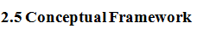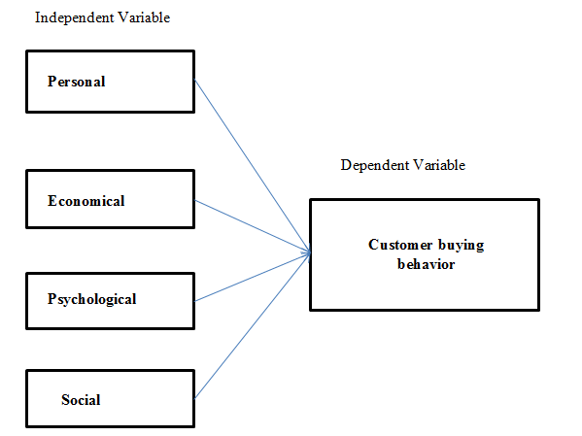
Figure 2-4：Framework

The theoretical framework is the basis for the study of logical expansion and description, which can explain the relationship network between independent variables and dependent variables related to the problem and determine through investigation (Libby, 2017). In the model above, the research framework shows the relationship between personal, economical, psychological as well as social factors and consumer buying behavior in Tea Houses.

Hypothesis 1: Personal factors have a significant impact on consumer buying behavior in Tea Houses.

Hypothesis 2: Economical factors have a significant impact on consumer buying behavior in Tea Houses.

Hypothesis 3: Psychological factors have a significant impact on consumer buying behavior in Tea Houses.

Hypothesis 4: Social factors have a significant impact on consumer buying behavior in Tea Houses.

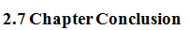
This chapter expounds the related theory and model of consumer purchase behavior, four factors of the independent variables: personal, economic and psychological, on the concrete analysis to the society. After reference to the 4P and 4C marketing theory, the marketing theory of 4P and 4C is cited, and Maslow's demand theory combined with the marketing strategy of catering industry is introduced.

In this chapter, the conceptual framework and assumptions of the research are proposed, and all the research in this paper is based on the framework model. In the next chapter, the research method of this paper will be introduced in detail.

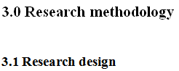
In this study, relevant data were collected by means of questionnaire survey, and then conclusions were drawn through SPSS22.0 software analysis. This study explored the relationship between the four independent variables and the research object by obtaining the information related to the research object.

Based on the understanding of the industry of traditional Tea Houses in Guangzhou, and through online search of industry information, more clearly understand the basic market conditions of Guangzhou Tea Houses. The study focused on consumers and potential consumers of Guangzhou, China. From the point of view of the survey object, different consumers have different consumption preferences. Therefore, the factors that affect consumers' purchasing behavior are also various. This paper mainly designed questionnaires based on the consumers and potential consumers of Guangzhou Tea House, and put forward specific questions.

Before designed the questionnaire for Tea Houses, conducted small-scale interviews with several famous Tea Houses in Guangzhou, and then modified and improved the contents of the questionnaire for Tea Houses according to the final interview, and distributed the questionnaire to consumers and potential consumers. From the very beginning to identify needs, and then to search the information, and finally evaluate alternative scheme, the final purchase of consumer buying decision process, considering the influence of consumer buying behavior has four aspects: personal factors , economical factors, psychological factors and social factors.

The questionnaire in this study is mainly consisted of 3 parts. The first part is the introduction. It mainly introduces the relevant information of the questionnaire in a simple and clear way. The misunderstanding of the questionnaire is avoided and the validity of the questionnaire is improved. The second part is personal information, such as age, income, occupation, lifestyle, personality and other consumer buying behavior is affected. This helps us to have a certain understanding of the participants and also provides us with a large number of data sources. The third part is the main part of the questionnaire.

Through the questionnaire, the consumption behavior of the Tea House is investigated. Then the results of the questionnaire were analyzed to explore the consumption behavior of Tea House and the possible influencing factors in the consumption of Tea House.

3.2 Study Population, Unit of Analysis, Sample Selection and Sampling Techniques
According to China's sixth census, Guangzhou has a population of 14.5 million. The population aged 0-18 was 2.55 million, accounting for 17.57%. The population aged between 18 and 60 was 9.45 million, accounting for 65.16%; there are 2.5 million people aged 60 and above, accounting for 17.27% of the total population. This study mainly considers the adults of Guangzhou who have independent opinions on Tea House products, and mainly considers the population of 18-60 years old, which is 9.45 million. However, due to the large population, this study adopts the method of random sampling to investigate.

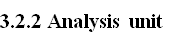
The analysis unit is the object that the researcher tries to understand and describe, and it is also the focus of the research work. The content of the survey is to analyze the attributes and characteristics of the unit. Random samples, stratified random samples, purposeful or non-random samples can be selected from a certain sample amount of the unit. It can also be the entire sample size that can be used as a unit. The study got responses from Guangzhou Tea House consumers and strong in consumers, the unit for individuals.

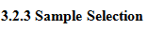
The study focused on consumers aged between 18 and 60 and potential consumers. So the total population was 9.45 million. According to Krejcie and Morgan’s research, the sample size should be 384. So the study was at least 384 people. To ensure the validity of the questionnaire, I expanded the sample size to 400.
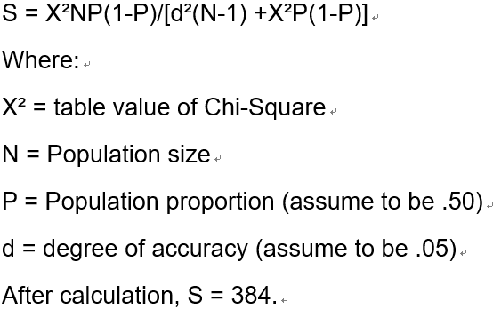

3.3.1 Data Collection
The research will help to further position the market and segment the market. When formulating this questionnaire, I also referred to many questionnaires from different industries to explore the problem proportion of different variables. After repeated deliberation, I drafted the final questionnaire, and consulted professionals to determine whether it was reasonable. The variables studied in this paper are meaningful and valid.

The field survey and questionnaire survey have their own advantages and disadvantages. The field survey has a relatively small scope but a high degree of authenticity, while the network questionnaire survey has a relatively large scope and high efficiency, but the authenticity of the questionnaire survey data remains to be verified. Improbability sampling was used in this study. A large part of the questionnaires were forwarded by relatives and friends of major Tea House in Guangzhou. Large questionnaires are distributed randomly through the Internet.

Primary data analysis was used in this study. The purpose is to analysis the influencing factors of purchasing decisions of potential buyers and buyers in Guangzhou, China. Collect the data through the questionnaire, and then analyze the valid data concretely.

All information contained in the questionnaire will be kept confidential and will only be used to analyze the factors influencing consumers' decision-making, and will not be re-disseminated or sold. I will make the questionnaire through the "Google questionnaire"

This paper will use quantitative research to analyze consumers' consumption behavior in Tea Houses. After completing the relevant steps of questionnaire recovery, the researchers collated the collected data and input it into SPSS 22.0.

The survey method of this paper is mainly questionnaire. Since the purpose of this study is to explore consumers' consumption behavior in Tea Houses, questionnaires will be designed. It is worth mentioning that the questionnaire data is primary data, which is more reliable than other secondary data. In this study, SPSS22.0 was mainly used to conduct descriptive statistics, cross analysis and regression analysis of the data of the Tea House, so as to study the influence of factors on the consumer buying behavior in Tea House.

Descriptive statistics analysis is the use of statistical indicators to describe the characteristics of a kind of analysis method in all collected questionnaires. Among all the collected questionnaires, the invalid questionnaires were first excluded and the remaining valid questionnaires were recorded into SPSS22.0. Through descriptive analysis, the influencing factors of consumer buying behavior of Guangzhou Tea House were segmented into market segments and analyzed.
Cross analysis was conducted on the age and occupation of the respondents to understand the relationship between personal factors such as age, occupation and consumption cycle of Tea House consumers. Then, the cross analysis of household income and consumption cycle: according to the comparison of household income of the respondents and the frequency of consumption in Tea Houses, the relationship between economic factors and consumption cycle of Tea Houses is understood.

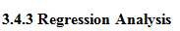
Regression analysis refers to a statistical analysis method for determining the interdependent quantitative relationships between two or more variables. There are 4 variables in this study and there are many dimensions, multiple regressions can test the linear relationship between important variables and multiple variables.

Validity analysis is the validity and accuracy of questionnaire design, which is used to measure the rationality of item design. Reliability analysis is used to measure whether the sample answers are reliable or not, For example, if the measurement results of the same object are close to each other for many times, the result will be considered to be reliable and true, that is, with high reliability. If the results of each measurement vary greatly, the reliability is low.

Validity can be divided into content validity, structure validity and criterion validity. The main research of the thesis is the content validity and constructs validity of the questionnaire. The content validity of this study is to illustrate the validity of the questionnaire in words. For example, the authoritativeness and validity of the questionnaire can be explained by references or authoritative sources. In addition, the validity of the questionnaire is fully demonstrated through the pre-test and item modification combined with the results. In terms of structural validity, the corresponding relationship between measurement items and measurement dimensions. The measurement method is confirmatory factor analysis.

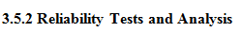
Reliability analysis can be roughly divided into three categories: stability coefficient (consistency across time), equivalence coefficient (consistency across forms) and intrinsic consistency coefficient (consistency across items). In this paper, Cronbach coefficient reliability analysis was used to test the consistency of the questionnaire.

3.5.2 Reliability Tests and Analysis
Reliability analysis can be roughly divided into three categories: stability coefficient (consistency across time), equivalence coefficient (consistency across forms) and intrinsic consistency coefficient (consistency across items). In this paper, Cronbach coefficient reliability analysis was used to test the consistency of the questionnaire.

4.0 Data analysis
This chapter verifies the research hypothesis through data analysis. The collected valid questionnaires were statistically analyzed by SPSS 22.0 software. To evaluate whether the data in the questionnaire has practical significance, the relationship between independent variables and dependent variables was verified by reliability and validity analysis, and then the relationship between independent variables and dependent variables was verified by descriptive statistical analysis, correlation analysis, crossover analysis, and multiple regression analysis.

4.1 Pilot test
Pilot test is defined as a software test that validates a system or a component of the entire system under real-time operating conditions. The purpose of the pilot is to assess the feasibility, time, cost, risk and performance of a research project. 40 questionnaires were selected for Pilot test.

4.1.1 Factor analysis of Pilot test
 | 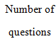 | 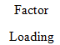 | 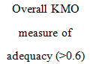 | 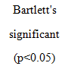
Personal | 4 | 0.410-0.777 | 0.740 | 0.000
Economical | 3 | 0.764-0.950 | 0.861 | 0.000
Psychological | 3 | 0.714-0.816 | 0.717 | 0.000
Social | 3 | 0.756-0.844 | 0.730 | 0.000
Consumer buying behavior | 4 | 0.779-0.948 | 0.784 | 0.000
Table 4-1: KMO and Bartlett tests

KMO and Bartlett tests were conducted on five dimensions: personal, economic, psychological, social, and CBB (consumer buying behavior). The test results show that the KMO of each dimension is between 0.717 and 0.861, all of which are >0.6, and the p-value of Bartlett's test is 0.000<0.05, indicating that the test questionnaire has good structural validity.

4.1.2 Reliability test of pilot test
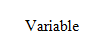 |  | 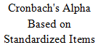
Personal | 0.781 | 0.782 | 4
Economical | 0.752 | 0.752 | 3
Psychological | 0.854 | 0.854 | 3
Social | 0.881 | 0.884 | 3
Consumer buying behavior | 0.801 | 0.813 | 4
Reliability refers to the correctness of a measure, including stability and consistency. Kerlinger believes that reliability can measure the reliability, consistency and stability of the tool (questionnaire). Correlation is that the higher the correlation coefficient, the higher the correlation. If the correlation coefficient higher, the internal consistency will higher. There are many ways to check reliability, among which Cronbach Alpha is the most commonly used. Measure the reliability of the sum of a set of synonymous or parallel tests. If all items in the scale reflect the same characteristics, there should be a true correlation between items. If there is no correlation between a project and other projects in the scale, the project does not belong to the scale. If the reliability value higher than 0.7, the questionnaire has high reliability and validity.

4.1.3 Correlation test of pilot test
Personal | Q6 | Q7 | Q8 | Q9
Q6 | 1
Q7 | 0.653** | 1
Q8 | 0.790* | 0.721** | 1
Q9 | 0.767** | 0.808** | 0.865** | 1
Economical | Q10 | Q11 | Q12
Q10 | 1
Q11 | 0.763* | 1
Q12 | 0.848** | 0.780** | 1
Psychological | Q13 | Q14 | Q15
Q13 | 1
Q14 | 0.808** | 1
Q15 | 0.639** | 0.736** | 1
Social | Q16 | Q17 | Q18
Q16 | 1
Q17 | 0.885** | 1
Q18 | 0.877** | 0.792** | 1
Consumer buying behavior | Q19 | Q20 | Q21 | Q22
Q19 | 1
Q20 | 0.897** | 1
Q21 | 0.853** | 0.771** | 1
Q22 | 0.858** | 0.828** | 0.884** | 1
The results of the correlation coefficient test of each item in each dimension show that the correlation coefficient of corresponding items under individual, economic, psychological, social and consumer buying behavior has a highly significant correlation.

4.2 Descriptive statistics
Table 4-4: Personal basic information statistics

 |  | Frequency | Percent
age | 18-28 | 116 | 29%
age | 29-38 | 68 | 17%
age | 39-48 | 80 | 20%
age | 49-60 | 136 | 34%
Gender | Female | 208 | 52%
Gender | Male | 192 | 48%
Occupation | Management technician | 56 | 14%
Occupation | Office clerk | 100 | 25%
Occupation | Student | 81 | 21%
Occupation | Teacher | 96 | 24%
Occupation | Others | 64 | 16%
Family monthly income | Below 3,000 | 96 | 24%
Family monthly income | 3001-5000 | 64 | 16%
Family monthly income | 5001-10000 | 100 | 25%
Family monthly income | Above 10,000 | 140 | 35%
Frequency to Tea House | Less than 3 times | 124 | 31%
Frequency to Tea House | 3-5 times | 68 | 17%
Frequency to Tea House | 5-10 times | 60 | 15%
Frequency to Tea House | More than 10 times | 148 | 37%
The basic information of participants in this survey was analyzed statistically.

According to statistics, the survey participants in the age between 49 and 60 years old have a total of 136 people, and the proportion was 34 percent. And respondents age between 18 and 28 years have 116 people that account for 29 %. While those aged 29-38 and 39-48 were the smaller groups, accounting for 17 percent and 20 percent of the survey participants, respectively. The survey involved 192 men (48%) and 208 women (52%). As for the occupation, office clerks were the most, with 100 accounting for 25%, followed by teachers with 96 accounting for 24%. The income of respondents is mainly over 5,000, of which 240 people account for 60%. Those whose monthly household income is between 3,001 and 5,000 are the least, 64 people account for 16%, and 96 people whose monthly household income is less than 3000RMB account for 24%.

The 148 respondents visited the teahouse more than 10 times a month, accounting for 37% and 124 people less than 3 times a month, accounting for 31%. Thus, there is still a large development market in Guangzhou Tea House.
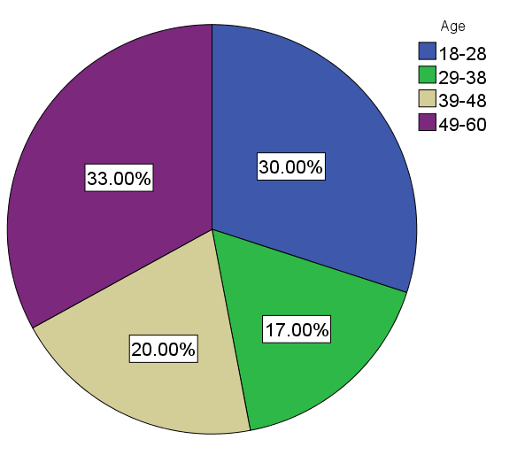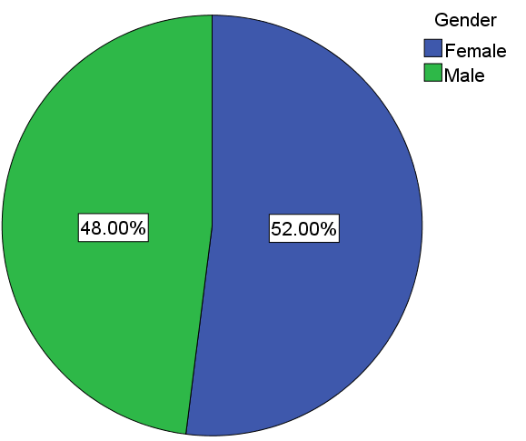
Figure 4-2-1: Age and Gender distribution ratio pie chart
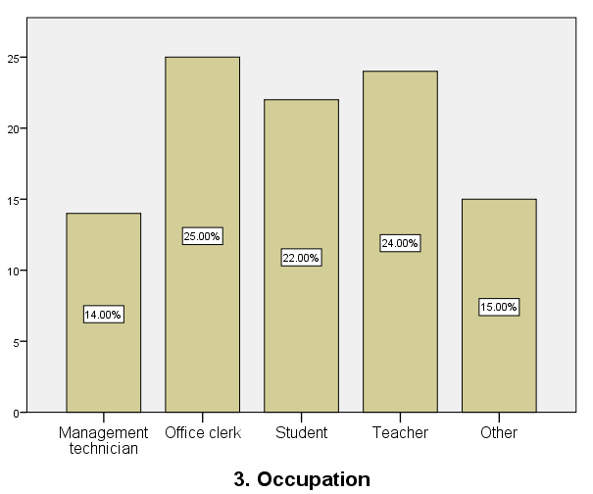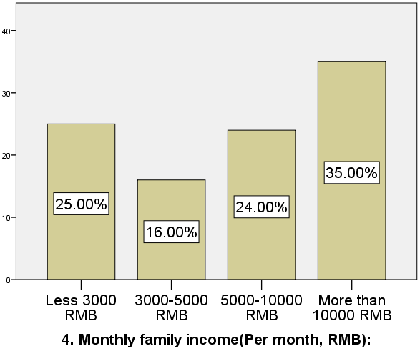
Figure 4-2-2 Occupation and Monthly family income distribution ratio histogram

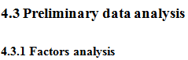
Factor analysis is a statistical analysis method to analyse or measure the influence direction and degree of each influence factor change in the overall change of objective phenomena by using the index system.

KMO and Bartlett's Test is used to compare the indicators of simple correlation coefficient and partial correlation coefficient between variables. The KMO statistic is between 0 and 1.When the sum of squares of simple correlation coefficients among all variables is much larger than the sum of squares of partial correlation coefficients, the KMO value is close to 1.When the sum of squares of simple correlation coefficients between all variables is close to 0, the KMO value is close to 0.

 |  |  |  |  |  |  | .768
 |  |  | Approx. Chi-Square |  |  |  | 3645.07
 |  |  | df |  |  |  | 12
 |  |  | Sig. |  |  |  | .000
 |  |  |  |  | 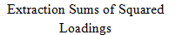
 |  | 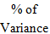
1 | 2.382 | 78.032 |  | 78.032 | 2.382 | 78.032 |  | 78.032
2 | .303 | 13.381 |  | 70.413
3 | .256 | 4.350 |  | 85.363
4 | .272 | 4.859 |  | 100.000
The factor analysis of the Personal dimension from Table 4-5 shows that KMO = 0.768, and the p-value of Bartlett's Test significance test = 0.000 < 0.05, indicating that the item contained in this dimension is suitable for factor analysis.

And according to the Table 4-6, the Total Variance Explained of Personal results show that all the items contained in this dimension can extract a common factor and can explain the 78.032% variation that was originally mentioned, indicating that the item contained personal can better represent the personal variable.

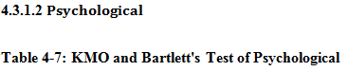
 |  | .711
 | Approx. Chi-Square | 3400.706
 | df | 3
 | Sig. | .000

1 | 2.166 | 72.202 | 72.202 | 2.166 | 72.202 | 72.202
2 | .454 | 15.381 | 87.340
3 | .380 | 12.660 | 100.000
The factor analysis of the Psychological dimension from Table 4-7 shows that KMO = 0.711, and the p-value of Bartlett's Test significance test = 0.000 < 0.05, indicating that the item contained in this dimension is suitable for factor analysis.

And according to the Table 4-8, the Total Variance Explained of Personal results show that all the items contained in this dimension can extract a common factor and can explain the 72.202% variation that was originally mentioned, indicating that the item contained Psychological can better represent the Psychological variable.

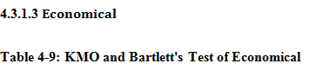
 |  | .729
 | Approx. Chi-Square | 4452.196
 | df | 3
 | Sig. | .000

Table 4-10: Total Variance Explained of Economical

1 | 2.342 | 78.068 | 78.068 | 2.342 | 78.068 | 78.068
2 | .378 | 12.606 | 90.674
3 | .280 | 9.326 | 100.000
The factor analysis of the economical dimension from Table 4-9 shows that KMO = 0.729, and the p-value of Bartlett's Test significance test = 0.000 < 0.05, indicating that the item contained in this dimension is suitable for factor analysis.

And according to the Table 4-10, the Total Variance Explained of Personal results show that all the items contained in this dimension can extract a common factor and can explain the 78.068% variation that was originally mentioned, indicating that the item contained economical can better represent the economical variable.

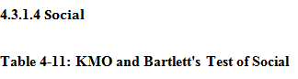
 |  | .727
 | Approx. Chi-Square | 4267.322
 | df | 3
 | Sig. | .000

Table 4-12: Total Variance Explained of Social

1 | 2.341 | 78.041 | 78.041 | 2.341 | 78.041 | 78.041
2 | .386 | 12.876 | 90.917
3 | .272 | 9.084 | 100.000
The factor analysis of the social dimension from Table 4-11 shows that KMO = 0.727, and the p-value of Bartlett's Test significance test = 0.000 < 0.05, indicating that the item contained in this dimension is suitable for factor analysis.

And according to the Table 4-12, the Total Variance Explained of Personal results show that all the items contained in this dimension can extract a common factor and can explain the 78.041% variation that was originally mentioned, indicating that the item contained social can better represent the social variable.

 |  |  |  |  |  |  |  | .734
 |  |  |  |  | Approx. Chi-Square |  |  | 2080.680
 |  |  |  |  | df |  |  | 6
 |  |  |  |  | Sig. |  |  | .000
 | 1 | 2.322 | 76.358 | 76.358 |  | 2.322 | 76.358 |  | 76.358
 | 2 | .886 | 23.598 | 89.324
 | 3 | .769 | 19.228 | 94.402
 | 4 | .045 | 1.122 | 100.000
The factor analysis of the consumer buying behavior dimension from Table 4-13 shows that KMO = 0.734, and the p-value of Bartlett's Test significance test = 0.000 < 0.05, indicating that the item contained in this dimension is suitable for factor analysis.

And according to the Table 4-14, the Total Variance Explained of Personal results show that all the items contained in this dimension can extract a common factor and can explain the 76.358% variation that was originally mentioned, indicating that the item contained CBB can better represent the CBB variable.

 |  | 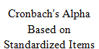
Personal | 0.781 | 0.782 | 4
Economical | 0.772 | 0.772 | 3
Psychological | 0.860 | 0.860 | 3
Social | 0.859 | 0.859 | 3
Consumer buying behavior | 0.831 | 0.831 | 4

Reliability test correlation is that the higher the correlation coefficient, the higher the correlation. If the reliability value higher than 0.7, the questionnaire has high reliability and validity. From the Table 4-15, Cronbach's Alpha is between 0.781-0.860> 0.7, it indicates that this questionnaire has high reliability and internal consistency.

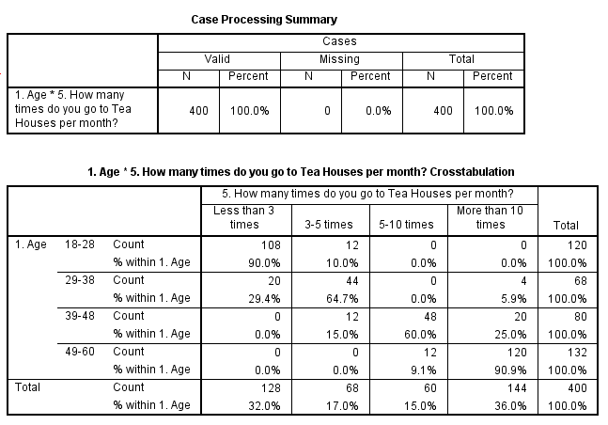
Cross-analysis of age and frequency of Tea House

According to the Table 4-16, there were 120 people aged 18-28, of whom 108 went to Tea House less than 3 times per month, and only 12 people went to Tea House 3-5 times per month. 0 people who go to Tea House more than 5 times a month. This indicates that the frequency of young groups going to Tea House is low.

However, there are a total of 144 people who go to Tea House more than 10 times per month, among whom 90.9% are aged 49 to 60, 25% are aged 39 to 48, only 5.9% are aged 29 to 38, and 0 are aged 18 to 28. This indicates that the consumption frequency of consumers aged 40 to 60 is significantly higher than that of young consumers.

Cross-analysis of occupation and frequency of Tea House
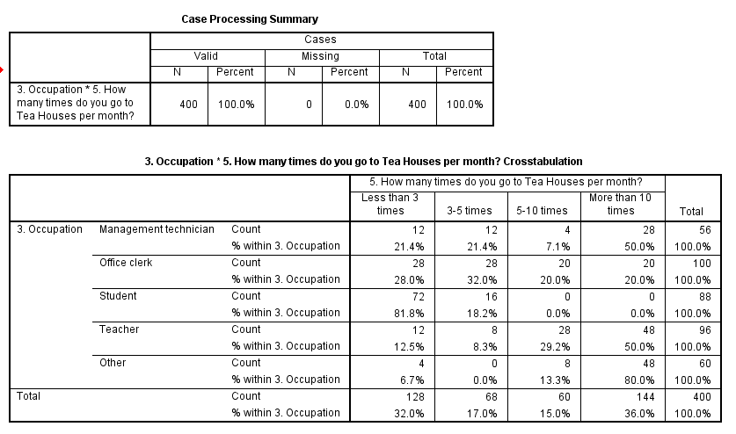
According to the Table 4-17, it can be clearly seen that 128 people go to Tea House less than 3 times a month, of which 72 are students. Among the 144 people who go to Tea House more than 10 times a month, 96 are other and teachers. However, the consumption frequency of office clerk and management technician in Tea House is relatively uniform distribution.

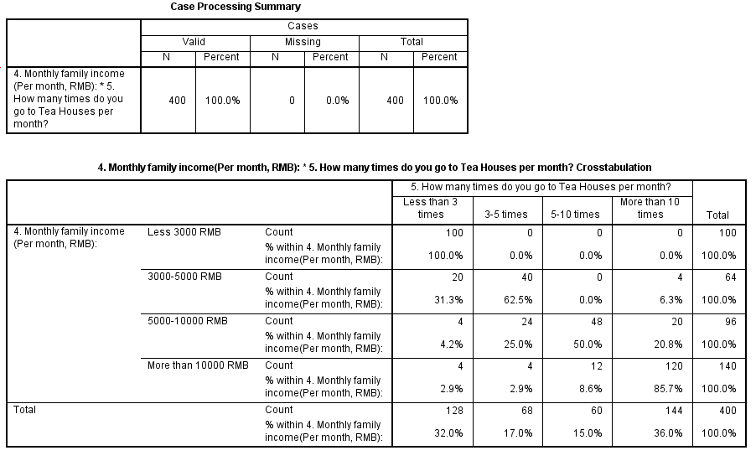

Cross-analysis of Monthly family income and frequency of Tea House

According to Table 4-18, it can be clearly seen that if the family income is less than 3000RMB, the monthly consumption frequency of Tea House is less than 3 times, a total of 100 people. There were 140 people whose monthly income was more than 10000RMB, among which only 4 people consumed Tea House less than 3 times per month, and 120 people consumed Tea House more than 10 times per month. The difference was very obvious. Therefore, the monthly consumption frequency of Tea House is related to the family's monthly income.

4.5 Correlation analysis

 |  | CBB | Personal | Economical | Psychological | Social
Consumer  Buying Behavior | Pearson Correlation | 1 | .447** | .273** | .364** | .015
Consumer  Buying Behavior | Sig. (2-tailed) |  | .001 | .001 | .000 | .635
Consumer  Buying Behavior | N | 400 | 400 | 400 | 400 | 400
Personal | Pearson Correlation | .447** | 1 | .367** | .263** | -.012
Personal | Sig. (2-tailed) | .001 |  | .001 | .001 | .734
Personal | N | 400 | 400 | 400 | 400 | 400
Economical | Pearson Correlation | .273** | .367** | 1 | .463** | -.121*
Economical | Sig. (2-tailed) | .001 | .001 |  | .001 | .010
Economical | N | 400 | 400 | 400 | 400 | 400
Psychological | Pearson Correlation | .364** | .263** | .463** | 1 | -.032
Psychological | Sig. (2-tailed) | .000 | .001 | .001 |  | .623
Psychological | N | 400 | 400 | 400 | 400 | 400
Social | Pearson Correlation | .015 | -.012 | -.121* | -.032 | 1
Social | Sig. (2-tailed) | .635 | .734 | .010 | .623
Social | N | 400 | 400 | 400 | 400 | 400
According to the correlation analysis results in Table 4-19, the correlation coefficient between the consumer buying behavior and personal factors of the surveyed population in the factors of Tea House buying behavior of Chinese consumers is 0.447, and the p value of coefficient significance test is 0.001 < 0.05, indicating that there is a significant positive correlation between personal factors and consumer buying behavior. Similarly, the correlation coefficient between Economical factors and Psychological factors and consumer buying behavior is greater than 0, and the p value of significance test is 0.000<0.05, indicating that there is still a significant positive correlation between the two factors and consumer buying behavior.

Correlation coefficient between consumer buying behavior and Social factors among people surveyed on buying behavior of Guangzhou Tea House in 0.015, the coefficient significance test of assumed value was 0.635 > 0.05, indicating that although there was a positive correlation between Social factors and consumer buying behavior, there was no significant statistical significance to some extent.

Based on the results of correlation analysis, in order to quantitatively measure the relationship between Guangzhou consumer buying behavior and personal, economical, psychological and social consumer buying behavior as a dependent variable, personal, economical, psychological and social as an independent variable, establish multiple linear regression model:
$$CPI=β_{0}+β_{1}personal+β_{2}Economical+β_{3}psychological+β_{4}social+ε$$
In this formula above is intercept term, is regression coefficient, and is random error term. A regression analysis was performed, and the results were as follows.

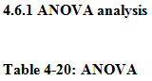
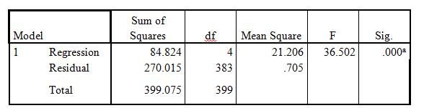a. Predictors: (Constant), Personal, Psychological, Economical, Social
b. Dependent Variable: CBB of tea house

According to the table 4-17, it can be seen that the F value of the model significance test = 36.502, p value = 0.000 < 0.05, indicating that the established multivariate information regression model is significantly effective.

4.6.2 Model Summary
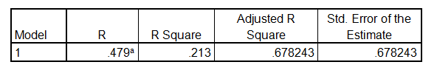
According to the Table 4-21, it can be seen that the model's goodness of fit R Square= 0.213 and Adjusted R Square =0.678243 are both large, indicating that the independent multivariate linear regression model independent personal, economical, psychological and social can explain the dependent variable Consumer Buying Behavior 21.3 % variation.

4.6.3 Coefficients
Table 4-22: Coefficients

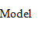 |  | 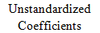 |  | 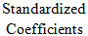 |  | 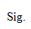
 |  | B | Error
1 | (Constant) | .076 | .310 |  | .232 | .806
1 | Personal | .141 | .086 | .147 | 1.642 | .003
1 | Economical | .325 | .096 | .313 | 3.388 | .001
1 | Psychological | .157 | .071 | .165 | 2.213 | .028
 | Social | .066 | .054 | .071 | 1.531 | .712

The table 4-22 shows that the regression coefficient of social is 0.066, the t value of coefficient significance test = 1.531, p value = 0.712>0.05, indicating that the regression coefficient between social and consumer buying behavior is not significant. The regression coefficient between personal and consumer buying behavior is 0.225, the t value of the coefficient significance test is 1.642, and the p value is 0.003<0.05, indicating that the regression coefficient of price is significantly effective. Similarly, for the regression coefficient between economical and psychological, the p-value <0.05 is tested, indicating that the regression coefficients between the two factors and consumer buying behavior are significant. And the fitted regression equation is as follows:

$$CPI=0.076+0.141personal+0.325economical+0.157Psychological+0.066social$$

For each additional unit of the independent personal, the consumer buying behavior increases by an average of 0.141 units; for each additional unit of economical, the consumer buying behavior increases by an average of 0.325 units; for each additional unit of psychological, the consumer buying behavior increases by an average of 0.157. For each unit of social, the consumer buying behavior increases by an average of 0.066 units; from the regression coefficient, it can be seen intuitively that economical and psychological have a greater impact on consumer buying behavior, followed by personal, and the impact of social is small on people's purchase behavior.

4.7.1 Summary on hypothesis
Hypothesis | Result
Hypothesis 1: Personal factors have a significant impact on consumer buying behavior in Tea Houses. | Accepted
Hypothesis 2: Economical factors have a significant impact on consumer buying behavior in Tea Houses. | Accepted
Hypothesis 3: Psychological factors have a significant impact on consumer buying behavior in Tea Houses. | Accepted
Hypothesis 4: Social factors have a significant impact on consumer buying behavior in Tea Houses. | Rejected
Hypothesis 1 proposes this hypothesis to understand whether the personal factors of customers' purchasing behavior have a significant impact on the Tea House purchasing behavior of consumers in Guangzhou. This hypothesis mainly includes four questions, and the personal factor is examined from the perspective of life style and personality. This study proves that personal has a significant influence on the purchasing decision of Tea House of consumers in Guangzhou.

Hypothesis 2 proposes this hypothesis to understand whether the psychological factors of consumer buying behavior have significant influence on the Tea House purchasing behavior of Guangzhou consumers. This hypothesis mainly includes three problems, which are to investigate psychological factors from consumer motivation, consumer cognition and consumer attitude. This study has proved that in China, Guangzhou, psychological has a significant influence on customer purchasing behavior in Tea House.

Hypothesis 3 proposes this hypothesis to understand whether the economical of consumer buying behavior factor has a significant influence on the Tea House purchasing behavior of Guangzhou consumers. This hypothesis mainly consists of three questions, which are to verify the economical factor in terms of fixed assets, family income and government policies. This study demonstrates that in Guangzhou, China, economical has a significant influence on consumers' purchasing behavior of Tea House.

Hypothesis 4 proposes this hypothesis to understand whether the Social influence of consumer buying behavior factor has a significant impact on the Tea House buying behavior of Guangzhou consumers. This hypothesis mainly includes three questions, namely, family, reference and Social status to verify Social factors. This study proves that Social factors have no significant influence on Chinese consumers buying behavior in Tea House in Guangzhou.

To sum up, by testing the hypothesis of the four independent variables, we found that economical had the most significant relationship with the dependent variable consumer buying behavior, and the correlation between social and consumer buying behavior was not strong.

4.7.2 Summary on research questions
There are 5 questions about the questionnaire research. The researchers used regression analysis to answer the study's questions. The summary on research questions are as follows:

For the first research question, Personal significantly affects the behavior of consumer buying, and the answer is no. As shown in the coefficient table, the value of b shows that if the product increases by 1 unit, the consumer buying behavior increases by 0.141 units. Therefore, it can be said that the Personal factor has a significant influence on the behavior of consumer buying. From the sig value of coefficient table, the sig value of Personal is 0.003, which is greater than 0.05, so personal factors has statistical significance on consumer buying behavior.

For the second study question, is economical has a significant influence on consumer buying behavior, the answer is yes. As shown in the coefficient table, the value of b indicates that if the price increases by 1 unit, the consumer buying behavior will increase by 0.325 units. Therefore, it can be said that the economical factor has a great influence on consumer buying behavior. Otherwise, the sig value of the price in the coefficient table is 0.001, which is less than 0.05, so economical factors are statistically significant for consumer buying behavior.

For the third research question, psychological has a significant influence on consumer buying behavior, the answer is yes. As can be seen from the coefficient table, the value of b indicates that if one unit is increased, the consumer buying behavior will increase by 0.157 units. Therefore, it can be said that the consumer buying behavior factor has a great influence on the consumer buying behavior. Otherwise, from the sig value of coefficient table, the sig value of place is 0.028, which is less than 0.05, so psychological factors have statistical significance on consumer buying behavior.

For the fourth research question, Social has a significant influence on consumer buying behavior, and the answer is no. As can be seen from the coefficient table, b value represents the increase of 1 unit, while the consumer buying behavior increases by 0.066 units. Therefore, it can be said that the promotion factor has a great influence on the behavior of consumer buying. Otherwise, from the sig value in the coefficient table, the sig value of Social is 0.712, which is higher than 0.05, so there is no statistical significance of social factor on consumer buying behavior.

As for the fifth question, what are the appropriate Suggestions for the development of Tea House? The results of questionnaire research show that Economical factors have the greatest influence on consumers buying behavior, so it is suggested that Tea restaurants make more marketing strategies from the economic perspective, such as special price for festival products and student discounts.

5.0 Summary

5.1 Conclusion
In this study, factors affecting Guangzhou consumer buying behavior in Tea House were studied, and information and opinions of 400 participants were collected through questionnaires. Through the analysis of the results, it was found that personal, economical and psychological factors of consumer buying behavior had a greater impact on consumers in Guangzhou, while economical had the greatest impact on consumer buying intention of Tea House in Guangzhou. Although the marketing of Guangzhou Tea House is facing many difficulties at present, the survey results show that a large number of consumers do not often go to Tea House, for example, consumers aged 18-28 go to Tea House less than 3 times a month, which indicates that the market of Guangzhou Tea House is still large. As for the influencing factor of Social, most participants' attitude is not very good. Compared with Social factors, more consumers tend to have personal, economical and psychological factors impacts. Therefore, for Guangzhou's Tea House enterprises, they should attach more importance to marketing activities from personal, economical and psychological factors aspects to attract more consumers.

5.2 Limitation
Firstly, a total of 400 questionnaires were issued in this survey, which may not fully reflect the consumer's consumption behavior characteristics, and there are certain limitations. The follow-up will obtain more comprehensive first-hand information through a broader survey, so as to have a more comprehensive understanding of consumers' consumption behavior, so as to develop more scientific and complete market competition strategies.

Secondly, the marketing strategy of this paper, must further do more detailed research, in depth operation should also consider more factors. Due to the limited level, there are still many shortcomings in the research depth and argumentation.

5.3 Recommendations
This paper mainly focuses on the purchasing behavior of consumers in Guangzhou at Tea House. Therefore, in combination with this survey, the researchers put forward many Suggestions on the marketing and development of Tea House enterprises.

Firstly, market segmentation and market positioning. According to the results of the cross analysis in the fourth chapter, the average consumption times of guests are related to the following factors: more consumption times of 49-60 years old. The average family monthly income of guests with high consumption frequency is higher. Teacher groups consume more frequently than students. This paper thinks that the emphasis should be put on improving consumers' attention to tea restaurants through marketing activities, because the consumption frequency is directly proportional to consumers' attention to tea restaurants. The current market segments and market positioning that Tea House enterprises should focus on have the following characteristics: people with high monthly family income and middle-aged and elderly people with stable jobs.

Secondly, enterprise should focus more on customer communication, from the perspective of enterprises; enterprises should not only meet the needs of consumers, but also actively communicate with consumers to promote the brand identity of consumers. Modern marketing requires not only to develop excellent products according to consumers' needs, but also to set acceptable prices according to consumers' perceived value, and to communicate with their potential relationship parties and the public. Therefore, every enterprise inevitably plays the role of promoter and communicator. But at the heart of the problem is what we call the target audience, the topic of communication and the way of communication. For the communication channels of Tea House customers, they can make use of the face-to-face communication with consumers and potential consumers in various marketing promotions. In the process of activities and marketing promotion, Tea House should win the recognition and word of mouth of consumers and potential consumers by providing hospitable services. It can attract consumers to try and consume Tea House by offering coupons, free tasting and periodic flexible and powerful discounts. Tea House membership system can be implemented to develop consumers to become Tea House members, fill in the membership information, issue membership card, membership card when the consumption of preferential and discount, can also enjoy extra benefits on their birthday, such continuous development, Tea House will have a group of very stable consumers. Through word-of-mouth publicity and the use of the Internet to promote, the old consumers bring in new consumers, and the new consumers become Tea House members, so that more and more consumers come to consume.

Thirdly, based on the 4C marketing theory, when considering the place problem, enterprises should pay more attention to how to bring the greatest convenience to customers and pay more attention to the convenience requirements of consumers when purchasing. Enterprises provide convenience for customers to buy, so that customers in the consumption of products also bought convenience. For Tea House, to offer convenience to consumers is to make them feel at home. This paper suggests that in terms of customer convenience, the following points should be considered: to recommend the most suitable promotion product for customers. Handle the details of the product recommended to the customer.

Finally, according to the current market position of Tea House, it is suggested to adopt the market penetration pricing strategy. At the present stage, it is suggested that Tea House be priced slightly lower than competitors of the same category, so as to accelerate the growth of Tea House in the market in the short term, gain a higher market share and sales volume, and provide customers with the feeling of "affordable luxury". At the same time to attract younger consumer groups.

5.4 Future research
According to the research process and results, the future research in this direction can be further prospected in the following aspects: the selection of research samples and the influencing factors of consumer buying behavior. By adding cultural factors and analyzing the influence of cultural factors on consumers' purchasing behavior, the research is more complete. In terms of sample size, the sample size can be increased to investigate more potential consumers. In the choice of cities, the future research not limited to the city of Guangzhou. In terms of the research content, we can further discuss the importance order of the marketing mix factors related to the consumer buying behavior of Guangzhou Tea House, so as to have a more comprehensive understanding of the marketing influencing factors and the factors of the consumer buying behavior of consumers in Tea House.

5.5 Conclusion
The study of consumer buying behavior is the basis for enterprises to make their marketing activities and their decisions. The development of scientific and reasonable market competition strategy should be based on four factors that affect consumers' purchasing behavior. The first-hand information is obtained through questionnaire survey, and the statistical analysis method is used to analyze and study the data, and then the four factors of consumer buying behavior are studied. At the same time, based on the analysis of the survey data, it needs to combine the actual situation of Tea House itself, so as to effectively determine its competitive strategies in the market. Enterprises to create market competition strategy if it is established on the basis of serious research market, can make its marketing effectiveness and pertinence, quicker and better occupy its segment of the market, and from the market and consumers access to higher profits than the original, to further promote the status and development of enterprises in the market. The final suggestion of this paper is that Tea House enterprises should pay more attention to the development of marketing strategies in terms of personal, economic and psychological factors.

5.6 Personal reflection
From the beginning of the topic selection to the completion of this paper, I encountered many difficulties. I sincerely thank my supervisor Ms. Faziha, for her patient guidance. From the topic selection, conception, writing to the final draft of the paper, she gave me careful guidance and enthusiastic help. With her help, I overcame a lot of difficulties and improved my thesis. In addition, I also sincerely thank my second supervisor Dr. Alex, who also gave me valuable advice and professional guidance. He pointed out some of my problems to help me improve my paper. My classmates also have given me great care and help; they often encourage me to finish it. My MBA career is coming to an end. I love Malaysia and I am grateful to INTI University, I would like to take this opportunity to express my sincere thanks to all those who have given me support, help and encouragement.

Reference
Bearden, W.O. and Etzel, M.J., 1982. Reference group influence on product and brand purchase decisions. Journal of consumer research, 9(2), pp.183-194.
Chen, F., Li, S., Jiang, R. and Jiang, A., 2016. What factors are influencing tea consumption among Chinese urban residents? An empirical study. International journal of consumer studies, 40(2), pp.249-254.
Collins, C.M., Steg, L. and Koning, M.A., 2007. Customers' values, beliefs on sustainable corporate performance, and buying behavior. Psychology & Marketing, 24(6), pp.555-577.
Cretu, A.E. and Brodie, R.J., 2007. The influence of brand image and company reputation where manufacturers market to small firms: A customer value perspective. Industrial marketing management, 36(2), pp.230-240.
Dabholkar, P.A., Bobbitt, L.M. and Lee, E.J., 2003. Understanding consumer motivation and behavior related to self‐scanning in retailing. International Journal of Service Industry Management.
Dupree, J., 2000. Brand Spirit: How Cause‐Related Marketing Builds Brands. Journal of Consumer Marketing.
Dominici, G., 2009. From marketing mix to e-marketing mix: a literature overview and classification. International journal of business and management, 4(9), pp.17-24.

Eavani, F. and Nazari, K., 2012. Marketing mix: a critical review of the concept. Elixir Marketing Mgmt, 49, pp.9914-9920.
Erkmen, E. and Hancer, M., 2019. Building brand relationship for restaurants. International Journal of Contemporary Hospitality Management.
Farley, J.U. and Ring, L.W., 1970. An empirical test of the Howard-Sheth model of buyer behavior. Journal of Marketing Research, 7(4), pp.427-438.
Gadenne, D., Sharma, B., Kerr, D. and Smith, T., 2011. The influence of consumers' environmental beliefs and attitudes on energy saving behaviours. Energy policy, 39(12), pp.7684-7694.
Gatling, A., Molintas, D.H.R., Self, T.T. and Shum, C., 2020. Leadership and behavioral integrity in the restaurant industry: the moderating roles of gender. Journal of Human Resources in Hospitality & Tourism, 19(1), pp.62-81.
Gao, X. and Wang, X., 2020. The trends of migration in China, 1949–2019. China Population and Development Studies, 3(2), pp.154-159.
Gilaninia, S., Taleghani, M. and Azizi, N., 2013. Marketing mix and consumer behavior. Kuwait Chapter of Arabian Journal of Business and Management Review, 33(861), pp.1-6.
Goi, C.L., 2009. A review of marketing mix: 4Ps or more?. International journal of marketing studies, 1(1), p.2.

Grunert, K.G., Hieke, S. and Wills, J., 2014. Sustainability labels on food products: Consumer motivation, understanding and use. Food Policy, 44, pp.177-189.
Han, M., 2008, December. Customer segmentation model based on retail consumer behavior analysis. In 2008 International Symposium on Intelligent Information Technology Application Workshops (pp. 914-917). IEEE.
Haugtvedt, C.P., Herr, P.M. and Kardes, F.R., 2018. Goal-Directed Consumer Behavior: Motivation, Volition, and Affect: Hans Baumgartner and Rik Pieters. In Handbook of Consumer Psychology (pp. 376-401). Routledge.
Herhausen, D. and Schögel, M., 2013. Profiting from customer relationship management: The overlooked role of generative learning orientation. Management Decision, 51(8), pp. 1678-1700.
Howard, J.A., 1977. Consumer behavior: Application of theory (Vol. 325). New York: McGraw-Hill.

Hwang, J. and Hyun, S.S., 2012. The antecedents and consequences of brand prestige in luxury restaurants. Asia Pacific Journal of Tourism Research, 17(6), pp.656-683.
Jiang, N., 2019, October. Research on the improvement of the core competitiveness of tea industry in famous tea town: A case study of Huangshan City, Anhui Province. In IOP Conference Series: Earth and Environmental Science (Vol. 346, No. 1, p. 012082). IOP Publishing.
Kim, E. and Drumwright, M., 2016. Engaging consumers and building relationships in social media: How social relatedness influences intrinsic vs. extrinsic consumer motivation. Computers in Human Behavior, 63, pp.970-979.
Kobia, C. and Liu, C., 2017. Why forward viral fashion messages? The moderating roles of consumers’ fashion traits and message orientation. Journal of Internet Commerce, 16(3), pp.287-308.
Kotwal, N., Gupta, N. and Devi, A., 2008. Impact of TV advertisements on buying pattern of adolescent girls. Journal of Social sciences, 16(1), pp.51-55.
Krejcie, R.V. and Morgan, D.W., 1970. Determining sample size for research activities. Educational and psychological measurement, 30(3), pp.607-610.
Lai, I.K., 2015. The roles of value, satisfaction, and commitment in the effect of service quality on customer loyalty in Hong Kong–style Tea Houses. Cornell Hospitality Quarterly, 56(1), pp.118-138.
Li, H., 2019, November. The Culture of Teahouses in China. In 3rd International Conference on Art Studies: Science, Experience, Education (ICASSEE 2019). Atlantis Press.
Lutz, R.J. and Resek, R.W., 1972. More on testing the Howard-Sheth model of buyer behavior. Journal of Marketing Research, 9(3), pp.344-345
McDonald, M., Christopher, M. and Bass, M., 2003. Market segmentation. In Marketing (pp. 41-65). Palgrave, London.

Kaldor, N., 1935. Market imperfection and excess capacity. Economica, 2(5), pp.33-50.
Kazi, R. and Khan, R., 2020. CONSUMER BEHAVIOR WITH RESPECT TO CONSUMER DURABLE PRODUCTS: A LITERATURE REVIEW. International Journal of Scientific Research, 8(12).
Kim, D., Rao, R. and Cho, B., 2000. Effects of consumer lifestyles on purchasing behavior on the internet: a conceptual framework and empirical validation. ICIS 2000 Proceedings, p.76.
Kotler, P., 1999. Marketing management: the millennium edition (Vol. 199). Upper Saddle River, NJ: Prentice Hall.
Kwan, C.M., 2015. The meaning of Cha Chaan Teng as a chain restaurant: the Tsui Wah Restaurant as an example(Doctoral dissertation).
Lapierre, J., 2000. Customer‐perceived value in industrial contexts. Journal of business & industrial marketing.
Lee, J., 2008. Relative and interaction effects of situational and personal factors on impulse buying. University of Minnesota.
Li, H., 2019, November. The Culture of Teahouses in China. In 3rd International Conference on Art Studies: Science, Experience, Education (ICASSEE 2019). Atlantis Press.
Li, J., 2015. Teahouses and the Tea Art: A Study on the Current Trend of Tea Culture in China and the Changes in Tea Drinking Tradition (Master's thesis).
Li, M.M., Lee, Y.E. and Youn, D.K., 2017. Effects of Chinese Resident's Perceptions of Quality Attributes on Customer Satisfaction, Revisit Intention and Recommendation Intention at coffee Shops in Beijing, China. Journal of the Korean Society of Food Culture, 32(5), pp.421-436.
Li, Y.J., Haws, K.L. and Griskevicius, V., 2019. Parenting motivation and consumer decision-making. Journal of Consumer Research, 45(5), pp.1117-1137.
Libby, R., 2017. Accounting and human information processing. In The Routledge Companion to Behavioural Accounting Research (pp. 42-54). Routledge.
Lin, S.Y. and Chang, C.C., 2020. Tea for Well-Being: Restaurant Atmosphere and Repurchase Intention for Hotel Afternoon Tea Services. Sustainability, 12(3), p.778.
Malär, L., Krohmer, H., Hoyer, W.D. and Nyffenegger, B., 2011. Emotional brand attachment and brand personality: The relative importance of the actual and the ideal self. Journal of marketing, 75(4), pp.35-52.
McLeod, S., 2007. Maslow's hierarchy of needs. Simply psychology, 1, pp.1-8.
Mittal, S., 2018. An Analysis of the Potentiality (Loan Repayment Capacity) of Unorganised Sector Employees on the basis of Ratio Analysis Related to their Disposable and Discretionary Income. Indian Journal of Public Health Research & Development, 9(12), pp.1957-1962.
Moreno, F.M., Lafuente, J.G., Carreón, F.Á. and Moreno, S.M., 2017. The characterization of the millennials and their buying behavior. International Journal of Marketing Studies, 9(5), pp.135-144.
Mowen, J.C., 2000. The 3M model of motivation and personality: Theory and empirical applications to consumer behavior. Springer Science & Business Media.
Nagarkoti, B., 2014. Factors influencing consumer behavior of Smartphone users.
Oyserman, D., 2009. Identity‐based motivation: Implications for action‐readiness, procedural‐readiness, and consumer behavior. Journal of Consumer Psychology, 19(3), pp.250-260.
Pandya, P.R. and Pandya, K., 2018. The Impact of Demonetization on the Impulse Buying Behavior of FMCG Consumers. IUP Journal of Management Research, 17(4), pp.45-62.
Pincus, J., 2004. The consequences of unmet needs: The evolving role of motivation in consumer research. Journal of Consumer Behaviour: An International Research Review, 3(4), pp.375-387.
Ramya, N. and Ali, M., 2016. Factors affecting consumer buying behavior. International journal of applied research, 2(10), pp.76-80.
Rani, P., 2014. Factors influencing consumer behaviour. International journal of current research and academic review, 2(9), pp.52-61.
Sack, A.L., Singh, P. and DiPaolo, T., 2009. Spectator motives for attending professional women's tennis events: linking marketing and Maslow's hierarchy of needs theory. International Journal of Sport Management and Marketing, 6(1), pp.1-16.
Shao, Q., 1998. Tempest over teapots: the vilification of teahouse culture in early Republican China. The Journal of Asian Studies, 57(4), pp.1009-1041.
Shehzadi, K., Ahmad-ur-Rehman, M., Cheema, A.M. and Ahkam, A., 2016. Impact of personality traits on compulsive buying behavior: Mediating role of impulsive buying. Journal of Service Science and Management, 9(05), p.416.
Sheth, J.N., 1974. A theory of family buying decisions. Models of buyer behavior, pp.17-33.
Syaglova, Y.V., 2015. Systemic analysis of marketing paradigms. Innovations and investments, 12, pp.70-73.
Taylor, A.M. and Taylor, M.P., 2004. The purchasing power parity debate. Journal of economic perspectives, 18(4), pp.135-158.
Tadajewski, M., 2006. Remembering motivation research: toward an alternative genealogy of interpretive consumer research. Marketing Theory, 6(4), pp.429-466.
Teo, T.S. and Yeong, Y.D., 2003. Assessing the consumer decision process in the digital marketplace. Omega, 31(5), pp.349-363.
Tikkanen, I., 2007. Maslow's hierarchy and food tourism in Finland: five cases. British food journal.
Ting, C.H., Chang, C.L. and Huang, W.T., 2019, February. Fact Affecting Comsumer’s Experience within Tea House. In Journal of Physics: Conference Series (Vol. 1168, No. 3, p. 032014). IOP Publishing.
Wang, D., 2000. The idle and the busy: Teahouses and public life in early twentieth-century Chengdu. Journal of Urban History, 26(4), pp.411-437.
Wang, K., Wang, Y. and Yao, J., 2005, December. A comparative study on marketing mix models for digital products. In International Workshop on Internet and Network Economics (pp. 660-669). Springer, Berlin, Heidelberg.
Wang, K.Y., Lin, X.H., Han, C.K., Lin, C.C., Liao, Y.C., Ting, T.Y. and Fang, T.S., 2018, July. Study on Production and Marketing of Tea: A Company. In International Conference on Innovative Mobile and Internet Services in Ubiquitous Computing (pp. 771-782). Springer, Cham.
Yalch, R. and Brunel, F., 1996. Need Hierarchies in Consumer Judgments of Product Designs: Is It Time to Reconsider Maslow's Theory?. ACR North American Advances.
Yan, W., Ge, Z. and Xiong, L., 2020. Research on the Influence of Chinese Tea Technology on the World Tea Industry. American Journal of Industrial and Business Management, 10(01), p.135.
Yan-chao, S.H.E.N.G., 2006. On Service Quality Improvement of Catering Trade from the Perspective of Maslow's Hierarchy of Needs. Journal of Nantong Vocational & Technical Shipping College, (1), p.6.
Yang, J., Yan, N., Chen, L., Ye, Y. and Lu, L., 2019, May. Research on the Integrated Marketing Communication Strategies of Tea Enterprises in China Against the Backdrop of Mobile Internet. In 2019 International Conference on Management, Education Technology and Economics (ICMETE 2019). Atlantis Press.
Yun-sheng, W., 2001. Perfection and innovation of 4P marketing mix–How to evaluate 4P marketing mix. Commercial Research, 5(6).
Yurchisin, J. and Johnson, K.K., 2004. Compulsive buying behavior and its relationship to perceived social status associated with buying, materialism, self‐esteem, and apparel‐product involvement. Family and Consumer Sciences Research Journal, 32(3), pp.291-314.

Appendix

Appendix 1: PROJECT PAPER LOG
This is an important document, which is to be handed in with your dissertation. This log will be taken into consideration when awarding the final mark for the dissertation.
Student Name: | Fan Jiayuan
Supervisor’s Name: | Ms. Faziha Abd Malek
Dissertation Topic:
Identifying factors influencing customer buying behavior towards traditional Tea House in Guangzhou, China

SECTION A. MONITORING STUDENT DISSERTATION PROCESS
The plan below is to be agreed between the student & supervisor and will be monitored against progress made at each session.
Activity | Milestone/Deliverable Date
Confirmation research title | 20/1
Final initial proposal |  | 5/2
Chapter 1,2,3 draft |  |  | 25/2
Questionnaire design |  |  |  | 10/3
Questionnaire collection |  |  |  |  | 18/3
Draft Chapter 4 |  |  |  |  |  | 25/3
Draft Chapter 5 |  |  |  |  |  |  | 31/3
Final draft |  |  |  |  |  |  |  | 6/4

SECTION B. RECORD OF MEETINGS
The expectation is that students will meet their supervisors up to seven times and these meetings should be recorded.
Meeting 1
Date of Meeting | 20 Jan 2020
Progress Made | Confirm research title
Agreed Action | Required to list titles, study statements, research objectives, research frameworks, and hypothetical questions
Student Signature | Fan Jiayuan
Supervisor’s
Signature

Meeting 2
Date of Meeting | 24 Jan 2020
Progress Made | Check title, research objectives, research frameworks, and hypothetical questions.
Agreed Action | Required to modify the problem statement and hypothetical questions
Student Signature | Fan Jiayuan
Supervisor’s
Signature
Meeting 3
Date of Meeting | 10 Feb 2020
Progress Made | Check arguments and dependent variables
Agreed Action | Required to delete the independent variable and change the IV direction
Student Signature | Fan Jiayuan
Supervisor’s
Signature

Meeting 4
Date of Meeting | 17 Feb 2020
Progress Made | Checked keywords of independent variables
Agreed Action | Some IV need specific expanation
Student Signature | Fan Jiayuan
Supervisor’s
Signature

Meeting 5
Date of Meeting | 25 Feb 2020
Progress Made | Checked the literature review
Agreed Action | Required to add specific IV latitude studies to the literature review
Student Signature | Fan Jiayuan
Supervisor’s
Signature

Meeting 6
Date of Meeting | 11 Mar 2020
Progress Made | Checked chapter 1 to chapter 3 again after PD
Agreed Action | Required to design questionnaire and data collection
Student Signature | Fan Jiayuan
Supervisor’s
Signature

Meeting 7
Date of Meeting | 18 Mar 2020
Progress Made | Checked questionnaire and data collected
Agreed Action | Required to modify the questionnaire and sample size
Student Signature | Fan Jiayuan
Supervisor’s
Signature
Meeting 8
Date of Meeting | 25 Mar 2020
Progress Made | Checked the data analysis
Agreed Action | Required to modify the multiple regression analysis  Required to add more content for Chapter 5
Student Signature | Fan Jiayuan
Supervisor’s
Signature
Meeting 9
Date of Meeting | 27 Mar 2020
Progress Made | Checked the chapter 1-5
Agreed Action | Required to increase the data discussion in Chapter5
Student Signature | Fan Jiayuan
Supervisor’s
Signature
Meeting 10
Date of Meeting | 6 Apr 2020
Progress Made | Checked the slides of project presentation
Agreed Action | Required to modify slides
Student Signature | Fan Jiayuan
Supervisor’s
Signature

Appendix 2: Questionnaire
Dear consumers, I am a master of INTI university in Malaysia. I am collecting questionnaire for sample analysis. This study mainly discusses the factors that influence consumer buying behavior in Tea Houses. Your information will be kept confidential and used only for data.

Section A: Demographic Information
- Age
□ 18-28 □ 29-38 □ 39-48 □ 49-60
- Gender
- Male □ Female
- Occupation
Management technician □ Office clerk □ Student □ Teacher □ Other
- Monthly family income (Per month, RMB):
Less 3000 RMB 3000-5000 RMB □ 5000-10000 RMB
More than 10000 RMB

- How many times do you go to Tea Houses per month?
Less than 3 times □ 3-5 times □ 5-10 times □ More than 10 times

Section B: (Assessment on dependent and independent variables)
Please tick (√）for the suitable answer according to the questions below. Rate each statement using the 5-point Likert scale. (1= Strongly disagree 2= Disagree 3= Neutral 4= Agree 5= Strongly agree)
No. | Statement | 1 | 2 | 3 | 4 | 5
6 | I think going to Tea House is a way to relieve pressure.
7 | I think people with quiet personalities prefer to come to Tea House.
8 | I think it's a life style of mine to go to Tea House.
9 | I go to Tea house because of my occupation.
10 | The popularity of Tea House is an important factor for my consumption.
11 | The health benefits of Tea are an important factor in my buying behavior at Tea House.
12 | I will go to Tea House because of habits
13 | My income level enable me to purchase at Tea House
14 | My buying behavior at Tea House is related to whether I have a house or not.
15 | If government policy requires me to go to Tea Houses, I will.
16 | Family member’s opinion will affect my buying behavior in Tea House.
17 | Friends or colleague's opinion will affect my buying behavior in Tea House.
18 | I think the higher the social status, the more people like to come to Tea House.
19 | Personal factors (e.g. age, income, occupation) have a significant impact on buying behavior in Tea House.
20 | Economical factors (e.g. family income, government policy) have a significant impact on buying behavior in Tea House.
21 | Psychological factors (e.g. motivation, perception) have a significant impact on buying behavior in Tea House.
22 | Social factors (e.g. family, reference) have a significant impact on buying behavior in Tea Houses.

Appendix 3: Initial Research Paper Proposal
Student Name | Fan Jiayuan | ID No | I18016301
Broad Area | Marketing
Concise Title | Identifying factors influencing customer buying behavior towards traditional Tea House in Guangzhou, China
Problem Definition | Age difference：Consumers aged between 41 and 60 accounts for 92%, while consumers aged between 0 and 20 only accounts for 1%.  Crisis of Tea House: Total sales for the Tea House industry are down 10 % from the same period in 2015 and net profit is down more than 50 %. The overall Internet search index of Tea House has shown a downward trend. The number of Tea House in China dropped from 4,110 to 3,410, with a mortality rate of 17%.  This paper will use relevant literature, including market segmentation analysis, 4P and 4C marketing mix analysis and consumer buying behavior theory, to understand the consumption and significance of Tea Houses, explain the source of consumer behavior demand of Tea Houses, so as to have a preliminary understanding of the main factors affecting the consumption behavior of Tea Houses (Goi, 2009).  Consumers' preferences directly affect the marketing strategies of Tea Houses, so it is necessary to study. The innovation of this paper is as follows: from a more specific perspective, take Guangzhou as an example; In terms of research methods, field interview method, case study method and data analysis method were applied, and combined with the characteristics and development status of the tea catering industry, exploratory research was conducted, which made the research content of the paper have a certain positivity and credibility.
Research Questions or Objective | 1. To determine whether personal factors have a significant impact on consumer buying behavior in Tea Houses.  2. To determine whether economical factors have a significant impact on consumer buying behavior.  3. To determine whether psychological factors have a significant impact on consumer buying behavior.  4. To determine whether social factors have a significant impact on consumer buying behavior.  5. To suggest suitable marketing strategy to the Tea House based on the result of analysis.
Scope of study | The purpose of this study is to analyze how personal, economical, psychological and social significantly affect consumers' purchasing behavior in Tea Houses, the scope of the study is Guangzhou, China. According to the census results, the population of Guangzhou in 2019 is 12.968 million (Gao and Wang, 2020). The sample size of the questionnaire is 400, which were randomly distributed in 11 districts of Guangzhou. This paper focuses on potential buyers and buyers. The research methods included literature review, questionnaire survey and SPSS statistical analysis.
Significance of the Research | Academic significance: In the academic field, there is little research on Tea Houses, most of which focus on the overall situation of Chinese Tea Houses, and few of which focus on specific cities such as Guangzhou. Therefore, this paper enriches the academic research on Tea House enterprises.  Significance for the government and industry: this is conducive to the regulation of China's Tea House market, to maintain market stability. It provides some valuable ideas for the research and sustainable development of similar tea catering enterprises.
Literature Review | The consumer behavior or buyer behavior is influenced by several factors or forces can be roughly divided into five kinds. They are: Psychological factors; Social factors; Cultural factors; Economic factors; Personal factors (Nagarkoti, 2014). The 4P marketing mix theory was put forward by Jerome McCarthy, which refers to products, place, prices and promotion (Dominici, 2009). 4P marketing mix theory can be regarded as a very classic theory in the industry, which has great significance and influence in marketing theory and practice.  The 4C marketing mix was put forward by Lauterborn: Customer wants and needs, Convenience, Communication and Cost Customer wants to pay (Goi, 2009).
Research methodology | 1. Descriptive statistical analysis: build a consumer group segmentation system through the basic sample structure.  2. Reliability analysis: Cronbach and coefficient reliability analysis were used to determine the internal consistency of the questionnaire.  3. Correlation analysis: analyze the factors affecting consumer behavior and develop marketing strategies.  This study adopts random sampling on the Internet. The main sample is urban residents. Through literature analysis, the variables reflecting the characteristics of consumption behavior are summarized. The characteristics of consumer behavior factors are summarized as the main content of the questionnaire. SPSS 22.0 is mainly used as an analysis and statistical tool.

Appendix 4：Comments on Management of Project
(To be completed at the end of the dissertation process)
Student Comments

__ To be able to complete this paper, I would first like to thank Ms. Faziha for guiding me when I am in trouble. Ms. Faziha will patiently point out the mistakes in the paper and explain it to me. At the same time, I would like to thank Dr. Alex for his advice. His comments are very helpful to me. After experiencing my graduation thesis, I think that I have learned a patient and directional planning and learned knowledge in constant revision, Fe me I thank this is a fortune in life.

Supervisor Comments

_Fan Jiayuan is very hardworking and focus in her work. She will take on the advice and patiently amending her work. She does frequently meet up with supervisor to get guidance and feedback. This is a good learning process for her as she learns to work with people. She demonstrated a good attitude and respect to others, willing to learn and determined.

Signature of  Student Fan Jiayuan | Date 10.4.2020
Signature of  Supervisor | Date 11.4.2020
Ethics  Confirmed | Date

Appendix 5: Viva slides
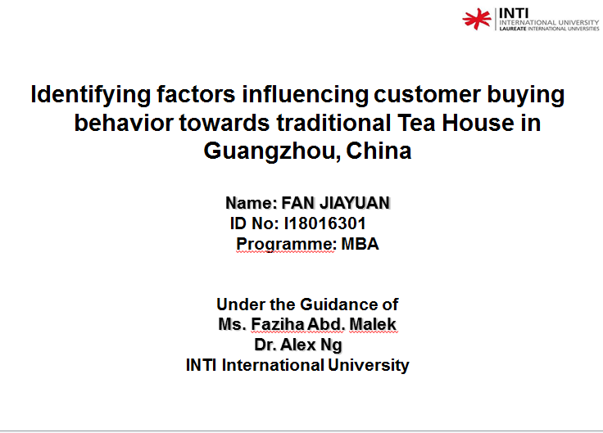
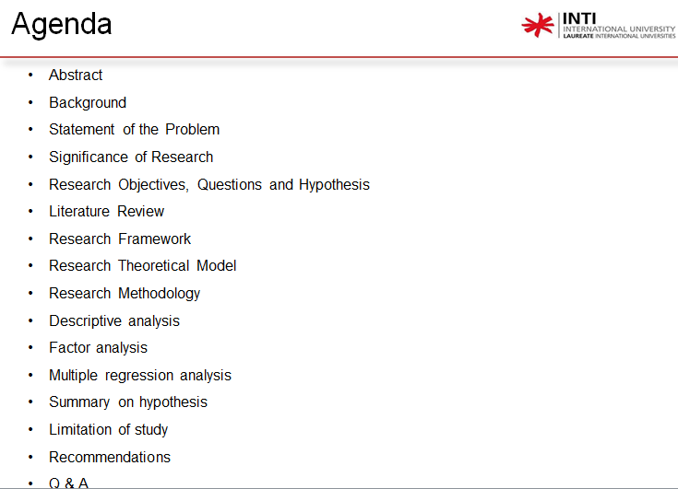
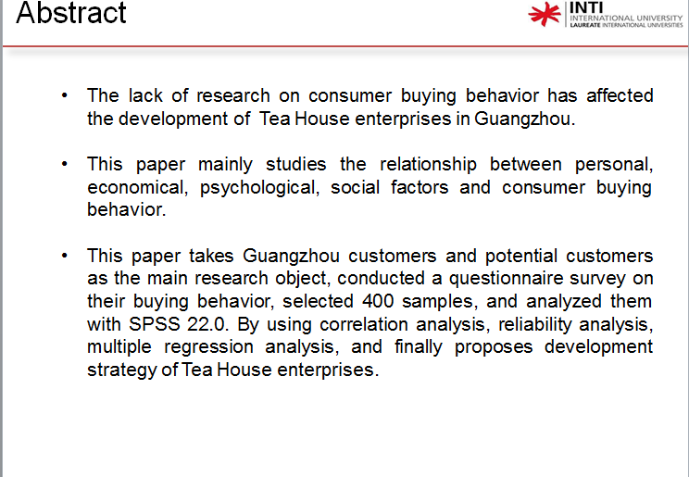
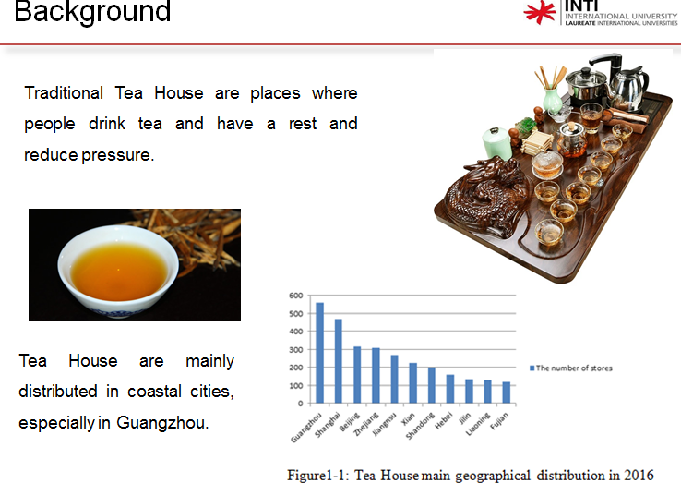
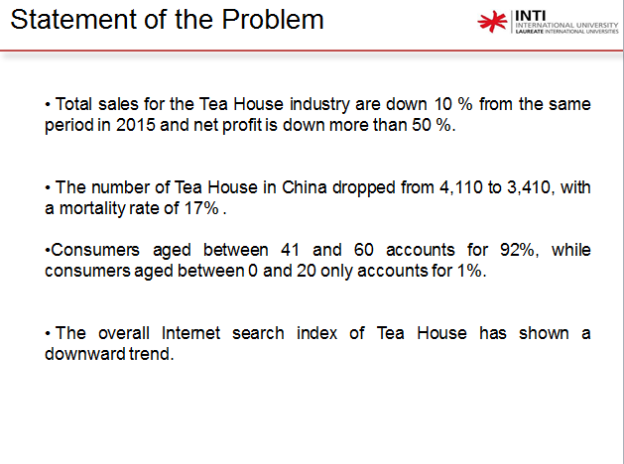
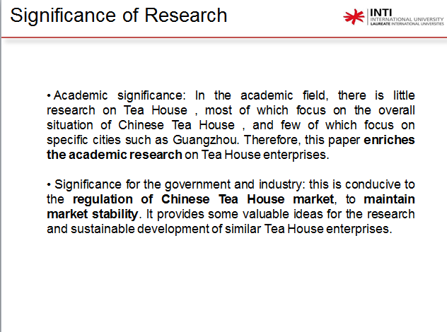
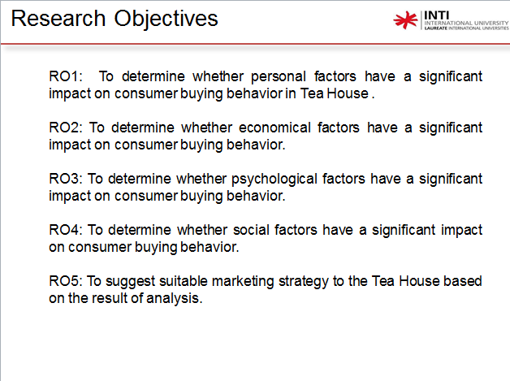
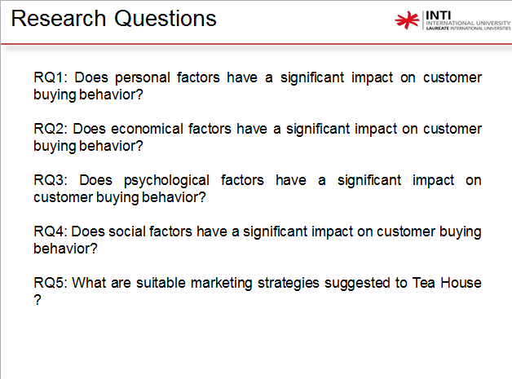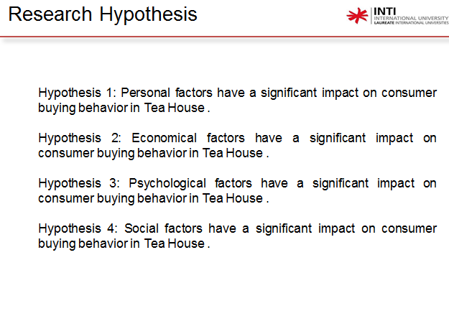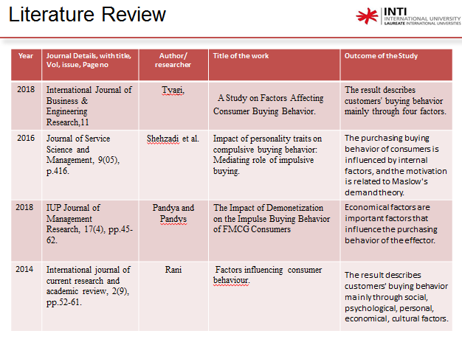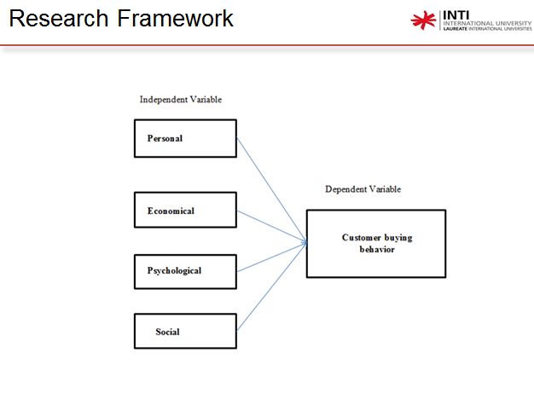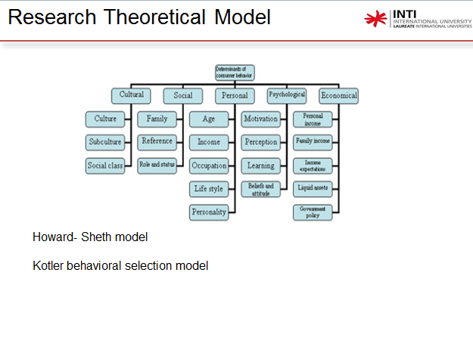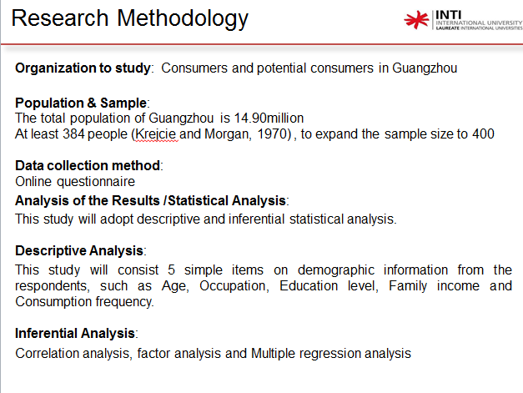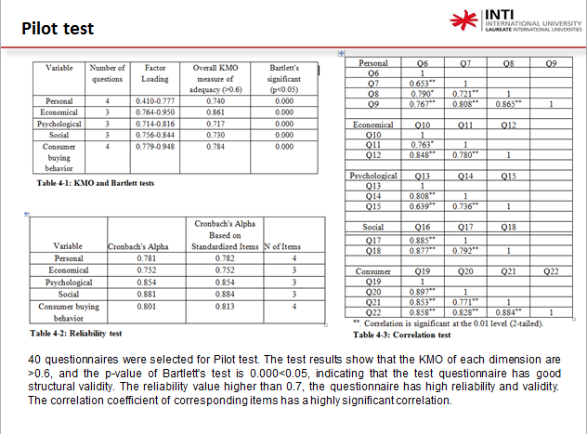
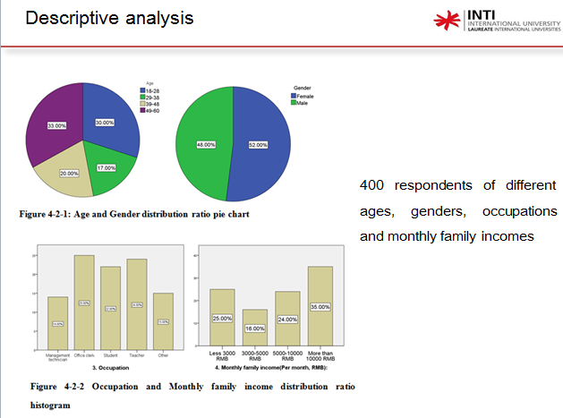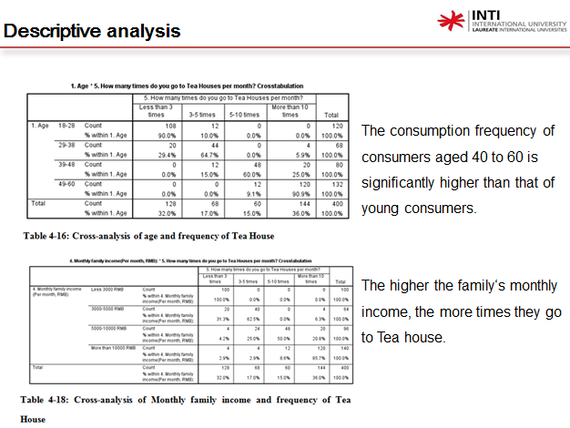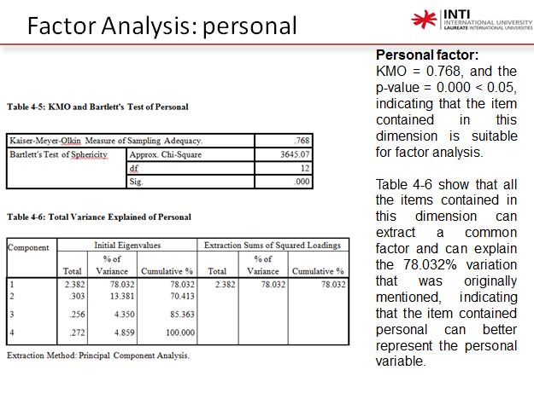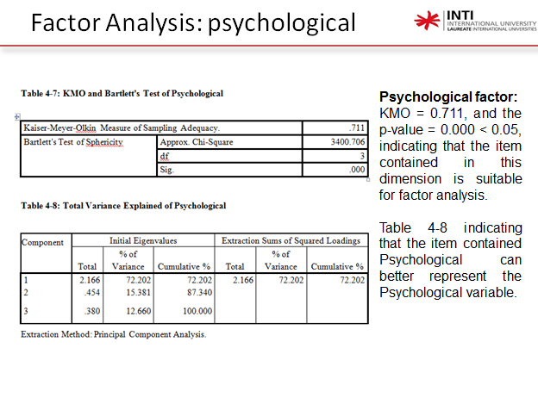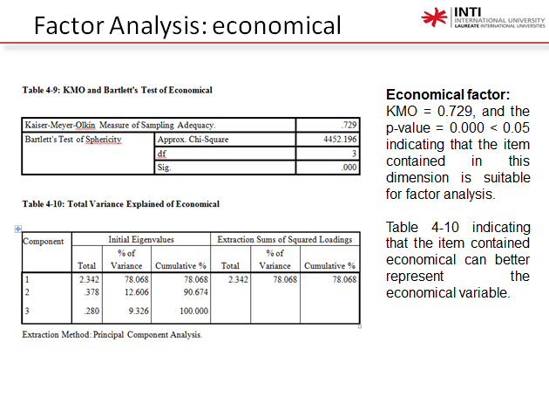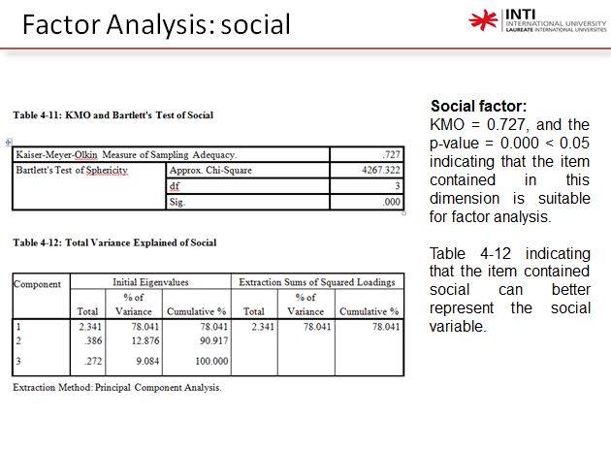
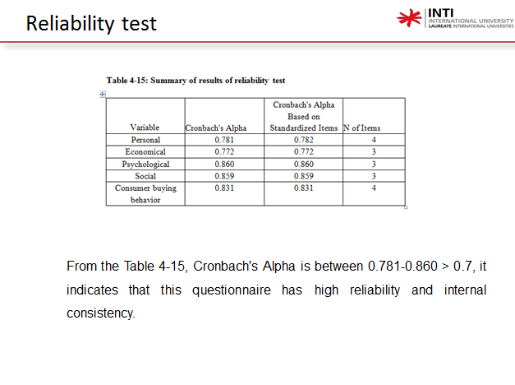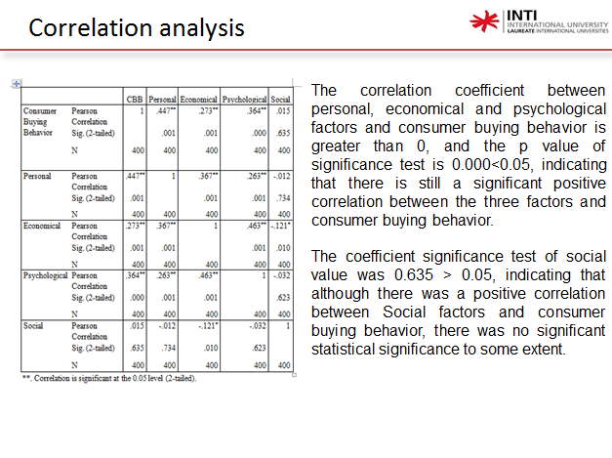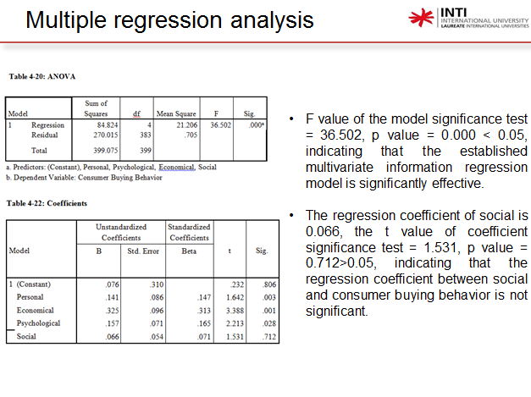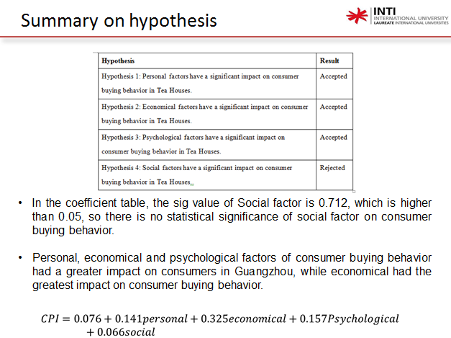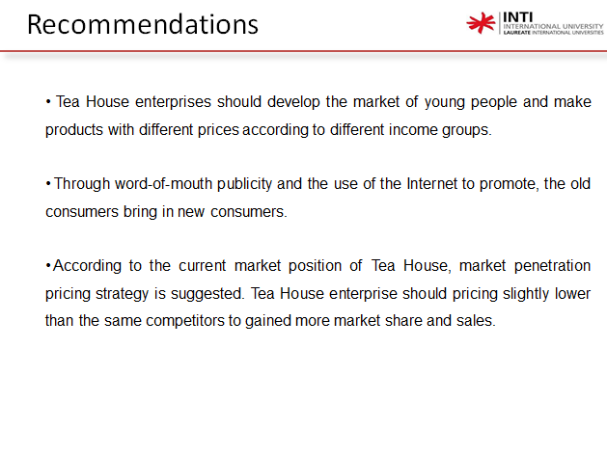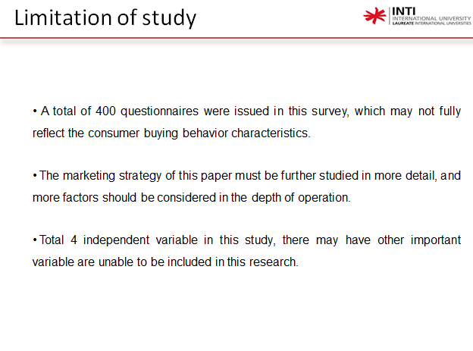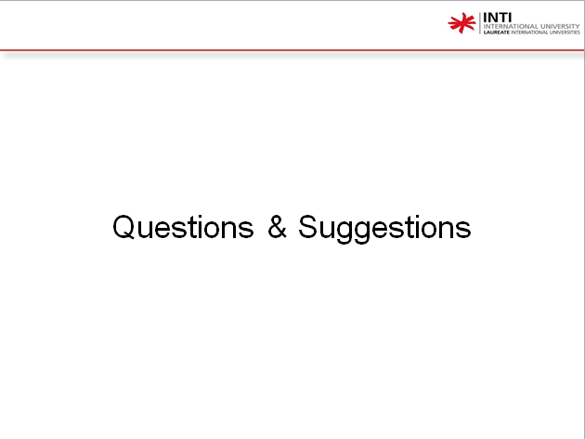

Appendix 6: SafeAssign report
