|  |  |
| --- | --- |
| **WONG YEE FONG MASTEROFBUSINESSADMINISTRATION 2019** | **FACTORS AFFECTING SATISFACTION OF PRIVATE UNIVERSITIES’ UNDERGRADUATES IN SELANGOR, MALAYSIA**  **WONG YEE FONG**  **MASTER OF BUSINESS ADMINISTRATION FACULTY OF BUSINESS, COMMUNICATION &LAW INTI INTERNATIONAL UNIVERSITY**  **2019** |

# **Title Page**

**INTI INTERNATIONAL UNIVERSITY**

**MASTER OF BUSINESS ADMINISTRATION**

**FACTORS AFFECTING SATISFACTION OF PRIVATE UNIVERSITIES’ UNDERGRADUATES IN SELANGOR, MALAYSIA**

**Author: WONG YEE FONG**

**Student No: I14006393**

**Supervisor: DR. WONG CHEE HOO**

**Submission Date: 20/12/2019**

**Ethics Number: BUS/PGT/UH/04349**

**Final Word Count: 16114**

# **ABSTRACT**

Student satisfaction is getting more and more significant to private education industry as it influences the development of private universities. This research is conducted focusing on factors affecting satisfaction of private universities’ undergraduates in Selangor, Malaysia. Since education is categorized as a type of service, therefore, in order to conduct the research, researcher had applied quantitative research methods to analyze the relationship between the service quality which is Tangibles, Assurance, Reliability, Responsiveness, Empathy, and undergraduates’ satisfaction in Malaysian Private Universities in Selangor, Malaysia.

In this study, the research objectives and questions are highlighted, and a conceptual framework that integrates different factors that influence the satisfaction of undergraduates is proposed. Questionnaire survey is used in the analysis process to gain actual data from the public in order to achieve the appropriate conclusion of this study.

**Key words**: Tangibles, Assurance, Reliability, Responsiveness, Empathy, Undergraduates’ Satisfaction, Malaysian Private University.

# **STUDENT’S DECLARATION**

I hereby declare that this thesis is my own work and effort and that it has not been submitted anywhere for any award. Where other sources of information have been used, they have been duly acknowledged.

Name : WONG YEE FONG

Student ID : I14006393

Signature : WONG YEE FONG

Date : 20/12/2019

# **ACKNOWLEGEMENT**

First and foremost, I would like to express my full appreciate and gratitude to Dr. Wong Chee Hoo, my research supervisor for providing supportive guidance with useful knowledge, research methods and professional information for my preparation of research study. Thank to his supervision, I am able to overcome every difficulties while conducting data analysing during my research study. I successfully complete the research study after having multiple reviews and discussions with Dr. Wong Chee Hoo.

I would like to express my sincere thank to Mrs. Faziha Abdul Malik for becoming my second marker in my research study. I appreciate her as she observed the details that I was lacking while preparing my works and provided supportive points for explanations in my research study.

I also grateful to my parents for their love and monetary supports during my research preparation. I also appreciate them for educating me to prepare for my future. I would like to thank my siblings and my dearest friends for providing helps and valuable support while I was working on research data analysis.

Finally, I would like to appreciate my respondents who were willing to get participated to provide valuable answers in my questionnaires. Thank to their times, I am able to collect valuable data and important information for my statistical analysis in research study.

TABLE OF CONTENTS

**Title Page** i

**ABSTRACT** ii

**STUDENT’S DECLARATION** iii

**ACKNOWLEGEMENT** iv

**CHAPTER 1** 1

**INTRODUCTION** 1

1.1 Background 1

1.2 Literature Gap 2

1.3 Statement of Problem 3

1.4 Research objectives 4

1.5 Research Questions 5

1.6 Significant of Study 6

Academic Purpose 6

Industry Purpose 6

1.7 Limitation of the study 7

1.8 Scope of the study 8

1.9 Ethical consideration 8

**CHAPTER 2** 9

**LITERATURE REVIEW** 9

2.0 Overview 9

2.1 Undergraduates’ Satisfaction 9

2.2 Service Quality in Higher Education 10

Tangibles 11

Assurance 13

Reliability 15

Responsiveness 17

Empathy 19

2.1 Theoretical Framework 21

SERVQUAL Model 21

2.2 Proposed Research Framework 22

2.3Hypothesis Development 22

**CHAPTER 3** 23

**RESEARCH METHODOLOGY** 23

3.0 Research Methods 23

3.1 Research Design 23

3.2 Measuring Instrument 23

3.2 1 Descriptive analysis 24

Pilot test 28

Reliability and Validity Tests 29

Reliability Statistics 29

Cronbach’s Alpha Acceptance Level 29

Factor Analysis 30

Multiple Regressions 31

One way Analysis of Variance (ANOVA) 32

3.3 Unit of Analysis 33

3.4 Sampling 33

Sample size 33

Target Population and sampling frame 33

Sampling Techniques 33

3.5 Data collection 34

Primary data 34

Secondary data 34

3.6 Ethical consideration 35

**CHAPTER 4** 36

**DATA ANALYSIS AND INTERPRETATION** 36

4.0 Overview 36

4.1 Demographic of respondent profile analysis 36

Frequency analysis 36

4.2 Reliability Analysis 42

4.3 Validity Analysis 43

KMO and Bartlett's Test 43

Normality test 46

4.4 Hypothesis Testing 49

4.4.1 Pearson Correlation Analysis 49

4.5 Regression analysis 50

**CHAPTER 5** 54

**CONCLUSION AND RECOMMENDATION** 54

5.0 Overview 54

5.1 Conclusion 54

For Hypothesis Testing 54

5.2 Research implication 57

Theoretical implication 57

Managerial Implication 57

5.3 Limitation 58

5.4 Future Research and Recommendations 59

**References** 60

**APPENDICES** 67

**Appendix A: MBA Questionnaire** 82

**Appendix B: SPSS Output** 87

**Appendix C: Record of meetings** 97

STUDENT’S DECLARATION 104

Appendix D: Initial Research Paper Proposal 106

# **CHAPTER 1**

# **INTRODUCTION**

Proposed title: Factors affecting Undergraduates’ Satisfaction in Malaysian Private Universities in Selangor, Malaysia

This thesis studies the background of Private Universities Industry in Malaysia. The following contents would be the problem statement, research objectives, research questions, limitation and scope of the study.

## 1.1 Background

The main reason for a company to be existed is to satisfy customers (Drucker, 1954). The purpose of marketing is "looking at the whole business from the perspective of the final result, that is, from the perspective of customers" (Kotler, 1977). That explained why marketers are focusing on meeting customer needs.

In Malaysia, the marketing of private universities is very mature and becomes a customer-centric market in this country. The education in Malaysia is the leading industry in the country and plays a very important role in the country's development. Malaysia's higher education industry has continuously grown and developing over the past 20 years.

In the past 20 years, Malaysia's higher education industry has made significant development in admissions; hence the industry successfully gained global recognition in some key areas such as research publications, teaching patents and institutional quality, and become the preferred destination for international students to pursue their further studies.

There is a total of 38 private universities in Malaysia (Etawau.com, 2019). Private higher education institutions have made great contributions to the Malaysian economy through the foreign exchange income brought by the influx of foreign students from 163 countries (Nordin Yahaya, 2019). In 2018, a total of 130,110 students were enrolled in private education institutions. According to the Education Ministry of Malaysia, the revenue from international students expected to grow to RM15.6b (malaymail.com, 2019). These achievements credited to the drive and innovation of Malaysian academia, the support of the private sector, and the deep investment from the government (Ministry of Higher Education (MoHE), 2015).

Pursuing studies in Private Universities by undergraduates in Malaysia from local and foreign students contribute the development of economy of Malaysia. Therefore, Malaysia Government actively welcomes local and foreign students to study in Private Universities in Selangor, Malaysia. Malaysia government also encourages students to continuously pursue their study in Malaysian Private Universities after graduating their degree studies. Malaysian Private Universities need student as the main financial resources to continue their operation as the government does not provide subsidies to private universities. There are 5 factors that affecting undergraduates’ loyalty in Malaysian Private Universities in Selangor, Malaysia.

## 1.2 Literature Gap

In this study, various literatures from different countries were cited on the satisfaction of university students with private university education, areas about service quality, and the ways that service quality affects students' satisfaction with private university education.

From the previous literature, the researcher gathered all sorts of different arguments which proved that tangibles, assurances, reliability, responsiveness, and empathy have positive significant relationship with undergraduates’ satisfaction. However, it was difficult to find literature that simultaneously demonstrated a positive relationship between all the 5 dimensions in SERQUAL Model and student’s satisfaction.

To reinforce the title of this study, the researcher also used literatures from different industries, such as hospitality, catering, banking and aviation, to study how service quality affects customer satisfaction with specific services.

After searching some academic databases, the researcher found that information about the service quality of Malaysia's private universities and the factors influencing students' satisfaction with Malaysia's private universities did not appear in the previous literature. Therefore, the main papers of this study were identified and confirmed to discover factors influencing undergraduate satisfaction toward the services of private universities in Malaysia.

## 1.3 Statement of Problem

Since 2016, 64% of private higher education industries in Malaysia are facing debt distress and losses (Freemalaysiatoday.com, 2018). For private education in Malaysia, there are no subsidies provided from government, these may cause those private universities short of funds to purchase or update equipment，additionally, causing the institutions lacking funds to employ adequate and well-trained staff, all of the impact will lead to affect student’s learning experience. As the result, the student’ satisfaction reduced.

Generally, students are likely to see themselves as customers of private universities (Guilbault, M., 2018). It is the same point of view as the private universities to the student, that is, students are important clients. Additionally, students are increasingly aware of the gap between their consumer rights and their expectations and expectations for service delivery, which can potentially encourage students to withdraw from the university (Haihambo, J., 2018).

The student satisfaction to the university service is very important, if students are not satisfied with the service provided by the university, the student may choose to stop studying at the university and move to other university to study, it directly affects the university next year the number of new students. Reducing the number of new students means the increasing of the risk of future failure and could allow the university to be closed down. While private education industry failed to operate well, the economy of Malaysia will be affected as well as it may affect Malaysia's GDP and cause the dropping of the country’s revenue.

In order to gain more clients, increasing clients’ satisfaction always becomes a significant action planning for a company. Public Comparisons of Private Higher Education Institutions (PHE) in Malaysia throughout an executive ranking system named SETARA also highlight the significance of understanding and enhancing student satisfaction (Etawau.com, 2019).

Students are the main financial resources of all private universities in Malaysia. By understanding the factors that persuade student’s satisfaction, management of Private Universities in Selangor, Malaysia must be able to develop quality reassurance projects or develop departments to meet up the prospect of students and stakeholders and help retain students, and identifying the factors affecting Undergraduates’ Satisfaction in Private Universities in Selangor, Malaysia became the title of this research study.

## 1.4 Research objectives

The objectives of this research study mainly highlighted the relationship between SERQUAL (tangibles, assurance, reliability, responsiveness, empathy) and satisfaction of Private Universities’ undergraduates in Selangor, Malaysia. The 5 research objectives were stated as the following:

1. To determine the relationship between tangibles and satisfaction of Private Universities’ undergraduates in Selangor, Malaysia

2. To determine the relationship between assurance and satisfaction of Private Universities’ undergraduates in Selangor, Malaysia

3. To determine the relationship between reliability and satisfaction of Private Universities’ undergraduates in Selangor, Malaysia

4. To determine the relationship between responsiveness and satisfaction of Private Universities’ undergraduates in Selangor, Malaysia

5. To determine the relationship between empathy and satisfaction of Private Universities’ undergraduates in Selangor, Malaysia

## 1.5 Research Questions

This study will carry out appropriate findings and develop a number hypothesis to answer the following research questions:

1. Is there any relationship between tangibles and satisfaction of Private Universities’ undergraduates in Selangor, Malaysia?

2. Is there any relationship between assurance and satisfaction of Private Universities’ undergraduates in Selangor, Malaysia?

3. Is there any relationship between reliability and satisfaction of Private Universities’ undergraduates in Selangor, Malaysia?

4. Is there any relationship between responsiveness and satisfaction of Private Universities’ undergraduates in Selangor, Malaysia?

5. Is there any relationship between empathy and satisfaction of Private Universities’ undergraduates in Selangor, Malaysia?

## 1.6 Significant of Study

This research helps Malaysian private universities to achieve strategic competitiveness by combining students' expectations of service quality and improving student satisfaction by identifying students' various requirements for service quality.

### Academic Purpose

This research study helps private universities to increase the quality of private education. While students receive high quality education, it is good for their future development as high quality education helps the next generation of young people to get prepared for employment in private industry. Additionally, after increasing service quality, it will increase the reputation of private universities in Malaysia as well and successfully recruit more local and foreign students.

Management will also be able to develop quality assurance programs that meet the needs of their key stakeholders and students.

### Industry Purpose

In addition, this research can help entrepreneurs who are interested in entering higher education in the future to set reference points for quality standards in order to accurately provide the right services to students who has potential to become customers.

Making enhancement of service quality helps to attract more loyal customers and hence increase company’s revenue. While a company able to operate well, there will be a good economic development to the country as well. The research results about SERQUAL brought constructive advices to various industries in addition of education industry.

Overall, the enhancements implemented based on the findings of this study may help to increase the reputation of private universities in Malaysia and thus successfully recruit more local and foreign students.

## 1.7 Limitation of the study

**Limited Time**

The duration of collect data is short. Time also limit to collect more survey and need to generate the data in the short period.

**Distribute questionnaire online to respondent**

Due to the questionnaires are distribute trough online method, the researchers cannot explain the meanings of the questionnaire face to face with the respondents this may cause the respondent unable to understand clearly to the contents of the questionnaire. It may also possibility that some of the respondents may not read the question carefully and answer carefully the questionnaire while completing the questionnaire, therefore causing missing value and affect the result of analyzation.

**Sample size not big enough**

Due to the restricted time, the researcher was unable to collect data from a sample size that more than 300 people. This caused some of the result of analyzation only can be categorized as qualified result, but not the ideal results.

## 1.8 Scope of the study

The research is conducted by the researcher with identifying the factors which affecting Undergraduates’ Satisfaction in Malaysian Private Universities in Selangor, Malaysia. The geographic area covered the area in Selangor, Malaysia. The sample focused private university students in Malaysia. Moreover, the unit of analysis is focused on private university students in Selangor, Malaysia.

## 1.9 Ethical consideration

The critical point that relevant to ethical apprehension in this study is, all details and information that had been collected by the researcher was kept safely as secrete information. Additionally, the creation of the questions in the questionnaire also prevented the use of offensive and discriminatory languages.

# **CHAPTER 2**

# **LITERATURE REVIEW**

## 2.0 Overview

The literature review in this research focused on the factors influencing private university’s students' satisfaction. Today, more and more private universities are being established in Malaysia. Therefore, in order to improve the enrolment rate of students, many universities have conducted research on the determinants of student satisfaction.

## 2.1 Undergraduates’ Satisfaction

Student satisfaction is defined as a key factor to measure the quality of education methods and the achievement of learning programs. Undergraduate’s satisfaction is an important part of successful promotion of higher education (Duong, 2015). Disgruntled students may reduce the number of courses registered or simply drop out form studying the course ( Kunanusorn, A. and Puttawong, d., 2015).

Through a national survey of British college students, it was found that there were differences in student satisfaction in different research fields (Lenton, 2015). Previous studies have shown that the most important factors influencing student satisfaction are those related to teaching, while the least important factors are those related to physical facilities (Douglas, Jacqueline & Douglas, Alex & Barnes, Barry, 2006). Besides, recent studies have found that factors related to academic atmosphere, such as teachers' response to students' needs, have a great impact on students' satisfaction (Li and Carroll, 2017). Controversially, only a few of these previous studies that attempted to measure the quality of higher education services using appropriate measuring model since there is no universal definition of quality at those previous times (Viraiyan, 2016).

## 2.2 Service Quality in Higher Education

The service industry plays an important role in the development of the economy. For nearly 20 years, service quality evaluation has been focused and given attention by researchers (Sabina and Samira, 2015). According to research data from Pakistan, unlike other factors such as price and reputation, the quality of service has the greatest impact on student satisfaction (Saleem, S., Moosa, K., Imam, A. and Ahmed Khan, R., 2017).

Research data from Spain University also claimed that, with supported hypothesis, there are a significant relationship between service quality and student satisfaction, which mean that service quality can influence learner satisfaction ( Vu Thi Huong, Marti Casadesus, and Frederic Marimon, 2017). Zeithaml and Parasuraman pointed out that service quality includes three key dimensions: function, technology and image, while service quality depends on two variables: expected service and perceived service (Zeithaml and Parasuraman, 1985).

Higher education in universities is considered a service (Mazzarol, 1998). The purpose of higher education institutions is to create and provide knowledge and skills to enrich, equip and expand human development and understanding; it can itself become a core part of the national economic infrastructure (Haihambo, J., 2018).

Data from Indian researchers indicate that Student Perceived Service Quality contributes 85% of Student Satisfaction and 43% of Student Loyalty, and this study showed and confirmed that there is a key linking supposed service quality, student satisfaction, loyalty and motivation (Subrahmanyam Annamdevula, Raja Shekhar Bellamkonda, 2016). As will be described, it has been used by researchers around the world as a tool for measuring the quality of higher education services.

### Tangibles

In a service business, all existing facilities that provide facilities, integrity, interior design and facilities should be considered, especially those closely related to what consumers directly perceive or obtain (Yenny, 2017). Tangible substances are elements that can be "seen" and "moved" by students in university services (Afshan Azam, 2018).

According to researchers from Norwegian university, there are 34% of the students can be satisfied with university facilities (UF), showing that Facilities (UF), especially the social part, such as areas where students usually choose to relax and gathering with lectures and classmates, have a powerful influence on student in general satisfaction (Hanssen, T.E.S. and Solvoll, G., 2015).

Research data from Bangladesh illustrated that the tutoring environment has significant relationship with student satisfaction, which representing the fact that the enhanced overall environment of tutoring place will make higher the level of satisfaction of the university undergraduates (Imtiaz, A., 2018).

While the researchers from Indonesia and Malaysia research centres claimed that there is a strong relationship between the quality service of campus facility and student satisfaction (Napitupulu, D., 2018), additionally, data from research from University Utara Malaysia showed that Tangibility service appears the highest significant level to student satisfaction (Pohyae, 2016), as well as the data from researcher in Sri Lanka, with accepted hypothesis( Kajenthiran, K. and Karunanithy, M., 2015.), indentified that the correlation between campus service and user satisfaction is strongly taked to mean. This explained that if the service quality enhanced, the satisfaction will also be increased. Thus, students can be considered to have psychological interactions with the physical environment in which they learn. There are many factors to consider when trying designing a physical site.

It is thought that the characteristics of many sports venues in the sports learning environment is important to increase student satisfaction (Wilson, HK and AJ, 2016). It includes physical factors such as the artistic colors of university constructions and the cleanliness of university buildings. Physical facilities are important because, as a tangible element, it has a significant impact on developing students' basic attitudes towards the university. Empirically, it is also considered as a influence of student satisfaction, especially given its obvious nature that allow students to evaluate their experience in the field (Afshan Azam, 2018). Therefore, this supports the need to determine how to design a college physical education learning environment to best maintain correspondence with student requirements. Other than education industry, there are also research data which researching about others industry came out evidence data showing that there is a significant relationship between tangibles and customer satisfaction.

There is a study from 4 - 5 star hotels in HCM city, Viet Nam showed that tangibles could affect customer satisfaction, it is because there is a supported result showing that there is a significant positive relationship between tangibles and customer’s satisfaction (Phi, H.D., Thanh, L.P. and Nguyen Viet, B., 2018).

About food and beverage (F&B) industry, the data from UK researches showed that, with a supported result of all hypothesises, it proved that tangibles have a positive significant relationship with customers’ satisfaction in UK restaurants (Nguyen, 2018).

About the banking industry, the finding in the research data from Pakistan and Irbid city, Jordan confirmed that the hypothesis is accepted, which claimed that tangibles has a positive impact to customer’s satisfaction (Ali, M. and Raza, S.A., 2017; Al-Azzam, A.F.M., 2015).

About the airline service industry, the research data from Jordan came out a result proved that tangibles has significant positive relationship with passengers’ satisfaction (Jahmani, A., 2017).

### Assurance

A study defined that assurance is the knowledge of employees, and the capability to help the business to stimulate confidence and trust (Anwowie, Amoako, and Abrefa, 2015). This dimension is important in determining the quality and risks and uncertainties that customers consider to involve high-level services.

There are four broad concepts of quality in higher education. They are purposeful, transformative, special, and responsible (Schindler, 2015), while assurance in education define as the knowledge employees and the ability to gain trust and confidence from student (Chong, YT, Lim, EM, Ng, CY and Wong, CS, 2016). Examples of assurance in this study include employee behaviour in universities to gain student trust, whether good teaching is provided, whether students trust the services provided, whether they feel safe in the institution, and whether students are polite to employees, and the knowledge of employees to answer students' questions (Anwowie, 2015).

From the data from USM Malaysia showed that, with supported hypothesis; there is a significant positive effect of good teaching on students’ overall satisfaction (Thien, L.M. and Jamil, H., 2019).

There is also data from researcher in Sri Lanka, Thailand, and University Utara Malaysia, with accepted hypothesis, the result showed that there is a significant relationship connecting assurance and student’s satisfaction ( Kajenthiran, K, 2015; Kunanusorn, A. and Puttawong, D., 2015; Pohyae, S., 2016),

Besides, data from Jordanian Governmental University showed that among the five dimension of service quality, only Assurance and Empathy have significant relationship to affect students‟ intention of moving (Twaissi, N.M. and Al-Kilani, M.H., 2015), means that assurance could affect the students’ satisfaction and making them moving to study at another university.

Other than education industry, there are also research data which researching about others industry came out evidence data showing that there is a significant relationship between assurance and customer satisfaction.

From a case study about hotel industry from Vietnam and a study from 4 - 5 star hotels in HCM city, Viet Nam, there is a supported result showing that there is a significant positive relationship between assurance and customer’s satisfaction (Phi, H.D., Thanh, L.P. and Nguyen Viet, B., 2018).

About food and beverage (F&B) industry, the data from UK researches showed that, with a supported result of all hypothesises, it proved that assurance have a positive significant relationship with customers’ satisfaction in UK restaurants (Nguyen, 2018).

About the banking industry, the finding in the research data from Pakistan and Irbid city, Jordan confirmed that the hypothesis is accepted, which claimed that assurance has a positive impact to customer’s satisfaction (Ali, M. and Raza, S.A., 2017; Al-Azzam, A.F.M., 2015).

About the airline service industry, the research data from Jordan came out a result proved that assurance has significant positive relationship with passengers’ satisfaction (Jahmani, A., 2017).

### Reliability

Previous research study showed that reliability is the ability to increase reliably and accurately perform the services promised and the researcher of the study claimed that reliability is the most important determinant of consumers' perception of service quality and suggested that customers want to do business with organizations that keep their promises (Anwowie, 2015). Accordingly, all service providers, including private universities, need to understand customer expectations for reliability. In higher education, quality measures are growing, and there is an increasing emphasis on the reliability and responsibility of education. (Abdullah, F., 2006).

Reliability in private education can be measured by determining whether students are receiving services within the time committed by the university, whether lecturer has done commitment to students, whether the staffs are showing a genuine interest in addressing student problems, whether staffs are correctly providing services to students in the first place, and maintaining an error-free record (Anwowie, 2015).

From the data from researcher in Sri Lanka, and also the data from Institute Technology Indonesia, with accepted hypothesis, both results showed that there is a significant relationship connecting reliability and students’ satisfaction ( Kajenthiran, 2015; Theresia, L. and Bangun, R., 2017).

Data from University Technology Malaysia showed the correlation between reliability and students’ loyalty was 0.331 which signified a moderate and positive relationship between reliability and student loyalty (Sin, M.C., Yusof, B.B. and Sin, K.Y., 2018). As student loyalty must be achieved only after the service quality gained student satisfaction at the first place, therefore the data indirectly confirmed that there is a significant relationship among reliability and students’ satisfaction.

There is also data from research from China University showed that there is a positive relationship between both lecturer assurance to students’ educational achievement and lecturer dedication to the social incorporation of students and student satisfaction (Xiao, J. and Wilkins, S. ,2015).

Other than education industry, there are also research data which researching about others industry came out evidence data showing that there is a significant positive relationship linking reliability and customer’s satisfaction.

From a case study about hotel industry from Vietnam and a study from 4 - 5 star hotels in HCM city, Viet Nam, there is a supported result showing that there is a significant positive relationship between reliability and customer’s satisfaction (Phi, H.D., Thanh, L.P. and Nguyen Viet, B., 2018).

About food and beverage (F&B) industry, the data from UK researches showed that, with a supported result of all hypothesises, it proved that reliability have a positive significant relationship with customers’ satisfaction in UK restaurants (Nguyen, 2018).

About the banking industry, the finding in the research data from Pakistan and Irbid city, Jordan confirmed that the hypothesis is accepted, which claimed that reliability has a positive impact to customer’s satisfaction (Ali, M. and Raza, S.A., 2017; Al-Azzam, A.F.M., 2015).

About the airline service industry, the research data from Jordan came out a result proved that reliability has significant positive relationship with passengers’ satisfaction (Jahmani, A., 2017).

### Responsiveness

Responsiveness is the readiness to help customers and offer well-timed services. It is also communicated to customers by waiting for help or paying concentration to their inconvenience, criticism and requests, which can be achieved through levels of flexibility and the ability of employees Ung, V. and Norng, T., 2017). Examples of responsiveness in this study include university staff telling students exactly when services are available, staff providing timely services to students, and staff willing to help students when needed (Anwowie, 2015). Responsiveness can also be accessed through students' experiences with online learning.

From the data from researcher in Sri Lanka, and also the research data from Syria, with accepted hypothesis, both the results showed that there is a significant positive relationship between responsiveness and student’s satisfaction (Kajenthiran, 2015; Mahmoud, A.B. and Grigoriou, N., 2017).

Data from University Technology Malaysia showed that responsiveness portrayed a strong relationship with the students’ loyalty with an r-value of 0.583 (Sin, 2018). As student loyalty must be achieved only after the service quality gained student satisfaction at the first place, therefore the data indirectly proved that responsiveness portrayed a strong relationship with the students’ satisfaction.

Other than education industry, there are also research data which researching about others industry came out evidence data showing that there is a significant positive relationship between responsiveness and customers’ satisfaction.

From a case study about hotel industry from Vietnam and a study from 4 - 5 star hotels in HCM city, Viet Nam, there is a supported result showing that there is a significant positive relationship between responsiveness and customer’s satisfaction (Phi, H.D., Thanh, L.P. and Nguyen Viet, B., 2018).

About food and beverage (F&B) industry, the data from UK researches showed that, with a supported result of all hypothesises, it proved that responsiveness have a positive significant relationship with customers’ satisfaction in UK restaurants (Nguyen, 2018).

About the banking industry, the finding in the research data from Pakistan and Irbid city, Jordan confirmed that the hypothesis is accepted, which claimed that responsiveness has a positive impact to customer’s satisfaction (Ali, M. and Raza, S.A., 2017; Al-Azzam, A.F.M., 2015).

About the airline service industry, the research data from Jordan came out a result proved that responsiveness has significant positive relationship with passengers’ satisfaction (Jahmani, A., 2017).

### Empathy

Empathy is defined as a kind of compassion, which is the company's care and personal attention to customers (Hofelich, A.J. and Preston, S.D., 2012). The nature of empathy conveys the message that customers are unique and special. For example, empathy includes the degree to which a university provides emotional support to students, and provides teachers with the ability to personally focus on and understand the specific needs of students, such as for students, and offering course time table arrangement that fit their time (Anwowie, 2015).

From the data from researcher in Sri Lanka, and also the research data from Syria, with accepted hypothesis, both the results showed that there is a significant positive relationship between empathy and student’s satisfaction (Kajenthiran, 2015; Mahmoud, A.B. and Grigoriou, N., 2017).

Moreover, the research data from American Psychological Association gave explanation that there is a significant relationship linking both facility support and student-peer support and student’s satisfaction. (Tompkins, K.A., Brecht, K., Tucker, B., Neander, L.L. and Swift, J.K., 2016).

There is also data from research from University Utara Malaysia showed that empathy is categorized together with assurance and tangibles as the most affecting factors that influences student satisfaction, there is a significant relationship with empathy represented the value r=.36, p<.05 which is statistically highly significant at the. 000 levels (Pohyae, S., 2016), means that there is a significant relationship connecting empathy and student’s satisfaction.

Other than education industry, there are also research data which researching about others industry came out evidence data showing that there is a significant relationship linking empathy and customer’s satisfaction.

From a case study about hotel industry from Vietnam and a study from 4 - 5 star hotels in HCM city, Viet Nam, there is a supported result showing that there is a significant positive relationship between empathy and customer’s satisfaction (Phi, H.D., Thanh, L.P. and Nguyen Viet, B., 2018).

About food and beverage (F&B) industry, the data from UK researches showed that, with a supported result of all hypothesises, it proved that empathy have a positive significant relationship with customers’ satisfaction in UK restaurants (Nguyen, 2018).

About the banking industry, the finding in the research data from Pakistan and Irbid city, Jordan confirmed that the hypothesis is accepted, which claimed that empathy has a positive impact to customer’s satisfaction (Ali, M. and Raza, S.A., 2017; Al-Azzam, A.F.M., 2015).

About the airline service industry, the research data from Jordan came out a result proved that empathy has significant positive relationship with passengers’ satisfaction (Jahmani, A., 2017).

## 2.1 Theoretical Framework

According to all the previous literature, it can be determined the 5 dimensions of SERQUAL model (tangibles, assurance, reliability, responsiveness, and empathy) consider as important factors affecting undergraduates’ satisfaction in Malaysian Private University(Zeithaml and Parasuraman, 1985). The framework is described as follows: the dependent variable (DV) for this research study is undergraduates’ satisfaction. There was various literature reviews proved that, those independent variables (tangibles, assurance, reliability, responsiveness, and empathy) have positive relationship with and have impacts to the dependent variable.

### SERVQUAL Model

In order to overcome the difficulty of quality assessment caused by the interpretation of the term, Zeithhaml and Parasuraman proposed a SERVQUAL service quality measurement model based on multi-project scale. They called this model a "gap model" because the gap between customer expectations is to provide superior quality and must eliminate customer perception gaps (Zeithaml and Parasuraman, 1985). The SERVQUAL model and its scope of application have been widely used in the fields of "banking, retail, wholesale, health and education" (Viraiyan, 2016).

In the SERVQUAL model in education, the main dimensions are:

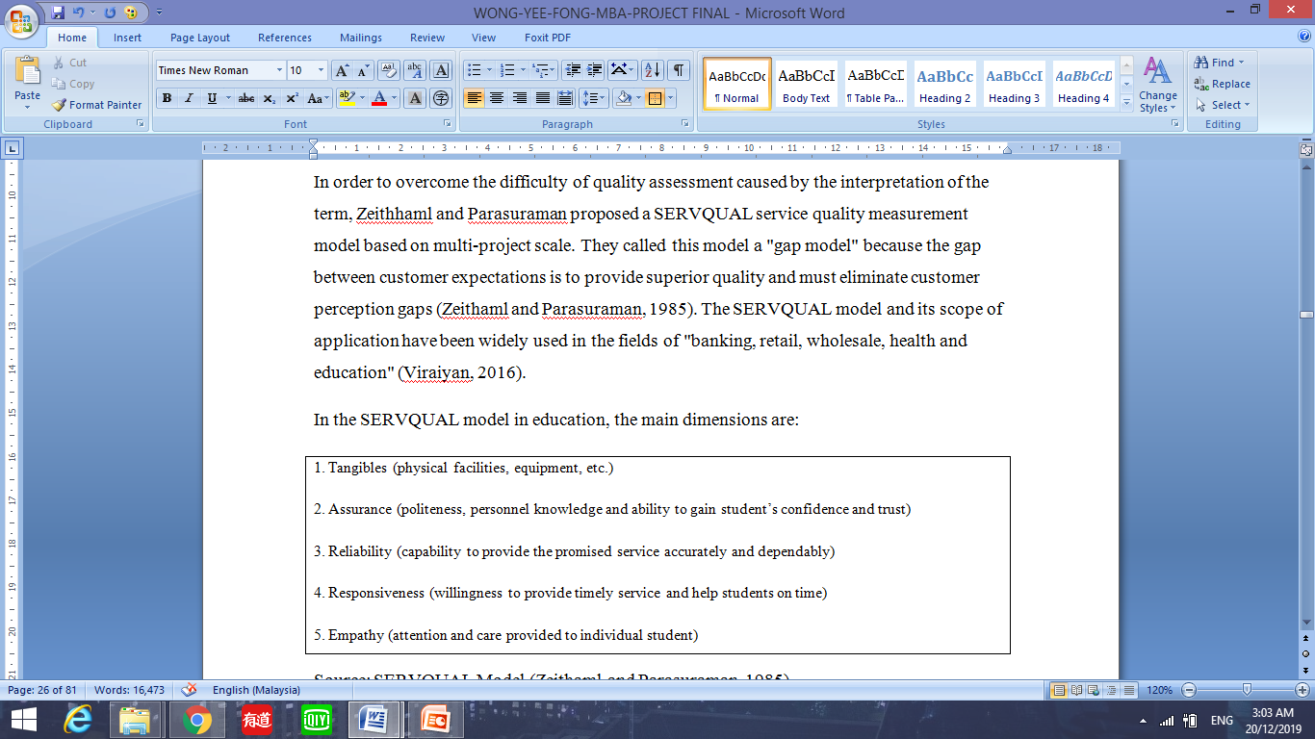

Source: SERVQUAL Model (Zeithaml and Parasuraman, 1985).

The establishment of a higher education service quality evaluation model is a difficult problem, and the main problem is the determination of the quality dimension. Although there are different approaches to this problem, the SERVQUAL model is the tool that is the most commonly used to assess the quality of higher education services (SabinaĐonlagić and Samira Fazlić, 2015).

## 2.2 Proposed Research Framework

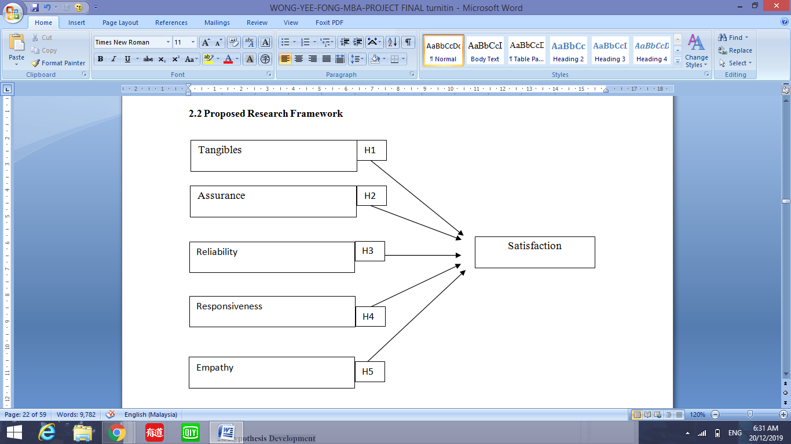

## 2.3Hypothesis Development

The hypotheses are developed based on the following assumptions.

H1: There is a significant relationship between tangibles and undergraduates’ satisfaction

H2: There is a significant relationship between assurance and undergraduates’ satisfaction

H3: There is a significant relationship between reliability and undergraduates’ satisfaction

H4: There is a significant relationship between responsiveness and undergraduates’ satisfaction

H5: There is a significant relationship between empathy and undergraduates’ satisfaction

# **CHAPTER 3**

# **RESEARCH METHODOLOGY**

## 3.0 Research Methods

The third chapter mainly introduces the research methods used by researcher to analyze factors affecting undergraduates’ satisfaction. This chapter includes the following parts: research design, measuring instrument, population, sample, sampling design procedure, data analysis, and the ethical issues related to research.

## 3.1 Research Design

Research design is a grand plan for researching topics and answering research questions (Nooshinfard, F., Nemati-Anaraki, L., Zikmund, W., Babin, J .., & & Griffin, M., 2012). This study is a quantitative study. Researchers use descriptive techniques to evaluate the data and draw conclusions. Questionnaires are used to collect data from participants' answers by answering questions in the questionnaire. The questionnaire was planned by referring to the SERVQUAL model. The data collected through the questionnaire survey is based on the five dimensions of the SERVQUAL model to measure student satisfaction factors, namely tangible, assurance, reliability, responsiveness, and empathy.

## 3.2 Measuring Instrument

Measurement tools those used by the researcher are questionnaires used to collect and collect data. Social Science Statistics Package (SPSS) 24.0 is an analytical tool for analyzing data gathered during research. SPSS is software used for analyzing and managing data. SPSS is used for data analysis because it provides a rich and varied analysis tool, allowing researchers to obtain reliable and accurate analysis results from different data (Hinton, McMurray and Brownlow, 2014). SPSS 24.0 is the latest SPSS version on the market. It is therefore suitable for this study. Using SPSS, the Cronbach alpha generation process and descriptive analysis were used to analyze the data in this study (Heale et al., 2015).

The availability of questionnaires can be tested through descriptive information, preliminary testing and hypothesis testing. Descriptive statistics of available variables, reliability analysis, validity analysis, confidence interval estimation and causal correlation analysis were used to analyze the data collected from questionnaires. It describes the relationship between factors and effects, and involves independent and dependent variables.

### 3.2 1 Descriptive analysis

The data analysis technique used in this study is descriptive analysis. Descriptive analysis is used by researchers to interpret quantitative data as manageable information structures (William, 2006).The results can be translated into graphical summaries and charts or pie charts, allowing researchers to interpret the results.

Descriptive statistics can also help analyze and computing numerical summaries of the mean, pattern, median, and frequency of the data collected .The important use of descriptive analysis is to enable raw data to be expressed and interpreted in a more direct and understandable manner.

This study contained five simple demographic information included: gender, age, education, marital status and income. The population data collected are illustrated in a pie chart.

Table 1: Source of Questionnaire

|  |  |
| --- | --- |
| Variables | Sample of Items |
| Tangibles | 1. Excellent universities will have modern and up to date equipment (computer labs, swimming pools, learning resource centre, cafeteria, etc.).  2. Excellent universities will have visual appealing of physical facilities.  3. Excellent universities will have neat and well-dressed staffs.  4. Excellent universities will have visual appeal of materials (brochures or statement related with courses and programme). |
| Assurance | 5. The behaviour of staffs of excellent universities will instil confident in students.  6. Students of excellent universities will feel safe while receiving services from staffs.  7. Staffs of excellent universities are polite with students.  8. Lecturers of excellent universities will have the knowledge to answer students. |
| Reliability | 9. Excellent universities will provide service as promised.  10. Excellent universities will perform services right at the first time.  11. Excellent universities will provide services at appointed time.  12. Excellent universities will keep error-free records. |
| Responsiveness | 13. Staffs of excellent universities will tell students exactly when service will be provided.  14. Staffs of excellent universities will give prompt service to students.  15. Staffs of excellent universities will always be willing to help students.  16. Staffs of excellent universities will never be too busy to respond to students’ requests. |
| Empathy | 17. Excellent universities will give students individual attention.  18. Excellent universities will have staffs who give students personal attention.  19. Excellent universities will have operating hours convenient to all students.  20. Staff of excellent universities will keep students’ interest at heart.  21. Excellent universities will understand specific needs of students. |
| Satisfaction | 22. I believed I am satisfied with the services in my university.  23. Overall, I feel pleased with the services in my university.  24. Using services from my university is a satisfying experience  25. My feelings toward my university’s services can be best characterised as. |

Source: 1. Adapted from Parasuraman, A., Zeithami, V.A., and Berry, L, (1988). “SERQUAL: A multiple- Item Scale for Masuring Consumer Perceptions of Service Quality,” Journal of Retailing. Vol. 64, pp. 12-40. (Q1-Q21)

2. Malhotra, N.K. , 2010. Marketing Research: an applied approach. 6th Edition. Pearson Education UK. (Q22-Q25)

### Pilot test

The researchers used 21 sets of questionnaires for the pilot test. After passing the test, the researchers distributed all the questionnaires, collected the answers, and then conducted reliability analysis, and then conducted reliability test with SPSS software.

The preliminary test is a method for researchers to test the reliability and validity of the study and the questionnaire before the final questionnaire is issued (Callegaro, Manfreda and Vehovar, 2015).After conducting the pilot test procedure, researchers need to evaluate the questionnaire, and those incorrectly expressed and unclear questions need to be rearranged so as not to affect the research objectives.

The advantage of using the research instrument for pilot test and improvement based on the results is to improve the quality of the measuring instrument (Andrews et al., 2003) and minimize the errors and problems of measurement (Merolli).Et al., 2014).

The researcher used 21 sets of questionnaires for the pilot test.

### Reliability and Validity Tests

The table below showed that result of reliability analysis of all variables is significant with Cronbach’s Alpha value more than 0.7.

Table 0: Results of Reliability analysis (n=25)

|  |  |  |
| --- | --- | --- |
| Reliability Statistics | | |
| Cronbach's Alpha | Cronbach's Alpha Based on Standardized Items | N of Items |
| .814 | .815 | 25 |

The result showed the Cronbach's Alpha is more than 0.7, proved that the questionnaire is reliable and ready to be distributed.

### Cronbach’s Alpha Acceptance Level



Source: Adapted from Andale (2014)

SPSS software was used for reliability test to help researchers verify the validity, reliability and consistency of data. Previous research results have proved that secondary data are more reliable than primary data (Rabianski, J.S. 2003).As mentioned earlier, the secondary information is written articles and journals collected from well-known sources, including the EPSCO database, Research Gate, and Emerald. By contrast, the original data is less reliable because it comes from an untested questionnaire.

During the response to the survey, biases and errors of respondents or biases and errors of researchers may appear (Springate et al., 2011). Reliability tests are used to determine the approval of the hypotheses in this research study and to measure the accuracy of the entire questionnaire to accurately determine the relevance of the questionnaire to the survey (Papadopoulos, V., & Giovanis, D, 2018). Cronbach's Alpha is assessing the interior consistency of the study. According to Pallant (2010), in Cronbach's Alpha, the average relationship of used items represents a value from 0 to 1, where the greater the value of the item, the more reliable it is. According to the rules of thumb of Nunnally & Bernstein (1999), when the range of the coefficient should be 0.700 or higher, it is generally recognized as reliability.

Validity testing is the measure of accuracy and significance of extrapolating results (Drost, 2011). The researchers collected the validity of the variables from earlier researchers, and some professionals, included the project supervisor of this research study, were assigned to the researcher to critique and build effectiveness tools.

### Factor Analysis

Factor analysis is an inter-reliant method used to describe the fundamental structure among variables (Hair et al., 2010). It preserve be used for data aggregation. KMO values are used as a further measurement to verify the statistical significance of the correlation connecting variables. KMO values are used to evaluate the competence of sampling, and values higher than 0.6 are considered to be sufficient (IBM, 2019).

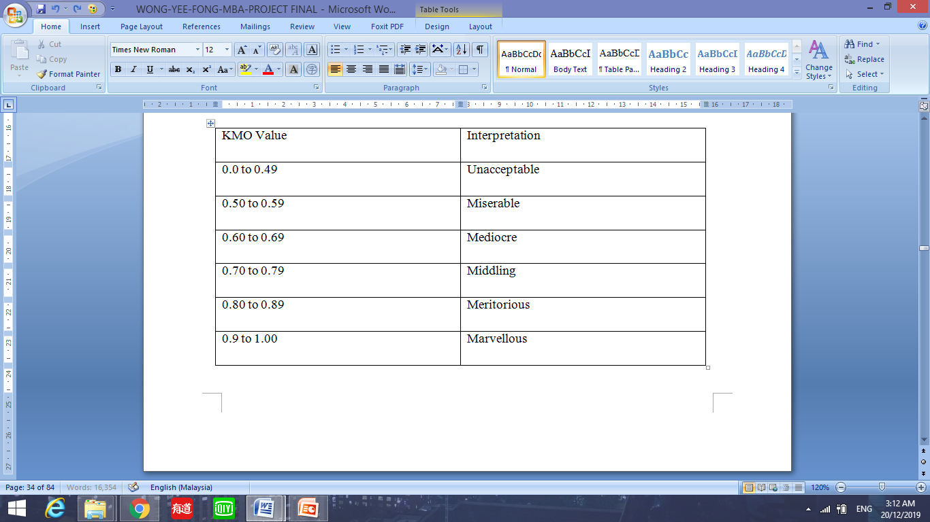

Source: Rovai, A. P., Bakar, J. D. & Ponton, M. K. (2013). Social Science Research Design and Statistics: A Practitioner’s Guide to Research Methods and IBM SPSS Analysis. 11.0 update (2nd ed). Virginia Beach, VA: Watertree Press

### Multiple Regressions

The function of multiple regressions is to study the factors that affect private university’s undergraduates’ satisfaction in Malaysia. The researcher analyzed the Independent Variable as the equal type of regression equation and predicted a single Dependant Variable. The analysis was used to verify whether the five independent variables (tangible, assurance, reliability, responsiveness, and empathy) were positively influence satisfaction, and explained the differences in confidence levels.

The formula of multiple regressions is constructed as follows:

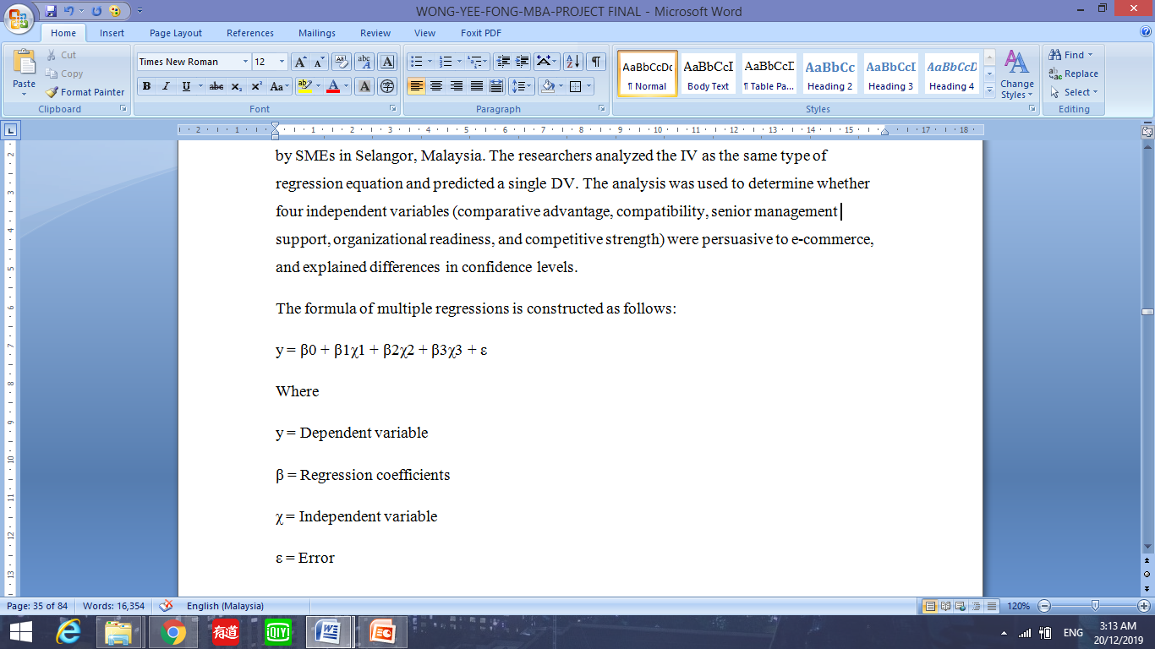

### One way Analysis of Variance (ANOVA)

ANOVA is a tool used for quantitative linear regression to quantify the relationship between Dependent Variable and Independent Variable. The analysis provides the whole test to define differences among groups.

Before performing a one-way analysis of variance, the researcher settled a set of assumptions as follows:

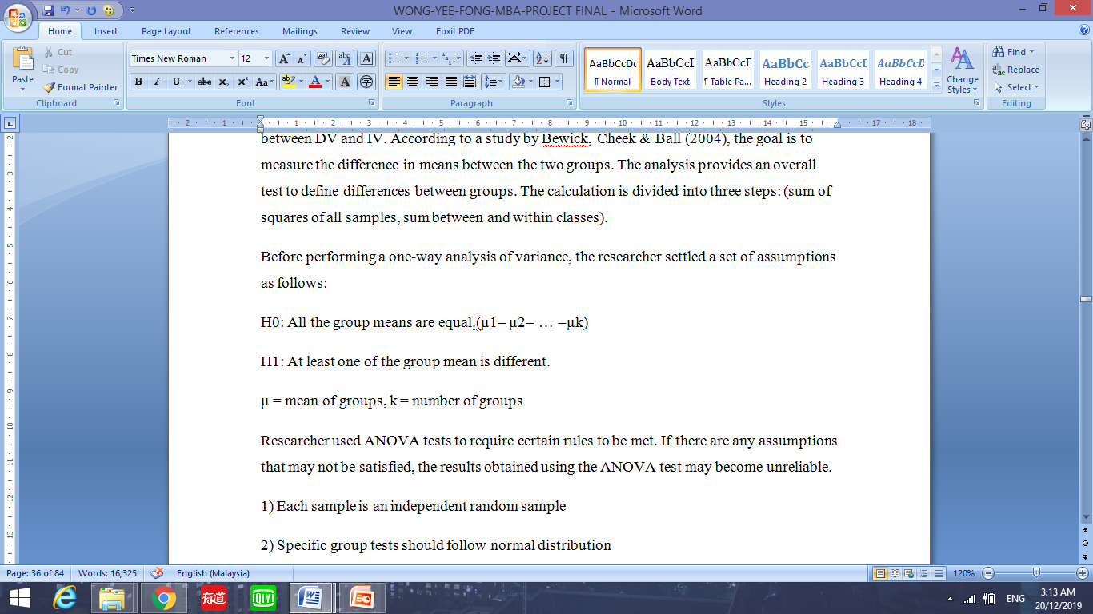

## 3.3 Unit of Analysis

The student of private universities will be the unit of analysis in this research, and the main focus area for this research study is private universities in Selangor Malaysia

## 3.4 Sampling

### Sample size

Sample size may impact the detection of significant relationship, differences or interactions (James et al., 2001). Based on the Raosoft calculation, a total of 288 sample size should be a acceptable sample size for this study from a huge population of private university students in Malaysia.

### Target Population and sampling frame

The target population in this study was concentrated with the students in private universities in Selangor Malaysia. The judgment behind to choose Selangor state is, it is a high population city and becoming the centre of the country area, there are a number of private universities located at that particular area and therefore the population of private university’s students are much higher than other states.

### Sampling Techniques

Researcher distributes the questionnaires to the students in private universities in Selangor Malaysia. The sampling technique that used is convenience sampling, which is a non-probability sampling technique, researcher selected this technique for a reason that this technique is convenience for the researcher to distribute the questionnaire as the message in the questionnaire are easier to reach respondents and convenience for the researcher to collect data (Dorherty, 1994). The researcher distributed the questionnaires to the students in private universities in Selangor Malaysia.

## 3.5 Data collection

Data gathering is an important advance in research (Hox, j. and Boejje, H, 2005).Prior to the actual implementation of the research tools, the researchers had carried out various activities. Data collection is divided into primary and secondary data.

### Primary data

Primary data refers to the new original data being collected, especially for the current ongoing research (Aitrs, 2012).original data can be collected using questionnaire which has the skill to acquire a huge quantity of information and is the main tool for data collection (Boynton, P.M. and Greenhalgh, T, 2004).The questionnaire design can accurately measure the opinions of

private university students and clearly understand the opinions of the respondents to evaluate the overall questionnaire response (Mathers N, Fox N., and Hunn, 2007).The researcher can save time by adjusting and correcting the questions in the questionnaire by referring to the questionnaires created by previous researcher who done the research related to this study. Questionnaires were distributed via email. A total of 288 questionnaires were randomly selected and spread to students from private universities in Malaysia. The questionnaires contained closed questions. The survey will be distributed and collected within two weeks. Researchers collect data in a reasonable way, which is appropriate for determining quantitative methods.

### Secondary data

Secondary data is information which has been collected, analyzed and published by a different researcher (Church, R. M, 2002). There are three sorts of secondary data, including surveys, literature, and numerous sources (Boslaugh. S, 2009). Literature mainly collects written materials such as online journals, textbooks, dissertations or dissertations and articles. The researchers will use previous research to support the independent variable and dependent variable and to support the result of testing whether there is a important relationship connecting both variables, and also support the hypotheses. This method is convenient and low cost to be obtained and read online. However, researcher had to spend a lot of time sifting through subject-related and composite data from recent years.

## 3.6 Ethical consideration

The researcher had provided a written declaration to promise and make certain that all the individual information is held in reserve confidentially and the data collected for the purpose for academic research. The official letter from INTI International University helped to authorize the confidential of source of data.

# **CHAPTER 4**

# **DATA ANALYSIS AND INTERPRETATION**

## 4.0 Overview

This chapter presented the results of this study. The researcher interpreted the demographic data of the respondents and also provided data for the analysis, and the results will be discussed further.

## 4.1 Demographic of respondent profile analysis

|  |  |  |  |
| --- | --- | --- | --- |
| Frequency analysis **Statistics:** | | | |
|  | | Gender | Age |
| N | Valid | 288 | 288 |
| Missing | 0 | 0 |

In this study, a total of 288 questionnaires were distributed to respondents. After 2 weeks of data collection, a total of 288 questionnaires were received, and 288 answers in the questionnaires were valid.

Descriptive analysis is usually based on the fraction of respondents answering questions in the questionnaire. Thus, the probability distribution of each problem is obtained, and the related information such as frequency statistics is obtained.

**Frequency Tables:**

|  |  |  |  |  |  |
| --- | --- | --- | --- | --- | --- |
|  | | | | | |
|  | | Frequency | Percent | Valid Percent | Cumulative Percent |
| Valid | Female | 137 | 47.6 | 47.6 | 47.6 |
| Male | 151 | 52.4 | 52.4 | 100.0 |
| Total | 288 | 100.0 | 100.0 |  |

Table 1: Table of gender frequency

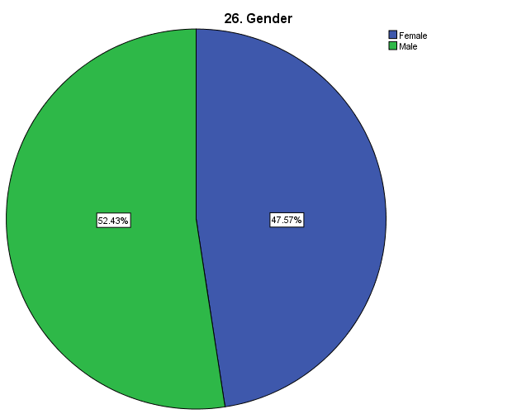

According to the frequency table 1 and pie chart above, the data shows that among the total number of respondent, 52% of them are male and 48% of them are female.

|  |  |  |  |  |  |
| --- | --- | --- | --- | --- | --- |
|  | | | | | |
|  | | Frequency | Percent | Valid Percent | Cumulative Percent |
| Valid | 21-25 years old | 82 | 28.5 | 28.5 | 28.5 |
| 26-30 years old | 138 | 47.9 | 47.9 | 76.4 |
| 31-35 years old | 63 | 21.9 | 21.9 | 98.3 |
| More than 35 years old | 5 | 1.7 | 1.7 | 100.0 |
| Total | 288 | 100.0 | 100.0 |  |

Table 2: Table of age

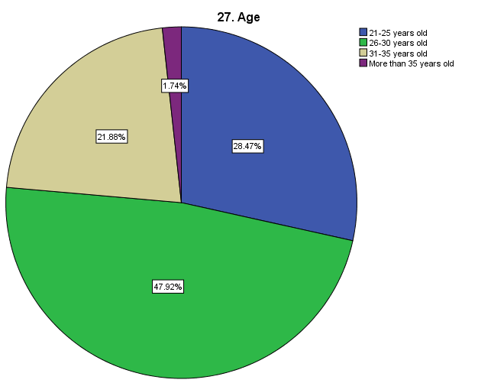

According to the frequency table 2 and pie chart above, the data shows that among the total number of respondent, 48% of them between 26-30 years old and there are only 1.7% of them more than 35 years old.

|  |  |  |  |  |  |
| --- | --- | --- | --- | --- | --- |
|  | | | | | |
|  | | Frequency | Percent | Valid Percent | Cumulative Percent |
| Valid | Certificate | 17 | 5.9 | 5.9 | 5.9 |
| Degree | 153 | 53.1 | 53.1 | 59.0 |
| Diploma | 63 | 21.9 | 21.9 | 80.9 |
| Master | 51 | 17.7 | 17.7 | 98.6 |
| SPM | 4 | 1.4 | 1.4 | 100.0 |
| Total | 288 | 100.0 | 100.0 |  |

Table 3: Table of Education Level

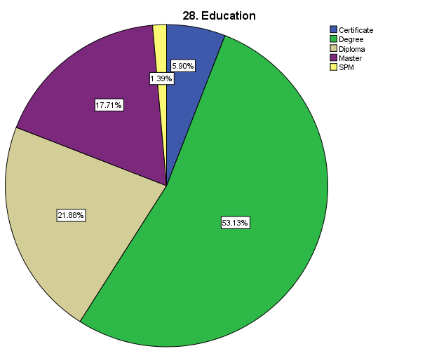

According to the frequency table 3 and pie chart above, the data shows that among the total number of respondent, 53% of them have Degree as the highest education level and there are only 1.4% of them have SPM as highest education level.

|  |  |  |  |  |  |
| --- | --- | --- | --- | --- | --- |
|  | | | | | |
|  | | Frequency | Percent | Valid Percent | Cumulative Percent |
| Valid | Married | 68 | 23.6 | 23.6 | 23.6 |
| Others | 2 | .7 | .7 | 24.3 |
| Single | 218 | 75.7 | 75.7 | 100.0 |
| Total | 288 | 100.0 | 100.0 |  |

Table 4: Table of marital status

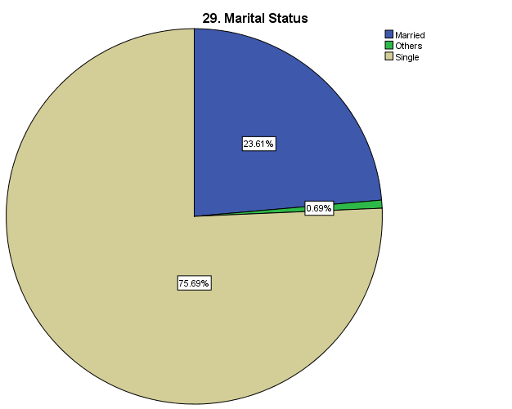

According to the frequency table 4 and pie chart above, the data shows that among the total number of respondent, 76% of them are single and there are only 0.7% of them have others marital status.

|  |  |  |  |  |  |
| --- | --- | --- | --- | --- | --- |
|  | | | | | |
|  | | Frequency | Percent | Valid Percent | Cumulative Percent |
| Valid | Less than RM3, 000 | 83 | 28.8 | 28.8 | 28.8 |
| More than RM7, 000 | 23 | 8.0 | 8.0 | 36.8 |
| RM3, 001 – RM5, 000 | 96 | 33.3 | 33.3 | 70.1 |
| RM5, 001 – RM7, 000 | 86 | 29.9 | 29.9 | 100.0 |
| Total | 288 | 100.0 | 100.0 |  |

Table 5: Table of monthly income

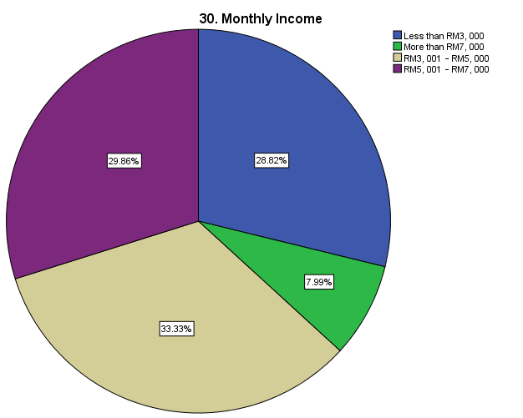

According to the frequency table 5 and pie chart above, the data shows that among the total number of respondent, 33% of them have monthly income between RM3.001- RM5, 000 and there are only 8% of them have monthly income more than RM7,000.

## 4.2 Reliability Analysis

**Scale: ALL VARIABLES**

|  |  |  |
| --- | --- | --- |
|  | Cronbach's Alpha | N of Items |
| SATIS | .690 | 4 |
| TANG | .608 | 4 |
| ASS | .606 | 4 |
| REL | .604 | 4 |
| RES | .601 | 4 |
| EMP | .618 | 5 |
| Overall | .763 | 25 |

Table 6: table of reliability statistics

Based on the table 6 above, there are signals that Satisfaction (SATIS), Tangibles (TANG), Assurance (ASS), Reliability (REL), Responsiveness (RES), and Empathy (EMP). The Cronbach's Alpha is 0.690, 0.608, 0.606, 0.604, 0.601 and 0.618 respectively, showing that the reliability of every variable is acceptable as all of the values are more than 0.6. However, the overall Cronbach's Alpha is 0.763, showed that satisfactory result, the result is mean that scale of the questionnaire is positive.

Therefore, overall, the questionnaire is reliable because the result proved a good reliability.

## 4.3 Validity Analysis

**Factor Analysis**

|  |  |  |
| --- | --- | --- |
| KMO and Bartlett's Test | | |
| Kaiser-Meyer-Olkin Measure of Sampling Adequacy. | | .650 |
| Bartlett's Test of Sphericity | Approx. Chi-Square | 1964.749 |
| df | 300 |
| Sig. | .000 |

Table 7: table of KMO and Bartlett's Test

According to the table 7 above, the KMO value of the questionnaire is 0.650, which is higher than 0.60, indicating that the questionnaire is acceptable for factor analysis.

Additionally, the Bartlett's Test of Sphericity results demonstrated that the approx. chi-square has a large value of 1964.749 and the Sig value is smaller than 0.001.

As the result, the total sampling size is big enough for factor analysis, validity of scale is good.

|  |  |  |
| --- | --- | --- |
|  | | |
|  | Initial | Extraction |
| TANG1 | 1.000 | .697 |
| TANG2 | 1.000 | .660 |
| TANG3 | 1.000 | .528 |
| TANG4 | 1.000 | .547 |
| ASS1 | 1.000 | .705 |
| ASS2 | 1.000 | .723 |
| ASS3 | 1.000 | .667 |
| ASS4 | 1.000 | .632 |
| REA1 | 1.000 | .494 |
| REA2 | 1.000 | .624 |
| REA3 | 1.000 | .660 |
| REA4 | 1.000 | .751 |
| RES1 | 1.000 | .638 |
| RES2 | 1.000 | .647 |
| RES3 | 1.000 | .652 |
| RES4 | 1.000 | .570 |
| EMP1 | 1.000 | .736 |
| EMP2 | 1.000 | .628 |
| EMP3 | 1.000 | .533 |
| EMP4 | 1.000 | .512 |
| EMP5 | 1.000 | .687 |
| SATIS1 | 1.000 | .515 |
| SATIS2 | 1.000 | .562 |
| SATIS3 | 1.000 | .631 |
| SATIS4 | 1.000 | .680 |
| Extraction Method: Principal Component Analysis. | | |

Table 8: table of Communalities

According to the table 8 above, the extraction value of each variable is larger 0.5, which signify the level interpretation of the extraction of the extracted factor were achieved more than 50% for every variable, therefore, result showed that the extracted factor of the research is adequate.

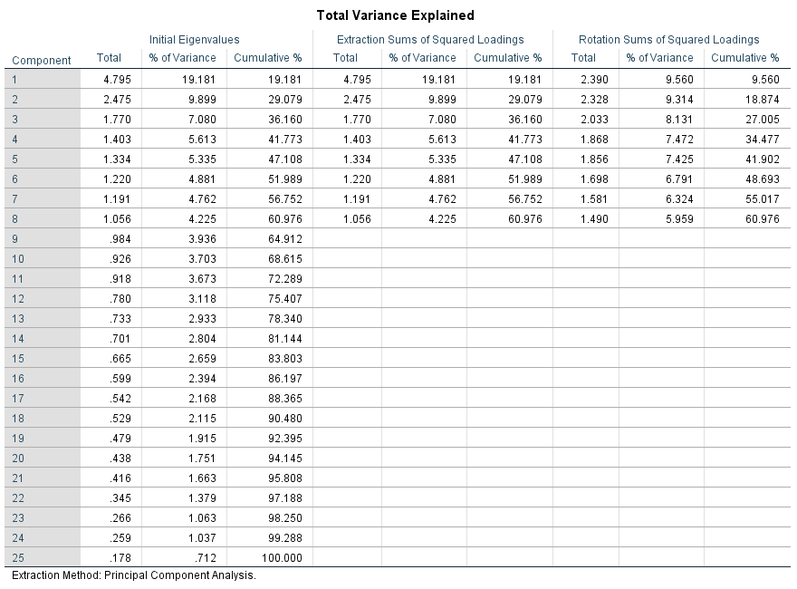

Table 9: table of total variance explained.

According to the table 9 above, the cumulative variance rate value of the first 8 components is 60.976%, shows that the validity of the questionnaire is good.

### Normality test

**Tangibles**

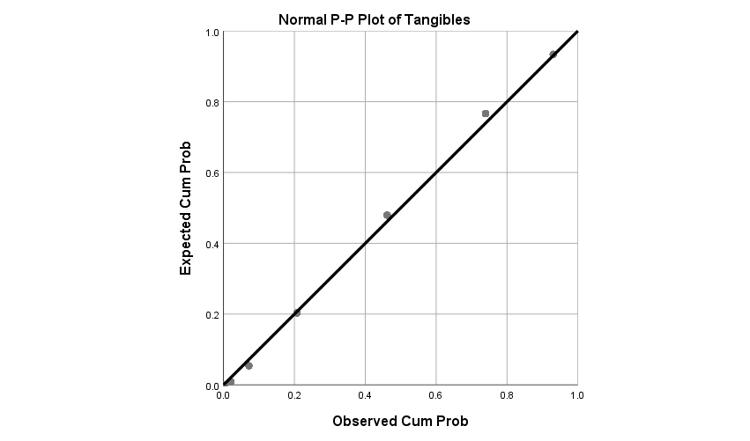

**Assurance**

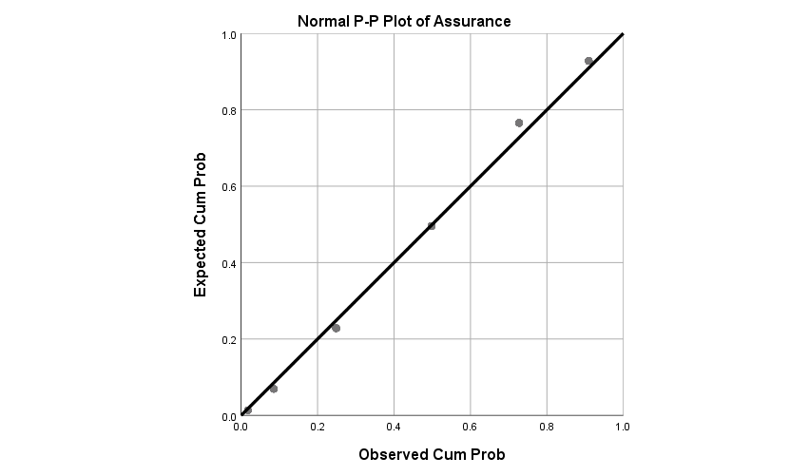

**Reliability**

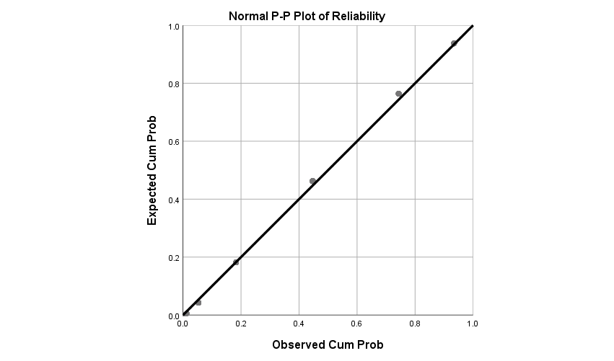

**Responsiveness**

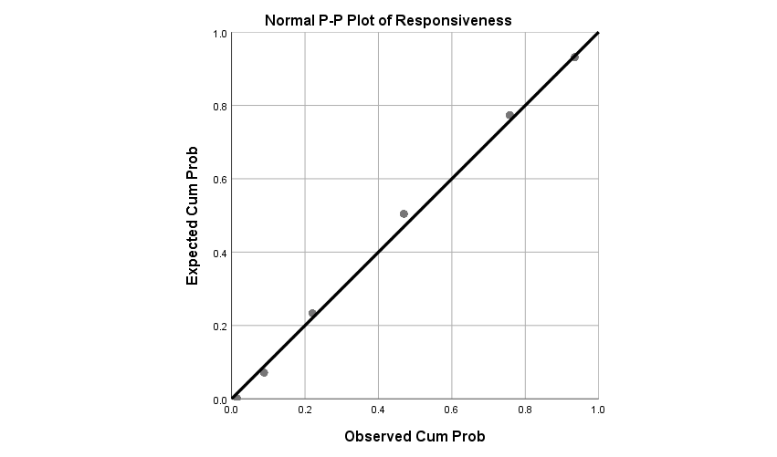

**Empathy**

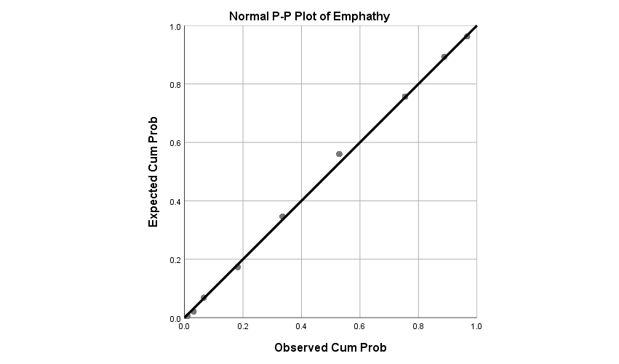

**Satisfaction**

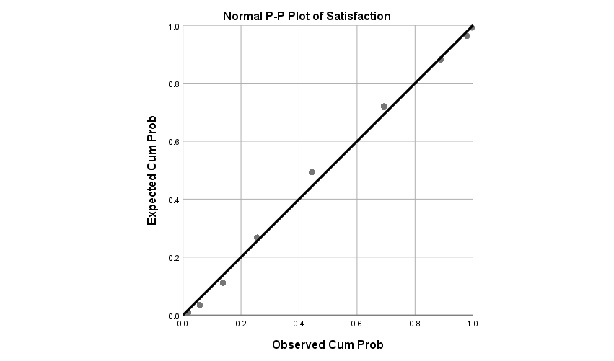

According to all of the charts above, it can be clearly seen that, for each independent variable (tangible, assurance, reliability, responsiveness, and empathy), there is all data lie down on a perfect faultless straight line with a positive and rising slope. Additionally, for the dependent variable (Satisfaction) as well, data lie down on a perfect faultless straight line with a positive and rising slope, showed that the normality of the questionnaire is good.

## 4.4 Hypothesis Testing

### 4.4.1 Pearson Correlation Analysis

Correlation is a technique used to swot up the relationship among two quantitative variables, and the Pearson correlation coefficient (r) is a determine of the strength of the alliance connecting two variables (Learntech, 2019). The results Pearson Correlation are the most directly related to the purpose of this research and the results are the key which were confirming whether all hypotheses stated are acceptable.

|  |  |  |  |  |  |  |  |
| --- | --- | --- | --- | --- | --- | --- | --- |
| **Correlations** | | | | | | | |
|  | | TANG | ASS | REA | RES | EMP | SATIS |
| TANG | Pearson Correlation | 1 | .507** | .516** | .389** | .294** | .217** |
| Sig. (2-tailed) |  | .000 | .000 | .000 | .000 | .000 |
| N | 288 | 288 | 288 | 288 | 288 | 288 |
| ASS | Pearson Correlation | .507** | 1 | .593** | .571** | .449** | -.021 |
| Sig. (2-tailed) | .000 |  | .000 | .000 | .000 | .729 |
| N | 288 | 288 | 288 | 288 | 288 | 288 |
| REA | Pearson Correlation | .516** | .593** | 1 | .559** | .351** | .093 |
| Sig. (2-tailed) | .000 | .000 |  | .000 | .000 | .117 |
| N | 288 | 288 | 288 | 288 | 288 | 288 |
| RES | Pearson Correlation | .389** | .571** | .559** | 1 | .401** | .045 |
| Sig. (2-tailed) | .000 | .000 | .000 |  | .000 | .451 |
| N | 288 | 288 | 288 | 288 | 288 | 288 |
| EMP | Pearson Correlation | .294** | .449** | .351** | .401** | 1 | .328** |
| Sig. (2-tailed) | .000 | .000 | .000 | .000 |  | .000 |
| N | 288 | 288 | 288 | 288 | 288 | 288 |
| SATIS | Pearson Correlation | .217** | -.021 | .093 | .045 | .328** | 1 |
| Sig. (2-tailed) | .000 | .729 | .117 | .451 | .000 |  |
| N | 288 | 288 | 288 | 288 | 288 | 288 |
| **. Correlation is significant at the 0.01 level (2-tailed). | | | | | | | |

Table 10: table of Correlations

According to the table 10 above, the results showed that there is positive relationship between all independent variable which are Tangible (TANG), Assurance (ASS), Reliability (REA), Responsiveness (RES), and Empathy (EMP), and the dependent variable which is Satisfaction (SATIS). This is a significant evidence proved that all factors are relevant to the satisfaction of undergraduates of private universities in Malaysia.

However, the result only can be categorized as MODERATE level, this is because among the entire variable, even the largest value of Pearson correlation coefficient (r) is Reliability, which is 0.516. The value is not more than 0.8, showed that the factors are relevant and acceptable to satisfaction, but not the ideal factors to be considered.

## 4.5 Regression analysis

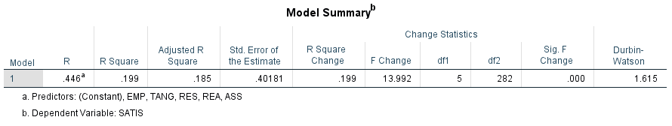

Table 11: table of Model Summary

According to the table 11 above, R Square is 0.199, and Adjusted R Square is 0.185, representing that the illustrative variability of these five variables achieved 18.5%.

The R-squared value is lower than 50%, showing that some factors of the model used for analysation are not relevant to dependent variable.

However, Durbin-watson's value is 1.615, which is close up to 2 compared with 0 and 4, representing that there is no problem of autocorrelation in the model.

|  |  |  |  |  |  |  |
| --- | --- | --- | --- | --- | --- | --- |
| **ANOVAa** | | | | | | |
| Model | | Sum of Squares | df | Mean Square | F | Sig. |
| 1 | Regression | 8.776 | 5 | 1.755 | 12.385 | .000b |
| Residual | 36.280 | 256 | .142 |  |  |
| Total | 45.057 | 261 |  |  |  |
| a. Dependent Variable: Satisfaction | | | | | | |
| b. Predictors: (Constant), Empathy, Tangibles, Responsiveness, Reliability, Assurance | | | | | | |

Table 12: table of ANOVA

According to table 12 above, the ANOVA test result shows the significant F-test (F= 12.385， p-value<0.01), proved that the combination of independent variables significantly predicted dependent variable.

|  |  |  |  |  |  |  |  |  |
| --- | --- | --- | --- | --- | --- | --- | --- | --- |
| **Coefficients** | | | | | | | | |
| Model | | Unstandardized Coefficients | | Standardized Coefficients | t | Sig. | Collinearity Statistics | |
| B | Std. Error | Beta | Tolerance | VIF |
| 1 | (Constant) | 2.318 | .426 |  | 5.441 | .000 |  |  |
| Tangibles | .318 | .089 | .246 | 3.579 | .000 | .665 | 1.504 |
| Assurance | -.312 | .096 | -.256 | -3.241 | .001 | .505 | 1.978 |
| Reliability | .036 | .104 | .026 | .342 | .733 | .531 | 1.882 |
| Responsiveness | -.144 | .093 | -.117 | -1.545 | .124 | .548 | 1.826 |
| Empathy | .493 | .073 | .435 | 6.781 | .000 | .764 | 1.309 |
| a. Dependent Variable: Satisfaction | | | | | | | | |

Table 12: Table of Coefficients

The purpose of Multiple Regression is to propose a prediction model of a research study but not to propose the relationship among two variables.

According to the table 12 above, the final regression equation stated as the following:

**SATIS= 2.318+ 0.318(Tangibles)-0.312(Assurance) +0.493(Empathy)**

Based on the data on table 12, it showed that Tangible has a significant positive effect on Satisfaction (beta =0.246, P<0.001). Assurance has a significant positive effect on Satisfaction (beta =-0.256, P<0.01). Reliability has no significant positive effect on Satisfaction (beta =0.026, P>0.001). Responsiveness has no significant positive effect on Satisfaction (beta =-0.117, P>0.01); Empathy had a significantly positive impact on Satisfaction (beta =0.435, P<0.001).

In conclusion, by looking at all the results of the above analysis, researcher had made a wrapping up and stated as table 13 as the following:

**Summary of hypotheses testing results**

|  |  |  |
| --- | --- | --- |
| Hypotheses | Variable | Results |
| H1 | Tangibles | Accept |
| H2 | Assurance | Accept |
| H3 | Reliability | Accept |
| H4 | Responsiveness | Accept |
| H5 | Empathy | Accept |

Table 13: Summary of hypotheses testing results

# **CHAPTER** **5**

# **CONCLUSION AND RECOMMENDATION**

## 5.0 Overview

This chapter concluded all the statistical analysis by broadcasting and summarizing the data in Chapter Four. The researcher has a propensity to identify the implications and limitations of the research and made some recommendations and suggestions and finally concluded the study in the whole.

## 5.1 Conclusion

Among the total number of respondent, 52% of them are male and 48% of them are female; most of them between 26-30 years old; most of them have Degree as the highest education level; most of them are single, and most of them have monthly income between RM3.001- RM5, 000.

### For Hypothesis Testing

**Hypothesis 1: Tangible has positive relationship with Undergraduates’ Satisfaction in Malaysian Private Universities in Selangor, Malaysia**

Tangible always presents as an essential role in increasing Undergraduates’ Satisfaction in Malaysian Private Universities in Selangor, Malaysia. Students will intuitively judge the quality of the university's services through the advanced level, durability of the school's facilities, and whether they have been repaired and updated.

The improvement of tangible will ultimately change students' perceptions about the quality of the university's services. Hence, H1 can be accepted.

**Hypothesis 2: Assurance has positive relationship with Undergraduates’ Satisfaction in Malaysian Private Universities in Selangor, Malaysia**

The reason why students enter the University for Further Studies is that for gaining knowledge. Lecturers who have rich knowledge and can provide constructive information are the most important for students. Because the teaching of the lecturer is related to the students' future development and growth, knowledge is very important. Lecturers who have high assurance mean that they have high politeness, personnel knowledge and ability to gain student’s confidence and trust. Assurance can increase student’s satisfaction. Hence, H2 can be accepted.

**Hypothesis 3: Reliability has positive relationship with Undergraduates’ Satisfaction in Malaysian Private Universities in Selangor, Malaysia**

A university needs employees who have ability to increase reliably and accurately perform the services promised. Students will choose a university that is highly feasible to continue their studies. This is because many important documents such as admission forms, loan documents, payment documents, etc. need to be processed. Students need efficient people to help deal with these tedious but extremely important documents to save time wasted due to file processing errors. Efficient staff with high assurance can give students confidence and give students peace of mind and able to study with no trouble. Reliability is an influencing determinant of student' perception of service quality and it is an important factor to influence student’s satisfaction. Hence, H3 can be accepted.

**Hypothesis 4: Responsiveness has positive relationship with Undergraduates’ Satisfaction in Malaysian Private Universities in Selangor, Malaysia**

Humans hate waiting. Therefore, an excellent university needs employees who have willingness to provide timely service and help students on time. Fast service saves students time and does not delay their trips, which will naturally increase their satisfaction with the service. Responsiveness is an important factor to influence student’s satisfaction. Hence, H4 can be accepted.

**Hypothesis 5: Empathy has positive relationship with Undergraduates’ Satisfaction in Malaysian Private Universities in Selangor, Malaysia**

The empathy, intimate and warm service seems unimportant, but it unexpectedly helps many companies have achieved their achievements earlier than others. It can be seen that all human beings will feel happy because they are being understood by others. Student will satisfy when they are given extra attention and care provided by employees such as university staffs and lecturers. Empathy can increase satisfaction. Hence, H5 can be accepted.

## 5.2 Research implication

### Theoretical implication

This research provides noteworthy participation in recent study. Previous research has analyzed companies from the perspective of consumers, while less research has managed the enhancement of service quality, especially private universities. The study provided comprehensive information and provided useful information for other future research on identifying factors influencing student satisfaction in private universities.

### Managerial Implication

This is a conceptual framework that can help influence the satisfaction toward services provided. During the research process, top managers and practitioners could concider to be responsible and consider to apply the conceptual framework into two aspects of such as organization and environment.

Making enhancement of service quality helps to attract more loyal customers and hence increase company’s revenue. While a company able to operate well, there will be a good economic development to the country as well. The research results about SERQUAL brought constructive advices to various industries in addition of education industry.

## 5.3 Limitation

**Limited Time**

The duration of collect data is short. Time also limit to collect more survey and need to generate the data in the short period.

**Distribute questionnaire online to respondent**

Due to the questionnaires are distribute trough online method, the researchers cannot explain the meanings of the questionnaire face to face with the respondents this may cause the respondent unable to understand clearly to the contents of the questionnaire. It may also possibility that some of the respondents may not read the question carefully and answer carefully the questionnaire while completing the questionnaire, therefore causing missing value and affect the result of analyzation.

**Sample size not big enough**

Due to the restricted time, the researcher was unable to collect data from a sample size that more than 300 people. This caused some of the result of analyzation only can be categorized as qualified result, but not the ideal results.

## 5.4 Future Research and Recommendations

The following is another research that carried out similar result with this study:

Data from Jordanian Governmental University showed that among the five dimension of service quality, only Assurance and Empathy have significant relationship to affect students‟ intention of moving (Twaissi, N.M. and Al-Kilani, M.H., 2015), means that assurance could affect the students’ satisfaction and making them moving to study at another university.

Looking at this research study and all the analyzing conducted and results evaluation, there is a recommend for future researchers to use other research model to analyse more variables which are more suitable to identify the factors influencing Undergraduates’ Satisfaction.

Besides, this research only studied the private universities in Selangor, Malaysia. Therefore, the researcher recommend future researchers to conduct studies covering the whole country, Different demographics, location, and larger sample size provide distinctive perceptions and more accurate research results.

Moreover, for any future research study, the researcher suggested to conduct research focus to the reason why reliability and responsiveness not relevant, conduct research on how to make improvement to make reliability and responsiveness important.

Finally, it is suggested to include comparison between local and private university, in order to help private university to study about what have the local university done to the students such as better equipment and better quality of education, hence allows private universities to be able to learn from local universities for further improvement.

# **References**

Abdullah, F. (2006). The development of HEdPERF: a new measuring instrument of service quality for the higher education sector. *International Journal of Consumer Studies*, 30(6), pp.569-581.

Afshan Azam. (2018). Service Quality Dimensions and Students’ Satisfaction: A study of Saudi Arabian Private Higher Education Institutions. *European Online Journal of Natural and Social Sciences*. 7(2) pp. 275-284

Al-Azzam, A.F.M. (2015). The impact of service quality dimensions on customer satisfaction: A field study of Arab bank in Irbid city, Jordan. *European Journal of Business and Management*, 7(15), pp.45-53.

Ali, M. and Raza, S.A. (2017). Service quality perception and customer satisfaction in Islamic banks of Pakistan: the modified SERVQUAL model. *Total Quality Management & Business Excellence*, 28(5-6), pp.559-577.

Aitrs. (2012). Primary data collection methods. aitrs.org, 1–19. [online] Available at: http://www.aitrs.org/EchoBusV3.0/SystemAssets/Documents/program2012/entro sampling/lecture1.pdf [Accessed 15 October 2019].

Anwowie, S., Amoako, J. and Abrefa, A.A. (2015). Assessment of Students' Satisfaction of Service Quality in Takoradi Polytechnic: The Students' Perspective. *Journal of Education and Practice*, 6(29), pp.148-155.

Boslaugh, S., & Boslaugh, S. (2009). An introduction to secondary data analysis. In Secondary Data Sources for Public Health (pp. 1–11). Cambridge University Press.

Boynton, P.M. and Greenhalgh, T. (2004) 'Selecting, designing, and developing your questionnaire', *BMJ*, 328(7451), pp. 1312-1315.

Chong, Y.T., Lim, E.M., Ng, C.Y. and Wong, C.S. (2016). Factors That Affecting Customer Satisfaction among Local Tourists toward Budget Hotels in Malaysia. *Doctoral dissertation*, UTAR.

Church, R. M. (2002). The effective use of secondary data. *Learning and motivation*, 33(1), 32–45.

Dora, Y.M. (2017). Analysis Effect of Service Quality, Educational Facilities, and Method of Learning, Student Satisfaction and Loyalty to Students-Studies in the University of Widyatama Bandung. *European Journal of Social Science Education and Research*, 4(3), pp.16-27.

Dorherty, M. (1994). Probability versus non-probability sampling in the sample. *The NewZealand Statistics Review*, p 21-28.

Douglas, Jacqueline & Douglas, Alex & Barnes, Barry. (2006). Measuring Student Satisfaction at a UK University. *Quality Assurance in Education*. 14. 251-267.

Drost, E.A. (2011) 'Validity and reliability in social science research', *Education Research and Perspectives*, 38(1), pp. 105.

Drucker, P. (1954). The Practice of Management. *Harper & Row, New York*, NY.

Etawau.com. (2019). Malaysian Private Universities. [online]. Available at: http://www.etawau.com/edu/IndexUniversityPrivate.htm[Accessed 15 November 2019].

Guilbault, M. (2018). Students as customers in higher education: The (controversial) debate needs to end. *Journal of Retailing and Consumer Services*. 40, pp.295-298.

Haihambo, J. (2018). An investigation of students' perceptions of service quality at the Namibia Business School (*Doctoral dissertation*, University of Namibia).

Hanssen, T.E.S. and Solvoll, G. (2015). The importance of university facilities for student satisfaction at a Norwegian University. Facilities, 33(13/14), pp.744-759.

Hair, J., Black, W., Babin, B. & Anderson, R. (2010). Multivariate Data Analysis Global Edition, 7th Edition, Upper Saddle River, NJ, Pearson Education, Inc.

Hofelich, A.J. and Preston, S.D. (2012). The meaning in empathy: Distinguishing conceptual encoding from facial mimicry, trait empathy, and attention to emotion. *Cognition & Emotion*, 26(1), pp.119-128.

Hox, J. and Boeije, H. (2005). Data collection, primary vs. secondary. *Encyclopaedia of Social Measurement*, Vol. 1, pp. 593-599

IBM. (2019). KMO and Bartlett’s Test. [online] Available at:https://www.ibm.com/support/knowledgecenter/SSLVMB_26.0.0/statistics_casestudies_project_ddita/spss/tutorials/fac_telco_kmo_01.html [Accessed 1 December 2019].

Imtiaz, A. (2018). Exploring Factors Influencing Satisfaction of the University Students Who Work as Private Tutors. *International Education Studies*. 11(5), pp.133-143.

Jahmani, A. (2017). THE EFFECT OF ROYAL JORDANIAN AIRLINE SERVICE QUALITY ON PASSENGERS'SATISFACTION. *International Journal of Business and Society*, 18(S3), pp.519-530.

James E. Bartlett, I., Kotrlik, J. W., & Higgins, C. C. (2001). Organizational research: determining appropriate sample size in survey research. *Information Technology, Learning, and Performance Journal*, 19(1), p 43-50.

Kajenthiran, K. and Karunanithy, M. (2015). Service Quality and Student Satisfaction: A Case Study of Private External Higher Education Institutions in Jaffna, Sri Lanka. *Journal of Business*, 1(2).

Kotler, P. (1977). From sales obsession to marketing effectiveness. *Harv. Bus. Rev*. 55 (6), pp 67-75.

Kunanusorn, A. and Puttawong, D. (2015). The Mediating effect of satisfaction on student loyalty to higher education institution. *European Scientific Journal (Special Edition),* 1, pp.449-463.

Learntech (2019). Pearson's Correlation Coefficient. [online]. Available at: http://learntech.uwe.ac.uk/da/Default.aspx?pageid=1436[Accessed 10 December 2019].

Lenton, P. (2015), “Determining Student Satisfaction: An Economic Analysis of the National Student Survey”, *Economics of Education Review*, vol. 47, pp. 118-127.

Li, I. W., & Carroll, D. (2017). Factors Influencing University Student Satisfaction, Dropout and Academic Performance: An Australian Higher Education Equity Perspective. *National Centre for Student Equity in Higher Education (NCSEHE)*, Perth: Curtin University.

Mahmoud, A.B. and Grigoriou, N. (2017). When empathy hurts: Modelling university students’ word of mouth behaviour in public vs. private universities in Syria. *Higher Education Quarterly*, 71(4), pp.369-383.

Mathers N, Fox N., and Hunn. (2007). A surveys and questionnaires. *The NIHR RDS for the East Midlands*, Yorkshire & the Humber

Malaymail.com. (2019). Education Ministry: Revenue from international students expected to grow to RM15.6b. [online] Available at: https://www.malaymail.com/news/malaysia/2019/09/12/education-ministry-revenue-from-international-students-expected-to-grow-to/1789792 [Accessed 15 November 2019].

Malhotra, N.K. (2010). Marketing Research: an applied approach. 6th Edition. Pearson Education UK.

Mazzarol, T. (1998). Critical success factors for international education marketing*. Int. J. Educ. Manag.* 12 (4), 163–175.

Minh-Quang Duong. (2015). University Experiences and Satisfaction of Vietnamese University Students. *Journal of Studies in Education*. 5(4). Pp 90-99.

Minh, N.H., Ha, N.T., Anh, P.C. and Matsui, Y. (2015). Service quality and customer satisfaction: A case study of hotel industry in Vietnam. *Asian Social Science*, 11(10), p.73.

Ministry of Higher Education (MoHE). (2015). Executive summary Malaysia education blueprint 2015-2025 (higher education).

Napitupulu, D., Rahim, R., Abdullah, D., Setiawan, M.I., Abdillah, L.A., Ahmar, A.S., Simarmata, J., Hidayat, R., Nurdiyanto, H. and Pranolo, A. (2018). Analysis of student satisfaction toward quality of service facility. *In Journal of Physics: Conference Series*. 954(1), p. 12-19.

Nguyen, Q., Nisar, T.M., Knox, D. and Prabhakar, G.P. (2018). Understanding customer satisfaction in the UK quick service restaurant industry: The influence of the tangible attributes of perceived service quality. *British Food Journal*, 120(6), pp.1207-1222.

Nooshinfard, F., Nemati-Anaraki, L., Zikmund, W.., Babin, J.., & Griffin, M. (2012). Business Research Methods. *Electronic Library*, Vol. 32

Nordin Yahaya. (2019). Recent Development of the International Higher Education in Malaysia - Challenges and Opportunities. *EURIE Eurasia Higher Education Summit 2019 (EURIE2019)*. Istanbul. pp1-26.

Nunnally, J.. & Bernstein, I (1999). Psychometric Theory. *Journal of Psychometric Assessment*, 17(3), pp.275–280.

Pallant, J. (2010). SPSS Survival Manual. *Berkshire: McGraw-Hill*, 4.

Papadopoulos, V., & Giovanis, D. G. (2018). Reliability analysis. In Mathematical Engineering (pp. 71–98). Springer Verlag.

Parasuraman, A., Zeithaml, V. A., Berry, L. L. (1985): A Conceptual Model of Service Quality and Its Implications for Future Research. *Journal of Marketing*, 49, pp. 41-50.

Parasuraman, A., Zeithaml, V. A., Berry, L. L. (1986): SERVQUAL: A Multiple-item Scale for Measuring Customer Perceptions of Service Quality, Marketing Science Institute, Cambridge.

Phi, H.D., Thanh, L.P. and Nguyen Viet, B. (2018). Effects of service quality on customer satisfaction and customer loyalty: A case of 4-and 5-star hotels in Ho Chi Minh City, Vietnam. *Business and Economic Horizons (BEH)*, 14(1232-2019-848), pp.437-450.

Pohyae, S., Romle, A.R., Saleh, N.H., Saleh, S. and Mohamood, K.B. (2016). The Relationship Between Service Quality and Student Satisfaction: The Case of International Students in Public University. *World Applied Sciences Journal*, 34(4), pp.491-498.

Rabianski, J. S. (2003). Primary and secondary data: Concepts, concerns, errors, and issues. *The Appraisal Journal*, 71(1), 43–55

Rovai, A. P., Bakar, J. D. & Ponton, M. K. (2013). Social science research design and statistics: A practitioner’s guide to research methods and IBM SPSS snalysis. 11.0Virginia Beach, VA: Watertree Press

Sabina Đonlagić and Samira Fazlić. (2015) Quality assessment in higher education using the SERVQUAL model, *Management*. 20(1). pp. 39-57

Saleem, S., Moosa, K., Imam, A. and Ahmed Khan, R. (2017). Service quality and student satisfaction: the moderating role of university culture, reputation and price in education sector of pakistan. *Iranian Journal of Management Studies*, 10(1), pp.237-258.

Schindler, L., Puls-Elvidge, S., Welzant, H., & Crawford, L. (2015). Definitions of quality in higher education: A synthesis of the literature. *Higher Learning Research Communications*, 5(3), p 3-13.

Sin, M.C., Yusof, B.B. and Sin, K.Y. (2018). International Students’ Satisfaction Level towards Service Quality in Academic Aspect and Loyalty to Universiti Teknologi Malaysia. *INTERNATIONAL JOURNAL OF ACADEMIC RESEARCH IN BUSINESS AND SOCIAL SCIENCES*, 8(10).

Springate, S.D. ( 2011). The effect of sample size and bias on the reliability of estimates of error: A comparative study of Dahlberg's formula. *The European Journal of Orthodontics*, 34(2), pp.158-163.

Subrahmanyam Annamdevula, Raja Shekhar Bellamkonda, (2016) "Effect of student perceived service quality on student satisfaction, loyalty and motivation in Indian universities: Development of HiEduQual", *Journal of Modelling in Management*, Vol. 11 Issue: 2, pp.488-517.

Theresia, L. and Bangun, R. (2017. Service quality that improves customer satisfaction in a university: a case study in Institut Teknologi Indonesia. *In IOP Conference Series: Materials Science and Engineering*. 277(1), p. 12-59.

Thien, L.M. and Jamil, H. (2019). Students as ‘Customers’: unmasking course experience and satisfaction of undergraduate students at a Malaysian Research University. *Journal of Higher Education Policy and Management*, pp.1-22.

Tompkins, K.A., Brecht, K., Tucker, B., Neander, L.L. and Swift, J.K. (2016). Who matters most? The contribution of faculty, student-peers, and outside support in predicting graduate student satisfaction. *Training and Education in Professional Psychology*, 10(2), p.102.

Twaissi, N.M. and Al-Kilani, M.H. (2015). The Impact of Perceived Service Quality on Students' Intentions in Higher Education in a Jordanian Governmental University. *International Business Research*, 8(5), p.81.

Ung, V. and Norng, T. (2017). Gearing Service Quality into High Educational Institutes in Cambodia. *Archives of Business Research*, 5(9).

Viraiyan Teeroovengadum T.J. Kamalanabhan Ashley Keshwar Seebaluck , (2016),"Measuring service quality in higher education", *Quality Assurance in Education*. 24 (2), pp. 244 – 258

Vu Thi Huong, Marti Casadesus, and Frederic Marimon. (2017). Assessing learner satisfaction by simultaneously measuring learner attitude, motivation, loyalty and service quality in English academies. *Innovations In Education and TeachIng InternatIonal*. 54(4), p 301–312.

William, M. K. (2006). Descriptive Statistics. [online] Available: https http://www.socialresearchmethods.net/kb/statdesc.php[Accessed 15 October 2019].

Wilson, HK and Cotgrave, AJ (2016). Factors that influence students' satisfaction with their physical learning environments. *Structural Survey*, 34 (3). pp. 256-275.

Xiao, J. and Wilkins, S. (2015). The effects of lecturer commitment on student perceptions of teaching quality and student satisfaction in Chinese higher education*. Journal of Higher Education Policy and Management*, 37(1), pp 98-110.

# **APPENDICES**

**List of Literature**

**Undergraduates’ Satisfaction**

|  |  |  |  |
| --- | --- | --- | --- |
| Title | Author | Year | Output |
| Analysis Effect of Service Quality, Educational Facilities, and Method of Learning, Student  Satisfaction and Loyalty to Students - Studies in the University of Widyatama Bandung | Yenny Maya Dora | 2017 | In a business engaged in services, then all existing facilities that condition facilities, completeness, interior design, and cleanliness of the facility should be considered especially that closely related to what is perceived or obtained by consumers directly. |

**Service Quality**

|  |  |  |  |  |
| --- | --- | --- | --- | --- |
| Study | Title | Country | Data | Major Findings |
| Subrahmanyam Annamdevula, Raja Shekhar Bellamkonda, | Effect of student perceived service quality on student satisfaction, loyalty and motivation in Indian universities: Development of HiEduQual | India | The survey instrument called HiEduQual was developed and The total valid sample of 2,565 was collected with 85 per cent response rate. | This study revealed and confirmed the existence of the critical relationship among perceived service quality, student satisfaction, loyalty and motivation. |
| Vu Thi Huong, Marti Casadesus, and Frederic Marimon. (2017). | Assessing learner satisfaction by simultaneously measuring learner attitude, motivation, loyalty and service quality in English academies. | Spain | A cross-sectional survey design was used and 334 learner participants were included | With supported hypothesis, there are a significant relationship between service quality and student satisfaction |
| Saleem, S., Moosa, K., Imam, A. and Ahmed Khan, R., 2017. | Service Quality and Student Satisfaction: The  Moderating Role of University Culture, Reputation and  Price in Education Sector of Pakistan | Pakistan | questionnaires were distributed to students of 20 HEIs and 747 response were received | Results identified that, service quality  strongly and significantly impacts the students’ satisfaction in education sector. |

**Tangibles**

|  |  |  |  |  |
| --- | --- | --- | --- | --- |
| Study | Title | Country | Data | Major Findings |
| Thor-Erik Sandberg Hanssen  & Gisle Solvoll | The importance of university facilities for student satisfaction at a Norwegian University | Norway | The web-based questionnaire was distributed to 5,232 Norwegian students at the University of  Nordland (UoN) | Facilities (UF), especially the social areas, such as hallways and areas where students may choose to  relax and interact socially between lectures and classes, have a strong and statistically significant influence on student overall satisfaction |
| Napitupulu, D., Rahim, R., Abdullah, D., Setiawan, M.I., Abdillah, L.A., Ahmar, A.S., Simarmata, J., Hidayat, R., Nurdiyanto, H. and Pranolo, A. | Analysis of student satisfaction toward quality of service facility | Indonesia and Malaysia | Questionnaire-based survey method that was distributed to students of  XYZ University Computer Science Faculty with 89 respondents who were involved. | The relationship or correlation between campus service facility variables and user satisfaction variables is strongly interpreted. This means that if the service quality increase, then the satisfaction level will also be raised. |
| Pohyae, S., Romle, A.R., Saleh, N.H., Saleh, S. and Mohamood, K.B. | The Relationship Between Service Quality and Student Satisfaction: The Case of International Students in Public University | Malaysia | 400 questionnaires distributed to international students in the university. In this study, 250 answers are useful for the further analysis | There is a significant relationship between tangibles and student satisfaction |
| Imtiaz, A., 2018 | Exploring Factors Influencing Satisfaction of the University Students  Who Work as Private Tutors | Bangladesh | A questionnaire distributed to a sample size of  150 pupils from University of Dhaka. | Tutoring Environment has significant positive regression weights  demonstrating the fact that the better the overall environment of tutoring place/ tutoring environment, the higher  the level of satisfaction of the university students who work as private tutors |
| Kajenthiran, K. and Karunanithy, M., 2015. | SERVICE QUALITY AND STUDENT SATISFACTION: A CASE STUDY OF PRIVATE EXTERNAL HIGHER EDUCATION INSTITUTONS IN JAFFNA, SRI LANKA. | Sri Lanka | Researchers have distributed 120 questionnaires for every institution. After all, 200 respondents completed (100 from New College of High Studies, Jaffna and 100 from Jaffna College Undergraduate Department) | With accepted hypothesis, the result showed that there is a significant relationship between tangibility in the service quality and student satisfaction |
| Phi, H.D., Thanh, L.P. and Nguyen Viet, B., 2018. | Effects of service quality on customer satisfaction and customer loyalty: A case of 4-and 5-star hotels in Ho Chi Minh City, Vietnam. | Vietnam | This study conducted  the sampling technique of using direct interview methods from 322 respondents using service  at 4 - 5 star hotel in HCM city, Viet Nam. | Satisfaction of customers with services from 4- and 5-star hotels is directly affected  by five components of the service quality (reliability, responsiveness, website usefulness, tangibles, and empathy), and therefore hypotheses H1, H2, H3, H4, and H5 are accepted. |
| Nguyen, Q., Nisar, T.M., Knox, D. and Prabhakar, G.P., 2018. | Understanding customer satisfaction in the UK quick service restaurant industry: The influence of the tangible attributes of perceived service quality. | UK | 147 questionnaire responses were collected from the customers at two KFC restaurants, two McDonald’s restaurants, and one Burger King Restaurant in the city of Bristol, in the south-west of England, in the United Kingdom. | With a supported result of all hypothesises, it proved that Tangibles (H1), Reliability (H2), Responsiveness (H3), Assurance(H4), and Empathy(H5), variables respectively have a positive relationship with customer satisfaction in UK fast food restaurants. |
| Ali, M. and Raza, S.A., 2017. | Service quality perception and customer satisfaction in Islamic banks of Pakistan: the modified SERVQUAL model. | Pakistan | A questionnaire is created and distributed to a sample of total 477 respondents who are Islamic bank customers based in Karachi, Pakistan. | The findings confirm that all the hypotheses, that is, H1–H6 (compliance, tangibles, assurance, reliability, responsiveness, and empathy), of the study are accepted. Hence, the six dimensions of the SERVQUAL model have a positive and significant impact on customer satisfaction. |
| Al-Azzam, A.F.M., 2015. | The impact of service quality dimensions on customer satisfaction: A field study of Arab bank in Irbid city, Jordan. | Irbid city, Jordan. | A questionnaire is created and distributed to selected 400 respondents that participated in the study. | All the five dimensions of SERVQUAL are significant with customer satisfaction at the level p < .05. |
| Jahmani, A., 2017. | THE EFFECT OF ROYAL JORDANIAN AIRLINE SERVICE QUALITY ON PASSENGERS'SATISFACTION. | Jordan | Questionnaire was pilot studied through its convenient distribution to 50 passengers who were selected on a base of who travel by Royal Jordanian and just arrive in the airport | The result indicated that overall model (tangibles, assurance, reliability, responsiveness, and empathy) was statistically significant relationship between service quality and passengers satisfaction. |

**Assurance**

|  |  |  |  |  |
| --- | --- | --- | --- | --- |
| Study |  | Country | Data | Major Findings |
| Pohyae, S., Romle, A.R., Saleh, N.H., Saleh, S. and Mohamood, K.B. | The Relationship Between Service Quality and Student Satisfaction: The Case of International Students in Public University | University Utara Malaysia | 400 questionnaires distributed to international students in the university. In this study, 250 answers are useful for the further analysis | There is a significant relationship between assurance and student satisfaction |
| Twaissi, N.M. and Al-Kilani, M.H. | The Impact of Perceived Service Quality on Students' Intentions in Higher Education in a Jordanian Governmental University | Jordanian governmental university, Jordan. | A stratified systemic random sample of 841 studentswas surveyed yielding 572 participants with 68% response  rate. | Assurance could affect the students’ intentions of moving to study at another university. |
| Kunanusorn, A. and Puttawong, D., 2015. | THE MEDIATING EFFECT OF SATISFACTION ON STUDENT LOYALTY TO HIGHER EDUCATION INSTITUTION | Thailand | A questionnaire distributed to total sample consists of 100 students in private higher education institutions in the northern region of Thailand. | There is a supported positive hypotheses and significant relationship proved that Student Trust (TRUST) has a significant positive direct effect on Student Satisfaction (SATIS) |
| Thien, L.M. and Jamil, H. | Students as ‘Customers’: unmasking course experience and satisfaction of undergraduate students at a Malaysian Research University | Malaysia | cross-sectional quantitative survey distributed to 400  undergraduate students | With supported hypothesis, Good teaching has a significant positive direct effect on students’ overall satisfaction. |
| Kajenthiran, K. and Karunanithy, M., 2015. | SERVICE QUALITY AND STUDENT SATISFACTION: A CASE STUDY OF PRIVATE EXTERNAL HIGHER EDUCATION INSTITUTONS IN JAFFNA, SRI LANKA. | Sri Lanka | Researchers have distributed 120 questionnaires for every institution. After all, 200 respondents completed (100 from New College of High Studies, Jaffna and 100 from Jaffna College Undergraduate Department) | With accepted hypothesis, the result showed that there is a significant relationship between assurance in the service quality and student satisfaction |
| Minh, N.H., Ha, N.T., Anh, P.C. and Matsui, Y., 2015. | Service quality and customer satisfaction: A case study of hotel industry in Vietnam. | Vietnam | Questionnaire for this study comprised 30 questions. The survey respondent is a mixed sample of individual and group visitors who stayed at least one night at examined hotel | The regression results supported hypotheses related with Reliability, Responsiveness, Assurance, and Empathy. |
| Phi, H.D., Thanh, L.P. and Nguyen Viet, B., 2018. | Effects of service quality on customer satisfaction and customer loyalty: A case of 4-and 5-star hotels in Ho Chi Minh City, Vietnam. | Vietnam | This study conducted  the sampling technique of using direct interview methods from 322 respondents using service  at 4 - 5 star hotel in HCM city, Viet Nam. | Satisfaction of customers with services from 4- and 5-star hotels is directly affected  by five components of the service quality (reliability, responsiveness, website usefulness, tangibles, and empathy), and therefore hypotheses H1, H2, H3, H4, and H5 are accepted. |
| Nguyen, Q., Nisar, T.M., Knox, D. and Prabhakar, G.P., 2018. | Understanding customer satisfaction in the UK quick service restaurant industry: The influence of the tangible attributes of perceived service quality. | UK | 147 questionnaire responses were collected from the customers at two KFC restaurants, two McDonald’s restaurants, and one Burger King Restaurant in the city of Bristol, in the south-west of England, in the United Kingdom. | With a supported result of all hypothesises, it proved that Tangibles (H1), Reliability (H2), Responsiveness (H3), Assurance(H4), and Empathy(H5), variables respectively have a positive relationship with customer satisfaction in UK fast food restaurants. |
| Ali, M. and Raza, S.A., 2017. | Service quality perception and customer satisfaction in Islamic banks of Pakistan: the modified SERVQUAL model. | Pakistan | A questionnaire is created and distributed to a sample of total 477 respondents who are Islamic bank customers based in Karachi, Pakistan. | The findings confirm that all the hypotheses, that is, H1–H6 (compliance, tangibles, assurance, reliability, responsiveness, and empathy), of the study are accepted. Hence, the six dimensions of the SERVQUAL model have a positive and significant impact on customer satisfaction. |
| Jahmani, A., 2017. | THE EFFECT OF ROYAL JORDANIAN AIRLINE SERVICE QUALITY ON PASSENGERS'SATISFACTION. | Jordan | Questionnaire was pilot studied through its convenient distribution to 50 passengers who were selected on a base of who travel by Royal Jordanian and just arrive in the airport | The result indicated that overall model (tangibles, assurance, reliability, responsiveness, and empathy) was statistically significant relationship between service quality and passengers satisfaction. |
| Al-Azzam, A.F.M., 2015. | The impact of service quality dimensions on customer satisfaction: A field study of Arab bank in Irbid city, Jordan. | Irbid city, Jordan. | A questionnaire is created and distributed to selected 400 respondents that participated in the study. | All the five dimensions of SERVQUAL are significant with customer satisfaction at the level p < .05. |

**Reliability**

|  |  |  |  |  |
| --- | --- | --- | --- | --- |
| Study | Title | Country | Data | Major Findings |
| Sin, M.C., Yusof, B.B. and Sin, K.Y. | International Students’ Satisfaction Level towards Service Quality in Academic Aspect and Loyalty to Universiti Teknologi Malaysia | Malaysia | A non-experimental survey distributed and 334 international students were selected as the samples of this study. | There is a moderate and positive relationship between reliability and student satisfaction |
| Theresia, L. and Bangun, R. | Service quality that improves customer satisfaction in a university: a case study in Institut Teknologi Indonesia | Indonesia | Questionnaires were distributed to 1300 regular ITI students | Reliability variables have statistically significant effects because they have a p value less than 0.05. |
| Xiao, J. and Wilkins, S. | The effects of lecturer commitment on student perceptions of teaching quality and student satisfaction in Chinese higher education | China | 2 questionnaires, one completed by lecturers and the other by students, at a university in China. The sample comprised 24 lecturers and 456 students. | there is a positive relationship between both  lecturer commitment to students’ academic achievement and lecturer commitment to the social integration of students and student satisfaction |
| Kajenthiran, K. and Karunanithy, M., 2015. | SERVICE QUALITY AND STUDENT SATISFACTION: A CASE STUDY OF PRIVATE EXTERNAL HIGHER EDUCATION INSTITUTONS IN JAFFNA, SRI LANKA. | Sri Lanka | Researchers have distributed 120 questionnaires for every institution. After all, 200 respondents completed (100 from New College of High Studies, Jaffna and 100 from Jaffna College Undergraduate Department) | With accepted hypothesis, the result showed that there is a significant relationship between reliability in the service quality and student satisfaction |
| Minh, N.H., Ha, N.T., Anh, P.C. and Matsui, Y., 2015. Service quality and customer satisfaction: A case study of hotel industry in Vietnam. *Asian Social Science*, *11*(10), p.73. | Service quality and customer satisfaction: A case study of hotel industry in Vietnam. | Vietnam | Questionnaire for this study comprised 30 questions. The survey respondent is a mixed sample of individual and group visitors who stayed at least one night at examined hotel | The regression results supported hypotheses related with Reliability, Responsiveness, Assurance, and Empathy. |
| Phi, H.D., Thanh, L.P. and Nguyen Viet, B., 2018. | Effects of service quality on customer satisfaction and customer loyalty: A case of 4-and 5-star hotels in Ho Chi Minh City, Vietnam. | Vietnam | This study conducted  the sampling technique of using direct interview methods from 322 respondents using service  at 4 - 5 star hotel in HCM city, Viet Nam. | Satisfaction of customers with services from 4- and 5-star hotels is directly affected  by five components of the service quality (reliability, responsiveness, website usefulness, tangibles, and empathy), and therefore hypotheses H1, H2, H3, H4, and H5 are accepted. |
| Nguyen, Q., Nisar, T.M., Knox, D. and Prabhakar, G.P., 2018. | Understanding customer satisfaction in the UK quick service restaurant industry: The influence of the tangible attributes of perceived service quality. | UK | 147 questionnaire responses were collected from the customers at two KFC restaurants, two McDonald’s restaurants, and one Burger King Restaurant in the city of Bristol, in the south-west of England, in the United Kingdom. | With a supported result of all hypothesises, it proved that Tangibles (H1), Reliability (H2), Responsiveness (H3), Assurance(H4), and Empathy(H5), variables respectively have a positive relationship with customer satisfaction in UK fast food restaurants. |
| Ali, M. and Raza, S.A., 2017. | Service quality perception and customer satisfaction in Islamic banks of Pakistan: the modified SERVQUAL model. | Pakistan | A questionnaire is created and distributed to a sample of total 477 respondents who are Islamic bank customers based in Karachi, Pakistan. | The findings confirm that all the hypotheses, that is, H1–H6 (compliance, tangibles, assurance, reliability, responsiveness, and empathy), of the study are accepted. Hence, the six dimensions of the SERVQUAL model have a positive and significant impact on customer satisfaction. |
| Jahmani, A., 2017. | THE EFFECT OF ROYAL JORDANIAN AIRLINE SERVICE QUALITY ON PASSENGERS'SATISFACTION. | Jordan | Questionnaire was pilot studied through its convenient distribution to 50 passengers who were selected on a base of who travel by Royal Jordanian and just arrive in the airport | The result indicated that overall model (tangibles, assurance, reliability, responsiveness, and empathy) was statistically significant relationship between service quality and passengers satisfaction. |
| Al-Azzam, A.F.M., 2015. | The impact of service quality dimensions on customer satisfaction: A field study of Arab bank in Irbid city, Jordan. | Irbid city, Jordan. | A questionnaire is created and distributed to selected 400 respondents that participated in the study. | All the five dimensions of SERVQUAL are significant with customer satisfaction at the level p < .05. |

**Responsiveness**

|  |  |  |  |  |
| --- | --- | --- | --- | --- |
| Study | Title | Country | Data | Major Findings |
| Sin, M.C., Yusof, B.B. and Sin, K.Y. | International Students’ Satisfaction Level towards Service Quality in Academic Aspect and Loyalty to Universiti Teknologi Malaysia | Malaysia | A non-experimental survey distributed and 334 international students were selected as the samples of this study. | Responsiveness portrayed a strong relationship with the students’ loyalty with an r-value of 0.583. |
| Mahmoud, A.B. and Grigoriou, N. | When empathy hurts: Modelling university students’ word of mouth behaviour in public vs. private universities in Syria. | Syria | The survey was administered to 1,500 students during classes using a convenience sampling that resulted in 302 usable responses. | Support staff helpfulness is positively related to student satisfaction. |
| Kajenthiran, K. and Karunanithy, M., 2015. | SERVICE QUALITY AND STUDENT SATISFACTION: A CASE STUDY OF PRIVATE EXTERNAL HIGHER EDUCATION INSTITUTONS IN JAFFNA, SRI LANKA. | Sri Lanka | Researchers have distributed 120 questionnaires for every institution. After all, 200 respondents completed (100 from New College of High Studies, Jaffna and 100 from Jaffna College Undergraduate Department) | With accepted hypothesis, the result showed that there is a significant relationship between responsiveness in the service quality and student satisfaction |
| Minh, N.H., Ha, N.T., Anh, P.C. and Matsui, Y., 2015. Service quality and customer satisfaction: A case study of hotel industry in Vietnam. *Asian Social Science*, *11*(10), p.73. | Service quality and customer satisfaction: A case study of hotel industry in Vietnam. | Vietnam | Questionnaire for this study comprised 30 questions. The survey respondent is a mixed sample of individual and group visitors who stayed at least one night at examined hotel | The regression results supported hypotheses related with Reliability, Responsiveness, Assurance, and Empathy. |
| Phi, H.D., Thanh, L.P. and Nguyen Viet, B., 2018. | Effects of service quality on customer satisfaction and customer loyalty: A case of 4-and 5-star hotels in Ho Chi Minh City, Vietnam. | Vietnam | This study conducted  the sampling technique of using direct interview methods from 322 respondents using service  at 4 - 5 star hotel in HCM city, Viet Nam. | Satisfaction of customers with services from 4- and 5-star hotels is directly affected  by five components of the service quality (reliability, responsiveness, website usefulness, tangibles, and empathy), and therefore hypotheses H1, H2, H3, H4, and H5 are accepted. |
| Nguyen, Q., Nisar, T.M., Knox, D. and Prabhakar, G.P., 2018. | Understanding customer satisfaction in the UK quick service restaurant industry: The influence of the tangible attributes of perceived service quality. | UK | 147 questionnaire responses were collected from the customers at two KFC restaurants, two McDonald’s restaurants, and one Burger King Restaurant in the city of Bristol, in the south-west of England, in the United Kingdom. | With a supported result of all hypothesises, it proved that Tangibles (H1), Reliability (H2), Responsiveness (H3), Assurance(H4), and Empathy(H5), variables respectively have a positive relationship with customer satisfaction in UK fast food restaurants. |
| Ali, M. and Raza, S.A., 2017. | Service quality perception and customer satisfaction in Islamic banks of Pakistan: the modified SERVQUAL model. | Pakistan | A questionnaire is created and distributed to a sample of total 477 respondents who are Islamic bank customers based in Karachi, Pakistan. | The findings confirm that all the hypotheses, that is, H1–H6 (compliance, tangibles, assurance, reliability, responsiveness, and empathy), of the study are accepted. Hence, the six dimensions of the SERVQUAL model have a positive and significant impact on customer satisfaction. |
| Jahmani, A., 2017. | THE EFFECT OF ROYAL JORDANIAN AIRLINE SERVICE QUALITY ON PASSENGERS'SATISFACTION. | Jordan | Questionnaire was pilot studied through its convenient distribution to 50 passengers who were selected on a base of who travel by Royal Jordanian and just arrive in the airport | The result indicated that overall model (tangibles, assurance, reliability, responsiveness, and empathy) was statistically significant relationship between service quality and passengers satisfaction. |
| Al-Azzam, A.F.M., 2015. | The impact of service quality dimensions on customer satisfaction: A field study of Arab bank in Irbid city, Jordan. | Irbid city, Jordan. | A questionnaire is created and distributed to selected 400 respondents that participated in the study. | All the five dimensions of SERVQUAL are significant with customer satisfaction at the level p < .05. |

**Empathy**

|  |  |  |  |  |
| --- | --- | --- | --- | --- |
| Study | Title | Country | Data | Major Findings |
| Pohyae, S., Romle, A.R., Saleh, N.H., Saleh, S. and Mohamood, K.B. | The Relationship Between Service Quality and Student Satisfaction: The Case of International Students in Public University | Malaysia | 400 questionnaires distributed to international students in the university. In this study, 250 answers are useful for the further analysis | There is a significant relationship between empathy and student satisfaction |
| Tompkins, K.A., Brecht, K., Tucker, B., Neander, L.L. and Swift, J.K. | Who matters most? The contribution of faculty, student-peers, and outside support in predicting graduate student satisfaction. | America | A survey distributed to 228 graduate students enrolled in clinical, counseling, or combined professional psychology doctoral programs accredited by the APA. | There is a significant relationship between both faculty support and student-peer support and student’s program satisfaction |
| Mahmoud, A.B. and Grigoriou, N. | When empathy hurts: Modelling university students’ word of mouth behaviour in public vs. private universities in Syria. | Syria | The survey was administered to 1,500 students during classes using a convenience sampling that resulted in 302 usable responses. | Faculty individualised attention and support staff helpfulness are positively related to student satisfaction. |
| Kajenthiran, K. and Karunanithy, M., 2015. | SERVICE QUALITY AND STUDENT SATISFACTION: A CASE STUDY OF PRIVATE EXTERNAL HIGHER EDUCATION INSTITUTONS IN JAFFNA, SRI LANKA. | Sri Lanka | Researchers have distributed 120 questionnaires for every institution. After all, 200 respondents completed (100 from New College of High Studies, Jaffna and 100 from Jaffna College Undergraduate Department) | With accepted hypothesis, the result showed that there is a significant relationship between empathy in service quality and student satisfaction |
| Minh, N.H., Ha, N.T., Anh, P.C. and Matsui, Y., 2015. Service quality and customer satisfaction: A case study of hotel industry in Vietnam. *Asian Social Science*, *11*(10), p.73. | Service quality and customer satisfaction: A case study of hotel industry in Vietnam. | Vietnam | Questionnaire for this study comprised 30 questions. The survey respondent is a mixed sample of individual and group visitors who stayed at least one night at examined hotel | The regression results supported hypotheses related with Reliability, Responsiveness, Assurance, and Empathy. |
| Phi, H.D., Thanh, L.P. and Nguyen Viet, B., 2018. | Effects of service quality on customer satisfaction and customer loyalty: A case of 4-and 5-star hotels in Ho Chi Minh City, Vietnam. | Vietnam | This study conducted  the sampling technique of using direct interview methods from 322 respondents using service  at 4 - 5 star hotel in HCM city, Viet Nam. | Satisfaction of customers with services from 4- and 5-star hotels is directly affected  by five components of the service quality (reliability, responsiveness, website usefulness, tangibles, and empathy), and therefore hypotheses H1, H2, H3, H4, and H5 are accepted. |
| Nguyen, Q., Nisar, T.M., Knox, D. and Prabhakar, G.P., 2018. | Understanding customer satisfaction in the UK quick service restaurant industry: The influence of the tangible attributes of perceived service quality. | UK | 147 questionnaire responses were collected from the customers at two KFC restaurants, two McDonald’s restaurants, and one Burger King Restaurant in the city of Bristol, in the south-west of England, in the United Kingdom. | With a supported result of all hypothesises, it proved that Tangibles (H1), Reliability (H2), Responsiveness (H3), Assurance(H4), and Empathy(H5), variables respectively have a positive relationship with customer satisfaction in UK fast food restaurants. |
| Ali, M. and Raza, S.A., 2017. | Service quality perception and customer satisfaction in Islamic banks of Pakistan: the modified SERVQUAL model. | Pakistan | A questionnaire is created and distributed to a sample of total 477 respondents who are Islamic bank customers based in Karachi, Pakistan. | The findings confirm that all the hypotheses, that is, H1–H6 (compliance, tangibles, assurance, reliability, responsiveness, and empathy), of the study are accepted. Hence, the six dimensions of the SERVQUAL model have a positive and significant impact on customer satisfaction. |
| Jahmani, A., 2017. | THE EFFECT OF ROYAL JORDANIAN AIRLINE SERVICE QUALITY ON PASSENGERS'SATISFACTION. | Jordan | Questionnaire was pilot studied through its convenient distribution to 50 passengers who were selected on a base of who travel by Royal Jordanian and just arrive in the airport | The result indicated that overall model (tangibles, assurance, reliability, responsiveness, and empathy) was statistically significant relationship between service quality and passengers satisfaction. |
| Al-Azzam, A.F.M., 2015. | The impact of service quality dimensions on customer satisfaction: A field study of Arab bank in Irbid city, Jordan. | Irbid city, Jordan. | A questionnaire is created and distributed to selected 400 respondents that participated in the study. | All the five dimensions of SERVQUAL are significant with customer satisfaction at the level p < .05. |

# **Appendix A: MBA Questionnaire**

**SURVEY OF FACTORS AFFECTING UNDERGRADUATES’ SATISFACTION IN PRIVATE UNIVERSITIES IN SELANGOR, MALAYSIA**

Dear Sir/ Madam,

Thank you for participating in this survey. I am Wong Yee Fong, a MBA student at INTI International University. The purpose of this survey is to identify the factors that affecting undergraduates’ satisfaction in Malaysian Private Universities in Selangor, Malaysia. Your input will be used as materials for completing my MBA final project research study. The researcher sincerely hopes that you would make this study a success by answering all questions thoroughly and honestly.

The data collected will be analyzed using statistical tools. Your privacy and all personal information would not be disclosed and be kept confidentially. Kindly complete all questions in each section.

Thank you for your cooperation.

Regards,

WONG YEE FONG

**Section A (1-21)**

Choose 1: Strongly Disagree, 2: Disagree, 3: Neutral, 4: Agree, or 5: Strongly Agree

**Tangibles - Including both academic and non academic services**

1. Excellent universities will have modern and up to date equipment (computer labs, swimming pools, learning resource centre, cafeteria, etc.).

2. Excellent universities will have visual appealing of physical facilities.

3. Excellent universities will have neat and well-dressed staffs.

4. Excellent universities will have visual appeal of materials (brochures or statement related with courses and programme).

**Assurance - Including both academic and non academic services**

5. The behaviour of staffs of excellent universities will instil confident in students.

6. Students of excellent universities will feel safe while receiving services from staffs.

7. Staffs of excellent universities are polite with students.

8. Lecturers of excellent universities will have the knowledge to answer students.

**Reliability - Including both academic and non academic services**

9. Excellent universities will provide service as promised.

10. Excellent universities will perform services right at the first time.

11. Excellent universities will provide services at appointed time.

12. Excellent universities will keep error-free records.

**Responsiveness - Including both academic and non academic services**

13. Staffs of excellent universities will tell students exactly when service will be provided.

14. Staffs of excellent universities will give prompt service to students.

15. Staffs of excellent universities will always be willing to help students.

16. Staffs of excellent universities will never be too busy to respond to students’ requests.

**Empathy - Including both academic and non academic services**

17. Excellent universities will give students individual attention.

18. Excellent universities will have staffs who give students personal attention.

19. Excellent universities will have operating hours convenient to all students.

20. Staff of excellent universities will keep students’ interest at heart.

21. Excellent universities will understand specific needs of students.

**Source:**

Adapted from Parasuraman, A., Zeithami, V.A., and Berry, L, (1988). “SERQUAL: A multiple- Item Scale for Masuring Consumer Perceptions of Service Quality,” *Journal of Retailing.* Vol. 64, pp. 12-40.

**Satisfaction - Including both academic and non academic services**

22. I believed I am satisfied with the services in my university.

23. Overall, I feel pleased with the services in my university.

24. Overall, I feel pleased with the services in my university.

25. My feelings toward my university’s services can be best characterised as.

**Source:**

Adapted from Malhotra, N.K., 2010. Marketing Research: An Applied Orientation Sixth Edition Pearson Education.

**Section B (26-30)**

**Demographic Information**

26. Gender

○ Male

○ Female

27. Age

○ 21-25 years old

○ 26-30 years old

○ 31-35 years old

○ More than 35 years old

28. Education

○ SPM

○ Certificate

○ Diploma

○ Degree

○ Master

29. Marital Status

○ Married

○ Single

○ Others

30. Monthly income

○ Less than RM3, 000

○ RM3, 001 – RM5, 000

○ RM5, 001 – RM7, 000

○ More than RM7, 000

# **Appendix B: SPSS Output**

Table 0: Results of Reliability analysis (n=25)

|  |  |  |
| --- | --- | --- |
| **Reliability Statistics** | | |
| Cronbach's Alpha | Cronbach's Alpha Based on Standardized Items | N of Items |
| .814 | .815 | 25 |

|  |  |  |  |
| --- | --- | --- | --- |
| **Frequency analysis**  **Statistics:** | | | |
|  | | Gender | Age |
| N | Valid | 288 | 288 |
| Missing | 0 | 0 |

**Frequency Tables:**

|  |  |  |  |  |  |
| --- | --- | --- | --- | --- | --- |
|  | | | | | |
|  | | Frequency | Percent | Valid Percent | Cumulative Percent |
| Valid | Female | 137 | 47.6 | 47.6 | 47.6 |
| Male | 151 | 52.4 | 52.4 | 100.0 |
| Total | 288 | 100.0 | 100.0 |  |

|  |  |  |  |  |  |
| --- | --- | --- | --- | --- | --- |
|  | | | | | |
|  | | Frequency | Percent | Valid Percent | Cumulative Percent |
| Valid | 21-25 years old | 82 | 28.5 | 28.5 | 28.5 |
| 26-30 years old | 138 | 47.9 | 47.9 | 76.4 |
| 31-35 years old | 63 | 21.9 | 21.9 | 98.3 |
| More than 35 years old | 5 | 1.7 | 1.7 | 100.0 |
| Total | 288 | 100.0 | 100.0 |  |

|  |  |  |  |  |  |
| --- | --- | --- | --- | --- | --- |
|  | | | | | |
|  | | Frequency | Percent | Valid Percent | Cumulative Percent |
| Valid | Certificate | 17 | 5.9 | 5.9 | 5.9 |
| Degree | 153 | 53.1 | 53.1 | 59.0 |
| Diploma | 63 | 21.9 | 21.9 | 80.9 |
| Master | 51 | 17.7 | 17.7 | 98.6 |
| SPM | 4 | 1.4 | 1.4 | 100.0 |
| Total | 288 | 100.0 | 100.0 |  |

|  |  |  |  |  |  |
| --- | --- | --- | --- | --- | --- |
|  | | | | | |
|  | | Frequency | Percent | Valid Percent | Cumulative Percent |
| Valid | Married | 68 | 23.6 | 23.6 | 23.6 |
| Others | 2 | .7 | .7 | 24.3 |
| Single | 218 | 75.7 | 75.7 | 100.0 |
| Total | 288 | 100.0 | 100.0 |  |

|  |  |  |  |  |  |
| --- | --- | --- | --- | --- | --- |
|  | | | | | |
|  | | Frequency | Percent | Valid Percent | Cumulative Percent |
| Valid | Less than RM3, 000 | 83 | 28.8 | 28.8 | 28.8 |
| More than RM7, 000 | 23 | 8.0 | 8.0 | 36.8 |
| RM3, 001 – RM5, 000 | 96 | 33.3 | 33.3 | 70.1 |
| RM5, 001 – RM7, 000 | 86 | 29.9 | 29.9 | 100.0 |
| Total | 288 | 100.0 | 100.0 |  |

**Reliability Analysis**

**Scale: ALL VARIABLES**

|  |  |  |
| --- | --- | --- |
|  | Cronbach's Alpha | N of Items |
| SATIS | .690 | 4 |
| TANG | .608 | 4 |
| ASS | .606 | 4 |
| REL | .604 | 4 |
| RES | .601 | 4 |
| EMP | .618 | 5 |
| Overall | .763 | 25 |

Validity Analysis

**Factor Analysis**

|  |  |  |
| --- | --- | --- |
| **KMO and Bartlett's Test** | | |
| Kaiser-Meyer-Olkin Measure of Sampling Adequacy. | | .650 |
| Bartlett's Test of Sphericity | Approx. Chi-Square | 1964.749 |
| df | 300 |
| Sig. | .000 |

|  |  |  |
| --- | --- | --- |
|  | Initial | Extraction |
| TANG1 | 1.000 | .697 |
| TANG2 | 1.000 | .660 |
| TANG3 | 1.000 | .528 |
| TANG4 | 1.000 | .547 |
| ASS1 | 1.000 | .705 |
| ASS2 | 1.000 | .723 |
| ASS3 | 1.000 | .667 |
| ASS4 | 1.000 | .632 |
| REA1 | 1.000 | .494 |
| REA2 | 1.000 | .624 |
| REA3 | 1.000 | .660 |
| REA4 | 1.000 | .751 |
| RES1 | 1.000 | .638 |
| RES2 | 1.000 | .647 |
| RES3 | 1.000 | .652 |
| RES4 | 1.000 | .570 |
| EMP1 | 1.000 | .736 |
| EMP2 | 1.000 | .628 |
| EMP3 | 1.000 | .533 |
| EMP4 | 1.000 | .512 |
| EMP5 | 1.000 | .687 |
| SATIS1 | 1.000 | .515 |
| SATIS2 | 1.000 | .562 |
| SATIS3 | 1.000 | .631 |
| SATIS4 | 1.000 | .680 |
| Extraction Method: Principal Component Analysis. | | |



**Normality test**

**Tangibles**



**Assurance**



**Reliability**



**Responsiveness**



**Empathy**



**Satisfaction**



|  |  |  |  |  |  |  |  |
| --- | --- | --- | --- | --- | --- | --- | --- |
| **Correlations** | | | | | | | |
|  | | TANG | ASS | REA | RES | EMP | SATIS |
| TANG | Pearson Correlation | 1 | .507** | .516** | .389** | .294** | .217** |
| Sig. (2-tailed) |  | .000 | .000 | .000 | .000 | .000 |
| N | 288 | 288 | 288 | 288 | 288 | 288 |
| ASS | Pearson Correlation | .507** | 1 | .593** | .571** | .449** | -.021 |
| Sig. (2-tailed) | .000 |  | .000 | .000 | .000 | .729 |
| N | 288 | 288 | 288 | 288 | 288 | 288 |
| REA | Pearson Correlation | .516** | .593** | 1 | .559** | .351** | .093 |
| Sig. (2-tailed) | .000 | .000 |  | .000 | .000 | .117 |
| N | 288 | 288 | 288 | 288 | 288 | 288 |
| RES | Pearson Correlation | .389** | .571** | .559** | 1 | .401** | .045 |
| Sig. (2-tailed) | .000 | .000 | .000 |  | .000 | .451 |
| N | 288 | 288 | 288 | 288 | 288 | 288 |
| EMP | Pearson Correlation | .294** | .449** | .351** | .401** | 1 | .328** |
| Sig. (2-tailed) | .000 | .000 | .000 | .000 |  | .000 |
| N | 288 | 288 | 288 | 288 | 288 | 288 |
| SATIS | Pearson Correlation | .217** | -.021 | .093 | .045 | .328** | 1 |
| Sig. (2-tailed) | .000 | .729 | .117 | .451 | .000 |  |
| N | 288 | 288 | 288 | 288 | 288 | 288 |
| **. Correlation is significant at the 0.01 level (2-tailed). | | | | | | | |



|  |  |  |  |  |  |  |
| --- | --- | --- | --- | --- | --- | --- |
| **ANOVAa** | | | | | | |
| Model | | Sum of Squares | df | Mean Square | F | Sig. |
| 1 | Regression | 8.776 | 5 | 1.755 | 12.385 | .000b |
| Residual | 36.280 | 256 | .142 |  |  |
| Total | 45.057 | 261 |  |  |  |
| a. Dependent Variable: Satisfaction | | | | | | |
| b. Predictors: (Constant), Empathy, Tangibles, Responsiveness, Reliability, Assurance | | | | | | |

|  |  |  |  |  |  |  |  |  |
| --- | --- | --- | --- | --- | --- | --- | --- | --- |
| **Coefficients** | | | | | | | | |
| Model | | Unstandardized Coefficients | | Standardized Coefficients | t | Sig. | Collinearity Statistics | |
| B | Std. Error | Beta | Tolerance | VIF |
| 1 | (Constant) | 2.318 | .426 |  | 5.441 | .000 |  |  |
| Tangibles | .318 | .089 | .246 | 3.579 | .000 | .665 | 1.504 |
| Assurance | -.312 | .096 | -.256 | -3.241 | .001 | .505 | 1.978 |
| Reliability | .036 | .104 | .026 | .342 | .733 | .531 | 1.882 |
| Responsiveness | -.144 | .093 | -.117 | -1.545 | .124 | .548 | 1.826 |
| Empathy | .493 | .073 | .435 | 6.781 | .000 | .764 | 1.309 |
| a. Dependent Variable: Satisfaction | | | | | | | | |

# **Appendix C: Record of meetings**

**PROJECT PAPER LOG**

This is an important document, which is to be handed in with your dissertation. This log will be taken into consideration when awarding the final mark for the dissertation.

|  |  |
| --- | --- |
| Student Name: | **WONG YEE FONG** |
| Supervisor’s Name: | **DR. WONG CHEE HOO** |
| Dissertation Topic  **FACTORS AFFECTING SATISFACTION OF PRIVATE UNIVERSITIES’ UNDERGRADUATES IN SELANGOR, MALAYSIA** | |
| **MONITORING STUDENT DISSERTATION PROCESS**  **The plan below is to be agreed between the student & supervisor and will be monitored against progress made at each session.**   |  |  |  |  |  |  |  |  |  |  | | --- | --- | --- | --- | --- | --- | --- | --- | --- | --- | | **Activity** | **Milestone/Deliverable Date** | | | | | | | | | | 17/9 | 24/9 | 1/10 | 15/10 | 22/10 | 4/11 | 12/11 | 28/11 | 20/12 | | Submission IRPP |  |  |  |  |  |  |  |  |  | | Define Research topic |  |  |  |  |  |  |  |  |  | | Confirm theoretical framework |  |  |  |  |  |  |  |  |  | | Chapter one |  |  |  |  |  |  |  |  |  | | Chapter two |  |  |  |  |  |  |  |  |  | | Chapter three |  |  |  |  |  |  |  |  |  | | Mock Presentation |  |  |  |  |  |  |  |  |  | | Questionnaire design |  |  |  |  |  |  |  |  |  | | Presentation Research Proposal |  |  |  |  |  |  |  |  |  | | Submission of Research Proposal |  |  |  |  |  |  |  |  |  | | |

# **C:\Users\Acer\Desktop\1.jpeg**

# **C:\Users\Acer\Desktop\1.jpeg**

# **C:\Users\Acer\Desktop\1.jpeg**

# **C:\Users\Acer\Desktop\1.jpeg**

***APPENDIX 2***

**Example of Spine and Cover of the Thesis**

|  |  |
| --- | --- |
| **WONG YEE FONG MASTEROFBUSINESSADMINISTRATION 2019** | **FACTORS AFFECTING SATISFACTION OF PRIVATE UNIVERSITIES’ UNDERGRADUATES IN SELANGOR, MALAYSIA**  **WONG YEE FONG**  **MASTER OF BUSINESS ADMINISTRATION FACULTY OF BUSINESS, COMMUNICATION &LAW INTI INTERNATIONAL UNIVERSITY**  **2019** |

***APPENDIX 2***

**Declaration**

# STUDENT’S DECLARATION

I hereby declare that this thesis is my own work and effort and that it has not been submitted anywhere for any award. Where other sources of information have been used, they have been duly acknowledged.

Name : WONG YEE FONG

Student ID : I14006393

Signature : WONG YEE FONG

Date : 20/12/2019

**Title Page**

**INTI INTERNATIONAL UNIVERSITY**

**MASTER OF BUSINESS ADMINISTRATION**

**FACTORS AFFECTING SATISFACTION OF PRIVATE UNIVERSITIES’ UNDERGRADUATES IN SELANGOR, MALAYSIA**

**Author: WONG YEE FONG**

**Student No: I14006393**

**Supervisor: DR. WONG CHEE HOO**

**Submission Date: 20/12/2019**

**Ethics Number: BUS/PGT/UH/04349**

**Final Word Count: 16114**

# Appendix D: Initial Research Paper Proposal

A. INITIAL RESEARCH PAPER PROPOSAL (30%) (Not exceeding 3 pages)

|  |  |
| --- | --- |
| Student Name & ID No. | WONG YEE FONG I14006393 |
| Broad Area | Management |
| Concise Title | FACTORS AFFECTING SATISFACTION OF PRIVATE UNIVERSITIES’ UNDERGRADUATES IN SELANGOR, MALAYSIA |
| Problem Definition (35m) | For private education in Malaysia, there are no subsidies provided from government, these may cause those private universities short of funds to purchase or update equipment，additionally, causing the institutions lacking funds to employ adequate and well-trained staff, all of the impact will lead to affect student’s learning experience. As the result, the student’ satisfaction reduced. |
| Research Objective (10m) | 1. To determine the relationship between tangibles and satisfaction of Private Universities’ undergraduates in Selangor, Malaysia  2. To determine the relationship between assurance and satisfaction of Private Universities’ undergraduates in Selangor, Malaysia  3. To determine the relationship between reliability and satisfaction of Private Universities’ undergraduates in Selangor, Malaysia  4. To determine the relationship between responsiveness and satisfaction of Private Universities’ undergraduates in Selangor, Malaysia  5. To determine the relationship between empathy and satisfaction of Private Universities’ undergraduates in Selangor, Malaysia |
| Scope of study (5m) | Students are the main financial resources of all private universities in Malaysia. By understanding the factors that persuade student’s satisfaction, management of Private Universities in Selangor, Malaysia must be able to develop quality reassurance projects or develop departments to meet up the prospect of students and stakeholders and help retain students, and identifying the factors affecting Undergraduates’ Satisfaction in Private Universities in Selangor, Malaysia became the title of this research study. |
| Significance of the Research (5m) | ACADEMIC PURPOSE-  Increase the service quality of private education.  INDUSTRY PURPOSE-  Increase economic development to the country |
| Literature Review (10m) | Student satisfaction is defined as a key factor to measure the quality of education methods and the achievement of learning programs. Undergraduate’s satisfaction is an important part of successful promotion of higher education (Duong, 2015).  The service industry plays an important role in the development of the economy. For nearly 20 years, service quality evaluation has been focused and given attention by researchers (Sabina and Samira, 2015).  Higher education in universities is considered a service (Mazzarol, 1998). The purpose of higher education institutions is to create and provide knowledge and skills to enrich, equip and expand human development and understanding; it can itself become a core part of the national economic infrastructure (Haihambo, J., 2018). |
| Research methodology (20m) | **Measurement tool:** Statistical Packages for Social Science  (SPSS)  **Unit of Analysis -** The student of private universities will be the unit of analysis in this research  **Sample size -** Based on the Raosoft calculation, a total of 288 sample size should be a acceptable sample size for this study from a huge population of private university students in Malaysia.  **Target Population and sampling frame -**The target population in this study was concentrated with the students in private universities in Selangor Malaysia.  **Sampling Techniques -**The sampling technique that used is convenience sampling, which is a non-probability sampling technique |

**Similarity Report**

