|  |  |
| --- | --- |
| **YAO YUXIAN MASTER OF BUSINESS ADMINISTRATION 2019** | **The Effect of Debt and Equity Financing on the Performance of Real Estate Listed Companies in China A Share Market**  **YAO YUXIAN**  **MASTER OF BUSINESS ADMINISTRATION**  **FACULTY OF BUSINESS, COMMUNICATION & LAW**  **INTI INTERNATIONAL UNIVERSITY**  **2019** |

**INTI INTERNATIONAL UNIVERSITY**

**MASTER OF BUSINESS ADMINISTRATION**

**The Effect of Debt and Equity Financing on the Performance of Real Estate Listed Companies in China A Share Market**

**Author: YAO YUXIAN**

**Student No: I18015818**

**Supervisor:** **Ms. Rebecca Yew**

**Submission Date: 25th December 2019**

**Final Word Count: 10688**

**Declaration**

I hereby declare that this thesis is my own work and effort and that it has not been submitted anywhere for any award. Where other sources of information have been used, they have been duly acknowledged.

Name : YAO YUXIAN

Student ID : I18015818

Signature :

Date : 23/12/2019

**ACKNOWLEDGEMENTS**

First of all, I would like to wholeheartedly thank my respected supervisor and express my gratitude towards Ms. Rebecca Yew for her guidance and support since the beginning of this research till the very end. She has patiently dedicated her time and effort for directing me to the right path and writing this thesis. Special thanks and gratitude to Dr. Rashedul Hasan for his useful comments towards the betterment of this project. He has provided me with insights and guidance for accomplishing this research.

Moreover, I would like to take this opportunity to thank the management, lecturers and staffs of Faculty of Business, Communication and Law of INTI International University for their support and assistance during this period. Last but not least, I am grateful to my family and friends that have inspired me to continuously grow and learn.

**Abstract**

At present, China's listed real estate companies mainly rely on equity financing and bank loans to obtain external financing, which is relatively excessive, making the external financing structure and term selection unreasonable. On this basis, it is of great practical significance to study the relationship between external financing and corporate performance. This article takes A-share listed real estate companies as the research object. First, the author will summarize the research results of the impact of external financing on curatorial performance by domestic and foreign scholars, and analyze the results from the perspective of theory and impact. Then use Stata16 to do statistic analysis in order to analyze the correlation between external financing of A-share listed real estate companies. Finally, based on the analysis of this article, the author will put forward relevant recommendations for the current status of external financing of A-share listed real estate companies, hoping that these suggestions will help the real estate industry achieve healthy and sustainable development. The following conclusions are obtained through analysis: debt financing has the greatest impact on the performance of listed real estate companies; equity financing has a significant impact on the performance of listed real estate companies. Listing time has a nonsignificant impact on the performance of listed real estate companies. Based on these results, the authors suggest: 1. Reasonably use equity financing and relatively increase its proportion in corporate financing; 2. Making full use of short-term liabilities; 3. Further, improve and develop corporate governance and strengthen management skills in financing.

**Keywords:** listed real estate companies; equity financing; debt financing; performance

**Table of Contents**

Declaration I

ACKNOWLEDGEMENTS II

Abstract III

CHAPTER 1: INTRODUCTION 1

1.1 Background 1

1.2 Problem statement 2

1.3 Research questions 3

1.4 Research objectives 3

1.5 Significance of the study 4

1.6 Limitation of the study 4

1.7 Scope of the study 5

1.8 Ethical consideration 5

1.9 Organization of chapters 5

CHAPTER 2: LITERATURE REVIEW 7

2.0 Overview 7

2.1 Key literature 7

2.2 Key concepts 9

2.2.1 Equity financing 9

2.2.2 Debt financing 9

2.2.3 Business performance 9

2.3 Key theories 10

2.3.1 MM theorem 10

2.3.2 Pecking order theory 11

2.3.3 Financial leverage 12

2.4 Research Hypotheses 13

2.5 Variable selection 15

2.5.1 Independent Variable 15

2.5.2 Dependent Variable 16

2.5.3 Control Variable 17

2.6 Conclusion 18

CHAPTER 3: RESEARCH METHODOLOGY 19

3.0 Overview 19

3.1 Research Method 19

3.2 Data Collection 19

3.3 Data analysis 21

3.4 Descriptive analysis 21

3.5 Correlation analysis 22

3.6 Regression analysis 22

3.7 Conclusion 22

CHAPTER 4: FINDINGS AND DISCUSSION 24

4.0 Overview 24

4.1 Descriptive Analysis 24

4.2 Correlation Analysis 25

4.3 Multiple Linear Regression Analysis 27

4.3.1 Overall multiple regression coefficient 28

4.3.2 Regression analysis of equity financing and performance 29

4.3.3 Regression analysis of debt financing and performance 32

4.4 Discussion on findings 34

4.4.2 Current debt ratio and operating performance 35

4.4.3 Equity financing ratio and operating performance 36

4.5 Hypotheses 36

CHAPTER 5: CONCLUSION AND RECOMMENDATION 38

5.0 Overview 38

5.1 Conclusions 38

5.2 Recommendations 39

5.2.1 Controlling debt levels 39

5.2.2 Introduce foreign shares 40

5.2.3 Making full use of short-term liabilities 40

5.2.4 Strengthen equity financing 41

5.2.5 Improve management level 41

5.2.6 Improve related policy guarantees 42

5.3 Limitations 43

5.4 Personal Reflections 43

6 References 45

7 Appendices 53

Appendix 1: Proposal defense presentation 53

Appendix 2: VIVA presentation 57

Appendix 3: Initial research paper proposal 68

Appendix 4: Data analysis in Stata16 70

Appendix 5: Secondary research declaration 73

Appendix 6: MBA project log 74

Appendix 7: Turnitin report 78

**List of Tables**

Table 1 : Descriptive analysis 24

Table 2 : Correlation coefficient based on roa 26

Table 3 : Correlation coefficient based on eps 26

Table 4 : VIF Variance Expansion Factor 27

Table 5 : Overall multiple regression coefficient 28

Table 6 : Regression coefficient of ROA to equity variable 30

Table 7 : Regression coefficient of EPS to equity variable 31

Table 8 : Regression coefficient of ROA to debt variables 32

Table 9 : Regression coefficient of EPS to debt variables 33

Table 10 : The testing result of hypothesis 37

**List of Figures**

Figure 1 : Research IV and DV 18

Figure 2 : Selected 122 real estate listed companies 20

**List of Abbreviations**

Current Ratio - CR

Earnings Per Share - EPS

Equity Financing Ratio - EFR

Debt to Asset Ratio - DAR

Return on Assets - ROA

Return on Equity - ROE

**CHAPTER 1: INTRODUCTION**

* 1. **Background**

The real estate industry is closely related to the daily life of the public, which has a high degree of relevance and the long industrial chain. (Fung et al., 2006) As a capital-intensive industry, the real estate industry has obvious industry characteristics in many aspects compared to other industries. According to Glaeser et al. (2017), the real estate industry has the following five significant features: Firstly, the capital investment is huge. With the continuous development of real estate organizations, their fund demand is huge; Secondly, their investment cycle is long. The whole period of real estate projects is generally one year or more, and the recovery of funds is slow; Thirdly, the ability to monetize is poor. Real estate is relatively difficult to realize assets due to its fixed asset characteristics; Fourthly, the price changes are large. Fifthly, significantly affected by the policy. The control policies for the industry and real estate prices will affect the company's capital cost and the needs of buyers. In General, the construction of real estate projects will go through a very long cycle. (Li and Wu, 2014) The early stage mainly includes project planning and other related preparatory work, the medium-term is mainly for engineering construction, and the necessary marketing and sales operations and management operations are required in the later stage. From pre-preparation to post-management operations, every link requires huge and uninterrupted capital investment. Besides, the industry's return of funds is quite slow, and many real estate companies are in a state of nil income before marketing sales. (Zhu, 2016) Therefore, enough upfront funds play a decisive role in their income level and ability to continue to operate for housing enterprises, in a sense, capital is the core production factor of real estate enterprises, and its corresponding corporate financing channels and the choice of financing structure also has a meaning that cannot be ignored.

Financing is the key to the sustainable development of enterprises. (Martin and Walker, 2015) Whether a company has a stable and sufficient flow of funds will determine whether the company can maintain normal business activities and necessary investment activities. Therefore, the choice of financing is crucial for managers that they need to concern. According to Brealey et al.(2012), internal and external financing form the structure of financing to enterprises, in specific, internal financing reflects the process of converting their own savings into investment, it mainly composed of retained earnings and depreciation. Internal financing has the characteristics of low cost, strong autonomy and strong anti-risk ability, but the disadvantage is that it is easily affected by the company's profitability and it is difficult to conduct large-scale financing in a short period of time. (Chowdhry and Coval,1998). External financing is a financing method for raising funds from other economies outside the enterprise. The main forms are equity financing and debt financing (Frankel et al., 1995). Equity financing refers to the injection of external funds at the expense of the transfer of equity while internal financing is gradually unable to meet the demand for capital flow under the expansion of companies size. Therefore, enterprises are gradually turning from internal financing to external financing, and the purpose of listing is to obtain more external financing to expand the scale of business operations and seek higher returns. (Gertner et al., 1994)

**1.2 Problem statement**

As the backbone of this industry, real estate listed companies have important influence on social and economic stability, government revenue, and normal life of residents. (Zhang, 2017) Whether they can obtain a stable and sufficient flow of funds, whether they can maintain normal operations and necessary investment, and whether they can have the positive effect on their business performance after obtaining financing, these are not only the keys to industry sustainability, but also the key to whether the national social economy can continue to benefit.

In recent years, real estate companies have often been driven by high profits and do not consider the impact of capital structure, but focus on seeking to integrate funds (Shen and Yin, 2016). The production and operation activities of an enterprise cannot be separated from sufficient and stable cash flow support. Nowadays, the domestic capital market is still immature and the financing channels are relatively single. When real estate companies operate under high asset-liability ratios, they will face relatively large risks. The real estate market is a policy market in a sense. With the government's gradual deepening and improvement of the housing price control policy, real estate companies will face various financing difficulties in the foreseeable future.

**1.3 Research questions**

The choice of financing methods are crucial to the development of housing companies. (Fung, et al., 20060 Therefore, the following three questions have been raised:

How do the two financing methods of equity financing and debt financing affect the company's performance?

What is the correlation between the two financing methods and the housing companies' performance

What is the difference between the two financing methods?

What is the reasonable combination of debt and equity structure?

**1.4** **Research objectives**

The main objective of this research is to identify how the two financing ways influencing the performance of housing companies in China A-share market. Specific objectives are as following:

Measuring which factors are related to company performance; Whether equity has a positive or negative effect on company performance; Which debt structure is best for real estate companies.

**1.5 Significance of the study**

For real estate listed industry, the demand for funds continues to expand due to the continuous expansion of scale, external financing is of great significance. Therefore, as the main external financing methods, the choice of equity financing and debt financing is crucial for a company. Choosing different financing methods will directly affect the capital structure of listed companies, and then affect the company’s operating performance. On the one hand, for listed companies, research results are expected to help them formulate financing strategies to reduce operating costs and enhance business performance; for another thing, the healthy and stable growth of the performance is of great sign importance to the sustained growth and further influence the national and regional economies. Therefore, the research results of this article will also provide a reference for the government to formulate related policies and measures.

**1.6 Limitation of the study**

First, in the hypothesis research section, the independent (IV) and dependent variable (DV) only consider the internal operating characteristics of the company, and do not consider in detail the impact of macroeconomic factors, policy factors and corporate governance factors on the operating performance of China's real estate listed companies. Second, the sample interval is short. This paper only selects the data of relevant indicators of housing companies from 2014 to 2018, and does not fully consider the impact of abnormal fluctuations of these indicators in certain years on the conclusion of research.

**1.7 Scope of the study**

The main study contents are equity and financing and debt financing. The geographic focus of the study is in China, and the target participants are 122 real estate listed companies in the A-share market. At the same time, this article selects the auxiliary data collected from the WIND database. Data will be analyzed by descriptive, correlation and regression analysis of Stata16.

**1.8 Ethical consideration**

This article adheres to the following basic ethical: This article respects intellectual property rights and respects research results that others have obtained; truthfully indicate the source when citing the results of other articles; tell the truth about the source of the quote.

In the introduction and evaluation of one's own or others' work, follow the accuracy and demonstration based on valid data. The collected and published data ensure its validity and accuracy, and safety of experimental records and data are ready for examination.

**1.9 Organization of chapters**

This paper is divided into five chapters:

'Chapter One: Introduction' introduces the purpose and significance of this paper, expounds the purpose of this research and raises the questions.

'Chapter Two: Literature Review' summarizes the theories and concepts related to the financing and the business performance. Then puts forward the research hypothesis of this paper based on the actual institutional background of China.

'Chapter Three: Research Methodology' brief describes research methods and research tools, and then sample selection, data collection and variable selection are described.

'Chapter Four: Findings' is the key section of the study, which includes quantitative analysis of the relationship between the three elements. Firstly, the descriptive statistics of the selected data are used. Then Stata16 software is used to establish the relevant regression model. Finally, the model output is interpreted and analyzed.

'Chapter Five: Conclusion', the last section, includes the conclusions and prospects of this paper. In addition to making recommendations, it also mention the limitations of this paper.

**CHAPTER 2: LITERATURE REVIEW**

**2.0 Overview**

This chapter discusses empirical research and literature-related theoretical analysis of many different methods in financing methods and prospect theory. This chapter defines the capital structure, introduces business performance and evaluation indicators, and summarizes the relevant theories used by them.

**2.1 Key literature**

Lewis and Tan (2016) found through research that the optimal financing structure related to the choice of the enterprise can effectively improve the profit of the enterprise. Therefore, in the case of better growth expectations, the proportion of equity financing in corporate financing should be increased. Larrain and Urzua (2013) believe that the motive for equity refinancing stems from the private interest of the controlling shareholder, and the issuance of new shares to reduce the shareholding will encroach on the interests of minority shareholders. Hovakimian (2011) found that when external financing is not easy to obtain and there is agency cost, the company's managers need to reconfigure funds to more valuable investment opportunities, which will objectively improve the business performance of the company. Brown et al.(2009) believes that when the stock market is booming, the company's equity financing can reduce its financing costs and improve the profitability of the company. Zeitum and Tian (2007) examined the relationship between the financing structure and financial performance of 167 companies in Jordan and found that there is a significant negative correlation between the company's financing structure and financial performance. Gilson (2002) proposed that the impact of the financing structure on the company's operating performance should consider both the financing method and the macroeconomic environment and financial situation the company faces.

Debt financing refers to financing by means of borrowing from external economies. Zhao et al. (2013) found through research that there is a reverse relationship between the company's profitability and asset-liability ratio and short-term debt-to-asset ratio, because bank borrowing will have a significant negative impact on the company's business performance. Coulibaly et al. (2013) through research on companies in emerging markets, believed that some companies use commercial credit financing instead of bank credit financing. Molina and Preve (2012) also found that smaller companies with strong product uniqueness tend to use commercial credit to replace bank loans during periods of economic downturn. Sanjo (2012) believed that because corporate debt interest can be deducted from taxes, companies will tend to use more debt financing when transnational investment activities are carried out in countries with high tax rates, thereby reducing operating costs and upgrading the company. Business performance. Deangelo et al. (2011) argued that companies often solve liquidity difficulties through short-term debt financing, which temporarily deviates the capital structure from the target capital structure, but then the company's managers make adjustments through active capital decisions. To return to the target capital structure. According to Margaritis et al. (2010), there is no simple linear relationship between the company's asset-liability ratio and its operating performance, but an inverted U-shaped state of change. Boone et al. (2007) found through research that GEM listed companies would prefer to raise funds through debt, while financial institutions such as banks also have a strong willingness to lend to larger, better-growing GEM listed companies. Campello (2006) conducted empirical research on the data of listed companies in 115 industries from 1971 to 2006. It also found that there is a positive correlation between the proportion of debt financing of enterprises and the performance of enterprises, but there is a critical point, excessive debt will reduce the company's business performance.

**2.2 Key concepts**

**2.2.1 Equity financing**

Equity financing refers to the direct acquisition of funds by the enterprise to obtain funds. The cost of equity financing is relatively high, but there is no need to repay the capital contribution of the fund provider, and there is no need to pay interest on time as well. (Kochhar and Hitt, 1998)

**2.2.2 Debt financing**

Debt financing means borrowing money from the outside, including borrowing from banks, raising funds by means of commercial credit lending and so on. (Kochhar and Hitt, 1998) According to Mansi et al. (2011), debt financing has the following characteristics: First, it needs to pay the principal on time; 3. This way has lower cost; 4. The debt financing not related to control rights; 5. The supervision cost of debt financing is low.

**2.2.3 Business performance**

Frazier and Howell (1983) believed that there are 3 levels of the definition of performance: first is the comparison between competitors; the second is the ratio between inputs and outputs invested by the company; the third is the ability to respond to external threats and opportunities. Based on past research, the measurement indicators of the company's business performance roughly be divided into two categories: financial evaluation indicators and non-financial evaluation indicators. (Coram, 2011) Compared with non-financial indicators, financial indicators can be specifically quantified, which can directly reflect the operating results and company value in a company's stage. Therefore, this paper will choose main financial indicators to evaluate the operating performance. Financial indicators can be roughly divided into three categories: one is based on book value, and common financial indicators are returned on assets, return on net assets, and return on main operations. The second is based on the market price, which is mainly represented by the Tobin Q value. The third is based on the economic value of the company, and the typical representative is the EVA indicator (Edison, 2003). Overall, in order to comprehensively reflect the efficiency of the funds obtained by equity and debt financing, and then reflect the impact of external financing on the company's performance.

**2.3 Key theories**

**2.3.1 MM theorem**

In the new era of capital structure theory, Modigliani and Miller (1958) proposed a theory which mainly states that the value of the company and the inherent capital structure exist a certain relationship. There are two models of MM theorem. The first model is the irrelevance capital structure, which has measurable business risks, no need to consider the company's income tax, while at the same time reaching a balanced supply and demand in the market. Under such assumptions, there is a risk-free when the debt of the company increases. The second model is the relevant capital structure. This model differs from the first model in that it takes into account the related taxes of the enterprise. However, due to the increase in liabilities, the taxes and fees considered will reduce the cost of the company. It also contributes to the company's tax burden reduction, and the increase in cash flow and corporate value can be achieved through debt financing, and it has an advantage in the competition of investment opportunities (Villamil, 2008).

**2.3.2 Pecking order theory**

Myers (1984) proposed that equity financing has higher financing costs than other financing methods in the early stage, so enterprises often regard equity financing as the final financing method. Usually, when the company raises funds from external investors through equity financing, it will also send signals to external investors that have negative effect on the operations, which will decrease the market value of the company. Equity financing structure usually affects the company's operating performance through the concentration of equity and attributes of equity. Proper equity concentration makes the majority shareholder have the will to supervise the company's managers, which can effectively reduce the company's agency costs and improve the company's operating performance. At the same time, the reasonable distribution of equity attributes can prevent shareholders from being too disperse (Myers, 1984).

According to the pecking order theory, in various ways of external financing, enterprises will prefer debt than equity way, because in the case of information asymmetry, enterprises will pass on their own financing structure to external investors. Information on the company's operating status, but investors will think that companies will only be willing to issue shares for financing while the stock price is overvalued, so the external economy will not invest in the company, the company lacks funds injection, which leads to a reduction in market value. The traditional capital structure theory also believes that the equity cost is higher than due to the reason that the after tax dividend have no effect on tax deduction. In addition, corporate equity financing also has the inadequacies of diluting control rights and causing excessive constraints on enterprises (Frank and Goyal, 2003).

**2.3.3 Financial leverage**

Financial leverage refers to the reasonable borrowing of an enterprise when it determines the composition of its capital structure, which can bring additional benefits to the enterprise. (Long and Malitz, 1985) This section discusses the impact of debt financing on operational performance from the perspective of financial leverage theory.

For the theory of net operating income, David Durand (1952) believed that the capital structure is irrelevance from the market price of the company. The level of corporate financial leverage does not change its overall cost of capital, so the so-called optimal funding structure does not exist. This theory has an implicit assumption that the debt financing cost of a firm is fixed and always lower than the equity capital cost, and as the weight of the debt in the total capital continues to rise, the cost of equity will increase. Therefore, the theory shows that changes in the capital structure of an enterprise do not change the total cost and value. The scale of the business value should depend on the net operating income of the business. The net operating income theory holds that there is no significant correlation between the value of the firm and the structure of the creditor's rights. David Durand (1952) first assumed that the expected return rate of the investor to the firm remained unchanged. The firm could raise debt financing at a fixed interest rate without restriction. The cost of debt financing was lower than the equity capital cost. The cost of capital and capital of the enterprise will not change due to the change of the debt ratio. Based on these assumptions, enterprises can decrease the comprehensive cost through the method of debt financing, which can enhance the market value of enterprises.

The traditional theory is between the net operating income theory and the net income theory. (Solomon, 1963) It considers that debt financing has low risk and tax reduction function, and its cost is usually lower than the equity financing cost. The equity financing cost will increase with the proportion of debt financing. When the percentage of debt financing rises, the cost of continuing debt financing will also begin to go up. Suppose debt financing ratio is zero, when it starts to increase the proportion, the cost increase in equity financing cannot totally offset the benefits of the tax-saving effect of debt financing and low-cost, which will lower the total capital cost and improve corporation value. Therefore, at this stage, a reasonable proportion of debt financing is benefit to the operation. When the total cost of a business begins to rise, the market value of the enterprise begins to decrease. At this critical point, the marginal cost of debt financing equals the marginal cost of equity financing, the total capital cost of the enterprise is the lowest value, and the market price of the enterprise.(Kraus and Litzenberger, 1973)

**2.4 Research Hypotheses**

When the company meets the demand for funds, it will first choose debt financing based on pecking order theory. (Myers, 1984) Equity financing refers to the issue of shares by the enterprise to the original or new shareholders to meet the capital requirements. Usually, there are two methods: initial public offering (IPO) and private placement. Companies tend to use endogenous financing as a priority financing method, followed by debt and equity way. However, the amount of funds from endogenous financing usually cannot meet the financing requirements of enterprises. In the current financial environment market in China, debt financing methods rely too much on bank credit. Therefore, for the real estate industry that faces greater financing pressure and demand, equity financing is also a method that listed housing companies must consider. The company's inability to choose to pay dividends leads investors to be bearish and share prices fall. So, equity financing is a financing method that increases the explicit and hidden costs of an enterprise. In this case, this paper proposes Hypothesis 1:

H1: The equity financing rate is negatively correlated with the performance.

The debt to assets is also important, according to the MM theory, considering conditions of income tax, increasing the debt of an enterprise will increase its overall value. The theory of trade-offs holds that, in the initial stage of the company's establishment, appropriately increasing its own liabilities has a certain driving effect, because the liabilities have the function of a tax shield. But this advantage will gradually disappear. From the perspective of corporate financing costs, the increasing debt ratio will inevitably cause an increase in debt costs, higher debt ratios will also increase the risk of bankruptcy and reduce corporate performance. So, if the firm wants to continuously improve its operating performance, it is bound to pay attention to its debt ratio, and maintaining the appropriate debt ratio is the correct choice. At this stage, the domestic macro economy is generally on the decline, the real estate industry's inventory backlog is prominent, and the debt to assets ratio is high, which has brought severe debt repayment pressure to listed real estate companies. Based on this, this article proposes Hypothesis 2:

H2: The asset-liability ratio is negatively correlated with operating performance.

From the perspective of asset stability, the company's liability period has long-term and short-term debts, that is, liquid liabilities and non-current liabilities. (Klein and Olivei, 2008) Without external investors' knowledge of the company's internal information, they can pass the information on the company's development prospects. The external investment will think that the company is in a profitable state or has a good investment project, have full confidence in the company, and invest more funds to improve the company's operating conditions. According to agency theory, when a company holds short-term debt, due to the repayment of principal and interest on schedule, managers will consider the pressure of repayment when investing, reduce the behavior of excessive investment, and focus on the improvement of performance. That is, according to the theory of signaling theory and agency theory, short-term debt can have a positive effect on company performance. Based on this, this paper proposes Hypothesis 3:

H3: The current debt ratio is positively correlated with the performance.

**2.5 Variable selection**

**2.5.1 Independent Variable**

The financing structure of an enterprise is the result of raising funds in a certain period of time, and its impact on company performance is mainly exerted through leverage effects and corporate governance mechanisms. Based on the broad concept of capital structure, this study will select research variables from three perspectives: the debt level of listed real estate companies, the debt maturity structure and the equity structure.

The debt-to-asset ratio is an important indicator for assessing capital structure and has been widely used in academia (Clingermayer and Wood, 1995). It shows how much total assets have been obtained through debt financing, which reflects the overall situation of debt. Enterprises can use this indicator to adjust their operating strategies to maximize the value of their liabilities; after providing funds through this indicator, creditors can directly understand the risks they face. Therefore, this indicator is selected to measure the debt level of listed real estate companies.

Corporate debt financing can be divided into two types. Short-term debt refers to low borrowing costs and fast fund raising, which mainly include two basic forms of short-term borrowing and commercial credit financing. The long-term debt of the real estate industry can be divided into corporate bonds, long-term payables, and housing funds according to the difference in financing methods. It can measure the reasonableness of the company's capital structure, thereby improving the company's ability to pay debts. As the percentage of long-term liabilities in total liabilities changes, the current debt ratio is used as an indicator to measure the debt maturity structure.

For the equity variable, this paper intends to select the equity financing rate as a variable for research. The equity financing rate is the ratio of the paid-up capital and the capital reserve to the total assets, that is, the ratio of equity financing to total assets. It is chosen to measure the impact of two different financing methods.

**2.5.2 Dependent Variable**

The main dependent variables selected in this paper are total return on assets (ROA) and earnings per share (EPS). This is because measuring the operating performance usually through two aspects: on the one hand, the actual operating income of a company, and on the other hand, the capital market for the company. Therefore, here will select two indicators to represent the business performance of these two aspects, namely profit indicators and market indicators.

In the selection of profit indicators, indicators that can be considered include total return on assets (ROA), return on equity (ROE), and economic value added. Economic value added is a good combination of financial standards and business objectives, but it is an absolute indicator that makes it difficult to make horizontal comparisons between different asset sizes. For real estate companies, there may be a company with a lower net asset. Although the return on net assets is higher, the actual operating risk is huge, which makes the profit unsustainable. While the return on total assets reflects the profit, it also has a certain effect on the risk and profitability of the profit. Therefore, the profit indicator finally selected in this paper is the total return on assets (ROA), which is used to measure the operating income of the company as a whole. When selecting market indicators, commonly used indicators are earnings per share (EPS), Tobin Q, price-earnings ratio and price-earnings ratio. Earnings per share is the ratio of profit after tax to equity and reflect the company's development potential. Therefore, this article finally chooses EPS as a market indicator to reflect the value of the company in the capital market.

**2.5.3 Control Variable**

Different factors affect performance and play different roles. Enterprise size is also an important factor, generally speaking, large companies have a strong operating and anti-risk capabilities and will show good operating performance. The company's listing time represents the years that the company has experienced since it was listed. Generally speaking, the longer a company goes public, the longer it takes for public supervision, and the more standardized its internal governance structure. The more rational it will be, and the standardized corporate governance structure and reasonable use of funds will have a positive impact on business performance. Based on this, this paper selects the firm size and the number of years of listing as the control variables.

Figure 1: Research IV and DV

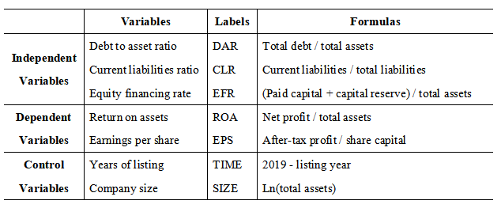

**2.6 Conclusion**

This chapter provided a discussion of previous literature, including MM theory, Pecking order theory, and financial leverage theories. Besides, comparing various research to find the gap and deficiencies that formed the research variables. Therefore, this research provided a literature review that conceptualized the research framework of the study in order to focus on the hypothesis.

**CHAPTER 3: RESEARCH METHODOLOGY**

**3.0 Overview**

In this section, the design of the research is discussed by choosing and applying related statistic methods to achieve desired outcomes. Moreover, this chapter tries to explain and define the research design throughout that will be carried out. In addition to that, this chapter will discuss data design and the object targeted for this research, sample size. Various analysis methods for testing the data and hypothesis that are applied in this research is explained in this chapter, for instance, description analysis, correlation analysis, and multiple regression analysis.

**3.1 Research Method**

The main method in this paper is quantitative analysis. Quantitative analysis is a method of revealing the interaction or trend of a particular phenomenon by analyzing the internal characteristics of existing data and the relationship between different data. (Lynch and Walsh, 1998) This paper empirically studies the relevant financial data of China's real estate firms in 2014-2018 by collecting and processing the relevant characteristics data by descriptive statistics, multiple linear regression analysis and robustness test.

**3.2 Data Collection**

This article takes the Shanghai and Shenzhen stock A share markets as the scope, and takes the 2014-2018 time span to select the raw data. The principles are as follows:

1. Listing date: listed before January 1, 2014;
2. Types of stocks: Due to the difference between the A, B and the H shares, the real estate listed companies that are issued in the A shares are selected;
3. Main business: Due to the diversified operation of certain group companies, the main business has changed from real estate to other industries. Companies with no real estate development and operation in the main business are deleted;
4. Bad management: Excluding companies with ST and *ST in the original data, the reasons for the abnormal real estate companies are different. The financial data of these companies have no reference value.

Through the above principles, 122 real estate listed companies will be selected as research samples. The data in this paper mainly comes from WIND Database.

Figure 2: Selected 122 real estate listed companies

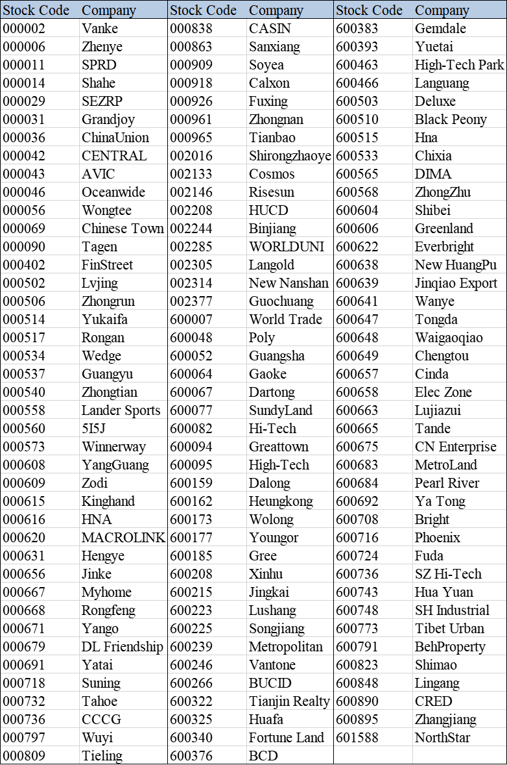

**3.3 Data analysis**

According to the research needs of this paper, for understanding the external financing situation and business performance of real estate industry more intuitively and comprehensively, this paper uses STATA16 statistical software to analyze the obtained data. This article first processed the financial statement data of 122 real estate listed companies from 2014 to 2018, and then descriptively analyzes each indicator data according to the annual order. Secondly, the correlation analysis is carried out for each variable in the model to obtain a simple linear correlation between the variables. The third is multivariate regression analysis. The regression score can be based on the mathematical model constructed by the correlation between variables, using probabilistic statistical knowledge as the basis to analyze this relationship.

**3.4 Descriptive analysis**

Descriptive statistics refer to activities that use tabulation and classification, graphics, and calculation of general data to describe the characteristics of the data. (Oja, 1983). According to Sprinthall and Fisk (1990), descriptive statistical analysis is to statistically describe the relevant data of all the variables in the survey, including frequency analysis, centralized trend analysis, dispersion analysis, distribution, and some basic statistical graphs. 1. Frequency analysis of data: It means that in the preprocessing part of the data, outliers can be checked using frequency analysis and cross-frequency analysis. 2. Centralized trend analysis of data: It is used to reflect the general level of data. Commonly used indicators include average, median, and mode. 3. Analysis of the degree of dispersion of data: It is mainly used to reflect the degree of difference between data. Commonly used indicators include variance and standard deviation. 4. Data distribution: In statistical analysis, it is usually assumed that the distribution of the population to which the sample belongs is a normal distribution, so two indicators of skewness and kurtosis are needed to check whether the sample data conform to the normal distribution. 5. Draw a statistical graph: expressing data in the form of graphics is more clear and concise than expressing in words. In Stata statistics software, it easy to draw the statistical graph of each variable.

**3.5 Correlation analysis**

Correlation analysis is to study whether there is some kind of dependency relationship between phenomena and to explore the related direction and degree of correlation for a specific dependent phenomenon (Ezekiel, 1941). It is a statistical method to study the correlation relationship between random variables. In order to more accurately describe the degree of linear correlation between variables, correlation analysis is generally performed by calculating correlation coefficients. Pearson Correlation Coefficient reflects the strength of the linear correlation between two variables. The value range of r is -1≤r≤1, and the larger the absolute value of r, the stronger the correlation (Benesty et al., 2009).

**3.6 Regression analysis**

The purpose of the multiple linear regression model is to construct a regression equation that uses multiple independent variables to estimate the dependent variable, so as to explain and predict the value of the dependent variable. The dependent variable and most independent variables in the multiple linear regression model are quantitative values. Certain qualitative indicators need to be converted to quantitative values before they can be applied to the regression equation (Seber and Lee, 2012)

**3.7 Conclusion**

This chapter has inclusively provided specifics on how to conduct the research and find the following procedures to find answers for the research objectives. A Sample of analysis of this research has been identified as 122 listed real estate companies in China. All the related data will be processed by using Stata16, Chapter 4 will be containing the statistical analysis and findings of the research.

**CHAPTER 4: FINDINGS AND DISCUSSION**

**4.0 Overview**

This chapter will provide information about the analysis and interpretation of the findings of data collected using the WIND database. In this chapter, there are five aspects of descriptive analysis and seven variable measurements. This research uses Stata16 statistical software to analyze the data.

**4.1 Descriptive Analysis**

Descriptive statistical analysis is the use of mathematical languages including tabulation, classification, graphics, and calculations to statistically describe the data of related sample variables (Acock, 2008). This article uses the minimum, maximum, mean, standard deviation, median and other indicators for analysis. By observing the descriptive statistics in Table 1, it can be seen the basic data of the selected 122 listed real estate companies and establish an intuitive impression.

Table 1: Descriptive analysis

|  |  |  |  |  |  |  |
| --- | --- | --- | --- | --- | --- | --- |
| variable | N | mean | p50 | sd | min | max |
| roa | 610 | 0.0412 | 0.0399 | 0.0431 | -0.300 | 0.260 |
| eps | 610 | 0.400 | 0.300 | 0.530 | -1.332 | 3.790 |
| dar | 610 | 0.648 | 0.669 | 0.175 | 0.0876 | 0.941 |
| clr | 610 | 0.685 | 0.685 | 0.178 | 0.103 | 1 |
| efr | 610 | 0.197 | 0.132 | 0.249 | 0.00960 | 2.398 |
| size | 610 | 14.29 | 14.20 | 1.511 | 9.896 | 18.84 |
| time | 610 | 20.58 | 21 | 4.375 | 8 | 27 |

As shown in Table 1, the company's earnings per share is about 0.4. This earnings value is not high. Although the earnings per share are subject to external factors such as the company's size and market environment, it is not comparable to other industries, but from the perspective of absolute value to see the low value of earnings per share, it shows that the profitability of listed real estate companies in China still needs to be improved. The average current liability ratio is 0.685, which reflects that the short-term debt solvency of listed real estate companies is weak. Meanwhile, the average value of the asset-liability ratio is around 0.65, indicating that the current overall situation of China's listed housing companies is mainly to raise funds through debt rather than equity. Overall, it is found that the index coefficient reflects the characteristics of high leverage, heavy assets and long cycle in the real estate industry.

**4.2 Correlation Analysis**

Inquiring whether there is a linear correlation between variables is a necessary prerequisite for building a regression model (Chan, 2004). Therefore, before constructing a regression model, it requires to analyze the correlation between the variables first. According to Andrew et al.(2013), correlation analysis is to measure the closeness of the correlation between two variable elements, generally, two or more variable elements that may be related are used as the research object. There are many methods for correlation analysis, this article mainly uses the statistical method of correlation coefficient to calculate. This paper uses Stata16 statistical software to extract the correlation coefficient matrix between the variables. Since there are two dependent variables ROA and EPS in this paper, the specific values of the correlation coefficients corresponding to these two variables are shown in Table 2 and Table 3.

Table 2: Correlation coefficient based on roa

|  |  |  |  |  |  |  |
| --- | --- | --- | --- | --- | --- | --- |
|  | roa | efr | dar | clr | size | time |
| roa | 1 | -0.027 | -0.183*** | 0.118*** | 0.135*** | 0.137*** |
| efr | -0.221*** | 1 | -0.785*** | 0.153*** | -0.707*** | 0.015 |
| dar | -0.103** | -0.567*** | 1 | -0.178*** | 0.657*** | -0.131*** |
| clr | 0.124*** | 0.205*** | -0.237*** | 1 | -0.264*** | -0.003 |
| size | 0.128*** | -0.600*** | 0.627*** | -0.259*** | 1 | -0.131*** |
| time | 0.047 | 0.005 | -0.097** | -0.043 | -0.123*** | 1 |

*** p<0.01, ** p<0.05, * p<0.1

According to the above table, it can be seen from the P-value of the correlation test that the P-value of the equity financing ratio (efr), current debt ratio (clr) and the size of the enterprise (size) is smaller than 0.01, which is relatively significant, and the asset ratio (dar) is at a significance level of 0.05, which is relatively significant when p less than 0.05. The listing time (time) failed to pass the 0.05 significance level test, and the performance is relatively insignificant.

Table 3: Correlation coefficient based on eps

|  |  |  |  |  |  |  |
| --- | --- | --- | --- | --- | --- | --- |
|  | eps | efr | dar | clr | size | time |
| eps | 1 | -0.509*** | 0.251*** | -0.027 | 0.605*** | 0.066 |
| efr | -0.291*** | 1 | -0.785*** | 0.153*** | -0.707*** | 0.015 |
| dar | 0.207*** | -0.567*** | 1 | -0.178*** | 0.657*** | -0.131*** |
| clr | 0.041 | 0.205*** | -0.237*** | 1 | -0.264*** | -0.003 |
| size | 0.550*** | -0.600*** | 0.627*** | -0.259*** | 1 | -0.131*** |
| time | -0.007 | 0.005 | -0.097** | -0.043 | -0.123*** | 1 |

*** p<0.01, ** p<0.05, * p<0.1

According to the above table, it can be seen from the P-value of the correlation test that the P-value of the equity financing ratio (efr), asset ratio (dar) and company size (size) is smaller than 0.01, which show the performance is relatively significant.If the correlation coefficient between variables is greater than 0.9, collinearity will occur. If the correlation coefficient between variables is less than 0.8, regression analysis can be performed (Benesty et al., 2009). As can be seen from Table 2 and Table 3, the maximum coefficient value is dar, the value is 0.627, which is less than 0.8, so a linear regression analysis can be performed.

Table 4: VIF Variance Expansion Factor

|  |  |  |
| --- | --- | --- |
| VARIABLES | VIF | 1/VIF |
| size | 2.55 | 0.391977 |
| dar | 1.73 | 0.577589 |
| eps | 1.58 | 0.631302 |
| clr | 1.14 | 0.873807 |
| time | 1.14 | 0.969987 |
| Mean VIF | 1.61 | |

To further determine if there is the existence of multicollinearity among variables, a Variance inflation factor (VIF) test was performed. According to Daoud (2017), Multicollinearity test generally has two conditions, the first is the tolerance is less than 0.1, and the second is the VIF is greater than 10. It can be seen from Table 4 that the tolerances are all greater than 0.1, and VIF is all less than 10. Therefore, it is clear that there is no multicollinearity among the variables, which further validates that the model can perform multiple linear regression analysis.

**4.3 Multiple Linear Regression Analysis**

Correlation analysis can only analyze the correlation between various variables rather than measure the effectiveness of the entire model and the effect of each variable on the explanatory variables in the model (Chan, 2004). This section uses Stata16 software to substitute the dependent and control variables of the sample companies into the model for regression.

**4.3.1 Overall multiple regression coefficient**

Table 5: Overall multiple regression coefficient

|  |  |  |
| --- | --- | --- |
|  | (1) | (2) |
|  | m1 | m2 |
| VARIABLES | roa | eps |
| roa |  |  |
| efr | -0.0606*** | -0.0118 |
|  | (-7.140) | (-0.130) |
| dar | -0.0961*** | -0.616*** |
|  | (-7.760) | (-4.643) |
| clr | 0.0386*** | 0.555*** |
|  | (4.115) | (5.522) |
| size | 0.00596*** | 0.257*** |
|  | (3.992) | (16.04) |
| time | 0.000425 | 0.00868** |
|  | (1.143) | (2.180) |
| eps |  |  |
| Constant | -0.00501 | -3.424*** |
|  | (-0.201) | (-12.83) |
| Observations | 610 | 610 |
| R-squared | 0.166 | 0.369 |
| Adj R-squared | 0.159 | 0.364 |

t-statistics in parentheses

*** p<0.01, ** p<0.05, * p<0.1

From the data in the table, it can be seen that the R-square of the model m1 based on the dependent variable roa is 0.166 and the adjusted R-square is 0.159, indicating that the 16.6% change in operating performance can be explained by the independent variable and its control variable jointly, The fitting effect of the model is relatively low. And the R square of the model m2 based on the eps of the dependent variable is 0.369 and the adjusted R square is 0.364, indicating that the model has a better fitting effect.

At the same time, it can be seen from the regression data in Table 5 that the variables such as asset-liability ratio, current debt ratio, and company size all passed the significance test. For model 1's operating performance measured by the profit indicator roa, the regression coefficient of the equity financing rate is -0.0606, which means that for every 1% increase in the company's equity financing rate, the operating performance will decrease by -0.0606%; the regression coefficient of the current debt ratio is 0.0386, which means that for every 1% increase in the company's current debt ratio, the operating performance will increase by 0.0386%; the regression coefficient of the capital-liability ratio is -0.0961, which means that for every 1% increase in the company's capital-liability ratio, the operating performance will decrease by 0.0961%; The regression coefficient is 0.00596, which means that for every 1% increase in the size of the company, the operating performance will increase by 0.00596%; the number of years the company has been listed has no significant effect on the operating performance. For Model 2's operating performance measured by the profit indicator eps, in addition to the equity financing rate, the significance, direction, and meaning of the other variables are basically the same.

**4.3.2 Regression analysis of equity financing and performance**

This section analyzes the relationship between equity financing and performance under two dependent variables by adjusting the control variables. For Table 6, m1 is the regression analysis of roa to efr, m2 is the regression analysis of roa for independent variable efr and control variable size, and m3 is the regression analysis of roa for independent variable efr and control variable size and time. For Table 7, m1, m2 and m3 all refer to the regression analysis of eps to related variables that same as in Table 6.

Table 6: Regression coefficient of ROA to equity variable

|  |  |  |  |
| --- | --- | --- | --- |
|  | (1) | (2) | (3) |
|  | m1 | m2 | m3 |
| VARIABLES | roa | roa | roa |
| roa |  |  |  |
| efr | -0.0383*** | -0.0391*** | -0.0382*** |
|  | (-5.593) | (-4.568) | (-4.450) |
| size |  | -0.000234 | 2.14e-05 |
|  |  | (-0.166) | (0.0150) |
| time |  |  | 0.000472 |
|  |  |  | (1.197) |
| Constant | 0.0487*** | 0.0522** | 0.0387 |
|  | (22.46) | (2.454) | (1.606) |
| Observations | 610 | 610 | 610 |
| R-squared | 0.049 | 0.049 | 0.051 |
| Adj R-squared | 0.0474 | 0.0458 | 0.0465 |

t-statistics in parentheses

*** p<0.01, ** p<0.05, * p<0.1

According to Table 6, it can be seen that under the three models, the regression estimation coefficient of the equity financing rate (efr) is about -0.039, the t-test values are all about -5, and the significance level significant values are less than 0.01, indicating that the equity financing rate is negatively related to roa.

Table 7: Regression coefficient of EPS to equity variable

|  |  |  |  |
| --- | --- | --- | --- |
|  | (1) | (2) | (3) |
|  | m1 | m2 | m3 |
| VARIABLES | eps | eps | eps |
| eps |  |  |  |
| efr | -0.619*** | 0.131 | 0.147 |
|  | (-7.491) | (1.460) | (1.626) |
| size |  | 0.206*** | 0.210*** |
|  |  | (13.87) | (14.04) |
| time |  |  | 0.00809* |
|  |  |  | (1.955) |
| Constant | 0.521*** | -2.569*** | -2.801*** |
|  | (19.91) | (-11.47) | (-11.07) |
| Observations | 610 | 610 | 610 |
| R-squared | 0.084 | 0.305 | 0.309 |
| Adj R-squared | 0.083 | 0.303 | 0.306 |

t-statistics in parentheses

*** p<0.01, ** p<0.05, * p<0.1

According to the above table, the regression estimation coefficient of the equity financing rate is -0.619 in model 1, and the significance level is less than 0.01. So it can be seen that the equity financing rate is negatively correlated with eps, and the relationship is significant. Although in model 2 and model 3, its regression coefficients are 0.131 and 0.147, its significance level is greater than 0.1 which means it failed the significance test, so the positive correlation between efr and eps is not significant.

Overall, the equity financing rate (efr) is negatively related to operating performance and has a significant relationship, that is, the more equity financing, the worse the operating performance.

**4.3.3 Regression analysis of debt financing and performance**

This section analyzes the relationship between debt financing and performance under two dependent variables by adjusting the control variables. For Table 8, m1 is the regression analysis of roa to dar and clr, m2 is the regression analysis of roa for independent variable dar and clr, and control variable size, and m3 is the regression analysis of roa for independent variable dar and clr, and control variable size and time. For Table 9, m1, m2 and m3 all refer to the regression analysis of eps to related variables that same as in Table 8.

Table 8: Regression coefficient of ROA to debt variables

|  |  |  |  |
| --- | --- | --- | --- |
|  | (1) | (2) | (3) |
|  | m1 | m2 | m3 |
| VARIABLES | roa | roa | roa |
| roa |  |  |  |
| dar | -0.0192* | -0.0698*** | -0.0691*** |
|  | (-1.888) | (-5.684) | (-5.631) |
| clr | 0.0256** | 0.0354*** | 0.0368*** |
|  | (2.564) | (3.628) | (3.765) |
| size |  | 0.00980*** | 0.0100*** |
|  |  | (6.835) | (6.980) |
| time |  |  | 0.000680* |
|  |  |  | (1.768) |
| Constant | 0.0361*** | -0.0778*** | -0.0965*** |
|  | (3.367) | (-3.968) | (-4.337) |
| Observations | 610 | 610 | 610 |
| R-squared | 0.021 | 0.091 | 0.096 |
| Adj R-squared | 0.018 | 0.087 | 0.09 |

t-statistics in parentheses

*** p<0.01, ** p<0.05, * p<0.1

According to Table 8, the regression estimation coefficients of the debt to assets ratio (dar) in the three models are -0.0192, -0.0698 and -0.0691 respectively, of which two significance levels are less than 0.01 and one significance level is less than 0.1, indicating the debt to assets ratio has a significant negative correlation with roa. In terms of current debt ratio (clr), its regression estimation coefficients are 0.0256, 0.0354, and 0.0368 respectively in the three models, and all the significance level are less than 0.05, so the current debt ratio (clr) is positively correlated with roa and the relationship is significant. For the two control variables of size and time, their regression estimation coefficients are both positive and passed the significance test.

Table 9: Regression coefficient of EPS to debt variables

|  |  |  |  |
| --- | --- | --- | --- |
|  | (1) | (2) | (3) |
|  | m1 | m2 | m3 |
| VARIABLES | eps | eps | eps |
| dar | 0.695*** | -0.620*** | -0.611*** |
|  | (5.650) | (-4.900) | (-4.838) |
| clr | 0.284** | 0.537*** | 0.555*** |
|  | (2.345) | (5.347) | (5.525) |
| size |  | 0.254*** | 0.257*** |
|  |  | (17.24) | (17.42) |
| time |  |  | 0.00873** |
|  |  |  | (2.205) |
| Constant | -0.246* | -3.201*** | -3.442*** |
|  | (-1.894) | (-15.87) | (-15.04) |
| Observations | 610 | 610 | 610 |
| R-squared | 0.052 | 0.364 | 0.369 |
| Adj R-squared | 0.048 | 0.361 | 0.365 |

t-statistics in parentheses

*** p<0.01, ** p<0.05, * p<0.1

According to Table 9, the regression estimation coefficient of the debt to assets ratio (dar) is about 0.6 after the adjustment of the control variable is added, and the significance level is less than 0.01, indicating that there is a significant negative correlation between the debt to assets ratio and eps. In terms of current debt ratio (clr), its regression estimation coefficient is greater than 0 in all three models, and the significance level is less than 0.05, so the current debt ratio (clr) is positively related to eps, and the relationship is significant. For the two control variables of size and time, their regression estimation coefficients are both positive and passed the significance p <0.05 test, indicating that they have a positive correlation with eps.

Overall, in the debt financing part, the debt to assets ratio (dar) is negatively related to operating performance, and the relationship is significant, that is, the more debt financing, the worse the operating performance. The current debt ratio (clr) is positively related to the company's operating performance, and the relationship is significant, that is, the higher the ratio of current liabilities to total debt, the better the operating performance.

**4.4 Discussion on findings**

After conducting a multiple linear regression analysis on equity financing, debt financing and operating performance, the results are analyzed as follows.

**4.4.1 Debt to assets ratio and operating performance**

Through regression analysis, it is concluded that the debt to assets ratio is negatively related to the company's performance. This research conclusion is consistent with the content of the trade-off theory, but the conclusion does not agree with the peck-order theory, which is determined by the characteristics of China's listed real estate companies and their economic development environment. Competition between enterprises is very fierce, enterprises need to continuously expand their scale in order to seize more market share, and the expansion of the enterprise's scale requires a steady stream of input funds. As shown in Table 1, the average value of the debt to assets ratio of listed real estate companies in China has reached about 64.8%. According to Wenjun (2012), the peck-order theory believes that enterprises should give priority to internal financing to raise funds, but the premise of choosing this financing method is that the enterprise has good profitability and strong ability to create funds. At this stage, the real estate companies listed in China are generally profitable, so they prefer debt financing, however, increasing liabilities have increased the cost of the company's debt, and the total cost of the company has therefore increased, which will inevitably have a negative impact on the company's operating performance (Wu, 2015). At the same time, real estate companies are facing great financial risks, and the market value is affected to a certain extent, and there is a downward trend. After the company's liabilities increase, the company's risk of bankruptcy also increases. Although the real estate company did not enter bankruptcy immediately, it caused the conflict of interests between shareholders and creditors to continue to intensify, which reduced the company's operating performance.

**4.4.2 Current debt ratio and operating performance**

Regression analysis using Stata16 statistical software shows that the current debt ratio is positively related to operating performance, which is consistent with the conclusions of agency theory and signal transmission theory. Therefore, short-term debt accounts for a large proportion of debt, which has a significant positive impact on the company’s operating performance.According to Benmelech and Dvir (2013), the advantage of short-term debt is that it not only has a certain incentive to the company, but also has a restrictive effect, especially in terms of investment of business managers, which can prevent blind investment behavior and promote the improvement of the performance. Meanwhile, the company obtains short-term debt financing, and external investors will think that there are new investment projects, so increasing investment will promote the company’s performance. In addition, combined with the current status of the debt structure of listed real estate companies, the positive impact of short-term liabilities on the company's operating performance may also be related to its own characteristics.(Kahl,2015). Although the short-term debt has a short debt period and there is interest rate risk, the cost of short-term debt is low. Among the listed real estate companies, advance accounts and payables, which account for a large proportion of short-term liabilities, do not need to pay interest, which greatly reduces the company's operating costs and greatly improves the company's operating performance.

**4.4.3 Equity financing ratio and operating performance**

Through precious regression analysis, it is concluded that the equity financing ratio is negatively related performance. According to Vanacker and Manigart (2010), with the increase of equity financing rate, the financing cost of the company will increase, and it will send unfavorable signals to the capital market, and it will also lead to the dispersion of corporate control, which will lead to a reduction in operating performance.

**4.5 Hypotheses**

According to the previous analysis, it can be seen that H1, H2 and H3 are all accepted, the result shows in below table:

Table 10: The testing result of hypothesis

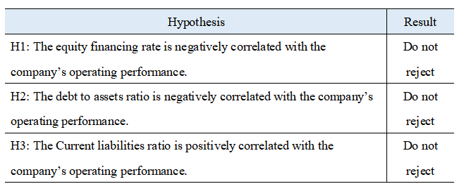

**CHAPTER 5: CONCLUSION AND RECOMMENDATION**

**5.0 Overview**

The content of this chapter discusses the findings of the research and statistical analysis conducted in the previous chapter. Moreover, the limitation of the study, the recommendation for future research and personal reflection are included in this chapter.

**5.1 Conclusions**

Currently, real estate industry's financing channels are gradually diversifying in China (Fung et al., 2010). Affected by the operating environment, bank loans have become the main source of funds, which has led to a high asset-liability ratio, the rise of bond financing in recent years has further increased this ratio. Affected by many factors, in recent years, listed real estate companies have shown weaker solvency and lower operating capacity (Shen and Wu, 2018). According to capital structure theories such as trade-off theory and agency theory, housing companies may have bankruptcy risks and agency problems. Therefore, exploring the capital structure of listed real estate companies and its correlation with business performance has important theoretical and practical values.

This paper selects listed companies in China's real estate industry as the research object, and studies the impact of real estate company equity and debt financing on operating performance. The data of 122 A-share listed companies in the past five years is used for empirical tests to verify relevant views and assumptions. This article analyzes in detail how financing methods, debt structure, and equity structure will affect operating performance, and carefully selects variables that measure equity and debt financing and operating performance during data analysis. The specific research results as follow:

First, the overall debt to assets ratio of China's listed real estate companies is relatively high, the source of funds is more dependent on bank deposits, and financial risks are greater. Second, in terms of debt structure, the asset-liability ratio of listed real estate companies in China is negatively related to operating performance, and the current debt ratio is positively related to operating performance. Third, in terms of equity structure, the equity financing rate of listed real estate companies in China has a negative correlation with operating performance. Fourth, the operating performance of China's listed real estate companies is significantly affected by scale. Larger real estate companies often show better operating performance.

**5.2 Recommendations**

In view of the above conclusions, in order to improve the operating performance of real estate companies, enhance their competitiveness, and ensure the healthy development of the real estate industry, this article proposes the following.

**5.2.1 Controlling debt levels**

The high debt ratio has a negative impact on operating performance. Therefore, listed real estate companies should appropriately reduce debt financing, control debt levels, and reduce operating risks. Large debt makes it very susceptible to external objective conditions such as national macro-control policies (Xia and Xu, 2011). Once interrupted by external unexpected factors, which makes the company's operation poor, the company's losses will be amplified by financial leverage, which will easily cause the company's capital chain to be tense or broken, which is not conducive to the company's sustainable development. According to Brander and Lewis (1986), the incentive effect of liabilities and the effect of interest tax deductions indicate that the asset-liability ratio has a positive impact on the company's performance. The leverage effect of liabilities indicates that there is a critical value for the positive increase of the asset-liability ratio to the company's performance. Furthermore, once the asset-liability ratio exceeds the critical value, it will bring negative growth in the company's performance. Therefore, in order to improve the company's operating performance, real estate listed companies should appropriately reduce debt financing and reasonably control debt levels.

**5.2.2 Introduce foreign shares**

In the distribution of real estate companies' capital sources, there are fewer foreign capital sources, and there is still much room for development in the introduction of foreign capital. In recent years, there has been a trend of liberalization of foreign investment (Zheng, 2019). Real estate companies should use relevant policies to actively develop corresponding channels for foreign investment. In view of the few companies that have been successfully listed in China in the past five years, rapid-growing real estate companies can consider using overseas listed equity financing methods or mergers and acquisitions of overseas real estate companies to achieve the purpose of expanding the scale and ease the problem of domestic financing.

**5.2.3 Making full use of short-term liabilities**

Based on the conclusion, the short-term debt has higher efficiency, and an appropriate increase in the short-term debt ratio can help improve the operating performance of listed real estate companies (Bărbuţă-Mişu, 2013). In this case, the short time span of debt makes its interest rate lower than that of medium and long-term borrowing. In addition, there is no additional financing cost for advance receipts and payables, which directly reduces the company's overall capital cost and enhances the company's operating capacity. In addition, short-term debt can solve the capital needs of the company's own development on the one hand, and on the other hand can constrain managers to make blind investments and improve management enthusiasm. At this stage, real estate market is facing problems of high inventory and economic downturn, and the government has also issued a series of policies. Real estate listed companies should review the situation, use some current liabilities to get rid of the current economic downturn, improve the company's operating efficiency, or use some creative marketing methods to stimulate the sales of real estate products and speed up the return of funds.

**5.2.4 Strengthen equity financing**

From the property rights ratio indicators of the past five years, the total debt of the entire industry is 3 to 4 times the shareholder's capital, and the highest is 10 times (Du and Luo, 2015). It shows that the proportion of equity structure in the entire capital structure is particularly small, while the proportion of debt structure in the entire capital structure is particularly large. Therefore, real estate companies can reduce the proportion of debt by optimizing the capital structure of the company by attracting new investors, additional investments by shareholders, and issuing tradable shares.

**5.2.5 Improve management level**

The development process of the company is accompanied by the continuous adjustment of the financing structure (Romano et al., 2011). The financing structure is a dynamic adjustment process, because as the company grows in size, it only focuses on profitability from the beginning to strengthen capital management and lower operating costs. In addition, the influencing factors continue to increase with the expansion of the company's size, including the market environment, the behavioral preferences of managers, and the company's operational management level. Therefore, this dynamic optimization process should be continuously learned, practiced, and explored by every manager. Company operators need to recognize the importance of financing structure's impact on business performance, establish management methods, clarify management concepts, and improve management levels. Managers should also comprehensively analyze the complex mechanism of various factors such as policies, industries, and markets, and formulate scientific and reasonable financing strategies to enhance the value of the company (Lewellen, 2006).

**5.2.6 Improve related policy guarantees**

The government should improve the relevant policy guarantees. If real estate companies want to promote diversified financing then it requires the protection of policies and regulations. Housing companies want to use financial leverage reasonably and avoid risks in accordance with regulations. The limits of these also need to be clear from the government to define and do a good job as a guide. In terms of capital requirements, the government must introduce relevant policies to promote the development of the capital market, formulate relevant rules for financial institutions to support the sound development of real estate, and reduce the dependence of the real estate industry on bank loans, so as to provide a good environment for real estate companies to develop healthily. In terms of capital operation, the government should properly guide and rely on macroeconomic policies and talent policies to guide the development direction of real estate, so that the capital market can better adapt to changes in capital needs of the real estate industry, and for the entry and exit of funds, the entry of enterprises and the Withdrawal provides a standardized channel, in addition, it provides assistance for assets restructuring and bankruptcy and liquidation-related matters for enterprises with poor returns.

**5.3 Limitations**

There are some limitations in this study: The first is insufficient sample data. Although A-share listed companies in Shanghai and Shenzhen are the main force in the real estate industry, they do not fully represent the real estate industry. Many small and medium-sized real estate companies and financial data are also of the reference value. However, due to the difficulty of data collection, it has not been taken into consideration, which is insufficient for the research scope of the real estate industry. Future research will try to expand the scope to include unlisted real estate companies and other listed companies that have not been selected. The second is the choice of performance evaluation methods. Since this article only selects ROA and EPS to quantify business performance indicators, there are still accuracy issues, so I hope to choose more evaluation methods in the future. By comparing multiple evaluation methods, then choose the best solution to represent the business. The third is the choice of control variables. The influence of financing structure on the company's operating performance is not limited to the internal structure of the company's capital, external factors will also affect its relationship. It is not enough that this article only selects the company size and the number of years the company is listed as control variables. The impact is all-round, so the choice of control variables should be more cautious and diversified, and the pertinence and purpose should be highlighted, including the impact of key government policies.

**5.4 Personal Reflections**

This thesis finally came to an end after one semester’s hard work. During the entire learning process, many problems appeared, but they were successfully solved with the guide of my supervisor and my second panel, I super appreciate them for their patient help. In the whole process, I realized: Writing a dissertation is a process of continuous learning. From the vague understanding of equity and debt financing issues when I first wrote the dissertation, in the data analysis part, in the beginning, I did not know how to search the data. By gradually exploring and self-learning the use of the WIND database, I successfully collected the financial information of more than 100 real estate companies required by the paper. The greater gain is that I learned the basic use of statistical software Stata. Stata is a brand new software for me since I have not touched programming and I do not know how to enter code, Stata's learning process is more difficult for me. However, by learning how to use Stata, I learned the importance of the data analysis part to a dissertation, and gained a more comprehensive knowledge of statistics, which also helped to enhance my personal competitive advantage.

Very grateful to my mentor Ms. Rebecca and Dr. Rashedul. In the process of writing this thesis, the mentor and I repeatedly communicated and communicated from the determination of the topic to the collection of data, the mentors helped me to improve the paper over and over. I would also like to thank my classmates, especially my seniors for sharing their experience on the academic road, which dispelled a lot of fog for my progress. Thanks to INTI University for such a compatible and inclusive platform, during my graduate study, I was able to meet many good teachers and friends. All in all, this is not only a thesis writing for me, but also a process of self-growth and self-learning. I hope that in the future, I can maintain the original intention of such learning and face the upcoming career with a serious and sincere attitude.

**6 References**

Acock, A.C., 2008. *A gentle introduction to Stata*. Stata press.

Andrew, G., Arora, R., Bilmes, J. and Livescu, K., 2013, February. Deep canonical correlation analysis. In *International conference on machine learning* (pp. 1247-1255).

Bărbuţă-Mişu, N., 2013. Factoring–alternative of short-term financing for companies. *Risk in Contemporary Economy*, pp.166-171.

Benesty, J., Chen, J., Huang, Y. and Cohen, I., 2009. Pearson correlation coefficient. In *Noise reduction in speech processing*(pp. 1-4). Springer, Berlin, Heidelberg.

Benmelech, E. and Dvir, E., 2013. Does short-term debt increase vulnerability to crisis? Evidence from the East Asian financial crisis. *Journal of International Economics*, *89*(2), pp.485-494.

Brander, J.A. and Lewis, T.R., 1986. Oligopoly and financial structure: The limited liability effect. *The American Economic Review*, pp.956-970.

Brealey, R.A., Myers, S.C., Allen, F. and Mohanty, P., 2012. *Principles of corporate finance*. Tata McGraw-Hill Education.

Brown, J.R., Fazzari, S.M. and Petersen, B.C., 2009. Financing innovation and growth: Cash flow, external equity, and the 1990s R&D boom. *The Journal of Finance*, *64*(1), pp.151-185.

Boone, A.L., Field, L.C., Karpoff, J.M. and Raheja, C.G., 2007. The determinants of corporate board size and composition: An empirical analysis. *Journal of financial Economics*, *85*(1), pp.66-101.

Campello, M., 2006. Debt financing: Does it boost or hurt firm performance in product markets?. *Journal of Financial Economics*, *82*(1), pp.135-172.

Chan, Y.H., 2004. Biostatistics 201: linear regression analysis. *Age (years)*, *80*, p.140.

Chowdhry, B. and Coval, J.D., 1998. Internal financing of multinational subsidiaries: Debt vs. equity. *Journal of corporate finance*, *4*(1), pp.87-106.

Clingermayer, J.C. and Wood, B.D., 1995. Disentangling patterns of state debt financing. *American Political Science Review*, *89*(1), pp.108-120.

Coram, P.J., Mock, T.J. and Monroe, G.S., 2011. Financial analysts' evaluation of enhanced disclosure of non-financial performance indicators. *The British Accounting Review*, *43*(2), pp.87-101.

Coulibaly, B., Sapriza, H. and Zlate, A., 2013. Financial frictions, trade credit, and the 2008–09 global financial crisis. *International Review of Economics & Finance*, *26*, pp.25-38.

Daoud, J.I., 2017, December. Multicollinearity and regression analysis. In *Journal of Physics: Conference Series* (Vol. 949, No. 1, p. 012009). IOP Publishing.

DeAngelo, H., DeAngelo, L. and Whited, T.M., 2011. Capital structure dynamics and transitory debt. *Journal of Financial Economics*, *99*(2), pp.235-261.

Durand, D., 1952, January. Costs of debt and equity funds for business: trends and problems of measurement. In *Conference on research in business finance* (pp. 215-262). NBER.

Du, X. and Luo, Y., 2015, June. Optimized Research on Capital Structure of Listed Companies in Chinese Real Estate Industry. In *2015 International Conference on Management, Education, Information and Control*. Atlantis Press.

Edison, H.J., 2003. Do indicators of financial crises work? An evaluation of an early warning system. *International Journal of Finance & Economics*, *8*(1), pp.11-53.

Ezekiel, M., 1941. Methods of correlation analysis.

Frank, M.Z. and Goyal, V.K., 2003. Testing the pecking order theory of capital structure. *Journal of financial economics*, *67*(2), pp.217-248.

Frankel, R., McNichols, M. and Wilson, G.P., 1995. Discretionary disclosure and external financing. *Accounting Review*, pp.135-150.

Frazier, G.L. and Howell, R.D., 1983. Business definition and performance. *Journal of Marketing*, *47*(2), pp.59-67.

Fung, H.G., Huang, A.G., LIU, Q.W. and Shen, M.X., 2006. The development of the real estate industry in China. *Chinese economy*, *39*(1), pp.84-102.

Fung, H.G., Jeng, J.L. and Liu, Q.W., 2010. Development of China's real estate market. *Chinese Economy*, *43*(1), pp.71-92.

Gertner, R.H., Scharfstein, D.S. and Stein, J.C., 1994. Internal versus external capital markets. *The Quarterly Journal of Economics*, *109*(4), pp.1211-1230.

Gilson, R.J. and Schizer, D.M., 2003. Understanding venture capital structure: a tax explanation for convertible preferred stock. *Harvard Law Review*, *116*(3), pp.874-916.

Glaeser, E., Huang, W., Ma, Y. and Shleifer, A., 2017. A real estate boom with Chinese characteristics. *Journal of Economic Perspectives*, *31*(1), pp.93-116.

Hackbarth, D., 2009. Determinants of corporate borrowing: A behavioral perspective. *Journal of Corporate Finance*, *15*(4), pp.389-411.

Kahl, M., Shivdasani, A. and Wang, Y., 2015. Short‐term debt as bridge financing: Evidence from the commercial paper market. *The Journal of Finance*, *70*(1), pp.211-255.

Kochhar, R. and Hitt, M.A., 1998. Linking corporate strategy to capital structure: diversification strategy, type and source of financing. *Strategic management journal*, *19*(6), pp.601-610.

Klein, M.W. and Olivei, G.P., 2008. Capital account liberalization, financial depth, and economic growth. *Journal of international money and finance*, *27*(6), pp.861-875.

Kraus, A. and Litzenberger, R.H., 1973. A state‐preference model of optimal financial leverage. *The journal of finance*, *28*(4), pp.911-922.

Larrain, B. and Urzúa, F., 2013. Controlling shareholders and market timing in share issuance. *Journal of Financial Economics*, *109*(3), pp.661-681.

Lewellen, K., 2006. Financing decisions when managers are risk averse. *Journal of Financial Economics*, *82*(3), pp.551-589.

Lewis, C.M. and Tan, Y., 2016. Debt-equity choices, R&D investment and market timing. *Journal of financial economics*, *119*(3), pp.599-610.

Li, L. and Wu, X., 2014. Housing price and entrepreneurship in China. *Journal of Comparative Economics*, *42*(2), pp.436-449.

Long, M.S. and Malitz, I.B., 1985. Investment patterns and financial leverage. In *Corporate capital structures in the United States* (pp. 325-352). University of Chicago Press.

Lynch, M. and Walsh, B., 1998. *Genetics and analysis of quantitative traits* (Vol. 1, pp. 535-557). Sunderland, MA: Sinauer.

Mansi, S.A., Maxwell, W.F. and Miller, D.P., 2011. Analyst forecast characteristics and the cost of debt. *Review of Accounting Studies*, *16*(1), pp.116-142.

Margaritis, D. and Psillaki, M., 2010. Capital structure, equity ownership and firm performance. *Journal of banking & finance*, *34*(3), pp.621-632.

Martin, M. and Walker, J., 2015. Financing the Sustainable Development Goals: Lessons from government spending on the MDGs.

Modigliani, F. and Miller, M.H., 1958. The cost of capital, corporation finance and the theory of investment. *The American*, *1*, p.3.

Molina, C.A. and Preve, L.A., 2012. An empirical analysis of the effect of financial distress on trade credit. *Financial Management*, *41*(1), pp.187-205.

Myers, S.C., 1984. The capital structure puzzle. *The journal of finance*, *39*(3), pp.574-592.

Oja, H., 1983. Descriptive statistics for multivariate distributions. *Statistics & Probability Letters*, *1*(6), pp.327-332.

Romano, C.A., Tanewski, G.A. and Smyrnios, K.X., 2001. Capital structure decision making: A model for family business. *Journal of business venturing*, *16*(3), pp.285-310.

Sanjo, Y., 2012. Country risk, country size, and tax competition for foreign direct investment. *International Review of Economics & Finance*, *21*(1), pp.292-301.

Seber, G.A. and Lee, A.J., 2012. *Linear regression analysis*(Vol. 329). John Wiley & Sons.

Shen, J. and Yin, X., 2016. Credit expansion, state ownership and capital structure of Chinese real estate companies. *Journal of Property Investment & Finance*, *34*(3), pp.263-275.

Shen, S. and Wu, Y., 2018. The Contrastive Analysis of China’s Bond Financing and Stock Financing—Based on PVAR Model. *Journal of Mathematical Finance*, *8*(03), p.527.

Solomon, E., 1963. Leverage and the Cost of Capital. *The Journal of finance*, *18*(2), pp.273-279.

Sprinthall, R.C. and Fisk, S.T., 1990. *Basic statistical analysis*. Englewood Cliffs, NJ: Prentice Hall.

Vanacker, T.R. and Manigart, S., 2010. Pecking order and debt capacity considerations for high-growth companies seeking financing. *Small Business Economics*, *35*(1), pp.53-69.

Villamil, A.P., 2008. The Modigliani-Miller Theorem. *The New Palgrave Dictionary of Economics, Second Edition. Eds. Steven N. Durlauf and Lawrence E. Blume. Palgrave Macmillan*, *6*.

Wenjun, Z., 2012. Industrial Cluster and Capital Structure: Trade-off Theory or Peck Order Theory. *Finance & Economics*, (6), p.8.

Wu, J., Gyourko, J. and Deng, Y., 2015. Real estate collateral value and investment: The case of China. *Journal of urban Economics*, *86*, pp.43-53.

XIA, Y. and XU, X., 2011. Corporate Internal Control Information Disclosure and Debt Contract——Evidence from Chinese Real Estate Listed Companies [J]. *Economic Management Journal*, *3*.

Zeitun, R. and Tian, G.G., 2014. Capital structure and corporate performance: evidence from Jordan. *Australasian Accounting Business & Finance Journal, Forthcoming*.

Zhang, J., Fan, J. and Mo, J., 2017. Government intervention, land market, and urban development: Evidence from Chinese cities. *Economic Inquiry*, *55*(1), pp.115-136.

Zhao, L., Huo, B., Sun, L. and Zhao, X., 2013. The impact of supply chain risk on supply chain integration and company performance: a global investigation. *Supply Chain Management: An International Journal*, *18*(2), pp.115-131.

Zheng, Y., 2019. 4. Foreign direct investment in China. *Handbook on the International Political Economy of China*, *8*(9), p.61.

Zhu, N., 2016. *China's Guaranteed Bubble*. McGraw-Hill Education.

**7 Appendices**

**Appendix 1: Proposal defense presentation**

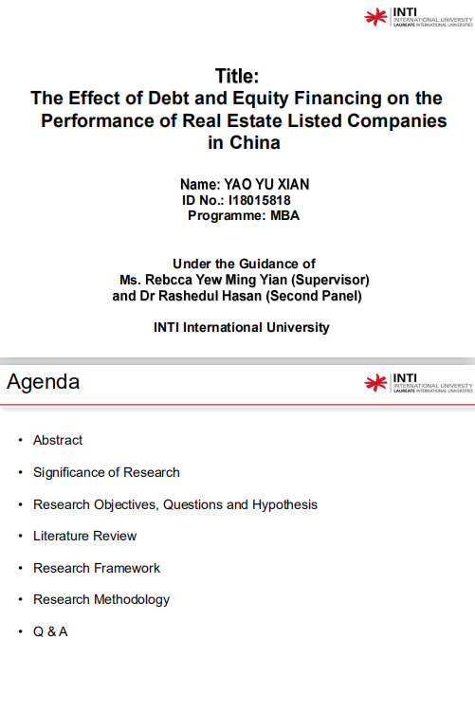

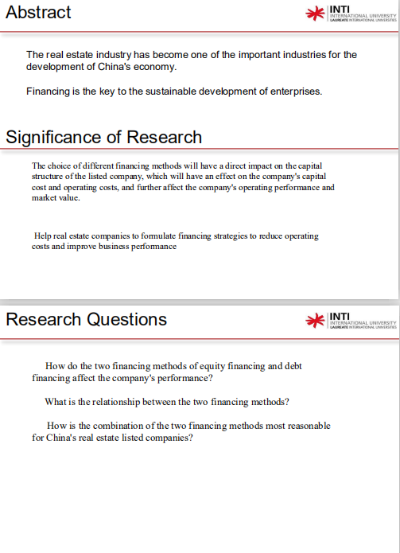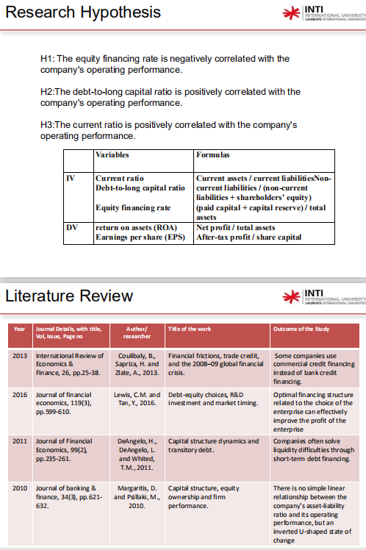

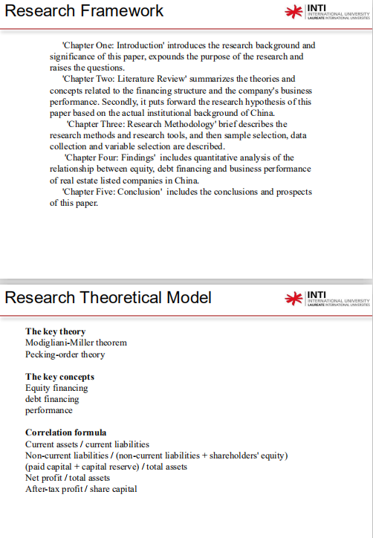

**Appendix 2: VIVA presentation**

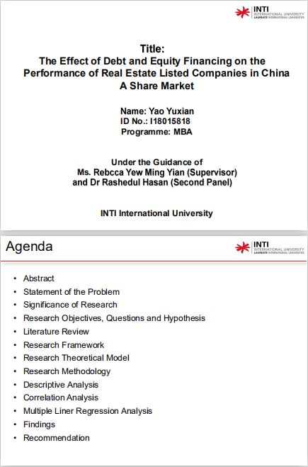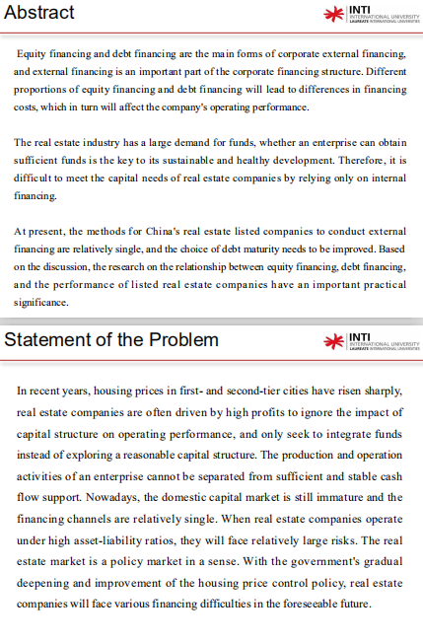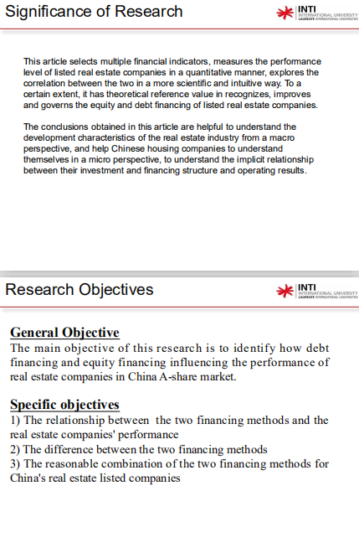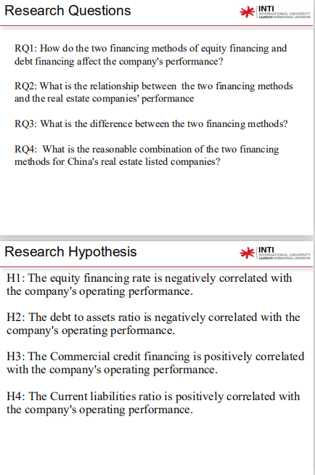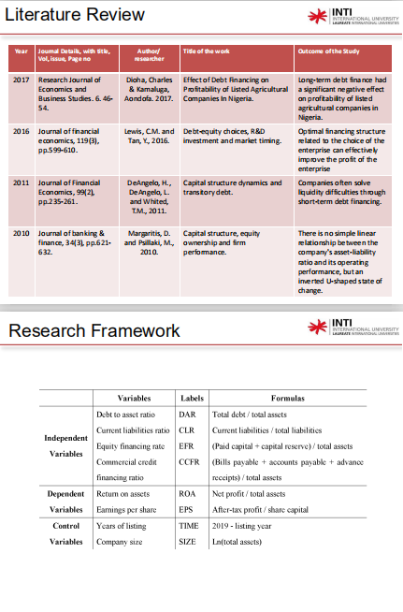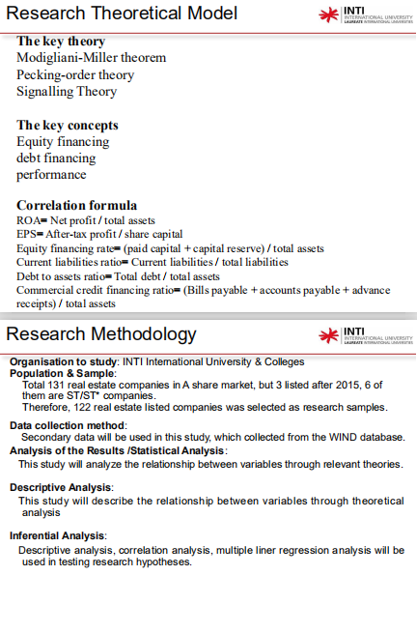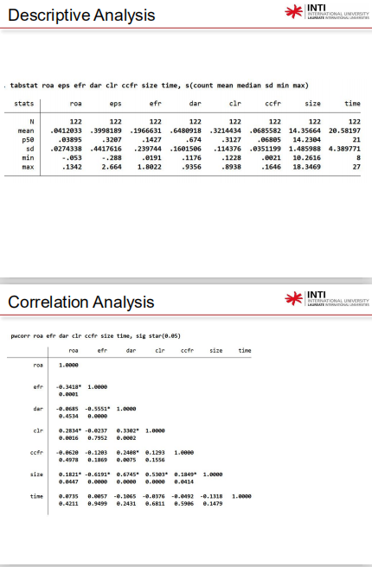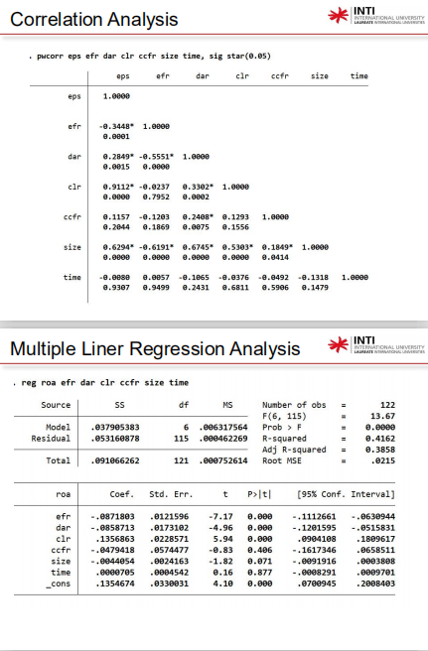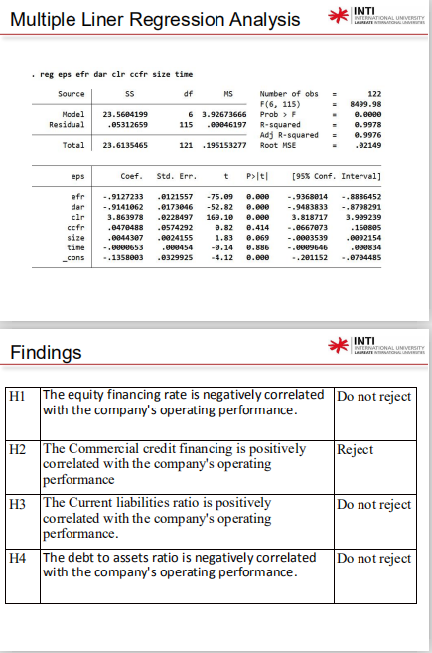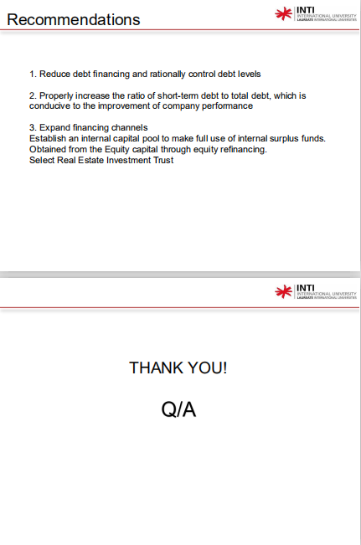

**Appendix 3: Initial research paper proposal**

|  |  |
| --- | --- |
| **STUDENT NAME & ID NO** | **YAO YUXIAN, I18015818** |
| **BROAD AREA** | Finance |
|  | |
| **Concise Title** | The Effect of Debt and Equity Financing on the Performance of Real Estate Listed Companies in China |
| **Problem Definition** | In recent years, housing prices in first- and second-tier cities have risen sharply, real estate companies are often driven by high profits to ignore the impact of capital structure on operating performance, and only seek to integrate funds instead of exploring a reasonable capital structure. The production and operation activities of an enterprise cannot be separated from sufficient and stable cash flow support. Nowadays, the domestic capital market is still immature and the financing channels are relatively single. When real estate companies operate under high asset-liability ratios, they will face relatively large risks. The real estate market is a policy market in a sense. With the government's gradual deepening and improvement of the housing price control policy, real estate companies will face various financing difficulties in the foreseeable future |
| **Research Questions OR Objectives** | The main objective of this research is to identify how debt financing and equity financing influencing the performance of real estate companies in China A-share market. There are three specific objectives:1. The relationship between the two financing methods and the real estate companies' performance 2. The difference between the two financing methods 3. The reasonable combination of the two financing methods for China's real estate listed companies. |
| **Scope of study** | This research is mainly focused on the influence of financing structure, especially the debt and equity financing. The geographic focus of the study is in China and the target objectives are real estate companies in A share market. |
| **Significance of the Research** | This article selects multiple financial indicators, measures the performance level of listed real estate companies in a quantitative manner, explores the correlation between the two in a more scientific and intuitive way. To a certain extent, it has theoretical reference value in recognizes, improves and governs the equity and debt financing of listed real estate companies. The conclusions obtained in this article are helpful to understand the development characteristics of the real estate industry from a macro perspective, and help Chinese housing companies to understand themselves in a micro perspective, to understand the implicit relationship between their investment and financing structure and operating results. |
| **Literature Review** | According tp Dioha et al., (2017), long-term debt finance had a significant negative effect on profitability of listed agricultural companies in Nigeria. Lewis and Tan (2016) believed that ptimal financing structure related to the choice of the enterprise can effectively improve the profit of the enterprise. There is no simple linear relationship between the company's asset-liability ratio and its operating performance, but an inverted U-shaped state of change (Margaritis and Psillaki, 2010) |
| **Research Methodology** | The main study contents are equity and financing and debt financing. The geographic focus of the study is in China, and the target participants are 122 real estate listed companies in the A-share market. At the same time, this article selects the auxiliary data collected from the WIND database. Data will be analyzed by descriptive, correlation and regression analysis of Stata16. |

**Appendix 4: Data analysis in Stata16**

1. **Description analysis**

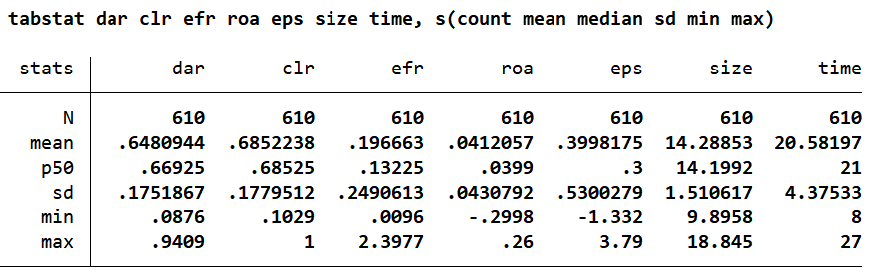

1. **Correlation analysis**

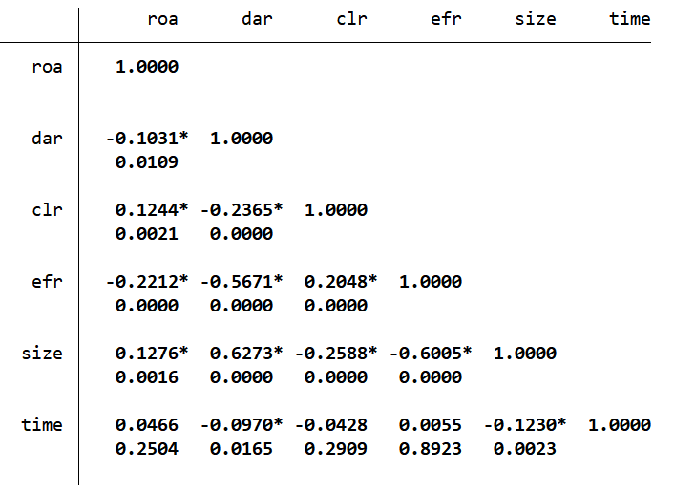

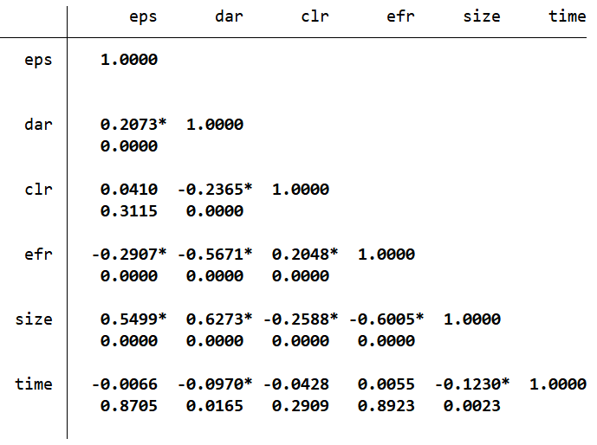

1. **VIF factor**

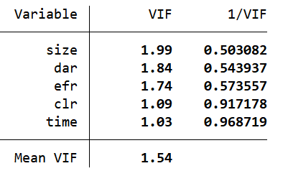

1. **Regression analysis**

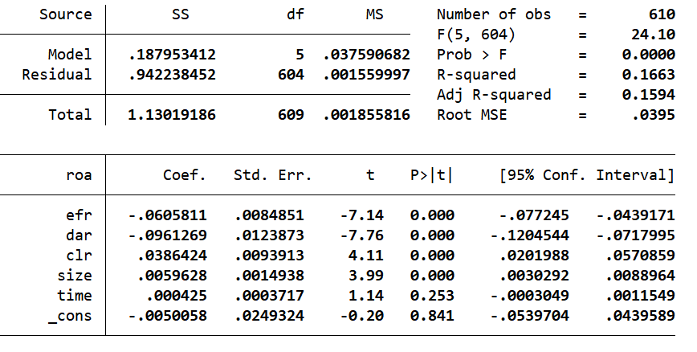

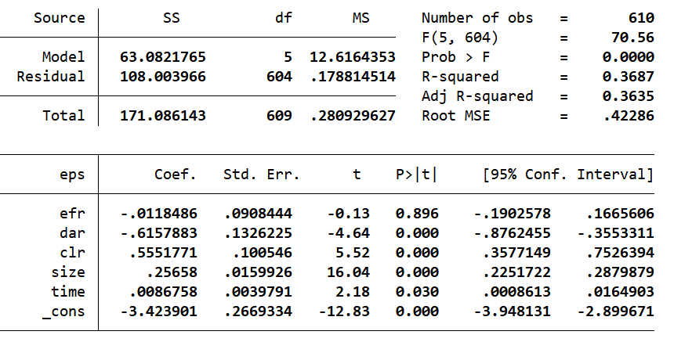

**Appendix 5: Secondary research declaration**



**Appendix 6: MBA project log**



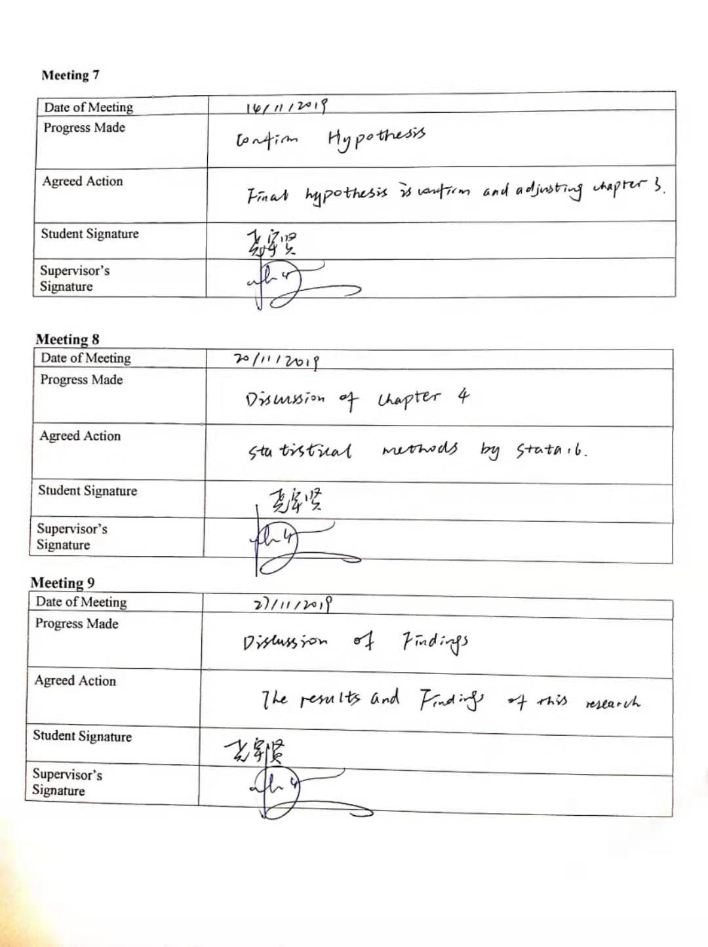

**Appendix 7: Turnitin report**

