**INTI INTERNATIONAL UNIVERSITY**

**MASTER OF BUSINESS ADMINISTRATION**

The Impact of Social Media Influencers and Consumer Attitude on Luxury Cosmetics Brands Purchase Intention in Klang Valley, Malaysia

Author: CHONG HOONG SHIEN

Student No: I17014185

Supervisor: Dr. Siti Intan Nurdiana Wong Abdullah

Submission Date: 18th December 2019

Ethics Number: cBUS/PGT/CP/04359

Final Word Count: 12200

**Declaration**

I hereby declare that this thesis is my own work and effort and that it has not been submitted anywhere for any award. Where other sources of information have been used, they have been duly acknowledged.

Name: Chong Hoong Shien

Student ID: I17014185

Signature: **Tracey Chong**

Date: 18th December 2019

**Acknowledgement**

I would like to take this opportunity to acknowledge a few person who give me support and guidance during the process of completing this research. Before this, I would like to say thank you for those participant that help me to take part in the data collection process. Without their tremendous support, I would not be able to gain enough data in short period of time.

Then, I would like to express my appreciation to my supervisor Dr. Diana for her guidance from the beginning of the research until completion. I have gained a lot knowledge from my supervisor that will be benefit me for my further study. Without her support and encouragement, I would not be able to complete this research on time. Once again, thank you very much, Dr Diana!

Last but not least, I would like express my deepest gratitude to my parents, my husband and my kids for their unconditional support and love. Thank you for always be there for me and accompany me in many sleepless nights to complete my MBA project. They are my biggest motivation to unleash my potential to complete my master degree in two years’ time.

**Abstract**

The rise of e-commerce online and social media platforms, consumer purchase behavior are also switching from the traditional shopping platform to digital platform. Influencer marketing constantly evolves, many businesses are partnering with micro-influencers to increase their credibility. This study is to designed and investigate the effectiveness of social media influencers focusing on how influencers’ trustworthiness, expertise and attractiveness can influence the consumer attitude toward the luxury cosmetics brands’ purchase intention. This research is a quantitative study that focus in the woman age 20 to 55 years old who live in Klang Valley from all income levels. Data collection was designed and sampling of 200 respondents’ dataset will be analyzed by using SPSS statistical software. All hypothesis are found to be supported except the attractiveness of the influencers. Implications, limitations, and recommendation for future research are further discussed.

**Key words**: Luxury Cosmetics Brands, Social Media Influencer, Trustworthiness, Expertise, Attractiveness, Consumer Attitude, Purchase Intention.

**Table of Contents**

**ABSTRACT**………………………………………………………………………..…. 3

**CHAPTER 1: INTRODUCTION**

* 1. Overview…………………………………………………...……………………... 10
  2. Background Study of Social Media Influencers…………………………………...10
  3. Background Study of Luxury Cosmetics Brands…………………………………...12
  4. Problem Statement…………………………………………………………………13
  5. Research Objectives…………………………………………………………....…..14
  6. Research Questions………………………………………………………………..14
  7. Contribution of the Study………………………………………………………….15
  8. Scope of Research…………………………………………………………………16
  9. Definition of Key Terms…………………………………………………………..16

**CHAPTER 2: LITERATURE REVIEW**

* 1. Overview…………………………………………………………………………18
  2. Luxury Cosmetics Industry in Malaysia…………………………………………..18
  3. Purchase Intention in Luxury Cosmetics Products………………………………..19
  4. Consumer Attitude and Purchase Intention………………………………………20
  5. Social Media Influencers…………………………………………………………21
  6. Trustworthiness and Consumer Attitude…………………………………………22
  7. Expertise and Consumer Attitude………………………………………………..23
  8. Attractiveness and Consumer Attitude…………………………………………..24
  9. Underpinning Theory………………………………………………….…………25
     1. Social Learning Theory……………………………………………….25
     2. Theory of Reasoned Action (TRA)…………………………………....25
  10. Conceptual Framework…………………………………………………………...27
  11. Hypothesis…………………………………………………………………….27
  12. Conclusion…………………………………………………………………….28

**CHAPTER 3: RESEARCH METHODOLOGY**

3.0 Overview………………………………………………………………………….29

3.1 Research Design…………………………………………………………………..29

3.2 Sample and Procedure ……………………………………………………..…….32

3.2.1 Sampling Design………………………………………………………..32

3.2.2 Sample Size……………………………………………………………..32

3.3 Questionnaire Design……………………………………………………………..33

* 1. Pilot Study………………………………………………………………………..37
  2. Measurement……………………………………………………………………..37
  3. Statistical Analysis……………………………………………………………….38
     1. Factor Analysis……………………………………………………….38
     2. Reliability Analysis…………………………………………………..38
     3. Descriptive Analysis…………………………………………………39
     4. Hypothesis Analysis………………………………………………….40
        1. Multiple Regression Analysis…………………………….40

3.7 Conclusion…………………………………………………………………………..41

**CHAPTER 4: RESEARCH FINDING**

4.0 Overview…………………………………………………………………………….42

4.1 Pilot Test…………………………………………………………………………….42

4.1.1 Factor Analysis……………………………………………………………42

4.1.2 Reliability Analysis……………………………………………………….45

4.2 Preliminary Data Analysis………………………………………………………….46

4.2.1 Factor Analysis…………………………………………………………...46

4.2.2 Reliability Analysis……………………………………………………….48

4.3 Demographic Characteristics Analysis……………………………………………..49

4.3.1 Response Rate…………………………………………………………….49

4.3.2 Demographic Profile……………………………………………………..50

4.3.3 Social Media Behavior……………………………………………………52

4.3.4 Area of Specialization of Social Media Influencers Preference………….53

4.3.5 Cosmetics Brands by Ethnicity…………………………………………….55

4.4 Hypothesis Analysis………………………………………………………………...57

4.4.1 Multiple Regression Analysis (RO1)…………………………………….58

4.4.2 Multiple Regression Analysis (RO2)…………………………………….60

4.4.3 Hypothesis Analysis Summary………………………………………….62

4.5 Conclusion…………………………………………………………………………64

**CHAPTER 5: CONCLUSION AND RECOMMENDATION**

5.0 Overview…………………………………………………………………………..65

5.1 Discussion on Findings…………………………………………………………....65

5.2 Recommendations…………………………………………………………………68

5.3 Contributions………………………………………………………………………70

5.3.1 Contribution to Industry…………………………………………………70

5.3.2 Contribution to Academy……………………………………………….70

* 1. Limitation of the Study……………………………………………………………71

5.5 Recommendation for Future Research……………………………………………71

5.6 Conclusion………………………………………………………………………...72

5.7 Personal Reflection………………………………………………………………..72

**REFERENCES**………………………………………………………………………74

**APPENDICES**..............................................................................................................84

APPENDIX A: SPSS OUTPUT, COMMUNALITIES (PILOT TEST)……………..84

APPENDIX B: SPSS OUTPUT, RELIABILITY CHECK (PILOT TEST)………….86

APPENDIX C: SPSS OUTPUT – DEMOGRAPHIC PROFILE…………………….89

APPENDIX D: SPSS OUTPUT– Area of Specialization of Social Media……………91

APPENDIX E: TURNITIN…………………………………………………………….92

APPENDIX F: ETHICAL APPROVAL……………………………………………….94

APPENDIX G: QUESTIONNAIRE…………………………………………………...96

APPENDIX H: PROJECT PAPER LOG……………………………………………..109

**LIST OF TABLES**

Table 1: Summary of the Research Design applied………………………………………31

Table 2: Demographic Questions Construct and Measure………………………………..34

Table 3: Social Media Behavior Questions Construct and Measure…………………….34

Table 4: Section B - Four Independent Variables Questions Construct and Measure…...36

Table 5: Section C - Dependent Variables Questions Construct and Measure…………..36

Table 6: Rule of Thumb – KMO…………………………………………………………38

Table 7: Rule of Thumb – Cronbach Alpha……………………………………………...39

Table 8: Communalities for Pilot Test Result (N= 30 respondents)……………………..44

Table 9: Summary Result of Reliability Analysis for Pilot Test (N= 30 respondents)…..45

Table 10: Summary of Independent Variables and Dependent Variable………………...46

Table 11: Communalities for Final Data Collection (N= 200 respondents)……………..47

Table 12: Reliability Analysis Summary Result (N= 200 respondents)…………………48

Table 13: Response Rate Summary………………………………………...…....………49

Table 14: Demographic Profile Summary.................................................................…....52

Table 15: Cross-tabulation Summary of Social Network users and Social Media Usage per day……………………………………………………………………………………….....53

Table 16: Summary of Area of Specialization Social Media Influencers Preference……...54

Table 17: Cross-tabulation Summary of Ethnicity, Age group, and Area of Specialization Social Media Influencers…………………………………………………………………...55

Table 18: Cross-tabulation Summary of Ethnicity and Cosmetics Brands Preference….....56

Table 19: Research Hypothesis………………………………………………………….....57

Table 20: Model Summary Table - Consumer Attitude, Trust, Expertise &

Attractiveness………………………………………………………………………………58

Table 21: ANOVA Table - Consumer Attitude, Trust, Expertise & Attractiveness……….59

Table 22: Coefficients Table - Consumer Attitude, Trust, Expertise & Attractiveness…...59

Table 23: Model Summary Table – Purchase Intention & Consumer Attitude……………60

Table 24: ANOVA Table - Purchase Intention & Consumer Attitude…………….………60

Table 25: Coefficients Table - Purchase Intention & Consumer Attitude………................61

Table 26: Hypothesis analysis summary..............................................................................63

**LIST OF FIGURES**

Figure 1: Theory of Reasoned Action (TRA)………………………………………..…….25

Figure 2: Conceptual Framework for Social Media Influencers and Consumer Attitude on Luxury Cosmetics Brands Purchase Intention in Klang Valley, Malaysia………………..27

Figure 3: Research Design Framework…………………………………………………….31

Figure 4: KMO and Bartlett’s Test for final data collection (N= 200 respondents)……….46

Figure 5: Research Framework…………………………………………………………….57

**CHAPTER 1: INTRODUCTION**

* 1. **Overview**

This is an introduction chapter of the study on how social media influencers impact the luxury cosmetics brands' purchase intention in Klang Valley, Malaysia. First of all, the background study of the social media influencers and the luxury cosmetics brands will be discussed followed by the problem statement arise in the industry and the reasons for conducting this research. Research objectives, research questions, contribution of study and scope of research shall also include in this chapter. Last but not least, the definition of each key terms will be discussed to provide readers a better understanding of this research.

* 1. **Background Study of Social Media Influencers**

Social media are commonly used in interacting with friends and family anywhere and everywhere across the world to stay connected. Social media began to change rapidly in the 20th century, the first social media site was called "Six Degrees" that was launched in 1997, and the common activities were instant messaging and blogging (Daemi, 2018). When Facebook launched in 2004, it then becomes the social media giant. The users increase dramatically from a billion users in 2006, until 2.23 billion monthly active users in 2019 (Clement, 2019). Today social media allow us to share content quickly, efficiently, and in real-time (Lou et al, 2018). However, social media constantly evolve and playing a different role today in internet marketing. The majority of retailers are leveraging the benefit of internet marketing as part of their marketing strategy to grow their businesses (Abreu, 2019).

The rise of e-commerce online and social media platforms, consumer purchase behavior are also switching from the traditional shopping platform to an online platform (Zhung, 2017). According to the research, the number of digital buyers that buy goods and services is from 1.32 billion in 2014 expected to shoot up to 2.14 billion in the year 2021 (statista.com, 2019). In the next chapter, we will be discussing how consumer behavior theory can impact and drive purchase intention in luxury cosmetics (Kim et al, 2011).

Influencer marketing constantly evolves, many businesses are partnering with micro-influencers to increase their credibility. The micro-influencers are not the celebrity influencer however they have large followers on social media and they have high engagement with their followers (Lou et al, 2018). Influencer marketing is now the largest social media trends and strategy in brand marketing to build trust with the audience meanwhile to achieve cost-effective to the business, lead consumers' purchasing decisions, and ultimately profitability to business (Daemi, 2018). The characteristics of the credibility of micro-influencers consist of personal brand trustworthiness, the attractiveness of personality and expertise to drive consumers' behavioral towards purchase intention (Abreu, 2019).

According to the Influencer Marketing report (2019), there are many cosmetics brands constantly partnership with the social media influencers and brand ambassadors to continually evolve their marketing strategies according to the market and industry trends. With the rise of influencer marketing trends in social media, 84 percent of the marketers' judge influencer marketing is effective to meet the campaign goals and expanding the market share. In 2016 Facebook influenced 62 percent of consumers' online and offline purchases compared to 52 percent purchases in 2015 (Influencer Marketing Hub, 2019). According to the research on Influencer Marketing Hub website (2019), each social media platform attracts a different degree of influencers for the influencer campaigns, Instagram successfully attracts 79 percent influencers while Facebook attracts 46 percent, YouTube attracts 36 percent, Twitter attracts 24 percent and LinkedIn attracts 12 percent.

* 1. **Background Study of Luxury Cosmetics Brands**

The health and beauty market is growly rapidly in Malaysia. According to the research, the revenue in the personal care segment amount in 2019 is US$329million, the annual growth rate (CAGR) from 2019 to 2023 expected to grow 14.7% to hit the market volume of US$569million by 2023 (statista.com, 2019). The demand of super-premium beauty and personal care segment are growing strong in 2018, and we noticed the brands like Tom Ford and Yves Saint Laurent beauty specialist outlet are expanding and newly open in the majority of the shopping mall in Klang Valley (euromonitor.com, 2019).

With the presence of the internet, the consumers' retail trends are moving from the traditional model to e-commerce platforms (Wertz, 2018). The cosmetics industry in the global market has blown up to US$532 billion and expected continuous growth in both developed and developing countries (Blron, 2019). In Malaysia, the cosmetics and personal care market is worth US$5 billion (stastista.com, 2019). The luxury brands are expanding rapidly in the cosmetics industry in Malaysia, the premium skincare products are showing strong demand in 2018. Brands like SK-II, Estee Lauder, Yves Saint Laurent, and Chanel are aggressively expanding and opened a new beauty specialist outlet in major shopping malls in Klang Valley (Euromonitor, 2019).

* 1. **Problem Statement**

The explosive growth of influencer marketing has brought evolution to the traditional marketing strategy and most of the companies leveraging the social media marketing programs to partner with the bloggers and influencers to increase brand awareness and ultimately driving more sales to the company (Vision Critical, 2019). However, there are uncertain business risks of the credibility and the authenticity of the influencers and the bloggers (Mangles, 2019).

There are a few cases of unethical practices whereby the followers of the "influencers" on social media platforms are fake (Vision Critical, 2019). In that case, these “influencers” have no real influence on the products they promote. According to researches, brands like Ritz-Carlton found the followers of the influencers, 78% were fake (Grin, 2019) and only 4% of the internet users trust influencers (Carelse, 2019).

The influencer fraud cases costs millions of dollar losses to the companies (Field, 2019). The company was shocked of the engagement with the audience was not true, every likes, comments or shares on the post were found fraudulent engagement (Field, 2019). Researches from HypeAuditor revealed, there are 47% of the influencers in Singapore are involved in fraudulent activities of buying followers, likes, comments and shares on the post (Asiaone, 2019). According to the new research from a cybersecurity firm named Cheq, the fraud influencer cases can cost the brand marketer US$1.3 billion annually (Cerullo, 2019). Therefore, the fraud cases can damage the brand’s reputation and company image and eventually affect sales for the brand (Clark, 2019).

Looking at the issues raised in influencer marketing however, there is a limited studies focus only on the social media influencers with the luxury cosmetics brands.

* 1. **Research Objectives**

In reflection on the problem statement highlighted in the previous section, the main objective of this research is to increase the credibility of influencers to reduce fraud and unethical practices and ultimately increase brand reputation and sales to the company and contribute to country GDP.

The following RO1 to RO4 is the sub-objectives to support the main objective of this research:

**RO1**: To investigate how trustworthiness impacts consumer attitude in purchase intention.

**RO2**: To examine how expertise impacts consumer attitude in purchase intention.

**RO3**: To determine how attractiveness impacts consumer attitude in purchase intention.

**RO4**: To predict how consumer attitudes can influence the purchase intention in luxury cosmetics brands.

* 1. **Research Questions**

Based on the research objectives, this research questions are a particular form as below.

**RQ1**: Does trustworthiness positively influence consumer attitude in purchase intention?

**RQ2**: Doesexpertise positively influence consumer attitude in purchase intention?

**RQ3**: Does attractiveness positively influence consumer attitude in purchase intention?

**RQ4**: Does consumer attitude positively impact the purchase intention in luxury cosmetics brands?

* 1. **Contribution of the Study**

This research will bring benefits to academics, the beauty industry and some inputs to the policymaker. From the academic perspective, despite the field are quite new and there is a lack of previous studies in the area of social media influencers' credibility's' factor of trustworthiness, expertise, and attractiveness that can influence the purchase intention on the luxury cosmetics brands. Therefore, these empirical findings of this research might contribute vital knowledge and added value to future researchers to enhance knowledge in digital marketing.

Moreover, the finding of this research to the industry and the company to pick the right influencer for the brand ambassador. This research will also be giving some insights to the marketer in what is the credibility factor that can influence the purchase intention toward luxury cosmetics brands. Then, the marketer can make use of the findings to decide and discover more appropriate marketing strategies to increase sales to the company.

Furthermore, this research will also provide some inputs to the local authority in regulating new policy for the social media influencers for the commercial purposes. This is a new trend where the social media influencers have to register with the government and to be licensed, to enhance the reliability and the influencers are accountable for what they said online.

* 1. **Scope of Research**

This research focused on 3 social media influencers' credibility factors: trustworthiness, expertise, and attractiveness that will influencer the consumer attitude and eventually influence the luxury cosmetics brands' purchase intention in Klang Valley, Malaysia. This research is a quantitative study that focus in the woman age 20 to 55 years old who live in Klang Valley from all income levels.

* 1. **Definition of Key Terms**

**Luxury Cosmetics Brands** – The luxury brands has the branded image in consumers’ mind that’s usually associate with the high pricing, prestigious, premium quality, extraordinary with high degree of symbolic value (Vigneron and Johnson, 2004; Kim, 2005). The top luxury cosmetics brands according to the popularity ranking are Chanel, Estee Lauder, Urban Decay, Nars Cosmetics, Lancome, MAC, Dior Beauty, YSL Beauty (Vogue, 2019).

**Purchase Intention** – Willingness or readiness of the consumer toward a product or brand before the decision-making process occurs to own the product (Wells et. al., 2011). If the consumer has a high purchase intention, the readiness of owning a particular product is very high (Toor et. al., 2017).

**Social Media Influencer** – The social media influencer is a person who has the influencing power to influencer the audience on social media platforms to have the intention to purchase the products he/she endorse with the skillsets and the knowledge within (Lau et. Al., 2018). They are usually celebrities, micro-celebrities or bloggers (Rebelo, 2017).

**Trustworthiness** – Trustworthiness is referring to the characteristics of honesty, integrity and trustworthy of a person (van der Waldt et. al., 2009). It is also been defined as the confidence level towards the influencers on the messages he/she conveyed (Ohanian, 1990).

**Attractiveness** – Attractiveness focusses on an endorser's physical attributes or characteristics in personality (Erdogan 1999). Attractive influencer has more power in developing the effective messages than the less attractive one (Schlecht, 2003).

**Expertise** – Expertise is defined as the perceived level of knowledge and experience of an endorser to promote and market the products (van der Waldt et. al., 2009). An endorser is not required to have a high level of expertise unless the consumers perceive it (Erdogan, 1999).

**Consumer Attitude** – Attitudes can be related to the evaluation of the people toward the object in various experiences in behavioral or cognitive processes (Petty & Cacioppo, 1986). The proneness of favorable or unfavorable toward an object (Smith et. al., 2008).

**CHAPTER 2: LITERATURE REVIEW**

**2.0 Overview**

The researcher will be reviewed and discussed the literature on the social media influencers' credibility (trustworthiness, expertise, and attractiveness) that will influence the consumer attitude toward the luxury cosmetics brands' purchase intention. The dependent variable of this study is the luxury cosmetics brands’ purchase intention and the independent variables which is the factor affecting the purchase intention are trustworthiness, expertise, attractiveness and consumer attitude in this chapter. The Social Learning Theory and the Theory of Reasoned Action (TRA) and the conceptual framework will be discussed with the development of the hypothesis before the end of the chapter.

**2.1 Luxury Cosmetics Industry in Malaysia**

Luxury brands are usually defined as prestigious, expensive, premium quality (Vigneron and Johnson, 2004) and offer to high levels of symbolic value and high social value (Kim, 2005) to individual perceptions. According to Forbes, 2019 the top luxury cosmetics brands according to the popularity ranking are Chanel, Estee Lauder, Urban Decay, Nars Cosmetics, Lancome, MAC, Dior Beauty, YSL Beauty (Vogue, 2019). In Malaysia, the super-premium skincare brans shown a strong growth in 2018 and brands La Mer, Shu Uemura, Bobbi Brown and Laura Mercier aggressively launch various new products and presented in roadshow events (euromonitor.com, 2019). According to the Euromonitor research findings, Estee Lauder remained the leading player in the super-premium beauty industry in 2017, the retailers and outlets usually offer promotional prices for the super-premium skincare and luxury cosmetics during festive seasons and year-end sale to attract customer and boost sales. The attitude of the usage behavior pattern of women towards the luxury cosmetics products influences by the social media influencers has not been studied in-depth from the previous journals, hence the hypothesis will be developed in the next section in 2.11.

**2.2 Purchase Intention in Luxury Cosmetics Products**

From the previous journal article in the field of advertising and marketing, the intention of a consumer in purchasing a product is occurring when the decision-making process and the behavior toward to own a brand or product (Wells et. al., 2011). Notably, according to Rebelo (2017) and Lim et. al., (2017) social media influencers and social network marketing influence the purchase intention of a consumer. The content and activities in social media marketing have a significant influencing power to influencer consumers purchasing luxury brand behavior (Liu et. at., 2019). For the past ten years, luxury brands have to leverage the power of social media as an important marketing tool to influences the willingness of consumers in buying luxury beauty products (Scott, 2015).

The video-posting on YouTube is useful to establish a good relationship with the consumers in luxury brand purchasing (Lee and Watkins, 2016). Nowadays, luxury brand uses social media marketing as a holistic concept to connect and engage with consumer in building trust (Liu et. al., 2019) and good relationship before the consumer has the intention to purchase a product.

**2.3 Consumer Attitude and Purchase Intention**

There are several pieces of literature saying consumer attitude influences power before the purchasing behavioral process is made. The positive and negative attitudes will impact the evaluation of the product or brand (Bouhlel et. al., 2010).

There are numerous studies provided empirical findings to support the relationship between consumer attitude and purchase intention are significant. According to the research finding from Lim et. al., (2017) consumer attitude has a positive effect on purchase intention and the favorable attitude toward social media influencers influences the intention to purchase the endorsed product by the influencers in general. The research finding of Yuksel (2016) supported the consumers' attitude has a positive relation toward the purchase intention after watching the YouTube beauty videos that will stimulate a higher intention in purchasing the related beauty products.

Finding of researcher Duygu (2017) and J.Jung et. al., (2015) supporting attitude toward social media advertisements have positive effects on the purchasing intention and the relationship between attitude and behavioral intention toward social networking advertising types such as home page advertising, social impression advertising, and the organic impression advertising.

As such, the Theory of Reasoned Action model demonstrates the attitude towards behavioral and behavioral intention are co-related.

**2.4 Social Media Influencers**

Social media is one of the advertising strategy that is impacting brands. According to research, social media platforms for example Facebook, YouTube, Instagram, etc. have become an important factor influencing the cosmetics purchase decision-making process and 60% of heavy buyers are relying on these platforms (TABS Cosmetics Study, 2017).

Social media influencers are a new marketing strategy trend to drive brand message and awareness consumer purchasing intention and decision, the influencer marketing trend grows exponentially this few years (Lau et. al., 2018). It is the greatest tool for marketers to reach and influence consumers effectively (Burke, 2017). The opinion leaders on social media are known as "influencer" as well as bloggers because of them are seen as authentic and highly engage with the audience (Bruns, 2018). The contribution of the influencer to influencer consumers through posts, pictures, messages to have engagement and digital dialogue to the potential consumers (Forbes, 2016).

There are 2 types of influencers, the micro-influencer is more likely an ordinary person acquired several followers in between 10,000 to 100,000 people while the macro-influencers are referring to the traditional celebrities (Abreu, 2019). Macro-celebrities are playing a role on social media however, the consumer tends to have higher trust with the micro-influencer compare to the macro-influencer. In the previous literature, the micro-influencers have positive influence on brand trust and lead purchase intention than the traditional celebrities (Bijen, 2017). The consumers tend to trust the influencers' endorsement with the brands in their areas of expertise (Hall, 2016).

Consumers like stories. "Storytelling" will be the principal strategy for the influencers to bring up to the audience such as, the brand story with "Why, How, What" in a genuine way (Romo et at, 2017). Besides, consumers will be happy to hear the "true feelings" from the influencers about brand perception and product integrity (Hall, 2016). It is value-added if the process of "behind the scenes" can be exposed as part of the advertising strategy to create and to fulfill the curiosity of consumers to build trust in the brand (Lau et al, 2018).

Social media influencers' credibility can use to measure the effectiveness of endorsement (Taghipoorreyneh and de Run, 2016). One of the ways to earn endorsement is by the recommendations of influencers on the true and unbiased feeling after using the product (Rebelo, 2017). Both Lim et. al. (2017) and Rebelo (2017) was mentioned the social media influencers' credibility consists of two-element which is trustworthiness and expertise in the area the influencers represents. The influencer has to perceive credible as a positive characteristic to strengthen the influence power toward consumers in the perceived and acceptance of a message (Lau and Yuan, 2019).

**2.5 Trustworthiness and Consumer Attitude**

Trustworthiness defined as honesty with integrity and generally is customer perception about truthfulness, credibility, reliability, believability (Ling et. al., 2010).

Rebelo (2017) demonstrate the findings of the social media influencers that can influences the consumers perceived trustworthiness as the main dimension in purchase intention. The endorser credibility was having a strong influence on attitude in purchasing intention (Goldsmith, Lafferty and Newell, 2000). Products endorsed by a celebrity significantly influence the consumers' attitudes and purchase intention however, the perceptions of consumers are more favorable toward high credibility influencers' dimensions in the products the influencers endorsed (Tripp, Jensen and Carlson, 1994). The female millennial consumers in Ireland mentioned the trustworthiness of the social media influencers are more important than expertise in the cosmetics products they endorsed (Baker, 2018). According to Burns (2018), consumers nowadays never judge influencer authenticity by the number of followers and the micro-influencers are perceived with higher authenticity and trust that able to influences the behavior of an individual.

The influencers on social media are part of the electronic word of mouth (eWOM) marketing tool (Wroblewski, 2017). In Ewers (2017) finding result support trustworthiness is measured by part of source credibility has a significant relationship in attitude. In contrast, in the journal of Lim et. al. (2017) and Duygu et. al. (2017) source credibility of influencers (perceived trustworthiness) and reliability have an insignificant relationship with consumer attitude.

**2.6 Expertise and Consumer Attitude**

Lim et. al. (2017) the dimension of expertise for an influencer can be constructed within the source credibility. Many researchers have proven in their finding the social media influencers require to equip themselves in knowledge when endorsed product. Lack of expertise fields could be causing a negative relationship to impact the purchase intention (Evan, 2013). Expertise is the competence level about the proficiency of one topic of an influencer to influence trust (Nadezhada and Zeina, 2017).

According to Rebelo (2017), findings revealed the expertise of an influencer does not affect the purchase intention of Instagram users in Portuguese. The female millennial consumers in Ireland are not less concerned about the expertise level of the social media influencers in beauty products that will impact attitudes in purchasing (Baker, 2018).

**2.7 Attractiveness and Consumer Attitude**

A person who is socially and physical attractiveness in the personality has the predictor power to increase the social media post viewing and more interactions in comments (Ballantine and Martin, 2005).

Attractiveness is measured by part of source credibility and the research finding is supported by Erdogan (1999) and Ewers (2017) in attitude towards the intention to buy. Lim et. at. (2017) and Rebelo (2017) proved that physical attractiveness has a positive relation toward the consumer attitude. Being well organized is part of the attractiveness personality that can significantly influence the pre-purchase decision-making process (Nadezhada and Zeina, 2017). Karasiewicz and Kowalczuk (2014) revealed the greater the celebrity's attractiveness was significantly higher than the non-celebrity when endorsed a product. Munnukka et al’s (2016) encountered attractiveness is the key for the right endorser in altering consumer attitude. The female millennial consumers in Ireland mentioned the attractiveness of the social media influencers remain critical to the cosmetics products they endorsed (Baker, 2018). Lau and Yuan (2019) found the influencers' attractiveness has positively affected the trust and attitude of the followers toward purchase intentions. The social attractiveness and the physical attractiveness positively influenced the consumer attitude (Lee and Watkins, 2016).

**2.8 Underpinning Theory**

**2.8.1 Social Learning Theory**

The social learning theory invented by Bandura (1963), were frequently applied in commercial fields in academic research as a theoretical framework (Bush et. al., 2004). Human behavior is formed by observation and imitates others with environmental influences.

Markgosa (2010) adopt the social learning theoretical framework to describe the influence of the celebrities on consumption behaviors and aligned with the theory the celebrity endorsement of the social media can shape consumer attitudes and decision making toward purchasing a product. Lim et. al. (2017) adopt the social learning theory in his research where the effectiveness of the social media influencers and the respondents' attitude are high influences the individual's purchase intention to products. However, most of the academic scholars adopted the TRA theory and will be explained in the next section.

**2.8.2 Theory of Reasoned Action (TRA)**

Evaluation of behavioral outcomes

Behavioral Intention

Attitude towards behavior

Behavioral Beliefs

*Figure 1: Theory of Reasoned Action (TRA)*

*Source: Ajzen & Fishbein (1975)*

The TRA theory is widely used in academic research commonly in address the consumer choice and behavior intention is predicted by the human attitude within the influence of behavioral outcomes and beliefs. According to Li (2010) TRA model is used to predict the high volitional of an individual behavior in a voluntary situation.

Zhung (2017) applied Theory of Reasoned Action in his research finding indicate to build solid brand loyalty, social media marketing remain critical in maintaining positive impression in electronic word of mouth to increase customer engagement and influencing consumer toward purchase intentions. The TRA theory model also supported by Nadezhda, Zeina (2017), the influencers can influence the purchase intention between the consumer together with the characteristics of trustworthiness, credibility, competence, legitimacy, honesty, and expertise. The authenticity of the influencers is the most significant feature that has an impact on consumers' online purchase intent. In Yuksel (2016) research had adopted the TRA theory to investigate the consumer purchase intention will be influenced the consumer choice after watching YouTube.

Furthermore, according to Jarungjit and Jomkwan (2019) also adopt the TRA theory to support where the social influence has a significant effect on the attitude setting behavior during the decision-making process. Hence, the TRA theory will also be applied in this study how the social media influencers are referring to the "influence of the behavioral outcomes" that will impact the consumer attitude and their choice in purchase intention of the luxury cosmetics products.

**2.9 Conceptual Framework**

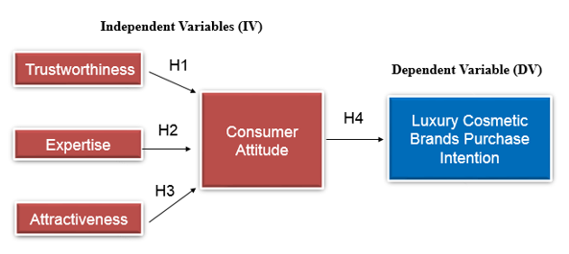

*Figure 2: Conceptual Framework for Social Media Influencers and Consumer Attitude on Luxury Cosmetics Brands Purchase Intention in Klang Valley, Malaysia.*

**2.10 Hypothesis**

Concerning the above research framework, the following hypothesis are defined to support the research study in finding out the relationship of independent variables (IVs): trustworthiness, expertise, attractiveness and consumer attitude on the dependent variable (DV), luxury cosmetics brands’ purchase intention in Klang Valley, Malaysia.

 H1: Trustworthiness has a positive relationship with the consumer attitude in purchase intention.

H2: Expertise has a positive relationship with the consumer attitude in purchase intention.

H3: Attractiveness has a positive relationship with the consumer attitude in purchase intention.

H4: Consumer attitude has a positive relationship in luxury cosmetics brands purchase intention in Klang Valley, Malaysia

**2.11 Conclusion**

In conclusion, existing literature about the social media influencers and the influencers' marketing and the luxury product purchasing intention in Malaysia context has been reviewed. The explanation of the 3 independent variables (trustworthiness, expertise, and attractiveness) on the social media influencer that is influenced the consumer attitude toward the luxury cosmetics product purchase intention critically explained. The grounded theory – Theory of Reasoned Action (TRA) and the theoretical framework are illustrated and discussed in detail. Four hypothesis are developed before the end of the chapter.

**CHAPTER 3: RESEARCH METHODOLOGY**

**3.0 Overview**

This chapter will be discussed and explore the appropriate research methodology that can provide the result of the study. Starting with the research design, the population, and sampling process. It will then followed by the survey questionnaire construct to measure each of the independent variables and dependent variables. The pilot test of the study will also be included and the measurement table will be performed to provide the analysis details.

**3.1 Research Design**

Research design provides understanding how to conduct particular research by using the most appropriate method to solve the research problems (Bhat, 2019). It is a blueprint chosen by the researcher to gather multiple components for the data collection to enable to assess the research questions and achieve the research objectives (Bougie and Sekaran, 2016).

Qualitative research is to gather non-numeric data through observation, opinion, and motivation (Earl, 2014). It helps to develop ideas for potential quantitative research by collecting thoughts, interviews, and a small group of discussions into the problems (Cooper and Schindler, 2014). The sample size is typically small and target to the chosen respondents. However, quantitative research is used to solve the problems by gathering the opinions attitudes and behavior into numeric measurement and transform it into useful statistical analysis (Antiwi and Hamza, 2015). There are multiple data collection methods such as face to face surveys, online surveys, telephone interviews, online polls, etc. (Labaree, 2014). In this study will adopt quantitative research method to serve the purpose of examining the factors in social media influencers whether trustworthiness, expertise and attractiveness influences consumer attitude toward luxury cosmetics brands purchase intention in Klang Valley, Malaysia by focus on the theory testing and hypothesis testing with numerical data analysis, analyzed them by using statistical techniques to reach findings (Goertzen, 2017).

The investigation type of this study is to co-relational design that helps to find out the significant relationship between the independent variable and the dependent variable (Cooper and Schindler, 2014). The researcher would conduct the study is non-contrived setting considering to avoid human bias and interface without effect the research environment and to achieve the high data accuracy (Bougie and Sekaran, 2016).

The cross-sectional time horizon usually used in large populations and sample size when there are limited resources and time constraints (Collis and Hussey, 2014). The data collection for the cross-sectional approach is collected from more than one respondent in a short period (Bryman and Bell, 2015). Therefore, the cross-sectional time horizon is a suitable approach for this study. Refer to the summary of the research design below.

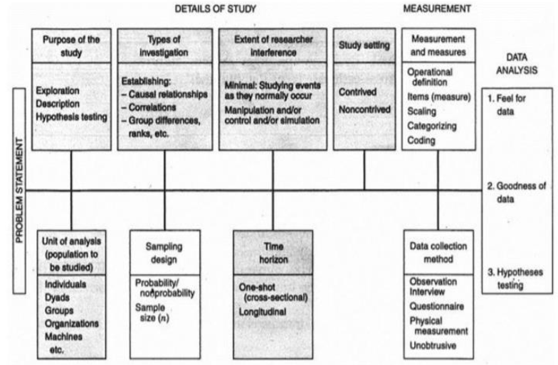

*Figure 3: Research Design Framework (source from Bougie and Sekaran, 2011)*



*Table 1: Summary of the Research Design applied*

**3.2 Sample and Procedure**

**3.2.1 Sampling Design**

Sampling design is a procedure to enable researchers to focus on a smaller group of people from a larger population in data collection in cost-effective, accurate and economical (Greener and Martelli, 2015).

There are two types of sampling type: probability sampling and non-probability sampling. In this study, the researcher adopts the non-probability - convenience sampling and snowballing technique that provides convenience to the researchers in time and cost-effective in getting the potential respondents and convenient to access with the respondents is willing to participate in the questionnaire survey later (Kumar, 2019). The snowball sampling technique is the chain referral process for the woman population in Klang Valley age 20 to 55, the respondents can have their friends and family who volunteered to participate in the survey that allows the researcher to reach more sample population in a short time-frame (Saunders et. al., 2016).

**3.2.2 Sample Size**

According to Taherdoost (2016), sample size is important in giving accurate and reliable feedback in the survey. The target respondents should be identified and they are the representative respondents for the target population. According to the research, the young generation consumers today are the emphasis on luxury goods and cosmetics (euromonitor.com, 2019). According to the report of household income survey in Malaysia, the highest median income level states by the state is Kuala Lumpur, RM9,073 followed by Putrajaya, RM8,275 and Selangor RM7,225 per month (dosm.gov.my, 2019). The statistical report revealed that the high-income group that most likely the potential luxury cosmetics purchaser is from the Klang Valley area. The population in Klang Valley is approximately 7.2 million, the female population are approximately 4 million and the female population ages between 20 to 55 are approximately 1 million (dosm.gov.my, 2019).

According to Roscoe (1975), the rule of thumb to determine the appropriate sample size is between 30 to 500 respondents for most of the behavioral research. The central limit theorem in statistics, the sufficient large sample size the sampling distribution will provide a normal distribution despite the variable in the population (Yusof, 2010). Based on the Roscoe rule, the sample size can be determined as 200 respondents for this research to ensure to achieve the central limit theorem and less error occurred. Besides, this is an effective decision in time management to complete the research within a short time-frame.

**3.3 Questionnaire Design**

A questionnaire is a tool commonly used research as a measurement instrument to evaluate phenomena and subjects in a particular research setting (Gidengil et. at., 2010). The questionnaire is composed based on the adopted method concerning the previous article journal in the related field. There are major 3 sections in the questionnaire where sections A, B, and C. Section A consists of 2 parts, where the 1st part is the demographic questions and the 2nd part is the respondent's social media behavior. The demographic questions are about ethnicity, age group, highest education background of the respondent, marital status, employment status, monthly income level, and the cosmetics brands the respondent has purchased before for personal use. Refer to table 2 below for the demographic questions construct.

**Section A: Demographic Questions**

Table 2*: Demographic Questions Construct and Measure*

1. **Section A: Social Media Behavior Questions**

The second part of section A is to collect the data of social media behavioral for the respondents.

*Table 3: Social Media Behavior Questions Construct and Measure*

**Section B: Measurements of Independent Variables**

A questionnaire was created using Google Form and distributed to the targeted respondent through social media networking apps such as Facebook Messenger, WhatsApp, LinkedIn, Instagram and email. The measurement for sections B and C designed using the five-point Likert Scale to measure the level of agreement of the respondents from strongly disagree to strongly agree. The answer select based on their own experience and knowledge is more effective in getting accurate data (Bougie and Sekaran, 2010).

Section B is to measure the independent variables (trustworthiness, expertise, attractiveness, and consumer attitude). There are 5 questions for each of the independent variables in this section measured by the 5 points Likert-scale measurement. Refer to table 4 for the questionnaire design for the independent variables.



*Table 4: Section B - Four Independent Variables Questions Construct and Measure*

**Section C: Measurements of Dependent Variables**

Section C is to measure the dependent variables of the luxury cosmetics purchase intention. There are 3 questions in this section measured by the 5 points Likert-scale measurement. Table 5 is showing the questionnaire design for dependent variables.

*Table 5: Section C - Dependent Variables Questions Construct and Measure*

**3.4 Pilot Study**

A pilot study is a small scale preliminary approach to evaluate and investigate the feasibility before the full-scale of the data collection (Johanson and Brooks, 2009). It is known as a trial run before formal data collection (Leon et al., 2011) to test whether the respondent are fully understood each of the questions. According to Roscoe (1975), the minimum sample size is 30 therefore questionnaire will be sent to 30 respondents for the pilot test data collection in this study. Upon data collected, the researcher will analyze the data via SPSS statistical software to generate and analyze the factor analysis and reliability analysis to ensure questionnaires are factor loading of each variable are valid and reliable at the initial stage before the full-scale data collection.

**3.5 Measurement**

The measurement is the measuring tool to be used in research often to quantify the variables by the application tool and software (Mohajan, 2018). The questionnaire will be sent to the potential respondents via online through social media instant messaging platforms for data collection. The data collected will be input into the Statistical Package for Social Science (SPSS) management software to analyze the statistical analysis in social science (Bougie and Sekaran, 2011). Therefore, IBM SPSS version 20.0 will be utilized in this study.

**3.6 Statistical Analysis**

**3.6.1 Factor Analysis**

The factor analysis has to first conduct preliminary analysis before the reliability test to verify the validity of the construct if any specific factor needs to be removed (Babin et. al., 2013). The factor analysis can be executed to validate the full-scale data collection and pilot test.

Kaiser-Meyer-Olkin (KMO) test is to measure the sampling adequacy and the value is in between 0 to 1, the higher value of KMO closer to 1 is better. The minimum KMO value to proceed further analysis is 0.60 (Taherdoost, 2016). Bartlett's test of Sphericity is to determine the data collected are relevant and appropriate within the questionnaire (Kumar et. al., 2010).

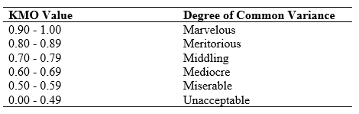

*Table 6: Rule of Thumb – KMO*

*Source: Kaiser (1974)*

* + 1. **Reliability Analysis**

Reliability test remain critical in data analysis to ensure the data collected are consistent and reliable (Hair et. al., 2014). The Cronbach alpha value is to measure the internal consistency value, the higher the alpha value leads to higher reliability (Bell et. al., 2018).

The Cronbach alpha value is between 0 to 1, according to the rule of thumb, Andale (2014) the acceptable alpha value for the reliability is above 0.70, alpha value above 0.80 is considered good and the alpha value of 0.90 and above is excellent.

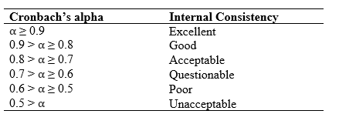

*Table 7: Rule of Thumb – Cronbach Alpha*

*Source: Andale (2014)*

**3.6.3 Descriptive Analysis**

The descriptive information of the respondent is collected in "section A – demographic and social media behavior" in this study. The purpose of collecting the demographic information is to understand the background of the respondent and knowing the respondents' characteristics (Davis, 2014). It usually contains age, gender, race, occupation, an education level (Aktürk, Aslan and Aylaz et. al., 2012). The personal information of the respondent will not be revealed and disclosed. In this research, the demographic profile collected from the respondents is ethnicity, age group, education level, marital status, profession, monthly income, and the cosmetics brand the respondents have tried.

In social media behavioral questions, the researcher wants to know which social network the respondent used the most, and how often the respondents spent on social media per day (Savage, 2012). Besides, if the respondents are following any influencers on social media, which area of specialization of the influencers the respondent follows the most whether in fashion, beauty, fitness, lifestyle or travel (Burns, 2018). Furthermore, which beauty influencers the respondents follow on social media. The frequency table and the cross-tabulation table will be generated from the raw data in SPSS.

**3.6.4 Hypothesis Analysis**

The hypothesis analysis can be performed upon the validity and the reliability test has been performed (Quinian, 2011). Hypothesis testing is to examine the relationship between two variables between both the independent variable and the dependent variable has a positive or negative relationship (Gaston, 2014).

* **Multiple Regression Analysis**

The multiple regression analysis is used to discover the relationship between two or more variables in positive or negative and the regression analysis is also to determine the significant factor (Waters, 2011).

Once the multiple regression analysis executed the adjusted R-squared in the model summary explain the predictive significance of independent variables towards the dependent variable (Garson, 2015). The higher R-squared value explains the variation in the dependent variable is due to the variation of the independent variable (Bougie and Sekaran, 2013). If the R-squared value is lower than 0.50, it means the construct of the framework has low predictive power and other factors that are not included in the study might influence the phenomenon of the study (Lewis et. al., 2015).

Besides, p-value in multiple regressions is to measure the statistical significance of each independent variable with a p-value of lower than 0.05 (Cooper and Schindler, 2014). For the p-value of higher than 0.05, the hypothesis is not significant and acceptable (Saunder, 2011). The beta coefficient (β) value indicates the strong relationship and the high influencer power on the phenomenon of the study compared to other variables (Brown and Peterson, 2005).

In this study, the researcher will first test the hypothesis which credibility factor of an influencer (trustworthiness, expertise, and attractiveness) has a significant relationship with the consumer attitude, then to test again the consumer attitude has a strong relationship with the luxury cosmetics purchase intention.

**3.7 Conclusion**

This chapter explained the research methods to achieve the objective of the study. The quantitative research method implemented and the self-administered questionnaire sent through an online survey for data collection. Non-probability convenience sampling and snowball sampling will be applied. Pilot test of 30 respondents and 200 respondents for the final data collections input. Several data analysis will be performed and the finding will be presented in the next chapter.

**CHAPTER 4: RESEARCH FINDING**

**4.0 Overview**

In this chapter, data collection, analysis and data interpretation will be conducted based on the research methodology as discussed in chapter 3. Data collected from the female respondent live in Klang Valley. The final result will be analyzed via the statistical software, IBM SPSS version 20. Before proceeding to the final data result, a pilot test will be conducted to ensure the reliability and validity of the questionnaire. Then, a full set of data analysis including factor analysis, reliability analysis, descriptive analysis, and hypothesis testing will be performed to assess the relationship between each variable upon the final data collection is complete.

**4.1 Pilot Test**

The purpose of the pilot test is to inspect the feasibility of an approach that will be used in the larger scale of the research, it is also known as a trial run before formal data collection (Leon et al., 2011). In this research, the questionnaire will be sent to 30 respondents for the pilot test data collection. Upon data collected, the researcher will analyze the data via SPSS statistical software to generate and analyze the factor analysis and reliability analysis to ensure questionnaires are factor loading of each variable are valid and reliable at the initial stage.

**4.1.1 Factor Analysis**

Factor analysis is a statistical method that is to examine whether the questionnaire relevant to the research and the factor loading giving some information whether specific variables require to be removed/deleted from final data collection to enhance the validity and appropriateness of the constructs (Hof, 2012). Factor analysis is related to principal component analysis (PCA) but they are not identical. The principal component analysis (PCA) is to explain the variance however the factor analysis is to explain the covariance between the variables.

Factor loading is to explain the relationship of each variable to the underlying factor (Creswell, 2009). The communalities table below is the output from factor analysis using SPSS. Concerning the rule of thumb, the communalities' value should be more than 0.5 to be considered for further analysis. From the table 8 below the communalities value of each variable are in between 0.594 to 0.906. In this case none of these variables need to be removed can proceed further to the reliability analysis. It means each of the variables is relevant and suitable for the research. The result obtained from SPSS for factor analysis in communalities attached in appendix A.

|  |  |  |  |
| --- | --- | --- | --- |
| **Underlying Factors** | **Code** | **Variables in Data** | **Extraction** |
| IV - Trustworthiness | TR1 | The social media influencers on social networks are authentic. | 0.670 |
| TR2 | The social media influencers on social networks has integrity. | 0.898 |
| TR3 | The social media influencers on social networks are convincing. | 0.723 |
| TR4 | The social media influencers on social networks are dependable. | 0.680 |
| TR5 | The social media influencers on social networks are consistent. | 0.854 |
| IV - Expertise | EX1 | The social media influencers on social networks are expert in the area they represent. | 0.594 |
| EX2 | The social media influencers on social networks are experienced. | 0.823 |
| EX3 | The social media influencers on social network is knowledgeable. | 0.772 |
| EX4 | The social media influencers on social network is qualified. | 0.774 |
| EX5 | The social media influencers on social network are having a good skill in make-up. | 0.853 |
| IV - Attractiveness | AT1 | The social media influencers on social networks looks confident in what they are doing. | 0.859 |
| AT2 | The social media influencers on social networks appear to be passionate. | 0.852 |
| AT3 | The social media influencers on social networks are presentable. | 0.872 |
| AT4 | The social media influencers on social networks are elegant. | 0.845 |
| AT5 | The social media influencers on social networks have flawless skin. | 0.827 |
| IV - Consumer Attitude | CA1 | The recommendations of the social media influencers are accurate and honest to their opinion. | 0.793 |
| CA2 | I enjoy watching the products sharing of the social media influencers on social networks. | 0.823 |
| CA3 | I like the way the social media influencers presents their idea on social networks. | 0.812 |
| CA4 | I have emotionally attached to the social media influencers and feels like they could be my friends. | 0.682 |
| CA5 | I agree if I put the luxury cosmetics products marketed by social media influencer can make me feel successful. | 0.800 |
| DV - Luxury Cosmetics Brands Purchase Intention | PI1 | I am very likely to buy the luxury cosmetics brands endorsed by my favorable influencers on social networks. | 0.842 |
| PI2 | I intend to purchase the luxury cosmetics brands as marketed by the social media influencers on social networks. | 0.906 |
| PI3 | I will definitely purchase the luxury cosmetics brands in near future as marketed by the social media influencers on social networks. | 0.855 |

Extraction Method: Principal Component Analysis

*Table 8: Communalities for Pilot Test Result (N= 30 respondents)*

**4.1.2 Reliability Analysis**

The purpose of the reliability analysis is to ensure the respondents can understand each of the questions to collect the appropriate data for further analysis and interpretation (Sekaran and Bougie, 2013). The reliability test is to measure the internal consistency of the questionnaire items through Cronbach alpha value. The suggested Cronbach's alpha value is between 0.70 to 0.95, the higher Cronbach alpha value indicates the better internal consistency of the data (Dennick and Tavakol, 2011).

From the table 9 below, the Cronbach's alpha range of each variable range is from 0.780 to 0.909 and the overall reliability of 23 items is 0.901. Meaning to say the alpha value indicates high internal consistency and good to go for the final data collection. The result obtained from SPSS for reliability analysis attached in appendix B.

|  |  |  |  |
| --- | --- | --- | --- |
|  | **Variables** | **Cronbach's Alpha (α)** | **Number of Item** |
| Independent Variables | IV - Trustworthiness | 0.888 | 5 |
| IV - Expertise | 0.889 | 5 |
| IV - Attractiveness | 0.946 | 5 |
| IV - Consumer Attitude | 0.780 | 5 |
| Dependent Variable | DV - Luxury Cosmetics Brands Purchase Intention | 0.909 | 3 |
| All Variables | | 0.901 | 23 |

*Table 9: Summary Result of Reliability Analysis for Pilot Test (N= 30 respondents)*

**4.2 Preliminary Data Analysis**

In this research, the researcher will conduct factor analysis and reliability analysis on the full scale of the 200 responses collected and SPSS is the statistical software to generate and analyze the data set.

The following table 10 explains the summary of both independent variables and the dependent variable.

|  |  |  |
| --- | --- | --- |
| **Independent Variables** | **Independent Variable** | **Dependent Variable** |
| Trustworthiness | Consumer Attitude | Luxury Cosmetics Brands Purchase Intention |
| Expertise |
| Attractiveness |

*Table 10: Summary of Independent Variables and Dependent Variable*

**4.2.1 Factor Analysis**

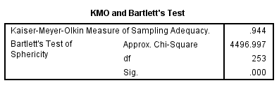

*Figure 4: KMO and Bartlett’s Test for final data collection (N= 200 respondents)*

KMO is to measure the sampling adequacy, the rule of thumb for KMO (Kaiser, 1974) the minimum value is 0.5 (barely accepted), values in between 0.7 to 0.8 is acceptable and value above 0.9 are superb. Concerning the figure 4 for KMO and Bartlett's test result obtained from SPSS.

The KMO test result of this study is 0.944, which indicates the sampling size is superb.

Bartlett's test is an indication of the strength of the relationship among variables. A strong relationship between variables is sig < 0.05. From the Bartlett's test result, sig = 0. It means the relationship between all the variables is strong enough to proceed to the next analysis.



Extraction Method: Principal Component Analysis

*Table 11: Communalities for Final Data Collection (N= 200 respondents)*

Communalities indicate the common variance shared by the factors with the given variables. Higher communalities indicate the larger amount of the variance in the variable has been extracted by the factor solution. For a better measurement of factor analysis communalities the value should be more than 0.5. From the results from SPSS, the communalities value are in between 0.691 to 0.905, the results indicate the factors are considered appropriate to proceed to the further analysis.

**4.2.2 Reliability Analysis**

|  |  |  |  |
| --- | --- | --- | --- |
|  | **Variables** | **Cronbach's Alpha (α)** | **Number of Item** |
| Independent Variables | IV - Trustworthiness | 0.884 | 5 |
| IV - Expertise | 0.895 | 5 |
| IV - Attractiveness | 0.908 | 5 |
| IV - Consumer Attitude | 0.892 | 5 |
| Dependent Variable | DV - Luxury Cosmetic Brands Purchase Intention | 0.900 | 3 |
| All Variables | | 0.973 | 23 |

*Table 12: Reliability Analysis Summary Result (N= 200 respondents)*

According to the rule of thumb of Cronbach’s alpha, ⍺ ≥ 0.9 is an excellent internal consistency, while 0.9 > ⍺ ≥ 0.8 is indicating a good internal consistency (Andale, 2014). Based on the data collection on 200 respondents, all the ⍺ values of all variables are above 0.80. It means this is showing a very high internal consistency for the scale.

**4.3 Demographic Characteristics Analysis**

In this section, the results of the demographics of the respondents will be analyzed through SPSS statistical software. The information includes ethnicity, age group, highest education, marital and employment status. Besides, the behavior of using social media of a respondent such as average time per day spend on social media, which social network the respondent used the most and who are the favorite social media influencers.

**4.3.1 Response Rate**

The total 224 sets questionnaire survey link in Google form was sent out to reach to the target respondents through Facebook messenger, WhatsApp, WeChat. The targeted respondents are to the respondents biologically female (age 20 to 55) live in Klang Valley. 9 respondents are not female, and 15 respondents are living outside of Klang Valley area. Thus, these responses will be excluded from further analysis. The usable response rate of this survey is 89.30%. Table 13 below is showing a summary of the response rate.

|  |  |  |
| --- | --- | --- |
| **Total response Received** | **Total Usable response** | **Response Rate (Usable)** |
| 224 | 200 | 89.30% |

*Table 13: Response Rate Summary*

**4.3.2 Demographic Profile**

From the demographic profile, we can know the demographic information of the respondents such as ethnicity, age range, the highest education level, marital status, employment status, and the monthly income range.

The data collected from the respondents, there are total 81 (40.5%) respondents are Malay, followed by Chinese 75 (37.5%), Indian 35 (17.5%) and others ethnic 9 (4.5%). The majority age range from the total of 200 respondents, 90 (45%) are from the aged group of "30 – 39 years old", "20 – 29 years old" age group 73 (36.5%), while "40 – 49 years old" range have 32 (16%) and the minority of age group "50 – 55 years old" is 5 (2.5%).

The highest education level from the respondents are mainly with the degree level, “Undergraduate (Degree)” is contribute 101 (50.5%), followed by “Undergraduate   
(Pre-University Level)” is 55 (27.5%), “Postgraduate (Master)” is having 39 respondents (19.5%) and “Postgraduate (doctorate) is 5 (2.5%). 107 out of 200 (53.5%) respondents are married, 72 respondents (36%) are single, 12 (6%) out of 200 respondents are divorced and only 9 (4.5%) are widowed.

For the employment status of the 200 respondents, the majority of 111 (55.5%) are employed "Executive / managerial". 46 (23%) respondents are "self-employed / own company", 34 (17%) respondents are professional and 9 (4.5%) are unemployed. The majority 73 (36.5%) female respondents' monthly income level are in between the range of "RM7001- RM12000", while 72 (36%) respondents is having "RM 3001 -RM7000", 32 (16%) respondents as having "more than RM12001" and 23 (11.5%) is having "below RM3000" income level per month. Please refer to table 14 for the demographic profile summary and the results obtained from SPSS will be attached in Appendix C.

|  |  |  |  |  |  |
| --- | --- | --- | --- | --- | --- |
| **Profile** | | **Code in SPSS** | **Frequency** | **Percent (%)** | **Cumulative Percent (%)** |
| Ethnicity | Malay | 1 | 81 | 40.5 | 40.5 |
| Chinese | 2 | 75 | 37.5 | 78.0 |
| Indian | 3 | 35 | 17.5 | 95.5 |
| Others | 4 | 9 | 4.5 | 100.0 |
| Age Group | 20 - 29 years old | 1 | 73 | 36.5 | 36.5 |
| 30 - 39 years old | 2 | 90 | 45.0 | 81.5 |
| 40 - 49 years old | 3 | 32 | 16.0 | 97.5 |
| 50 - 55 years old | 4 | 5 | 2.5 | 100.0 |
| Highest Education Level | Undergraduate  (Pre-University Level) | 1 | 55 | 27.5 | 27.5 |
| Undergraduate  (Degree) | 2 | 101 | 50.5 | 78.0 |
| Postgraduate (Master) | 3 | 39 | 19.5 | 97.5 |
| Postgraduate (Doctorate) | 4 | 5 | 2.5 | 100.0 |
| Marital Status | Single | 1 | 72 | 36.0 | 36.0 |
| Married | 2 | 107 | 53.5 | 89.5 |
| Widowed | 3 | 9 | 4.5 | 94.0 |
| Divorced | 4 | 12 | 6.0 | 100.0 |
| Employment Status | Unemployed | 1 | 9 | 4.5 | 4.5 |
| Professionals | 2 | 34 | 17.0 | 21.5 |
| Executive / Managerial | 3 | 111 | 55.5 | 77.0 |
| Self- Employed / Own Company | 4 | 46 | 23.0 | 100.0 |
| Monthly Income | below RM3000 | 1 | 23 | 11.5 | 11.5 |
| RM 3001 -RM7000 | 2 | 72 | 36.0 | 47.5 |
| RM7001- RM12000 | 3 | 73 | 36.5 | 84.0 |
| more than RM12001 | 4 | 32 | 16.0 | 100.0 |

*Table 14: Demographic Profile Summary*

**4.3.3 Social Media Behavior**

From the cross-tabulation results generated from SPSS table 15 below, the highest social media network users is Facebook 98 (49%), followed by Instagram users 60 (30%), YouTube users from the 200 female respondents are 38 (19%), LinkedIn and others social network both are having 2 (1%). 98 of the 200 respondents (49%) spending "2 – 4 hours per day" on social media, 62 (31%) are spending "less than 1 hour", 25 (12.5%) are spending "5 – 7 hours per day" and 15 (7.5%) are spending "8 – 10 hours per day" on social media in a day.

From the 98 respondents who choose Facebook as the social network they mostly use, 43 respondents (43.9%) are choosing "2 – 4 hours per day" and "Less than 1 hour per day" for the usage of the social network. 8 (8.2%) are using Facebook " 5 – 7 hours per day" and 4 (4.1%) respondents are using Facebook "8 – 10 hours per day".

From the 60 respondents who choose Instagram as the social network they mostly use, 31 respondents (51.7%) are choosing "2 – 4 hours per day". 12 (20.0%) respondents are choosing "Less than 1 hour per day" for the usage of social networks. 10 (16.7%) are using Instagram "5 – 7 hours per day" and 7 (11.7%) respondents are using Instagram "8 – 10 hours per day".

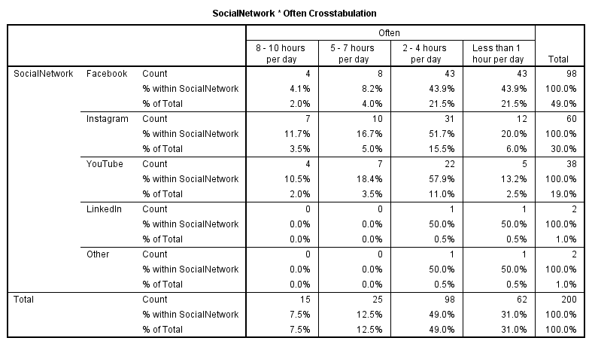

*Table 15: Cross-tabulation Summary of Social Network users and Social Media Usage per day*

**4.3.4 Area of Specialization of Social Media Influencers Preference**

From the 200 female respondents, only 160 (80%) respondents follow influencers on social media. The highest area of specialization the respondents follows on social media is the beauty area that contributes 44 (27.5%) response, followed by lifestyles area 41 (25.6%), fashion area 29 (18.1%), fitness area 28 (17.5%), and the travel area has 18 (11.3%) followers from the respondents. Summary result obtained from SPSS shown in table 16.

Malay respondents have the highest ethnic group, 68 (42.5%) out of 160 total respondents who follow influencers on social media. The "beauty" area has the highest preference 22 (13.8%), followed by "fitness" area 15 (9.4%), "lifestyle" 14 (8.8%), "fashion" 12 (7.5%) and "travel" 5 (3.1%). Chinese has the second largest ethnic group, 58 (36.2%) from the respondents. 17 (10.6%) Chinese follows the influencers in the area of “Lifestyles” on social media, followed by fashion 13 (8.1%), beauty12 (7.5%), travel 9 (5.6%) and fitness area 7 (4.4%).

From the 160 respondents who has follow the influencers on social media, 71 (44.4%) are contributing the largest from the age group of "30 – 39 years old", among them 18 (11.2%) of them are equally follow the influencers in the area of "Lifestyles" and "Beauty" on social media followed by "fashion" 13 (8.1%), "travel" 12 (7.5%) and "fitness" 10 (6.2%). The age group of "20 – 29 years old" has 65 (40.6%), 24 (15%) of them follows the influencers in "beauty" area, 14 (8.8%) follows the influencers in "fitness" area, 12 (7.5%) in lifestyles, 11 (6.9%) on fashion, and 4 (2.5%) on travel. Refer to table 17 below for the cross-tabulation summary between ethnicity, age group, and area of specialization social media influencers. Results obtained from SPSS will be attached in appendix D.

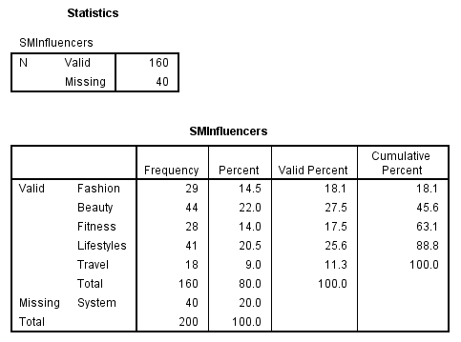

*Table 16: Summary of Area of Specialization Social Media Influencers Preference*



*Table 17: Cross-tabulation Summary of Ethnicity, Age group, and Area of Specialization Social Media Influencers*

**4.3.5 Cosmetics Brands by Ethnicity**

In the questionnaire survey, the female respondents are required to select which are the cosmetics brands they have tried. The respondents are free to select more than one option for the cosmetics brands they used. A cross-tabulation summary has been done between cosmetics brands and the ethnicity in table 18 below.

The cosmetics brand M.A.C. Malay has the highest number 29 (52.7%) of respondents tried the brand before. Other than M.A.C, brands like L'Oreal 30 (47.6%), Maybelline 30 (52.6%), The Body Shop 27 (44.3%), NARS 14 (58.3%) and Covergirl 13 (59.1%) are also having the highest selection from Malay.

Brand Estée Lauder, Chanel, YSL Beauty, and Dior are having the highest selection from Chinese where Estée Lauder is 27 (71.1%), Chanel is 26 (68.4%), YSL Beauty 25 (78.1%) and Dior 15 (65.2%). However, the brand Avon 14 (35.9%) has the most selection from Indian.



*Table 18: Cross-tabulation Summary of Ethnicity and Cosmetics Brands Preference*

**4.4 Hypothesis Analysis**

In this section, the researcher will be using multiple linear regression analysis to test the relationship between the independent variables (IVs) and the dependent variable (DV). The hypothesis is developed below.

|  |  |
| --- | --- |
| Item | Hypothesis |
| H1 | Trustworthiness has a positive relationship with consumer attitude in purchase intention. |
| H2 | Expertise has a positive relationship with consumer attitude in purchase intention. |
| H3 | Attractiveness has a positive relationship with consumer attitude in purchase intention. |
| H4 | Consumer attitude has a positive relationship in luxury cosmetics brands purchase intention in Klang Valley, Malaysia |

*Table 19: Research Hypothesis*



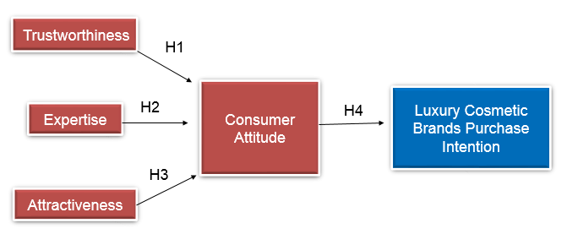

*Figure 5: Research Framework*

Concerning the research framework design (figure 4.4), consumer attitude is influenced by the trustworthiness, expertise, and attractiveness and the luxury cosmetics brands’ purchase intention is influenced by the consumer attitude, therefore there will be **two (2)** multiple regression will be carried to test:

1. A positive relationship between consumer attitude versus trust, expertise, and attractiveness.
2. A positive relationship between consumer attitude and the cosmetics brand's purchase intention.

**4.4.1 Multiple Regression Analysis (RO1)**

There is 2 part of the multiple regression in this study. First, the relationship between consumer attitude, trust, expertise, and attractiveness will be measured followed by the second part of the relationship between consumer attitude and the luxury cosmetics brands’ purchase intention.

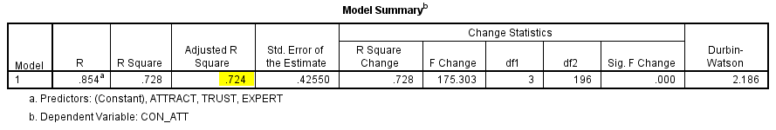

*Table 20: Model Summary Table - Consumer Attitude, Trust, Expertise & Attractiveness*

Based on the model summary in table 20, the derived adjusted R-square is 0.724, which indicating that 72.4% of the variance in consumer attitude can be predicted by trustworthiness, expertise, and attractiveness of social media influencers. The remaining 27.6% of the variance could be explained by other factors where it is not included in this research.

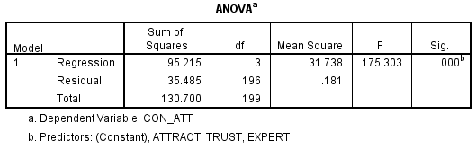

*Table 21: ANOVA Table - Consumer Attitude, Trust, Expertise & Attractiveness*

Based on the above table 21, the ANOVA table shows the F-test result of 175.303 (sig = 0.000) indicates the regression model is significant at p < 0.05. This indicates the combination of the constructs significantly predicted by the consumer attitude overall.

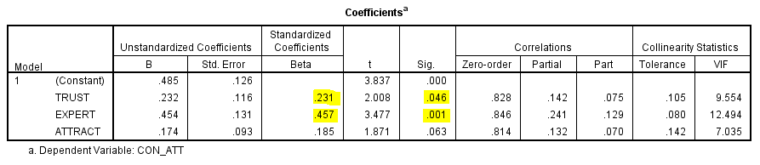

*Table 22: Coefficients Table - Consumer Attitude, Trust, Expertise & Attractiveness*

Based on table 22, there are 2 variables with a p-value < 0.05. The variable of trustworthiness showing p = 0.0406 and expertise showing of p = 0.001 are showing a significant relationship between consumer attitude. However, the variable of attractiveness is showing p = 0.063 (p > 0.05), in this case, the attractiveness variable does not have a significant relationship with consumer attitude.

The standardized coefficients β value of trustworthiness with β = 0.231 and expertise with β = 0.457 are showing positive value; it means these variables are having a positive relationship with consumer attitude.

As a result, expertise is showing the strongest predictor that can influencer consumer attitude followed by the trustworthiness of an influencer. Attractiveness is excluded because the p-value is not significant to the consumer attitude.

**4.4.2 Multiple Regression Analysis (RO2)**

The 2nd part of the multiple regression analysis is to measure the positive relationship between consumer attitude and the cosmetics brands' purchase intention.

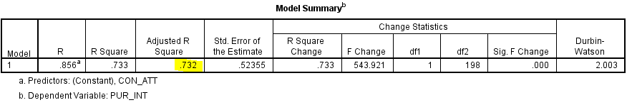

*Table 23: Model Summary Table – Purchase Intention & Consumer Attitude*

Based on the model summary in table 23, the derived adjusted R-square is 0.732, indicating that 73.2% of the variance in luxury cosmetics brands purchase intention can be predicted by consumer attitude. The remaining 26.8% of the variance could be explained by other factors other than consumer attitude where it is not covered in this research.

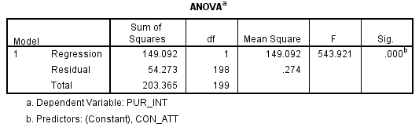

*Table 24: ANOVA Table - Purchase Intention & Consumer Attitude*

Based on the above table 24, the ANOVA table showed a strong F-test result of 543.921 (sig = 0.000) indicate the regression model is significant at p < 0.05. This indicates the combination of the constructs significantly predicted the luxury cosmetics brands' purchase intention overall.

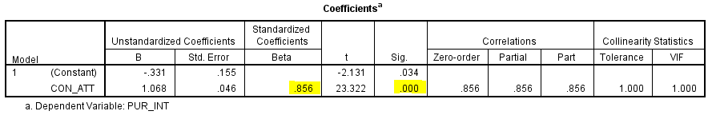

*Table 25: Coefficients Table - Purchase Intention & Consumer Attitude*

Based on table 25, the only variable, p-value of consumer attitude = 0.000 (p < 0.05). In this case, consumer attitude has a significant relationship with the purchase intention. The standardized coefficients β value of consumer attitude β = 0.856, it means these variables are having a positive relationship with the luxury cosmetics brands purchase intention.

**4.4.3 Hypothesis Analysis Summary**

Based to the findings in multiple regression (R1) and (R2), the detailed test finding shows as follow:

**Hypothesis 1: Trustworthiness has a positive relationship with consumer attitude in purchase intention.**

The relationship between trustworthiness and consumer attitude was evaluated. The results showed there is a significant positive relationship between two variables. (p = 0.046, β = 0.231)

**Therefore, hypothesis 1 is accepted.**

**Hypothesis 2: Expertise has a positive relationship with consumer attitude in purchase intention.**

The relationship between expertise and consumer attitude was evaluated. The results showed there is a significant positive relationship between two variables. (p = 0.001, β = 0.457)

**Therefore, hypothesis 2 is accepted.**

**Hypothesis 3: Attractiveness has a positive relationship with consumer attitude in purchase intention.**

The relationship between attractiveness and consumer attitude was evaluated. The results showed there is no significant relationship between the two variables. (p = 0.063, β = 0.185)

**Therefore, hypothesis 3 is rejected.**

**Hypothesis 4: Consumer attitude has a positive relationship in luxury cosmetics brands purchase intention in Klang Valley, Malaysia**

The relationship between consumer attitude and luxury cosmetics brands purchase intention was evaluated. The results showed there is a significant positive relationship between two variables. (p = 0.000, β = 0.856)

**Therefore, hypothesis 4 is accepted.**

Refer to the hypothesis analysis summary in table 26 below.

|  |  |  |  |  |
| --- | --- | --- | --- | --- |
| **Hypothesis** | | **β value** | **p<0.05** | **Status** |
| H1 | Trustworthiness has a positive relationship with consumer attitude in purchase intention. | 0.231 | 0.046 | Accepted |
| H2 | Expertise has a positive relationship with consumer attitude in purchase intention. | 0.457 | 0.001 | Accepted |
| H3 | Attractiveness has a positive relationship with consumer attitude in purchase intention. | 0.185 | 0.063 | Rejected |
| H4 | Consumer attitude has a positive relationship in luxury cosmetics brands purchase intention in Klang Valley, Malaysia | 0.856 | 0.000 | Accepted |

*Table 26: Hypothesis analysis summary*

**4.5 Conclusion**

In conclusion, the research findings were analyzed through the factor analysis, reliability analysis, descriptive analysis, and hypothesis analysis using the SPSS statistical software. A pilot test was conducted before the full-scale distribution to ensure the questionnaire is relevant and reliable. Throughout the research findings, three out of four hypothesis were accepted. The expertise factor of influencers has the most powerful influence followed by trustworthiness factor on consumer attitude prior to purchase intention on the luxury cosmetics products. Consumer attitude is showing a strong influencer in luxury cosmetics brands' purchase intention. The next chapter will discuss more on the findings, recommendations, limitations and contributions to the society.

**CHAPTER 5: CONCLUSION AND RECOMMENDATION**

**5.0 Overview**

In this chapter, the researcher will discuss the detailed findings demonstrated from Chapter 4 - research finding. The main findings of how social media influencers can help businesses to grow and expand. Furthermore, the contribution toward academics and society will be covered in this chapter. Besides, limitations and recommendations for future research will be discussed. Last, will be a conclusion and personal reflection to end the chapter.

**5.1 Discussion on Findings**

This study is research on how social media influencers and consumer attitudes influence the purchase intention of luxury cosmetics products. From the previous studies, it identify factor of influencing purchase intention is the consumer attitude from an individual; and the social media influencers can influence consumer attitude through their credibility of trustworthiness, expertise and the attractiveness on their own. Four hypothesis were developed based on the research objectives in the previous chapter. This section will provide a comprehensive discussion of the research objectives and research question based on the final result obtained.

**RO1**: To investigate how trustworthiness impacts consumer attitude in purchase intention.

**RQ1**: Does trustworthiness positively influence consumer attitude in purchase intention?

RO1 proposed to investigate how the trustworthiness impact consumer attitude in purchase intention, Based on the hypothesis analysis summary in table 4.11 of the previous chapter: research findings, the p-value of trustworthiness toward consumer attitude is p = 0.046 (p < 0.05) and the statistical result is significant and the hypothesis is accepted. Based on the previous literature from Rebelo (2017), this hypothesis is supported where trustworthiness is most significant to purchase intention. However, according to Lim et. al., (2017), source credibility include the two-element which is trustworthiness and expertise that is within source credibility. The statistical result finding is contradicted with the previous literature finding, credibility is not supported and no relationship to consumer attitude (Lim et. al., 2017).

**RO2**: To examine how expertise impacts consumer attitude in purchase intention.

**RQ2**: Doesexpertise positively influence consumer attitude in purchase intention?

RO2 proposed to examine how expertise impacts consumer attitude in purchase intention, based on the hypothesis summary, hypothesis 2 is accepted with the p-value = 0.001 (p < 005). The expertise factor is the most significant factor that is influencing the consumer attitude followed by trustworthiness from the statistical result of this study. However, it has a contradicted result with the previous literature from both Lim et. al., (2017) and Rebelo (2017) where expertise has no relationship with the consumer attitude and purchase intention.

**RO3**: To determine how attractiveness impacts consumer attitude in purchase intention.

**RQ3**: Does attractiveness positively influence consumer attitude in purchase intention?

RO3 proposed to determine how attractiveness impact consumer attitude in purchase intention, based on the hypothesis summary in table 4.11, the statistical result is shown rejected and not supported of this hypothesis. Based on the previous literature findings, source attractiveness is supported to consumer attitude in literature Lim et. al., (2017) and Rebelo (2017) attractiveness has the second significant statistical result after trustworthiness in purchase intention.

**RO4**: To predict how consumer attitudes can influence the purchase intention in luxury cosmetics brands.

**RQ4**: Does consumer attitude positively impact the purchase intention in luxury cosmetics brands?

RO4 proposed to predict how consumer attitude can influence the purchase intention in luxury cosmetics brands, based on the hypothesis summary in table 4.11, the statistical result is shown accepted with the p-value of 0 (p < 0.05) and very high beta value of 0.856. It is supported by the literature Lim et. al., (2017) as well as Duygu et. al. (2017) indicate consumer attitude has a positive relationship with the purchase intention.

As a conclusion of the findings in this study, there are several factors where the findings are different from the previous literature. In this study, the purchase intention is focus on the luxury cosmetics brands where the targeted population and the expectation respondents are different from the literature findings of Lim et. al., (2017) and Rebelo (2017).

**5.2 Recommendations**

Based on the hypothesis testing on the sample data collected from the respondents, it can help businesses and marketers to make better business decisions strategically to leverage the social media platform and improve business performance (Mohan, 2016). Social media can be an important and useful tool to the luxury brand managers, where the targeted sample respondents most are not just high-income groups but they are also highly educated (50.5% with degree level from the total respondents) in urban areas. The expectation of their needs are different unlike with the everyday consumer goods, luxury brands are special and establish a long term relationship that can influence consumer attitude. Physically attractive by just looking good is not what the customers want, but the solid knowledge and the skill sets in the specific area the influencers representing are the key factors in influencing the consumer attitude. Here are some recommendations to the marketers/businesses.

Since back then the influencer is so much important to the businesses, acquire high credibility and responsible influencers to represent the brand. There are many marketing platforms in the market of getting the trusted influencers. Select highly accountable, knowledgeable and credible influences for the brand ambassador. Alternatively, provide the training program to improve the qualifications of the influencers are also one of the suggestion that can reduce the unethical practices and fraud within the influencers. Demand for the social media influencers has now become more transparent, and the qualifications and the industry standards will equally be elevated to become more mature to meet the expectation of the industry. Education will never go wrong in any industry. Educate the influencers and marketers on the industry's best practices and be the top in the industry.

A successful influencer has the power to influence the consumer purchase intention, not only the outstanding appearance to attract more customers and to create the customer's curiosity but the solid qualifications of the content category to support their statement. Influencers that promote one brand, do they even try the products before they share the personal experience toward the product in terms of feeling and the ingredients are safe and prof by the literature? Besides, influencers can also strengthen the influencing power of a product by "Use it, share it, and love it" and have faith in it. This is one of the ways to increase the trustworthiness toward consumers.

Furthermore, we can leverage the Internet of Things (IoT) and big data to connect to the measurement software to track and to measure the credibility and trust of the influencers. Example: Scrunch is the recommended software in the industry. However, researching new ways to identify and to measure credibility and authenticity in influencers marketing are most welcome to provide the solution to the industry.

**5.3 Contributions**

**5.3.1 Contribution to Industry**

The study aims to obtain an in-depth analysis of how businesses can leverage the power of social media and the criteria of an influencer that can influences the consumer attitude toward luxury cosmetics brands purchase intention and ultimately increase company sales. The finding of this study able to provide insights into which the credibility factor of influencers can influence purchase intention the most and which factor has the least influences. Expertise of the area and trustworthiness characteristics has the most influencing factor that can lead to purchase intention. However, surprisingly the attractiveness factor has not significant to the consumer attitude toward luxury cosmetics toward purchase intention. Marketers and businesses can leverage the research finding to develop an effective marketing strategy by leveraging the power of influencers to build strong branding.

**5.3.2 Contribution to Academy**

From the research findings, the results contribute the insights to the researcher of the relationship between the variables. Besides, this study is serving reference purposes for future researchers who are interested to conduct the related studies. This research has to provide insights on how businesses can leverage the power of social media influencers in business context in Malaysia.

* 1. **Limitation of the Study**

In this research, the most challenging part is the short time-frame given from stretch to project completion is only 3 months (short semester). Due to the short time-frame, the researcher might not able to include all potential factors that might impact the finding of the research.

Secondly, the quality of the respondents in answering the survey might also be questionable. The researcher has no control and ensures respondents are answering with honesty on the questionnaire.

Subsequently, the female population in Klang Valley ages between 20 to 55 years old is approximately 1 million population. A sample size of 200 respondents might not be fully covered and represent the targeted respondents.

**5.5 Recommendation for Future Research**

Based on the limitation mentioned in the previous section, here comes with the suggestion for future research. Other variables may consider to include in the study such as psychological factor might lead to luxury purchases key factor that may need to look into in the future studies.

Adopt mix method research methodology besides only based on the finding results on the quantitative method. Qualitative methods in interview and observation may enhance the detailed research with higher reliability and accuracy of the research findings.

Moreover, suggest the future study to expand the sample size to cover more other states such as Penang and Johor in Malaysia to increase the population to have more accuracy on data collection that can represent the major voice that might influence the research findings.

**5.6 Conclusion**

This is the last chapter of the research that discussed the discussion on findings, recommendations, contribution, limitation and recommendation for future research. The results of this study giving the researchers and the marketers the insights the credibility factors – expertise and trustworthiness of influencers can influence the consumer attitude toward the luxury cosmetics brands' purchase intention. The recommendation is to strengthen and support tools for the businesses to enhance the expertise area and trustworthiness of an influencer. The limitations and the recommendation to future research enable the in-depth study of the relevant topic. Lastly, identifying the credibility of an influencer and how consumers perceived has an impact on purchase intention. It is significant for marketers to build brand strategies over the social media platform (Rebelo, 2017).

**5.7 Personal Reflection**

By conducting this MBA project, allows me to understand the research process in a business context. In the fast-changing business era, research is an efficient method in solving business problems and crises. It brings value to the society and the industry for the problems that a researcher can be solved. I have gained so much knowledge of how to conduct research independently and it has completely sharpened my mind the importance of research can contribute to the businesses. It is never an easy journey for me along the way and I faced so many challenges by completing the project on time. Thank you to each of everyone who willing to spend their time in helping me in the survey inputs, I truly appreciate your kind-hearted.

I would like to express my gratitude and millions of appreciation to my supervisor, Dr. Diana who has given her very best support and step-by-step guidance along the journey in completing my research. I am truly appreciated her extra miles of guidance especially during my proposal defense and Viva presentation sessions.

Never forget to thank my 2nd panel, Dr. Sam, who had sharpened my mind in solving bigger problems in business by using the research way. Thank you, Dr. Sam, for your encouragement in a higher level of achievement and never stop after completing my MBA.

**REFERENCES**

1. Ahmad, Abdul-Rahim and Hoda, Najmul and AlHazmi, Basem and Melibari, Amal and Althubiani, Majid, (2014). Determinants of Online Buying Behavior of Social Media Users in Saudi Arabia: An Exploratory Study. Available at SSRN: <https://ssrn.com/abstract=2519254> or [http://dx.doi.org/10.2139/ssrn.2519254](https://dx.doi.org/10.2139/ssrn.2519254)
2. Ajitha, S., & Sivakumar, V. J. (2017). Understanding the effect of personal and social value on attitude and usage behavior of luxury cosmetic brands. Journal of Retailing and Consumer Services, 39, 103–113. doi:10.1016/j.jretconser.2017.07.009
3. Alfred Lua, 2019. “21 Top Social Media Sites to Consider for Your Brand” [online] Available at: <https://buffer.com/library/social-media-sites> [Accessed: 16 July 2019]
4. Anand, Abhinav and Dutta, Souvik and Mukherjee, Prithwiraj, (2019). Influencer Marketing with Fake Followers IIM Bangalore Research Paper No. 580. Available at SSRN: <https://ssrn.com/abstract=3306088> or [http://dx.doi.org/10.2139/ssrn.3306088](https://dx.doi.org/10.2139/ssrn.3306088)
5. Astalin, 2013. QUALITATIVE RESEARCH DESIGNS: A CONCEPTUAL FRAMEWORK International Journal of Social Science & Interdisciplinary Research, ISSN 2277- 3630 IJSSIR, Vol.2 (1), January (2013) Online available at indianresearchjournals.com
6. Azizpour, R., Abbasnejad, T. and Siyavooshi, M. (2016). Effective Factors on Purchasing Intention of Cosmetics and Health Products in Tehran City. International Journal of Academic Research in Business and Social Sciences, 6(11).
7. Babbie, Earl (2014). The Basics of Social Research (6th ed.). [Belmont, California](https://en.wikipedia.org/wiki/Belmont,_California): Wadsworth Cengage. pp. 303–04. [ISBN](https://en.wikipedia.org/wiki/International_Standard_Book_Number) [9781133594147](https://en.wikipedia.org/wiki/Special:BookSources/9781133594147)
8. Behavior Change Models, 2018. [online] Available at: <http://sphweb.bumc.bu.edu/otlt/MPH-Modules/SB/BehavioralChangeTheories/BehavioralChangeTheories3.html> [Accessed: 13 July 2019]
9. Bijen, Y.J., 2017. # AD: The effects of an influencer, comments and product combination on brand
10. Bougie, R. and Sekaran, U. (2011). Business Research Methods: A skill-building approach.
11. Bougie, R. and Sekaran, U. (2016). Research Methods for Business: A Skill Building Approach. 7th ed. New York: John Wiley and Sons.
12. Buckle, 2019. “The Luxury Market in 2019: What Brands Should Know” [Online] available at: <https://blog.globalwebindex.com/chart-of-the-week/luxury-market-2019/> [Accessed: 20 September 2019]
13. Burke, K.E., 2017. Social Butterflies-How Social Media Influencers are the New Celebrity
14. businessinsider.my, 2019. “Beauty Multibillion Industry Trends Future 2019” [Online] available at: <https://www.businessinsider.my/beauty-multibillion-industry-trends-future-2019-7/?r=US&IR=T> [Accessed: 20 September 2019]
15. Carelse, 2019. Hands up. Who Trusts Influencers? <https://miappi.com/alternative_to_influencer_marketing/>

# Chen Lou & Shupei Yuan (2018) Influencer Marketing: How Message Value and Credibility Affect Consumer Trust of Branded Content on Social Media, Journal of Interactive Advertising, 19:1, 58-73, DOI: [10.1080/15252019.2018.1533501](https://doi.org/10.1080/15252019.2018.1533501)

1. Chu, S.-C., Kamal, S., & Kim, Y. (2013). Understanding consumers’ responses toward social media advertising and purchase intention toward luxury products. Journal of Global Fashion Marketing, 4(3), 158–174. doi:10.1080/20932685.2013.790709

# comparehero.my, 2019. “The T20, M40 And B40 Income Classifications in Malaysia” [Online] available at: <https://www.comparehero.my/budgets-tax/articles/t20-m40-b40-malaysia> [Accessed: 16 October 2019]

# Daemi, 2018. “Effective Internet Marketing Strategies for Online Fashion Jewelry Businesses”by Daemi, Zohreh, D.B.A.  Walden University. 2018: 139 pages; 13425342.

1. dosm.gov.my, 2019. “Report of Household Income And Basic Amenities Survey 2016” Department of Statistics, Malaysia. 2019. “Selangor Population” [Online] available at: <https://www.dosm.gov.my/v1/index.php?r=column/cone&menu_id=eGUyTm9RcEVZSllmYW45dmpnZHh4dz09> [Accessed: 8 October 2019]

# Elise Moreau. (2019) “Tools for Broadcasting Live Video Online” [online] Available at: <https://www.lifewire.com/tools-for-broadcasting-live-video-3486110> [Accessed: 13 July 2019]

1. Emily Copp, 2018. “Top 5 Social Media Trends in 2019 (And How Brand Should Adapt) [online] Available at: <https://hootsuite.com/research/social-trends> [Accessed: 13 July 2019]

# Emma Londan (2018). “Trends That Will Drive Online Spending In 2019” [online] Available at: <https://ceoworld.biz/2018/12/20/trends-that-will-drive-online-spending-in-2019/> [Accessed: 13 July 2019]

1. Essays, UK. (2018). Theoretical Foundations of Purchase Intention. Retrieved from <https://www.ukessays.com/essays/marketing/the-theoretical-foundation-of-purchase-intention-marketing-essay.php?vref=1> [Accessed: 13 July 2019
2. Euromonitor, 2019. “Beauty and Personal care in Malaysia.” [Online] available at: <https://www.euromonitor.com/beauty-and-personal-care-in-malaysia/report> [Accessed: 16 July 2019]
3. Euromonitor.com, 2019. Super Premium Beauty and Personal Care in Malaysia. [Online] available at: <https://www.euromonitor.com/super-premium-beauty-and-personal-care-in-malaysia/report> [Accessed: 20 September 2019]
4. Forbes.com. 2019. “How The Beauty Industry is Adapting to Change” [Online] available at: <https://www.forbes.com/sites/richardkestenbaum/2017/06/19/how-the-beauty-industry-is-adapting-to-change/#36c51b036813> [Accessed: 16 July 2019]
5. Freberg, Karen & Graham, Kristin & Mcgaughey, Karen & Freberg, Laura. (2011). Who are the social media influencers? A study of public perceptions of personality. Fuel and Energy Abstracts. 37. 90-92. 10.1016/j.pubrev.2010.11.001.
6. Gaber et al. (2019). Consumer attitudes towards Instagram advertisements in Egypt: The role of the perceived advertising value and personalization. Cogent Business & Management (2019), 6: 1618431
7. Gross, Jana and Wangenheim, Florian V., (2018). The Big Four of Influencer Marketing. A Typology of Influencers.. Marketing Review St. Gallen, Vol. 2, 30-38. Available at SSRN: <https://ssrn.com/abstract=3230687>

# Growthgurus, 2019. “WHY YOU NEED TO UNDERSTAND THE IMPORTANCE OF SOCIAL MEDIA” <https://www.growthgurus.com/blog/business-brand-need-understand-importance-social-media/> [Accessed: 16 July 2019]

1. Hashim, Yusuf. (2010). DETERMINING SUFFICIENCY OF SAMPLE SIZE IN MANAGEMENT SURVEY RESEARCH ACTIVITIES. International Journal of Organisational Management and Entreprenuership Development. 6. 119-130.
2. Hassali, Mohamed & Al-Tamimi, Saleh & Dawood, Omar Thanoon & Verma, Ashutosh & Saleem, Fahad. (2015). Malaysian cosmetic market: current and future prospects. 04. 10.4172/2167-7689.1000155.
3. Hee Yeon Kim, Jae‐Eun Chung, (2011) "Consumer purchase intention for organic personal care products", Journal of ConsumerMarketing, Vol. 28 Issue: 1, pp.40-47, https://doi.org/10.1108/07363761111101930
4. Hof, 2012. Questionnaire Evaluation with Factor Analysis and Cronbach’s Alpha <http://www.let.rug.nl/nerbonne/teach/rema-stats-meth-seminar/student-papers/MHof-QuestionnaireEvaluation-2012-Cronbach-FactAnalysis.pdf>
5. Hwa, Cheah. (2017). The Impact of Social Media Influencers on Purchase Intention and the Mediation Effect of Customer Attitude. Asian Journal of Business Research. 7. 19-36. 10.14707/ajbr.170035.
6. In-cosmetics, 2017. “Online Shopping VS In-Store” [online] Available at: <https://news.in-cosmetics.com/2017/02/09/online-shopping-v-s-in-store-battle-of-the-beauty-retail/> [Accessed: 23 September 2019]
7. Influencer marketing hub, 2019. “The rise of nano influencers” [online] Available at: <https://hypeauditor.com/blog/the-rise-of-nano-influencers-how-many-followers-do-you-need-to-become-an-instagram-influencer/> [Accessed: 23 September 2019]

# J. Clement (2019). “Social Media – Statistics & Facts” [online] Available at: <https://www.statista.com/topics/1164/social-networks/> [Accessed: 8 August 2019]

1. JANSRI, WILAWAN (2015). THE INFLUENCE OF PERCEIVED VALUE, PERSONAL VALUES, AND SALESPEOPLE TOWARDS REPURCHASE INTENTION: A STUDY ON LUXURY NATURAL PRODUCT [Online] available at: <http://eprints.usm.my/30112/1/Final_thesis_PHD_WILAWAN_JANSRI.pdf> [Accessed: 10 October 2019]
2. Jelle Fastenau, 2018. “Under the Influence: The Power of Social Media Influencers.” <https://medium.com/crobox/under-the-influence-the-power-of-social-media-influencers-5192571083c3>
3. Jia Wertz, 2018. “5 Trends That Will Redefine Retail In 2019”[Online] available at: <https://www.forbes.com/sites/jiawertz/2018/11/28/5-trends-that-will-redefine-retail-in-2019/#1aa87f8d6526> [Accessed: 20 September 2019]
4. Jung, J., Shim, S. W., Jin, H. S., & Khang, H. (2015). Factors affecting attitudes and behavioural intention towards social networking advertising: a case of Facebook users in South Korea. International Journal of Advertising, 35(2), 248–265. doi:10.1080/02650487.2015.1014777
5. Justin Braun, 2017. “Consumer: Credibility Is King When It Comes to Influencer Marketing” [online] Available at: <https://izea.com/2017/07/18/credibility-king-influencer-marketing/> [Accessed: 13 July 2019]
6. Kaiser, H. F. (1974). An index of factorial simplicity. Psychometrika, 39, 31–36.
7. Kapitan, S. and Silvera, D.H., 2016. From digital media influencers to celebrity endorsers: attributions drive endorser effectiveness. Marketing Letters, 27(3), pp.553-567.
8. Katie Hall (2016), “The importance of authenticity in influencer marketing. Sprout Content,” [online] Available at: <https://www.sproutcontent.com/blog/the-importance-ofauthenticity-in-influencer-marketing/> [Accessed: 17 July 2019]
9. Ko, E., et al., (2016). Luxury brand strategies and customer experiences: Contributions to theory and practice, Journal of Business Research http://dx.doi.org/10.1016/j.jbusres.2016.04.170
10. Kristie Lorette, 2019 “Importance of Factor Analysis in Marketing” [Online] available at: <https://smallbusiness.chron.com/importance-factor-analysis-marketing-1698.html> [Accessed: 21 September 2019]
11. Kundu, Supratim and Rajan, C.R. Sundara, (2016). Word of Mouth: A Literature Review Available at SSRN: <https://ssrn.com/abstract=2973022> or [http://dx.doi.org/10.2139/ssrn.2973022](https://dx.doi.org/10.2139/ssrn.2973022)

# Lary Kim (2018). “**These Are 9 Reasons Why You Should Use Facebook Ads Right Now”** [online] Available at: <https://medium.com/marketing-and-entrepreneurship/these-are-9-reasons-why-you-should-use-facebook-ads-right-now-3fefbeef7ae5> [Accessed: 13 July 2019]

1. Lee, Dokyun (DK) and Hosanagar, Kartik and Nair, Harikesh. (2017). Advertising Content and Consumer Engagement on Social Media: Evidence from Facebook Management Science, Accepted and Forthcoming. Available at SSRN: <https://ssrn.com/abstract=2290802> or [http://dx.doi.org/10.2139/ssrn.2290802](https://dx.doi.org/10.2139/ssrn.2290802)
2. Leon, A. C., Davis, L. L., & Kraemer, H. C. (2011). The role and interpretation of pilot studies in clinical research. Journal of psychiatric research, 45(5), 626–629. doi:10.1016/j.jpsychires.2010.10.008
3. Liu, X., Shin, H., & Burns, A. C. (2019). Examining the impact of luxury brand’s social media marketing on customer engagement​: Using big data analytics and natural language processing. Journal of Business Research. doi:10.1016/j.jbusres.2019.04.042
4. Lu, L.-C., Chang, W.-P., & Chang, H.-H. (2014). Consumer attitudes toward blogger’s sponsored recommendations and purchase intention: The effect of sponsorship type, product type, and brand awareness. Computers in Human Behavior, 34, 258–266. doi:10.1016/j.chb.2014.02.007
5. Madichie, Nnamdi. (2012). Consumer Attitude.
6. Makgosa, R., (2010), “The influence of vicarious role models on purchase intentions of Botswana teenagers”, Young Consumers, vol. 11, no. 4, pp. 307-319.
7. Mallipeddi, Rakesh and Kumar, Subodha and Sriskandarajah, Chelliah and Zhu, Yunxia, (2018). A Framework for Analyzing Influencer Marketing in Social Networks: Selection and Scheduling of Influencers Fox School of Business Research Paper No. 18-042. Available at SSRN: <https://ssrn.com/abstract=3255198> or [http://dx.doi.org/10.2139/ssrn.3255198](https://dx.doi.org/10.2139/ssrn.3255198)

# Par Marie Bladt, 2019. “The top 10 most influential luxury cosmetics brands in the world [Online] available at: <https://www.vogue.fr/beauty-tips/article/the-top-10-most-influential-luxury-cosmetics-brands-in-the-world> [Accessed: 20 September 2019]

1. Ramesh Mohan, 2016. Hypothesis Testing Can Improve Your Business Decisions” [Online] available at: <https://www.accenture.com/us-en/blogs/blogs-hypothesis-testing-improve-business-decisions> [Accessed: 20 November 2019]
2. Reddy, Malathi and Kumar, Dr. L. Kuladeep, (2016). A Study on Effectiveness of Social Media Advertising in India Available at SSRN: <https://ssrn.com/abstract=2751745> or [http://dx.doi.org/10.2139/ssrn.2751745](https://dx.doi.org/10.2139/ssrn.2751745)
3. Roscoe, J.T. (1975), Fundamental research statistics for the behavioural sciences, Second edn, Holt Rinehart & Winston, New York.
4. Schindler, P. (2019). Business Research Methods. 13th ed. McGraw Hill Education, p.66.
5. statista.com, 2019. “Consumer Opinion of Influencers” [Online] available at: <https://www.statista.com/statistics/956231/consumer-opinion-of-influencers/> [Accessed: 16 July 2019]
6. Swidi et. al., 2008. “THE MAINSTREAM COSMETICS INDUSTRY IN MALAYSIA AND THE EMERGENCE, GROWTH, AND PROSPECTS OF HALAL COSMETICS” [Online] available at: <http://repo.uum.edu.my/2466/1/Abdullah_Swidi_-_The_Mainstream_Cosmetics_Industry.pdf> [Accessed: 25 September 2019]
7. Taherdoost, Hamed (2016). Sampling Methods in Research Methodology; How to Choose a Sampling Technique for Research, International Journal of Academic Research in Management (IJARM), Vol. 5, No. 2, 2016, Page: 18-27, ISSN: 2296-1747

# Teagan West, 2019. Credibility, Trust and Authenticity in Influencer Marketing [Online] available at: <https://www.scrunch.com/blog/credibility-trust-authenticity> [Accessed: 20 September 2019]

1. technavio.com (2019). “Top 10 Cosmetics Companies in the World 2019. [Online] available at: <https://blog.technavio.com/blog/top-10-cosmetics-companies> [Accessed: 20 September 2019]
2. Teijlingen, E. R. Van (2014) ‘The Importance of Pilot Studies’, (June). doi: 10.7748/ns2002.06.16.40.33.c3214.
3. Tiautrakul, Jarungjit and Jindakul, Jomkwan, (2019). Influencer Marketing Trends Available at SSRN: <https://ssrn.com/abstract=3385446> or [http://dx.doi.org/10.2139/ssrn.3385446](https://dx.doi.org/10.2139/ssrn.3385446)
4. UKEssays. (2018). The Meaning Of Luxury Brands Marketing Essay. [Online]. Available from: https://www.ukessays.com/essays/marketing/the-meaning-of-luxury-brands-marketing-essay.php?vref=1 [Accessed: 26 September 2019].
5. Viechtbauer, Wolfgang et al. (2015). A simple formula for the calculation of sample size in pilot studies. Journal of Clinical Epidemiology, 68(11), 1375–1379. doi:10.1016/j.jclinepi.2015.04.014
6. [worldpopulationreview.com](http://worldpopulationreview.com). 2019. “Kuala Lumpur Population” [Online] available at: <http://worldpopulationreview.com/world-cities/kuala-lumpur-population/> [Accessed: 16 October 2019]

**APPENDICES**

**APPENDIX A: SPSS OUTPUT, COMMUNALITIES– PILOT TEST**

Pilot Test: Factor Analysis (N= 30 respondents)

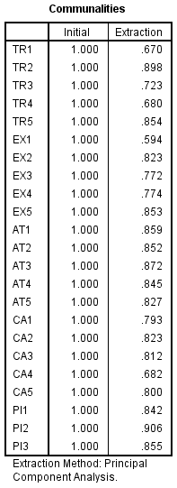

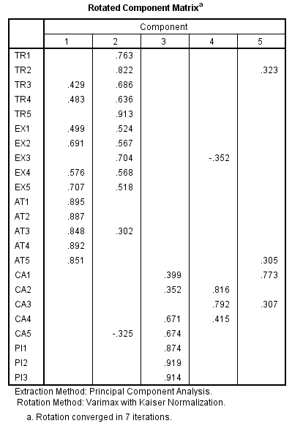

**APPENDIX B: SPSS OUTPUT, RELIABILITY CHECK– PILOT TEST**

Pilot Test: Reliability check (N= 30 respondents)

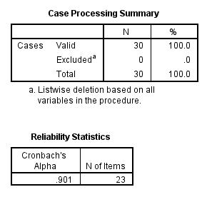

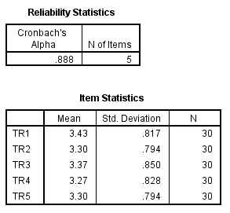

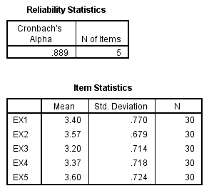

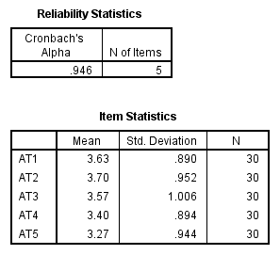

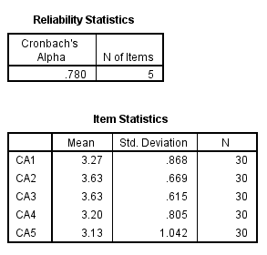

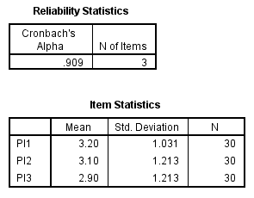

**APPENDIX C: SPSS OUTPUT FOR DATA ANALYSIS – DEMOGRAPHIC PROFILE**

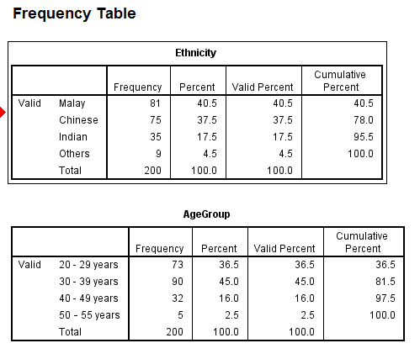

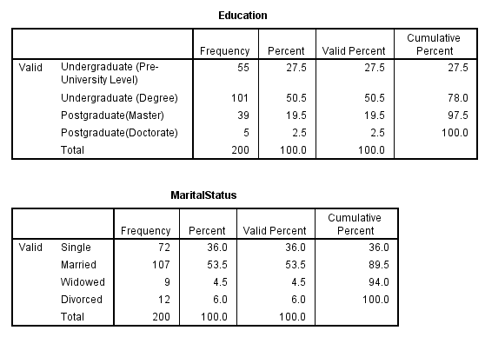

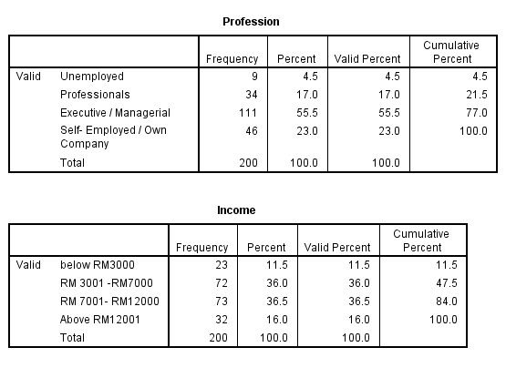

**APPENDIX D: SPSS OUTPUT FOR DATA ANALYSIS – Area of Specialization of Social Media**

**Influencers Preference**

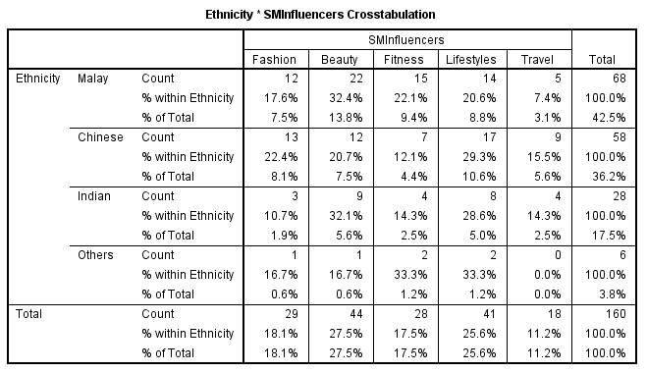

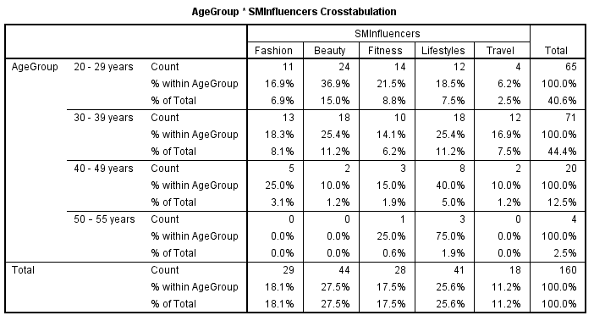

**APPENDIX E: TURNITIN**

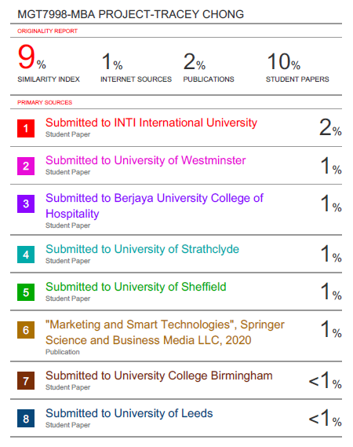

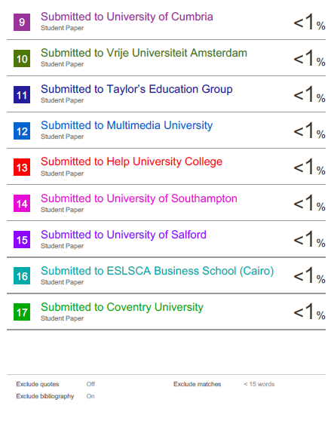

**APPENDIX F: ETHICAL APPROVAL**

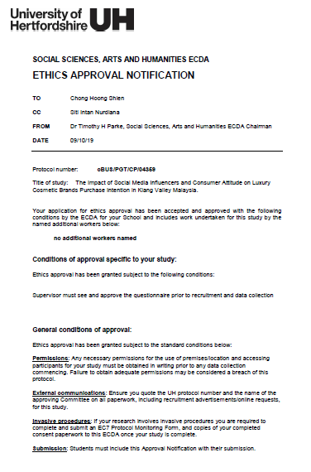

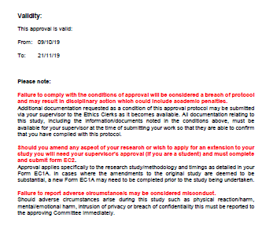

**APPENDIX G: QUESTIONNAIRE**

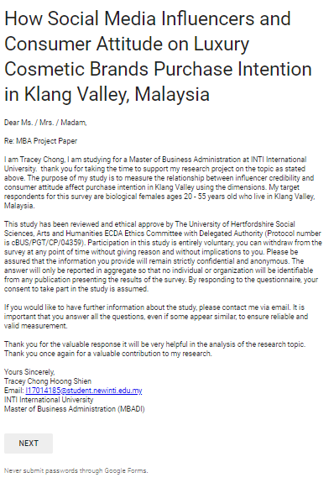

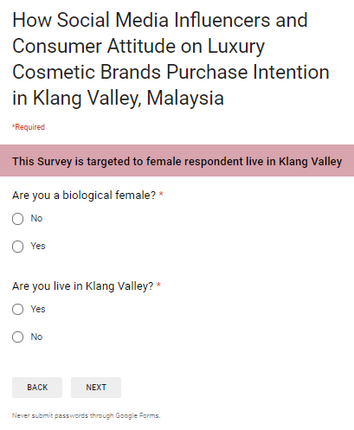

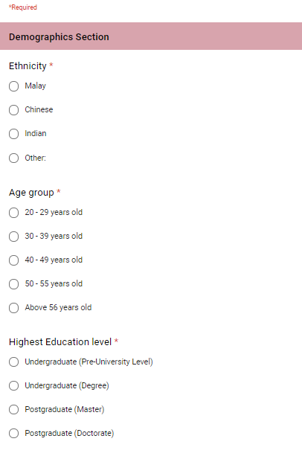

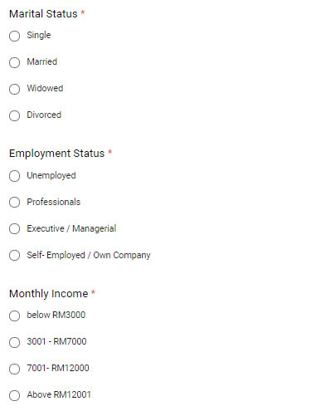

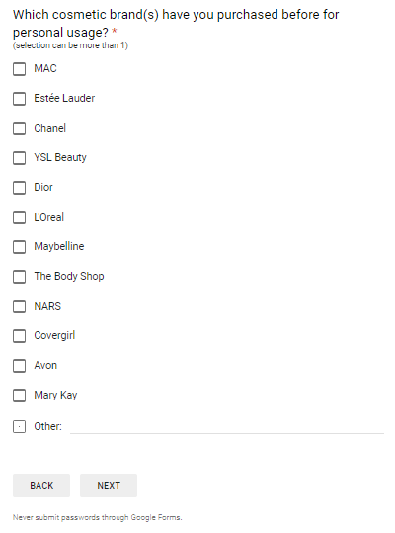

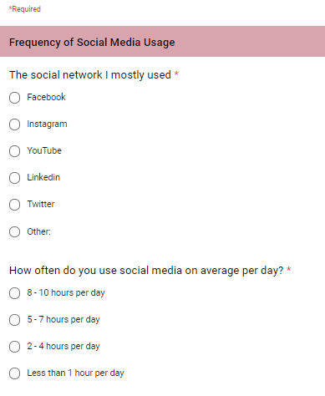

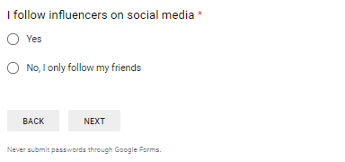

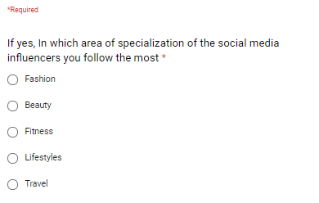

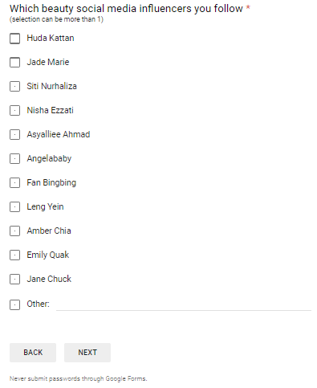

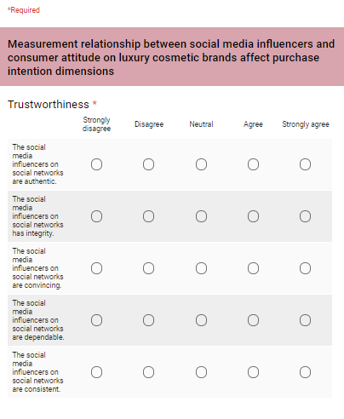

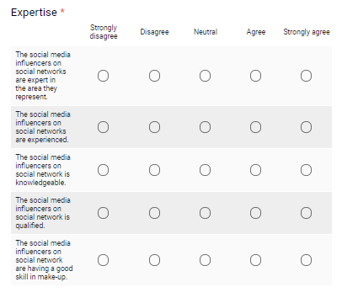

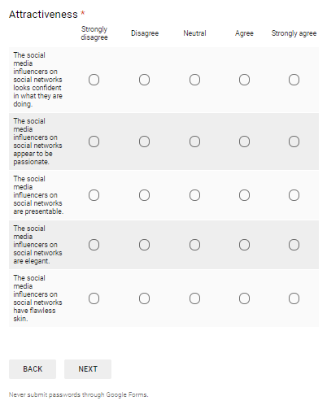

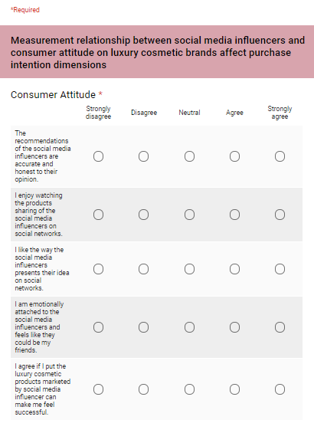

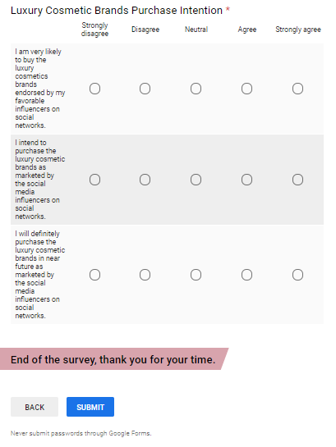

### **APPENDIX H: PROJECT PAPER LOG**

This is an important document, which is to be handed in with your dissertation. This log will be taken into consideration when awarding the final mark for the dissertation.

|  |  |
| --- | --- |
| **Student Name:** | CHONG HOONG SHIEN |
| **Supervisor’s Name:** | SITI INTAN NURDIANA WONG ABDULLAH |
| **Dissertation Topic:**  The Impact of Social Media Influencers on Luxury Cosmetic Brands Purchase Intention in Klang Valley Malaysia | |

#### SECTION A. MONITORING STUDENT DISSERTATION PROCESS

The plan below is to be agreed between the student & supervisor and will be monitored against progress made at each session.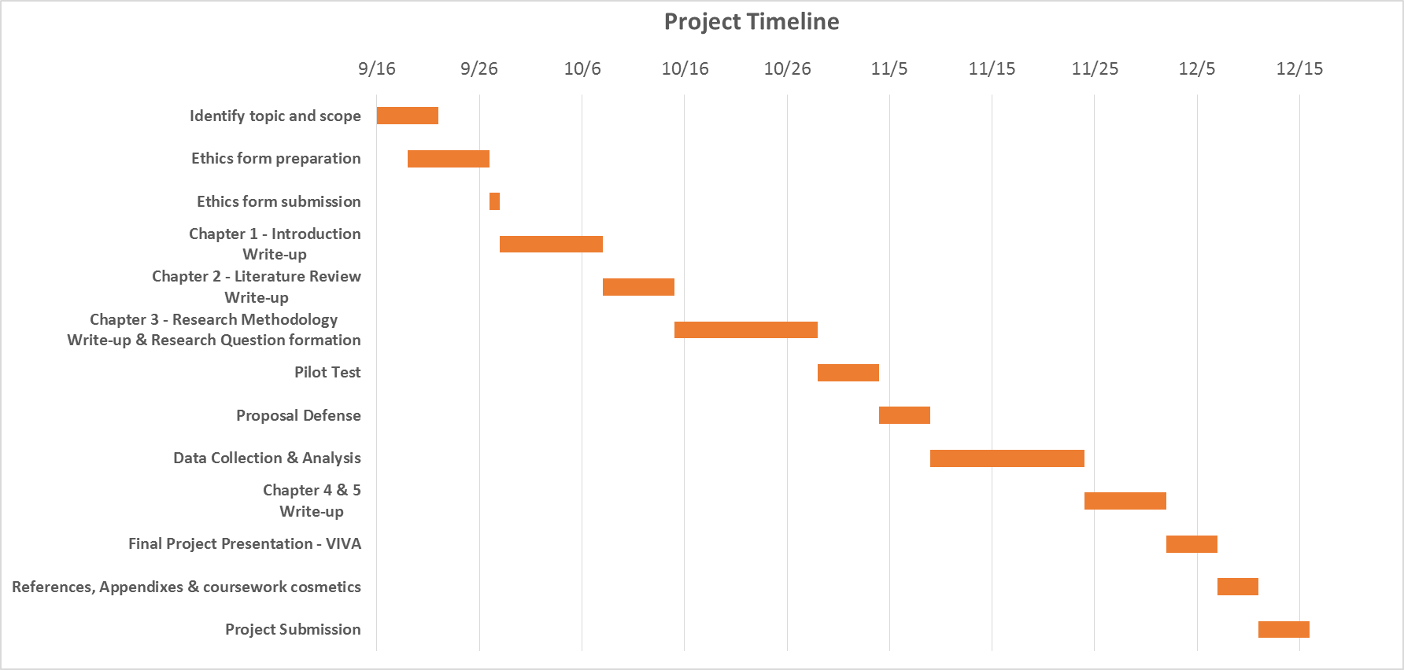

## **SECTION B. ETHICS**

Ethics form protocol number: cBUS/PGT/CP/04359

**SECTION C. RECORD OF MEETINGS**

The expectation is that students will meet their supervisors up to seven times and these meetings should be recorded.

**Meeting 1**

|  |  |
| --- | --- |
| Date of Meeting | 18/09/2019 (Wednesday) |
| Progress Made | First meeting with supervisor |
| Agreed Action | Identify research question, research objective and research questions |
| Student Signature |  |
| Supervisor’s  Signature | 12.12.2019 |

**Meeting 2**

|  |  |
| --- | --- |
| Date of Meeting | 19/09/2019 (Thursday) |
| Progress Made | Review past year literature and brief in step by step research process in Chapter 2, 3 and 4. |
| Agreed Action | * Work on the literature matrix * Identify in independent variables and dependent variable |
| Student Signature |  |
| Supervisor’s  Signature | 12.12.2019 |

**Meeting 3**

|  |  |
| --- | --- |
| Date of Meeting | 26/09/2019 (Thursday) |
| Progress Made | Review conceptual framework in Chapter 2 |
| Agreed Action | * Review the literature matrix and initial discussion in conceptual framework * Work on IRPP and ethic forms to submit to UH |
| Student Signature |  |
| Supervisor’s  Signature | 12.12.2019 |

**Meeting 4**

|  |  |
| --- | --- |
| Date of Meeting | 28/09/2019 (Saturday) |
| Progress Made | IRPP outline and Ethics Form Discussion |
| Agreed Action | * Finalize research methodology and finalize conceptual framework |
| Student Signature |  |
| Supervisor’s  Signature | 12.12.2019 |

**Meeting 5**

|  |  |
| --- | --- |
| Date of Meeting | 03/10/2019 (Thursday) |
| Progress Made | IRPP and Ethics Submission |
| Agreed Action | * Chapter 2 and Chapter 3 write-up * Work on the proposal defense pptx for presentation |
| Student Signature |  |
| Supervisor’s  Signature | 12.12.2019 |

**Meeting 6**

|  |  |
| --- | --- |
| Date of Meeting | 01/11/2019 (Friday) |
| Progress Made | Proposal Defense slide review and prepare for the question will be asked |
| Agreed Action | * PD slide review * Discussion and preparation for the PD session |
| Student Signature |  |
| Supervisor’s  Signature | 12.12.2019 |

**Meeting 7**

|  |  |
| --- | --- |
| Date of Meeting | 08/11/2019 (Friday) |
| Progress Made | Improvement area and fine tune with the research objective after suggestion from 2nd panel |
| Agreed Action | * Review again the research objective, hypothesis and research questions * Alignment with the theoretical framework and the conceptual framework * Discuss the research questionnaire |
| Student Signature |  |
| Supervisor’s  Signature | 12.12.2019 |

**Meeting 8**

|  |  |
| --- | --- |
| Date of Meeting | 11/11/2019 (Monday) |
| Progress Made | Finalize the research questionnaire |
| Agreed Action | * Sending the questionnaire for data collection and work on the pilot test |
| Student Signature |  |
| Supervisor’s  Signature | 12.12.2019 |

**Meeting 9**

|  |  |
| --- | --- |
| Date of Meeting | 28/11/2019 (Thursday) |
| Progress Made | Research Findings and prepare for VIVA presentation slide |
| Agreed Action | * Factor analysis and hypothesis testing result * Work on the managerial recommendations * Viva slide preparation |
| Student Signature |  |
| Supervisor’s  Signature | 12.12.2019 |

**Meeting 10**

|  |  |
| --- | --- |
| Date of Meeting | 04/12/2019 (Wednesday) |
| Progress Made | Viva presentation slide checking |
| Agreed Action | * Minor amendment in viva slide * Discussion on how to present the data effectively |
| Student Signature |  |
| Supervisor’s  Signature | 12.12.2019 |

## **Section D. Comments on Management of Project**

(to be completed at the end of the dissertation process)

Student Comments

Learned from the supervisor step by step the technique how to conduct a research for the solution from the business problem. Very much appreciate my supervisor for her patience guidance and her passion in education.

Supervisor Comments

Student displayed high interest for the research topic undertaken and thus have shown the effort and commitment to really understand the requirement of this project. Overall, she did manage her time well and showed some independent research work that is crucial for postgraduate level. With some guidance, she was able to grasp the required concepts and complete the project within the required timeframe. Overall, her study is timely in making relevant contribution to the digital marketing world.

|  |  |
| --- | --- |
| Signature of  Student Tracey Chong | Date  12.12.2019 |
| Signature of  Supervisor | Date  12.12.2019 |
| Ethics  Confirmed **cBUS/PGT/CP/04359** | Date  09.10.2019 |