

INTI INTERNATIONAL UNIVERSITY

MASTER OF BUSINESS ADMINISTRATION

Factors Affecting Movie Consumption Decision in China Market

Author : Zhuang Qin
Student No : I18014283
Supervisor : Ms. Liew Heong Shya
Submission Date : August 23, 2019

DECLARATION BY CANDIDATE

I hereby declare that this undergraduate research project is the end result of my own work, and all sources of information, whether printed, electronic or personal, are appropriately acknowledged in the references.

Name : Zhuang Qin
Student ID : I18014283
Signature :
Date : August 23, 2019

ACKNOWLEDGEMENT
First of all, I would like to thank my tutor Ms. Liew, for her support and guidance during the completion of the research project. Her guidance and support provided insights into the subject. Without her help, I could not have finished the research project successfully. I highly appreciate her guidance and efforts in helping and supporting me.
In addition, I would also like to thank our second tutor, Dr. Lin, for his recommendation and Suggestions during our viva presentation. His Suggestions helped me to further improve and complete my report.
Besides, I would like to thank all participants who took the time and effort to complete the questionnaire. I highly appreciate their willingness and efforts to participate in our research.
What’s more, I would like to thank my parents, family and friends for their unconditional support and guidance during the course of my dissertation.
Finally, I also want to thank myself for finishing this research through hard work and struggle, which is a big challenge for me.

ABSTRACT
Nowadays, the film market develops rapidly, the concept of ‘marketing is bigger than film’ becomes more and more important. The role of IWOM has become increasingly prominent due to the booming development of the Internet and is becoming a vital factor influencing the film market. This paper mainly starts from the theoretical basis of the influence of film WOM on consumers' movie-watching decisions, besides introduces several other factors that may also affect the purchase intention of movie. This paper studies, analyses and reveals the influence of IWOM, film schedule and star power on decision making on movie consumption, for promoting the development of Chinese film market.
In this paper, 200 random Chinese residents are selected as the research sample. Data analysis is carried out through SPSS, and a summing-up is drawn that IWOM and other factors affects film purchasing decision. On this basis, combined with the characteristics of the film itself, the film WOM marketing for the relevant recommendations.

Key words: Decision making on movie consumption, IWOM, Film schedule, Star power, SPSS

TABLE OF CONTENT
Chapter 1 Introduction
1.1 Research Background 1
1.2 Problem Statement 4
1.3 Research Objective 5
1.4 Research Questions 6
1.5 Research Hypotheses 6
1.6 Importance of the Study 7
1.7 Limitations of the Study 10
1.8 Scope of the Study 11
1.9 Ethical Consideration 11
Chapter 2 Literature Review
2.1 Internet Word-of-mouth 13
2.2 Internet Word-of-mouth in Film Industry 14
2.3 Research on Movie Consumption Decision 16
2.4 Research Hypothesis 17
Chapter 3 Research Methodology
3.1 Research Design 19
3.2 Measuring Instrument 20
3.2.1 Descriptive Analysis 20
3.2.2 Validity Test 21
3.2.3 Reliability Test 21
3.2.4 Pearson Correlation Analysis 22
3.2.5 Multiple Regression Analysis 23
3.3 Study Population, Unit of Analysis and Sampling Design 24
3.4 Questionnaire Design 24
3.5 Data Collection and Analysis Methods 25
Chapter 4 Data Analysis
4.1 Descriptive Analysis 27
4.1.1 Demographic Profile 27
4.1.1.1 Gender 27
4.1.1.2 Age 28
4.1.1.3 Eduction Level 29
4.1.1.4 Occupation 31
4.1.1.5 Monthly Income 33
4.1.1.6 Preferred Movie Type 34
4.1.2 Central Trend Measurement of Constructs 35
4.1.2.1 Movie Consumption Decision (MCD) 35
4.1.2.2 Internet Word-of-mouth (IWOM) 36
4.1.2.3 Film Schedule (FS) 37
4.1.2.4 Star Appeal (SP) 38
4.2 Reliability Analysis 39
4.3 Inferential Analyses 40
4.3.1 Pearson Correlation Analysis 40
4.3.2 Multiple Regression Analysis 42
Chapter 5 Discussions, Conclusions and Recommendations
5.1 Summary of Statistics Analyses 37
5.1.1 Descriptive Analyses 37
5.1.2 Inferential Analyses 38
5.2 Main Findings 39
5.3 Study Implications 42
5.4 Limitations of the Study 44
5.5 Recommendation for Future Study 45
5.6 Reflection 46
REFERENCE 58
APPENDIX 1: Questionnaire 69
APPENDIX 2: Initial Research Paper Proposal 75
APPENDIX 3: SPSS Output for Descriptive Analyses 78
APPENDIX 4: SPSS Output for Reliability Analysis 82
APPENDIX 5: SPSS Output for Pearson Correlation Analysis 84
APPENDIX 6: SPSS Output for Multiple Regression Analysis 85
APPENDIX 7: PowerPoint 87
APPENDIX 8: Project Paper Log 101
APPENDIX 9: Turnitin Results 109

LIST OF TABLES
Table 3.1 Cronbach’s Alpha Internal Consistency Assessment 21
Table 3.2 Questionnaire Design 25
Table 4.1 Gender 27
Table 4.2 Age 28
Table 4.3 Education Level 30
Table 4.4 Occupation 31
Table 4.5 Monthly Income 33
Table 4.6 Overview of Central Trend for Movie Consumption Decision 35
Table 4.7 Overview of Central Trend for Internet Word-of-mouth 36
Table 4.8 Overview of Central Trend for Film Schedule 37
Table 4.9 Overview of Central Trend for Star Appeal 38
Table 4.10 Reliability Statistics 39
Table 4.11 Pearson Correlation Coefficient between Dependent Variable and Independent Variables 41
Table 4.12 Summary of Model 42
Table 4.13 Analysis of Variance (ANOVA) 43
Table 4.14 Coefficients of Multiple Linear Regression Model 44
Table 5.1 Main Findings on Hypotheses Test 49
LIST OF FIGURES
Figure 1.1 Global Box Office 8
Figure 1.2 2018 Top 20 International Box Office Markets 9
Figure 2.1 Research Framework 18
Figure 3.1 Coefficient of Correlation Strength 22
Figure 4.1 Percentage of Participants Based on Gender 28
Figure 4.2 Percentage of Participants Based on Age 29
Figure 4.3 Frequency of Participants Based on Education Level 30
Figure 4.4 Frequency of Participants Based on Occupation 32
Figure 4.5 Frequency of Favorite Movie Types Based on Gender 34
Figure 4.6 Normal Probability Plot of Regression Standardized Residual 45

LIST OF ABBREVIATIONS
WOM – Word-of-mouth
IWOM – Internet Word-of-mouth
FS – Film Schedule
SP – Star Power
MCD – Movie Consumption Decision
ANOVA – Analysis of Variance Between Groups
MLR – Multiple Linear Regression

Chapter 1 Introduction

1.1 Research Background
Film was a comprehensive art that can accommodate literary drama, characters, music, painting, dance, photography, and other art forms, meanwhile, it also had its own unique artistic features. Film was born at the beginning of the 20th century. As 100 years wear away, film, as an industry, has not only been recognized globally, but also penetrated into all aspects of human life. It has gradually become an important pillar affecting national economy as well as an important embodiment of cultural resources and soft power of various countries (Hughes-Warrington, 2009).
With the development of media technology, the change of cultural context and the process of global integration, the connotation of the film industry has broken through the original territory and the space limitation of the cinema. It has gradually evolved into the most dynamic part of the cultural industry and become a big film industry. The film industry has broken through the limitations of film production, distribution and screening, advertising, publishing, clothing, toys, games, tourism, television and Internet also have become the stage for the film to display its power, and these industries also rely on the film to expand their territories to a certain extent. In the face of the trend of global economic, political and cultural integration, film, as an industry, has already surpassed the field of economy in its significance, covering politics, culture and other aspects, and has a very significant impact and role (Chen, 2016).
Compared to the benefit of 55.911 billion yuan ($8 billion) in 2017, China’s box office had reached 60.98 billion yuan ($ 8.7 billion) in 2018, which had a growth with 9.1 percent. According to the data, the box office growth rate in the fourth- and fifth-tier cities (relatively less affluent areas) in 2018 was 13.8% and 14.9% respectively. On the contrary, the relatively wealthy first- and second-tier cities had lower box office growth rates than the fourth- and fifth-tier cities, and the growth rates of the fourth- and fifth-tier cities had exceeded the average box office growth rate. This would continue for the next three years. In addition, compared with first- and second-tier cities, the per-capita movie-watching frequency in third- and fifth-tier cities still has great room for growth. On the other hand, the layout of channels in third- and fifth-tier cities is gradually improved, and early cinemas have also gradually passed the cultivation period. Compared with first-tier and second-tier cities, the fare increase is relatively large (Chyxx, 2019).
In the first five months of 2019, China's box office revenue was 26.97 billion yuan ($3.9 billion), down from 28.43 billion yuan in the same period of 2018. China's first quarter is usually the most important and busy season for box office receipts, as the first quarter includes the Chinese New Year holiday. It suggests that the 8% drop in first-quarter ticket sales from a year earlier was largely due to poor first-quarter results. Five of the top 10 performing films of the period in China market were from mainland China, with mainland sci-fi blockbuster “The Wandering Earth” which took in 4.7 billion yuan topping the box office. Four other films came from the United States, including the hugely popular Chinese hero movie "Avengers: Endgame" which earned 4.2 billion yuan. Taiwanese romance "More Than Blue" came in seventh with 950 million yuan (China Film Insider, 2019).
Moreover, the box office was expected to reach 200 billion yuan (about 28.6 billion us dollars) in 2020, by which time China would become the first country in the world to surpass North America, the world's largest box office earner, in terms of attendance and revenue, thus dominating the world film market. The rapid growth is not only related to government policies aimed at encouraging the development of cultural and entertainment industries and internet-related services, but also influenced by new capital input from new investors such as Internet giants led by Baidu and Alibaba and real estate enterprise developers such as Wanda. Chinese property developer Wanda group, for example, had used its commercial properties to build cinemas and acquired AMC entertainment holdings to become the world's largest cinema chain supplier. Wanda cinema was the first cinema chain in China, and its emergence had led to a booming film industry, as cinemas surrounded by shopping malls provided high-quality entertainment facilities for consumers coming to shopping. In addition, it was also an enterprise organization which listed in the small and medium-sized board of the Shenzhen stock exchange (Hou and Chung, 2019). The main point of this article is to study the current situation, future development and trend of the Chinese market.
The development of Chinese film market is growing rapidly in recent years which is cannot be underestimated. The continuous improvement of the industrial chain, production level and marketing as well as distribution capacity have laid a well preparation for a big increase in the box office in the future. For consumers, how to choose a movie has become a concern when they are faced with various types and subjects of various countries' films. Film market promotion in the early and late stages is a direct way for consumers to obtain external information, so it is a powerful means to improve the popularity and box office of films (Chen, 2016).
In addition, the popularity of the Internet has changed the way of WOM publicity into the way of Internet communication, rather than just person-to-person communication. This way of WOM communication enables consumers to obtain movie information through convenient network channels and at the same time express their comments and feelings on the movies they have watched, which makes the movie information on the Internet richer and more comprehensive. Just like Helm (2000) said, IWOM affected many aspects of consumers, such as information search and purchase intention, and it was an important means for consumers to obtain relevant information.

1.2 Problem Statement
Film is not only a kind of art, but also a kind of entertainment. At the same time, it is also a kind of product that needs to be produced and sold like a commodity. For filmmakers, they have to not only face the challenges in creation and production, but also face huge pressure of film sales. In the future, with the intervention of the Internet and the development needs of the film itself, it will surely stimulate the transformation of the film marketing activities to the direction of network and precision. Through a survey of many marketing methods, word-of-mouth (WOM) marketing which is a new type of marketing strategy has the characteristics of rapid dissemination, strong pertinence, etc. It has been regarded as an important factor affecting the market. As a kind of experiential consumption, moviegoers need more information to support their purchase decisions while forming purchase intentions based on their own preferences. On the other hand, the film has certain expectations for the audience, hoping that more audience can participate in the consumption process of the film (Nie, 2015). Therefore, the WOM of the audience gradually become important.
Market preference, publicity and advertising, film schedule and type as well as WOM are all factors that affect the box office of films. In this article, Internet Word-of-mouth (IWOM) is chosen as the key research object to explore its influence on the economic benefits of film products, and the method to improve the benefits of the entire film cultural industry is discussed and studied as a breakthrough point. As for why we choose IWOM as the main research objective, as a new marketing strategy, it not only affects the success of enterprises, but also affects consumers' purchasing behaviour. As the wide development and growth of Internet and the anonymity of the Internet or network platform, interactive features are presented. As a result, people gradually like and used to obtain information from various sites and community communication platform and their opinions, communication and interaction. The traditional form of word of mouth also gradually show is a new form, namely IWOM form (Hoszowska, 2014).
Due to its fast and convenient nature, WOM marketing has become a new way of WOM communication that has a profound impact on people's purchase intentions and decisions (Shi et al., 2016). Although there were a large number of scholars studying IWOM marketing and their researches were relatively comprehensive, few studies had applied IWOM marketing to the film industry. Moreover, relevant scholars only researched the direct impacts of IWOM on consumer movie consumption decision, whereas, few of them bring in the impact of interaction between other factors and IWOM on film box office (Chen, 2018).
Therefore, it is very necessary to explore and perfect the research in this field. The goal of this study is to understand the influence factors of customers on movie purchasing decision and explore the marketing methods of upcoming movies in the market. Besides, marketers need to know how to promote films and attract audiences. Besides, audiences will also utilize information sources provided by marketers to avoid choosing unpopular movies.

1.3 Research Objective
The aim of this study is to explore the decisive factors of consumption decision and box office of Chinese film market.
- To determine the relationship between Internet Word-of-mouth and movie consumption decision
- To determine the relationship between film schedule and movie consumption decision
- To determine the relationship between star appeal and movie consumption decision

1.4 Research Questions
The purpose of this paper is to solve the following problems:
- Does Internet Word-of-mouth affect the movie consumption decision?
- Does film schedule affect the movie consumption decision?
- Does star appeal affect the movie consumption decision?
- Do all the independent variables (i.e. Internet Word-of-mouth, film schedule and star appeal) significantly affect the movie consumption decision?
- Among these independent variables that affect the movie consumption decision, is Internet Word-of-mouth the most critical factor?

1.5 Research Hypotheses
Hypothesis 1:
H1: There is a significant relationship between Internet Word-of-mouth and movie consumption decision.
Hypothesis 2:
H2: There is a significant relationship between film schedule and movie consumption decision.
Hypothesis 3:
H3: There is a significant relationship between star appeal and movie consumption decision.

1.6 Importance of the Study
- Significance in film industry
The factors that influence the box office are complex. The type of film, the actor, the director, the schedule, the release, the reviews and even the weather all affect the box office and consumption decision of movie of consumers (Wang, Zhang, Li, & Zhu, 2010). In this era of rapid development of big data, profound changes are taking place in the groups of film watchers, their preferences, the way of film information dissemination and acquisition. It is of great significance to study the specific factors that influence the relationship between IWOM and film ticket sales and the degree of influence, so as to drop the market risk of the film industry and develop the operation and management of the film industry. The number of films is increasing at an alarming rate every year, and the competition in the film industry is also increasing day by day. As the film investment amount is generally large, a failed investment may ruin a company. Therefore, it has become an urgent task for production companies to understand the factors influencing the box office, understand customers, gain insight into the market and produce popular films. Research on the factors influencing the consumption decision of movie and box office of Chinese films is an important means to ensure the return on investment and control the development risk of film distribution, which has important reference value for investment decisions. Its practical significance lies in that it can provide suggestions for the next investment direction of Chinese films, so that film planners and investors can get the maximum revenue, improve the industry chain of the film industry, and promote the prosperity and development of China's film industry (Yu, 2016).
- Significance in the development of economy
Motion Picture Association of America (2018) showed that the worldwide box office hit $41.1 billion in 2018. The U.S./Canada box office which accounted for $11.9 billion grew 7% year-on-year, while the International box office (exclude U.S./Canada) fell 1 percent, which was $29.2 billion. International markets accounted for 71 percent of the total box office in 2018, down 2 percent from 2017. Compared with the past five years, the international market is up 12 percent, while the global box office is up 13 percent in the same period.
Figure 1.1 Global Box Office
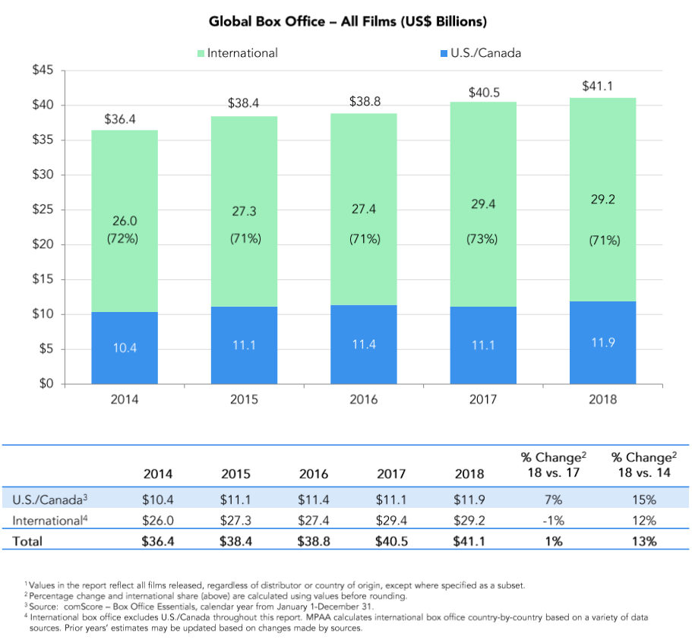
Box office sales in the Asia-pacific region ($16.7 billion) in 2018 were up 5 percent year-on-year, with China's mainland box office up 12 percent, the biggest driving force of overall growth in the region. North America was still the world's biggest movie market, but China was closing in, grossed $7.9 billion in 2017, four times as much as the third-place Japanese market (Motion Picture Association of America, 2018).
Figure 1.2 2018 Top 20 International Box Office Markets
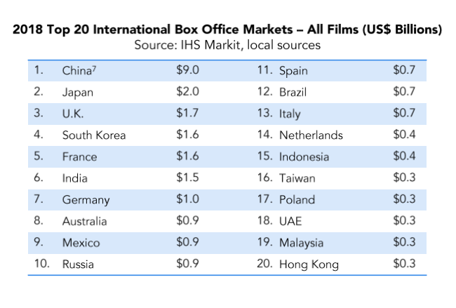
Although China's film industry is developing at an amazing speed, there is still a lot of room for development. In addition, the film industry chain involves many industries, such as advertising, publishing, television, Internet, games and toys, all of which are closely related to the film industry (Philpot, 2011). Studying the factors influencing the consumption intention of consumer and thus improving the economic benefits of the film industry has a profound impact on all related industries.

- Significance in cultural transmission
Film has been widely recognized around the world. As a product, it plays a deeper role in cultural communication and spread. North American films not only gain economic benefits but also influence the whole world through this series of cultural exports. Therefore, in the increasingly open market competition, it is of great significance to understand the influencing factors of consumers’ movie consumption decision and China's film box office and improve the competitiveness of box office to expand the competitiveness and influence of Chinese culture all over the world, which enhances the discourse dominance of China's film in the world and the soft power of China's culture (Chen, 2016).

1.7 Limitations of the Study
As a typical quantitative analysis article, this paper studied the impact of IWOM, film schedule and star appeal on film consumption decision making. Although it pursued rigorous and accurate research methods and data analysis, due to the limitations of quantitative research and the limited research ability, level and energy, this study had the following shortcomings.
- The factors taken into consideration were not comprehensive enough.
The influence of the film box office was very complex, and there was no authoritative paper that can give a clear answer. The writing of this paper was still based on the references of relevant scholars, and some of my own thoughts and subjective judgments were added, which might affect the accuracy of the regression results.

- The measurement method used was relatively simple.
This paper utilized the relatively simple research and analysis method in SPSS, which may be deviated from the real situation.
- Various factors affect decision making on movie consumption.
Based on the availability of data, this paper selects four factors related to Internet public praise for analysis, without including all influencing elements, which may have certain limitations.

1.8 Scope of the Study
The total population of mainland China was some 1.5 billion in 2018, of which about 713 million were men and some 682 million were women. In terms of age structure, the highest percentage of age group was composed of people those who aged between 16 and 59, which accounted for 64.3% (China economic information network, 2019). Shanghai, with a population of 24.18 million, was the second most populous and most densely populated city in China (Shanghai statistics bureau, 2018). Therefore, in order to make the survey subjects more representative, this paper selects 200 mainland Chinese residents as the research sample, and most participants are Shanghai residents from 16 to 59 years old.

1.9 Ethical Consideration
I solemnly declare that the thesis “Survey on the Influence of IWOM on Box Office” is my own research achievement under the guidance of my tutor. As far as I know, except for the special notes and acknowledgements, the paper does not contain the content and research results published or written by others, nor does it contain the materials used to obtain the degree certificate of INTI International University.
I fully understand the relevant regulations of INTI International University on the retention and use of academic theses. The university has the right to retain the copies of the papers submitted and allow the papers to be reviewed, borrowed or indexed online. The university may publish all or part of the contents of the dissertation and may preserve the dissertation by photocopying or other means of reproduction.

Chapter 2 Literature Review

2.1 Internet Word-of-mouth
It was found that the key words such as Internet WOM, Online WOM, Virtual WOM and Electronic WOM were all about the research of computer-mediated IWOM while searching literatures. With the advent of the Internet age, traditional word of mouth has evolved from oral communication to non-verbal communication, the new form known as IWOM. IWOM was the act of communicating opinions to other consumers in text form, pictures or video through Internet tools such as chat tools, E-mail and social networking sites. (Ma, 2014).
Stauss (1997) was an early elaborator of IWOM. He pointed out that customers would use the message board on the company's website to inquire about product information, or complain or praise the company about relevant matters. It is possible for consumers to expand their perception of service quality to a global scale, and this kind of non-commercial communication using the Internet is also known as IWOM. Meanwhile, Hanson (2004) also called this form of communication Electronic WOM or Online WOM, and believed that this form of communication took the Internet as the medium and carried out Word-of-mouth communication through E-mail, online BBS, discussion boards and other forms. According to Datte (2005), the communication between potential customers and actual consumers on the Internet about the products or services they had experienced was called IWOM.
Based on Internet platforms, Hennigs-Thurau (2004) found that potential customers or actual customers would pass positive or negative comments on a product to other companies or organizations through BBS or newsgroups. In addition, customers would search and follow the opinions of online leaders when they were making purchase decisions, thus forming Electronic Word-of-mouth. Litvin (2008) emphasized that consumers were the participants of IWOM, and they were the only participants. The communicators of IWOM information were consumers who communicated with each other on products and services through the Internet. Cheung and Lee (2012) dedicated that IWOM can be carried out through a variety of different environments. Consumers could comment on products on discussion groups, social networks and so on. The new form of word of mouth defined by Kumar (2013) was' IWOM ', which related to the information exchange and interaction between consumers about products, brands or services through communication platforms such as Internet bulletin board (BBS) or instant messaging tools such as Microsoft Service Network (MSN).
Combined with the above literatures, this paper defines IWOM as the behaviour that potential consumers or actual consumers exchange their viewpoints of products or services by words, pictures, sounds and videos through the Internet.

2.2 Internet Word-of-mouth in Film Industry
Under this society that with the increasing forms of entertainment, movie-watching has become an indispensable pastime in people's life. As an industry or cultural product, a large amount of public participation is crucial to its successful development. Chaffee and Steven (1982) confirmed that communication between groups about movies must be existing, and such communication would have impact on consumers' purchasing ideas and decisions of film. In view of the particularity of movies, consumers could not make an accurate judgment on the quality level of movies before watching them, and consumers would search the Internet for information and comments about the movie when they didn't know about the movie. Therefore, IWOM would influence consumers' purchasing decisions to a large extent.
Relevant data showed that online comments not only had effect on consumers' buying intention, but also had a great impact on product sales. What’s more, online comments had a significant influence on the sales of books (Chevalier, 2006). Yong Liu (2006) confirmed that online reviews had a significant impact on film box office profit through research. Cui et al. (2012) found that the early sales of electronic products and video games were greatly influenced by the number of online reviews, and the influence became smaller and smaller over time. Compared with the impact of positive WOM on the sales of new products, negative WOM had a greater negative effect, which proved that negative WOM effect existed. In addition, Yong Liu (2006) found that the WOM before the release of a film could strongly predict the box office of the film within a period of five weeks after the release. Hadida (2009) thought that the influence of IWOM was the most significant before and during the first week of the release of the film. As time wore away, the influence of IWOM weakened accordingly.
According to Moul (2007), the influence of WOM on the change of consumers' expectations was about 10%, and compared with films with high expectations, films with low expectations could hardly have a good WOM. Duan et al. (2008) compared the relationship between box office and IWOM within two weeks of a film's release, and studied the correlation between them. With the development of the Internet, compared with traditional media, Internet users could obtain more convenient information about movies in various online communities or social media, and the communication and discussion of IWOM became easier. Therefore, under developed network environment, the influence of Word-of-mouth would be increasingly large. Similarly, Duan et al. (2008) based on the data of 71 film departments released between July 2003 and May 2004, Duan et al. (2008) concluded that the main factor influencing the box office success was IWOM.

2.3 Research on Movie Consumption Decision
Litman (1983) found that the decisive factors significantly affecting the decision making on movie consumption include the film producing budget, the number of cinema screens, professional movie comments, film type, distribution in the big cinema, film schedule of Christmas, Oscar nominations and other awards. Besides, Wyatt (1991) found that production budget, professional film reviews, major studios, star actors and summer schedule factors influence decision making on movie consumption significantly.
The organizational model theory invented by Sochay (1994) divides the impact on the final performance of the box office into three stages: production, distribution and projection. He found that production budgets, screens, professional reviews, summer schedules, Oscar best picture and release concentration each had significant predictive ratings for box office performance, and those films with violent and pornographic content were less likely to lose money.
De Vany and Walls (1999) examined the influence of producing budgets, appeal of actors and directors, sequels, style, and ratings on the movie consumption decision and concluded that the success of a film does not depend on just one factor. Otherwise, the research of Collins et al. (2002) indicated that star influence and good reputation were the success factors of box office revenue in the British film market, but it also pointed out that the respective influence of these factors was still uncertain.
Based on the reality of China, Cui Ningning and Tang Jiageng (2012) selected film types, film scores, actors' appeal and film producing areas as independent variables, and took the box office of the top ten films from 2003 to 2012 as dependent variables to establish a multiple regression model of factors affecting decision making on movie consumption by using the stepwise regression analysis. The results showed that film types, film ratings and actors' charisma had a prominent impact on the movie consumption decision-making of consumers, while production areas of the films were excluded from the model.
Liu Yanyan (2013) took the top ten films ranked in China's box office from 2002 to 2010 as samples, selected six indexes to establish a regression model based on Barry Litman's model. Through empirical analysis, she indicated that the director's reputation, film critics, number of fans and number of a-list stars were the important factors influencing the film consumption decision, while the awarding time and number of awards have no significant impact on the consumption decision.

2.4 Research Hypothesis
According to the review of the above literatures, movie consumption decision is affected by Internet word-of-mouth certainly, and factors such as stars, schedule of film also have a certain impact.
Therefore, this paper decided to take Internet Word-of-mouth, film schedule and star appeal as the main influencing factors, to reveal the influence of these factors on the movie consumption decision. Hypotheses as below:

Hypothesis 1:
H1: There is a significant relationship between Internet Word-of-mouth and movie consumption decision.
Hypothesis 2:
H2: There is a significant relationship between film schedule and movie consumption decision.
Hypothesis 3:
H3: There is a significant relationship between star appeal and movie consumption decision.
Figure 2.1 Research Framework
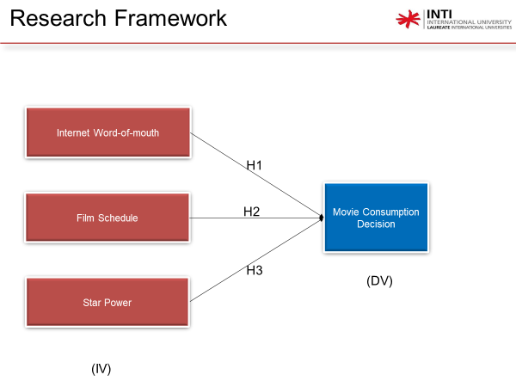

Chapter 3 Research Methodology

3.1 Research Design
De Vaus (2001) said that research design generated work plans, which specify the work needed to complete the project. But research design was more than just a production plan. Its function was to ensure that the data obtained could clearly answer the initial questions. For example, when designing research, we need to give research questions, and then what evidence is needed to answer this question. Besides, Trochim and Donnelly (2008) said that research design was a portfolio strategy that brings together independent individuals in a coherent and logical way to form a whole. It developed particular plans for data collection, measurement and analysis, which ensure raised issues to be resolved effectively.
The research content of this paper mainly includes the design of questionnaire, data collection, measurement tools and methods. Analysing the influencing factors of Chinese box office is the main goal of the study, and with which descriptive research and explanatory research are adopted. Explanatory research is to ask questions about 'why' and explain them in the context of descriptive research description (De Vaus, 2001). According to the research framework, the correlation between dependent and independent variables was constructed. Relevant hypotheses were proposed for independent and dependent variables, and a questionnaire will be designed to evaluate the collected real data and ensure the authenticity of the research. The questionnaire will be distributed online and offline.

3.2 Measuring Instrument
The questionnaire is designed by the author, using nominal and ordinal scale (Galasiński and Kozłowska, 2012). Movies belong to the virtual trading economy, so there is no specific numerical indicator to measure or test it. Therefore, this paper introduces four independent variables related to films and counts the dependent variables and independent variables quantitatively by adopting the research method of Likert Scale. Likert Scale is usually utilized in questionnaires and is widely employed in research. The scale was usually composed of several sets of related statements, and each statement was consisted of five answers from high to low or from low to high. The five levels are marked as 5, 4, 3, 2 and 1 respectively. Different scores represent the strength and weakness of respondents' attitudes to this question (Zumbo, Gadermann and Zeisser, 2007).
Furthermore, the data obtained is analysed by SPSS software, which contains various ways of analysing and testing.

3.2.1 Descriptive Analysis
The description of the basic characteristics of the collected data is usually completed by descriptive statistical analysis. For example, when we need to measure a large number of people in a certain way or standard in a certain study, descriptive analysis can help us simplify these data in a reasonable way, reducing a large number of data to a simple summary (Trochim, 2006). Descriptive data analysis methods need to be matched by a powerful and effective analytical tool, which is multi-dimensional and can obtain important relevant information based on market research (Gabor, 2010). Descriptive statistics are based on the mean, range, and quantity of a variable where applicable. The descriptive statistics used in this study are frequencies analysis and descriptives analysis respectively.

3.2.1 Validity Test
Validity testing is a process that is considered after the researcher has identified the measuring instrument for the study. According to Sekaran and Bougie (2013), validity test is employeed to assess the measurement results obtained by the measuring instrument and see whether it is set to measure what should be measured.

3.2.2 Reliability Test
According to Sekaran and Bougie (2013), although there were sometimes not valid in reliable measures, reliability is often the prerequisite for validity. So, in order to determine internal consistency, it also was demanded to run reliability on the collected data (Kumar, 2014). Sekaran and Bougie (2011) said that there are many ways to check the internal consistency of data, but the Cronbach’s alpha scale is the most widely used. Tavakol and Dennick (2011) presented that the value is acceptive for validity if it is between 0.70 and 0.95. The closer to 0.95, the more reliable the data will be; on the contrary, the value around 0.70 is considered to be suspicious. In this study, the consistency of the questionnaire was tested by this testing method.
Table 3.1 Cronbach’s Alpha Internal Consistency Assessment
α > 0.9 | Great
0.8 < α < 0.9 | Good
0.7 < α < 0.8 | Acceptable
0.6 < α < 0.7 | Suspectable
0.5 < α < 0.6 | Bad
α < 0.5 | Unacceptable

3.2.3 Pearson Correlation Analysis
Pearson correlation analysis is often taken into account when measuring and interpreting the strength of linear or nonlinear relationships between independent and dependent variables. The measure of the strength relationship between the two kind of variables is called Pearson correlation coefficient which labelled as ‘r’. In detail, there is a definite range of R values from (-1) to (+1), values of (-1) to (0) indicate negative correlation between the dependent and independent variables, values of (0) indicate they are uncorrelated, while values of (0) to (+1) indicate positive-going correlation between the two variables (Berger, 2016). The sign of correlation coefficient determines the direction of the relationship, and the number indicates the strength of the relationship (Zou, Tuncali and Silverman, 2003). The reason why Pearson correlation analysis was chosen in this study is that It is able to interpret the dependent and independent variables in the questionnaire designed by Likert Five Scale.
Figure 3.1 Coefficient of correlation strength
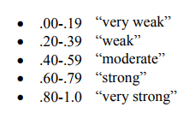
According to Evans (1996), the magnitude of the absolute value of r can be used to describe the strength of the correlation. When the value is between 0.00 and 0.19, the correlation between variables is very weak, and the value between 0.20 and 0.39 is also weak, but slightly stronger than the value below 0.19. The number of 0.40-0.59 indicates moderate intensity, while 0.60-0.79 means strong correlation. Particularly strongly correlated were values between 0.80 and 1.0.

3.2.4 Multiple Regression Analysis
Multiple linear regression analysis is a measurement and statistical method for the strength of the relationship between dependent variables and independent variables (Nagy, 2018). By analysing the values of multiple independent variables or explanatory variables, predict how much the dependent variable will change as the value of the independent variable changes. (Yan and Su, 2009). In this article, the independent variables are the IWOM, film schedule and star appeal, the dependent variable is the film consumption decisions, by using multiple linear regression analysis method, we get a regression analysis equation about the relationship between the dependent and independent variables, and the role of the equation is to be able to let us know each unit change of independent variables will affect how much change of dependent variable. In short, this method is used to test the influence of more than or equal two independent variables on dependent variable (Fletcher, 2009). The equation of this analysis method is generally:
y_{i} = B₀ + B₁x_{i1} + B₂x_{i2} + … + B_{p}x_{ip} + E_{i} where i = 1, 2, …, n
Y = dependent variable
X₁, X₂, X₃ = independent variables
α = intercept or constant
B₁ to B_{n} = (independent) variables to the predictor (dependent) variables
Therefore, this test method allows us to clear and identify the factors or independent variables that most affect consumers' movie-watching consumption decisions.

3.3 Study Population, Unit of Analysis and Sampling Design
Chinese consumers are selected as the study population. China's total population as of April 24, 2019 was over 1,4 billion, which is currently the world's most populous country (Worldometers, 2019).
Moreover, according to World Population Review (2019), Shanghai was the most populous city in China, which had more than 26 billion population. Therefore, most of respondents of the research are Shanghai citizens. Otherwise, according to the sample size formula proposed by Krejcie and Morgan (1970), when the study population exceeded one million, the sample size should be 384, with a 95% confidence level and a 0.5% margin of error. However, due to limited time, the research will select almost 200 participants as this simple size is sufficient to obtain the research aims.
Sekaran and Bougie (2013) argued that if the problem statement of the study was primarily of interest to the individuals and its purpose was to investigate certain behavioural characteristics of the individuals, then the unit of analysis is the individual.

3.4 Questionnaire Design
This study employees the method of online distribution and collection of questionnaires, because it is the cheapest method to collect a large number of target population data (Sekaran and Bougie, 2013). Problem statements regarding independent and dependent variables will be presented on 5-Point Likert Scale.
Table 3.2 Questionnaire Design
Section | Variable | Items | Source
A | Demographic Profile | 5 | Bello (2009)
B | General Information | 5 | Haw (2013)
C  (Independent Variables) | Internet Word-of-mouth | 3 | Yu(2016)
C  (Independent Variables) | Film schedule | 3 | Nie (2015)
C  (Independent Variables) | Actor appeal | 3 | Chen (2016)
D  (Dependent Variable) | Movie Consumption Decision | 3 | Ma (2014)  Chen (2018)

3.5 Data Collection and Analysis Methods
Primary and secondary data are two main methods of data collection. According to Zikmund et al. (2013), he claimed that primary data were the original data information collected directly from the subjects of the study through questionnaires and other means. Kumar (2014) indicated that the Internet, books, magazine and journal articles, or government and organizational websites were all sources of secondary data collection.
This paper adopts the method of primary data survey. According to Paul and Rana (2012), the most common way to collect primary data is questionnaire. Therefore, the researcher will design the questionnaire and mainly distribute it in Shanghai through online methods such as WeChat and E-mail. In addition, other regions include Zhejiang province, Liaoning province, Jiangxi province and Guangdong province and so on.
This study will analyse the data with SPSS, because SPSS is a professional quantitative analysis method widely used to analyse large amounts of data (Wagner, 2016).

Chapter 4 Data Analysis

4.1 Descriptive Analysis
This section summarizes the central trend measurement of population profile data and structure of respondents in the form of tables, graphs and pie charts.

4.1.1 Demographic Profile

4.1.1.1 Gender
Table 4.1 Gender
Gender
 |  | Frequency | Percent | Valid Percent | Cumulative Percent
Valid | Female | 96 | 48.0 | 48.0 | 48.0
Valid | Male | 104 | 52.0 | 52.0 | 100.0
Valid | Total | 200 | 100.0 | 100.0

Figure 4.1 Percentage of Participants Based on Gender
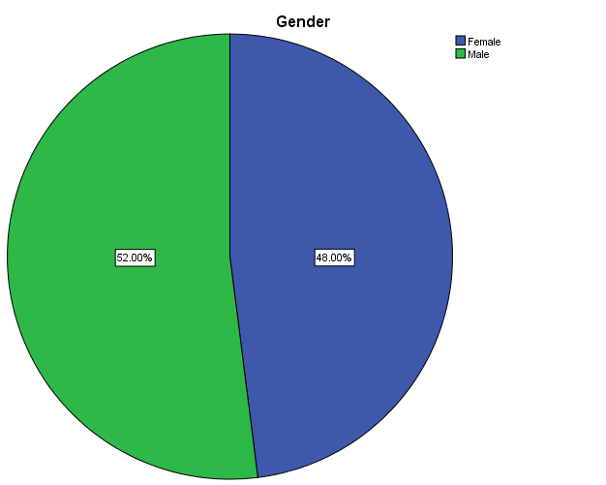
Table 4.1 and figure 4.1 illustrate that there are more male than female among participants who are invited to join in this research, which are 96 women and 104 men, taking 52% and 48% respectively.

4.1.1.2 Age
Table 4.2 Age
Age
 |  | Frequency | Percent | Valid Percent | Cumulative Percent
Valid | 16-29 | 22 | 11.0 | 11.0 | 11.0
Valid | 30-43 | 122 | 61.0 | 61.0 | 72.0
Valid | 44-57 | 52 | 26.0 | 26.0 | 98.0
Valid | Above58 | 4 | 2.0 | 2.0 | 100.0
Valid | Total | 200 | 100.0 | 100.0

Figure 4.2 Percentage of Participants Based on Age
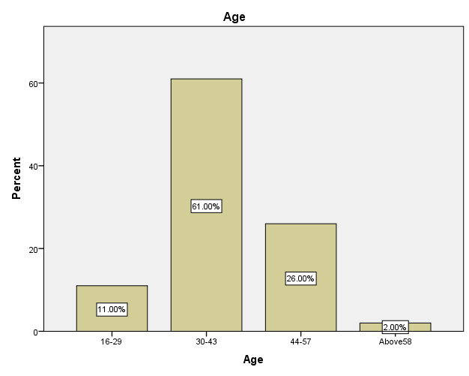
It can be seen from table 4.2 and figure 4.2 that most of the participants (122) are aged 30-43, accounting for 61%.The next age group is 44-57 (52), accounting for 26.There were 22 respondents aged 16-29, and the fewest participants aged 58 and over, with just four respondents.

4.1.1.3 Education Level
Table 4.3 Education Level
EducationLevel
 |  | Frequency | Percent | Valid Percent | Cumulative Percent
Valid | JuniorHighSchool | 22 | 11.0 | 11.0 | 11.0
Valid | SeniorHighSchool | 64 | 32.0 | 32.0 | 43.0
Valid | Undergraduate | 104 | 52.0 | 52.0 | 95.0
Valid | MasterDegreeCandidate | 9 | 4.5 | 4.5 | 99.5
Valid | DoctoralCandidate | 1 | .5 | .5 | 100.0
Valid | Total | 200 | 100.0 | 100.0
Figure 4.3 Frequency of Participants Based on Education Level
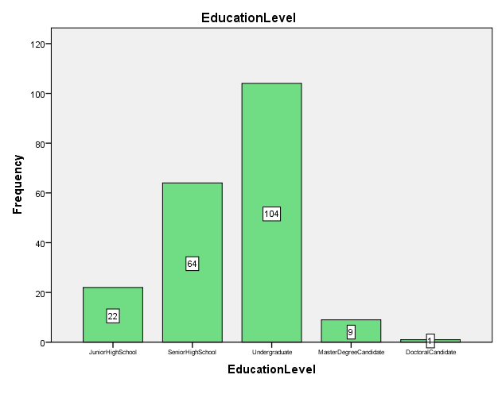
Table 4.3 and figure 4.3 show that most of the participants have undergraduate degrees (52%), the second most senior high school students (32%) and the third most junior high school students (11%). Nine respondents with a master's degree and only one doctoral candidate participated.

4.1.1.4 Occupation
Table 4.4 Occupation
Occupation
 |  | Frequency | Percent | Valid Percent | Cumulative Percent
Valid | Student | 5 | 2.5 | 2.5 | 2.5
Valid | Teacher | 37 | 18.5 | 18.5 | 21.0
Valid | ProductionStaff | 65 | 32.5 | 32.5 | 53.5
Valid | Salesman | 35 | 17.5 | 17.5 | 71.0
Valid | MarketingPersonnel | 13 | 6.5 | 6.5 | 77.5
Valid | AdministrativeSupportPersonnel | 14 | 7.0 | 7.0 | 84.5
Valid | FinancialAuditor | 9 | 4.5 | 4.5 | 89.0
Valid | ClercialStaff | 16 | 8.0 | 8.0 | 97.0
Valid | TechnicalR&DPersonnel | 4 | 2.0 | 2.0 | 99.0
Valid | Other | 2 | 1.0 | 1.0 | 100.0
Valid | Total | 200 | 100.0 | 100.0

Figure 4.4 Frequency of Participants Based on Occupation
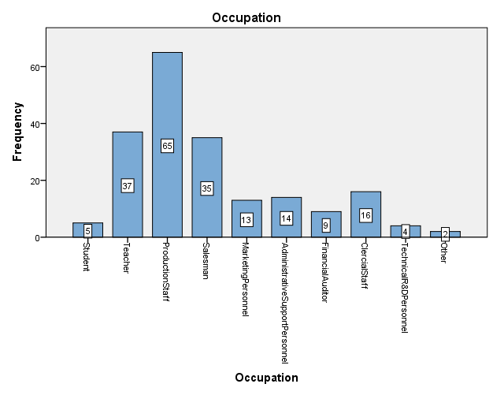
According to table 4.4 and figure 4.4, 65 of the 200 people interviewed are production employees, accounting for 32%. Teachers and salespersons occupy 18.5% and 17.5 respectively, ranking second and third. At the very least, there are only four technical researchers.

4.1.1.5 Monthly Income
Table 4.5 Monthly Income
MonthlyIncome
 |  | Frequency | Percent | Valid Percent | Cumulative Percent
Valid | NoIncome | 6 | 3.0 | 3.0 | 3.0
Valid | Below2000RMB | 18 | 9.0 | 9.0 | 12.0
Valid | 2001-3000RMB | 16 | 8.0 | 8.0 | 20.0
Valid | 3001-5000RMB | 86 | 43.0 | 43.0 | 63.0
Valid | 5001-8000RMB | 57 | 28.5 | 28.5 | 91.5
Valid | 8001-15000RMB | 10 | 5.0 | 5.0 | 96.5
Valid | 15001-50000RMB | 2 | 1.0 | 1.0 | 97.5
Valid | Above50000RMB | 5 | 2.5 | 2.5 | 100.0
Valid | Total | 200 | 100.0 | 100.0
Based on table 4.5, about half of the participants had an income range of 3,001-5,000rmb (43%) for 86 people. Next is 5001-8000rmb (28.5%) with 57 employees. There are 34 participants (18+16) below 3000RMB salary. Finally, only 17 respondents (10+2+5) above 8000, accounting for 8.5%.

4.1.1.6 Preferred Movie Type
Figure 4.5 Frequency of Favorite Movie Types Based on Gender
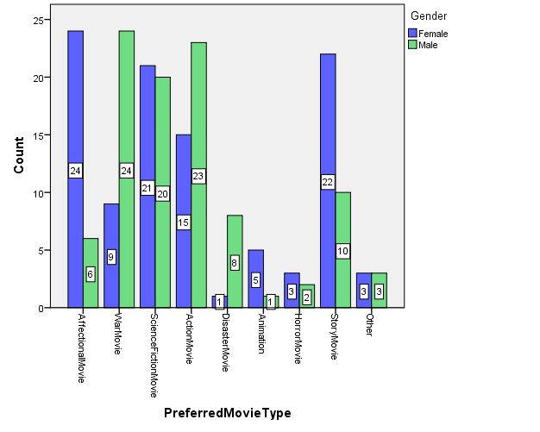
According to figure 4.5, female participants tended to watch romance and drama, followed by science fiction. Male participants, by contrast, were more likely to watch war movies and action movies, but like women, they also watched science fiction.

4.1.2 Central Trend Measurement of Constructs
This part is the central tendency measurement of the structure of independent variables and three dependent variables.

4.1.2.1 Movie Consumption Decision (MCD)
Table 4.6 Overview of Central Trend for Movie Consumption Decision
Descriptive Statistics
 | N | Minimum | Maximum | Mean | Std. Deviation | Skewness |  | Kurtosis
 | Statistic | Statistic | Statistic | Statistic | Statistic | Statistic | Std. Error | Statistic | Std. Error
MCD1 | 200 | 1 | 5 | 3.38 | 1.028 | -.388 | .172 | -.454 | .342
MCD2 | 200 | 1 | 5 | 3.31 | 1.020 | -.560 | .172 | .281 | .342
MCD3 | 200 | 1 | 5 | 3.31 | 1.008 | .227 | .172 | .311 | .342
Valid N (listwise) | 200
MCD1 = Your intention of watching movie in cinema is affected by online recommendation.
MCD2 = When you choose whether to go to the cinema or not, you will refer to the schedule of the film.
MCD3 = You decide to go to the cinema to see a film based on the star actors of the film.
Table 4.6 shows that within the four statements of the dependent variable movie consumption decision, MCD1 has the highest mean score of 3.38, MCD2 and MCD3 have the same score of 3.31.In terms of standard deviation (SD), MCD1 has the highest standard deviation score (1.028), followed by MCD2 (1.020), and MCD3 has the lowest score (1.008).Except for MCD3, the skewness of the other two statements is negative test, while the kurtoses of MCD2 and MCD3 are 0.281 and 0.311 respectively, both positive. This suggests that the distribution of these statements tends to be more peak than normal.

4.1.2.2 Internet Word-of-mouth (IWOM)
Table 4.7 Overview of Central Trend for Internet Word-of-mouth
Descriptive Statistics
 | N | Minimum | Maximum | Mean | Std. Deviation | Skewness |  | Kurtosis
 | Statistic | Statistic | Statistic | Statistic | Statistic | Statistic | Std. Error | Statistic | Std. Error
IWOM1 | 200 | 1 | 5 | 3.26 | .943 | -.168 | .172 | .649 | .342
IWOM2 | 200 | 1 | 5 | 3.33 | 1.050 | -.171 | .172 | -.660 | .342
IWOM3 | 200 | 1 | 5 | 3.39 | 1.070 | -.327 | .172 | .688 | .342
Valid N (listwise) | 200
IWOM1 = You think the information that word-of-mouth provides is valuable.
IWOM2 = Your sense is that if most of the comments on the Internet said they enjoyed the movie which they had watched, this movie must be good.
IWOM3 = When you are not sure which movie to watch, you prefer to watch the movie recommended by netizens.
According to table 4.7, the mean value of IWOM3 (3.39) is the highest and the lowest value (3.26) belongs to IWOM1.In addition, the standard deviation above 1 is below the value of IWOM3 (1.070), indicating that it shows good results. The smallest standard deviation is IWOM1 (0.943). All skewness is negative, and the kurtosis of IWOM1 and IWOM3 is positive, so the distribution of positive kurtosis statements is greater than that of positive kurtosis statements.

4.1.2.3 Film Schedule (FS)
Table 4.8 Overview of Central Trend for Film Schedule
Descriptive Statistics
 | N | Minimum | Maximum | Mean | Std. Deviation | Skewness |  | Kurtosis
 | Statistic | Statistic | Statistic | Statistic | Statistic | Statistic | Std. Error | Statistic | Std. Error
FS1 | 200 | 1 | 5 | 3.26 | 1.070 | -.425 | .172 | -.615 | .342
FS2 | 200 | 1 | 5 | 3.29 | 1.055 | -.360 | .172 | -.465 | .342
FS3 | 200 | 1 | 5 | 3.25 | .974 | -.500 | .172 | .079 | .342
Valid N (listwise) | 200
FS1 = You think the timing of the film is influencing the purchase intention of consumers on movie ticket.
FS2 = You watch movies on weekends or holidays even though the price of ticket is relatively high.
FS3 = You watch movies on weekdays due to low price and uncrowded watching environment although there is usually not enough time.
Table 4.8 shows the five statements under the movie schedule.FS2 has the highest average at 3.29, while FS1 is 3.26 which more 0.01 than FS3 (3.25). Contrary to the mean value, the highest standard deviation was FS1 (1.070) and the lowest was FS3 (0.974). All three statements are negative skewed. In terms of kurtosis value, FS3 is positive with a value of 0.079.

4.1.2.4 Star appeal (SA)
Table 4.9 Overview of Central Trend for Star appeal
Descriptive Statistics
 | N | Minimum | Maximum | Mean | Std. Deviation | Skewness |  | Kurtosis
 | Statistic | Statistic | Statistic | Statistic | Statistic | Statistic | Std. Error | Statistic | Std. Error
SA1 | 200 | 1 | 5 | 2.97 | 1.028 | -.288 | .172 | -.500 | .342
SA2 | 200 | 1 | 5 | 3.09 | 1.071 | .294 | .172 | -.493 | .342
SA3 | 200 | 1 | 5 | 3.12 | .986 | -.499 | .172 | -.102 | .342
Valid N (listwise) | 200
SA1 = It's important for you to get to know the stars or actors in the movie before you watch it.
SA2 = Usually, the films that attract you to the cinema are those starring famous or outstanding stars.
SA3 = Stars who have performed well in previous films will make you feel better about the movie.
The mean value of SA3 is the highest and SA1 the lowest, respectively 3.12 and 2.97, which is showed in the table 4.9. The high standard deviation of SA2 was 1.071, and the expression of SA2 was positively skewed, with a value of 0.294. But all three of these statements have negative kurtosis, which means they're gentler than a normal distribution.

4.2 Reliability Analysis
The reliability establishment of variables in this section serves as a possibility to fully verify the hypothesis. The following tables analyse the internal consistency of independent and dependent variables and obtain the consequence of reliability analysis.
Table 4.10 Reliability Statistics
Variables | Items | Cronbach’s Alpha (α)
Internet Word-of-mouth (IV) | 3 | 0.711
Film Schedule (IV) | 3 | 0.638
Star appeal (IV) | 3 | 0.696
Decision Making on Movie Consumption (DV) | 3 | 0.703
Reliability analysis is conducted on the basis of one dependent variable and three independent variables with a total of 12 items. First, the Cronbach’s alpha value of word-of-mouth divided by three items tested was 0.711. Then three items of the movie schedule were tested, and the Cronbach’s alpha value was 0.638. Star appeal is the last independent variable to be tested, which is also the reliability test based on three projects, and the result is 0.696. The tested Cronbach’s α value of film consumption decision is 0.703. Look at the above table, it is known that all alpha reliability coefficients range from 0.638 to 0.711. Cronbach’s α value less than 0.6 indicates poor reliability and the reliability within the range of 0.7 is acceptable, while the value above 0.8 symbolizes good reliability (Sekaran and Bougie, 2011). Therefore, since the Cronbach’s α values for all projects were above 0.6, it means that the measurements for all projects are sufficient to afford important results.

4.3 Inferential Analyses
This part explains the conclusion of each variable in detail, as well as the relationship between individual variables and other variables.

4.3.1 Pearson Correlation Analysis
This analysis is widely used to measure the degree of correlation between two variables (Howitt and Cramer, 2014).
Table 4.11 Pearson Correlation Coefficient between Dependent Variable and Independent Variables
Correlations
 |  | Total_IWOM | Total_FS | Total_SA | Total_MCD
Total_IWOM | Pearson Correlation | 1 | .632** | .626** | .644**
Total_IWOM | Sig. (2-tailed) |  | .000 | .000 | .000
Total_IWOM | Sum of Squares and Cross-products | 129.351 | 81.129 | 82.304 | 84.773
Total_IWOM | Covariance | .650 | .408 | .414 | .426
Total_IWOM | N | 200 | 200 | 200 | 200
Total_FS | Pearson Correlation | .632** | 1 | .650** | .566**
Total_FS | Sig. (2-tailed) | .000 |  | .000 | .000
Total_FS | Sum of Squares and Cross-products | 81.129 | 123.464 | 82.197 | 71.620
Total_FS | Covariance | .408 | .620 | .413 | .360
Total_FS | N | 200 | 200 | 200 | 200
Total_SA | Pearson Correlation | .626** | .650** | 1 | .568**
Total_SA | Sig. (2-tailed) | .000 | .000 |  | .000
Total_SA | Sum of Squares and Cross-products | 82.304 | 82.197 | 133.547 | 73.486
Total_SA | Covariance | .414 | .413 | .671 | .369
Total_SA | N | 200 | 200 | 200 | 200
Total_MCD | Pearson Correlation | .644** | .566** | .568** | 1
Total_MCD | Sig. (2-tailed) | .000 | .000 | .000
Total_MCD | Sum of Squares and Cross-products | 84.773 | 71.620 | 73.486 | 129.553
Total_MCD | Covariance | .426 | .360 | .369 | .651
Total_MCD | N | 200 | 200 | 200 | 200
**. Correlation is significant at the 0.01 level (2-tailed).
Table 4.11 shows the relationships between dependent variable and several independent variables. When at the 2-tailed significant relationship with confidence level of 95%, the P value of each item in the table is 0.000, less than alpha 0.01, showing a significant correlation (Weaver and Koopman, 2014). This means that all statistics are reliable and the risk is the lowest. In addition, independent and dependent variables in the table show a positive correlation. The most influential factor in movie consumption decisions is Internet word-of-mouth, with a correlation coefficient of 0.644. Meanwhile, followed by star appeal, the independent variable with the smallest positive correlation is film schedule, but the difference between the two coefficients is only 0.002, 0.568 and 0.566 respectively.

4.3.2 Multiple Regression Analysis
This paper has two or more independent variables. Therefore, it is more practical to use multiple linear regression than single linear regression. Since a phenomenon is often related to multiple factors, it is more effective to have an optimal combination of multiple independent variables to predict or evaluate the dependent variable than to assess with only one independent variable.
Table 4.12 Summary of the Model
Model Summary^{b}
Model | R | R Square | Adjusted R Square | Std. Error of the Estimate | Change Statistics |  |  |  |  | Durbin-Watson
 |  |  |  |  | R Square Change | F Change | df1 | df2 | Sig. F Change | Durbin-Watson
1 | .690ª | .476 | .468 | .58842 | .476 | 59.390 | 3 | 196 | .000 | 2.029
a. Predictors: (Constant), Total_IWOM, Total_FS, Total_SA
b. Dependent Variable: Total_MCD
As for table 4.12, the R means the correlation coefficients of the three independent variables and the dependent variable film consumption decision. Besides, in the table, the degree to which the dependent variable film consumption decision is affected by the independent variables is marked as R square. R square equals 0.476 indicates that the film consumption decision is affected by the independent variables of Internet word-of-mouth, film schedule and star appeal to 47.6%. In other words, there are still 52.4% (100-47.6%) of factors not involved in this study. On the other hand, by observing the adjusted R square and the original R square, it is found that the difference between them is only 0.008. Therefore, the relationship between all three independent variables and dependent variables movie consumption decision-making is not weak.
Table 4.13 Analysis of Variance (ANOVA)
ANOVAª
Model |  | Sum of Squares | df | Mean Square | F | Sig.
1 | Regression | 61.690 | 3 | 20.563 | 59.390 | .000^{b}
1 | Residual | 67.864 | 196 | .346
1 | Total | 129.553 | 199
a. Dependent Variable: Total_MCD
b. Predictors: (Constant), Total_IWOM, Total_FS, Total_SA
In above table, the value of P at the significance level is 0.000 which is less than alpha (0.01), and accompanied by F value of 59.39. The P value is acceptable and the F value is also positive, which means the three independent variables have a significant influence on the dependent variable.
Table 4.14 Coefficients of Multiple Linear Regression Model
Coefficientsª
Model |  | Unstandardized Coefficients |  | Standardized Coefficients | t | Sig.
 |  | B | Std. Error | Beta | t | Sig.
1 | (Constant) | .790 | .197 |  | 4.009 | .000
1 | Total_IWOM | .402 | .071 | .408 | 5.693 | .000
1 | Total_FS | .187 | .075 | .183 | 2.486 | .009
1 | Total_SA | .193 | .073 | .193 | 2.643 | .004
a. Dependent Variable: Total_MCD
According to above table, the three independent variables are positively correlated with the movie consumption decision, and its significance value is p <0.01. The highest beta value (β=0.408) belongs to Internet word-of-mouth. Then, second one is star appeal which beta value is 0.193, and the lowest one is movie schedule (β=0.183), indicating that the most vital factor that influence the decision-making of respondents in the movie is IWOM.
The final equation is: Decision Making on Movie Consumption = 0.790 + 0.402Internet Word-of-mouth + 0.187Film Schedule + 0.193Star appeal
This equation indicates that Internet word-of-mouth, film schedule and star appeal have significant positive relationship with movie consumption decision-making respectively. The equation fitting diagram is shown in the following figure.
Figure 4.6 Normal Probability Plot of Regression Standardized Residual
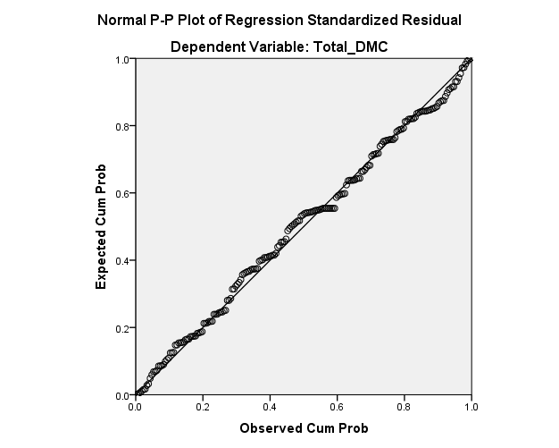

Chapter 5 Discussions, Conclusions and Recommendations

5.1 Summary of Statistics Analyses

5.1.1 Descriptive Analyses

5.1.1.1 General Information of Respondents
There was a total of 200 people in this study, among whom 104 men accounted for 52% and 96 women accounted for 48%. In terms of age, 122 people (61%) were aged between 30 and 43, followed by 52 people (26%) aged between 44 and 57, 22 people (11%) aged between 16 and 29 as well as 4 people (2%) aged over 58. In terms of education, 104 undergraduates (52%) which accounted for the largest percentage of the research population. Otherwise, 64 senior high school students (32%), 22 junior high school students (11%), and 10 master's and doctoral students (5%). The majority of the study population were production employees (65), accounting for 32.5%, in addition, 18.5% (37) were teachers, 17.5% (35) were salesmen, and others accounted for minority. In terms of income, there were 86 employees (43%) with a salary between 3,001-5,000rmb, 57 employees (28.5%) with a salary between 5,001-8,000rmb, 18 employees (9%) with a salary between 2,001-3,000rmb, 16 employees (8%) with a salary between 2,001-3,000rmb, and 10 employees (5%) with a salary between 1,001-15,000rmb. There were 7 employees (3.5%) with a salary above 15,001, and 6 people (3%) with no income at present. In terms of movie type preference, 24 women and 6 men liked watching romantic movies. Nine women and 24 men preferred war movies.21 women and 20 men preferred science fiction.15 women and 23 men liked watching action movies. There were 22 women and 10 men who liked drama. Other types of movies were in the minority.

5.1.1.2 Central Trend Measurement of Constructs
By utilizing frequency analysis, three independent variables (Internet Word-of-mouth, Film Schedule, Star appeal) and one dependent variable (Movie Consumption Decision) were analysed.
According to online word-of-mouth statement, the third sentence ‘When you are not sure which movie to watch, you prefer to watch the movie recommended by netizens’ scored the highest score, 3.39, compared with other two sentences. Therefore, when people don't know what movie to watch, they will search the Internet for relevant information and netizens' recommendations.
In the statement about the second independent variable movie schedule, ' You watch movies on weekends or holidays even though the price of ticket is relatively high.' has the highest score, 3.29. In terms of time, the participants are more likely to go to the cinema on holidays or weekends.
' Stars who have performed well in previous films will make you feel better about the movie.' was the highest-scoring statement in the star appeal statement, with a score of 3.12. Therefore, a star or actor who has performed well will make a good impression on the audience.
According to the table corresponding to the dependent variable (Decision Making), the average value of the first statement that ‘Your intention of watching movie in cinema is affected by online recommendation.’ is the highest, 3.38, indicating that IWOM is the most important factor which affect consumers' movie-watching decisions.

5.1.1.3 Reliability Analysis
Cronbach's alpha was used to conduct internal consistency test on 9 independent variables and 3 dependent variables, and the following conclusions were drawn. Among the three independent variables, the highest score belongs to IWOM, with the α of 0.711. Star appeal was second with score of 0.696. The lowest score was the movie schedule, with an alpha value of 0.638. Cronbach's α value of movie consumption decision is 0.703. All values were above 0.6, which is enough to indicate that the results of the study are reliable.

5.1.2 Inferential Analyses

5.1.2.1 Pearson Correlation Analysis
There is a strong positive-going correlation between Internet reputation, movie schedule and star appeal and the dependent variable by employing correlation analysis. Among them, the dependent variable of Internet reputation has the strongest positive relationship (r= 0.644, p<0.01), then is star appeal (r=0.568, p<0.01), and the weakest positive relationship between film schedule and the dependent variable (r= 0.566, p<0.01).

5.1.2.2 Multiple Linear Regression Analysis
Based on the multivariate return analysis, 69% of movie consumption decisions are affected by three independent variables, because R=0.690. This value indicates that the relationship between the two variables is the most significant when the change of movie consumption decision is influenced by the independent variable by 69%. Besides, 0.476 of R square means that 47.6% variance of movie consumption decision is significantly explained by IWOM, movie schedule and star appeal.
In the coefficient analysis of multiple regression model, the beta value of IWOM is the largest, 0.408, and the scores of film schedule (0.183) and star appeal (0.193) are smaller than those of IWOM. This indicates that among the three independent variables, the most influential factor film consumption decision is IWOM, which is consistent with the proposed research objective.

5.2 Main Findings
Table 5.1 Main Findings on Hypotheses Test
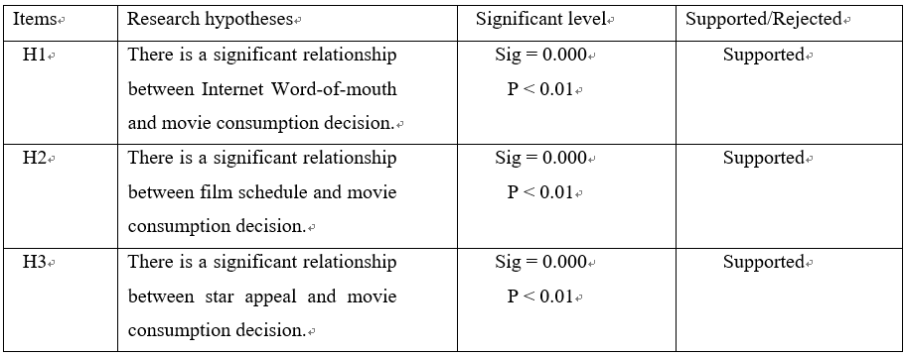
H1: There is a significant relationship between Internet Word-of-mouth and movie consumption decision.
Since Sig=0.000 is less than 0.01, there is a positive-going correlation between IWOM and film consumption decisions. According to multiple regression analysis, it is concluded that there is a significant correlation between IWOM and movie consumption decision with a conventional coefficient of 0.408, which indicates that the degree of IWOM affecting movie consumption decision-making is 40.8%.
That reason why IWOM has a significant impact on movie consumption decisions is because moviegoers don't watch movies that they're not familiar with. Consumers don't usually spend money to personally test a movie if they've never heard of it, so they look it up online for information and reviews. Therefore, at that time, their purchase intention is dependent on the quality of IWOM.
In a matter of fact, the results of this study are consistent with those of other researchers, that is, IWOM is positively correlated with movie consumption decisions. According to Liu (2001), before audiences choose a movie to watch, IWOM will have a strong impact on them if they believe that IWOM is one of credible source of information. In addition, Iris Mohr (2007) argues that word-of-mouth marketing stimulates other audiences by conveying their positive feelings and experiences when watching movies in cinemas. Chakravarty et al. (2010) believe that in this era of rapid development of information technology, IWOM is one of the most vital factors influencing consumers to make movie consumption decisions.
H2: There is a significant relationship between film schedule and movie consumption decision.
Since Sig=0.000 is less than 0.01, there is a positive-going correlation between film schedule and film consumption decisions. According to multiple regression analysis, it is concluded that there is a significant correlation between IWOM and movie consumption decision with a conventional coefficient of 0.183, which indicates that the degree of IWOM affecting movie consumption decision-making is 18.3%.
The movie schedule has a certain influence on movie consumption decisions because moviegoers decide whether to go to the cinema or not based on whether they have free time. People don’t want to spend extra time in cinema at weekdays when they are already tired after the whole day’s work. Moreover, through testing and analysis, it can be concluded that most people would choose to watch movies in weekends, festivals or holidays. Although the ticket prices are relatively expensive in these times, their focus is still on the issue of time.
Litman (1989) established the basic methodology and model of film box office research, and through testing he found that the summer vacation schedule had a positive impact on film consumption decisions and box office. Besides, Wang (2013) also verified that film schedule had a positive-going impact on movie consumption decision-making by Logit model.
H3: There is a significant relationship between star appeal and movie consumption decision.
Since Sig=0.000 is less than 0.01, there is a positive-going correlation between star appeal and film consumption decisions. According to multiple regression analysis, it is concluded that there is a remarkable correlation between star appeal and movie consumption decision with a conventional coefficient of 0.193, which indicates that the degree of star appeal affecting movie consumption decision-making is 19.3%.
In this era of rapid development of China's economy and information society, stars and actors have become the focus of discussion on TV and Internet news. Everyone has more or less one favourite star actor. As a result, whether the protagonist of a movie is favourite star or not becomes the factor that audiences pay attention to when choosing a movie.
Several researchers have made the same point. Karniouchina (2011) said that star appeal can attract audiences to the cinema, especially in the first week of the film release. Levin et al. (1997) also verified the same view that stars familiar to the audience are more likely to influence the audience's movie consumption decision. Similarly, star appeal can easily excite the audience when watching movies, which is enough to arouse their interest (Ravid, 1999). The findings of these three scholars are consistent with my hypothesis.

5.3 Study Implications
The results of this study are of great significance to the executives in the film industry. Since they need to decide how to market upcoming films in their management process, the conclusions of this article can provide them with effective advice. According to the analysis and conclusions drawn in the article, managers can consider the marketing incentives of different influencing factors to different types of movies, so as to stimulate and attract consumers' interest in watching movies especially in cinema.The results obtained from the three hypotheses prove that IWOM, movie schedule and star appeal have great influences on the consumption decisions of movie consumers.
- IWOM
According to H1, IWOM is the most influential factor, so market managers dealing with newly released films need to pay more attention to the impact of online reputation. Wenjing et al. (2018) indicated that marketing managers should make full use of IWOM channels in the film industry, including blogs, wikis and online reviews. Movie consumers always look at a new released movie with a sceptical eye. As a free and credible publicity campaign initiated by the public, IWOM usually adds credibility to the WOM marketing of new films (Chevalier, 2006). Internet users usually talk about high quality and attractive movies on the Internet, excellent movies will generate some wonderful reviews, and people who haven't seen the movie can make decisions about the movie consumption based on the reviews (Hadida, 2009). Therefore, a good IWOM must first come from the story line and quality of the film produced by the film producers, and whether the film itself looks good is the key way to promote IWOM. On the other hand, marketing managers should also accurately locate the target market and hold relevant promotional activities in the market, as this will stimulate the audience of the target market to concerned about to communicate based on the film, thus promoting the IWOM.
- Film Schedule
In addition, although movie schedule (H2) is the least influential factor among the three hypothetical independent variables on movie consumption decision, it also has a significant positive-going influence on the decision. Therefore, marketing managers should also pay attention to the importance of film schedule to increase the box office revenue. The ability to arrange the release time of a film and change the price of the ticket over time is one of the key factors for the success of film marketing. For audiences, the movie schedule is the time period when they have leisure time and are willing to focus on certain types of movies (Cui and Tang, 2012). In fact, film schedule is a form of film marketing. The emergence of the film schedule and the marketing strategy for the film market of different schedules is an important sign of the marketization degree of a country's film (Mingant, Tirtaine and Augros, 2015). However, a good schedule is not a guarantee, it is also fraught with risk (Liu, 2013). For example, in China, "Animal world", a film released during the 2018 summer vacation, has all prominences from Douban rating (Movie. douban. com) to director strength, star flow, production level and post-production special effects. In every way, it is a film with high reputation, high box office and high profits. In the matter of fact, the box office went up all the way when it was released. However, because of the official release of "Dying for survive", the box office of "Animal world" went down rapidly, and all audiences were attracted by "Dying for survive" (Sina News, 2018). Compared with the high box office in the hot movie schedule, its high risk is also obvious, since big-budget films want to generate high box office revenue when they are released on national holidays. Hence, there's a lot of competition in that time frame, and it's even worse than it would be in the normal time slot. Therefore, marketing managers need to conduct more rigorous investigation in the film schedule. They should not blindly believe that as long as the film is released in a good schedule, it will certainly gain considerable profits.
- Star Appeal
The importance of star appeal in movie consumption decisions also should be realized by marketing managers. Similarly, according to the research and analysis of this paper, star appeal has a strong positive impact on movie consumption decisions (H3). Films are more likely to be discussed by audiences when the actors in the films are the stars known by the audience (Van, 2013). Therefore, films can be developed and promoted by managers through the perspective of star influence according to the popularity and status of movie stars or actors in the minds of audiences. If the actors or stars have high recognition in the target market, the marketing manager should emphasize the details of the stars in the film on the posters and advertise in TV and newspapers to highlight the stars in the film (Collins et al., 2002). At the same time, they can tell about the previous films the stars have participated in and the awards or reputation they have won. If they have acted in very famous films, they should be emphasized more, so as to further enhance the credibility of the stars.

5.4 Limitations of the Study
1. Most respondents of the questionnaire are from Shanghai, China, which has not been widely spread to all provinces, regions and cities in China. This indicates that the results are not evenly distributed among different regions. Therefore, this study does not strictly consider the influence of residents in different regions on film consumption decisions.
2. The independent variables studied in this paper only include Internet reputation, movie schedule and star appeal. In fact, in addition to the three factors, there are many other factors such as the location of release, film director, film remake, film sequel, film adaptation, technical effect, distribution company and award status, which may also affect the decision of film consumption. In addition, as movies are an experiential product, they may have an impact on consumers' emotional state. However, this paper does not take into account the hedonic factors that consumers may have when watching movies, such as pleasure, cheerfulness, excitement and depression. These factors thus should be incorporated into future research.
3. Frequent moviegoers and infrequent moviegoers may have different responses to the three independent variables of this study, which were not taken into account in this paper. Therefore, this study neglected the difference effect of IWOM, movie schedule and actor power on people who often watch movies and those who don't.
4. Statistical analysis is relatively simple. Only descriptive analysis, reliability analysis, Pearson correlation analysis and multiple linear regression analysis were used in this study. Multiple linear regression analysis may have endogeneity, multicollinearity and other problems.

5.5 Recommendation for Future Study
1. This paper only uses quantitative research and does not conduct qualitative research on the problem. Qualitative research methods should be included in future studies to gain more insight into the research topic and to help assess emotional factors that may affect consumers' movie-watching decisions.
2. This study only collected the consumption intention of movie-watching consumers in Shanghai. China is a vast country and consumers in different regions may have different views on various factors. In addition, the sample size of this study is also small, only 200, which may lead to insufficient accuracy of the analysis results and may cause deviation from big data. Therefore, future studies should expand the scope of data collection to the whole of China and increase the amount of sample collection, which will play an important role in further research on the decisive factors that affect consumers' film buying intention.
3. The number of independent variables should also be expanded. There are many factors influencing movie consumption decisions, thus future research should consider more relevant factors. By combining more data and a wider range of data collection, research and analyse which factors will also affect movie consumption decisions and box office.
4. Individual differences will affect the consumption status and degree of the film. Future studies should investigate the different effects of independent variables on people who watch movies regularly and those who don't, which will give more accurate results.
5. Although the relationship between independent and dependent variables can be explained by multiple regression model, its prediction accuracy is poor. In the future, we need to continue to explore methods and models that are more suitable for studying the influencing factors of film consumption decisions based on the actual situation.

5.6 Reflection
Since the task of MBA project was proposed, I did not search a lot of literature on film industry and market in advance, which caused me to waste a lot of time in the early stage of my research when I encountered many problems about incomplete collection of literature materials. When I proposed the independent variable and dependent variable architecture, I also encountered some setbacks, mainly because there were too many factors affecting the film market and sales volume, and I did not know how to decide. In terms of data collection, since the research object population is Chinese, China does not have access to Google forms, so all questionnaire questions are translated into Chinese, and data collection is conducted on participants through the questionnaire survey website accessible by the Chinese network. In terms of the use of SPSS analysis method, I was not very familiar with the use of SPSS because I did not focus on and study the software for a long time, so I encountered many problems at the beginning of the analysis, but finally completed all the tasks of the project with the help of my teachers and classmates. This research not only enables me to learn the influencing factors of the Chinese film market and how to invest in the film industry if I have the opportunity in the future, but also enables me to feel the friendship between teachers and classmates and between classmates. Therefore, this research benefits me a lot.

REFERENCES:
Bello, M. (2009). Socio-Demographic and Economic Characteristics as Correlates of Work Attitudes of Elementary School Teachers. JPAIR Multidisciplinary Research, 3(1).
Berger, D. (2016). Kendall's Rank Correlation vs Pearson's Linear Correlation: A Proof Of Greiner's Relation. SSRN Electronic Journal.
Chaffee, Z. and Steven, Q. (1982). “Mass Media and Interpersonal Channels：Competitive，Convergent, or Complementary?” In Gary Gumpert and Robert Cathcart. New York: Oxford University Press.
Chakravarty, A., Liu, Y., and Mazumdar, T. (2010). The differential effects of online word-of-mouth and critics' reviews on pre-release movie evaluation. Journal of Interactive Marketing, 185-197.
Chen, L. (2018). Empirical study on the impact of Internet word-of-mouth on the economic benefits of film products. [online] Cdmd.cnki.com.cn. Available at: http://cdmd.cnki.com.cn/Article/CDMD-10357-1018087907.htm [Accessed 23 Apr. 2019].
Chen, R. (2016). Research on influencing factors of commercial movie box office in china - based on multiple linear regression and neural network analysis. [online] Max.book118.com. Available at: https://max.book118.com/html/2018/0808/8066061067001117.shtm [Accessed 23 Apr. 2019].
Chen, W. (2016). Research on the influence of online word-of-mouth on the box office of mainland film market from 2014 to 2015. [online] Max.book118.com. Available at: https://max.book118.com/html/2018/0410/160906798.shtm [Accessed 23 Apr. 2019].
Cheung, C. and Lee, M. (2012). What drives consumers to spread electronic word of mouth in online consumer-opinion platforms. Decision Support Systems, 53(1), pp.218-225.
Chevalier, J. and Mayzlin, D. (2006). The Effect of Word of Mouth on Sales: Online Book Reviews. Journal of Marketing Research, 43(3), pp.345-354.
China economic information network. (2019). Analysis of China's total population, gender, age and urban-rural structure in 2018. [online] Available at: https://baijiahao.baidu.com/s?id=1623601218323141434&wfr=spider&for=pc [Accessed 22 Apr. 2019].
China Film Insider. (2019). Chinese Box Office Takings Dip By 5% In The First 5 Months of 2019 | China Film Insider. [online] Available at: http://chinafilminsider.com/chinese-box-office-takings-dip-by-5-in-the-first-5-months-of-2019/ [Accessed 23 Jun. 2019].
Chyxx. (2019). Analysis on the development trend of Chinese film industry box office revenue in 2019. [online] Available at: http://www.chyxx.com/industry/201902/717194.html [Accessed 23 Jun. 2019].
Collins, A., Hand, C. and Snell, M. (2002). What makes a blockbuster? Economic analysis of film success in the United Kingdom. Managerial and Decision Economics, 23(6), pp.343-354.
Cui, G., Lui, H. and Guo, X. (2012). The Effect of Online Consumer Reviews on New Product Sales. International Journal of Electronic Commerce, 17(1), pp.39-58.
Cui, N. and Tang, J. (2012). Research on Influencing Factors of Chinese Film Box Office based on Regression Analysis. Commercial Economy, 8, pp.35-38.
Datte, P., Chowdhury, D. and Chakraborty, B. (2005). Viral Marketing: New Form of Word-of-Mouth Through Internet. The Business Review, 3(2), pp.69-75.
De Vany, A. and Walls, W. (1999). Uncertainty in the movie industry：Does star power reduce the terror of the box office?. Journal of Cultural Economics, 23(4), pp.285-318.
De Vaus, D. (2001). Research Design in Social Research. London: SAGE, pp.8-9.
Duan, W., Gu, B. and Whinston, A. (2008). The dynamics of online word-of-mouth and product sales—An empirical investigation of the movie industry. Journal of Retailing, 84(2), pp.233-242.
Evans, J. (1996). Straightforward statistics for the behavioral sciences. Pacific Grove: Cole Publishing.
Fletcher, J. (2009). Multiple linear regression. BMJ, 338(jan28 3), pp. b167-b167.
Gabor, M. R. (2010). Descriptive methods of data analysis for marketing data: Theoretical and practical considerations. Management and Marketing, 119-134.
Galasiński, D. and Kozłowska, O. (2012). Interacting with a questionnaire: respondents’ constructions of questionnaire completion. Quality & Quantity, 47(6), pp.3509-3520.
Hadida, A. (2009). Motion picture performance: A review and research agenda. International Journal of Management Reviews, 11(3), pp.297-335.
Hanson, W. and Kalyanam, K. (2004). Principles of Internet marketing. Mason, Ohio: South-Western.
Haw, W., Ho, E., Lim, Y. and Wong, J. (2013). The Effect of Trailar, Critics Review, Star Power and Word of Mouth Toward Decision Making on Movie Consumption. Malaysia: University Tunku Abdul Rahman.
Helm S. (2000). Viral Marketing: Establishing Customer Relationships by Word-of-mouth. Electric Markets, 10(3), pp.159-160.
Hennig-Thurau, T., Gwinner, K., Walsh, G. and Gremler, D. (2004). Electronic word-of-mouth via consumer-opinion platforms: What motivates consumers to articulate themselves on the Internet?. Journal of Interactive Marketing, 18(1), pp.38-52.
Hoszowska, A. (2014). User Generated Content - The empowerment of consumers. [online] BrandBa.se. Available at: http://www.brandba.se/blog/socialmedia/usergeneratedcontent/theempowermentofconsumers [Accessed 18 Jun. 2019].
Hou, P. and Chung, R. (2019). New Era of China’s Film Industry. [online] www2.deloitte.com. Available at: https://www2.deloitte.com/content/dam/Deloitte/cn/Documents/about-deloitte/dttp/deloitte-cn-dttp-vol5-chapter5-en.pdf [Accessed 18 Jun. 2019].
Howitt, D. and Cramer, D. (2014). Introduction to SPSS in psychology. Harlow: Pearson Education.
Hughes-Warrington, M. (2009). History goes to the movies: studying history on film. London: Routledge.
Iris, M. (2007). Buzz marketing for movies. Business Horizons, 50(5), pp.395-403
Karniouchina, V. E. (2011). Impact of star and movie buzz on motion picture distribution and box office revenue. Journal of Research in Marketing, 28, 62-74
Krejcie, R. and Morgan, D. (1970). Determining Sample Size for Research Activities. Educational and Psychological Measurement, 30(3), pp.607-610.
Kumar, R. (2014). Research methodology: a step-by-step guide for beginners. London; Thousand Oaks, Calif: SAGE.
Kumar, S. (2013). Online Reviews: Do Consumers Trust Them. SSRN Electronic Journal.
Levin, A. M., Levin, I. P., and Heath, C. E. (1997). Movie stars and authors as brand names: Measuring brand equity in experiential products. Advances in Consumer Research, 24, 175-181.
Litman, B. (1983). Predicting Success of Theatrical Movies: An Empirical Study. The Journal of Popular Culture, 16(4), pp.159-175.
Litman, B. R. (1989). Predicting Success of Theatrical Movies: The 80’s Experiences. Journal of Media Economics, 23(2), pp.35-50.
Litvin, S., Goldsmith, R. and Pan, B. (2008). Electronic word-of-mouth in hospitality and tourism management. Tourism Management, 29(3), pp.458-468.
Liu, Y. (2001). Word-of-mouth for movies: Its dynamics and impact on box office revenue. Forthcoming at the Journal of Marketing, 1-49.
Liu, Y. (2006). Word of Mouth for Movies: Its Dynamics and Impact on Box Office Revenue. Journal of Marketing, 70(3), pp.74-89.
Liu, Y. (2013). Empirical Analysis of Influencing Factors of Chinese Film Box Office. Economic and Management Strategy Research, 8, 40-52.
Ma, Y. (2014). Research on the impact of Internet word-of-mouth on film box office -- an empirical study based on the Chinese mainland film market. [online] docin. Available at: https://www.docin.com/p-1685839982.html [Accessed 23 Apr. 2019].
Mingant, N., Tirtaine, C. and Augros, J. (2015). Film marketing into the twenty-first century. London: A BFI Book, published by Palgrave.
Motion Picture Association of America (MPAA). (2018). A comprehensive analysis and survey of the theatrical and home entertainment market environment (THEME) for 2018. [online] Available at: https://www.mpaa.org/wp-content/uploads/2019/03/MPAA-THEME-Report-2018.pdf [Accessed 22 Apr. 2019].
Moul, C. (2007). Measuring Word of Mouth's Impact on Theatrical Movie Admissions. Journal of Economics & Management Strategy, 16(4), pp.859-892.
Nagy, G. (2018). Sector Based Linear Regression, a New Robust Method for the Multiple Linear Regression. Acta Cybernetica, 23(4), pp.1017-1038.
Nie, H. (2015). Factors influencing the box office of Chinese films and their empirical research. [online] Xueshu.baidu.com. Available at: http://xueshu.baidu.com/usercenter/paper/show?paperid=d1cdb159914a2e2cc901638a89176285&site=xueshu_se [Accessed 23 Apr. 2019].
Paul, J. and Rana, J. (2012). Consumer behavior and purchase intention for organic food. Journal of Consumer Marketing, 29(6), pp.412-422.
Philpot, J. (2011). The Contemporary Hollywood Film Industry. Journal of Film and Video, 63(1), pp.71-72.
Ravid, S. (1999). Information, blockbusters, and stars: A study of the film industry. Journal of Business, 72, 463-92.
Sekaran, U. and Bougie, R. (2011). Research Methods for business: A skill building approach. 5th ed. New Delhi: John Wiley and Sons.
Sekaran, U. and Bougie, R. (2013). Research Methods for Business: A Skill-Building Approach. 6th ed. Chichester: WILEY.
Shanghai statistics bureau. (2018). What is the permanent population of Shanghai in 2018?. [online] Available at: http://www.chinairn.com/news/20181119/15125348.shtml [Accessed 22 Apr. 2019].
Shi, W., Tang, L., Zhang, X., Gao, Y. and Zhu, Y. (2016). How does word of mouth affect customer satisfaction?. Journal of Business & Industrial Marketing, 31(3), pp.393-403.
Sina News. (2018). The impact of film schedule on box office. [online] Available at: http://k.sina.com.cn/article_2348210457_8bf6d91900100ds4d.html [Accessed 14 Aug. 2019].
Sochay, S. (1994). Predicting the Performance of Motion Pictures. Journal of Media Economics, 7(4), pp.1-20.
Stauss, B. (1997). Global word-of-mouth: Service bashing on Internet is a thorny issus. Merketing Management, 6, pp.28-30.
Tavakol, M. and Dennick, R. (2011). Making sense of Cronbach's alpha. International Journal of Medical Education, 2, pp.53-55.
Trochim, W. (2006). Social Research Methods - Knowledge Base - Descriptive Statistics. [online] Socialresearchmethods.net. Available at: http://www.socialresearchmethods.net/kb/statdesc.php [Accessed 6 Aug. 2019].
Trochim, W. and Donnelly, J. (2008). Research methods knowledge base. Mason, Ohio: Atomic Dog/Cengage Learning.
Van, D. (2013). Harnessing the Power of the Stars: The Economics Behind the Classical Hollywood Star System. Film Matters, 4(2), pp.24-29.
Wagner, W. (2016). Using IBM SPSS statistics for research methods and social science statistics. Sage Publications.
Wang, F., Zhang, Y., Li, X. L., & Zhu, H. W. (2010). Why do moviegoers go the theatre? The role of pre-release media publicity and online word of mouth in driving moviegoing behaviour. Journal of Interactive Advertising, 11(1).
Wang, Z. (2013). Analysis of Influencing Factors of Film Box Office – Research based on Logit Model. Journal of Economics, 11, 96-102.
Weaver, B. and Koopman, R. (2014). An SPSS Macro to Compute Confidence Intervals for Pearson’s Correlation. The Quantitative Methods for Psychology, 10(1), pp.29-39.
Wenjing, D., Bin, G., and Whinston, A. B. (2018). The dynamics of online word-of-mouth and product sales: An empirical investigation of the movie industry. Journal of Retailing, 233-242.
World Population Review. (2019). World City Populations 2019. [online] Available at: http://worldpopulationreview.com/world-cities/ [Accessed 23 Apr. 2019].
Worldometers. (2019). China Population (2019) - Worldometers. [online] Available at: http://www.worldometers.info/world-population/china-population/ [Accessed 23 Apr. 2019].
Wyatt, J. (1991). High concept，product differentiation，and the contemporary U．S． film industry．Norwood, NJ: Ablex, pp.86-105.
Yan, X. and Su, X. (2009). Linear regression analysis. Singapore: World Scientific Pub. Co.
Yu, H. (2016). A study on the factors influencing the box office of Chinese mainland films -- based on the micro data of 261 films in 2014-2015. [online] Max.book118.com. Available at:https://max.book118.com/html/2018/0608/171414171.shtm [Accessed 23 Apr. 2019].
Zikmund, W., Babin, B., Carr, J. and Griffin, M. (2013). Business research methods. Mason, Ohio: South-Western.
Zou, K., Tuncali, K. and Silverman, S. (2003). Correlation and Simple Linear Regression. Radiology, 227(3), pp.617-628.
Zumbo, B., Gadermann, A. and Zeisser, C. (2007). Ordinal Versions of Coefficients Alpha and Theta for Likert Rating Scales. Journal of Modern Applied Statistical Methods, 6(1), pp.21-29.

APPENDIX 1: Questionnaire
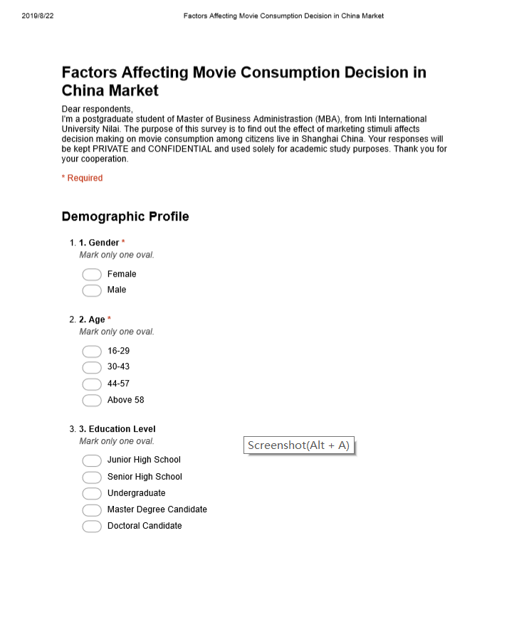
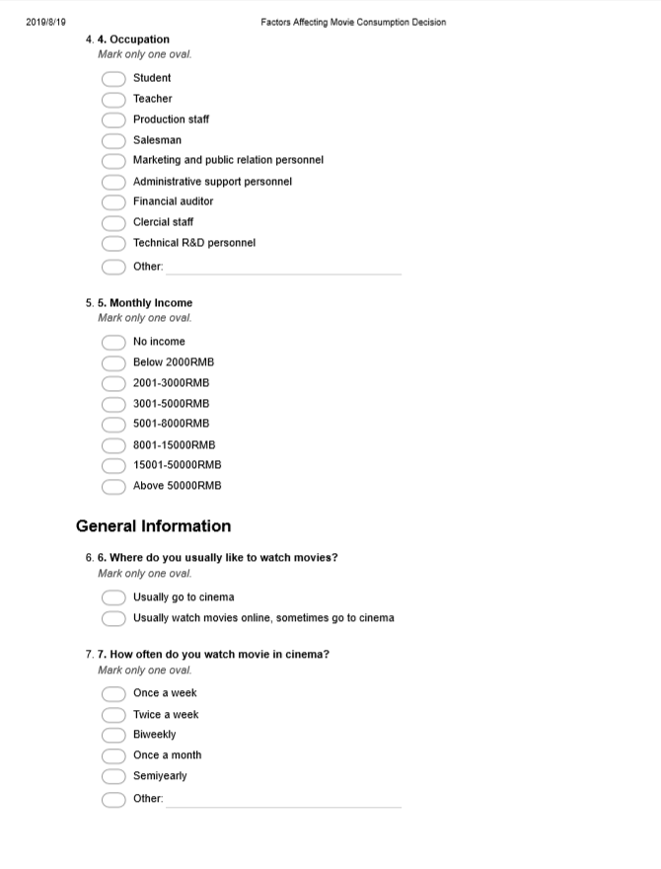
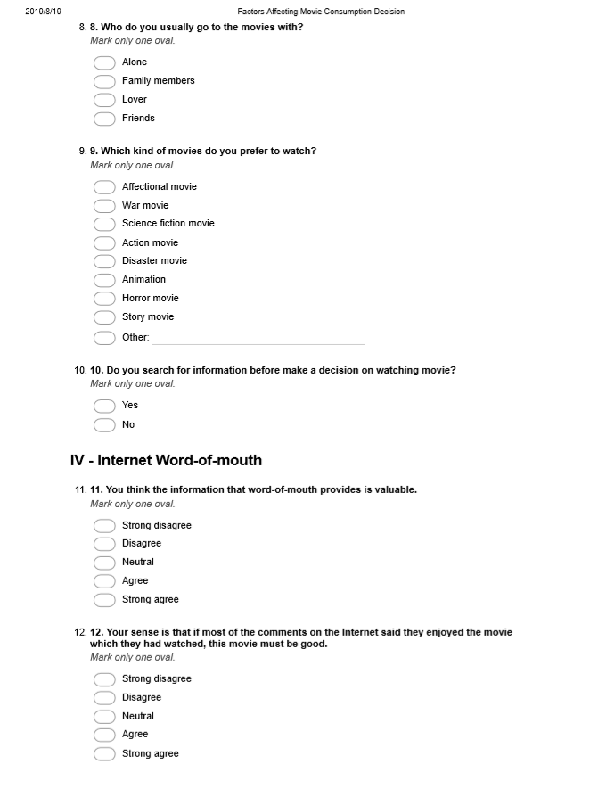
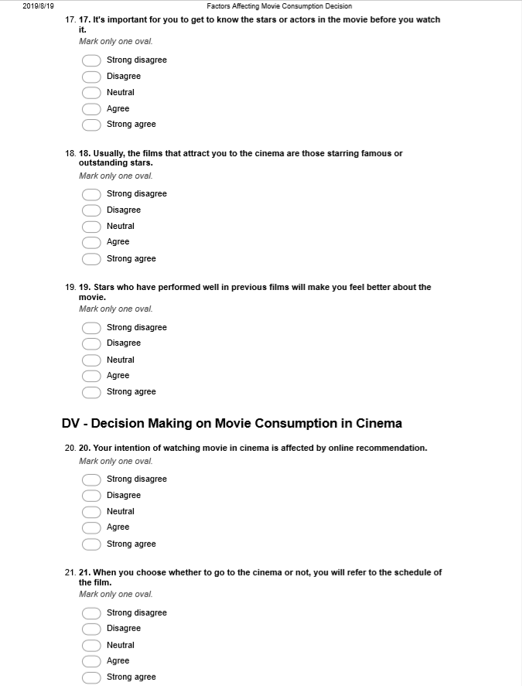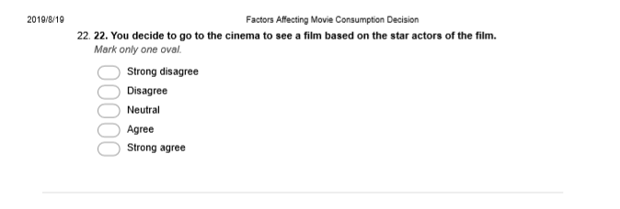

APPENDIX 2: Initial Research Paper Proposal
STUDENT NAME & ID NO | ZHUANG QIN I18014283
BROAD AREA | Marketing
Concise Title | Factors Affecting Movie Consumption Decision
Problem Definition | Looking at home and abroad research, there is relatively little investigation about utilizing netizen evaluation marketing to the filmdom. There are fewer studies that select actual box office data and IWOM for empirical analysis (Nguyen and Romaniuk, 2013). Therefore, more research is needed to perfect this area.  Collecting box office data for the past three years, considering the impact on the sales of the movie through a number of factors including IWOM (Liu, 2006). The conclusions of this paper are obtained and provide important theoretical guidance for film IWOM marketing.  As for literature, as the beginning the correlative theories and concepts of WOM and IWOM. Then, introducing the big impact on consumers’ purchase behaviour from IWOM (Zufryden, 2000). Finally, related researches of current IWOM and box office are teased and evaluated based on the properties and feature of movie industry (McKenzie and Walls, 2012).  The main issues study in this paper are: What factors will consumers pay attention to when choosing a movie? Do consumers actively collect video related information before they want to watch movie? What causes consumers to decide purchasing intention? Does IWOM have an impact on decision making? and many more (McKenzie, 2009).  The results of this survey are of significant importance to the film industry, the business community, and the interests of national business. Based on commercial films, the study of the factors affecting the box office is conducive to the development of the film industry, while giving the business community important development and investment reference value. In addition, the improvement of the two will undoubtedly bring more national interests (Cabral and Natividad, 2016).
Research Questions OR Objectives | To determine the relationship between Internet Word-of-mouth and decision making on movie consumption  To determine the relationship between film schedule and decision making on movie consumption  To determine the relationship between star power and decision making on movie consumption
Scope of study | Geographic focus: China Shanghai  Sample focus: Chinese participants mainly in Shanghai Municipality  Analysis focus: Analyse the impact of IWOM, film schedule and star appeal on movie sales  Methodology: First, the reliability of each variable is tested. Secondly, the SPSS software is used to analyse the sample data.
Significance of the Research | This paper selects 200 Chinese residents whose age from 16-59 for analysis, analyzing the influence of Internet word-of-mouth, film schedule and star appeal on consumer purchasing decisions, revealing the important impact of movie marketing on the film industry (Zuckerman, 2003).
Literature Review | Hanson (2000) called it Electronic WOM or Online WOM, which is spread through e-mail, online forums and discussion boards through the Internet as a medium.  Helm (2000) pointed out that IWOM has a profound impact on consumers' purchase decisions, and it has become an important source for consumers to obtain film information.  Litman (1983) found that the decisive factors significantly affecting the decision making on movie consumption include the film producing budget, the number of cinema screens, professional movie comments, film type, distribution in the big cinema, film schedule of Christmas, Oscar nominations and other awards.
Research Methodology | The research content of this paper mainly includes the design of questionnaire, data collection, measurement tools and methods. The main target of this study is to analyse the influencing factors of movie consumption decision of consumers and Chinese box office, and descriptive analysis and inferential analyses are adopted.  Pearson correlation analysis and multiple regression analysis are performed on the collected data by using SPSS, verifying interaction of IWOM, film schedule and star appeal with movie consumption decision-making and box office.

APPENDIX 3: SPSS Output for Descriptive Analyses
Demographic Statistics
Gender
 |  | Frequency | Percent | Valid Percent | Cumulative Percent
Valid | Female | 96 | 48.0 | 48.0 | 48.0
Valid | Male | 104 | 52.0 | 52.0 | 100.0
Valid | Total | 200 | 100.0 | 100.0

Age
 |  | Frequency | Percent | Valid Percent | Cumulative Percent
Valid | 16-29 | 22 | 11.0 | 11.0 | 11.0
Valid | 30-43 | 122 | 61.0 | 61.0 | 72.0
Valid | 44-57 | 52 | 26.0 | 26.0 | 98.0
Valid | Above58 | 4 | 2.0 | 2.0 | 100.0
Valid | Total | 200 | 100.0 | 100.0

EducationLevel
 |  | Frequency | Percent | Valid Percent | Cumulative Percent
Valid | JuniorHighSchool | 22 | 11.0 | 11.0 | 11.0
Valid | SeniorHighSchool | 64 | 32.0 | 32.0 | 43.0
Valid | Undergraduate | 104 | 52.0 | 52.0 | 95.0
Valid | MasterDegreeCandidate | 9 | 4.5 | 4.5 | 99.5
Valid | DoctoralCandidate | 1 | .5 | .5 | 100.0
Valid | Total | 200 | 100.0 | 100.0

Occupation
 |  | Frequency | Percent | Valid Percent | Cumulative Percent
Valid | Student | 5 | 2.5 | 2.5 | 2.5
Valid | Teacher | 37 | 18.5 | 18.5 | 21.0
Valid | ProductionStaff | 65 | 32.5 | 32.5 | 53.5
Valid | Salesman | 35 | 17.5 | 17.5 | 71.0
Valid | MarketingPersonnel | 13 | 6.5 | 6.5 | 77.5
Valid | AdministrativeSupportPersonnel | 14 | 7.0 | 7.0 | 84.5
Valid | FinancialAuditor | 9 | 4.5 | 4.5 | 89.0
Valid | ClercialStaff | 16 | 8.0 | 8.0 | 97.0
Valid | TechnicalR&DPersonnel | 4 | 2.0 | 2.0 | 99.0
Valid | Other | 2 | 1.0 | 1.0 | 100.0
Valid | Total | 200 | 100.0 | 100.0

MonthlyIncome
 |  | Frequency | Percent | Valid Percent | Cumulative Percent
Valid | NoIncome | 6 | 3.0 | 3.0 | 3.0
Valid | Below2000RMB | 18 | 9.0 | 9.0 | 12.0
Valid | 2001-3000RMB | 16 | 8.0 | 8.0 | 20.0
Valid | 3001-5000RMB | 86 | 43.0 | 43.0 | 63.0
Valid | 5001-8000RMB | 57 | 28.5 | 28.5 | 91.5
Valid | 8001-15000RMB | 10 | 5.0 | 5.0 | 96.5
Valid | 15001-50000RMB | 2 | 1.0 | 1.0 | 97.5
Valid | Above50000RMB | 5 | 2.5 | 2.5 | 100.0
Valid | Total | 200 | 100.0 | 100.0
Central Trend Measurement of Constructs
Descriptive Statistics
 | N | Minimum | Maximum | Mean | Std. Deviation | Skewness |  | Kurtosis
 | Statistic | Statistic | Statistic | Statistic | Statistic | Statistic | Std. Error | Statistic |  | Std. Error
MCD1 | 200 | 1 | 5 | 3.38 | 1.028 | -.388 | .172 | -.454 |  | .342
MCD2 | 200 | 1 | 5 | 3.31 | 1.020 | -.560 | .172 | .281 |  | .342
MCD3 | 200 | 1 | 5 | 3.31 | 1.008 | .227 | .172 | .311 |  | .342
Valid N (listwise) | 200
Descriptive Statistics
 | N | Minimum | Maximum | Mean | Std. Deviation | Skewness |  | Kurtosis
 | Statistic | Statistic | Statistic | Statistic | Statistic | Statistic | Std. Error | Statistic |  | Std. Error
IWOM1 | 200 | 1 | 5 | 3.26 | .943 | -.168 | .172 | .649 |  | .342
IWOM2 | 200 | 1 | 5 | 3.33 | 1.050 | -.171 | .172 | -.660 |  | .342
IWOM3 | 200 | 1 | 5 | 3.39 | 1.070 | -.327 | .172 | .688 |  | .342
Valid N (listwise) | 200
Descriptive Statistics
 | N | Minimum | Maximum | Mean | Std. Deviation | Skewness |  |  | Kurtosis
 | Statistic | Statistic | Statistic | Statistic | Statistic | Statistic | Std. Error |  | Statistic |  | Std. Error
FS1 | 200 | 1 | 5 | 3.26 | 1.070 | -.425 | .172 |  | -.615 |  | .342
FS2 | 200 | 1 | 5 | 3.29 | 1.055 | -.360 | .172 |  | -.465 |  | .342
FS3 | 200 | 1 | 5 | 3.25 | .974 | -.500 | .172 |  | .079 |  | .342
Valid N (listwise) | 200
Descriptive Statistics
 | N | Minimum | Maximum | Mean | Std. Deviation | Skewness |  |  | Kurtosis
 | Statistic | Statistic | Statistic | Statistic | Statistic | Statistic | Std. Error |  | Statistic |  | Std. Error
SA1 | 200 | 1 | 5 | 2.97 | 1.028 | -.288 | .172 |  | -.500 |  | .342
SA2 | 200 | 1 | 5 | 3.09 | 1.071 | .294 | .172 |  | -.493 |  | .342
SA3 | 200 | 1 | 5 | 3.12 | .986 | -.499 | .172 |  | -.102 |  | .342
Valid N (listwise) | 200

APPENDIX 4: SPSS Output for Reliability Analysis
Variables | Items | Cronbach’s Alpha (α)
Internet Word-of-mouth (IV) | 3 | 0.711
Film Schedule (IV) | 3 | 0.638
Star appeal (IV) | 3 | 0.696
Decision Making on Movie Consumption (DV) | 3 | 0.703
Internet Word-of-mouth (IV)
Reliability Statistics
Cronbach's Alpha | N of Items
.711 | 3
Film Schedule (IV)
Reliability Statistics
Cronbach's Alpha | N of Items
.638 | 3
Star Appeal (IV)
Reliability Statistics
Cronbach's Alpha | N of Items
.696 | 3
Movie Consumption Decision
Reliability Statistics
Cronbach's Alpha | N of Items
.703 | 3

APPENDIX 5: SPSS Output for Pearson Correlation Analysis
Correlations
 |  | Total_IWOM | Total_FS | Total_SA | Total_MCD
Total_IWOM | Pearson Correlation | 1 | .632** | .626** | .644**
Total_IWOM | Sig. (2-tailed) |  | .000 | .000 | .000
Total_IWOM | Sum of Squares and Cross-products | 129.351 | 81.129 | 82.304 | 84.773
Total_IWOM | Covariance | .650 | .408 | .414 | .426
Total_IWOM | N | 200 | 200 | 200 | 200
Total_FS | Pearson Correlation | .632** | 1 | .650** | .566**
Total_FS | Sig. (2-tailed) | .000 |  | .000 | .000
Total_FS | Sum of Squares and Cross-products | 81.129 | 123.464 | 82.197 | 71.620
Total_FS | Covariance | .408 | .620 | .413 | .360
Total_FS | N | 200 | 200 | 200 | 200
Total_SA | Pearson Correlation | .626** | .650** | 1 | .568**
Total_SA | Sig. (2-tailed) | .000 | .000 |  | .000
Total_SA | Sum of Squares and Cross-products | 82.304 | 82.197 | 133.547 | 73.486
Total_SA | Covariance | .414 | .413 | .671 | .369
Total_SA | N | 200 | 200 | 200 | 200
Total_MCD | Pearson Correlation | .644** | .566** | .568** | 1
Total_MCD | Sig. (2-tailed) | .000 | .000 | .000
Total_MCD | Sum of Squares and Cross-products | 84.773 | 71.620 | 73.486 | 129.553
Total_MCD | Covariance | .426 | .360 | .369 | .651
Total_MCD | N | 200 | 200 | 200 | 200
**. Correlation is significant at the 0.01 level (2-tailed).

APPENDIX 6: SPSS Output for Multiple Regression Analysis
Model Summary^{b}
Model | R | R Square | Adjusted R Square | Std. Error of the Estimate | Change Statistics |  |  |  |  | Durbin-Watson
 |  |  |  |  | R Square Change | F Change | df1 | df2 | Sig. F Change | Durbin-Watson
1 | .690ª | .476 | .468 | .58842 | .476 | 59.390 | 3 | 196 | .000 | 2.029
a. Predictors: (Constant), Total_IWOM, Total_FS, Total_SA
b. Dependent Variable: Total_MCD

ANOVAª
Model |  | Sum of Squares | df | Mean Square | F | Sig.
1 | Regression | 61.690 | 3 | 20.563 | 59.390 | .000^{b}
1 | Residual | 67.864 | 196 | .346
1 | Total | 129.553 | 199
a. Dependent Variable: Total_MCD
b. Predictors: (Constant), Total_IWOM, Total_FS, Total_SA

Coefficientsª
Model |  | Unstandardized Coefficients |  | Standardized Coefficients | t | Sig.
 |  | B | Std. Error | Beta | t | Sig.
1 | (Constant) | .790 | .197 |  | 4.009 | .000
1 | Total_IWOM | .402 | .071 | .408 | 5.693 | .000
1 | Total_FS | .187 | .075 | .183 | 2.486 | .009
1 | Total_SA | .193 | .073 | .193 | 2.643 | .004
a. Dependent Variable: Total_MCD

APPENDIX 7: PowerPoint
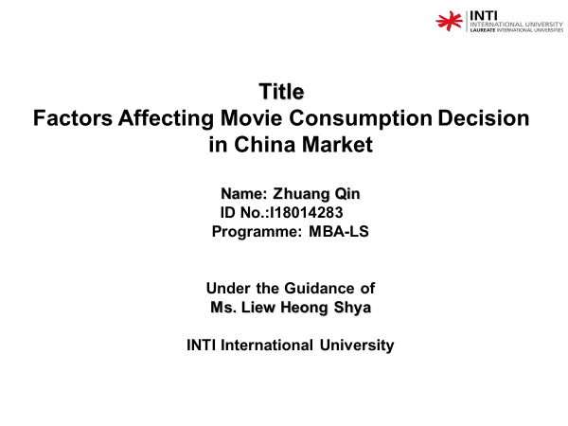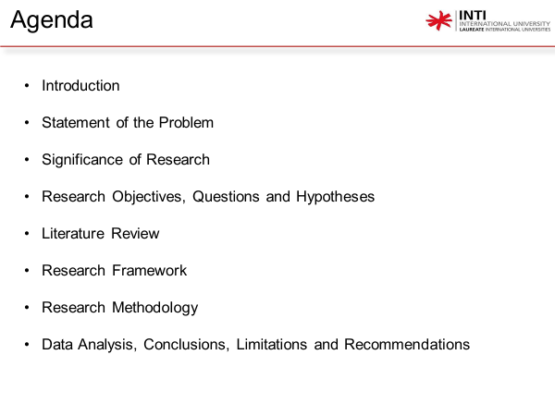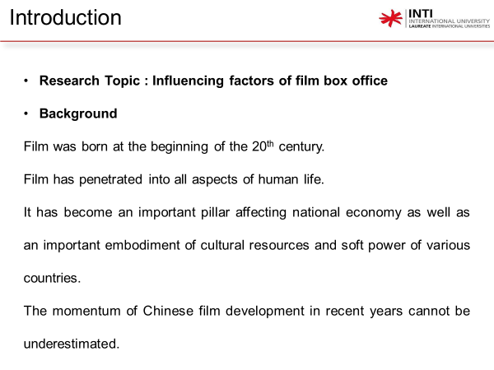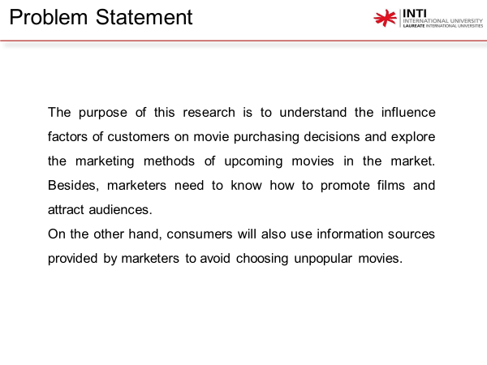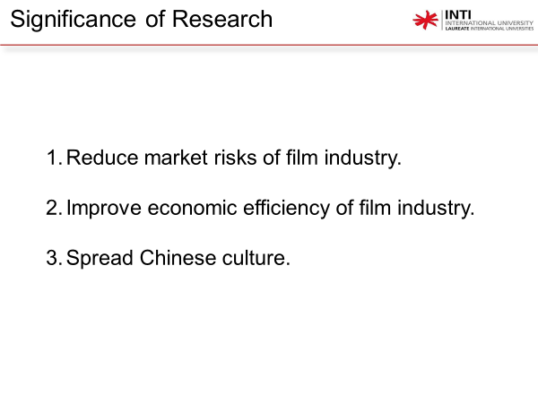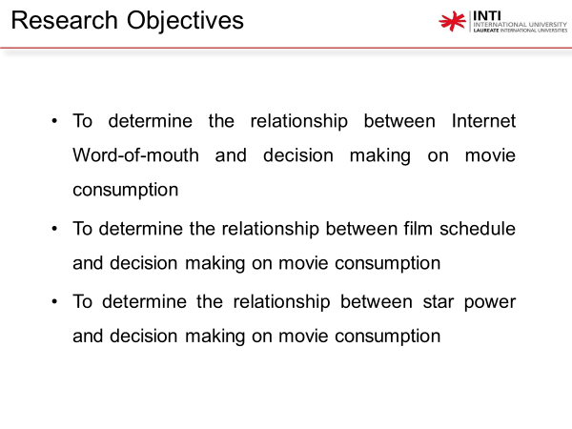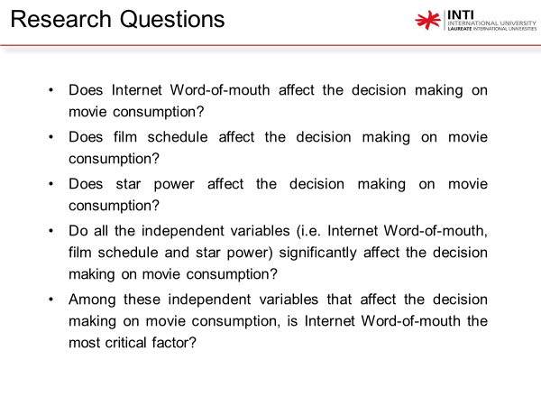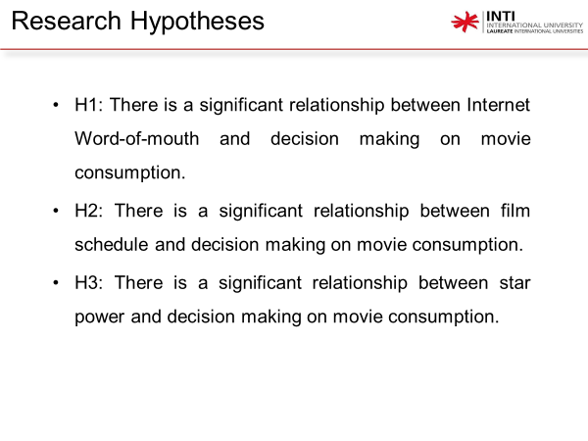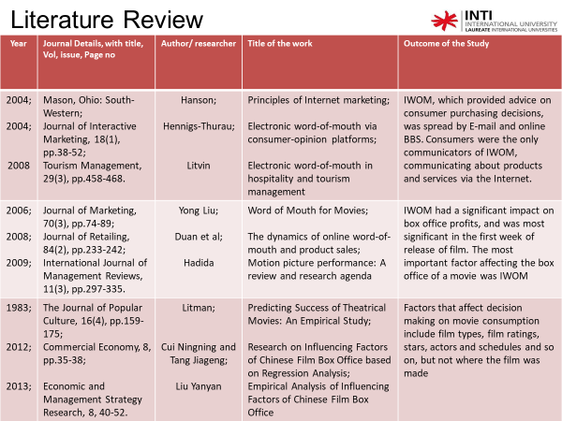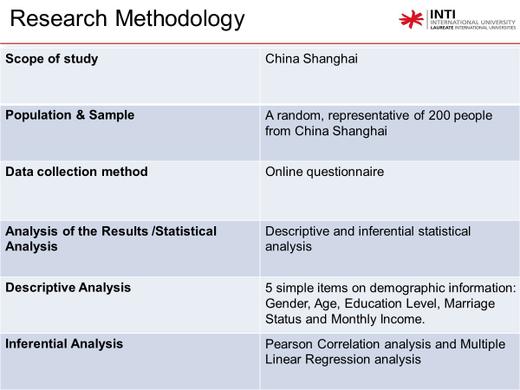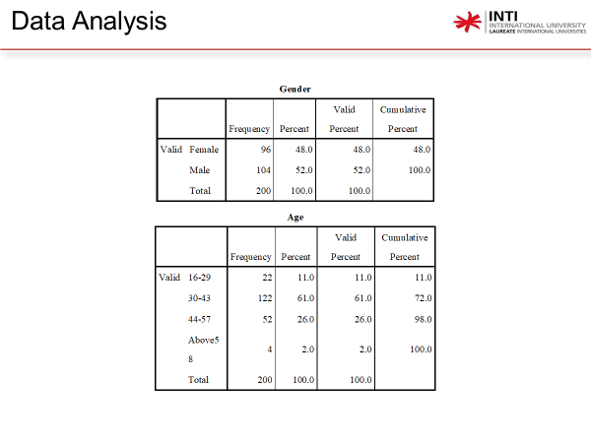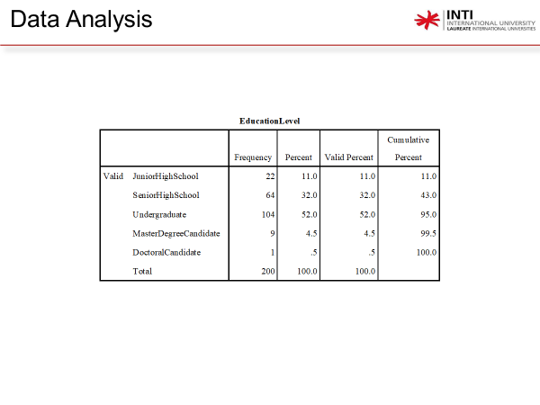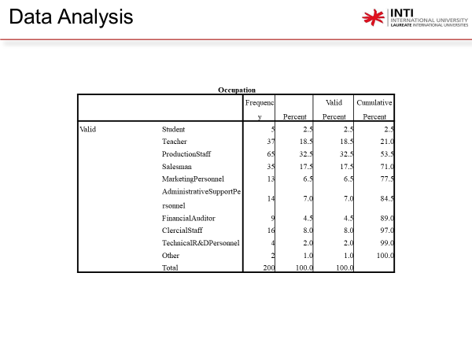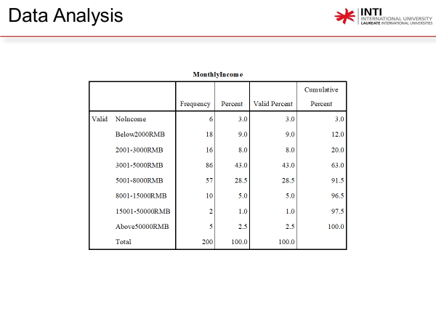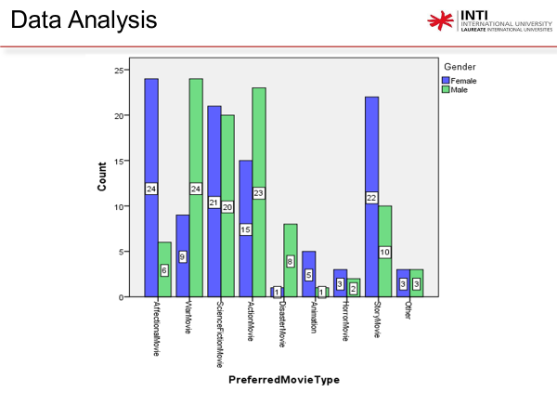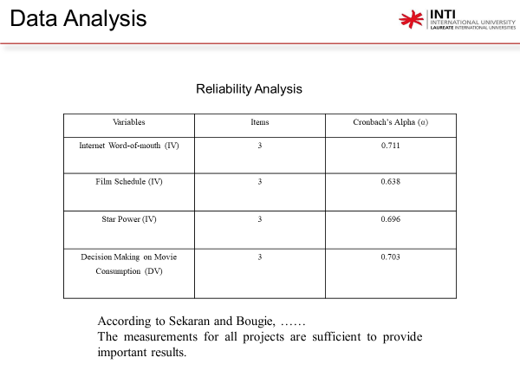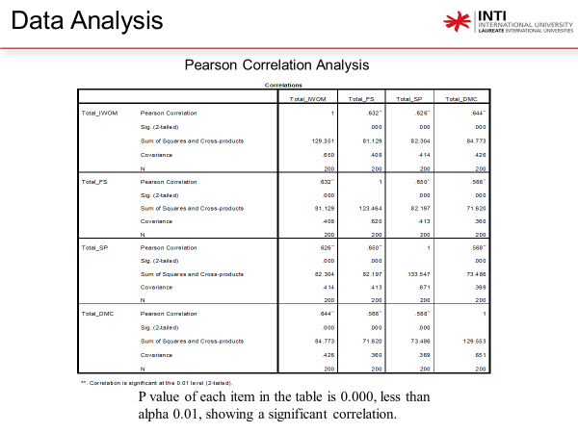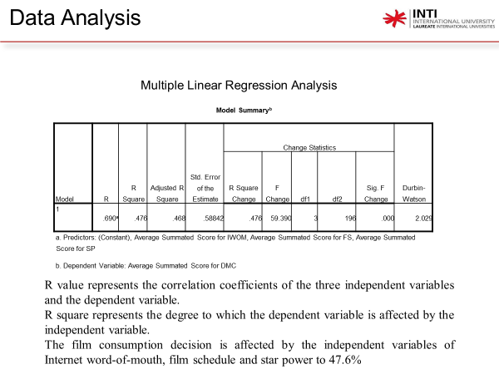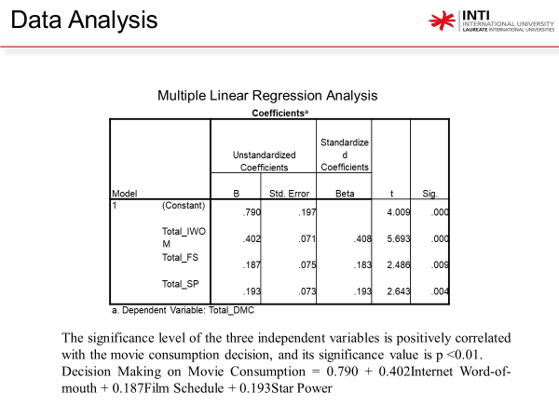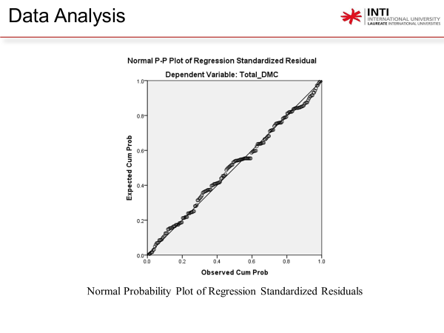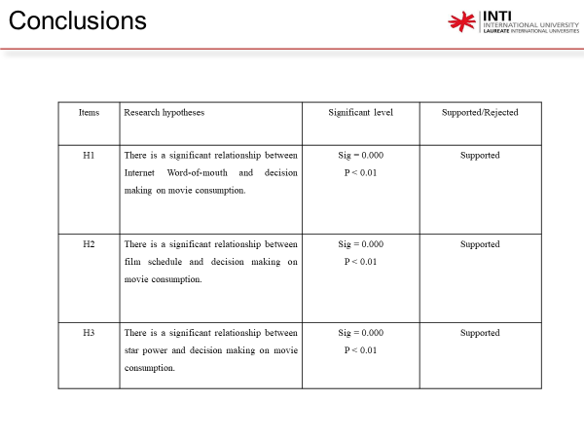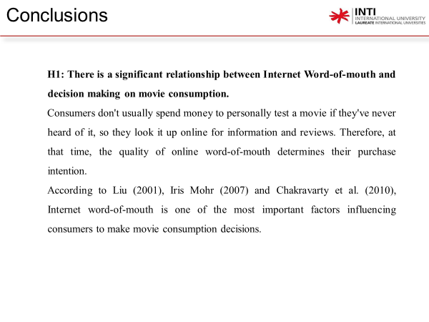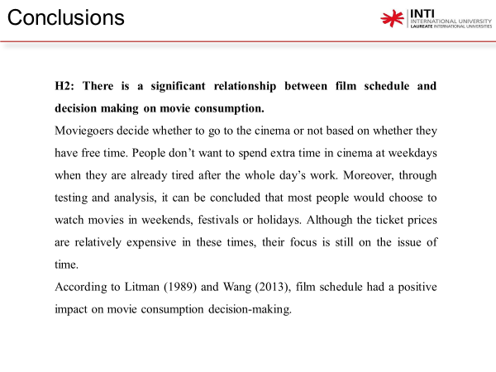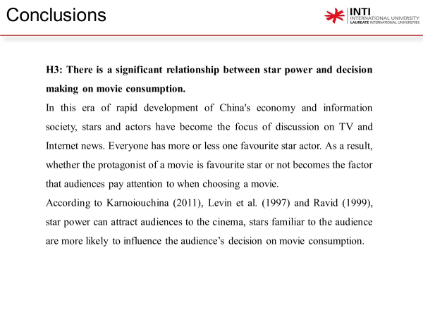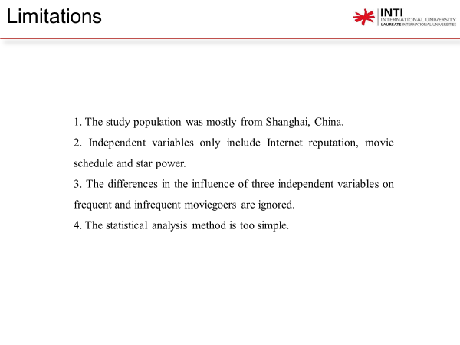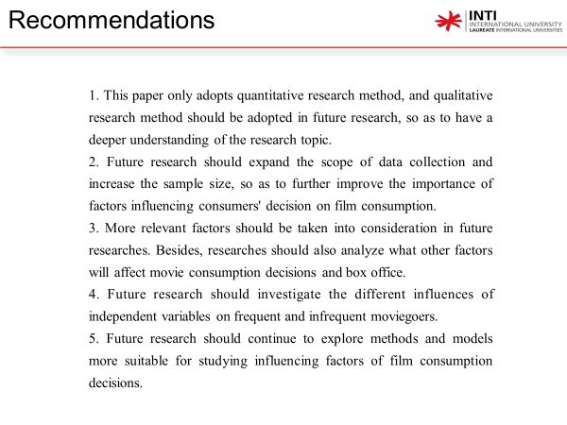

APPENDIX 8: Project Paper Log
This is an important document, which is to be handed in with your dissertation. This log will be taken into consideration when awarding the final mark for the dissertation.

Student Name: | Zhuang Qin
Supervisor’s Name: | Liew Heong Shya
Dissertation Topic:
Factors Affecting Movie Consumption Decision in China Market

SECTION A. MONITORING STUDENT DISSERTATION PROCESS
The plan below is to be agreed between the student & supervisor and will be monitored against progress made at each session.

Activity | Milestone/Deliverable Date

SECTION B. ETHICS
Ethics form protocol number:-
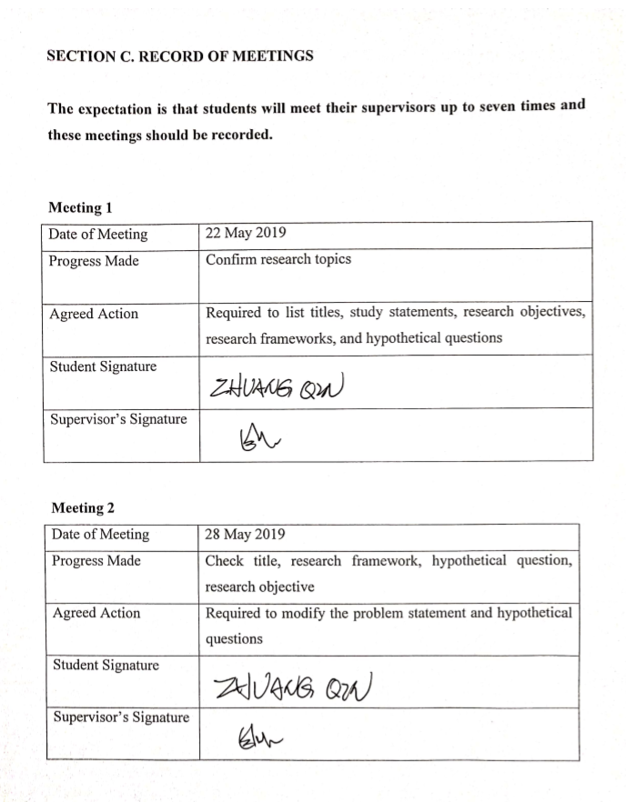
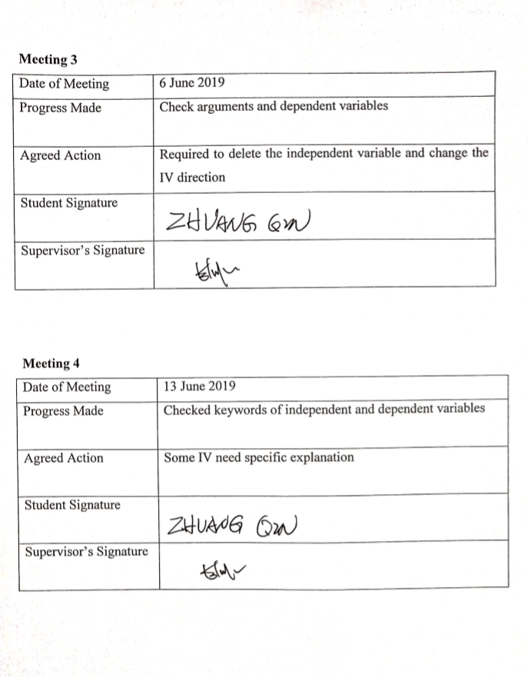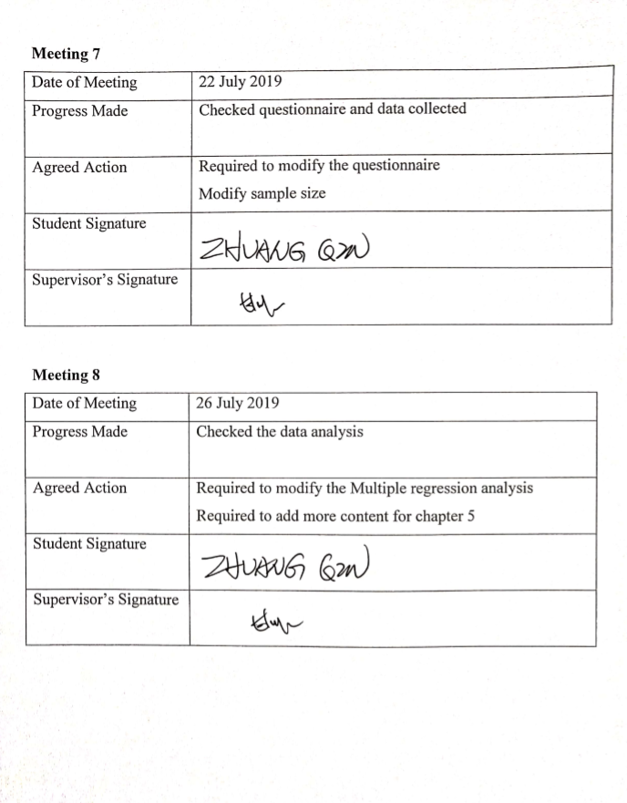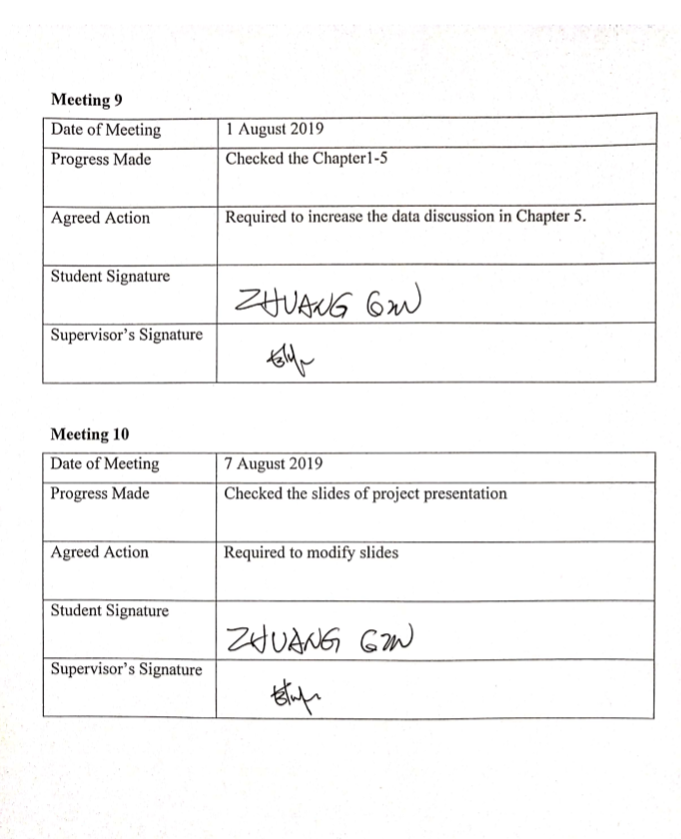

APPENDIX 9: Turnitin Results
