
Research on The Influencing Factors of Knowledge Employee Engagement in Private Enterprises in Hohhot, China

Student Name: ZHAO QIAN (Dual Award)
Identification Number: I18014345
Program: Master of Business Administration
Ethics Number: cBUS/PGT/CP/04278
Subject: MGT 7998- MBA Project
Supervisor: Dr. Sukjeet Kaur Sandhu

(Final Word Count: 12928)
STUDENT’S SECLARATION

I hereby declare that I understand the meaning of “Plagiarism” and “Intellectual Property Rights” and Ethics Related to the Principles of Academic Works.

This project is hereby acknowledged as my own work and I have duly acknowledged use of published and unpublished works of other people from the print, electronic and other media.

Name: ZHAO QIAN
Student ID: I18014345
Date: 22 / 08 /2019

ACKNOWLEDGEMENTS
This project was made possible with the blessings; assistance and support of many individuals that I would like to extend my most sincere gratitude. Firstly, I would like to sincerely thank my supervisor, Dr. Sukjeet Kaur Sandhu for her knowledge, dedication, motivation and help throughout the research work, and guidance towards the successful completion of this Master Project.
I would also want to thank my family and friends for helping me with unconditional love and without their great support; I will not be able to complete this project on time and with confidence.
I would also like to express gratitude to the faculty members of the Faculty of Business, Communication and Law at INTI International University for providing the necessary resources and support to conduct my research.
Last but not least, I would like to thank all the respondents who participated in my survey and those who have directly and indirectly supported me during the process.

ABSTRACT
With the global competition of enterprises more and more fierce, every industry find that knowledge employee engagement is the key factor affecting organizational development, lower knowledge employees' engagement can reduces the company's efficiency (Hameduddin and Fernandez, 2019). So the purpose of this research is to analysis the engagement of knowledge employees who worked in private enterprises in Hohhot where is part of china.
Based on the literature review, the purpose of this research is to explore the relationship between job levels, organizational commitment, internal communication and knowledge employee engagement in enterprises (Yaneva, 2018) and three factors are job levels, organizational commitment and internal communications. The data were collected by online questionnaire through WeChat to send to people who suitable for this research. Quantitative research method is adopted，descriptive and inferential statistical analysis is conducted by using SPSS to verify the hypotheses. Finally, this research successfully got the result that the above three main influencing factors all have positive relationship with knowledge employee engagement, the enterprises can improve knowledge employees' engagement through increase these three aspects.

Key words: knowledge employee engagement; private enterprises; job levels; organizational commitment; international communication

Table of Content

ACKNOWLEDGEMENTS 1
ABSTRACT 2
CHAPTER 1: INTRODUCTION 8
1.1 Research Background 8
1.2 Problem Statement 11
1.3 Research Objectives 12
1.4 Research Question 12
1.5 Significance of the Study 13
1.5.1 Theoretical Significance 13
1.5.2 Practical Significance 13
1.6 Limitations of Study 14
1.7 Scope of Study 15
1.8 Ethical Consideration 15
CHAPTER 2: LITERATURE REVIEW 16
2.1 Knowledge Employee 16
2.2 Employee Engagement 20
2.3 Private enterprises 23
2.4 Factors Influencing Knowledge employees’ engagement 26
2.4.1 Job Levels 26
2.4.2 Organizational Commitment 27
2.4.3 Internal Communication 29
2.5 Main Theories 33
2.5.1 Social Exchange Theory 33
2.5.2 Fairness Theory 34
2.5.3 Organizational Commitment Theory 34
2.6 Conceptual Framework 35
2.7 Research Hypotheses Formation 36
CHAPTER 3: RESEARCH METHODOLOGY 37
3.1 Research Design 37
3.2 Questionnaire Design 37
3.3 Source of Data 39
3.4 Sample Design 40
3.4.1 Questionnaire Develpoment 40
3.4.2 Sampling Frame 40
3.4.3 Sampling Techniques 41
3.5 Measurements 42
3.5.1 Descriptive Analysis 43
3.5.2 Reliability test 43
3.5.3 Validity Test 43
3.5.4 Factor analysis 44
3.5.5 Correlation analysis 44
3.5.6 Regression analysis 44
CHAPTER 4: RESEARCH FINDINGS 45
4.1 Demographic Description 45
4.1.1 Frequency statistics 45
4.1.2 Descriptive statistical analysis of samples 46
4.2 Reliability Test 47
4.3. Validity Analysis 48
4.4 Correlation Test 51
4.5 Regression Analysis 53
4.6 Summary 55
CHAPTER 5: CONCLUSION AND RECOMMENDATION 56
5.1 Conclusion 56
5.2 Recommendation 57
5.3 Limitation of Study 60
5.4 Personal Reflection 61
REFERENCES 62
APPENDIX A. INITIAL RESEARCH PROPOSAL 82
APPENDIX B. UH ETHICS CONFIRMATION AND NOTIFICATION 88
APPENDIX C. QUESTIONNAIRE 90
APPENDIX D. MBA PROJECT LOG 93
APPENDIX E. TURNITIN RESULTS 99
APPENDIX F. TABLES 102

List of Tables
Table 1: Table for Questionnaire Design…………………………………38
Table 2: Table for Determining Sample Size ……………………………40
Table 3: Basic Information Frequency Statistics...................................45
Table 4: Descriptive Statistics……………………………….................…46
Table 5: Table of Reliability Test…………………………............……….47
Table 6: KMO and Bartlett's Test…………………………...........……..49
Table 7: Total Variance Explained………………………….........……..50
Table 8: Rotated Component Matrix……………………......…………..51
Table 9: Descriptive Statistics of Correlation analysis………………...52
Table 10: Correlations analysis…………………………….............…...52
Table 11: Model Summaryb………………………………......................53
Table 12: ANOVA test…………………………………...........................54
Table 13: Coefficients analysis………………………..............…………54
List of Figures
Figure 1: The Characteristics of Knowledge Workers……….................…20
Figure 2: Conceptual Framework........................…………………..……....35
Figure 3: Questionnaire Design...........................…………………..……....39

CHAPTER 1: INTRODUCTION

1.1 Research Background
With the improvement of the market economy, the rise of perpetual data innovation and the consistently changing business sector condition makes the worldwide challenge of undertakings increasingly savage and achieving a white-hot state (Hameduddin and Fernandez, 2019). Every industry whatever big or small, all strive to find a magic weapon to improve the company. In the process of exploring, it is increasingly found that employees’ engagement is the key factor affecting organizational development (Yaneva, 2018).
Private enterprises are an important part of China's economic market and it has made great contributions to economic growth and development (Arslan, 2017). The development of private enterprises depends on the efforts and dedication of employees, but at present, the phenomenon of employee disengagement and loss of knowledge employees in private enterprises is quite common (Etukudo, 2019). The company needs more suggestions to help them improve the engagement of knowledge employees to develop the company. (Lewis, 2019).
At present, the model of economic growth in China has changed greatly and it developed very rapidly, the era has crossed into the era of the knowledge economy, knowledge is increasingly important in enterprises so the role of knowledge employees in this era is crucial (Segalla and DeNisi, 2019). Besides, most companies improve themselves through technology and knowledge, so the knowledge employees' engagement takes an important impact on a company, the level of knowledge employees reflects the core competitiveness of enterprises (Delina and Samuel, 2019). The knowledge employees grasp advanced production technology, integrate knowledge capital and other resources of enterprises through their own work, and become the main creators of enterprise value (Allen, Turner and Turner, 2018).
The decrease of knowledge employees' engagement in private enterprises in China is mainly manifested in three aspects:
(1) High flow rate
At present, the high employee turnover rate in China is the most direct manifestation of the decline in employee engagement. With the rapid development of China's market economy, information has become the blood of the whole economy (Anitha, 2014). Because employees can easily get information, they can always find vacancies in enterprises and choose to change jobs when they have the opportunity. Frequent job-hopping has become a common topic in global enterprises.
On the one hand, employee mobility can make enterprises get ideal talents, but on the other hand, it brings huge losses to enterprises. If an employee who has a large amount of customer information and customer resources leaves the company, he may take away a large number of customers, or even put the whole enterprise into a business dilemma (Breevaart, Bakker and Hetland et al., 2014). If employees who have important secrets leave the company, the consequences will be very serious and may bring a devastating blow to the company. But as far as the current situation of employee turnover in China's private enterprises is concerned, it has far exceeded this limit. Frequent job-hopping is not conducive to the accumulation of their own work experience and the upgrading of their professional skills (Alfes, Shantz and Trusset al., 2013). The discontinuity of this kind of work will deprive the employees of frequent job-hopping of many career opportunities, but also bring certain losses to enterprises, which shows that there are great problems in the management mechanism and other aspects of private enterprises.
(2) Low motivation
At present, the enthusiasm of employees in private enterprises is not high. We often hear managers complain that employees lack enthusiasm in their work, just like puppets (Graban, 2018). Employees'low motivation is mainly manifested in their weak sense of responsibility and low work morale. Employees in private enterprises are quite different from those in state-owned enterprises (Truss, Shantz and Soane, 2013). Employees in state-owned enterprises often emphasize that they should love their factories such as home, be dedicated to their jobs, actively contribute their youth and talents to enterprises, and advocate their hard work and devotion to strategies (Albrecht, Bakker and Gruman et al., 2015). However, at present, the employees of private enterprises lack the corresponding incentive mechanism. They think that they are only selling their own labor force. They have to get a day's salary for a day's work. They will not take the initiative to assume responsibility and seek benefits for the enterprises.
(3) Low employee satisfaction
employee fulfillment alludes to how much representatives acknowledge the genuine sentiments of the endeavor contrasted and their desires, that is, how much workers feel that the work itself can meet or address their own issues of work esteems (Bedarkar and Pandita, 2014). The level of employee satisfaction has a direct impact on the level of enterprise operation and performance, but also directly affects the employee's satisfaction with the enterprise. Generally speaking, the higher the employee's satisfaction, the less the turnover will be (Mone and London, 2018). Only by maintaining the stability of the enterprise's personnel composition can the loss caused by the turnover be reduced. Only by maintaining the employee's satisfaction, can they work more passionately, stimulate their intelligence and create benefits, and bring benefits to the enterprise. More profit margins (Biswas and Bhatnagar, 2013). At the same time, high employee satisfaction will also bring some external effects, bring unexpected benefits to enterprises, and may even affect the engagement level of the whole industry.

1.2 Problem Statement
According to Kocherlakota (2015), some previous articles research on employees' engagement only focuses on the impact of employee individual factors, other factors affecting employee engagement have been neglected, the result of the research is not comprehensive. Therefore, so as to improve the precision of the examination on components influencing employee engagement, this research analyze the influencing factors of knowledge employees’ engagement from the other three factors(Ulfig, 2019). They are job levels, organizational commitment, and internal communication, the problem of employees' engagement is deeply studied.
At present, knowledge employees' engagement is not optimistic in China. Employees' engagement has become a trend of decreasing(Seal, Devija and Kumaran, 2018). In private enterprises, about 20% of senior managers and technicians' engagement decreased every year (Cesario and Chambel, 2017). This research plan to understand the structure of knowledge employees' engagement and to find what causes employees' disengaged.
According to Khuong and Dung (2015) said when employees change jobs, companies always complain that the cause of changing job is due to employees' individual problem, they are not engaged in company enough, but enterprises do not know enough about the reasons why employees are not engagement enough and how to cultivate employees' engagement. So, this research wants to find the relationship between the main three factors and knowledge employees' engagement then help companies to improve.
Byrne (2015) said that employees at work lack initiative and often blame each other, especially knowledge employees. Most of them are the post-80s generation. Their thoughts are relatively open (Nienaber, 2019). Many people just regard work as an option to make money, and because of the competitions they have no chance to choose the job which they want to do, so they don't enjoy and engage in their work, let engagement alone (Kumar and Swetha, 2013).

1.3 Research Objectives
This paper hopes to find out the influencing factors of knowledge employees' engagement by investigating the degree of engagement of knowledge employees who are working in private enterprises in Hohhot (Graffigna, 2017). Exploring the influencing factors degree of engagement, analyzing the result variables of employee engagement, understanding the existing problems of knowledge employees' engagement, and for private enterprises to improve employees' engagement, and then the harmonious and stable development of enterprises and provide some useful suggestions for the fundamental improvement of efficiency(Tamayo, 2016).
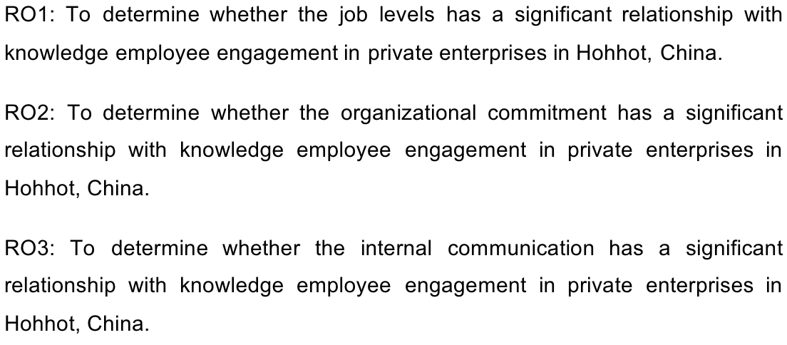

1.4 Research Question
The determination of research issues is the first step in the development of research projects. Only by identifying the issues that need to be studied can specific research plans be formulated, then researchers can study according to the plans (Chandani et al., 2016). Research questions determine the order of research content, which is important for researchers. It is indispensable to determine the purpose of the study, then extend it and determine the issues (Kanwar and Sharma, 2016).
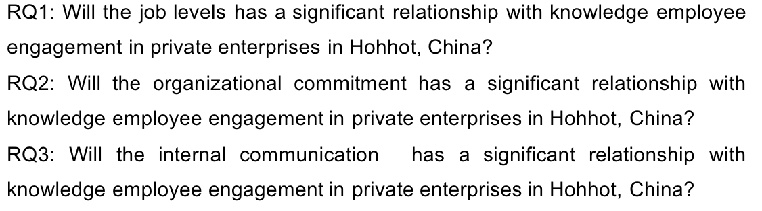

1.5 Significance of the Study

1.5.1 Theoretical Significance
The theoretical value of this paper is mainly embodied in two aspects. Firstly, research on employee engagement in China started relatively late, although the current research on employee engagement has involved the empirical research of enterprises, the empirical research on private enterprises is not enough (Nienaber, 2019). In this study, quantitative research methods are used as the main method, and multiple methods are combined organically, thus effectively ensuring the reliability and validity of the study (Rao, 2019). This paper studies the private enterprise, which is a specific scale enterprise, considering its influencing factors and results comprehensively, which makes up for the completeness of the study of employee engagement, develop a new direction, especially knowledge employee engagement (Nazir et al., 2019).
Secondly, from the perspective of the research content of engagement, previous studies seldom discuss the internal structure of engagement. This study concludes the internal structure of employee engagement in private enterprises in Hohhot through field investigation, which has a positive significance to remedy the lack of this research field, thus enriching the relevant theory of employee engagement, and expanding the scope of application of employee engagement research (Anand, 2019).

1.5.2 Practical Significance
As an imperative marker to quantify the legitimacy of big business, worker commitment has pulled in increasingly more consideration (Gibbs and Poisat, 2019). Understanding the status of employees' engagement is conducive to enterprises seeking profits and avoiding disadvantages, rational development of human resources, and high operating efficiency (Othman and Mahmood, 2019). At present, the rapid growth of private enterprises in China has accompanied, some problems come out in management, employee disengagement has become very common (Rutishauser and Sender, 2019). Therefore, taking private enterprises as the research subject, analyzing the structure of knowledge employee engagement, its influencing factors and the results, has important practical reference value for evaluating the employee engagement, improving the situation of low work efficiency, it also has an impact on decreasing the loss of employees and predicting the general trend of private enterprises in the coming decades (Williams, et al., 2019).

1.6 Limitations of Study
Firstly, in the beginning, the researcher encounters some obstacles in collecting relevant data, there are not many English pieces of literature on the subject of this study. When looking for information, it cannot draw on foreign pieces of literature very well, which has certain limitations for the study.
Secondly, this paper aims at the situation of knowledge employees in private enterprises in Hohhot of China, which will be limited by local culture, tradition, lifestyle and consumption level (Doyle, 2019). If the local life rhythm is slow, everyone is satisfied with the status quo, without too much ambition, maybe employees' engagement will not be very high, so these reasons will lead to a certain limitation of research (Sfeir, 2019).
Then, there are some limitations in data collection. This study plans to conduct a questionnaire survey of 384 employees from different backgrounds of private enterprises. These samples may not well represent all knowledge employees of private enterprises in China (Garg, Srivastav and Gupta, 2018). At last, as far as possible, the study time and research time of this examination have certain constraints, It may not be an entirely sensible course of action of time, the advancement of the study will likewise be balanced due to the effect of time.

1.7 Scope of Study
This study’s scope is to investigate the influencing factors of knowledge employees' engagement in Hohhot in China by researching on three factors, which are job levels, organizational commitment and internal communication, then utilizing the gathered information to examine the connection between the affecting components and knowledge employees' engagement (Frino, Djibo and Desiderio, 2019). Because there are many private enterprises in China and the number is too large to research so this research only choose a specific region which is Hohhot, then the survey is more targeted, and the results of the survey have more reference value for a Hohhot.

1.8 Ethical Consideration
Firstly, the survey in this study is non-real-name, the design of the questionnaire will not infringe on the personal privacy of employees and will respect the wishes of employees in the process of the survey (Tiwari, et al., 2018). In addition, the content design of this survey will not violate relevant laws and regulations, will protect the basic situation and findings of the company under investigation and will not involve sensitive issues of the company. Finally, the analysis of the survey results will be reasonable and objective, respecting the facts, without personal feelings.

CHAPTER 2: LITERATURE REVIEW

2.1 Knowledge Employee
Relevant studies abroad mainly state the definition, category, structure level, measurement of engagement, causal variables affecting engagement, and outcome variables of engagement.
According to Rahim and Shazween (2019) said that knowledge employees refer to a type of employee. such as employees who have special knowledge and technique, furthermore, they assume a significant job in the organization and control the primary piece of an organization. They can provide some advanced information and new products for the company.
Pangestu and Wahjuadi (2019) first discussed the structure of engagement. He divided the structure of engagement into physical, cognitive and emotional. knowledge employees can show their thoughts and feelings in the process, show their creativity, beliefs and values, and keep in touch with others, which are embodied in physical involvement, cognitive arousal and emotional empathy for others.
Liang (2015) recorded that knowledge people devote themselves to work and enjoy groups. they would like to engaged to their studies and are willing to consult with others.
Chen (2016) said that knowledge people are engaged to their own work and get along well with their colleagues and from a few years ago, engagement has become a traditional virtue highly respected in the history of Chinese ethical thought.
Wang (2015) believes that engagement is a lasting, positive emotional and motivational awakening state in the treatment of employees. Knowledge employees are reluctant to get away from work and are willing to make extra efforts at work.
According to Guan (2014), knowledge employees can engage themselves wholeheartedly to their work at any time, accompanied by pleasant, proud and inspiring experience in the process of work, they feel that working time is too fast to be tired, they have high endurance in the face of difficulties and pressures, once they enter the role of work.
According to Li, Xu and Chen (2016), the factors affecting knowledge employee engagement, domestic research, institutions are also making great strides in the world. Human Resources launched a special online survey on the impact of knowledge on employee engagement in China.
Leng (2017) said that the survey found that the main factors affecting such commitment and engagement were work challenge, the dimension of initiative and executives, organization welfare benefits, individual profession advancement openings and space, organization acknowledgment of employee competence, and personal professionalism.
Chen (2015) said that in a survey of knowledge employee engagement in China, it shows that engagement has an impact on knowledge employee retention rate, and the survey will divide the employees into three levels according to their level of knowledge are Colledge, bachelor and master.
Jiang (2016) believes that the results show that in the engagement degree, high-level knowledge employees rank first, medium-level knowledge employees are in the middle, and low-level knowledge employees have the lowest engagement.
By consulting a lot of domestic and foreign literature, this paper synthesizes the definition of knowledge employees by domestic experts, and summarizes the definition of knowledge employees as follows those employees with higher educational background who pursue work autonomy, diversification, good at exerting innovative spirit in their work through their own mental work, innovative application wisdom (Buell, Cai and Sandino, 2019). Knowledge employees must carry out innovative work through their own knowledge and can bring value-added capital to enterprises.
Peter Drucker described knowledge worker as those who grasp and use symbols and concepts, and use knowledge or information to work. At that time, it mainly refers to senior managers or executive managers. However, today, the concept of knowledge employees has expanded to a large number of white-collar employees, senior skilled employees, high-tech and technical personnel.
Researcher Wang (2013) wrote in his book Knowledge Economy that from the viewpoint of learning capital hypothesis and human capital hypothesis, information representatives allude to the individuals who take part underway, creation, development and utilization of learning and information, bring esteem added information cash-flow to endeavors and accept it as their calling.
Zhang (2014) accepts that information based work expects representatives to have insight information, imagination, and expert to finish the work while learning-based representatives, for the most part, incorporate those experts, instructors with profound expert aptitudes and center and ranking directors.
Liu (2013) thought that those who use their knowledge and ability to create benefits for the production and operation of enterprises, innovate technology, improve core competitiveness, maximize their knowledge into enterprise wealth and take this as their profession are knowledge employees. Francis Hereby, a knowledge management expert in Canada, puts forward that knowledge employees do not produce material products, but knowledge and ideas. They are resources in a new sense.
According to Woodruffe, knowledge employees are people who rely on wisdom and use their knowledge to create value and innovate. Knowledge employees have their own understanding of innovation. Knowledge is only the foundation for innovation, not innovation itself. He believes that innovation is an important criterion to measure knowledge employees. Mack believes that knowledge employees are people who specialize in problem solving by collecting, organizing, analyzing, creating and synthesizing information.
Knowledge employees mainly meet the following three conditions, first one is higher personal qualities. Knowledge employees generally have higher personal qualities, higher academic qualifications and other abilities (Sharma, 2019). They are no longer just "machines" to sell the labor force. They have more learning of expert information, additionally of the economy and ace the most recent innovation. Second one is strong autonomy, knowledge employees are dynamic roles, they learn like robot, step by step, they have a self-ruling workplace, not just to be liable to company requirements, yet additionally more accentuation on self-direction in their work (Hooi, 2019). Third one is creative labor of high value: knowledge employees are not occupied with basic monotonous work, yet in adaptable and unsure frameworks to manage variables conceivable circumstances, and to advance mechanical advancement (Hill, 2019).
As a group of enterprise value creation, knowledge employees are different from ordinary employees, both are externally and internally. Because of the different research angles, many experts and scholars have put forward different views on the characteristics of knowledge employees (Ahmed and Islam, 2018). By summarizing the views of experts and scholars, this paper classifies the characteristics of knowledge employees as follows:
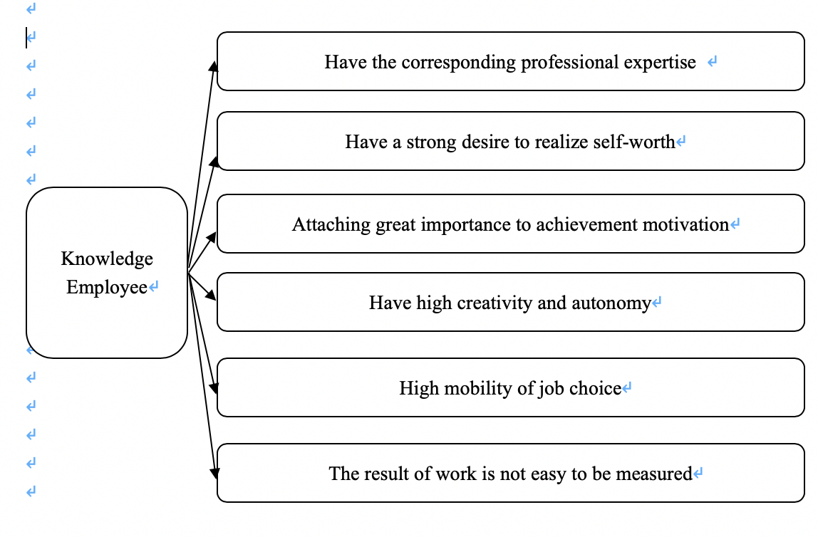
Figure 1: The Characteristics of Knowledge employees

2.2 Employee Engagement
The earliest person to study engagement is management expert Kahn (2013), he elaborated on the definition of engagement is that employment and self-expression occur simultaneously at work, and through the active and full display of work roles by members of the organization physically, cognitively and emotionally to promote individual-work and other-person connections.
Chelliah (2019) said that employees are more committed when they are provided with more meaningful work and more psychological security. Some scholars explain it from a psychological point of view. For example, James H. Robbins believes that employees' engagement is essentially a belief. For this belief, the more important thing is form and practice.
According to Gustomo (2019), representatives considered the commitment to be something contrary to burnout, they accept that employees' commitment and occupation burnout are two shafts of a three-dimensional can be utilized to assess commitment, in particular, enthusiastic fatigue and pessimism.
Sukatno (2018) believes that the degree of disrespect is low, and the degree of professional efficacy is high, that is engagement. The three elements of commitment are characterized as vitality, inclusion and adequacy.
Gao and Yao (2015) defined engagement as an engagement to one's career. They think engagement is the spirit of engagement and excellence to the profession itself, which is embodied in engagement to duty, diligence, selflessness, etc.
Zhang (2017) Chinese scholars believe that the content of an employee engagement survey tends to be systematic, and its detection indicators include many dimensions, such as cognitive, emotional, behavioral level indicators, individual and organizational level indicators.
Yang (2016) believe that the commonly used measurement methods of employee engagement include appreciation inquiry method, others' best self-evaluation method, engagement to participant management, multi-information, evaluation and so on.
According to Wang (2016) research shows that the engaged employees generally believe that the degree of engagement also affects the cost, the quality of work, income growth, profit margin and customer service level of enterprises.
Employees' engagement refers to their behavior orientation and psychological attribution to the enterprise, that is, their dedication to the enterprise they serve (Roesdiono, EP and Suminar, 2019).
Employees’ engagement includes active engagement and passive engagement (Hendrawati, 2018). The former refers to the subjective desire of employees to be loyal to the enterprise. This yearning is as often as possible achieved by such factors as the high consistency of various leveled and delegate destinations, the assistance of the relationship for pros' self-awareness and self-confirmation.
The author finds that many experts and scholars define employee engagement from their own point of view, but basically there are three similar tendencies: attitude engagement, behavior engagement, attitude and behavior synthesis.
(1) Attitude engagement. This is mainly from the staff's understanding of the enterprise level, emotional level and behavioral orientation level to carry out research.
Representatives of this view include foreign scholar Josiah Royce and domestic scholar Zheng(2013). They generalize employee engagement as a kind of emotion of employees to enterprises. They are willing to pay their own intelligence for enterprises, and they are willing to grow and progress together with enterprises through difficulties. They are conscientious of their work, take the initiative to undertake tasks and responsibilities, and give full play to their intelligence to achieve the goals of enterprises.
(2) Behavioral engagement. This view is mainly from the level of employees'behavior, which is embodied in the daily work and life, and can be studied by observation (Biswas and Bhatnagar, 2013). This view mainly emphasizes the contribution of employees to the enterprise.
American scholars Bobvoyles and Rchardcoughlan are both representatives of this view. They think that these behaviors of employees are a kind of interdependent relationship among employees (Dhar, 2015). They form a group together and make a voluntary commitment to the group or they abide by it when they pursue individual goals and team goals. A rule.
(3) A comprehensive view of attitude and behavior. This view synthesizes the above two viewpoints and holds that engagement is the unity of employee's engagement to enterprise behavior and attitude.
After synthesizing the views of many experts and scholars, this paper also uses the attitude and behavior comprehensive view to define employee engagement, that is, employee engagement is the unity of employee's attitude engagement and behavior engagement to the enterprise, which is not static and unchangeable, but dynamic and flexible (Tnay, Othman and Siong et al., 2013). From the attitude, it shows the unity of employees'recognition of the enterprise and their values: from the behavior, it shows the employees' sense of responsibility and mission to the enterprise. Employees do their best to work for the enterprise, create benefits for the enterprise, and consciously safeguard the interests of the enterprise (Hassan, Wright and Yukl, 2014). This kind of engagement is the mutual engagement of employees and enterprises, and has an interactive and mutually reinforcing relationship.

2.3 Private enterprises
Most definition of private enterprises lies in its narrow sense. The operation mode of private enterprises refers to the operation mode in which the owners of the assets of the enterprises transfer to possession, use, disposal and income of the assets to the enterprises conditionally on the premise of ensuring the ownership of the assets from their own interests (Mishra, Mishra and Walker, 2019). At present, private undertakings basically legally binding activities, stock activity, renting activity, endowed activity and offering activity.
The number of private enterprises in China is huge. Most of the profits of private enterprises mainly depend on the labor force of employees. If employees create more labor force, the profits of companies will be more. Especially in private enterprises, the value of knowledge employees will be higher, because knowledge employees grasp the main technology and information of the company.
According to Rahim and Shazween (2019) said compared with some private enterprises, the results of professional engagement research of some large-brand management companies seem to be more widely known, most private enterprises do not focus on their employees' engagement, they only focus on the result.
Zhang (2016) said that in modern times, inspired by the active exploration of engagement by foreign scholars, domestic scholars also put forward their own opinions on employees' engagement according to their own conditions, especially about private enterprises in Hohhot.
The concept of private enterprise is not easy to get rid of discrimination because of historical reasons. Whether investors, managers, representatives of private ventures or social workers who mean to advance the improvement of private endeavors (Ellis and Normore, 2019).
The decision of authoritative types of various sorts of undertakings has various wellsprings of capital, various laws and diverse extent of money related administration exercises (Wayne, Casper and Matthews et al., 2013). Private enterprises mostly choose limited liability companies as their organizational form, but most of them are enterprises jointly run by relatives, families and friends. In the early stage of construction, these enterprises replace the rules and regulations by their sentiments. Enterprises have different forms of organization and capital structure (Salleh, Amin and Mudaet al., 2013). Capital structure and organizational characteristics affect the financial supervision mode and the specific content of financial management.
Owner's quality: Owners of private enterprises are often both investors and managers. Their quality directly affects the development of financial management activities. Whether the goal of enterprise financial management can be achieved depends on the owner's quality of controlling and supervising financial management.
Corporate culture. Owners play an extremely important role in the formation of corporate culture. Corporate culture also affects the selection and use of financial managers, the responsibility and authority of management and the disclosure of financial information in enterprise management (Lamba and Choudhary, 2013). Corporate culture is additionally a significant factor in pulling in and balancing out monetary administration gifts partially.
The advancement of science and innovation. In innovative private endeavors, HR is a significant asset of undertakings. The improvement and development of endeavors rely on mechanical advancement and board development. Therefore, the development of science and technology affects not only the management mechanism and profit distribution mechanism of enterprises, but also the function of financial management.
Acccording to Juhdi, Pa'wan and Hansaram (2013) find that among the objective and microcosmic factors, microcosmic factors play a greater role in stimulating the financial management activities of enterprises. The following focuses on micro-environmental factors, analysis of different environmental factors affecting the characteristics of financial management.
So as to reinforce the institutionalized administration of the organization, assemble an astounding and productive working group, and advance the improvement and development of the organization, the organization's administration framework is detailed as per the important articles of affiliation (Bang, Ross and Reio, 2013).
All workers of the organization will keep the organization's principles and guidelines. The organization advocates the possibility of "relatives". No office or individual may do anything hurtful to the organization's advantages, picture, notoriety or advancement (Shahid and Azhar, 2013). So as to improve the expert degree all things considered and give full play to their excitement and imagination, Through the reasonable and sensible challenge, each representative ought to perform his responsibility and be helpful to advance the organization's generosity.
The organization advocates that all workers study hard in science, innovation and social learning to give information to representatives (Jehanzeb, Rasheed and Rasheed, 2013). Conditions and open doors for further investigation, and endeavor to improve the general quality and level of representatives to make a group new-disapproved, dedicated, solid business, talented staff.
The organization urges workers to take an interest in the administration of the organization, give full play to their abilities, and set forward legitimization. The organization actualizes the post-compensation framework to give representatives pay and welfare insurance, and alongside the financial advantages (Suliman and Al Kathairi, 2013). We should gradually improve the treatment of employees in all aspects and implement a system of attendance and assessment so as to give priority to others. To commend and reward those who have contributed.
The organization advocates a reasonable and sober-minded work style, advocates exacting economy and contradicts luxury and waste. Backer staff solidarity and shared help, cooperate in a comparable situation, convey forward the soul of aggregate participation and aggregate imagination, and upgrade bunch attachment and centripetal power (Pierro, Raven and Amato et al., 2013). Regular meetings of the company are scheduled to discuss and debate business ideas at regular meetings every Monday-morning. Management strategy, discuss the problems found and propose solutions.

2.4 Factors Influencing Knowledge employees’ engagement

2.4.1 Job Levels
According to some research said the difference in engagement among employees of different job levels is very significant. The job levels means people work at different levels, like general employees, managers and directors. They work at different job levels have different duties for the company. The higher the position of employees has higher the engagement (Williams, et al., 2019).
According to some researches, the proportion of engaged employees in general employees, managers and directors are different. General employees' engagement is less than managers, and the engagement of directors is more than managers, most directors are very engaged in the company due to their duty (Brace, 2018). This shows that the top management of the company contributes more to the company, and pays more brains and efforts, so it is easier to rely on the enterprise and produce a stronger sense of collective honor and responsibility.

2.4.2 Organizational Commitment
The knowledge employees’ hierarchical duty is the inner marketization procedure of learning representatives (Wiljanen, 2018). Knowledge employees tend to internalize labor market companies because of their own characteristics like they have special expertise and skills, challenging and uncertain jobs, they are easy to access to external information, etc. (Milhem, Muda and Ahmed, 2019). Organizational commitment of knowledge employees also means they are consciously comparing the internal remuneration level with the average remuneration level in the external labor market.
The factors related to the organizational commitment that knowledge employees are engaged in are job achievement, job acceptance, job self-factors, job responsibility, job promotion opportunities and so on. As per Herzberg's two-factor hypothesis, these variables are for the most part impetus factors (Ferreira, 2019). And improving incentive factors is the most direct and effective way to improve employee's work engagement, that is to say, the love of occupation will enhance employee's work engagement.
The factors affecting organizational commitment include salary, colleague relationship, relationship with managers, company policy, etc. According to previous research and survey, because of the complexity and uncertainty of employees' work, their work engagement has strong flexibility, which shows a lot of creativity and initiative (Biswas and Bhatnagar, 2013). The higher the level of organizational commitment, the more interested and enthusiastic employees are in the profession they are engaged in, so that will engage in their job, they can manage themselves and take responsibility for their own initiative within the scope of their work.
Employee engagement is the commitment of representatives to the organization, it is a quantitative idea (Aydin, Sarier and Uysal, 2013). Commitment is the natural solidarity of the representative's conduct commitment and frame of mind commitment. Conduct commitment is the reason and purpose behind the outlook responsibility, and mental responsibility is the broadening and growth of direct duty.
The idea of authoritative duty was proposed by Becker to mirror the mental contract among representatives and associations. Representatives with a feeling of authoritative responsibility are bound to remain in the association, give more vitality to their work and make progress toward the objectives of the association (Chun, Shin and Choi et al., 2013). The examination of hierarchical responsibility demonstrates that authoritative duty has contrarily corresponded with misfortune, low yield conduct and nonappearance from work, however emphatically connected with employment fulfillment, proficiency, inspiration and authoritative citizenship conduct. Along these lines, increasingly more consideration has been paid to authoritative responsibility (Yahaya and Ebrahim, 2016).
Mowday, Porter and Steers (2014) isolate hierarchical responsibility into attitudinal duty and social duty. Attitudinal duty, for the most part, thinks about the connection among people and associations, and a mental state wherein the qualities and objectives of people and associations correspond. Social responsibility is identified with the procedure of representatives entering a specific association and the manner in which they manage issues.
Chatman (2013) accepts that authoritative duty is a mental bond among workers and associations, which is shown in three structures: consistency, character and disguise. Consistence is to get a specific reward, not founded on the sharing of hierarchical objectives and qualities. Workers may remain in the association due to the staggering expense of evolving occupations. Personality is to acknowledge the impact of the association on the person. Disguise is the frame of mind, convictions and estimations of the association, and the objective is reliable with the person.
Ling (2013) investigates the mental structure of representative hierarchical responsibility in China and advances five essential sorts of authoritative duty: passionate responsibility, standardizing responsibility, perfect duty, financial responsibility and opportunity responsibility (Fu and Deshpande, 2014). Passionate responsibility alludes to the acknowledgment of the unit and profound sentiments; readiness to add to the survival and advancement of the unit, even paying little heed to compensation; under any incitement: disarray won't quit and change occupations.
Ideal commitment refers to attaching importance to personal growth and pursuing the realization of ideals; focusing on whether individual aptitude can be brought into play in the unit, regardless of whether the unit can give different working conditions, learning and advancement openings, in order to facilitate the realization of ideals (Dhar, 2015).
Regularizing responsibility implies that the frame of mind and conduct of endeavors are guided by social standards and expert morals; they have an awareness of other's expectations to the association and carry out their responsibility and commitment to the work and the unit (Farooq, Payaud and Merunka et al., 2014). Monetary responsibility alludes to remaining in a unit inspired by a paranoid fear of financial misfortunes. Opportunity responsibility alludes to the central explanation behind treating this unit is that it can not discover other progressively palatable units, or as a result of its low specialized level, there is no chance to secure another position.

2.4.3 Internal Communication
The communications impact of an association decides the productivity of association the board. During the time spent endeavor the board, if chiefs can do well in authoritative correspondence, it will accomplish double the outcome with a large portion of the push to advance the accomplishment of big business execution objectives (Hariyant oand Ferdian, 2019).
Men (2014) think that smooth and successful hierarchical correspondence is helpful for the full stream and sharing of data inside the association, to improve the effectiveness of authoritative work, to reinforcing law based administration, and to advancing the scientificity and soundness of hierarchical basic leadership (Mas-Machuca and Marimon, 2019).
To persuade the representative's commitment to work, the most significant thing is correspondence. Great administrators should set aside effort to comprehend what correspondences can make the group best and what representative profession objectives are (Quirke, 2017). In the wake of comprehension, it will be utilized to make open doors for advancement and further reinforce the estimation of representatives' commitment.
Venture the board has four capacities: arranging, association, authority and control, and one of the fundamental lines going through it is correspondence. Correspondence is the primary way, strategy, means and approach to understand its administration work (Karanges, Johnston and Beatson et al., 2015).
Without correspondence, there will be no administration, no correspondence. The executives are just a creative mind and an absence of imperativeness of mechanical conduct. Correspondence is the lifesaver of the big business associations (Men and Stacks, 2014). Like a vein in a living being, it goes through each part and connection of the entire body, advances the flow of the body, gives an assortment of supplements, and structures a creature of life.
Correspondence is vital to the day by day the executives of endeavors. Every day the executives, for example, business the board, money related administration and HR the board, can be completed easily just by methods for the executives' correspondence (Mazzei, 2014). The center of business the executives are to give administrations and items appropriate to the far-reaching needs of the objective market and target client bunches based on top to bottom comprehension of clients and markets, and to interface with the market requires correspondence.
Karanges (2014) said in money related administration, auspicious obtaining and resemblance, examination, rundown, dispersion and transmission of budgetary information are the definitive reason for big business the executives to manage the activity status of endeavors, which is a common correspondence conduct. Human asset the executives is an immediate and vital administration object. Just great administration correspondence can open the entryway of individuals' knowledge and soul, rouse individuals, tap individuals' potential, and make better an incentive for undertakings (Constantin and Baias, 2015).
Correspondence the executives is the primary way and apparatus to make and upgrade venture soul and culture and to accomplish the essential objective of big business the executives (Men, 2014). The most elevated domain of the executives is to make an extraordinary undertaking soul and culture in the administration of endeavors, so the outer needs of big business the board can be changed into the idea of employees'freedom and hesitant conduct mode, and relate to the fundamental beliefs, targets and mission of ventures.
As indicated by Zerfass and Franke (2013), the development and molding of big business soul and undertaking society is basically a correspondence of thoughts, perspectives, feelings and spirits, and the most elevated structure and substance of the executives' correspondence. Without correspondence, there will be no understanding and accord of corporate soul and culture, and it is difficult to relate to the normal mission of endeavors.
Correspondence the executives is a vital way and fruitful soil for the executives' advancement. Numerous new administration ideas, strategies, and methods are the consequence of a few correspondences and crashes, targeting improving the proficiency and execution of big business the board correspondence (Jacobs, Yu and Chavez, 2016). Its major reason for existing is to improve the productivity and effectiveness of the board.
In a sense, modern enterprise management is communication. Communication is indeed the core, essence and soul of modern enterprise management.
(1) According to Mishra, Boynton and Mishra (2014), they figure any choice will include what to do, how to do, when to do, etc. At whatever point looked with these earnest issues, supervisors need to acquire a lot of data and insight from a wide scope of inner correspondence inside the venture, and after that decide, or recommend that the significant faculty decide, so as to take care of the issue rapidly.
Yeomans and FitzPatrick (2017) felt that subordinates can likewise step up to the plate and speak with unrivaled chiefs and set forward their own proposals for reference when pioneers decide, or through correspondence, get the endorsement of predominant pioneers and settle on choices all alone. Correspondence inside the venture gives data to basic leadership of different divisions and work force, and improves the judgment capacity.
(2) All divisions and positions in a venture are associated. The more noteworthy the reliance, the higher the requirement for coordination. Coordination must be accomplished through correspondence (Wright, 2016). Without appropriate correspondence, directors won't think enough about their subordinates. Subordinates may have an off-base comprehension of the errands doled out to them and the undertakings they are required to finish, which will make the assignments not be finished effectively and attractively, bringing about the loss of advantages for endeavors (Hume and Leonard, 2014).
(3) Correspondence enables pioneers to rouse subordinates and set up great relational connections and hierarchical environment. Notwithstanding specialized and composed data, representatives additionally need empowering data (Sisko, 2014). It can empower pioneers to comprehend the necessities of representatives, care about their affliction, and consider the prerequisites of representatives in basic leadership, in order to upgrade their excitement for work. Individuals, for the most part, require proper evaluation of their capacity to work (Men, 2015). In the event that the pioneer's applause, endorsement or fulfillment can be transmitted to representatives through different directs in time, it will bring about some sort of work motivator.
Simultaneously, a great relational relationship inside the venture is indivisible from correspondence. Ideological and passionate correspondence can upgrade common comprehension, wipe out misconception, offense and doubt (Mazzei and Ravazzani, 2015). Regardless of whether it can not accomplish total comprehension, in any event, it can likewise accomplish seeing, with the goal that undertakings have an amicable authoritative climate, the supposed "everybody thinks one spot, endeavor one spot" is the consequence of viable correspondence (Vercic, 2017).

2.5 Main Theories

2.5.1 Social Exchange Theory
According to social exchange theory, reliant gatherings have a feeling of commitment through a progression of collaborations. For whatever length of time that they keep certain trade standards, the connection between them will create trust, dependability and common duty after a timeframe. One route for people to compensate associations is to change their degree of devotion (Cook, Cheshire and Rice et al., 2013). That is to say, employees choose different levels of engagement to give feedback on the resources they get from the organization. It is increasingly hard for representatives to change the degree of their exhibition since execution is frequently surveyed and utilized as a reason for pay rates and other managerial choices. In perspective on this, representatives are bound to trade their polished skills with the assets and advantages given by the association.
The theory of social exchange provides a theoretical basis for explaining the change in employees’ engagement. Engagement can be considered as the exchange of economic and social-emotional resources under the theory of social exchange. At the point when representatives get these assets from the association, they feel obliged to pay back the association with a higher level of commitment (Blau, 2017). On the off chance that the association neglects to give these assets, representatives are bound to pull back their inner selves from their jobs and stay amateurish. In this manner, the measure of psychological passionate and physiological assets that people are set up to add to the exhibition of their work jobs differs from the financial and social-enthusiastic assets given by associations (Ruck, 2015).

2.5.2 Fairness Theory
The theory of fairness is based on what psychologists call cognitive dissonance, which was first proposed by American therapist Adams during the 1960s. The hypothesis centers around the connection between remuneration and fulfillment. Employees are concerned about the rationality and fairness of distribution (Carter and Baghurst, 2014). In fairness theory, fairness refers not only to the absolute remuneration of employees, but also to the ratio of individual input to output, and the result of comparison with the input-output ratio of comparable objects under the same conditions. Equity theory is expressed as follows: the reward of individual A divided by the input of individual A equals the reward of another person B divided by the input of another person B (Menguc, Auh and Fisher at al., 2013). They judge and compare the relationship between their input and output. If they find that their input and output ratio is not consistent with others'input-output ratio, they will have certain psychological pressure. This kind of pressure may cause dissatisfaction among employees. If there is no place for such dissatisfaction to vent, it will be manifested in the work, such as passive idle work, irresponsible treatment of work, reducing output, etc. They will reduce engagement to enterprises, and even sell their own enterprises.

2.5.3 Organizational Commitment Theory
The theory was first put forward by American scholar Becker. He believed that with the increase of employees'unilateral investment in the enterprise, the willingness to leave the enterprise would be gradually reduced, because they were afraid that leaving the enterprise would suffer losses and had to continue to work in the enterprise. Meyer, a scholar, divides organizational commitment into three dimensions, namely emotional commitment, sustained commitment and normative commitment (Bailey, Maddenand Alfes, 2017). This is the famous three-dimensional model. Emotional commitment is the psychological internalization of employee engagement to the organization, which is not short-term but long-term. Unlike emotional commitment, sustained commitment has obvious timeliness. This commitment is unstable and the starting point of employee disengagement (Sorenson, 2013). That is, once more powerful temptation appears, the balance of this commitment will be broken immediately. Standardizing responsibility alludes to a feeling of commitment that workers are eager to stay in the association. This sense of obligation mainly comes from the sense of responsibility of employees. Because of the complexity and uncertainty of knowledge employees'work, most of them have high commitment to their profession (Shuck and Reio, 2014). Therefore, it is very meaningful to study employee engagement from the factors that affect employee organizational commitment.

2.6 Conceptual Framework
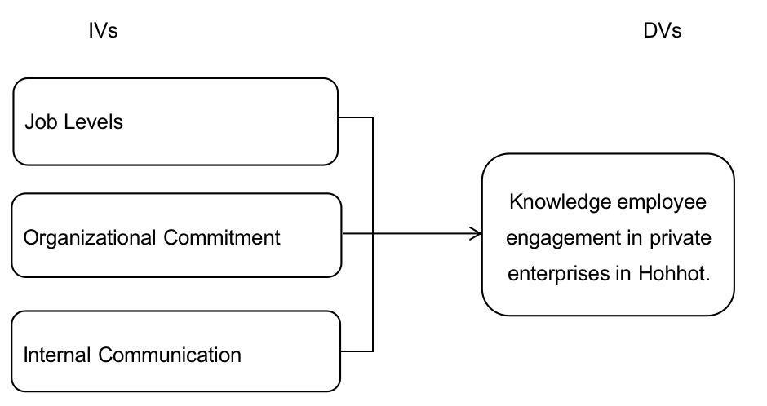

Figure 2: Conceptual Framework

2.7 Research Hypotheses Formation
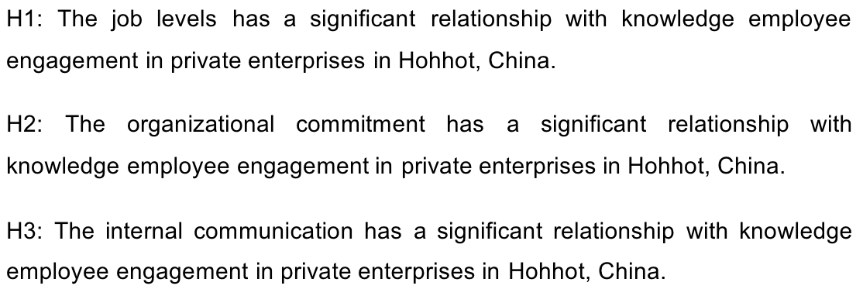

CHAPTER 3: RESEARCH METHODOLOGY

3.1 Research Design
Quantitative research is to describes information by quantitative data, predict and test hypothetical theories. This research is descriptive because its purpose is to know whether job levels, organizational commitment and internal communication are the factors affecting employees' engagement (Burnett and Lisk, 2019).
This study intends to adopt the questionnaire method for investigation and research, that is random sampling of some private enterprises in Hohhot as the research object (Smith, Fisher and Ryan et al., 2013). Using the online questionnaire survey method for investigation and information collection through wechat application, because this research only focuses on the enterprises in Hohhot so the degree of interference in this study is very small (Mazzei, Et Al., 2018).
Then in the data analysis stage, SPSS information measurement programming is utilized to investigate and abridge the gathered poll information.

3.2 Questionnaire Design
This study mainly adopts the questionnaire survey, which consists of five major aspects. They are the basic personal situation of the respondents, employees’ job levels, organizational commitment, international communication and knwledge employees’ engagement survey, (Yadav and Morya, 2019).
Among them, the first part of the basic characteristics of individuals mainly related to gender, age, education background, job level and length of employment (Watson, Kuofie and Dool, 2018).

Table 1: Table for Questionnaire Design
Section | Items | Source
1. Personal Information | 5 | Xanexa, M. (2018)
2. Job levels affect the employee engagement | 5 | Truss, Alfes and Delbridge et al., (2013)
3. Organizational commitment affect the employee engagement | 5 | Eldor and Vigoda-Gadot, (2017)
4. Internal communicate affect the employee engagement | 5 | Kang and Sung, (2017)
5. Knowledge employee engagement | 5 | Mishra, Boynton and Mishra, (2014)

The survey of employees’ engagement includes five parts. Employees' general understanding of their engagement level, the engagement measurement scale, which is mainly based on Macey's survey on employee engagement, has been rewritten according to the characteristics of employees in enterprises (Latta, 2019).
From the figure 3 we can see that there are 25 items in the scale, of which 5 variables are used to measure basic information; 5 variables are used to measure job levels factors; 5 variables measure the organizational commitment; 5 variables are used to measure international communication; 5 variables are used to measure knowledge employees' engagement (Saufi, 2018).
The Richter Five-Point Scale was used in the study (Silverman,2018). There were five scales: strongly disagree, disagree, neutral, agree and strongly agree. (Nawangsari and Sutawidjaya, 2019).

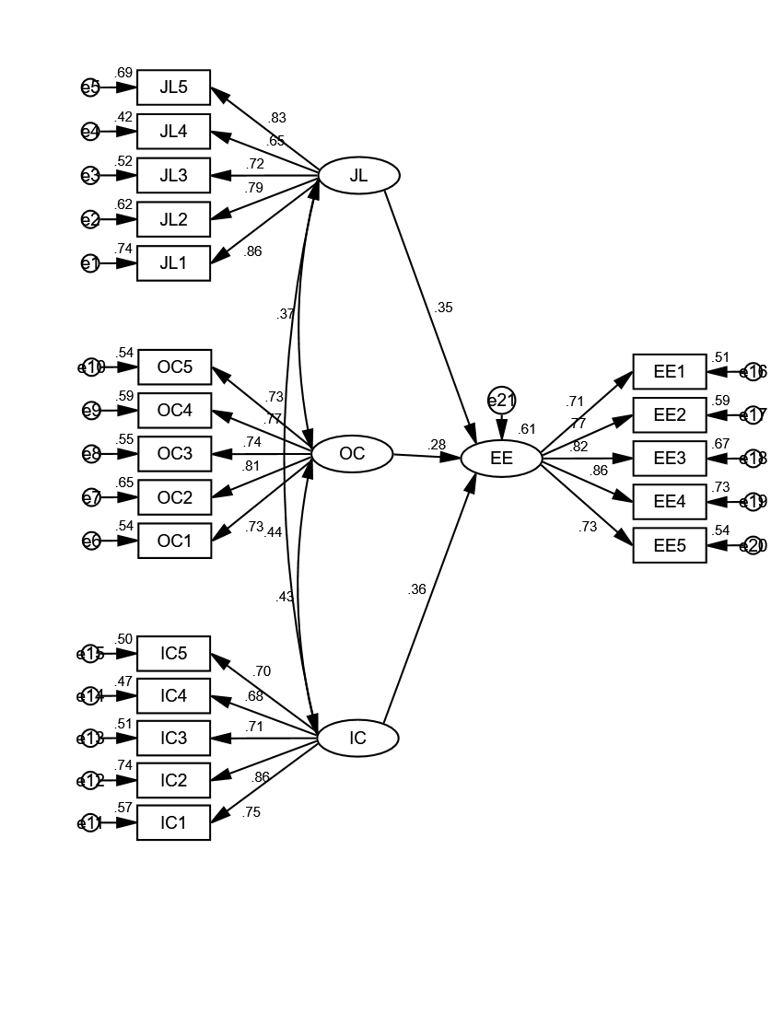
Figure 3: Questionnaire Design

3.3 Source of Data
The data of this research are from the online questionnaire, the online questionnaire distributed to 450 people who are working in private enterprises in Hohhot, because this research only focuses on Hohhot so the questionnaire only distributes to one place (Gerber and Finn, 2013). The respondents are people who worked in private enterprises, especially in technique company.

3.4 Sample Design

3.4.1 Questionnaire Develpoment
Sampling design in a restricted sense alludes to the plan of examining plans, including deciding the objective populace, detailing inspecting techniques and estimation strategies, figuring the vital example size, and advancing the necessities of exactness and dependability (Tsvangirai and Chinyamurindi, 2019). Sampling design is a unit used to measure samples. Before testing, it is important to select suitable areas, companies and personnel types for investigation (Levine, 2013). Sampling design is an important step because the data collected through sampling design need to be used as samples to provide data for subsequent experiments (Githinji and Muli, 2018).

3.4.2 Sampling Frame
Table 2: Table for Determining Sample Size
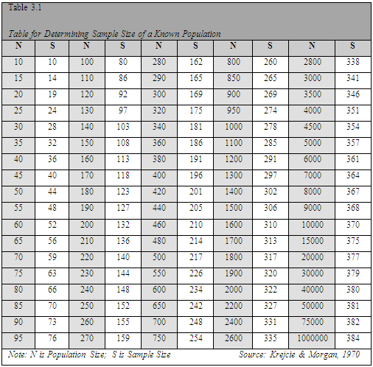
The sample selection of this study is Inner Mongolia Autonomous Region of China. The reason for choosing this area is that the investigators have a better understanding of this area (Pallant, 2013). The number of private enterprises in this area is moderate and suitable for investigation, and the results of the survey have a certain reference, which can help the development of private enterprises in this area in the future (Shaik and Makhecha, 2019).
Sampling selected some knowledge-based employees of private enterprises for investigation and research and the selection of this sample survey is random (Syadina, Purnomo And Anggraeni, 2019). Because the number of employees that private enterprises can refer to is 120000 more than 100000 (Park, 2015). According to the sample number selection table, at least 384 questionnaires were designed to conduct an online survey and in this research, there will be 450 questionnaires were designed (Brace, 2018). In addition, samples are representative, so it is very important to ensure the rationality of sampling design (Albright and Marinova, 2015).

3.4.3 Sampling Techniques
Sampling technology is a part of insights. It is an innovation to think about the inspecting technique in examining the study and the estimation strategy for all out-target amount (SAHOO and MOHANTY, 2019). As a rule, sampling methods include probabilistic sampling and non-probabilistic sampling, as well as sequential sampling and simple random sampling (Rai and Ojha, 2018).
Sampling methods include:
1. Sequential sampling: A certain number of units are sampled in a given order, such as the number of units in the whole population, the sampling at 1 or 5 equidistance (Meyers, Gamst and Guarino, 2013). The sampling at a certain number of intervals, the sampling at a certain interval of rows, or the sampling at a certain number of rows, or the sampling in the same direction (Kura, et al., 2019). This sampling method is simple and accurate when the sampling units are evenly distributed in the whole population (Kyriakidis, Happee and de Winter, 2015).
2. Simple random sampling: Simple random sampling is also called simple random sampling (Alkusani and Sukaris, 2019). Generally, first numbering the experimental areas of the population, then drawing lots or random number tables to extract the required number of sampling units to form samples, which can make the open doors for every unit to be separated similarly in the populace, in this manner improving the unwavering quality of the evaluated qualities determined by the examples (Johnson and Pike, 2018).
3. Typical sampling: Typical sampling consciously selects a certain number of representative typical sampling units from the whole according to the purpose and requirement of investigation and research and determines them (Nikolova, Schaufeli and Notelaers, 2019). At least, it requires the selected units to represent the majority of the whole. This sampling method is easy to explain, but it is easy to lose the role of random sampling. The data obtained are not suitable for statistical analysis (Weaver and Wuensch, 2013).
4. Zoning sampling: Zoning sampling or stratified sampling or type sampling. Firstly, the typical unit groups are selected from the population by the typical sampling method, then random or sequential sampling is carried out in each part, and then the population estimates are calculated according to the sample values of each part (Arifin, Nirwanto and Manan, 2019).
5. Band sampling method: Band sampling method refers to that some experiments need group influence as sampling criterion and need to divide several sampling zones (Cheche, Muathe and Maina, 2019). Randomly select banded product groups as representatives and compare with each other.

3.5 Measurements
The analysis is the core step in the experiment. It’s necessary to use molecular tools correctly to analyze data in order to make the experiment go smoothly (Milhem, Muda and Ahmed, 2019). Analytical tools refer to the tools for analysis and collation of collected data and use the data to continue the next research (Si and Johansen, 2019). In this investigation, a quantitative examination strategy, to be a specific poll, gather information and use SPSS to break down information. SPSS is the most commonly used and easy-to-use data analysis software, which is more efficient and accurate in data analysis (Pallant and Manual, 2013).

3.5.1 Descriptive Analysis
The narrative statistical method mainly carries on the basic narrative analysis to the sample, including the frequency and percentage of demographic variables like gender, age range, education background, job levels and the length of employment (Agarwala and Panwar, 2019). And also includes the test of the mean value of each variable measured by the scale (Pallant, 2013).

3.5.2 Reliability test
Reliability test to the consistency or solidness of the outcomes acquired by the testing instrument (Field, 2013). A measurement must have high reliability, so as to determine that the behavior of the sample is consistent to some extent, otherwise, the measurement results can only show the performance of the sample in "specific time and specific behavior samples" (Moletsane, Tefera and Migiro, 2019). The common representations of reliability analysis are the retest reliability coefficient, half-fold reliability coefficient, duplicate reliability coefficient and Cronbach a reliability coefficient (Firdinata and Hendriyani, 2018). No matter which reliability representation method is used, the consistency or stability of measurement results is expressed by a coefficient value (Peong, 2019). The higher the reliability coefficient of a measurement result, the better its consistency and stability (Hinton, McMurray and Brownlow, 2014).

3.5.3 Validity Test
According to the pilot experiment, the preliminary experiment is carried out, which is the first step to do this research (Sen, 2018). The purpose is to test the operability of the experiment from multiple levels, so as to promote and improve the smooth implementation of the experiment (Mayers, 2013). According to the calculation of the total number of samples in this experiment, 380 questionnaires were distributed in the preliminary test (Siju and Johansen, 2019). In the preliminary test, research analysis, factor analysis and reliability analysis of the experiment were carried out (Heck, Thomas and Tabata, 2013).

3.5.4 Factor analysis
Factor analysis is a factual strategy that utilizes a couple of variables to depict the connection between numerous pointers or factors and uses a couple of elements to reflect the vast majority of the data of the first information (Ahmad and Islam, 2018). In this study, there are many variables, especially about trust dimension and loan cognition (Cronk, 2017). It is necessary to find several key factors to reflect the information of the original variables so as to simplify the variables (Srivastav and Yadav, 2018).

3.5.5 Correlation analysis
Relevance analysis refers to the analysis of two or more variables with correlation, so as to measure the degree of correlation between the two variables (Leech, Barrett and Morgan, 2014). There must be a certain connection or probability between the relevant elements before correlation analysis can be carried out (George and Mallery, 2016).

3.5.6 Regression analysis
This research needs to study the internal relationship between many variables, so there are many contents to explore the internal structural relationship between variables by regression analysis (Rovai, Baker and Ponton, 2013). Regression analysis is a statistical analysis method to determine the quantitative relationship between two or more variables (Ho, 2013). Regression analysis can be isolated into a single relapse investigation and numerous relapse investigation as per the number of factors included (Allen, Bennett and Heritage, 2014). Straightforward relapse examination and numerous relapse investigation as indicated by the number of autonomous factors (Heck, Thomas and Tabata, 2013). Direct relapse examination and non-straight relapse investigation as indicated by the kind of connection between free factors and ward factors (Pituch and Stevens, 2015). On the off chance that just a single autonomous variable and one ward variable are incorporated into the relapse examination, and the connection can be approximated by a straight line, the relapse investigation is called direct relapse examination (Park, 2015).

CHAPTER 4: RESEARCH FINDINGS

4.1 Demographic Description

4.1.1 Frequency statistics
This research destributed 450 questionnaires, the valid questionnaires are 405. In this study the frequency statistics of Gender, Age, Education background, Job levels and Length of employment in the basic information were conducted, and the percentages of the options in the total number of people were respectively calculated (Weaver and Maxwell, 2014).
Table 3: Basic Information Frequency Statistics
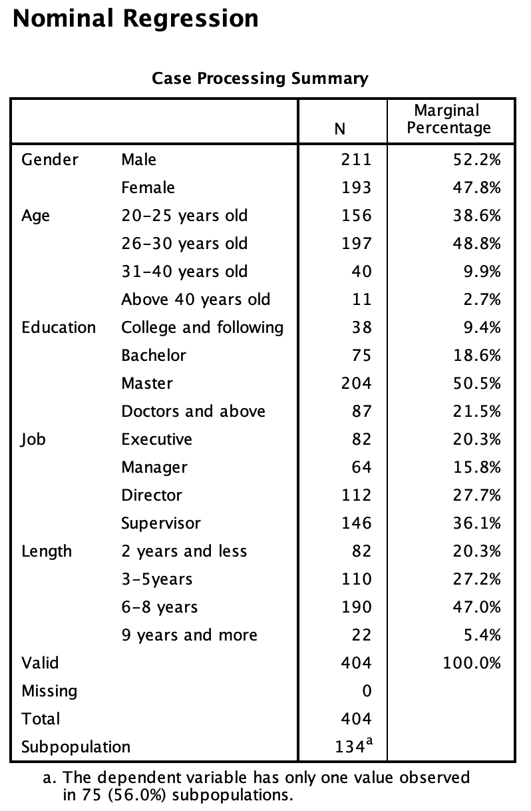
From the above table, we can see that the number of the male from the questionnaire is 211, it accounts for 52.2% of respondents, and others are 193 female which accounting for 47.8% of respondents, the number of genders don’t have too much gap. The age range is mainly in 26-30 years old, it accounting for 48.8%, followed by age between 20-25 years old, then the fewer people are 31-40 years old and above. Education background is mainly in the master which accounting for 50.5%, there are only 9.4% of people are from college. The supervisor is the main part of job levels and it accounting for 36.1%, followed by the director which accounting for 27.7%, and the Length of employment is mainly worked for 6-8 years, it accounts for 47%.

4.1.2 Descriptive statistical analysis of samples
In this paper, descriptive statistics are led for certain things in the scale, which for the most part contain data, for example, mean worth, standard deviation, skewness and kurtosis, in order to pass judgment on the essential degree of things in the scale and the dispersion of information (Norris, Qureshi, Howitt and Cramer, 2014).
Table 4: Descriptive Statistics
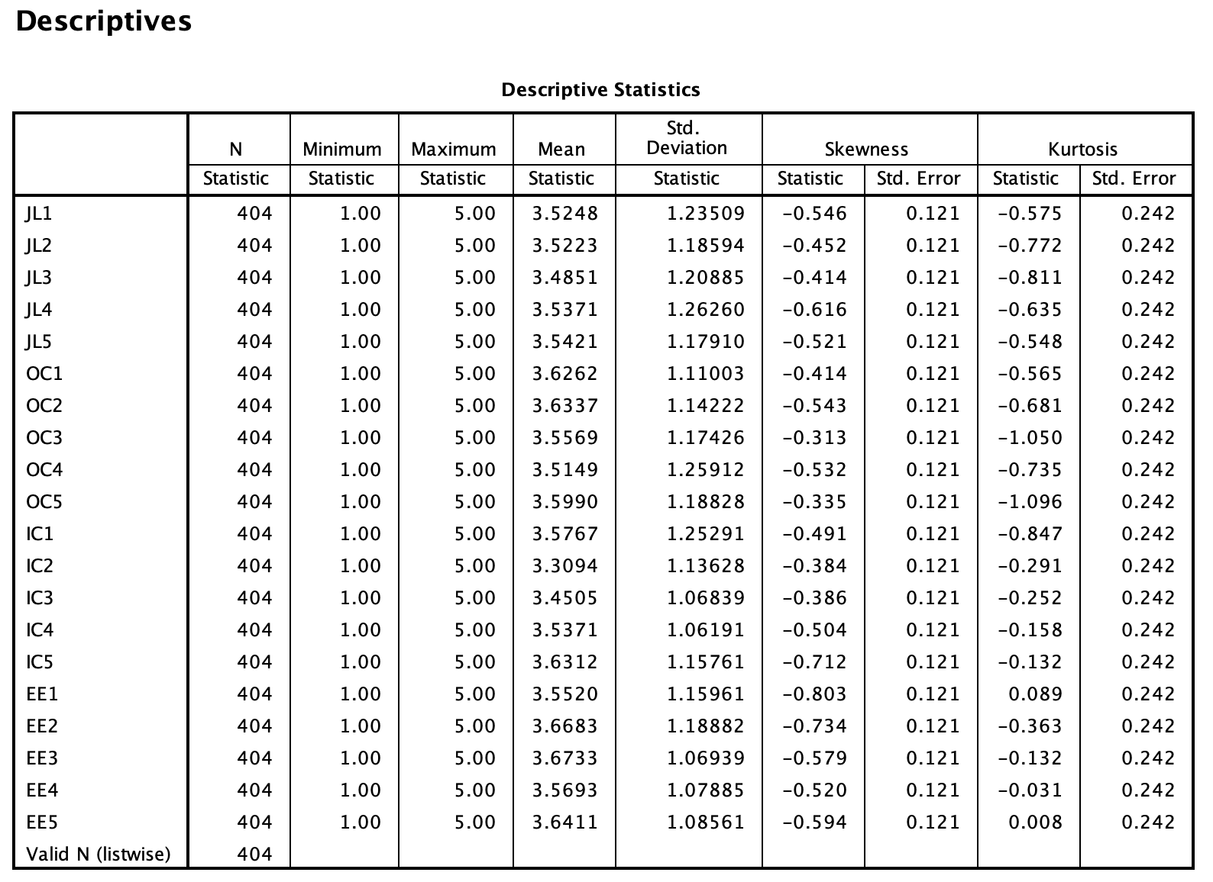
As can be seen from the above table, the factual investigation aftereffects of the information of each subject incorporated into the poll, including the quantity of cases, least worth, most extreme worth, mean worth, standard deviation, skewness and kurtosis, are utilized to confirm whether the information acquired from the review are liable to ordinary conveyance. Regardless of whether the information complies with ordinary dispersion will impact ensuing investigation. Kline (2013) accepted that when the outright estimation of skewness is under 3 and the total estimation of kurtosis is under 10, it shows that the example essentially complies with typical conveyance.
The data collected from the questionnaire can be directly used for subsequent statistical analysis such as reliability and validity (Darawsheh and Stanley, 2014). The official example brings about the table demonstrate that the total estimation of the skewness of each subject is under 3, and the supreme estimation of kurtosis is under 10. Both the skewness and kurtosis fulfill the state of the typical circulation, showing that each subject can comply with the ordinary appropriation. The information gathered from the poll can be legitimately utilized for consequent measurable examination, for example, reliability and validity.

4.2 Reliability Test
Table 5: Table of Reliability Test
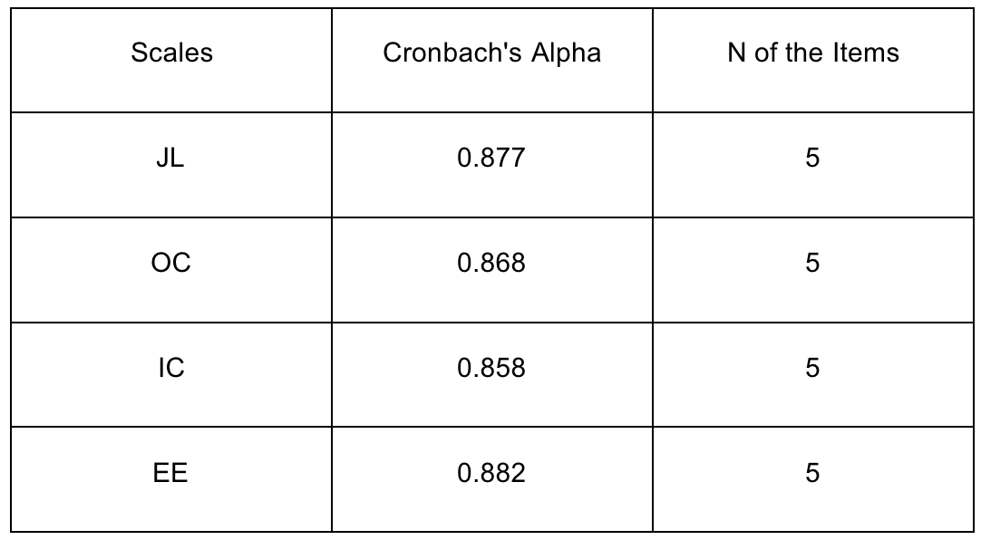
So as to guarantee the dependability and solidness of the survey, the exploration must break down the unwavering quality of the poll. By and large, inquire about utilizations the alpha coefficient to quantify the dependability of the poll (Csikszentmihalyi and Larson, 2014). The alpha coefficient is higher, the unwavering quality of the survey is higher, the solidness of the poll is higher (Gunuc and Kuzu, 2015). In early examinations, polls with an alpha coefficient higher than 0.5 were viewed as satisfactory, and those with an alpha coefficient more noteworthy than 0.7 were viewed as incredible, with the improvement of research, researchers have progressively high necessities on the unwavering quality of surveys (Andrew, Arora and Bilmes et al., 2013). The reliability of the variables in this study is shown in table 3. It can be concluded that the Alpha value of each variable is higher than 0.8, indicating that all variables in this research are reliability.

4.3. Validity Analysis
Validity Analysis is a significant piece of the observational investigation, the specialists for the most part need more time or assets to the advancement of new estimation instruments (Heale and Twycross, 2015). Ttherefore, so as to spare time and cost alludes to the flow existing estimation apparatuses, for example, surveys, utilizing existing devices can help the investigation found that a similar estimation instruments whether crosswise over research will likewise be good (Ott and Longnecker, 2015). Thusly, it is imperative to check in the case of estimating devices are connected and deciphered successfully and precisely for the items learned at present (Noble and Smith, 2015).
For questionnaires, content legitimacy and structure legitimacy are generally used to gauge. Among them, the substance legitimacy alludes to the reasonableness of thing with the deliberate factors and rationale reliable (Lu Juan, and so on., 2006), utilized in the survey of this examination depended on the writing audit demonstrates that the connection between the factors or third party referencing, and as indicated by the fundamental examination is the consequence of thing wording, for example, articulation made further update and improvement of which can be thought of as the size of substance legitimacy (Cohen, West and Aiken, 2014). The accentuation of this investigation is on the investigation of auxiliary legitimacy, which alludes to the capacity of the things to quantify the tried factors (CAI li, yi miaomiao, 2009). The exploratory factor examination (EFA) test is directed on the gathered information to demonstrate the basic legitimacy of the scale.
In general exploratory factor analysis, the possible trial of factor examination should initially meet two conditions Field (Hardle and Simar, 2015), the value of KMO more than 0.7 and the significant value less than 0.05. The SPSS was used to do the factor analysis. KMO and Bartlett's test was performed as follows.
Table 6: KMO and Bartlett's Test
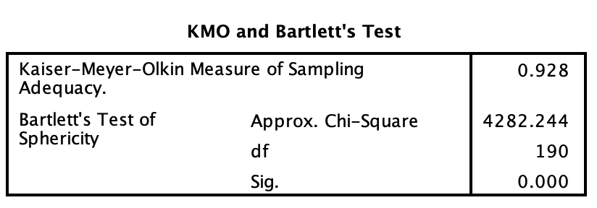
It can get information from table 6, the value of KMO is 0.928, more than 0.7, what's more, Bartlett's test worth is critical, Sig value less than 0.05, demonstrating that the poll information meets the reason necessities of factor examination. Thusly, further investigation was done. The primary part investigation strategy was received for factor extraction, and regular components were extricated with trademark roots more prominent than 1 as the factor. Factor analysis was led with the symmetrical turns with the biggest fluctuation when the factor pivoted.The results are shown in Figure 4.4 below.

Table 7: Total Variance Explained
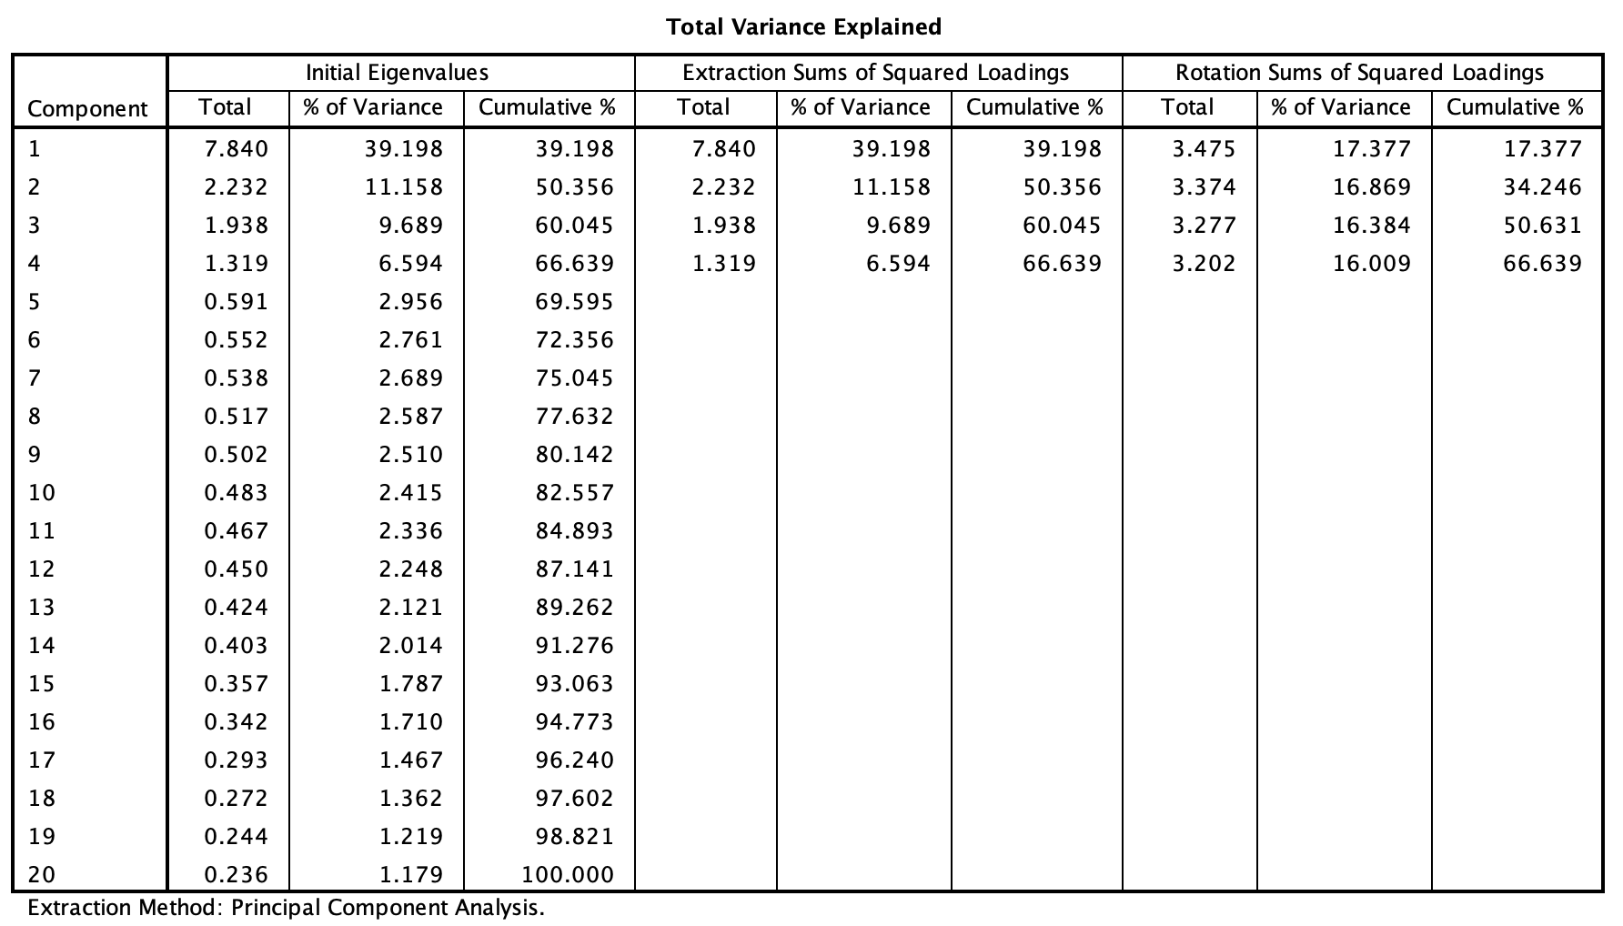

This table 7 shows that an aggregate of 4 variables can be gotten from the factor investigation results, and the illustrative capacity is 39.198, 11.158, 9.689 and 6.594, respectively.The complete illustrative capacity arrives at 66.639% and over half, demonstrating that the four elements screened are of good representativeness. Factor load coefficients appear in table 4.2 underneath.

Table 8: Rotated Component Matrix
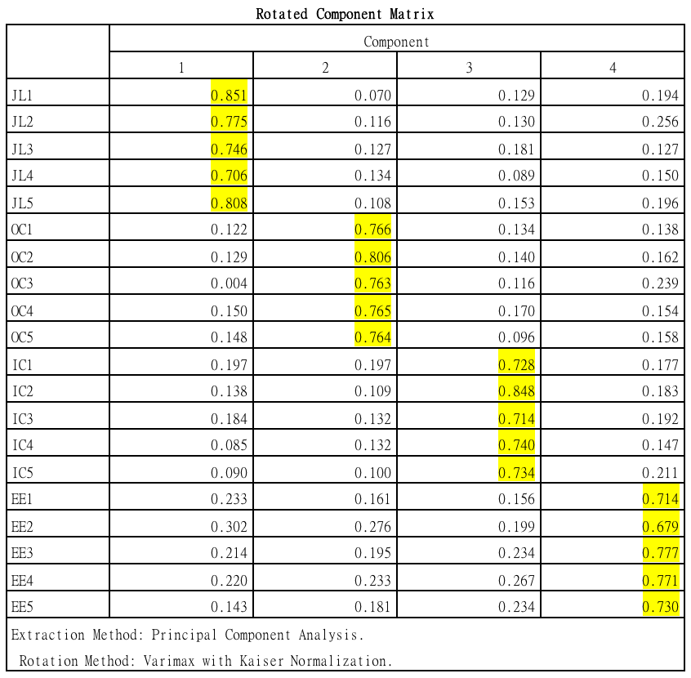
As can be seen from the above table, the factor heap of every estimation thing is more prominent than 0.5, and there is no cross-stacking (Kleinbaum, Kupper and Nizam et al., 2013). Every thing falls into the comparing factor, which demonstrates that the scale has great auxiliary legitimacy.

4.4 Correlation Test
The structure of measurements and relating questions are resolved through legitimacy investigation and unwavering quality examination (Krosnick, 2018). The normal score of each measurement is determined as the score of this measurement, and after that relationship, the investigation is done. Connection investigation essentially ponders the relationship between's factors. The worth scope of the connection coefficient is between - 1 and 1, the outright worth is ale, the relationship between's factors is nearer (IJsselsteijn, De Kort and Poels, 2013).
Table 9: Descriptive Statistics of Correlation analysis
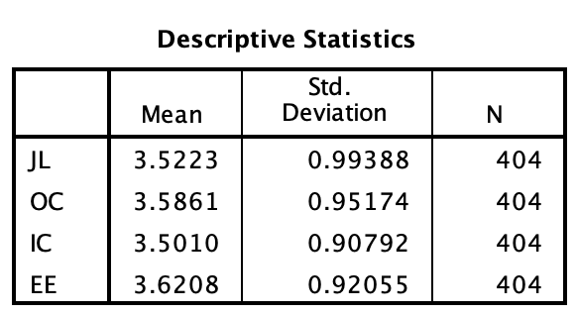
Table 10: Correlations analysis
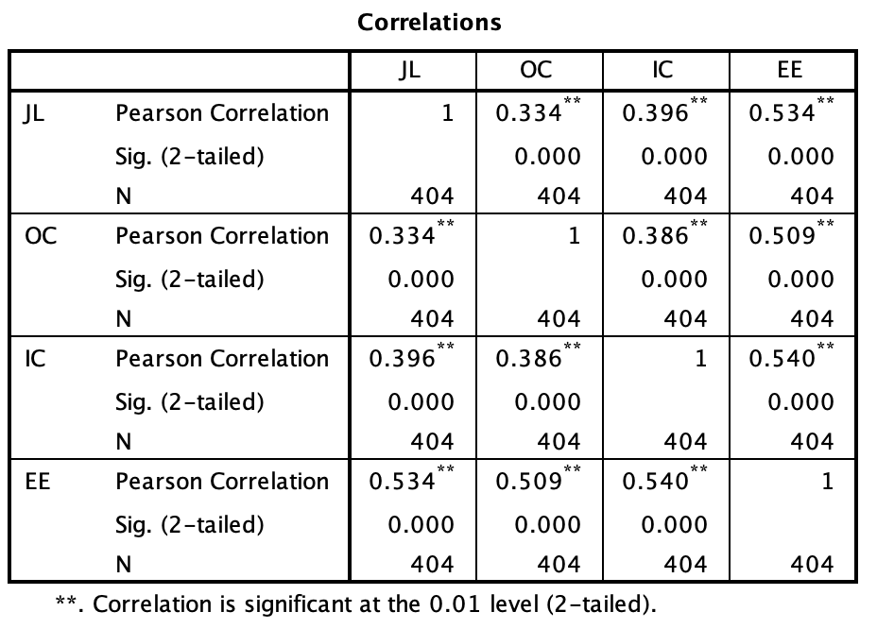
From the above two tables we can see that job leves (JL) has a significant relationship with employee engagement (EE), r value equal to 0.534, p value equal less than 0.01, the organizational commitment has a ssignificant relationship with employee engagement (EE), r value equal to 0.509, p value less than 0.01, internal communication also has a significant relationship with employee engagement (EE), r value equal to 0.540, p value less than 0.01, so the research of the independent variable job leves, organizational commitment and internal communication all have significant positive correlation with the dependent variable employee engagement (Fox, 2015). So as to further examine the connection between factors, various relapse investigation is embraced to improve the speculation test further.

4.5 Regression Analysis
Correlation analysis can just essentially depict the communication between two factors, can not reject the collaboration between the affecting variables (Yang, 2013). In this manner, we have to further utilize numerous straight relapse investigation. Multivariate direct relapse can avoid the association between autonomous factors and get the connection between free factors and ward factors (Babbie, Wagner and Zaino, 2018). In this study, Gender, Age, Education background, Job and Length of employment as control variables, job levels, organizational commitment and internal communication and employee engagement are used to do multiple linear regression (Chatterjee and Hadi, 2015). The results are shown in the table below.
Table 11: Model Summaryb
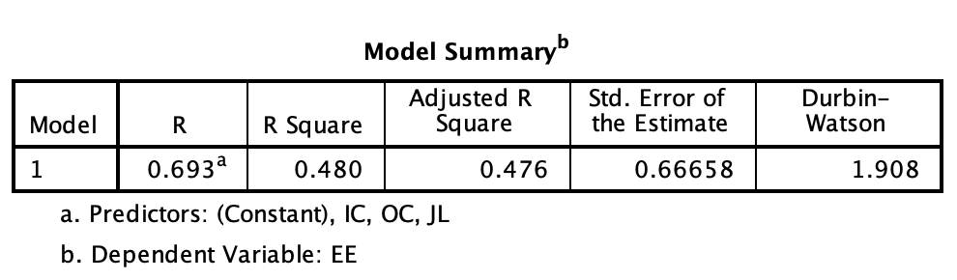
Table 11 summary of the model shows that the determinant coefficient of the model is R Square 0.480 and Adjusted RSquare is 0.476, which indicates that the model can explain the employee engagement (EE) variation to 47.6%.
Table 12: ANOVA test
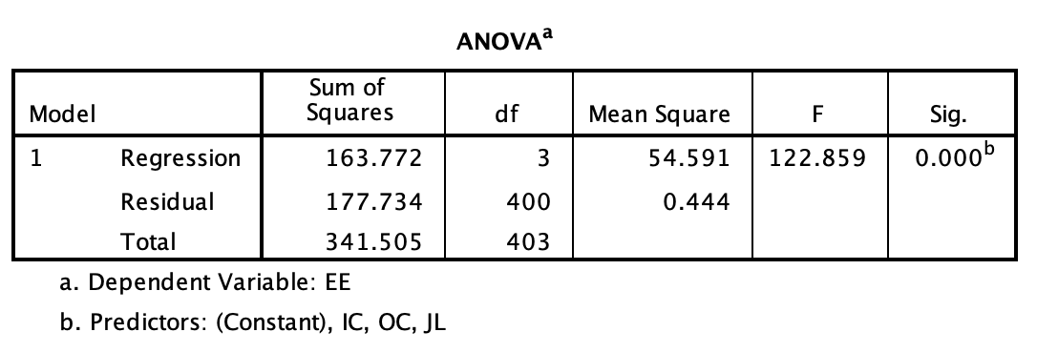
The ANOVA brings about Table 12 demonstrate that the F estimation of the relapse condition model is 122.859, and its noteworthiness worth is 0.000, under 0.01. It rejects the first suspicion that the general relapse coefficient is 0 (Pfister, Schwarz, Carson and Jancyzk, 2013). In this manner, the fitting impact of the last relapse condition is awesome.
Table 13: Coefficients analysis
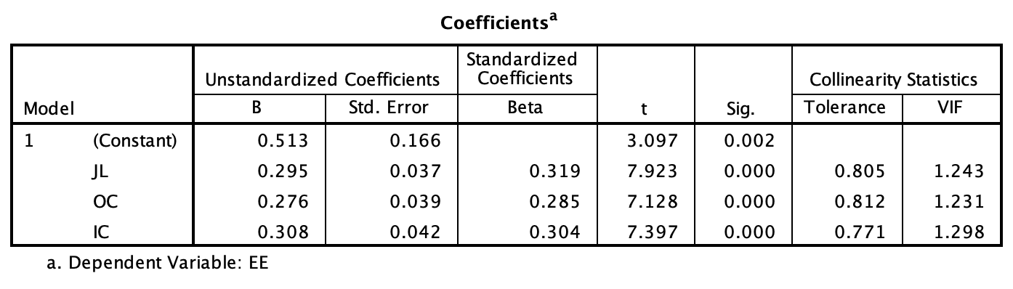
From the table above, we can see that the VIF of each independent variable is less than 5, indicating that there is no collinearity between independent variables, and the estimated results of the model are stable. The standardized regression coefficient can be obtained that JL has a significant positive impact on EE (beta = 0.319, P < 0.001) and OC has a significant positive impact on EE (beta = 0.285, P < 0.001) in independent variables. In independent variables, IC has a significant positive effect on EE (beta = 0.304, P < 0.001). So the hypothesis are valid, and the improvement of job levels, organizational commitment and internal communication can effectively improve employee engagement.

4.6 Summary
From the above analysis, we can get the result that three factors all support the hypothesis, the beta coefficient of internal communication is the highest, which means that it has the most positive relationship with the knowledge employees' engagement in private enterprises in Hohhot (Coolican, 2017). Then the job levels based on the beta coefficient has a significant relationship with knowledge employees' engagement. It is a necessary factor that absolutely affects knowledge employees' engagement, it also means that job levels has some decisive impact on the knowledge employees' engagement of private enterprises (Schroeder, Sjoquist and Stephan, 2016).
And there also has a significant relationship between organizational commitment and knowledge employees' engagement, but the beta coefficient of organizational commitment is the lowest in three IVs, which means that the organizational commitment to the impact of the knowledge employees' engagement in Hohhot private enterprises is relatively small (Gunst, 2018).

CHAPTER 5: CONCLUSION AND RECOMMENDATION

5.1 Conclusion
This paper studies the three factors influencing the engagement of knowledge employees’s engagement in private enterprises. There are several definitions in this paper. The first one is the definition of enterprise scope (Hameduddin and Fernandez, 2019). This research mainly focuses on private enterprises in Hohhot, which is obviously differernce with state-owned enterprises and foreign-funded enterprises. Secondly, the object of the study is knowledge employees. Knowledge employees are the basis for the survival of an enterprise and the main source of independent innovation ability of an enterprise (Tamayo, 2016). Contrasted and non-information representatives, learning representatives have numerous particularities in close to home qualities, mental needs, qualities and working techniques. The third is the study of engagement. Employees' engagement to the enterprise is the basis of its development. Only by keeping employees' moderate engagement can enterprises have the opportunity to use talents (Williams, et al., 2019).
The engagement of knowledge employees is very important for enterprises. If an enterprise wants to survive and develop, it must have such core talents as knowledge employees. Especially in today's increasingly fierce social competition, rapid progress in science and technology, rapid changes in economic forms, everything can be imitated, only the knowledge employees of enterprises can not be replaced (Yaneva, 2018). Therefore, the author believes that private enterprises urgently need to improve the engagement of knowledge employees, furthermore, so as to improve the commitment, we should initially discover what are the significant variables influencing the commitment of information representatives.
Based on perusing an enormous number of related hypotheses and research results at home and abroad, the author explores the internal structure of employee engagement in private enterprises by using the method of empirical analysis and analyzing the characteristics of employees in private enterprises (Guan, 2014). This paper analyses the three factors of knowledge employees' engagement in private enterprises in Hohhot, and comes to hypothesis of the relationship between three influencing factors (job levels, organizational commitment and international communication) and knowledge employees’ engagement (Gao and Yao, 2015) . Then, it explores the relationship between three factors of knowledge employees' engagement and verifies the hypothesis in light of the consequences of the poll overview and information measurable investigation. Finally, according to the empirical analysis results of the article, this paper explores the impact of knowledge employees’ engagement on private enterprises and provides corresponding management practice suggestions for enterprises to enhance employee engagement (Frino, Djibo and Desiderio, 2019). The conclusion of this study is that all three factors have a significant relationship with the engagement of knowledge employees.

5.2 Recommendation
Nowadays, with the deepening of economic globalization and economic integration, the competition of national strength is mainly embodied by economic development, and economic development mainly depends on talents (Anand, 2019). Knowledge employees can be said to be the carrier of the core talents of enterprises. The demand for knowledge employees is increasing day by day, and they have become the object of competition for various enterprises. The development of private enterprises can not be separated from the contribution of knowledge employees, and the engagement of knowledge employees is also a problem that enterprises must consider (Chen, 2015). Only knowledge employees actively participate in the organization can promote the development of enterprises. On the contrary, if the engagement of employees is reduced, the efficiency of enterprises will be reduced or even unable to survive.
Accordingly, so as to improve the commitment of information representatives in private ventures, this paper advances the accompanying proposals:

(1) Establishing engagement-oriented recruitment mechanism
Enterprises should do a good job in recruiting and managing knowledge employees from the source. Enterprises can formulate perfect recruitment procedures according to the actual situation (Pallant and Manual, 2013). For example, before an enterprise starts to recruit, it should first have a clear evaluation of each position in the enterprise, find out the vacant positions and the number and conditions of employees needed to ensure the accuracy of recruiting employees; then, by identifying the application materials and work experience of job candidates, it can exclude those frequent job-hopping or low engagement in advance (Nazir et al., 2019). Finally should test the knowledge and skills of job candidates as well as their personal inclination to understand the knowledge and skills level of job candidates and to make sure that the values of job candidates are in line with the values of enterprises, so as to ensure that employees with high engagement are recruited.
(2) Establishing a Good Salary
To improve organizational commitment, organizations can establish a good salary system, the role of salary is to reduce employee dissatisfaction. However, for private enterprises in China, the role of salary is to fully mobilize the enthusiasm of employees on the basis of ensuring their survival. Perhaps an enterprise can get 100% return for raising 1% of its employees' salary. Perhaps it can cause strong dissatisfaction and even quit because the enterprise lowers 1% of its employees' salary (Ferreira, 2019). This fully illustrates the important role of salary in improving the engagement of knowledge employees. Enterprises should establish flexible, hierarchical and differentiated salary system according to different people, and change with the change of internal and external environment (Cesario and Chambel, 2017). In addition, when setting salary, private enterprises should make salary and performance linked closely with the performance of employees, increase the proportion of performance pay in the whole salary system, if employees do more work, then they can get more, in order to improve representative fulfillment and keep up the commitment to the private undertaking.
(3) Establishing communication channels
Modern society is a society of information, information is called the nervous system of enterprises, and the transmission and reception of information benefits from the smooth communication channels. Communication management is an important part of enterprise management (Buell, Cai and Sandino, 2019). For an private enterprise, communication is a link that can not be ignored. Its has important role in improving the engagement of knowledge employees in private enterprises.
Communication should be a two-way process, with both information transmission and feedback. Firstly, the enterprise should clearly tell employees the internal information of the enterprise, so that employees can keep abreast of the operation and development of the enterprise. And company should try best to avoid unrealistic expectations and commitments between enterprises and employees, create a good communication atmosphere, what's more, set up a relationship of common trust among endeavors and representatives. Secondly, employees should timely feedback information to the enterprise, so that the enterprise can keep abreast of their true ideas (Rahim and Shazween, 2019). In this process, enterprises can not only discover the strengths and weaknesses of employees, and focus on the implementation of education and training for employees, but also obtain suggestions from employees, stimulate the interests and enthusiasm of employees, and increase the efficiency of enterprises.
A good communication environment can share the company's knowledge wealth, make information exchange complementary, and greatly improve the utilization of information (Kanwar and Sharma, 2016). Through reasonable authorization, enterprises have greatly satisfied the needs of knowledge employees with strong autonomy. The increase of job rotation, job enrichment and sense of responsibility makes knowledge employees improve their engagement to enterprises on the basis of obtaining independent, innovative and challenging work (Doyle, 2019).

5.3 Limitation of Study
At present, the research on engagement management of knowledge employees in private enterprises in Hohhot is not only lack of corresponding management theory, but also a lack of management practice (Milhem, Muda and Ahmed, 2019). The decrease of knowledge employees' engagement has not attracted enough attention from the managers of private enterprises in China, and most enterprises lack the experience of employee engagement management that can be used for reference, which determines that there are many deficiencies in this study.
(1) In the design of preliminary and formal questionnaires, due to limited time, the author only studied three influencing factors and did not explore the correlation between other factors and knowledge employees' engagement. Because there are many factors to be measured (Patten, 2016). The author has a certain subjective tendency in the classification of factors, which may bring about systematic deviation and subjective problems of data. Therefore, the author believes that it can be further corrected in future research to obtain more accurate factors affecting knowledge employees' engagement.
(2) In the empirical study, the information filled in by the questionnaire can not be completely confidential, and the information may be affected by other employees or overrated for not revealing the true idea (Garg, Srivastav and Gupta, 2018). The sample size and sampling area are mainly concentrated in some private enterprises in Hohhot. There are some limitations in the way of issuing online questionnaires. The representativeness of the data needs further empirical research.
(3) In the empirical analysis stage, because of the limited knowledge and theoretical level of the author, this research do some simple analysis. Like factor analysis, correlation test and regression test. The demonstration may be relatively simple and needs further in-depth analysis (Rutishauser and Sender, 2019).

5.4 Personal Reflection
In a word, the engagement of knowledge employees in private enterprises is a significant and complex issue. The research on this issue needs not only profound theoretical accumulation but also rich practical experience of enterprises.
The engagement of knowledge employees in private enterprises is also a very real problem, and many aspects of enterprise management will be involved (Allen, Turner and Turner, 2018). Therefore, how to define the concept and scope of knowledge employees' engagement accurately, how to find out the factors affecting their engagement, and how to take effective measures to cultivate and enhance the engagement of knowledge employees are all issues that need to be considered in the study of engagement. This article is just the beginning. In the future study and work, with the continuous accumulation of the author's theory and practical experience, the author will continue to pay attention to the engagement of knowledge employees in private enterprises and try his best to put forward some original opinions with certain practical guiding significance and theoretical value.

REFERENCES
Agarwala, V. and Panwar, S., (2019). Enlighten the Effect of Smartphone Usage onEmployee Engagement and Employee Performance in Higher Educational Institutions,34(3), pp.53-58.
Ahmad, R. and Islam, T., (2018). Relationships between Corporate SocialResponsibility, Work Engagement and Organizational Commitment: Explanatory Roleof Organizational Identification. Journal of Behaxioural Sciences, 28(2), pp.34-43.
Ahmed, S. and Islam, S.R., (2018). Influence of human resource management practiceson employee engagement in developing economy. Journal of Business, 5(1), p.2.
Albrecht, S.L., Bakker, A.B., Gruman, J.A., Macey, W.H. and Saks, A.M., 2015. Employee engagement, human resource management practices and competitive advantage: An integrated approach. Journal of Organizational Effectiveness: People and Performance, 2(1), pp.7-35.
Albright, J.J. and Marinova, D.M., 2015. Estimating multilevel models using SPSS, Stata, SAS and R.
Alkusani, A. and Sukaris, S., (2019). Pengaruh Job· .Engagement Terhadap. PerilakuWithdrawal Melalui Komitmen Organisasi. Jurnal Riset Entrepreneurship, 2(1), pp.43-51.
Allen, J., Turner, A. and Turner, J. (2018). Employee Performance and Engagement forPerformance Improvement. Performance Improvement Quarterly, 30(4), pp.225- 230.
Allen, P., Bennett, K. and Heritage, B., 2014. SPSS statistics version 22: A practical guide. Cengage Learning Australia.
Alfes, K., Shantz, A.D., Truss, C. and Soane, E.C., 2013. The link between perceived human resource management practices, engagement and employee behaviour: a moderated mediation model. The international journal of human resource management, 24(2), pp.330-351.
Anand, R., (2019). Internals Matter: Internals Matter: Internal Customer Engagement-Perspectives from The Bhagavad Gita, 23(3), pp.33-37.
Andrew, G., Arora, R., Bilmes, J. and Livescu, K., 2013, February. Deep canonical correlation analysis. In International conference on machine learning (pp. 1247-1255).
Anitha, J., 2014. Determinants of employee engagement and their impact on employee performance. International journal of productivity and performance management, 63(3), p.308.
Arifin, Z., Nirwanto, N. and Manan, A., 2019. Improving the Effect of WorkSatisfaction on Job Performance through Employee Engagement. International Journalof Multi Discipline Science, 2(1), pp.1-9.
Arslan, M. (2017). Organizational Cynicism and Employee Performance: ModeratingRole of Employee Engagement. SSRN Electronic Journal, 12(3), pp.23-27.
Aydin, A., Sarier, Y. and Uysal, S., 2013. The Effect of School Principals' Leadership Styles on Teachers' Organizational Commitment and Job Satisfaction. Educational sciences: Theory and practice, 13(2), pp.806-811.
Babbie, E., Wagner III, W.E. and Zaino, J., 2018. Adventures in social research: Data analysis using IBM SPSS statistics. Sage Publications.
Bailey, C., Madden, A., Alfes, K. and Fletcher, L., 2017. The meaning, antecedents and outcomes of employee engagement: A narrative synthesis. International Journal of Management Reviews, 19(1), pp.31-53.
Bang, H., Ross, S. and Reio, T.G., 2013. From motivation to organizational commitment of volunteers in non‐profit sport organizations. Journal of Management Development.
Bedarkar, M. and Pandita, D., 2014. A study on the drivers of employee engagement impacting employee performance. Procedia-Social and Behavioral Sciences, 133, pp.106-115.
Biswas, S. and Bhatnagar, J., 2013. Mediator analysis of employee engagement: role of perceived organizational support, PO fit, organizational commitment and job satisfaction. Vikalpa, 38(1), pp.27-40.
Blau, P., 2017. Exchange and power in social life. Routledge.
Brace, I., 2018. Questionnaire design: How to plan, structure and write survey material for effective market research. Kogan Page Publishers.
Breevaart, K., Bakker, A., Hetland, J., Demerouti, E., Olsen, O.K. and Espevik, R., 2014. Daily transactional and transformational leadership and daily employee engagement. Journal of occupational and organizational psychology, 87(1), pp.138-157.
Buell, R.W., Cai, W. and Sandino, T., 2019. Learning or Playing? The Effect ofGamified Training on Performance, 23(7), pp.33-36.
Burnett, J.R. and Lisk, T.C., 2019. The Future of Employee Engagement: Real-TimeMonitoring and Digital Tools for Engaging a Workforce. International Studies ofManagement & Organization, 49(1), pp.108-119.
Byrne, Z. (2015). Understanding employee engagement. New York: Routledge, 12(2),pp.22-29.
Cameron, A.C. and Trivedi, P.K., 2013. Regression analysis of count data (Vol. 53). Cambridge university press.
Carter, D. and Baghurst, T., 2014. The influence of servant leadership on restaurant employee engagement. Journal of Business Ethics, 124(3), pp.453-464.
Cesário, F. and Chambel, M. (2017). Linking Organizational Commitment and WorkEngagement to Employee Performance. Knowledge and Process Management, 24(2),pp.152-158.
Chandani, A., Mehta, M., Mall, A. and Khokhar, V. (2016). Employee Engagement: AReview Paper on Factors Affecting Employee Engagement. Indian Journal of Scienceand Technology, 9(15), pp.24-27.
Chatterjee, S. and Hadi, A.S., 2015. Regression analysis by example. John Wiley & Sons.
Cheche, S.G., Muathe, S.M. and Mainạ, S.M., 2019. Employee Engagement,Demographic Characteristics and Performance of State Research and TrainingCorporations in Kenya. IUP Journal of Organizational Behavior, 18(1), pp55-70.
Chelliah, T.D., Ling-Meng, C., Jaganathan, M. and Koay, Y.Y., 2019. Case Study ofWorkplace Spirituality on Organizational Commitments among University Membersin Malaysia. Asia Proceedings of Social Sciences, 3(2), pp.44-47.
Chen Aiwu, (2016). Reflections on Employee Engagement in Chinese Enterprises.Market Modernization, 34(10), pp.89-93.
Chen Tan, (2015). Research on the relationship between job stressors and jobengagement of primary and secondary school teachers. Private education research,23(01), pp.33-36.
Chun, J.S., Shin, Y., Choi, J.N. and Kim, M.S., 2013. How does corporate ethics contribute to firm financial performance? The mediating role of collective organizational commitment and organizational citizenship behavior. Journal of Management, 39(4), pp.853-877.
Cohen, P., West, S.G. and Aiken, L.S., 2014. Applied multiple regression/correlation analysis for the behavioral sciences. Psychology Press.
Constantin, E.C. and Baias, C.C., 2015. Employee Voice• Key Factor in Internal Communication. Procedia-Social and Behavioral Sciences, 191, pp.975-978.
Cook, K.S., Cheshire, C., Rice, E.R. and Nakagawa, S., 2013. Social exchange theory. In Handbook of social psychology(pp. 61-88). Springer, Dordrecht.
Coolican, H., 2017. Research methods and statistics in psychology. Psychology Press.
Cronk, B.C., 2017. How to use SPSS: A step-by-step guide to analysis and interpretation. Routledge.
Csikszentmihalyi, M. and Larson, R., 2014. Validity and reliability of the experience-sampling method. In Flow and the foundations of positive psychology (pp. 35-54). Springer, Dordrecht.
Darawsheh, W. and Stanley, M., 2014. Reflexivity in research: Promoting rigour, reliability and validity in qualitative research. International Journal of Therapy and Rehabilitation, 21(12), pp.560-568.
Delina, G. and Samuel, P. (2019). A Study on The Interrelationships BetweenEmployee Engagement, Employee Engagement Initiatives and JobSatisfaction. International Journal of Business Excellence, 1(1), p.1.
Dhar, R.L., 2015. Service quality and the training of employees: The mediating role of organizational commitment. Tourism Management, 46, pp.419-430.
Doyle, K.A., 2019. Behind Closed Doors: Understanding how Canadian CompaniesUtilize Internal Communication to Engage Employees in Corporate SocialResponsibility, 15(2), pp.31-37.
Eldor, L. and Vigoda-Gadot, E., 2017. The nature of employee engagement: Rethinking the employee–organization relationship. The International Journal of Human Resource Management, 28(3), pp.526-552.
Ellis, B. and Normore, A.H., 2019. First-Line Police Supervisory Leadership: A PivotalRole in Effective Communication and Engagement. In Handbook of Research onStrategic Communication, Leadership, and Conflict Management in ModernOrganizations, 85(3), pp. 237-254.
Etukudo, R.U., 2019. Strategies for Using Analytics to Improve Human ResourceManagement, 34(7), pp.76-79.
Farooq, O., Payaud, M., Merunka, D. and Valette-Florence, P., 2014. The impact of corporate social responsibility on organizational commitment: Exploring multiple mediation mechanisms. Journal of Business Ethics, 125(4), pp.563-580.
Ferreira, P., 2019, March. Exploring Employee Engagement across Generations inHospitality: A Cross-Sectional Study of European Countries. In 2nd InternationalConference on Tourism Research, 25(4), p. 110.
Firdinata, R. and Hendriyani, H., 2018.Predicting Employee Engagement: A studyamong millennials. In Social and Humaniora Research Symposium, 23(4), pp.47-53.
Fu, W. and Deshpande, S.P., 2014. The impact of caring climate, job satisfaction, and organizational commitment on job performance of employees in a China’s insurance company. Journal of Business Ethics, 124(2), pp.339-349.
Erino, M., Djibo, I. and Desiderio, K.P., 2019. Organizational Alignment as a Predictorof Employee Engagement. Performance Improvement, 58(4), pp.21-27.
Field, A., 2013. Discovering statistics using IBM SPSS statistics. sage.
Fox, J., 2015. Applied regression analysis and generalized linear models. Sage Publications.
Gao Chengli, Yao Lingling, (2015). How to improve employee engagement. Talentresource development, 10(09), pp.24-27.
Garg, V., Srivastav, S. and Gupta, A., 2018, October. Application of ArtificialIntelligence for Sustaining Green Human Resource Management. In 2018 InternationalConference on Automation and Computational Engineering, 67(4), pp. 113-116.
George, D. and Mallery, P., 2016. IBM SPSS statistics 23 step by step: A simple guide and reference. Routledge.
Gerber, S.B. and Finn, K.V., 2013. Using SPSS for Windows: Data analysis and graphics. Springer.
Gibbs, M. and Poisat, P., 2019. Educator Engagement: Key to High Performance ofSchool Operational teams in South African Secondary Schools. Africa EducationReview, pp.1-16.
Githinji, J.W. and Muli, J., 2018. Employee engagement strategies and employeeperformance of Air Kenya Limited. International Academic Journal of HumanResource and Business Administration, 3(4), pp.397-412.
Graffigna, G. (2017). Is a Transdisciplinary Theory of Engagement in OrganizedSettings Possible? A Concept Analysis of the Literature on Employee Engagement,Consumer Engagement and Patient Engagement. Frontiers in Psychology, 23(8),pp.38-42.
Graban, M., 2018. Lean hospitals: improving quality, patient safety, and employee engagement. Productivity Press.
Guanxin, (2014). Research on the impact of the structure of employee engagement andjob-individual matching on employee engagement in IT industry. Master's DegreeThesis of South China Normal University, 27(05), pp.41-47.
Gunst, R.F., 2018. Regression analysis and its application: a data-oriented approach. Routledge.
Gunuc, S. and Kuzu, A., 2015. Student engagement scale: development, reliability and validity. Assessment & Evaluation in Higher Education, 40(4), pp.587-610.
Gustomo, A., Eebriansyah, H., Ginting, H. and Santoso, I.M., 2019. Understandingnarrative effects: The impact of direct storytelling intervention on increasing employeeengagement among the employees of state-owned enterprise in West Java,Indonesia. Journal of Workplace Learning, 87(2), pp.134-145.
Hameduddin, T. and Fernandez, S. (2019). Employee Engagement as AdministrativeReform: Testing the Efficacy of the OPM's Employee Engagement Initiative. PublicAdministration Review, 34(2), pp.76-80.
Hardle, W.K. and Simar, L., 2015. Canonical correlation analysis. In Applied multivariate statistical analysis (pp. 443-454). Springer, Berlin, Heidelberg.
Harịỵanto, R.P.F. and Ferdian, A., 2019. Pengaruh Talent Management TerhadapEmployee Engagement (Studi Kasus Pada K antor Badan Pelaksana K egiatan y ayasanPendidikan Telkom). Jurnal Mitra Manajemen, 3(3), pp.254-267.
Hassan, S., Wright, B.E. and Yukl, G., 2014. Does ethical leadership matter in government? Effects on organizational commitment, absenteeism, and willingness to report ethical problems. Public Administration Review, 74(3), pp.333-343.
Heale, R. and Twycross, A., 2015. Validity and reliability in quantitative studies. Evidence-based nursing, 18(3), pp.66-67.
Heck, R.H., Thomas, S. and Tabata, L., 2013. Multilevel modeling of categorical outcomes using IBM SPSS. Routledge.
Hendrawati, N.N.D., Handoyo, A.H., Ruliana, P. and Irwansyah, I., 2018. PengaruhIklim Komunikasi, terhadap Engagement Karyawan, 3(2), pp.122-136.
Hill, L. and Hill, L.M., 2019. The Convergence of Engagement Leadership and Leader-Driven Retrenchment Business Strategies: A Phenomenological Approach, 3(7), pp.23-27.
Hinton, P.R., McMurray, I. and Brownlow, C., 2014. SPSS explained. Routledge.
Ho, R., 2013. Handbook of univariate and multivariate data analysis with IBM SPSS. Chapman and Hall/CRC.
Hooi, L.W., 2019. Leveraging human assets for MNCs performance: the role ofmanagement development, human resource system and employee engagement. TheInternational Journal of Human Resource Management, pp.1-30.
Hume, J. and Leonard, A., 2014. Exploring the strategic potential of internal communication in international non-governmental organisations. Public relations review, 40(2), pp.294-304.
IJsselsteijn, W.A., De Kort, Y.A.W. and Poels, K., 2013. The game experience questionnaire. Eindhoven: Technische Universiteit Eindhoven.
Jacobs, M.A., Yu, W. and Chavez, R., 2016. The effect of internal communication and employee satisfaction on supply chain integration. International Journal of Production Economics, 171, pp.60-70.
Jehanzeb, K., Rasheed, A. and Rasheed, M.F., 2013. Organizational commitment and turnover intentions: Impact of employee's training in private sector of Saudi Arabia. International Journal of Business and Management, 8(8), p.79.
Jiangbo, (2016). Employee satisfaction, engagement, loyalty cultivation andConstruction Research - Take Company A as an example. Master's degree thesis ofNortheast University of Finance and Economics, 54(12), pp.62-69.
Johnson, S. and Pike, B., 2018. Employee Retention: The State of Engagement inPublic Accounting Firms and Why It Matters. The CPA Journal, 88(12), pp.64-66.
Juhdi, N., Pa'wan, F. and Hansaram, R.M.K., 2013. HR practices and turnover intention: the mediating roles of organizational commitment and organizational engagement in a selected region in Malaysia. The International Journal of Human Resource Management, 24(15), pp.3002-3019.
Kang, M. and Sung, M., 2017. How symmetrical employee communication leads to employee engagement and positive employee communication behaviors: The mediation of employee-organization relationships. Journal of Communication Management, 21(1), pp.82-102.
Kanwar, D. and Sharma, P. (2016). "employee engagement: identifying gaps inhospitality industry" to "employee engagement: an overview." South Asian Journal ofMarketing & Management Research, 6(10), p.70.
Karanges, E., Johnston, K., Beatson, A. and Lings, I., 2015. The influence of internal communication on employee engagement: A pilot study. Public Relations Review, 41(1), pp.129-131.
Karanges, E.R., 2014. Optimising employee engagement with internal communication: a social exchange perspective(Doctoral dissertation, Queensland University of Technology).
Khuong, M. and Dung, D. (2015). The Effect of Ethical Leadership and OrganizationalJustice onEmployee Engagement The Mediating Role of EmployeeTrust. International Journal of Trade, Economics and Finance, 6(4), pp.235-240.
Kim, J.K. and LePine, J.A., 2019. Employee Engagement: The Past, the Present, andthe Future. The SAGE Handbook of Human Resource Management, p.371.
Kleinbaum, D.G., Kupper, L.L., Nizam, A. and Rosenberg, E.S., 2013. Applied regression analysis and other multivariable methods. Nelson Education.
Kocherlakota, S. (2015). Employee Commitment: A Giant Leap in EmployeeEngagement. OPUS: HR Journal, 6(1), pp.23-27.
Krosnick, J.A., 2018. Questionnaire design. In The Palgrave handbook of survey research (pp. 439-455). Palgrave Macmillan, Cham.
Kura, K.M., Shamsudin, F .M., Umrani, W .A. and Salleh, N.M., 2019. Linking HumanResource Development Practices to Counterproductive Work Behaviour: DoesEmployee Engagement Matter. Journal of African Business, pp.1-17.
Kyriakidis, M., Happee, R. and de Winter, J.C., 2015. Public opinion on automated driving: Results of an international questionnaire among 5000 respondents. Transportation research part F: traffic psychology and behaviour, 32, pp.127-140.
Lamba, S. and Choudhary, N., 2013. Impact of HRM practices on organizational commitment of employees. International Journal of Advancements in Research & Technology, 2(4), pp.407-423.
Latta, G.F., 2019. A complexity analysis of organizational culture, leadership andengagement: integration, differentiation and fragmentation. International Journal ofLeadership in Education, pp.1-26.
Leech, N.L., Barrett, K.C. and Morgan, G.A., 2014. IBM SPSS for intermediate statistics: Use and interpretation. Routledge.
Lengmei, (2017). Study on the Influencing Factors of Employee Engagement. Master'sDegree Thesis of Jilin University. 27(06), pp.44-53.
Levine, G., 2013. A Guide to SPSS for Analysis of Variance. Psychology Press.
Lewis, A., 2019. Human Capital Development: An Investigation of InnovativeMethods. In Innovation and Social Capital in Organizational Ecosystems, 76(4), pp.151-172.
Li Jinbo, Xu Baibua, Chen Jianming, (2016). Study on the Organizational FactorsAffecting Employees'Job Involvement. Applied Psychology, 16(02), pp.34-40.
Liang Qiong, (2015). New challenges of HR management: enhancing employeeengagement and organizational commitment. Industry and Technology Forum, 12(09),pp.45-50.
Mas-Machuca, M. and Marimon, F., 2019. From sense-making to perceivedorganizational performance: looking for the best way. Journal of ManagementDevelopment, 2(1), pp.4-13.
Mayers, A., 2013. Introduction to statistics and SPSS in psychology. Pearson Higher Ed.
Meyers, L.S., Gamst, G.C. and Guarino, A.J., 2013. Performing data analysis using IBM SPSS. John Wiley & Sons.
Mazzei, A., Quaratino, L., Butera, A. And Fisichella, C., 2018. TransformativeStrategies for Employee Engagement: Managers and EmployeesConfronted. Transformative business strategies and new patterns for value creation,p.53.
Mazzei, A. and Ravazzani, S., 2015. Internal crisis communication strategies to protect trust relationships: A study of Italian companies. International Journal of Business Communication, 52(3), pp.319-337.
Mazzei, A., 2014. Internal communication for employee enablement: Strategies in American and Italian companies. Corporate Communications: An International Journal, 19(1), pp.82-95.
Men, L.R. and Stacks, D., 2014. The effects of authentic leadership on strategic internal communication and employee-organization relationships. Journal of Public Relations Research, 26(4), pp.301-324.
Men, L.R., 2014. Strategic internal communication: Transformational leadership, communication channels, and employee satisfaction. Management Communication Quarterly, 28(2), pp.264-284.
Men, L.R., 2014. Why leadership matters to internal communication: Linking transformational leadership, symmetrical communication, and employee outcomes. Journal of Public Relations Research, 26(3), pp.256-279.
Men, L.R., 2015. The internal communication role of the chief executive officer: Communication channels, style, and effectiveness. Public Relations Review, 41(4), pp.461-471.
Menguc, B., Auh, S., Fisher, M. and Haddad, A., 2013. To be engaged or not to be engaged: The antecedents and consequences of service employee engagement. Journal of business research, 66(11), pp.2163-2170.
Milbem, M., Muda, H. and Ahmed, K., 2019. The Effect of Perceived TransformationalLeadership Style on Employee Engagement: The Mediating Effect of Leader'sEmotional Intelligence. Foundations of Management, 11(1), pp.33-42.
Milhem, M.M., Muda, H. and Ahmed, K., 2019. The Effect of Perceived TransactionalLeadership Style on Employee Engagement in Palestinian ICT Industry. Journal ofAdvanced Advanced Research in Business and Management Studies, 14(1), pp.42-51.
Mishra, K., Boynton, L. and Mishra, A., 2014. Driving employee engagement: The expanded role of internal communications. International Journal of Business Communication, 51(2), pp.183-202.
Mishra, K.,, Mishra, A.K. and Walker, K., 2019. Using Innovative InternalCommunication to Enhance Employee Engagement. In Handbook of Research onStrategic Communication, Leadership, and Conflict Management in ModernOrganizations, 90(3), pp. 445-468.
Moletsane, M., Tefera, o. and Migiro, S., 2019. The relationship between employeeengagement and organisational productivity of sugar industry in South Africa: theemployees perspective. African Journal of Business and Economic Research, 14(1),pp.113-134.
Mone, E.M. and London, M., 2018. Employee engagement through effective performance management: A practical guide for managers. Routledge.
Nawangsari, L.C. and Sutawidjaya, A.H., 2019. Talent Management in MediatingCompetencies and Motivation to Improve Employee's Engagement. InternationalJournal of Economics & Business Administration, 7(1), pp.140-152.
Nazir, E.N.M., Abdullah, M.S., Mhd, N.F., Nasir, D.I.S., Omar, N.F. and Halim, N.A.,2019. A Study on Workplace Fun Affects Employee Engagement: Case Study ofManufacturing Industry. In Second International Conference on the Future of ASEAN,23(5), pp. 56-71.
Nienaber, H., 2019. Employee engagement: Driving strategy implementation throughdimensions of organisation. Journal of Management & Organization, pp.1-21.
Nazir, E.N.M., Abdullah, M.S., Mhd, N.F., Nasir, D.I.S., Omar, N.F. and Halim, N.A., .2019. A Study on Workplace Fun Affects Employee Engagement: Case Study ofManufacturing Industry. In Second International Conference on the Future of ASEAN,23(5), pp. 56-71.
Nienaber, H., 2019. Employee engagement: Driving strategy implementation throughdimensions of organisation. Journal of Management & Organization, pp.1-21.
Nikoloỵa, I., Schaufeli, W. and Notelaers, G., 2019. Engaging Leader- -EngagedEmployees? A Cross-Lagged Study on Employee Engagement. European ManagementJournal, 13(3), pp.23-27.
Noble, H. and Smith, J., 2015. Issues of validity and reliability in qualitative research. Evidence-based nursing, 18(2), pp.34-35.
Norris, G., Qureshi, F., Howitt, D. and Cramer, D., 2014. Introduction to statistics with SPSS for social science. Routledge.
Othman, S. and Mahmood, N., 2019. Linking employee engagement towards individualwork performance through human resource management practice: From high potentialemployee's perspectives. Management Science Letters, 9(7), pp.1083-1092.
Ott, R.L. and Longnecker, M.T., 2015. An introduction to statistical methods and data analysis. Nelson Education.
Pallant, J. and Manual, S.S., 2013. A step by step guide to data analysis using IBM SPSS. Australia: Allen & Unwin. doi, 10, pp.1753-6405.
Pallant, J., 2013. SPSS survival manual. Berkshire, UK.
Pangestu, T.T. and Wahjuadi, D., 2019. Pengaruh Budạỵa Qrganisasi Terhadap.Employee Engagement Di Pt Asuransi Kredit Indonesia (Persero) Cabang.Bandung. Almana: Jurnal Manajemen dan Bisnis, 3(1), pp.200-216.
Park, H.M., 2015. Linear regression models for panel data using SAS, Stata, LIMDEP, and SPSS.
Park, H.M., 2015. Univariate analysis and normality test using SAS, Stata, and SPSS.
Patten, M.L., 2016. Questionnaire research: A practical guide. Routledge.
Peong, H.K., 2019. The Effect of Corporate Social Responsibility and TalentManagement on Employee Engagement (A Study at Tirta Komodo Regional WaterCompany, East Nusa Tenggara, Indonesia). KnE Social Sciences, 3(11), pp.967-981.
Pfister, R., Schwarz, K., Carson, R. and Jancyzk, M., 2013. Easy methods for extracting individual regression slopes: Comparing SPSS, R, and Excel. Tutorials in Quantitative Methods for Psychology, 9(2), pp.72-78.
Pierro, A., Raven, B.H., Amato, C. and Bélanger, J.J., 2013. Bases of social power, leadership styles, and organizational commitment. International Journal of Psychology, 48(6), pp.1122-1134.
Pituch, K.A. and Stevens, J.P., 2015. Applied multivariate statistics for the social sciences: Analyses with SAS and IBM’s SPSS. Routledge.
Quirke, B., 2017. Making the connections: using internal communication to turn strategy into action. Routledge.
Rahim, A. and Shazween, N.H., 2019. Factors influencing employee engagement: astudy among production employees of TROX Malaysia Sdn Bhd/Nor HusnạShazweenAbdul Rahim, 12(2), pp.44-49.
Rai, R. and Ojha, P., 2018. Role of Employee Engagement Measures in ManagingAttrition: A Study of Hospitality Industry. Amity Global HRM Review, 8(2), pp. 11-17.
Rao, I., 2019. Proven people practice at three leading Indian firms. Global Business andOrganizational Excellence, 38(3), pp.43- 49.
Roesdiono, E., EP, P.S. and Suminar, D.R., 2019. Employee retention at Precious 'English language course in Surabaya. Masyarakat, Kebudạyaan dan, Politik, 32(1),pp.95- 104.
Rovai, A.P., Baker, J.D. and Ponton, M.K., 2013. Social science research design and statistics: A practitioner's guide to research methods and IBM SPSS. Watertree Press LLC.
Ruck, M.K. ed., 2015. Exploring internal communication: Towards informed employee voice. Gower Publishing, Ltd..
Rutishauser, L. and Sender, A., 2019. Effect of Team-Member Exchange on TurnoverIntention: A Cross-Cultural Perspective on a Selected Aspect of EmployeeEngagement. International Studies of Management & Organization, pp.1-20.
Sahoo, S.R. and Mohanty, S., 2019. Impact of Employee Engagement onOrganizational Citizenship Behavior. An Overview. Revista ESPACIOS, 40(06),pp.51-59.
Salleh, M., Amin, A., Muda, S. and Halim, M.A.S.A., 2013. Fairness of performance appraisal and organizational commitment. Asian Social Science, 9(2), p.121.
Saufi, S., 2018. Measuring the Influence of Corporate Social Responsibility onEmployee Engagement in Islamic Banking Sectors in Malaysia. International JournalOf Academic Research In Business And Social Sciences, 8(11), pp.14-19.
Schroeder, L.D., Sjoquist, D.L. and Stephan, P.E., 2016. Understanding regression analysis: An introductory guide (Vol. 57). Sage Publications.
Seal, P.P., Devjja, P. and Kumaran, P.S., 2018. Employee Engagement in Hotels:Comparison between a Four Star and a Five Star Hotel in Kolkata. ManagementToday, 8(1), pp.76-80.
Segalla, M. and DeNisi, A., 2019. International Perspectives On EmployeeEngagement: Are American Firms Leading The Way Or Walking Alone? InternationalStudies of Management & Organization, pp.1-6.
Sen, S., 2018. Mediating Role of Psychological Conditions in the Relationship BetweenJob Crafting and Employee Engagement. Aayam; Akgim Journal of Management, 8(2),pp.17-23.
Sfeir, E.K., 2019. Wasta, the Impact of Preferment on Organizational Culture andHuman Resource Management. International Journal of Applied Management Theoryand Research (IJAMTR), 1(1), pp.16-31.
Shahid, A. and Azhar, S.M., 2013. Gaining employee commitment: Linking to organizational effectiveness. Journal of Management Research, 5(1), p.250.
Shaik, F.F. and Makhecha, U.P., 2019. Drivers of Employee Engagement in GlobalVirtual Teams. Australasian Journal of Information Systems, 23(3), pp.41-47.
Sharma, N., 2019. PO Fit and Employee's Turnover Intentions: Examining theMediation of Employee Engagement in Indian IT Sector. International Journal ofHuman Capital and Information Technology Professionals, 10(2), pp.51-60.
Shuck, B. and Reio Jr, T.G., 2014. Employee engagement and well-being: A moderation model and implications for practice. Journal of Leadership & Organizational Studies, 21(1), pp.43-58.
Siju, J. and Johansen, M., 2019. Oncology Nurse Engagement. Clinical Journal ofOncology Nursing, 23(2), pp.33-39.
Siju, J. and Johansen, M.L., 2019. Oncology Nurse Engagement: The Impact of a .Management Education Program. Clinical journal of oncology nursing, 23(2), pp.39-45.
Silverman, B.W., 2018. Density estimation for statistics and data analysis. Routledge.
Sisko Maarit Lipiäinen, H., Ensio Karjaluoto, H. and Nevalainen, M., 2014. Digital channels in the internal communication of a multinational corporation. Corporate Communications: An International Journal, 19(3), pp.275-286.
Smith, J., Fisher, G., Ryan, L., Clarke, P., House, J. and Weir, D., 2013. Psychosocial and lifestyle questionnaire. Survey Research Center, Institute for Social Research.
Sorenson, S., 2013. How employee engagement drives growth. Gallup business journal, 4, pp.1-4.
Srivastav, S. and Yadav, V.K., 2018. Correlate of employee engagement on workperformance: A study of technical institutions of K anpur. Quest-The Journal of UGC-HRDC Nainital, 12(3), pp.247-255.
Sukatno, S.T., Huseini, M., Syafganti, I. and Irwansyah, I., 2018. Komunikasi InternalPt. Solid Logistics Memengaruhi. Meningkatnya EmployeeEngagement. InterKomunika, 3(2), pp.176-191.
Suliman, A. and Al Kathairi, M., 2013. Organizational justice, commitment and performance in developing countries. Employee Relations.
Syadina, K.P., Purnomo, R. And Anggraeni, A.I., 2019. The Impact ofTransformational Leadership and Peceived Organizational Support on OrganizationalCommitment: The Mediating Role of Employee Engagement. Journal of Research InManagement, 1(4), pp.7-11.
Tamayo, A. (2016). Employee Engagement in Higher Learning Institution. SSRNElectronic Journal, 12(2), pp.30-37.
Tiwari, P., Nagpal, R., Mirg, T. and Jain, N., 2018. An Empirical Study on EmployeeEngagement and its effect on Job Satisfaction. MANTHAN: Journal of Commerce andManagement, 5(2), pp.103-118.
Tnay, E., Othman, A.E.A., Siong, H.C. and Lim, S.L.O., 2013. The influences of job satisfaction and organizational commitment on turnover intention. Procedia-Social and Behavioral Sciences, 97, pp.201-208.
Truss, C., Alfes, K., Delbridge, R., Shantz, A. and Soane, E. eds., 2013. Employee engagement in theory and practice. Routledge.
Truss, C., Shantz, A., Soane, E., Alfes, K. and Delbridge, R., 2013. Employee engagement, organisational performance and individual well-being: exploring the evidence, developing the theory.
Tsvangirai, F.P. and Chinyamurindi, W.T., 2019. The moderating effect of workplacesurveillance on employee engagement and employee motivation. Evidence from aZimbabwean parastatal. Journal of Contemporary Management, 16(1), pp.52-72.
Ulfig, Y.M., 2019. Leadership Strategies for Increasing Employee Engagement in theService Industry, 71(2), pp.113-122.
Vercic, A.T. and Vokić, N.P., 2017. Engaging employees through internal communication. Public Relations Review, 43(5), pp.885-893.
Wang Xiaochen, (2015). Work outlook and professionalism of the younger generationin China and the United States. Master's Degree Thesis, University of ForeignEconomics and Trade, 89(05), pp.145-156.
Wang Xiaochen, (2016). Work outlook and professionalism of the younger generationin China and the United States. Master's Degree Thesis, University of ForeignEconomics and Trade, 66(05), pp.78-84.
Watson, M., Kuofie, M. and Dool, R., 2018. Relationship between SpirituallyIntelligent Leadership and Employee Engagement. Journal of Marketing andManagement, 9(2), pp.1-24.
Wayne, J.H., Casper, W.J., Matthews, R.A. and Allen, T.D., 2013. Family-supportive organization perceptions and organizational commitment: The mediating role of work–family conflict and enrichment and partner attitudes. Journal of Applied Psychology, 98(4), p.606.
Weaver, B. and Maxwell, H., 2014. Exploratory factor analysis and reliability analysis with missing data: A simple method for SPSS users. The Quantitative Methods for Psychology, 10(2), pp.143-152.
Weaver, B. and Wuensch, K.L., 2013. SPSS and SAS programs for comparing Pearson correlations and OLS regression coefficients. Behavior research methods, 45(3), pp.880-895.
Wiljanen, D., 2018. Retaining and Attracting Talent in West Michigan. SeidmanBusiness Review, 24(1), p.8.
Williams, D.F., Chen- Bowers, N., Lankford, T. and Wolff, M.B., 2019. Designing anOrganizational Profile to Inform Leadership of Employee Well-being, 23(4), pp.50-57.
Wright, M. ed., 2016. Gower handbook of internal communication. CRC Press.
Yadav, S. and Morya, K.K., 2019. A Study of Employee Engagement and Its Impacton Organizational Citizenship Behavior in the Hotel Industry. IUP Journal ofOrganizational Behavior, 18(1), pp.7-31.
Xanexa, M. (2018). Employee Satisfaction vs. Employee Engagement vs. EmployeeNPS. European Journal of Economics and Business Studies, 4(1), pp.221-227.
Yahaya, R. and Ebrahim, F., 2016. Leadership styles and organizational commitment: literature review. Journal of Management Development, 35(2), pp.190-216.
Yang, H., 2013. The case for being automatic: introducing the automatic linear modeling (LINEAR) procedure in SPSS statistics. Multiple Linear Regression Viewpoints, 39(2), pp.27-37.
Yang Ling, (2016). Hotel Employee Satisfaction and Its Influences on ProfessionalDegree. Master's Degree Thesis of Hunan Normal University, 18(05), pp.31-35.
Yeomans, L. and FitzPatrick, L., 2017. Internal communication.
Zhang Jingmei, (2016). Discrimination of employee satisfaction/engagementloyalty.Decision-making exploration, 26(03), pp.50-67.
Zhang Peifeng, (2017). Empirical study on the relationship between organizationalvalues and employee engagement. Master's Degree Thesis, University of ForeignEconomics and Trade, 35(05), pp.67-78.
Zerfass, A. and Franke, N., 2013. Enabling, advising, supporting, executing: A theoretical framework for internal communication consulting within organizations. International Journal of Strategic Communication, 7(2), pp.118-135.

APPENDIX A. INITIAL RESEARCH PROPOSAL
INTI International University
Master of Business Administration MGT 6202
Initial Research Paper Proposal
STUDENT NAME & ID NO | ZHAO QIAN I18014345
BROAD AREA | Human Resources
Concise Title | Research on the influencing factors of knowledge employee engagement in private enterprises in Hohhot, China
Problem Definition | According to Kocherlakota (2015), the research on employees' engagement previously only focuses on the impact of employee individual factors, other factors affecting employee engagement have been neglected, the result of the research is not comprehensive. Therefore, so as to improve the precision of the examination on components influencing employee engagement, this research analyses the influencing factors of employee engagement from the other three factors(Ulfig, 2019). They are job levels, organizational commitment, and internal communication, the problem of employees' engagement is deeply studied.  At present, knowledge employees' engagement is not optimistic in China. Employees' engagement has become a trend of decreasing(Seal, Devija and Kumaran, 2018). In chinese enterprises, about 20% of senior managers and technicians' engagement decreased every year (Cesário and Chambel, 2017). This research is to understand the structure of knowledge employees' engagement and what causes employees' disengaged.  According to Khuong and Dung (2015) said when employees change jobs, companies always complain that the cause of changing job is due to employees' individual problem, they are not engaged in company enough, but enterprises do not know enough about the reasons why employees are not engagement enough and how to cultivate employees' engagement. So, this research wants to find the relationship between the main three factors and knowledge employees' engagement then help companies to improve.  Byrne (2015) said that employees at work lack initiative and often blame each other, especially knowledge workers. Most of them are the post-80s generation. Their thoughts are relatively open (Nienaber, 2019). Many people just regard work as an option to make money, and because of the competitions they have no chance to choose the job which they want to do, so they don't enjoy and engage in their work, let engagement alone (Kumar and Swetha, 2011).
Research Questions OR Objectives | The determination of research issues is the first step in the development of research projects. Only by identifying the issues that need to be studied can specific research plans be formulated, then researchers can study according to the plans (Chandani et al., 2016). Research questions determine the order of research content, which is important for researchers. It is indispensable to determine the purpose of the study, then extend it and determine the issues (Kanwar and Sharma, 2016).  RQ1: Will the job levels has a significant relationship with knowledge employee engagement in private enterprises in Hohhot, China?  RQ2: Will the organizational commitment has a significant relationship with knowledge employee engagement in private enterprises in Hohhot, China?  RQ3: Will the internal communication has a significant relationship with knowledge employee engagement in private enterprises in Hohhot, China?  RO1: To determine whether the job levels has a significant relationship with knowledge employee engagement in private enterprises in Hohhot, China.  RO2: To determine whether the organizational commitment has a significant relationship with knowledge employee engagement in private enterprises in Hohhot, China.  RO3: To determine whether the internal communication has a significant relationship with knowledge employee engagement in private enterprises in Hohhot, China.
Scope of study | This study’s scope is to investigate the influencing factors of knowledge employees' participation in Hohhot in China by researching on three factors, which are job levels, organizational commitment and internal communication, then utilizing the gathered information to examine the connection between the affecting components and knowledge employees' engagement (Frino, Djibo and Desiderio, 2019). Because there are many private enterprises in China and the number is too large to research so this research only choose a specific region which is Hohhot, then the survey is more targeted, and the results of the survey have more reference value for a Hohhot.
Significance of the Research | In this study, quantitative research methods are used as the main method, and multiple methods are combined organically, thus effectively ensuring the reliability and validity of the study (Rao, 2019). This paper studies the private enterprise, which is a specific scale enterprise, considering its influencing factors and results comprehensively, which makes up for the completeness of the study of employee engagement, develop a new direction, especially knowledge employee engagement (Nazir et al., 2019).
Literature Review | According to Rahim and Shazween (2019) said that knowledge employees refer to a type of employee. such as employees who have special knowledge and technique, and they play an important role in the company and control the main part of a company. They can provide some advanced information and new products for the company.  Pangestu and Wahjuadi (2019) first discussed the structure of engagement. He divided the structure of engagement into physical, cognitive and emotional. knowledge employees can show their thoughts and feelings in the process, show their creativity, beliefs and values, and keep in touch with others, which are embodied in physical involvement, cognitive arousal and emotional empathy for others.  Liang (2015) recorded that knowledge people devote themselves to work and enjoy groups. they would like to engaged to their studies and are willing to consult with others.  Chen (2016) said that knowledge people are engaged to their own work and get along well with their colleagues and from a few years ago, engagement has become a traditional virtue highly respected in the history of Chinese ethical thought.  Wang (2015) believes that engagement is a lasting, positive emotional and motivational awakening state in the treatment of employees. Knowledge employees are reluctant to get away from work and are willing to make extra efforts at work.  According to Guan (2014), knowledge employees can engage themselves wholeheartedly to their work at any time, accompanied by pleasant, proud and inspiring experience in the process of work, they feel that working time is too fast to be tired, they have high endurance in the face of difficulties and pressures, once they enter the role of work.  According to Li, Xu and Chen (2016), the factors affecting knowledge employee engagement, domestic research institutions are also making great strides in the world. Human Resources launched a special online survey on the impact of knowledge on employee engagement in China.  Leng (2017) said that the survey found that the main factors affecting such commitment and engagement were work challenge, the dimension of initiative and the executives, organization welfare benefits, individual profession advancement openings and space, organization acknowledgment of employee competence, and personal professionalism.  Chen (2015) said that in a survey of knowledge employee engagement in China, it shows that engagement has an impact on knowledge employee retention rate, and the survey will divide the employees into three levels according to their level of knowledge are Colledge, bachelor and master.  Jiang (2016) believes that the results show that in the engagement degree, high-level knowledge employees rank first, medium-level knowledge employees are in the middle, and low-level knowledge employees have the lowest engagement.
Research Methodology | Use the online questionnaire for data collection and get information.  Quantitative method: statistical analysis of the collected questionnaire data by SPSS statistical software, collation and summary. Research process：1.Develop specific market research plans 2. Identify the data source 3. Design survey plan and sample size 4.Data collection. Size: 450 questionnaires, Obtain data based on questionnaires and Internet information. Sampling survey and all of the tested subjects have received a good education. The questionnaire was filled out in an anonymous form. Conduct a questionnaire survey on the combination of field research and online research in some private enterprises with a large number of knowledge-based talents. Sample description statistical analysis & Reliability & Validity analysis & Correlation analysis & Regression analysis through SPSS.

APPENDIX B. UH ETHICS CONFIRMATION AND NOTIFICATION
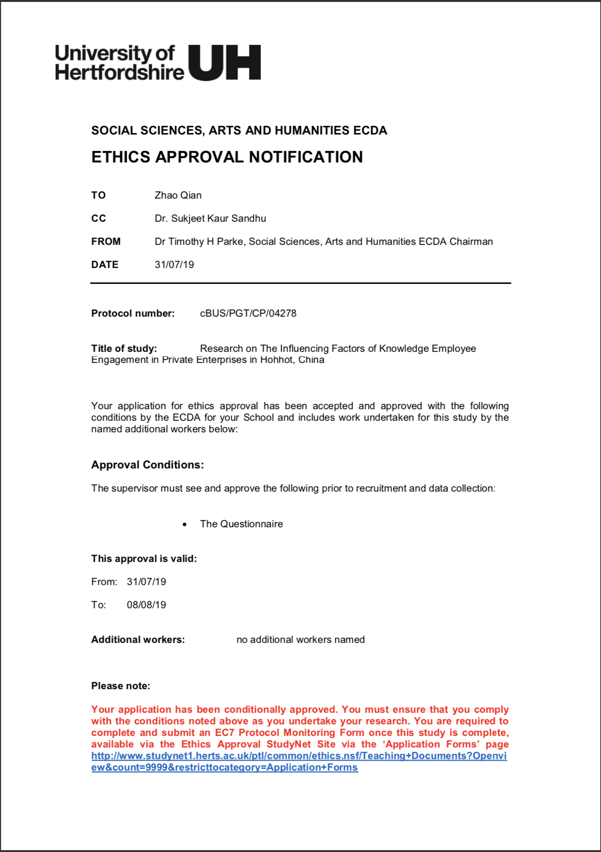
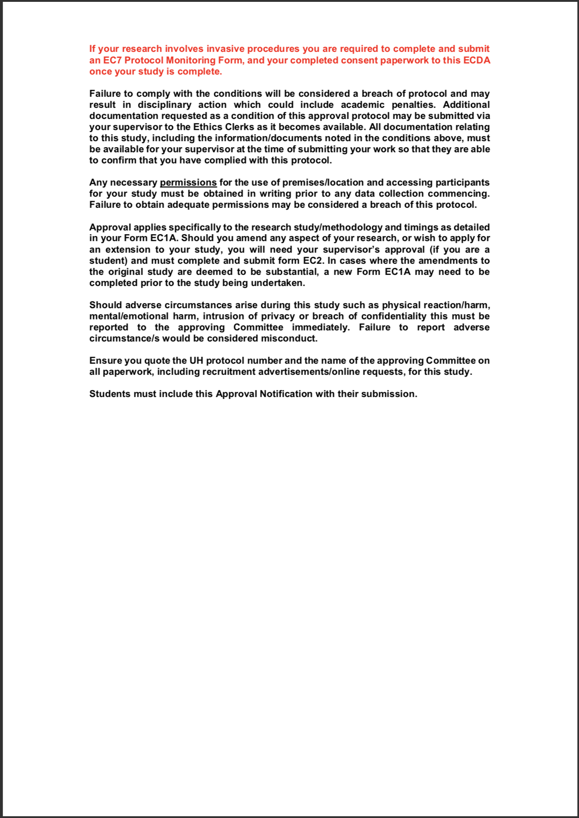

APPENDIX C. QUESTIONNAIRE
Dear Respondents,
This is an individual work, I am a final year student of Master of Business Administration (MBA), INTI International University, Nilai Campus. I am researching the employee engagement topic. kindly request you to complete the questions below in this survey. Your answers and information that you fill in this questionnaire are confidential and used in this research only. This questionnaire consists of 38 questions and will only take approximately 10 minutes to complete this survey. Please read the instructions carefully before answering the questions. Your participation will greatly contribute to the success of the survey. I deeply appreciate your assistance in participating in this survey and your responses will remain private and confidential which is used for academic purposes only.
Thank you.
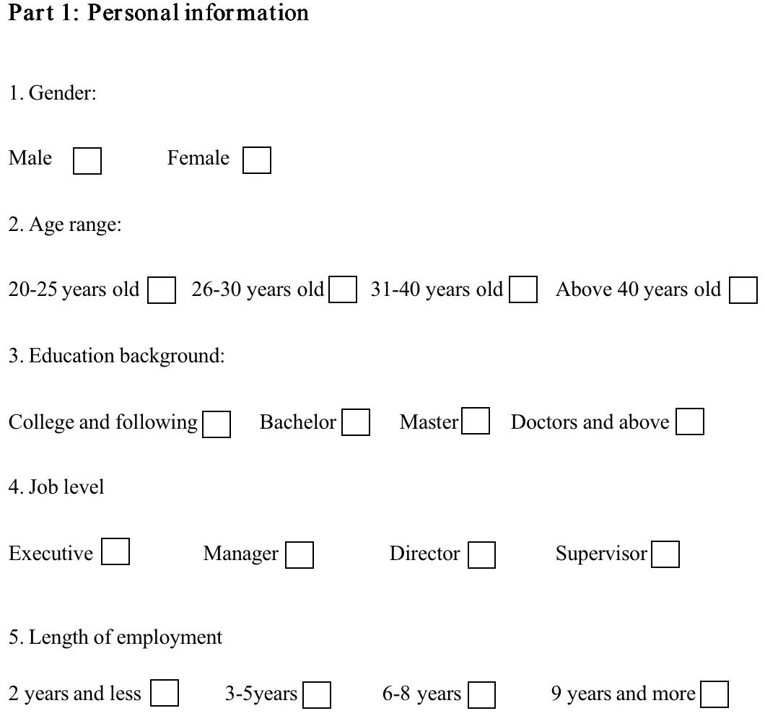

Part 2: job levels affect the employee engagement
Here Please type on the appropriate options according to your level of conformity.
 |  | Strongly disagree | disagree | neutral | agree | Strongly agree
1 | I think my job level has close relevance to the company's development.
2 | My ability can meet the requirements of my job level.
3 | I think the job level is different and the responsibility is different.
4 | I think people with high job levels are more engaged in the company.
5 | I don’t think engagement has any relationship with the level of the job.

Part 3: organizational commitment affect the employee engagement
Here Please type on the appropriate options according to your level of conformity.

 |  | Strongly disagree | disagree | neutral | agree | Strongly agree
1 | I am proud to belong to this organization.
2 | When I talk to my acquaintances about the organization I convey favorable information about this organization.
3 | I identify with the values that are promoted by the organization.
4 | I feel the problems of the organization as my own.
5 | I receive more resources from the organization than I give.

Part 4: internal communicate affect the employee engagement
Here Please type on the appropriate options according to your level of conformity.
 |  | Strongly disagree | disagree | neutral | agree | Strongly agree
1 | The company has standardized performance communication mechanisms and systems.
2 | There is regular communication or training in the company.
3 | I think communication is very important in company management.
4 | I will actively communicate with the leader when I have a problem and the leaders will support my comments.
5 | I know what communication channels are inside the company.

Part 5: knowledge employee engagement
Here Please type on the appropriate options according to your level of conformity.
 |  | Strongly disagree | disagree | neutral | agree | Strongly agree
1 | I have a strong initiative and be proactive in my job.
2 | I am energetic and passionate when I am at work.
3 | I am concerned about whether my work has contributed to the organization.
4 | I know that I have obligations and responsibilities to the company I work for.
5 | In order to work, I will not hesitate to sacrifice my hobby.

APPENDIX D. MBA PROJECT LOG

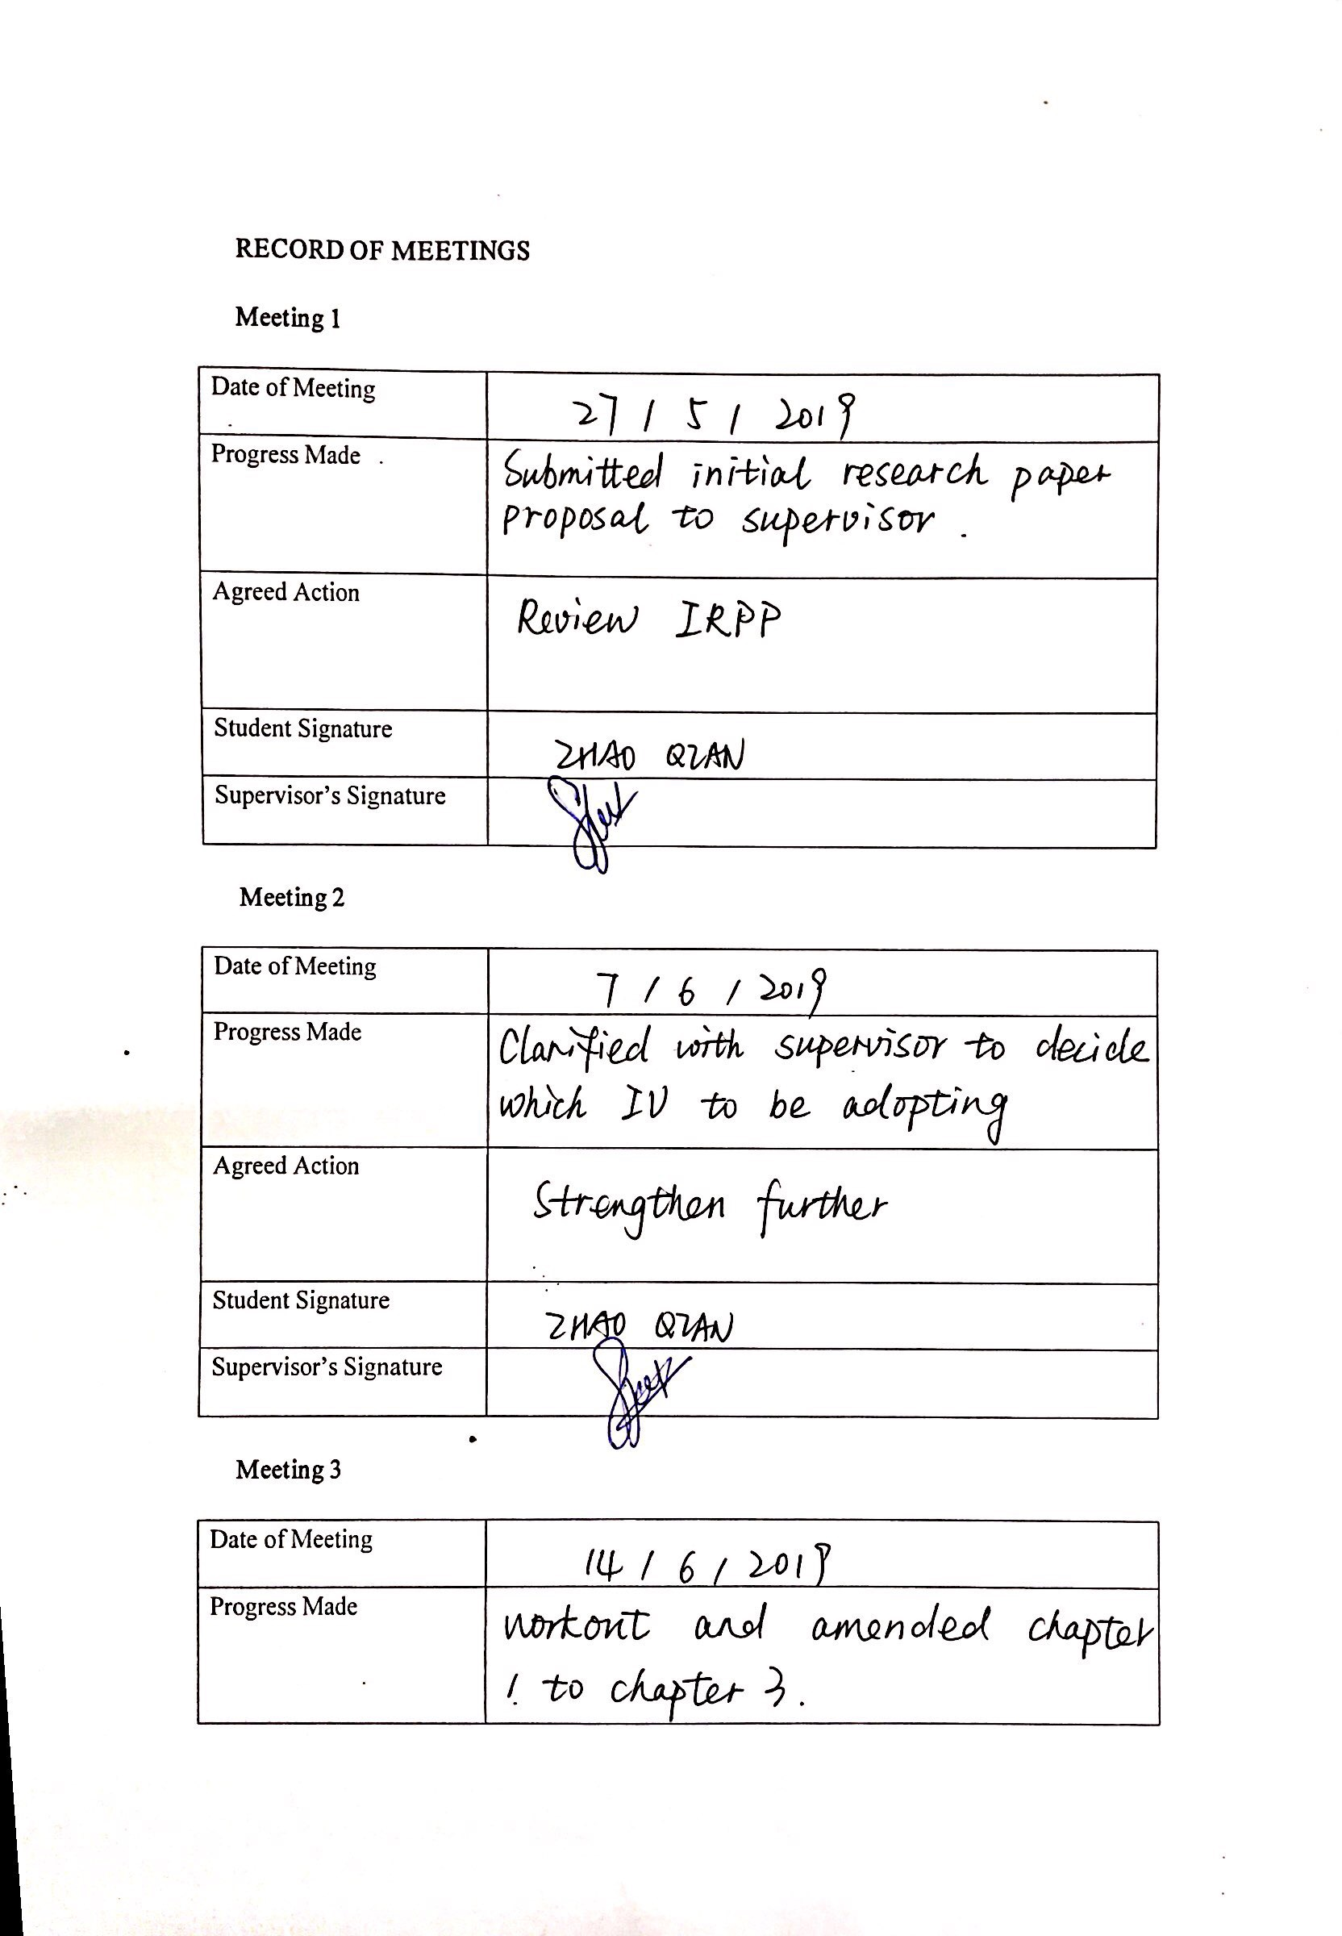

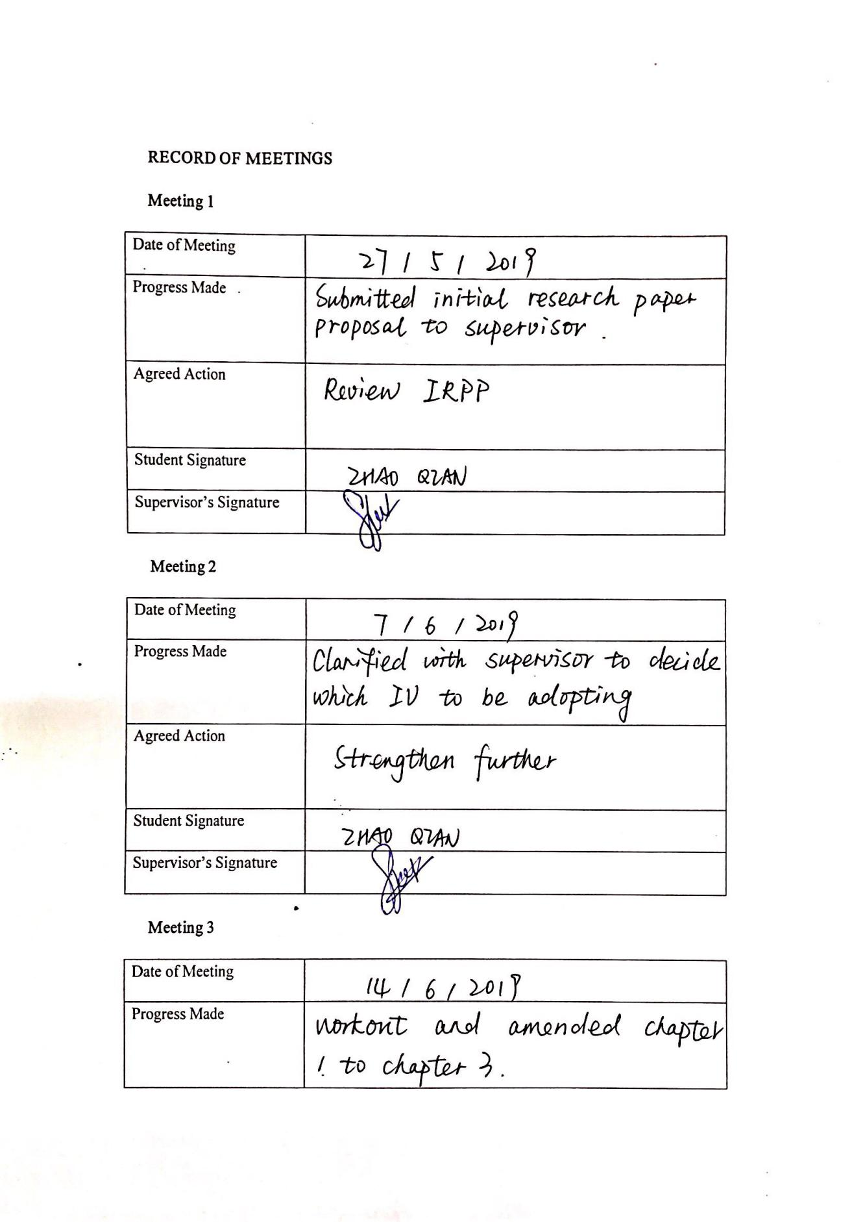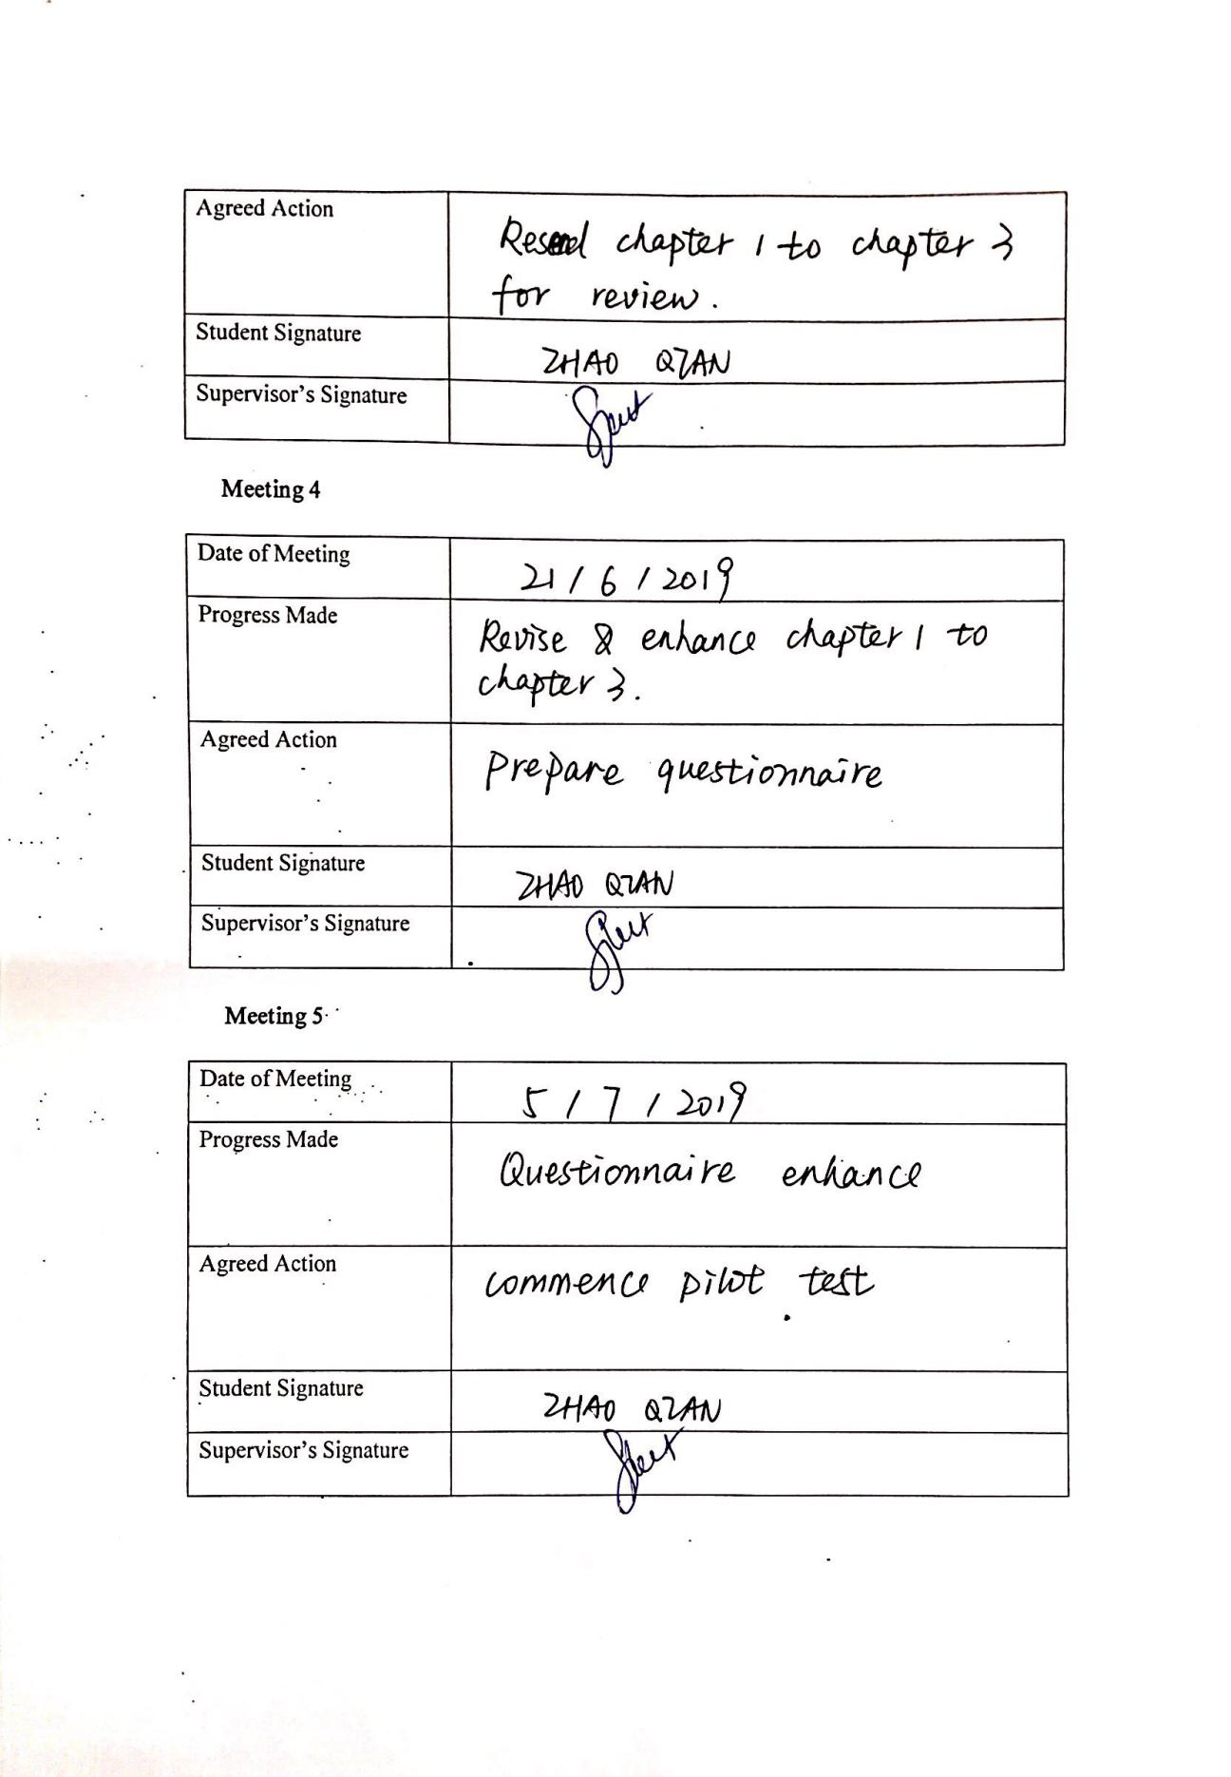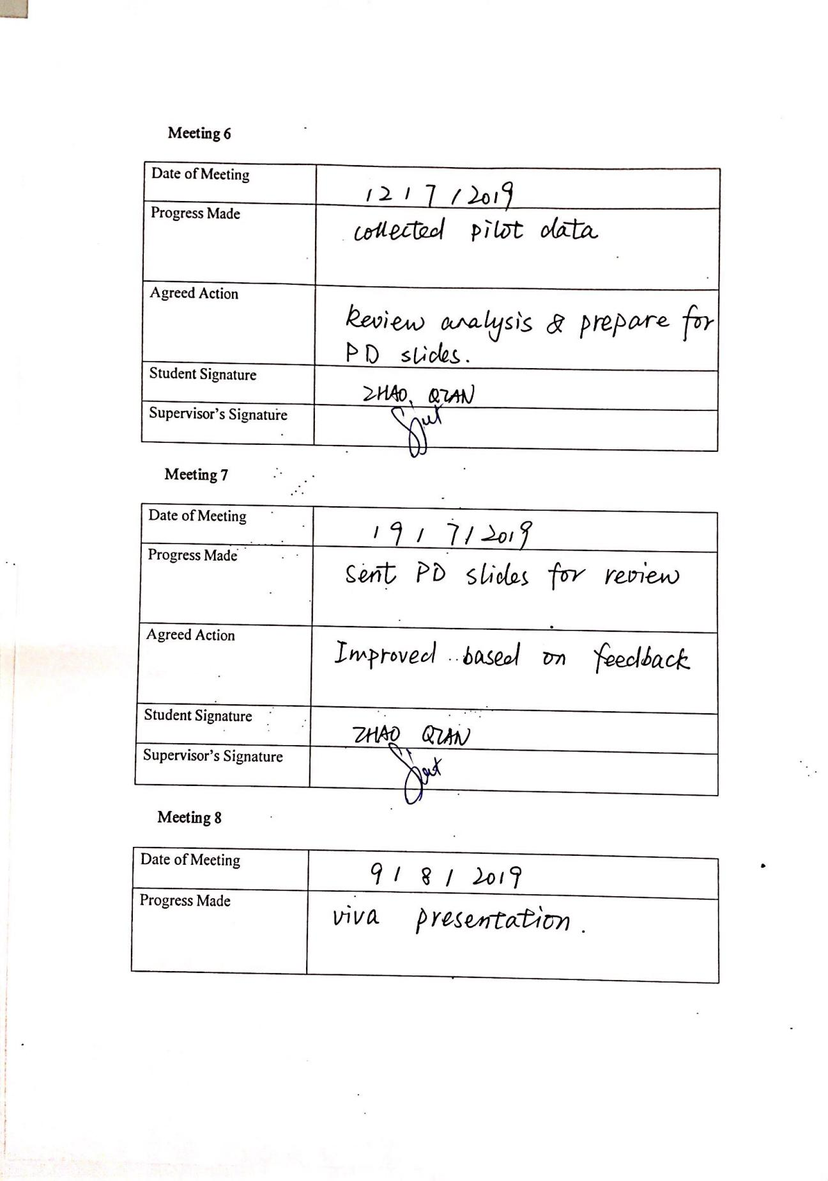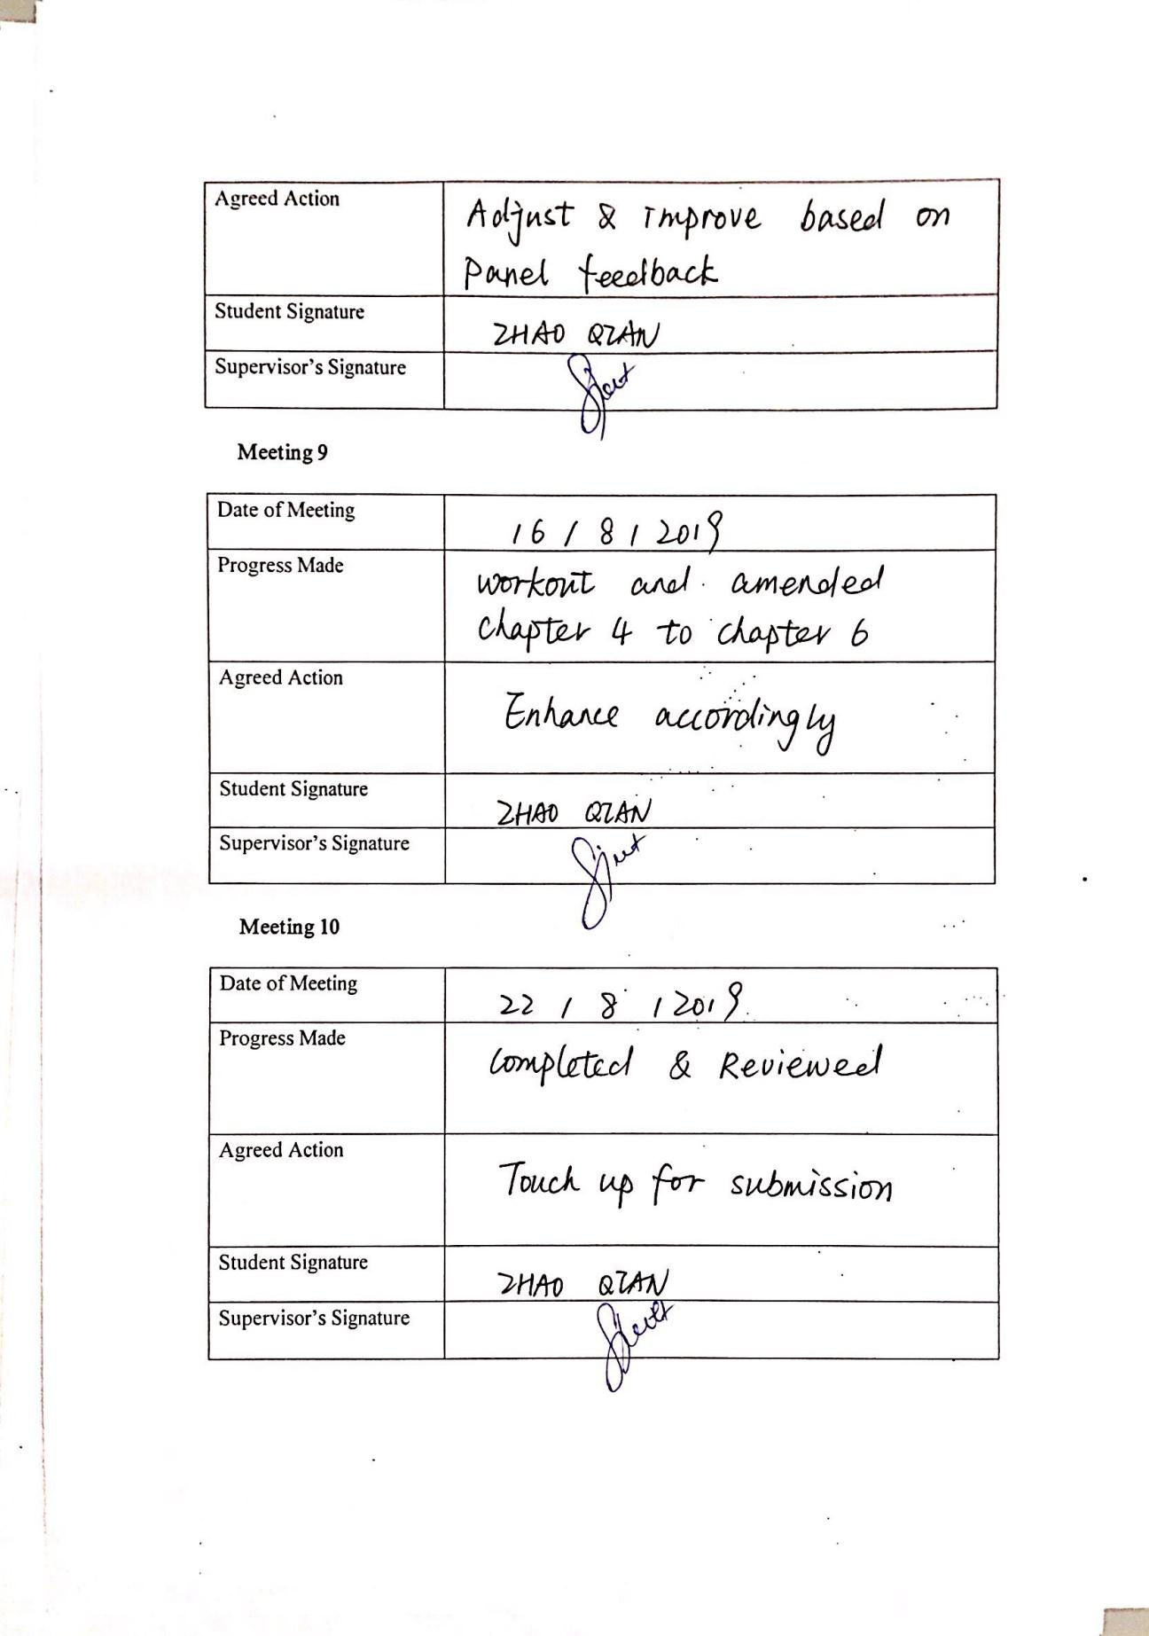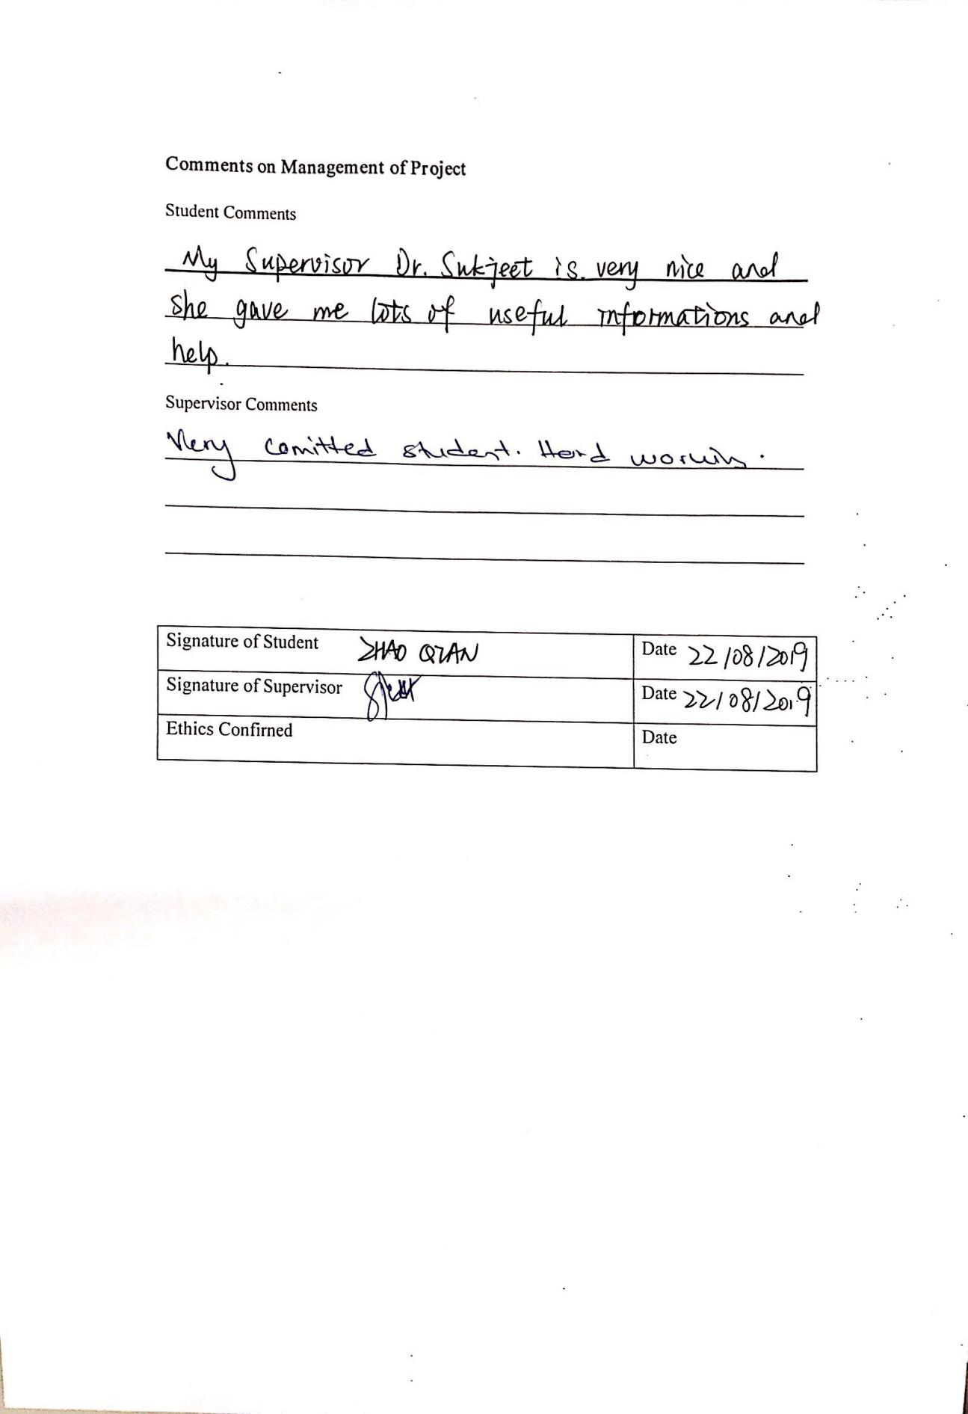

APPENDIX E. TURNITIN RESULTS
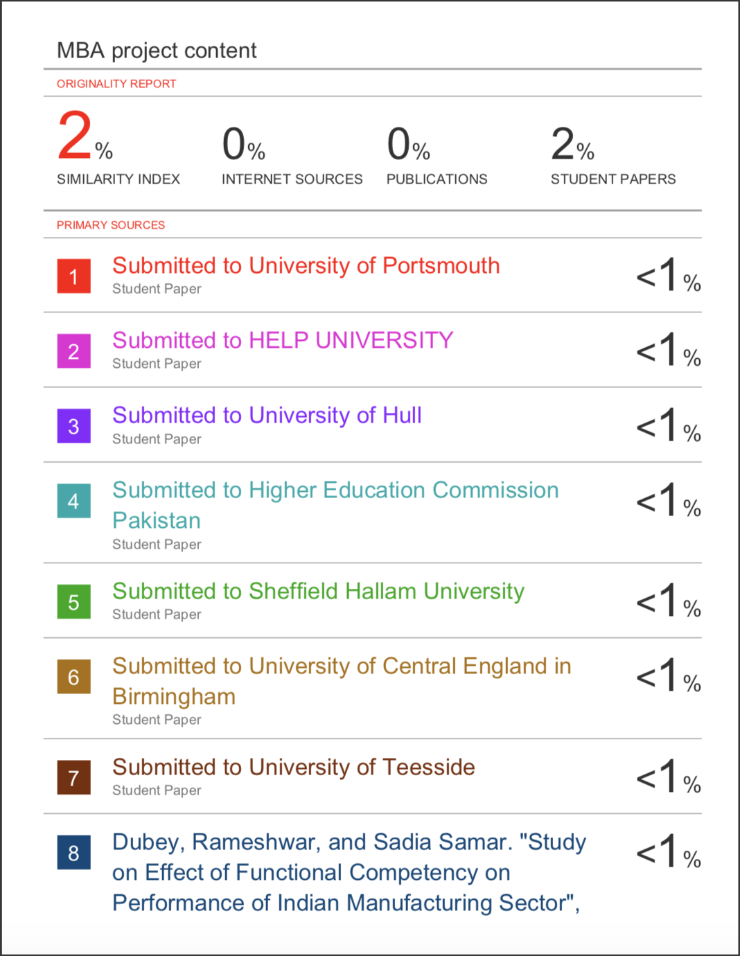

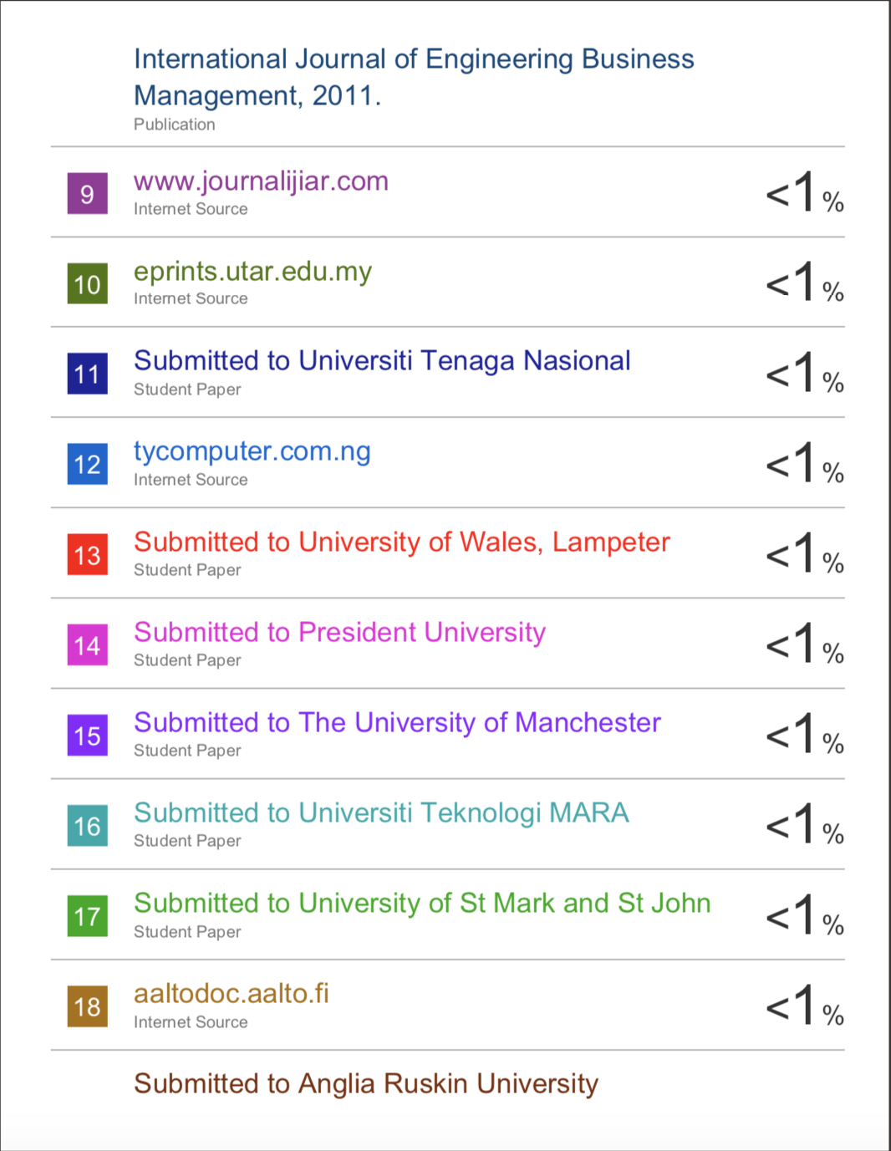



APPENDIX F. TABLES
Table 1: Table for Questionnaire Design
Section | Items | Source
1. Personal Information | 5 | Xanexa, M. (2018)
2. Job levels affect the employee engagement | 5 | Truss, Alfes and Delbridge et al., (2013)
3. Organizational commitment affect the employee engagement | 5 | Eldor and Vigoda-Gadot, (2017)
4. Internal communicate affect the employee engagement | 5 | Kang and Sung, (2017)
5. Knowledge employee engagement | 5 | Mishra, Boynton and Mishra, (2014)

Table 2: Table for Determining Sample Size
Table 3: Basic Information Frequency Statistics

Table 4: Descriptive Statistics

Table 5: Table of Reliability Test

Table 6: KMO and Bartlett's Test

Table 7: Total Variance Explained

Table 8: Rotated Component Matrix
Table 9: Descriptive Statistics of Correlation analysis

Table 10: Correlations analysis
Table 11: Model Summaryb

Table 12: ANOVA test

Table 13: Coefficients analysis

