WEI SHENGLI  MASTER OF BUSINESS ADMINISTRATION  2019 | INVESTIGATING THE MARKETING MIX FACTORS INFLUENCING CONSUMER DECISION TO PURCHASE REAL ESTATE IN ZIBO, CHINA  WEI SHENGLI  MASTER OF BUSINESS ADMINISTRATION  FACULTY OF BUSINESS, COMMUNICATION & LAW  INTI INTERNATIONAL UNIVERSITY  2019

INVESTIGATING THE MARKETING MIX FACTORS INFLUENCING CONSUMER DECISION TO PURCHASE REAL ESTATE IN ZIBO, CHINA

WEI SHENGLI

MASTER OF BUSINESS ADMINISTRATION
FACULTY OF BUSINESS, COMMUNICATION & LAW
INTI INTERNATIONAL UNIVERSITY

2019
INTI INTERNATIONAL UNIVERSITY
MASTER OF BUSINESS ADMINISTRATION
INVESTIGATING THE MARKETING MIX FACTORS INFLUENCING CONSUMER DECISION TO PURCHASE REAL ESTATE IN ZIBO, CHINA

Author: WeiShengli
Student No: I18015541
Supervisor: Ms. Faziha Abd Malek
Submission Date: 22 August 2019
Final word count: 13881

Abstract
Recently, real estate has gradually become an important asset of many Chinese residents. Whether or not to buy a house has become a question that many Chinese residents are considering, but at the same time, many Chinese real estate companies are facing increasingly serious problems in the sales process, thus analyzing the marketing mix factors influencing consumer decision to purchase real estate in China have practical significance. This paper draws on the relevant literature, summarizes the relevant research theories, and then determines the research independent variables of this paper as the product, price, place and promotion. This study uses questionnaires to collect data and analyzes it. 384 questionnaires were collected from Zibo residents. Then, based on the actual situation in China, the factors influencing consumer decision to purchase real estate in Zibo, China were studied. Through the analysis of the survey data, this study found that the price and promotion of the marketing mix factors have an obvious association with consumer decision to purchase real estate in Zibo. Therefore, real estate companies should pay attention to the impact of these two aspects when selling real estate products and improve their marketing strategies according to actual conditions.
Keywords: Real estate, Marketing mix, Factors, Price, Promotion, Consumer decision

Acknowledgement
This survey has been going through several months from the initial selection to the final summary. In this investigation, the researcher encountered a lot of difficulties, and with the help of many people, this investigation can be completed. Here I would like to thank everyone who has worked hard for this research. Without your help, this survey will not be successful. In the distribution and collection of the questionnaire, the researcher encountered a lot of troubles, because the content of this survey is the consumer purchase decision in Zibo, China, so it is not advantageous for the distribution and collection of the questionnaire. Through the online questionnaire, the researcher distributed questionnaires to a large number of consumers in Zibo, thank you for your serious answers, and provided a large amount of data for this survey. In addition, this survey has also received great help from two supervisors and classmates. In terms of data analysis, the researcher was not proficient in the processing and analysis of the data, so the researcher chose the supervisors and classmates for help, and finally, with their patience, this data analysis was completed. In the determination of the independent variables of the questionnaire, the researcher also had a lot of confusions. The help of Ms Faziha and Dr Wong allowed the independent variables of this survey to be successfully determined, and helped the researcher make many adjustments and improvements to the part of the literature review. So here I would like to thank the two supervisors for their help.

Declaration
I hereby declare that this thesis is my own work and effort and that it has not been submitted anywhere for any award. Where other sources of information have been used, they have been duly acknowledged.
Name: Wei Shengli
Student ID: I18015541
Signature: Wei Shengli
Date: 22 August 2019

Table of contents

Chapter 1 Introduction 1
1.1 Background 2
1.1.1 Background in China 2
1.1.2 Background in Zibo 3
1.2 Problem statement 5
1.3 Research questions 7
1.4 Research objectives 8
1.5 Significance of the study 9
1.6 Limitations of the study 10
1.7 Scope of the study 10
1.8 Ethical consideration 11
1.9 Research hypotheses 11
Chapter 2 Literature review 12
2.1 Related concepts of real estate sales 13
2.1.1 Sales and marketing 13
2.1.2 The sales of real estate 14
2.2 Related research results of real estate 15
2.2.1 Research on real estate demand and supply 15
2.2.2 Research on real estate market structure 16
2.2.3 Research on the real estate cycle 17
2.3 Marketing mix 17
2.3.1 Product 18
2.3.2 Price 20
2.3.3 Place 21
2.3.4 Promotion 23
2.4 Theoretical framework 25
2.5 Conceptual Framework 26
Chapter 3 Research Methodology 27
3.1 Research Design 27
3.2 Study Population, Unit of Analysis, Sample Selection and Sampling Techniques 28
3.2.1 Study Population 28
3.2.2 Unit of Analysis 28
3.2.3 Sample Selection 28
3.3 Data Collection and Analysis Methods 29
3.3.1 Data Collection 29
3.4 Measuring Instrument 30
3.4.1 Descriptive analysis 30
3.4.2 Correlation analysis 30
3.4.3 Regression Analysis 31
3.5 Validity and Reliability Tests and Analysis 31
3.5.1 Validity Tests and Analysis 31
3.5.2 Reliability Tests and Analysis 32
Chapter 4 Research finding 33
4.1 Pilot test 33
4.1.1 Factor analysis of Pilot test 33
4.1.2 Reliability test of pilot test 34
4.1.3 Correlation test of pilot test 35
4.2 Descriptive statistics of respondents 37
4.3 Preliminary data analysis 39
4.3.1 Factors analysis 40
4.3.2 Reliability test 45
4.4 Correlation analysis 45
4.5 Hypothesis analysis 47
4.5.1 ANOVA analysis 47
4.5.2 Model Summary 48
4.5.3 Coefficients 48
4.6 Summary of findings 49
4.6.1 Findings of research hypothesis 50
4.6.2 Findings of research questions 52
Chapter 5 Summary 54
5.1 Conclusion 54
5.2 Limitation 55
5.3 Recommendations 55
5.4 Further research 59
5.5 Personal reflection 59
Reference 61
Appendix 76
Appendix 1: PROJECT PAPER LOG 76
Appendix 2: List of Abbreviations 82
Appendix 3: Data analysis results 82
Appendix 4: Questionnaire 95
Appendix 5: Initial Research Paper Proposal 100
Appendix 6: Viva slides 103
Appendix 7: Turnitin report 114

Chapter 1 Introduction
Real estate sale is an emerging industry under the social economy model dominated by the market economy in China, and is an industry developed with China's housing market. After 1978, China first established a planned commodity economic system (Hong, 2016). Under this system, human labor products, whether they are living materials or means of production, become commodities with property rights of individuals or social groups, and others must obtain these products through market exchange. The premise of people's use and consumption is to own them, so the sales of houses become necessary. The Chinese Constitution stipulates that land ownership and use rights are separated, land is owned by the government, and land use rights can be sold to users as commodities (Xu & Gong, 2016). Land users, that is, real estate developers, can develop real estate projects on land and sell the final product of real estate. The real estate market was a seller's market from the 1980s to the early 1990s. At that time, there were not many enterprises engaged in real estate development, and the supply of real estate products was less than demand. Therefore, the sales of real estate products were not difficult, and the sales price also rose again and again. Due to the prosperity of the real estate market and the lucrative profits, it has attracted a large number of developers (Huang et al. 2017). By the mid-1990s, due to over-exploitation, the supply of real estate products in the market exceeded demand, the number of idle houses continued to increase, and the vacancy rate remained high, creating a backlog. At this time, the real estate market turned into a buyer's market. The sales of real estate became an important role in the whole market.

Background

1.1.1 Background in China
Under the influence of traditional Chinese concepts, real estate has always been one of the most preferred investment tools of the Chinese. As can be seen from figure 1, since the beginning of the second quarter of 2003, due to the flood of funds and the long-term decline in market interest rates, house prices in various regions of China have generally increased by 4 to 5 times (Glaeser, Huang & Shleifer, 2016). Even in the rare global financial tsunami between 2007 and 2009, Due to the monetary policy of Quantitative Easing in the United States, the sharp appreciation of Asian countries' currencies has prompted a large influx of funds, and the Chinese government's 4 trillion loose monetary policy has made China's housing prices remain high (Schnabl, 2017). However, since March 2014, the United States Federal Reserve Bank has gradually reduced the scale of quantitative easing, which has led to the gradual return of emerging market funds to developed markets (White, 2015). China’s tax reduction and rising unemployment rate due to economic restructuring and GDP decline in the real estate market, adopting a mild stimulus policy, such as lifting the restrictions on purchases, lowering the down payment ratio, and lowering the loan interest rate, etc., These measures have a stabilizing effect on housing prices in first-tier cities, but for the third- and fourth-tier cities, the market exceeds demand. The situation and the effect remain to be seen.
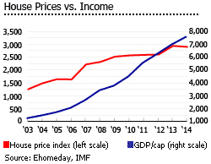
Figure 1-1: House price in China
Source: Ehomeday, IMF
In addition to the housing market alarm brought by the policy, there is a hidden danger from the relationship between house prices and rents in China's central cities (Wen & Tao, 2015). The reason is that the sharp rise in the price of this real estate is not a solid economic growth that reflects the improvement of economic momentum and wage income. Therefore, we can find that although the rise in housing prices makes the potential capital gains of real estate increase, but the rent is not improved, resulting in the current low real estate rental rate.

1.1.2 Background in Zibo
In recent years, as the development of national economy, the improvement of resident per capita income, the gradual change of consumption concept, under the active guidance of the market, Zibo city housing construction quality, performance has a great improvement. Developers also gradually from the seller's market point of view to wake up, more and more attention to the improvement of product quality and late service and other aspects of the importance, thus a series of high quality, high quality real estate.
Zibo City is an important heavy industry base in Shandong Province. It is a heavy industry city mainly engaged in chemical, electromechanical, building materials and metallurgy. Zibo’s gross national product is also steadily increasing. In 2015, Zibo City’s GDP reached 143.095 billion yuan, a year-on-year increase of 17.1%. The total production value in 2016 was 164.516 billion yuan, a year-on-year increase of 15.8%. The total production value in 2017 was 1945. 100 million yuan, an increase of 16% year on year (Figure 2).

Figure 1-2: National Economic change in Zibo
Source: https://wenku.baidu.com/view/f8ed71e17cd184254a3535ec.html?from=search
With the development of the national economy, the overall consumption level and per capita disposable income of Zibo residents have also increased year by year. In 2015, the per capita disposable income of Zibo City was 12032 yuan, a year-on-year increase of 20.8%. In 2016, the per capita disposable income of Zibo City was 13,294 yuan, a year-on-year increase of 14.6%. In 2017, the per capita disposable income of Zibo City was 15,849 yuan, a year-on-year increase of 14.9% (Figure 3).

Figure 1-3: Zibo per capita income of residents
Source: https://wenku.baidu.com/view/f8ed71e17cd184254a3535ec.html?from=search
With the continuous development of Zibo City's economy, there has been many changes in the real estate market. The real estate market began to develop in the direction of branding and quality. Developers also shifted from the previous single development to the focus on sales and branding. The market began to transition from the seller's market to the buyer's market. The purchasing psychology of consumers is gradually transformed into rational consumption by impulse consumption.

1.2 Problem statement
Real estate is slowly becoming a necessity for people's lives (Shin, 2017). This has attracted lots of real estate developers, resulting in oversupply in some cities. Moreover, some problems appeared in the development of China's real estate industry, such as high housing prices in some cities (Li et al. 2017). Since the beginning of the second quarter of 2003, due to the flood of funds and the long-term decline in market interest rates, house prices in various regions of China have generally increased by 4 to 5 times (Glaeser, Huang & Shleifer, 2016). Many documents have pointed out the current domestic housing price bubble. In the future, the expected profit margin of the Chinese real estate market may gradually shrink, and the housing bubble will continue to heat up (Chen & Wen, 2017). The excessive easing of the currency makes the investment in the real estate market too simple, and the overheating of investment has also led to the rise of property prices and the prosperity of the loan market. The price on the real estate market does not reflect the true value of the asset. Many Chinese residents have hesitant attitudes in buying houses. This has also had a huge impact on the sales of the real estate industry.
On the other hand, China's housing vacancy rate has been high (Figure 4), which reflects the real situation of the Chinese real estate market. The developer has a large number of properties that have not been sold. For house prices, developers cannot make major changes due to the government's macroeconomic regulation and control. Consumers are not only concerned with the price of the house; commercial companies should reach their target audience through available marketing channels (Gana & Koce, 2016). In this case, product, place, promotion has also become a marketing aspect that developers focus on. The sales of real estate are affected by various factors, which in turn affects other aspects of society. For the Chinese national economy, the real estate industry is an important part of it, and the development of the real estate industry can promote the development of the overall economy (Chen, Liu & Lu, 2016). Therefore, it is very important to conduct a comprehensive analysis of real estate sales and explore the related marketing mix factors that influence the customer decision to purchase real estate products in China.
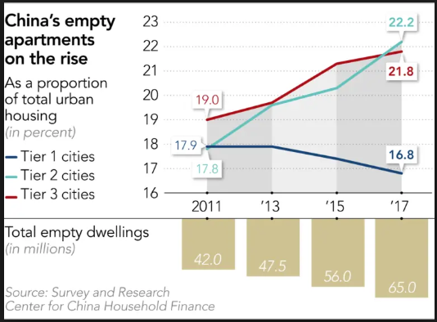
Figure 1-4: China's housing vacancy rate
Source: https://asia.nikkei.com/Spotlight/Cover-Story/China-s-housing-glut-casts-pall-over-the-economy

1.3 Research questions
There are five questions in this research:
1. Is product has significant influence towards consumer decision to purchase real estate in Zibo, China?
2. Is price has significant influence towards consumer decision to purchase real estate in Zibo, China?
3. Is place has significant influence towards consumer decision to purchase real estate in Zibo, China?
4. Is promotion has significant influence towards consumer decision to purchase real estate in Zibo, China?
5. Which factor is the most significant in influencing consumer purchase decision for buying real estate in Zibo, China?

1.4 Research objectives
There are five objectives in this research:
1. To determine whether product has a significant influence on consumer decision to purchase real estate in Zibo, China.
2. To determine whether price has a significant influence on consumer decision to purchase real estate in Zibo, China.
3. To determine whether place has a significant influence on consumer decision to purchase real estate in Zibo, China.
4. To determine whether promotion has a significant influence on consumer decision to purchase real estate in Zibo, China.
5. To determine which factor is the most significant in influencing consumer purchase decision for buying real estate in Zibo, China.

1.5 Significance of the study
In terms of academic contribution, many studies focus on the sales of real estate products, but most of the research targets are first- and second-tier cities, and there are very few studies on real estate in third and fourth-tier cities. Therefore, the research on the factors influencing the sales of Zibo real estate products can enrich the academic research of real estate in the third and fourth tier cities. Otherwise, through the research and study of a large amount of literature materials, this research deeply understands that real estate marketing, especially marketing mix strategy, has a significant impetus to the development of real estate development enterprises and real estate market. Based on this understanding, this study starts from the relevant theory of 4Ps marketing mix, and how to determine the marketing mix strategy suitable for its own projects, and summarizes relevant opinions and understandings, which is conducive to promoting the application of marketing mix theory in the real estate industry.
For real estate industry, the sales of real estate products are related to the survival and development of enterprises. By analyzing the marketing mix factors influencing consumer decision to purchase real estate products, this study can help real estate companies to recognize their own sales problems and improve related marketing strategies. Moreover, through the research on the theory of real estate marketing mix, we can better understand the needs of consumers, develop goods suitable for sale, accelerate the transformation of real estate products from commodity form to currency form, thereby shortening the circulation period of real estate goods and gradually reducing or eliminating commercial houses on the market. The backlog has indirectly promoted the real estate market regulations and policies to improve the real estate market.

1.6 Limitations of the study
In this study, after consulting relevant literature, found that most of the research on China's real estate industry is concentrated in first- and second-tier cities. Therefore, it is difficult to obtain accurate real estate information about third- and fourth-tier cities in this study. Moreover, this research based on the situation of Chinese real estate. Due to Chinese specific economic situation and social situation, the relevant conclusions may not apply to other countries. In terms of questionnaires, this time, the form of questionnaires collected online is used, and it is difficult to control the specific situation of respondents, so the collected data may be deviated from the actual situation. Because there may be many respondents who did not take the investigation seriously. Finally, this survey is about the sales of real estate in Zibo, China, which can provide reference for other studies, but it cannot be applied to the specific conditions of other cities.

1.7 Scope of the study
Based on the previous scholars' research, this study analyzes the marketing mix factors influencing customer decision to purchase real estate in Zibo, China through relevant theories of real estate commodity sales, and provides relevant recommendations for the developers and companies. In this study, the research variables were determined by relevant literature and theory, and the research data was collected through questionnaires, and then the collected data were analyzed. This study mainly analyzes the impact of product, price, place and promotion when customer purchase real estate in Zibo, China. Among them, the product mainly includes house design, greening rate, etc. The price mainly includes factors such as house price. The promotion factors mainly include advertising, brand, after-sales service and so on. The place factors mainly include location, transport intermediary methods and so on.

1.8 Ethical consideration
First of all, this survey treats each respondent as an independent legal subject, regardless of his ethnic origin, wealth, or good education. Secondly, in this study, the questionnaire was only used for this data analysis. This survey will strictly protect the privacy of participants and adopt an anonymous method that will not reveal the personal information of participants. Finally, the research process is based on the voluntary cooperation of the respondents and will inform the participants of the relevant information of this survey before the investigation.

1.9 Research hypotheses
H1: The product has a significant influence on consumer decision to purchase real estate in Zibo, China.
H2: The price has a significant influence on consumer decision to purchase real estate in Zibo, China.
H3: The place has a significant influence on consumer decision to purchase real estate in Zibo, China.
H4: The promotion has a significant influence on consumer decision to purchase real estate in Zibo, China.

Chapter 2 Literature review
According to Wu (2015), real estate is an important driving force for China's economic development. Real housing prices remained high, with an average annual increase of 10% since 2006. China’s rising house prices are driven by rising land values rather than construction costs. Actual land value has risen by an average of more than 14.4% per year (Wu, Gyourko & Deng, 2015). China's real estate boom may be slowing, and one of the main concerns of experts is that the collapse of the real estate market could seriously damage the Chinese economy (Fang et al. 2015). From 2003 to 2014, the actual annual growth rate of China's housing prices exceeded 10% (Glaeser, Huang & Shleifer, 2016). The real estate market also showed some new changes, consumer demand for real estate has become saturated (Zhang et al. 2016). Property market’s shocks could bring much larger influence on Chinese economy (Chan, Han & Zhang, 2016). In China, the rise and fall of house prices has been receiving much attention. China’s real estate market is often described as highly speculative, triggering a ‘bubble’ problem (Girardin, Deng & Joyeux, 2018). Real estate industry is still immature, and there are many problems, such as excessive housing prices. Under these circumstances, sales of real estate are greatly affected by these reasons. The construction of corporate culture and system will promote the sales of related enterprises (Xu, 2018). Li, Wang & Lin (2018) pointed out that many consumers buy houses through online real estate agents.

2.1 Related concepts of real estate sales

2.1.1 Sales and marketing
Sales is a kind of market trading behavior, which is a kind of contract or agreement between buyers and sellers in a certain social and economic environment. This kind of transaction realizes the transfer of product ownership: the buyer and the seller have obtained tangible products or intangible services, which meets their own needs. The seller realizes the market value of the products through this transaction and obtains the currency. So, for the seller, it can be said that the sales are to sell their own production or purchased products (Banerjee & Poddar, 2019). For service companies, sales are the services offered (Cusumano, Kahl &Suarez, 2015). According to Stepan (2018), the purpose of sales is to exchange products, services and ideas with money based on the mutual satisfaction of buyers and sellers.
The role of sales is more about the company's current business to attract consumers to buy their own products (Terho et al. 2015). The organization must actively engage in sales and promotion efforts, such as training sales staff with good sales skills, design sales incentive system, establish a good sales staff management system, etc., in order to complete the company's established sales targets. Therefore, the focus of the sales activity is to achieve the company's current performance but consider the future very little. Correspondingly, the role of marketing is to consider how companies can establish a system to respond to changes in environment and customer demand. The central point of marketing is in order to obtain ‘reward for tomorrow’. Enterprises accumulate today's rewards through sales, but they cannot guarantee to get paid tomorrow. Constantly exploring, exploring, and pursuing sustained growth is the role of marketing.
If the company pursues continuous operation, then only marketing can make the company achieve the goal of continuous operation (Erevelles, Fukawa & Swayne, 2016). The difference between sales and marketing is as follows: Marketing is a strategic thinking focus, which is devoted to: 1. Investigating the establishment of a sales system; 2. Concerning the satisfaction of customer needs; 3. Focusing on the sustainable development of the company; 4. Taking market analysis, customer creation as Center; 5. Based on the future of the company. Sales is a tactical thinking focus, which is devoted to: 1. Investigating sales techniques and methods; 2. Concerning the sales of existing products; 3. Focusing on the achievement of current sales targets; 4. Focusing on sales personnel; Create a company's performance today.

2.1.2 The sales of real estate
Real estate sales refer to the whole process of selling real estate products (Chow, Hafalir & Yavas, 2016). It includes finding customers, approaching customers, interviewing, handling customer objections, transactions, after-sales services, etc., mainly an interactive process between sales personnel and customers. In general, real estate sales have the following characteristics: First, because real estate products are fixed and cannot be moved, sales personnel and customers must go to the site for sale to communicate and negotiate (Aalbers, 2017). Second, the uniqueness of the product sold (Rahadi, 2015). Since each set of commercial housing is different, including the location, floor, apartment type, price and other conditions are different, the sales staff is required to be familiar with the real estate. Third, real estate products are high-consumption products, customers will be quite cautious when purchasing, and the service requirements in sales are also very high (Zhang, 2017). Fourth, in the sales process, the communication between the sales staff and the customer is very important (Familmaleki, Aghighi & Hamidi, 2015). Fifth, sales of real estate products require sales personnel to have professional knowledge (Hughes et al. 2019). It involves knowledge of architecture, structure, hydropower, building materials, decoration, law, policy, finance, economic situation, feng shui, communication skills, persuasion, service awareness, etc.
China began to introduce modern sales theory in the 1980s, during this period, China's social and economic life has shifted to the socialist market economic system (Niedermeier, Wang & Zhang). During 1990s, enterprise became the main body of market behavior with independent management rights (Guan & Yam, 2015). The market gradually became a complete market, the market demand diversified, the market competition became increasingly fierce, the enterprise only strengthened Real estate commodity sales management, continuous improvement of real estate commodity sales management, in order to find and meet market demand, to provide satisfactory goods and services to the society, more effectively achieve the company's sales goals and corporate goals.

2.2 Related research results of real estate

2.2.1 Research on real estate demand and supply
Sales prices are inversely proportional to real estate demand (Xue, Huang & Wang, 2018). Hu et al. (2016) found that the number of people of the age-appropriate population is an important factor influencing the real estate demand. If the mortgage policy be tighter, the market heat will decline, on the contrary, if the mortgage policy is more relaxed, the heat of the real estate market will rise (Jaiyawala et al. 2018). Han & Yang (2015) believes that economic, social and natural factors are main factors influencing demand of real estate industry. Among them, economic factors are the core factors.
Davidoff (2016) pointed out that in a long-term, the interaction between supply and demand can balance housing prices, but in real life, there is a contradiction between house market and equilibrium price. The supply of the house is fixed recently. Although the supply and demand relationship also follow the law of ordinary commodities, because of speculative existence, the relationship between supply and demand is unique (Nathanson & Zwick, 2018). Feng & Wu (2015) found that high-end commercial housing is vacant and oversupply, while ordinary commercial housing is in short supply, and demand exceeds supply.

2.2.2 Research on real estate market structure
Duan (2013) pointed out that real estate industry is highly concentrated in China, with strict requirements on land and capital, and scarce resources are in the larger scale. The real estate industry has sustained high housing prices and high profits. The phenomenon shows a significant monopoly, similar to the oligopolistic market. Huang (2013) emphasized in his research that a reasonable real estate market structure should inhibit the speculation of real estate investment. We should also actively cultivate and develop the second-hand housing market for low and middle-income people to increase the coverage of affordable housing. (Huang et al. 2015). According to Zhu (2016), China's real estate market is a lack of large-scale oligopoly market. Rational advertising behavior, product strategy Behavior and mergers can promote the increase of market efficiency.

2.2.3 Research on the real estate cycle
Wang (2015) found in the study that national economic factors influence real estate cycle a lot. Dong & Li (2014) established a vector autoregressive model to quantitatively analyze real estate cycle volatility and stability. They found that the stability of the financial industry is affected by real estate cycle fluctuations. Zhang (2014) pointed out that economic factors are the key factors affecting real estate cycle volatility. In addition, development investment and consumer expectations of housing prices will also cause fluctuations in cycle. Li & Feng (2014) applied STAR model to study correlation between fixed investment cycle and economic cycle and found that the economic growth cycle and the consumer price index cycle can interact with the real estate cycle.

2.3 Marketing mix
Marketing is a social and management process to realize what the producer needs or think (Zaheer & Rashid, 2017). According to Hunt (2017), the concept of marketing is defined on the basis of the concepts of demand, product, value, cost, satisfaction, exchange, transaction, market and marketing personnel. Marketing activities involve all business activities of the company, and selling are just one of them (Baker & Hart, 2016). According to Cuevas (2018), the selling work of modern enterprises needs to be carried out under the guidance of modern marketing concepts. The Marketing Theory of 4P mainly includes price, promotion, product and place. Consumers are satisfied by combining the variety, quality, trademark, packaging, and style of the products. The pricing strategy is a comprehensive application of cost, discount, payment term, and credit line of the product, and the price of various products of the enterprise is determined according to the market law (Isoraite, 2016). Promotional strategy means that the company stimulates consumers' desire to purchase and achieves sales of products to realize the enterprise's marketing objectives.

2.3.1 Product
The economy growth has improved the development of cities and towns, and people have more requirements for housing conditions (Wu, Bian & Zhang, 2018). In this case, housing design is very important. The impact of design on the residential market is growing, and it is gradually moving towards the planning of the entire process of residential construction (Grundstrom & Molina, 2016). Modern residential design is no longer a problem that only solves housing. It pays more attention to the combination of architecture and ecological environment. Therefore, design has become an important part of real estate planning and marketing.
Green environment will be assessed based on the greening rate (Zhu et al. 2016). Generally speaking, the level of greening is affecting the quality of life of residents (Guttman & Simmons, 2016). The greening rate is higher, the building density will be lower. The smaller the area that developers can use to recover funds, the more comfortable the residents are. As an important part of urban greening, the greening of urban residential areas is also directly related to people's lives (Gould & Lewis, 2017). Green plants have the functions of dust removal, sound elimination, air purification, landscaping, etc., and can regulate the physiological mechanism of ecosystem balance. The urban population is dense. Whether it is the exhaust of automobile exhaust or the pollution of noise, it will affect the living and working environment of residents (Brown & Lam, 2015). The construction of urban greening can help reduce pollution and improve the quality of people's living environment (Oyedoken, Dunse & Jones, 2017). The greening of residential areas can also raise people's spiritual requirements for the environment, so that people can be placed in the beautiful environment and enjoy the beauty. The natural environment has an important impact on real estate enterprises (Zhang, 2015). The superior natural environment will promote the market prosperity (Ji et al. 2017). Real estate companies must scientifically analyze the natural conditions of the region, actively respond to the relationship between the natural environment and the real estate.
After-sales services include sales services, property rights services, club services, and more. Since there are many people who provide services to real estate companies, and there are many people who receive services from customers, any mistakes will have negative comments, it is not easy to praise them all (Danielle, 2018). Because of this feature, a good overall service is very important (Tsakiridou & Karanikolas, 2019). The service facilities and service functions that the property management in the district can provide are also the choices for consumers to purchase. Good property management is not only to provide safe, convenient and complete physical facilities for the owners, but more importantly, to create a unique high-quality life atmosphere and healthy cultural atmosphere for the owners (Ley, 2015). In the real estate property management, in consideration of and in accordance with the relevant requirements of the contract and the contract, the specialized property management agencies and personnel will invest in and use various housing buildings in the two stages of the pre-development stage (Jin, Wu & Huang, 2017). The matching supporting venues and facilities are managed in the form of operations. At the same time, the surrounding environment, sanitary conditions, public greening level, safety and security issues and even road maintenance are also included in the scope of property management (Ferlan, Bastic & Psunder, 2017). In addition, it is also necessary to provide the owners with the services they need, in order to improve the comfort of the building, and help create a civilized living environment. Residents' daily travel is increasingly inclined to choose facilities with higher levels, complete services and diverse functions (Cai et al. 2018). Cultural and leisure facilities should achieve a ‘multi-level, networked’ layout, considering different ages, genders, hobbies, providing a variety of services, not only as a place for residents to walk and chat after a meal, while providing professional entertainment of a certain scale Leisure facilities, such as clubs, swimming pool, etc.

2.3.2 Price
The development of real estate in different cities is different (Knoll, Schularick & Steger, 2017). Life stress is a negative impact of housing prices (Yilmazer, Babiarz & Liu, 2015). The pressure of buying a house has brought fear to marriage to young people today. The level of housing prices in different regions influence much on consumers' choice of home purchases.
Real estate is different from other ordinary commodities, and its price is affected by different factors. Different scholars have given different opinions on the influencing factors. The increase of housing cost-price ratio caused the rise in real estate prices (Riggs, 2016). According to Glaeser & Gyourko (2018), the less land supply, the stricter land use restrictions, the faster price rises, and the amount of land supply is inversely proportional to real estate prices. Cheng and Zhao (2018) found that the higher the inflation in the future, the greater the fluctuation in real estate prices. Zhang (2017) used the OLS (Ordinary Least Square) method finding that the increase in the contradiction between supply and demand is the main factor leading to price fluctuation and the fluctuation is not a leading factor.
The differences in social and economic situations have caused huge regional differences (Liu, Zhou & Wang, 2019). There is an impact and promotion between house prices and commodity prices. Both will also affect each other's gains at different stages. From the big picture, the rise in house price and commodity prices are also long-term existence (Raza et al. 2018). Living in a high-price area is equivalent to setting a higher standard of living for yourself. In particular, the high-price housing area is also quite attractive to the business (Wang & Jiang, 2016). The gradual increase and maturity of the business has also promoted the increase of housing price, and the increase of housing price has also boosted the commodity price. The relevant food, clothing, housing and transportation needs to increase the commodity price accordingly.

2.3.3 Place
The real estate industry is a special industry that strongly related to location, because the real estate commodity formed by real estate investment in a certain location is a kind of real estate, which has the fixed position of space (Zhuge et al. 2016). The location of the space in which it resides and its relationship with adjacent parcels, ie the location. Location is an essential and important part of real estate demand (Nase, Berry & Adair, 2016). The immobility of buildings determines the importance of location factors. On the other hand, the location of the community has a great impact on traffic. A good location usually brings many conveniences to residents’ work and life. In general, the house price in a good location will be higher.
Many city dwellers are more concerned about traffic congestion (Henderson & Spencer, 2016). The increase of modern family cars brings many troubles to the construction of relatively lagging urban traffic roads and the lack of convenient daily travel conditions of residents. As consumers' demands for quality of life continue to increase, there is a higher demand for residential land transportation.
The air environment, the water environment and other polluting environmental factors can influence real estate supply and demand a lot (Boennec & Salladarre, 2017). The water environment includes drinking water and the surrounding water environment (Moriasi, Gitau & Pai, 2015). As urban density increases, rivers or other water bodies around real estate often become a highlight of a project or a successful selling point (Chen, 2017). However, if the water environment is polluted by a large amount of domestic sewage, industrial wastewater, it will cause a bad influence on the surrounding houses’ prices (Boennec & Salladarre, 2017). The negative impact of the atmospheric environment on consumers can be divided into two types (Yu et al. 2015). One is direct, obvious effects, such as the effects of odor. Such effects may cause uncomfortable and unpleasant feelings in the human body, and severe symptoms may lead to nausea and vomiting. The second is the impact of various toxic and harmful gases and dust, mainly including suspended particulate matter, co, no, and so on (Fuzzi et al. 2015). The urban co level is closely related to climatic conditions, traffic conditions and sources of emissions.
The noise of real estate projects is caused by the unreasonable planning of construct projects (Swoboda, Nega & Timm, 2015). For example, due to incomplete consideration of site selection, no noise pollution has been noticed (Fiedler & Zannin, 2015). On the other hand, it is caused by location, especially traffic noise (Hammer & Fan, 2017). Some developers only consider the location and transportation advantages of vicinity of the airport and the two sides of the national highway (Szczepanska et al. 2015). However, frequent aircraft movements or many passing vehicles on the road often cause serious noise pollution, which greatly affects the price of real estate.

2.3.4 Promotion
Real estate development projects in the promotion process, in order to continue to sell well in the opening and future sales work to better gather popularity, attract prospective customers, to achieve rapid sales and rapid return of funds and achieve profitability goals, usually take various real estate promotions Program (Sun & Yun, 2019). The promotion methods between developers have been refurbished, from the original real estate trade fairs, trade fairs, free viewing buildings, home purchases, etc. to the purchase of homes for decoration, home appliances, and discounts (Cheng, 2018). The constant updating and upgrading of the promotion methods has greatly induced consumers' desire to purchase houses (Keenan, 2019). Real estate developers gain profits through the implementation of the development process (Loon, 2016). Developers' commitments such as quality of property, area, price, delivery period, and payment methods and quotas largely affect the trust of consumer real estate. The reason why the real estate developers developed by Vanke and other successful real estate developers are favored by consumers and maintains the prosperous performance for a long time is inseparable from their supreme reputation (Glaeser et al. 2017). For the customers who purchase the house, the strength of the developer is an important guarantee for the quality of the house, the delivery of the house on time, and the property service. These are all dependent on the credibility of the developer. For the average consumer, the developer's strength can be learned through professional publications or through a keyword search on the developer's name on the local professional website to learn about the relevant information (Shen & Zhang, 2017). The strength of the developer is an important guarantee for the quality of the house and an important guarantee for service. Corporate brands are more important than project brands (Robin, 2018). The project brand is the social reputation of a single real estate, while the corporate brand is the overall corporate credit of the real estate company. The relationship between the two is individual and collective.
Advertising marketing can greatly enhance the brand influence of the company. Advertising can be very straightforward and concretely reflects the characteristics of the product and can also indirectly reflect the characteristics of other environmental factors related to the advertising product (Zahoor & Qureshi, 2017). Through advertising marketing, the company can enhance the brand competitiveness. First of all, it is necessary to clarify which aspects of the products can meet people's needs, and to find the consumer's demand points. Second, find a reasonable consumer group through shared demand points. Then, the specific planning of the advertising marketing strategy should base on different consumer groups that the products mainly oriented to. Finally, the company must adjust the advertising strategy according to the changing rules of the real life of the consumer groups. Only in this way can understand the relationship between advertising marketing and people's lives, and timely adjust and optimize the advertising marketing strategy, so that the company's advertising marketing has always been efficient.
Sales promotion means that developers use as many ways as possible to promote sales and stimulate customers' desire to buy, thereby increasing sales (Madura, 2017). In small companies, most promotions are directly linked to product discount (Park, Ryu & Han, 2017). For example, companies will launch various purchase promotions, opening lottery, gift giving, holiday ceremony promotion, etc. Developers use these methods to stimulate consumers to spend. Most of these sales’ promotion models are to hold a variety of activities to attract customers, and then use gifts to impress customers, stimulating customers' desire to buy.

2.4 Theoretical framework
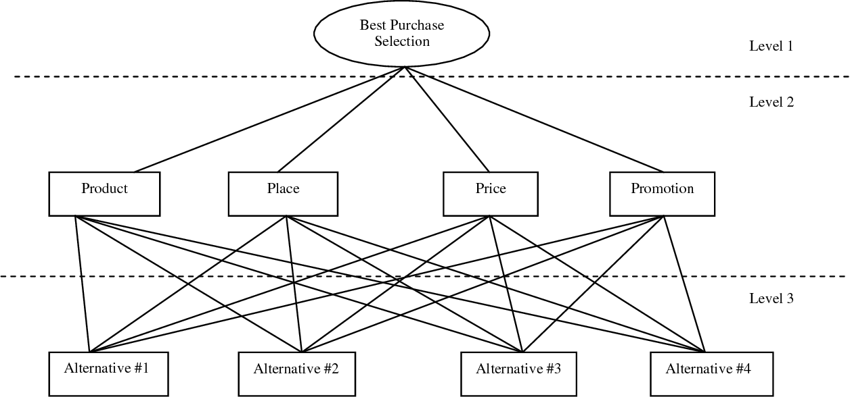
Figure 2-1: Hierarchy for purchase selection
Source: https://pdfs.semanticscholar.org/19b9/afdf972ef17afbd29010eaece61c5b14c76b.pdf

2.5 Conceptual Framework
Product
Price
Place
Consumer Purchase Decision
Promotion

Chapter 3 Research Methodology

3.1 Research Design
This study collected relevant data through questionnaires and drawing conclusions according to the analysis of data. This study explores the relationship between 4 independent variables and the research object by obtaining information related to the subject.
The study was mainly targeted at residents of Zibo, China. From the perspective of the survey object, the requirements for consumers to purchase real estate are complicated, and different customers have different requirements for real estate. Therefore, the factors influencing customer decision to purchase real estate are also diverse. This paper mainly designs questionnaires based on the economic development level of Zibo area and proposes targeted problems.
The questionnaire in this study is mainly consisted of 3 parts. The first part is the introduction. It mainly introduces the relevant situation of the questionnaire in a simple and clear way. It avoids the misunderstandings of questionnaire and improves the effectiveness of the questionnaire. The second part is about the personal information of participants, including gender, age, education level, income level, etc., which helps us to have a certain understanding of the participants, and also to provide lots of data source. The third part is the main part of the questionnaire, which is designed for the residents of Zibo area.

3.2 Study Population, Unit of Analysis, Sample Selection and Sampling Techniques

3.2.1 Study Population
According to the sixth China Census, Zibo has a population of 4,530,000. The population aged 0-14 is 660,000, accounting for 14.58%, the population aged 15-64 is 3.41 million, accounting for 75.40%; the population aged 65 and over is 450,000, accounting for 10.02%. This study mainly considers adults in Zibo who have independent views on real estate goods, mainly considering the population between the ages of 15 and 64, with a population of 3.41 million. However, due to the large population, this study used a random sampling method to investigate.

3.2.2 Unit of Analysis
The unit of analysis refer to the object studied in a social survey. The survey object is the object that is asked during data collection; the survey content is the attributes and characteristics of the analysis unit. The analysis unit may be the same as the survey object or sampling unit, or it may be different. The study was responded by residents of Zibo, and the unit was an individual.

3.2.3 Sample Selection
The population is 3,410,000, (N) in this survey. Krejcie & Morgan (1970) shows the sample calculation as follows:
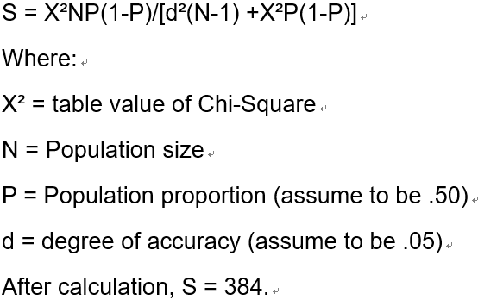

3.3 Data Collection and Analysis Methods

3.3.1 Data Collection
The total population in this study was 3,410,000. After the calculation by using Krejcie & Morgan formula, 384 participants are required. This survey will use online distribution. This questionnaire will be distributed online. It is conducive to cost savings and shorter investigation time. This survey will conduct a pilot study before the questionnaire is issued. During the pilot study, a small number of questionnaires will be used to distribute the participants to determine the participants' understanding and clarity of the questions in the questionnaire, and to improve the areas in the questionnaire that need to be modified.
3.2 Analysis Methods
After completing the relevant steps of questionnaire recovery, the researchers collated the collected data and input it into SPSS 22.0. Descriptive statistical analysis is then carried out to understand individual situation of participants, including gender, age, house number and so on. Finally, the investigator will conduct correlation analysis and regression analysis on related issues.

3.4 Measuring Instrument
This study used SPSS22.0 software to perform statistical analysis based on the valid questionnaires that have been collected. Then, through reliability and validity analysis, it is judged whether the data of the questionnaire has practical significance, and then descriptive analysis. Finally, the correlation analysis and regression analysis are used to verify the relationship between independent variables and dependent variables, thus ensuring the accuracy of marketing mix factors affecting consumer purchase decision in Zibo.

3.4.1 Descriptive analysis
Descriptive statistical analysis is an analysis method that uses statistical indicators to describe its characteristics. The description seems simple, but it is actually the basic work of many advanced analysis. Many advanced analysis methods have certain data, hypothesis and applicable conditions.

3.4.2 Correlation analysis
Correlation analysis can verify linear relationship between two or more variables. From the correlation coefficient r, we can see the degree of correlation between two variables and the positive and negative correlation. The correlation coefficient is defined when the standard deviation of the two variables is not zero. When one or two variables have measurement errors, their correlation is impaired.

3.4.3 Regression Analysis
Regression analysis is often used for predictive analysis. Regression analysis is mainly by establishing the regression model between the dependent variable Y and the independent variable X affecting it, the ability of the independent variable X to influence the dependent variable Y is measured, and then the development trend of the dependent variable Y can be predicted. For example, sales have a dependency on advertising costs. By analyzing this dependency, you can predict the sales that will be realized in the case of the next advertising cost.

3.5 Validity and Reliability Tests and Analysis

The design level of the questionnaire directly affects the quality of the paper, and the most important judgment of the quality of the questionnaire is the reliability and validity of the questionnaire. Therefore, in order to ensure the validity and credibility of the research purpose of the paper, the validity and reliability of the data of the questionnaire should be tested and explained.

3.5.1 Validity Tests and Analysis

The validity of the questionnaire refers to the authenticity and accuracy of the questionnaire, including criterion validity, content validity and construct validity. The main research of the thesis is the content validity and construct validity of the questionnaire. In terms of content validity, the design of this questionnaire is mainly composed of two parts; the first draft of the questionnaire is determined, and the questionnaire is pre-investigated. At the time of the drafting of the first draft of the questionnaire, the author read a large number of excellent research results at home and abroad, and then made further corrections to the questionnaire. The questionnaire is determined at the pre-investigation stage that the validity of the questionnaire is feasible. Therefore, from the perspective of the design of the entire questionnaire, this questionnaire has good validity. In terms of construct validity, because this paper mainly studies the influencing marketing mix factors of Zibo real estate purchase decision, the factor analysis method is used to test the construction validity of the questionnaire.

3.5.2 Reliability Tests and Analysis

Since the questionnaire uses the measurement method of the Likert’s point scale, and the questionnaire questions include the analyzed marketing mix factors influencing consumer decision to purchase real estate in Zibo, China, and because Test-retest reliability tends to be a factual questionnaire, the half confidence method and Cronbach's alpha can be used as the reliability analysis of this questionnaire. Moreover, because Cronbach’s alpha is more widely used, the paper finally uses Cronbach's alpha coefficient. Method to check the internal consistency of the questionnaire.

Chapter 4 Research finding
This study used SPSS 22.0 software to perform statistical analysis based on the valid questionnaires that have been collected. It is judged whether the data of the questionnaire has practical significance through reliability and validity analysis, and then verified the relationship between the independent variables and the dependent variable by descriptive statistical analysis, correlation analysis and regression analysis to ensure the accuracy of the marketing mix factors including the purchase of real estate by residents in Zibo. In this chapter, hypothesis verified by data analysis.

4.1 Pilot test
Piroska (2014) pointed out that a 30-50 sample size is usually enough for pilot test. Therefore, in this survey, 40 questionnaires are used for pilot study. Factor analysis (used for validity test), reliability test and correlation test are used for pilot test in this study.

4.1.1 Factor analysis of Pilot test
For the KMO and Bartlett's test of independent and dependent variables, the results are shown in the table below.

Table 4-1: KMO and Bartlett's test

Variable | Number of questions | Factor Loading | Overall KMO measure of adequacy (>0.6) | Bartlett's significant (p<0.05)
product | 6 | 0.853-0.960 | 0.836 | 0.000
price | 6 | 0.764-0.950 | 0.761 | 0.000
place | 6 | 0.645-0.935 | 0.840 | 0.000
promotion | 5 | 0.854-0.948 | 0.862 | 0.000
CPD | 4 | 0.779-0.906 | 0.783 | 0.000

For the five dimensions of product, price, place, promotion, and CPD (Customer Purchase Decision), the KMO and Bartlett's test tests were performed. The test result shows that the KMO of each dimension is between 0.761 and 0.862, and all are >0.6, and the p-value of Bartlett's test are 0.000<0.05, indicating that the test questionnaire has good structural validity.

4.1.2 Reliability test of pilot test
The validity of the test questionnaire is expressed by Cronbach's Alpha coefficient. Generally, the value is greater than 0.7, which means that the questionnaire has good reliability and internal consistency. For the reliability analysis of the analyzed test questionnaire, the results are shown in the following table:

Table 4-2: Reliability Statistics

Variable | Cronbach's Alpha | Cronbach's Alpha Based on Standardized Items | N of Items
product | 0.960 | 0.960 | 6
price | 0.970 | 0.971 | 6
place | 0.955 | 0.955 | 6
promotion | 0.967 | 0.967 | 5
CPD | 0.941 | 0.945 | 4

The results of the reliability analysis show that the Cronbach's Alpha coefficient and the standardized Cronbach's Alpha coefficient of each dimension are greater than 0.9, which means that the questionnaire has high reliability and internal consistency. So, the dimensions of this questionnaire have high reliability and internal consistency.

4.1.3 Correlation test of pilot test
Table 4-3: Correlations
product | Q6 | Q7 | Q8 | Q9 | Q10 | Q11
Q6 | 1
Q7 | .864** | 1
Q8 | .713** | .785** | 1
Q9 | .794** | .853** | .803** | 1
Q10 | .612** | .756** | .870** | .678** | 1
Q11 | .842** | .947** | .793** | .890** | .769** | 1
price | Q12 | Q13 | Q04 | Q15 | Q16 | Q17
Q12 | 1
Q13 | .883** | 1
Q04 | .768** | .802** | 1
Q15 | .902** | .768** | .727** | 1
Q16 | .850** | .976** | .813** | .795** | 1
Q17 | .964** | .912** | .813** | .877** | .900** | 1
place | Q18 | Q19 | Q20 | Q21 | Q22 | Q23
Q18 | 1
Q19 | .745** | 1
Q20 | .788** | .960** | 1
Q21 | .736** | .934** | .891** | 1
Q22 | .747** | .673** | .717** | .637** | 1
Q23 | .700** | .825** | .865** | .818** | .629** | 1
promotion | Q24 | Q25 | Q26 | Q27 | Q28
Q24 | 1
Q25 | .804** | 1
Q26 | .846** | .812** | 1
Q27 | .814** | .877** | .825** | 1
Q28 | .897** | .855** | .902** | .921** | 1
CPD | Q29 | Q30 | Q31 | Q32
Q29 | 1
Q30 | .824** | 1
Q31 | .824** | .938** | 1
Q32 | .810** | .716** | .760** | 1
**. Correlation is significant at the 0.01 level (2-tailed).
For the correlation coefficient test results of the items in each dimension, the correlation coefficients between the corresponding items under product, price, place, promotion and CPD have a high significant correlation.

4.2 Descriptive statistics of respondents
Conduct statistical analysis of the basic information of the participants in this survey.
According to the statistics, there are 189 males participating in this survey, accounting for 49.2%, and 195 females accounting for 50.8%. The age of the participants in this survey is mainly between 41 and 60 years old, with 205 people. The proportion was 53.4%, followed by 110 people aged 25 to 40 years old, accounting for 28.6%, while those older than 60 years old and less than 25 years old accounted for a small proportion, respectively 12.5% ​​and 14.8% of the participants in this survey. The educational level is mainly concentrated in the stage of degree, with 162 people accounting for 42.2%, followed by master and above, 95 people accounting for 24.7%; the income of the surveyed personnel is mainly concentrated in 6001-10000, with 133 people accounting for 34.6%, followed by less than 3,000, 127 people accounted for 33.1%, while more than 10,000 accounted for 13.3% of the participants.
The number of properties that have been purchased by the respondents is mainly concentrated in one property, with 164 people accounting for 42.7%; and a large proportion of 34.6% people have not purchase real estate; 9 people accounted for 2.3% that have above 2 houses. It shows that Zibo Real Estate still has a large development market.

Table 4-4: Personal basic information statistics

 |  | Frequency | Percent
gender | Female | 195 | 50.8
gender | Male | 189 | 49.2
age | Below 25 | 57 | 14.8
age | 25-40 | 110 | 28.6
age | 41-60 | 205 | 53.4
age | Above 60 | 12 | 3.1
education level | High school and below | 48 | 12.5
education level | Diploma | 79 | 20.6
education level | Degree | 162 | 42.2
education level | Master and above | 95 | 24.7
monthly income | Below 3,000 | 127 | 33.1
monthly income | 3001-6000 | 73 | 19.0
monthly income | 6001-10000 | 133 | 34.6
monthly income | Above 10,000 | 51 | 13.3
number of houses have purchased | 0 | 133 | 34.6
number of houses have purchased | 1 | 164 | 42.7
number of houses have purchased | 2 | 78 | 20.3
number of houses have purchased | Above 2 | 9 | 2.3

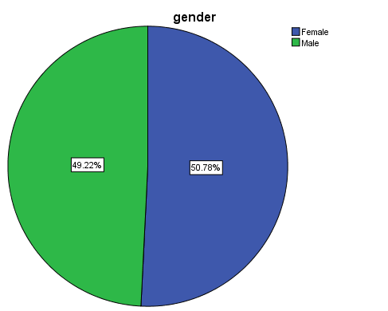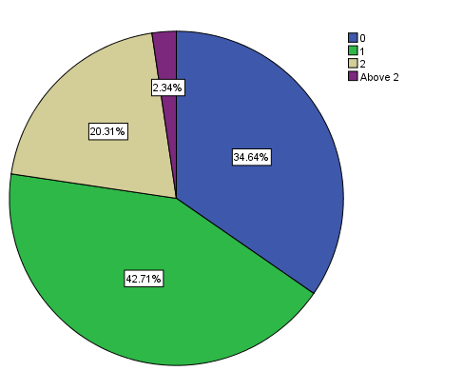
Figure 4-2-1: Gender and purchase property distribution ratio pie chart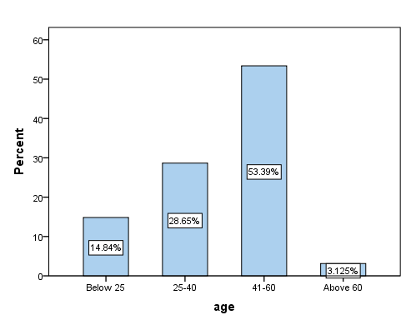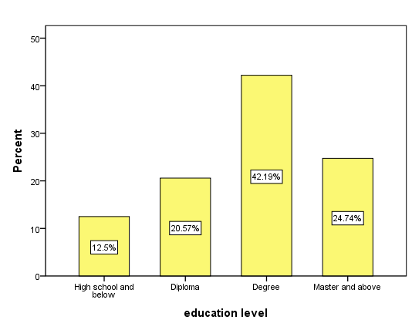
Figure 2 Age and education level distribution ratio histogram

From the results of Figure 1 and Figure 2 of the basic information of individuals, it can be seen intuitively that the gender distribution of the participants in this questionnaire has a relatively uniform proportion, and the number of men and women is quite the same; the age is mainly concentrated in 41~60 years old, and the education is mainly concentrated in the degree. Most of the participants have purchased one real estate, and a large number of people still have not purchased real estate.

4.3 Preliminary data analysis
Preliminary data analysis includes factor analysis based on each dimension (product, price, place, promotion & CPD). In addition, the overall questionnaire and reliability testing are performed to ensure the reliability and internal consistency of the overall questionnaire. The purpose of factor analysis is to explore the basic structure of a research project by reducing the components to a more manageable set of configurations. Next is the reliability analysis to assess the degree of consistency and stability of the items used in the measuring instrument.

4.3.1 Factors analysis
4.3.1.1 Product
Table 4-5: KMO and Bartlett's Test of product

Kaiser-Meyer-Olkin Measure of Sampling Adequacy. |  | .806
Bartlett's Test of Sphericity | Approx. Chi-Square | 3045.708
Bartlett's Test of Sphericity | df | 15
Bartlett's Test of Sphericity | Sig. | .000

Table 4-6: Total Variance Explained of product

Component | Initial Eigenvalues |  |  | Extraction Sums of Squared Loadings
Component | Total | % of Variance | Cumulative % | Total | % of Variance | Cumulative %
1 | 4.682 | 78.032 | 78.032 | 4.682 | 78.032 | 78.032
2 | .803 | 13.381 | 91.413
3 | .237 | 3.950 | 95.363
4 | .172 | 2.859 | 98.222
5 | .079 | 1.323 | 99.544
6 | .027 | .456 | 100.000
Extraction Method: Principal Component Analysis.

The factor analysis results below product showed that KMO=0.806, and the p-value of Bartlett's Test significance test=0.000<0.05, indicating that the item contained in this dimension is suitable for factor analysis.
And the Total Variance Explained results show that all the items included in this dimension can extract a common factor and can explain the 78.03% variation that was originally mentioned, indicating that the items contained in Product can better represent the product variable.
4.3.1.2 Price
Table 4-7: KMO and Bartlett's Test of price
Kaiser-Meyer-Olkin Measure of Sampling Adequacy. |  | .850
Bartlett's Test of Sphericity | Approx. Chi-Square | 5830.515
Bartlett's Test of Sphericity | df | 15
Bartlett's Test of Sphericity | Sig. | .000

Table 4-8: Total Variance Explained of price

Component | Initial Eigenvalues |  |  | Extraction Sums of Squared Loadings
Component | Total | % of Variance | Cumulative % | Total | % of Variance | Cumulative %
1 | 5.447 | 90.791 | 90.791 | 5.447 | 90.791 | 90.791
2 | .314 | 5.228 | 96.019
3 | .208 | 3.473 | 99.492
4 | .017 | .289 | 99.781
5 | .009 | .155 | 99.937
6 | .004 | .063 | 100.000
Extraction Method: Principal Component Analysis.

The factor analysis of the Price dimension shows that KMO = 0.850, and the p-value of Bartlett's Test significance test = 0.000 < 0.05, indicating that the item contained in this dimension is suitable for factor analysis.
And the Total Variance Explained results show that all the items contained in this dimension can extract a common factor and can explain the 90.79% variation that was originally mentioned, indicating that the item contained underprice can better represent the price variable.

4.3.1.3 Place
Table 4-9: KMO and Bartlett's Test of place
Kaiser-Meyer-Olkin Measure of Sampling Adequacy. |  | .772
Bartlett's Test of Sphericity | Approx. Chi-Square | 4453.856
Bartlett's Test of Sphericity | df | 15
Bartlett's Test of Sphericity | Sig. | .000

Table 4-10: Total Variance Explained of place

Component | Initial Eigenvalues |  |  | Extraction Sums of Squared Loadings
Component | Total | % of Variance | Cumulative % | Total | % of Variance | Cumulative %
1 | 5.157 | 85.953 | 85.953 | 5.157 | 85.953 | 85.953
2 | .524 | 8.736 | 94.688
3 | .179 | 2.983 | 97.671
4 | .114 | 1.905 | 99.577
5 | .016 | .273 | 99.850
6 | .009 | .150 | 100.000
Extraction Method: Principal Component Analysis.

The factor analysis results of the Place dimension show that KMO=0.772, the p-value of Bartlett's Test significance test = 0.000<0.05, indicating that the item contained in this dimension is suitable for factor analysis.
And the Total Variance Explained results show that all the items included in this dimension can extract a common factor and can explain the 85.95% variation that was originally mentioned, indicating that the items contained in the place can better represent the place variable.

4.3.1.4 Promotion
Table 4-11: KMO and Bartlett's Test of promotion

Kaiser-Meyer-Olkin Measure of Sampling Adequacy. |  | .793
Bartlett's Test of Sphericity | Approx. Chi-Square | 4267.003
Bartlett's Test of Sphericity | df | 10
Bartlett's Test of Sphericity | Sig. | .000

Table 4-12: Total Variance Explained of promotion

Component | Initial Eigenvalues |  |  | Extraction Sums of Squared Loadings
Component | Total | % of Variance | Cumulative % | Total | % of Variance | Cumulative %
1 | 4.691 | 93.810 | 93.810 | 4.691 | 93.810 | 93.810
2 | .174 | 3.476 | 97.286
3 | .107 | 2.148 | 99.435
4 | .021 | .418 | 99.853
5 | .007 | .147 | 100.000
Extraction Method: Principal Component Analysis.

The factor analysis results of the Promotion dimension show that KMO=0.793, the p-value of Bartlett's Test significance test = 0.000<0.05, indicating that the item contained in this dimension is suitable for factor analysis.
And the Total Variance Explained results show that all the items contained in this dimension can extract a common factor and can explain the 93.81% variation that was originally mentioned, indicating that the items contained in Promotion can better represent the Promotion variable.

4.3.1.5 CPD
Table 4-13: KMO and Bartlett's Test of CPD

Kaiser-Meyer-Olkin Measure of Sampling Adequacy. |  | .714
Bartlett's Test of Sphericity | Approx. Chi-Square | 2020.460
Bartlett's Test of Sphericity | df | 6
Bartlett's Test of Sphericity | Sig. | .000

Table 4-14: Total Variance Explained of CPD

Component | Initial Eigenvalues |  |  | Extraction Sums of Squared Loadings
Component | Total | % of Variance | Cumulative % | Total | % of Variance | Cumulative %
1 | 3.545 | 88.631 | 88.631 | 3.545 | 88.631 | 88.631
2 | .309 | 7.722 | 96.352
3 | .101 | 2.526 | 98.878
4 | .045 | 1.122 | 100.000
Extraction Method: Principal Component Analysis.

The factor analysis results of the CPD dimension showed that KMO=0.714, and the p-value of Bartlett's Test significance test=0.000<0.05, indicating that the item contained in this dimension is suitable for factor analysis.
And the Total Variance Explained results show that all the items included in this dimension can extract a common factor and can explain the 88.63% variation that was originally mentioned, indicating that the items contained in the CPD can better represent the CPD variables.

4.3.2 Reliability test
Table 4-15: Summary of results of reliability test

Variable | Cronbach's Alpha | Cronbach's Alpha Based on Standardized Items | N of Items
product | 0.943 | 0.943 | 6
price | 0.980 | 0.979 | 6
place | 0.967 | 0.967 | 6
promotion | 0.983 | 0.983 | 5
CPD | 0.955 | 0.957 | 4

The reliability analysis showed that Cronbach's Alpha>0.9 of product, price, place, promotion, CPD, and Cronbach's Alpha>0.9 were standardized, indicating that the questionnaire has high reliability and internal consistency.

4.4 Correlation analysis
In order to analyze the influencing factors of China's Zibo real estate purchase decision, the Pearson correlation analysis is carried out on the product, price, place, promotion and the purchase decision CPD of the surveyed personnel. The analysis results are shown in the following table:

Table 4-16: Correlations

 |  | CPD | product | place | price | promotion
CPD | Pearson Correlation | 1 | .017 | .163** | .264** | .457**
CPD | Sig. (2-tailed) |  | .739 | .001 | .000 | .000
CPD | N | 384 | 384 | 384 | 384 | 384
product | Pearson Correlation | .017 | 1 | -.167** | -.040 | -.016
product | Sig. (2-tailed) | .739 |  | .001 | .433 | .754
product | N | 384 | 384 | 384 | 384 | 384
place | Pearson Correlation | .163** | -.167** | 1 | .163** | -.131*
place | Sig. (2-tailed) | .001 | .001 |  | .001 | .010
place | N | 384 | 384 | 384 | 384 | 384
price | Pearson Correlation | .264** | -.040 | .163** | 1 | .068
price | Sig. (2-tailed) | .000 | .433 | .001 |  | .187
price | N | 384 | 384 | 384 | 384 | 384
promotion | Pearson Correlation | .457** | -.016 | -.131* | .068 | 1
promotion | Sig. (2-tailed) | .000 | .754 | .010 | .187
promotion | N | 384 | 384 | 384 | 384 | 384
**. Correlation is significant at the 0.05 level (2-tailed).

According to the relevant analysis results table, the correlation coefficient between the CPD and Place of the surveyed people in China's Zibo real estate purchase is 0.163, and the p value of the coefficient significance test is 0.001<0.05, indicating that there is a significant positive between place and CT. Correlation. Similarly, the correlation coefficient between price, promotion and CPD is greater than zero, and the p-value of the coefficient significance test is 0.000<0.05, indicating that the two still have a significant positive correlation with CPD.
The correlation coefficient between the CPD and product of the surveyed people in China's Zibo real estate purchase is 0.017, and the p-value of the coefficient significance test is 0.739>0.05, indicating that although the product has a positive correlation with the purchase decision to a certain extent, there was no significant statistical significance.

4.5 Hypothesis analysis
Based on the results of correlation analysis, in order to quantitatively measure the relationship between China's Zibo real estate purchase willingness and product, price, place and promotion, CPD as a dependent variable, product price, place promotion as an independent variable, establish multiple linear regression model:
$$CPI=β_{0}+β_{1}product+β_{2}price+β_{3}place+β_{4}promotion+ε$$
Where, is intercept term, is regression coefficient, is random error term. A regression analysis was performed, and the results were as follows.

4.5.1 ANOVA analysis
Table 4-17: ANOVA

Model |  | Sum of Squares | df | Mean Square | F | Sig.
1 | Regression | 116.064 | 4 | 29.016 | 41.186 | .000ª
1 | Residual | 267.011 | 379 | .705
1 | Total | 383.075 | 383
a. Predictors: (Constant), promotion, product, price, place
b. Dependent Variable: CPD

The ANOVA results table shows that the F value of the model significance test = 41.186, p value = 0.000 < 0.05, indicating that the established multivariate information regression model is significantly effective.

4.5.2 Model Summary
Table 4-18: Model Summary

Model | R | R Square | Adjusted R Square | Std. Error of the Estimate
1 | .550ª | .303 | .296 | .83935
a. Predictors: (Constant), promotion, product, price, place

The model summary results table shows that the model's goodness of fit R Square= 0.303 and Adjusted R Square =0.296 are both large, indicating that the independent multivariate linear regression model independent product, price, place and promotion can explain the dependent variable CPD 30.3. % variation.

4.5.3 Coefficients
Table 4-19: Coefficientsª

Model |  | Unstandardized Coefficients |  | Standardized Coefficients | t | Sig.
 |  | B | Std. Error | Beta | t | Sig.
1 | (Constant) | .078 | .330 |  | .237 | .813
1 | product | .065 | .043 | .067 | 1.532 | .126
1 | price | .225 | .049 | .201 | 4.608 | .000
1 | place | .192 | .042 | .203 | 4.560 | .000
1 | promotion | .496 | .046 | .472 | 10.849 | .000
- Dependent Variable: CPD

The Coefficients results table shows that the regression coefficient of product is 0.065, the t value of coefficient significance test = 1.532, p value = 0.126>0.05, indicating that the regression coefficient between product and CPD is not significant. The regression coefficient between price and CPD is 0.225, the t value of the coefficient significance test is 4.608, and the p value is 0.000<0.05, indicating that the regression coefficient of price is significantly effective. Similarly, for the regression coefficient between place and promotion and CPD, the p-value <0.05 is tested, indicating that the regression coefficients between the two and CPD are significant. So, the fitted regression equation is:

$$CPI=0.078+0.065product+0.225price+0.192place+0.496promotion$$

For each additional unit of the independent product, the consumer purchase decision CPD increases by an average of 0.065 units; for each additional unit of price, the consumer purchase decision CPD increases by an average of 0.225 units; for each additional unit of place, the consumer purchase decision CPD increases by an average of 0.192. For each unit of promotion, the CPD of consumers' purchase decision increases by an average of 0.496 units; from the regression coefficient, it can be seen intuitively that promotion and price have a greater impact on people's purchase behavior, followed by location place, and the impact of product is small on people's purchase behavior.

4.6 Summary of findings
In this chapter, the reliability and validity of the questionnaire are determined by the pilot test. The data collection and investigation in the later stage are based on this. After collecting the data, each independent variable and dependent variable are analyzed, indicating that the questions among each variable is strongly correlated. By verifying the hypothesis of four independent variables is found that price, place, promotion have a strong correlation with the dependent variable CPD, and the degree of association between product and CPD is not strong.

4.6.1 Findings of research hypothesis
The verification of the hypothesis is shown in the following table:
Table 4-20: Hypothesis Finding

Hypothesis | Result
H1: The product has a significant influence on customer decision to purchase real estate in Zibo, China. | Rejected
H2: The price has a significant influence on customer decision to purchase real estate in Zibo, China. | Accepted
H3: The place has a significant influence on customer decision to purchase real estate in Zibo, China. | Accepted
H4: The promotion has a significant influence on customer decision to purchase real estate in Zibo, China. | Accepted

For Hypothesis 1, this hypothesis is proposed to understand whether the product of the marketing mix factor has a significant impact on the purchase decision of real estate by consumers in Zibo. This hypothesis mainly includes six issues, from the housing design, green environment, after-sales service, service facilities, number of floors and housing space to examine the product factor. This study proves that product has no significant influence on the purchase decision of real estate by consumers in Zibo, China.
For Hypothesis 2, this hypothesis is proposed to understand whether the price of the marketing mix factor has a significant impact on the purchase decision of real estate by consumers in Zibo. This hypothesis mainly includes six issues, from the cost of living, house price level, payment method, home loan, future market price of house and rental price to examine the price factor. This study proves that price has significant influence on customer decision to purchase real estate in Zibo, China.
For Hypothesis 3, this hypothesis is proposed to understand whether the place of the marketing mix factor has a significant impact on the purchase decision of real estate by consumers in Zibo. This hypothesis mainly includes six issues, from location, traffic condition, water quality, property agent, air quality and noise pollution to examine the place factor. This study proves that place has a significant influence on customer decision to purchase real estate in Zibo, China.
For Hypothesis 4, this hypothesis is proposed to understand whether the promotion of the marketing mix factor has a significant impact on the purchase decision of real estate by consumers in Zibo. This hypothesis mainly includes five issues, from advertisement, price discount, additional incentive, sales promotion activities and sales exhibition to examine the promotion factor. This study proves that promotion has a significant influence on customer decision to purchase real estate in Zibo, China.
In summary, by verifying the hypothesis of four independent variables is found that promotion have a most significant with the dependent variable CPD, and the degree of association between product and CPD is not strong. In the article ‘The Housing Market Effects of Local Home Purchase Restrictions: Evidence from Beijing’, Sun (2016) pointed out that most of China’s residential buildings are similar, such as floor number, community environments and so on. Therefore, this caused that many consumers have no interested in the house design, because there are no differences between the houses. Sun (2016) also said that in many places of China, especially in some small cities, there are very few layouts of house to choose, usually only two or three. Although people have some requirements of house space, the larger living space in China means more expensive price, so many consumers are more concerned about price rather than house itself. In the other hand, many Chinese residents buy house not for living, but for rent (Zheng, Cheng & Ju, 2019), this is also an important reason that cause many consumers doesn’t pay attention on product.

4.6.2 Findings of research questions
As for the research questions, there are 5 questions in this research. The researcher used regression analysis to answer the research questions in this research. The findings as below show:
For the first research question, is product has a significant influence on CPD, the answer is negative. As is shown in the coefficients table, the b value shows that if product increase 1 unit, the CPD will increase only 0.065 unit. So, we can say that the product factor can only influence CPD a little. Otherwise, from the sig value in coefficients table, the sig value of product is 0.126, this number is above 0.05, so the product has no statistically significant on CPD.
For the second research question, is price has a significant influence on CPD, the answer is positive. As is shown in the coefficients table, the b value shows that if price increase 1 unit, the CPD will increase 0.225 unit. So, we can say that the product factor can influence CPD much. Otherwise, from the sig value in coefficients table, the sig value of price is 0.000, this number is below 0.05, so the price has statistically significant on CPD.
For the third research question, is place has a significant influence on CPD, the answer is positive. As is shown in the coefficients table, the b value shows that if place increase 1 unit, the CPD will increase 0.192 unit. So, we can say that the product factor can influence CPD much. Otherwise, from the sig value in coefficients table, the sig value of place is 0.000, this number is below 0.05, so the place has statistically significant on CPD.
For the fourth research question, is promotion has a significant influence on CPD, the answer is positive. As is shown in the coefficients table, the b value shows that if promotion increase 1 unit, the CPD will increase 0.496 unit. So, we can say that the promotion factor can influence CPD much. Otherwise, from the sig value in coefficients table, the sig value of promotion is 0.000, this number is below 0.05, so the promotion has statistically significant on CPD.
For the fifth research question, which factor has most significant influence on CPD, the answer is promotion. It can be seen from the comparison of the four survey questions above that CPD is most affected by promotion, which is 0.496 units.

Chapter 5 Summary

5.1 Conclusion
This study studied the relevant marketing mix factors affecting Zibo consumers' purchase of real estate and collected information and opinions on 384 participants through questionnaires. Through the analysis of the results, it is found that the three marketing mix factors of price, place and promotion have a greater impact on the consumers in Zibo area, and promotion has the greatest impact on Zibo consumers' willingness to purchase real estate. Although the current marketing of real estate in Zibo is facing many difficulties, the survey results show that a large part of the residents have not yet purchased real estate, which indicates that there is still a large market for real estate in Zibo. For the influencing factor product, most of the participants did not have a very agreeable attitude. Compared with product, more consumers tend to influence the price, place and promotion. For example, in the house design question, the number of participants who chose to disagree is 47, the number of participants who choose to disagree is 107, and the number of participants who choose to neutral is 105. It can be seen that most consumers do not value the house design, while paying more attention to factors such as price. Therefore, combine with the model below, for real estate developers and companies in Zibo, they should pay more attention to marketing activities from the aspects of promotion, price and place to attract more consumers. In addition, the product needs to be improved.
Product
Price
Place
Consumer Purchase Decision
Promotion

5.2 Limitation
First, this paper studies the marketing mix factors related to Zibo consumer real estate purchase decision, mainly to explore the dimensional composition and overall level of Zibo real estate marketing mix factors. Due to the limited experience and other internal and external factors, there is no differentiation between research respondents, and the personal information of the research respondents was not comprehensive enough. There was no detailed investigation on the different influence of these influencing factors on the marketing of Zibo real estate, which led to the lack of certain content of the research.
Second, the research methods were not enough. The research in this paper adopts research methods such as questionnaire survey, literature method, factor analysis and regression analysis. The data mainly comes from the questionnaire. Although the design and survey of the questionnaire are accompanied after certain research, the data is limited, and the parameters are limited. In addition, the questionnaire of this study was designed on the basis of theoretical research. Although the first draft of the program and the revision of the questionnaire are included, the level of reliability and validity analysis was also high, it is still difficult to ensure that the questionnaire is absolutely complete, and it is impossible to determine that the questions covered by the questionnaire are not in error.

5.3 Recommendations
This survey mainly focuses on the marketing mix factors of Zibo Real Estate. Therefore, in combination with this survey, the researchers have put forward many suggestions for the marketing and development of real estate enterprises.
First of all, market positioning is a prerequisite for the development of a company's business. Only by rationally applying the market positioning strategy to the production and operation process can the company gain a firm foothold in the market and make full use of limited resources to obtain higher benefits. Zibo Real Estate Company should consider the influence of individual factors on real estate sales when conducting real estate marketing. It can adopt market segmentation to reasonably locate the market and formulate different marketing strategies for different consumer groups.
Secondly, promotion is the most important factor of concern for Zibo consumers. Promotion is a process in which a marketer delivers various information about the company and its products to the consumer, in order to attract the attention of the consumer and thereby increase sales. The word promotion is no stranger to any enterprise in today's market economy. Real estate companies are one of the indispensable means to improve the level of real estate marketing. Real estate companies can take a variety of promotional forms when making property promotions. Advertising and promotion are the company's payment of the corresponding fees to certain media on the basis of a certain budget, through which the information of Zibo real estate is conveyed to consumers. Advertising promotion is because advertising has the advantage of wide radiation range, large economic effect and good media effect. When the real estate company conducts advertising promotion, it can formulate an advertising promotion plan according to the order of the market life cycle of Zibo real estate. Different advertising methods and content are used at different stages to promote advertising.
Then, it can be seen from the survey results that Zibo's consumers pay more attention to price marketing, so Zibo's real estate companies should formulate different pricing strategies. The real estate company should adopt the differential pricing method to promote the marketing of real estate according to the market changes, the self-construction of the real estate and the cost control situation, and the consumer psychology of potential customers, also known as the pricing strategy. There are three main pricing strategies commonly used in the industry today: infiltration pricing strategies, price discounts and discount strategies, and differential pricing strategies. The penetration pricing strategy is a strategy of trading at a low price for market share. The company can adopt this method within a certain period of time at the beginning of the opening period, thus helping the company to quickly withdraw funds and establish a corporate image. The price discount strategy is to promote the enthusiasm of consumers to purchase through the method of price reduction, and to maximize consumers’ purchase decision. Price discounts and discount strategies can generally be divided into cash discount strategies, quantity discount strategies, and seasonal delivery strategies. Companies can choose appropriate discount strategies based on actual conditions. The differential pricing strategy is a pricing strategy based on market segmentation. Given the diversity of factors affecting Zibo's real estate marketing, Zibo Real Estate can divide the property into multiple levels and types of properties and then adopt a differential and use the spread to attract client.
In addition, the researcher made two suggestions for the location factor. First, the service facilities in the vicinity of residential areas should be appropriately increased to facilitate the lives of residents, such as supermarkets. In this way, residents can purchase things more conveniently, and more consumers will choose to buy such houses. Second, developers need to conduct more in-depth investigations and research when conducting site selection. A good location is not only the social attributes but also its natural attributes. For example, the location of the site near the road is conducive to people's travel, but at the same time brings a lot of noise pollution to people's lives. Therefore, developers should consider comprehensively when selecting sites, and try to integrate the benefits of various aspects to meet the needs of consumers.
Finally, for the product, applicability is the fundamental requirement of the house. The performance of the house should be suitable for the needs of the occupants and the needs of their physical functions. In the actual design, as the designer, the first step is to use the function and partition the internal functions of the house according to the nature of the living. The living room, dining room and kitchen form a public activity area; the bedroom and the bathroom form a private activity area, the public area is close to the entrance, and the private area is located inside the house. The public and private, dynamic and static divisions are clear, and the use is smooth. Secondly, the area and scale of the room should be appropriate. Avoiding the housing set is only a simple expansion of the small-area floor plan to become a large and improper house. For the large-area sets required by the market, not only the moderate expansion of the room area, but also the increase in the amount of space for different functions, so that the housing set and modern lifestyle. The development of science and technology has promoted the level of housing construction, improved the quality of residential functions, and also met the residents' requirements for living comfort. The scientific nature of residential technology is reflected in the promotion and application of new technologies, new materials, new processes, new equipment, and continuous improvement; community management forms an intelligent system to meet the needs of modern living. In the promotion of intelligent technology, we must seek truth from facts, do our best, and closely integrate with the economics of development projects to achieve practical, advanced and economic integration effect.

5.4 Further research
According to the research and further thinking and discussion of this paper, the following prospects are proposed: In the selection of research samples related to the marketing mix factors influencing Zibo consumers’ real estate purchase decision, the research sample should be further expanded in the subsequent research, which can be obtained from the potential customers of real estate companies and strive to include more customers in the research. In addition, it is also possible to choose sample according to the preferences, characteristics, lifestyles, and consumption levels of different customers, and then conduct research on the samples and continue to explore the purchase decisions of Zibo consumer real estate under other variables. In the content of the research, regarding the marketing mix factors related to the decision of Zibo consumer real estate purchase, we can further explore the order of importance of these influencing factors; and, in addition to the influencing factors proposed in this paper, we should continue to explore other factors affecting the marketing influencing factors and dimensions of Zibo's consumer real estate purchase decisions, and thus a more comprehensive understanding of the marketing influencing factors related to Zibo's consumer real estate purchase decision and the future improvement direction of Zibo real estate enterprises in marketing strategies can be known.

5.5 Personal reflection
From the topic design of the research to the end of the research, it is quite a long process. This process is full of all kinds of emotions, such as the excitement of learning new knowledge, the happiness after finished a difficult chapter, and some confusions. This research is based on the results of many previous researchers. The researcher read a large amount of literature and online materials and then have a deeper understanding of the theory of marketing mix and have a better understanding of the situation of Zibo real estate industry. At the time of the topic selection, the research was more interested in the real estate situation, so the researcher chose to conduct real estate-related research. However, this survey also has some shortcomings. During the research process, the researcher listened to many suggestions from supervisors to improve these shortcomings. This research has received a lot of help from my supervisor Ms. Faziha. Ms. Faziha has put forward many professional suggestions for this research. I am very grateful to Ms. Faziha for guiding me in her busy work, the literature review, questionnaire, framework and many other parts have been greatly improved with her help. Finally, I would like to thank my second supervisor Dr. Wong, who put forward a lot of professional advice for my research. With his help, the influencing factors of my investigation have been greatly improved, and the marketing mix factors have been deepened understand, at the same time, Dr. Wong pointed out the shortcomings in this research, which made me have more perfect thinking and improvement on the theoretical framework of this research. Under the guidance of two supervisors, I completed this research. Their help not only improved my research paper, but also taught me how to do a good research.

Reference
Aalbers, M, B. (2017) ‘The Variegated Financialization of Housing’, International Journal of Urban and Regional Research, Vol. 41, No. 4, pp. 542-554.
Baker, M, J & Hart, S. (2016) The Marketing Book. 7th ed. London: Routledge.
Banerjee, S & Poddar, S. (2019) ‘To sell or not to sell: Licensing versus selling by an outside innovator’, Economic Modelling, Vol. 76, pp. 293-304.
Boennec, R, L & Salladarre, F. (2017) ‘The impact of air pollution and noise on the real estate market. The case of the 2013 European Green Capital: Nantes, France’, Ecological Economics, Vol. 138, pp. 82-89.
Brown, A, L & Lam, K, C. (2015) ‘Quantification of the exposure and effects of road traffic noise in a dense Asian city: a comparison with western cities’, Environmental Health, Vol. 14, No. 22 , pp. 139-156.
Cai, Y, Q., Zhou, Y., Ji, Z & Feng, Q. (2018) ‘The Influence of the Built Environment of Neighborhoods on Residents’ Low-Carbon Travel Mode’, Sustainability 2018, Vol. 10, No. 8, pp. 1-26.
Chan, S., Han, G and Zhang, W. (2016) ‘How strong are the linkages between real estate and other sectors in China?’, Research in International Business and Finance, Vol 36, No. 1, pp. 52-72.
Chen, M, X., Liu, W, D & Lu, D, D. (2016) ‘Challenges and the way forward in China’s new-type urbanization’, Land Use Policy, Vol. 55, pp. 334-339.
Chen, K & Wen, Y. (2017) ‘The Great Housing Boom of China’, American economic journal: Macroeconomics, Vol. 9, NO. 2, pp. 73-114.
Chen, W, Y. (2017) ‘Environmental externalities of urban river pollution and restoration: A hedonic analysis in Guangzhou (China)’, Landscape and Urban Planning, Vol. 157, pp. 170-179.
Cheng, Y, P & Zhao, J. (2018) ‘Analysis of the Relationship between the Real Estate Fluctuations and Economic Growth Fluctuations’, Advances in Economics, Business and Management Research, Vol. 5, pp. 16-38.]
Cheng, X. (2018) ‘Proceedings of the 2018 2nd International Conference on Education Science and Economic Management (ICESEM 2018)’, International Conference on Education Science and Economic Management, Vol. 2, pp. 23-52.
Chow, Y, L., Hafalir, I & Yavas, A. (2016) ‘Auction versus Negotiated Sale: Evidence from Real Estate Sales’, Real estate economics, Vol. 43, No. 2, pp. 432-470.
Cuevas, J, M. (2018) ‘The transformation of professional selling: Implications for leading the modern sales organization’, Industrial Marketing Management, Vol. 69, pp. 198-208.
Cusumano, M, A., Kahl, S, J & Suarez, F, F. (2015) ‘Services, industry evolution, and the competitive strategies of product firms’, Strategic Management, Vol. 36, No. 4, pp.559-575.
Danielle, A. (2018) ‘Game on! Real estate reforms are here’, Real Estate Institute of New South Wales, Vol. 69, No. 3.
Davidoff, T. (2016) ‘Supply Constraints Are Not Valid Instrumental Variables for Home Prices Because They Are Correlated with Many Demand Factors’, Critical Finance Review, Vol. 5, pp. 177–206.
Dong, X, Y & Li, X, Y. (2014) ‘Research on the Correlation between Real Estate Cycle Fluctuation and Financial Stability’, Chinese trade, Vol. 26, pp. 99-100.
Duan, Y. (2013) ‘Analysis of China's Real Estate Market Structure’, Business magazine, Vol. 14, pp. 263-270.
Erevelles, S., Fukawa, N & Swayne, L. (2016) ‘Big Data consumer analytics and the transformation of marketing’, Journal of Business Research, Vol. 69, No. 2, pp. 897-904.
Familmaleki, M., Aghighi, A & Hamidi, K. (2015) ‘Analyzing the Influence of Sales Promotion on Customer Purchasing Behavior’, International Journal of Economics & Management Sciences, Vol.4, No.4, pp. 243-249.
Fang, H, M., Gu, Q, L., Xiong, W & Zhou, L, A. (2015) ‘Demystifying the Chinese Housing Boom’, NBER Macroeconomics Annual, Vol. 30, No. 1, pp. 105-166.
Feng, Q & Wu, G. (2015) ‘Bubble or riddle? An asset-pricing approach evaluation on China's housing market’, Economic Modelling, Vol. 46, pp. 376-383.
Ferlan, N., Bastic, M & Psunder, I. (2017) ‘Influential Factors on the Market Value of Residential Properties’, Engineering Economics, Vol. 28, No. 2, pp. 135-144.
Fiedler, P & Zannin, P. (2015) ‘Evaluation of noise pollution in urban traffic hubs—Noise maps and measurements’, Environmental Impact Assessment Review, Vol. 51, pp. 1-9.
Fuzzi, S., Baltensperger, U., Carslow, K & Decesari, S. (2015) ‘Particulate matter, air quality and climate: lessons learned and future needs’, Atmospheric Chemistry and Physics, Vol. 15, pp. 8217-8299.
Gana, M, A & Koce, H, D. (2016) ‘Mobile Marketing: The Influence of Trust and Privacy Concerns on Consumers’ Purchase Decision’, International Journal of Marketing Studies, Vol. 8, No. 2, pp. 121-127.
Girardin, E., Deng, Y, H and Joyeux, R. (2018) ‘Fundamentals and the volatility of real estate prices in China: A sequential modelling strategy’, China Economic Review, Vol. 48, pp. 205-222.
Glaeser, E., Huang, W., Ma, Y & Shleifer, A. (2016) ‘A Real Estate Boom with Chinese Characteristics’, Journal of Economic Perspectives, Vol. 31, No. 1, pp. 93-16.
Glaeser, E & Gyourko, J. (2018) ‘The Economic Implications of Housing Supply’, Journal of Economic Perspectives, Vol. 32, No. 1, pp. 3-30.
Gould, K & Lewis, T. (2017) ‘Urban sustainability and the struggle for environmental justice’, Green Gentrification, Vol. 2, pp. 22-34.
Grundstrom, K & Molina, I. (2016) ‘From Folkhem to lifestyle housing in Sweden: segregation and urban form, 1930s–2010s’, International Journal of Housing Policy, Vol.16, No. 3, pp. 316-336.
Guan, J, C & Yam, R, C. (2015) ‘Effects of government financial incentives on firms’ innovation performance in China: Evidences from Beijing in the 1990s’, Research Policy, Vol. 44, No. 1, pp. 273-282.
Guttman, E & Simmons, R. (2016) ‘Greening Real Estate Professionals: A Model for
Landowner Engagement through Effective Education for Brokers & Appraisers’, Salish Sea Ecosystem Conference, Vol. 25, pp. 10-26.
Ley, D. (2015) ‘Global China and the making of Vancouver's residential property market’, International Journal of Housing Policy, Vol. 17, pp. 15-34.
Liu, X, Q., Zhou, Q, Q & Wang, C, A. (2019) ‘Spatial Spillover Effects of The Real Estate Industry on Economic Development -from Destocking Perspective’, Journal of Physics: Conference Series, Vol. 1187, PP. 115-123.
Loon, J, V. (2016) ‘Patient versus impatient capital: the (non-) financialization of real estate developers in the Low Countries’, Socio-Economic Review, Vol. 14, No. 4, pp. 709–728.
Han, L, H & Yang, C. (2015) ‘Scenario Simulation and the Prediction of Land Use and Land Cover Change in Beijing, China’, Sustainability, Vol. 7, No. 4, pp. 4260-4279.
Hanner, M, S & Fan, Y. (2017) ‘Applying a novel environmental health framework theory (I-ACT) to noise pollution policies in the United States, United Kingdom, and the Netherlands’, Journal of Environmental Planning and Management, Vol. 61, No. 12, pp. 2111-2132.
Henderson, J & Spencer, J. (2016) ‘Autonomous Vehicles and Commercial Real Estate’, Cornell Real Estate Review, Vol. 14, pp. 45-54.
Hong, Y, X. (2016) ‘The Evolving Economic Thinking of the Communist Party of China’, The China Path to Economic Transition and Development, pp. 195-211.
Hu, S., Yang, S, F., Li, W, D., Zhang, C, R & Xu, F. (2018) ‘Spatially non-stationary relationships between urban residential land price and impact factors in Wuhan city, China’, Applied Geography, Vol. 68, pp. 48-56.
Huang, D, Q., Huang, Y, C., Zhao, X, S & Liu, Z. (2017) ‘How Do Differences in Land Ownership Types in China Affect Land Development? A Case from Beijing’, Sustainability, Vol. 9, No. 1, pp. 123.
Huang, L, Y. (2013) ‘The structure of real estate market in developed countries and regions and its enlightenment’, Journal of Chifeng College (Nature Scientific version), Vol. 9, pp. 85-88.
Huang, L, Y., Wu, Ling., Deng, F, K & Chen, X, F. (2015) ‘On the adjustment of the structure of the real estate market’, Journal of Chifeng College (Natural Science Edition), Vol. 7, pp. 24-27.
Hughes, D, E., Richards, K, A., Calantone, R., Baldus, B & Spreng, R, A. (2019) ‘Driving In-Role and Extra-Role Brand Performance among Retail Frontline Salespeople: Antecedents and the Moderating Role of Customer Orientation’, Journal of Retailing, In Press.
Hunt, S, D. (2017) ‘Advancing marketing strategy in the marketing discipline and beyond: from promise, to neglect, to prominence, to fragment (to promise?)’, Journal of Marketing Management, Vol. 34, No.1-2, pp. 16-52.
Isoraite, M. (2016) ‘Marketing mix theoretical aspects’, International journal of research-granthaalayah, Vol. 4, No. 6, pp. 25-37.
Jaiyawala, Y., Maher, J., Burke, R & Byrne, S. (2018) ‘Holding on and Letting Go in Ireland: Examining the Policy and Fiscal Environment for Supplementing Retirement Income from Residential Property’, Old-Age Provision and Homeownership – Fiscal Incentives and Other Public Policy Options, pp. 51-81.
Ji, H., Xing, M., Xiang, Z., Yi, B., Liu, M & Wei, N, X. (2017) ‘A long-term analysis of urbanization process, landscape change, and carbon sources and sinks: A case study in China's Yangtze River Delta region’, Journal of Cleaner Production, Vol. 141, pp. 1040-1050.
Jin, S, S., Wu, W, J & Huang, X, M. (2017) ‘Improving Property Service for the City Residential Community’, Annual International Conference on Information Technology and Applications, Vol. 12, pp. 71-97.
Keenan, J, M. (2015) ‘From sustainability to adaptation: Goldman Sachs’ corporate real estate strategy’, Journal of Building Research & Information, Vol. 44, No. 4, pp. 407-422.
Knoll, K., Schularick, M & Steger, T. (2017) ‘No Price Like Home: Global House Prices’, American economic review, Vol. 107, pp. 331-353.
Li, Q., Wang Q, S and Lin, Z, J. (2018) ‘Effects of consumer visit to online community and product channel on local sales of large consumer products: Evidence from real estate industry’, Journal of Strategic Information Systems, Vol. 27, No. 2, pp 191-204.
Li, S, W., Ye, X, Y., Lee, J., Gong, J, F & Qin, C, L. (2017) ‘Spatiotemporal Analysis of Housing Prices in China: A Big Data Perspective’, Applied Spatial Analysis and Policy, Vol. 10, No. 3, pp 421–433.
Li, X, F & Feng, Z, X. (2014) ‘The correlation between real estate cycle, fixed asset investment cycle and economic cycle: based on the analysis of monetary policy perspective’, Economic Theory and Economic Management, Vol. 4, pp. 34-44.
Madura, B, Z. (2017) ‘Marketing offer presentation on the real estate market’, The Business and Management Review, Vol. 8, No. 4, pp. 7-12.
Moriasi, D, N., Gitau, M, W & Pai, N. (2015) ‘Hydrologic and Water Quality Models: Performance Measures and Evaluation Criteria’, Transactions of the ASABE, Vol. 58, No. 6, pp. 1763-1785.
Nase, I., Berry, J & Adair, A. (2016) ‘Impact of quality-led design on real estate value: a spatiotemporal analysis of city centre apartments’, Journal of Property Research, Vol. 33, No. 4, pp. 309-331.
Nathanson, C, G & Zwick, E. (2018) ‘Arrested Development: Theory and Evidence of Supply‐Side Speculation in the Housing Market’, The Journal of Finance, Vol. 73, No. 6, pp. 2587-2633.
Niedermeier, K, E., Wang, E & Zhang, X, H. (2016) ‘The use of social media among business-to-business sales professionals in China: How social media helps create and solidify guanxi relationships between sales professionals and customers’, Journal of Research in Interactive Marketing, Vol. 10, No. 1, pp. 33-49.
Nuseir, M, T & Madanat, H. (2015) ‘4Ps: A Strategy to Secure Customers’ Loyalty via Customer Satisfaction’, International Journal of Marketing Studies, Vol. 7, No. 4, pp. 78-87.
Oyedoken, T., Dunse, N & Jones, C, A. (2017) ‘Local market factors influencing office stock greening process: A case study of three British cities’, European Real Estate Society, Vol. 17, pp. 139-145.
Park, K., Ryu, G & Han, Y, J. (2017) ‘How the perceptual fluency of price discounts and promotional cues affect consumer responses’, Social Behavior and Personality: an international journal, Vol. 45, No. 5, pp. 757-772.
Piroska, B, B. (2014) ‘How to pretest and pilot a survey questionnaire’, [Online]. Retrieved from: http://www.tools4dev.org/wp-content/uploads/how-to-pretest-and-pilot-a-survey-questionnaire.pdf [Accessed 2 August 2019].
Qiu, G, H. (2015) ‘On the sales channel model of real estate goods’, Value Engineering, Vol. 26, pp. 9-11.
Rahadi, R, S. (2015) ‘Factors influencing the price of housing in Indonesia’, International Journal of Housing Markets and Analysis, Vol. 8, No. 2, pp.169-188.
Raza, N., Ali, S., Shahzad, S & Raza, S. (2018) ‘Do commodities effectively hedge real estate risk? A multi-scale asymmetric DCC approach’, Resources Policy, Vol. 57, pp. 10-29.
Resnick, S, M., Cheng, R & Simpson, M. (2016) ‘Marketing in SMEs: a “4Ps” self-branding model’, International Journal of Entrepreneurial Behavior & Research, Vol. 22, No. 1, pp. 155-174.
Riggs, W. (2016) ‘Inclusively walkable: exploring the equity of walkable housing in the San Francisco Bay Area’, The International Journal of Justice and Sustainability, Vol. 21, No. 5, pp. 527-554.
Robin, E. (2018) ‘Performing real estate value(s): real estate developers, systems of expertise and the production of space’, Geoforum, Vol. 9, pp. 587-603.
Schnabl, G. (2017) ‘Exchange Rate Regime, Financial Market Bubbles and Long‐term Growth in China: Lessons from Japan’, China & World Economy, Vol. 25, No. 1, pp. 32-57.
Shen, L & Zhang, Z. (2017) ‘Key factors affecting green procurement in real estate development: A China study’, Journal of Cleaner Production, Vol. 153, pp. 372-383.
Shin, C, L. (2017) ‘Understanding Chinese Economy Accurately—John Wong and His China Research’, Producing China in Southeast Asia, pp. 59-73.
Stepan, J. (2018) ‘Money, price, value, and exchange’, Ethos. Kwartalnik Instytutu Jana Pawła II KUL Journal, Vol. 1, pp. 221-241.
Sun, W, Z., Zheng, S, Q., Geltner, D, M & Wang, R. (2016) ‘The Housing Market Effects of Local Home Purchase Restrictions: Evidence from Beijing’, Vol. 55, No. 3, pp. 288-312.
Sun, Y, T & Yun, X, G. (2019) ‘Research on the Integration of Tourism Industry and Real Estate Industry in China’, Scientific research, Vol. 9, No. 10, pp. 1654-1664.
Swoboga, A., Nega, T & Timm, M. (2015) ‘HEDONIC analysis of time and space: case of housing prices and traffic noise’, Journal of regional science, Vol. 55, pp. 189-211.
Szczepanska, A., Senetra, A & Pszczolkowska, M, W. (2015) ‘The effect of road traffic noise on the prices of residential property – A case study of the polish city of Olsztyn’, Transportation Research Part D: Transport and Environment, Vol. 36, pp. 167-177.
Terho, H., Eggert, A., Haas, A & Ulage, W. (2015) ‘How sales strategy translates into performance: The role of salesperson customer orientation and value-based selling’, Industrial Marketing Management, Vol. 45, pp. 12-21.
Tsakiridou, E & Karanikolas, N. (2019) ‘Real estate in the web and social media era, the Greek reality’, International Journal of Real Estate & Land Planning, Vol. 2, pp. 23-48.
Wang, N, W. (2015) ‘Exploring the interaction between real estate cycle and macro economy’, Business magazine, Vol. 1, pp. 250-267.
Wang, Y, F & Jiang, Y, Q. (2016) ‘An empirical analysis of factors affecting the housing price in Shanghai’, Asian Journal of Economic Modelling, Vol. 4, No. 2, pp. 104-111.
Wen, H, Z & Tao, Y, L. (2015) ‘Polycentric urban structure and housing price in the transitional China: Evidence from Hangzhou’, Habitat International, Vol. 46, pp. 138-146
White, L, H. (2015) ‘The Federal Reserve System’s Overreach into Credit Allocation’, The Journal of Private Enterprise, Vol. 30, No. 4, pp. 17–29.
Wu, F, L. (2015) ‘Commodification and housing market cycles in Chinese cities’, International Journal of Housing Policy, Vol. 15, No. 1, pp. 6-26.
Wu, J., Gyourko, J & Deng, Y, H. (2015) ‘Evaluating the Risk of Chinese Housing Markets: What We Know and What We Need to Know’, China Economic Review, vol. 39, pp. 91-114.
Wu, L, L., Bian, Y & Zhang, W. (2018) ‘Housing ownership and housing wealth: new evidence in transitional China’, Journal of housing studies, Vol. 34, No. 3, pp. 448-468.
Xu, D, Y. (2018) ‘research on the cultural construction of homelink real estate’, Engineering Heritage Journal (GWK), Vol. 2, No 1, pp 24-26.
Xu, T & Gong, W. (2016) ‘The Legitimacy of Extralegal Property: Global Perspectives and China's Experience’, Northern Ireland Legal Quarterly, Vol. 67, No. 2, pp. 189-208.
Xue, D., Huang, R & Wang, X. (2018) ‘Analysis of Factors Affecting the Housing Price in Different Cities of China and Macro Control Measures’, Proceedings of the 2018 International Seminar on Education Research and Social Science, Vol, 43, pp. 18-29.
Yamane, Taro. (1967) Statistics: An Introductory Analysis. 2nd ed. New York: Harper and Row.
Yilmazer, T., Babiarz, P & Liu, F. (2015) ‘The impact of diminished housing wealth on health in the United States: Evidence from the Great Recession’, Social Science & Medicine, Vol. 130, pp. 234-241
Yu, Z., Xiu, W, Y., Li, M., Li, R, Y & Zhang, Q, S. (2015) ‘Forecasting Fine-Grained Air Quality Based on Big Data’, Proceedings of the 21th ACM SIGKDD International Conference on Knowledge Discovery and Data Mining, Vol. 15, pp. 2267-2276.
Zaheer, A, N & Rashid, A. (2017) ‘Analyzing the role of public sector marketing in improving social effectiveness: a case study from Anhui province, China’, International Review on Public and Nonprofit Marketing, Vol. 14, No. 1, pp. 57-71.
Zahoor, S, Z & Qureshi, I, H. (2017) ‘Social Media Marketing and Brand Equity: A Literature Review’, IUP Journal of Marketing Management, Vol. 16, No. 1, pp. 47-64.
Zhang, H., Li, L, J., Chen, T, T & Li, V. (2016) ‘Where will China's real estate market go under the economy's new normal?’, Cities, Vol. 55, pp. 42-48.
Zhang, H, Q. (2014) ‘Analysis of economic factors of cyclical fluctuations in real estate’, Modern marketing, Vol. 6, pp. 46-47.
Zhang, X, L. (2015) ‘Green real estate development in China: State of art and prospect agenda—A review’, Renewable and Sustainable Energy Reviews, Vol. 47, pp. 1-13.
Zhang, Y. (2017) ‘Social class differences in consumption propensity in contemporary China – from survival-oriented consumption to development-oriented consumption’, The Journal of Chinese Sociology, Vol.4, No. 21.
Zhang, Z. (2017) ‘Empirical research on the impact of interest rates on real estate prices’, Modern Business, Vol. 12, pp. 59-60.
Zheng, S, Q., Cheng, Y & Ju, Y, J. (2019) ‘Understanding the Intention and Behavior of Renting Houses among the Young Generation: Evidence from Jinan, China’, Sustainability, Vol. 11, No. 6, pp. 1-18.
Zhu, H., Xiong, H., Tang, F, S & Liu, Q. (2016) ‘Days on Market: Measuring Liquidity in Real Estate Markets’, International Conference on Knowledge Discovery and Data Mining, Vol. 16, pp. 392-402.
Zhu, J. (2016) ‘The impact of real estate market structure and market behavior on industrial efficiency’, Cooperative economy and technology, Vol. 6, pp. 6-17.

Appendix

Appendix 1: PROJECT PAPER LOG
This is an important document, which is to be handed in with your dissertation. This log will be taken into consideration when awarding the final mark for the dissertation.
Student Name: | Wei Shengli
Supervisor’s Name: | Ms. Faziha Abd Malek
Dissertation Topic:
Investigating the marketing mix factors influencing consumer decision to purchase real estate in Zibo, China

SECTION A. MONITORING STUDENT DISSERTATION PROCESS
The plan below is to be agreed between the student & supervisor and will be monitored against progress made at each session.
Activity | Milestone/Deliverable Date
Confirmation research title | 20/5
Final initial proposal |  | 5/6
Chapter 1,2,3 draft |  |  | 15/6
Questionnaire design |  |  |  | 1/7
Questionnaire collection |  |  |  |  | 10/7
Draft Chapter 4 |  |  |  |  |  | 26/7
Draft Chapter 5 |  |  |  |  |  |  | 1/8
Final draft |  |  |  |  |  |  |  | 6/8

SECTION B. RECORD OF MEETINGS
The expectation is that students will meet their supervisors up to seven times and these meetings should be recorded.





SECTION C. COMMENTS OM MANAGEMENT OF PROJECT
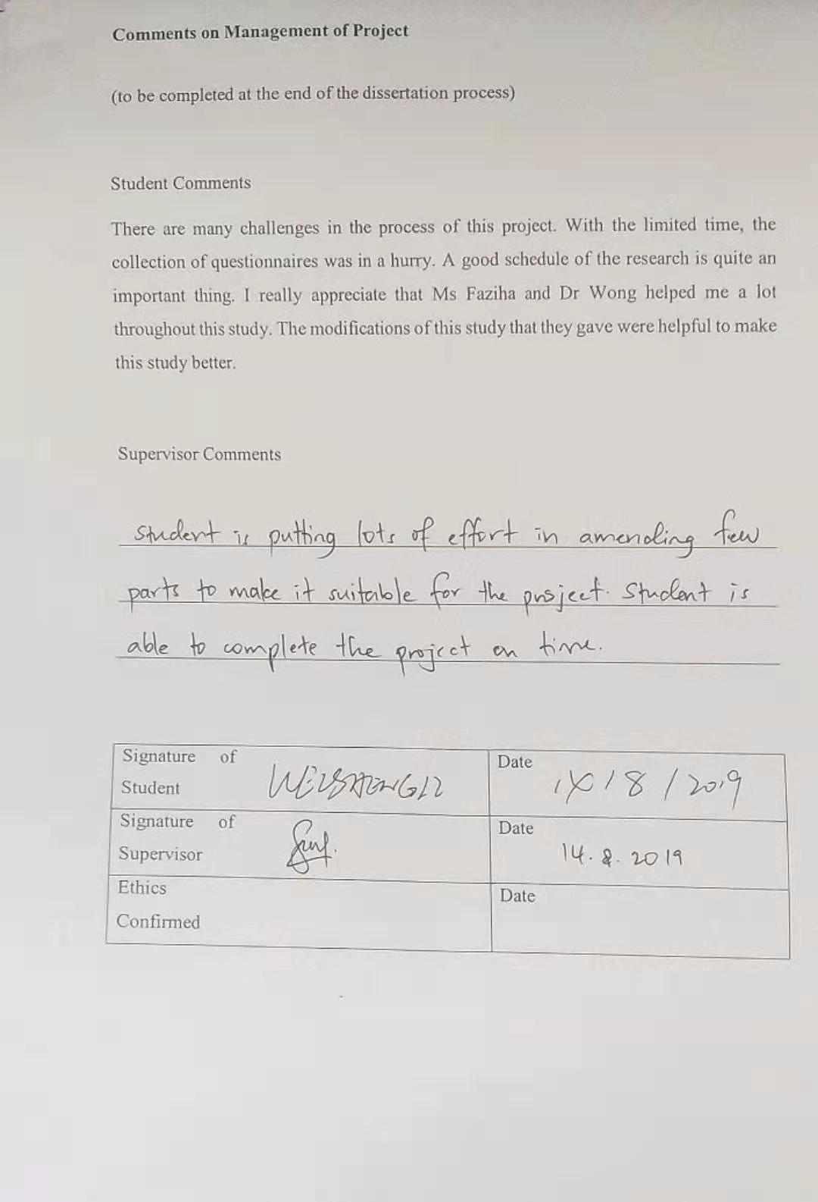

Appendix 2: List of Abbreviations
Abbreviations | Full name
STAR | Smooth Transition Autoregression
OLS | Ordinary Least Square
CPD | Customer Purchase Decision

Appendix 3: Data analysis results
Pilot test:
KMO and Bartlett's Test
Kaiser-Meyer-Olkin Measure of Sampling Adequacy. |  | .836
Bartlett's Test of Sphericity | Approx. Chi-Square | 293.851
Bartlett's Test of Sphericity | df | 15
Bartlett's Test of Sphericity | Sig. | .000

Communalities
 | Initial | Extraction
1 | 1.000 | .779
2 | 1.000 | .908
3 | 1.000 | .819
4 | 1.000 | .844
5 | 1.000 | .727
6 | 1.000 | .921
Extraction Method: Principal Component Analysis.

Total Variance Explained
Component | Initial Eigenvalues |  |  | Extraction Sums of Squared Loadings
Component | Total | % of Variance | Cumulative % | Total | % of Variance | Cumulative %
1 | 4.998 | 83.299 | 83.299 | 4.998 | 83.299 | 83.299
2 | .501 | 8.346 | 91.645
3 | .207 | 3.455 | 95.100
4 | .177 | 2.944 | 98.045
5 | .073 | 1.219 | 99.264
6 | .044 | .736 | 100.000
Extraction Method: Principal Component Analysis.

KMO and Bartlett's Test
Kaiser-Meyer-Olkin Measure of Sampling Adequacy. |  | .761
Bartlett's Test of Sphericity | Approx. Chi-Square | 397.768
Bartlett's Test of Sphericity | df | 15
Bartlett's Test of Sphericity | Sig. | .000

Communalities
 | Initial | Extraction
7 | 1.000 | .916
8 | 1.000 | .908
9 | 1.000 | .764
10 | 1.000 | .814
11 | 1.000 | .905
12 | 1.000 | .950
Extraction Method: Principal Component Analysis.

Total Variance Explained
Component | Initial Eigenvalues |  |  | Extraction Sums of Squared Loadings
Component | Total | % of Variance | Cumulative % | Total | % of Variance | Cumulative %
1 | 5.257 | 87.621 | 87.621 | 5.257 | 87.621 | 87.621
2 | .338 | 5.625 | 93.246
3 | .250 | 4.161 | 97.407
4 | .112 | 1.861 | 99.268
5 | .034 | .566 | 99.834
6 | .010 | .166 | 100.000
Extraction Method: Principal Component Analysis.

KMO and Bartlett's Test
Kaiser-Meyer-Olkin Measure of Sampling Adequacy. |  | .840
Bartlett's Test of Sphericity | Approx. Chi-Square | 290.437
Bartlett's Test of Sphericity | df | 15
Bartlett's Test of Sphericity | Sig. | .000

Communalities
 | Initial | Extraction
13 | 1.000 | .751
14 | 1.000 | .908
15 | 1.000 | .935
16 | 1.000 | .865
17 | 1.000 | .645
18 | 1.000 | .801
Extraction Method: Principal Component Analysis.

Total Variance Explained
Component | Initial Eigenvalues |  |  | Extraction Sums of Squared Loadings
Component | Total | % of Variance | Cumulative % | Total | % of Variance | Cumulative %
1 | 4.905 | 81.753 | 81.753 | 4.905 | 81.753 | 81.753
2 | .512 | 8.533 | 90.285
3 | .240 | 3.996 | 94.282
4 | .215 | 3.583 | 97.864
5 | .104 | 1.733 | 99.597
6 | .024 | .403 | 100.000
Extraction Method: Principal Component Analysis.

KMO and Bartlett's Test
Kaiser-Meyer-Olkin Measure of Sampling Adequacy. |  | .862
Bartlett's Test of Sphericity | Approx. Chi-Square | 250.922
Bartlett's Test of Sphericity | df | 10
Bartlett's Test of Sphericity | Sig. | .000

Communalities
 | Initial | Extraction
19 | 1.000 | .860
20 | 1.000 | .854
21 | 1.000 | .870
22 | 1.000 | .891
23 | 1.000 | .948
Extraction Method: Principal Component Analysis.

Total Variance Explained
Component | Initial Eigenvalues |  |  | Extraction Sums of Squared Loadings
Component | Total | % of Variance | Cumulative % | Total | % of Variance | Cumulative %
1 | 4.424 | 88.472 | 88.472 | 4.424 | 88.472 | 88.472
2 | .238 | 4.762 | 93.234
3 | .154 | 3.072 | 96.305
4 | .139 | 2.772 | 99.078
5 | .046 | .922 | 100.000
Extraction Method: Principal Component Analysis.

KMO and Bartlett's Test
Kaiser-Meyer-Olkin Measure of Sampling Adequacy. |  | .783
Bartlett's Test of Sphericity | Approx. Chi-Square | 165.597
Bartlett's Test of Sphericity | df | 6
Bartlett's Test of Sphericity | Sig. | .000

Communalities
 | Initial | Extraction
24 | 1.000 | .869
25 | 1.000 | .884
26 | 1.000 | .906
27 | 1.000 | .779
Extraction Method: Principal Component Analysis.

Total Variance Explained
Component | Initial Eigenvalues |  |  | Extraction Sums of Squared Loadings
Component | Total | % of Variance | Cumulative % | Total | % of Variance | Cumulative %
1 | 3.439 | 85.963 | 85.963 | 3.439 | 85.963 | 85.963
2 | .337 | 8.431 | 94.394
3 | .166 | 4.161 | 98.555
4 | .058 | 1.445 | 100.000
Extraction Method: Principal Component Analysis.

Case Processing Summary
 |  | N | %
Cases | Valid | 40 | 100.0
Cases | Excludedª | 0 | .0
Cases | Total | 40 | 100.0
a. Listwise deletion based on all variables in the procedure.

Reliability Statistics
Cronbach's Alpha | Cronbach's Alpha Based on Standardized Items | N of Items
.960 | .960 | 6

Item Statistics
 | Mean | Std. Deviation | N
1 | 3.13 | 1.114 | 40
2 | 3.25 | 1.193 | 40
3 | 3.38 | 1.102 | 40
4 | 3.20 | 1.159 | 40
5 | 3.50 | 1.109 | 40
6 | 3.20 | 1.203 | 40

Item-Total Statistics
 | Scale Mean if Item Deleted | Scale Variance if Item Deleted | Corrected Item-Total Correlation | Squared Multiple Correlation | Cronbach's Alpha if Item Deleted
1 | 16.52 | 28.358 | .832 | .775 | .957
2 | 16.40 | 26.605 | .929 | .915 | .946
3 | 16.27 | 28.153 | .863 | .852 | .953
4 | 16.45 | 27.433 | .880 | .843 | .951
5 | 16.15 | 28.797 | .792 | .817 | .961
6 | 16.45 | 26.408 | .939 | .929 | .945

Factor analysis:

KMO and Bartlett's Test
Kaiser-Meyer-Olkin Measure of Sampling Adequacy. |  | .806
Bartlett's Test of Sphericity | Approx. Chi-Square | 3045.708
Bartlett's Test of Sphericity | df | 15
Bartlett's Test of Sphericity | Sig. | .000

Communalities
 | Initial | Extraction
Q6 | 1.000 | .765
Q7 | 1.000 | .901
Q8 | 1.000 | .686
Q9 | 1.000 | .804
Q10 | 1.000 | .611
Q11 | 1.000 | .916
Extraction Method: Principal Component Analysis.

Total Variance Explained
Component | Initial Eigenvalues |  |  | Extraction Sums of Squared Loadings
Component | Total | % of Variance | Cumulative % | Total | % of Variance | Cumulative %
1 | 4.682 | 78.032 | 78.032 | 4.682 | 78.032 | 78.032
2 | .803 | 13.381 | 91.413
3 | .237 | 3.950 | 95.363
4 | .172 | 2.859 | 98.222
5 | .079 | 1.323 | 99.544
6 | .027 | .456 | 100.000
Extraction Method: Principal Component Analysis.

KMO and Bartlett's Test
Kaiser-Meyer-Olkin Measure of Sampling Adequacy. |  | .850
Bartlett's Test of Sphericity | Approx. Chi-Square | 5830.515
Bartlett's Test of Sphericity | df | 15
Bartlett's Test of Sphericity | Sig. | .000

Communalities
 | Initial | Extraction
Q12 | 1.000 | .958
Q13 | 1.000 | .927
Q14 | 1.000 | .730
Q15 | 1.000 | .947
Q16 | 1.000 | .923
Q17 | 1.000 | .962
Extraction Method: Principal Component Analysis.

Total Variance Explained
Component | Initial Eigenvalues |  |  | Extraction Sums of Squared Loadings
Component | Total | % of Variance | Cumulative % | Total | % of Variance | Cumulative %
1 | 5.447 | 90.791 | 90.791 | 5.447 | 90.791 | 90.791
2 | .314 | 5.228 | 96.019
3 | .208 | 3.473 | 99.492
4 | .017 | .289 | 99.781
5 | .009 | .155 | 99.937
6 | .004 | .063 | 100.000
Extraction Method: Principal Component Analysis.

KMO and Bartlett's Test
Kaiser-Meyer-Olkin Measure of Sampling Adequacy. |  | .772
Bartlett's Test of Sphericity | Approx. Chi-Square | 4453.856
Bartlett's Test of Sphericity | df | 15
Bartlett's Test of Sphericity | Sig. | .000

Communalities
 | Initial | Extraction
Q18 | 1.000 | .794
Q19 | 1.000 | .898
Q20 | 1.000 | .952
Q21 | 1.000 | .877
Q22 | 1.000 | .701
Q23 | 1.000 | .936
Extraction Method: Principal Component Analysis.

Total Variance Explained
Component | Initial Eigenvalues |  |  | Extraction Sums of Squared Loadings
Component | Total | % of Variance | Cumulative % | Total | % of Variance | Cumulative %
1 | 5.157 | 85.953 | 85.953 | 5.157 | 85.953 | 85.953
2 | .524 | 8.736 | 94.688
3 | .179 | 2.983 | 97.671
4 | .114 | 1.905 | 99.577
5 | .016 | .273 | 99.850
6 | .009 | .150 | 100.000
Extraction Method: Principal Component Analysis.

KMO and Bartlett's Test
Kaiser-Meyer-Olkin Measure of Sampling Adequacy. |  | .793
Bartlett's Test of Sphericity | Approx. Chi-Square | 4267.003
Bartlett's Test of Sphericity | df | 10
Bartlett's Test of Sphericity | Sig. | .000

Communalities
 | Initial | Extraction
Q24 | 1.000 | .905
Q25 | 1.000 | .881
Q26 | 1.000 | .973
Q27 | 1.000 | .950
Q28 | 1.000 | .982
Extraction Method: Principal Component Analysis.

Total Variance Explained
Component | Initial Eigenvalues |  |  | Extraction Sums of Squared Loadings
Component | Total | % of Variance | Cumulative % | Total | % of Variance | Cumulative %
1 | 4.691 | 93.810 | 93.810 | 4.691 | 93.810 | 93.810
2 | .174 | 3.476 | 97.286
3 | .107 | 2.148 | 99.435
4 | .021 | .418 | 99.853
5 | .007 | .147 | 100.000
Extraction Method: Principal Component Analysis.

KMO and Bartlett's Test
Kaiser-Meyer-Olkin Measure of Sampling Adequacy. |  | .714
Bartlett's Test of Sphericity | Approx. Chi-Square | 2020.460
Bartlett's Test of Sphericity | df | 6
Bartlett's Test of Sphericity | Sig. | .000

Communalities
 | Initial | Extraction
Q29 | 1.000 | .901
Q30 | 1.000 | .874
Q31 | 1.000 | .888
Q32 | 1.000 | .883
Extraction Method: Principal Component Analysis.

Total Variance Explained
Component | Initial Eigenvalues |  |  | Extraction Sums of Squared Loadings
Component | Total | % of Variance | Cumulative % | Total | % of Variance | Cumulative %
1 | 3.545 | 88.631 | 88.631 | 3.545 | 88.631 | 88.631
2 | .309 | 7.722 | 96.352
3 | .101 | 2.526 | 98.878
4 | .045 | 1.122 | 100.000
Extraction Method: Principal Component Analysis.

Reliability:

Reliability Statistics
Cronbach's Alpha | Cronbach's Alpha Based on Standardized Items | N of Items
.943 | .943 | 6

Item Statistics
 | Mean | Std. Deviation | N
Q6 | 2.85 | 1.106 | 384
Q7 | 2.96 | 1.202 | 384
Q8 | 3.24 | 1.101 | 384
Q9 | 2.97 | 1.167 | 384
Q10 | 3.41 | 1.137 | 384
Q11 | 2.99 | 1.211 | 384

Summary Item Statistics
 | Mean | Minimum | Maximum | Range | Maximum / Minimum | Variance | N of Items
Item Means | 3.072 | 2.852 | 3.409 | .557 | 1.195 | .044 | 6

Item-Total Statistics
 | Scale Mean if Item Deleted | Scale Variance if Item Deleted | Corrected Item-Total Correlation | Squared Multiple Correlation | Cronbach's Alpha if Item Deleted
Q6 | 15.58 | 26.866 | .812 | .773 | .935
Q7 | 15.47 | 24.939 | .917 | .945 | .921
Q8 | 15.19 | 27.349 | .767 | .819 | .940
Q9 | 15.46 | 26.008 | .842 | .815 | .931
Q10 | 15.02 | 27.681 | .704 | .804 | .947
Q11 | 15.44 | 24.738 | .929 | .954 | .920

Reliability Statistics
Cronbach's Alpha | Cronbach's Alpha Based on Standardized Items | N of Items
.980 | .979 | 6

Item Statistics
 | Mean | Std. Deviation | N
Q12 | 3.57 | 1.098 | 384
Q13 | 3.82 | 1.027 | 384
Q14 | 3.49 | .939 | 384
Q15 | 3.58 | 1.096 | 384
Q16 | 3.85 | 1.037 | 384
Q17 | 3.57 | 1.091 | 384

Summary Item Statistics
 | Mean | Minimum | Maximum | Range | Maximum / Minimum | Variance | N of Items
Item Means | 3.646 | 3.487 | 3.846 | .359 | 1.103 | .023 | 6

Item-Total Statistics
 | Scale Mean if Item Deleted | Scale Variance if Item Deleted | Corrected Item-Total Correlation | Squared Multiple Correlation | Cronbach's Alpha if Item Deleted
Q12 | 18.30 | 24.291 | .970 | .993 | .972
Q13 | 18.05 | 25.198 | .945 | .982 | .974
Q14 | 18.39 | 27.251 | .802 | .646 | .987
Q15 | 18.30 | 24.392 | .961 | .979 | .973
Q16 | 18.03 | 25.125 | .942 | .981 | .975
Q17 | 18.30 | 24.333 | .973 | .992 | .972

Reliability Statistics
Cronbach's Alpha | Cronbach's Alpha Based on Standardized Items | N of Items
.967 | .967 | 6

Item Statistics
 | Mean | Std. Deviation | N
Q18 | 3.76 | 1.147 | 384
Q19 | 3.70 | 1.127 | 384
Q20 | 3.80 | 1.150 | 384
Q21 | 3.73 | 1.141 | 384
Q22 | 3.83 | 1.125 | 384
Q23 | 3.81 | 1.153 | 384

Summary Item Statistics
 | Mean | Minimum | Maximum | Range | Maximum / Minimum | Variance | N of Items
Item Means | 3.773 | 3.701 | 3.828 | .128 | 1.034 | .002 | 6

Item-Total Statistics
 | Scale Mean if Item Deleted | Scale Variance if Item Deleted | Corrected Item-Total Correlation | Squared Multiple Correlation | Cronbach's Alpha if Item Deleted
Q18 | 18.88 | 28.473 | .848 | .846 | .965
Q19 | 18.94 | 27.954 | .919 | .982 | .958
Q20 | 18.83 | 27.304 | .961 | .976 | .953
Q21 | 18.90 | 27.972 | .903 | .979 | .959
Q22 | 18.81 | 29.402 | .779 | .767 | .972
Q23 | 18.83 | 27.396 | .949 | .970 | .955

Reliability Statistics
Cronbach's Alpha | Cronbach's Alpha Based on Standardized Items | N of Items
.983 | .983 | 5

Item Statistics
 | Mean | Std. Deviation | N
Q24 | 4.20 | .689 | 384
Q25 | 4.25 | .712 | 384
Q26 | 4.24 | .680 | 384
Q27 | 4.27 | .682 | 384
Q28 | 4.25 | .678 | 384

Summary Item Statistics
 | Mean | Minimum | Maximum | Range | Maximum / Minimum | Variance | N of Items
Item Means | 4.244 | 4.201 | 4.273 | .073 | 1.017 | .001 | 5

Item-Total Statistics
 | Scale Mean if Item Deleted | Scale Variance if Item Deleted | Corrected Item-Total Correlation | Squared Multiple Correlation | Cronbach's Alpha if Item Deleted
Q24 | 17.02 | 7.203 | .923 | .936 | .983
Q25 | 16.97 | 7.137 | .906 | .870 | .986
Q26 | 16.97 | 7.091 | .977 | .978 | .975
Q27 | 16.95 | 7.128 | .960 | .972 | .977
Q28 | 16.97 | 7.080 | .984 | .989 | .974

Reliability Statistics
Cronbach's Alpha | Cronbach's Alpha Based on Standardized Items | N of Items
.955 | .957 | 4

Item Statistics
 | Mean | Std. Deviation | N
Q29 | 3.35 | 1.056 | 384
Q30 | 3.64 | .957 | 384
Q31 | 3.54 | .916 | 384
Q32 | 3.42 | 1.114 | 384

Summary Item Statistics
 | Mean | Minimum | Maximum | Range | Maximum / Minimum | Variance | N of Items
Item Means | 3.488 | 3.346 | 3.638 | .292 | 1.087 | .017 | 4

Item-Total Statistics
 | Scale Mean if Item Deleted | Scale Variance if Item Deleted | Corrected Item-Total Correlation | Squared Multiple Correlation | Cronbach's Alpha if Item Deleted
Q29 | 10.60 | 7.942 | .914 | .903 | .934
Q30 | 10.31 | 8.644 | .877 | .871 | .945
Q31 | 10.41 | 8.806 | .893 | .874 | .943
Q32 | 10.53 | 7.712 | .895 | .897 | .942

Appendix 4: Questionnaire
Dear participant,
This questionnaire is designed to study ‘the marketing mix factors influencing consumer decision to purchase real estate in Zibo, China’. The researcher sincerely hope that you could make this study a success by answering all questions frankly, honestly and thoroughly. Confidentiality will be retained, and no information obtained from this study shall be disclosed in any manner that will identify you. Participant is strictly voluntary. We wish to thank you in advance for your cooperation and participation in this study.
Yours sincerely,
Research Team
Section A: Personal Information
Question 1: Your gender?
- Female
- Male
Question 2: Your age?
- Below 25
- 25-40
- 41-60
- Above 60
Question 3: Your education level?
- High school and below
- Diploma
- Degree
- Master and above
Question 4: Your monthly income?
- Below ¥3,000
- ¥3,001-¥6,000
- ¥6,001-¥10,000
- Above ¥10,000
Question 5: The number of houses you have purchased
- 0
- 1
- 2
- Above 2
Section B: (Assessment on dependent and independent variables)
Please tick (√）for the suitable answer according to the questions below. Rate each statement using the 5-point Likert scale. (1=Strongly disagree 2=Disagree 3=Neutral 4=Agree 5=Strongly agree)
No. | Statement | 1 | 2 | 3 | 4 | 5
1 | When you buy a house, house design is an important factor to consider.
2 | Green environment is an important factor to consider for me buying a house.
3 | When you buy a house, after-sales service is an important factor to consider.
4 | When you buy a house, service facility (such as swimming pool or gymnasium) is an important factor to consider.
5 | When you buy a house, floor number is an important factor to consider.
6 | When you buy a house, space is an important factor to consider.
7 | You will consider cost of living in the area when you plan to buy a house.
8 | When you buy a house, house price level is an important factor to consider.
9 | When you buy a house, payment method is an important factor to consider.
10 | When you buy a house, home loan is an important factor to consider.
11 | The future market price of the house is important for me in considering buying a house.
12 | If I buy a house for rental purpose, I will consider the rental price is important.
13 | When you buy a house, location is an important factor to consider.
14 | When you buy a house, traffic condition is an important factor to consider.
15 | When you buy a house, water quality is an important factor to consider.
16 | When you buy a house, property agent is an important factor to consider.
17 | When you buy a house, air quality is an important factor to consider.
18 | When you buy a house, noise pollution is an important factor to consider.
19 | Advertisement influence me to buy a house
20 | Price discount influence me to buy a house
21 | I will be influenced to buy the house if I can get additional incentive such as free installation of kitchen cabinet.
22 | Sales promotion activity such as free gift contest will influence me to buy a house.
23 | I am interested to buy the house through the sales exhibition conducted by developer.
24 | The house itself is the most important factor which influence me to buy the house.
25 | Price is the most important factor which I consider buying a house.
26 | Location is most important for me in deciding to buy a house.
27 | Promotion is the most important factor in influencing me to buy a house.

Appendix 5: Initial Research Paper Proposal
Student Name & ID No. | WEISHENGLI I18015541
Broad Area | Marketing
Concise Title | Investigating the marketing fix factors influencing consumer decision to purchase real estate in Zibo, China.
Problem Definition (35m) | From 2003 to 2014, the actual annual growth rate of China's housing prices exceeded 10% (Glaeser et al. 2017). The sales of real estate in China are affected by many factors such as price. Therefore, this article takes Zibo as an example to investigate the related factors.
Research Questions or Objective | 1. To determine whether product has a significant influence on consumer decision to purchase real estate in Zibo, China.  2. To determine whether price has a significant influence on consumer decision to purchase real estate in Zibo, China.  3. To determine whether place has a significant influence on consumer decision to purchase real estate in Zibo, China.  4. To determine whether promotion has a significant influence on consumer decision to purchase real estate in Zibo, China.  5. To determine which factor is the most significant in influencing consumer purchase decision for buying real estate in Zibo, China.
Scope of study | The research focus is to investigate the marketing fix factors influencing consumer decision to purchase real estate in Zibo, China. This thesis collects the questionnaires from consumers in Zibo, China. This thesis mainly analyzes the impact of various factors on people's purchase of real estate, such as price, policy, income, etc. This thesis uses quantitative analysis to perform descriptive statistical analysis and cross-analysis of the collected data.
Significance of the Research | Academia: This research can enrich the academic research of real estate in the third and fourth tier cities. Promoting the application of marketing mix theory in the real estate industry.  Industry: Help real estate companies to recognize their own sales problems and improve marketing strategies. Can better understand the needs of consumers.
Literature Review | Before exploring the factors affecting China's real estate sales, it is necessary to fully understand the development status of China's real estate industry and China's housing prices. Because of the gradual decline of consumer demand in China, the development of china’s real estate is slowing down (zhang et al. 2016). What factors have caused this phenomenon is an important focus of this survey. Property market’s shocks could bring much larger influence on Chinese economy (Chan, 2016). In China, the rise and fall of house prices has been receiving much attention. China’s real estate market is often described as highly speculative, triggering a ‘bubble’ problem (Girardin et al. 2018). Real estate industry is still immature in China, and there are many problems, such as excessive housing prices. Under these circumstances, sales of real estate are greatly affected by these reasons. The construction of corporate culture and system will promote the sales of real estate enterprises (Xu, 2018). For most real estate companies in China, real estate sales are critical to the survival of the company. One of the goals of this survey to explore the factors affecting real estate sales is to provide Chinese real estate companies with some better suggestions to promote their development. It can also help local government do macro regulation for the real estate industry. Many consumers buy homes through online real estate agents (Li, 2018). For this survey, it is important to understand the psychology and behavior of Chinese consumers' housing purchases in Zibo, China.
Research methodology | This research collects questionnaires from Zibo, China. The sample size is calculated by raosoft.com. After the collecting, only valid questionnaires can be used in this survey. In this survey, the researcher uses Questionnaire Star (a questionnaire platform in China) to collect the questionnaires. IBM-SPSS 22.0 is applied for statistical treatment. This research will strictly protect the privacy of investigators and will not disclose survey data.

Appendix 6: Viva slides
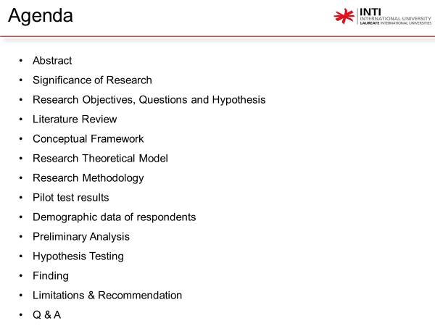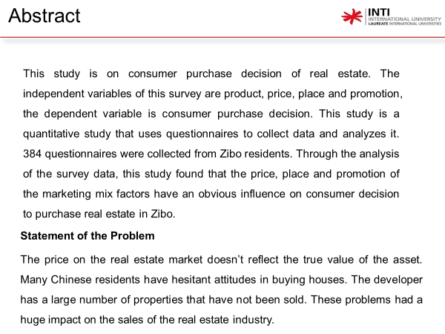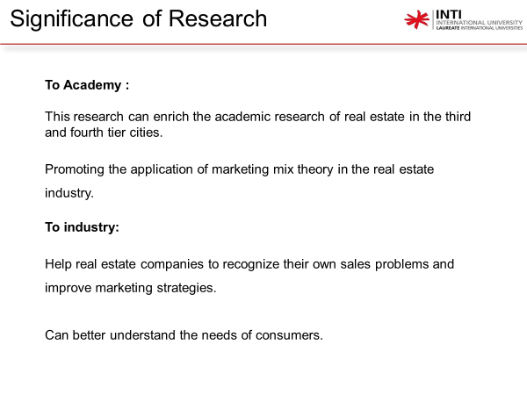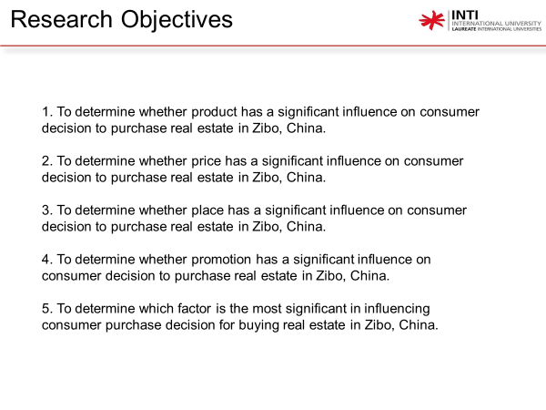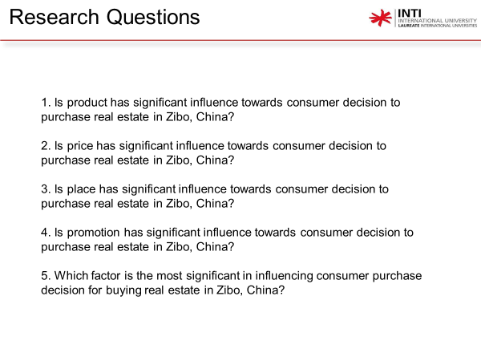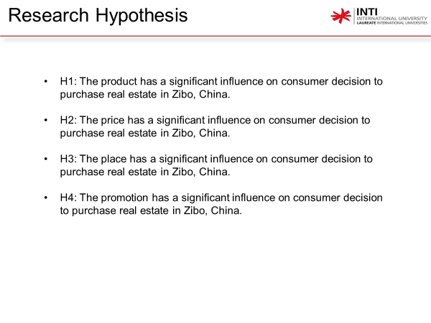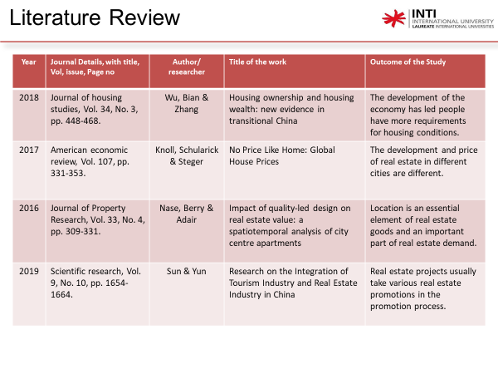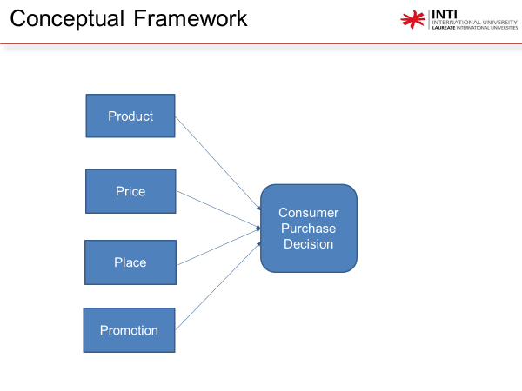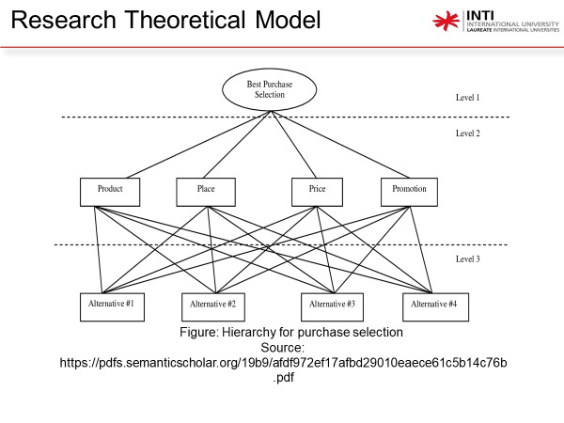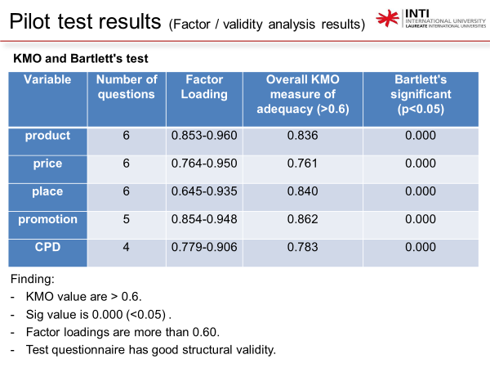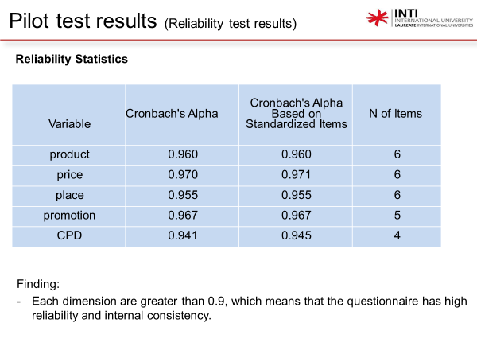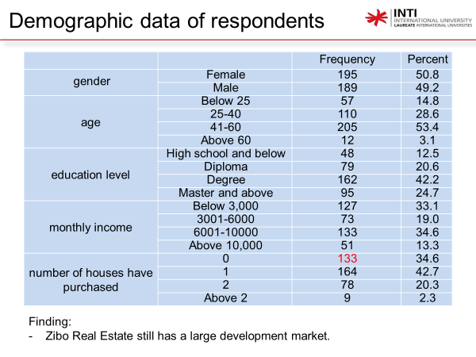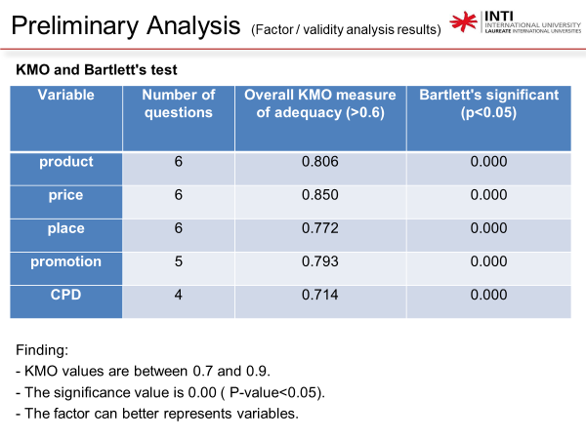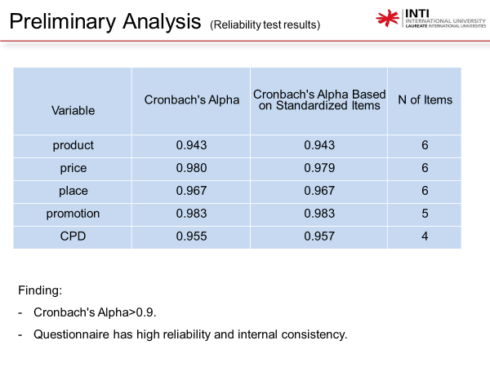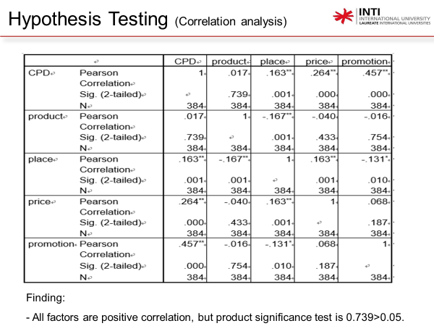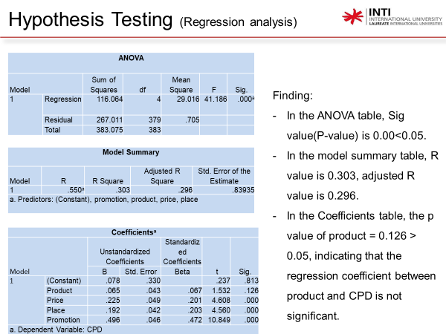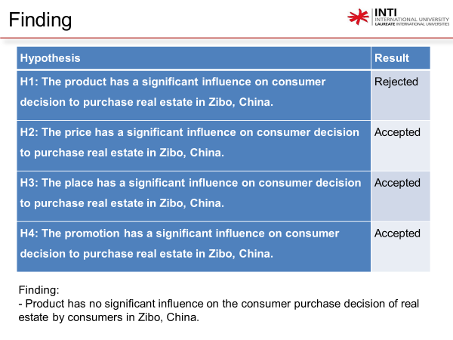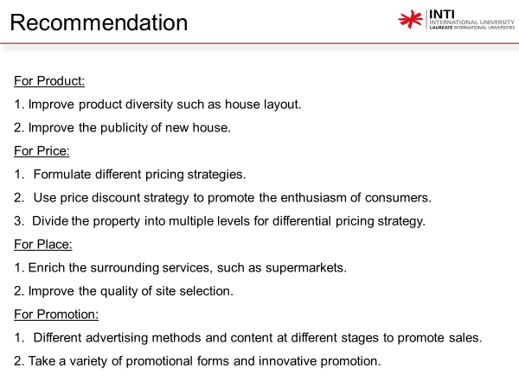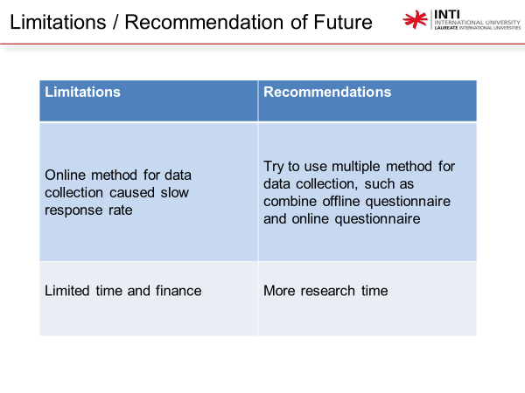

Appendix 7: Turnitin report
