WANG SITAO MASTER OF BUSINESS ADMINISTRATION 2019 | ANALYSIS OF THE INTERNATIONAL COMPETITIVENESS OF CHINESE MOBILE PHONE ENTERPRISES IN THE MALAYSIAN MARKET  WANG SITAO  MASTER OF BUSINESS ADMINISTRATION FACULTY OF BUSINESS, COMMUNICATION & LAW INTI INTERNATIONAL UNIVERSITY  2019

ANALYSIS OF THE INTERNATIONAL COMPETITIVENESS
OF CHINESE MOBILE PHONE ENTERPRISES
IN THE MALAYSIAN MARKET

WANG SITAO

MASTER OF BUSINESS ADMINISTRATION
FACULTY OF BUSINESS, COMMUNICATION & LAW
INTI INTERNATIONAL UNIVERSITY

2019

INTI INTERNATIONAL UNIVERSITY

MASTER OF BUSINESS ADMINISTRATION

Analysis of the International Competitiveness of Chinese Mobile Phone
Enterprises in the Malaysian Market

Author: Wang Sitao
Student No: I18015905
Supervisor: Ms. Faziha Abd Malek
Submission Date: August 2019
Final Word Count: 12251

Abstract
In recent years, China's electronic information industry has developed rapidly, especially the rapid rise of the mobile phone industry. The rapid development of mobile Internet has promoted the popularity of smart phones, and China has become the world's largest smartphone market. However, according to market research firm IDC, China's smartphone market has entered a period of saturation. In 2018, China's smartphone market shipments were 444 million units, down 4.92% compared to 2017. This is the Chinese smartphone market. Maintaining the first decline after years of growth. In the fierce competition with foreign mobile phone companies, Chinese mobile phone companies represented by Huawei, OPPO, vivo, and MI have gradually mastered the core technologies of communication manufacturing through unremitting efforts, and have gradually become internationally competitive. Under such circumstances, how can Chinese mobile phone companies continue to maintain rapid growth?
Malaysia has a good political, economic, cultural and technological environment, and the demand for mobile phone market in Malaysia is also relatively strong. Chinese mobile phone companies want to further develop in the Malaysian market, to determine whether Chinese mobile phone companies have international competitiveness in the Malaysian market. First of all, we must analyze the development status of China's mobile phone industry. China's mobile phone industry has developed rapidly in the era of mobile Internet, and has formed a complete industrial chain. China's mobile phone production and exports are increasing, so we must analyze the further develop of the international competitiveness of Chinese mobile phone companies in the Malaysian market.
In addition, this article will analyze the international competitiveness of Chinese mobile phone companies from the perspective of consumers, and investigate the awareness, popularity, satisfaction and reputation of Malaysian consumers from various mobile phone companies, and then purchase them from Malaysian mobile phone users. The mobile phone brand is surveyed. This paper will collect data through questionnaires, use software SPSS 22.0 to process selected data samples, and then analyze the advantages and disadvantages of mobile phone brands used by Malaysian mobile phone users, and combined with the actual situation of each mobile phone enterprises, to clearly identify the reasons that restrict the development of China's mobile phone enterprises. Finally, it summarizes and analyzes the international competitiveness of Chinese mobile phone companies in the Malaysian market. Using the data analysis results of the questionnaire, the countermeasures and suggestions for improving the international competitiveness of the Chinese mobile phone industry in the Malaysia market are given.

Keywords: Chinese mobile phone companies; international competitiveness; Malaysia mobile phone market

ACKNOWLEDGEMENT

I would like to express my sincere appreciation to everyone who contributed to the accomplishment of this dissertation. I am thankful to my supervisor, Ms. Faziha for her excellent guidance, effort, patience, and time throughout the study. My thanks also go to my examiner, Dr. Arasu Raman who has been supportive and offered his valuable comments.

Special thanks to my friends who helped me distribute the questionnaires to their acquaintances. I would also like to spare my utmost thanks to those respondents who have been kind enough to answer my queries as well as the authors whose work helped me have a thorough understanding of the subject. The inputs provided have made the findings of my research conclusive. Very special thanks go to all those who have generously assisted in my work in a way or another.

None of this would have been possible without my family and closest friends. For the support, encouragement, and unconditional love through the times I did not believe in myself, I am forever grateful to them.

Declaration
I hereby declare that this thesis is my own work and effort and that it has not been submitted anywhere for any award. Where other sources of information have been used, they have been duly acknowledged.
Name: Wang Sitao
Student ID: I18015905
Signature: Wang Sitao
Date: August 2019

Table of contents
Chapter 1
- Introduction …………………………………………………………………...…….11
1.1 Background ………………………………………………………………………….12
1.11 Definition of China Mobile Phone Enterprises ……………………………...….14
1.12 Definition of China's mobile phone industry ……...........…………………...….14
1.13 Mobile phone competition in Malaysia ……………………………..………..….15
1.2 Problem Statement …………………………………………………….…………...18
1.3 Significance of the Study ………………………………………………………….. 20
1.31 Academic Contribution ………………………………………………..…….…… 20
1.32 Corporate Contribution ……………………………………………….…….….… 21
1.4 Research Objectives / Questions…………………………….……………..….... 22
1.5 Hypothesis/Propositions ………………………………………….………..…..…. 22
1.6 Limitations of the study …………………………………………….……..…..…... 24
1.7 Scope of the Study ………………………………………………….……..…..….. 25
1.8 Ethical consideration ……………………………………………………..………...25

Chapter 2
2.0 Research on International Competitiveness of Mobile Phone Enterprises …….26
2.1 Research on the relationship between international competitiveness and customer purchase intention………………………………………………………........27
2.2 Factors affecting consumers' purchase intentions ……………………….………29
2.21 Brand Awareness ……………………………………………………….….……...29
2.22 Brand Visibility ……………………………………………………………..……..30
2.23 Consumer Satisfaction …………………………………………………..…....... 31
2.24 Brand reputation …………………………………………………………..….......32
2.3 Conceptual Framework …………………………………………………….….......33

Chapter 3
3.0 Research Methodology ………………………………………………………........34
3.1 Research Design ………………………………………………………….……..... 34
3.2 Questionnaire design ……………………………………………………………….34
3.21 Study population ……………………………………………………………......... 35
3.22 Unit of Analysis …………………………………………………………………….35
3.23 Sample Size ……………………………………………………………….............35
3.3 Data Collection ………………………………………………………………..……..36
3.4 Pilot Study ……………………………………………………………………………36
3.5 Techniques and Measurement Instruments ……………………………….……..37
3.51 Reliability Test ……………………………………………………………………...37
3.52 Descriptive Analysis ……………………………………………………...….........37
3.53 Multiple Regression Analysis …………………………………………..…...........37

Chapter 4
4.1 Descriptive analysis ……………………………………………………………......39
4.2 Preliminary Overall data analysis ……………..…………………………..……...43
4.2.1 Factors analysis of Independent Variables ………………………….………...43
4.2.2 Factors analysis of Dependent Variables ………………………...…...………49
4.2.3 Summary result of factor analysis ………………………………………………50
4.2.4 Reliability analysis of Independent Variable ………………………………... 51
4.2.5 Reliability analysis of Independent Variable …………………………………54
4.2.6 Summary result of reliability analysis …………………………………..…….54
4.3 Correlation analysis …………………………………...……..………….............55
4.4 Regression analysis ……………………………………………………………...57
4.5 Summary of key findings ………………………………………………………...59

Chapter 5
5.1 Conclusion ……………………………………..………………………………….62
5.2 Recommendations ……………………………………….……………………….62
5.21 Band visibility …………………………………………..............................……62
5.22 Brand awareness ………………………………………...……………..……….63
5.23 Customer satisfaction ……………………………………………………….…..64
5.24 Brand reputation …………………………………………………………………65
5.3 Limitations ……………………………………………………………………….…66
5.4 Recommendations for future research …………………………………….……67
5.5 Personal reflection …………………………………..…………………….………67

Reference …………………………………………….………………………....……..69
Appendix
Appendix 1: PROJECT PAPER LOG …………………………….…………………76
Appendix 2: List of Abbreviations ……………………………………………...........83
Appendix 3: Data analysis results ……………………………………………….…..84
Appendix 4: Questionnaire ………………………………….………………………..94
Appendix 5: Viva slides ………………………….…………………………………....98
Appendix 6: Initial Research Paper Proposal ……….…………….......................107
Appendix 7: Turnitin report ……………………………………………….………….111

CHAPTER 1:
- Introduction

In the era of mobile Internet, electronic information technology has become an important driving force for the world economy. Electronic information technology has entered an accelerated growth period, and electronic information technology has penetrated into various industries to help profound changes in various industries (Krugman,2000). Major developed countries such as Europe and the United States have upgraded the electronic information industry to the height of national strategy. Brazil, India, Russia and other countries have also begun to focus on the development of electronic information industry. The electronic information industry is gradually becoming the strategic focus of global competition.
The Chinese government pays attention to the development of the electronic information industry. In the implementation of the “Made in China 2025” strategic plan of action for manufacturing countries, it is clearly proposed to vigorously promote breakthrough development in key areas, focusing on the development of a new generation of information technology industry, high-end CNC machine tools and robots and aviation (Cao &Yu, 2017). Ten major fields such as aerospace equipment, and the new generation of information technology as the first of these ten areas. In recent years, China's electronic information industry has continued to undergo structural adjustment, transformation and upgrading, the production and business environment has been continuously improved, the overall scale of the industry has gradually expanded, key technologies have achieved staged breakthroughs, and the electronic information industry has achieved rapid development, production and investment growth. Maintaining a leading level in all industries, the export situation has improved significantly, and the quality of benefits has continued to improve. In China's electronic information industry, China's mobile phone industry has performed particularly well (Chen &Xu,2016). In recent years, the production and export of mobile phones have maintained a relatively fast growth trend, and China's mobile phone industry has developed rapidly.

1.1 Background

In 2007, Apple launched the first generation of iPhone, marking the advent of smartphones. In just over a decade, smart operating systems, low-power chips, application stores, touch screens and mobile Internet are just like engines, promoting smartphones. With the rapid development, smart phones have gradually replaced functional phones to become the main competition in the mobile phone market (Ricardo,1976). Smartphones have become the world's largest consumer electronics products, and the competition of global mobile phone companies is mainly focused on smart phones. According to data from China's ICT, in 2017, smartphone shipments in the Chinese market accounted for 93.89% of mobile phone shipments. The competition in China's domestic market is mainly due to competition from smartphones. Chinese mobile phone companies Huawei, OPPO, vivo, MI, etc., in the fierce competition with foreign mobile phone companies, relying on the domestic mobile phone industry supply chain, gradually mastered the core technology of communication equipment manufacturing, and produced more suitable for the use of Chinese people. Smartphones have achieved excellent results in the Chinese market (Huang,2016).
Company | 2017 shipments  (100 million) | 2017 market share | 2016 shipments  (100 million) | 2016 market share | Year-on-year growth
Huawei | 0.91 | 20.50% | 0.77 | 16.49% | 18.18%
OPPO | 0.81 | 18.24% | 0.78 | 16.70% | 3.85%
Vivo | 0.69 | 15.54% | 0.69 | 14.78% | 0.00%
Millet | 0.55 | 12.39% | 0.42 | 8.99% | 30.95%
Apple | 0.41 | 9.23% | 0.45 | 9.64% | -8.89%
Others | 1.07 | 24.09% | 1.56 | 33.40% | -31.41%
Total | 4.44 | 100.00% | 4.67 | 100.00% | -4.93%
Table 1.1 Smartphone shipments in the Chinese market (Source: IDC)
According to data from IDC (International Data Corporation), a well-known market research organization, in 2017, Huawei occupied the number one position in China's smartphone shipments. The top four mobile phone companies in the market are Chinese mobile phone companies, and the four mobile phone companies account for the total. The smartphone market is 66.67%, and the market concentration is high (He &Sun, 2012). Chinese mobile phone companies have gained competitive advantage in the fierce domestic competition. In 2017, the domestic market share of Chinese mobile phone companies has improved overall. In China's smart phone market, Chinese mobile phone companies compete with mobile phone companies from all over the world. The Chinese mobile phone companies have still achieved excellent results and enhanced the confidence of Chinese mobile phone companies to go global.
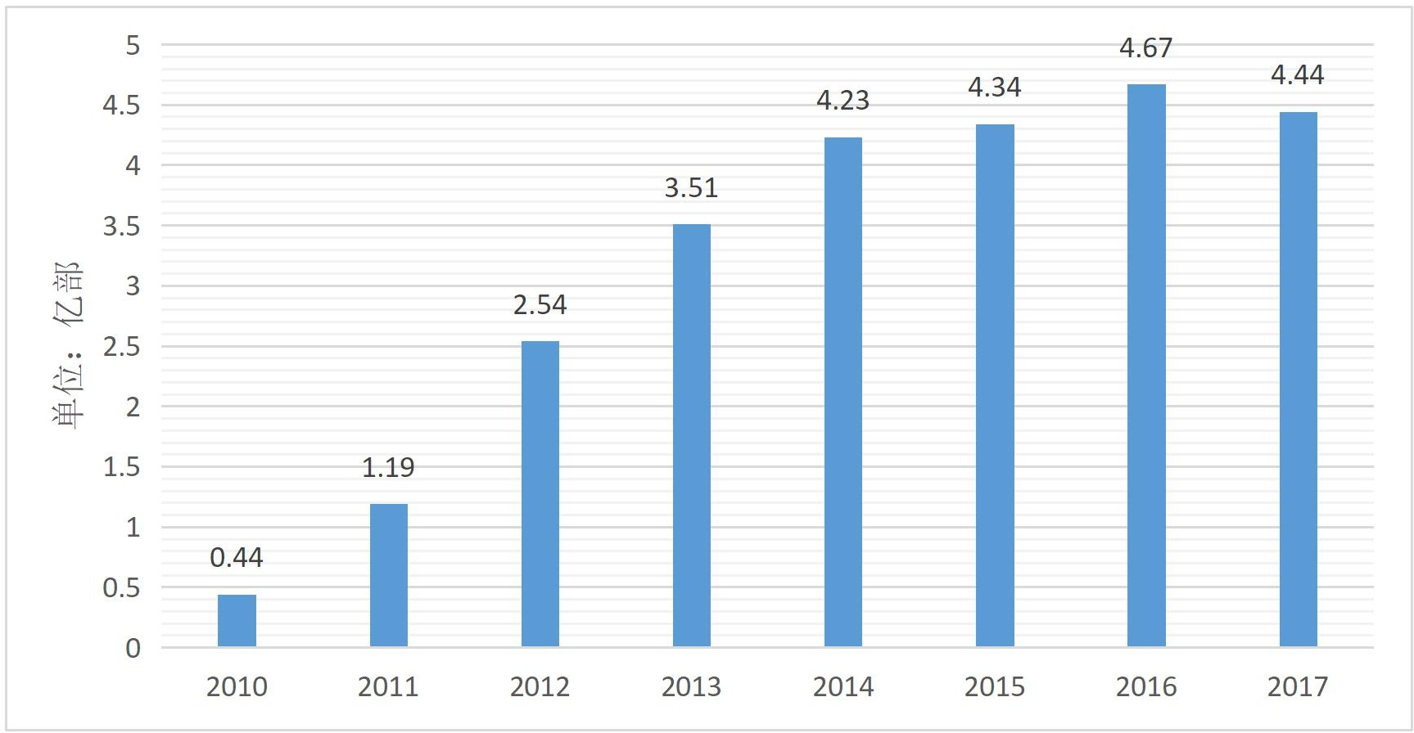
Figure 1.2 Smartphone shipments in the Chinese market from 2010 to 2017

1.11 Definition of China Mobile Phone Enterprises

The Chinese mobile phone companies studied in this paper refer to enterprises engaged in the production and sales of communication equipment owned by Chinese individuals, legal persons or governments (Wu,2005). For example, the brands originated from China's Huawei, MI, OPPO, vivo, HTC, etc., and Motorola acquired by Lenovo. It is also a Chinese mobile phone company, and the Wiko mobile phone that Shenzhen Tianzhu Mobile actually controls is also a Chinese mobile phone company.
China is the world's largest mobile phone production and processing base, the US mobile phone company Apple, South Korea's mobile phone company Samsung, and the Japanese mobile phone company Sony. Some of these companies' mobile phones are manufactured and processed in China, and then exported to countries around the world (Wang,2004). Processing in China, exports are also included in the export of China's mobile phone industry, but it does not belong to Chinese mobile phone companies.

1.12 Definition of China's mobile phone industry

There are narrow and broad points in the definition of industry. In a narrow sense, industry has a special position in the development of industry, and industry refers to the industrial sector. Divided broadly, industry refers to all walks of life in the economy. From the perspectives of production, service, culture and education, it can be called industry. Industries in industrial economics use a broad definition (Chen,2010). This article defines the Chinese mobile phone industry as a collection of companies engaged in the production and sale of communication equipment. Since the customs is counting the import and export of Chinese mobile phones, it does not distinguish whether the exported mobile phones belong to Chinese mobile phone enterprises, or belong to foreign mobile phone enterprises that are processed in China (Zhao,2016). Therefore, the Chinese mobile phone industry studied in this paper not only includes Chinese mobile phone companies, but also includes foreign countries. The part of mobile phone companies that produce and export in China.

1.13 Mobile phone competition in Malaysia

Malaysia has a good political, economic, cultural and technological environment. Malaysia's mobile phone market is also in strong demand. Malaysia's total population reached 32.4 million in 2018. Malaysia's actual smartphone penetration rate is 49.2%. More than half of the people still do not use it (Hallack,2004). Smartphones, and Malaysia is a middle-income country, and Chinese mobile phone companies have huge room for growth in the Malaysian market.
Chinese mobile phone companies want to further develop in the Malaysian market, to determine whether Chinese mobile phone companies have international competitiveness in the Malaysian market. First of all, we must analyze the development status of China's mobile phone industry. China's mobile phone industry has developed rapidly in the era of mobile Internet, and has formed a complete industrial chain (Sasatani,2010). China's mobile phone production and exports are increasing. In order to analyze the international competitiveness of China's mobile phone industry, this paper found the export market share of China's mobile phone industry after consulting the relevant data of the three indicators of export market share, trade specialization coefficient and display comparative advantage index. Continuous improvement, which shows that China's mobile phone industry has strong international competitiveness and is still in the stage of enhancement (Sasatani,2010). Beyond the mobile phone industry in countries around the world. However, the mobile phone data also includes the mobile phone data of foreign mobile phone companies in China for processing and exporting, so we should further analyze the international competitiveness of Chinese mobile phone companies in the Malaysian market.
In 2017, Chinese mobile phone companies accounted for 23.89% of the market share in the Malaysian market (Ricardo,1976). OPPO, vivo and Huawei each achieved 8.06%, 3.99% and 3.73% market share. After consulting relevant data, it was found that the OPPO indicators of China's mobile phone enterprises are ranked after the US mobile phone company Apple and South Korea's mobile phone company Samsung, but higher than the Malaysian mobile phone company NEFFOS. Among the mobile phone brands that may be purchased, Chinese mobile phone companies OPPO, Huawei, and vivo are second only to Apple and Samsung, which are significantly higher than Malaysian mobile phone brands JBS, VIGO, NEFFOS, MYFON, etc. Chinese mobile phone companies have strong international competitiveness in the Malaysian market, only weaker than Apple and Samsung (Zheng,2005). However, Chinese mobile phone companies are also facing many problems in Malaysia. The homogenization of mobile phones is becoming more and more serious. The low-end image of Chinese mobile phone companies is solidified, it is difficult to develop high-end mobile phone market, and the proliferation of mobile phones in the Malaysian mobile phone market has seriously affected The image of China's mobile phone companies has adversely affected the development of China's mobile phone companies.
Year | OPPO | ASUS | HUA  WEI | vivo | LENO  VO | ZTE | WIKO | HTC | ACER | MEIZ  U
2012 | 0.00 | 0.00 | 0.09 | 0.00 | 0.18 | 0.03 | 0.00 | 1.23 | 0.07 | 0.00
2013 | 0.00 | 0.00 | 0.27 | 0.00 | 0.38 | 0.03 | 0.00 | 0.98 | 0.11 | 0.00
2014 | 1.5 | 0.58 | 0.57 | 0.01 | 1.19 | 0.50 | 0.00 | 0.8 | 0.52 | 0.00
2015 | 3.25 | 2.68 | 0.8 | 0.25 | 1.46 | 1.39 | 0.07 | 0.70 | 0.49 | 0.01
2016 | 3.51 | 2.56 | 1.24 | 1.24 | 1.6 | 1.55 | 0.69 | 0.38 | 0.23 | 0.14
2017 | 8.06 | 2.49 | 3.73 | 3.99 | 1.47 | 1.37 | 1.95 | 0.18 | 0.22 | 0.23
Table 1.3 Market share of China's mobile phone enterprises in the Malaysian smartphone market in 2012-2017
OPPO, a Chinese mobile phone company, has entered the Malaysian market since 2009. OPPO mobile phones are mainly targeted at the low-end market. In Malaysia, it also adopts the celebrity endorsement entity sales strategy. OPPO invites Malaysian popular stars to speak for them, and is in the subway, airport, and street signs. Wait for a large number of ads. OPPO Open Line stores, OPPO can be seen in the streets of various shopping malls across Malaysia. According to OPPO's official website, OPPO has established a comprehensive after-sales service in Malaysia (Shang,2017). Currently, there are 11 after-sales service centers in Kuala Lumpur and 31 after-sales service centers in other regions. OPPO developed into a fast lane in 2014, and its market share has increased year by year. In 2017, it reached 8.06%. Although it is not far from the first Samsung 34.81% and Apple's 18.71%, the market's third ranking is enough to prove. The strength of OPPO mobile phones.
In 2014, we began to deploy the Malaysian market, which is the beginning of the vivo internationalization strategy (Schott,2004). Vivo also adopts the entity sales strategy of celebrity endorsement, and then mass-produces large-scale advertisements in TV stations, major theaters, shopping malls, universities and other places. Vivo chose to work with more than 400 Malaysian partners when it entered, and quickly established a Vivo flagship store and a comprehensive after-sales store all over the country within a few years. Vivo entered the Malaysian market later than OPPO, but gained a certain market share in the year of entry, followed by rapid growth. In 2017, it achieved a market share of 3.99% and ranked sixth in market share.
Huawei first entered the Malaysian mobile phone market as a telecommunications service provider since 1998. Due to its good relationship with telecom operators, Huawei mobile phones have a certain proportion of sales through telecom operators (Timmer,2000). Currently ranked in the Malaysian smartphone market. Seventh, Huawei attaches great importance to the Malaysian mobile phone market, timely updates Malaysia's new product launches, and keeps pace with China. Huawei is also striving to develop high-end markets. It has a strong promotion of high-end mobile phones and has certain competitiveness in the high-end mobile phone market.

1.2 Problem Statement

China's mobile phone companies are developing faster and faster, and their international competitiveness is getting stronger. However, China's smartphone market has been growing slowly in recent years (Gao & Yan, 2017). By 2017, smartphone shipments in the Chinese market have even declined. In 2017, China's smartphone market shipments were 444 million units, down 4.92% year-on-year. The growth boom of feature phones to smartphones has passed. Before the popularization of 5G, the advancement of new technologies such as full screen and AI is not enough to form a new growth point. The Chinese smartphone market has entered a period of saturation.
In this context, how will Chinese mobile phone companies maintain rapid development? Chinese mobile phone companies have begun to accelerate their pace of entering the international market and seek new growth points overseas (Jiao & Ge, 2008). Although the early Chinese mobile phone companies entered the international market, they only used the overseas market as a supplement to the Chinese market. Now Chinese mobile phone companies have begun to equate the importance of overseas markets with the domestic market, and have increased their investment in overseas markets, focusing on mobile phones. Development of emerging markets.
China's mobile phone companies currently use developed countries such as Europe, the United States, Japan and South Korea as well as developing countries in India, the United Arab Emirates and Southeast Asia as their core markets (Jin,1997). In the context of China's “One Belt, One Road”, China will have more economic and trade exchanges with countries along the “Belt and Road”, and regional economic integration will speed up the process, which will bring convenience to the development of Chinese mobile phone companies in Southeast Asia. . Malaysia, located in the heart of Southeast Asia, has maintained close economic ties with China since ancient times. Malaysia is also a potential emerging mobile phone market. In 2016, the total population of Malaysia reached 68.86 million (World Bank), but the penetration rate of smartphones was less than 37.40%. Malaysia is a middle-income country with strong purchasing power (Jin,2001). Chinese mobile phone companies can gain a certain market share in the Malaysian mobile phone market, which will help Chinese mobile phone companies to maintain rapid growth and will also have an important significance for radiating the entire Southeast Asian market. Chinese mobile phone companies have begun to pay attention to the Malaysian market. Huawei, OPPO, ZTE, vivo, MI, Meizu, HTC, Lenovo and other Chinese mobile phone companies have entered the Malaysia market, but Chinese mobile phone companies still occupy less market share in Malaysia. . In the process of competition between the Malaysian market and mobile phone companies in various countries, a correct and comprehensive understanding of the international competitiveness of enterprises is the basis for the development and growth of Chinese mobile phone companies in the Malaysian market (Yang,2008). Through the analysis of the international competitiveness of Chinese mobile phone companies, it is necessary to find a way to restrict Chinese mobile phone companies. The factors of development further propose countermeasures in a targeted manner.

1.3 Significance of the Study

1.31 Academic Contribution

In the 1980s, China began to study the theory of corporate international competitiveness. Many Chinese scholars have studied the theory of international competitiveness and began to study the international competitiveness of various industries in China (Zhou, 2017). With the continuous improvement of Chinese scholars' theory of international competitiveness. Chinese scholars began to combine the theory of corporate international competitiveness with the theory of international competitiveness in foreign markets. These are all improving the internationalization of Chinese companies. However, there are few studies on the international competitiveness of China's mobile phone industry. The specific analysis and research on the Chinese mobile phone industry in the Malaysian market is unprecedented. This may be due to the fact that Chinese mobile phone companies have achieved rapid development in recent years, and have achieved good development in the international market and have a certain market share, so there have been few related studies.
This article is the first time to select Chinese mobile phone companies in the Malaysian market as a research object to analyze their international competitiveness. By exploring the factors affecting the purchase intention of mobile phone consumers in Malaysia, and based on field research in Malaysia, this paper has a high academic reference.
In terms of research methods, the existing indicators of the international competitiveness of the existing research industry are mostly based on the international market, and there are few indicators for the international competitiveness of the industry in a certain country or region, and no relevant indicators have been found. Empirical analysis. This paper narrows the international market to the national market, and conducts in-depth research on the factors affecting the purchase bias of mobile phone consumers through field research in Kuala Lumpur, Malaysia, and analyzes the international competitiveness of Chinese mobile phone companies in the Malaysian market. The analysis method of this paper is conducive to the improvement and supplement of the international competitiveness of the industry and the theory of international competitiveness of enterprises under the background of globalization. It has certain expansion and complementation in content and system.

1.32 Corporate Contribution

The research in this paper also has certain practical significance. In the context of the saturation of China's smartphone market, Malaysia's smartphone penetration rate is low, and Malaysian consumers have strong spending power, so the Malaysian mobile phone market has great potential. The presence in the Malaysian mobile phone market will help solve the problem of weak growth in China's mobile phone companies (Ma,2013). This paper uses the PEST analysis model, Porter's five-force model to analyze the mobile phone market environment in Malaysia, which has certain reference value for Chinese mobile phone companies that have entered the Malaysian market and Chinese mobile phone companies that are ready to enter Malaysia. When competing in the Malaysian market, a correct and comprehensive understanding of the international competitiveness of enterprises is the basis for the growth and development of Chinese mobile phone companies in the Malaysian market (Qin &Ni, 2006).

1.4 Research Objectives / Questions

The study identified the international competitiveness of Chinese mobile phone companies in the Malaysian market by investigating customer purchase intentions. Conducts field research in Malaysia, through the distribution of questionnaires, to assess the factors that affect the purchase intention of Chinese mobile phone brands in the Malaysian market. Measure a survey to analyze the advantages and disadvantages of various mobile phone companies in the perception of consumers, and to find factors that restrict the further development of Chinese mobile phone companies. The analysis of the international competitiveness of Chinese mobile phone companies in the Malaysian market has very important practical significance for improving the international competitiveness of Chinese mobile phone companies and promoting the overall development of Chinese mobile phone companies (Xie & Yan, 2014).
This article will analyze from the perspective of consumers, and conduct consumer surveys on the awareness, visibility, satisfaction, reputation of Chinese mobile phone companies in Malaysia. There are two objectives in this research:
1. To determine the factors influencing the purchase intention of mobile phone buyers.
2. Which factor is the most significant in influencing the customer purchase intention?

There are Five questions in this research:
1. Is there a relationship between the brand awareness and customer purchase intention?
2. Is there a relationship between the brand visibility and customer purchase intention?
3. Is there a relationship between the customer satisfaction and customer purchase intention?
4. Is there a relationship between the brand reputation and customer purchase intention?
5. Which factor is the most significant in influencing the customer purchase intention?

1.5 Research Hypothesis

H1: Brand visibility has a significant influence on customer purchase intention.
H2: Brand awareness has a significant influence on customer purchase intention.
H3: Customer satisfaction a significant influence on customer purchase intention.
H4: Brand reputation has a significant influence on customer purchase intention.

1.6 Limitations of the study

On the one hand, when analyzing the international competitiveness of China's mobile phone industry, the import and export data of China's mobile phone industry not only includes the import and export data of Chinese mobile phone companies, but also the import and export data of mobile phones processed by foreign mobile phone companies in China, such as Apple mobile phones. There are more than a dozen assembly plants around the world, most of which are located in China. Foxconn is Apple's largest foundry (Zhai & Wang, 2002). Half of Apple's mobile phone production comes from Zhengzhou Foxconn. These Chinese-made mobile phones are also included in China's mobile phones. Among the export data. Some mobile phone companies in China have established factories overseas. China's mobile phone companies vivo, MI, OPPO, and ZTE have all invested in factories in India. Therefore, the international competitiveness of China's industry illustrates that the international competitiveness of China's entire mobile phone industry, including foreign companies that produce and export in China, cannot be completely equated with the international competitiveness of Chinese mobile phone companies.
On the other hand, when analyzing the international competitiveness of Chinese mobile phone companies in the Thai market, they use a questionnaire in Malaysia to study the international competitiveness of Chinese companies perceived by consumers and combine the international competitiveness of China's mobile phone industry. Display indicators and the performance of Chinese mobile phone companies in the Malaysian market. These are the analysis of the international competitiveness of Chinese mobile phone companies from the perspective of market and consumers, and will be financial competitiveness, technical competitiveness, marketing competitiveness, management competitiveness. Compared with the evaluation system that combines indicators, it is inevitable that there will be omissions.

1.7 Scope of the Study

The research focus of this study is to analyze the factors affecting the international competitiveness of Chinese mobile phone companies in the Malaysian market. The geographical area of ​​the study is Malaysia, and the focus of the research is on Malaysian consumers. The variable setting of this study is based on the perspective of Malaysian consumers, collecting relevant data through questionnaires, and finally analyzing and summarizing the data. This study mainly has the following variables: Malaysian consumers' awareness, popularity, satisfaction, reputation, association and loyalty to mobile phone companies. This study will explore the impact of these six factors on the international competitiveness of Chinese mobile phone companies.

1.8 Ethical consideration

First of all, in this study, all the respondents from the questionnaire were from Malaysian consumers. They did not target the social status of the respondents and there was any prejudice in religious beliefs. Secondly, in this survey, the questionnaire is only used to collect data. The questionnaire is anonymous. It does not disclose any relevant personal information, strictly abides by relevant laws and regulations and protects the privacy of respondents. Finally, there is no compulsion in the filling of this questionnaire.

CHAPTER 2:

- Research on International Competitiveness of Mobile Phone Enterprises

In the research on the international competitiveness of mobile phone companies, Yuan Yuan (2012) analyzes the market competitiveness of smart phones from the perspective of business ecosystem. The concept of ecosystem, smart phone and market competitiveness is elaborated. Then, using Porter's five-force model, the bargaining power of consumers in the mobile phone industry, the bargaining power of producers, the competitiveness of new entrants, the competitiveness of potential substitutes, and the degree of competition in the industry were analyzed. Yan Yunfeng (2012) also used the Porter Five Forces model and combined with the existing enterprise competitiveness theory to select five perspectives and analyze the development status of Chinese mobile phone companies.
China's mobile phone industry has achieved certain success since its development in the last century. Liu Manman (2016) pointed out that China's mobile phone industry chain has gradually improved, China's mobile phone industry exports have increased year by year, but in comparison with international mobile phone companies, there are still many shortcomings in the Chinese mobile phones enterprise. The scholars use the Porter Five Forces model to analyze the international competitiveness of China's mobile phone industry, and find that China's mobile phone industry is still in a rising stage, and then proposes two levels from the government and enterprises. Suggestions for improving the international competitiveness of China's mobile phone industry.
For Apple, a leading mobile phone company in the global market, Yin Wen and Yuan Cuicui (2016) believe that the core competitiveness of mobile phone enterprise Apple is characterized by product innovation, corporate culture and featured marketing. The development model of mobile phone enterprise Apple is important to China's mobile phone industry. The enlightenment role is that to enhance the core competitiveness of Chinese mobile phone companies, it is necessary to accelerate the cultivation of mobile phone corporate culture. Chinese mobile phone companies should focus on innovation and differentiated marketing strategies. Liu Qicheng (2016) believes that brand competitiveness can enhance the competitiveness of Chinese mobile phone companies, and improving brand loyalty will enhance the competitiveness of mobile phone companies. Gao Haiyan and Wang Xin (2015) conducted a competitive analysis of Huawei's smartphone products in the international market, and found that Huawei's mobile phones have certain advantages in terms of cost, technology, quality and brand. Chinese mobile phone companies must accelerate product innovation. Broaden marketing channels and pursue monopoly status. Zhou Deming and Liu Jin (2017) pointed out that the reason why Chinese mobile phone enterprises have developed rapidly in recent years is that Chinese mobile phone enterprises have gradually gained strong core competitiveness, and analyzed the core competitiveness of OPPO and vivo, and found that two enterprises are in enterprises. Culture, supply chain, research and development, and the market all have core competitiveness.

2.1 Research on the relationship between international competitiveness and customer purchase intention

Paul Krugman (1996) pointed out that competitiveness is the concept that a company or industry gains or loses market share. International competitiveness refers to the ability to acquire international market share. He emphasizes the competition between national industries or enterprises of various countries. The Presidential Committee on Industrial Competitiveness of the United States points out that the international competitiveness of enterprises refers to the ability of enterprises to provide good products and good services in the international market while improving the living standards of their own people in a free market. Increasing the purchasing intention of consumers in the international market is closely related.
Consumer intent is the probability that a consumer is willing to take a particular behavior. Mullet believes that consumers' attitudes towards a certain product or brand, combined with external factors, constitute consumers' willingness to buy. Dodds believes that the purchase intention refers to the probability and possibility of the consumer purchasing a particular product. Domestic scholar Zhu Zhixian believes that the purchase intention is a psychological consultant for consumers to buy goods that suit their needs. It is a manifestation of consumer psychology and a prelude to purchasing behavior.
In terms of the impact of purchase intentions on corporate competitiveness, Howard and Sheth (1969) first proposed that the purchase intention is the basis for the establishment of corporate brand confidence. The higher the consumer's confidence in the corporate brand, the higher the evaluation. It is easy to actively collect relevant information about the brand of the company. When the consumer reaches the balance between brand confidence and information, only a small amount of product information is needed, and the purchase intention can also be stimulated.
Yang Ying and Zhang Li (2007) believe that the brand of the enterprise is the source of the international competitiveness of the enterprise, and the independent brand can essentially build the international competitiveness of the enterprise. Although the brand is an intangible asset, it can form added value among consumers, further increase market share and bring excess profits. Therefore, by enhancing the brand effect, the company's brand awareness, reputation, satisfaction, reputation, and thus stimulate international consumer purchase intentions, and enhance the company's international competitiveness.

2.2 Factors affecting consumers' purchase intentions

Scholars have different ideas about the factors that influence purchase intentions. Aaker (1991) identified four key factors in Brand Management: awareness, visibility, and satisfaction and reputation. These four factors are the determinants of brand loyalty and the influencing consumers' purchasing intentions. major factor. Feld-wick (1996) Chernatony and McDonald (2003) proposed six dimensions of brand attributes: popularity, image, perceived quality, perceived value, personality, and corporate association. Aaker proposes five dimensions of brand personality: integrity, stimulating, competitive, maturity and durability. The most widely used is the consumer-based brand equity model of Keller (1993, 2003).

2.21 Brand Visibility

Brand visibility relates to the strength of the brand in the consumer's mind. For example, consumers recall whether the brand is easy or difficult (Keller, 1993). Brand recall is the most common way to measure brand awareness visibility. The brand image relates to the strength, preference and uniqueness of the brand in the minds of consumers (Keller, 2003). Its role is that consumers have a positive feeling and attitude towards brand perception quality as a whole. According to Keller (1993), brand visibility is a necessary condition for generating a brand image. When a brand takes root in the consumer's brain, it is easier for consumers to give brand associations. As Schuiling and Kapferer (2004) confirm that the brand image is strongly related to many brand image dimensions. Therefore, the higher the brand visibility, the better the brand image.
However, brand visibility only reflects the consumer's visibility of the brand, and does not represent the consumer's understanding of the brand. The popularity is the degree to which an organization is known by the public, the extent of its understanding, the breadth and depth of social influence, and the objective measure of the size of its reputation. Brand visibility is a key brand asset, but sales alone cannot increase sales, especially for new products. In a highly competitive market segment, increasing brand visibility and generating actual sales revenue is critical to the business.

2.22 Brand Awareness

With the increasingly fierce competition in the market, the rapid establishment of product and brand awareness, highlighting the characteristics of products and the image of the brand, and increasing consumers' purchasing intentions have become the common concern of many companies.
Based on the consumer's intention to buy the brand is based on the consumer's understanding of the various brands - brand knowledge, when the consumer is familiar with a brand and has a positive association with it, the purchase behavior is generated. Brand awareness can be defined as a series of interwoven network frameworks that relate to consumer relevance and evaluation of the brand's relevance (Anderson 1983, Keller 2003). Brand awareness is a core element of brand equity in the consumer's perspective, including brand visibility and brand image. These two dimensions are widely recognized in previous marketing studies (Agarwal and Rao, 1996; Mackay, 2001; Pappu et al., 2005).
Brand awareness is an important part of brand equity. It is a measure of consumers' understanding and understanding of brand content and value. Brand awareness is a manifestation of the company's competitiveness, and sometimes it becomes a core competitiveness. Especially in the mass consumer goods market, the quality of products and services provided by various competitors is not much different. At this time, consumers will tend to Decide on the purchase behavior based on the familiarity of the brand. The operation of awareness can drive consumers' awareness of brand awareness.

2.23 Consumer satisfaction

In the study of consumer purchase intention behavior, Fournier's ideal result of the transaction relationship is the satisfaction of the transaction party. Therefore, satisfaction can be seen as a cognitive evaluation of whether a brand is rewarded in a transactional relationship of the brand.
Satisfaction is the state of pleasure or disappointment that a customer forms when the consumer perceives the effect (or outcome) of a product against the expected value. The earliest paper on customer satisfaction theory can be traced back to "An Experimental Study of Customer Effort, Expectation, and Satisfaction" published by Cardozo in 1965. Early research on satisfaction focused on products, and Cardozo (1965) argued that increasing consumer satisfaction would cause consumers to re-shop and not convert other products.
At present, the competition in the market is mainly manifested in the overall competition for consumers, and whether or not the consumer has a relationship depends on the relationship between the enterprise and the consumer, and depends on the satisfaction of the consumer's products and services. Yang Ying and Zhang li (2007) believe that the higher the satisfaction of consumers, the stronger the competitiveness of enterprises, the greater the market share, and the better the benefits of enterprises. This is self-evident.
Excellent product quality and service quality are the basis for consumers to have trust and satisfaction with the brand. A good brand image is the basis for consumers to generate trust in the brand. A good consumer experience is a direct reflection of consumers' satisfaction with the brand.
2.24 Brand reputation

American scholar Prahalad and British scholar Hamel (1990) jointly proposed that brand reputation is one of the components of brand power. It is the degree of people's goodwill and trust in a certain brand in the market. It is an important part of modern corporate image shaping. They believe that brand awareness is the basis of reputation; and brand reputation can truly reflect the value of the brand in the minds of consumers, both of which are important indicators to measure the value of brand value.
Zhang Jinchang (2001) pointed out that reputation is a good image of the brand in the hearts of consumers. The reputation is based on the prestige, and there is no good reputation, let alone a good brand image. However, the popularity can be quickly improved through publicity, and the reputation needs to be established through long-term and careful brand management and maintaining a good brand image for ten years.
Wang Wei (2004) pointed out that if the recognition is low and the reputation is low, it indicates that the brand is in the market introduction period, and the product quality and brand promotion work are still not enough; if the recognition is low and the reputation is high, it means good. Products have accumulated a good reputation among consumers; if the product has high recognition and low reputation, it is easy to give people a feeling of notoriety; high recognition and high reputation is a very mature product.
Zhou Xing and Fu Ying (2000) believe that brand reputation also plays a decisive role in the process of consumer purchase intention decision-making. Brand reputation is the degree of consumer's love and recognition of a brand. It is the consumer's recognition of the brand value through its own consumption experience and comprehensive other brand information. This kind of recognition is the consumer's perception in the heart, not simply rely on advertising to influence consumers' brand decisions.

2.3 Conceptual Framework

Brand Visibility H1

Brand Awareness H2

Customer Satisfaction H3 Customer purchase intention

Brand Reputation H4

CHAPTER 3:

- RESEARCH METHODOLOGY

3.1 Research design

In this research, quantitative method will be used which is questionnaire. Apart from that, primary data will also be used to further enhance and strengthen the analysed outcome with enough justification and supporting evidence. All data and information will be by using questionnaires and the Data will be further discussed and presented in graph and table. It is to ease the understanding of readers of this study.
This study focuses on the international competitiveness of Chinese mobile phone companies in the Malaysian market, so the purchase intention of Malaysian consumers is the focus of this study. This study will design a questionnaire for four factors that influence consumers' purchasing intentions, namely “brand recognition, brand awareness, consumer satisfaction and brand reputation”. The survey was conducted by local Malaysian consumers.

3.2 Questionnaire design

This paper takes the mobile phone users in Malaysia as the survey object, and designs a questionnaire to evaluate the international competitiveness of mobile phone companies from the perspective of consumers.
This questionnaire has three main parts. The first part is the survey of respondents' personal information, including gender, age, income level and so on. The second part is the use of personal mobile phones by respondents, including the current use of mobile phone brands, prices, advantages and disadvantages. The third part is the factors that affect the purchase intention of respondents when purchasing mobile phones, including preference brands, considerations, purchase channels, etc.

3.21 Study population

The subject of this study is mainly for Malaysian consumers. After consulting relevant materials, the total population of Malaysia was 32.04 million by 2019. However, due to the limitations of this research site, this study is mainly aimed at residents of Kuala Lumpur. The population is 1.589 million. Due to the large population, this study used a random sampling method to investigate.

3.22 Unit of Analysis

The unit of analysis refers to the respondents who participated in the study. Since this study used questionnaires to collect survey data, the survey location was limited. The survey was mainly for local residents living in Malaysia near Kuala Lumpur. The unit is an individual.

3.23 Sample Size

The population is 1,589,000, (N) in this survey. Krejcie & Morgan (1970) shows the sample calculation as follows:
S = X²NP(1-P)/[d²(N-1)+X²P(1-P)]
Where:
X² = table value of Chi-Square
N = Population size
P = Population proportion (assume to be .50)
d = degree of accuracy (assume to be .05)
After calculation, S = 400.

3.3 Data Collection

In this study, the total population was 158,9000. After calculation，the sample size of this study was determined to be 400.
In order to save time and research costs, an online survey will be used. Distribute the questionnaire through Google Form.

3.4 Pilot Study

Before the actual research has been start, the pilot study will be run. There were 40 respondents will be randomly pick to answer the questionnaire, let them fill the questions. Once the respondents can understand the question, the actual research can be start. After The pilot study, the data will be key in SPSS, run the reliability test before determine which question should be removed, to make the research reliable.

3.5 Techniques and Measurement Instruments

In the research, there were three techniques and measurement instruments will be used: reliability test, descriptive analysis and multiple regression analysis.

3.51 Reliability Test

The reliability test will using to analyse the internal consistency of variable. Once the pilot study has been done, the reliability test will used to test whether there were any relationships within all the variables. If the calculated Cronbach’s Alpha less than 0.7, the research need to remove those suggestion questions.

3.52 Descriptive Analysis

The descriptive analysis is used to define the characteristics of respondents such as gender, income level, and education level and so on. The descriptive analysis will clearly showed the characteristics of respondents in term of frequencies and percentage. Therefore, the readers can have a full view to look over the characteristics of respondents who were participated in this research as the report will be showed in a professional format table.

3.53 Multiple Regression Analysis

Multiple regression will be using to analyse more than two or more independent variables towards the dependent variable. For example, the independent variables will be consumers' awareness, visibility, satisfaction, reputation to mobile phone companies, and how these will affect the international competitiveness of Chinese mobile phone companies. Moreover the multiple regression analysis will also determine which independent variables has the most impact to the dependent variable in this research.

CHAPTER 4:

4.1 Descriptive analysis

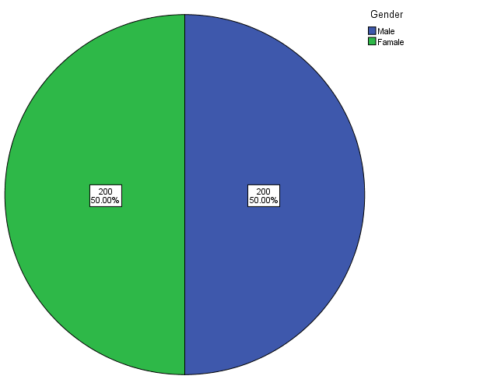

[Figure 4.1-1 Descriptive analysis of Gender]
As shown in Figure 4.1-1, in this survey, males and females accounted for 50% of the 400 respondents, each with 200.

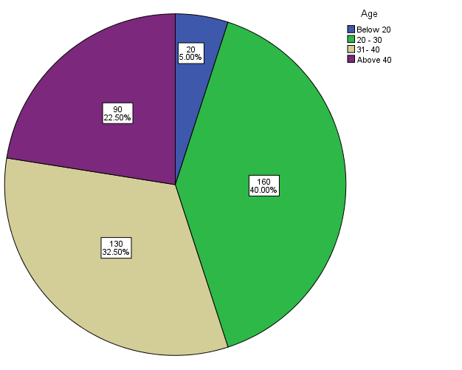

[Figure 4.1-2 Descriptive analysis of Age]
As shown in Figure 4.1-2, in this survey, the age is below 20 years old, accounting for 5% of the total, and there are 20 respondents; most of the respondents are between 20-30 years old，accounting for 40% of the total, there are 160 respondents; the next is between 31-40 years old, accounting for 32.5%, there are 130 respondents; the age is above 40 years old, accounting for 22.5%, there are 90 respondents.

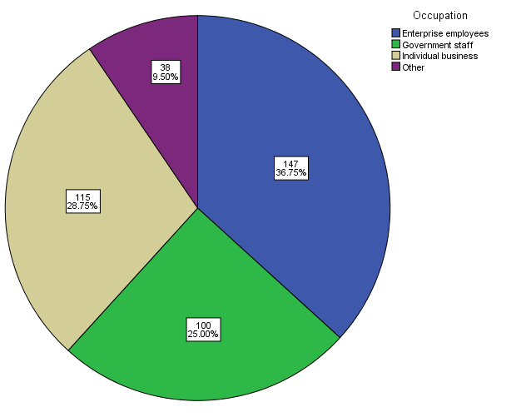

[Figure 4.1-3 Descriptive analysis of Occupation]
As shown in Table 4.1-3, among all respondents, the number of occupations was the highest among Enterprise employees, accounting for 36.8%, with 147 respondents; followed by Individual business, accounting for 25%, with 115 respondents; the number of Government staff is 25%, there are 100 respondents; 9.5% of respondents chose other occupations.

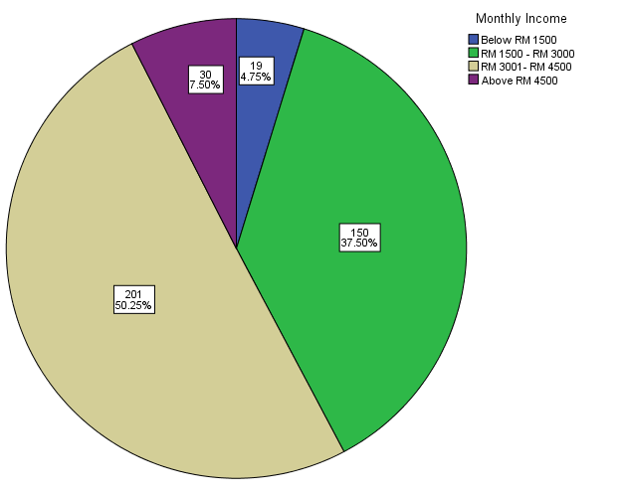

[Figure 4.1-4 Descriptive analysis of Monthly Income]
As shown in Table 4.1-4, the majority of respondents' monthly income was RM3000-RM4500, accounting for 50.2%, with 201 respondents; followed by monthly income of RM1500-RM3000, accounting for 37.5%, there are 150 respondents; 7.5% of the monthly income above RM4500, there are 30 respondents; the lowest monthly income is less than RM1500, accounting for 4.8%, and there are 19 respondents.

4.2 Preliminary data analysis

In the academic research process, the reliability of the data is determined by two parts, namely, validity and reliability. In this study, the sample size was calculated to be 400 Malaysian mobile phone consumers. This test is divided into two parts, namely: factor test and reliability test.
In this survey, there are four independent variables: Brand visibility (BV); Brand awareness (BA); Customer satisfaction (CS); Brand reputation (BR). And one dependent variable: Customer purchase intention (CPI)

4.2.1 Factor Analysis of Independent Variables

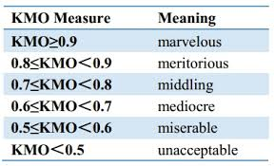
Factor analysis also called validity analysis, it is mainly through linear combination, changing the original variables, dividing them into several components, and replacing the larger original variables with fewer comprehensive indicators (Dhillon et al., 2014). Factor analysis can construct explicit common factors on the basis of principal components, and test the differences and correlations between variables by decomposing the original framework (Taherdoost, Sahibuddin and Jalaliyoon, 2017).
[Figure 4.2.1-1The meaning of Kaiser-Meyer-Olkin（KMO）]
In this study, survey data will be tested based on the Kaiser-Meyer-Olkin (KMO) index, factor loading, and eigenvalues ​​of the data.
Usually the KMO value is between 0-1 and the value is greater than 0.6, which means that the sample data meets the reasonable requirements of the survey (Chan and Idris, 2017).
The Bartlett’s test significance value implies a significant level of p-values, and if the p-value is between 0.01 and 0.05, the difference is significant. If the p-value is less than 0.01, the difference is extremely significant, indicating that the data from the questionnaire is suitable for factor analysis.

KMO and Bartlett's Test
Kaiser-Meyer-Olkin Measure of Sampling Adequacy. |  | .867
Bartlett's Test of Sphericity | Approx. Chi-Square | 2379.206
 | df | 10
 | Sig. | .000
[Table 4.2.1-2 KMO and Bartlett’s test of Brand visibility]
As shown in Table 4.2.1-2, the KMO value of the independent variable of brand visibility is 0.867. According to the criteria in Figure 4.1.1-1, the KMO value is between 0.7 and 0.8. The meaning is middling, the Bartlett's test significance (p value) must below 0.05, in Table 4.1, P-value is 0.000.

Communalities
 | Initial | Extraction
BVS1 | 1.000 | .688
BVS2 | 1.000 | .898
BVS3 | 1.000 | .926
BVS4 | 1.000 | .828
BVS5 | 1.000 | .867
[Table 4.2.1-3 Factor loading of brand visibility]
Factor loadings in factor analysis shows the correlation between variables and factors, usually between -1 and 1. Below 0.4 means the load is too low, above 0.6 means the load is high (Wang et al., 2017)
According to Table 4.2.1-3, in the five investigation questions about the independent variable BV (BVS1; BVS2; BVS3; BVS4; BVS5), each factor loading value is more than 0.6. That means the factor all accept.

Total Variance Explained
Component | Initial Eigenvalues |  |  | Extraction Sums of Squared Loadings
 | Total | % of Variance | Cumulative % | Total | % of Variance | Cumulative %
1 | 4.208 | 84.151 | 84.151 | 4.208 | 84.151 | 84.151
2 | .385 | 7.704 | 91.855
3 | .202 | 4.044 | 95.899
4 | .157 | 3.137 | 99.036
5 | .048 | .964 | 100.000
[Table 4.2.1-4 Eigenvalues of brand visibility]
Each factor has an eigenvalue in the factor analysis. The eigenvalue indicates whether the factor is interpretable in all variables. Usually, the value cannot be less than 1. The eigenvalue is too small to indicate that the factor has little interpretability for the variable and should be Elimination (Fox and Kapoor, 2012).
According to Table 4.2.1-4, Eigenvalues ​​more than 1, and have 1 main factor in this 5 questions.

KMO and Bartlett's Test
Kaiser-Meyer-Olkin Measure of Sampling Adequacy. |  | .849
Bartlett's Test of Sphericity | Approx. Chi-Square | 1596.368
 | df | 10
 | Sig. | .000
[Table 4.2.1-5 KMO and Bartlett’s test of Brand awareness]

Communalities
 | Initial | Extraction
BAS1 | 1.000 | .809
BAS2 | 1.000 | .610
BAS3 | 1.000 | .800
BAS4 | 1.000 | .707
BAS5 | 1.000 | .856
[Table 4.2.1-6 Factor loading of Brand awareness]
Total Variance Explained
Component | Initial Eigenvalues |  |  | Extraction Sums of Squared Loadings
 | Total | % of Variance | Cumulative % | Total | % of Variance | Cumulative %
1 | 3.783 | 75.663 | 75.663 | 3.783 | 75.663 | 75.663
2 | .595 | 11.907 | 87.570
3 | .292 | 5.834 | 93.403
4 | .171 | 3.418 | 96.821
5 | .159 | 3.179 | 100.000
[Table 4.2.1-7 Eigenvalues of Brand awareness]
As shown in Table 4.2.1-5, the KMO value of the independent variable of brand awareness is 0.849, the value of bartlett's test significance value is 0.00, that means p-value<0.05.
As shown in Table 4.2.1-6, in the five investigation questions about the independent variable BA (BAS1; BAS2; BAS3; BAS4; BAS5), each factor loading value is more than 0.6. That means the factor all accept.
As shown in Table 4.2.1-7, Eigenvalues ​​more than 1, and have 1 main factor in this 5 questions.
KMO and Bartlett's Test
Kaiser-Meyer-Olkin Measure of Sampling Adequacy. |  | .844
Bartlett's Test of Sphericity | Approx. Chi-Square | 2473.740
 | df | 10
 | Sig. | .000
[Table 4.2.1-8 KMO and Bartlett’s test of Customer satisfaction]
Communalities
 | Initial | Extraction
CSS1 | 1.000 | .815
CSS2 | 1.000 | .806
CSS3 | 1.000 | .923
CSS4 | 1.000 | .897
CSS5 | 1.000 | .839
[Table 4.2.1-9 Factor loading of Customer satisfaction]
Total Variance Explained
Component | Initial Eigenvalues |  |  | Extraction Sums of Squared Loadings
 | Total | % of Variance | Cumulative % | Total | % of Variance | Cumulative %
1 | 4.279 | 85.588 | 85.588 | 4.279 | 85.588 | 85.588
2 | .294 | 5.887 | 91.474
3 | .252 | 5.040 | 96.515
4 | .125 | 2.503 | 99.017
5 | .049 | .983 | 100.000
[Table 4.2.1-10 Eigenvalues of Customer satisfaction]
As shown in Table 4.2.1-8, the KMO value of the independent variable of customer satisfaction is 0.844, the value of bartlett's test significance value is 0.00, that means p-value<0.05.
As shown in Table 4.2.1-9, in the five investigation questions about the independent variable CS (CSS1; CSS2; CSS3; CSS4; CSS5), each factor loading value is more than 0.6. That means the factor all accept.
As shown in Table 4.2.1-10, Eigenvalues ​​more than 1, and have 1 main factor in this 5 questions.
KMO and Bartlett's Test
Kaiser-Meyer-Olkin Measure of Sampling Adequacy. |  | .827
Bartlett's Test of Sphericity | Approx. Chi-Square | 1769.178
 | df | 10
 | Sig. | .000
[Table 4.2.1-11 KMO and Bartlett’s test of Brand reputation]
Communalities
 | Initial | Extraction
BRS1 | 1.000 | .872
BRS2 | 1.000 | .609
BRS3 | 1.000 | .892
BRS4 | 1.000 | .683
BRS5 | 1.000 | .768
[Table 4.2.1-12 Factor loading of Brand reputation]
Total Variance Explained
Component | Initial Eigenvalues |  |  | Extraction Sums of Squared Loadings
 | Total | % of Variance | Cumulative % | Total | % of Variance | Cumulative %
1 | 3.824 | 76.484 | 76.484 | 3.824 | 76.484 | 76.484
2 | .535 | 10.696 | 87.180
3 | .398 | 7.956 | 95.136
4 | .146 | 2.924 | 98.060
5 | .097 | 1.940 | 100.000
[Table 4.2.1-13 Eigenvalues of Brand reputation]

As shown in Table 4.2.1-11, the KMO value of the independent variable of brand reputation is 0.827, the value of bartlett's test significance value is 0.00, that means p-value<0.05.
As shown in Table 4.2.1-12, in the five investigation questions about the independent variable BR (BRS1; BRS2; BRS3; BRS4; BRS5), each factor loading value is more than 0.6. That means the factor all accept.
As shown in Table 4.2.1-13, Eigenvalues ​​more than 1, and have 1 main factor in this 5 questions.

4.2.2 Factors analysis of Dependent Variables

KMO and Bartlett's Test
Kaiser-Meyer-Olkin Measure of Sampling Adequacy. |  | .831
Bartlett's Test of Sphericity | Approx. Chi-Square | 2034.810
 | df | 6
 | Sig. | .000
[Table 4.2.2-1.KMO and Bartlett’s test of Customer purchase intention]
Communalities
 | Initial | Extraction
CPI1 | 1.000 | .903
CPI2 | 1.000 | .945
CPI3 | 1.000 | .858
CPI4 | 1.000 | .874
[Table 4.2.2-2 Factor loading of Customer purchase intention]

Total Variance Explained
Component | Initial Eigenvalues |  |  | Extraction Sums of Squared Loadings
 | Total | % of Variance | Cumulative % | Total | % of Variance | Cumulative %
1 | 3.581 | 89.529 | 89.529 | 3.581 | 89.529 | 89.529
2 | .207 | 5.179 | 94.708
3 | .162 | 4.062 | 98.770
4 | .049 | 1.230 | 100.000
[Table 4.2.2-3 Eigenvalues of Customer purchase intention]

As shown in Table 4.2.2-1, the KMO value of the dependent variable of customer purchase intention is 0.831, the value of bartlett's test significance value is 0.00, that means p-value<0.05.
As shown in Table 4.2.2-2, in the four investigation questions about the dependent variable CPI (CPI1; CPI2; CPI3; CPI4), each factor loading value is more than 0.6. That means the factor all accept.
As shown in Table 4.2.2-3, Eigenvalues ​​more than 1, and have 1 main factor in this 5 questions.

4.2.3 Summary result of factor analysis

Variable | Number of questions | KMO Measure of Sampling Adequacy.  (>0.60) | Bartlett's Test of Significance (P<0.05) | Factor loading  (>0.6)
Brand visibility  (BV) | 5 | .867 | .000 | 0.688-0.926
Brand awareness  (BA) | 5 | .849 | .000 | 0.610-0.856
Customer satisfaction  (CS) | 5 | .844 | .000 | 0.806-0.897
Brand reputation  (BR) | 5 | .827 | .000 | 0.609-0.892
Customer purchase intention  (CPU) | 4 | .831 | .000 | 0.858-0.945

[Table 4.2.3-1 Summary result of factor analysis of the iv and dv]

As shown in Table 4.2.3-1, in this survey, the KMO values of all independent and dependent variables are between 0.8 and 0.9, which proves that meaning of data are meritorious. And the value of Bartlett's test significance value is 0.00 ( P-value<0.05), that means the data is very suitable for factor analysis. Each factor loading value is more than 0.6. That means the factor all accept.

4.2.4 Reliability analysis of Independent Variable

Generally, for the questionnaire research method, it is first necessary to determine whether the survey question can accurately reflect the intent and purpose of the survey. Second, it is necessary to determine whether the data in the questionnaire is reliable (Bartlett, 2013). Therefore, reliability analysis of survey data is essential. It is usually measured by the Cronbach’s alpha coefficient in the reliability analysis, and has different degrees of measurement, as shown in Figure 4.2.4-1 below.

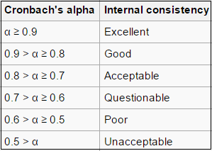
[Figure 4.2.4-1The meaning of Cronbach’s alpha]

Reliability Statistics
Cronbach's Alpha | Cronbach's Alpha Based on Standardized Items | N of Items
.951 | .952 | 5
[Table 4.2.4-2 Reliability analysis of Brand visibility]

As shown in Table 4.2.4-2, the reliability coefficient ​​of brand visibility is Cronbach = 0.951 > 0.9, According to the criteria in Figure 4.2.4-1, the reliability of BV has excellent internal consistency and reliability.

Reliability Statistics
Cronbach's Alpha | Cronbach's Alpha Based on Standardized Items | N of Items
.918 | .919 | 5
[Table 4.2.4-3 Reliability analysis of Brand awareness]
As shown in Table 4.2.4-3, the reliability coefficient ​​of brand awareness is Cronbach = 0.918 > 0.9, According to the criteria in Figure 4.2.4-1, the reliability of BA has excellent internal consistency and reliability.

Reliability Statistics
Cronbach's Alpha | Cronbach's Alpha Based on Standardized Items | N of Items
.957 | .958 | 5
[Table 4.2.4-4 Reliability analysis of Customer satisfaction]

As shown in Table 4.2.4-4, the reliability coefficient ​​of customer satisfaction is Cronbach = 0.957 > 0.9, According to the criteria in Figure 4.2.4-1, the reliability of CS has excellent internal consistency and reliability.

Reliability Statistics
Cronbach's Alpha | Cronbach's Alpha Based on Standardized Items | N of Items
.920 | .922 | 5
[Table 4.2.4-5 Reliability analysis of Brand reputation]

As shown in Table 4.2.4-4, the reliability coefficient ​​of brand reputation is Cronbach = 0.920 > 0.9, According to the criteria in Figure 4.2.4-1, the reliability of BR has excellent internal consistency and reliability.

4.2.5 Reliability analysis of Dependent Variable

Reliability Statistics
Cronbach's Alpha | Cronbach's Alpha Based on Standardized Items | N of Items
.960 | .961 | 4
[Table 4.2.5-1 Reliability analysis of Customer purchase intention]

As shown in Table 4.2.5-1, the reliability coefficient ​​of Customer purchase intention is Cronbach = 0.960 > 0.9, According to the criteria in Figure 4.2.4-1, the reliability of CPI has excellent internal consistency and reliability.

4.2.6 Summary result of reliability analysis
Variable | Number of Items | Cronbach’s Alpha
Brand visibility (BV) | 5 | 0.951
Brand awareness (BA) | 5 | 0.918
Customer satisfaction (CS) | 5 | 0.957
Brand reputation (BR) | 5 | 0.920
Customer purchase intention (CPU) | 4 | 0.960
[Table 4.2.6-1 Summary result of reliability analysis of the iv and dv]

According to Table 4.2.6-1, in this questionnaire, the Cronbach values ​​of all independent variables and dependent variables are greater than 0.8, which proves that the questionnaire has good reliability and the questionnaire has high internal consistency.

4.3 Correlation analysis

The correlation analysis is mainly for whether there is a positive correlation or a negative correlation between the detection variables. Usually, the "Pearson Correlation" and "Sig" values ​​are used as reference standards, and the sig value is also called "P-value". When p-value<0.05, it indicates that there is a correlation between variables (Mourougan and Sethuraman, 2017).
Pearson Correlation Value | Relevant degree
0.8 – 1.0 | Extremely Strong
0.6 – 0.8 | Strong
0.4 – 0.6 | Medium
0.2 – 0.4 | Weak
0.0 – 0.2 | Irrelevant
[Table 4.3-1 Relevant degree of independent and dependent variable]

When "Pearson Correlation" is positive, it indicates that the relationship between variables is positively correlated. On the contrary, if "Pearson Correlation" is negative, it means the relationship between variables is negatively correlated. The relevant degree refers to the Table 4.3-1.

Correlations
 |  | BR | CS | BA | BV | CPI
BR | Pearson Correlation | 1 | .264** | .504** | .285** | .456**
 | Sig. (2-tailed) |  | .000 | .000 | .000 | .000
 | N | 400 | 400 | 400 | 400 | 400
CS | Pearson Correlation | .264** | 1 | .283** | .220** | .223**
 | Sig. (2-tailed) | .000 |  | .000 | .000 | .000
 | N | 400 | 400 | 400 | 400 | 400
BA | Pearson Correlation | .504** | .283** | 1 | .575** | .550**
 | Sig. (2-tailed) | .000 | .000 |  | .000 | .000
 | N | 400 | 400 | 400 | 400 | 400
BV | Pearson Correlation | .285** | .220** | .575** | 1 | .449**
 | Sig. (2-tailed) | .000 | .000 | .000 |  | .000
 | N | 400 | 400 | 400 | 400 | 400
CPI | Pearson Correlation | .456** | .223** | .550** | .349** | 1
 | Sig. (2-tailed) | .000 | .000 | .000 | .000
 | N | 400 | 400 | 400 | 400 | 400
**. Correlation is significant at the 0.01 level (2-tailed).
[ Table 4.3-2 Correlations between independent and dependent variables]

According to Table 4.3-2, all P-values are less than 0.05, and the correlation coefficient is positive and more than 0.2, indicating a positive correlation between the variables.

4.4 Regression analysis

When a survey has multiple variables, regression analysis is used to determine if there is a linear relationship between the variables to determine whether the hypothesis of this survey is true.
Model Summary
Model | R | R Square | Adjusted R Square | Std. Error of the Estimate
1 | .740ª | .547 | .542 | .57495
a. Predictors: (Constant), BR, BA, CS, BV
[Table 4.4-1 Model summary of regression analysis]

In the model summary table, the R value indicates the goodness of fit. Usually, the R value is closer to 1, the better the regression model is and the higher the fit to the actual data (Uyanik and Gulerb, 2013).
As shown in Table 4.4-1, the R value is 0.740, which means that the correlation between the independent variable and the dependent variable reaches 0.740.

ANOVAª
Model |  | Sum of Squares | df | Mean Square | F | Sig.
1 | Regression | 157.710 | 4 | 39.427 | 119.271 | .000^{b}
 | Residual | 130.575 | 395 | .331
 | Total | 288.285 | 399
a. Dependent Variable: CPI
b. Predictors: (Constant), BR, BA, CS, BV
[Table 4.4-2 ANOVA result of regression analysis]
In the ANOVA table, the F value and the Sig value are mainly observed, and the Sig value (P-value) corresponding to the F value is <0.05, which means that the regression equation is applicable.
According to Table 4.4-2, P-value is 0.00<0.05, that means in this research, the model represented is established and fit.
Coefficientsª
Model |  | Unstandardized Coefficients |  | Standardized Coefficients | t | Sig.
 |  | B | Std. Error | Beta
1 | (Constant) | .525 | .221 |  | 2.377 | .000
 | BV | .026 | .064 | .019 | .407 | .684
 | BA | .467 | .047 | .478 | 9.951 | .000
 | CS | .312 | .052 | .312 | 6.038 | .000
 | BR | .033 | .044 | .026 | .756 | .450
a. Dependent Variable: CPI
[Table 4.4-3 Coefficients result of regression analysis]

In the Coefficients table, Sig value<0.05, that means the independent variable has a significant influences on the dependent variable.
As shown in Table 4.4-3, among the four independent variables, the p-values ​​of brand visibility (BV) and brand reputation (BR) are 0.684 and 0.450, are greater than 0.05, that means these two independents variables are not influences significant on dependent variable.

4.5 Summary of key findings

There are four hypotheses in this study. Based on the above data analysis results, the following key conclusions are obtained, as shown in Table 4.5-1:

Hypothesis | Result
H1: Brand visibility has a significant influence on customer purchase intention. | Rejected
H2: Brand awareness has a significant influence on customer purchase intention. | Accepted
H3: Customer satisfaction has a significant influence on customer purchase intention. | Accepted
H4: Brand reputation has a significant influence on customer purchase intention. | Rejected
For H1: Brand visibility has a significant influence on customer purchase intention.

Brand visibility has no significant relationship with customer purchase intention. According to the research of REHDA and Ratna, Due to the increasing number of mobile phone brands in recent years, mobile phones from various national brands have provided consumers with more options. Consumers usually don't choose to understand the brand's products because they have seen a brand of mobile phone (REHDA, 2017). For example, there are many mobile phone brands of low-cost small businesses in the market. These mobile phone brands change the name of big brands and define their own brands into similar words, which makes consumers have the illusion that their price is many times lower than that of big brands (Ratna, 2017). But the quality of the product is extremely poor. Therefore, it is more important for consumers to understand the attractiveness of this brand. When they choose mobile products, brand visibility is only the most basic and will not be included in their list of considerations.

For H2: Brand awareness has a significant influence on customer purchase intention.

Brand awareness has a significant relationship with customer purchase intention. According to the research of Chong, Brand awareness often indicates that consumers have learned about the brand's products in some way and know the advantages of the brand. Among many mobile phone brands, consumers can measure whether the brand's mobile phone can meet their own requirements according to their own needs (Chong, 2017). For example, HUAWEI has a high brand awareness. Most consumers understand that the biggest advantage of this brand is that the pixels are extremely high, which is the first choice for many photographers. Therefore, when consumers choose mobile phone products, the brand awareness is high, which can make this mobile phone brand listed as their consideration list, thus increasing the possibility of being selected.

For H3: Customer satisfaction has a significant influence on customer purchase intention.

Customer satisfaction has a significant relationship with customer purchase intention. According to the research of Sultan Sidi, Customer satisfaction is reflected in many aspects, not only the brand's product itself, but also whether the brand can provide convenient and valuable after-sales service. This series of systems affects customer satisfaction (Sultan Sidi, 2012). For example, some big brands have sufficient capital chain, strong internal sales and service system, and branch offices in different parts of the world, which enables their product chain and service chain to be fully adjusted according to market needs, providing comprehensive coverage for local consumers. After-sales service, this greatly increases customer satisfaction. When consumers choose mobile phone companies with high customer satisfaction, whether they are traveling to the outside world or working, when the mobile phone has problems, they can find branch businesses and get solutions in time. Therefore, higher customer satisfaction can give consumers more security.

For H4: Brand reputation has a significant influence on customer purchase intention.

Brand reputation has no significant relationship with customer purchase intention. According to the research of Ghaffarianhoseini and Tan, consumers of different ages, jobs, and incomes have different needs, brand reputation cannot represent the views of all consumers (Ghaffarianhoseini et al., 2014; Tan, 2012). For example, for young consumers, HUAWEI mobile phones have high pixel counts to meet their needs, so they are highly regarded among young consumers; but for older consumers, pixels are not important, they need to operate more. Simple mobile phone products, such as Chinese Gionee mobile phone, this brand focuses on the elderly consumers, its mobile phone products have simple operation, loud phone ringing, large screen fonts and so on. Therefore, among the elderly consumers, HUAWEI has a slightly lower brand reputation. Therefore, brand reputation cannot be a standard that affects consumer purchase bias.

CHAPTER 5:

5.1 Conclusion

In the study of the international competitiveness of Chinese mobile phone companies in the Malaysian market, researchers are based on: brand visibility; brand awareness; customer satisfaction; brand reputation. Exploring the relationship between these four factors on customer purchase intention, as an impact on Chinese mobile phone companies in Malaysia Competitive indicators of market development. The survey results show that:
- Brand awareness and Customer satisfaction are important factors influencing customer purchase intention when Malaysian consumers purchase mobile phone products
- Brand visibility and Brand reputation has no significant impact on customer purchase intention.

5.2 Recommendations

According to the research results, next, researchers will provide some suggestions to Chinese mobile phone enterprises when they entry to Malaysia market:

5.21 Brand visibility
1. Enhance the image of the terminal store
Most consumers' perceptions of corporate brands start with terminal stores. The store represents the brand image of a company, which includes the visibility of the store, the display specifications, and the quality of the staff. Therefore, first of all, Chinese mobile phone companies must maintain good terminal store visibility, enhance brand image, and let consumers often see the brand's terminal sales points, such as in Pavillion, Midvelly and other large markets. To make consumers remember the brand subtly, and gradually become curious and interested in the brand.
2. Enhance influence through advertising
When improving brand visibility, companies must adopt a proactive attitude to stimulate consumers' understanding of the brand. At present, there are many mobile phone products from different brands in the Malaysian market. Therefore, in order to stimulate consumers' consumption behavior, they must first occupy a certain market share in the market and increase consumers' association with brands. For example: online advertising, bus body advertising, SMS advertising, media promotion, etc. Through these methods, increase market share.
3. Increase brand visibility through celebrity endorsements.
To stand out from the crowd, companies can also leverage external resources such as the star effect. Because consumers usually take the initiative to pay attention to people or things that they are interested in, the stars themselves have strong influence and appeal, and at the same time can stimulate consumers' imitation behavior. Celebrity endorsement products can give consumers more security and interest.

5.22 Brand awareness
1. Market positioning of brands
Enterprises must first determine the target audience of consumers, and set the characteristics of products according to the needs of different groups of people, which can quickly increase the brand awareness of target customers. For example, statistics show that most people in Malaysia have monthly incomes between RM1500 and RM3000. Such consumers tend to choose mobile phones with moderate prices and good performance, so Chinese companies can position product prices at the mid-end.
2. Multi-channel promotion of products
After the fine market positioning, the company should vigorously promote the products and highlight the product features. For example, in a mall with large traffic, namely: Midvelly or Pavillion, set up a product experience center with promotional activities to promote product performance; sponsor Malaysian national events, launch a limited edition customized mobile phone, use the promotion of the event to enhance brand awareness and increase product sales. .
3. Pay attention to cooperation with Malaysian operators
In Malaysia, operators can find physical stores everywhere. Consumers can not only buy mobile phones from shopping malls, but also buy mobile phones from operators Umobile; Hotlink, because mobile phones purchased from operators can give consumers more security, and also there will be many discount packages for purchasing mobile phones. Therefore, Chinese mobile phone companies should pay attention to the cooperation opportunities with local Malaysian operators to obtain the mobile phone sales model of contract machines.

5.23 Customer satisfaction
1. Focus on core technology development
Malaysia is a country with relatively backward technology. There are many local brands of mobile phone companies whose products are imported. Therefore, Chinese mobile phone companies should focus on making up for the gap in Malaysia's core technology industry and promote the upgrade of the Malaysian mobile phone industry chain, which will enhance the goodwill and satisfaction of Chinese mobile phone companies in the Malaysian market.
2. Improve mobile phone performance in combination with local environment
Malaysia is a tropical country with a hot climate that can cause the phone to become hot. Therefore, Chinese mobile phone companies must achieve product performance and localization in Malaysia, attach importance to mobile phone fever control, provide intimate services to Malaysian consumers, pay attention to consumer experience and enhance satisfaction.
3. Improve service quality
Due to the hot weather in Malaysia, this has caused most corporate workers to be lazy and inefficient. Therefore, in the development of the Malaysian mobile phone market, Chinese mobile phone companies should make up for this deficiency, provide good training for enterprise staff, correct service attitude, improve service quality, put consumer interests first, and provide consumers with timely, Valuable service.

5.24 Brand reputation
1. Participate in public welfare activities
Public relations activities can increase the affinity of the brand and win the favor and respect of consumers. For Chinese companies that want to enter the multinational market, they need to be good at grasping opportunities. When appropriate, they can carry out some hype. The key is to attract the attention of the public, such as sponsorship and participation in public welfare activities. It is necessary to make full use of the hot news in the Malaysian market and the events of public concern, to add points to its own brand, to enhance the brand's good reputation, to embed the consumer's awareness, and to integrate its own brand image into the society.
2. Provide different marketing solutions and products for different consumer groups
Since Malaysia is a country with diverse cultures and its countries are composed of different ethnic groups, Chinese companies must also formulate corresponding marketing plans and products according to different consumer groups, different cultures and different needs. This can enable enterprises to balance services in terms of cross-ethnicity, transgender, and cross-level. This more comprehensive service approach can enhance the brand's reputation in various fields.
3. Ensure product quality is consistent with consumer expectations
To ensure that product quality and consumer expectations are consistent, even higher or far beyond the expectations of consumers, to give consumers an unexpected surprise. Consumer expectations are largely determined by the company's commitment. The heavier the commitment, the higher the consumer's expectations; the higher the expectations, the more disappointing. When the company's promise is not fulfilled, or the consumer believes that the company's fulfillment does not meet his expectations, he will lose trust in the company, and perhaps never buy this brand product again. Therefore, the commitment to the consumer should be very cautious, and once promised, it must be honored, otherwise it will cause damage to the brand reputation.

5.3 Limitations

First, because this study is aimed at the competitiveness of Chinese mobile phone companies in the Malaysian market, due to time and traffic constraints, the data collection of this study is mainly concentrated in Selangor, so it may not be comprehensive.
Second, because this study uses online questionnaires to collect feedback, it is impossible to monitor the attitude of respondents. There may be cases where respondents are not patient or serious when filling out the questionnaire, so the data of this survey may be biased.
Third, the hypothesis model proposed in this study is based on the author's own considerations, and its research factors may not be representative.

5.4 Recommendations for future research

First, for the analysis of the competitiveness of Chinese mobile phone companies in the Malaysian market, consumer purchase bias is only one of the external reference indicators. In the future research direction, it can be analyzed from the enterprise's own factors, based on the Michael Porter Five Forces Model, analyzed in Malaysia. In the mobile phone industry, the competition between Chinese mobile phone companies and other mobile phone companies may make corporate financial indicators more competitive with academic indicators.
Second, in future research, it can be based on the company's 4P marketing theory, namely: product, price, place, promotion. From these four aspects, we explore the factors that influence consumers' purchase bias, and thus determine how Chinese mobile phone companies can focus on improving their competitiveness in the development of the Malaysian market.

5.5 Personal reflection

The reason for choosing this theme is because, with the increasing number of mobile phone companies, the authors find that Chinese mobile phone companies will face competition from mobile phone companies in different countries. Therefore, it is necessary to study more deeply how to improve competitiveness in order to maintain stability in the development of mobile phone industry. At the same time, as a student with five years of experience in studying in Malaysia, I have already included Malaysia in my life plan. I found that Malaysia is a huge potential market for the mobile phone industry. More and more mobile phone companies are stationed in the Malaysian market. It is necessary to have an in-depth understanding of local residents' views on the mobile phone industry.
During this research, I learned that it is not easy to master the different needs of different customers, because consumer preferences are difficult to balance, and this research has also enhanced my ability to withstand stress and time management, as well as The correct understanding of relevant academics and the application of SPSS software provide the necessary foundation for my future work, so this research is a good learning opportunity for me in the direction of market management.
So far, this research is about to be completed. I am very grateful to my supervisor Ms. Faziha for gave me a lot of guidance, which gives me deeper understanding of academic research. I am also very grateful to second panel Mr. Arasu Raman gave comments and suggestions for my research. Finally, I would also like to thank all the respondents for their support in the survey.
I am sincerely respectful of the authors who support the theories and literature in the above studies. Although this study has certain limitations, I hope this study can provide useful reference in the field of future academic research.

Reference

Adam.S.(1981) ‘The Nature and Sources of National Wealth’. The Commercial Press.
Aerospacecraft Manufacturing Industry’. World Economic Research, NO.6.pp. 39-47.
Aiginger, K.(1998) ‘Unit Values ​​to Signal the Quality Position of CEECs In The Competitiveness of Transition Economies’. Proceedings of the OECD, Paris.
Allen.P,Brunner.P.(2005) ‘Productivity, Competitiveness and Incomes in Asia: An Evolutionary Theory of International Trade’. Cheltenham UK: Edward Elgar.
Balassa, B.(1989) ‘Comparative Advantage, Trade Policy and Economic Development’. New York University Press, New York.
Balassa, B.(1965) ‘Trade Liberation and Revealed Comparative Advantage’. The Manchester School of Economic and Social Studies, No,33. Pp.92-123.
Cao, H.&Yu, W.(2017) ‘Evaluation of the International Competitiveness of China's Strategic Emerging Industries’. Economic Mathematics, Vol.34, No, 1. pp,26-30.
Chen, H.& Chen,G.(2002) ‘Evaluation Model and Case Analysis of Regional Industrial Competitiveness,’China Soft Science.
Chen, H.&Xu, R.(2016) ‘Research on the International Competitiveness of Chinese and American Listed Companies——An Empirical Analysis Based on High-end Manufacturing and Information Technology Industry’. International Finance Research, Vol.34, No, 4. pp,49-61.
Chen, H.&Zhang, G.(2010) ‘Empirical Research on the International Competitiveness of China's Service Trade’. Management World, No, 10. pp,13-23.
Dieter.H, Englert.H.(2007) ‘Competitiveness in the global forest industry sector an empirical study with special emphasis on Germany’. European Journal of Forest Research, No.126.pp. 401-412.
Dunning.J.(1993) ‘Internationalizing Porter's Diamond’. Management International Review, Vol.2.pp. 7-15.
Fabrizio.S, Igan.D, Mody.A.(2007) ‘The Dynamics of Product Quality and International Competitiveness’. IMF Working Paper, Vol.07.pp. 97.
Gao,H.&Wang, X.(2015) ‘Analysis of Product Competitiveness Based on International Market Development——Taking Huawei Mobile Phone as an Example’.Modern Marketing (late issue), No,07. pp. 2-3.
Gao,W.&Yan, L.(2017) ‘Comparative Analysis of the International Competitiveness of Chinese and Japanese Cultural and Creative Industries——A New Measurement Based on the Change of Creative Products and Service Trade’. Modern Japanese Economy, No, 1. pp,66-80.
Hallack.J.(2004) ‘Product Quality, Linder and the Direction of Trade’. University of Michigan, Dearborn, Michigan.
He,W.& Sun, J.(2012) ‘Analysis of International Competitive Power Based on the Method of Measuring Economics’. Economic Research Guide, No.27, pp.6-7.
Huang, G.(2013) ‘Technological innovation is the core driving force for enhancing the competitiveness of enterprises--Seeing the development of Chinese mobile phone enterprises from the success of South Korea's Samsung Company’. Manager, Vol.20, No, 48.
Huang, W.(2013) 'Thinking on promoting service brand and reputation construction'. China Urban Finance,Vol.07.
Huang, Y.& Zhang, D. (2012) ‘On the current situation and development of domestic smart phone market’. Modern Business, Vol. 6,No,55.
Jiao, F.&Ge, B.(2008) ‘Comprehensive Measurement of International Competitiveness Level of China's Telecom Industry Based on Principal Component Analysis’. Industrial Technology & Economy, Vol. 12, pp.131-133.
Jiang, L., Li, S. &Lei, X. (2016) ‘Research on the Mechanism and Countermeasure of China's Agricultural Products International Competitiveness Improvement from the Perspective of Structural Optimization’. Management World, No.1,pp.170-171.
Jin,W.(1997) ‘China's Industrial International Competitiveness: Theory, Methodology and Empirical Research’. Economic Management Press.
Jin,W., Li,G.&Chen, Z.(2007) ‘Analysis of the current international competitiveness of China's manufacturing industry and its promotion strategy’. Finance and Trade, Vol.3. No. 3, pp.10-128.
Jing, Z., Li, M.& Wang,C.(2012) ‘Evaluation and Countermeasures of Safety Status of China's Steel Industry’. Economic Aspects, No,12. pp,44-47.
Jin,W.(2001) ‘On the nature of enterprise competitiveness’. China Industrial Economy, Vol.10,pp. 5-10.
Krugman.P.(1996) ‘Pop Internationalism’. MIT Press, Cambridge.
Krugman, P.(2000) ‘Strategic Trade Policy and New International Economics’ Renmin University of China Press.
Landesmann.M, Poeschl.J.(2011) ‘Balance of Payments Constrained Growth in Central and Eastern Europe’. In M. Knell. Ed, Economics of Transition.
Li.G, Liu.J.(2012) ‘An Empirical Analysis of the International Competitiveness of Chinese Industry in the Ten Years of WTO Entry’. Finance & Trade in Economics, Vol. 8.pp. 88-96.
Liu,J.&Chen,X.(2007) 'The formation mechanism of word-of-mouth communication and word-of-mouth marketing'. Financial theory.
Li.J, Li.F, Wan.X. (2017) ‘Research on the Evaluation of International Competitiveness of Chinese Railway Enterprises’. China Engineering Science, Vol. 19.pp. 68-73.
Li.L.(2017) ‘Reflections on the Differences of International Competitiveness of High-tech Enterprises in China’. Times Finance, NO. 3.pp. 102-103.
Liu.M.(2016) ‘Analysis and Development Strategy of China's Mobile Phone Industry's International Competitiveness’. Economic Research Guide, No. 19,pp. 30-31.
Liu.Q.(2016) ‘Looking at the competitiveness of mobile phones from brand loyalty’. Communication World, Vol. 32.pp. 1.
Lin,S.(2003) ‘Analysis of Competitiveness of Domestic Mobile Phone Enterprises’. Economic Frontiers, Vol. Z1,pp. 117-118.
Luo,Y.(2005). 'Research on the Core Factors and Marketing Strategies of Influencing Consumers' Brand Choice Behavior' Jiangxi Normal University.
Ma.Y.(2013) ‘Suggestions on Improving the Competitiveness of China's Smartphone Enterprises' Brands’. Economic Issues Research, No.12.pp. 164-168.
Michael.P.(1990) ‘The competitiveness advantage of nations’. The Free Press, New York.
Michael.S, Heather.H.(1998) ‘International Competitiveness Ballinger Publishing Company’.
U.S.
Prahalad.C.(1998) ‘Gary Hamel - Competing for the Future’. Beijing Kunlun Press.
Peterson.J.(1988) ‘Export shares and revealed comparative advantage: A Study of International Travel’. Applied Economics, Vol. 20.pp. 351-365.
Qin.W, Ni.Y.(2006) ‘Empirical Measurement of the International Competitiveness of China's
Ricardo, D.(1976) ‘Political Economy and Taxation Principles’. The Commercial Press.
Sasatani.D.(2010) ‘National competitiveness index of the forest products industry in the Asia-pacific region’. FAO Working Paper, NO. 2.
Schott.P.(2004) ‘Across-product versus within-product Specialization in International Trade’. Quarterly Journal of Economics, Vol.2.pp. 647-78.
Shang.Q.(2017) ‘Comparative Study on the International Competitiveness of China-India Service Outsourcing Industry’. South Asia Research, No.3.pp. 49-63+152.
Sun.H,Wang.Y.(2013) ‘Research on Organizational Practice Change and Enterprise Competitiveness——Taking Nokia Mobile Phone as an Example’. Science and Technology Management Research, No.15.pp. 130-136.
Tan.J, Wang.Y.(2007) ‘Analysis of the international competitiveness of China's small household electrical appliances’. International Trade Issues, Vol.1.pp. 38-43.
Thomas.L, Hu.D.(1988) ‘Investigating the Nature of World Agriculture Competitiveness, U S Department of Agriculture, Economic Research Service’. Technical Bulletin, No.1754.
Timmer.M.(2000) ‘The Dynamics of Asian Manufacturing’. Cheltenham, UK: Edward Elgar.
Wang.W.(2004) ‘Quantitative economic analysis of factors affecting the international competitiveness of enterprises’. Jilin University.
Wang.Y.(2017) ‘Research on the Enhancement Path of International Competitiveness of Internet Enterprises in China’. China Market, No.2.pp. 12-16.
Wang.Y, Zhao.Z.(2008) ‘Comprehensive evaluation of international competitiveness of drilling companies based on factor analysis’. Journal of Oil and Gas Technology, No.2.pp. 380-382.
Wernerfelt.(1984) ‘A Resource—based view of the Firms’. Strategic Management Journal
Wu.X.(2005) ‘Chen Han. Research on Jiangsu Industrial Competitiveness’. Nanjing Social Sciences, Vol.3.pp. 87-92.
Xie.Z, Yan.F.(2014) ‘Homogeneous agglomeration, heterogeneous agglomeration and industrial international competitiveness——based on 15 manufacturing industries in China Empirical Study of Panel Data from 2000 to 2011’. International Trade Issues,Vol.2.pp. 13-23.
Yang, J.(2008) ‘Empirical Analysis of the International Competitiveness of China's Textile and Apparel Industry’. International Trade Issues.Vol.9,No.88,pp,95-122.
Yan.M.(2014) ‘Coupling research between independent brand strategy and corporate international competitiveness’. Science and Technology Management Research, Vol.17.pp. 127-133.
Yan.M.(2006) ‘New Diamond Model” for Industrial Competitiveness’. Social Sciences, Vol.4.pp. 68-73.
Yan.Y.(2012) ‘Analysis on the Development Competitiveness of Domestic Mobile Phone Enterprises’. Academic Exchange, Vol.8.pp. 106-109.
Yin,W.,&Yuan, C.(2016) ‘On the Way to Improve the Core Competitiveness of Domestic Mobile Phone Industry——Taking Apple Mobile Phone as an Example’ Theoretical version), Vol.24, pp.72-90.
Yuan, Y.(2012) ‘Analysis of the Competitiveness of the Smartphone Market from the Perspective of Business Ecosystem’. Business, Vol. 11,pp. 41-42.
Zhai.C, Wang.L.(2002) ‘On the Theoretical Concept and Analysis Method of International Competitiveness’. China Industrial Economy, Vol.4.pp. 41-45.
Zhang, J.(2001) ‘Research on the Method of Evaluating International Competitiveness with Export Data’. Economic Management, Vol.20, pp.17-25.
Zhang, J. (2002) ‘Theory and Method of International Competitiveness Evaluation’. Beijing: Economic Science Press.
Zhang, S., Yang, S.,& Zhao, H.(2011) ‘Chinese Enterprise Brand International Competitiveness Index System’. Beijing: Economic Management Press.
Zhang,X.&Yang,X.(2002) ' Brand ladder - brand awareness, reputation, loyalty'.Economic Management, No,21.
Zhao,D. &Sang, B.(2016) ‘International Capacity Cooperation under the “Belt and Road Initiative”——An Empirical Analysis Based on Industrial International Competitiveness’. International Trade Issues, No.10, pp, 3-14.
Zheng,G. &Jiang, C.(2001) ‘Research on Evaluation Index System of Regional Industry International Competitiveness’. Science Management Research, Vol. 6, No.24, pp.27-46.
Zheng, H., &Ren, R.(2005) ‘Research on the International Competitiveness of China's Manufacturing Industry under the Multilateral Comparison: 1980-2004’. Economic Research, Vol. 12,pp.77-89.
Zhou, D.,& Liu,J.(2017) ‘Preliminary Study on the Core Competence of Domestic Smartphones——Taking OPPO and VIVO as Examples’. Modern management science, No.09, pp.94-96.
Zhou, S.(2008) ‘Comparison of Competitiveness of China, Japan and Korea Technology-intensive Product Manufacturing——Based on the New Perspective of Item Group Classification Based on RCA Measurement’. Asia-Pacific Economics, No.04, pp.67-73.
Zhou, X., &Fu, Y.(2000) ‘Research on Evaluation Index System of Industrial International Competitiveness’. Research Management, Vol.3, No.29, pp.34.

Appendix

Appendix 1: PROJECT PAPER LOG
This is an important document, which is to be handed in with your dissertation. This log will be taken into consideration when awarding the final mark for the dissertation.
Student Name: | Wang Sitao
Supervisor’s Name: | Ms. Faziha Abd Malek
Dissertation Topic:
ANALYSIS OF THE INTERNATIONAL COMPETITIVENESS
OF CHINESE MOBILE PHONE ENTERPRISES IN THE MALAYSIAN MARKET

SECTION A. MONITORING STUDENT DISSERTATION PROCESS
The plan below is to be agreed between the student & supervisor and will be monitored against progress made at each session.
Activity | Milestone/Deliverable Date
Confirmation research title | 20/5
Final initial proposal |  | 5/6
Chapter 1,2,3 draft |  |  | 15/6
Questionnaire design |  |  |  | 1/7
Questionnaire collection |  |  |  |  | 10/7
Draft Chapter 4 |  |  |  |  |  | 26/7
Draft Chapter 5 |  |  |  |  |  |  | 1/8
Final draft |  |  |  |  |  |  |  | 6/8
SECTION B. RECORD OF MEETINGS
The expectation is that students will meet their supervisors up to seven times and these meetings should be recorded.
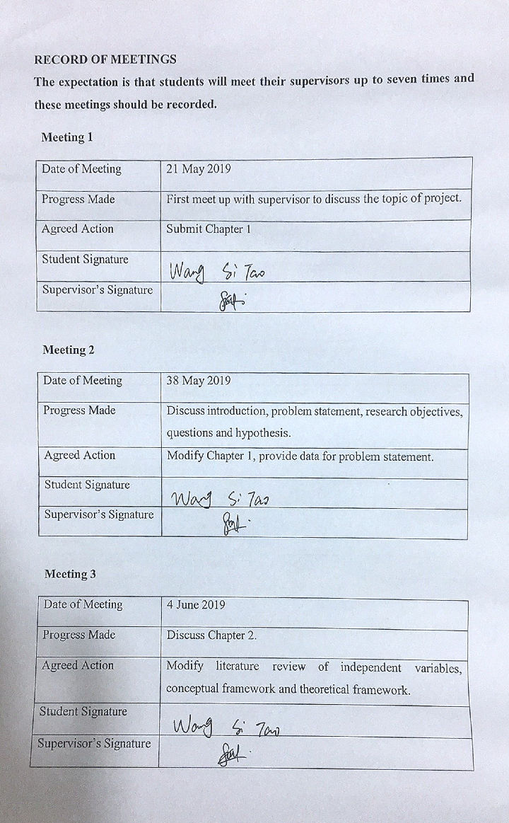

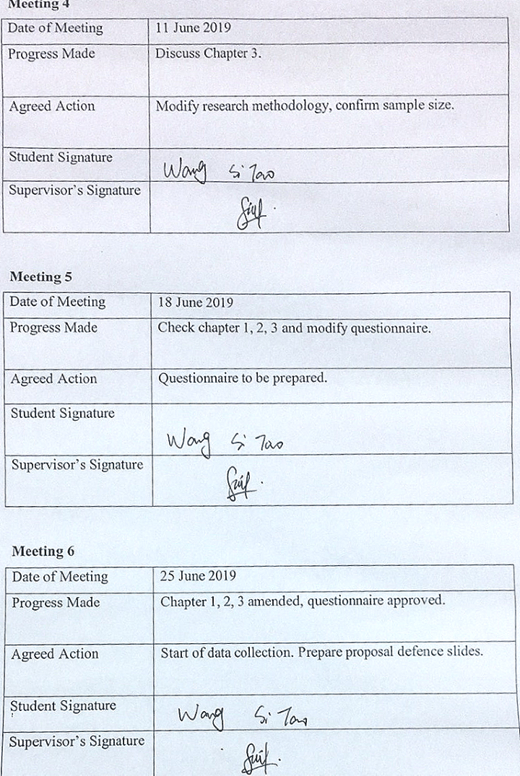
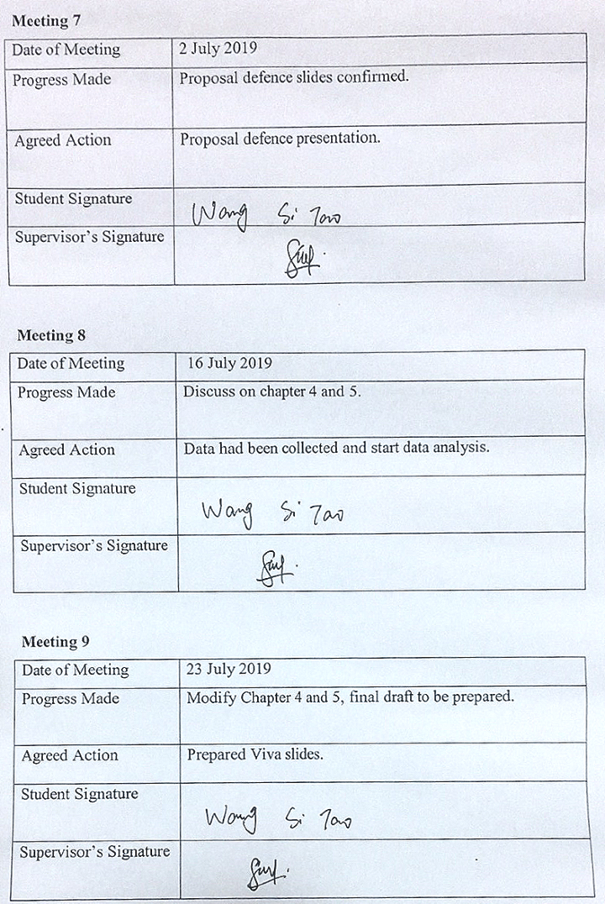
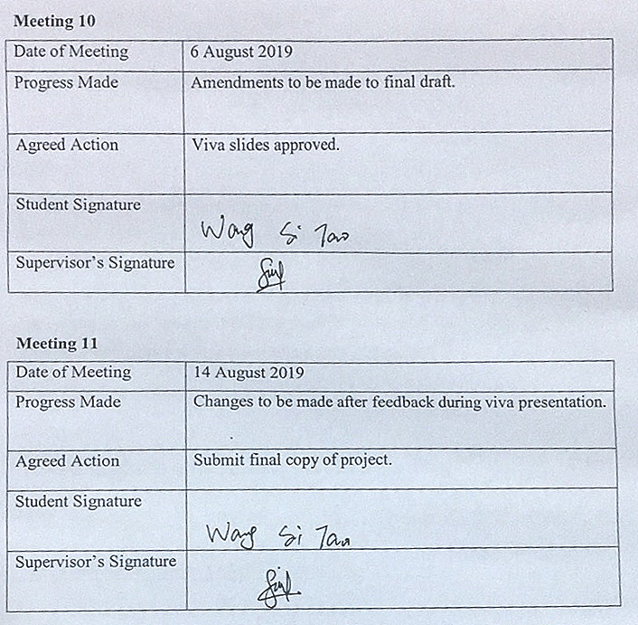

SECTION C. COMMENTS OM MANAGEMENT OF PROJECT

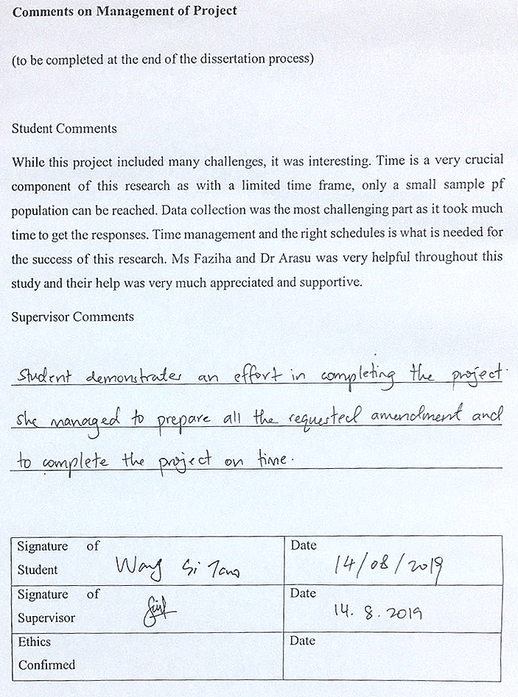

Appendix 2: List of Abbreviations
Abbreviations | Full name
BV | Brand Visibility
BA | Brand Awareness
CS | Customer Satisfaction
BR | Brand Reputation
CPI | Customer Purchase Intention

Appendix 3: Data analysis results
Descriptive analysis

[Figure 4.1-1 Descriptive analysis of Gender]
[Figure 4.1-2 Descriptive analysis of Age]

[Figure 4.1-3 Descriptive analysis of Occupation]

[Figure 4.1-4 Descriptive analysis of Monthly Income]

Factor Analysis of Independent Variables

KMO and Bartlett's Test
Kaiser-Meyer-Olkin Measure of Sampling Adequacy. |  | .867
Bartlett's Test of Sphericity | Approx. Chi-Square | 2379.206
 | df | 10
 | Sig. | .000
[Table 4.2.1-2 KMO and Bartlett’s test of Brand visibility]

Communalities
 | Initial | Extraction
BVS1 | 1.000 | .688
BVS2 | 1.000 | .898
BVS3 | 1.000 | .926
BVS4 | 1.000 | .828
BVS5 | 1.000 | .867
[Table 4.2.1-3 Factor loading of brand visibility]

Total Variance Explained
Component | Initial Eigenvalues |  |  | Extraction Sums of Squared Loadings
 | Total | % of Variance | Cumulative % | Total | % of Variance | Cumulative %
1 | 4.208 | 84.151 | 84.151 | 4.208 | 84.151 | 84.151
2 | .385 | 7.704 | 91.855
3 | .202 | 4.044 | 95.899
4 | .157 | 3.137 | 99.036
5 | .048 | .964 | 100.000
[Table 4.2.1-4 Eigenvalues of brand visibility]

KMO and Bartlett's Test
Kaiser-Meyer-Olkin Measure of Sampling Adequacy. |  | .849
Bartlett's Test of Sphericity | Approx. Chi-Square | 1596.368
 | df | 10
 | Sig. | .000
[Table 4.2.1-5 KMO and Bartlett’s test of Brand awareness]

Communalities
 | Initial | Extraction
BAS1 | 1.000 | .809
BAS2 | 1.000 | .610
BAS3 | 1.000 | .800
BAS4 | 1.000 | .707
BAS5 | 1.000 | .856
[Table 4.2.1-6 Factor loading of Brand awareness]
Total Variance Explained
Component | Initial Eigenvalues |  |  | Extraction Sums of Squared Loadings
 | Total | % of Variance | Cumulative % | Total | % of Variance | Cumulative %
1 | 3.783 | 75.663 | 75.663 | 3.783 | 75.663 | 75.663
2 | .595 | 11.907 | 87.570
3 | .292 | 5.834 | 93.403
4 | .171 | 3.418 | 96.821
5 | .159 | 3.179 | 100.000
[Table 4.2.1-7 Eigenvalues of Brand awareness]
KMO and Bartlett's Test
Kaiser-Meyer-Olkin Measure of Sampling Adequacy. |  | .844
Bartlett's Test of Sphericity | Approx. Chi-Square | 2473.740
 | df | 10
 | Sig. | .000
[Table 4.2.1-8 KMO and Bartlett’s test of Customer satisfaction]
Communalities
 | Initial | Extraction
CSS1 | 1.000 | .815
CSS2 | 1.000 | .806
CSS3 | 1.000 | .923
CSS4 | 1.000 | .897
CSS5 | 1.000 | .839
[Table 4.2.1-9 Factor loading of Customer satisfaction]
Total Variance Explained
Component | Initial Eigenvalues |  |  | Extraction Sums of Squared Loadings
 | Total | % of Variance | Cumulative % | Total | % of Variance | Cumulative %
1 | 4.279 | 85.588 | 85.588 | 4.279 | 85.588 | 85.588
2 | .294 | 5.887 | 91.474
3 | .252 | 5.040 | 96.515
4 | .125 | 2.503 | 99.017
5 | .049 | .983 | 100.000
[Table 4.2.1-10 Eigenvalues of Customer satisfaction]
KMO and Bartlett's Test
Kaiser-Meyer-Olkin Measure of Sampling Adequacy. |  | .827
Bartlett's Test of Sphericity | Approx. Chi-Square | 1769.178
 | df | 10
 | Sig. | .000
[Table 4.2.1-11 KMO and Bartlett’s test of Brand reputation]
Communalities
 | Initial | Extraction
BRS1 | 1.000 | .872
BRS2 | 1.000 | .609
BRS3 | 1.000 | .892
BRS4 | 1.000 | .683
BRS5 | 1.000 | .768
[Table 4.2.1-12 Factor loading of Brand reputation]
Total Variance Explained
Component | Initial Eigenvalues |  |  | Extraction Sums of Squared Loadings
 | Total | % of Variance | Cumulative % | Total | % of Variance | Cumulative %
1 | 3.824 | 76.484 | 76.484 | 3.824 | 76.484 | 76.484
2 | .535 | 10.696 | 87.180
3 | .398 | 7.956 | 95.136
4 | .146 | 2.924 | 98.060
5 | .097 | 1.940 | 100.000
[Table 4.2.1-13 Eigenvalues of Brand reputation]

Factors analysis of Dependent Variables

KMO and Bartlett's Test
Kaiser-Meyer-Olkin Measure of Sampling Adequacy. |  | .831
Bartlett's Test of Sphericity | Approx. Chi-Square | 2034.810
 | df | 6
 | Sig. | .000
[Table 4.2.2-1.KMO and Bartlett’s test of Customer purchase intention]
Communalities
 | Initial | Extraction
CPI1 | 1.000 | .903
CPI2 | 1.000 | .945
CPI3 | 1.000 | .858
CPI4 | 1.000 | .874
[Table 4.2.2-2 Factor loading of Customer purchase intention]

Total Variance Explained
Component | Initial Eigenvalues |  |  | Extraction Sums of Squared Loadings
 | Total | % of Variance | Cumulative % | Total | % of Variance | Cumulative %
1 | 3.581 | 89.529 | 89.529 | 3.581 | 89.529 | 89.529
2 | .207 | 5.179 | 94.708
3 | .162 | 4.062 | 98.770
4 | .049 | 1.230 | 100.000
[Table 4.2.2-3 Eigenvalues of Customer purchase intention]

Reliability analysis of Independent Variable
Reliability Statistics
Cronbach's Alpha | Cronbach's Alpha Based on Standardized Items | N of Items
.951 | .952 | 5
[Table 4.2.4-2 Reliability analysis of Brand visibility]

Reliability Statistics
Cronbach's Alpha | Cronbach's Alpha Based on Standardized Items | N of Items
.918 | .919 | 5
[Table 4.2.4-3 Reliability analysis of Brand awareness]

Reliability Statistics
Cronbach's Alpha | Cronbach's Alpha Based on Standardized Items | N of Items
.957 | .958 | 5
[Table 4.2.4-4 Reliability analysis of Customer satisfaction]

Reliability Statistics
Cronbach's Alpha | Cronbach's Alpha Based on Standardized Items | N of Items
.920 | .922 | 5
[Table 4.2.4-5 Reliability analysis of Brand reputation]
Reliability analysis of Dependent Variable

Reliability Statistics
Cronbach's Alpha | Cronbach's Alpha Based on Standardized Items | N of Items
.960 | .961 | 4
[Table 4.2.5-1 Reliability analysis of Customer purchase intention]

Summary result of reliability analysis
Variable | Number of Items | Cronbach’s Alpha
Brand visibility (BV) | 5 | 0.951
Brand awareness (BA) | 5 | 0.918
Customer satisfaction (CS) | 5 | 0.957
Brand reputation (BR) | 5 | 0.920
Customer purchase intention (CPU) | 4 | 0.960
[Table 4.2.6-1 Summary result of reliability analysis of the iv and dv]

Correlation analysis
Correlations
 |  | BR | CS | BA | BV | CPI
BR | Pearson Correlation | 1 | .264** | .504** | .285** | .456**
 | Sig. (2-tailed) |  | .000 | .000 | .000 | .000
 | N | 400 | 400 | 400 | 400 | 400
CS | Pearson Correlation | .264** | 1 | .283** | .220** | .223**
 | Sig. (2-tailed) | .000 |  | .000 | .000 | .000
 | N | 400 | 400 | 400 | 400 | 400
BA | Pearson Correlation | .504** | .283** | 1 | .575** | .550**
 | Sig. (2-tailed) | .000 | .000 |  | .000 | .000
 | N | 400 | 400 | 400 | 400 | 400
BV | Pearson Correlation | .285** | .220** | .575** | 1 | .449**
 | Sig. (2-tailed) | .000 | .000 | .000 |  | .000
 | N | 400 | 400 | 400 | 400 | 400
CPI | Pearson Correlation | .456** | .223** | .550** | .349** | 1
 | Sig. (2-tailed) | .000 | .000 | .000 | .000
 | N | 400 | 400 | 400 | 400 | 400
**. Correlation is significant at the 0.01 level (2-tailed).
[ Table 4.3-2 Correlations between independent and dependent variables]

Regression analysis

Model Summary
Model | R | R Square | Adjusted R Square | Std. Error of the Estimate
1 | .740ª | .547 | .542 | .57495
a. Predictors: (Constant), BR, BA, CS, BV
[Table 4.4-1 Model summary of regression analysis]

ANOVAª
Model |  | Sum of Squares | df | Mean Square | F | Sig.
1 | Regression | 157.710 | 4 | 39.427 | 119.271 | .000^{b}
 | Residual | 130.575 | 395 | .331
 | Total | 288.285 | 399
a. Dependent Variable: CPI
b. Predictors: (Constant), BR, BA, CS, BV
[Table 4.4-2 ANOVA result of regression analysis]

Coefficientsª
Model |  | Unstandardized Coefficients |  | Standardized Coefficients | t | Sig.
 |  | B | Std. Error | Beta
1 | (Constant) | .525 | .221 |  | 2.377 | .000
 | BV | .026 | .064 | .019 | .407 | .684
 | BA | .467 | .047 | .478 | 9.951 | .000
 | CS | .312 | .052 | .312 | 6.038 | .000
 | BR | .033 | .044 | .026 | .756 | .450
a. Dependent Variable: CPI
[Table 4.4-3 Coefficients result of regression analysis]

Appendix 4: Questionnaire



Dear respondents,
This questionnaire is used in the Inti International University MBA final project report to study and evaluate the International Competitiveness of Chinese Mobile Phone Enterprises (eg: OPPO, VIVO) in the Malaysian Market. This questionnaire uses an anonymous survey method to strictly respect the privacy of respondents. It is for academic research only and does not make any commercial use.
As a student of MBA at INTI, I hope that you can take the time to fill out the questionnaire. Thank you for your cooperation.

Section A: ( Personal Information)

This section is to fill in some of your personal details, your answers will be strictly confidential. Please place a tick (√）according to your response.
1. Your gender is:
A. Male
B. Female
2. Your age is:
A. Below 20
B. 20 - 30
C. 31- 40
D. Above 40
3. Your occupation is:
A. Enterprise employees
B. Government staff
C. Individual business
D. Other
4. Your monthly income:
A. Below RM 1500
B. RM 1500 - RM 3000
C. RM 3001- RM 4500
D. Above RM 4500

Section B: (Assessment on dependent and independent variables)

Using the statement below, please place a tick (√）according to your response. Rate each statement using the 5-point likert scale.
( 1=Strongly disagree 2=Disagree 3=Neutral 4=Agree 5=Strongly agree )
No. | Statement | 1 | 2 | 3 | 4 | 5
5 | Chinese mobile phone brands are popular in Malaysia.
6 | By using Chinese mobile phone brands, it can shows certain statues.
7 | I can easily name the Chinese mobile phone brands.
8 | When it comes to the mobile phone industry, you will first think of Chinese mobile phone brands.
9 | I often see the physical store of Chinese mobile phone brands.
10 | I can recognize all Chinese mobile phone brands on trademarks.
11 | I think that you are very concerned about the product launch of at least one Chinese mobile phone company.
12 | I can easily differentiate all Chinese mobile phone brands.
13 | I can list the pros and cons of at least one Chinese mobile phone company's products.
14 | I am very familiar with the history of at least one Chinese mobile phone company.
15 | The quality of Chinese brand mobile phones is very good.
16 | The appearance of Chinese brand mobile phone looks good.
17 | The price of the Chinese brand mobile phone is very reasonable.
18 | The function of the Chinese brand mobile phone is comprehensive.
19 | The Chinese brand mobile phone performs very well.
20 | I often hear others praise the Chinese mobile phone brand.
21 | It is often have many others recommended you to buy a Chinese brand mobile phone.
22 | I believe the Chinese mobile phone brand has a good development prospect.
23 | There are many people using Chinese brand mobile phone.
24 | The Chinese mobile phone brands have the best reputation in the mobile phone industry.
25 | Brand visibility can influence me to choose a specific mobile phone brand.
26 | I will purchase a specific mobile phone brand based on brand awareness.
27 | I will buy the specific mobile phone brand if it can bring a total satisfaction to me.
28 | The brand reputation influences me to choose a specific mobile phone brand to purchase.

Appendix 5: Viva slides
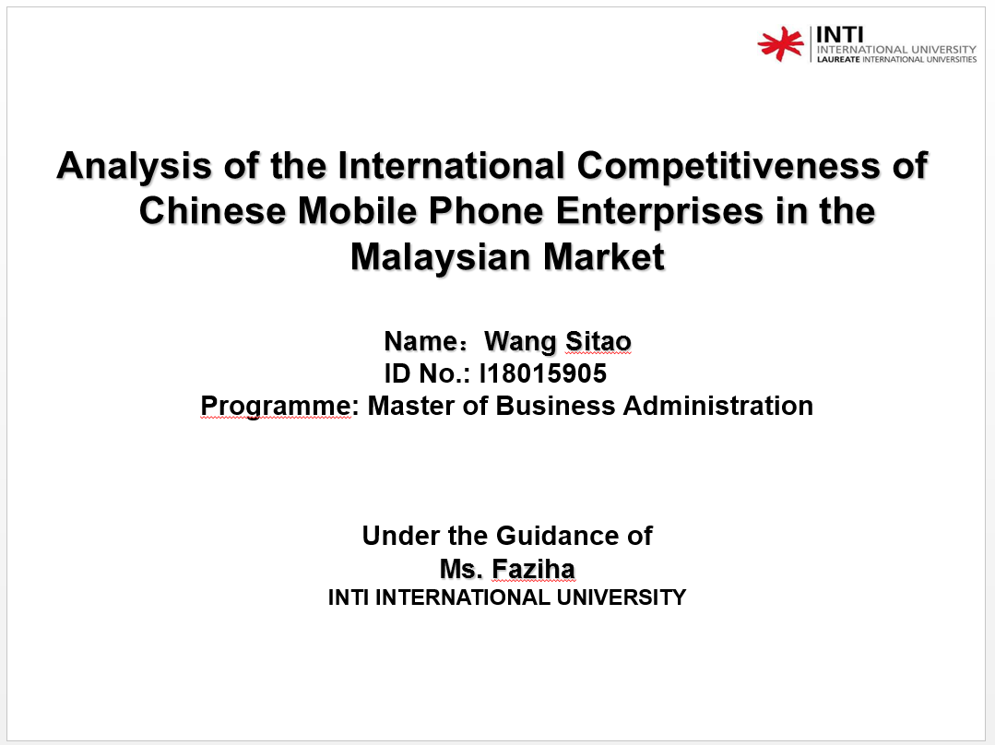
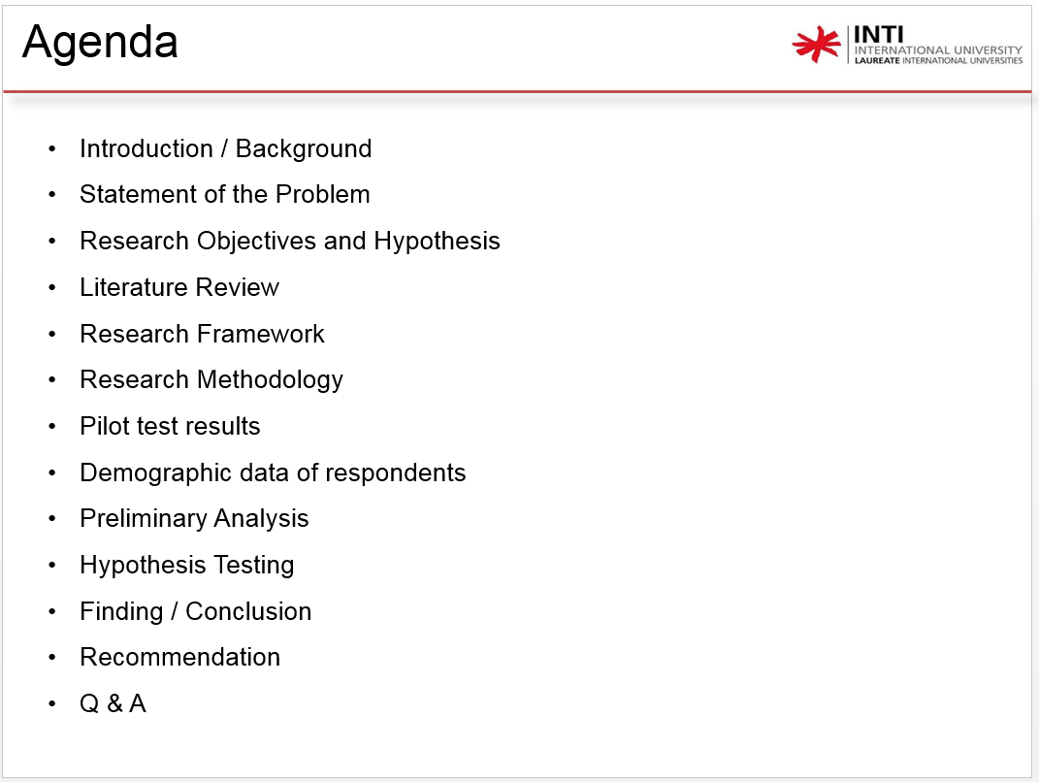
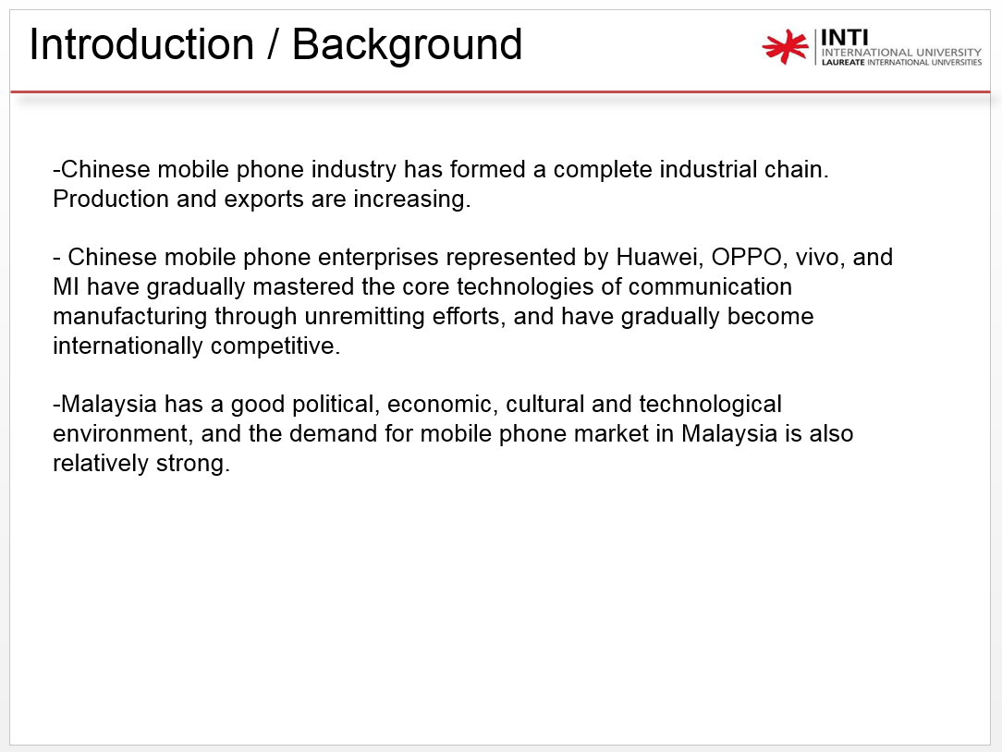
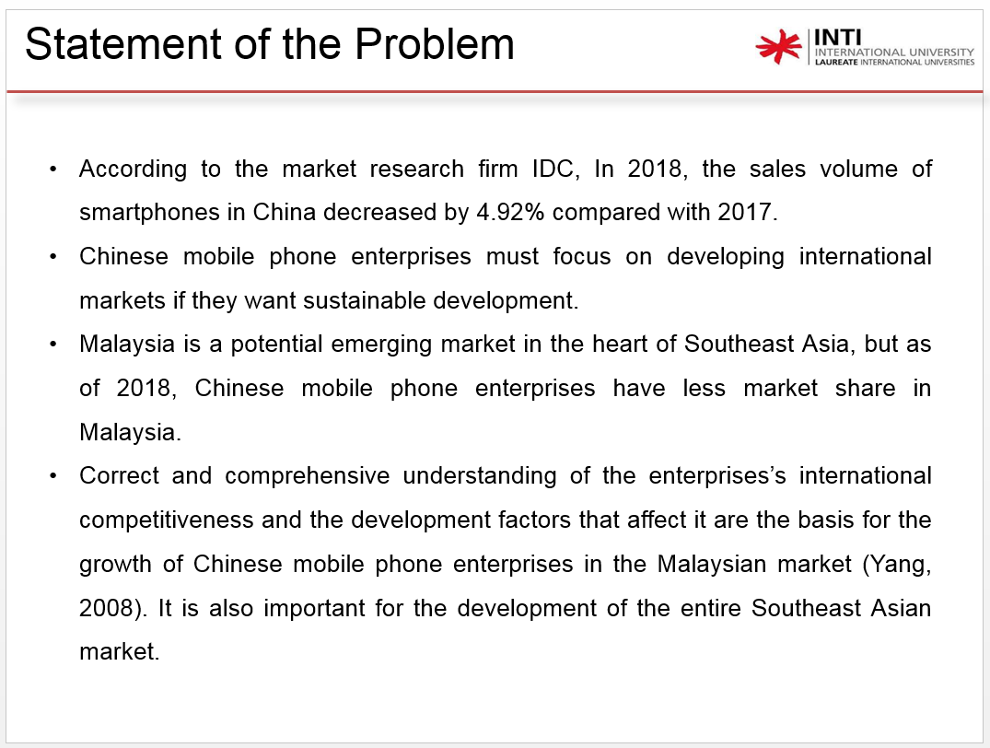

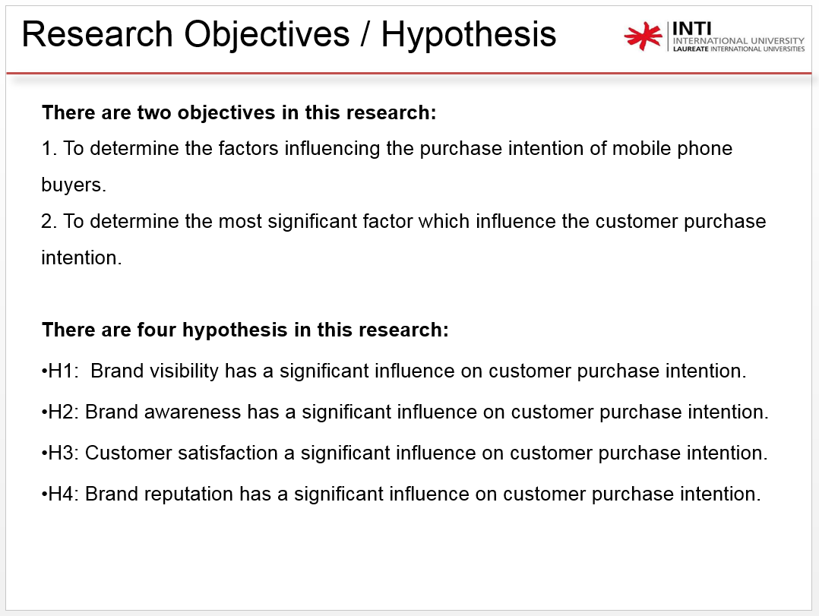
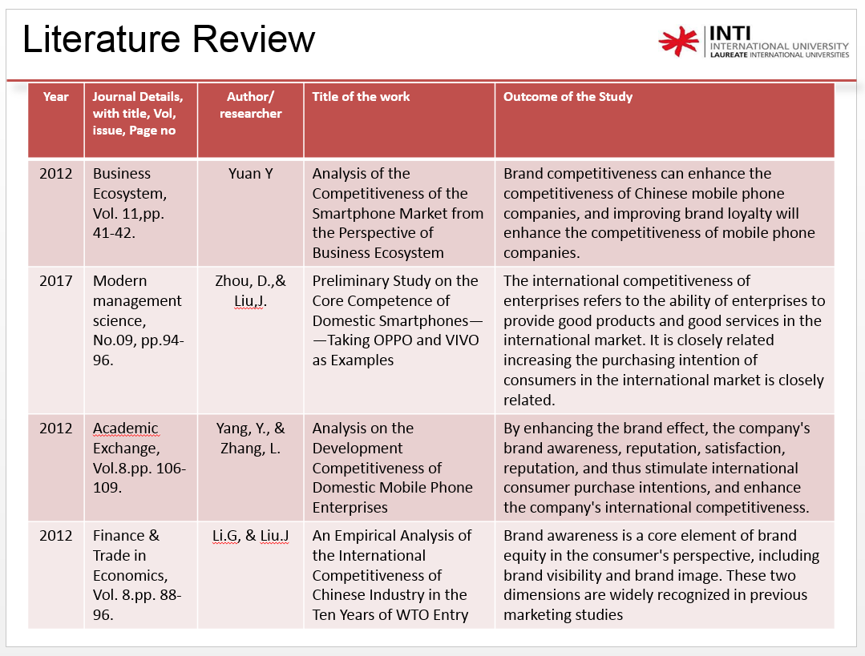
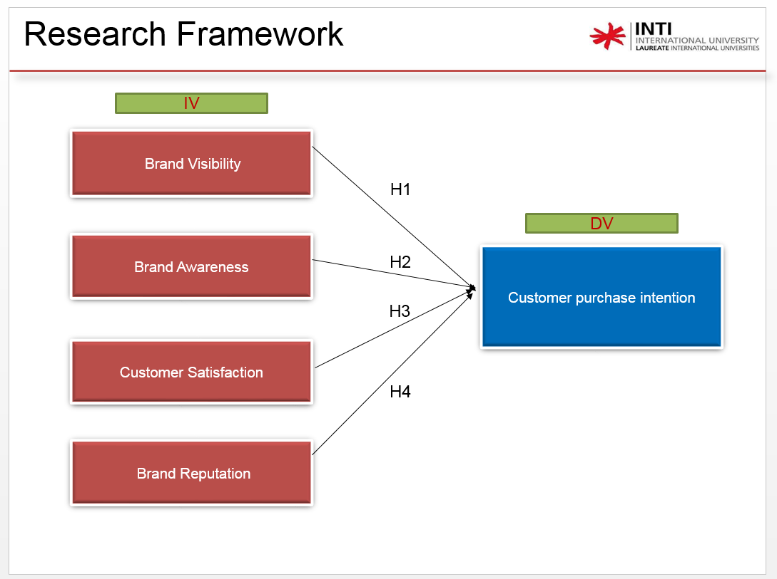
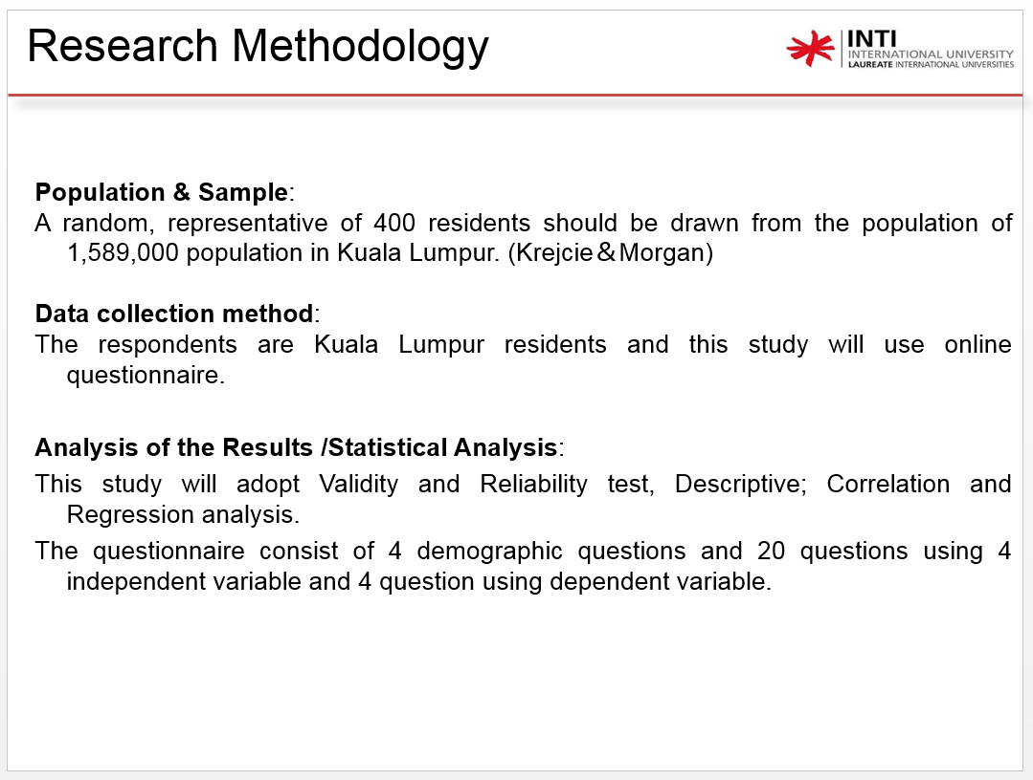
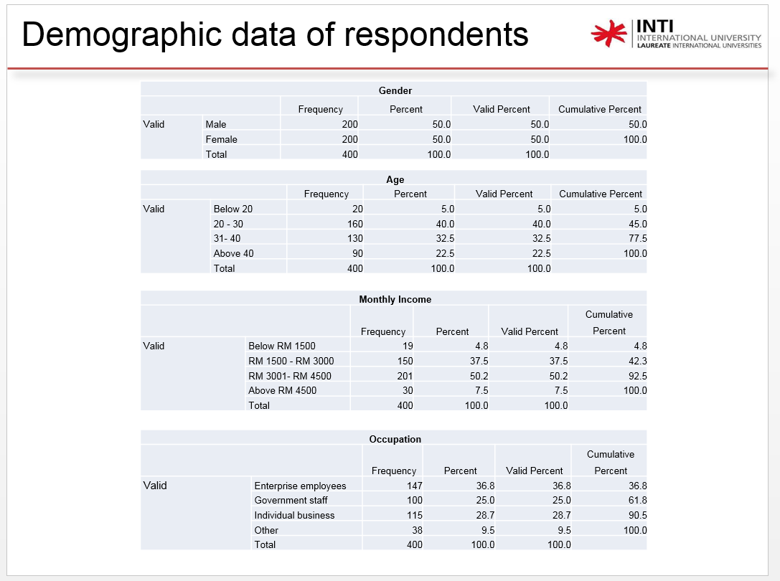
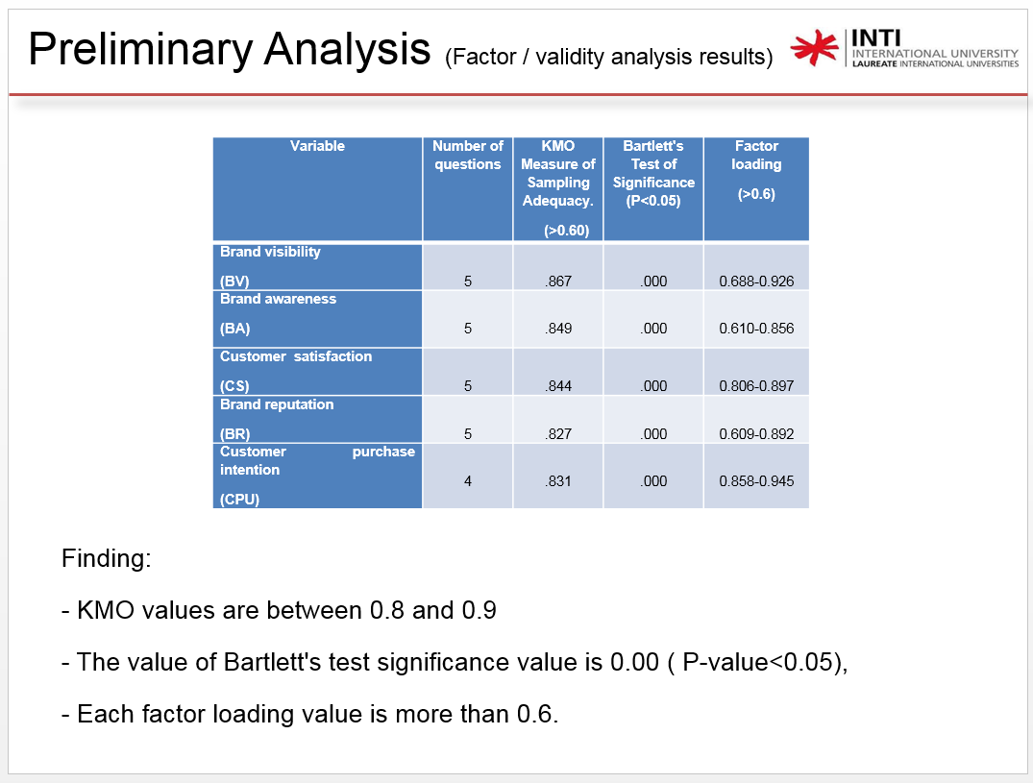
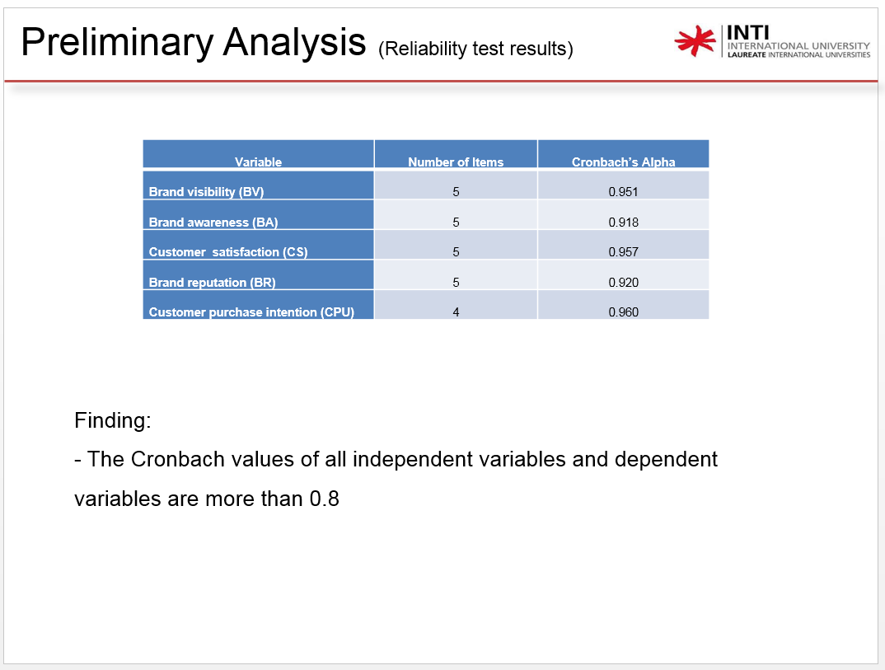
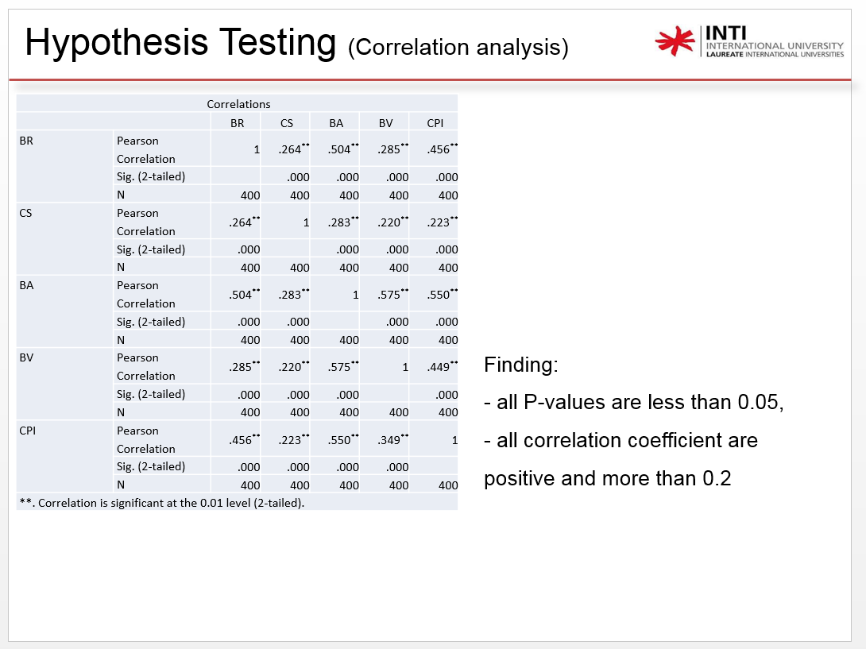
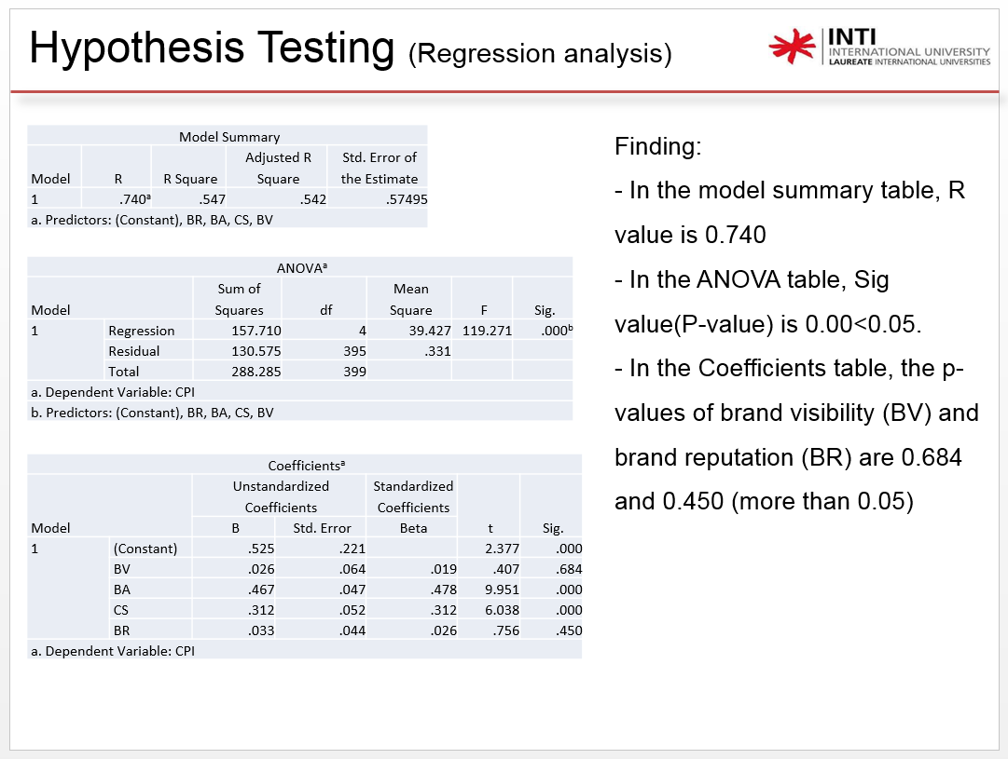
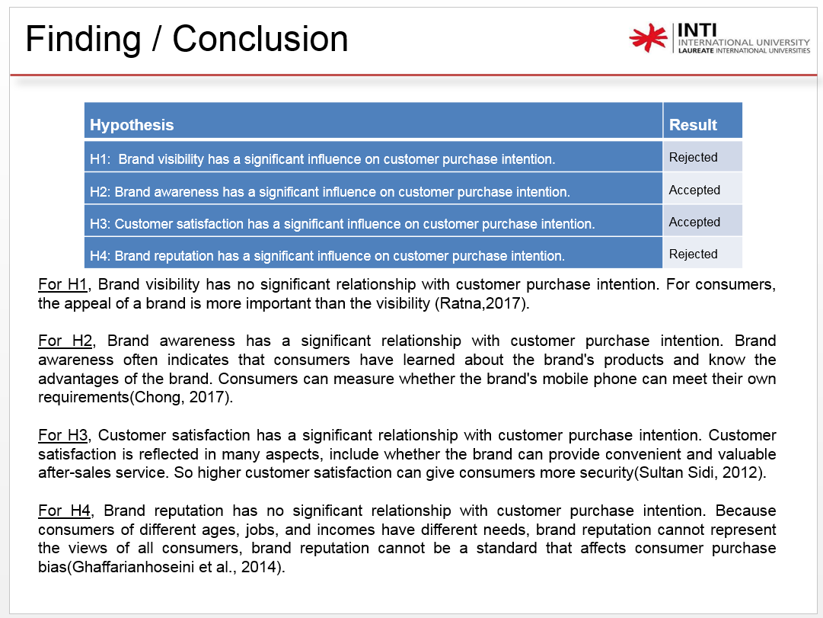
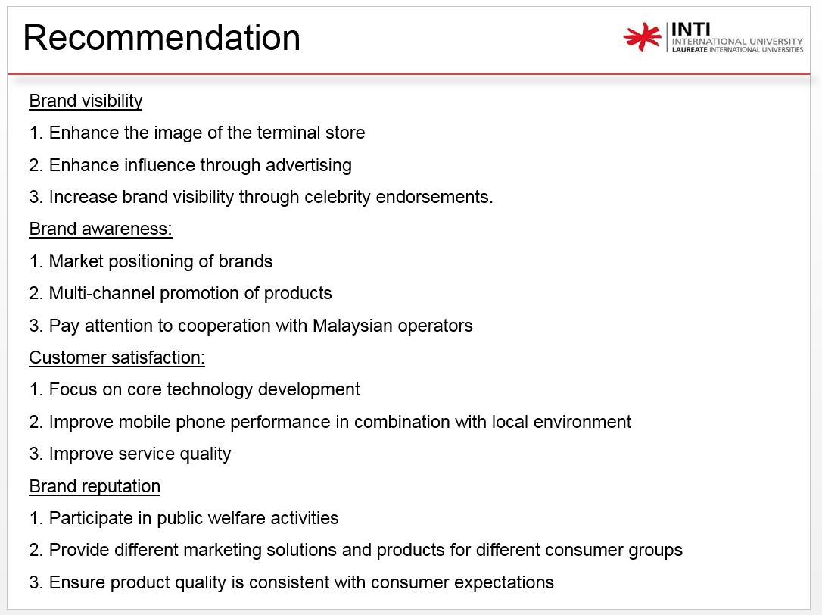
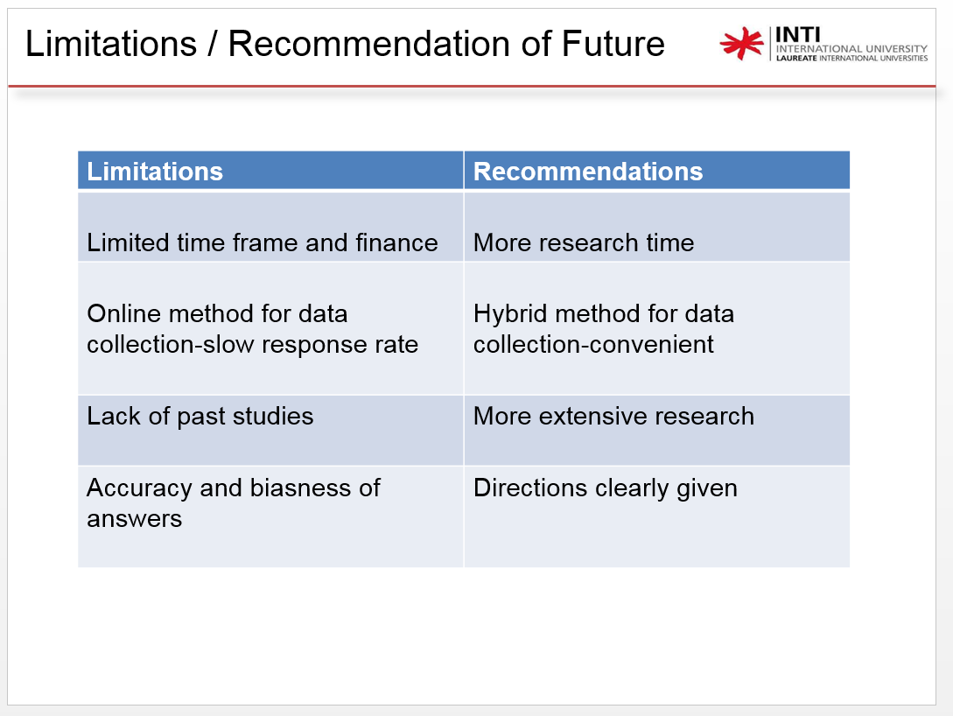
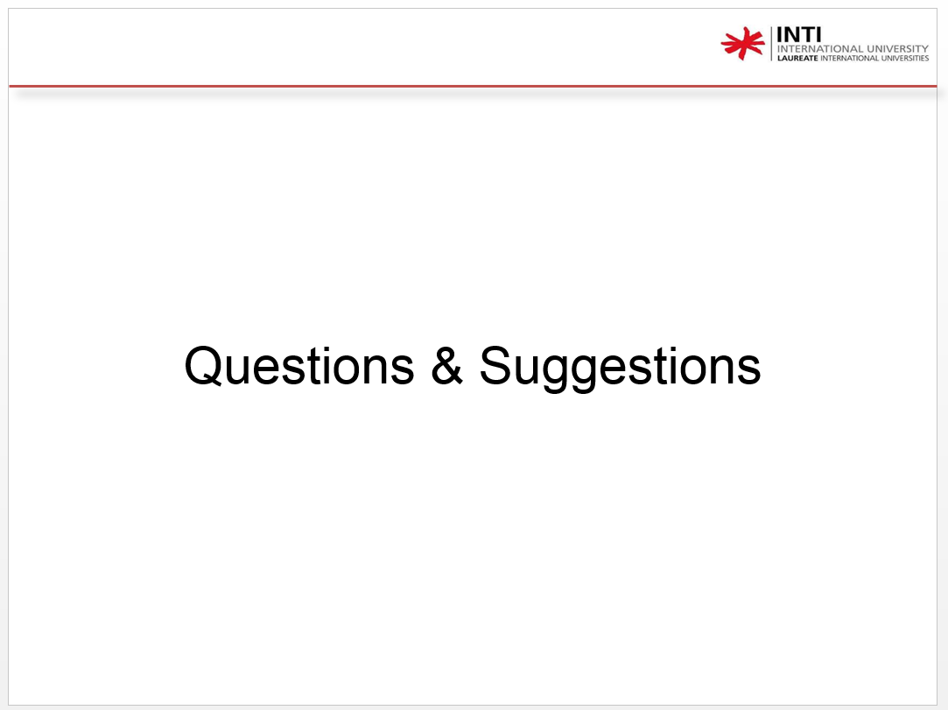

Appendix 6: IRPP
Student Name & ID No. | WANGSITAO  I18015905
Broad Area | Marketing
Concise Title | Analysis of the International Competitiveness of Chinese Mobile Phone Enterprises in the Malaysian Market
Problem Definition | 1. China's mobile phone enterprises are developing faster and faster, and international competitiveness is getting stronger. However, China's smartphone market has been growing slowly in recent years. By 2017, smartphone shipments in the Chinese market have even declined.  2. In this context, how will Chinese mobile phone companies maintain rapid growth? Chinese mobile phone companies have begun to accelerate their pace of entering the international market and seek new growth points overseas.  3. China's mobile phone companies currently use developed countries such as Europe, the United States, Japan and South Korea as well as developing countries in India, the United Arab Emirates and Southeast Asia as their core markets.  4. Chinese mobile phone companies have begun to pay attention to the Malaysian market. Huawei, OPPO, ZTE, vivo, Meizu, HTC, Lenovo and other Chinese mobile phone companies have entered the Malaysian market, but Chinese mobile phone companies still occupy less market share in Malaysia. In the process of competition between the Malaysian market and mobile phone companies in various countries, a correct and comprehensive understanding of the international competitiveness of enterprises is the basis for the development and growth of Chinese mobile phone companies in the Malaysian market. Through the analysis of the international competitiveness of Chinese mobile phone companies, it is necessary to find a way to restrict Chinese mobile phone companies. The factors of development further propose countermeasures in a targeted manner.
Research Objective | Overall research objectives:  Exploring the international competitiveness of Chinese mobile phone companies in the Malaysian market  The sub objectives:  1. To determine the factors influencing the purchase intention of mobile phone buyers.  2. To determine the most significant factor which influence the customer purchase intention.
Scope of study | The research focus of this study is to analyze the factors affecting the international competitiveness of Chinese mobile phone companies in the Malaysian market. The geographical area of the study is Malaysia, and the focus of the research is on Malaysian consumers. The variable setting of this study is based on the perspective of Malaysian consumers, collecting relevant data through questionnaires, and finally analyzing and summarizing the data.
Significance of the Research | 1.Academic Contribution  This article is the first time to select Chinese mobile phone companies in the Malaysian market as a research object to analyze their international competitiveness. By exploring the factors affecting the purchase intention of mobile phone consumers in Malaysia, and based on field research in Malaysia, this paper has a high academic reference. In terms of research methods, this paper narrows the international market to the national market, and conducts in-depth research on the factors affecting the purchase bias of mobile phone consumers through field research in Kuala Lumpur, Malaysia, this paper has certain expansion and complementation in content and system.  2.Corporate Contribution  The research in this paper also has certain practical significance. In the context of the saturation of China's smartphone market, Malaysia's smartphone penetration rate is low, and Malaysian consumers have strong spending power, so the Malaysian mobile phone market has great potential. The presence in the Malaysian mobile phone market will help solve the problem of weak growth in China's mobile phone companies. This paper has certain reference value for Chinese mobile phone companies that have entered the Malaysian market and Chinese mobile phone companies that are ready to enter Malaysia. When competing in the Malaysian market, a correct and comprehensive understanding of the international competitiveness of enterprises is the basis for the growth and development of Chinese mobile phone companies in the Malaysian market.
Literature Review | Literature Review  Variable Example of Reviewed Literature  customer purchase intention (DV) Paul Krugman (1996), Howard and Sheth (1969), Yang Ying and Zhang Li (2007), Aaker (1991), Feld-wick (1996) ,Chernatony and McDonald (2003), Keller (1993, 2003).  Brand Visibility (IV) Keller (1993), Keller (2003), Schuiling and Kapferer (2004)  Brand Awareness (IV) Anderson (1983), Keller (2003), Agarwal and Rao (1996),Mackay (2001),Pappu et al., (2005).  Consumer satisfaction (IV) Cardozo (1965), Yang Ying and Zhang li (2007).  Brand reputation (IV) Prahalad and British scholar Hamel (1990), Zhang Jinchang (2001), Wang Wei (2004), Zhou Xing and Fu Ying (2000).
Research Methodology | Population & Sample:  A random, representative of 400 residents should be drawn from the population of 1,589,000 population in Kuala Lumpur. (Krejcie＆Morgan)  Data collection method:  The respondents are Kuala Lumpur residents and this study will use online questionnaire.  Analysis of the Results /Statistical Analysis:  This study will adopt Validity and Reliability test, Descriptive; Correlation and Regression analysis.  The questionnaire consist of 4 demographic questions and 20 questions using 4 independent variable and 4 question using dependent variable.

Appendix 7: Turnitin report
