
Research Proposal
Title: Employee Empowerment: A study on Empowerment of Civil Servant in Bangladesh on Gender.

Chand Sitara Binta Islam
MBA (Dual)
Student id: I18015165
Course code- MGT7998
Course name-MBA PROJECT
Broad Area: Human Resource

Module Leader:
Dr. Sukjeet Kaur Sandhu
LECTURER
Faculty of Business, Communication & Law
INTI International University

Faculty of Business, Communication & Law
Inti International University
Nilai, 2019

STUDENT DECLARATION
I, Chand Sitara Binta Islam, hereby declare that the presented report of MBA Project titled “Employee Empowerment: A Study on Empowerment of Civil Servant in Bangladesh on Gender” is uniquely prepared by me after the completion of three/four months’ work at INTI International University, Nilai, Malaysia.
I also confirm that the report is only prepared for my academic requirement, not for any other purpose. It might not be used with the interest of the opposite party of the University.
…………………………….
CHAND SITARA BINTA ISLAM
ID-i18015165
MBA (Dual)
Faculty of Business, Communications & Law
INTI International University
Persiaran Perdana BBN, Putra Nilai
71800 Nilai, Negeri Sembilan
Malaysia

Abstract
Bangladesh is a developing country which achieved independence from Pakistan in 1971. Since independence, the journey of Bangladesh Civil Service (BCS), this commences a new horizon in the development of Bangladesh. Equal participation of both genders in the decision-making process is essential for the development of a country. In the last three decades, the government of Bangladesh accelerated both the gender participation in the development process, but in the case of employee empowerment, there are some problems in the various aspects of the BCS and at the policy level of the government. This study explores the implementation of employee empowerment based on gender attempts to highlight various aspects such as power delegation, leadership style, and organizational culture of Bangladesh Civil Service.
The Ministry of Public Administration, Peoples’ Republic of Bangladesh and Office of the Deputy Commissioner, Dhaka, Bangladesh will complete the online survey of 300 respondents of the executive level employees through the study of Quantitative Method. This study will adopt descriptive and SPSS statistical analysis. Study ‘Pilot Test’ will be accomplished by surveying 40 high officials from the Bangladesh High Commission Office in Malaysia before collecting the original data.
The findings of the study will help administrator, community, scholar, politically influential and policymaker for further designing prospect sustainable development strategy and program.

Dedication
To special memory of my dear parents: Departed mother (May Allah bless her) Momotaz-Ara-Begum and father Md. Saiful Islam.

Acknowledgement
I extend my heartfelt gratitude and appreciation to the University of Hertfordshire, UK, and INTI International University, Nilai, Malaysia, for offering me the opportunity to pursue the MBA (dual) Project.
I would like to thank my distinguished supervisor, DR. SUKJEET KAUR SANDHU, for the guidance in completing the project on a limited scale, because it was difficult to finish without that help. I would also like to prolong my good wishes in this landmark work to DR. ABIDAH for her participation. Thanks to DR. SYRIAC NEILKUNNEL DEVASIA for his input in the research work as well.
Many thanks for the unwavering support of my companion Mr. Hussam, Hassib, Dong Ying Ying and Warren for everyday support in research work.

List of Abbreviation:
ADP= Annual Development Program
BCS=Bangladesh Civil Service
CEDAW=Convention for the Elimination of all forms of Discrimination against Women
CSP=Civil Service of Pakistan
DC=Deputy Commissioner
DM=District Magistrate
EE= Employee Empowerment
IRPP=Initial Research Proposal
ICS=Indian Civil Service
LS= Leadership Style
MOPA=Ministry of Public Administration
PARC=Public Administration Reform Commission
PACC= Public Administration Computer Centre
PD= Power Delegation
StdDev= Standard Deviation
UN=United Nations
UNO=Upazilla Nirbahi Officer
SPSS=Statistical Package for the Social Sciences

Table of Contents
Dedication 4
Acknowledgement 5
CHAPTER 1: INTRODUCTION 12
1.1 Background 12
1.1.1 History of BCS 12
1.2 Problem Statement 14
1.3 Research Objectives 15
1.4 Research Questions 15
1.5 Significance of the Study 15
1.6 Limitations of the study 15
1.7 Scope of the Study 16
1.8 Ethical consideration 16
CHAPTER 2-LITERATURE REVIEW 17
2.1 Introduction 17
2.2 Operational Definitions 17
2.2.1 Employee empowerment 17
2.2.2 Power delegation 17
2.2.3 Leadership Style 17
2.2.4 Organizational Culture 18
2.3 Employee Empowerment 18
2.3.1 Empowerment practice 19
2.3.2 Gender disparity 19
2.3.4 Employee involvement & gender participation 19
2.3.5 Gender Differences and Employee Empowerment Practices 20
2.4 Delegation of Power 20
2.4.1 Relationship between power delegation and employee empowerment 21
2.4.2 Relationship between power delegation and employee empowerment of BCS 21
2.5 Leadership style 23
2.5.1 Different leadership style 23
2.5.1.1 Transformational Leadership Style 23
2.5.1.2 Transactional Leadership Style 24
2.5.1.3 Laissez Faire Leadership Style 24
2.5.1.4 Democratic Leadership style 24
2.5.1.5 Autocratic Leadership style 24
2.5.1.6 Ethical Leadership 25
2.5.2 Leadership style of employee empowerment 25
2.5.3 Leadership style of employee empowerment in Bangladesh Civil Service 26
2.6 Organizational Culture 27
2.6.1 Definition of Organizational Culture 27
2.6.2 Relationship between Organizational Culture and employee empowerment 28
2.6.3 Organizational Culture of Bangladesh Civil Service 29
2.7 Theories or key concept 30
2.7.1 Kanter’s Theory of Structural Empowerment 30
2.7.2 Social Role Theory 30
2.8 Umbrella perspective 31
2.9 Research Hypotheses 31
2.9.1 Hypothesis (H1): Is there any significant relation between power delegation and employee empowerment on gender. 31
2.9.2 Hypothesis (H2): Is there any significant relation between leadership style and employee empowerment on gender. 33
2.9.3 Hypothesis (H3): Is there any significant relation between organizational culture and employee empowerment on gender. 35
CHAPTER 3- REASEARCH METHODOLOGY 37
3.1 Conceptual framework 37
3.2 Research Design 37
3.3 Research Methodology 38
3.4 Measuring Instrument 38
Table 1: 5-point ‘Likert Scale’ 39
3.5 Validity and Reliability Tests and Analysis 39
3.5.1 Study Population 39
a) Sample Population 39
Table-2: Clarification of study population: (Ministry level) 39
Table-3: Description of study population: (District level) 40
b) Unit of Analysis 40
c) Sampling Techniques 41
3.6 Data Collection and Analysis Methods 41
3.7 Research Area: 42
3.8 Gantt chart 42
CHAPTER 4: DATA ANALYSIS, REPRESENTATION &INTERPRETATION 44
4.1 Introduction 44
4.2 Demographic Details 44
4.2.1 Present Service Status of Civil Servant in Bangladesh 45
4.2.2 Gender 46
4.2.3Age group 46
4.2.4 Marital Status 47
4.2.5 Grade-9(Duration of Service) 47
4.2.6 Current Position (Duration of Service) 48
4.2.7. Crosstabs between Present Service Position & Gender 48
Table 4.2.7 Crosstabs between Present Service & Gender 48
4.3. Pilot Test 49
4.3.1Factor Analysis 49
4.3.1a. Dependent Variable: Gender on Employee Empowerment 49
4.3.1(a. i) Factor loading 50
4.3.1(a.ii) Variance Explained and Eigenvalues Analysis 50
4.3.1b. Independent variables: (Power Delegation, Leadership style and Organizational Culture) 51
4.3.1(b. i) Factor loading 52
4.3.1 (b. ii) Variance Explained and Eigenvalues Analysis 53
4.4 Reliability Test 53
4.4.1 Gender on Employee Empowerment (DV) 54
4.4.2Power Delegation (IV) 55
4.4.3Leadership Style (IV) 55
4.4.4 Organizational Culture (IV) 56
4.5 Preliminary Test 57
4.5.1 Factor Analysis: Both Dependent Variable& Independent Variables 57
4.5.1 (a) Factor Loading DV & IV 58
4.5.1 (b) Variance Explained & Eigenvalues Analysis (DV & IV) 59
4.6 Reliability Test: Both DV & IVs 59
4.7 Correlation Matrix 60
4.8 Hypothesis Test 61
4.8.1 Multiple Linear Regression Model 61
4.8.2 ANOVA 63
4.8.3 Estimated Model Coefficient 63
4.9 Hypothesis Test Results 64
CHAPTER 5: FINDINGS, RECOMMENDATIONS & CONCLUSION 65
5.1 Introduction 65
5.2 Findings 65
5.3 Recommendation 66
5.3.1 For Government 67
5.3.2 For Academic 67
5.4 Conclusion 68
5.5 Suggestions for Future Research 68
Reference 70
Appendix 80

List of Table Page No.
Table 1: 5-point ‘Likert Scale’……………………………………………………………………..39
Table-2: Clarification of study population: (Ministry level)………………………...……………..39
Table-3: Description of study population: (District level)………………………………………….40
Table 4: Gantt chart. Source: Shaped by researcher…………………………………….………….42
Table: 4.2.1Present Service Status of Civil Servant in Bangladesh…………………….…………..45
Table 4.3.1(a) Factor Analysis: Dependent Variable: Gender on Employee Empowerment………49
Table 4.3.1(a. i) Factor loading of Dependent variable (EE)……………………………………….50
Table 4.3.1(a. ii) Variance Explained and Eigenvalues Analysis of DV………………….………...50
Table 4.3.1b. Factor Analysis of IVs…………………………………………………………..……51
Table 4.3.1 (b.i) Factor loading of Independent Variable (PD, OC, LS)……………………...…….52
Table 4.3.1 (b.ii) Variance Explained and Eigenvalues Analysis of IVs………………….………...53
Table 4.4.1 Reliability Test of Gender on Employee Empowerment (DV)…………………..……..54
Table 4.4 1(a) Item Total Statistics for DV………………………………………………………….54
Table 4.4.2 Reliability Test of Power Delegation (IV) ………………………………………….…..55
Table 4.4.2 (a) Item- Total Statistics of Power Delegation (IV)………………………………….…55
Table 4.4.3 Reliability Test of Leadership Style (IV)………………………………………….…….55
Table 4.4.3 (a) Item-Total Statistics of Leadership Style (IV)……………………………….……..56
Table 4.4.4 Reliability test of Organizational Culture (IV)…………………………………..……..56
Table 4.4.4(a) Item-Total Statistics of Organizational Culture (IV)……………………...…………57
Table 4.5.1 Factor Analysis: Both Dependent Variable & Independent Variables…………………57
Table 4.5.1(a) Factor Loading of both DV & IVs…………………………………………………..58
Table 4.5.1(b) Variance Explained & Eigenvalues Analysis (DV & IV)……………………….….59
Table 4.6 Reliability Test: Both DV & IVs…………………………………………………………59
Table 4.7 Correlation Matrix…………………………………………………………….…….........61
Table 4.8.1Model Summary of Multiple Linear Regression Model…………….…………………..62
Table 4.8.2 ANOVA Table……………………………………………………………….…………63
Table 4.8.3 Estimated Model Coefficient……………………………………………………………63
Table 4.9 Hypothesis Test result…………………………………………………………………….64
Table-5: Regional Gender Difference (2006-2015). Source: (Bidisha, 2017)………………………82
Table-6: Gender participation of Bangladesh Civil Service from 1999-2011.
Source: (Sultana and Ferdous, 2017)……………………………………………………………..…83

List of Figure Page No.
Figure 3.1 Conceptual framework (Theory of Structural Empowerment)…………………………37
Figure 1: Location of research area. Source: www.mopa.gov.bd & Google.com, 2019…………..42
Figure 4.2.2 Gender (Male & Female)……………………………………………………..……...46
Figure 4.2.3 Age Group of Respondents…………………………………..………………………46
Figure 4.2.4 Marital Status of Respondents………………………………………………………..47
Figure 4.2.5 Grade-9 (Duration of Service)………………………………………………..………47
Figure 4.2.6 Current Position (Duration of Service)………………………..……………………..48
Table 4.2.7 Crosstabs between Present Service & Gender…………………………………………48
Figure 2: Hierarchy of Central Government Secretariat. Source: www.mopa.gov.bd.....................80
Figure-3: Existing structure of field administration of Bangladesh.
Source: (Google.com, 2019)………………………………………………….…………………….80
Figure4: Hierarchy of Field Administration in Bangladesh.
Source: www.mopa.gov.bd.............................................................................................................. 81
Figure 5: Administrative units of Bangladesh, Source: (Google.com, 2019)…………………........81
Figure 6: Decision making level of both genders of BCS. Source: (Labony, 2013)…………….....81
Figure 7: Kanter’s theory of empowerment. Source: (Google.com, 2019)…………………..…….82
Figure-8: Social Role Theory of Gender. Source: (Google.com, 2019)……………………………82
Figure-9: Regional Gender Difference (2006-2015). Source: (Bidisha, 2017)……………………..83

CHAPTER 1: INTRODUCTION

1.1 Background
The role of employee empowerment is very important for the organizational successes and simplification of services in the competitive world. In the case of employee empowerment, gender contribution is equally important for the use of talent potentiality. For any government, civil servants are the key maker and the economic development, long-term sustainable goals ensured by the balanced participation of both genders in the civil service (Hazra and Aminuzzaman, 2018). United Nations (2011) emphasize- a) gender as masculinity and femininity- eminence and individuality that social order assigns to both sex, b) it is the common behavior and prospects related to sex and the links amid men and women, and c) gender decides the estimation, permissible and appreciation for both sex in a specified situation (Dlanjwa, 2018). Gender is the key component in development; different elements like religious, economic, cultural, sociological and political roots produced gender differences and each society has created gender differences (Ferdous, 2014). Gender defines staff autonomy and individual empowerment relates to the distribution of more control to work experts where authority is allocated to staff on the basis of certain variables such as citizenship behavior, workplace relationships and so on (Sankar, 2018).
Civil Service is an important institution for enhancing faithful governance which eventually contributes to the socio-economic improvement of a state (Hassan, 2015). Sustainable development is impossible without empowerment employee on gender (Bayeh, 2016).

1.1.1 History of BCS:
Bangladesh Civil Service inborn a civil service that is advanced in British colonial and Pakistan. Bangladesh was associated with the Indian subcontinent. Indian Civil Service (ICS) was male-dominated. Even until 1935 there was no female Civil Servant in ICS. The Civil Service of Pakistan (CSP) was followed by the trend of ICS. Bangladesh was independent in 1971 from Pakistan but there was gender depreciation in the Civil Service (Sultana and Ferdous, 2017). Noted that, Bangladesh regards as a developing country; its target to be ‘Middle Income’ country by 2021 and ‘High Income’ country in 2050 (Sarker, Bingxin, Sultana and Prodhan, 2017).
Since the formation of the Bangladesh Civil Service in 1971 (see appendix figure-2), the gender issue is more relevant to the empowerment concept and the formation of employment and scope within Bangladesh Civil Service (BCS) are approximately unrepresentative of the demographic phenomena in the country (Khair, Haque and Mukta, 2017).
The government website (www.mopa.gov.bd) in 2019 represents there are only 6 (out of 68) women secretary post, none of the Divisional Commissioner or Additional Divisional Commissioner (highest level post of field administration), and 9 (out of 64) Deputy Commissioner & District Magistrate position, and 115 (out of 457) Upozilla Nirbahi Officer/Sub-district head (Pmis.mopa.gov.bd, 2019).
International frameworks also hold up gender equality among organizations by the empowerment of employees. Bangladesh ratified CEDAW in 1984. CEDAW recommended (2004) to Adopt proactive women's involvement strategies at all levels. Beijing Platform’s key assignment is to aid government-extensive mainstreaming of a gender-equality perspective in all policy areas (Kwesiga, 2018). Section 33 of the National Women Policy (2011) of Bangladesh mentions that more women will be appointed to administrative, policy-making and constitutional posts and those women will be nominated to various international and UN posts and assignments. PARC Report (2000) highlights, massive improvements in working conditions are needed to attract women to the civil service. Special programs for boosting gender equality and equity have also been considered as crosscutting concern within the Constitution of Bangladesh and Article 29(i), National Policy on Women’s Development, Poverty Reduction Strategy Paper and Annual Development Programs, but empirically those simply reflect the base actuality, which reflects that those official statements and techniques stay mere rhetoric, with little change in mainstreaming gender equality (Khairet. al, 2017).
Rai and Singh (1979) stated that the civil service is a body of impartial and expert specialists in administration, which dedicated to serving without liking to its individual takings or without connection with group benefit or party-political points of interest (Ferdous, 2014). But it is seen in the light of the above data that the gender difference in the employee empowerment of BCS is visible. While there are a substantial number of female officers in the civil service entry stage, the proportionality rate of particular gender at the greater stage or level of decision-making is smaller (see Appendix figure-6).
Therefore, the purpose of the said study is to find out the gender disparity of employee empowerment in Bangladesh Civil Service.
Keywords: Employee Empowerment, Civil Servant, Bangladesh, Gender, Power Delegation, Leadership Style, Organizational Culture.

1.2 Problem Statement
Empowerment is the decision-making approaches accepted by means of organization to enhance productivity, increase stakeholder’s fulfillment, and exaggerate competitive benefits as well as well-designed empowerment practices encourage personnel, increasing job pleasure, forward organization performance through employees’ participation, abilities, and freedom (NJOKI, 2014).
In the colonial system decision making and administrative position is considered on gender basis in the civil service (Ferdous, 2014). Although ILO Convention No. 100 (1951) emphasis on the reduction of discrimination and increasing efficiency for equal opportunities at the workplace and Article 28 & 29(3) (c) Constitution of Peoples’ Republic of the Bangladesh guarantee non-discrimination and gender equality particularly in case of employment (Khairet a., 2017). After the development of Bangladesh Civil Service (BCS) government has taken initiatives intend to empower the employees but the neutrality of gender is still absent. Since the beginning of BCS from 1971, the first female officer entry started in 1982, which is a major gender gap. At present, the number of female employees in the civil service increased, but gender disparity is evident in the higher level of decision-making process. Even disparity of workplace environment, gender-oriented organizational performance, talent depreciation, differentiation of views and weak policy of BCS has questioned its role. Gender disparity of empowerment creates inefficiency of management and overall performance of an employee.
Consequently, a comprehensive study is required to identify the existing disparity of gender in employee empowerment of BCS.

1.3 Research Objectives
- To investigate the relationship between power delegation and employee empowerment of Bangladesh civil service based on gender.
- To investigate the relationship between leadership style and employee empowerment in Bangladesh Civil Service.
- To investigate the relationship between organizational culture and employee empowerment of Bangladesh Civil Service.

1.4 Research Questions
- Is there any relationship between power delegation and employee empowerment in Bangladesh Civil Service based on gender?
- Is there any relationship between leadership styles and employee empowerment in Bangladesh Civil Service?
- Is there any relationship between organizational culture and employee empowerment in Bangladesh Civil Service?

1.5 Significance of the Study
- For future researchers and scholar, the findings of this study would be vital because they would act as a contribute reference structure besides suggesting areas for further research whether they can research on.
- It will link the knowledge gap of government plan and actuality to guarantee gender equality in Bangladesh civil service.
- When employee empowerment is implemented based on balanced gender, the productivity of government officials will increase greatly by utilizing full-fledged talent.

1.6 Limitations of the study
Only one government office has been selected as the field of research in this study; as a result, due to lack of time, it was not possible to know the other government office's perception. The researcher moreover encountered problems in eliciting statistics from the respondents as the facts required become a situation to regions of perceptions, which couldn't be correctly quantified and proven objectively. The use of Likert scale best gave the respondents a few alternatives which they will not have completely agreed, while, a few respondents may not have liked to be extremist in the select and consequently remained slight. Given the small sample (70 respondents), the confidence and consequently the result projections of the study could have been compromised, which therefore might have implied generalizing positive instance.

1.7 Scope of the Study
This study was designed to investigate the problem of employee empowerment of Bangladesh civil service particularly focusing on the gender issue.The study area is Bangladesh because the gender difference in civil service of Bangladesh is visible.The civil servant of Bangladesh is the sample focus. Unit of analysis focus on the Office of the Deputy Commissioner, Dhaka, Bangladesh the research methodology approach is quantitative and analysis technique is surveys based.

1.8 Ethical consideration
Ethics contains moral values such as right or wrong which control individuals or groups behavior. Researchers have the responsibility to adhere to the high ethical obligation for ensuring research professionalism, not harmful of psychological, financial and social security, not the influence of respondent’s decision and the information are not brought disregard.
This study will be directed by the ethical considerations on research with Civil Servants participants set out by the Ministry of Public Administration and Office of the Deputy Commissioner, Dhaka district, Bangladesh. The participants will be informed about the research program in detail before asking for consent to take part. Aims and objectives of the research including data collection process will be explained to the participants. The participants will be informed that they could withdraw from the research at any time without questions being asked.

CHAPTER 2-LITERATURE REVIEW

2.1 Introduction:
This chapter reviewed the information from different researchers who have accomplished studies on employee opinion and empowerment performs. Resources were collected from different sources which might be carefully associated with the topic.

2.2 Operational Definitions

2.2.1 Employee empowerment:
In organizations employees are main focal point (Liu, Gong,andZhouet al.,2017).Employee empowerment is one of the efficient methods for enhancing staff efficiency and standardizing their personal and social capabilities to attain organizational goals. Empowerment is a method in which people and groups ' capacities will be helped to enhance and execute sustainable growth through development and impact expansion (IvanovaandScheve,2019).

2.2.2 Power delegation:
Power Delegation is crucial because it speeds up organizational results like decision precedent job satisfaction, team success. The delegation also recognized the efficient way of enhancing organizational achievement results for both gender involvement and empowerment (Amundsen, and Martinsen, 2014). By mutual power produces a feeling of control that a person influenced by the organization as if he or she (gendered) (Haselhuhn,Wong and Ormiston, 2017).

2.2.3 Leadership Style:
Tannenbaum and Schmidt suggest that, efficient leadership functions are based on the governmental agency's circumstance, setting, and maturation. Goleman has indicated that an efficient leader will tailor management features or features to the framework in that he or she works (Spohn, 2018).

2.2.4 Organizational Culture:
Organizational culture is the mutual impact of employees’ in an organization shared beliefs, attitudes, and principles and these standards control how executives operate and serve people, how they collaborate with others, either they feel inspired to overcome obstacles, whether they are genuinely part of the general expedition of the organization (Shao, 2019).

Philips Lighting, for instance, performed a series of workshops around the globe to assist their business define their traditional present and future values in order to create alignment with a fresh, more creative culture. The firm developed a joint manifesto around four fresh cultural principles (Pioneering, Caring, Fast, and External Focus) to assist the business empowers teams, innovate quickly and shed light on them (Morcos, 2018).

2.3 Employee Empowerment:
“Empowerment is a continuum process to change the distribution of power both in interpersonal relations and in institutions throughout society” (Khan, 2014). Empowerment signifies giving employees’ discretion over the positive job- related actions. It defines employee empowerment as “an exchange of power” from the organization to the person; the empowerment is not most effective having the liberty to act but also having a higher amount of responsibility and duty. This indicates that control must empower employees so they can be motivated, devoted, satisfied and assist the organization in reaching its objectives (Kumarand Kumar, 2017).

Employee empowerment categorizes two perspectives- Psychological and Managerial: Psychological perspective indicates that employee empowerment is a state of mind wherein a person believes strongly in his or her ability to execute job inherently. Job enthusiasm emphasizes four-dimensional motivational assemble composed of cognitions like-meaning, competence, self-willpower, and effect; managerial performance geared toward sharing data, assets, rewards, and authority with lower degree personnel (Kimand Fernandez, 2017). In Minnow Brook Conference, added the requirement for public sector leaders to allocate power more consistently within hierarchies and inspire employee involvement in decision making (Degago, 2014). By utilization of empowerment, it just not only makes the effectual assessments that decide by the accurate people in the organization but also supports the mechanism process. The lack of team results is harmful to the achievement of an organization's performance aims and goals. In certain instances, actions are at the highest level layers of management, often swirling the individual (Kimand Fernandez, 2017).

2.3.1 Empowerment practice:
There are diverse empowerment practices that management in organizations can adapt to empower their employees. Employees are empowered by referring them as to heighten an experience of self-efficacy in the employees; these protected control practices at the organizational phase–design and selection of instruction packages which make certain needful technical abilities are provided and attitudes broaden policies and cultures that inspire self-determination, collaboration, opposition, high performance standards, non-discrimination (NJOKI, 2014).

2.3.2 Gender disparity:
Gender-precise occupational segregation has seemed like a solid and inflexible phenomenon that exits in traditional in addition to societies (Krishnappa, 2013). The aspect of society is not gender neutral and social notions have played a vital part in shaping the position of gender. Social norms and hierarchies deeply embedded within society incapacitate the supreme guidelines and plan to improve gender equality. Several socially constructed ideologies regularly justify men’s supremacy over women based on faith, tradition, customs, and sex. Men had been predominantly socialized to exercise preponderant strength in almost every area in their lives and people around them (Dlanjwa, 2018).

2.3.4 Employee involvement & gender participation:
In Bangladesh, over the past decades, women representation and participation in the decision-making level are not excellent. Women’s lively participation in selection making is not handiest critical for ensuring equality and justice for themselves as citizens however additionally in order that the establishments they may be hired in becoming extra responsive and able to address the desires of women in addition to men (Sultanand Jahan, 2016).

2.3.5 Gender Differences and Employee Empowerment Practices
Employment guidelines are formulated to provide a policy framework that may enhance the potential of economies to create jobs, facilitating activity-creating approaches and optimizing their ability for employment increase. The rules are also there to offer supportive measures for each gender to collect important information and talents to absolutely take part in their monetary lives. To deal with the gender discrimination confronted within the organization, human rights, and social justice needs a proper and rational purpose (NJOKI, 2014).

2.4 Delegation of Power
Delegation of power defined as the exchange of power to settle on choices and complete explicit events (Aburuman, 2016). Delegation of Authority where bosses give subordinates a piece of their obligations subsequent to furnishing them with the suitable preparing, giving them the vital capacity to accomplish these obligations, and conveying the duty of achieving these obligations effectively (Abuzaid, 2018).

Delegation makes manager subordinates relationship. It is an authoritative procedure which empowers the sharing obligation, move of power among superior and subordinate. It enables subordinate to make responsibilities, use assets and complete action dispensed to him (Sev, 2017). Delegation does not imply surrender of authority by the higher-level manager to the subordinate. It only means transfer of certain level of authority to subordinates to discharge responsibilities. The manager who delegated the authority is still answerable and responsible to the tasks being executed should anything go wrong (Obi, Okpara and Lugard, 2018).

2.4.1 Relationship between power delegation and employee empowerment:
Delegation of power is the key of empowerment in lower staffs and empowers them to make decision which prompts improve the feeling of pride, confidence and duty of the workforce. Employee empowerment includes providing proper information; power and independence to ensure quick services and protect employees’ dissatisfaction as well as its empowered organization’s lower staffs to make skilled judgment (Ukil, 2016).
Empowerment of executives relates to the method of delegating authority and accountability from the higher to the reduced levels of personnel within an company, in the force that allows them to create choices (Abuzaid, 2018). Empowerment involves enhancing employees ' work duties and responsibilities by providing them independence and appropriate decision-making authority (Abou, Elnaga and Imran, 2014).
Delegation is firmly linked with empowerment. Empowerment is a persuasive idea connected with self-value. Individuals understanding empowerment when they feel liable of significant responsible jobs as well as empowered people are competent and make works diversified. Earlier it’s thought that leader behavior was like delegation; but recent its emphasis on psychological states experienced by employees (Maynard, Luciano and D'Innocenzoet al.,2014).
When authority is delegated to workforce, they faced many confronts and that confronts tackled autonomously. To solve the complex job, it requires high level competency and experience; therefore, delegation composes subordinates’ activities is meaningful and they are accountable for their work. Delegation enables subordinates to exercise self-direction and control, provides employees with meaning, perceptions of self-efficacy and self-determination and the perception that they make an impact, all of which have been identified as key ingredients of empowerment (Zhang, Qian, and Wang et al., 2017).

2.4.2 Relationship between power delegation and employee empowerment of BCS
Administration in Bangladesh is truly a Pro-British background where the legislature has been not able or having hard time to empower the management (Hossain, 2017). Administration in a developing nation like Bangladesh holds immense power, since it grips an assortment of societal issues and dilemma (Islam, 2016).
Administrative system of Bangladesh is very much centralized. The central government does not allow distributing authority among other officials as they are foremost contestant of the supremacy (Haque and Mohammad, 2013). Public administration in Bangladesh remains generally incorporated, unnecessarily dependent on chain of command and various levels of managerial decision. The government employees of Bangladesh were never concerned in delegating executive authority and accountability to the administration (Islam, 2016)
Centralized authority influences the total administrative decision-making mechanism; all are subject to unwillingness to reorganization, uninvited changing environment. Centralized authority generates defective perform which made the bureaucracy of Bangladesh very much authoritative. Very few initiatives have been taken at different period to distribute the authority, but the chosen outcome cannot achieve. Therefore, the form of insensitivity stretches is not granting within the organization. Due to centralized power of government public servant always enjoying the power and unwilling to administrative reforms (Rahman, 2018). Employees’ stumpy trust in the organization of Bangladesh is a consequence of colonial inheritance, which prompts centralization of power (Islam, 2016).
It concerns about not having the delegated power by mid-level and local level public servants. Most administrative professional recommends maximizing the use of knowledge rather than building power. However, public servants concurrently obtain more authority and abuse their power to absolutely expand own interest from the citizens (Hossain, 2017).
Bangladesh is exemplified as hierarchical culture in which affiliation depends on position, status, rank, and sex, and the connection among senior and junior is alluded to as "benefactor customer" relationship. In common administration, seniors give requests and young officers are relied upon to complete requests. While employees’ dealings are generally bound to service, between administration connections are described by contention, factionalism, and absence of coordination. The officials are frequently more dedicated to their unit interest than the achievement of organizational trustworthy objectives (Islam, 2016).

2.5 Leadership style:
Leadership style is the prominent part of management and industrial psychology related with human resource outcomes (Kesting, Ulhoi and Song et al., 2016).A leader is one individual who choose, provides, prepares, and impacts on one or more admires who have various endowments, capacities, and abilities and centers the admires to the organization's main goal and targets causing the admires to eagerly and excitedly use otherworldly, passionate, and physical vitality in a purposefully composed exertion to accomplish the hierarchical mission and destinations(Gandolfi and Stone, 2018).
Leadership empowersorganizations more dynamic and beneficial, but the accomplishment relies upon the style of the leader and the ensuing condition made for staffs to purpose well. This leadership style displayed by administrators to an enormous impacts valuable administrative results like low workforce turnover, decreased absence, consumer loyalty, and executive usefulness (Asrar-ul-Haq and Kuchinke, 2016).

2.5.1 Different leadership style:
Diverse leadership styles have various results with straight or insincere impact on the workforce conduct and mentality inside the business (Islam, Jantan and Rahman et al., 2018).

2.5.1.1 Transformational Leadership Style:
Transformational leader works with their employees or groups to distinguish the essential changes and construct a dream. Leaders’ job is to control them through the progressions by propelling and performing the adjustments couple with the devoted individuals from the various congregations (Rosenbach, 2018). This leadership helps staffs change their convictions and mentalities yet by an uplifting procedure, defining specific incorporated objectives that rouse employees to accomplish them through their joined endeavors (Islam et al., 2018). This style is recognized as the imaginative influence where executive in the organization motivate their workforce to surpass certain desires (Doucet, Fredette and Simard et al, 2015). This style positively affects employees’ imagination, inspiration, self-viability, and administrative execution(Vasilagos, Polychroniou, and Maroudas, 2017).

2.5.1.2 Transactional style of leadership:
Transactional leadership style centers the management and employees of the organization. Additionally, it focuses on the individual and performance of the organization. Subsequently, reward system is applied by the leaders for gaining desired performance of the organization as well as uses punishment method for not performing as indicated by desire (Islam et al., 2018).

2.5.1.3 Leadership style of Laissez Faire:

Laissez Faire Leadership style avoids decision making and encounter problems (Northouse, 2018). Leaders who embrace this style do not offer advice to their supporters; so that they discharge their action by empowerment (Skogstad, Aasland and Nielsenet al., 2015). Still leader provides full authority to the supporters to achieve the obligations as indicated by the guidance of the organization (Wong and Giessner, 2018).

2.5.1.4 Democratic Leadership style:
Democratic leadership style concentrates on public and better communication within the cluster. This style is shared with members of the group and the leader is more part of the team. The standards of democratic leadership are easiness, kindness, and participatory support. The philosophical statement of this leadership style is that all citizens are dependable, energetic, liability and hardworking, and confident to promote organizational collaboration, best activities and pleasure (Jones, Jones and Winchester et al., 2016).

2.5.1.5 Autocratic Leadership style:
Autocratic leadership style focuses of the authority of leader and the entire communications with the leader. The leader unusually implemented all decision-makingpowerby deciding plan, actions for accomplishing objectives, employment duty, connections, control of remuneration, and discipline. The fundamental suspicion hidden imperious authority style depends on the reason that, individuals are normally sluggish, offhand, and conniving and leaving the elements of arranging, sorting out, and controlling to subordinate would yield unbeneficial results thus such capacities ought to be cultivated by the pioneer without the association of individuals (Fiaz, Su and Saqib, 2017).

2.5.1.6 Ethical Leadership:
The ethical leader includes specifically practices that are helpful and increased in value by their supporters and they incorporate good standards into certain qualities and convictions in public organizations. Ethical chiefs acutely advance good practices among their subordinates, give moral direction, obviously convey moral benchmarks and give a reasonable feeling of responsibility towards moral and abusive behavior (Qing, Asif and Hussainet al., 2019).

2.5.2 Leadership style of employee empowerment:
Leadership style has extensive relationships in case of employee empowerment. Employee empowerment influences by successful leadership style, proficiency, and enthusiasms (Rawas and Seddawy, 2015). Leadership styles are being used to achieve the goals, objectives, reputation and productivity of organizations. Besides, in addition to increasing the knowledge and skills of the employees through power deletion in leadership style, the responsibilities and duties towards the organization of the employees also amplified.
A leadership style described by the empowerment of supporters by resting trust in them and giving them self-sufficiency to self-deal with their self-set objectives is alluded to as empowering leadership. In such an atmosphere, alluded to as representative inclusion atmosphere, staffs appreciate the self-rule to partake in basic leadership, approach information for their attainment and use and are persuaded to do exercises to accomplish authoritative objectives (Naqshbandi, Tabche and Choudhary, 2019).
Researcher investigates the important function of leadership style which plays in empowering employees. Factors that are determined employees’ interest of empowerment are information and rewards. Employee empowerment mediates its task by giving interest of empowerment is crucial ability of leadership which have a genuine influence on the responses of employees (Menand Stacks, 2013).Leadership offers its workforce with the assets, legal reasons, or opportunity to occupy (Bakker and Demerouti, 2017) authorizing delegation was emphatically related with the expansion of demanding requirements and the expansion of social assets (Thun and Bakker, 2018).
Leader can make an idea among workforce that they are being taken seriously, listened to and valued as members of the organization. Employees’ empowerment has prospective effect on apparent competencies and control which strengthen job satisfaction and real commitment to the organization (Menand Stacks, 2013).

2.5.3 Leadership style of employee empowerment in Bangladesh Civil Service:
Before going to discussion about the leadership practice of employee empowerment in Bangladesh Civil Service (BCS) researcher is explained the bureaucratic/administrative system is.
The government structure of Bangladesh has its heredity in the colonial administration of British India (Rahman and Tosun, 2018). After the independence in 1971, Bangladesh possessed bureaucratic system was highly centralized and elitist (Zafarullah, 2016). In 1975, country adopts the amendments of constitution which denied prudential form, reducing the role of parliament which creates ‘no direct execution authority of lower staffs and always central government control attitude’ (Rahman &Tosun, 2018). Later, the army rule increasingly cultured its long-term execution with the preservation of autocratic ingredient which limited the democratic practice of the country. As a result, bureaucracy welcomed ‘Favored treatment of the political leadership’ and ‘Autocratic regime’.
So, above mentioned information proved that the leadership style of employee empowerment in the civil service of Bangladesh is autocratic phenomenon. Although current bureaucratic system has been characterized politicization attitude (Ahmed, Greenleaf and Sacks, 2014). But the nourishment of democracy in early 1990s (Zafarullah, 2013) enhance a mixture influence of both authoritarian and democratic elements of leadership practice (Rahman and Tosun, 2018). Therefore, current administrative system of employee empowerment boosts up mixed leadership styles like autocratic/authoritarian and democratic moods.

2.6 Organizational Culture:
The organizational culture relates to the situation of the workplace, favorable organizational instructions and help provided to their members. A favorable working condition that involves flexible working hours, enhanced work-life stability, redressed grievance scheme, paid leave, compensation for their family member's medical and educational costs and other financial and non-economic advantages. (Sarkeret al, 2017).
Philosophical interpretation about organizational execution is the capacity of an organization to accomplish set goals of maintaining benefits, a spirited periphery, expanding overall industry, and keeping up long haul survival relies upon utilizing major administrative approaches and activity plans (Oyemomiet al, 2019)
Organizational culture is a well-known idea derived from the field of Human Resource Management (Gayathri, 2013). Employee Empowerment is a rejoinder to the necessities of current organization as well as the accomplishment for empowerment plan which requires organizational culture (Saremi and Nejad, 2013). The consequence of culture in the service and the expansion of employee empowerment are owing to the establishment of globalization. A sound culture which asses its employees and their commitments encourage the empowerment. Competences of the organization and improved employment system required the organizational independence behind empowerment (Gayathri, 2013).

2.6.1 Definition of Organizational Culture:
Organizational culture means an accumulation of shared statement, principles and idea that is replicated in administrative practices and objectives (Shao, 2019).Organizational culture is an outline of mutual basic statement learned by a faction as it solved its difficulty of outer adjustment and internal combination, which has worked healthy enough to be measured legal and therefore, to be taught to new members as the correct way to perceive and feel in relation to those problems (Dhir, 2019).

Organizational culture is an example of essential suppositions concocted, found, or created by a given group as it figures out how to adapt to its issues of outside adjustment and inside amalgamation (Rasmussen and Hall, 2016).Organizational culture is the most conspicuous empowering influence in upgrading information allocation in global ventures (Staadt, 2015).For successful project supervision administrative indecision is an essential tool. With this view, organization should concentrate about the flourishing of its culture and expand suitable infrastructure and competence to handle suspicions.

2.6.2 Relationship between Organizational Culture and employee empowerment:
Organizational culture influences employee empowerment (Zhang and Li, 2016). It shapes the organization and gives an advanced knowledge of multi-faceted managerial mechanism like empowerment. A suitable administrative system promotes employee empowerment process within the organization. Culture provides employees’ sovereignty to generate constructive environment for the improvement of employee empowerment. Diverse cultural system such as transparency, argument, confidence, independence, specialization, legitimacy, team work, and practical knowledge can impact employee empowerment (Pradhan et al., 2017).

The study of employee empowerment and its persuasive mechanism specify that the low indicator of empowerment is because of nonappearance of organizational culture prevailing. Without the utilization of proper administrative culture organization will be confronting decline and diminish the profitability. While an appropriate culture creates more production and it encourages workforce how much exertion and attempt, they ought to do. In this manner, a solid culture can be incentive for the strengthening of employment process (Saremi and Nejad, 2013). A shabby and prohibited culture when facing with a dynamic situation can't well adjust to it and will be inactive for the endeavors that occur to revolve the improvement. Additionally, the meager culture has less effect on staffs; therefore, it causes rise truancy, employees’ lack of responsibility, work turnover, decline pleasure within the organization (Saremi and Nejad, 2013).

2.6.3 Organizational Culture of Bangladesh Civil Service:
Public bureaucracy is the key performer of organizational culture. Due to its everything inescapable forces, organization has been a casualty of regulatory ills, including lethargy, formality, self-sustaining, self-glorification, debasement, absence of lack of bias, departmentalism or realm building, and the present (Islam, R., 2016).

Administration and its related culture have turned into a block or imperative to combination and compelling working of organization in Bangladesh. The objective of the managerial improvement is to give basic services to its natives. Despite, unenthusiastic culture, poor compensation, bureaucratic power, frail lawfulness and legal executive frameworks are not great for the administration to give the accurate support of the resident. The push to convince common administrations of the creating nations, like Bangladesh is probably going to deliver bureaucratic wastefulness as opposed to giving wanted administrations to its native (Hossain, 2017).
The culture of the civil service of Bangladesh is developed with two essential systems. First one is governmental system and the second one is governance system. Diverse institutional situations influence organizational system on which culture of civil service proceed with inexpressive civil servants, weak establishment, and a propensity of centralized power manipulating the entire managerial system. All these things are subject to some awful behavior such as unwillingness to improvement, unwelcome situation of change (Rahman, 2018).
Administrative culture of Bangladesh is developed with politicization, centralization which avoids indecision at most of the times. The central government does not allow disseminating authority among other public servants as they are main contestant of the power (Haque and Mohammad, 2013). On the other hand, administrative elitism is a new culture within executive system of Bangladesh. They consciously counter the execution of major administrative reorganization as they do not desire to give up them relieve zone. They are used to functioning with a structure that they have inherited. Bangladesh is busy with continuing just status quo (Miah, 2013).

2.7 Theories or key concept:

2.7.1 Kanter’s Theory of Structural Empowerment:
Kanter (1977) notes that the employment structure is a crucial link between staff strategy and efficiency in organizations and that alleged entry into power and potential structures reflect the behaviors and ways of employees in service (Dabo and Ndan, 2018). Kanter’s (1993) theory illustrates how the office environment influences employee comfort and organizational competence. Theory indicates two major empowering structures like a) opportunity structure: opportunity refers to potentiality, discover and expand knowledge and talent; b) power structure: power means as the ability to assemble information, maintain and resources to get things done at occupation (showed in Appendix figure-7). Kanter also emphasis on the Information which refers to access to the workplace, organizational acquaintance and technical information for workplace perform. Access to support apprehensions is getting a positive response from leadership, co-worker, an assistant, which reinforce employees’ independent decision-making. Access to resources unease having the goods, objects and time needed to carry out work. Formal and informal power assists access to these empowerment structures. Kanter also states administration in the organization have key duty for contribution employee’s entrée to the authority arrangement that can aid those bear out their job competently (ErikssonandEngström, 2018).
Kanter describes empowering structure which includes support information and informal power that may help the employee empowerment based on gender in Civil Service of Bangladesh.

2.7.2 Social Role Theory:
It is a social psychological theory that relates to gender dissimilarity and resemblance in societal actions. Its key precept is that distinction and comparison rise up in the main from the distribution of men and women into social roles inside their society. Through socialization and the formation of gender roles, the behaviors of women and men usually aid and preserve the dissection of work (EaglyandWood, 2016).
Social role theory explains that gender disparities are flexible due to the fact they are dependent on the social role of the individuals. For instance, an individual can be engaged in some of the duties all of which may influence the behavior of employees in the organization (in Appendix figure-8). Employment positions including leadership positions, for example may also supplant gender roles and decrease gender variations (NJOKI, 2014).

2.8 Umbrella perspective
Bangladesh has given stresses on guarantees gender equality using by various principles, regulations, and guidelines to improve employee empowerment on the initiative of gender. The government is a prime organization in Bangladesh; consequently, the appointment of both genders in Bangladesh Civil Service (BCS) can be ensured based on merit and equal potentiality and wishes unique attention from diverse perspectives (Ali, 2014). To ensure gender equality in the field of employee empowerment, the government of Bangladesh has already adopted various policies and guidelines such as reservation system, quota policy, and policies for the evaluation ofdignity, constitutional guarantees for setting equality of organization for both the gender.

Although the journey of the Bangladesh Civil Service (BCS) was started in 1971, the women civil servant entered the workplace in 1982, which is against of empowerment concepts, gender equality policy and the complete contradiction of the International Human Declaration Charter 1948 (Ferdous, 2014). Over the years though women have managed to increase their ratio within the public service of the State their role in terms of potency and authority decision making has not yet enhanced; very frequently they may be excluded from the decision-making process and challenging job (Labony, 2013). In this situation, the government has the major liability to make a position for the well-built organization based on equivalent privileges, tasks, and prospect for both genders (Khairetal., 2017).

2.9 Research Hypotheses:

2.9.1 Hypothesis (H1): Is there any significant relation between power delegation and employee empowerment on gender.
According to Jokisaari andVuori (2018), in management field, the concept of delegation and the devolution of decision-making influence is the vital of empowerment. Delegation infers when individual is authorize by others’ superior to obtain accountability as well as implies that one has been empower by one’s superior to take responsibility for certain actions and it is strongly connected with empowerment where as it is a persuasive idea that identified with self-viability and individuals experience empowerment when they feel in charge of significant errands which also make them capable for that reason they able to create distinction (Zhang et al., 2017).

Empowerment does not only denote power utilization, but it is a system by which it is segregation and engagement of all employees about decision making which prompts improve the feeling of pride, confidence and obligation of the workforce. According to Karakoc and Yilmaz (2009), employee empowerment is one of the best methods for enabling employees at each level to use their resourceful analysis and capacities to improve the nature of their work and the performance of the business (Ukil, 2016).

Many successful organizations implement their horizontal or non-hierarchical mentality which attracts proficient and increasingly comfortable management environment in which authority is entrusted and employees are more engaged in decision making (Garvin, 2013). With this delegated power employees can enjoy their freedom so positive outcomes such as higher occupation fulfillment, hierarchical responsibility, inventive conduct and job execution guaranteed and additionally stimulate employees to upgrade their abilities and skill (Zhang et al., 2017).

Empowerment is a common theme in most development work concern to gender and power refers to both gender’s access or ownership and agency or control thus providing a more concrete understanding of the development programs goals and outcomes. Gender equality is a critical part of the vision to empower people- both male and female-to succeed in the global economy (Thin, 2015).
According to Haselhuhn, Wong and Ormiston (2017), both genders have the inspiration over the setting of the organization. Because both gender’s representational participation should lead to functional effectiveness of the organization (SULTAN & JAHAN, 2016). When employee has delegated power then they are enthusiastic to segment their decision-making expert with others. Indifference, workforces who impression moderately immobilized are probable to combine decision making buff and uphold principal control.
So, it's here clear that there is an important connection between equality of personnel and delegation of authority based relatively on gender issues. Zhang, Qian & Wang et.al., (2017) states, empowerment is indispensable for structural success and empowered workforces are advanced, better-off, and creative as well as it also progresses inspiration, devotion, problem-solving and synchronization.
Abukhait, Bani-MelhemandZeffane (2019) said, if government policy can establish an impartial gender perception on employee empowerment by giving more delegation of power then state’s position will be enlarged and diminish the breaches among both genders discrimination at civil service and gender balance empowerment system stimulating and endorsing equal opportunity for the employment of both genders.
NJOKI (2014) emphasis on both genders has an equal contribution to the empowerment process in any organization. Empowerment will increase males and females’ negligible positions as well as prioritize their access to understanding, assets, decision-making power and participation of the societies so that it will reach a stage of influencing over their own environment. Empowerment is playing continuously with a special role in gender and development; it also promotes gender equality where male and female share the same rights, opportunities, resources, obligations and benefits, and addressing gendered rules both formal and informal that lead to power differentials.

2.9.2 Hypothesis (H2): Is there any significant relation between leadership style and employee empowerment on gender.
Good leadership styles have inconsistent results with explicit or implicit effects on the attitude and perceptions of personnel within agencies (Islam, Jantan and Rahman et al., 2018) and it has a protective effect on innovation, inspiration, effort-efficacy and managerial efficiency of managers (Kark, Van Dijk, and Vashdi, 2018). Transformation leaders assist people in a competitive and difficult position to implement the institutional transition (Kark, et al., 2018). So, through this phase, staff had a certain degree of power and accountability for policy-making involving their specific operational roles in order to enable to execute them on the appropriate and quick principle (Islam et al., 2018).
Gender influences its empowerment of staff (Sankar, 2018). Employees accomplish improved performance after they are empowered (Bose, 2018). Staff is empowered entirely based on their employment performance and gender-based objectification of workers is not preferred (Kaymakçı and Babacan, 2013). Worker empowerment applies to more powers being designated to the work experts; this authority is offered to personnel on the grounds of some parameters such as nationality behavior, interactions in the work environment etc. The standard of impacts of both gender participation in the employee empowerment is equivalent (Sankar, 2018).
There is a significant relation between leadership style and employee empowerment based on gender. Because leader’s innate quality enhances employees’ self-interest by changing their morale, ideals interest, values and motivating them to perform better than initially expected (Buil, Martínez and Matute, 2019). On the other hand, leadership style has a unique role for changing immediate organizational effective management and it renovate the organization by vision for the future, and by clarifying their vision, they can empower the workforces to take responsibility for achieving that vision (Holten, BollingtoftandCarneiroet al.,2018). Leaders have some different attitudes like ideal influence, inspirational motivation, intellectual stimulation and individualized consideration which boost up employee empowerment situation of the organization (Pan &Lin, 2015).
Bilkis (2012) and Aminuzzaman (2013) highlights that, the leadership style of employee empowerment of Bangladesh public administration is widely labeled as a section of ineffective people lacking a standard level of commitment and responsiveness to their duties and responsibilities therefore, bureaucracy of Bangladesh is process oriented, centralized, top-down decision-making system that is still carrying out routine, stereotyped functions only (Hazra & Aminuzzaman, 2018). The Public Administration in Bangladesh still faced by corruption, violence, absence of rule of law, outdated laws, non-transparency, lack of professionalism, abuse of human rights, non-accountability, and serious politicization of all government institutions even the judicial system (Sarker, Bingxinand Sultana et al., 2017).
Administrative leadership of Bangladesh has an inclination for domination of concentration; the administration has a significant exertion in national advancement, contrasted with western impartial realms. Bangladesh public amenity has generally been subjugated by the legislature and ideological merrymakings including civil and armed personnel contribution (Baird, Su, and Munir, 2018). The centralization of intensity is no hesitation a report of Bangladesh’s conventional culture as a decidedly ranked group in which esteem to the informally prevalent and non-angry methodology are acknowledged standards. In generating nations like Bangladesh, the administration is identified with the social parts of power and authority (Selvarajah, Meyer and Bose 2018).
Poor performance of the bureaucracy in Bangladesh is often alleged with inefficiency, corruption, nepotism, lack of accountability and an assortment of other ailments. It is sometimes portrayed as a hindrance to development (Kohli and Sharma, 2017). The claim is often made that bureaucratic ills are associated with attitudes and mentality among the bureaucrats. The impact of obtaining power in policy making in Bangladesh shakes them tothe center of public policy discussions yet stuck in conventional approach of performance (Mitul, & Kabir, 2019).

2.9.3 Hypothesis (H3): Is there any significant relation between organizational culture and employee empowerment on gender.
Culture is the catalyst behind the actions of entities and the significance of organizational culture is providing empowerment and to transform staff job strategies as well as it become increasingly competitive ethnically due to the inclusiveness of procedures. Empowerment can influence an employee's efficiency (Khan and Rasli, 2015). Organizational culture should generate a structure whereby staff can shape their sense of organizational existence, without an organization's suitable tradition, attempts to empower may struggle (Saremi and Nejad, 2013). Organizational culture offers an atmosphere in which development is carried out by employees of the organization, thus improving organizational effectiveness, while these impacts can be invisible and commonly influenced by certain operations or variables strongly related to performance, such as expertise acquisition, career progression, etc. (ZhangandLi,2016).
Academics have identified gendered development in management, many of which are connected to organizational culture. Ely and Rhode (2010) in the Handbook of Leadership Theory and Practice chapter entitled “Defining the Challenges” states, females management experience a plethora of challenges to participation and attitudinal behavior. Clearly, women officials cross a distinct social and organizational landscape from the masculine competitors, a land rooted in cultural indifference (Longman, Daniels and Bray et al., 2018). The range of different organizational factors that form the understanding of females effectively "interrupt the thinking process at the core of being a mentor", affecting women's opinions of contemplating or transferring into management positions (Ibarra, Ely and Kolb, 2013).
Thus, the distribution of both genders in the employee empowerment is important for the organizational culture.
Over the years, Bangladesh's civil service has undergone extensive structural and practical changes. One shift was to minimize framework distinctions and elitism — a feature introduced in during the British colonial period and later in the Pakistani rule's enactment. It has transformed the civil service into a mediocrity characterized by pressure, inefficiency and slowness with the removal of elitism from the civil service. It resulted in the poor effects of an erratic fall in the confidence of employees on their professional neutrality and expertise (Haque and Haque, 2019).
Organizational culture shaped by the lawful, societal, and financial structures within its embedded. Administrative system of Bangladesh is still horizontal and remaining the restricted mentality; therefore, the civil servant of Bangladesh is frequently disinclined to delegation of administrative authority (Islam, 2016). There three consequences of organizational culture which affect the employee empowerment of Bangladesh Civil Service (Zafarullah, 2013):

- Organizational culture in Bangladesh highlights the reflection of social-cultural conventions while compliant to Weberian philosophies of familiarized colonial rule. Confidence in social conventionalism and unpremeditated relations inside a neo-patrimonial clientelist request denies the Weberian thoughts of a parameter of law, formalism, indifferent, and meritocracy.

b) Bureaucratic pathology descends from basic multifaceted nature and its inflexibility by Weberian and the counter-goals of reacting to customary pleas. Employment behind a facade of nonpartisanship, the administration is a profoundly politicized independent substance with direct inclusion in a policymaking-a fundamental political isometric.

c) The existing bureaucratic culture of Bangladesh showing a high level of conservatism fills in as an impediment to equitable standard and social and monetary improvement. The overall culture mirroring the mentalities and alignments of the individuals from the administration cannot be changed by restructuring or law.

CHAPTER 3- REASEARCH METHODOLOGY

3.1 Conceptual framework
Figure 3.1 Conceptual framework. Source: Adopted from Kanter’s (1977) Theory of Structural Empowerment
A conceptual research framework was built from Kanter’s (1977) Theory of Structural Empowerment where researcher is showing at the above model in figure 3.1in this model is examined the relationship independent and dependent variable on gender on employee empowerment. This model offered that the independent variables (IV) power delegation, leadership style and organizational culture and demographic details {Present Service Status, Gender, Age, Marital status, Duration of Service (grade 9 & above), Duration of Service (current position)} at the same time dependent variable (DV) is Gender on Employee Empowerment.

3.2 Research Design
Research design is one of the essential mechanisms for any scientific learning since it gives the idea to the readers concerning the researcher’s observe plan (HazraandAminuzzaman, 2018). A research outline is the compilation of situation for series and analysis of data in a manner that aims to merge significance to the research reason with a saving in the process.

3.3 Research Methodology
The research finds out the impact of employee empowerment on gender issue among the selected Bangladesh Civil Service (BCS) cadre personnel’s who are working at the policy level like Ministry and Office of the Deputy Commissioner (see Appendix figure 3-5) of government. Deputy Commissioner is the sole authority to implement central government development- oriented program such as project implementation, ensure law & order situation, social welfare activities, etc. For obtaining, the primary data, an online survey is conducted with questionnaires. However, during a survey, the researcher uses the direct observation method on various issues by a close discussion with the respondents which might be helpful for assuming the gathered data at the analysis stages. Moreover, the researcher uses an interview method for the justification of the findings. Concurrently, secondary data are integrated from government records, gazetteers, circular, acts, laws, rules, regulations, articles, the various website of government as well as international organizations.
It is remarked that before going to the original survey, the limitations of this survey have been evaluated to confirm adequate data. However, some social research and SPSS software are implemented along with direct observation.

3.4 Measuring Instrument
The 5-point ‘Likert Scale’ will be used for performing this research. This scale is used for the rating system of quantitative research (Hazra and Aminuzzaman, 2018). Using this scale researcher will get the identification of the respondents’ agreement and disagreement with the relevant statements. Usually, Likert Scale consists of a 5-piont scale which identifies 5 different scores such as Completely Agree/Satisfied to Completely Disagree/Dissatisfied.

Table 1: 5-point ‘Likert Scale’
Likert Scale | Strongly disagree/dissatisfied  (5) | disagree/dissatisfied  (4) | Neutral  (3) | Agree/satisfied  (2) | Strongly  agree/satisfied  (1)

3.5 Validity and Reliability Tests and Analysis:
Reliability and Validity are the two most crucial and elementary tests to assess within the valuation of any quantity tools for better research. These two tests are using in the Research Methodology Chapter in a brief but with an exact way and proper thoughts for commencing a splendid placing in studies. Reliability is noted like the steadiness of findings, while validity is represented the truthfulness of findings (Mohajan, 2017). Validity means the extension of perception which is precisely deliberate in a quantitative analysis hence there is no qualitative analysis in this research and reliability accumulates to the uniformity of a measure (Heal and Twycross, 2015).
The questionnaire is one of the maximums broadly used tools to collect statistics in this research. The essential objective of the questionnaire in research is to reap applicable records inside the most dependable and legitimate way. For that, the accuracy and consistency of the survey/questionnaire form a sizable element of research method where validity and reliability are needed (Taherdoost, 2016). Hence reliability is the most common measure of inner uniformity; for that this research will focus on reliability test. Generally, Likert questions in an analysis/survey which forms a scale to decide if the size is dependable.

3.5.1 Study Population:

a) Sample Population:

Table-2: Clarification of study population: (Ministry level)
Rank | Total | Male | Female
Deputy Secretary | 88 | 88 | 0
Senior Assistant Secretary | 42 | 29 | 13
Assistant Secretary /Assistant Commissioner | 113 | 72 | 41

Table-3: Description of study population: (District level)
Rank | Total | Male | Female
Deputy Commissioner & District Magistrate | 1 | 1 | 0
Additional Deputy Commissioner | 23 | 15 | 8
Senior Assistant Commissioner | 16 | 13 | 3
UpazillaNirbahi Officer (Sub-District Head) | 16 | 10 | 6

Here target population is 500 employees from Ministry of Public Administration, Peoples’ Republic of Bangladesh. Therefore, according to Smith (2013), this study uses the following formula to regulate the sample size (Khair et al.,2017)
Formulation for sample size parameter:
(Z-) ² * Standard Deviation*(1-StdDev)/ (margin of error)²
= (Z score)² * SD*(1-SD) / (margin of error)²
Here, z score is 1.96at 95% confidence level, StdDev is .5 and margin of error (confidence interval) of +/- 5%.
So, the sample size is:
= (1.96)² *.5 * (1-.5)/ (.05)²
=3.8416 * .25/ .0025
=9604/.0025
=385
It is states that calculated sample size was 385. But, at the end of the online questionnaire survey, 330 questions filled up. Among them 300 were found to be useful for the research.

b) Unit of Analysis:
The unit of analysis is selected cautiously to symbolize the utmost coverage. Several300 different position officers from BCS Administration Cadre like Deputy Secretary, Senior Assistant Secretary, Assistant Secretary at ministry level and Deputy Commissioner & District Magistrate, Additional Deputy Commissioner, Additional Deputy Magistrate, Assistant Commissioner & Executive Magistrate at Deputy Commissioner Office are taken as the units of analysis for this study. The reasons behind taking this level of cadre officials:
- Firstly, officers are playing crucial responsibility in their position particularly officers are supervising the policy level decisions in the ministry level.
- Secondly, Chosen Deputy Commissioner office because Deputy Commissioner is the sole and responsible officer in the field level who implemented the central government policy, instructions, directions in the focus of Development Administration.
- Thirdly, both level officers are easily accessible (other than senior officials) which is very much easy to make this research a success.

c) Sampling Techniques:
To suit the objective BCS administration Cadre has been selected for the Sample techniques. For this research Probability Random Sampling method will be taken; Random Sample selected through a way which ensures that all viable samples, of a given size, are similarly possibly to be selected. The descriptive mode will be used for the research purpose.

3.6 Data Collection and Analysis Methods:
The quantitative method will be used to clarify the considerable facts, causalities, social actuality, and knowledge. But it turned into not intended to test any theory. This is the first-rate manner to get the insiders views, the actor’s description of the scenario and the implication human beings join to matters and activities. They are properly able to cope with the difficulty of societal occurrence (Labony, 2013).
The study comprises both at the Ministry rank and at the field stage. The study is inadequate to civil servants (who belong to BCS Administration Cadre) only working at Ministries of Public Administration in Bangladesh Secretariat and at Office of the Deputy Commissioner, Dhaka, Bangladesh in various positions. Ministries of Public Administration have been chosen on the center of the magnitude in terms of means policy concern, the convenience of the investigator and the solidity of male and female officers.

3.7 Research Area:
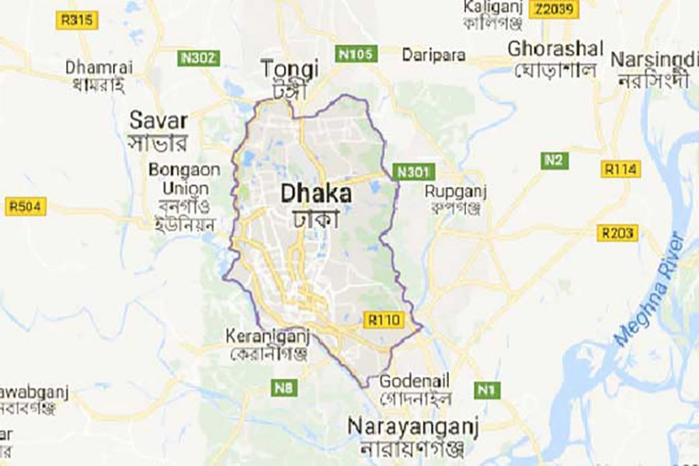
Figure 1: Location of a research area. Source:www.mopa.gov.bd& Google.com, 2019
Ministry of Public Administration and Office of the Deputy Commissioner, Dhaka, Bangladesh is the research area which fulfills the shared the leading position of total respondents.

3.8 Gantt chart
Gantt chart means task managing mechanism which allows to time work over a time frame; it may helpful for rupture a huge part of work into a chain of responsibilities and planning when to finish one. Table-4 states the whole research proposal activities have been done by utilization of given time frame through Gantt chart.
Table 4: Gantt chart. Source: Shaped by researcher
Month | March |  |  |  | April |  |  |  | May
Major Activities | WK1 | WK2 | WK3 | WK4 | WK1 | WK2 | WK3 | WK4 | WK1 | WK2 | WK3 | WK4
Topic collection | - *
Consultation with guide
Topic selection
Data collection from secondary sources & again meet with guide
Submission of IRPP
Starting of 1st chapter
Discuss with the guide on the progress of 1st chapter
Starting Literature Review (2nd chapter)
Continuation of literature review
Preparation of research proposal presentation
Presentation of research proposal
Starting of 3rd chapter
Started combining all chapters
Mid Check to guide
Revision all chapters
Final submission of research proposal

CHAPTER 4: DATA ANALYSIS, REPRESENTATION &INTERPRETATION

4.1 Introduction
The objective of the study is to investigate the empowerment situation of Bangladesh Civil Service (BCS) administration cadre officer based on gender. Total 300 different categories officers from BCS administration cadre are surveyed through an online questionnaire are interviewed for understanding profound opinion and information on the condition of this cadre. The researcher has achieved knowledge by contextual experience to examine the statistics. Firstly, demographic and variable wise facts are accessible followed by data analysis and interpretation using different analysis methods like Factor Analysis, Reliability Test, Correlation Analysis and Multiple Regression Analysis has been used in testing research hypotheses. Before going to final data collection researcher conducted a pilot test among 40 respondents of the BCS administration cadre officials by analyzing only Factor Analysis and Reliability Test. In this study Principal Component Analysis has been used because according to Pearson (1901)it helps to decrease a big number of probably correlated variables into a little number of factors which flexible to apprehend and for next evaluation(Khair et al.,2017).

4.2 Demographic Details:
Before going to depth analysis and elucidation of the gathered information, this part of the chapter expects to provide the per user for previous thought on the exploration ground that introducing significant components and factors. At the beginning, some fundamental demographic elements are interpreted by the independent variable-based information introduction.

4.2.1 Present Service Status of Civil Servant in Bangladesh

Table: 4.2.1Present Service Status of Civil Servant in Bangladesh
Above table 4.2.1 demonstrate that the collected data came from BCS (Administration) Cadre employees in diverse positions where respondents from different batches and their present service status. Among 300 respondents Deputy Commissioner is 1 (.35%), Deputy Secretary is 88 (29.3%), Additional Deputy Commissioner is 23 (7.7%), Upazilla Nirbahi Officer (Sub-district head) 16 (7.7%), Senior assistant Secretary is 43 (14.3%), Senior Assistant Commissioner is 16 (5.3%), Assistant Secretary/Assistant Commissioner is 113 (37.7%).

4.2.2 Gender
Figure 4.2.2 Gender (Male & Female)

Above Figure 4.2.2shows that among 300 respondents of Bangladesh Civil Service 227 are male and 73 are female. Moreover, 24.33% are female participants and 75.67% are male participants. Both genders are full time employee of Bangladesh Civil Service.

4.2.3Age group
Figure 4.2.3 Age Group of Respondents
Above Figure 4.2.3 shows the age group of 300 respondents of Bangladesh Civil Service among them 127(42.33%) between the ages of 25-29, 24 (8.00%) between the ages of 30-34, 103 (34.33%) between the ages of35-39 and 46(15.33%) Civil Servants between the ages of 40-44.

4.2.4 Marital Status
Figure 4.2.4 Marital Status of Respondents
From above the Figure 4.2.4 among the 300 Civil Servants, 149 (49.67%) is married and 151 (50.33%) is unmarried.

4.2.5 Grade-9(Duration of Service)
Figure 4.2.5 Grade-9 (Duration of Service)
Grade -9 is the entry level pay scale of Bangladesh Civil Service (BCS) with the highest being Grade-1. Above Figure 4.2.5 shows thatamong the 300 respondents, 119 (39.67%) are in Grade-9 for 0-5 years, 54 (18.00%) are for 06-10 years and 127 (42.33%) are for 11-15 years.

4.2.6 Current Position (Duration of Service)

Figure: 4.2.6 Current Position (Duration of Service)
Above mentioned figure 4.2.6 shows that, among 300 respondents 276 (92.00%) for 0-5 years and 24 (8.00%) participants for 6-10 years.

4.2.7. Crosstabs between Present Service Position & Gender

Figure: 4.2.7 Crosstabs between Present Service & Gender

Here above-mentionedFigure4.2.7 demonstrates, among 300 respondents 227 are male Civil Servants and 73are female Civil Servants in their present service position. Here male respondent is 1(0.44%) for Deputy Commissioner& District Magistrate and female respondent is zero, male respondent in Deputy Secretary is 88 (38.77%) and no female respondent, for Additional Deputy Commissioner (ADC) male respondent is 1 (0.44%) and female 22 (30.14%), male respondent for UNO is 10 (4.41%) and female respondent 6 (8.22%), male for Senior Assistant Secretary (SAS) is 42 (18.50%) and no female respondent here, for male respondent in Senior Assistant Commissioner is 13 (5.73%) and 3(4.11%) female respondent and finally, for Assistant Secretary/Assistant Commissioner male respondent is 72 (31.72%) and female 41 (56.16%).

4.3. Pilot Test:
Before going to the Preliminary Test, it is very fundamental to make a Pilot Test for identify the consistency of the questionnaire. To do this 10% of sample size which is 40 questions to be evaluated.

4.3.1Factor Analysis:

4.3.1a. Dependent Variable: Gender on Employee Empowerment
This research has employed factor analysis to scrutinize respondents’ view on ‘employee empowerment on gender’ indicators like employee enhancement, acceleration of dynamic leadership, employees’ participation on decision making, role of gender, equal opportunity for both gender, employee position with accordance gender, and victim of harassment for gender. The study has run Kaiser-Meyer-Olkin (KMO) for the sampling adequacy and Bartlett’s test of sphericity to find out the numeral of factors. Beside this, Principal Component Analysis (PCA) with VARIMAX Rotation has been used. This research has considered just only those which have loading factor value of 0.60 and above which is suggested by Kaisen in 1974.
Table 4.3.1(a) Factor Analysis: Dependent Variable: Gender on Employee Empowerment

KMO and Bartlett's Test
Kaiser-Meyer-Olkin Measure of Sampling Adequacy. |  | .878
Bartlett's Test of Sphericity | Approx. Chi-Square | 359.849
Bartlett's Test of Sphericity | df | 21
Bartlett's Test of Sphericity | Sig. | .000

Above table 4.3.1(a) presents the opinion of respondents on the gender on Employee Empowerment. Here KMO measure of sampling adequacy is.878 and Bartlett’s test of sphericity is 359.849, p<05.So, the data is relevant for further analysis.

4.3.1(a. i) Factor loading:
Table 4.3.1(a. i) Factor loading of Dependent variable (EE)
Communalities
 | Initial | Extraction
EE_1 | 1.000 | .931
EE_2 | 1.000 | .892
EE_3 | 1.000 | .912
EE_4 | 1.000 | .882
EE_5 | 1.000 | .683
EE_6 | 1.000 | .681
EE_7 | 1.000 | .658

Extraction Method: Principal Component Analysis.

Here above table 4.3.1(a.i) shows that all extractions are >0.6 which means the questions of questionnaire are valid and appropriate for further analysis.

4.3.1(a.ii) Variance Explained and Eigenvalues Analysis:
Table 4.3.1(a. ii) Variance Explained and Eigenvalues Analysis of DV
Total Variance Explained
Component | Initial Eigenvalues |  |  | Extraction Sums of Squared Loadings
Component | Total | % of Variance | Cumulative % | Total | % of Variance | Cumulative %
1 | 5.639 | 80.554 | 80.554 | 5.639 | 80.554 | 80.554
2 | .494 | 7.051 | 87.606
3 | .390 | 5.566 | 93.171
4 | .276 | 3.949 | 97.121
5 | .108 | 1.545 | 98.665
6 | .076 | 1.081 | 99.747
7 | .018 | .253 | 100.000

Extraction Method: Principal Component Analysis.

Above table 4.3.1(a. ii) shows that the Principle Component Analysis with Varimax Rotation has extracted 1 factor that is gender on employee empowerment. This one factor is account for 80.554%where variance in variables is gender on employee empowerment and furthermore, the Eigenvalue is more than 1.0 that is 5.639, which is sustain for interpretation.

4.3.1b. Independent variables: (Power Delegation, Leadership style and Organizational Culture)
Here the factor analysis to scrutinize respondents’ view on Power delegation indicators like acceleration of decision making, authority of decision making, centralization of decision making, requirements of role. For Organizational culture its indications are influence employee behavior, policy formulation for zero-tolerance, effectiveness of job, suggestions for improvement. Finally, Leadership style’s indications are effectiveness of leader, helping subordinates, team building and appraising subordinates’ work.
Table 4.3.1b. Factor Analysis of IVs
Above table 4.3.1b presents the opinion of respondents on the Power Delegations, Leadership styles and Organizational Culture. Here KMO measure of sampling adequacy is.732 and Bartlett’s test of sphericity is 579.647, p<05.So, the data is relevant for further analysis.

4.3.1(b. i) Factor loading:
Table 4.3.1 (b.i) Factor loading of Independent Variable (PD, OC, LS)
Here Above table 4.3.1 (b. i) shows that all extractions are >0.6 which means the questions of questionnaire are valid and appropriate for further analysis.

4.3.1 (b. ii) Variance Explained and Eigenvalues Analysis:
Table 4.3.1 (b.ii) Variance Explained and Eigenvalues Analysis of IVs
Above table 4.3.1 (b. ii) shows that the Principle Component Analysis with Varimax Rotation has extracted 3 factors those are Power Delegation, Organizational Culture and Leadership Style. These 3 factors are account for 83.790% where variance in variables are the three- PD, OC and LS and furthermore, the Eigenvalues are more than 1.0 those are 5.687,3.592 and 1.614 which are sustain for interpretation.

4.4 Reliability Test
Reliability Test known as Cronbach Alpha is conducted within SPSS for measuring the internal consistency (i.e. to analyze the reliability of the measuring questionnaire) as well as when the questionnaire has developed in 5-point LIKERT Scale for determining whether it is reliable or not. The rule of thumb for Cronbach Alpha is .70 & above is good, .80 & above is better and .90 & above is best (Bolarinwa, 2015).

4.4.1 Gender on Employee Empowerment (DV)
Table 4.4.1 Reliability Test of Gender on Employee Empowerment (DV)
Here above table 4.4.1 shows the Reliability Statistics Table which represents the value of Cronbach Alpha is .956 and it replicates the high reliability for computing tools. Moreover, it specifies the high level of internal consistency with admired to the specific sample.

Table 4.4 1(a) Item Total Statistics for DV
Above table 4.4.1(a) provides that if one question deletes any other question then the Cronbach Alpha value will be low. But here this table 4.4.1(a) showed that Corrected Item-Total Correlation has no low value. So, no need to delete any item.

4.4.2Power Delegation (IV)
Table 4.4.2 Reliability Test of Power Delegation (IV)
Here above table 4.4.2is Reliability Statistics Table which represents the value of Cronbach Alpha is .947 and it replicates the high reliability for computing tools. Moreover, it specifies the high level of internal consistency with admired to the specific sample.

Table 4.4.2 (a) Item- Total Statistics of Power Delegation (IV)
From the above table4.4.2 (a) shown that Corrected Item-Total Correlation has no low value. So, here no need to delete any item.

4.4.3Leadership Style (IV)
Table 4.4.3 Reliability Test of Leadership Style (IV)

Here above table 4.4.3is Reliability Statistics Table which represents the value of Cronbach Alpha is .963 and it replicates the high reliability for computing tools. Moreover, it specifies the high level of internal consistency with admired to the specific sample.

Table 4.4.3 (a) Item-Total Statistics of Leadership Style (IV)
From the above table 4.4.3 (a) it shown that Corrected Item-Total Correlation has no low value. So, here no need to delete any item.

4.4.4 Organizational Culture (IV)
Table 4.4.4 Reliability test of Organizational Culture (IV)
Here above table 4.4.4is Reliability Statistics Table which represents the value of Cronbach Alpha is .902 and it replicates the high reliability for computing tools. Moreover, it specifies the high level of internal consistency with admired to the specific sample.

Table 4.4.4(a) Item-Total Statistics of Organizational Culture (IV)
Here above table4.4.4 (a) is the Item-total Statistics of Organizational Culture and this shows that there is no low value in Corrected Item-Total Correlation and for that reason no need to delete any item. It’s known that delete item can make low the value of Cronbach Alpha.

4.5 Preliminary Test:
There is a standard rule of research that at least 10-15 respondents every variable is required. According to Fiedel (2005), generally 300 respondents is acceptable for sampling analysis (Ong, and Puteh,2017).

4.5.1 Factor Analysis: Both Dependent Variable& Independent Variables:

Table 4.5.1 Factor Analysis: Both Dependent Variable & Independent Variables
Rule of Thumb | Findings | Decision
KMO>0.6 |  | (Sekaran & Bougie, 2016)
IV | .886 | Data is relevant & appropriate for further analysis
DV | .770 | Data is relevant & appropriate for further analysis

Above table4.5.1 presents the opinion of respondents on the Gender on Employee Empowerment (DV). Here KMO measure of sampling adequacy is.770 which is p<0.5. On the other hand, For Power Delegation, Leadership Style and Organizational Culture (IVs) KMO measure of sampling adequacy is .886. So, the data is relevant for further analysis and consequently, it can be just acceptable.

4.5.1 (a) Factor Loading DV & IV
Table 4.5.1(a) Factor Loading of both DV & IVs

Above table 4.5.1(a) Gender on Employee Empowerment is the Dependent Variable, maximum extractions are >0.5 and Power Delegation, Leadership Style and Organizational Culture are the Independent Variables, all extractions are >0.5 to be measured for added analysis.

4.5.1 (b) Variance Explained & Eigenvalues Analysis (DV & IV)

Table

4.5.1(b)Variance Explained & Eigenvalues Analysis (DV & IV)

Above table 4.5.1(b)shows that the Principle Component Analysis with Varimax Rotation has extracted 1 factor that is gender on employee empowerment. This one factor is account for 67.512%where variance in variables is gender on employee empowerment and furthermore, the Eigenvalue is more than 1.0 that is 4.726, which is sustain for interpretation.

Above table 4.5.1(b) shows that the Principle Component Analysis with Varimax Rotation has extracted 3factors those are Power Delegation, Organizational Culture and Leadership Style. These 3 factors are account for 75.276% where variance in variables are the three- PD, OC and LS and furthermore, the Eigenvalues are more than 1.0 those are 6.312, 2.111 and 1.363 which are sustain for interpretation.

4.6 Reliability Test: Both DV & IVs
Table 4.6 Reliability Test: Both DV & IVs
Variables | Cronbach’s Alpha | N of Items
Independent Variables- Power Delegation | .886 | 4
Independent Variables-Leadership Styles | .816 | 4
Independent Variables-Organizational Culture | .885 | 5
Dependent Variables-Gender on Employee Empowerment | .910 | 7

Here above table 4.6is Reliability Statistics Table which represents the value of Cronbach Alpha for the three Independent Variables (PD, LS, OC) are.886,.816 and .885, these replicate the high reliability for computing tools. Moreover, it specifies the high level of internal consistency with admired to the specific sample.
Again, table 4.6 is Reliability Statistics Table which represents the value of Cronbach Alpha for Dependent Variables (EE) is .910 it replicates the high reliability for computing tools. Moreover, it specifies the high level of internal consistency with admired to the specific sample.

4.7 Correlation Matrix
Correlation is a word used to indicate the connection respectively two or more empirical factors, also called correlation analysis. This evaluation is basically based on the premise that the empirical factors have a straight linear relation. It is the computing tool for understanding the strength or the level that associate between the variables and tits right track (Schober, Boer and Schwarte, 2018).The consequences of Correlation Analysis are the Correlation Coefficient which is from +1 to -1, here +1 specifies that 2 variables are positively and perfectly associated, on the other hand -1 specifies variables are negatively and perfectly associated. Furthermore, 0 is the indication of no association of two variables that can be studied (Gogtay & Thatte, 2017).

Table 4.7 Correlation Matrix
Above table 4.7 shows that there is a strong relationship between Employee Empowerment and Organizational Culture which and it reflects that when one variable is changes it is strongly correlation with the changes of second variable. Here Pearson Correlation is .852 which is also close to 1.

4.8 Hypothesis Test
Hypothesis testing is the mechanism for ascertaining the likelihood of an observed case that only happens by necessity and if the chance was not the cause of a case, then something else must have been the cause (Drebee, 2016).

4.8.1 Multiple Linear Regression Model
Linear regression is statistical analysis that relies on describing a distinction between dependent (response) and independent (determined) variables of two types. The fundamental objective of regression is to investigate whether the independent variables are competitive in modeling the result variable and which independent variables are essential for determining the consequence (Kologlu, Birinci & Kanalmaz et al., 2018). This model must fulfill the requirements when analyzing the model’s contaminants or inaccuracies predict model error, normal distribution must be carried out with an average of equitable 0 (Castillo, Viloria &Parody et al., 2016).

Table 4.8.1Model Summary of Multiple Linear Regression Model
From the above table 4.8.1 it’s demonstrated that R is the value of Multiple Correlation coefficient. Here R is one of the measurement tools to identify the quality of the Dependent Variable which can be predicted, and R Square represents the determination of Coefficient. However, above table4.8.1also showed that the 3 IVs can explain 76.2% of the variances that happening in DV, the remaining 23.8% variations could be explained by other factors. The model of the study has a good level of fitness since r square>0.75 (Pandis, 2016). Furthermore, variables are independent because Durbin-Watsonis 2.166 (Durbin-Watson 1.5-2.50).

4.8.2 ANOVA
Table 4.8.2 ANOVA Table
Above the Anova table4.8.2 showed that the F is the value to test about the Regression Model is good enough fit for the data. It also showed that Independent Variables can statistically and significantly predict the Dependent Variable. Now, F (3, 296) =315.135, p<.0005, which demonstrate that this Regression Model is good fit for the data.

4.8.3 Estimated Model Coefficient
Table 4.8.3 Estimated Model Coefficient
Here above table4.8.3 shows the Estimated Model Coefficient-The general equation is that to predict Employee Empowerment from Power Delegation, Leadership style and Organizational Culture is, prediction of EE= .414 – (0.126* PD) + (.652*OC) + (.350*LS).Also, it shows that there is no Multicollinearity between variables (Variation Inflation Factor<10).

4.9 Hypothesis Test Results
Table 4.9 Hypothesis Test result
Hypothesis | Status
H1 | Accept
H2 | Accept
H3 | Accept

From the above table4.9its resulted that all hypothesis is accepted.

HP1: Power delegation has positive significant relation with employee empowerment on gender.
That means there is a significant relation between power delegation and employee empowerment on gender. Referring from the table 4.8.3 PD is .002 which is lower than 0.05. From the statistics of Hypotheses result H1 is accepted. However, it can say that Power delegation has influence on employee empowerment on gender.
H2: Leadership style has positive significant relation with employee empowerment on gender:
That means there is a significant relation between Leadership Style and employee empowerment on gender. Referring from the table 4.8.3LS is .000 which is lower than 0.05. From the statistics of Hypotheses result H2 is accepted. However, it can say that Leadership Style has influence on employee empowerment on gender.
H3: Organizational culture has positive significant relation with employee empowerment on gender:
That means there is a substantial relation amid administrative values and participant empowerment on gender. Referring from the table 4.8.3 LS is .000 which is lower than 0.05. From the statistics of Hypotheses result H3 is accepted. However, it can say that Organizational Culture has influence on employee empowerment on gender.

CHAPTER 5: FINDINGS, RECOMMENDATIONS & CONCLUSION

5.1 Introduction
The overview of the results, debates, inferences, and recommendations reached in this chapter is confined to this study's mandate and goals. Suggestions for future work have been rendered.

5.2 Findings:
Power delegation has positive significant relation with employee empowerment on gender-Balanced and neutral power delegation accelerates both gender decision-making in the employee empowerment.

In this study, gender differences in employment empowerment in the Bangladesh Civil Service have been made visible. In this study, gender differences in employment empowerment in the Bangladesh Civil Service have been made visible. It was also found that there is an important connection between gender and BCS workforce participation rate of policy-making.
In the study, the employee empowerment by the respondent of the Ministry of Public Administration and Deputy Commissioner Office, Dhaka, Bangladesh has emerged as a gender differential icebreaker, especially in the areas of power delegation, organizational culture and leadership style.

Even in this study, the participation rate of women civil servants in the employment empowerment at BCS is relatively low, which demonstrates the barrier to talent acquisition. This study also demonstrated that, the fair delegation of power reduces the level of centralism of decision-making process.

Leadership style has significant relation with employee empowerment on gender-
Leadership style can enhance responsive and effective service delivery in employee empowerment on gender.
In this study, leadership style in the employee empowerment will be accelerated by gender participation, affinity, talent involvement which increases productivity, prompt service delivery, as well as pro-managerial competency or New Public Management (NPM) that will play a vital role to strengthening of BCS.
Findings supported that, if Civil Servants are given certain responsibilities and the ability to work with senior officials or executives, they feel empowered. Furthermore, the neutrality of leadership style is very effectual for employee empowerment of BCS.
Present bureaucratic system controlled by senior civil servants; so, senior bureaucrats are still performing as powerful actors in a new appearance of modernizing employee empowerment of BCS. On the other hand, the unfairness in leadership style generates one sided support which increases the gender disparity in BCS.
Organizational culture has significant relation with employee empowerment on gender-
Organizational culture improves gender participation which develops efficiency-performance in employee empowerment. However, it has been discovered that there is a favorable and powerful connection with awareness of the duties carried out as well as the connection between competitive and creative culture improves organizational performance.
The study revealed that, to empowering the employees’ the organizational culture of BCS has the existence of biased behavioral outlook and distancing of diversity. The study showed that the conditions affecting Bangladesh's organizational culture like encompass staying in power, counter-developmental, bureaucratic corruption and inefficiency under the challenge of efficiency.
From the research, it is obvious that one of the barriers toward executing regulatory improvements in Bangladesh is a long-established organizational culture.

5.3 Recommendation:
The research showed that female civil servants are experiencing from many issues ranging from adverse mentalities in the profession including its logistic deficiencies. Such interferes reduces civil servants’ quality and effectiveness. It is a waste of regional assets and possibilities in the long run. Some steps should be considered in order to make the civil servants’ genuine human equity. Following suggestions are thus produced to alleviate concerns and generate a pleasant atmosphere for both gender employees' in the field.

5.3.1 For Government:
- Policy formulation to ensure participation of both genders in decision making process for employee empowerment of Bangladesh Civil Service.
- There are number of gender differences that have not been fully accommodated in the BCS. These issues need to be addressed and policy measures taken to rectify them.
- Take effective action from the civil service to eliminate extremist, discriminatory attitude and stereotypical ideas for empowerment of both genders in BCS.
- Simultaneously, the development of social consciousness requires to be reinforced so that both genders can and should perform an equal part in the nation's user friendliness mechanism and needed protections to be enacted to track the implementation of these strategies and successfully resolve differences.
- To establish fair empowerment, mitigate against gender equality initiatives like conservative organizational culture in the BCS, weak policy oversight and still limited awareness of the whole issue.
- Suggest specific ways to promote empowerment in the civil service as well as private sector.

5.3.2 For Academic:
Future researchers have the scope of determining the decision-making process of employee empowerment on both genders. Hence, this small study may play a helpful role in subsequent research.
Future research should also explore whether structural constraints like formalization, centralization, power distance between leaders and employees influence the use of empowering leadership by administrator in public organization.
Khairet. al. (2017), Mitul & Kabir (2019), NJOKI (2014), SULTAN & JAHAN (2016)

5.4 Conclusion
This study concluded that there are gender differences are visible on the purposes of employee empowerment in the Civil Service of Bangladesh. Moreover, both genders must be empowerment by the government initiative for the enabling employees to feel an act autonomously. The study established that most female respondents agreed to enhance empowerment for the decision-making in the highest level. Although the male respondents’ opinions that women Civil Servant discharging their duties independently with the support of organization.
Regarding power delegation the study also concludes, due to the centralization of power delegation system cannot expand in other jurisdiction of the country. On the other hand, dynamic leadership style has influence on the empowerment system of BCS, but the autocratic image still perceives in the organization. Majority of respondents thinking that the zero-tolerance strategy against gender discrimination on employee empowerment of BCS, cannot implement properly. Even behavioral pattern of Bangladesh Civil Servant is still running in a stereotype phenomenon which hindrances Organizational culture.
Finally, the study concludes that both genders’ respondents think that talent should be given priority in empowering employees’ in decision-making and empowerment should be practices by involvement and participation of both genders’ in Bangladesh Civil Service.

5.5 Suggestions for Future Research
The participant proposes the following in conjunction with more exploration:
- This research is being conducted among other public organizations on certain aspects of workforce empowerment. For example, the connection between staff empowerment techniques and staff profitability between ministries could be evaluated.
- The atmosphere where organizations function is incredibly dynamic, the extent, velocity, complexity, and effect of the change is higher than ever, and organizations must constantly monitor the climate to guarantee which they compete.
- The demands and aspirations of executives are developing. Given the modifications, a scheme to assist us begins to understand a workforce equality strategy is proposed

Total Word Count-13,116

Reference
Aburuman, N., 2016. The Impact of Administrative Empowerment on Creativity Improvement among the Workers of Jordanian Public Administration Institute. International Journal of Business and Social Science, 7(1), pp.182-190.
Asrar-ul-Haq, M. and Kuchinke, K.P., 2016. Impact of leadership styles on employees’ attitude towards their leader and performance: Empirical evidence from Pakistani banks. Future Business Journal, 2(1), pp.54-64.
Ahmed, F.Z., Greenleaf, A. and Sacks, A., 2014. The paradox of export growth in areas of weak governance: The case of the readymade garment sector in Bangladesh. World Development, 56, pp.258-271.
Abuzaid, A. (2018). Employees’ Empowerment and its Role in Achieving Strategic Success: A Practical Study on Jordanian Insurance Companies. Jordan Journal of Business Administration, [online] 14(No. 4). Available at: https://www.researchgate.net/profile/Ahmad_Abuzaid/publication/329714756_Employees'_Empowerment_and_its_Role_in_Achieving_Strategic_Success_A_Practical_Study_on_Jordanian_Insurance_Companies/links/5c17b00d92851c39ebf3eac6/Employees-Empowerment-and-its-Role-in-Achieving-Strategic-Success-A-Practical-Study-on-Jordanian-Insurance-Companies.pdf [Accessed 20 Jun. 2019].
AbouElnaga, A., and Imran, A. 2014. “The Impact of Employee Empowerment on Job Satisfaction: Theoretical Study”. American Journal of Research Communication, 2(1): 13-26
Ali, S. (2014). Women Leading Public Service and Political Participation in South Asia: New and Emerging Developments. Women’s Political Participation and Leadership in Public Service in Bangladesh. [online] South Delhi: WPSP Institute at Lady Shri Ram College, p.8. Available at: http://www.50x50movement.org/sites/default/files/2016-11/Women-Leading-Public-Service-and-Political-Participation-in-South-Asia2%20%281%29.pdf [Accessed 8 Apr. 2019].
Arnold, Josh A., Sharon Arad, Jonathan A. Rhoades, and Fritz Drasgow. "The empowering leadership questionnaire: The construction and validation of a new scale for measuring leader behaviors." Journal of Organizational behavior 21, no. 3 (2000): 249-269.
Abukhait, R.M., Bani-Melhem, S., and Zeffane, R., 2019. Empowerment, Knowledge Sharing And Innovative Behaviours: Exploring Gender Differences. International Journal of Innovation Management, 23(01), p.1950006.
Amundsen, S. and Martinsen, Ø.L., 2014. Empowering leadership: Construct clarification, conceptualization, and validation of a new scale. The Leadership Quarterly, 25(3), pp.487-511.
Bose, I., 2018. Employee Empowerment and Employee Performance: An Empirical Study on Selected Banks in UAE. Journal of Applied Management and Investments, 7(2), pp.71-82.
Baird, K., Su, S. and Munir, R., 2018. The relationship between the enabling use of controls, employee empowerment, and performance. Personnel Review, 47(1), pp.257-274.
Bakker, A.B. and Demerouti, E., 2017. Job demands–resources theory: Taking stock and looking forward. Journal of occupational health psychology, 22(3), p.273.
Bidisha, M. (2017). A study on gender gap women empowerment and human development among the below poverty line households in Dibrugarh district of Assam. PhD. North-Eastern Hill University.
Bayeh, E., 2016. The role of empowering women and achieving gender equality to the sustainable development of Ethiopia. Pacific Science Review B: Humanities and Social Sciences, 2(1), pp.37-42.
Buil, I., Martínez, E. and Matute, J., 2019. Transformational leadership and employee performance: The role of identification, engagement and proactive personality. International Journal of Hospitality Management, 77, pp.64-75.
Bolarinwa, O.A., 2015. Principles and methods of validity and reliability testing of questionnaires used in social and health science researches. Nigerian Postgraduate Medical Journal, 22(4), p.195.
Castillo Ramirez, M., Viloria, A., Parody Muñoz, A. and Posso, H., 2016. Application of Multiple Linear Regression Models in the Identification of Factors Affecting the Results of the Chelsea Football Team. Journal of Control Theory and Applications. ISSN, pp.0974-5572.
Dabo, Z. and Ndan, R.T., 2018. Impact of employee empowerment on organization performance: evidence from quoted bottling companies in kaduna. International Journal of Economics, Business and Management Research, 2(1), pp.360-369.
Degago, E., (2014). A study on Impact of Psychological Empowerment on Employee Performance in small and Medium Scale Enterprise Sectors. European Journal of Business and Management, 6(2), 60-71Performance. 2 International Symposiums on Sustainable Development. June 8 -9, Pp. 142 – 146)
Dlanjwa, M.Z., 2018. Gender equality and the advancement of women into senior management positions: assessing the perceptions of the diversity and gender initiatives section of the City of Cape Town (Doctoral dissertation, Stellenbosch: Stellenbosch University).
Doucet, O., Fredette, M., Simard, G. and Tremblay, M., 2015. Leader profiles and their effectiveness on employees’ outcomes. Human Performance, 28(3), pp.244-264.
Dhir, S., 2019. The changing nature of work, leadership, and organizational culture in future ready organizations. Corporate culture, Management, Leadership, Job redesign, Organizational Behavior, Innovation, Change Management, Human Resources, VUCA.
Drebee, H.A., 2016. The Impact of Financial Depth and Exchange Rate on Inflation in Iraq During the Period (1970-2014). Muthanna Journal of Administrative and Economic Sciences, 6(2), pp.8-24.
Eriksson, E. and Engström, M., 2018. Internationally educated nurses’ descriptions of their access to structural empowerment while working in another country's health care context. Journal of nursing management, 26(7), pp.866-873.
Eagly, A.H. and Wood, W., 2016. Social role theory of sex differences. The Wiley Blackwell encyclopedia of gender and sexuality studies, pp.1-3
El Rawas, A.S. and El Seddawy, A.I.B., 2015. Leadership Development and Employees Empowerment. International Journal of Economic and Business Management, pp.39-44.
Fernandez, S., &Moldogaziev, T. (2011). Empowering public sector employees to improve performance: Does it work? American Review of Public Administration, 41(1), 23-47.
Ferdous, J., 2014. Women in Bangladesh Civil Service: Stumbling Blocks towards the Way of Participation. Social Sciences, 3(5), pp.177-182.
Fiaz, M., Su, Q. and Saqib, A., 2017. Leadership styles and employees' motivation: perspective from an emerging economy. The Journal of Developing Areas, 51(4), pp.143-156.
Google.com. (2019). organogram of central administration bangladesh - Google Search. [online] Available at: https://www.google.com/search?biw=1088&bih=474&tbm=isch&sa=1&ei=vc_DXMeeC4jFrQH64oEY&q=organogram+of+central+administration+bangladesh&oq=organogram+of+central+administration+bangladesh&gs_l=img.3..35i39.99100.101391..102388...0.0..0.128.740.3j4......1....1..gws-wiz-img.5M5TwV885kc#imgrc=dwzytB7et5kt_M: [Accessed 27 Apr. 2019].
Google.com. (2019). organogram of administration bangladesh - Google Search. [online] Available at: https://www.google.com/search?biw=1088&bih=474&tbm=isch&sa=1&ei=-c7DXNvrEoSurQGt5IPgBA&q=organogram+of+administration+bangladesh&oq=organogram+of+administration+bangladesh&gs_l=img.3...66249.74243..75095...0.0..0.176.1438.8j6......1....1..gws-wiz-img.......0i8i7i30.vlc_OjjHvVE#imgrc=f5p78bTt9F1F2M: [Accessed 27 Apr. 2019].
Google.com. (2019). organogram kanter's theory of empowerment - Google Search. [online] Available at: https://www.google.com/search?biw=1088&bih=426&tbm=isch&sa=1&ei=v9fDXLyrK73iz7sP5PWU8AU&q=+organogram+kanter%27s+theory+of+empowerment&oq=+organogram+kanter%27s+theory+of+empowerment&gs_l=img.3...29574.34485..35315...0.0..0.160.1313.6j6......1....1..gws-wiz-img.......0j0i8i30j0i24.zijaIeIGmaI#imgrc=7zP1LXJDS3MiLM: [Accessed 27 Apr. 2019].
Google.com. (2019). social role theory of gender - Google Search. [online] Available at: https://www.google.com/search?biw=1088&bih=426&tbm=isch&sa=1&ei=xtrDXPDJF4Xgz7sP7ZGo8AI&q=social+role+theory+of+gender&oq=social+role+theory+of+gender&gs_l=img.1.0.0j0i24l2.1470.3961..6206...0.0..0.747.3893.0j4j1j0j2j1j2......1....1..gws-wiz-img.......0i30j0i8i30._SVOG6YmIHs#imgrc=RkYmfkLptfSWJM: [Accessed 27 Apr. 2019].
Gandolfi, F. and Stone, S., 2018. Leadership, leadership styles, and servant leadership. Journal of Management Research, 18(4), pp.261-269.
Gogtay, N.J. and Thatte, U.M., 2017. Principles of correlation analysis. Journal of the association of physicians of India, 65(3), pp.78-81.
Gayathri, A.S., 2013. Organizational culture and empowerment of women.
Hassan, M.S., 2015. Ensuring Effective Public Service Delivery in the Field Administration of Bangladesh to Boast up Good Governance: The Perspective of Deputy Commissioner Office.
Haque, S.T.M. and Mohammad, S.N., 2013. Administrative culture and incidence of corruption in Bangladesh: A search for the potential linkage. International Journal of Public Administration, 36(13), pp.996-1006.
Hossain, M.A., 2017. Bureaucratic System in Bangladesh. Review of Public Administration and Management, 5(2), p.1000214.
Hazra, P.K. and Aminuzzaman, S.M., 2018. Job Satisfaction: A Comparative Analysis on Selected Mid-Level Bangladesh Civil Service (BCS) Cadre Officials.
Heal, R. and Twycross, A., 2015. Validity and reliability in quantitative research. Evidence-Based Nursing, vol. 0, no. 0, pp.66-67.
Haque, S.T.M. and Mohammad, S.N., 2013. Administrative culture and incidence of corruption in Bangladesh: A search for the potential linkage. International Journal of Public Administration, 36(13), pp.996-1006.
Haselhuhn, M.P., Wong, E.M. and Ormiston, M.E., 2017. With great power comes shared responsibility: Psychological power and the delegation of authority. Personality and Individual Differences, 108, pp.1-4.
Holten, A.L., Bøllingtoft, A., Carneiro, I.G. and Borg, V., 2018. A within-country study of leadership perceptions and outcomes across native and immigrant employees: Questioning the universality of transformational leadership. Journal of Management & Organization, 24(1), pp.145-162.
Haselhuhn, M.P., Wong, E.M. and Ormiston, M.E., 2017. With great power comes shared responsibility: Psychological power and the delegation of authority. Personality and Individual Differences, 108, pp.1-4.
Islam, M.A., Jantan, A.H., Rahman, M.A., Hamid, A.B.A., Mahmud, F.B. and Hoque, A., 2018. Leadership Styles for Employee Empowerment: Malaysian Retail Industry. Journal of Management Research, 10(4), pp.27-40.
Islam, R., 2016. Bureaucracy and Administrative Culture in Bangladesh. Global Encyclopedia of Public Administration, Public Policy, and Governance, pp.1-9.
Ivanova, M. and von Scheve, C., 2019. Power through empowerment? The managerial discourse on employee empowerment. Organization, p.1350508419855709.
Ibarra, H., Ely, R. and Kolb, D., 2013. Women rising: The unseen barriers. Harvard business review, 91(9), pp.60-66.
Kark, R., Van Dijk, D. and Vashdi, D.R., 2018. Motivated or demotivated to be creative: the role of self‐regulatory focus in transformational and transactional leadership processes. Applied Psychology, 67(1), pp.186-224.
Kohli, A. and Sharma, A., 2017. AN ANALYSIS OF EMPLOYEE EMPOWERMENT AND JOB SATISFACTION: A REVIEW. Management Dynamics, 17(1).
Kaymakçı, K. and Babacan, S., 2013. Employee empowerment in new public management approach and a research. European Journal of Research on Education, 2, pp.62-70.
Kim, S.Y. and Fernandez, S., 2017. Employee empowerment and turnover intention in the US federal bureaucracy. The American Review of Public Administration, 47(1), pp.4-22.
Kwesiga, J.C., 2018. The national machinery for gender equality in Uganda: institutionalized gesture politics?. In Mainstreaming gender, democratizing the state?. Manchester University Press.
Krishnappa, R., 2013. Gender dimension of employment in Karnataka a case study of Koppal district.
Khair, D., Haque, D. and Mukta, A. (2017). Gender and Representation of Women in Bangladesh Civil Service: An Empirical Analysis of ‘Glass Ceiling’ Effect. Dhaka: BPATC, p.1
Kumar, M.P.J. and Kumar, A.A., 2017. Employee Empowerment–An Empirical Study. Global Journal of Management And Business Research.
Khan, M. (2014). Organizational Democracy and Women’s Empowerment: An Examination of Four Advocacy Organizations in Bangladesh. PhD. Virginia Polytechnic Institute and State University.
Kesting, P., Ulhøi, J.P., Song, L.J. and Niu, H., 2016. The impact of leadership styles oninnovation-a review. Journal of Innovation Management, 3(4), pp.22-41.
Kologlu, Y., Birinci, H., Kanalmaz, S.I. and Ozyilmaz, B., 2018. A Multiple Linear Regression Approach For Estimating the Market Value of Football Players in Forward Position. arXiv preprint arXiv:1807.01104.
Khan, M.M. and Rasli, A.M., 2015. Relationship between organization culture, empowerment and conflict. International Journal of Economics and Financial Issues, 5(1S), pp.324-329.
Longman, K., Daniels, J., Bray, D.L. and Liddell, W., 2018. How organizational culture shapes women’s leadership experiences. Administrative Sciences, 8(2), p.8.
Liu, D., Gong, Y., Zhou, J. and Huang, J.C., 2017. Human resource systems, employee creativity, and firm innovation: The moderating role of firm ownership. Academy of Management Journal, 60(3), pp.1164-1188.
Labony, R.A., 2013. Women representation in top management of civil service in Bangladesh (Doctoral dissertation, BRAC University).
Mohajan, H.K., 2017. Two criteria for good measurements in research: Validity and reliability. Annals of SpiruHaret University. Economic Series, 17(4), pp.59-82.
Marume, S.B.M., Ndudzo, D. and Chikasha, A.S., 2016. The essence of the principle of delegation of authority.
Maynard, M.T., Luciano, M.M., D'Innocenzo, L., Mathieu, J.E. and Dean, M.D., 2014. Modeling time-lagged reciprocal psychological empowerment–performance relationships. Journal of Applied Psychology, 99(6), p.1244.
Men, L.R. and Stacks, D.W., 2013. The impact of leadership style and employee empowerment on perceived organizational reputation. Journal of Communication Management, 17(2), pp.171-192.
Miah, H., 2013. Post-colonial State and Bureaucracy in Bangladesh: Theoretical Understanding. International Letters of Social and Humanistic Sciences, (07), pp.43-54.
Morcos, M. 2018. ORGANISATIONAL CULTURE: DEFINITIONS AND TRENDS. ResearchGate. [online] Available at: http://file:///C:/Users/Ruhul/Downloads/ORGANISATIONALCULTUREDEFINITIONSANDTRENDS-AnOverview.pdf [Accessed 20 Aug. 2019].
NJOKI, R. (2014). GENDER DIFFERENCES ON PERCEPTIONS OF EMPLOYEE EMPOWERMENT PRACTICES IN THE STATE DEPARTMENT OF PLANNING IN KENYA. MBA. University of Nairobi.
Northouse, P.G., 2018. Leadership: Theory and practice. Sage publications.
Naqshbandi, M.M., Tabche, I. and Choudhary, N., 2019. Managing open innovation: The roles of empowering leadership and employee involvement climate. Management Decision, 57(3), pp.703-723.
OBI, J.N., Okpara, A. and LUGARD, M., 2018. IMPROVING EMPLOYEES'PRODUCTIVITY THROUGH DELEGATION OF AUTHORITY (A CASE STUDY OF 7UP BOTTLING COMPANY PLC.). International Journal of innovations in Social Science, Arts and Management, 8(1), pp.181-195.
Oyemomi, O., Liu, S., Neaga, I., Chen, H. and Nakpodia, F., 2019. How cultural impact on knowledge sharing contributes to organizational performance: Using the fsQCA approach. Journal of Business Research, 94, pp.313-319.
Ong, M.H.A. and Puteh, F., 2017. Quantitative Data Analysis: Choosing Between SPSS, PLS, and AMOS in Social Science Research. International Interdisciplinary Journal of Scientific Research, 3(1), pp.14-25.
Pmis.mopa.gov.bd. (2019).List of Secretaries. [online] Available at: http://pmis.mopa.gov.bd/pmis/Forms/seclist.php [Accessed 25 Mar. 2019].
Pradhan, R.K., Panda, M. and Jena, L.K., 2017. Transformational leadership and psychological empowerment: The mediating effect of organizational culture in Indian retail industry. Journal of Enterprise Information Management, 30(1), pp.82-95.
Pan, S.Y. and Lin, K.J., 2015. Behavioral mechanism and boundary conditions of transformational process. Journal of Managerial Psychology, 30(8), pp.970-985.
Pandis, N., 2016. Multiple linear regression analysis. American journal of orthodontics and dentofacial orthopedics, 149(4).
Qing, M., Asif, M., Hussain, A. and Jameel, A., 2019. Exploring the impact of ethical leadership on job satisfaction and organizational commitment in public sector organizations: the mediating role of psychological empowerment. Review of Managerial Science, pp.1-28.
Rosenbach, W.E., 2018. Contemporary issues in leadership. Routledge.
Rahman, N.E., 2018. Traditional Bureaucratic Culture as an Impeding Factor in Implementing New Public Management in Bangladesh. South Asian Journal of Social Studies and Economics, pp.1-6.
Rahman, M.S. and Tosun, J., 2018. State bureaucracy and the management of climate change adaptation in Bangladesh. Review of Policy Research, 35(6), pp.835-858.
Rasmussen, L. and Hall, H., 2016. The adoption process in management innovation: A Knowledge Management case study. Journal of Information Science, 42(3), pp.356-368.
Staadt, J., 2015. The cultural analysis of soft systems methodology and the configuration model of organizational culture. Sage Open, 5(2), p.2158244015589787.
Saremi, H. and Nejad, B.M., 2013. Impact of organizational culture on employees empowerment.
Shao, Z., 2019. Interaction effect of strategic leadership behaviors and organizational culture on IS-Business strategic alignment and Enterprise Systems assimilation. International Journal of Information Management, 44, pp.96-108.
Skogstad, A., Aasland, M.S., Nielsen, M.B., Hetland, J., Matthiesen, S.B. and Einarsen, S., 2015. The relative effects of constructive, laissez-faire, and tyrannical leadership on subordinate job satisfaction. ZeitschriftfürPsychologie.
SULTAN, M. and JAHAN, F., 2016. Openings and resistances: women in the Bangladesh Civil Service. In Public Policy and Governance in Bangladesh (pp. 170-183). Routledge.
Sev, J.T., 2017. Effective delegation of authority as a strategy for task accomplishment and performance enhancement in business organizations-an empirical survey of flour mills of Nigeria plc, Lagos-Nigeria. The Business & Management Review, 8(4), p.138.
Spreitzer, G. M. (2008). Taking stock: A review of more than twenty years of research on empowerment at work. In J. Barling & C. L. Cooper (Eds.), The sage handbook of organizational behavior: Volume I - micro approaches (pp. 54-72). London, UK: Sage
Srivastava, A., Bartol, K. M., & Locke, E. A. (2006). Empowering leadership in management teams: Effects on knowledge sharing, efficacy, and performance. Academy of Management Journal, 49(6), 1239-1251.
Sarker, M.N.I., Bingxin, Y., Sultana, A. and Prodhan, A.S., 2017. Problems and challenges of public administration in Bangladesh: pathway to sustainable development. International Journal of Public Administration and Policy Research, 3(1), pp.16-25.
Sultana, F.N. and Ferdous, J., 2017. Women Elites (Civil Service) in Bangladesh: A Governance Paradox. Society & Change, 11(1).
Sankar, R. (2018). Gender, Work Performance and Workers Empowerment: A Statistical Interrogation. International Journal of Management Studies, [online] Vol.–V, Special(Issue - 3, August 2018). Available at: http://dx.doi.org/10.18843/ijms/v5iS3/03 [Accessed 27 Apr. 2019].
Smolović Jones, S., Smolović Jones, O., Winchester, N. and Grint, K., 2016. Putting the discourse to work: On outlining a praxis of democratic leadership development. Management Learning, 47(4), pp.424-442.
Schober, P., Boer, C. and Schwarte, L.A., 2018. Correlation coefficients: appropriate use and interpretation. Anesthesia & Analgesia, 126(5), pp.1763-1768.
Spohn, D., 2018. An Operational Definition of Effective Leadership: Was Covey Right. Review Pub Administration Manag, 6(251), p.2.
Taherdoost, H., 2016. Validity and reliability of the research instrument; how to test the validation of a questionnaire/survey in a research.
Thim, A., 2015. Women's Economic Empowerment: An Analysis of Development Discourse and Its Impact on Gender Development Programs (Doctoral dissertation, The American University of Paris (France)).
Thun, S. and Bakker, A.B., 2018. Empowering leadership and job crafting: T he role of employee optimism. Stress and Health, 34(4), pp.573-581.
Ukil, M.I., 2016. The impact of employee empowerment on employee satisfaction and service quality: Empirical evidence from financial enterprizes in Bangladesh. Verslas: teorijairpraktika, 17(2), pp.178-189.
Vasilagos, T., Polychroniou, P. and Maroudas, L., 2017. Relationship Between Supervisor’s Emotional Intelligence and Transformational Leadership in Hotel Organizations. In Strategic Innovative Marketing (pp. 91-95). Springer, Cham.
Wong, S.I. and Giessner, S.R., 2018. The thin line between empowering and laissez-faire leadership: An expectancy-match perspective. Journal of Management, 44(2), pp.757-783.
Wilkinson, A. J., &Dundon, T. (2010). Direct employee participation. In P. J. Gollan, D. Lewin, M. Marchington & A. Wilkinson (Eds.), The oxford handbook of participation in organizations (pp. 167-185). New York, NY: Oxford University Press.
Zhang, X., Qian, J., Wang, B., Jin, Z., Wang, J. and Wang, Y., 2017. Leaders’ Behaviors Matter: psychology, 8, p.920.
Zhang, X. and Li, B., 2016. Organizational culture and organizational performance: a brief review. Journal of Advances in Social Science and Humanities, 2(5), pp.16-21.
Zafarullah H. Public administration and bureaucracy. InRoutledge handbook of contemporary Bangladesh 2016 Jan 29 (pp. 114-128). Routledge.
Zafarullah, H., 2013. Bureaucratic culture and the social-political connection: the Bangladesh example. International Journal of Public Administration, 36(13), pp.932-939.

Appendix

Figure 2: Hierarchy of Central Government Secretariat. Source: www.mopa.gov.bd
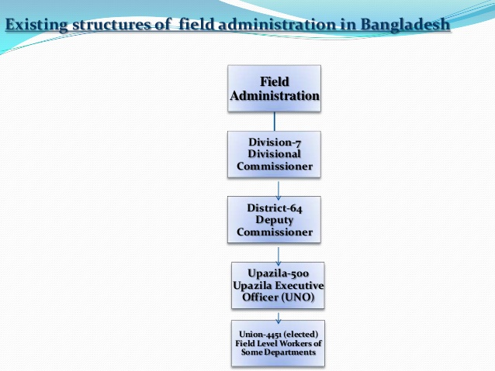
Figure-3: Existing structure of field administration of Bangladesh. Source: (Google.com, 2019)
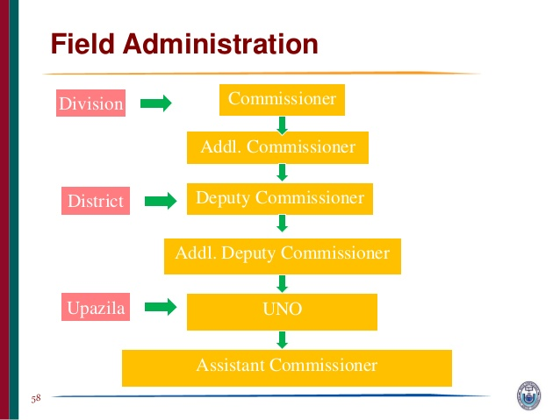
Figure4: Hierarchy of Field Administration in Bangladesh. Source: www.mopa.gov.bd
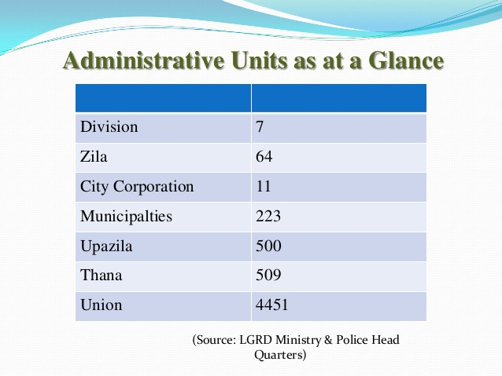
Figure 5: Administrative units of Bangladesh, Source: (Google.com, 2019)

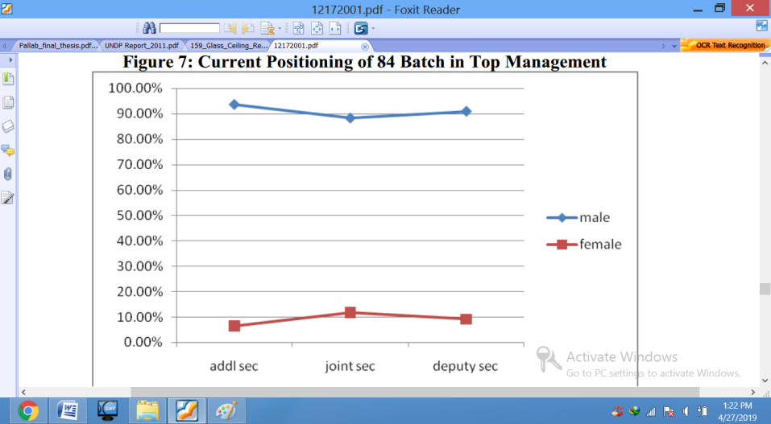
Figure 6: Decision making level of both genders of BCS. Source: (Labony, 2013)
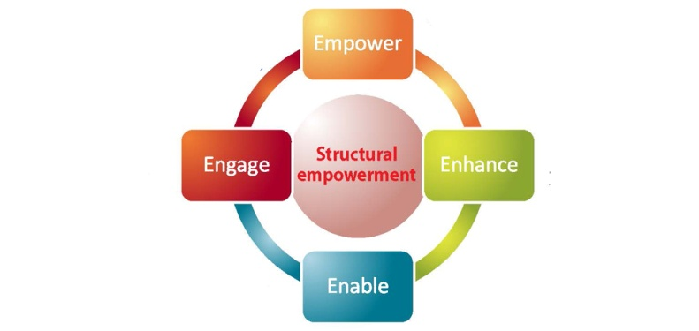
Figure 7: Kanter’s theory of empowerment. Source:(Google.com, 2019)

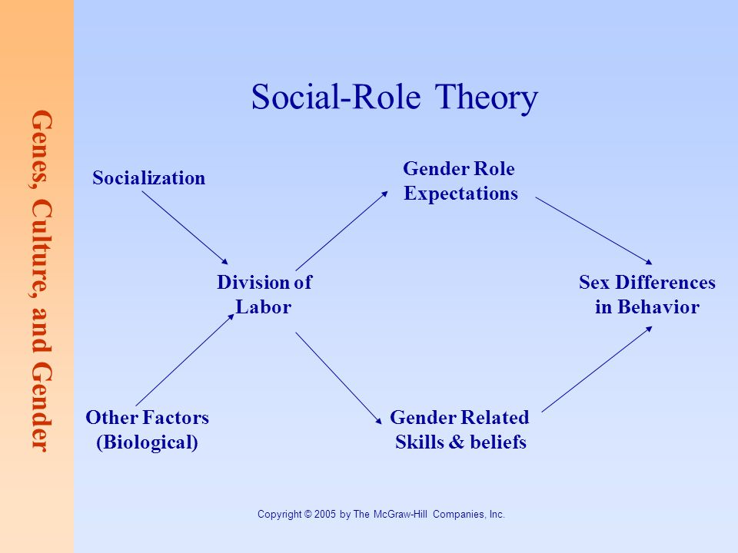
Figure-8: Social Role Theory of Gender. Source: (Google.com, 2019)
Table-5: Regional Gender Difference (2006-2015). Source: (Bidisha, 2017).

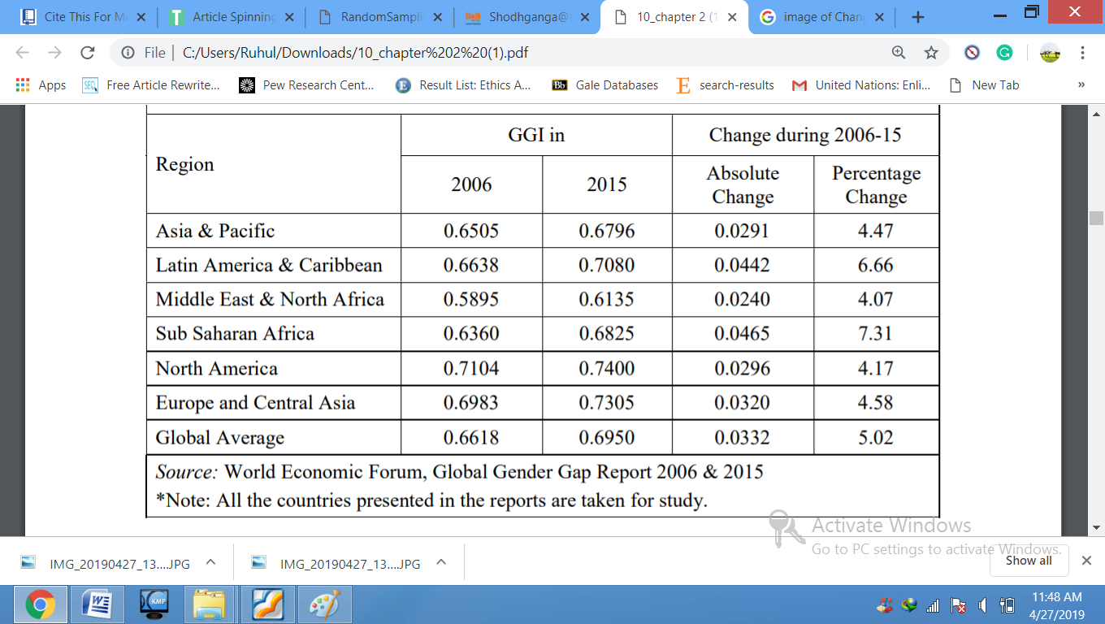

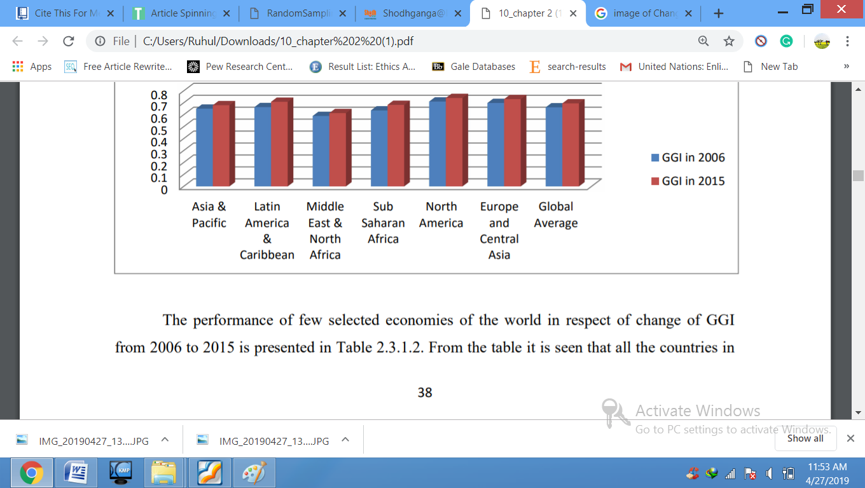
Figure-9: Regional Gender Difference (2006-2015). Source: (Bidisha, 2017).

Table-6: Gender participation of Bangladesh Civil Service from 1999-2011. Source:(Sultana and Ferdous, 2017).
Position | 2011 | 2006 | 1999
Secretary | Men (%) Women (%)  96.1 3.9 | Men (%) Women (%)  98.4 1.6 | Men (%) Women (%)  98.0 2.0
Additional Secretary | 94.8 5.2 | 100.0 0.0 | 98.2 1.8
Join Secretary | 90.2 9.8 | 93.2 6.8 | 98.5 1.5
Deputy Secretary | 88.1 11.9 | 88.3 11.7 | 98.6 1.1
Senior Assistant Secretary | 79.8 20.2 | 84.3 15.7 | 91.0 9.0
Assistant Secretary | 79.8 25.9 | 77.3 22.7 | 85.7 14.3
Total | 79 21 | 85 15 | 91.5 8.5

Questionnaire
Master of Business Administration (MBA) Program
INTI International University
Nilai, Malaysia.

Title: Employee Empowerment: A Study on Empowerment of Civil Servant in Bangladesh on Gender.
This questionnaire is a part of the research paper entitled ‘Employee Empowerment: A Study on Empowerment of Civil Servant in Bangladesh on Gender’ of my Master of Business Administration (MBA) program at INTI International University, Malaysia. The objective of the research is to assess the impact of employee empowerment on the basis of gender from Deputy Secretary to Assistant Secretary level officials of BCS Administration Cadre. In this regard, your reliable and pragmatic reply is highly expected. Nonetheless, your valuable understanding will be used for scholarly reasons with preserving your confidentiality. It remarks that, to fill up the whole questionnaire only takes 15 minutes.
Thank you for your kind attention & Cooperation
Chand Sitara Binta Islam
Student & Researcher
MBA (Dual)
INTI International University
Contact: +6 0147116162,
E-mail address: i18015165@student.newinti.edu.my

Information of Deputy Commissioner/Deputy Secretary, Additional Deputy Commissioner, Senior Assistant Secretary/Senior Assistant Commissioner, Assistant Secretary/Assistant Commissioner of BCS (Administration) Cadre

(Kindly mark the correct box, where needed)

Demographic Information

- Present service status:(a) Deputy Commissioner
(b) Deputy Secretary
- Additional Deputy Commissioner
- Senior Assistant Secretary
- Senior Assistant Commissioner
- Assistant Secretary
- Assistant Commissioner
- Others

- Gender: (a) Male (b)Female

- Age group: (a) 20-24 (b) 25-29 (c) 30-34 (d) 35-39
(e) 40-44 f) 45-49 g) 50-54 h) 55-59
- Marital status:(a) Married (b) Unmarried (c) Widow/Widower
(d) Divorced/Divorcee (e) Living Separately
5. Duration of service (Grade 9 & above):
(a) 0-5 yrs (b) 06-10 yrs (c) 11-15 yrs
(d) 16-20 yrs (e) 21-25 yrs (f) 26 yrs and above
6. Duration of service (current position):
(a) 0-5 yrs (b) 06-10 yrs (c) 11-15 yrs
(d) 16-20 yrs (e) 21-25 yrs (f) 26 yrs and above

7. Employee Empowerment on Gender

7.1. Empowerment enhances employees’ motivation, devotion, and satisfaction and assists the organization in reaching the specific goals. | Strongly agree  (5) | Agree  (4) | Moderate  (3) | Disagree  (2) | Strongly disagree  (1)
7.2. Employee empowerment is more accelerated and faster with dynamic leadership styles. | Strongly agree  (5) | Agree  (4) | Moderate  (3) | Disagree  (2) | Strongly disagree  (1)
7.3. Employees are allowed to participate in decision making process. | Strongly agree  (5) | Agree  (4) | Moderate  (3) | Disagree  (2) | Strongly disagree  (1)
7.4. Gender has an important role in empowering employees. | Strongly agree  (5) | Agree  (4) | Moderate  (3) | Disagree  (2) | Strongly disagree  (1)
7.5. In case of empowerment, both the gender enjoy equal opportunities | Strongly agree  (5) | Agree  (4) | Moderate  (3) | Disagree  (2) | Strongly disagree  (1)
7.6. My position or role for empowerment is less in comparison to other colleagues. | Strongly agree  (5) | Agree  (4) | Moderate  (3) | Disagree  (2) | Strongly disagree  (1)
7.7. In case of employment I am the victim of harassment or bullion due to gender. | Strongly agree  (5) | Agree  (4) | Moderate  (3) | Disagree  (2) | Strongly disagree  (1)

8. Power of Decision-making

8.1. Delegation accelerates decision making process. | Strongly agree  (5) | Agree  (4) | Moderate  (3) | Disagree  (2) | Strongly disagree  (1)
8.2. Authority of decision-making is visible at every hierarchy. | Strongly agree  (5) | Agree  (4) | Moderate  (3) | Disagree  (2) | Strongly disagree  (1)
8.3. Delegation reduces the level of centralism in decision-taking. | Strongly agree  (5) | Agree  (4) | Moderate  (3) | Disagree  (2) | Strongly disagree  (1)
8.4. I clearly define time requirements of the role | Strongly agree  (5) | Agree  (4) | Moderate  (3) | Disagree  (2) | Strongly disagree  (1)

9. Organizational culture

9.1. Organizational culture influences employees behavior. | Strongly agree  (5) | Agree  (4) | Moderate  (3) | Disagree  (2) | Strongly disagree  (1)
9.2. Organizational culture remains to a zero-tolerance policy against any kind of discrimination. | Strongly agree  (5) | Agree  (4) | Moderate  (3) | Disagree  (2) | Strongly disagree  (1)
9.3. I am trusted to carry out my job effectively. | Strongly agree  (5) | Agree  (4) | Moderate  (3) | Disagree  (2) | Strongly disagree  (1)
9.4. Most people in this organization are encouraged to make suggestions for improvement. | Strongly agree  (5) | Agree  (4) | Moderate  (3) | Disagree  (2) | Strongly disagree  (1)
9.5. My immediate supervisor encourages my suggestions for improvement. | Strongly agree  (5) | Agree  (4) | Moderate  (3) | Disagree  (2) | Strongly disagree  (1)

10. Leadership Style
10.1. Effective leaders give orders and clarify procedures. | Strongly agree  (5) | Agree  (4) | Moderate  (3) | Disagree  (2) | Strongly disagree  (1)
10.2. I like to use my leadership power to help subordinates grow. | Strongly agree  (5) | Agree  (4) | Moderate  (3) | Disagree  (2) | Strongly disagree  (1)
10.3. I always maintain the final decision making authority within my team. | Strongly agree  (5) | Agree  (4) | Moderate  (3) | Disagree  (2) | Strongly disagree  (1)
10.4. As a rule, leaders should allow subordinates to appraise their own work. | Strongly agree  (5) | Agree  (4) | Moderate  (3) | Disagree  (2) | Strongly disagree  (1)

Final Initial Research Proposal

MASTERS OF BUSINESS ADMINISTRATION
January 2019 Session
Initial Research Proposal
Module Name | Business Research Methodology | Module Code |  |  | MGT6202
Module Leader | DR. ARASU RAMAN |  |  | Initial Research Proposal
Students Name | Chand Sitara Binta Islam |  | Student ID |  | I18015165  MBA(Dual)
Student’s  Declaration | I certify that this IRPP is my own work and where materials have been used from published sources, they have been properly acknowledged. I understand I will receive a mark of 0% for this assignment and may receive further penalties if the content is found to be plagiarized.  Signed: Sitara  Date: 5 March, 2019

Broad Area | Human Resource
Title | Employee Empowerment: A Study of Empowerment in Civil Servant of Bangladesh on Gender.
Problem Definition | Introduction of the primary issue: Gender is a well-known issue. It is necessary to afford gender equality in the case of employee empowerment of any organization. The organization's fairness, dignity, diversity, and respect for all personnel are ensured through gender. The gender issue in Bangladesh Civil Service has attracted everyone's attention since the 1980s. Equal implementation of gender equality in different categories of public service faces much of the challenge. Especially in the case of employee empowerment, the problem is observed.  Key theories: Social Role Theory: Gender stereotypes involve the task and decision of social roles (Park et al., 2017) Gender variations in social relationships, different social expectations for males and females establish social norms that emphasize control and competition (ABUKHAIT et al., 2018). Empowerment Theory: Employees responsibility for and autonomy in specified tasks, as well as data that allow their participation in decision making, expertise transfer, access to resources and organizational affairs (ABUKHAIT et al., 2018).  Review of literature: Gender is conflated with an occupational role and hierarchical position and men are the main performer (ABUKHAIT et al., 2018). ILO Convention No. 100 (1951) and article 28 & 29(3)(c), Constitution of Peoples’ Republic of Bangladesh emphasis on the reduction of discrimination and increasing efficiency for equal opportunities at the workplace (Khair et al., 2017). The position of gender in the civil service of Bangladesh is under-representation (Jahan, 2010).  Introduction: Gender equality is not guaranteed, it is considered as a barrier to the success of any organization. In spite of being a member of the United Nations Charter, the International Law Organization, there is a gender prejudice in the employee empowerment of the civil service of Bangladesh. A disparity of workplace environment, gender-oriented organizational performance, talent depreciation, difficulty of participating in decision making, differentiation of views and weak policy in Bangladesh civil service has questioned its role.  Importance: Gender balanced is not relying on basic equity however additionally facilitates government greater efficiently (The Institute for Government, 2019). Employee empowerment is important for making sure the highest effectiveness and excellence from human resources, which are the vital resources and competition instrument of organizations (Kaymakçı, K. 2013). The originality of the research problem is the lack of involvement in participatory decision making and the one-sided outlook. And its relevance is that it will affect the organization’s sustainable performance. In the case of employee empowerment, if gender equity is not permanent, then social balance and human rights will be despoiled. The overall progress will be scratched.
Research Objectives & Questions | Objectives:  - To investigate the gender concern of employee empowerment in civil service of Bangladesh. b) To identify the barriers of instituted equal gender representation of Bangladesh civil service. c) To suggest government for employee empowerment according to gender.  Questions:  - What types of difference in gender perceptions of employee empowerment practices in the civil service of Bangladesh? b) What are the obstacles to establish equal gender representation of Bangladesh Civil Service? c) What is the recommendation to boost up employee empowerment according to gender?
Scope of study | The study area is Bangladesh because employee empowerment base on the gender differences in civil service of Bangladesh is visible. The civil servant of Bangladesh is the sample focus. A unit of analysis focus is Upazila Nirbahi Officer (sub-district head who is the chief coordination officer of central government). If required then officer of ministry and Bangladesh High Commission, Malaysia can be included. The research methodology approach is quantitative and analysis technique is surveys based.
Significance of the research | This study would be vital because researchers would act as a contribute reference structure besides suggesting areas for further research. Study links the knowledge space of government plan and actuality to guarantee gender equality in Bangladesh civil service. When employee empowerment is implemented on the basis of balanced gender, the productivity of the industry will increase greatly by utilizing the full-fledged talent.
Literature Review | Gender states influential male dominance for that innovation technique is underdeveloped (Pecis, L., 2016). Kanter’s Theory of Structural Empowerment (1977) asserted that shape of work environment is an essential correlate of employee mindset and behaviors in businesses and that perceived get entry to power and possibility systems to relate to the behaviors and attitudes of employees in an organization. (Dabo, Z. and Ndan, R.T., 2018). Empowering both genders in civil service of Bangladesh has been necessitated through developing knowledge, awareness of rights, privilege leading to equal opportunities and participates in decision making which reduced gender difference.H1: Empowerment is positively related to gender. H2: The impact of empowerment on gender difference is likely to be higher among females. H3: The impact of empowerment on gender difference is likely to be higher among males.
Research methodology | This study is based on descriptive survey and used stratified random samplings. A random sample size of 50 representing both gender civil servants will be drawn from employees in the ministry and field office. This study collects primary data and questionnaire. The questionnaire included both open and closed-ended questions. The goal of ethical consideration is to sentinel individuals those who are participating as respondents. The questionnaire consisted of 2 parts; part-A collected demographic data whilst part-B collected details on employees’ perceptions of empowering practices and gender. This study employed descriptive statistical facts analysis to consider the facts received. The enhancing turned into performed to make certain that the data was free from inconsistencies and incompleteness. Descriptive data which includes percentages, frequency distribution mean, standard deviation and likert scale will be used within the analysis.
Reference:
ABUKHAIT, R., BANI-MELHEM, S. and ZEFFANE, R. (2018). EMPOWERMENT, KNOWLEDGE SHARING AND INNOVATIVE BEHAVIOURS: EXPLORING GENDER DIFFERENCES. International Journal of Innovation Management (2018) 1950006 (28 pages).
Dabo, Z. and Ndan, R.T., 2018). Impact of employee empowerment on organization performance: evidence from quoted bottling companies in kaduna. International Journal of Economics, Business and Management Research, 2(1), pp.360-369.
Khair, R., Haque, M. and Mukta, A. (2017). Gender and Representation of Women in Bangladesh Civil Service: An Empirical Analysis of ‘Glass Ceiling’ Effect. Bangladesh Public Administration Training Centre Savar, Dhaka August 2017.
Kaymakçı, K. and Babacan, S., 2013. Employee empowerment in new public management approach and a research. European Journal of Research on Education, 2, pp.63-70.
Park, S.G., Kang, H.J., Lee, H.R. and Kim, S.J., 2017. The effects of LMX on gender discrimination and subjective career success. Asia Pacific Journal of Human Resources, 55(1), pp.127-148.
Jahan, R. (2010). Problems of working at the field level: A study of women civil servants of Bangladesh. Master in Public Policy and Governance Program. North South University, Bangladesh.
NJOKI, R. (2014). GENDER DIFFERENCES ON PERCEPTIONS OF EMPLOYEE EMPOWERMENT PRACTICES IN THE STATE DEPARTMENT OF PLANNING IN KENYA. MBA. University of Nairobi.
Pecis, L., 2016. Doing and undoing gender in innovation: Femininities and masculinities in innovation processes. Human relations, 69(11), pp.2117-2140.
The Institute for Government. (2019). Gender balance in the civil service. [online] Available at: https://www.instituteforgovernment.org.uk/explainers/gender-balance-civil-service [Accessed 28 Feb. 2019]

Slides of Power point presentation

SPSS Analysis
- Demographic Detail
1.1 Present Service Status of Civil Servant in Bangladesh
1.2. Gender

1.3Age group

1.4Marital Status
1.5Grade-9(Duration of Service)

1.6Current Position (Duration of Service)
1.7Crosstabs between Present Service Position & Gender

- Pilot Test

2.1Factor Analysis
2.1.1Dependent Variable: Gender on Employee Empowerment
KMO and Bartlett's Test
Kaiser-Meyer-Olkin Measure of Sampling Adequacy. |  | .878
Bartlett's Test of Sphericity | Approx. Chi-Square | 359.849
Bartlett's Test of Sphericity | df | 21
Bartlett's Test of Sphericity | Sig. | .000

2.1.2Factor loading:
Communalities
 | Initial | Extraction
EE_1 | 1.000 | .931
EE_2 | 1.000 | .892
EE_3 | 1.000 | .912
EE_4 | 1.000 | .882
EE_5 | 1.000 | .683
EE_6 | 1.000 | .681
EE_7 | 1.000 | .658

2.1.3Variance Explained and Eigenvalues Analysis:
Total Variance Explained
Component | Initial Eigenvalues |  |  | Extraction Sums of Squared Loadings
Component | Total | % of Variance | Cumulative % | Total | % of Variance | Cumulative %
1 | 5.639 | 80.554 | 80.554 | 5.639 | 80.554 | 80.554
2 | .494 | 7.051 | 87.606
3 | .390 | 5.566 | 93.171
4 | .276 | 3.949 | 97.121
5 | .108 | 1.545 | 98.665
6 | .076 | 1.081 | 99.747
7 | .018 | .253 | 100.000

Extraction Method: Principal Component Analysis.

2.2 Independent variables: (Power Delegation, Leadership style and Organizational Culture)
2.2.1Factor loading:

2.2.2Variance Explained and Eigenvalues Analysis:

  - Reliability Test
2.3.1 Gender on Employee Empowerment (DV)
2.3.2Power Delegation (IV)

2.3.3Leadership Style (IV)

2.3.4Organizational Culture (IV)
3. Preliminary Test:
3.1Factor Analysis: Both Dependent Variable& Independent Variables:
Rule of Thumb | Findings | Decision
KMO>0.6 |  | (Sekaran & Bougie, 2016)
IV | .886 | Data is relevant & appropriate for further analysis
DV | .770 | Data is relevant & appropriate for further analysis

3.1.1 (a) Factor Loading DV & IV

3.1.1 (b) Variance Explained & Eigenvalues Analysis (DV & IV)

3.2 Reliability Test: Both DV & IVs
Variables | Cronbach’s Alpha | N of Items
Independent Variables- Power Delegation | .886 | 4
Independent Variables-Leadership Styles | .816 | 4
Independent Variables-Organizational Culture | .885 | 5
Dependent Variables-Gender on Employee Empowerment | .910 | 7

- Correlation Matrix
- Multiple Linear Regression Model
5.1Model Summary of Multiple Linear Regression Model

5.2ANOVA
Table 4.8.2 ANOVA Table
5.2Estimated Model Coefficient

Final Viva (Presentation Slides)

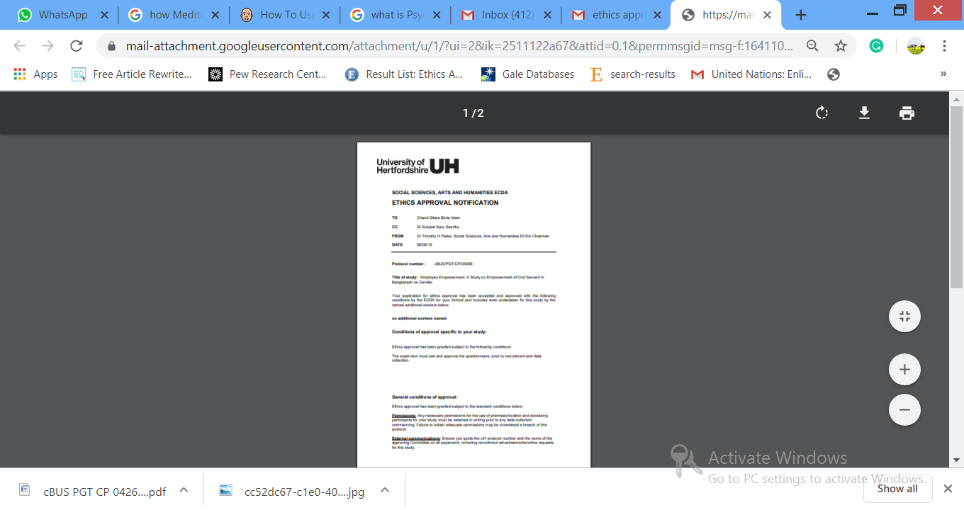

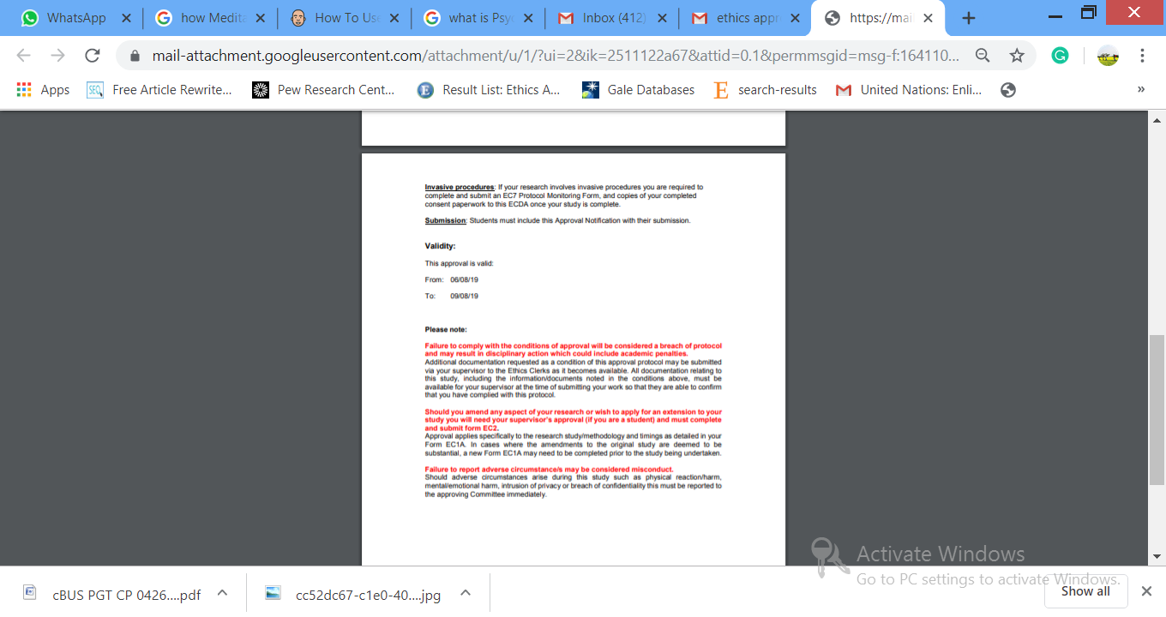

UNIVERSITY OF HERTFORDSHIRE
ETHICS COMMITTEE FOR STUDIES INVOLVING THE USE OF HUMAN PARTICIPANTS
(‘ETHICS COMMITTEE’)
FORM EC3
CONSENT FORM FOR STUDIES INVOLVING HUMAN PARTICIPANTS
I, the undersigned [please give your name here, in BLOCK CAPITALS]
of [please give contact details here, sufficient to enable the investigator to get in touch with you, such as a postal or email address]

……………………………………………………………………………………………………………
hereby freely agree to take part in the study entitled Employee Empowerment on gender in Bangladesh Civil Service

[insert name of study here]

(UH Protocol number) cBUS/PGT/CP/04266

1 I confirm that I have been given a Participant Information Sheet (a copy of which is attached to this form) giving particulars of the study, including its aim(s), methods and design, the names and contact details of key people and, as appropriate, the risks and potential benefits, how the information collected will be stored and for how long, and any plans for follow-up studies that might involve further approaches to participants. I have also been informed of how my personal information on this form will be stored and for how long. I have been given details of my involvement in the study. I have been told that in the event of any significant change to the aim(s) or design of the study I will be informed and asked to renew my consent to participate in it.

2 I have been assured that I may withdraw from the study at any time without disadvantage or having to give a reason.

3 In giving my consent to participate in this study, I understand that voice, video or photo-recording will take place and I have been informed of how/whether this recording will be transmitted/displayed.

4 I have been given information about the risks of my suffering harm or adverse effects. I have been told about the aftercare and support that will be offered to me in the event of this happening, and I have been assured that all such aftercare or support would be provided at no cost to myself. In signing this consent form I accept that medical attention might be sought for me, should circumstances require this.

5 I have been told how information relating to me (data obtained in the course of the study, and data provided by me about myself) will be handled: how it will be kept secure, who will have access to it, and how it will or may be used.

6 I understand that my participation in this study may reveal findings that could indicate that I might require medical advice. In that event, I will be informed and advised to consult my GP. If, during the study, evidence comes to light that I may have a pre-existing medical condition that may put others at risk, I understand that the University will refer me to the appropriate authorities and that I will not be allowed to take any further part in the study.
7 I understand that if there is any revelation of unlawful activity or any indication of non-medical circumstances that would or has put others at risk, the University may refer the matter to the appropriate authorities.
8 I have been told that I may at some time in the future be contacted again in connection with this or another study.
Signature of participant: …………………………………..…Date…………………………

Signature of (principal) investigator CHAND SITARA BINTA ISLAM………………………………………………………Date 22-8-2018…………………………

Name of (principal) investigator [in BLOCK CAPITALS please]

UNIVERSITY OF HERTFORDSHIRE

ETHICS COMMITTEE FOR STUDIES INVOLVING THE USE OF HUMAN PARTICIPANTS
(‘ETHICS COMMITTEE’)

FORM EC6: PARTICIPANT INFORMATION SHEET

Title of study

Title: Employee Empowerment: A study on Empowerment of Civil Servant in Bangladesh on Gender.

Introduction

You are being invited to take part in a study. Before you decide whether to do so, it is important that you understand the research that is being done and what your involvement will include. Please take the time to read the following information carefully and discuss it with others if you wish. Do not hesitate to ask us anything that is not clear or for any further information you would like to help you make your decision. Please do take your time to decide whether or not you wish to take part. The University’s regulations governing the conduct of studies involving human participants can be accessed via this link:

http://sitem.herts.ac.uk/secreg/upr/RE01.htm

Thank you for reading this.

What is the purpose of this study?

To investigate is there any relationship between power delegation, leadership style and organizational culture and employee empowerment in Bangladesh Civil Service

Do I have to take part?
It is completely up to you whether or not you decide to take part in this study. If you do decide to take part, you will be given this information sheet to keep and be asked to sign a consent form. Agreeing to join the study does not mean that you have to complete it. You are free to withdraw at any stage without giving a reason. A decision to withdraw at any time, or a decision not to take part at all, will not affect.

Are there any ages or other restrictions that may prevent me from participating?

The target respondents are the employees working in the government sector over the age of 18.

How long will my part in the study take?

If you decide to take part in this study, you will be involved in it for 10 minutes to 15 minutes to answer a survey.

What will happen to me if I take part?

The findings and results of this research will help to analyze the employee empowerment situation in Bangladesh Civil Service and its gender effects. In the case of employee empowerment, very little research has been done in the Bangladesh Civil Service with the effect of gender. Through the outcome of that research, the contribution of both the gender in the empowerment field will be reflected.

What are the possible disadvantages, risks or side effects of taking part?
For the research questionnaire, the respondent may have a cover of 10 to 15 minutes, which can be described as a possible disadvantage of this study.

What are the possible benefits of taking part?
Research outcome can play a vital role in the academic and administrative field for the future exploration.
How will my taking part in this study be kept confidential?

The questionnaires were collected and saved by researchers themselves. Third parties are not allowed to access the questionnaire detail and the questionnaire details will be stored via encryption method with password.

What will happen to the data collected within this study?

The outcome of the research shall be used as the interview aspect for my MBA thesis only and shall not be used for any other purposes. The results shall be disposed of permanently in the future once the MBA thesis has been graded and finalized. The data collected will be stored electronically, in a password-protected environment, for 2 years, after which time it will be destroyed under secure conditions.
Who has reviewed this study?

This research has been reviewed by my supervisor Dr. Sukjeet Kaur Sandhu. She is currently working in INTI International University, Nilai, Malaysia. Besides, this research has reviewed by The University of Hertfordshire Social Sciences, Arts and Humanities Ethics Committee with Delegated Authority.
The UH protocol number is cBUS/PGT/CP/04266
Who can I contact if I have any questions?
If you would like further information or would like to discuss any details personally, please get in touch with me, in writing, by email: Chand Sitara Binta Islam; i18015165@student.newinti.edu.my
Although we hope it is not the case, if you have any complaints or concerns about any aspect of the way you have been approached or treated during the course of this study, please write to the University’s Secretary and Registrar.
Secretary and Registrar
University of Hertfordshire
College Lane
Hatfield
Herts
AL10 9AB

Thank you very much for reading this information and giving consideration to taking part in this study.
Screen shot of Plagiarism
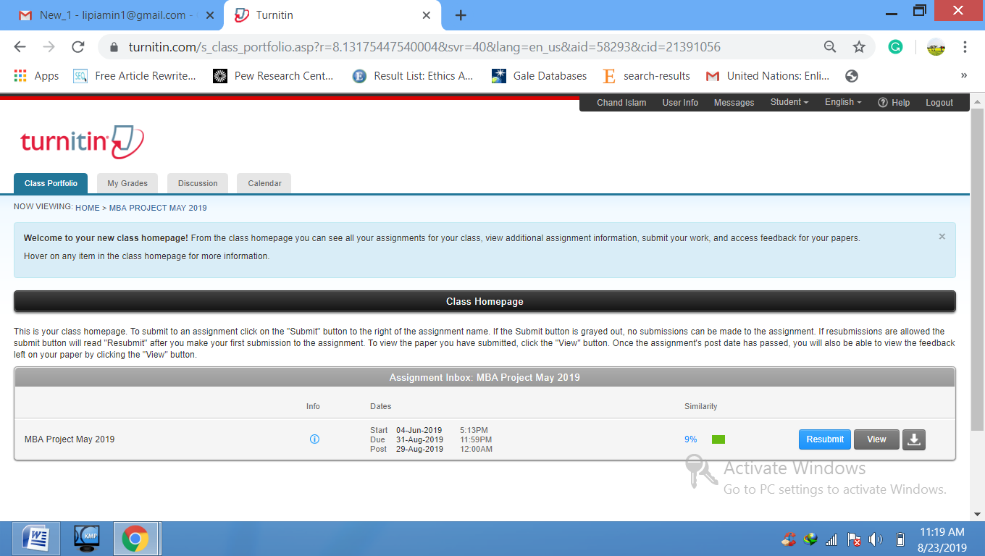

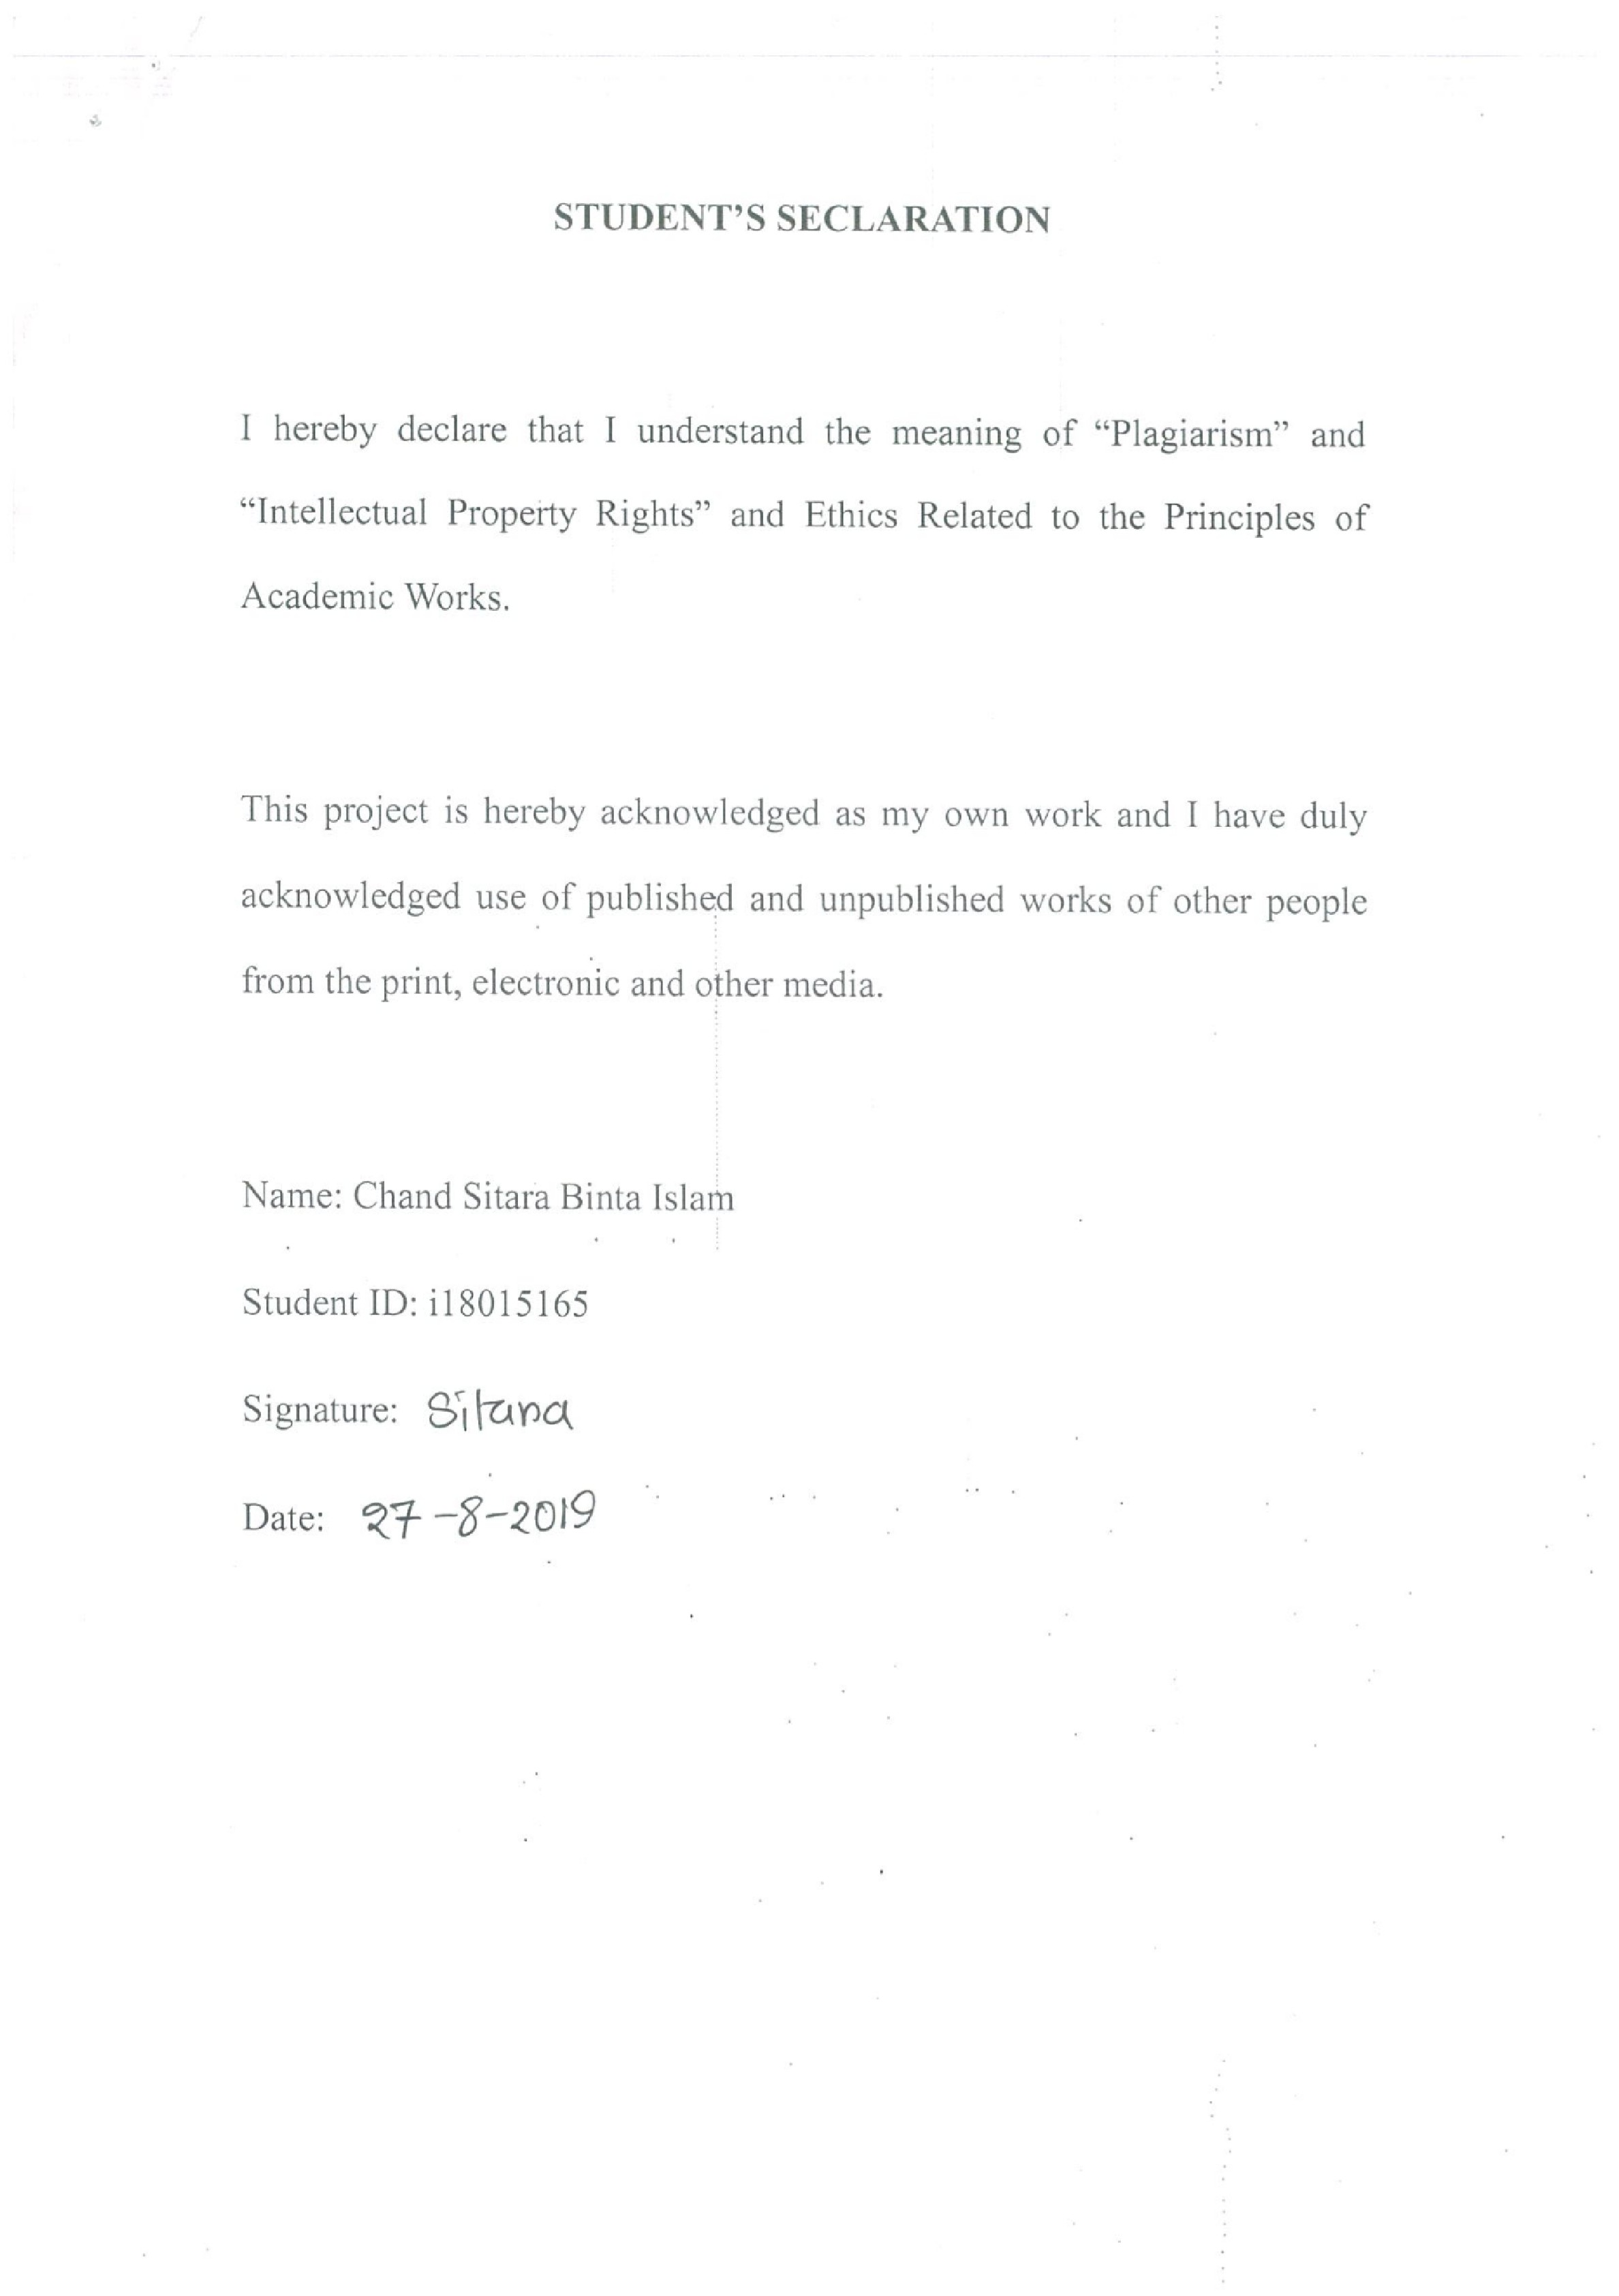
Project Logs
