

|  |
| --- |
| **Factors Influencing Employee Motivation for State-Owned Enterprises**  **in Beijing, China**  Name: WANG SHIYAO  Student Number: I14005302  Course Code: MGT7998  Program: MBADI  Supervisor: Dr. Syarifah Mastura Syed Abu Bakar  MASTER OF BUSINESS ADMINISTRATION  FACULTY OF BUSINESS, COMMUNICATION & LAW  INTI INTETNATIONAL UNIVERSITY  2019 |

**Table of Content**

Abstract..........................................................................................................................4

**Chapter1.Introduction**

1.0Background of research.............................................................................................4

1.1ProblemStatement .................................................................................................4-5

1.2Research Objectives ..............................................................................................5-9

1.3Signaficance of research ...........................................................................................9

1.3.1Significance to academic

1.3.2 Significance to industry

1.3.3 Significance to government

1.4Limitations of this research

1.5 Scope of the Study..................................................................................................11

**Chapter2. Literature Review**

2.0 Employees of State-owned Enterprises..................................................................12

2.1 Employee motivation………………………………………………………………

2.1.1 Global view of Employee motivation…………………………………………….

2.2.1 Employee motivation in china…………………………………………………….

2.3 Fundamental theory…………………………………………………………………

2.4 Conceptual framework...........................................................................................27

**Chapter3. Research methodology**

3.0Overview.................................................................................................................29

3.1Research Design…………………………………………………………………....

3.2 Unit of Analysis, population and Sampling Design……………………………….

3.3 Data collection method and Statistical Analysis……………………………………

3.4 Conclusion.............................................................................................................34

**Chapter 4 Data analysis and interpretation**

4.0 Overview.................................................................................................................35

4.1Descriptive Analysis.................................................................................................

4.2 Pilot Test ……………………………………………………………………………

4.2.1 Reliability Test ……………………………………………………………………

4.3 Factor Analysis……………………………………………………………………...

4.4 Hypothesis testing…………………………………………………………………...

4.4.1 One Way ANOVA………………………………………………………………….

4.4.2 Multiple Regression Analysis………………………………………………….

4.4.3Beta Coefficient Test..........................................................................................49

**Chapter 5 Conclusion and Recommendations**

5.0 Findings and Discussion .....................................................................................50

5.0.1 Demographic Factor……………………………………………………………

5.0.2 Hypothesis Testing………………………………………………………………

5.1 Limitations and recommendations of Research……………………………………

5.2 Conclusion ............................................................................................................54

**References**..............................................................................................................55-61

**Appendix**

**Abstract**

With the steady development of market economy, the competitiveness of talents in various industries in China has also increased. Effective employee motivation has a big effect of the economic benefits and long-term development of state-owned enterprises (Zhang and Liu, 2018). However, many state-owned enterprises (SOEs) facing serious problems such as bureaucracy, low working efficiency and serious brain drain. This paper is the first that attempts to identify which main factors influence the employee motivation and how they improve Employee Motivation level for China’s State-Owned Enterprises

**Chapter1.Introduction**

**1.0 Background of research**

As we all know, employees are an important resource of the company, which is related to the future development of the company. Effective motivation system can stimulate employees' motivation, make them spontaneously stimulate potential internal forces, and contribute their own strength to the long-term goals of enterprises (Liu, 2014).

Besides that, Pandta *et al.* (2015) defines employee motivation refers to the level of commitment, energy and creativity that members bring to their work. The motivation of members directly affects the company's performance and sustainable development.

In china, State-Owned Enterprises can be regarded as extensions of government, they are an important force for governments at all levels in implementing economic and social policies (Xin, Bao and Hu, 2018).

Since the implementation of the reform and opening-up policy in China, many state-owned enterprises have gradually established Incentive system because of the influence of business management theory in Western countries ; however, the reform of employee management in State-Owned Enterprises is always incomplete, how to motivate employees is an important content to further strengthen the operation and development ability of State-Owned Enterprises (Sunghoon, Wright and Su, 2015).

In order to explore what motivational factors affect employees, this paper assumes that there is a significant relationship between Promotion, Performance Appraisal, Immaterial incentive, Welfare and employee motivation, how they to arouse the enthusiasm and creativity of the employees, so that to improve the overall working efficiency of State-Owned Enterprises.

* 1. **Problem Statement**

According to the report of the departure and salary survey, Since the year 2010, the turnover rate of china’s state-owned enterprises has increased year by year, especially by 4.2% in 2015 (Sunghoon *et al.*, 2015). State-owned enterprises are facing the problems of structural adjustment, transformation and upgrading. In addition, some employees choose industries with good development prospects such as Internet and finance, so the overall turnover rate is further increased.

Although some achievements have been made in the reform of state-owned enterprises, there are still some problems of employee motivation because state-owned enterprises are mainly controlled by the government, employees mainly work for the state rather than for individuals. Many state-owned enterprises lack effective supervision mechanism and distribution system, and Incentive model is too general, thus most employees are not motivated and inefficient (Xin *et al.*, 2018).

Based on the previous research, the problems of employee motivation in China’s state-owned enterprises mainly include the following points:

* **Lack of reasonable promotion system**

Different job levels set different maximum wage lines, sometimes it can motivate employees to go up, through higher ranks to make wage promotion. But it also depends on the rationality of the promotion system, an unreasonable promotion system can only have a greater attack on the enthusiasm of employees (Ahmad, 2017). According to the Expectation theory, when the value of promotion is very small, the incentive value of salary to employees will be very small (Kiyoshi, 2016). In state-owned enterprises, wage promotion can only be done with the increase of working years, and there are few opportunities to break this promotion standard, which makes employees' expectations of promotion in the short term very low (Song, Yang and Zhang, 2016). In the years when employee's salary is the main source of employee's monthly income, this kind of salary promotion system has greatly dissipated employee's working enthusiasm and strengthened employee's behavior of " Muddle along " (Ahmad, 2017). Only in the past two years, as the increase of monthly bonuses has exceeded the monthly wages of employees, the strengthening effect of wages has also been somewhat weakened (Loo, Tan and Yep, 2015). However, the legacy of the atmosphere, the impact of the enterprise is still very long-term.

* **Lack of effective Performance Appraisal System**

Zhang’s (2015) found that performance appraisal of State-Owned Enterprises lags behind that of private enterprises and is still in the initial stage of application. Most of the time, the appraisal scheme is mere formality, and the role of performance appraisal is difficult to fully play.

The effect of performance appraisal is not obvious, the results of performance appraisal are not timely feedback. Employees do not know where to improve their work. In addition, employee welfare, salary and performance appraisal are not fully linked, which makes employees not be motivated to work hard, and managers of state-owned enterprises are unable to conduct appropriate training, promotion and mobilization through evaluation (Kbhatti, Saslam and Hassan *et al*., 2015).

Besides that, although the owner of state-owned enterprises is Chinese government, the operators and managers are specific to individuals, which makes it difficult to ensure that the managers of enterprises will be cronyism.

On the other hand, because of the lack of fair competition environment in state-owned enterprises, coupled with the rise of private enterprises and foreign funded enterprises has led to large quantities of brain drain. According to the survey, 80% of the departing employees think that the first reason for them to quite their job, then resign to a foreign-funded or private enterprise is the lack of a fair competition environment for state-owned enterprises (Zhang and Liu, 2018).

* **Lack of effective Immaterial incentive**

Immaterial incentive refers to invisible incentive in spirit, including employee empowerment, recognition from superior and Colleague, providing learning and development, broad development space and flexible, diverse flexible working time system and so on (Fang, Qi and Liu *et al*., 2014). Immaterial incentive is a complex, thorough, widely, changeable, used and far-reaching work, which an effective way for managers to promote enterprise spirit by means of ideological education and mobilize the enthusiasm, initiative and creativity of employees, however, most china’s State-owned enterprises do not attach importance to corporate culture, which makes the collective concept of employees weak, and pay insufficient attention to the personal honor of employees, so that they cannot mobilize the enthusiasm of employees. Besides that, low immaterial incentive leading to employees cannot play their greatest potential, some seemingly impossible things into reality. Even if the conditions are superior to others, it is easy to give up in the face of difficulties (Mhlanga, 2018).

* **Lack of reasonable Welfare system**

Employee welfare plays an important part of the salary system, which is the remuneration provided to employees by enterprises or other organizations in the form of welfare (Ghodrati and Ghaffar, 2015). Welfare is the care of employees' life, the material treatment provided by the organization for employees except salary and bonus, and the indirect return of labor. Welfare is an indirect remuneration for employees, it usually includes health insurance, paid vacation or retirement pension. As part of the welfare of enterprise members, these awards are awarded to individual employees or staff groups (Ghodrati and Ghaffar, 2015). Welfare must be considered as part of the total remuneration, which is one of the important aspects of human resources strategic decision-making.

However, many state-owned enterprises do not understand the welfare system well enough, they only provide "Five Insurances and One Pension", but do not solve the actual needs of employees (Bodmer, 2015). In addition, although enterprises have invested a lot of money in employee welfare, they have not played an incentive role because of overemphasizing equalitarianism, enterprises are facing greater risk of loss (Du and Li, 2014).

.

**1.2Research Objectives**

In order to achieve the excepted results, we first need to understand what the motivation of the investigation is, how to design the plan of the investigation activities, what methods to adopt, and how to conduct the investigation activities should be determined according to the purpose (Lyons, 2017).

Due to the constrains and limited resources of study in State-Owned Enterprises of Beijing, China. This study is aimed to focus on employee motivation from perspective of promotion (Kiyoshi, 2016), performance appraisal (Kbhatti *et al.*, 2015), Immaterial incentive (Fang, Qi, Liu *et al*., 2014) and welfare (Ghodrati and Ghaffari, 2015) of PetroChina Cor ltd.

There are specific objectives are as below:

RO1:

To determine there is significant influence of performance appraisal on employee’s motivation level in China’s State-Owned Enterprises.

RO2:

To determine there is significant influence of promotion on employee motivation level in China’s State-Owned Enterprises.

RO3:

To determine there is significant influence of Immaterial incentive on employees’ motivation level in China’s State-Owned Enterprises.

RO4：determine there is significant influence of welfare on employees’ motivation level in China’s State-Owned Enterprises

**1.3Signaficance of research**

This research will provide reference towards the academia, the related industry and Chinese government.

**1.3.1Significance to academic**

As we all know, human resources are the core of modern enterprise management, while employee motivation is an important part of human resources management, has been paid more and more attention in the field of human resources (Parshetty, 2019). This research mainly focuses on the problems of employee motivation of state-owned enterprises in China, and carries out discussions and investigations on them, then it’ll increase the practicability of related human resources academia.

**1.3.2 Significance to industry**

For any industry, incentive can stimulate the enthusiasm of employees and improve the production efficiency of enterprises; induce the innovation ability of employees, enhance the research and development ability of enterprises; create a friendly but fair competitive working environment, so that enterprises glow with vitality（Du and Li, 2014）.

**1.3.3 Significance to government**

State-owned enterprises are regulated and controlled by the state, mainly for profit, but also to provide basic social services for the state. As the mainstay of China's national economy, this study puts forward suggestions for improving employee motivation and improving the efficiency of state-owned enterprises, while also provides literature reference for the future economic development of the whole country (Brødsgaard, 2018).

**1.4 Limitations of this research**

Firstly, it is difficult to ensure the accuracy of the investigation content. Since the content design of the questionnaire will directly influence the value of the whole special survey, considering that I need to design for different groups and strata, which requires designers to invest a lot of time and energy in information collection, so there may be inaccurate and professional survey content itself.

Secondly, Questionnaires are conducted by means of dialogue in written language. If the questions are too short, it is impossible to discuss a certain problem and its causes in depth. Respondents with too many questions are easily bored.

Lastly, because the questionnaire is conducted online, it is difficult to guarantee the completion rate of the questionnaire and the quality of the answers. Respondents may refuse to answer certain questions, and we are not sure whether the respondents completed the questionnaire independently, thus influencing the judgement of the end results (Sincero, 2015).

**1.5 Scope of the Study**

This paper mainly studies the current situation and main problems of the employee motivation of human resources in large state-owned enterprises. Therefore, the geographical location of the study is mainly Beijing city in China. I will take PetroChina Co Ltd as an example. The headquarters of those companies are in Beijing, so I collected 383 questionnaires from 6500 employees of the them for reference.

**Chapter2. Literature Review**

**2.0 Employees of State-owned Enterprises**

State-owned enterprises (SOEs) are enterprises owned or controlled by the state, the concept and interests of the government will directly affect the actions taken by SOEs (Brødsgaard, 2018). Therefore, its rights will not be held in the hands of individuals alone, but directly belong to the state. All state-owned enterprises must put national interests first and personal interests second.

(1) State-owned enterprises have two forms of existence, one is commercial, the other is public welfare. Different forms have different functions. As a form of economic market, commerciality participates in the market of economic competition. Commerciality can improve the international influence of enterprises and bring more economic benefits to enterprises. Public welfare mainly reflects that part of the expenditure of state-owned enterprises is used for macro-economic regulation and control, alleviating the economic pressure brought by the world financial crisis, and providing certain funds and policy support for national economic development.

(2) Employees refer to all kinds of employees in enterprises (units), including fixed workers, contract workers, temporary workers, as well as trainees and interns. If an enterprise wants to achieve the maximum profit scientifically, it must have a set of management mode for the enterprise itself. An enterprise which can play a vital role in the national economic growth must be managed professionally, entrepreneurship and scientifically. The operation of an enterprise requires the cooperation of every employee. Only when every employee does well in his own position can he possibly drive the general trend upward. Enterprises need to develop a humanized management model to meet the needs of employees, win the hearts and minds of the people from all aspects, and let employees act independently for enterprises.

**2.1 Employee motivation**

Motivation is the organization and for some special common purpose to influence the inner drive and needs of employees, and then guide and strengthen people's behavior (Cao, 2014). The general understanding of motivation, explaining it as a connection of dependent and independent variables that influence the direction, size and duration of the human behavior (Pandţa and Deri, 2015).

**2.1.1 Global view of Employee motivation**

It mainly includes content-based incentive theory, process-based incentive theory and intensified incentive theory (Othman, 2015). Among them, the main characteristics of the content-based incentive theory are the various factors that stimulate individual behavior motivation. The representative theories include McClellan's achievement need incentive theory, Maslow's hierarchy of needs theory, Odford's ERG theory, Herzberg's two-factor theory, etc (Babatunde and Joseph, 2015).

Maslow's hierarchy of needs theory mainly expresses different levels of individual needs from five aspects: security needs, respect needs, physiological needs, social needs and self-realization. People are constantly growing toward higher levels of demand, and it is this demand that makes individuals grow constantly (Othman, 2015). Odford's ERG theory is an improvement of Maslow's demand theory, he combines the physiological and safety needs of individual's basic needs and summarizes them into the basic material needs of individual in the process of survival, followed by using of mutual needs (Karaskakovska, 2014).

Needs represent the interpersonal needs of individuals in social life. Again, growth needs are put forward, that is, the psychological and spiritual needs in individual growth are the needs of self-affirmation and development (Gel and Miao, 2015). Odford's exposition of individual needs emphasizes diversification, which demand is not one-way development. When high-level needs are difficult to achieve, the desire of lower-level needs will be more intense. Individual needs do not exist only in a certain stage but should be all-round and multi-faceted development. The difference between process-based theory and content-based theory is that it emphasizes the process from motivation to action. It is a study of individual psychological process, the representative theories include fairness theory, expectation theory, etc. These theories all focus on individual psychological research, reinforcement incentive theory focuses on how to correct and correct behavior, its goal is to stimulate individual motivation through behavior intervention. The representative theories include Skinner's frustration theory and reinforcement theory (Babatunde and Joseph, 2015).

In the previous study, Financial Incentives, Job security, Recognition and status as factors influencing employee motivation in education sector in Pakistan (Sandhu ,2017). Mhlanga (2018) also found that Social opportunities, Teamwork, Responsibility and being appreciated has a significant impact on employee motivation in hotels in South Africa.

In addition, Karaskakovska (2014) found that interesting job, good salary, appreciation for good work, job security, suitable working condition, organizational promotion has a significant effect on motivation level in public offices in city of Kashan, Iran, Kbhatti *et al.* (2014) found that Islamic spirituality, reward and punishment, justice improving employee’s motivation.

**2.1.2 Employee motivation in China**

In China, the right to use human capital of the operators of state-owned enterprises is not independent, most state-owned enterprises lack the actual control over their managers' behavior, and the selection, appointment and removal of managers in state-owned enterprises are greatly interfered by the government. As the largest shareholder of state-owned enterprises, the government holds most of the real power of enterprises even if it does not use administrative power, which makes it difficult for managers and managers to realize the real sense of operational autonomy (Xin *et al.*, 2018).

Besides that, unlike other enterprises, the way and requirement of selecting talents in state-owned enterprises are different. The job competition is adopted in the recruitment of state-owned enterprises, which usually divided into three steps: written examination, interview and democratic evaluation. Although these steps aim to select talents fairly and openly, there are inevitably "relatives" and missing talents (Cao, 2014).

No enterprise can avoid the existence of professional consumption, but job consumption must be moderate, because excessive job consumption will have a negative incentive effect on managers and employees. This phenomenon is particularly evident in state-owned enterprises, in many cases, job consumption has become a means for some managers to obtain personal grey income, because of the lack of effective supervision system, these managers embezzle public funds privately, enjoy themselves in the name of travel abroad, luxurious office conditions, private use of high-end buses and so on (Sheng, Xu and Zhu, 2018). Those behaviors not only waste enterprise resources, making the performance of enterprises unable to improve, but also damage the interests of the country, arouse the dissatisfaction of the vast number of employees (Kbhatti *et al.*, 2015).

In addition, Previous studies have reported the current situation of employee motivation of Chinese state-owned enterprises.

Guo (2014) believes that the compensation of the managers of state-owned enterprises is out of line with their contributions, that is, the compensation of the managers is not proportional to their contributions to the enterprises. Through hard work and high-level management, some managers of state-owned enterprises have created tremendous wealth for enterprises and the state, they are leading a lower level of salary. According to relevant data, a large enterprise group in China has paid over 20 billion yuan of state interest and tax in recent decades and realized 3.3 billion yuan of interest and tax in 1999 alone, however, the average annual income of nine executives in the group was less than 40,000 yuan, less than one-tenth of that year's interest and tax (Sheng *et al*., 2018).

On the contrary, Groves *et al* (2016) stated that a state-owned enterprise lost 2.666 billion yuan in 2015, while the average annual salary of the top three executives of the company was still as high as 7.3 million yuan. Whether high salary or low salary, the result will produce a negative image of the operator and reduce the effectiveness of the employee motivation.

**2.2 Influencing factors of Employee motivation**

When modern organizations encourage human resources, many high-level knowledge talents need more immaterial incentives besides the traditional material incentives, sometimes they also think that obtaining control power is the highest incentive way. The key to successful human resource incentive in modern organizations is to implement balanced incentive (D'Souza and Mathai, 2017). From the material level, in addition to the traditional forms of salary, bonus and allowance, there are also housing incentives, tourism and other forms of living and welfare conditions, and there are many innovative ways such as employee empowerment plan, employee stock ownership plan, venture partner plan, stock option plan and so on (Parshetty, 2014). From the spiritual point of view, more attention should be paid to the construction of organizational culture, especially in the face of "knowledge workers", new possible solutions should be put forward from the aspects of employee career planning, hierarchical partnership plan, flexible working system and so on (D'Souza and Mathai, 2017).

**2.2.1 Performance** **appraisal**

Studies by Xin (2018) stated that the importance of employee motivation and performance appraisal in human resource management, to clarify the relationship between performance appraisal and employee incentive is the premise of effective human resource management. Performance appraisal is the basis of employee motivation, which mainly reflects a value orientation, and the rules formulated to achieve the expected business results of enterprises (Kbhatti and Hassan, 2016). Enterprises can motivate the excellent performers to make them more active and confident in their future work performance, while the laggards can also make clear their own shortcomings and make changes (Yang and Ran, 2014). On the contrary, if performance appraisal is not taken as the basis, the performance appraisal system will not be clear, which may strike the advanced, while the backward has no loss, and the employee motivation will lose its significance (Kbhatti and Hassan, 2016).

Besides that, Wang (2018) also agree with the Yang and Ran (2014)’s opinion, performance appraisal should not be separated from employee motivation, because it’s only stays on the spiritual level, reward and punishment actions need to be made through employee motivation. The function of employee motivation is to stimulate the real strength of the advanced people through spiritual and material rewards, to combine the will of enterprises and individuals, thus enable enterprises to obtain the human support needed for their development.

**2.2.2 Welfare**

The earliest enterprise welfare system was born in the western industrialized countries. In the late 19th century, Germany took the lead in introducing the industrial injury insurance law, by the beginning of the 20th century, the welfare system of enterprises has been widely implemented in Europe and United states, and it has been perfected with the development of capitalism (Korzynski, 2015). Compared with Chinese enterprises, western enterprises pay more attention to own welfare, which can make the relationship between enterprises and employees stronger, because statutory welfare is the most basic social security system, it only plays a certain incentive role for low-income people to a certain extent, and the incentive conditions are low (Yang and Ran, 2014). Welfare is necessary for more enterprises to exist, but the impact on enterprise performance is rather weak, therefore, foreign enterprises prefer to invest in independent welfare. For example, perfect enterprise annuity system and backbone employee stock ownership plan can not only provide sufficient material security for employees, but also strengthen the bond between enterprises and employees and enhance the sense of belonging of employees (Song, 2016). At the same time, the social insurance system has been constantly enriched, the welfare of western enterprises also provides commercial insurance benefits other than statutory benefits for employees, further reducing employees' insecurity about future life (Mhlanga, 2018). By providing employees with refresher, education and training, medical consultants and health examinations, employees' physical and mental qualities can be effectively improved and increased. Humanistic care for employees, support the personal improvement of employees, enhance the competitiveness of the staff team and the dedication and loyalty of enterprises (Korzynski, 2015).

In addition, Western enterprises attach importance to employee's family when designing their own welfare, and provide family services to employees, such as providing sports venues, free working meals, establishing their own independent kindergartens, and helping employees to care for the elderly. This series of benefits to employee's family will help employees. Reduce the pressure of life from society and family.

**2.2.3 Immaterial incentive**

According to the relevant research results of foreign scholars, immaterial incentive factors play an important role in the motivation of the new generation of employees (Heryati, 2017). Based on the survey and research, the most important motivation factor for knowledge workers is not the material needs, but the sense of achievement that work brings to them. By investigating and studying the impact of various incentive factors on employees, the research shows that the main factors that can improve the performance of R&D personnel are: Job challenge, personal development space and personal appreciation, which also confirms the importance of non-material incentives to employees (Bussin,2015). American modern knowledge management expert Mahantam's servant has made a thorough and systematic investigation on the motivation factors of knowledge workers. The results show that the first three motivation factors are immaterial motivation factors: individual growth, self-determination and work achievement, while money ranks fourth, which proves the importance of non-material incentives to staff incentives (Heryati, 2017). After entering the era of knowledge economy, the cultural quality of employees has generally improved, and the demand for non-material incentives has also increased. However, Lettice (2015) studied the needs of knowledge workers of different genders for various non-material incentives, the results show that women value training opportunities, freedom of working hours and interpersonal relationships at work more, while men value work autonomy more, therefore, employees with different backgrounds also have different needs for non-material incentives.

**2.2.4 Promotion**

The central problem of promotion is resource allocation, through job promotion, different employees are redistributed to new jobs, which not only improves the efficiency of employees, but also improves the employment relationship between enterprises and employees (Mhlanga, 2018).

Yan proposed that the promotion incentive function is also reflected in the promotion proportion, thus describing the promotion incentive mechanism. In fact, there is a certain correlation between salary increase and promotion probability, which may complement or replace each other. When the promotion probability is very small, the improvement of the promotion probability can enhance the degree of effort of employees, so that the value of output increase is higher than the wage increase, the wage increase and the promotion probability are complementary (Mhlanga, 2018). When the probability of promotion is very high, to improve it, on the one hand, because the promotion competition is not fierce and the staff is not motivated, but also increases the total wage cost of the manufacturer. Thus, even if the output rises, the rising output cannot compensate for the cost of wage increase. Through the synthesis of these two aspects, Yan describes the promotion incentive mechanism more completely.

In addition, promotion encourages more investment in specific human capital. Carmichael has proved that promotion can achieve effective mobility. This is because only a part of the workers who invest in specific human capital can be promoted. After promotion, wage growth can compensate for the cost of investment in specific human capital, so employees have the motivation to invest in specific human capital, and then make mobile decisions.

* 1. **Fundamental theory**

**Maslow's hierarchy of needs**

Shah (2017）expresses his understanding of Maslow's hierarchy of needs in his article，only when people satisfy the most basic physiological needs can they choose to pursue high-level needs. Only when the need for survival, safety, belonging/love and esteem is met, then pursue the realization of self-actualization. As for enterprises, human resource managers should also use Marlowe's hierarchy of needs theory to formulate corresponding incentives according to different personalities, organizations and employees in different periods (Zvavahera and Tandi, 2019). In addition, managers should regularly adopt a variety of ways to conduct research to find out what the unmet needs of employees are, and then motivate them accordingly.

The theory of hierarchy of needs tells us that salary not only meets the low-level needs of employees, but also helps them to pursue high-level needs, which has a good incentive effect. Basic wages must be set at a high enough level to provide financial support to meet the basic living needs of employees. Excessive risky wages can hinder employees from meeting their low-level needs, so incentives are limited. At the same time, we should also pay attention to the significance of salary for employees' high-level needs (Sandhu, 2017).

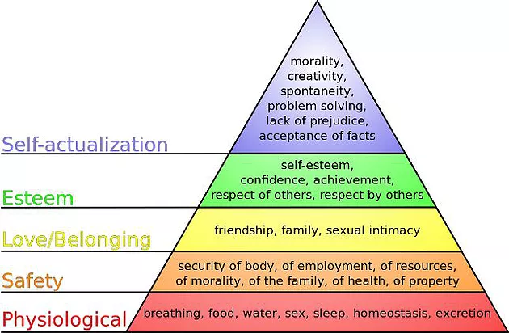

**Figure-1: Maslow’s hierarchy of needs model*. (*Source: Shah,2017)**

* **Equity Theory**

As Sims mentioned in a 2014 survey, Fairness is the premise of motivation. Equity theory holds that people's passion is not only related to the actual outcomes of the individual, but also to whether the outcomes is consistent with that of others.

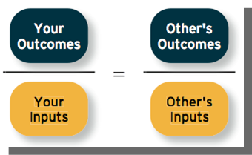

**Figure-2: Equity Theory*. (*Source: Sims, 2014)**

From the above figure, it shows people always compare their inputs and outcomes with others intentionally or unintentionally, and judge whether they are fair or not. Fairness directly influences employees' work behavior and motivation, when the proportion of gains and losses is like that of others, employees will feel calm inside; When their outcomes are higher than others, they usually feel excited and will be more motivated in future work; however, when they feel they are getting less than others, they will show anger or frustration (Shah, 2016). Therefore, in a sense, the process of stimulating work motivation lies in the rationality of distribution, which influences people's work enthusiasm by comparing with others (Sims, 2014).

In addition, Adams believes that when people feel that the allocation is unreasonable, different people will react differently. There are major reactions include: they may try to change their income and investment, change their perception of themselves and others, change their reference objects or directly change their current work (Al-Madi and Al-Zawahreh, 2014).

* **Expectation Theory**

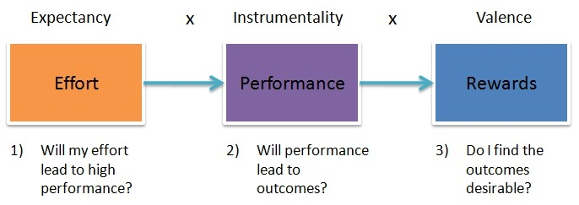

**Figure-3: Expectation Theory*. (*Source:** **Nemati,2016)**

As Valence write in a 2016 paper: There are two factors will influence people's motivation level, which are expectancy and target valence (Pandta *et al.*, 2015).

The first one is expectancy, which refers to people's subjective judgment of the feasibility of a goal. When people are confident of achieving the goal, they will try their best to accomplish the task, so as to maximize the incentive role of the goal; on the contrary, if people think it is difficult to achieve a goal, the incentive role of the goal will be very small (Okpu and Obiora, 2018).

The another one is target valence, according to people's subjective judgment of a goal, if the realization of this goal is of no value to them, the enthusiasm will be very low; on the contrary, it will be very high. Based on expectation theory, the incentive measures provided by enterprises to employees must be attractive and achievable (Pandta *et al*., 2015). Appropriately adjust the gap between the expected probability and the actual probability and the difficulty of achieving the goal, increase the difference between expected and non-expected behavior of enterprises can also help to enhance the incentive effect (Nemati, 2016).

* **Herzberg's two-factor theory**

Herzberg's two-factor theory divides the factors existing in management into hygiene factors and motivators. among them, hygiene factors refer to factors related to working environment or conditions, including job security, wages (Okpu and Obiora, 2018). Once the hygiene factors fail to meet the basic requirements, employees will be dissatisfied, in serious cases will damage the enthusiasm of employees, but even if the hygiene factors reach a certain level, employees will not have a direct sense of satisfaction (Riley,2015). Motivators factors are directly related to the specific content of the work itself, including promotion opportunities, sense of achievement and so on. Improving motivators can effectively motivate employees to produce satisfaction and mobilize their enthusiasm for work. In order to improve staff's work enthusiasm and work efficiency, Herzberg's two-factor theory enables business managers to redesign their work, such as job content, redesigning work departments, redesigning work processes, job responsibilities and so on.

* 1. **Conceptual Framework**

Based on the previous relevant literatures, promotion (Kiyoshi ,2016), performance appraisal (Kbhatti, *et al*., 2015), Immaterial incentive (Fang, Qi, Liu *et al*., 2014) and welfare (Ghodrati and Ghaffari, 2015) will be supposed to Indenpendt variables in this paper.

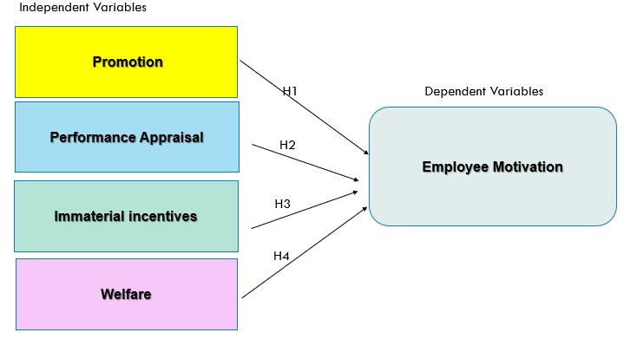

Figure 4-Conceptual framework

**2.6 Research hypothesis**

Based on the assumed causal relationship given in the conceptual model the following hypotheses were developed for testing.

H1: Performance Appraisal will significantly influence Employee motivation of China’s State-Owned Enterprises

H2: Promotion will significantly influence Employee motivation of China’s State-Owned Enterprises

H3: Immaterial incentive will significantly influence Employee motivation of China’s State-Owned Enterprises

H4: Welfare will significantly influence Employee motivation of China’s State-Owned Enterprises

**Chapter3. Research methodology**

**3.0Overview**

According to read a lot of literature, I have a deep understanding of the research content. In order to ensure the scientific and rigorous nature of this study, this paper collects relevant data through a questionnaire survey, based on the survey data, uses quantitative analysis method to conduct in-depth discussion on the research issues in this paper, in order to verify the research hypothesis proposes (Case and Hunter, 2015).

**3.1Research Design**

This aims of this research to perform a descriptive analysis through correlation to understand the factors that influence the effective Employee motivation of state-owned enterprises (Firestone, 2017). The respondents who are willing to answer the questionnaire are existing employees of Beijing PetroChina Co. Ltd. In this study, 550 employees of PetroChina Co. Ltd in Beijing, China were interviewed using random sampling and 384 valid answers were collected.

By referring to the valid questionnaires template for related research, this paper designs a questionnaire on employee motivation factors in state-owned enterprises in China, which combines the research of relevant literature. The design of this questionnaire mainly uses five-point scale, which requires the respondents to judge the importance of various incentive factors, satisfaction and the overall incentive status of the respondents according to their actual situation.

The questionnaire is divided into five parts. The first is basic information, including the gender, length of service, monthly income, educational level and current position of the employees. The next two to five parts are to investigate employees' attention to and satisfaction with corporate welfare, promotion, non-material incentives and performance evaluation. They are mainly divided into five levels: very agree, agree, generally disagree, very disagree.

**3.2 Unit of Analysis, population and Sampling Design**

The unit of analysis for this research is PetroChina Co. Ltd, as one of the most famous State-owned enterprises in Beijing, China. Although the interviewees are individuals, the main purpose of the study is to analyze the incentive status of the company and how to stimulate the enthusiasm of its employees through the employee motivation (Al-zawahreh and Madi, 2012).

PetroChina Co. Ltd distributed in various provinces and municipalities, 384 findings of investigation from 6500 employees in Beijing headquarters for this survey. The reason for choosing PetroChina Co. Ltd as the research object is that it is a typical representative of state-owned enterprises in China and would be easier for me to collect the data. It not only has the highest sales revenue in China, but also is one of the largest oil companies in the world. The use of online survey is mainly due to the limited time and space, and there are large number of employees in this enterprise, it is difficult to visit personally. The questionnaire is easy to implement, the speed of online access is fast, the information feedback is timely, and the privacy is strong. Some sensitive questions which are difficult to answer in public can be exchanged through the network. In addition, the respondents 'response rate is usually controlled at 75 percent, thus 384 respondents in 410 questionnaires are effective (Flynn, 2019).

**3.3 Data collection method and Statistical Analysis**:

The respondents are PetroChina Co Ltd. employees and this research used online questionnaire to collect data. There has two parts of data collection, the first part is basic information of respondents and the second part containing questions related to variables that Promotion, Performance Appraisal, Immaterial incentive and Welfare.

In this study, the data collected from questionnaires are analyzed by the popular social science statistical software. The main analysis methods include reliability analysis, descriptive statistical analysis, factor analysis, variance analysis and related analysis.

**Reliability analysis.**

Reliability analysis is reliability analysis, which is used to test whether a group of survey items measure the same characteristics and whether there is a high consistency among these survey items (Cooper and Schindler, 2015). This paper examines the reliability of the importance scale and satisfaction scale of four incentive factors for employees of a state-owned enterprise.

**Factor Analysis**

KMO and Bartlett’s test are used to analyze the importance of the four incentive factors in the questionnaire, so as to classify these incentive factors and divide them into dimensions (Firestone, 2017). At the same time, the hypothesis of the previous dimension division of incentive factors is tested and revised according to the results of factor analysis, then facilitate the further study of this paper (Dattalo, 2017).

**Multiple regression analysis**

In this research, regression equation is used to describe the linear dependence between strain and multiple independent variables (Zaslavsky, 2016). The basic idea of regression analysis is that although there is no strict and definite functional relationship between dependent variables and independent variables, I will try to find out the mathematical expression which best represents the relationship between them.

The process of doing a SPSS analysis as below:

**Step 1: Define variables**

In Variable View, variables usually include Income, type, width, label decimals, Values, Missing, Columns, Align, Measure, etc. Each question in the questionnaire is set as a variable, and the answer to each question is the value of the variable (Arkkelin, 2014).

For example, what is your monthly income?

A:1500 below B:1501-2500 C:2501-3500 D:3501-5500 E:5500 above

Therefore, the variables are set as follows: Income is variable name 1, type can be set according to the type of answer. Answer I use 1, 2, 3, 4, 5 instead of A, B, C, D, E. So Numeric, width is 5, label is variable label is "revenue query", decimal is 0. Because the answer has no decimal point, Values is used to define the label of specific variable value, that is, 1 = RMB1500 below, 2 = RMB1501 - 2500,3=RMB2501-2500, 4 = RMB3501 – 5500, 5=RMB5500 above. Missing, used to define missing values of variables, can define up to three values; the last one is "missing range plus an optional missing value", Columns, which defines the display column width and can be set according to the actual situation; Align defines display alignment mode, which has three ways: left, right and middle; Measure, which defines variable types according to disorderly and orderly continuous classification (Flynn, 2019).

**Step 2: Data entry**

SPSS data has multiple ways to input, here are roughly several ways:

1. Read data in Excel and other formats

2. Read data in SPSS format

3. Read data in database format

4. Read Fixed and Delimiter

In the data entry window, there will be 1, 2, 3, 4, 5 above the table... This is the variable name of each question in the questionnaire. That is, 1 represents the first question and 5 represents the fifth question.

For example, the question of monthly income, if the answer B is checked on the questionnaire, the number 2 is displayed in SPSS. In short, each line represents a question, and there are several lines of data in the questionnaire (Field,2014).

**Step3: Statistical analysis**

After filling in the data, using SPSS analysis methods to analyze, which statistical analysis method to choose is the key to get the correct analysis results. SPSS can be divided into two types: Graphic analysis and Numerical analysis.

Graphic analysis usually using scatter plots, pie charts and bar charts. The advantage of drawing analysis is that it is easy to operate and easy to understand. For instance, the pie chart can intuitively draw the proportion of gender, age and income involved in the survey.

In Numerical analysis, basic statistical analysis is the premise of other more in-depth statistical analysis. Through basic statistical analysis, users can grasp the overall characteristics of the analysis data more accurately, and then study the analysis object via using more in-depth analysis methods.

Correlation analysis mainly counts the degree of closeness between two variables, which can simply and effectively explain the relationship between the two variables (Gastwirth and Gel, 2015). These relationships are usually described as negative correlation, positive correlation, linear correlation and so on. Such as, by analyzing the relationship between job satisfaction and wage level of employees of a company, sig > 0 indicates that the two variables are positively correlated, otherwise they are negatively correlated. In addition, if sig < 0.3, there is basically no correlation between the two, which means that there is not much relationship between employee's job satisfaction and salary level.

Multiple linear regression analysis mainly studies the correlation between a dependent variable and multiple independent variables. In k independent variables, F test can pass as long as there is a significant linear relationship between an independent variable and a dependent variable, but this does not mean that the relationship between each independent variable and a dependent variable is significant. R square represents the fitness. If the fitness is too low and the concern between multiple linear regression equations is not significant, it means that an independent variable has nothing to do with a dependent variable. It is not necessary to put this independent variable into the model. For example, by exploring the relationship between the basis of improving employees and factors such as employee performance, seniority, high quality of oneself and interpersonal relationship, through multiple linear regression, we can find out which factor is most likely to be the basis of employee promotion (Okpu and Obiora, 2018).

In a word, the steps of multiple linear regression analysis are as follows: making scatter plots, observing the trend among variables - investigating the distribution of data - carrying out linear regression analysis, establishing basic models - carrying out residual analysis (normality, independence, homogeneity) - judging multicollinearity and diagnosing strong influence points (Arkkelin, 2014).

**Step 4: Examination results**

After analyzing the relationship between the variables, we confirm whether there are any errors in the operation and whether each analysis method is applicable. Then summarize the scattered results and draw final conclusions.

**3.4** **Conclusion**

In order to find out which factors will influence these companies to improve employee motivation, this research use the Quantitative methods to collect the data, use the SPSS software to analyze statistical data and then get the correlation between independent variables and dependent variables. Such as, in terms of data collection method, online questionnaires will be used to collect the 384 valid replies from those three companies. In terms of Statistical Analysis, I will apply various data analysis methods which included scatter plots, pie charts and bar charts, Correlation analysis, and multiple linear regression.

**Chapter 4. Data analysis and interpretation**

**4.0 Overview**

Based on the previous analysis, this chapter uses the relevant statistical analysis of the data collected from the questionnaire, so as to test the previous research hypothesis and get the results of this study.

**4.1 Descriptive Analysis**

In this paper, I used the questionnaire designed to measure the motivation factors of PetroChina employees in detail. Due to the differences in background variables such as age, gender, working years, educational background and current position, the respondents were divided into different groups, forming a diversified sample structure, as shown in the tables below.

Table 1 Gender of Respondents

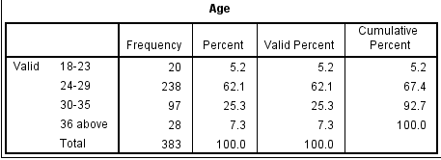

Table 2 Age of Respondents

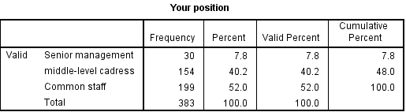

Table 3 Current position of Respondents

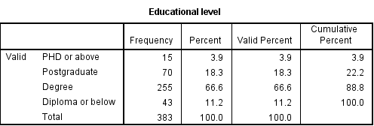

Table 4 Educational level of Respondents

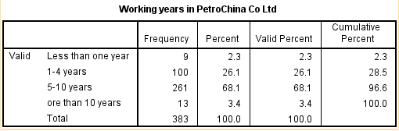

Table 5 Working years of Respondents

From the results of this survey, we can see that the sample distribution of this research is comprehensive and in line with the object of this study. Firstly, from the perspective of gender and age, most of the respondents are 24-35 years old, and males accounting for 70 percent of the total, indicating that most of the employees of PetroChina belong to the young group born in the 1980s and 1990s.

Secondly, from the position point of view, most of the respondents are common staff and middle-level cadres.

Lastly, according to the academic distribution of the sample, 67% of the employees with bachelor's degree, 18% of the postgraduates and 12% of the diploma, respectively, show that the educational level of the employees in the state-owned enterprises has generally improved.

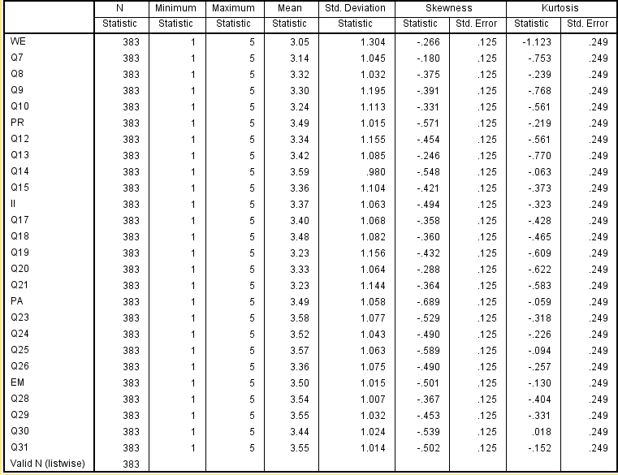

Table 6: Descriptive statistics

In order to prove normal univariate distribution, the values for kurtosis and asymmetry between -2 and +2 are considered acceptable (George & Mallery, 2015). As shown table above, the mean values of these items are ranged between 3.50 and 4.30. Most of the respondents are giving rate between “Neutral” and “Agree”. The kurtosis values are ranged between -1.123 and -0.018, while the skewness values are ranged between -0.689 and -0.180. Those test results indicated that the data from the respondents are reasonable.

**4.2 Pilot test**

Pilot test is usually carried out before formal test. Through small-scale preliminary testing, the design of questionnaire can be improved and evaluated before the survey is fully carried out, so that the data results are more reliable and effective (Wright and Bonett, 2015).

**4.2.1 Factor Analysis (KMO and Bartlett’s test)**

In order to ensure the scientific of this study, before factor analysis, we first use KMO and Bartlett’s to test whether the data collected from questionnaires are suitable for factor analysis.

From the following two tables, we can see that the KMO values of dependent variable and independent variable are 0.654 and 0.765 respectively. According to statistical standards, when the value is greater than 0.6, the relevant data is suitable for factor analysis (Pestana, 2015). Therefore, from the sample test, the survey data is suitable for sub-analysis. At the same time, the Bartltt’s results of dependent and independent variables are less than 0.05, indicating that there are common factors in the sample data, which is also suitable for factor analysis.

**Independent Variables**

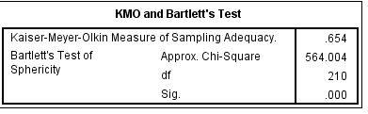

Table 7 KMO and Bartlett’s test (IV)

**Dependent Variables**

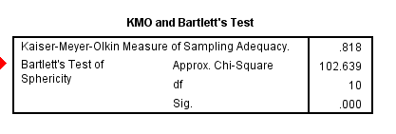 Table 8 KMO and Bartlett’s test (DV)

**Factor Analysis (Communalities)**

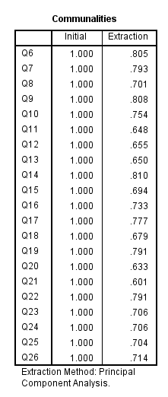

Table 9 Communities for independent variables

Samuels（2016）shows that the communalities are used to how much variance in each variable is explained by the analysis, and those variables must be greater than 0.50. From the table 8, communalities extraction for all components in Independent variables are from 0.601 to 0.810.

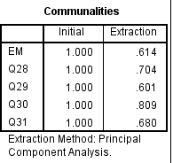

Table 10 Communities for dependent variables

From the table above, communalities extraction for all components in dependent variables are from 0.601 to 0.809, which more than 0.05. Therefore, we can conclude that all factors maybe be useful and adequate in this study.

**Factor Analysis (Eigenvalues)**

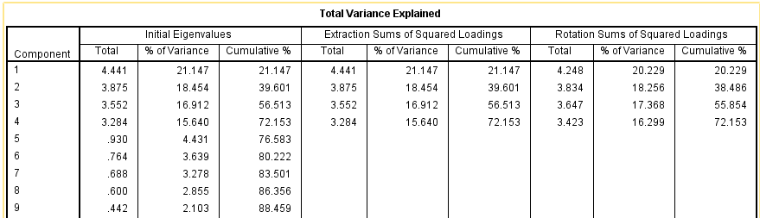

Table 11 Total valued explained (IV)

Factors with eigenvalues more than 1 are considered significant, the percent of cumulative usually more than 60% (Hayton, Allen and Scarpello, 2013). From the table 11, there are four components, component 1,2,3 and 4 are more than one, thus the four stated components are to be kept for further analysis. The rest of components which have the Eigenvalues less than one must be exclude for further analysis.

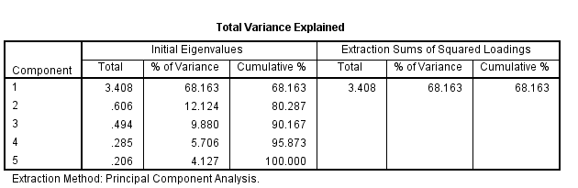

Table 12. Total valued explained (DV)

The tables show that Eigenvalues for component 1 is 3.408, thus it’s to be kept for further analysis, however, the rest of components which have the Eigenvalues less than one must be exclude for further analysis.

**4.2.2 Reliability Analysis**

|  |  |  |
| --- | --- | --- |
|  | Cronbach Alpha | Items |
| Employee motivation | 0.880 | 5 |
| Welfare | 0.919 | 5 |
| Promotion | 0.868 | 5 |
| Immaterial Incentive | 0.904 | 5 |
| Performance Appraisal | 0.895 | 5 |

Table 13 Reliability analysis

In this pilot test, I calculate the Cronbach’s Alpha of the items, including dependent variables (employee motivation) and independent variables（welfare, promotion, performance appraisal and immaterial incentive) As a whole, the Cronbach‘s Alpha obtained is 0.880, it would be considered reliable because it's within 0.7 to 0.95 (Maier and Berking, 2015).

**4.3 Factor Analysis**

**KMO and Bartlett’s test**

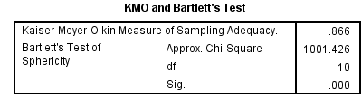

Table 14 KMO and Bartlett’s test for Dependent Variable

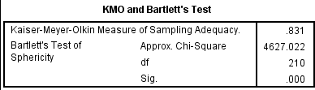

Table 15 KMO and Bartlett’s test for Independent Variable

From the following two tables, we can see that the KMO values of dependent variable and independent variable are 0.866 and 0.831 respectively. According to statistical standards, when the value is greater than 0.6, the relevant data is good for factor analysis (Pestana,2015). Therefore, from the sample test, the survey data is suitable for sub-analysis. At the same time, the Bartlett’s results of dependent and independent variables are 0.000, indicating that there are common factors in the sample data, which is also suitable for factor analysis.

**Communalities**

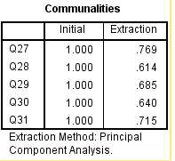

Table 16 Communalities extraction for Dependent variables

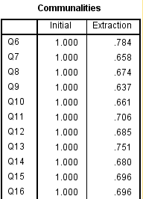

Table 17 Communalities extraction for Independent variables

From table 16 and 17, we can see that all those variables are greater than 0.50, which indicated that the data from the respondents are useful and adequate in this study.

**4.4 Reliability test**

|  |  |  |
| --- | --- | --- |
|  | Cronbach Alpha | Items |
| Employee motivation | 0.884 | 5 |
| Welfare | 0.882 | 5 |
| Promotion | 0.889 | 5 |
| Immaterial Incentive | 0.902 | 5 |
| Performance Appraisal | 0.870 | 5 |

Table 18 Reliability test

Reliability analysis is an effective method to test the stability and reliability of survey data. Before the in-depth study of the survey data, in order to ensure the scientific conclusion of the study, this paper uses the Cronbach coefficient to measure the internal consistency of the questionnaire-related scale. Generally speaking, when the coefficient is greater than 0.8, the reliability of the questionnaire is very high; when the coefficient is greater than 0.7 and less than 0.8, there are problems in the design of the questionnaire, but there is still some reference value; when the coefficient is less than 0.7, there are larger problems in the design of the questionnaire, which need to be redesigned. This paper will analyze the reliability of the incentive factors of employees in state-owned enterprises, and the statistical results are as follows. From the test results, the results of the above five variables are more than 0.8, which shows that the questionnaire has high internal consistency and can meet the needs of statistical analysis in this study.

**Eigenvalues**

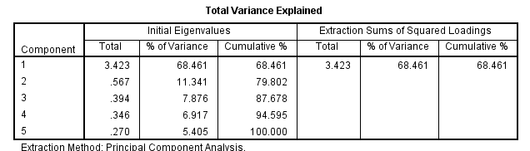

1. Total variance explained for DV

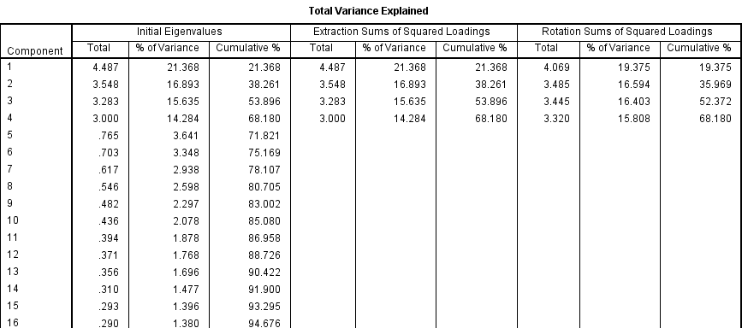

1. Total variance explained for IV

Table 19 Eigenvalues

From the funding above, for Independent variables, component 1,2,3 and 4 are more than one, thus the four stated components are to be kept for further analysis. The rest of components which have the Eigenvalues less than one must be exclude for further analysis. For dependent variables, the Eigenvalues for component 1 is 3.423, thus it’s to be kept for further analysis, however, the rest of components which have the Eigenvalues less than one must be exclude for further analysis.

**4.5 Hypothesis testing**  
**One-way ANOVA**

|  |  |  |  |  |  |
| --- | --- | --- | --- | --- | --- |
| **ANOVA** | | | | | |
| WE | | | | | |
|  | Sum of Squares | df | Mean Square | F | Sig. |
| Between Groups | .423 | 3 | 2.266 | 3.158 | .025 |
| Within Groups | 337.944 | 379 | .892 |  |  |
| Total | 338.366 | 382 |  |  |  |

a. Welfare – Employee motivation

|  |  |  |  |  |  |
| --- | --- | --- | --- | --- | --- |
| **ANOVA** | | | | | |
| PR | | | | | |
|  | Sum of Squares | df | Mean Square | F | Sig. |
| Between Groups | 13.939 | 3 | 3.313 | 4.102 | .004 |
| Within Groups | 299.138 | 379 | .789 |  |  |
| Total | 303.077 | 382 |  |  |  |

b. Promotion – Employee motivation

|  |  |  |  |  |  |
| --- | --- | --- | --- | --- | --- |
| **ANOVA** | | | | | |
| II | | | | | |
|  | Sum of Squares | df | Mean Square | F | Sig. |
| Between Groups | 11.696 | 3 | 3.899 | 4.985 | .002 |
| Within Groups | 296.426 | 379 | .782 |  |  |
| Total | 308.123 | 382 |  |  |  |

c. Immaterial incentive – Employee motivation

|  |  |  |  |  |  |
| --- | --- | --- | --- | --- | --- |
| **ANOVA** | | | | | |
| PA | | | | | |
|  | Sum of Squares | df | Mean Square | F | Sig. |
| Between Groups | 7.448 | 3 | 2.483 | 3.402 | .018 |
| Within Groups | 276.620 | 379 | .730 |  |  |
| Total | 284.068 | 382 |  |  |  |

d. Performance appraisal – Employee motivation

Table 20 ANOVA

From the table above, the p-value of Immaterial incentive, promotion and performance appraisal, welfare are less than 0.05, indicated that there is a significant influence between Performance Appraisal, welfare, Immaterial Incentive, promotion and employment motivation (Statistics, L).

**Multiple Regression Analysis**

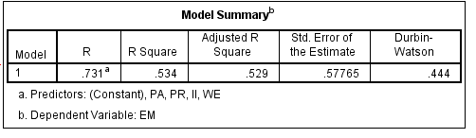

Table 21: Multiple regression analysis

Multiple linear regression is used to study the relationships between a dependent variable and multiple independent variables, fitting degree of independent variables to dependent variables, which can be measured by R square. The larger the R square is, the higher the fitting degree of the model is. The outcome shows that R square value had achieved 0.534, indicates about 53 percent of the model fit and determine the relationship. The remaining of about 47 percent of variances which don’t contribute to the model, could be explained by other factors that are not considered in this research.

**Beta Coefficient Test**

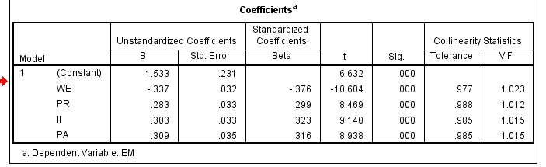

Table 21 Coefficient between IV and DV

A standardized beta coefficient is used to compare the strength of the effect of each individual independent variable to the dependent variable, the association between variables will be stronger with the increase of Beta values (Grace, 2015). Based on the funding above, the Immaterial Incentive which has a value of 0.323 indicated that it has strongest influence on other independent variables. At the same time, it is worth noting that the Beta value of welfare factors is negative, which shows that although welfare has a significant impact on employee motivation, it is negatively correlated.

In addition, based on the rule of thumb for interpreting, if the VIF is 1 means not correlated, between 1 to 5 means moderately correlated. Based on the table above, the value is ranging from 1.012 to 1.023, which belongs to moderately correlated.

**4.6 Summary of funding result**

|  |  |
| --- | --- |
| **Hypotheses** | **Accept/Reject** |
| H1 (Performance appraisals) | Accept |
| H2 (Promotion) | Accept |
| H3 (Immaterial incentive) | Accept |
| H4 (Welfare) | Accept |

From above time, all are accepted based on results of multiple regression analysis. Therefore, Performance appraisal, Promotion, Immaterial Incentive and welfare will significantly influence employee motivation of State-Owned Enterprises in Beijing, China.

**Chapter 5. Conclusion and Recommendation**

**5.0 Findings and Discussion**

**Demographic factor**

Through this online survey, PetroChina employees as the respondent group received 410 questionnaires, but due to various reasons, the final effective answer was 383 copies. In the 383 valid questionnaires, 271 of respondents were males and 112 were females, most of them came from age groups of 24 to 35. Therefore, we recognize that the backbone of state-owned enterprises today is mainly concentrated in the age group born in the 1980s and 1990s. In addition, among these 383 respondents, 340 respondents had at least an undergraduate degree, which shows that the level of labor culture in Beijing is generally high. Most of the respondents' working years are between 2 and 10 years, with more and more young people joining the job, the personality characteristics and background variables of these new generation employees determine their diversity and innovation of incentive needs.

**Hypothesis testing**

H1: Performance appraisal will significantly influence employee motivation of State-Owned Enterprises in Beijing, China (Positive relationship).

H2: Promotion will significantly influence employee motivation of State-Owned Enterprises in Beijing, China (Positive relationship).

H3: Immaterial incentive will significantly influence employee motivation of State-Owned Enterprises in Beijing, China (Positive relationship).

H4: Welfare will significantly influence employee motivation of State-Owned Enterprises in Beijing, China (Negative relationship).

From the results of hypothesis test, the three incentive factors (performance appraisal, promotion, immaterial incentive) of PetroChina employees are positively correlated with employee motivation while welfare factors are negatively correlated with employee incentive. For the standardized coefficients, the beta of Immaterial Incentive, performance appraisal, promotion and welfare are 0.323, 0.316, 0.299 and -0.376, which indicated that it has strongest influence on other independent variables. At the same time, it is worth noting that the Beta value of welfare factors is negative, which shows that although welfare has a significant impact on employee motivation, it is negatively correlated.

This result shows that improving the satisfaction of various immaterial incentive factors can improve the overall incentive level of employees. Enterprises provide sufficient material incentives for the new generation of knowledge-based employees, at the same time, they also must attach great importance to non-material incentives for employees. Starting from the characteristics of employees, they should carefully study their specific needs for immaterial incentives and adopt targeted immaterial incentives in order to truly achieve the purpose of motivating employees.

**5.1 Conclusion**

From the above findings, we can see that most employees of state-owned enterprises do not get enough incentives in their daily work, which is also the reason for the inefficiency of state-owned enterprises. At the same time, it also shows that the state-owned enterprises pay insufficient attention and understanding to the incentive problem of the new generation of employees and cannot take effective incentive measures to improve the enthusiasm and loyalty of employees. Based on the above situation, this paper puts forward relevant suggestions for state-owned enterprises in three aspects: performance appraisal, immaterial incentives and promotion.

1) Emphasizing career development to improve staff's working ability

For personal growth and development, the new generation of state-owned enterprise employees have strong desire to improve their professional knowledge and skills. They regard work as the continuation of campus learning and life, not just the guarantee of life, besides that, they hope to constantly supplement their lack of knowledge in work, so as to improve their working ability (Gel and Miao, 2015). Therefore, effective staff training is an important incentive to stimulate the enthusiasm of the new generation of knowledge workers. State-owned enterprises must attach importance to the training of the new generation of knowledge workers and establish a sound training mechanism for them.

2) Fair Distribution Mechanism

State-owned enterprises should realize the internal fairness of salary and improve the external competitiveness of salary, because different positions have different requirements for employees' abilities and qualities, in order to achieve internal fairness, it is necessary to distinguish the relative values of different positions on the basis of detailed job analysis, so as to determine the wage and remuneration gap (Chai, Ling and Piew, 2016). Employee performance evaluation system is the basis of implementing the salary system of the whole enterprise. Enterprises should link performance appraisal with income, establish a positive incentive mechanism, effectively improve the healthy competition and development of employees under the guidance of the principle of internal fairness, and obtain corresponding income. In addition, enterprises need to actively and effectively update and understand the human resources situation of the entire industry market and adjust the market price to determine the external competitiveness of compensation (Song *et.al.*, 2016).

3) Develop a clear promotion mechanism

The value orientation of the new generation of employees is diversified, and the definition of personal success is different from that of post in the past. However, under the influence of traditional Chinese concepts and social environment, they still pay attention to the pursuit of individual rights and status, and regard job promotion as an important criterion to measure individual success (Wang, 2018). They are also eager to be respected and recognized by the society while pursuing the realization of their self-worth. Therefore, a good promotion mechanism can make employees work harder in order to get rapid job promotion, and help state-owned enterprises effectively promote the enthusiasm of employees (Loo *et al*., 2015).

**5.2 Limitations and recommendations of Research**

Through the study of the incentive factors of employees in state-owned enterprises, this paper has made some valuable research results and put forward corresponding incentive measures. However, due to the limitations of many aspects, this paper still has deficiencies in many aspects. This chapter considers and summarizes the deficiencies of this study and makes further progress in the future, the next step of the study carries out the corresponding prospects.

Firstly, due to the limited research conditions, the sample and number of this study meet the requirements of statistical analysis, but there are still some limitations. For example, insufficient sample size may affect the representativeness of the research results, especially for PetroChina, which employs more than 20,000 employees nationwide. In addition, due to the influence of time, region and other conditions, this paper only investigates the employees of state-owned enterprises in Beijing, and the survey data have certain geographical limitations. Therefore, in future research, we should expand the scope of research, increase the sample size of research, and make the conclusions more convincing.

Secondly, there are some limitations in the refinement of incentive factors and the construction of indicator system for employees of state-owned enterprises (Viberg and Gronlund, 2013). That is, in the process of refining the indicators, there is a certain degree of subjectivity, which makes it difficult to measure the employees' demand for incentives in state-owned enterprises in an all-round way and makes the conclusions of the study have certain limitations. Therefore, in the future research, we should adopt a more scientific and reasonable method to refine the incentive factors of the new generation of knowledge workers, reduce their subjectivity as far as possible, and ensure the objectivity and reality of the research conclusions.

Lastly, this paper only studies the independent influence of performance appraisal, promotion, immaterial incentive and welfare on employee motivation, but does not make corresponding research on the influence of background variables on the four motivation factors, people can further discuss this direction in the future.

(Final word count:10026)

**4.0Reference:**

Al-Madi, F. and Al-Zawahreh, A. (2014). The Utility of Equity Theory in Enhancing Organizational Effectiveness. *European Journal of Economics, Finance and Administrative Sciences*, [online] 45(3), pp.4-15. Available at: https://eis.hu.edu.jo/deanshipfiles/pub105581932.pdf [Accessed 26 July. 2019].

Arkkelin, D. (2014). *Using SPSS to Understand Research and Data Analysis*. [online] Available at: https://scholar.valpo.edu/cgi/viewcontent.cgi?article=1000andcontext=psych_oer [Accessed 26 July. 2019].

Al-zawahreh, A. and Madi, F. (2012). The Utility of Equity Theory in Enhancing Organizational Effectiveness. *European Journal of Economics, Finance and Administrative Sciences*, [online] 46(8), pp.1460-2276. Available at: https://www.researchgate.net/publication/267783009_The_Utility_of_Equity_Theory_in_Enhancing_Organizational_Effectiveness [Accessed 26 July. 2019].

Babatunde, L and Joseph. (2015). The effect of employees’ motivation on organizational performance. *Journal of Public Administration and Policy Research.* 7(4) pp. 62-75

Brødsgaard, K. E. (2018)*. How China Keep Controlling Its SOEs?* [online] Available at: https://thediplomat.com/2018/03/can-china-keep-controlling-itssoes/ [Accessed 26 July. 2019].

Bodmer, F. (2015). On the Use of Incentive Pay in Chinese State‐owned Enterprises: The Role of Hierarchy. *International Journal of Socialist Economy*, 8(12), pp.667-690.

Cooper, D. R., & Schindler, P. S. (2015). Business research methods (11th ed.). New

York, NY: McGraw-Hill/Irwin

Du, F. and Liu, J. (2014) *The History and Future of China Oil and Gas.* [online] Available at: <https://www.onepetro.org/conference-paper/SPE-89776-MS> [Accessed 27 July. 2019].

Field, A. (2014). *Data entry for correlation analysis using SPSS*. [online] Available at: https://www.discoveringstatistics.com/repository/correlation_spss.pdf [Accessed 27 July. 2019].

Flynn, D. (2019). Multivariate Statistical Methods in SPSS. *Department of Biological Sciences*, [online] 45(6), pp.45-50. Available at: https://barnard.edu/sites/default/files/inline/student_user_guide_of_spss.pdf [Accessed 25 July. 2019].

Filho, J. and Alve, C. (2017). Motivation mechanisms in the corporate governance of state-owned enterprises (SOEs). *The monthly Journal of Economics*, [online] 16(1), pp.1679-2651. Available at: http://dx.doi.org/10.1590/1679-385172454 [Accessed 26 July. 2019].

Gel, G. and Mao. (2015). Attractiveness of non-financial rewards for prospective knowledge workers: An experimental investigation, Employee Relations, 37(3), pp.274-295.

Ghodratia, H. and Ghaffari, T. (2015). A study on effective factors on employee motivation. *Management Science Letters*. pp.1511-1520.

Groves, T., McMillan, J., Hong, Y. and Naughton, B. (2016). What are the root causes of hindering the development of state-owned enterprises. *The Monthly Journal of Economics*, 109(2), pp.3-7.

Guo, B. (2014). Low working efficiency problem in China State-Owned Enterprise, Journals of China economics, [Online]. 12(2), PP.6-10. Available at: https://academic.oup.com/jcmc/article/JCMC1034/4614509 [Accessed 24 July. 2019].

Hou, S. (2016). Thoughts on Employee motivation in China’s State-Owned Enterprises. *Journal of Asia social science*, [online] 4(11), pp.83-86. Available at: https://pdfs.semanticscholar.org/7eea/8fe844ccb9bc18e7f7de398b5dad4f99450.pdf [Accessed 26 July. 2019].

Korzynski, P. (2013). Employee motivation in new working environment. *International Journal of Academic Research*, 5(5), pp.184-188.

KBhatti, O. and Hassan, A. (2016). Employee motivation an Islamic perspective, Human omics. 32(1), pp.33-47.

Karaskakovska, S. (2014). Analysis of the Employee Motivation Factors: Focus on Age and Gender Specific Factors. *SSRN Electronic Journal*.

Kiyoshi, T. (2016). Effects of wage and promotion incentives on the motivation levels of Japanese employees. *Career Development International*, 11(3), pp.193-203.

Liu, Y. (2014). The Employee motivations of the New Generation Employees. *International Journal of Business and Social Science*, [online] 5(8), pp.310-317. Available at: https://ijbssnet.com/journals/Vol_5_No_8_July_2014/31.pdf [Accessed 24 July. 2019]**.**

Lyons, K. (2017). *HOW TO DEFINE GOOD RESEARCH OBJECTIVES*. [online] Available at: https://www.lipmanhearne.com/how-to-define-good-research-objectives/ [Accessed 25 July. 2019].

Leutert, W. (2016). Challenges Ahead in China’s Reform of State-Owned Enterprises. *Journal of Asia Policy*, [online] 12(7), pp.83-99. Available at: https://www.brookings.edu/w-content/uploads/2016/07/Wendy-Leutert-Challenges-ahead-in-Chinas-reform-of-stateowned-enterprises.pdf [Accessed 26 July. 2019].

Megginson, W. (2017). Corporate Governance of modern State-owned Enterprises in China. *International Journal of Property Investment and Finance*, [online] 45(13), pp.18-29. Available at: http://www.oecd.org/daf/corporategovernanceofstate-ownedenterprises/1923755.pdf [Accessed 26 July. 2019].

Maier, T. and Berking, M. (2015). A multicentre pilot study investigating high definition optical coherence tomography in the differentiation of cutaneous melanoma and melanocytic naevi. Journal of the European Academy of Dermatology and Venereology, 29(3), pp.537-541.

Nemati, S. (2016). *Expectancy Theory Overview*. [online] Available at: https://wikispaces.psu.edu/display/PSYCH484/4.+Expectancy+Theory [Accessed 25 July. 2019].

Okpu, T. and Obiora, N. (2018). Organizational Justice and Employee Work Passion in Nigerian Universities. [online] Available at: https://www.researchgate.net/publication/327907238_organizational_justice_and_employee_work_passion [Accessed 15 Agu. 2019].

Othman, L. (2015). A Study on the Impact of Rewards and Recognition on Employee Motivation. *International Journal of Science and Research (IJSR)*, 4(11), pp.1644-1648.

Parshetty, S. (2019). Employee Motivation and Their Impact on Employee Performance in Banking Sector in Hyderabad Karnataka Region. *International Journal of Trend in Scientific Research and Development*, Volume-3(Issue-4), pp.390-393.

Pandţa, J., Đeri, L., Galamboš, A. and Galamboš, T. (2015). Two-factor Analysis of Employee Motivation at "Postal Traffic – Department in Novi Sad." *European Journal of Economic Studies,* 12(2), pp.101-111.

Pestana, T. 2015. The use of factor analysis in the statistical analysis of multiple time

series. *Psychometrika*, 1963(28), pp.1-25

PetroChina Co Ltd Website. (2019). *The mechanism for assessment of performance and for incentive and restrictions*. [online] Available at: http://www.petrochina.com.cn/ptr/gszljg/201405/84ba3eac10fe49029359c5e1eec9c71c.shtml [Accessed 24 July. 2019].

Riley, S. (2015). Herzberg 's Two-Factor Theory of Motivation Applied to the Motivational Techniques within Financial Institutions. *Journal of Senior Honors Theses*, 12(2), pp.34-45.

Statistics, L., (2015). One-way ANOVA using SPSS Statistics. Statistical tutorials and software guides

Song, L., Yang, J. and Zhang, Y. (2016). State-owned Enterprises' Outward Investment and the Structural Reform in China. *China & World Economy*, 22(5), pp.38-53.

Shah, P. (2017). *How Maslow’s Hierarchy of Needs Applies in The Workplace*. [online] HOPE DOCTORS. Available at: https://www.hopedoctors.com/single-post/2017/03/17/Maslows-Hierarchy-Of-Needs-Workplace [Accessed 26 July. 2019].

Sims, B. (2014). *FALL 2014 Equity Theory Case*. [online] Available at: https://wikispaces.psu.edu/display/PSYCH484/FALL+2014+Equity+Theory+Case [Accessed 25 July. 2019].

Sheng, Y., Xu, a. and Zhu, K. (2014). Incentive mechanism of SMEs innovation policy: empirical evidence from Zhejiang province, China. International Journal of Technology, Policy and Management, 14(2), p.160.

Sincero, S. (2015). *Pros and cons of web-based questionnaires*. [online] Available at: https://explorable.com/online-surveyshttps://explorable.com/online-surveys [Accessed 26 July. 2019].

Sunghoon, K., Wright, P. and Su, Z. (2015). Human resource management and firm performance in China: A critical review. *Asia Pacific Journal of Human Resources*, 48(2), pp.58-85.

Tondello, G. (2018). *Understanding Gamification Through Goal-Setting Theory*. [online] Available at: https://medium.com/@hcigamesgroup/understanding-gamification-through-goal-setting-theory-3010481b05cd [Accessed 25 July. 2019].

Wang, h. (2018). Analysis on the Employee motivation of State-owned Enterprises in China. *IOP Conference Series Materials Science and Engineering,* 493(8), p.12.

Wen, J. and Moore, S. (2013). Human resources Reform of State-owned enterprises and challenges in China. *Journal of Entrepreneurship in Emerging Economies*, [online] 51(3), pp.56-98. Available at: https://www.emeraldinsight.com [Accessed 26 July. 2019].

Wright, T.A., and Bonett, D.G. (2015). Cronbach's alpha reliability: Interval estimation,

hypothesis testing, and sample size planning. Journal of Organizational Behavior, 36(1),

pp.3-15.

Xin, L., Bao, M. and Hu, J. (2018). West meets east: Understanding managerial incentives in Chinese SOEs. *China Journal of Accounting Research*, 12(209), pp.177-189.

Yong, G. and Ran, a. (2014). Analysis of State-owned Enterprises Incentives. *The International Conference on E-Business and E-Government*, [online] 31(8), pp.12-14. Available at: https://www.researchgate.net/publication/328752090. [Accessed 24 July. 2019].

Zhang, L. and Liu, F. (2018). High turnover rate in China’s state-owned enterprises: Government-oriented or market-oriented? *China Journal of Accounting Research*, 11(2), pp.129-149.

Zaslavsky, L. (2016). Interrelationships of multivariate regression methods using eigenvector basis sets. J. Chemom. pp.13-99

Zvavahera, P. and Tandi, R. (2019). Application and implications of Maslow s Hierarchy of Needs Theory: The Zimbabwean experience. *Turk Turizm Arastirmalari Dergisi*, 2(3), pp.63-82.

Appendix 1: Questionnaire

**Questionnaire**

Dear Respondents:  
The purpose of this study is investigating the factors influence the employee motivation of PetroChina Co Ltd. in Beijing, China, I would like to invite you to participate and complete this questionnaire.   
Your answers will be treated with strictest confidentially and only used in this research. This questionnaire includes 31 questions and will take 5-10 minutes to finish it. Before   
answering the questions, please read the instructions carefully.  
I would be grateful if you could take time to answer this questionnaire, serious answers will help to make the results more accurate. Thank you for your cooperation.

Part1:Basic information

1. Gender

Male

Female

1. Working years in PetroChina Co Ltd

Less than one year

1-4 years

5-10 years

More than 10 years

1. Educational Level

PHD or above

Postgraduate

Degree

Diploma

1. Position

Senior management

Middle level cadres

Common staff

1. Age

18-23

24-29

30-35

35 above

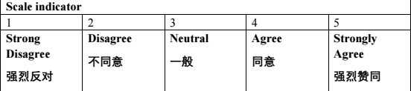

Part 2: Welfare (Ghodrati and Ghaffari, 2015).   
Instruction: please read the following questions carefully and answer all questions according to the facts

6.I think the company's current welfare management system is reasonable.

A. Strong Disagree

B. Disagree

C. Neutral

D. Agree

E. Strongly Agree

7. I think there is a small gap between the welfare of the company's management and common employees.

8. Compared with other state-owned enterprises, the activities of my organization are various, and the welfare level is higher.

9. The company's welfare system has a great incentive for me.

10. The welfare system provided by the company made me feel secure in my work and life.

Part 3: Promotion（Kiyoshi,2016）  
Instruction: please read the following questions carefully and answer all questions according to the facts

11. I think the company should provide me with space for career development

12.I have many opportunities for promotion in the company.

13. I am very satisfied with my present position.

14.Compared with the working ability, the company's promotion conditions are more focused on Seniority (Ahmad,2017).

15.The promotion system of our company is reasonable

Part 4: Immaterial Incentives (Fang, Qi and Liu *et al*., 2014)

16. I think the training courses offered by the company can help me achieve career advancement (Loo, Tan and Yep, 2015).

17. I think it's important to have respect, care and prompt recognition and encouragement from superiors if I do a good job.

18. I am satisfied with my working environment.

19. Challenging tasks can stimulate my enthusiasm for work.

20. At work, I am respected and recognized by my colleagues and supervisors.

21.It's important for me to learn knowledge in my work.

Part 5: Performance Appraisal (Kbhatti *et al*., 2015)

22.Managers should be very impartial in evaluating performance and build on a large amount of information and data.

23. Selecting excellent employees should listen more to the opinions of grass-roots employees.

24.The performance appraisal system should represent the interests of most people.

25.The results of company performance appraisal should be linked to performance pay.

26.I think the company's performance appraisal system is perfect fair and reasonable.

Part 6: Employee motivation (Parshetty, 2019).

27.Regular training can motivate me to work harder.

28.Regular training can motivate me to work harder.

29. The company's performance appraisal mechanism is effective for individual incentives.

30. I think the company's salary and work arrangement are fair and reasonable.

31. I get enough motivation in my daily work.

Appendix2: Turnitin report

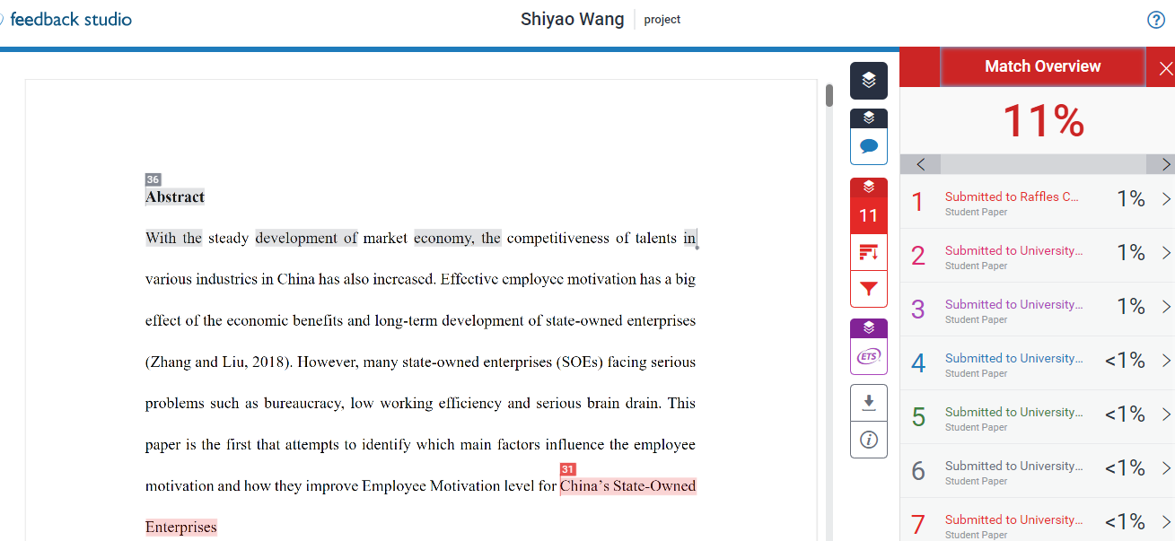

Appendix 3 MBA Project log

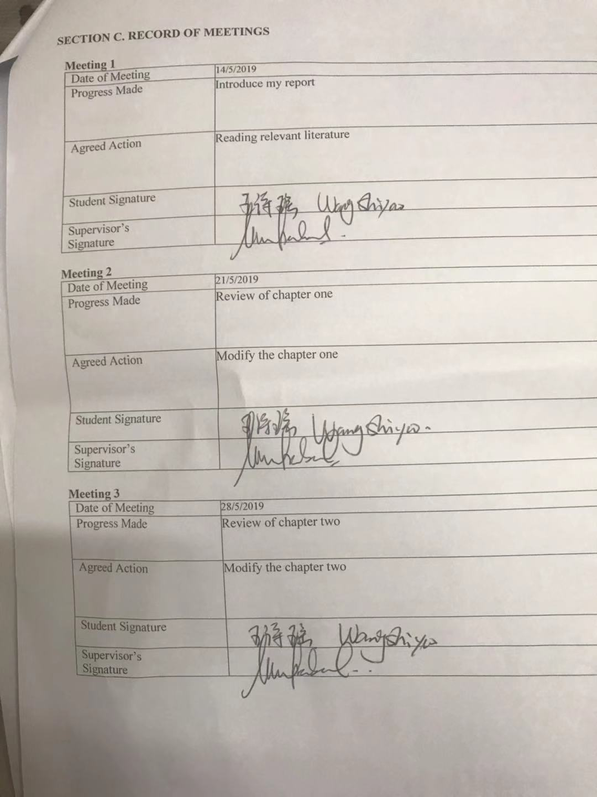

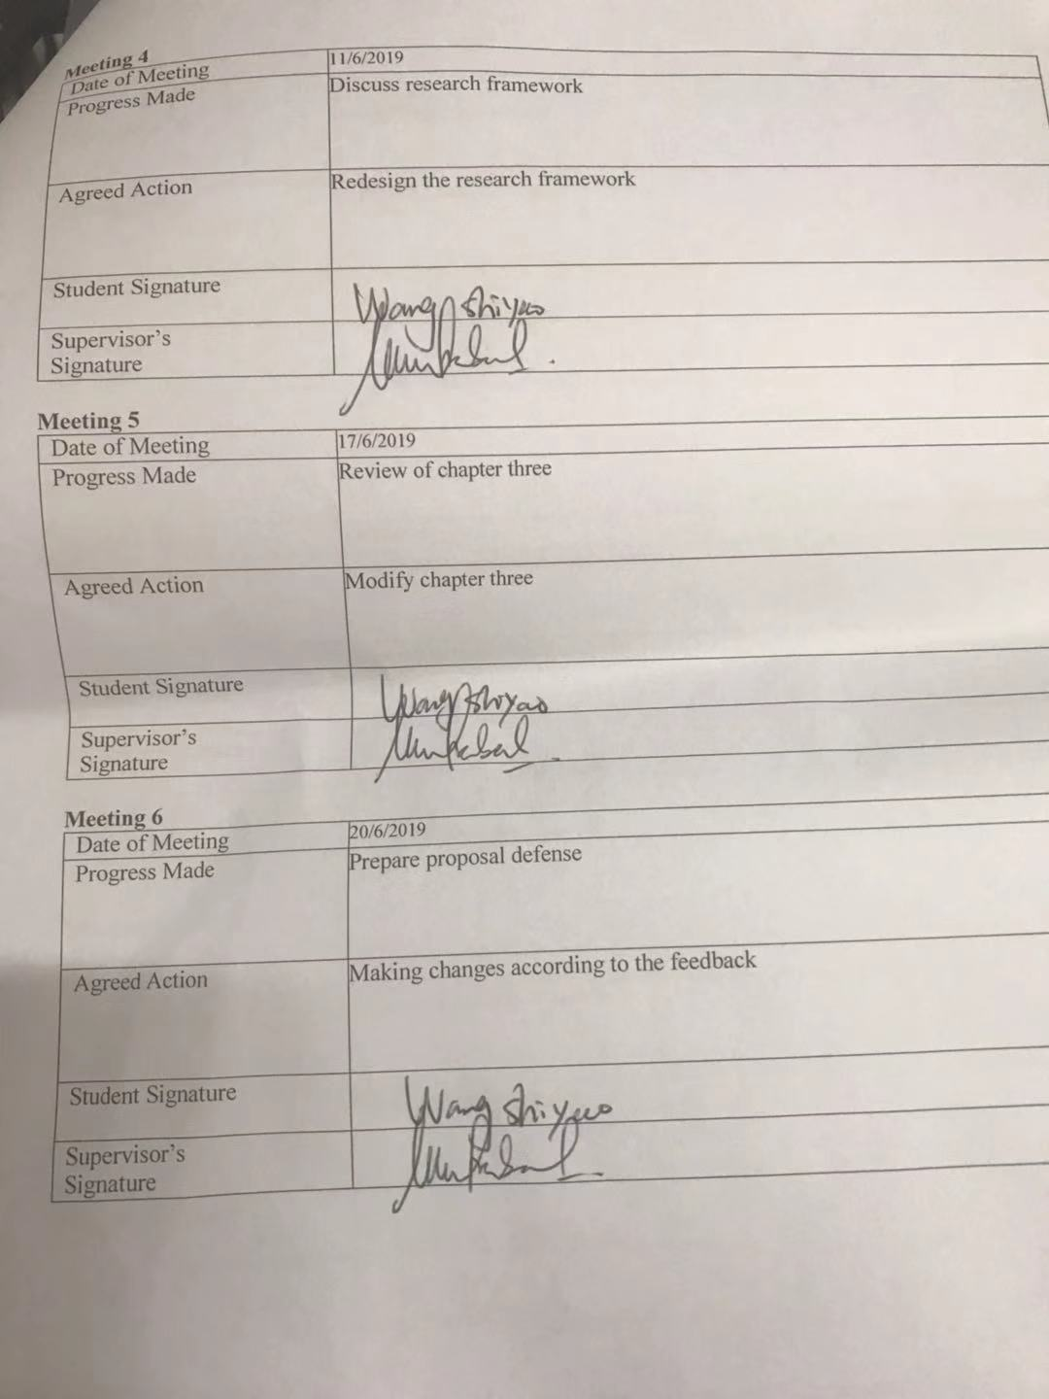



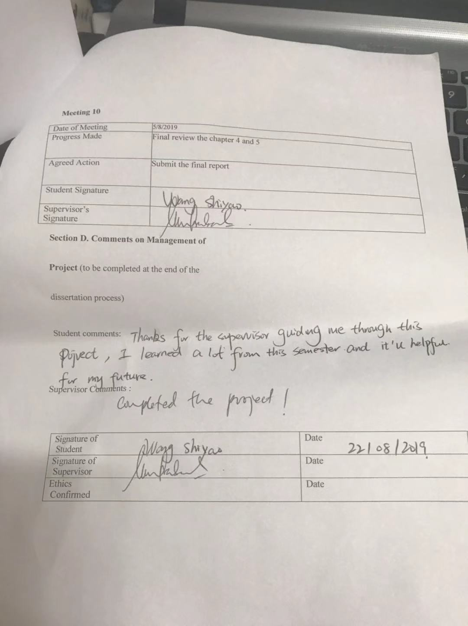

Appendix 4 Declaration

**Declaration**

I hereby declare that: I understand the meaning of “Plagiarism” and Intellectual

Property Rights” and ethics related to Principles of Academic works.

This dissertation is hereby acknowledged as my own work and I have duly

acknowledged use of published and unpublished works of other people from the print,

electronic and other media.

NAME: Wang Shiyao

STUDENT ID: I14005302

SIGATURE: Wang Shiyao

DATE :22/08/2019

Appendix 5 IRPP

|  |  |
| --- | --- |
| Broad area | Human resource management |
| Concise Title [5 m] | The reasons for the lack of effective incentive mechanism in Chinese state-owned enterprises. |
| t | **Primary issue:** Many state-owned enterprises in China have imperfect incentive mechanism, unreasonable salary distribution system and lack of effective spiritual incentive measures, resulting in low overall work efficiency.  Insufficient incentive is the biggest problem faced by state-owned enterprises in China. There is still a big gap between state-owned enterprises and private enterprises in terms of material incentives such as wages and remuneration, and there is no scientific design of salary structure, which can not be effectively linked to employee performance. In addition, welfare benefits are getting worse and worse. Insufficient incentives have brought about a series of serious consequences, such as brain drain, employees do not work hard, resulting in inefficiency of enterprises. Chinese style  The indistinct reward and punishment system in enterprises also leads employees to think that hard work is meaningless, which greatly reduces the enthusiasm and initiative of employees, makes employees work with emotion, and results in the low efficiency of enterprises.  **key theories:** Human Capital Theory, Equity theory.  For example, according to two factor theory, we can see that people’s quality is the most important factor in economic development. (Kwasi,2011）  **Review** **literature:** From Guo Hongying(2014), “Incentive and constraint mechanism of modern enterprise property rights  is the key to solve the problem of incentive” submitted in Shanghai University.  **Key research problem**:1. Leaders fail to adapt to the needs of the economic market and lack sufficient leadership. 2. State-owned Enterprises do not pay attention to the personal development of employees, just focus on the company 3. Talent selection mechanism is not sound, young people have fewer opportunities for advancement.  **The importance of solving problems**: With the unification of the global economy, state-owned enterprises are facing bigger challenges, only they use scientific management concept and methods to strengthen human resources management, actively explore the management system reform, so that to improve enterprise's core competitive ability.  **The originality of the research problem**: As national economy's important constituent, state-owned firms have a great impact on the economic development of the whole society.  **Quality research articles**: Based on William James research, he found that if employees didn’t have enough motivation to complete a task, their potential could be only achieved 20% to 30%, while if they are fully motivated, the potential could be achieved to 80% to 90% (Bell,2008). |
| Research Questions OR Objectives [10 m] | **Overarching objective**: The purpose of the research is to investigate whether establish reasonable performance evaluation mechanism, perfect welfare system, intrinsic motivation and more investment in enterprise culture establishment will improve human resource management capability.  **Specific research objectives**: 1. Pay attention to the cultivation of employees' corporate culture, form a good working atmosphere. 2. Through the establishment of salary welfare system, then form a fine competition. 3.In order to avoid the appearance of favouritism, distribution according to knowledge and work. |
| Scope of study [5 m] | This research focus on how to improve human resource management capability of state-owned enterprises. The geographic focus of this research is Shanghai, Beijing, Qingdao city in china. I will take a state-owned enterprise as an example, refer to related information, and make a questionnaire. |
| Significance of the Research [5 m] | **To acdamia**: This research discuss the situation of HRM in state-owned enterprises, and propose relevant solutions.  **To government**: State-owned enterprises controlled by the government, through the overall management level of state-owned enterprises, then increase the government revenue.  **To industry**: No matter what industry, HRM is the most necessary factor for enterprise development. |
| Literature Review [10 m] | **Key literature**: Research on Incentive System in China State-Owned Enterprise.  About compatibility constraint of incentive mechanism in state-owned enterprises (Shi Jin-ping,2016). From Guo Hongying(2014), “Incentive and constraint mechanism of modern enterprise property rights  is the key to solve the problem of incentive” |
| Research Methodology [20 m] | **Research method**: Use the form of questionnaire to Solicit answers to relevant questions. The biggest advantages of Questionnaire investigation is that it can break through space and time limitations, investigate on many subjects at the same time, and costs are also minimal (Sarantakos, 2013).  **Sampling size:** 60 **Data collection approach:** Using Online survey method to collect data. **Questionnaire source:** Inter  net  **Data analysis tools**: After collect the data, use SPSS to analysis. |