NIE ZEKAI MASTER OF BUSINESS ADMINISTRATION 2019 | Research on Housing Development Strategy of Real Estate Enterprises Based on Housing Consumption Behavior--A Case Study of Shijiazhuang, China  NIE ZEKAI  MASTER OF BUSINESS ADMINISTRATION FACULTY OF BUSINESS, COMMUNICATION & LAW INTI INTERNATIONAL UNIVERSITY  2019

Research on Housing Development Strategy of Real Estate Enterprises Based on Housing Consumption Behavior--A Case Study of Shijiazhuang, China

NIE ZEKAI

2019
MASTER OF BUSINESS ADMINISTRATION
FACULTY OF BUSINESS, COMMUNICATION & LAW
INTI INTERNATIONAL UNIVERSITY
INTI INTERNATIONAL UNIVERSITY
MASTER OF BUSINESS ADMINISTRATION
Research on Housing Development Strategy of Real Estate Enterprises Based on Housing Consumption Behavior--A Case Study of Shijiazhuang, China

Author: Nie Zekai
Student No: I18014797
Supervisor: Ms. Faziha Abd Malek
Submission Date: August 2019
Final word count: 12078

ABSTRACT

China's real estate market is gradually standardized and improved. The housing industry has begun to change from the seller's market to the buyer's market. Competition among real estate enterprises is becoming increasingly fierce. How to occupy a favorable position in the fierce market competition has become a serious issue for real estate enterprises. Under this background, this paper analyses the housing consumption behavior of Shijiazhuang urban residents and the housing development strategy of real estate enterprises, and on this basis, explores the housing development strategy of real estate enterprises based on consumption behavior.
This study mainly explores the relationship between influencing intention and customer purchase behavior. In designing the questionnaire, three attributes were considered. 384 potential buyers used the questionnaire. The reaction rate was 90%. Use SPSS (22) to explore. In this paper, we use Chi-Square test, multiple regression analysis to verify the housing matching, property of housing products and promotion as independent variables, and discuss the influence of customer purchase decisions as dependent variables. Therefore, this study will help real estate developers to formulate successful development strategies and provide theoretical support for government decision-making. In fact, this study may be limited by the geographical limitations of China's real estate market.
Key words: housing consumption behavior; housing development strategy; Shijiazhuang

ACKNOWLEDGEMENT

I would like to express my sincere appreciation to everyone who contributed to the accomplishment of this dissertation. I am thankful to my supervisor, Ms. Faziha for her excellent guidance, effort, patience, and time throughout the study. My thanks also go to my examiner, Dr.Lim who has been supportive and offered her valuable comments.
Special thanks to my friends who helped me distribute the questionnaires to their acquaintances. I would also like to spare my utmost thanks to those respondents who have been kind enough to answer my queries as well as the authors whose work helped me have a thorough understanding of the subject. The inputs provided have made the findings of my research conclusive. Very special thanks go to all those who have generously assisted in my work in a way or another.
None of this would have been possible without my family and closest friends. For the support, encouragement, and unconditional love through the times I did not believe in myself, I am forever grateful to them.

DECLARATION

I hereby declare that this thesis is my own work and effort and that it has not been submitted anywhere for any award. Where other sources of information have been used, they have been duly acknowledged.

Name : Nie Zekai
Student ID : I18014797
Signature : Nie Zekai
Date : August 2019

Table of Content：
1.0.Introduction 1
1.1.Background 1
1.2.Problem Statement 3
1.2.1. Housing vacancy 3
1.2.2. Decline in residential sales 7
1.3. Research Questions/Objectives 8
1.4. Significance of the Study 9
1.5. Limitations 11
1.6. Scope of the Study 12
1.7. Ethical consideration 15
2.0. Literature review 17
2.1 The Relevant Theory of Consumption Behavior 17
2.1.1 Factors Affecting Consumer's Purchasing Behavior 18
2.2 Relevant Theory of Housing Development Strategy 20
2.2.1. Current Situation of Real Estate in China 20
2.2.2. Residential product attributes 22
2.2.3. Housing Matching 26
2.2.4. Promotion 28
2.3. Highlights of the research hypotheses formation 30
2.4. Propositional Hypothesis 32
3.0.Research methodology 34
3.1.Research design 34
3.2. Measuring Instrument 35
3.3. Validity and Reliability Tests and Analysis 36
3.4.Analytical methods 38
4.0. Data Analysis 39
4.1 Chapter Overview 39
4.2. Descriptive Analysis 39
4.3. Reliability Analysis 44
4.4.Correlation test 47
4.5. Validity Test 49
4.5.1 Analysis of Housing Matching 50
4.5.2. Analysis of Product Attribute 51
4.5.3. Analysis of Promotion 52
4.5.4. Analysis of Decision 52
4.6. Multiple regression analysis 53
4.6.1 Hypothesis Test 54
4.6.2. Results of multivariate regression analysis 56
4.7. Data summary 59
5.0. Summary 64
5.1 Chapter Overview 64
5.2 Result discussion 64
5.3 Contribution 66
5.3.1 To Industry 66
5.3.2 To Government 66
5.3.3 To academic 67
5.4. Future Research 67
5.5. Recommendation 68
5.5.1 To Industry 68
5.5.2. To government 71
5.5.3. To academic 72
5.6. Conclusion 72
5.7. Personal Reflection 73
6.0.Reference 75
7.0. Appendix 86

List of Figure:
Figure 1-1:the proportion of real estate in GDP 2
Figure 1-2:residential inventory number 5
Figure 1-3:decomposition period of residential inventory 6
Figure 1-4:residential sales area 8
Figure 1-5:the age proportion of the population in shijiazhuang 13
Figure 1-6:the proportion map of china structure 14
Figure 1-7:educational proportion 15
Figure 2-1 :Factors influencing purchasing decision 19
Figure 2-2:segmentation of housing development strategy 30
Figure 2-3:franmework 32
Figure 3-1:main design 35

List of Table:
Table 1-1 vacancy rate in different location 4
Table 2-1:price of cities in china and M1 growth map 21
Table 4-1:age structure 40
Table 4-2:annual household income 41
Table 4-3:level of education 42
Table 4-4:purpose 43
Table 4-5:processing summary 45
Table 4-6:item-total statistics 46
Table 4-7:correlations 48
Table 4-8：communalities test1 50
Table 4-9:communalities test2 51
Table 4-10:communalities test 3 52
Table 4-11:communalities test 4 53
Table 4-12:hypothesis test 55
Table 4-13:coefficients 56
Table 4-14:analysis resulit 59
Table 5-1:main development strategies 71

Chapter1

1.0.Introduction

1.1.Background
Real estate market plays an important role in economic and social development. The study of real estate market consumption behavior has important theoretical and practical significance for the government's macro-decision-making, enterprise management and the improvement of consumer consumption level. Under the rapid development of China's real estate bubble (Kauškale and Geipele, 2016), we also find that there are serious problems. The following are the following aspects: first, the real estate market has a large area of regulation and control. As shown in Figure 1-1, the proportion of real estate in the national economy has increased year by year. If indirect effects are taken into account, real estate has a greater impact on the economy. According to estimates, one third of China's economy is related to real estate. In 2018, 6.7% of GDP is driven by the real estate industry's direct investment, including construction, building materials, decoration and other upstream and downstream industries, which contributed 36% to GDP growth (LIU, 2016). De-leveraging and risk prevention have become the main direction of the current market because of the deep binding of financial industry and real estate, high leverage and credit risk. Second, the real estate price growth is too fast, seriously deviating from the growth of people's income and the whole national economic growth, and there is a bubble crisis; third, the real estate market out of rigid living demand, there is still speculative investment demand (Panosa Gubau and Maria Panosa, 2014). Real estate market problems are caused by a variety of reasons, mainly manifested in: first, people speculate on housing prices, policy maintenance and stability has exacerbated people's expectations of rising housing prices; second, the quantitative easing policy in the past decade has led to inflation. Real estate is the best product to preserve assets.
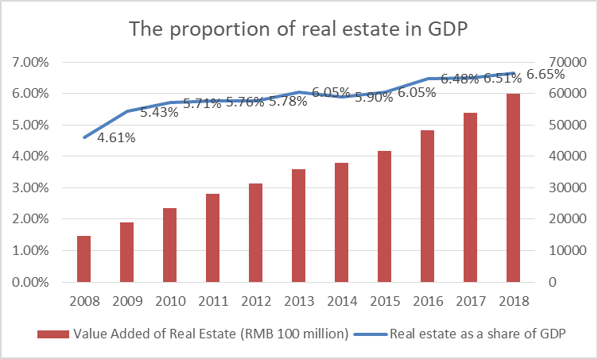
Figure 1-1:the proportion of real estate in GDP
Data source: China National Bureau of Statistics
These problems have led to a great change in consumer behavior when buying real estate, and the housing demand of residents in Shijiazhuang appears diversified trend. Consumers'choices of residential products and services are expanding and their choices are improving (Sandelin, 1981). More and more enterprises enter the real estate market. The disorderly competition leads to the decline of product quality and the decrease of developer's profit. With the development of Shijiazhuang metropolitan area and the entry of domestic well-known real estate enterprises, the problems of insufficient customer segmentation and incompatibility between development projects and their own abilities caused by the lack of investigation on residents'housing consumption behavior in Shijiazhuang real estate enterprises have been gradually exposed, which has seriously affected the development of real estate enterprises.

1.2.Problem Statement

1.2.1. Housing vacancy
At present, the Chinese government's macro-policy on real estate continues to tighten, stabilizing house prices has become one of the important responsibilities of local governments (Zhang, Jia and Yang, 2016). The real estate sales market has changed from the seller's market to the buyer's market, and the competition in the real estate market has become increasingly fierce. From Figure 1-2, it can be seen that the vacancy rate of the existing housing in Shijiazhuang has reached a high level. According to the "Survey and Analysis of Housing Vacancy Rate in Shijiazhuang City" published by Shijiazhuang Statistical Bureau, the survey is based on the inquiry of the accumulative electricity value of the housing meter for a certain period of time. The following results are obtained: the vacancy rate of the housing is 10.11%, which is comparable to the reasonable interval value of the internationally prevailing housing vacancy rate (3%~10 The overall vacancy rate of residential quarters in Shijiazhuang City is on the high side. According to Denise D. and Willian C. W. (Miceli and Sirmans, 2013), the concept of vacancy is defined as the ratio of vacant housing area to total housing area at a certain time, which is an important index reflecting the balance between supply and demand in the real estate market. According to international experience, the vacancy rate of commercial housing is between 5%-10%, and the market is running at a reasonable stage. The vacancy rate is between 10%-20%, and there is a huge bubble in the market., we should take certain measures to increase the sales of commercial housing, so as to ensure the normal development of the real estate market and the normal operation of the national economy. With the rapid development of urban planning and infrastructure, the government accelerates the development of new urban areas, expecting to introduce population into new urban areas. However, due to the lagging construction of supporting facilities, transportation, environment and other aspects, the speed of population inflow is relatively slow, which weakens the purchase demand of potential buyers and the motivation of buyers to live(Xie, 2019), thus forming a large number of housing vacancies.
Vacancy Rate of Housing in Different Locations
Loop location | Investigate the number of houses(suite) | Vacant(suite) | used(suite) | vacancy rate(%)
One ring | 133 | 16 | 117 | 12.03%
two ring | 717 | 70 | 647 | 9.76%
three ring | 287 | 29 | 258 | 10.10%
Total | 1137 | 115 | 1022 | 10.11%
Table 1-1 vacancy rate in different location
Data source: Shijiazhuang Bureau of Statistics
With the saturation of urban housing demand and the state's pressure on the real estate industry, speculative buyers and multiple buyers are gradually decreasing, the housing market is changing to just-in-demand customers, and the inventory of residential buildings is gradually rising. CRIC, a professional real estate agency, shows that in 2018, 1.68 million square meters can be sold for ordinary residential buildings in Shijiazhuang City, which takes 14.3 months to decontaminate. The effective inventory area is 11.66 million square meters, and the consumer's wait-and-see mood is high. Because of the policy pressure and the reduction of real estate growth expectations(White, 1974), a large number of inventory prompts Housing enterprises to change from the product perspective in response to consumer demand. In order to achieve the purpose of marketing.
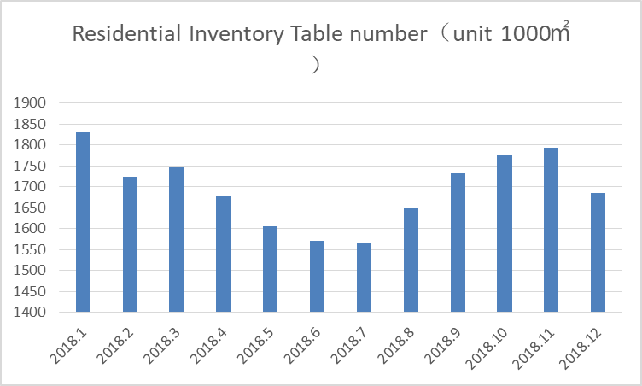
Figure 1-2:residential inventory number
Data source: CRIC
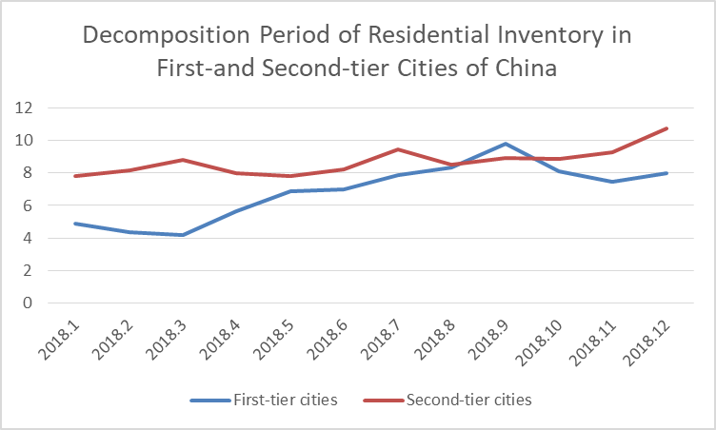
Figure 1-3:decomposition period of residential inventory
Data source: CRIC
According to CRIC's "China's 100 Cities Housing Inventory Report 2018", the average inventory of second-tier cities in China is about 11.5 months, and the inventory cycle is increasing. The Chinese government defines the second-tier cities mostly as provincial capital cities, strong economic cities in the eastern region or regional central cities with developed economy. Shijiazhuang, as the capital of Hebei Province, is classified as a second-tier medium-level city and a regional center(Wang and Yeh, 2019). Shijiazhuang's housing inventory is in a high position, higher than the level of the same city. At present, the real estate market in the city is in a negative state, and the speed of housing degrading is slow. So this paper hopes to analyze the demand of residential products based on consumer demand, and put forward targeted suggestions for future product design.

1.2.2. Decline in residential sales
Seen from the data， housing is still the basis of commercial housing transactions.of which the total supply of residential area is 2.313million square meters, the total transaction area is 3.93 million square meters, a decline of 43.97% annually. The average transaction price was 15681 yuan per square metre, rising by 7% annually, showing a trend of lower sales area and higher prices. At present, the concentration of the general residential market is further improved, the differentiation of project sales will be more obvious, and the market competition will be more intense. Because of the particularity of the real estate industry, the primary development of land in China is basically under the responsibility of the local government(Che, 2009). Real estate development enterprises need to acquire land by bidding for land and paying land transfer fee. The cost of land accounts for the highest proportion of the cost of real estate development enterprises. At present, the cost of land in the main development areas of Shijiazhuang City is between 7000 and 9000 yuan/㎡ housing. Construction cost and enterprise marketing and operation cost are about 3500 RMB /, while the regional house price is concentrated around 15,000 yuan /㎡(Sorens, 2016), and the net profit margin is about 8-15%. At present, the real estate industry is affected by the government's macro-control policy, and the sale price of development projects is limited by the local government housing management department to sell to consumers after verification, in order to avoid short-term excessive growth(Hill, 1994). Because of the above reasons, the strategy of purely using price for sales is not applicable in China's real estate market. How to differentiate products has become a major concern in attracting consumer markets. According to the above data, the housing vacancy rate in Shijiazhuang City is very high, while housing sales are declining. Through the research and analysis of this paper, I want to explore the real estate problem in Shijiazhuang from the perspective of consumer decision-making.
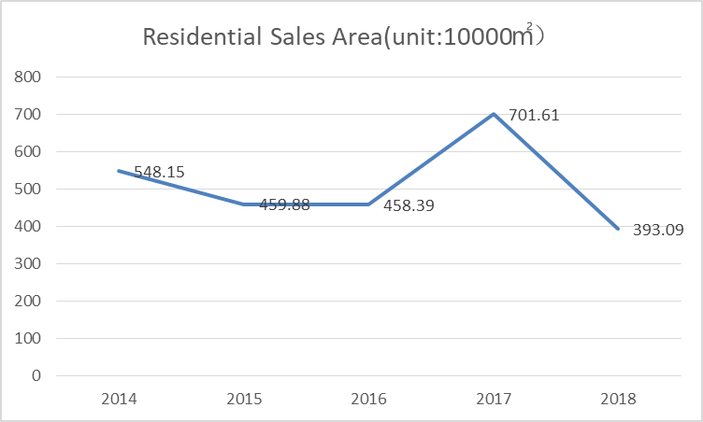
Figure 1-4:residential sales area
Data source: CRIC

1.3. Research Questions/Objectives
This study focusing on the relationship between consumers and housing development strategies from the perspective of buyers'consumption, so as to optimize the enterprise's housing product system, household function design and marketing system.
RQ1: Does Housing matching have a significant impact on purchase decisions in the development of real estate in Shijiazhuang, China?
RQ2: Does the residential product attributes have a significant impact on purchase decisions in the development of real estate in Shijiazhuang, China?
RQ3: Does promotion have a significant impact on purchase decisions in the development of real estate in Shijiazhuang, China?
Objectives
RO1; The focus of this study is to determine the relationship between Housing matching and purchase decisions in real estate development in Shijiazhuang City, China.
RO2; The focus of this study is to determine the relationship between product attributes and purchase decisions in the development of real estate in Shijiazhuang City, China.
RO2; The focus of this study is to determine the relationship between promotion and purchase decisions in real estate development in Shijiazhuang, China.

1.4. Significance of the Study
Theoretical significance
Most studies analyze housing consumption behavior from the perspective of consumer behavior and marketing. Many cities in China, such as Shanghai and Hangzhou, have conducted a lot of research on housing consumption behavior led by the government, but most of them are macro-policy studies(zhou Jin, 2019). This topic combines consumer behavior and housing development strategies of real estate enterprises at the micro level, providing some theoretical basis for the research between the two theories. (Lannes, 2019). At the same time, by analyzing the influence of consumption behavior, especially the consumption behavior of different strata on human survival and development, large-scale socialized production, enterprise management and government macro-control, we can improve the social welfare level and industry development level.
Practical significance
With the gradual intensification of competition and regulation in the real estate industry, higher product requirements have been brought to the housing development of real estate enterprises. The relevant research in this paper puts forward some suggestions for the real estate enterprises to formulate corresponding housing development strategies, and provides guidance for the government to formulate macro-policies and the concept of individual consumers to buy houses.
Firstly, from the aspect of real estate enterprises, it provides differentiation strategies for real estate enterprises to implement specific housing development strategies. In particular, the analysis of the characteristics and trends of housing consumption behavior of Shijiazhuang residents can provide great help for real estate enterprises to segment the market, select housing types and household types, and design and development concepts.
Second, from the government's point of view, it is conducive to the government to propose targeted control strategies to promote economic development, increase employment, maintain price stability and promote balance of payments(Church, 2018), while optimizing the healthy development of the market and stabilizing the financial and real estate markets.
Third, from the perspective of individual consumers, individual consumers are most sensitive to the changes in the real estate market, and individual consumption behavior directly determines the trend of the real estate market. Through this study, consumers can be guided to choose better products and avoid blind and excessive consumption.

1.5. Limitations
1. Because of the limitation of sample size and survey area, the conclusion of this paper has some limitations. For example, some consumer groups have fewer samples and can not get an effective analysis of consumer behavior. At the same time, the questionnaire mainly adopts the combination of network questionnaire and telephone questionnaire, which can not ensure that the respondents fill in the questionnaire under the objective environment.
2. This paper mainly puts forward strategies for real estate development from the perspective of consumer behavior. It does not combine the laws and policies of the industry market. The real estate industry is greatly influenced by funds and policies. The development strategies proposed solely from the perspective of consumers are not suitable for the changes of the market.
3. The limitations of the article in data collection, because some official data and transaction data may not be updated in time, so the latest relevant data can not be obtained. Secondly, the research on foreign magazines of real estate in China is not extensive enough to cite many practical theories and examples for analysis.

1.6. Scope of the Study
This paper mainly focuses on the urban permanent population in Shijiazhuang City, China. This survey mainly refers to the data of the 2016 census. Shijiazhuang's permanent population is 10.1637 million, of which 50.06% are males and 49.94% are females (He et al., 2019). The population structure is basically stable. As shown in Figure 1-2, the main population of Shijiazhuang is concentrated between 15 and 64 years old, but the aging is increasing. According to the international general standards, the age composition of Shijiazhuang's population has entered an old-age society. On the sample selection, according to the survey report on house purchasing issued by CRIC, a real estate consultancy agency in China, the average age of house buyers in 2018 was 29.5 years, while those with replacement demand were mainly between 45 and 49 years old (Cristadoro and Marconi, 2018).
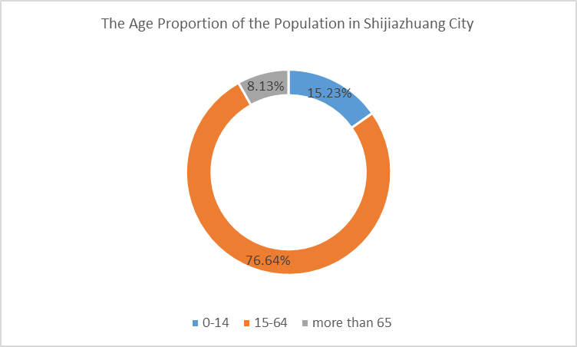
Figure 1-5:the age proportion of the population in shijiazhuang
Data source: Shijiazhuang Statistical Bureau
Figure 1-3 shows that the population with housing potential is mainly in the 25-50 age range. Therefore, this study will focus on young and middle-aged people aged 25-50 to increase the credibility of the sample base.
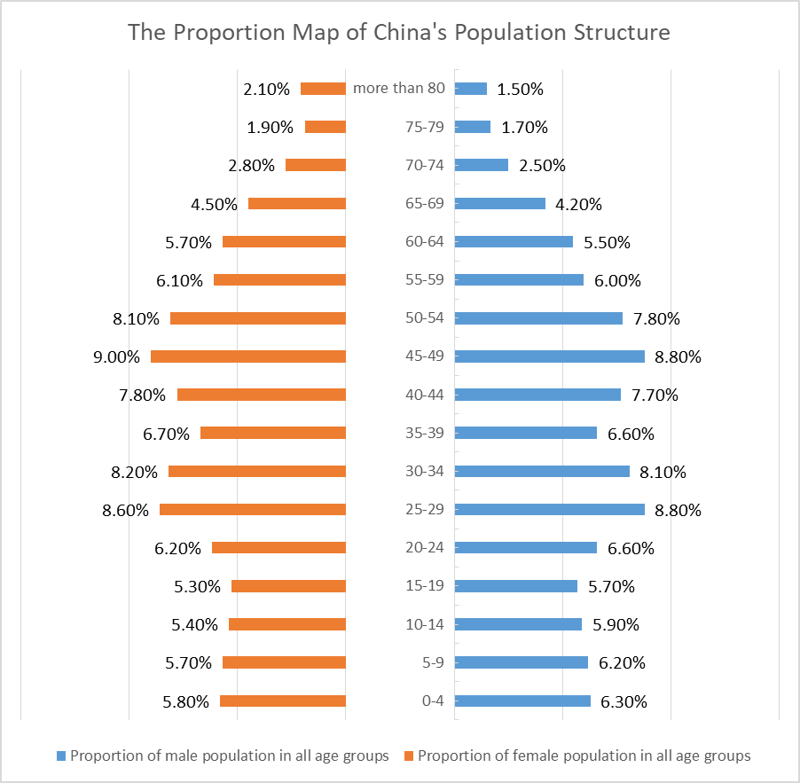
Figure 1-6:the proportion map of china structure
Data source: China National Bureau of Statistics
In terms of the educational background and income range of the sample, according to the 2008 China Urban Family Wealth Health Report published by Guangzhou Development Bank and Southwest University of Finance and Economics, 80.9% of the families with junior middle school education and below, and 76.2% of the families with bachelor degree or above (Or, 2017). Therefore, it is believed that people with low and middle educational background pay more attention to the purchase of houses. According to the educational composition of Shijiazhuang population in Fig. 1-4, we mainly focus on consumers from undergraduate to junior high school. In terms of the range of household income, according to Gallup's survey data, due to the property of just-needed housing, all income strata have the demand for housing. Low-income buyers buy their first home for themselves, middle-income people are busy improving their home ownership, and high-income people are used to improve or invest for themselves. Therefore, the research scope of this study covers the whole family income range.
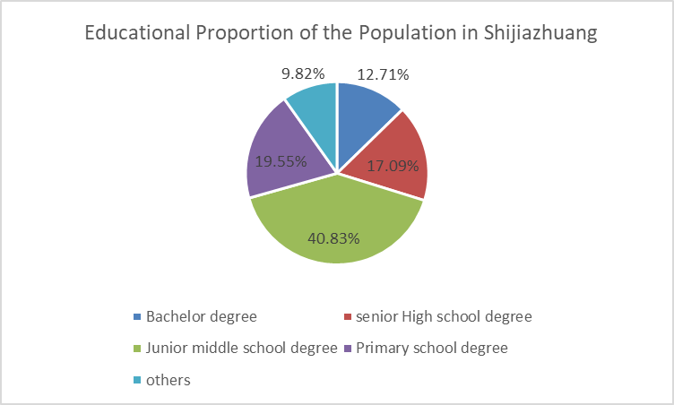
Figure 1-7:educational proportion
Data source: Shijiazhuang Statistical Bureau

1.7. Ethical consideration
In this paper, we treat each participant equally. Questionnaires were randomly distributed to all groups and filled in anonymously, avoiding discrimination on sex, income and education. At the same time, in the questionnaire survey, do not take the case of comparison with other projects, to avoid misleading consumer propaganda. In the questionnaire design, religious beliefs are avoided, such as the special design and color of houses by Muslims. In the processing of sample results, we do not differentiate the sample data by gender, such as the comparison of income level and education level.

Chapter2

2.0. Literature review

2.1 The Relevant Theory of Consumption Behavior
In modern marketing system, most researchers divide consumer behavior into two categories, one is consumer behavior, the other is consumer purchase decision-making process (Belknap and Clark, 1956). Purchasing decision-making refers to consumers'behavior tendency before they decide to buy products. It belongs to the cognitive process of consumer attitude. Consumer behavior is a more specific propensity to consume. It is generally used to explain that a product has a profound understanding, but it has not been decided whether to buy it or not. These two factors interact and form a complete consumption system. This paper mainly studies consumer decision-making, there are two main directions: first, from the perspective of economics to study consumer behavior, from the perspective of Marshall, using mathematical analysis methods, based on utility value theory, quantitative analysis of consumer behavior to draw conclusions. MER behavior (Cowan, 2012).After that, Keynes founded the theory of consumption demand according to the needs of contemporary capitalist society. Later scholars Dussenberry interpreted Keynes'absolute income hypothesis around the revision of its theoretical connotation (Beckhart and Keynes, 1936). Another main line of research is to analyze consumer behavior from the perspective of marketing or salespeople (Maslow, 1943). From the early study of purchase motivation to the construction of a systematic consumer behavior model in the latter half of the 1960s, to the later development of consumer behavior research based on decision process, coupled with the study of factors affecting consumer behavior, consumer behavior tends to be complete (Nooraie, 2018). From the perspective of research path, empirical research method is one of the ways to study consumer behavior. We generally divide the consumer purchase process into five stages: consumer perception, cognition, learning, attitude, decision-making and feedback (Williams, 2014)). From the perspective of research path, this theory is also called post-modern research theory. It believes that consumer behavior does not have a specific law of behavior, and will change with the change of the environment. Only by linking individuals with the macro environment can we compare the consumption patterns suitable for this era (Rani, 2016). However, because consumers'decision-making is influenced by too many objective and subjective factors, this theory can not be widely used.

2.1.1 Factors Affecting Consumer's Purchasing Behavior
There are many factors that affect buying behavior, including psychological factors, personal factors, consumer environment factors, policy factors and market factors. (Stávková, Stejskal and Toufarová, 2008). Internal factors mainly refer to the consumer's own factors, such as: long time to make purchase decisions, the decision-making time of general purchase behavior is from three months to six months, some as much as one year (Duffy, 2003); a large number of people participate in decision-making, the decision-making of general purchase is jointly participated by a family; the process of information collection is complex, consumers need to pay a large amount of cash to purchase residential goods, plus The purchase of houses is a major event in life, so consumers in the process of information collection often need to refer to a variety of information, through various media to understand housing information, but also need to go to the sales site to understand (JinHyunJoung,, 2012). This series of processes will increase the uncertainty of data collection on consumer purchasing behavior. External factors mainly refer to regional economic development index (Dr. N. Kathirvel, 2011), regional average house price, regional population inflow and wage level. as well as the design of residential products, area, price, peripheral matching, transportation convenience and other indicators.
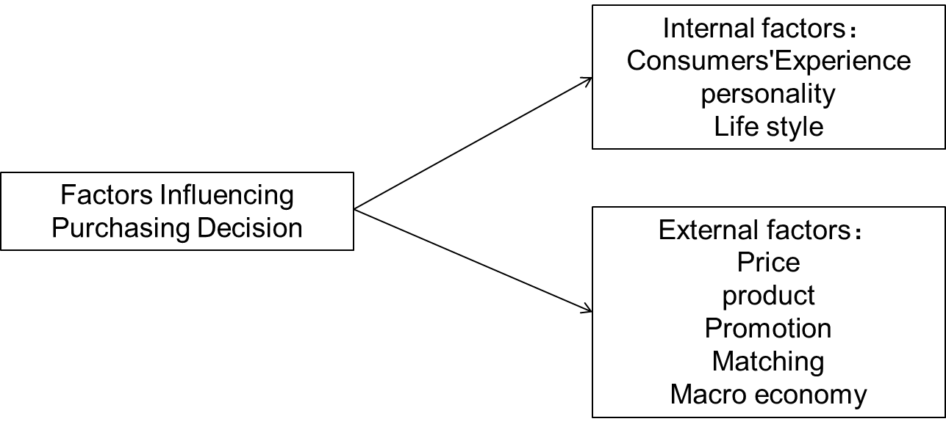
Figure 2-8 :Factors influencing purchasing decision
(William, 2019)
Because this research mainly studies the influence of consumer's demographic characteristics on housing development strategy, and mainly has a high degree of correlation with housing products, it mainly chooses external factors as the research focus. There are two main external factors for consumers to consider in the purchase of houses(Sengupta, 2019), which are related to the strategy of enterprise housing development.
Because the main research scope of this study is the impact of residential development strategies on consumer behavior, so this study is mainly related to residential products, so external factors are chosen as the focus of the study, while price and marketing factors are mainly affected by government departments and macroeconomic factors(Nijkamp, 1988). So we mainly adopt three external factors that consumers mainly consider in buying houses.

2.2 Relevant Theory of Housing Development Strategy

2.2.1. Current Situation of Real Estate in China
Over the past decade, the average annual rise in housing prices in China's first-tier cities has been 17.4%. and that in major second-tier cities increased by 22.51%. The real land price of housing in 35 major cities increased nearly eight times from 2008 to 2018. In addition, with the rise of land and housing prices and construction prices, the number of construction workers accounted for 7.17% of the total employment of the whole society, which increased by 0.04 percentage points compared with the previous year and reached a new high (Fan and Yavas, 2018). The chart shows that M1 (narrow money supply) has a certain correlation with housing prices. Inflation caused by the rapid increase of money supply in the past ten years is the basic reason for the rapid rise of housing prices. Since the global financial crisis in 2008, the Chinese government has adopted quantitative easing policy to stimulate the rapid recovery of the economy. The additional money mainly flows to the urban infrastructure and real estate industry (Kien Hwa, 2007), which causes the rapid rise of housing prices. After implementing the tight monetary policy in 2018 and turning to the direction of reducing bank reserve ratio, M1 growth and housing prices have maintained a stable state.
But because China's housing prices are rising faster than the average household income, many economists believe that China still has a lot of room to develop real estate. But Edward points out that many Chinese consumers who buy houses invest in them, which exacerbates people's expectations of rising house prices, which will further aggravate the polarization between rich and poor. On the one hand, many real estate industries in China are facing macro-level policy and industry crisis. Many economists have done a lot of research on the latest development trend of real estate, which shows that land prices and house prices are rising too fast. Local governments regard land transfer fee as an important tax source, and the construction cost of real estate is too high. On the other hand, because China's land property rights belong to the state, consumers can only buy the right to use the land. This system makes the circulation of land slow, which is not conducive to the operation of the market.When the right expires, it is up to the government to decide how to deal with the house (Glaeser, Huang, MA, Shleifer, 2017). Therefore, many young people living in the first and second tiers are choosing to rent houses because they can not afford expensive commercial housing. However, the urbanization construction vigorously promoted by the government urges people to stay in big cities, and the working skills of ordinary young people are difficult to survive and work in small cities.
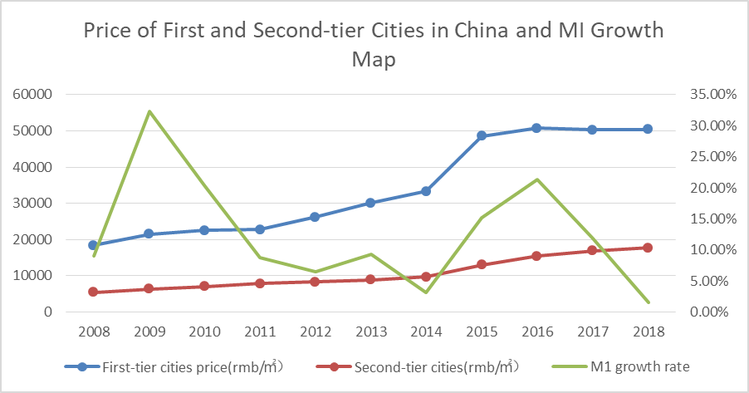
Table 2-2:price of cities in china and M1 growth map
Data source: China National Bureau of Statistics

2.2.2. Residential product attributes
The attributes of residential products mainly include housing quality, architectural style, property form, landscape, household design, residential intellectualization and so on. These plans determine the competitiveness of residential products in the market and the comfort of consumers.
1. Quality
Housing quality mainly includes housing quality, residential greening, infrastructure quality. (IMRIE, 2003), this is related to the objective structural attributes of housing and related land area such as room units.
Customers who buy the first house pay special attention to the quality of the building. What is important is that the three evaluation conditions in the quality of the building, Structural engineering, construction engineering and electromechanical engineering are the key parts of the main body of the building, because they are mostly concealed works, but also the main structure. (Chen and Luo, 2014).
On the other hand, the quality of residential buildings is related to the surrounding environment, and the external environment such as garden greening, residential facade and surrounding lanes should be cleaned. Residential unit quality "is also an important factor to measure the quality of housing, mainly reflected in property management, these supporting facilities will certainly bring about improvement in the quality of the project.
2. Architectural Style
With the development of the times, people's living requirements are getting higher and higher, not simply to meet the housing function and purchase houses, more consideration of the quality of housing and environment. Residential facade can intuitively reflect the grade of the building itself, while high-quality facade can improve the anti-seepage and anti-falling ability of the house (Hua, 2017). In order to make their products more distinctive, real estate developers design the facade of the building into a distinctive style at a higher level, deepen the impression of customers on the architectural form, greatly improve the quality of the building, strengthen their own advantages, create a perfect artistic conception, create their own brand image, and obtain good economy.
3. Property Form
Residential buildings are divided into low-rise, multi-storey and high-rise according to the general level. The corresponding property forms are villas, townhouses and high-rise buildings. Because villas are mostly improved customers of ultimate home ownership and have fewer groups, we generally define the object of study as foreign houses and high-rise buildings(Kim, 2017). Multi-storey residential: refers to the four to six-storey high residential, is one of the most representative urban collective housing. townhouses buildings with less land use, high performance-price ratio, better public space and atmosphere, and less shared area are widely constructed. High-rise residential buildings: generally refers to residential buildings with a total height of more than 12 floors (Kulu and Vikat, 2007). It is a high-density residential means to solve the shortage of urban land. It reflects the economic principles of urban construction, but also meets the residents'needs of convenience and richness of urban life in urban central areas. However, such high-rise residential buildings in the city centre often have the problems of high living costs and low performance-price ratio of residential buildings (compared with other areas). The main advantages of high-rise residential buildings are high efficiency of land use, large outdoor public space and facilities, good view, built in urban areas and good living convenience. Generally speaking, the share area is large and the cost is high, and the appearance lacks the pleasant sense of scale.
4. Landscape Architecture
Landscape greening design of residential district should highlight local characteristics and have distinct personality, so as to give full play to the best ecological, social and economic benefits. It is emphasized that the ecological benefits of greening mainly depend on the planting of trees and flowers (Fabiani Giannetto, 2017). Good plant landscape often serves as a unique background for garden sketches, even paving and sitting benches. Through the contrast of color and texture, it highlights garden sketches and the specific space where paving and sitting benches are located, thus playing a role of landscape.
5. Layout design
Layout is the structure and shape of housing. Layout and area are the focus of consumers'most attention at present. Layout innovation is considered to be one of the most important means to improve the competitiveness of residential products. Successful layout can perfectly integrate the functionality, comfort and aesthetics of the house itself. Because of the particularity of housing structure, it is necessary to create functional zones more suitable for living and satisfying functions in a limited space. At the same time, it is necessary to give consideration to sunshine, ventilation, action routes and other factors. In general, a good layout design should include six kinds of separation: physiological separation, functional division, dynamic and static separation, public and private separation, primary and secondary separation, dry and wet separation. At present, the main layout structure in China's housing market is: two rooms, two halls and one bathroom, with an area of 70㎡(Huang, 2013). Three rooms, two halls and one bathroom with an area of 90-100 ㎡. Four rooms, two halls and two bathrooms, with an area of 110-130㎡.
6. Intelligent Housing
Intelligent residence refers to the residence which is based on an advanced and reliable network system, which builds up the network of households and public facilities and realizes the computerized management of living facilities and service facilities of households and communities. It is composed of many intelligent buildings, aiming at connecting community security, property, service and public facilities through highly integrated communication and computer network, so as to realize intelligent and optimal managemen (Detterman, 1994) t. Intelligent residence mainly includes security precautions in independent households, three-meter metering (including IC card or data remote transmission), integration platform of household electrical appliances automation system, broadband network interface.

2.2.3. Housing Matching
The supporting facilities of residential districts refer to the facilities to ensure the basic living needs of residents, including supporting infrastructure and supporting public service facilities. Infrastructure mainly refers to municipal infrastructure (civil, pipeline, equipment installation of urban roads, public transport, water supply, drainage, gas, heat, garden greening, environmental sanitation, retaining wall, sewage treatment, garbage treatment, flood control, above-ground public facilities, underground public facilities and their subsidiary facilities), supporting facilities of residential quarters and other supporting facilities of housing construction (Tse, Ho and Ganesan, 1999). Public service facilities refer to the allocation of the following supporting public buildings according to the scale and grade of residential areas, including educational, medical and health, cultural and sports, social services, administrative management, basic unit services, commercial services and other facilities. This article refers to the supporting facilities of residential quarter refers to public service facilities, excluding infrastructure (Genesove and Han, 2012). The research divides the supporting facilities into sports and sports facilities, leisure and entertainment facilities, commercial facilities, education facilities, medical facilities and parking facilities.
1. Sports and physical fitness facilities
Sports and sports facilities refer to the facilities that can provide sports and sports activities for the owners or others. They are mainly built for the owners of the community, but also provide services for others. It mainly includes swimming pools, various stadiums, stadiums, sports facilities for the elderly and so on.
2. leisure and entertainment facilities
Leisure and recreational facilities refer to the facilities that can provide leisure and entertainment places and services for owners or others. They are built for owners of residential areas, but also for others. It mainly includes chess room, sauna room, children's amusement room, painting room, dance room, dining room, etc. It also includes gardens and squares.
3. Commercial facilities
Commercial supporting facilities refer to the facilities that can meet the needs of owners or other people and provide them with shopping places. They rely on residential areas, but their business scope is not limited to this. Including supermarkets, meat markets, convenience stores, small grocery stores or stores, as well as commercial streets, shopping malls, post offices, banks and so on.
4. Educational facilities
Educational facilities refer to the facilities that can solve the problem of schooling of owners or other children. The management mode is very flexible, and the objects of operation are not limited to the community. There are mainly nurseries, kindergartens, primary schools and secondary schools.
5. Medical facilities
Medical facilities refer to facilities that can solve the medical problems of owners or other people's children. These facilities are built on the basis of community, but both owners and non-owners can receive services equally. Mainly including hospitals, clinics and so on.
6. Parking facilities
Parking facilities refer to a variety of parking facilities, including temporary roadside parking, open-air parking and underground parking.

2.2.4. Promotion
Real estate promotion is mainly carried out by real estate advertising, sales discounts and the publicity of real estate consultants.
Advertisement:
Firstly, the potential market demand and customer distribution are analyzed (kok, 2017), and through domestic sales agents, the personal information of customers is excavated through the use of propaganda and promotion (TV advertising, outdoor advertising, online advertising, billboards) to find customers with purchasing intention to facilitate transactions. (Han Hong, 2014).
By adjusting the promotion efforts, real estate developers formulate different marketing strategies and develop new products according to the different levels of consumers and economic development in different cities. In order to promote sales diversification, city intelligence and other new business.
Internet marketing promotion:
Real estate belongs to a large number of consumer goods. Customers often can not only make purchase decisions through network information, but also need off-line experience and on-site visits (Drossos et al., 2011). Therefore, the online customer gathering and offline experience consumption mode of O2O has gradually become another brand-new marketing mode in the real estate industry. In benchmark housing enterprises, there are three key words in the O2O model, namely, Smart Square, Congress Members and Big Data. For example, Wanda Group, the largest commercial real estate developer in China, is based on Wisdom Square. Through the synchronization of the off-line business platform of Wanda's Department stores, the online website platform of enterprises and businesses, and the large-scale member platform of customers, the Internet platform ecosphere based on entity commerce is completed.
Property consultants
Property consultants have a high level of cultural quality and experience, and have been systematically trained. At the same time, they also need to know about finance, real estate market, credit policy and other aspects of knowledge. Can provide consultancy services such as house purchase, loan and market analysis to customers. For home buyers, the enthusiasm and expertise of the real estate consultant can give people a sense of trust, preferring to buy the house of this building.

2.3. Highlights of the research hypotheses formation
This article will focus on the market segmentation method to subdivide the housing development strategy in this section. The specific steps and methods of subdivision are shown in Figure 2-3:
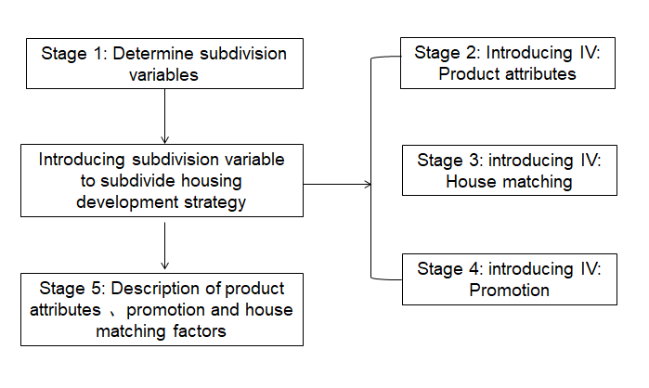
Figure 2-9:segmentation of housing development strategy
In this paper, when subdividing the housing development strategy, we take full account of the results of previous researchers, and on this basis improve it. First, we decide to introduce the two variables of product attributes and housing matching, and consider the different sensitivity of consumers at all levels to products in matching and products, so as to determine the development strategy of real estate enterprises. After that, the purpose of purchasing houses is distinguished, and the different needs of investment customers and residential customers in enterprise development projects are subdivided. (Wilcox, 2015).
In the actual development, the routine procedure of residential product positioning is six factors: architectural style, landscape, surrounding environment, household design, intellectualization, internal and external matching. We divide these indicators into two dependent variables: residential matching measures and residential product attributes. At the same time, we summarize the late marketing activities as promotional variables.
Housing supporting facilities
Mainly related to the internal and external supporting housing, landscape, surrounding environment. It is divided into the following latitudes: sports, recreation, business, education, medical facilities, parking facilities, community clubs.
Residential product attributes
Mainly related to the proportion of residential units, household design, intelligent. It is divided into the following latitudes: housing quality, design area of apartment type, property form and intellectualization, housing quality and architectural style.
Promotion
Mainly related to residential marketing and customer acquisition. Detailed into the following latitudes: traditional advertising, Internet advertising, price discounts.
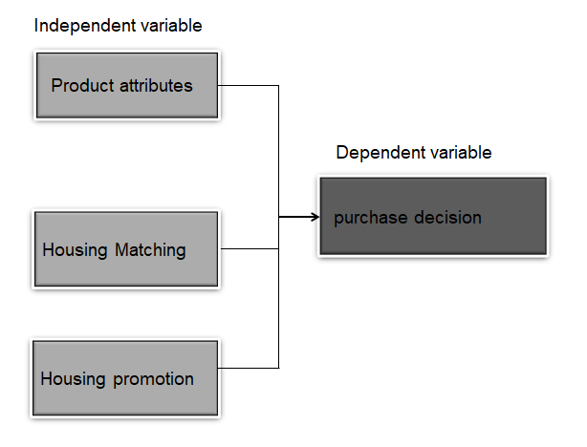
Figure 2-10:franmework

2.4. Propositional Hypothesis
Hypothesis 1: Housing matching has an important impact on purchase decision-making when buying a house in Shijiazhuang.
Hypothesis 2: Product attributes have an important impact on purchase decisions when buying a house in Shijiazhuang.
Hypothesis 3: Promotion has a significant impact on purchasing decisions when buying a house in Shijiazhuang.

Chapter3

3.0.Research methodology

3.1.Research design
This paper mainly uses descriptive research to explore the impact of different residential products on consumers'purchase demand in Shijiazhuang, so as to explore how enterprises can upgrade their marketing and products. The research object is mainly aimed at the permanent residents and potential buyers in Shijiazhuang City, China. Questionnaire design should embody the following principles: Firstly, the questionnaire questions must accurately reflect the two latitudes of housing products and housing peripheral supporting. The purpose of the questionnaire survey is to clarify the evaluation model. Prepare to grasp the meaning of the indicators in the evaluation model, transform them into related problems, and achieve the desired objectives. Secondly, we should pay attention to the questions in the questionnaire which should be easy for consumers to understand. This requires that the description of the questions should be as concise as possible, and the Likert Quantitative Table should be used as the design form of the questionnaire. The problem of selecting and distributing is to collect natural data and check whether there is a relationship between independent variables and dependent variables. (Adiguzel and Wedel, 2005). The characteristics of each consumer group are tested mainly through three dimensions: housing matching，Promotion and product attributes. The main design is shown in Figure 3-1.
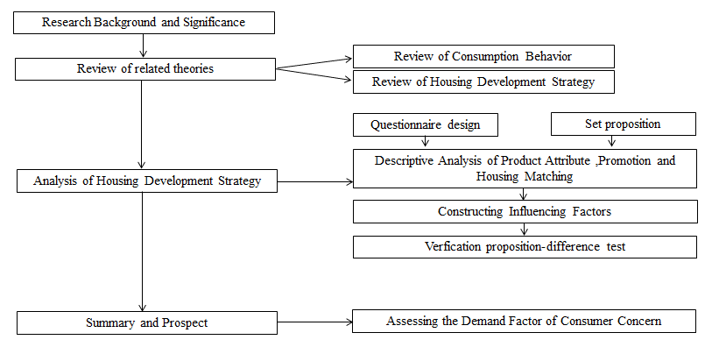
Figure 3-11:main design

3.2. Measuring Instrument
This paper mainly adopts the form of questionnaires to collect data: because this study intends to explore the consumer's housing consumption behavior, it adopts the form of questionnaires and takes the valid results of the questionnaires as the analysis data. At the same time, the questionnaire data belongs to the first-hand data, which is more credible than other second-hand data.

3.3. Validity and Reliability Tests and Analysis
1. Validity of variable design
From the measurable design of variables to the design of questionnaires, this paper refers to the relevant literature or according to the actual situation, tries to make each item contain the main aspects of the scope of the content tested, and keeps the appropriate proportion of all aspects of the project. After the formation of the initial form of the questionnaire, relevant experts are invited to demonstrate the rationality of the content structure of the questionnaire and the suitability of the project. The design of variables in this paper is valid.
2. Validity of observation methods
Non-probabilistic sampling was used in this study. Because of the cost and time constraints.. Limited to factors such as time and cost, the combination of random sampling and quota sampling is adopted. A small part of the questionnaire is distributed through colleagues, friends and classmates in various intermediary stores and real estate enterprises in Shijiazhuang city. Large-scale questionnaire is distributed mainly through the network in the form of random distribution in the Shijiazhuang buyers'forum.
3. Data collection
In this study, first-hand data analysis was used (Sekaran and Bougie, 2011). Data acquisition mainly uses the form of questionnaires to investigate the influencing factors of purchase decision-making of potential buyers in Shijiazhuang. Refer to some data.
The questionnaire is divided into two parts. The first part mainly includes demography. Population research involves age, investment purpose, education level and income level. The second part investigates what factors will affect consumers'purchase decisions when buying a house.
Personal information of the person filling in the questionnaire is guaranteed not to be disseminated. The personal information filled in the questionnaire is only used to analyze the relationship between independent variables and dependent variables. It's also a spontaneous activity (Zikmund, 2010). I will use the Chinese questionnaire software "Questionnaire Star" to produce questionnaires and distribute them to the respondents.
Shijiazhuang has a total population of 10.16 million. The questionnaire was collected for about 10 days. According to Krejcie and Morgan (Krejcie and Morgan, 1970), 384 samples were collected to determine the sample size of the guidelines. The research scale is about 384, and the distribution of questionnaires should be expanded by 10%. So I will send out questionaires to 480 residents, most of whom are residents with purchasing intention and a few with purchasing experience.

3.4.Analytical methods
This research on housing consumption behavior in Shijiazhuang will focus on quantitative research methods, mainly using SPSS 13.O as a statistical analysis tool, followed by the weighted average method, the specific analysis methods are as follows:
1. Descriptive statistical analysis: The valid questionnaires will be retrieved, descriptive statistical analysis will be carried out to have a basic understanding of the sample structure, and on this basis, build a subdivision system of housing consumption groups in the City.
2. Reliability analysis: This paper uses Cronbach, a coefficient reliability analysis test to determine the internal consistency of the questionnaire.
3. Difference analysis: Chi-square test is used to test whether there are differences among different groups of buyers in the process of housing consumption behavior, and different product development strategies are put forward.
4. Multivariate regression analysis: Because there are fewer variables but more latitudes in this study, the linear relationship between multiple variables can be tested by multivariate regression.
Chapter4

4.0. Data Analysis

4.1 Chapter Overview
The research methods outlined in the previous chapter will be used for data collection. This chapter uses social science statistical software package to record data, focusing on the impact of factors on dependent variables. Factor analysis, reliability analysis and correlation analysis were used to test the hypothesis. The basic structure of common factors is mainly used to explain the relationship between factors. Factor analysis based on Skaran theory is used to check the validity of the questionnaire for further analysis. According to McDonald's 1970 study, reliability tests were used to assess the reliability and stability of the questionnaire. Finally, correlation analysis was conducted to evaluate the relationship between variables in this study.

4.2. Descriptive Analysis
According to the problems discussed in Chapter 3, this questionnaire is targeted to the consumers in Shijiazhuang City of China when they issue questionnaires. A total of 500questionnaires were distributed, 460 questionnaires were collected and 456 valid questionnaires were sent out. Questionnaire data were released in July 2019. Because the network survey must be completed before it can be submitted, the survey rate of the respondents is about 99.13%. All questionnaires will be sent online. Questionnaires are filled out in the form of a Google form and are disseminated through online forums and groups. Therefore, 456 questionnaires were used to meet the requirements of sample size.The age, educational background, monthly income and investment purpose of the respondents are in the demographic section.
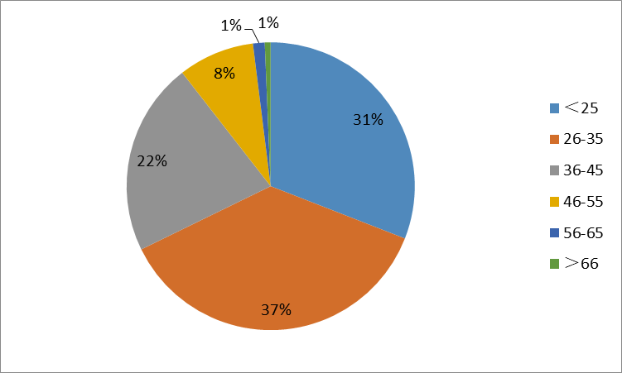
Table 4-3:age structure
In terms of age structure, the population under 45 accounted for 89.4% of the total population surveyed. This part of the population is economically independent and in rigid demand. The majority of people over 46 years old mainly invest in home ownership. The increase in the proportion of people under the age of 25 buying houses is due to the current trend of fewer children. Most parents buy houses for their children(Zwick, 1957). Therefore, from the statistical data point of view, the survey will not appear due to the uneven age distribution leading to deviations in the overall representation, so sampling is also basically reasonable.
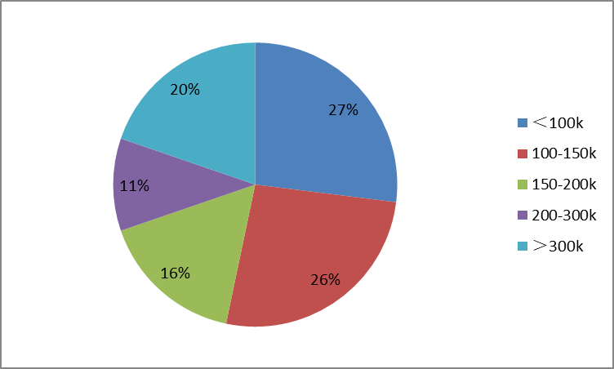
Table 4-4:annual household income
According to the statistics of annual household income by questionnaire, the annual household income of the investigated population is mainly between 50,000 yuan and 150,000 yuan per year. accounting for 53.3% of the total population. This part of the consumer belongs to the middle income level of Shijiazhuang City. Their income is basically stable, and they have a slight surplus besides meeting daily consumption. They are the main group of Shijiazhuang purchasing commercial housing, and they have the greatest influence on the consumption situation of Shijiazhuang housing. In addition, housing has investment attributes (Eriksen and Ross, 2012), and high-income families also show strong desire for demand, accounting for 19.7%.
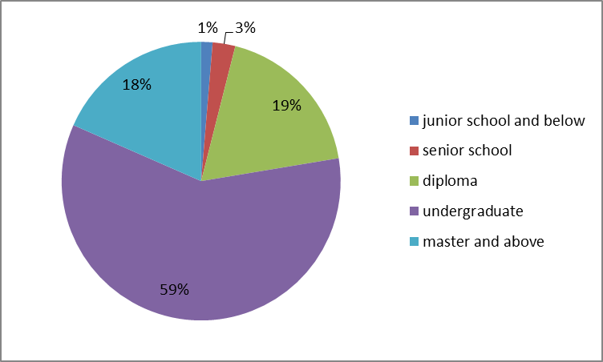
Table 4-5:level of education
In terms of education level, the survey population concentrated on undergraduate and above education level, accounting for 59.2% of the total population surveyed. This part of the population generally have a relatively stable job, with the financial strength to buy a house. Because of income level, residence restriction, job instability and other reasons, people with low and middle educational level have less demand for real estate in big cities, mostly for temporary work. Therefore, from the statistical data point of view, the survey will basically not be due to uneven distribution of education level leading to deviations in the overall representation, so sampling is also basically reasonable.
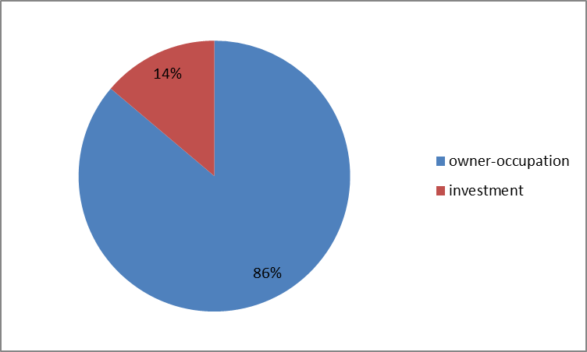
Table 4-6:purpose
From the distribution structure of investment purposes, the majority of households live by themselves, accounting for 86.2% of the total population, which corresponds to the current development trend of the real estate market, as well as the age structure of residents in Shijiazhuang. In the second tier cities, the real estate bubble is relatively small, and young people are the main consumers of the property market (HEYMANN et al., 2012). The purpose of their purchase is mainly to solve the rigid needs of local residents. Therefore, from the statistical data point of view, this survey sampling is also basically reasonable.

4.3. Reliability Analysis
Reliability represents the possibility of using the same observation method to obtain the same observation result for the same observation object. It is used to represent the measurement reliability index. The measurement of reliability includes retest reliability, half-fold reliability and Cronbach'Sa reliability. The a-trust coefficient proposed by Cronbach is a commonly used reliability index at present. In this paper, Cronbach'Sa (internal consistency coefficient) and Split-half (Spielman-Brown split reliability coefficient) are used to measure the reliability of the questionnaire. See Table 4-5, the reliability value of the questionnaire is 0.715, higher than 0.7, which shows that the questionnaire has a high level of reliability, and the survey has good consistency and stability (Preko, 1976).

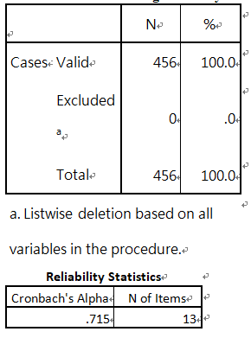
Table 4-7:processing summary
Relevance analysis method is mainly used to evaluate the relationship between consumer purchase decisions and housing matching, product attributes and promotion. (Goldreich, 2010). This variable was used for correlation test and bivariate analysis. The results are shown in Table 4.6. Cronbach's Alpha was more than 0.70, with a moderate correlation between 0.7 and 0.4, and a weak correlation between less than 0.3..
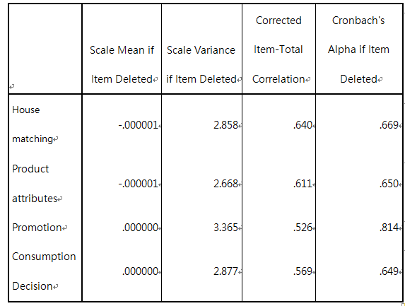
Table 4-8:item-total statistics
From the table, we can see that cronbach's alpha is 0.715, > 0.70, which means that the reliability of independent variables and dependent variables is high, has a significant positive relationship, and has good internal consistency. (Cronbach, 1951). Therefore, it can be used as a reliable basis for further analysis. In addition, the overall results of the reliability analysis show that the reliability of independent variables and dependent variables is higher.

4.4.Correlation test
In order to analyze the relationship between variables, Pearson correlation analysis was carried out for each variable (Krauczi, 2007). The main purpose of correlation analysis is to evaluate the relationship between public factors such as housing matching, product attributes, promotion and consumption decision-making. This variable is used for correlation test and binary analysis. The results are shown in Table 4.7. Then, according to (Limsuwan, 2010), when the Prot value is less than 0.05 and the correlation coefficient is greater than 0, there is a significant positive relationship between variables.
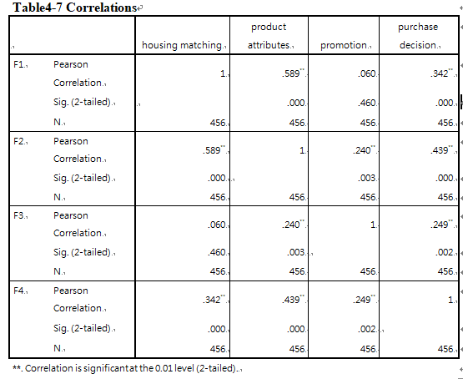
Table 4-9:correlations
As can be seen from Table 4-7, there is a significant impact of real estate promotion on customers'purchase decisions.The positive correlation significant value is 0.249 greater than 0, P < 0.05.From these data, it can be seen that potential buyers in Shijiazhuang are easily affected by the marketing methods of developers, because the prices of first and second-tier cities are higher, and project prices have become a sensitive point for consumers to make decisions.
Housing matching and consumer purchase decision have a high positive significance, reaching 0.342, and P < 0.05. This means that most consumers in Shijiazhuang think that the supporting environment of housing is absolutely important to them. Because from the survey data of this article, we can see that most buyers are self-employed customers and need to live in it for a long time (Csörgö, 2002). It is necessary to provide convenience of life and the needs of children's education, shopping, entertainment and medical treatment in the future. As a commodity, housing also has the attribute of investment. A well-matched project has tremendous appreciation potential in the future, which is conducive to maximizing benefits.
However, product attributes showed a strong positive correlation, that is, 0.439, P < 0.05. This also means that infrastructure factors are considered to be significantly positively correlated. Product attributes are also an important factor for consumers to buy houses. However, as house prices rise, consumers'purchasing power is reduced, which will strengthen consumers' demand for high-standard housing. Consumers will also have higher requirements for housing quality in the process of affording high housing prices (Streimikiene, 2015). However, because customers can not see the whole infrastructure when they buy houses, they can only visit in the high-quality model provided by enterprises. The quality of visiting model houses will weaken the demand of consumers for greening and the quality of housing after construction, because the infrastructure of model houses is perfect.

4.5. Validity Test
Validity refers to the validity of the questionnaire. It refers to the extent to which a measurement tool or means can accurately measure the things that need to be measured(Ryder, 1964). Validity refers to the degree to which the measured result reflects the content to be examined. The more consistent the measurement result is with the content to be examined, the higher the validity; otherwise, the lower the validity. Validity is divided into three types: content validity, criterion validity, and structural validity. Validity of relativity The validity of any test is for a given goal(uno, Satomura and Adachi, 2016), or the test is only valid for purposes and occasions that are consistent with the test objectives. Therefore, in evaluating the validity of the test, the purpose and function of the validity test must be considered. This paper mainly uses the KMO value to detect the content validity of the data. It refers to whether a test question tests whether the content should be tested or whether the tested content reflects the test requirements. It mainly studies the representativeness of the test and the degree of coverage(Yasui, Harada and Shimakawa, 2014).

4.5.1 Analysis of Housing Matching
Kmo and Barlett tests were performed first.
According to the table below, the kmo value is 0.770, and the kmo value is higher. Factor analysis can be used. Bartlett's Test corresponds to the test probability p = 0.000 < 0.05. data can be processed in the next step.
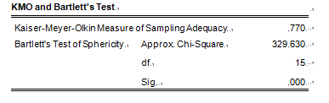
Table 4-10：communalities test1

4.5.2. Analysis of Product Attribute
According to table 4-9, Kaiser-Meyer-Olkin (kmo) has a value of 0.695 and Bartlett's sphericity test value is p=0.000 less than 0.05. The analysis shows that product attributes have a significant impact on consumption decision-making. On the other hand, from the data, consumers in Shijiazhuang recognize the brand power of enterprises with good housing quality.
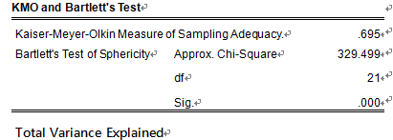
Table 4-11:communalities test2

4.5.3. Analysis of Promotion
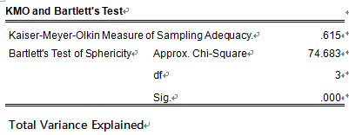
Table 4-12:communalities test 3
According to Table 4-10, Kaiser-Meyer-Olkin (kmo) is 0.615, and Bartlett's sphericity is less than 0.05. Promotion factors have significant impact and are suitable for future analysis. On the other hand, it can be seen from the data that customers believe that discount strength is still one of the factors affecting the purchase of houses.

4.5.4. Analysis of Decision
According to table 4-11, kmo is 0.655 and Bartlett's sphericity test is p<0.05. This means that the validity of decision-making factors is high and suitable for further analysis.
KMO and Bartlett's Test
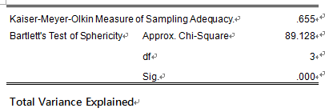
Table 4-13:communalities test 4

4.6. Multiple regression analysis
In view of the three hypotheses proposed in Chapter 3, we use multiple regression FA to test them.
Table 4-12 Research hypotheses

Hypotheses 1: Housing matching has a significant impact on purchase decisions in Shijiazhuang，china.

Hypotheses 2: Product attributes have a significant impact on purchase decisions in Shijiazhuang.

Hypotheses 3: Promotion has a significant impact on purchase decisions in Shijiazhuang, China.

4.6.1 Hypothesis Test
Model Summary shows that the regression model can be R Square = 0.229, Adjusted R Square = 0.213, and the numerical value is normal (Maneesha and Bajpai, 2013). It shows that the model has high goodness of fit, and the independent variable can explain 22.9% variation of dependent variable.
Model Summary^{b}
Model |  | R | R Square |  | Adjusted R Square |  | Std. Error of the Estimate |  | Durbin-Watson
1 |  | .479ª | .229 |  | .213 |  | .6782431 |  | 1.791
a. Predictors: (Constant), F3, F1, F2
b. Dependent Variable: F4
ANOVAª
Model |  |  |  | Sum of Squares |  | df |  | Mean Square |  | F | Sig.
1 | Regression |  |  | 20.221 |  | 3 |  | 6.740 |  | 14.653 | .000^{b}
1 | Residual |  |  | 68.082 |  | 148 |  | .460
1 | Total |  |  | 88.303 |  | 151
a. Dependent Variable: F4
b. Predictors: (Constant), F3, F1, F2
Table 4-14:hypothesis test
A. Dependent variables: (purchase decision)
B. Predictive factors: housing matching, product attributes, promotion,
According to the data shown in Table 4-13, it can be assumed that the model described the positive correlation between consumer purchase decision-making and three independent variables in Shijiazhuang. In addition, the Durbin-Watson value is less than 2, which means that variables can be proved to be independent (Cambanis and Wu, 1992). In addition, since 1.791 is between 1.6 and 2, the multiple collinearity hypothesis of variables has been confirmed. In addition, because the VIF threshold is 10, according to the data shown in Table 4-17, the variance inflation factor (VIF) is between 1.468 and 3.526, which is less than the threshold of 10. The analysis of variance shows that when P < 0.05, the hypothesis of this study is significant. (Blackwell, 2011).

4.6.2. Results of multivariate regression analysis
Coefficientsª
Model |  | Unstandardized Coefficients |  | Standardized Coefficients | t | Sig.
 |  | B | Std. Error | Beta | t | Sig.
1 | (Constant) | -3.769E-7 | .055 |  | .000 | 1.000
1 | housing matching | .141 | .086 | .147 | 1.642 | .003
1 | product attributes | .325 | .096 | .313 | 3.388 | .001
1 | promotion | .157 | .071 | .165 | 2.213 | .028
a. Dependent Variable: F4
Table 4-15:coefficients
After implementing the multiple regression hypothesis, we begin to study the regression results given in Table 4-14. Then, through the evaluation of the table, when P <0.05, R>0.1, T>1.96, the results show that all three factors have achieved positive correlation, and the results show that the residential package has no significant impact, product attributes and promotions have Significant influence, which is important for predicting the purchase intention of Shijiazhuang consumers (Fruchter, 1983). In addition, in the case of the highest beta coefficient, product attributes are often the most important factor affecting the purchasing intention of consumers in Shijiazhuang. The future appreciation potential and product quality of housing are ranked first by consumers, and the appreciation potential is affected by various infrastructures.
H1: Housing matching has a major impact on China's Shijiazhuang purchase decision
Table 4-14 shows the test values ​​P=0.03, t=1.642(<1.96), r=0.479 (Zhang, Zhu, Feng, 2018), so there is no significant relationship between Shijiazhuang housing package and consumer purchase intention (β= 0.141, P <0.05). The results also show that the increase in housing matching factors can increase the willingness to purchase 0.141 sets in Shijiazhuang.
H2: Product attributes have a significant impact on Shijiazhuang's purchasing decisions.
Table 4-14 shows that P = 0.01 and t = 3.388 for the regression test, indicating that there is a significant relationship between the price of Shijiazhuang and the purchase intention (β = 0.325, P < 0.05). In addition, the research results also show that the product attributes of a unit can increase the purchase intention of 0.325 sets of Shijiazhuang customers.
H3: Promotional activities have a major impact on the purchase decision of Shijiazhuang, China.
Table 4-14 shows that the P value of the regression test = 0.028, t = 2.213, indicating a significant relationship between the promotion and purchase intention of Shijiazhuang (β = 0.157, P <0.05). The results also show that increasing the promotion factor of one unit can increase the purchase intention of 0.157 units in Shijiazhuang.
Based on the above analysis, the fitting regression equation is as follows:
F1=-3.769E-7+0.141F1+0.325F2+0.157F3
It shows that the average increase of purchase decision is 0.141 units for every additional unit of housing matching (Cambanis and Wu, 1992), 0.325 units for every additional unit of product attributes, and 0.157 units for every additional unit of promotion. It shows that product attributes have the greatest influence on purchase decision, while housing matching is the smallest.

4.7. Data summary
factor | data result | Hypothetical result
Housing matching | P=0.03, t=1.642,r=0.479 | invalid
Product attributes | P = 0.01 t = 3.388,,r=0.479 | Established
Promotion | P = 0.028 t = 2.213,,r=0.479 | Established
Table 4-16:analysis result
Housing matching
The data show that residential matching has no significant impact on consumer decision-making. This is mainly affected by the three aspects of China's housing sales system, education system, and business planning. The Chinese real estate market adopts a pre-sale system, that is, the project construction has just taken place when consumers purchase houses. To the 3F state, full delivery needs to be after 1-2 years. This policy has enabled real estate developers to speed up the flow of funds, but it is not good for consumers because they cannot see the status of project delivery, and the supporting facilities of the project are unknown (Alvayay, Rutherford and Smith, 1995).
The unreasonable development of commercial businesses has led to the construction of commercial facilities, which has determined that the scale of the facilities they develop cannot be very large. The survey found that most residential projects are located in the new urban area, and the business scale and flow of people in the new district will take 5-10 years to complete. Although many developers have commercial facilities (Lai, 2018), they are mainly retail shops, especially in the suburbs. It is difficult to attract large supermarkets to enter, which is not popular, and the occupancy rate is low.
The allocation of educational resources in China is the responsibility of the government, not the real estate developers. Schools and hospitals are public welfare buildings (Schwartz and Stiefel, 2004). There is a distance between the purpose of “building schools” and the pursuit of maximum profits by developers. Once there is a problem with the construction and sales of the house, it is easy to affect the construction progress of the school, and it has its limitations. Mainly manifested in:
1. The progress of the school's development and construction has been delayed. In reality, there is a widespread phenomenon that educational facilities and housing construction are not synchronized or even the educational facilities are finally built. This construction method links the overall situation and performance of the construction of the school with the development of the community, and the dependence is very high. Therefore, a series of prominent problems have appeared in the construction of the school.
2. For newly-developed real estate, the government department will only formulate the school district to which the project belongs when the real estate is delivered, and the education support will be blind when the consumer purchases. This will reduce the importance of this factor in the minds of consumers.
Product attributes
The data shows that the attributes of residential products have a significant impact on consumer decision-making, which mainly affects consumer psychology from three aspects: housing quality, apartment design and landscape design. For the customers who need it, the house is a long-term consumable, and the quality of the product directly affects the comfort and health of the residents. Chinese high-rise residential buildings often appear in the later period: the house leaks, the exterior paint falls off, and the wall cracks. Therefore, good housing quality is the basic guarantee for buying a house.
The type of housing is the most concerned issue for the residents. The level of the design of the apartment also reflects the level and strength of the developer to a certain extent (Bedi, 2006). The family structure and lifestyle are constantly changing, requiring residential units to adapt to the needs of different family structures, different life stages, and lifestyle changes. The developer optimizes the home mainly in terms of residential comfort, lighting, porch design and functional area division.
Garden landscapes are also attractive to consumers. There are no real estates without landscapes. On the other hand, real estates with good landscapes are also easier to sell than those with poor landscapes (Farncombe and Waller, 2005). In the case of similar or different hardware conditions, the landscape environment has become the focus of consumers' purchases, and it has also contributed to the high rate of return on landscape investment. It is understood that investing in landscapes can bring about 5 times of revenue, and its return on investment exceeds many current investment methods. In other words, as long as 100 yuan per m2 is invested in the landscape of the garden, the sales price of the house can increase by about 500. Yuan, a large number of developers are happy with the investment landscape.
Promotion
The data shows that promotion has a significant impact on consumer decision-making, and the housing price bubble makes consumers pay more attention to economic factors such as price, sales channels, advertising, and brands. The price advantage compared with the surrounding competitors, and the perfect distribution channel can help the company to obtain more customers, while the advertising and experienced home buyers can expand the project potential and promote the determination of consumers to buy.

Chapter5

5.0. Summary

5.1 Chapter Overview
This chapter mainly discusses the explanations and results discussed in Chapter IV. Then, the first part of this chapter is a further explanation of data analysis, and the second part is a hypothetical contribution, such as the contribution to academia, industry and government. In addition, this study also explores the future research of this study. Finally, from the perspective of researchers, this paper puts forward the future development strategy of residential enterprises based on consumer decision-making.

5.2 Result discussion
Firstly, two problems in the development of the real estate market in Shijiazhuang are analyzed: high vacancy rate and low sales volume. The purpose of this study is to analyze the impact of customer purchasing decision-making intention, and what is the most important factor affecting customer purchasing decision-making (Keeling, 2000), so as to help real estate enterprises optimize their own development strategy. According to the questionnaire survey, 456 respondents in Shijiazhuang City were investigated in the process of questionnaire issuance. According to the literature review of Chapter 3, this paper studies three factors: housing matching, product attributes and promotion. In the demographic analysis, the majority of the people who buy houses are young people from 20 to 35. The income of the main families is below 150,000RMB/year. Most of the buyers have received higher education and are just in need of housing. According to the results of multiple regression analysis, there is no significant relationship between housing matching and consumer decision-making. There is a significant positive correlation between product attributes and promotion decisions and consumption decisions, which can explain 22.9% of consumption decisions. Residential matching is limited by government planning and regional development, and has less influence when buying a house. Most consumers are more concerned with product attributes and promotions. Since housing requires long-term protection, a reliable infrastructure and environment will provide long-term convenience and appreciation for life (Kleffe, 1979). Second, promotional discounts and prices are very sensitive data in real estate, because as a commodity, buying a house takes decades of family wealth accumulation. For example, in China, the “Gold, Nine, Silver, Ten” seasons have higher turnover because consumers believe that prices are lower this month (Zhao and Sing, 2015). Finally, the improvement of life support has affected the post-maintenance and appreciation potential of housing, and it is also one of the key means for companies to obtain a premium.

5.3 Contribution

5.3.1 To Industry
This study will help to better analyze the impact of housing supporting factors, product attributes and promotional factors on consumers'housing preferences in Shijiazhuang(Shiem‐Shin Then, 2000). The results show that the housing matching has the highest coefficient value. Therefore, based on consumer purchasing intention, the results of this study will help developers to develop more reasonable supporting facilities(Stoy and Johrendt, 2008), more accurate positioning, segmentation and positioning of consumers. In the development stage, we should actively introduce education, commerce and medical support to enhance the value of the project.

5.3.2 To Government
This paper puts forward three factors affecting consumers'purchase, which is conducive to better market supervision by the government, enacting laws and regulations at sensitive points of consumer concern, regulating market behavior and protecting consumers' rights and interests (Nicholas, 1981). The study of consumers is conducive to protecting the right of newly needed customers to buy houses and attacking investment customers. It also provides multi-dimensional management of Housing enterprises in terms of product quality, introduction of supporting facilities and product marketing.

5.3.3 To academic
According to the research results, it can help scholars to understand the significant relationship between independent variables and dependent variables. At the same time, according to the research results, We can further study the trend of Chinese consumers'sensitivity to real estate.

5.4. Future Research
The hypothesis test results based on R-square value show that there are other factors that affect Chinese consumers'purchase intention, because the three factors explored in this paper can only affect 22.9% of consumer decision-making(Haruki, 1971). This paper mainly explores the factors that real estate enterprises need to adjust, so it does not involve the factors of price and real estate policy. However, China's real estate market is significantly affected by policies and prices. Consumers have strong herd mentality. They often take wait-and-see actions when the market goes down, while real estate sales surge when the market goes up(LIU, 2016). China's real estate policy in the short term, in the medium term and in the long term. In the past two decades, as long as the policy is tightened, the housing price will probably fall(Wolf-Powers, 2017). The government controls the real estate market through the policies of interest rate, credit, purchase restriction, sale restriction, taxation, financing, land transaction and housing security. (Chen and Yang, 2018) Therefore, future research may include more macro-factors to explore its relationship with consumer purchasing decisions.

5.5. Recommendation

5.5.1 To Industry
Faced with the huge housing consumption group, any real estate enterprise can not occupy every segment of the market. It can only select specific housing consumption groups according to the characteristics of housing consumption behavior of different consumers, and put forward its own housing development strategy. According to the questionnaires of this study, young and middle-aged people have a higher demand for real estate(Yi, 2018). We believe that 100㎡ high-rise housing with low total price will be the mainstream product for future development of housing enterprises, because it meets the price needs and investment needs of consumers.
In recent years, Shijiazhuang City's huge investment in urban infrastructure and the gradual implementation of "three years of great changes", the continuous improvement of the housing market environment has ushered in a period of rapid development of small and medium-sized household products, and sales are also increasing(Nilsson, 1992). The rise in house prices is expected to further reduce the size of residential buildings. In the future, small apartments will become the first choice for new customers(Nababan, 2008). At present, its share in the real estate market in Shijiazhuang has an obvious upward trend, and it is expected that there will be greater room for development in the future real estate market. Although small-scale housing may be further favored in the Shijiazhuang market(Bielski and Giermek, 2019), it should be noted that in addition to traditional housing types and prices, building good quality is also an important factor to attract young consumers and investors to accept, such as in decoration design, housing intellectualization and overall environment supporting links.
Through long-term analysis and planning, the company establishes a huge marketing channel to provide customers with products and services, making it difficult for competitors to imitate in the short term, ensuring that enterprises gain competitive advantage in a long period of time. In the process of implementing channel differentiation, enterprises can gain competitive advantage through the coverage width, expertise and performance of distribution channels, tap and use modern multimedia advantages to establish a “three-dimensional promotion” network, and break the geographical limitations of sales channels. For example, residential sales in mega-cities can be set up in each urban area to cover a wider range of areas; to leverage the various relationships (Yavas and Yang, 1995), experience and expertise of marketing intermediaries to create higher marketing efficiencies than competitors The commercial housing materials will be published online, and online shopping will be launched to expand sales channels. As a comprehensive symbol of marketing, brand reflects the quality and price of products to a certain extent.
Service and reputation have become an important reference for customers when selecting similar products. The value of intangible assets has been paid more and more attention and attention. From the strategic height, we understand the importance of brand positioning differentiation, take corporate brand building as a long-term goal (Sridhar and Mehta, 2018), establish a lasting and good corporate image, and use media and other propaganda methods to target consumption in the process of implementing brand differentiation strategy. The company conveys information about products and brand characteristics, establishes an excellent image in the minds of consumers, and effectively distinguishes the products, brands and competitors to achieve the competitive advantage of the brand.
Main strategies | Strategic content
Location strategy | University districts, near industrial agglomeration areas, new urban areas, with Metro or bus stops
Product Design Strategy | Mainly high-rise, with an area of 100㎡, three-bedroom, independent living room, kitchen and bathroom.
Matching strategies | Introduce supermarkets and schools to locate in convenient transportation areas
Table 5-17:main development strategies

5.5.2. To government
According to the data of this study, most consumers believe that housing quality can not be guaranteed, housing supporting construction is slow, and enterprise price publicity has misleading concepts(Panosa and Maria 2014). Therefore, there is a certain gap between the development strategy of real estate enterprises and consumer demand. Shijiazhuang Municipal Government should improve the quality of housing and the acceptance standards of supporting facilities.Secondly, detailed regulations on real estate regulation are introduced to guide housing enterprises to publish the price of a house and improve the transparency of sales (Hoesli and Reka, 2015). Strictly crack down on creating false sales and real estate speculators. We should adopt Price-Limiting policies to stabilize house prices and ensure the fairness of people's house purchasing. On the other hand, we should increase the construction scale of affordable housing to meet the needs of low-income people and stabilize the healthy operation of the real estate market in Shijiazhuang (Field, 1997).

5.5.3. To academic
This study not only has made a useful contribution to the academic community, but also has some guidance and explanation for the future study of real estate marketing in Shijiazhuang, so that this study can test the relationship between variables. On this basis, more variables are proposed. In addition, the framework of this study can provide a method for other scholars who may study similar research in the future.

5.6. Conclusion
Real estate is an important industry in China's economy, which involves many industries. After decades of development, high vacancy rate and declining sales volume have become the crisis of the industry. From the perspective of real estate enterprises, this paper combs and studies customers'purchasing intention in Shijiazhuang. The purpose of this paper is to analyze the relationship among housing matching, product attributes, promotion and customer purchase decision-making. The geographical focus of this study is Shijiazhuang, China. The subjects of this study are 456 residents of Shijiazhuang, China. Then according to the hypothesis test, all three variables have a positive impact on consumers'purchase. Based on the questionnaire, we believe that enterprises should focus on small-sized, high-quality, complete real estate projects to meet the needs of consumers.

5.7. Personal Reflection
This paper was completed under the careful guidance and hard instruction of my supervisor, Mrs. Faziha. From the topic selection, research and thesis writing, my tutor gave me the best guidance. During my postgraduate period, my tutor's profound theoretical knowledge, rigorous academic attitude and forgetting my enthusiasm for work have had a profound impact on me, which has benefited me for life. Of course, throughout the assignment process, I have been exposed to a lot of literature and theory, especially in research methods and data analysis, in order to better understand the application of statistical software. Graduation thesis needs more rigorous and professional knowledge. During this period, I also found many deficiencies in the thesis, such as the setting of independent variables is not comprehensive enough. I am also very grateful to my classmates for their help. Finally, I would also like to thank my second supervisor, Dr. Lim, for his suggestions for my paper so that I can improve it further. Finally, I would like to thank all the teachers of INTI International University for their guidance and encouragement during my master life.

6.0.Reference
Adiguzel, F. and Wedel, M. (2005). Split Questionnaire Design. SSRN Electronic Journal.

Alvayay, J., Rutherford, R. and Smith, W. (1995). Tax Rules and the Sale and Leaseback of Corporate Real Estate. Real Estate Economics, 23(2), pp.207-238.

Beckhart, B. and Keynes, J. (1936). The General Theory of Employment, Interest and Money. Political Science Quarterly, 51(4), p.600.

Bedi, K. (2006). Automating the Quality Function Deployment House of Quality. SSRN Electronic Journal.

Belknap, I. and Clark, L. (1956). Consumer Behavior. Volume II: The Life Cycle and Consumer Behavior. American Sociological Review, 21(2), p.240.

Bielski, A. and Giermek, A. (2019). Coagulation of greywater from a small household. DESALINATION AND WATER TREATMENT, 151, pp.74-81.

Cambanis, S. and Wu, W. (1992). Multiple regression on stable vectors. Journal of Multivariate Analysis, 41(2), pp.243-272.

Cambanis, S. and Wu, W. (1992). Multiple regression on stable vectors. Journal of Multivariate Analysis, 41(2), pp.243-272.

Cambanis, S. and Wu, W. (1992). Multiple regression on stable vectors. Journal of Multivariate Analysis, 41(2), pp.243-272.

Che, Y. (2009). Mismatch: Land Reallocations, Recovery Land Rental and Land Rental Market Development in Rural China. SSRN Electronic Journal.

Chen, K. and Yang, J. (2018). Housing Price Dynamics, Mortgage Credit and Reverse Mortgage Demand: Theory and Empirical Evidence. Real Estate Economics.

Church, A. (2018). The Effects of Local Government Expenditure and Property Taxes on Investment*. Real Estate Economics, 9(2), pp.165-180.

Cowan, S. (2012). Third-Degree Price Discrimination and Consumer Surplus. The Journal of Industrial Economics, 60(2), pp.333-345.

Cristadoro, R. and Marconi, D. (2018). Households' Savings in China. SSRN Electronic Journal.

Cronbach, L. (1951). Coefficient alpha and the internal structure of tests. Psychometrika, 16(3), pp.297-334.

Csörgö, S. (2002). Weighted correlation tests for scale families. Test, 11(1), pp.219-248.

Detterman, D. (1994). Changes in intelligence. Intelligence, 18(1), p.1.

Dr. N. Kathirvel, D. and P.VIMALAGRACY, P. (2011). Factors Affecting The Buying Behaviour and Buying Preferences of Individual House Owners. Indian Journal of Applied Research, 4(5), pp.88-90.

Drossos, D., Fouskas, K., Kokkinaki, F. and Papakyriakopoulos, D. (2011). Advertising on the internet: perceptions of advertising agencies and marketing managers. International Journal of Internet Marketing and Advertising, 6(3), p.244.

Duffy, D. (2003). Internal and external factors which affect customer loyalty. Journal of Consumer Marketing, 20(5), pp.480-485.

Eriksen, M. and Ross, A. (2012). The Impact of Housing Vouchers on Mobility and Neighborhood Attributes. Real Estate Economics, 41(2), pp.255-277.

Fabiani Giannetto, R. (2017). A Response to the New Landscape Declaration: A Summit on Landscape Architecture and the Future. Journal of Landscape Architecture, 12(1), pp.90-91.

Fan, Y. and Yavas, A. (2018). How Does Mortgage Debt Affect Household Consumption? Micro Evidence from China. Real Estate Economics.

Farncombe, M. and Waller, A. (2005). Outsourcing for corporate real estate managers: How can real estate learn lessons from other industries?. Journal of Corporate Real Estate, 7(3), pp.258-270.

Field, C. (1997). Building consensus for affordable housing. Housing Policy Debate, 8(4), pp.801-832.

Fruchter, B. (1983). Test That Hypothesis. Contemporary Psychology: A Journal of Reviews, 28(5), pp.370-371.

Genesove, D. and Han, L. (2012). Search and matching in the housing market. Journal of Urban Economics, 72(1), pp.31-45.

Goldreich, Y. (2010). Distcorrelation Matrix: A Spatial Correlation Trend Analysis. Geographical Analysis, 16(4), pp.358-368.

Haruki, H. (1971). On a Relation between the “Square” Functional Equation And The “Square” Mean-Value Property. Canadian Mathematical Bulletin, 14(2), pp.161-165.

He, D., Zhang, X., Zhuang, Y., Wang, Z. and Jiang, Y. (2019). China fertility report, 2006–2016. China Population and Development Studies.

HEYMANN, H., MACHADO, B., TORRI, L. and ROBINSON, A. (2012). HOW MANY JUDGES SHOULD ONE USE FOR SENSORY DESCRIPTIVE ANALYSIS?. Journal of Sensory Studies, 27(2), pp.111-122.

Hill, R. (1994). Upland development policy in the People's Republic of China. Land Use Policy, 11(1), pp.8-16.

Hoesli, M. and Reka, K. (2015). Contagion Channels between Real Estate and Financial Markets. Real Estate Economics, 43(1), pp.101-138.

Hua, X. (2017). Analysis on the Influence of Russian Historical Changes on Architectural Style. Journal of Architectural Research and Development, 1(2).

Huang, Y. (2013). Analysis of Affordable Housing Space Layout — Case Study of Ningbo，Zhejiang. Advanced Materials Research, 838-841, pp.2934-2937.

IMRIE, R. (2003). Housing Quality and the Provision of Accessible Homes. Housing Studies, 18(3), pp.387-408.

JinHyunJoung,(2012). Analysing Factors on Consumers' Purchasing Behaviors in Social Commerce. The e-Business Studies, 13(2), pp.259-282.

Kauškale, L. and Geipele, I. (2016). Economic and Social Sustainability of Real Estate Market and Problems of Economic Development – a Historical Overview. Baltic Journal of Real Estate Economics and Construction Management, 4(1), pp.6-31.

Keeling, K. (2000). A Regression Equation for Determining the Dimensionality of Data. Multivariate Behavioral Research, 35(4), pp.457-468.

Kien Hwa, T. (2007). Impact of the Asian financial crisis on corporate real estate acquisitions. Journal of Corporate Real Estate, 9(4), pp.239-256.

Kim, J. (2017). The Comparison of Local Housing Price Determinants by Housing Type. Korean Association for Housing Policy Studies, 25(2), pp.175-195.

Kleffe, J. (1979). On Hsu's theorem in multivariate regression. Journal of Multivariate Analysis, 9(3), pp.442-451.
kok, N. (2017). Special Feature：Big Data in Real Estate and Real Estate Tech. The Japanese Journal of Real Estate Sciences, 31(1), pp.35-35.

Krauczi, É. (2007). A study of the quantile correlation test for normality. TEST, 18(1), pp.156-165.

Krejcie, R. and Morgan, D. (1970). Determining Sample Size for Research Activities. Educational and Psychological Measurement, 30(3), pp.607-610.

Kulu, H. and Vikat, A. (2007). Fertility differences by housing type. Demographic Research, 17, pp.775-802.

Lai, S. (2018). A simulation model for urban development in China. Journal of Urban Management, 7(1), pp.1-5.

Lannes, B. (2019). Consumption in China: Ten Trends for the Next 10 Years. [online] Bain. Available at: https://www.bain.com/insights/consumption-in-china-ten-trends-for-the-next-ten-years/ [Accessed 24 Apr. 2019].

Limsuwan, A. (2010). Correlation between the 6-min walk test and exercise stress test. Acta Paediatrica, 99(7), pp.958-959.
LIU, Y. (2016). The Impact of Purchase Restrictions Policy on Real Estate Market: Evidence from China. Advances in Social Sciences Research Journal, 3(4).

Maneesha and Bajpai, P. (2013). Multiple Regression Analysis Using ANCOVA in University Model. International Journal of Applied Physics and Mathematics, pp.336-340.

Maslow, A. (1943). A theory of human motivation. Psychological Review, 50(4), pp.370-396.

Miceli, T. and Sirmans, C. (2013). Efficiency rents: A new theory of the natural vacancy rate for rental housing. Journal of Housing Economics, 22(1), pp.20-24.

Nababan, T. (2008). The Analysis of Household Electricity Demand for Small Scaled Household in Medan. SSRN Electronic Journal.

Næss, P. (1994). Normative planning theory and sustainable development. Scandinavian Housing and Planning Research, 11(3), pp.145-167.

Nicholas, J. (1981). Housing Costs and Prices Under Regional Regulation. Real Estate Economics, 9(4), pp.384-396.

Nijkamp, P. (1988). Regional planning and urban impact analysis. Scandinavian Housing and Planning Research, 5(1), pp.17-32.

Nilsson, J. (1992). Relocation of state agencies as a strategy for urban development: The Swedish case. Scandinavian Housing and Planning Research, 9(2), pp.113-118.

Nooraie, M. (2018). Decision magnitude of impact and strategic decision‐making process output. Management Decision, 46(4), pp.640-655.

Or, T. (2017). Pathways to homeownership among young professionals in urban China: The role of family resources. Urban Studies, 55(11), pp.2391-2407.

Panosa Gubau, A. and Maria Panosa, A. (2014). Speculation and Real Estate: Can Speculation Contribute to an Efficient Real Estate Market?. Critical Housing Analysis, 1(2), p.1.

Panosa Gubau, A. and Maria Panosa, A. (2014). Speculation and Real Estate: Can Speculation Contribute to an Efficient Real Estate Market?. Critical Housing Analysis, 1(2), p.1.

Preko,, A. (1976). Reliability analysis management. Microelectronics Reliability, 15(6), p.523.
Rani, P. (2016). Factors Influencing Meat Buying Behaviour among Rural, Semi-Urban and Urban Households. International Journal of Science and Research (IJSR), 5(2), pp.317-318.

Ryder, R. (1964). Profile Factor Analysis and Variable Factor Analysis. Psychological Reports, 15(1), pp.119-127.

Sandelin, B. (1981). Price Behavior and Capital Gains on Residential Real Estate: The Case of Sweden*. Real Estate Economics, 9(3), pp.241-264.

Schwartz, A. and Stiefel, L. (2004). Immigrants and the Distribution of Resources Within an Urban School District. Educational Evaluation and Policy Analysis, 26(4), pp.303-327.

Sengupta, U. (2019). State-led housing development in Brazil and India: a machinery for enabling strategy?. International Journal of Housing Policy, pp.1-27.

Shiem‐Shin Then, D. (2000). The role of real estate assets in supporting the fulfilment of corporate business plans: Facilities, 18(7/8), pp.273-281.

Sorens, J. (2016). Residential Building Restrictions, Cost of Living, and Partisanship. SSRN Electronic Journal.

Sridhar, M. and Mehta, A. (2018). The Moderating and Mediating Role of Corporate Reputation in the Link Between Service Innovation and Cross-Buying Intention. Corporate Reputation Review, 21(2), pp.50-70.

Stávková, J., Stejskal, L. and Toufarová, Z. (2008). Factors influencing consumer behaviour. Agricultural Economics (Zemědělská ekonomika), 54(No. 6), pp.276-284.
Stoy, C. and Johrendt, R. (2008). Cleaning management of owner‐operated real estate. Facilities, 26(3/4), pp.131-143.

Streimikiene, D. (2015). Quality of Life and Housing. International Journal of Information and Education Technology, 5(2), pp.140-145.

Tse, R., Ho, C. and Ganesan, S. (1999). Matching housing supply and demand: an empirical study of Hong Kong's market. Construction Management and Economics, 17(5), pp.625-633.

Uno, K., Satomura, H. and Adachi, K. (2016). Fixed factor analysis with clustered factor score constraint. Computational Statistics & Data Analysis, 94, pp.265-274.

Wang, J. and Yeh, A. (2019). Administrative restructuring and urban development in China: Effects of urban administrative level upgrading. Urban Studies, p. 42

White, S. (1974). Translating Housing Analysis into Housing Policy. Real Estate Economics, 2(2), pp.59-80.

Wilcox, J. (2015). The Home Purchase Sentiment Index: A New Housing Indicator. Business Economics, 50(4), pp.178-190.

William, B. (2019). group influence on product and brand purchase decisions. [online] Www2.bc.edu. Available at: https://www2.bc.edu/arch-woodside/nov%202%20reference%20grp.pdf [Accessed 22 Aug. 2019].

Williams, P. (2014). Emotions and Consumer Behavior. Journal of Consumer Research, 40(5), p.viii-xi.

Wolf-Powers, L. (2017). Food Deserts and Real-Estate-Led Social Policy. International Journal of Urban and Regional Research, 41(3), pp.414-425.

Xie, S. (2019). Quality matters: housing and the mental health of rural migrants in urban China. Housing Studies, pp.1-23.

Yasui, K., Harada, F. and Shimakawa, H. (2014). Extraction of Usefulness Factors of Reviews by Factor Analysis. Lecture Notes on Software Engineering, pp.144-149.

Yavas, A. and Yang, S. (1995). The Strategic Role of Listing Price in Marketing Real Estate: Theory and Evidence. Real Estate Economics, 23(3), pp.347-368.

Yi, H. (2018). A Study of the Influences on Assets and Depression in Middle-aged and Elderly People. Konkuk Research Institute of Real Estate and Urban Studies, 11(1), pp.65-86.

Zhang, C., Jia, S. and Yang, R. (2016). Housing affordability and housing vacancy in China: The role of income inequality. Journal of Housing Economics, 33, pp.4-14.

Zhang, H. and Li, Y. (2013). Search-matching model in China’s resale housing market based on simulation. JOURNAL OF SHENZHEN UNIVERSITY SCIENCE AND ENGINEERING, 30(4), pp.385-391.

Zhang, J., Zhu, J. and Feng, Z. (2018). Estimation and hypothesis test for single-index multiplicative models. TEST, 28(1), pp.242-268.

Zhao, D. and Sing, T. (2015). Corporate Real Estate Ownership and Productivity Uncertainty. Real Estate Economics, 44(2), pp.521-547.

zhou Jin, Y. (2019). [online] Econ.berkeley.edu. Available at: https://www.econ.berkeley.edu/sites/default/files/jin_yizhou.pdf [Accessed 24 Apr. 2019].

Zwick, C. (1957). Demographic Variation: Its Impact on Consumer Behavior. The Review of Economics and Statistics, 39(4), p.451.

7.0. Appendix
Appendix 1: Descriptive Analysis
Appendix 2: Reliability Analysis
Appendix 3: Correlation test
Appendix 4: Validity Test
Appendix 5: multivariate regression analysis
Appendix 6: Initial Research Paper Proposal
Appendix 7: Viva Slides
Appendix 8: MBA Project Log Book
Appendix 9: Survey Questionnaire
Appendix 10: Turnitin Report

Appendix 1: Descriptive Analysis
Age structure
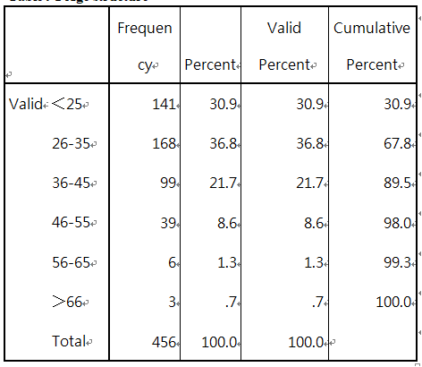
Level of education
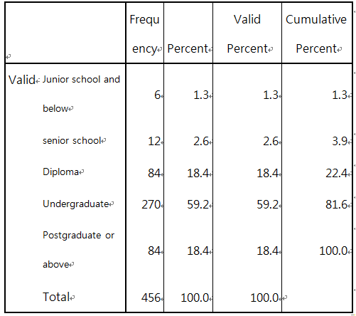
Annual Family income
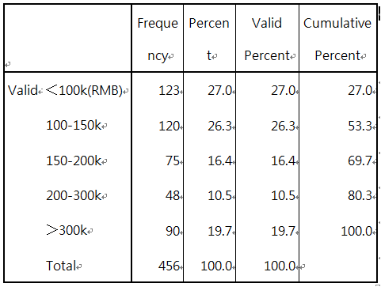
purpose
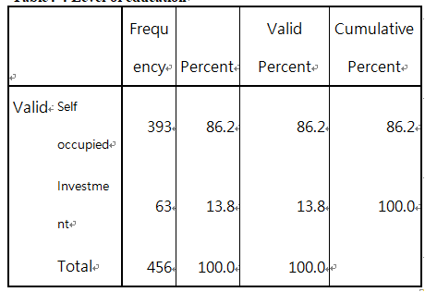

Appendix 2: Reliability Analysis
Case Processing Summary
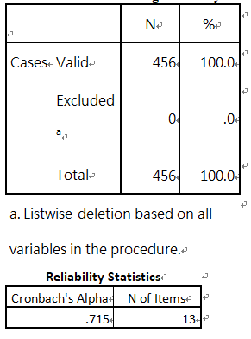
Item-Total Statistics
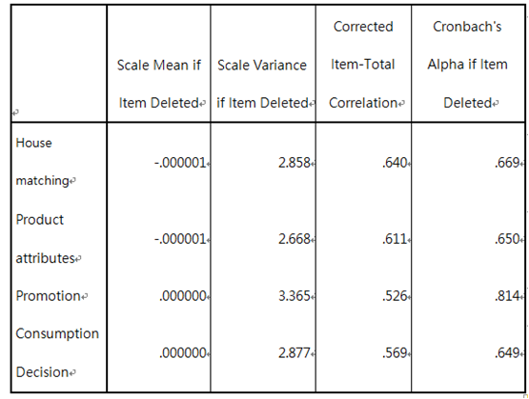

Appendix 3: Correlation test
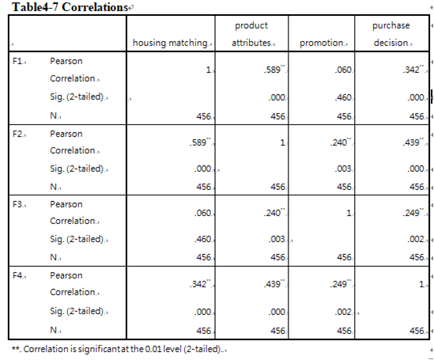
Appendix 4: Validity Test
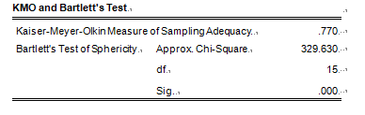
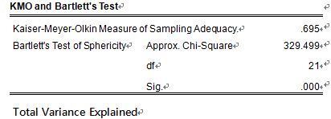
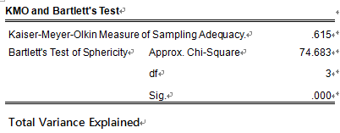
KMO and Bartlett's Test
Appendix 5: multivariate regression analysis
Hypothesis Test
Model Summary^{b}
Model |  | R | R Square |  | Adjusted R Square |  | Std. Error of the Estimate |  | Durbin-Watson
1 |  | .479ª | .229 |  | .213 |  | .6782431 |  | 1.791
a. Predictors: (Constant), F3, F1, F2
b. Dependent Variable: F4
ANOVAª
Model |  |  |  | Sum of Squares |  | df |  | Mean Square |  | F | Sig.
1 | Regression |  |  | 20.221 |  | 3 |  | 6.740 |  | 14.653 | .000^{b}
1 | Residual |  |  | 68.082 |  | 148 |  | .460
1 | Total |  |  | 88.303 |  | 151
a. Dependent Variable: F4
b. Predictors: (Constant), F3, F1, F2
Coefficients
Coefficientsª
Model |  | Unstandardized Coefficients |  | Standardized Coefficients | t | Sig.
 |  | B | Std. Error | Beta | t | Sig.
1 | (Constant) | -3.769E-7 | .055 |  | .000 | 1.000
1 | housing matching | .141 | .086 | .147 | 1.642 | .003
1 | product attributes | .325 | .096 | .313 | 3.388 | .001
1 | promotion | .157 | .071 | .165 | 2.213 | .028
a. Dependent Variable: F4
Appendix 6: Initial Research Paper Proposal
Student Name | Nie zekai | ID No | I18014797
Broad Area | Marketing
Concise Title | Research on real estate development strategy based on consumer behavior
Problem Definition | Based on the analysis of urban residents'housing consumption behavior and the housing development strategy of Chinese real estate enterprises, this paper makes an exploratory study on the housing development strategy of real estate enterprises.  Mainly applied to consumer behavior related theory 2. STP theory 3. Pre-planning theory, three major theories. The formation of the study refers to William M. Schenker (1995) - "Real Estate Marketing" and Luc Arrondel (2002) - "Risk Management and Wealth Accumulation Behavior in France", and Professor Yu Xiaofen, Zhejiang University of Technology, who published "Analysis of Consumer Behavior Model for Purchasing Houses". Because the real estate industry is the pillar industry of the country. At present, the homogeneity of real estate products in the market is serious, ignoring consumer demand for product improvement (Ben-Akiva, 2018). Consumer behavior has a direct impact on the stable and healthy development of the real estate market, so this study is necessary.The innovation of this paper is to divide the housing consumption groups and test the differences of housing consumption behavior.
Research Questions or Objective | The overall purpose of this paper is to explore the impact of different factors on consumer spending decisions. At the same time, there are three assumptions:  1: Housing matching has an important impact on purchase decision-making when buying a house in Shijiazhuang.  2: Product attributes have an important impact on purchase decisions when buying a house in Shijiazhuang.  3: Promotion has a significant impact on purchasing decisions when buying a house in Shijiazhuang.
Scope of study | This paper focuses on the differences in consumer behavior in residential matching, residential product attributes and promotions. The focus of the study is on urban residents in Shijiazhuang, China. Key research units: potential buyers and buyers. Methodological methods include literature review, questionnaire survey, and statistical analysis.
Significance of the Research | Academic Significance: This topic will combine the analysis of housing consumption behavior and the formulation of housing development strategy of real estate enterprises from the micro level to provide theoretical basis for the study of both(Chen and Fik, 2017). Significance for the government and industry: Segmenting the housing enterprise market will be of great help to the design and development of concepts. It is conducive to standardizing China's real estate market and maintaining market stability.
Literature Review | From the perspective of behavior-driven: Qrtalo-Mange believes that the purchase behavior of housing can be divided into two categories: housing investment and housing consumption (Carmichael and Coën, 2016).  From the perspective of consumer perception: Luc Arrondel believes that the factors affecting housing consumption can be divided into subjective factors, objective factors and environmental factors.  From the Perspective of Individual Economic Ability: Omar Hassan Ghazzawi  It holds that(Al-Nahdi, 2016) an important viewpoint of consumer behavior research is the perception of potential purchase risk.
Research methodology | 1. Descriptive statistical analysis: Through the basic sample structure, we construct the housing consumption group segmentation system.  2. Reliability analysis: Cronbach, coefficient reliability analysis test to determine the internal consistency of the questionnaire(Quansah, 2017).  3. Multiple regression analysis: By measuring the level and degree of peripheral demand, different consumer groups can be obtained.  This study used quota sampling and network random sampling for a total of 456 samples. Random assignments are performed by using purchase groups and networks in the purchase site. The main sample is urban residents. Through literature analysis, this paper summarizes the variables that reflect the characteristics of housing consumption behavior. The characteristics of consumer behavior factors are summarized as the main content of the questionnaire. SPSS 22.0 is primarily used as an analytical and statistical tool.

Appendix 7: Viva Slides
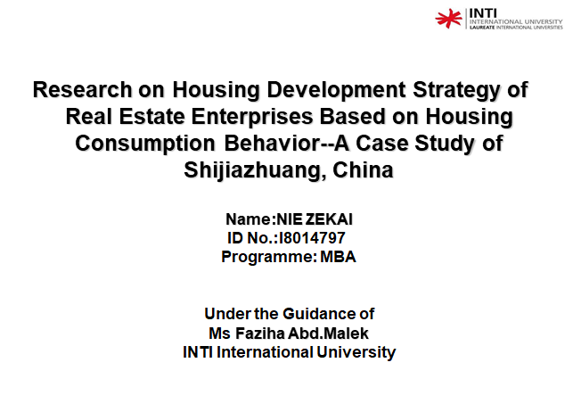

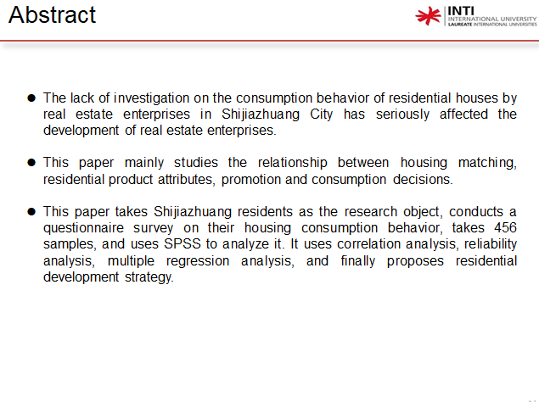
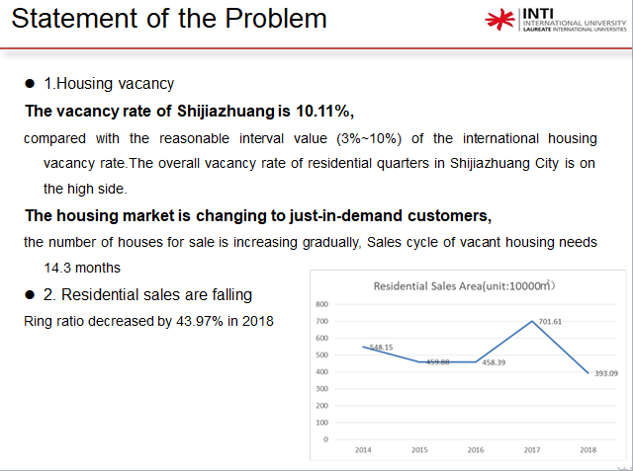

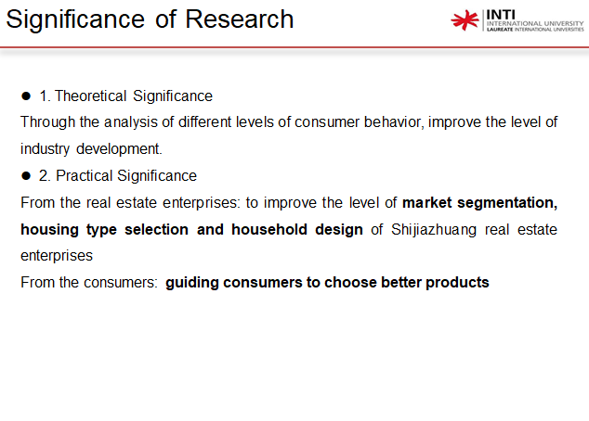
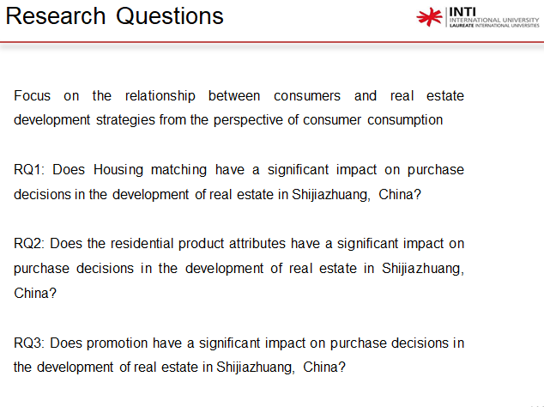

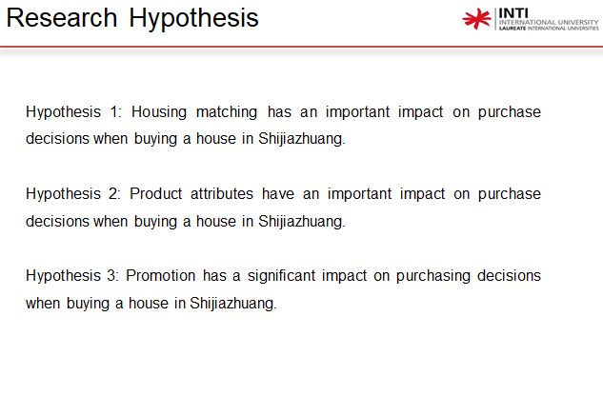
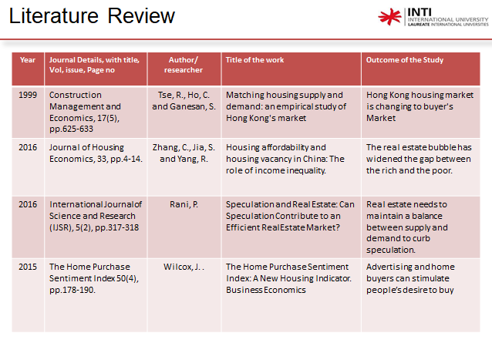

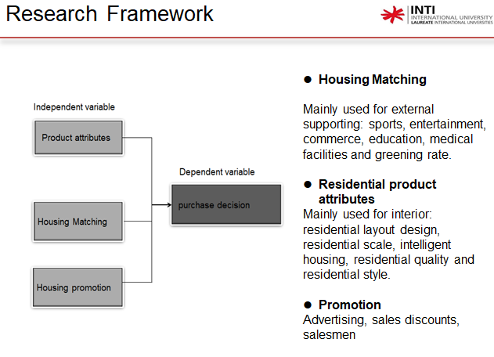
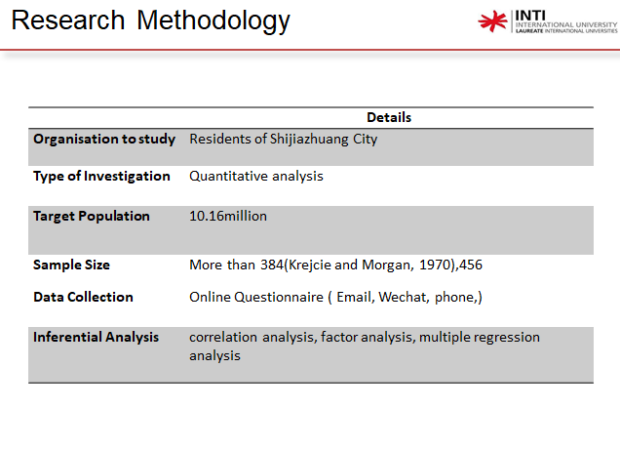

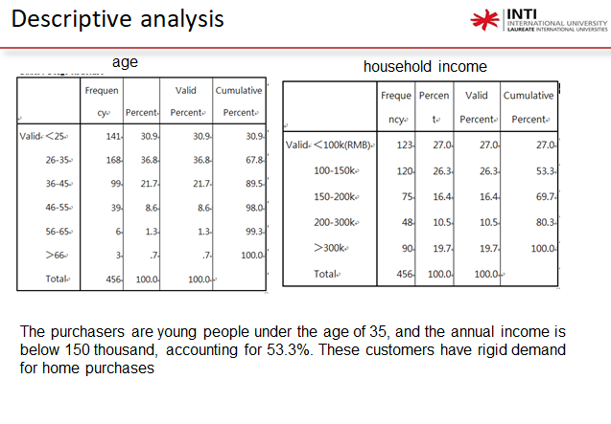
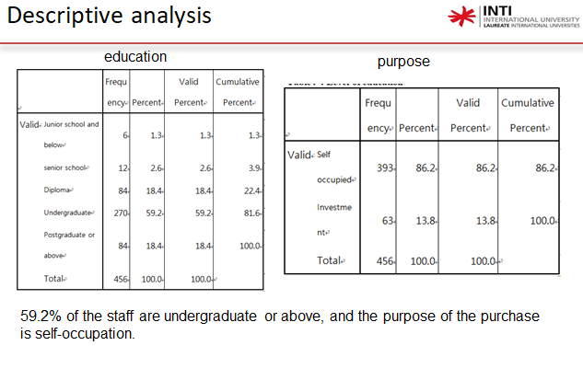

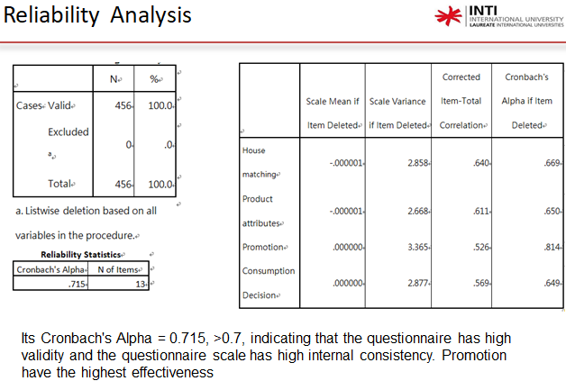
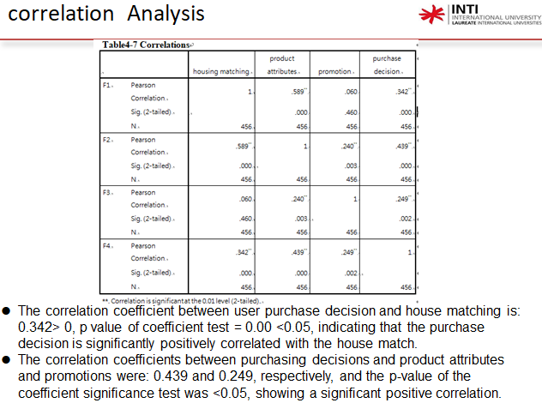

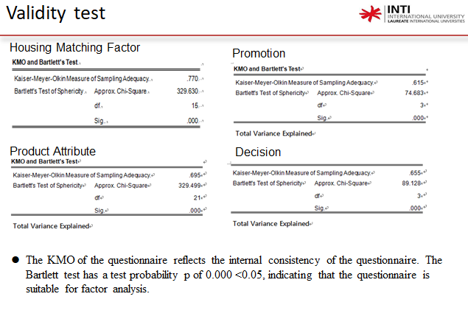
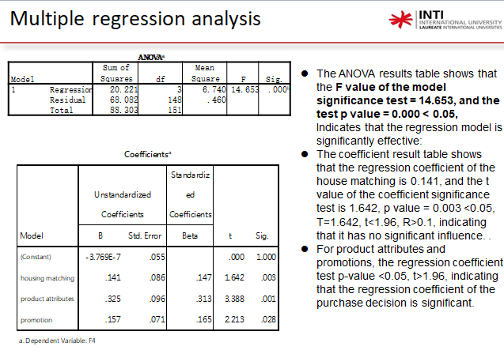

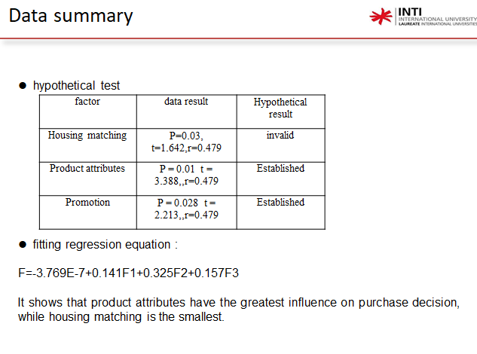
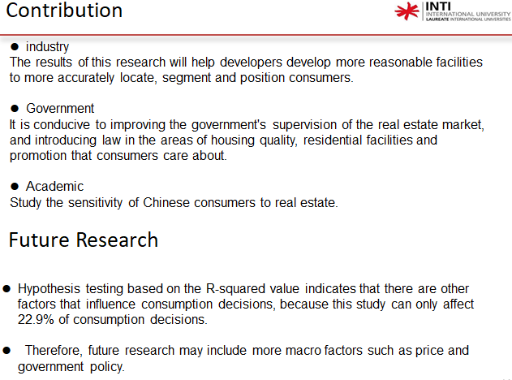

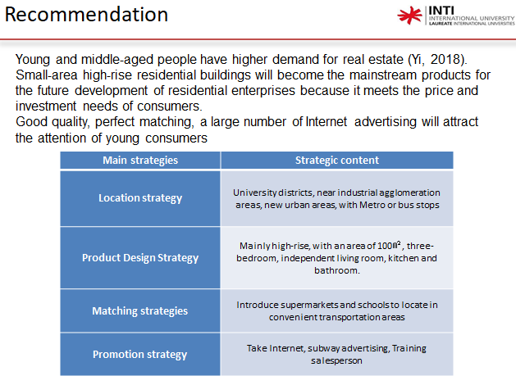

Appendix 8: MBA Project Log Book


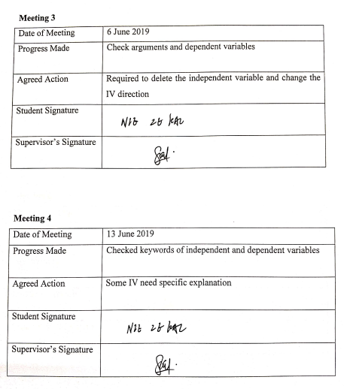
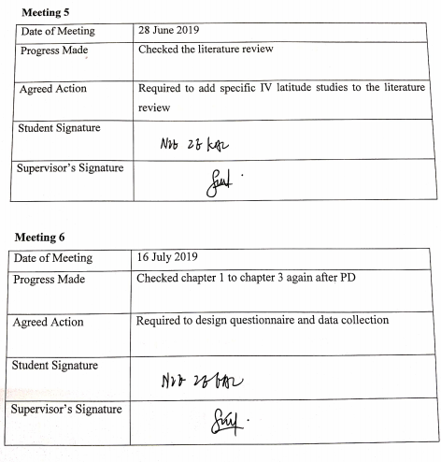
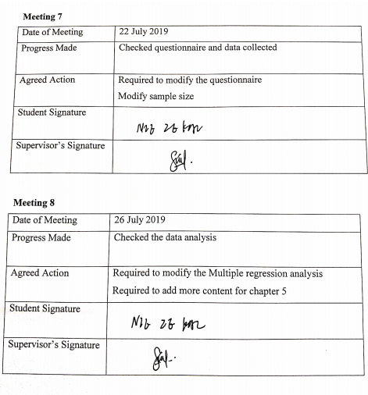

Comment on management of projrct


Appendix 9: Survey Questionnaire
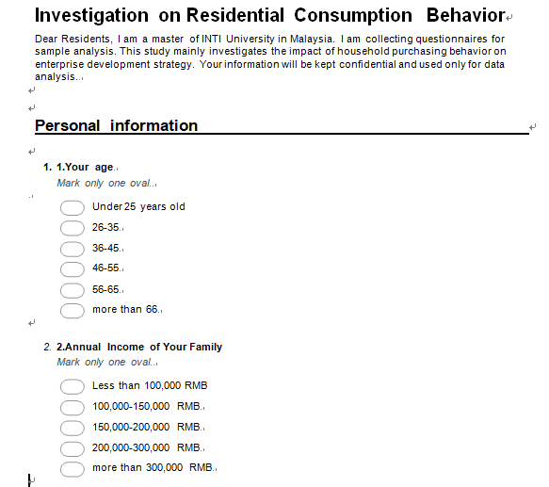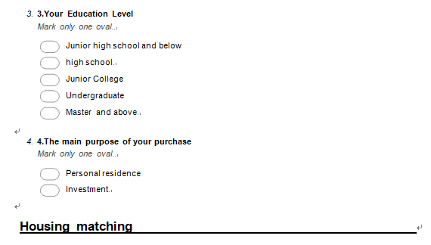

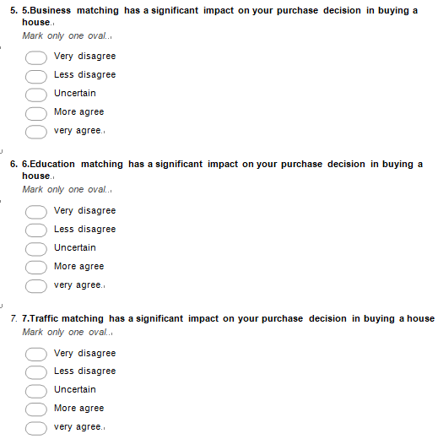

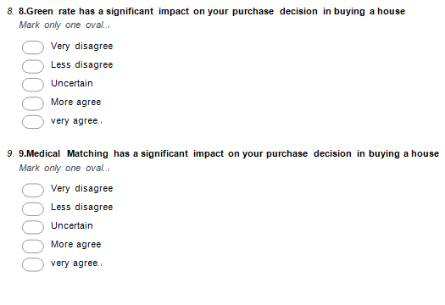
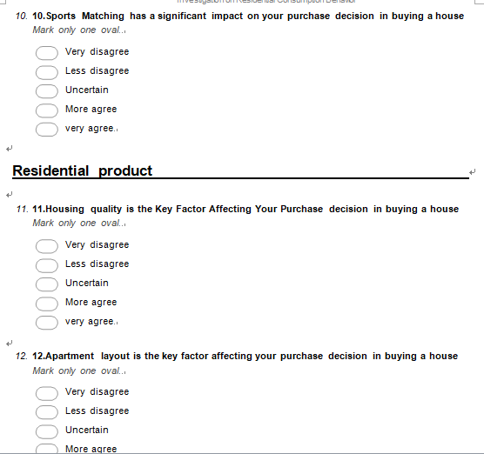
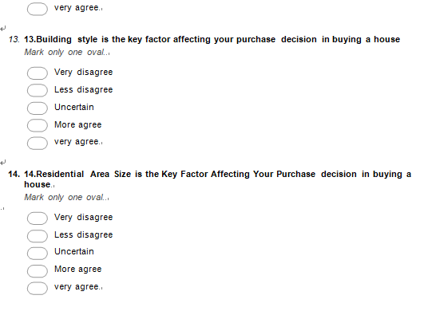
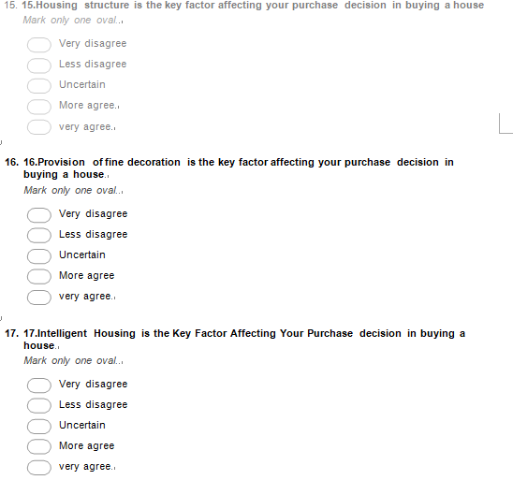
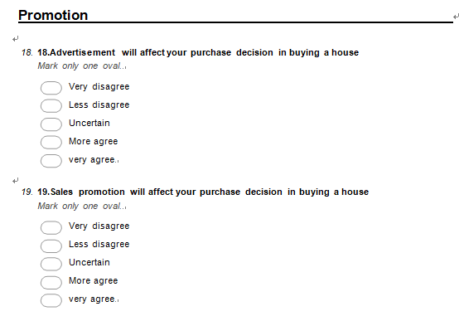
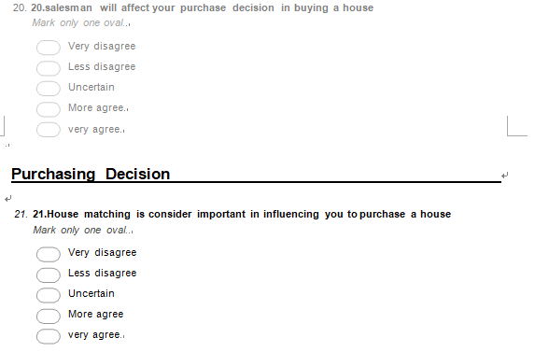
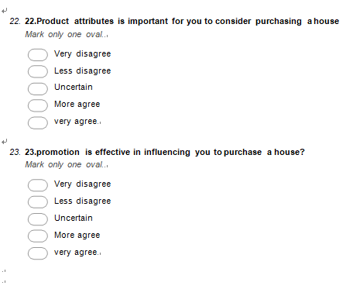

Appendix 10: Turnitin Report
