

INTI INTERNATIONALUNIVERSITY

MASTER OF BUSINESS ADMINISTRATION

**Factors influencing consumers' trust in e-commerce in Shanghai**  
  
Name: GUAN DI

ID No.: I18015917  
Programme: MBA  
  
Under the Guidance of   
Dr. Wong Chee Hoo   
  
INTI International University

**Acknowledgement**

Special thanks to my supervisor, Dr. Wong Chee Hoo for his time and advice during the preparation for this project and patience in guiding the students on how to start and end the Project systematically. Thanks to my second panellist, Ms Siti Intan Nurdiana for her encouragement and valuable comments in this project. I would like to take this opportunity to thank the management, lecturers and staffs from INTI International University for their great support and assistance provided.

During the course of MBA, I am glad to know many new course mates who have been very helpful and support in whatever way possible. Thanks to all survey respondents who had spent their effort to participate in my study.

**CONTENTS**

Abstract 4

CHAPTER 1: INTRODUCTION 5

1.1 Overview 5

1.2 Background of study 5

1.3 Problem statement 6

1.4 Research objectives 8

1.5 Research questions 8

1.6 Significance of the study 9

1.6.1 signification to the industry 9

1.6.2 signification to the academic 9

1.7 Scope of the study 10

1.8 Limitations 10

1.9 Assumptions in the study 11

1.10 Definitions of key concepts 11

1.11 Summary 12

CHAPTER 2: LITERATURE REVIEW 13

2.1 Overview 13

2.2 Theory review 14

2.2.1 Technology acceptance model (TAM) 14

2.2.2 Theory of Reasoned Action (TRA) 16

2.2.3 Theory of Planned Behavior (TPB) 18

2.3 Dependent variable 20

2.3.1 Buyers’ trust 20

2.4 Independent variables 22

2.4.1 Perceived usefulness 22

2.4.2 Perceived ease of use 23

2.4.3 e-Seller’s reputation 24

2.4.4 Perceived risk 25

2.5 Development of research framework 26

2.6 Hypotheses 27

2.7 Summary 29

Chapter 3: Research methodology 30

3.1 Overview 30

3.2 Research design 30

3.3 The study of population, unit of analysis and sampling design 31

3.3.1 Target population 31

3.3.2 Unit of analysis 31

3.3.3 Sampling frame and sampling location 31

3.3.4 Sampling techniques 32

3.3.5 Sample size 33

3.4 Design and procedure 33

3.5 Measurement instruments 34

3.5.1 Scales measurement 34

3.5.2 Questionnaire Design 34

3.5.3 Pilot study 35

3.5.4 Factor analysis 35

3.5.5 Validity and reliability test 36

3.6 Data analysis 36

1. Descriptive analysis 36

2. Correlation Analysis 37

3. Linear Regression Analysis 37

3.7 Summary 37

Chapter 4: Research Findings 38

4.1 Overview 38

4.2 Pilot Test 38

4.2.1 Factor Analysis 40

4.2.2 Reliability Test 42

4.3 Descriptive Statistics 43

4.4 Preliminary Data Analysis 47

4.4.1 Factor Analysis 47

4.4.2 Reliability Test 48

4.4.3 Correlation Analysis 49

4.5 Hypotheses Testing 50

4.6 Summary of Key Research Findings 51

4.7 Summary 52

Chapter 5: Discussion and Conclusion 53

5.1 Overview 53

5.2 Discussion of Findings 53

5.3 Recommendation 54

5.4 Limitations 55

5.5 Contribution to Academia 56

5.6 Future Direction of Reasearch 57

5.7 Personal Reflection 57

5.8 Conclusion 58

Reference 59

Appendix : Survey Questionnaire 72

# Abstract

The purpose of this study is to investigate the factors which influence consumer trust in e-commerce in China in Shanghai.

Previous scholars (Wijaya, T. and Wang, G, 2018) have done some researches using TAM model to analysis e-commerce, but none of them only focus on Chinese consumers. Therefore, my research focuses on Chinese consumers' trust in e-commerce.

A convenience sampling questionnaire will be use as instrument for data collection. A data of 384 respondents will be collected and analyzed by SPSS. Descriptive and inferential statistical analysis will be carry out to examine the relationship between the independent variables and dependent variables.

# CHAPTER 1: INTRODUCTION

## Overview

In this chapter, the background of this research, namely definition of e-commerce and its development status in China will be shown. E-commerce provides buyers and sellers with different kinds of data and tools, such as online shopping, flight booking and online payment. E-commerce has created more business opportunities for China, including online banking, hotel and air ticket booking, and purchase of various products and services. Problem statements, research objectives, problems, meaning, scope, defects, desired outcomes, and key conceptual statements will also be presented. Perceived usefulness, perceived ease of use of e-commerce sites, the reputation of sellers and perceived risks may have some positive or negative effects on the trust of consumers. My research focuses on determining whether these factors have a positive impact on consumer trust.

## Background of study

The essence of E-commerce is the transaction of products and services through the Internet. E-commerce provides buyers and sellers with different kinds of data and tools, such as online shopping, flight booking and online payment. In the past 10 years, the trend of E-commerce has become more and more popular. Many E-commerce companies use e-stores and platforms for online planning and marketing, and they use E-commerce to monitor the logistics process and improve the direction of the company (Huseynov and Yıldırım, 2016). Globally, the utilization of E-commerce is on the rise. According to forecasts, China's E-commerce retail sales will exceed $400 million by 2020, which is a very big breakthrough for China and the world (Liao and Cheung, 2018).

In the past 10 years, the use of e-commerce has been increasing. E-commerce has created more business opportunities for China, including online banking, hotel and air ticket booking, and purchase of various products and services. E-commerce markets in all countries and regions are developing rapidly. As the most populous country in the world, China is a driving force for e-commerce in other countries. According to smic's 2015 survey, China has 649 million Internet users (nearly half the population). In China's e-commerce market, the three most widely used e-commerce services are online shopping, online payment and online banking, accounting for 374 million, 336 million and 301 million users respectively (56.9 percent, 48.3 percent and 44.6 percent of all Internet users respectively). The Chinese government's overall strategy to promote ICT is considered a key factor for the sustainable growth of the Chinese economy and plays an increasingly important role in economic development as part of the development of its economic, cultural fabric and social (Yao and Watanabeb, 2018). The sustainable development and use of e-commerce is expected to play an important role in China's urbanization process to achieve social inclusion and socio-environmental sustainability (Harter et al., 2014).

TAM model is one of the most commonly used models to identify perceived usefulness and perceived easy of use. According to this theory, users' acceptance of a certain technology mainly depends on two aspects: perceived usefulness and perceived ease of use (Prashar, Sai Vijay and Parsad, 2015). Perceived usefulness indicates what aspects of e-commerce potential users think enhance the likelihood of a user experience. Perceived ease of use is determined by the degree to which potential users expect ease of operation of an e-commerce system (Davis et al., 1989).

## Problem statement

For e-commerce to succeed, it is important to attract new customers and retain old ones. Consumer confidence in online sellers and businesses is playing an increasingly important role in attracting new consumers and retaining existing consumers. One reason is that the degree of consumer confidence in e-commerce and online stores influences the perception of e-commerce by other consumers and influences their expectations for the use of e-commerce (Srivastava, 2017).

Trust is important for e-commerce and for the benefit of merchants. Consumers are easily taken advantage of by merchants in the process of online transactions, thus reducing their trust in merchants (Susanto, Chang and Ha, 2016). Amazon, for example, sends consumers' personal information to third parties without their consent. After this incident, many consumers lost trust in amazon.

Consumer trust is the most important factor affecting their use of e-commerce business. When purchasing online, consumers trade with merchants through their websites. As with other applications of new technologies, the acceptance and use of websites depends on two key factors in the technology acceptance model -- perceived usefulness and ease of use (Vijayasarathy, 2014).

Perceived usefulness, perceived ease of use of e-commerce sites, the reputation of sellers and perceived risks may have some positive or negative effects on the trust of consumers. My research focuses on determining whether these factors have a positive impact on consumer trust. By finding out the relationship between these factors and consumer trust, the development of e-commerce business can be further studied and understood.

My research is mainly based on Theory of Reasoned Action (TRA) and Theory of Planned Behavior (TPB). The purpose of Theory of Reasoned Action (TRA) is to explain the relationship between opinions and behaviors in human society. It is mainly used to predict a person's future behavior based on his previous attitude and behavior. A person's decision to make an action is based on the expected result, also known as the result of an action. Reasoned Action theory is a universal model in which any factor can influence behavior only indirectly, through subjective attitudes and criteria, giving a clear idea of the rational production of behavior (Waheed, Kaur, Ain and Sanni, 2015). Theory of Planned Behavior (TPB) proposes that human behavior is the result of thinking and planning in advance (Yong and Jing, 2014). This theory holds that people's preferred behavioral intentions are influenced by their own agreed attitudes and others' support. And people's intentions affect their actual behavior. In other words, Theory of Planned Behavior (TPB) suggests that the human mind controls their behavior.

## Research objectives

Perceived usefulness, perceived ease of use of e-commerce sites, the reputation of sellers and perceived risks may have some positive or negative effects on the trust of consumers. My research focuses on determining whether these factors have a positive impact on consumer trust. By finding out the relationship between these factors and consumer trust, the development of e-commerce business can be further studied and understood.

## Research questions

My research questions are the impact of the perceived usefulness, perceived ease of use of e-commerce sites, the reputation of sellers and perceived risks on consumer trust. I raise this research question because consumer trust plays an important role in the adoption of electronic sales and online transactions by businesses. In addition, network cooperation, crisis management and crisis assessment also need the trust of consumers.

Privacy and security are the main factors to improve user trust in e-commerce market. Consumers'trust in certain aspects of businesses and enterprises will not only affect their attitudes towards other aspects, but also affect the online purchasing process of buyers (Venkatesh and Davis, 2014).

## Significance of the study

### signification to the industry

E-commerce, especially the latest O2O model, has changed the way people consume products. It reduces the amount of time people spend on their purchases and is more flexible. For example, the introduction of online courses has kept people out of learning centres. People can study at home in front of the computer, and they can choose their own time freely (Yoon, 2019). Through e-commerce, students can pay their tuition online and complete the course at a pace that suits them.

There are many kinds of e-commerce consumption, and traditional brick-mortar stores cannot fully meet people's diversified consumption needs (zhong ying, 2018). Physical stores may also be out of stock, out of stock, and people may have to go to many stores to buy what they like. E-commerce allows consumers to search for the product they want in a few minutes and select details such as color and price (Zhou and Lu, 2018). Therefore, e-commerce research is of great significance to provide diversified products and bring more convenience to people's lives.

### signification to the academic

The importance of academia lies in understanding the academic frontier, industry dynamics and relationship with related fields of e-commerce industry. Grasp industry trend, facilitate the determination of government investment direction. Research can help the retail industry adjust its development direction and give full play to its advantages.

The significance of this study is to study the biggest advantages and future development of China's e-commerce model by describing the phenomenon of shopping on the Chinese network and combining the development of China's e-commerce model at home and abroad (Zhong and Ying, 2018). First of all, e-commerce is the inevitable product of the continuous development of the Internet age, and also the new direction of the application of network technology. The development of e-commerce has driven the popularity of shopping phenomenon on the global Internet and promoted the rapid development of B2C, C2C and other e-commerce models (Yu, Balaji and Khong, 2015). In addition, there are a large number of Internet users and consumers in China, so research on Chinese consumers is conducive to the clear presentation of research results (Zucker, 2016). Secondly, the analysis with TAM model has practical guiding significance for both consumers and merchants, which can help them better understand consumers' psychology.

## Scope of the study

My research focuses on determining whether perceived usefulness, perceived ease of use of e-commerce sites, the reputation of sellers and perceived risks have a positive impact on consumer trust. Its geographical focus is China. This research mainly investigates the consumers in the e-commerce market. In addition, there are a large number of Internet users and consumers in China, so the research on Chinese consumers is conducive to the clear presentation of research results and has research significance (Yang, Hney, Ming and Yong, 2018). The survey was conducted among consumers aged between 18 and 50. This study analyzes the relationship between consumers' trust in e-commerce and perceived usefulness, perceived ease of use of e-commerce sites, the reputation of sellers and perceived risks based on TAM model. This study is based on second-hand information from journals, books, newspapers and the Internet.

## Limitations

The limitations of this study are shown below. First, the sample size is relatively small, and there are some factors that make it difficult to find a significant correlation from the statistics. If you want more accurate data results, you need to count through a larger sample size. Second, data may lack real-time and reliability. Previous research can be the basis for literature review and research projects, but may not be in line with current development needs. Data obtained through questionnaires and interviews may lack reliability. Third, the method of collecting data has limitations. All questions and details related to the research cannot be covered in the questionnaire. This situation will affect my comprehensive analysis of the results, and in the latter part of the problem study, I may find that the previous investigation lacks a specific problem. Fourthly, the only way for me to conduct the survey is questionnaire and data analysis, which may be too limited to obtain diversified information.

## Assumptions in the study

My research hypothesis is to establish a basic framework through TAM model, obtain data about consumers by means of questionnaire, and analyze the correlation between consumer trust and perceived usefulness, perceived ease of use of e-commerce sites, the reputation of sellers and perceived risks with SPSS. The questionnaire mainly surveys consumers in China's e-commerce market, and is distributed through electronic questionnaires on Internet platforms and mailboxes. Then I will analyze and summarize the impact of these factors on consumer trust. Because consumer trust plays an important role in the adoption of electronic sales and online transactions by businesses. In addition, network cooperation, crisis management and crisis assessment also need the trust of consumers. Consumers'trust in certain aspects of businesses and enterprises will not only affect their attitudes towards other aspects, but also affect the online purchasing process of buyers (Zhang, 2015).

## Definitions of key concepts

The essence of E-commerce is the transaction of products and services through the Internet. E-commerce provides buyers and sellers with different kinds of data and tools, such as online shopping, flight booking and online payment.

TAM model is one of the most commonly used models to identify perceived usefulness and perceived easy of use. According to this theory, users' acceptance of a certain technology mainly depends on two aspects: perceived usefulness and perceived ease of use. Perceived usefulness indicates what aspects of e-commerce potential users think enhance the likelihood of a user experience. Perceived ease of use is determined by the degree to which potential users expect ease of operation of an e-commerce system (Davis et al., 1989).

The purpose of Theory of Reasoned Action (TRA) is to explain the relationship between attitudes and behaviors in human society. It is mainly used to predict a person's future behavior based on his previous attitude and behavior. A person's decision to perform an action is based on the expected result, also known as the result of an action. Reasoned Action theory is a universal model in which any factor can influence behavior only indirectly, through subjective attitudes and criteria, giving a clear idea of the rational production of behavior. The Planned Behavior Theory (PDB) states that human behavior is the result of prior thinking and planning. This theory holds that people's preferred behavioral intentions are influenced by their own agreed attitudes and others' support. And people's intentions affect their actual behavior. In other words, Theory of Planned Behavior (TPB) suggests that the human mind controls their behavior.

## Summary

In this chapter, the background of this research, namely the definition of e-commerce and its development status in China have been shown. E-commerce provides buyers and sellers with different kinds of data and tools, such as online shopping, flight booking and online payment. Problem statements, research objectives, problems, meaning, scope, defects, desired outcomes, and key conceptual statements have also been presented. My research focuses on determining whether perceived usefulness, perceived ease of use of e-commerce sites, the reputation of sellers and perceived risks have a positive impact on consumer trust.

The introduction of the first chapter is the basis for the following research, because the first chapter has a preliminary framework, theory and model for my research.

# 

# CHAPTER 2: LITERATURE REVIEW

## 2.1 Overview

In the second chapter, I mainly reviewed the TAM model (Technology acceptance model), Theory of Reasoned Action (TRA) and Theory of Planned Behavior (TPB). According to TAM, users' acceptance of a certain technology mainly depends on perceived usefulness and perceived ease of use. TRA is a useful model in which any factor can influence behavior only indirectly, through subjective attitudes and criteria, giving a clear idea of the rational production of behavior. TPB overcomes the inability of the theory of rational behavior to explain the behaviors that are not controlled by the will. Planned behavior theory can represent perceived control belief (PBC) controlled by irrational factors and add it to the original theoretical framework to form TPB.

In addition, I summarized the literature on independent variables and dependent variables. In e-commerce transactions, buyers' trust in e-commerce platforms and sellers directly affects their purchasing activities. The "ease of use" includes the ease of access to the internet, the provision of secure electronic services, and high level, and the need for online shopping services (Treiblmaier, Pinterits and Floh, 2017). From these literatures, I have drawn my research model and four hypotheses.

## 2.2 Theory review

### 2.2.1 Technology acceptance model (TAM)

The TAM model is one of the most used models for identifying perceived usefulness and perceived ease of use. According to this theory, users' acceptance of a certain technology mainly depends on perceived usefulness and perceived ease of use. Perceived usefulness indicates what aspects of e-commerce potential users think enhance the likelihood of a user experience. The perception of usability depends on the extent to which potential users expect ease of use of the e-commerce system (Davis et al., 1989).

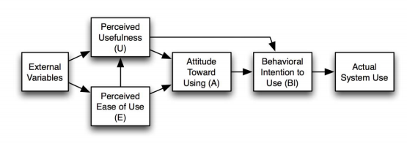

Figure 2: TAM

Source: Fedorko, I., Bacik, R. & Gavurova, B. (2018)

Technology acceptance model is the most common research model to predict whether information system and technology are accepted by users. It was developed by Davis (1989). Reasearchers have proved its feasibility, and different systems’ technology acceptance behavior can be proved by different studies.

In this model, perceived usefulness and perceived ease of use are the greatest factors affecting people's use of a application. Perceived usefulness is interpreted by Davis as the subjective probability of users, that is, to improve the quality of life or work of users through some application systems (Yoon, 2019). Davis interprets perceived EOU as effortless level of user expectations for the application system. According to the TAM model, these two factors are most effective factors determining the acceptance of a system. External environment also affects these two factors. External economic, social, cultural, environmental and political factors affect acceptance. Social and cultural changes include changes in people's thinking, language patterns and skills. The impact of using information systems in political events is the main external environmental impact. User satisfaction with these applications affects their acceptance and attitude to use.

### 2.2.2 Theory of Reasoned Action (TRA)

The purpose of Theory of Reasoned Action (TRA) is to explain the relationship between attitudes and behaviors in human society (Eid, 2018). It is mainly used to predict a person's future behavior based on his previous attitude and behavior. A person's decision to perform an action is based on the expected result, also known as the result of an action.

Theory of Reasoned Action (TRA) proposes that human behavior is the result of thinking and planning in advance. This theory holds that people's preferred behavioral intentions are influenced by their own agreed attitudes and others' support. And people's intentions affect their actual behavior. In other words, Theory of Reasoned Action (TRA) suggests that the human mind controls their behavior.

This theory believes that human beings can think sensibly and Behavioral Intention determines everyone's behavior. It has two assumptions. First, each person's consciousness controls all his or her actions, which are the result of rational thinking. Second, whether or not people take certain actions is determined by the intention of the action. Although TRA can reasonably explain how people behave, the theory is flawed. In reality, people's own consciousness cannot completely control the occurrence of behaviors, such as emergency response and conditioned reflex in emergency situations.

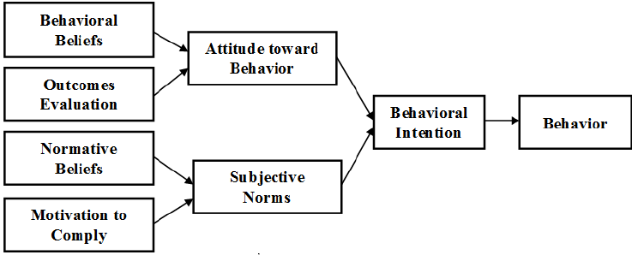

Figure 3: Theory of Reasoned Action (TRA)

Source : Chiung-Wen Hsu and Li-Ting Huang (2017)

Theory of Reasoned Action believes that people's attitudes and values are determined by the general concept of society. A person's motivation to perform certain actions is influenced by his attitude and values towards the behavior. Whether or not he will act is influenced by his motivation for the act. Therefore, social values, personal attitudes and values directly affect whether a behavior will be adopted or not.

Fishbein identified the TRA elements in 1994 as follows:

1. Behavior: it is a purposeful action taken by a person at a certain place at a certain time.
2. Intention: it directly determines whether a person will take an action or not.
3. Attitude: it refers to a person's positive or negative feelings and attitudes towards something or a behavior.
4. Behavioral Beliefs: it is people's subjective Beliefs and predictions of the consequences of a behavior they are going to engage in. These beliefs may vary from population to population. For example, people in economically backward areas have relatively backward and conservative thoughts, while people in economically highly developed areas have diverse and open thoughts.
5. Concept model (Norms) : it is a person about others thoughts on some behaviors of evaluation. For example, people think "if I do this action, will others think this is wrong?”
6. Normative Beliefs: it's a new belief pattern that people use to compare their own thoughts and Beliefs with others' Beliefs. For example: "it's important to me that I do this, even though other people don't think it's important."

Although TRA can reasonably explain how people behave, the theory is flawed. In reality, people's own consciousness cannot completely control the occurrence of behaviors, such as emergency response and conditioned reflex in emergency situations (Qingfei, Shaobo and Gang, 2008). TRA says that a person's behavior is completely controlled by his or her conscious mind, the result of rational thinking. This view ignores the influence and control of external factors on human behavior. Because not all human behavior is actually controlled by will.

### 2.2.3 Theory of Planned Behavior (TPB)

Although TRA can reasonably explain how people behave, the theory is flawed. In reality, people's own consciousness cannot completely control the occurrence of behaviors, such as emergency response and conditioned reflex in emergency situations (Salam, Iyer, Palvia and Singh, 2015). So Ajzen improved on TRA and proposed the TPB (Theory of Planned Behavior).

The theory of planned behavior overcomes the inability of the theory of rational behavior to explain the behaviors that are not controlled by the will. This is the biggest difference between the two theories. Planned behavior theory can represent perceived control belief (PBC) controlled by irrational factors and add it to the original theoretical framework to form TPB (Karakaya and Shea, 2017). The theory of planned behavior is influenced by the perception of behavioral control, attitude and subjective norms when connecting behavioral intention and behavior.

TRA says that a person's behavior is completely controlled by his or her conscious mind, the result of rational thinking. This view ignores the influence and control of external factors on human behavior. Because not all human behavior is actually controlled by will (Kang and Kim, 2018). So Ajzen adds a perspective of behavioral control perception, or one's ability to control the external environment. This point of view points out that people can feel the degree of difficulty to achieve a certain behavior, and can also combine their previous behavior experience and expectations (Scarpi, 2012).

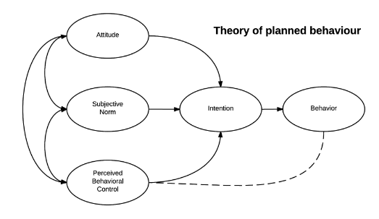

Figure 4: Theory of Planned Behavior (TPB)

Source: Shaikh, I. M. and Noordin, K. (2019)

The theory of planned behavior is regarded by modern scholars as a relatively complete mode of behavior intention. In addition, its predictive power is relatively high. Here is an analysis of various factors of The theory of planned behavior:

1. Attitude: It is a person's thoughts and evaluation of an object or event, such as like or dislike, satisfaction or dissatisfaction. This attitude can be used to predict people's future behavior (Serener, 2016). That is to say, people's good or bad evaluation of something is people's attitude. The more positive people are about something, the higher their intentions are. The more negative people are about something, the less likely they are to act.
2. Subjective norm: It is when people feel pressure from other people or groups of people to do the things they want to do, such as from parents, friends, teachers, classmates and colleagues (Tenenhaus, 2018). In other words, social pressure influences people's behavior. The more positive subjective norm is, the stronger will be people's intention to make an action. The more negative the subjective norm, the more depressed are people's intentions to practice a certain behavior.
3. Perceived behavioral control: It is the ability of people to control and manage the influence of time, land resources, money, human resources, skills, social environment and so on when they implement a certain behavior (Giovanis, Binioris and Polychronopoulos, 2012). These resources are beyond the control of the individual, not including the control of the mind, consciousness, etc. So if a person does not have the resources to complete an action, even if he has a strong desire to complete an action, he cannot succeed. Additionally, perceived behavioral control is divided into external resources and self-efficacy. External resources refer to the extent to which resources available to people are readily available. Self-efficacy refers to people's awareness of whether they can successfully perform certain behaviors. Both of these aspects can seriously affect people's behavior (Venkatesh and Bala, 2008).

Behavior intention: It refers to the extent to which people want to perform an action. That is to say, do people have corresponding psychological intensity during the implementation of behaviors?It can be translated by the willingness to make an effort or the amount of effort that a person is willing to devote to an action. The actual behavior of a person can be predicted by his intention to act.

According to Planned Behavior Theory, the willingness of individuals to perform an act is influenced by attitudes, subjective norms, and the perception of behavioral control (Ha and Stoel, 2016). The intention of another person to perform a particular act determines the behavior of that person. The will of people to perform an act is influenced by attitudes, subjective norms and the perception of behavioral control. Therefore, if an individual has a very positive attitude towards a certain behavior, has the resources to complete the task, has a positive view from others, and thinks that he or she can succeed in doing it, then the intention and possibility of completing the behavior will be higher and higher (Jones and Leonard, 2017).

## 2.3 Dependent variable

### 2.3.1 Buyers’ trust

In e-commerce transactions, buyers' trust in e-commerce platforms and sellers directly affects their purchasing activities. For example, the C2C model like taobao can adopt the later pricing model and auction. The pricing models in the back are fixed price mechanism, which are typical of the procurement catalogue and price mechanisms are generally used in the dynamic auction models (Chen and Liu, 2015). B2C e-commerce model represents shopping online mall, such as jingdong mall. The C2C e-commerce model represents the open market on the Internet, such as taobao and xianyu. The B2C commodity trading process, from product purchase to after-sales service, is managed and supervised by the staff of shopping online platform. Employees of shopping, an online platform, will be responsible for purchasing procedures, payment, transportation and after-sales service (Deery and Mahony, 2016). However, the online shopping process in the C2C mode is conducted by individual sellers themselves.In south korea, the agent price is an important part of trust of the electronic commerce C2C.

In the electronic commerce plays a crucial role in the diffusion of electronic commerce. Trust is the most important in the C2C electronic commerce than in B2C E-commerce, because sellers are more vulnerable to opportunistic behaviour (Cheung and Lee, 2016). The factors related to the trust, and the prices are essential to the purchasing decisions of consumers online. Although there are a lot of research on trust in electronic commerce, many people consider the confidence and the price of the product. At the same time, from the point of view of the consumer purchasing decisions. as a general rule. customers who want to buy a product, must first determine whether they are physical or online store (Lei, Hu and Zhou, 2019). If they decide to visit an online shop, they can buy goods on the site. in such cases, they shall take into account the factors of confidence and prices (Limayem, Khalifa and Frini, 2016). The models of pricing in electronic commerce C2C were studied.

In electronic commerce, trust of the buyer to the seller is a critical factor in the customer's purchase decision. This means that more trust in the seller. The higher the seller may offer a higher price to the buyer. The seller's reputation as a form of trust has a significant influence on the final price premium.

Trust in suppliers is extremely important in all business activities. Especially in e-commerce, the asymmetry of information is more obvious, and the information of suppliers is incomplete. If so, buyers may choose unqualified or opportunistic suppliers. The danger is the transaction between buyers and suppliers. In this case, trust is extremely important. In multi-national e-commerce, the time and space of buyers and suppliers are limited. Assumption increases the risk of information asymmetry and therefore increases the value of trust (Lu, Yu and Yao, 2015). When information asymmetry occurs, the way to increase the buyer's trust is to reduce the information gap. Buyer's information can be gathered, and suppliers can provide reliable information to reduce asymmetry to convince them of their capabilities and intentions (Krause and Horvitz, 2018).

## 2.4 Independent variables

### 2.4.1 Perceived usefulness

In the area of electronic banking, it was generally recognized the importance of perceived usefulness. Utility is the subjective possibility that the use of technology improves the way the user performs a particular task. Based on psychosocial theories such as rational behavior theory and planned behavior theory, your acceptance model (TAM) has proven to be powerful and effective. According to tam, the perception of utility is the extent to which a person thinks that using a particular system can improve their performance.Davis et al. (1989) stated that perceived usefulness is perception results of the experiment by the consumer. Davis (1989) defines the perceived usefulness and the fact that the individual believes that the use of new technologies to enhance and improve its performance. Similarly, perceived usefulness shows the degree to improve a system’s performance. The application of tam in finland and the fact that they are useful as a specific behavior determining encourages users of the banking sector in the 21st century the use of innovative technologies (Napitupulu and Kartavianus, 2014). And easier to use for banking transactions, giving them greater autonomy in s financial services, access to information and purchase other financial products (Gökmen, 2012). However, the perceived usefulness depends on the provision of banking services, such as checking account balances, the demand for loans, the payment of utility bills, and the transfer of funds abroad, and access to information on mutual funds (Kim and Benbasat, 2016). There is ample evidence that perceived usefulness is important for the effect of the willingness to adapt. Perceived usefulness is an important factor affecting the adjustment of innovation. therefore, the value sense of the use of electronic banking services, the greater the likelihood of adopting an electronic bank (Parameswaran, Kishore and Li, 2015).

|  |  |
| --- | --- |
| Table: significent relationship between preceived usefulness and buyers’ trust | |
| Auther (year) | Journal |
| Chen, J., S. Chen, P. F. Landry, and D. S. Davis. (2014) | The China Quarterly 220: 988–1011. |
| Davis, F. D. (1989) | MIS Quarterly 13: 319–340. |
| Fedorko, I., Bacik, R. & Gavurova, B. (2018) | *Management & Marketing. Challenges for the Knowledge Society,* Vol. 13, No. 4, pp. 1242-1256, DOI: 10.2478/ mmcks- 2018-0034. |
| Gökmen, A. (2012) | *Electronic Commerce Research*, *12*(1), 31-51. |
| Harter, G., J. Sinha, A. Sharma, and S. Dave. (2014) | New York: Booz & Company. |
| Jones, K., and Leonard, L. N. K. (2017) | Journal of Electronic Commerce in Organizations, 5(4), 39-54. |
| Kim, D., and Benbasat, I. (2016) | Journal of Electronic Commerce Research, 4(2), 49-63. |
| Kwahk, K., Ge, X., and Park, J. (2017) | Engineering and Technology, 69, 547-551. |
| Liao, Z., and Cheung, M. T. (2018) | Communications of the ACM, 51(4), 47-51. |
| Lu, J., Yao, J. E., and Yu, C. S. (2015) | The Journal of Strategic Information Systems, 14(3), 245-268. |
| McKnight, D. H., Choudhury, V., and Kacmar, C. (2016) | Information Systems Research, 13(3), 334-359. |
| Miyazaki, A. D., and Fernandez, A. (2017) | Journal of Consumer Affairs, 35(1), 27-44. |
| Andrews, L., and Bianchi, C. (2017) | Journal of Business Research, 66(10), 1791-1799. |
| Basarir-Ozel, B. and Mardikya, S. (2017) | International Journal of Management Science & Technology Information, (23), pp. 1–11. |
| Chan, K. W. (2013) | Encyclopedia of Global Human Migration |
| Chiung-Wen Hsu, Chun-Po Yin and Li-Ting Huang (2017) | International Journal of Business & Information, 12(2), pp. 149–182. |
| Dakduk,S., Ter Horst,E. H., and Malave.J. (2017) | Journal of Theoretical and Applied Electronic Commerce Research, vol. 12, no. 2, pp. 1-20. |
| Ha, S., and Stoel, L. (2016) | Journal of Business Research, 62, 565–571. |
| Huseynov, F. and Yıldırım, S. Ö. (2016) | Information Development, 32(5), pp. 1343–1358. |
| Jones, K., and Leonard, L. N. K. (2016) | Information & Management, 45(2), 88-95. |

### 2.4.2 Perceived ease of use

According to the researchers, ease of use is the extent to which it is considered that the use of a strict methodology costs nothing. Rogers (2003) finds that ease of understanding is a term that indicates the extent to which innovation is perceived as difficult to understand, learn and use. It also noted that the degree of consumer perception of the usability of a new product or service means that the consumer considers the new product or service to be superior to other options. Similarly, the extent to which innovation is easy to understand and use can be considered as ease of use. "Ease of use" means that consumers think that buying online does not require any effort (Li and Jiao, 2018). In addition, the perceived ease of use is the ability of consumers to take advantage of novelty and to easily evaluate the benefits. It is also considered that the dynamics of the development of electronic banking is determined by the "ease of use". "Ease of Use" includes the ease of use of the Internet, the provision of secure and high-quality electronic services, and the need for online sales services. Numerous studies conducted over the last decade have shown that ease of understanding has a significant impact, directly or indirectly, on intentions to use (Chen, Davis and Dai, 2015). In 1962, Rogers emphasizes that knowledge of this technology allows customers to adapt to new services / products, which is easy to use. More recently, two aspects of the interface, the perceived ease of use and the perceived usefulness, have been highlighted, which has a great influence on the customer's willingness to adapt (Lu, Yao and Yu, 2015 ).

|  |  |
| --- | --- |
| Table: significent relationship between preceived ease of use and buyers’ trust | |
| Joo.J, (2015) | Journal of Theoretical and Applied Electronic Commerce Research, vol. 10, no. 3, pp.30-44. |
| Kang, J.-Y. M., and Kim, E. (2018) | International Journal of Fashion Design, Technology and Education, 5(2), 91-103. |
| Karakaya, F. and Shea, T. (2017) | Journal of Internet Commerce, 7(2), pp.153-179. |
| Ahn, T., Ryu, S.,and Han, I. (2017) | Information & Management, 44(3), 263-275. |
| Ashraf, A. R. (2016) | Journal of International Marketing, 25(2), pp. 25–51. |
| Cheung, C. M. K., and Lee, M. K. O. (2016) | Journal of the American Society for Information Science and Technology, 57(4), 479-492. |
| Deery, S. J. and Mahony, A. (2016) | Journal of Industrial Relations, 36(3), pp. 332–352. |
| Howard, P. E. N., L. Rainie, and S. Jones. (2011) | American Behavioral Scientist 45: 383–404. |
| Krause, A., and Horvitz, E. (2018) | Journal of Artificial Intelligence Research, 39, 633-662. |
| Lei, M., Hu, B., and Zhou, X. (2019) | An Empirical Study on Usage Intention of Mobile E-Commerce. Risk, 1, 0.935. |
| Li, W. Z., and Jiao, A. Y. (2018) | International Conference of Wireless Communications, Networking and Mobile Computing |
| Lu, J., Yu, C.-S., and Yao, J. E. (2015) | Communications of the IIMA, 3(1), 9. |
| Pei, Z., Paswan, A., and Yan, R. (2018) | Journal of Retailing and Consumer Services, 21(3), 249-257. |
| Peng, C., and Y. G. Kim. (2014) | Journal of Internet Commerce 13 (3–4):159–76. |
| Peterson, R. A., and Wilson, W. R. (2016) | Journal of the Academy of Marketing Science, 20(1), 61-71. |
| Prashar, S., T. Sai Vijay, and C. Parsad. (2015) | *International Journal of E-Business Research (IJEBR)*11 (1):35–55. |
| Qiu, L., and Li, D. (2018) | Tsinghua Science & Technology, 13(3), 265-272. |
| Schneider, G. P. (2017) | CT: Cengage Learning. |
| Seyal, A. et al. (2014) | Electronic Markets, 14(4): 372-387. |
| Shaikh, I. M. and Noordin, K. (2019) | Middle East Journal of Business, 14(2), pp. 4–9. |
| Tenenhaus, M. (2018) | Total Quality Management, 19(7-8), 871-886. |

### 2.4.3 e-Seller’s reputation

Ashraf (2016) has shown that faults can occur in the markets in which the seller is not able to provide a reliable signal. In this case, the reputation of the seller is likely to reduce the asymmetry of information and allow the market to function (Peng and Kim, 2014). Theoretical models usually lead to a relationship between the price and seller's reputation, which is because of reputation of agent for the qualitative features not observed prior to the transaction (McKnight, Choudhury and Kacmar, 2016). However, the empirical analysis of the issue is relatively full and complete, mainly because it quantifies and measures in the "credibility of the seller.

The development of trade on the internet in recent years has created an environment in which to test empirically the problem, and several studies have used the online data to study the impact of the reputation of the seller, on the willingness of payment by the buyer (Pavlou, 2016). We use an internet auction site where the data is the index of the reputation of the seller of the site, an estimate of the effect of reputation on the product price to the seller (Qiu and Li, 2018). The online auction sites such as Yahoo.com and Ebay.com, Amazon has become more and more popular every day.

Most of the sales channels on the internet have put in place a mechanism for buyers to leave comments on the sellers after the conclusion of the agreement. this feedback may be positive, neutral or negative, and it can be said, "it's been three months, but the goods have not arrived."(Peterson and Wilson, 2016). Internet sales sites have these comments into positive minus the number of negative comments, and call this number the seller. The notes and comments can be provided to prospective buyers (Dakduk, Ter Horst and Malave, 2017). The note will be displayed at the top of the seller's product, and is easily visible for every visitor.

|  |  |
| --- | --- |
| Table: significent relationship between e-sellers’ reputation and buyers’ trust | |
| Thaler, R. H., and Tucker, W. (2015) | Harvard Business Review, 91(1), 44-54. |
| Utz, S., Kerkhof, P., and van den Bos, J. (2016) | Electronic Commerce Research and Applications, 11(1), 49-58. |
| Van Der Heijden, H., (2015) | MIS Quarterly 28(4): 695-704. |
| Alharbi, I. M., Zyngier, S., and Hodkinson, C. (2016) | Journal of Enterprise Information Management, 26(6), 702-718. |
| Chen, J., D. S. Davis, K. Wu, and H. Dai. (2015) | Cities 49: 88–97. |
| Chen, M.-Y., and Teng, C.-I. (2018) | Electronic Commerce Research, 13(1), 1-23. |
| Forsythe, S., Liu, C., Shannon, D., and Gardner, L. C. (2016) | Journal of Interactive Marketing, 20(2), 55-75. |
| Hsu, M.-H., and C.-M. Chiu. (2014) | Decision Support Systems 38: 369–381. |
| Lee, M. K. O., C. M. K. Cheung, K. H. Lim, and C. L. Sia. (2011) | Information & Management 48: 185–191. |
| Limayem, M., Khalifa, M., and Frini, A. (2016) | Systems, Man and Cybernetics, Part A: Systems and Humans, IEEE Transactions on, 30(4), 421-432. |
| Pavlou, P. A. (2016) | International journal of electronic commerce, 7(3), 101-134. |
| Parameswaran, S. Kishore, R. and Li, P. (2015) | Information and Management, 52: 317-336. |
| Riffai, M. Grant, A. and Edgar, D. (2014) | International Journal of Information Management, 32: 239-250. |
| Schlosser, A. E., White, T. B., and Lloyd, S. M. (2016) | Journal of Marketing, 133-148. |
| Treiblmaier, H., Pinterits, A., and Floh, A. (2017) | International Conference on Information Systems, Washington, D.C., USA. |
| Pikkarainen, T., Pikkarainen, K., Karjaluoto, H., and Pahnila, S. (2014) | Internet Research, 14(3), 224-235 |
| Urban, G. L., Amyx, C., and Lorenzon, A. (2019) | Journal of Interactive Marketing, 23(2), 179-190. |
| Qingfei, M. Shaobo, J. and Gang, Q. (2008) | Tsinghua Science and Technology, 13(3): 257-264. |
| Salam, A. F., Iyer, L., Palvia, P., and Singh, R. (2015) | Communications of the ACM, 48 (2), 72-77. |
| Venkatesh, V., and F. D. Davis. (2014) | Management Science 46: 186–204. |
| Yu, P. L., Balaji, M. S., and Khong, K. W. (2015) | Industrial Management & Data Systems, 115(2), 235–252. |

### 2.4.4 Perceived risk

The variable of perceived risk was transformed in two issues related to the use of medicines and food products carried out a correlation analysis with components of the scale of perceived risk in order to test the factor structure. He runs up against problems of risk data (i.e., financial loss, physical capacity and performance) and private equity (i.e., loss, psychological, and social). An overview of the individual risk is due to the risks associated with the image, in the design of self and social analysis. However, according to this, the analysis from the perceived risk is mainly concentrated on the former and the procurement market. Research on the virtual environment is totally different from research in a store. the online search has the advantage of convenience, time and economy (Chung, 2014).. On the other hand, the use of online research is full of risk, which are not encountered in the market standard. Other dimensions are relevant in this context, in addition to the risk to the privacy, security, and the provision of risk are provided to support the literature on electronic commerce (Nachtsheim, Neter, Kutner and Wasserman, 2017).

1. Financial risk : On shopping, users' credit card information and other personal information are easy to abuse.Retailers may overcharge customers because they have information about their payments.Sellers may disclose consumer payment information to third parties (Zigmund, Babin, Carr and Griffin, 2010).
2. Product risk : The products consumers receive online may have quality problems. Consumers may receive something different from what they see on shopping. It is difficult to judge the quality of products through the information on the website and shopping platform.
3. Delivery risk : Consumers doubt the reliability of online logistics. Consumers may not receive products in time due to logistics companies. Consumers may be unable to receive products ordered online because of the logistics company's obsolescence.
4. Time convenience risk : Finding the right product online requires comparing prices and reviews from different vendors, which can be time-consuming. Canceling an order requires a complicated return process. Consumers may have problems returning goods and repairing them.
5. Privacy risk : Retailers may team up with other companies to profit by selling them information about consumers' choices and preferences. Third party companies may abuse consumers' email addresses to send advertising emails to consumers. Third party companies may abuse consumers' personal information such as addresses and phone Numbers.

In China's e-commerce shopping, the most important ones are product risk, delivery risk, privacy risk, because the utilization of e-commerce is on the rise (Chen and Teng, 2018). Therefore, I choose these three risks and propose three questions respectively.

|  |  |
| --- | --- |
| Table: significent relationship between preceived risks and buyers’ trust | |
| Zhong, L., and Ying, J. (2018) | International Conference on Wireless Communications, Networking and Mobile Computing Conference (WiCOM). |
| Pikkarainen, T., Pikkarainen, K., Karjaluoto, H., and Pahnila, S. (2014) | Internet Research, 14(3), 224-235 |
| Balasubraman, S., Peterson, R. A. and Jarvenpaa, S. L. (2017) | Journal of the Academy of Marketing Science, 30(4), pp. 348–361. |
| Gökmen, A. (2012) | *Electronic Commerce Research*, *12*(1), 31-51. |
| Harter, G., J. Sinha, A. Sharma, and S. Dave. (2014) | New York: Booz & Company. |
| Yang, E. T., Hney, K. J., Ming, L. Y., and Yong, T. L. (2018) | International Journal of Business and Information, 3(2), 233–244. |
| Lu, J., Yao, J. E., and Yu, C. S. (2015) | The Journal of Strategic Information Systems, 14(3), 245-268. |
| McKnight, D. H., Choudhury, V., and Kacmar, C. (2016) | Information Systems Research, 13(3), 334-359. |
| Miyazaki, A. D., and Fernandez, A. (2017) | Journal of Consumer Affairs, 35(1), 27-44. |
| Andrews, L., and Bianchi, C. (2017) | Journal of Business Research, 66(10), 1791-1799. |
| Basarir-Ozel, B. and Mardikya, S. (2017) | International Journal of Management Science & Technology Information, (23), pp. 1–11. |
| Zigmund, W. G., Babin, B. J., Carr, J. C. and Griffin, M. (2010) | South-Western: Cengage Learning. |
| Chen, M.-Y., and Teng, C.-I. (2018) | Electronic Commerce Research, 13(1), 1-23. |
| Forsythe, S., Liu, C., Shannon, D., and Gardner, L. C. (2016) | Journal of Interactive Marketing, 20(2), 55-75. |
| Chen, L., and Liu, H.-w. (2015) | Journal of Advanced Management Science Vol, 3(1). |
| Venkatesh, V., and F. D. Davis. (2014) | Management Science 46: 186–204. |
| Yu, P. L., Balaji, M. S., and Khong, K. W. (2015) | Industrial Management & Data Systems, 115(2), 235–252. |
| Yong, H.L., and Jing, W.H. (2014) | World Academy of Science, Engineering and Technology, 53, 919-925. |
| Deery, S. J. and Mahony, A. (2016) | Journal of Industrial Relations, 36(3), pp. 332–352. |
| Howard, P. E. N., L. Rainie, and S. Jones. (2011) | American Behavioral Scientist 45: 383–404. |
| Krause, A., and Horvitz, E. (2018) | Journal of Artificial Intelligence Research, 39, 633-662. |

## 2.5 Development of research framework

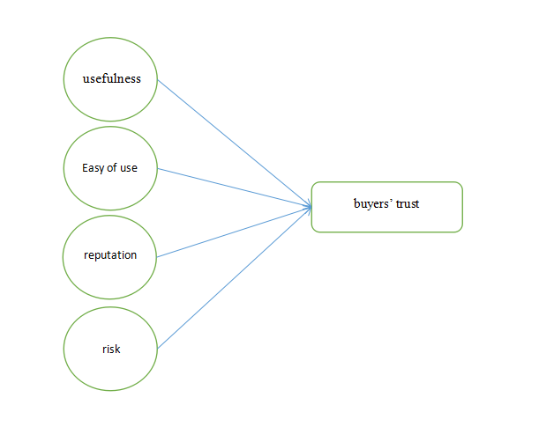

## 2.6 Hypotheses

**H1:Perceived usefulness of online shopping has positive effects on buyers’ trust.**

Perceived usefulness is one of the key elements of the TAM model (technical acceptance model) used in this paper. TAM was introduced by Davis in 1986, to describe the behavior of users in the use of information technology. The perceived utility is defined as the extent to which a person believes that the use of a certain technology will improve its performance. Perceived usefulness in this article refers to the subjective availability in terms of arrival to the buyer and the seller, to improve operational efficiency and improve the quality of service to the buyer and the seller. The trends of chinese consumers to shop online are increasingly apparent, and these trends pose a challenge for sellers to improve the feasibility of applications.

**H2: Perceived ease of use of online shopping has positive effects on buyers’ trust.**

Ease of use is a key factor of this model. The perception of the facility is defined as the extent to which it is believed that the use of information technology can be difficult. The role of perceived usefulness in the electronic market and create behavioral intentions to use were discussed, some parts are very could participants. In addition, the perceived usefulness, perceived ease as the simplicity of the role of the buyer in the electronic market, and the minimum amount of effort (Chan, 2013). In view of the large number of buyers in the market recently, the ease of use is an important problem to solve.

**H3: e-Seller’s reputation has positive effects on buyers’ trust.**

Reputation plays an important role in the formation of the market, in particular with regard to price and promotion. The reputation of the market reflects the overall evaluation, the image, and the identification of the electronic market. A better reputation usually means more profit.

The credibility of the seller, reflects the confidence in the ability of the seller to provide quality of service and the degree of confidence in the information provided by the seller prior to the transaction (Balasubraman, Peterson and Jarvenpaa, 2017). However, in some cases, the high reputation sellers can produce more profit. To improve the reputation of sellers is not an easy task for the Chinese sellers, as new sellers have access to online transactions.

Sellers’ expertise plays an important role in the formation and development of the trust of the buyer in the preparation of products and the quality of the seller. Through the appropriate sales strategy, sales may increase the sale price and to facilitate sales. On the other hand, some procurement strategies will also lead to a decline in prices. The expertise of the seller may affect the credibility of the seller, reduce uncertainty and increase confidence. The Chinese e-commerce market is new to all stakeholders and sellers to develop their expertise, in order to maximize the benefits of the electronic market.

**H4: Perceived risk assessment of online shopping has positive effects on buyers’ trust.**

In the electronic marketplace, the privacy and security are the key features that enhance the competitive advantages and improve the level of confidence. Trust plays an important role in the regulation of the willingness of firms to adopt e-commerce sales, and the participation of buyers. Trust plays an important role in a wide range of contacts, such as cooperation, relationships online, and crisis management. The confidence of buyers in a component of the electronic market not only affects their confidence in the other component, but also the way in which the buyers purchase online. on the basis of these facts. The assessment of the perceived risk in electronic markets is a prerequisite for reducing the potential loss of buyers and sellers in electronic markets. the buyers are concerned about losing their privacy abuse their personal information and the quality of their products (Yeh, Xu and Liu, 2014). It is understood that the importance of trust has an important impact on the confidence of the customer. Chang and Wang discussed the factors of trust in electronic markets, electronic markets, and participation in capacity and predictability. The literature reviews indicate that effective risk management is seen to have a positive impact on trust in the network.

## 2.7 Summary

In the second chapter, I mainly reviewed the TAM model (Technology acceptance model), Theory of Reasoned Action (TRA) and Theory of Planned Behavior (TPB). According to Technology acceptance model, users' acceptance of a certain technology mainly depends on two aspects: perceived usefulness and perceived ease of use.

In addition, I summarized the literature on independent variables and dependent variables. In e-commerce transactions, buyers' trust in e-commerce platforms and sellers directly affects their purchasing activities. The "ease of use" includes the ease of access to the internet, the provision of secure electronic services, and high level, and the need for online shopping services. The past reputation seller can serve as a mechanism by which the information on the actual behaviour of the seller may be provided to the purchaser. In this case, the reputation of the seller is likely to reduce the asymmetry of information and allow the market to function. An overview of the individual risk is due to the risks associated with the image, in the design of self and social analysis. Other dimensions are the risk to the privacy, security, and the provision of risk are provided to support the literature on electronic commerce. From these literatures, I have drawn my research model and four hypotheses.

# Chapter 3: Research methodology

## 3.1 Overview

In the third chapter, I mainly described my research process, research design, questionnaire design and measurement methods. My research focuses on determining been perceived usefulness, perceived ease of use of e-commerce sites, the reputation of sellers and perceived risks have a positive impact on consumer trust. I conduct a survey of e-commerce buyers on the dependent variable and four independent variables.

I use SPSS to conduct quantitative analysis on the data obtained from the questionnaire. I chose to use the quantitative analysis method because it can conduct large-scale social surveys and quickly grasp the development trend of e-commerce. In my research, I interview online shopping consumers in China's e-retailing industry.

## 3.2 Research design

In terms of research background, in China in the 21st century, the Internet environment is constantly changing and making new breakthroughs (Alharbi, Zyngier and Hodkinson, 2016). Customer-to-customer platforms like eBay and taobao allow any user to talk and trade with each other, bringing a whole new way of life to people. Compared with previous physical stores, online shopping has more choices and lower transaction costs. As an intermediary between buyers and sellers, many factors affect consumers' trust in online shopping platforms (Yu and Buahom, 2013).

Before doing the research, I will understand the current situation of e-commerce in China and the importance of consumer trust. After collecting relevant existing data and literature, I will choose questionnaire to conduct market research. Since the questionnaire can conduct extensive surveys on Chinese consumers, and the data results obtained from the questionnaire are easier to quantify, it is suitable for SPSS statistical analysis. By consulting the relevant information of the four aspects that affect consumer trust, and conducting the second study, the future development is predicted.

In my questionnaire, I will first investigate the basic information, such as gender, age, occupation, income and so on. Then I will conduct a survey of e-commerce buyers on the dependent variable and four independent variables. The dependent variable is consumer trust.

## 3.3 The study of population, unit of analysis and sampling design

### 3.3.1 Target population

In my research, I surveyed and interviewed online shopping consumers in China's e-retailing industry. By sending questionnaires online, I received 307 valid questionnaires who between 18 and 50 for data analysis. I used E-mail and WeChat platform to send the questionnaire. I mainly send to young people in Shanghai.

### 3.3.2 Unit of analysis

My research unit is group. Because of the trust of Chinese consumers I investigated, I analyzed the data in groups after collecting them. I analyzed the overall trend of the data obtained from the questionnaire in the form of groups of consumers.

### 3.3.3 Sampling frame and sampling location

In China, Taobao, Tmall mall, Jingdong mall, Suning Tesco and Vipshop are the five most important electronic Internet platforms. Taobao has nearly 500 million registered users, and the total number of online goods on the platform has exceeded 1 billion. Tmall is the representative of B2C, China's e-commerce platform, which has the advantage of integrating tens of thousands of merchants and brands around the world. In 2017, jingdong had nearly 300 million active users and about 1.3 trillion yuan of transactions on its platform. In the sales of online home appliances in 2017, suning ranked first with a market share of 20%. Vipshop has more than 300 million registered members. I investigated users of Taobao, Tmall mall, Jingdong mall, Suning Tesco and Vipshop in Shanghai of China. Since almost all Internet users in China are e-commerce consumers, I can smoothly survey e-commerce users in Shanghai by releasing electronic questionnaires on the online platform.

### 3.3.4 Sampling techniques

The collection of primary quantitative data is based on various forms of mathematical statistics. Methods for the collection and analysis of quantitative data include descriptive analysis, correlation analysis, partial correlation analysis and linear regression analysis (Chen, Landry and Davis, 2014). Compared with the qualitative analysis method, the time cost of quantitative analysis is lower, and the result can be obtained in a short time. The results from quantitative analysis are straightforward, so it's easier to compare. Since there are many objects to be investigated, quantitative analysis can be extended to groups with larger sample size (Van Der Heijden, 2015).

Questionnaire is a way to collect data, and its design process is relatively simple. The questionnaire can choose open questions and closed questions, or it can provide respondents with multiple choices, allowing them to choose statements close to the description of a project (Lei, Hu and Zhou, 2019). Although it is impossible for him to replace face-to-face questionnaires, due to lower costs, it is easier to adjust the design of the questionnaires in a timely manner (Pei, Paswan and Yan, 2018). More and more questionnaires are in the form of electronic questionnaires, which can be published and recycled through e-mail (Chen and Teng, 2018).

### 3.3.5 Sample size

By sending questionnaires online, I received 100 valid questionnaires who between 18 and 50 for data analysis.

## 3.4 Design and procedure

Perceived usefulness, perceived ease of use of e-commerce sites, the reputation of sellers and perceived risks may have some positive or negative effects on the trust of consumers. My research focuses on determining whether these factors have a positive impact on consumer trust.

Before doing the research, I will understand the current situation of e-commerce in China and the importance of consumer trust. After collecting relevant existing data and literature, I will choose questionnaire to conduct market research. Since the questionnaire can conduct extensive surveys on Chinese consumers, and the data results obtained from the questionnaire are easier to quantify, it is suitable for SPSS statistical analysis. By consulting the relevant information of the four aspects that affect consumer trust, and conducting the second study, the future development is predicted.

In my questionnaire, I will first investigate the basic information, such as gender, age, occupation, income and so on. Then I will conduct a survey of e-commerce buyers on the dependent variable and four independent variables.

I will use SPSS to conduct quantitative analysis on the data obtained from the questionnaire. I chose to use the quantitative analysis method because it can conduct large-scale social surveys and quickly grasp the development trend of e-commerce. Moreover, the method of quantitative analysis can ensure the standardization and scientificity of the research through statistical and data analysis. Through the reasoning of the formula, the results are accurate and persuasive. In addition, quantitative analysis can accurately analyze the relationship between social phenomena.

Descriptive analysis, correlation analysis and linear regression analysis can be carried out through SPSS software. The data can be analyzed clearly and accurately by bar chart, line chart and pie chart. The scatter diagram of SPSS allows us to see the distribution of research factors, which is scientific and persuasive (Forsythe, Liu, Shannon and Gardner, 2016).

## 3.5 Measurement instruments

### 3.5.1 Scales measurement

In the questionnaire questions, I used the 5-point agree-disagree scale. This scale proposes five categories, which are "strongly agree", "agree", "neither agree nor disagree", "disagree", "strongly disagree". All problem scales are now fully labeled with vertical categories (Gartner, 2013).

### 3.5.2 Questionnaire Design

The collection of primary quantitative data is based on various forms of mathematical statistics. Methods for the collection and analysis of quantitative data include descriptive analysis, correlation analysis, partial correlation analysis and linear regression analysis (Chen, Landry and Davis, 2014). Compared with the qualitative analysis method, the time cost of quantitative analysis is lower, and the result can be obtained in a short time. The results from quantitative analysis are straightforward, so it's easier to compare. Since there are many objects to be investigated, quantitative analysis can be extended to groups with larger sample size (Van Der Heijden, 2015).

In my questionnaire, I will first investigate the basic information, such as gender, age, occupation, income and so on. Then I will conduct a survey of e-commerce buyers on the dependent variable and four independent variables. I asked respondents to respond to questions on five levels. The dependent variable is consumer trust.

### 3.5.3 Pilot study

My pilot study was conducted by releasing questionnaires on WeChat platform. After three days, 40 questionnaires were received. This situation tells me that I need to release the questionnaire on multiple platforms. If it is only in WeChat, the number of valid questionnaires I receive in a certain period of time is not enough. At the same time, I should increase the publicity efforts to get as many young people as possible to participate in this questionnaire survey.

### 3.5.4 Factor analysis

|  |  |  |
| --- | --- | --- |
| Variables | code | Loding factor |
| preceived usefulness | PU1 | 0.75 |
| PU2 | 0.87 |
| PU3 | 0.74 |
| preceived easy of use | PEOU1 | 0.73 |
| PEOU2 | 0.77 |
| PEOU3 | 0.77 |
| sellers' reputation | SR1 | 0.78 |
| SR2 | 0.62 |
| SR3 | 0.74 |
| preceived risk | PR1 | 0.63 |
| PR2 | 0.8 |
| PR3 | 0.83 |
| trust | TRS1 | 0.69 |
| TRS2 | 0.72 |
| TRS3 | 0.73 |

Figure 5: Factor Analysis (CFA) method analysis

Source: Sfenrianto, S., Wijaya, T. and Wang, G. (2018)

Since the loding factor of each question in factor analysis exceeds 0.5, each question is valid.

### 3.5.5 Validity and reliability test

Reliability refers to the stability and consistency of the results of the questionnaire survey on the same object using the same method, that is, whether the measuring tool can measure the measured things or variables stably (Howard, Rainie and Jones, 2011). Credibility measures the reliability of the questionnaire results, but does not involve the question of whether the results are correct (Krause and Horvitz, 2018). Validity focuses on the validity of the measurement results for the purpose of questionnaire measurement. The evaluation index of credibility is the credibility coefficient, which can be expressed theoretically as the ratio of the variance of the true value and the variance of the measured value (Hsu and Chiu, 2014).

The validity coefficient is the ratio of the variance of the measured target value to the variance of the total measured value.

## 3.6 Data analysis

### 1. Descriptive analysis

Descriptive statistics refers to the use of various charts and calculated summary data to describe the characteristics of the target. It carries out statistical description of all the variables of the survey, including frequency analysis of data, dispersion analysis and some other graphical results (Zhu and Chen, 2013). Frequency analysis of data is to use frequency analysis and cross frequency analysis to check outliers. The centralized trend analysis of the data is used to express the average level of the data, and the indicators used are averages, medians, and so on (Lee, Cheung and Sia, 2011). The degree of dispersion analysis of data is used to reflect the degree of difference of data, including variance and standard deviation. By drawing various charts such as bar charts, pie charts, line charts, etc., data can be clearly expressed, which is more concise than words (Zhou and Lu, 2018).

### Correlation Analysis

Correlation analysis refers to analyzing the intimacy of two variables. In the correlation analysis, the relationship between variables can be visually described by scatter plots (Miyazaki and Fernandez, 2017). No correlation means that the two variables are independent and independent of each other (Palvia, 2015).

### 3. Linear Regression Analysis

Linear regression analysis can study the quantitative adjoint relationship between two variables, and describe their relationship by establishing a mathematical equation y=ax+b between variables (Riffai, Grant and Edgar, 2014). In this way you can determine how much one variable affects another. First, we need to analyze whether there is a linear relationship between the dependent variable and the independent variable through the xy scatter plot (Seyal, A. et al. 2014). Therefore, the value of the independent variable can affect the value of the dependent variable.

## 3.7 Summary

In the third chapter, I mainly described my research process, research design, questionnaire design and measurement methods. My research focuses on determining been perceived usefulness, perceived ease of use of e-commerce sites, the reputation of sellers and perceived risks have a positive impact on consumer trust. I conduct a survey of e-commerce buyers on the dependent variable and four independent variables.

# 

# Chapter 4: Research Findings

## 4.1 Overview

In Chapter4, I will conduct Pilot test with 40 questionnaires and obtain factor analysis and reliability analysis of 40 questionnaires, so as to judge whether my sample data is valid and suitable for further study.

Through descriptive analysis, I will get basic information frequency and chart information about the age, gender, monthly income and monthly expenditure of the interviewees.

In the preliminary data analysis, I will analyze the factor analysis and credibility analysis of 307 questionnaires received to determine whether the data of these questionnaires are suitable for analysis. Correlation analysis is used to analyze the correlation between dependent variable and independent variables.

Through hypothesis analysis, I will verify whether H1, H2, H3 and H4 are true through linear regression analysis.

## 4.2 Pilot Test

My pilot study was conducted by releasing questionnaires on WeChat platform. After a few days, 40 questionnaires were received. This situation tells me that I need to release the questionnaire on multiple platforms. If it is only in WeChat, the number of valid questionnaires I receive in a certain period of time is not enough. At the same time, I should increase the publicity efforts to get as many young people as possible to participate in this questionnaire survey.

Forty valid questionnaires were used for pilot testing, factor analysis and reliability analysis. The general trend, factor analysis and reliability of the study can be determined through the pilot test of the 40 questionnaires.

KMO (Kaiser- meyer-olkin) test statistic is used to compare the simple correlation coefficient and partial correlation coefficient between variables. KMO test is mainly used for statistical multivariate factor and factor analysis, and its value is between 0 and 1.

If the sum of squares of simple correlation coefficients between variables is greater than the sum of squares of partial correlation coefficients, and the greater the difference is, the closer the KMO value is. In this case, the closer the relationship between these factors is, the stronger the correlation is, so these variables are more suitable for factor analysis. If the sum of the squares of the simple correlations between the variables is small, close to zero, the closer the KMO value is to zero. This indicates that the relationship between these factors is not close enough and the correlation is weak, so these variables are not suitable for factor analysis.

Reliability refers to the stability and consistency of the results of the questionnaire survey on the same object using the same method, that is, whether the measuring tool can measure the measured things or variables stably (Howard, Rainie and Jones, 2011). Credibility measures the reliability of the questionnaire results, but does not involve the question of whether the results are correct (Krause and Horvitz, 2018). Validity focuses on the validity of the measurement results for the purpose of questionnaire measurement. The evaluation index of credibility is the credibility coefficient, which can be expressed theoretically as the ratio of the variance of the true value and the variance of the measured value (Hsu and Chiu, 2014).

Validity refers to the degree to which a measurement tool or method can accurately measure what is required to be measured. There are three types of validity: content validity, criterion validity and structure validity. The validity coefficient is the ratio of the variance of the measured target value to the variance of the total measured value.

### 4.2.1 Factor Analysis

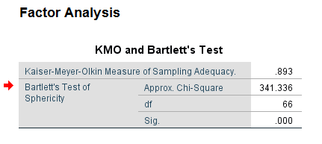

Table 1: KMO and Bartlett’s Test of pilot test

The KMO value measured by my pilot test was 0.893 and the Bartlett 'P value was 0.000. Because the KMO value of the variable is closer to 1, the more suitable for factor analysis. The KMO value is very suitable for factor analysis in the interval of 0.8-0.9. The value I measured is 0.893, so independent variables of my study are very suitable for factor analysis. Bartlett's P value is less than or equal to 0.01, the variable is suitable for factor analysis. From the Bartlett test, the independent variables of my research are very suitable for factor analysis.

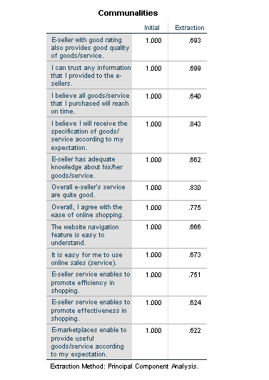

Table 2: Communalities of pilot test

It can be seen from the common factor variance of the above figure that all the contribution rates of the variables are above 0.6, indicating that the cumulative contribution rate of the common factor variance is high. Because the higher the cumulative contribution rate of the common factors, the higher the representativeness of the extracted common factors for the original variables, the better the research effect.

### 4.2.2 Reliability Test

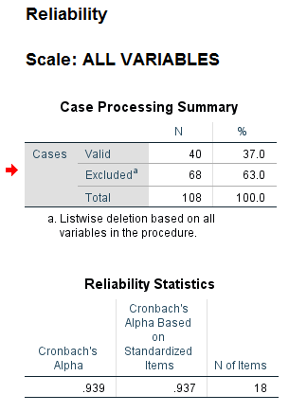

Table 3: Reliability Statistics of Pilot Test

As shown in the Table 3, the value of Cronbach’s alpha has been tested to be 0.939, which is greater than 0.7, so the dependent and independent variables of my study are generally valid and can be studied.

|  |  |  |  |
| --- | --- | --- | --- |
| Valuables | Item number | Cronbach's Alpha | Status |
| Preceived usefulness | 3 | 0.827 | vaild |
| Preceived ease of use | 3 | 0.786 | vaild |
| Sellers’ reputation | 3 | 0.779 | vaild |
| Preceived risks | 3 | 0.817 | vaild |
| Buyers’ trust | 6 | 0.759 | vaild |

Table 4: Item-Total Statistics of Pilot Test

I tested the validity and reliability of the independent and dependent variables of the study and conducted a confirmatory factor analysis (CFA) method. The indicators are valid when the load factor (λ) is greater than 0.5 or more, and the data of the variables have a significant effect. When all values of construction reliability (CR) > 0.7 and Cronbach's alpha > 0.6, all data for the variables are suitable for analysis. As shown in the figure, the independent and dependent variables of Cronbach's alpha are greater than 0.7, so the CR and Cronbach values show that all variable data are suitable for further analysis.

## 4.3 Descriptive Statistics

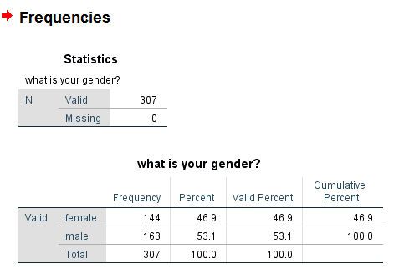

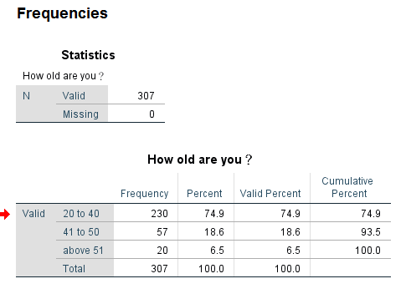

In this study, I sent out 384 electronic questionnaires through the Internet platform and emails, and received 307 valid questionnaires. According to frequency statistics based on the gender and age of the interviewees, 144 of them are women, accounting for 46.9% of the total number. 163 of the respondents were men, 53.1 percent of the total. Overall, there were about the same number of male and female respondents, with slightly more male respondents.

In terms of age, 230 were aged between 20 and 40, accounting for 74.9 per cent of respondents. There were 57 people aged 41 to 50, accounting for 18.6 per cent of the total. There were 20 respondents over 51 years old, accounting for 6.5% of the total. This suggests that most of the people who filled out the questionnaires in this study were young people.

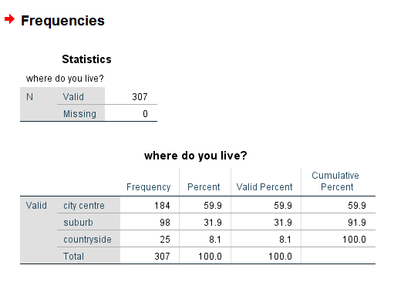.

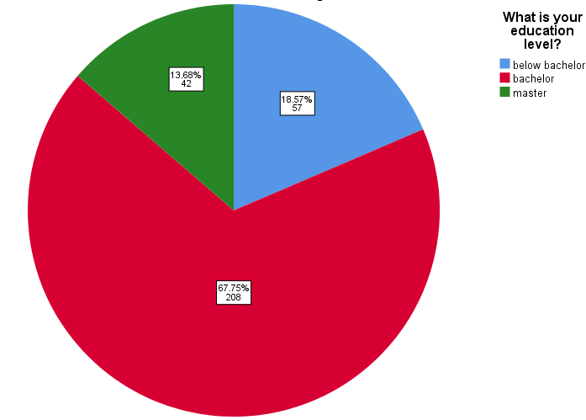

In terms of where respondents live, 184 individuals live in the city center, or 59.9 percent of the total. 98 people live in the suburbs, accounting for 31.9% of the total, while the remaining 25 live in the countryside, accounting for 8.1% of the total.Most of the respondents have bachelor's degrees, with 208 people accounting for 67.75% of the total.

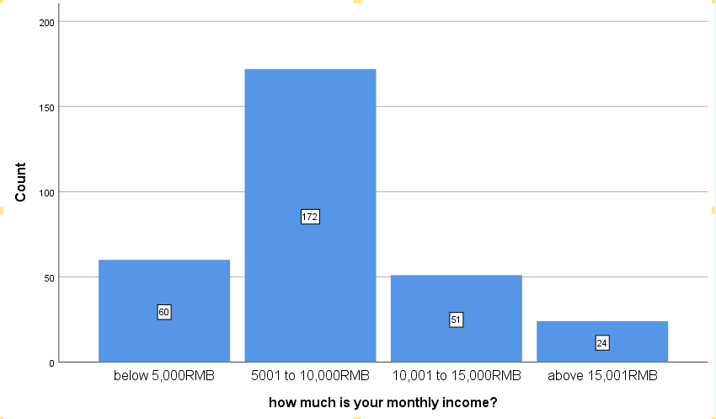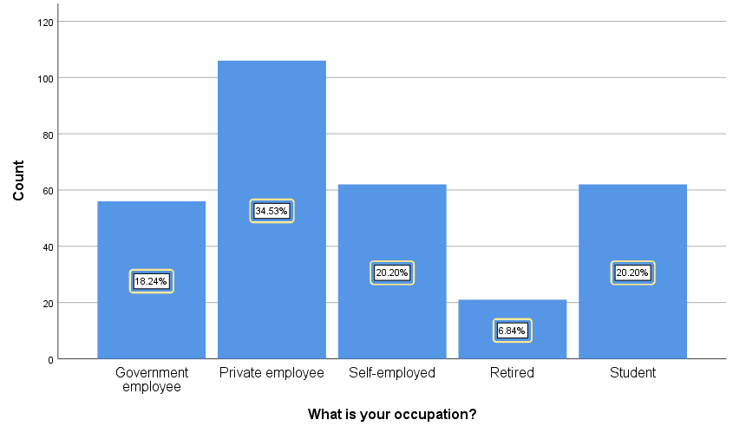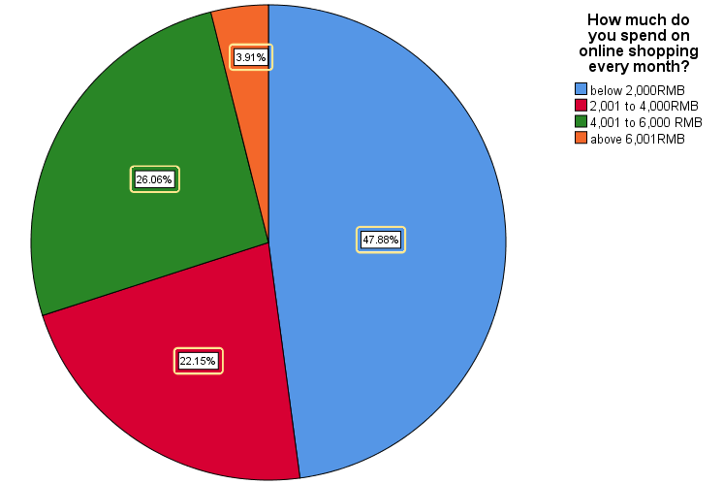

|  |  |  |
| --- | --- | --- |
| Demographics | Frequency % |  |
| **Occupation**  Government employee  Private employee  Self-employed  Retired | 56 18.24 106 34.53  62 20.20  21 6.84 |  |
| Student | 62 20.20 |  |
| **Income**  Below 5,000RMB  5,001 to 10,000RMB  10,001 to 15,000RMB  Above 15,001RMB  **Spending online**  Below 2,000RMB  2,001 to 4,000RMB  4,001 to 6,000RMB  Above 6,001RMB | 60 19.54  172 56.03  51 16.61  24 7.82  147 47.88  68 22.15  80 26.06  12 3.91 |  |

Table 5: Frequency of Demographics

In terms of the occupation of the interviewees, the largest number of them are private employees, 106 of whom are private employees, accounting for 34.63% of the total number. Students and self-employed students are the next largest group, accounting for 62 employees respectively, accounting for 20.20% of the total number. Only 21 people retired, accounting for 6.84 percent.

There were 172 respondents whose monthly income was between 5,001 and 10,000 RMB, accounting for 56.03%. Next, there are 60 people with an income below 5,000 RMB, accounting for 19.54% of the total. Only 24 respondents with monthly income greater than 15.001RMB, accounting for the least proportion.

Most people who fill out the electronic questionnaire spend less than 2,000 RMB online every month, accounting for 47.88%. Next, 80 people spent 4,001 to 6,000 RMB, accounting for 26.06%. Only 12 of them spend more than 6,001 RMB on online shopping every month, which is the least, accounting for only 3.91% of the total.

## 4.4 Preliminary Data Analysis

### 4.4.1 Factor Analysis

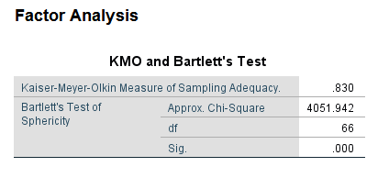

Table 6: KMO and Bartlett’s Test of Preliminary Data Analysis

The KMO value measured by my preliminary data analysis was 0.830 and the Bartlett 'P value was 0.000. Because the KMO value of the variable is closer to 1, the more suitable for factor analysis. The KMO value is very suitable for factor analysis in the interval of 0.8-0.9. The value I measured is 0.830, so independent variables of my study are very suitable for factor analysis. Bartlett's P value is less than or equal to 0.01, the variable is suitable for factor analysis. From the Bartlett test, the independent variables of my research are very suitable for factor analysis.

It can be seen from the common factor variance of the below table that all the contribution rates of the variables are above 0.6, indicating that the cumulative contribution rate of the common factor variance is high. Because the higher the cumulative contribution rate of the common factors, the higher the representativeness of the extracted common factors for the original variables, the better the research effect.

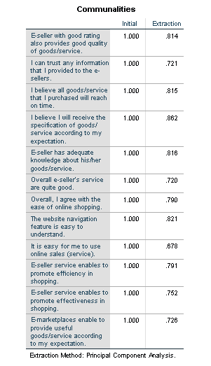

Table 7: Communalities of Preliminary Data Analysis

### 4.4.2 Reliability Test

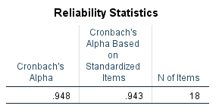

Table 8: Reliability Statistics of Preliminary Data Analysis

As shown in the Table 3, the value of Cronbach’s alpha has been tested to be 0.948, which is greater than 0.7, so the dependent and independent variables of my study are generally valid and can be studied.

|  |  |  |  |
| --- | --- | --- | --- |
| Valuables | Item number | Cronbach's Alpha | Status |
| Preceived usefulness | 3 | 0.889 | vaild |
| Preceived ease of use | 3 | 0.725 | vaild |
| Sellers’ reputation | 3 | 0.852 | vaild |
| Preceived risks | 3 | 0.832 | vaild |
| Buyers’ trust | 6 | 0.764 | vaild |

Table 9: Item-Total Statistics of Preliminary Data Analysis

I tested the validity and reliability of the independent and dependent variables of the study and conducted a confirmatory factor analysis (CFA) method. The indicators are valid when the load factor (λ) is greater than 0.5 or more, and the data of the variables have a significant effect. When all values of construction reliability (CR) > 0.7 and Cronbach's alpha > 0.6, all data for the variables are suitable for analysis. As shown in the figure, the independent and dependent variables of Cronbach's alpha are greater than 0.7, so the CR and Cronbach values show that all variable data are suitable for further analysis.

### 4.4.3 Correlation Analysis

|  |  |  |
| --- | --- | --- |
| IV | DV | Pearson correlation |
| Preceived usefulness | Buyers’ trust | 0.703 |
| Preceived ease of use | Buyers’ trust | 0.734 |
| Sellers’ reputation | Buyers’ trust | 0.545 |
| Preceived risks | Buyers’ trust | 0.711 |

Table 10: Pearson correlation of valuables

Suggested by Cohen (1988) and expanded by Sawilowsky (2009), As shown in the figure below, Effect size of Pearson correlation is small with d=0.2 and medium with d=0.5. When d=0.8, the effect size is large, and when d=1.2, the effect is very large.

Therefore, according to the data of table 10, the Pearson correlation for preceived usefulness, preceived ease of use and preceived risks is 0.703, 0.734 and 0.711 respectively, both exceeding 0.7, so the effect size of these three independent variables is very large. The Pearson correlation of sellers’ reputation is 0.545, exceeding 0.5, and the effect size is above medium.

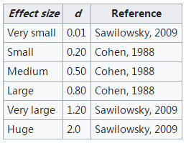

Table 11: Effect size of Pearson correlation

## 4.5 Hypotheses Testing

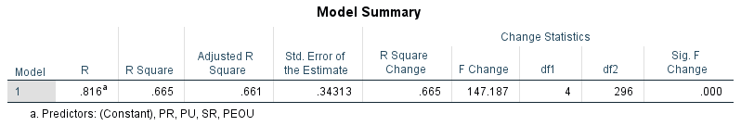

Table 12: Model Summary of Hypotheses Testing

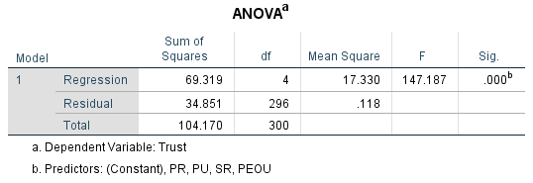

Table 13: ANOVA of Hypotheses Testing

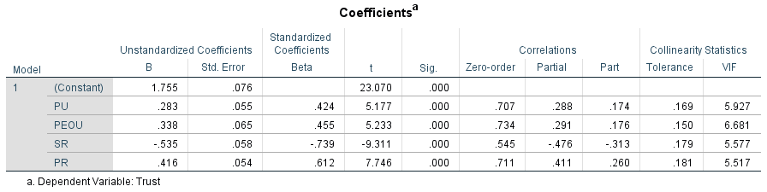

Table 14: Coefficients of Hypotheses Testing

The model summary table can reflect the strength of the relationship between the model and the dependent variable. R embodies the linear correlation between the observed value of the dependent variable and the predicted value of the model, and is the multivariate correlation coefficient. R is 0.816, which is a relatively large value, indicating that the relationship between the model and the variable is strong.

The square of R, the coefficient of determination, is the square of the multiple correlation coefficient. The results show that the model explains 66.5% of the time variation.

The analysis of ANOVA tables is a method of testing the acceptability of a model. The regression line explains the change information of the model. The remaining lines explain the change information outside the model. The significance value of the F statistic is less than 0.05, which is 0.000, so the change in the model interpretation is not accidental.

From the coefficient table analysis, the sig coefficients of the four independent variables in the table are all 0.000, which are significant coefficients. It also shows that these variables contribute a lot to the whole model research. So, Therefore, H1, H2, H3 and H4 are all supported.

## 4.6 Summary of Key Research Findings

According to the data above, the Pearson correlation for preceived usefulness, preceived ease of use and preceived risks is 0.703, 0.734 and 0.711 respectively, both exceeding 0.7, so the effect size of these three independent variables is very large. The Pearson correlation of sellers’ reputation is 0.545, exceeding 0.5, and the effect size is above medium.

The model summary table can reflect the strength of the relationship between the model and the dependent variable. R is 0.816, which is a relatively large value, indicating that the relationship between the model and the variable is strong.The square of R, the coefficient of determination shows that the model explains 66.5% of the time variation.

The analysis of ANOVA tables is a method of testing the acceptability of a model. The significance value of the F statistic is less than 0.05, which is 0.000, so the change in the model interpretation is not accidental.

From the coefficient table analysis, the sig coefficients of the four independent variables in the table are all 0.000, which are significant coefficients. It also shows that these variables contribute a lot to the whole model research. So, Therefore, H1, H2, H3 and H4 are all supported.

## 4.7 Summary

In this Chapter, I will conduct Pilot test with 40 questionnaires and obtain factor analysis and reliability analysis of 40 questionnaires, so as to judge whether my sample data is valid and suitable for further study.

Through descriptive analysis, I will get basic information frequency and chart information about the age, gender, monthly income and monthly expenditure of the interviewees.

In the preliminary data analysis, I will analyze the factor analysis and credibility analysis of 307 questionnaires received to determine whether the data of these questionnaires are suitable for analysis. Correlation analysis is used to analyze the correlation between dependent variables and independent variables.

Through hypothesis analysis, I will verify whether H1, H2, H3 and H4 are supported through linear regression analysis.

# Chapter 5: Discussion and Conclusion

## 5.1 Overview

In Chapter 5, I will analyze the previously derived data to explain why the hypothesis is supported. In addition, I will reflect on the limitations of this study and, in response to these limitations, propose areas for future research to improve. I will also make a few suggestions on some of the existing phenomena in the Chinese e-commerce market, which are aimed at e-commerce sellers, online shopping platforms and courier companies.

## 5.2 Discussion of Findings

The KMO value measured by my preliminary data analysis was 0.830 and the Bartlett 'P value was 0.000. Because the KMO value of the variable is closer to 1, the more suitable for factor analysis. The KMO value is very suitable for factor analysis in the interval of 0.8-0.9. The value I measured is 0.830, so independent variables of my study are very suitable for factor analysis. Bartlett's P value is less than or equal to 0.01, the variable is suitable for factor analysis. From the Bartlett test, the independent variables of my research are very suitable for factor analysis.

It can be seen from the common factor variance of the below table that all the contribution rates of the variables are above 0.6, indicating that the cumulative contribution rate of the common factor variance is high. Because the higher the cumulative contribution rate of the common factors, the higher the representativeness of the extracted common factors for the original variables, the better the research effect.

I tested the validity and reliability of the independent and dependent variables of the study and conducted a confirmatory factor analysis (CFA) method. The indicators are valid when the load factor (λ) is greater than 0.5 or more, and the data of the variables have a significant effect. When all values of construction reliability (CR) > 0.7 and Cronbach's alpha > 0.6, all data for the variables are suitable for analysis. As shown in the figure, the independent and dependent variables of Cronbach's alpha are greater than 0.7, so the CR and Cronbach values show that all variable data are suitable for further analysis.

According to the data, the Pearson correlation for preceived usefulness, preceived ease of use and preceived risks is 0.703, 0.734 and 0.711 respectively, both exceeding 0.7, so the effect size of these three independent variables is very large. The Pearson correlation of sellers’ reputation is 0.545, exceeding 0.5, and the effect size is above medium.

The model summary table can reflect the strength of the relationship between the model and the dependent variable. R is 0.816, which is a relatively large value, indicating that the relationship between the model and the variable is strong.The square of R, the coefficient of determination shows that the model explains 66.5% of the time variation.

The analysis of ANOVA tables is a method of testing the acceptability of a model. The significance value of the F statistic is less than 0.05, which is 0.000, so the change in the model interpretation is not accidental.

From the coefficient table analysis, the sig coefficients of the four independent variables in the table are all 0.000, which are significant coefficients. It also shows that these variables contribute a lot to the whole model research. So, Therefore, H1, H2, H3 and H4 are all supported.

## 5.3 Recommendation

The first is a suggestion for the shopping website. The safety of online shopping is very important for shopping website. Shopping website should constantly improve all aspects of online shopping, such as purchasing and payment; Simplify the process of online shopping so that consumers can simply carry out the operation process of online shopping; Allow all consumers and businesses to carry out real-name authentication to ensure the authenticity and accuracy of information; Change those unreasonable shopping terms to protect the rights and interests of consumers and merchants to the greatest extent. Shopping website should also be improved in consumer information protection and other aspects to prevent the disclosure of consumer and business private information.

Shopping online security has become an important consideration for consumers shopping online. Shopping website only to strengthen the protection of consumer information and password, strengthen network supervision and website facilities propaganda, can let consumers on the Internet shopping rest assured, reduce their concerns about security issues when shopping online.

The second is advice to merchants. Shopping online sellers should treat consumers honestly, provide accurate commodity information to consumers and improve customer service quality. Sellers should also increase communication and interaction with consumers and give feedback to management on consumers' thoughts and opinions. The seller should also ensure the quality and specification of the goods and deal with the reasonable return and exchange requirements of consumers efficiently.

The third is the advice to express companies. Express companies should improve delivery efficiency and enhance customer service. Express companies also need to ensure that the goods are in good condition during the delivery process and cannot be damaged, while providing timely feedback to consumers.

## 5.4 Limitations

The limitations of this study are shown below. First, I only received data from 307 e-questionnaires. The sample size is relatively small, and there are some factors that make it difficult to find the difference from the statistics. Because this study was only conducted in Shanghai and did not understand the consumer situation in other cities in China, the data was not comprehensive enough. Due to limited research time and resources, there is no way to investigate everyone in Shanghai. If you want more accurate data results, you need to calculate a larger sample size. Second, the study of literature materials may lack real-time. Previous research can serve as the basis for literature review and research projects, but may not meet current development needs. Data obtained through questionnaires and interviews may lack reliability. Third, the method of collecting data has limitations. All questions and details related to the study are not included in the questionnaire. This situation will affect my comprehensive analysis of the results, because in the previous research, there is no problem that my research needs. Fourth, the only way I conduct surveys is through electronic surveys and data analysis, which may be too limited to get diverse information. Such an approach would make it impossible for those who could not do an electronic questionnaire to participate in this study.

## 5.5 Contribution to Academia

The importance of academia lies in understanding the academic frontier, industry dynamics and relationship with related fields of e-commerce industry. Grasp industry trend, facilitate the determination of government investment direction. Research can help the retail industry adjust its development direction and give full play to its advantages.

The significance of this study is to study the biggest advantages and future development of China's e-commerce model by describing the phenomenon of shopping on the Chinese network and combining the development of China's e-commerce model at home and abroad (Zhong and Ying, 2018). First of all, e-commerce is the inevitable product of the continuous development of the Internet age, and also the new direction of the application of network technology. The development of e-commerce has driven the popularity of shopping phenomenon on the global Internet and promoted the rapid development of B2C, C2C and other e-commerce models (Yu, Balaji and Khong, 2015). In addition, there are a large number of Internet users and consumers in Shanghai, so research on Chinese consumers is conducive to the clear presentation of research results (Zucker, 2016). Secondly, the analysis with TAM model has practical guiding significance for both consumers and merchants, which can help them better understand consumers' psychology.

## 5.6 Future Direction of Reasearch

In the future research, I will make improvements based on the deficiencies of this research. In this study, due to limited time and resources, the understanding of consumers is not comprehensive and meticulous. In the future research, I will segment consumers from the perspective of income or culture, and study their consumption level and attitudes towards online shopping respectively.

In addition, in future research, I will add factors that may affect consumer trust. In this study, I may have neglected some factors that will affect e-commerce consumers, such as the current trend of e-commerce shopping and the reputation of China's e-commerce market. In future research, I will increase my research on these factors and explore their relationship with consumer trust.

## 5.7 Personal Reflection

This study enabled me to learn many research methods and statistical methods, and encountered some challenges and resource limitations in the research process. This study gave me an understanding of the current situation of China's e-commerce market, and inspired my research by reading scholars' articles and literatures. I used electronic questionnaires to collect consumer data, and then analyzed the data through SPSS, and got a convincing and accurate conclusion.

The results of this study is the four hypotheses proposed I proved to be formed, preceived usefulness, preceived ease of use, the sellers' reputation and preceived risks have a positive effect on consumer trust.

## 5.8 Conclusion

In Chapter 5, I analyzed the data from the SPSS data analysis and explained why the four hypotheses support it. In addition, I have also reflected on the limitations of this study. In response to these limitations, I propose areas where future research can be improved, such as segmenting consumer populations and increasing possible influencing factors. I also made a few suggestions on some existing phenomena in the Chinese e-commerce market, which are aimed at e-commerce sellers, online shopping platforms and courier companies.

# Reference

Ahn, T., Ryu, S.,and Han, I. (2017). The impact of Web quality and playfulness on user acceptance of online retailing. Information & Management, 44(3), 263-275.

Alharbi, I. M., Zyngier, S., and Hodkinson, C. (2016). Privacy by design and customers’ perceived privacy and security concerns in the success of e-commerce. Journal of Enterprise Information Management, 26(6), 702-718.

Andrews, L., and Bianchi, C. (2017). Consumer internet purchasing behavior in Chile. Journal of Business Research, 66(10), 1791-1799.

Ashraf, A. R. (2016) ‘The Role of M-Commerce Readiness in Emerging and Developed Markets’, *Journal of International Marketing*, 25(2), pp. 25–51.

Balasubraman, S., Peterson, R. A. and Jarvenpaa, S. L. (2017) ‘Exploring the Implications of M-Commerce for Markets and Marketing’, *Journal of the Academy of Marketing Science*, 30(4), pp. 348–361.

Basarir-Ozel, B. and Mardikya, S. (2017) ‘Factors affecting E-commerce adoption: A case of Turkey’, *International Journal of Management Science & Technology Information*, (23), pp. 1–11.

Chan, K. W. (2013). “China, Internal Migration.” In The Encyclopedia of Global Human Migration, edited by I. Ness and P. Bellwood. Hoboken: Blackwell.

Chen, J., S. Chen, P. F. Landry, and D. S. Davis. (2014). “How Dynamics of Urbanization Affect Physical and Mental Health in Urban China.” The China Quarterly 220: 988–1011.

Chen, J., D. S. Davis, K. Wu, and H. Dai. (2015). “Life Satisfaction in Urbanizing China: The Effect of City Size and Pathways to Urban Residency.” Cities 49: 88–97.

Chen, L., and Liu, H.-w. (2015). A Review of Privacy Protection in E-commerce. Journal of Advanced Management Science Vol, 3(1).

Chen, M.-Y., and Teng, C.-I. (2018). A comprehensive model of the effects of online store image on purchase intention in an e-commerce environment. Electronic Commerce Research, 13(1), 1-23.

Cheung, C. M. K., and Lee, M. K. O. (2016). Understanding consumer trust in Internet shopping: A multidisciplinary approach. Journal of the American Society for Information Science and Technology, 57(4), 479-492.

Chiung-Wen Hsu, Chun-Po Yin and Li-Ting Huang (2017) ‘Understanding Exchangers’ Attitudes and Intentions to Engage in Internet Bartering Based on Social Exchange Theory (SET) and the Theory of Reasoned Action (TRA)’, *International Journal of Business & Information*, 12(2), pp. 149–182.

Chung, K. C. (2014). “Gender, Culture and Determinants of Behavioural Intents to Adopt Mobile Commerce among the Y Generation in Transition Economies: Evidence from Kazakhstan.”Behaviour & Information Technology 33: 743–756.

CNNIC. (2016). 2015-2016 China Online Shopping Research Report: CNNIC(China Internet Network Information Center).

Dakduk,S., Ter Horst,E. H., and Malave.J. (2017) Customer behavior in electronic commerce: a Bayesian approach, Journal of Theoretical and Applied Electronic Commerce Research, vol. 12, no. 2, pp. 1-20.

Davis, F. D. (1989). “Perceived Usefulness, Perceived Ease of Use, and User Acceptance of Information Technology.” MIS Quarterly 13: 319–340.

Deery, S. J. and Mahony, A. (2016) ‘Temporal Flexibility: Management Strategies and Employee Preferences in the Retail Industry’, *Journal of Industrial Relations*, 36(3), pp. 332–352.

Eid, M. I. (2018). Determinants of e-commerce customer satisfaction, trust, and loyalty in Saudi Arabia. Journal of Electronic Commerce Research, 12(1), 78-93.

Fedorko, I., Bacik, R. & Gavurova, B. (2018), “Technology Acceptance Model in E-Commerce Segment”, *Management & Marketing. Challenges for the Knowledge Society,* Vol. 13, No. 4, pp. 1242-1256, DOI: 10.2478/ mmcks- 2018-0034.

FORRESTER. (2013). Forrester Research Online Retail Forecast, 2012 to 2017(US). from https: //www.forrester.com/Forrester+Research+Online+Retail+Forecast+2012+To+2017+US/fulltext/-/E-RES90661

Forsythe, S., Liu, C., Shannon, D., and Gardner, L. C. (2016). Development of a scale to measure the perceived benefits and risks of online shopping. Journal of Interactive Marketing, 20(2), 55-75.

Gartner (2013). *Predicts 2014: E-Commerce Becomes Digital for Those That Can Adapt Fast.* www.gartner.com

Giovanis, A. N., Binioris, S., and Polychronopoulos, G. (2012). An extension of TAM model with IDT and security/privacy risk in the adoption of internet banking services in Greece. *EuroMed Journal of Business*, *7*(1), 24-53.

Gökmen, A. (2012). Virtual business operations, e-commerce & its significance and the case of Turkey: current situation and its potential. *Electronic Commerce Research*, *12*(1), 31-51.

Ha, S., and Stoel, L. (2016). Consumer e-shopping acceptance: Antecedents in a technology acceptance model. *Journal of Business Research, 62*, 565–571.

Harter, G., J. Sinha, A. Sharma, and S. Dave. (2014). Sustainable Urbanization: The Role of ICT in City Development. New York: Booz & Company.

Howard, P. E. N., L. Rainie, and S. Jones. (2011). “Days and Nights on the Internet: The Impact of a Diffusing Technology.” American Behavioral Scientist 45: 383–404.

Hsu, M.-H., and C.-M. Chiu. (2014). “Internet Self-Effificacy and Electronic Service Acceptance.” Decision Support Systems 38: 369–381.

Huseynov, F. and Yıldırım, S. Ö. (2016) ‘Behavioral Issues in B2C E-commerce: The-state-of-the-art’, *Information Development*, 32(5), pp. 1343–1358.

Jones, K., and Leonard, L. N. K. (2017). Consumer-to-consumer electronic commerce: a distinct research stream. Journal of Electronic Commerce in Organizations, 5(4), 39-54.

Jones, K., and Leonard, L. N. K. (2016). Trust in consumer-to-consumer electronic commerce. Information & Management, 45(2), 88-95.

Joo.J, (2015), Roles of the buyer’s trust in seller in posted-price model of consumer to consumer e-commerce, Journal of Theoretical and Applied Electronic Commerce Research, vol. 10, no. 3, pp.30-44.

Kang, J.-Y. M., and Kim, E. (2018). e-Mass customisation apparel shopping: effects of desire forunique consumer products and perceived risk on purchase intentions. International Journal of Fashion Design, Technology and Education, 5(2), 91-103.

Karakaya, F. and Shea, T. (2017). Underlying Motivations for Establishing E-Commerce Business and Their Relationship to E-Commerce Success. *Journal of Internet Commerce*, 7(2), pp.153-179.

Kim, D., and Benbasat, I. (2016). Trust-related arguments in Interent stores: a framework for evaluation. Journal of Electronic Commerce Research, 4(2), 49-63.

Krause, A., and Horvitz, E. (2018). A utility-theoretic approach to privacy in online services. Journal of Artificial Intelligence Research, 39, 633-662.

KUMAR, M. (2016) ‘Consumer Behavior and Satisfaction in E-Commerce: A Comparative Study Based on Online Shopping of some Electronic Gadgets’, *CLEAR International Journal of Research in Commerce & Management*, 7(7), pp. 62–66.

Kwahk, K., Ge, X., and Park, J. (2017). Investigating the Determinants of Purchase Intention in C2C E-Commerce. Engineering and Technology, 69, 547-551.

Lee, M. K. O., C. M. K. Cheung, K. H. Lim, and C. L. Sia. (2011). “Consumer’s Decision to Shop Online: The Moderating Role of Positive Informational Social Inflfluence.” Information & Management 48: 185–191.

Lei, M., Hu, B., and Zhou, X. (2019). An Empirical Study on Usage Intention of Mobile E-Commerce. Risk, 1, 0.935.

Li, W. Z., and Jiao, A. Y. (2018). The Impact of Website and Offline Equality on Relationship Quality: An Empirical Study on E-Retailing. Paper presented at the 4th International Conference of Wireless Communications, Networking and Mobile Computing

Liao, Z., and Cheung, M. T. (2018). Measuring consumer satisfaction in internet banking: a core framework. Communications of the ACM, 51(4), 47-51.

Limayem, M., Khalifa, M., and Frini, A. (2016). What makes consumers buy from Internet? A longitudinal study of online shopping. Systems, Man and Cybernetics, Part A: Systems and Humans, IEEE Transactions on, 30(4), 421-432.

Lu, J., Yu, C.-S., and Yao, J. E. (2015). Exploring factors associated with wireless internet via mobile technology acceptance in Mainland China. Communications of the IIMA, 3(1), 9.

Lu, J., Yao, J. E., and Yu, C. S. (2015). Personal innovativeness, social influences and adoption of wireless Internet services via mobile technology. The Journal of Strategic Information Systems, 14(3), 245-268.

McKnight, D. H., Choudhury, V., and Kacmar, C. (2016). Developing and validation trust measures for e-commerce: an integrative typology. Information Systems Research, 13(3), 334-359.

Miyazaki, A. D., and Fernandez, A. (2017). Consumer perceptions of privacy and security risks for online shopping. Journal of Consumer Affairs, 35(1), 27-44.

Nachtsheim, C. J., Neter, J., Kutner, M. H., and Wasserman, W. (2017). Applied linear regression models. McGraw-Hill Irwin.

National Bureau of Statistics of China. (2015). China Statistical Yearbook 2015. Beijing: China Statistical Press.

Napitupulu, T. A., and Kartavianus, O. (2014). A structural equations modeling of purchasing decision through e-commerce. *Journal of Theoretical and Applied Information Technology*, *60*(2), 358-364.

Palvia, P. (2015). The role of trust in e-commerce relational exchange: A unified model. *Information & Management*, *46*, 213-220.

Pavlou, P. A. (2016). Consumer acceptance of electronic commerce: Integrating trust and risk with the technology acceptance model. International journal of electronic commerce, 7(3), 101-134.

Parameswaran, S. Kishore, R. and Li, P. (2015). Within-Study measurement invariance of the UTAUT instrument: An assessment with user technology engagement variables. *Information and Management*, 52:317-336.

Pei, Z., Paswan, A., and Yan, R. (2018). E-tailer׳ s return policy, consumer׳ s perception of return policy fairness and purchase intention. Journal of Retailing and Consumer Services, 21(3), 249-257.

Peng, C., and Y. G. Kim. (2014). Application of the stimuli-organism-response (SOR) framework to online shopping behavior. *Journal of Internet Commerce* 13 (3–4):159–76.

Peterson, R. A., and Wilson, W. R. (2016). Measuring customer satisfaction: fact and artifact. Journal of the Academy of Marketing Science, 20(1), 61-71.

Pikkarainen, T., Pikkarainen, K., Karjaluoto, H., and Pahnila, S. (2014). Consumer acceptance of online banking: An extension of the technology acceptance model. *Internet Research*, *14*(3), 224-235

Pozzi, A. (2016). The effect of Internet distribution on brick‐and‐mortar sales. The RAND Journal of Economics, 44(3), 569-583.

Prashar, S., T. Sai Vijay, and C. Parsad. (2015). Antecedents to online shopping: Factors influencing the selection of web portal. *International Journal of E-Business Research (IJEBR)*11 (1):35–55.

Qiu, L., and Li, D. (2018). Applying TAM in B2C e-commerce research: An extended model. *Tsinghua Science & Technology*, *13*(3), 265-272.

Qingfei, M. Shaobo, J. and Gang, Q. (2008). Mobile commerce user acceptance study in China: A revised UTAUT model. *Tsinghua Science and Technology*, 13(3): 257-264.

Riffai, M. Grant, A. and Edgar, D. (2014). Big TAM in Oman: Exploring the promise of on-line banking, its adoption by customers and the challenges of banking in Oman. *International Journal of Information Management*, 32: 239-250.

Rogers, E. M. (2003). Diffusion of Innovations. 5th ed. New York: Free Press.

Salam, A. F., Iyer, L., Palvia, P., and Singh, R. (2015). Trust in e-commerce. *Communications of the ACM, 48 (2),* 72-77.

Scarpi, D. (2012). Work and fun on the Internet: The effects of utilitarianism and hedonism online. *Journal of Interactive Marketing* 26 (1):53–67.

Schlosser, A. E., White, T. B., and Lloyd, S. M. (2016). Converting web site visitors into buyers: how web site investment increases consumer trusting beliefs and online purchase intentions. Journal of Marketing, 133-148.

Schneider, G. P. (2017). New Perspectives on E-commerce: Comprehensive. Stamford, CT: Cengage Learning.

Sexton, R. S., Johnson, R. A., and Hignite, M. A. (2018). Predicting Internet/e-commerce use. Internet research, 12(5), 402-410.

Seyal, A. et al. (2014). Determinants of electronic commerce in Pakistan: Preliminary evidence from small and medium enterprises. *Electronic Markets*, 14(4): 372-387.

Serener, B. (2016). Statistical Analysis of Internet Banking Usage with Logistic Regression. *Procedia Computer Science*, *102*(August), 648–653.

Sfenrianto, S., Wijaya, T. and Wang, G. (2018) ‘Assessing the Buyer Trust and Satisfaction Factors in the E-Marketplace’, *Journal of Theoretical & Applied Electronic Commerce Research*, 13(2), pp. 43–57.

Srivastava, R. K. (2017). Customer ’ s perception on usage of internet banking. *Innoative Marketing*, *3*(4), 67–73.

Steers, R.M. Meyer, A.D. and Sanchez-Runde, C.J. (2008). National culture and the adoption of new technologies. *Journal of World Business*, 43: 255- 260.

Shaikh, I. M. and Noordin, K. (2019) ‘Customers’ Intention to use Islamic Home Financing in Pakistan: An Extension of Theory of Planned Behaviour’, *Middle East Journal of Business*, 14(2), pp. 4–9.

Su-Yueh Chu *et al.* (2016) ‘Does an Established Offline Store Drive Online Purchase Intention?’, *International Journal of Business & Information*, 11(4), pp. 432–465.

Susanto, A., Chang, Y., and Ha, Y. (2016). Determinants of continuance intention to use the smartphone banking services. *Industrial Management & Data Systems*, *116*(3), 508– 525. https://doi.org/10.1108/IMDS-05-2015-0195

Tenenhaus, M. (2018). Component-based structural equation modeling. *Total Quality Management*, *19*(7-8), 871-886.

Thaler, R. H., and Tucker, W. (2015). Smarter information, smarter consumers. Harvard Business Review, 91(1), 44-54.

Treiblmaier, H., Pinterits, A., and Floh, A. (2017). Antecedents of the Adoption of E-Payment Services in the Public Sector. Paper presented at the 25th International Conference on Information Systems, Washington, D.C., USA.

Urban, G. L., Amyx, C., and Lorenzon, A. (2019). Online trust: state of the art, new frontiers, and research potential. Journal of Interactive Marketing, 23(2), 179-190.

Utz, S., Kerkhof, P., and van den Bos, J. (2016). Consumers rule: How consumer reviews influence perceived trustworthiness of online stores. Electronic Commerce Research and Applications, 11(1), 49-58.

Van Der Heijden, H., (2015). “User Acceptance of Hedonic Information Systems.” *MIS Quarterly* 28(4): 695-704.

Van Slyke, C., H. Lou, F. Belanger, and V. Sridhar. (2015). “The Inflfluence of Culture on Consumer-Oriented Electronic Commerce Adoption.” Journal of Electronic Commerce Research 11: 30–40.

Venkatesh, V., and F. D. Davis. (2014). “A Theoretical Extension of the Technology Acceptance Model: Four Longitudinal Field Studies.” Management Science 46: 186–204.

Venkatesh, V., Morris, M. G., Davis, G. B., & Davis, F. D. (2003). User acceptance of information technology: Toward a unified view. *MIS Quarterly, 27*(3), 425–478.

Venkatesh, V., and Bala, H. (2008). Technology acceptance model 3 and a research agenda on interventions. *Decision Sciences*, *39*(2), 273–315.

Vijayasarathy, L. R. (2014). Predicting consumer intentions to use on-line shopping: The case for an augmented technology acceptance model. *Information Management, 41*(6), 747-762.

Waheed, M., K. Kaur, N. Ain, and S. A. Sanni. (2015). “Emotional Attachment and Multidimensional Self-Effificacy: Extension of Innovation Diffusion Theory in the Context of eBook Reader.” Behaviour & Information Technology 34: 1147–1159.

Wu, G., Hu, X., and Wu, Y. (2017). Effects of perceived interactivity, perceived web assurance and disposition to trust on initial online trust. Journal of Computer-Mediated Communication, 16, 1-26.

Yao, X., and C. Watanabeb. (2018). “Co-evolution Between Economic Growth, Educational Development, and Urbanization in China: The Triggering Role of Informatization.” Asian Journal of Technology Innovation 16: 23–44.

Yang, E. T., Hney, K. J., Ming, L. Y., and Yong, T. L. (2018). Predictors of Intention To Continue Using Internet Banking Services : An Empirical Study of Current Users. *International Journal of Business and Information*, *3*(2), 233–244.

Yeh, A. G. O., X. Xu, and K. Liu. (2014). China’s Post-reform Urbanization: Retrospect, Policies and Trends. International Institute for Environment and Development (IIED) and United Nations Population Fund (UNFPA).

Yong, H.L., and Jing, W.H. (2014). Applying Theory of Perceived Risk and Technology Acceptance Model in the Online Shopping Channel. *World Academy of Science, Engineering and Technology, 53*, 919-925.

Yoon, H. S. (2019). Focusing on consumer-to-consumer trust in electronic commerce with age and gender factors. University of Missouri--Columbia.

Yu, Y. W., and Buahom, K. (2013). Exploring factors influencing consumer adoption on mobile commerce services. *The Business Review Cambridge, 21*(1), 258-265.

Yu, P. L., Balaji, M. S., and Khong, K. W. (2015). Building trust in internet banking: a trustworthiness perspective. *Industrial Management & Data Systems*, *115*(2), 235–252.

Zhang, L. (2015). Strangers in the City: Reconfifigurations of Space, Power, and Social Networks Within China’s Floating Population. Palo Alto, CA: Stanford University Press.

Zhu, S., and J. Chen. (2013). “The Digital Divide in Individual E-Commerce Utilization in China: Results from a National Survey.” Information Development 29: 69–80.

Zhong, L., and Ying, J. (2018). The impact of website and offline quality on relationship quality: an empirical study on e-retailing. Paper presented at the Proceedings of 4th International Conference on Wireless Communications, Networking and Mobile Computing Conference (WiCOM).

Zhou, T., and Lu, Y. (2018). The effects of personality traits on user acceptance of mobile commerce. Intl. Journal of Human–Computer Interaction, 27(6), 545-561.

Zhou, T. Lu, Y. Wang, B. (2013). Integrating TTF and UTAUT to explain mobile

banking user adoption. *Computers in Human Behaviour*, 26: 760-767.

Zigmund, W. G., Babin, B. J., Carr, J. C. and Griffin, M. (2010). *Business Research Methods,* 8 th Edition. South-Western: Cengage Learning.

Zucker, L. G. (2016). Production of trust: Institutional sources of economic structure Research in Organizational Behavior, 8, 1840-1920.

# Appendix : Survey Questionnaire

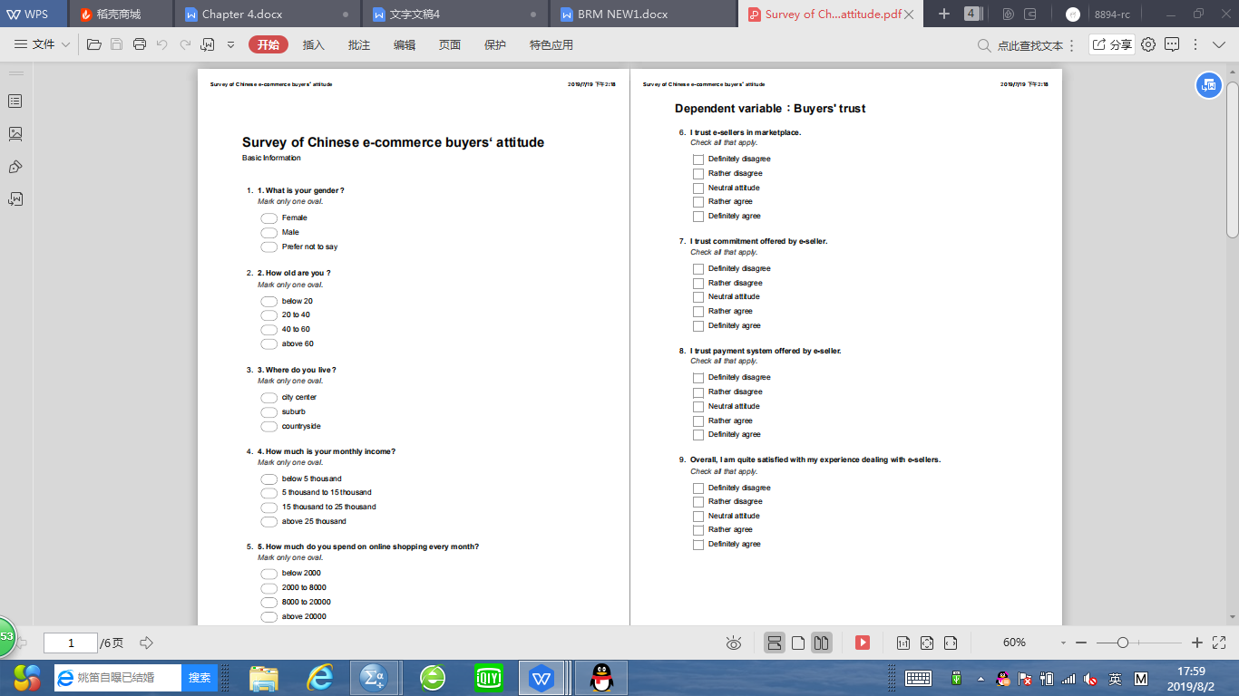



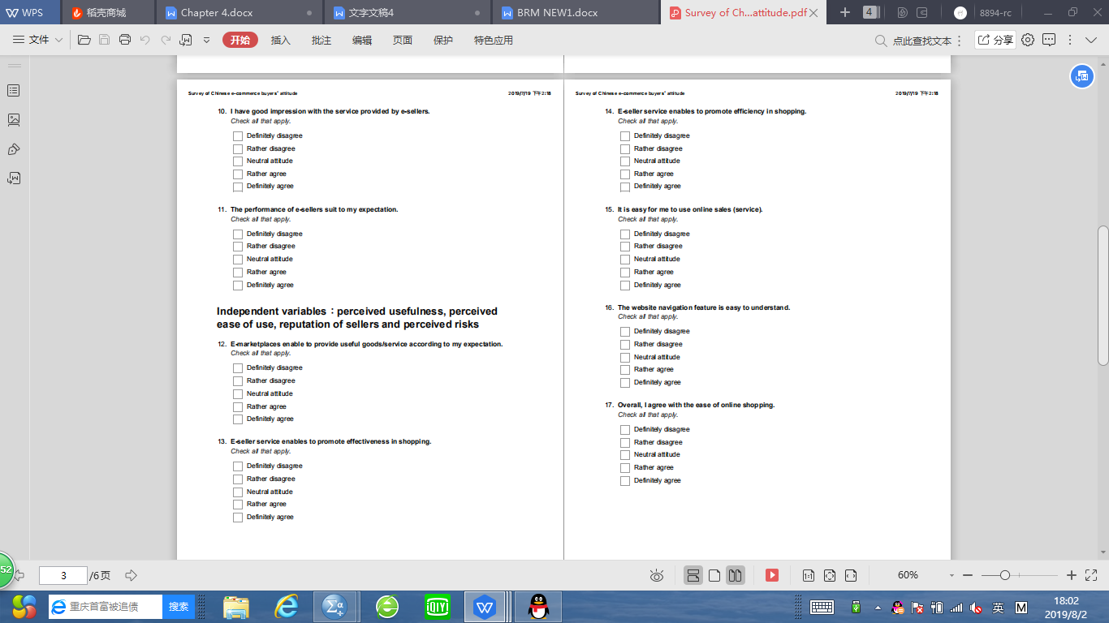



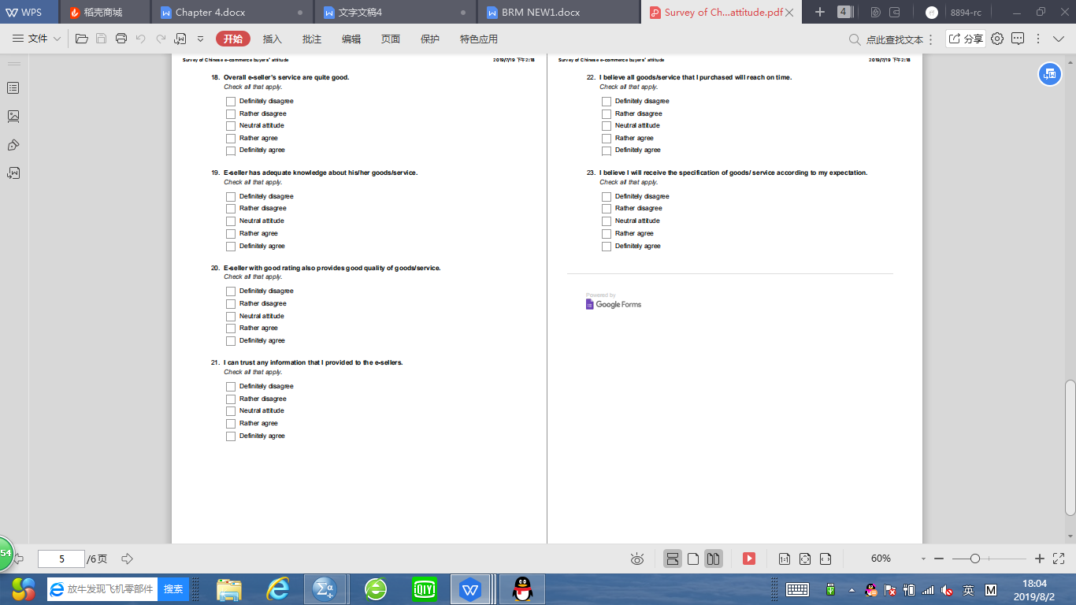



PILOT TEST Factor Analysis



PILOT TEST Reliability:

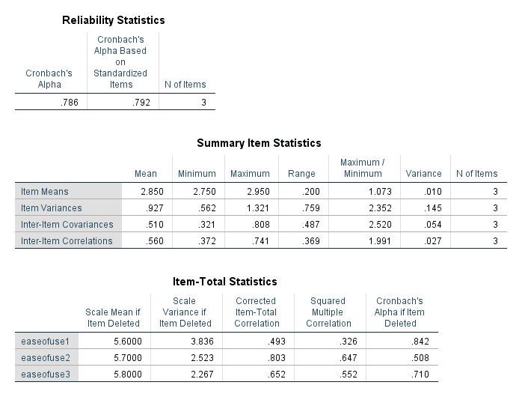

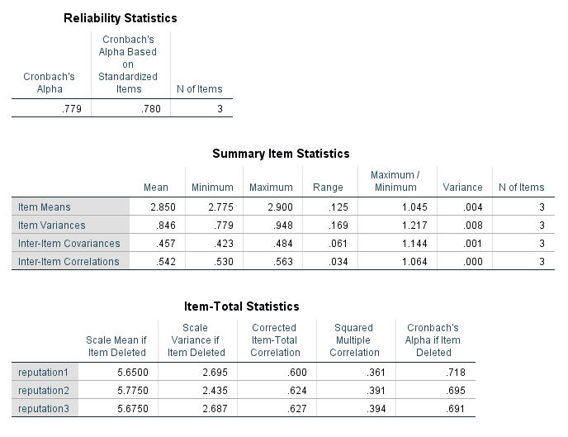

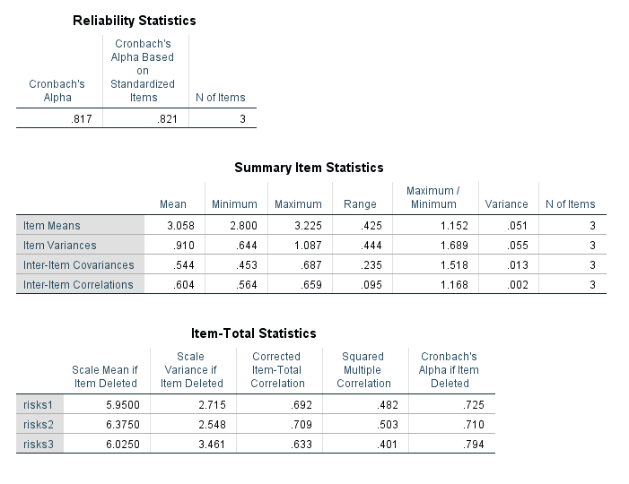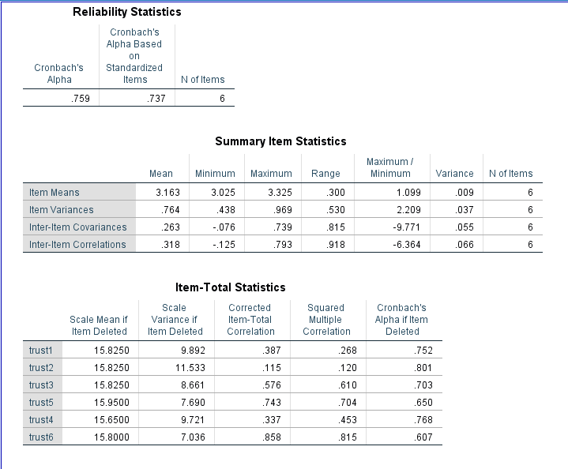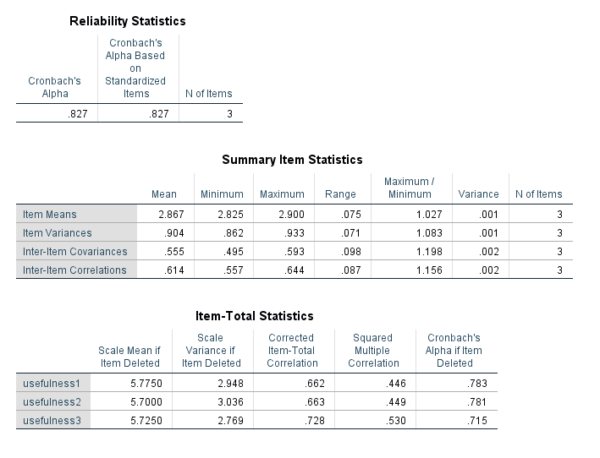

Factor Analysis: Preliminary Data Analysis

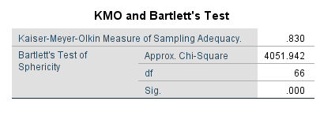

Reliability : Preliminary Data Analysis

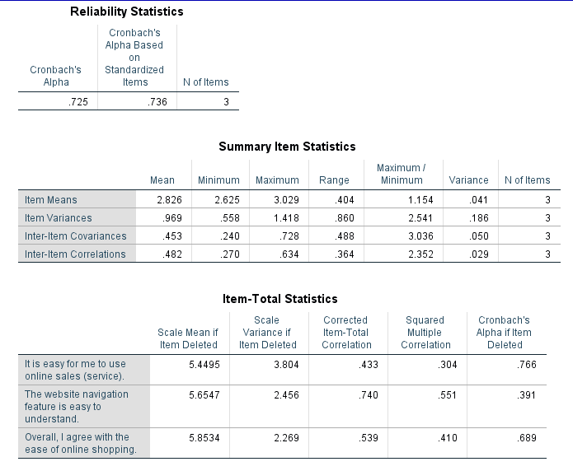

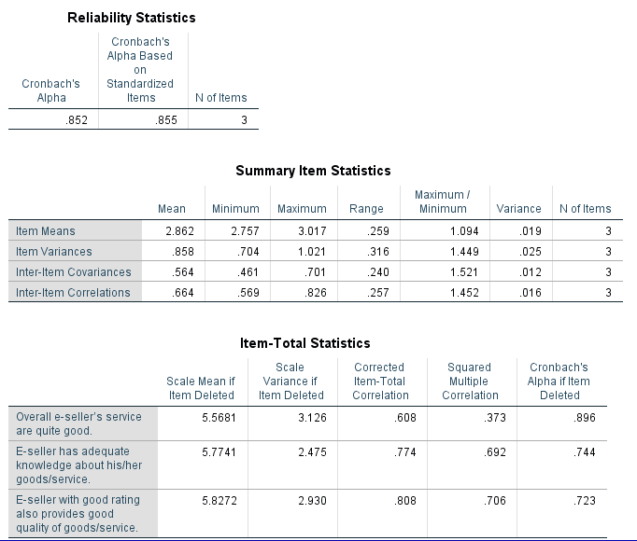

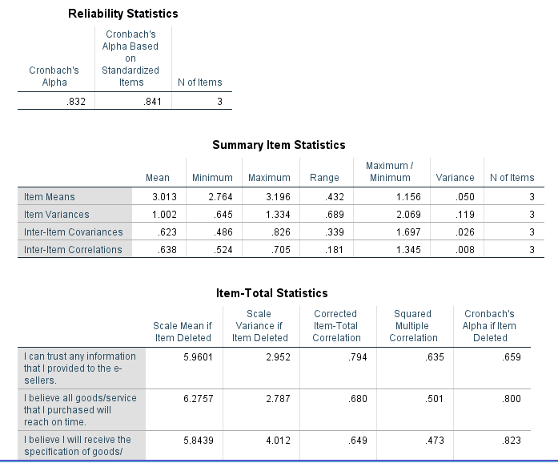

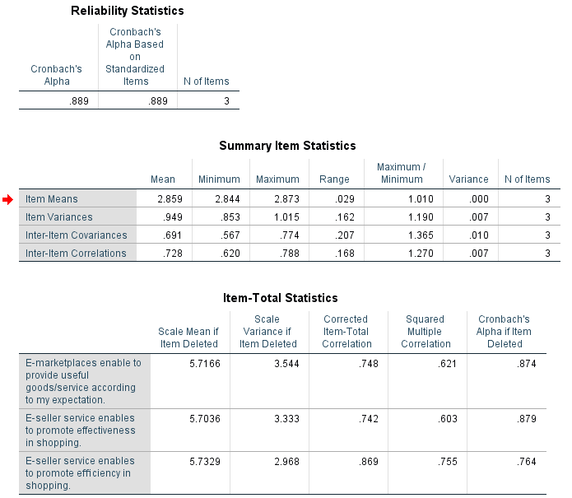

Correlation analysis:

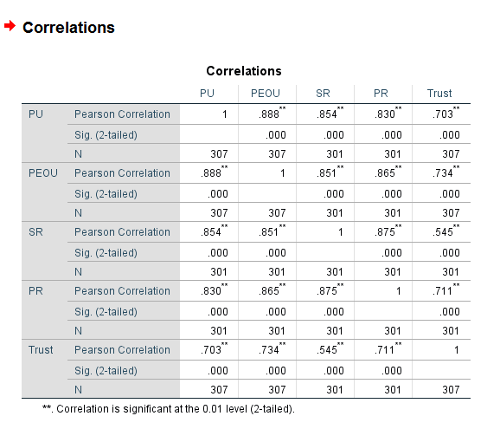

Hypotheses testing:







