

MASTER OF BUSINESS ADMINISTRATION

Factors Influencing New Energy Vehicle Purchase Intention: A study in China

Author: Wang Cheng
Student No: I17013959
Supervisor: Dr Syriac Nellikunnel Devasia
Co-supervisor: Dr Revathi Sagadavan
Submission Date: 22nd August, 2019
Ethics Number: cBUS/PGT/CP/04250
Final Word Count: 12423

Faculty of Business, Communication & Law

DECLARATION BY CANDIDATE

I hereby declare that this thesis is my own work and effort and that it has not been submitted anywhere for any award. Where other sources of information have been used, they have been duly acknowledged.

Author: Wang Cheng
Student No: I17013959
Signature: Wang Cheng
Date: 22nd August, 2019

ACKNOWLEDGEEMNT

For me, the first thing to say is thanks. Thanks to Dr. Syriac for guiding me on my thesis. When I encountered problems that I didn’t understand, Dr. Syriac would patiently explain to me and be responsible. At the same time, I would also like to thank my Co-supervisor, Dr.Revathei, for his guidance and improvement in my data analysis. Ms. Kumarashvari was my second supervisor. After first defense and final project presentation, her comments had helped me a lot.
At the same time, after a few months of writing a thesis, my own improvement is also very big. For example, if you have to do things with planning and patience, you need to actively solve problems and not complain. In general, in the future, when I think about this experience, it will be a valuable asset.

ABSTRACT

There are more and more people who have cars, at the same time of rising automobile usage, energy problem and environmental problems have also emerged, and the new energy vehicles has unique advantages in energy saving and environmental protection, make it become a new direction in the field of automobile, topic is more and more hot, it will be the opportunity to develop the automobile industry in China. In recent years, the government has launched a series of policies to develop new energy vehicles. The effect is obvious, the sales of new energy vehicles have been steadily improved. However, this trend of surging sales is mostly due to the support of government policies and the publicity of enterprises. Once the policy support is not enough, sales problems may appear. Therefore, in order to make the new energy automobile industry achieve sustainable development, this paper will explore other influencing factors from the perspective of customer perceived value.

According to consumer perception theory, consumers' sense of value to products is an important leading factor affecting consumers' purchase intention. This paper takes customer perceived value as an entry point to discuss the influence of price value, quality value, emotional value and social value on purchase intention of new energy vehicles. Firstly, relevant literature was studied, and the theoretical framework of the research was established on this basis. Then, relevant data were collected through questionnaire survey, and spss22.0 was used to analyze the data, so as to verify the proposed research model and hypothesis.

Based on the consumer point of view, this paper analyzes the customer perceived value to the influence of new energy vehicles purchase intention and consumers at this stage the overall cognition of new energy vehicles, the research conclusion is helpful to further implement the better in the future government policy, at the same time, for the enterprise, can according to consumer preferences to grasp the design of the new energy vehicles, production and sales, in order to promote consumer purchasing desire of new energy vehicles. Finally, according to the research results, some suggestions are given.

Key Words: New Energy Vehicles; Customer Perceived Value; Customer Purchase Intention

TABLE OF CONTENTS
CHAPTER 1: INTRODUCTION 1
1.1 Background 1
1.2 Statement of problem 2
1.3 Research objectives 4
1.4 Research questions 5
1.5 Significance of research 6
1.5.1 Theoretical significance 6
1.5.2 Practical significance 6
1.6 Limitation of the study 7
1.6.1 Limitations of the research object 7
1.6.2 Limitations of data collection 7
1.7 Scope of the study 8
1.8 Ethical considerations 8
Chapter summary 8
CHAPTER 2: LITERATURE REVIEW 9
2.1 The global development trend of NEV 9
2.2 The Chinese development trend of NEV 10
2.3 Analysis of purchase intention of NEV 13
2.3.1 The concept of purchase intention 13
2.3.2 Theoretical basis of purchase intention research 13
2.3.3 Purchase intention of NEV 16
2.4 Analysis of customer perceived value of new energy vehicles 18
2.4.1 The concept of customer perceived value 18
2.4.2 Research on the dimension model of customer perceived value 19
2.4.3 Customer perceived value of new energy vehicles 20
2.5 Framework design 26
Chapter summary 27
CHAPTER 3: RESEARCH METHODOLOGY 29
3.1 Research design 29
3.2 Questionnaire design 30
3.3 Measuring Instrument 32
3.4 Research object and sample analysis 32
3.5 Data collection 33
3.6 Analysis methods 34
3.6.1 Descriptive analysis 34
3.6.2 Validity test 34
3.6.3 Reliability test 35
3.6.4 Correlation analysis 35
3.6.5 Regression analysis 36
3.7 Summary of analysis method 36
Chapter summary 37
CHAPTER 4：DATA ANALYSIS AND HYPOTHESIS TESTING 38
4.1 Descriptive analysis 38
4.1.1 Statistical analysis of sample characteristics 38
4.1.2 Consumers' Cognitive Analysis of NEV 39
4.2 Preliminary data analysis 45
4.2.1 Reliability test 45
4.2.2 Validity test 45
4.3 Correlation analysis 47
4.4 Regression analysis 48
Chapter summary 50
CHAPTER 5: CONCLUSION 51
5.1 Research conclusions and analysis 51
5.2 Contribution to the literature 53
5.3 Contribution to the industry 53
5.4 Limitations of the research 54
5.5 Strategic suggestions 54
5.5.1 From the perspective of quality value 55
5.5.2 From the perspective of price 56
5.5.3 From the perspective of emotional value 56
5.6 Personal reflection 58
Chapter summary 58
REFERENCES 59
APPENDICES 73
Appendix 1: Questionnaire 73
Appendix 2: SPSS Output for Data Analysis 76
Appendix 3: Initial Research Paper Proposal 88
Appendix 4: Ethics Form 95
Appendix 5: MBA Project Log 97
Appendix 6: Turnitin Result 104

LIST OF TABLES

Table 2-1 The interpretation of CPV……………………………………………...16
Table 2-2 Sweeney's division and definition of customer perceived value dimension……………………………………………………………….20
Table 3-1 Summary table of Questionnaire……………………………………..31
Table 3-2 Summary table of analysis method…………………………………...36
Table 4-1 Descriptive statistics of valid samples………………………………..38
Table 4-2 Reasons for consumers to buy new energy vehicles……………....42
Table 4-3 Ways for consumers to get information on new energy vehicles…43
Table 4-4 Consumers' perception of new energy car brands…………………44
Table 4-5 Reliability Test…………………………………………………………..45
Table 4-6 Summary of results of independent variable factor analysis……...46
Table 4-7 Correlations between independent variables and dependent variables………………………………………………………………...47
Table 4-8 Summary of multiple linear regression analysis……………………49
Table 4-9 Summary of key findings……………………………………………...50

LIST OF FIGURES

Figure 1-1 China's crude oil dependence on foreign countries………………..3
Figure 1-2 Sales of NEV in China from 2014 to 2019………………………......4
Figure 2-1 Theory of planned behavior………………………………………….18
Figure 2-2 Conceptual research framework……………………………………..27
Figure 4-1 Consumer familiarity with NEV………………………………………40
Figure 4-2 Consumers' choice of NEV types……………………………………41
Figure 4-3 Problems with conventional energy vehicles………………………42

List of abbreviations

Abbreviations | Full name
KMO | Kaiser-Meyer-Olkin
CPV | Customer perceived value
NEV | New energy vehicle

CHAPTER 1: INTRODUCTION

1.1 Background
At present, the world is facing two major problems, one is energy, the other is ecological environment. This is closely related to everyone's survival and health. Of course, China also faces these problems. In fact, these two problems are particularly serious in China, mainly due to its large population, which leads to energy consumption and environmental damage. In this case, China's NEV industry has been rapidly developed. The advantages of NEV are obvious, which can not only save the consumption of conventional energy, but also benefit the environment. Therefore, the rapid development of this industry fully conforms to China's requirements of building an environment-friendly society and a resource-conserving society (Yang and Li, 2013). In the auto market, consumers have a preliminary understanding on NEV. But marketing new energy vehicles is complicated and time-consuming, because the policy support is only on the one hand, the most important thing is to understand whether consumers like it (Wang, 2016). Therefore, from the perspective of individual buyers, it is very crucial to research factors influencing NEV purchase intention.

Most scholars discuss NEV from the perspective of government industrial policy, technology and management. From the perspective of consumers, this paper deeply explores consumer demand to meet consumer demand and enhance consumers' willingness to purchase. Through summarizing the research findings, the impact of new energy vehicle purchases will be divided into two major factors: product factors and consumer factors: (1) product factors such as brand awareness, product attributes, product prices, product quality and so on. (2) Consumer factors: such as environmental attitudes, values, cognitive effects, environmental knowledge, social norms, lifestyles, and demographic factors. The customer perception value theory combines product and consumer factors, and research on customer purchase intention has become an independent research field. Hence, this paper studies the influence of CPV on the purchase intention of NEV, draws relevant research conclusions, and applies them to the marketing strategy of new energy vehicles, which has a significant practical impact on the long-term development of NEV in the future.

1.2 Statement of problem
At present, due to rapid economic growth, science and technology have ushered in the golden stage of development. While improving the living environment and the quality of life, people are also increasingly suffering from environmental pollution and excessive energy consumption. From Figure 1-1, since China's crude oil industry has exceeded 50% in foreign countries in 2009, it has reached 65.4% in 2016, and there are short-term energy sources. In the future, this problem may have an adverse impact on the progress of automobile industry in China

Figure 1-1: China's crude oil dependence on foreign countries
unit: %
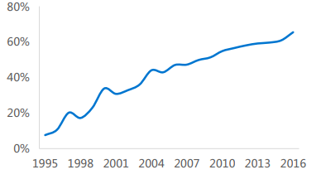
Data source: CNPC Economic and Technological Research Institute in 2017

In 2018, the total sales volume of automobiles in China was 28.081 million. Although the sales volume was very high, it was 2.8% lower than that of 2017. However, data show that sales of new energy vehicles are still showing a steady growth trend. In 2018, 1.256 million new energy vehicles were sold, up 61.7% from 2017. On the basis of figure 1-2, from 2014 to 2018, sales of new energy vehicles have maintained steady growth, especially from 2017, there was a sharp increase. Meanwhile, the forecast sales volume of 2019 is also given in the figure, which indicates that the new energy vehicle market will enter a golden period of development.

Figure 1-2: Sales of NEV in China from 2014 to 2019
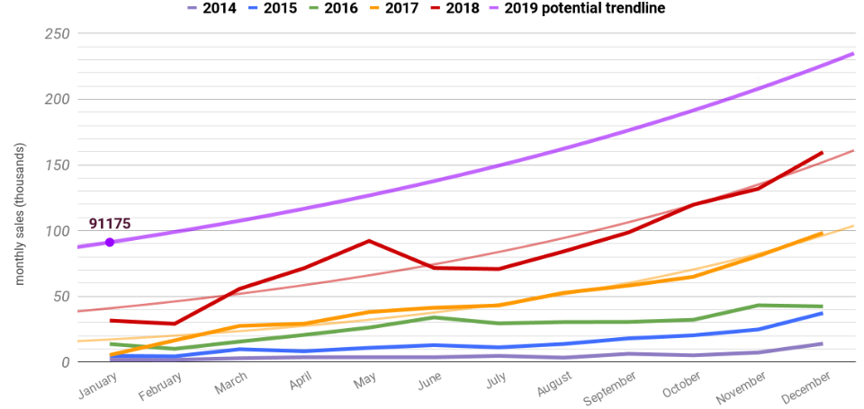
Passengers vehicles only( exclude commercial vehicles)，numbers in thousands( data source: CPCA)

Combined with figure 1-1 and figure 1-2, in order to reduce reliance on traditional energy, new energy automobile market has been rapid development, obviously, there is a reason for this development, on the one hand, the environmental protection consciousness of people had to ascend, the implementation of government policy, this is a common factor. On the other hand, may be related to the characteristics of new energy vehicles itself, as well as the consumer's attitude toward new energy vehicles unique about exactly which factors make more and more consumers want to buy new energy vehicles. Therefore, in order to study the reasons for the rapid development of new energy vehicles, this paper will study the influence of CPV on their purchase intention from the perspective of consumers.

1.3 Research objectives
According to (Ulaga and Chacour, 2016), when consumers decide whether to buy a commodity, they will be influenced by a lot of factors, and their perceived value of products is an important prerequisite for purchase. Therefore, based on CPV consists of price, emotion, social, and emotional value. The relationship between these four values and the willingness to purchase is studied. In order to study the intrinsic relationship between these factors and the willingness to purchase, there are a total of four research goals:

RO1: To study the influence of quality value on purchase intention of NEV.

RO2: To study the influence of price value on purchase intention of NEV.

RO3: To study the influence of emotional value on purchase intention of NEV.

RO4: To study the influence of social value on purchase intention of NEV.

1.4 Research questions
The main concerned questions for this research will be as following:

- Is there any relationship between quality value and purchase intention of NEV.

- Is there any relationship between price value and purchase intention of NEV.

- Is there any relationship between emotional value and purchase intention of NEV.

- Is there any relationship between social value and purchase intention of NEV.

1.5 Significance of research

1.5.1 Theoretical significance
(1) Enriched the relevant theory of NEV
In the past, the research on new energy vehicles is mainly from the technical level, and this research is a completely new perspective, that is, from the perspective of consumers themselves. The richness of this theory is to better adapt to the current development of new energy vehicles and provide more theoretical support for the research of new energy vehicles.

(2) This paper enriches the theory of CPV
New energy vehicles, as a new green travel tool, have a new feeling when consumers are first exposed. In the later discussion, the paper deepens the theoretical study of CPV in the field of NEV. Specifically, the specific data analysis is done through the composition of dimensions.

1.5.2 Practical significance
(1) Research on NEV based on the perceived value of consumers is helpful for enterprises and governments to establish the consumer-oriented concept. Focus on improving product quality, price, emotional and social value perception. In this way, More people will be interested in new energy vehicles, which will help increase car sales, such as the currently popular hybrid, pure electric cars. The increase in sales volume will also lead to the upgrading of technology, which will lead to the comprehensive development of the industry (Kley, Lerch and Dallinger, 2016).

(2) Provide reference for enterprises and governments to formulate relevant promotion strategies.
Through the analysis of this study, since each value is made up of a variety of factors, the results of the study allow us to know what factors affect consumers 'willingness to buy. The significance of this to the enterprise is that the enterprise can formulate a suitable market strategy based on some reliable conclusions. At the same time, the government can better play its own regulatory role and implement more clear strategies to promote the development of the market and technological progress.

1.6 Limitation of the study

1.6.1 Limitations of the research object
Due to the practical orientation from the perspective of consumers, this paper does not analyze and study the uncontrollable factors such as economic globalization, trade liberalization, politics and job opportunities in the national and global consumption environment. The effects of these existing factors cannot be ignored, and they all have an impact on the willingness to purchase. In future studies, these existing factors can also be added into the research model, so as to improve and expand the model.

1.6.2 Limitations of data collection
In terms of data sources, the limitations of data volume and the categories of respondents will all have an impact on the final results. Because research is limited, in this study, the population involved is relatively small. Hence, the research conclusions of this paper may only be applicable to the respondents of this survey, and the extensive application of the research results needs to be further studied.

1.7 Scope of the study
This article mainly discusses what factors can influence consumers' willingness to purchase, and the consumer market is in China. The specific research content involves the relationship between consumer perceived value and consumers' purchase intention. Affected by research methods, the research mainly involves different age groups, occupations, degree, occupations and education levels. On the basis of collecting their opinions on new energy vehicles through questionnaires, empirical research is conducted.

1.8 Ethical considerations
In the research process of this paper, I strictly follow the ethics of academic research. Respect the achievements of others in academic work and comply with the norms of academic papers. In academic research, when drawing on the knowledge of other scholars, it must be clearly pointed out. Eliminate plagiarism, forgery, disclosure and intentional distortion of others' academic views and other behaviors that violate academic norms and ethics. Meanwhile, I strictly follow the objective, fair and accurate principles in the process of research. On the basis of fully mastering the academic materials, this paper makes a comprehensive analysis, evaluation and argumentation.

Chapter summary
This chapter is the first chapter of the thesis. The main purpose is to familiarize with some basic information about the subject of the thesis. First of all, it introduces the background of the research of the paper. Due to environmental problems, the intensification of energy problems and the advancement of technology, new energy vehicles have developed rapidly in the Chinese market. At the same time, in response to this situation, the question of research is raised. What factors make consumers have a stronger willingness to purchase pure electric vehicles, hybrid electric vehicles, etc. Then, According to the statement of the problem, the objectives and problems that need to be studied in this paper are put forward. This is the important content of the first part, which has a guiding role for the empirical research below. In addition, a brief analysis of the significance, limitations and scope of the paper. Finally, a brief explanation of moral considerations was made. The above is the main content of the first part.

CHAPTER 2: LITERATURE REVIEW

2.1 The global development trend of NEV
The US Energy Foundation (2006) launched a research program to promote hybrid vehicle R&D and industrialization policies, and evaluated and summarized the industrial policies for promoting hybrid vehicles in American. Meanwhile, it analyzes what policy support is needed in the future development of the US electric vehicle industrialization. (Hasishi Ishitani, 2007) combined with the development strategy research and policy system analysis of Japan's future new energy vehicles, He believes that the process of NEV cannot be separated from the support of the whole society. This potentially indicates the importance of the consumer.

From November 2015 to May 2016, (Deloitte Global Manufacturing Group, 2016) surveyed 12,000 consumers in 17 countries around the world to learn about electric vehicles in their eyes. According to the survey results, the six key factors affecting the willingness of respondents to purchase electric vehicles include: the longest mileage traveled, the required charging time, the price of the car, the power, the price of the charge, and the price difference from the traditional car.

From the actual case analysis, (Rezvani and Bengtsson, 2018) explores the factors affecting consumers' purchase of NEV, and concluded that the five driving factors mainly include automobile quality factor, consumption factor, after-sales service factor and purchase cost factor.

(Qian, Grisolía and Soopramanien, 2019) based on government policies, He pointed out the obstacles encountered by NEV in entering the market. To break through these barriers, the government needs to guide consumers, supplemented by supporting automobile manufacturers, and constantly add fuel to the new energy car industry.

2.2 The Chinese development trend of NEV
(Yuan and Zuo, 2015) conducted an in-depth study on the overall strategy and policy system of Japan's future progress of NEV. He proposed a up-to-date energy vehicle progress system that requires the participation of the whole society.

From the perspective of management, (Yunna and Yisheng, 2014) applied the "five forces model" to explain the market advantages of the new energy automobile industry. As a result, the market advantages of NEV are slightly inadequate. Accordingly, he put forward the feasible proposal of industry initial stage.

(Wang and Mogi, 2017) Based on the technical and economic significance of NEV, He pointed out that the automotive market will transform from traditional energy (oil) to hybrid energy and electricity, and market competition will become fierce. New energy vehicle industry technology chain has a strong technical effect, affecting the further development and improvement of the industrial chain.

In China, the technical route of NEV has experienced four stages of development. (Yu and Xu, 2019). From 2003 to 2005, In the long-term science and technology plan, the state has formulated an energy-saving and environmentally-friendly vehicle strategy (low-energy NEV strategy); From 2009-2012, Science and technology department and the development plan of the Industry and information sector has established a "pure electric drive" technology transformation strategy; In 2014, the progress of NEV has been valued by the state, developing a development strategy for NEV in China. In November 2018: In the political consultation meeting, some members suggested to quickly study and develop the development plan for new energy vehicles by 2035. In addition, there is a need to clearly define the sales restrictions for fuel vehicles by category and region, close industrial development expectations, and initiate a new round of strategic discussions.
At present, NEV has entered a period of rapid development, whether it is government support, the active promotion of the new energy automobile industry itself, the enhancement of consumer environmental awareness, or the endless stream of promotional activities by manufacturers(Xu and Lin, 2018). Both have greatly promoted the development of NEV. However, there are still some improvements in the development of NEV, such as unaffordable technology development costs and insufficient investment in some scientific research (Zhang and Wang, 2019). Although the Chinese government’s capital investment has gradually increased, there are still many important technologies that are not mastered, and there is no technology to master core components, and research and development efforts are not great (Masiero and Risso, 2016). The technology, control technology and engine technology of the storage power of NEV batteries need to be further strengthened. Analyze from infrastructure construction, the supporting facilities for NEV are not very sound, and the construction of charging stations is slow. If you want to build a charging facility, you must solve both the huge funding problem and the shortage of land in some areas. These are facing great challenges and require the joint efforts of the government and enterprises (Wang and Ke, 2018).

With the support of the national policy, Shanghai, Guangzhou, Shenzhen, Beijing, Tianjin and other places have also formulated corresponding policies on the progress of NEV (Fan and Feng, 2017). A large number of preferential support policies have also been introduced in succession, including the implementation of parking fee reduction and charging fee concessions; for example, the number of licenses auction, the implementation of limited number driving in some areas, car quotas and other measures, in September 2014, the purchase tax of NEV was also cancelled (Zhang and Bai, 2017). In some places, if consumers buy pure electric vehicles, they can also enjoy double subsidies from the state and the local. In some places, even subsidies are as high as nearly 100,000 yuan (Helveston, 2019). Not only the high subsidies, but also the trouble of shaking the number. NEV are one of the highly supported industries in the country, are constantly developing, and various subsidies and preferential policies have become catalysts for their rapid popularization (Tan, 2018).

2.3 Analysis of purchase intention of NEV

2.3.1 The concept of purchase intention
Psychology is the earliest research field involving purchase intention. As behavioral science becomes the main target of research, the desire to purchase will serve as a study of consumer purchasing decisions, which refers to the probability that consumers actively want to buy a certain goods or services (Javornik, 2016)

(Budiman and Wijaya, 2014) believes the purchase intention is to refer to the generation of a subjective idea of the consumer, for example, a perception of a good or a service, and a change in the likelihood of a perception of the good or service after being interfered with by external factors. He believes that the willingness to purchase is not an objective existence, but a subjective cognition.

(Teng and Wang, 2015) believed that the purchase intention reflects both the consumer's goodwill for a product and the likelihood that the consumer has the possibility to purchase it. In fact, this situation stems from the subjective consciousness of consumers.

(Paul, 2016) interpret consumer purchase intention as a subjective probability, based on products, can be used to predict people's purchase behavior.

2.3.2 Theoretical basis of purchase intention research
(1) Research on purchasing intention based on consumer attitude
(Singh and Gupta, 2013) shows that when consumers have a certain kind of environmentally friendly behavior, the relationship between consumers' environmental attitudes and behaviors will be greater.

(Lee and Yun, 2015) found that consumers’ attitudes are closely linked to their willingness to buy green food. When consumers are more favorable to green foods, they are more willing to buy them.

(Biswas, 2016) studied the willingness of consumers in developing countries to buy green products. Consumers' environmental attitudes have a positive impact on purchasing green products.

(Obayelu, Arowolo and Poji, 2018) research on willingness to buy safe food has found that when consumers are more aware of their own attitudes toward safe green products, they will have a clearer intention to buy.

(2) Research on purchasing intention based on maximizing perceived value
(Wu and Chen, 2014) believed that when a consumer buys a product or enjoys a service, the higher the perceived value of the consumer, the more they desire the item or the service, and may choose again.

(Vera, 2015) studied customers' choice of specific online stores, using the concept of purchase intention instead of customer choice, found that there is a positive correlation between CPV and purchase intention.

(Pappas, 2016) research results show that consumers' perception of product risks and benefits will affect customers' perceived value and ultimately affect consumers' purchasing behavior. The relationship between purchase intention and perceived value is very close. That is, when the perceived value of the consumer is rising, the willingness to purchase will become stronger.

(Nellikunnel, 2017) explored the link between the origin of the product and the propensity to buy, and clearly pointing out that consumers are biased towards products from the country of origin, because in their eyes, products of origin have higher quality and they are more willing to buy.

(3) Study purchase intention from the perspective of planning behavior theory
On the basis of the social psychology research, (Ajzen & Fishbein, 1975) introduced the theory of planned behavior. This theory can be used to explain the general decision-making process of consumer behavior, providing a classical theoretical research framework for studying the factors affecting consumers' willingness to act and the link between behavioral willingness and consumer behavior. (Ajzen, 2015) assumed that the three variables of subjective norms, behavioral attitudes, and perceptual behavioral control would have an impact on consumer behavioral intention. If consumers behave differently, these three factors will have different effects on consumers' willingness to act. The theory also reveals that consumers' willingness to act is the direct cause of consumers' actual behavior. As shown in figure 2-1

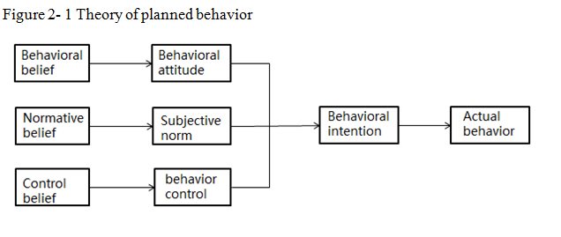
In general, the theory is applied to different fields, which can predict the individual's willingness to act. Scholars introduce different variable factors according to different research objects. While verifying the influence of three factors of planning behavior theory on purchasing intention, they also enrich the theory of planned behavior.

2.3.3 Purchase intention of NEV
From the analysis above, consumers' purchase intention is closely related to the properties of products and their attitudes towards products. The research finds that green products will stimulate consumers' purchase intention. Since the progress of NEV conforms to the category of green products, there is an interactive relationship between NEV and consumers' purchase intention to some extent (Junish R and Archana L, 2015). There are four different situations of consumers' purchase intention on NEV, namely, consumers will consider buying, consumers are completely willing to buy, consumers will repeat buying and consumers will introduce this product to others. The following is a detailed analysis of these four situations.

(1) Consider buying NEV
Although the new energy vehicle market has made great progress, some people are still hesitant, they are considering buying new energy vehicles, but the answer is not clear (Zhao, 2017). The reason is that many consumers don’t know enough about NEV (Molin and van Wee, 2016). When buy, they will consider many factors, for example, they think of the price of pure electric vehicles and maintenance cost and so on economy, at the same time, the plug-in hybrid car more consumers from the product attributes, such as range, product safety, reliability, etc., comparing with pure electric vehicles, finally to make a choice.

(2) Willing to buy NEV
Based on the poll, 86 percent of Chinese consumers "fully agree" or "partially agree" that NEV will replace internal combustion engines in the current Chinese market (Zhang and Wang, 2019). Meanwhile, 95 percent said they are fully or partially willing to buy NEV. This kind of consumer makes this kind of choice mainly is influenced by many factors. To be specific, first of all, NEV are environmentally friendly. As environmental and energy issues intensify and Chinese consumers become more environmentally conscious, many will turn to new energy vehicles when buying a family car (Song, 2019). Then, new-energy cars can save fuel, for example, hybrid cars. Finally, affected by government policies, consumers will have government subsidies and free license plates when buying new energy vehicles. Especially in some big cities, such as Beijing and Shanghai, the license plates of traditional energy vehicles are difficult to obtain and expensive, so many people choose new energy vehicles with free license plates.

(3) Purchase NEV repeatedly
Some people will choose to buy NEV repeatedly. On the one aspect, it may be because of the needs of families, one car cannot meet the travel demand. On the other aspect, it is mainly influenced by the post-use experience of the first NEV (Perkins and Murmann, 2018). These people believe that NEV have a good driving experience (Lin and Wu, 2018). For example, compared with traditional cars, they are more comfortable to drive, with high safety and few faults. Therefore, after driving a new car for a period of time, consumers will consider to buy another one as their own or their families' needs.

(4) Willing to introduce new energy vehicles to others
People are willing to introduce NEV to others, partly because of the positive feedback after user experience (Bennett and Vijaygopal, 2018). The survey found that some consumers believe that driving luxury electric cars will make a good impression and be appreciated by others. These consumers are influenced by the mood of the supervisor. After receiving praise, they will take the initiative to recommend the car brand and perfect driving experience to others, which is also the so-called word-of-mouth effect.

2.4 Analysis of customer perceived value of new energy vehicles

2.4.1 The concept of customer perceived value
Through research, scholars have different opinions on the interpretation of CPV, as we can see in table 2-1.

Table 2- 1 The interpretation of CPV
Scholars | Definition of CPV
(Walsh, Shu and Hassan, 2014) | CPV is a consumer's perception of the goods or services before they are enjoyed. This feeling includes the functional attributes of the goods or the superiority or inferiority of the services.
(Rasheed and Abadi, 2014) | CPV is a comparison between the value a customer expects from a good or service and the actual value
(Long, 2015) | CPV is the external motivation for organizations to change, and companies can only succeed if they grasp the changes in customer value.
(Makanyeza, 2015)) | CPV is the subjective evaluation of consumers before purchasing a commodity or enjoying a service.
(Senbabaoglu, 2017) | CPV is derived from merchants' evaluation of a certain commodity or service
(Cheng, 2018) | CPV is the perception and assessment of the customer's influence on the existence of the product of the enterprise and the extent to which the change is compatible with the customer's needs.
Source: According to the literature

2.4.2 Research on the dimension model of customer perceived value
(Sweeney, 2001) thinks that the dimensionality model of customer Perceived value not only considers the price and quality of goods, but also considers whether there are social and emotional factors in the needs of products. The perceptive value model can help us construct the scale and contribute to the empirical research. The meanings of each dimension are shown in table 2-2.

Table 2- 2 Sweeney's division and definition of customer perceived value dimension
Dimension | Definition
Quality value | The utility that a customer derives from the comparison between the quality of a service or product and its expectations
Price value | The utility of a cost reduction felt by customers in the short or long term
Emotional value | The utility that the customer obtains when consuming, specific have feeling or emotive state
Social value | Products or services can enhance the utility of customers' social self-concept

2.4.3 Customer perceived value of new energy vehicles
Through the above theoretical analysis of perceived value, it can be concluded that customer perceived value can be divided into four points: quality value, price value, emotional value and social value. The following four values ​​will be combined with NEV to analyze the specific factors involved in each value and how these factors affect consumers' willingness to buy.

(1) Quality value affecting the purchase intention of NEV

High safety factor
The high safety factor here mainly includes two sides, one is the safety of battery, the other is the safety of driving technology. On the one hand, in the early stage of the progress of NEV, electric vehicle manufacturers continue to increase the use of batteries in pursuit of high range, which also increases the safety risk (Feng and He, 2018). Therefore, the progress of NEV is in urgent need of new and safer batteries. In recent years, due to technological progress and the application of lithium titanate batteries, along with the expansion of the market scale of charging piles, the unification of rapid charging and high safety has been realized (Lin and Wu, 2018). On the other hand, due to the application of automatic cruise driving technology in NEV, it also increases the safety of drivers.

Strong endurance
(Liu guofeng, 2019) believes that in addition to technological innovation, innovative business models are also important for the new energy automobile industry. Users used to buy their own batteries and charge them themselves, which was expensive and unsafe, but now there is a new model of Shared battery leasing. China tower has set up battery replacement businesses and built smart electrical changing stations in 100 cities. Users only need to scan code at the electrical changing station to exchange a fully charged battery and realize unlimited battery life, which is the new power to develop the progress of NEV.

High quality parts
Along with the pressure of energy and environment, the NEV represents the mainstream direction of the development of automobile industry in the future (Chapman and Itaoka, 2018). In order to seize market resources, automobile companies are investing more and more in the field of NEV technology, which means that high-quality automobile parts have become the main investment target. The improvement of battery technology, higher safety and endurance. Car Internet intelligent operating system applications, many functions only through the screen can complete the operation.

Strong power performance
Consumers often compare the performance of NEV with that of conventional energy vehicles in terms of power (Adlard, 2018). Many people believe that most of the NEV on the market rely on electric power and hybrid vehicles, and these vehicles will have poor power performance. However, this is not the case. Most NEV in the market rely on automobile manufacturers with mature technologies, for instance, the tesla, Volkswagen and other famous brands. Therefore, relying on mature technologies, NEV also have strong power performance.

The key factor for consumers to purchase is product quality (Feldmann and Hamm, 2015). The perception of quality value they bring to consumers will directly affect their purchase intention. Hence, hypothesis 1 is the following.

H1: Quality value has a significant influence on the purchase intention of NEV

(2) Price value affecting the purchase intention of NEV

Reduction of oil consumption
The fuel consumption reduction mainly refers to two aspects. On the one aspect, due to the introduction of HEV, cars can not only rely on traditional energy as power, but also make electric power as power (Xiong and Cao, 2018). This directly reduces the cost of car fuel consumption. Electricity consumption has also increased, but overall costs have fallen. On the other hand, as more people choose all-electric cars, the overall demand for gasoline will decrease (Stolaroff, 2018). Consumers are also indirectly spending less on petrol.

Government subsidies
In the current Chinese market, consumers' purchase of new energy vehicles is greatly influenced by government policies (Gu and Zhang, 2019). In order to encourage people to green consumption, the government adopts the most financial subsidies to consumers and enterprises of new energy vehicles through economic policies. The government's policies are mainly reflected in the following three aspects: first, accelerate the establishment of supporting facilities for charging stations; But to strengthen the strongest subsidies for NEV; Third, tax exemption (such as toll-free) policy. The implementation of these policies has directly formed the price advantage of new energy vehicles and strengthened consumers' purchasing intention.
Value in line with price
Whether the price of goods is equal to its value is the key factor influencing consumers' purchase (Bittar, 2018). In China's auto market, the reason for the popularity of NEV is that they provide prices that match the value. No matter the low or medium price brands, such as Volkswagen. Or high-priced brands like tesla. NEV from these car manufacturers are always able to meet consumer requirements in function and appearance, and have a clear market price positioning.

The meaning of price value is the effect of the cost reduction experienced by the customer in a short time or a long time. NEV can save on the fuel costs of using conventional energy vehicles, and purchase new energy vehicles will also get relevant preferential policies, in the long time, the employ of NEV can bring customers lower costs, and get the price of its value. Hence, hypothesis 2 is the following.

H2: Price value has a significant influence on the purchase intention of NEV

(3) Emotional value affecting the purchase intention of NEV

Comfortable driving experience
Pure electric vehicles and hybrids because joined the power battery, car driving up overall stability is much better than fuel vehicles, its driving experience is completely different from the fuel efficient class cars change, can remove noise greatly weakened, new energy pure electric and hybrid cars in the process of driving the smooth experience, is also one reason for the consumer to fall in love with it (Fraser, 2019). Meanwhile, some NEV because of the realization of touch-screen central control system, so that the driver to operate more convenient and simple.

Satisfactory appearance design
Compared with traditional cars, the appearance of NEV has undergone great changes. In general, the emerge of NEV looks more technological and has stronger ability to attract consumers' attention (Choi, 2017). Tesla, for example, as the bellwether of NEV, its unique design has become a major selling point, the eagle wing door is the most eye-catching design, the new Model X eagle wing door on the world famous sports car design, the most common application is seldom seen on SUV, the design of this breakthrough also attracted a large number of consumers.

Reassuring operational control
The operation and control of new energy vehicles are quite reassuring, which is mainly reflected in simple operation and control and autonomous driving technology (Sun, 2017). Due to the investment of advanced technology, compared with conventional energy vehicles, the operation of NEV becomes simpler and more convenient (Loeb and Kockelman, 2019). Nissan's single-pedal operating system, for example, is much more comfortable than the traditional dual-pedal operating system for gas-powered cars. At the same time, the innovation of autonomous driving technology is a milestone in the history of automobile development, which not only provides a new driving experience for drivers, but also provides a heavy guarantee for the safety of cars.

From the above analysis, the emotional value is mainly reflected in the comfortable driving experience, satisfactory appearance design and reassuring operation control. These factors may influence consumers' purchasing intentions on NEV. Hence, hypothesis 3 is the following.

H3: Emotional value has a significant influence on the purchase intention of NEV

(4) Social value affecting the purchase intention of NEV

Be more confident in social situations
Studies show that when consumers use excellent products in the public domain, they will feel more confident and eager to own the products all the time (Gu and Zhang, 2019). As a revolutionary product in the field of automobile, new energy vehicle is chosen by many people not only because of the fresh feeling brought by the product itself, but also because it is a new symbol in the field of automobile, enabling people to feel more confident in public places. On the one aspect, as the unique design of NEV, the appearance and interior are better than ordinary fuel energy vehicles. On the other aspect, driving new energy vehicles can make people feel more proud of their environmental awareness.

Earn more compliments
In today's economic society, products and services have been symbolized. As a symbol, new energy vehicles show consumers' concern for the environment and ecology, and express a positive and responsible attitude to the society (Shao and Ünal, 2019). Under this situation, people who driving new energy vehicles will definitely get more praise from others.

Make a good impression
As a consumer trend of green products, as a new symbol of the automotive industry, new energy vehicles not only reflect people's awareness of green consumption, but also a symbol of the quality and status of life and life(Ng and Law, 2018). Consumers will win the envy of their consumption and set a good example to make a good impression on others. When consumers are aware of this, it is clear that this will whet their desire to buy.

Based on the above analysis of social values, the employ of NEV can make them more confident, and they can also establish a good social image while being appreciated. Hence, hypothesis 4 is the following.

H4: Social value has a significant influence on the purchase intention of NEV

2.5 Framework design
Through analysis, we know that CPV is an important prerequisite for consumers to purchase (Abdullah, 2016). Learning based on relevant literature scholars, this paper takes the perspective of customer perceived value as the starting point, studies its effect on the willingness to purchase NEV and establishes a theoretical framework.

New energy vehicles are durable goods. Based on (Sweeney, 2001) dimension of perceived value of durable goods customers, this paper divides the independent variables into four dimensions: quality value, price value, emotional value and social value. The specific framework is constructed in the following figure 2-2.

Figure 2-2 Conceptual research framework
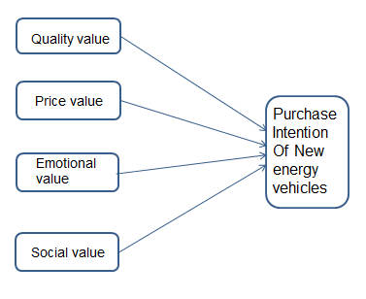

Chapter summary
Through the review of relevant literature on new energy vehicles, it can be found that most scholars focus on qualitative research on new energy vehicles, such as related policies, infrastructure and technological innovation. Research from a consumer perspective is rare. Based on the analysis of the development trend of new energy vehicles globally and in China, we find that the new energy vehicle industry has made rapid development, which is mainly due to the progress of technology, the promotion of national policies and the enhancement of consumers' environmental awareness. However, in the current Chinese market, the development of new energy vehicles will still face many problems.

Through the review of relevant literature on purchase intention, it is found that scholars will study the purchase intention of consumers from different perspectives, which are embodied in the customer attitude, the maximization of perceived value and the theory of planned behavior. Our traditional automobile consumption's results show that when consumer is buying a car, pay more attention to the car brings to the value of their own, so some characteristics of the automobile consumption, the research of new energy vehicles purchase intention, this article from the perspective of customer perceived value as the breakthrough point, study its effect on purchase intention of new energy vehicles.

According to different research objects, the dimensions of customer perceived value are also different. New-energy vehicles belong to the category of durable goods. The scale in this paper will adopt the dimensions divided by Sweeney's research on durable goods. The scale divides customer perceived value into quality value, price value, emotional value and social value. Based on the analysis of the relationship between these four values and purchase intention, this paper establishes research hypothesis and specific research framework.

CHAPTER 3: RESEARCH METHODOLOGY

3.1 Research design
Research design is the method and technical framework chosen by researchers to combine all parts of research in a reasonable and logical way so as to effectively deal with research problems. Does it provide insight into "how" to conduct research in a particular way (Lewis, 2015).

In general, research design can be divided into three categories: exploratory research, descriptive research and causal research (Angrist and Pathak, 2017). These three categories basically cover the entire research process and are necessary for research design. Next, we will analyze these three categories in detail.

First of all, exploratory research is the beginning of the whole research plan, which is to let researchers better understand the research topic, as well as the problems and objectives that researchers need to study in this topic. The results of the study are not involved here (Wilderom, 2017).

Then, descriptive research occupied most of the online survey, because of its quantitative nature, qualitative research is considered to be conclusive. Unlike exploratory research, descriptive research is planned in advance and structured in design, so the collected information can be statistically inferred according to the population (Colorafi and Evans, 2016).

Descriptive analysis is used to define the attitudes, views and behaviors of different groups of people towards the research topic (Sung and Kim, 2013). Since respondents choose from predefined categories, these questions will not bring unique insights into exploratory research. Instead, grouping the answers into predetermined options provides statistically inferable data. This allows you to measure the importance of your findings to the general population you study, as well as changes in the views, attitudes, and behaviors of your interviewees.

Finally, like descriptive research, causal research is quantitative in nature and pre-planned and structured in design. Therefore, it is also considered conclusive research (Scriven and Coryn, 2008). What makes causal research different is that it attempts to explain the causal relationship between variables.

In the research of this thesis, it mainly involves descriptive research and causal research. On the one hand, descriptive research mainly explains the basic information of the researcher, such as age, salary, occupation and so on. On the other hand, causal studies mainly explain the relationship between independent variables and dependent variables, specifically, the relationship between consumers' quality value, price value, emotional value, social value and purchase intention in new energy vehicles.

3.2 Questionnaire design
This article divides the questionnaire into three parts, the questionnaire survey is mainly measured by 5-point Likert scale. From 1 to 5, 1 point means strongly disagree, 2 points means less agree, 3 points means generally agree and 4 points means comparatively agree , 5 points means completely agree (Armstrong, 1987).

The design structure of the main body of the questionnaire is following:
The part A is a survey of the basic information of the population, involving gender, age, income and so on, and to analyze the significant differences in the impact of consumers of different demographic variables on the willingness to purchase new energy vehicles.

The part B is a survey of basic issues, in order to investigate consumers' overall perception of NEV at this stage, including: consumer understanding of NEV types of new energy vehicles, and consumers' familiarity with existing brands of new energy vehicles and car purchase methods, etc.

The part C is the main part of the questionnaire, which is divided into two aspects.
On the one hand, the consumer's perceived value is divided into four points, namely, quality value, price value, emotional value and social value. These four points constitute the independent variable. On the other hand, consumers' willingness to buy on new energy vehicles is taken as a dependent variable.

Table 3- 1 Summary Table of Questionnaire
Section | Variable | Source
A | Demographic  Profile | (Kurz, Li and Vine, 2016)
B | Basic issues | (Li, 2015)
C  (Independent  variable) | Quality value | (Sweeney and Soutar, 2001)
C  (Independent  variable) | Price value | (Sweeney and Soutar, 2001)
C  (Independent  variable) | Emotional value | (Sweeney and Soutar, 2001)
C  (Independent  variable) | Social value | (Sweeney and Soutar, 2001)
C  (Dependent variable) | Purchase  intention | (Mangmeechai and Yuan, 2018)

3.3 Measuring Instrument
In the study of this paper, there are two kinds of measurement tools. On the one hand, data is collected through questionnaires (Jain and Dubey, 2016), mainly the basic information of the respondents and the problem design based on the theoretical research framework.

On the other hand, SPSS and excel are used to analyze and organize data. Analyze the data according to the hypothetical questions mentioned above. In the process of data analysis, the specific analysis methods involved include descriptive analysis, reliability and validity test, correlation analysis and regression analysis.

3.4 Research object and sample analysis
Study population
This article will conduct a questionnaire survey of 359 Chinese consumers. The questionnaire distinguishes these people with some basic information, such as education level, salary level, age group and so on. In this way, the research population can be made extensive and can better represent the ideas of different people on NEV.

Unit of analysis
The object studied in a social survey is called the unit of analysis (Seddon and Rosner, 2016). This article is aimed at the vast majority of consumers, collecting data by means of random questionnaires, so the unit of analysis is an individual.

Sample Selection
Sample selection is extremely crucial for the analysis of the data (Erener and Selcuk-Kestel, 2017). The validity of the sample selected in the sample survey, that is, the extent to which the sample can represent the population, is an important factor affecting the accuracy of the sample survey results (Gaskin and Lambert, 2017). The sample selection in this paper is mostly for young people living in big cities, because these people have more choices on new energy vehicles.

Sampling Techniques
In terms of sampling method, considering the convenience of data collection, this study uses a random sampling method, and to ensure the accuracy of sample selection. Therefore, in order to ensure the rationality of data, data validity and reliability tests will be conducted before data analysis.

3.5 Data collection
The data in this article is from a questionnaire survey, which is used online survey. The network survey mainly forms an electronic version through questionnaires, which are collected through social media, which is mainly distributed through WeChat and Weibo. The questionnaire was randomly distributed, and the main target was Fengxian District, Shanghai. The network survey involves consumers in different regions, with relatively high cultural level, mostly young people, and the geographical distribution is mainly concentrated in the first and second-tier cities.

3.6 Analysis methods

3.6.1 Descriptive analysis
Obviously, descriptive analysis is a very important step in social statistical survey, which can help us process and summarize big data, so as to figure out the intrinsic correlation of data-- centralized trend and decentralized trend (Yang and Lee, 2019). Use the data to reflect the main features of the sample, for example, averages and percentages. The descriptive analysis in this paper mainly reflects the basic information of the interviewees, for instance, occupation nature and annual income. Their proportion in these populations was analyzed by sample size and percentage.

3.6.2 Validity test
Validity is the ability of a measurement tool to accurately measure the true state of a thing. It can reflect the accuracy of the data (Helvoort and Brand-Gruwel, 2017). From the content of the questionnaire, this article will use structural validity and content validity to measure the accuracy of the data. Specifically, since the variables in the questionnaire are all derived from the analysis of the literature, they are all based on the associations and relationships between them. At the same time, some discussions have been made on some of the contents after discussion with the tutor, so The scale in the questionnaire is consistent in terms of content validity. The main purpose of this paper is to analyze the structural validity, namely exploratory factor analysis. The specific method is KOM and Bartlett's Test. If KOM is bigger than 0.7 and the value of significant value is less than 0.001, the data is valid and can be analyzed in the next step (Anastasiadou,2011). The design of the questionnaire draws on the research results of others. Through constant communication with supervisor, and some small scope of early investigation. After that, the questionnaire is modified and improved for many times.

3.6.3 Reliability test
Reliability test refers to verify whether the data of the inspection results is stable and available (Jenkins, 2017). In general, errors are easy to occur in measurement, which is mainly due to improper word choice, sentence construction and question form, inappropriate situation investigated by investigators, improper sampling design and negligence of investigators themselves when designing questionnaires. Secondly, the respondents' age, education, social class and other psychological factors affect the correctness of the answers. Through the reliability analysis, we can know whether the questionnaire design is good and proper, as the basis for improvement and correction, to avoid making wrong judgment.

(Wu, 2003) believed that the reliability coefficient of a scale or questionnaire was better, and the subscale reliability coefficient should be above 0.7, if it was between 0.6 and 0.7, it would be acceptable to use. If it is a total table, its reliability coefficient is above 0.8, indicating a good reliability. If it is between 0.7 and 0.8, it is considered an acceptable range.

3.6.4 Correlation analysis
Correlation analysis is the study of the correlation between variables. The correlation coefficient ranges from -1 to 1, and the results are expressed in absolute values. The specific classification method of correlation coefficient is shown, I r I=1, completely correlated; I r l≤0.70, highly correlated; 0.40≤l r I<O. 69, Moderate correlation; 0.10 ≤ l r I < 0.39, low correlation; I r I < 0.10, weak or no correlation (Adler and Parmryd, 2010).

3.6.5 Regression analysis
Regression analysis is a statistical analysis method for analyzing whether there is a linear relationship between independent and dependent variables (Hays and Montoya, 2017). In the study of this paper, multiple regression analysis will be used because there are multiple independent variables and one independent variable. The main purpose is to study whether the independent variable has a positive effect on the dependent variable. Specifically, the relationship between CPV and the willingness to purchase NEV is analyzed, that is, the assumptions presented above are verified.

3.7 Summary of analysis method
Analysis method | Purpose | Criteria
Descriptive analysis | Analyze the basic information of the respondents. | The percentage distribution
Validity test | Check whether the content of the questionnaire is properly designed | Cronbach’α>0.7, good reliability; 0.6<Cronbach’α<0.7, Acceptable reliability;
Reliability test | Check whether it is suitable for factor analysis | KMO<0.7, unsuitable for factor analysis;  KMO>0.7 Suitable
Correlation analysis | Test whether there is a correlation between independent variables and dependent variables | I r l≤0.70, highly correlation, l r I < 0.39, low correlation and no correlation.
Regression analysis | Test whether the independent variable has a positive effect on the dependent variable | P-value <0.05, and the regression coefficient is positive, indicating positive effect

Chapter summary
Based on the literature review of the second chapter, this chapter establishes specific research ideas. Firstly, specific analysis methods are established in the research design, including descriptive analysis and causal analysis. Then, according to the above research hypothesis, the questionnaire design was determined. Next, the research objectives and sample analysis methods involved in the following data analysis are elaborated. Finally, it points out the specific analysis process and method used in the analysis of independent variable and dependent variable. In general, the content of this chapter has a guiding effect on the data analysis below.

CHAPTER 4：DATA ANALYSIS AND HYPOTHESIS TESTING

4.1 Descriptive analysis

4.1.1 Statistical analysis of sample characteristics
In this study, a total of 359 questionnaires were distributed, and 59 invalid questionnaires were removed. The final valid questionnaire was 300. The basic information about the number of people counted is shown in table 4-1 below:

Table 4-1 Descriptive statistics of valid samples
 |  | Frequency | Percent | Valid Percent | Cumulative Percent
Gender | Male | 132 | 44.0 | 44.0 | 44.0
Gender | Female | 168 | 56.0 | 56.0 | 100.0
Age | Below 25 | 78 | 26.0 | 26.0 | 26.0
Age | 25-35 | 156 | 52.0 | 52.0 | 78.0
Age | 36-45 | 54 | 18.0 | 18.0 | 96.0
Age | Above 46 | 12 | 4.0 | 4.0 | 100.0
Education level | High school | 24 | 8.0 | 8.0 | 8.0
Education level | Associate/Diploma | 24 | 8.0 | 8.0 | 16.0
Education level | Bachelor/Degree | 168 | 56.0 | 56.0 | 72.0
Education level | Master or Above | 84 | 28.0 | 28.0 | 100.0
Income(per year, RMB) | Below 50k | 30 | 10.0 | 10.0 | 10.0
Income(per year, RMB) | 50k-100k | 78 | 26.0 | 26.0 | 36.0
Income(per year, RMB) | 100k-150k | 120 | 40.0 | 40.0 | 76.0
Income(per year, RMB) | 150k-200k | 54 | 18.0 | 18.0 | 94.0
Income(per year, RMB) | Above 200k | 18 | 6.0 | 6.0 | 100.0
Profession | Private business owner | 72 | 24.0 | 24.0 | 24.0
Profession | Company employees | 138 | 46.0 | 46.0 | 70.0
Profession | Government employees | 42 | 14.0 | 14.0 | 84.0
Profession | Student | 42 | 14.0 | 14.0 | 98.0
Profession | Others | 6 | 2.0 | 2.0 | 100.0

According to the table 4-1, there are more women than men in the sample, and women and men accounted for 56% and 44%, respectively. More than half of the respondents between the ages of 25 and 35, accounting for 52%. The percentage below 25 is 26%, and the age between 36-45 and above 46 is 18% and 4% respectively. Then, 168 people are undergraduate degrees, followed by master's degrees (84 people), with the lowest number of high schools and diplomas (24 people). In addition, most people's income is between 1000k-150k yuan, accounting for 40%, and only 6% of annual salary is higher than 200k. In terms of careers, most people are employees of the company, with the percent of 46%. In general, the demographic characteristics recorded here are basically consistent with the demographic characteristics of current Chinese private car consumers, hence, this is beneficial for the following studies and can be supported by sufficient basic data.

4.1.2 Consumers' Cognitive Analysis of NEV
(1) survey on the understanding of NEV
Figure 4-1 shows the degree of familiarity of respondents with new energy vehicles. First, from the data in the figure, more than 60% of people here have a simple familiarity with new energy vehicles, accounting for 63.5%. Secondly, only 9.6% of the new energy vehicles have been instructed to hear about it. No one has ever heard of new energy vehicles. However, there are not many people who know a lot about new energy vehicles, with the percentage of 26.9%.

Figure 4-1 Consumer familiarity with NEV
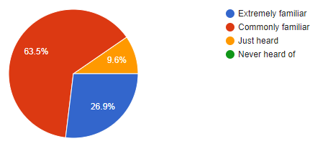

In general, most of the respondents came from company employees, as well as students and government workers, who had easy access to a variety of information. At the same time, the propaganda of manufacturers and governments has become more frequent in recent years. So most of them have a simple understanding of NEV. However, there are still very few people who extremely know about new energy vehicles. Therefore, it is not enough to rely on consumers' passive contact with NEV.

(2) survey on consumers' preference for NEV
Figure 4-2 shows the consumer's choice of car type. From the data in the figure, more than half of the people prefer hybrid vehicles, and 41.7% choose pure electric vehicles. In addition, a few others choose full cell vehicles and other types of vehicles. Although pure electric cars and hybrid cars account for the majority, more people choose hybrid cars than pure electric cars. This may have something to do with the current imperfect charging infrastructure. For convenience, more people choose hybrid vehicles that can both charge and add gasoline

Figure 4-2: Consumers' choice of NEV types
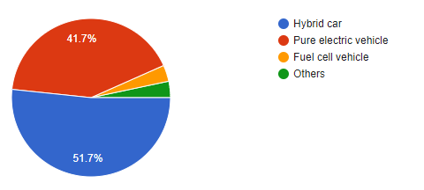

(3) The problems consumers think exist in traditional energy vehicles and the reasons why they choose NEV
Figure 4-3 shows the problems that respondents believe exist in traditional energy vehicles. Based on the data in the figure, more people hold the view that the problem of traditional energy vehicles is high fuel consumption and high repair costs, accounting for 36.5%. Then, 17.3% of people suppose that the noise is relatively large, and there may be some minor problems. In addition, 9.6% of people have high maintenance costs as a major issue. From these data, combined with table 4-2, it is precisely the main problem of traditional energy vehicles that allows more people to choose NEV.

Figure 4-3 Problems with conventional energy vehicles
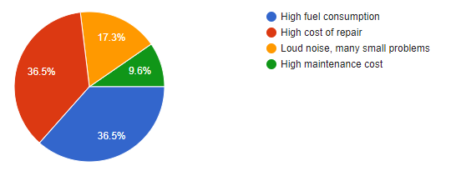

Table 4-2 shows survey on consumers' choice of NEV. Consumers choose NEV because of low carbon, environmental protection and cost saving, accounting for 48% respectively, which corresponds to the problems consumers think exist in fuel cars. Obviously, NEV can solve the problems of high energy consumption and high cost of fuel cars. At the same time, subsidies from government policies are also an important reason, accounting for 44.3%. This is also related to the government's strong support for the new energy automobile industry in recent years.

Table 4-2: Reasons for consumers to buy new energy vehicles
 |  | Responses |  | Percent of Cases
 |  | N | Percent | Percent of Cases
Why do you choose to buy new energy | Low carbon environmental protection | 144 | 25.5% | 48.0%
Why do you choose to buy new energy | Economical and low cost | 144 | 25.5% | 48.0%
Why do you choose to buy new energy | The government subsidies | 133 | 23.5% | 44.3%
Why do you choose to buy new energy | Policies and regulations mandate it | 60 | 10.6% | 20.0%
Why do you choose to buy new energy | Security | 54 | 9.6% | 18.0%
Why do you choose to buy new energy | A friend recommended | 30 | 5.3% | 10.0%
Total |  | 565 | 100.0% | 188.3%
(4) consumers get information about NEV
Table 4-3 shows the way the respondents get information on new energy vehicles. From the data in this table, more than half of the people learned about NEV from relatives and friends, which is unexpected. Then, 26% of people rely on the media for information. 24% of respondents advertised and introduced new energy vehicles as a way to get information about NEV. From here we know, most consumers mainly rely on the introduction of friends and media publicity, and as a new car product, to let more consumers know, only rely on the introduction of friends and relatives is not enough, relying on the Internet, strengthen the media publicity and business advertising is very necessary.

Table 4-3: Ways for consumers to get information on new energy vehicles
 |  | Frequency | Percent | Valid Percent | Cumulative Percent
What is your main access to new energy vehicle information | Media analysis | 78 | 26.0 | 26.0 | 26.0
What is your main access to new energy vehicle information | Advice from relatives and friends | 150 | 50.0 | 50.0 | 76.0
What is your main access to new energy vehicle information | Manufacturer's publicity | 36 | 12.0 | 12.0 | 88.0
What is your main access to new energy vehicle information | Business introduction | 36 | 12.0 | 12.0 | 100.0
What is your main access to new energy vehicle information | Total | 300 | 100.0 | 100.0

(5) consumers' cognition of automobile brands
Table 4-4 is about respondents' familiarity with NEV brands. From the content in this table, consumers are most familiar with tesla, accounting for 66%, followed by domestic automobile brands Chery and BYD, accounting for 46% and 28% respectively. Toyota is also popular with consumers, with 38% of GAToyota and 24% of FAWToyota. It can be seen that consumers are more familiar with foreign auto brands than local auto brands. Therefore, while foreign brands are favored, it is particularly important to improve the competitiveness of local brands.
Table 4-4: Consumers' perception of new energy car brands
 |  | Responses |  | Percent of Cases
 |  | N | Percent | Percent of Cases
What kinds of new energy vehicles  Brands do you know | BYD | 84 | 10.7% | 28.0%
What kinds of new energy vehicles  Brands do you know | Chery | 138 | 17.6% | 46.0%
What kinds of new energy vehicles  Brands do you know | GAToyota | 114 | 14.5% | 38.0%
What kinds of new energy vehicles  Brands do you know | FAWToyota | 72 | 9.2% | 24.0%
What kinds of new energy vehicles  Brands do you know | JH | 48 | 6.1% | 16.0%
What kinds of new energy vehicles  Brands do you know | BJ | 54 | 6.9% | 18.0%
What kinds of new energy vehicles  Brands do you know | SAIC | 78 | 9.9% | 26.0%
What kinds of new energy vehicles  Brands do you know | Tesla | 198 | 25.2% | 66.0%
Total |  | 786 | 100.0% | 262.0%

4.2 Preliminary data analysis

4.2.1 Reliability test
When designing a questionnaire survey, the researcher may have unreasonable question design due to subjective and objective influences, or the respondents probably effected by age, education level and income, which may affect the authenticity of the answers(Jenkins, 2017). Through reliability analysis, the rationality of questionnaire design can be tested. Thus contributing to the following research. As shown in table 4-5, this is the reliability test of the questionnaire. Cronbach's Alpha=0.878>0.7, so the reliability coefficient of this questionnaire is very good.

Table 4-5: Reliability Test
Cronbach's Alpha | N of Items
.878 | 17

Variables | Cronbach's AIpha | Number of Items
Quality value | .787 | 4
Social value | .742 | 3
Emotional value | .720 | 3
Price value | .752 | 3
Purchase intention | .712 | 4
Total | .878 | 17

4.2.2 Validity test
Validity analysis, also known as factor analysis, is to verify the validity and usefulness of the data analyzed (Welbourne and Johnson, 1998). In validity analysis, it is usually expressed by KMO value. The higher the value is, the more suitable it is for factor analysis. Specifically, it is required to be greater than 0.7.
According to the table 4-6, we can see that the approximate chi-square value of Bartlett's sphericity test is 1093.378 and the significance level is 0.000 (<0.05), indicating the existence of factor structure and the kaiser-meyer-olkin value is 0.759 (>0.7), indicating the suitability for factor analysis.

Table 4-6：Summary of results of independent variable factor analysis
 |  |  | Factor loading after rotation
Name |  | Question | F1 | F2 | F3 | F4
Quality value |  | QV1 | .807
 |  | QV2 | .540
 |  | QV3 | .693
 |  | QV4 | .658
Social value |  | SV1 |  | .800
 |  | SV2 |  | .719
 |  | SV3 |  | .754
Price value |  | PV1 |  |  | .749
 |  | PV2 |  |  | .745
 |  | PV3 |  |  | .753
Emotional value |  | EV1 |  |  |  | .638
 |  | EV2 |  |  |  | .815
 |  | EV3 |  |  |  | .565
 |  | KMO |  |  |  |  | 0.759
 |  | Approx. Chi-Square |  |  |  |  | 1093.378
 |  | Sig. |  |  |  |  | .000
 |  | Cumulative variance contribution rate |  |  |  |  | 61.64%
Extraction Method: Principal Component Analysis.
Rotation Method: Varimax with Kaiser Normalization.
 | a. Rotation converged in 6 iterations.

From table 4-6 independent variable factor analysis results, a total of extract four characteristic values greater than 1, the cumulative variance of 61.64% (> 50%), which suggests that the independent variable of the measurement is valid, questionnaire construct validity is good.

4.3 Correlation analysis
(Adler and Parmryd, 2010) mainly take correlation coefficient and p-value as the main reference standards when describing correlation. When the correlation coefficient is positive, it means that there is a positive correlation between variables. When the correlation coefficient is negative, it means that there is a negative correlation between variables. The asterisk in the upper right corner of the correlation coefficient represents the significance level, one (*) represents the significance level at 0.05, and two (**) represents the significance level at 0.01. In addition, determine whether the p-value value is less than 0.05. If it is less than 0.05, it indicates that there is a correlation between variables.

Table 4-7: Correlations between independent variables and dependent variables
 |  | Quality | Social | Emotional | Price | Purchase intention
Quality | Pearson Correlation | 1 | .264** | .504** | .285** | .456**
Quality | Sig. (2-tailed) |  | .000 | .000 | .000 | .000
Quality | N | 300 | 300 | 300 | 300 | 300
Social | Pearson Correlation | .264** | 1 | .283** | .220** | .223**
Social | Sig. (2-tailed) | .000 |  | .000 | .000 | .000
Social | N | 300 | 300 | 300 | 300 | 300
Emotional | Pearson Correlation | .504** | .283** | 1 | .575** | .550**
Emotional | Sig. (2-tailed) | .000 | .000 |  | .000 | .000
Emotional | N | 300 | 300 | 300 | 300 | 300
Price | Pearson Correlation | .285** | .220** | .575** | 1 | .449**
Price | Sig. (2-tailed) | .000 | .000 | .000 |  | .000
Price | N | 300 | 300 | 300 | 300 | 300
Purchase intention | Pearson Correlation | .456** | .223** | .550** | .349** | 1
Purchase intention | Sig. (2-tailed) | .000 | .000 | .000 | .000
Purchase intention | N | 300 | 300 | 300 | 300 | 300
**. Correlation is significant at the 0.01 level (2-tailed).

According to the statistical data provided in table 4-7, we found that the correlation coefficient was between 0.3 and 0.6, and the p-value<0.05, which was significant at the level of 0.01. This indicates that there is a statistically significant positive correlation between quality value, social value, emotional value, price value and purchase intention.

4.4 Regression analysis
According to the previous analysis, we have a good understanding of the regression analysis. In the following analysis, in order to verify the establishment or failure of the hypothesis, multiple regression analysis will be adopted. (DeFries and Fulker, 1985) believes that in the multiple regression analysis, it is mainly to look at the relationship between variables.

Table 4-8: Summary of multiple linear regression analysis
Model Summary
Model |  | R | R Square | Adjusted R Square | Std. Error of the Estimate
 | 1 | .590ª | .348 | .340 | .45363
a. Predictors: (Constant), Price, Social, Quality, Emotional

ANOVA^{b}
Model |  | Sum of Squares | df | Mean Square | F | Sig.
1 | Regression | 32.453 | 4 | 8.113 | 39.427 | .000ª
1 | Residual | 60.704 | 295 | .206
1 | Total | 93.158 | 299
a. Predictors: (Constant), Price, Social, Quality, Emotional
b. Dependent Variable: Purchase intention

Coefficientsª
Model |  | Unstandardized Coefficients |  | Standardized Coefficients | t | Sig.
 |  | B | Std. Error | Beta | t | Sig.
1 | (Constant) | .783 | .224 |  | 3.503 | .001
1 | Quality | .232 | .055 | .234 | 4.244 | .000
1 | Social | .034 | .042 | .040 | .802 | .423
1 | Emotional | .433 | .071 | .394 | 6.138 | .000
1 | Price | .043 | .052 | .047 | 3.814 | .000

According to the table 4-8, quality value, emotional value, price value are considered to have significant result with F-value of 39.427 and significant at the 0.05 level (p< 0.05). This shows the model is significant ( at least one variables has the predictability power on purchase intention). The derived R-square value is 0.348, which indicating that 34.8% variations in purchase intention were explained by the three variables as in the table. The resultant equation from the analysis is:

Y _{Purchase intention}=0.783+0.232X _{Quality}+0.433X_{Emotional}+0.043X_{Price}+ε

Therefore, according to the above conclusions, the most critical conclusions of this paper are drawn, as shown in table 4-9.

Table 4-9: Summary of key findings
Hypothesis | Result
H1: Quality value has a significant influence on the purchase intention of NEV | Accepted
H1: Price value has a significant influence on the purchase intention of NEV | Accepted
H1: Emotional value has a significant influence on the purchase intention of NEV | Accepted
H1: Social value has a significant influence on the purchase intention of NEV | Rejected

Chapter summary
Based on the theoretical support of the previous three chapters, the research hypothesis and the guidance of research methods, This section uses SPSS to analyze the collected data. On the one hand, the cognition of consumers in NEV is analyzed in detail. On the other hand, Through data analysis and data results, the correctness of hypothesis 1, hypothesis 2 and hypothesis 3 is verified, that is, there is a positive correlation between quality value, price value, emotional value and purchase intention of new-energy vehicles. However, hypothesis 4 has not been verified.

CHAPTER 5: CONCLUSION

5.1 Research conclusions and analysis
Through literature review, This paper makes a simple analysis of the development history of NEV, including both China and foreign countries, summarizes relevant theories based on consumers' perceived value, purchase intention and other aspects, and establishes hypothetical research that affects consumers' purchase intention. Data resources were collected through questionnaire survey, and the following conclusions were drawn through the analysis of empirical research:

(1) Consumers' general cognition of NEV
Through analysis, we can know that most of the respondents are only familiar with new energy vehicles, while only a few are completely familiar with them, but there are no consumers who have never heard of new energy vehicles. Therefore, In general, consumers' familiarity with NEV has increased significantly. As for the choice of automobile types, current consumers prefer electric and hybrid vehicles. Consumers choose to buy NEV mainly as the low cost and environmental factors, but also because of the impact of government subsidies. Consumers mainly learn information about NEV from relatives, friends and media publicity.. The most familiar brand of energy vehicle is Tesla, followed by Chery automobile.

(2) There is a significant difference in the purchase of NEV between education and income
Research shows that when people choose to buy NEV, they are greatly influenced by their income level and education level. Specifically, High-income people have a more obvious preference for NEV, and they are more willing to use them as their transportation tools., which may be on account of they have enough economic ability to choose NEV and pursue better products and high quality of life. At the same time, people with higher education have stronger environmental awareness, novel ideas and prefer new technological products.
(3) The influence of customer perceived value on consumers' purchase intention is significant
Customer perceived value includes four dimensions: social value, emotional value, quality value and price value. The data analysis in the fourth part shows that there is a correlation between the three dimensions and consumers' purchase intention, and the regression effect of each dimension and purchase intention is significant. This fully explains that with the improvement of consumers' perceived value, consumers will have stronger purchase intention. Therefore, this just confirms the conclusions of some scholars in previous years. (Li and Long, 2016) believes that with the prompt progress of NEV market of China, consumers are increasingly demanding new energy vehicles with high value in various aspects, which urge automobile manufacturers to promote product quality, so as to enhance market competitiveness and meet the demand of consumers in all aspects. Meanwhile, the role of government regulation is becoming more and more important. In general, for automobile manufacturers, from the perspective of customer perception, production of products in line with quality, emotional and price value is the key to development.

5.2 Contribution to the literature
From the review of literature review, in the world, the previous scholars on the NEV mainly focused on the technology development field, the development process of technology has a clear research; In China, more scholars are studying the implementation of government policies and the prompt progress of automobile industry. However, this paper studies NEV from a completely new field and from the perspective of customers. The research not only enriches the theoretical basis of consumer perspective research in the field of NEV, but also provides reference significance for future scholars. This is because in view of the rapid development of NEV in China, scholars should have a better understanding of the psychology of Chinese consumers. Except the research results given in this paper, scholars can explore more ideas of consumers themselves from various aspects in future research.

5.3 Contribution to the industry
Through the analysis of the results of this paper, we know that consumers give more concern to the quality, price and emotional value of NEV. Therefore, for the whole automobile industry, this conclusion is of great significance to the future progress of the automobile field. For example, consumers focus on the price and value of NEV. Therefore, on the one hand, automobile manufacturers need to produce cars that are in line with the price and value, and must ensure the quality of cars. On the other hand, car dealers can use different price strategies to attract consumers to buy. In addition, for the future progress of NEV, except developing technologies, more industry leaders should fully realize the importance of consumers. Only from the perspective of consumers, the development of NEV will be better. According to some data, by the end of 2018, the global NEV accumulative total sales of more than 5.5 million vehicles, China accounted for more than 53% (Xiao, 2018). This is not just that China's new energy automotive technology progress, more important is China has a huge consumer market, therefore, look to the consumer, the consumer preference for new energy vehicles is particularly important.

5.4 Limitations of the research
The limitations mainly involved in this study are as follows: First, the limitations of the scope of the study. The respondents in this study were only a specific region of the population and could not fully represent the views of the entire Chinese consumer. Moreover, the scope of the research is only from the perspective of consumers, and it is impossible to fully reflect the situation of the entire Chinese new energy vehicle market.

Second, the limitations of the sample size. The sample size of this study is relatively small. Although the hypothesis is verified by empirical analysis, the conclusions obtained do not reflect the views of the entire Chinese consumer.

Finally, in this study, because the respondents are affected by the supervisory consciousness, the questionnaire may not be fully filled with the objective situation, which will affect the authenticity of the research results.

5.5 Strategic suggestions
Research shows that quality value, price value and emotional value have significant positive effects on consumers' purchase intention of new energy vehicles. Therefore, based on these three dimensions, specific suggestions are given below.

5.5.1 From the perspective of quality value
(1) Through the above data analysis, it is found that more than 90% of consumers prefer pure electric vehicles and hybrid vehicles. Therefore, for automobile manufacturers, this is the focus of the future progress of NEV market. Most consumers worry about safety and battery life. Therefore, for auto manufacturers, we must vigorously develop NEV technology, and strive to overcome the current NEV problems. For example, some consumers encounter problems such as slow charging speed and short range, and a few vehicles have safety problems such as spontaneous combustion. Only by solving these problems can consumers improve their perception of the quality of NEV and enhance their purchase intention. Meanwhile, promoting the development of NEV technology is not only the responsibility of corporations, but also the joint participation of relevant research institutions and governments, which share responsibilities and risks.

(2) Brand building is the key. Consumers pay attention to the choice of brand, because many consumers regard brand as the symbol of quality. This can also be reflected from the above data, Chinese consumers are more familiar with tesla brands than local brands, such as Chery and BYD. In the above theoretical research, the higher the perceived value of customers to well-known brands, the stronger their purchase intention will be. Therefore, it is also very crucial for Chinese local automobile brands to raise their profile, so as to increase their market share. To be specific, on the one hand, companies need to invest more in technological innovation to improve product reliability; On the other hand, media can be used to promote advertising and make appropriate promotion plans to enhance popularity.

5.5.2 From the perspective of price
According to the above data analysis, 44.3% of consumers prefer to choose NEV as the influence of government subsidies. Therefore, to make the price of NEV reasonable and meet consumers' expectations, the government must formulate corresponding measures.

(1) The government can increase subsidies, such as cash subsidies for people to purchase NEV, and lessen or exempt the purchase tax of NEV.

(2) In China's big cities, for example, Beijing, Shanghai and Guangzhou. Car plates are expensive and require a lottery. Therefore, if the choice of NEV can provide free license plates, it will greatly attract consumers.

(3) Improve the construction of charging facilities to reduce the time and energy cost of consumers when using NEV.

(4) Government should give appropriate policy support and technical support to automobile manufacturers, enhance technological innovation, reduce production costs and improve the price value of NEV.

5.5.3 From the perspective of emotional value
According to the research results above, 63.5% and 9.6% of consumers have a simple familiarity with NEV, while only 26.9% are very familiar with them. This shows that most consumers only have a simple familiarity with NEV and lack of strong awareness. If consumers are not familiar with NEV, there is no strong desire to buy. On the contrary, If consumers' understanding of NEV improves, their emotional value will increase. This is because when consumers know the value of a product, the favorable opinion of the product will increase, followed by the increase of purchase intention.

(1) Strengthen publicity and expand publicity methods
Based on the above analysis, 50% of people know that the information of NEV comes from friends and relatives, which is unexpected. Only 26% came from the media. In this era of highly developed Internet, with the rapid growth of new media users, automobile manufacturers can use WeChat, Weibo and video websites to publicize the information of new energy vehicles through multiple channels, such as the breakthrough of new technology and the launch of new products. Automobile dealers should also provide more consulting services, for example, introducing products to consumers in detail, solving consumers' questions when buying, providing online and offline consulting services and so on.

(2) Provide test drive service
New energy automobile enterprises can provide test driving services in physical stores like traditional energy automobile enterprises, so that consumers can truly experience the intuitive feeling brought by new energy automobile driving and feel the comfort, convenience and driving pleasure of new energy automobile. In this way, the emotional value of consumers can be enhanced and the desire to buy can be increased.

5.6 Personal reflection
After the research of this paper, I fully realized the rigor of this paper. Specifically, the choice of topic is a very important step because it determines the scope of your research. Secondly, before starting to write the paper, we should actively listen to the advice and guidance of our tutor, because the tutor's advice can help us establish a correct research direction. At the same time, I need to read a lot of literature related to the topic of the paper, which can help me understand the specific situation of the research field more quickly and deeply. In the design process of the questionnaire, the design of the questionnaire questions should conform to the actual situation of the society, so that the feedback obtained can be authentic. In the specific empirical research, it is necessary to ensure the accuracy of data strictly, so as to ensure the authenticity of research results. In a word, although this research was successfully completed, there are still some deficiencies. The experience gained in this paper will be of great help to the future research.

Chapter summary
This chapter makes a specific analysis of the research conclusions of the whole paper, including consumers' cognition of new energy vehicles, the relationship between customer perceived value and purchase intention, and the different attitudes of groups with low income and education when choosing new energy vehicles. Through the analysis of hypothesis results, new contributions to literature and industry and some suggestions are given.

REFERENCES
Abdmouleh, Z., Alammari, R. and Gastli, A. (2015). Review of policies encouraging renewable energy integration & best practices. Renewable and Sustainable Energy Reviews, 45, pp.249-262.

Abdullah, D. (2016). A Conceptual Model of Interactive Hotel Website: The Role of Perceived Website Interactivity and Customer Perceived Value Toward Website Revisit Intention. Procedia Economics and Finance, 37, pp.170-175.

Adlard, E. (2018). Mehrdad Ehsani, Yimin Gao, Stefano Longo and Kambiz M. Ebrahimi: Modern Electric Hybrid Electric and Fuel Cell Vehicles (3rd Edn). Chromatographia, 82(4), pp.793-793.

Adler, J. and Parmryd, I. (2010). Quantifying colocalization by correlation: The Pearson correlation coefficient is superior to the Mander's overlap coefficient. Cytometry Part A, 77A(8), pp.733-742.

Ajzen, I. (2015). Consumer attitudes and behavior: The theory of planned behavior applied to food consumption decisions. Italian Review of Agricultural Economics, 70(2), pp.121-138.

Al-Debei, M., Akroush, M. and Ashouri, M. (2015). Consumer attitudes towards online shopping. Internet Research, 25(5), pp.707-733.

Anastasiadou, S.D.(2011). Reliability and validity testing of a new scale for measuring attitudes toward learning statistics with technology. Acta Didactica Napocensia, 4(1), pp.1-10.

Angrist, J. and Pathak, P. (2017). Research Design Meets Market Design: Using Centralized Assignment for Impact Evaluation. Econometrica, 85(5), pp.1373-1432.

Armstrong, R. (1987). The Midpoint on a Five-Point Likert-Type Scale. Perceptual and Motor Skills, 64(2), pp.359-362.

Bennett, R. and Vijaygopal, R. (2018). Consumer attitudes towards electric vehicles. European Journal of Marketing, 52(3/4), pp.499-527.

Biswas, A. (2016). A Study of Consumers’ Willingness to Pay for Green Products. Journal of Advanced Management Science, pp.211-215.

Bittar, A. (2018). Selling remanufactured products: Does consumer environmental consciousness matter?. Journal of Cleaner Production, 181, pp.527-536.
Budiman, S. and Wijaya, T. (2014). Purchase Intention of Counterfeit Products: The Role of Subjective Norm. International Journal of Marketing Studies, 6(2).

Chang, H.H.(2017). Consumer socially sustainable consumption: the perspective toward corporate social responsibility, perceived value, and brand loyalty. Journal of Economics and Management, 13(2), pp.167-191.

Chapman, A. and Itaoka, K. (2018). Energy transition to a future low-carbon energy society in Japan's liberalizing electricity market: Precedents, policies and factors of successful transition. Renewable and Sustainable Energy Reviews, 81, pp.2019-2027.

Chen, K. and Ren, C. (2019). Exploring purchase intentions of new energy vehicles: From the perspective of frugality and the concept of “mianzi”. Journal of Cleaner Production, 230, pp.700-708.

Cheng, H. (2018). Analysis of the Drivers of Customer Value[J]. Soft Science, 34(6), pp.48-59.

Cherian, J. and Jacob, J. (2017). Green Marketing: A Study of Consumers’ Attitude towards Environment Friendly Products. Asian Social Science, 8(12).

Choi, H. (2017). Technology-push and demand-pull factors in emerging sectors: evidence from the electric vehicle market. Industry and Innovation, 25(7), pp.655-674.

Colorafi, K. and Evans, B. (2016). Qualitative Descriptive Methods in Health Science Research. HERD: Health Environments Research & Design Journal, 9(4), pp.16-25.

Deloitte Global Manufacturing Group. Global Perspective: Comparison of Electric Vehicle Status and Consumer Expectations. 2016: 1-17.

DeFries, J.C. and Fulker, D.W. (1985). Multiple regression analysis of twin data. Behavior genetics, 15(5), pp.467-473.

Erener, A. and Selcuk-Kestel, A. (2017). Analysis of training sample selection strategies for regression-based quantitative landslide susceptibility mapping methods. Computers & Geosciences, 104, pp.62-74.

Fan, Y. and Feng, L. (2017). An evaluation of government incentives for new energy vehicles in China focusing on vehicle purchasing restrictions. Energy Policy, 110, pp.609-618.

Feldmann, C. and Hamm, U. (2015). Consumers’ perceptions and preferences for local food: A review. Food Quality and Preference, 40, pp.152-164.

Feng, X. and He, X. (2018). Thermal runaway mechanism of lithium ion battery for electric vehicles: A review. Energy Storage Materials, 10, pp.246-267.

Gaskin, C. and Lambert, S. (2017). Why sample selection matters in exploratory factor analysis: implications for the 12-item World Health Organization Disability Assessment Schedule 2.0. BMC Medical Research Methodology, 17(1).

Gu, R. and Zhang, P. (2019). Exploring purchase intentions of new energy vehicles: From the perspective of frugality and the concept of “mianzi”. Journal of Cleaner Production, 230, pp.700-708.

Hayes, A. and Montoya, A. (2017). A Tutorial on Testing, Visualizing, and Probing an Interaction Involving a Multicategorical Variable in Linear Regression Analysis. Communication Methods and Measures, 11(1), pp.1-30.

Helveston, J. (2019). Institutional complementarities: The origins of experimentation in China’s plug-in electric vehicle industry. Research Policy, 48(1), pp.206-222.

Helvoort, J. and Brand-Gruwel, S. (2017). Reliability and validity test of a Scoring Rubric for Information Literacy. Journal of Documentation, 73(2), pp.305-316.

Huang, P. and Li, P. (2019). Politics of urban energy transitions: new energy vehicle (NEV) development in Shenzhen, China. Environmental Politics, pp.1-22.

Javornik, A. (2016). Augmented reality: Research agenda for studying the impact of its media characteristics on consumer behaviour. Journal of Retailing and Consumer Services, 30, pp.252-261.

Jenkins, L. (2017). Reliability and Validity of a Self-paced Cardiopulmonary Exercise Test in Post-MI Patients. International Journal of Sports Medicine, 38(04), pp.300-306.

Junish R, J. and Archana L, A. (2015). Green Marketing: a Way to Build a Greener World. Indian Journal of Applied Research, 3(8), pp.407-410.

Khan, S. and Mohsin, M. (2017). The power of emotional value: Exploring the effects of values on green product consumer choice behavior. Journal of Cleaner Production, 150, pp.65-74.

Kley, F., Lerch, C. and Dallinger, D. (2016). New business models for electric cars—A holistic approach. Energy Policy, 39(6), pp.3392-3403.
Kurz, C., Li, G. and Vine, D. (2016). The Young and the Carless? The Demographics of New Vehicle Purchases. FEDS Notes, 2016(1798).

Lee, H. and Yun, Z. (2015). Consumers’ perceptions of organic food attributes and cognitive and affective attitudes as determinants of their purchase intentions toward organic food. Food Quality and Preference, 39, pp.259-267.

Li, J. (2015). The Research of Impact Factors Residents Buying New Energy Vehicles. International Journal of Energy and Power Engineering, 4(5), p.298.

Li, N. and Liu, J. (2018). Research on the early warning analysis of new energy accommodation in China. IOP Conference Series: Materials Science and Engineering, 394, p.042072.

Li, W. (2018). A study on the decision process behind outbound tourists’ post-experience choice of destination based on the extended theory of planned behavior. International Journal of Tourism and Hospitality Research, 32(4), pp.41-55.

Li, W., Long, R. (2016). Consumers’ evaluation of national new energy vehicle policy in China: An analysis based on a four paradigm model. Energy Policy, 99, pp.33-41.

Lin, B. and Wu, W. (2018). Why people want to buy electric vehicle: An empirical study in first-tier cities of China. Energy Policy, 112, pp.233-241.

Lin, P. and Huang, Y. (2012). The influence factors on choice behavior regarding green products based on the theory of consumption values. Journal of Cleaner Production, 22(1), pp.11-18.

Loeb, B. and Kockelman, K. (2019). Fleet performance and cost evaluation of a shared autonomous electric vehicle (SAEV) fleet: A case study for Austin, Texas. Transportation Research Part A: Policy and Practice, 121, pp.374-385.

Long, S. (2015). The Evaluating Indicator Research on Chinese Express Company Customer Perceived Value in the Age of Network Marketing. Korean Review of Management Consulting, 6(2), p.1.

Makanyeza, C. (2015). Perceived product necessity, perceived value, customer satisfaction and affective attitude: an integrative model. Journal of African Business, 17(1), pp.69-86.

Mangmeechai, A. and Yuan, A. (2018). Factors Influencing Customer Purchase Intentions towards New Energy Vehicles in China. The International Journal of Interdisciplinary Environmental Studies, 13(1), pp.1-15.

Masiero, G. and Risso, M. (2016). Electric vehicles in China: BYD strategies and government subsidies. RAI Revista de Administração e Inovação, 13(1), pp.3-11.

Molin, E. and van Wee, B. (2016). Consumer preferences for electric vehicles: a literature review. Transport Reviews, 37(3), pp.252-275.

Nellikunnel, S. (2017). The country of origin effect on consumer purchase intention: PLS modelling. International Journal of Business and Globalisation, 19(3), p.378.

Ng, M. and Law, M. (2018). Predicting purchase intention of electric vehicles in Hong Kong. Australasian Marketing Journal (AMJ), 26(3), pp.272-280.

Obayelu, A., Arowolo, A. and Poji, H. (2018). Consumers’ willingness to pay for safe buka foods: A case study of workers in Nigeria tertiary institutions. Agricultura Tropica et Subtropica, 51(1), pp.29-35.

Pappas, N. (2016). Marketing strategies, perceived risks, and consumer trust in online buying behaviour. Journal of Retailing and Consumer Services, 29, pp.92-103.

Paul, J. (2016). Predicting green product consumption using theory of planned behavior and reasoned action. Journal of Retailing and Consumer Services, 29, pp.123-134.

Perkins, G. and Murmann, J. (2018). What Does the Success of Tesla Mean for the Future Dynamics in the Global Automobile Sector?. Management and Organization Review, 14(3), pp.471-480.

Qian, L., Grisolía, J. and Soopramanien, D. (2019). The impact of service and government-policy attributes on consumer preferences for electric vehicles in China. Transportation Research Part A: Policy and Practice, 122, pp.70-84.
Rasheed, F. and Abadi, M. (2014). Impact of Service Quality, Trust and Perceived Value on Customer Loyalty in Malaysia Services Industries. Procedia - Social and Behavioral Sciences, 164, pp.298-304.

Rezvani, Z. and Bengtsson, M. (2018). Consumer motivations for sustainable consumption: The interaction of gain, normative and hedonic motivations on electric vehicle adoption. Business Strategy and the Environment, 27(8), pp.1272-1283.

Richardson, D. (2013). Electric vehicles and the electric grid: A review of modeling approaches, Impacts, and renewable energy integration. Renewable and Sustainable Energy Reviews, 19, pp.247-254.

Scriven, M. and Coryn, C. (2008). The logic of research evaluation. New Directions for Evaluation, 2008(118), pp.89-105.

Seddon, J. and Rosner, B. (2016). Response to AREDS supplements according to genetic factors: survival analysis approach using the eye as the unit of analysis. British Journal of Ophthalmology, 100(12), pp.1731-1737.

Senbabaoglu, E. (2017). The Impact of the Service Innovativeness on Perceived Overall Service Quality, Customer Loyalty and Perceived Customer Value in Shopping Sites. Marketing and Branding Research, 4(4), pp.371-383.

Shao, J. and Ünal, E. (2019). What do consumers value more in green purchasing? Assessing the sustainability practices from demand side of business. Journal of Cleaner Production, 209, pp.1473-1483.

Singh, N. and Gupta, K. (2013). Environmental attitude and ecological behaviour of Indian consumers. Social Responsibility Journal, 9(1), pp.4-18.

Song, Y. (2019). Does haze pollution promote the consumption of energy-saving appliances in China? An empirical study based on norm activation model. Resources, Conservation and Recycling, 145, pp.220-229.

Steg, L. and Shwom, R. (2018). What Drives Energy Consumers?: Engaging People in a Sustainable Energy Transition. IEEE Power and Energy Magazine, 16(1), pp.20-28.

Stolaroff, J. (2018). Energy use and life cycle greenhouse gas emissions of drones for commercial package delivery. Nature Communications, 9(1).

Sun, L. (2018). Development and Policies of New Energy Vehicles in China. Asian Social Science, 8(2).

Sun, Z.Y. and Li, G.X.(2015). On reliability and flexibility of sustainable energy application route for vehicles in China. Renewable and Sustainable Energy Reviews, 51, pp.830-846.

Sung, Y. and Kim, K. (2013). Descriptive Analysis of Toothpaste Flavor Using Novel Sample Preparation Procedure. Journal of Sensory Studies, 28(2), pp.154-160.
Sweeney, J. and Soutar, G. (2001). Consumer perceived value: The development of a multiple item scale. Journal of Retailing, 77(2), pp.203-220.

Tan, R. (2018). Policy impact of new energy vehicles promotion on air quality in Chinese cities. Energy Policy, 118, pp.33-40.

Ulaga, W. and Chacour, S. (2016). Measuring Customer-Perceived Value in Business Markets. Industrial Marketing Management, 30(6), pp.525-540.

Vera, J. (2015). Perceived brand quality as a way to superior customer perceived value crossing by moderating effects. Journal of Product & Brand Management, 24(2), pp.147-156.

Walsh, G., Shiu, E. and Hassan, L. (2014). Replicating, validating, and reducing the length of the consumer perceived value scale. Journal of Business Research, 67(3), pp.260-267.

Wang, K. and Ke, Y. (2018). Public-Private Partnerships in the Electric Vehicle Charging Infrastructure in China: An Illustrative Case Study. Advances in Civil Engineering, 2018, pp.1-10.

Wang, N. and Mogi, G. (2017). Deregulation, market competition, and innovation of utilities: Evidence from Japanese electric sector. Energy Policy, 111, pp.403-413.

Wang, N. and Tang, L. (2018). Analysis of public acceptance of electric vehicles: An empirical study in Shanghai. Technological Forecasting and Social Change, 126, pp.284-291.

Wang, S., Fan, J., Zhao, D., Yang, S. and Fu, Y.(2016）. Predicting consumers’ intention to adopt hybrid electric vehicles: using an extended version of the theory of planned behavior model. Transportation, 43(1), pp.123-143.

Wang, Z., Wang, C. and Hao, Y. (2013). Influencing factors of private purchasing intentions of new energy vehicles in China. Journal of Renewable and Sustainable Energy, 5(6), p.063133.

Wilderom, C. (2017). Values and behaviors of effective lean managers: Mixed-methods exploratory research. European Management Journal, 35(2), pp.174-186.

Welbourne, T.M., Johnson. (1998). The role-based performance scale: Validity analysis of a theory-based measure. Academy of management journal, 41(5), pp.540-555.

Wu, M. (2003). SPSS Statistical Application Practice - Questionnaire Analysis and Applied Statistics [M]. Beijing: Science Press, 35(8), pp.56-58.

Wu, S. and Chen, Y. (2014). The Impact of Green Marketing and Perceived Innovation on Purchase Intention for Green Products. International Journal of Marketing Studies, 6(5).

Xiong, R. and Cao, J. (2018). Reinforcement learning-based real-time power management for hybrid energy storage system in the plug-in hybrid electric vehicle. Applied Energy, 211, pp.538-548.

Xiao juntao. (2018). Research on China's new energy automobile industry policy. Southwestern university of finance and economics press.

Xu, B. and Lin, B. (2018). Do we really understand the development of China's new energy industry?. Energy Economics, 74, pp.733-745.

Yang, J. and Lee, J. (2019). Application of Sensory Descriptive Analysis and Consumer Studies to Investigate Traditional and Authentic Foods: A Review. Foods, 8(2), p.54.

Yang, L. and Li, Y.(2013). Low-carbon city in China. Sustainable Cities and Society, 9, pp.62-66.

Yin, J. and Zhang, B. (2017). Purchasing intentions of Chinese citizens on new energy vehicles: How should one respond to current preferential policy?. Journal of Cleaner Production, 161, pp.1000-1010.

Yu, P. and Xu, T. (2019). The Evolution of China’s New Energy Vehicle Industry from the Perspective of a Technology–Market–Policy Framework. Sustainability, 11(6), p.1711.

Yuan, X. and Zuo, J. (2015). The development of new energy vehicles for a sustainable future: A review. Renewable and Sustainable Energy Reviews, 42, pp.298-305.

Yunna, W. and Yisheng, Y. (2014). The competition situation analysis of shale gas industry in China: Applying Porter’s five forces and scenario model. Renewable and Sustainable Energy Reviews, 40, pp.798-805.

Zhang, J. and Wang, R. (2019). Research on the Marketing Strategy of New Energy Vehicles in SL Company. American Journal of Industrial and Business Management, 09(02), pp.306-314.

Zhang, J. and Wang, R. (2019). Research on the Marketing Strategy of New Energy Vehicles in SL Company. American Journal of Industrial and Business Management, 09(02), pp.306-314.

Zhang, X. and Bai, X. (2017). Incentive policies from 2006 to 2016 and new energy vehicle adoption in 2010–2020 in China. Renewable and Sustainable Energy Reviews, 70, pp.24-43.

Zhang, X. and Wei, Y. (2013). The impact of government policy on preference for NEVs: The evidence from China. Energy Policy, 61, pp.382-393.

Zhao, D. (2017). The impact of policy measures on consumer intention to adopt electric vehicles: Evidence from China. Transportation Research Part A: Policy and Practice, 105, pp.14-26.

APPENDICES

Appendix 1: Questionnaire
《Factors Influencing New Energy Vehicle Purchase Intention: A study in China》questionnaire survey
Dear Sir/madam,
Hello! I am a postgraduate student of INTI International University. I am writing my master's thesis to do a research on consumers' willingness to buy new energy vehicles. Please make a simple questionnaire survey, the results of which are only for academic research. For the information you provide, I will be strictly confidential, please feel free to fill in. Thanks!

Section 1: Demographic information
Gender | 1. male 2. female
Age | 1. below 25 2. 25-35 3. 36-45 4. Above 46
Education level | 1. high school 2. Associate/diploma 3. Bachelor/degree  4. master or above
Income(per year, RMB) | 1. below 50k 2. 50k-100k 3. 100k-150k 4. 150k-200k  5. above 200k
Profession | 1. private business owner 2. Company employees  3. government employees 4. Student 5. others

Section 2: General Information about new energy vehicles

1. Have you heard of new energy vehicles ?
A. extremely familiar B. commonly familiar C. just hear D. never heard of

2. Do you think automobile exhaust is one of the main factors causing greenhouse effect ?
A. yes B. no C. maybe

3. If you buy a new energy vehicle, what kind of new energy vehicle will you choose ?
A. hybrid car B. pure electric car C. fuel cell vehicle D. others

4. Why do you choose to buy new energy vehicles? (multiple choices are available) ?
A. Low carbon environmental protection B. Economical and low cost C. Security D. The government subsidies E. Policies and regulations mandate it

F. A friend recommended

5. What do you think is the biggest problem for conventional fuel vehicles ?
A. High fuel consumption B. High cost of repair
C. Loud noise, many small problems D. High maintenance cost

6. What is your main access to new energy vehicle information ?
A . Media analysis B. Advice from relatives and friends
C. Manufacturer's publicity D. Business introduction

7. What kinds of new energy vehicles brands do you know? (multiple choices are available) ?
A. BYD B. Chery C. Guangzhou Automobile Toyota D. FAW Toyota
E. Tesla F. Others

Section 3: Questions about independent variables and dependent variables of new energy vehicles
The following questions are single choice. Please tick the “√” which you agree with according to your actual situation. Please use the following scale.

（1. Strongly disagree, 2. Disagree, 3. Neutral 4. Agree 5. Strongly agree）

Variables | Statements | 1 | 2 | 3 | 4 | 5
Quality  value | The safety factor of new energy vehicle is high
Quality  value | The new energy vehicle has high quality parts
Quality  value | New energy vehicles have strong power performance
Quality  value | New energy vehicles can maintain long-lasting endurance (easier to charge)
Price  value | The reduction of oil consumption by new energy vehicles is economically reasonable in the long run
Price  value | Government subsidies and price range make me feel acceptable
Price  value | New energy vehicles provide value in line with the price
Emotional  value | Using new energy cars gives me a comfortable driving experience
Emotional  value | The new energy car has satisfactory appearance design(such as Tesla)
Emotional  value | The new energy vehicle has reassuring operational control
Social  value | Using new energy vehicles, let me leave a good impression on others
Social  value | Using new energy vehicles, let me earn more compliments(praise)from others
Social  value | Using new energy vehicles, let me feel more confident in social situation
Purchase intention of new energy vehicle | I would consider buying a new energy car
Purchase intention of new energy vehicle | I'd like to buy a new energy car
Purchase intention of new energy vehicle | I'm happy to recommend new energy vehicles to others
Purchase intention of new energy vehicle | I will repeatedly buy new energy vehicles

Appendix 2: SPSS Output for Data Analysis
1. Descriptive Analysis
1. Gender

 |  | Frequency | Percent | Valid Percent | Cumulative Percent
Valid | Male | 132 | 44.0 | 44.0 | 44.0
Valid | Female | 168 | 56.0 | 56.0 | 100.0
Valid | Total | 300 | 100.0 | 100.0

2. Age

 |  | Frequency | Percent | Valid Percent | Cumulative Percent
Valid | Below 25 | 78 | 26.0 | 26.0 | 26.0
Valid | 25-35 | 156 | 52.0 | 52.0 | 78.0
Valid | 36-45 | 54 | 18.0 | 18.0 | 96.0
Valid | Above 46 | 12 | 4.0 | 4.0 | 100.0
Valid | Total | 300 | 100.0 | 100.0

3. Education level

 |  | Frequency | Percent | Valid Percent | Cumulative Percent
Valid | High school | 24 | 8.0 | 8.0 | 8.0
Valid | Associate/Diploma | 24 | 8.0 | 8.0 | 16.0
Valid | Bachelor/Degree | 168 | 56.0 | 56.0 | 72.0
Valid | Master or Above | 84 | 28.0 | 28.0 | 100.0
Valid | Total | 300 | 100.0 | 100.0

4. Income(per year, RMB)

 |  | Frequency | Percent | Valid Percent | Cumulative Percent
Valid | Below 50k | 30 | 10.0 | 10.0 | 10.0
Valid | 50k-100k | 78 | 26.0 | 26.0 | 36.0
Valid | 100k-150k | 120 | 40.0 | 40.0 | 76.0
Valid | 150k-200k | 54 | 18.0 | 18.0 | 94.0
Valid | Above 200k | 18 | 6.0 | 6.0 | 100.0
Valid | Total | 300 | 100.0 | 100.0

5. Profession

 |  | Frequency | Percent | Valid Percent | Cumulative Percent
Valid | Private business owner | 72 | 24.0 | 24.0 | 24.0
Valid | Company employees | 138 | 46.0 | 46.0 | 70.0
Valid | Government employees | 42 | 14.0 | 14.0 | 84.0
Valid | Student | 42 | 14.0 | 14.0 | 98.0
Valid | Others | 6 | 2.0 | 2.0 | 100.0
Valid | Total | 300 | 100.0 | 100.0

6. Consumer familiarity with NEV

7. Consumers' choice of NEV types

8. Problems with conventional energy vehicles

9. Reasons for consumers to buy new energy vehicles

 |  | Responses |  | Percent of Cases
 |  | N | Percent | Percent of Cases
Why do you choose to buy new energy | Low carbon environmental protection | 144 | 25.5% | 48.0%
Why do you choose to buy new energy | Economical and low cost | 144 | 25.5% | 48.0%
Why do you choose to buy new energy | The government subsidies | 133 | 23.5% | 44.3%
Why do you choose to buy new energy | Policies and regulations mandate it | 60 | 10.6% | 20.0%
Why do you choose to buy new energy | Security | 54 | 9.6% | 18.0%
Why do you choose to buy new energy | A friend recommended | 30 | 5.3% | 10.0%
Total |  | 565 | 100.0% | 188.3%

10. Ways for consumers to get information on new energy vehicles

 |  | Frequency | Percent | Valid Percent | Cumulative Percent
What is your main access to new energy vehicle information | Media analysis | 78 | 26.0 | 26.0 | 26.0
What is your main access to new energy vehicle information | Advice from relatives and friends | 150 | 50.0 | 50.0 | 76.0
What is your main access to new energy vehicle information | Manufacturer's publicity | 36 | 12.0 | 12.0 | 88.0
What is your main access to new energy vehicle information | Business introduction | 36 | 12.0 | 12.0 | 100.0
What is your main access to new energy vehicle information | Total | 300 | 100.0 | 100.0

11. Consumers' perception of new energy car brands

 |  | Responses |  | Percent of Cases
 |  | N | Percent | Percent of Cases
What kinds of new energy vehicles  Brands do you know | BYD | 84 | 10.7% | 28.0%
What kinds of new energy vehicles  Brands do you know | Chery | 138 | 17.6% | 46.0%
What kinds of new energy vehicles  Brands do you know | GAToyota | 114 | 14.5% | 38.0%
What kinds of new energy vehicles  Brands do you know | FAWToyota | 72 | 9.2% | 24.0%
What kinds of new energy vehicles  Brands do you know | JH | 48 | 6.1% | 16.0%
What kinds of new energy vehicles  Brands do you know | BJ | 54 | 6.9% | 18.0%
What kinds of new energy vehicles  Brands do you know | SAIC | 78 | 9.9% | 26.0%
What kinds of new energy vehicles  Brands do you know | Tesla | 198 | 25.2% | 66.0%
Total |  | 786 | 100.0% | 262.0%

2. Reliability test

Variable: Quality value
Reliability Statistics
Cronbach's Alpha | N of Items
.787 | 4

Variable : Social value

Reliability Statistics
Cronbach's Alpha | N of Items
.742 | 3

Variable: Emotional value

Reliability Statistics
Cronbach's Alpha | N of Items
.720 | 3

Variable：Price value

Reliability Statistics
Cronbach's Alpha | N of Items
.752 | 3

Variable: Purchase intention

Reliability Statistics
Cronbach's Alpha | N of Items
.712 | 4

All variables

Reliability Statistics
Cronbach's Alpha | N of Items
.878 | 17

3. Validity test (Factor analysis)

KMO and Bartlett's Test
Kaiser-Meyer-Olkin Measure of Sampling Adequacy. |  | .659
Bartlett's Test of Sphericity | Approx. Chi-Square | 1093.378
Bartlett's Test of Sphericity | df | 78
Bartlett's Test of Sphericity | Sig. | .000

Total Variance Explained

Component | Initial Eigenvalues |  |  | Extraction Sums of Squared Loadings |  |  | Rotation Sums of Squared Loadings
Component | Total | % of Variance | Cumulative % | Total | % of Variance | Cumulative % | Total | % of Variance | Cumulative %
1 | 3.662 | 28.169 | 28.169 | 3.662 | 28.169 | 28.169 | 2.413 | 18.564 | 18.564
2 | 1.719 | 13.223 | 41.392 | 1.719 | 13.223 | 41.392 | 2.007 | 15.436 | 34.001
3 | 1.519 | 11.682 | 53.074 | 1.519 | 11.682 | 53.074 | 1.858 | 14.291 | 48.291
4 | 1.114 | 8.566 | 61.640 | 1.114 | 8.566 | 61.640 | 1.735 | 13.349 | 61.640
5 | .937 | 7.209 | 68.849
6 | .795 | 6.118 | 74.967
7 | .694 | 5.335 | 80.302
8 | .612 | 4.707 | 85.009
9 | .560 | 4.307 | 89.315
10 | .472 | 3.632 | 92.947
11 | .372 | 2.862 | 95.809
12 | .306 | 2.351 | 98.160
13 | .239 | 1.840 | 100.000
Extraction Method: Principal Component Analysis.

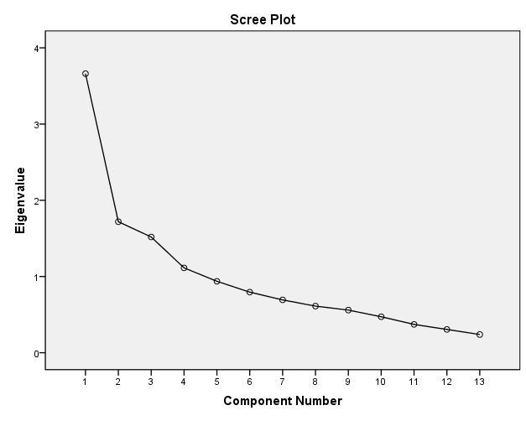

Rotated Component Analysis

 | Component
 | 1 | 2 | 3 | 4
QV1 | .807
QV3 | .693
QV4 | .658
QV2 | .540
SV1 |  | .800
SV3 |  | .754
SV2 |  | .719
PV3 |  |  | .753
PV1 |  |  | .749
PV2 |  |  | .745
EV2 |  |  |  | .815
EV1 |  |  |  | .638
EV3 |  |  |  | .565
Extraction Method: Principal Component Analysis.
Rotation Method: Varimax with Kaiser Normalization.
a. Rotation converged in 6 iterations.

4. Correlations analysis

Correlations
 |  | Quality | Social | Emotional | Price | Purchase intention
Quality | Pearson Correlation | 1 | .264** | .504** | .285** | .456**
Quality | Sig. (2-tailed) |  | .000 | .000 | .000 | .000
Quality | N | 300 | 300 | 300 | 300 | 300
Social | Pearson Correlation | .264** | 1 | .283** | .220** | .223**
Social | Sig. (2-tailed) | .000 |  | .000 | .000 | .000
Social | N | 300 | 300 | 300 | 300 | 300
Emotional | Pearson Correlation | .504** | .283** | 1 | .575** | .550**
Emotional | Sig. (2-tailed) | .000 | .000 |  | .000 | .000
Emotional | N | 300 | 300 | 300 | 300 | 300
Price | Pearson Correlation | .285** | .220** | .575** | 1 | .449**
Price | Sig. (2-tailed) | .000 | .000 | .000 |  | .000
Price | N | 300 | 300 | 300 | 300 | 300
Purchase intention | Pearson Correlation | .456** | .223** | .550** | .349** | 1
Purchase intention | Sig. (2-tailed) | .000 | .000 | .000 | .000
Purchase intention | N | 300 | 300 | 300 | 300 | 300
**. Correlation is significant at the 0.01 level (2-tailed).

5. Regression analysis

Variables Entered/Removed^{b}
Model | Variables Entered | Variables Removed | Method
1 | Price, Social, Quality, Emotional | . | Enter
a. All requested variables entered.
b. Dependent Variable: Purchase intention

Model Summary
Model | R | R Square | Adjusted R Square | Std. Error of the Estimate
1 | .590ª | .348 | .340 | .45363
a. Predictors: (Constant), Price, Social, Quality, Emotional

ANOVA^{b}
Model |  | Sum of Squares | df | Mean Square | F | Sig.
1 | Regression | 32.453 | 4 | 8.113 | 39.427 | .000ª
1 | Residual | 60.704 | 295 | .206
1 | Total | 93.158 | 299
a. Predictors: (Constant), Price, Social, Quality, Emotional
b. Dependent Variable: Purchase intention

Coefficientsª
Model |  | Unstandardized Coefficients |  | Standardized Coefficients | t | Sig.
 |  | B | Std. Error | Beta | t | Sig.
1 | (Constant) | .783 | .224 |  | 3.503 | .001
1 | Quality | .232 | .055 | .234 | 4.244 | .000
1 | Social | .034 | .042 | .040 | .802 | .423
1 | Emotional | .433 | .071 | .394 | 6.138 | .000
1 | Price | .043 | .052 | .047 | .814 | .000
a. Dependent Variable: Purchase intention

Appendix 3: Initial Research Paper Proposal
A. INITIAL RESEARCH PAPER PROPOSAL (30%)
Student name & ID | Wangcheng&I17013959
Broad area | Marketing
Concise title | Factors Influencing New Energy Vehicle Purchase Intention: A study in China
Problem definition | At present, due to rapid economic growth, science and technology have ushered in the golden stage of development. While improving the living environment and the quality of life, people are also increasingly suffering from environmental pollution and excessive energy consumption.  In 2018, the total sales volume of automobiles in China was 28.081 million. Although the sales volume was very high, it was 2.8% lower than that of 2017. However, data show that sales of new energy vehicles are still showing a steady growth trend. In 2018, 1.256 million new energy vehicles were sold, up 61.7% from 2017  in order to reduce reliance on traditional energy, new energy automobile market has been rapid development, obviously, there is a reason for this development, on the one hand, the environmental protection consciousness of people had to ascend, the implementation of government policy, this is a common factor. On the other hand, may be related to the characteristics of new energy vehicles itself, as well as the consumer's attitude toward new energy vehicles unique about exactly which factors make more and more consumers want to buy new energy vehicles. Therefore, in order to study the reasons for the rapid development of new energy vehicles, this paper will study the influence of CPV on their purchase intention from the perspective of consumers.
Research questions or objectives | According to (Ulaga and Chacour, 2016), when consumers decide whether to buy a commodity, they will be influenced by a lot of factors, and their perceived value of products is an important prerequisite for purchase. Therefore, based on CPV consists of price, emotion, social, and emotional value. The relationship between these four values and the willingness to purchase is studied. In order to study the intrinsic relationship between these factors and the willingness to purchase, there are a total of four research goals:  RO1: To study the influence of quality value on purchase intention of NEV.  RO2: To study the influence of price value on purchase intention of NEV.  RO3: To study the influence of emotional value on purchase intention of NEV.  RO4: To study the influence of social value on purchase intention of NEV.  The main concerned questions for this research will be as following:  - Is there any relationship between quality value and purchase intention of NEV.  - Is there any relationship between price value and purchase intention of NEV.  - Is there any relationship between emotional value and purchase intention of NEV.  - Is there any relationship between social value and purchase intention of NEV.
Scope of study | This article mainly discusses what factors can influence consumers' willingness to purchase, and the consumer market is in China. The specific research content involves the relationship between consumer perceived value and consumers' purchase intention. Affected by research methods, the research mainly involves different age groups, occupations, degree, occupations and education levels. On the basis of collecting their opinions on new energy vehicles through questionnaires, empirical research is conducted.
Significance of the research | Theoretical significance  (1) Enriched the relevant theory of NEV  In the past, the research on new energy vehicles is mainly from the technical level, and this research is a completely new perspective, that is, from the perspective of consumers themselves. The richness of this theory is to better adapt to the current development of new energy vehicles and provide more theoretical support for the research of new energy vehicles.  (2) This paper enriches the theory of CPV  New energy vehicles, as a new green travel tool, have a new feeling when consumers are first exposed. In the later discussion, the paper deepens the theoretical study of CPV in the field of NEV. Specifically, the specific data analysis is done through the composition of dimensions.  Practical significance  (1) Research on NEV based on the perceived value of consumers is helpful for enterprises and governments to establish the consumer-oriented concept. Focus on improving product quality, price, emotional and social value perception. In this way, More people will be interested in new energy vehicles, which will help increase car sales, such as the currently popular hybrid, pure electric cars. The increase in sales volume will also lead to the upgrading of technology, which will lead to the comprehensive development of the industry (Kley, Lerch and Dallinger, 2016).  (2) Provide reference for enterprises and governments to formulate relevant promotion strategies.  Through the analysis of this study, since each value is made up of a variety of factors, the results of the study allow us to know what factors affect consumers 'willingness to buy. The significance of this to the enterprise is that the enterprise can formulate a suitable market strategy based on some reliable conclusions. At the same time, the government can better play its own regulatory role and implement more clear strategies to promote the development of the market and technological progress.
Literature review | (Budiman and Wijaya, 2014) believes the purchase intention is to refer to the generation of a subjective idea of the consumer, for example, a perception of a good or a service, and a change in the likelihood of a perception of the good or service after being interfered with by external factors. He believes that the willingness to purchase is not an objective existence, but a subjective cognition.  On the basis of the social psychology research, (Ajzen & Fishbein, 1975) introduced the theory of planned behavior. This theory can be used to explain the general decision-making process of consumer behavior, providing a classical theoretical research framework for studying the factors affecting consumers' willingness to act and the link between behavioral willingness and consumer behavior.  (Sweeney, 2001) thinks that the dimensionality model of customer Perceived value not only considers the price and quality of goods, but also considers whether there are social and emotional factors in the needs of products. The perceptive value model can help us construct the scale and contribute to the empirical research.  (Nellikunnel, 2017) explored the link between the origin of the product and the propensity to buy, and clearly pointing out that consumers are biased towards products from the country of origin, because in their eyes, products of origin have higher quality and they are more willing to buy.
Research methodology | In the study of this paper, there are two kinds of measurement tools. On the one hand, data is collected through questionnaires (Jain and Dubey, 2016), mainly the basic information of the respondents and the problem design based on the theoretical research framework.  On the other hand, SPSS and excel are used to analyze and organize data. Analyze the data according to the hypothetical questions mentioned above. In the process of data analysis, the specific analysis methods involved include descriptive analysis, reliability and validity test, correlation analysis and regression analysis.

Appendix 4: Ethics Form
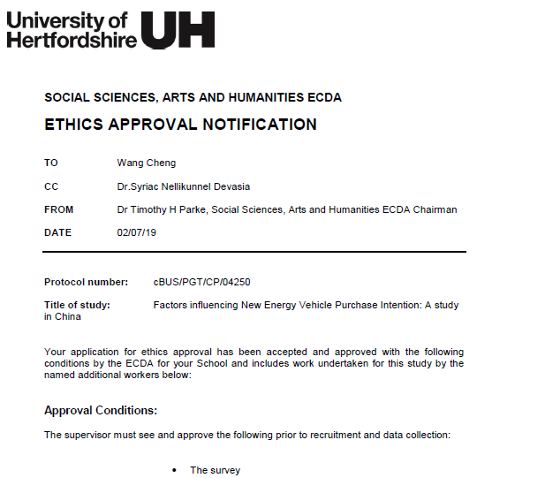
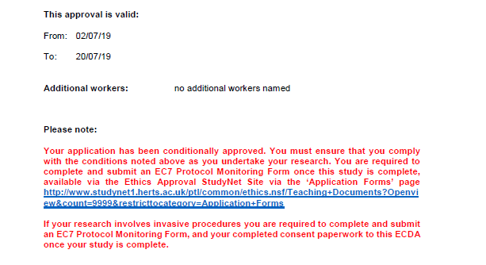
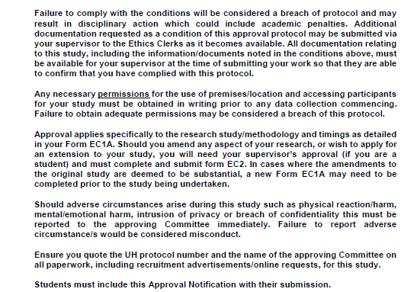

Appendix 5: MBA Project Log

PROJECT PAPER LOG
This is an important document, which is to be handed in with your dissertation. This log will be taken into consideration when awarding the final mark for the dissertation.

Student name: | Wang Cheng
Supervisor’s Name: | Dr Syriac Nellikunnel Devasia
Dissertation Topic:

Factors Influencing New Energy Vehicle Purchase Intention:
A study in China

SECTION A. MONITORING STUDENT DISSERTATION PROCESS

The plan below is to be agreed between the student & supervisor and will be monitored against progress made at each session.

Activity | Milestone/Deliverable Date
Activity | 21/5 | 4/6 | 5/7 | 15/7 | 19/7 | 26/7 | 5/8 | 22/8
Confirm title | ×
Chapter 1-3 draft |  | ×
Chapter 1-3 Submission |  |  | ×
Pilot study |  |  | ×
Slide for proposal defense |  |  | ×
Data collection |  |  |  | ×
Data analysis |  |  |  |  | ×
Chapter 4, 5 and 6 |  |  |  |  |  | ×
Slide for final presentation |  |  |  |  |  |  | ×
Submission for final draft |  |  |  |  |  |  | ×
Submission for final soft copy |  |  |  |  |  |  |  | ×

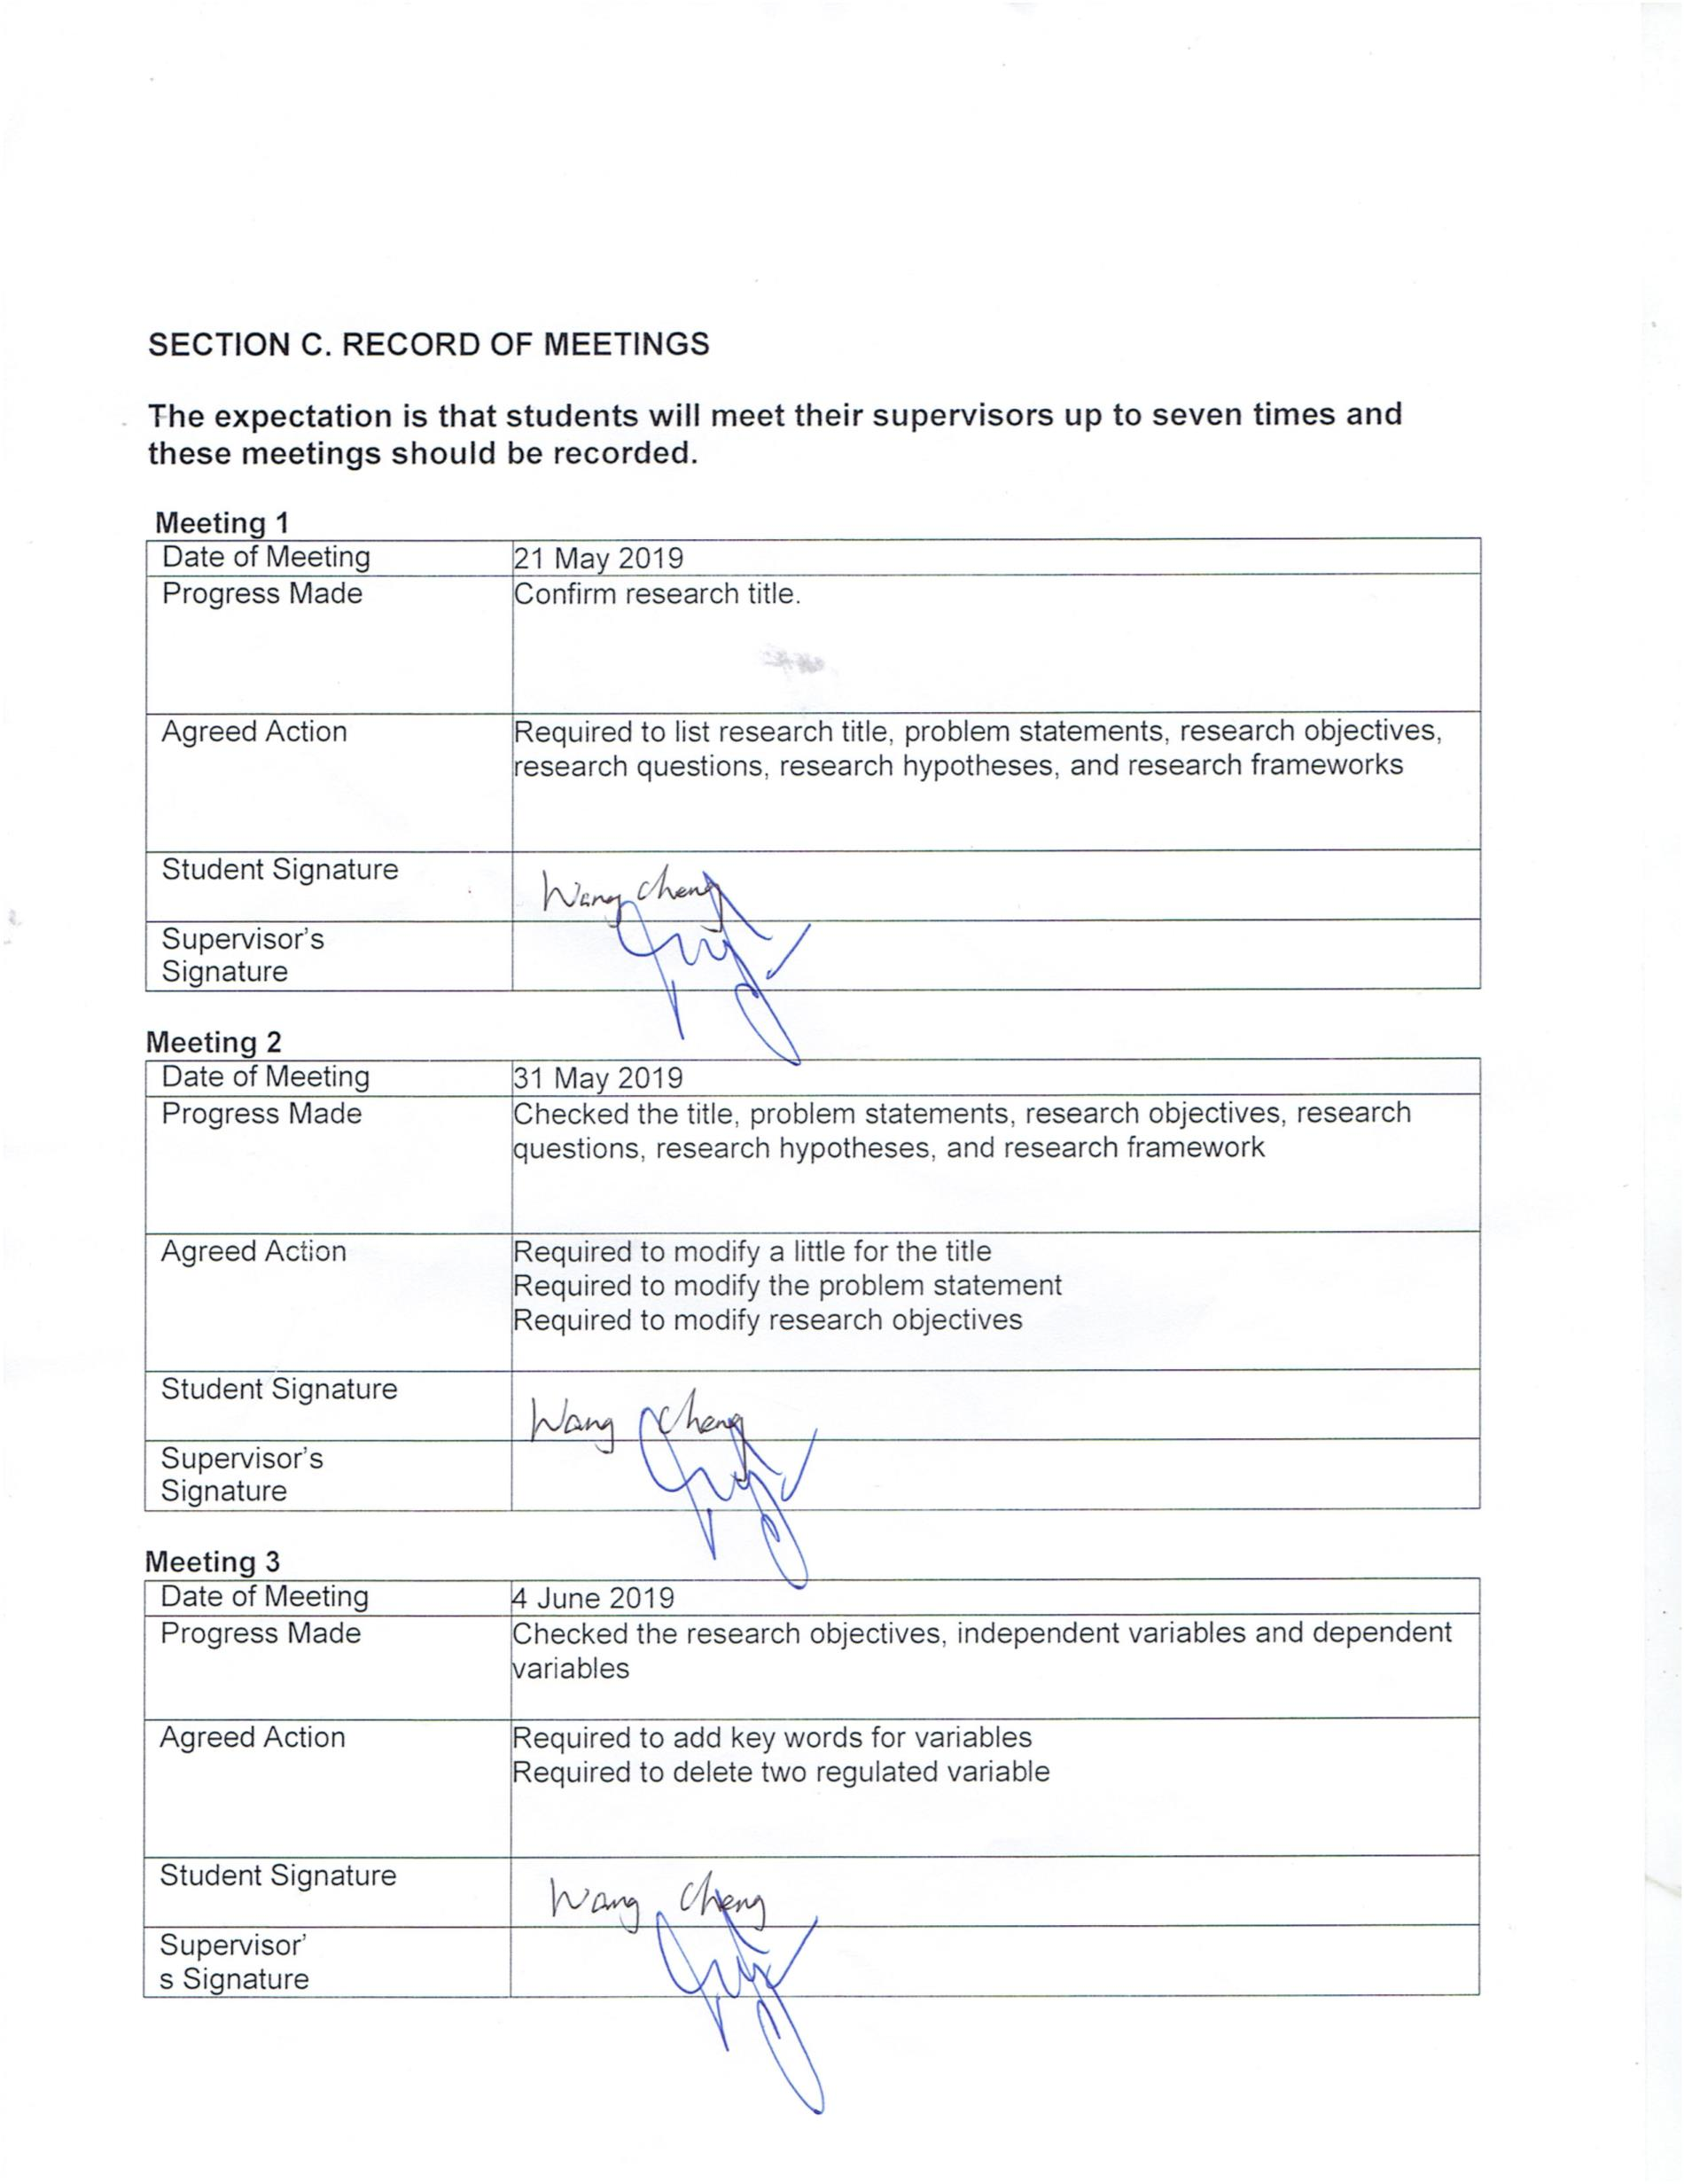
SECTION B. ETHICS

Ethics form protocol number: cBUS/PGT/CP/04250

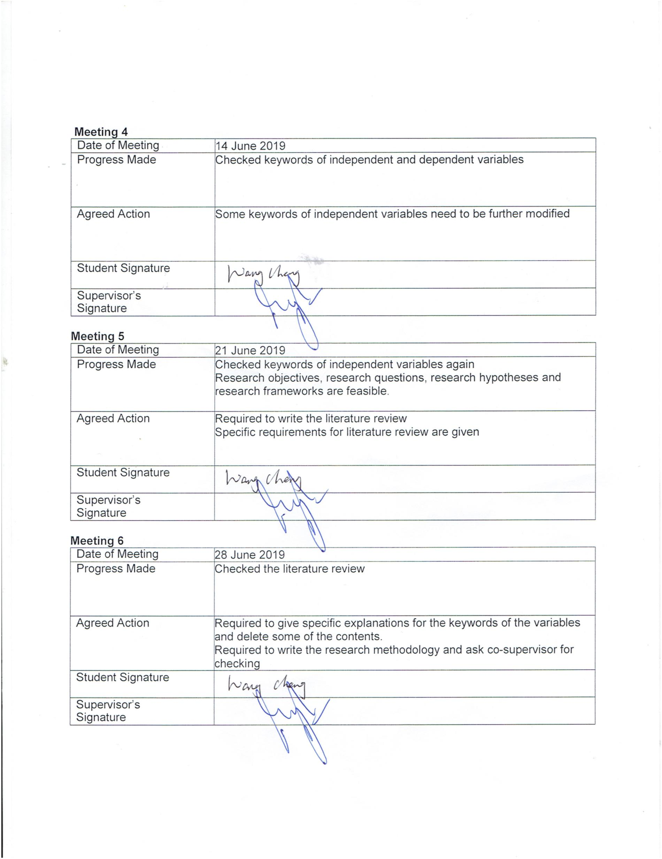





Section D. Comments on Management of Project

(to be completed at the end of the dissertation process)

Student Comments

For me, the first thing to say is thanks. Thanks to Dr. Syriac for guiding me on my thesis. When I encountered problems that I didn’t understand, Dr. Syriac would patiently explain to me and be responsible. At the same time, I would also like to thank my Co-supervisor, Dr.Revathei, for his guidance and improvement in my data analysis. Ms. Kumarashvari was my second supervisor. After first defense and final project presentation, her comments had helped me a lot.
At the same time, after a few months of writing a thesis, my own improvement is also very big. For example, if you have to do things with planning and patience, you need to actively solve problems and not complain. In general, in the future, when I think about this experience, it will be a valuable asset.

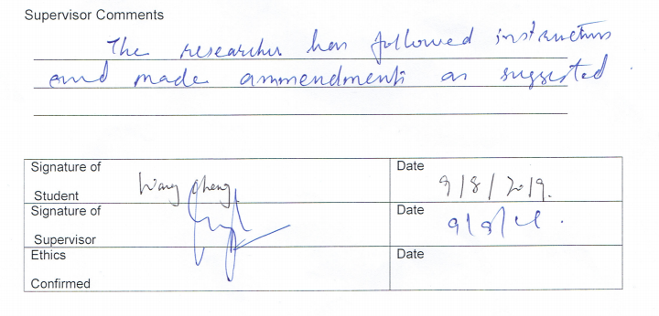

Appendix 6: Turnitin Result
