

**MACROECONOMIC FACTORS INFLUENCING SHANGHAI STOCK EXCHANGE COMPOSITE INDEX IN CHINA**

**Student’s Name: Lyu Ye**

**Identification Number: I18014325**

**Program: Master of Business Administration Learning Simplified**

**Subject: MGT 7999E- MBA Project**

**Supervisor: Dr. Babak Naysary**

**(Final Word Count: 12,009)**

# Declaration

I hereby declare that this thesis is my own work and effort and that it has not been submitted anywhere for any award. Where other sources of information have been used, they have been duly acknowledged.

Name : Lyu Ye

Student ID : I18014325

Signature : 

Date : 22/8/2019

# Acknowledgement

I would like to express my deepest appreciation to all those who have provided the assistance to complete this research. A special gratitude to my first supervisor, Dr. Babak Naysary for his contribution, suggestions, dedication and patience to complete the research. His processional knowledge and profound views have been really conductive and helpful which teach me a lot of how to do the research systematically. I really appreciate his passion and guidance towards the successful completion of this Master Project. Dr. Ming Yian Rebecca Yew as my second supervisor really inspired me to be more confidence when I was in doubt and loss of direction during the progress. I am extremely thankful to her for her encouragement and valuable comments improve the project. And her kindness and rigorous academic attitude have really set an example for me.

And I would like to take this opportunity to thank the management, lecturers and staffs from INTI International University for their great support and assistance provided.

Last but not least, I would also want to thank my family and friends for showing me with unconditional love. If without their great support I will not be able to complete this project on time.

# Abstract

This research paper aims to determine the macroeconomic factors influencing the Shanghai Stock Exchange (SSE) Composite Index in China. Although there have been many analyses made by previous researchers on various factor that influence the stock market performance but few in China, this research focuses on the Shanghai Stock Exchange market which has the quite huge amount of large listed companies including stated owner companies that is representative in China. China’ financial market is not like the other capitalist state which is fully open and developed. Therefore, five (5) macroeconomic factors are being considered in this research: gross dynamic product (GDP); inflation rate (CPI); interest rate; exchange rate (ER) and money supply (M2) to in determining their relationships with the SSE. Literature support have been reviewed on the influencing factors to understand financial market of China and lead to advice to invest. This research is using Secondary data collected from Shanghai Stock Exchange Market, World Bank and National Bureau of Statistics of China. By using pearson correlation analysis and multiple linear regression to examine the hypotheses and statistical relationships in a yearly basis from January 2012 to December 2018. The key findings reveal that SSE index and inflation rate have significant relationship. On the other hand, this research also indicates that gross dynamic product interest rate, exchange rate and money supply have an insignificant relationship with SSE index.

Keywords: China’s stock market, multiple linear regression analysis, GDP, inflation rate, interest rate exchange rate, money supply, Shanghai Stock Exchange Composite Index

Table of COntent

Declaration 2

Acknowledgement 3

Abstract 4

CHAPTER 1: RESEARCH OVERVIEW 8

**1.0 Overview** 8

**1.1 Background** 8

**1.2 The Problem Statement** 9

**1.3 Research Questions** 11

**1.4 Research Objectives** 11

1.4.1 Specific Objectives 12

**1.5 Significance of the Study** 12

**1.6 Scope of Study** 13

**1.7 Ethical Consideration** 13

CHAPTER 2: LITERATURE REVIEW 14

**2.1 Review of the Literature** 14

**2.2 Stock Market Performance in China** 20

2.2.1 Major Issue of Trade with Washington, USA 21

2.2.2 Domestic Economy Woes 21

**2.3 Key Concepts as the Lens for the Study** 23

2.3.1 Gross Domestic Product 23

2.3.2 Inflations Rate 25

2.3.3 Interest Rate 27

2.3.4 Exchange Rate 31

2.3.5 Money Supply 35

2.4 Conceptual Framework 38

**2.5 Development of hypothesis** 38

2.5.1 GDP 38

2.5.2 Inflation Rate 39

2.5.3 Interest Rate 39

2.5.4 Exchange Rate 39

2.5.5 Money Supply 39

CHAPTER 3: METHODOLOGY 40

**3.0 Introduction** 40

**3.1 Research Design** 40

**3.2 Sampling Design** 41

**3.3 Data Collection Methods** 41

**3.4 Data Processing** 42

**3.5 Data Analysis** 43

3.5.1 Multiple Linear Regression Model 43

**3.6 Conclusion** 45

CHAPTER 4: RESEARCH FINDINGS 46

**4.0 Introduction** 46

**4.1 Descriptive Analysis** 46

**4.2 Correlation Analysis** 47

**4.3 Regression Analysis** 49

**4.4 Conclusion** 53

CHAPTER 5: CONCLUSION AND IMPLICATION 54

**5.0 Introduction** 54

**5.1 Discussion of Major Findings** 54

5.1.1 Significant Variables 55

5.1.2 Insignificant Variables 55

5.2 Contributions 58

5.2.1 Contributions to the Potential Investors 58

5.2.2 Contributions to the Government and Policy Makers 58

**5.3 Limitation** 59

**5.4 Personal Reflection** 59

**5.5 Conclusion** 60

REFERENCE 62

APPENDIX A：PROJECT PAPER LOG 76

APPENDIX B：TURNITIN RESULTS 82

**CHAPTER 1: RESEARCH OVERVIEW**

## **1.0 Overview**

This study proposal is about how macroeconomic factors influencing Shanghai composite stock market index in China. Begin with the first chapter introduces the basic aspects of present report. The section 1.1 will discuss the background. Section 1.2 shows the problem statement and the intervals of this study are proposed. In section 1.3 and section 1.4, Research objectives and Research questions are listed. From section 1.5, section 1.6 to section 1.7, the importance, scope and extent of this study have been explained. Finally, operational definitions of chapters and organizational are prepared.

## **1.1 Background**

China has reported economic growth for the second quarter of 2019, which is still 6.2 percent, the lowest in nearly 30 years. With the prospect of a trade war between the United States and China still uncertain, the whole world is concerned about China's current and future economic trends (Cubizol, 2019).

The current domestic economic situation and abroad remains complex and grim, with the slower of global growth, external factors of instability and uncertainty on the rise, domestic development still remains unbalanced and insufficient, and the economy facing new downward pressure. (National bureau of statistics, 2019).

In past years, monetary market of China has experienced rapid growth in diverse businesses, the scale of transactions and the number of participants has expanded greatly in the market (Rees and Wambach, 2008). For developing the money market, central bank’s indirect control became more effective through economic policy. Nevertheless, the development of the monetary market of China is still at its preliminary level (Bennett and Dixon, 2011). The instruments available for trade are relatively limited, the market is fragmented to some extent, and the regulatory mechanisms for the market is less effective. Also, due to the control of deposit reserved rate and Central bank benchmark interest rate, changes with the interest rates in the currency market have a weak effect on the credit market and other financial markets (Rees and Wambach, 2008), which determines the basic behavior and growth of various submarkets of monetary market given the monetary control by the central bank.

Studying the stock market is the important subjective of research in recent years. The reason is that the stock market is not only for those who willing to invest and grow their fortune as time goes by. Hoverer, it is also important to increase country's economy because it is an essential indicator for the current and future economy of the country. Therefore, working on this study can be especially suitable to analyze the microeconomics variables affecting the stock market of China (Lin, 2012).

## **1.2 The Problem Statement**

Following in excess of two decades of growth, China's stock markets has been expanding in size and growing in prosperity. Since the beginning of the 21st century, with the completion of the non-tradable shares reform and the acceleration of the process of financial globalization, stock market of China has gradually opened and become an essential stock market in Asia and even the world (Roberts and Kelly, 2017). At the same time, alongside continuous growth of China's economy and gradual implementation of “The Belt and Road initiatives”, impacts from China's economic development on other economies around the world is increasing. The stock market of China has become a main stock market around the world, and the connection among the China’s stock markets and the world stock markets has become closer as well (Rozelle and Zhang, 2016).

However, there’s still quite many arguments about the immaturity of the stock market of China. Many domestic scholars believe that institutional defects are the essence of the immaturity of China's stock market. As for private equity funds on the stock market, it has very few channels and also imperfect mechanism, while public equity funds are completely put into the scope of administrative approval by the government (Xu and He, 2016). The government mainly intervenes in the issuance, listing and circulation of stocks through administrative mechanism and means, which contravenes the market mechanism and capital mechanism to a large extent. This shows that there are serious defects in the system of stock market of China, which directly leads to the phenomenon of government intervention on stock markets.

Stock market of China has great uncertainty in its functional positioning. The government has positioned the stock market in different periods with different functions to meet the requirements of the government. The authority assigns different roles to the stock market, so that the stock markets can plays a character that achieves the goals that the government wants. The main function of the stock market in the early 1990s was to help reform the stockholding system in state-owned enterprises. In the late period of 1990s, the stock market was positioned to help out state-owned enterprises; In 1999 the stock market was positioned to absorbing funds; The stock market was positioned to cash out in 2001 (Zhang, 2015). Thus, the uncertainty of stock market is quite obvious. According to changes in the stock markets, the mechanism of the stock markets is immutable every time when the function is changed (Knight, 2014). Since there is no change, it needs to cooperate with different functions, which leads to the difficulties of stock market regulation and the disorder of trading rules.

A complete system is indispensable for the normal function of the stock market and it is the elementary basis for favorable operation of the stock markets. As stock market of China has undergone economic system transformation, which is from planned economy to market economy, people need to slowly understand and absorb this process. However, unique market rules have been formed in this process (Zhang and Xiang, 2014). Therefore, compared with the mature financial market in other countries, understand how the macroeconomic factors on China’ unique stock market is quite necessary.

## **1.3 Research Questions**

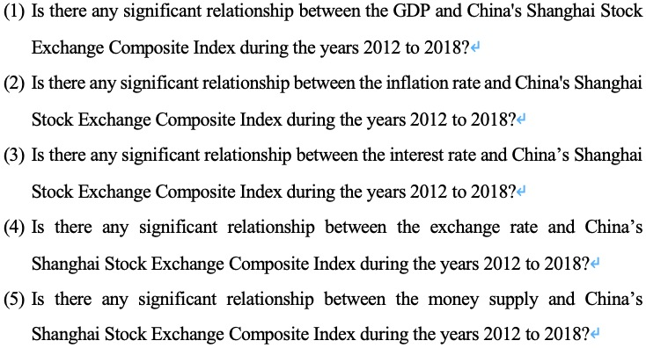

## **1.4 Research Objectives**

Our determination of this investigation is to study the finding from share market behaviors in China. In essence, the foremost determination of this paper is to expound whether selective variables affect the performance of the China's Shanghai Stock Exchange Composite Index or not. This is why the first purpose of work is to measure relationships between microeconomics variables and China Shanghai stock market index.

### 1.4.1 Specific Objectives

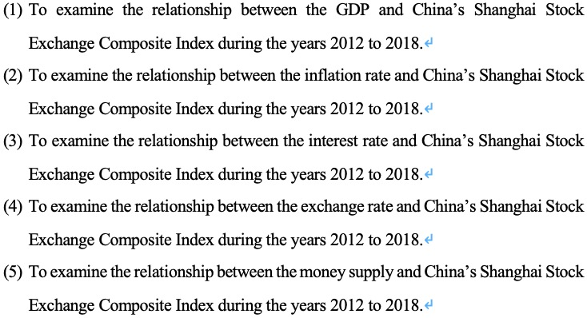

## **1.5 Significance of the Study**

This research analyzes the connection among yearly time sequences data from 2012 to 2018, analyzes the instructive sections like Gross domestic product, Inflation rate, Interest rate, Exchange rate and Money supply and reaction variables China Shanghai stock market index. Data, given study will deliver prospective stockholders, administration and policy makers and analyzers for stocks and economics with some updated indications in their relevant studies (Chan and Yu, 2013).

As said by Murthy et al (2017), stock exchange can be seen as a place in which a company shares can be publicly issued or traded. Where an interested investor can buy n sell those stocks to earn maximum profit and maintain his assets (Yanhua, 2015). However, trader sometimes fail to make the desired deal of return with his investment because of uneven factor of stock market. because market fluctuate according to some news and occasionally reacts to certain irrelevant news. This is why investor should focus on some important factor before investing (Chan and Yu, 2013).

Besides, Janor, Halid and Rahman (2015), discovered that the performances of the stock markets reflects the anticipation of upcoming budget of China. It states the importance of policy maker and for government to clarify the connection between microeconomics factors and share of market. Therefore, they can increase the chances of accurately forecasting the behavior of the stock markets and this will help them in formulating a policy draft.

Actually, based on the empirical results of previous researchers, it has no agreement on how microeconomics factor could affect the performance of China's Shanghai Stock Exchange Composite Index. Additionally, this study may become the example in the form of a director for future investigators that want to examine the causes of the share market concert in China (Chan and Yu, 2013).

## **1.6 Scope of Study**

To understand the influence and impact of microeconomics factor the stock market crisis and growth during the years 2012-2018.

## **1.7 Ethical Consideration**

For this study going to contain the secondary data released by Chinese government which will reveal the financial situation in the country during the years 2012-2018.

# CHAPTER 2: LITERATURE REVIEW

## **2.1 Review of the Literature**

Connections among macroeconomic variables and stock market index has been widely investigated. For example, Bahloul, Mroua and Naifar (2016) employed Linear regression analysis, Markov regression models, Granger causality test to survey the connection between stock market and macroeconomic variables including Consumer price index, three-month Treasury bill rate, ten-year government bond yield and money supply (M3). Monthly index returns, inflation, short-term interest rate fluctuations, and changes in money supply are continuously calculated as the logarithm of two consecutive observations. They show that between 2002 and 2014, Islamic stock indices in developed and emerging countries were affected by the returns of traditional stock indices with low volatility and high volatility and the money supply. Yes. However, other macroeconomic variables cannot expound the movements of the Islamic stock index, particularly in excessive volatility systems. Comparable conclusions can be drawn using the MS-VAR model. The outcomes of this survey are pertinent and valued to stockholders and provide different understandings into the dependence between Islamic stock market returns and market institutions' macroeconomic variables.

Altinbas and Biskin (2015) proposed another approach, pointing out that a one-month lag in the stock market index is adequate to forecast the future value of the market index. Researchers add macroeconomic indicators that they think are important to their model. This causes a misunderstanding of the model output if the relevant elements are not included. Factor selection is therefore another important factor in the success of the analysis and the method used. They measured the correlation concerning the stock market and macroeconomic factors such as GDP, industrial production index, unemployment rate, and savings as indicators of overall economic conditions; Treasury returns, debt certificates, central bank monetary policy, discounts LIBOR policy indicators as rates, interest rates and currencies; single-factor or multi-factor models, ARCH models, vector autoregressive models, Johansen cointegration test, Granger causality test, variance, inflation rate, exchange rates as price level indicators and Foreign currency reserve capital flow index decomposition method, artificial neural network, support vector machine.

In 2006, financial newspaper case evidence showed that stockholders commonly consider that monetary policy and macroeconomic events have a significant effect on stock price volatility, which means that macroeconomic factors can impact stockholders' investment decisions, and numerous scholars have the incentive to explore the relationship between P/E ratios and macroeconomic variables.

Gun et al. (2016) Johansen's multivariate cointegration and Granger causality tests, impulse response and error variance decomposition analysis, Augmented Dickey-Fuller (ADF) and Philips-Perron (PP) methods. They found a correlation between Interest rates, Money supply, real GDP and stock market volatility. NZSE40 is always affected by interest rates, money supply and real GDP in 1990-2003. The outcomes indicate that New Zealand's investment concept regarded as a hybrid of other mature stock markets as seen in Korea, the United States and Japan.

By using the method of Flannery and Protopapadakis (2002), the short-term connection among macroeconomic factors and long-term equilibrium adjustments can be inferred. Employment reports and housing starts), capital market returns, date and importance of each macro announcement, and expected measurements of the public value of the market. The most extensive data set ever used to understand the influence of macro circumstances on the price / earnings ratio: 17 macro series announcements from 1980 to 1996. It turns out that 6 of the 17 macro factors are powerful risk element. Among them, both inflation indicators (CPI and PPI) only influence the return level of the market portfolio. Three candidates (Trade Balance, Employment / Unemployment, Housing Start) influence only the conditional volatility of revenue. The total amount (usually M1) affects revenue and changes in terms. Several of these factors have been formerly recognized in the literature as stock market risk elements, however; evidence of the significance of trade balance, employment, and real estate is new.

The results confirm the former tests of macro factors may not remain huge effects. This is due to the returned continuous coefficient model enforces too much structure on the data. Even if the market's time-varying reaction and announcement accidents are misleading, stock returns seem to be less subtle to macro statements, even though the basic macro series has a significant impact on prices.

Monte (2002) also examined inflation, industrial productivity, crude oil import prices, and lira / dollar exchange rates. Using Arbitrage Pricing Theory (APT), Exploratory Factor Analysis (EFA), Asset Pricing Model to correct inflation, default risk premium or unexpected change in money supply, per capita change in consumption, securities As well as the individual factors of the load, the passage of time is almost irrelevant and a significant percentage of the inventory is experiencing a sign reversal of the estimated load.

Uncertainty between securities returns and macroeconomic factors may result in significant deviations in risk measurement. This instability can be misunderstood when using models of income processes driven by macroeconomic variables in applications that need to estimate expected returns, such as portfolio selection and capital assessment costs. May come to a conclusion.

Pilinkus and Boguslauskas (2009) explored the association among the previous year's stock market and macroeconomic factors, including Gross Domestic Product (GDP); Unified Consumer Price Index (HCP1) compared to 2005 (Ml), Lit And foreign currency and next day deposits, unemployment rate (UR) is the labor market trend for three months, the provision rate between Vilnius banks (VILIB0R3M). Use logical analysis and integration of scientific literature, method comparison and facilitation, and statistical grouping methods. Applied technology has confirmed similar results from other studies. In other words, GDP and money supply have a significant positive effect on stock prices in the short term, but unemployment rates, exchange rates, and short-term interest rates lead the stock price to change in reverse. This undoubtedly supports the short-term correlation among Lithuanian stock market returns and macroeconomic factors. The analysis presented in this paper shows that scholars and practitioners provide different classifications of macroeconomic variables. Regardless of classification, macroeconomic variables are an indicator of changes in the stock market. This issue has been widely discussed in various markets and time frames.

Hosseini, Ahmad and Yew (2011) paid attention on the influence of oil prices, money supply, industrial manufacture and inflation, which are vital elements in the performance of Chinese and Indian stock markets. Unit root tests, multivariate cointegration tests and Vector Error Correction Models (VECM) are used to show long-term and short-term connections between macroeconomic factors and stock market index in two countries (China and India). When it comes to the long run, the effect of rising crude oil prices in China is positive, but in India it is adverse. When it comes to money supply, the influence on the Indian stock market is negative, however, China has a positive impact. The impact from industrial production is negative only occurred in China. What’s more, the impact of rising inflation in both countries on these stock indices is positive. As the short term, the impact of Indian crude oil prices will be positive. This effect is negative in China and can be ignored. The influence of money supply on the present Chinese stock market index is positive, however, negative for India. However, all of these effects are not significant. On the other hand, the concurrent impact of inflation on the current Chinese stock index (SSE) is positive and important, but the positive impact is negligible, but the impact is delayed by one month. In contrast, India had a negative impact during the same period, but this was negligible. However, the delay effect is negative and important.

Maysami and colleagues analyzed the relationship between short-term and long-term interest rates, industrial production, price levels, exchange rates and money supply, and stock index changes. (2005), they use arbitrage pricing theory (APT), error correction model (ECM), dynamic joint movement, and Singapore stock market and SES All-S stock property index to determine macroeconomic variables I discovered that they formed an important relationship with everyone. The SES All-S Stock Financing Index alone with the SES All-S Stock Hotel Index lead an important relationship between the chosen variable.

Vuyyuri (2005) used monthly observations from 1992 to December 2002 to investigate the causal relationship between the economic and physical sectors of the Indian economy. The financial variables used are represented by the actual sectors represented by interest rates, inflation, exchange rates, stock returns, and industrial production.

Johansen's (1988) multivariate cointegration test supports a long-term relationship among the economic sector and the physical sector. The Granger test shows a one-way Granger causality between the economic sector and the actual economy.

Maghyereh (2002) used the cointegration analysis of Johansen (1988) and monthly time series data from Jan. 1987 to Dec. 2000 to determine the long-term association concerning Jordanian stock prices and chosen macroeconomic factors. Researched the relationship. According to the survey, the macroeconomic variables are reflected in the Jordanian financial market share price.

Gunasekarage, Pisedtasalasai and Power (2004) investigated the impact of macroeconomic factors on stock prices in Sri Lanka's stock market. Stock market and money supply, national bill interest rate (as a size of interest), consumer price index (as an inflation indicator), and exchange rate using the Colombo total stock index as a macroeconomic variable.

There is little literature on the connection between macroeconomic variables and individual stock index. Geambasu (2015) assesses market evolution, inflation, interest rates, currency trading, exchange rates, industry, industrialized evolution, and the existence of joint integration relationships between the Romanian stock market, again arbitrage price theory model and model substitution The use of regressions suggested the adoption of the introduction of local macroeconomic factors affecting the Bucharest Stock Exchange reveals the peculiarities of the Romanian economy. Factors like inflation, interest rates, and industrialized manufacture are common in papers that study APT models in foreign economies. Other factors such as exchange rates, currency exchanges, and trading activities are unique to the Romanian economy.

In addition, Valoran (20014) is an ARCH model, a GARCH model, a GJR model, an EGARCH model, a fixed effect panel, a random effects model, and a GMM method. First, use the variance of returns and the ARCH model to restore volatility. Next, we modified the market index conditional model and added the macro equation variability as an exogenous variable to the dispersion equation. The results show that there is a correlation between macro fundamentals and market indices, but they vary from country to country and sometimes negative, negating the initial assumptions. As a result, a team estimate was used. The purpose of this estimation is to eliminate the different characteristics of each state of the biased result, the so-called fixed effect. The identified and over-identified dynamic panel GMM model reveals a positive correlation among exchange rate volatility and stock market volatility.

This result of evidences shows that there is an association among macro fundamentals and market indices, however, there are differences by country, sometimes the correlation is negative, denying early assumptions.

## **2.2 Stock Market Performance in China**

2015-2018 Chinese stocks haven’t been the best one and consider worst of the history in fact. The Shanghai Composite, the main stock average of the mainland, closed year of the trading at 2,493.90 - which was in 2017,23% less than its final closing of the year (Vighneswaran, 2017). As per the Chinese a firm all the 10 sectors of the index have seen a significant decline in the year, the worst is Information Technology. Even the finest presenting zone, services, plunged by 11%. This has put Shanghai composite performance in the worst position since the period of financial bubble since 2008, when it fell more than 65 percent (Kong, 2012).

In other places in China, dramatic damage was noticed, in which Shenzhen composite fell to approximately 34.44 percent in 2018 compared to the end of 33.25 percent and Shenzhen component 2018. The performance of the Shenzhen component was even worse since 2008, when this pigeon was 63 %, according to the wind information. Since the shares on pumped were made on the mainland, Hong Kong shares performed a little good. And index like hang Seng recorded blow like 13.61% (Kong, 2012).

### 2.2.1 Major Issue of Trade with Washington, USA

The trade war between Beijing and Washington remained in the limelight for a long time, the Chinese markets hit with whole events, such as harsh of the investments kept by the bank, with limited success in cooling the merchants （Lin, 2012). After a sequence of penalties punishable by the president of US and China, decided in the beginning of December for a 90-day stoppage in tariff hikes. While waiting for 2019, a financier informed CNBC's "squawk box" maybe the two economics power house are going to make big deal. A senior investor in Cannoning Asia Pacific, told there might be a possibility of this kind of agreement to have three aspects. First of all, they stated that there would be a decline with import tariff on some American products. Moreover, investors ought to expect that they can afford to buy American agriculture and energy products in large amounts. Third, he said that there is a possibility of potential deferrals - but not canceled - on some aspects of China's ambition to become world leader in high technology manufacturing, it’s accordingly called made in China 2025 policy. The business world would prefer the progress, but probably it will not solve issues in long-term (Kong, 2012*)*.

### 2.2.2 Domestic Economy Woes

According to official statistics, beyond the skirmish of its business with the United States, own economy of china has also shown symbols of stutter, for the first time in its manufacturing sector, for the first time in December contracted (Tianshu and Baek, 2016).

The official of the country came to 49.4 on Monday - less than 49.9 prediction in the Reuters poll. The figure beyond 50 indicates the growth, while a figure under the contraction of the signal. Even during the previous growth of business tension with the US this year, the Beijing authority was trying to adjust the recession in its state economy after the breakneck development of three decades (Fang, Lu and Egan, 2018).

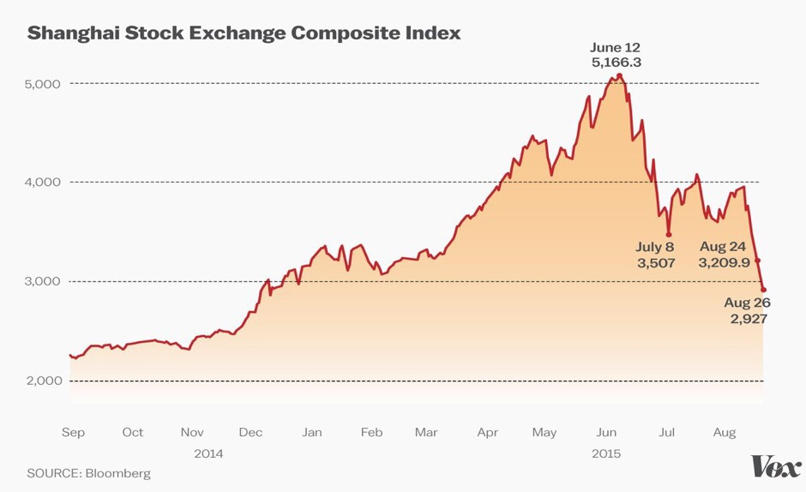

**Figure 2.2.2: China Stock Market Crash**

Since the past, crash in stock market of any country in the world always has seen negative effects on itself and the world economy. Alumonia, Bennetrix, Eisen Green, O'Rourke and Puddle (2010) believe that the 20th century's largest economic depression is the 20th century. One of the examples of the Great Depression, the financial crisis and deflation that came after t1980 the environment is similar to the 1930. though, it started with the 1929 USA market crash (Sheikh, 2015).

Normally, Shanghai index has risen 150 % between the year 2014-15 up to the high level of5166 on June 12, then dropped out of the market. Within less than a month, it decreased to 3,507 which is a decline of 32 percentage (Fang, Lu and Egan, 2018).

## **2.3 Key Concepts as the Lens for the Study**

### 2.3.1 Gross Domestic Product

Gross Domestic Product (GDP) refers to the end result of all household unit production activities within a given period and it is the best indicator for measuring a country's macroeconomic development. The stock markets are a barometer of the economy (Zhao and Tang, 2015). It can be said that the trend of the stock index of a country should be basically consistent with the economic growth of a country (Haldane, 2018). There’s previously researcher found that before 2005, stock market and GDP growth have no relationship, or even a negative relationship in China. From 1991 to 2005, when GDP was growing fast, the stock market index fell; While GDP growth has slowed, the stock market index has risen (Lalwani and Chakraborty, 2019).

The reason he claimed that is because of the progress phase of China's stock markets. First, before 2005, stock markets values were too small to reflect the real economy. Secondly, before the stockholders’ reform in 2005, stocks were divided into tradable shares and non-tradable shares, which distorted the evaluation function of the stock market and could not reflect the real value of stocks (Chen, 2015). What's more, before 2005, state-owned enterprises, such as industrialized and commercial bank of China and China life insurance, which accounted for the largest proportion of China's economy, had not been listed on the share market. Those companies listed on the share market were mediocre and could not epitomize the mainstream of economy China (Hu, 2014). Finally, stock market of China is a new plus transition, moreover, there are still many structures and procedures to be improved.

However, after 2005, the upsurge and plummet of stock markets of China and the growing rate of GDP basically show a consistent relationship. In 2007, GDP maintained rapid growth and the stock market ushered in a big bull market (Mao and Xu, 2015). At the end of 2007, the economic development hit a crisis, and the stock index plunged in 2008. In 2009 GDP returned to rapid growth and the stock market enjoyed a big rally. GDP growth slowed in 2010, and the stock market was tepid (Lin, 2015).

In developed markets, the growing rate of GDP is optimistically interrelated with the upsurge and plunge of the stock market of countries. But it remains to be seen whether China’s stock market will also maintain a positive correlation with the economic growth rate in the future (Church, 2016). For the reason that the stock markets of China are still in constant change and development, perhaps at a certain stage, there will be some unexpected factors can become the decisive factors of this stage, in which circumstances need further specific analysis and cannot be simply conclude. However, even so, the development of the real economy can be regarded as a significant reference to predict how will the stock market goes.

Gross domestic product does not matter whether it is produced by citizens or foreigners if they are in border area location of the country, then their production is included in the gross domestic product.

To avoid double-counting, the final value of the product is included in the GDP. For example, an American shoes production house uses its product made of US. Only the price of shoes is counted; Shoelace doesn’t (Sheikh, 2011).

GDP affects personal finance, investment and job development Investors see a nation’s GDP rate to decide if they could manage their allocation n. They equate the nation's best rates to their greatest global chances. They buy shares of corporations that are in firm rising states (Fang, Lu and Egan, 2018). It enforces expansionist monetary policy to curb inflation and stop the contracting monetary policy to prevent inflation. Its primary device is the federal fund rate (Fang, Lu and Egan, 2018).

For example, if growth is on the rise then the Fed increases interest rates to increase inflation. In this case, you should lock in a fixed rate mortgage. Your adjustment on an adjustable rate mortgage will increase with the Fed fund rate (Tianshu and Baek, 2016).

During 1979 to 2010, the average yearly GDP growth of China was 9.91%, which reached a historical high record of 15.2% in 1984 and of 3.8% in 1990 (Fang, Lu and Egan, 2018).

According to Chinese government statistics, the actual GDP of China rose from the average yearly percentage of 6.7% during 1953 to 1978, although many analysts have questioned the accuracy of these data, china official governments Especially at production levels), frequently overstated making level economist Angus Madison, during this period, China's real regular annual real GDP growth is around 4.4% (Kong, 2012). Apart from this, China's economy is headed by President Mao Zedong, from 1958 to 1962 (which was led to Great Leap Forward), during significant economic recession. Massive famine and reportedly 45 million deaths). From 1950 to 1978, Per Capita GDP of china on the basis of Purchasing Power Parity (PPP) doubled to 8 times in the normal measurement of the country's standard of living (Tianshu and Baek, 2016).

### 2.3.2 Inflations Rate

Inflation is a vital element which considered as the microeconomics variables and the price of stocks. The effect is complicated factor on share market. It can stimulate the stock market and can suppress it.

At the initial stage of inflation, modest inflation has a significant supporting force on the index of stock markets. The reason for that are illustrated as follow: The first one is mild inflation stimulates economic growth, thereby driving stock market price rise; The second one is since inflation is an upsurge in the currency cycle, numerous funds will inevitably enter into the stock market, leading to an increase in stock market funding and demand, thus facilitating the rise in the stock market (Fang, Lu and Egan, 2018); Lastly, in the case of overall price upsurge, the assets of the listed corporations will increase correspondingly, which will inevitably indicate the rise of the stock price of companies (Junttila and Korhonen, 2013).

In the rising stage of inflation, extreme inflation rates have huge restraining effects on the stock market. The reason of it are illustrated as follow: Firstly, high inflation can cause the high costs for businesses, which makes listed companies hard to control and their stocks decline (Sensoy and Sobaci, 2014); Secondly, high inflation can unavoidably cause the reverse of macro-control policies, so that the authority keeps employing the tight policies to control inflation, which restricts commercial growth and causes the decline of the stock index (Tessaromatis, 2003); Thirdly, High inflation would lead to negative actual interest rate, which will cause the continuous rise of bank interest rate and lead to the fund shortage of enterprises and the fund difficulty of stock market, eventually there’s decline of stock market (Yang and Zhang, 2016).

In the initial periods of the decline, the negative impact on the stock index remained due to inflation was still high. Meanwhile, as authority fears a rebound in inflation and continues to employ tight policies to combat it (Tianshu and Baek, 2016). That also could cause the stock market to fall further. Stocks rose as inflation bottomed out. This is because the low inflation rate or even negative inflation appear. Nevertheless, because of the weak market, the macro-control policy changes from tight to loose. On the contrary, because the nominal interest rates and the real interest rates have great gaps, prompting interest rates of bank to reduce continuously (Qin et al., 2019).

On the contrary, extreme inflation has negative influence on the stock index: Firstly, inflation directly triggers the monetary policy response from the central bank, which possibly remain contractionary influences on the aspect of the stock market fund. Obviously, contractionary monetary policy reactions activated by inflation would not simply tighten monetary policies and lower the supply of money and credit, as well as increase interest rates (Asri, 2017). It will have methodical adversarial impacts on the stock index. Numerous major stock market cataclysms in history have been heralded by obvious and persistent monetary policy tightness (Fang, Lu and Egan, 2018).

Secondly, the signal of macroeconomic disproportions from inflation increases the ambiguity of the economic expectation, making it likely for investors to make a reversal their expectations of the stock market (Tianshu and Baek, 2016)

Thirdly, inflation directly reduces the actual return of investors. Inflation can be regarded as the “inflation tax” for almost all monetarist gains and cuts the actual rate of return on future equity investments (Iqbal, 2017). Under the circumstance of apparent inflation and prospects, the decay in stockholders' future yields and the increase in the discount rate will unavoidably prime to a revaluation of stock prices and a fall in stock prices (Fang, Lu and Egan, 2018).

### 2.3.3 Interest Rate

In a lot of finance theory, Interest rates are often viewed as a “buckle” of the macro economy, and the stock markets are a vital part of the macro economy (Pepic, 2014). Therefore, from this perspective, the associations of interest rates and the stock market are inseparable.

In May 18, 2007, the People's Bank of China declared that they will increase the standard of the one-year deposit rate for financial institutions by 0.27 percentage point, which directly triggered the stock market unpredictability the following daytime (Eita, 2014). This move sent a letter that the authority needed to reinforce commercial rules, preventing the economy from turning from fast to overheated growth, and try to cool down red-hot capital markets (Rees and Wambach, 2008).

Nonetheless, it should be illustrated out that the impacts of interest rates amendment in the stock markets are not always so direct, the effect between them is very complex. Historically, the interest rate cut in May 1996 had the biggest influence on China's stock markets. In addition, the following five Interest rate cuts had relatively weak impact. This suggests that lower interest rates have little influence on the supply of equity funds (Yang and Zhang, 2016).

Some people even summed up such a law: the short-term upsurge in interest rate has a greater negative influence on the stock markets; When it comes to the medium period, it is hard to tell exactly how this affects; In the long term (more than three months) the shift is towards positive effects.

There are some special situations comes out in the procedure of the improvement of the stock markets. While times are good, when the stock market is booming, interest rates do not exert much control over share prices. Correspondingly, on the situation that the stock market is in a plunge, even a policy amendment of lower interest rates can cause a sluggish recovery in share prices.

For example, in the US, interest rates and stock index both rose in 1978. There are two key reasons for this abnormality. Firstly, many financial organizations have no self-reliance in the capability of the US government to maintain dollar’ status in the world and maintain inflation. Secondly, the stock index has fallen at a very low level, which is far relatively lower the stock index. As a consequence, a large amount of foreign capital entered into the US stock markets and the cause stock price increase. The same thing occurred in Hong Kong in 1981. Generally, interest rates and stock index rarely rise and fall simultaneously (Qin et al., 2019).

Of all the elements that influence the stock market index, none of them are more acute than financial factors. Among the financial factors, the adjustment of the level of interest rate has straight and rapid impacts on the stock index. Interest rate adjustment is a main element affecting the stock market in the short term and has a significant negative connection with stock price changes within long period, but the correlation between the two is complex (Ali, 2014).

Generally speaking, economic elements are regarded as the most subtle elements affecting stock index, and among the economic elements, the modification of interest rate has the huge impact on the stock index. Some people employed Granger's causality test and discovered that adjustments of interest rate affect the stock index in lengthy period of time. Conversely, the interest rate amendment policy setting need not be only affected by the stock market (Khalid, 2017). Specifically, stock prices are contrariwise relational to interest rates-stock prices decline as interest rates rise and stock index rise when interest rates fall.

There’s several reason why stock prices change into the contradictory direction of interest rate: Firstly, the upsurge in interest rates will escalate the cost of financing of listed corporations and surge the struggle of capital gaining. It will inevitably squash the corporation's incomes and reduce the amount of manufacture, which can lead to a plummet of stock index in the future. And vice versa (Addo and Sunzuoye, 2013).Secondly, when interest rates increase, the discount rate employed by stockholders to assess the stock price climb, as for internal values of the stock would therefore decline, which lead to the corresponding decline of the stock price (Khrawish, et al., 2010). Thirdly, when interest rates climb, some money would be taken from the stock market to buy bond and use as deposit in the bank, thereby reducing the amount of money in the stock markets. Such "blood loss" in stock markets can lead to huge decline of the stock index (Pallegedara, 2012).

Since there is such an association between interest rates adjustment and stock index changes, it is necessary for investors to have considerations of timing, direction and the intensity of interest rate adjustment. And, if possible, to anticipate changes in interest rates so that stocks can be bought and sold ahead of time.

There’re many other factors that affect stock prices. What our paper focus on is not the daily change of stock prices, but the overall view of how stock prices fluctuate with the fluctuations in interest rates and the amount of currency. It is hard to predict the change of stock price from day to day through the fluctuation curve of stock price itself, and its fluctuation curve is complex and varied, which may change at any time and cannot be explained in a few words. Moreover, it is impossible to sit in front of the computer screen and stare at the change of stock price all day. When everyone finally figured out the fluctuation curve of share price, the investment institution had already completed the transaction quickly with the artificial intelligence machine, how could we catch up with the speed of the artificial intelligence machine? These AI machines are built by researchers who specialize in mathematics, physics and other fields, and they are still improving their computing power every day (Mukit, 2013). Plus, our ability to deal with the overwhelming amount of information we receive every day is not that great, so the best choice for us is to grasp the overall trend and invest steadily according to this trend.

During the period of inflation, the scale of credit expansion is enlarged, and the stock price is also rising. When a bubble is forming, not only institutional investors but also retail investors are fueling it, which can be said to be a very dangerous period. This conclusion can help us judge the medium - and long-term positive conditions of the economy and determine the best time to sell or buy (Khrawish, et al., 2010).

From China's actual situation, investors can mainly focus on the following aspects: Firstly, it is the range of loan interest rate adjusting. Loan funds are supplied by deposits, so as the modification of the loan interest rates, the deposit interest rate will be adjusted accordingly (Mouna and Anis, 2016). Secondly, market trends. When markets are booming and prices are rising, interest rates tend to rise, because this is the only way to attract more deposits and reduce market pressure. On the contrary, interest rates will adjust downward (Musawa and Mwaanga, 2017). Thirdly, the degree of tension in the capital market and the international financial market interest rate. Simply put, in an open market system money knows no borders and must be viewed globally (Meng and Deng, 2013).

In theory, stock prices climb when interest rate drops, and stock prices descent when interest rates ascent. Therefore, the relationship among interest rates and the stock index is additionally a standard for stockholders to purchase and sell stocks. Because interest rate and stock index generally transfer in contradictory directions, investors need to pay close attention to rising and falling interest rates and forecast the interest rate trends in advance (Adebowale and Akosile, 2018)

### 2.3.4 Exchange Rate

Theoretically, the upsurge and plummet of the stock index is the demand and supply performance, and there are many elements affecting supply and demand. Generally speaking, in terms of exchange rates, the appreciation of the national currency is contributing for import but not contributing for export; the decline of the national currency is conducive to exports and is not conducive to imports. A climb in the exchange rates of a country versus foreign currency would cause more foreign currenciy being altered to the local currency, which will promote the need for the local currency (Mohan and N. Chitradevi, 2011). In an opened market, exchanges of foreign currency into the local currency is possible to enter the stock market, which will increase sources of capital in the stock markets and stimulate the appreciation of the stock. Quite the reverse, when there is no central bank to strengthen the currency, the massive loss of local currency will trigger the stock market funds to flow to the foreign currency market, causing the stock index to fall and vice versa (Yadav, 2016). Therefore, there is no absolute positive or negative association between the movement of exchange rates and the country's stock indicator, many scholars believed it should be determined by the openness of the country.

With the persistent operation of development, market opening and the deepen degree of RMB internationalization, foreign exchange market and the stock market performance an increasingly important character in a nation’s economy. The exchange rate reform named "811” was implemented in 2015, in 2016 The RMB has officially joined the SDR basket of the international monetary fund, China-US trade war appeared in March 2018 (Yunita and Robiyanto, 2018). By the ongoing transformations of the exchange rate and the confusing worldwide macro situation, government intervention in foreign exchange has been accompanied by the movement of the foreign currency market. During the past years, many scholars studied the stock index and the foreign currency markets with the background of developed countries. However, the strategic research based on the capital market of developed countries is not necessarily suitable for the foreign currency market and stock market of China (Kumar, 2008). Since the actual situation of China's foreign exchange market, that means, China’s central bank conducts long-term and normalized government intervention in foreign exchange (Mun, 2004). Government intervention has a huge impact on economic development and exchange rate expectation. Incorporating foreign exchange intervention into the whole theoretical system can make the research more consistent with the national conditions of developing countries. The trade flows between countries are more complex, and there are many hot moneys went through the universal market (Asri, 2017). The exchange rate expectation can be considered the main reason for the international hot money flows. It is more realistic to investigate the connection among the stock index and the foreign currency market from the perception of foreign currency expectation. Meanwhile, the development of non-tradable shares appeared in the stock markets of China and the implementation of science and innovation are the reflections of continuous improvement in the stock markets of China (Tai, 2000).

Due to the expansion of the scale of the China-us trade war, the RMB has been under continuous pressure and depreciated in a large scale in the near future. The impact of it are concluded as three points as follow:

1. **Macro liquidity**

Currency, exchange rates and stock markets are often linked. One major factor disturbing the rise and fall of the stock markets is liquidity. A great influx of investment will allow the stock market to develop in a healthy way, with corresponding room for ups and downs. Under the expectation of the depreciation of the native currency and the continued depreciation, capital in the market has flowed out and dried up. The central bank used foreign exchange reserves to control the exchange rates, causing the base currency to contract, further tightening the liquidity of the domestic capital market (Yadav, 2016). For sensitive stock markets, liquidity tensions have triggered the stock market to descent. The profit-seeking nature of capital drives capital to flow between national markets. Under the expectation of a national currency appreciation, capital would continue to flow into the nation and enjoy the profit of the exchange rate difference. On the contrary, capital flows out under the expectation of continued depreciation and even depreciation. The transmission mechanism of international capital has made the more and more close connection among foreign exchange markets and stock index (Hyde, 2007).

**(2) Industry fundamentals**

Continuous decline of RMB exchange rate directly affects the industries that account for a large proportion of foreign business. In export-oriented industries, depreciation is conducive to sales in foreign markets; Conversely, in industries that rely on imports of raw materials, depreciation increases their costs. It is found that the price of industrial stocks performs better when the currency appreciates. Resource stocks hold up better when currencies fall (Toraman and Başarir, 2014).

**(3) Emotional transmission**

The forex market and the stock index are related as the previous research, and the exchange rate movements affect stock prices. Traditional financial theories assume that investors are rational and can make correct investment decisions in the face of crisis. However, in actual financial activities, investors tend to act blindly, which called "herd effect". Investors' psychological expectation will aggravate the volatility of stock market and foreign exchange. Trading with emotions is not uncommon in secondary markets (Sensoy and Sobaci, 2014). Stockholders in China's stock markets have always been based on retail investors, most of whom lack basic financial investment knowledge and are prone to making emotional mistakes. In the case of the continuous depreciation of the RMB, the pessimistic expectation of the market makes investors to act irrationally, which eventually transmits from the foreign currency markets to the stock markets, thus causing a crisis of confidence in the market and triggering financial turmoil (Gong and Dai, 2017).

**(4) Friction pressure of international trade**

The trade war between China and the US in 2018 is one of the most important risk factors for the whole year. After many rounds of fruitless negotiations, the trade issue between China and the US has become increasingly serious. The impact of trade war on the exchange rate is mainly from two aspects. One is the country's international trade, balance of payments, interest rate, etc. Second is the market expectations (Ainapure, 2016). Carry trade is an important form of international capital flow. It borrows money in low-interest currency, sells low-interest currency and buys high-interest currency, invests in assets such as securities denominated in high-interest currency, obtains interest margin of two currencies and investment profit and loss of high-interest currency (Michelis and Ning, 2010). If the sum of the two is greater than 0, the carry trade is profitable. If low-interest currency is expected to deflate while high-interest currency is expected to appreciate, then investment gains and losses will be positive and carry trades between currencies will increase (Addo and Sunzuoye, 2013). On the contrary, the carry trade decreases. As a risk event, the cloud of trade war will affect the future tendency of exchange rate and increase the uncertainty of carry trade. The depreciation of the RMB and the expectation affect the carry trade. The demand for assets such as securities denominated in high-yielding currencies in carry trades decreases as carry trades decrease. In the stock market, capital outflow makes the stock market under pressure and further affects the stock price (Mun, 2004).

### 2.3.5 Money Supply

With the opportunities and challenges brought by the development and market opening, the economy of China develops rapidly. As a fragment of the capital markets, the stock index performances a progressively vital part in developments of the economy. People gradually put their more idle money in the stock markets and makes it become gathering places of excess money supply (Thabet, 2014). In the premise of maintaining price stability, excessive money supply will trigger a sharp upsurge in stock index. The formulation and implementation of monetary policies has been impacted by the stock market. From 96 to the present practice of monetary policy can be seen, the decrease of the interest rate and the increase of money supply is not to at a great extent which influence the development of economy, consumption demand and investment demand was still weak, however, since 98 the stock market has experienced for a year and a half of a bull market, suggesting that fragment of the effect of monetary policies to stock index (Choi and Yoon, 2015). Meanwhile, the upsurge and plummet on the stock market affects the operation of monetary policy by affecting consumption and investment. The association among stock index of China and monetary policies has become one of the topics that academic circles and policy authorities concentrate on.

As the intermediate target of monetary policies recognized by the world, the central bank influences the capital market by regulating the money supply in the market (Gao, 2016). The performance of the securities market is strictly linked to a monetary policy of a country. The implementation and formulation of monetary policies have profound impacts on the performance of the stock index (Lesage and Solocha, 2011). Specifically, for the purpose to alleviate the economic crunch and reduce negative impacts of the turmoil in the securities market on the economy, the central bank will often employ monetary policy instruments to control as tight monetary policy and the sudden decrease in market liquidity will cause accidents in the securities market. Shock. For example, after the Internet bubble burst at the beginning of this century, for the purpose to save the US economy, the Fed repeatedly cut interest rates frequently, launched a loose monetary policy, and increased liquidity for the US economy, which largely saved the US securities market at that time. As the vital proportion of securities market of China, Shanghai and Shenzhen security markets are more subtle to changes in monetary policy (Pícha, 2017). From 2006 to 2007, due to China's prudent monetary policy and a large amount of passive foreign exchange, the money supply maintained a rapid growth. The stock index of China has accordingly got out of its way. While facing an apparent over-liquidity situation, the central bank has repeatedly upraised the standard interest rates and reserve ratio for deposits and loans and issued central bank bills to limit the liquidity bubble. Under the influence of a succession of measures, China's stock index began to fall sharply. In just one year, the market value of evaporation exceeded half of the original (Li, 2008).

In response to the subprime crisis, China adopted an active and effective loose monetary policy. With the change of economic situation, China also timely adjusted the monetary policy from loose to steady. During the same period, the stock market also had great fluctuation. The Asian financial crunch in 1997 alone with the American financial crunch in 2008 showed that the volatility of financial asset prices would have serious impacts on the stock index (Dutt and Mihov, 2013). According to the central bank's monitoring of data over the past few years, the upsurge or reduction of the money supply has not guided to the climb or fall of China's stock markets, and there are no high correlations among the money supply and the stock index. And the household deposit is closely linked to the stock index expectation. When the stock index rises, the household deposit demand tendency increases. And the household deposit is closely linked to the stock index expectation. When the stock index rises, the household deposit demand tendency increases (Alizadeh and Muradoglu, 2014).

How the money supply influences the stock market becomes a vital task for the monetary authority. Because of the change of money supply, which affects stock demand and thus stock price, the comprehensive use of money supply and macro-control function is of great significance to promote economic development.

### 2.4 Conceptual Framework

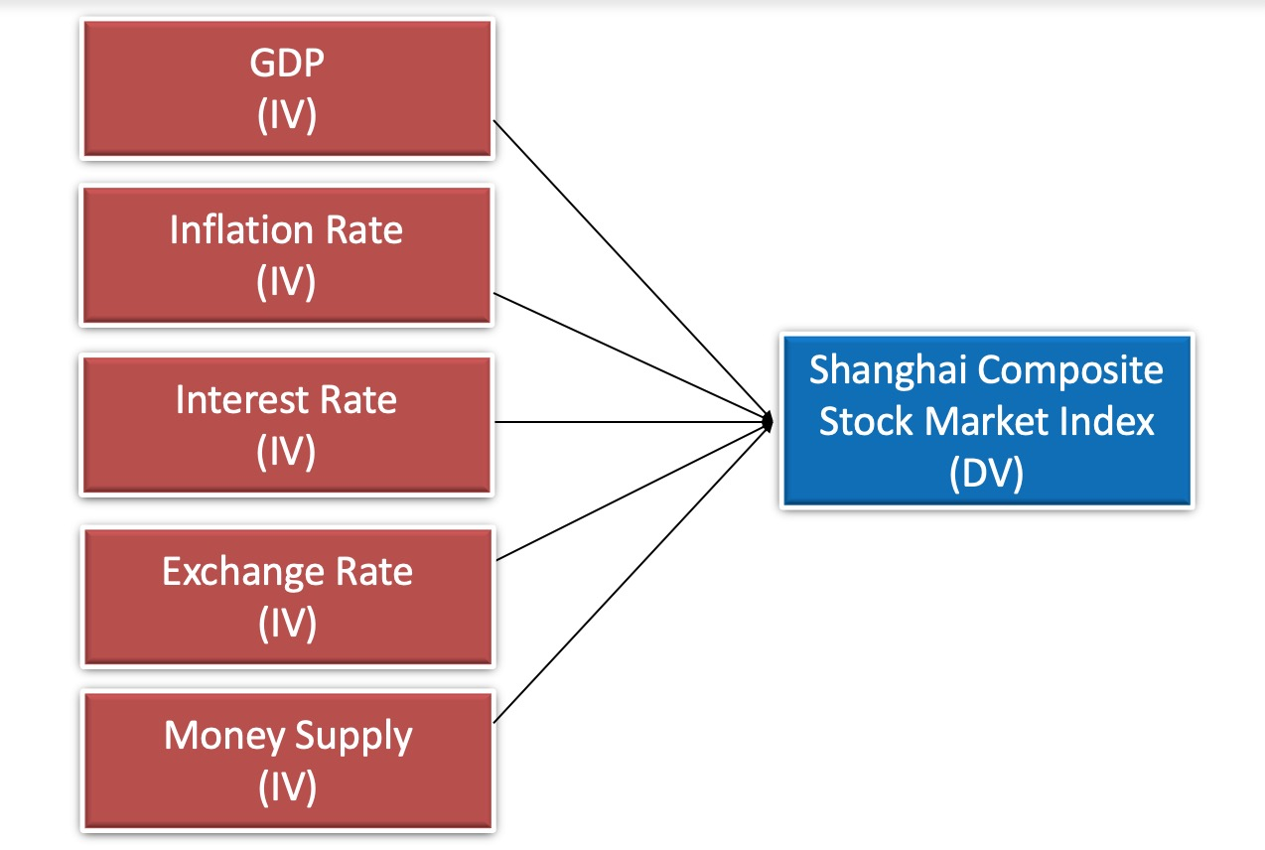

**Figure 2.4：Conceptual Framework**

## **2.5 Development of hypothesis**

According to Geambasu (2015) the following hypotheses are formulated to have a disciplined approach and guidance for the study.

### 2.5.1 GDP

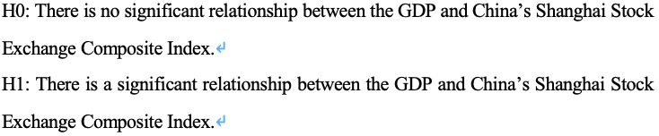

### 2.5.2 Inflation Rate

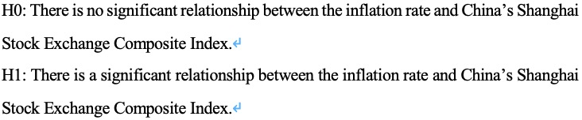

### 2.5.3 Interest Rate

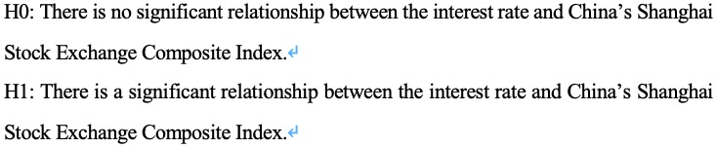

### 2.5.4 Exchange Rate

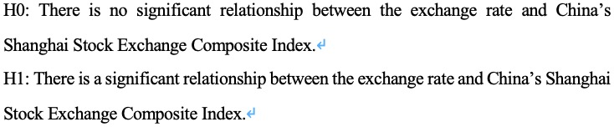

### 2.5.5 Money Supply

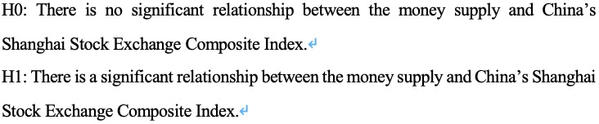

# CHAPTER 3: METHODOLOGY

## **3.0 Introduction**

The chief determination of this chapter is to be providing an explanation of the methodology chosen for the detailed completion of this study project. This chapter describes data collection methods, data processing procedures, econometric models and applied methods. In general, this chapter contains the following sections:



## **3.1 Research Design**

According to a study by Conrad and Serlin (2011), the study design reflects the entire research process. The first step in the process is to form problematic ideas, and the second step is to analyze literature reviews. The third step is to collect relevant data, and then the final step is to draw a conclusion. Research design is important because it is a way to combine all the information considering the core characters of the research. In fact, it can be classified into three types of method: quantitative, qualitative and the mix of both (Hughes, 2013). For this research project, the method employed is a quantitative study design, which is a study design that includes statistical and numerical methods. It is exclusively based on the theories that currently exist and then comes with surveys and experiments to answer the questions of this study. Through the data collecting and processing，it provide more realistic results.

## **3.2 Sampling Design**

This research uses purposive sampling. Shanghai stock market of China is designated as the target population. In other words, this investigation is designed to explore the association among the dependent variable SSE and GDP, inflation rate (CPI), interest rate (IR), exchange rate (January 2012 to December 2018) RMB/ US dollars) and money supply (M2). The reason for choosing SSE as an indicator is because of the high accuracy to represent the China stock market index as it has more than 3,000 listed companies in various industries and comprises of many large companies from the main market.

## **3.3 Data Collection Methods**

This investigation selected secondary data, which is a set of data that you can collect and use immediately from other sources. This type of data saves time and lowers data collection costs (Shea et al., 2013). The following table shows the different sources of data collection access:

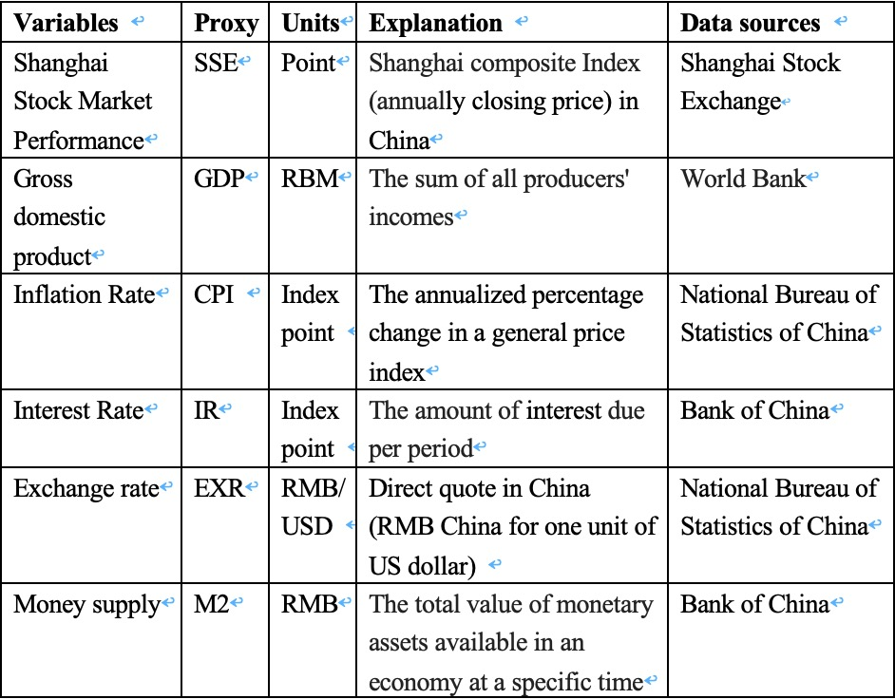

**Table 3.3: Data Collection Access**

## **3.4 Data Processing**

By browsing and analyzing at least 20 journals in the past few years, all the results of study related to this research were recorded. On the other hand, all the data in this research were attained in various sources such as the World bank, the National bureau of statistics of China, and the Bank of China. After doing so, all the data was placed in Microsoft-Excel, then it comes diagnostic check using SPSS and explanation of the results. The following figure shows an overview of the data processing sequence.

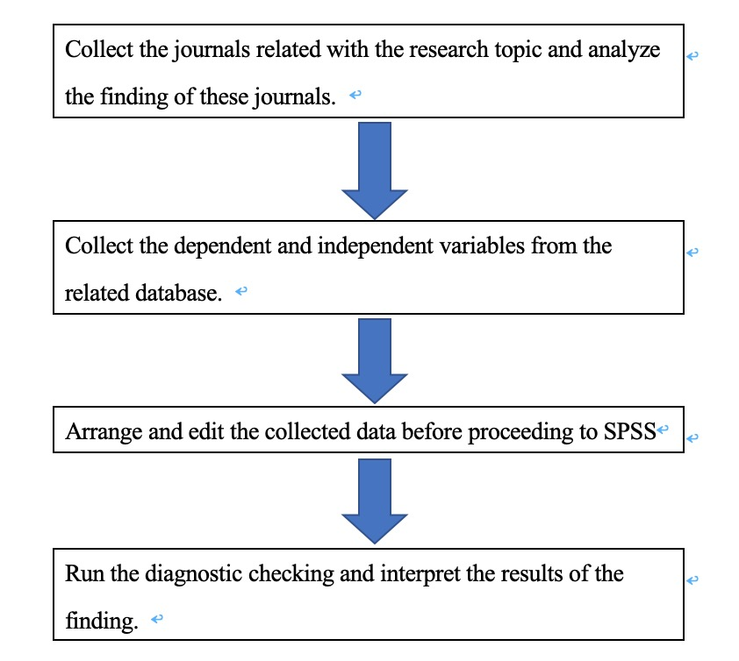

**Figure 3.4: The Process of the Data.**

## **3.5 Data Analysis**

### 3.5.1 Multiple Linear Regression Model

Multiple regression is a further development of simple linear regression, which can be referred to forecast the value of a variable depending on the values ​​of two or extra other variables. The variable to predict is called the dependent variable (in some cases, the result, target, or standard variable). Variables used to predict the value of the dependent variable are called independent variables (or predictors, descriptive variables, and regression variables) (Nagy, 2018).

For instance, the multiple regression can be used to see if the test outcomes can be predicted based on revision time, test nervousness, classroom presence, and sex. What’s more, researchers can use multiple regression to see if they can predict monthly alcohol consumption based on time length of drinking, time of starting drinking, type of drinker, salary, and sex (Shi, Li and Wan, 2018).

Multiple regression can also observe the general goodness of fit (interpretation variance) of the model and the relative contribution of each predictor variable to the total variance expounded (Kicsiny, 2015). As previous sample, if there’s researchers want to identify how much of the difference in test performance can expounded by review period, test nervousness, lecture presence, and sex “as a whole” at the same time, it also illuminates the "relative influence" of each variable in describing variance. The model as follow:

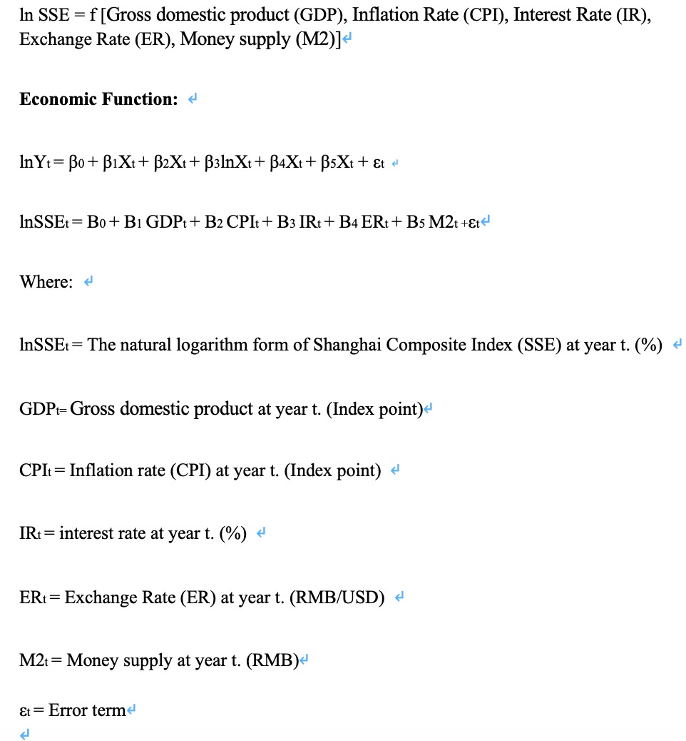

## **3.6 Conclusion**

In this chapter, we use quantitative, descriptive, and correlation designs to determine the research methods which are appropriate for this research topic. Based on the requirements identified in this chapter involving several areas of selected populations, sample sizes, hypothesis testing and measurement tools, systematic research can proceed to the next stage.

# CHAPTER 4: RESEARCH FINDINGS

## **4.0 Introduction**

According to the methodology of our study presented in the former chapter, this chapter displays the outcomes of the research. IBM-SPSS software was employed to test and analyze the collected sample. Descriptive statistics are used to explain the collected data. Correlation analysis is applied to investigate relationship between variables. Finally, the formulated hypotheses were tested using multiple regression analysis to accept or reject those hypotheses.

## **4.1 Descriptive Analysis**

With the purpose to intuitively analyze the relationship between GDP, inflation rate, interest rate, exchange rate and money supply and Shanghai composite stock market index, Firstly, the scatter diagram of the relationship between GDP, inflation rate, interest rate, exchange rate and Shanghai composite stock market index is drawn as follows:

Scatter diagram of the relationship between each index and SSE

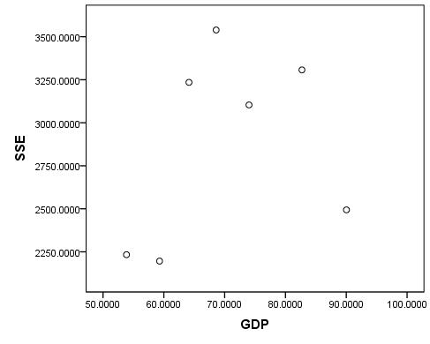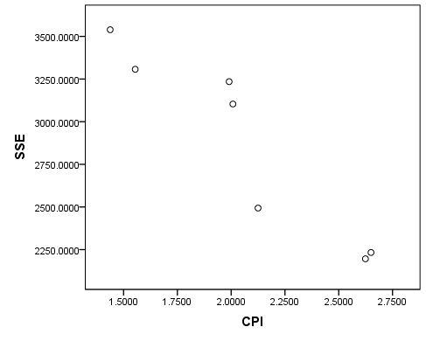

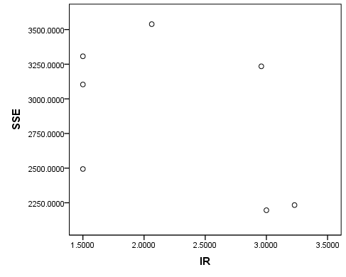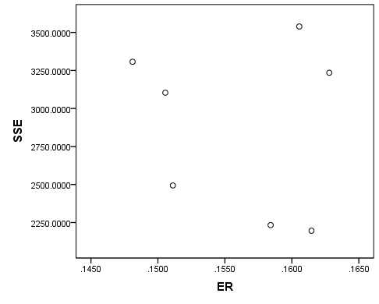

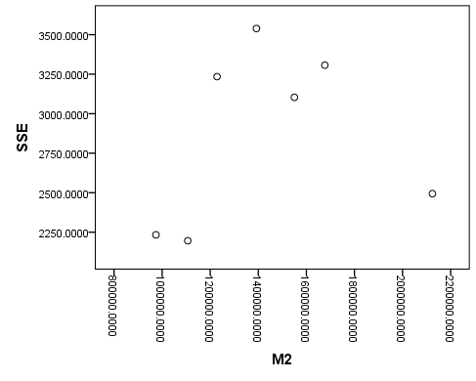

As we can see from the scatter diagram above, it can be concluded intuitively that CPI and SSE have an obvious linear trend. With the increase of CPI, SSE has an obvious downward trend. However, there is no obvious linear trend between other variables and SSE.

## **4.2 Correlation Analysis**

According to the scatter diagram, we can intuitively conclude the correlation between GDP, inflation rate, interest rate, exchange rate, money supply and Shanghai Composite Stock Index. So as to further analyze the relationship for each variable and SSE, Pearson correlation analysis is adopted to quantitatively depict the connection between each variable and SSE. The following table shows the results of analysis:

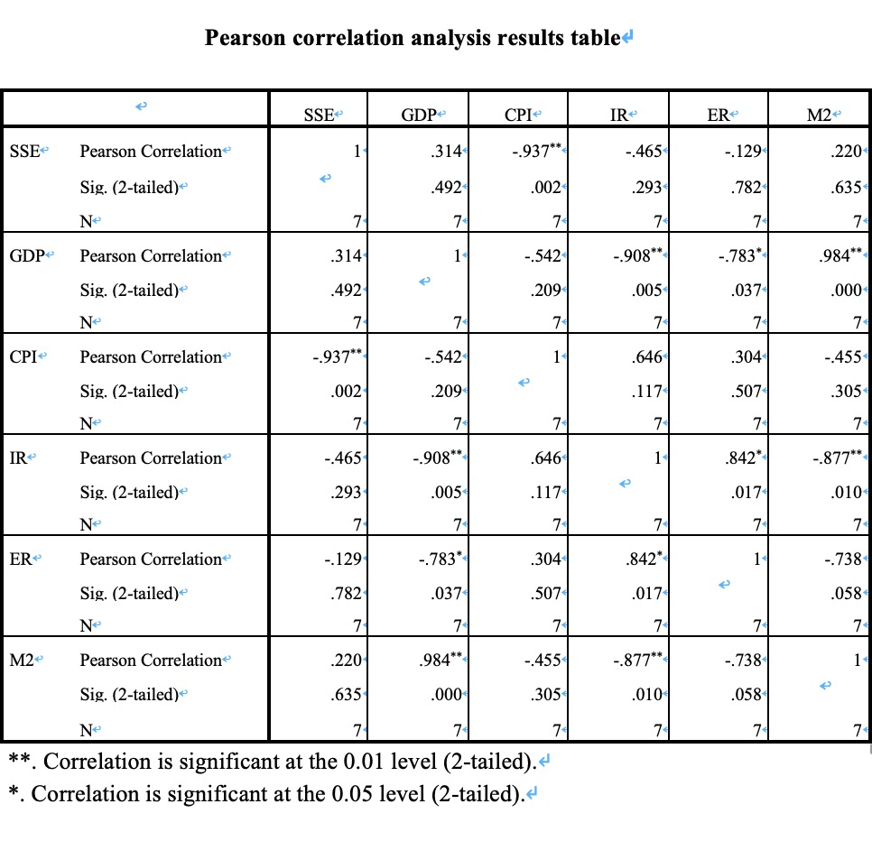As we can see from the result of correlation analysis, the correlation coefficient between CPI and SSE is -0.937, the p value of coefficient significance test=0.002<0.05, indicating that CPI and SSE show a significant negative correlation, which SSE shows a downward trend with the increase of CPI index. The correlation coefficient between GDP and SSE is 0.314, but the p value of coefficient significance test is 0.492>0.05, indicating that the data analysis results based on the research show that there is no significant linear connection among GDP and SSE. Similarly, correlation coefficients between IR, M2 and SSE are insignificant, and it is still an insignificant linear relationship between these variables and SSE.

## **4.3 Regression Analysis**

From the results of correlation analysis, we can conclude that, except CPI and SSE show a significant negative correlation, other variables have no significant negative correlation with SSE. Taking into account the different dimensions of each variables, we take the logarithms of GDP, IR, ER and M2，use the processed natural log (GDP), natural log (IR), natural log (ER), natural log (M2) and CPI to be independent variables, SSE to be dependent variable used establish a multiple linear regression model:



Where,  is the intercept term,  is the regression coefficient, is the random error term. Using SPSS for model fitting, the entry method was selected firstly, then incorporate all indicators into the model. Parameter estimation and model test outcomes are exposed in the following figure:

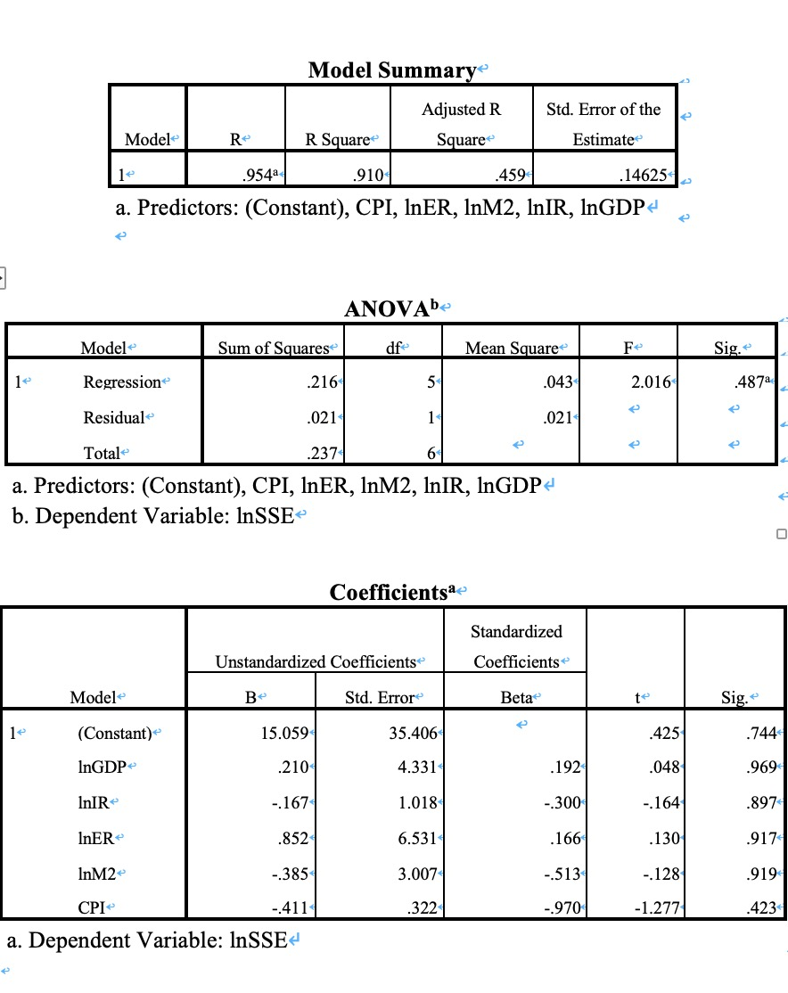 According to the above figure from the regression model, R Square=0.910，Adjusted R Square=0.459，There was a significant decline in R Square, but the overall fit of the model was good. Independent variables ln (GDP), ln (IR), ln (ER), ln (M2) and CPI could describe the variation of 91.0% of the dependent factor.

Outcomes of ANOVA variance examination table showed that the F value of model significance test was 2.016 and the p value was 0.487>0.05, indicating that the joint linear influence of independent factor on dependent factor was insignificant. Besides, the established regression model was invalid. Therefore, the Coefficients are not very significant.

According to the analysis above, the regression model outcomes considering all independent variables are insignificant. Therefore, the method of model parameter estimation is improved. Stepwise regression method is selected to re-estimate the model parameters.

The outcomes are revealed in the following figure:

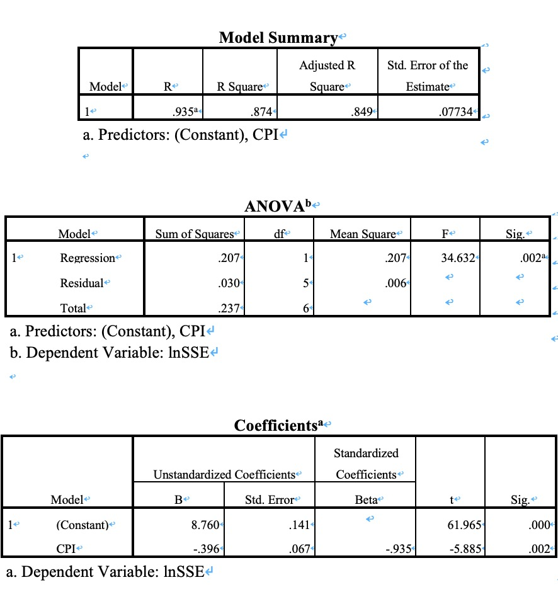 In the regression analysis model, R Square=0.874 and Adjusted R Square=0.849， which both can be considered relatively large, indicating that the general fitness of the model is good and the independent variable can explicate the variation of 87.4% in the dependent variable.

The outcomes of ANOVA variance examination table showed that the F value of the model significance test was 34.632, and the p value was 0.002<0.05, indicating that the independent variable had a significant influence on the joint linear effect of the dependent variable, and the established regression model was significant and effective.

Through stepwise regression, the only significant variable was CPI, which was consistent with the previous correlation analysis results. The p value of CPI coefficient significance test was =0.002<0.05, indicating that the regression coefficient between CPI and SSE was significant. Therefore, the fitting regression equation is:



It indicates that for everyone unit increase in CPI, the log of Shanghai composite index ln (SSE) decreases by 0.396 units on average.

## **4.4 Conclusion**

According to the outcomes of above analysis, CPI and SSE show a significant negative correlation, which SSE shows a downward trend with the increase of CPI index. The correlation coefficient between GDP and SSE demonstrating that there was insignificant linear correlation between GDP alone with SSE. Similarly, correlation coefficients between IR, M2 and SSE were not significant, and there is still no significant linear correlation between these independent variables and SSE. Based on the results of regression analysis, we have concluded that exclude for CPI, other variables had no significant relationship with SSE. Through stepwise regression, the only significant variable was CPI, which is consistent with the previous correlation analysis results.

# CHAPTER 5: CONCLUSION AND IMPLICATION

## **5.0 Introduction**

The results of Chapter 4 showed the connection between the Shanghai stock index and the five independent variables which are Gross domestic product (GDP), Inflation rate (CPI), Interest rate (IR), Exchange rate (ER) and Money supply (M2). The first part of this chapter is an overview and discussion of the relationship between the main findings of this study. The second part introduces the policy implications suggested for different group of people. The third part of this chapter describes the limitations of this research. For the last part, the personal reflection is presented as well.

## **5.1 Discussion of Major Findings**

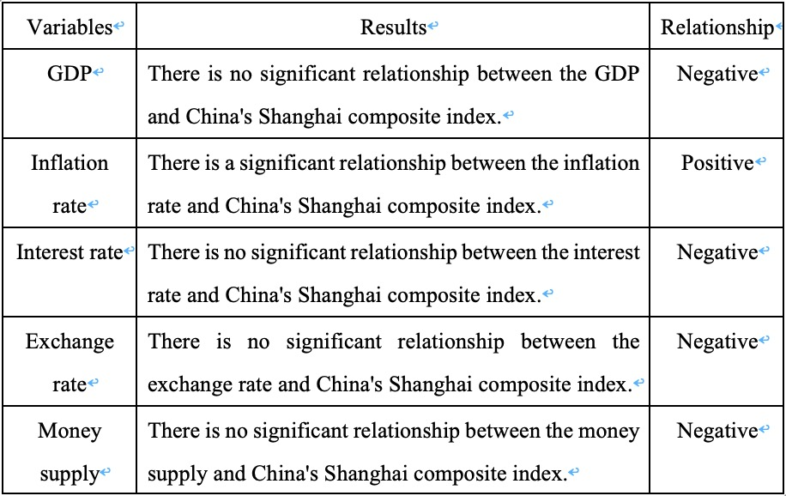

**Table 5.1：Summary of Major Findings**

According to the summary of Table 5.1, all the variables failed to show any statistically significant connection with SSE expect for inflation rate. To be more specify, this study has one significant independent variable and four insignificant variables.

### 5.1.1 Significant Variables

**5.1.1.1 Inflation rate**

Table 5.1 indicates that the inflation rates are significantly negatively interrelated with the China Shanghai Composite Index. According to previous studies, the negative correlation between inflation and China's Shanghai Composite Index is rare. According to previous research, Sakti and Harun (2015) discovered a significant association between the Islamic stock performance and Malaysia's inflation rate.

### 5.1.2 Insignificant Variables

**5.1.2.1 Gross domestic product**

GDP have been used as the factor is found insignificantly related to the China's Shanghai composite index in this research. In other word, the amount of Gross domestic product won’t affect how the Shanghai composite index perform. The result is coincident with numerous studies such as Geetha et al. (2011). The insignificant result of Gross domestic product attained may be because of the rapid economic growth of China. For industrialized countries, the general level of economic growth has extended to a high level, and it is difficult to improve the economic development speed. As for growing nations whose economy are still in the initial stage, their economic growth may reach extraordinary speed due to their great development potential. At this time, the national economy is prone to a series of problems, such as aggregate demand inflation, rising price index, causing overheating of the macro economy (Fraumeni, 2017).

For example, in the early 1980s, when the economy was overheated, the economic development was staggering, and many enterprises with low technical level, weak backward production management, and large difference between product and the real market demand gradually declined, and the enterprise profit of supporting stock price was negative. The actual cash income of stockholders has fallen, and it has been sluggish in the bullish environment of the big market (Hameed, 2010). Therefore, the influence of GDP on the stock index is not accord with individual stocks. People who want to invest must realize the difference among the macroeconomic stock index and individual stock.

**5.1.2.2 Interest rate**

It has been found that interest rate has an insignificant association with the SSE, which ca referred to the result of Yakob et al. (2014). They discovered if the appeal of stock investing drosp, the stock market will be overflowing, and the stock index may plunge. Nevertheless, as interest rates descent, stock index upsurge. This converse association between stock index and interest rates. However, as for medium period and long period, interest rates and the stock index have not a simple negative association. This is because for the tendency of period and long period, the stock markets are not simply influenced by interest rates movements, but likewise very subtle to non-market macro policy factors and economic growth factors. If these elements are greater than the impacts of interest rates on the stock index, stock index trends will deviate from interest rate trends. Therefore, this might be the reason for the results of this study. What’s more, Kutty (2010) who observed that stock market only responds to unanticipated announcements.

**5.1.2.3 Exchange rate**

We also discovered that the exchange rates have insignificantly connection with China's Shanghai Composite Index. This is similar to the results found by Zhao (2010). Zhao’s study outcomes demonstrate that there is unsteady long-period equilibrium connection among the genuine operational exchange rates of the RMB and the stock index. There is also no average chain reaction between foreign currency and the stock index. This was due to from a foreign currency perspective, the exchange rate is considered to be one of the key elements of asset prices. The researchers also believe that the main factors of current and future exchange rate changes are not the same. For example, exchange rate fluctuations may be affected by the performance of a country's international trade. However, the future exchange rate may be affected by major political and economic events such as elections, economic recession, war and changes in government policies. Therefore, there is no causal relationship between these two variables.

**5.1.2.4 Money supply**

The result of this investigation is supported by Chakraborty and Gupta (2017), who discovered that there is insignificant connection among the money supply and Shanghai stock index. Based on this finding, the result of this study might due to when it comes to long period of time, explanations of money supply to the stock index is weak. Money supply mainly influences the fluctuations of stock index in the short period of time, this effect is mainly caused by Mo and M1. M2 has no long period or short period influence on the stock index. In addition, M1's reaction has a more lasting effect on the stock index. Therefore, in short period, monetary authorities can regulate changes in consumption and money supply to control stock market prices. Investors can also focus on changes in the money supply to enhance their ability to predict investments in financial markets. However, as for long period of time, the volatility of the stock index is mainly influenced by the market.

### 5.2 Contributions

### 5.2.1 Contributions to the Potential Investors

It is very important for investors to consider macroeconomic factors before entering the stock market. Therefore, the awareness and deep understanding of macroeconomic performance is essential for future investors. Considering factors such as inflation, investors and stockholders tend to enter and hold stocks when a bullish market comes. Meanwhile, the main findings may help potential investors and stockholders to determine macroeconomic variables (Gross Domestic Product, inflation, interest rates, exchange rates, money supply) and China's Shanghai Composite Index. In addition, they can analyze and make the right decisions by concentrating more on significant variables.

### 5.2.2 Contributions to the Government and Policy Makers

The Chinese authority plays a vital role in influencing factors affecting the country. Therefore, it can be considered important that the government has a clear idea of ​​the association among factors and stock index and adjust their policy as well. Referring to the results of this survey, the government needs to analyze inflation in depth since it is significant to the stock index which relatively have the influence on the country’s economy.

## **5.3 Limitation**

From an academic point of view, the Period of this study is from 2012 to 2018, during which most countries have faced financial crisis, including the United States-influenced China Republic. However, in our empirical study, we rely on certain key factors like GDP, the Inflation rate, the Interest rate, Exchange rate and the Money supply of China, which cannot hold the full impact of the financial crisis (Attig et al., 2015). Another limitation is that it may be possible to suggest suggestions for different interested parties based on the empirical results we have found. There is a perspective on doing another study with different models on this subject and discussing deeply on the differences. We suggest that future studies realize the impact of the financial crisis

From a personal point of view, there are few limitations in this study especially on the time, experience and skill in data collection. Firstly, time is limited to carry out the data collection from the online website. The data may not be specifically accurate due to different ways of measuring. As there are some slight differences between different websites of data and the period of data may not be enough to reflect the whole picture.

Another defect is that the experience of the researcher is limited in effectively adapting the data analysis. Due to the limited knowledge of statistics of the researcher, there might be different analysis method to conduct the results. And five hypotheses cannot conclude all the macro factors so it may be not enough to be meet the requirement of this topic considering its complexity of stock market.

## **5.4 Personal Reflection**

Before beginning to write, I have searched the vast amount of information available on Internet and other relevant academic papers then carefully selected few most valuable papers for repeated reading and research comparison. Through this research, I’m able to practice on the knowledge and techniques attained earlier in the class and attain a profound understanding at the association of selected variables and Shanghai composite stock market index through the process of review of literature and data collection. Outcomes of this investigation did surprise me when it comes there’s only one variable that have the significant relationship with Shanghai composite stock market in China and other variables presented insignificant relationship.

This research brought me a new experience on how to conduct research and also made me aware of the challenges that academia faces when conducting a good research. The systematic organizational research process taught me new knowledge, meticulous in stating words and statements as researchers should not bias and draw conclusions without literature support. A large number of journals have improved my knowledge of reading research papers. Also, it was a good learning experience for my future career paths.

## **5.5 Conclusion**

The core determination of this research is to survey the connection among the selected factors and Shanghai composite stock market index. From the empirical outcome, it showed that one variable was significant whereas other four variables were not. Additionally, there was an insignificant relationship between GDP, Interest rate, Exchange rate and Money supply to the Shanghai Stock Exchange Composite Index. On the contrary, the inflation rate and Shanghai composite stock market index were having a significant negative relationship. Furthermore, the advices to the potential investors, government and policy makers are presented as well.

During the study period, the Shanghai Composite Index, conversion factors and limited resource constraints made this study unable to fully understand the determinants of Shanghai composite stock index. Therefore, the personal reflection of this study had drawn a few suggestions that may help future researchers conduct relevant research.

# REFERENCE

Agarwal, V., Liao, A., Taffler, R. and Nash, E. (2008). The Impact of Effective Investor Relations on Market Value. SSRN Electronic Journal.

Ali Khrawish, H., Zakaria Siam, W. and Jaradat, M. (2010). The relationships between stock market capitalization rate and interest rate: Evidence from Jordan. Business and Economic Horizons, 2, pp.60-66.

Addo, A. and Sunzuoye, F. (2013). The Impact of Treasury Bill Rate and Interest Rate On The Stock Market Returns: Case Of Ghana Stock Exchange. European Journal of Business and Economics, 8(2).

Ali, H. (2014). Impact of Interest Rate on Stock Market; Evidence from Pakistani Market. IOSR Journal of Business and Management, 16(1), pp.64-69.

Anilov, K. (2014). Corporate Bankruptcy: Assessment, Analysis and Prediction of Financial Distress, Insolvency, and Failure. SSRN Electronic Journal.

Alizadeh, A. and Muradoglu, G. (2014). Stock market efficiency and international shipping-market information. Journal of International Financial Markets, Institutions and Money, 33, pp.445-461.

Attig, N., Boubakri, N., El Ghoul, S. and Guedhami, O. (2015). The Global Financial Crisis, Family Control, and Dividend Policy. Financial Management, 45(2), pp.291-313.

Ainapure, V. (2016). An Analysis into Interrelationship between Foreign Institutional Investments, Stock Market Returns and Exchange Rate Movement. Account and Financial Management Journal.

Asri, M. (2017). The Influence of Inflation, Exchange Rate, Market Value Added and Market Capitalization Value on Stock Price. SSRN Electronic Journal.

Adebowale, E. and Akosile, A. (2018). Interest Rate, Foreign Exchange Rate, and Stock Market Development in Nigeria. Binus Business Review, 9(3), p.247.

Abousamak, A. (2018). The effect of earning persistence and components of earning on the predictability of earning: evidence from an emerging market. International Journal of Economics and Business Research, 16(3), p.405.

Baroian, E. (2014). Can macroeconomic volatility affect stock market volatility? The case of 5 central and eastern European countries. Romanian Journal of Fiscal Policy (RJFP), 5(2), 41-55.

Bahloul, S., Mroua, M., & Naifar, N. (2017). The impact of macroeconomic and conventional stock market variables on Islamic index returns under regime switching. Borsa Istanbul Review, 17(1), 62-74.

Chan, M. and Yu, W. (2013). Stock Market Liberalization and Market Returns in China: Evidence from QFII Announcement. SSRN Electronic Journal.

Choi, K. and Yoon, S. (2015). The Effect of Money Supply on the Volatility of Korean Stock Market. Modern Economy, 06(05), pp.535-543.

Chen, C. (2015). Do Inland Provinces Benefit from Coastal Foreign Direct Investment in China?. China & World Economy, 23(3), pp.22-41.

Church, J. (2016). Comparing the Consumer Price Index with the gross domestic product price index and gross domestic product implicit price deflator. Monthly Labor Review.

Chakraborty, A., & Gupta, A. (2017). Macroeconomic Factors and Indian Stock Market: A Critical Reexamination of APT Model. IPE Journal of Management, 7(1), 35-41.

Cubizol, D. (2019). Rebalancing in China: A taxation approach. China Economic Review.

DUTT, P. and MIHOV, I. (2013). Stock Market Comovements and Industrial Structure. Journal of Money, Credit and Banking, 45(5), pp.891-911.

Discrete-time queues with correlated arrivals, negative customers and server interruption. RAIRO - Operations Research, 50(1), pp.67-81.

Dss.princeton.edu, 2015. Panel Data. [Online] Available at: http:/dss princeton.edu/online_help/tats nackages/stata/panel.htm [Accessed 22th november 2018).

Eita, J. (2014). Interest Rate And Stock Market Returns In Namibia. International Business & Economics Research Journal (IBER), 13(4), p.689.

Edwards, L. and Lomax, W. (2017). Financial credit and social discredit: the pawnbroking dilemma. Journal of Financial Services Marketing, 22(2), pp.77-84.

Flannery, M. J., & Protopapadakis, A. A. (2002). Macroeconomic factors do influence aggregate stock returns. The review of financial studies, 15(3), 751-782.

Fraumeni, B. (2017). Gross domestic product: Are other measures needed?. IZA World of Labor.

Fang, S., Lu, X. and Egan, P. (2018). Reinvestigating the Oil Price-Stock Market Nexus: Evidence from Chinese Industry Stock Returns. China & World Economy, 26(3), pp.43-62.

Gan, C., Lee, M., Yong, H. H. A., & Zhang, J. (2006). Macroeconomic variables and stock market interactions: New Zealand evidence. Investment management and financial innovations, 3(4), 89-101.

Geetha, C., Mohidin, R., Chandran, V.V. and Chong, V. (2011). The relationship between inflation and stock market: Evidence from Malaysia, United States and China. International journal of economics and management sciences, 1(2), pp.1-16.

Garwal, V., Taffler, R., Bellotti, X. and Nash, E. (2015). Investor relations, information asymmetry and market value. Accounting and Business Research, 46(1), pp.31-50.

Gepp, A. and Kumar, K. (2015). Predicting Financial Distress: A Comparison of Survival Analysis and Decision Tree Techniques. Procedia Computer Science, 54, pp.396-404.

GEAMBAŞU, C., Jianu, I., Herteliu, C., & GEAMBAŞU, L. (2014). MACROECONOMIC INFLUENCE ON SHARES'RETURN STUDY CASE: ARBITRAGE PRICING THEORY (APT) APPLIED ON BUCHAREST STOCK EXCHANGE. Economic Computation & Economic Cybernetics Studies & Research, 48(2).

Gong, P. and Dai, J. (2017). Monetary policy, exchange rate fluctuation, and herding behavior in the stock market. Journal of Business Research, 76, pp.34-43.

Hyde, S. (2007). The response of industry stock returns to market, exchange rate and interest rate risks. Managerial Finance, 33(9), pp.693-709.

Hyde, S. (2006). The Response of Industry Stock Returns to Market, Exchange Rate and Interest Rate Risks. SSRN Electronic Journal.

Hameed, D. (2010). Impact of Monetary Policy on Gross Domestic Product (GDP). SSRN Electronic Journal.

Hosseini, S. M., Ahmad, Z., & Lai, Y. W. (2011). The role of macroeconomic variables on stock market index in China and India. international Journal of Economics and finance, 3(6), 233-243.

Hughes, C. (2013). Researching Health: Qualitative, Quantitative and Mixed MethodsResearching Health: Qualitative, Quantitative and Mixed Methods. Cancer Nursing Practice, 12(6), pp.8-8.

Hu, F. (2014). Risk Attitudes and Self-employment in China. China & World Economy, 22(3), pp.101-120.

Haldane, A. (2018). How Monetary Policy Affects Your Gross Domestic Product. Australian Economic Review, 51(3), pp.309-335.

Hussain, N., Rigoni, U. and Orij, R. P. (2018) ‘Corporate Governance and Sustainability Performance: Analysis of Triple Bottom Line Performance’, Journal of Business Ethics, 149(2), pp. 411–432. doi: 10.1007/s10551-016-3099-5.

Iqbal, J. (2017). Does gold hedge stock market, inflation and exchange rate risks? An econometric investigation. International Review of Economics & Finance, 48, pp.1-17.

Junttila, J. and Korhonen, M. (2013). Stock market information and the relationship between real exchange rate and real interest rates. Applied Financial Economics, 23(11), pp.901-920.

Jena, P. R. (2018) ‘Does trade liberalization create more pollution? Evidence from a panel regression analysis across the states of India’, Environmental Economics & Policy Studies, 20(4), pp. 861–877. doi: 10.1007/s10018-018-0217-x.

Kumar, P. (2008). Is Indian Stock Market Related with Exchange Rate and Inflation? An Empirical Test Using Time Series. SSRN Electronic Journal.

Kutty, G. (2010). The relationship between exchange rates and stock prices: the case of Mexico. North American Journal of Finance and Banking Research, 4(4), 1-12.

Kadir, H. B. A., Selamat, Z., Masuga, T., & Taudi, R. (2011). Predictability power of interest rate and exchange rate volatility on stock market return and volatility: Evidence from Bursa Malaysia. In International Conference on Economics and Finance Research IPEDR (Vol. 4).

Kong, Y. (2012). How International Market Affect China Stock Market?. Journal of Stock & Forex Trading, 01(02).

Kicsiny, R. (2015). Simplified multiple linear regression based model for solar collectors. Hungarian Agricultural Engineering, (28), pp.11-14.

Kumari. N. (2013): “Evaluation of Financial Health of MMTC of India: Z score Model”, European Journal of Accounting Auditing and Finance Research, Volume1, No. 1, pp. 36-43.

Knight, J. (2014). Economic Causes and Cures of Social Instability in China. China & World Economy, 22(2), pp.5-21.

Khalid, W. (2017). Effects of Interest Rate and Exchange Rate on the Stock Market Performance of Pakistan: A Cointegration Approach. Journal of Finance and Economics, 5(5), pp.219-232.

Kim Min Choul (2016). The Relationship between the Firm Bankruptcy Probability and Earning Quality. Korea International Accounting Review, null(69), pp.49-67.

Khakimova, M. F. and Ahad, M. (2018) ‘Econometric Analysis of Money Demand in A Dollarized Economy: The Case of Tajikistan’, Journal of Applied Economics & Business Research, 8(1), pp. 24–37. Available at: http://search.ebscohost.com.ezproxy.inti.edu.my:2048/login.aspx?direct=true&db=bth&AN=128868560&site=ehost-live (Accessed: 23 November 2018).

Lin, J. (2002). APPLIANCEEFFICIENCYSTANDARDS ANDLABELINGPROGRAMS INCHINA. Annual Review of Energy and the Environment, 27(1), pp.349-367.

Li, Z. (2008). Money demand elasticity, effective money supply and money market disequilibrium: “China’s Puzzle” and long-term excessive liquidity. Frontiers of Economics in China, 3(2), pp.209-222.

LeSage, J. and Solocha, A. (2011). The Impact Of Weekly Money Supply Announcements ON Stock Market Returns: A Multiprocess Mixture Model Approach. Journal of Applied Business Research (JABR), 9(3), p.100.

Lin, Y. (2015). Is China Relinquishing Manufacturing Competitiveness to Mexico in US Markets?. China & World Economy, 23(4), pp.104-124.

Lopez Aliouchkin, R. (2015). Option-Implied Idiosyncratic and Systematic Risk in the Cross-Section of Expected Stock Returns. SSRN Electronic Journal.

Łęgowik-Świącik, S. (2017) ‘The Application of the Altman Z-Score in the Assessment of the Business Model of the Company’, Research Papers of the Wroclaw University of Economics / Prace Naukowe Uniwersytetu Ekonomicznego we Wroclawiu, (474), pp. 85–94. doi: 10.15611/pn.2017.474.08.

Lalwani, V. and Chakraborty, M. (2019). Aggregate earnings and gross domestic product: International evidence. Applied Economics, pp.1-17.

Mun, A. (2004). The Contribution of Exchange Rate Fluctuations to Stock Market Volatility and Cross-Market Correlations. SSRN Electronic Journal.

Maysami, R. C., Howe, L. C., & Rahmat, M. A. (2005). Relationship between macroeconomic variables and stock market indices: Cointegration evidence from stock exchange of Singapore's all-S sector Indices. Jurnal Pengurusan (UKM Journal of Management), 24.

Michelis, L. and Ning, C. (2010). The dependence structure between the Canadian stock market and the USD/CAD exchange rate: a copula approach. Canadian Journal of Economics/Revue canadienne d'économique, 43(3), pp.1016-1039.

Mohan, D. and N. Chitradevi, N. (2011). Impact of Inflation and Exchange Rate on Stock Market Performance in India. Indian Journal of Applied Research, 4(3), pp.230-232.

Muktadir-al-Mukit, D. (2013). Effects of Interest Rate and Exchange Rate on Volatility of Market Index at Dhaka Stock Exchange. Journal of Business and Technology (Dhaka), 7(2), pp.1-18.

Meng, X. and Deng, X. (2013). Interest Rate and Foreign Exchange Sensitivity of Bank Stock Returns: Evidence from China. Multinational Finance Journal, 17(1/2), pp.77-106.

Muktadir-al-Mukit, D. (2013). Effects of Interest Rate and Exchange Rate on Volatility of Market Index at Dhaka Stock Exchange. Journal of Business and Technology (Dhaka), 7(2), pp.1-18.

Mao, R. and Xu, J. (2015). Labor Market Dynamics and Structural Change: Evidence from China. China & World Economy, 23(4), pp.60-83.

Mukherjee, P. and Roy, M. (2016). What Drives the Stock Market Return in India? An Exploration with Dynamic Factor Model. Journal of Emerging Market Finance, 15(1), pp.119-145.

Mouna, A. and Anis, J. (2016). Market, interest rate, and exchange rate risk effects on financial stock returns during the financial crisis: AGARCH-M approach. Cogent Economics & Finance, 4(1).

Musawa, N. and Mwaanga, C. (2017). The Impact of Commodity Prices, Interest Rate and Exchange Rate on Stock Market Performance: Evidence from Zambia. Journal of Financial Risk Management, 06(03), pp.300-313.

Ma, G., Roberts, I. and Kelly, G. (2017). Rebalancing China's Economy: Domestic and International Implications. China & World Economy, 25(1), pp.1-31.

Nagy, G. (2018). Sector Based Linear Regression, a New Robust Method for the Multiple Linear Regression. Acta Cybernetica, 23(4), pp.1017-1038.

Panetta, F. (2002). The stability of the relation between the stock market and macroeconomic forces. Economic Notes, 31(3), 417-450.

Pilinkus, D., & Boguslauskas, V. (2009). The short-run relationship between stock market prices and macroeconomic variables in Lithuania: an application of the impulse response function. Inžinerinė ekonomika, (5), 26-34.

Pallegedara, A. (2012). Dynamic Relationships between Stock Market Performance and Short Term Interest Rate - Empirical Evidence from Sri Lanka. SSRN Electronic Journal.

Pepic, M. (2014). Managing interest rate risk with interest rate futures. Ekonomika preduzeca, 62(3-4), pp.201-209.

Park, Y. and Park, H. (2014). Stock Market Co-Movement and Exchange Rate Flexibility: Experience of the Republic of Korea. SSRN Electronic Journal.

PANDA, J. K. and BEHERA, P. (2015) ‘Financial Distress Prediction of Pharmaceutical Industry through Z-Score Model’, CLEAR International Journal of Research in Commerce &&#160; Management, 6(2), pp. 17–22. Available at: http://search.ebscohost.com.ezproxy.inti.edu.my:2048/login.aspx?direct=true&db=bth&AN=119728742&site=ehost-live (Accessed: 22 November 2018).

Pícha, V. (2017). Effect of Money Supply on the Stock Market. Acta Universitatis Agriculturae et Silviculturae Mendelianae Brunensis, 65(2), pp.465-472.

Qin, X., Liao, H., Zheng, X. and Liu, X. (2019). Stock Market Exposure and Anxiety in a Turbulent Market: Evidence From China. Frontiers in Psychology, 10.

Rees, R. and Wambach, A. (2008). The Microeconomics of Insurance. Foundations and Trends® in Microeconomics, 4(1–2), pp.1-163.

Rozelle, S. and Zhang, L. (2016). Introduction: China's Rural Economy And Human Captial. China & World Economy, 24(3), pp.1-2.

Rezende, F., Montezano, R., Oliveira, F. and Lameira, V. (2017). Predicting financial distress in publicly-traded companies. Revista Contabilidade and Finanças, 28(75), pp.390-406.

Shea, C., Roberts, M., Johnson, E. and Hadlock, W. (2013). Matching Data Collection Method to Purpose: In the Moment Data Collection with Mobile Devices for Occasioned Based Analysis. Survey Practice, 6(1), pp.1-7.

Sulphey, M.M. and Nisa, S. (2013): “The Analytical Implication of Altman’s Z Score Analysis of BSE Listed Small Cap Companies”, Global Journal of Commerce and Management Perspective, pp.145-155.

Sternberg, E. (2013). Ethical Misconduct and the Global Financial Crisis. Economic Affairs, 33(1), pp.18-33.

Singhal, R. and Zhu, Y. (2013). Bankruptcy risk, costs and corporate diversification. Journal of Banking and Finance, 37(5), pp.1475–1489.

Sensoy, A. and Sobaci, C. (2014). Effects of volatility shocks on the dynamic linkages between exchange rate, interest rate and the stock market: The case of Turkey. Economic Modelling, 43, pp.448-457.

Shi, S., Li, Y. and Wan, C. (2018). Robust continuous piecewise linear regression model with multiple change points. The Journal of Supercomputing.

Shahwan, T. M. (2015) ‘The effects of corporate governance on financial performance and financial distress: evidence from Egypt’, Corporate Governance: The International Journal of Effective Board Performance, 15(5), pp. 641–662. doi: 10.1108/CG-11-2014-0140.

Schmitt, T., Schäfer, R. and Guhr, T. (2015). Credit risk: taking fluctuating asset correlations into account. The Journal of Credit Risk, 11(3), pp.73-94.

Swadia, D. and Shah, S. (2016). , Testing of Altman’s z- score model, a case study of Ambuja cement limited, Sagar. international journal of management and research, 1(2).

Shilpa, N. C. and Amulya, M. (2017) ‘Corporate Financial Distress: Analysis of Indian Automobile Industry’, SDMIMD Journal of Management, 8(1), pp. 47–54. doi: 10.18311/sdmimd/2017/15726.

Sembiring, M. and Rambe, H. (2017). Analysis of Business Process at PT XYZ by Using SCOR Thread Diagram. IOP Conference Series: Materials Science and Engineering, 180, p.012117.

Sonu, C., Choi, A. and Ahn, H. (2017). Audit Fee Structure, Financial Crisis and Corporate Governance. Korean Accounting Journal, 26(6), pp.161-202.

Saji, T. G. (2018) ‘Financial Distress and Stock Market Failures: Lessons from Indian Realty Sector’, Vision (09722629), 22(1), pp. 50–60. doi: 10.1177/0972262917750244.

Times. Economics and Business Journal:: Inquiries and Perspective, 3, pp.122-134.

Tai, C. (2000). Time-varying market, interest rate, and exchange rate risk premia in the US commercial bank stock returns. Journal of Multinational Financial Management, 10(3-4), pp.397-420.

Tessaromatis, N. (2003). Stock Market Sensitivity to Interest Rates and Inflation. SSRN Electronic Journal.

Thabet, E. (2014). Examining the Long Run Relationship between the U.S. Money Supply (M2) and the Canadian Stock Market. International Journal of Economics and Finance, 6(10).

Toraman, C. and Başarir, Ç. (2014). The Long Run Relationship Between Stock Market Capitalization Rate and Interest Rate: Co-integration Approach. Procedia - Social and Behavioral Sciences, 143, pp.1070-1073.

Tianshu, L. and Baek, J. (2016). Asset Pricing Models in China Stock Market. SSRN Electronic Journal.

Verma, S. and Sachdeva, Y. (2014). A study on financial performance of leading cycle manufacturing companies in India. Indian Journal of Economics and Development, 10(4), p.352.

Wu, W. (2010). Beyond business failure prediction. Expert Systems with Applications, 37(3), pp.2371-2376.

Wu, J. and J. EZELL, S. (2016). How National Policies Impact Global Biopharma Innovation. A Worldwide Ranking, [online] pp.07-13. Available at: <http://www2.itif.org/2016-national-policies-global-biopharma.pdf?_ga=1.31130998.83834353.1460473341>.

Xu, Q. and He, F. (2016). Influence of RMB Cross-border Settlement on the Chinese Economy. China & World Economy, 24(1), pp.104-122.

Zhang, B. (2015). China's Economic Transition Syndrome. China & World Economy, 23(3), pp.59-78.

Yakob, N. A., Tzeng, Y. Y., & McGowan Jr, C. B. (2014). Overnight Policy Rate Changes and Stock Market Reactions–The Experience in Malaysia. Accounting and Finance Research, 3(3), p1.

Yanhua, D. (2015). Empirical Study on Stock Return Volatility in China&apos;s Stock Market. Journal of Investment and Management, 4(5), p.186.

Yadav, S. (2016). Integration of Exchange Rate and Stock Market : Evidence from the Indian Stock Market. Indian Journal of Finance, 10(10), p.56.

Yang, L. and Zhang, C. (2016). Can Stock Index Future Really Stabilize Stock Market? The Evidence from Chinese Stock Market. Journal of Stock & Forex Trading, 05(01).

Yang, L. (2017). Predicting Stock Market Returns with an Accounting Factor. SSRN Electronic Journal.

Yadav, P. and Huria, N. (2017) ‘Relations and Emotions beyond the Boundaries in the Post Crisis Era - An Analysis of the Impact of Selected Variables on the Indian Stock Market’, Scholedge International Journal of Management & Development, 4(8), pp. 72–84. doi: 10.19085/journal.sijmd040801.

Yunita, Y. and Robiyanto, R. (2018). THE INFLUENCE OF INFLATION RATE, BI RATE, AND EXCHANGE RATE CHANGES TO THE FINANCIAL SECTOR STOCK PRICE INDEX RETURN IN THE INDONESIAN STOCK MARKET. Jurnal Manajemen dan Kewirausahaan, 20(2).

Zhao, H. (2010). Dynamic relationship between exchange rate and stock price: Evidence from China. Research in International Business and Finance, 24(2), 103-112.

Zhang, J. and Xiang, J. (2014). How Aging and Intergeneration Disparity Influence Consumption Inequality in China. China & World Economy, 22(3), pp.79-100.

Zhao, J. and Tang, J. (2015). Industrial Structural Change and Economic Growth in China, 1987-2008. China & World Economy, 23(2), pp.1-21.

04/02420 Estimation of daily diffuse solar radiation inChina. (2004). Fuel and Energy Abstracts, 45(5), p.340.

# APPENDIX A：PROJECT PAPER LOG

This is an important document, which is to be handed in with your dissertation. This log will be taken into consideration when awarding the final mark for the dissertation.

|  |  |
| --- | --- |
| **Student Name:** | **Lyu Ye** |
| **Supervisor’s Name:** | **Dr. Babak Naysary** |
| **Dissertation Topic:**  **MACROECONOMIC FACTORS INFLUENCING SHANGHAI STOCK EXCHANGE COMPOSITE INDEX IN CHINA** | |

**SECTION A. MONITORING STUDENT DISSERTATION PROCESS**

The plan below is to be agreed between the student & supervisor and will be monitored against progress made at each session.

|  |  |  |  |  |  |  |  |
| --- | --- | --- | --- | --- | --- | --- | --- |
| **Activity** | **Milestone/Deliverable Date** | | | | | | |
| 24/05/2019 | 05/07/2019 | 12/07/2019 | 03/08/2019 | 04/08/2019 | 09/08/2019 | 23/08/2019 |
| Finalizing Research Topic | Completed |  |  |  |  |  |  |
| Complete chapter 1-3 |  | Completed |  |  |  |  |  |
| Proposal defense |  |  | Completed |  |  |  |  |
| Data collection |  |  |  | Completed |  |  |  |
| Data analysis and complete chapter 4-5 |  |  |  |  | Completed |  |  |
| Final Project presentation (VIVA) |  |  |  |  |  | Completed |  |
| Final submission |  |  |  |  |  |  | Completed |

**SECTION B. ETHICS**

Ethics form protocol number









# APPENDIX B：TURNITIN RESULTS

