

MASTER OF BUSINESS ADMINISTRATION

FACTORS INFLUENCING THE ADOPTION OF E-WALLETS AMONG GEN Z IN SELANGOR

AUTHOR: HAZIQ ASYRAF BIN MARZUKI
STUDENT ID: I17013163
SUPERVISOR: DR. SAM TOONG HAI
SUBMITTION DATE: 21 AUGUST 2019
UH ETHIC APPROVAL NUMBER: cBUS/PGT/CP/04281
FINAL WORD COUNT: 13191 Words

STUDENT’S DECLARATION

I hereby declare that this thesis is my own work and effort and that it has not been submitted anywhere for any award. Where other sources of information have been used, they have been duly acknowledged.

Name : HAZIQ ASYRAF BIN MARZUKI

Student ID : I17013163

Signature :

Date : 16/08/2019

ACKNOWLEDGEMENT

The journey to finish this project has been an amazing experience for me. I would like to express my special thanks of gratitude to my supervisor, Dr. Sam Toong Hai who have guided me along the process of completing this research. I would also like thank Dr. Wong, who have also guided me in terms of his opinions and suggestions towards the completion of this research. I truly appreciate the encouragement and supports given by Dr. Sam and Dr. Wong. I would also like to take this opportunity to thank all the respondents who has generously given their time and effort in answering the questionnaires and contributing towards the success of this research. Their participation has given a clear view on the technology adoption of e-wallets among the gen z`s in Selangor based on technology acceptance model. Last but not least, to my beloved family who have supported me since the day i started my journey in pursuing MBA studies especially to my parents for their sacrifice and strength that they had given to me in completing my studies. Finally, to my thoughtful wife, thank you for keeping up the great momentum by being together with me in this roller coaster ride. Thank you again, to everyone involved.

Name: Haziq Asyraf Bin Marzuki
Student ID: I17013163

ABSTRACT

Cashless transaction has become a major agenda globally in the financial sector as it promotes a greater benefit towards the revolution of transaction. Besides lowering the cost of handling money, financial institutions and governments are actively promoting the usage of cashless transactions. In Malaysia, the level of adoption of cashless transaction specifically using e-wallets are still low despite the high smartphone and internet penetration throughout the country. There are not much study being conducted on the low adoption level in Malaysia whereby most studies focus on the functionality and features from technical perspective. This study investigates the factors influencing the adoption of e-wallet among gen z in Selangor. 203 respondents were involved in this study and the study is applying the Extended Technological Acceptance Model (TAM) where the measures is on Perceived Ease of Use, Perceived Usefulness, and Perceived Security. The dependent variable in this study is the user adoption towards e-wallet among gen z in Selangor. Data collection is via questionnaires and the analysis were conducted using Pearson`s Correlation and Multiple Regression. From the results, it is concluded that all three variables namely Perceived Ease of Use, Perceived Usefulness and Perceived Security are the factors influencing the adoption of e-wallet among gen z in Selangor. Hence, the Extended TAM Model can be applied in predicting the adoption of e-wallet among gen z in Selangor.

Key words: Generation Z, Mobile Payment, E-Wallet, User Adoption, Perceived Ease of Use, Perceived Usefulness, Perceived Security.

Table of Contents
ACKNOWLEDGEMENT iii
ABSTRACT iv
List Of Figures vii
List Of Tables viii
List Of Abbreviation ix
1.0 CHAPTER 1: INTRODUCTION 1
1.1 Background 1
1.2 Problem Statement 2
1.2.1 Low Adoption of E-Wallet Despite High Internet and Smartphone Penetration 2
1.2.2 Increased personal security issues in handling physical cash 4
1.2.3 Illegal activities involving physical cash 5
1.3 Research Objective 7
1.4 Research Question 7
1.5 Significance of Study 8
1.6 Limitations Of Study 9
1.7 Scope Of Study 9
1.8 Operational Definition 10
1.9 Organization of Chapters 11
1.10 Ethical Consideration 12
1.11 Conclusion 13
2.0 CHAPTER 2: LITERATURE REVIEW 14
2.1 Ecommerce & Generation Z 14
2.2 Mobile Payments & Ewallets 15
2.3 Key Driver for e-wallets growth 17
2.3.1 Internet infrastructures 17
2.4 Financial Inclusion 18
2.5 Grounded Theory 19
2.5.1 Technology Acceptance Model (TAM) 19
2.5.2 Strength and limitation of technology acceptance model 21
2.6 Gaps in Literature 23
2.7 Theoretical Framework 24
2.8 Hypothesis 24
2.9 Conclusion 25
3.0 CHAPTER 3: RESEARCH METHODOLOGY 26
3.1 Research Design 26
3.2 Study Population, Unit of Analysis, Sample Selection 28
3.2.1 Unit of analysis 28
3.2.2 Sampling Design& Sampling Plan 28
3.3 Sample Size 29
3.4 Questionnaire design 30
3.4.1 Pilot test 31
3.4.2 Factor Analysis 32
3.4.3 Reliability Test 32
3.4.4 Demographic Information 33
3.4.5 Hypothesis testing 33
3.5 Conclusion 36
4.0 Research Findings & Analysis 37
4.1 Pilot test 37
4.1.1 Factor Analysis 37
4.1.2 Reliability Test 39
4.2 Frequency and Descriptive Analysis 40
4.3 Preliminary Data Analysis 44
4.3.1 Factor Analysis 44
4.3.2 Reliability Analysis 47
4.4 Pearson Correlation Analysis 47
4.5 Multiple Regression Analysis 48
4.5.1 Summary of ANOVA 50
4.6 Hypothesis Testing 50
4.7 Summary of Findings 53
4.8 Conclusion 54
5.0 Conclusion and Recommendations 55
5.1 Discussion of findings and recommendation 55
5.2 Contributions 57
5.3 Contributions to literature 57
5.4 Contribution to Industry 58
5.5 Contribution to Government 59
5.6 Limitations of Study 60
5.7 Future Study Recommendation 61
5.8 Personal Reflections 61
5.9 Conclusion 62
6.0 REFERENCES 63
7.0 Appendices 70
7.1 Appendix B: Research Questionnaires 74
7.2 Appendix C: SPSS Results (Pilot Test) 80
7.3 Appendix D: SPSS Results (Preliminary Test) 84
7.4 Appendix E: SPSS Results (Preliminary Test - Factor loading less than 0.5 removed 87
7.5 Appendix F: SPSS Results (Pearson Correlation) 89
7.6 Appendix G: SPSS Results (Multiple Regression) 90
7.7 Appendix H: University of Hertfordshire Ethics Approval 93
7.8 Appendix I: Project Timeline 94
7.9 Appendix J: MBA Project Log 95
7.10 Appendix K: Turnitin Originality Report 95

List Of Figures
Figure 1.1: Bank Negara three waves payment system reformation(Zhi Wei and Peng Tsu, 2018) 3
Figure 1.2: Snatch case reported in Selangor from 2009-2015 (Malaysia, 2017) 4
Figure 1.3: Malaysia Crime Index 2017 (Mahidin, 2018) 5
Figure 1.4: Cash involved in crime cases(Force, 2015) 6
Figure 2.1: Technology Acceptance Model (Abdullah and Ward, 2016) 19
Figure 2.2: Final model of TAM(Abdullah and Ward, 2016) 20
Figure 2.3: Perceived Security is added to the extended TAM model (Fitriyani et al., 2016) 21
Figure 2.4: Comparison of between technological acceptance model (Assegaff, 2015) 22
Figure 2.5: TAM model strengths and weaknesses (Olushola and Abiola, 2017) 22
Figure 2.6: Theoretical Framework 24
Figure 3.1 Research design diagram 27
Figure 3.2: Statistic by age for Selangor (Malaysia, 2019) 29
Figure 4.1: Gender 40
Figure 4.2: Age Distribution 40
Figure 4.3: Level Of Education 41
Figure 4.4: Occupation 41
Figure 4.5: Monthly Expenses 42
Figure 4.6: Number of Ewallet Application installed in Smartphone 42
Figure 4.7: Brands of EWallets used most in the last 3 months 43
Figure 4.8: EWallet Usage Category 43

List Of Tables
Table.1.1; Key Terms Definition 11
Table 3.1: Questionnaire summary by segment 31
Table 3.2: MSA Interpretation 32
Table 3.3: Cronbach coefficient interpretation 33
Table 3.4: Summary of measurements 35
Table 4.1: Factor Analysis Result for Pilot Test (for Dependent Variable) 38
Table 4.2: Factor Analysis Result for Pilot Test (for Independent Variable) 38
Table 4.3: Reliability Test Result for Pilot Test (for DV & IV) 39
Table 4.4: Factor Analysis Result for Dependent Variable-Preliminary Analysis 44
Table 4.5: Factor Analysis Result for Independent Variables-Preliminary Analysis 45
Table 4.6: Factor Analysis Rerun Result for Independent Variable (IV) – Preliminary Analysis 46
Table 4.7: Reliability Test Result for Preliminary Test (for Dependent & Independent Variables) 47
Table 4.8: Result of Pearson Correlation Analysis 48
Table 4.9: Beta Coefficient & VIF 49
Table 4.10: Model Summary 50
Table 4.11: Summary of ANOVA 50
Table 4.12: Pearson Correlation Result 51
Table 4.13: Multiple Linear Regression Analysis 51
Table 4.14: Summary of Hypotheses Testing for H1, H2 and H3 53
Table 4.15: Summary of Hypothesis Testing for H4 53

List Of Abbreviation
AU | Actual Usage
BI | Behavioural Intention
FINTECH | Financial Technology
IM | Image
JR | Job Relevance
OQ | Output Quality
PEOU | Perceived Ease Of Use
PS | Perceived Security
PU | Perceived Usefulness
RD | Result Demonstrability
RFID | Radio Frequency Identification
SN | Subjective Norm
TAM | Technology Acceptance Model

CHAPTER 1: INTRODUCTION

Background

Monetary transactions has evolved in a lot of ways in recent years where we can see a growing trend in demand of cashless transactions globally (Fabris, 2019). The revolution of transactions is highly impacted by the emergence of new technology and also the transformation of financial institution where they are actively seeking new ways of applying the latest technology in their banking system (Lu, 2018). In Sweden for instance, the number of transactions using cash has declined significantly and it is convenient and realistic for household to keep lesser cash in their pockets while the merchants have reduce the acceptability of cash as payment medium which in turn, promotes the usage of cashless transactions (Engert, Fung and Hendry, 2018). The advancement of payment instruments has ruled out the usage for example credit and debit cards has significantly reduced the dependency on the usage of cash which is a result from the high number of businesses that offers their product and services to be purchased using a contactless payment such as airline tickets, online marketplaces and transportation services (Fabris, 2019).

There are a lot of importance of using a cashless transactions such as less availability of cash for illegal activities, promotes secured transactions and greater contribution for economic growth since all transactions can be traced and recorded (Shendge, Shelar and Kapase, 2017). In the European countries, an estimated of 0.45% of the Gross Domestic Product (GDP) are contributed by the cost of handling cash hence, the reduction of cash dependent economy will greatly benefit the growth of economy (Fabris, 2019). In addition, crimes involving black money such as money laundering, illegal drug trading and also terrorist funding can be curbed when the circulating cash is being reduced gradually in the economy (Agrawal, 2017).

In order to ensure that the cashless society concept can be achieved, it must be backed up by a very high technology of infrastructure that enables the integration of the whole system can be easily adopted by financial institution, merchants and customers(Johnson, Kiser, Washington and Torres, 2018). The adoption is still ongoing globally for instance in Korea, although their infrastructure of contactless payment is highly advanced, Koreans still used cash transactions in daily purchase of goods and services hence the financial institution such as The Bank of Korea are introducing Coinless Society as an infant step to achieve 100 percent rate of cashless transactions (Moon, 2017).

Problem Statement

Low Adoption of E-Wallet Despite High Internet and Smartphone Penetration

Window of opportunity is created as the advancement of mobile technology grows in an uptrend in recent years where it is observed that the technology has impacted our daily routine (Kazan, Tan, Lim, Sørensen and Damsgaard, 2018). Mobile technology especially smartphone are constantly being introduced globally and the users of smartphone increased significantly where 89.4% of the internet penetration rate are contributed by smartphone penetration (MCMC, 2017). PricewaterhouseCoopers explained that Malaysia is one of the suitable ground to fully adopt mobile payment technology since 86% mobile penetration is discovered in Malaysia but the adoption rate of mobile payment is very low as compared to other countries in the region including China, India and Singapore (Tan and Yen Li, 2018).

In recent revision of policy by Bank Negara Malaysia, the major highlights of policy reform is to ensure smooth migration to fully cashless payment adoption in order to totally remove the usage of paper money by promoting the e-wallets as the next generation payment technology (Zhi Wei and Peng Tsu, 2018). For the policy to be success, consumers and merchants need to work hand in hand to ensure that the adoption of mobile payments grow in an uptrend such as mass infrastructure set up for merchants as well as promoting incentives to consumers who are using e-wallets including promotions and discounts (Tan and Yen Li, 2018). Understanding of the overall concept and policy by the central bank, the technology developer such as e-wallets technology companies has to further improve their products by capturing the major factors that has resulted in the poor adoption of the technology (Pikri, 2019). Financial technology (FINTECH) companies in Malaysia such as Grabpay and Alipay have to focus on understanding the local market needs for the e-wallet to overcome the low adoption of the technology (Tan, 2018).
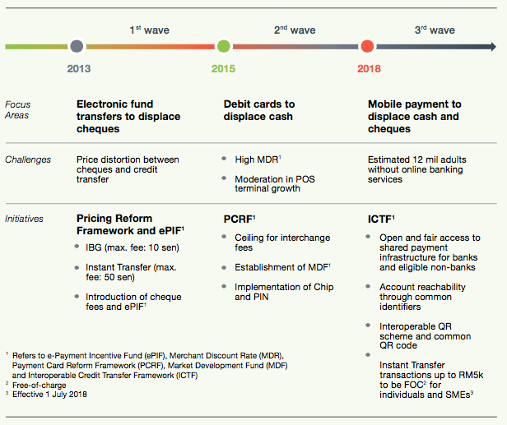
Figure 1.1: Bank Negara three waves payment system reformation(Zhi Wei and Peng Tsu, 2018)
There is a big question on why there is a need to transform all of the payment medium from paper cash to digital cash or cashless since the existence of paper cash has been in the economy beginning decades ago. Apart from that, a lot of modern countries such as Sweden, China and United Kingdom has started to pursue a digital economy driven by the cashless payment using payment mediums such as e-wallets which results in a new label of society which is called "cashless society" (Kumar, 2019). In Sweden for instance, the number of banknotes has significantly dropped and based on Riskbank, central bank of Sweden, there is only 13% of the transaction in Sweden that is still adopting paper cash as compared to Europe which holds nearly 80% (Fabris, 2019). The problem statement below addresses the needs to transform the current economy into digitized system;

Increased personal security issues in handling physical cash

Handling physical cash is a high risk activity since the security of individuals varies between each other. Since cash is a tangible and highly accessible, the usage is very high especially in less developed countries (Wulandari, Soseco and Narmaditya, 2016). Hence, it promotes criminal activities such as street crimes, prostitution and gambling (Wright, Tekin, Topalli, McClellan, Dickinson and Rosenfeld, 2017). Bank robbery and street muggings has declined significantly and with less cash circulating on the street, illegal criminal activities such as drug dealing can be curbed easily by making money trail becoming traceable through cashless transactions (Heller, 2016).

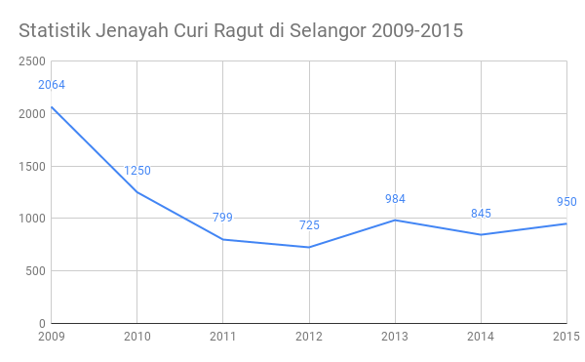
Figure 1.2: Snatch case reported in Selangor from 2009-2015 (Malaysia, 2017)
In Selangor, it is reported that the case of snatch is the highest in the year 2009 where 2064 cases were reported. The following year, it has been reduced to 1250 and further down to 725 cases in 2011. The reported case increased in 2013 where 984 cases were reported. The downtrend of the reported cases is no longer applicable since the cases were significantly increased. In 2017, robbery case recorded was 14,128 cases while snatch case reported was 239 cases.

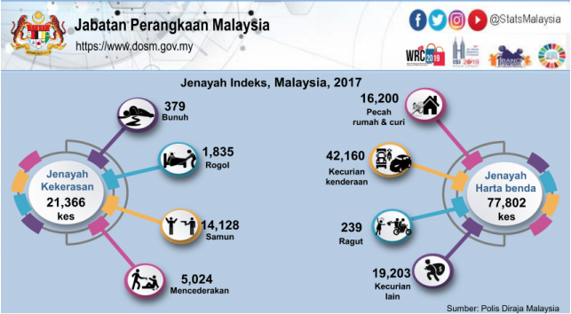
Figure 1.3: Malaysia Crime Index 2017 (Mahidin, 2018)

Illegal activities involving physical cash

Criminal activities such as frauds, money laundering, bribery and drug smuggling are usually cannot be traced and are in the form of physical cash where it prevent the government from tracing and taxing (Refonaa, Sebastian, Ramanan and Lakshmi, 2018). Bribery activity for instance, is usually transacted via physical cash (Rivera, 2019). A report by Financial Task Force (2015) explains that drug trafficking is the highest cash proceeds activity as compared to other crimes including tax fraud and corruption.
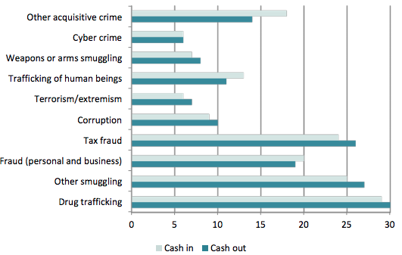
Figure 1.4: Cash involved in crime cases(Force, 2015)

In Malaysia, money laundering is one of the serious cross borders cash transaction issues. A report by The Sun Daily (2019) explains that a citizen of Malaysia who served the plantation industry was charged in court due to an illegal activity involving RM1.05 Million activities. In addition, Bernama (2019) also reported a similar case involving money laundering activities with the involvement of top political individuals in Malaysia. The individual is said to face two charges involving RM 9.5 million which was siphoned into his accounts allegedly received from the Prime Minister of Malaysia (Bernama, 2019). These 2 cases that happens recently is obviously showing that the country is in a bad situation in terms of financial crime and frauds.

India for example, according to Ronak (2018), the country remains as the top index for corruption in the world and it is found that majority of the transactions made in the country is by using cash as compared to developed countries. This issue of corruption hinders the development of the nation hence making the people of India to suffer on a lot of under standard facilities including clean water issues (Amit and Sasidharan, 2019).

Research Objective

The initial based for a research is objective which aids in answering queries or specific issues in a research (Sekaran and Bougie, 2010). The research objective in this study is as follows:

RO1: | To investigate the relationship between Perceived Ease of Use towards the Adoption of E-Wallet Among Gen Z in Selangor.
RO2: | To investigate the relationship between Perceived Usefulness towards the Adoption of E-Wallet Among Gen Z in Selangor.
RO3: | To investigate the relationship between Perceived Security towards the Adoption of E-Wallet Among Gen Z in Selangor.
RO4: | To investigate the significant impact of the predictors towards the adoption of E-wallet Among Gen Z in Selangor

Research Question

The following questions are proposed to study the factors influencing adoption of e-wallets among gen z in Selangor:

RQ1: | Does perceived ease of use have a significant relationship with the adoption of e-wallets among Gen z in Selangor?
RQ2: | Does perceived usefulness have a significant relationship with the adoption of e-wallets among Gen z in Selangor?
RQ3: | Does perceived security have a significant relationship with the adoption of e-wallets among Gen z in Selangor?
RQ4: | What is the impact of the predictors towards the Adoption of E-Wallet Among Gen Z in Selangor?

Significance of Study

From the perspective of academia research, the technology adoption based on this topic is highly important in refining the behaviour of the Gen Z`s in Malaysia in response to the adoption of e-wallet usage. Current research available in the fields are mostly in the area of e-payment technology which is more towards the adoption in the western countries while the research focus in ASEAN especially Malaysia is not explored in depth. While there is still a bigger area to be researched, this study will be a stepping-stone as it contributes to the research focus in Malaysia and geographically focusing on the adoption of the technology in Selangor.

Another important stakeholder that will be greatly benefit is the government itself where the new emerging e-payment technology such as e-wallet, m-commerce and mobile app technology must be governed under a very strong policy in order to monitor and handle transactions of money as well as regulation of business activity in the country. From this study, the government can further understand the current trend in the country to ensure that they can plan a policy to cover the usage and adoption of the technology in this country. In addition, the government must also be prepared to face the new trend of payment which will change the landscape of transactions such as the adoption of cashless payment which will greatly impact the citizen of the country apart from being able to curb crimes in involving money transactions such as bribery and money laundering.

Industries or sectors involving e-payment technology are growing bigger and the numbers are significantly improving year by year which signals the adoption is growing at a high rate every year. Despite the growth of the adoption, the adoption in Malaysia are still behind among neighbouring countries Singapore, Philippines and Thailand. Technology involving mobile payment is adopted in a lot of sectors such as retail, automobile, food and beverages industry whereby the rate of technological growth is supported by the involvement of the financial institution especially Bank Negara Malaysia or the central bank is making the adoption processes becoming seamless.

Limitations Of Study

The main tool for data collection is questionnaires and individuals are selected at random in the defined age. Therefore the randomization selection of individuals may varies in terms of background, personality and experience in using e-payments hence the quality of data input will be varies from an individual to the other. This is due to the type of products used by the respondents varies between individuals. In Malaysia, there is a significant number of industrial players that produces the e-wallet technology such as Grab, BigPay and TouchnGo. These wallets may offer different kind of experience to the users hence the perception on the technology will definitely be at different levels. Another limitation in this study is the usage of the model selected, which is Technology Acceptance Model. The questionnaires will be build based on TAM extended model therefore other factors and variables, which are not under TAM extended model, will be limited in the study. This will impact the data input and the result where it will be focusing on the significance of the research towards TAM extended model. TAM extended model focus on Perceived Usefulness while giving lesser focus on perceived ease of use therefore, the constructs gives limitation to the actual result.

Scope Of Study

Investigation of this study includes the factors influencing the usage of e-wallets among Gen Z in Selangor via Technology Acceptance Model. Geographical location selected for this study is the state Selangor, Malaysia due to the economic performance of the state. Unit of analysis is Generation Z and quantitative methods are applied in the research and online questionnaires are used as the tools to gather information from targeted respondents.

Operational Definition

Term | Operational Definition | Reference
E-Wallet | E-wallet is the terms used for the transaction of purchase and sales of products and services via the net | (Hänninen, 2017), (Dixit, Singh and Chaturvedi, 2017)
Generation Z (Gen Z) | Age group which includes individuals born between 1995 and 2010 | (Seemiller and Grace, 2018),(Eberhardt, 2017)
Mobile Payments | Any transaction using digital devices that aids in initiating, authorizing, and or confirming an exchange in financial values with goods and services | (Taylor, 2016),(Lu, 2018)
Perceived Ease of Use (PEOU) | The degree of a technology is defined to help the user achieve their objective with a free of effort | (Ozturk, Bilgihan, Nusair and Okumus, 2016),(Abdinnour and Chaparro, 2017), (Adapa, Nah, Hall, Siau and Smith, 2018)
Perceived Usefulness (PU) | Defines the perception of the customer towards the expected outcome | (Putra, 2019), (Sharifzadeh, Damalas, Abdollahzadeh and Ahmadi-Gorgi, 2017)
Perceived Security | The degree of security and privacy concern that a technology gives to the users | (Kassim, 2017), (Hajli and Lin, 2016), (Lai, 2017)

Table.1.1; Key Terms Definition

Organization of Chapters
The study is organized into five (5) main chapters with sub chapters involved. The summary of the chapters is as follows:
Chapter 1: Introduction
The opening chapter explained extensively on background information of the topics, current trend and also the phenomena revolving the subject matter. In this chapter, the problem statement is highlighted as to give a clear view of the need of the study. Constructs significance, limitations and scope of the study is also included to distinguish the boundary involved.

Chapter 2: Literature Review
Chapter 2 discuss on the past information on the research topic. Literature review is divided into the revolution of payment system and also the study on current trend and phenomena involving e-commerce and e-wallets as well as literature on generation z which is also included as part of the literature review. In addition the chapter also explains on the predictors of adoption of e-wallets in general. At the end of the chapter, a framework based on the grounded theory is explained

Chapter 3: Research Methodology
The third chapter explains comprehensively on the research methodology that is applied to the study. This involves the measuring instrument, sample size, questionnaire design and data collection method and analysis.

Chapter 4: Research findings and analysis
Chapter 4 presents the research findings on the study conducted. The sample data that was collected were processed in SPSS software, analysed and tabulated. The first test conducted was the pilot test and preliminary test, which are used to get the validity and reliability of the study. The analysis on the data collected were then analysed and followed by hypothesis testing. Pearson Correlation and Multiple Linear Regression are applied on the analysis and the hypothesis were then accepted or rejected based on the result.
Chapter 5: Conclusion and Recommendations
The final part of the study presents the conclusion and recommendations made to the study. Discussion on the analysis and results are included as well together with the suggestion for further improvement of the study. Limitations of the study are also discussed in this chapter and personal reflection is highlighted.

Ethical Consideration

Research quality and integrity must be prioritized at all times therefore researchers have to ensure that data collection is done in an ethical manner (Sekaran and Bougie, 2010). The data collected in this study will be in an ethical manner and the participants will be given full freedom to give their opinions and views without any influence or bias during data collection. The data will also be protected and the privacy of respondents such as personal information will not be exploited for any other purpose except for this study purpose. In this manner, data will be collected honestly after gaining consent from the correspondents, which will greatly contribute to the quality of research. Participants will be given a briefing sheet before the distribution of questionnaires in order to inform the participants on the purpose of the study and the impact and significance from the study towards the stakeholders.

In addition, the secondary data for this research will be collected from certified sources and will be referenced in this research to portray that no plagiarized content involved in this study. The questionnaire question structure will also be prepared in an organized and clear manner to ensure the participants can better understand the requirements from the research. Furthermore, the questionnaires will be adopted from previous research, which will contribute in terms of validity of the research.

Conclusion

In conclusion, chapter 1 examine the overview phenomena of e-wallets adoption in Malaysia. Bank Negara, central bank of Malaysia has realized that cashless is the future therefore, steps and proactive action has been taken such as improvement of policies in order to move the country towards a cashless society. A lot of issues is addressed from the usage of paper money such as security issue, crime and tax evasion that is affecting the economy of the country. From the cashless initiative including adoption of e-wallet, the situation can be further improved in the country hence improving the economy social and security of Malaysia. Since the country is left behind in adoption of e-wallets, the influencing factors have to be identified in order to ensure the the abundance of e-wallets provider in the country can be fully utilized.

CHAPTER 2: LITERATURE REVIEW

Sources related to the research topic and areas will be reviewed in this chapter. Various technology acceptance models were reviewed and followed by the study on the evolution of mobile payment technology. The literature also includes the study on acceptance factor that were researched in other demographics parameters. The research gap were determined and the theory related to the study framework is highlighted in this chapter.

Ecommerce & Generation Z

E-commerce is the terms used for the transaction of purchase and sales of products and services via the net (Hänninen, 2017). The retail industry has taken over a major revolution since the massive innovation and technology advancement especially in bringing up a business online to ensure competitive advantage of the business remains relevant (Nisar and Prabhakar, 2017). The barrier to enter in the e-commerce ecosystem is very low and not limited to only giant retail companies hence it is also observed that the participation of the e-commerce ecosystem come from the small medium enterprise, SME, which has a huge potential in expanding the business not only to the local market but also to the global platform (Sin, Osman, Salahuddin, Abdullah, Lim and Sim, 2016). Some major ecommerce players including amazon.com, and ebay.co.uk do not even have a physical store where they only focus on virtual shopping which is under the category of online marketplace (Nisar and Prabhakar, 2017). Online shopping behaviour does not deviate from the way of traditional shopping but online shopping offers a great amount of convenience to the customers while the focus factor such as location, convenience and price remains the same (Pauwels, Leeflang, Teerling and Huizingh, 2011).

The advancement of web technology has also enabled metrics or analytical tools for businesses to analyse and understand the combination of the data provided which will results in enhancement of product and services quality (Nisar and Prabhakar, 2017). In a study regarding purchasing decision between male and female, the result from the research shows that female have more spending power in regards to clothing purchases as compared to men (Fernandes and Panda, 2018). These data or metrics provided to the businesses are very important as this will affect on how the system is developed to include the marketing aspect of the business such as providing a website that suits the user (Yu, 2019). Business to Business and Business to Consumer are hugely affected by the presence of the data analytics that has changed the products and services that are offered online which includes that data for personal behaviour, online marketing services and personalized services (Lekhwar, Yadav and Singh, 2019). The online e-commerce marketplace is running around the clock which is one of the biggest advantage of the system apart from ease, effectiveness and quality (Lin and Chuang, 2018).

Apart from the technological aspect, the user perspective must also be explored in order to ensure that the e-commerce remains relevant to serve the current and future markets. This includes the preparation for the market to serve Generation Z in particular. In defining Generation Z, one must look into the age group which includes individuals born between 1995 and 2010 and the growth environment which is the high exposure to economic and social challenges including extensive advancement of technology and also aggressive human rights fights for fair and justice (Seemiller and Grace, 2018). In addition, the Gen Z`s behaviour are highly influenced by economy fluctuation and recession whereby their point of views are very distinctive as compared to the boomers, Gen X`s and Y`s(Rodriguez, Boyer, Fleming and Cohen, 2019).

Mobile Payments & E-wallets

The wide adoption of mobile technology as a result of continuous development and innovation has greatly affected the way human being interact and conduct their personal and business activities (Liébana-Cabanillas, Ramos de Luna and Montoro-Ríos, 2015). 3.9 billion people which is roughly 51.2% of the world population roughly are using the internet and mobile cellular telephone subscription has the highest percentage (ITU, 2018). If the technology is assumed to be unified and integrated is such a way that the technology fits a lot of requirement across platforms, there is a big potential in the adoption of mobile payments (Zhong, 2009).

Samsung Pay is one of the earliest technology company to release features of mobile payments and digital wallet or e-wallets in 2015 by integrating Near-Field Communication or NFC whereby users can straight away make payments on the merchants terminal by using their Samsung smartphone (Samsung, 2019). Method of payment using cashless concept is applied to a lot retailers today and the party that has to adopt the technology earlier will always be the merchants where they have to cover the cost of infrastructures and transactions charges on payment gateways (Pisani and Moormann, 2018).

Apart from the major ethnological advancement in mobile payment technology, social influence are to be found as a significant major factors that has the influencing impact towards the usage of mobile payments including e-wallets such as WeChat application which combines both social chat and mobile payment system under one roof (Xu, 2017). User interactions in the social cloud allows them to do instant messaging, photos sharing, voice chatting and at the same time WeChat penetrates the mobile payments through e-wallets in between the user interactions itself (Wang and Gu, 2017). This features has further enhanced the strength of the brand and also significantly increase the level of e-wallet technology especially in China whereby the technology adoption is slowly moving towards Europe (Kapron, 2018).

Mobile payment also has a lot of drawbacks where one of it is the level of difficulties to understand the usage of the payment system. Most of mobile devices application does not come with a manual or instant guide whereby most of the time the mobile application usage are self-taught (Rachels and Rockinson-Szapkiw, 2018). Deployment of mobile payment technology has a very big challenge including the cost having the platform itself. In the perspective view of a user, an individual will not simply switch to Samsung mobile platform just to obtain the access to Samsung Pay usage whereby this will incur a very high switching cost (Wang, Luo, Yang and Qiao, 2019). There a re always a better option as compared to switching platforms such as WeChat pay and Alipay, which are available in every platform across different devices and operating systems (Lu, 2018).

Key Driver for e-wallets growth

Internet infrastructures

The number of high user of mobile phone penetration in developed countries which have reached 121% as compared to 90% in the lower income nation are driven by modern and advanced communication infrastructures, high accessibility and high financial literacy (Mothobi and Grzybowski, 2017). In addition, investment have to be done by corporate and the relevant government parties due to the high cost especially in increasing the reach of the connectivity to the rural areas where there are less and under developed communication infrastructures (Bajpai, Biberman and Sachs, 2018).

The usage of mobile banking including e-wallets services requires a strong connectivity to ensure the transactions can be done successfully in a secure manner. The investment made to the infrastructures in the rural areas are also risking the return on investments of the companies since the internet penetration rate have to grow side by side with financial literacy for the development to have an impact (Pandita, 2017).

Pandita (2017) highlighted that North America constitute the largest number of internet users with 88.12% of users followed by Europe, 77.42%, Asia, 45.83% and the last on list is Africa with 27.73%. A study conducted in Sub Saharan Africa shows that the mobile phone penetration in the region helps to improve the economy since mobile banking services are available have an acceptable accessibility rate which allows people in the rural areas to conduct mobile banking (Mothobi and Grzybowski, 2017).

The study also shows that mobile internet has a big role in encouraging individuals to use mobile banking especially those in rural areas which will promotes the growth of digital wallet services.

Financial Inclusion

The terms are referring to the level of access by individuals and businesses to an affordable financial services including credit and payments (Bank, 2018). In developing countries, banking services cost is very high due to the increase in cost of bank operation such as staffing and other operational cost (Tyler, 2018). Unaffordable issue of the banking services have to be overcome in order to enhance the reach of the digital economy.

Apart from that, government have to play a major role in setting up policies that supports financial technology products apart from forcing the banking services to be more accessible and affordable (Tam, 2018). Industrial revolution 4.0 allows the digital economy to be pursued due to the advancement of technology especially in the banking industry (Sung, 2018).

This will encourage financial inclusion and also help to benefit both consumers and financial institution whereby consumers can get access to a lower cost products and easier banking services via mobile phone (Tam, 2018). Therefore, as the effort for financial inclusion grows, the adoption towards e-wallet will be increasing as well.

Grounded Theory

Technology Acceptance Model (TAM)

TAM is focusing on understanding the process of technology acceptance and also to enhance the perspective of designers and technologists in order for them to proposed a system or technology that is best suits the implementation (Wirtz and Göttel, 2016). The main factors of the attitude beliefs that is included in the model are mainly perceived usefulness and perceived ease of use that has a direct relation to perceived usefulness and the hypothetical ideology behind this theory is that a user is influenced by his or her attitude in determining the user beliefs towards the technology adoption (Abdinnour and Chaparro, 2017).

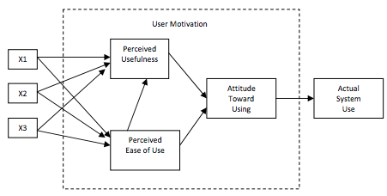
Figure 2.1: Technology Acceptance Model (Abdullah and Ward, 2016)
The experiment expanded to include more variables and factors that are highly influencing the attitude of users while other researchers are also extending the research to gain more factors that has a high correlation to the user motivation. A study on 107 individuals to understand the effectiveness of the modified TAM model found out that PEOU and PU had caused and impact on behavioural intention is not significant therefore attitude factor is removed from the TAM Model (Ooi and Tan, 2016). Venkatesh and Davis has also conducted a research regarding TAM model where the external variables namely X1, X2 and X3 are being refined into system characteristics, training of the users, involvement in design process by user and the nature of implementation process (Tarhini, Hone, Liu and Tarhini, 2017).
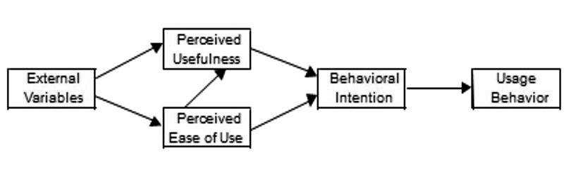
Figure 2.2: Final model of TAM(Abdullah and Ward, 2016)

The development of TAM model is not stagnant where the evolution of the model is being done since its origin. The study of TAM has been replicated in several studies for instance in 1992, the study is replicated for other technology including word processing software, graphical user interface, spread sheets and email application and the test reliability maintained and the consistency of the factors are significant(Abdullah and Ward, 2016).

One of the added variable to enhanced the reliability of TAM model is security factor. In applying TAM model towards understanding the technology acceptance, the aspect of security is the most crucial element in applying the technology in financial sector especially in banking industry (Fitriyani, Sfenrianto, Wang and Susanto, 2016).

The transactions that were made using internet facilities deemed that security aspect to be the utmost concern when it comes to the perceived security by its users (Al-Sharafi, Arshah, Abo-Shanab and Elayah, 2016). Security concerned is a major aspect in e-payment system as customer are afraid that their cash and cards are exposing them towards a bad risk such as theft and loss (Lai, 2017).
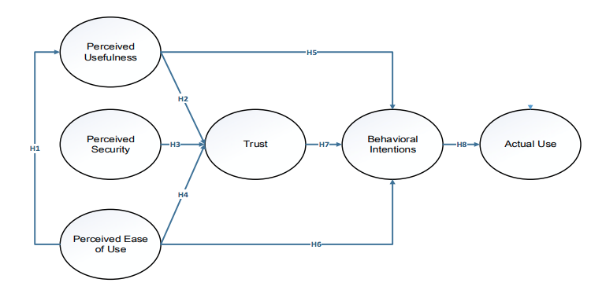
Figure 2.3: Perceived Security is added to the extended TAM model (Fitriyani et al., 2016)

Strength and limitation of technology acceptance model

TAM model define its strength in terms of explaining the usage behaviour of information system, predicting usage intention as well as easy to be applied and less cost needed to be used (Assegaff, 2015). Apart from that, TAM model explains clearly on usage intention on variety of technologies and has consistently explained significance variance in the usage (Olushola and Abiola, 2017). Assegaff (2015) outline the technology acceptance measurement has been applied on various researches especially on e-learning software where TAM is the most used model as compared to UTAUT and Task Technology Fit (TTF).
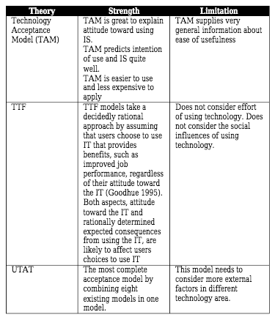
Figure 2.4: Comparison of between technological acceptance model (Assegaff, 2015)
TAM model has also receives critiques from the research done in comparison with other technology acceptance model. One of the drawbacks is that PEOU is applied in a very general terms as compared to perceived usefulness which has five main factors (Wirtz and Göttel, 2016). In addition, TAM model ignores the constraint of a user whereby the features of the technology is given less focus as compared to the behavioural and usage intention of the user itself (Olushola and Abiola, 2017).

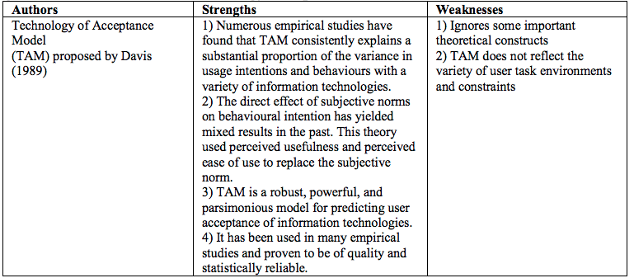
Figure 2.5: TAM model strengths and weaknesses (Olushola and Abiola, 2017)

Gaps in Literature

From the past literature, most of the study is focusing on the geographic areas other than Malaysia. There is a significant impact on geographical areas and technology whereby the infrastructure of specific country will determine the growth of a technology. Korea and Sweden for example, since the internet infrastructure supports the growth of technology, the adoption factors will be different as compared to other countries.

Since countries differs in infrastructures and adoption of technologies, the factors influencing e-wallets technology adoption in other regions cannot be generalized to other countries as well. The geographical factors is a part of the limitations in this study.

In addition, the past literature does not specifically address the study on Generation Z where the study on them requires timing due to the age. Generation Z can be identified by the range of age and since the Gen Zs has begin their career and entering the job market , they can be seen to have a new pattern of spending, a different approach of technology adoption and also new habit and influences.

This is due to the rapid growth of technology such as social media influences and the internet reach itself that contributes to the differences in the pattern. The characterization of Gen Z`s are different than the other generation including the boomers. Therefore, the study on Gen Z requires the right time and the market need to prepare to face a new and fresh challenges from the Gen Z`s.

Theoretical Framework
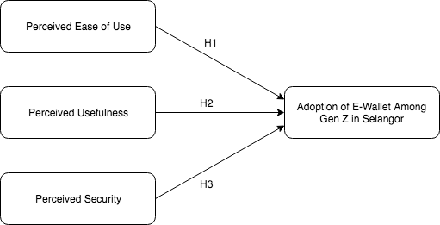

Figure 2.6: Theoretical Framework

Hypothesis

The following hypotheses are proposed to study the factors influencing adoption of e-wallets among gen z in Selangor:

H1: Perceived Ease of Use has a positive relationship towardsadoption of e-wallets among Gen Z in Selangor

H2: Perceived Usefulness has a positive relationship towards the adoption of e-wallets among Gen Z in Selangor

H3: Perceived Security has a positive relationship towards the adoption of e-wallets among Gen Z in Selangor

H4: Perceived Security has the highest impact on the adoption of e-wallets among Gen Z in Selangor followed by Perceived Ease of Use and Perceived Usefulness

Conclusion

Chapter 2 of the study is gathering the information from previous study on ecommerce and the revolution of the cashless environment that leads to the e-wallet technology. From the literature review conducted, there are gaps on the literature is identified which are geographical areas and the study on individual group of age. Extended Technology Acceptance Model which outlines the factors of PEOU, PU and PS is applied in the study which leads to an actual behaviour of the technology usage. Apart from PEOU and PU, perceived security is also included as part of the study since the importance is highlighted by Kassim (2017). The end of the chapter is explaining on the theoretical framework and hypothesis that will be applied in the research.

CHAPTER 3: RESEARCH METHODOLOGY

Research Design

Quantitative method will be applied to this study. Sample representative from the population will be studied in depth in order to find the factors from the constructs. Since the study is applying TAM model as the main framework, the main variable for the study will be PEOU and PU which is testing the degree of easiness of use and usefulness of the technology.

Relationships between the variables are tested to show positive or negative relationship towards the dependent variable. Research design diagram, which explains on the overview on the study research methodology, is shown in figure 3.1 based on Sekaran and Bougie (2016). Method of data collection is via questionnaires, which are distributed to the respondents that are qualified for the study. Researcher interference is limited in this study where the respondent’s daily activity will not be disrupted. The independent variables in this study namely Perceived Ease of Use and Perceived Usefulness based on TAM and additional of Perceived Security based on extended TAM model are suitable for the research design as the variables are tested to determine the influencing factors towards the dependent variable, the adoption of e-wallets.

Figure 3.1 Research design diagram

Study Population, Unit of Analysis, Sample Selection

Unit of analysis

The term refers to the individual who will give the required data and at which level of aggregation (Zikmund, Babin, Carr and Griffin, 2013).This study is focusing on the influencing factors of the adoption of e-wallets among gen z in Selangor. Therefore, individual that falls in the category of Gen Z is the unit of analysis of the study. Time horizon for this study is cross-sectional where the data is collected in one shot from the respondents and at a specific time frame (Sekaran and Bougie, 2016).

Sampling Design& Sampling Plan

Sampling is needed because in some research, it is not practical to gather data from a large number of population while the information gathered from a sample is already enough to represent the whole population (Saunders, Lewis, Thornhill and Wilson, 2009) . Sekaran and Bougie (2016) explains that there are two ways in selecting a sample. In this study, non-probability sampling will be adopted because the sample is easily accessible. The sampling design for this research will mainly focus on non-probability convenient sampling. This method is suitable for the study due to ensure a high response rate from the respondents apart from limitation and constraints such as limited number of members to distribute the questionnaire. Sampling design are the basic component for the selection of survey methods in the form of framework or a design map that may affect the result of a study (Lohr, 2009).

Sample Size

The study population for this case is Gen Z, individuals who were born between 1995 and 2010 (Seemiller and Grace, 2018). The group of individuals in this category will be surveyed at random and it is estimated around 1.5million individuals falls in this category (Malaysia, 2019). However, the minimum age limit to involve in this study is18 years old. Hence, The sample size recommended is 385 respondents with 5% margin of error and 95% confidence level (Raosoft, 2019).

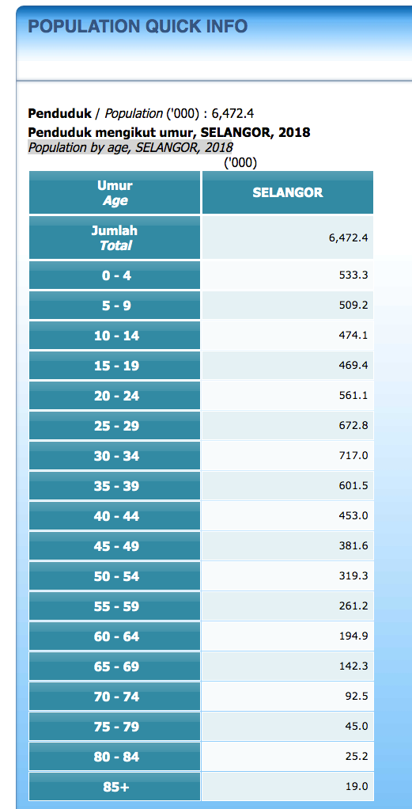
Figure 3.2: Statistic by age for Selangor (Malaysia, 2019)

Questionnaire design

The data collection in this study will be via questionnaires, which will be distributed to the targeted respondents. The questionnaire design will be split into two main segments namely demographics and Usage of E-Wallets. The demographics will include individual background while the usage of e-wallets will include the variables listed in TAM extended model, which are PEOU, PU and PS. The questionnaire are segmented as follows:

Part A
The first section of the questionnaire requires the participant to give their demographic information as to identify the background of the participant. The information includes age, gender, ethnicity, education level, occupation and monthly expenses.

Part B
Likert scale from one (1) to five (5) is applied where the participant are required to give a rating based on the questions given. The questions will be focusing on the subject of dependent variable which is the satisfaction of e-wallets usage among gen z in Selangor.

Part C
Likert scale from one (1) to five (5) is again applied in Part C. Participants are required to use the same rating system for the questionnaire The questions in this section will be focusing on the independent variable of the study which is Perceived Ease of Use (PEOU) and Perceived Usefulness (PU) and Perceived Security and Privacy.

Section | Variable | Items | Source
A | Demographic Profile | 6 | (Sekaran and Bougie, 2016), (Zikmund et al., 2013)
B (Dependent Variable) | Adoption of E-Wallet Among Gen Z in Selangor | 5 | (Seemiller and Grace, 2018), (Taylor, 2016), (Lu, 2018)
C (Independent Variables) | Perceived Ease of Use (PEOU) | 4 | (Ozturk et al., 2016),
C (Independent Variables) | Perceived Usefulness (PU) | 5 | (Putra, 2019), (Sharifzadeh et al., 2017)
C (Independent Variables) | Perceived Security | 5 | (Kassim, 2017), (Hajli and Lin, 2016)
Table 3.1: Questionnaire summary by segment

Pilot test

Pilot testing allows the research to be done at a smaller scale in order to test the approach whether it is feasible for the study or otherwise before the real study is carried out (Zikmund, Babin, Carr and Griffin, 2009) . The interview questions need to be validated through the pilot study before it can be conducted to be a full study (Shariffuddin, Razali and Hashim, 2017). It is suggested that 10% sample from calculated sample size are used in a pilot study (Connelly, 2008). Other studies shown that, depending on the type of study, 10-15 sample is sufficient while 30 is recognized as a reasonable minimum sample size (Johanson and Brooks, 2010). Hence in this study, a conservative approach is taken where the number of sample for the pilot study will be adopted as 10% of the sample size which is 40.

Factor Analysis

Factor analysis will be used to group a set of estimate a model which explains variance between a set of observed variables in a population where the correlations between the variables and the factor is known as loadings (Zikmund et al., 2009). Factor analysis will be conducted in advanced followed by the validity and reliability tests which will be conducted in SPSS to ensure the measurement used in the study is accurate and consistence (Zikmund et al., 2009). The data collected will be tested using Kaiser-Meyer-Olkin (KMO) and Bartlett`s test of Sphericity to test the adequacy of the sampling via Measure of Sampling Adequacy (MSA) (Hair, Black, Babin and Anderson, 2014). By using Bartlett`s test of Sphericity, the sample can be considered as adequate when the significant value p is less than 0.05 (p<0.05). Table below explains the interpretation of MSA.

Value | Interpretation
Less than 0.05 | Unacceptable
0.500 – 0.599 | Miserable
0.600 – 0.699 | Mediocre
0.700 – 0.799 | Middling
0.800 and above | Meritorious
Table 3.2: MSA Interpretation

Reliability Test

The test is followed by reliability test which refers to the consistency of the measurement in the study (Heale and Twycross, 2015). In order to determine the reliability, Cronbach`s Alpha value is applied where the range of acceptance is between 0.7 to 0.9 (Hair et al., 2014). The lowest limit of the value is between 0.6 to 0.7 and if the test result falls within this range, the item will be remove from the study (Quinlan, Babin, Carr and Griffin, 2019).
Cronbach`s Coefficient | Consistency
More than 0.9 | Excellent
More than 0.8 | Above Average
More than 0.7 | Sufficient
More than 0.6 | Minimal
More than 0.5 | Poor
Table 3.3: Cronbach coefficient interpretation

Demographic Information

Demographic information refers to the background of the participants such as age, spending habit, and income level (Sekaran and Bougie, 2016). In this study, 6 item will be included in the questionnaire namely, gender, age, education level, occupation and level of monthly expenses.

Hypothesis testing

For the purpose of hypothesis testing, two methods will be used in this study which are One way ANOVA and Multiple Regression Analysis. ANOVA is used to analyse the differences between the mean differences between the groups while multiple linear regression aims to find the strength of the independent variable, one or more, towards the dependent variable (Saunders et al., 2009). The P-value from the ANOVA one way test will determine if there exist a significant differences between the group where the P value less than 0.05 will show significant relationship statistically. From multiple linear regression analysis, the R² value will be the determining predictive power for the model and the value must be more than 0.5 in order for the values to be fit (Sekaran and Bougie, 2010).

The input from the respondents will be organized in a data format which will be imported into SPSS. By having the data input in SPSS, the analysis will be conducted using Multiple Regression Analysis. Multiple linear regressions is used in measuring multiple sets of independent variables that affects a dependent variable. The determinant is denoted by R² which implicating the regression model whereby the value of R² must be close to 1.0 to enable the model to explain the predictive independent variables against the dependent variable.

Apart from that, correlation will also be applied to this study. Correlation refers to the strength that exists between two different variables that relates to the same subject. The method of analysis will give a significantly clear view on how the variables in TAM extended model affect the user`s usage intention and the actual use of e-wallets. Correlation value shall range from +1.00 to -1.00 to enable the result to be interpreted and further analysis and conclusions can be made based on the correlation values between the independent and dependent variables.

Tests |  | Rule of Thumb | References
Pilot & Preliminary Tests | Factor Analysis – Validity of questionnaire | MSA > 0.6 | (Zikmund et al., 2009), (Hair et al., 2014)
Pilot & Preliminary Tests | Kaiser-Meyer-Olkin (KMO)- sampling adequecy | KMO > 0.6. Amendment to the questionnaire have to be done if less than 0.6 | (Zikmund et al., 2009), (Hair et al., 2014)
Pilot & Preliminary Tests | Factor Loading – loading of a factor on the measured variable | Factor Loading > 0.5 | (Zikmund et al., 2009), (Hair et al., 2014)
Pilot & Preliminary Tests | Eigenvalues | Eigenvalues>1 | (Zikmund et al., 2009), (Hair et al., 2014)
Pilot & Preliminary Tests | Reliability Test - consistency of data | Cronbach Alpha > 0.7 | (Hair et al., 2014)
Descriptive Analysis | Demographic Information | Charts (Pie, bar), Graph and Table | (Zikmund et al., 2009), (Hair et al., 2014)
Hypothesis Testing | Pearson Correlation | To find the correlation between the variables towards. | (Zikmund et al., 2009), (Hair et al., 2014)
Hypothesis Testing | Multiple Regression | To find the strength and relationship between IV and DV and to check the predictive power of the model | (Zikmund et al., 2009), (Hair et al., 2014)
Hypothesis Testing | Beta Coefficient | Determine the changes variation in the outcome result | (Zikmund et al., 2009), (Hair et al., 2014)
Hypothesis Testing | Multicollinearity | Variance Influence Factor (VIF) is calculated and VIF must be less than 10 | (Zikmund et al., 2009), (Hair et al., 2014)
Table 3.4: Summary of measurements

Conclusion

Chapter 3 explains in detail on the research methodology that will be applied for the study. Quantitative methods including descriptive and regression is defined as suitable for the research in order to look for the relationship between the independent and dependent variable. Pilot test will be executed to find the suitability of the research parameters for the purpose of this study.

Research Findings & Analysis

Chapter 4.0 presents the collected data and the analysis made for this research. The research begins with a pilot test and preliminary test, which aims to ensure that the item in the questionnaire is valid and the data collected, is reliable. Validity and reliability testing are applied in the research during the pilot test and preliminary test. The main tools that is used to analyze is Statistical Package for Social Sciences (SPSS). After both reliability and validity test requirement are met in the pilot study, the data collection is proceed to meet the sample size. The data collected is further used for hypothesis testing, including correlation and regression in order to explain the acceptance or rejection of the research hypothesis.

Pilot test

The number of sample used for the pilot test is 10% of the total sample size. The total sample size is 385 hence the total number used in the pilot study is 38.5. For the purpose of this study, 40 sample are collected for the pilot test. 10% of the total sample size is adequate as explained by Connelly (2008). Factor Analysis and Reliability test were applied to the pilot data collected prior to preliminary test to test on the validity and reliability of the data collected.

Factor Analysis

Factor Analysis is done on each item that is listed as variables for both dependent and independent variables. Kaiser-Meyer-Olkin (KMO) value and the loadings are shown in table 4.1.

Table 4.1: Factor Analysis Result for Pilot Test (for Dependent Variable)
Variable | Item | Factor Loading
Dependent Variables
Adoption of E-Wallet Among Gen Z in Selangor | EW1 | 0.832
Adoption of E-Wallet Among Gen Z in Selangor | EW2 | 0.604
Adoption of E-Wallet Among Gen Z in Selangor | EW3 | 0.713
Adoption of E-Wallet Among Gen Z in Selangor | EW4 | 0.738
Adoption of E-Wallet Among Gen Z in Selangor | EW5 | 0.739
KMO: 0.651
Bartlett`s Test of Sphericity: Aprox. Chi-Square 74.277, df : 10, Sig: 0.000

The results of factor analysis on the dependent variables indicate that the sampling adequacy is ‘Mediocre’ where the value is 0.651. This is an indication of the relevancy of the variables as explained in Chapter 3 of the research. The Bartletts`s test of sphericity is significance where the value of p<0.05. All of the factor loading for all construct is more than 0.500 to be accepted in the study.

Table 4.2: Factor Analysis Result for Pilot Test (for Independent Variable)
Variable | Item | Factor Loading
Independent Variables
Perceived Ease Of Use | PEOU1 | 0.654
Perceived Ease Of Use | PEOU2 | 0.743
Perceived Ease Of Use | PEOU3 | 0.780
Perceived Ease Of Use | PEOU4 | 0.818
Perceived Usefulness | PU1 | 0.629
Perceived Usefulness | PU2 | 0.682
Perceived Usefulness | PU3 | 0.661
Perceived Usefulness | PU4 | 0.668
Perceived Usefulness | PU5 | 0.720
Perceived Security | PS1 | 0.603
Perceived Security | PS2 | 0.641
Perceived Security | PS3 | 0.700
Perceived Security | PS4 | 0.857
Perceived Security | PS5 | 0.592
KMO: 0.819
Bartlett`s Test of Sphericity: Aprox. Chi-Square 400.670, df : 91, Sig: 0.000

Table 4.2 is showing the factor loadings based on the independent variable used in this research. All constructs in this research are gathered and tested to get the reliability of the data collected. The KMO result for the independent variables is 0.819 where it indicates ‘Meritorious’ for the sampling adequacy. The factor loading for all construct is more than 0.500 which indicates that the item is acceptable for the research. Bartlett`s test of Sphericity are also significance where the significance value of p is less than 0.05.

Reliability Test

After the factor analysis is conducted and the conditions for the factor loadings are met for all of the items, reliability is then tested for both dependent and independent variables. Reliability tests on the internal consistency from the data collected (Sekaran and Bougie, 2016). Table 4.3 shows the result for the reliability test using Cronbach`s Alpha.

Table 4.3: Reliability Test Result for Pilot Test (for DV & IV)
Variable | Item | Cronbach`s Alpha
Dependent Variable
Adoption of E-Wallet Among Gen Z in Selangor | EW1, EW2, EW3, EW4, EW5 | 0.758
Independent Variable
Perceived Ease Of Use | PEOU1 - PEOU5 | 0.872
Perceived Usefulness | PU1 - PU4 | 0.834
Perceived Security | PS1 - PS5 | 0.873

The value presented in table above for dependent variable is Sufficient where the value is 0.758. Value of Cronbach`s Alpha between 0.700 and 0.800 is considered as sufficient for the internal consistency. As for the independent variable, the value is 0.915 which indicates high internal consistency. Hence, the level of consistency for the data from both independent and dependent variable for this study is acceptable.

Frequency and Descriptive Analysis

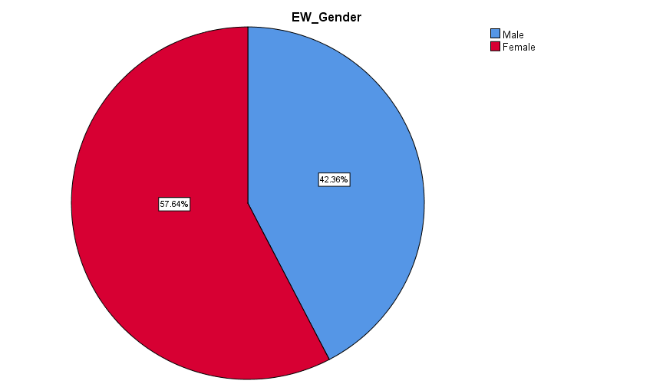

Figure 4.1: Gender

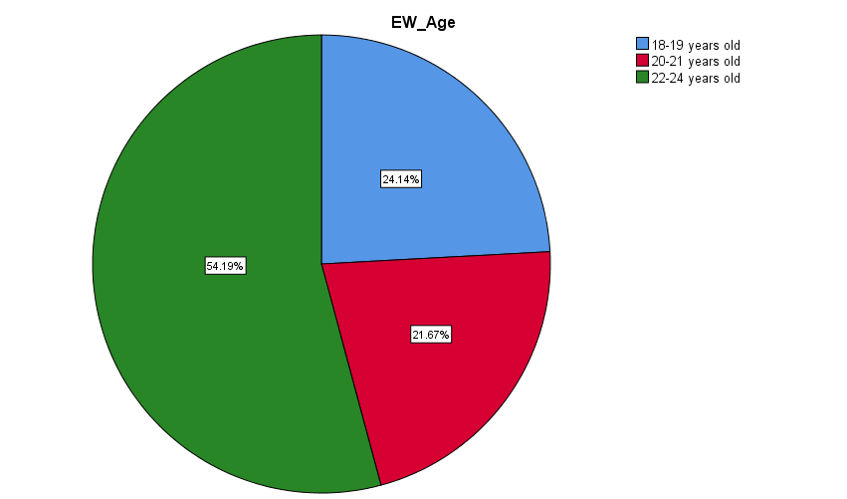

Figure 4.2: Age Distribution

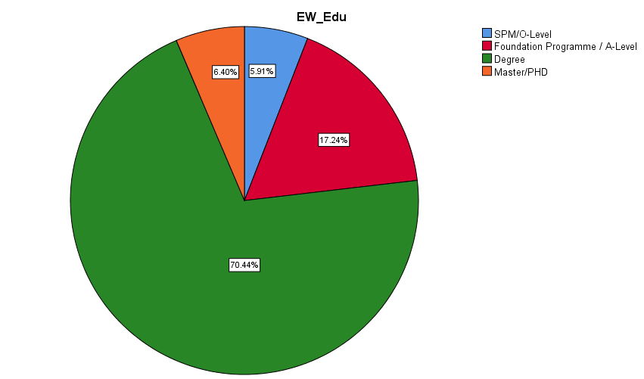

Figure 4.3: Level Of Education

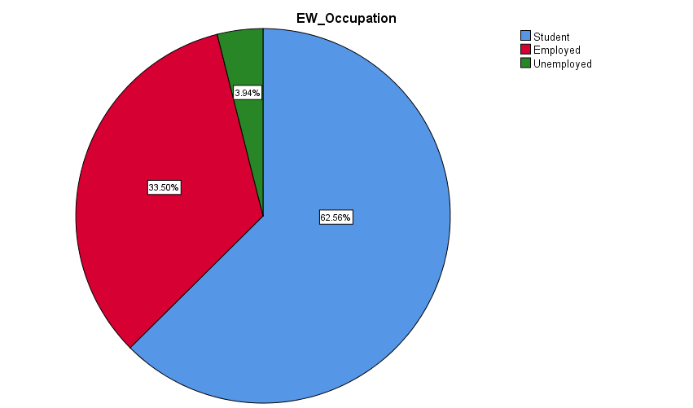

Figure 4.4: Occupation

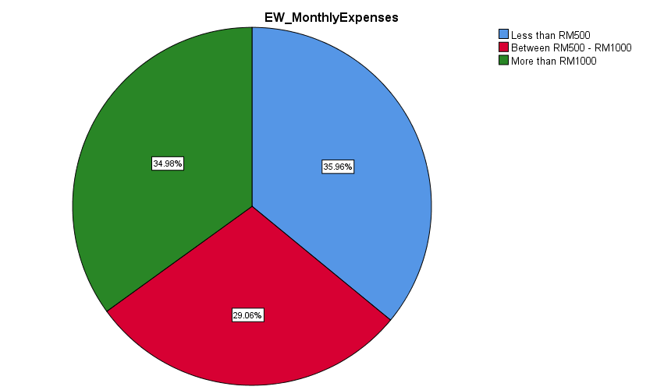

Figure 4.5: Monthly Expenses
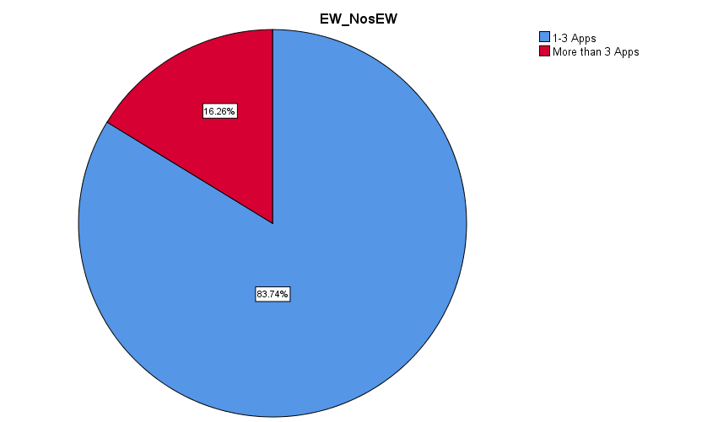

Figure 4.6: Number of Ewallet Application installed in Smartphone

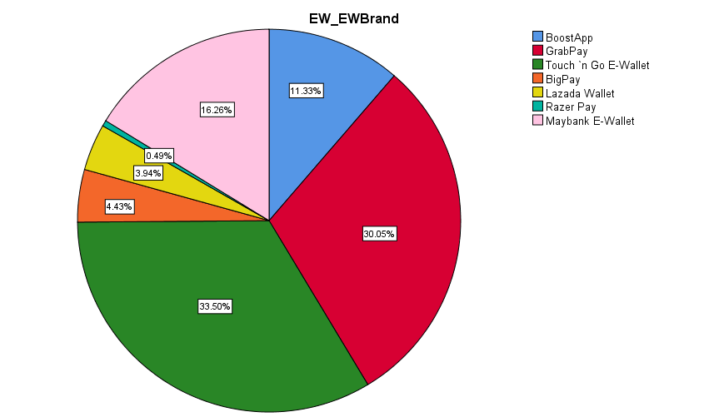

Figure 4.7: Brands of EWallets used most in the last 3 months
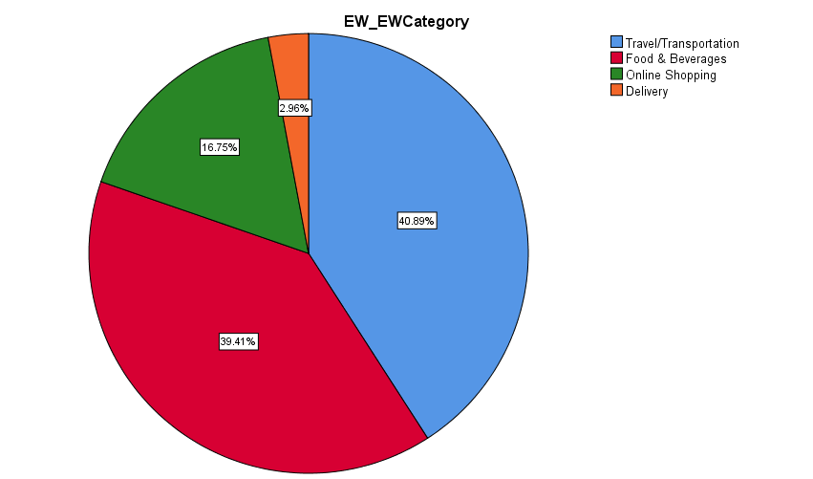

Figure 4.8: EWallet Usage Category

Preliminary Data Analysis

Factor Analysis

Upon collecting the full set of data from the survey and the questionnaire, the factor analysis and reliability test is conducted to validate the independent and dependent variables involve in the study.

Table 4.4: Factor Analysis Result for Dependent Variable-Preliminary Analysis
Variable | Item | Factor Loading
Dependent Variables
Adoption of E-Wallet Among Gen Z in Selangor | EW1 | 0.667
Adoption of E-Wallet Among Gen Z in Selangor | EW2 | 0.754
Adoption of E-Wallet Among Gen Z in Selangor | EW3 | 0.751
Adoption of E-Wallet Among Gen Z in Selangor | EW4 | 0.820
Adoption of E-Wallet Among Gen Z in Selangor | EW5 | 0.791
KMO: 0.728
Bartlett`s Test of Sphericity: Aprox. Chi-Square 336.058, df : 10, Sig: 0.000

Table 4.4 is explaining the result of factor analysis, which was done, on the fullset of data. The above table is referring to dependent variable of the study. The value for Kaiser-Meyer-Olkin measure of sampling adequacy are showing KMO=0.728 which falls in the category of middling as explained in chapter 3 of this study. The MSA value is acceptable in this study since it surpasses 0.600, the minimum requirement. Bartlett`s test of sphericity is indicating a significant value where P is 0.00 which is less than 0.05. The factor loading is more than 0.05 indicating the validity of the variables. Hence, this result is an indication that the dependent variable for this study is valid therefore, reliability test shall proceed.

Table 4.5: Factor Analysis Result for Independent Variables-Preliminary Analysis
Variable | Item | Factor Loading
Independent Variables
Perceived Ease Of Use | PEOU1 | 0.553
Perceived Ease Of Use | PEOU2 | 0.668
Perceived Ease Of Use | PEOU3 | 0.580
Perceived Ease Of Use | PEOU4 | 0.645
Perceived Usefulness | PU1 | 0.577
Perceived Usefulness | PU2 | 0.615
Perceived Usefulness | PU3 | 0.448
Perceived Usefulness | PU4 | 0.304
Perceived Usefulness | PU5 | 0.372
Perceived Security | PS1 | 0.650
Perceived Security | PS2 | 0.794
Perceived Security | PS3 | 0.768
Perceived Security | PS4 | 0.677
Perceived Security | PS5 | 0.594
KMO: 0.852
Bartlett`s Test of Sphericity: Aprox. Chi-Square 1599.617, df : 91, Sig: 0.000

Table 4.5 is explaining the result of factor analysis which was done on the fullset of data. The above table is referring to independent variable of the study. The value for Kaiser-Meyer-Olkin measure of sampling adequacy are showing KMO=0.852 which falls in the category of meritorious as explained in chapter 3 of this study. The MSA value is highly acceptable since it is very strong. Bartlett`s test of sphericity is indicating a significant value where P is 0.00 which is less than 0.05. However, the factor loading for for PU3,4 and 5 is lower than 0.05 therefore this 3 item is removed for the purpose of this study. The factor analysis is tested again after removing the 3 item.

Table 4.6: Factor Analysis Rerun Result for Independent Variable (IV) – Preliminary Analysis
Variable | Item | Factor Loading
Independent Variables
Perceived Ease Of Use | PEOU1 | 0.576
Perceived Ease Of Use | PEOU2 | 0.705
Perceived Ease Of Use | PEOU3 | 0.587
Perceived Ease Of Use | PEOU4 | 0.663
Perceived Usefulness | PU1 | 0.595
Perceived Usefulness | PU2 | 0.608
Perceived Security | PS1 | 0.652
Perceived Security | PS2 | 0.810
Perceived Security | PS3 | 0.792
Perceived Security | PS4 | 0.699
Perceived Security | PS5 | 0.596
KMO: 0.852
Bartlett`s Test of Sphericity: Aprox. Chi-Square 1599.617, df : 91, Sig: 0.000

After removing 3 items which has low factor loading on the study, the factor analysis is rerun on the independent variables. Table 4.6 is explaining the result of factor analysis which was done on the full set of data with the removal of the 3 item namely PU3, PU4 and PU5. The value for Kaiser-Meyer-Olkin measure of sampling adequacy are showing KMO=0.823 which falls in the category of meritorious as explained in chapter 3 of this study. The MSA value is highly acceptable since it is very strong. Bartlett`s test of sphericity is indicating a significant value where P is 0.00 which is less than 0.05 while the degree of freedom is 91.

Reliability Analysis

Table 4.7: Reliability Test Result for Preliminary Test (for Dependent & Independent Variables)
Variable | Item | Cronbach`s Alpha
Dependent Variable
Adoption of E-Wallet Among Gen Z in Selangor | EW1, EW2, EW3, EW4, EW5 | 0.770
Independent Variable
Perceived Ease Of Use | PEOU1 - PEOU5 | 0.851
Perceived Usefulness | PU1 - PU2 | 0.773
Perceived Security | PS1 - PS5 | 0.893

Reliability test is carried out after factor analysis was done. This test aims to check on the internal consistency of the variables measurements. Table 4.7 is showing that the result of Cronbach`s alpha coefficient (α) for dependent variables is 0.770 which is ‘Sufficient’ while for independent variables, 0.884 which falls under the category of above average. All construct related to this study has surpassed the minimum requirement for reliability test score of 0.60 therefore, the variables used in this study is reliable.

Pearson Correlation Analysis
Pearson correlation analysis result is conducted on the data collected and the result is tabulated in table 4.7 below. The purpose of the test is to explain the strength of the variables (independent and dependent variables) as well as to show the relationship between the variables. The notation of Pearson Correlation is (r) value where the value range from -1 to +1, perfect negative to perfect positive. The result may also be 0 which explains no relationship between the variables. P value less than 0.05 indicates the relationship between the variables exist while no relationship for the variables with P value more than 0.05.

Table 4.8: Result of Pearson Correlation Analysis
Variables | Adoption of E-Wallets Among Gen Z in Selangor
Variables | Pearson Correlation (r) | Significance (2-tailed)
Perceived Ease Of Use (PEOU) | 0.648 | 0.000
Perceived Usefulness (PU) | 0.605 | 0.000
Perceived Security (PS) | 0.484 | 0.000

Based on table 4.7, three independent variables namely, Perceived Ease of Use, Perceived Usefulness and Perceived Security is tested against the dependent variable, Adoption of Ewallet among Gen Z in Selangor. All variables results in the value of P = 0.000 (P<0.05) which indicates that Perceived Ease of Use, Perceived Usefulness and Perceived Security are statistically significant towards the adoption of e-wallet among gen z in Selangor. The, Pearson Correlation (r) value for Perceived Ease of Use is 0.648 while for Perceived Usefulness is 0.603 which signifies a moderate correlation towards the adoption of ewallets among gen z in Selangor. On the other hand, Perceived Security demonstrate the lowest (r) value for Pearson Correlation among the three variables which is 0.486, a weak correlation towards the dependent variable.

Multiple Regression Analysis

Although the relationship and strength of the variables can be explained by Pearson Correlation values, the impact on dependent variables when all of the independent variables are combined cannot be explained by the test alone. Hence, multiple linear regression is used to analyze the relationship between multiple independent variable towards an independent variable. In this study, PEOU, PU and PS are applied in the multiple regression since all three variables are found to be correlated with the adoption of e-wallets among gen z in Selangor.

Table 4.9: Beta Coefficient & VIF
Variables | Beta Coefficient | VIF
Perceived Ease Of Use (PEOU) | 0.385 | 1.670
Perceived Usefulness (PU) | 0.287 | 1.643
Perceived Security (PS) | 0.226 | 1.224

In order to perform multiple linear regression, few assumptions need to be check and verified in SPSS before proceeding with the actual result of the multiple linear regression. Interrelated and independent characteristic of the variables in the model is defined as collinearity (Zikmund et al., 2013). Table 4.8 explains the assumptions check on the variables used in this study namely PEOU, PU and PS. From the test conducted, VIF for each variables is less than 10 where PEOU = 1.670, PU = 1.643 and PS = 1.224. Zikmund et al. (2013) suggests that any VIF value more than 5 is indicating issues with multicollinearity. Hence, the variables in this study does not exceed the maximum value of VIF therefore the assumption for multicollinearity is accepted.

From Table 4.9, the model summary, the value of R is 0.729 which indicates a moderate linear relationship between the independent and dependent variable. The R Square, coefficient of determination, is 0.532 which indicates that 53.2% of changes in the level of “Adoption of E-Wallets Among Gen Z in Selangor” can be explained by the variation in Perceived Ease of Use, Perceived Usefulness and Perceived Security where the strength of each variables were 0.385, 0.287 and 0.226 respectively. The summary are as follows;

Adoption of E-Wallet Among Gen Z in Selangor | = | 0.711CONSTANT + 0.385PEOU + 0.287PU + 0.226PS

Table 4.10: Model Summary
Model Summary^{b}
Model | R | R Square | Adjusted R Square | Std. Error of the Estimate | Durbin-Watson
1 | .729ª | .532 | .525 | .45994 | 1.821
a. Predictors: (Constant), MEAN_PS, NEWMEAN_PU, MEAN_PEOU
b. Dependent Variable: MEAN_EW

Summary of ANOVA

ANOVA in the regression analysis is used to find out the validity of the model or the predictability of the model itself. In table 4.10 below, from the analysis, the significant value, P, is 0.000 (P<0.05) which indicates that there exist a relationship between the independent variable and dependent variable.

Table 4.11: Summary of ANOVA
ANOVAª
Model |  | Sum of Squares | df | Mean Square | F | Sig.
1 | Regression | 47.879 | 3 | 15.960 | 75.445 | .000^{b}
1 | Residual | 42.097 | 199 | .212
1 | Total | 89.976 | 202
a. Dependent Variable: MEAN_EW
b. Predictors: (Constant), MEAN_PS, NEWMEAN_PU, MEAN_PEOU

Hypothesis Testing
All hypothesis that was developed earlier as stated in chapter 2 is tested after obtaining the results from the analysis. The dependent and independent variable in the study were developed into a theoretical model, which was then served as the basis of the developed hypothesis. The result obtained are as follows;

Table 4.12: Pearson Correlation Result
Correlations
 |  | MEAN_EW | MEAN_PEOU | NEWMEAN_PU | MEAN_PS
Pearson Correlation | MEAN_EW | 1.000 | .648 | .605 | .484
Pearson Correlation | MEAN_PEOU | .648 | 1.000 | .608 | .392
Pearson Correlation | NEWMEAN_PU | .605 | .608 | 1.000 | .374
Pearson Correlation | MEAN_PS | .484 | .392 | .374 | 1.000
Sig. (1-tailed) | MEAN_EW | . | .000 | .000 | .000
Sig. (1-tailed) | MEAN_PEOU | .000 | . | .000 | .000
Sig. (1-tailed) | NEWMEAN_PU | .000 | .000 | . | .000
Sig. (1-tailed) | MEAN_PS | .000 | .000 | .000 | .
N | MEAN_EW | 203 | 203 | 203 | 203
N | MEAN_PEOU | 203 | 203 | 203 | 203
N | NEWMEAN_PU | 203 | 203 | 203 | 203
N | MEAN_PS | 203 | 203 | 203 | 203

Table 4.13: Multiple Linear Regression Analysis
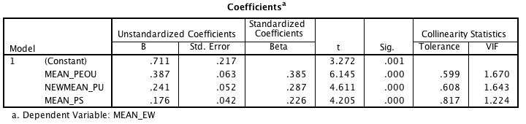

H1: Perceived Ease of Use has a positive relationship towards adoption of e-wallets among Gen Z in Selangor
Based on table 4.11, the result shows that Perceived Ease of Use had a p-value of 0.000 (p<0.05). This explains that there is a significant relationship between perceived ease of use and the adoption of e-wallets among gen z in Selangor. From the Pearson Correlation result, perceived ease of use shows a result of 0.648 which reflects a moderate positive correlation towards the adoption of e-wallets among gen z in Selangor. From table 4.13, since the P-Value is less than 0.05, the regression model is significant. PEOU exhibits a strength of 0.385 towards the variation in adoption of e-wallet among gen z in Selangor. Hence, there is a sufficient statistical evidence to conclude that perceived ease of use has a positive relationship towards the adoption of e-wallets among gen z in Selangor. In conclusion, H1 is accepted.
H2: Perceived Usefulness has a positive relationship towards the adoption of e-wallets among Gen Z in Selangor

Based on table 4.11, the result shows that Perceived Usefulness had a p-value of 0.000 (p<0.05). This explains that there is a significant relationship between perceived ease of use and the adoption of e-wallets among gen z in Selangor. From the Pearson Correlation result, perceived usefulness shows a result of 0.605, which reflects a moderate positive correlation towards the adoption of e-wallets among gen z in Selangor. From table 4.13, since the P-Value is less than 0.05, the regression model is significant. PU exhibits a strength of 0.287 towards the variation in adoption of e-wallet among gen z in Selangor. Hence, there is a sufficient statistical evidence to conclude that perceived usefulness has a positive relationship towards the adoption of e-wallets among gen z in Selangor. In conclusion, H2 is accepted.

H3: Perceived Security has a positive relationship towards the adoption of e-wallets among Gen Z in Selangor

Based on table 4.13, the result shows that Perceived Security had a p-value of 0.000 (p<0.05). This explains that there is a significant relationship between perceived ease of use and the adoption of e-wallets among gen z in Selangor. From the Pearson Correlation result, perceived usefulness shows a result of 0.484 that reflects a weak positive correlation towards the adoption of e-wallets among gen z in Selangor. From table 4.13, since the P-Value is less than 0.05, the regression model is significant. PS exhibits a strength of 0.226 towards the variation in adoption of e-wallet among gen z in Selangor. Hence, there is a sufficient statistical evidence to conclude that perceived security has a positive relationship towards the adoption of e-wallets among gen z in Selangor. In conclusion, H3 is accepted.

H4: Perceived Security has the highest impact on the adoption of e-wallets among Gen Z in Selangor followed by Perceived Ease of Use and Perceived Usefulness

Based on table 4.13, the regression model result shows that all three constructs namely Perceived Ease of Use, Perceived Usefulness and Perceived Security had a p-value of 0.000 (p<0.05). This explains that there is a significant relationship between the three constructs and the adoption of e-wallets among gen z in Selangor. The β coefficient for Perceived Ease of Use is 0.385, Perceived Usefulness is 0.287 and Perceived Security is 0.226. PEOU exhibits the highest impact towards the adoption of e-wallet among gen z in Selangor followed by PU and PS. Hence, there is a sufficient statistical evidence to conclude that PEOU has the highest impact on the adoption of e-wallet among gen z in Selangor followed by PU and PS. In conclusion, H4 is rejected.

Summary of Findings
Table 4.14: Summary of Hypotheses Testing for H1, H2 and H3
Hypotheses | Pearson Correlation |  | Multiple Regression |  | Results
Hypotheses | r-value | p-value | Beta β | p-value | Results
H1 (PEOU) | 0.648 | 0.000 | 0.385 | 0.000 | Accepted
H2 (PU) | 0.605 | 0.000 | 0.287 | 0.000 | Accepted
H3 (PS) | 0.484 | 0.000 | 0.226 | 0.000 | Accepted

Table 4.15: Summary of Hypothesis Testing for H4
Hypotheses | CONSTRUCTS |  |  | Results
Hypotheses | PEOU | PU | PS | Results
H4 (Impact of Significant Predictors) | 0.385 | 0.287 | 0.226 | Rejected

Conclusion

Chapter 4 of the study presents the result of the analysis from the data collected. Pilot test was conducted which highly focus on validity test namely factor analysis and reliability test. The preliminary test was conducted after the full data is collected with using the same validity and reliability test. The analysis was further detailed using descriptive analysis, Pearson’s Correlation Multiple Linear Regression.

Conclusion and Recommendations

Discussion of findings and recommendation

RO1: To investigate the relationship between Perceived Ease of Use towards the Adoption of E-Wallet Among Gen Z in Selangor.

The result from chapter 4 explains that there exist a significant relationship between perceived ease of use and the adoption of e-wallets among gen z in Selangor. The r-value of PEOU construct is 0.648 which implies a moderate positive correlation and the Beta value from regression is According to Ozturket.al (2016) and Abdinnour and Chapparo (2017), perceived ease of use has been found to have stronger effects towards the usage intention of a specific technology. The finding is supported by Wirtz and Göttel (2017) where PEOU are found to be as one of the influence factor towards technology adoption. In this study, PEOU construct towards the adoption of the technology is positively correlated. The results from the analysis are showing the consistency of findings when compared to the previous study. In previous TAM model application towards technology adoption, ease of use is found to be a very critical aspect as it influence the attitude and behavioral intention of users which leads to the actual usage (Adapa et al., 2018). Hence, the consistency of PEOU construct is valid as an influence factor towards the adoption of e-wallet among gen z in Selangor.

RO2: To investigate the relationship between Perceived Usefulness towards the Adoption of E-Wallet Among Gen Z in Selangor.

From the result of this study as shown in table 4.13, Perceived Usefulness exhibits a relationship towards the e-wallet adoption among gen z in Selangor. The r-value of PU construct is 0.605, which implies a moderate positive correlation. According to Putra (2019), usefulness of a technology is a base for users to be convinced and influenced to adopt a technology. The positive correlations results of PU construct in this study are found to be consistent with the findings from Putra (2019). This is supported by Sharifzadeh et.al (2017), which explains the behavioral intention of a technology, is positively correlated with perceived usefulness. Hence, the consistency of PU construct is valid as an influence factor towards the adoption of e-wallet among gen z in Selangor.

RO3: To investigate the relationship between Perceived Security towards the Adoption of E-Wallet Among Gen Z in Selangor.

Apart from PEOU and PU that has correlation with the adoption of e-wallet among gen z in Selangor, Perceived Security or PS construct also exhibits a positive correlation. The p-value from the Pearson Correlation is less than 0.05 (p<0.05) signifies there exist a correlation between PS and adoption of e-wallet among gen z in Selangor. The r-value of PS construct is 0.484, which implies a weak positive correlation. According to Kassim (2017), perceived security is one of the factors influencing technology adoption especially in banking sector as customer are afraid that their data will be used for fraudulent purpose. The result from this study is consistent with the findings from Kassim (2017) where PS construct is showing positive correlation towards the adoption of e-wallets among gen z in Selangor. This is supported by Lai (2017) which also concluded similar findings where security and e-payment adoption has a significant relationship.

RO4: To investigate the significant impact of the predictors towards the adoption of E-wallet Among Gen Z in Selangor

The Pearson`s Correlation test shows all three constructs namely Perceived Ease of Use (PEOU), Perceived Usefulness (PU) and Perceived Security (PS) has a significant relationship towards the Adoption of E-wallet Among Gen Z in Selangor whereby all three constructs exhibits a significant value of 0.000 (p<0.05). Based on the R² value of 0.532, 53.2% of the variation in the Adoption of E-wallet Among Gen Z in Selangor can be explained by the three variables namely PEOU, PU and PS. The results of the analysis also shows, among all three construct, Perceived Ease of Use has the highest Beta value, 0.387 followed by Perceived Usefulness, 0.241 and Perceived Security, 0.176. The result is inconsistent with Kassim (2017) and Lai (2017) which stresses on the security construct to predict the technology adoption. However, the findings are consistent with Ozturket.al (2016) and Abdinnour and Chapparo (2017) where PEOU has been found to exhibit a higher strength in terms of the impact of a technology adoption. The model from the study are as follows;

Adoption of E-Wallet Among Gen Z in Selangor | = | 0.711CONSTANT + 0.385PEOU + 0.287PU + 0.226PS

Contributions

Contributions to literature

For the academia contribution, this study confirms that the Extended Technological Acceptance Model (TAM) with the factors of Perceived Ease of Use, Perceived Usefulness and Perceived Security can influence and predict the adoption of e-wallet among gen z in Selangor. The consistency from the result obtained with the previous studies confirms that the factors in the Technological Acceptance Model can be further used to test other factors pertaining the adoption of e-wallet technology. Apart from that, from the result, it is also concluded that Perceived Ease of Use is the highest determining factor for adoption of e-wallet as compared to Perceived Usefulness and Perceived Security. This study help to bridge the literature gap on factors of e-wallet adoption among gen z in Selangor. Hence this study can be further expand on different factors of the e-wallet adoption among gen z. In the past, studies on TAM model is used across various technology and this study confirms that the model is valid in predicting the user intention to use a specific technology.

Contribution to Industry

The focus to revolutionize monetary transactions will never stop globally. New technology is being produced from time to time in the banking industry due to rapid innovation and technology growth. Apart from focusing on the technical aspect of the innovation, industry players in this case fintech companies, have to take into account the users perspective because a technology can only be successful if it is solving the pain point of the users. From the findings in this study, there are 3 major factors need to be consider when developing e-wallet technology which are Perceived Ease of Use, Perceived Usefulness and Perceived Security. These three factors need to be as part of the business decision as well as the technical specification. The findings also shows that the Perceived Ease of Use exhibits the highest weightage in predicting the adoption level of e-wallet technology. From here, fintech companies may use this information to further improvise the ease of using the e-wallet technology such as enhancing the user interface and experience of the mobile application, easier user guideline, and smoother transaction processes. Apart from that, the usefulness aspect including increasing user dependency on e-wallet technology and security aspect must also come into the picture when developing or improvising the current e-wallet technology.

E-wallet technology developer are suggested to explain on the security aspect of the technology to the users apart from improving the innovation of the technology. This is due to the respondents in this study who are unsure on the security levels of the e-wallet technology. This also includes the clueless of the users towards the safety of their money in their own e-wallet. Promotion of the technology must include the security aspect of e-wallet to ensure that users trust can be further improved. Users trust towards the security of the technology are influencing the adoption level of e-wallets.

Contribution to Government

Earlier in this study, it is known that Bank Negara is planning up policies pertaining cashless adoption transactions including e-wallet adoption. From the result of this study, Bank Negara can use this findings to examine the loophole areas in the current and future policies. In order to ensure that adoption level increase, the policies regarding cashless transaction must go along side by side the innovation in technology. Bank Negara may set up a rules and regulations that covers the three factors influencing the adoption of e-wallet which are Perceived Ease of Use, Perceived Usefulness and Perceived Security. All three factors are important to ensure that the policies followed by the e-wallet technology developer will ensure a high adoption from the public. It is not worth to develop a technology with low level of acceptance. In this way, the Bank Negara blueprint to remove physical cash from the system in this country can be achieved in a shorter time frame. In addition, Bank Negara has to also find a way to integrate the application across various brands of e-wallets which is a hassle to the users since a store or shop may only accept some brands of e-wallets. This aspect falls under the Perceived Ease of Use factor in this study where the respondents among the Gen Zs are responding to the improvement of location to apply the e-wallet technology.

The findings from the study also exhibits Perceived Security as the lowest impact factor as compared to PEOU and PU. When zoomed into the response from the study conducted, it is found that most of the respondents are not sure on the security level of the e-wallet whether it is trusted or not. Government bodies such as the Malaysian Communications And Multimedia Commission (MCMC) have to start awareness campaigns among Malaysian to educate on cyber security issues such as cyber attacks, data privacy and personal data protection. The campaign may include the Gen Z group in primary and secondary schools to ensure that the awareness towards the security aspect of e-wallet technology can be instill since young age. Technology users must be able to understand and protect their own privacy especially when it comes to banking and monetary transactions online.

Limitations of Study

The study have few highlights on the limitations that is influencing the findings of the study. Firstly the sample size is not achieve where the required sample size is 385 while the achieved sample is 203. This is due to time constraint and limited capability in reaching a mass number of participants for the study. Apart from that, the limitations also include the Generation Z that is involved in this study. For the purpose of this study, the limitation is due to the age limit that is set up which is 18 years old while according to Seemilar and Grace (2017) the age group that falls under the category of Gen Z is individuals who were born between 1995 to 2010 which means the sample should include minors beginning 9 years old as of 2019 to represent the whole population of Gen Z in Selangor.

In addition to the sample and target group limitations, the acceptance model is only focusing based on 1 model only which is TAM model. The factors listed in TAM model for this study is only Perceived Ease of Use, Perceived Usefulness and Perceived Security. While the factors influencing the adoption may not be limited to absolutely only these 3 factors as listed in TAM model. However, the constructs built in the questionnaire are mainly based on the grounded theory chosen in this study which is Technology Acceptance Model.

Since the adoption of e-wallets in Malaysia is still at its infancy stage, user perception varies between one another due to the different technology developed by the e-wallets technology. There are more than twenty e-wallet license issued in Malaysia therefore there are a lot of e-wallet application in the market for Malaysian context. The features, user interface and user experience is different across various platforms which will results in different perception of the technology. Participants of this research are majorly the users of GrabPay and TouchnGo E-wallet where both constitute a percentage of 30% and 33% respectively in this study. The results might shows a different results when different platforms were given to the participants.

Future Study Recommendation
Recommendations for future study is to expand the horizon of the factors influencing the e-wallet adoption. Apart from TAM model, there are also few user technology acceptance model such as the innovative TAM2 model which has a higher focus on perceived ease of use and also TAM3 model which expands the factors influencing perceived ease of use and perceive usefulness. The study can also be expanded to apply other grounded theory such as UTAUT model and Lazy User Model which has different approach in terms of user acceptance of a technology. Apart from that, in the future research for adoption of e-wallets, the environment of the study can be fixed by only allowing a specific aspect to be tested in one time. For example, a study can be done on a group of respondents by using the same e-wallet application. By controlling the environment, the respondents is not influenced by other external factors such as advertising of the e-wallet brand. The controlled environment can further explain the exact influence of the factors towards e-wallet adoption.

Personal Reflections
I truly appreciate and highly value the experience that I have gained from conducting this study. The research process that I have gone through is very important especially in making business decision. Any business decision maker should never jump into a decision without understanding the feasibility of the product from the user perspective. In recent years, online transactions, e-wallet and cashless society is becoming a hype topic and it has influenced investors from multinational companies even from the small-medium enterprise to jump into the business of making more e-wallets but slowly dying due to lack of response from the users. The low adoption rate of e-wallet in Malaysia has slows down the fintech companies growth financially due to unsustainable business model. I have also learnt that going down to the field and ask for respondents opinion and input for the factors influencing the e-wallet adoption are one of the ways data can be collected and analysed before making a business decision. Most importantly, I have learnt that data is powerful where it can predict the direction of a business. Opinions and instinct in business decision making is only valid if supporting data from the field is considered.

Conclusion

The final chapter of the study discussed on the findings and recommendations made pertaining to the adoption of e-wallets among gen z in Selangor. The research objective that were developed in Chapter 2 is connected back to the grounded theory as discussed in the same chapter. Apart from that, limitations of the study is also discussed to explain the variations in the results as well as the further improvement that can be done for the future research. The highlights of this chapter is the recommendations made to academia, industry and the government which signifies that this study is relevant and significantly contribute to the stakeholders. Extended TAM Model (PEOU, PU and PS) are applicable and the factors are significant towards the adoption of e-wallet among gen z in Selangor. The model can be applied towards predicting the adoption of e-wallets where PEOU factor has the highest impact on the adoption of E-wallets among Gen Z in Selangor followed by PU and PS respectively. Further exploration on other influencing factors is required to find other variables that affecting the e-wallet adoption.

REFERENCES

Abdinnour, S. & Chaparro, B. (2017). An Integrated Temporal Model of Belief and Attitude Change: An Empirical Test with the Ipad. Journal of the Association for Information Systems, 18, 113.
Abdullah, F. & Ward, R. (2016). Developing a General Extended Technology Acceptance Model for E-Learning (Getamel) by Analysing Commonly Used External Factors. Computers in Human Behavior, 56, 238-256.
Adapa, A., Nah, F. F.-H., Hall, R. H., Siau, K. & Smith, S. N. (2018). Factors Influencing the Adoption of Smart Wearable Devices. International Journal of Human–Computer Interaction, 34, 399-409.
Agrawal, R. K. (2017). Study on Introduction of Cashless Economy in India: Benefits & Challenges. International Journal of Research in Management, Economics and Commerce, 7, 187-189.
Al-Sharafi, M. A., Arshah, R. A., Abo-Shanab, E. & Elayah, N. (2016). The Effect of Security and Privacy Perceptions on Customers’ Trust to Accept Internet Banking Services: An Extension of Tam. Journal of Engineering and Applied Sciences, 11, 545-52.
Amit, R. & Sasidharan, S. (2019). Measuring Affordability of Access to Clean Water: A Coping Cost Approach. Resources, Conservation and Recycling, 141, 410-417.
Assegaff, S. A Literature Review: Acceptance Models for E-Learning Implementation in Higher Institution. 2014 International Conference on Advances in Education Technology (ICAET-14), 2015. Atlantis Press.
Bajpai, N., Biberman, J. & Sachs, J. D. (2018). Post-Demonetization E-Payment Trends.
Bank, W. (2018). Financial Inclusion [Online]. Retrieved from: http://www.worldbank.org/en/topic/financialinclusion/overview [Accessed 11/06/2019 2019].
Bernama. (2019). Shafee’s Money Laundering Trial Moved to March Next Year [Online]. Retrieved from: https://www.freemalaysiatoday.com/category/nation/2019/06/28/shafees-money-laundering-trial-moved-to-march-next-year/ [Accessed 29/06/2019 2019].
Burns, A. C. & Bush, R. F. (2010). Marketing Research. Global Edition. New Jersey: Prentice Hall.
Connelly, L. M. (2008). Pilot Studies. Medsurg Nursing, 17, 411.
Dixit, R. V., Singh, R. & Chaturvedi, S. (2017). A Study on Adoption of Mobile Wallet for Cashless Economy. Anvesha, 10, 32-44.
Eberhardt, D. (2017). Generation Z Goes to College: An Opportunity to Reflect on Contemporary Traditional College Students: By Corey Seemiller and Meghan Grace, 2016. San Francisco, Ca: Jossey-Bass, 220 Pp. Taylor & Francis.
Engert, W., Fung, B. S. & Hendry, S. (2018). Is a Cashless Society Problematic?, Bank of Canada= Banque du Canada.
Fabris, N. (2019). Cashless Society–the Future of Money or a Utopia? Journal of Central Banking Theory and Practice, 8, 53-66.
Fernandes, S. F. & Panda, R. (2018). Social Reference Group Influence on Women Buying Behaviour: A Review. Journal of Commerce & Management Thought, 9, 273-291.
Fitriyani, A., Sfenrianto, S., Wang, G. & Susanto, A. (2016). Examining the Security Issues of Automated Teller Machine Based on Revised Technology Acceptance Model.
Force, F. A. T. (2015). Money Laundering through the Physical Transportation of Cash [Online]. Retrieved from: https://www.fatf-gafi.org/media/fatf/documents/reports/money-laundering-through-transportation-cash.pdf [Accessed 29/06/2019 2019].
Hair, J. F., Black, W. C., Babin, B. J. & Anderson, R. E. (2014). Multivariate Data Analysis, United States of America, Pearson.
Hajli, N. & Lin, X. (2016). Exploring the Security of Information Sharing on Social Networking Sites: The Role of Perceived Control of Information. Journal of Business Ethics, 133, 111-123.
Hänninen, H. (2017). Digital Service in Global B2b Companies: Ecommerce in an Industrial Company.
Heale, R. & Twycross, A. (2015). Validity and Reliability in Quantitative Studies. Evidence-based nursing, 18, 66-67.
Heller, N. (2016). Imagining a Cashless World. The New Yorker, 10.
ITU. (2018). Key Ict Indicators for Developed and Developing Countries and the World [Online]. Retrieved from: https://www.itu.int/en/ITU-D/Statistics/Pages/default.aspx [Accessed 17/03/2019 2019].
Johanson, G. A. & Brooks, G. P. (2010). Initial Scale Development: Sample Size for Pilot Studies. Educational and Psychological Measurement, 70, 394-400.
Johnson, V. L., Kiser, A., Washington, R. & Torres, R. (2018). Limitations to the Rapid Adoption of M-Payment Services: Understanding the Impact of Privacy Risk on M-Payment Services. Computers in Human Behavior, 79, 111-122.
Kapron, Z. (2018). From Digital Payments to Digital Finance: How China’s Tech Companies Are Redefining Banking in Asia and Soon Europe. Journal of Payments Strategy & Systems, 12, 68-73.
Kassim, N. M. (2017). Effect of Perceived Security and Perceived Privacy Towards Trust and the Influence on Internet Banking Usage among Malaysians. International Academic Journal of Social Sciences, 4, 26-36.
Kazan, E., Tan, C.-W., Lim, E. T., Sørensen, C. & Damsgaard, J. (2018). Disentangling Digital Platform Competition: The Case of Uk Mobile Payment Platforms. Journal of Management Information Systems, 35, 180-219.
Kumar, A. (2019). Cashless Society: Challenges and Opportunities. Journal Current Science, 20.
Lai, P. (2017). Security as an Extension to Tam Model: Consumers’ Intention to Use a Single Platform E-Payment. Asia-Pacific Journal of Management Research and Innovation, 13, 110-119.
Lekhwar, S., Yadav, S. & Singh, A. (2019). Big Data Analytics in Retail. Information and Communication Technology for Intelligent Systems. Springer.
Liébana-Cabanillas, F., Ramos de Luna, I. & Montoro-Ríos, F. J. (2015). User Behaviour in Qr Mobile Payment System: The Qr Payment Acceptance Model. Technology Analysis & Strategic Management, 27, 1031-1049.
Lin, C.-T. L. & Chuang, S.-S. (2018). The Importance of Brand Image on Consumer Purchase Attitude: A Case Study of E-Commerce in Taiwan. Studies in Business and Economics, 13, 91-104.
Lohr, S. L. (2009). Sampling: Design and Analysis, Nelson Education.
Lu, L. (2018). Decoding Alipay: Mobile Payments, a Cashless Society and Regulatory Challenges. Butterworths Journal of International Banking and Financial Law, 40-43.
Mahidin, M. U. (2018). Statistik Jenayah, Malaysia, 2018 [Online]. Retrieved from: https://www.dosm.gov.my/v1/index.php?r=column/pdfPrev&id=c2QzbXRSQzY3dlpMM3JoYmtlNmptZz09 [Accessed 29/06/2019 2019].
Malaysia, D. o. S. (2017). Statistik Kes Jenayah Indek Seluruh Malaysia [Online]. Department of Statistics Malaysia. Retrieved from: http://www.data.gov.my/data/ms_MY/dataset/statitisk-jenayah-indeks-seluruh-malaysia-mengikut-jenis-jenayah-negeri-dan-tahun/resource/9518d01f-42d0-4202-8b28-063d31da3c8f [Accessed 29/06/2019 2019].
Malaysia, D. O. S. (2019). Population by Age, Selangor, 2018.
MCMC. (2017). Internet Users Survey 2017. Available: https://www.mcmc.gov.my/skmmgovmy/media/General/pdf/MCMC-Internet-Users-Survey-2017.pdf [Accessed 25/02/2019].
Moon, W. (2017). A Coinless Society as a Bridge to a Cashless Society: A Korean Experiment. Cash in East Asia. Springer.
Mothobi, O. & Grzybowski, L. (2017). Infrastructure Deficiencies and Adoption of Mobile Money in Sub-Saharan Africa. Information Economics and Policy, 40, 71-79.
Nisar, T. M. & Prabhakar, G. (2017). What Factors Determine E-Satisfaction and Consumer Spending in E-Commerce Retailing? Journal of retailing and consumer services, 39, 135-144.
Oliveira, T., Thomas, M., Baptista, G. & Campos, F. (2016). Mobile Payment: Understanding the Determinants of Customer Adoption and Intention to Recommend the Technology. Computers in Human Behavior, 61, 404-414.
Olushola, T. & Abiola, J. (2017). The Efficacy of Technology Acceptance Model: A Review of Applicable Theoretical Models in Information Technology Researches. Journal of Research in Business and Management, 4, 70-83.
Ooi, K.-B. & Tan, G. W.-H. (2016). Mobile Technology Acceptance Model: An Investigation Using Mobile Users to Explore Smartphone Credit Card. Expert Systems with Applications, 59, 33-46.
Ozturk, A. B., Bilgihan, A., Nusair, K. & Okumus, F. (2016). What Keeps the Mobile Hotel Booking Users Loyal? Investigating the Roles of Self-Efficacy, Compatibility, Perceived Ease of Use, and Perceived Convenience. International Journal of Information Management, 36, 1350-1359.
Pandita, R. (2017). Internet: A Change Agent an Overview of Internet Penetration & Growth across the World. International Journal of Information Dissemination and Technology, 7, 83.
Pauwels, K., Leeflang, P. S., Teerling, M. L. & Huizingh, K. E. (2011). Does Online Information Drive Offline Revenues?: Only for Specific Products and Consumer Segments! Journal of Retailing, 87, 1-17.
Pikri, E. (2019). 4 Big New Features You Can Expect from Your E-Wallets in 2019 [Online]. FINTECH MALAYSIA. Retrieved from: https://fintechnews.my/19657/payments-remittance-malaysia/mobile-wallet-payments-malaysia-paynet-real-time-retail-payments-rpp/ [Accessed 11/03/2019 2019].
Pisani, F. & Moormann, J. (2018). The Role of Competition in the Adoption of Mobile Payment among Merchants.
Putra, I. D. G. R. D. (2019). The Evolution of Technology Acceptance Model (Tam) and Recent Progress on Technology Acceptance Research in Elt: State of the Art Article. Yavana Bhāshā: Journal of English Language Education, 1.
Quinlan, C., Babin, B., Carr, J. & Griffin, M. (2019). Business Research Methods, South Western Cengage.
Rachels, J. R. & Rockinson-Szapkiw, A. J. (2018). The Effects of a Mobile Gamification App on Elementary Students’ Spanish Achievement and Self-Efficacy. Computer Assisted Language Learning, 31, 72-89.
Raosoft (2019). Sample Size Calculator.
Refonaa, J., Sebastian, G. G., Ramanan, D. & Lakshmi, M. Effective Identification of Black Money and Fake Currency Using Nfc, Iot and Android. 2018 International Conference on Communication, Computing and Internet of Things (IC3IoT), 2018. IEEE, 275-278.
Rivera, J. W. (2019). Potential Negative Effects of a Cashless Society: Turning Citizens into Criminals and Other Economic Dangers. Journal of Money Laundering Control, 00-00.
Rodriguez, M., Boyer, S., Fleming, D. & Cohen, S. (2019). Managing the Next Generation of Sales, Gen Z/Millennial Cusp: An Exploration of Grit, Entrepreneurship, and Loyalty. Journal of Business-to-Business Marketing, 1-13.
Samsung. (2019). Samsung Pay More Than a Wallet [Online]. Retrieved from: https://www.samsung.com/my/samsung-pay/ [Accessed 11/04/2019 2019].
Saunders, M., Lewis, P., Thornhill, A. & Wilson, J. (2009). Business Research Methods. Financial Times, Prentice Hall: London.
Seemiller, C. & Grace, M. (2017). Generation Z: Educating and Engaging the Next Generation of Students. About Campus, 22, 21-26.
Seemiller, C. & Grace, M. (2018). Who Is Generation Z? Characteristics of the Cohort Values Motivations. Generation Z. Routledge.
Sekaran, U. & Bougie, R. (2010). Theoretical Framework in Theoretical Framework and Hypothesis Development. Research methods for business: A skill building approach, 80.
Sekaran, U. & Bougie, R. (2016). Research Methods for Business: A Skill Building Approach, John Wiley & Sons.
Shariffuddin, S. A., Razali, J. R. & Hashim, S. M. (2017). Exploring the Problems Faced by the Academics in Transforming University Colleges to Universities: A Pilot Study. International Journal of Education, Psychology and Counseling, 2, 30-43.
Sharifzadeh, M. S., Damalas, C. A., Abdollahzadeh, G. & Ahmadi-Gorgi, H. (2017). Predicting Adoption of Biological Control among Iranian Rice Farmers: An Application of the Extended Technology Acceptance Model (Tam2). Crop protection, 96, 88-96.
Sharma, S. K., Mangla, S. K., Luthra, S. & Al-Salti, Z. (2018). Mobile Wallet Inhibitors: Developing a Comprehensive Theory Using an Integrated Model. Journal of Retailing and Consumer Services, 45, 52-63.
Shendge, M. P. A., Shelar, M. B. G. & Kapase, A. P. S. S. (2017). Impact and Importance of Cashless Transaction in India. International Journal of Current Trends in Engineering and Research, 3, 22-28.
Sin, K. Y., Osman, A., Salahuddin, S. N., Abdullah, S., Lim, Y. J. & Sim, C. L. (2016). Relative Advantage and Competitive Pressure Towards Implementation of E-Commerce: Overview of Small and Medium Enterprises (Smes). Procedia Economics and Finance, 35, 434-443.
Sung, T. K. (2018). Industry 4.0: A Korea Perspective. Technological Forecasting and Social Change, 132, 40-45.
Tam, L. T. (2018). Fintech for Promoting Financial Inclusion in Vietnam: Fact Findings and Policy Implications. Business & Social Sciences Journal, 3, 12-20.
Tan, Y. (2018). E-Wallet Race Heats Up [Online]. Retrieved from: https://www.thestar.com.my/business/business-news/2018/03/17/ewallet-race-heats-up/ [Accessed 11/04/2019 2019].
Tan, Y. & Yen Li, C. (2018). Banking on the E-Walet in Malaysia. Available: https://www.pwc.com/my/en/assets/blog/pwc-my-deals-strategy-banking-on-the-ewallet-in-malaysia.pdf [Accessed 25/02/2019].
Tarhini, A., Hone, K., Liu, X. & Tarhini, T. (2017). Examining the Moderating Effect of Individual-Level Cultural Values on Users’ Acceptance of E-Learning in Developing Countries: A Structural Equation Modeling of an Extended Technology Acceptance Model. Interactive Learning Environments, 25, 306-328.
Taylor, E. (2016). Mobile Payment Technologies in Retail: A Review of Potential Benefits and Risks. International Journal of Retail & Distribution Management, 44, 159-177.
Tyler, A. (2018). Financial Inclusion—Why Mobile Payments and Remittances Are Vital [Online]. Retrieved from: https://internationalbanker.com/banking/financial-inclusion-why-mobile-payments-and-remittances-are-vital/ [Accessed 11/06/2019 2019].
Venkatesh, V. & Davis, F. D. (2000). A Theoretical Extension of the Technology Acceptance Model: Four Longitudinal Field Studies. Management science, 46, 186-204.
Wang, J. & Gu, L. (2017). Why Is Wechat Pay So Popular? Issues in Information Systems, 18, 1-8.
Wang, L., Luo, X. R., Yang, X. & Qiao, Z. (2019). Easy Come or Easy Go? Empirical Evidence on Switching Behaviors in Mobile Payment Applications. Information & Management.
Wirtz, B. W. & Göttel, V. (2016). Technology Acceptance in Social Media: Review, Synthesis and Directions for Future Empirical Research. Journal of Electronic Commerce Research, 17, 97.
Wright, R., Tekin, E., Topalli, V., McClellan, C., Dickinson, T. & Rosenfeld, R. (2017). Less Cash, Less Crime: Evidence from the Electronic Benefit Transfer Program. The Journal of Law and Economics, 60, 361-383.
Wulandari, D., Soseco, T. & Narmaditya, B. S. (2016). Analysis of the Use of Electronic Money in Efforts to Support the Less Cash Society. International Finance and Banking, 3, 1-10.
Xu, W. (2017). The Study of Wechat Payment Users Willingness Factor. Journal of Service Science and Management, 10, 251.
Yu, L. (2019). E-Commerce Models, Players, and Its Future. Advanced Methodologies and Technologies in Digital Marketing and Entrepreneurship. IGI Global.
Zhi Wei, L. & Peng Tsu, K. (2018). Transforming Mobile Phones into
E-Wallets in Malaysia Available: http://www.bnm.gov.my/files/publication/qb/2018/Q2/p7.pdf.
Zhong, J. (2009). A Comparison of Mobile Payment Procedures in Finnish and Chinese Markets. BLED 2009 Proceedings, 37.
Zikmund, W. G., Babin, B. J., Carr, J. C. & Griffin, M. (2009). Business Research Methods (with Qualtrics Card). Cengage Learning.
Zikmund, W. G., Babin, B. J., Carr, J. C. & Griffin, M. (2013). Business Research Methods, Cengage Learning.

Appendices

Appendix A: Initial Research Proposal

STUDENT NAME & ID NO | HAZIQ ASYRAF BIN MARZUKI
BROAD AREA | MARKETING
Concise Title | FACTORS INFLUENCING THE USAGE OF EWALLETS AMONG GENERATION Z IN SELANGOR
Problem Definition  examined | The purpose of the research is to study the various factors that is influencing the usage of ewallets as well as understanding the acceptance of the technology among Gen Z in Selangor. There are a lot of Fintech companies in Malaysia that are currently developing the technology such as BigPay, Boost, TouchNGoEwallets and Razor Pay but the driving factor for consumer usage and acceptance is a wide area to be studied.  The relevant theory involve in the study is Technology Acceptance Model that has outlined the key driving factor of technology acceptance which are determined by two major factor , perceived usefulness and perceived ease of use (Venkatesh and Davis, 2000). The theory also extended into the study social forces that affects whether the user accepts or reject the technology which is called TAM2 (Oliveira, Thomas, Baptista and Campos, 2016).  The advancement of mobile technology globally has created a lot of window of opportunities in major of sectors in business and also affecting how we conduct our daily routine. One of the rapid growing technology is smartphone where we can see the number of smartphone users especially in Malaysia has been increasing from year to year and it is recorded that 89.4% of internet users are using smartphone to browse the internet (MCMC, 2017). According to PWC (2018), Malaysia is one of the best country to adopt the usage of ewallet where the country`s internet penetration is 86% and mobile phone penetration rate of 64% but unfortunately we are currently left behind our neighbors including Singapore, China, and India in the adoption of ewallet technology.  Therefore, in addressing this issue, various parties need to be involved in ensuring that the adoption rate increased significantly. Bank Negara Malaysia (2018) has outlined the migration to epayments in the Financial Sector Blueprint which aims to make mobile payment to displace cash and cheques whereby the usage of ewallets are being accelerated starting 2018. By understanding the general outline of the banking sector, the Fintech players especially those who specialized in ewallets have to tackle the low adoption rate of ewallets by understanding the factors influencing the usage of ewallets.
Research Questions OR Objective | - To determine the relationship between perceived usefulness and usage of ewallets among Gen Z in Selangor  - To determine the association between perceived ease of use and usage of ewallets among Gen Z in Selangor
Scope of study | The research will mainly focus on to investigate the factors influencing usage of ewalletsamong Gen Z in Malaysia. The geographic focus of the study is in Selangor, Malaysia. Individual that are in the age range of Generation Z are the unit of analysis of this study. The research is using quantitative methods. Internet-mediated questionnaires will be used to collect the data from target respondents.
Significance of the Research | Academia: Refine the research by targeting different demographics and area of study to get a more precise result. Researchers are also will be able to further research on the factors to get a new findings in future.  Government: New policies and regulations can be created involving usage of ewallets in transactions especially in the banking sector. The growth of mobile transaction has to be regulated by the central bank. By understanding this study, the government can offer a better way to ensure the adoption rate of ewallets increased significantly as to achieve a cashless society.  Industry: Industry players especially fintech companies will get to know the driving factor for ewallets adoption. By understanding the subject, industry players will be able to produce a better ewallet technology that enable users to easily adopt the usage.
Literature Review | Ewallet  In recent years, the development of mobile wallets which are being adopted in developing and developed countries has significantly improves the productivity, scale and excellence especially in the banking sector (Sharma, Mangla, Luthra and Al-Salti, 2018). An electronic wallet or e-wallet is similar to a prepaid account that stores information such as digital money, receipts and coupons which can be used in doing transaction as a replacement to physical cash either in an online or offline payment environment (Dixit et al., 2017).  Gen Z  Generation Z by definition are the individuals who were born between 1995 and 2010. This group of individuals are exposed and shaped by the challenging environment including advancement of technology, fluctuation of economy and human rights movement (Seemiller and Grace, 2017). Individuals that falls in the category of Generation Z were greatly influenced by global economic issues and recession which has greatly impacted their point of views which makes them very distinctive (Rodriguez et al., 2019).  Since the behavior of the Gen Z is very distinctive and the development of ewallets are going towards serving the Gen Z`s currently and in the upcoming years, there is a gap of research which need to be explored in order to find out the factors that can influence the Gen Z`s to adopt ewallet in making transactions hence achieving the objective of cashless society.
Research Methodology | Methodology: The study will be using quantitative methods of research. A representative sample will be surveyed to further enhance the understanding of the factors influencing usage of ewalletsamong the Gen Z in the state of Selangor. Apart from that, variables involved in the research will be further examined to establish the relationship, which leads to the formation of the hypothesis. In large population study, descriptive research is one of the appropriate method that will examine the phenomena and also recognize the cause as to find out any similarities and differences in the research (Burns and Bush, 2010)  Sampling Technique: Convenience sampling (Non- probability sampling)  Questionnaire Design: The survey questionnaire will consist of three consecutive section namely Section A, B, and C. Section A questions will consist of demographic profile while Section B and C, the question will involve five- point Likert scale format, which range from “strongly disagree”(1) and “strongly agree”(5). In Section B requires respondents to answer based on independent variables while for section c, the questionnaires will be based on dependent variable which is usage of ewallets.  Data Collection Method: Primary and secondary data will be collected in this study. Primary data will be obtained through online questionnaire. Journal articles, surveys, online report and newspaper articles will be gathered for secondary data.  Analysis Methodology: The research will focus on the analysis using Statistical Package for the Social Sciences (SPSS) which enables the data to be analyzed including descriptive statistics, frequencies, charts and also analysis of variance for inferential and multivariate statistic analysis (Sekaran and Bougie, 2010).

Appendix B: Research Questionnaires

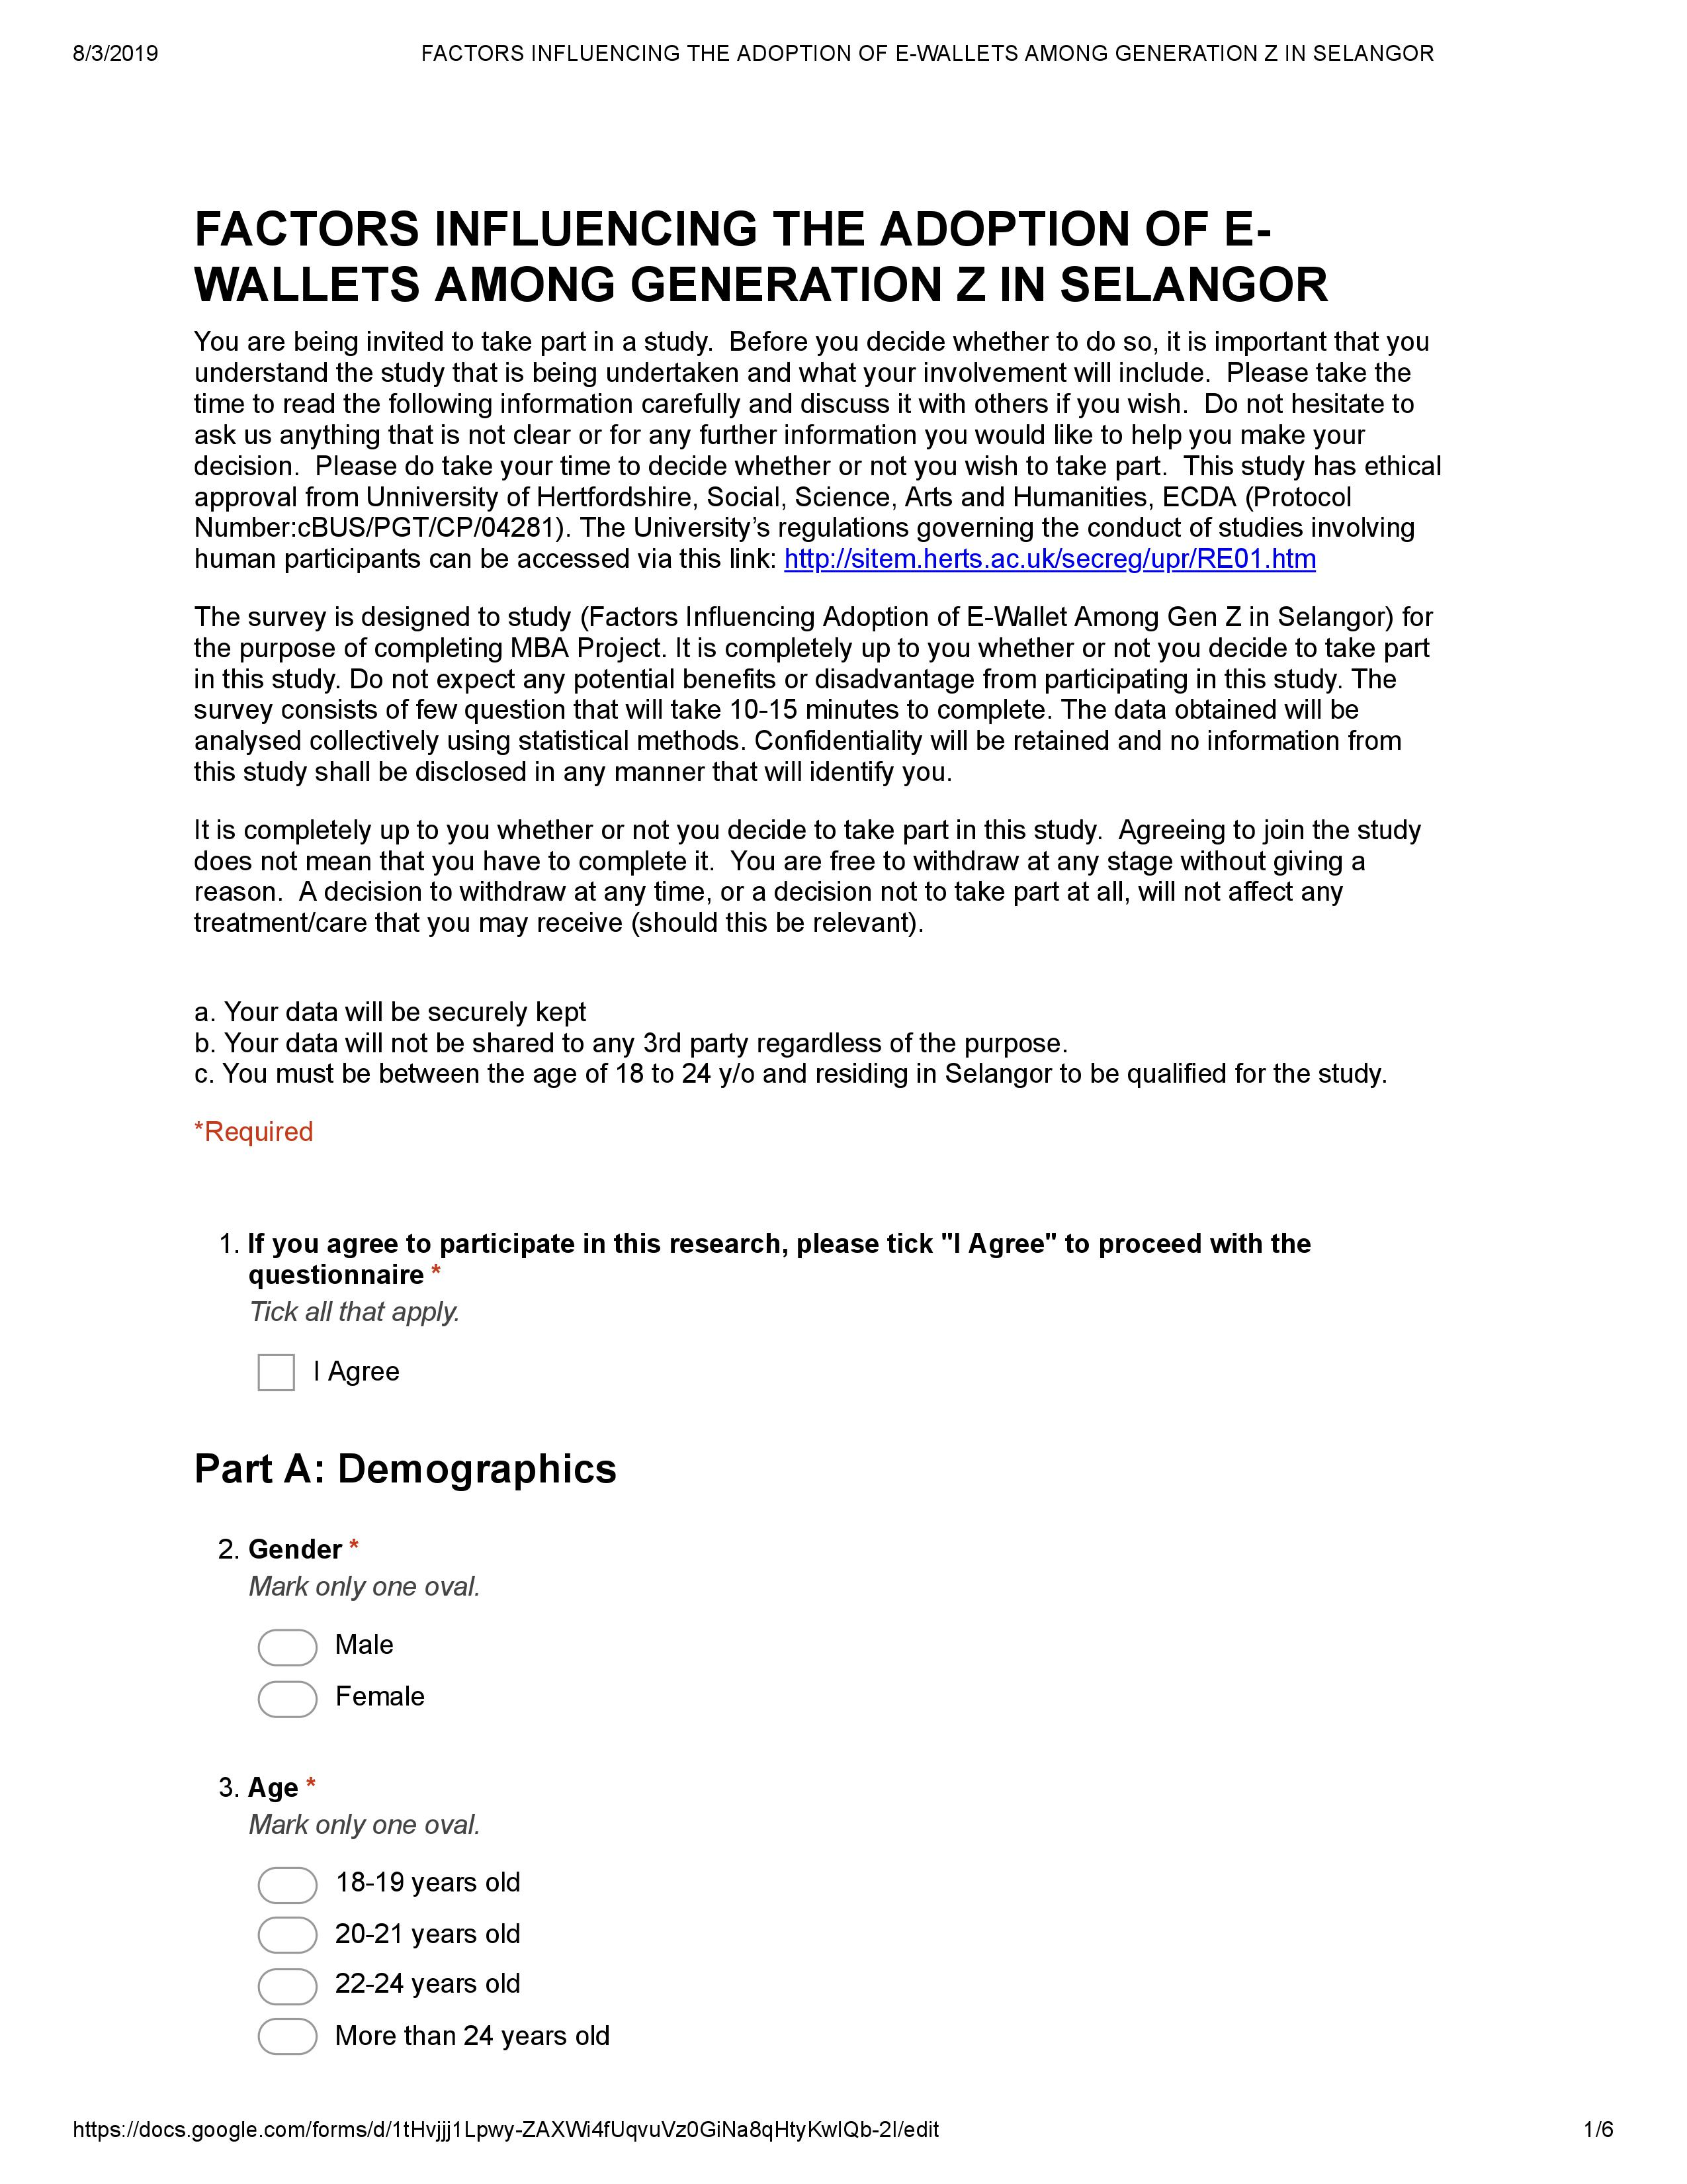
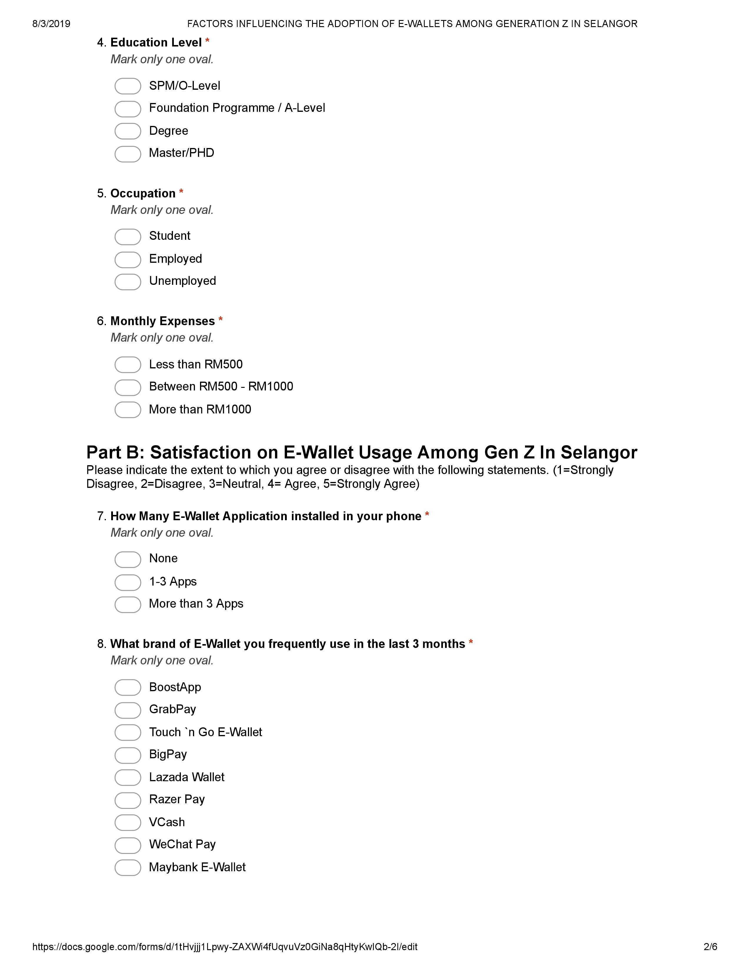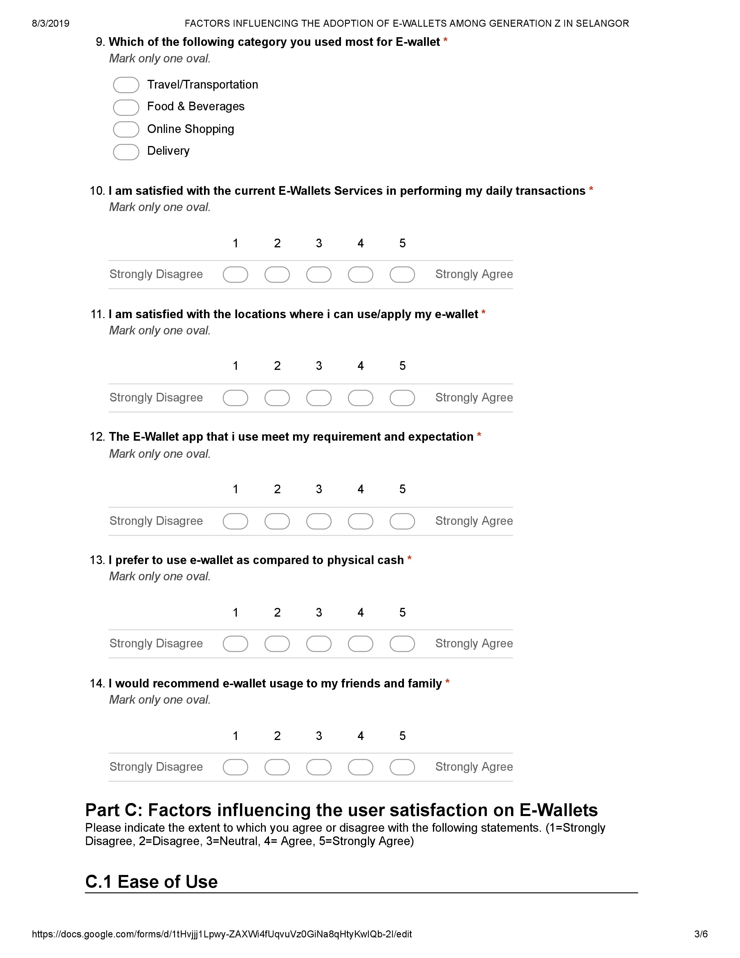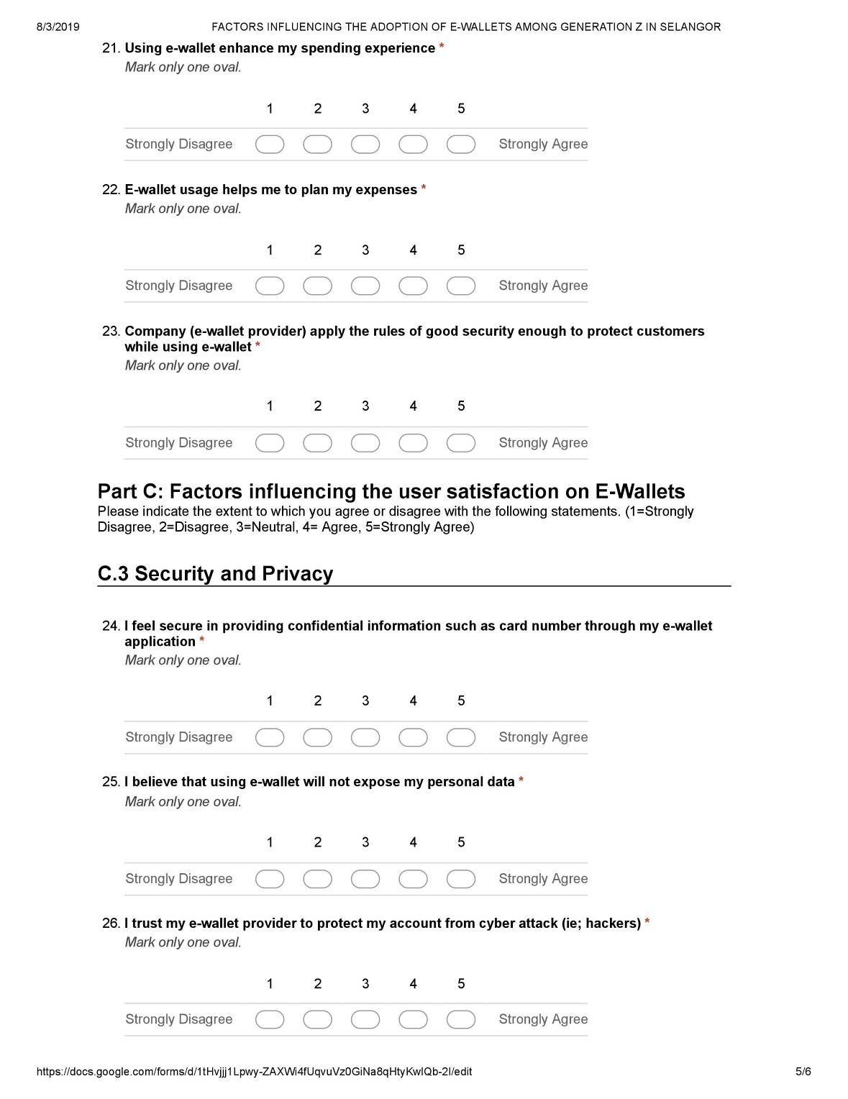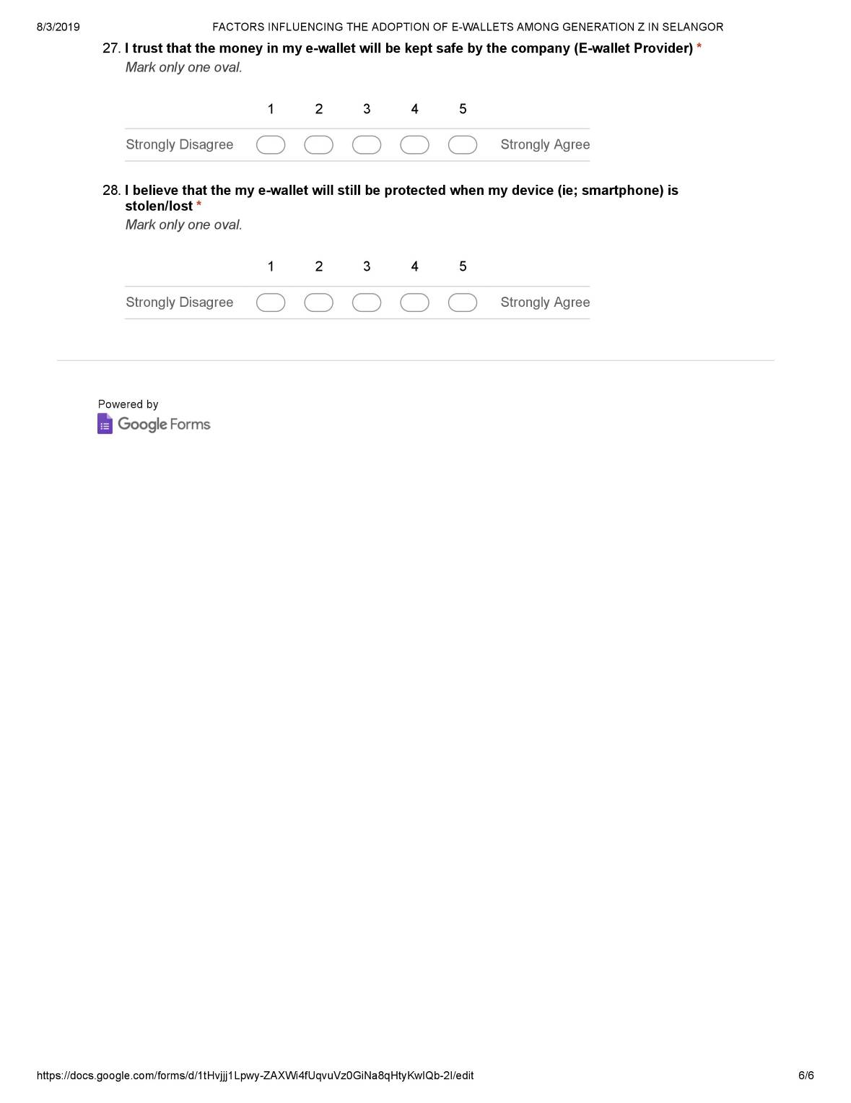

Appendix C: SPSS Results (Pilot Test)

Factor Analysis

Communalities
 | Initial | Extraction
I am satisfied with the current E-Wallets Services in performing my daily transactions | 1.000 | .717
I am satisfied with the locations where i can use/apply my e-wallet | 1.000 | .745
The E-Wallet app that i use meet my requirement and expectation | 1.000 | .728
I prefer to use e-wallet as compared to physical cash | 1.000 | .855
I would recommend e-wallet usage to my friends and family | 1.000 | .874
Extraction Method: Principal Component Analysis.

Total Variance Explained
Component | Initial Eigenvalues |  |  | Extraction Sums of Squared Loadings
Component | Total | % of Variance | Cumulative % | Total | % of Variance | Cumulative %
1 | 2.658 | 53.155 | 53.155 | 2.658 | 53.155 | 53.155
2 | 1.260 | 25.198 | 78.352 | 1.260 | 25.198 | 78.352
3 | .486 | 9.724 | 88.077
4 | .391 | 7.815 | 95.891
5 | .205 | 4.109 | 100.000
Extraction Method: Principal Component Analysis.

Component Matrixª
 | Component
 | 1 | 2
I am satisfied with the current E-Wallets Services in performing my daily transactions | .832 | .154
I am satisfied with the locations where i can use/apply my e-wallet | .604 | .616
The E-Wallet app that i use meet my requirement and expectation | .713 | .468
I prefer to use e-wallet as compared to physical cash | .738 | -.557
I would recommend e-wallet usage to my friends and family | .739 | -.572
Extraction Method: Principal Component Analysis.
a. 2 components extracted.

Factor Analysis
Communalities
 | Initial | Extraction
I find e-wallet is easy to use and apply in my daily transaction | 1.000 | .682
E-wallet does not require a lot of effort to use | 1.000 | .715
I understand how to use e-wallet application as explained by my e-wallet provider | 1.000 | .743
My E-wallet application interface is highly effective and convenient to be used in daily transaction | 1.000 | .791
Using e-wallet saves my time and effort | 1.000 | .818
Using e-wallet makes me more efficient | 1.000 | .641
Using e-wallet enhance my spending experience | 1.000 | .497
E-wallet usage helps me to plan my expenses | 1.000 | .490
Company (e-wallet provider) apply the rules of good security enough to protect customers while using e-wallet | 1.000 | .617
I feel secure in providing confidential information such as card number through my e-wallet application | 1.000 | .760
I believe that using e-wallet will not expose my personal data | 1.000 | .883
I trust my e-wallet provider to protect my account from cyber attack (ie; hackers) | 1.000 | .888
I trust that the money in my e-wallet will be kept safe by the company (E-wallet Provider) | 1.000 | .813
I believe that the my e-wallet will still be protected when my device (ie; smartphone) is stolen/lost | 1.000 | .784
Extraction Method: Principal Component Analysis.

Total Variance Explained
Component | Initial Eigenvalues |  |  | Extraction Sums of Squared Loadings
Component | Total | % of Variance | Cumulative % | Total | % of Variance | Cumulative %
1 | 6.868 | 49.061 | 49.061 | 6.868 | 49.061 | 49.061
2 | 2.220 | 15.859 | 64.919 | 2.220 | 15.859 | 64.919
3 | 1.032 | 7.369 | 72.288 | 1.032 | 7.369 | 72.288
4 | .942 | 6.731 | 79.019
5 | .640 | 4.570 | 83.589
6 | .549 | 3.922 | 87.511
7 | .452 | 3.226 | 90.737
8 | .380 | 2.717 | 93.454
9 | .269 | 1.922 | 95.376
10 | .183 | 1.309 | 96.684
11 | .165 | 1.178 | 97.862
12 | .134 | .961 | 98.823
13 | .098 | .703 | 99.525
14 | .066 | .475 | 100.000
Extraction Method: Principal Component Analysis.

Component Matrixª
 | Component
 | 1 | 2 | 3
I find e-wallet is easy to use and apply in my daily transaction | .654 | .494 | .099
E-wallet does not require a lot of effort to use | .743 | .386 | -.112
I understand how to use e-wallet application as explained by my e-wallet provider | .780 | -.086 | -.358
My E-wallet application interface is highly effective and convenient to be used in daily transaction | .818 | .028 | -.347
Using e-wallet saves my time and effort | .629 | .627 | .174
Using e-wallet makes me more efficient | .682 | .407 | .101
Using e-wallet enhance my spending experience | .661 | .244 | .026
E-wallet usage helps me to plan my expenses | .668 | .145 | -.151
Company (e-wallet provider) apply the rules of good security enough to protect customers while using e-wallet | .720 | -.138 | -.281
I feel secure in providing confidential information such as card number through my e-wallet application | .603 | -.589 | -.222
I believe that using e-wallet will not expose my personal data | .641 | -.664 | .177
I trust my e-wallet provider to protect my account from cyber attack (ie; hackers) | .700 | -.558 | .295
I trust that the money in my e-wallet will be kept safe by the company (E-wallet Provider) | .857 | -.246 | .134
I believe that the my e-wallet will still be protected when my device (ie; smartphone) is stolen/lost | .592 | -.024 | .657
Extraction Method: Principal Component Analysis.
a. 3 components extracted.

Reliability

Scale: ALL VARIABLES

Case Processing Summary
 |  | N | %
Cases | Valid | 40 | 100.0
Cases | Excludedª | 0 | .0
Cases | Total | 40 | 100.0
a. Listwise deletion based on all variables in the procedure.

Reliability Statistics
Cronbach's Alpha | N of Items
.758 | 5

Reliability

Scale: ALL VARIABLES
Case Processing Summary
 |  | N | %
Cases | Valid | 40 | 100.0
Cases | Excludedª | 0 | .0
Cases | Total | 40 | 100.0
a. Listwise deletion based on all variables in the procedure.

Reliability Statistics
Cronbach's Alpha | N of Items
.915 | 14

Appendix D: SPSS Results (Preliminary Test)

Factor Analysis
KMO and Bartlett's Test
Kaiser-Meyer-Olkin Measure of Sampling Adequacy. |  | .727
Bartlett's Test of Sphericity | Approx. Chi-Square | 333.268
Bartlett's Test of Sphericity | df | 10
Bartlett's Test of Sphericity | Sig. | .000

Communalities
 | Initial | Extraction
I am satisfied with the current E-Wallets Services in performing my daily transactions | 1.000 | .666
I am satisfied with the locations where i can use/apply my e-wallet | 1.000 | .753
The E-Wallet app that i use meet my requirement and expectation | 1.000 | .751
I prefer to use e-wallet as compared to physical cash | 1.000 | .820
I would recommend e-wallet usage to my friends and family | 1.000 | .791
Extraction Method: Principal Component Analysis.

Total Variance Explained
Component | Initial Eigenvalues |  |  | Extraction Sums of Squared Loadings
Component | Total | % of Variance | Cumulative % | Total | % of Variance |  | Cumulative %
1 | 2.706 | 54.126 | 54.126 | 2.706 | 54.126 |  | 54.126
2 | 1.075 | 21.499 | 75.624 | 1.075 | 21.499 |  | 75.624
3 | .471 | 9.414 | 85.039
4 | .424 | 8.480 | 93.519
5 | .324 | 6.481 | 100.000
Extraction Method: Principal Component Analysis.
Component Matrixª
 |  |  |  |  |  | Component
 |  |  |  |  |  | 1 |  | 2
I am satisfied with the current E-Wallets Services in performing my daily transactions |  |  |  |  |  | .810 |  | .100
I am satisfied with the locations where i can use/apply my e-wallet |  |  |  |  |  | .660 |  | .563
The E-Wallet app that i use meet my requirement and expectation |  |  |  |  |  | .762 |  | .412
I prefer to use e-wallet as compared to physical cash |  |  |  |  |  | .695 |  | -.580
I would recommend e-wallet usage to my friends and family |  |  |  |  |  | .741 |  | -.491
Extraction Method: Principal Component Analysis.
a. 2 components extracted.

Factor Analysis
KMO and Bartlett's Test
Kaiser-Meyer-Olkin Measure of Sampling Adequacy. |  | .852
Bartlett's Test of Sphericity | Approx. Chi-Square | 1587.606
Bartlett's Test of Sphericity | df | 91
Bartlett's Test of Sphericity | Sig. | .000

Communalities
 | Initial | Extraction
I find e-wallet is easy to use and apply in my daily transaction | 1.000 | .553
E-wallet does not require a lot of effort to use | 1.000 | .670
I understand how to use e-wallet application as explained by my e-wallet provider | 1.000 | .584
My E-wallet application interface is highly effective and convenient to be used in daily transaction | 1.000 | .665
Using e-wallet saves my time and effort | 1.000 | .573
Using e-wallet makes me more efficient | 1.000 | .610
Using e-wallet enhance my spending experience | 1.000 | .451
E-wallet usage helps me to plan my expenses | 1.000 | .297
Company (e-wallet provider) apply the rules of good security enough to protect customers while using e-wallet | 1.000 | .376
I feel secure in providing confidential information such as card number through my e-wallet application | 1.000 | .641
I believe that using e-wallet will not expose my personal data | 1.000 | .789
I trust my e-wallet provider to protect my account from cyber attack (ie; hackers) | 1.000 | .769
I trust that the money in my e-wallet will be kept safe by the company (E-wallet Provider) | 1.000 | .671
I believe that the my e-wallet will still be protected when my device (ie; smartphone) is stolen/lost | 1.000 | .586
Extraction Method: Principal Component Analysis.

Component Matrixª
 | Component
 | 1 | 2
I find e-wallet is easy to use and apply in my daily transaction | .598 | .442
E-wallet does not require a lot of effort to use | .658 | .488
I understand how to use e-wallet application as explained by my e-wallet provider | .713 | .275
My E-wallet application interface is highly effective and convenient to be used in daily transaction | .700 | .418
Using e-wallet saves my time and effort | .645 | .396
Using e-wallet makes me more efficient | .720 | .304
Using e-wallet enhance my spending experience | .665 | .091
E-wallet usage helps me to plan my expenses | .540 | -.073
Company (e-wallet provider) apply the rules of good security enough to protect customers while using e-wallet | .609 | .070
I feel secure in providing confidential information such as card number through my e-wallet application | .666 | -.445
I believe that using e-wallet will not expose my personal data | .704 | -.542
I trust my e-wallet provider to protect my account from cyber attack (ie; hackers) | .695 | -.535
I trust that the money in my e-wallet will be kept safe by the company (E-wallet Provider) | .703 | -.419
I believe that the my e-wallet will still be protected when my device (ie; smartphone) is stolen/lost | .643 | -.415
Extraction Method: Principal Component Analysis.
a. 2 components extracted.

Appendix E: SPSS Results (Preliminary Test - Factor loading less than 0.5 removed
KMO and Bartlett's Test
Kaiser-Meyer-Olkin Measure of Sampling Adequacy. |  | .822
Bartlett's Test of Sphericity | Approx. Chi-Square | 1359.898
Bartlett's Test of Sphericity | df | 55
Bartlett's Test of Sphericity | Sig. | .000

Communalities
 | Initial | Extraction
I find e-wallet is easy to use and apply in my daily transaction | 1.000 | .578
E-wallet does not require a lot of effort to use | 1.000 | .708
I understand how to use e-wallet application as explained by my e-wallet provider | 1.000 | .588
My E-wallet application interface is highly effective and convenient to be used in daily transaction | 1.000 | .674
Using e-wallet saves my time and effort | 1.000 | .594
Using e-wallet makes me more efficient | 1.000 | .607
I feel secure in providing confidential information such as card number through my e-wallet application | 1.000 | .652
I believe that using e-wallet will not expose my personal data | 1.000 | .809
I trust my e-wallet provider to protect my account from cyber attack (ie; hackers) | 1.000 | .792
I trust that the money in my e-wallet will be kept safe by the company (E-wallet Provider) | 1.000 | .699
I believe that the my e-wallet will still be protected when my device (ie; smartphone) is stolen/lost | 1.000 | .596
Extraction Method: Principal Component Analysis.

Component Matrixª
 | Component
 | 1 | 2
I find e-wallet is easy to use and apply in my daily transaction | .599 | .468
E-wallet does not require a lot of effort to use | .666 | .514
I understand how to use e-wallet application as explained by my e-wallet provider | .713 | .282
My E-wallet application interface is highly effective and convenient to be used in daily transaction | .701 | .428
Using e-wallet saves my time and effort | .645 | .423
Using e-wallet makes me more efficient | .705 | .332
I feel secure in providing confidential information such as card number through my e-wallet application | .672 | -.448
I believe that using e-wallet will not expose my personal data | .724 | -.534
I trust my e-wallet provider to protect my account from cyber attack (ie; hackers) | .721 | -.522
I trust that the money in my e-wallet will be kept safe by the company (E-wallet Provider) | .727 | -.412
I believe that the my e-wallet will still be protected when my device (ie; smartphone) is stolen/lost | .656 | -.406
Extraction Method: Principal Component Analysis.
a. 2 components extracted.
Reliability

Scale: ALL VARIABLES

Case Processing Summary
 |  | N | %
Cases | Valid | 203 | .0
Cases | Excludedª | 1048343 | 100.0
Cases | Total | 1048546 | 100.0
a. Listwise deletion based on all variables in the procedure.

Reliability Statistics
Cronbach's Alpha | N of Items
.769 | 5

Reliability

Scale: ALL VARIABLES
Case Processing Summary
 |  | N | %
Cases | Valid | 202 | .0
Cases | Excludedª | 1048344 | 100.0
Cases | Total | 1048546 | 100.0
a. Listwise deletion based on all variables in the procedure.

Reliability Statistics
Cronbach's Alpha | N of Items
.897 | 14

Appendix F: SPSS Results (Pearson Correlation)

Correlations
 |  | MEAN_EW | MEAN_PEOU | NEWMEAN_PU | MEAN_PS
Pearson Correlation | MEAN_EW | 1.000 | .648 | .605 | .484
Pearson Correlation | MEAN_PEOU | .648 | 1.000 | .608 | .392
Pearson Correlation | NEWMEAN_PU | .605 | .608 | 1.000 | .374
Pearson Correlation | MEAN_PS | .484 | .392 | .374 | 1.000
Sig. (1-tailed) | MEAN_EW | . | .000 | .000 | .000
Sig. (1-tailed) | MEAN_PEOU | .000 | . | .000 | .000
Sig. (1-tailed) | NEWMEAN_PU | .000 | .000 | . | .000
Sig. (1-tailed) | MEAN_PS | .000 | .000 | .000 | .
N | MEAN_EW | 203 | 203 | 203 | 203
N | MEAN_PEOU | 203 | 203 | 203 | 203
N | NEWMEAN_PU | 203 | 203 | 203 | 203
N | MEAN_PS | 203 | 203 | 203 | 203

Appendix G: SPSS Results (Multiple Regression)

Model Summary^{b}
Model | R | R Square | Adjusted R Square | Std. Error of the Estimate | Durbin-Watson
1 | .729ª | .532 | .525 | .45994 | 1.821
a. Predictors: (Constant), MEAN_PS, NEWMEAN_PU, MEAN_PEOU
b. Dependent Variable: MEAN_EW

ANOVAª
Model |  |  | Sum of Squares |  | df |  | Mean Square |  | F |  | Sig.
1 | Regression |  | 47.879 |  | 3 |  | 15.960 |  | 75.445 |  | .000^{b}
1 | Residual |  | 42.097 |  | 199 |  | .212
1 | Total |  | 89.976 |  | 202
a. Dependent Variable: MEAN_EW
b. Predictors: (Constant), MEAN_PS, NEWMEAN_PU, MEAN_PEOU

Model |  |  |  | Unstandardized Coefficients |  |  |  | Standardized Coefficients |  | t |  | Sig. |  | Collinearity Statistics
 |  |  |  | B |  | Std. Error |  | Beta |  |  |  |  |  | Tolerance | VIF
1 |  | (Constant) |  | .711 |  | .217 |  |  |  | 3.272 |  | .001
 |  | MEAN_PEOU |  | .387 |  | .063 |  | .385 |  | 6.145 |  | .000 |  | .599 | 1.670
 |  | NEWMEAN_PU |  | .241 |  | .052 |  | .287 |  | 4.611 |  | .000 |  | .608 | 1.643
 |  | MEAN_PS |  | .176 |  | .042 |  | .226 |  | 4.205 |  | .000 |  | .817 | 1.224
a. Dependent Variable: MEAN_EW

Collinearity Diagnosticsª
Model | Dimension | Eigenvalue | Condition Index | Variance Proportions
 |  |  |  | (Constant) | MEAN_PEOU | NEWMEAN_PU | MEAN_PS
1 | 1 | 3.935 | 1.000 | .00 | .00 | .00 | .00
1 | 2 | .037 | 10.246 | .05 | .03 | .05 | .99
1 | 3 | .018 | 14.983 | .66 | .00 | .57 | .00
1 | 4 | .010 | 19.457 | .29 | .97 | .38 | .00
a. Dependent Variable: MEAN_EW

Residuals Statisticsª
 | Minimum | Maximum | Mean | Std. Deviation | N
Predicted Value | 2.4862 | 4.7311 | 3.9163 | .48685 | 203
Residual | -1.38646 | 1.56262 | .00000 | .45651 | 203
Std. Predicted Value | -2.937 | 1.674 | .000 | 1.000 | 203
Std. Residual | -3.014 | 3.397 | .000 | .993 | 203
a. Dependent Variable: MEAN_EW

Chart
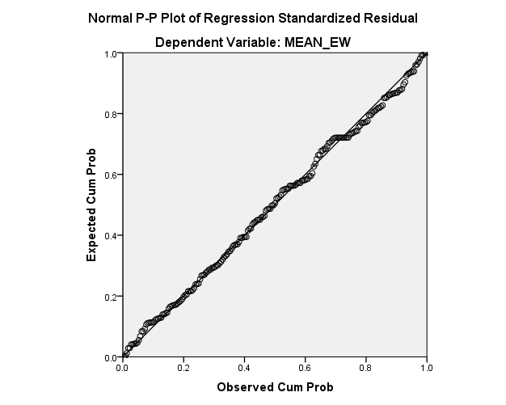

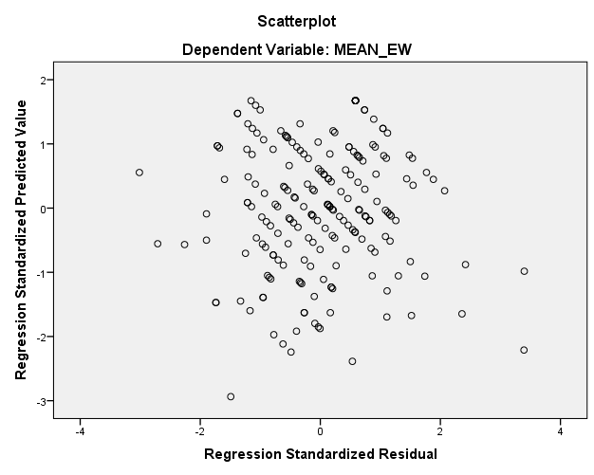

Appendix H: University of Hertfordshire Ethics Approval
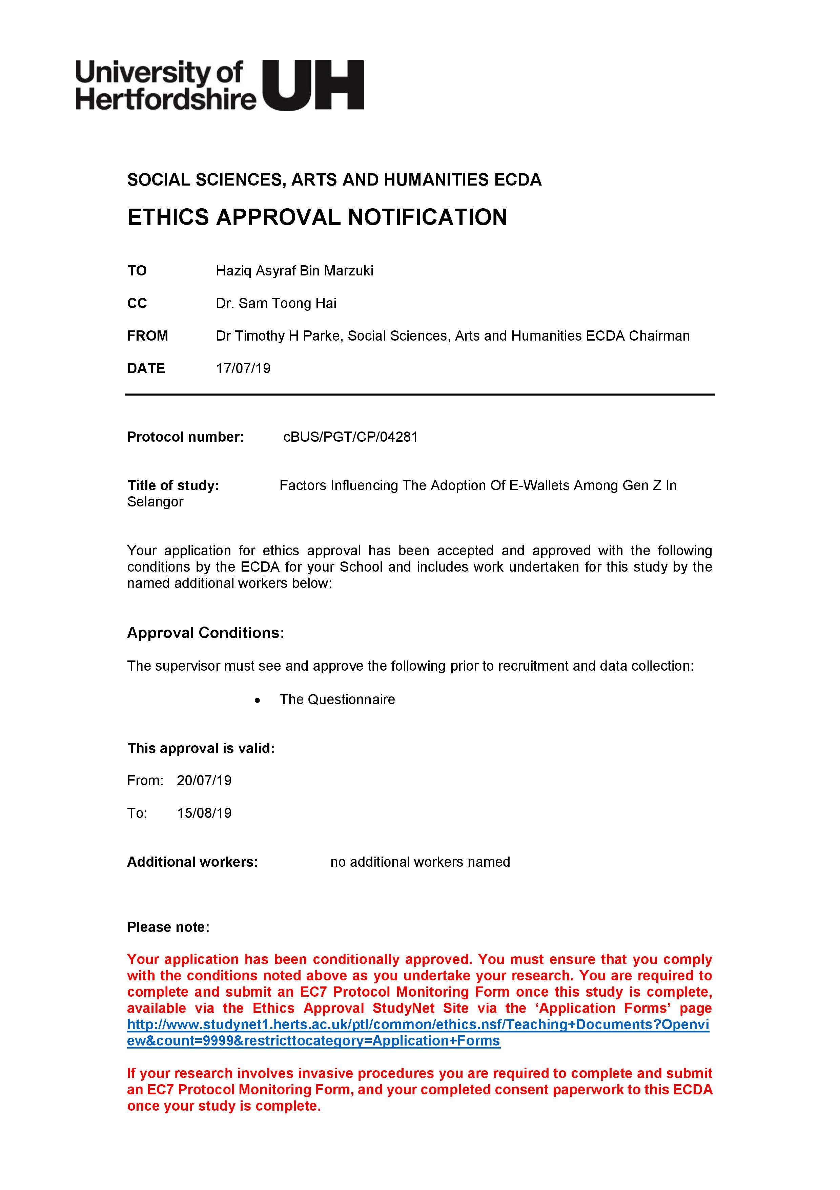

Appendix I: Project Timeline
ITEM | W1 | W2 | W3 | W4 | W5 | W6 | W7 | W8 | W9 | W10 | W11 | W12 | W13 | W14 | W15
Initial Research Proposal
Chapter 1-Introduction
Chapter 2-Literature
Chapter 3-Methodology
Draft and Review by SV
Proposal Defence
Data Collection
Data Analysis
Chapter 4
Chapter 5
Viva, Final Presentation
Final Compilation, Proofreading
Submission

Appendix K: Turnitin Originality Report
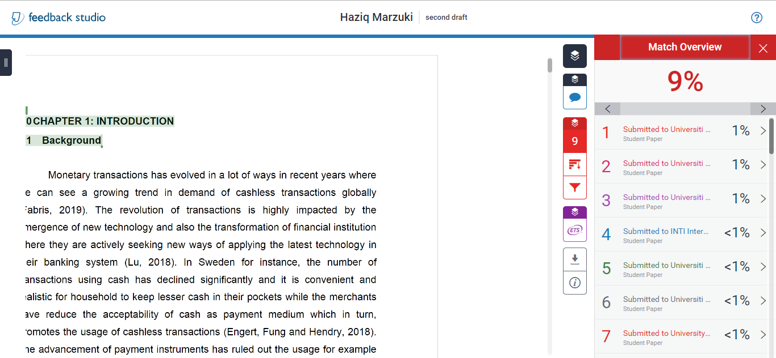

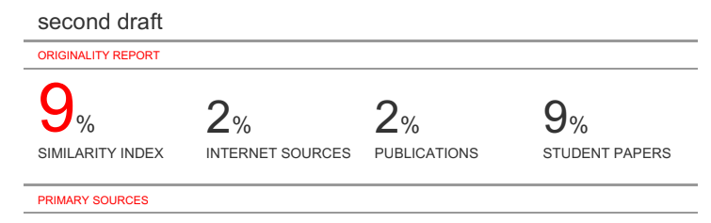

Appendix J: MBA Project Log
